First round 18 September 2014
Second round 30 January 2015

AusPAR Attachment 2

Extract from the Clinical Evaluation Report for Netupitant / palonosetron (as hydrochloride)
  - Proprietary Product Name: Akynzeo
  - Sponsor: Specialised Therapeutics Australia Pty Ltd

About the Therapeutic Goods Administration (TGA)
- The Therapeutic Goods Administration (TGA) is part of the Australian Government Department of Health, and is responsible for regulating medicines and medical devices.
- The TGA administers the Therapeutic Goods Act 1989 (the Act), applying a risk management approach designed to ensure therapeutic goods supplied in Australia meet acceptable standards of quality, safety and efficacy (performance), when necessary.
- The work of the TGA is based on applying scientific and clinical expertise to decision-making, to ensure that the benefits to consumers outweigh any risks associated with the use of medicines and medical devices.
- The TGA relies on the public, healthcare professionals and industry to report problems with medicines or medical devices. TGA investigates reports received by it to determine any necessary regulatory action.
- To report a problem with a medicine or medical device, please see the information on the TGA website <https://www.tga.gov.au>.
About the Extract from the Clinical Evaluation Report
- This document provides a more detailed evaluation of the clinical findings, extracted from the Clinical Evaluation Report (CER) prepared by the TGA. This extract does not include sections from the CER regarding product documentation or post market activities.
- The words [Information redacted], where they appear in this document, indicate that confidential information has been deleted.
- For the most recent Product Information (PI), please refer to the TGA website <https://www.tga.gov.au/product-information-pi>.
Copyright
© Commonwealth of Australia 2016
This work is copyright. You may reproduce the whole or part of this work in unaltered form for your own personal use or, if you are part of an organisation, for internal use within your organisation, but only if you or your organisation do not use the reproduction for any commercial purpose and retain this copyright notice and all disclaimer notices as part of that reproduction. Apart from rights to use as permitted by the Copyright Act 1968 or allowed by this copyright notice, all other rights are reserved and you are not allowed to reproduce the whole or any part of this work in any way (electronic or otherwise) without first being given specific written permission from the Commonwealth to do so. Requests and inquiries concerning reproduction and rights are to be sent to the TGA Copyright Officer, Therapeutic Goods Administration, PO Box 100, Woden ACT 2606 or emailed to <tga.copyright@tga.gov.au>.

Contents
List of abbreviations 5
1. Introduction 8
2. Clinical rationale 8
3. Contents of the clinical dossier 9
3.1. Scope of the clinical dossier 9
3.2. Paediatric data 10
3.3. Good clinical practice 11
4. Pharmacokinetics 11
4.1. Studies providing pharmacokinetic data 11
4.2. Summary of pharmacokinetics 12
4.3. Evaluator’s overall conclusions on pharmacokinetics 22
5. Pharmacodynamics 25
5.1. Studies providing pharmacodynamic data 25
5.2. Summary of pharmacodynamics 26
5.3. Evaluator’s overall conclusions on pharmacodynamics 29
6. Dosage selection for the pivotal studies 30
7. Clinical efficacy 32
7.1. Pivotal efficacy study 32
7.2. Other efficacy studies 55
7.3. Analyses performed across trials (pooled analyses and meta-analyses) 67
7.4. Evaluator’s conclusions 67
8. Clinical safety 80
8.1. Studies providing evaluable safety data 80
8.2. Pivotal studies that assessed safety as a primary outcome 83
8.3. Patient exposure 83
8.4. Adverse events 84
8.5. Laboratory tests 95
8.6. Post-marketing experience 99
8.7. Evaluator’s overall conclusions on clinical safety 100
9. First round benefit-risk assessment 101
9.1. First round assessment of benefits 101
9.2. First round assessment of risks 102
9.3. First round assessment of benefit-risk balance 103
10. First round recommendation regarding authorisation 103
11. Clinical questions 104
11.1. Pharmacokinetics 104
11.2. Pharmacodynamics 104
11.3. Efficacy 104
11.4. Safety 105
12. Second round evaluation of clinical data submitted in response to questions 105
12.1. Pharmacokinetics question 1 105
12.2. Pharmacokinetics question 2 107
12.3. Pharmacokinetics question 3 110
12.4. Pharmacokinetics question 4 111
12.5. Pharmacokinetics question 5 112
12.6. Pharmacokinetics question 6 113
12.7. Pharmacodynamics question 1 114
12.8. Pharmacodynamics question 2 115
13. Second round benefit-risk assessment 117
13.1. Second round assessment of benefits 117
13.2. Second round assessment of risks 117
13.3. Second round assessment of benefit-risk balance 117
14. Second round recommendation regarding authorisation 117
15. References 117

List of abbreviations
Abbreviation | Meaning
< | Less than
> | Greater than
5-HT3 | Serotonin
AE | adverse event
ALT | Alanine transaminase
AST | Aspartate transaminase
AUC_{0-inf} | area under the concentration versus time curve up to infinity; also AUC_{inf}
AUC_{0-t} | area under the concentration-time curve from time zero to time t
AUC_{0-tz} | area under the concentration-time data profile from administration until the last sampling point (tz) equal or above LLOQ.
BD | twice daily
BA | bioavailability
BE | bioequivalence
BMI | body mass index
BP | Blood pressure
bpm | beats per minute
BW | body weight
CI | Confidence interval
CINV | Chemotherapy induced nausea and vomiting
CL/F | apparent clearance
CLR | renal clearance
C_{max} | peak drug concentration
CSR | Clinical Study Report
DBP | diastolic blood pressure
ECG | Electrocardiogram
ECOG | Eastern Cooperative Oncology Group
EMA | European Medicines Agency
EPAR | European public assessment reports
EU | European Union
FAS | Full Analysis Set
FDA | Food and Drug Administration
FDC | fixed dose combination
fE | fraction of drug in erythrocytes
FILE | Functional Living Index-Emesis
G | Gram
GCP | Good Clinical Practice
h | hour/s
HBP | Helsinn Birex Pharmaceuticals
HEC | highly emetogenic chemotherapy
ITT | Intent-To-Treat
IUD | intrauterine device
IV | Intravenous
L | Litre
LLOQ | lower limit of quantification
MEC | moderately emetogenic chemotherapy
Mg | Milligram
min | minute/s
mL | Millilitre
ms | Millisecond
NK1 | Neurokinin 1
OR | Odds ratio
PD | Pharmacodynamics
PET | positron emission tomography
PI | Product Information
PK | Pharmacokinetics
PP | Per-Protocol
PPK | population PK
SAE | serious adverse event
SBP | systolic blood pressure
SD | Standard Deviation
SDS | surfactant sodium dodecylsulfate
SE | sucrose lauric ester
SOC | System Organ Class
ss | steady state
t½ | half-life
t½_{Z} | apparent terminal elimination half-life
TEAE | treatment emergent adverse events
TGA | Therapeutic Goods Administration
US | United States
VAS | Visual Analog Scale
Versus | Versus
V_{z}/F | volume of distribution
λ | blood/plasma concentration ratio
µg | Microgram

Introduction
This is a submission to register a new chemical entity, netupitant in an oral fixed dose combination (FDC) product with palonosetron.
Netupitant, a new chemical entity, is a selective antagonist of human substance P/neurokinin 1 (NK1) receptors, with little or no affinity for serotonin (5-HT3), dopamine, and corticosteroid receptors.
Palonosetron is a 5-HT₃receptor antagonist with a strong binding affinity for this receptor and little or no affinity for other receptors. Palonosetron (as hydrochloride) is currently approved and marketed in Australia (under the trade name of Aloxi) as a 250 µg/5 mL solution for intravenous injection (AUST R 114185). The currently approved indication for intravenous palonosetron is ‘for prevention of nausea and vomiting induced by cytotoxic chemotherapy’. Oral palonosetron is not currently approved in Australia.
The proposed indication for the netupitant/palonosetron FDC is for the
  - ‘Prevention of acute and delayed nausea and vomiting associated with initial and repeat courses of highly emetogenic cancer chemotherapy.
  - Prevention of acute and delayed nausea and vomiting associated with initial and repeat courses of moderately emetogenic cancer chemotherapy’.
The submission proposes registration of the following dosage forms and strengths: Akynzeo 300 mg/0.5 mg as a hard gelatin capsule containing 300 mg netupitant (as three 100 mg netupitant immediate release tablets) and 0.5 mg of palonosetron (as hydrochloride) soft gel capsule.
The proposed dose and schedule for Akynzeo for the proposed indications is one 300 mg/0.5 mg FDC capsule to be administered orally approximately one hour prior to the start of each chemotherapy cycle. The hard capsule should be swallowed whole.

Clinical rationale
Chemotherapy induced nausea and vomiting (CINV) can lead to metabolic problems such as fluid and electrolyte balance disturbances and nutritional status deficiencies, psychological problems, decision by physician to reduce chemotherapy dose intensity, or decision by the patient to stop potentially beneficial cancer treatment.
CINV is classified as either acute (occurring within the first 24 hours after chemotherapy) or delayed (occurring after the first 24 hours, extending until the fifth day). The development of acute emesis is known to largely depend on serotonin (5-HT). CINV is mainly due to input from the chemoreceptor trigger zone (CTZ). The neurotransmitters serotonin and dopamine stimulate the vomiting centre indirectly via stimulation of the CTZ. The 5-HT₃receptor has been shown to selectively participate in the emetic response, thus providing a physiological explanation for the clinical anti emetic effects of 5-HT₃receptor antagonists. The pathophysiology of delayed emesis is less understood, and multiple mechanisms may contribute to it, including substance P, which belongs to the neurokinin (NK) family of neuropeptides and exerts its biological effects via interaction with the NK1 receptor.
According to the sponsor, 5-HT₃and NK1 receptor antagonists are among the drugs of choice for optimal anti emetic prophylaxis in cancer patients receiving chemotherapy, and current clinical practice guidelines generally recommend that patients receiving highly or moderately emetogenic chemotherapy regimens should be treated with a combination of a 5-HT₃receptor antagonist, NK1 receptor antagonist and a systemic corticosteroid. The clinical anti emetic efficacy of 5-HT₃receptor antagonists and NK1 receptor antagonists is considered to be complementary: the major effect of 5-HT₃receptor antagonists is in the control of the acute phase of CINV, while the additional benefit of NK1 receptor antagonists is mostly seen in the control of the delayed phase of CINV. The sponsor was of the opinion that the clinical significance of this association provides a strong rationale for the development of a fixed combination of the two agents. The proposed palonosetron/netupitant FDC is composed of palonosetron (a registered 5-HT₃receptor antagonist), and a new molecular entity, netupitant (a NK1 receptor antagonist).
In addition, it was felt that a fixed dose combination product could improve patient compliance due to a simplification and convenience of treatment regimen and hence increase adherence to guidelines for administration of both a 5-HT₃and NK1 receptor antagonist for control of CINV. Moreover, the long half-lives of both components (approximately 40 and 90 hours for palonosetron and netupitant, respectively) suggested that a single oral dose administered on Day 1 of chemotherapy could be sufficient to protect patients from both acute and delayed CINV, allowing further simplification of treatment regimen and increasing patient compliance. According to the sponsor, the EU Committee for Medicinal Products for Human Use (CHMP) had agreed that the rationale for the development of the proposed fixed dose combination was based on valid therapeutic principles.

Contents of the clinical dossier

Scope of the clinical dossier
The submission contained the following clinical information:
- 23 clinical pharmacology studies, including 20 that provided pharmacokinetic data and 4 that provided pharmacodynamic data.
- 1 population pharmacokinetic/pharmacodynamic analyses.
- 1 pivotal efficacy/safety study (Study NETU-08-18; oral netupitant/palonosetron FDC 300/0.5 mg versus oral palonosetron 0.5 mg, moderately emetogenic chemotherapy (MEC), single and multiple chemotherapy cycles).
- 1 dose finding study (Study NETU-07-07; netupitant 100 mg + palonosetron 0.5 mg, netupitant 200 mg + palonosetron 0.5 mg and netupitant 300 mg + palonosetron 0.5 mg versus palonosetron 0.5 mg alone, highly emetogenic chemotherapy (HEC), single cycle).
- 1 other efficacy/safety study (Study NETU-10-29; supportive safety study, netupitant/palonosetron FDC 300/0.5 mg versus aprepitant + palonosetron, MEC and HEC, multiple cycles).
- 3 bridging studies;
  - PALO-10-01 [non-inferiority study comparing efficacy of single dose oral palonosetron 0.5 mg versus single-dose intravenous (IV) palonosetron 0.25 mg, HEC, single cycle]
  - PALO-03-13 [dose finding study; oral palonosetron 0.25 mg, 0.5 mg and 0.75 mg versus IV palonosetron 0.25 mg, MEC, single cycle]
  - PALO-03-14 [open label, uncontrolled study on efficacy and safety of oral palonosetron 0.75 mg in MEC, multiple cycles]).
- 2 efficacy/safety studies not relating to proposed indications;
  - Study NETU-08-03, assessing the use of netupitant in patients with overactive bladder
  - Study NETU09-11, assessing the use of netupitant/palonosetron FDC in an acute pain model).
- 3 studies involving IV palonosetron (Studies PALO-99-03, PALO-99-04, and PALO-99-05; IV palonosetron versus other 5-HT₃receptor antagonists); Integrated Summary of Efficacy, Integrated Summary of Safety.
- Clinical Overview, Summary of Clinical Efficacy, Summary of Clinical Safety and literature references.
In this submission, the efficacy and safety of Akynzeo for the proposed indications is supported mainly by results from 3 studies (Studies NETU-08-18, NETU-07-07, and NETU-10-29). Study NETU-08-18 was the pivotal efficacy trial for assessing the efficacy of the netupitant/palonosetron FDC in MEC. Although Study NETU-07-07 was a Phase II dose finding study and study treatment involved concomitant administration of netupitant and palonosetron instead of the FDC formulation, it was submitted as providing pivotal efficacy data to support efficacy in HEC. Study NETU-10-29 was designed as a safety trial to provide safety data on the use of the FDC formulation in patients receiving repeat cycles of MEC and HEC, but also provided supportive efficacy information. In addition to these 3 studies, Study PALO-10-01 was also submitted by the sponsor to provide data that oral palonosetron 0.5 mg contributed to the FDC efficacy in the HEC setting (oral palonosetron 0.5 mg is currently registered in both European Union (EU) and the United States (US) for the prevention of CINV induced by MEC only).
In this evaluation report, Study NETU-08-18 will be evaluated as the pivotal efficacy trial for assessing the efficacy of the netupitant/palonosetron FDC in initial and repeat courses of MEC. Study NETU-07-07 will be evaluated with regards to the efficacy of netupitant plus palonosetron in HEC, as well as with regards to the rationale for the dose selection of netupitant. Study NETU-10-29 will be evaluated with regards to providing supportive safety and efficacy data for the netupitant/palonosetron FDC in repeat cycles of MEC and HEC. Of the 3 bridging studies, Study PALO-10-01 provided supportive efficacy data for oral palonosetron 0.5 mg in the HEC setting. Study PALO-03-13 will be evaluated with regards to the rationale for the selection of oral palonosetron dose for the FDC formulation, while Study PALO-03-14 will be evaluated with regards to providing general supportive efficacy and safety data on the use of palonosetron in MEC. The 2 studies not relating to the proposed indications and the 3 studies assessing IV palonosetron are not relevant to the current submission, and will not be evaluated for the purpose of this evaluation report.

Paediatric data
The submission did not include paediatric data.

Good clinical practice
The clinical studies reviewed in this evaluation were in compliance with CPMP/ICH/135/95 Note for Guidance on Good Clinical Practice.

Pharmacokinetics

Studies providing pharmacokinetic data
Summaries of the pharmacokinetic studies were provided. Table 1 below shows the studies relating to each pharmacokinetic topic.

Table 1. Submitted pharmacokinetic studies
PK topic | Subtopic | Study ID | *
PK in healthy adults | Bioequivalence† - Single dose | NETU-11-02 | BE of late Phase 1 and Phase 3 FDC
PK in healthy adults | Bioequivalence† - Single dose | NETU-09-07 | BE of FDC and free combination
PK in healthy adults | Bioequivalence† - Single dose | NETU-08-12 | BE of formulations utilised during drug development.
PK in healthy adults | Bioavailability | BP17408 | BA of two netupitant forms with & without food.
PK in healthy adults | Bioavailability | NETU-11-23 | BA of netupitant administered as three FDC forms
PK in healthy adults | Influence of food | NETU-10-12 | Effect of food and age on FDC
PK in healthy adults | Influence of food | NP16600 | Effects of food and age on netupitant
PK in healthy adults | Dose proportionality | NP16603 | Single ascending doses of netupitant
PK in healthy adults | Bioavailability during multiple-dosing | NP16601 | Multiple ascending doses of netupitant
PK in healthy adults | ADME | NETU-09-21 | Mass balance
PK in special populations | Target population | NETU-10-02 | PPK/PPD
PK in special populations | Hepatic impairment | NETU-10-10 | Effect of hepatic impairment on PK of FDC
PK interactions | CYP3A4-inhibitor and inducer | NETU-10-11 | PK FDC in presence of ketoconazole & rifampicin
PK interactions | CYP3A4 substrates | NP16599 | Effect of netupitant on the PKs of midazolam and erythromycin
PK interactions | Components of FDC | NETU-06-06 | Netupitant with palonosetron
PK interactions | Components of FDC | NETU-06-27 | Netupitant with palonosetron
PK interactions | Netupitant vs dexamethasone | NETU-06-07 | Examine the effects of netupitant on dexamethasone PK
PK interactions | Netupitant with oral digoxin | NETU-07-01 | Effects of netupitant on the PKs of steady-state digoxin
PK interactions | FDC and oral contraceptives | NETU-10-08 | Effect of FDC on the PK of ethinylestradiol and levonorgestrel.
PK interactions | Chemotherapy drug-interactions in cancer | NETU-10-09 | Effects of netupitant on the PK profile of 3 different chemotherapeutic agents
BA – Bioavailability BE – Bioequivalence * Indicates the primary aim of the study. † Bioequivalence of different formulations. § Subjects who would be eligible to receive the drug if approved for the proposed indication.
None of the pharmacokinetic studies had deficiencies that excluded their results from consideration.

Summary of pharmacokinetics
The information in the following summary is derived from conventional pharmacokinetic studies unless otherwise stated.

Pharmacokinetics in healthy subjects

Absorption

Sites and mechanisms of absorption
Following oral administration of the proposed commercial formulation of the netupitant/palonosetron FDC capsule (300 mg/0.5 mg), to 88 healthy subjects (Study NETU-11-02) netupitant was absorbed in a first order fashion and the C_{max}, AUC_{0-inf}, T_{max} and t½ values for netupitant were 453 ng/mL, 13,862 ng.h/mL, 5.00 h and 76.62 h, respectively. For the palonosetron component the values were: 1,271 ng/mL, 48,165 ng.h/mL, 3.00 h and 37.22 h, respectively.

Bioavailability

Absolute bioavailability netupitant
Absolute netupitant bioavailability data are not available in humans. However, based on the results of two studies, which examined the safety, tolerability and PK of ascending doses of IV netupitant in healthy volunteers (Studies BP17085 and NETU-11-01), the bioavailability of netupitant in man is thought to be greater than 60%.
Comment: Study BP17085 examined IV dosages equivalent to 3, 10 and 30 mg netupitant, whereas, the primary objective of Study NETU-11-01 was to achieve systemic exposure following IV infusion comparable (or higher) to the plasma exposure achieved following administration of 300 mg netupitant orally (that is the proposed dose in the FDC). This could not be achieved however, as the extent of exposure of all tested IV doses was too low and the safety and tolerability data did not allow further escalation of the IV dose. Hence the maximum dose of netupitant given in this study was 100 mg and this resulted in a AUC_{inf} of approximately 5,492 ng.h/mL. If we compare this value to the AUC_{inf} following an oral dose of 100 mg netupitant in Study NP16603 (4,795 ng.h/mL) the bioavailability of oral netupitant compared with an IV dose is approximately 87%. Therefore, the > 60% value given by the sponsor is a relatively conservative estimate of the absolute bioavailability of netupitant.

Absolute bioavailability palonosetron
Absolute bioavailability of palonosetron has not been determined in the present submission. However, The PI for Aloxi 500 µg soft capsules in force in the EU Countries indicates that palonosetron is well absorbed with an absolute bioavailability reaching 97%.

Bioavailability relative to an oral solution or micronised suspension
Not applicable.

Bioequivalence of clinical trial and market formulations

Study NETU-11-02
Study NETU-11-02 represented a bridging study of late Phase I and Phase III FDC formulations with the proposed commercial formulation in healthy subjects. For the netupitant component of the FDC the C_{max} and AUC values were bioequivalent between the trial and commercial formulations, as the 90% CIs for the ratios of netupitant C_{max}, AUC_{0-t} and AUC_{0-inf} were within the acceptance limits of 80 to 125%, and the median values for netupitant T_{max} and t½ were very similar for both formulations. The C_{max} and AUC of the palonosetron components in the trial and commercial formulations were also bioequivalent (that is 90% CIs between 80 and 125%) and the median values for palonosetron T_{max} and t½ did not differ significantly between the formulations (p = 0.2388 and p = 0.1110, respectively).

Bioequivalence of different dosage forms and strengths
A number of studies examined the bioequivalence of various formulations of netupitant and palonosetron which are discussed in the formulation development section of this report.

Study NETU-09-07
Study NETU-09-07 examined the bioequivalence of netupitant and palonosetron, when administered as a FDC (300 mg/0.50 mg hard gel capsules) and as a free combination of netupitant 2 x 150 mg capsules and palonosetron 0.50 mg softgel capsules in healthy subjects under fasting conditions. The C_{max} and AUC values for the netupitant component of each treatment were bioequivalent and there was no statistically significant difference in netupitant median T_{max} or mean t½ values between the two treatments. The C_{max} and AUC values for the palonosetron component of each treatment were also bioequivalent and there was no statistically significant difference in palonosetron T_{max} or t½.

Study NETU-08-12
A second study (NETU-08-12) also examined the bioequivalence of netupitant and palonosetron, when administered as a FDC (300 mg/0.50 mg hard gel capsules) and as a free combination of netupitant 2 x 150 mg capsules and palonosetron 0.50 mg softgel capsules. In this pilot study of 8 healthy subjects, although the values were similar bioequivalence for the two formulations, based on the C_{max} and AUC of the netupitant component, could not be concluded as the 90% CIs were slightly outside the predefined range of 80 to 125%. By contrast, bioequivalence was demonstrated in regards to the palonosetron component.
Comment: The sponsor states that the lack of bioequivalence between the FDC and the free combinations in regards to the netupitant component may result from high inter-subject variability related to the small number of subjects examined in this study and given that the preceding study (NETU-09-07) did establish bioequivalence in a larger population this explanation appears to be justified.

Study BP17408
Study BP17408 compared the bioavailability of netupitant after oral administration of 450 mg doses of two different formulations of netupitant (SDS capsule formulation and a SE capsule formulation) in healthy volunteers under fed conditions. This study indicated that there were no significant differences in the PKs of the SDS and SE capsule formulations with T_{max} occurring at approximately 5 h post dose for both treatments. The mean C_{max} values were 762 and 727 ng/mL, respectively for the SDS and SE formulations and the mean AUC_{inf} was 34,700 ng.h/mL for both formulations.

Study NETU-11-23
Study NETU-11-23 examined the bioequivalence of 3 formulations of the netupitant and palonosetron combination, including a FDC capsule with standard dissolution, a FDC with slow dissolution and a free combination comprising a 300 mg netupitant suspension with a 0.5 mg palonosetron soft gel capsule. In this study the C_{max}, AUC and T_{max} values of netupitant were similar for the two FDC formulations, whereas, the formulation containing the suspension of netupitant demonstrated a lower T_{max} and higher C_{max} and AUC than either of the two FDC formulations.
Comment: It should be noted that the PKs of palonosetron were not examined in this study.

Bioequivalence to relevant registered products
As netupitant has not been previously approved for marketing there are no relevant registered products for this component of the FDC. On the other hand, as stated in the formulation development section of this report, palonosetron oral softgel capsules are currently approved for use in Europe (EU/1/04/306/002-003).
Comment: The palonosetron softgel capsules have not yet been evaluated for use in Australia and currently only 250 µg/5 mL solution for injection vial has gained approval (ARTG 114185).
Although the palonosetron oral softgel capsules used in the FDC are similar to the formulation currently approved for use in Europe, the two formulations are not identical as there are differences relating to capsule size and quantity of solvent vehicle and the effects of these formulation differences on the PKs of the palonosetron component have not been examined by the sponsor.

Influence of food
Two studies examined the effect of food on the PKs of netupitant (Studies BP17408 and NP16600) following oral administration of 450 mg and 100 mg of netupitant, respectively, and a third study (Study NETU-10-12) examined the food effect on the PKs of both netupitant and palonosetron following administration of the FDC (300 mg/0.5 mg).
Study NETU-10-12 identified that following a high fat breakfast in healthy subjects the mean netupitant C_{max} was significantly higher (649.8 µg/L) than under fasted conditions (596.4 µg/L), as was the AUC_{0-inf} (22,391 µg.h/L [fed] versus 20,039 µg.h/L [fasted]) These differences represented a 1.18 fold increase in netupitant C_{max} and 1.16 fold increase in AUC_{0-inf}. By contrast, food did not affect the PKs of palonosetron.
Although Studies BP17408 and NP16600 used two 150 mg capsules that contained slightly different formulations to that found in the 100 mg netupitant capsule contained in the FDC, Studies BP17408 and Study NETU-09-07 identified that all three formulations were essentially bioequivalent. However, the results for Studies BP17408 and NP16600 indicated that the magnitude of increase in netupitant exposure with food was greater than that seen in Study-10-12, with netupitant C_{max} increasing by 1.69 to 1.89 fold and AUC_{0-inf} by 1.51 to 1.53 fold.

Dose proportionality
Study NP16603 evaluated the PKs of netupitant after single, oral, ascending, capsule doses of 10 mg to 450 mg in healthy males, following a standard breakfast. For doses up to 300 mg, there was a statistically significant over proportional increase with dose in C_{max}, AUC_{last} and AUC_{0-inf} for netupitant. For instance, the measures of deviation from dose-proportionality between the 100 mg and 300 mg doses are 1.48, 1.77 and 1.75 respectively for C_{max}, AUC_{inf} and AUC_{last}. By contrast, dose proportionality was observed between the 300 mg and 450 mg doses, with ratios being close to one.

Bioavailability during multiple dosing
Study NP16601 evaluated the PKs of netupitant following one week daily oral dosing with 100 mg, 300 mg or 450 mg netupitant in healthy volunteers. In keeping with the long half-life of netupitant there was an increase in netupitant AUC_{0-23.5} of approximately 3 fold after 7 days dosing for all three dose levels. As in the previous study, there was an over proportional increase with dose in C_{max} and AUC_{0-23.5} on both Days 1 and 7 of the study.

Effect of administration timing
Not examined.
Comments: Given that the T_{max} values for netupitant and palonosetron were 5 h and 3 h, respectively, and maximum NK1-receptor occupancy was identified 6 hours after dosing with netupitant, without studies examining the effect of administration timing it is difficult to determine whether even greater anti emetic activity could have been achieved if the FDC had been given earlier than the proposed one hour prior to chemotherapy.

Distribution

Volume of distribution
Two studies examined the volume of distribution of netupitant (NP16600 and BP17408) under fasted conditions in healthy subjects. Following oral capsule doses of 300 mg and 450 mg of netupitant containing the surfactants SDS and SE, respectively, the apparent volume of distribution after oral administration (Vz/F) values were 1,842 L and 3,090 L, respectively.

Plasma protein binding
The in vitro plasma protein binding of the NK1 receptor antagonist netupitant was investigated in human, dog, rat, and gerbil blood and plasma by equilibrium dialysis (Study 1006047). The results indicated that in humans, netupitant was highly bound (> 99%) to plasma proteins, with both albumin and α1-acid glycoprotein contributing to the high plasma binding of this drug, and the mean percentage of free drug was 0.33%.

Erythrocyte distribution
Study 1006047 also indicated that the blood/plasma concentration ratio (λ) for netupitant in humans was 0.69 and the fraction of drug in erythrocytes (fE) was approximately 13%. The conclusions of the in vivo study were supported by the oral Absorption /Distribution /Metabolism /Excretion (ADME) study, Study NETU-09-21, which was conducted in 6 healthy, white males, and demonstrated that total drug related material in plasma was higher than that of whole blood, as few subjects had detectable radioactivity levels measurable in whole blood.

Tissue distribution
The high volume of distribution for netupitant indicates that the drug is highly distributed in tissues outside the plasma and interstitial fluid.

Metabolism

Interconversion between enantiomers
Not applicable.

Sites of metabolism and mechanisms / enzyme systems involved
Based on the renal and non-renal clearance it would appear that the hepatic/biliary route, rather than renal clearance, is the major elimination route for netupitant related entities.
The in vitro study, 1003832, identified that although CYP2C9, 2C19 and 2D6 did not catalyse the formation of netupitant metabolites, CYP3A4 was responsible for the formation of three metabolites: a demethylation (RO0681133 –M1); an N-oxidation (RO0713001 – M2); and a hydroxylation (M3 - RO0731519) product. A minor metabolite, M4, was identified late in the development process.

Non-renal clearance
Study NETU-09-21 demonstrated that by 696 h following administration of [¹⁴C]-netupitant (60 µCi), 70.7% of the total radioactivity was recovered in the faeces.

Metabolites identified in humans
Four metabolites have been detected in human plasma at netupitant doses of 30 mg and higher (M1, M2, M3 and M4).

Active metabolites
All of the four metabolites are potentially active as they have been shown to bind to the hNK1 receptor in vitro (Study NETU-12-31). In addition, the M1, M2 and M3 metabolites have all demonstrated pharmacological activity in the gerbil foot tapping NK1 assay, where M3 was most potent and M2 was the least active (Study 1006030).

Other metabolites
No inactive metabolites have been detected in human plasma.

Pharmacokinetics of metabolites
The oral ADME study, Study NETU-09-21 estimated that exposure to the three major metabolites of netupitant, M1, M2 and M3, which each account for > 10% of parent drug related exposure was equivalent to 29%, 14%, and 33%, respectively, of the systemic exposure to netupitant. By contrast, the minor metabolite M4 accounted for approximately 7% of parent drug exposure. The T_{max} values for the M1, M2 and M3 metabolites were 10.00 h, 2.00 h and 24.00 h, respectively, and the t½ values were 64.77 h, 17.10 h and 41.49 h, respectively.

Consequences of genetic polymorphism
Not examined.

Excretion

Routes and mechanisms of excretion
Results of the oral ADME study, NETU-09-21 indicates that of all of the netupitant related material was excreted by 696 h post dosing; 86.49% was excreted in the faeces and a further 4.75% of drug related material was excreted in the urine.

Mass balance studies
Following administration of 60 µCi [¹⁴C]-netupitant (Study NETU-09-21), approximately 50% of the administered radioactivity was recovered within 120 h of dosing and an estimated 90% of radioactivity by 696 h post dose.

Renal clearance
See above.

Intra- and inter-individual variability of pharmacokinetics
The thorough QT study, NETU-07-20, identified that the inter-subject variability of netupitant PK was high with a variability of 42% and 48% for AUC_{0-t} and C_{max}, respectively, following a 200 mg dose and 47% and 56% for AUC_{0-t} and C_{max}, respectively, following a 600 mg dose. For palonosetron, inter-subject variability was lower with variability of 25% and 29% for AUC_{0-t} and C_{max}, respectively, following a 0.5 mg dose and 20% and 23% for AUC_{0-t} and C_{max}, respectively, following a 1.5 mg dose.
These findings were supported by the variability estimates from the final netupitant model derived in the PPK study, NETU-10-02, which was based on netupitant concentration data from 117 patients, and predicted an inter-subject variability of 38.2% and 57% for C_{max} and AUC_{inf}, respectively following a 300 mg dose of netupitant. For 0.5 mg palonosetron, the final palonosetron model predicted an inter-subject variability of 28.3% and 33.4% for C_{max} and AUC_{inf}. Population modelling also indicated that the estimated inter-individual variability on clearance was 65.4% and 26.2% for netupitant and palonosetron, respectively and intra-subject variability for netupitant and palonosetron was estimated at 37.3% and 17.2%, respectively.

Pharmacokinetics in the target population
The PPK study NETU-10-02 represented a population PK analysis of the plasma concentration data from the pivotal Phase III clinical trial NETU-08-18, in which patients receiving moderately emetogenic chemotherapy were administered oral netupitant/palonosetron (300 mg/0.5 mg) FDC and oral dexamethasone 20 mg. Results of this PPK analysis indicated that netupitant PKs could be characterised by a 2 compartment model with an estimated median systemic CL of 20.5 L/h and a large apparent volume of the central compartment (V₂), estimated to be 486 L. The mean C_{max} and AUC_{inf} values for netupitant were estimated to be 567 ng/mL and 17,284 ng.h/mL, respectively, and the median T_{max} was 3.61 h.
For palonosetron, a 2 compartment model with first order absorption and elimination was determined to provide the best fit for the data and estimated median CL and V₂ were 7.64 L/h and 367 L, respectively. The mean C_{max} and AUC_{inf} values for palonosetron were estimated to be 1,378 ng/mL and 68,611 ng.h/mL, respectively and the median T_{max} was 2.30 h.
Comment: It must be noted that the ‘Investigational plan’ section of Study Report NETU-08-18 indicated that the subset of patients in which the PKs of the FDC were to be determined numbered approximately 500 and it is not clear why the data for only 117 patients was included in the modelling studies.
In addition, the design and analysis of the PPK study were not satisfactory as the demographics of the population used to develop the PK model for netupitant indicates that the population was primarily female (96.6%) and Caucasian (86.3%). In addition, it is not clear from the median age (range) the number of subjects that fell into the elderly group (≥ 65 years) and the younger age group (18 to 45) as described in Study NETU-10-12. As in the netupitant population, the palonosetron population was also primarily female (95.8%) and Caucasian (86.4%). There is also the same issue with the ages reported described above. Therefore, based on the small number of male and non-Caucasian subjects included in the two populations, it is difficult to interpret the effects of covariates such as race and gender using the PK models developed. In addition, it is also difficult to compare the results related to age with those contained in Study NETU-10-12.
No studies have examined the PKs of the FDC in the target population who were not receiving concurrent chemotherapy (for example docetaxel).

Pharmacokinetics in other special populations

Pharmacokinetics in subjects with impaired hepatic function
Study NETU-10-10 examined the effect of different stages of hepatic impairment, resulting from cirrhosis, upon the PKs of netupitant, its metabolites M1, M2, and M3, and palonosetron. The study population included 8 subjects with mild hepatic impairment, 8 subjects with moderate hepatic impairment, 2 subjects with severe hepatic impairment and 18 healthy subjects with normal hepatic function. Following oral administration of the FDC containing 300 mg netupitant and 0.5 mg palonosetron, subjects with mild hepatic impairment displayed small, non-significant, increases of 11% and 14% in the C_{max} values of netupitant and palonosetron, respectively, compared to subjects with normal hepatic function. Interestingly, the CV% for netupitant C_{max} was 65.7% in the group of subjects with mild hepatic impairment compared to 22.7% in the healthy subjects. Netupitant AUC_{0-inf} was 19% higher and palonosetron AUC_{0-inf} was significantly higher by 33% in subjects with mild impairment than in healthy subjects. In subjects with moderate hepatic impairment, exposure to netupitant was significantly higher compared to matching healthy subjects with an increase of 70% for C_{max} and 143% for AUC_{0-inf}. As in the subjects with mild impairment, the variability in netupitant PKs was higher in subjects with moderate hepatic impairment than in matching healthy subjects. In regard to palonosetron PKs in subjects with moderate hepatic impairment compared to healthy normal subjects, although C_{max} was similar in the two groups, AUC_{0-inf} was significantly higher, by 62%, in the moderately impaired group.
Comment: Interpretation of the PK analysis in subjects with severe hepatic impairment was limited due to the low number of subjects (n = 2) included in the analysis. Overall, hepatic impairment appears to result in increased inter-subject variability in netupitant PKs as well as increases in exposure to both netupitant and palonosetron. Can the sponsor please provide an explanation for the increased variability in netupitant PKs that occurs as a result of hepatic impairment?

Pharmacokinetics in subjects with impaired renal function
No studies have examined the PKs of the FDC in subjects with renal impairment. Given that the oral ADME study, NETU-09-21, indicated that only low levels of netupitant related material were excreted in urine (4.75%), impaired renal function is unlikely to induce significant changes in the PKs of netupitant.
Comment: As netupitant is a new chemical entity and given that the FDC has not been previously described or registered the evaluator believes that a study of the FDC in patients with impaired renal function is appropriate.

Pharmacokinetics according to age
One of the objectives of Study NETU-10-12 was to compare the PKs of the FDC in healthy elderly (≥ 65 years of age) and younger subjects (18 to 45 years). In elderly subjects, the C_{max} and AUC_{0-inf} of netupitant were 1.36 and 1.25 fold higher, respectively, than in younger subjects. For palonosetron, C_{max} and AUC_{0-inf} were also significantly higher (1.1 and 1.37 fold, respectively) in elderly than younger subjects. By contrast, the results of the PPK Study NETU-10-02 indicated that age was not a significant covariate in the PPK models developed for either netupitant or palonosetron.
Comment: As stated previously, the “Investigational plan” section of Study Report NETU-08-18 indicated that the subset of patients in which the PKs of the FDC were to be determined numbered approximately 500 and it is not clear why the data for only 117 to 118 patients was included in the modelling studies.
In addition, the design and analysis of the PPK study were not satisfactory as the demographics of the population used to develop the PK model for netupitant indicates that the population was primarily female (96.6%) and Caucasian (86.3%). In addition, it is not clear from the median age (range) the number of subjects that fell into the elderly group (≥ 65 years) and the younger age group (18 to 45) as described in Study NETU-10-12. As in the netupitant population, the palonosetron population was also primarily female (95.8%) and Caucasian (86.4%). There is also the same issue with the ages reported described above. Therefore, based on the small number of male and non-Caucasian subjects included in the two populations, it is difficult to interpret the effects of covariates such as race and gender using the PK models developed. In addition, it is also difficult to compare the results related to age with those contained in Study NETU-10-12.

Pharmacokinetics related to genetic factors
Not examined.

Pharmacokinetics {in other special population/according to other population characteristic}
The PPK study (NETU-10-02) indicates that race and gender were not significant covariates in the final PK models for either netupitant or palonosetron.
Comment: See previous comment.

Pharmacokinetic interactions

Pharmacokinetic interactions demonstrated in human studies

Drug interaction studies in healthy subjects

Effect of CYP3A4-inhibitor and inducer on the PKs of the FDC
Study NETU-10-11 investigated the influence of the cytochrome CYP3A4 inhibitor ketoconazole (400 mg) and of the CYP3A4 inducer rifampicin (600 mg) on the PKs of the FDC (300 mg/0.5 mg) in healthy subjects. In this study, netupitant C_{max} and AUC_{0-inf} were significantly increased by 25% and 140%, respectively, when the FDC was co-administered with ketoconazole compared to when the FDC was administered alone and the formation of the metabolites M1 and M3 were delayed with T_{max} increasing by 8 fold and 2 fold, respectively. By contrast, ketoconazole had little to no effect on the PKs of palonosetron. Rifampicin co-administration with the FDC resulted in a significant decrease in netupitant C_{max} and AUC_{inf} (-62% and -83%, respectively) compared to when the FDC was administered alone. For the palonosetron component of the FDC, rifampicin co-administration did not significantly affect palonosetron C_{max}; however palonosetron AUC_{inf} was significantly lower by 19% following co-administration compared to when the FDC was given alone.

Netupitant versus CYP3A4 substrates
Study NP16599 examined the impact of co-administration of 150 mg netupitant on the PKs of either 7.5 mg midazolam or 500 mg erythromycin in healthy subjects. Co-administration of netupitant with midazolam induced a small reduction in the C_{max} and AUC_{inf} of netupitant with decreases of approximately 7% and 9%, respectively, when compared to netupitant alone. By contrast, exposure to the CYP3A4 substrate midazolam was significantly increased when taken in combination with netupitant compared to administration of midazolam alone with C_{max} increasing by approximately 40% and AUC_{inf} by approximately 250%. When netupitant was co-administered with erythromycin, netupitant C_{max} was 18% higher when given in combination compared to when administered alone and AUC_{inf} decreased by approximately 12%. For erythromycin, the C_{max} and AUC_{0-inf} increased by approximately 92% and 56% respectively when given in combination with netupitant compared to when it was administered alone.
Comment: It is important to note that in this study the significant increase in midazolam exposure (AUC_{inf} increased by 250%) was seen in the presence of only half the proposed dose of netupitant (that is, 150 mg). Therefore, the PI needs to appropriately describe this interaction.

Netupitant versus palonosetron
Two studies examined the PK interaction between the netupitant and palonosetron in healthy subjects. The first of these, Study NETU-06-06 was inconclusive as an erroneous administration error during the study prevented PK assessment. The second study, Study NETU-06-27, examined the interaction between a 450 mg oral dose of netupitant and a 0.75 mg dose of palonosetron. The results of this study indicated that co-administration of netupitant with palonosetron had little effect on the C_{max} and AUC_{inf} of netupitant, whereas for palonosetron, the C_{max} and AUC_{inf} were 15% and 10% higher, respectively when palonosetron was co-administered with netupitant compared to when it was administered alone. These small differences in the PKs of palonosetron are unlikely to be clinically significant.
Comment: The doses of netupitant/palonosetron given in this study are higher than the doses of the two drugs in the proposed FDC. However, given that at the higher dose the PK interaction between the two drugs is unlikely to be clinically significant, it follows that there would be little to no interaction between the components in the FDC.

Netupitant versus dexamethasone
Study NETU-06-07 examined the PKs of the corticosteroid dexamethasone and netupitant following administration of 20 mg dexamethasone on Day 1, followed by 8 mg twice daily from Day 2 to Day 4 and 0, 100, 300 or 450 mg netupitant on Day 1. Co-administration of netupitant significantly increased the exposure to dexamethasone in a dose and time dependant manner. For instance, on the first day of dosing dexamethasone AUC₀₋₂₄ increased 1.5, 1.7 and 1.8 fold following co-administration of 100, 300 and 450 mg netupitant, respectively and on Day 2 dexamethasone AUC₂₄₋₃₆ increased 2.1, 2.4 and 2.6 fold, respectively. By contrast, dexamethasone C_{max} on Day 1 was only slightly affected by co-administration of netupitant (1.1 to 1.2 fold increase during co-administration with 100 to 450 mg netupitant) while C_{max} on Day 2 and Day 4 was increased approximately 1.7 fold in subjects administered netupitant. Dexamethasone C_{min} on Days 2 to 4 was increased approximately 2.8, 4.3 and 4.6 fold with co-administration of 100, 300 and 450 mg netupitant, respectively. The t½,z of dexamethasone was increased by 1.9 to 3.2 h on Day 1 and by 2.0 to 2.4 h on Day 4. There was no relevant change in T_{max} for dexamethasone when administered in combination with netupitant. There was no relevant gender effect for AUC or C_{min} but C_{max} was slightly higher in female subjects.
Comment: Although the PKs of netupitant when given alone were not determined in this study, the sponsor states that the netupitant PKs following the co-administration of netupitant and dexamethasone were similar to those seen in other studies conducted in healthy subjects when netupitant was administered alone. However, comparison of the PK results in the present study with those in Study NP16603, where the same doses of netupitant were administered (that is, 100, 300 and 450 mg), indicates that netupitant AUC_{inf} was significantly lower in Study NETU-06-07. Therefore, a study examining the effect on netupitant PKs when netupitant is co-administered with dexamethasone is warranted.

Netupitant verses oral digoxin
Study NETU-07-01 assessed the effects of netupitant on the PKs of digoxin at steady state (ss) in healthy subjects who received a loading dose of 3 x 0.5 mg digoxin on Day 1, followed by a daily oral dose of 0.25 mg digoxin for 11 consecutive days and 450 mg netupitant on Day 8. The AUC_{0-24h,ss} of digoxin was not affected by co-administration with netupitant and the excretion of digoxin in urine was 55% when given alone compared to 57% after netupitant co-administration, adding support to the absence of an interaction between the two drugs. In addition, there was no evidence of a gender specific difference in digoxin AUC_{0-24ss} when digoxin was given alone or in combination with netupitant.
Comment: The effect of digoxin on netupitant PKs was not examined in this study.

FDC and oral contraceptives
Study NETU-10-08 investigated the effect of the FDC of 300 mg netupitant/0.5 mg palonosetron on the PK of oral contraceptives (60 µg ethinylestradiol and 300 µg levonorgestrel). Following co-administration of the contraceptives and the FDC the C_{max} of ethinylestradiol was unchanged, whereas, the AUC_{inf} was 12% higher compared to when the contraceptive was given alone. Similarly, for levonorgestrel the C_{max} was unchanged by the co-administration of FDC, whereas the AUC_{inf} was significantly higher (40%) compared to when the oral contraceptive was administered alone.
Comment: The effect of the contraceptive administration upon the PKs of the FDC was not examined in this study.

Drug interaction studies in patients
Study NETU-10-09 examined the effects of oral netupitant, administered as the FDC (300 mg netupitant and 0.5 mg palonosetron) on the PK profile of 3 different chemotherapeutic agents (docetaxel, etoposide, cyclophosphamide) administered with 0.5 mg palonosetron in 42 cancer patients. In this study, compared to when IV docetaxel and oral palonosetron were co-administered, administration of docetaxel with the FDC resulted in 1.49 and 1.35 fold increases in docetaxel C_{max} and AUC_{0-t}, respectively. For etoposide, the AUC_{0-t} in the FDC period was approximately 21% higher than in the reference period, whereas, etoposide C_{max} values were similar in both treatment periods. For cyclophosphamide, the C_{max} and AUC_{0-t} values were 27% and 20% higher, respectively, following co-administration of the FDC compared to the period in which palonosetron was administered with cyclophosphamide. As this study was conducted in patients undergoing chemotherapy, the effect of administering netupitant alone to this population was not possible.

Clinical implications of in vitro findings
An in vitro study was undertaken, NETU-10-27, to examine the possible induction of CYP1A2, CYP2C9, CYP2C19 and CYP3A4 by netupitant, M1, M2 and M3 in long-term monolayer cultures of freshly isolated human hepatocytes. This study identified that netupitant at concentrations of 0.2, 2 and 20 µM and M1, M2 and M3 at concentrations of 0.02, 0.2 and 2 µM did not induce CYP1A2, CYP2C9, CYP2C19 or CYP3A4 activity in human hepatocytes.

Evaluator’s overall conclusions on pharmacokinetics

Absorption/Distribution/Metabolism/Excretion (ADME)
Following administration of the proposed commercial FDC (300 mg/0.50 mg) to healthy subjects the C_{max}, AUC_{0-inf}, T_{max} and t½ values for netupitant were 453 ng/mL, 13,862 ng.h/mL, 5.00 h and 76.62 h, respectively, and for palonosetron component were: 1,271 ng/mL, 48,165 ng.h/mL, 3.00 h and 37.22 h, respectively.
Absolute netupitant bioavailability data are not available in humans; however, in man it is thought to be greater than 60%. The European Public Assessment Report (EPAR) PI for Aloxi 500 µg soft capsules indicates that palonosetron has an absolute bioavailability of 97%.
A bridging study of late Phase I and Phase III FDC formulations with the proposed commercial FDC indicated that the formulations were bioequivalent. The FDC and free combination of netupitant 2 x 150 mg capsules and palonosetron 0.50 mg were bioequivalent. The SDS and SE formulations of netupitant were bioequivalent.
As netupitant has not been previously approved for marketing there are no relevant registered products for this component of the FDC, whereas, the palonosetron component of the FDC is similar to but not identical with the capsule formulation currently approved for use in Europe. It should be noted that only palonosetron IV is approved for use in Australia.
Administration of the FDC following a high fat breakfast increased the C_{max} and AUC_{inf} values of netupitant by 1.18 fold and 1.16 fold, respectively, compared to when the FDC was administered in the fasted state. By contrast, food did not affect the PKs of palonosetron. Other studies indicated that the C_{max} and AUC_{inf} values of netupitant were increased by as much as 1.89 and 1.53 fold, respectively, when netupitant was administered under fed conditions compared to the fasted state.
For netupitant doses from 10 mg to 300 mg, there was a statistically significantly greater than proportional increase with dose in C_{max}, AUC_{last} and AUC_{0-inf} for netupitant.
Following one week daily oral dosing with 100 mg, 300 mg or 450 mg netupitant there was an increase in netupitant AUC_{0-23.5} of approximately 3 fold after 7 days dosing for all three dose levels.
Following oral capsule doses of 300 mg and 450 mg of netupitant containing the surfactants SDS and SE, respectively, the Vz/F values were 1,842 L and 3,090 L, respectively.
The high volume of distribution for netupitant indicates that the drug is highly distributed in tissues outside the plasma and interstitial fluid.
In humans, netupitant was highly bound (> 99%) to plasma proteins, with both albumin and α1-acid glycoprotein contributing to the high plasma binding of this drug, and the mean percentage of free drug was 0.33%. The fraction of drug in erythrocytes was approximately 13%.
The major elimination route for netupitant-related entities was the hepatic/biliary route.
Four potentially active netupitant metabolites have been detected in human plasma (M1, M2, M3 and M4). CYP3A4 was responsible for the formation of three major netupitant metabolites (M1, M2 and M3). A minor metabolite, M4, was identified late in the development process. The exposure to the three major metabolites of netupitant, M1, M2 and M3 was equivalent to 29%, 14%, and 33%, respectively, of the systemic exposure to netupitant. By contrast, the minor metabolite M4 accounted for approximately 7% of parent drug exposure. The T_{max} values for the M1, M2 and M3 metabolites were 10.00 h, 2.00 h and 24.00 h, respectively, and the t½ values were 64.77 h, 17.10 h and 41.49 h, respectively.
Following administration of 60 µCi [¹⁴C]-netupitant, approximately 50% of the administered radioactivity was recovered within 120 h, whereas, by 696 h post dose 70.7% of the total radioactivity was recovered in the faeces. Of all of the netupitant related material excreted by this time 86.49% was excreted in the faeces and a further 4.75% of drug related material was excreted in the urine.

Intra- and inter-individual variability of pharmacokinetics
Inter-subject variability of netupitant PK was high with a variability of 42% and 48% for AUC_{0-t} and C_{max}, respectively, following a 200 mg dose and 47% and 56% for AUC_{0-t} and C_{max}, respectively, following a 600 mg dose. For palonosetron, inter-subject variability was lower with variability of 25% and 29% for AUC_{0-t} and C_{max}, respectively, following a 0.5 mg dose and 20% and 23% for AUC_{0-t} and C_{max}, respectively, following a 1.5 mg dose.
The PPK analysis estimated inter-subject variability in netupitant C_{max} and AUC_{inf} was 38.2% and 57% for C_{max} and AUC_{inf}, respectively following a 300 mg dose of netupitant. For 0.50 mg palonosetron, the final palonosetron model predicted an inter-subject variability of 28.3% and 33.4% for C_{max} and AUC_{inf}. The PPK also indicated that the estimated inter-individual variability on clearance was 65.4% and 26.2% for netupitant and palonosetron, respectively and intra-subject variability for netupitant and palonosetron was estimated at 37.3% and 17.2%, respectively.

Pharmacokinetics in the target population
PPK analysis of concentration data following administration of the FDC and oral dexamethasone 20 mg in patients receiving moderately emetogenic chemotherapy indicated that netupitant PKs could be characterised by a 2 compartment model with an estimated median systemic CL of 20.5 L/h and a large apparent volume of the central compartment (V2), estimated to be 486 L. The mean C_{max} and AUC_{inf} values for netupitant were estimated to be 567 ng/mL and 17,284 ng.h/mL, respectively and the median T_{max} was 3.61 h. For palonosetron, a 2 compartment model with first order absorption and elimination was identified as providing the best fit for the data and estimated median CL and V₂ were 7.64 L/h and 367 L, respectively. The mean C_{max} and AUC_{inf} values for palonosetron were estimated to be 1,378 ng/mL and 68,611 ng.h/mL, respectively and the median T_{max} was 2.30 h.

Pharmacokinetics in subjects with impaired hepatic function
Following administration of the FDC, subjects with mild hepatic impairment displayed small, not significant, increases of 11% and 14% in the C_{max} values of netupitant and palonosetron, respectively, compared to subjects with normal hepatic function, whereas, netupitant AUC_{0-inf} was 19% higher and palonosetron AUC_{0-inf} was significantly higher by 33% in subjects.
In subjects with moderate hepatic impairment, exposure to netupitant was significantly higher compared to matching healthy subjects with an increase of 70% for C_{max} and 143% for AUC_{0-inf}, whereas, for palonosetron, although C_{max} was similar in the two groups, AUC_{0-inf} was significantly higher, by 62%, in the moderately impaired group.
The variability in netupitant PKs was higher in subjects with mild and moderate hepatic impairment than in matching healthy subjects.

Pharmacokinetics in subjects with impaired renal function
No studies have examined the PKs of the FDC in subjects with renal impairment.

Pharmacokinetics according to age
In healthy elderly (≥ 65 years of age) compared to younger subjects (18 to 45years) the C_{max} and AUC_{0-inf} of netupitant were 1.36 and 1.25 fold higher and the C_{max} and AUC_{0-inf} of palonosetron were also significantly higher (1.1 and 1.37fold, respectively). By contrast, the results of the PPK Study NETU-10-02 indicated that age was not a significant covariate in the PPK models developed for either netupitant or palonosetron.

Pharmacokinetics in other special populations
The PPK study indicates that race and gender were not significant covariates in the final PK models for either netupitant or palonosetron. It should be noted that the PPK analysis was not deemed adequate for evaluation of factors such as gender and race as the population examined was primarily female (approximately 96%) and Caucasian (approximately 86%).

Pharmacokinetic interactions in healthy subjects
Netupitant C_{max} and AUC_{0-inf} were significantly increased by 25% and 140%, respectively, when the FDC was co-administered with the CYP3A4 inhibitor ketoconazole compared to when the FDC was administered alone and the formation of the metabolites M1 and M3 were delayed with T_{max} increasing by 8 fold and 2 fold, respectively. By contrast, ketoconazole had little to no effect on the PKs of palonosetron.
Co-administration of the CYP3A4-inducer rifampicin with the FDC resulted in a significant decrease in netupitant C_{max} and AUC_{inf} (-62% and -83%, respectively) compared to when the FDC was administered alone. For the palonosetron component of the FDC, rifampicin co-administration did not significantly affect palonosetron C_{max}; however palonosetron AUC_{inf} was significantly lower.
Co-administration of netupitant with midazolam induced a small reduction in the C_{max} and AUC_{inf} of netupitant with decreases of approximately 7% and 9%, respectively, when compared to netupitant alone. By contrast, exposure to the CYP3A4 substrate midazolam was significantly increased when taken in combination with netupitant compared to administration of midazolam alone with C_{max} increasing by approximately 40% and AUC_{inf} by approximately 250%.
When netupitant was co-administered with the CYP3A4-substrate erythromycin, netupitant C_{max} was 18% higher when given in combination compared to when administered alone and AUC_{inf} decreased by approximately 12%. For erythromycin, the C_{max} and AUC_{0-inf} increased by approximately 92% and 56% respectively when given in combination with netupitant compared to when it was administered alone.
Co-administration of netupitant with palonosetron had little effect on the C_{max} and AUC_{inf} of netupitant, whereas for palonosetron, the C_{max} and AUC_{inf} were 15% and 10% higher, respectively when palonosetron was co-administered with netupitant compared to when it was administered alone. These small differences in the PKs of palonosetron are unlikely to be clinically significant.
Co-administration of netupitant significantly increased the exposure to the corticosteroid dexamethasone in a dose and time dependant manner. Dexamethasone C_{min} on Days 2 to 4 was increased approximately 2.8, 4.3 and 4.6 fold with co-administration of 100, 300 and 450 mg netupitant, respectively. The t_{½,z} of dexamethasone was increased by 1.9 to 3.2 h on Day 1 and by 2.0 to 2.4 h on Day 4.
The PKs of digoxin were not affected by co-administration of netupitant.
Following co-administration of contraceptives and the FDC the C_{max} of ethinylestradiol was unchanged, whereas, the AUC_{inf} was 12% higher compared to when the contraceptive was given alone. Similarly, for levonorgestrel the C_{max} was unchanged by the co-administration of FDC, whereas the AUC_{inf} was significantly higher (40%).

Pharmacokinetic interactions in patients
Compared to when IV docetaxel and oral palonosetron were co-administered, administration of docetaxel with the FDC resulted in 1.49 and 1.35 fold increases in the docetaxel C_{max} and AUC_{0-t}, respectively. For etoposide, the AUC_{0-t} in the FDC period was approximately 21% higher than in the reference period, whereas, etoposide C_{max} values were similar in both treatment periods. For cyclophosphamide, the C_{max} and AUC_{0-t} values were 27% and 20% higher, respectively, following co-administration of the FDC compared to the period in which palonosetron was administered with cyclophosphamide.

In vitro interactions
Netupitant concentrations of 0.2, 2 and 20 µM and M1, M2 and M3 at concentrations of 0.02, 0.2 and 2 µM did not induce CYP1A2, CYP2C9, CYP2C19 or CYP3A4 activity in human hepatocytes.

Limitations of PK studies
No studies have examined the PKs of the FDC in the target population who were not receiving concurrent chemotherapy (for example docetaxel).
Due to the low number of subjects (n = 2) included in the PK analysis of subjects with severe hepatic impairment the effect the PKs of the FDC are unknown. Overall, hepatic impairment appears to result in increased inter-subject variability in netupitant PKs as well as increases in exposure to both netupitant and palonosetron.
No studies have examined the PKs of the FDC in subjects with renal impairment. Although the oral ADME study indicated that only low levels of netupitant related material were excreted in urine (4.75%) and therefore impaired renal function is unlikely to induce significant changes in the PKs of netupitant, as netupitant is a new chemical entity and given that the FDC has not been previously described or registered the evaluator believes that a study of the FDC in patients with impaired renal function is appropriate.
As stated in the evaluator’s comments, there are some issues with the modelling data that prohibit an accurate comparison of the PPK results relating to age with those from Study NETU-10-12.
As stated in the evaluator’s comments, the populations modelled were primarily female (approximately 96%) and Caucasian (approximately 86%). Therefore, due to the small number of male (n = 4 to 5) and non-Caucasian subjects (n =16) included in the analyses, it may not have allowed an accurate determination of the importance of these covariates and further analysis regarding gender and race may be required.
Comparison of the PK results in Study NETU-06-07 with those in Study NP16603, where the same doses of netupitant were administered (that is, 100, 300 and 450 mg), indicates that netupitant AUC_{inf} was significantly lower in Study NETU-06-07. Therefore, a study examining the effect on netupitant PKs when netupitant is co-administered with dexamethasone is warranted.
The effect of digoxin on netupitant PKs was not examined.
The effect of the contraceptive administration upon the PKs of the FDC was not examined.

Pharmacodynamics

Studies providing pharmacodynamic data
Summaries of the pharmacodynamic studies were provided. Table 3 below shows the studies relating to each pharmacodynamic topic.

Table 2. Submitted pharmacodynamic studies
PD Topic | Subtopic | Study ID | *
Primary Pharmacology | Effect on nausea and vomiting | NP16602 | Ability of netupitant to inhibit apomorphine-induced nausea and/or emesis.
Primary Pharmacology | NK1 receptor occupancy | NETU-06-08 | Netupitant dose that provides a NK1 receptor occupancy of at least 90% at a time point close to expected C_{max}
Secondary Pharmacology | Thorough QT | NETU-07-20 | Effect of FDC on QT interval
* Indicates the primary aim of the study. § Subjects who would be eligible to receive the drug if approved for the proposed indication. ‡ And adolescents if applicable.
None of the pharmacodynamic studies had deficiencies that excluded their results from consideration.

Summary of pharmacodynamics
The information in the following summary is derived from conventional pharmacodynamic studies in humans unless otherwise stated.

Mechanism of action

Netupitant
Substance P is an 11 amino acid neuropeptide that is the endogenous ligand for the NK1-receptor, which are located both in the central nervous system and peripherally. Drugs that block the action of substance P at this receptor have been shown to inhibit emesis induced by a variety of emetogens. Netupitant is a NK1 receptor antagonist and therefore blocks the action of emetogens at the NK1-receptor.

Palonosetron
Palonosetron is a registered 5-HT₃receptor antagonist. The 5-HT₃receptor has been demonstrated to selectively participate in the emetic response, thus providing a physiologic explanation for the demonstrated and clinically useful antiemetic effects of 5-HT₃receptor antagonists (RAs).
Currently the clinical efficacy of 5-HT₃RAs and NK1 RAs is consensually considered as complementary, that is if the major effect of 5-HT₃receptor antagonists is exerted in control of the acute phase of CINV, then the NK1 receptor antagonists additional benefit is mostly seen in control of the delayed phases of emesis.

Pharmacodynamic effects

Primary pharmacodynamic effects

Nausea and vomiting
Study NP16602 investigated the ability of three doses of netupitant (100, 300 or 450 mg) to inhibit apomorphine induced nausea and/or emesis following administration to fed healthy subjects. The results indicated that at plasma netupitant concentrations of > 50 ng/mL there was an inverse relationship between plasma netupitant concentration and the incidence of vomiting (Table 3) with no subjects in the highest concentration group (> 300 ng/mL) experiencing vomiting. Retching was also reduced in subjects treated with netupitant; however, there was no observable trend between concentration groups. Nausea tended to increase as netupitant exposure increased in subjects who had plasma netupitant levels of > 50 ng/mL (Table 3).

Table 3. Summary of vomiting episodes and area under the nausea VAS
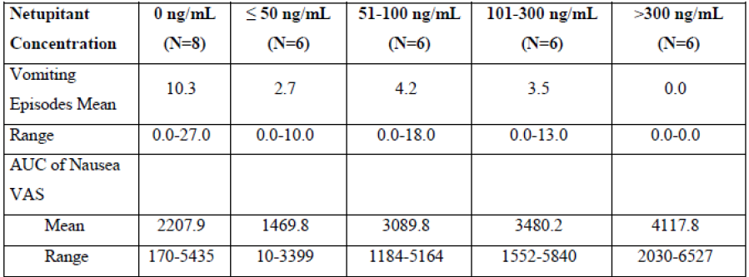

NK1-receptor occupancy
As netupitant acts directly at NK1 receptors, Study NETU-06-08 investigated the dose of netupitant that provided at least 90% NK1 receptor occupancy, as determined by a PET brain scan. In this study, healthy males were administered the radioactive NK1 receptor binding selective tracer ¹¹C-GR205171 as an IV bolus injection at baseline and at 6, 24, 48, 72 and 96 hours following administration of netupitant at doses of 100, 300 or 450 mg. Each administration of tracer was accompanied by a 60 min PET scan. Overall, the results indicate that netupitant is a potent selective NK1 receptor antagonist that blocks NK1 receptors in the human brain for a relatively long time. At 6 h post netupitant administration (that is near the approximate C_{max} for netupitant) NK1-receptor occupancy of 90% or higher was identified in the occipital cortex and frontal cortex for all investigated doses as well as for striatum (for 300 and 450 mg netupitant) and anterior cingulate (for 100 and 450 mg netupitant). NK1 receptor blockade following all 3 netupitant doses declined slowly in most brain regions until 96 h post dose in a dose dependent fashion. At 96 h following dosing with 100 mg netupitant, NK1 receptor occupancy was over 70% in 4 of the 6 brain regions, whereas, 96 h following the 450 mg dose of netupitant, 5 of the 6 regions had a mean NK1 receptor occupancy of near to 80% or higher.

Secondary pharmacodynamic effects

Thorough Qt
Study NETU-07-20 investigated QT interval following administration of netupitant in combination with palonosetron, 400 mg moxifloxacin or placebo to healthy subjects. Two dose levels of the netupitant/palonosetron combination were examined in this study, which contained 200 mg/0.5 mg and 600 mg/1.5 mg netupitant and palonosetron, respectively. The results demonstrated, that when compared to placebo, administration of netupitant in combination with palonosetron had no effect on AV conduction or cardiac depolarisation as measured by the PR and QRS interval durations, whereas, there was a non-dose related reduction in heart rate of approximately 4 bpm. The QT interval increased by approximately 9.0 ms following both doses of the netupitant/palonosetron combination; however, when corrected for heart rate, in contrast to moxifloxacin, the effect of netupitant/palonosetron on QTcI, QTcB and QTcF was negligible).

Mood and sedation
One of the objectives of Study NP16603 was to assess whether netupitant affected cognitive function and mood. Healthy males administered 450 mg netupitant demonstrated a reduction in performance of two tasks (digit vigilance and numeric working memory) and a lowering of self-rated alertness were observed at around 8 h post-dose. However, these results were largely due to two specific subjects: subject 26 showed several large declines in numeric working memory, and effects on the Vigilance task and to Self-rated Alertness were due to subject 29. The second was a general impairment to word recall and recognition. No clear dose response relationship was detected, however, this may be due to the small number of subjects per group (N = 4).
Comment: One of the TEAEs of special interest that was identified in the pivotal study and was assessed by the investigator as being possibly related to study drugs was mood alteration during Cycle 2. This TEAE was of moderate intensity and resolved after 13 days with no specific therapy. In addition, Study NP16603 identified 2 out of 4 subjects who experienced decreased vigilance, alertness and memory impairment. Therefore, can the sponsor please provide a summary of all the data related to the central effects of the FDC on alertness, mood and memory?

Time course of pharmacodynamic effects
Study NETU-06-08 demonstrated that following administration of 100 mg, 300 mg or 450 mg of netupitant, NK1-receptor occupancy in various regions of the brain was maximal at approximately 6 hours following dosing. Netupitant receptor occupancy slowly decreased up until 96 hours following dosing and ranged from 48.5 to 85.5%, 76 to 94.0% and 82.5 to 96.5% for the 100 mg, 300 mg and 450 mg doses, respectively.
Comment: As mentioned previously, these results indicate that enhanced efficacy would be achieved if the FDC was given earlier than one hour prior to chemotherapy as proposed in the current PI.

Relationship between drug concentration and pharmacodynamic effects
Study NP16602 indicated that the incidence of vomiting decreased as netupitant levels increased (Table 3). Results of the PET Study, NETU-06-08 suggested that although there was a clear relationship between the degree of NK1 receptor occupancy in striatum and plasma concentrations of netupitant (Figure 1), overall there was only a small trend in NK1-receptor occupancy as the dose of netupitant increased. The PPK Study, NETU-10-02 concluded that there did not appear to be any overt relationship or trend between exposure parameters for netupitant (and its metabolites) and the safety and efficacy parameters studied.
Figure 1. Relationship between plasma concentrations of netupitant (log transformed values) and Striatal NK1-ROs at 6.24.48.72 and 96 h after oral administration of 100, 300 and 450 mg of netupitant
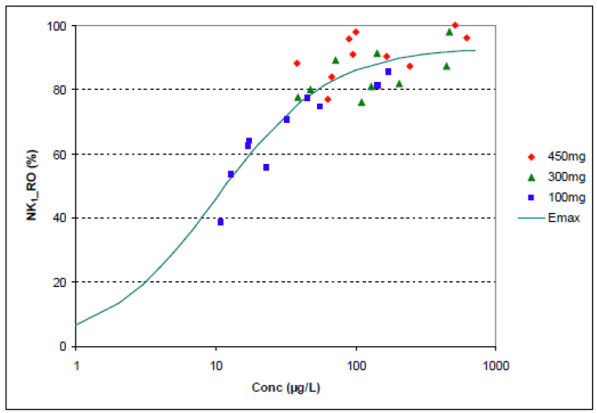

Genetic, gender and age related differences in pharmacodynamic response
The effects of gender on PDs have not been examined.

Pharmacodynamic interactions
PD interactions between the FDC and other drugs have not been examined.

Evaluator’s overall conclusions on pharmacodynamics

Mechanism of action
Netupitant is a NK1 receptor antagonist and therefore blocks the action of emetogens at the NK1-receptor. Palonosetron is a registered 5-HT₃receptor antagonist.

Primary pharmacodynamic effects
At plasma netupitant concentrations of > 50 ng/mL there was an inverse relationship between plasma netupitant concentration and the incidence of vomiting. Retching was also reduced in subjects treated with netupitant; however, there was no observable trend between concentration groups. By contrast, nausea tended to increase with netupitant concentration to levels above that seen in placebo treated subjects.
Netupitant is a potent selective NK1 receptor antagonist that blocks NK1 receptors in the human brain for a relatively long time. At 6 h post administration of 100, 300 or 450 mg netupitant, netupitant related NK1-receptor occupancy of ≥ 90% was identified in the occipital cortex and frontal cortex, as well as for striatum (for 300 and 450 mg netupitant) and anterior cingulate (for 100 and 450 mg netupitant).

Secondary pharmacodynamic effects
Administration of netupitant in combination with palonosetron, in contrast to moxifloxacin, had little to no effect on heart rate corrected QT interval. Healthy males administered 450 mg netupitant demonstrated a reduction in performance of two tasks (digit vigilance and numeric working memory) and a lowering of self-rated alertness were observed at around 8 h post dose.

Time course of pharmacodynamic effects
Following administration of 100 mg, 300 mg or 450 mg of netupitant, NK1 receptor occupancy in various regions of the brain was maximal at approximately 6 hours following dosing. Netupitant receptor occupancy slowly decreased up until 96 hours following dosing and ranged from 48.5 to 85.5%, 76 to 94.0% and 82.5 to 96.5% for the 100 mg, 300 mg and 450 mg doses, respectively.
Comment: Please see previous evaluator comment.

Relationship between drug concentration and pharmacodynamic effects
The incidence of vomiting decreased as netupitant levels increased. Although there was a clear relationship between the degree of NK1 receptor occupancy in striatum and plasma concentrations of netupitant, overall there was only a small trend in NK1-receptor occupancy as the dose of netupitant increased. The PPK study concluded that there did not appear to be any overt relationship or trend between exposure parameters for netupitant (and its metabolites) and the safety and efficacy parameters studied.

Limitations of PD studies
The effects of gender on PDs have not been examined.
PD interactions between the FDC and other drugs have not been examined.
The PK/PD data suggests that earlier treatment with the FDC than that proposed may result in enhanced anti-emetic effectiveness and the absence of PD data examining administration of the FDC at a range of times prior to chemotherapy is a limitation of this application.

Dosage selection for the pivotal studies
The FDC formulation comprises of oral palonosetron 0.50 mg and oral netupitant 300 mg. The dose selection of palonosetron was based mainly on the dose finding Phase III Study PALO-03-13, which tested oral palonosetron doses of 0.25 mg, 0.50 mg and 0.75 mg. According to the sponsor, the selection of palonosetron dose range to be tested in this Phase III study was based mainly on results from two Phase II oral and IV dose response studies (Studies 2332 and 2330). Results of Study 2332 indicated that a plateau in palonosetron efficacy was observed starting at 10µg/kg (corresponding to a fixed dose of approximately 0.75 mg). The complete response of the lowest oral palonosetron dose (0.3 to 1 µg/kg) was higher and the response of the 3 µg/kg (corresponding to a fixed dose of approximately 0.25 mg) was lower than expected. Results of Study 2330 showed that the minimal effective dose in preventing CINV was 3 µg/kg. Based on these data, oral palonosetron 0.25 mg, 0.50 mg and 0.75 mg were selected to be tested in the dose finding Study PALO-03-13, conducted from 2005 to 2006, assessing efficacy in a single cycle of MEC. In addition, an open label, uncontrolled Study PALO-03-14, was conducted concurrently with PALO-03-14 to assess the safety (primary objective) and the efficacy of a single oral dose of palonosetron in the prevention of CINV in repeated and consecutive MEC cycles, and the 0.75 mg oral dose was chosen for this study to represent the highest oral dose tested in PALO-03-13.
Results for Study PALO-03-13 showed that all 3 oral palonosetron doses (0.25 mg, 0.50 mg and 0.75 mg) were found to be non-inferior to IV palonosetron 0.25 mg (currently approved formulation in Australia for prevention of nausea and vomiting induced by cytotoxic chemotherapy) in preventing MEC induced nausea and vomiting with regards to the primary efficacy endpoint of the proportion of patients with complete response during the first 24 hours after the administration of chemotherapeutic agent (that is acute phase). Although analyses of secondary efficacy endpoints did not reveal any clear differences between the 3 oral doses and the IV palonosetron dose, a comparison of the 3 oral dose groups indicated that the oral palonosetron 0.50 mg and 0.75 mg doses tended to show higher anti-emetic efficacy than the oral palonosetron 0.25 mg dose. Safety analyses did not raise any safety concerns for all 3 doses. Based on the study results, the sponsor concluded that palonosetron 0.50 mg was the lowest effective oral palonosetron dose in the prevention of CINV following MEC chemotherapy. Results for Study PALO-03-14 showed that oral palonosetron 0.75 mg administered in repeated (up to a maximum of four) consecutives cycles of chemotherapy showed continued efficacy for the prevention of MEC induced nausea and vomiting, and did not trigger any safety concerns. Based on the results of these studies and the fact that oral palonosetron 0.50 mg has been approved in the US and EU for the treatment of MEC induced nausea and vomiting, oral palonosetron 0.50 mg was chosen to be the palonosetron dose for the netupitant/palonosetron FDC.
As oral palonosetron 0.50 mg is not registered for the prevention of nausea and vomiting induced by HEC, and as its efficacy in HEC had only been explored in a Phase II study, Study PALO-10-01 was later conducted from 2011 to 2012 to support the efficacy of oral palonosetron 0.50 mg in the prevention of HEC induced nausea and vomiting in comparison to IV palonosetron 0.25 mg, focusing on the 0 to 24 hour period (that is acute phase). Results supported the choice of palonosetron 0.50 mg for the FDC. Analyses of the primary efficacy outcome showed non-inferiority of oral palonosetron 0.50 mg compared with IV palonosetron 0.25 mg in terms of complete response rate in the acute phase. There was also no statistically significant difference (that is comparable efficacy) between the 2 treatment groups with regards to complete response rate in the delayed (24 to 120 hour interval) and overall (0 to 120 hour interval) phases as well as the other study secondary efficacy endpoints in all 3 phases (acute, delayed and overall).
The dose selection of netupitant for the FDC was based mainly on the dose finding Phase II Study NETU-07-07, which tested 3 different single oral doses of netupitant (100 mg, 200 mg and 300 mg) or placebo, each combined with a fixed oral dose of palonosetron (0.50 mg) and given with oral dexamethasone prior to HEC. The selection of the dose range to be tested in this study was based on earlier pre-clinical studies which evaluated the clinical pharmacology of netupitant using an apomorphine challenge model (NP16602) and a NK1 receptor binding assay Study (NETU-06-08). The results of these 2 studies suggested that the therapeutic dose in humans was likely to be in the 100 to 300 mg dose range. Results of Study NETU-07-07 showed that there was a statistically significant treatment difference between the netupitant 300 mg plus palonosetron 0.50 mg group and the palonosetron 0.50 mg alone group in the percentage of patients with complete response in the acute phase (0 to 24 hour interval; treatment difference of 8.8%, in favour of netupitant 300 mg), while the treatment differences from the palonosetron alone group were not statistically significant for the netupitant 100 mg and netupitant 200 mg groups. Complete response rates in the delayed phase (24 to 120 hour interval) and the overall phase (0 to 120 hour) were comparable among the 3 netupitant doses and were statistically significantly higher for all 3 doses compared to palonosetron alone. Statistical analyses comparing the 3 netupitant doses to one another showed that netupitant 300 mg was statistically significantly superior to both lower doses (100 mg and 200 mg) for endpoints of complete response, no emesis and complete protection10 in the acute phase. Netupitant 300 mg was also found to be statistically significantly superior to netupitant 100 mg for the endpoint of proportion of patients with no significant nausea in the overall and delayed phase). Safety analyses did not raise any safety concerns for the administration of palonosetron combined with netupitant at doses of 100 mg, 200 mg or 300 mg. Based on the efficacy and safety results of this Phase II dose ranging study, the dose of oral netupitant to be used in combination with 0.50 mg oral palonosetron for the FDC was identified to be 300 mg.
Comment: The rationale for the selection of the palonosetron and netupitant doses for the FDC formulation is sound.

Clinical efficacy
For the indication of prevention of acute and delayed nausea and vomiting associated with initial and repeat courses of MEC and HEC.

Pivotal efficacy study

Study NETU-08-18

Study design, objectives, locations and dates
Study NETU-08-18 was a Phase III multi centre, randomised, double blind, double dummy, active controlled, parallel group study assessing the efficacy and safety of a single oral dose of a fixed dose combination of netupitant/palonosetron (300 mg/0.50 mg) compared to oral palonosetron 0.50 mg, for the prevention of nausea and vomiting in cancer patients receiving moderately emetogenic chemotherapy.
The primary objective of the study was to compare the efficacy of a single oral dose of a FDC of netupitant/palonosetron (300 mg/0.50 mg) and oral dexamethasone versus oral palonosetron 0.50 mg with oral dexamethasone in terms of complete response in the delayed phase (> 24 to ≤ 120 hours) at Cycle 1 of a MEC regimen. Secondary objectives included the comparison of the efficacy, safety and tolerability of a single oral dose of a FDC of netupitant/palonosetron (300 mg/0.50 mg) and oral dexamethasone versus oral palonosetron 0.50 mg and oral dexamethasone for the prevention of MEC induced nausea and vomiting in initial and repeat cycles. Study NETU-08-18 was a multi-centre study where subjects were enrolled in a total of 177 study sites in 15 countries. The study start date (date of first enrolment) was 21 April 2011, and study end date was 06 November 2012.
Eligible patients were randomised in a 1:1 ratio to receive either oral netupitant/palonosetron (300 mg/0.50 mg) FDC with oral dexamethasone 12 mg or oral palonosetron 0.50 mg with oral dexamethasone 20 mg preceding the administration of MEC on the first day of Cycle 1. After Cycle 1, patients could continue in a multiple cycle extension phase (that is they could participate in consecutive repeated chemotherapy cycles [at least 21 days apart from each other] as long as they continued to fulfil the inclusion/exclusion criteria). On Day 1 of each repeat cycle, the patients received the same study drugs as in Cycle 1. During Cycle 1, patients participated in the study for a maximum of 37 days (including a screening period of up to 14 days, one day of treatment, and a follow-up visit or a telephone call 21 ± 2 days after Day 1). In the multiple cycle extension, patients participated for a maximum of 30 days in each repeat cycle (including a screening period of up to 7 days, one day of treatment, and a follow-up visit or a telephone call 21 ± 2 days after Day 1) as shown in Figure 2.
Figure 2. Study design and plan. Study NETU-08-18
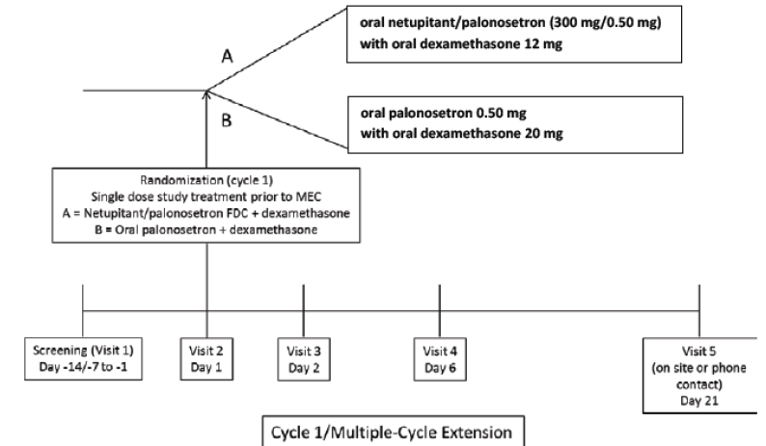

Inclusion and exclusion criteria
Subjects enrolled in the study were adult (≥ 18 years of age) chemotherapy naïve male or female patients scheduled to receive their first course of an anthracycline and cyclophosphamide MEC regimen for the treatment of a solid malignant tumour. Patients were required to have an Eastern Cooperative Oncology Group (ECOG) performance status of 0, 1, or 2, and fulfil criteria indicating a hematologic and metabolic status adequate for receiving a MEC regimen. Female patients of childbearing potential were required to have a negative pregnancy test within 24 hours prior to the first dose of study drugs on Day 1 and to practice an acceptable method of contraception during the study.
Patients could not participate in the study if they experienced vomiting, retching, or mild nausea within 24 hours prior to Day 1, if they were currently using illicit drugs or abusing alcohol, were scheduled to receive any HEC from Day 1 to Day 5 or MEC from Day 2 to Day 5 following the allowed MEC regimen, received (within 1 week prior to Day 1) or were scheduled to receive (between Days 1 to 5 of Cycle 1) radiation therapy to the abdomen or pelvis, had symptomatic primary or metastatic central nervous system malignancy or any uncontrolled medical condition that, in the opinion of the investigator, could confound the results of the study or pose unwarranted risk in the administration of the study medications. Patients were also excluded if they had taken any medication with known or potential anti-emetic activity within 24 hours prior to Day 1 of Cycle 1.
For inclusion in the multiple cycle extension, participation had to be considered appropriate by the investigator and not pose unwarranted risk to the patient. In addition, the patient had to have demonstrated satisfactory study compliance in the preceding chemotherapy cycles and study procedures. Patients could enter the multiple cycle extension if they were scheduled to receive the same chemotherapy regimen as at Cycle 1 and if they had an adequate metabolic status. Patients could not participate in the multiple cycle extension if they had an active infection or uncontrolled disease except for malignancy, had started any restricted medications, or had vomiting, retching or mild nausea within 24 hours prior to Day 1.
A full list of inclusion and exclusion criteria is as follows.

Inclusion criteria
Patients were to have met all of the following criteria for inclusion in the study:
- Signed written informed consent.
- Male or female patient ≥ 18 years of age.
- Naïve to cytotoxic chemotherapy. Previous biological or hormonal therapy was permitted.
- Scheduled to receive first course of an anthracycline and cyclophosphamide containing MEC regimen for the treatment of a solid malignant tumour: cyclophosphamide IV (500 to 1500 mg/m²) and IV doxorubicin (≥ 40 mg/m²) or cyclophosphamide IV (500 to 1500 mg/m²) and I.V. epirubicin (≥ 60 mg/m²).
- If scheduled to receive chemotherapy agents of minimal to low emetogenic potential they could be given on any day.
- Eastern Cooperative Oncology Group (ECOG) Performance Status of 0, 1, or 2.
- Female patients of either:
- Non-childbearing potential (that is, physiologically incapable of becoming pregnant, including any female who is postmenopausal. For purposes of this study, postmenopausal was defined as 12 consecutive months of amenorrhea). In addition, postmenopausal definition had to be confirmed by consistent age and/or Follicle Stimulating Hormone (FSH) levels.
- Child bearing potential with a negative urine dipstick pregnancy test within 24 hours prior to the first dose of investigational product on Day 1 and with a commitment to consistent and correct use throughout the clinical study of one of the following contraceptive methods:
- whose male partner was sterile prior to the female patient’s entry into the study and is the sole sexual partner
- using double-barrier method of contraception consisting of spermicide with either condom or diaphragm, also if taking any oral contraceptive, for a period after the study to account for a potential drug interaction (minimum 4 weeks)
- with intrauterine device
- with complete abstinence from intercourse for 2 weeks before exposure to the investigational product and throughout the clinical study, and for a period after the trial to account for elimination of the drug (minimum of 21 days); should patients become sexually active during the period described above, they must have agreed to follow an acceptable method of birth control, as described above.
- Hematologic and metabolic status adequate for receiving a moderately emetogenic regimen and fulfilment of the following criteria:
- Total neutrophils ≥ 1500/mm³ (standard units: ≥ 1.5 x 10⁹/L)
- Platelets ≥ 100,000/ mm³ (standard units: ≥ 100.0 x 10⁹/L)
- Bilirubin ≤ 1.5 x Upper Limit of Normal (ULN)
- Liver enzymes:
- Without known liver metastases, Aspartate Aminotransferase (AST) and/or Alanine Aminotransferase (ALT) ≤ 2.5 x ULN
- With known liver metastases, AST and/or ALT ≤ 5.0 x ULN
- Serum creatinine ≤ 1.5 mg/dL (standard units: ≤ 132.6 µmol/L) or Creatinine Clearance (CrCl) ≥ 60 mL/min.
- Able to read, understand, follow the study procedure and complete patient diary.

Inclusion Criteria for Multiple-Cycle Extension
Patients must have met all of the following criteria for inclusion in each cycle of the multiple cycle extension:
- Participation in the study during the next cycle of chemotherapy was considered appropriate by the investigator and did not pose unwarranted risk to the patient.
- Satisfactory study compliance in the preceding cycle of chemotherapy and related study procedures.
- Scheduled to receive the same chemotherapy regimen as Cycle 1 as defined in Inclusion Criterion 4.
- Adequate hematologic and metabolic status as defined by Inclusion Criterion 8.

Exclusion Criteria
Patients who met any of the following exclusion criteria were not to be included in the study:
- If female, pregnant or lactating.
- Current use of illicit drugs or current evidence of alcohol abuse.
- Scheduled to receive any HEC from Day 1 to Day 5 or MEC from Day 2 to Day 5 following the allowed MEC regimen.
- Received or was scheduled to receive radiation therapy to the abdomen, or the pelvis within 1 week prior to Day 1 or between Days 1 to 5 in Cycle 1.
- Any vomiting, retching, or mild nausea (grade ≥ I as defined by National Cancer Institute) within 24 hours prior to Day 1.
- Symptomatic primary or metastatic CNS malignancy.
- Active peptic ulcer disease, gastrointestinal obstruction, increased intracranial pressure, hypercalcemia, an active infection or any uncontrolled medical condition (other than malignancy) that, in the opinion of the investigator, may have confounded the results of the study, represented another potential etiology for emesis and nausea (other than CINV) or posed unwarranted risk in administering the study drugs to the patient.
- Known hypersensitivity or contraindication to 5-HT₃receptor antagonists (for example, palonosetron, ondansetron, granisetron, dolasetron, tropisetron, ramosetron) or dexamethasone.
- Previously received an NK1 receptor antagonist (for example, aprepitant, casopitant).
- Participation in a clinical trial involving oral netupitant administered in combination with palonosetron.
- Any investigational drugs taken within 4 weeks prior to Day 1 of Cycle 1, and/or was scheduled to receive any investigational drug during the study.
- Systemic corticosteroid therapy at any dose within 72 hours prior to Day 1 of Cycle 1. However, topical and inhaled corticosteroids with a steroid dose of ≤ 10 mg of prednisone daily or its equivalent were permitted.
- Scheduled to receive bone marrow transplantation and/or stem cell rescue therapy.
- Any medication with known or potential antiemetic activity within 24 hours prior to Day 1 of Cycle 1, including:
- 5-HT₃receptor antagonists (for example. ondansetron, granisetron, dolasetron, tropisetron, ramosetron, palonosetron)
- benzamides (for example. metoclopramide, alizapride)
- phenothiazines (for example. prochlorperazine, promethazine, fluphenazine, perphenazine, thiethylperazine, chlorpromazine)
- benzodiazepines (except if the subject was receiving such medication for sleep or anxiety and had been on a stable dose for at least 7 days prior to Day 1)
- butyrophenones (for example. haloperidol, droperidol)
- anticholinergics (for example. scopolamine, with the exception of inhaled anticholinergics for respiratory disorders for example. ipratropium bromide)
- antihistamines (for example. cyclizine, hydroxyzine, diphenhydramine, chlorphenhyramine), except for prophylactic use for taxanes therapy
- domperidone
- mirtazapine
- olanzapine
- prescribed cannabinoids (for example. tetrahydrocannabinol or nabilone).
- Scheduled to receive any strong or moderate inhibitor of Cytochrome P450 (CYP)3A4 or its intake within 1 week prior to Day 1.
- Scheduled to receive any of the following CYP3A4 substrates: terfenadine, cisapride, astemizole, pimozide.
- Scheduled to receive any CYP3A4 inducer or its intake within 4 weeks prior to Day 1.
- History or predisposition to cardiac conduction abnormalities, except for incomplete right bundle branch block.
- History of risk factors for Torsade de Point (heart failure, hypokalemia, family history of long QT syndrome).
- Severe cardiovascular diseases, including myocardial infarction within 3 months prior to Day 1, unstable angina pectoris, significant valvular or pericardial disease, history of ventricular tachycardia, symptomatic congestive heart failure New York Heart Association (NYHA) class III to IV, and severe uncontrolled arterial hypertension.
- Any illness or condition that, in the opinion of the investigator, may have confounded the results of the study or posed unwarranted risk in administering the investigational product to the patient.
- Concurrent medical condition that would preclude administration of dexamethasone such as systemic fungal infection or uncontrolled diabetes.

Exclusion Criteria for Multiple-Cycle Extension
The following exclusion criteria were checked prior to inclusion in each cycle of the multiple-cycle extension:
- If female, pregnant or lactating, that is, positive urine dipstick pregnancy test within 24 hours prior to Day 1.
- Active infection or uncontrolled disease except for malignancy.
- Started any of the restricted medications.
- Any vomiting, retching, or mild nausea (grade ≥ I as defined by National Cancer Institute) within 24 hours prior to Day 1.
Comment: The inclusion and exclusion criteria were in line with recommendations on study population in the EMA guidelines on nonclinical and clinical development of medicinal products for the prevention of nausea and vomiting associated with chemotherapy. Overall, the inclusion and exclusion criteria aimed to recruit adult chemotherapy naïve patients scheduled to receive their first course of a MEC regimen for the treatment of a solid malignant tumour.

Study treatments
Patients were randomised in a 1:1 ratio to 1 of 2 treatments groups: oral netupitant/palonosetron (300 mg/0.50 mg) FDC with oral dexamethasone 12 mg, both given on Day 1, or oral palonosetron 0.50 mg with oral dexamethasone 20 mg, both given on Day 1. For each cycle, oral netupitant/palonosetron (and placebo for oral palonosetron) or oral palonosetron (and placebo for oral netupitant/palonosetron) were administered 60 minutes prior to the start of chemotherapy on Day 1 (that is a total of 2 capsules in each treatment group). Oral dexamethasone/placebo tablets were administered 30 minutes prior to the start of chemotherapy on Day 1 of each cycle (that is a total of 5 tablets in each treatment group).
Rescue medication for treatment of established, refractory or persistent nausea and vomiting was permitted during the study, but not as prevention or to increase the expected anti-emetic effects of the study medications. Investigators were provided with metoclopramide tablets as rescue medication to be given to patients on an as-needed basis. Investigators were authorised to use an alternative rescue medication based on his/her judgment. However, 5-HT₃or NK1 receptor antagonists were not to be used as rescue medication.
Comment: The study dose selection for the components of the test FDC drug is appropriate. According to the sponsor the dose of dexamethasone used was based on drug-drug interaction study results which showed that a clinically relevant increase in dexamethasone exposure occurred when it was administered with netupitant. Therefore, the standard dexamethasone regimen (20 mg) was reduced in the netupitant/palonosetron group (to 12 mg) to balance the dexamethasone exposure in both study groups.
The study design is generally consistent with the EMA guidelines on clinical development of fixed combination medicinal product. The study design involving an active control is appropriate and consistent with the recommendation of the EMA guidelines on nonclinical and clinical development of medicinal products for the prevention of nausea and vomiting associated with chemotherapy. The choice of active control of oral palonosetron 0.50 mg was appropriate. Although oral palonosetron is not currently approved in Australia, it has been approved in the US and in the EU for the treatment of MEC induced nausea and vomiting. The currently approved dose for this indication is one 0.50 mg palonosetron capsule administered orally approximately one hour prior to the start of chemotherapy.

Efficacy variables and outcomes
The primary efficacy endpoint was the proportion of patients with complete response (CR; defined as no emesis and no rescue medication) in the delayed phase (25 to 120 hours [that is > 24 to ≤ 120 hours after the start of the MEC administration]) at Cycle 1.
Key secondary efficacy endpoints were defined at Cycle 1 as the proportion of patients with CR during the acute phase (0 to 24 hours) and the proportion of patients with CR during the overall phase (0 to 120 hours). Other secondary efficacy endpoints were defined at Cycle 1 as the proportion of patients during the delayed, acute, and overall phases with: no emesis; no rescue medication; no significant nausea (Visual Analogue Scale [VAS] < 25 mm); no nausea (VAS < 5 mm); complete protection (no emesis, no rescue medication and no significant nausea [maximum nausea VAS < 25 mm]); total control (no emesis, no rescue medication and no nausea [maximum VAS < 5 mm]).
Other efficacy endpoints at Cycle 1 included the severity of nausea (defined as the maximum nausea on the VAS in the acute, delayed, and overall phases); time to first emetic episode, time to first rescue medication intake, and time to treatment failure (defined as the time to the first emetic episode or time to the first rescue medication intake, whichever occurred first); impact on patients’ daily life activities for the first 120 hours following the administration of MEC as assessed by the Functional Living Index-Emesis (FLIE) questionnaire.
Secondary efficacy endpoints evaluated during the multiple cycle extension were the proportion of patients with: CR during the delayed, acute, and overall phases following subsequent cycles of MEC; no significant nausea (VAS < 25 mm) during the delayed, acute, and overall phase following subsequent MEC cycles.
Each patient receiving study medication was asked to complete a patient diary designed to capture information about the frequency and duration of each experienced episode of retching or vomiting, as well as any rescue medications taken from the start of chemotherapy on Day 1 (0 hour) to Day 5 (120 hours) of every cycle. A VAS used for the assessment of the severity of nausea was also included in the diary.. The patient had to start completing the diary on Day 1 and maintain it for the next 5 days (that is until the morning of Day 6 [Visit 4]). An emetic episode was defined as one or more continuous vomits (expulsion of stomach contents through the mouth) or retches (an attempt to vomit that is not productive of stomach contents). Episodes separated from each other by a period of at least one minute were considered separate episodes.
Comment: Overall, the primary and secondary endpoints of the study are appropriate and consistent with the recommendations in the EMA guidelines on nonclinical and clinical development of medicinal products for the prevention of nausea and vomiting associated with chemotherapy, which stated that “due to the relevance of both vomiting and nausea, the percentage of patients with complete control (CC), meaning absence of emesis and nausea (or only mild) is a meaningful end point. No emesis and no use of rescue constitute an alternative and acceptable definition of response (R)”. The guidelines also stated that the Functional Living Index of Emesis is considered “an accepted questionnaire specifically designed to assess the impact of chemotherapy-induced nausea and vomiting on patients’ daily function and may provide meaningful supportive evidence of activity”. The time intervals used to define acute and delayed phases of CINV are also consistent with the above EMA guidelines.
The primary efficacy endpoint assessing CR in the delayed phase is consistent with the stated objective of the study. According to the sponsor, CR in the delayed phase was chosen to isolate and study the effect of netupitant within the FDC, as 5-HT₃receptor antagonists (for example. palonosetron) had been found to be mainly effective in the acute phase of CINV, while NK1 receptor antagonists (for example. netupitant) were expected to be mainly effective in the delayed phase. As the study involved a comparison of netupitant/palonosetron FDC versus the active comparator of palonosetron, which is expected to reduce acute phase CINV, the choice of CR in the delayed phase as a primary efficacy endpoint is appropriate. Overall, the study primary and secondary endpoints allowed evaluations of the effect of the FDC compared to palonosetron alone on various symptoms and combinations of symptoms of CINV (nausea, significant nausea, emesis, need for rescue medication, no emesis plus no rescue medication, no emesis plus no rescue medication plus no significant nausea, no emesis plus no rescue medication plus no nausea) in the acute, delayed and overall phases of CINV. Efficacy endpoints in the multiple cycle extension allowed evaluation of the persistence of anti-emetic effect of the FDC over repeated cycles of MEC.

Randomisation and blinding methods
Patients meeting the inclusion and exclusion criteria were randomised in a 1:1 ratio to 1 of 2 treatments groups: oral netupitant/palonosetron FDC with oral dexamethasone, or oral palonosetron with oral dexamethasone. Patients were assigned to treatment groups through a static central blocked randomisation scheme, stratified by region (US, Latin America including Mexico, Europe, Commonwealth of Independent States [that is former Soviet Republics], Asia) and age class (age < 55 years and age ≥ 55 years).
Two randomisation lists were prepared, one for each age class. For each region a different block of the relevant list was allocated (that is each time a new region started to randomise patients or each time a block for the relevant region was completed, the next unused block was attributed to that region). At Day 1 (Visit 2), after confirmation of patient eligibility, the Randomisation and Trial Supply Management system (accessed by Electronic Data Capture or Interactive Voice Response System [IVRS]) assigned the patient to the first free treatment in the relevant list and relevant block.
The study was double blind. In order to maintain study blinding, matching placebos were manufactured for each of the study drugs. The netupitant/palonosetron (300 mg/0.50 mg) FDC and its matching placebo were provided as hard gelatin capsules for oral administration, while palonosetron 0.50 mg and its matching placebo were provided as soft gelatin capsules for oral administration. Dexamethasone 4 mg and its matching placebo were provided as tablets for oral administration.

Analysis populations
The Full Analysis Set (FAS) was defined as all patients in Cycle 1 who were randomised to treatment and received a MEC regimen and the study drug. Following the Intent-To-Treat (ITT) principle, patients were analysed according to the treatment to which they had been randomised. The FAS was the main population for efficacy analyses, and was used for the primary and all other efficacy analyses.
The Per-Protocol (PP) population consisted of all patients included in the FAS who completed the 0 to 120 hours study period with no major protocol violations. The PP population was used for supportive primary and key secondary efficacy analyses. The ITT population consisted of all patients in Cycle 1 who were randomised to treatment. Following the ITT principle, patients were analysed according to the treatment to which they had been randomised. The ITT population was used for the primary efficacy endpoint sensitivity analysis. The safety population consisted of all patients in Cycle 1 who received at least one study drug and had at least one safety assessment after the treatment administration. Patients in the safety population were analysed according to the actual treatment received. The safety population was used for all safety analyses.
Two analysis populations were used for the multiple cycle extension. The FAS (multiple cycle extension) was defined as all patients who entered the multiple cycle extension and received a MEC regimen and the study drugs in the first cycle of the multiple cycle extension. Patients were analysed according to the treatment to which they had been randomised at Cycle 1. The FAS (multiple cycle extension) was used for efficacy analyses of the multiple cycle extension endpoints. The safety population (multiple cycle extension) consisted of all patients who entered the multiple cycle extension, received at least one study drug and had at least one safety assessment after the treatment administration. Patients were analysed according to the actual treatment they received. In cases where a patient received different treatments in different study cycles in error, he/she was to be included in the safety population for the treatment actually received at Cycle 1. For by cycle summaries, the patient was analysed in each cycle according to the actual treatment received. The safety population (multiple cycle extension) was used for all safety analyses of the multiple cycle extension.
Comment: The definitions of the analysis populations and the efficacy analyses on the FAS population are in keeping with the TGA adopted ICH E9 Statistical Principles for Clinical Trials. Although the FAS population excluded patients who took no study drug, the intent-to-treat principle would be preserved as the study was double blind, and the initial decision by patients of whether or not to begin treatment would not be influenced by knowledge of the assigned treatment, and hence the exclusion of these patients is not deemed to have introduced any potential bias.

Sample size
Sample size was calculated based on the assumption that the CR rate in the time interval 25 to 120 hours of Cycle 1 would be 60% in the netupitant/palonosetron FDC group and 51% in the palonosetron alone group. It was estimated that for a 2 sided test of difference using α = 0.050, a sample size of 661 evaluable patients per group was needed to ensure 90% power to detect the 9% difference. This number was increased to 730 patients per treatment group (that is a total of 1,460 patients in the study), to ensure an adequate number of evaluable patients.
With regards to the key secondary efficacy endpoints, it was estimated that this sample size of 1,460 patients would give the study a power of about 60% to detect a difference of 6% in the CR rate in the acute phase (assuming CR rates of 70% and 64% in the FDC and palonosetron alone groups, respectively). The power to detect a difference of 9% in terms of CR rates in the overall phase was close to 90%.

Statistical methods
The primary efficacy analysis was performed on the FAS using a 2 sided stratum adjusted Cochran Mantel Haenszel (CMH) test including treatment, age class and region as strata. All missing data were imputed as treatment failures, following the worst case principle. The null hypothesis of no difference between treatments was to be rejected, and the superiority of the FDC versus oral palonosetron demonstrated, if the 2 sided p value from the CMH test was less than or equal to 0.050 and in the right direction (that is the odds ratio [or] was in favour of the FDC).
A supportive PP analysis imputing all missing data as treatment failures was performed on the primary efficacy endpoint. Additional sensitivity analyses of the primary endpoint were also performed to challenge the robustness of the study: analysis of the primary endpoint on the ITT population (all missing data were imputed as treatment failures; patients who did not receive the chemotherapy [that is emetogenic stimulus] were to be conservatively considered as treatment failures) and on complete cases (that is by excluding patients with missing or non-completed diaries [who had been considered as treatment failures in the primary efficacy analysis]).
Key and other secondary efficacy endpoints were analysed in the same way as the primary efficacy analysis. To avoid type I error inflation, a hierarchical approach to testing was used. Once the null hypothesis of no treatment difference for the primary efficacy endpoint was rejected (that is primary study objective was met), further confirmatory statistical tests were performed on the key secondary efficacy endpoints in the following order: CR in the acute phase, followed by CR in the overall phase (that is tested only if the FDC was found to be superior to oral palonosetron alone for CR in the acute phase). The other secondary efficacy endpoints (no emesis, no rescue medication intake, no nausea, no significant nausea, complete protection and total control) were grouped together into families by phase (delayed, acute, and overall). Each family was tested only if the FDC demonstrated superiority versus oral palonosetron alone for CR for that phase. Results of analyses for other efficacy endpoints were interpreted descriptively with nominal p values.

Participant flow
A total of 1,455 patients were randomised (726 to the FDC group and 729 to the palonosetron alone group), of whom 1,450 received study medication (724 in the FDC group and 726 in the palonosetron alone group) (Figure 3). Of the 1,455 randomised patients, 1,438 patients (98.8%) completed Cycle 1 and 1,286 patients (88.4%) were scheduled for treatment and treated in the multiple cycle extension. A total of 907 patients (62.3%) completed the multiple cycle extension. The maximum number of treatment cycles was 8, which was completed by 5 patients (0.3%).
Overall, 39 patients (2.7%) prematurely discontinued the study after randomisation and 498 (34.2%) completed a cycle but did not continue in further cycles. The most common reasons for discontinuation after randomisation or for not continuing in a subsequent cycle in the netupitant/palonosetron FDC and palonosetron alone groups were withdrawal of consent (9.0% [65 out of 726] and 5.8% [42 out of 729], respectively) and failure to meet inclusion/exclusion criteria for the multiple cycle extension (7.6% [55 out of 726] and 9.1% [66 out of 729], respectively). The majority of patients with reason for discontinuation categorised as “Other” consisted of patients who were discontinued due to study closure.
Figure 3. Disposition of subjects, Study NETU-08-18
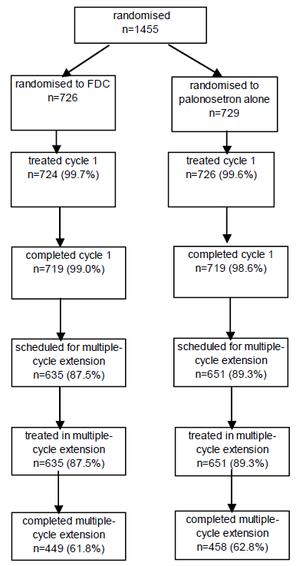
Analysis population datasets are summarised in Table 4.

Table 4 Analysis populations and reasons for exclusion – all randomised patients Study NETU-08-18
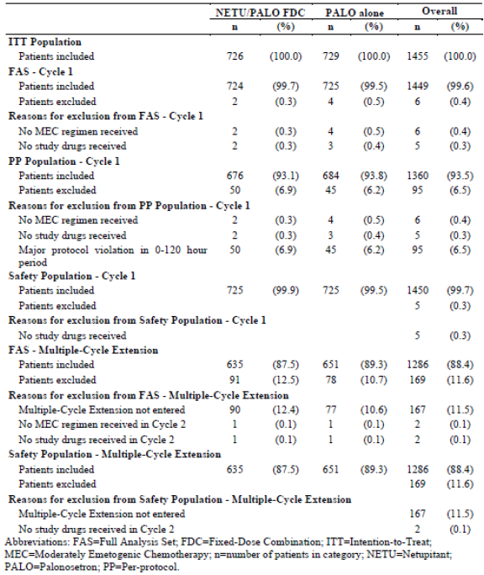

Major protocol violations/deviation
Frequency of major protocol deviations (that is violations affecting the primary efficacy endpoint and resulting in exclusion of the patient from the PP population), was comparable between treatment groups (6.6% and 5.7% in the FDC and the palonosetron alone groups, respectively).
Treatment compliance was measured by the amount of study medication taken. A patient was considered to be compliant with treatment if he/she took all study medication as determined by the randomised treatment group, and all additional study drugs (that is dexamethasone). Treatment compliance during Cycle 1 was high (100.0% and 99.6% in the FDC and the palonosetron alone groups, respectively). In the multiple cycle extension, treatment compliance remained high in both treatment groups.

Baseline data
For the Cycle 1 analyses, baseline demographic characteristics were comparable between treatment groups. The majority of patients in each treatment group were female (98.1% in both treatment groups) and White (79.2% and 79.9% in the FDC and the palonosetron alone groups, respectively). The mean (SD) age was 53.7 (10.66) and 54.1 (10.65) years, respectively. Baseline mean BMI was similar between treatment groups (mean [SD] BMI of 27.69 [5.804] and 27.77 [5.693], respectively). For the Cycle 1 analyses, baseline disease characteristics were also comparable between treatment groups, as were the chemotherapeutic agents administered in Cycle 1.
Baseline demographic characteristics for the multiple cycle extension safety population were similar to those of the Cycle 1 safety population and were comparable between treatment groups, as were the baseline disease characteristics.
Comment: Overall, the baseline demographic and disease characteristics were comparable between treatment groups. The study population was generally representative of the target population of patients. As the protocol specified chemotherapy regimen was mostly indicated for breast cancer, the study population comprising mainly of females was expected. Although the predominance of female patients in the study makes it difficult to extrapolate study results to male patients, the overall evaluation of the anti-emetic efficacy of the netupitant/palonosetron FDC would involve results from other efficacy/safety studies which included male patients. In addition, with regards to patient characteristics which can affect CINV, it has been clinically recognised that female patients are more prone to CINV compared to males.

Results for the primary efficacy outcome
The percentage of patients with CR over 25 to 120 hours after the start of MEC administration in Cycle 1 was statistically significantly higher in the netupitant/palonosetron FDC group compared to the palonosetron alone group (76.9% versus 69.5%, p = 0.001). Superiority of the netupitant/palonosetron FDC compared to palonosetron alone was demonstrated using a two sided CMH test with age class and region as strata (OR: 1.48, 95% confidence interval [CI]: 1.16 to 1.87; p = 0.001).

Results for other efficacy outcomes

Other analyses on the primary efficacy endpoint
Results of the analysis of the primary efficacy endpoint on the PP population yielded similar results as the primary efficacy outcome analysis.
Sensitivity analyses done on complete cases (that is by excluding patients with missing or incomplete diaries which were considered as failures in the primary analysis [20 patients excluded: 6 in the netupitant/palonosetron FDC group and 14 in the palonosetron alone group]), and on the ITT population supported the results of the primary efficacy outcome analysis. In the complete case analysis, the percentage of patients with CR over 25 to 120 hours after the start of MEC administration in Cycle 1 was 77.6% in the netupitant/palonosetron FDC group and 70.9% in the palonosetron alone group (OR: 1.44, 95% CI: 1.13 to 1.83; p = 0.003). In the ITT population analysis, the percentage of patients with CR over 25 to 120 hours after the start of MEC administration in Cycle 1 was 76.7% in the netupitant/palonosetron FDC group and 69.1% in the palonosetron group (OR: 1.48, 95% CI: 1.17 to 1.88; p = 0.001).

Key secondary efficacy endpoints
In the acute phase of Cycle 1, the percentage of patients with CR was statistically significantly higher in the netupitant/palonosetron FDC group compared to the palonosetron alone group (88.4% versus 85.0%, p = 0.047). As the superiority of netupitant/palonosetron FDC was demonstrated for the delayed phase (primary efficacy endpoint), the same test was carried out in the acute phase according to the pre-specified hierarchical testing procedure. Results showed that netupitant/palonosetron FDC was statistically superior to palonosetron alone for the endpoint of the proportion of patients achieving CR in the acute phase of Cycle 1 (CMH-Test; OR: 1.37, 95% CI: 1.00 to 1.87; p = 0.047).
In the overall phase of Cycle 1, the percentage of patients with CR was also statistically significantly higher in the netupitant/palonosetron FDC group compared to the palonosetron alone group (74.3% versus 66.6%, p = 0.001). As the superiority of netupitant/palonosetron FDC was demonstrated for the delayed and acute phases, the same test was carried out in the overall phase according to the pre-specified hierarchical testing procedure. Results showed that netupitant/palonosetron FDC was statistically superior to palonosetron alone for the endpoint of the proportion of patients achieving CR in the overall phase of Cycle 1 (CMH-Test; OR: 1.47, 95% CI: 1.17 to 1.85; p = 0.001).
In the supportive PP analysis for the acute phase, the difference in the percentage of patients with CR in the netupitant/palonosetron FDC group compared to the palonosetron group was not statistically significant (88.3% versus 85.5%; OR: 1.29, 95% CI: 0.93 to 1.78; p = 0.122). For the overall phase, the results in the PP population supported the results for the FAS analysis, showing that the percentage of patients with CR was statistically significantly higher in the netupitant/palonosetron FDC group compared to the palonosetron alone group (74.1% versus 67.1%; OR: 1.41, 95% CI: 1.11 to 1.7; p = 0.004).

Other secondary efficacy endpoints (Cycle 1)
In the delayed phase of Cycle 1, the percentage of patients with no emesis was statistically significantly higher in the netupitant/palonosetron FDC group compared to the palonosetron alone group (81.8% versus 75.6%; OR: 1.46, 95% CI: 1.13 to 1.89; p = 0.004). In the acute phase of Cycle 1, the percentage of patients with no emesis was also statistically significantly higher in the netupitant/palonosetron FDC group compared to the palonosetron alone group (90.9% versus 87.3%; OR: 1.47, 95% CI: 1.05 to 2.06; p = 0.025), as was that in the overall phase of Cycle 1 (79.8% versus 72.1%; OR: 1.55, 95% CI: 1.21 to 1.99; p < 0.001).
In the delayed phase of Cycle 1, the percentage of patients with no rescue medication was statistically significantly higher in the netupitant/palonosetron FDC group compared to the palonosetron alone group (85.8% versus 80.6%; OR: 1.47, 95% CI: 1.11 to 1.95; p = 0.007). However, in the acute phase of Cycle 1, the difference in the percentage of patients with no rescue medication in the netupitant/palonosetron FDC group compared to the palonosetron alone group was not statistically significant (93.5% versus 92.3%; OR: 1.21, 95% CI: 0.81 to 1.83; p = 0.350). In the overall phase of Cycle 1, the percentage of patients with no rescue medication was statistically significantly higher in the netupitant/palonosetron FDC group compared to the palonosetron alone group (84.0% versus 79.0%; OR: 1.41, 95% CI: 1.07 to 1.85; p = 0.014).
In the delayed phase of Cycle 1, the percentage of patients with no significant nausea (maximum value on VAS < 25 mm) was statistically significantly higher in the netupitant/palonosetron FDC group compared to the palonosetron alone group (76.9% versus 71.3%; OR: 1.35, 95% CI: 1.06 to 1.71; p = 0.014). However, in the acute phase of Cycle 1, the difference in the percentage of patients with no significant nausea in the netupitant/palonosetron FDC group compared to the palonosetron alone group was not statistically significant (87.3% versus 87.9%; OR: 0.95, 95% CI: 0.69 to 1.30; p = 0.747). In the overall phase of Cycle 1, the percentage of patients with no significant nausea was statistically significantly higher in the netupitant/palonosetron FDC group compared to the palonosetron alone group (74.6% versus 69.1%; OR: 1.32, 95% CI: 1.04 to 1.66; p = 0.020).
The difference in the percentage of patients with no nausea (maximum value on VAS < 5 mm) in the netupitant/palonosetron FDC group compared to the palonosetron alone group was not statistically significant in the delayed phase (53.3% versus 49.5%; OR: 1.16, 95% CI: 0.95 to 1.43; p = 0.149), acute phase (70.4% versus 70.1%; OR: 1.02, 95% CI: 0.81 to 1.28; p = 0.861) and the overall phase (50.3% versus 47.2%; OR: 1.13, 95% CI: 0.92 to 1.39; p = 0.238) of Cycle 1.
In the delayed phase of Cycle 1, the percentage of patients with complete protection (no emesis, no rescue medication and no significant nausea [maximum nausea VAS < 25 mm]) was statistically significantly higher in the netupitant/palonosetron FDC group compared to the palonosetron alone group (67.3% versus 60.3%; OR: 1.36, 95% CI: 1.10 to 1.69; p = 0.005). However, in the acute phase of Cycle 1, the difference in the percentage of patients with complete protection in the netupitant/palonosetron FDC group compared to the palonosetron alone group was not statistically significant (82.2% versus 81.1%; OR: 1.09, 95% CI: 0.83 to 1.43; p = 0.528). In the overall phase of Cycle 1, the percentage of patients with complete protection was statistically significantly higher in the netupitant/palonosetron FDC group compared to the palonosetron alone group (63.8% versus 57.9%; OR: 1.29, 95% CI: 1.04 to 1.60; p = 0.020).
The difference in the percentage of patients with total control (no emesis, no rescue medication and no nausea [maximum VAS < 5 mm]) in the netupitant/palonosetron FDC group compared to the palonosetron alone group was not statistically significant in the delayed phase (51.5% versus 46.9%; OR: 1.20, 95% CI: 0.98 to 1.48; p = 0.077), acute phase (68.6% versus 67.9%; OR: 1.04, 95% CI: 0.83 to 1.30; p = 0.730) and the overall phase (48.3% versus 44.0%; OR: 1.19, 95% CI: 0.97 to 1.47; p = 0.095) of Cycle 1.

Other efficacy endpoints (Cycle 1)
The mean maximum severity of nausea on the VAS was statistically significantly lower in the netupitant/palonosetron FDC group than the palonosetron alone group during the delayed phase of Cycle 1 (treatment difference of -4.2, p = 0.032). The difference between the treatment groups was not statistically significant in the acute phase (treatment difference of -0.5, p = 0.973) and overall phase (treatment difference of -4.3, p = 0.064) of Cycle 1.
The Kaplan-Meier plot for time to first emetic episode is shown in Figure 4. The time to first emetic episode in Cycle 1 was statistically significantly longer for netupitant/palonosetron FDC than for palonosetron alone (p < 0.001; p value from 2 sided log-rank test, stratified by age class and region).

Figure 4. Kaplan-Meier graph for time (hours) to first emetic episode in Cycle 1; full analysis set (Cycle 1) Study NETU-08-18
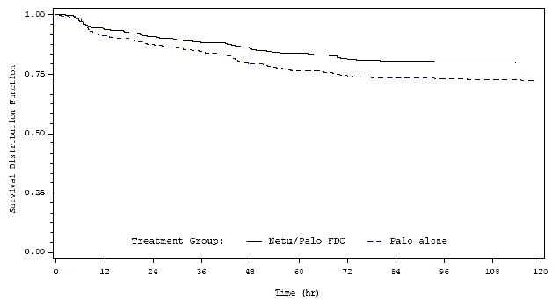
Abbreviations FDC = fixed dose combination; NETU = netupitant; PALO = palonosetron
The percentage of patients who used rescue medication at any time in Cycle 1 during the study was 16.0% in the netupitant/palonosetron group and 20.4% in the palonosetron alone group. The Kaplan-Meier plot for time to first administration of rescue medication was provided. The time to first administration of rescue medication in Cycle 1 was statistically significantly longer for netupitant/palonosetron FDC (p = 0.015; 2 sided log-rank test) than for palonosetron alone.
The Kaplan-Meier plot for time to treatment failure (defined as the time to the first emetic episode or the time to first use of rescue medication, whichever occurred first) was provided. The time to treatment failure in Cycle 1 was statistically significantly longer for netupitant/palonosetron FDC (p < 0.001; 2 sided log-rank test) than for palonosetron alone.
The number and percentage of patients with No Impact of Daily Life activities (NIDL) overall and for the nausea and vomiting domains of the FLIE questionnaire in Cycle 1 are summarised in Table 5. Overall, the percentage of patients with NIDL was statistically significantly higher in the netupitant/palonosetron FDC group compared to the palonosetron alone group (78.5% versus 72.1%; OR: 1.43, 95% CI: 1.12 to 1.83; p = 0.005). The percentage of patients with NIDL for the nausea domain was also statistically significantly higher in the netupitant/palonosetron FDC group compared to the palonosetron alone group (71.5% versus 65.8%; OR: 1.33, 95% CI: 1.06 to 1.67; p = 0.015), as was that for the vomiting domain (90.1% versus 84.4%; OR: 1.71, 95% CI: 1.24 to 2.37; p = 0.001).

Table 5. FLIE: no impact in daily life overall and for the nausea and vomiting domains in Cycle 1 – full analysis set (Cycle 1) Study NETU-08-18
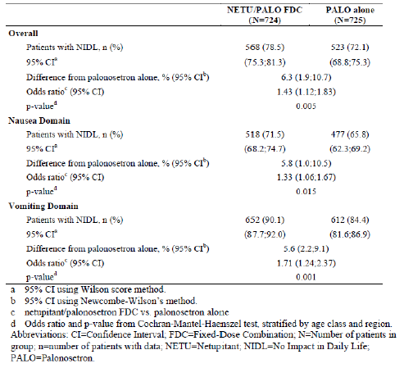

Efficacy endpoints in multiple cycle extension
The CR rate in the delayed, acute and overall phases of each cycle in the multiple cycle extension was provided. Results showed that the CR rates were higher for netupitant/palonosetron FDC than for palonosetron alone in each phase and each cycle up to Cycle 6, with treatment differences more pronounced in the delayed and overall phases. Only 6 and 5 patients performed Cycles 7 and 8, respectively, and all these patients were responders, and there was hence no difference observed between treatment groups in Cycles 7 and 8. During the delayed phase, the difference in response rate between netupitant/palonosetron and palonosetron alone groups ranged from 12.9% (95% CI: 8.2% to 17.5%) in Cycle 2 to 5.6% (95% CI: -1.3% to 12.6) in Cycle 6, while during the acute phase, the difference in response rate ranged from 7.8% (95% CI: 4.1% to 11.5%) in Cycle 3 to 3.0% (95% CI: -2.7% to 8.8%) in Cycle 5. During the overall phase, the difference in response rate between netupitant/palonosetron and palonosetron alone groups ranged from 13.6% (95% CI: 8.8% to 18.4%) in Cycle 2 to 5.2% (95% CI: -1.6% to 12.1%) in Cycle 5.
The number and percentage of patients with no significant nausea in each cycle of the multiple cycle extension is summarised in Table 6. Overall, the proportions of patients with no significant nausea were higher for the netupitant/palonosetron FDC than for palonosetron alone in each phase and each cycle up to Cycle 6, with treatment differences more pronounced in the delayed and overall phases. Only 6 and 5 patients performed Cycle 7 and 8, respectively, and all these patients were responders, and there was hence no difference observed between treatment groups in Cycles 7 and 8. During the delayed phase, the difference in response rate between netupitant/palonosetron and palonosetron alone groups ranged from 9.2% (95% CI: 2.2% to 16.2%) in Cycle 6 to 4.4% (95% CI: -0.4% to 9.0%) in Cycle 3, while during the acute phase, the difference in response rate ranged from 3.4% (95% CI: -2.4% to 9.2%) in Cycle 6 to 1.6% (95% CI: -2.0% to 5.1%) in Cycle 2. During the overall phase, the difference in response rate between netupitant/palonosetron and palonosetron alone groups ranged from 4.7% (95% CI: 0.1% to 9.4%) in Cycle 5 to 2.8% (95% CI: -1.5% to 7.1%) in Cycle 6.

Table 6. Number and percentage of patients with no significant nausea by cycle of the multiple-cycle extension – full analysis set (extension) Study NETU-08-18
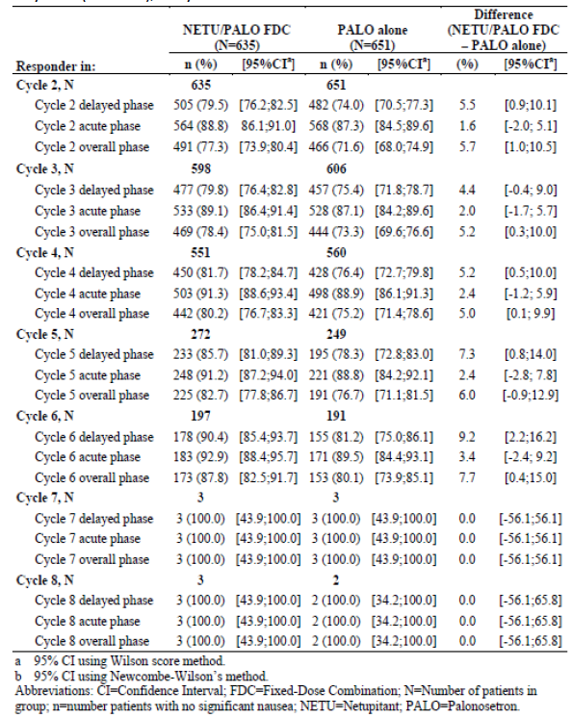

Subgroup analyses
Subgroup analyses in this study were considered exploratory, and were performed based on the stratification factors of age class and region. Subgroup analyses by age group on the primary efficacy endpoint showed that netupitant/palonosetron FDC had a higher CR rate in the delayed phase of Cycle 1 compared to palonosetron alone in both age groups (< 55 years and ≥ 55 years), with the treatment difference more pronounced in the younger patients. Within the netupitant/palonosetron FDC group, CR rates in the delayed phase of Cycle 1 were comparable between patients aged < 55 years (75.2%) and those aged ≥ 55 years (78.8%), but in the palonosetron alone group they were lower in patients aged < 55 years (62.4%) than in those aged ≥ 55 years (77.1%). Subgroup analyses by age group on the key secondary efficacy endpoints (that is CR rates in the acute and overall phases of Cycle 1) showed similar pattern. Subgroup analyses by region were constrained by small sample size in some regions, but results were generally consistent with the efficacy results in the overall population.

Study NETU-07-07
Study NETU-07-07 was a Phase II multi centre, randomised, double blind, double dummy, dose ranging, parallel group study to assess the effect of different doses of netupitant or placebo administered with palonosetron and dexamethasone on the prevention of HEC induced nausea and vomiting in cancer patients. The objective of the study was to compare the efficacy and safety of 3 single oral doses of netupitant (100 mg, 200 mg, and 300 mg) combined with palonosetron and dexamethasone to palonosetron and dexamethasone alone in the prevention of HEC induced nausea and vomiting. Study NETU-07-07 was a multi-centre study where subjects were enrolled in a total of 44 study sites in 2 countries.18. The study start date (date of first enrolment) was 04 February 2008, and study end date was 22 November 2008.
Subjects enrolled in the study were adult (≥ 18 years of age) chemotherapy naïve male or female patients with histologically or cytologically confirmed solid tumour malignancy and scheduled to receive the first course of highly emetogenic cisplatin-based chemotherapy regimen (dose of cisplatin ≥ 50 mg/m² to be administered over 1 to 4 hours on Day 1 alone or in combination with other chemotherapy agents). Patients were required to have a Karnofsky index ≥ 70%. Female patients of childbearing potential were required to have a negative pregnancy test at screening and to practice concurrently two reliable methods of contraception during the study. A full list of inclusion and exclusion criteria was provided.
Randomisation was stratified according to gender. Eligible patients were randomised in a 1:1:1:1:1 ratio to 1 of 5 treatment groups- Group 1: oral palonosetron 0.50 mg on Day 1 (with dexamethasone standard regimen: 20 mg on Day 1 and 8 mg twice daily [BD] from Days 2 to 4); Group 2: oral netupitant 100 mg and oral palonosetron 0.50 mg on Day 1 (with dexamethasone adjusted regimen: 12 mg on Day 1 and 8 mg daily from Days 2 to 4); Group 3: oral netupitant 200 mg and oral palonosetron 0.50 mg on Day 1 (with dexamethasone adjusted regimen: 12 mg on Day 1 and 8 mg daily from Days 2 to 4); Group 4: oral netupitant 300 mg and oral palonosetron 0.50 mg on Day 1 (with dexamethasone adjusted regimen: 12 mg on Day 1 and 8 mg daily from Days 2 to 4); Group 5: oral aprepitant 125 mg (on Day 1) and 80 mg daily (for the following two days) and IV ondansetron 32 mg on Day 1 (with dexamethasone adjusted regimen: 12 mg on Day 1 and 8 mg daily from Day 2 to Day 4). Patients remained on study for up to 22 days, including up to 7 days of screening period, 6 days on the study including 4 days on active treatment, and a follow-up visit or a telephone call 9 days after the end of the treatment period.
According to the sponsor, the doses of oral netupitant selected for this Phase II study were based on results of pre-clinical studies which suggested that the therapeutic dose in humans was likely to be in the 100 to 300 mg dose range (see Section 6). The 0.50 mg oral palonosetron dose used in this study was selected based on the results of Study PALO-03-13 which evaluated the non-inferiority of 3 oral palonosetron doses, 0.25 mg, 0.50 mg and 0.75 mg, as compared to IV palonosetron 0.25 mg for the prevention of CINV following MEC. The sponsor had stated that the treatment arm with aprepitant (a selective substance P/NK-1 receptor antagonist) administered with ondansetron (a selective 5-HT₃receptor antagonist) and dexamethasone was included for exploratory purposes only. The study dosing regimens of aprepitant and ondansetron were currently approved therapeutic dose regimens.
The study was double blind. To maintain study blinding, matching placebos were manufactured for each of the study drugs. Netupitant was provided as hard gelatin capsules for oral administration in strengths of 50 mg and 150 mg that were identical in appearance. Aprepitant was provided as hard gelatin capsules for oral administration in strengths of 125 mg and 80 mg that were identical in appearance. Netupitant capsules were identical in appearance to aprepitant capsules and therefore, the same placebo capsule matched both drugs. Palonosetron 0.50 mg and its matching placebo were provided as soft gelatin capsules for oral administration. Ondansetron 8 mg (2 mg/mL) was provided in ampoules for IV infusion. Placebo ampoules contained 4 mL of 0.9% sodium chloride. Dexamethasone 4 mg and its matching placebo were provided as tablets for oral administration.
The primary efficacy endpoint was the proportion of patients with complete response (CR; defined as no emesis and no rescue medications) during the overall phase (0 to 120 hours after the start of the HEC administration). Secondary efficacy endpoints included the proportion of patients with CR during the acute phase (0 to 24 hours) and delayed phase (25 to 120 hours), and the proportion of patients during the acute, delayed and overall phases with: no emesis; no rescue medications; no significant nausea (maximum VAS < 25 mm); no nausea (maximum VAS < 5 mm); complete protection (no emetic episode, no rescue medications and no significant nausea); total control (no emetic episode, no rescue medications and no nausea). Other secondary efficacy endpoints were the severity of nausea (measured by means of VAS for each 24 hour interval); time to first emetic episode, time to first rescue medications intake and time to treatment failure (defined as the time to the first emetic episode or time to the first rescue medications intake, whichever occurred first); patient global satisfaction with anti-emetic therapy by means of VAS for each 24 hour interval. Efficacy analyses were performed on the modified full analysis set (MFAS) population, which consisted of the full analysis set (FAS) population19 excluding patients randomised to the aprepitant treatment arm.
A total of 694 patients were randomised, of whom 679 patients (97.8%) received study medication, and 675 patients (97.3%) completed the study. Baseline demographic characteristics were comparable among treatment groups. The majority of patients in each treatment group were White (99.3% to 100.0%), and male (56.0% to 58.0% respectively). The median age was from 53.0 to 55.5 years. Baseline disease characteristics were also generally comparable among treatment groups.
Primary efficacy analyses results showed that the percentage of patients with CR over 0 to 120 hours after start of cisplatin administration was 87.4%, 87.6%, and 89.6% in the netupitant 100 mg, 200 mg, and 300 mg groups, respectively, compared with 76.5% in the palonosetron alone group (that is treatment differences from the palonosetron alone group of 10.9% to 13.2%). The treatment differences from the palonosetron alone group were statistically significant in favour of all 3 doses of netupitant (p ≤ 0.018).
Secondary efficacy analyses showed that in the acute phase, the percentage of patients with CR was 93.3%, 92.7%, and 98.5% in the netupitant 100 mg, 200 mg, and 300 mg groups, respectively, compared with 89.7% in the palonosetron alone group. There was a statistically significant treatment difference between the netupitant 300 mg group and the palonosetron alone group (treatment difference of 8.8%, in favour of netupitant 300 mg; p = 0.007). The treatment differences from the palonosetron alone group were not statistically significant for the netupitant 100 mg and netupitant 200 mg groups. In the delayed phase, the percentage of patients with CR was 90.4%, 91.2% and 90.4% in the netupitant 100 mg, 200 mg, and 300 mg groups, respectively; compared with 80.1% in the palonosetron alone group (that is treatment differences from the palonosetron alone group of 10.2% to 11.1%). The treatment differences from the palonosetron alone group were statistically significant in favour of all 3 doses of netupitant (p ≤ 0.018).
Analyses results of other secondary efficacy endpoints are presented in Table 7. Results showed that the treatment differences from the palonosetron alone group were mostly not statistically significant for the netupitant 100 mg group, and mostly statistically significant in favour of the netupitant 300 mg group (in particular for the delayed phase), with the netupitant 200 mg group showing intermediate efficacy. The results for the proportion of patients with no rescue medications were difficult to interpret due to the very small proportion of patients across all treatment groups who took rescue medication. The results for the proportion of patients with no nausea, with no significant nausea, or with total control suggested a dose response relationship in the delayed phase, particularly between the netupitant 100 mg group and the 2 higher dose groups (200 mg and 300 mg). Statistical analyses comparing the 3 netupitant doses to one another using logistic regression model showed that netupitant 300 mg had statistically significant differences over both lower doses (100 mg and 200 mg) for the endpoints of no emesis, complete response, and complete protection in the acute phase (p value < 0.050). Netupitant 300 mg was also found to be statistically significantly superior to netupitant 100 mg for the endpoint of proportion of patients with no significant nausea in the overall and delayed phases.

Table 7. Summary of secondary efficacy results: MFAS population Study NETU-07-07
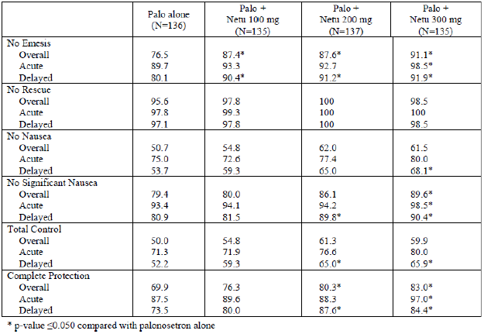
Log-rank test showed that the time to first emetic episode was statistically significantly longer for patients in all 3 netupitant groups compared to the palonosetron alone group (p ≤ 0.020). Differences between netupitant doses were not statistically significant. Analyses of time to first rescue medications intake did not yield meaningful results due to the very small number of patients across all treatment groups who took rescue medication. The results for the time to treatment failure were similar to the results for time to first emetic episode. The time to treatment failure was statistically significantly longer for patients in all three netupitant groups compared to the palonosetron alone group (p ≤ 0.020). Differences between netupitant doses were not statistically significant.
The sponsor conducted post-hoc analyses, per US FDA request in order to support using Study NETU-07-07 as a pivotal study for assessment of efficacy in the prevention of CINV after HEC. The additional analyses requested included analysis using CR in the delayed phase as primary efficacy endpoint (instead of CR in the overall phase), using Cochran-Mantel-Haenszel (CMH) test stratified for gender (instead of a logistic regression model with gender as covariate, which was used for the analyses per study protocol) and applying a hierarchical procedure to control Type I error inflation for the secondary efficacy variables. Results were consistent with those of the original study analyses.
In order to better investigate the netupitant efficacy profile versus the current standard of care, the sponsor also performed additional post-hoc analyses comparing the efficacy of the aprepitant regimen versus palonosetron alone and versus the selected netupitant dose of 300 mg. Results suggested similar efficacy between the netupitant 300 mg dose regimen (oral netupitant 300 mg plus oral palonosetron 0.50 mg) and the aprepitant regimen (oral aprepitant 125 mg [on Day 1] and 80 mg daily [for the following two days] and IV ondansetron 32 mg on Day 1) (Table 8).

Table 8. Efficacy comparisons for the aprepitant regimen versus palonosetron alone or netupitant 300 mg in the overall phase; FAS Population Study NETU-07-07
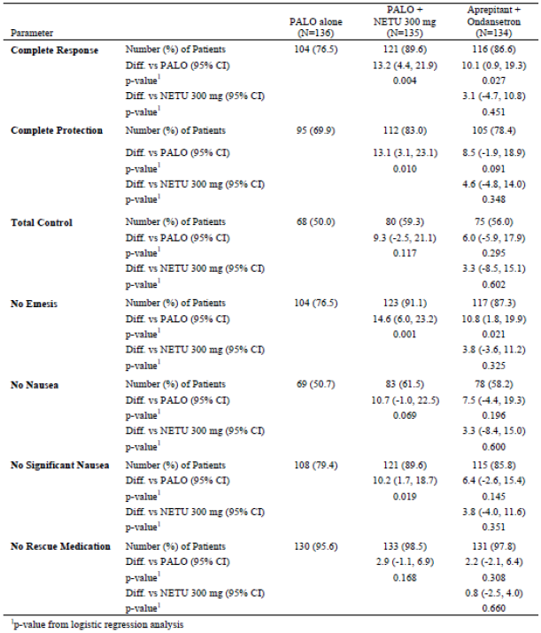
Subgroup analyses were performed for the primary efficacy endpoint for subgroups based on gender (male versus female) and country (Russia versus Ukraine). Results showed that CR rate in the overall phase was numerically higher for all 3 netupitant doses compared to palonosetron alone, for both male and female patients, although the treatment difference from palonosetron alone was smaller in male patients (treatment difference range of 7.6% to 11.5% across the 3 netupitant dose groups) than in female patients (range of 13.8% to 15.5%). Subgroup analyses based on country showed that CR rate in the overall phase was numerically higher for all 3 netupitant doses compared to palonosetron alone, in both Russia and Ukraine, although the treatment difference from palonosetron alone was smaller in Ukraine patients (range of 5.7% to 9.8% across the 3 netupitant dose groups) than in Russian patients (range of 11.9% to 15.2%).

Other efficacy studies

Study NETU-10-29
Study NETU-10-29 was a Phase III multi centre, randomised, double blind, double dummy, active controlled, unbalanced (3:1), parallel group study assessing the safety and describing the efficacy of a single oral dose of a FDC of netupitant and palonosetron (300 mg/0.50 mg) given with oral dexamethasone versus an anti-emetic regimen with aprepitant, palonosetron and dexamethasone prior to repeated cycles of HEC or MEC. The primary objective of the study was to assess the safety and tolerability of a single oral dose of a FDC of netupitant and palonosetron (300 mg/0.50 mg) in initial and repeated cycles of chemotherapy. The secondary objective was to describe the efficacy of a single oral dose of a FDC of netupitant and palonosetron (300 mg/0.50 mg) during the acute (0 to 24 hours), delayed (25 to 120 hours) and overall (0 to 120 hours) phases of initial and repeated cycles of chemotherapy. Study NETU-10-29 was a multi-centre study where subjects were enrolled in a total of 72 study sites in 10 countries. The study start date (date of first enrolment) was 20 July 2011, and study end date was 12 September 2012.
Subjects enrolled in the study were adult (≥ 18 years of age) chemotherapy naïve male or female patients scheduled to receive repeated consecutive courses of HEC or MEC for the treatment of a malignant tumour. Patients were required to have an ECOG performance status of 0, 1, or 2, and fulfil criteria indicating a haematologic and metabolic status adequate for receiving a chemotherapy regimen. Female patients of childbearing potential were required to have a negative pregnancy test within 24 hours prior to the first dose of study drug on Day 1 of each cycle and to practice an acceptable method of contraception during the study. A full list of inclusion and exclusion criteria were provided.
Randomisation was stratified according to chemotherapy emetogenicity (MEC, HEC) and gender (male, female). Patients were randomised in an unbalanced ratio (3:1) on Day 1 of their first chemotherapy cycle, before administration of MEC or HEC, to one of two treatment groups: oral netupitant/palonosetron FDC (300 mg/0.50 mg) and dexamethasone 12 mg on Day 1 of each cycle, followed by dexamethasone 8 mg on Days 2 to 4 (HEC patients only); oral aprepitant 125 mg, palonosetron 0.50 mg and dexamethasone 12 mg on Day 1 of each cycle, followed by aprepitant 80 mg on Days 2 to 3, and dexamethasone 8 mg on Days 2 to 4 (HEC patients only). There was no limit in the number of repeat consecutive cycles for each patient. Within patient changing of emetogenicity of their main chemotherapy during the study either from MEC to HEC or from HEC to MEC was allowed. The study was to be closed after the last patient enrolled had completed his/her last scheduled chemotherapy cycle. During each cycle, patients participated in the study for a maximum of 2 to 5 weeks according to chemotherapy schedule, including a screening period of up to 14 days, an evaluation period of 6 (+2) days of which 3 (if administered with MEC) to 4 days (if administered with HEC) were on active treatment, and a follow-up visit or a telephone call 14 (-3) to 21 (+2) days after Day 1, based on the schedule of the subsequent chemotherapy cycle (Figure 5).
Figure 5. Study design and plan Study NETU-10-29
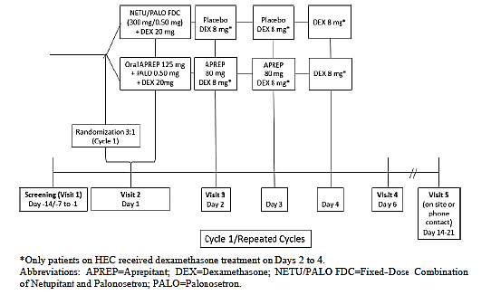
The study was double blind. To maintain study blinding, matching placebos were manufactured for each of the study drugs (netupitant/palonosetron FDC as hard gelatin capsules, aprepitant as hard gelatin capsules and palonosetron as soft gelatin capsules). Dexamethasone 4 mg was provided as tablets for oral administration. Oral dexamethasone administration was open label and identical in both treatment groups.
The assessment of efficacy was a secondary objective of the study, and only descriptive statistics were planned for the efficacy endpoints. Efficacy endpoints were the proportion of patients with complete response (CR; defined as no emesis and no rescue medication) during the delayed, acute, and overall phase, and the proportion of patients with no significant nausea (defined as maximum VAS value < 25 mm) during the delayed, acute, and overall phase. In this study, no formal comparison was planned with the randomised active control group. According to the sponsor, a concurrent active control group in the same patient population was included in the study to help interpret any unexpected safety finding in the FDC group.
Efficacy analyses were done on the Full Analysis Set (FAS), which was defined as all patients who were randomised to treatment and received the MEC or HEC regimen according to their schedule and the study treatment. Following the ITT principle, patients were analysed according to the treatment to which they had been randomised. Safety analyses were done on the safety population, which consisted of all patients who received at least one study treatment and had at least one safety assessment after the treatment administration. Patients were analysed according to the actual treatment received. In cases where a patient received different treatments in different study cycles in error, he/she was to be included in the safety population for the treatment actually received at Cycle 1. For by cycle summaries, the patient was analysed in each cycle according to the actual treatment.
A total of 413 patients were randomised (309 to the netupitant/palonosetron FDC group and 104 to the aprepitant + palonosetron group), of whom 412 received study medication (309 in the netupitant/palonosetron FDC group and 103 in the aprepitant + palonosetron group). Of the 412 patients who received study medication, 312 patients (75.7%) received MEC in Cycle 1 (234 patients [75.7%] in the netupitant/palonosetron FDC group and 78 patients [75.7%] in the aprepitant + palonosetron group), and 100 patients (24.3%) received HEC in Cycle 1 (75 patients [24.3%] in the netupitant/palonosetron FDC group and 25 patients [24.3%] in the aprepitant + palonosetron group).26. Of the 413 randomised patients, 405 patients (98.1%) completed Cycle 1 and 165 patients (40.0%) completed Cycle 6. The maximum number of treatment cycles was 14, which were completed by one (0.2%) patient.
Overall, 23 patients (5.6%) prematurely discontinued the study after randomisation and 154 (37.3%) completed a cycle but did not continue in further cycles. The most common reasons for discontinuation or for not continuing in a subsequent cycle, in the netupitant/palonosetron FDC and aprepitant + palonosetron groups, were “other” (70 [22.7%] and 28 [26.9%] patients, respectively), adverse events (19 [6.1%] and 12 [11.5%] patients, respectively) and withdrawal of consent (17 [5.5%] and 7 [6.7%] patients, respectively). The majority of patients with reason for discontinuation categorised as “Other” consisted of patients who discontinued due to study closure. Analysis population datasets are summarised in Figure 6.
Figure 6. Flowchart of analysis populations Study NETU-10-29
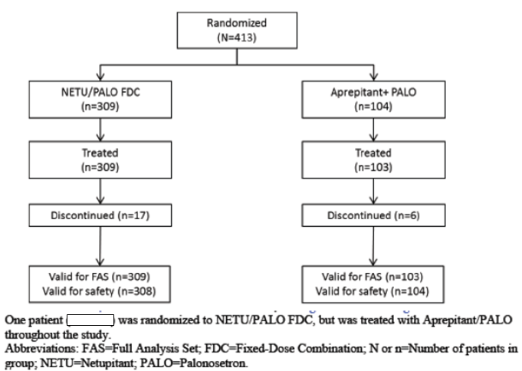

Baseline demographic characteristics were comparable between treatment groups. The majority of patients in each treatment group were White (83.8% and 83.7% in the netupitant/palonosetron FDC and aprepitant + palonosetron groups, respectively), and about half were females (50.3% and 49.0%, respectively). The mean (SD) age was 56.5 (10.44) and 56.9 (11.70) years, respectively. Baseline mean BMI was similar between treatment groups (mean [SD] BMI of 25.20 [5.508] and 24.57 [4.675], respectively). Baseline disease characteristics were also generally comparable between treatment groups.
According to the sponsor, as the number of patients who continued in the study after Cycle 6 (33 and 13 patients in the netupitant/palonosetron FDC and aprepitant + palonosetron groups, respectively) was too low to permit meaningful analysis, description of efficacy results was focussed on those for Cycles 1 to 6. The proportion of patients with CR in Cycle 1 were numerically higher for the netupitant/palonosetron FDC group than in the aprepitant + palonosetron group in the delayed phase (83.2% versus 77.7% [treatment difference of 5.5%], 95% CI: -2.8 to 15.2) and overall phase (80.6% versus 75.7% [treatment difference of 4.9%], 95% CI: -3.8 to 14.8), but comparable between treatment groups in the acute phase (92.9% versus 94.2% [treatment difference of -1.3%], 95% CI: -5.9 to 5.4). The proportion of patients with CR in Cycles 2 to 6 showed similar pattern, with CR rates being numerically higher for the netupitant/palonosetron FDC group compared to the aprepitant + palonosetron group in the delayed and overall phases.
The proportion of patients with no significant nausea in Cycle 1 were numerically higher for the netupitant/palonosetron FDC group than in the aprepitant + palonosetron group in the delayed phase (85.1% versus 81.6% [treatment difference of 3.6%], 95% CI: -4.1 to 12.8) and overall phases (84.1% versus 80.6% [treatment difference of 3.6%], 95% CI: -4.3 to 13.0), but numerically lower for the netupitant/palonosetron FDC group than in the aprepitant + palonosetron group in the acute phase (90.6% versus 93.2% [treatment difference of -2.6%], 95% CI: -7.7 to 4.5). The proportion of patients with no significant nausea in Cycles 2 to 6 showed similar pattern, with CR rates being numerically higher for the netupitant/palonosetron FDC group than the aprepitant + palonosetron group in the delayed and overall phases, except in Cycle 2 where the proportion of patients with no significant nausea was comparable between treatment groups in the delayed and overall phases.
Subgroup analyses in this study were considered exploratory, and were performed based on the stratification factors: chemotherapy emetogenicity and gender. Subgroup analyses by chemotherapy emetogenicity for the endpoint of complete response showed that percentages of patients with CR in the netupitant/palonosetron FDC group were generally comparable between MEC (81.7%, 93.2% and 79.6% for the delayed, acute and overall phases of Cycle 1, respectively) and HEC subgroups (87.8%, 91.9% and 83.8%, respectively). Analyses in Cycles 2 to 6 yielded similar results. In the MEC subgroup, the percentage of patients with CR was comparable between the 2 treatment groups (that is netupitant/palonosetron FDC versus aprepitant + palonosetron) in the delayed, acute and overall phases of Cycle 1. In the HEC subgroup, the percentage of patients with CR was higher in the netupitant/palonosetron FDC group compared to the aprepitant + palonosetron group in the delayed and overall phases of Cycle 1, but lower compared to the aprepitant + palonosetron group in the acute phase of Cycle 1. Analyses in Cycles 2 to 6 yielded similar results. Subgroup analyses by chemotherapy emetogenicity for the endpoint of no significant nausea showed that percentages of patients with no significant nausea in the netupitant/palonosetron FDC group were generally comparable between MEC (85.5%, 90.2% and 84.7% for the delayed, acute and overall phases of Cycle 1, respectively) and HEC subgroups (83.8%, 91.9% and 82.4%, respectively). Analyses in Cycles 2 to 6 yielded similar results. In the MEC subgroup, the percentage of patients with no significant nausea was comparable between the 2 treatment groups in the delayed and overall phases of Cycle 1 but lower compared to the aprepitant + palonosetron group in the acute phase of Cycle 1. In the HEC subgroup, the percentage of patients with no significant nausea was higher in the netupitant/palonosetron FDC group compared to the aprepitant + palonosetron group in the delayed, acute and overall phases of Cycle 1, but with greater treatment difference in the delayed and overall phases. Analyses in Cycles 2 to 6 yielded similar results.
Subgroup analyses by gender for the endpoint of complete response showed that percentages of patients with CR in the netupitant/palonosetron FDC group were generally comparable between male (85.7%, 94.2% and 82.5% for the delayed, acute and overall phases of Cycle 1, respectively) and female patients (80.6%, 91.6% and 78.7% respectively). Analyses in Cycles 2 to 6 yielded similar results. In both the male and female patient subgroups, the percentage of patients with CR was higher in the netupitant/palonosetron FDC group compared to the aprepitant + palonosetron group in the delayed and overall phases of Cycle 1, but comparable between treatment groups in the acute phase of Cycle 1. Subgroup analyses by gender for the endpoint of no significant nausea showed that percentages of patients with no significant nausea in the netupitant/palonosetron FDC group were generally comparable between male (82.5%, 87.7% and 81.8% for the delayed, acute and overall phases of Cycle 1, respectively) and female patients (87.7%, 93.5% and 86.5%, respectively). In the male patient subgroup, the percentage of patients with no significant nausea was comparable between the 2 treatment groups in the delayed and overall phases of Cycle 1 but lower compared to the aprepitant + palonosetron group in the acute phase of Cycle 1. In the female patient subgroup, the percentage of patients with no significant nausea was higher in the netupitant/palonosetron FDC group compared to the aprepitant + palonosetron group in the delayed and overall phases of Cycle 1, but comparable between treatment groups in the acute phase of Cycle 1. Analyses in Cycles 2 to 6 yielded similar results.
Comment: The choice of active control in this study was appropriate. Aprepitant is an NK1 receptor antagonist which is currently approved in Australia for the indication of: “in combination with other anti-emetic agents, is indicated for the prevention of acute and delayed nausea and vomiting associated with initial and repeat courses of:
- highly emetogenic cancer chemotherapy.
- moderately emetogenic cancer chemotherapy”
The currently approved recommended dose regimen for the 3 day oral regimen is aprepitant 125 mg orally 1 hour prior to chemotherapy treatment (Day 1) and 80 mg orally once daily in the morning on Days 2 and 3. The study dosing regimen for aprepitant is consistent with this currently approved recommended dose regimen.

Study PALO-10-01
Study PALO-10-01 was a Phase III multi centre, randomised, double blind, double dummy, parallel group study to assess the efficacy and safety of oral palonosetron 0.50 mg compared to intravenous (IV) palonosetron 0.25 mg for the prevention of chemotherapy induced nausea and vomiting in cancer patients receiving cisplatin based HEC. The primary objective of the study was to demonstrate the non-inferiority of single dose of oral palonosetron 0.50 mg versus single dose of IV palonosetron 0.25 mg in terms of percentage of patients with complete response (CR) during the acute phase (0 to 24 hours). Secondary objectives were to assess the efficacy of single dose oral palonosetron 0.50 mg versus single dose IV palonosetron 0.25 mg by the evaluation of other secondary efficacy variables during the acute phase (0 to 24 hours), to describe the efficacy during the delayed (25 to 120 hours) and overall (0 to 120 hours) phases, and to evaluate the safety and tolerability of oral palonosetron 0.50 mg versus IV palonosetron 0.25 mg for the prevention of HEC induced nausea and vomiting. Study PALO-10-01 was a multi-centre study where subjects were enrolled in a total of 80 study sites in 12 countries. The study start date (date of first enrolment) was 21 June 2011, and study end date was 14 November 2012.
Subjects enrolled in the study were adult (≥ 18 years of age) chemotherapy naïve male or female patients scheduled to receive their first course of a cytotoxic chemotherapy regimen with cisplatin (administered as a single IV dose of ≥ 70 mg/m² over 1 to 4 hours on study Day 1, either alone or in combination with other chemotherapeutic agents) for the treatment of a solid malignant tumour. Patients were required to have an ECOG performance status of 0, 1, or 2, and fulfil criteria indicating a haematologic and metabolic status adequate for receiving a chemotherapy regimen. Female patients of childbearing potential were required to have a negative pregnancy test within 24 hours prior to the first dose of study drug on Day 1 of each cycle and to practice an acceptable method of contraception during the study. A full list of inclusion and exclusion criteria was provided.
Randomisation was stratified according to gender (male, female) and region (United States, Latin America, Europe, Commonwealth of Independent States [that is former Soviet Republics] and Asia). Patients were randomised in a 1:1 ratio on Day 1 of their first chemotherapy cycle, before administration of HEC, to one of two treatment groups: oral palonosetron 0.50 mg and oral dexamethasone 20 mg both given on Day 1, followed by dexamethasone (8 mg) twice daily (BD) from Days 2 through 4; IV palonosetron 0.25 mg and oral dexamethasone 20 mg both given on Day 1, followed by dexamethasone (8 mg BD) from Days 2 through 4. Patients participated in the study for a maximum of 37 days (including a screening period of up to 14 days, 6 +2 days on study of which 4 days on active treatment, and a follow-up visit or a telephone call 21±2 days after Day 1).
The study was double blind. To maintain study blinding, matching placebos were manufactured for each of the study drugs (palonosetron 0.50 mg as soft gelatin capsules; palonosetron 0.25 mg as 5 mL vials for IV administration). Dexamethasone 4 mg was provided as tablets for oral administration. Oral dexamethasone administration was open label.
The primary efficacy endpoint was the proportion of patients with complete response (CR; defined as no emesis and no rescue medications) in the acute phase (that is within 24 hours after the start of the HEC administration on Day 1). Secondary efficacy endpoints included the proportion of patients with CR during the delayed and overall phase, and the proportion of patients during the acute, delayed and overall phase with: no emesis; no rescue medications; no significant nausea (maximum VAS < 25 mm); no nausea (maximum VAS < 5 mm); complete protection (no emetic episode, no rescue medications and no significant nausea); total control (no emetic episode, no rescue medications and no nausea). Other secondary efficacy endpoints were the severity of nausea (defined as the maximum nausea on the VAS in the acute, delayed and overall phase); time to first emetic episode, time to first rescue medications intake and time to treatment failure (defined as the time to the first emetic episode or time to the first rescue medications intake, whichever occurred first); impact on patients’ daily life activities in the acute and delayed phase following the administration of cisplatin as assessed by the FLIE questionnaire. Analyses for secondary efficacy endpoints were interpreted descriptively with nominal p values, and no test for non-inferiority was performed.
A total of 743 patients were randomised (371 to the oral palonosetron group and 372 to the IV palonosetron group), of whom 739 received study medication (370 in the oral palonosetron group and 369 in the IV palonosetron group). Of the 743 randomised patients, 710 patients (95.6%) completed the study (359 [96.8%] in the oral palonosetron group and 351 [94.4%] in the IV palonosetron group). The most common reason for discontinuation in both treatment groups was death, reported in 6 (1.6%) patients in the oral palonosetron group and 11 (3.0%) patients in the IV palonosetron group.
Baseline demographic characteristics were comparable between treatment groups). The majority of patients in each treatment group were White (86.8% and 86.7% in the oral palonosetron and the IV palonosetron groups, respectively), and male (59.2% and 58.8%, respectively). The mean (SD) age was 58.0 (9.41) and 57.7 (9.92) years, respectively. Baseline mean BMI was similar between treatment groups (mean [SD] BMI of 24.73 [5.272] and 24.76 [5.652], respectively). Baseline disease characteristics were also generally comparable between treatment groups.
Results of the primary efficacy outcome analysis showed non-inferiority of oral palonosetron 0.50 mg compared with IV palonosetron 0.25 mg in terms of CR in the acute phase. In the acute phase, 89.4% of patients in the oral palonosetron group and 86.2% of patients in the IV palonosetron group achieved CR (treatment difference of 3.21%, 99% CI: -2.74% to 9.17%; Full analysis set). Non-inferiority of oral palonosetron versus IV palonosetron was demonstrated since the lower limit of the two sided 99% CI for the difference in proportions was greater (that is closer to zero) than the pre-defined non-inferiority margin of -15%. Similar results were obtained in the PP population (treatment difference of 3.77%, 99% CI: -3.22% to 10.76%).
Analyses of the secondary endpoints showed no statistically significant difference (that is comparable efficacy) between the 2 treatment groups with regards to CR rate in the delayed and overall phases and the other secondary efficacy endpoints in all phases: proportion of patients with no emesis; proportion of patients with no rescue medication; proportion of patients with no nausea or no significant nausea; complete protection rate); total control rate; quality of life questionnaire (FLIE).
There was also no statistically significant difference between the oral palonosetron and IV palonosetron groups in time to first emetic episode (p = 0.307 from log-rank test;, time to first administration of rescue medications (p = 0.158 from log-rank test; and time to treatment failure (p = 0.199 from log-rank test).

PALO-03-13
Study PALO-03-13 was a single dose, multi-centre randomised, non-inferiority, double blind, double dummy, parallel group, active control study to assess the efficacy and safety of oral palonosetron 0.25 mg, 0.50 mg and 0.75 mg compared to IV palonosetron 0.25 mg for the prevention of MEC induced nausea and vomiting in cancer patients. The primary objective was to compare the effect of single doses of palonosetron 0.25 mg, 0.50 mg and 0.75 mg administered orally versus a single IV dose of palonosetron 0.25 mg on complete response (CR; defined as no emetic episode and no rescue medication) during 0 to 24 hours and > 24 to 120 hours after the start of MEC administration. Secondary objectives were to investigate the effect of study treatments on the efficacy by the evaluation of other secondary efficacy variables, and on safety. The study start date (date of first enrolment) was 21 June 2005, and study end date was 07 August 2006.
Subjects enrolled in the study were adult (≥ 18 years of age) male or female patients with histologically or cytologically confirmed malignant disease, who were naïve or non-naïve to cancer chemotherapy (if a patient was non-naïve, he/she had to have experienced no more than mild nausea and no vomiting following any previous chemotherapy cycle), had a Karnofsky index of ≥ 50%, and were scheduled to receive a single IV dose of at least one of the following agents administered on Day 1: any dose of oxaliplatin, carboplatin, epirubicin, idarubicin, doxorubicin, ifosfamide, irinotecan or daunorubicin or cyclophosphamide < 1500 mg/m² or cytarabine > 1 g/m². A full list of inclusion and exclusion criteria was provided.
Randomisation was stratified according to gender (male, female) and previous chemotherapeutic history (naïve or non-naïve). Eligible patients were randomised in a 1:1:1:1 ratio to one of four treatment groups: oral palonosetron 0.25 mg, 0.50 mg, 0.75 mg or IV palonosetron 0.25 mg. In each group half of the patients were randomised to receive 8 mg dexamethasone IV on Day 1, and the other half was randomised to receive placebo on Day 1. The palonosetron was given as a single dose, administered 60 minutes before the start of the first (most) emetogenic chemotherapeutic agent.
The primary efficacy endpoint was CR for the acute phase (that is 0 to 24 hour interval after the start of the administration of the first [most] emetogenic chemotherapeutic agent). Primary efficacy outcome was to assess non-inferiority in the primary efficacy endpoint between the oral palonosetron doses and the IV palonosetron dose. According to the statistical hypothesis of the study, non-inferiority of the oral palonosetron doses to the IV palonosetron dose would be demonstrated if the lower bound of the two sided 98.3% confidence interval of the difference in the percentage of patients with CR between each of the oral treatment groups and the IV treatment group was above the pre-set threshold of -15%. Key secondary efficacy endpoint was CR for the delayed phase (> 24 to 120 hour interval).
Other secondary efficacy variables included the proportion of patients with CR daily for the 24 to 120 hour interval (that is 24 to 48 hours, 48 to 72 hours, 72 to 96 hours and 96 to 120 hours), for cumulative time intervals (0 to 48 hours, 0 to 72 hours and 0 to 96 hours) and for the overall 0 to 120 hour interval; the proportion of patients with complete control (CC; defined as complete response and no more than mild nausea) daily and cumulative for the 0 to 120 hour interval, for the overall 0 to 120 hour interval and for the > 24 to 120 hour interval; the number of emetic episodes daily for the 0 to 120 hour interval and for the overall 0 to 120 hour interval; percentage of patients with/without nausea, percentage of patients with/without rescue medication, percentage of patients with/without emesis (daily for the 0 to 120 hour interval, the overall 0 to 120 hour interval, and for the > 24 to 120 hour interval); time to first emetic episode; time to first administration of rescue therapy; time to treatment failure (time to first emetic episode or to administration of rescue therapy, whichever occurred first); severity of nausea (using a 4 point Likert scale) daily for the 0 to 120 hour interval; patient global satisfaction with anti-emetic therapy (using VAS), daily for the 0 to 120 hour interval.
A total of 639 patients were randomised and treated (157, 161, 158 and 163 in the oral palonosetron 0.25 mg, 0.50 mg, 0.75 mg and IV palonosetron 0.25 mg groups, respectively). Of the 639 patients, 634 patients (99.2%) completed the study (155 [98.7%], 161 [100.0%], 157 [99.4%] and 161 [98.8%] in the oral palonosetron 0.25 mg, 0.50 mg, 0.75 mg and IV palonosetron 0.25 mg groups, respectively). Baseline demographic and disease characteristics were comparable among treatment groups. The majority of patients in each treatment group were White (67.1% to 70.7% across treatment groups), and female (71.5% to 74.5%). The mean age was from 55.9 to 57.7 years across treatment groups. Chemotherapeutic treatment administered on Day 1 was also comparable among treatment groups.
Primary efficacy endpoint analysis showed that the proportion of patients with CR during the first 24 hours after start of chemotherapy was comparable among all treatment groups (73.5%, 76.3% and 74.1% in the oral palonosetron 0.25 mg, 0.50 mg, 0.75 mg groups, respectively, versus 70.4% in the IV palonosetron group). As the lower bound of the two sided 98.3% confidence interval of the difference in the percentage of patients with CR between each of the oral treatment groups and the IV treatment group was above the pre-set threshold of -15%, non-inferiority of all 3 oral palonosetron doses to IV palonosetron was demonstrated. The equivalence of the 3 oral palonosetron doses to one another with reference to the proportion of patients with complete response during the first 24 hours in the FAS was analysed by using pairwise comparisons. Results showed that the lowest and intermediate oral palonosetron doses (0.25 mg and 0.50 mg) were both equivalent to the highest oral palonosetron dose (0.75 mg). However, the lowest oral dose was not equivalent to the intermediate oral dose (that is the lower limit of the 98.3% confidence interval for the difference in the percentage of complete responses between oral palonosetron 0.25 mg and 0.50 mg was not above the threshold of -15%).
Analysis of the key secondary efficacy variable showed that the proportion of patients with CR during the > 24 to 120 hour time interval was 59.4%, 62.5% and 60.1% in the oral palonosetron 0.25 mg, 0.50 mg, 0.75 mg groups, respectively, versus 65.4% in the IV palonosetron group. Statistical non-inferiority to IV palonosetron could not be shown (that is the lower bound of the confidence interval was not above -15%) for any of the three oral palonosetron doses during the 24 to 120 hour interval. However, the sponsor noted that the differences in CR rate between the IV and oral doses were small, especially that between the oral palonosetron 0.50 mg dose and the IV palonosetron (treatment difference of 2.9%), which was not considered clinically significant by experts in the field. Comparison of the 3 oral palonosetron doses to one another for the key secondary efficacy variable showed equivalence only between the oral 0.25 mg and the oral 0.75 mg dose.
Results for the analyses of the CR rate for the cumulative time intervals 0 to 48 hours, 0 to 72 hours, 0 to 96 hours, for the overall 0 to 120 hour time interval, and daily for the 24 to 120 hour time interval are presented in Tables 9 and 10. Non-inferiority to the IV palonosetron was shown for oral palonosetron 0.25 mg on Day 4 (72 to 96 hour interval) and Day 5 (96 to 120 hour interval), for oral palonosetron 0.50 mg during the 0 to 48, 0 to 72 and 0 to 120 hour intervals and on Day 5, and for oral palonosetron 0.75 mg during the 0 to 48 hour time period and on Day 2 (24 to 48 hour interval) and Day 5. The oral 0.50 mg palonosetron dose was therefore the only oral dose showing non-inferiority to IV palonosetron for the endpoint of CR during the overall phase (0 to 120 hour). Comparing the 3 oral dose groups, the highest CR rates tended to occur in the oral palonosetron 0.50 mg group in the cumulative time intervals, while no trend was identified for the daily CR rates.

Table 9. Patients with complete response after start of chemotherapy, cumulative time periods (Full analysis set, N = 635) Study PALO-03-13
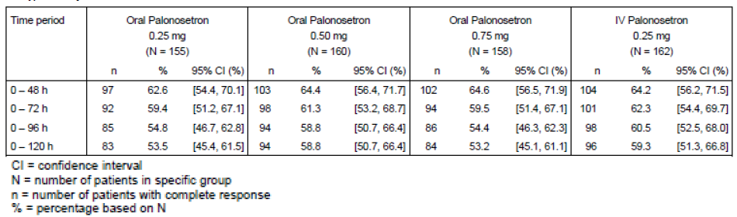

Table 10. Patients with complete response after start of chemotherapy, per day (Full analysis set, N = 635) Study PALO-03-13
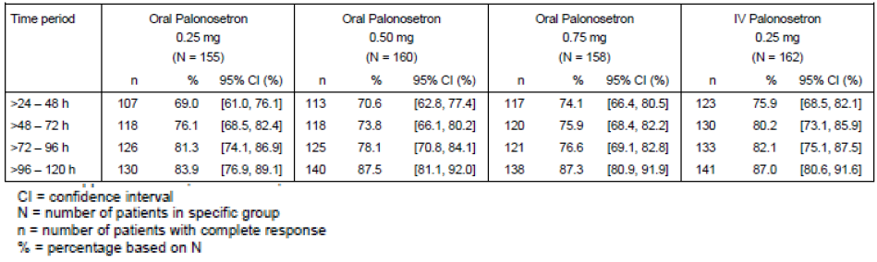
Analyses on complete control rate showed that, similar to the results for CR rate, during the acute phase (0 to 24 hour interval) the percentage of patients with complete control was highest in the oral palonosetron 0.50 mg treatment group (74.4%), while in the delayed phase (> 24 to 120 hours) the highest complete control rate was found in the IV palonosetron group (62.3%). The response rate for complete control was lowest in the oral palonosetron 0.25 mg group during all cumulative time periods, but was comparable between the oral palonosetron 0.50 mg and 0.75 mg groups. No clear dose dependence was observed when comparing the 3 oral treatment groups for the daily complete control rate.
The number of emetic episodes was calculated daily for the 0 to 120 hour interval and for the overall 0 to 120 hour interval. Results showed that the mean number of daily emetic episodes decreased in all treatment groups from the first study day (oral palonosetron 0.25 mg: 0.7; oral palonosetron 0.50 mg: 0.5; oral palonosetron 0.75 mg: 0.6; IV palonosetron 0.25 mg: 0.7) to the last study day (oral palonosetron 0.25 mg: 0.3; oral palonosetron 0.50 mg: 0.1; oral palonosetron 0.75 mg: 0.1; IV palonosetron 0.25 mg: 0.2).
The percentages of patients who did not experience any emesis, any nausea or did not require rescue medication during the first 24 hours were generally higher in the oral palonosetron treatment groups compared to the IV treatment group. However, for the > 24 to 120 hour time period the highest percentage of patients without any emesis or without rescue medication was found in the IV palonosetron treatment group, while the highest percentage of patients without nausea during this time interval was recorded in the oral palonosetron 0.50 mg treatment group. In the overall 0 to 120 hour time period, the percentages of patients who did not experience any emesis, any nausea or did not require rescue medication was highest in the oral palonosetron 0.50 mg group. Overall, for the percentage of patients without emesis, without nausea or without rescue medication, no trend in favour of any one particular treatment group was evident throughout the study.
In all 4 treatment groups, the median time to the first emetic episode, the median time to first administration of rescue medication and the median time to treatment failure were not calculable, as more than 50% of patients had no events within the first 120 hours. With regards to the 25% quartile, the time to first emetic episode and the time to treatment failure were longest in the oral palonosetron 0.50 mg group, whereas time to first administration of rescue medication was longest in the IV palonosetron treatment group.
In all treatment groups the majority of patients (≥ 53.5%) did not have nausea in any time period. The severity of nausea was mainly mild in all 4 groups. In all time periods, the daily percentage of patients with no more than mild nausea (that is patients with no or only mild nausea) in all 4 treatment groups, was always highest in either the oral palonosetron 0.50 mg or 0.75 mg groups with the percentages being similar in these two groups. The IV palonosetron treatment group followed the two highest oral dose groups in these daily time periods, with the exception of the 48 to 72 hour time period (Day 3), when the highest percentage of patients with no more than mild nausea was reported in the oral 0.75 mg palonosetron dose group, which was followed by the oral 0.25 mg and 0.50 mg groups and was lowest in the IV palonosetron group.
For all 4 treatment groups, the median patient global satisfaction with the anti-emetic therapy was high during this study (≥ 90.0 mm on a 100 mm VAS) during all time periods. In addition, statistical comparisons between the 3 oral doses of palonosetron and IV palonosetron, and among the 3 oral doses of palonosetron, did not reveal any statistically significant difference regarding any of the secondary variables.
Subgroup analyses by dexamethasone use showed that in patients using dexamethasone there was a trend towards higher complete response rates and higher complete control rates compared to patients not using dexamethasone. This trend was also seen in other secondary efficacy variables of this study. Subgroup analyses by chemotherapy history (chemotherapy naïve versus non-naïve patients) showed that for the primary efficacy endpoint complete response in the acute phase (0 to 24 hour), the percentage of patients with complete response during the 0 to 24 hour time period was higher in the chemotherapy non-naïve subgroup than in the chemotherapy naïve subgroup across all 4 treatment groups. Among the 4 treatment groups, the CR rate in the acute phase was numerically the highest in the oral palonosetron 0.50 mg group for both the chemotherapy naïve and chemotherapy non-naïve subgroups. This was consistent with the analysis results in the overall study population for this endpoint. Comparisons of each oral palonosetron dose group with the IV palonosetron group showed non-inferiority between oral palonosetron 0.50 mg and IV palonosetron 0.25 mg for both the chemotherapy naïve and chemotherapy non-naïve subgroups. Non-inferiority between oral palonosetron 0.25 mg and IV palonosetron 0.25 mg and between oral palonosetron 0.75 mg and IV palonosetron 0.25 mg was shown only in the chemotherapy naïve subgroup, but not in the chemotherapy non-naïve subgroup.
Subgroup analyses by chemotherapy history on the key secondary efficacy endpoint of complete response in the delayed phase (> 24 to 120 hour), showed that the percentage of patients with complete response during the delayed phase was higher in the chemotherapy non-naïve subgroup than in the chemotherapy naïve subgroup across all 4 treatment groups. In the chemotherapy naïve subgroup, consistent with the analysis results in the overall study population for this endpoint, the CR rate in the delayed phase was the highest in the IV palonosetron group, followed by the oral palonosetron 0.50 mg group. In the chemotherapy non-naïve subgroup, the CR rate in the delayed phase was generally comparable among all 4 treatment groups. Also consistent with the analysis results in the overall study population for this endpoint, comparisons of each oral palonosetron dose group with the IV palonosetron group failed to show non-inferiority between any oral palonosetron dose and IV palonosetron in both the naïve and non-naïve subgroups.
Comment: Overall, all 3 oral palonosetron doses 0.25 mg, 0.50 mg and 0.75 mg were found to be non-inferior to IV palonosetron 0.25 mg (currently approved formulation in Australia for prevention of nausea and vomiting induced by cytotoxic chemotherapy) in preventing MEC induced nausea and vomiting with regards to the primary efficacy endpoint of the proportion of patients with complete response during the first 24 hours after the administration of the first [most] emetogenic chemotherapeutic agent.
During the 24 to 120 hour time period, CR rate was higher with IV palonosetron compared to the 3 oral palonosetron doses, and although the treatment differences were small and considered clinically insignificant (particularly for the 0.50 mg oral dose where the treatment difference versus the IV formulation was 2.9%), statistical analysis failed to demonstrate non-inferiority with IV palonosetron for all three oral palonosetron doses.
The remaining secondary efficacy variables measured in this study did not reveal any clear differences between the three oral doses and the IV palonosetron dose. However, the oral palonosetron 0.50 mg and 0.75 mg doses tended to show higher anti-emetic efficacy than the oral palonosetron 0.25 mg dose. The oral 0.50 mg palonosetron dose was the only oral dose showing non-inferiority to IV palonosetron for the CR during the overall 0 to 120 hour time period. In the analyses of CR rates in the cumulative time intervals, among the three oral dose groups, the highest complete response rates tended to occur in the oral palonosetron 0.50 mg group, although no trend was identified for the daily CR rates analyses. In the overall 0 to 120 hour time period, the percentages of patients who did not experience any emesis, any nausea or did not require rescue medication was highest in the oral palonosetron 0.50 mg group. In addition, in all time periods, the daily percentage of patients with no more than mild nausea (that is patients with no or only mild nausea) was highest in either the oral palonosetron 0.50 mg or 0.75 mg groups with the percentages being similar in these two groups.
Based on the study results, the sponsor’s conclusion that oral palonosetron 0.50 mg was the lowest effective oral palonosetron dose in the prevention of chemotherapy induced nausea and vomiting following moderately emetogenic cancer chemotherapy was reasonable.

PALO-03-14
Study PALO-03-14 was a multi-centre, open label, repeated cycle, uncontrolled study to assess the safety and the efficacy of single oral doses of palonosetron 0.75 mg in the prevention of CINV in repeated and consecutive MEC cycles. The primary objective of this study was to assess the safety of single oral doses of palonosetron 0.75 mg (with or without concomitant corticosteroids) used for the prevention of MEC induced nausea and vomiting in repeated (up to a maximum of four) and consecutive chemotherapeutic cycles. Secondary objective was to assess the efficacy of single oral doses of palonosetron 0.75 mg (with or without concomitant corticosteroids) for the prevention of MEC induced nausea and vomiting in up to a maximum of four consecutive chemotherapy cycles. The study start date (date of first enrolment) was 15 June 2005, and study end date was 27 April 2006.
Subjects enrolled in the study were adult (≥ 18 years of age) male or female patients with histologically or cytologically confirmed malignant disease, who were scheduled to receive repeated and consecutive MEC cycles employing the same basic MEC regimen (single or multi-drug regimen; this could include changes in dose or discontinuation of concomitant chemotherapeutic agents as clinically appropriate, as long as the agent that defined the regimen as moderately emetogenic was still included and no highly emetogenic agents were added), naïve or non-naïve to cancer chemotherapy (if a patient was non-naïve before the first study cycle, he/she had to have experienced no more than mild nausea and no vomiting following any previous chemotherapy cycle), had a Karnofsky index of ≥ 50%, and scheduled to receive a single IV dose of at least one of the following moderately emetogenic agents administered on Day 1: any dose of oxaliplatin, carboplatin, epirubicin, idarubicin, doxorubicin, ifosfamide, irinotecan or daunorubicin or cyclophosphamide < 1,500 mg/m² or cytarabine > 1g/ m². A full list of inclusion and exclusion criteria was provided.
All enrolled patients received on Day 1 a single oral dose of palonosetron 0.75 mg, 60 minutes before each MEC cycle, up to a maximum of 4 consecutives cycles. Oral or IV dexamethasone 8 mg could be administered as concomitant corticosteroid at the discretion of the investigator 30 minutes before the start of administration of the first emetogenic chemotherapeutic agent. Patients, who at the investigator’s discretion had received concomitant dexamethasone 8 mg with oral palonosetron during the first cycle in this study, were to be administered concomitant dexamethasone 8 mg in all subsequent cycles in this study. Patients, who at the investigator’s discretion had not received concomitant dexamethasone with oral palonosetron during the first cycle in this study, were not to be administered concomitant dexamethasone in any subsequent cycles in this study.
The main efficacy endpoint was the proportion of chemotherapy cycles in which patients were considered to have achieved complete response (CR) (defined as no emetic episode and no rescue medication) for the 0 to 24 hour interval (CR_{0-24h}) and for the > 24 to 120 hour interval (CR_{24-120h}) after the start of administration of chemotherapy. The other efficacy endpoints were the same as those for Study PALO-03-13.
A total of 223 patients were enrolled. Of the 223 patients, 217 were treated with study medication in at least 1 cycle for a total of 654 study cycles. Baseline demographic characteristics were provided. The majority of the patients were White (60.8%) and female (75.1%). The mean (SD) age was 57.1 (12.5) years.
Efficacy analyses showed that complete response was seen in a higher percentage of cycles for the 0 to 24 hours period (70.6%) than for the > 24 to 120 hours period (62.2%). The percentage of cycles in which patients showed a complete response was higher for both the 0 to 24 and the > 24 to 120 hours periods when palonosetron was given together with dexamethasone (73.9% and 63.1%, respectively) than when palonosetron was given alone (61.4% and 59.6 %, respectively).
The percentage of cycles in which patients had a complete response was higher in the palonosetron 0.75 mg + dexamethasone group than in the palonosetron 0.75 mg alone group for the cumulative time intervals and on Study Days 1 and 2, whereas for all individual study days following Day 2 the complete response rates were comparable between the 2 treatment groups. Efficacy results also showed that, in general, the anti-emetic efficacy shown on Day 1 (that is 0 to 24 hour interval) as well as the efficacy measured in the > 24 to 120 hour and 0 to 120 hour intervals was maintained throughout at least 4 repeated and consecutive cycles in both treatment groups.
Similar to the complete response results, the proportion of cycles with complete control, the proportion of cycles in which patients did not experience any emesis and the proportion of cycles in which patients did not experience any nausea were higher when palonosetron was given together with dexamethasone than when palonosetron was given alone during Days 1 (0 to 24 hour interval) and 2 (24 to 48 hours interval), and during the delayed time period (> 24 to 120 hour interval) and the overall time period (0 to 120 hour interval).
For the 0 to 24 hour time period, the percentage of cycles without rescue medication was higher in the palonosetron 0.75 mg + dexamethasone group (84.9%) than in the palonosetron 0.75 mg alone group (79.5%), while for the remaining time periods as well as for the delayed time period (> 24 – 120 h) and the overall time period (0 to 120 h) the percentages of cycles where rescue medication was not required were comparable between both groups).
For both treatment groups, the median patient global satisfaction with anti-emetic therapy was high during this study (≥ 90). The median patient global satisfaction was higher in the palonosetron 0.75 mg + dexamethasone group than in the palonosetron 0.75 mg alone group on Day 1 and Day 2, while it was comparable between the two treatment groups for the remaining days. The median time to first emetic episode, the median time to first administration of rescue medication and the median time to treatment failure were longer than 120 hours in both treatment groups. Concerning the 25% quartile, the time to first emetic episode, the time to first administration of rescue medication and the time to treatment failure were longer in the palonosetron 0.75 mg + dexamethasone group compared to the palonosetron 0.75 mg alone group.
Comment: Overall, efficacy results in this study showed that the anti-emetic efficacy of oral palonosetron 0.75 mg, in terms of complete response during the acute (0 to 24 hour interval), delayed (> 24 to 120 hour interval) and overall (0 to 120 hour interval) phases, was maintained throughout at least 4 repeated and consecutive MEC cycles regardless of the concomitant use of dexamethasone.

Analyses performed across trials (pooled analyses and meta-analyses)
Not applicable.

Evaluator’s conclusions
Evaluator’s conclusions on clinical efficacy for the indication of prevention of acute and delayed nausea and vomiting associated with initial and repeat courses of MEC and HEC.
Overall, the study design, study inclusion and exclusion criteria, and study endpoints of the clinical studies submitted were appropriate. The primary and secondary endpoints of the studies allowed evaluations of the effect on various symptoms and combinations of symptoms of CINV (nausea, significant nausea, emesis, need for rescue medication, no emesis plus no rescue medication [complete response; CR], no emesis plus no rescue medication plus no significant nausea [complete protection], no emesis plus no rescue medication plus no nausea [total or complete control]) in the acute, delayed and overall phases of CINV, of netupitant/palonosetron FDC compared to palonosetron alone (Study NETU-08-18 ), of concomitant administration of netupitant and palonosetron compared to palonosetron alone (Study NETU-07-07) and of netupitant/palonosetron FDC compared to aprepitant + palonosetron (Study NETU-10-29; exploratory comparison). The primary and main secondary efficacy endpoints of the main clinical studies submitted are presented in Table 11. Baseline demographic and disease characteristics were comparable among treatment groups in each study, and were consistent with the target patient population.

Table 11. Primary and main secondary endpoints in clinical Trials NETU-08-18, NETU-07-07, NETU-10-29 and PALO-10-01
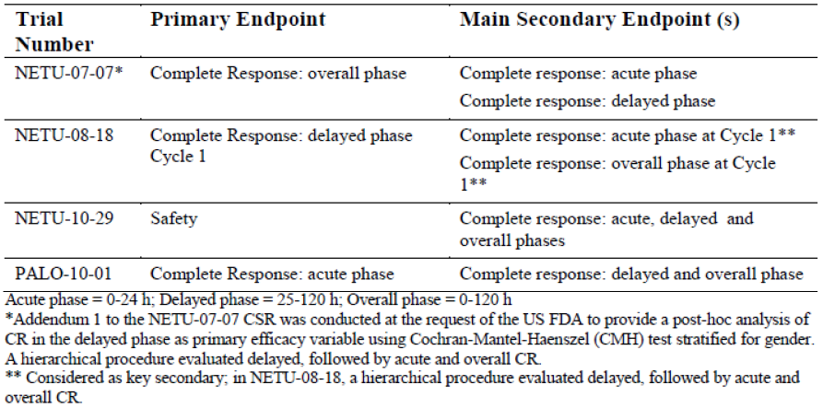
Overall, efficacy results supported the anti-emetic efficacy of oral netupitant 300 mg plus palonosetron 0.50 mg in acute and delayed phases of CINV with MEC and HEC, as well as efficacy over repeated cycles of chemotherapy. Primary and main secondary efficacy analyses in the clinical studies submitted showed that there was better anti-emetic efficacy in terms of the endpoint of CR rate for oral netupitant 300 mg plus palonosetron 0.50 mg compared to oral palonosetron 0.50 mg alone, with statistical significance achieved for all three phases (delayed [25 to 120 hours], acute [0 to 24 hours] and overall [0 to 120 hours]) in studies NETU-08-18 (MEC) and NETU-07-07 (HEC) (Table 12). In NETU-08-18 there was a treatment difference (netupitant/palonosetron FDC over palonosetron alone) of 7.4%, 3.4% and 7.7% in the delayed, acute and overall phases, respectively, while in NETU-07-07 the treatment differences (netupitant 300 mg + palonosetron over palonosetron alone) were 10.2%, 8.8% and 13.2%, respectively. Although no formal comparison was performed against comparators other than oral palonosetron, a numerical advantage of netupitant/palonosetron FDC was shown versus aprepitant + palonosetron in Study NETU-10-29 (MEC and HEC) in CR rate in the delayed and overall phases (treatment difference of 5.5% and 4.9% in the delayed and overall phases, respectively; treatment difference of -1.3% in the acute phase).

Table 12. Patients with complete response - Cycle 1- Studies NETU-08-18, NETU-07-07 and NETU-10-29 (MFAS or FAS)
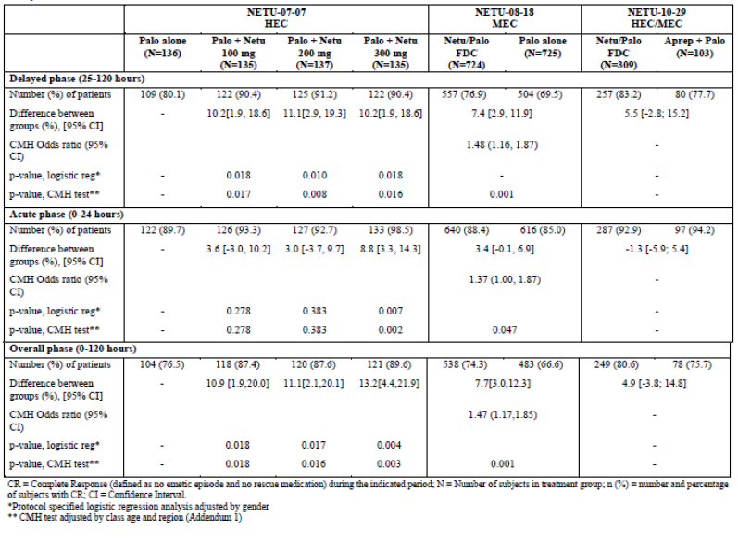
Further analyses looking at efficacy in MEC (studies NETU-08-18 and MEC subgroup of NETU-10-29) and HEC (studies NETU-07-07 and HEC subgroup of NETU-10-29) supported the anti-emetic efficacy of oral netupitant 300 mg plus palonosetron 0.50 mg for both MEC and HEC. Complete response rates for netupitant/palonosetron FDC were generally comparable between Study NETU-08-18 and the MEC subgroup of Study NETU-10-29 for all 3 phases (NETU-08-18: CR rates of 66.6% to 85.0% across the 3 phases; NETU-10-29: CR rates of 79.6% to 93.2% across the 3 phases) (Table 13). CR rates were comparable between netupitant/palonosetron FDC and aprepitant + palonosetron in the MEC subgroup of Study NETU-10-29 in the delayed, acute and overall phases.

Table 13. Comparison of complete response in MEC patients; Cycle 1; (NETU-08-18 and NETU-10-29: FAS)
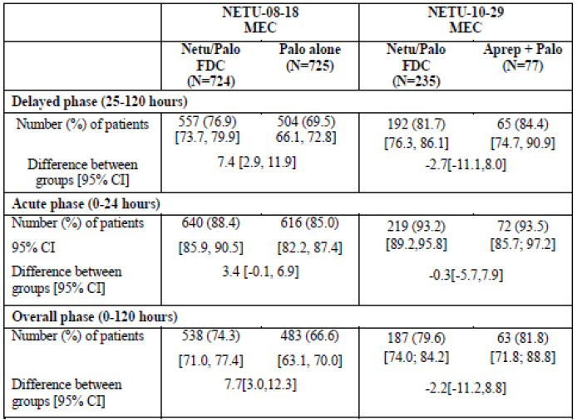
Complete response rates for oral netupitant 300 mg plus palonosetron 0.50 mg were generally comparable between Study NETU-07-07 (netupitant + palonosetron) and the HEC subgroup of Study NETU-10-29 (netupitant/palonosetron FDC) for all 3 phases (NETU-07-07: CR rates of 89.6% to 98.5% across the 3 phases; NETU-10-29: CR rates of 83.8% to 91.9% across the 3 phases) (Table 14). A numerical advantage of netupitant/palonosetron FDC was shown versus aprepitant + palonosetron in the HEC subgroup of Study NETU-10-29 in the delayed and overall phases (treatment difference of 30.1% and 26.1% in the delayed and overall phases, respectively). In addition, in Study NETU-10-29, exploratory subgroup analyses by chemotherapy emetogenicity for the endpoint of complete response showed that percentages of patients with CR in the netupitant/palonosetron FDC group were generally comparable between MEC (81.7%, 93.2% and 79.6% for the delayed, acute and overall phases of Cycle 1, respectively) and HEC subgroups (87.8%, 91.9% and 83.8%, respectively), as were the percentages of patients with no significant nausea in the netupitant/palonosetron FDC group (MEC: 85.5%, 90.2% and 84.7% for the delayed, acute and overall phases of Cycle 1, respectively; HEC: 83.8%, 91.9% and 82.4%, respectively).

Table 14. Comparison of complete response in HEC patients; Cycle 1 (NETU-07-07 and NETU-10-29; MFAS or FAS)
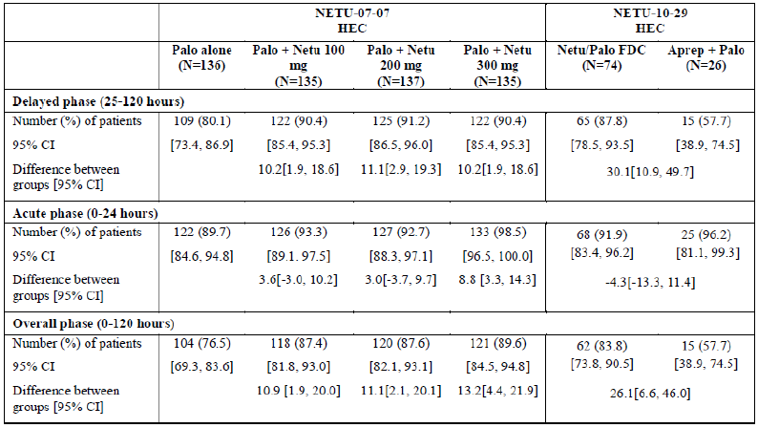
Results in Study PALO-10-01 supported efficacy of the palonosetron component of the FDC in HEC, showing non-inferiority of oral palonosetron 0.50 mg compared with IV palonosetron 0.25 mg in terms of CR rate in the acute phase in patients receiving HEC (treatment difference of 3.21%, 99% CI: -2.74% to 9.17%), and no statistically significant difference between oral palonosetron 0.50 mg and IV palonosetron 0.25 mg with regards to CR rate in the delayed and overall phases in patients receiving HEC (delayed phase: treatment difference of 1.4%, p = 0.637; overall phase: treatment difference of 3.5%, p = 0.269).
Analyses of other secondary efficacy endpoints generally supported the results of primary and main secondary efficacy endpoints (Table 15). Efficacy endpoints of no emesis, no significant nausea, and complete protection (no emesis, no rescue medication, and no significant nausea) showed that oral netupitant 300 mg plus palonosetron 0.50 mg had statistically significantly better efficacy compared to oral palonosetron 0.50 mg alone in the delayed and overall phases in studies NETU-08-18 (MEC; netupitant/palonosetron FDC) and NETU-07-07 (HEC; netupitant + palonosetron).

Table 15. Secondary efficacy results- Cycle 1; Studies NETU-08-18, NETU-07-07 and NETU-10-29 (MFAS or FAS)
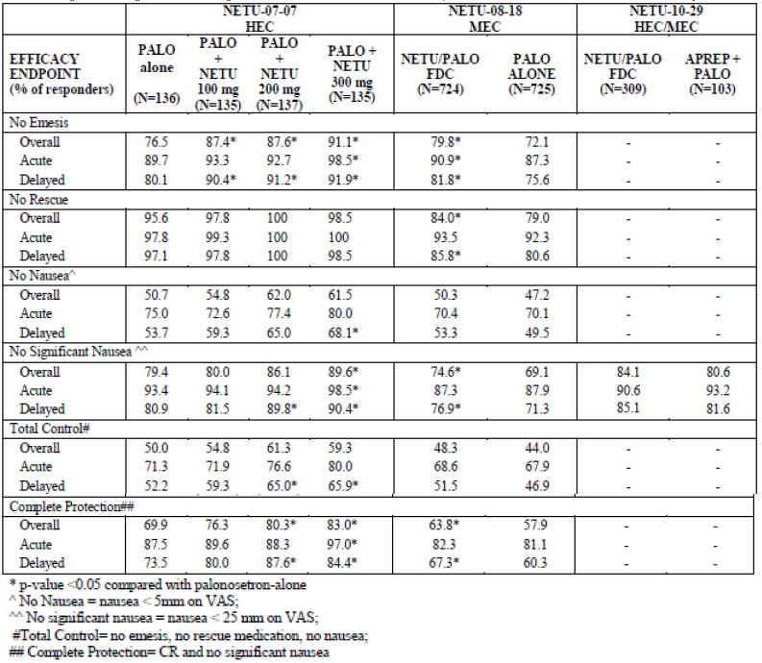
With regards to efficacy over repeated cycles of chemotherapy, 2 studies collected efficacy data over multiple cycles of chemotherapy (NETU-08-18 in MEC and safety Study NETU-10-29 in MEC and HEC). Overall the results indicated that the anti-emetic effect of the FDC was maintained over multiple cycles of chemotherapy. Results in Study NETU-08-18 showed that the CR rates were higher for netupitant/palonosetron FDC than for palonosetron alone in each phase and each cycle up to Cycle 6, with treatment differences more pronounced in the delayed and overall phases (Table 16). The range of treatment differences across Cycles 2 to 6 in the delayed phase was 5.6% to 12.9%, in the acute phase was 3.0% to 7.8%, and in the overall phase was 5.2% to 13.6%. The proportions of patients with no significant nausea were also higher for the netupitant/ palonosetron FDC than for palonosetron alone in each phase and each cycle up to Cycle 6, with treatment differences more pronounced in the delayed and overall phases (Table 17). The range of treatment differences across Cycles 2 to 6 in the delayed phase was 4.4% to 9.2%, in the acute phase was 1.6% to 3.4%, and in the delayed phase was 2.8% to 4.7%.

Table 16. Complete response in the delayed, acute and overall phases by Cycle of the Multiple-Cycle Extension – Full Analysis Set (Extension), Study NETU-08-18
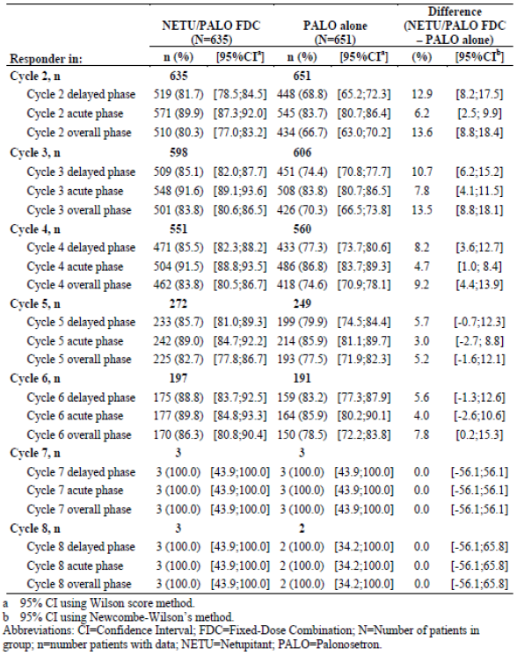

Table 17. Number and percentage of patients with no significant nausea by cycle of the multiple-cycle extension – Full Analysis Set (Extension), Study NETU-08-18
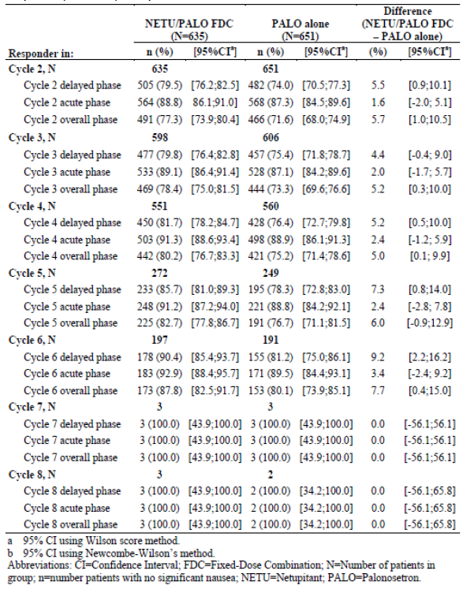
Results in Study NETU-10-29 showed that in Cycles 2 to 6, the proportion of patients with CR was numerically higher for the netupitant/palonosetron FDC group than the aprepitant + palonosetron group in particular in the delayed and overall phases. Results in the acute phase were more similar between groups (Table 18). The range of treatment differences across Cycles 2 to 6 in the delayed phase was 3.3% to 7.0%, in the acute phase was -3.4% to 4.8%, and in the overall phase was 2.5% to 5.7%. Analyses of the proportion of patients with no significant nausea showed similar pattern. In Cycle 2 percentages of patients with no significant nausea were comparable between netupitant/palonosetron FDC and aprepitant + palonosetron for all phases (treatment differences ranging from 0.3% in the overall phase to 2.6% in the acute phase). Starting from Cycle 3 and up to 6, the proportion of patients with no significant nausea was numerically higher for the netupitant/palonosetron FDC group than the aprepitant + palonosetron group, in particular in the delayed and overall phases (range of differences 5.4% to 11.1% in the delayed phase and 5.4% to 9.9% in the overall phase) (Table 19). The range of treatment differences across Cycles 3 to 6 in the delayed phase was 5.4% to 11.1%, in the acute phase was 1.9% to 8.9%, and in the overall phase was 5.4% to 9.9%.

Table 18. Complete response in delayed, acute and overall phase, Cycles 2 to 6 (FAS), Study NETU-10-29
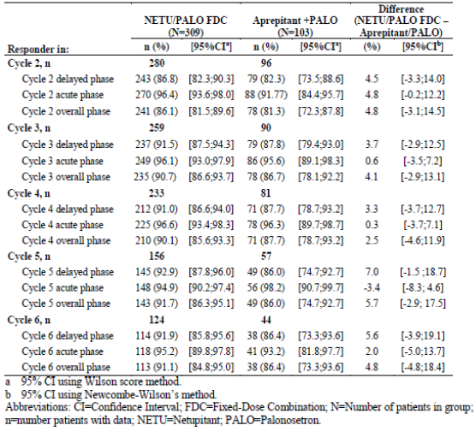

Table 19. No significant nausea in delayed, acute and overall phase, Cycles 2 to 6 (FAS), Study NETU-10-29
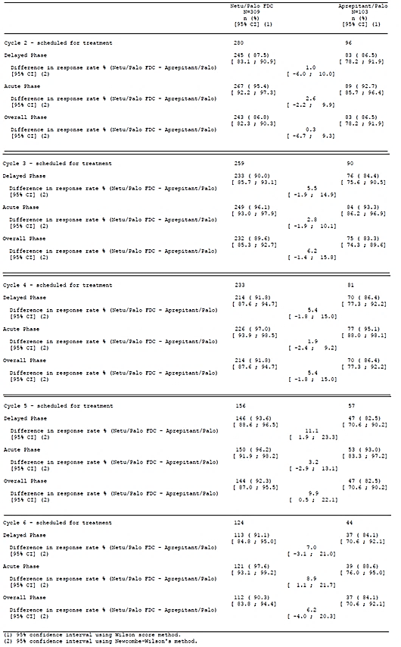
The study population in Study NETU-08-18 comprised mainly of females (98.1%; 1422 out of 1450). This was expected as the protocol specified chemotherapy regimen is mostly indicated for breast cancer. However, in studies NETU-07-07 (HEC) and NETU-10-29 (MEC and HEC), male patients made up 57% and 50% of the respective study populations (Table 20). In addition, subgroup analyses in studies NETU-07-07 and NETU-10-29 showed that there was anti-emetic efficacy with oral netupitant 300 mg plus palonosetron 0.50 mg in both male and female subgroups. Results in Study NETU-07-07 showed that CR rate in the overall phase was numerically higher for oral netupitant 300 mg plus palonosetron 0.50 mg compared to palonosetron alone, for both male and female patients, although the treatment difference from palonosetron alone was smaller in male patients (94.8% versus 83.3%; treatment difference of 11.5%, p = 0.030) than in female patients (82.8% versus67.2%; treatment difference of 15.5%, p = 0.057) (Table 21). Results in Study NETU-10-29 showed that percentages of patients with CR in the netupitant/palonosetron FDC group were generally comparable between male (85.7%, 94.2% and 82.5% for the delayed, acute and overall phases of Cycle 1, respectively) and female patients (80.6%, 91.6% and 78.7% respectively) (Table 22). Subgroup analyses by gender for the endpoint of no significant nausea showed that percentages of patients with no significant nausea in the netupitant/palonosetron FDC group were also generally comparable between male (82.5%, 87.7% and 81.8% for the delayed, acute and overall phases of Cycle 1, respectively) and female patients (87.7%, 93.5% and 86.5%, respectively) (Table 23). The clinical overview submitted in module 2 was reviewed and did not raise any additional concerns.

Table 20. Patient demographics and summary of cancer history; Cycle 1; Studies NETU-08-18, NETU-07-07 and NETU-10-29 (Safety population) clinical safety
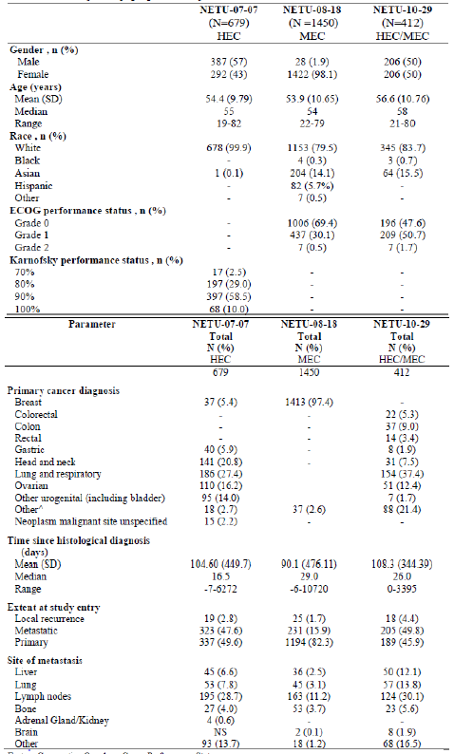

Table 21. Complete response rate summarised by gender; MFAS population, Study NETU-07-07
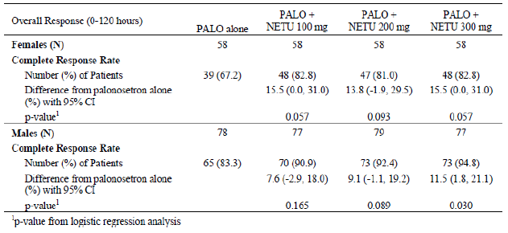

Table 22. Complete response in delayed, acute and overall phase by gender (FAS), Study NETU-10-29
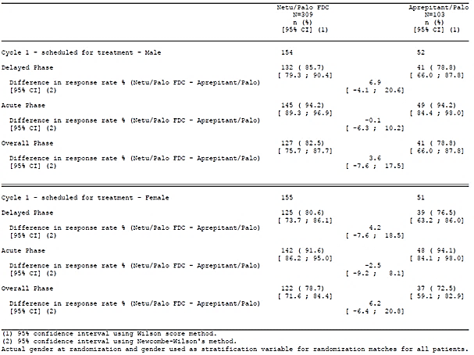

Table 23. No significant nausea in delayed, acute and overall phase by gender (FAS), Study NETU-10-29
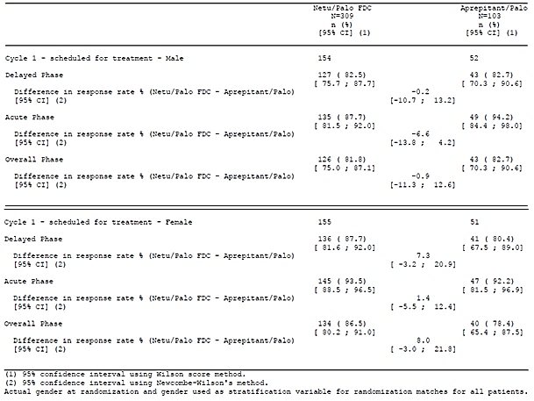

Clinical safety

Studies providing evaluable safety data
The following studies provided evaluable safety data.

Pivotal efficacy study
In Study NETU-08-18, the following safety data were collected:
- General adverse events (AEs) were assessed by the investigator obtaining and recording all AEs at each scheduled visit.
- AEs of particular interest were cardiac and CNS or psychiatric treatment emergent AEs (TEAEs). These AEs of special interest were selected and identified by standardised MedDRA queries (SMQs). According to the sponsor these analyses of AEs of special interest were not done due to specific safety concerns, but to fulfil a requirement of the regulatory authority, with an objective of showing that there were no clusters of cardiac, CNS or psychiatric TEAEs in the study. In particular, special attention on CNS and psychiatric events of special interest was done to isolate possible signs of drug abuse and to support pre-clinical data showing no evidence of physical dependence potential for the netupitant/palonosetron FDC.
- Laboratory tests performed included haematology, blood chemistry (urea, creatinine, total bilirubin, alkaline phosphatase, alanine aminotransferase [ALT], aspartate aminotransferase [AST], sodium, potassium, chloride, bicarbonate, calcium, albumin, total protein, blood glucose, total creatine kinase [CK], CK-MB fraction and myoglobin), and urinalysis. Laboratory tests were performed according to the schedule provided.
- Other safety endpoints included vital signs, 12-lead electrocardiogram (ECG), Left Ventricular Ejection Fraction (LVEF), cardiac Troponin I (cTnI) levels35, and were performed according to the schedule presented.

Table 24. Study visits and assessments, Study NETU-08-18
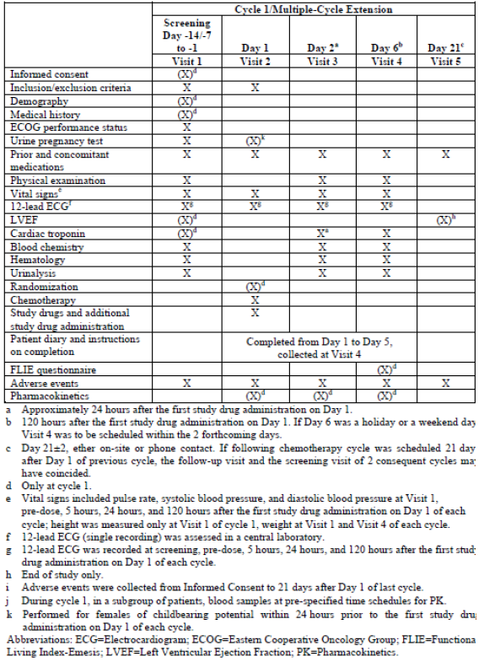
Note: A threshold of cTnI of 0.12 ng/mL was considered an “alert value” appropriate for patients receiving anthracycline-based chemotherapy. Randomised patients with cTnI levels of ≥ 0.12 ng/mL and < 0.50 ng/mL could continue on the study at the investigator’s discretion, and were to enter a cardiovascular follow-up functional assessment. Randomised patients with cTnI levels of ≥ 0.50 ng/mL were to be withdrawn from the study and were to enter a cardiovascular follow-up functional assessment. Cardiovascular follow-up functional assessment was performed by monitoring the LVEF using a Multiple-Gated Acquisition (MUGA) scan or Echocardiography (ECHO) and included a cardiac assessment visit for NYHA classification, vital signs, 12-lead ECG, assessment of cardiotoxic medications, and cardiac specific concomitant medication.

Pivotal studies that assessed safety as a primary outcome
Not applicable.

Dose response and other efficacy studies
The dose response and other efficacy studies provided safety data, as follows:
- Study NETU-07-07 provided data on adverse events, vital signs, laboratory evaluations (haematology, blood chemistry and urinalysis) and 12-lead ECG.
- Study NETU-10-29 provided data on adverse events, vital signs, laboratory evaluations (haematology, blood chemistry, and urinalysis), 12-lead ECG, LVEF, and cTnI levels, performed according to the schedule provided.
- Studies PALO-10-01, PALO-03-13 and PALO-03-14 provided data on adverse events, vital signs, laboratory evaluations (haematology, blood chemistry and urinalysis) and 12-lead ECG.

Other studies evaluable for safety only
Not-applicable.

Pivotal studies that assessed safety as a primary outcome
Not-applicable.

Patient exposure
In Study NETU-08-18, a total of 1450 patients were treated with study medication, 724 in the netupitant/palonosetron FDC group and 726 in the palonosetron alone group. Over the complete study period, 164 (11.3%) patients overall received 1 dose of study drugs (90 [12.4%] and 74 [10.2%] in the netupitant/palonosetron FDC and palonosetron alone groups, respectively), 591 (40.8%) patients received 4 doses of study drugs (280 [38.5%] and 311 [42.9%], respectively) and 382 (26.3%) patients received 6 doses of study drugs (194 [26.8%] and 188 [25.9%], respectively). The median number of days on study drugs was 4.0 in both treatment groups.
In Study NETU-07-07, a total of 679 patients were treated with study medications, 136, 135, 138, 136 and 134 in the palonosetron alone, palonosetron + netupitant 100 mg, palonosetron + netupitant 200 mg, palonosetron + netupitant 300 mg, and aprepitant + ondansetron groups, respectively. The median duration of treatment with the study drugs was 4.0 days in all treatment groups.
In Study NETU-10-29, a total of 412 patients were treated with study medications, of whom 308 were exposed to the netupitant/palonosetron FDC and 104 to aprepitant + palonosetron during Cycle 1. Over the complete study period, patients in the netupitant/palonosetron FDC group (N=308) received a mean (SD) of 4.7 (2.19) netupitant/palonosetron FDC capsules on Day 1.
Patients in the aprepitant + palonosetron group (N=104) received a mean (SD) of 5 (2.36) aprepitant capsules and 5 (2.36) palonosetron capsules on Day 1, 4.9 (2.35) aprepitant capsules on Day 2, and 5.0 (2.29) aprepitant capsules on Day 3 (aprepitant was given for 3 days of the treatment cycle and palonosetron was given on Day 1 only). The median number of days on netupitant/palonosetron FDC capsules was 5.0 in the netupitant/palonosetron FDC group. The median number of days on aprepitant and palonosetron was 15.0 and 5.0, respectively, in the aprepitant + palonosetron group.
In Study PALO-10-01, a total of 739 patients were treated with study medications, of whom 370 received oral palonosetron, and 369 received IV palonosetron. The median duration of treatment with the study drugs was 1.0 days in both treatment groups. A summary of the extent of exposure to study medication in Study PALO-03-13 was provided. A summary of the extent of exposure to study drug in Study PALO-03-14 was provided. Overall in Study PALO-03-14, the study medication was administered in 654 out of 661 cycles (98.9% of cycles).
Comment: Overall, the study drug exposure is adequate to assess the safety profile of netupitant/palonosetron FDC.

Adverse events

All adverse events (irrespective of relationship to study treatment)

Pivotal study
In Study NETU-08-18, in Cycle 1, the percentage of patients with any TEAEs was higher in the netupitant/palonosetron FDC group (76.0%) compared to the palonosetron alone group (69.9%). Most TEAEs were mild or moderate in intensity. The incidence of TEAEs of severe intensity was higher in the netupitant/palonosetron FDC group (13.0%) compared to the palonosetron alone group (9.1%). TEAEs that occurred in ≥ 5% of patients in any treatment group are presented in Table 25. The most commonly reported AE by preferred term in the netupitant/palonosetron FDC group was alopecia (34.9% versus 34.9% in the palonosetron alone group) and neutropenia (23.9% versus 25.1%).

Table 25. TEAEs reported by ≥ 5% of patients in either treatment group in Cycle 1 summarised by MedDRA SOC, PT, and treatment group – safety population (Cycle 1), Study NETU-08-18
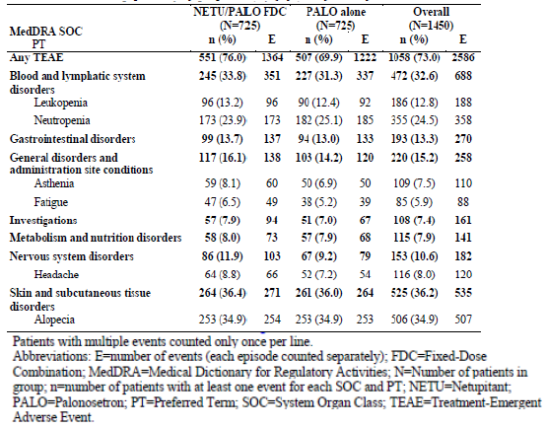
In the multiple cycle extension safety population in Study NETU-08-18, the percentage of patients with any TEAEs was comparable between the netupitant/palonosetron FDC group (83.9%) and the palonosetron alone group (81.0%) (Table 26). Most TEAEs were mild or moderate in intensity. The incidence of TEAEs of severe intensity was comparable between the netupitant/palonosetron FDC group (15.4%) and the palonosetron alone group (14.6%). TEAEs that occurred in ≥ 5% of patients in any treatment group were provided. The most commonly reported TEAE by preferred term in the netupitant/palonosetron FDC group was neutropenia (35.6% versus 36.6% in the palonosetron alone group) and alopecia (23.9% versus 23.2%).

Table 26 Overall summary of patients with treatment-emergent adverse events in the multiple-cycle extension; Safety Population (Extension), Study NETU-08-18
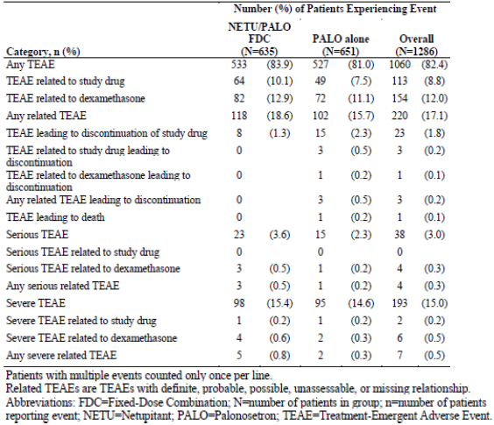

Other studies

NETU-07-07
In Study NETU-07-07, the percentage of patients with any TEAEs was generally comparable among treatment groups and there was no clear dose related trend (incidence of 40.7% to 53.0% across treatment groups). Most TEAEs were mild or moderate in intensity. The incidence of TEAEs of severe intensity was 3.0%, 5.8% and 3.9% in the palonosetron + netupitant 100 mg, palonosetron + netupitant 200 mg, and palonosetron + netupitant 300 mg groups, respectively, versus 5.1% in the palonosetron alone group and 4.5% in the aprepitant group.
TEAEs that occurred in ≥ 5% of patients in any treatment group were provided. The most commonly reported TEAE by preferred term in the palonosetron + netupitant 100 mg group was leucocytosis (7.4%, 5.1% and 3.7% in the palonosetron + netupitant 100 mg, palonosetron + netupitant 200 mg, and palonosetron + netupitant 300 mg groups, respectively, versus 7.4% in the palonosetron alone group and 4.5% in the aprepitant group). The most commonly reported TEAE by preferred term in the palonosetron + netupitant 200 mg and palonosetron+ netupitant 300 mg groups was asthenia (3.0%, 8.7% and 8.8% in the palonosetron + netupitant 100 mg, palonosetron + netupitant 200 mg, and palonosetron + netupitant 300 mg groups, respectively, versus 9.6% in the palonosetron alone group and 9.7% in the aprepitant group).

NETU-10-29
In Study NETU-10-29, the percentage of patients with any TEAEs was lower in the netupitant/palonosetron FDC group (86.0%) compared to the aprepitant + palonosetron group (91.3%). Most TEAEs were mild or moderate in intensity. The incidence of TEAEs of severe intensity was lower in the netupitant/palonosetron FDC group (25.0%) compared to the aprepitant + palonosetron group (32.7%). TEAEs that occurred in ≥ 5% of patients in any treatment group are presented in Table 27. The most commonly reported TEAE by preferred term in the netupitant/palonosetron FDC group was neutropenia (30.8% versus 27.9% in the aprepitant + palonosetron group) and alopecia (25.0% versus 30.8%).

Table 27. TEAEs reported by ≥5% of patients in either treatment group for the whole study period summarised by MedDRA SOC, PT, and treatment group; safety population, Study NETU-10-29
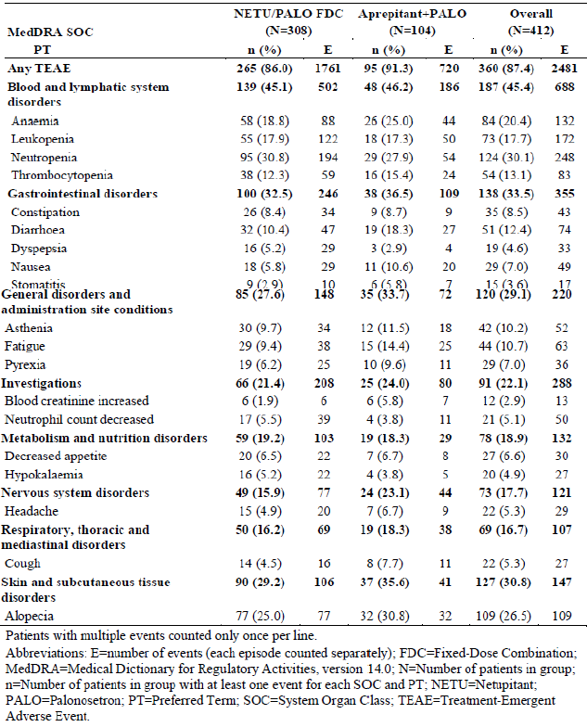
According to the sponsor, as the number of patients who continued in the study after Cycle six (33 and 13 patients in the netupitant/palonosetron FDC and aprepitant + palonosetron groups, respectively) was too low to permit meaningful analysis, safety analysis by cycle was focussed on those for Cycles 1 to 6. The percentage of patients with any TEAEs in both treatment groups showed a general decreasing trend over the first 6 cycles, from an overall incidence of 63.8% in Cycle 1 (64.6% and 61.5% in the netupitant/palonosetron FDC and aprepitant + palonosetron groups, respectively) to 34.1% in Cycle 6 (34.7% and 32.6%, respectively). The sponsor was of the opinion that this could potentially be attributable to the progressive worsening of the patients’ clinical condition with time, leading to discontinuation of chemotherapy and patients being no longer qualifying to continue in the study. As a consequence, patients continuing to be in the study in later cycles could have been in relatively better health condition and reported less TEAEs. The incidence of TEAEs was generally similar between the treatment groups within each cycle from Cycles 1 to 6. In Cycle 1, the most commonly reported TEAEs (≥ 5% patients overall) were neutropenia (14.6%), alopecia (12.1%), which were consistent with the most commonly reported TEAEs for the overall study. Over subsequent cycles, neutropenia remained commonly reported TEAEs. Alopecia remained common in Cycle 2 (12.5% of patients), then decreased in Cycle 3 (2.9%) and further cycles.
Analyses of TEAEs in the whole study period by chemotherapy emetogenicity showed similar results to the overall analyses. Among the safety population on MEC (N = 312), the percentage of patients with any TEAEs was lower in the netupitant/palonosetron FDC group (86.3%) compared to the aprepitant + palonosetron group (92.4%). Among the safety population on HEC (N = 100), the percentage of patients with any TEAEs was comparable between the netupitant/palonosetron FDC group (85.3%) and the aprepitant + palonosetron group (88.0%). In the both the MEC and HEC subgroup safety populations, the most commonly reported TEAE by preferred term in the netupitant/palonosetron FDC group was neutropenia (MEC: 31.8% in the netupitant/palonosetron FDC group versus 31.6% in the aprepitant + palonosetron group; HEC: 28.0% versus 16.0%) and alopecia (MEC: 25.8% versus 29.1%; HEC: 22.7% versus 36.0%).

Studies PALO-10-01, PALO-03-13 and PALO-03-14
In Study PALO-10-01, the percentage of patients with any TEAEs was comparable between the oral palonosetron group (48.6%) and the IV palonosetron group (51.8%). Most adverse events were mild or moderate in intensity. The incidence of TEAEs of severe intensity was comparable between treatment groups (10.3% in both groups). TEAEs that occurred in ≥ 5% of patients in any treatment group were provided. The most commonly reported TEAE by preferred term in the oral palonosetron group was asthenia (8.4% versus 7.6% in the IV palonosetron group) and constipation (6.2% versus 5.4%).
In Study PALO-03-13, the percentage of patients with any TEAEs was comparable among all treatment groups, and there was no obvious dose dependent trend in the oral palonosetron groups (49.7%, 47.2% and 47.5% in the oral palonosetron 0.25 mg, 0.50 mg and 0.75 mg groups, respectively, versus 47.9% in the IV palonosetron group). The most commonly reported TEAE by preferred term in the oral palonosetron groups was headache (12.1%, 16.1% and 11.4% in the oral palonosetron 0.25 mg, 0.50 mg and 0.75 mg groups, respectively, versus 14.7% in the IV palonosetron group).
In Study PALO-03-14, the overall percentage of patients with any TEAEs was 68.1. Overall, TEAEs were reported in 46.8% of cycles. The incidence of cycles with TEAEs decreased slightly from Cycle 1 to Cycle 3 and remained about the same in Cycle 4. The most commonly reported TEAE by preferred term was headache (reported in 12.7% of cycles).

Treatment-related adverse events (adverse drug reactions)

Pivotal study
In the Cycle 1 safety population of Study NETU-08-18, the percentages of patients with any study drug related TEAEs were comparable between the netupitant/palonosetron FDC group (8.1%) and the palonosetron alone group (7.2%). Study drug related TEAEs in Cycle 1 that occurred in ≥ 2% of patients in any treatment group were provided. The most commonly reported study drug related TEAE by preferred term in the netupitant/palonosetron FDC group was headache (3.3% versus 3.0% in the palonosetron alone group) and constipation (2.1% versus 2.1%).
In the multiple cycle extension safety population in Study NETU-08-18, the percentages of patients with any study drug related TEAEs were 10.1% in the netupitant/palonosetron FDC group and 7.5% in the palonosetron alone group. Study drug related TEAEs that occurred in ≥ 2% of patients in any treatment group in the multiple cycle extension safety population were provided. The most commonly reported study drug related TEAE by preferred term in the netupitant/palonosetron FDC group was headache (3.5% versus 2.8% in the palonosetron alone group) and constipation (2.0% versus 2.2%).

Other studies

NETU-07-07
In Study NETU-07-07, the percentages of patients with any study drug related TEAEs were generally comparable across treatment groups and there was no clear dose related trend (incidence of 12.5% to 19.4% across treatment groups). Study drug related TEAEs that occurred in ≥ 2% of patients in any treatment group are presented in Table 28. The most commonly reported study drug related TEAE by preferred term in the palonosetron+ netupitant 300 mg group was hiccups (3.7%, 3.6% and 5.1% in the palonosetron + netupitant 100 mg, palonosetron + netupitant 200 mg, and palonosetron + netupitant 300 mg groups, respectively, versus 3.7% in the palonosetron alone group and 0% in the aprepitant group). There was no clear dose related trend in the incidence of these TEAEs.

Table 28. TEAEs related to study drug reported by ≥2% of patients in any treatment group summarised by MedDRA system organ class, preferred term, and treatment group; safety population, Study NETU-07-07
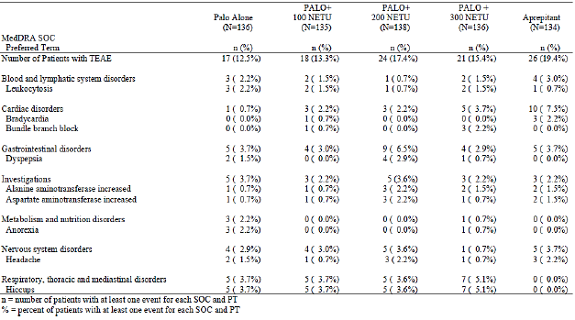

NETU-10-29
In Study NETU-10-29, the percentages of patients with any study drug related TEAEs were higher in the netupitant/palonosetron FDC group (10.1%) compared to the aprepitant + palonosetron group (5.8%). Study drug related TEAEs that occurred in ≥ 2% of patients in any treatment group were provided. The only TEAE related to the study drugs reported by ≥ 2% patients in any treatment group was constipation (3.6% in the netupitant/palonosetron FDC group versus 1.0% in the aprepitant + palonosetron group). The next most commonly-reported TEAE in the netupitant/palonosetron FDC group was headache (1.0% versus 1.0% in the aprepitant + palonosetron group). Most study drug related TEAEs were mild or moderate in intensity. Only one (0.2%) patient (in the netupitant/palonosetron FDC group) experienced a study drug related TEAE (acute psychosis; SAE) of severe intensity, which led to discontinuation.
In the safety analysis by cycle, similar to the analysis on incidence of all causality TEAEs by cycle, the percentage of patients with any study drug related TEAEs in both treatment groups showed a general decreasing trend over the first 6 cycles, from an overall incidence of 4.6% in Cycle 1 (5.2% and 2.9% in the netupitant/palonosetron FDC and aprepitant + palonosetron groups, respectively) to 1.2% in Cycle 6 (1.6% and 0%, respectively). The incidence of study drug related TEAEs was generally similar between the treatment groups within each cycle from Cycles 1 to 6. The only study drug related TEAE that was reported by ≥ 2% patients in any treatment group, for Cycles 1 through 6, was constipation (incidence in Cycle 1 of 2.3% in the netupitant/palonosetron FDC versus 0% in the aprepitant + palonosetron group; incidence in Cycle 2 of 2.5% versus 0%).
Analyses of study drug related TEAEs in the whole study period by chemotherapy emetogenicity showed similar results to the overall analyses. Among the safety population on MEC (N = 312), the percentage of patients with any study drug related TEAEs was higher in the netupitant/palonosetron FDC group (9.0%) compared to the aprepitant + palonosetron group (3.8%). Among the safety population on HEC (N = 100), the percentage of patients with any study drug related TEAEs was comparable between the netupitant/palonosetron FDC group (13.3%) and the aprepitant + palonosetron group (12.0%). In the both the MEC and HEC subgroup safety populations, the most commonly reported study drug related TEAE by preferred term in the netupitant/palonosetron FDC group was constipation (MEC: 3.0% in the netupitant/palonosetron FDC group versus 0% in the aprepitant + palonosetron group; HEC: 5.3% versus 4.0%).

Studies PALO-10-01, PALO-03-13 and PALO-03-14
In Study PALO-10-01, the percentages of patients with any study drug related TEAEs were lower in the oral palonosetron group (3.2%) compared to the IV palonosetron group (6.5%). Study drug related TEAEs were provided. The most commonly reported study drug related TEAE by preferred term in the oral palonosetron group was constipation (1.4% versus 2.4% in the IV palonosetron group).
In Study PALO-03-13, the percentages of patients with any study drug related TEAEs were lower in the oral palonosetron treatment groups compared to the IV palonosetron group, and there was no obvious dose dependent trend in the oral palonosetron groups (7.0%, 8.1% and 7.6% in the oral palonosetron 0.25 mg, 0.50 mg and 0.75 mg groups, respectively, versus 16.0% in the IV palonosetron group). The most commonly reported study drug related TEAE by preferred term in the oral palonosetron groups was headache (3.8%, 3.7% and 3.8% in the oral palonosetron 0.25 mg, 0.50 mg and 0.75 mg groups, respectively, versus 8.6% in the IV palonosetron group).
In Study PALO-03-14, the percentages of patients with any study drug related TEAEs was 15.7%. The incidence of cycles with study drug related TEAEs was highest in Cycle 1 (12.4%) and was comparable between Cycles 2 to 4 (5.6% to 8.4%). Study drug related TEAEs were reported in 8.9% of cycles. The most commonly reported study drug related TEAE by preferred term was headache (reported in 4.9% of cycles).

Deaths and other serious adverse events

Pivotal study up
In Cycle 1 of Study NETU-08-18, there were no deaths in the netupitant/palonosetron FDC group, and one (0.1%) death in the palonosetron alone group (cause of death: acute respiratory failure and cardiac failure acute; not considered study drug related). In the Cycle 1 safety population of Study NETU-08-18, the percentages of patients with any serious adverse events (SAEs) were comparable between the netupitant/palonosetron FDC group (1.8%) and the palonosetron alone group (1.7%). SAEs in Cycle 1 are presented in Table 29. The most commonly reported SAE by preferred term in the netupitant/palonosetron FDC group was febrile neutropenia (0.6% versus 0.4% in the palonosetron alone group). There were no reports of study drug related SAEs in Cycle 1.

Table 29. Serious TEAEs reported in Cycle 1 summarised by MedDRA SOC, PT, and treatment group; safety population (Cycle 1)), Study NETU-08-18
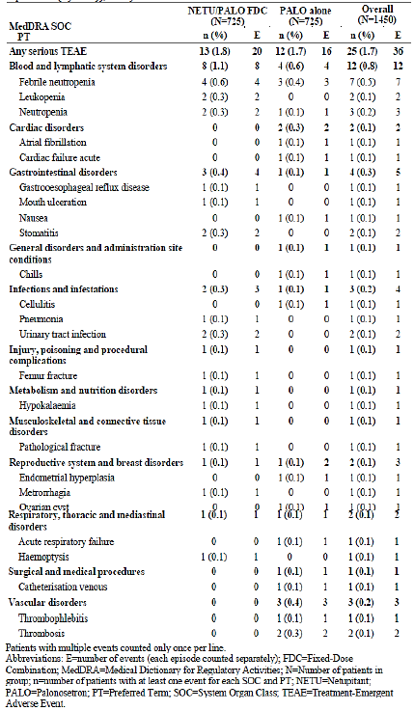
In the multiple cycle extension safety population in Study NETU-08-18, there were no deaths in the netupitant/palonosetron FDC group, and one (0.2%) death in the palonosetron alone group (cause of death: disease progression of metastatic breast cancer; not considered study drug related). In the multiple cycle extension safety population, the percentage of patients with any SAEs was 3.6% in the netupitant/palonosetron FDC group compared to 2.3% in the palonosetron alone group. SAEs in the multiple cycle extension safety population were provided. The most commonly reported SAEs by preferred term in the netupitant/palonosetron FDC group was febrile neutropenia (0.9% versus 0.6% in the palonosetron alone group) and neutropenia (0.9% versus 0.2%). There were no reports of study drug related SAEs in the multiple cycle extension safety population.

Other studies

NETU-07-07
Only 1 death was reported in Study NETU-07-07 (in the palonosetron + netupitant 100 mg group; multiple organ failure; unrelated to study drug). There was no clear dose related trend in the incidence of SAEs (incidence of 0.7%, 0.7% and 0% in the palonosetron + netupitant 100 mg, palonosetron + netupitant 200 mg, and palonosetron+ netupitant 300 mg groups, respectively, versus 2.2% in the palonosetron alone group and 0% in the aprepitant group). Only one study drug related SAE was reported in the study (in the palonosetron + netupitant 200 mg group; loss of consciousness).

NETU-10-29
In Study NETU-10-29, there were 16 deaths (5.2%) in the netupitant/palonosetron FDC group, compared to 1 death (1.0%) in the aprepitant + palonosetron group. The most common cause of death in the netupitant/palonosetron FDC group was disease progression (5 patients) and lung/pulmonary embolism (2 patients). Other causes of deaths were reported in 1 patient each: hemoptysis and dyspnoea due to disease complication, lower respiratory tract infection and pancytopenia, cancer intoxication, pulmonary heart insufficiency, ischaemic stroke, pneumothorax, weakness, circulatory and respiratory failure, pneumonia. One patient (1.0%) in the aprepitant + palonosetron group experienced a serious TEAE of renal insufficiency and convulsion leading to death. None of the deaths were considered related to study drugs.
The percentages of patients with any SAEs were comparable between the netupitant/palonosetron FDC group (16.2%) and the aprepitant + palonosetron group (18.3%). SAEs were provided. The most commonly reported SAEs by preferred term in the netupitant/ palonosetron FDC group were febrile neutropenia (1.9% in the netupitant/palonosetron FDC group versus 1.0% in the aprepitant + palonosetron group) and vomiting (1.6% versus 1.0%). Overall, 2 study drug related SAEs were reported in 2 (0.6%) patients in the netupitant/palonosetron FDC group (ventricular extrasystoles; acute psychosis) compared with none in the aprepitant + palonosetron group.
Analyses of deaths and SAEs by cycle showed that the incidence of death was highest in Cycle 1 (7 deaths [overall incidence of 1.7%]; all in netupitant/palonosetron FDC group). The overall incidence of death in Cycles 2 to 6 was 0.3% (1 death; FDC group), 0.9% (3 deaths, FDC group), 0.6% (2 deaths (FDC group), 0.9% (2 deaths, FDC group) and 1.2% (2 deaths, 1 in each treatment group), respectively. The incidence of SAEs was generally comparable from Cycles 1 to 6 (incidence range of 2.9% to 5.3%). The highest frequency of SAEs was reported in Cycle 1, with overall incidence of 5.3% (5.8% in the netupitant/palonosetron FDC group and 3.8% in the aprepitant + palonosetron group). The incidence of SAEs was generally similar between the treatment groups within each cycle from Cycles 1 to 6.
Analyses of deaths and SAEs in the whole study period by chemotherapy emetogenicity showed similar results to the overall analyses. Among the safety population on MEC (N = 312), there were 12 deaths (12.2%) in the netupitant/palonosetron FDC group compared with none in the aprepitant + palonosetron group. Among the safety population on HEC (N = 100), there were 4 deaths (5.3%) in the netupitant/palonosetron FDC group compared with 1 death (4.0%) in the aprepitant + palonosetron group. Among the safety population on MEC, the percentage of patients with any SAEs was 16.3% in the netupitant/palonosetron FDC group and 13.9% in the aprepitant + palonosetron group. Among the safety population on HEC, the percentage of patients with any SAEs was 16.0% in the netupitant/palonosetron FDC group and 32.0% in the aprepitant + palonosetron group.

Studies PALO-10-01, PALO-03-13 and PALO-03-14
In Study PALO-10-01, there were 7 deaths (1.9%) in the oral palonosetron group, compared to 12 deaths (3.3%) in the IV palonosetron group. None of the deaths were considered related to study drugs. The percentages of patients with any SAEs were comparable between the oral palonosetron group (9.7%) and the IV palonosetron group (9.8%). SAEs were described and provided. The most commonly reported SAEs by preferred term in the oral palonosetron group was neutropenia (1.4% versus 2.4% in the IV palonosetron group). Overall, 4 study drug related SAEs were reported in 2 (0.5%) patients in the oral palonosetron group (1 patient reported SAEs of asthenia and diarrhoea; the other reported SAEs of constipation and abdominal pain) compared with none in the IV palonosetron group.
Overall 3 deaths were reported in Study PALO-03-13, one (0.6%) in the oral palonosetron 0.50 mg group (cause of death was subileus; investigator’s term: “subocclusive syndrome [peritoneal carcinomatosis]”), and two (1.3%) in the oral palonosetron 0.75 mg group (cardio-respiratory arrest; febrile neutropenia and septic shock). None of these deaths were considered to be related to study medications. There was no obvious dose dependent trend in the percentages of patients with any SAEs in the oral palonosetron groups (1.9%, 5.6% and 2.5% in the oral palonosetron 0.25 mg, 0.50 mg and 0.75 mg groups, respectively, versus 0.6% in the IV palonosetron group). Overall, anaemia, chest pain and dyspnoea were the only SAEs reported for more than 1 patient in any treatment group in this study (2 patients each, 1.2% of patients for each SAE, all in the oral palonosetron 0.50 mg group). Overall, only 1 SAE in the study was considered to be study drug related (atrioventricular block second degree; in oral palonosetron 0.50 mg group).
Only 1 death was reported in Study PALO-03-14 (cardiac arrest; not related to study drug). In Study PALO-03-14, the percentage of patients with any SAEs was 6.5%. SAEs were reported in 2.1% of cycles. Anaemia was the only SAE reported in more than 1 cycle (reported in 2 cycles [0.3%]). Overall, only 1 SAE in the study was considered to be study drug related (convulsion).

Discontinuation due to adverse events

Pivotal study
In Cycle 1 of Study NETU-08-18, the percentages of patients with any TEAEs leading to discontinuation of study drug were comparable between the netupitant/palonosetron FDC group (1.0%) and the palonosetron alone group (0.6%). TEAEs leading to discontinuation of study drug in Cycle 1 are presented in Table 30. The most commonly reported TEAEs leading to discontinuation of study drug by preferred term in the netupitant/palonosetron FDC group was neutropenia (0.3% in the netupitant/palonosetron FDC group versus 0% in the palonosetron alone group). There were no reports of study drug related TEAEs leading to discontinuation of study drug in Cycle 1 in the netupitant/palonosetron FDC group, compared with 0.3% (2 out of 725) in the palonosetron alone group.

Table 30. TEAEs leading to discontinuation of study drugs in Cycle 1 summarised by MedDRA SOC, PT and treatment group – safety population (Cycle 1), Study NETU-08-18
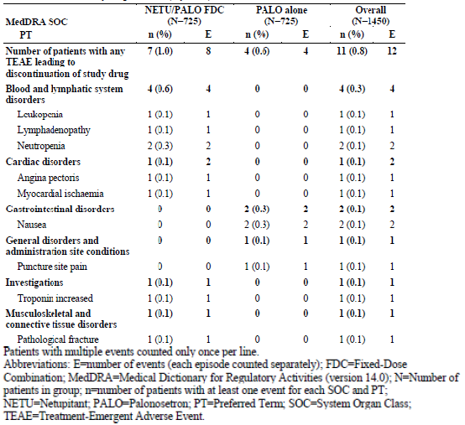
In the multiple cycle extension safety population in Study NETU-08-18, the percentages of patients with any TEAEs leading to discontinuation of study drug was 1.3% in the netupitant/palonosetron FDC group compared with 2.3% in the palonosetron alone group. TEAEs leading to discontinuation of study drug in the multiple cycle extension safety population are presented in Table 31. The most commonly reported TEAEs leading to discontinuation of study drug by preferred term in the netupitant/palonosetron FDC group was alanine aminotransferase increased (0.3% in the netupitant/palonosetron FDC group versus 0% in the palonosetron alone group). There were no reports of study drug related TEAEs leading to discontinuation of study drug in the multiple cycle extension safety population in the netupitant/palonosetron FDC group, compared with 0.5% (3 out of 651) in the palonosetron alone group.

Table 31. TEAEs leading to discontinuation of study drugs in the multiple-cycle extension summarised by MedDRA SOC, PT and treatment group – safety population (Extension), Study NETU-08-18
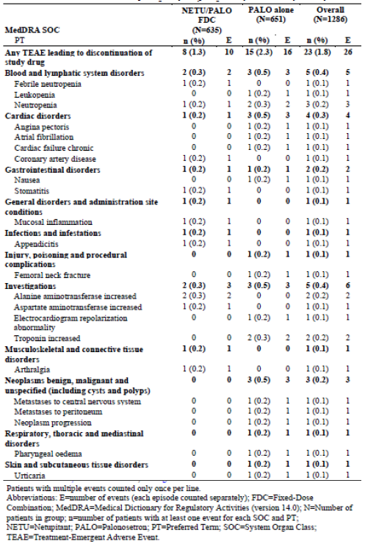

Other studies

NETU-07-07
In Study NETU-07-07, there was no clear dose related trend in the incidence of TEAEs leading to study discontinuation (incidence of 0.7%, 0.7% and 0% in the palonosetron + netupitant 100 mg, palonosetron + netupitant 200 mg, and palonosetron+ netupitant 300 mg groups, respectively, versus 0% in both the palonosetron alone group and the aprepitant group). Only one study drug related TEAEs leading to study discontinuation was reported in the study (in the palonosetron + netupitant 200 mg group; loss of consciousness; reported as SAE).

NETU-10-29
In Study NETU-10-29, the percentages of patients with any TEAEs leading to discontinuation of study drug were lower in the netupitant/palonosetron FDC group (9.1%) compared to the aprepitant + palonosetron group (12.5%). TEAEs leading to discontinuation of study drug were provided. The most commonly reported TEAEs leading to discontinuation of study drug by preferred term in the netupitant/palonosetron FDC group were neoplasm malignant (1.3% in the netupitant/palonosetron FDC group versus 1.9% in the aprepitant + palonosetron group) and neoplasm progression (1.6% versus 0%). There was one study drug related TEAEs leading to discontinuation of study drug in the netupitant/palonosetron FDC group (0.3%; acute psychosis), compared with none in the aprepitant + palonosetron group.

Studies PALO-10-01, PALO-03-13 and PALO-03-14
In Study PALO-10-01, the percentages of patients with any TEAEs leading to discontinuation of study drug were comparable between the oral palonosetron group (0.3%; 1 patient) and the IV palonosetron group (0.3%; 1 patient). None of these TEAEs leading to discontinuation of study drug were considered related to study drugs.
In Study PALO-03-13, only two TEAEs leading to discontinuation of study drug were reported, one each in the oral palonosetron 0.25 mg and 0.75 mg groups. None of these TEAEs leading to discontinuation of study drug were considered related to study drugs.
In Study PALO-03-14, TEAEs leading to discontinuation of study drug were reported in 0.5% of cycles. None of the TEAEs leading to discontinuation of study drug by preferred term were reported in > 1 cycle. Overall, only 1 TEAE leading to discontinuation of study drug was considered to be study drug related (convulsion; SAE).

Laboratory tests

Haematology, blood chemistry and urinalysis

Pivotal study
Across all cycles of Study NETU-08-18, analyses of haematology, blood chemistry and urinalysis parameters did not raise any safety concerns. The proportions of patients with clinically significant abnormalities in haematology and blood chemistry parameters were generally comparable between treatment groups.

Other studies
Analyses of haematology, blood chemistry and urinalysis parameters did not raise any safety concerns in studies NETU-07-07, NETU-10-29, PALO-10-01, PALO-03-13 and PALO-03-14.

Cardiac troponin I levels and LEVF

Pivotal study
Overall, the proportion of patients with post-dose high troponin values (≥ 0.12 ng/mL) was comparable between treatment groups (3.5% in the netupitant/palonosetron FDC group versus 3.0% in the palonosetron alone group). Similar proportions of patients in the 2 treatment groups had post dose high troponin levels in Cycle 1 (0.1% versus 0.3%) and in the multiple cycle extension (3.4% versus 2.9%). In the majority of cases, the high troponin values developed in Cycle 5 or 6 (that is after several cycles of anthracycline-cyclophosphamide based chemotherapy).
Mean LVEF changes from baseline (screening) to end of study were small and comparable between treatment groups.

Other studies
In Study NETU-10-29, the proportion of patients with pos -dose high troponin values (≥ 0.12 ng/mL) was comparable between treatment groups (2.3% in the netupitant/palonosetron FDC group versus 2.9% in the aprepitant + palonosetron group). Mean LVEF changes from baseline (screening) to end of study were small and comparable between treatment groups (mean [SD] change from baseline of -1.242 [5.418] and -1.433 [5.649] in the netupitant/palonosetron FDC and aprepitant + palonosetron groups, respectively).

Electrocardiograph

Pivotal study
Analysis of 12-lead electrocardiography parameters in Cycle 1 and in the multiple cycle extension did not reveal any safety concerns. In Cycle 1, at 5 hours after treatment (approximate T_{max} for netupitant/palonosetron FDC), there was a comparable increase of heart rate adjusted QTcF interval in both treatment groups (13.1 ms in the netupitant/palonosetron FDC group versus 13.4 ms in the palonosetron alone group), with similar results observed at 24 hours (12.2 ms versus 10.5 ms) and a return to baseline values at 120 hours after treatment (-2.0 ms versus -0.3 ms).
In Cycle 1, the percentage of patients whose QTcF interval changed from ≤ 450 ms to > 450 ms, ≤ 480 ms to > 480 ms and ≤ 500 ms to > 500 ms was comparable between treatment groups. Proportion of patients with increases in QTcF from baseline of between > 30 ms and ≤ 60 ms and of > 60 ms was comparable between treatment groups. The percentage of patients with treatment emergent ECG abnormalities during Cycle 1 was comparable between treatment groups. In Cycle 1, the most frequently reported treatment emergent ECG abnormalities in the netupitant/palonosetron FDC group were flat T waves (12.6% versus 12.1% in the palonosetron alone group) and ST depression (6.5% versus 6.5%).
In the multiple cycle extension safety population, the percentage of patients whose QTcF interval changed from ≤ 450 ms to > 450 ms, ≤ 480 ms to > 480 ms and ≤ 500 ms to > 500 ms was comparable between treatment groups. Proportion of patients with increases in QTcF from baseline of between > 30 ms and ≤ 60 ms and of > 60 ms was comparable between treatment groups. In the multiple cycle extension safety population, the percentage of patients with treatment emergent ECG abnormalities was comparable between treatment groups. The most frequently reported treatment emergent ECG abnormalities in the netupitant/palonosetron FDC group were flat T waves (33.5% versus 30.3% in the palonosetron alone group) and sinus tachycardia (24.7% versus 20.9%, respectively).

Other studies
Analysis of 12-lead electrocardiography parameters did not raise any safety concerns in studies NETU-07-07, PALO-10-01, PALO-03-13 and PALO-03-14.
In Study NETU-10-29, analysis of 12-lead electrocardiography parameters did not reveal any safety concerns. In Cycle 1, at 5 hours after treatment (approximate T_{max} for netupitant/palonosetron FDC), there was a comparable increase of QTcF interval in both treatment groups (10.6 ms in the netupitant/palonosetron FDC group versus 8.3 ms in the aprepitant + palonosetron group), with similar results observed at 24 hours (9.5 ms versus 7.3 ms) and a return to baseline values at 120 hours after treatment (-2.1 ms versus -4.0 ms).
In each cycle, the proportion of patients whose QTcF interval changed from ≤ 450 ms to > 450 ms, ≤ 480 ms to > 480 ms and ≤ 500 ms to > 500 ms, and the proportion of patients with increases in QTcF from baseline of between > 30 ms and ≤ 60 ms and of > 60 ms were generally comparable between treatment groups. The results for Cycles 1 and 6 are presented in Table 32.

Table 32. Electrocardiogram outlier analysis (Cycle 1 and Cycle 6) for QTcF intervals; safety population, Study NETU-10-29
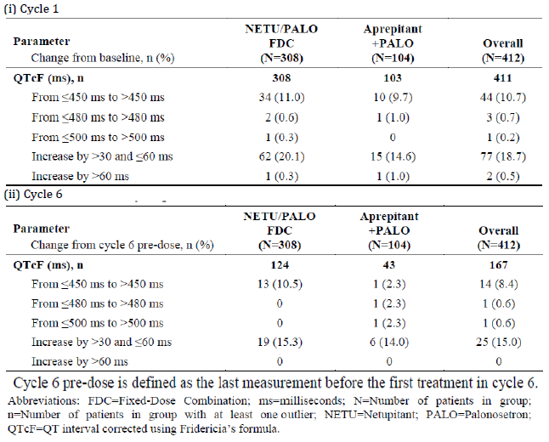
The percentage of patients with treatment emergent ECG abnormalities during each cycle was generally comparable between treatment groups. In Cycles 1 and 6, the most frequently reported treatment emergent ECG abnormalities in the netupitant/palonosetron FDC group were premature atrial complexes (Cycle 1: 6.2% versus 2.9% in the aprepitant + palonosetron group; Cycle 6: 8.9% versus 2.3%) and flat T waves (Cycle 1: 5.2% versus 3.8%; Cycle 6: 8.1% versus 4.7%).

Vital signs

Pivotal study
Analysis of vital signs did not reveal any safety concerns. In Cycle 1, the mean values for pulse rate, systolic blood pressure and diastolic blood pressure were comparable between treatment groups at baseline and at 5, 24 and 120 hours after treatment. The mean changes from baseline were small, not clinically significant and comparable between treatment groups. In the multiple cycle extension safety population, the mean values for pulse rate, systolic blood pressure, and diastolic blood pressure were also comparable between treatment groups at baseline and at 5, 24, and 120 hours after treatment in Cycles 2 to 6. The mean changes from baseline were small, not clinically significant, and comparable between treatment groups.

Other studies
Analysis of vital signs did not reveal any safety concerns in studies NETU-07-07, NETU-10-29, PALO-10-01, PALO-03-13 and PALO-03-14.

AEs of special interest

Pivotal study
Medical review of the cardiovascular events, identified based on pre-defined standard MedDRA Queries (SMQs), resulted in 260 events being judged to be of “special interest”. Four out of these 260 events were serious events: three in the palonosetron alone group (2 events of atrial fibrillation, and 1 event of acute cardiac failure) and one in the netupitant/palonosetron FDC group (event of cytotoxic miocardyopathy [sic]). All these 4 events were considered not or unlikely to be related to study drugs. Of the non-serious cardiovascular events of special interest, a total of 23 treatment-related AEs were reported in 12 patients (1.7%) in the netupitant/palonosetron FDC group, and 6 treatment-related AEs were reported in 5 patients (0.7%) in the palonosetron alone group. In the netupitant/palonosetron FDC group the most common non-serious treatment-related cardiovascular AEs of special interest was ECG QT prolonged (n=11), followed by cardiomyopathy (n=4), and atrio-ventricular block 1st degree (n=2). In addition there was 1 event each of ECG ST-T segment abnormal, ST segment depression, troponin increased, CK increased, CK -MB increased, and arrhythmia. Of the 6 non-serious treatment-related cardiovascular AEs of special interest in the palonosetron alone group, there were 2 events each of QT prolongation, non-specific changes of repolarisation, and supraventricular extrasystoles.
According to the pre-selected CNS and psychiatric disorders SMQs, overall 430 TEAEs reported by 268 patients were identified to be considered potentially of special interest for CNS and psychiatric disorders. Of these 268 patients, in order to identify patients with clusters of events, patients with single occurrences of TEAEs, as well as patients with same the event occurring more than once at different cycles, were excluded from the assessment. However, in order to depict all signals of abuse potential, as an exception to the above-mentioned rule, patients with euphoria-type, sedation, inappropriate affect and psychotomimetic events, like visual and auditory hallucination, were considered even if reporting a single episode. In addition patients were excluded from assessment if they reported two or more TEAEs (that is different preferred terms) considered potentially of special interest but not pertaining to the same SMQ and which therefore did not indicate any cluster of symptoms or signs attributable to a specific CNS or psychiatric medical condition.
Overall, out of the 268 patients identified by the pre-selected CNS and psychiatric disorders SMQs, 27 patients (19 in the netupitant/palonosetron FDC group and 8 in the palonosetron alone group) reported two or more TEAEs included in the same SMQ and were considered to be of special interest. Out of these 27 patients assessed, 12 patients (8 in the netupitant/palonosetron FDC group and 4 in the palonosetron alone group) reported TEAEs included in the SMQ “anticholinergic syndrome” (among these, only one TEAE [vision blurred; netupitant/palonosetron FDC group], was assessed by the investigator as being related to study drugs), 10 patients (7 in the netupitant/palonosetron FDC group and 3 in the palonosetron alone group) reported TEAEs listed in the SMQ “neuroleptic malignant syndrome” (among these, only one TEAE [myoglobin blood increased; netupitant/palonosetron FDC group], was assessed as being related to study drugs), 2 patients (both in the netupitant/palonosetron FDC group) reported TEAEs listed in the SMQ “extrapyramidal syndrome” (no TEAEs was judged to be related to study drugs), and 1 patient in the netupitant/palonosetron FDC group experienced TEAEs of tachycardia and pyrexia during Cycle 2 and Cycle 3 that are included in two SMQs: “anticholinergic syndrome” (not related to study drugs) and “neuroleptic malignant syndrome” (not related to study drugs).
In addition, the evaluation of any adverse event indicative of a potential drug abuse resulted in the identification of 2 TEAEs experienced by 2 patients (0.3%) in the netupitant/palonosetron FDC group: one was the occurrence of visual hallucination 2 days after study drugs administration during Cycle 1, which resolved after one day with no specific therapy. This TEAE was assessed by the investigator as being unrelated to study drugs and was of mild intensity. The other TEAE of special interest was reported as mood alteration during Cycle 2 and resolved after 13 days with no specific therapy. The TEAE was assessed by the investigator as being possibly related to study drugs and was of moderate intensity. Beside these two cases based on the pre-defined SMQs, no additional medical condition or cluster of events was indicative of any abuse potential of netupitant/palonosetron FDC.

Other studies

Study NETU-10-29
Review of cardiovascular AEs of special interest identified a total of 133 TEAEs, regardless of seriousness and study drug relationship, of which 96 events were reported by 59 (19.2%) patients in the netupitant/palonosetron FDC group and 37 were reported by 18 (17.3%) patients in the aprepitant + palonosetron group. Overall, 103 TEAEs were assessed by the investigator as being not related to the study drugs, 23 as unlikely related, 5 probably related (all in netupitant/palonosetron FDC group; one each of A-V block 1st degree, bundle branch block left, bundle branch block right, QT prolongation and ventricular extrasystoles; all of mild intensity, except for event of ventricular extrasystoles [moderate intensity]) and 2 possibly related (both in the netupitant/palonosetron FDC group; one each of hypertension (moderate intensity) and myocardial ischaemia (mild intensity). The intensity of these TEAEs was assessed as mild in 75, moderate in 43 and severe in 15 out of the total 133 events. Fifteen of the selected events were serious TEAEs, of which 12 events occurred in 11 patients in the netupitant/ palonosetron FDC group and 3 events occurred in 3 patients in the aprepitant+ palonosetron group. Only one of the events was considered related to study drug (in netupitant/palonosetron FDC group; ventricular extrasystoles).
According to the pre-selected CNS and psychiatric disorders SMQs, overall 159 TEAEs reported by 94 patients were identified to be considered potentially of special interest for CNS and psychiatric disorders. Among these 268 patients, in order to identify patients with clusters of events, patients with single occurrences of TEAEs, as well as patients with same the event occurring more than once at different cycles, were excluded from the assessment. However, in order to depict all signals of abuse potential, as an exception to the above mentioned rule, patients with euphoria-type, sedation, inappropriate affect and psychotomimetic events, like visual and auditory hallucination, were considered even if reporting a single episode. In addition patients were excluded from assessment if they reported two or more TEAEs (that is different preferred terms) considered potentially of special interest but not pertaining to the same SMQ and which therefore did not indicate any cluster of symptoms or signs attributable to a specific CNS or psychiatric medical condition.
Overall, out of the 268 patients identified by the pre-selected CNS and psychiatric disorders SMQs, 6 patients (3 [1.0%] in the netupitant/palonosetron FDC group and 3 [2.9%] in the palonosetron aprepitant + palonosetron group) reported two or more TEAEs included in the same SMQ and were considered to be of special interest. Out of these 6 patients assessed, 4 patients (2 in each treatment group) reported TEAEs included in the SMQ “anticholinergic syndrome”, and 2 patients (1 in each treatment group) reported TEAEs listed in the SMQ “neuroleptic malignant syndrome”. Two patients (1 in each treatment group) counted in the SMQ “anticholinergic syndrome” experienced also TEAEs related to the SMQ “dementia”. Overall, no cluster of events was indicative of any abuse potential of netupitant/palonosetron FDC.

Post-marketing experience
Not applicable.

Evaluator’s overall conclusions on clinical safety
Overall, safety results did not raise any major safety concerns. In the Cycle 1 safety population of Study NETU-08-18 (MEC), the percentages of patients with any study drug related TEAEs were comparable between the netupitant/palonosetron FDC group and the palonosetron alone group (8.1% versus 7.2%). The most commonly reported study drug related TEAE by preferred term in the netupitant/palonosetron FDC group was headache (3.3% versus 3.0% in the palonosetron alone group) and constipation (2.1% versus 2.1%). Safety results in Study NETU-07-07 (HEC) showed similar findings. The percentages of patients with any study drug related TEAEs were comparable between the netupitant 300 mg plus palonosetron 0.50 mg group and the palonosetron alone group (15.4% versus 12.5%). The most commonly reported study drug related TEAE by preferred term in the netupitant 300 mg plus palonosetron group was hiccups (5.1% versus 3.7% in the palonosetron alone group). Although the percentages of patients with any study drug related TEAEs were higher in the netupitant/palonosetron FDC group (10.1%) compared to the aprepitant + palonosetron group (5.8%) in Study NETU-10-29, most of these study drug related TEAEs were mild or moderate in intensity. Only one (0.2%) patient (in the netupitant/palonosetron FDC group) experienced a severe study drug related TEAE (acute psychosis; SAE). The most commonly reported study drug related TEAE by preferred term in the netupitant/palonosetron FDC group was constipation (3.6% versus 1.0% in the aprepitant + palonosetron group) and headache (1.0% versus 1.0%).
In Study NETU-08-18, there were no deaths in the netupitant/palonosetron FDC group in Cycle 1 (compared to one death in the palonosetron alone group). There were also no deaths in the netupitant 300 mg plus palonosetron 0.50 mg group in Study NETU-07-07 (also no death in the palonosetron alone group). In Study NETU-10-29, the incidence of death was higher in the netupitant/palonosetron FDC group (16 deaths; 5.2%) compared to the aprepitant + palonosetron group (1 death; 1.0%). However, the most common cause of death in the netupitant/palonosetron FDC group was disease progression (5 patients) and lung/pulmonary embolism (2 patients), with other causes of deaths reported in 1 patient each. In addition, none of the deaths were considered related to study drugs.
In Study NETU-08-18, the percentages of patients with any SAEs in the Cycle 1 were comparable between the netupitant/palonosetron FDC group and the palonosetron alone group (1.8% versus 1.7%). The most commonly reported SAE by preferred term in the netupitant/palonosetron FDC group was febrile neutropenia (0.6% versus 0.4% in the palonosetron alone group). There were no study drug related SAEs in Cycle 1. In Study NETU-07-07, there were no SAEs in the netupitant 300 mg plus palonosetron 0.50 mg group (compared to 2.2% in the palonosetron alone group). In Study NETU-10-29, the percentages of patients with any SAEs were comparable between the netupitant/palonosetron FDC group and the aprepitant + palonosetron group (16.2% versus 18.3%). The most commonly reported SAEs by preferred term in the netupitant/ palonosetron FDC group were febrile neutropenia (1.9% versus 1.0% in the aprepitant + palonosetron group) and vomiting (1.6% versus 1.0%). Two study drug related SAEs were reported in 2 (0.6%) patients in the netupitant/ palonosetron FDC group (ventricular extrasystoles; acute psychosis) compared with none in the aprepitant + palonosetron group.
The percentages of patients with any TEAEs leading to discontinuation of study drug were comparable between netupitant/palonosetron FDC and palonosetron alone (Study NETU-08-18; 1.0% versus 0.6%), between netupitant 300 mg plus palonosetron 0.50 mg and palonosetron alone (Study NETU-07-07; 0% in both groups), and between netupitant/palonosetron FDC and aprepitant + palonosetron (Study NETU-10-29; 9.1% versus 12.5%). Analyses of haematology, blood chemistry, urinalysis, 12-lead ECG and vital signs did not raise any safety concerns in studies NETU-08-18, NETU-07-07, and NETU-10-29. Assessment of drug abuse potential did not raise any safety concerns.
Analyses of safety over repeated chemotherapy cycles did not raise any safety concerns. In the multiple cycle extension safety population in Study NETU-08-18, the percentages of patients with any study drug related TEAEs was comparable between the netupitant/palonosetron FDC group and the palonosetron alone group (10.1% versus 7.5%). Consistent with the findings in Cycle 1, the most commonly reported study drug related TEAE by preferred term in the netupitant/palonosetron FDC group in the multiple cycle extension was headache (3.5% in the versus 2.8% in the palonosetron alone group) and constipation (2.0% versus 2.2%). There were no deaths in the netupitant/palonosetron FDC group in the multiple cycle extension (compare with one death in the palonosetron alone group). In the multiple cycle extension safety population, the percentages of patients with any SAEs was comparable between the netupitant/palonosetron FDC group and the palonosetron alone group (3.6% versus 2.3%). Consistent with the findings in Cycle 1, the most commonly reported SAEs by preferred term in the netupitant/palonosetron FDC group was febrile neutropenia (0.9% versus 0.6% in the palonosetron alone group) and neutropenia (0.9% versus 0.2%). None of the SAEs were considered study drug related.
In Study NETU-10-29, the percentage of patients with any study drug related TEAEs in both treatment groups showed a general decreasing trend over the first 6 cycles, from an overall incidence of 4.6% in Cycle 1 (5.2% and 2.9% in the netupitant/palonosetron FDC and aprepitant+ palonosetron groups, respectively) to 1.2% in Cycle 6 (1.6% and 0%, respectively). The incidence of study drug related TEAEs was generally similar between the treatment groups within each cycle from Cycles 1 to 6. The only study drug related TEAE that was reported by ≥ 2% patients in any treatment group, for Cycles 1 through 6, was constipation (incidence in Cycle 1 of 2.3% in the netupitant/palonosetron FDC versus 0% in the aprepitant + palonosetron group; incidence in Cycle 2 of 2.5% versus 0%). The incidence of death was highest in Cycle 1 (7 deaths [overall incidence of 1.7%]; all in netupitant/palonosetron FDC group) while the incidence of death in Cycles 2 to 6 was low (0.3% to 1.2%). The incidence of SAEs was generally comparable from Cycles 1 to 6 (incidence range of 2.9% to 5.3%). The incidence of SAEs was generally similar between the treatment groups within each cycle from Cycles 1 to 6.

First round benefit-risk assessment

First round assessment of benefits
The benefits of Akynzeo in the proposed usage are:
- Prevention of acute as well as delayed nausea and vomiting associated with initial and repeat courses of both highly emetogenic and moderately emetogenic cancer chemotherapy.
- Potential improved medication compliance as oral FDC formulation offers simpler dosing regimen.
Overall, efficacy results supported anti-emetic efficacy of a single oral dose of netupitant/ palonosetron FDC in acute and delayed phases of CINV with MEC and HEC, as well as efficacy over repeated cycles of chemotherapy.
Efficacy analyses results showed that there was a statistically significantly higher proportion of patients with complete response (no emesis and no rescue medication) with netupitant/palonosetron FDC compared to palonosetron alone in patients on MEC in the acute (0 to 24 hours) and delayed (25 to 120 hours) phases (Study NETU-08-18: treatment difference [netupitant/palonosetron FDC over palonosetron alone] of 3.4% [p = 0.047] and 7.4% [p = 0.001] in the acute and delayed phases, respectively). There was also a statistically significantly higher proportion of patients with complete response with netupitant 300 mg + palonosetron 0.50 mg compared to palonosetron alone in patients on HEC in the acute and delayed phases (Study NETU-07-07: treatment difference [netupitant 300 mg + palonosetron over palonosetron alone] of 8.8% [p = 0.002; CMH test] and 10.2% [p = 0.016; CMH test] in the acute and delayed phases, respectively).
Analyses of other efficacy endpoints generally supported the results of the endpoint of complete response. Efficacy endpoint of the proportion of patients with no emesis showed statistically significant differences (p < 0.05) between oral netupitant 300 mg plus palonosetron 0.50 mg and oral palonosetron 0.50 mg alone in the acute, delayed and overall phases in studies NETU-08-18 (netupitant/palonosetron FDC versus palonosetron alone; acute phase: 90.9% versus 87.3%; delayed phase: 81.8% versus 75.6%) and NETU-07-07 (netupitant 300 mg + palonosetron versus palonosetron alone; acute phase: 98.5% versus 89.7%; delayed phase: 91.9% versus 80.1%). Endpoints of the proportion of patients with no significant nausea, and with complete protection (no emesis, no rescue medication, and no significant nausea) also showed statistically significant differences between oral netupitant 300 mg plus palonosetron 0.50 mg and oral palonosetron 0.50 mg alone (in favour of the former) in the delayed and overall phases in studies NETU-08-18 and NETU-07-07.
With regards to efficacy over repeated cycles of chemotherapy, analyses of efficacy data over multiple cycles of chemotherapy in Study NETU-08-18 (MEC) and safety Study NETU-10-29 (MEC and HEC) showed that the anti-emetic effect of the FDC was maintained over multiple cycles of chemotherapy. Results in Study NETU-08-18 showed that the proportions of patients with complete response and those with no significant nausea were higher for netupitant/palonosetron FDC than for palonosetron alone in each phase (acute, delayed and overall) and each cycle up to Cycle 6, with treatment differences more pronounced in the delayed and overall phases. Results in Study NETU-10-29 showed that in Cycles 2 to 6, the proportion of patients with complete response was numerically higher for the netupitant/palonosetron FDC group than the aprepitant + palonosetron group particularly in the delayed and overall phases, while that in the acute phase was more similar between treatment groups.

First round assessment of risks
The risks of Akynzeo in the proposed usage are:
- headache
- constipation.
Overall, safety results did not raise any major safety concerns. In both studies NETU-08-18 (MEC) and NETU-10-29 (MEC and HEC), the most commonly reported study drug related TEAE by preferred term in the netupitant/palonosetron FDC group was headache (Study NETU-08-18 Cycle one: 3.3% versus 3.0% in the palonosetron alone group; Study NETU-10-29: 1.0% versus 1.0% in the aprepitant + palonosetron group) and constipation (Study NETU-08-18 Cycle one: 2.1% versus 2.1%; Study NETU-10-29: 3.6% versus 1.0%). In Study NETU-07-07 (HEC), the most commonly reported Study drug related TEAE by preferred term in the netupitant 300 mg plus palonosetron group was hiccups (5.1% versus 3.7% in the palonosetron alone group).
The majority of study drug related TEAEs were mild to moderate in intensity. The incidence of severe study drug related TEAEs in the netupitant/palonosetron FDC group was 0.7% (5 out of 725) in Study NETU-08-18 Cycle 1 (versus 0% [0 out of 725] in the palonosetron alone group) and 0.3% (1 out of 308) in Study NETU-10-29 (versus 0% [0 out of 104] in aprepitant + palonosetron group), and that of netupitant 300 mg + palonosetron was 0% (0 out of 136) in Study NETU-07-07 ( versus 1.5% [2 out of 136] in the palonosetron alone group). The incidence of drug related SAEs was also low. There were no study drug related SAEs in Study NETU-08-18 (Cycle 1) and in Study NETU-07-07 and only two study drug related SAEs were reported in 2 (0.6%) patients in the netupitant/ palonosetron FDC group (ventricular extrasystoles; acute psychosis) in Study NETU-10-29.
Analyses of safety over repeated chemotherapy cycles did not raise any safety concerns. In the multiple cycle extension safety population in Study NETU-08-18, the percentages of patients with any study drug related TEAEs was comparable between the netupitant/palonosetron FDC group and the palonosetron alone group (10.1% versus 7.5%). Consistent with the findings in Cycle 1, the most commonly reported study drug related TEAE by preferred term in the netupitant/palonosetron FDC group in the multiple cycle extension was headache (3.5% in the versus 2.8% in the palonosetron alone group) and constipation (2.0% versus 2.2%). The majority of study drug related TEAEs were mild to moderate in intensity. The incidence of severe study drug related TEAEs in the netupitant/palonosetron FDC group was 0.2% (1 out of 635; versus 0.2% [1 out of 651] in the palonosetron alone group). There were no study drug related SAEs in either treatment groups. In Study NETU-10-29, the percentage of patients with any study drug related TEAEs was generally similar between the treatment groups within each cycle from Cycles 1 to 6, and showed a general decreasing trend over the first 6 cycles, from an overall incidence of 4.6% in Cycle 1 (5.2% and 2.9% in the netupitant/palonosetron FDC and aprepitant+ palonosetron groups, respectively) to 1.2% in Cycle 6 (1.6% and 0%, respectively). The only study drug related TEAE that was reported by ≥ 2% patients in any treatment group, for Cycles 1 through 6, was constipation (incidence in Cycle 1 of 2.3% in the netupitant/palonosetron FDC versus 0% in the aprepitant + palonosetron group; incidence in Cycle 2 of 2.5% versus 0%).

First round assessment of benefit-risk balance
The benefit-risk balance of Akynzeo, given the proposed usage, is favourable.
Overall, efficacy results supported anti-emetic efficacy of oral netupitant 300 mg plus palonosetron 0.50 mg in acute and delayed phases of CINV with MEC and HEC, as well as efficacy over repeated cycles of chemotherapy. Efficacy analyses results showed that there was a statistically significantly higher proportion of patients with complete response with netupitant/palonosetron FDC compared to palonosetron alone in patients on MEC in the acute and delayed phases (Study NETU-08-18: treatment difference [netupitant/palonosetron FDC over palonosetron alone] of 3.4% and 7.4% in the acute and delayed phases, respectively). There was also a statistically significantly higher proportion of patients with complete response with netupitant 300 mg + palonosetron 0.50 mg compared to palonosetron alone in patients on HEC in the acute and delayed phases (Study NETU-07-07: treatment difference [netupitant+palonosetron over palonosetron alone] of 8.8% and 10.2% in the acute and delayed phases, respectively). Analyses of other efficacy endpoints generally supported the results of the endpoint of complete response. Analyses of efficacy data over multiple cycles of chemotherapy showed that the anti-emetic effect of the FDC was maintained over multiple cycles of chemotherapy.
Overall, safety results did not raise any major safety concerns. In both studies NETU-08-18 (MEC) and NETU-10-29 (MEC and HEC), the most commonly reported study drug related TEAE by preferred term in the netupitant/palonosetron FDC group was headache and constipation, while in Study NETU-07-07 (HEC), the most commonly reported study drug related TEAE by preferred term in the netupitant 300 mg plus palonosetron group was hiccups. The majority of study drug related TEAEs were mild to moderate in intensity. The incidence of severe and serious drug related TEAEs was low. Analyses of safety over repeated chemotherapy cycles did not raise any safety concerns.

First round recommendation regarding authorisation
It is recommended that the application for registration of Akynzeo for the prevention of acute and delayed nausea and vomiting associated with initial and repeat courses of highly emetogenic and moderately emetogenic cancer chemotherapy be approved. This is subject to incorporation of suggested changes to proposed PI.

Clinical questions

Pharmacokinetics
- Although the palonosetron oral softgel capsules used in the FDC are similar to the currently approved formulation, the two formulations are not identical; why has the sponsor not examined the effects of these formulation differences on the PKs of the palonosetron component?
- Can the sponsor please provide an explanation as to why food has a much greater effect on netupitant PKs in Studies BP17408 and NP16600 compared with Study NETU-10-12.
- Can the sponsor please provide an explanation for the increased variability in netupitant PKs that occurs as a result of hepatic impairment?
- As comparison of the PK results regarding netupitant when given in combination with dexamethasone (Study NETU-06-07) and in Study NP16603, where the same doses of netupitant were administered (that is 100, 300 and 450 mg), indicate that netupitant AUC_{inf} was significantly lower in Study NETU-06-07, can the sponsor please explain this discrepancy.
- As the “Investigational plan” section of Study Report NETU-08-18 indicated that the subset of patients in which the PKs of the FDC were to be determined numbered approximately 500 it is not clear why the data for only 117-8 patients was included in the PPK modelling studies. Therefore, can the sponsor please provide details concerning how the sub-population for the PPK study was selected?
- As stated in the evaluator’s comments for Study NETU-10-02 the populations modelled in the PPK were primarily female (approximately 96%) and Caucasian (approximately 86%). Therefore, due to the small number of males (n = 4 -5) and non-Caucasian subjects (n =16) included in the analyses, it may not have allowed an accurate determination of the importance of these covariates. Can the sponsor please justify the use of this population in the modelling studies?

Pharmacodynamics
- One of the TEAEs of special interest that was identified in the pivotal study and was assessed by the investigator as being possibly related to study drugs was mood alteration during Cycle 2. This TEAE was of moderate intensity and resolved after 13 days with no specific therapy. In addition, Study NP16603 identified 2 out of 4 subjects who experienced decreased vigilance, alertness and memory impairment. Therefore, can the sponsor please provide a summary of all the data related to the central effects of the FDC on alertness, mood and memory?
- The PK/PD data suggests that earlier treatment with the FDC than that proposed may result in enhanced anti-emetic effectiveness. Therefore, in the absence of data examining a range of times of FDC administration prior to chemotherapy how was the proposed 1 h pre-chemotherapy time point chosen?

Efficacy
None.

Safety
None.

Second round evaluation of clinical data submitted in response to questions

Pharmacokinetics question 1
Although the palonosetron oral softgel capsules used in the FDC are similar to the currently approved formulation, the two formulations are not identical; why has the sponsor not examined the effects of these formulation differences on the PKs of the palonosetron component?
Sponsor’s Response:
The palonosetron softgel capsule (size 1.5 oval, intermediate palonosetron softgel capsule) used in the netupitant-palonosetron FDC is similar to that of the ALOXI (palonosetron HCl) 0.50 mg softgel capsules on the market in EU and in other Countries. Marginal differences between capsules refer to size, quantity of solvent vehicle Capmul MCM EP, and the absence of printing ink on the intermediate capsule. Comparison of the currently approved formulation and the proposed formulation is provided in the Table 33.

Table 33. Comparison of currently approved and proposed formulation
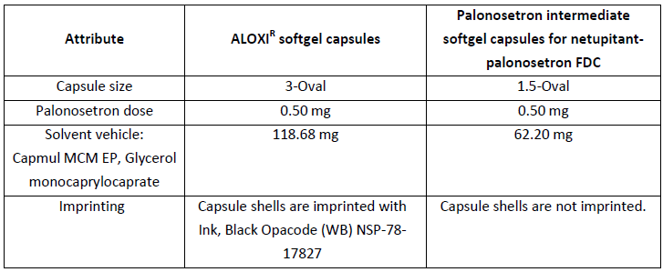
Changes proposed for the intermediate softgel capsules are justified by the need to fit a smaller softgel capsule size into a Size 0 hard gelatin capsule that also contains 3 netupitant tablets. The final dose of palonosetron hydrochloride was unchanged, 0.50 mg, as well as the quali-quantitative composition of the filling solution with the exception of the quantity of Capmul MCM EP, which was reduced in the softgel capsule for the FDC. The softgel capsule shell composition did not change from the ALOXI softgel capsule.
The softgel capsules are immediate release formulations, pharmaceutically equivalents, and contain a BCS class I active ingredient (palonosetron hydrochloride). The decrease in the excipient Capmul MCM EP and the elimination of the ink to imprint capsules can be classified level 1 changes.
Therefore, according to international guidelines,³⁵, , , BCS-based biowaivers of in vivo bioequivalence studies are applicable. Effects of formulation differences on the pharmacokinetics of the palonosetron component were excluded on the basis of comparability of the dissolution profiles of the two softgel capsule formulations in compendial in vitro dissolution test, developed and validated for the currently approved softgel Size 3 oval, at different pH media. Reference is made to the quality dossier for the dissolution method used to test palonosetron softgel for the netupitant/palonosetron FDC.
The in vivo absorption and full PK characterisation of the intermediate palonosetron 0.5 mg softgel capsule formulated as FDC with 300 netupitant have been performed in studies with the fixed dose combination (for example., NETU-10-12, NETU-11-02).
Evaluator’s Response
No clinical studies directly examined the bioequivalence and dissolution of the Aloxi Size 3 oval softgel capsule formulation of palonosetron and the Size 1.5 oval palonosetron softgel capsule intermediate formulation when given alone. However, Study NETU-09-07 assessed the bioequivalence and dissolution of palonosetron, when administered as a fixed combination of netupitant/palonosetron, which contained the intermediate palonosetron softgel capsule and the free combination, which included the Aloxi formulation. Although the dissolution profiles for the 2 palonosetron formulations could be considered different at the 15 min collection time (see following Table A below) and the dissolution study was not conducted according to TGA guidelines (Guidance 15: Biopharmaceutic studies) as only 6 samples of each formulation were examined and no similarity factor was calculated, the C_{max} and AUC values for the two formulations were bioequivalent in terms of the palonosetron component (Table 34). Therefore, the evaluator believes that the sponsor’s response is acceptable.

Table 34. Study NETU-09-07; mean ±palonosetron PK parameters after a single oral dose administration of netupitant/palonosetron (300 mg/ 0.5 mg) fixed (test) and extemporaneous (reference combination and results of bioequivalence testing. N = 47
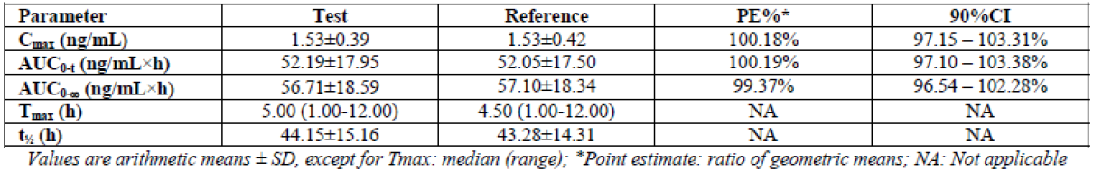

Table 35. Palonosetron dissolution profile for bioequivalence Study NTEU-09-07 Batches N0600976 and A09148 Bridging of Phase I and Phase II
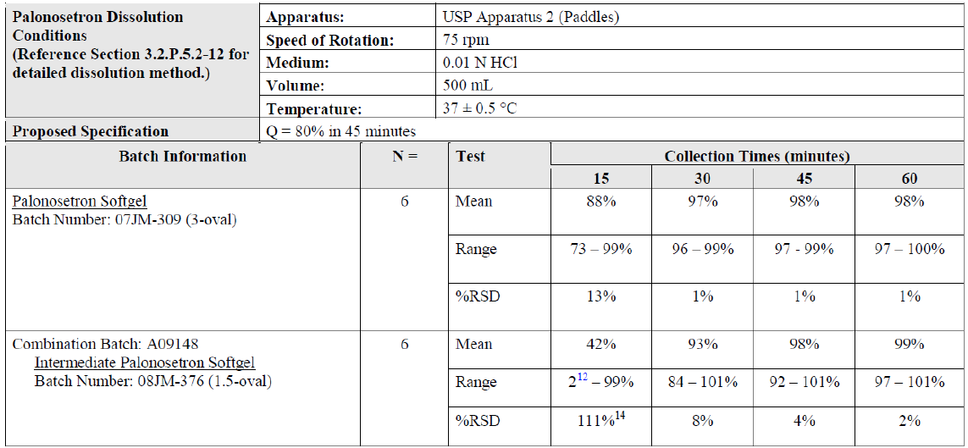
¹² Two softgels did not dissolve at 15 minutes resulting in high % RSD

Pharmacokinetics question 2
Can the sponsor please provide an explanation as to why food has a much greater effect on netupitant PKs in Studies BP17408 and NP16600 compared with Study NETU-10-12.
Sponsor’s Response
The sponsor states in the product labelling that Akynzeo can be taken with or without food. This is based on data from three studies, which evaluated the effect of food on the absorption of netupitant. In early Phase I clinical studies (NP16600 and BP17408), Roche investigated the effect of food on netupitant absorption using preliminary hard gelatin capsule formulations that contained netupitant only. The composition of these formulations is detailed in the quality dossier.

Table 36. Composition of netupitant capsules, 50 and 150 mg used in early Phase I clinical studies
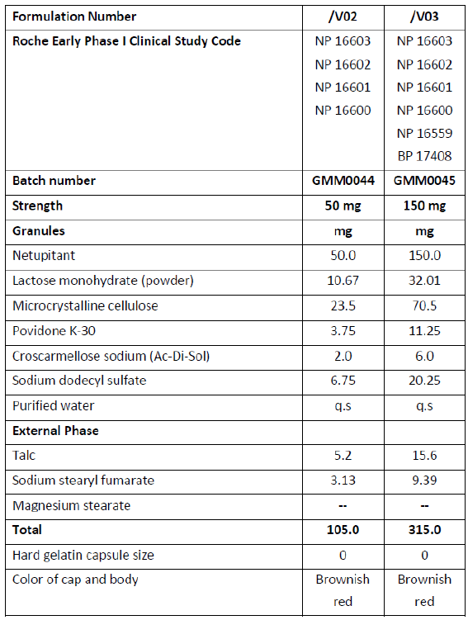
The 50 mg and 150 mg hard gelatin capsules used respectively in studies NP16600 and BP17408 had identical qualitative composition and strength proportional quantitative excipient composition. Using these formulations, co-administration of netupitant with food (standardised breakfast) resulted in a moderate increase in netupitant exposure. Wide inter subject variability, ranging from no effect to > 3 fold increase was observed.
A more recent study evaluated the Akynzeo combination of netupitant + palonosetron fixed dose combination (Study NETU-10-12). Batch No. N0901409 contained intermediate netupitant tablets Batch No. N0901098 and intermediate palonosetron softgel capsules batch No. 09JM-270 (1.5-oval). The composition of the FDC capsule is illustrated in the quality dossier and given in Table 37 below.

Table 37. Composition of netupitant 100 mg tablets/palonosetron 0.5 mg softgel capsule used in late clinical development (including Study NETU-10-12) and for commercial purposes as FDC capsules
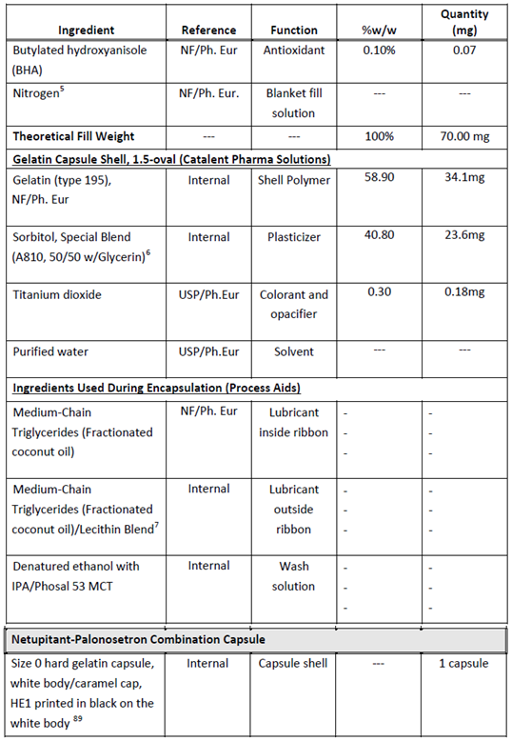
The composition of intermediate netupitant tablets in the FDC with palonosetron differ from that of netupitant capsules used in early clinical studies. Pharmacokinetic parameters observed after administration of netupitant capsules during early netupitant development (studies NP16600 and BP17408) and late netupitant/palonosetron FDC development are reported in Table 38.

Table 38. Pharmacokinetic parameters observed after administration of netupitant capsules during early netupitant development (studies NP16600 and BP17408) and late netupitant/palonosetron FDC development
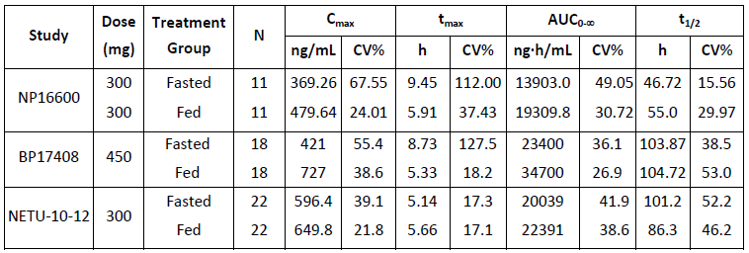
In Study NETU-10-12, a modest increase in systemic exposure (18% for C_{max}, 16% for AUC_{0-inf}) was observed in the presence of food. The 90% CIs for the fed/fasted geometric mean ratios for netupitant C_{max} and AUC_{0-inf} exceeded the higher predefined boundary of the 80% to 125% interval.
There was no effect of food on the concentrations of palonosetron. The 90% CIs for the fed/fasted ratio of palonosetron C_{max} and AUC_{0-inf} were contained within the predefined no effect boundaries of 80% to 125%. This slight increase in netupitant exposure is not considered clinically relevant.
Based on the conclusive study with the FDC (NETU-10-12) that showed a slight increase in netupitant exposure following food administration and the lack of effect of food on palonosetron concentrations, the Applicant indicates that Akynzeo can be administered with or without food.
Early netupitant capsule formulations used in NP1660 and BP17408 seemed to provide lower exposure in fasting conditions as compared to the final FDC formulation used in Study NETU-10-12, whereas similar exposures were warranted with food. This apparent discrepancy is likely due to differences in formulation composition between early netupitant capsules and final netupitant tablets of the FDC.
Evaluator’s Response
The applicant’s response is acceptable.

Pharmacokinetics question 3
Can the sponsor please provide an explanation for the increased variability in netupitant PKs that occurs as a result of hepatic impairment?
Sponsor’s Response
The primary route of metabolism for netupitant is via hepatic metabolism. Palonosetron is eliminated via both hepatic and renal routes.
In mild hepatic impairment (Study NETU-10-10), exposure to netupitant was slightly higher compared to matching healthy subjects with an increase of 11% for C_{max}, 28% for AUC_{0-tz}, and 19% for AUC_{0-inf}. The mean coefficient of variation of C_{max} was 65.7% in the group of subjects with mild hepatic impairment and 22.7% in the group of matching healthy subjects. The observed increase in exposure of netupitant was not statistically significant.
In moderate hepatic impairment, exposure to netupitant was statistically significantly higher compared to matching healthy subjects with an increase of 70% for C_{max}, 88% for AUC_{0-tz} and 143% for AUC_{0-inf}. Netupitant exposure parameters exhibited high variability in subjects with moderate hepatic impairment (ranging from 53% to 68.9%) and moderate variability in matching healthy subjects (27.9% to 41.8%).

Table 39. Netupitant PK characteristics
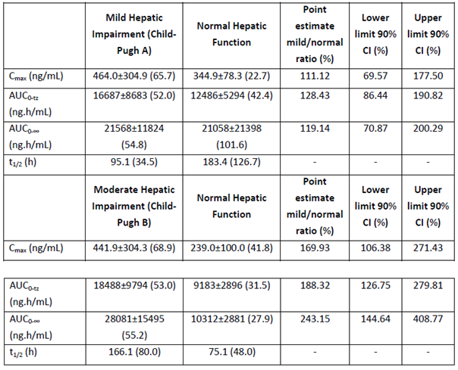
The sponsor further believes that the netupitant safety margin established within the development program, evaluating doses up to 600 mg, is adequate to support use in this special population of patients with mild and moderate hepatic dysfunction, where concentrations of netupitant may be increased.
Variability in netupitant PK parameters has been shown to be high throughout the development program. This was confirmed across all the subject groups for netupitant in hepatic impairment. In fact, netupitant elimination occurs predominantly via hepatic metabolism. In particular, CYP3A4 is the cytochrome P450 isoform that catalyses the formation of three major (M1, M2, M3) and several minor oxidative metabolites. We can, therefore, speculate that variable degree of liver insufficiency will cause a more variable metabolic clearance, which in turn will determine additional variability in netupitant elimination rate, half-life, and exposure. Moreover, the extent of binding to albumin and α1-acid glycoprotein of netupitant, a highly bound drug (fu < 0.01), may be altered in hepatic impaired subjects with reduced synthesis of transport proteins, with possible increased variability in volume of distribution.
Evaluator’s Response
The sponsor’s response is acceptable.

Pharmacokinetics question 4
As comparison of the PK results regarding netupitant when given in combination with dexamethasone (Study NETU-06-07) and in Study NP16603, where the same doses of netupitant were administered (that is 100, 300 and 450 mg), indicate that netupitant AUC_{inf} was significantly lower in Study NETU-06-07, can the sponsor please explain this discrepancy.
Sponsor’s Response
Study NP16603 is a single ascending dose Phase I study performed with a low number of subjects (4 per dose group) and netupitant capsule formulations developed for early clinical development trials. Capsules containing 10, 50 and 150 mg netupitant alone were administered to provide subjects with doses of 10, 30, 100, 300 and 450 mg netupitant. Capsule composition is detailed in the quality section of the dossier.
Study NETU-06-07 was a drug-drug interaction study of netupitant with dexamethasone, a substrate of CYP3A4. In Study NETU-06-07 the final FDC formulation employed in late clinical development and intended for commercial use, containing 300 mg netupitant with 0.5 mg palonosetron, was used.
Capsule composition is detailed in the quality dossier.
The number of subjects receiving the netupitant/palonosetron FDC ranged from 13 to 16. The apparent discrepancy in the exposure values between studies NP16603 and NETU-06-07 could be justified in light of the wide variability of PK parameters for netupitant, the low number of subjects treated in the SAD study in each cohort, and the different netupitant formulations used. C_{max}, T_{max}, and half-life values were comparable between studies.

Table 40. PK parameters of netupitant observed in studies NP16603 and NETU-06-07
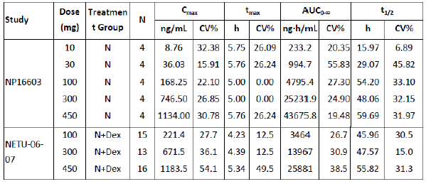
Evaluator’s Response
The applicant’s response is acceptable.

Pharmacokinetics question 5
As the “Investigational plan” section of Study Report NETU‐08‐18 (p48 of 92335) indicated that the subset of patients in which the PKs of the FDC were to be determined numbered approximately 500 it is not clear why the data for only 117‐8 patients was included in the PPK modelling studies. Therefore, can the sponsor please provide details concerning how the sub‐population for the PPK study was selected?
Sponsor’s Response
As described in the population PK data analysis report NETU-10-02, the number of patients planned to be randomised in Study NETU-08-18 was 1460, equally distributed in the two groups (that is 730 patients per group). In total up to 500 patients could have been blindly enrolled in the population PK sub study. Considering that the randomisation scheme was 1:1 and assuming that patients who accepted to participate in the PK sub study would have been equally distributed in the two arms, it was assumed to have up to 250 oral netupitant/palonosetron FDC treated patients and up to 250 oral palonosetron treated patients. Only patients who received the FDC were used in the population analysis.
At study completion, the randomised patients were 1,455 and 262 participated in the PK sub study, 120 treated with the oral netupitant/palonosetron FDC and 142 treated with oral palonosetron. All subjects who received the study drugs, had complete drug administration information (the dose of drugs administered and the date and time of drugs administration) recorded in their eCRFs and with at least one concentration measurement of netupitant palonosetron were included in the population PK data analysis.
Of the 120 patients treated with the oral netupitant/palonosetron FDC, 3 patients were not included in either one of the PK evaluations: two were not included in the netupitant and palonosetron analysis due to lack of netupitant or palonosetron concentration data (sample not taken and sample haemolysed, respectively). The third subject was not included in the netupitant analysis due to lack of measurable netupitant concentrations (all concentrations were below the limit of quantification).
Therefore, 117 patients were evaluable for netupitant and its metabolites and 118 patients were evaluable for palonosetron.
The valid concentration time data for netupitant and its metabolites M1, M2, and M3 were 571, 546, 560, and 561, respectively, from 117 evaluable patients. The valid concentration time data for palonosetron were 567 from 118 evaluable patients who were administered with netupitant/palonosetron FDC.
Evaluator’s Response
The applicant’s response is acceptable.

Pharmacokinetics question 6
As stated in the Evaluator’s comments for Table 4.11 the populations modelled in the PPK were primarily female (approximately 96%) and Caucasian (approximately 86%). Therefore, due to the small number of male (n = 4 to 5) and non-Caucasian subjects (n = 16) included in the analyses, it may not have allowed an accurate determination of the importance of these covariates. Can the sponsor please justify the use of this population in the modelling studies?
Sponsor’s Response
The patient population treated in the Phase III Study NETU-08-18 was primarily comprised of females (1,422 out of 1,450; 98.1%), with a minority (28 out of 1,450; 1.9%) of males due to the protocol specified chemotherapy regimen (MEC, AC/EC) mostly indicated for breast cancer. As a consequence, patients from NETU-08-18 who participated in the population PK Study NETU-10-02 (n=117) were predominantly females [female/males ratio: 113 (96.6%) / 4 (4.3%)] and Caucasian [Caucasian / Asian ratio: 101 (86.3%) /16 (13.7%)].
In the population PK Study NETU-10-02, initial exploratory graphical analyses on all covariates, including gender and race, showed that the potential covariates for netupitant were body weight on systemic clearance (CL) and volume of distribution of peripheral compartment (V2), age and gender on CL, and smoking status on V2. However, after performing stepwise deletions of the covariates from the full model of netupitant, none of the covariates were found to significantly affect PK parameters, including gender and race (despite the limitation determined by the low number of males).
Lack of gender effect on netupitant PK was also assessed post-hoc using three single dose Phase I studies (NETU-09-07, NETU-11-02 and NETU-11-23) both by study and in a pooled analysis in 153 healthy subjects, including 446 PK profiles for netupitant (NEPA-13-11). Data were provided. When the pooled data were analysed, females showed higher netupitant C_{max} (35% increase), AUC0-t (2% increase) and half-life (36% increase) versus males. However, the safety margin of netupitant has been shown, during development, to more than cover such potential exposure increase.
Evaluator’s Response
The applicant’s response is acceptable.

Pharmacodynamics question 1
One of the TEAEs of special interest that was identified in the pivotal study and was assessed by the investigator as being possibly related to study drugs was mood alteration during Cycle 2. This TEAE was of moderate intensity and resolved after 13 days with no specific therapy. In addition, Study NP16603 (Table 4.8) identified 2 out of 4 subjects who experienced decreased vigilance, alertness and memory impairment. Therefore, can the sponsor please provide a summary of all the data related to the central effects of the FDC on alertness, mood and memory?
Sponsor’s Response
CNS penetration of netupitant is considered a prerequisite for the anti-emetic effect since the area postrema, a circumventricular structure located at the caudal end of the fourth ventricle, is considered a “chemoreceptor trigger zone”.
In the mentioned early Phase I Study carried out by Roche (Protocol NP16603 - Research Report 1007847), the Cognitive Drug Research (CDR) computerised Cognitive Assessment System, the Bond-Lader Visual Analogue Scales (VAS) of Mood and Alertness test and the Profile of Mood States (POMS) test were specifically included among the study assessments to have a proxy measure of netupitant ability to penetrate the brain and to provide information about netupitant CNS effects.
Within the highest tested dose of the 450 mg dose group, a reduction in the performance of two tasks (digit vigilance and numeric working memory) and a lowering of self-rated alertness were observed at around 8 hour post-dose.
However, these results were largely driven by two study subjects: one subject showed several large declines in numeric working memory, and the other subject presented effects on the Vigilance task and Self-rated Alertness with general impairment to word recall and recognition. The reported impaired performances were not assessed by the investigator as adverse reactions. The results of these tests showed no evidence of any undesirable effects on mood or sedation and no clear dose response relationship was detected.
The TEAE of mood alteration of moderate intensity was reported in Study NETU-08-18, a 57 year old woman with severe obesity, with an history of total thyroidectomy and chronic treatment with 125 mcg L-thyroxin QD, and thiazides for hypertension; during the course of the study the patients showed persistent hypokalaemia (a well-recognised cause of mood impairment), syncope episodes, generalised bone pain, peripheral oedema with pain at the extremities. Moreover the patient developed chemotherapy induced neutropenia and was administered with CSF treatment. Finally she received anticoagulant therapy for DVT prophylaxis and she experienced an adverse event of malfunctioning central venous access port-a-cath. In this clinical context she developed an episode of mood alteration during Cycle 2 which was assessed as being possibly related by the investigator and resolved after 13 days without intervention.
With the aim to better characterise the neurological and psychiatric safety profile of netupitant given in combination with palonosetron, careful monitoring of any event detected at the central nervous system or at psychiatric level was implemented throughout the clinical development program.
Table 41 shows selected TEAEs within the nervous system disorders and psychiatric disorders SOCs possibly indicative of reduced alertness, altered mood or impaired memory reported in cancer patients enrolled in the Phase II/III across all chemotherapy cycles, who received either oral netupitant 300 mg in combination with oral palonosetron 0.5 mg, or oral palonosetron 0.5 mg alone or a 3 day oral aprepitant regimen combined with either palonosetron or ondansetron.

Table 41. Selected TEAEs within the nervous system disorders and psychiatric disorders
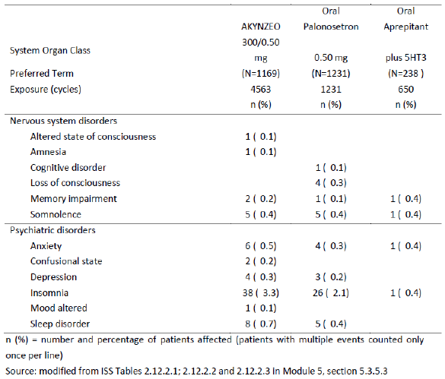
Apart from insomnia, which is generally considered common in cancer patients, all PT were uncommon across the three groups. There was no sign of increased frequency of these events in patients exposed to oral 300 mg netupitant/0.50 mg palonosetron compared to 0.50 mg palonosetron alone. None of the events of altered state of consciousness and memory impairment was assessed as drug related in all groups across all cycles.
In conclusion, the evaluation of the TEAE profile in cancer patients receiving the netupitant/palonosetron combination does not suggest any signal of reduced alertness, altered mood or impaired memory.
Evaluator’s Response
The applicant’s response is acceptable.

Pharmacodynamics question 2
The PK/PD data suggests that earlier treatment with the FDC than that proposed may result in enhanced anti-emetic effectiveness. Therefore, in the absence of data examining a range of times of FDC administration prior to chemotherapy how was the proposed 1 h pre-chemotherapy time point chosen?
Sponsor’s Response
The time of the FDC administration (1 hour prior to chemotherapy start) was selected for consistency with the tested and label-approved time of administration of oral Aloxi.
Since the overall clinical development strategy of the FDC was aimed at assessing the contribution of netupitant component to the FDC, both pivotal studies NETU-07-07 and NETU-08-18 were designed to demonstrate the superiority of the FDC with oral netupitant 300 mg and oral palonosetron versus oral palonosetron 0.50 mg alone. Therefore the decision of the administration timing was firstly driven by regulatory policies.
Efficacy data obtained in Phase II, III and in the post-marketing experience with palonosetron administered orally strengthened the decision to proceed with the same schedule of Aloxi.
Remarkably also oral aprepitant (Emend), the first NK1-RA being approved on the market, must be dosed one hour prior to chemotherapy start.
Since the pharmacological contribution of the NK1-RA is mainly exerted in the delayed phase of emesis (that is after the first 24 hours following chemotherapy initiation) it is unlikely that an earlier treatment would enhance its antiemetic effectiveness. Moreover, a time to first emetic event Kaplan Meier analysis performed in Study NETU-08-18 showed that no patients had vomiting episode in the first 4 hours after chemotherapy start in both treatment groups.
Figure 7. Kaplan-Meier graph for time (hours) to first emetic episode in Cycle 1 – full analysis set (Cycle 1)
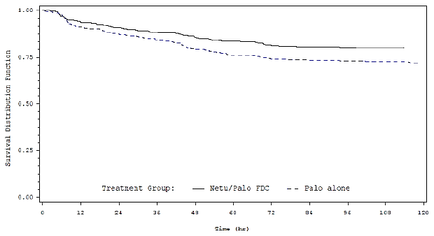
From a real world standpoint, it is important to consider that Akynzeo will be administered at the hospital, once the patient’s eligibility to undergo chemotherapy is verified. According to standard clinical practices in oncology, one hour is considered a suitable time interval to set up the chemotherapy regimen and to pre-treat the patient with the antiemetic drug.
Therefore all clinical studies were carried out by applying the time interval of 1 hour between the oral administration of netupitant-palonosetron FDC and chemotherapy.
Evaluator’s Response
The applicant’s response is acceptable.

Second round benefit-risk assessment

Second round assessment of benefits
No clinical questions were raised pertaining to efficacy. Accordingly, the benefits of Akynzeo are unchanged from those identified in the first round assessment of benefits.

Second round assessment of risks
No clinical questions were raised pertaining to safety. Accordingly, the risks of Akynzeo are unchanged from those identified in the first round assessment of risks.

Second round assessment of benefit-risk balance
The benefit-risk balance of Akynzeo, given the proposed usage, is favourable.

Second round recommendation regarding authorisation
It is recommended that the application for registration of Akynzeo for the prevention of acute and delayed nausea and vomiting associated with initial and repeat courses of highly emetogenic and moderately emetogenic cancer chemotherapy be approved.

References
European Medicines Agency, Guidelines on clinical development of fixed combination medicinal products. 19 February 2009. http://www.ema.europa.eu/docs/en_GB/document_library/Scientific_guideline/2009/09/WC500003686.pdf (accessed 28th July 2014)
European Medicines Agency, Guidelines on nonclinical and clinical development of medicinal products for the prevention of nausea and vomiting associated with chemotherapy. 14 December 2006. http://www.ema.europa.eu/docs/en_GB/document_library/Scientific_guideline/2009/12/WC500017746.pdf (accessed 28th July 2014)
European Medicines Agency, Points to consider on multiplicity in clinical trials. 19th September 2002. http://www.tga.gov.au/pdf/euguide/ewp090899en.pdf (accessed 28th July 2014)
European Medicines Agency Summary of product characteristics for oral palonosetron, March 2010. http://www.ema.europa.eu/docs/en_GB/document_library/EPAR_-_Product_Information/human/000563/WC500024259.pdf (accessed 28th July 2014)
FDA, Guidance for Industry Assessment of Abuse Potential of Drugs, 2010. http://www.fda.gov/downloads/Drugs/GuidanceComplianceRegulatoryInformation/Guidances/UCM198650.pdf (accessed 28th July 2014)
FDA product label for oral palonosetron, August 2008. http://www.accessdata.fda.gov/drugsatfda_docs/label/2008/022233LBL.pdf (accessed 28th July 2014)
Hesketh PJ., Chemotherapy-induced nausea and vomiting. N Engl J Med. 358(23):2482-94, 2008.
ICH Efficacy Guidelines. E9: Statistical Principles for Clinical Trials. September 1998. http://www.emea.europa.eu/docs/en_GB/document_library/Scientific_guideline/2009/09/WC500002928.pdf (accessed 28th July 2014)
TGA Product Information for Aprepitant, 07 November 2013 https://www.ebs.tga.gov.au/ebs/picmi/picmirepository.nsf/pdf?OpenAgent&id=CP-2010-PI-04084-3 (accessed 28th July 2014)

Therapeutic Goods Administration
PO Box 100 Woden ACT 2606 Australia
Email: info@tga.gov.au Phone: 1800 020 653 Fax: 02 6232 8605
https://www.tga.gov.au

Post registration the sponsorship for Akynzeo has changed to Mundipharma Pty Ltd, GPO Box 5214, Sydney NSW 2001.
Australian Product Information, palonosetron, 20 August 2013.
Proposed Australian Product Information, Akynzeo, Module 1.3.1
According to the sponsor, during a meeting with the CHMP, the scientific advice working party had agreed that study NETU-07-07 had the potential for consideration as a pivotal efficacy trial to support the HEC indication, considering the robustness of the results, and provided that the similar study conducted in MEC induced CINV (NETU-08-18) was to be similarly positive, since HEC- and MEC induced nausea and vomiting were considered to be closely related.
According to the sponsor, during a meeting with the CHMP, the scientific advice working party was of the opinion that study PALO-10-01 was probably not necessary to provide evidence of efficacy of oral palonosetron 0.50 mg in the HEC setting as the efficacy of oral palonosetron monotherapy in HEC could be inferred both from its efficacy in MEC (approved indication in the EU) and from the results of study NETU-07-07. The sponsor had also stated that during meetings with the FDA, the FDA had agreed that the single-cycle studies NETU-07-07 and PALO-10-01 would be acceptable to support efficacy of the FDC for the prevention of acute and delayed CINV in HEC, provided their outcomes were positive. In addition, it was considered that inclusion of repeat cycles and the number of patients in the MEC trial NETU-08-18 was sufficient for inclusion of the “repeat cycle” wording in the HEC indication.
http://www.ema.europa.eu/docs/en_GB/document_library/EPAR_Product_Information/human/000563/WC500024259.
http://www.ema.europa.eu/docs/en_GB/document_library/EPAR_-_Product_Information/human/000563/WC500024259.pdf
defined as no emesis and no rescue medication use
Defined as no emesis, no rescue medication and no significant nausea
9 sites in Argentina, 6 sites in Belarus, 12 sites in Brazil, 12 sites in Bulgaria, 9 sites in Croatia, 11 sites in Germany, 8 sites in Hungary, 14 sites in India, 5 sites in Italy, 5 sites in Mexico, 10 sites in Poland, 13 sites in Romania, 23 sites in Russia, 12 sites in Ukraine and 28 sites in the US.
European Medicines Agency, Guidelines on non-clinical and clinical development of medicinal products for the prevention of nausea and vomiting associated with chemotherapy. 14 December 2006
Dexamethasone 4 mg and its matching placebo were provided as tablets for oral administration
European Medicines Agency, Guidelines on clinical development of fixed combination medicinal product. 19 February 2009
The Functional Living Index-Emesis (FLIE) questionnaire was provided on paper to each patient on Day 1 of Cycle 1 only. The patient was instructed to complete the questionnaire on Day 6 reflecting the impact of nausea and vomiting during the 120 hours after chemotherapy administration. The FLIE is a nausea- and vomiting-specific self-assessment questionnaire comprising of 2 domains (nausea and vomiting), with 9 items in each domain. The items assess the impact of nausea and vomiting on multiple aspects of a patient’s daily life. Each item is answered using a 100 mm VAS with anchors corresponding to “none/not at all” and “a great deal” or in the opposite direction for some items. Items within the domain are weighted equally, reversed as required for some items (items with the scale anchors in the opposite direction) and summed to create the domain score according to the FLIE Scoring and Administration Manual. The 2 domain scores are then summed to create the total FLIE score. Higher scores indicate less impact on daily life as a result of nausea and vomiting.
Severity of nausea was evaluated by the patient in the diary on a daily basis for the 0 to 120 hours interval (Day 1 to Day 5) of each cycle, using a 100 mm horizontal VAS. The left end of the scale (0 mm) was labelled as “no nausea” and the right end of the scale (100 mm) was labelled as “nausea as bad as it could be”. The patient was asked to record his/her assessment of the degree of nausea during the preceding 24 hours by placing a vertical mark on the scale.
As per study protocol, the study was to be closed when the last patient enrolled had completed his/her last scheduled chemotherapy cycle. After the point at which the last patient enrolled had completed his/her final chemotherapy cycle, all other patients still on the study had to complete the cycle they were currently in and were not permitted to enter any further study cycle.
29 sites in Russia and 15 sites in Ukraine
The FAS population was defined as all patients who were randomised to treatment and received a HEC regimen and at least one dose of study treatment.
The percent of patients who used rescue medication at any time during the study was 4.4% (6/136), 2.2% (3/135), 0%, and 1.5% (2/135) for palonosetron alone and the netupitant 100 mg, 200 mg, and 300 mg groups, respectively
The hierarchical procedure was to be applied in the order of CR in the delayed phase (25-120 hours), acute phase (0-24 hours) and overall (0-120 hours) phase (e.g. comparisons between the 3 netupitant doses and palonosetron alone were to be performed for CR in the acute phase only if at least one dose of netupitant was found to be superior to palonosetron alone in the delayed phase).
8 sites in India, 10 sites in Russian Federation, 8 sites in Ukraine, 5 sites in Bulgaria, 5 sites in Czech Republic, 11 sites in Germany, 5 sites in Hungary, 7 sites in Poland, 3 sites in Serbia, and 10 sites in the US.
any single intravenous dose of one or more of the following agents: cisplatin, mechlorethamine, streptozocin, cyclophosphamide ≥ 1500 mg/m², carmustine, dacarbazine
any single intravenous dose of one or more of the following agents: oxaliplatin, carboplatin, epirubicin, idarubicin, ifosfamide, irinotecan, daunorubicin, doxorubicin, cyclophosphamide IV < 1500 mg/ m², cytarabine IV > 1 g/ m², azacidine, alemtuzumab, bendamustine, or clofarabine
According to the sponsor, the goal of this study was to characterise and quantify the safety profile of netupitant/palonosetron FDC over a reasonable duration of time consistent with the intended use of this drug, and this period had been identified as 6 cycles for the chemotherapy regimens allowed in this study. Patients were randomised to the netupitant/palonosetron FDC and aprepitant+ palonosetron regimens in a ratio of 3:1 in order to ensure a sufficient number of patients were treated with the netupitant/palonosetron FDC for 6 cycles.
As allowed by the protocol, a total of 12 patients changed the emetogenicity of their main chemotherapy during the study either from MEC to HEC (7 patients: 5 patients in netupitant/palonosetron FDC group and 2 patients in aprepitant+palonosetron group) or from HEC to MEC (5 patients: 4 patients in netupitant/palonosetron FDC group and 1 patient in aprepitant+palonosetron group).
As per study protocol, the study was to be closed when the last patient enrolled had completed his/her last scheduled chemotherapy cycle. After the point at which the last patient enrolled had completed his/her final chemotherapy cycle, all other patients still on the study had to complete the cycle they were currently in and were not permitted to enter any further study cycle.
Australian Product Information, Aprepitant. 07 November 2013
6 sites in India, 11 sites in Russian Federation, 8 sites in Ukraine, 6 sites in Bulgaria, 5 sites in Croatia, 4 sites in Germany, 6 sites in Hungary, 4 sites in Italy, 6 sites in Poland, 8 sites in Romania, 7 sites in Argentina and 9 sites in the US.
defined as all patients who were randomised to treatment and received a HEC regimen and the study medication.
PP population consisted of all patients included in the FAS who completed the 0-24 hours study period with no major protocol violations i.e. those affecting the primary efficacy endpoint.
46 centres in Europe, Mexico and the United States: 24 centres in Europe (11 in the Czech Republic, 7 in Poland and 6 in Romania), 7 centres in Mexico and 15 centres in North America.
In the event that a combination of chemotherapeutic agents of different emetogenicity levels was to be administered, the most emetogenic agent was to be administered as the first chemotherapeutic agent on study Day 1.
22 study centres in Europe, Mexico and the United States: 8 centres in Europe (5 in Czech Republic, 3 in Poland), 5 centres in Mexico and 9 centres in the United States
According to the sponsor, cardiac troponin data were collected upon regulatory request.
FDA Guidance for Industry: Immediate Release Solid Oral Dosage Forms. Scale-Up and Post approval Changes: Chemistry, Manufacturing, and Controls, In Vitro Dissolution Testing, and In Vivo Bioequivalence Documentation (1995)
FDA Guidance for Industry: Waiver of In Vivo Bioavailability and Bioequivalence Studies for Immediate-Release Solid Oral Dosage Forms Based on a Biopharmaceutics Classification System (2000)
FDA Guidance for Industry (draft): Bioavailability and Bioequivalence Studies Submitted in NDAs or INDs — General Considerations (2014)
EMEA Guideline on the investigation of bioequivalence (2010)

