This medicinal product is subject to additional monitoring in Australia. This will allow quick identification of new safety information. Healthcare professionals are asked to report any suspected adverse reactions at www.tga.gov.au/reporting-problems. See Section 4.8 Adverse Effects (Undesirable Effects) for how to report adverse reactions.

Name of the medicine
NERLYNX (neratinib)

Qualitative and quantitative composition
Each film-coated tablet contains neratinib maleate, equivalent to 40 mg neratinib.
For the full list of excipients, see Section 6.1 List of excipients.

Pharmaceutical form
Film-coated tablet.
Oval, red film-coated tablet with ‘W104’ debossed on one side and plain on the other side. Tablet dimensions are 10.5 mm x 4.3 mm with thickness of 3.1 mm.

Clinical particulars

Therapeutic indication
NERLYNX is indicated for the extended adjuvant treatment of adult patients with early-stage HER2-overexpressed/amplified breast cancer, to follow adjuvant trastuzumab based therapy.

Dose and method of administration
NERLYNX treatment should be initiated and supervised by a physician experienced in the administration of anti-cancer medicinal products.
The recommended dose of NERLYNX is 240 mg (six x 40 mg tablets) taken orally once daily, continuously for one year. The tablets should be swallowed whole preferably with water and should not be crushed or dissolved, and should be taken with food, preferably in the morning. Patients should initiate treatment within 1 year after completion of trastuzumab therapy.

Anti-diarrhoeal prophylaxis
Anti-diarrhoeal prophylaxis is recommended during the first 2 cycles (56 days) of treatment and should be initiated with the first dose of NERLYNX.
Instruct patients to take loperamide as directed in Table 1, titrating to 1-2 bowel movements per day.
Table 1. Loperamide Prophylaxis
Time on NERLYNX | Dose | Frequency
Weeks 1-2 (days 1 - 14) | 4 mg | Three times daily
Weeks 3-8 (days 15 - 56) | 4 mg | Twice daily
Weeks 9-52 (days 57 - 365) | 4 mg | As needed
Additional anti-diarrhoeal agents may be required to manage diarrhoea in patients with loperamide-refractory diarrhoea. NERLYNX dose interruptions and dose reductions may also be required to manage diarrhoea.
Diarrhoea management requires the correct use of an anti-diarrhoeal medicinal product, dietary changes, and appropriate dose modifications of NERLYNX. Guidelines for adjusting doses of NERLYNX in the setting of diarrhoea are shown in Table 2.
Table 2: Dose Modifications for Diarrhoea
Severity of Diarrhoea* | Action
- Grade 1 diarrhoea [increase of < 4 stools per day over baseline]  - Grade 2 diarrhoea [increase of 4-6 stools per day over baseline] lasting < 5 days  - Grade 3 diarrhoea [increase of ≥ 7 stools per day over baseline; incontinence; hospitalization indicated; limiting self-care activities of daily living] lasting ≤ 2 days | - Adjust anti-diarrhoeal treatment  - Diet modifications  - Fluid intake of ~2 L should be maintained to avoid dehydration  - Once event resolves to ≤ Grade 1 or baseline, start loperamide 4 mg with each subsequent NERLYNX administration.
- Any grade with complicated features†  - Grade 2 diarrhoea lasting 5 days or longer‡  - Grade 3 diarrhoea lasting longer than 2 days‡ | - Interrupt NERLYNX treatment  - Diet modifications  - Fluid intake of ~2 L should be maintained to avoid dehydration  - If diarrhoea resolves to Grade 0-1 in one week or less, then resume NERLYNX treatment at the same dose.  - If diarrhoea resolves to Grade 0-1 in longer than one week, then resume NERLYNX treatment at reduced dose (see Table 1).  - Once event resolves to ≤ Grade 1 or baseline, start loperamide 4 mg with each subsequent NERLYNX administration.
- Grade 4 diarrhoea [life-threatening consequences; urgent intervention indicated] | - Permanently discontinue NERLYNX treatment
- Diarrhoea recurs to Grade 2 or higher at 120 mg per day | - Permanently discontinue NERLYNX treatment
* Per CTCAE v4.0
† Complicated features include dehydration, fever, hypotension, renal failure, or Grade 3 or 4 neutropenia
‡ Despite being treated with optimal medical therapy

Dose Modifications for Adverse Reactions
NERLYNX dose modification is recommended based on individual safety and tolerability. Management of some adverse reactions may require dose interruption and/or dose reduction as shown in Table 2, Table 3, Table 4, and Table 5.
Discontinue NERLYNX for patients who:
- Fail to recover to Grade 0 to 1 from treatment-related toxicity,
- For toxicities that result in a treatment delay > 3 weeks, or
- For patients that are unable to tolerate 120 mg daily
Additional clinical situations may result in dose adjustments as clinically indicated (e.g. intolerable toxicities, persistent Grade 2 adverse reactions, etc.).
Table 3: NERLYNX Dose Modifications for Adverse Reactions
Dose Level | NERLYNX Dose
Recommended starting dose | 240 mg daily
First dose reduction | 200 mg daily
Second dose reduction | 160 mg daily
Third dose reduction | 120 mg daily
Table 4: NERLYNX Dose Modifications and Management – General Toxicities*
Severity of Toxicity† | Action
Grade 3 | Stop NERLYNX until recovery to Grade ≤1 or baseline within 3 weeks of stopping treatment. Then resume NERLYNX at the next lower dose level.
Grade 4 | Discontinue NERLYNX permanently.
* Refer to Table 4 and Table 5 below for management of diarrhoea and hepatotoxicity
† Per CTCAE v4.0

Missed dose
Missed doses should not be replaced and treatment should resume with the next scheduled daily dose.

Use of Gastric Acid- Reducing Agents
Proton pump inhibitors (PPI): Avoid concomitant use with NERLYNX (see Section 4.5 Interactions with other medicines and other forms of interactions).
H2-receptor antagonists: NERLYNX must be taken at least 2 hours before the next dose of the H2-receptor antagonist or 10 hours after the H2-receptor antagonist (see Section 4.5 Interactions with other medicines and other forms of interactions).
Antacids: Separate dosing of NERLYNX and antacids by 3 hours after antacids (see Section 4.5 Interactions with other medicines and other forms of interactions).

Use of CYP3A4 inhibitors
If the inhibitor cannot be avoided, reduce NERLYNX dose to 40 mg (one 40 mg tablet) taken once daily with a strong CYP3A4 inhibitor or 200 mg (five 40 mg tablets) taken once daily with a moderate CYP3A4 inhibitor. After discontinuation of a strong or moderate CYP3A4 inhibitor, resume previous dose of NERLYNX 240 mg (see Section 4.4 Special warnings and precautions for use and Section 4.5 Interactions with other medicines and other forms of interactions).

Use of CYP3A4 inducers
If a potent or moderate CYP3A4 inducer cannot be avoided, increase NERLYNX dose to 320 mg (eight 40 mg tablets) taken once daily. After discontinuation of a CYP3A4 inducer, resume previous dose of NERLYNX 240 mg. The daily dose of NERLYNX should not exceed 320 mg (see Section 4.4 Special warnings and precautions for use and Section 4.5 Interactions with other medicines and other forms of interactions).

Patients with hepatic impairment
No dose adjustment is required in patients with Child Pugh A or B (mild to moderate) hepatic impairment. Treatment of patients with Child Pugh C hepatic impairment is not recommended (see Section 4.4 Special warnings and precautions for use and 4.3 Contraindications).

Dose modifications for hepatotoxicity
Guidelines for dose adjustment of NERLYNX in the event of liver toxicity are shown in Table 5. Patients who experience ≥ Grade 3 diarrhoea requiring IV fluid treatment or any signs or symptoms of hepatotoxicity, such as worsening of fatigue, nausea, vomiting, right upper quadrant pain or tenderness, fever, rash, or eosinophilia, should be evaluated for changes in liver function tests. Fractionated bilirubin and prothrombin time should also be collected during hepatotoxicity evaluation (see Section 4.4 Special warnings and precautions for use).
Table 5: Dose Modifications for Hepatotoxicity
Severity of Hepatotoxicity* | Action
- Grade 3 ALT (>5-20 x ULN)  OR  - Grade 3 bilirubin (>3-10 x ULN) | - Stop NERLYNX until recovery to ≤ Grade 1  - Evaluate alternative causes  - Resume NERLYNX at the next lower dose level if recovery to ≤ Grade 1 occurs within 3 weeks. If Grade 3 ALT or bilirubin occurs again despite one dose reduction, permanently discontinue NERLYNX
- Grade 4 ALT (>20 x ULN)  OR  - Grade 4 bilirubin (>10 x ULN) | - Permanently discontinue NERLYNX  - Evaluate alternative causes
ULN=Upper Limit Normal; ALT= Alanine Aminotransferase
* Per CTCAE v4.0

Contraindications
Hypersensitivity to the active substance or to any of the excipients contained in NERLYNX.
Co-administration with the following medical products that are strong inducers of the CYP3A4/Pgp isoform of cytochrome P450:
- carbamazepine, phenobarbital, phenytoin (antiepileptics)
- St John’s wort (Hypericum perforatum) (herbal product)
- rifampin (antimycobacterial)
Co-administration with moderate CYP3A4/P-gp inhibitors:
- fluconazole (antifungal)
- diltiazem, verapamil (calcium-channel blockers)
- erythromycin (antibiotic)
Severe hepatic impairment (Child-Pugh C).

Special warnings and precautions for use

Diarrhoea
Diarrhoea has been reported during treatment with NERLYNX. The diarrhoea may be severe and associated with dehydration. Diarrhoea generally occurs early during the first or second week of treatment with NERLYNX and may be recurrent. (see Section 4.2 Dose and method of administration and Section 4.8 Adverse effects [Undesirable effects]).
Patients should be instructed to initiate prophylactic treatment with an anti-diarrhoeal medicinal product (e.g., loperamide) with the first dose of NERLYNX, and maintain regular dosing of the anti-diarrhoeal medicinal product during the first 1-2 months of NERLYNX treatment, titrating to 1-2 bowel movements per day, and continue prophylactic anti-diarrhoeal medicinal product (e.g., loperamide) for subsequent months as needed proactive management of diarrhoea including adequate hydration combined with anti-diarrhoeal medicinal product, especially within the first 1-2 months of NERLYNX treatment, should start at the first signs of diarrhoea. As necessary, the dose of anti-diarrhoeal medicinal product should be escalated to the highest recommended approved dose; they should be readily available to patients and continued until loose bowel movements cease for 12 hours.
Severe diarrhoea occurrences, despite prophylaxis treatment, should be aggressively managed with electrolytes and fluids replacement, and/or interruption, reduction, or discontinuation of therapy with NERLYNX.

Patients with a significant chronic gastrointestinal disorder
Patients with a significant chronic gastrointestinal disorder with diarrhoea as a major symptom were not included in the pivotal study and should be carefully monitored.

Left ventricular function
Left ventricular dysfunction has been associated with HER2 inhibition. NERLYNX has not been studied in patients with less than lower limit of normal left ventricular ejection fraction (LVEF) or with significant cardiac history. In patients with known cardiac risk factors, conduct cardiac monitoring, including assessment of LVEF, as clinically indicated.

Skin and subcutaneous tissue disorders
NERLYNX is associated with skin and subcutaneous tissue disorders. Patients with symptomatic skin and subcutaneous tissue disorders should be carefully monitored.

Use in hepatic impairment
In patients with severe hepatic impairment (Child-Pugh C) there is a 2.8-fold increase of exposure to neratinib (see Section 5.2 Pharmacokinetic properties).
Hepatotoxicity has been reported in patients treated with NERLYNX. Liver function tests including alanine aminotransferase (ALT), aspartate aminotransferase (AST), and total bilirubin should be monitored at 1 week, then monthly for the first 3 months and every 6 weeks thereafter while on treatment or as clinically indicated (see Section 4.2 Dose and method of administration).

Use in renal impairment
Patients with renal impairment are at a higher risk of complications of dehydration if they develop diarrhoea, and these patients should be carefully monitored (see Section 4.2 Dose and method of administration).
NERLYNX has not been studied in patients with severe renal impairment including patients on dialysis. Treatment of patients with severe renal impairment or on dialysis is not recommended (see Section 5.2 Pharmacokinetic properties).

Use in the elderly
Elderly patients (≥65 years of age) are at a higher risk of renal insufficiency and dehydration which may be a complication of diarrhoea and these patients should be carefully monitored.

Paediatric use
The safety and efficacy of NERLYNX in the paediatric population has not been studied in breast cancer.

Effects on laboratory tests
No data available.

Interactions with other medicines and other forms of interactions

Effects of other substances on neratinib

CYP3A4 inhibitors
Co-administration of a single oral dose of 240 mg of neratinib in the presence of ketoconazole (400 mg once daily for 5 days), a strong CYP3A4 inhibitor, increased neratinib systemic exposure. The C_{max} of neratinib increased by 3.2-fold and AUC increased by 4.8-fold when co-administered with ketoconazole, compared with neratinib administered alone. Simulations using physiologically-based pharmacokinetic (PBPK) models suggested that a moderate CYP3A4 inhibitor (fluconazole) may increase the C_{max} and AUC of neratinib by 6% and 19%, respectively.
Concomitant use of strong CYP3A4 inhibitors (e.g. atazanavir, indinavir, nefazodone, nelfinavir, ritonavir, saquinavir, ketoconazole, itraconazole, clarithromycin, telithromycin, and voriconazole) should be avoided. Grapefruit, grapefruit juice, grapefruit hybrids, pomelos, star-fruit, and Seville oranges may also increase neratinib plasma concentrations and should be avoided.

Proton pump inhibitors, H2-receptor antagonists and antacids
Neratinib solubility decreases with increasing pH. Drugs that alter the pH of the upper GI tract may alter the solubility of neratinib and hence its bioavailability. When a proton pump inhibitor (lansoprazole) was co-administered with NERLYNX the neratinib C_{max} and AUC decreased by 71% and 65%, respectively. When NERLYNX was administered 2 hours following a 300 mg dose of an H-2 receptor antagonist (ranitidine), the neratinib C_{max} and AUC were reduced by 55% and 47%, respectively. When NERLYNX was administered 2 hours prior to ranitidine 150 mg twice daily (administered in the morning and evening, approximately 12 hours apart), the neratinib C_{max} and AUC were reduced by 40% and 30%, respectively. Increasing the dose of NERLYNX when co-administered with gastric acid reducing agents is not likely to compensate for this loss of exposure (see Section 4.2 Dose and method of administration).

CYP3A4 inducers
Following concomitant administration with repeated doses of 600 mg rifampin, a strong CYP3A4 inducer, neratinib exposures were significantly decreased with mean values that were 24% and 13% of reference values (neratinib administered alone) for C_{max} and AUC, respectively.
Concurrent use of neratinib with potent CYP3A4 inducers (e.g. dexamethasone, phenytoin, carbamazepine, rifampin, phenobarbital or herbal preparations containing St John’s Wort/Hypericum perforatum) should be avoided.
Simulations using PBPK models suggested that a moderate CYP3A4 inducer (efavirenz) may decrease the C_{max} and AUC of neratinib by 12% and 32%, respectively.

Effects of neratinib on other substances

Hormonal contraceptives
It is currently unknown whether NERLYNX reduces the effectiveness of systemically acting hormonal contraceptives. Therefore, women using systemically acting hormonal contraceptives should add a barrier method (see Section 4.6 Fertility, pregnancy and lactation).

Breast cancer resistance protein inhibitors
Neratinib may inhibit breast cancer resistance protein (BCRP) moderately as suggested by in vitro studies. Clinical studies with BCRP substrates have not been conducted. Patients who are treated with BCRP substrates (e.g., rosuvastatin and sulfasalazine) should be monitored carefully.

P-glycoprotein transporters
In in-vitro studies, neratinib is an inhibitor of P-glycoprotein (P-gp) substrates. In healthy subjects, digoxin increased C_{max} by 54% and AUC increased by 32% when co-administered with multiple oral doses of neratinib 240 mg compared with exposures of digoxin alone. The clearance values of digoxin were equivalent following digoxin and digoxin plus neratinib. It appeared that the inhibitory effect of neratinib was primarily on P-gp activity in the gastrointestinal tract as a result of pre-systemic inhibition. This pre-systemic interaction of neratinib with digoxin might be clinically relevant for P-gp substrates with a narrow therapeutic window (e.g. dabigatran, digoxin, and fexofenadine). Patients who are treated concomitantly with therapeutic agents whose metabolism involves P-gp substrates in the gastrointestinal tract should be monitored carefully.

Other transporters
In in vitro studies, neratinib had no clinically-relevant inhibitory activity on BSEP, OATP1B1, OATP1B3, OAT1, OAT3 and OCT2.

CYP3A4 substrates
In vitro studies indicate neratinib may alter the pharmacokinetics of orally-administered CYP3A4 substrates.

Fertility, pregnancy and lactation

Women of childbearing potential/Contraception in females and males
Based on findings in animals, neratinib may cause fetal harm when administered to pregnant women. Women should avoid becoming pregnant while taking NERLYNX and for up to 1 month after ending treatment. Therefore, women of child-bearing potential must use highly effective contraceptive measures while taking NERLYNX and for 1 month after stopping treatment.
It is currently unknown whether neratinib may reduce the effectiveness of systemically acting hormonal contraceptives, and therefore women using systemically acting hormonal contraceptives should add a barrier method.
Men should use a barrier method of contraception during treatment and for 3 months after stopping treatment.

Effects on fertility
No fertility studies in women or men have been conducted. No significant changes in fertility parameters in male and female rats were detected following oral dosing up to 12 mg/kg/day resulting in estimated exposures 22 times the clinical AUC (see Section 5.3 Preclinical safety data).

Use in pregnancy - Category D
There are no data from the use of NERLYNX in pregnant women. Studies in animals have shown embryofetal lethality and fetal morphological anomalies. In rabbits, an increased incidence of fetal skeletal variations/ abnormalities ((fetal gross external (domed head), soft tissue (dilation of the brain ventricles and a ventricular septal defect), skeletal (misshapen anterior fontanelles and enlarged anterior and/or posterior fontanelles) abnormalities, ventricular septum defect of heart) were observed at an oral dose of ≥ 6 mg/kg/day, with exposures below (based on AUC) the clinical exposure.
The potential risk for humans is unknown. NERLYNX is not recommended during pregnancy and in women of childbearing potential not using contraception.
If neratinib is used during pregnancy, or if the patient becomes pregnant while taking NERLYNX, the patient should be informed of the potential hazard to the fetus.”

Use in lactation
It is not known whether neratinib is excreted in human milk. A risk to the breast-fed infant cannot be excluded. A decision must be made whether to discontinue breast-feeding or to discontinue NERLYNX, taking into account the importance of NERLYNX to the mother and the benefit of breast-feeding to the child.

Effects on ability to drive and use machines
NERLYNX has minor or moderate influence on the ability to drive and use machines. Fatigue, dizziness, dehydration, and syncope have been reported as adverse reactions with neratinib. The clinical status of the patient should be considered when assessing the patient’s ability to perform tasks that require judgment, motor, or cognitive skills.

Adverse effects (Undesirable effects)

Summary of the safety profile
The most common adverse reactions of any grade in the pooled data from 1,710 patients were diarrhoea (93.6%), nausea (42.5%), fatigue (27.3%), vomiting (26.8%), abdominal pain (22.7%), rash (15.4%), decreased appetite (13.7%), abdominal pain upper (13.2%), stomatitis (11.2%), and muscle spasms (10.0%).
The most common Grade 3-4 adverse reactions in the pooled data from 1,710 patients were diarrhoea (Grade 3, 36.9% and Grade 4, 0.2%) and vomiting (Grade 3, 3.4% and Grade 4, 0.1%). Patients who received NERLYNX in the pivotal Phase ExteNET trial were not required to receive prophylaxis with anti-diarrhoeal agents to prevent diarrhoea.
Adverse reactions reported as serious included diarrhoea (1.9%), vomiting (1.3%), dehydration (1.1%), nausea (0.5%), alanine aminotransferase increased (0.4%), aspartate aminotransferase increased (0.4%), abdominal pain (0.3%), fatigue (0.3%) and decreased appetite (0.2%).

Tabulated list of adverse reactions
The table below lists adverse reactions observed with neratinib based on the assessment of pooled data from 1,710 patients.
The following convention has been utilised for the classification of frequency: very common ≥ 1/10, common ≥ 1/100 but < 1/10, uncommon ≥ 1/1,000 but < 1/100, rare ≥ 1/10,000 but < 1/1,000, very rare < 1/10,000.
Within each frequency grouping, adverse reactions are presented in order of decreasing seriousness.
Table 6. Adverse drug reactions due to NERLYNX in monotherapy breast cancer studies
System Organ Class | Frequency | Adverse Drug Reaction
Infections and infestations | Common | Urinary tract infection
Metabolism and nutrition disorders | Very Common | Decreased appetite
Metabolism and nutrition disorders | Common | Dehydration
Respiratory, thoracic and mediastinal disorders | Common | Epistaxis
Gastrointestinal disorders | Very Common | Diarrhoea, vomiting, nausea, abdominal pain, abdominal pain upper, and stomatitis¹
Gastrointestinal disorders | Common | Abdominal distension, dry mouth and dyspepsia
Hepatobiliary disorders | Common | Alanine aminotransferase increased, and aspartate aminotransferase increased
Hepatobiliary disorders | Uncommon | Blood bilirubin increased
Skin and subcutaneous tissue disorders | Very Common | Rash²
Skin and subcutaneous tissue disorders | Common | Nail disorder³, skin fissures and dry skin
Musculoskeletal and connective tissue disorders | Very Common | Muscle spasms
Renal and urinary disorders | Common | Blood creatinine increased
Renal and urinary disorders | Uncommon | Renal failure
General disorders and administration site conditions | Very common | Fatigue
Investigations | Common | Weight decreased
¹ Includes stomatitis, aphthous stomatitis, mouth ulceration, oral mucosal blistering, and mucosal inflammation.
² Includes rash, rash erythematous, rash follicular, rash generalized, rash pruritic, and rash pustular.
³ Includes nail disorder, paronychia, onychoclasis, and nail discolouration.

Description of selected adverse reactions

Diarrhoea
Of the 1,660 patients treated with NERLYNX monotherapy without loperamide prophylaxis, 94.6% experienced at least 1 episode of diarrhoea. 2.0% of patients experienced serious diarrhoea. Grade 3 diarrhoea was reported in 37.5% of NERLYNX patients. 0.2% of patients had diarrhoea classified as Grade 4. Diarrhoea led to hospitalisation in 1.9% of NERLYNX-treated patients.
Diarrhoea generally occurred in the first month, with 83.6% of patients reporting this toxicity in the first week, 46.9% in the second week, 40.2% in the third week and 43.2% in the fourth week (median time to first onset was 2 days). Thereafter, the incidence of diarrhoea remained relatively stable through month 12.
The median duration of a single episode of any grade diarrhoea was 2 days. The median cumulative duration of any grade diarrhoea was 59 days and the median cumulative duration of Grade 3 diarrhoea was 5 days.
Diarrhoea was also the most common adverse reaction leading to discontinuation, 14.4 % of patients treated with NERLYNX without loperamide prophylaxis discontinued treatment due to diarrhoea. Dose reductions occurred in 24.7% of NERLYNX-treated patients.

Rash
In the NERLYNX monotherapy group, 16.7% of patients experienced rash. The incidence of Grade 1 and Grade 2 was 13.3% and 2.9% respectively; 0.4% of NERLYNX-treated patients experienced Grade 3 rash.

Nail disorders
In the NERLYNX monotherapy group, 7.8% patients experience nail disorders. The incidence of Grade 1 and Grade 2 was 6.2% and 1.4% respectively. There were 0.2% of NERLYNX treated patients who experienced Grade 3 nail disorder.
Both rash and nail disorders led to treatment discontinuation in 0.6% of NERLYNX-treated patients.

Hepatotoxicity
Hepatic-associated adverse reactions in the pivotal phase III study, ExteNET (3004), were reported more frequently in the NERLYNX arm compared to the placebo arm (12.4% vs. 6.6%), due primarily to alanine aminotransferase (ALT) increased (8.5% vs. 3.2%), aspartate aminotransferase (AST) increased (7.4 vs 3.3%) and blood alkaline phosphatase increased (2.1% vs. 1.1%). Grade 3 adverse reactions were reported in 1.6% vs 0.5% and Grade 4 adverse reactions were reported in 0.2% vs. 0.1%, NERLYNX- and placebo-treated patients, respectively. Grade 3 ALT increased was reported in 1.1% vs 0.2% and Grade 4 ALT increased was reported in 0.2% vs 0.0% of NERLYNX- vs placebo-treated patients. Grade 3 AST increased was reported in 0.5% vs 0.3% and Grade 4 AST increased was reported in 0.2% vs 0.0%, of NERLYNX- vs placebo-treated patients. There was no Grade 3 or 4 adverse reactions of blood bilirubin increased.

Other special populations

Elderly
In the pivotal phase III study, ExteNET (3004), the mean age was 52 years in the NERLYNX arm, 1236 patients were <65 years, 172 were ≥65 years, of whom 25 were 75 years or older.
There was a higher frequency of treatment discontinuations due to adverse reactions in the ≥65 years age group than <65 years age group; in the NERLYNX arm, the respective percentages were 44.8% compared with 25.2%, respectively.
The incidence of serious adverse reactions in the NERLYNX arm vs placebo arm was 7.0% vs. 5.7% (<65 years-old) and 9.9% vs. 8.1% (≥65 years-old). The serious adverse reactions most frequently reported in the ≥65 years-old group were vomiting (2.3%), diarrhoea (1.7%), dehydration (1.2%), and renal failure (1.2%).
Treatment-emergent adverse reactions leading to hospitalisation in the NERLYNX arms versus the placebo arm was 6.3% vs 4.9% in the <65 years-old group and 8.7% vs. 8.1% in the ≥65 years-old group.

Effect of race
In the pivotal phase III study, ExteNET (3004), the frequency of Treatment Emergent Adverse Events (TEAEs) in the Skin and Subcutaneous Disorders System Organ Class (SOC) in Asian patients treated with NERLYNX was higher than in Caucasian patients (56.4% vs. 34.5%) but comparable in placebo patients (24.9% vs. 22.8%). Pooled safety data of 1710 patients treated with NERLYNX monotherapy showed a higher incidence of dermatologic toxicities in Asian patients (57.1%) versus Caucasian patients (34.6%).
In the analysis of pooled safety data, the majority of TEAEs in the Skin and Subcutaneous Disorders SOC in Asians were Grade 1 (43.3%) and Grade 2 (12.3%); in Caucasians, the incidence of Grade 1 and Grade 2 events was 25.6% and 7.8%, respectively. The frequency of Grade 3 events was similar between Asians and Caucasians (1.6% vs. 1.0%). There was no difference in frequency of SAEs in the Skin SOC between Asian and Caucasian subgroups. The most common TEAEs in the Skin SOC that occurred more frequently in Asian patients than in Caucasian patients were rash (29.4% vs. 13.5%), Palmar-plantar erythrodysaesthesia syndrome (9.9% vs. 1.0%), and dermatitis acneiform (6.0 vs. 1.0%).

Reporting of suspected adverse reactions
Reporting suspected adverse reactions after registration of the medicinal product is important. It allows continued monitoring of the benefit-risk balance of the medicinal product. Healthcare professionals are asked to report any suspected adverse reactions at http://www.tga.gov.au/reporting-problems and drugsafety-STA@stbiopharma.com.

Overdose
There is no specific antidote, and the benefit of haemodialysis in the treatment of NERLYNX overdose is unknown. In the event of an overdose, administration should be withheld and general supportive measures undertaken.
In the clinical trial setting, a limited number of patients reported adverse reactions associated with overdose. The adverse reactions most commonly reported were diarrhoea, with or without nausea, vomiting and dehydration.
For information on the management of overdose, contact the Poisons Information Centre on 131126 (Australia).

Pharmacological properties

Pharmacodynamic properties
Pharmacotherapeutic group: Antineoplastic agent, other antineoplastic agents, protein kinase inhibitor, ATC code: L01XE45.

Mechanism of action
Neratinib is an irreversible inhibitor of 3 epidermal growth factor receptors (EGFRs): EGFR (encoded by ERBB1), HER2 (encoded by ERBB2), and HER4 (encoded by ERBB4). Neratinib binds to the HER2 receptor, reduces EGFR and HER2 autophosphorylation, downstream MAPK and AKT signalling pathways, and inhibits tumour cell proliferation in vitro. In vivo, oral administration of neratinib inhibited tumour growth in mouse xenograft models with tumour cell lines expressing HER2 and EGFR.

Clinical trials
In the multicentre, randomised, double-blind, placebo-controlled, pivotal phase III study, ExteNET (3004), 2,840 women with early-stage HER2-positive breast cancer (as confirmed locally by assay) who had completed adjuvant treatment with trastuzumab were randomised 1:1 to receive either NERLYNX or placebo daily for one year. The median age in the intention-to-treat (ITT) population was 52.3 years (59.9% was ≥50 years old, 12.3% was ≥65 years old); 81.0% were Caucasian, 2.6% black or African American, 13.6% Asian and 2.9% other. At baseline, 57.4% had hormone receptor positive disease (defined as ER-positive and/or PgR-positive), 23.6% were node negative, 46.8% had one to three positive nodes and 29.6% had four or more positive nodes. Approximately 10% of patients had Stage I tumours, approximately 40% had Stage II tumours and approximately 30% had Stage III tumours. Median time from the last adjuvant trastuzumab treatment to randomisation was 4.5 months.
The primary endpoint of the study was invasive disease-free survival (iDFS). Secondary endpoints of the study included disease-free survival (DFS) including ductal carcinoma in situ (DFS-DCIS), time to distant recurrence (TTDR), distant disease-free survival (DDFS), cumulative incidence of central nervous system recurrence and overall survival (OS).
The primary analysis of the study 2 years post-randomisation demonstrated that NERLYNX significantly reduced the risk of invasive disease recurrence or death by 34% (HR=0.66 with 95% CI (0.49, 0.90), two-sided p = 0.008).
The results for the primary and secondary endpoints are shown in Table 7. The OS data are not mature.
Table 7. Primary efficacy analyses – ITT population
Variable | Estimated 2 year event free rates¹ (%) |  | Stratified² hazard ratio  (95 percent confidence interval)³ | Stratified log rank test two sided p value⁴
Variable | NERLYNX  (n = 1420) | Placebo  (n = 1420)
Invasive disease-free survival | 94.2 | 91.9 | 0.66  (0.49, 0.90) | 0.008
Disease-free survival including ductal carcinoma in situ | 94.2 | 91.3 | 0.61  (0.45, 0.83) | 0.001
Distant disease-free survival | 95.3 | 94.0 | 0.74  (0.52, 1.05) | 0.094
Time to distant recurrence | 95.5 | 94.2 | 0.73  (0.51, 1.04) | 0.087
CNS recurrence | 0.92 | 1.16 | – | 0.548

CNS = central nervous system.
1 Event-free rates for all endpoints, except for CNS recurrence for which cumulative incidence is reported.
2 Stratified by prior trastuzumab (concurrent vs. sequential), nodal status (0-3 positive nodes vs. ≥4 positive nodes), and ER/PR status (positive vs. negative)
3 Stratified Cox proportional hazards model
4 Stratified 2-sided log-rank test for all endpoints, except for CNS recurrence for which Gray’s method was used.
Figure 1 shows the Kaplan-Meier plots for iDFS for the ITT population of study ExteNET (3004).

Figure 1 Kaplan-Meier plots for iDFS for the ITT population of study ExteNET (3004)
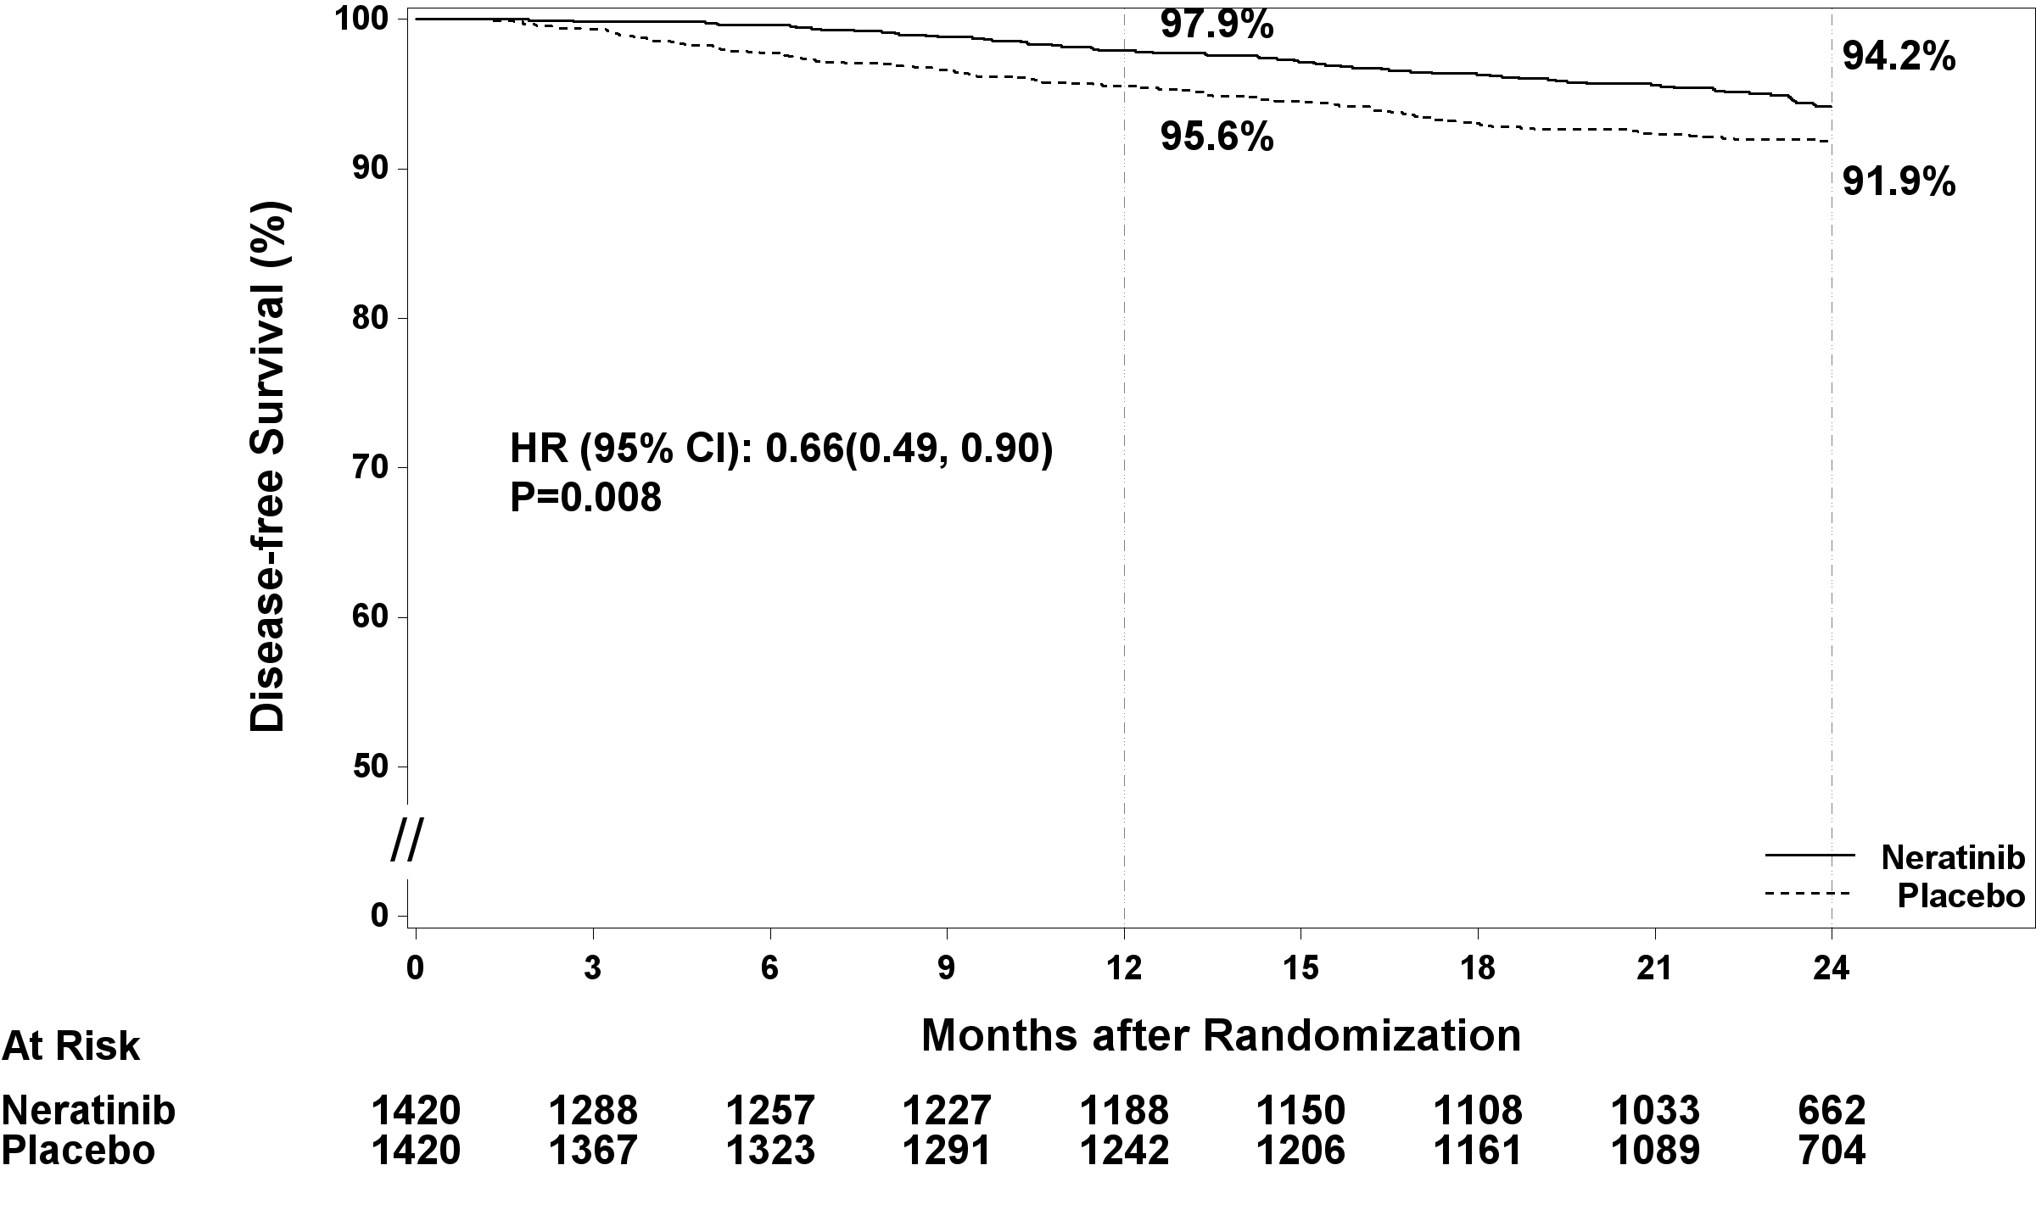
Figure 2 shows the Forrest Plot for iDFS by pre-specified patient subgroup.
Figure 2. Disease-Free Survival by Patient Subgroupª

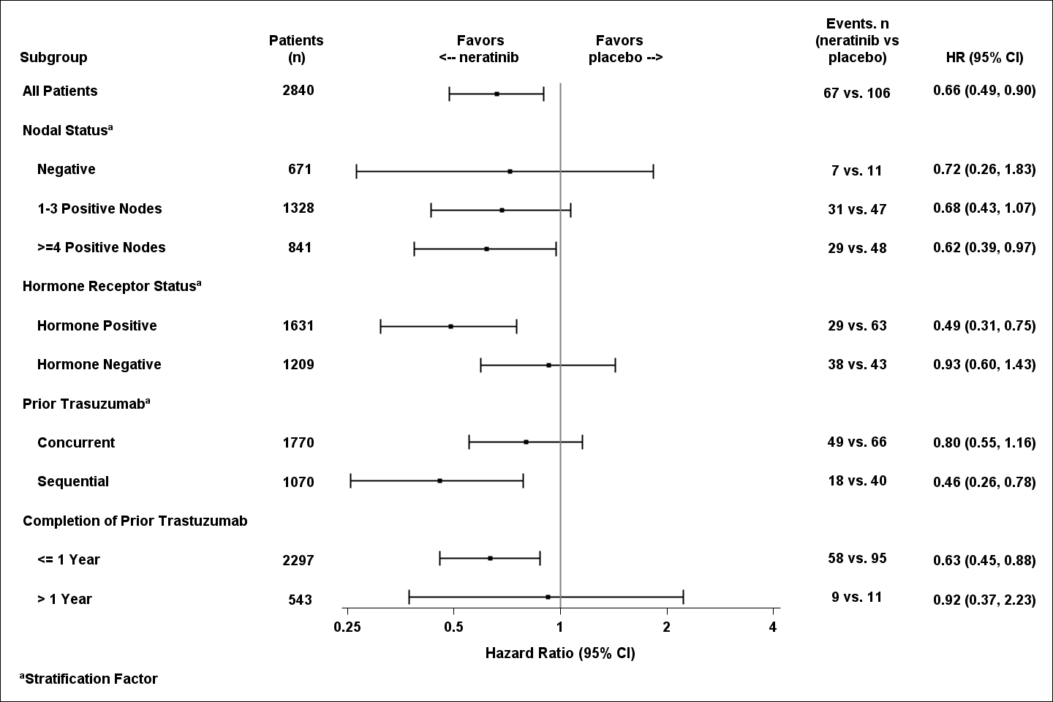

Approximately 75% of patients were re-consented for extended follow-up beyond 24 months. This exploratory analysis confirms that the iDFS results at 5 years are durable and consistent with the 2-year iDFS results.
Figure 3 shows a descriptive analysis of the 5-year iDFS that demonstrated the durability of the treatment effect on efficacy. The Hazard Ratio is 0.73 (95% CI 0.57, 0.92) for the ITT population.
Figure 3. Kaplan-Meier plot of 5-year disease-free survival – ITT population
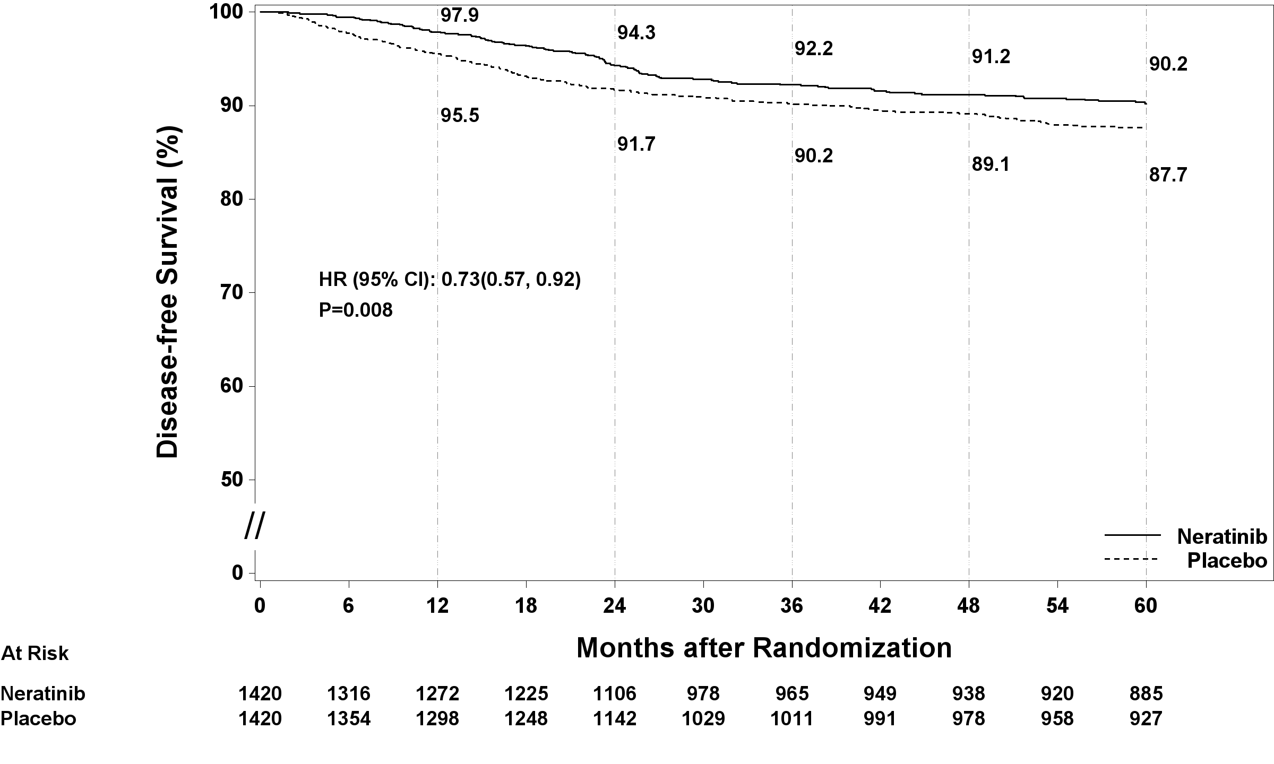

Pharmacokinetic properties
The mass balance after administration of a single oral dose of 200 mg of neratinib was studied in six healthy subjects.

Absorption
Following oral administration of 240 mg neratinib, absorption was slow and peak plasma concentrations of neratinib occurred around 7 hours after administration. A single dose of 240 mg neratinib taken with food increased C_{max} and AUC by approximately 17% and 23%, respectively, compared with administration in the fasting state. A single oral dose of 240 mg neratinib taken with a meal high in fat increased both C_{max} and AUC by approximately 100%.

Distribution
Binding of neratinib to human plasma proteins, including covalent binding to human serum albumin (HSA), was greater than 98% and independent of concentration. Neratinib bound predominantly to HSA and human alpha-1 acid glycoprotein (AAG). In vitro, neratinib inhibited P-gp and BCRP at concentrations similar to the expected intestinal concentrations of neratinib. Neratinib produced no clinically-relevant inhibitory activity towards the transporters, BSEP, OATP1B1*1a, OATP1B3, OAT1, OAT3, OCT1 and OCT2.

Metabolism
Neratinib is metabolised primarily in liver microsomes by CYP3A4 and to a lesser extent by flavin-containing monooxygenase (FMO).
Metabolite profiling in human plasma indicates that after oral administration, neratinib undergoes oxidative metabolism through CYP3A4. Circulating metabolites include neratinib pyridine N-oxide (M3), N-desmethyl neratinib (M6), neratinib dimethylamine N-oxide (M7) and traces of hydroxyl neratinib N-oxide and neratinib bis-N-oxide (M11). Neratinib represents the most prominent component in plasma and systemic exposure to the metabolites (M3, M6, M7 and M11) after oral administration of neratinib is between 10% and 33% lower than parent in healthy subjects. The neratinib metabolites M3, M6, M7 and M11 were shown to have similar or lower potencies to neratinib in either in vitro enzyme (binding assays) or cell based assays against cells expressing ERBB1, ERBB2 (HER2) and ERBB4.

Excretion
Following single doses of neratinib, the mean apparent plasma half-life of neratinib was 17 hours in patients.
Following the administration of a single radiolabelled dose of 200 mg neratinib oral solution, 97.1% and 1.1% of the administered dose was recovered in the faeces and urine, respectively. The excretion was rapid and complete, with the majority of the radioactivity (61%) recovered within 96 hours and 98% recovered after 10 days. It is not known if elimination is as unchanged medicine or metabolites.

Pharmacokinetic/pharmacodynamic relationship(s)

Renal impairment
Pharmacokinetic studies in patients with renal impairment or undergoing dialysis have not been carried out. Population pharmacokinetic modelling revealed that creatinine clearance did not explain the variability between patients, hence, no dose modifications are recommended for patients with mild to moderate renal impairment.

Hepatic impairment
Neratinib is extensively metabolised in the liver. In subjects with severe pre-existing hepatic impairment (Child Pugh Class C) without cancer, the clearance of neratinib was decreased by 36% and exposure to neratinib increased by about 3-fold as compared to healthy volunteers.

5.3 Preclinical safety data
Adverse reactions not observed in clinical studies but seen in animals at exposure levels like clinical exposure levels and with possible relevance to clinical use were as follows:

Genotoxicity
NERLYNX was neither clastogenic nor mutagenic in the standard battery of genotoxicity studies.
Neratinib metabolites M3, M6, M7 and M11 are negative in the standard battery of in vitro genotoxicity studies.

Carcinogenicity
Neratinib was not carcinogenic in rats up to 10 mg/kg/day (18-30 X the clinical AUC) administered by oral route for 24 months. Neratinib did not show any carcinogenic potential in Tg.rasH2 transgenic mice when administered at oral doses up to ≤ 50 mg/kg/day in males and ≤125 mg/kg/day in females, resulting in exposures 9-35 X the clinical AUC.

Pharmaceutical particulars

List of excipients

Tablet core
Mannitol, Microcrystalline cellulose, Crospovidone, Povidone, Colloidal anhydrous silica, Magnesium stearate

Tablet coating
Polyvinyl alcohol, Titanium dioxide, Macrogol 3350, Purified talc, Iron oxide red

Incompatibilities
Refer to section 4.5 Interactions with other medicines and other forms of interactions for further information.

Shelf life
3 years.

Special precautions for storage
Store below 25°C. Keep the bottle tightly closed in order to protect from moisture.

Nature and contents of container
White, 60 mL high density polyethylene (HDPE) round bottle with child-resistant, polypropylene closure, and foil induction inner seal.
An HDPE desiccant canister with 1 g silica gel is enclosed with the tablets in each bottle.
Each bottle contains 180 tablets.

Special precautions for disposal
Any unused medicinal product or waste material should be disposed of in accordance with local requirements.

Physicochemical properties

Chemical structure
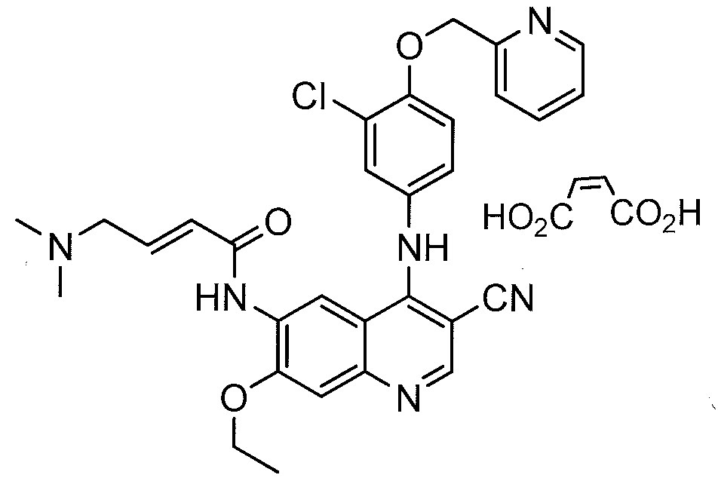

Chemical Name:
(E)-N-{4-[3-chloro-4-(pyridin-2-yl methoxy)anilino]-3-cyano-7-ethoxyquinolin-6-yl}-4-

(dimethylamino)but-2-enamide maleate

Molecular Weight

673.1 (neratinib maleate)
557.1 (neratinib)

CAS number

915942-22-2 (neratinib maleate)

698387-09-6 (neratinib)
The active ingredient, Neratinib maleate, is an off-white to yellow powder. Its solubility decreases as pH increases over the range 1.2 - 9.6; it is insoluble at pH above 5.0 (e.g., in water). The API is slightly soluble in ethanol and sparingly soluble in methanol. The dissociation constant is pKa 7.65 and pKa 4.66. The partition coefficient is logP 4.72 and logP 4.47.

Medicine schedule (Poisons Standard)
S4 / PRESCRIPTION MEDICINE

Sponsor

Specialised Therapeutics PM Pty Ltd
Level 2, 17 Cotham Road, Kew, Victoria 3101

Ph: (03) 9859 1493

Fax: (03) 9859 6950
Website: www.stbiopharma.com

Date of first APPROVAL
14 MARCH 2019

Date of revision

Summary table of changes
Section Changed | Summary of new information

