First round CER: April 2015
Second round CER: June 2015

AusPAR Attachment 2

Extract from the Clinical Evaluation Report for nepafenac
  - Proprietary Product Name: Ilevro
  - Sponsor: Alcon Laboratories (Australia) Pty Ltd

About the Therapeutic Goods Administration (TGA)
- The Therapeutic Goods Administration (TGA) is part of the Australian Government Department of Health, and is responsible for regulating medicines and medical devices.
- The TGA administers the Therapeutic Goods Act 1989 (the Act), applying a risk management approach designed to ensure therapeutic goods supplied in Australia meet acceptable standards of quality, safety and efficacy (performance), when necessary.
- The work of the TGA is based on applying scientific and clinical expertise to decision-making, to ensure that the benefits to consumers outweigh any risks associated with the use of medicines and medical devices.
- The TGA relies on the public, healthcare professionals and industry to report problems with medicines or medical devices. TGA investigates reports received by it to determine any necessary regulatory action.
- To report a problem with a medicine or medical device, please see the information on the TGA website <https://www.tga.gov.au>.
About the Extract from the Clinical Evaluation Report
- This document provides a more detailed evaluation of the clinical findings, extracted from the Clinical Evaluation Report (CER) prepared by the TGA. This extract does not include sections from the CER regarding product documentation or post market activities.
- The words [Information redacted], where they appear in this document, indicate that confidential information has been deleted.
- For the most recent Product Information (PI), please refer to the TGA website <https://www.tga.gov.au/product-information-pi>.
Copyright
© Commonwealth of Australia 2015
This work is copyright. You may reproduce the whole or part of this work in unaltered form for your own personal use or, if you are part of an organisation, for internal use within your organisation, but only if you or your organisation do not use the reproduction for any commercial purpose and retain this copyright notice and all disclaimer notices as part of that reproduction. Apart from rights to use as permitted by the Copyright Act 1968 or allowed by this copyright notice, all other rights are reserved and you are not allowed to reproduce the whole or any part of this work in any way (electronic or otherwise) without first being given specific written permission from the Commonwealth to do so. Requests and inquiries concerning reproduction and rights are to be sent to the TGA Copyright Officer, Therapeutic Goods Administration, PO Box 100, Woden ACT 2606 or emailed to <tga.copyright@tga.gov.au>.

Contents
List of abbreviations 5
1. Introduction 7
1.1. Drug class and therapeutic indication 7
1.2. Dosage forms and strengths 7
1.3. Dosage and administration 7
2. Clinical rationale 7
3. Contents of the clinical dossier 8
3.1. Scope of the clinical dossier 8
3.2. Paediatric data 8
3.3. Good clinical practice 8
4. Pharmacokinetics 9
4.1. Studies providing pharmacokinetic data 9
4.2. Summary of pharmacokinetics 9
4.3. Evaluator’s conclusions on pharmacokinetics 13
5. Pharmacodynamics 14
6. Dosage selection for the pivotal studies 14
7. Clinical efficacy 14
7.1. Postoperative pain & inflammation associated with cataract surgery 14
7.2. Analyses performed across trials (pooled & meta analyses) 23
7.3. Evaluator’s conclusions on efficacy 23
8. Clinical safety 24
8.1. Studies providing evaluable safety data 24
8.2. Pivotal studies that assessed safety as a primary outcome 24
8.3. Patient exposure 25
8.4. Adverse events 26
8.5. Laboratory tests 29
8.6. Other safety issues 33
8.7. Post marketing experience 34
8.8. Evaluator’s conclusions on safety 34
9. First round benefit-risk assessment 35
9.1. First round assessment of benefits 35
9.2. First round assessment of risks 36
9.3. First round assessment of benefit-risk balance 38
10. First round recommendation regarding authorisation 38
11. Clinical questions 38
11.1. Pharmacology 38
11.2. Efficacy 38
11.3. Safety 39
12. Second round evaluation 39
13. Second round benefit-risk assessment 40
14. Second round recommendation regarding authorisation 40
15. References 40

List of abbreviations
Abbreviation | Meaning
ADR | Adverse drug reaction (a treatment related adverse event)
AE | Adverse event/effect
ARTG | Australian Register of Therapeutic Goods
AUC | Area under the plasma concentration - time curve
BCVA | Best corrected visual acuity
BLQ | Below limit of quantitation
CER | Clinical evaluation report
Ci | Curie
C_{max} | Maximum measured plasma concentration over the entire sampling period
CMH | Cochran-Mantel-Haenszel
CMI | Consumer Medicines Information
CSR | Clinical study report
FDA | (US) Food and Drugs Administration
GCP | Good Clinical Practice
HPLC | High-performance liquid chromatography
IEC | Independent ethics committee
IOP | Intraocular pressure
IRB | Institutional review board
ISS | Integrated safety summary
ITT | Intent-to-treat
Kel | Elimination rate constant
LLOQ | Lower limit of quantification
MedDRA | Medical dictionary for regulatory activities
NCE | New chemical entity
NNT | Number needed to treat
NSAID | Non-steroidal anti-inflammatory drug
PD | Pharmacodynamic
PI | Product Information
PK | Pharmacokinetic
PP | Per protocol
PSUR | Periodic safety update report
QD | 1 time daily
RMP | Risk management plan
SAE | Serious adverse event
SAS | Special Access Scheme
SCS | Summary of clinical safety
SCE | Summary of clinical efficacy
SD | Standard deviation
SmPC | Summary of Product Characteristics
TEAE | Treatment-emergent AE
T_{1/2} | Half-life
T_{max} | Time to reach C_{max}

Introduction
This is a Category 1 submission to register a new chemical entity (NCE).

Drug class and therapeutic indication
Nepafenac (synonym: amfenac amide) is a prodrug of amfenac, a non-steroidal anti-inflammatory drug (NSAID), which inhibits the enzymatic action of prostaglandin H synthase (cyclooxygenase; COX-1 and COX-2). The proposed indication is:
The prevention and treatment of postoperative pain and inflammation associated with cataract surgery.

Dosage forms and strengths
The submission proposes to register the following dosage form and strength:
- Nepafenac 0.3% eye drops, suspension, bottle

Dosage and administration
From the proposed Product Information (PI) document:
For ophthalmic use only.
For individual patient use only.
Shake the bottle well before use. After cap is removed, if tamper evident snap collar is loose, remove before using Ilevro.
If more than one topical ophthalmic medicinal product is being used, the medicinal products must be administered at least 5 minutes apart. Eye ointments should be administered last.
To prevent contamination of the dropper tip and solution, care must be taken not to touch the eyelids, surrounding areas or other surfaces with the dropper tip of the bottle. Instruct patients to keep the bottle tightly closed when not in use.
For the prevention and treatment of pain and inflammation, the dose is 1 drop of Ilevro in the conjunctival sac of the affected eye(s) once a day beginning 1 day prior to cataract surgery, continued on the day of surgery and up to 21 days of the postoperative period, as directed by the clinician. An additional drop should be administered 30 to 120 minutes prior to surgery.
Nasolacrimal occlusion and gently closing the eyelid after instillation are recommended. This may reduce the systemic absorption of eye drops and result in a decrease in systemic adverse reactions.

Clinical rationale
The rationale for using a NSAID, pre- and post-cataract surgery, was to minimise pain and inflammation that resulted from surgical trauma.

Contents of the clinical dossier

Scope of the clinical dossier
The submission contained the following clinical information:
- 1 Phase I study that provided pharmacokinetic (PK) data (C-09-053) and 3 additional Phase I PK studies (C-05-08; C-04-27; C-05-19).
- 1 Phase III pivotal efficacy/study (C-09-055).
- 1 Phase II pivotal efficacy/safety study (C-11-003).
- 1 Periodic safety update report (PSUR) for nepafenac 0.1% eye drops (covering period 01/12/10 to 30/11/11).
- 1 Integrated summary of safety (ISS).
Evaluator’s comments: The clinical dossier did not document a full development program of clinical pharmacology, efficacy and safety studies. The data package was deficient in respect of clinical pharmacology. No human pharmacodynamic (PD) studies were provided in this application. Refer to the relevant findings from the Non-clinical Evaluator’s report.
The data package was intended for regulatory agencies that already marketed nepafenac 0.1% eye drops. In the proposed Australian PI the annotations that related to ‘source documents’ were cross referenced to particular sections in the EU SmPC rather than the actual clinical data from which the information were derived. Many hyperlinks did not work, especially for links between modules.
Fenazox is not available in Australia and the clinical data provided in this submission for Fenazox were limited. However, this evaluation report will refer to Fenazox in the pharmacology and clinical safety sections of this report.
The New Zealand Data Sheet for Ilevro was provided however, an application for Ilevro was not submitted to NZ at the time of this application.

Paediatric data
The submission did not include paediatric data. Specific studies in the paediatric population were considered unnecessary as cataract surgery is uncommon in children. When anterior surgery is required, steroidal preparations are the mainstay of treatment, as children are more sensitive to post operative inflammation.

Good clinical practice
The submitted studies were stated to have been conducted in compliance with Good Clinical Practice (GCP), including the archival of essential documents. All studies were conducted according to appropriate ethical standards.

Pharmacokinetics

Studies providing pharmacokinetic data
Table 1 shows the PK studies. No PK study had deficiencies that excluded their results from consideration.
Table 1: Submitted pharmacokinetic studies.
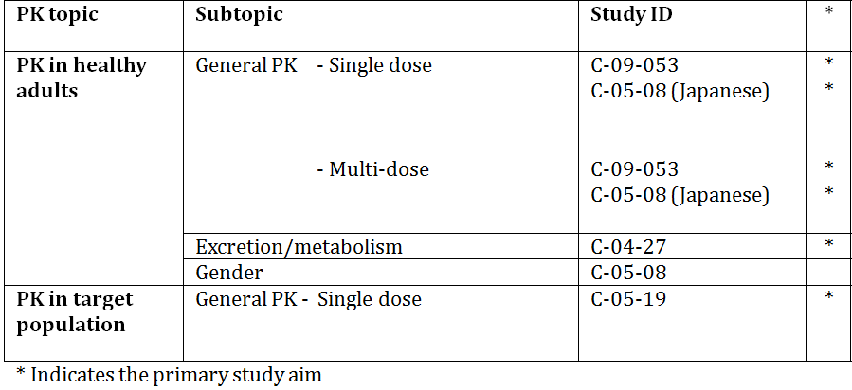

Summary of pharmacokinetics
The following summary is derived from conventional PK studies unless otherwise stated.

Physicochemical characteristics of the active substance
Nepafenac [2-(2-amino-3-benzoylphenyl) acetamide or 2-amino-3-benzoylbenzeneacetamide] is a yellow crystalline powder that is poorly water soluble. It has an average pH of 6.75 and is a light yellow to yellow, uniform suspension for multiple-dose topical ophthalmic use. Nepafenac is an achiral substance with no variations in its stereochemical configuration. The chemical structure of the pro-drug, nepafenac (C15H14N2O2), and its amide analogue, amfenac, are represented below in Figure 1.
Figure 1: Chemical structure of the pro-drug, nepafenac (C15H14N2O2), and its amide analogue, amfenac.
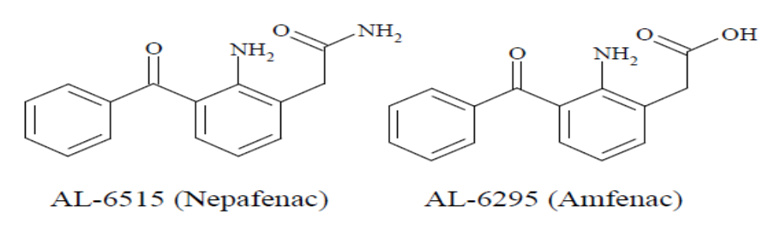

Pharmacokinetics in healthy subjects

Absorption
In healthy adults (Study C-09-053), following bilateral topical ocular dosing of 1 drop of nepafenac 0.3% ophthalmic suspension once daily for 4 days, low but quantifiable plasma concentrations of nepafenac and amfenac were observed in most subjects within 30 minutes post-dose, respectively. The mean nepafenac and amfenac plasma concentration versus time profiles on Day 1 and Day 4 were similar, which indicated there was no meaningful accumulation. Other mean PK parameters of nepafenac and amfenac on Day 1 and Day 4 were also similar e.g. mean (SD) steady-state Cmax for nepafenac and amfenac were 0.847 ± 0.269 ng/mL and 1.13 ± 0.491 ng/mL, respectively.
From the Fenazox (amfenac) prescribing information, for the 50 mg dose, Tmax was 15 to 30 minutes and Cmax was 700 ng/mL i.e. approximately 609 times greater than topically-administered amfenac after bilateral single dosing of nepafenac 0.3% eye-drops. Accumulation was not reported.

Bioavailability
No specific clinical studies were undertaken as part of this application.

Influence of food
No specific clinical studies were undertaken as part of this application. Any effect of food is likely to be low given nepafenac 0.3% is administered topically with low systemic exposure.

Dose proportionality
No specific dose-ranging studies formed part of this application.
In healthy adult Japanese males and females (Study C-05-08), the mean nepafenac Cmax and AUC0-inf results after single-dosing were approximately2.6 fold and 2.9 fold higher with nepafenac 0.3% vs. nepafenac 0.1%, respectively. Similarly, the mean amfenac Cmax and AUC0-inf values were approximately 3.1 fold and 3.4 fold higher with nepafenac 0.3% vs. nepafenac 0.1%, respectively. A similar pattern was observed at steady-state. Together, these results suggest there is a positive correlation between dose and plasma concentration between nepafenac 0.1% and nepafenac 0.3% for both nepafenac and amfenac.

Effect of administration timing
In Studies C-09-053, Tmax for nepafenac 0.3% was achieved in approximately 0.42h and Tmax for amfenac was achieved in approximately 0.75h. Hence, administration of topical nepafenac 0.3% within 30 to 120 minutes before cataract surgery, as proposed by the sponsor, should coincide with the maximum concentrations of nepafenac and amfenac achieved within intraocular tissue.
The marketed nepafenac 0.1% formulation is dosed three times a day while the nepafenac 0.3% formulation in this application is proposed to be dosed once a day. While the half-life for amfenac is 6.26 hours at steady state, a once-a-day dosing can be achieved provided the plasma concentration is increased sufficiently.
From the US Product Label for Nevanac, following bilateral topical ocular three-times-daily dosing:
The mean steady-state Cmax for nepafenac and for amfenac were 0.310 ± 0.104 ng/mL and 0.422 ± 0.121 ng/mL, respectively, following ocular administration.
In contrast, the Cmax at Day 4 following bilateral topical ocular nepafenac 0.3% once-daily dosing is reported at approximately three-fold higher, in Study C-09-053, for both nepafenac 0.847 ± 0.269 ng/mL and amfenac 1.13 ± 0.491 ng/mL. These levels were expected and support once daily dosing of nepafenac 0.3% eye drops.

Distribution
The application did not include any specific clinical studies that assessed volume of distribution, plasma protein binding, erythrocyte distribution and tissue distribution in humans.
As stated in the submission:
Nepafenac protein binding was moderate and independent of concentration (range 10 to 1000 ng/mL). The mean (SD) protein binding of 14C nepafenac in human plasma was 83.5 ± 0.8%. Amfenac, on the other hand, exhibits high affinity binding to albumin. The percentages bound in vitro to human albumin and to human serum were 95.4% and 99.1%, respectively.
The binding rate with human serum protein measured by ultra-filtration method was 99.1% (in vitro) for Fenazox and hence, supports the protein binding results for amfenac.
As stated in the submission:
Partitioning of 14C-amfenac into blood cells is minimal. The ratio of radioactivity in the blood to plasma was less than 0.05 at concentrations of 0.2 μg/mL and 2.0 μg/mL, respectively. Given the limited 14C-amfenac concentration range examined, slight partitioning of radioactivity into blood cells did not indicate a concentration dependency.
As stated in the submission:
Studies in rats have shown that radioactive labelled active substance-related materials distribute widely in the body following single and multiple oral doses of 14C-nepafenac.

Metabolism
Nepafenac is a prodrug that penetrates the cornea and is rapidly converted to amfenac by intraocular hydrolases. Amfenac then undergoes extensive hydroxylation of the aromatic ring, which leads to glucuronide conjugate formation. In vitro study results showed nepafenac and amfenac, in concentrations up to 1000 ng/mL, did not inhibit any major cytochrome P450 isozyme (CYP1A2, CYP2C9, CYP2C19, CYP2D6, CYP2E1 and CYP3A4).

Non-renal clearance
Following metabolic conversion to glucuronides, subsequent clearance is predominantly renal (85.5%) with a smaller proportion of an administered radioactive drug recoverable from faeces (6.2%; Study C-04-27 summary).

Metabolites identified in humans
Nine quantifiable aglycone metabolites were observed in plasma. Amfenac was the major metabolite in plasma, which represented approximately 13% of total plasma radioactivity. The second most abundant plasma metabolite was 5-hydroxy nepafenac, which represented about 9.5% of total radioactivity at Cmax. In urine, the most abundant metabolite observed was Mu5, which represented 22% of the dose excreted in 8 hours. The second most abundant metabolite was Mu4, which accounted for 16.9% of the dose excreted in 8 hours. Nepafenac and amfenac were not quantifiable in the urine.
The plasma metabolic profile demonstrated nepafenac is extensively metabolised and metabolites circulate both as unconjugated (amfenac) and glucuronide conjugates. Hence, the glucuronidation pathway may be important in the metabolism of nepafenac and amfenac in vivo.
Evaluator’s comment: It is not apparent from the submission documentation whether, apart from amfenac, any of the other eight aglycone metabolites of nepafenac have pharmacological activity. Furthermore, it is not apparent from the submission documentation whether the sponsor undertook any PK on any identified metabolite.

Consequences of genetic polymorphism
This application did not include study results for genetic polymorphism.

Excretion

Routes and mechanisms of excretion
Renal clearance is the primary pathway of nepafenac excretion. Following oral administration of 14C-nepafenac, 91.7% of radioactivity was recovered, with 85.5% and 6.2% recovered in urine and faeces, respectively.
These findings are supported by the Fenazox prescribing information:
The urinary excretion rate 8 hours after 100 mg of the drug was administered orally to healthy adults was 92.8%, most of which was glucuronic acid conjugation.

Mass balance studies
This application did not include mass balance studies.

Renal clearance
In Study C-09-053, apparent plasma clearance following extravascular administration (CL/F) for the nepafenac analyte was planned but no results were presented. No other estimates of renal clearance were undertaken as part of this application. Nepafenac and its metabolites are primarily eliminated through the renal route, with 85.5% of radiolabelled dose recovered in urine (Study C-04-27).

Intra- and inter-individual variability of pharmacokinetics
Inter-individual variability was generally moderate to high across studies for PK values. No results in terms of percent coefficient of variation were provided in the individual studies submitted. Within-subject variability does not appear to have been directly addressed by any PK study within this submission.

Pharmacokinetics in the target population
In Study C-05-19, single ocular doses of nepafenac 0.1% and ketorolac 0.4% (active control) were administered to subjects undergoing cataract surgery. At 1h post-dose, the mean aqueous humour concentration of nepafenac was 4-fold higher than that of amfenac and ketorolac.
Evaluator’s comments: From PK results in healthy adult subjects (Studies C-05-08 and C-09-053) a higher mean concentration of amfenac would be expected (of a similar magnitude) in the target population. The results of Study C-05-19 suggest the sampling timing schedule was inadequate to fully assess the PK profile. The results of Study C-05-19 also highlight the limitations of using small patient numbers (with wide inter-patient variability) and the sparse sampling methodology used in PK studies.

Pharmacokinetics in the special populations

Pharmacokinetics in subjects with impaired renal function
No studies were undertaken due to the low systemic exposure expected from topical application.

Pharmacokinetics in subjects with impaired hepatic function
No studies were undertaken due to the low systemic exposure expected from topical application.

Pharmacokinetics according to age

Paediatrics
Not applicable.

Elderly
Given elderly patients (≥ 65 years of age) are expected to be the main target population, and also constituted the largest population by age-group in all the pharmacology (and efficacy) studies in the nepafenac clinical development program, no specific studies in the elderly were deemed necessary. This is reasonable.

Pharmacokinetics according to gender
Gender was not studied as a primary objective. Study C-05-08 enrolled both male and female subjects. There were no statistically significant gender differences in the PK of nepafenac or amfenac following the administration of nepafenac 0.3%. However, the small sample size and high inter-subject variability observed in the PK data limited the usefulness of the results.

Pharmacokinetic interactions
No specific clinical studies were undertaken as part of this application.

Evaluator’s conclusions on pharmacokinetics
The data package was limited to four human PK studies (three obtained on further request) that examined single dose and multiple dose PK in healthy adult volunteers with the nepafenac 0.3% ophthalmic suspension, single dose and multiple dose PK in the target population using nepafenac 0.1% eye drops (with ketorolac 0.4% as active control) and a radiolabelled study that demonstrated the metabolism and excretion of a single oral dose of 14C nepafenac.
No clinical studies on bioavailability or bioequivalence were provided in this submission on the basis of limited systemic exposure of nepafenac 0.3% eye drops and the registration of a single product. This is reasonable.
Nepafenac and its active metabolite, amfenac, demonstrated rapid absorption with Tmax in one hour or less, in both healthy subjects and the target population. Hence, administration of nepafenac 0.3% topically within 30 to 120 minutes before cataract surgery, as proposed by the sponsor, should coincide with the maximum concentrations of nepafenac and amfenac achieved within intraocular tissue. This is desirable.
Once daily dosing of nepafenac 0.3% eye drops is supported by the amfenac half life > 6 hours and the three fold increase in Cmax for amfenac in the nepafenac 0.3% formulation compared with the nepafenac 0.1% formulation.
Nepafenac and amfenac demonstrated low systemic exposure following 4 days of once daily bilateral topical ocular dosing of nepafenac 0.3% eye drops in both healthy adult US subjects (Study C-09-053) and healthy adult Japanese male and female subjects (Study C-05-08). Furthermore, nepafenac and amfenac did not appear to accumulate after 4 days of multiple dosing (that is, at steady state).
Similar aqueous humour exposure was noted between amfenac (from nepafenac 0.1% eye drops) and ketorolac 0.4%. Given the differences in strength, particle size and formulation between the nepafenac 0.1% used in Study C-05-19 and the proposed nepafenac 0.3% preparation it is difficult to extrapolate these results to the higher strength formulation. Greater exposure with nepafenac 0.3% would be expected based on other PK results.
There appeared to be minimal uptake and retention of radioactivity by red blood cells or haemoglobin. Urinary excretion accounted for 85.5% of radioactivity from a 10 mg dose of nepafenac oral suspension and 6.2% of radioactivity from a 10 mg dose was excreted in faeces. Nepafenac was extensively metabolised with eight glucuronide metabolites (other than unconjugated amfenac) identified in plasma. It is unclear whether any metabolite other than amfenac had pharmacological activity.
PK drug interactions are unlikely to occur or they are likely to be clinically insignificant based on lack of effect on hepatic cytochrome P450 enzymes, and the low systemic exposure of nepafenac and amfenac.
On the basis of limited systemic exposure of topical nepafenac 0.3% eye drops, no dose adjustments would be expected for subjects with impaired hepatic or renal function, or by gender or age (as cataract surgery is primarily targeted in an elderly population, which formed the majority of subjects studied in the nepafenac clinical development program). These assumptions are reasonable.
Generally, PK data from oral Fenazox were consistent with PK from ophthalmic nepafenac 0.3%.

Pharmacodynamics
Nonclinical PD data indicated nepafenac is effective in suppressing PGE2 synthesis in rabbits for over 30 hours following a single dose at a concentration of 3 mg/mL, in both the anterior and posterior chambers of the eye.
Given the low systemic exposure to nepafenac in humans, the sponsor did not conduct a specific QT study or PD interaction studies for the nepafenac 0.3% preparation, or the commercially available 0.1% preparation (Nevanac). This is reasonable. Furthermore, to date, no drug interactions have been reported with the nepafenac 0.1% and 0.3% preparations.

Dosage selection for the pivotal studies
From Study C-11-003 Clinical Safety Report:
The drug concentration (0.3%) for this study was considered safe based upon the results of nonclinical studies and previous clinical trials. During the clinical development of nepafenac, patients were exposed to various concentration formulations ranging from 0.003% to 0.3% for up to 6 months. Adverse reactions in patients exposed to 0.3% nepafenac concentrations during previous clinical trials were mild in intensity, and resolved with or without treatment, except for 1 event (cataract) which was continuing without treatment when the patient exited from the study.
In a pharmacokinetic animal model, nepafenac 0.3% dosed once daily resulted in steady state drug levels (nepafenac and amfenac) in the ICB that were significantly higher than those for nepafenac 0.1% when dosed once daily or 3 times daily. The once daily formulation had similar cumulative exposure levels over a 24 hour period to those observed with nepafenac 0.1% dosed 3 times daily. The dosing regimen of once daily rather than 3 times daily is expected to be more convenient for the patient and result in improved compliance for the prevention and treatment of postoperative pain and inflammation associated with cataract surgery.

Clinical efficacy

Postoperative pain & inflammation associated with cataract surgery
The pivotal efficacy studies, C-11-003 and C-09-055, are considered together in this section because their study design, entry criteria, treatments, randomisation and blinding methods, efficacy variables and statistical methods were similar. Any notable differences are discussed in the relevant sub-section.
The sponsor provided multiple comparisons in the efficacy studies of the nepafenac 0.1% eye preparation versus nepafenac vehicle 0.1%. Given nepafenac 0.1% is not proposed to be marketed in Australia at the time of the application, the latter results are considered supportive of the nepafenac 0.3% application and will not be discussed in great detail in this CER. However, in Study C-09-055, a non-inferiority comparison of nepafenac 0.3% vs. nepafenac 0.1% was a co-primary endpoint and the results of this analysis are presented.

Pivotal efficacy studies: C-11-003 and C-09-055

Study design, objectives, locations and dates
Study C-11-003 was a prospective, Phase II, randomised, multicentre (37 USA centres), active- and vehicle-controlled, double-masked, parallel-group, efficacy and safety clinical trial conducted between 30 March 2011 and 01 September 2011.
Study C-09-055 was a prospective, Phase III, randomised, multicentre (65 centres), multinational, active- and vehicle-controlled, double-masked, parallel-group, efficacy and safety clinical trial. The study was conducted in Hungary (6 sites), Italy (4 sites), Sweden (4 sites), Switzerland (2 sites) and the USA (49 sites) between 23 June 2010 and 25 May 2011.
Study design was essentially the same in the pivotal efficacy studies (Figure 1).
Figure 2: General study design for the nepafenac 0.3% eye drops pivotal efficacy trials (C-11-003 and C-09-055).
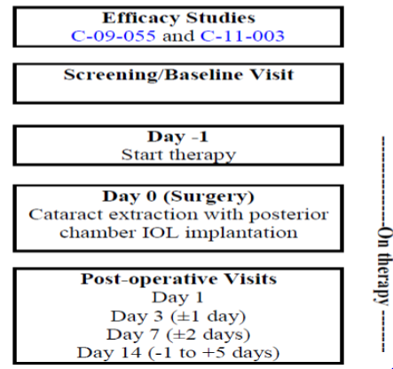

Primary efficacy objective
The primary efficacy objective in the efficacy trials was to demonstrate that once daily nepafenac 0.3% was superior to nepafenac vehicle 0.3%, for the prevention and treatment of ocular inflammation with respect to cure rate 14 days after cataract extraction.

Secondary efficacy objective/s
Study C-11-003: Demonstrate once daily nepafenac 0.3% was superior to once daily nepafenac 0.1%, for the prevention and treatment of ocular inflammation with respect to cure rate 7 days after cataract extraction.
Study C-09-055: Demonstrate, via investigator assessment, at Day 14: superiority of once daily nepafenac 0.3% to once daily nepafenac vehicle 0.3%.

Inclusion and exclusion criteria
General criteria for study entry into the pivotal efficacy studies are presented.
In summary, study participants were adult females and males who required cataract surgery by phacoemulsification and implantation of a posterior chamber intraocular lens. Participants were not permitted to have any intraocular inflammation (aqueous cells or aqueous flare greater than Grade 0) or ocular pain greater than Grade 1 in the study eye that was present during the Baseline Visit, a visually non-functional fellow eye, uncontrolled diagnosed glaucoma in the operative eye, diabetic retinopathy, a history of chronic or recurrent inflammatory eye disease in the operative eye, previous ocular trauma to the operative eye (this included cataract and previous intraocular surgery) and use of topical, topical ocular, inhaled or systemic steroids and topical ophthalmic prostaglandin in the operative eye.
A washout period of a minimum of 14 days was required for steroids. For NSAIDs, the washout period was a minimum of 7 days. Patients who were taking a prophylactic daily dose of aspirin (up to 100 mg) prior to the study were permitted to continue with their aspirin therapy during the study.

Study treatments
Patients were randomised to receive topical ocular treatment in the operative eye for 16 days (day prior to surgery, day of surgery and for 14 days post-surgery). An additional drop was given 30 to 120 minutes prior to surgery.
- In Study C-11-003, subjects received either once-daily nepafenac 0.3%, nepafenac vehicle 0.3% (to facilitate masking) or nepafenac 0.1% (active control); and
- In Study C-09-055, subjects received either once-daily nepafenac 0.3% or nepafenac vehicle 0.3%, or three times daily nepafenac 0.1% or nepafenac vehicle 0.1%.
Note: In Study C-09-055, 2 vehicle controls were chosen to mask the 2 dosing frequencies. Due to formulation differences between nepafenac 0.1% and nepafenac 0.3%, the 2 vehicles also had different formulations.

Efficacy variables and outcomes
The primary efficacy endpoint in both efficacy trials was the proportion of patients in the nepafenac 0.3% and nepafenac 0.3% vehicle groups, respectively, at Day 14, who were declared a cure, defined as the absence of inflammation i.e. aqueous cells score + aqueous flare score = 0. Efficacy variables for the pivotal efficacy trials are summarised in Table 2.
Table 2: Efficacy variables in the pivotal nepafenac 0.3% eye drops suspension clinical trials (C-11-003 and C-09-055).
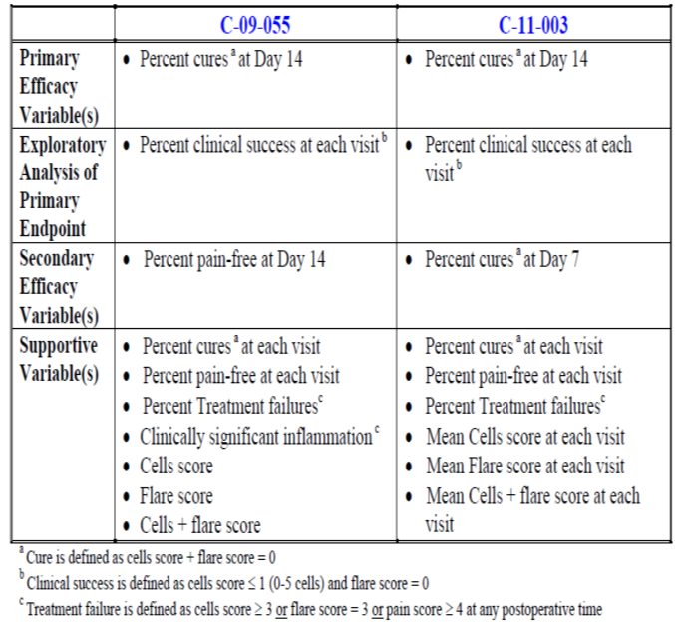
Note: A patient could be considered a treatment failure for ocular pain and still have zero cells and zero flare. Therefore, patients with a pain score of 4 or greater were not considered cured even if they had a cells score and flare score = 0.
Grading scores for aqueous cells and aqueous flare, and ocular pain, are summarised in Tables 3 and 4, respectively.
Table 3: Grading scales for aqueous cells and aqueous flare in the pivotal efficacy studies (C-11-003 and C-09-055).
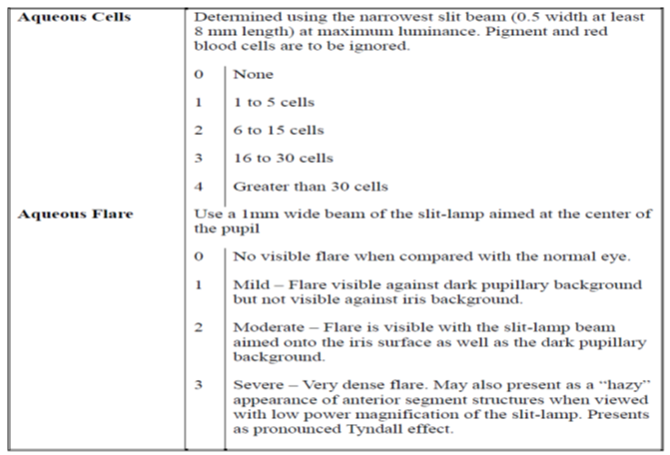
Table 4: Grading scales for ocular pain in the pivotal efficacy studies (C-11-003 and C-09-055).
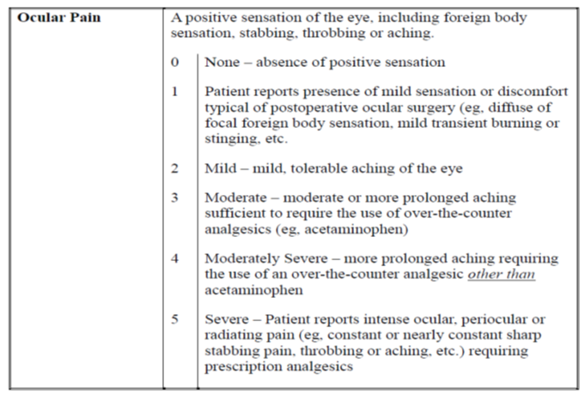
Evaluator’s comments: The efficacy variables used in Studies C-11-003 and C-09-055 for postoperative inflammation are consistent with those used in the registration for Acular, 1 for a similar indication, and are therefore acceptable for a claim of reduced inflammation at Day 14. However, neither Acular nor Voltaren Ophtha is registered for the treatment of postoperative pain so there is no available comparative data.

Randomisation and blinding methods
Upon entry into the efficacy studies, patients were randomised via a computerised system available by telephone 24 hours a day, 7 days a week.
- In Study C-11-003: Patients were randomised in a 2:2:1 ratio (with stratification by study site) to receive once daily treatment with topical ocular nepafenac 0.3%, nepafenac 0.1% or nepafenac vehicle 0.3%, respectively; and
- In Study C-09-055: Patients were randomised in a 4:4:1:1 ratio (with stratification by study site) to receive once daily treatment with topical ocular nepafenac 0.3%, nepafenac vehicle 0.3%, and three times daily nepafenac 0.1% or nepafenac vehicle 0.1%, respectively.
These studies were double-masked. The investigator, patient, sponsor, and monitors involved in reporting, obtaining, and/or reviewing the clinical evaluations were not aware of the specific treatments administered. This level of masking was maintained throughout the conduct of the study. Patients were assigned treatment in sequential order. The randomisation schedule was blocked to ensure a balance of study treatment allocations within investigational sites.
The sponsor generated and maintained the randomisation scheme. The randomisation code was not broken during the conduct of either study.

Analysis populations
In both efficacy trials the intent-to-treat (ITT) population was the primary data set and included all randomised patients who received study medication, had cataract surgery and returned for at least 1 scheduled postoperative visit.
- In Study C-11-003: 1,257 patients enrolled in the ITT analysis. Of these, 764 patients received either nepafenac 0.3% (n = 512) or nepafenac vehicle 0.3% (n = 252); and
- In Study C-09-055: A total of 2022 patients enrolled were included in the ITT analysis. Of these, 1004 patients received either nepafenac 0.3% (n = 807) or nepafenac vehicle 0.3% (n = 197).
In Study C-09-055, the per protocol (PP) population included all patients who received study medication, had at least 1 scheduled on-therapy visit, satisfied pre-randomisation entry criteria, and did not have protocol deviations that would impact the efficacy data. 1962 total patients enrolled were included in the PP analysis. There were 249 patients (12.7%) in the PP data set that discontinued before study completion.
No PP analysis was undertaken in Study C-11-003.

Sample size
Each of the following primary analyses was reported at the nominal level of α = 0.05 (2-sided):
- Study C-11-003: A Fisher’s exact test with a 0.05 two-sided significance level had 99% power to detect the difference between nepafenac 0.3% Day 14 cure rate of 0.43 and nepafenac vehicle 0.3% Day 14 cure rate of 0.24 with sample sizes of 500 and 250, respectively; and
- Study C-09-055: With approximately 800 patients in each nepafenac group and 200 patients in the corresponding vehicle group, there was 99% power to demonstrate superiority of nepafenac 0.3% over nepafenac vehicle 0.3%. This assumed the cure rate was 70% in the nepafenac 0.3% group and 50% in the nepafenac vehicle 0.3% group, and at least 90% of randomised patients would be evaluable.

Statistical methods
The primary efficacy analysis was based upon the Cochran-Mantel-Haenszel (CMH) method, controlling for investigative site to assess differences between treatment groups (nepafenac 0.3% vs. nepafenac vehicle 0.3%) at alpha of 0.05 (2-sided). If a patient was cured prior to Day 14 and missed subsequent visits, a last observation carried forward approach was used. Therefore, the patient was considered a cure at subsequent visits.
Since paracetamol was allowed by the protocol, a sensitivity analysis was performed that compared the proportion of patients who had ocular pain or who took paracetamol within 48 hours prior to assessment to the proportion of patients who were pain-free and did not take paracetamol within 48 hours prior to assessment.
Evaluator’s comment: The statistical analysis plans for the pivotal efficacy studies were consistent and are considered acceptable.

Participant flow
In Study C-11-003, 42.9% more subjects discontinued treatment in the nepafenac vehicle 0.3% group compared with the nepafenac 0.3% group for all enrolled subjects. A similar magnitude of effect was observed in the ITT population in Study C-09-055 (38.5%). Approximately twice the proportion of subjects discontinued treatment in Study C-11-003 compared with Study C-09-055 for nepafenac 0.3% (12.0% vs. 5.7%, respectively). The active control, nepafenac 0.1%, had proportionally similar percentages of study discontinuations compared with nepafenac 0.3%, in both efficacy studies. In Study C-09-055, the 0.3% and 0.1% vehicles also had proportionally similar percentages of study discontinuations.
The reasons for study discontinuation were similar across the efficacy studies for each treatment group. In the nepafenac 0.3% group, most commonly, patients ‘did not use study medication’ (3.3% in Study C-11-003 and 4.0% in Study C-09-055, respectively), followed by ‘treatment failure’ (3.5% vs. 2.9%) and then ‘adverse event’ (3.0% vs. 1.8%). Similar trends were found across the efficacy studies for the nepafenac 0.1% groups, which were also numerically similar. The major reason to explain the relatively large numbers of study discontinuations in both efficacy studies for the vehicle 0.3% groups was ‘treatment failure’: 37.7% for the nepafenac vehicle 0.3% group in Study C-11-003 and 32.7% for the nepafenac vehicle 0.3% group in Study C-09-055.

Major protocol violations/deviations
In both efficacy studies, the only patients excluded were those who did not receive study medication or did not have an on-therapy follow-up visit:
- In Study C-11-003: 10 patients in the nepafenac 0.3% group and 2 in the nepafenac vehicle 0.3% group, respectively, in the ITT population; and
- In Study C-11-003: 10 patients in the nepafenac 0.3% group and 4 in the nepafenac vehicle 0.3% group, respectively, in the ITT population. Furthermore, 19 patients in the nepafenac 0.3% group and 4 in the nepafenac vehicle 0.3% group were also excluded from the PP analysis.

Treatment compliance
Treatment compliance was not accurately assessed in the efficacy studies. While designated study personnel administered the assigned treatment 30 to 120 minutes prior to surgery, patients administered the Day -1 dose and post-operative doses (for up to two weeks). Assessment of drug concentration in plasma samples was not conducted. Weighing of the bottles was not conducted.
In Study C-11-003, 1 patient in the nepafenac 0.1% group discontinued due to noncompliance.

Baseline data
In the efficacy studies, the study populations were evenly distributed among the treatment groups in terms of age, sex, race and iris colour. Over 80% of all treatment groups studied across the trials was in Caucasian subjects. The most common iris colour was brown (> 40% across treatment groups) and then blue.
Evaluator’s comment: The populations studied in the efficacy trials were generally consistent with the target population i.e. elderly and female.

Results for the primary efficacy outcome
The proportion of patients who received nepafenac 0.3% eye-drops in both efficacy trials had statistically significantly (p < 0.0001) superior cure rates at Day 14 than subjects treated with nepafenac vehicle 0.3%.
- In Study C-11-003, the treatment difference (64.6% nepafenac 0.3% minus 25.0% nepafenac vehicle 0.3%) of 39.6% meant the number of patients needed to treat (NNT) to produce a cure by Day 14 was 1/0.395 i.e. approximately 3 subjects; and
- In Study C-09-055, the treatment difference (68.4% nepafenac 0.3% minus 34.0% nepafenac vehicle 0.3%) of 34.4% meant the NNT to produce a cure by Day 14 was 1/0.344 i.e. approximately 3 subjects.

Sub-group analysis of primary efficacy outcome
The results of the sub-group analyses of the primary efficacy outcome by age-group (< 65 years or ≥ 65 years), sex, race and iris colour were consistent across the efficacy trials.
Generally iris colour and sex did not impact significantly on cure rates. While Caucasians tended to have higher cure rates than Black/African Americans or Asian populations this may reflect the small population numbers in the non-Caucasian groups studied. Cure rates in the nepafenac 0.3% groups were generally similar irrespective of age-group. Those patients in the highest age group (≥ 85 to < 95 years) tended to have the highest cure rates, albeit subject numbers were low.

Sensitivity analysis of the primary efficacy outcome

PP analysis
In Study C-09-055, the PP analysis was consistent with the ITT analysis.

Paracetamol administration
The use of paracetamol did not meaningfully impact pain data in the efficacy trials.

Results for secondary efficacy outcomes

Percent cures at day 7
In Study C-11-003, cumulative percent cures at Day 7 following cataract extraction were 31.3% for nepafenac 0.3% vs. 10.3% for the nepafenac vehicle 0.3% group (p < 0.05).

Percent pain-free at day 14
In the efficacy trials, the proportion of patients who received nepafenac 0.3% had statistically significantly higher percent of pain free subjects at Day 14 than subjects treated with nepafenac vehicle 0.3% (Table 5).
Table 5: Percent pain free at Day 14 in Studies C-09-055 and C-11-003 (ITT population).
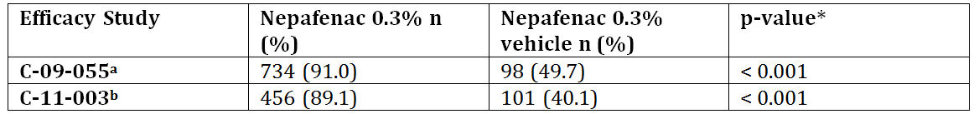
* Based upon Cochran-Mantel-Haenszel controlling for site
The results of Study C-09-055 were supported by the PP analysis: percent pain-free at Day 14 was 67.5% for the nepafenac 0.3% group and 32.6% for the nepafenac 0.3% vehicle group. In Study C-11-003, the results of the active comparison (i.e. nepafenac 0.1% vs. nepafenac vehicle 0.3%) supported the results of the vehicle comparison (nepafenac 0.3% vs nepafenac vehicle 0.3%). This is indicative of good internal validity within the study design.
Evaluator’s comment: The results for percent pain free at Day 14 in Study C-11-003 are presented here as a secondary efficacy outcome comparison for the results of Study C-09-055, even though this was not a defined secondary endpoint in Study C-11-003.

Results for supportive variables

Cumulative percent cures by visit
A “cumulative” cure required a patient judged to be a cure to remain cured at all subsequent visits.
In Study C-11-003, nepafenac 0.3% was superior to its vehicle beginning Day 3 postoperatively (p = 0.0367 Day 3, and p < 0.0001 Days 7 and 14) whereas in Study C-09-055 statistical separation did not occur until Day 7. In contrast, in Study C-09-055, nepafenac 0.1% had a statistically significant difference in the percentage of patients considered cured beginning at the Day 3 Visit (p < 0.0001) compared with nepafenac vehicle 0.1%. There was an approximate doubling in percent cures from Day 7 to Day 14 for all treatments.

Cumulative percent pain-free by visit
The percentages of patients who were pain-free and remained pain-free at all subsequent visits are presented in Table 6. In both efficacy trials nepafenac 0.3% was statistically superior to its vehicle at all postoperative visits, including Day 1.
Table 6: Cumulative percent pain free at each visit in Studies C-09-055 and C-11-003 (ITT population).
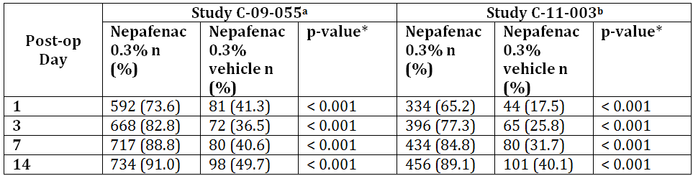
* Based upon Cochran-Mantel-Haenszel controlling for site

Percent treatment failures by visit
Treatment failure was defined as aqueous cells score ≥ 3, aqueous flare score = 3, and/or ocular pain score ≥ 4.
In Study C-11-003, fewer patients were treatment failures in the nepafenac 0.3% group compared with the nepafenac vehicle 0.3% group (4.5% vs. 40.5%, respectively; p < 0.0001). Nepafenac 0.3% was statistically superior to nepafenac vehicle 0.3% at all postoperative visits.
In Study C-09-055, there were statistically significant differences between nepafenac 0.3% compared with nepafenac vehicle 0.3% (3.2% vs. 35.0%, respectively; p < 0.0001). There was a statistically significant difference between nepafenac 0.3% compared with nepafenac vehicle 0.3% in the cumulative percentage of patients who were treatment failures at all postoperative visits (p = 0.0012 Day 1, p < 0.0001 Days 3, 7 and14). There were minimal differences in treatment failures between Day 7 and Day 14 for all treatments.

Clinically significant inflammation

Mean aqueous cells scores by visit
In Study C-11-003, nepafenac 0.3% was statistically superior (p < 0.05) to nepafenac vehicle 0.3% beginning Day 3 postoperatively for mean aqueous cell scores. The mean aqueous cell score for the nepafenac 0.3% group decreased from 1.50 at Day 1 to 0.49 at Day 14, whereas the nepafenac vehicle 0.3% scores remained constant throughout the 14-day postoperative period.

Mean aqueous flare scores by visit
In Study C-11-003, nepafenac 0.3% was statistically superior (p < 0.05) to nepafenac vehicle 0.3% beginning Day 1 postoperatively for mean aqueous flare scores. The mean aqueous flare score for the nepafenac 0.3% group decreased from 0.69 at Day 1 to 0.16 at Day 14, whereas the nepafenac vehicle 0.3% scores remained constant throughout the 14-day postoperative period.

Mean aqueous cells + aqueous flare scores by visit
Nepafenac 0.3% dosed once daily was statistically superior (p < 0.05) to nepafenac vehicle 0.3% beginning Day 1 postoperatively for lower mean aqueous cell + mean aqueous flare scores in Study C-11-003, and Day 3 in Study C-09-055.

Other efficacy endpoint: Non-inferiority of nepafenac 0.3% vs. nepafenac 0.1%
In Study C-09-055, the non-inferiority comparison between nepafenac 0.3% vs. nepafenac 0.1% was a co-primary endpoint. It assumed there were 800 subjects in each treatment group, which provided 98% power to demonstrate non-inferiority. This further assumed each group had a 70% cure rate and a 10% non-inferiority margin. This also assumed 90% of patients randomised would be evaluable for analysis of non-inferiority. Provided the nepafenac 0.3% group had a cure rate of 67.5% compared with the nepafenac 0.1% group with a cure rate of 70%, the comparison would retain 86% power.
In the primary efficacy analysis, nepafenac 0.3% dosed once daily was non-inferior to nepafenac 0.1% dosed 3 times daily for the prevention and treatment of ocular inflammation 14 days after cataract extraction. The lower bound of the 95% 2-sided CI (-5.73% to 3.17%) was greater than -10% (p < 0.0001) with 68.4% patients cured at Day 14 with nepafenac 0.3% compared with 70.0% with nepafenac 0.1%.

Exploratory analysis of primary efficacy endpoint: cumulative percent clinical success
In the efficacy trials nepafenac 0.3% was superior to nepafenac vehicle 0.3% at all postoperative visits including Day 1 (p < 0.0001). In each efficacy trial, this same difference was not observed in the nepafenac 0.1% group compared with its vehicle group until Day 3. The percent cumulative clinical successes in the nepafenac 0.3% and nepafenac vehicle 0.3% at Day 14 were, as expected, higher than in the primary efficacy analysis, given complete absence of aqueous cells was not required to constitute a clinical success. In Study C-11-003, 84.8% nepafenac 0.3% subjects were recorded as a clinical success compared with 37.7% of nepafenac vehicle 0.3% subjects (i.e. treatment difference 47.1%). In study C-09-055, 85.6% nepafenac 0.3% subjects were recorded as a clinical success compared with 47.8% of nepafenac vehicle 0.3% subjects (i.e. treatment difference 37.8%).

Analyses performed across trials (pooled & meta analyses)
No pooled efficacy analysis was included in this submission.

Evaluator’s conclusions on efficacy
The pivotal efficacy studies (C-11-003 and C-09-055) were generally well designed, controlled (active and vehicle) trials using subjects with comparable baseline characteristics , in a population who would be expected to benefit from treatment from cataract surgery, that is, an elderly, predominantly female group. However, while the sponsor provided primary efficacy analyses for postoperative inflammation, postoperative pain was only assessed as a secondary efficacy endpoint in Study C-09-055 and supportive efficacy endpoints in Studies C-09-055 and C-11-003, that is, no primary efficacy analysis of postoperative pain was undertaken. This is important as the sponsor’s application is for an indication in both postoperative inflammation and postoperative pain associated with cataract surgery. Further information on postoperative pain will be requested.
The cure rates and rate differences in the primary efficacy analysis for nepafenac 0.3% versus nepafenac vehicle 0.3% were consistent between the efficacy trials and NNT of 3 patients in each trial is clinically significant. Further, in Acular (ketorolac) clinical trials in post operative inflammation, approximately 39% of ketorolac patients achieved a zero score for anterior cells and flare after 2 weeks of treatment compared with 12% of placebo patients. The treatment difference of 27% equates to a number needed to treat (NNT) of 4 (1/0.27). Hence, the nepafenac 0.3% results are similar to the results achieved with the Australian approved product, Acular, for the treatment of post operative inflammation. There are no comparative endpoints for pain in the Acular PI.
The subgroup analyses of the primary efficacy endpoint, secondary efficacy results, supportive and exploratory results, across all efficacy trials, were consistent with the primary efficacy results. In particular, statistical separation between nepafenac 0.3% and nepafenac vehicle 0.3% occurred early in the studies (often from the Day 1 post operatively) in inflammatory scores (mean aqueous cells and flare). These scores improved in the nepafenac 0.3% groups throughout the 14 day study period. Hence, nepafenac 0.3% provided a reduction in early postoperative inflammation compared with nepafenac vehicle 0.3%.
Treatment failures were in the order of 10 fold less in the nepafenac 0.3% treatment groups compared with the nepafenac vehicle 0.3% groups. These differences were noted from the Day 1 post operative visit, with most of the difference between active treatment with nepafenac and its vehicle treatment achieved within the first 7 days.
In the primary efficacy analysis in Study C-09-055, nepafenac 0.3% dosed once daily was non inferior to nepafenac 0.1% dosed 3 times daily for the prevention and treatment of ocular inflammation 14 days after cataract extraction.
Generally, the comparative analyses of nepafenac 0.1% versus nepafenac vehicle 0.1% provided similar results, of similar magnitude, to the nepafenac 0.3% versus nepafenac vehicle 0.3% analyses performed across the efficacy trials. The nepafenac 0.1% results therefore provided supportive efficacy data for the nepafenac 0.3% strength preparation proposed in this submission.

Clinical safety

Studies providing evaluable safety data

Pivotal studies that assessed safety as a primary outcome
Studies C-11-003 and C-09-055 were pivotal studies that assessed safety as a primary outcome. In this section of the CER, the pooled results (from the ISS) were used for the pivotal studies. Each individual CSR was reviewed and the results compared with the ISS results. Any notable differences are discussed in the relevant sub-section.

Other studies evaluable for safety: Clinical pharmacology studies
In addition, safety assessments were measured in healthy subjects exposed to nepafenac 0.3% eye drops in the Phase I PK trial (C-09-053). These measurements, which served as supportive safety information included extent of exposure to study drug, AEs, and other safety related parameters such as Best corrected visual acuity (BCVA), ocular signs (eyelids/conjunctiva, cornea, iris/anterior chamber, lens), intraocular pressure (IOP) and dilated fundus parameters (vitreous, retina/macula/choroid, and optic nerve) and clinical laboratory examinations (haematology, blood chemistry, and urinalysis).
Safety data on the 7 Japanese subjects who received nepafenac 0.3% treatment in Study C-05-08, an additional clinical pharmacology provided during the first round clinical evaluation are not included in the pooled data (Tables 6, 7 and 8 in this CSR), as they were not included in the integrated safety set (ISS).
Studies C-05-19 and C-04-27, two additional clinical pharmacology studies the sponsor provided, did not include subjects exposed to nepafenac 0.3% treatment.

Pivotal studies that assessed safety as a primary outcome
In the pivotal efficacy studies, C-11-003 and C-09-055, the following safety data were collected:
- General adverse events (AEs);
- AEs of particular interest that included corneal disorders (including ocular bleeding), headache and increased intraocular pressure (IOP);
- Laboratory tests that included haematology, blood chemistry and urinalysis;**
- BCVA;
- Slit-lamp parameters/ocular signs (corneal oedema, bulbar conjunctival injection and chemosis);
- IOP; and
- Dilated fundus parameters (retina/macula/choroid and optic nerve).
There were no clinical laboratory evaluations conducted for Study C-11-003.

Analysis populations
Safety population: All randomised patients who received at least 1 dose of study drug (n = 1351).

Baseline data
The baseline demographics of the safety population in the pivotal efficacy studies, C-11-003 and C-09-055 were evenly distributed among the treatment groups in terms of age, sex, race and iris colour and consistent with the ITT population baseline demographics. The safety population were generally consistent with the projected target population i.e. predominantly elderly and female.

Patient exposure
The clinical development of nepafenac 0.3% eye drops suspension to treat pain and inflammation associated with cataract surgery consisted of 3 studies [1 PK study (C-09-053; dosing duration 4 days) and 2 post-cataract inflammation studies (C-09-055 and C-11-003; dosing duration 16 days)]. A total of 1,351 subjects/patients were exposed to nepafenac 0.3% eye drops suspension (Table 7).
Table 7: Overview of patient exposure to study drug by protocol and treatment group (Studies C-09-053, C-09-055 and C-11-003).
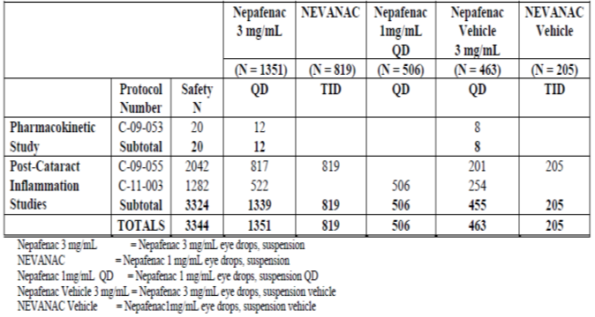
In Study C-09-055, the mean (SD) duration of nepafenac 0.3% treatment was 16.3 ± 3.3 days (range 2 to 30 days). The mean (SD) duration of nepafenac vehicle 0.3% treatment was 12.0 ± 5.6 days (range 2 to 20 days). In Study C-11-003, the mean (SD) duration of nepafenac 0.3% treatment was 14.9 ± 3.7 days (range 1 to 23 days). The mean (SD) duration of nepafenac vehicle 0.3% treatment was 10.3 ± 5.7 days (range 1 to 23 days).
From Table 8, 60.5% patients who were administered nepafenac 0.3% in Study C-09-055 received more than 16 days of treatment. In contrast, 18.4% patients who were administered nepafenac 0.3% in Study C-11-003 received more than 16 days of treatment.
Table 8: Overview of patient exposure to study drug by protocol, treatment group and post-operative treatment period (Studies C-09-053, C-09-055 and C-11-003).
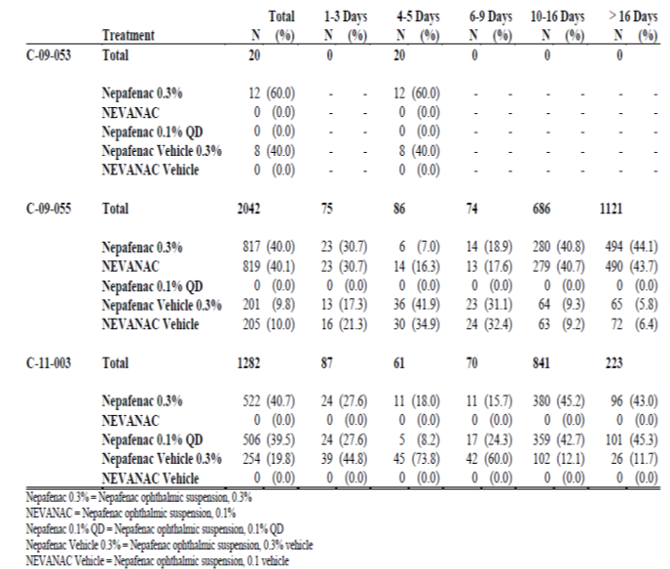
Evaluator’s comment: Nepafenac 0.3% eye drops suspension was intended to be dosed for 16 days (day prior to surgery, day of surgery, and 14 days following surgery) in the pivotal efficacy studies yet 43.7% (n = 590 of 1351) total received nepafenac 0.3% treatment for more than 16 days i.e. between 17 and 30 days (Table 1.2.1.A.8 RMP page 33). No explanation is provided why such a large proportion of subjects received nepafenac 0.3% treatment beyond 16 days, especially given the cure rates were in excess of 60% in both pivotal efficacy studies and over 89% of subjects in each of these trials was pain-free at Day 14. Further information is requested.

Adverse events

All adverse events (irrespective of relationship to study treatment)
Overall incidence of AEs in the efficacy trials for nepafenac 0.3% was 11.7% vs. 13.6% for its vehicle. The nepafenac 0.1% treatment groups had slightly less overall AE frequencies (9.5% to 10.0%), while its vehicle had proportionally higher rates than the nepafenac vehicle 0.3% group (16.1%).
The overall frequency and incidence of AEs that occurred at rates ≥ 1.0% in all studies (C-09-053, C-09-055 and C-11-003) is summarised in Table 9. Local ocular AEs in the system organ class ‘eye disorders’ accounted for most observed AEs in the pivotal studies.
Table 9: Frequency and incidence of AEs that occurred at rates ≥ 1.0% in all studies (C-09-053, C-09-055 and C-11-003).
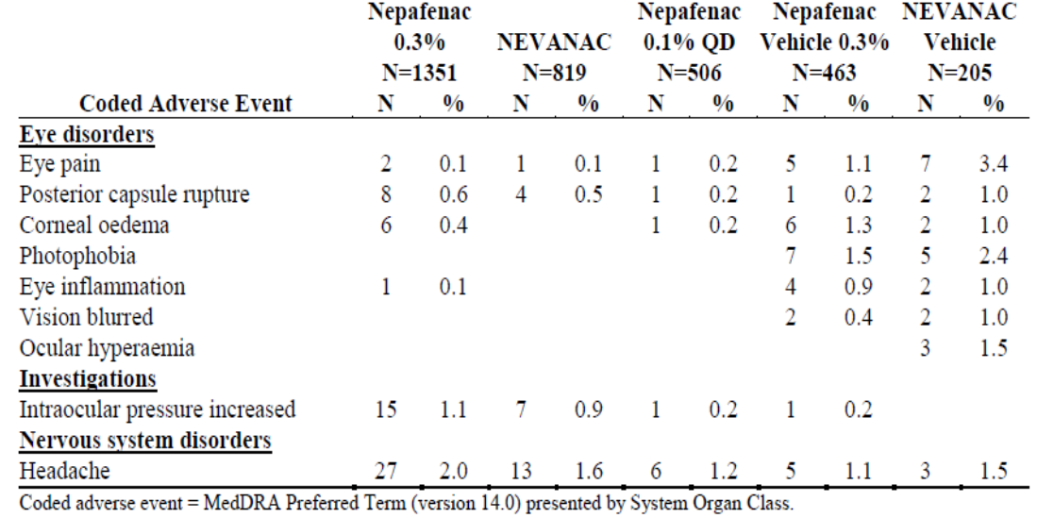
Evaluator’s comments: Headache incidence was greater than 1% in all treatment groups, with a dose-response trend with the highest incidence in the nepafenac 0.3% formulation. A dose-response trend in IOP was also apparent. The ‘inactive’ nepafenac vehicle 0.3% preparation gave rise to more eye pain, corneal oedema and photophobia than active treatment. The highest rates of eye pain and photophobia and ocular hyperaemia occurred in the nepafenac vehicle 0.1% group. The latter results suggest the ingredients in the vehicle, such as the preservative benzalkonium chloride, may give rise to AEs that need to be considered in the benefit-risk balance.
Other AEs (> 0.1% to < 1.0% incidence) in the nepafenac 0.3% treatments in the pivotal studies (taken from Table 5.3.5.3.11 ISS page 55): hypertension 0.4% (n = 5); back pain 0.3% (n = 4); corneal abrasion 0.4% (n = 6); injury 0.7% (n = 9); pain 0.3% (n = 4); toothache 0.4% (n = 5); punctate keratitis 0.2% (n = 3); foreign body sensation in eyes 0.2% (n = 3); cystoid macular oedema 0.3% (n = 4) and conjunctival haemorrhage 0.4% (n = 5).

Treatment-related adverse events (adverse drug reactions)

Pivotal studies
The overall frequency and incidence of adverse drug reactions (ADRs) reported in the post-cataract inflammation studies are summarised in Table 10.
Table 10: Overall frequency and incidence of treatment-related AEs in the post-cataract inflammation studies (C-11-003 and C-09-055).
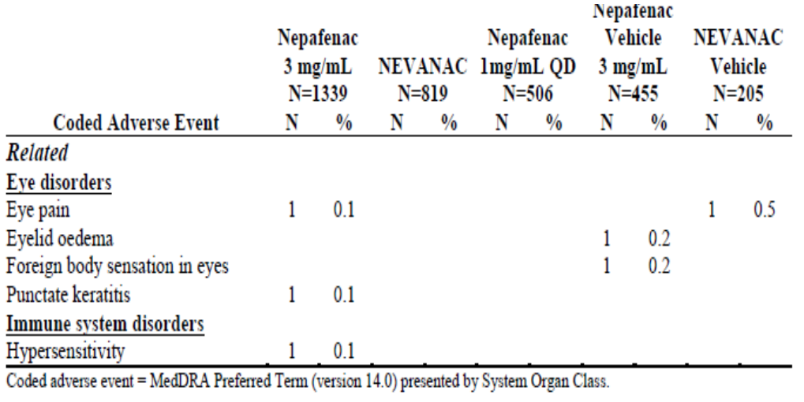
All ADRs reported in the post-cataract inflammation studies (C-09-055 and C-11-003) were single reports. Three ADRs were reported in the nepafenac 0.3% treatment group with no ADRs reported among the other active treatment groups. Among the 3 ADRs reported in the nepafenac 0.3% treatment group, eye pain and punctate keratitis were mild in intensity, resolved without treatment and did not interrupt patient study participation. The hypersensitivity ADR (characterised as an allergic reaction localised on the face) was moderate in intensity, resolved with treatment, but caused the patient to discontinue from the study.
All other ADRs reported for patients in the post-cataract inflammation studies occurred in the nepafenac vehicle 0.3% treatment group (single reports of eyelid oedema and foreign body sensation in eyes) and in the nepafenac vehicle 0.1% treatment group (single report of eye pain). The eyelid oedema and foreign body sensation in eyes were moderate and mild in intensity, respectively, and both events resolved without treatment and did not interrupt patient study participation. The eye pain was moderate in intensity, resolved without treatment and did not interrupt patient study participation.

Clinical pharmacology studies
In the PK study (C-09-053), AEs reported for nepafenac 0.3%, and nepafenac vehicle 0.3% consisted of events associated with the phlebotomy procedure used to obtain the blood samples for the PK analysis. No ocular AEs were reported in the PK study.
In the Japanese study, C-05-08, the most frequent treatment-related ocular AEs were blurred vision and eye discomfort (non-serious, mild and transient and each occurring in 2 subjects with nepafenac 0.1%). All other treatment-related ocular AEs were reported as single occurrences for subjects with exposure to nepafenac 0.1% (foreign body sensation, dry eye, pruritis eye, tearing and photophobia), nepafenac 0.3% (vision blurred, foreign body sensation, dry eye, pruritis eye, keratitis, oedema lid, pain eye, vision abnormal and visual acuity decreased), and vehicle (vision blurred and keratitis). Single cases of non-ocular AEs related to therapy were non-serious, mild in intensity, resolved without treatment, and did not interrupt subject continuation in the study: nepafenac 0.3% (headache, dizziness and taste perversion) and nepafenac 0.1% (headache).

Deaths

Pivotal studies
No deaths were reported for patients exposed to nepafenac. However, 2 subjects in Study C-09-055 died prior to any exposure to investigational product:
- [information redacted] died from hyperthermia 3 weeks in advance of scheduled first dose of test article, although test bottle never returned
- [information redacted] died from an acute myocardial infarction, bottle of test article returned unopened).

Clinical pharmacology studies
No deaths were reported in Studies C-09-053 and C-05-08.

Other serious adverse events

Pivotal studies
Overall, 0.9% nepafenac 0.3% subjects experienced a serious adverse event (SAE) compared with 0.4% for nepafenac 0.1% and 0.8% for QD nepafenac 0.1%. No patients exposed to nepafenac vehicle 0.1% or 0.3% experienced a SAE.
Twelve (12) nepafenac 0.3% patients experienced SAEs, 8 non-ocular and 4 ocular [single reports of corneal abrasion, hypopyon, endophthalmitis, angle closure glaucoma, lens dislocation and retinal detachment]. The latter three reports occurred in a patient who had a history of laser iridotomy, indicative of a history of narrow anterior chamber angles. Hypopyon, endophthalmitis, lens dislocation and retinal detachment are associated with cataract surgery.
No treatment-related SAEs were reported during the post-cataract inflammation studies (C-09-055 and C-11-003).

Clinical pharmacology studies
No SAEs were reported in Studies C-09-053 and C-05-08.

Discontinuation due to adverse events

Pivotal studies
In the post-cataract inflammation studies (C-09-055 and C-11-003), 80(6.0%) patients discontinued participation due to an AE: 31 (2.3%) patients with exposure to nepafenac 0.3%; 15 (3.3%) patients with exposure to nepafenac vehicle 0.3%; 17 (2.1%) patients with exposure to nepafenac 0.1%, 15 (3.3%) patients with exposure to QD nepafenac 0.1% and 6 (2.9%) patients with exposure to nepafenac vehicle 0.1%.
Ten (10) patients discontinued due to SAEs including 6 (0.4%) patients with exposure to nepafenac 0.3%, 2 (0.2%) patients with exposure to nepafenac 0.1% and 2 (0.4%) patients with exposure to QD nepafenac 0.1%. A single (0.1%) elderly patient in Study C-09-055, exposed to nepafenac 0.3%, discontinued due to a treatment-related AE (hypersensitivity; moderate intensity).

Clinical pharmacology studies
No patient discontinued due to an AE in Studies C-09-053 and C-05-08.

Laboratory tests
- No clinically relevant change from baseline in a blood chemistry parameter, haematology parameter or urinalysis parameter was reported in the pivotal studies or the clinical pharmacology studies;
- No AE associated with changes in blood chemistry parameters, haematology parameters or urinalysis parameters was reported in the pivotal studies or the clinical pharmacology studies; and
- Physical examinations, electrocardiographs and vital signs were not performed as a safety assessment in the clinical trials.

Visual acuity

Pivotal studies
There appeared to be a trend toward an increase (i.e. improvement) in mean visual acuity letters read in the study eye across all treatment groups (expected after cataract surgery). From Visit 3 (Day 5), mean visual acuity letters read were slightly higher among nepafenac patients (0.3% and 0.1%) vs. patients dosed with their vehicle (Figure 2). No clinically relevant treatment group differences were observed for decreases in visual acuity from baseline to exit in the study eye, with no observable differences in incidence of decreased visual acuity between nepafenac 0.3% and 0.1%. No AEs were reported for reduced visual acuity in nepafenac 0.3% treated patients.
Figure 2: Best corrected visual acuity (95% CI) by visit (C-09-055 and C-11-003; Safety Population).
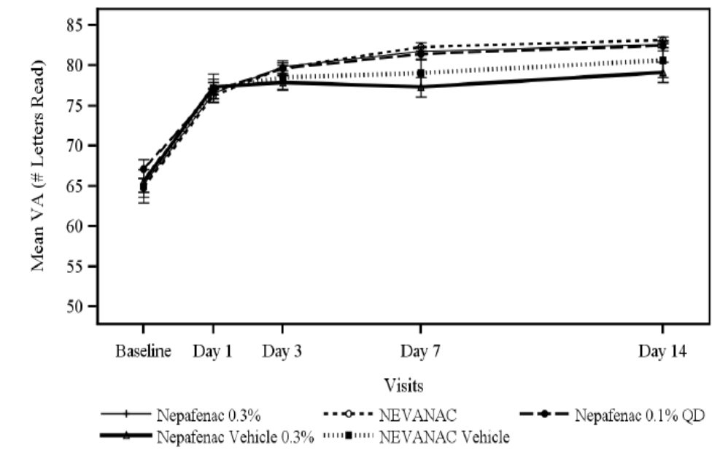

Clinical pharmacology studies
The BCVA for both eyes was assessed using a visual acuity protocol for all subjects. Results were reported as the number of letters read correctly. The maximum change in visual acuity for either eye (worse eye) in each subject was calculated as the largest decrease in letters read between the Exit Visit and Baseline. No subject experienced a decrease in visual acuity greater than or equal to 10 letters during the study, in the worst eye.

Ocular signs

Pivotal studies
There were no clinically relevant treatment group differences for maximum changes from baseline for chemosis, bulbar conjunctival injection and corneal oedema. In general, among those patients exposed to either vehicle, there were higher percentages of patients with maximum scores reported in all ocular signs parameters when compared with those patients exposed to either nepafenac 0.1% or nepafenac 0.3% eye drops suspension. No ADR was reported for a change in an ocular sign parameter in patients treated with nepafenac 0.3% eye drops, suspension.

Clinical pharmacology studies
An assessment of ocular signs (eyelid/conjunctiva, cornea, iris/anterior chamber, and lens) was performed for both eyes of all subjects. There were no changes in ocular signs reported during Study C-09-053.

IOP

Pivotal studies
While there appeared to be an increase in incidence of raised IOP of both active strengths of nepafenac vs. their respective vehicles, the magnitude of the effects observed are not likely to be clinically significant. Most patients in all treatment groups experienced maximum changes in IOP of no more than 10 mm Hg.
The sponsor demonstrated mean IOP was higher at Day 1 i.e. immediately after cataract surgery, for all treatment groups, and returned to levels lower than baseline values from Day 3 post-operatively, with little observed differences between treatments by Day 14 (Figure 3).
Figure 3: IOP (95% CI) by visit (Safety population: Studies C-11-003 and C-09-055).
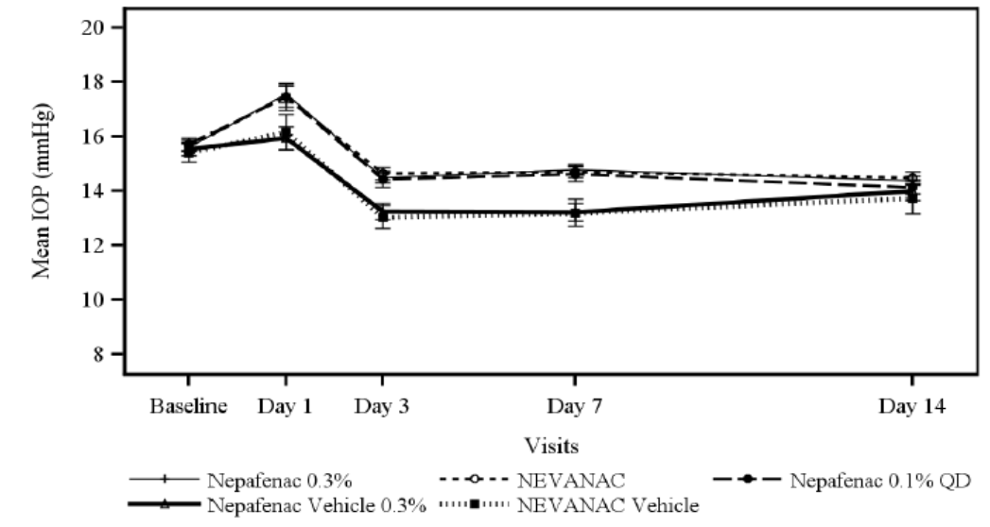

Clinical pharmacology studies
No AE of ‘raised IOP’ was identified in the clinical pharmacology trials, Studies C-09-053 and C-05-08. In Study C-09-053, no subject experienced ≥ 10 mmHg change in IOP during the study.

Dilated fundus parameter

Pivotal studies
Dilated fundus parameters (vitreous, optic nerve and retina/macula/choroid) were assessed for the study eye for all subjects. The change in fundus parameters for the study eye for each subject was calculated as a one-unit change in optic nerve score and a grade 2 score in retina/macula/choroid that was not present at baseline.
There were no clinically relevant differences between the nepafenac 0.3% eye drops and nepafenac 0.1%. No ADR was reported for a change in a dilated fundus parameters in patients treated with nepafenac 0.3% eye drops.

Clinical pharmacology studies
Dilated fundus parameters (vitreous, optic nerve and retina/macula/choroid) were assessed for both eyes for all subjects. The change in fundus parameters for the worse eye in each subject was calculated as any one-unit change between the Exit Visit and Baseline.
No safety issues were identified for nepafenac 0.3% eye drops based upon an analysis of changes in dilated fundus parameters during Study C-09-053.

AEs of special interest
As a drug class, topical ocular NSAIDs can produce corneal AEs and potentially impact on ocular bleeding (Table 11).
Table 11: Frequency and Incidence of TEAEs of special interest (C-09-055 and C-11-003).
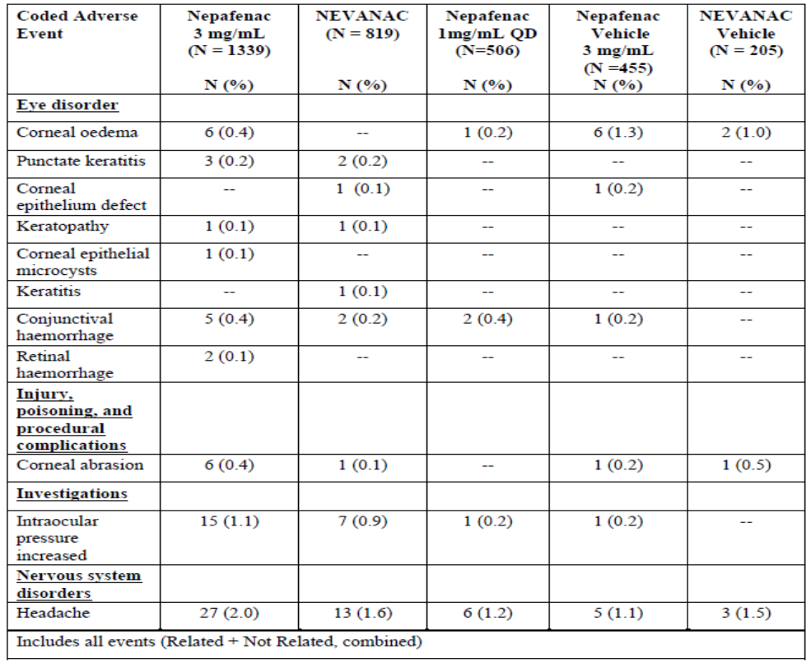

Corneal AEs

Pivotal studies
There were no clinically significant differences between active nepafenac treatments and their respective vehicles for corneal AEs. The incidence for each eye disorder category, for active treatments, was < 1%.

Clinical pharmacology studies
No ocular AE was identified in the clinical pharmacology trial, Study C-09-053. In the Japanese trial, C-05-08, single cases of ‘keratitis’ occurred in subjects exposed to nepafenac 0.3% and vehicle nepafenac 0.3%.

Ocular haemorrhage

Pivotal studies
There were no clinically significant differences between active nepafenac treatments and their respective vehicles.

Clinical pharmacology studies
No AE of ‘conjunctival haemorrhage’ or ‘retinal haemorrhage’ was identified in the clinical pharmacology trials, Studies C-09-053 and C-05-08.

Headache

Pivotal studies
A dose-response increase in incidence of headache between nepafenac 0.1% and nepafenac 0.3% was observed.

Clinical pharmacology studies
No AE of ‘headache’ was identified in the clinical pharmacology trial, Study C-09-053.
In the Japanese trial, C-05-08, single, mild, transient cases of treatment-related headache occurred with nepafenac 0.3% and nepafenac 0.1%.

Other safety issues

Intrinsic factors
In the pivotal efficacy trials, there were no clinically relevant differences in the types and incidences of AEs between adult and elderly patients; between male and female patients; by racial subpopulation; by concomitant disease category; by concomitant medication category and by iris colour.
Most ocular AEs associated with the use of nepafenac 0.3% eye drops occurred within 1 week following the first dose of study medication (i.e. in the immediate postoperative period).

Extrinsic factors
TEAEs were not evaluated based on extrinsic factors (incidence of AEs by alcohol use, drug interactions, use in pregnancy and lactation, overdose, drug abuse, withdrawal and rebound).
As with any eye drops, temporary blurred vision or other visual disturbances may affect the ability to drive or operate machinery. Within the clinical studies of nepafenac 0.3% eye drops, no AEs were noted which would result in an impairment of mental ability.

Safety related to drug-drug interactions and other interactions
No drug interactions involving nepafenac were reported in any clinical study involving nepafenac 0.3% eye drops. Nepafenac 0.3% eye drops have been safely administered in conjunction with other ophthalmic medications such as antibiotics, anaesthetics, beta-blockers, carbonic anhydrase inhibitors, alpha-agonists, cycloplegics and mydriatics. Further, no drug interactions have been reported in association with concomitant systemic medications. However, nepafenac clinical trials have excluded patients receiving prostaglandin analogues and topical steroids, which would be expected to interact with nepafenac based on its known pharmacology.

Overdose
No cases of overdose of nepafenac 0.3% eye drops were reported during the clinical trials. The risk of AEs due to accidental (or intentional) ingestion of the entire contents of a 4 mL bottle (3 mL fill size containing 9 mg nepafenac) of nepafenac 0.3% eye drops has not been quantified. The recommended adult dose of amfenac sodium (Fenazox), marketed in Japan since 1986, is one to four 50 mg tablets daily. This translates to 1 to 4 mg/kg per day for a 50 kg person. If a 20 kg child ingested the entire contents of a 4 mL bottle (3 mL fill size) of nepafenac 0.3% eye drops it would translate to a dose of 0.45 mg/kg or 11% to 45% of the recommended adult dose.
If an elderly patient were to consume the entire contents of the bottle and they had concomitant illnesses such as active peptic ulcer disease, a bleeding disorder or a history of NSAID-induced bronchospasm/asthma then the potential effects in the elderly could be serious and severe.

Immunogenicity
While there is no known potential for nepafenac to cause immunogenicity, its use is contraindicated in patients with demonstrated hypersensitivity to any ingredients in the formulation or to other NSAIDs.

Post marketing experience
As provided by the sponsor:
Nepafenac eye drops, suspensions are currently marketed as Nepafenac 1 mg/mL, eye drops, suspension and Nepafenac 3 mg/mL, eye drops suspension. Data from post marketing experience involving each of these products will be described below.
The first Alcon product containing nepafenac for ocular use (NEVANAC, Nepafenac 1 mg/mL, eye drops, suspension was approved in the United States of America (USA) in August 2005. In December 2007 this product was first approved by European Medicines Agency (EMA). Currently, Alcon has registered nepafenac-containing products for ocular use (ophthalmic nepafenac at concentrations of 1 mg/mL and 3 mg/mL) in over 90 countries world-wide.
From product launch in 2005 up to April 30, 2014, 30,237,833 units of NEVANAC have been distributed world-wide by Alcon. From product launch in 2012 up to April 30, 2014; 522,473 units of Nepafenac 3 mg/mL eye drops suspension have been distributed world-wide by Alcon.
AEs possibly associated with the ocular use of nepafenac are varied, generally non-serious and mostly related to local ocular disorders. As of 30 April 2014, there were 1710 post-marketing AEs for nepafenac 0.1% ophthalmic preparation, of which 919 (53.7%) were categorised under ‘eye disorders’. In contrast, for Ilevro, as of 30 April 2014, there were 68 (63.0%) AEs classified under ‘eye disorders’ from a total of 108 spontaneous AE reports. There have been no regulatory actions related to safety since the marketing of Nevanac (nepafenac 0.1% eye drops suspension) and nepafenac 0.3% eye drops suspension.
Evaluator’s comment: While no new safety signal compared with the nepafenac 0.1% eye drops has been noted to date, the exposure to nepafenac 0.3% is limited at the time of this review. Furthermore, the PSUR submitted with this application included data for the period up to the end of November 2011. This PSUR did not include data for nepafenac 0.1% in the treatment of diabetic patients.

Evaluator’s conclusions on safety
Most AEs observed in the post cataract inflammation studies (C-09-055 and C-11-003) for nepafenac 0.3% eye drops were local/ocular. AEs tended to occur in the first week after cataract surgery, with mild or moderate intensity. Few subjects experienced serious adverse events (SAEs) (0.9% who received nepafenac 0.3% across trials), although one elderly subject in Study C-09-055 withdrew from the study due to a treatment related hypersensitivity reaction (facial allergic reaction). No deaths were reported for nepafenac eye drops throughout the clinical development program.
Headache incidence was greater than 1% in all treatment groups, with an apparent dose-response trend. Headache was also an observed AE for Acular and Voltaren Ophtha.
There appeared to be a dose response trend in elevated intraocular pressure (IOP). While the investigators did not consider a single case of raised IOP as treatment related to nepafenac (15 for nepafenac 0.3% and 7 for nepafenac 0.1%), but rather an effect of cataract surgery, the relative rise in IOP was proportionally greater in both active treatments than their corresponding vehicles. This effect may not be clinically meaningful in the populations studied, especially given the rapid reduction towards pre baseline IOP pressures by Day 3 post operatively, but a contributory effect of nepafenac to IOP elevation cannot be ruled out. Raised IOP is indicated as an AE for Acular and Voltaren Ophtha.
No safety issues were identified for nepafenac 0.3% eye drops based upon analysis of AEs by intrinsic factors (age, gender, race, iris colour, concomitant diseases and concomitant medications). No analyses were undertaken for extrinsic factors.
No safety issues were identified for nepafenac 0.3% eye drops based upon an analysis of change from baseline in ocular and systemic parameters, which included BCVA, ocular signs (eyelids/conjunctiva, cornea, iris/anterior chamber, lens, corneal oedema, bulbar conjunctival injection, and chemosis), dilated fundus parameters (vitreous, retina/macula/choroid, and optic nerve) and clinical laboratory evaluations (haematology, blood chemistry and urinalysis).
The safety profile of nepafenac 0.3% eye drops dosed once daily up to 16 days for the treatment of post cataract surgical pain and inflammation was generally comparable with the safety profile previously established for nepafenac 0.1% eye drops suspension. The major differences are in the higher incidence of headache and IOP with the 0.3% eye drops and a higher incidence of hypersensitivity reactions with the 0.3% eye drops compared with nepafenac 0.1% eye drops (common versus rare, respectively).
Furthermore, the risks of AEs due to accidental (or intentional) ingestion of the entire contents of a 4 mL bottle (3 mL fill size) of nepafenac 0.3% eye drops suspension have not been quantified. There is an approximate doubling of the nepafenac content in the 0.3% eye drop preparation compared with the commercially available 0.1% preparation, that is, 9 mg versus 5 mg, respectively. If a 20 kg child ingested 3 mL of nepafenac 0.3% eye drops suspension, this would equate to a dose of 0.45 mg/kg, that is, up to 45% of the recommended adult dose (200 mg per day, Fenazox). This is not an insignificant amount. For example, the Voltaren Ophtha PI states 3% of the maximum adult dose is available after ingestion, that is, 15 times less exposure than for Ilevro. Hence, toxicity following accidental or intentional oral overdose may become an issue, especially in very young children or in elderly patients. The latter may have co-morbidities such as active peptic ulcer disease, which places them at greater risk of adverse health outcomes.

First round benefit-risk assessment

First round assessment of benefits
The benefits of nepafenac 0.3% eye drops in the proposed usage are:
- The cure rates and rate differences in the primary efficacy analysis for nepafenac 0.3% vs. nepafenac vehicle 0.3% were consistent between the efficacy trials and NNT of 3 patients in each trial is clinically significant. Hence, nepafenac 0.3% provided a reduction in early postoperative inflammation compared with nepafenac vehicle 0.3%;
- The subgroup analyses of the primary efficacy endpoint, secondary efficacy results, supportive and exploratory results, across all efficacy trials, were consistent with the primary efficacy results. In particular, statistical separation between nepafenac 0.3% and nepafenac vehicle 0.3% occurred early in the studies (often from the Day 1 post operative visit) in pain scores, as well as inflammatory scores (mean aqueous cells and flare);
- Treatment failures were approximately 10 fold less in the nepafenac 0.3% treatment groups compared with the nepafenac vehicle 0.3% groups. These differences were noted from the Day 1 post operative visit, with most of the difference between active treatment with nepafenac and its vehicle treatment achieved within the first 7 days;
- Low potential for drug-drug interactions based on low systemic exposure;
- No dosage adjustment required based on age, weight, race, renal or hepatic function (based on low systemic exposure);
- The nepafenac 0.3% results were similar in magnitude to the results achieved with the Australian approved product, Acular, for treatment of postoperative inflammation following cataract surgery;
- No deaths or treatment related SAE were observed in the pivotal efficacy and safety studies;
- In the primary efficacy analysis in Study C-09-055, nepafenac 0.3% dosed once daily was non-inferior to nepafenac 0.1% dosed 3 times daily for the prevention and treatment of ocular inflammation 14 days after cataract extraction;
- Generally, the comparative analyses of nepafenac 0.1% versus nepafenac vehicle 0.1% provided similar results, of similar magnitude, to the nepafenac 0.3% vs. nepafenac vehicle 0.3% analyses performed across the efficacy trials. The nepafenac 0.1% results therefore provide supportive efficacy data for the nepafenac 0.3% strength preparation proposed in this submission;
- Ilevro once daily dosing provides a simpler dosage regimen than Voltaren Ophtha and Acular (patient compliance and convenience, especially if multiple eye preparations used), as well as providing an alternative to ocular corticosteroid treatments;
- Most AEs were local, non serious, mild or moderate, and transient in nature (principally occurring in the first week post operatively);
- Generally, the safety profile of nepafenac 0.3% was similar to nepafenac vehicle 0.3% (as well as nepafenac 0.1%), and consistent with other products in the class of topical NSAIDs.
Areas of uncertainty:
- The efficacy of postoperative pain following cataract surgery has not been fully determined at the time of this report;
- The generalizability of the study results to a non Caucasian population is unclear since more than 80% of study participants across the trials were Caucasian in origin, although ethnicity is not expected to impact the results significantly;
- Since both ocular prostaglandin analogues and ocular corticosteroids were excluded from clinical trials (on the basis of potential for drug-drug interactions), any effect on Ilevro efficacy is unknown.

First round assessment of risks
The risks of nepafenac in the proposed usage are:
- A dose response relationship for headache may represent a safety signal;
- A dose response relationship for elevated IOP may represent a safety signal;
- Higher rate of hypersensitivity compared with nepafenac 0.1% may represent a new (dose response) safety signal.
Class effects of topical ophthalmic NSAIDs:
- Corneal AEs (which include keratitis, epithelial breakdown, corneal thinning, corneal erosion, corneal ulceration or corneal perforation). These may become sight threatening in patients with complicated ocular surgeries, corneal denervation, corneal epithelial defects, diabetes mellitus, ocular surface diseases (for example, dry eye syndrome), rheumatoid arthritis, or repeat ocular surgeries within a short period of time;
- Ocular bleeding, including hyphaemas, in conjunction with ocular surgery (increased bleeding time due to interference with thrombocyte aggregation);
- Slowed or delayed healing (especially with concomitant corticosteroids);
- Masking of an acute ocular infection;
- As with any eye drops, temporary blurred vision or other visual disturbances may affect the ability to drive or operate machinery;
- Cross-sensitivity to other NSAIDs, including aspirin, and hence potential to precipitate attacks of asthma, urticaria or acute rhinitis in susceptible individuals.
Potential safety risks:
- The safety of nepafenac 0.3% eye drops has not been established in macular oedema in subjects with proliferative diabetic retinopathy (with Nevanac use in the EU for this indication, dosage duration was up to 60 days or greater and higher AE incidence rates were noted, particularly for ocular events, for example, punctate keratitis 3%);
- Concomitant administration with topical ocular steroids (potential interaction, for example, delayed corneal healing and may act synergistically with NSAIDs in the development of ulcerative keratolysis);
- Concomitant administration with topical ocular prostaglandin analogues (for example, increase in IOP);
- The safety of nepafenac 0.3% eye drops has not been established in overdose (especially ingestion);
- Some systemic NSAIDs (for example, rofecoxib) have been found to increase the risk for serious arterial thrombotic events, including heart attack, stroke and blood clots;
- Pregnancy or nursing women;
- Use of guar as an excipient in the nepafenac 0.3% formulation (not present in the nepafenac 0.1% formulation). While AEs with guar are expected to be low, there is insufficient data at the time of this application to determine whether guar poses a safety risk;
- Use in concurrent ocular diseases, for example, dry eye, diabetic retinopathy;
- The safety of preserved nepafenac 0.3% eye drops has not been established in prolonged use. This may increase the probability of:
  - contaminated product applied to the eye(s);
  - local irritation and potential to cause punctate keratopathy and/or toxic ulcerative keratopathy from the preservative, benzalkonium chloride;
  - Repeated doses of preserved eye drops can have a cumulative effect, and the prolonged contact with the epithelium may cause chronic irritation and fibrotic changes of the conjunctiva and Tenon’s capsule.

First round assessment of benefit-risk balance
Notwithstanding the deficiencies in the documentation provided in support of registration of Ilevro, much of the Nevanac information is directly relevant and, together, have provided a provisional favourable benefit-risk balance of nepafenac 0.3% eye drops, in subjects without diabetic retinopathy, for postoperative inflammation. The efficacy of Ilevro in post operative inflammation was similar to that observed in Acular, an Australian registered product for the proposed indication. Furthermore, the safety profile of Ilevro was generally consistent with both Acular and Voltaren Ophtha (except for omission of increased incidences of elevated IOP and headache in the Ilevro PI). The benefits of nepafenac 0.3% eye drops appear to outweigh the risks in the treatment of ocular inflammation following cataract surgery.
The sponsor has not provided sufficient data at the time of this first round report for a recommendation to approve Ilevro in postoperative pain following cataract surgery.

First round recommendation regarding authorisation
This evaluator recommends nepafenac 0.3% eye drops suspension (Ilevro) be approved for the prevention and treatment of postoperative inflammation associated with cataract surgery. However, pending further clinical data, the indication should be restricted to subjects who do not suffer from diabetes mellitus, as treatment duration may be up to four fold longer and corneal AEs are expected to be higher than for subjects who do not have diabetes mellitus. Further, until further data is provided a recommendation for Ilevro to be indicated in the prevention and treatment of postoperative pain associated with cataract surgery should be withheld.

Clinical questions

Pharmacology

Question 1
- Do any of the metabolites of nepafenac (other than amfenac) identified in Study C-04-27 have pharmacological activity? If yes, please indicate which metabolites are active and their relative activity compared with amfenac.

Question 2
- Did the sponsor undertake any pharmacokinetic studies on any of the metabolites of nepafenac (other than amfenac) identified in Study C-04-27? If so, please provide further information, particularly on Cmax, Tmax, AUC indices and elimination half life.

Question 3
- Where in the submission documentation is the apparent plasma clearance (CL/F) following extravascular administration results for the nepafenac analyte in Study C-09-053?

Efficacy

Question 4
- The assessment of postoperative pain following cataract surgery was only undertaken as secondary and supportive efficacy endpoints in Study C-09-055, and as supportive efficacy endpoints in Study C-11-003.
Given the current application seeks to register Ilevro for the prevention and treatment of postoperative inflammation and pain following cataract surgery, why did the sponsor not analyse pain as a co-primary endpoint in the pivotal efficacy trials, Studies C-09-055 and C-11-003? Furthermore, why was postoperative pain not analysed as a secondary efficacy endpoint in Study C-11-003?

Question 5
- What proportions of subjects in the intent-to-treat populations, by clinical trial (Studies C-09-055 and C-11-003) and by treatment group, were both cured and pain-free at Day 14?

Safety

Question 6
- Nepafenac 0.3% eye drops suspension was intended to be dosed for 16 days (day prior to surgery, day of surgery, and 14 days following surgery) in the pivotal efficacy studies (C-11-003 and C-09-055) yet more than 43.7% (n = 590 of 1351) total received nepafenac 0.3% treatment for more than 16 days despite the high cure rates and subjects who were pain free at Day 14 post operatively. No explanation is provided why such a large proportion of subjects received nepafenac 0.3% treatment beyond 16 days.
Will the sponsor please clarify why 43.7% total subjects were exposed to more than 16 days treatment with nepafenac 0.3% eye drops suspension in the pivotal efficacy trials (C-11-003 and C-09-055)?
What proportions of subjects, by clinical trial (Studies C-09-055 and C-11-003) and by treatment group, who were (a) cured at Day 14 continued treatment beyond Day 14 post-operatively and (b) pain free at Day 14 continued treatment beyond Day 14 post-operatively?

Second round evaluation
- Question 1. Satisfactory response. No amendment to clinical evaluation report.
- Question 2. Satisfactory response. No amendment to clinical evaluation report.
- Question 3. Asked “Where in the submission documentation is the apparent plasma clearance (CL/F) following extravascular administration results for the nepafenac analyte in Study C-09-053?”
The clinical evaluation report had:
In Study C-09-053, apparent plasma clearance following extravascular administration (CL/F) for the nepafenac analyte was planned but no results were presented. No other estimates of renal clearance were undertaken as part of this application. Nepafenac and its metabolites are primarily eliminated through the renal route, with 85.5% of radiolabelled dose recovered in urine (Study C-04-27 summary).
The sponsor replied:
The apparent plasma clearance parameter (CL/F) was reported in the clinical study report for C-09-053 (TDOC-0012899). However, this parameter was not explicitly stated in the submission (Module 2.7.2.2 Summary of Pharmacokinetic Results, Table 2.7.2.2-1). Since the dose route was topical ocular and an intravenous study was not conducted, the fraction of dose reaching the plasma compartment is unknown. Therefore, reporting this parameter (CL/F) in the submission was considered to be not appropriate.
The sponsor’s response was unsatisfactory simply stating it was there, not where. This has delayed evaluation.
The sponsor was again asked: “Can the sponsor be asked to be more specific”, that is, on which page in the clinical study report for C-09-053 it could be found.
The sponsor’s response was satisfactory on this occasion. Amendment made to clinical evaluation report.
- Question 4. Satisfactory response. Amendment made to clinical evaluation report.
- Question 5. Satisfactory response. No amendment to clinical evaluation report.
- Question 6. Satisfactory response. Amendment made to clinical evaluation report.

Second round benefit-risk assessment

Second round assessment of benefits
The first round assessment should be modified by the deletion of:
Areas of uncertainty:
- The efficacy of postoperative pain following cataract surgery has not been fully determined at the time of this report;

Second round recommendation regarding authorisation
The first round recommendation should be modified by the deletion of:
- Furthermore, until further data is provided a recommendation for Ilevro to be indicated in the prevention and treatment of postoperative pain associated with cataract surgery should be withheld.

References
- Acular Australian Product Information
- Voltaren Ophtha Australian Product Information
- Fenazox capsules prescribing information (Meiji, japan)
- Protocol C-04-027: An open-label excretion study of nepafenac (Al-6515) following administration of a single oral dose of radiolabelled nepafenac in healthy subjects;
- Protocol C-05-08: A double-masked. Multiple-dose, safety and pharmacokinetic study of AL-6515 ophthalmic suspensions in health Japanese subjects
- Protocol C-05-19: An open-label, single-dose, pharmacokinetic study of nepafenac and amfenac, or ketorolac, in human aqueous humor following administration of Nevanac or Acular LS, respectively
- Protocol C-09-053: A pharmacokinetic and safety study of nepafenac ophthalmic suspension 0.3% in healthy subjects
- Protocol C-09-055: Clinical evaluation of nepafenac ophthalmic suspension 0.3% for prevention and treatment of ocular inflammation and pain after cataract surgery
- Protocol C-11-003: Clinical evaluation of nepafenac ophthalmic suspension 0.3% compared to nepafenac ophthalmic suspension 0.1% and vehicle for prevention and treatment of ocular inflammation and pain associated with cataract surgery

Therapeutic Goods Administration
PO Box 100 Woden ACT 2606 Australia
Email: info@tga.gov.au Phone: 1800 020 653 Fax: 02 6232 8605
https://www.tga.gov.au

Three additional clinical study reports and four references were provided upon request, which included Fenazox prescribing information.
Acular Australian PI.

