August 2016

Australian Public Assessment Report for Nalmefene (as hydrochloride dihydrate)
  - Proprietary Product Name: Selincro
  - Sponsor: Lundbeck Australia Pty Ltd

About the Therapeutic Goods Administration (TGA)
- The Therapeutic Goods Administration (TGA) is part of the Australian Government Department of Health and is responsible for regulating medicines and medical devices.
- The TGA administers the Therapeutic Goods Act 1989 (the Act), applying a risk management approach designed to ensure therapeutic goods supplied in Australia meet acceptable standards of quality, safety and efficacy (performance), when necessary.
- The work of the TGA is based on applying scientific and clinical expertise to decision-making, to ensure that the benefits to consumers outweigh any risks associated with the use of medicines and medical devices.
- The TGA relies on the public, healthcare professionals and industry to report problems with medicines or medical devices. TGA investigates reports received by it to determine any necessary regulatory action.
- To report a problem with a medicine or medical device, please see the information on the TGA website <www.tga.gov.au>.
About AusPARs
- An Australian Public Assessment Report (AusPAR) provides information about the evaluation of a prescription medicine and the considerations that led the TGA to approve or not approve a prescription medicine submission.
- AusPARs are prepared and published by the TGA.
- An AusPAR is prepared for submissions that relate to new chemical entities, generic medicines, major variations, and extensions of indications.
- An AusPAR is a static document, in that it will provide information that relates to a submission at a particular point in time.
- A new AusPAR will be developed to reflect changes to indications and/or major variations to a prescription medicine subject to evaluation by the TGA.
Copyright
© Commonwealth of Australia 2016
This work is copyright. You may reproduce the whole or part of this work in unaltered form for your own personal use or, if you are part of an organisation, for internal use within your organisation, but only if you or your organisation do not use the reproduction for any commercial purpose and retain this copyright notice and all disclaimer notices as part of that reproduction. Apart from rights to use as permitted by the Copyright Act 1968 or allowed by this copyright notice, all other rights are reserved and you are not allowed to reproduce the whole or any part of this work in any way (electronic or otherwise) without first being given specific written permission from the Commonwealth to do so. Requests and inquiries concerning reproduction and rights are to be sent to the TGA Copyright Officer, Therapeutic Goods Administration, PO Box 100, Woden ACT 2606 or emailed to <tga.copyright@tga.gov.au>.

Contents
List of abbreviations 5
I. Introduction to product submission 8
Submission details 8
Product background 9
Regulatory status 10
Product Information 12
II. Quality findings 12
Drug substance (active ingredient) 12
Drug product 12
Biopharmaceutics 13
Quality summary and conclusions 16
III. Nonclinical findings 16
Introduction 16
Pharmacology 17
Pharmacokinetics 21
Toxicology 26
Nonclinical summary and conclusions 39
IV. Clinical findings 42
Introduction 42
Pharmacokinetics 49
Pharmacodynamics 52
Dosage selection for the pivotal studies 53
Efficacy 54
Safety 56
First Round Benefit-Risk Assessment 62
First Round Recommendation Regarding Authorisation 63
Clinical questions following the CER Round 1 63
Second Round Evaluation 66
Second Round Benefit-Risk Assessment 69
Sponsor’s response to second round recommendations 71
V. Pharmacovigilance findings 71
Risk management plan 71
VI. Overall conclusion and risk/benefit assessment 78
Quality 78
Nonclinical 79
Clinical 79
Risk management plan 84
Risk-benefit analysis 85
Outcome 101
Attachment 1. Product Information 102
Attachment 2. Extract from the Clinical Evaluation Report 102

List of abbreviations
Abbreviation | Meaning
ACPM | Advisory Committee on Prescription Medicines
AD50 | dose that produced a 50% antagonism of agonist effects
AE | adverse event
APD50 | action potential duration at 50% repolarisation
APD90 | action potential duration at 90% repolarisation
API | Active Pharmaceutical Ingredient
APTS | All Patients Treated Set
ASA | Australian Specific Annex
AUC_{t1-t2} | area under the plasma concentration-time curve from time t1 to t2
BOCF | baseline observation carried forward
CI | Confidence Interval
CL/F | oral clearance
Cmax | maximum plasma drug concentration
CMI | Consumer Medicines Information
CNS | central nervous system
DRL | Drinking Risk Level
EC50 | half maximal effective concentration
ECG | electrocardiogram
ED50 | half maximal effective dose
EMA | European Medicines Agency
GCP | Good Clinical Practice
GD | gestational day
GLP | Good Laboratory Practice
HD | high dose
HDD | Heavy Drinking Days
IA | intrinsic activity
IND | Investigational New Drug
ITBM | Intended To Be Marketed
IV | intravenous
Ki | inhibition constant
LD | low dose
LD50 | lethal dose 50%
LLN | local lymph node
MD | medium dose
MMRM | mixed model repeated measures
MOA | mechanism of action
NAc | nucleus accumbens
NMF | nalmefene
NOAEL | No Observed Adverse Effect Level
NOEL | No Observed Effect Level
OPR | Office of Product Review
PET | positron emission tomography
PI | Product Information
PND | post natal day
PO | per os (oral)
PSUR | Periodic Safety Update Report
RMP | Risk Management Plan
SAE | serious adverse event
SAP | Statistical Analysis Plan
SC | subcutaneous
SmPC | Summary of Product Characteristics
t_{1/2} | elimination half life
TAC | total alcohol consumption
TEAE | treatment emergent adverse event
TLFB | Timeline Follow Back
Tmax | time to reach maximum plasma concentration following drug administration
UGT | UDP glucuronosyltransferase
VTA | ventral tegmental area
WHO | World Health Organisation

I. Introduction to product submission

Submission details
Type of submission: | New chemical entity
Decision: | Approved
Date of decision: | 4 June 2015
Active ingredient(s): | nalmefene (as hydrochloride dihydrate)
Product name(s): | Selincro
Sponsor’s name and address: | Lundbeck Australia Pty Ltd  1 Innovation Road  North Ryde NSW 2113
Dose form(s): | Immediate release film coated tablets
Strength(s): | 18 mg
Container(s): | PVC/PVdC/Aluminium foil blisters
Pack size(s): | 7, 14, 28, 42, and 98 tablets
Approved therapeutic use: | Selincro is indicated for the reduction of alcohol consumption in adult patients with alcohol use disorder who have an average daily consumption of alcohol of more than 60 g for men and more than 40 g for women.  Selincro should be prescribed only if the patient has failed to achieve an adequate response following psychosocial intervention for at least 2 weeks.  Selincro should be prescribed in conjunction with continuing psychosocial support focused on treatment adherence and reducing alcohol consumption.  Selincro is not suitable for patients with physical withdrawal syndrome or who require immediate detoxification.
Route(s) of administration: | Oral
Dosage: | Selincro is to be taken as needed: on each day the patient perceives a risk of drinking alcohol; one tablet should be taken, preferably 1-2 hours prior to the anticipated time of drinking. If the patient has started drinking alcohol without taking Selincro, the patient should take one tablet as soon as possible. The starting and recommended dose for Selincro is one tablet per day, taken with or without food.
ARTG number (s): | 215784

Product background
This AusPAR describes the application by Lundbeck Australia Pty Ltd to register a new chemical entity nalmefene (as hydrochloride dihydrate) (trade name: Selincro) with a distinct μ, δ and κ opioid receptor profile developed for the treatment of alcohol dependence in adults. The submission states that in vitro studies have demonstrated that nalmefene is a selective opioid receptor ligand with antagonist activity at the μ and δ receptors and partial agonist activity at the κ receptor, while in vivo studies have demonstrated that nalmefene reduces alcohol consumption, possibly by modulating cortico mesolimbic functions.
In the present submission, the sponsor seeks to register an immediate release film coated tablet to be administered with or without food at a recommended starting and maximum dose of one tablet per day.
Selincro is indicated for the reduction of alcohol consumption in adult patients with alcohol dependence, who have a high Drinking Risk Level (DRL) without physical withdrawal syndrome and who do not require immediate detoxification. Selincro should be prescribed in conjunction with psychosocial support focused on treatment adherence and reducing alcohol consumption.
In different contexts within this document, this dose is variously referred to as nalmefene 20 mg (referring to the quantity of nalmefene hydrochloride) or as 18 mg (referring to the quantity of nalmefene base).
The proposed Product Information (PI) provides the following dosing instructions:
Selincro is to be taken as needed: on each day the patient perceives a risk of drinking alcohol; one tablet should be taken, preferably 1-2 hours prior to the anticipated time of drinking. If the patient has started drinking alcohol without taking Selincro, the patient should take one tablet as soon as possible. The maximum dose of Selincro is one tablet per day.
Nalmefene was initially developed as an opioid antagonist and parenteral forms have been approved for use in the treatment of opioid overdose in a number of countries including the United States (1995) and Canada (1996). Parenteral forms are still available for treatment of opioid overdose in Mexico and China. Nalmefene has also been tested for efficacy in a large number of indications ranging from cystitis to rheumatoid arthritis with an eventual focus on addiction disorders, including gambling and smoking. Finally, it was assessed for efficacy in alcohol dependence, the currently proposed indication.
Nalmefene was not primarily developed for treatment of alcohol dependence. Sponsor and formulation changes have occurred since nalmefene was developed. The earliest clinical study submitted was performed in 1984.
As noted in the Australian Therapeutic guidelines, group or individual support and counselling programs form the basis of long term management of alcohol problems. Three drugs with different modes of action may be used in treatment: disulfiram, acamprosate and naltrexone. Choice of drug needs to be individualised, depending on the person’s circumstances. Disulfiram gives good results but treatment must be closely supervised. It may be hard to achieve compliance with acamprosate because of the need to take six tablets daily; however, it will not affect treatment for pain relief. Naltrexone can interfere with treatment for pain relief but dosing with one tablet daily may aid compliance. For each of these drugs, treatment duration of 6 months or more is recommended. Of these approved treatments, naltrexone has a mechanism of action closest to that proposed to be the case for nalmefene. As noted in the clinical evaluation report, efficacy of naltrexone as an aid to the treatment of alcoholism was assessed in blinded, placebo controlled trials conducted over 12 weeks. Continued abstinence versus placebo has not been evaluated by the TGA.
With this submission, the goal of treatment is reduction in alcohol intake with a reduction of ≥20g/day considered potentially clinically significant. This was justified by referring to the WHO DRLs for alcohol consumption which increase in increments of 20 g alcohol/day for women, from low risk at ≤20 g/day to very high risk at >60 g/day. For men the increments are 40 g/day with low risk DRL at ≤40 g/day and very high risk >100 g/day. A standard drink contains 10 g alcohol.
The most closely related medicine with an indication similar to that proposed for nalmefene is naltrexone. The relevant indication for naltrexone is naltrexone is indicated for use within a comprehensive treatment programme for alcohol dependence. In clinical studies of naltrexone treatment reduced alcohol craving, supported abstinence, prevented relapse and decreased alcohol consumption. In the uncontrolled study (of naltrexone), the patterns of abstinence and relapse were similar to those observed in the controlled studies. Naltrexone was not uniformly helpful to all patients, and the expected effect of the drug (naltrexone) is a modest improvement in the outcome of conventional treatment.

Regulatory status
Table 1 describes the international status of current regulatory submissions at the time of submission to the TGA. There has not been a withdrawal or rejection in any country. Selincro has not been withdrawn in any country.

Table 1: International regulatory status for Selincro.
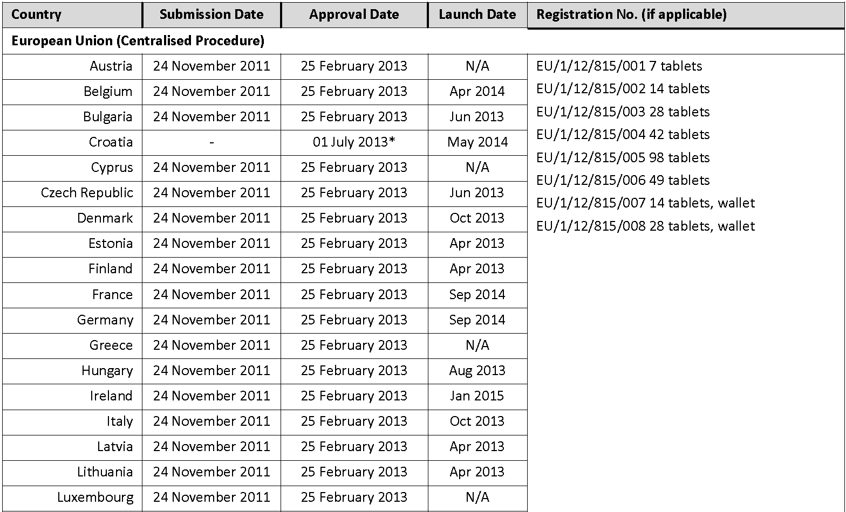
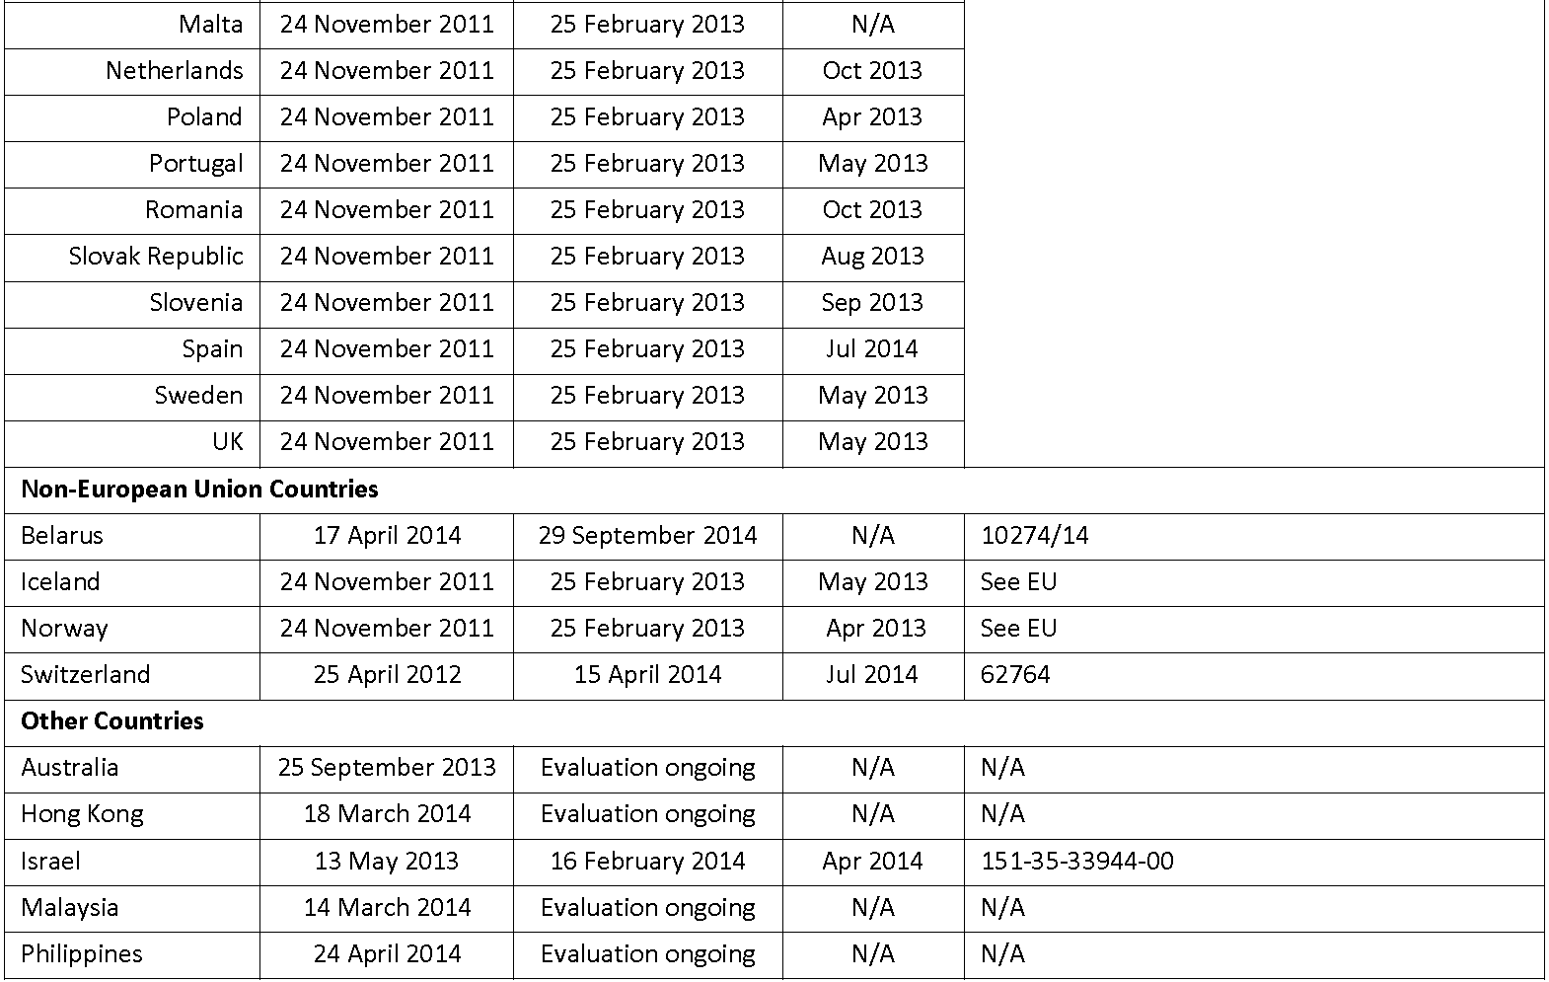
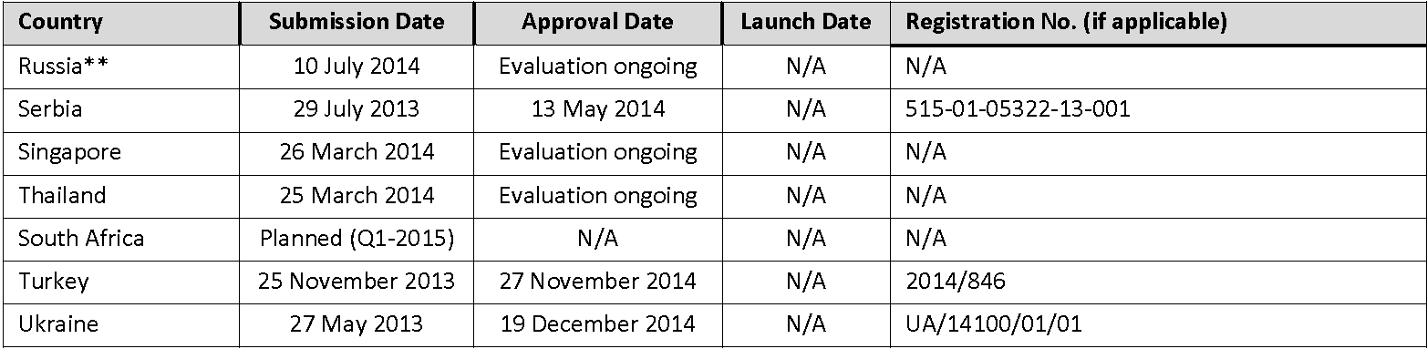
* Approval date = date of Croatia joining the EU
** Marketing Authorisation Application resubmitted to align Russian label with EU approved label

Product Information
The approved Product Information (PI) current at the time this AusPAR was prepared can be found as Attachment 1. For the most recent PI, please refer to the TGA website at <www.tga.gov.au/product-information-pi>.

II. Quality findings

Drug substance (active ingredient)
Nalmefene [designated Lu AA36143 (free base) and Lu AA36143-HCl.2H₂O (nalmefene hydrochloride dihydrate) by the company; structure of anhydrous substance reproduced below) has 4 chiral centres (C-5, C-9, C-13, C-14), for which the absolute configuration is 5S, 9R, 13S, 14S (Figure 1). The drug substance is manufactured by chemical synthesis from noroxymorphone, which in turn is derived from the naturally occurring opioid oripavine.
Figure 1: Chemical structure of nalmefene hydrochloride (left) and nalmefene (right).
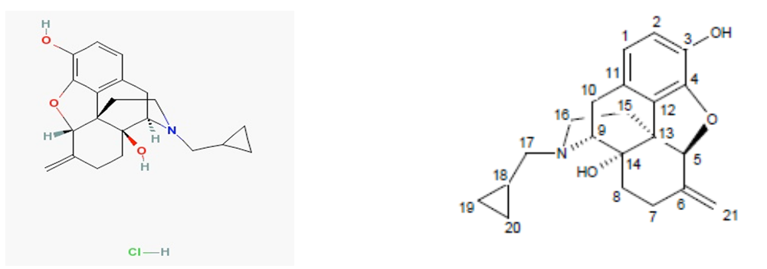
Only a single polymorph is described in the dossier and the literature.
The Biopharmaceutics Classification System (BCS) Class was not stated; however, the high aqueous solubility coupled with high permeability suggests it may be a Class I substance. The absolute oral bioavailability is 41%.
The dossier states that the pKa = 9.9 ± 0.3 (phenolic group) and 9.2 ± 0.1 (3° amine); however, the literature reports values of 7.6 and of 9.38 and 7.68 (predicted). The LogD7.4 and LogP were determined to be 1.3 and 3.1, respectively, in octanol/water.
The aqueous solubility of the free base at 5°C, 23.5°C and 40°C is 72 mg/mL, 109 mg/mL and 199 mg/mL, respectively (corresponding to 87 mg/mL, 132 mg/mL and 241 mg/mL of the hydrochloride dihydrate). The solubility varies in different pH buffer systems.
Because of the high aqueous solubility and dissolution rate of the drug substance, the dossier states that the particle size distribution is only monitored “for tablet manufacturing reasons and in order to achieve tablets with acceptable content uniformity”. The absence of a limit for D10% was accepted for this reason.
Three impurities are controlled in the drug substance; each is limited to ≤ 0.15% (the ICH qualification limit) in the Active Pharmaceutical Ingredient (API) specification.

Drug product
The drug product is an oval, biconvex, white, immediate release film coated tablet engraved "S" on one side and containing nalmefene (as nalmefene hydrochloride dihydrate) 18 mg. The dossier indicates that the tablets were originally developed as nalmefene hydrochloride 20 mg tablets (containing nalmefene hydrochloride dihydrate 21.917 mg), equivalent to nalmefene base 18.060 mg, but that Lundbeck was instructed by the European Medicines Agency (EMA) during evaluation of the European submission to express the active ingredient labelling as “nalmefene 18 mg” and not nalmefene hydrochloride 20 mg. In this respect, Lundbeck Australia has harmonised its approach with that taken in the EU.
The tablets are approved in PVC/PVdC/aluminium blisters in pack sizes of 7, 14, 28, 42, and 98 tablets. Not all pack sizes will be marketed.
The stability data support a shelf life of 36 months stored below 30°C to the tablets packaged in the PVC/ PVDC aluminium blisters proposed for Australia.
The expiry limit proposed for both of the specified degradants (≤ 0.3%) in the finished products is tighter than the ICH guideline qualification limit (0.5%), based on a maximum recommended daily dose of 18 mg. The release limit for naltrexone (≤ 0.2%) has been accepted based on regression analysis of the stability data, assuming the worst case scenario.

Biopharmaceutics
Five bioavailability/bioequivalence studies were included in the submission: Studies R7 (21,266-R7), JF-1-121, IX 313-003, CPH-101-1302 and 13505a. Details of each are presented below.

Absolute bioavailability Study R7 (21,266-R7)
This was a Phase I, single blind, placebo controlled, rising dose tolerance and oral bioavailability study in which 2 groups of 4 healthy male subjects aged between 19 and 39 years received placebo or intravenous (IV) doses of nalmefene of 0.5 mg to 2.0 mg, and oral doses of 2 to 64 mg. The purpose of the Study was to determine a safe range of doses of nalmefene by oral and IV routes of administration, and to measure post dose blood concentrations of the drug for both routes.

Relative bioavailability Study JF-1-121
This study, which determined the relative bioavailability of nalmefene when administered orally as 5 immediate release (early formulation) tablets each containing nalmefene hydrochloride (HCl) 10 mg, in comparison with a solution of nalmefene HCl equivalent to 50 mg of nalmefene free base, suggested that the 2 treatments were bioequivalent with respect to Cmax (estimate: 1.01) and AUC_{0-∞} (estimate: 0.99), but that the Tmax from the tablets (2.25 h) was longer than from the solution (1.33 h). However, only 6 subjects were used in this study, whereas statistical analysis indicated that the power of the study (α= 0.05, β = 0 .2) was such that in excess of 30 subjects would have been required to detect a 20% difference in Cmax and Tmax as significant. Nonetheless, although this resulted in a lack of sufficient power for Cmax due to a considerably higher value for this parameter being observed in one subject, 100% of the subjects exhibited an AUC_{0-∞} for the tablet which was within 75-125% of the AUC_{0-∞} for the solution.

Relative bioavailability/food Study IX 313-003
This study investigated the relative bioavailability of nalmefene when administered orally as an oral solution containing 60 mg of nalmefene (fasted conditions), with 6 x 10 mg early formulation tablets (fasted conditions) and 3 x 20 mg reformulated tablets administered either under fasted conditions or 30 minutes after a standard breakfast. Because of the absence of a study protocol, details of the associated method of analysis and of its validation, individual subject concentration versus time data and pharmacokinetic parameters and details of the pharmacokinetic analysis, as well as other significant faults, the sponsor was advised that the Study results were regarded as being unreliable for regulatory purposes.

Relative bioavailability/food Study CPH-101-1302
This study evaluated the effect of food (high fat meal) on the absorption and relative bioavailability of nalmefene after administration a single oral dose of an earlier variant of the nalmefene HCl 20 mg tablets. This differs from the proposed tablet in respect of overall description and content of film coat. The outcomes for nalmefene and for the nornalmefene, nalmefene glucuronide and glucuronidated nornalmefene metabolites are summarised below in Tables 2-5.
Table 2: Derived noncompartmental parameters for nalmefene.
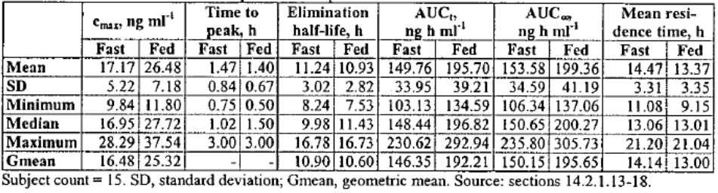
Table 3: Derived noncompartmental parameters for nornalmefene.
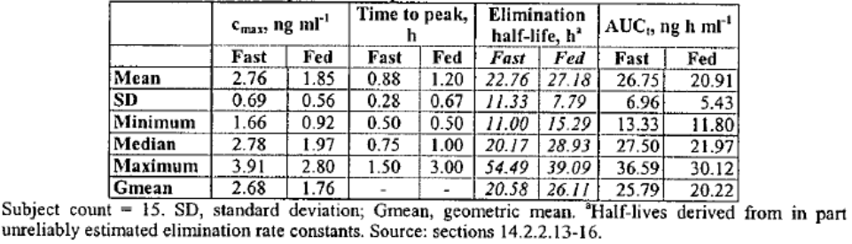
Table 4: Derived noncompartmental parameters for glucuronidated nalmefene.
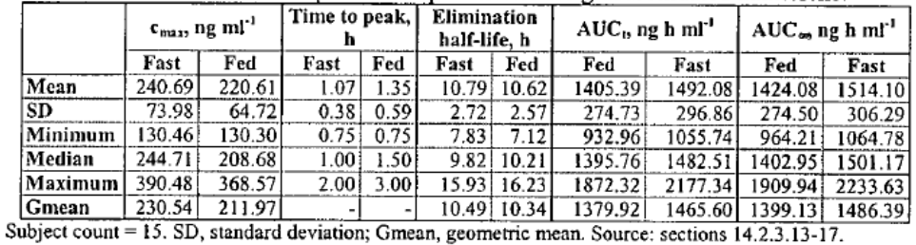
Table 5: Derived noncompartmental parameters for glucuronidated nornalmefene.
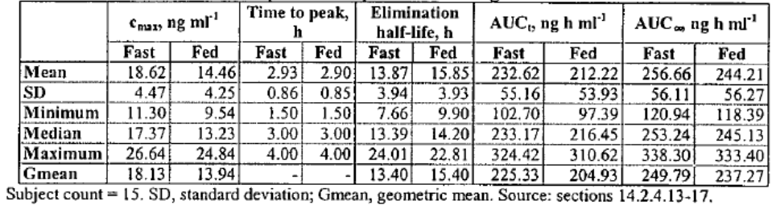
In respect of nalmefene, the dossier concluded that:
The relative bioavailability of nalmefene was larger when CPH-101 was taken after a high fat meal than when taken on an empty stomach. The AUC∞ was increased by 31%, the AUC_{t} by 32% and the peak concentration by 53%, all being statistically significant. The meal did not affect the time to peak concentration or the elimination rate. The inter individual differences were, however, larger than the effect of the standard meal. Therefore, the increased bioavailability of nalmefene upon meal is unlikely to be of clinical significance and the drug may be taken without regards to meal in clinical settings.
In respect of nornalmefene, the dossier concluded that:
The nornalmefene levels were low after a single 20 mg dose of CPH-101. The high fat meal statistically significantly reduced the peak concentration by 35% and the AUC_{t} by 22% when compared with the fasting state. Due to the low biological activity and the low levels of normalmefene this effect is not of clinical significance.
In respect of nalmefene glucuronide, the dossier concluded that:
The levels of glucuronidated nalmefene (NMF) were an order of magnitude higher than those of unconjugated NMF. None of the estimated pharmacokinetic parameters of glucuronidated NMF was influenced by the high fat meal.
In respect of glucuronidated nornalmefene, the dossier concluded that:
The concentrations of glucuronidated nornalmefene were close to those of unconjugated NMF. The high fat meal reduced the peak concentration statistically significantly but it did not affect the AUC_{t} or AUC∞ to any clinically significant degree.

Single/multiple doses bioequivalence Study 13505a
The primary objectives of this study was the evaluation of the pharmacokinetics of single and multiple oral doses of nalmefene in healthy young Japanese men and women, and of multiple doses in comparison with data from matching Caucasian subjects. Secondary pharmacokinetic objectives were:
- to assess the pharmacokinetics of the metabolites nalmefene 3-O-glucuronide, nornalmefene, and nornalmefene 3-O-glucuronide, in healthy young Japanese men and women, and of multiple doses in comparison with data from matching Caucasian subjects, and
- to evaluate the effect of food on the pharmacokinetics of nalmefene at a single dose of 20 mg nalmefene in healthy young Japanese men.
The company’s conclusions are as follows:
- The plasma concentration versus time profile for nalmefene in Japanese men and women was characterised by a rapid absorption phase. After reaching Cmax, plasma concentrations generally declined in a biphasic manner, with a t_{1/2} of ~11-12 h.
- After administration of multiple doses of nalmefene to Japanese and Caucasian subjects, the t_{1/2}, tmax and accumulation index across dose groups and sex were similar on Day 5. The mean t_{1/2} ranged from 11 to 15 h, the median tmax from 0.5 to 1 h, and accumulation index from 1.20 to 1.46. The mean CL/F ranged from 87.4 to 177 L/h. When adjusted for body weight, there was no statistically significant relationship between CL/F and ethnicity. A trend where exposure parameters depend on body weight was established after the statistical analysis. No consistent trends or statistical differences in the pharmacokinetics of nalmefene between Japanese and Caucasian subjects were apparent in this evaluation. Taking the wide safety margin of nalmefene into consideration, the moderate differences in the pharmacokinetics of nalmefene due to body weight are not considered clinically relevant.
- Nalmefene 3-O-glucuronide was the major metabolite of nalmefene, the AUC_{0-24h} between 8 and 17 fold that for nalmefene. AUC_{0-24h} and Cmax were similar in Japanese men and women, and Caucasian men and women, respectively. There were generally no significant differences in exposure to nornalmefene or nornalmefene 3-O-glucuronide, with the exception of nornalmefene exposure in women following 40 mg/day nalmefene, where AUC_{0-24h} and Cmax were up to 3 fold higher in Japanese women than Caucasian women. However, due to the low concentrations of nornalmefene, these data should be interpreted with caution.
- There were no statistically significant differences in nalmefene exposure based on weight adjusted AUC_{0-24h}, CL/F, or t_{1/2} after administration of multiple doses of nalmefene between Japanese men and women or Caucasian men and women, respectively.

Quality summary and conclusions
There are no objections in respect of Chemistry, Manufacturing, Controls and Biopharmaceutics to registration.

III. Nonclinical findings

Introduction
The range of studies submitted was adequate, and relevant studies were Good Laboratory Practice (GLP) compliant. A notable feature of the submission which detracted from its overall quality was that a large number of the studies, including many of the pivotal studies, dated back to around the 1980s. The quality of reporting was often poorer than what is expected today, and in some instances the study designs reflected the era, with toxicokinetic data, in particular, being limited. However, several more recent studies were conducted to rectify some of the deficiencies from the earlier studies. These issues are discussed in further detail under the relevant sections below. In many of the study reports, the exact nature of the test compound (base, hydrochloride salt or hydrochloride dihydrate) and how the dose/concentration was expressed was not clear. The molecular weight (MW) difference between the base and hydrochloride salt is ~11% and between the base and the hydrochloride dihydrate is ~21%. Where available, the missing information was provided in the Section 31 response; the remaining gaps in the data were considered to have little/no impact on study interpretation/conclusions.

Pharmacology

Primary pharmacology
Table 6 shows binding affinity for nalmefene and its metabolites at the µ, δ and κ opioid receptors.
Table 6a: Binding affinity: Ki values (nM) for nalmefene and its metabolites at the µ, δ and κ opioid receptors.
Study (receptor source) | 054-884-2011 (cloned receptors, human unless noted) | 12 (guinea pig brain)
Compound | Nalmefene | Nalmefene | Nalmefene glucuronide | Nornalmefene
µ receptor | 0.2  1.3 | 0.73 | 810 | 18.7
δ receptor | 16  53 | 9.3 | 5,064 | 279
κ receptor | 0.31 (rat receptor)  1.1  0.64 | 4.7 | ~10,000 | 917
Table 6b: Binding affinity: Ki values (nM) for nalmefene and its metabolites at the µ, δ and κ opioid receptors.
Study (receptor source) | 056-884-2011 (cloned receptors, human unless noted) | 053-884-2011 (cloned receptors, human unless noted)
Compound | Nalmefene-3-O-sulfate | Nornalmefene-3-O-sulfate
µ receptor | 1.3  0.74 | 350  370
δ receptor | 104  40 | 23% inhibition at 30 µM  27% inhibition at 30 µM
κ receptor | 1.2 (rat receptor)  2.5  1.8 (rat receptor) | 3,900 (rat receptor)  ~30,000  5,100 (rat receptor)
From the above tables, it can be seen that nalmefene has high affinity for human µ and κ opioid receptors, and slightly lower affinity for δ opioid receptors. The inhibition constant (Ki) values for nalmefene at all these receptors are well below plasma Cmax values achieved with the recommended dose (28.5 ng/mL (Study CPH-101-0902) corresponding to 84 nM), and even further below expected brain concentrations given a brain:plasma ratio about 17 (Study 929-300-2011-040).
Functionally, in vitro, nalmefene was a moderately potent antagonist at the human δ opioid receptor (Ki 2.6-13 nM) (Ki values at mouse/rat δ opioid receptors were similar: 2.6-6.7 nM). No significant agonist activity was observed at the human or mouse/rat δ opioid receptor (concentrations tested were up to 10 µM).
Nalmefene was a potent partial agonist at the human κ receptor (half maximal effective concentration [EC50] 0.52 nM) with relatively high intrinsic activity (IA) (52-76%), and similarly at the rat κ receptor (EC50 0.21-0.4 nM, IA 79-80%). The level of antagonist activity at the κ receptor was consistent with nalmefene acting as a partial agonist at this receptor.
Results for functional activity of nalmefene at cloned human µ opioid receptors varied depending on the test system used. In 3 studies, nalmefene showed potent antagonist activity (Ki 0.18-0.75 nM), with little or no agonist activity (no significant stimulation at concentrations up to 10 µM in 2 studies, and 19% stimulation at 30 µM in the third study). Consistent with these results, nalmefene did not show opioid agonist activity (no effect on twitch response) in electrically stimulated isolated guinea pig ileum in either of 2 studies at concentrations up to 10 µM, but increased the EC50 values for morphine inhibition of twitch response. However, in a fourth study using cloned human µ opioid receptors and a cAMP-HTRF assay, nalmefene acted as a partial agonist with an EC50 of 0.64 nM and 41% IA, but also displayed substantial antagonist activity (Ki 1.0 nM, MaxI=77%).
In in vivo studies in mice, nalmefene did not show any opioid receptor agonist activity in the tail flick or writhing tests at subcutaneous (SC) doses up to 30 mg/kg and 10 mg/kg, respectively. However, in in vivo studies in mice and rats, nalmefene consistently demonstrated antagonist activity. Thus, it reversed the antinociceptive effect of fentanyl, morphine (2 studies), methadone, codeine, butorphanol, propoxyphene, nalbuphine and buprenorphine (tail flick in rats) and the effect of morphine (tail flick in mice). It also increased tail skin temperature in morphine dependent rats. The AD50 value for the reversal of the antinociceptive effect of fentanyl in the rat tail flick test was 1.2 µg/kg IV while the AD50 values for the reversal of the antinociceptive effect of morphine were 8 µg/kg IV and 0.4 mg/kg per os (PO) (rat tail flick test) and 4 µg/kg SC and 0.2 mg/kg PO (mouse tail flick test). The half maximal effective dose (ED50) for the tail skin temperature response was 3.5 µg/kg SC.
In a number of studies, the potency and/or duration of action of nalmefene and naloxone were compared. In the majority of studies, nalmefene showed higher potency than naloxone; thus, it was 12.5 times more potent in its effect on the morphine concentration-response curve for twitch response in guinea pig ileal segments (Study 11) and was more potent in blocking the activities of butorphanol, nalbuphine and methadone in the same assay system; it was 5 times more potent in reversing the antinociceptive effect of fentanyl in one IV experiment using the rat tail flick test but equipotent in a different experiment in the same assay system (Study 1); it was 30 times more potent in eliciting increases in tail skin temperature when given SC in morphine dependent rats (and 2.5 times more potent than naltrexone in the same test system) (Study 3); it was 7.5 times more potent (SC route in mice), twice as potent (IV route in rats) and >12.5 times more potent (oral route in rats) in antagonising the effect of morphine in tail flick tests (Study 2). Duration of action of nalmefene was longer than that of naloxone when tested for fentanyl antagonism (3.6 fold) and morphine antagonism (2.8 fold) in the rat tail flick test (Study 1).
Four studies investigated the effect of nalmefene on consumption of alcohol (a 10% ethanol solution) in rats, with 2 studies conducted in Wistar rats and 2 studies in AA rats developed by selective outbreeding for high levels of voluntary ethanol drinking. In 3 studies, access to the ethanol solution was limited to 1 h/day, with nalmefene (0.18 or 0.36 mg/kg/day SC) administered 20 min prior to alcohol access. Nalmefene reduced alcohol consumption over the treatment period in all these studies. The magnitude of inhibition was substantial, with a 73% mean reduction over 4 days in AA rats given 0.36 mg/kg/day SC, a 67% reduction over 26 days in Wistar rats given 0.36 mg/kg/day SC, a 79% reduction in the same study over two 5 day periods separated by 9 days, and a 75% reduction over 4 days in Wistar rats given 0.18 mg/kg/day SC. In the latter study, prior treatment with nalmefene prevented an increase in alcohol consumption (seen in controls) after a 6 day period of alcohol deprivation and non treatment. In a fourth study, AA rats with continuous access to alcohol were treated for 4 days with nalmefene in the diet at 16.1 mg/kg/day. Again, nalmefene reduced alcohol consumption over the treatment period, although the magnitude of the inhibition was less than that seen in the other studies (23% mean inhibition).
Receptor occupancy (µ, δ and κ opioid receptors) was investigated in rat brain at doses over the range 0.01-1 mg/kg SC, although the strain of rats used in the receptor occupancy studies was different to those used in the alcohol consumption studies. Over the range 0.1-1 mg/kg SC which covered the doses used in the studies on limited access alcohol consumption, occupancies of central opioid receptors at 1 h post dose were substantial (43-99%, 68-84% and 64-93% for µ, δ and κ opioid receptors, respectively); this time point is slightly later than the time point (20 min post dose) for testing alcohol consumption in the animal studies. The recommended clinical dose of nalmefene (20 mg PO) also induces high µ opioid receptor occupancy in humans (94-100% within 3 h of dosing; Study CPH-101-0902).
The time course of binding to the µ opioid receptor was investigated in rat brain following SC dosing over the same dose range, with corresponding determination of plasma and brain nalmefene concentrations. When concentrations were sufficient to determine a brain: plasma ratio, it was about 17. At 6 h post dose, receptor occupancy had fallen to about 20% of the 1 h values (at the two higher doses), whereas plasma concentrations were undetectable and brain concentrations were only detectable at the 1 mg/kg dose. In humans, the slower decline in µ receptor occupancy relative to the decline in plasma concentrations was more marked than in rats, suggesting a particularly slow dissociation of nalmefene from the µ receptors in humans.
The binding affinities and functional activities of some of nalmefene’s main circulating metabolites were investigated (Table 6). Nalmefene glucuronide, the major circulating metabolite in dogs and humans, and a major circulating metabolite in rats, showed little affinity for any of the 3 (µ, δ or κ) opioid receptors. Functionally, in isolated guinea pig ileal segments, it showed no agonist activity (change in twitch height) at concentrations up to 30 µM, or antagonist activity (shift in the morphine concentration response curve for inhibition of twitch height) at concentrations up to 100 nM. Nornalmefene glucuronide was also a major circulating metabolite in rats, but a minor circulating metabolite in dogs and humans; its binding affinity was not determined. Nornalmefene was a major circulating metabolite in rats, but a relatively minor circulating metabolite in humans and was not detected in dog plasma or urine (although it was present at low levels in dog faeces). Nornalmefene showed moderate affinity for the µ opioid receptor (Ki 18.7 nM) but low affinity for the δ and κ opioid receptors. A test of the functional activity of nornalmefene (which is structurally similar to the opioid analgesic, oxymorphone) using isolated guinea pig ileal segments suggested that it possessed some agonist activity as it concentration dependently inhibited twitch height with an EC50 of 739 nM. When administered intrathecally in rats, it displayed antinociceptive activity in both the tail flick and hot plate tests at doses ≥0.1 µg. However, at IV doses up to 3.51 mg/kg, it showed little (tail flick test) or no (hot plate test) antinociceptive activity. Thus, it would appear that it only poorly penetrates the central nervous system (CNS) and is unlikely to produce agonist effects at clinically relevant concentrations (Cmax 3.5 ng/mL). Nalmefene-3-O-sulfate showed a similar affinity for the µ and κ opioid receptors as nalmefene, but was a relatively minor metabolite in rats, dogs and humans. While nornalmefene-3-O-sulfate reached comparable circulating levels to those of nalmefene in humans, this metabolite had low affinity for all the 3 opioid receptors. This metabolite was not detected in dog plasma and was a relatively minor metabolite in rat plasma. Overall, in humans, nalmefene metabolites are unlikely to make a quantitatively important contribution to pharmacological activity. In rats, nornalmefene may have contributed to pharmacological activity at the µ receptor.

Secondary pharmacodynamics and safety pharmacology
Secondary pharmacodynamic studies revealed the specificity of nalmefene for the µ, δ and κ opioid receptors. Nalmefene showed little or no affinity for other receptors. Thus, when tested at a concentration of 10 µM (>100 fold the expected clinical concentration), it showed no significant (>50%) inhibition of binding of relevant radioligands to well over 100 targets including receptors, ion channels, transporters and enzymes; at a relatively small number of targets (7), weak to moderate (25-50%) inhibition of binding of radioligand was observed.
Specialised safety pharmacology studies covered the core systems (CNS, cardiovascular and respiratory). Critical studies were GLP compliant.
CNS effects were investigated in an Irwin test (GLP compliant). In this test, as well as in the toxicity studies, CNS effects were observed and these are discussed in further detail under ‘Toxicology’ (below).
Cardiovascular studies included two in vitro studies (effects on action potential parameters in isolated rabbit Purkinje fibres and on hERG currents using HEK-293 cells transfected with the hERG-1 potassium channel (both GLP compliant)) and two in vivo studies in conscious dogs. In rabbit Purkinje fibres, nalmefene at 2 µg/mL (but not at 200 ng/mL) elicited a significant prolongation of APD90 (31%) and a non-significant prolongation of APD50 (28%), but only at a PCL of 4000 ms (a bradycardic non-physiological stimulation frequency) and not at a PCL of 1000 ms. A concentration of 2 µg/mL is 70-fold the expected clinical Cmax of 28.5 ng/mL and therefore these prolongations of APD90 and APD50 are not considered clinically relevant. Other effects in Purkinje fibres were small in magnitude and/or observed at high nalmefene concentrations and unlikely to be of biological significance. Nalmefene inhibited hERG-1 tail currents in a concentration-dependent manner, with an 11.7% inhibition (significant) at the lowest concentration tested (200 ng/mL). Although a No Observed Effect Level (NOEL) was not determined, the lowest concentration tested, which is 7-fold the expected clinical Cmax, elicited a relatively small inhibition of hERG tail current and therefore this in vitro study does not predict nalmefene induced QT prolongation. The plasma protein binding of nalmefene would also increase the safety margin for this effect under in vivo conditions.
Of the in vivo cardiovascular studies, the earlier study (IV route) was undated and non GLP compliant while the second study (oral route) was dated 2005 and was GLP compliant. The oral route was an appropriate choice because the data from Study DAQL1000 (in telemetered dogs) suggested that higher plasma concentrations (in the absence of CNS clinical signs) could be achieved following oral dosing than following IV administration. Heart rate, blood pressure parameters and electrocardiogram (ECG) parameters were measured in both studies (left ventricular dP/dt was only measured in the earlier study). There were no effects on any parameters in either study, with the exception of a significant prolongation of QRS duration at 6 h post dose in the 25 and 50 mg/kg PO groups in the 2005 study (48.3 and 50.7 ms, respectively cf 43.3 ms in the control group). However, these values are within the normal ranges published by Osborne and Leach (1971) and there were no significant changes at earlier time points (0.5-4 h post dose). At 6 h post dose in the 25 and 50 mg/kg PO groups, plasma nalmefene concentrations were 2.7 and 31.8 ng/mL, respectively. While the higher value is comparable to the expected clinical Cmax of about 28.5 ng/mL, concentrations achieved at earlier time points, including the Tmax (~1 h from pharmacokinetic and toxicokinetic data), would be expected to have exceeded the clinical Cmax, suggesting that doses were adequate.
Effects of nalmefene on respiration were investigated in a GLP study in rats given doses up to 150 mg/kg PO. Respiration rate and tidal volume were the only parameters assessed, but neither was significantly affected by treatment with nalmefene. Pharmacokinetic data for an oral dose of 150 mg/kg in rats indicated a Cmax of 1446 ng/mL (~50 fold the expected clinical Cmax).

Pharmacodynamic drug interactions
One pharmacodynamic drug interaction study was conducted in which nalmefene and flumazenil (a benzodiazepine receptor antagonist) were administered alone and simultaneously by the IV route in a rat model for convulsions. Nalmefene and flumazenil both dose dependently induced clonic seizures, with ED50 values of 7.45 and 167.8 mg/kg IV, respectively. When administered simultaneously, there was a less than additive effect for induction of convulsions. Although the data relate to this specific interaction, it is reassuring that this interaction was sub additive rather that additive or synergistic.

Pharmacokinetics

Absorption
Nalmefene was rapidly absorbed after oral administration in rats, dogs and humans, as indicated by low Tmax values (e.g. 0.25 h in rats, about 1 h in dogs and about 0.75-1.5 h in humans). This is consistent with high transport across cell membranes (Papp values of 31.9-40.9 cm.10⁻⁶/sec in MDCKII cells, higher than those for the high permeability positive control, caffeine).
Bioavailability was not estimated in rats, but was estimated at 10.1% in dogs. Absorption, estimated by comparing AUC for radioactivity after oral and IV administration, was 88% in rats and 85% in dogs. Calculation of absorption from the sum of radioactivity excreted in urine and bile (plus cage wash) also gave high values for rats (94-96%). Thus, there was a large difference between absorption and bioavailability of nalmefene in dogs, which is likely a reflection of a large first pass metabolism. Oral bioavailability was higher in humans (41%, or 53% in the presence of food).
Clearance was not estimated in rats, but was rapid in dogs (4.0 L/h/kg) and in humans (169 L/h, or ~2.4 L/h/kg; Study 14019A). Terminal half life was short in the laboratory animal species (0.83-2.6 h in rats, 1.14-2.5 h in dogs) but longer in humans (~14 h).
Overall, in mice, rats, dogs and humans, it appeared that plasma concentrations of nalmefene increased in a dose proportional manner over the dose ranges studied, although pharmacokinetic and toxicokinetic data often showed high variability. However, there was evidence of supraproportionality in the rat following gavage doses; thus, in the single dose pharmacokinetic study BTT31-PD097, supraproportionality (Cmax and AUC) was observed over the dose range 50-150 mg/kg PO, and in the rat fertility study (LBK0279) over the dose range 2-200 mg/kg/day PO (plasma concentrations at 0.25 h, approximately Cmax).
There was no consistent evidence in any of the species (mice, rats, dogs or humans) of a sex difference in nalmefene exposure, and consistent with this, no major sex differences in metabolism were observed (data for rats and dogs), except for an apparently greater first pass metabolism in male rats compared to female rats .
Some accumulation was observed with repeated dosing in mice (2.5 fold in Study 2202/0004 over 4 weeks and ~15 fold in Study 2202/001 over 5 weeks), but there was no evidence of accumulation in dogs (Study 12372). There was insufficient data to assess accumulation in rats, but the available toxicokinetic data for the 13 week study did not suggest accumulation of nalmefene, although there was evidence for substantial accumulation of conjugated metabolites. In humans, following repeated once daily dosing with nalmefene, there was little accumulation (accumulation index 1.30 for nalmefene).

Distribution
Plasma/serum protein binding of nalmefene in vitro was quite low in rats, dogs and humans and was independent of concentration over the tested range 10-2000 ng/mL (rats and dogs) and 10-100 ng/mL (humans). Percent bound averaged 33% and 42%, respectively, in rat and dog serum and 30% in human plasma. Plasma protein binding was also investigated in in vivo studies in dogs, rats and humans, with the data reflecting the protein binding of nalmefene and its metabolites. Plasma protein binding in the rat and dog studies was generally lower than for parent drug in vitro (9.8-35% in rats, 0-26% in dogs), whereas it was higher in the human study (55-69%), and why this is the case is not clear.
Blood:plasma ratios of radioactivity after in vitro incubation of blood spiked with ¹⁴C nalmefene were 1.26 (rats) and 1.33 (dogs), suggesting a slightly greater distribution of radioactivity to red blood cells than plasma. Plasma:blood ratios of radioactivity were also determined in vivo at various time points post dose in rats and dogs after oral doses of ¹⁴C nalmefene and will reflect the plasma:red cell distribution of nalmefene and it metabolites. Ratios were generally <1 in dogs, and in rats up to 24 h but >1 in rats at later time points.
Studies investigating tissue distribution of radioactivity following the administration of ¹⁴C nalmefene to rats revealed rapid and wide distribution of radioactivity following both oral and IV administration. This is consistent with the high Papp for nalmefene. It is also consistent with the high volume of distribution estimated in dogs (5.9 L/kg) and humans (about 46 L/kg) (there were no estimates of volume of distribution in rats). After oral administration, results were similar for male and female rats. In pregnant rats (gestational day 15 [GD15]) given ¹⁴C nalmefene IV, radioactivity was detected in foetuses and placenta, indicating placental transfer. The concentration of radioactivity in foetuses was similar to that in maternal blood at the Tmax but radioactivity in foetuses declined more rapidly than radioactivity in maternal blood.
There was no evidence of retention of radioactivity in any tissue/organ. While results for pigmented Lister-Hooded rats were broadly similar to those for albino Sprague Dawley rats, there was evidence of binding of nalmefene/metabolites to melanin, in particular in the uveal tract, for which the tissue:blood Cmax ratio was 80.4 in the former and 1.31 in the latter strain. However, binding of drugs to eye melanin does not predict ocular toxicity and no ocular toxicity was observed in the package of toxicity studies for nalmefene. Tissue:blood radioactivity Cmax ratios were relatively low in brain, the target organ for drug activity. Since brain:plasma concentrations of nalmefene were found to be high in Study 929-300-2011-040, the low brain:blood Cmax ratio for radioactivity is likely to be a reflection of the poor ability of the major metabolites to cross the blood-brain barrier. Tissue:blood ratio at Cmax was 0.66 in testes, indicative of some distribution of radioactivity into the this tissue; values for ovaries were variable (a relatively low 0.67 in Study 12535, but 3.7 in Study HRC/ANQ 60/930755).

Metabolism
Data were provided on metabolites in plasma, urine and faeces in rats and dogs, and additionally, in bile in rats. These data revealed extensive metabolism of nalmefene by both Phase I pathways (dealkylation and hydroxylation) and Phase II pathways (glucuronidation and sulfation).
In rats, the major pathways of metabolism were glucuronidation of nalmefene to form nalmefene-3-O-glucuronide, and dealkylation to form nornalmefene, followed by its glucuronidation to form nornalmefene-3-O-glucuronide. Thus, nalmefene-3-O-glucuronide and nornalmefene-3-O-glucuronide were the main circulating metabolites in rats (nalmefene-3-O-glucuronide was also the main circulating metabolite in dogs and humans), followed closely by nornalmefene (also a significant metabolite, particularly in males). Nornalmefene-3-O-glucuronide and nornalmefene were quantitatively more significant metabolites in rats than in humans. Male rats tended to have lower plasma concentrations of parent drug and higher concentrations of metabolites than females, suggesting a greater first pass effect in males. Nornalmefene was mainly excreted in the faeces, nalmefene-3-O-glucuronide mainly in bile, and nornalmefene-3-O-glucuronide mainly in urine, but to some extent also in bile. Other metabolites formed in rats at low/moderate levels and found in plasma, urine and bile, generally in both genders, were nalmefene and nornalmefene-3-O-sulfates, glucuronides of hydroxynalmefene and other glucuronide(s) of nalmefene.
In dogs, the major pathway of metabolism was direct glucuronidation of nalmefene to form nalmefene-3-O-glucuronide which was mainly excreted in urine. Although nornalmefene was not detected in plasma or urine of dogs, its glucuronide conjugate was a minor metabolite in plasma and urine. Other metabolites formed in dogs at low/moderate levels and found in plasma and urine and were nalmefene-3-O-sulfate (nornalmefene-3-O-sulfate was not detected in dogs), glucuronides of hydroxynalmefene, and diglucuronides of nalmefene and hydroxynalmefene. The diglucuronides of nalmefene and hydroxynalmefene were dog specific metabolites, being found in neither rats nor humans. Unchanged nalmefene was a circulating entity in both rats and dogs, as well as humans, but in all species was present at lower concentrations than the major circulating metabolite(s). In dogs, unlike in rats and humans, a substantial proportion of radioactivity was excreted in faeces as unchanged drug. In dogs, nalmefene-3-O-glucuronide was largely excreted in urine, unlike in bile duct cannulated rats in which it was mainly excreted in bile.
The metabolic pathways in humans were the same as those in rats and all metabolites formed in humans were also formed in rats. Most of the metabolites formed in humans were also formed in dogs, but an exception was nornalmefene-3-O-sulfate. In humans, as in dogs, nalmefene-3-O-glucuronide was mainly excreted in urine, whereas in bile duct cannulated rats it was mainly excreted in bile.
Using 3 methods (recombinant human CYP isozymes, CYP inhibitors and correlation analysis with phenotyped human liver microsomes), CYP3A4/A5 was identified as the major CYP isozyme responsible for the metabolism of nalmefene to nornalmefene. Other CYP isozymes that might also be involved to a much lesser extent were CYP2C19, 2B6, 2C8, 2A6 and 2C9 (identified by either one or both of the former 2 methods).
Using recombinant human UDP glucuronosyltransferase (UGT) enzymes, UGT1A3, 1A8, 2B7 and 1A9 were identified as the main potential UGT isozymes responsible for the metabolism of nalmefene to nalmefene-3-O-glucuronide. The relative contribution of these enzymes cannot be determined as the enzyme activity per mg protein in their respective microsomes varied. Correlation analysis identified UGT2B7, followed by UGT1A4, as the major UGT isozymes responsible for the metabolism of nalmefene to nalmefene-3-O-glucuronide (UGT1A3 and UGT1A8 was not evaluated in this study). The correlation with UGT1A4 may have been an artifact since nalmefene-3-O-glucuronide was not formed in incubations with recombinant human UGT1A4. UGT1A3 was not evaluated in the correlation study as there is no specific marker substrate known for it, and UGT1A8 was not evaluated since it is not present in the liver. Determination of Michaelis-Menton kinetic constants for the formation of nalmefene-3-O-glucuronide using recombinant UGT enzymes revealed particularly high Km values for UGT1A3. Overall, the data suggest that UGT2B7 is the main UGT enzyme responsible for the formation of nalmefene-3-O-glucuronide from nalmefene, with UGT1A3 possibly also contributing; UGT1A8 in extrahepatic tissues may also contribute.

Excretion
In intact rats, after oral administration of ¹⁴C nalmefene, a slightly higher proportion of radioactivity was excreted in faeces than in urine (Studies ADME-110 and 12536). In bile duct cannulated rats (Study 12536), only a small proportion (~3-4%) of radioactivity was excreted in faeces following oral administration, with the proportion excreted in bile being over twice that excreted in urine. These data suggest that biliary excretion is important, at least in rats, and are consistent with the substantial faecal excretion observed following IV administration in rats (Studies ADME-110 and DD93-053-007). Some faecal excretion (17-18%) was also observed in humans after IV administration of nalmefene, indicative of some biliary excretion in humans. The higher urinary excretion in intact compared to bile duct cannulated rats (Study 12536) suggests the possibility of some hepato-biliary recirculation. After IV administration of ¹⁴C nalmefene, the proportion of radioactivity in urine was slightly higher than in faeces. After oral administration of ¹⁴C nalmefene in dogs, the proportions of radioactivity excreted in urine and faeces were similar, with the data from Study 12537 indicating slightly higher excretion in faeces than urine and the reverse being true for the more limited data from Study ADME-110. Recovery in mass balance studies was high (around 100%), suggesting no retention of radioactivity in the body, which is consistent with the results from tissue distribution studies. In humans, the proportion of radioactivity excreted in urine (71% compared with 20% in faeces) was higher than in the laboratory animal species.

Conclusion
The pharmacokinetic profile of nalmefene in the rat, the rodent species used in the pivotal repeat dose toxicity studies, was similar to that in humans, allowing the rat to serve as an appropriate model for the assessment of drug toxicity in humans. Rats were exposed to a wide range of metabolites covering all metabolites observed in humans. The dog, the non rodent species used in the pivotal repeat dose toxicity studies, like humans, was largely exposed to nalmefene glucuronide, but the balance of metabolism towards the production of nalmefene glucuronide was particularly marked in the dog, resulting in very low exposure ratios for nalmefene in this species (see ‘Relative Exposure’ below). This factor detracted from the usefulness of the dog as a model for humans.

Pharmacokinetic drug interactions
Nonclinical in vivo studies of drug interactions were not submitted but adequately conducted in vitro studies were submitted.
Treatment of cultured human hepatocytes with nalmefene at concentrations up to 10 µM (~120 times the Cmax at the recommended clinical dose) for 3 days had little or no effect on CYP1A2, 2A6, 2B6, 2C8 2C9, 2C19 or 3A4/5 enzyme activities or on mRNA levels of these isozymes. While there was a slight increase (2.49 fold) in CYP3A4 mRNA levels following treatment with 10 µM nalmefene, this increase was only 3.1% of the increase elicited by 10 µM rifampicin and there was no effect at 1 µM nalmefene (~12 times the Cmax at the recommended clinical dose). Thus, nalmefene at therapeutic concentrations showed little potential for induction of CYP enzymes.
Although no positive control compound was tested, in human liver microsomes in vitro, there was little evidence of direct, time dependent or metabolism dependent inhibition of the activities of CYP1A2, 2A6, 2B6, 2C8, 2C9, 2C19, 2D6, 2E1 or 3A4/5 CYP by nalmefene, nornalmefene or their glucuronides at concentrations up to 100 µM (for nalmefene, >1000 times the Cmax at the recommended clinical dose). Nalmefene directly inhibited CYP2D6 with an IC50 of 18 µM, but this was >200 times the Cmax at the recommended clinical dose. Also in human liver microsomes in vitro, there was no evidence of inhibition by nalmefene (at concentrations up to 100 µM) of the activities of UGT1A1, 1A4, 1A6, 1A9 or 2B7.
Thus, nalmefene at therapeutic concentrations is unlikely to inhibit or induce CYP enzymes, or to inhibit UGT enzymes and is therefore unlikely to affect the pharmacokinetics of drugs that are substrates of these enzymes.
In vitro experiments provided no evidence that nalmefene (tested at concentrations up to 10 µM, ~120 times the Cmax at the recommended clinical dose) is a substrate for the human efflux transporters, MDR1 (p-glycoprotein), BCRP or MRP2, or for the human uptake transporters, OATP1B1, OATP1B3 and OCT1. They also provided no evidence that nalmefene is an inhibitor of the efflux transporters, MDR1, BCRP or MRP2, when tested at concentrations up to 1000 µM, or of BSEP when tested at concentrations up to 150 µM. Nalmefene was also tested at concentrations up to 150 µM for inhibition of the uptake transporters, OATP1B1, OATP1B3, OAT1, OAT3, OCT1 and OCT2 and was found to inhibit OCT1 and OCT2 with IC50 values of 1.21 and 7.36 µM, respectively. These IC50 values are 14 and 88 times the Cmax at the recommended clinical dose. Thus, the pharmacokinetics of nalmefene are unlikely to be affected by drugs that inhibit these transporters and nalmefene is unlikely to affect the pharmacokinetics of drugs that are substrates of these transporters.
As the major metabolic pathway of nalmefene in humans is metabolism to its 3-O-glucuronide, any drug that significantly inhibits the main enzyme responsible for this conversion, UGT2B7, is likely to cause an increase in plasma nalmefene concentrations. This issue is addressed in the draft PI, with statements under both ‘Precautions’ and ‘Interactions with other medicines’. In addition to the examples mentioned in the draft Product Information of drugs that are potential inhibitors of UGT2B7 (diclofenac, fluconazole, medroxyprogesterone acetate and meclofenamic acid), others include flurbiprofen and spironolactone. It is appropriate that it was also noted in the draft PI that inducers of UGT enzymes can potential result in subtherapeutic plasma nalmefene concentrations.

Toxicology

Acute toxicity
Single dose toxicity studies were conducted in mice, rats and rabbits, with nalmefene administered by PO, IV and SC routes in each species. All main studies were preceded by a dose range finding study. These studies were conducted in the early 1980s when it was standard practice to determine lethal dose 50% (LD50) values, and maximum non lethal doses were not always established. All main studies involved a 14 day observation period and adequate animal numbers of both sexes. Oral LD50 values were in the range 270-496 mg/kg in the 3 species, indicating that nalmefene is of moderate acute toxicity by the clinical route. IV and SC LD50 values were in the range 15.0-48.5 mg/kg and 157-1150 mg/kg, respectively. Oral maximum non lethal doses across the species were in the range 150-230/<300 mg/kg.
CNS related clinical signs were observed in all studies and were broadly similar for all species and all routes. They included convulsions, tremors, prostration, decreased activity, sleeping, vocalisation, unsteady gait, loss of balance/righting reflex, arched back, salivation, laboured breathing, jumping, thrashing and leg spraddle. Generally, there were no effects of treatment on body weight gain over the observation period. There were no consistent necropsy findings except for findings at the injection site following SC administration, which included haemorrhage and oedema in all species, and eschar and alopecia in mice and rats (not relevant for the proposed clinical route).

Repeat dose toxicity
Repeat dose toxicity studies were conducted in B6.129-Trp53tm1 N5-W (wild-type) mice (2 dietary studies), rats (4 dietary studies, 1 PO (gavage) study, 2 IV studies and 1 SC study), rabbits (1 PO study) and dogs (4 PO and 2 IV studies). With the exception of the 2 week SC study in rats, all studies were GLP compliant. The major species investigated were rats and dogs, with studies of up to 52 weeks duration in both these species, which is longer than the 6 months for rodents and 9 months for non rodents specified in published guidelines, but was a common duration for studies conducted in the 1980s. Animal numbers were adequate, with 25/sex in the pivotal rat study and 5/sex in the pivotal dog study. All studies in mice, rats and dogs involved dosing of both sexes, and parameters investigated were appropriate for the type of study. Dosing frequency was daily in all studies, as is the case clinically. Doses achieved in the dietary studies were close to the target doses (±12%). The dietary route used in mice and rats might be expected to result in an exposure profile over a 24 h period that would have less marked peaks and troughs than would be observed following administration of a tablet in humans or following gavage administration (which is the most commonly used oral administration today), but there were no marked difference in exposure ratios calculated based on Cmax and on AUC (see below) in rats given dietary nalmefene.
In rats, reductions in body weight gain, particularly in males, limited the doses that could be given in the dietary studies. In the 13 week study, reductions in body weight gain at the MD (medium dose) and HD (high dose) (100 and 500 mg/kg/day) were 14% and 26%, respectively in males, and 9% and 19%, respectively in females, while corresponding values at the MD and HD (100 and 300 mg/kg/day) in the 52 week study were 16% and 25%, respectively in males, and 11% and 28%, respectively in females. CNS clinical signs, most notably convulsions, limited the doses in dogs; thus, convulsions were observed at the HD (100 mg/kg/day) in the 13 week study and at the MD and HD (16 and 64 mg/kg/day) in the 52 week study.

Relative exposure
Some toxicokinetic data were provided for the original toxicity studies in rats. Thus, data were available on plasma concentrations of nalmefene and ‘conjugated nalmefene’ (β-glucuronidase/sulfatase hydrolysable conjugate) for the 13 and 52 week dietary studies. However, there were no data for specific conjugates and the results for ‘conjugated nalmefene’ are of limited usefulness. The data for nalmefene were also of limited usefulness because many of the plasma nalmefene concentrations were below the limit of quantification of the assays used (50 ng/mL for the 13 week study and 12.5 ng/mL for the 52 week study); the time of day of sampling was also not reported and, as there was only a single sampling time, there was no indication of diurnal variation. The 4 week bridging toxicokinetic study by the dietary route at dose levels corresponding to those used in the 52 week study (0, 30, 100 and 300 mg/kg/day) (LBK0257) rectified these deficiencies, although obviously suffers from the fact that samples were not taken from the animals investigated for toxicity, which is particularly relevant for dietary studies in which there is some discrepancy between target and achieved doses (for example, achieved doses in the 52 week study were slightly below target, whereas those in the toxicokinetic study were above target). In the rat bridging study, plasma concentrations of nalmefene, nornalmefene and their corresponding glucuronides were measured.
Toxicokinetic data were provided for the 52 week PO dog study, but only for plasma concentrations of nalmefene glucuronide and not for nalmefene itself. A 4-week bridging toxicokinetic study (12372) was conducted in dogs at dose levels of 4, 8 and 16 mg/kg/day PO (with 4 and 16 mg/kg/day dose levels being the LD and MD levels used in the 52 week oral dog study; it is unclear why the doses in the bridging study were not selected to be identical to those in the 52 week study). Levels of nalmefene itself, as well as those of the major metabolite in dogs, nalmefene glucuronide, were measured in this study.
The human AUC values used for calculating exposure ratios were from Study CPH-101-0902 (day 7 AUC_{0-last} values in healthy subjects who were given the recommended clinical dose (20 mg) of nalmefene, nornalmefene, nalmefene-3-O-glucuronide, and nornalmefene-3-O-glucuronide were 174, 41.3, 1120 and 270 ng.h/mL, respectively). The rat data were from the bridging study and the dog data from the bridging study and the 52 week toxicity study. These data may have overestimated the exposure ratio for nalmefene glucuronide because, while the human data were specifically for the 3-O-glucuronide, the animal data were for all glucuronides, which include M9 (a glucuronide of nalmefene) and additionally in dogs, M12 (nalmefene-3-O-diglucuronide).
Exposure ratios achieved for nalmefene in rats were low but adequate (5 at the HD) in the 52 week rat study based on data from the 4 week bridging toxicokinetic study; the NOAEL was below the HD but toxicological findings in this study were relatively minor. In dogs, exposure ratios for nalmefene were very low (<1) based on a linear extrapolation of data for 16 mg/kg from the bridging study to the HD of 64 mg/kg/day in the 52 week study.
High exposure ratios were achieved in the rat for nornalmefene, and particularly for nalmefene and nornalmefene glucuronides (Table 7). High exposure ratios were achieved for nalmefene glucuronide in dogs based on data from both the 52 week study and the 4 week bridging toxicokinetic study. Nornalmefene was not detected in plasma in dogs, and nornalmefene glucuronide was not measured in either the 52 week study or the bridging study.
Table 7: Relative exposure in repeat dose toxicity and carcinogenicity studies calculated based on AUC.
Species | Study duration (sampling day/week); study number | Analyte | Dose  (mg/kg/day) | AUC_{0–24 h}  (ng∙h/mL) | Exposure ratio#
Rat (SD) | 4-week toxicokinetic bridging study with doses corresponding to those used in the 52-week study (day 29/30);  Study LBK0257 | Nalmefene | 30 | 56.2 | 0.3
Rat (SD) |  | Nalmefene | 100 | 253 | 1.5
Rat (SD) |  | Nalmefene | 300 | 788 | 5
Rat (SD) |  | Nornalmefene | 30 | 257 | 6
Rat (SD) |  | Nornalmefene | 100 | 692 | 17
Rat (SD) |  | Nornalmefene | 300 | 815 | 20
Rat (SD) |  | Nalmefene glucuronide | 30 | 4,260 | 4
Rat (SD) |  | Nalmefene glucuronide | 100 | 25,600 | 23
Rat (SD) |  | Nalmefene glucuronide | 300 | 113,600 | 101
Rat (SD) |  | Nornalmefene glucuronide | 30 | 9,115 | 34
Rat (SD) |  | Nornalmefene glucuronide | 100 | 30,350 | 112
Rat (SD) |  | Nornalmefene glucuronide | 300 | 51,150 | 189
Dog (Beagle) | 4-week toxicokinetic bridging study (day 28);  Study 12372 | Nalmefene | 4 | 11.7 | 0.07
Dog (Beagle) | 4-week toxicokinetic bridging study (day 28);  Study 12372 | Nalmefene | 8 | 19.2 | 0.1
Dog (Beagle) | 4-week toxicokinetic bridging study (day 28);  Study 12372 | Nalmefene | 16 | 37.2 | 0.2
Dog (Beagle) | 4-week toxicokinetic bridging study (day 28);  Study 12372 | Nalmefene glucuronide | 4 | 10,920 | 10
Dog (Beagle) | 4-week toxicokinetic bridging study (day 28);  Study 12372 | Nalmefene glucuronide | 8 | 22,850 | 20
Dog (Beagle) | 4-week toxicokinetic bridging study (day 28);  Study 12372 | Nalmefene glucuronide | 16 | 43,150 | 39
Dog (Beagle) | 52-week study (week 15);  Study KPC/6/C | Nalmefene glucuronide | 4 | 14,700 | 13
Dog (Beagle) | 52-week study (week 15);  Study KPC/6/C | Nalmefene glucuronide | 16 | 77,800 | 69
Dog (Beagle) | 52-week study (week 15);  Study KPC/6/C | Nalmefene glucuronide | 64 | 222,000 | 198
# = animal AUC_{0-24h}:human plasma AUC_{0-last}
Note: Combined data for males and females, as there was no evidence of a sex difference in the pharmacokinetics of nalmefene in either rats or dogs. Data have not been corrected for species differences in plasma protein binding because of the relatively minor differences in in vitro protein binding (at least for nalmefene) between species
In the pharmacokinetics written summary, exposure ratios were calculated for some other metabolites based on single dose data for metabolism Study 13081 (300 mg/kg PO in rats, 4 mg/kg PO in dogs, and 20 mg tablet in humans). For rats, this calculation suffers from the fact that administration was by gavage whereas the toxicity studies used the dietary route (with higher AUC values achieved by the former route). Further, while the NOAEL in dogs was 4 mg/kg/day, assuming a NOAEL of 300 mg/kg/day in rats disregards some findings at lower doses. Exposure ratios calculated for additional metabolites were as shown in Table 8.
Table 8: Exposure ratios for additional metabolites.
Metabolite | AUC human (ng equiv.h/ mL) | AUC rat (ng equiv.h/ mL) | AUC dog (ng equiv.h/mL) | AUC rat/AUC human | AUC dog/AUC human
Nornalmefene-3-O-sulfate (M2) | 135 | 1791 | nd | 13 | NA
Glucuronide of hydroxynalmefene (M4) | 15 | 4242 | 96 | 283 | 6.4
Glucuronide of hydroxynalmefene (M5) | 89 | 732 | 232 | 8.2 | 2.6
Nalmefene-3-O-sulfate (M8) | 2.5 | 11 | nd | 4.4 | NA
Glucuronide of nalmefene (M9) | 1.5 | 363 | nd | 242 | NA
Unknown (M10) | 6.4 | 195 | 0.75 | 30 | 0.12
nd = not detected; NA = not applicable
Acceptable high exposure ratios were achieved in the rat for these additional metabolites, although for reasons noted above, these values are likely to overestimate the exposures achieved in the pivotal dietary toxicity study.
Since the dietary route was mainly used in the rat studies, exposure ratios based on Cmax have also been calculated in this species. The human Cmax values used for calculating exposure ratios were from Study CPH-101-0902 (Day 7 values in healthy subjects given the recommended clinical dose [20 mg] of nalmefene, nornalmefene, nalmefene-3-O-glucuronide, and nornalmefene-3-O-glucuronide were 28.5, 3.53, 186 and 17.5 ng.h/mL, respectively).
Table 9: Relative exposure in repeat dose toxicity and carcinogenicity studies calculated based on Cmax.
Species | Study duration (sampling day/week); study number | Analyte | Dose  (mg/kg/day) | Cmax (ng/ mL) | Exposure ratio
Rat (SD) | 4-week toxicokinetic bridging study with doses corresponding to those used in the 52-week study (day 29/30);  Study LBK0257 | Nalmefene | 30 | 9.94 | 0.3
Rat (SD) |  | Nalmefene | 100 | 51.3 | 1.8
Rat (SD) |  | Nalmefene | 300 | 150 | 5
Rat (SD) |  | Nornalmefene | 30 | 20.8 | 6
Rat (SD) |  | Nornalmefene | 100 | 67.2 | 19
Rat (SD) |  | Nornalmefene | 300 | 68.5 | 19
Rat (SD) |  | Nalmefene glucuronide | 30 | 505 | 3
Rat (SD) |  | Nalmefene glucuronide | 100 | 2,480 | 13
Rat (SD) |  | Nalmefene glucuronide | 300 | 9,030 | 49
Rat (SD) |  | Nornalmefene glucuronide | 30 | 803 | 46
Rat (SD) |  | Nornalmefene glucuronide | 100 | 2,250 | 129
Rat (SD) |  | Nornalmefene glucuronide | 300 | 4,735 | 271
Although it might be expected that rat:human exposure ratio values calculated from Cmax values would be lower than those calculated based on AUC values, they were, in fact, quite similar to those calculated from AUC values.

Major toxicities
In the B6.129-Trp53tm1 N5-W mouse, nalmefene was administered via the diet over the dose range 50-1500 mg/kg/day for 4-5 weeks. These studies were conducted to aid in the selection of dose levels for a subsequent 26-week carcinogenicity study in the p53 +/- heterozygous B6.129-Trp53tml N5-T mouse. In these dose range finding studies, there were no mortalities or clinical signs, but body weight gain was significantly reduced at ≥600 mg/kg/day in males and at 1500 mg/kg/day in females. The main organ affected was the liver, with increases in liver weights observed at all doses (significant at ≥300 mg/kg/day) in both sexes. The histological correlate was periportal hepatocellular hypertrophy which was observed in almost all mice at ≥300 mg/kg/day; its severity was increased in a dose related manner in these groups. Some other changes were found at higher incidence in the nalmefene treated groups but incidences were not dose-related. Adrenal histiocytosis was observed in all HD males but not in females. There was some evidence for arrested oestrus cycling in HD females (uterine cytology revealed an increase in the proportion of mice in pro oestrus and a decrease in the proportion in oestrus and dioestrus). These findings may have been associated with the stress of body weight loss/marked reduction in body weight gain.
In rats, nalmefene was administered via the diet over the dose range 20-500 mg/kg/day for 4-52 weeks (3 studies). There were no mortalities or clinical signs in any of the studies. The fact that no clinical signs were seen in these studies, nor in the mouse repeat dose toxicity studies, whereas clinical signs were seen after a single oral dose at lower dose levels in the single dose toxicity studies (albeit in a different strain of mice) is likely a reflection of the dietary route of administration. In the repeat dose rat studies, body weight gain was significantly reduced at ≥50 mg/kg/day in males (all 3 studies) and at 500 mg/kg/day in females (13 week study). There was some evidence for a reduction in prothrombin time in females (observed at ≥100 mg/kg/day in the 13 week study and at 300 mg/kg/day in the 52 week study). Organ weight changes and histological findings were only observed in the 52 week study (histopathology was not conducted in the 4 week study). Thyroid weights (relative and absolute) were increased at ≥30 mg/kg/day in both sexes. This correlated histologically with an increase in the incidence of epithelial whorls (histopathological data only for the control and HD [300 mg/kg/day] groups); however, this increase was only minimal in males. Other histological changes were increased incidences of nephrocalcinosis (in females) and chronic inflammation and haemorrhagic focus in papilla (in males) in the kidney, and adrenal cortical hyperplasia (in females). These changes were not consistent between the sexes, incidences were relatively low (≤8/25) and there were no changes in clinical chemistry parameters in any of these studies. Thus, increases in thyroid weights were observed at all doses in both sexes (exposure ratio ≥0.3) and, while there was a possible correlation between this finding and an increase in the incidence of epithelial whorls in the thyroid, at least in females, a NOEL could not be determined for this finding as only control and HD animals were examined. There was no evidence of an effect on the thyroid in dogs, and the significance of the thyroid effects in rats is unclear.
In rats given nalmefene orally at doses up to 200 mg/kg/day for 2 weeks, no clinical signs were observed. Based on Cmax data for a single oral dose (Study BTT31-PD097) at doses up to 150 mg/kg (plasma nalmefene concentrations up to 1446 ng/mL), plasma nalmefene concentrations in this study would have been well above that expected at the recommended clinical dose (28.5 ng/mL). Rat data therefore do not predict clinical signs in humans given the recommended dose.
One week and 4 week IV studies were conducted in rats, both covering the dose range 5-25 mg/kg/day. There were no mortalities in the 1 week study, but there were a number of treatment related mortalities at the HD in the 4 week study. Unlike the oral studies, CNS related clinical signs were observed in both studies, reflecting the higher plasma nalmefene concentrations reached. Convulsions, tremors, decreased activity, jumping, leg spraddle, laboured breathing, unsteady gait, loss of balance/righting reflex and vocalisation were observed in both studies. While increases in liver weight in some dose groups were observed in both studies, this was not a consistent finding. There were no consistent haematological or clinical chemistry changes or macroscopic findings at necropsy. Histopathological changes were not investigated in the 1 week study but increases in the incidence of the following changes were observed in both sexes in the HD group (only control and HD animals were examined) in the 4 week study: Harderian gland atrophy, lymph node infiltration and myeloid metaplasia in the spleen, and prostatic hypertrophy was observed in males. These were not the same organs as those affected following dosing by the dietary route. In a study by the SC route in rats at one relatively low dose level, there were no mortalities, clinical signs, effect on body weight gain, or macroscopic or histological (only ovaries and testes examined) changes.
Nalmefene was administered to beagle dogs in gelatin capsules in 3 studies (4, 13, 52 weeks) with doses over the range 4-200 mg/kg/day. In the 4 week study, both dogs died at the HD of 200 mg/kg/day, while in the 13 week study, 3/6 dogs at the HD of 100 mg/kg died; there were no deaths at the HD of 64 mg/kg/day in the 52 week study. Deaths were generally preceded by clinical signs (most notably, convulsions and tremors). The main findings in all 3 studies were CNS related clinical signs, particularly tremors and convulsions, but also salivation and hypo and hyperactivity in some of the studies. In the 52 week study, the NOEL for clinical signs was 4 mg/kg/day PO. Minor clinical chemistry and haematological changes but no histological changes were noted in the 52 week study.
In contrast to the rat, the dog data predicted clinical signs in humans, as the NOEL for clinical signs in dogs was 4 mg/kg/day and nalmefene Cmax value in dogs at a dose of 16 mg/kg/day (4.76 ng/mL [mean value for both sexes on Day 28 {Study 12372}]) was less than that expected at the recommended clinical dose. The nonclinical expert notes that because of this, CNS related adverse effects, with special emphasis on seizures, were carefully monitored in clinical studies and no increase in seizure frequency above control levels was observed in nalmefene treated patients.
One and 4 week IV studies were conducted in dogs at doses up to 8 mg/kg/day in both studies. CNS related clinical signs, including tremors, convulsions, salivation, thrashing and urination/defaecation amongst others, were the main findings in both studies. The only other finding was an increase in aspartate transaminase (AST) in HD dogs in the 4 week study. Histological examination (4 week study only) did not reveal any target organs.
Ophthalmological examination was conducted in a number of studies (13 and 52 week dietary studies in rats, 13 and 52 week PO studies in dogs, and 4 week IV study in dogs), but in none of these was an effect of treatment observed.
Repeat dose toxicity studies in dogs did not include ECG assessments as this was not standard practice at the time of the studies (mid 1980s). However, two in vivo cardiovascular safety studies in dogs included ECG examination, with the data from Study BTT31-PD025 being of adequate quality.
None of the repeat dose toxicity studies in rats or dogs included a recovery phase. However, as the main findings were CNS related clinical signs or reductions in body weight gain, and no target organs (other than the CNS) were clearly identified, this is not considered a major deficiency.

Genotoxicity
The compilation of genotoxicity studies submitted (in vitro: 2 bacterial reverse mutation studies [1981 and 2004], a forward mutation test in mouse lymphoma cells, and a chromosome aberration test in human lymphocytes; and in vivo: a mouse micronucleus test, and a rat cytogenetics test) was in excess of requirements outlined in published guidelines. All studies were GLP compliant and generally used appropriate concentrations/doses. Thus, in the bacterial reverse mutation assays, nalmefene was tested either at (or above) the maximum recommended concentration (5000 µg/plate). In the forward mutation assay, a preliminary cytotoxicity study indicated a survival of 27-31% at the highest concentration tested (100 µg/mL), just above the required ≤20%; however, in the main study, survivals were higher (≥79%), well above 20% at the same concentration. In the chromosome aberration study, mitotic index was inhibited by 50% at 3 mg/mL in the presence of S9 and by 97% at 6 mg/mL (this concentration was so toxic that no metaphases could be scored) and 45% at 3 mg/mL in the absence of S9. In the oral mouse micronucleus test, doses up to 220 mg/kg were used. This is considered an appropriate dose since in the acute oral toxicity study in mice (albeit in a different strain), a dose of 200 mg/kg was associated with 1/8 deaths in females and a dose of 230 mg/kg with 3/8 deaths in females, while CNS related clinical signs were observed in both sexes at 200 mg/kg. In the oral rat in vivo chromosome aberration test, doses of up to 248 mg/kg were used. This dose was selected based on LD50 data from the single dose oral toxicity study in rats, and was an appropriate dose. All studies were adequately conducted according to the standards of the day (mainly mid 1980s), although there have been some changes/improvements in standards over the ensuing decades, including a longer exposure time in the absence of metabolic activation in the in vitro chromosome aberration test and, in the same test, a focus on percentage of cells with aberrations rather than the number of aberrations. In vitro studies were conducted both in the presence and absence of metabolic activation using a rat liver S9 mix which, based on metabolism data for the rat, would be expected to provide adequate activation. Strains tested in the bacterial reverse mutation assays included strains that detect mutations at A-T sites, as well as mutations at G-C sites.
Results of all genotoxicity studies were negative, with the exception of a positive result at 3 mg/mL in the chromosome aberration assay in the absence of metabolic activation. There were also increases in aberrations (not significant) at 1.5 mg/mL in the absence of metabolic activation. Given the lack of any increase in aberrations in the presence of metabolic activation, as well as the rapid and extensive metabolism of nalmefene in humans in vivo, the high concentration at which nalmefene showed the positive result (3 mg/mL) and the negative results for all other studies including the two in vivo studies, the weight of evidence would suggest that nalmefene is not genotoxic.

Carcinogenicity
Carcinogenicity studies were conducted in mice (80 weeks) and rats (104 weeks) using the dietary route. These are standard species and the rat is an appropriate model; there were no pharmacokinetic data for CD-1 mice to determine the suitability of mice as a model. The duration of the studies was consistent with the published guidelines. Target doses were 0, 4, 20 and 100 mg/kg/day in both species and compound consumption was within 7% of the target in both species and sexes. These studies were conducted in the mid 1980s and although they were GLP compliant, their quality was below what is expected today. In particular, histopathological examination was only conducted on animals from the control and HD groups (exceptions were the testes and thyroid in the rat study which, in light of findings in the HD group, were examined in all dose groups). Thus, only pairwise comparisons (control versus HD) can be made and an assessment of any potential dose related trend in response in the control, LD (low dose), MD and HD groups cannot be conducted. This reduces the sensitivity of detecting a positive finding and is not compliant with the published guideline which states that:
Listed tissues… from all animals in all groups killed during or at termination of the study should be examined microscopically.
Data presentation was also below current standards, in particular, the lack of tabulation of non neoplastic histological findings. Oral carcinogenicity studies were more commonly conducted by the dietary route in the 1980s than is the case today, with drugs usually given by gavage. Three dose groups and a control were used in both studies, and there were 50 animals/sex in both studies and this is adequate.
There was no evidence of an effect of nalmefene on survival in either species. The sponsor did not provide any rationale for the selection of the HD level in either species. However, body weight gain was significantly reduced at the HD in male and female mice (13% and 22%, respectively) and male rats (23%) and at all doses in female rats (up to 33%). The extent of these reductions in body weight gain suggests that the MTD was reached in both species.
A comparison of tumour incidences in control and HD animals did not reveal any evidence of a carcinogenic effect in either mice or rats. In mice, the incidences of pulmonary adenomas and malignant liver cell tumours were slightly, but not significantly, higher in the HD group compared to controls (both sexes for the former, males only for the latter). In rats, parafollicular cell adenoma in the thyroid and interstitial cell tumours in the testes were observed at slightly higher incidences in HD males compared to controls, and consequently, thyroid and testes sections were examined from LD and MD groups as well. Chi square values for intergroup differences and for trend with dose and log dose were calculated. The only significant finding was for the parafollicular cell adenomas in LD males; given that a significant increase was observed only at the LD, this is unlikely to be treatment related.
There were no toxicokinetic data for the carcinogenicity studies. The bridging toxicokinetic study (LBK0257) in rats included a dose of 100 mg/kg/day given in the diet which was the same as the HD use in the rat carcinogenicity study; therefore, data from the bridging study, also in SD rats, can be used for estimating exposure ratios achieved in the rat carcinogenicity study. The rat exposure ratio for nalmefene, estimated to be 1.5 at the 100 mg/kg/day dose (based on AUC), is relatively low. Exposure ratios for nornalmefene, nalmefene glucuronide, and nornalmefene glucuronide at the 100 mg/kg/day dose were relatively high (17, 23, and 112, respectively). The exposure ratio for nalmefene calculated on a body surface area basis is 63. The large difference between exposure ratio calculated based on AUC and body surface area may in part be due to the differences between the dietary and oral routes.
No toxicokinetic data were provided in the submission for the CD-1 mouse. Toxicokinetic data from repeat-dose studies in the B6.129-Trp53tm1 N5-W mouse strain at 100 mg/kg/day in the diet (Study 2202/004) suggest an exposure ratio of 3 (550/174). As in the rat, there was a large discrepancy between the exposure ratio for nalmefene calculated on a body surface area basis (31) and that based on data for the B6.129-Trp53tm1 N5-W mouse strain) (3), which again may in part be due to the differences between the dietary and oral routes. The exposure ratio values of 1.5 and 3 calculated from AUC values for the rat and mouse, respectively, are consistent with each other, suggesting that values for the CD-1 and B6.129-Trp53tm1 N5-W mouse strains might be similar.
No carcinogenicity studies have been conducted on the related drug, naloxone. Another related drug, naltrexone, showed no carcinogenic potential in mice, and findings in rats were minor; the Naltrexone GH PI notes:
The incidence of mesotheliomas in males given naltrexone at a dietary dose of 100 mg/kg/day was 6%, compared with a historical incidence of 4%. The incidence of vascular tumours in males and females given dietary doses of 100 mg/kg/day (16 times the recommended therapeutic dose, based on surface area) was 4%, but only the incidence in females was increased compared with a maximum historical control incidence of 2%.
Given the expense, time and animal numbers involved in repeating the carcinogenicity studies (expense (>$2,000,000), time (3+ years) and large number of animals required (≥1,000), the deficiencies in these studies need to be weighed against the potential clinical benefit of the drug. When this assessment is made, it should be noted that on the weight of evidence, nalmefene lacks genotoxic potential.
Dose range finding studies were conducted in 2004 (many years after the conduct of the life time mouse and rat carcinogenicity studies) to select dose levels for a subsequent 26-week carcinogenicity study in the p53+/- heterozygous B6.129-Trp53tml N5-T mouse, a strain which is susceptible to the rapid development of neoplasia by mutagenic carcinogens relative to control strains. However, such a carcinogenicity study was never conducted and the reason for this is not clear, although this strain of mice is particularly useful for detecting mutagenic carcinogens and there is no evidence that nalmefene is mutagenic.

Reproductive toxicity
Nalmefene/metabolites crossed the placenta in pregnant rats as evidenced by the labelling of foetuses in a tissue distribution study conducted on GD15. Nalmefene/metabolites was also shown to be excreted in milk in lactating rats given 2 mg/kg ¹⁴C nalmefene IV on post natal day 7 (PND7), with milk:plasma AUC ratio being a moderate 1.55.
Standard reproductive toxicity studies were submitted, including 2 fertility studies each in both males and females, embryofetal development studies in rats and rabbits and a peri-postnatal development study in rats. All studies dated roughly to the 1980s except for one of the fertility studies (2011). Toxicokinetic bridging studies were also more recent (2005 (rabbit), 2011 (rat)). Most of these studies used the oral route, but pilot embryofoetal development studies in rats and rabbits and an additional main study in rabbits used the IV route. Except for the pilot IV embryofoetal development studies, all reproductive toxicity studies were GLP compliant. Dose selection for the oral studies was based on data from the repeat dose toxicity studies, with doses of up to 200 mg/kg/day in the fertility and embryofoetal development studies (both species), and up to 100 mg/kg/day in the peri-postnatal development study. These doses were adequate but it should be noted that in the embryofoetal development studies in both species, the 3 dose levels (plus vehicle control) were not investigated in the same study, and the MD was a large multiple (20) lower than the HD. In rats, oral treatment was associated with some (but not excessive) mortalities and/or CNS clinical signs. The dose range finding study in non-pregnant rabbits revealed no mortalities or clinical signs at doses up to 200 mg/kg/day for 4 days, but relatively severe clinical signs at 300 mg/kg/day, indicating 200 mg/kg/day as an appropriate dose for the embryofoetal development study. The IV doses in the rabbit were also appropriate, with the HD eliciting clinical signs and with 1 of 20 HD females euthanased for treatment related clinical signs. Animal numbers and parameters measured were adequate with the exception of the group size of 15 for the main oral embryofoetal development studies in rabbits which is just below the recommended group size of 16-20.
The initial (1984) fertility study differed from what is currently the norm in terms of study design, since females were not dosed during early gestation and were divided into Caesarean sectioning and littering groups (not an uncommon practice at the time). However, this study was repeated to present day design and reporting standards. The peri/postnatal study (1984) also had a treatment period that was standard at the time for a peri/postnatal study, but which differs from the current norm for a pre/postnatal study. Thus, dosing was from GD15-PND20 whereas today, the recommended dosing is from implantation to the end of lactation (generally GD6-PND20), with the guideline on reproductive toxicity describing the aim of a pre/postnatal study:
To detect adverse effects on the pregnant/lactating female and on development of the conceptus and the offspring following exposure of the female from implantation through weaning.
and notes that:
If a pre and postnatal study is separated into two studies, one covering the embryonic period the other the foetal period, parturition, and lactation, postnatal evaluation of offspring is required in both studies.
The package of studies did include dosing in the rat over the period of difference (GD6-14) in the embryofoetal development study, but postnatal evaluation of offspring was not included in this study and therefore the reproductive toxicity data package did not comply with the above mentioned recommendations. Although this is a deficiency, given the overall lack of major reproductive toxicity effects of nalmefene, it is not considered a major deficiency requiring the study to be repeated. Designs of the other studies, including timing and duration of treatment, were appropriate.
There was no evidence of any effects on mating or fertility of nalmefene treatment of males or females for standard (or greater) durations prior to mating in either of the 2 fertility studies. There was no effect of treatment on litter parameters in Caesarean-sectioned females in either study. Consistent with this, there was no evidence of an effect of nalmefene on oestrus cycling in females or on sperm parameters or weights of testes or epididymides in males. Similarly, the repeat dose toxicity studies did not reveal any effects on reproductive organs in either sex in rats.
There was no consistent evidence of any effects on embryofoetal development (including teratogenicity, foetal viability and foetal weight) of nalmefene treatment at doses up to 200 mg/kg/day PO over the period of organogenesis in rats. The HD was maternotoxic as it elicited clinical signs (convulsions in 1/20 females in the main study and in 1/12 in the toxicokinetics study, and decreased activity in all treated females in the toxicokinetics study); it also initially (GD6-9 or GD6-7) inhibited body weight gain in both the main and toxicokinetic studies. A pilot IV study (n = 5 mated females/group) at doses up to 7 mg/kg/day suggested that nalmefene may increase pre implantation loss but a main study with a larger group size was not conducted using this route.
In rabbits, there were two embryofoetal findings at the HD (200 mg/kg/day) in the oral study: a reduction in foetal weight and an increase in the foetal incidence of unossified distal epiphysis. The effect on ossification may have been associated with the reduction in foetal weight. The only evidence of maternotoxicity was a reduction in food consumption over GD6-8. There was no evidence of a teratogenic effect of nalmefene or of an effect on foetal viability.
In the IV rabbit study at doses up to 8 mg/kg/day, which was maternotoxic as evidenced by clinical signs, a number of treated females had litters consisting only of early resorptions (1 LD, 1 MD and 2 HD, with 1, 3, 1 and 6 early resorptions, respectively, corresponding to 5.3%, 6.3% and 10% of litters at the respective doses). These incidences were above historical control values for early resorptions from the test facility for 53 studies conducted between 1987 and 1989 (1.0% (6 of 600) for control females with litters consisting of 1 or 2 conceptuses that were 100% resorbed and 0.5% (3 of 600) for litters consisting of ≥3 conceptuses that were 100% resorbed. The only other finding in this study was a minor ossification change (an increase in the foetal incidence of irregular ossification of the interfrontal bone of the skull at the HD).
In the peri postnatal study in rats at doses of up to 100 mg/kg/day PO, maternal toxicity was observed (1 mortality, and decreased body weight gain over GD15-20 at the HD) but there were no effects on the F1 generation, either at birth (live birth index, birth weight or external malformations) or postnatally (survival, body weight gain and development), except for a non significant reduction in pup viability over PND4-21 at the HD.

Relative exposure
Relative exposure in the rat fertility study is shown in Table 10.
Table 10: Relative exposure in the rat fertility study.
Species | Study | Dose  (mg/kg/day) | C_{0.25 h}  (ng/mL) |  | Exposure ratio#
Species | Study | Dose  (mg/kg/day) | ♀^ | ♂* | ♀ | ♂
Rat  (SD) | Fertility  LBK0279 | 2 | 9.18 | 1.20 | 0.3 | 0.06
Rat  (SD) | Fertility  LBK0279 | 20 | 275 | 19.7 | 10 | 0.7
Rat  (SD) | Fertility  LBK0279 | 200 | 2520 | 1710 | 88 | 60
Human  (healthy volunteers) | CPH-101-0902  (steady state) | [20 mg] | 28.5 |  | -
# = animal C0.25 h:human plasma Cmax; * Day 15 values; ^ Day 71 values
Exposure ratios achieved at the HD in the fertility study in both males and females were high, at least in part, a reflection of the supraproportional increase in plasma nalmefene concentrations with dose. The NOAEL for fertility was the HD for both males and females.
Relative exposure in rat and rabbit embryofoetal development studies (data from bridging studies) is shown in Table 11.

Table 11: Relative exposure in rat and rabbit embryofoetal development studies (data from bridging studies).
Species | Study (sampling day) | Dose  (mg/kg/day) | AUC_{0–24 h}  (ng∙h/mL) | Exposure ratio#
Rat (SD) | Embryofoetal development (GD17)  LBK0278 | 200 | 4190 | 24
Rabbit* | Embryofoetal development (GD6)  SC 063132-04008 | 1 | 13.0 | 0.07
Rabbit* | Embryofoetal development (GD6)  SC 063132-04008 | 10 | 35.3 | 0.2
Rabbit* | Embryofoetal development (GD6)  SC 063132-04008 | 200 | 1542 | 9
Human  (healthy volunteers) | CPH-101-0902  steady state | [20 mg] | 174 | –
# = animal:human plasma AUC0-24h; *bridging study conducted in NZW rabbits while the oral embryofoetal development studies were conducted in Dutch belted rabbits
ERs achieved at the HD in the embryofetal development studies in rats and rabbits were adequate-high. The NOEAL for the rat embryofetal development study was 200 mg/kg/day PO (exposure ratio 24). The NOAEL for findings in the rabbit embryofetal development study was 10 mg/kg/day PO, with the exposure ratio at this dose being only 0.2. AUC values in pregnant rats given nalmefene by gavage were considerably higher than those in non pregnant rats given nalmefene via the diet (AUC of 4190 ng.h/mL at 200 mg/kg/day for the pregnant rats compared to 406 ng.h/mL at 300 mg/kg/day in the bridging study (dietary administration) in non pregnant females; an AUC of 1495 ng.h/mL was also estimated in Study BTT31-PD097 for non pregnant rats given nalmefene at 150 mg/kg/day by gavage). This difference appears to be associated with route of administration, as available data, including toxicokinetic data for the fertility study, do not suggest higher exposures in pregnant compared to non pregnant animals.
There were no specifically relevant toxicokinetic data for calculation of the exposure ratio achieved in the peri/postnatal study.

Pregnancy classification
The sponsor originally proposed pregnancy Category C. The submitted nonclinical data do not lend strong support for this category. Rather, the lack of any effect on foetuses in the rat embryofoetal development study and the minor effects in the rabbit study in the presence of mild maternotoxicity (reduced food consumption over GD6-8) suggest B1. Alternatively, B3 (reduction in foetal weights and delayed ossification in HD rabbit foetuses) could be appropriate. Related drugs, naloxone and naltrexone, are classified as B1 and B3, respectively. The negative (including CNS) effects on newborn rats at a dose of 50 mg/kg/day SC are also not supportive of Category C. In the Section 31 response, the sponsor has agreed with these considerations, and has endorsed the recommended Category of B3.

Local tolerance
Although not relevant for the current application, local tolerance studies in rabbits using the IV, perivascular, intramuscular, SC, and intra arterial routes were submitted. A haemolysis study was also conducted using rat and dog blood. Negative controls were not always included in the study designs. Nalmefene showed little or no irritancy following administration by all these routes and elicited little or no haemolysis in blood samples.

Antigenicity
Two studies investigating the potential of nalmefene to elicit dermal sensitisation were submitted. Both studies were GLP compliant and adequately conducted, although positive controls were not included. One study (1985) was the guinea pig maximisation test of Magnusson and Kligman involving intradermal injections of nalmefene followed by topical application; the results were negative. This was one of the traditional tests for skin sensitisation prior to 1999. However, this test was superseded by the local lymph node (LLN) assay in mice (2010). The LLN assay is now the recommended test for skin sensitisation following extensive evaluations in national and international collaborative trials and detailed comparisons with guinea pig test methods (including the guinea pig maximisation test) and human skin sensitisation data. The assay offers a number of benefits compared with conventional guinea pig test methods, including an objective and quantitative endpoint. In the LLN, nalmefene, as well as crude nalmefene HCl (an intermediate in the synthesis of the API) and delta-7-nalmefene (an impurity), were all classified as potential skin sensitisers that have the ability to induce allergic contact dermatitis, since they all had a stimulation index of >3. It is unclear why nalmefene resulted in a clearly negative result in the guinea pig maximisation test, and a clearly positive result in the LLN, when both are essentially testing for the same characteristic (skin sensitisation potential).

Dependence
Several studies (non GLP) investigating the dependence potential of nalmefene were conducted in rhesus monkeys, which is appropriate for a drug known to target opioid receptors. Although no pharmacokinetic data were provided for rhesus monkeys and the clinical route was not used in the studies, this species is commonly used in dependence studies and the clinical signs observed were indicative of pharmacological activity of nalmefene in this species. However, the EMA guideline cites a preference for non rodent to primate models.
The dependence studies conducted on nalmefene examined an appropriate set of endpoints, including investigation of clinical signs post IV dosing, effect on withdrawal signs or on the development of withdrawal signs in morphine dependent monkeys, effect on self administration and effect of abrupt withdrawal following nalmefene dosing for 30 days. The latter study used the IV route (preferred). None of the results from any of these studies indicated a potential for abuse, and in some studies showed the opposite effects. This is consistent with the antagonist (rather than agonist) effects at µ and δ opioid receptors, as various studies provide arguments to support substantial roles for µ receptors, and the possible involvement of δ receptors, in the development of physical and psychological dependence on morphine.
Nalmefene was studied over a range of doses in the majority of studies. In the primary physical dependence test, the doses reached were high (up to 9.6 mg/kg IV). Using a conversion factor of 12, and not accounting for differences in route of administration, this dose corresponds to about 11 times the recommended human dose when calculated on a body surface area basis.

Paediatric use
Nalmefene is not proposed for paediatric use and no specific study program in juvenile animals was provided. However, a 3 week toxicity study was conducted in neonatal rats (with dosing from PND1-20) at doses up to 50 mg/kg/day SC, with no treatment related effects observed.

Phototoxicity
Phototoxicity testing was not conducted because the ultraviolet absorption spectra revealed that nalmefene absorbs minimally in the visible range 290-310 nm.

Nonclinical summary and conclusions

Summary
- The range of studies submitted was adequate and relevant studies were GLP compliant. A large number of the studies, including many of the pivotal studies, dated back to around the 1980s. This detracted from the overall quality of the submission and meant that some studies (see below) did not comply with current guidelines.
- Nalmefene has high affinity for human µ and κ opioid receptors, and slightly lower affinity for δ opioid receptors. Functionally, in vitro, nalmefene was an antagonist at the human µ and δ opioid receptors and a partial agonist at κ receptors. In in vivo studies, nalmefene did not show any opioid receptor agonist activity but consistently demonstrated antagonist activity. In 4 studies, orally administered nalmefene significantly reduced consumption of alcohol in rats.
- In secondary pharmacodynamic studies nalmefene showed specificity for the µ, δ and κ opioid receptors and had little or no affinity for other receptors tested.
- Core safety pharmacology studies were conducted. CNS effects were observed in an Irwin test. In in vitro cardiovascular studies, at clinically relevant concentrations, nalmefene showed no effects on action potential parameters in isolated rabbit Purkinje fibres or on hERG currents using HEK-293 cells transfected with the hERG-1 potassium channel. No findings of clinical relevance (including effects on ECGs) were observed in in vivo cardiovascular studies in dogs.
- Nalmefene was rapidly absorbed after oral administration in all species (rats, dogs and humans). Absorption after oral administration (rats and dogs) was high (≥85%), but bioavailability was low (dogs, ~10.1%) consistent with extensive first pass metabolism. Clearance was rapid (2.4-4 L/kg/h in dogs and humans). Terminal half life was short in the laboratory animal species (0.83-2.6 h in rats, 1.14-2.5 h in dogs) but longer in humans (~14 h). Plasma/serum protein binding of nalmefene in vitro was quite low in rats, dogs and humans (33%, 42%, and 30%, respectively). There was rapid and wide distribution of radioactivity following oral and IV administration of 14C-nalmefene, which was consistent with a large volume of distribution (5.9 and 46 L/kg in dogs and humans, respectively). There was no evidence of retention of radioactivity in any tissue/organ, but there was evidence of melanin binding. Nalmefene, but not its metabolites, appeared to readily cross the blood:brain barrier. Major pathways of metabolism in rats and humans were glucuronidation of nalmefene to form nalmefene-3-O-glucuronide and dealkylation to form nornalmefene, followed by its glucuronidation to form nornalmefene-3-O-glucuronide. Rats were exposed to all metabolites observed in humans. The balance of metabolism towards the production of nalmefene-3-O-glucuronide in dogs was particularly marked, resulting in very low exposure ratios for nalmefene in this species. Excretion was in both urine and faeces, with evidence (rats and humans) for some biliary excretion.
- Single dose toxicity studies were conducted in mice, rats and rabbits using the oral, IV and SC routes in all species. Nalmefene was of moderate acute toxicity. In the 3 species, LD50 values were in the range 270-496 mg/kg (oral), 15.0-48.5 mg/kg (IV) and 157-1150 mg/kg (SC), and oral maximum non lethal doses were in the range 150-230/<300 mg/kg. CNS clinical signs were observed in all studies.
- Repeat dose toxicity studies were largely conducted in rats (dietary (up to 52 weeks), PO, IV and SC) and dogs (PO (up to 52 weeks) and IV), but two studies were also conducted in B6.129-Trp53tm1 N5-W (wild type) mice and one in rabbits. No target organs were identified other than the CNS. Results in dogs but not rats were predictive of convulsions in humans; however, in clinical trials there was apparently no increase in seizure frequency above control levels. Respective animal:human exposure ratios (plasma AUC) of up to about 5, 20, 100 and 190 were estimated (bridging study) to have been achieved for nalmefene, nornalmefene, nalmefene glucuronide and nornalmefene glucuronide in the pivotal rat study; corresponding values for nalmefene (bridging study) and nalmefene glucuronide (52 week study) in the pivotal dog study were 0.8 and 198, respectively.
- Nalmefene was not genotoxic in two bacterial reverse mutation assays and a forward mutation test in mouse lymphoma cells in vitro, or in a mouse micronucleus test or a rat cytogenetics assay in vivo. In a chromosome aberration assay in human lymphocytes in vitro, nalmefene was negative in the presence of metabolic activation but positive in the absence of metabolic activation. A weight of evidence approach suggests that nalmefene is not genotoxic.
- Carcinogenicity studies were conducted in CD-1 mice (80 weeks) and SD rats (104 weeks) at dietary doses up to 100 mg/kg/day in both species and no positive carcinogenic findings were observed. These studies did not comply with current guidelines as histological examination was only conducted in the control and HD groups (and additionally in the LD and MD groups for testes and thyroid in the rat study). Exposure ratio at the HD in rats was about 1.5 (based on plasma AUC from the bridging study) and in mice was 3 (based on toxicokinetic data for the B6.129-Trp53tm1 N5-W [wild type] strain). Exposure ratio estimates based on body surface area were much higher (31 and 63 in mice and rats, respectively).
- In rats, nalmefene/metabolites were shown to cross the placenta and to be excreted in milk. Oral fertility studies in rats at doses up to 200 mg/kg/day (exposure ratio ≥60) did not show an effect on mating, fertility or litter parameters. Oral embryofoetal development studies were conducted in rats and rabbits at doses up to 200 mg/kg/day. No effects on foetuses were observed in rats, while in rabbits, foetal weights were reduced and ossification was delayed at the HD (exposure ratios at the HD in rats and rabbits were 24 and 9, respectively (0.2 at the NOAEL in rabbits) based on bridging studies). In a peri-postnatal study in rats (at oral doses up to 100 mg/kg/day), the only finding was a small (non significant) reduction in pup viability at the HD. There were no specifically relevant toxicokinetic data for calculation of the exposure ratio achieved in this study. This study did not comply with current guidelines as dosing was initiated on GD15 rather than GD6. This deficiency was not considered so major that the study needed to be repeated.
- Dermal sensitisation potential was investigated in a guinea pig maximisation test (negative) and local lymph node assay (positive). A number of dependence studies in rhesus monkeys revealed no evidence of dependence potential. Impurities and degradation products were within International Conference on Harmonisation (ICH) limits. A number of compounds involved in the chemical synthesis of the API had genotoxicity alerts but were negative in an AMES IITM mutagenicity test.

Conclusions
- A broadly adequate dossier of nonclinical studies was submitted, although the designs of the mouse and rat carcinogenicity studies and the peri-postnatal study in rats were not fully compliant with current guidelines.
- Nalmefene is an opioid system modulator with antagonist activity at the µ and δ receptors and partial agonist activity at the κ receptor. Orally administered nalmefene significantly reduced consumption of alcohol in rats. Primary pharmacology data support use for the proposed indication.
- Secondary pharmacodynamic studies showed that nalmefene is selective for the µ, δ and κ opioid receptors. Nalmefene elicits a range of CNS clinical signs in the nonclinical species, but no clinically relevant hazards were identified in safety pharmacology studies.
- Pharmacokinetic data did not reveal any issues of critical significance. A major metabolite in all species (rats, dogs and humans) was nalmefene-3-O-glucuronide. Of the nonclinical species, the rat was the best model as exposures greater than human exposure were achieved in this species for all the major circulating human metabolites. In vitro studies showed a low potential for drug interactions at clinically relevant concentrations.
- Repeat dose toxicity studies did not identify any target organs other than the CNS. Convulsions occurred in dogs, but not in rats, at clinically relevant plasma nalmefene concentrations.
- The drug is not considered to pose a genotoxic or carcinogenic hazard. There was a positive genotoxicity finding in the chromosome aberration study in cultured human lymphocytes in the absence of metabolic activation but the weight of evidence suggests that nalmefene is not genotoxic. There were no positive findings in the carcinogenicity studies, although sensitivity for identification of carcinogenic effects may have been reduced due to the lack of histological examination on animals from all dose groups.
- Reproductive toxicity studies did not reveal any major findings. Nalmefene was not teratogenic and no toxic effects were observed in rat foetuses. In rabbits, foetal weights were reduced and a minor ossification delay was observed at a maternotoxic dose. No significant effects were observed in a peri/postnatal study in rats, but dosing was started in GD15 rather than on GD6 as required by current guidelines.
- Nalmefene showed dermal sensitisation potential in a local lymph node assay. There was no evidence for dependence potential.
- Registration of nalmefene for the proposed indications is supported provided that the clinical advantages outweigh the identified deficiency in the conduct of the mouse and rat carcinogenicity studies.

IV. Clinical findings

Introduction
The indication in the sponsor’s application form and the proposed PI sheet reads:
Selincro is indicated for the reduction of alcohol consumption in adult patients with alcohol dependence who have a high Drinking Risk Level (DRL), without physical withdrawal syndrome and who do not require immediate detoxification.
Selincro should be prescribed in conjunction with psychosocial support focused on treatment adherence and reducing alcohol consumption.
The proposed indication does not include a comment on whether subjects should have failed non pharmacological measures to treat their alcohol dependence prior to being prescribed nalmefene. However, elsewhere in the proposed PI, the following comment appears during description of the pivotal efficacy studies:
In Studies 1 (12014A; n = 579) and 2 (12023A; n = 655), 18%, and 33%, of the total population, respectively, considerably reduced their alcohol consumption in the period between screening and randomisation. Of the patients with a high or very high DRL at baseline, 35% experienced improvement due to non-pharmacological effects in the period between the initial visit (screening) and randomisation. At randomisation, these patients consumed such a small amount of alcohol that there was little room for further improvement (floor effect). Therefore, the patients who maintained a high or very high DRL at randomisation [that is, show persisting high DRL despite non-pharmacological measures] were defined post hoc as the target population. (Emphasis and [explanatory addition] added.)
The quoted paragraph indicates that the sponsor defines the target population according to very specific post hoc criteria – continued high DRL despite non pharmacological measures – and that this was the subgroup in which the evidence for therapeutic efficacy was more convincing. Accordingly, the proposed indication should be altered to match. Also, the indication should specify what ‘high DRL’ means, using terms familiar to most prescribers.
The approved European Summary of Product Characteristics (SmPC) expresses the indication as follows:
Selincro is indicated for the reduction of alcohol consumption in adult patients with alcohol dependence who have a high drinking risk level (DRL), without physical withdrawal symptoms and who do not require immediate detoxification.
Selincro should only be prescribed in conjunction with continuous psychosocial support focused on treatment adherence and reducing alcohol consumption.
Selincro should be initiated only in patients who continue to have a high DRL two weeks after initial assessment. (Emphasis added.)
The European wording for the indication is more appropriate than that proposed for the Australian PI, but it does not clearly indicate the purpose of the two week wait.
The following wording would be more appropriate:
Selincro is indicated for the reduction of alcohol consumption in adult patients with alcohol dependence who continue to have a high Drinking Risk Level (alcohol >60 g/day for men and >40 g/day for women) despite psychosocial interventions including counselling and documentation of alcohol intake during a pre-treatment baseline period of at least 2 weeks.
Selincro should only be prescribed in conjunction with psychosocial support focused on treatment adherence and reducing alcohol consumption. It should not be used in patients who have physical withdrawal syndrome or require immediate detoxification

Clinical rationale

Evolution of clinical role for nalmefene
Nalmefene binds to opioid receptors, including μ, δ, and κ receptors. In vitro studies have shown that it is a selective opioid receptor antagonist at the μ and δ receptors and a partial agonist at κ receptors. The sponsor proposes that antagonist activity at μ opioid receptors (“mu receptors”) is the most important activity with respect to the current proposed indication.
Nalmefene was initially developed as an opioid antagonist, and parenteral forms have been approved for use in the treatment of opioid overdose in a number of countries including the United States (1995) and Canada (1996). It has since been discontinued in the United States, for business reasons, and similarly it appears not to have made it to the Canadian market. Parenteral forms are still available for treatment of opioid overdose in Mexico and China.
Nalmefene has also been tested for efficacy in a large number of indications, ranging from cystitis to rheumatoid arthritis, with an eventual focus on addiction disorders, including gambling and smoking. Finally, it was assessed for efficacy in alcohol dependence, the currently proposed indication. The drug has passed through a number of sponsors, each of whom has had different ideas about its potential therapeutic role. The current sponsor, Lundbeck, acquired the rights for nalmefene in 2006, and has performed three efficacy/safety studies in the setting of alcohol dependence. The previous sponsor, Biotie, assessed nalmefene in alcohol use disorders, a more loosely defined category.
The drug was not primarily developed for treatment of alcohol dependence, and the clinical rationale for its use in alcohol dependence is somewhat post hoc. Indeed, the sponsor’s conception of how the drug should be used is still evolving. After the pivotal studies described in this report, but prior to submission, the current sponsor significantly modified the therapeutic target; the target group described in the proposed PI, for instance, is different to that identified prospectively in the pivotal efficacy studies,.
The precise mechanism of action (MOA) of nalmefene in the treatment of alcohol dependence is still unclear. The sponsor points out that alcohol consumption results in mesolimbic dopamine release that is facilitated by the release of β-endorphins, and this provides positive reinforcement. The sponsor also suggests that:
After repeated exposure to high doses of alcohol, neuroadaptations occur in several neurotransmitter neuropeptide systems, including the opioid receptor system, which leads to negative reinforcement that drives continued alcohol intake.
The relationship between positive and negative enforcement is not made clear in the sponsor’s clinical overview, and details of the proposed neuroadapatations involved in negative reinforcement were not provided in the clinical submission. The Clinical Overview suggests that antagonism of mu receptors plays a role, but a detailed pharmacological rationale was not provided. It also mentions that preclinical in vivo studies have shown that nalmefene reduces alcohol consumption, but assessment of those preclinical studies is beyond the scope of this clinical evaluation report. The sponsor proposes that the therapeutic effect is possibly mediated by modulating cortico mesolimbic functions, and concludes:
The most likely mechanism of action of nalmefene is to reduce the reinforcing effects of alcohol and thereby help the patient to reduce drinking.
Overall, it is the clinical evaluator’s opinion that an understanding of the MOA of nalmefene appears vague and this does not provide a strong basis for expecting substantial efficacy in humans. On the other hand, naltrexone, another opioid antagonist, has been approved for treatment of alcohol dependence in some countries, so there is some indirect evidence that opioid antagonism may be useful in alcohol dependence.

Clinical need for new treatments for alcohol dependence
The sponsor mounts a clear case that new treatments for alcohol dependence are needed. Alcoholism is obviously a major clinical and social problem, with extensive repercussions including liver disease, heart disease, neurological toxicity, an increased risk of injury, and social disruption. The evidence showing alcoholism to be harmful does not need to be reviewed here, but the sponsor’s clinical overview provides a good summary.
Alcohol dependence is rightly considered a disease because of the underlying neurotransmitter changes that mediate addiction, but alcohol intake also reflects conscious choices on the part of the drinker. This means that education and other psychosocial interventions play an important role in curtailing excessive drinking. Alcohol dependence is difficult to study in standard placebo controlled studies, because the endpoint, drinking behaviour, is under partial voluntary control.
The main existing treatments for alcohol dependence consist of psychosocial support programs, with pharmacological approaches playing a secondary role. The main psychosocial measures include Cognitive Behavioural Therapy, Motivational Enhancement Therapy, and 12-Step Facilitation. These can be combined with acute detoxification approaches, which usually require inpatient monitoring and management of withdrawal effects. Research has shown that all of the major psychosocial interventions have similar efficacy and that they share many overlapping design features. The most important aspect of all psychosocial interventions is the quality of the therapeutic relationship between the treatment provider and the patient.
In the submitted Lundbeck studies, blinded nalmefene treatment was combined with a psychosocial approach known as “BRENDA”, standing for:
- Biopsychosocial evaluation
- Report to the patient on assessment
- Empathic understanding of the patient’s situation
- Needs collaboratively identified by the patient and treatment provider
- Direct advice to the patient on how to meet those needs
- Assess reaction of the patient to advice and adjust as necessary for best care
Existing pharmacological treatments for alcohol dependence include disulfiram, acamprosate, and naltrexone, all of which are currently approved in the EU for this indication. The same drugs are also indicated for the maintenance of abstinence as part of a counselling programme.
The role of these drugs has been summarised by the EMA in their published guideline as follows:
Disulfiram is classified as an aversive treatment modality and primarily applied as a test of motivation or compliance with therapy. It interferes with alcohol metabolism, causing accumulation of toxic acetaldehyde. If alcohol is consumed simultaneously (although it is strongly recommended to avoid this), Disulfiram causes severe headache, nausea, and with higher amount of alcohol also more dangerous toxic effects.
Acamprosate, a GABA agonist and functional glutamate antagonist, is used as an anti-craving substance in several EU countries for preventing relapses in abstinent alcohol users. It has shown higher abstinence rates and longer periods of abstinence respectively, compared to placebo in several but not all trials.
Naltrexone, a non-selective opiate antagonist, binds with receptors for endogenous opioids and appears to modify some of the reinforcing effects of alcohol and to prevent the reinstatement of extinguished alcohol-seeking behaviour induced by alcohol-associated cues. Naltrexone treated alcohol-dependent patients have been reported to drink less frequently and smaller quantities. However, no benefit in continued abstinence versus placebo has been shown.
In general, it is expected that use of these drugs is combined with psychosocial treatments.

Alcohol reduction as a therapeutic goal
In previous studies of treatments aiming to achieve abstinence, 40 to 75% of the patients who follow an abstinence treatment plan relapse within the first 12 months. In one 5 year follow up study, 44% of the patients had remained abstinent, 38% had relapsed to heavy drinking, and 7% were drinking at non heavy levels.
Given that success rates in achieving abstinence are poor with available interventions, and not every patient who suffers from alcohol dependence has abstinence as their goal, the Sponsor proposes that a treatment aimed at reducing alcohol intake in problem drinkers could serve a useful role. This is reasonable, but raises the question of how much reduction is a worthwhile therapeutic goal.
The World Health Organisation’s International Guide for Monitoring Alcohol Consumption and Related Harm defines several brackets of risk, as shown in Table 12; the narrowest bracket ranges from 40-60 g/day in men and from 20-40g/day in women. As a rough guide, a shift in alcohol consumption of ≥ 20g/day could be considered potentially clinically significant.
Table 12: DRLs of alcohol consumption.
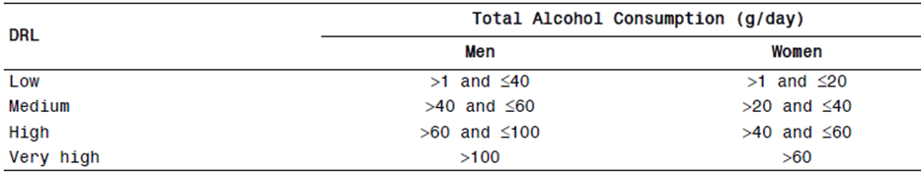

Guidance

EMA Guidelines
The TGA generally recommends that studies adhere to relevant EMA Guidelines for the conduct of studies in specific conditions, where available. The EMA has produced a guideline document on the development of medicinal products for the treatment of alcohol dependence. The latest version came into effect on 1 September 2010 when the pivotal studies were already underway, but the studies were based on an earlier version.
The EMA outlines a number of potential therapeutic approaches to alcohol dependence.
In particular, the guideline states:
The goals of alcohol dependence treatment include the achievement of abstinence, reduction in frequency and severity of relapse, and improvement in health and psychosocial functioning.
Later in the guideline, a harm reduction approach is described:
Two types of clinical studies may be conducted: relapse prevention trials with a full abstinence goal and harm reduction studies.
The guideline also discusses reduction in alcohol intake as a therapeutic target, which directly supports the sponsor’s choice of primary endpoints in the pivotal studies:
“Therefore, if the study drug is only addressing the intermediate goal of clinically significant moderation, efficacy should be expressed by change to baseline in total consumption of alcohol (per month, presented as amount of pure alcohol in grams per day) as well as by reduction in number of Heavy Drinking Days (HDD defined as more than 60 grams of pure alcohol in men and 40 grams in women). Both are considered primary variables, since HDD are associated with specific risks such as acute cardiovascular outcomes or accidents. A clinically relevant difference compared to placebo should be demonstrated.” (Emphasis added.)
Unfortunately, the EMA guideline does not indicate how much of a reduction in total alcohol consumption or number of HDDs should be considered clinically relevant.
Similarly, the EMA guideline recommends a key secondary endpoint of response rate, defined as “the proportion of subjects with a 50%, 70% and 90% reduction in alcohol consumption” or as “the proportion of subjects with a significant categorical shift in WHO risk levels of drinking (that is, the proportion of patients with a change of consumption to baseline from very high risk to at least medium risk level and change from high risk to at least low risk level). The sponsor adopted the second of these definitions as the key secondary endpoint in the major efficacy studies. The EMA guideline also suggested that the proportion of subjects achieving abstinence would be a useful additional measure of response; this was not a major endpoint in any of the Lundbeck studies.
With respect to study duration, the EMA guideline strongly recommends a double blind, placebo controlled treatment phase of at least 12 months for pivotal (confirmatory) studies in alcohol dependence, because treatment results have been shown to be unstable in the first 3 to 6 months. The sponsor did not comply with this recommendation for their two pivotal studies, but did convert a safety study with a planned duration of 12 months into a major supportive efficacy study (Study 12013A), giving some indication of longer term efficacy. (This study cannot be considered pivotal because it was already underway when the efficacy endpoints were established.)
The EMA guideline supports the use of the Timeline Follow Back (TLFB) method for estimating alcohol intake; this method was used in all major efficacy studies, and is discussed in the ‘Efficacy’ section of this clinical evaluation report.
In discussing potential methodological issues, the EMA guideline anticipates what turned out to be a major problem in at least one of the pivotal Lundbeck studies: discontinuations leading to withdrawal bias:
In order to minimise poor treatment adherence and high discontinuation rates, which frequently led to compromised validity of the results in prior alcohol dependence studies, efforts should be made in the design to enhance compliance to treatment (which should be monitored) and to reduce the number of discontinuations. The reasons for discontinuation should be documented and these patients should be followed up. The effect of missing values will need to be taken into account in the efficacy analysis and the method to address this problem needs to be pre-specified.
Unfortunately, about half the nalmefene recipients in one of the pivotal studies (Study 12014A) withdrew. The study protocol specifies that:
If possible, patients who withdrew were to be seen for a Withdrawal Visit as soon as possible
However, it is unclear how many withdrawing patients attended for such a visit and what data was collected about their alcohol intake for the remainder of the study period. The sponsor did pre specify a number of imputation methods for dealing with the missing data. It is not clear, however, that any of the methods eliminated the potential for withdrawal bias except the most pessimistic imputation method, baseline observation carried forward (BOCF), which was possibly biased against active treatment. The EMA guideline does not specify a withdrawal rate that would invalidate a study, but the withdrawal rate in pivotal Study 12014A was so high that it must be considered unreliable.
Overall, the pivotal studies broadly followed most of the EMA guideline recommendations, but concerns remain about:
- the lack of a sufficiently long prospective efficacy study; and
- the presence of potential withdrawal bias.

Discussions with TGA
Correspondence between the sponsor and the TGA prior to submission primarily dealt with two issues, the scope of the proposed indication, and the inclusion of “indirect evidence” of harm reduction.
With respect to the first issue, the TGA noted that the proposed indication was broader in scope than the efficacy evidence discussed in the PI (efficacy was only convincingly demonstrated in very high risk subjects), and suggested that a more restrictive indication might be appropriate. This clinical evaluation report reached the same conclusion independently.
The sponsor declared that:
The indication proposed in this application is more restrictive than that contained in the Briefing Document, and is based on the population suggested.
The original indication was worded as follows:
Selincro is indicated for the reduction of alcohol consumption, in conjunction with psychosocial support, in adult patients with alcohol dependence.
The proposed PI restricts the indication to subjects with high DRL, as follows:
Selincro is indicated for the reduction of alcohol consumption in adult patients with alcohol dependence who have a high Drinking Risk Level (DRL), without physical withdrawal syndrome and who do not require immediate detoxification.
Selincro should be prescribed in conjunction with psychosocial support focused on treatment adherence and reducing alcohol consumption.
Based on the efficacy evidence discussed in the PI, even the revised indication is too broad, as already discussed.
The second issue related to the proposed inclusion of “indirect evidence” of clinical benefit, based on literature reviews of alcohol related harm and subsequent modelling of harm reductions associated with shifts in alcohol consumption. The TGA did not object to the submission of such evidence, which is discussed later in this report. Clearly, because of the many uncertainties involved at every step of this modelling process, such an analysis can only be considered as speculative, providing a descriptive context for the modest clinical effect noted in the pivotal studies.

Contents of the clinical dossier
Figure 2 shows the relationship between the submitted studies. The submitted dossier contained 17 clinical pharmacology studies (13505A is listed twice below), 3 major studies in Alcohol Dependence performed by the current sponsor, Lundbeck, 2 of which can be considered pivotal, and 5 studies in Alcohol Use Disorders by a previous sponsor, Biotie. A number of older efficacy studies for other indications are also listed in the panel, but are only relevant to the assessment of safety.
Figure 2: Overview of Nalmefene Clinical Development Program.
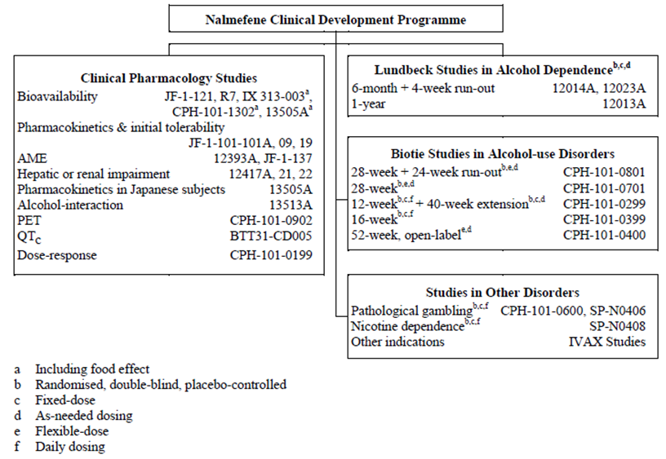
The submission contained the following clinical information:
- 17 clinical pharmacology studies, all of which included some pharmacokinetic data; 3 provided pharmacodynamic data (an alcohol interaction study, a positron emission tomography [PET] study and a dose response study), and 1 was primarily a safety study (the QTc study);
- 1 population pharmacokinetic analysis;
- 2 pivotal Lundbeck efficacy studies;
- 1 supportive Lundbeck safety/efficacy study;
- 5 Biotie studies in Alcohol Use Disorders;
- Literature references;
- A tabulated Summary of all clinical studies.

Paediatric data
The submission did not include paediatric data.

Good clinical practice
The Lundbeck studies, including the pivotal efficacy studies, included statements of compliance with Good Clinical Practice (GCP). Several older studies by previous sponsors failed to declare compliance with GCP, and a couple of very early pharmacokinetic studies were clearly not compliant with GCP; for instance, they lacked any discussion of safety.
Overall, compliance with GCP was declared in the studies that mattered. Regrettably, compliance with GCP in the conduct of these studies does not necessarily mean that appropriate practices were followed in the reporting of the results.
The ICH guidelines for GCP includes the following statement about the need for prospectively identified endpoints:
6.4 Trial Design
The scientific integrity of the trial and the credibility of the data from the trial depend substantially on the trial design. A description of the trial design, should include:
6.4.1 A specific statement of the primary endpoints and the secondary endpoints, if any, to be measured during the trial.
The study protocols contained clear statements of the primary endpoints and the proposed method of analysis, but the sponsor’s submission worked against the intent of the ICH guidelines by shifting the focus from prospectively stated endpoints to post hoc analyses. This was most marked in the proposed PI, where the prospective endpoints for the pivotal studies were not even mentioned, and instead p values for a post hoc subgroup were provided.

Pharmacokinetics

Studies providing pharmacokinetic data
Table 13 shows an overview of clinical pharmacology studies.
Table 13: Overview of clinical pharmacology studies.
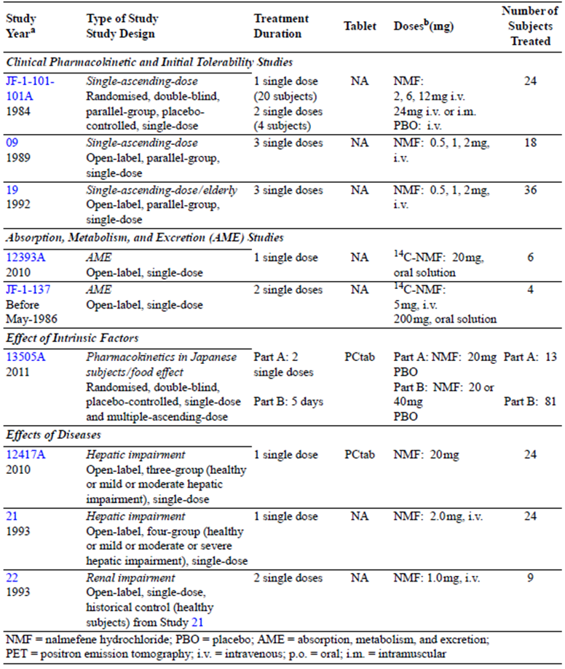
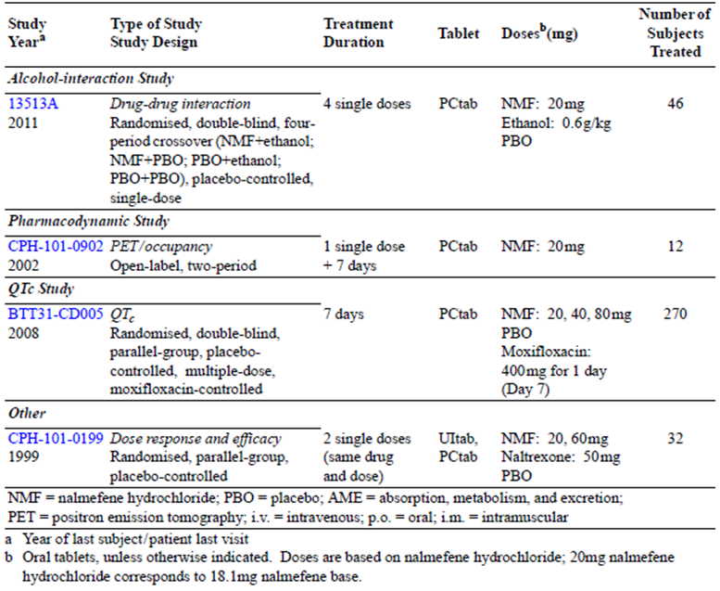
Table 14 shows submitted pharmacokinetic studies.
Table 14: Submitted pharmacokinetic studies.
PK topic | Subtopic | Study ID | *
PK in healthy adults | General PK - Single dose oral | JF-1-121 | *
PK in healthy adults | IV, oral | R7
PK in healthy adults | IV, IM | JF-101-101A
PK in healthy adults | IV | 09 | *
PK in healthy adults | - Multi-dose | 13505A | *
PK in healthy adults |  | CPH-101-0902
PK in healthy adults |  | BTT31CD005
PK in healthy adults | Pooled Analysis of Multiple PK Studies | 14019A | *
PK in healthy adults | - Bioequivalence† - Single dose. Tablet vs Solution | JF-1-121 | *
PK in healthy adults |  | IX 313-003
PK in healthy adults | Bioavailability IV vs Oral | R7 | *
PK in healthy adults | Mass Balance | 12393A | *
PK in healthy adults |  | JF-1-137 | *
PK in healthy adults | Food effect | IX-313-003 | *
PK in healthy adults |  | CPH-101-1302 | *
PK in healthy adults |  | 13505A
PK in special populations | Target population § - Single dose | -
PK in special populations | - Multi-dose | -
PK in special populations | Hepatic impairment | 12417A | *
PK in special populations |  | 21 | *
PK in special populations | Renal impairment | 22 | *
PK in special populations | Neonates/infants/children/adolescents | -
PK in special populations | Elderly | 19 | *
Genetic/gender related PK | Males versus females | 13505A | *
Genetic/gender related PK | Race | 13505A | *
PK interactions | Ethanol | 13513A | *
Population PK analyses | Healthy subjects | 12735A | *
* Indicates the primary aim of the study.
† Bioequivalence of different formulations.
§ Subjects who would be eligible to receive the drug if approved for the proposed indication.
None of the pharmacokinetic studies had such severe deficiencies that they were excluded from consideration, but the bioavailability study R7 was inadequate in the context of the current submission, because it was small, with only four subjects receiving matching IV and oral doses, and the doses administered were well below the proposed dose. Also, it produced estimates of bioavailability that were inconsistent with a pooled analysis of other studies.

Evaluator’s conclusions on pharmacokinetics based on the CER Round 1
The pharmacokinetics of nalmefene has been reasonably well characterised in healthy volunteers, but three issues remain slightly unresolved.
First, the pharmacokinetics of nalmefene in the target population has not been studied directly, though it might be expected from the hepatic impairment studies that subjects with alcoholic liver disease would have increased exposure.
Second, there has been no adequate study of absolute bioavailability, which has instead been inferred from the pooled analysis of multiple Phase I studies. Study R7 was ostensibly submitted as a bioavailability study, but it produced results inconsistent with the pooled results.
Third, and most importantly, it is the clinical evaluator’s opinion that there is evidence of a clinically relevant pharmacokinetics interaction between nalmefene and alcohol that appears to increase exposure to alcohol by ~9%. The estimate of the interaction fell within the conventional bioequivalence range (80-125%) but, when considered in the context of a drug administered with the sole intent of reducing alcohol exposure, the observed increase in exposure of 9% could be enough to compromise the proposed clinical benefit. Currently, the uncertainty bounds for this estimate are broad, and the 90% Confidence Interval (CI) includes the possibility of no effect, as well as the possibility that exposure to alcohol is increased by ~21% when drinking occurs after nalmefene administration. This could be more than enough to negate and even reverse the proposed benefits of nalmefene. The sponsor did not comment on this issue or appear to notice that an increase in exposure to alcohol has efficacy implications.

Pharmacodynamics

Studies providing pharmacodynamic data
Three pharmacodynamic studies were submitted: a PET study assessing nalmefene occupancy of opioid receptors (Study CPH-101-0902), a thorough QT study (Study BTT31CD005), and a “dose response” study attempting to assess the influence of nalmefene on short term drinking behaviour in volunteers (Study CPH-101-0199).
The PET study and QT study were acceptable and provided useful information. The dose response study was performed by an earlier sponsor and appeared to be of marginal value. It was a small study that assessed drinking behaviour in volunteers who were invited to participate in two drinking sessions, but given no particular incentive to curtail drinking. As shown by the modest results obtained in the pivotal studies, any effects of nalmefene on drinking behaviour are subtle, and unlikely to be revealed in a short term study of this nature. In fact, it produced completely inconsistent results across the two drinking sessions, and so it should be rejected.

Evaluator’s conclusions on pharmacodynamics based on the CER Round 1
The mechanism of action of nalmefene remains uncertain. The submitted PET study confirmed that it binds to opioid receptors, and the QT study confirmed that it has acceptable safety in terms of cardiac repolarisation. An old dose response study of nalmefene did not produce reliable results.

Dosage selection for the pivotal studies
The current sponsor, Lundbeck, did not perform a dose response study, and no dose response study has been performed for the proposed indication of alcohol dependence in high risk drinkers: all three pivotal studies used the same 20 mg dose.
In a previous study by an earlier sponsor, Biotie, which was performed for the indication of Alcohol Use Disorder, nalmefene doses of 10 mg and 40 mg were assessed, and a significant treatment effect was achieved for the 40 mg dose but not the 10 mg dose (Study CPH-101-0399). Tolerability at 40 mg was not ideal. The overall incidence of adverse events (AEs) was the same at both doses (92%, compared to 88% with placebo), but AEs were more common at the higher dose for the categories of “nervous system disorders”, “general disorders and administration site conditions” and “gastrointestinal disorders”. Conversely, “psychiatric disorders” were more common at the lower dose, as shown in Table 15.
Table 15: AEs by system organ class.
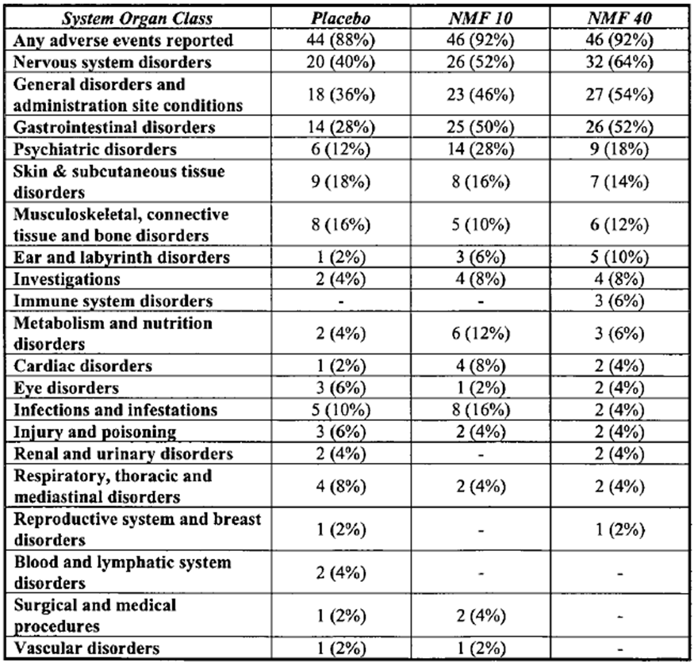
Subsequent studies by Biotie targeted 20 mg, but allowed subjects to alter the dose as needed to 10 mg or 40 mg: increasing the dose if efficacy was perceived to be poor, and reducing the dose if they encountered side effects. Despite the freedom to modify the dose, most subjects continued the target 20 mg dose, indicating that this dose was reasonably tolerated. Efficacy of the 20 mg dose in these Biotie studies was not clearly confirmed, with 2 of 3 placebo controlled Biotie studies of this dose producing a negative outcome.
No Biotie study directly compared the efficacy of 20 mg to 40 mg, or compared 20 mg to 10mg, so the comparative efficacy of doses in this range remains unclear.
Despite the shortcomings in the earlier Biotie study program, Lundbeck performed three Phase III studies that all used the same 20 mg dose, on the basis that one Biotie study had reached a positive outcome at this dose. Thus, there is still no adequate comparative efficacy data assessing other possible doses, but it is the clinical evaluator’s opinion that this is of relatively minor concern given the other problems with the efficacy data.

Efficacy

Studies providing efficacy data
Efficacy data for the proposed indication comes from 8 studies, including 3 performed by the current sponsor, Lundbeck, and 5 performed by an earlier sponsor, Biotie. These studies are listed below. In addition to having different sponsors, the two groups of studies had different entry requirements and they are therefore distinguished in the summary of clinical efficacy by using slightly different terms for the target condition: “Alcohol Dependence” for the Lundbeck studies, and “Alcohol Use Disorders” for the Biotie studies.
Table 16: Overview of clinical studies in Alcohol Dependence (Lundbeck sponsored).
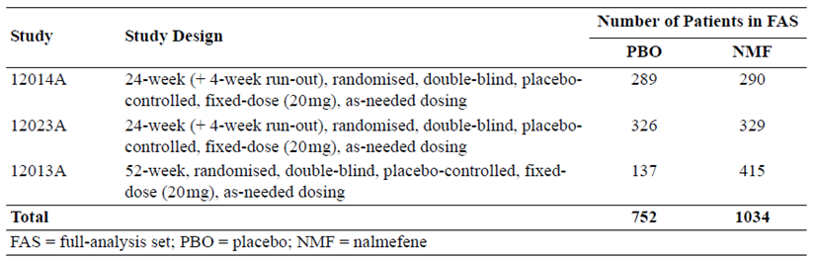
Table 17: Overview of clinical studies in Alcohol Use Disorders (Biotie sponsored).
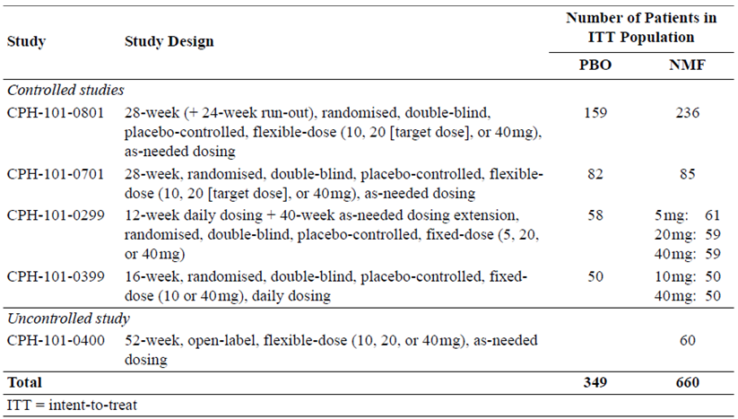
Two of the Lundbeck studies (12014A and 12023A) can be considered pivotal, and were submitted by the sponsor as confirmatory studies. These two studies shared an identical design, and they are described together in this report.
The third Lundbeck study (12013A) has an overall design that could have led to its being considered pivotal, if the protocol had been specified prospectively, but this study was originally conceived as a safety and tolerability study, with efficacy considerations finalised once the study was underway. This study should therefore be considered a major supportive study.
Of the 5 Biotie studies, only one (CPH-101-0801) was sufficiently large that it could be considered a major supportive study. Three other placebo controlled Biotie studies (CPH-101-0701, CPH-101-0299 and CPH-101-0399) should only be considered minor supportive studies and one of these (CPH-101-0701 was associated with such a high withdrawal rate (71%) that the results are meaningless). The uncontrolled Biotie study (CPH-101-0400) should be rejected.
In place of the cumbersome names used to designate each study in the submission, this report will use the following abbreviations as shown in Table 18.
Table 18: Study abbreviations.
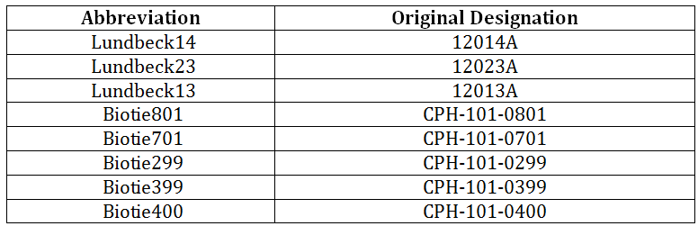

Evaluator’s conclusions on efficacy based on the CER Round 1
The efficacy of nalmefene in the treatment of alcohol dependence remains uncertain. The submitted studies suggest that nalmefene has some efficacy under carefully controlled trial conditions, but they fail to provide conclusive evidence of a clinically significant effect.
Of the three submitted Lundbeck studies, only one (Lundbeck14) was positive according to its primary endpoints; the other two were negative. The single positive study had a withdrawal rate of ~50% in the active group, and the withdrawal rate in the active group was about twice that of the placebo group, creating a real risk of withdrawal bias. In other words, the only positive study was severely compromised, and the less compromised studies were negative. In the most robust Lundbeck study (Lundbeck23) – ‘robust’ because it had a similar withdrawal rate in the two treatment arms – the effect of nalmefene treatment was clinically modest, amounting to ~5 g of alcohol per day (not statistically different from zero grams), and even this modest effect could be negated by plausible adjustments for unblinding and/or for pharmacokinetic interactions between nalmefene and alcohol. The treatment effect in the third study was even smaller (total alcohol consumption [TAC] 3.5 g/day, 95% CI -9.2 to +2.2 g/day, p = 0.232).
In the proposed PI, the sponsor has emphasised efficacy results in a subgroup identified post hoc, which raises major concerns about the application of statistical tests designed for prospective hypothesis testing. Even in this subgroup, the benefit was modest, especially in the second study, which is likely to have been the more robust of the two pivotal studies. As shown in Table 19 (copied from the proposed PI), the treatment benefit in this post hoc subgroup amounted to ~18g in the first study and ~10g, or about one standard drink per day in the second study (Lundbeck23). (Although the table title in the proposed PI refers to these results as “Co-primary Endpoints”, they cannot be considered primary because analysis of this group was not listed amongst the >20 endpoints mentioned in the prospective protocol.) Even in this post hoc subgroup, the benefit could be considerably less than 10 g if appropriate adjustments were made for unblinding or PK interaction effects. Furthermore, the only p values cited in the draft PI are invalid, given that they refer to a subgroup that was identified post hoc, and no adjustment has been made for the use of multiple endpoints.
Table 19: Post hoc results cited in proposed PI: HDDs and TAC in patients with a High or Very High DRL at screening and randomisation.
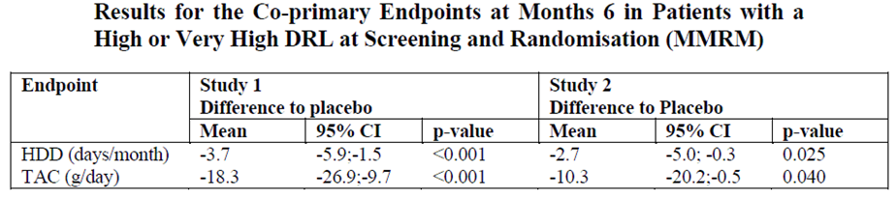

Safety

Studies providing safety data
The following studies provided evaluable safety data:
- 3 efficacy studies performed by Lundbeck assessing nalmefene in the treatment of alcohol dependence (12014A, 12023A, 12013A)
- 5 studies performed by Biotie in alcohol use disorders (Studies CPH-101-0801, CPH-101-0701, CPH-101-0299, CPH-101-0399, and CPH-101-0400).
- 2 studies in pathological gambling (one by Biotie and one by Somaxon Pharmaceuticals, Inc.)
- 1 study in nicotine dependence conducted by Somaxon
- 17 clinical pharmacology studies conducted by Lundbeck, Biotie, Key Pharmaceuticals, and IVAX Corporation
- 47 studies in various other indications, such as pruritic conditions, rheumatoid arthritis, and interstitial cystitis, conducted by IVAX, Key Pharmaceuticals, or in the context of investigator sponsored Investigational New Drug (IND) applications (collectively designated as ‘the IVAX Studies’ by the current sponsor)
The primary data pool for safety assessment comes from the three Lundbeck studies in Alcohol Dependence. Biotie also made an integrated safety database using pooled the safety data from studies in Alcohol Use Disorders. The other studies, which assessed a range of doses, routes and indications, are not easily pooled.

Pivotal efficacy studies
In the pivotal Lundbeck efficacy studies and the major Biotie studies, the following safety data were collected:
- General AEs were assessed by interviewing subjects at each visit and also noting unscheduled attendances and hospital admissions or abnormal laboratory results, if considered clinically significant.
- AEs were graded by severity and by presumed causal relation to study drug, and coded according to the Medical Dictionary for Regulatory Activities (MedDRA).
- Treatment emergent adverse events (TEAEs) were defined as AEs with an onset on or after the day of first study drug intake or, if present since baseline, AEs that had increased in intensity during the study.
- Laboratory tests, including liver function monitoring, creatinine, urea and electrolytes, and haematology monitoring were performed at regular intervals.
- Vital signs were recorded at each visit.
- Subjects underwent regular ECG assessment.

Pivotal studies that assessed safety as a primary outcome
Lundbeck13 (12013A) was initially designed as a safety study, but had efficacy endpoints added later; it has already been discussed in the efficacy section. Safety assessments in this study were similar to the two pivotal studies and were therefore combined in the Alcohol Dependence Pool. No other major studies assessed safety as a primary outcome.

Other studies
Efficacy studies in other indications and clinical pharmacology studies had variable safety monitoring. Nearly all studies recorded AEs apart from a couple of initial pharmacokinetic studies performed by earlier sponsors in the 1980s. Most studies incorporated laboratory monitoring, vital sign assessment and ECG monitoring.
It is the clinical evaluator’s opinion that because of patchy and inconsistent approaches to monitoring in several early studies, the primary safety analysis is based on the three Lundbeck studies (Alcohol Dependence Pool), with supportive data from the Biotie efficacy studies (Alcohol Use Disorders Pool). Patient disposition in these two pools is summarised below (All Patients Randomised Set, APRS).
All patients in the active groups of the Lundbeck studies (Alcohol Dependence pool) took nalmefene 20 mg once daily as needed, whereas dosing in the Biotie studies (Alcohol Use Disorders pool) varied from 5 mg to 40 mg (Tables 20-21).
Table 20: Patient disposition (APRS): Alcohol Dependence pool.
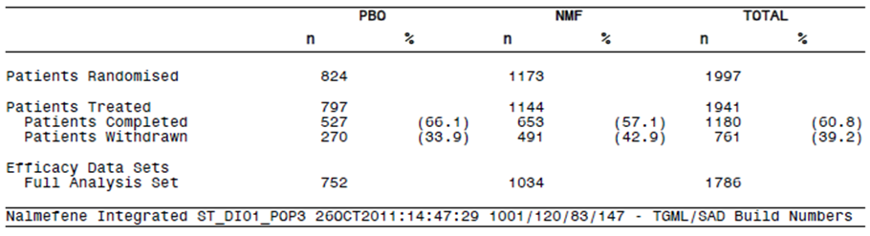
Table 21: Patient disposition (APRS) – Alcohol Use Disorders Pool.
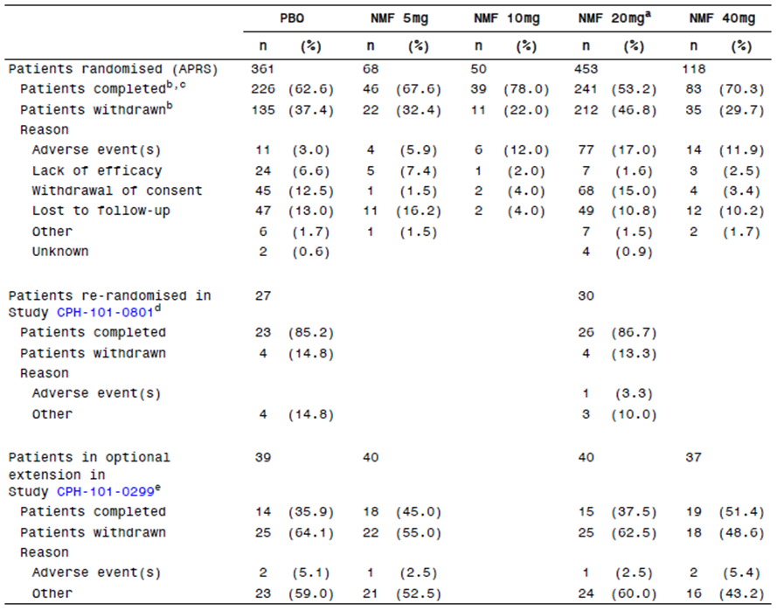
Patients studied in the context of other addiction indications are summarised in Table 22.
Table 22: Patient disposition (APRS): studies in other addiction indications.
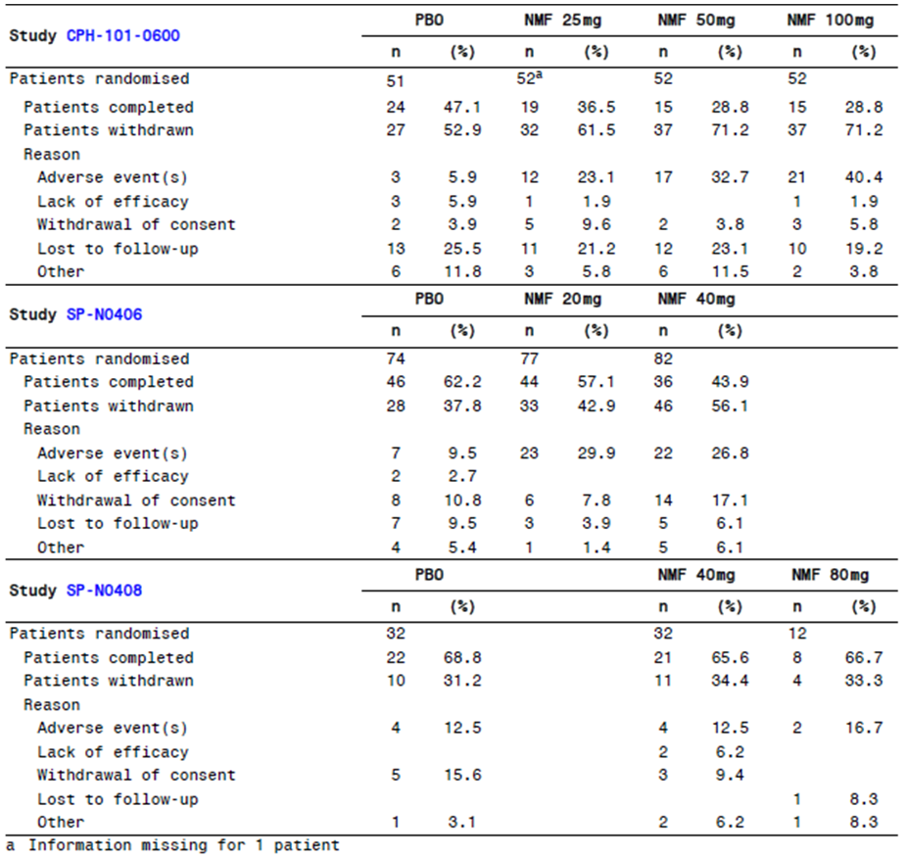

Patient exposure
Overall, approximately 3,090 patients have received nalmefene at doses up to 100mg/day for up to 52 weeks. These patients include:
- 1,144 patients in 3 studies in patients with alcohol dependence
- 689 patients in 5 studies in patients with alcohol use disorders
- 357 patients in 3 studies in other addiction indications:
- 486 subjects in 17 clinical pharmacology studies in healthy subjects (373 who received oral nalmefene in doses up to 80 mg, 113 who received IV nalmefene at doses up to 24 mg, and 4 who received IM nalmefene at a dose of 24 mg)
- 901 patients in 47 studies in various other indications, such as pruritic conditions, rheumatoid arthritis, and interstitial cystitis.
Exposure in the primary safety pool (APTS, All Patients Treated Set) is summarised below, and amounts to 312 patient years. Study drug was not taken every day, but only when subjects thought that drinking was imminent. Actual consumption of study drug is summarised in Tables 23-24.
Table 23: Overall time in study and exposure (APTS): Alcohol Dependence pool.
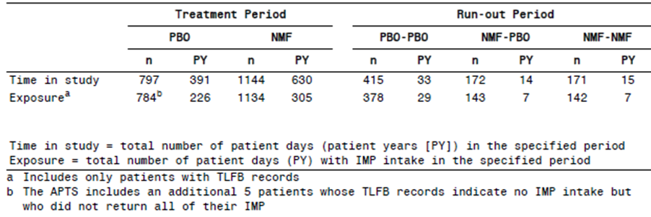
Table 24: IMP intake (APTS): Alcohol Dependence pool.
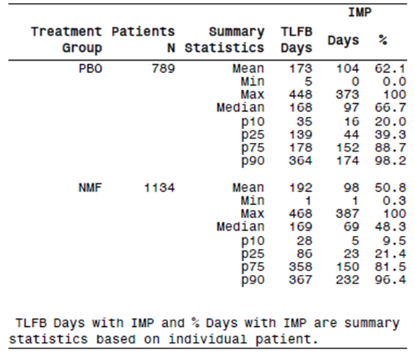
In the Alcohol Use Disorders pool, a total of 689 patients were exposed to nalmefene, amounting to 250 patient years, including 212 patient years in which subjects took 20 mg or more of nalmefene (Table 25)
Table 25: Exposure to nalmefene by mean daily Dose (APRS) – Alcohol Use Disorders pool.
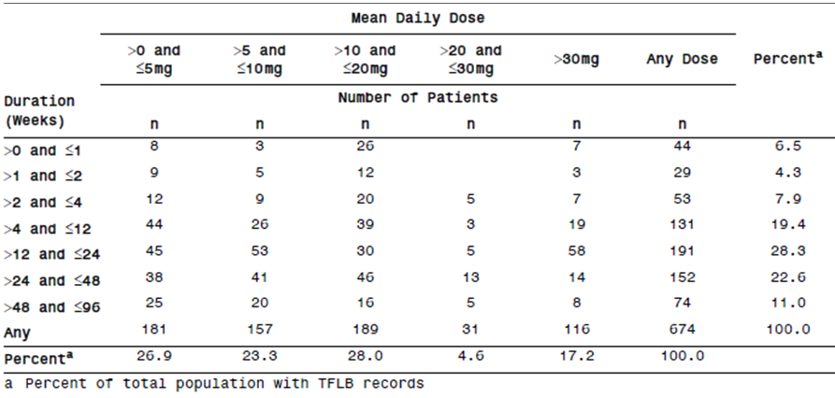
Exposure to nalmefene in studies for other addiction indications is summarised in Table 26. This exposure amounts to ~53 patient years (assuming patients took one dose per day).
Table 26: Exposure (Safety Population): studies in other addiction indications.
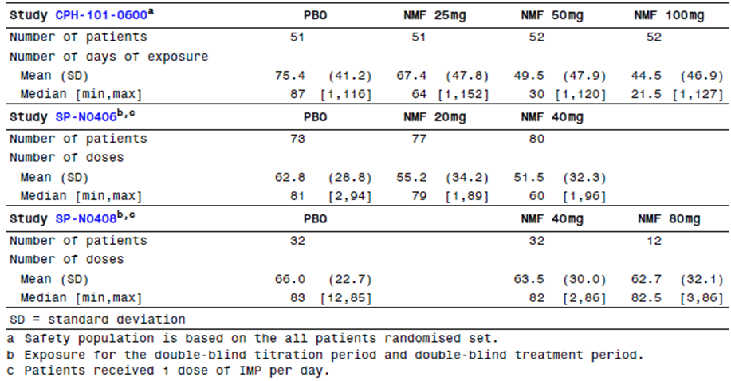
Exposure in the IVAX studies is somewhat unclear, because mean daily dose was often not recorded. The Summary of Clinical Safety summarises this exposure as follows:
Of the 901 patients, 5% received nalmefene 30 mg/day to 60 mg/day, 5% received 60 mg/day to 90 mg/day, and 9% received more than 90 mg/day. Nine percent of the patients were treated for 4 to 8 weeks (30 to 90 mg/day), 4% were treated for 8 to 12 weeks (unknown dose), 2% were treated for 24 to 48 weeks (the majority received >90 mg/day), and nearly 4% were treated for >48 weeks (>90 mg/day).
Exposure in the clinical pharmacology program was limited to single doses or very short treatment periods of about one week. A total of 486 subjects were exposed, 373 who received oral nalmefene in doses up to 80 mg, 113 who received IV nalmefene at doses up to 24 mg, and 4 who received intramuscular nalmefene at a dose of 24 mg. AEs reported in this population resembled the profile in larger studies.

Safety issues with the potential for major regulatory impact

Liver toxicity
There is no evidence that nalmefene causes serious liver toxicity. On average, liver function tests improved in the pivotal studies, with marginal superiority in the nalmefene groups compared to placebo.

Haematological toxicity
There is no evidence that nalmefene is associated with a significant risk of haematological toxicity.

Serious skin reactions
Overall, in the Alcohol Dependence pool, skin and subcutaneous reactions were seen more often in placebo recipients (6.2%) than nalmefene recipients (4.5%). There was no evidence of an increased incidence of serious skin reactions.

Cardiovascular safety
Based on vital signs and a through QTc study, there is no evidence that nalmefene poses serious safety concerns in relation to the cardiovascular system.

Unwanted immunological events
In the Alcohol Dependence pool, the AE of “drug hypersensitivity” was reported in 9 placebo recipients (1.1%) and 7 nalmefene recipients (0.6%). Overall, there was no evidence that the use of nalmefene is associated with a significant excess of unwanted immunological events.

Post marketing data
No data are available related to the post marketing use of oral nalmefene at or near the proposed dose. Previous parenteral use of nalmefene of reversal of opioid overdose has not raised any significant safety concerns, but the doses used are much lower than that proposed for use in Alcohol Dependence.

Evaluator’s conclusions on safety based on the CER Round 1
Overall, the safety profile of nalmefene is acceptable. Its use is associated with an increased incidence of a number of symptoms that reflect tolerability rather than safety issues. These include nausea, dizziness, headache, vomiting, and malaise. The therapeutic index appears to be broad, and higher doses have been used in previous studies for other indications, without major problems.

First Round Benefit-Risk Assessment

First round assessment of benefits
The benefits of nalmefene in the proposed usage are uncertain but, based on the more reliable of the two pivotal studies, may consist of the following:
- about 1-2 heavy drinking days per month might be converted to moderate drinking days;
- about 3.5-5 g of alcohol might be avoided per day, but the alcohol that is consumed could have an increased AUC, negating much of this small benefit.

First round assessment of risks
Nalmefene does not appear to pose major safety concerns, and analysis of the safety data primarily points to tolerability issues.
The risks of nalmefene in the proposed usage are:
- busy clinicians could trust the nalmefene to reduce alcohol intake, and cut back on effective psychosocial treatments, leading to increased alcohol intake compared to standard care;
- subjects taking nalmefene are at increased risk of dizziness, nausea, fatigue and insomnia.

First round assessment of benefit-risk balance
The benefit-risk balance of nalmefene, given the proposed usage, is unclear and possibly unfavourable. The efficacy of the drug was marginal in the original target population, was only slightly better in a post hoc subgroup of high risk drinkers, and could have been over estimated because of methodological flaws in the submitted studies. Efficacy in a trial setting might also translate poorly into clinical practice. The clinical evaluator was concerned that there are potential pharmacokinetic interactions between nalmefene and ethanol that appear to increase exposure to ethanol, compromising the therapeutic intent of the drug. Finally, the proposed PI is misleading.

First Round Recommendation Regarding Authorisation
The application to register nalmefene for the treatment of alcohol dependence should be rejected.
Should the sponsor convince the TGA to approve the application despite the recommendations of this report, the PI should be modified extensively to emphasise the prospective primary endpoints of each Lundbeck study, with post hoc endpoints given a secondary emphasis. Post hoc endpoints should be presented descriptively rather than with p values.
Other changes to the PI should be made as specified below.

Clinical questions following the CER Round 1

Pharmacokinetics
- How much does concurrent administration of nalmefene and alcohol increase exposure to alcohol?
The potential pharmacokinetic interaction between nalmefene and ethanol should be clarified with a new, adequately powered study.
- What is the absolute bioavailability of nalmefene?
Ideally, a direct bioavailability study should be performed comparing the proposed oral formulation with IV administration.
- How does the pharmacokinetic profile of nalmefene vary in the target population of subjects with excessive alcohol consumption?
The pharmacokinetics of nalmefene in the target population – subjects with excessive alcohol consumption – should be evaluated in a new pharmacokinetic study.

Pharmacodynamics
No questions.

Efficacy
- What was the magnitude of the effective reduction in alcohol intake in the pivotal studies after allowing for the potential drug interaction between nalmefene and alcohol?
Combining nalmefene with ethanol appears to increase the AUC for ethanol by ~9%, with a 90% CI consistent with an increase of up to 21% (ratio 1.086, 90%CI 0.977 to 1.208), as shown in Table 27. The existing efficacy results should be adjusted for the potential pharmacokinetic interaction between nalmefene and ethanol, and resubmitted. Two mean values for TAC reduction should be estimated, one based on the mean increase in exposure (8.6%) and one based on the upper limit of the 90% CI for the increase in exposure (20.8%). Alternatively, a new study of this interaction should be performed to provide more accurate estimates of the strength of the interaction.
Table 27: Pharmacokinetic parameters of ethanol following a single oral dose of 0.6g/kg ethanol administered to subjects exposed to nalmefene 20 mg or placebo: Study 13513A.
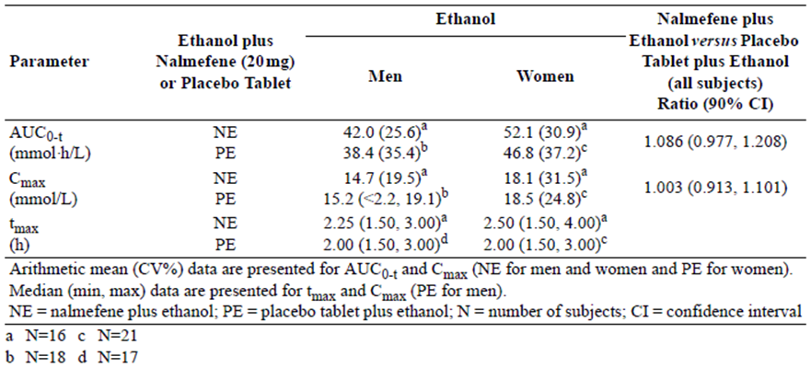
- How many subjects in each of the three Lundbeck studies had a major protocol deviation?
This data was not clearly summarised in the study reports. For each study, the sponsor should provide a single page table summarising the incidence of major and minor protocol deviations, by category.
- What was the drinking behaviour of subjects who withdrew from the pivotal studies?
The withdrawal rates in the pivotal studies were high, particularly in Study 12014A, raising substantial concerns about withdrawal bias. The sponsor should clarify what is known about the drinking behaviour of subjects who withdrew from Studies 12014A and 12023A after the point of withdrawal. If no such data is available, this should be stated clearly.
- How many subjects in the pivotal studies guessed they were receiving active treatment?
- In the pivotal Lundbeck studies, was a bittering agent used in the placebo tablets?
Nalmefene is reported to have a bitter taste, and also produces some side effects. Unblinding in the pivotal studies was not assessed or reported, and the Lundbeck study reports do not mention use of a bittering agent. (The major Biotie studies did employ a bittering agent in the placebo tablets.) The capacity for unblinding in the pivotal studies should be tested in a new, placebo controlled study of drinkers, who should be asked to guess their assigned treatment during and after a period of using nalmefene or placebo in the same manner as in the pivotal studies. The period of blinded treatment should be long enough that subjects have a chance to encounter the typical spectrum of nalmefene side effects (at least 2-4 weeks). These results would then allow interpretation of the efficacy results in the pivotal studies.
- Do the results obtained in post hoc analyses of the pivotal studies fairly reflect the likely efficacy of nalmefene when used prospectively in high risk drinkers?
A new, prospective placebo controlled study of subjects with high or very high DRL at randomisation should be performed, allowing prospective confirmation of adequate efficacy in this subgroup, which has so far only been identified post hoc.
- In real clinical practice, outside the artificial context of a clinical trial, how does the availability of a pharmacological treatment for alcohol dependence affect the thoroughness with which non-pharmacological measures are provided by busy clinicians?
Most subjects in the pivotal studies showed a substantial response to non pharmacological measures. The additional clinical benefit of nalmefene demonstrated in the pivotal studies was marginal, even in an artificial setting where all subjects received the same non pharmacological measures. If, in real clinical practice, nalmefene partially displaced non pharmacological approaches rather than being provided in addition to non pharmacological approaches, that marginal benefit could be negated, and the availability of nalmefene could even lead to worse outcomes by appearing to give clinicians a treatment option that is quicker and easier than time consuming counselling. What evidence does the sponsor have that this will not occur? What postmarketing monitoring does the sponsor propose to assess for this effect?

Safety
- The sponsor should explain the discrepancy between Table 105 of the Summary of Clinical Safety (excerpt below; Table 28), and Table 106 from the same report (reproduced below; Table 29).
Table 28: Related TEAEs by SOC, preferred term, and intensity (APTS): Alcohol Dependence pool.
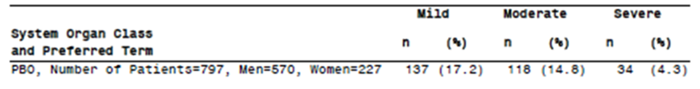
Table 29: Related, severe TEAEs with an incidence of 1% or more in either treatment group (APTS): Alcohol Dependence pool.
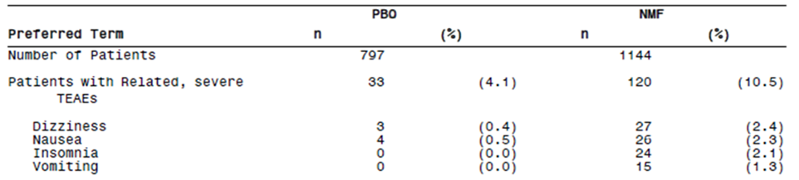
The number of placebo recipients with a severe related TEAE differs in the two tables.
- The sponsor should also provide a summary table for haematological indices of potential clinical concern.

Additional
- Please clarify the following point. In the individual pivotal study reports, prominence was given to subgroup analysis of subjects with High or Very High DRL at Baseline (and Randomisation), but there was little or no mention of a corresponding analysis of subjects with Medium DRL at Baseline (and Randomisation). In the clinical evaluator’s description of the individual studies, it was commented that this was a serious omission. In the Section 31 response the sponsor suggested that the evaluator comment was mistaken because, later, in a pooled analysis of both studies, results in the medium DRL subgroup were included in a couple of tables. The evaluator’s comments were not related to the section that dealt with pooled data and were clearly describing the individual studies, so as far as the clinical evaluator can tell their original comments were appropriate and the sponsor’s ‘correction’ fails to acknowledge the imbalance in their presentation of the data.
- A digital search of the individual study reports (for example, 12014a-study-report-body.pdf) finds numerous uses of the word ‘subgroup’, but always in the context of a High or Very High DRL subgroup. The clinical evaluator did not find a similar analysis of the Medium DRL subgroup. Also, the study synopsis at the start of the study reports explicitly mentions subgroup analysis of one group but not the other. The clinical evaluator requests to know whether he is mistaken in concluding that the individual pivotal study reports contained subgroup analyses of the High/Very High DRL group without a corresponding analysis of the Medium DRL subgroup. The clinical evaluator notes that it is possible that such a subgroup analysis is buried in an appendix, and would be happy to mention this if it can be located, but even then this would not count as 'corresponding' treatment of the two subgroups.
For details of the sponsor’s responses and the evaluator’s comments on the sponsor’s responses, see Attachment 2 of this AusPAR.

Second Round Evaluation

Independent statistician’s report
Because of continued disagreement between the sponsor and evaluator over the validity of the sponsor’s post hoc statistical results, the TGA sought advice from an independent statistician. Clarification was sought on two specific issues, the pharmacokinetic interaction between nalmefene and alcohol, and the validity of post hoc analyses. The independent statistician’s responses have been reproduced in their entirety.
The statistician confirmed the following points, as already discussed in this second round report:
- the potential pharmacokinetic interaction between alcohol and nalmefene is of concern, increases the uncertainty surrounding efficacy estimates, and potentially negates the treatment effect;
- the sponsor’s post hoc approach was statistically invalid;
- the sponsor abandoned their prospective Statistical Analysis Plan (SAP) and proceeded to perform analyses that were explicitly declared to be inappropriate in the SAP;
- even in the sponsor’s preferred post hoc subgroup, the size of the apparent treatment effect was small compared to pre study estimates of a clinically meaningful effect, such as the sponsor’s initial power calculations and WHO recommendations;
- the main efficacy parameters were potentially subject to recall bias, and may have been influenced by ‘the act of treatment’ more than the pharmacological effects of treatment; this relates directly to the evaluator’s concerns about unblinding.
The evaluator basically agrees with the independent statistician’s conclusions, which are concordant with discussions elsewhere in this document, and so no additional commentary is needed.
The statistician also flagged some other issues, as follows:
- In both pivotal clinical trials use of medication was as needed. Results suggest that there was high non compliance with nalmefene compared to placebo, subjects drank without taking nalmefene on 13-22% of days compared to 11-13% of days with placebo.
- Both co-primary endpoints were subject to recall bias (HDD and TAC). Months with less than 7 days of data were discarded; however, these were potentially months with a high number of high drinking days which would have affected recall.
- A prospective clinical trial in the high to very high drinking level target groups may want to consider a counselling only comparison arm to determine the effect of the ‘act of taking a treatment’ in this population. Additionally, this might inform whether counselling is provided less often after treatment than with no treatment.

Errata in Clinical Evaluation Report Round 1
A review of the sponsor’s annotations to Clinical Evaluation Report Round 1 found a mistake that appeared during editing of Clinical Evaluation Report Round 1. In a section assessing the potential pharmacokinetic interaction between alcohol and nalmefene, the following comment appeared:
To put this in context, the estimated treatment effect for TAC was 5 g/d in the pooled pivotal population and the mean baseline TAC was 89 g/d.
The sentence was not initially intended to refer to the pooled population, and earlier versions of the sentence made it clear that the 5 g/d estimate was based on consideration of both pivotal studies, with rejection of the Lundbeck14 results because of the high and unequal withdrawal rates in that study. “Consideration of both studies” was inadvertently transformed into “the pooled pivotal population”, which the sponsor justifiably flagged as an error.
The comment has now been revised to read as follows:
To put this in context, the estimated treatment effect for TAC was 5 g/d in Lundbeck23, the pivotal study least compromised by unequal withdrawals, and the mean baseline TAC was 89 g/d.
The sponsor has also clarified the nature of the scientific advice received from the EMA prior to commencement of the pivotal studies. Clinical Evaluation Report Round 1 stated that the sponsor had designed their studies in accord with the EMA Guidelines on studies in alcohol dependence published in 2008, but the sponsor actually received advice from the EMA in 2008 prior to publication of the official guidelines. This is a minor issue because the EMA advice and the EMA guidelines both reflect the EMA opinon on the same issue and in the same year, but it might account for some minor differences between the EMA recommendations and the sponsor’s study designs.
A few typographical errors were also identified on re-reading Clinical Evaluation Report Round 1. For one of these typographical errors, the effect was that the apparent size of the treatment effect in HDDs for Biotie801 was inadvertently inflated (from 0.8 HDDs to 1.2 HDDs), but this has been corrected in the current clinical evaluation report.

Sponsor’s annotations of Clinical Evaluation Report Round 1
The sponsor has extensively annotated Clinical Evaluation Report Round 1, marking what they considered to be errors. The sponsor also wrote a letter to the TGA expressing their concerns:
We would kindly like to draw your attention to the fact that Lundbeck’s review of the report has revealed a large number of inaccuracies and, therefore, we have made extensive comments on the content of the report.
The sponsor listed the following major concerns:
    - Interpretation of the results of the pharmacokinetic/pharmacodynamic interaction study in healthy volunteers (Study 135 13A) where the interaction between alcohol and nalmefene was assessed. The evaluation has inappropriately applied estimates from this study to the results of the Phase III studies in relation to the primary endpoint TAC.
    - Interpretation of clinical relevance and scientific validity of the target population represented by the post hoc analysis. The evaluation places emphasis on the efficacy data related to the total population, while the target population, that is, the population intended for treatment is essentially dismissed and not considered.
    - Interpretation of pre randomisation activities in the pivotal trials and subsequent influence on the evaluation of the results and impact on the proposed indication statement.
    - The First Round Benefit-Risk Assessment, appears to be based primarily on only one of the pivotal studies, again does not take into consideration the proposed target population in its overview of the efficacy of nalmefene and completely ignores the enormous unmet clinical need that exists for a medication to treat alcohol dependence.
The evaluator agrees that each of these issues represents a substantial point of disagreement. The first two of these issues were referred to an independent statistician who agreed with the concerns of Clinical Evaluation Report Round 1. The third issue is based on the sponsor’s reluctance to consider pre randomisation activities as a “psychosocial intervention”, despite the fact that these activities produced a major change in drinking behaviour, one that dwarfed the apparent treatment effect.
With respect to the fourth listed issue, the sponsor objected to the fact that, in Clinical Evaluation Report Round 1 relatively brief treatment was given to pooled efficacy analysis of the pivotal studies, and greater emphasis was given to Lundbeck23 than to Lundbeck14 in considering the benefit-risk balance of nalmefene. This reflects the evaluator’s belief that Lundbeck14 was severely compromised by excessive and unequal withdrawals, and produced results that were not concordant with Lundbeck23: the difference in mean TAC reduction between the two studies was greater than the treatment effect in Lundbeck23. Pooling the more compromised study (Lundbeck14) with the less compromised study (Lundbeck23) merely inflates the apparent statistical significance of the results without increasing the overall robustness of the analysis.
A couple of minor errors flagged by the sponsor are conceded above as errata; these changes do not have any impact on the overall conclusions reached.
In most cases, the sponsor’s annotations consisted of a declaration that one or other methodological criticism was unwarranted, often with reference to the relevant part of the sponsor’s Section 31 response. This means that the issues under contention have already been discussed in the various sections above.
A consistent and repeated theme in the annotations was the sponsor’s objection to the fact that Clinical Evaluation Report Round 1 refused to promote the sponsor’s preferred post hoc analysis of the HDAR subgroup to the same central position it occupied in the sponsor’s PI and Summary of Clinical Efficacy. This reflects the evaluator’s belief that the primary material being submitted for evaluation is the set of studies conceived and conducted prospectively. Despite being labelled post hoc as “the target group”, and thus having direct relevance to the Sponsor’s proposed indication and PI, the HDAR subgroup has no particular privilege as a source of efficacy data compared to the rest of the study population. In this respect, it is the PI and Summary of Clinical Efficacy that have drifted away from the source material and sought to redefine the debate, not the Clinical Evaluation Report. Also, the sponsor has used a range of definitions of the target group, with initial versions of the indication in the briefing document indicating a much broader target population than the one chosen for estimation of the treatment effect in the PI. In deference to the Sponsor’s concerns, however, this post hoc subgroup has been given its own section in this, Clinical Evaluation Report Round 2, and the second round benefit-risk assessment explicitly considers this post hoc subgroup.
Another recurring theme in the sponsor’s comments was that potential methodological flaws were dismissed whenever there was evidence in the literature that the methodology chosen was broadly appropriate. For instance, the TLFB method has been endorsed by regulatory authorities as a suitable method for trying to gather accurate drinking data, and for trying to cope with the fact that heavy drinkers are poorly compliant with record-keeping. This may have led the sponsor to have greater confidence in the efficacy results than is justified.
For instance, in response to the Clinical Evaluation Report Round 2 comment:
The TLFB and all other methods relying on patient reports are inherently prone to bias, because subjects who are embarrassed about their drinking may be motivated to reduce their estimates
the sponsor writes in a sidenote:
The use of TLFB is a validated method for collecting information on alcohol consumption. HDD and TAC were approved by the CHMP scientific advice as co-primary endpoints (derived from TFLB). TFLB and the co-primary endpoints were later endorsed by the EMA guideline on the Development of Medicinal Products for Treatment of Alcohol Dependence.
These and similar annotations are true, but tangential to the point being discussed. The implication from the sponsor’s comment appears to be that validation by the CHMP somehow protects the TLFB method from recall bias and the effects of unblinding.
Overall, on reviewing the sponsor’s various criticisms and annotations, the evaluator’s original concerns that were raised in Clinical Evaluation Report Round 2 and subsequently endorsed by an independent statistician remain undiminished.

Second Round Benefit-Risk Assessment
Consideration of the sponsor’s Section 31 response does not substantially modify the benefit-risk assessment of nalmefene, as originally assessed in Clinical Evaluation Report Round 1.
Clinical Evaluation Report Round 1 suggested the following potential benefits of nalmefene (based on the prospective results of Lundbeck23, the pivotal study least susceptible to withdrawal bias, and Lundbeck13, which was broadly concordant with Lundbeck23, but without any correction for possible biases):
- about 1-2 heavy drinking days per month might be converted to moderate-drinking days
- about 3.5-5 g of alcohol might be avoided per day, but the alcohol that is consumed could have an increased AUC, negating much of this small benefit
Clinical Evaluation Report Round 1 also suggested the following risks:
- busy clinicians could trust the nalmefene to reduce alcohol intake, and cut back on effective psychosocial treatments, leading to increased alcohol intake compared to standard care;
- subjects taking nalmefene are at increased risk of dizziness, nausea, fatigue and insomnia;
- acceptance of the proposed PI would set an undesirable precedent in which post hoc endpoints displaced prospective endpoints.
Of the potential benefits listed above, the size of the therapeutic effect could prove to be greater than that cited if the sponsor’s results in their favoured subgroup turned out to be representative of the results obtained in similar patients prospectively. The reduction in total alcohol consumption could be approximately 10 g, based on the more reliable pivotal study (or 18 g in the less reliable study), assuming that there has been no inflation of this estimate through withdrawal bias or unblinding. About 2.7 to 3.7 heavy drinking days might also be converted to moderate drinking days.
Even in this favoured subgroup, the benefit demonstrated would be clinically modest, and less than one drinking risk level in the WHO schema. It would also be substantially less than the benefit anticipated in the sponsor’s power calculations.
On the other hand, the benefit of nalmefene could be substantially less than the sponsor’s estimate if unblinding had a significant effect on subjects drinking reports, which seems very likely, or if the results have been inflated by withdrawal bias.
Of the risks listed above, the first could potentially be down-graded. The Sponsor has provided some argument to the effect that clinicians will not take the shortcut of prescribing nalmefene instead of providing full psychosocial support, and it must be conceded that there is no clear evidence that this will actually represent a major risk in practice. It is of concern, however, that the sponsor’s Section 31 response has suggested a new wording for the indication that de-emphasises the need for psychosocial input prior to prescription, and explicitly rejects the evaluator’s suggestion that psychosocial treatment should be tried as the first line approach.
The third risk listed above, the undesirable, precedent setting nature of the sponsor’s PI, seems understated in retrospect. It would be completely unacceptable to approve a PI in which the primary results of the pivotal studies were suppressed, and p-values were cited that were known to be invalid.

Second round recommendation
The application to register nalmefene should be rejected.
Should the sponsor choose to perform additional efficacy studies of nalmefene, with the intention of overcoming the deficiencies in the current submission, the following methodological features should be incorporated into their study program:
- a single unambiguous primary endpoint should be declared prospectively in a clearly defined target group, without any post hoc revisions;
- all additional (secondary and tertiary) endpoints should be declared prospectively and either ranked for hierarchical testing or adjusted for multiplicity;
- subjects who reduce drinking below high DRL prior to randomisation should be excluded;
- blinding should be assessed by asking subjects to guess their assigned treatment;
- strong consideration should be given to a non nalmefene active treatment arm using an agent known to produce a similar incidence of side effects; this agent need not have any particular effect on alcohol addiction but would allow estimation of the potential for side effects to alter drinking reports;
- strong consideration should be given to a psychosocial treatment arm (counselling-only arm) to allow assessment of the effect of psychosocial treatment as distinct from patient responses to the act of taking a tablet;
- some attempt should be made to follow the drinking habits of subjects after they withdraw (it is conceded that this could be difficult);
- the PI should restrict itself to the reporting of prospectively declared endpoints, which should be reported in full.

Sponsor’s response to second round recommendations
Following receipt of the second round evaluation report and the independent statistician’s report, and in recognition of the considerable differences remaining between the sponsor and the clinical evaluator, the sponsor requested an opportunity to respond to the Delegate. A comprehensive response document addressing key issues and an expert statement from a reputable Australian biostatistician were submitted for consideration by the Delegate prior to the request for advice from the Advisory Committee on Prescription Medicines (ACPM). The response document was also submitted as an appendix in the sponsor’s pre ACPM response.

Alcohol interaction study
The response document included further information to address the clinical evaluator’s concern that nalmefene may increase exposure to alcohol based on the data obtained in the interaction study in healthy volunteers (Study 13513A). The results from the study showed that the 90% and 95% CI for alcohol AUC_{0-t} were fully contained within the range of 0.80 to 1.25. Excluding 2 outlier estimates of alcohol AUC_{0-t} due to few available data points changed the estimate to 1.0306 (90% CI [0.9604; 1.1060]). In addition, nalmefene did not inhibit alcohol dehydrogenase in vitro. Thus, even though the sponsor acknowledges that the data points measured in the interaction study did not allow for an exact calculation of alcohol C_{max} and AUC_{0-t} for a precise evaluation of a potential effect of nalmefene on alcohol exposure, the sponsor considers it unlikely that nalmefene increases the exposure of alcohol. As stated in the Delegate’s overview, the sponsor’s response to the alcohol interaction issue in the Clinical Evaluation Report Round 2 has:
satisfactorily responded to the evaluator’s concerns that nalmefene may increase exposure to alcohol in individuals who do not reduce alcohol consumption while taking nalmefene.
Thus, the current approved PI text states:
There is no clinically relevant pharmacokinetic drug-drug interaction between nalmefene and alcohol.

V. Pharmacovigilance findings

Risk management plan
Nalmefene EU Risk Management Plan (RMP) version 3 dated 30 April 2014 (data lock point 25 August 2013), Australian Specific Annex (ASA) version 1.0 dated May 2014, and sponsor’s Section 31 response to the clinical evaluation dated 3 June 2014, which were reviewed by the TGA’s Office of Product Review (OPR).

Safety specification
The sponsor provided a summary of ongoing safety concerns which are shown at Table 30.
Table 30: Ongoing safety concerns.
Ongoing safety concerns
Important identified risks | - Confusional state, hallucination, dissociation  - Concurrent use with opioids
Important potential risks | - Off label use
Missing information | - Use in pregnant and lactating women  - Use in children  - Genetic polymorphism  - Use in other ethnic groups than Caucasian  - Overdose  - Use in patients with increased (> 3x ULN) ALAT or ASAT  - Use in patients with history of seizure disorder, including alcohol withdrawal seizures  - Use in elderly  - Use in patients with significant psychiatric comorbidity  - Use in patients with significant somatic comorbidity, e.g. renal, hepatic, cardiac, neurological disorders  - Long term use >1 year  - Concurrent use with other CNS active medicines (ATC groups N06A (antidepressants), N05A (antipsychotics), N05B (anxiolytics), or N05C (hypnotics))

Pharmacovigilance plan
Table 31 shows a summary of pharmacovigilance activities proposed.

Table 31: Pharmacovigilance activities proposed.
Important identified risks | Pharmacovigilance activities proposed
Confusional state, hallucination, dissociation | - Routine Pharmacovigilance  - Study 14910A
Concurrent use with opioids | - Routine Pharmacovigilance  - Study 14910A and 15649A
Important potential risks
Off label use | - Routine Pharmacovigilance  - Study 14910A and 15649A
Missing information
Use in pregnant and lactating women | - Routine Pharmacovigilance  - Study 14910A and 15649A
Use in children | - Routine Pharmacovigilance  - Study 14910A and 15649A
Genetic polymorphism | - No pharmacovigilance planned
Use in other ethnic groups than Caucasian | - Study 14910A
Overdose | - Routine Pharmacovigilance  - Study 14910A and 15649A
Use in patients with increased ALT and/or AST | - Routine Pharmacovigilance  - Study 14910A and 15649A
Use in patients with history of seizure disorder, including alcohol withdrawal seizures | - Routine Pharmacovigilance  - Study 14910A and 15649A
Use in elderly | - Routine Pharmacovigilance  - Study 14910A and 15649A
Use in patients with significant psychiatric comorbidity | - Routine Pharmacovigilance  - Study 14910A and 15649A
Use in patients with significant somatic comorbidity, eg. renal, hepatic, cardiac, neurological disorders | - Routine Pharmacovigilance  - Study 14910A, 15084A and 15649A
Long term use > 1 year | - Routine Pharmacovigilance  - Study 14910A and 15649A
Concurrent use with other CNS active medicines (antidepressants, antipsychotics, anxiolytics, hypnotics) | - Routine Pharmacovigilance  - Study 14910A and 15649A

Risk minimisation activities
The sponsor has advised in their Section 31 response dated 3 June 2014:
Lundbeck plans an educational campaign focusing on QUM (Quality Use of Medicine) (ASA to the EU RMP), especially targeted at prescribers who are not currently familiar with treatment of alcohol dependence. It is recognised that physicians and GPs will require support with the introduction of nalmefene as a novel treatment modality for alcohol dependence. Treatment with nalmefene should be considered as part of a treatment care plan that involves evidence-based non-pharmacological measures as well pharmacological options. Lundbeck will support GP training that helps doctors to better assess, advise and choose best treatments options and combinations.
Physicians and GPs will be supported with educational material for the disease, its diagnosis, the administration of psychosocial support and brief interventions, as well as tools to assist the patient. In addition, Lundbeck will conduct courses at which physicians will be educated on various aspects of nalmefene, including mode of action, prescribing information, and appropriate patient selection.
The Lundbeck Institute, which is dedicated to education activities on disease treatment in Australia, will develop a module providing education to healthcare professionals on how to manage patients with alcohol dependence.
These tools are to be used as part of the risk management strategy for nalmefene in Australia to ensure correct prescribing and appropriate patient management.

Reconciliation of issues outlined in the RMP report
Reconciliation of issues outlined in the RMP report is as follows.

Recommendation #1 in RMP evaluation report
Safety considerations may be raised by the nonclinical and clinical evaluators through the nonclinical and clinical evaluation reports respectively. It is important to ensure that the information provided in response to these includes a consideration of the relevance for the RMP, and any specific information needed to address this issue in the RMP. For any safety considerations so raised, the sponsor should provide information that is relevant and necessary to address the issue in the RMP.

Sponsor response
Any new safety considerations that are raised by either the nonclinical or clinical evaluators in the second round evaluation reports will be assessed by the sponsor and where appropriate, incorporated into the pre ACPM revision of the PI/Consumer Medicines Information (CMI).

OPR evaluator’s comment
The sponsor should commit to updating the RMP and ASA based on the recommendations made in the nonclinical and clinical evaluation reports.

Recommendation #2 in RMP evaluation report
It appears that the final report is due for Study 15084A. The sponsor should advise the TGA if there are any new safety related findings. Pending the TGA’s decision on whether nalmefene is approved for registration, the sponsor should include the final study report in its future Periodic Safety Update Report (PSUR) submitted to the TGA.

Sponsor response
Currently, the study report for Study 15084A “An interventional, single-site, open-label, four-group, single-dose study investigating the pharmacokinetic properties of nalmefene in subjects with renal imapirment (mild, moderate, or severe) and in healthy subjects” (ClinicalTrials.gov Identifier: NCT01934166) is unavailable as the recruitment phase is ongoing. We will provide the final clinical study report as soon as it is finalised.

OPR evaluator’s comment
The sponsor’s response is satisfactory. The sponsor should advise the TGA of any new safety findings once the study report has become available. The study report should be submitted with a future PSUR to the TGA.

Recommendation #3 in RMP evaluation report
The educational materials should include information on the risks associated with the use of nalmefene and possible adverse reactions.

Sponsor response
The sponsor confirms that information on the risks associated with the use of nalmefene and possible adverse reactions will be included with educational materials provided to healthcare professionals. Presently a “leave behind” promotional item is under development. It will provide an overview of the AEs that were associated with nalmefene during clinical trials, and will accurately reflect the AEs that are documented in the Australian Selincro PI.

OPR evaluator’s comment
The sponsor’s response is satisfactory.

Recommendation #4 in RMP evaluation report
The sponsor should provide draft educational materials to the TGA for review before the distribution of nalmefene in Australia. It is recommended that the educational program be accredited with a learned college.

Sponsor response
The sponsor provides assurance that draft educational material for healthcare professionals will be provided to the TGA prior to the distribution of nalmefene.
Lundbeck Australia is partnering with a company that provides online Continuing Medical Education (CME) accredited courses. The company, known as mdBriefCase Australia, will be drawing on the expertise of two leading experts to produce two educational modules that will be presented to healthcare professionals via the internet and that will attract Continuing Professional Development (CPD) points. One module will focus on the disease area of alcohol dependence and will educate physicians on the burden of risky/high-risk alcohol consumption and how reducing alcohol consumption can have a positive effect on health outcomes. The fact that the treatment of alcohol dependence requires a comprehensive treatment programme including psychological, educational and other measures will be stressed. It will also aim to increase the skills of general practitioners in identifying and screening for alcohol dependence based on current Australian Guidelines. A separate module will introduce Selincro as a new treatment option for alcohol dependence and educate physicians on the safe prescribing of nalmefene as well as information about the most appropriate patient population for Selincro in conjunction with psychosocial support. In keeping with both modules referencing current Australian Guidelines this module will seek to minimise the potential for medication errors and off-label use of nalmefene.
In addition, Lundbeck Australia is investigating the possibility of launching the website reduceyourdrinking.com locally. This website, currently under development for Europe, provides support to those suffering from alcohol dependence as well as their physicians. The adaptation of this website for Australia is a lengthy process, as the entire website will have to be reviewed and subsequently amended to ensure that it is compliant with the Medicines Australia Code of Conduct.
Lundbeck Australia will, when nalmefene is launched in Australia, host a speaker tour in which either one of the investigators that was involved in the nalmefene pivotal trials, or a physician who has gained experience in the prescribing of nalmefene, will give a series of talks in major Australian cities on the use of nalmefene in a clinical setting.
Lundbeck Australia will, on an ongoing basis host hour long educational meetings in which healthcare professionals will be educated on the treatment of alcohol dependence and the appropriate use of nalmefene.
The Australian chapter of the Lundbeck Institute will be adapting the local Depression and Schizophrenia modules which usually consist of four cases histories, to include at least one case in which the subject suffers from a psychiatric disorder that is comorbid with alcohol dependence. The Lundbeck Institute is a forum for professional medical education in psychiatry and neurology that was founded by H. Lundbeck A/S in 1997. The activities of the Lundbeck Institute are purely educational and non product related.
In conclusion, Lundbeck believes that the educational material that will be produced and presented to healthcare professionals when nalmefene is made available in Australia will reach a significant number of general practitioners as well as physicians from other specialties, who might encounter patients with alcohol dependence in their practices and significantly add to their understanding of the disease.

OPR evaluator’s comment
The sponsor’s response is satisfactory.

Summary of recommendations

Outstanding issues

Issues in relation to the RMP
The recommendations on the draft PI remain, awaiting consideration by the Delegate.

Additional recommendations
Further recommendations based on the advice provided by the Advisory Committee on the Safety of Medicines (ACSOM):
- The following should be added to the list of Ongoing Safety Concerns:
  - Insomnia;
  - Headache; and
  - Nausea.
- The following Important Potential Risk should be amended:
  - Off-label use should specifically include use without adequate psychosocial support.
- To address off-label use, and to assess the appropriate use of this medicine, the sponsor should propose a new, or assign or modify an existing appropriate additional pharmacovigilance activity, for example, a drug utilisation study or a drug utilisation data component in a post authorisation safety study (PASS).
- To address long term safety, the sponsor should propose a new, or assign or modify an existing appropriate additional pharmacovigilance activity.
- The sponsor should undertake to give specific consideration of reported adverse events in patients taking nalmefene for longer than 12 months in the future PSURs.
- The Delegate may wish to reconsider the adequacy of the proposed wording of the indication in the context of the following:
  - Proposed indications are difficult to interpret and require clearer definition;
  - Lack of clarity around alcohol dependence and withdrawal symptoms; and
  - Difficulty in defining the risk of the medicine in the absence of a clearly defined patient group.
- With regard to the proposed education programme, the following recommendations are made:
  - The programme should be accredited by a learned college such as the Royal Australian College of General Practitioners (RACGP), Australian College of Rural and Remote Medicine (ACRRM), Royal Australasian College of Physicians (RACP), or Royal Australian and New Zealand College of Psychiatrists (RANZCP).
  - The programme should target not only selected, but all general practitioners.
  - The educational programme should delineate between different types of problem alcohol drinking behaviour to help minimise off-label use of nalmefene.
  - Additional to the existing content, the educational program should also include the following issues:
    - Limited efficacy of nalmefene;
    - Recommendations for the types of psychosocial support;
    - Typical adverse reactions including but not limited to insomnia and headache;
    - Lack of evidence on use of nalmefene for longer than 12 months; and
    - Lack of evidence on use of nalmefene among indigenous Australians.
- The sponsor should update the ASA accordingly.

Comments on the safety specification of the RMP

Clinical Evaluation Report
The Office of Medicines Authorisation (OMA) of the TGA has provided the following comments in the clinical evaluation report:
According to the sponsor’s Letter of Application:
Lundbeck Australia proposed to the TGA in writing on 27 June 2013 that it would not include the current RMP in the initial application as it is in the old EU format, but that the new RMP (in preparation) would be provided as soon as possible during the Evaluation Phase. This was accepted by the TGA in the correspondence dated 15 July 2013.
The RMP should be reviewed when available.
Important risks that emerged from the submitted data, and which will require post-marketing monitoring, include:
    - the possibility of nalmefene being used as a partial substitute for adequate psychosocial support, leading to worse outcomes;
    - the possibility that psychosocial support will not be continued with the same vigour over the course of sustained clinical use as it was within the context of clinical studies, leading to poor translation of short duration study results to prolonged clinical use;
    - the possibility that efficacy over long periods will decline for additional reasons, given the uncertainties surrounding the mechanism of action (MOA) and the modest clinical benefits demonstrated.
The sponsor should also commit to clarifying the pharmacokinetic interaction between nalmefene and ethanol.
These comments were made during the first round clinical evaluation prior to the submission of the RMP. No further comments were made during the second round clinical evaluation.
The important risks raised by the clinical evaluator during the first round has been responded to by the sponsor and addressed by the ASCOM.
The sponsor’s response to the clinical evaluator’s question regarding the pharmacokinetic interaction between nalmefene and ethanol has been considered unsatisfactory. The OPR evaluator supports the comments made by the clinical evaluator and recommends that ‘increased exposure to alcohol when nalmefene is taken concurrently with alcohol’ be added as an important potential risk in the ASA.

Nonclinical Evaluation Report
The Office of Scientific Evaluation (OSE) of the TGA has provided the following comments in the nonclinical evaluation report:
The sponsor provided the RMP with the Section 31 response. The results and conclusions drawn from the nonclinical program for nalmefene described in the sponsor’s draft RMP are consistent with those of the nonclinical evaluator in the Nonclinical Evaluation Report.

Suggested wording for conditions of registration

RMP
Nalmefene EU RMP version 3 dated 30 April 2014 (data lock point 25 August 2013) with the ASA version 1.0 dated May 2014, to be revised to the satisfaction of the TGA, should be implemented.

VI. Overall conclusion and risk/benefit assessment
The submission was summarised in the following Delegate’s overview and recommendations:

Quality
There are no objections to approval from a biopharmaceutics perspective.
The chemistry evaluator has noted that nalmefene hydrochloride dihydrate (the dihydrated hydrochloride salt of nalmefene) has a distinct μ, δ and κ opioid receptor profile. The substance has 4 chiral centres. Whilst diastereomeric structures with alternative absolute configuration at these are theoretically possible, most of these are precluded by the route of synthesis unless arising from contaminants in the starting material.
The tablets were originally developed as nalmefene hydrochloride 20 mg tablets (containing nalmefene hydrochloride dihydrate 21.917 mg), equivalent to nalmefene base 18.06 mg (18.1 mg). Lundbeck was instructed by the EMA during evaluation of the European submission to express the active ingredient labelling as “nalmefene 18 mg” and not nalmefene hydrochloride 20 mg. In this respect, Lundbeck Australia has harmonised its approach with that taken in the EU. In the dossier and clinical evaluation report the nalmefene dose is referred to as 20 mg however this is the same quantity of active as in the tablet proposed for registration.

Nonclinical
Registration of nalmefene for the proposed indications is supported provided that the clinical advantages outweigh the identified deficiency in the conduct of the mouse and rat carcinogenicity studies.
The nonclinical evaluator identified a deficiency in the conduct of the mouse and rat carcinogenicity studies. The designs of the mouse and rat carcinogenicity studies and the peri/postnatal study in rats were not fully compliant with current guidelines. While there were no positive findings in the carcinogenicity studies, sensitivity for identification of carcinogenic effects may have been reduced due to the lack of histological examination on animals from all dose groups. Nalmefene was not considered to pose a genotoxic or carcinogenic hazard. There were no other issues that the nonclinical evaluator considered would preclude approval.
Nalmefene is an opioid system modulator with antagonist activity at the µ and δ receptors and partial agonist activity at the κ receptor. Secondary pharmacodynamic studies showed that nalmefene is selective for the µ, δ and κ opioid receptors. Nalmefene elicited a range of CNS clinical signs in the nonclinical species, but no clinically relevant hazards were identified in safety pharmacology studies. In vitro studies showed a low potential for drug interactions at clinically relevant concentrations.
Orally-administered nalmefene significantly reduced consumption of alcohol in rats. Primary nonclinical pharmacology data support use for the proposed indication.
Nalmefene showed dermal sensitisation potential in a local lymph node assay. Repeat dose toxicity studies did not identify any target organs other than the CNS. Convulsions occurred in dogs, but not in rats, at clinically relevant plasma nalmefene concentrations. Reproductive toxicity studies did not reveal any major findings. There was no evidence for dependence potential. Reproductive toxicity studies did not reveal any major findings. Nalmefene was not teratogenic and no toxic effects were observed in rat foetuses. In rabbits, foetal weights were reduced and a minor ossification delay was observed at a maternotoxic dose. No significant effects were observed in a peri/postnatal study in rats, but dosing was started in GD15 rather than on GD6 as required by current guidelines.

Clinical

Pharmacology
Nalmefene is a µ, κ and δ opioid receptor antagonist, similar by the structure to naltrexone. It has a longer half life in humans, and different receptor binding. Alcohol directly increases dopaminergic transmission in the nucleus accumbens (NAc; a nucleus in the cortico limbic pathway). Alcohol, by promoting gamma-aminobutyric acid A (GABA-A) receptor function, may inhibit GABA-ergic terminals in ventral tegmental area (VTA) and hence disinhibit VTA dopamine neurons. It may similarly inhibit glutamatergic terminals that innervate NAc neurons. Finally, there is some evidence that alcohol activates endogenous opioid pathways. Nalmefene works through the blockade of endogenous opioid pathways.
Clinical development of nalmefene commenced in 1984 and GCP has evolved since then. Not all submitted studies appear to be GCP compliant. Pharmacokinetic results were derived primarily from an integrated pharmacokinetic analysis of all oral dose studies. Nalmefene is rapidly absorbed with a tmax of approximately 1.5 h when taken fasted. After a single oral dose of 18 mg (20 mg of nalmefene hydrochloride), mean dose normalised Cmax was 16.5 ng/mL with AUC∞ of 131 ng•h/mL. Oral bioavailability was estimated to be approximately 40% but this estimate is not reliable. Food increased oral bioavailability by approximately 30%. Oral doses between 20 mg and 80 mg, that is, at the proposed dose and up to 4x the proposed daily dose showed approximate dose proportionality.
The estimated volume of distribution (Vz/F) was approximately 3200 L (SD 3770 L) indicating that nalmefene undergoes extensive and highly variable extravascular distribution. Vd declines somewhat with age. Approximately 30% is bound to plasma proteins.
PET involving single and repeated daily dosing with 20 mg nalmefene was consistent with 94-100% receptor occupancy within 3 h after dosing, suggesting that nalmefene readily crosses the blood-brain barrier.
The primary mechanism of clearance of nalmefene is by glucuronide conjugation, followed by renal excretion of metabolites along with some unaltered nalmefene. Less than 3% is excreted unchanged in urine and approximately 20% in faeces as total radioactivity (drug related material). CL/F was estimated to be ~169 L/h and the terminal half life 12.5 h.
Metabolism of nalmefene is extensive, and includes hydroxylation, N-dealkylation, glucuronic acid conjugation, and sulphation. In plasma, nalmefene accounted for ~4.5% of the total exposure (AUC∞) to nalmefene related compounds. Nine metabolites were quantified in human plasma, and the predominant metabolite in plasma was nalmefene 3-O-glucuronide. The only significant active metabolite is nalmefene 3-O-sulphate. It has a potency at opioid receptors that is similar to nalmefene but it is present in relatively low concentrations (<10% of nalmefene concentrations) and therefore makes only a small contribution to the overall pharmacological effect.
The variability of pharmacokinetics was up to ~45% for inter-subject variability (first value in each pair), and up to ~31% for the intra-subject variability, depending on the pharmacokinetic parameter under consideration. In patients with mild hepatic impairment, exposure (AUC) increased 1.5 times and oral clearance decreased by approximately 35%. In patients with moderate hepatic impairment, exposure increased 2.9 times for AUC and 1.7 times for Cmax, while oral clearance decreased by ~60%. Pharmacokinetics in subjects with severe hepatic impairment was not assessed.
The effect of renal impairment on the pharmacokinetics of nalmefene has not been adequately examined. Older study data suggest renal impairment delays clearance and increases the AUC of nalmefene and its metabolites. Only one drug interaction study was performed – with alcohol. The pharmacokinetics of nalmefene was not affected by alcohol (0.6g/kg). There is a suggestion that nalmefene may increase exposure to alcohol by around 9%, though this has not been comprehensively examined. The sponsor has satisfactorily responded to the evaluator’s concerns that nalmefene may increase exposure to alcohol in individuals who do not reduce alcohol consumption while taking nalmefene.
A PET study examined µ opioid receptor occupancy. This was high (94 to 100%) at 3 h after dosing, and declined more slowly than elimination of nalmefene and its metabolites in blood. Receptor occupancy was 83-100% at 26 h post dose, and over 50% at 50 h post dose in all brain areas studied. Peak occupancy was similar after single and repeated dosing, indicating that nalmefene does not accumulate significantly in the brain across doses. Nalmefene had no effect on the QT interval.
No studies assessed the effect of nalmefene on the analgesic effect of opioids.

Efficacy
Eight studies assessed efficacy, 5 of these were conducted by an earlier sponsor and are considered supportive. The pivotal studies, 12014A (Study 14) and 12023A (Study 23) were conducted by the current sponsor. A third study by the current sponsor, 12013A (Study 13) also assessed 20 mg nalmefene taken as needed in a randomised, double blind, placebo controlled, parallel group study. This was a negative study, showing no significant treatment effect for either of the co-primary endpoints. Study 13 was not considered pivotal for efficacy because it was designed initially as a safety and tolerability study to be conducted over 52 weeks, efficacy was subsequently added as an additional primary objective. In addition, unlike in the pivotal studies, subjects in Study 13 remained eligible for enrolment if they had a low DRL at Baseline.
Studies 14 and 23 were double blind, placebo controlled, parallel group studies that assessed the efficacy of as-needed dosing with nalmefene 20 mg versus placebo in the treatment of alcohol dependence. Treatment duration was 24 weeks, followed by a 4 week run out period in which subjects on active treatment were randomly and blindly assigned to continue active treatment or switch to placebo, in order to assess the effects of withdrawal of treatment.
In all subjects, formal psychosocial supportive measures (the BRENDA program) were supplied at randomisation and at each visit throughout the study (Weeks 0, 1, 2, 4, 8, 12, 16, 20, 24, 28).
The primary therapeutic objective in both studies was to reduce alcohol intake. Subjects were advised to take investigational medicinal product (IMP), which was either nalmefene 20mg or placebo, on days when they felt they were at risk of consuming alcohol. Subjects were asked to take their tablet 1 to 2 h prior to the anticipated time of drinking. If the patient started drinking alcohol without taking a study tablet, they were supposed to take it as soon as possible. Tablets could be taken up to once daily.
The major inclusion criteria were: age ≥18 years, blood alcohol concentration (BAC) <0.02% at the Screening Visit; ≥6 HDDs in the 4 weeks preceding the Screening Visit and average alcohol consumption at medium risk level or above (>40 g/day for men; >20 g/day for women) in the 4 weeks preceding the Screening Visit. The major exclusion criteria included having >14 consecutive non drinking days in the 4 weeks prior to screening, significant additional psychiatric conditions and dependence of other drugs. Risk levels of alcohol consumption were provided for subjects in each of the studies, though stratification was not prospectively performed. The population for which nalmefene is proposed for use are patients with WHO defined high DRL. The WHO defines this as >60 g alcohol daily for men and >40 g daily for women.
There were 2 co-primary efficacy variables for both studies were the two direct measures of alcohol consumption:
- HDDs per 28 day period. HDD was defined as consumption of >60 g of pure alcohol in men and 40 g in women;
- TAC in g/day, averaged over 28 days.
Consumption was estimated by patient recall of what they were doing each day, noting whether they drank and then estimating how much. Months with <7 days of data were discarded from the analysis.
The changes from Baseline I in monthly number of HDDs and monthly TAC were analysed using a mixed model repeated measures (MMRM) model, using observed cases (OC), with the Baseline I score as a covariate, and site, sex, time in months (Months 1 to 6), and treatment as fixed effects, with the estimated treatment difference at Month 6 tested at the 5% level of significance. The Baseline I score-by-time interaction and treatment-by-time interaction were also included in the model.
Both co-primary endpoints had to show a significant treatment effect at Month 6 for the study to be considered positive. The null hypothesis (hypothesis of no treatment effect) had to be rejected for both co-primary endpoints at the 5% level in order to proceed with formal testing of the key secondary Response Shift in Drinking Risk Level (RSDRL) endpoint. This means that the RSDRL endpoint should not have been subjected to formal statistical analysis in Lundbeck 23, and results for this endpoint should be considered descriptive.
The sponsor identified the RSDRL at Month 6 as the key secondary efficacy endpoint. RSDRL was defined as a downward shift from baseline in DRL. For patients at very high risk at Baseline, this was a shift to medium risk or below, and for patients at high or medium risk at Baseline, a shift to low risk or below. The following endpoints were nominated as secondary efficacy endpoints
- Response Shift in DRL (RSDRL)
- Response Low in DRL (RLDRL)
- Clinical Global Impression – Global Improvement (CGI-I) score
- Clinical Global Impression – Severity of Illness (CGI-S) score
At the end of the randomised treatment period there was a 4 week double blind run out Period during which patients who had received nalmefene in the main treatment period received either placebo or continued with nalmefene 20 mg and patients who had received placebo in the main treatment period continued with placebo. All investigational medicinal product was taken as-needed.
In Study 14 a total of 604 subjects were randomised with 598 receiving treatment: 296 given placebo and 302 given nalmefene. Of these 68% given placebo and 46% given nalmefene completed the study. In Study 23, a total of 718 subjects were randomised with 678 receiving treatment; 337 given placebo and 341 given nalmefene. There were a mean of 19.3 HDD per month across the groups in the 2 studies; mean daily total alcohol consumption was 87.7g and 1029 (77.8%) subjects met the WHO criteria for high or very high DRL. Completion rates were 39% for placebo and 43% for nalmefene. In the pooled studies, a total of 1029 subjects (77.8%) had pre study alcohol consumption that met the WHO criteria of high or very high DRL. This distribution was similar in the 2 pivotal studies.
Subjects randomised to nalmefene took study drug on 48% of days in Study 14, and on 57% of days in Study 23. Placebo recipients took study drug on 64% and 65% of days in the two studies, respectively. Subjects reported drinking alcohol without taking any study drug on 11-22% of days. This was not in compliance with study instructions on those days.
The result was statistically significant for the co-primary endpoint, that is, both endpoints in Study 14 but not in Study 23. Compared with placebo, the mean number of heavy drinking days reduced by 2.3 days/month and mean total alcohol consumption/day reduced by 11.0 g for subjects taking nalmefene. In Study 23, the mean reduction in heavy drinking days was 1.7days/ month and mean total alcohol consumption reduced by 8.8 g/day. These results should be considered together with the mean baseline rates of heavy drinking days (18-20/month across groups in both studies) and mean total alcohol consumption /day (84.5 g in Study 14 and 90.5 g in Study 23) to highlight the magnitude of response that can be attributed to nalmefene.
Three different approaches were taken to perform subgroup analyses of high risk drinkers, based on three different definitions of high risk:
- At least High DRL at Baseline (HDAB, the prospectively identified high risk group)
- At least Medium DRL at Baseline and Randomisation (MDAR, post hoc)
- At least High DRL at Baseline and Randomisation (HDAR, post hoc)
The prospectively identified high-risk subgroup – subjects with high or very high drinking risk level at Baseline – did not show a significant treatment effect for reduction in total alcohol consumption in Study 23.
The sponsor has proposed that the target group for nalmefene should be the HDAR group identified in the last of the above analyses. For the subgroup proposed in the indications (that is, high DRL at baseline and randomisation) results for the primary endpoints are presented. These results show statistically significant differences from placebo in both the changes from baseline in HDD and in daily total alcohol consumption in both studies. The effect was apparent and statistically significant for both MMRM and LOCF analyses in both studies.
Subjects who maintain high DRL after initial non pharmaceutical therapy represent an important target for therapy. For this subgroup at baseline the pooled mean number of heavy drinking days/month was 22.6 days and mean total alcohol consumption was 105.5 g/d. Their withdrawal rate was 47% in Study 14 and 36% in Study 23, with a higher withdrawal rate in the nalmefene group in Study 14. In Study 14 compared with placebo the mean number of heavy drinking days/ month reduced by 3.7 and the mean total alcohol consumption/d reduced by 18.3g. In Study 23 the mean number of heavy drinking days/ month reduced by 2.7 and mean total alcohol consumption reduced by 10.3 g (MMRM analysis).
Results in the Run Out Period showed no significant benefit in continuing active treatment, compared to its randomised withdrawal. In Lundbeck14 and Lundbeck23, the number of HDDs and the TAC were both slightly lower in subjects that continued nalmefene compared to those that switched to placebo.
Longer term efficacy was assessed to some extent in Study 13A. The same post hoc analysis of subjects with high or very high DRL at baseline and randomisation that was performed in the pivotal studies was performed for this study. For the overall study population this was a negative study. This subgroup represented just 27% of the original study population. In this high risk subgroup, a significant treatment effect was demonstrated at most time points for TAC, including Month 6. For HDDs, the Month 6 results were not significant, but some earlier time points did show a significant treatment effect; a sustained significant effect did not appear until Month 7. In this population, more patients receiving nalmefene withdrew (45%) compared to those receiving placebo (31%).

Safety
Overall, approximately 3090 patients have received nalmefene at doses up to 100mg/day for up to 52 weeks. The primary population for safety analysis was the population in the current sponsor’s alcohol dependence Studies 14, 23, and 13. A total of 1144 subjects received nalmefene in these studies and of these 653 (57%) completed a treatment course.
In the 3 alcohol dependence studies the following common or very common AEs were more frequently reported in subjects taking nalmefene compared with placebo: nausea (22.1% versus 5.9%), dizziness (18.2% versus 5.5%) and insomnia (13.4% versus 5.5%). Vomiting, somnolence and fatigue were also more frequent in the nalmefene group, though the difference between the placebo and nalmefene groups was smaller for those events. The excess of AEs in the nalmefene group occurred from the first dose of treatment.
The incidence of serious adverse effects was low in both the placebo and nalmefene treatment groups, occurring in 4.4% of placebo recipients and 5.0% of nalmefene recipients. The only serious adverse event (SAE) substantially more likely to occur in the nalmefene group was alcohol withdrawal syndrome, which was ~7 times more common (placebo 0.1%, nalmefene 0.7%). There were 8 deaths in the total patient population with 4 of these in the alcohol dependence studies. Only one death, a suicide in a placebo recipient, was thought by the investigator to be potentially related to study-drug.
Hepatic function was examined in the alcohol dependence studies. Overall, this data does not suggest that nalmefene is associated with an increased risk of hepatic disease. Similarly, nalmefene was not associated with an increase in abnormalities in renal function, serum lipids or glucose or in ECG abnormalities. Nalmefene has not been studied in patients with more than moderate hepatic impairment.

Risk management plan
There are no risk management issues that would preclude approval of nalmefene. The RMP evaluator has recommended the following condition of registration:
Nalmefene EU RMP version 3 dated 30 April 2014 (data lock point 25 August 2013) with the ASA version 1.0 dated May 2014, to be revised to the satisfaction of the TGA.
This submission was referred to the ACSOM and that committee’s recommendations are listed below:
Further recommendations based on the advice provided by the ACSOM:
- The following should be added to the list of Ongoing Safety Concerns:
  - Insomnia;
  - Headache; and
  - Nausea.
- The following Important Potential Risk should be amended:
  - Off-label use should specifically include use without adequate psychosocial support.
- To address off-label use, and to assess the appropriate use of this medicine, the sponsor should propose a new, or assign or modify an existing appropriate additional pharmacovigilance activity, for example, a drug utilisation study or a drug utilisation data component in a PASS.
- To address long term safety, the sponsor should propose a new, or assign or modify an existing appropriate additional pharmacovigilance activity.
- The sponsor should undertake to give specific consideration of reported AEs in patients taking nalmefene for longer than 12 months in the future PSURs.
- The Delegate may wish to reconsider the adequacy of the proposed wording of the indication in the context of the following:
  - Proposed indications are difficult to interpret and require clearer definition;
  - Lack of clarity around alcohol dependence and withdrawal symptoms; and
  - Difficulty in defining the risk of the medicine in the absence of a clearly defined patient group
The RMP evaluator also recommended specific design features for the proposed education program, including that it be accredited by a learned college such as the RACGP, ACRRM, RACP or RANZCP.

Risk-benefit analysis

Delegate’s considerations
The submitted efficacy studies suggest that nalmefene has some efficacy under carefully controlled trial conditions, but they failed to provide conclusive evidence of a clinically significant effect for the population as a whole. As noted by the clinical evaluator, the target of nalmefene treatment is the set of patients who cannot curtail their drinking after an initial counselling and monitoring process. The pivotal studies were not designed primarily to identify efficacy in those patients. The following features of the design and analysis of the pivotal efficacy studies are of concern and suggest that those studies have not adequately demonstrated clinically significant efficacy of nalmefene in any patient group.
- The pivotal studies to support the proposed indication had multiple efficacy endpoints including a co-primary endpoint and it was not clear there was adequate control for multiplicity effects.
- Only one of the pivotal studies showed a statistically significant benefit over placebo from treatment with nalmefene for the primary efficacy measure.
- Multiple efficacy analyses for the co-primary endpoint were performed with somewhat different outcomes across these analyses.
- There were high and variable withdrawal rates in the pivotal studies with higher withdrawal rates in the active treatment group in the only pivotal study that showed a statistically significant difference of nalmefene from placebo. This difference in withdrawal rates is likely to have increased the apparent effect of treatment with nalmefene as it suggests that it was the more highly motivated subjects taking nalmefene who continued on study. As noted by the clinical evaluator, adverse events were the major reason for withdrawal in the nalmefene group.
- There was only moderate treatment compliance while on study with study subjects reporting drinking alcohol without taking any study drug on 11-22% of days.
- The sponsor is proposing nalmefene be indicated for a patient population based on results from a post hoc subgroup analysis. Multiple subgroup analyses were performed and the group with the largest difference from placebo in outcome measures was then selected. The validity of this approach was uncertain and the matter was referred to a statistician for assessment.
- Relative to the baseline rate of high risk alcohol consumption prior to study commencement the effect of nalmefene was modest, even in the selected sub- group.
An independent statistical report of the pivotal clinical trials was obtained which supported the clinical evaluator’s view that the post hoc analysis was not acceptable. The sponsor was advised of the above concerns and given an opportunity to respond. Further justification for the post hoc defined target population for nalmefene was provided. In summary the sponsor referred to a draft EMA guideline (not adopted by the TGA and included with the documentation to be presented to the committee) on the investigation of subgroups in confirmatory clinical studies. The draft discussed where it would be appropriate to allow post hoc analyses of a population subgroup. This section stated that situations may exist where there is an interest in drawing positive conclusions about efficacy of the drug under investigation at least in a subset of the population that has been investigated in the clinical trial program. The guideline acknowledged that multiplicity effects and selection bias would occur therefore the level of evidence needed to establish credibility is arguably higher than would be the case (for the whole study population). The major points for subgroup selection are listed below:
- External evidence should exist that the subgroup of interest is a well defined and clinically relevant.
- A pharmacological rationale, or a mechanistically plausible explanation, should exist, why a certain drug or treatment could have different efficacy (or benefit/risk) in a subpopulation and its 675 complement (considering also the scale of assessment).
- The estimated effect of treatment in the subgroup would usually be more pronounced in absolute terms (that is, indicating a greater benefit) than in the all randomised population. The totality of statistical evidence, based on individual trials and pooled analyses, should meet the same standards of evidence as would usually be expected for the all randomised population indicating that the size of the treatment effect in the subgroup is substantial as compared to the variability of the problem.
- Replication of subgroup findings from other relevant trials (internal to the MAA or external trials that are relevant). A particular challenge exists in applications based on a single pivotal study since replication is a key component of credibility. In this instance the biological plausibility and the clinical trial data from the subgroup would have to be exceptionally strong.
The draft guideline further states that if the factor of interest has not been used to stratify the randomisation, a close inspection of the baseline profiles of the subgroups identified between treatment groups, and eventually adjustment for differences, is needed.
The Delegate is satisfied that for nalmefene the proposed population subgroup meets the criteria listed above and that these subjects were sufficiently randomly distributed across study groups in the pivotal trials. The remaining issue is whether the extent of benefit is sufficient, given the reduced credibility of this evidence due to multiplicity effects and potential selection bias. The clinical evaluator noted that the treatment-effect of nalmefene is small compared with the effect of psychosocial intervention in the pivotal studies. This statement assumes the effect in the placebo group was due only to the psychosocial intervention however, as noted by the sponsor, this is not the case. The response in the placebo group could be contributed to by other factors such as participation in a clinical trial which suggests a high level of motivation. The relative contributions of non-pharmacological treatment and clinical trial participation can’t be determined.
In the pivotal studies the placebo group’s overall mean reduction in alcohol consumption (40 g and 54 g per day in Study 14 and Study 23, respectively) was much greater than the apparent mean treatment effect (11 g and 5 g per day, respectively). The treatment effect in population in which it is proposed that nalmefene be indicated was higher (18.3 g/day in Study 14 and 10.3 in Study 23). These results are clinically significant. In patients able to tolerate the nausea and dizziness it can reasonably be assumed that the reduction would be higher. Nevertheless, the importance of non pharmacological treatment is clear from these studies.
The long term study in which it was decided to examine efficacy after the study had commenced is not acceptable evidence of long term efficacy. This study had high and different withdrawal rates in the active and placebo treatment groups and only 27% of the randomised subjects had high or very high DRL at baseline and randomisation. Additionally the primary efficacy endpoint was to be at 6 months yet secondary data to 1 year is proposed to be stated without reference to any statistical analysis. This study is useful for safety information only.
Nalmefene has not been associated with any major safety concerns in subjects with alcohol use disorder for up to 24 weeks but the number of subjects exposed to regular nalmefene for 12 months or more is not clear from the information provided at this stage. However, as the efficacy data is consistent with use for up to 6 months the absence of clear information on the extent of use beyond 12 months is not required. Nalmefene should not be used for longer than 6 months for a treatment episode. Subsequent treatment episodes could then be considered after reassessment of the patient’s alcohol consumption and whether the patient continues to meets the criteria for alcohol use disorder.
Exposure to nalmefene increases with reduced hepatic function and this could be significant for some patients, given that alcohol causes liver damage. Alcohol use disorder is an area where current medical treatments are of limited utility. Unfortunately it appears that nalmefene will also be of limited utility but is likely to be beneficial if used as proposed.
The ACSOM was concerned that nalmefene may be used by individuals who did not meet the definition of alcohol dependence but rather were “heavy drinkers” and that nalmefene may be used off-label in the absence of non pharmacological treatments/support programs. The education materials being developed should address these concerns. It should be noted that the DSM-IV definition of alcohol dependence has now been superseded by the DSM-V in which the previous “alcohol abuse” and “alcohol dependence” disorders have been combined into a single alcohol use disorder (AUD) with mild, moderate and severe sub-classifications. This has implications for the proposed indication which refers to “alcohol dependence”. It would be more appropriate to instead refer to alcohol use disorder. The WHO criteria for high DRL should be specified in the indication i.e. the minimum average daily total alcohol consumption consistent with high DRL.
The sponsor has proposed not specifying that nalmefene should be prescribed only after failure of non pharmaceutical methods to adequately reduce alcohol consumption. While no formal program was in place in the period between baseline and randomisation in the pivotal Phase III trials consider that participation in the clinical trial was a form of non pharmaceutical intervention. The indications should reflect the patient group in which efficacy has been demonstrated.

Proposed action
The Delegate has no reason to say, at this time, that the application for (the product) should not be approved for registration, subject to satisfactory resolution of the PI. These changes include amending to indication to reflect DSM-V changes to the definition of alcohol dependence and specifying the level of alcohol consumption required to meet the WHO criteria for high DRL.

Request for ACPM advice
The committee is requested to provide advice on the following specific issues:
1. Whether the evidence of efficacy in the proposed population should be accepted given the post hoc selection of that population and subsequent re-analysis of data.
2. Whether the amendments to the ‘Clinical Trials’ section of the PI to describe the pivotal trials provide sufficient disclosure of the level of evidence supporting efficacy of nalmefene.
3. Whether the proposed amended indication is sufficiently clear to potential prescribers. The indication the Delegate proposes is:
Selincro is indicated for the reduction of alcohol consumption in adult patients with alcohol use disorder who have an average daily consumption of alcohol of more than 60 g for men and more than 40 g for women.
Selincro should be prescribed only after participation in a psychosocial support program for at least 2 weeks has failed to produce an adequate response.
Selincro should be prescribed in conjunction with continuing psychosocial support focused on treatment adherence and reducing alcohol consumption. SELINCRO is not suitable for patients with physical withdrawal syndrome or who require immediate detoxification.
The committee is (also) requested to provide advice on any other issues that it thinks may be relevant to a decision on whether or not to approve this application.

Response from sponsor

Proposed changes to the Indication and Dosage & Administration
The sponsor agrees with the Delegate’s proposal to modify the proposed indication for nalmefene with some minor modifications as indicated below:
Selincro is indicated for the reduction of alcohol consumption in adult patients with alcohol use disorder who have an average daily consumption of alcohol of more than 60 g for men and more than 40 g for women.
Selincro should be prescribed only after participation in a psychosocial support program if the patient has failed to achieve an adequate response following psychosocial intervention for at least 2 weeks has failed to produce an adequate response.
Selincro should be prescribed in conjunction with continuing psychosocial support focused on treatment adherence and reducing alcohol consumption. SELINCRO is not suitable for patients with physical withdrawal syndrome or who require immediate detoxification.
The sponsor considers that the Word program could be misinterpreted by the prescriber, as it could imply that a standardised and comprehensive service is to be provided, whereas the choice of an intervention will depend on the patient’s presentation and needs, as well as available resources. Psychosocial intervention is considered more appropriate than psychosocial support program as it is in line with terminology used in the Australian guideline.
The sponsor agrees with the Delegate’s proposed changes to the ‘Dosage and Administration’ section, but has slightly reworded some of these changes to ensure consistency with the proposed indication. The following text has been added to this section at the request of the RMP evaluator with some slight modifications to reflect the Delegate’s proposed changes (see second round RMP evaluation report dated 14 October 2014):
During pivotal trials the greatest improvement was observed within the first 4 weeks… Clinical data for the use of Selincro under randomised controlled conditions are available for a period of 6 to 12 months.
The patient's response to treatment and the need for continued pharmacotherapy should be evaluated on a regular basis (e.g., monthly). The physician should continue to assess the patient's progress in reducing alcohol consumption, overall functioning, treatment adherence, and any potential side effects. Caution is advised if Selincro is prescribed for more than 24 weeks1 year.

Detailed response to issues raised in Delegate’s request for ACPM advice

Issue 1: Whether the evidence of efficacy in the proposed population should be accepted given the post hoc selection of that population and subsequent re-analysis of data.

Sponsor’s response
The appropriateness of defining the proposed target population post hoc has been established after careful evaluation. The post hoc defined target population is the outcome of the discussions with CHMP during the EU approval (the EMA Scientific Advisory Group also accepted the validity of defining the target population post hoc). It reflects the scenario in the draft EMA guideline on the investigation of subgroups in confirmatory clinical studies when it may be of interest to identify a subgroup for which efficacy and benefit-risk would be more beneficial even though the subgroup has not been pre specified as part of the confirmatory testing strategy. As recognised by the Delegate, there is compelling evidence to perform a subgroup analysis and all key considerations for the scenario, described in the draft guideline, applicable to nalmefene are fulfilled.
In the 6 month nalmefene studies, a large non specific treatment effect (a large response in the placebo group) was observed. This led to the question of whether the reduction in alcohol consumption started even before randomisation. Indeed, there was a substantial number of patients who reduced their drinking considerably in the period between screening and randomisation (Study 12014A: 18%; Study 12023A: 33%), and those patients maintained their low alcohol consumption throughout the study. This means that a substantial proportion of the patients reduced their alcohol consumption considerably before start of treatment with little prospect of further improvement with nalmefene. This illustrates that assessment of recent drinking and drinking related problems can profoundly influence the subsequent behaviour in patients with alcohol use disorders who are seeking help, and thereby have an impact on study outcomes. Thus, the total study population contains a proportion of patients who could not get any additional benefit from treatment due to a floor effect.
In order to substantiate the clinical efficacy and relevance of nalmefene, and to identify a population for whom the benefit of nalmefene would be greatest, the target population (patients with a high or very high DRL at baseline and randomisation) was defined post hoc applying the same criteria used at baseline and also at randomisation. Patients who continue their high level of alcohol consumption after initial assessment and are still drinking at high risk levels at the start of treatment are the patients expected to derive the greatest benefit from nalmefene.
The target population is a clinically relevant entity; the selection of the target population is based on patient behaviour that occurred before randomisation. The patient selection corresponds to the two step approach typically used in clinical practice in alcohol use disorders and across other disease areas that includes a behavioural component; that is, patients unable to change their behaviour after initial counselling also receive pharmacotherapy.

Clinical relevance
The treatment effect of nalmefene is clinically relevant. At baseline, the patients in the target population drank ~110 g alcohol/day and had about 23 HDDs/month (defined as 28 days). The patients treated with nalmefene reduced their TAC by approximately 60% and the number of HDDs by approximately 55% relative to baseline. Despite the large non specific treatment effect seen in the studies, treatment with nalmefene compared to placebo resulted in a statistically significant reduction in alcohol consumption. The co-primary variables, number of HDDs and TAC, were selected because the detrimental consequences of alcohol to health and psychosocial functioning are associated both with the drinking pattern, especially the frequency with which individuals consume high levels of alcohol (HDDs), and with total consumption (mean alcohol intake over time). The criteria for establishing the clinical relevance followed the EMA guideline on the development of medicinal products for the treatment of alcohol dependence.
The effect of nalmefene translates into clinical benefit as shown by:
- the clinically relevant effect size,
- the clinical relevance based on the responder analyses and the corresponding number needed to treat to benefit (NNTB), and
- the clinically significant improvements compared to placebo in Clinical Global Impression (CGI), liver enzymes, and patient reported health related quality of life (HRQoL).
Furthermore, the beneficial effects of alcohol reduction also translate into relevant real life outcomes in terms of reduced risk of mortality and morbidity. As the risk of dying from an alcohol attributable disease or injury increases exponentially with increased alcohol consumption, even a limited reduction in the amount of alcohol consumed could reduce the annual lifetime risk of an alcohol related death.
The standardised effect sizes for nalmefene in the target population (Cohen’s d based on MMRM analyses) for the number of HDDs and TAC are at least of the same order of magnitude as those reported for drinking variables for medicinal products approved in Australia and in the EU for maintenance of abstinence. The values are also within the range reported for approved medicinal products in other CNS indications (Table 32).

Table 32: Comparison of the standardised effect sizes (Cohen’s d) for nalmefene in the target population to those for other psychiatric disorders.
Nalmefene | HDDs |  | TAC
Study 12014A | 0.37 |  | 0.46
Study 12023A | 0.27 |  | 0.25
Alcohol treatment |  | 0.12 to 0.33
Antidepressants |  | 0.24 to 0.35
Antipsychotics |  | 0.30 to 0.53
The use of responder categories to express the clinical relevance of a treatment has been argued to provide more clinically relevant information than mean differences on severity scales. The reduction in alcohol consumption translates into significantly improved health outcomes on an individual patient level, shown by a greater proportion of responders (Figure 3), odds ratios (OR) >1, and NNTBs of 7 to 11 (Table 33), using different responder criteria based on HDDs and TAC (including responder criteria based on WHO defined risk categories for health problems based on the level of daily alcohol consumption [Table 34]):
- RSDRL response: defined as a 2 category downward shift in WHO DRL from baseline (for patients with a very high DRL, a shift to medium DRL or below; for patients with a high DRL, a shift to low DRL).
- RLDRL response: defined as a shift to low DRL or below.
- TAC response: defined as a ≥70% reduction from baseline in TAC.
- 0 to 4 HDDs/month: A decrease to this level is considered clinically relevant given thatthe patients had a mean of 23 HDDs/month at baseline.
- HDD response: defined as a ≥70% reduction from baseline in the number of HDDs; introduced since a similar responder definition based on TAC is used.
Figure 3: Proportion (%) of responders at Month 6 (MMRM) – Target Population – Studies 12014A and 12023A pooled.
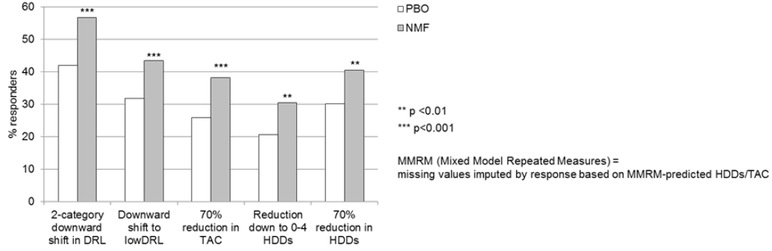
Table 33: Proportion (%) of responders, Odds Ratio for Response, and NNTB at Month 6 (MMRM, logistic regression) – Target Population – Studies 12014A and 12023A pooled.
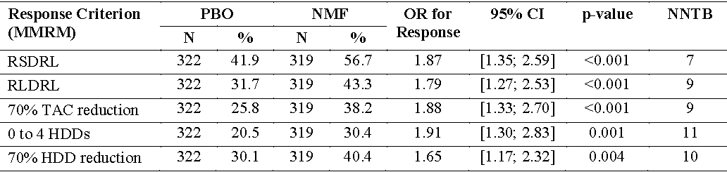
MMRM (Mixed Model Repeated Measures) = missing values imputed by response based on MMRM-predicted HDDs/TAC
Table 34: WHO DRL of alcohol consumption (g/day) for health problems based on the level of daily alcohol consumption.
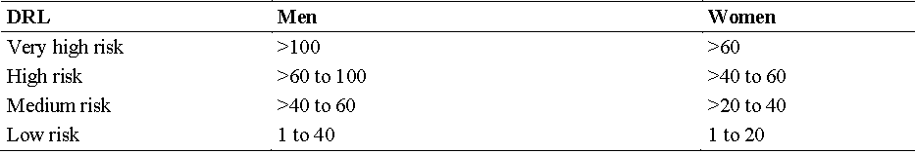
The CGI – Severity of Illness (CGI-S) and CGI – Global Improvement (CGI-I) reflect the global clinical judgement of the severity of a patient’s clinical condition and improvement or worsening. The differences to placebo for CGI-S and CGI-I at Week 24, ranging between 0.3 and 0.6 points, are highly clinically relevant. The improvements were observed already at Week 2 and maintained throughout the treatment period.
The liver enzymes GGT and ALAT were defined as secondary efficacy variables in the studies as they serve as valid liver function biomarkers. There were greater improvements in gamma glutamyl transpeptidase (GGT) and alanine transaminase (ALAT) (markers of hepatic cytolysis) at Week 24 in the nalmefene group than in the placebo group (Table 35), which further confirms the clinical relevance of nalmefene in reducing drinking.
Table 35: GGT and ALAT at Week 24 (MMRM) – Target Population.
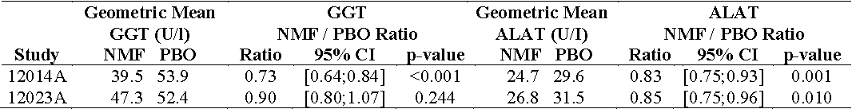
MMRM (Mixed Model Repeated Measures) = missing values imputed by response based on MMRM-predicted HDDs/TAC
The patients reported improvements in HRQoL. Favourable treatment effects for the SF-36 Mental Component Summary score (assessing mental aspects of perceived health status), the EQ-5D health state score and utility index score (measuring wellbeing), and the DrInC-2R total score (assessing alcohol related problems) were seen.
The clinical benefit of NMF treatment is supported by a systematic literature review that showed that high risk drinkers have a higher risk of developing a large number of diseases and experiencing harmful events (for example, traffic accidents and crime) than low risk drinkers. For example, high risk drinkers have a relative risk of cirrhosis of 5.1, pancreatitis of 2.6, and traffic accident of 52, compared to low risk drinkers.
The NNTBs, in the range of 7 to 11, for nalmefene in the responder analyses are highly clinically relevant considering the significant differences in relative risk of alcohol related harm between a high DRL and a low DRL.

Unmet medical need and new treatment paradigm
Alcohol dependence (as defined in DSM-IV) is one of the most common disorders of the CNS in Australia, with an estimated annual prevalence between 3% and 4%. Although the prevalence and harm associated with heavy drinking in individuals with alcohol use disorders is significant across the Australian community, and the level of presentations to primary care is high, treatment of AUDs in Australia remains inadequate. Only 22% of Australians with AUDs reported receiving treatment for their condition in the previous 12 months. Existing pharmacotherapy assisted options for alcohol treatment (naltrexone, acamprosate, and disulfiram) are limited to abstinence only, and fail to take into account the heterogeneity of the condition.
Treatment strategies for alcohol use disorders in Australia are insufficient for a large number of patients who need to significantly reduce their drinking. A new treatment option, such as nalmefene in conjunction with psychosocial support, which engages patients early and puts them in charge of disease management, may help to fill the treatment gap, especially for those not accepting abstinence as a realistic treatment goal. A reduction oriented treatment goal may help patients with alcohol use disorders to proactively seek and engage in treatment, and thereby achieve clinically relevant benefits by reducing the risk of alcohol related harm. The treatment aim of nalmefene in conjunction with psychosocial support is harm reduction through the reduction of alcohol consumption. Harm reduction is one of the pillars underpinning Australia’s National Drug Strategy, and it is supported by the National Guidelines and current international opinion.
The treatment path for nalmefene (Figure 4) will follow the well established two step approach in which only patients unable to reduce their alcohol consumption after psychosocial intervention are commenced on pharmacotherapy in addition to psychosocial support. Nalmefene is not intended for patients with complex needs (for example, patients with severe physical withdrawal syndrome requiring immediate inpatient detoxification), but rather for patients for whom a reduction oriented treatment goal can be an option. It is in line with the Australian guidelines. In addition, the as-needed dosing concept engages patients with alcohol use disorders in an active and responsible management of their illness, and should be seen as an integrated part of the disease management. Physicians will be supported with comprehensive educational material on the disease state, including screening, diagnosis, and treatment options.
Figure 4: Proposed clinical treatment algorithm.
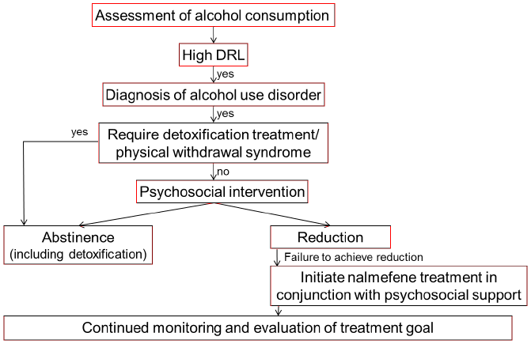

Issue 2: Whether the amendments to the ‘Clinical Trials’ section of the PI to describe the pivotal trials provide sufficient disclosure of the level of evidence supporting efficacy of nalmefene.

Sponsor’s response
The Delegate’s proposed amendments to the ‘Clinical Trials’ section of the PI are considered to provide greater disclosure of the clinical trial evidence supporting the efficacy of NMF. To ensure consistency in the presentation of these data, the sponsor has proposed additional changes as outlined in the revised PI, while incorporating changes in line with those recommended by the Delegate.
As suggested by the Delegate, information from Table 36 below (taken from the clinical evaluation report), has been added (Table 1 in the PI). In order to provide a sufficient description of efficacy, baseline values and MMRM estimates for each treatment group at Month 6 are also included for the total population. LOCF is omitted as it is not considered to provide additional value. For consistency, Table 2 in the PI is added to describe the efficacy of nalmefene in the target population. Appropriate text has been added to facilitate the incorporation of these new data and to explain the transition to the target population.
Table 36: Results for the Co-Primary Efficacy Variables at Month 6 (FAS) – Lundbeck14.
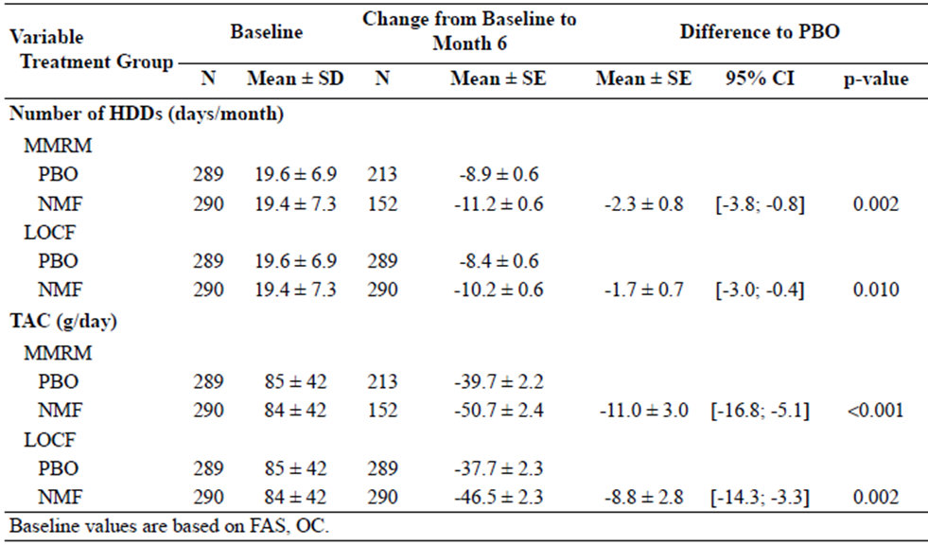

Issue 3: Whether the proposed amended indication is sufficiently clear to potential prescribers.

Sponsor’s response
The sponsor believes that the revised indication, as proposed by the Delegate, but with minor modifications as described earlier in this response, provides the physician with clear guidance to ensure that nalmefene will only be prescribed to patients likely to gain the most benefit from treatment in conjunction with continuing psychosocial support.

Overall conclusion and regulatory status in key markets
The appropriateness and validity of the post hoc defined target population and analyses have been established. Clinical studies have demonstrated clinical efficacy and relevance in the target population. The results have been appropriately translated into the Australian PI. Nalmefene when used with psychosocial support extends the treatment options for patients with alcohol use disorder.
Nalmefene was approved in the EU on 25 February 2013 and in Switzerland on 15 April 2014. For commercial reasons, marketing applications for nalmefene have not been submitted in Canada or in the US. Evaluation is ongoing in Singapore at the time of this response.

Advisory Committee Considerations
The ACPM, taking into account the submitted evidence of pharmaceutical quality, safety and efficacy, advised that Selincro film coated tablets containing 18 mg of nalmefene (as hydrochloride dihydrate) has an overall negative benefit-risk profile for the sponsor’s proposed indication.
In making this recommendation, the ACPM:
- Noted, in relation to the pivotal clinical trials:
  - There were extensive exclusion criteria including medical and psychiatric co-morbidities and other substance dependence. While these exclusions are consistent with the recommendations in the Guideline on the Development of Medicinal Products for the Treatment of Alcohol Dependence, they limit the generalisability of the results.
  - There was the potential for bias; including from a possible unblinding effect due to side effects or taste, high withdrawal rates (due to AEs) which varied across treatment groups in one of the pivotal studies and the application of a post hoc analysis and subsequent selection of the proposed target population
  - There were substantial protocol breaches and compliance issues reported.
  - Multiple post hoc subgroup analyses were performed, then results of a narrow subgroup post hoc analysis used to claim efficacy and select proposed treatment group.
  - The lack of investigation of effect size of psychosocial treatment and translation of claimed efficacy from trial to practice setting.
- The proposed description of the pivotal clinical trials in the PI was selective and failed to adequately disclose the selection process for the target population.
- Expressed concern over:
  - The pharmacokinetic interaction reported showing the potential for an increase in ethanol exposure;
  - The limited long term efficacy data in the target population and limited overall long term safety data;
  - The difficulty identifying patients within the proposed target population in clinical practice;
  - The unresolved safety issues which included a lack of detail on the 8 deaths reported which would have allowed the committee to consider the likelihood of treatment involvement and the lack of investigation of possible increased alcohol levels and driving safety.
- Was of the view that while the Delegate advised the sponsor’s approach to demonstrating acceptable efficacy is reasonable under the terms of a draft EMA guideline relating to post hoc data management, this guideline is yet to be adopted by any jurisdiction.
- The ACPM agreed with the clinical evaluator that the many flaws in the submission prevent any reliable conclusion about meaningful clinical efficacy for any population group with alcohol use disorder.

Specific advice
The ACPM advised the following in response to the Delegate’s specific questions on this submission:
- Whether the evidence of efficacy in the proposed population should be accepted given the post hoc selection of that population and subsequent re-analysis of data.
The ACPM advised the use of post hoc selection for the proposed target population was inappropriate. The post hoc selection target for nalmefene treatment was the set of patients who cannot curtail their drinking after an initial counselling and monitoring process. The pivotal studies were not designed primarily to identify efficacy in those patients.
- Whether the amendments to the ‘Clinical Trials’ section of the PI to describe the pivotal trials provide sufficient disclosure of the level of evidence supporting efficacy of nalmefene.
The ACPM was of the view that post hoc analyses played a very prominent part in the sponsor’s presentation of the results. In particular, the sponsor emphasised results in one particular subgroup, which was not identified in the study protocol, but which was subsequently given increasing prominence, culminating in the proposed description in the PI which described only the results in this subgroup, inappropriately omitting the primary efficacy results.
- Whether the proposed amended indication is sufficiently clear to potential prescribers. The indication proposed by the Delegate is:
Selincro is indicated for the reduction of alcohol consumption in adult patients with alcohol use disorder who have an average daily consumption of alcohol of more than 60 g for men and more than 40 g for women.
Selincro should be prescribed only after participation in a psychosocial support program for at least 2 weeks has failed to produce an adequate response.
Selincro should be prescribed in conjunction with continuing psychosocial support focused on treatment adherence and reducing alcohol consumption.
Selincro is not suitable for patients with physical withdrawal syndrome or who require immediate detoxification.
The ACPM advised the submitted efficacy studies suggest that nalmefene has some efficacy under carefully controlled trial conditions, but they failed to provide sufficient evidence of a clinically significant effect for the population as a whole. The pivotal studies were not designed primarily to identify efficacy in the post hoc population finally nominated as the target population. There are substantial features of the design and analysis of the pivotal efficacy studies which are of concern and suggest that those studies have not adequately demonstrated clinically significant efficacy of nalmefene in any patient group. The use of abstinence focused outcome measures and/or alcohol free days and/or relapse prevention related outcomes would also be preferable to those used in the pivotal studies.

Post ACPM discussions

Sponsor’s response to ACPM minutes & resolution
After this advice was received the sponsor sought permission from the TGA to respond to issues raised by the ACPM.
The sponsor responded to the concerns of the ACPM in a consolidated post ACPM response addressing the outstanding issues. The response included independent statements from two senior clinicians and an expert biostatistician.
In addition to the arguments provided by the sponsor in their comments on the Second Round Evaluation, further justification for the selection of the target population and the interpretation of results was provided by the sponsor by considering two recent publications on regulatory perspectives on subgroup analyses authored by statisticians working for the Medicines and Healthcare Products Regulatory Agency (MHRA) and the FDA. This further established the validity of the post hoc defined target population in addition to the criteria laid out in the draft EMA guideline.
The draft EMA Guideline on the investigation of subgroups in confirmatory clinical studies addresses several scenarios where it is of interest to identify a subgroup that has not been pre-specified as part of the confirmatory testing strategy, and where a relevant treatment effect is evident and there is compelling evidence of a favourable benefit-risk. Based on the outcome of the marketing authorisation application (MAA) approval and the learnings during the EU regulatory procedure, the indication and patient population proposed for Australia reflect the same as approved in the EU.
Both Hemmings and the draft EMA guideline discuss that the manner in which a subgroup is identified is of paramount importance for the credibility and interpretation of results from a subgroup analysis; not only observed data but also any a priori discussion on a subgroup, relevant external data and plausibility of the finding must be taken into account. It is essential to minimise purely data driven decisions because of the known multiplicity issues.
The identification of the target population was not arbitrary and was not a result of performing multiple subgroup analyses.
- Scientific advice focuses on the patients with a high or very high DRL at baseline, an analysis of this subgroup was pre-specified in the SAP for each study. No other subgroup analyses were pre-specified in SAP, thus a priori DRL was identified as a ‘key’ exploratory factor for predicting response to treatment.
- The further refinement of the subgroup still based on DRL was introduced post hoc based on the observation that a sizeable portion of patients in the three Lundbeck studies reduced their alcohol consumption during the screening assessments between the Baseline Visit and the Randomisation Visit. At randomisation, these patients consumed such a small amount of alcohol that there was little room for further improvement (floor effect) and consequently there was no difference in efficacy between the nalmefene and placebo groups throughout the treatment period. Thus, this group of patients provides a clinically and scientifically plausible explanation for heterogeneity in treatment effect in the total population. The plausibility is further supported by external data. Reduction in alcohol consumption during the assessment period prior to randomisation has been observed in other studies and can have an impact on study outcome.
- At the consultations with the regulatory authorities in EU prior to the MAA submission the ‘early reducers’ were discussed. The study results were later discussed with the EMA Rapporteur and Co-rapporteur during the procedure, and the population of high or very high DRL at baseline and randomisation was validated as the population with the highest need for treatment, thereby constituting the proposed target population. Targeting the population who did not reduce their alcohol consumption after an initial period of observation (1 to 2 weeks between screening and randomisation in the clinical studies) is highly clinically relevant and in line with clinical practice. During the EU procedure, the EMA Scientific Advisory Group (SAG) recognised the validity of post hoc defining the target population, and the clinical relevance of the treatment effect in the target population was supported by the EU medical community.
The credibility of the results from a subgroup analyses and interpretation of results from a subgroup analysis is discussed in EMA points to consider on multiplicity issues in clinical trials (adopted by the TGA in June 2005) and the discussion is extended in the draft EMA guideline on the investigation of subgroups in confirmatory clinical studies (the TGA added the Concept Paper for this draft guideline to the list of guidance documents on 1 April 2014). In the draft guideline some key criteria are listed to assess the validity of the results obtained from a subgroup of patients defined post hoc. For the target population of patients with a high or very high DRL at baseline and randomisation, these criteria were all fulfilled (see sponsor’s answer to Question 8 in the Section 31 Request for Information).
- External evidence exists that the target population of interest is a well-defined and clinically relevant entity in need of a therapeutic intervention.
- The nalmefene treatment effect in the target population is more pronounced than in the total population.
- There is no imbalance in baseline characteristics between the treatment groups in each of the studies, which contributes to the reliability of individual study results.
- Replication of evidence for efficacy in the target population across 4 placebo controlled double blinded Phase III clinical studies (Figure 5).
Figure 5: Changes from baseline at primary endpoint in HDDs and TAC (g/day) for total, target and non target population: Studies 12014A, 12023A, 12013A and CPH-101-801.
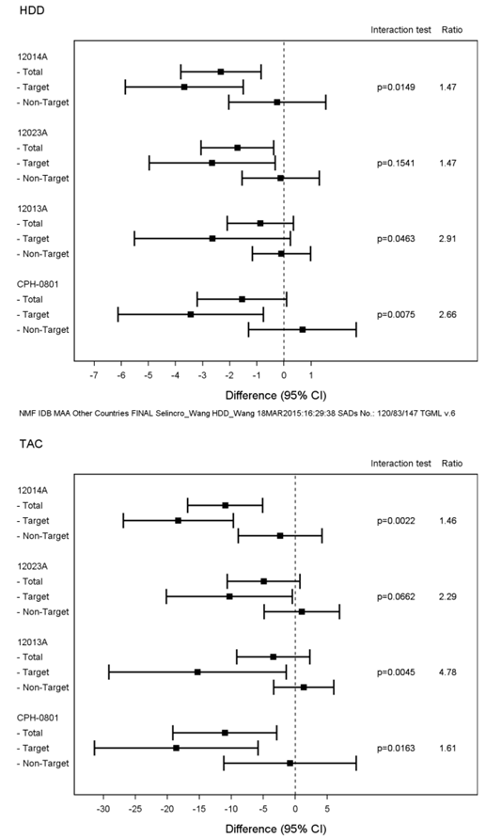
In the evaluation of the benefit-risk balance, Hemmings points outs that
considering the difficult problems of drawing inferences from subgroups a greater weight is commonly given to plausibility and to replication than to p-values or individual point estimates.
Based on this holistic approach, the benefit-risk balance is favourable for the post hoc target population of patients with a high or very high DRL at baseline and randomisation, as both plausibility and replication have been established.
A number of references were consulted and consistent with the statistical approach used in the post hoc analysis of pivotal clinical trial data.
The sponsor acknowledges that there were high and variable withdrawal rates in study 12014A, with a higher withdrawal rate in the nalmefene group. The difference between the treatment groups in the timing and proportion of withdrawals in Study 12014A was driven by the greater proportion of patients who withdrew early due to AEs in the nalmefene group than in the placebo group.
A careful evaluation of the impact of the withdrawal on the efficacy conclusions has been done. Data from both the sponsor sponsored clinical studies and other published studies suggest that patients maintain reduced alcohol consumption after withdrawal from treatment.
The justification for the post hoc defined target population and the robustness of the treatment effect was further supported by an independent biostatistical expert statement.
In summary, the outcome of the subgroup analyses was consistent and robust across all four Phase III studies. The credibility and validity of the interpretation and conclusion of the results from the target population are supported by the draft EMA guideline on the investigation of subgroups in confirmatory clinical trials, as well as by considering the holistic approach discussed by Hemmings and the decision rules proposed by Wang and Hung for rigorous post hoc subgroup specific conclusions.

Outcome
Based on a review of quality, safety and efficacy, TGA approved the registration of Selincro nalmefene (as hydrochloride dihydrate) 18 mg film coated tablet blister pack, indicated for:
Selincro is indicated for the reduction of alcohol consumption in adult patients with alcohol use disorder who have an average daily consumption of alcohol of more than 60 g for men and more than 40 g for women.
Selincro should be prescribed only if the patient has failed to achieve an adequate response following psychosocial intervention for at least 2 weeks.
Selincro should be prescribed in conjunction with continuing psychosocial support focused on treatment adherence and reducing alcohol consumption.
Selincro is not suitable for patients with physical withdrawal syndrome or who require immediate detoxification.

Specific conditions of registration applying to these goods
- The nalmefene RMP, version 3 dated 30 April 2014 (data lock point 25 August 2013) with the ASA version 1.0 dated May 2014, and any subsequent revisions, as agreed with the TGA will be implemented in Australia.

Attachment 1. Product Information
The PI approved for Selincro at the time this AusPAR was published is at Attachment 1. For the most recent PI, please refer to the TGA website at <www.tga.gov.au/product-information-pi>.

Attachment 2. Extract from the Clinical Evaluation Report

Therapeutic Goods Administration
PO Box 100 Woden ACT 2606 Australia
Email: info@tga.gov.au Phone: 1800 020 653 Fax: 02 6232 8605
https://www.tga.gov.au

Australian Government Department of Health and Ageing, Guidelines for the Treatment of Alcohol Problems, Canberra 2009.
European Medicines Agency, “ICH Topic Q 3 B (R2) Impurities in New Drug Products, Step 5: Note for Guidance on Impurities in New Drug Products (CPMP/ICH/2738/99)”, June 2006.
“CPH-101” is the company code for an early formulation nalmefene hydrochloride 20 mg tablet.
In cardiology, the QT interval is a measure of the time between the start of the Q wave and the end of the T wave in the heart’s electrical cycle.
The QRS complex is a name for the combination of three of the graphical deflections seen on a typical ECG. It is usually the central and most visually obvious part of the tracing. It corresponds to the depolarisation of the right and left ventricles of the human heart
Osborne BE, Leach GD. (1971) The beagle electrocardiogram. Food Cosmet Toxicol. 9: 857-864.
The values in humans are not adequately explained. The sponsor points out these results do not refer to drug related material, that is, the sum of parent and metabolites. Since the comparison is of the drug related material in the animals, the values in humans should also be drug related material. The sponsor cites these are 2-33%, which are similar to the animals.
Leblanc B, et al. 91998) Binding of drugs to eye melanin is not predictive of ocular toxicity. Regul Toxicol Pharmacol. 28: 124-132.
Bauman JN, et al. (2005) Udp-glucuronosyltransferase 2b7 is the major enzyme responsible for gemcabene glucuronidation in human liver microsomes. Drug Metab Dispos. 33: 1349-1354.
Knights KM, et al. (2010) Spironolactone and canrenone inhibit UGT2B7-catalyzed human liver and kidney microsomal aldosterone 18beta-glucuronidation: a potential drug interaction. Drug Metab Dispos. 38: 1011-1014.
European Medicines Agency, “ICH Topic S 4 Duration of Chronic Toxicity Testing in Animals (Rodent and Non Rodent Toxicity Testing), Step 5: Note for Guidance on Duration of Chronic Toxicity Testing in Animals (Roden and Non Rodent Toxicity Testing (CPMP/ICH/300/95)”, May 1999.
International Conference on Harmonisation of Technical Requirements for Registration of Pharmaceuticals for Human Use, “ICH Harmonised Tripartite Guideline: Guidance on Genotoxicity Testing and Data Interpretation for Pharmaceuticals Intended for Human Use, S2(R1)", 9 November 2011.
European Medicines Agency, “ICH Topic S 2 A Genotoxicity, Specific Aspects of Regulatory Genotoxicity Tests for Pharmaceuticals, Step 5, Note for Guidance on Genotoxicity: Specific Aspects of Regulatory Genotoxicity Tests for Pharmaceuticals (CPMP/ICH/141/95)”, April 1996.
European Medicines Agency, Committee for Proprietary Medicinal Products, “Note for guidance on carcinogenic potential (CPMP/SWP/2877/00)”, 25 July 2002.
European Medicines Agency, Committee for Proprietary Medicinal Products, “Note for guidance on carcinogenic potential (CPMP/SWP/2877/00)”, 25 July 2002.
Storer RD, et al. (2010) An industry perspective on the utility of short-term carcinogenicity testing in transgenic mice in pharmaceutical development. Toxicol Pathol. 38: 51-61.
European Medicines Agency, “ICH Topic S 5 (R2), Detection of Toxicity to Reproduction for Medicinal Products & Toxicity to Male Fertility, Step 5: Note for Guidance on the Detection of Toxicity to Reproduction for Medicinal Products & Toxicity to Male Fertility (CPMP/ICH/386/95)”, March 1994.
European Medicines Agency, “ICH Topic S 5 (R2), Detection of Toxicity to Reproduction for Medicinal Products & Toxicity to Male Fertility, Step 5: Note for Guidance on the Detection of Toxicity to Reproduction for Medicinal Products & Toxicity to Male Fertility (CPMP/ICH/386/95)”, March 1994.
Category C: “Drugs which, owing to their pharmacological effects, have caused or may be suspected of causing, harmful effects on the human foetus or neonate without causing malformations. These effects may be reversible. Accompanying texts should be consulted for further details.”
Category B3: “Drugs which have been taken by only a limited number of pregnant women and women of childbearing age, without an increase in the frequency of malformation or other direct or indirect harmful effects on the human foetus having been observed. Studies in animals have shown evidence of an increased occurrence of foetal damage, the significance of which is considered uncertain in humans.”
Magnusson B, Kligman AM. (1970) Identification of contact allergens in ‘Allergic Contact Dermatitis in the Guinea Pig’, Ed. Magnusson, B. and Kligman, A.M., C.C. Thomas, Illinois, USA, pp. 102-123.
Dearman RJ, et al. (1999) Local lymph node assay: use in hazard and risk assessment. J Appl Toxicol. 19: 299-306.
European Medicines Agency, Committee for Medicinal Products for Human Use (CHMP), “Guideline on the Non-Clinical Investigation of the Dependence Potential of Medicinal Products (EMEA/CHMP/SWP/94227/2004)”, 23 March 2006.
Narita M, et al. (2001) Regulations of opioid dependence by opioid receptor types. Pharmacol. Ther. 89: 1-15.
European Medicines Agency, Committee for Medicinal Products for Human Use (CHMP), “Guideline on the development of medicinal products for the treatment of alcohol dependence (EMA/CHMP/EWP/20097/2008)”, 18 February 2010.
Sadock BJ, Sadock VA. Kaplan and Sadock’s Comprehensive textbook of psychiatry. Philadelphia: Lippincott Williams & Wilkins, 2004; Miller WR, et al. (2001) How effective is alcoholism treatment in the United States? J. Stud. Alcohol 62: 211-220.
Gual A, et al. (1999) Five-year outcome in alcohol dependence. A naturalistic study of 850 patients in Catalonia. Alcohol 34: 183-192.
World Health Organisation, Department of Mental Health and Substance Dependence Noncommunicable Diseases and Mental Health Cluster, “International guide for monitoring alcohol consumption and related harm”, 2000.
European Medicines Agency, Committee for Medicinal Products for Human Use (CHMP), “Guideline on the development of medicinal products for the treatment of alcohol dependence (EMA/CHMP/EWP/20097/2008)”, 18 February 2010.
International Conference on Harmonisation of Technical Requirements for Registration of Pharmaceuticals for Human Use, “ICH Harmonised Tripartite Guideline: Guideline for Good Clinical Practice E6(R1)", 10 June 1996.
Australian Government Department of Health and Ageing, Guidelines for the Treatment of Alcohol Problems. Canberra, 2009.
European Medicines Agency, “Committee for Medicinal Products for Human Use (CHMP). Draft Guideline on the investigation of subgroups in confirmatory clinical trials (EMA/CHMP/539146/2013)”, 23 January 2014.
McCambridge J, Kypri K. (2011) Can simply answering research questions change behaviour? Systhematic review and metaanalysis of brief alcohol intervention trials. PLoS One 6: e23748; Kaner EF, et al. Effectiveness of brief alcohol interventions in primary care populations (Review). The Cochrane Collaboration. John Wiley & Sons Ltd, 2009, Issue 4; McQueen J, et al. Brief interventions for heavy alcohol users admitted to general hospital wards (Review). The Cochrane Collaboration. Published by John Wiley & Sons, Ltd, 2011, Issue 8; Beich A, Thorsen T, Rollnick S. (2003) Screening in brief intervention trials targeting excessive drinkers in general practice: systematic review and meta-analysis. BMJ 327: 536-542.
Epstein EE, et al. (2005) Is alcohol assessment therapeutic? Pretreatment change in drinking among alcohol-dependent women. J Studies Alcohol 66: 369-378; Litten RZ, et al. A double-blind, placebo-controlled trial to assess the efficacy of quetiapine fumarate XR in very heavy-drinking alcohol dependent patients. Alcohol Clin Exp Res. 36: 406-416.
European Medicines Agency, Committee for Medicinal Products for Human Use (CHMP), “Guideline on the development of medicinal products for treatment of alcohol dependence (EMA/CHMP/EWP/20097/2008)”, 22 January 2009.
Cuijpers P, et al. (2004) The effects on mortality of brief interventions for problem drinking: a meta-analysis. Addiction 99: 839-845; Rehm J, et al. (2011) Epidemiology and alcohol policy in Europe. Addiction 106(Suppl 1): 11-19; Nutt DJ, Rehm, J. (2014) Doing it by numbers: a simple approach to reducing the harms of alcohol. J Psychopharmacol. 28: 3-7; World Health Organisation (WHO), Global Status Report on Alcohol and Health 2011. Geneva, Switzerland: WHO Press; 2011.
Australian Government, Department of Health and Ageing: Guidelines for the Treatment of Alcohol Problems. Canberra, 2009; National Institute for Health and Clinical Excellence (NICE), Alcohol dependence and harmful alcohol use: Appendix 17d – pharmacological interventions forest plots, 2011.
Leucht S, et al. (2012) Putting the efficacy of psychiatric and general medicine medication into perspective: review of meta-analyses. Br J Psychiatry 200: 97-106.
National Institute for Health and Clinical Excellence (NICE), Alcohol dependence and harmful alcohol use: Appendix 17d – pharmacological interventions forest plots, 2011; Kranzler HR, Van Kirk J. (2001) Efficacy of naltrexone and acamprosate for alcoholism treatment: a meta-analysis. Alcohol Clin Exp Res. 25: 1335-1341.
Leucht S, et al. (2012) Putting the efficacy of psychiatric and general medicine medication into perspective: review of meta-analyses. Br J Psychiatry 200: 97-106.
Leucht S, et al. (2012) Putting the efficacy of psychiatric and general medicine medication into perspective: review of meta-analyses. Br J Psychiatry 200: 97-106.
[No authors listed] (1995) Clinical relevance of response and improvement in psychopharmacology: European College of Neuropsychopharmacology. Eur Neuropsychopharmacol. 5: 531-533.
World Health Organisation (WHO), International guide for monitoring alcohol consumption and related harm, 2000.
Wittchen HU, et al. (2011) The size and burden of mental disorders and other disorders of the brain in Europe 2010. Eur Neuropsychopharmacol. 21: 655-679; Rehm J, et al. (2013) Modeling the impact of alcohol dependence on mortality burden and the effect of available treatment interventions in the European Union. Eur Neuropsychopharmacol. 23: 89-97; Teesson M, et al. (2010) Prevalence and correlates of DSM-IV alcohol abuse and dependence in Australia: findings of the 2007 National Survey of Mental Health and Wellbeing. Addiction 105: 2085-2094.
Australian Institute for Health and Welfare (AIHW), General practice activity in Australia 2009-10, Canberra 2010.
Saitz R, et al. (2003) Alcohol and medication interactions in primary care patients: common and unrecognized. Am J Med. 114: 407-410.
Teesson M, et al. (2010) Prevalence and correlates of DSM-IV alcohol abuse and dependence in Australia: findings of the 2007 National Survey of Mental Health and Wellbeing. Addiction 105: 2085-2094.
National Health and Medical Research Council (NHMRC), Australian Guideline to Reduce Health Risks from Drinking Alcohol, Canberra 2009.
Rehm J, Roerecke M. (2013) Reduction of drinking in problem drinkers and all-cause mortality. Alcohol 48: 509-513.
Australian Government Department of Health and Ageing, Guidelines for the Treatment of Alcohol Problems, Canberra 2009.
European Medicines Agency, Committee for Medicinal Products for Human Use (CHMP), “Guideline on the development of medicinal products for the treatment of alcohol dependence (EMA/CHMP/EWP/20097/2008)”, 18 February 2010.
European Medicines Agency, Committee for Medicinal Products for Human Use (CHMP), “Draft guideline on the investigation of subgroups in confirmatory clinical trials (EMA/CHMP/539146/2013)”, 23 January 2014.
Hemmings R. (2014) An overview of statistical and regulatory issues in the planning, analysis, and interpretation of subgroup analyses in confirmatory clinical trials. J Biopharm Stat. 24: 4-18.
European Medicines Agency, Committee for Medicinal Products for Human Use (CHMP), “Draft guideline on the investigation of subgroups in confirmatory clinical trials (EMA/CHMP/539146/2013)”, 23 January 2014.
European Medicines Agency, Committee for Medicinal Products for Human Use (CHMP), “Draft guideline on the investigation of subgroups in confirmatory clinical trials (EMA/CHMP/539146/2013)”, 23 January 2014; Hemmings R. (2014) An overview of statistical and regulatory issues in the planning, analysis, and interpretation of subgroup analyses in confirmatory clinical trials. J Biopharm Stat. 24: 4-18
See sponsor’s comments on second round Clinical Evaluation Report.
European Medicines Agency, Committee for Medicinal Products for Human Use (CHMP), “Draft guideline on the investigation of subgroups in confirmatory clinical trials (EMA/CHMP/539146/2013)”, 23 January 2014.
Hemmings R. (2014) An overview of statistical and regulatory issues in the planning, analysis, and interpretation of subgroup analyses in confirmatory clinical trials. J Biopharm Stat. 24: 4-18.
Hemmings R. (2014) An overview of statistical and regulatory issues in the planning, analysis, and interpretation of subgroup analyses in confirmatory clinical trials. J Biopharm Stat. 24: 4-18; Wang SJ, Hung HM. (2014) A regulatory perspective on essential considerations in design and analysis of subgroups when correctly classified. J Biopharm Stat. 24: 19-41.
European Medicines Agency, Committee for Medicinal Products for Human Use (CHMP), “Draft guideline on the investigation of subgroups in confirmatory clinical trials (EMA/CHMP/539146/2013)”, 23 January 2014.
Hemmings R. (2014) An overview of statistical and regulatory issues in the planning, analysis, and interpretation of subgroup analyses in confirmatory clinical trials. J Biopharm Stat. 24: 4-18.
Wang SJ, Hung HM. (2014) A regulatory perspective on essential considerations in design and analysis of subgroups when correctly classified. J Biopharm Stat. 24: 19-41.

