September 2013

Australian Public Assessment Report for Nabiximols
  - Proprietary Product Name: Sativex
  - Sponsor: Novartis Pharmaceuticals Australia Pty Limited
About the Therapeutic Goods Administration (TGA)
- The Therapeutic Goods Administration (TGA) is part of the Australian Government Department of Health and is responsible for regulating medicines and medical devices.
- TGA administers the Therapeutic Goods Act 1989 (the Act), applying a risk management approach designed to ensure therapeutic goods supplied in Australia meet acceptable standards of quality, safety and efficacy (performance), when necessary.
- The work of the TGA is based on applying scientific and clinical expertise to decision-making, to ensure that the benefits to consumers outweigh any risks associated with the use of medicines and medical devices.
- The TGA relies on the public, healthcare professionals and industry to report problems with medicines or medical devices. TGA investigates reports received by it to determine any necessary regulatory action.
- To report a problem with a medicine or medical device, please see the information on the TGA website <http://www.tga.gov.au>.
About AusPARs
- An Australian Public Assessment Record (AusPAR) provides information about the evaluation of a prescription medicine and the considerations that led the TGA to approve or not approve a prescription medicine submission.
- AusPARs are prepared and published by the TGA.
- An AusPAR is prepared for submissions that relate to new chemical entities, generic medicines, major variations, and extensions of indications.
- An AusPAR is a static document, in that it will provide information that relates to a submission at a particular point in time.
- A new AusPAR will be developed to reflect changes to indications and/or major variations to a prescription medicine subject to evaluation by the TGA.
Copyright
© Commonwealth of Australia 2013
This work is copyright. You may reproduce the whole or part of this work in unaltered form for your own personal use or, if you are part of an organisation, for internal use within your organisation, but only if you or your organisation do not use the reproduction for any commercial purpose and retain this copyright notice and all disclaimer notices as part of that reproduction. Apart from rights to use as permitted by the Copyright Act 1968 or allowed by this copyright notice, all other rights are reserved and you are not allowed to reproduce the whole or any part of this work in any way (electronic or otherwise) without first being given specific written permission from the Commonwealth to do so. Requests and inquiries concerning reproduction and rights are to be sent to the TGA Copyright Officer, Therapeutic Goods Administration, PO Box 100, Woden ACT 2606 or emailed to <tga.copyright@tga.gov.au>.

Contents
I. Introduction to product submission 5
Submission details 5
Document outline 5
Product background 6
Regulatory status 7
Product Information 10
List of abbreviations 10
II. Quality findings 12
Drug substance (active ingredient) 12
Drug product 13
Biopharmaceutics 13
Recommendations 15
III. Nonclinical findings 16
Introduction 16
Pharmacology 16
Pharmacokinetics 18
Toxicology 20
Nonclinical summary and conclusions 25
IV. Clinical findings 27
Introduction 27
Pharmacokinetics 31
Pharmacodynamics 45
Dose selection for the pivotal studies 50
Efficacy 50
Safety 109
First round risk-benefit assessment 143
List of questions 156
Second round evaluation in response to questions 156
Second round risk-benefit assessment 162
V. Pharmacovigilance findings 162
Risk management plan 162
VI. Overall conclusion and risk-benefit assessment 170
Quality 170
Nonclinical 171
Clinical 171
Risk management plan 177
Risk-benefit analysis 178
Response from sponsor 181
Advisory committee considerations 187
Outcome (initial decision) 187
Final outcome (Section 60 decision) 189
Attachment 1. Product Information 203

I. Introduction to product submission

Submission details
Type of submission: | New Chemical Entity
Decision: | Approved
Date of decision: | 26 November 2012
Active ingredient: | Nabiximols
Product name: | Sativex
Sponsor’s name and address: | Novartis Pharmaceuticals Australia Pty Limited  54 Waterloo Road  North Ryde NSW 2113
Dose form: | Oromucosal spray
Strength: | Nabiximols 80 mg/mL corresponding to 27 mg/mL delta-9 tetrahydrocannabinol (THC) and 25 mg/mL cannabidiol (CBD)
Container: | Type I amber glass vial with external plastic coating, fitted with a crimped on pump actuator
Pack size: | 10 mL
Approved therapeutic use: | Treatment for symptom improvement in patients with moderate to severe spasticity due to multiple sclerosis (MS) who have not responded adequately to other anti spasticity medication and who demonstrate clinically significant improvement in spasticity related symptoms during an initial trial of therapy.
Route of administration: | Oromucosal
Dosage: | Patients should titrate the dose as needed between 1-12 sprays daily (2.7-32.4 mg THC and 2.5-30 mg CBD) in 2 or more divided doses. It is expected to usually be delivered sublingually. A titration schedule (to a maximum of 12 sprays daily) over 2 weeks is proposed.
ARTG number: | 181978

Document outline
This AusPAR follows the sequence of events for the review of the nabiximols (Sativex) submission as follows:
- Evaluator reports;
- Delegate’s initial considerations (including Conclusion and recommendation);
- Pre ACPM (Advisory Committee on Prescription Medicines) response from the sponsor, Novartis Pharmaceuticals Australia Pty Limited;
- ACPM Considerations;
- ACPM Outcome and Reasons for decision; and
- Opinion of the Delegate of the Minister following a sponsor appeal under Section 60 of the Therapeutics Goods Act 1989.

Product background
This AusPAR describes an application by the sponsor to register nabiximols (Sativex), a mixture of cannabinoid botanical extracts containing 27mg/ml delta-9 tetrahydrocannibinol (THC) and 25 mg/ml cannabidiol (CBD), as a new chemical entity. The proposed indication is for symptom improvement in patients with moderate to severe spasticity due to multiple sclerosis (MS) who have not responded adequately to other anti spasticity medication and who demonstrate clinically significant improvement in spasticity related symptoms during an initial trial of therapy.
Sativex represents a novel therapeutic class: botanical cannabinoids. Sativex contains two main cannabinoids derived from extracts of Cannabis sativa L., folium cum flore (Cannabis leaf and flower): THC and CBD. No members of this class have previously been approved for any medical use in Australia.

Cannabinoids
Plant derived cannabinoids are thought to act by mimicking a group of endogenous neurotransmitters, the endocannabinoids, by binding to cannabinoid receptors. The principle cannabinoid receptor in the central nervous system is type 1 (CB1), whereas the peripheral nervous system contains type 2 receptors (CB2).
THC – the first main cannabinoid in Sativex – is also the main psychoactive component of marijuana, and acts as a partial agonist at CB1 receptors. CB1 receptors are G-protein linked receptors; their activation causes an inhibition of cAMP, which is followed by phosphorylation and subsequent activation of a range of intracellular kinases. How this helps spasticity or produces psychoactivity is unclear.
However, CBD – the second main cannabinoid in Sativex – is psychoactive, and according to the sponsor it is thought to be “an inhibitor of Fatty Acid Amide Hydrolase, the main enzyme responsible for local catabolism of the principle endogenous cannabinoid, anandamide.” Thus, CBD could prolong the effect of anandamide, which is claimed to have an anti spastic action in animal models. Whether it actually has an anti spastic effect in humans is unknown.

MS related spasm
MS is one of the most common neurological diseases of young adults. It is characterised by the development of inflammatory plaques in the central nervous system, including the brain, spinal cord and optic nerves. The primary process is inflammatory damage to the myelin of the CNS, which may be reversible, but axonal damage may also occur and leads to increasing permanent disability. MS also has a degenerative component, and is associated with progressive brain atrophy. It is not a disease of the peripheral nervous system and, apart from the optic nerve which is really an elongated brain tract in functional and immunological terms, MS does not affect nerves.
Spasticity is a common symptom in MS, but it may occur in any condition that damages the upper motor pathways of the central nervous system, and it is also commonly seen in stroke and spinal cord injuries. The hallmark of spasticity is an increase in muscle tone and disinhibition of muscle stretch reflexes. Spasm is a related symptom that often accompanies spasticity characterised by the temporary unwanted contraction of muscles.
A number of drugs are used systemically to treat spasm and spasticity including baclofen, diazepam and sodium valproate.
The cannabis plants used to produce Sativex have been specifically bred to produce two separate chemotypes, expressing their cannabinoid content as high THC or high CBD, but the purification process is only partial. In addition to the specified active ingredients in Sativex, other plant compounds including other cannabinoids are present, and constitute up to 10% of the total cannabinoid content.

Regulatory status
The Sativex dossier included in this application for the indication “relief of spasticity in MS” has been approved in the following countries:
- European Union (through decentralised procedure followed by national procedure): Spain (approval July 2010); United Kingdom (approval June 2010). It was also approved through mutual recognition and national approval in Germany (approval May 2011), Denmark (approval June 2011), Sweden (approval December 2011), and Norway (approval August 2012);
- Canada (approval August 2010);
- New Zealand (gazetted October 2010).
Sativex does not have marketing authorisation in the United States.
No members of the novel therapeutic class of botanical cannabinoids have previously been approved for use in Australia for any indication, but Sativex has been used in the UK and Europe on a named patient basis for palliative analgesia and treatment of spasm. Marijuana and its derivatives have been used in Australia on an informal (and illegal) basis for many years to treat pain and a number of other complaints including muscular spasm, including MS related spasm.
Table 1 shows the international regulatory history of Sativex.
Table 1: Summary of international regulatory status of Sativex.
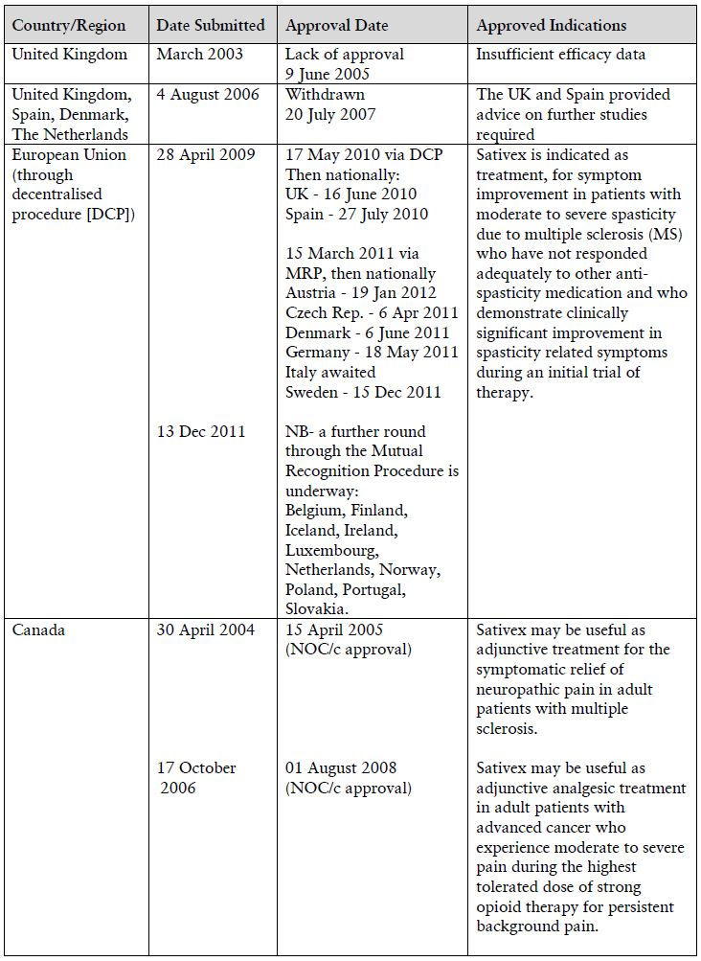
Table 1 (continued): Summary of international regulatory status of Sativex.
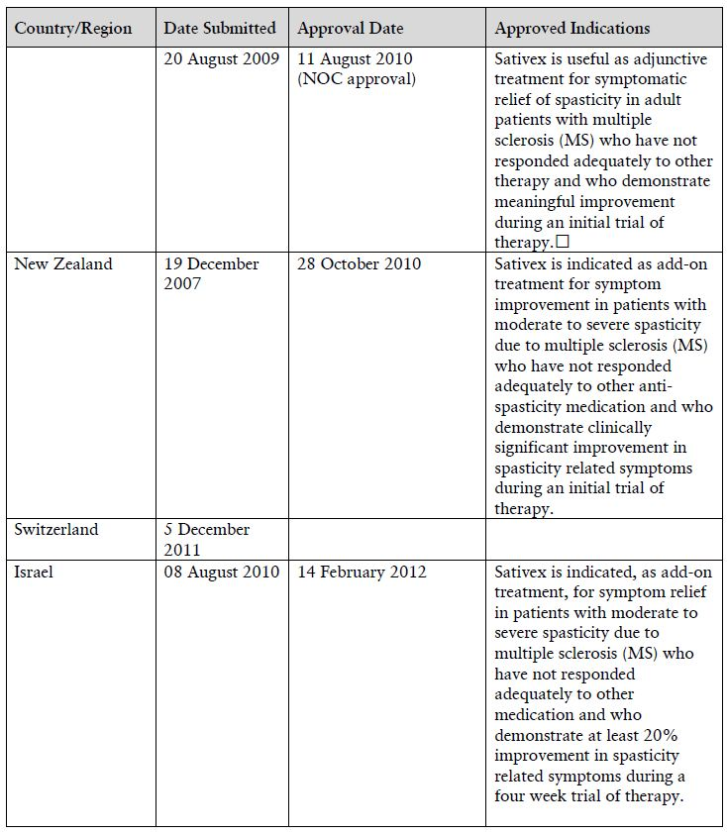
Sativex was also approved in Italy on 15 March 2011. There have been no further withdrawals, rejections or deferrals other than those outlined in Table 1.
Table 2 summarises the outcome of further mutual recognition procedure in the EU.
Table 2: Summary of outcome of further mutual recognition procedure in the EU for Sativex.
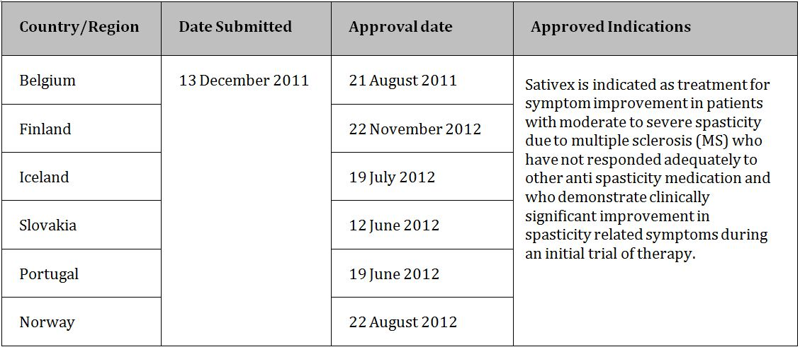

Product Information
The approved Product Information (PI) current at the time this AusPAR was prepared can be found as Attachment 1.

List of abbreviations
ACPM Advisory Committee on Prescription Medicines
ADL Barthel Activities of Daily Living
AE Adverse Event
ANCOVA Analysis of Covariance
AUC Area Under the plasma concentration-time Curve
AUC_{t1-t2} Area Under the plasma concentration-time Curve within time span t1 to t2
AUC∞ Area Under the plasma concentration-time Curve from time zero to infinity
BDI-II Beck Depression Inventory
BDS Botanical Drug Substance(s)
BRM Botanical Raw Material
C_{max} Maximum Plasma Drug Concentration
cAMP cyclic Adenosine Monophosphate
CB1 Cannabinoid Receptor type 1
CB2 Cannabinoid Receptor type 2
CBD Cannabidiol
CBME Cannabis Based Medicinal Extract
CBMs Cannabis Based Medicines
CER Clinical Evaluation Report
CGIC Carer’s Global Impression of Change
CI Confidence Interval
CME Cannabis Medicinal Extracts
CMI Consumer Medicine Information
CNS Central Nervous System
CREAE Chronic Relapsing Experimental Allergic Encephalomyelitis
Crem Cremophor
DCP Decentralised Procedure
ECG Electrocardiograph
EDSS Expanded Disability Status Scale
EQ-5D Quality of Life Questionnaires
EMG Electromyogram
ER AUC Exposure Ratio
Eth:PG Ethanol: Propylene Glycol
FAS Full Analysis Set. Data from all subjects who entered the study, were randomised, received at least one dose of study medication and yielded on treatment efficacy data.
FSH Follicle Stimulating Hormone
GCP Good Clinical Practice
GD Gestational Day
GHQ-28 General Health Questionnaire
GLP Good Laboratory Practice
GW GW Pharma Ltd
GW-1000-02 Sativex
HD High Dose (group)
hERG human Ether-à-go-go-Related Gene
IC₅₀ half maximal Inhibitory Concentration
ICH International Conference for Harmonisation
ITT Intention to Treat
IV Intravenous
IVRS Interactive Voice Response System
K_{i} inhibition constant
KLH Keyhole Limpet Hemocyanin
LD Low Dose (group)
LH Luteinizing Hormone
LOCF Last Observation Carried Forward
MCID Minimum Clinically Important Difference
MD Medium Dose (group)
MS Multiple Sclerosis
MSQoL-54 Quality of Life Questionnaire
NA Not Applicable
NOEL No Observable Effects Limit
NP Neuropathic Pain
NRS Numerical Rating Scale
NSF National Service Framework
PAE Psychiatric Adverse Event
PAR Sativex Provisional Assessment Report (UK/H/961/01/DC) of November 2006
PAS Pump Action Spray
PD Pharmacodynamic(s)
PGIC Physician’s Global Impression of Change
PI Product Information
PIR Public Information Report
PK Pharmacokinetic(s)
PO oral administration (Per Os)
PP Per Protocol
PSC Pharmaceutical Sub Committee
QoL Quality of Life
RMI Rivermead Mobility Index
RMP Risk Management Plan
SAE Serious Adverse Event
SD Standard Deviation
SE Standard Error
SOC System Order Class
SOMC Short Orientation Memory Concentration
SGIC Subject’s Global Impression of Change
SmPC Summary of Product Characteristics
SUSMP Standard for the Uniform Scheduling of Medicines and Poisons
t_{½} Half Life
T_{max} Time to reach Maximum Plasma Concentration following drug administration
TEAE Treatment Emergent Adverse Event
THC Delta-9 tetrahydrocannabinol
TRAE Treatment Related Adverse Event
VAS Visual Analogue Scale
VRS Verbal Rating Scale

II. Quality findings

Drug substance (active ingredient)
Nabiximols is a highly characterised botanical extract of defined chemotypes of Cannabis sativa L., containing THC and CBD as the major constituents, together with other cannabinoid and non cannabinoid components. The structures of THC and CBD are shown in Figure 1. The molecular formula of THC is C₂₁H₃₀O₂ and its molecular weight is 314.47. CBD has the same molecular formula (C₂₁H₃₀O₂) and molecular weight.
Figure 1: Structures of delta-9 tetrahydrocannabinol (THC) and cannabidiol (CBD).
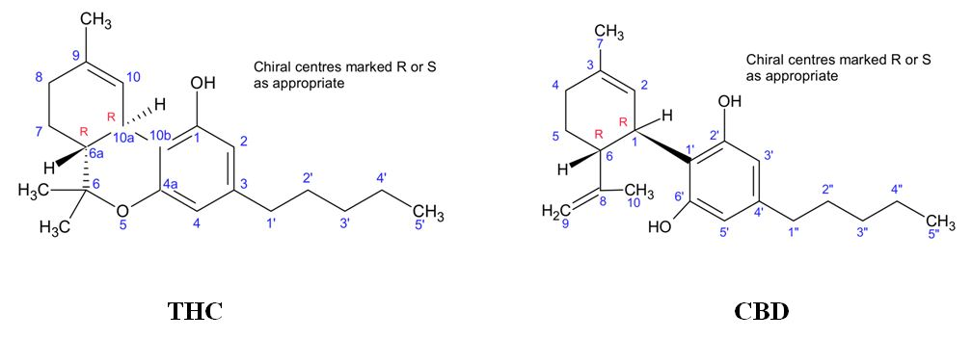
GW Pharma Limited has selectively bred Cannabis sativa L. plants over several generations to provide two plant hybrids or chemotypes, one containing high THC levels and the other containing high CBD levels. Traditional methods of plant breeding were used, with no genetic modification. Tetrahydrocannabinol Botanical Raw Material (THC BRM) and Cannabidiol Botanical Raw Material (CBD BRM) are obtained from these selected chemotypes.
The BRM contain, predominantly, tetrahydrocannabinolic acid and cannabidiolic acid (with carboxylic acid groups in the 2-position of THC and 3’-position of CBD). These raw materials are decarboxylated by heating, then extracted with liquid carbon dioxide. The BDS are assayed, then blended in the finished product in an appropriate ratio to produce the desired concentrations of THC and CBD.

Drug product
The drug product is a solution of ~56 mg/mL nabiximols in ethanol:propylene glycol (50:50) with added peppermint oil flavour. It contains 27 mg/mL THC, 25 mg/mL CBD, and ~4 mg/mL of other cannabinoids.
The solution is filled into Type I amber glass vials fitted with a metering pump possessing a polypropylene dip tube and elastomer neck covered with a polyethylene cap. The glass vial is coated externally with opaque, brown plastic. The metering pump delivers 100 µL per actuation, equivalent to 2.7 mg of THC and 2.5 mg of CBD. Each 10 mL pack size allows the delivery (after priming) of up to 90 actuations. The product is sprayed onto the inside of the cheek or under the tongue.

Biopharmaceutics
Several bioavailability studies were performed on various prototype formulations, including nebulisers, aerosols, sublingual drops and a number of oromucosal spray formulations. The most relevant study was Study GWPK0109, which compared the following treatments:
A: 8 × 25 µL in ethanol/propylene glycol (50:50)
B: 4 × 50 µL in ethanol/propylene glycol (50:50)
C: 2 × 100 µL in ethanol/propylene glycol (50:50)
D: 8 × 25 µL, in ethanol/propylene glycol (50:50) with peppermint oil
E: 8 × 25 µL in ethanol/cremophor (70:30)
Formulation D is the formulation proposed for registration, but using a 25 µL actuator instead of 100 µL. Formulations A, B and C are identical to formulation D except that they do not contain peppermint oil. Formulation E is a solution in ethanol/cremophor instead of ethanol/propylene glycol. The study used only ten subjects and was grossly underpowered. The company calculated 95% CI, which are wider than the conventional 90% CIs, and served to mask some of the significant differences observed in the study. Table 3 shows 90% CIs for THC, CBD, and the active 11-hydroxy metabolite of THC. Statistically significant differences are highlighted.
Table 3: Statistically significant differences between treatment groups.
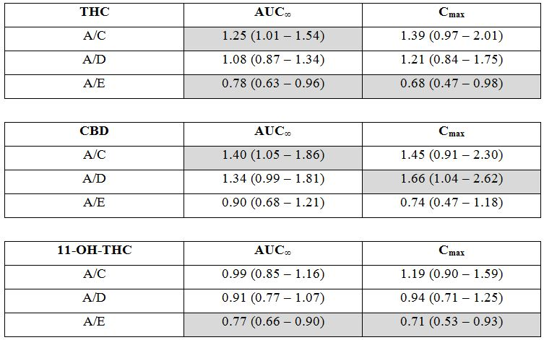
The study is largely inconclusive, but does show that the bioavailability of the cremophor formulation is significantly greater than that of the propylene glycol formulation with regard to THC and its active metabolite. Peppermint oil decreases the rate, and possibly the extent, of absorption of CBD. Also, administration of smaller volume sprays increases the extent of absorption of both THC and CBD. All of this suggests that the formulation proposed for registration (propylene glycol rather than cremophor, 100 µL spray, and containing peppermint oil) has the poorest absorption of all the formulations tested. All formulations show high inter subject variability, with CVs for formulation D up to 78% for C_{max} (CBD) and up to 61% for AUC (THC).
The saving grace is that the formulation proposed for registration, with 100 µL actuations, was used in all Phase 3 clinical studies. Furthermore, the patient dose is individually titrated from one single spray per day up to a maximum of 12 sprays per day.
Study GWCP0601 showed that consumption of a standard high fat breakfast 30 minutes prior to dosing with Sativex (formulation proposed for registration) caused a dramatic increase in bioavailability. AUC∞ and C_{max} for THC were increased 2.8 and 1.6 fold, respectively, and AUC∞ and C_{max} for CBD were increased 5.1 and 3.3 fold. For 11-hydroxy-THC, AUC∞ was increased 1.3 fold and C_{max} was decreased 0.8 fold. Median T_{max} values for all analytes were increased by 2-2.5 h. No rational explanation was provided for the dramatic food effects, although the company attempted to play down their significance by pointing out that the variations in bioavailability caused by food are less than the inter subject variations observed with this product. The PI states:
‘To minimise variation of bioavailability in the individual patient, administration of Sativex should be standardised as far as possible in relation to food intake’.
The company provided the following justification for not performing an absolute bioavailability study:
Absolute bioavailability studies may be especially helpful in the case of new active substances where little if any information exists on the properties of the molecule. In the case of Sativex, the components of the medicine have a long history of human use and an extensive literature describing their absorption, distribution, metabolism and excretion. Absolute bioavailability may also be helpful where there is a clearly defined pharmacokinetic/pharmacodynamics (PK/PD) relationship for the medicine. In the case of cannabinoids, there is no clear PK/PD relationship at the exposures seen in patients using Sativex and knowing the absolute bioavailability of the Sativex formulation would not contribute to the way the medicine is used (oromucosal spray, with patient self-titrating).
Cannabinoids are highly lipid soluble and formulation of an intravenous solution presents a significant challenge. With the extent of published information available on cannabinoids, added to the substantial programme of human clinical pharmacology that has been carried out by GW, it is not believed that absolute bioavailability studies would be helpful. Finally, the bioavailability of different oral dose forms of Sativex has been investigated by GW and has also been compared with the exposure seen after pulmonary administration. In the circumstances, GW believes that the risk/benefit attached to performing intravenous studies with Sativex is not justified.
This view regarding bioavailability studies is endorsed by the Competent Authorities of the UK, Spain, Germany, Italy, Austria, Czech Republic, New Zealand and Canada. The clinical aspects of Sativex, a botanical (herbal) medicinal product, will be addressed fully on review of Module 5 by the appointed TGA Clinical Assessor.

Recommendations
With regard to Chemistry, Manufacturing and Controls, Sativex oromucosal spray is considered approvable. A shelf life of 24 months under refrigerated conditions (2-8°C), with an allowance for the patient to store the product for up to 42 days below 25°C after opening, has been satisfactorily established.
The question of whether the submitted bioavailability studies are adequate should be assessed by the clinical evaluator, taking into account the way the product is used (dose titration in individual subjects over a wide dose range).
One major issue that still needs to be resolved concerns the nomenclature of the major cannabinoid components of Sativex for use on product labels. The sponsor wishes to adopt the names ‘delta-9-tetrahydrocannabinol (extracted)’ and ‘cannabidiol (extracted)’. However, there is already an AAN (‘dronabinol’) that corresponds to delta-9 tetrahydrocannabinol. The sponsor wishes to distinguish the synthetic substance from the extracted substance and also claims that the two substances are distinguished in the international treaties that govern the movement of controlled substances across international borders. On purely scientific grounds, ‘dronabinol’ is an appropriate name for the substance contained in Sativex. Further, ‘cannabidiol’ should be adopted as an AAN but not ‘cannabidiol (extracted)’. The nomenclature issue is discussed fully in the Evaluation of replies to CMC questions.

III. Nonclinical findings

Introduction
The sponsor submitted an adequate range of studies in the nonclinical dossier, generally using a mixture of botanical drug substances (THC BDS/CBD BDS), although Sativex was also investigated in some genotoxicity and repeated dose toxicity studies. However, carcinogenicity studies were not comprehensive (Genotoxicity and Carcinogenicity). Pure THC and CBD are available, and were used in an in vitro receptor screen, but the current preparation has presumably been developed on the basis that a complex extract may exhibit a different pharmacological profile to a mixture of these two components. Consequently, it is appropriate that submitted studies largely used the THC BDS/CBD BDS mixture, in contrast to the submitted literature publications which generally referred to single cannabinoids, and were primarily useful as a source of background information.
Although Sativex is a complex mixture of active components and components of unknown activity, all subject to unknown interactions, the nonclinical investigation program has largely been conducted as for a new chemical entity. It can be considered to be a herbal medicinal product (but not obviously ‘traditional’), and there is an EMEA Committee on Herbal Medicinal Products guideline covering this topic. Additionally, there is an FDA Guidance for Industry publication (2004) covering such products. In contrast to Sativex, a cannabinoid product approved in the USA (dronabinol) contains pure synthetic THC.

Pharmacology

Primary PD
The endogenous cannabinoid system includes CB1 and CB2 receptors, for which THC is a ligand, that are respectively expressed at high abundance in the brain and lymphoid tissue/immune cells. THC is considered to be a partial agonist by comparison with synthetic CB1/CB2 receptor agonists, while CBD exhibits low affinity at these receptors in ligand displacement assays. Nevertheless CBD may modulate agonist binding and the TRPV1 receptor, and it exhibits pharmacological activity itself, as seen in submitted studies (Safety and secondary pharmacology). Several putative endocannabinoids have been identified and the beneficial effects of cannabinoid receptor agonists in various animal models of multiple sclerosis have been the subject of reviews. Additionally, experiments in mice with induced chronic relapsing experimental allergic encephalomyelitis (CREAE) suggested that control of spasticity was mediated via CB1 receptors, with amelioration of spasticity by CB1/CB2 agonists in wild type but not CB1 receptor knockout mice. These knockout mice show more severe symptoms, associated with increased neurodegeneration.
Only one (contract) efficacy study was submitted for the current application, in which THC BDS/CBD BDS (1:1) IV was active at reducing limb stiffness in CREAE mice. This result was consistent with cannabinoid receptor agonists, including THC, ameliorating tremor and spasticity in this model, with exacerbations after antagonism at the CB1 receptor. Additionally, although both THC and a standardised cannabis extract (but not extract devoid of THC) exhibited comparable anti spasticity activity in this mouse model, the extract showed a more rapid onset of muscle relaxation and reduced time to maximal effect. Overall, results suggest potential efficacy of Sativex for the proposed indication, but this will only be apparent in the clinical trials.
A special expert report by Baker and colleagues, authors who conducted the contract study with Sativex, was included in the nonclinical overview.

Safety and secondary PD
Reduced hERG currents were observed in in vitro experiments with the THC BDS/CBD BDS mixture, indicative of a potential for QT interval prolongation. Although the IC₅₀ value of 1.8 µM (~562 ng/mL) obtained was high relative to likely therapeutic plasma concentrations (<10 ng/mL), there were considerable uncertainties regarding this because of lower than nominal concentrations in formulations and particularly organ bath efflux samples in this non GLP study. Additionally, high plasma protein binding may be expected to reduce likely activity in vivo, and QT intervals were unaffected in anaesthetised dogs with an intraduodenal THC BDS/CBD BDS dose achieving C_{max} values of 59 (CBD) and 121 (THC) ng/mL. Further, no effects on ECG intervals were apparent in the 52 week dog study with Sativex, in which plasma C_{max} values were high, that is, 0.67 (THC), 2.04 (CBD) and 0.38 (11-OH THC) µg/mL. The proposed PI notes that Sativex up to 18 sprays twice daily did not elicit clinically relevant QTc, PR or QRS interval duration, heart rate or blood pressure.
Behavioural abnormalities were observed in rats (for example, cautious creeping gait, stereotypy, catalepsy), but only at doses (5-25 mg/kg) that resulted in high peak THC concentrations relative to that expected in humans (~9-59 fold), which is not unexpected given that THC is a psychoactive drug. Clinical signs were prominent in the toxicity studies, and those with Sativex included hypoactivity, ataxia, staggering gait and convulsions (rats), and recumbency and tremors (dogs). The dependency/abuse potential of THC BDS/CBD BDS was similar to that for THC in a contract study using trained rats and PO administration, although Sativex could not be tested because of (unexplained) positive responses with the vehicle. The proposed PI notes that based on clinical results, dependence on Sativex is unlikely.
Extensive screening of CBD BDS for secondary PD activity in one integrated study showed that this component was not inactive, with notable positive responses in electroshock (but not metrazol) anticonvulsant, analgesia (phenylquinone) and anti inflammatory (carrageenan) activity tests, albeit at high IV doses (30 or 100 mg/kg). Additionally, significantly increased sleeping time elicited by hexobarbitone was observed in mice, and food consumption was reduced in rats. Further investigations showed that the THC BDS/CBD BDS mixture given PO at 0.2-5 mg/kg showed both antinociceptive activity (hot plate test) and increased hexobarbitone sleeping time in rats. Anticonvulsive activity (pentylenetetrazole threshold) was, however, not seen even with a higher dose of 25 mg/kg PO. Although no comparable studies were conducted with THC BDS alone, THC is known to be active in several animal models of antinociceptive activity.

Pharmacokinetics
Interspecies comparison of drug exposures is not straightforward because of the high degree of variability between patients as shown in the human clinical summary data, the complex nature of the mixture and extent and type of metabolism. However, exposures of the two main Sativex components were generally very high in the toxicity studies, as shown in Table 4 (sex combined mean values). The human values used for comparison result from a different dosing regimen, that is, 12 sprays given over a 15 min period, following 4 days of treatment with the same dose bid versus the proposed 5 morning and 7 evening sprays, each separated by at least a 15 min interval. Plasma values would therefore be expected to represent worst case dosing, especially in terms of C_{max} achieved, as sprays would be expected to be given at intervals throughout the day.
Table 4: PK and relative drug exposures in animals.
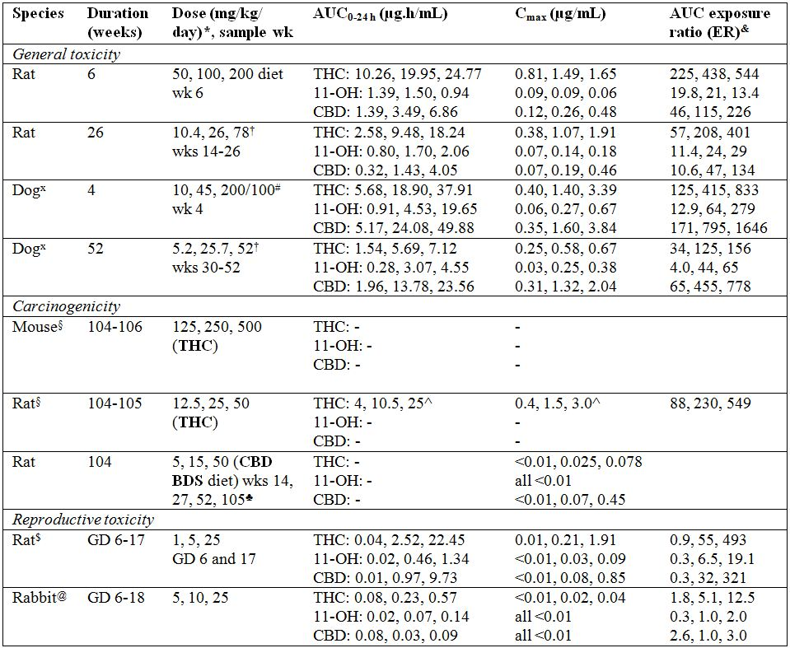
* in terms of THC and CBD combined, # dose reduction from day 10, † Sativex
x dog studies included an initial habituation phase in which dose escalation was carried out
& AUC0-24 h relative to human values of 45.5 (THC), 70.3 (11-OH THC) and 30.3 (CBD) ng.h/mL with a dose 12 x 0.1 mL although this follows a higher than proposed dose of 24 x 0.1 mL/day x 4 days; note that animal concentrations are in terms of µg/mL; values contain rounding errors
§ studies not conducted by the sponsor, @ pilot study (same doses used in the main study)
$ data from a pilot (MD, HD) and the main (LD) studies
♣ values are means of 2 sample times at each sample week (08:00 and 20:00 hours), ^ approx. values extracted from a figure; AUC values are 0-120 h
- = no data, GD = gestation day
It was noteworthy that AUC and C_{max} values in the rat embryofoetal development study were considerably higher on GD 17 compared with GD 6, for example respective high dose CBD AUC values were 18171 and 1285 ng.h/mL. The same doses were used in a rat fertility and early embryonic development study, and although there were no data for this study other than 4 h concentrations, exposures would be expected to be similar. Lower doses of 1, 2 and 4 mg/kg/day (THC and CBD combined) were used in a pre/post natal study, and only concentrations at 8 h and 24 h were monitored. The only AUC data available for this low dose range were from the rat embryofoetal development studies, for which LD values (1 mg/kg/day) were from the main study and MD and HD values (5 and 25 mg/kg/day) were from a pilot study. AUC_{0-last} values increased disproportionately with dose (especially from LD to MD), which together with the increases between gestation days 6 and 17 raises questions as to the usefulness of these values for determining likely exposures in the pre and post natal study.
These inter species comparisons are based on the two major components of Sativex, which also contains additional known and unknown compounds, and toxicokinetic values are thus proxies for these components. These values are probably more appropriate than comparisons based on body surface area, because they represent concentrations actually achieved after absorption and metabolism. The maximum recommended human dose is equivalent to ~20 mg/m²/day each of THC and CBD (1.2 mL x 25-27 mg/mL = 30-32.4 mg = 0.60-0.648 mg/kg for a 50 kg person x 33).

Metabolites
Metabolism was not investigated in the current submission. However, biotransformation of cannabinoids is known to be mainly by hydroxylation, primarily at the C8 and/or C11 positions, and conversion of both THC and CBD to their 11-hydroxylated derivatives is mediated via CYP2C9 in humans, at least in vitro. Additionally, besides the involvement of CYP2C9 in the formation of 11-OH THC, another major human hepatic metabolite 8β-OH THC and some minor metabolites were generated by CYP3A in vitro.
The active metabolite 11-OH THC was measured in all the toxicity studies and, as shown in Table 4, exposures were generally high, although it was noteworthy that they were lower than to the parent compound while the reverse was true in humans. This may reflect different administration routes (PO versus oromucosal) although THC is known to be subject to extensive first pass hepatic metabolism. Secondary metabolism includes formation of inactive 11-nor-9-carboxy Δ⁹-THC (11-COOH THC), which is a major urinary metabolite, and glucuronide conjugates. Apparently multiple metabolites (>33) were present in urine after chronic CBD administration (quoted in the Clinical Pharmacology Summary), and overall, there are insufficient data for a proper comparison of metabolite profiles in the experimental species and humans. In response to a Section 31 query, the sponsor indicated that metabolism studies of CBD were ongoing and that new data would be made available to the TGA; the submission of new data when available should be a requirement of registration.

Toxicology

General toxicity
Repeated dose studies were generally adequate, and were primarily the long-term rat and dog studies with Sativex, albeit with PO administration rather than by the proposed oromucosal route. These were supported by preliminary 2-6 week studies in rats and dogs with the THC BDS/CBD BDS mixture and additional investigations of CBD BDS alone in rats, with the 13 week dietary study being conducted to determine doses for a subsequent carcinogenicity study (Genotoxicity and carcinogenicity). General or specific toxicities of THC and to a minor extent CBD have also been examined in published studies. However, these are considered to be of less relevance to the current application, in part because of their emphasis on single cannabinoids.
The low dose used in the 26 week rat Sativex study elicited a number of changes including reduced body weight gain in the absence of an effect on food intake, clinical signs including transient clonic/tonic convulsions, and increased relative adrenal weight, although this was not apparent with the mid dose. Scheduled tissues were not routinely examined in low and mid dose rats, but the only adrenal findings in high dose rats were cytoplasmic vacuolation (males) or diffuse hypertrophy (females). Overall, overt toxicity was not apparent with the low dose, despite very high THC and high CBD exposures (Pharmacokinetics and relative drug exposures), although it would have been preferable to have included a lower dose to establish a NOEL. Although food intake was significantly reduced with associated impairment of body weight gain, findings with the high dose other than clinical signs were relatively benign considering the very high THC and CBD exposures. The apparent increase in female mortality was probably not a real effect because a relatively high mortality also occurred in vehicle control males.
The corresponding 52 week dog study with Sativex incorporated a habituation period, but the low dose which was used throughout the study was without effect other than eliciting minor clinical signs. As tabulated above (Pharmacokinetics and relative drug exposures), THC and CBD exposures were very high at this dose and results are indicative of a low toxicity in this species. There was a high MD and HD mortality in males (respectively 3/4 and 3/6), which were apparently incidental and related to aspiration of dosing solution (with one exception), but otherwise there were relatively few effects of treatment other than clinical signs.
An increase in the incidence of females in anoestrus was noted in this study, suggestive of possible hormonal changes, and this was also seen in a rat 6 week dietary study with THC BDS/CBD BDS. Hormones were not measured in the submitted toxicity studies, however, elevations in FSH and LH were measured in male rats in a published PO carcinogenicity study (Genotoxicity and carcinogenicity) which showed little or no dose dependency. A no effect dose was not established for these changes, and the low dose of 12.5 mg/kg/day resulted in a very high THC exposure (ER value of ~90). A lower PO dose of 0.5 mg/kg of THC has been reported to elicit acute reductions in male rat LH, which was potentiated by CBD. Effects on hormone concentrations appear not to have been measured in the clinical trials, as they were not mentioned in the clinical overview.
Other notable findings with the THC BDS/CBD BDS mixture were adrenal cortical hypertrophy and vacuolation in rats, which was also apparent with Sativex in rats and dogs, and hepatocytic hypertrophy in both species. The latter, also prominent in a long-term rat carcinogenicity study with CBD BDS, is suggestive of an adaptive enzyme induction response, although this was not seen in an in vitro study using human hepatocytes. Immunotoxicity was investigated as part of the 26 week Sativex study in rats, with which peripheral blood lymphocyte subsets and anti KLH IgM responses were measured, with no effect of treatment being apparent.
Overall, doses used were high and resulted in plasma exposures to THC and CBD that were many multiples of expected mean values in humans, which should cover the apparently very high variation seen clinically although, as noted above, metabolite profiles could not be compared. With regard to unknown compounds, in response to a Section 31 query the sponsor noted that ongoing work had allowed ~90% of BDS constituents to be identified and quantified. New data have been sighted for the BDS batches used to prepare the Sativex batch tested in the rat 6 month and dog 12 month toxicity studies showing that this was the case (89.9-95.9%). Additionally, chromatographic fingerprinting revealed that these BDS batches were very similar in composition to corresponding recently manufactured batches, suggesting that significant batch variations would be unlikely. Thus, although Sativex has not been fully characterised, the more recent data provide some reassurance that the toxicity of its individual components may have been investigated in the nonclinical studies. Treatment elicited a number of clinical signs but tissue toxicity was low and there were no findings that would preclude approval of registration.

Genotoxicity and carcinogenicity
Genotoxicity studies, which included tests with Sativex and a THC BDS/CBD BDS mixture were generally adequate. Apparently positive results were obtained in the mouse lymphoma L5187Y forward mutation test at the tk locus, but the small Sativex response was seen only with 24 h exposure in the absence of S9 at THC plus CBD concentrations of 2.6 and 5.2 µg/mL (23% and 47% decreases, respectively, in relative total growth). This was not apparent in an earlier study using a THC/CBD mixture at doses reducing relative survivals by up to 89%, using the same exposure, although the composition of the test substance (designated GW 91101) compared with Sativex was not clear. This preparation apparently contained equal concentrations of THC and CBD plus ~7% other extracted solids, which compares with the Sativex moieties THC BDS and CBD BDS which each contain ~66% of these components. This earlier study did give positive results with a 3 h exposure in the presence of S9, but only with one of two batches tested. Sativex did not elicit positive responses in tests for bacterial reverse mutation in vitro or clastogenicity in vivo and overall it is considered to be non genotoxic, although it would have been preferable to have repeated the lymphoma forward mutation test with Sativex itself.
In contrast to genotoxicity, the carcinogenic potential of Sativex was not comprehensively investigated. Published PO studies for THC in mice and rats were available through the USA National Toxicology Program (NTP), and these were included in the submitted dossier, and a rat dietary study was conducted with CBD BDS on behalf of GW Pharma. The THC BDS/CBD BDS mixture, with potential for interactions, was not tested, and although CBD BDS contained many of the same other cannabinoid or non cannabinoid components as THC BDS, these were not identical. Additionally, CBD BDS was tested only in one species, and a further problem with this study was that scheduled tissues were not routinely examined histologically from LD and MD rats.
The THC studies showed only a tendency for increased thyroid follicular cell tumours with the LD in mice of both sexes, associated with significantly increased incidences of follicular hyperplasia, and no real evidence of increased tumours in rats. The mouse HD of 500 mg/kg/day resulted in increased male mortality and marked impairment of body weight gain in both sexes (by ~50%). By contrast, the 10x lower doses used in the rat study resulted in lower body weight gain (by 14% in males and 8% in females) but increased survivals without dose dependency. The latter may account for the tendency for higher mononuclear cell leukaemia cases seen in MD and HD females. Plasma THC AUC values were available for the rat study, and as shown in Table 4 these were very high compared with the expected human value (88-549 fold). A noteworthy finding in both studies was the occurrence of decreased incidences of several tumours, that is, hepatocellular tumours in mice, and pancreatic acinar cell adenomas, pituitary pars distalis adenomas, testicular interstitial cell adenomas, female mammary gland fibroadenomas and uterine stromal polyps in rats.
The rat study with dietary CBD BDS failed to reveal any oncogenic response, and as with THC decreased incidences of some tumours were observed (pituitary tumours, female mammary fibroadenomas). Plasma analysis showed the presence of CBD and to a lesser extent THC (probably representing the THC content of the CBD BDS preparation). Concentration data were only for two time points (08.00 and 20.00 hours), but a rough estimate of AUC_{0-24h} (means x 24 = 10.8 and 1.87 µg.h/mL respectively) suggested that HD exposures to both compounds would be very high compared with the expected clinical value (ER values of ~350 and 40, respectively).
The nonclinical expert considered that studies with Sativex were not required, given the above investigations of THC and CBD BDS. Although it may be used for extended periods, the usefulness of long term studies with THC BDS/CBD BDS or Sativex is not certain, especially as PO rather than the proposed clinical route would probably be used. An EMEA guideline (not adopted in Australia) for well established or traditional herbal medicinal products suggests that although the genotoxic potential of herbal preparations should be assessed, carcinogenicity studies are not needed in cases where there is no suspicion of a carcinogenic potential. An FDA guidance for industry report for botanical drug products considered that carcinogenicity studies may be needed to support marketing approval of a botanical drug, depending on the duration of therapy or any specific cause for concern.
Overall, this evaluation considers that although potential carcinogenicity has not been comprehensively investigated, the lack of genotoxicity, available study data and history of use of the two major components suggests that a risk to humans is unlikely.

Reproductive toxicity
Full embryofoetal development studies were conducted with the THC BDS/CBD BDS mixture in Sprague Dawley rats and NZW rabbits, with no evidence for teratogenicity. Doses used (5, 10, 25 mg/kg/day PO of THC and CBD combined) were sufficient to elicit maternal toxicity, including maternal body weight loss and abortions in rabbits, reduced fetal weight (not significant in rats) and skeletal variants/minor abnormalities and/or impaired ossification. As tabulated above (Table 4), HD drug exposures were high except for CBD in rabbits (ER value of 3).
The same PO doses were used in a rat fertility and early embryonic development study, which again elicited reduced body weight gains (during the premating period in both sexes) but did not affect mating or fertility (pregnancies/mating). Slightly lower numbers of MD and HD live foetuses reflected lower numbers of corpora lutea, which were still within the historical control range, and this finding was probably of little toxicological significance especially given the marked impairment of premating body weight gain in these dose groups. Sperm counts and examinations were included in the longer duration toxicity studies with CBD BDS, with the only finding being slightly lower concentrations in the 13 week dietary study, but this was without dose dependency and drug exposures were very high (ER values at least 48-795).
Lower PO doses of THC BDS/CBD BDS were used in a pre/postnatal study, in which the salient findings were impaired pup body weight gain to weaning and slightly impaired righting reflex response on test Day 5. These effects were apparent with the HD (4 mg/kg/day of THC and CBD combined), at which exposures to THC and CBD would be expected to be high based on AUC values from the embryofoetal toxicity studies. There were insufficient data to determine exact values, however, and there may be some uncertainties in the use of this toxicokinetic data, as noted above (Table 4). Exposures at the MD NOEL of 2 mg/kg/day for these findings were difficult to estimate, but this dose is lower than the maximum recommended human dose in terms of body surface area (12 versus 41.2 mg/m²/day). Findings probably reflect drug exposure during suckling, given the high concentrations of THC and CBD measured in 6 h milk in this study (930 ng/mL and 328 ng/mL, respectively, with the MD). They may also be related to exposure in utero, or a combination of both routes, or be secondary to the appreciable impairment of maternal body weight gain over gestation days 6-20 (by ~20%). These results for cannabinoid excretion in milk and the impaired offspring growth suggest that Sativex should not be used during breast feeding, and it may also be prudent to exclude use during pregnancy. Pup survival from culling on day 4 to weaning (lactation index) was reduced in the LD and HD groups, but this was associated with total litter losses in 2 dams from each of these groups, suggesting that the lower HD value (which attained statistical significance) was incidental. Lower doses were used in the main study, as a pilot study showed 5 and 25 mg/kg/day to result in poor nursing behaviour and associated decreases in pup survivals (viability and lactation indices). When the two pre/postnatal studies are considered together, the viability and lactation indices are not clearly treatment affected at doses up to 4 mg/kg/day, but are reduced at ≥ 5 mg/kg/day.
THC has been shown in published studies to exert an inhibitory effect on the hypothalamic pituitary gonadal axis, with decreases in LH, FSH, prolactin, oestrogen, progesterone, testosterone, and thyroxine, with potential to interfere with the reproductive system. Both THC and CBD have been reported to have variable effects on the reproductive system in literature publications, but the use of single compounds and often high doses or inappropriate administration routes make any relationship to Sativex use uncertain. Examples include testicular atrophy with 150 and 500 mg/kg PO THC in a 13 week rat study, inhibition of spermatogenesis (assessed histologically) in rhesus monkeys treated with 30-300 mg/kg/day of CBD for 90 days and adverse effects on pregnancy in this species after treatment with 2.5 mg/kg/day THC. A noteworthy finding in the latter study was the presence of THC in the plasma of newborns after maternal treatment 1 h before birth (respective concentrations of 145 and 412 ng/mL).

Local tolerance
Sativex is an oromucosal spray containing ~50% ethanol, which was not used topically in the toxicity studies, and local tolerance was assessed in a 28 day study, with application of 100 µL/day of Sativex to hamster cheek pouches (following single application in another study). Irritation was not apparent in this test, despite the ethanol content of the formulation, but the duration of testing may not have been long enough to reveal potential effects. Although it was not specifically mentioned in the clinical overview, local reactions have been seen clinically according to the RMP. Consequently, and in view of the limited nonclinical testing, the clinical data will require assessment for potential local intolerance of Sativex.

Risk management plan
Nonclinical issues mentioned in the risk management plan under Toxicity and General safety pharmacology/drug-drug interactions and abuse liability were generally appropriate, although several entries under no risk to human safety are included and discussed. The subsection drug interactions could be rewritten more accurately and completely, that is, 6-9 µM are the IC₅₀ values for inhibition of CYP2C19 and CYP3A4.

Nonclinical summary and conclusions

Summary
- Sativex is an extract of Cannabis sativa, standardised to contain 27 mg/mL Δ⁹-tetrahydrocannabinol (THC) and 25 mg/mL cannabidiol (CBD), and formulated as an oromucosal spray containing ~50% ethanol. It is a 1:1 mixture of THC and CBD BDS, each of which contain ~66% of the respective active compounds, other cannabinoids and a large number of other compounds at low concentration. It is intended for the treatment of spasticity in adult multiple sclerosis patients who have not responded adequately to other medication. The dose is titrated up to a maximum of twelve 0.1 mL sprays a day.
- The nonclinical dossier contained a generally adequate range of studies, mainly using a 1:1 THC BDS/CBD BDS mixture, supplemented with literature references to the effects of THC and to a lesser extent CBD. Efficacy (reduction in hindlimb stiffness) was shown after IV treatment of mice with CREAE in the only primary pharmacology study submitted, although doses were high (5 and 10 mg/kg). Results were consistent with activity ascribed to THC in the literature.
- Safety pharmacology studies showed a reduction in hERG currents and altered Purkinje fibre action potentials in vitro, with an IC₅₀ value of 1.8 µM for each active component (THC and CBD) for the former activity, although there were concentration anomalies in this study. Little or no effect of treatment was seen in in vivo dog cardiovascular studies with sublingual or intraduodenal administration. Several behavioural changes were noted with single high PO doses in rats (5-25 mg/kg). Extensive screening of CBD BDS showed that it exhibited some anticonvulsive, analgesic and anti inflammatory activities. THC BDS/CBD BDS and its active components, alone or together, bound to a range of receptor types in vitro, but K_{i} values were high (high nM or µM).
- Standard PK investigations were not conducted, but toxicokinetic data were available for most toxicity studies, with plasma THC and its 11-hydroxy metabolite (11-OH THC) and CBD being measured. THC BDS/CBD BDS inhibited human microsomal preparation CYP isoforms to variable extents in vitro, with the highest activity against CYP3A4 and CYP2C19 largely reflecting inhibition by CBD. IC₅₀ values of 6-9 µM for the mixture (in terms of each active component) were very high compared with expected human values. There was no evidence for CYP induction in human hepatocytes in vitro.
- General toxicity studies were conducted with PO Sativex in the rat and dog, with respective durations of 26 and 52 weeks. Other studies included 2-6 week PO studies with the THC BDS/CBD BDS mixture and 13 week (dietary) and 2-4 week IV studies with CBD alone in rats. Drug exposures, based on plasma AUC, were high (and often very high) compared with values expected in humans. There were no toxicity studies with the proposed oromucosal route, but local irritation was not seen in a 28 day hamster cheek pouch test with topical application.
- The vehicle itself was irritating in the PO rat Sativex study, resulting in histological changes in the trachea, larynx and lungs, as well as deaths resulting from apparent aspiration. Findings with Sativex itself included reduced body weight gains and clinical signs, but little tissue toxicity, primarily adrenal vacuolation/hypertrophy. Indices of immunotoxicity, including an antibody response, were incorporated in this study, with no effect of treatment being apparent. An initial habituation period was used in the corresponding dog study, and there were several mid- and high-dose premature deaths apparently related to reflux of stomach contents and aspiration. Drug related clinical signs were observed, but tissue toxicity was minimal (adrenal cortical hypertrophy, epididymidal cell sloughing). There was an increased HD incidence of females in anoestrus. Hepatocytic hypertrophy was seen with THC BDS/CBD BDS in both species.
- Adequate genotoxicity studies were conducted mainly with THC BDS/CBD BDS and Sativex, with generally negative results. A positive response was observed with the L5178Y mouse lymphoma assay at the tk locus, but only with 24 h exposure in the absence of S9 (Sativex) or with 3 h exposure in the presence of S9 for one of two batches tested (extract containing THC/CBD).
- A long term carcinogenicity study was conducted only with CBD BDS in rats (dietary administration), with no oncogenic response being seen despite high estimated systemic exposures to CBD and to a lesser extent THC. Non neoplastic findings included hepatocytic centrilobular hyperplasia and increased male incidences of thyroid follicular cell hyperplasia. Well documented published studies conducted in mice and rats with THC by the US National Toxicology Program were available, using respective PO (gavage) doses of 125-500 mg/kg/day and 12.5-50 mg/kg/day. A tendency for increases in thyroid follicular cell tumours was seen in mice (significant only for adenomas in LD males), associated with increased follicular hyperplasia. There was no oncogenic response in rats. Measurement of selected plasma hormones in the rat study showed elevated FSH and LH concentrations in males, but without dose dependency.
- Reproductive toxicity studies were conducted with PO THC BDS/CBD BDS, and substantial concentrations of THC, CBD and 11-OH THC were measurable in rat foetuses at 6-8 h after maternal treatment. There was no evidence for teratogenicity in rat and rabbit embryofoetal development studies, with doses of 5-25 mg/kg/day (in terms of THC and CBD combined). The same doses had no effect on rat mating and fertility. THC and CBD were measurable at high concentrations in the milk of lactating rats, and reduced pup body weight gains to weaning were seen in a rat pre and post natal study using lower doses. The pup righting reflex response was also slightly impaired on test day 5 in this study, and the NOEL for these effects was the mid dose of 2 mg/kg/day (in terms of THC and CBD combined).

Conclusions and recommendations
The potential efficacy of Sativex for the proposed indication was shown in a study using an accepted animal model of multiple sclerosis, albeit with high IV doses. Results were consistent with literature publications suggesting the involvement of cannabinoid receptors in the control of spasticity. Cardiovascular responses to treatment should receive particular attention in the clinical assessment in view of the reduction in hERG currents shown in an in vitro study.
Toxicity studies were conducted with oral doses resulting in high or very high systemic exposures to THC and CBD, with no findings that would preclude approval of registration. However, as the proposed oromucosal administration route was not used, the potential long term local responses to Sativex, which has a high ethanol content, have not been determined in nonclinical studies. Assessment of potential carcinogenicity was not of a standard normally required for a new chemical entity, but available results suggest that a risk to humans is unlikely. The high excretion of the active cannabinoids in milk should preclude use in nursing mothers.
The main toxicological issue with Sativex is the incomplete characterisation of impurities and metabolites. Despite ongoing work to further identify the large number of impurities in the BDS preparations, and the chromatographic similarities between nonclinical BDS batches and recently manufactured batches, the total concentration of unknown compounds in the product still exceeds that normally expected of a New Chemical Entity, and it still remains an assumption that the nonclinical studies have adequately assessed the potential toxicity of these unidentified impurities. In addition, the metabolite profile of CBD is still to be definitively established, so it is not yet known whether the primary human metabolite(s) of CBD has (have) been assessed in the nonclinical studies. It is acknowledged that such botanical products are not within the scope of relevant ICH impurity guidelines applied to new drug substances and new drug products (Q3A, Q3B). However, a toxicological risk assessment has to be restricted to the available hard data and cannot be based on likely similarities in either composition or potential exposure to impurities and metabolites. Based on these considerations, the submission is not supported on nonclinical grounds.
Should Sativex be registered, any new data on metabolites and impurities arising from ongoing work on the product post marketing should be submitted to the TGA.

IV. Clinical findings

Introduction
The submission contained the following clinical information:
- 11 clinical pharmacology studies.
- 3 pivotal efficacy/safety studies.
- 6 other efficacy/safety studies.
The submission did not include paediatric data.
All submitted studies contained appropriate declarations that they were compliant with the Declaration of Helsinki, the ICH GCP, and “the clinical trial regulations adopting European Commission Directives into national legislation”.

Dosage and administration
It is proposed that patients should titrate the dose as needed between 1 and 12 sprays per day (2.7-32.4 mg THC and 2.5-30 mg CBD) in divided doses. It is expected that these will usually be administered sublingually.
The draft PI includes the following detailed titration instructions:
“The number of sprays should be increased each day following the pattern given in the table below (Table 5). The afternoon/evening dose should be taken at any time between 4 pm and bedtime. When the morning dose is introduced, it should be taken at any time between waking and midday. The patient may continue to gradually increase the dose by one spray per day, up to a maximum of 12 sprays per day, until they achieve optimum symptom relief. There should be at least a 15 minute gap between sprays.”
Table 5: Sativex titration schedule.
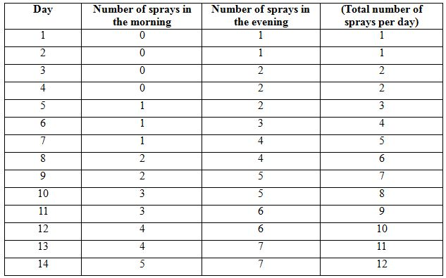
It is proposed that, during maintenance treatment, the total daily dose be distributed through the day in two or more divided doses according to patient preference, and the total dose be re titrated up or down as needed. Doses greater than 12 sprays per day are not recommended. The median dose in clinical studies was 8 sprays per day.

Formulation development
The rationale behind the sponsor’s development of the Sativex formulation (THC:CBD ~1:1) is not based on the known pharmacology of THC and CBD, but on the observation that wild type marijuana plants tend to contain roughly equal mixtures of both compounds. Both THC and CBD are readily obtained from the cannabis plant, and, for convenience, the sponsor elected to combine both in a single preparation at roughly equal concentrations (THC 27 mg/mL, CBD 25 mg/mL). There has not been an extensive program exploring the efficacy of either cannabinoid as monotherapy, nor has there been any investigation of the efficacy of significantly different mixing ratios. Instead, both cannabinoids were in the cannabis plant, so both ended up in Sativex. As far as this evaluator is concerned, this rationale appears to be delegating an important therapeutic decision to a plant.
This approach is in stark contrast to the usual development of combination medications, where the efficacy and safety of each component is demonstrated first, and then a rationale is developed for combining the drugs. Combination medicines are common, but usually the combination brings together agents with useful synergy (as in combination antihypertensives) or a shared indication (antihypertensive statin combinations for vascular disease). Examples of drugs where active agents are combined simply to match a plant are rare.
The main active ingredient of Sativex appears to be THC, which is active at CB1 receptors. CBD is not known to be active at CB1 receptors and it is unclear whether its addition to THC serves any clinical purpose. The clinical expert, Professor Barnes, writes:
“It is clear in animal models of MS that the Cannabinoid-1 (CB1) receptor, and not the CB2 receptor, plays a key role in the modulation of the spasticity and spasms exhibited by the experimental animals.”
This observation begs the important question of whether THC should have been developed as a single agent for investigation in clinical Phase 2 and 3 studies, rather than being combined with CBD as in Sativex.
The clinical expert goes on to claim that CBD has neuroprotective and anti inflammatory properties.
“CBD in contrast has little activity at cannabinoid receptors, but does have neuroprotective properties, most likely mediated by its ability to modulate intra cellular calcium.
The key pharmacology of CBD in MS here probably relates to its role as an agonist at TRP channels critical for maintaining calcium homeostasis; and as an inhibitor of adenosine uptake, providing a non cannabinoid receptor mechanism for its anti inflammatory properties.”
This anti inflammatory action, if real, might justify the development of CBD as a potential treatment for MS, which has an inflammatory basis, but demonstrating such an anti inflammatory effect would require a completely new set of studies, with different entry criteria, assessment methods and endpoints. No evidence of an anti inflammatory role of CBD in humans has been submitted.
Finally, the clinical expert comments in relation to CBD that
“Arguably, however, its most important function in Sativex may lie in its ability to modulate the anxiogenic and psychoactive effects of THC.”
The Karniol paper mentioned here is very old (published in 1973), and it was performed in animals (mice, rats and rabbits). The paper showed that CBD antagonises some of the sedative effects of THC in animals but, even if it were known that this also occurred in humans, it would still not show that the addition of CBD to THC produced a different pharmacological effect than simply lowering the dose of THC.
In terms of the submitted dossier, evidence that CBD improves the side effect profile of Sativex in humans is very slim. One small submitted study (Study GWPK0110) suggested that co administration of THC and CBD might have advantages relative to monotherapy with either drug, in that addition of an equal dose of CBD (THC 15 mg and CBD 15 mg) reduced the adverse effects of THC on daytime sleep latencies and memory, but the same study suggested that CBD worsens fatigue. Even if CBD did reduce the sedative side effects of THC, that alone would not provide a rationale for including CBD. The important question is whether CBD’s antagonism of adverse THC side effects differs from its potential antagonism of anti spasm effects.
In view of these concerns, the following preliminary question was put to the sponsor during the preparation of this evaluation:
“Sativex has two active ingredients, THC and CBD, but the [sponsor has not performed] the clinical studies normally expected with a combination preparation, such as studies showing efficacy of each active ingredient [individually] and then a synergistic or at least additive benefit when they are combined. The main reason that both compounds are present in Sativex simply seems to be that the cannabis plant produces both compounds, but to my mind this is allowing a plant to make a pharmacotherapeutic decision. Could the sponsor please advise me why they are seeking to register both compounds at once in a fixed mixture, and what evidence do they have that both compounds are necessary and effective?”
The sponsor’s primary rationale behind the formulation is contained in the following statement:
“Sativex is a single medicinal entity that contains consistent amounts of delta-9-tetrahydrocannabinol (THC), cannabidiol (CBD), as well as other named and specified cannabinoids, plant terpenes and other plant components. The composition reflects that of naturally occurring, ‘land race’ Cannabis sativa L., which contains approximately equal quantities of the principal cannabinoids THC and CBD (as well as a variety of other plant components) rather than excessively high levels of THC only. As with any plant based medicine, Sativex is regarded as a single medicinal entity, and not a construct of its many components.”
Irrespective of whether it is “regarded” as a single medicinal entity, it actually contains multiple active ingredients, including two specifically named cannabinoids known to have different pharmacological properties. There was a clear development path available, based on studying THC in MS related spasticity, and then seeing if additional cannabinoid compounds were useful, but the sponsor chose not to take that path. Instead, the sponsor chose to accept the arbitrary mix of THC and CBD produced by the plant (possibly because this was more viable commercially), and merely sought to reproduce this mix consistently by combining chemotypes.
It is also not true that multiple active ingredients are found in “any plant based medicine”. Many plant compounds throughout the history of pharmacology have become useful monotherapy agents, with the active component identified, purified and often subsequently synthesised. This is even true for THC, which is now available in a synthetic form and is marketed in some countries as Marinol.
The sponsor adds: “The underlying rationale for the development of Sativex lies in the observation that people with multiple sclerosis were frequently turning to the use of illicit cannabis for symptom relief – they were not turning to isolated cannabinoids or synthetic analogues of isolated cannabinoids.”
This argument also seems strained. MS patients have used the available illicit sources of cannabis, and have had none of the facilities available to drug companies to obtain “isolated cannabinoids” – nor have they had any evidence on which to make an alternative choice. It seems odd for these decisions of convenience by patients with no resources or pharmacological training to have become the basis of a subsequent development program.
Regardless of whether it should have been mandatory for the sponsor to have studied both main constituents of Sativex before seeking registration of the proposed THC:CBD formulation, it certainly would have been desirable, because without such research it cannot be known whether the chosen ratio of THC to CBD is in any way optimal, or whether the presence of CBD is even marginally beneficial.
The sponsor has pointed to a variety of sources in the literature that suggest complex interactions between THC and CBD, but they have failed to show that CBD helpfully modifies the anti spastic action of THC, or that the addition of CBD improves the balance between wanted versus unwanted PD effects.
In summary, the development of the Sativex formulation lacks an overt rational basis, and Sativex contains significant quantities of one cannabinoid, CBD, for which there is no known evidence of an anti spastic pharmacological effect. It remains unclear whether a pure THC preparation would have been more appropriate than Sativex, and whether a high THC or a high CBD preparation might have offered a better therapeutic effect. Combining an agonist with a possible antagonist, as Sativex appears to do, is an odd approach that requires some justification beyond the fact that they are both found in the same plant.

Pharmacokinetics

Studies providing pharmacokinetic data
Table 6 lists five non Sativex studies that were mentioned in the Summary of Clinical Pharmacology, but not submitted because they did not involve a formulation comparable to Sativex. Table 7 lists the Phase 1 PK/PD studies performed with Sativex – all of the listed studies are primarily PK studies, apart from GWPK0110, which was a PD study assessing intoxication potential, GWPC0605, which was a study of abuse potential in recreational marijuana users, and GWCP0607, which was a QT study. All involved healthy volunteers (with GWPC0605 specifically recruiting healthy marijuana users). In addition, one of the long term Phase 3 extension studies (GWMS0001Ext) had a small PK substudy.
Table 6: Phase 1 studies (healthy volunteers): non Sativex.
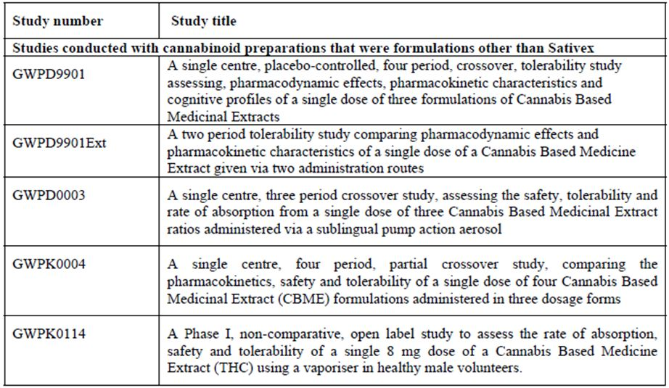
Table 7: Phase 1 studies (healthy volunteers): Sativex.
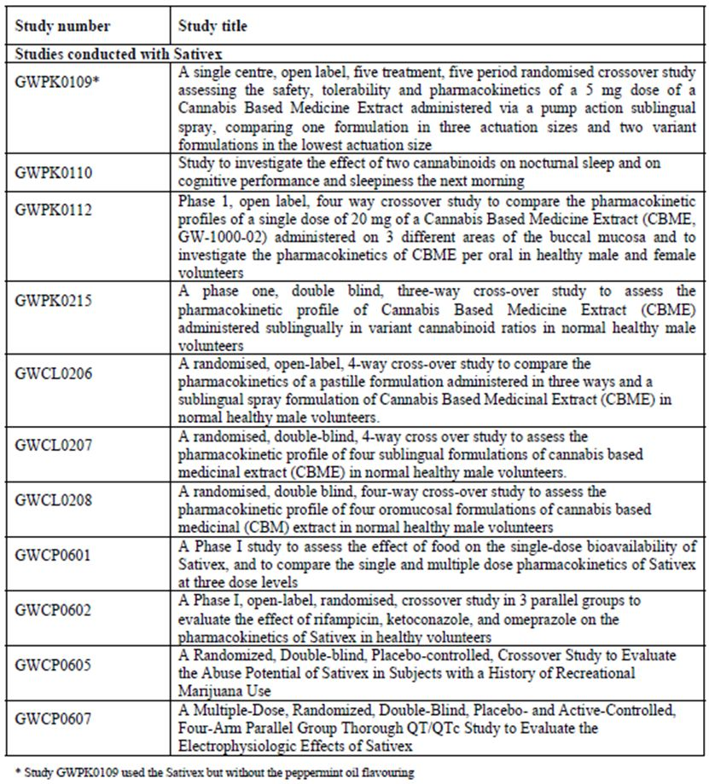

Summary of PK
The information in the following summary is derived from conventional PK studies unless otherwise stated.

PK in healthy subjects
The main PK parameters derived from the sponsor’s PK program are shown in Table 8 and they are summarised in the first row of Table 9, which is taken from the proposed PI. The values cited in the PI are equal to those from Study GWCP0601, but there is considerable variation in the C_{max} and T_{max} across studies and across individuals.
Table 8: T_{max}, C_{max} and t_{½} of CBD, THC and 11-OH THC following administration of GW-1000-02 (Sativex).
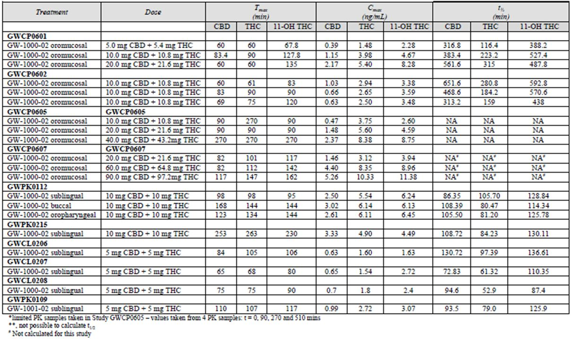
Table 9: PK parameters for Sativex, for vaporised THC extract and smoked cannabis.
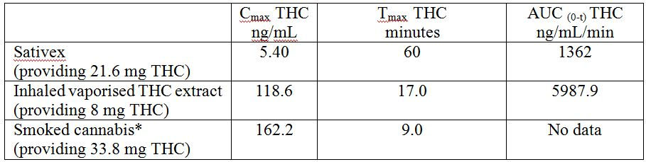
Table 10 shows that pulmonary administration of THC produces much higher plasma levels of THC, much faster than does Sativex. Note that Table 10, taken from the Clinical Overview, contains a typographical error, as clarified by the sponsor:
“… the number in the table is wrong and should be 10.8 (4 sprays of Sativex = 4 sprays x 2.7 mg THC per spray = 10.8mg THC.”
Table 10: C_{max} and T_{max} of THC after administration of vaporised THC, Sativex or smoked cannabis.
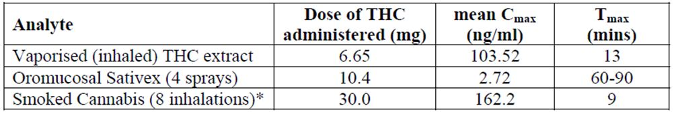

Absorption

Sites and mechanisms of absorption
The literature suggests that absorption of cannabinoids from the gastrointestinal tract is good, with 80-90% of an oral dose being absorbed but the oral bioavailability is low and variable (between 6-20%), which is why the sponsor sought another route of delivery. Although the pulmonary, nasal or rectal routes might also have avoided problems with first pass metabolism, the oromucosal route is clearly more convenient and has much higher patient acceptability.
Both THC and CBD are generally well absorbed via the oromucosal route due to their lipid solubility. This route also allows patients to titrate the dose with a variable number of small actuations, which is important for Sativex because the therapeutic dose is variable between subjects.
Following single dose administration of Sativex, both THC and CBD are rapidly absorbed. In Study GWCP0601, the primary PK study in this submission, the median T_{max} for THC and CBD in the fasted state was approximately 1-1.5 h and this did not change with increasing single doses of 2, 4 or 8 sprays. Results in other studies were broadly consistent with this, as shown above (Table 8). Some of the smaller studies produced divergent estimates of T_{max} for THC, up to 4 h. CBD is absorbed about as quickly as THC but less completely. The median T_{max} for CBD was generally similar to that observed for THC, >60 minutes, or in some studies CBD was absorbed slightly faster, but the C_{max} was generally less than half that seen for THC (Table 8).
Following oromucosal absorption, any remaining drug in the oral cavity is likely to be ingested and subsequent absorption occurs in the oesophagus and stomach. Drug absorbed via this route is subjected to first pass hepatic metabolism, resulting in the appearance of the main metabolite of THC, 11-hydroxy THC, in the systemic bloodstream, along with unmetabolised THC and CBD. The table above indicates that 11-hydroxy THC has a T_{max} of 90 or more minutes, though this was variable. In most studies, the T_{max} for the hydroxyl metabolite was after that observed for THC. In addition to variable first-pass metabolism, it is likely that subjects vary in the extent to which they swallow the drug.
Two PK studies were performed comparing the oromucosal and oral routes: GWPK0112, GWCL0206. Both studies showed some PK differences with different routes of administration, but these were small compared to the differences seen between subjects. In Study GWPK0112, exposure was reduced when the oral route was used (probably reflecting first pass metabolism) but T_{max} was achieved slightly faster via the oral route, on average. An oral pastille was absorbed more rapidly than Sativex administered via the proposed sublingual route. By either the oral or sublingual route, T_{max} is reached in about 60-100 minutes.

Bioavailability

Absolute bioavailability
The absolute bioavailability of THC and CBD, as administered in Sativex via oromucosal sprays, is unknown because these compounds were not administered intravenously in any study. The bioavailaibility of oral cannabinoids is low because of first pass metabolism.
Recreational cannabinoids are generally inhaled, not injected, and the effects of inhaled cannabinoids are quite well characterised, so it is important to compare the PK of oromucosal Sativex with the PK of inhaled cannabinoids. The potential for abuse and psychiatric morbidity would be expected to be significant if Sativex produced a similar concentration profile to inhaled cannabinoids.
The bioavailability of oromucosal Sativex was compared with inhaled THC extract and smoked cannabis in studies by Huestis, tabulated above (Tables 9-10).
The concentration-time curves for the inhaled THC extract and for Sativex are also shown in Figure 2, derived from Studies GWPK0114and GWPK0215. Despite the fact that the oromucosal Sativex taken in this study had a higher dose of THC (10.8 mg) than the inhaled THC (6.65 mg), the peak concentration achieved and the AUC was a small fraction of that observed after inhalation.
Figure 2: Plasma THC levels following administration of 6.65 mg of vaporised THC extract or of 4 sprays of Sativex.
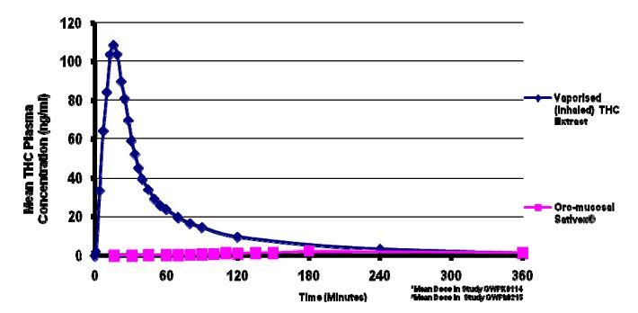
The sponsor also compared the PK of Sativex, as derived from Study GWPK0215, with a previous study by Huestis on the PK profile of smoked cannabis. The values for Sativex were dose normalised post hoc to an equivalent amount of THC as 8 inhalations of cannabis (33.8 mg) – this is very similar to the maximum recommended Sativex dose of 12 sprays (12 x 2.7 mg = 32.4 mg). Note that this is an inferred result, as subjects in the submitted study were not actually given 33.8 mg, and that analytic methods in the two studies are likely to have been different. The value “10.4” is also probably mistaken, as in the previous similar table (Table 10), and is supposed to be “10.8”. Nonetheless, the comparison showed that Sativex has much lower availability than smoked cannabis. The C_{max} was only 8.84 ng/mL for oromucosal Sativex, compared to 162.2 ng/mL following smoked cannabis, and the T_{max} was also greatly delayed via the oromucosal route (Table 11 and Figure 3).
Table 11: C_{max} and T_{max} of smoked cannabis, THC and Sativex.
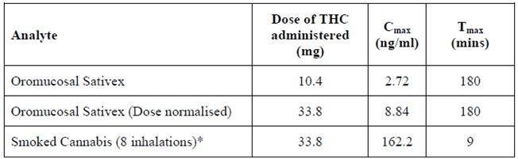
Figure 3: Plasma THC levels following administration of smoked cannabis and oromucosal Sativex.
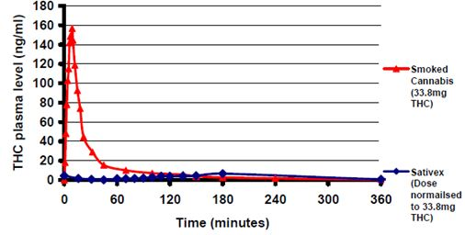
The sponsor proposes that these marked PK differences mean that the typical CNS effects of smoked cannabis are unlikely to be seen with the use of Sativex, which is a broadly reasonable interpretation if it is accepted that the peak concentration and speed of reaching peak levels are the major determinants of the user experience of marijuana. Ultimately, though, the claim that the intoxication potential of Sativex is substantially different to smoked cannabis needs to be backed up with appropriate PD studies, which are discussed in the PD section of this report.
Obviously, the relative bioavailability of Sativex compared to hypothetical intravenous administration would be expected to be even less than that seen compared to inhalation.

Bioequivalence of clinical trial and market formulations
There was no apparent difference between the formulation used in the clinical trials and that proposed for registration. Subtle changes in formulation are possible, given that it is a plant derived product, but these are likely to be offset by the self titration mechanism.

Bioequivalence of different dosage forms and strengths
Only one dosage form and strength is proposed for registration, so formal bioequivalence studies of different dosage forms and strengths are not strictly necessary.
The sponsor did perform some comparative studies assessing the PK of different concentrations of Sativex with different excipients (Table 12).
Table 12: Comparison of AUC of CBD, THC and 11-OH THC following administration of Sativex.
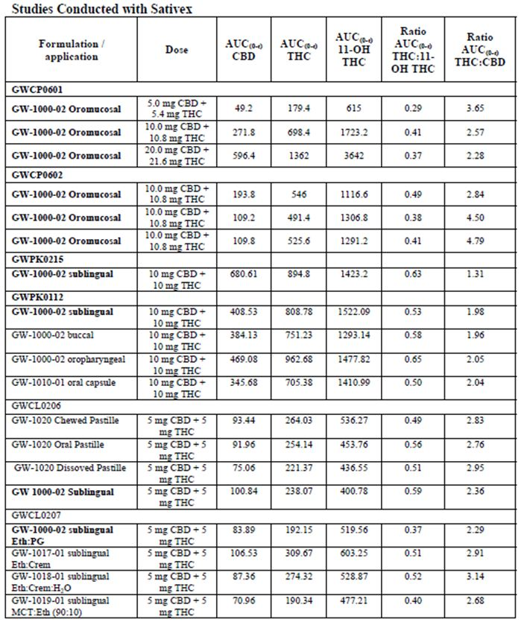
Table 12 (continued): Comparison of AUC of CBD, THC and 11-OH THC following administration of Sativex.
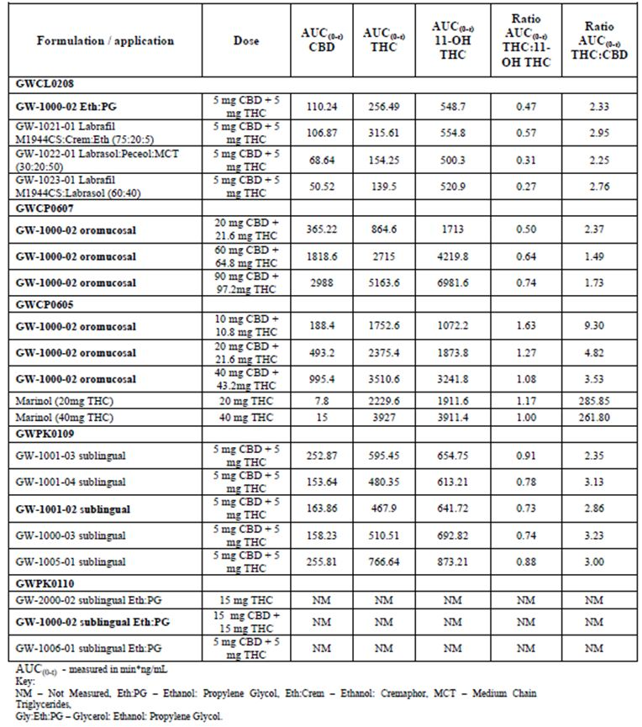
Also, Study GWFK0109 specifically assessed the PK of CBME according to the actuation volume. It was a five way crossover study in which 10 mg of CBME (THC : CBD, 5 mg : 5 mg) was delivered in a range of pump sizes (25, 50 or 100 mcL), with and without peppermint flavouring. The results are summarised in Table 12. No consistent difference was observed with different actuation volumes: the C_{max} and AUC of both cannabinoids was greater with the 25 mcL pump than the 50 mcL pump, but there was no significant difference between the 25 mcL and 100 mcL pump.
Other studies in the table below assessed the PK of Sativex according to route of delivery (Study GWPK0112), and with different excipients (Studies GWCL0208 and GWPK0110).

Bioequivalence to relevant registered products
Not applicable.

Influence of food
The effect of food on the PK profile of Sativex was investigated in Study GWCP0601, in which 12 healthy volunteers received 4 sprays of Sativex in the fed and fasted state, in a crossover design.
Group mean AUC_{(0-t)}, AUC∞ and C_{max} values for THC were 2.9, 2.8 and 1.6 fold higher, respectively, when Sativex was administered in the fed state.
For CBD, the corresponding parameters were 5.1, 5.1 and 3.3 fold higher in the fed state. For 11-hydroxy THC, AUC_{(0-t)} and AUC∞ were 1.3 fold higher and C_{max} was 0.8 fold lower when Sativex was administered in the fed state.
The mean values disguise the fact that significant inter subject variability was noted, making it impossible to predict the effect of food on absorption: 7 subjects had an increased C_{max} in the fed state, and 5 had a reduced C_{max}. For THC, the range of C_{max} values was 2.81-14.91 ng/ml (fed) and 0.97-9.34 ng/ml (fasted), so the two states overlapped considerably.
Food does appear to have a marked effect on the timing of absorption, possibly reflecting that a significant proportion of the drug is absorbed via swallowing (Table 13). The absorption of THC and CBD was delayed when Sativex was given with food (T_{max} was approximately 2.5 h later than during fasting conditions, at approximately 4 h). Median T_{max} for 11-hydroxy THC was approximately 2 h later during fed conditions (median T_{max} = 4 h).
Table 13: Summary of PK parameters of THC, CBD and 11-OH THC after administration of a single dose of Sativex (4 sprays): food effect.
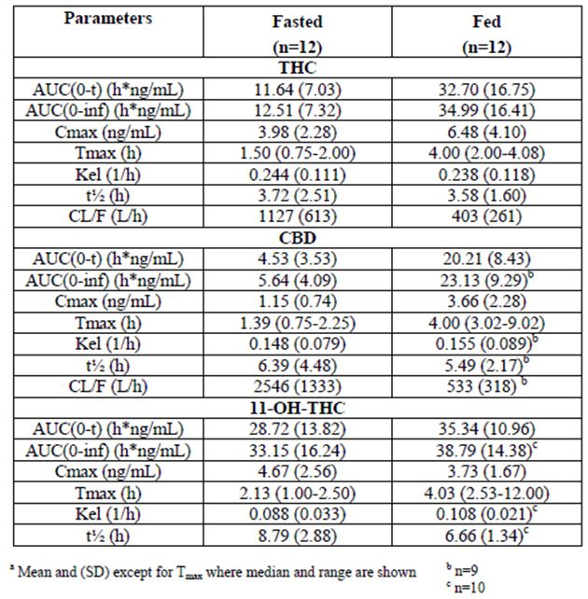
In another study (GWPK0215), 24 healthy male subjects received 4 sprays of Sativex following a low fat breakfast, and this produced a similar range of C_{max} values (mean (±SD): 4.90 ng/ ml (±4.92), range: 0.75-24.63 ng/ ml), which broadly resembles that observed in Study GWCP0601.

Dose proportionality
A number of PK studies assessed the PK of varying doses. In particular, Study GWCP0607 assessed Sativex in ascending doses (THC : CBD, 21.6 mg : 20 mg , 64.8 mg : 60 mg, and 97.2 mg : 90 mg). Study GWCP0605 assessed a lower range of doses (THC : CBD, 10.8 mg : 10 mg, 21.6 mg : 20 mg; 43.2 mg : 40 mg). In broad terms, the C_{max} and AUC showed a predictable increase, as shown in Table 12 above.
Dose proportionality was specifically assessed in Study GWCP0601. This study involved a fed and fasted comparison, followed by administration of 2, 4 or 8 sprays of Sativex once daily over ten days. An approximately dose proportional increase in exposure was observed after administration of 2, 4 and 8 sprays (5.4-21.6 mg THC and 5.9-20.0 mg CBD) in the fasting state (Table 13). Following multiple dosing, the 4-fold increase in dose (8 sprays compared to 2) gave an estimated increase of 9.8, 8.1 and 11.1 fold for THC, CBD and 11-hydroxy THC AUC_{(0-t)}, respectively, and a 7.3 fold increase in C_{max} for 11-hydroxy THC. Thus, higher doses produced a somewhat disproportionally elevated exposure.

Bioavailability during multiple dosing
As mentioned above, the multi dose PK profile of Sativex was assessed in Study GWCP0601. The accumulation of cannabinoids, as estimated by the ratio of AUC_{(0-t)} on Day 12 compared to AUC₍₀₋₂₄₎ on Day 1 or 4 in the fasted state, was 1.11-3.64 for THC, 1.71-3.20 for CBD and 0.97-2.41 for 11-hydroxy THC. There were no relevant dose dependant changes in T_{max} or t_{½} for THC, CBD or 11-hydroxy THC during single and multiple dosing. Accumulation did not appear to be significant in this study, because all analytes (including THC and CBD) were near or below the limit of quantification (0.5 ng/ml) within 24 h of the last dose of Sativex after 9 consecutive days of once daily dosing with 8 sprays.
Similarly, all analyte levels were low after 5 days of consecutive dosing with 36 sprays per day in Study GWCP0607.
In the chronic treatment setting, there is no evidence of clinically significant accumulation of THC and CBD. In Study GWMS0001EXT, the trough levels in these chronic patients were low, as shown Table 14, and C_{max} was similar to that observed in the other PK studies.
Table 14: Mean plasma concentration for Study GWMS0001 Visit A.
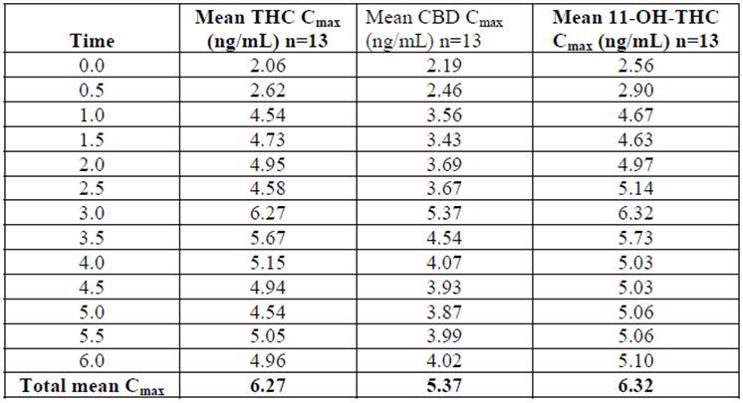

Effect of administration timing
No studies were performed that specifically assessed the effect of administration timing, except in relation to food. There is no reason to expect a clinically significant variation in PK according to the timing of the doses.

Distribution

Volume of distribution
The sponsor did not study the volume of distribution (Vd) of THC or CBD, but it would be expected to be high because these cannabinoids are highly lipophilic and they are redistributed rapidly to fatty tissues.
The sponsor’s Summary of Clinical Pharmacology refers to two published studies in which Vd was estimated. Lemberger estimated that the volume of distribution for THC was 484 +/- 23 L in non users of cannabis, and broadly similar (564+/-90 L) in chronic users. Kelly and Jones noted that the literature suggested a Vd of ~700 L, but they found a Vd of 96 L and a Vd at steady state of 75 L. They suggested that previous estimates had been in error because of technical differences.

Plasma protein binding
The proposed PI states that “Protein binding of THC is high (~97%).” No clinical studies assessed this. The interaction of CBD with glycoprotein was specifically addressed because pre clinical studies suggested a potentially important interaction. This issue is discussed above – in summary, the magnitude of the effect is unlikely to be of clinical importance.

Erythrocyte distribution
The term ‘erythrocyte’ does not appear in the Summary of Clinical Pharmacology. There does not appear to be any clinically significant distribution in erythrocytes.

Tissue distribution
Both CBD and THC are distributed into fatty tissues, which is why they have a high volume of distrubtion. The prolonged terminal elimination half life of cannabinoids is thought to be due the prolonged release of cannabinoids from poorly vascularised fatty tissue. This store of cannabinoids in chronic users might be expected to increase levels, but as discussed above, the PK profile of Sativex with multiple doses or even chronic use does not differ greatly from the single dose PK. To some extent, the lipid stores of cannabinoids would be expected to buffer the serum level leading to a smoother profile between doses.
Because cannabinoids are lipophilic, they readily cross the blood brain barrier, but information about the concentrations achieved in the CNS are lacking. Plasma concentrations are likely to correlate poorly with levels at the sites of action within the CNS, making PK/PD assessments difficult.

Metabolism

Sites of metabolism and mechanisms/enzyme systems involved
The initial metabolites of THC and CBD are hydroxylated derivatives, of which 11-hydroxy THC is the main component. A proportion of these metabolites undergo oxidation by CYP450 isoforms. According to the sponsor, subsequent excretion of conjugated metabolites is predominantly via the faecal route, and to a lesser extent, the renal route. Clearance from the plasma is also aided by redistribution into fatty tissues, such that serum levels of THC and its major metabolite are usually below the limits of detection after 24 hours (see Study GWCP0607). There is little data on the metabolism of CBD.

Non renal clearance
A proportion of the conjugated metabolites of cannabinoids are eliminated via the faecal route, but specific measurements in humans were not included in the clinical dossier. Some literature reports are summarised below.

Metabolites identified in humans

Active metabolites
The major active metabolite is 11-hydroxy THC.

Other metabolites
No details were provided about other active metabolites of Sativex.

PK of metabolites
The only metabolite the sponsor studied in detail was the primary metabolite, 11-hydroxy THC. The C_{max} and T_{max} for this metabolite are shown in nearly all of the PK tables considered so far. This metabolite generally peaks somewhat later than THC, as expected, but otherwise follows a broadly similar time course. In Study GWCP0601, the metabolite 11-hydroxy THC had a median T_{max} that increased with increasing dose from 1.13 h after 2 sprays Sativex to 2.25 h after 8 sprays Sativex. Its mean t_{½} was 6.47, 8.79 and 8.13 h after 2, 4 and 8 sprays Sativex, respectively.

Consequences of genetic polymorphism
No data was submitted in relation genetic variation in the metabolism of cannabinoids, but all PK studies noted wide inter subject variation in the PK profile. It seems likely that this has a genetic component.
No metabolites of cannabinoids are noted to be particularly toxic and no PK related genetic susceptibility issues have been identified during the prolonged human experimentation with recreational cannabinoids.
The self titration approach advocated by the sponsor would be expected to overcome much of the presumed genetic variation in Sativex PK and PD.

Excretion

Routes and mechanisms of excretion
CBD, THC and 11-hydroxy THC are largely eliminated within a day of consumption. After 9 days of dosing with up to 8 sprays daily in Study GWCP0601, or after 5 days of high level dosing with 36 sprays in Study GWCP0607, these analytes were usually below 1 ng/ml within 24 hours of the final dose.
The sponsor did not perform studies detailing the methods of elimination, but instead referred to the literature, which suggests that elimination is due to a combination of renal and hepatic clearance and the re distribution of the cannabinoids and their metabolites to adipose tissue. The store of cannabinoids in adipose tissue contributes to the long terminal elimination half life, but does not appear to lead to clinically significant accumulation in terms of serum levels after chronic dosing.
The sponsor’s Summary of Clinical Pharmacology summarised the relevant studies as follows:
“Lemberger found that THC is rapidly metabolised to polar compounds and about 40% is excreted in faeces within 7 days. In urine about 30% of total THC is excreted by chronic users and about 22% by non users. No free THC is excreted in urine. In urine, highly polar metabolites of THC were [excreted]. No unchanged THC and very small amounts of 11-OH-THC was found in urine. In faeces, 11-OH-THC accounted for a considerable amount (about 20%) of THC.
Wall found that after 72 h following IV administration, the urinary excretion of THC metabolites in both sexes ranged from 13-17% and in faeces 25-30% of total dose. After oral administration the faecal excretion ranged from 48-53%. 11-Hydroxy-delata-9-THC was found to be the major metabolite, which is mainly excreted unchanged in faeces and as acidic conjugates in urine.”
These two studies are in broad agreement, and a review of the original papers found the sponsor’s summary to be appropriate.

Mass balance studies
No mass balance studies were submitted.

Renal clearance
In Study GWPK0112, urine was collected at multiple time points to assess levels of 11-hydroxy THC. This metabolite was detected in urine throughout the sampling period; its excretion began within the first 0.5 to 1 h after dosing, and peaked during the 3-6 h collection period.
The two studies cited above reported that renal clearance accounted for a significant proportion of an intravenous dose of THC, with Lemberger and colleagues reporting that 22-30% was recoverable in the urine, and Wall and colleagues reporting that 13-17% was recoverable.

Intra and inter individual variability of PK
Most PK studies noted high inter subject variability. Details are provided in the summaries of individual PK studies. The self titration approach to Sativex dosing would be expected to compensate for this variability.

PK in the target population
PK data in the target population are limited, but there is no substantial reason to expect that MS patients would have a very different PK profile than the general population, unless they had sustained additional medical problems such as renal or hepatic disease.

PK in other special populations

PK in subjects with impaired renal or hepatic function
There have been no studies of the PK of Sativex in subjects with hepatic or renal impairment.
Many cannabinoid metabolites are expected to be active, and it is likely that subjects with renal impairment would have increased levels of these metabolites, though this has not been directly demonstrated and no PK studies were submitted that involved patients with renal impairment. The sponsor recommends that Sativex be used with appropriate caution in this population. Given that the drug is self titrated, the risk of excessive serum levels is somewhat ameliorated, but such caution is appropriate.
There is no evidence from animal studies, and no reports from clinical experience with Sativex, of liver or renal toxicity from cannabinoids. There is no anecdotal evidence suggesting hepatic or renal toxicity in recreational marijuana users.

PK according to age
No specific age related PK studies were submitted. It would be expected that metabolism and clearance would be reduced in the elderly.

PK related to genetic factors
No specific genetic studies were submitted.

PK interactions

PK interactions demonstrated in human studies
The sponsor submitted a Phase 1 drug interaction study assessing the PK of Sativex when combined with rifampicin (a CYP3A4 inducer), ketoconazole (a CYP3A4 inhibitor), and omeprazole (a CYP2C19 inhibitor).
Exposure to multiple doses of rifampicin reduced the mean levels of THC, CBD and 11-OH-THC achieved after a single dose of 4 sprays of Sativex, compared to levels achieved when Sativex was give alone. The magnitude of the effect was small in relation to the inter-subject variability obtained with Sativex by itself alone, but this study suggests that induction of CYP3A4 will reduce exposure to cannabinoids. It also suggests that 11-OH THC is metabolised by CYP3A4.
Ketoconazole increased exposure to Sativex. For THC and CBD, there was an increase in C_{max} of 25% and 96%, respectively, and an increase in AUC of 77% and 171%, respectively. This change was less than the inter subject variability. For 11-OH THC, the C_{max} was 3.1 times greater after ketoconazole, and the AUC was 3.8 times greater. This study also suggests that 11-OH THC is metabolised by CYP3A4.
Omeprazole had minimal effects on mean levels of THC, CBD and 11-OH-THC.

Clinical implications of in vitro findings
In vitro studies using human hepatocytes have suggested that Sativex has some ability to inhibit CYP4503A4 and 2C19, but only at concentrations well in excess of those achieved with therapeutic doses. Clinically important drug-drug interactions by this mechanism are therefore unlikely.
The research literature on cannabinoids suggests that CBD inhibits P-glycoprotein mediated drug transport in vitro, suggesting that CBD could influence the absorption and disposition of other drugs that are P-glycoprotein substrates in vivo. Digoxin is one well known substrate for P-glycoprotein, and P-glycoprotein regulates its oral absorption and renal clearance. Because digoxin has a narrow therapeutic window, this interaction could have potential clinical consequences.
The interaction of CBD with P-glycoprotein has been investigated a number of authors. The overall consensus is that CBD has an inhibitory effect on P-glycoprotein at an IC₅₀ of about 8 to 39 µM. The effect does not appear to be mediated by the cannabinoid receptor and is not yet explained, but it is similar in magnitude to the effect seen with turmeric and verapamil. When Sativex is administered to humans, even at high doses, the maximum observed plasma concentration of CBD is <14 ng/ml, equivalent to <50 nM, which is a tiny fraction of the IC₅₀. This effect is thus unlikely to be clinical relevant.

Evaluator’s overall conclusions on PK
The PK profile of Sativex has been well characterised, and is fairly summarised in the proposed PI. Sativex is subject to first pass metabolism, and has a high degree of inter subject variability, so an oromucosal route and a self titration approach are appropriate. Long term accumulation of Sativex in fatty tissues is expected with prolonged use, but does not cause any known safety problems.
The PK of oromucosal Sativex differ substantially from inhaled cannabinoids, which would be expected to lessen the abuse potential and CNS side effects of the drug.

Pharmacodynamics

Studies providing PD data
Very little PD data was submitted. Importantly, there were no PD studies assessing the effect of THC or CBD on muscle tone or spasticity. Even in the published literature, the only studies attempting to assess the effect of cannabinoids on muscle tone were those that used the Ashworth spasticity scale and these failed to show an effect.
Four pre clinical studies have been performed showing an anti spasticity effect of THC in animals; an assessment of these is beyond the scope of this clinical evaluation. There are no studies showing an anti spasticity effect of CBD, either in animals or humans, and the submission does not propose any theoretical reason to suppose that CBD would be useful in the treatment of spasticity. (The sponsor has since provided a single comment about anandamide in their response to a preliminary question.)
The primary pharmacology of Sativex was partially assessed in the first Phase 1 Study GWPD9901: “A single centre, placebo controlled, four period, crossover, tolerability study assessing, PD effects, PK characteristics and cognitive profiles of a single dose of three formulations of Cannabis Based Medicine Extract (CBME).” This study did not include any formulation directly comparable to Sativex, but did show that 20 mg THC caused a degree of intoxication and cognitive impairment, with and without CBD.
Other PD studies included GWPK0110, which was a PD study assessing intoxication potential, GWPC0605, which was a study of abuse potential in recreational marijuana users, and GWCP0607, which was a QT study. Table 15 shows the studies relating to each PD topic and the location of each study summary.
Table 15: Submitted PD studies.
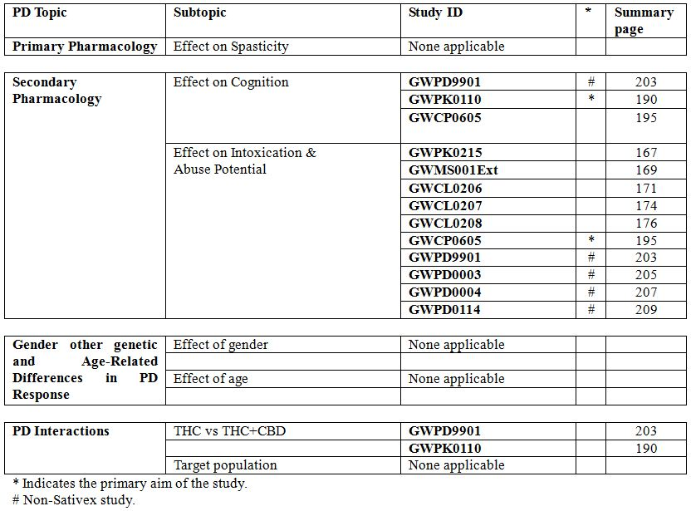
None of the PD studies had deficiencies that excluded their results from consideration, but there were no PD studies looking at spasticity, and the two studies explicitly assessing cognition as a primary focus (Studies GWPD9901 and GWPK0110) both excluded the cognition results from the main study report. Most of the PK studies assessed intoxication, so this was the only PD parameter for which there is adequate information. These deficiencies should be addressed with further studies, particularly in regards to the cognitive effects of Sativex in the target population. PD studies of spasticity are likely to be technically difficult because the lack of a sensitive, objective spasticity measure.

Summary of PD

Mechanism of action
Plant derived cannabinoids are thought to act by mimicking a group of endogenous neurotransmitters, the endocannabinoids, by binding to cannabinoid receptors. The principle cannabinoid receptor in the central nervous system is type 1 (CB1), whereas the peripheral nervous system contains type 2 receptors (CB2). THC, one of two key cannabinoids in Sativex, has been studied for decades. It acts as a partial agonist at CB1 receptors, though it is unclear how it exerts its psychoactive and anti spastic effects. Most of the data has been derived from animal studies, and is discussed in more detail below. Much less is known about the mechanism of action of CBD, though the sponsor provided some additional discussion, based on literature references, in response to preliminary questions. There are no human studies studying the PD or efficacy of CBD in spasticity. It is unknown whether the inclusion of CBD in Sativex has a facilitating or antagonising effect on the anti spastic action of THC.

Mechanism of action of THC
THC acts as a partial agonist at CB1 receptors. CB1 receptors are G-protein linked receptors; their activation causes an inhibition of cyclic adenosine monophosphate (or cAMP), which is followed by phosphorylation and subsequent activation of a range of intracellular kinases. The ultimate results of this pathway are not well characterised, so the actual effects of THC on the brain and the ability of THC to modulate spasticity can only be inferred from observational studies, not deduced at the mechanistic level.

Mechanism of action of CBD
CBD, the second main cannabinoid in Sativex, is known to be psychoactive, but it not known to act as an agonist at cannabinoid receptors, despite is rough chemical resemblance to THC. It may even act as a CB1 antagonist.
The mechanism of action of CBD, and even whether it has any anti spastic effects at all, is unclear.
The sponsor’s response to a preliminary question on this issue is reproduced in full in the Appendix. According to the sponsor, CBD is thought to be “an inhibitor of Fatty Acid Amide Hydrolase, the main enzyme responsible for local catabolism of the principle endogenous cannabinoid, anandamide.” Thus, CBD could prolong the effect of anandamide, which is claimed to have an anti spastic action in animal models (no references supplied).
CBD also has complex and poorly characterised PD interactions with THC. As related by the sponsor, McPartland and Russo proposed three principal mechanisms which may be involved in the interactions between THC and CBD:
“(i) CBD has a weak affinity for, and has been demonstrated to exert antagonist or inverse agonist activities at, CB1 receptors.
(ii) CBD may modulate signal transduction by perturbing the fluidity of neuronal membranes, or by remodelling G-proteins that carry intracellular signals downstream from cannabinoid receptors.
(iii) CBD is a relatively potent inhibitor of the cytochrome P450 3A11 hepatic enzyme system and thus blocks the formation of 11-hydroxy-THC, a metabolite with higher psychoactive and immunosuppressive activity than THC.”
It has been proposed that, when combined with THC in Sativex, CBD modulates the anxiogenic and psychoactive effects of THC; the mechanism for such modulation is unclear, and in different animal models the interaction may be synergistic or antagonistic.
As evidence of a synergistic effect, the sponsor reports:
“For example, CBD increased the effects of THC in causing analgesia in mice and in impairing rope climbing performance in rats. Similarly, Fernandes and colleagues reported that CBD enhanced the effects of THC, in rats, in terms of effects on food and water intake, body temperature, catalepsy and pentobarbital induced sleep time.”
By contrast, an antagonistic effect was demonstrated by other authors, using multiple animal models in rabbits, mice and rats: CBD reduced some of the acute effects of THC, including abolition of the corneal reflex and the induction of catatonia, but did not affect these responses when given alone. Some researchers have suggested that CBD is anxiolytic in humans and in animal models, whereas THC has stimulant effects.
The uncertainty surrounding these issues is even evident in the sponsor’s response, where the sponsor writes:
“The potential modulating effect of CBD on the psychoactivity of THC may be of importance to the clinical profile of Sativex when compared with THC administered as a single agent.”(Emphasis added).
In other words, the presence or absence of CBD in the formulation is likely to be clinically important, but the science is too premature to draw any firm conclusions about the nature and even the direction of the various interactions. The lack of preclinical data is made more significant by the complete lack of any clinical studies of the effect of CBD on spasticity.
According to the clinical expert, CBD is also claimed to have neuroprotective and anti inflammatory properties, mediated in part via modulation of intra cellular calcium. It acts as an agonist at TRP channels, which are involved in calcium homeostasis, and it is an inhibitor of adenosine uptake, which could reduce inflammation. Whether these effects are relevant in MS patients is unknown.
Overall, the role of CBD in Sativex is unclear. There are no clear cut theoretical reasons for supposing it will increase the anti spastic action of THC, and there are some indicators that it could even play an antagonistic role. The notion that CBD modulates of THC’s psychoactivity is plausible, but the idea that this modulation is useful remains an unconfirmed hope. CBD has not been added to Sativex because of a process of rational drug design, but has instead been included simply because the cannabis plant produces it.

PD effects

Primary PD effects
In the context of the current submission, the primary PD effects of Sativex would be its effect on muscle tone and spasticity. No studies have been performed that directly address this, either in normal subjects or in patients with spasticity. Some animal studies suggest that canabinoids reduce spasticity, but the only evidence of an anti spastic effect in humans comes from the major efficacy studies. These efficacy studies did not adequately address the time profile of the response, the relationship between serum concentration and anti spasticity effect, or the different roles of THC and CBD.
To some extent, this lack of data is understandable because such studies would be difficult to perform. There is wide inter subject variability in the response to cannabinoids, and there are no objective measures of spasticity that appear sensitive enough to monitor the acute PD effects of anti spastic agents. The Ashworth score, a traditional semi objective measure of spasticity, has not shown a significant anti spastic effect for cannabinoids, and none of the accepted anti spastic agents have been shown to have a significant effect on the Ashworth score (Table 16).
Table 16: The Ashworth and Modified Ashworth Scales.
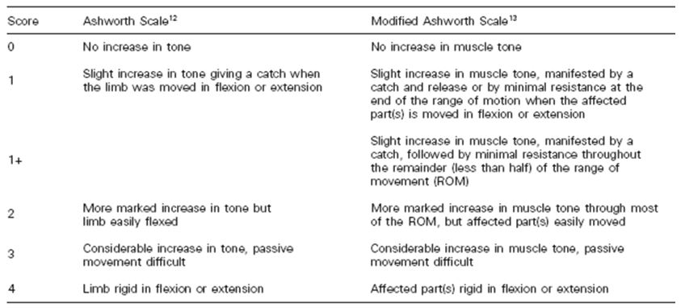
The lack of a clear PD model for Sativex’s effect on spasticity is a significant deficiency in the submitted dossier, but it is offset by the proposal that subjects should self titrate their Sativex dose according to response. This should allow patients to find the correct dose despite the lack of data to guide dose selection. Also, the proposed 4 week trial period should identify the majority of patients who are unable to respond to Sativex, and this should compensate for the lack of a predictive neurophysiological model.
The lack of any attempt to characterise the PD effects of THC in comparison to CBD and the combination of THC and CBD is a much more serious deficiency.

Secondary PD effects
The secondary PD effects of Sativex might be expected to resemble the CNS effects of recreational marijuana, and in this respect the effects of cannabinoids have been well described in the literature. Such effects can include a sense of intoxication, sedation, euphoria, and altered perceptions. The submitted dossier included some studies attempting to demonstrate that these familiar CNS effects are not a feature of Sativex administration, primarily because its PK profile differs substantially from inhaled cannabis. The Safety analysis showed that many CNS AEs were over represented in Sativex users, however, consistent with a mild intoxication syndrome.
Some of the PK studies included a self assessment of intoxication. Mean levels of intoxication were low, but one or two individuals in each study reported at least moderate intoxication.

Time course of PD effects
There are no studies in humans exploring the acute time course of Sativex on spasticity.

Relationship between drug concentration and PD effects
There are no studies in humans exploring the relationship between plasma or CNS concentration and acute PD response. Chronic drug levels in apparent responders were explored in the efficacy Studies GWMS0001Ext and GWEXT0102. There was no evidence of dose escalation with prolonged use, suggesting that the relationship between concentration and effect remained reasonably constant. Against this, it has been observed that recreational cannabis users do show habituation and dose escalation. This could reflect differences between the primary (anti spastic) and secondary (psychoactive) PD profiles of cannabinoids.

Genetic, gender and age related differences in PD response
This has not been studied.

PD interactions
There are no studies of the primary PD effect of Sativex on spasticity, even as monotherapy, let alone studies exploring PD interactions between anti-spasticity agents. The efficacy studies assessed interactions indirectly, because many patients continued to take anti spastic agents such as baclofen during the trials.
PD interactions related to other CNS effects of cannabinoids, such as intoxication, have been described in the literature, but were not studied extensively by the sponsor. One Phase 1 study (GWPK0110) assessed the interaction of THC and CBD on sleep and latency and memory function. There were some soft findings suggesting CBD may offset some of the adverse effects of THC on psychomotor performance, but it seemed to worsen fatigue compared to THC by itself. This issue remains unresolved, and worthy of further study, particularly as there are no efficacy studies of THC vs the combination of THC and CDB.

Evaluator’s overall conclusions on PD
Overall, there is a severe lack of PD data related to Sativex and its effect on the neurological substrate of spasticity. The dossier refers to 4 animal studies assessing the effect of THC on spasticity, no animal studies of CBD and spasticity, and no human studies of either compound that directly assess the PD of the purported anti spastic effect. This deficiency is particularly important because no efficacy studies addressed the issue of whether CBD adds or detracts from the efficacy of THC in the treatment of spasticity.
The submission thus rests almost entirely on the pivotal efficacy studies, all of which assessed the combination of THC and CBD without considering each component of Sativex individually.
The other PD effects of cannabinoids, such as their effects on mood and perception, have been well described in the literature. The sponsor has submitted reasonably convincing evidence that acute intoxication is not a major feature of Sativex use when it is taken at the proposed doses.

Dose selection for the pivotal studies
There is wide inter subject variability in the dose response to cannabinoids, and the sponsor elected to develop Sativex as a drug that would be self titrated as needed. This partially circumvents the need to perform dose ranging studies.
Phase 1 studies suggested significant intoxication potential at higher doses. In particular, toxic psychosis was observed in Study GWCP0607 (an ECG study in healthy volunteers). All psychotic episodes occurred in recipients of high dose Sativex (18 sprays twice daily), and in three of them it occurred on the first day of dosing, after just 18 sprays. Some of the supportive studies assessed a higher range of doses than currently proposed. For instance, in Study 001, the maximum permitted dose was 8 sprays within three hours and 48 sprays (130 mg THC, 120 mg CBD) in 24 h. The incidence of CNS AEs was significant. The maximum recommended dose was therefore reduced in the pivotal studies on tolerability grounds.
There have been no dose ranging studies showing different efficacy at different doses which is one of the weakness of the submission. A dose response curve would have added to the internal validity of the sponsor’s evidence.

Efficacy

Efficacy of Sativex in the treatment of MS related spasticity

Spasticity assessments used in the efficacy studies
One of the points of contention during the original, unsuccessful submission of Sativex in Europe was the appropriateness of various assessment tools for rating spasticity.
The pivotal studies used an 11 point (0 to 10 point) NRS, in which patients rated their spasticity subjectively, in response to the question:
“On a scale of ‘0 to 10’ please indicate the average level of your spasticity over the last 24 hours.”
Responses were anchored via labels at each end: 0 = “no spasticity” and 10 = “worst possible spasticity”.
In rejecting the original submission, evaluators in the European regulatory setting suggested that the NRS might have assessed factors other than spasticity:
“The validity of the NRS as a measure specifically of spasticity appears unclear. The proposed indication is specifically for spasticity. The applicant should discuss to what extent a difference in the patient reported NRS score reflects a difference in the severity specific to the physiological phenomenon of spasticity in this patient population, as opposed to other symptoms that a patient might complain of, and general well being.”
This issue was discussed in detail by the sponsor in the new, revised submission, which included a 48 page discussion of the validity of the NRS. Also, 10 pages of the European evaluation of the latest Sativex submission were devoted to a discussion of the merits of different spasticity assessments, including the NRS.
There is some validity to the original European concerns. With any subjective scale, patient self assessments may depart from a hypothetical objective gold standard, and this is likely to be particularly true of a complex phenomenon such as spasticity. Patients with low mood or pain might be more negative in their spasticity assessments than patients with a brighter outlook, even when their spasticity was actually no different. Patients with significant weakness or greater fatigue might find ambulation more difficult than other patients with better strength or energy, and might blame their spasticity, even though their spasticity was actually no worse than other patients who walked more easily and therefore rated their spasticity a milder. All of this would be expected to produce at least some unreliability in the NRS, when using it as a surrogate for the underlying objective motor phenomena of disinhibited stretch reflexes, impaired relaxation and abnormal muscle tone.
If such unreliability merely produced unbiased random variation in NRS scores, then using the NRS as a primary efficacy variable would be expected to lower the power of any efficacy study because the efficacy ‘signal’ might be difficult to discern amongst the ‘noise’ of inaccurate ratings. A study that overcame these limitations would still be reliable, but it might have to recruit more patients to achieve statistical significance. A much more serious possibility is that systematic bias could be present, with the subjective ratings confounded by some factor other than the efficacy of Sativex as an anti spastic agent. For instance, patients intoxicated by cannabis might be more positive in their ratings because of elevated mood, poor insight into their deficits, or reduced pain levels.
Of even more concern, patients might guess that they were on active treatment because they detected any of the many known effects of cannabis on the central nervous system, such as mood or perceptual changes, dizziness, appetite changes, impaired concentration, and so on. Knowing or suspecting that they had received active treatment, they might then rate themselves as having less spasticity because of an expectation that the drug should work, a desire to please the investigator, or a number of other psychological factors. This appears to have been a major concern of the European regulatory authorities when they rejected the original submission, and, in response, the sponsor has specifically addressed the possibility of unblinding in the pivotal studies. This issue is discussed separately – unfortunately the sponsor’s attempts to provide reassurance about the possibility of unblinding are unconvincing.
In defence of the NRS, the sponsor has pointed out that there is no ideal gold standard for assessing spasticity. The most widely used assessment tools in previous studies, the Ashworth Scale and the modified Ashworth Scale, attempt to rate spasticity objectively, based on resistance to passive movement (Table 16). According to the sponsor, both variants of the Ashworth scale have poor sensitivity and reliability, and are not good at detecting clinically relevant changes. That is, patients can experience a significant improvement in their spasticity symptoms without necessarily shifting from one Ashworth category to another. This view has some support in the literature where it has been noted that there is significant inter rater variability in assigning Ashworth scales.
One problem with the Ashworth scale is that it reduces a multi faceted motor abnormality to a single element – resistance to passive movement – when patients may be bothered by many other aspects of the spasticity symptom complex. For instance, some types of muscle contraction may produce more discomfort than others, or may have more severe functional consequences, despite having similar effects on resistance to passive movement. The timing and nature of the unwanted contractions may be more important than the actual resistance to passive movement. Unwanted muscle tone may manifest itself during activity, for instance, when it has important functional consequences, and this might not be reflected in an assessment of the supine patient on the examination couch.
A related problem is that spasticity may vary over the course of a day, and may be more pronounced when the patient is active or tired, so a single assessment in the physician’s consulting room suffers from sampling error, and may completely miss the times when the spasticity is most problematic. In view of these problems, Pandyan and colleagues have suggested that the Ashworth scale may fail to capture the patient’s most important spasticity related symptoms, and many other authors have concurred.
Of note, the Ashworth scale has not been useful in demonstrating the efficacy of most accepted anti spasticity treatments. The sponsor comments:
“outside of the single example of the focal relief of spasticity in the forearm with botulinum toxin, there are no data linking changes in the Ashworth Scale with changes in function.”
Another commonly used measure of spasticity, the Tardieu scale, resembles the Ashworth scale, but it takes the velocity of the muscle stretch into account. This is appropriate, because one of the hallmarks of spasticity is that, like the stretch reflex itself, it is more marked at higher stretch velocities. Factoring in stretch velocity might be expected to improve inter rater reliability, because it systematises one potential source of variation. The Tardieu scale therefore shows some promise, but it has not been sufficiently validated and it shares with the Ashworth scale the problems of insensitivity and failing to capture the full experience of spasticity, including diurnal variation.
Thus, compared to the currently available objective scales of spasticity, the NRS offers the following potential advantages:
- It reflects the patient’s daily experience of spasticity, and thus produces an assessment of clinical relevance.
- By asking the patient to consider spasticity severity over a 24 h period, it incorporates diurnal fluctuations in severity.
The first of these points is very important. Although, like the Ashworth Scale, the NRS reduces a complex phenomenon to a single number, it is at least scored by the patients who actually experience the entire constellation of spasticity related symptoms and who may be best placed to rate the overall severity and significance of their spasticity. Given that spasticity is primarily treated for patient comfort, not to prolong life, reduce future health risks, or eliminate disease, the patient’s subjective experience is at the core of what is being treated, and is potentially of more clinical relevance than any one dimensional physiological phenomenon, however objective. In this sense, an NRS for spasticity is just as necessary and potentially as valid as similar scales used in pain studies. Several authors have pointed out any outcome measure used in spasticity studies “must correspond to the patients’ daily experience of spasticity.”
The second point – the incorporation of diurnal variation – is also a fairly persuasive point in favour of the NRS over spot assessments by clinicians at individual moments. MS patients commonly report that their spasticity varies during the day, or increases with activity, and they commonly show varying spasticity from one visit to the next.
In general, then, it is plausible that the NRS is an appropriate tool for measuring spasticity, but there is a substantial risk that individual assessments might be confounded by additional factors.
In the sponsor’s Summary of Clinical Efficacy, five principle arguments are presented in defence of the NRS. The sponsor writes:
“There are five elements to this discussion:
- Expert physician and subject representative opinion that confirms the view that subjects are able to distinguish one symptom from another.
- Analysis of existing data which confirms that subjects are able to distinguish changes in spasticity from changes in other symptoms of MS such as pain, sleep and fatigue.
- An expert based assessment that the NRS as a measure of spasticity, meets published criteria for a valid measurement tool.
- An independent published paper which confirms that the NRS as a measure of spasticity, meets published criteria for a valid and reliable measurement tool.
- Published data from a longitudinal validation study confirming that the NRS is measuring the same phenomenon as is being assessed by the observer based measurement tools of the Ashworth Scale and the Tardieu Scale.”
Each of these five elements will be considered in turn.

1) “Expert physician and subject representative opinion that confirms the view that subjects are able to distinguish one symptom from another.”
In relation to the ability of MS patients to distinguish their various symptoms, Professor Lynne Turner-Stokes (2005) states:
“In my experience even patients with quite profound cognitive and communicative difficulties are able to distinguish their various symptoms”
Christine Jones, Chief Executive, of The Multiple Sclerosis Trust makes a similar comment:
“There is no doubt in my mind that people with MS and their carers are the best judges of whether the symptom has improved or not. All I can say is that as someone with MS myself, active in the MS voluntary sector for over 25 years and the only person with MS on the NICE Guideline Development Group, you know if your spasticity is reduced over the course of a given 24 h. The painful spasm with which spasticity is associated is most definitely distinguishable from say a general muscle weakness or a particular neurogenic or musculoskeletal pain.”

Evaluator’s comment:
It is indeed likely that most MS patients are able to recognise spasticity, but this does not negate the very real possibility that, despite knowing what spasticity is, a patient who is tired, grumpy, weak, or in pain may choose a different arbitrary rating for their spasticity than another patient without these confounders. In this setting, any unblinding or other systematic confounding influence could invalidate the assessment.

2) “Analysis of existing data which confirms that subjects are able to distinguish changes in spasticity from changes in other symptoms of MS such as pain, sleep and fatigue.”
This argument is expressed much more definitely than the evidence justifies. In the absence of an accepted gold standard for measuring spasticity, it is simply not possible to confirm that subjects are completely reliable in their attempts to distinguish one symptom from another. The sponsor points out that the subjects recruited to the major efficacy studies had suffered from spasticity for a considerable period of time and they were responding inadequately to first line anti spasticity medications, so they were generally well acquainted with the symptom and had experienced many chances to discuss the nature of their spasticity with their treating physician, including its response to treatment. This increases the likelihood that they were able to rate the symptom with reasonable accuracy, but it does not eliminate the possibility of confounding.
The sponsor also refers to a population based survey in MS patients that showed a high (but incomplete) correlation between patients’ self reported spasticity severity and a range of independent assessments. Such correlation is reassuring but not definitive, because confounding could be responsible for the incomplete correlation.
The sponsor points out that “spasticity” was explained as “muscle stiffness” in the subject information leaflets, and it was equated to muscle stiffness at the protocol level, so all participants are likely to have had a clear understanding of what was being studied.
Finally, the sponsor points out that the main symptoms that might have confounded spasticity ratings, such as pain, fatigue, sleep quality and tremor, were assessed during the pivotal studies, and they did not move in parallel with spasticity ratings. In particular, spasticity improved with active treatment during the pivotal studies, but fatigue was worse with active treatment, relative to placebo. This is broadly reassuring, but still leaves some room for confounding influences.

Evaluator’s comment:
It seems likely that, to a large extent, patients knew what was being measured with the NRS and attempted to rate spasticity as distinct from their other MS symptoms. The lack of parallel changes in various symptom scores confirms that the NRS for spasticity was measuring something substantially different from pain, fatigue or general well being, but confounders were not completely eliminated.

3) “An expert based assessment that the NRS as a measure of spasticity, meets published criteria for a valid measurement tool.”

4) “An independent published paper which confirms that the NRS as a measure of spasticity, meets published criteria for a valid and reliable measurement tool.”
Dr John Farrar, of The University of Pennsylvania, is a statistician who appears to have been commissioned by the sponsor to argue in favour of the NRS. His 2008 paper in defence of the NRS refers to criteria proposed by Bland and Altman for validation of a new instrument. Bland and Altman’s criteria are reasonable and widely accepted.
According to Bland and Altman, a valid instrument should have all of the following:
- Face and Content Validity
- Construct Validity
- Internal Consistency and Reliability
- Responsiveness
- Clinical Usefulness
- Feasible to use in the Clinical Setting

Face and content validity
Face validity relates to whether the scale “looks right,” and whether it asks about the sorts of thing we think of as related to what we want to measure. Content validity refers to whether the scale covers all the different aspects of what we want to measure. The NRS clearly has face validity, as it is a response to a targeted question:
“On a scale of ‘0 to 10’ please indicate the average level of your spasticity over the last 24 hours.”
and patients were told that spasticity was defined as “muscle stiffness”. It is somewhat less clear, however, that the NRS covers the full constellation of spasticity related symptoms, because this depends on what the patient considers to be relevant to spasticity. A patient primarily troubled by spasms might not consider other aspects of spasticity, for instance. A multi item questionnaire asking about gait, knee bending, toe clearance, spasms, cramps, muscle aches and other spastic symptoms might have had more content validity than the NRS, at the expense of being more complicated and more difficult to use. These considerations aside, several experts have supported the content validity of the NRS, including Farrar, Anwar and Barnes, and Professor Lynne Turner-Stokes (2005), Dunhill Professor of Rehabilitation at King’s College, and it appears acceptable overall.

Evaluator’s comment:
The NRS appears to have adequate face and content validity, and is supported by experts in the field.

Construct validity
Construct validity refers to the property of having appropriate relationships with other measurement variables and behaving appropriately in situations where the quality of interest is expected to change. Construct validity for the NRS was investigated by assessing the correlation between the primary outcome measure (spasticity NRS), and other measures of spasticity related outcome measures such as the Ashworth scores, spasm frequency scores and subjective global impression of change (SGIC). In Study GWMS0106, there was a significant correlation between the spasticity NRS and change in the spasm frequency scale (r = 0.63, p <0.001). There was also a significant correlation between % change in spasticity NRS and the SGIC (r = 0.515, p<0.0001). The correlation with the Ashworth Scale approached significance (p = 0.06). In Study GWCL0403, there was a significant correlation between spasticity NRS and the CGIC (r = 0.515, p <0.0001).

Evaluator’s comment:
The correlation with spasm frequency is broadly reassuring. The two measurements are only moderately correlated, but close correlation is not expected or desirable because spasms are not the same phenomenon as spasticity, despite being functionally related. Similarly, the correlation with the Ashworth score was weak, but this could reflect faults with either scale, and for reasons already discussed the Ashworth scale is not expected to reflect the patient’s complete experience of spasticity. Any score that significantly improved on the Ashworth scale would be expected to depart from it in all the situations where the Ashworth score was inaccurate. Correlations with global impressions of change are difficult to interpret because the CGIC is also somewhat subjective, and potentially susceptible to confounding. Thus, this data neither confirms nor negates the claim that the NRS is a good measure of spasticity. A complete lack of correlation with other measures would have suggested the NRS was invalid.

Internal consistency and reliability
The test/retest reliability of the NRS Spasticity Scores and Ashworth scores was assessed by the sponsor during the baseline period in Study GWMS0106. In Figure 4, mean values at the end of the baseline period are plotted against mean values at the beginning of the baseline period, during a time when there was no clinical intervention and spasticity would be expected to be relatively stable.
Figure 4: The test/retest reliability of NRS spasticity scores (Study GWMS0106).
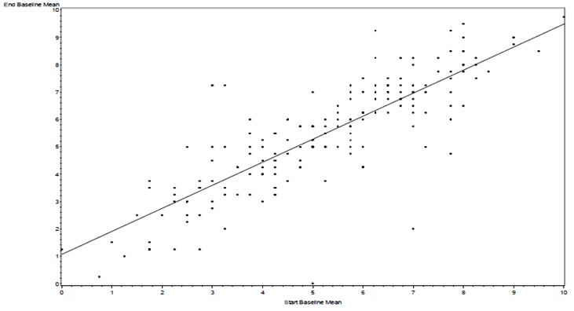
There was a highly statistically significant association (correlation coefficient: 0.828, p <0.0001) between the spasticity NRS scores produced at Visit 1 (Study Screening) and those recorded at Visit 2 (Baseline). The equivalent analysis for the Ashworth Scale shows substantially less correlation between the scores recorded at two baseline visits (correlation coefficient: 0.58, p <0.0001) reflecting lower test/retest reliability.

Evaluator’s comment:
The internal consistency of the NRS appears to be quite good, and it seems to be superior to the Ashworth Scale in this regard. It is possible that the Ashworth scale appropriately detected changes between visits, but if such changes were transient and related to diurnal variation, then this makes it a poor tool for assessing a long term intervention. Unfortunately, internal consistency, though desirable, does not negate the possibility that the NRS measures factors other than spasticity, because potential confounding factors could also have been stable between visits.

Responsiveness to change
Responsiveness to change is the ability of the measurement tool to detect changes in clinical status. The pivotal efficacy studies suggest that the NRS is responsive to treatment, whereas the Ashworth score showed poor responsiveness. This is discussed in more detail in the description of the pivotal studies.

Evaluator’s comment:
The NRS appears to be superior to the Ashworth scale in terms of its responsiveness to treatment, but improved responsiveness might also be noted if the NRS was positively influenced by the confounding factors of mood, and so on. From first principles, it would be expected that a holistic score covering all aspects of spasticity would have a better chance of responding to treatment than a one-dimensional assessment of passive stretch resistance.

Clinical usefulness and feasibility in the clinical setting
No specific data is available on the feasibility and utility of the NRS in the clinical setting, but since it consists of asking the patient a simple question and recording their answer in numerical form, it is clearly an easy test to administer.

5) “Published data from a longitudinal validation study confirming that the NRS is measuring the same phenomenon as is being assessed by the observer-based measurement tools of the Ashworth Scale and the Tardieu Scale.”
The sponsor submitted a study entitled “A pilot study of a comparison between a patient scored numeric rating scale and clinician scored measures of spasticity in multiple sclerosis,” which was written by the clinical expert, Professor M P Barnes, and an associate.
This study was independent of the sponsor’s own clinical study program, but it cannot be considered an independent assessment of the various competing assessment tools given that Professor Barnes has publically committed to the validity of the NRS and therefore has an interest in the outcome. Patients with stable spasticity due to MS, on stable anti spasticity medication, recorded their NRS over 7 days prior to each of two consecutive clinic visits, 6-8 weeks apart. At each clinic visit, the investigators completed the following assessments: Modified Ashworth Score, Tardieu Scale score, Motricity Index, and a Timed 10m Walk. The first two are specific measures of spasticity while the last two are measures of strength and function.
The authors compared the spasticity NRS against the physician based assessments of motor function using Pearson’s Correlation Coefficient, as shown below in Table 17.
Table 17: Correlation between NRS and other assessments.
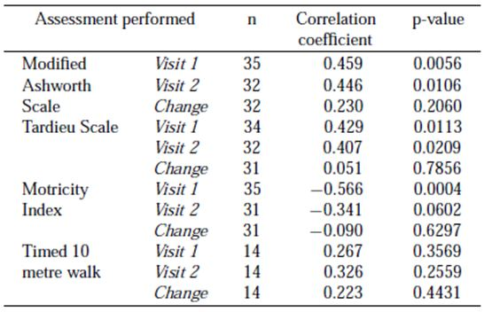
The correlations between the spasticity NRS and the objective measures of spasticity (Modified Ashworth Score and Tardieu Scale) were weak to moderate, the (inverse) correlation with Motricity Index was moderate and highly significant (p = 0.0004 at the first visit), whereas the correlation with the timed walk was weak.
The authors interpreted the results as follows:
“As would be expected, the correlation of the 0-10 spasticity NRS with assessments of functional improvement (10m walk time) were not as robust, as the NRS measures the patient’s daily experience of their spasticity as opposed to functional improvement in ambulatory ability. Although the Motricity Index does not measure spasticity per se, it is a validated measurement tool for the assessment of voluntary motor power. The fact that it negatively correlates with the spasticity NRS, indicates that as patients spasticity improves, their motor control and muscle power also seems to improve.”
The authors final conclusion was that the NRS provided an assessment of spasticity and not, for example, general wellbeing.

Evaluator’s comment:
This paper shows good test/retest reliability of the NRS, and moderate correlation with other relevant clinical measures. This suggests that the NRS primarily assesses spasticity, but does not rule out a significant problem with potential confounding. The authors cannot be considered completely independent, with Professor Barnes having publically backed the use of Sativex for spasticity and the NRS as a means of demonstrating the efficacy of Sativex.

Overall conclusion regarding the validity of the NRS
Measuring spasticity is difficult, and no score is ideal. Existing objective scales for measuring spasticity have problems with inter rater reliability, sensitivity to change, under sampling of a phenomenon that varies through the day, and questionable relevance to patients’ subjective symptoms. Despite its subjectivity, the NRS offers several advantages over the available objective scales, including the potential ability to encapsulate multiple facets of the patients’ experiences of spasticity. The NRS satisfies all the relevant criteria for a valid scale, including face and content validity, reliability and responsiveness. The test/retest reliability of the NRS is good, and superior to that of the Ashworth Scale.
Despite all this, the possibility of substantial confounding remains as there is no solid evidence that the NRS is a pure measure of spasticity. Rather there is a high likelihood that scores are at least partially affected by other factors including pain, mood, fatigue and strength. It is therefore an appropriate tool to use in the pivotal studies, but the results need to be interpreted with some scepticism, particularly in the context of the current submission because cannabinoids can cause intoxication, have known positive effects on mood and pain, and have a well recognised side effect profile that could potentially lead to unblinding. This is not merely a theoretical possibility: at doses comparable to those tested in the efficacy studies, the PK/PD studies showed that some patients recognised a degree of intoxication.
All of these issues are further compounded by the use of an “enrichment protocol” in the latest pivotal study (Study 604), where a minority of Sativex “responders” were selected prior to randomisation, and “non-responders” were excluded from the placebo controlled phase. Even if confounding and unblinding were a problem in only a small subset of patients, these are the very ones most likely to have proceeded to the randomisation stage. The study population was potentially “enriched” with confounding factors as well as with true responders.

Pivotal efficacy studies
Three studies can be considered pivotal in the current submission: GWMS0106, GWCL0403, and GWSP0604, referred to in this report via their last three digits as Studies 106, 403, and 604 (Table 18). Studies 106 and 403 were pivotal in the earlier submission for the same indication in Europe, and were not considered adequate. Study 604 was designed after the original submission to address deficiencies in the original data; it uses an unusual “enrichment protocol” in which an unblinded treatment phase was used to select treatment responsive patients to enter a double blind continuation versus withdrawal phase. The earlier pivotal studies need to be considered first, to see why such a convoluted protocol was deemed necessary.
Table 18: Phase 3 studies investigating the efficacy and safety of Sativex in the treatment of spasticity in patients with MS.
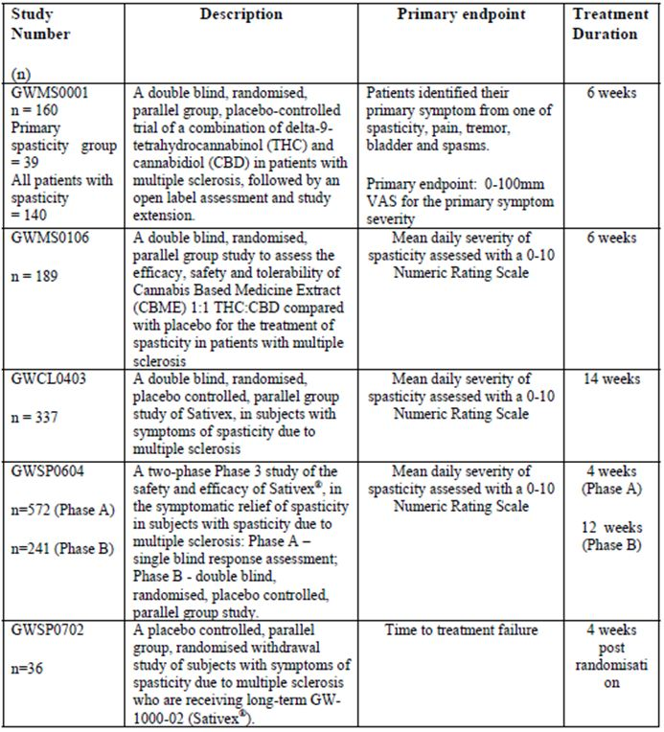
The other Phase 3 studies (GWMS001 and GWSP0702, hereafter 001 and 702) are merely supportive: Study 001 was a markedly unfocussed study and assessed a mixed bag of indications (total n = 160, n = 39 for main spasticity subgroup), while Study 702 was quite small (n = 36).

First pivotal study {Study 106, n=189}

Study design, objectives, locations and dates
This randomised, double blind, placebo controlled superiority study was designed to investigate the efficacy, safety and tolerability of Sativex (“GW-1000-02”) versus placebo over 6 weeks in MS patients with spasticity, when added to the patients’ existing anti spasticity medications. It was a multicentre study, conducted from 12 June 2002 to 30 March 2004. The primary outcome measure was the change from baseline spasticity score in the diary based NRS.

Inclusion and exclusion criteria
Patients were eligible if they had MS and symptomatic spasticity. Spasticity was assessed with the Ashworth Score, and patients had to have an Ashworth Score of 2 or more in at least 2 separate muscle groups, not adequately relieved by existing anti spasticity therapy.
Subjects were asked not to alter the regimen of any medications that affected their spasticity prior to or during the study, including physiotherapy. Beta interferons were not explicitly mentioned as disallowed, and there were no formal requirements that beta interferons could not have been introduced in the weeks prior to entry. Lack of clarity on this point created a major analytical problem because of one subject was recruited soon after starting beta interferon. Recreational cannabis or self-medication with cannabis was excluded within seven days of study entry and during the study.
Exclusion criteria included significant psychiatric illness, other neurological conditions including epilepsy, significant cardiovascular, renal or hepatic disease, and concurrent use of a range of medications such as sildenafil, fentanyl, and anti Parkinsonian agents. Concurrent anti spasm agents were accepted, but were not required, as Sativex was being investigated as a second line agent rather than purely as an add on agent.

Study treatments
Patients were randomised to Sativex (n = 124) or matching placebo (n = 66). Study medication was administered in 100 μl actuations by oromucosal spray. The maximum permitted dose was eight actuations in any three hour period and 48 actuations (THC 130 mg : CBD 120 mg) in 24 h.

Efficacy variables and outcomes
The primary efficacy variable was the change from baseline in the NRS for spasticity. This primary variable was designated during the study, replacing the initial protocol specified primary endpoint which was the Ashworth score. The endpoint was changed before the blind was broken, but not before investigators had the chance to observe potential telltale unblinding side effects.
The main secondary efficacy variables were:
- Ashworth scale for spasticity
- Daily 5 point ordinal scale for spasm frequency
- Motricity Index Scores
- SGIC
Responder analyses were also performed, using two levels of response: 30% and 50% reduction in NRS from baseline.

Randomisation and blinding methods
Randomisation was performed at a 2:1 ratio in favour of the active treatment, using a pre determined computer generated randomisation code in which treatment was allocated in permuted blocks of three.
Blinding was maintained by matching the smell, taste and appearance of the placebo with the study medication. Dark glass containers were used to minimise visual inspection of the treatments and placebo also contained colours to match the yellow colour of the active formulation. The smell of active ingredients was obscured with peppermint oil.

Analysis populations
The primary analysis was based on the ITT population (Sativex n = 124, placebo n = 66), but the sponsor argued that a fairer analysis was one based on the ITT population minus one individual outlier (Sativex n = 124, placebo n = 65).
Results below are presented for both the full ITT (FITT or ITT1) population and the modified ITT (MITT or ITT2) population; the unmodified FITT population is considered to be the primary population for the purposes of this evaluation.
The sponsor’s proposed reason for excluding the outlier was that this patient, randomised to placebo, was a protocol violator who had recently started disease modifying treatment with beta interferon before entering the baseline assessment period. The patient was identified while analysis was still blinded because the spasticity improvement in this patient was highly atypical (studentised residual of -3.94, compared to the other patients who had residuals within the range [-2.74, 2.55]). The sponsor argued that the patient was an outlier on both clinical and statistical grounds, stating that “we felt justified in excluding this subject from the ITT population, in compliance with ICHE9.”
This patient certainly poses a problem with analysis of the study. A well known potential complication of beta interferons is short term worsening of spasticity, which meant that the study potentially followed this patient during recovery from a short term exacerbation of spasticity brought on by interferon treatment. This recovery could account for the observed improvement in spasticity scores, which were thus unrelated to the treatments being assessed. The mean placebo improvement was therefore possibly inflated by this unrelated effect, while the mean Sativex improvement received no such inflation. While this argument carries some weight, it is a post hoc revision of the data set. Even though the outlier was identified while still blinded, the subsequent presentation of the data, which chose to emphasise the MITT over the FITT population, was not blinded. It is not clear that the sponsor would have mounted the same argument with the same enthusiasm if the spurious improvement in spasticity had occurred in a Sativex recipient, leading to an increase in the apparent efficacy of Sativex. Handling of this outlier is important, because inclusion of the patient leads to only a marginal treatment effect for the primary efficacy variable (p = 0.048), compared to a more substantial statistical result if the patient is excluded (p = 0.013). Unfortunately, the study is flawed because of this outlier whichever decision is made: inclusion leads to a potential bias against Sativex, and exclusion represents a post hoc selection bias in favour of Sativex.

Sample size
Sample size was calculated prospectively to obtain 80% power to show a 1.0 point difference in NRS, with a two sided hypothesis test at the 5% level. The calculation was based on a SD for change from baseline in spasticity score of 2.1 out of 10, based on a previous study (GWMS0001), which showed a SD of 21mm out of a 100mm VAS. This calculation resulted in a sample size of 159 subjects (106 active, 53 placebo). Allowing for a 9% dropout rate, 174 subjects were recruited.
Patients were randomised to Sativex versus placebo in a 2:1 ratio, so of the 174 subjects who completed the study, 112 were in the Sativex group and 62 in the placebo group. The MITT population included some additional patients who did not complete the study so the ITT treatment groups were:
- Sativex n = 124
- placebo n = 65 (excluding outlier); or n = 66 (including outlier).

Statistical methods
The primary efficacy variable was mean change from baseline in the 11 point NRS spasticity scores. Results in the active and placebo groups were compared using ANCOVA with baseline as a covariate. A two sided significance test was used at the 5% level (p <0.05) and ANCOVA was used to estimate a 95% CI for the difference between treatments.
Secondary efficacy variables were also analysed with ANCOVA.

Participant flow
Figure 4: Patient disposition in Study 106.
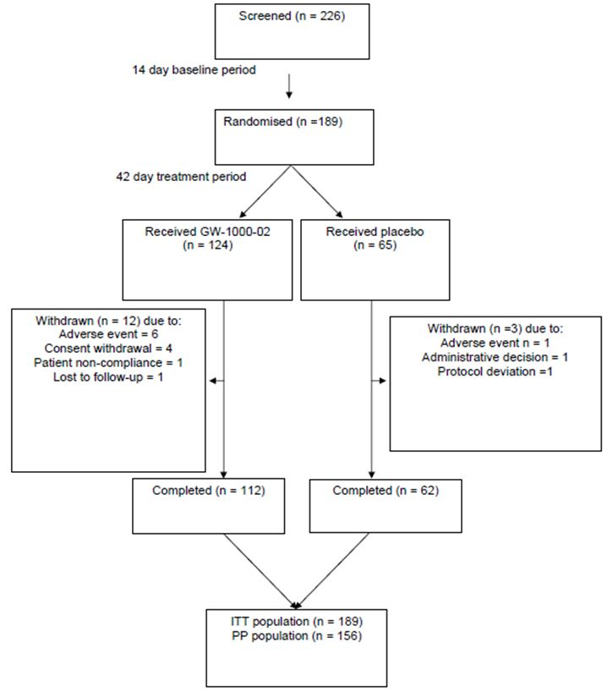

Major protocol violations/deviations
A total of 36 subjects had major protocol deviations: 17 subjects attended for Visit 4 outside the visit window (13 Sativex subjects and 4 placebo subjects), and 18 subjects altered their concomitant medication within the study period (12 Sativex subjects and 6 placebo subjects). Two Sativex subjects did not meet the entry criteria and one subject in the placebo group did not record usage of study medication on at least four of the seven days over which the primary efficacy assessment was being made.
The most significant violation was that which led to inclusion of the outlier, discussed above.

Baseline data
The groups were reasonably well matched at baseline in terms of their general demographics (Tables 19-20). The gender distribution was somewhat different, with a higher proportion of females in the active group.
Table 19: Demographics in Study 106.
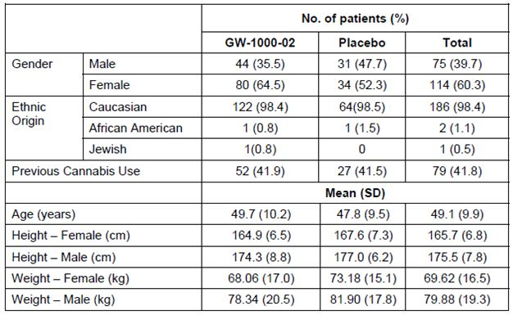
Table 20: Duration of MS at study entry in Study 106.
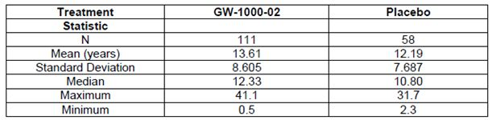
Use of concurrent anti spasticity medications was broadly comparable in the two groups, but 3 Sativex recipients and 0 placebo recipients had received some form of botulinum toxin A (Botox or Dysport) (Table 21). Given that such toxins are typically given periodically and wear off between treatments, it is not possible to guarantee constancy of the pharmacological effect during the course of the study, and these patients should not have been included. If the botulinum toxin effect wore off during the study, this would bias the results against Sativex. If the drug was given during the study, after the baseline assessments, this would bias the study in favour of Sativex. Unfortunately, the study report did not specify the timing of the botulinum injections relative to baseline.
Table 21: Summary of spasticity medications taken during Study 106.
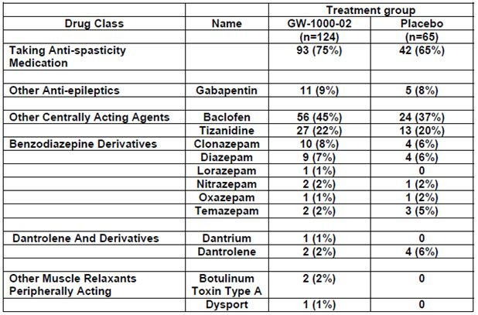

Results for the primary efficacy outcome
This was a weakly positive study. Considering the full ITT population, the study achieved narrow statistical significance, but the efficacy figures cited in different parts of the submission were difficult to reconcile. The study synopsis records: “A reduction of 1.18 points was observed in the GW-1000-02 group compared to a reduction of 0.59 points in the placebo group.” According to body of the study report: “The adjusted mean change in 11 point NRS scores for spasticity for the GW-1000-02 treatment group at the end of treatment shows a reduction of 1.18 points from a mean baseline period score of 5.49 points. For the corresponding period, the placebo group showed an adjusted mean decrease of 0.63 points from a mean baseline period score of 5.39 points.” The clinical overview reports different figures again: -1.11 for the Sativex group, and -0.52 for the placebo group, as shown in Figure 5 and Table 22.
Figure 5: Change from Baseline in mean NRS spasticity scores by Week 6 (Study 106, ITT).
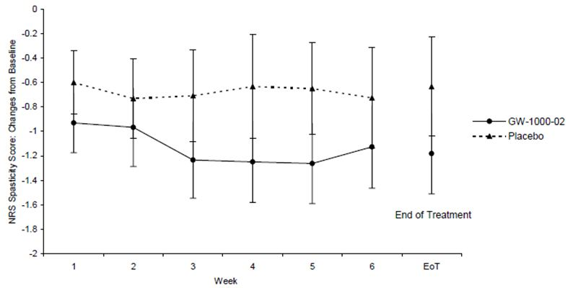
Table 22: Primary and responder analysis for the ITT and Per Protocol populations in Study 106.
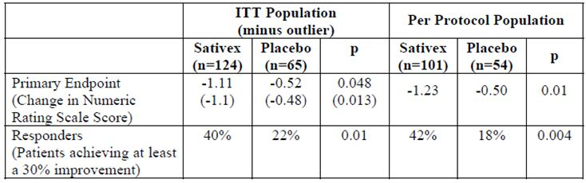
All mentions of this result agree that the estimated between group treatment difference (~0.52 points) was in favour of active treatment, and this was just statistically significant at the p <0.05 level (p = 0.048; 95% CI: -1.029, -0.004 points).
Excluding the beta interferon outlier, the placebo group showed a smaller mean improvement, and the inferred treatment effect was correspondingly greater. Again, various reports of this are difficult to reconcile but, according to the main study report: “Excluding the outlier identified in the placebo group (Subject 233 at Centre 006) the treatment difference of 0.63 points, in favour of the GW-1000-02 treatment group was statistically significant (p= 0.013, 95% CI: -1.118, -0.131 points)”.
For the PP population, the estimated treatment difference was 0.73 points, in favour of the Sativex group, and this was statistically significant (p = 0.010; 95% CI: -1.286, -0.178 points).

Other analyses of the primary efficacy variable
A responder analysis of the primary variable was presented as a secondary outcome measure. A 95% CI was estimated, based on the normal approximation to the binomial distribution for the difference in proportions, and a p value from Fisher’s Exact test was calculated. A supporting logistic regression analysis was also performed.
As shown in Table 23, approximately one fifth of the placebo group (22%) reported at least a 30% improvement in spasticity, compared to two fifths (40%) of the Sativex group, meaning that on average about 5 patients need to be treated to achieve one extra result of a ≥ 30% improvement. This difference in responder rate was statistically significant (p <0.01). Table 23 shows the responder rates for other definitions of response: the treatment effect was significant for improvements of ≥ 20%, ≥ 30% and ≥ 40%, and was numerically favourable but not significant at other thresholds. Figure 6 shows the odds ratio for achieving each level of spasticity reduction.
Table 23: Proportions of subjects achieving a response at various levels, Study 106.
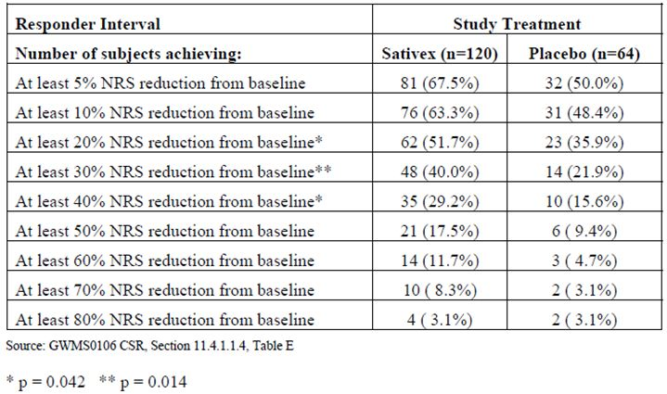
Figure 6: Odds ratio for Sativex versus placebo in achieving a response, Study 106.
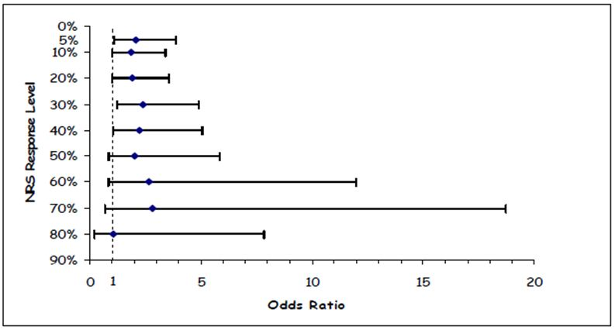
The sponsor also analysed the time to achieve a response in those Sativex recipients who did reach a 30% reduction in spasticity (Table 24). The main reason that this analysis is important is that it suggests most responders can be identified within the first 4 weeks of treatment. This insight was used in the design of the later pivotal study, Study 604, which used an “enrichment” protocol to exclude non responders prior to randomisation.
Table 24: Week of first response for eventual 30% responders, Study 106.
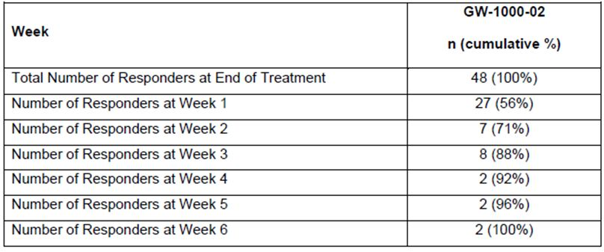
A subgroup analysis of the primary efficacy variable according to prior cannabis use did not suggest that this made a difference to the efficacy of Sativex, but the data were only subjected to descriptive statistics. The placebo effect appeared greater in subjects not previously exposed to cannabinoids, as shown in Table 25. This observation is based on small numbers – only 37 placebo recipients were cannabis naïve – but it potentially indicates a problem with blinding, or complex effects based on patients’ expectations, and many interpretations are possible. Among placebo recipients, those experienced with cannabis might have been more able to recognise that they had been given a THC free formulation, and thus rate their spasticity as unchanged. Among Sativex recipients, mean changes in spasticity were not greatly affected by prior cannabis use, but complex interactions between expectations of change, recognition of side effects, and subsequent subjective spasticity ratings seem quite possible. This effect is not minor: the difference in the two different placebo effects (-0.87 versus -0.30) is 0.57 points, similar in magnitude to the inferred treatment difference between the Sativex and placebo groups.
Table 25: Baseline spasticity score and change, according to prior use of cannabis.
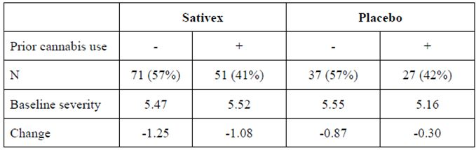

Secondary efficacy variables
None of the secondary variables, discussed below, achieved statistical significance. This weakens the internal validity of the trial and adds to concerns about the subjective nature of the primary endpoint, especially considering that the endpoint was changed during the study. The positive evidence is essentially restricted to a borderline result for the primary endpoint.

Ashworth scale
The Ashworth scale, a traditional clinician rated measure of spasticity, was not used as a primary efficacy variable because of concerns about its sensitivity. The between group difference in adjusted mean change in the Ashworth Scale score from baseline to Visit 4 was 0.11 points in favour of Sativex treatment (p = 0.218, 95% CI: -0.29, 0.07), which is not statistically significant.

Spasm frequency score
The estimated between group difference in the change in spasm frequency scores from baseline to the end of treatment was 0.17 points, in favour of Sativex. This difference was not statistically significant (p = 0.141, 95% CI: -0.39, 0.06).

Motricity index
The Motricity Index for affected legs showed an improvement after six weeks of treatment for both treatment groups, which was numerically greater in the Sativex group (between group difference 3.86 points), which approached statistical significance (p = 0.054; 95% CI: -0.06, 7.78).
The Motricity Index for affected arms, showed an improvement of 3.64 points from a baseline score of 68.59 points in the Sativex group, and an increase of 3.07 points from a baseline score of 63.19 in the placebo group. The estimated treatment difference of 1.30 points was in favour of active treatment but was not statistically significant (p = 0.766; 95% CI: -7.47, 10.07).

Patient global impression of change
A total of 66 subjects (56.9%) from the Sativex group and 31 subjects (48.4%) from the placebo group considered their condition “Minimally improved”, “Much improved” or “Very much improved”. This treatment difference of 8.46% (odds ratio 1.36) did not achieve statistical significance (statistical summary not provided).

Overall summary of study 106
This medium sized study of short duration (6 weeks) had a number of protocol violations, including a placebo subject who had recently started beta interferon. Including this subject in the ITT analysis produces a result for the primary endpoint that is only marginally significant.
The change in NRS on an 11 point scale was -1.11 for the Sativex group, and -0.52 for the placebo group. The estimated between group treatment difference (0.52 points) was in favour of active treatment, and this was just statistically significant at the p <0.05 level (p = 0.048; 95% CI: -1.029, -0.004 points). Exclusion of this outlier led to better results (p = 0.013), but is of questionable validity. Three recipients of Sativex also received botulinum toxin, and the pharmacological effect of this treatment cannot have been constant during the study. Whether this produced a bias against or for Sativex is unknown.
Overall, the results were of borderline statistical and clinical significance, especially when the possibility of unblinding is considered. If a small number of patients guessed their treatment and rated their spasticity better, this could have inflated the apparent treatment effect. Removing this spurious benefit from the actual recorded benefit would then convert this borderline study into a negative study. Secondary endpoints were negative, including the Ashworth Scale endpoint initially designated as primary but abandoned during the study, which also adds to concerns about the internal validity of this study.

Second pivotal study {Study 403, n= 337}

Study design, objectives, locations and dates
This multicentre, double blind, randomised, placebo controlled, parallel group study of Sativex in MS related spasticity shared many design features with the previous study (Study 106), making them acceptable for a pooled analysis, which is presented later. The main difference was that this study was longer (with a one week baseline assessment and 14 weeks’ treatment, rather than 6 weeks’ treatment as in the previous study) and it was larger (n = 337 compared with n = 189). Both differences would be expected to make it more reliable, so it is of interest that this study was negative for its primary endpoint, whereas the less reliable study was weakly positive.
Eligible subjects entered a seven day baseline assessment period, and then returned for randomisation and dose introduction. Visits occurred at the end of treatment Weeks 2, 6, 10 and 14, or earlier if the patient withdrew.

Inclusion and exclusion criteria
Eligible subjects were adult patients (at least 18 years) with any disease sub type of MS, of at least six months’ duration, and at least a three month history of spasticity due to MS, not fully relieved with current therapy.
Exclusion criteria included other neurological diseases, botulinum toxin use in the previous 4 months, cannabis within 30 days, cannabinoid medications within 60 days, a significant psychiatric disorder (other than depression associated with their MS), or suspected alcohol or substance abuse. Patients with significant cardiac, renal or hepatic disorders were also excluded.

Study treatments
The active treatment was Sativex (“GW-1000-02”), containing THC 27 mg/ml and CBD 25 mg/ml, delivered in 100 μl oromucosal sprays. The maximum permitted dose was eight actuations in any three hour period and 24 actuations (THC 65 mg : CBD 60 mg) in 24 hours. Matching placebo was also provided.

Efficacy variables and outcomes
The primary efficacy endpoint was the mean spasticity NRS over the final 14 days of the evaluable period (end of treatment). The variable for analysis was the change in mean NRS from baseline.
Secondary endpoints included:
- Spasticity NRS score at clinic visit
- Response to treatment
- Modified Ashworth Scale
- Timed 10 metre walk
- Barthel Activities of Daily Living (ADL)
- Carer global impression of change (CGIC)
- Quality of life questionnaires.

Randomisation and blinding methods
Randomisation was performed with a pre determined computer generated randomisation code, in which treatment allocation was made using permuted blocks within each centre. Blinding was achieved as described previously.

Analysis populations
Two populations were subjected to efficacy analysis:
- all subjects who entered the study, were randomised, received at least one dose of study medication and yielded on treatment efficacy data (the FAS); and
- the PP set.

Sample size
Sample size estimations were based on anticipated efficacy. From other studies, the sponsor expected this study to result in a difference in the primary NRS endpoint of at least 0.75 points, with a SD of the changes from baseline of about 2.0 points. Given these estimates, for a significance level of 5% and 80% power, a total of 226 evaluable subjects (113 in each group) would be needed to detect a difference of 0.75 points. Allowing for 20% of randomised subjects to be not evaluable, then 284 subjects (142 in each group) needed to be randomised. The sponsor exceeded this recruitment target.

Statistical methods
The primary efficacy analyses were conducted on the FAS. The mean spasticity NRS was assessed using change from baseline to the end of treatment, and the two groups were compared using ANCOVA with baseline severity as a covariate and study centre and treatment group as factors. A two sided significance test at the 5% level of significance and a 95% CI was calculated for the difference between treatments. An assessment of response was also performed for spasticity, taking a 30% improvement in NRS as being clinically significant.
Secondary efficacy variables were analysed in a similar manner.

Participant flow
Figure 7: Disposition of subjects, Study 403.
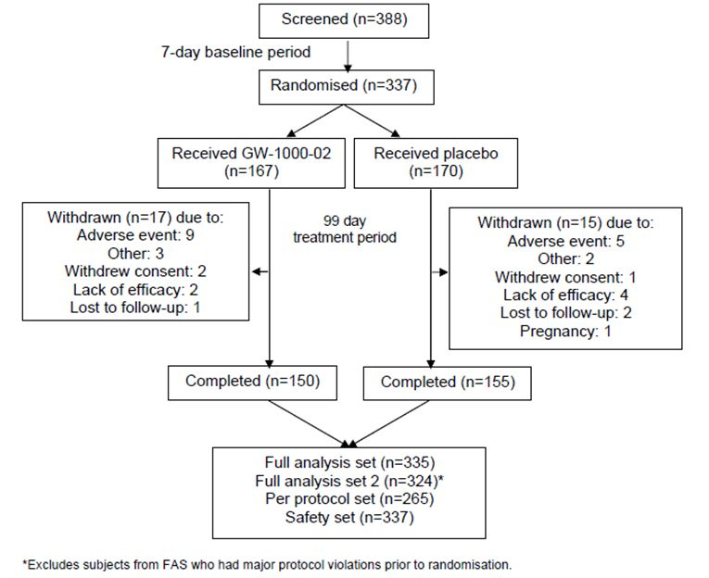

Major protocol deviations
One subject from each group was excluded from the FAS due to a complete lack of on therapy efficacy data. An additional 45 subjects (27%) in the active group and 27 (16%) in placebo group had protocol deviations that warranted their exclusion from the PP analysis set: these included mistimed treatments, changes in concomitant treatments, failure to use active treatment on enough days, and positive THC levels in four placebo recipients (2%). Overall, considering the heterogeneity of the individual deviations shown in Table 26, these errors are likely to have merely obscured some of the efficacy signal without introducing any overall systematic bias, but it is difficult to dismiss the possibility of non random confounding influences, particularly as the proportion of violations was higher in the active group (27% versus 16%).
Table 26: Protocol deviations, Study 403.
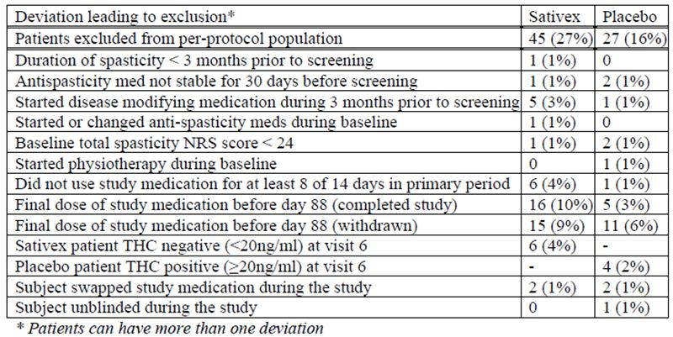

Baseline data
Baseline demographic and disease characteristics are shown in Tables 27-29. In broad terms, the two groups were balanced and were typical of the target population, with an excess of females (61% overall), a disease duration expected for patients with refractory spasticity (15.2 years) and an age typical of that disease duration (mean 47.5 years).
Table 27: Demographics and baseline characteristics, Study 403.
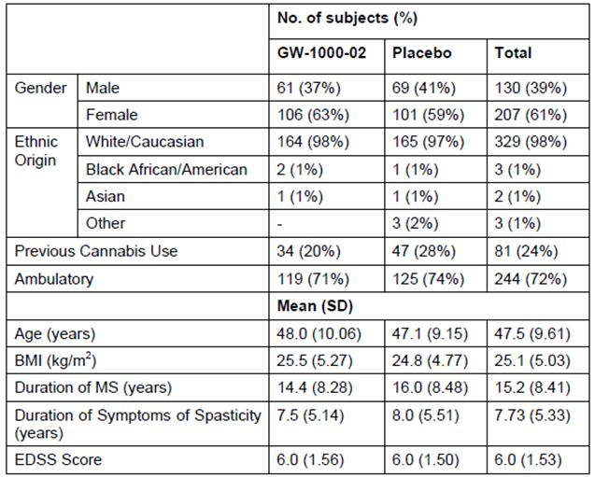
Table 28: Previous and baseline concomitant anti spasticity medication, Study 403.
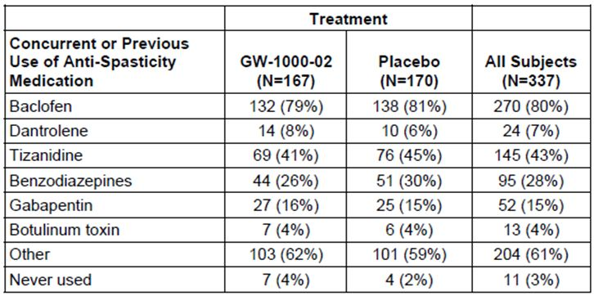
Table 29: Previously use of anti spasticity medication (tried and failed).
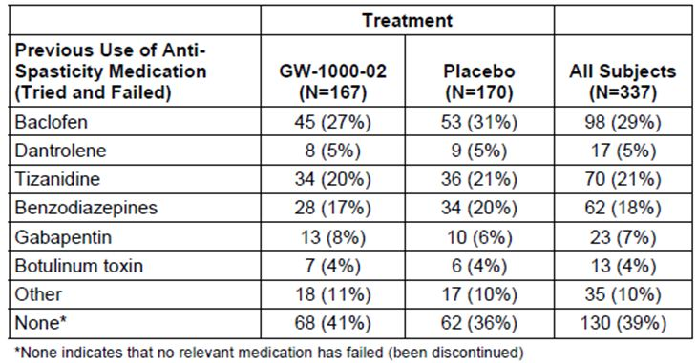

Results for the primary efficacy outcome
This was a negative study. Considering the FAS, the adjusted mean reduction in spasticity NRS score for Sativex was 1.05 points compared to a 0.82 point reduction for placebo, from baseline scores of 6.77 and 6.48 points, respectively. The difference of -0.23 points was in favour of active treatment but it was of dubious clinical utility (a quarter of a point on an 11 point scale) and was not statistically significant (p = 0.219; 95% CI: -0.59, 0.14 points). Considering the possibility that some of the difference between groups was due to unblinding or to the failure of the NRS to isolate spasticity as distinct from confounding factors, this is an especially disappointing result and essentially shows that, in an unselected group of MS patients, Sativex on average is not a useful treatment for spasticity.
For the PP analysis, the results were more favourable. The adjusted mean reduction in NRS was 1.46 points in the Sativex group compared to a decrease of 0.91 points for placebo, from baselines of 6.84 and 6.49 points, respectively. The estimated treatment difference of -0.46 points, in favour active treatment, was still small but achieved statistical significance (p = 0.035; 95% CI: -0.88, -0.03 points). The improved estimate of the treatment effect is largely due to better results in the PP Sativex group than the FAS Sativex group, as shown in Figure 8. This could mean that Sativex works when it is taken per protocol, but PP analyses are subject to a huge number of methodological concerns so the results overall merely suggest that a repeat study with less protocol deviations might be of interest. Given that some protocol violations were related to non compliance, and that subjects remaining compliant are a self selected group, the PP analysis is ultimately unreliable.
Figure 8: Primary endpoint analyses, Study 403 (FAS versus Per Protocol results).
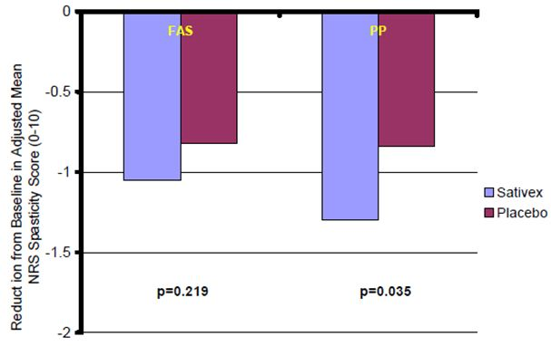

Other analyses of the primary efficacy variable
Responder analyses at both the 30% and 50% spasticity reduction level showed non significant treatment differences in the FAS, in favour of active treatment, with odd ratios of 1.34 (p = 0.231) and 1.21 (p = 0.569), respectively (Figure 9).
Figure 9: NRS spasticity scores: improvement from baseline, Study 403 (FAS).
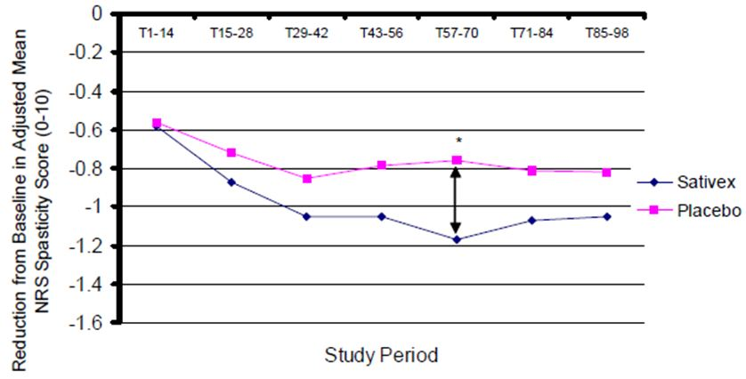
When analysed at different time points, there was one period (days 57-70) in which the between group difference in NRS achieved significance. Visual inspection of the curves, shown below, suggest that this period was atypical, deviating from the general trend in spasticity scores. The results were better when the analysis was restricted to the PP set (Figure 10).
Figure 10: NRS spasticity scores: improvement from baseline, Study 403 (PP).
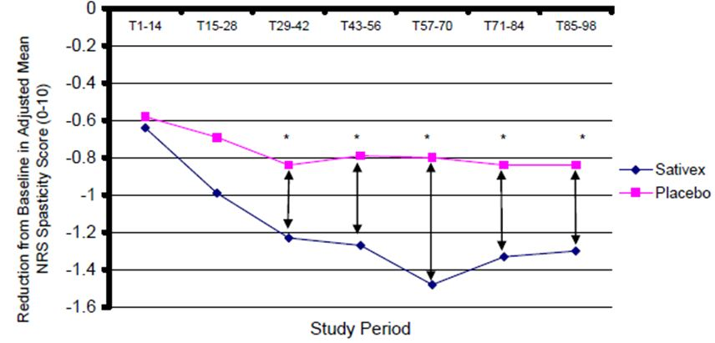

Results for other efficacy outcomes
For all secondary outcomes, only the FAS is considered. In every case, there was no significant benefit for active treatment. For some parameters, the PP analysis was more favourable, but PP analyses of secondary variables are clearly of minor value in a study that failed to achieve its primary endpoint.

Timed 10 metre walk
The mean change was a reduction of 2.1 seconds from a baseline of 34.8 seconds, in the Sativex group, compared to an increase of 9.3 seconds from a baseline of 36.7 seconds in the placebo group. This apparent benefit in favour of Sativex was not confirmed in the ANCOVA analysis, which showed an estimated treatment difference of 0.0 seconds (p = 0.624).

Carers global impression of change
In the active group, 35% of subjects experienced an improvement in ease of transfer, compared to 24% in the placebo group. The odds ratio of 1.25 was not significant (p = 0.270, 95% CI: 0.842, 1.849).

Barthel ADL
The mean change in the Barthel Index was a tiny reduction of 0.1 points in the Sativex group from a mean baseline of 70.0 points, compared to a decrease of 0.5 points from a baseline of 72.0 points in the placebo group. The estimated treatment difference of -0.15 points was in favour of the placebo treatment group, but was not statistically significant (p = 0.867; 95% CI: -1.95, 1.64 points).

Modified Ashworth Scale
The mean change in the Modified Ashworth Scale was a reduction of 3.3 points in the Sativex group, compared to a reduction of 2.8 points for placebo, from mean baseline scores of 30.8 and 29.0 points, respectively. The estimated treatment difference, in favour of active treatment, was thus 0.5 points by a direct comparison of means, but only -0.16 points by the more robust ANCOVA method, which was not statistically significant (p = 0.857; 95% CI: -1.94, 1.61 points).

Clinic-Visit Sleep Assessment
The mean change in disturbed sleep scores showed a reduction of 0.8 points in the Sativex group, compared to a reduction of 0.6 points in the placebo group, from baseline scores of 3.3 and 3.0 points, respectively. The estimated treatment difference of -0.07 points was weakly in favour of active treatment, but was not significant (p = 0.764; 95% CI: -0.55, 0.40 points).

EQ-5D and Health Status VAS
Analysis of these two quality of life scores, the EQ-5D health state index and health status VAS, suggested estimated treatment differences of 0.02 and 1.42 points, respectively, which were only weakly in favour of active treatment. Neither reached statistical significance (p = 0.175, 95% CI: -0.01, 0.04 for EQ-5D and p = 0.538, 95% CI: -3.11, 5.94 for HS-VAS).

MSQoL-54
Analysis of individual MSQoL-54 scales showed some sub domains in favour of active treatment (physical health, pain and sexual function) and some in favour of placebo (cognitive function, health, ‘physical health composite’ and ‘mental health composite’), but the only significant differences were the differences for cognitive function (-7.23 points) and changes in health (-9.35 points) both favoured the placebo (p = 0.046, 95% CI: -14.32, -0.13 and p = 0.018, 95% CI: -17.04, -1.65, respectively).

Blinding assessment in Study 403
A blinding assessment was incorporated into the second pivotal study. At the end of treatment, each investigator was asked to indicate what treatment they thought the subject had taken during the study, and the results are shown in Table 30.
Table 30: Unblinding in Study 403: investigator’s guesses about assigned treatment.
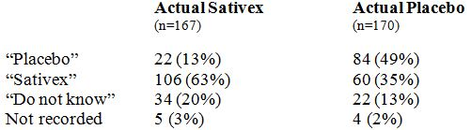
Actual placebo recipients were much more likely to be identified as placebo recipients than were Sativex recipients (49% versus 13%), and actual Sativex recipients were correctly identified much more often than placebo recipients were misidentified as Sativex recipients (63% versus 35%). The EU evaluation report interprets these same figures very generously, calculating that 56% of patients (106+84 from 337 patients) were identified correctly, compared to an expected identification by chance of 50%, and concluding that the success rate was similar to chance. This interpretation is invalid, because it mishandles the 65 patients for whom no attempt was made at guessing the allocated treatment – wrongly assuming that all 65 of them would have had the wrong treatment guessed. Amongst the actual guesses (first two rows), investigators were correct 190 times (106+84) out of 272 guesses, and wrong only 82 times (60+22), a 70% hit rate that is well beyond that expected by chance. In the Sativex group, the group in whom side effects might lead to unblinding, investigators’ guesses were correct 106 times out of 128 guesses, a far from random success rate of 83%.
Even if the patients for whom the investigator did not guess are included (but distributed evenly between the two treatments, rather than simply counted as misguesses), this implies an accuracy of (84+13)/170 in the placebo group, or 57%, and (106+19.5)/167 in the Sativex group, or 75%. The overall accuracy would then be (84+13+106+19.5)/ (167+170), or 66%, well above that expected by chance. Given that investigators only had subjects’ reports to go on, whereas subjects had direct experience of the telltale symptoms of active treatment, the actual unblinding effect in subjects is likely to have been even stronger than this analysis suggests.
This significant excess of correct guesses could reflect either accurate recognition of an efficacious treatment, or unblinding due to recognisable side effects, or a combination of both. Given that this study was actually negative for its primary efficacy endpoint, it seems unlikely that the correct identification of so many patients was solely due to a strong efficacy signal.

Overall conclusions regarding study 403
This study was relatively large (n = 337) and it had an appropriate study duration (14 weeks on treatment), compared to the other first round pivotal study that was smaller (n = 189) and briefer (6 weeks). If Sativex were clearly efficacious in an unselected group of MS patients with spasticity not fully responding to first line medications, then this study would be expected to demonstrate that. Instead, it showed only a weak trend in favour of active treatment that did not reach significance, and the difference is even less impressive once it is considered that some patients might have been unblinded, or might have rated their spasticity more favourably because of factors that confounded the subjective NRS. The failure of secondary endpoints to show significant benefit adds to these concerns. The fact that the PP analysis was more favourable is of interest, and suggests that more studies are indicated, but it is not possible to interpret the reasons for the better PP results, and it is of concern that protocol violations were more common in the active group.

Third pivotal study, with enrichment design (Study 604, n = 241)

Study design, objectives, locations and dates
The first two pivotal studies (Studies 106 and 403) were part of a first round, unsuccessful submission to the European Union. The failure of the original submission is not surprising, given that one study only narrowly achieved significance (p = 0.048) and the second, larger, longer study was negative (p = 0.219).
For the second round submission the sponsor sought a new design that could overcome what was said to be the main barrier to demonstration of efficacy: the long-standing, pharmacologically intractable spasticity of the majority of spastic MS patients, which the sponsor felt disguised and diluted the efficacy of Sativex in a small subset of responsive patients. The sponsor argued, with some merit, that clinicians are not necessarily looking for a treatment that works in every patient or even most patients, because this may not be possible; instead clinicians are looking for a treatment that can work in an identifiable subset of patients.
The sponsor observed that clinicians often use an “n = 1” paradigm in which a treatment is started on a trial basis and continued if it appears efficacious. In this paradigm, patients serve as their own controls, with their post treatment clinical status compared to pre treatment clinical status, on the assumption that any observed changes are likely to be due to the last pharmacological manipulation. In the real world, this is indeed the way that clinicians are often forced to practice, but it is obviously fraught with methodological problems: patients may undergo changes due to the placebo effect, the variable course of their underlying illness, the natural resolution of temporary ailments, and other random factors, and if these coincide with a change in medication then the medication gets the credit or the blame.
The sponsor also pointed out that, in the original pivotal studies, eventual responders could be identified within the first 4 weeks. They suggested that Sativex might have a useful role in clinical practice if it was introduced as a therapeutic trial in a broad population of MS patients, and then continued in the subset in which it appeared efficacious. They therefore proposed a study design derived from the familiar clinical idea of an “n = 1” therapeutic trial.
The resulting study, Study 604, was designed to have two phases: an unblinded therapeutic trial phase, Phase A, in which responders were identified, and then a randomised, blinded treatment phase, Phase B, conducted in a population of apparent responders. Non responders were not invited to enter the randomised Phase B, so their pharmacologically refractory spasticity did not have a chance to dilute the supposed efficacy of Sativex in the subset of patients capable of responding. This is an “enrichment” design, in which a mixed population is “enriched” by elimination of proven non responders.
The criterion chosen for entering the randomised phase of the study was a 20% improvement in NRS spasticity scores after 4 weeks of unblinded treatment. The 20% threshold was based on the observation that, in Study 403, the vast majority of eventual 30% responders had already demonstrated at least a 20% response in the first 4 weeks of treatment. As shown in Table 31, if the first two pivotal studies are used as a guide, very few eventual 30% responders would be missed in a 4 week therapeutic trial looking for a 20% initial response (only 3% would be missed). If the threshold was increased to 30%, then 18% of eventual responders could be missed.
Table 31: Response to first 4 weeks treatment in subjects who ultimately achieve at least a 30% improvement, Studies 106 and 403.
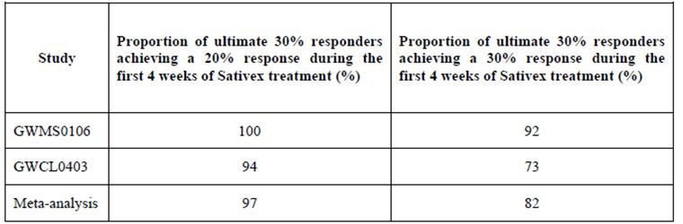
The study design that emerged from these considerations is illustrated in Figure 11.
Figure 11: Basic design of Study 604.
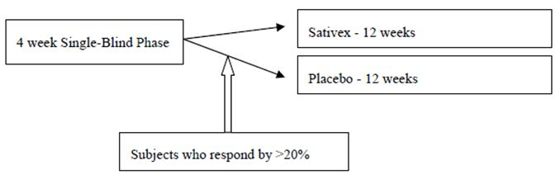
What is not emphasised in the diagram above is that the eventual placebo recipients were given Sativex for 4 weeks and then subjected to a randomised withdrawal, so this was essentially a withdrawal study, though patients were not informed of this.
The study design was approved by the Medicines and Healthcare products Regulatory Agency (MHRA), the regulatory body of the United Kingdom. It has some merit, in that it matches the approach taken in clinical practice. It is also plausible that spasticity in MS is biologically heterogeneous. MS lesions occur at different levels in the central nervous system, in random locations, with different temporal profiles. It is plausible that some patients have substantial loss of descending inhibitory function and are no longer amenable to pharmacological rescue, while others have intermediate levels of disinhibition and maintain potential drug responsiveness. Spasticity is a complex syndrome in which patients exhibit variable mixtures of enhanced stretch reflexes, impaired relaxation, weakness, and spasms. Reducing spasticity would be most useful in patients for whom the spasticity is making a critical difference to the ability of voluntary muscular activity to overcome involuntary spastic activity, and this balance is likely to be different in every patient. Treating spasms might be of more symptomatic benefit than trying to alleviate chronic, static stiffness. The cellular substrate subserving spasticity could be different in different patients. Thus, it is entirely plausible that there exists a subset of patient in whom a new spasticity drug might work, while another group, ostensibly similar, have intractable spasticity and no chance of response. It is also plausible that the potential responder subgroup might only be identified via a therapeutic trial.
The main flaw in the study design is that it employs a randomised withdrawal of active treatment, rather than a randomised introduction. It is possible that Sativex, while not efficacious in itself, produces a withdrawal syndrome affecting spasticity, or even just withdrawal symptoms affecting subjective spasticity scores.
It is not hard to imagine scenarios in which a similar enrichment design produced spurious findings of efficacy. For instance, if it was wrongly suggested that alcohol could be useful in the treatment of epilepsy, and epileptic patients were then treated with continuous alcohol for 4 weeks, it is likely a small subset would show an improved seizure frequency during that 4 weeks despite the alcohol. Subjecting this subset to randomised alcohol withdrawal in the form of placebo could demonstrate that continued alcohol was associated with better seizure control than placebo, simply because the withdrawal effect in the placebo group produced seizures.
Thus, it is theoretically possible that the design employed in Study 604 could lead to a spurious inference of efficacy if cannabinoid withdrawal caused spasticity (or even if withdrawing patients tended to be more negative in their self assessment of spasticity), even if Sativex was not actually useful in the treatment of spasticity. The duration of the randomised treatment phase (12 weeks) makes this concern somewhat less pressing, because withdrawal effects would be expected to be more prominent in the first few weeks, but there are no hard data to indicate when and whether a withdrawal effect might be manifest.
Figure 12 suggests that most cannabis withdrawal effects abate within 4 weeks. This suggests that withdrawal effects should not be a major factor at the end of a 12 week study, but the potential for unblinding during the earlier phases of withdrawal is large, and whether cannabinoid withdrawal might exacerbate spasticity in MS patients for a significant duration is unknown. (In this context, data imputation performed on a LOCF basis is potentially suspect because the last rating might have been during the early phases of withdrawal, but this does not appear to have been a significant problem in practice because, in the placebo group, only two discontinuations lead to data imputation. There were more discontinuations in the GW-1000-02 group [15, 12%] as opposed to placebo [2, 2%], with the median duration of treatment amongst the withdrawn subjects of 45 days versus 58 days, respectively.)
Figure 12: Time profile of irritability and withdrawal discomfort following abstinence from cannabis in two non submitted studies.
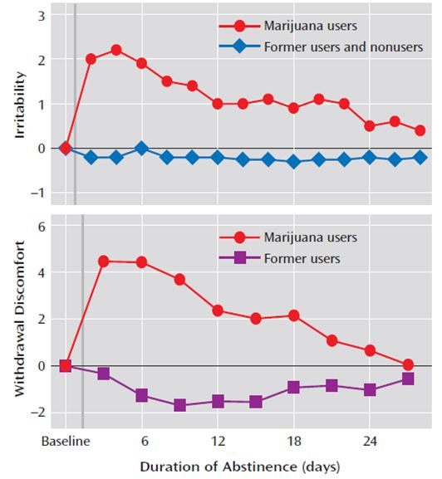
A more robust design might have been to identify potential responders, pass through a washout phase, and then to randomise subjects to treatment re initiation at a much later date (Figure 13). Alternatively the patients could have continued randomised treatment for longer, so it could be assumed with more confidence that withdrawal effects had completely abated, though this does not circumvent the potential problem of unblinding. The questions that remain unanswered are whether 12 weeks is sufficient to dismiss the possibility of a withdrawal effect, and whether unblinding issues were aggravated by this design.
Figure 13: Study schema for Study 604.
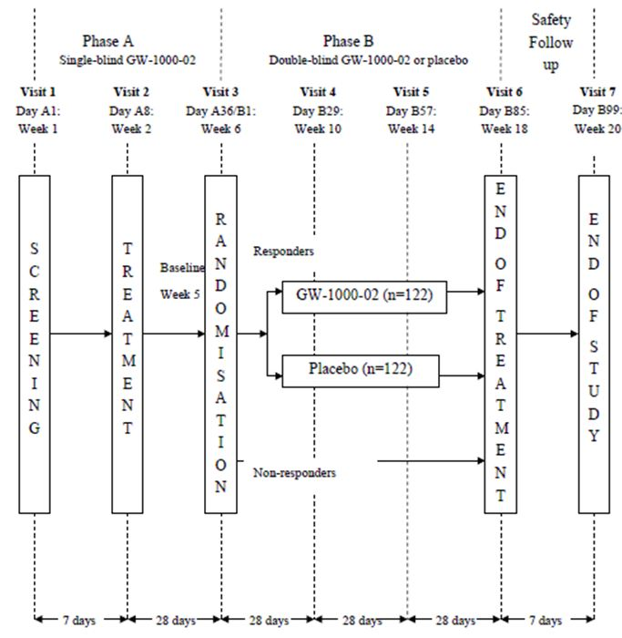

Inclusion and exclusion criteria
To be eligible for the single blind 4 week introductory phase of the study, subjects had to be 18 years or over and diagnosed with any disease subtype of MS of at least six months’ duration and with at least moderate spasticity (defined by a score of ≥ 4 on a spasticity severity NRS) of at least three months’ duration, which was not adequately relieved with current anti spasticity therapy. Subjects were required to maintain their anti spasticity and disease modifying therapy at a stable dose throughout the study.
To be eligible for randomisation, and hence for continued treatment in the controlled phase of the study, subjects had to report a 20% improvement on their NRS rating. How many of them guessed this, and whether it affected their ratings, is unknown. Any patients who had a liking of cannabinoid side effects, and found out about the study design, had a clear incentive to rate their spasticity as improved. Even if such subjects were rare they were necessarily enriched in the actual population that progressed to randomisation.

Study treatments
Sativex was administered with a pump action oromucosal spray, which delivered 100 μl per actuation, containing 2.7 mg THC and 2.5 mg CBD. The placebo spray delivered the same volume, excipients, flavourings and colourants but lacked any cannibinoids.
The number of sprays was variable, because actuations was administered as required for symptomatic relief of spasm, and subjects self titrated the dose up to a maximum of 12 sprays per day based on efficacy and tolerability. Medication was either self administered or given by a carer.

Efficacy variables and outcomes
The primary efficacy endpoint was the change in spasticity severity from randomisation to the end of the double blind phase of the study, as assessed by the 11 point NRS.
Secondary efficacy assessments included:
- Sleep disruption
- Spasm frequency score
- Modified Ashworth score
- Motricity Index
- Timed 10 Metre Walk
- Subject Global Impression of Change (SGIC) in spasticity
- Carer Global Impression (CGIC) of functional ability and ease of transfer
- Physician Global Impression of Change (PGIC) in spasticity severity
- Barthel ADL
- Quality of life measures.

Randomisation and blinding methods
Randomisation was performed using IVRS, and subjects were randomised according to a randomisation schedule for each centre on a 1:1 basis to Sativex or placebo. Blinding was achieved as described previously.

Analysis populations
Two main populations are described in the report. Subjects who were enrolled into the single blind phase (Phase A) and received at least one dose of study medication were included in the single blind set, which was merely analysed with descriptive statistics.
All subjects who were correctly randomised into the double blind phase (Phase B), received at least one dose and had some on treatment efficacy data were included in the ITT analysis set.

Sample size
On the basis of the previous pivotal studies, it was estimated that Study 064 would result in a difference in a treatment difference of at least 0.75 points on the NRS, and the SD of the changes from baseline would be ~1.6 points. To demonstrate this difference with a significance level of 5% and 90% power, 97 evaluable subjects in each group were needed in the randomised phase of the study (Phase B). Allowing for 20% not evaluable subjects, a total of 244 subjects (122 in each group) were required in Phase B.
It was estimated that 50% of the subjects enrolled into Phase A of the study would achieve a 20% response at the end of four weeks, and thus enter Phase B, so ~488 subjects would need to enter Phase A, but with recruitment adjusted as needed to ensure adequate entry into Phase B.
The actual number entering Phase B (n = 241) was very close to the planned number (n = 244).

Statistical methods

Single blind phase (Phase A)
No statistical hypothesis testing was performed on any data collected during Phase A. The results were summarised descriptively.

Double blind phase (Phase B)
The primary efficacy analyses used the ITT analysis set for patients entering Phase B.
The primary statistical tool was an ANCOVA. The null hypothesis of no difference was assessed at a threshold of 5% (p <0.05), and an estimate of the treatment difference and its 95% CI was produced. Assumptions of normality and homogeneity of variance were checked via examination of residual plots and normality was also assessed using the Shapiro-Wilk test. Study centre was intended to be used as a factor in the ANCOVA model for centres that recruited at least 24 subjects into Phase B; otherwise smaller centres were to be combined within each country as an additional country specific factor. The final analysis plan, established before breaking the blind, simply grouped centres by country.

Participant flow
The disposition of subjects is shown in Figure 14. The active treatment group showed an excess of withdrawals (15 for Sativex versus 2 for placebo), partly due to AEs (8 versus 0).
Figure 14: Disposition of Subjects in Study 604.
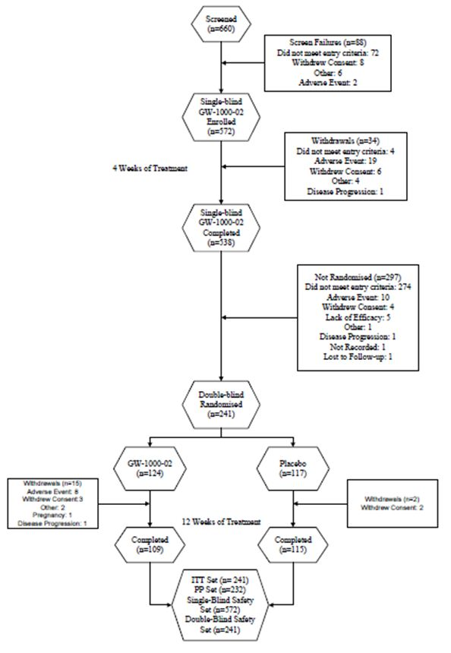

Major protocol violations/deviations
Seven ineligible subjects were randomised into Phase B by mistake, and were given medication, but they were excluded prior to unblinding. One subject received placebo in both phases and was also excluded prior to unblinding.

Baseline data
The “enriched” Phase B population was broadly similar to the initial Phase A population, with one clear exception: they had milder spasticity, with an NRS of 3.9 compared to 6.9 in the total population (and presumably the NRS was even higher in the excluded population not invited to join Phase B). Following randomisation, the active and placebo groups were similar (Table 32).
Table 32: Demographic characteristics of Phase A and Phase B populations in Study 604.
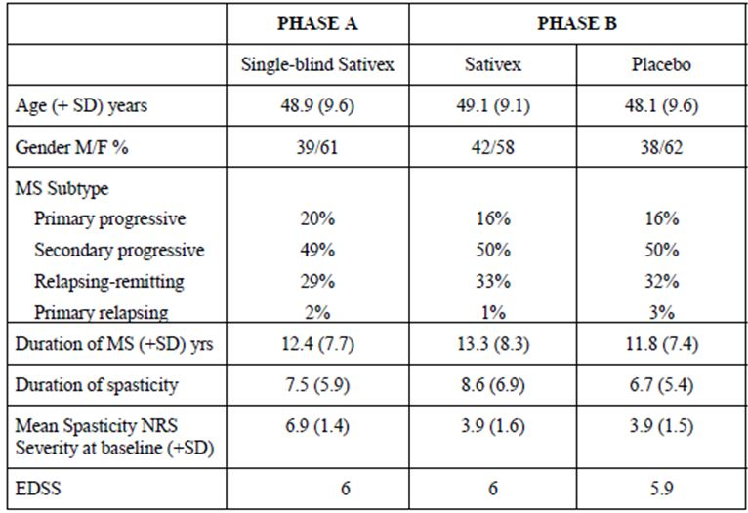

Results for the primary efficacy outcome
For subjects entering Phase B, the overall improvement during single blind treatment, from the original Phase A baseline to the end of Phase A, was 3.01 units from a baseline of 6.91 (44%). This includes whatever improvement occurred as a result of the placebo effect, regression to the mean, and recovery from temporary ailments. It also includes the protocol driven selection effect, which mandated that only patients with at least 20% improvement were eligible for randomisation. Thus, improvements during this phase provide no information about the efficacy of Sativex.
The primary endpoint was the change in spasticity from the Phase B baseline (randomisation) to the end of treatment. The mean baseline scores at randomisation were 3.87 and 3.92 points for the Sativex and placebo groups, respectively. Following randomisation, there was a further improvement of 0.19 units in the Sativex group (4.9%) by the end of the treatment phase, and a deterioration of 0.64 units in the placebo group (16.4%). The adjusted mean difference between the groups in spasticity scores was 0.84 units, which was significantly in favour of Sativex (p = 0.0002, 95% CI: -1.29 to -0.40) (Figure 15).
Figure 15: Change from baseline in mean spasticity NRS by time (double blind phase).
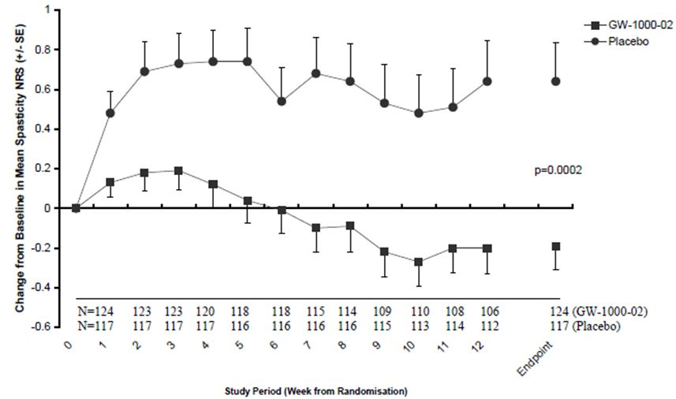
Of note, there is no obvious feature of the curves that suggests placebo NRS scores deteriorated temporarily, in parallel with the expected timeframe of cannabis withdrawal symptoms, which would be expected to be worse in the first 2-4 weeks. This somewhat offsets concerns raised earlier in this evaluation report, but still leaves open the possibility that patients experiencing withdrawal symptoms were unblinded and their negative assessments of placebo were then carried forward. Most of the deterioration occurred in the first two weeks, right when withdrawal symptoms would be expected to be most prominent.

Other analyses of the primary efficacy variable
The sponsor also subjected the primary efficacy variable, change in NRS, to a responder analysis using the original Phase A baseline. Note that this analysis has a built in inflation of the response rate by virtue of the fact that subjects were only analysed if they had at least a 20% response in the unblinded phase, and they only had to improve slightly more to be counted as responders.
A total of 92 Sativex recipients (74%) in Phase B were classified as responders at the 30% level, compared with 60 placebo recipients (51%) on placebo, consistent with an absolute increase of 23% in response rate. It should be noted that “response” is a somewhat misleading term in this setting, as the randomised phase did not study the response to the introduction of Sativex, but the response to withdrawing it. Also, all subjects in this phase had already demonstrated a protocol driven improvement of at least 20%, from the selection effect of the enrichment design.
Relative to the Phase A baseline, the odds of a 30% improvement in spasticity were higher for the Sativex group than for the placebo group, with an odds ratio of 2.73 (95% CI: 1.59, 4.69), which was statistically significant (p = 0.0003).
At the 50% response threshold, a total of 56 Sativex recipients (45%) were classified as responders, compared with 39 placebo recipients (33%). The odds of a 50% improvement in spasticity were better for the Sativex group than for the placebo group, with an odds ratio of 1.65 (95% CI: 0.98, 2.78), but this was not significant (p = 0.061).
In Table 33, the results of Study 604 (n = 241) are contrasted with the pooled analysis of the two prior pivotal studies (n = 519): the first column shows the threshold reduction defined as response (>30% or >50%), and subsequent columns show the proportion of patients achieving each threshold – but note that the p value of 0.015 contradicts the value of 0.019 cited in the expert report (Table 34 and Figure 16).
Table 33: Analysis of responders in Study 604, versus pooled analysis of Studies 106 and 403.
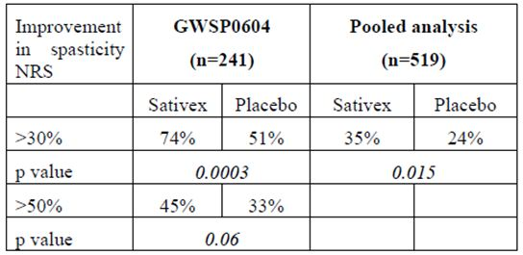
Table 34: Responder rates in Studies 106 and 403.
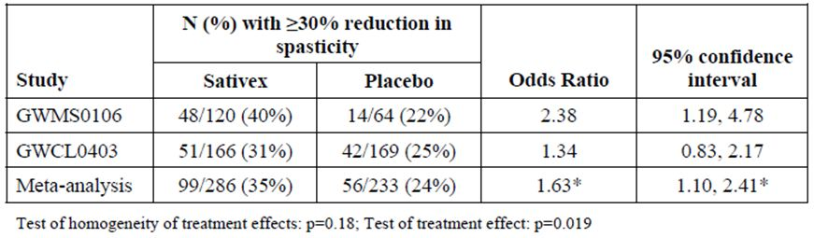
Figure 16: NRS responder analysis, Study 604 (Phase B).
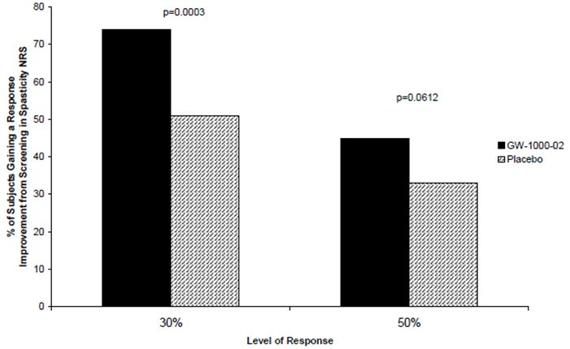

Results for other efficacy outcomes
Unlike the previous two studies, which failed to show a significant benefit for secondary endpoints, this enrichment study showed either significant benefit or strong favourable trends for all spasticity related and functional endpoints. It did not show a significant benefit for quality of life assessments, however, which is of concern in relation to the overall risk-benefit analysis.
The p values for each secondary endpoint are shown in Table 35 and actual values for the Sativex group and placebo group are shown in the subsequent tables (Tables 36-38). Note that the Barthel index was analysed by two statistical techniques (ANCOVA and ordinal logistic regression), and all of the tables include the second, more favourable analysis, rather than the protocol specified ANCOVA which was only marginally significant (p = 0.048).
Table 35: Primary and efficacy endpoints, Study 604 (treatment difference and p value).
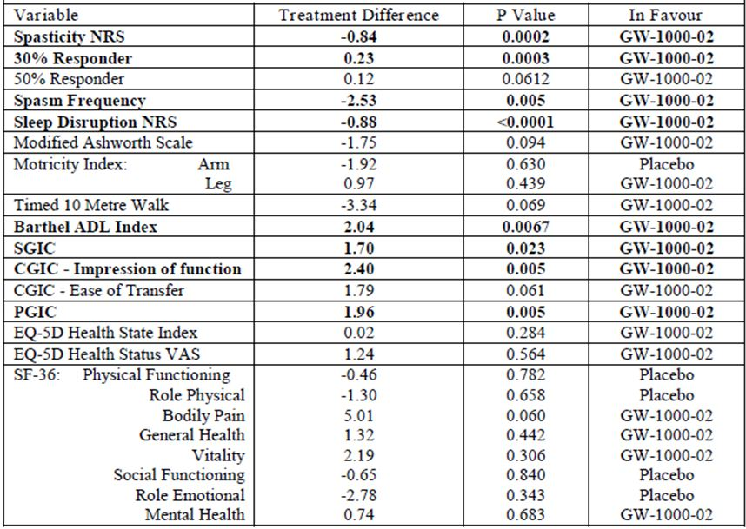
Table 36: Secondary efficacy outcome measures, Study 604.
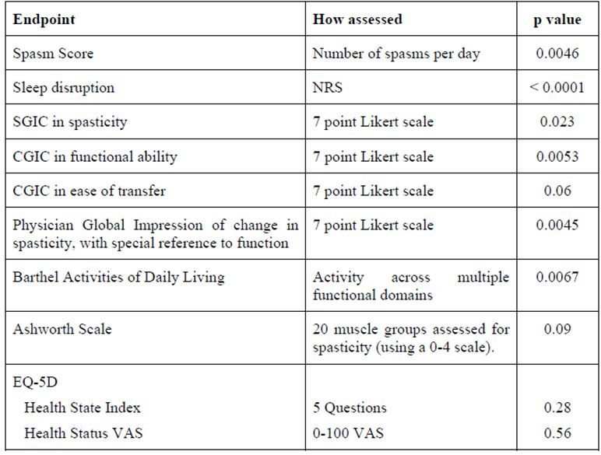
Table 37: Spasm score, sleep and Ashworth score, Study 604.
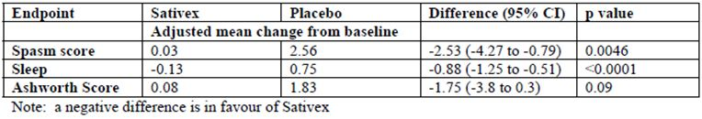
Table 38: Key functional measures, Study 604.
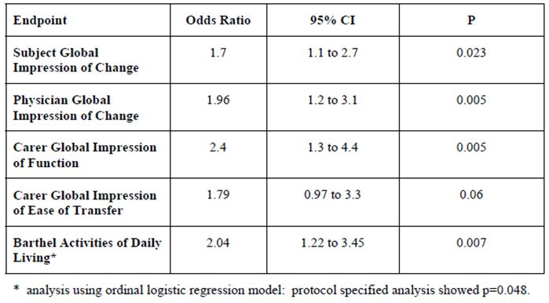

Individual secondary endpoints
Global impressions of change (patient, carer or physician) were expressed relative to the Phase A treatment baseline (that is, Visit 2, after screening but before single blind treatment). They therefore include the placebo effect, recovery from temporary ailments, and the protocol driven selection effect.
Unless otherwise stated, all other secondary endpoints discussed below are expressed relative to the Phase B baseline (time of randomisation).

Spasm frequency
The adjusted mean spasm frequency showed a marginal increase of 0.03 spasms per day from a mean baseline score of 5.61 for the Sativex group, compared with an increase of 2.56 from a baseline of 5.29 for placebo (Figure 17). The estimated between group difference was 2.53 fewer spasms per day in the Sativex group (95% CI: -4.27 to -0.79).
Figure 17: Change from baseline in spasm frequency by time.
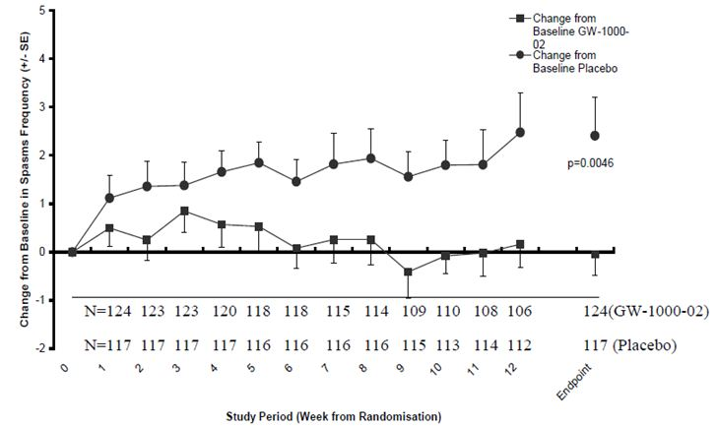

Sleep disruption NRS
The Sativex group showed an adjusted mean decrease (improvement) of 0.13 points from a baseline of 1.96 points, whereas the placebo group showed an increase (deterioration) of 0.75 points from a baseline of 2.07 (Figure 18). The estimated treatment difference was 0.88 (95% CI: -1.25 to -0.51) points, in favour of active treatment (p <0.0001).
Figure 18: Change from baseline in sleep disruption, Study 604.
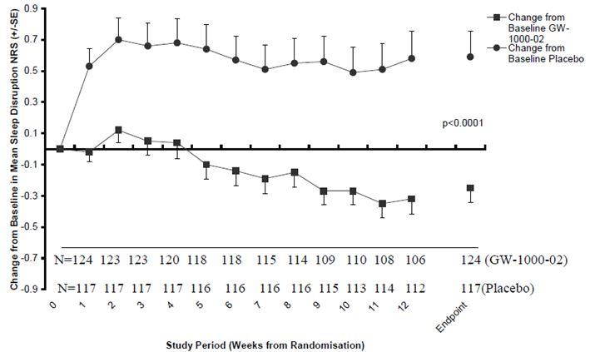

Modified Ashworth Scale
The Sativex group showed an adjusted mean increase (deterioration) of 0.08 points on the Ashworth scale, compared to a greater increase of 1.83 points for placebo, from mean baseline scores of 22.1 and 20.8 points, respectively (Figure 19). The estimated treatment difference in favour of active treatment was 1.75 points (95% CI: -3.80 to 0.30), which was not significant (p = 0.094). Note that the method of graphing (with baseline scores subtracted) exaggerates the visual impact, as the group differences were actually quite small compared to the baseline scores (Figure 19).
Figure 19: Change from baseline in modified Ashworth total score.
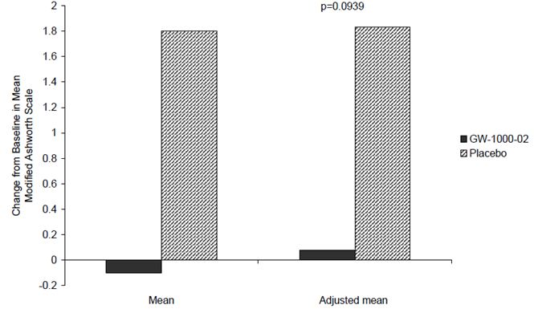

Motricity Index
The Motricity Index was completed for affected arms and legs by 19 and 79 subjects, respectively, in the Sativex group and for 15 and 81 subjects, respectively, in the placebo group.
The Motricity Index for affected arms showed a decrease (worsening) of 10.50 from a baseline of 74.8 in the Sativex treatment group, and a decrease of 8.58 from a baseline of 85.5 in the placebo group. The treatment difference of 1.92 (95% CI: -10.02, 6.18) was in favour of the placebo group (p = 0.630) but was not significant.
The Motricity Index for affected legs showed a decrease (worsening) of 3.24 points from a baseline of 63.6 in the Sativex group, and a decrease of 4.21 points from a baseline of 64.4 in the placebo group. The treatment difference of 0.97 (95% CI: -1.49, 3.42) was in favour of active treatment, but was not statistically significant (p = 0.439).

Timed 10 Metre Walk
The mean change from baseline in the time taken to complete a Timed 10 Metre Walk was a decrease (improvement) of 0.13 seconds in the Sativex group, from a baseline score of 24.5 seconds, compared to an increase of 3.22 seconds in the placebo group, from a baseline of 25.3 seconds (Figure 20). The estimated treatment difference was 3.34 (95% CI: -6.95, 0.26) seconds in favour of active treatment, and this approached statistical significance (p = 0.069).
Figure 20: Change from baseline in the Timed 10 Metre Walk.
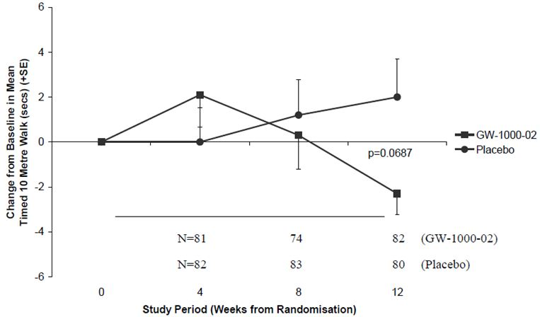

Global impressions of change
Global impressions of change were assessed on a 7-point Likert scale, with subjects, carers and physicians asked to compare the patient’s current spasticity at any assessment with the pre treatment spasticity (prior to single blind treatment in Phase A). Note that this means the impression of change includes the single blind treatment phase and is likely to have been influenced by the placebo effect, recovery from temporary ailments and the protocol driven selection effect.
The odds of reporting improvement on the Likert scale at the end of treatment were significantly increased by active treatment, with broadly consistent results obtained across the SGIC, CGIC and PGIC (Table 39).
Table 39: Patient, Caregiver and Physician Global Impression of Change.
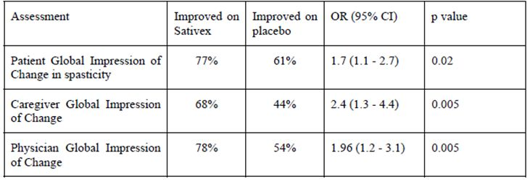
The distribution of responses are also shown graphically in Figures 21-24.
Figure 21: Subject Global Impression of Change, Study 604.
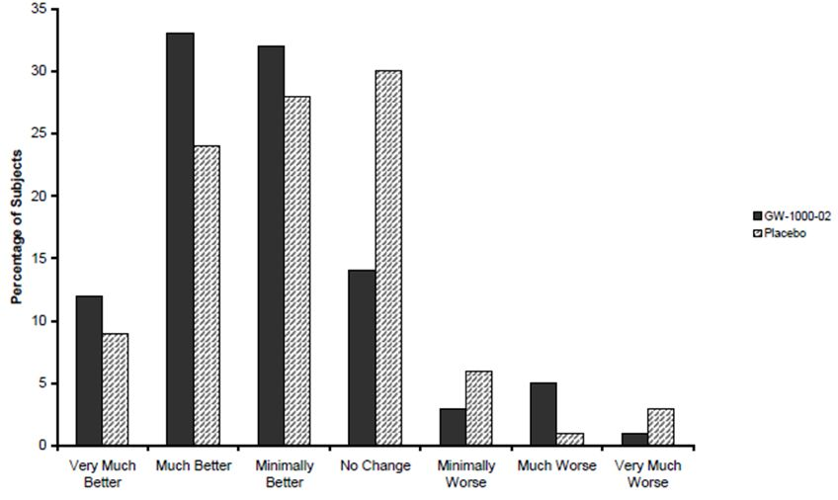
Figure 22: Caregiver Global Impression of Change, Study 604.
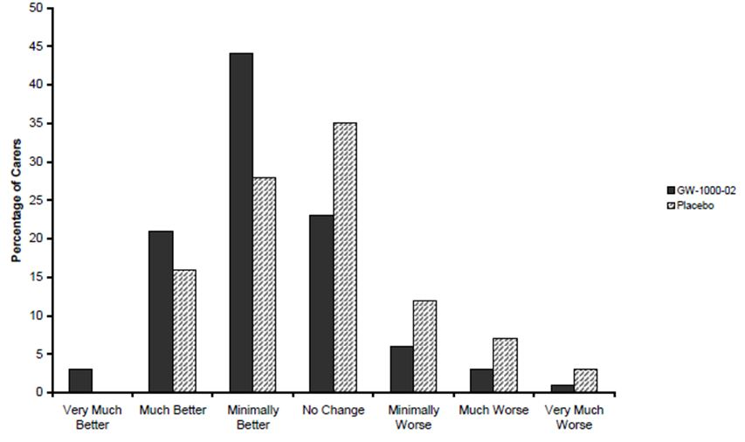
Figure 23: CGIC for Ease of Transfer, Study 604.
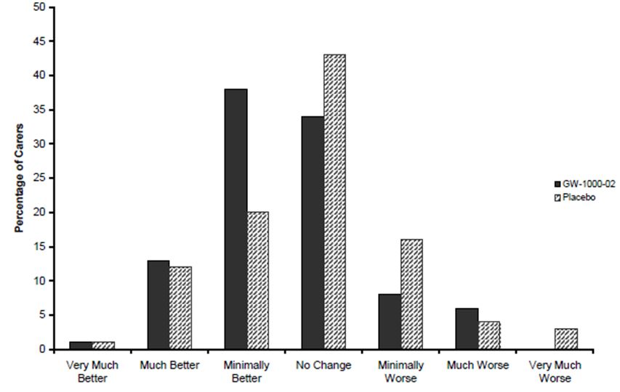
Figure 24: Physician Global Impression of Change, Study 604.
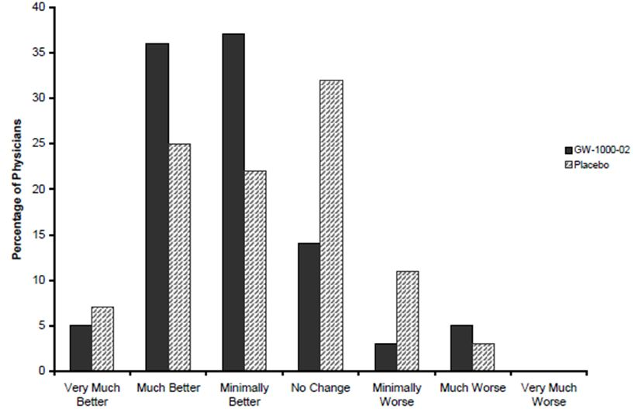

Depression scores
While not reflecting efficacy per se, depression scores are of interest in the efficacy analysis in view of the criticism that the NRS might be reflecting factors other than spasticity. The sponsor assessed depression with the Beck Depression Inventory, and found no mean difference in the active group versus placebo, and little overall change from baseline (Table 40). This is broadly reassuring, and supports the assertion that favourable effects on the NRS were not simply due to mood changes. The effects of cannabinoids on mood would be expected to be complex, with some short term mood elevating effects and possibly an increased long term risk of depression. This might not be reflected in mean Depression Scores. AEs related to mood disturbances, both depressed and elevated, were increased with active treatment as discussed in the Safety section.
Table 40: Beck Depression Inventory, Study 604.
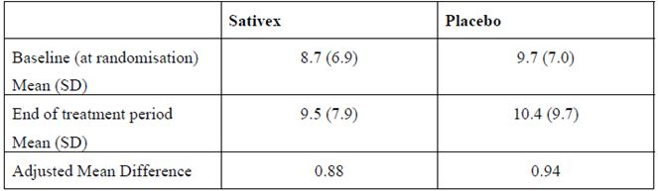

Overall summary of efficacy in Study 604
This study of self titrated Sativex via oromucosal spray used an unusual enrichment design in which responders were first identified during a single blind treatment trial for four weeks. Only patients who reported a 20% improvement in NRS progressed to randomisation and double blind, placebo controlled treatment. The primary endpoint was the change in spasticity NRS scores from the start of the double blind phase to the end of treatment. The mean baseline scores at randomisation were 3.87 and 3.92 points for the Sativex and placebo groups, respectively, which had already improved relative to the start of the single blind treatment phase. Following randomisation, there was a further improvement of 0.19 units in the Sativex group (4.9%) by the end of the treatment phase, compared to a deterioration of 0.64 units in the placebo group (16.4%). The adjusted mean difference between the groups was 0.84 units (p = 0.0002, 95% CI: -1.29 to -0.40). Continued active treatment thus led to better NRS scores, as compared to withdrawal (placebo substitution).
The only concerns this study raises are the possibility that the subjective NRS scores were affected by confounding factors, including unblinding. The withdrawal of cannabinoids could have led to temporary “rebound” worsening of spasticity in the placebo group, or mood effects that affected NRS scores adversely, but this effect seems relatively unlikely to have persisted for the 14 weeks of the study. In the placebo group, NRS scores deteriorated in the first two weeks of withdrawal and did not show a substantial recovery after that. It is possible, however, that some patients became unblinded during the first two weeks, and their negative assessments were carried forward. The apparent magnitude of the treatment effect is therefore likely to have been inflated by this design.
The internal validity of the study was supported by positive findings for most secondary endpoints, including spasm frequency and global assessments of change by patients and carers. The objective Ashworth scale, known to be relatively insensitive, showed a favourable trend, as did the timed 10 Metre Walk. Although not reaching significance, these objective measures suggest that bias and confounding did not play a dominant role in producing the appearance of efficacy in this study. Carers should have been relatively uninfluenced by withdrawal effects (though they may have suffered second hand effects because of irritability in the patients they were caring for). Their judgement that the patients had improved ease of transfer is therefore reassuring.
Importantly, the results in this enriched population of responders cannot be generalised to the broader population of patients with MS related spasticity. Instead, clinicians wanting to replicate these results in their own patients would need to subject their patients to a therapeutic trial and only proceed to long term treatment if there was a clear improvement in spasticity. As discussed further in the Evaluator’s conclusions on clinical efficacy of Sativex for the treatment of MS related spasticity section and in the First round assessment of benefits section, the proportion of patients achieving a clinically meaningful treatment response via this approach is small. Only a minority of subjects in Study 604 (42%) showed an initial response and although most of these (74%) went on to show a 30% response overall, the placebo group also showed a high response rate (51%), and the attributable response rate was therefore only 23%, which is just 9.7% of the original cohort. Given the likely confounding of the efficacy results through unblinding, the actual yield is likely to be lower still.

Analyses performed across pivotal studies

Meta analysis of Studies 106 and 403
In the original unsuccessful submission, the sponsor pooled the smaller, borderline positive study (Study 106) and the larger, negative study (Study 403) in a meta analysis, on the basis that both studies recruited similar patients, applied the same treatments and used the same efficacy measure.
The main difference between the studies was the treatment duration (6 weeks in Study 106 and 14 weeks in Study 403); the sponsor dealt with this by assessing the NRS at the 6 week time point in both studies, as well as at the end of randomised treatment. The other main difference between the studies was in the baseline severity of spasticity, so baseline severity was included as a term in the statistical model.
The results of this pooled analysis in 519 patients (Table 41) suggested that despite inclusion of the negative Study 403, the overall results were weakly in favour of Sativex (p = 0.03). The treatment effect in the pooled group was quite small, however, representing about one third of a point in the 11 point scale. Considering the potential for some of this difference to be due to unblinding or confounding effects, the original rejection of the first Sativex submission appears reasonable.
Table 41: Pooled analysis of spasticity assessment across Studies 106 and 403.
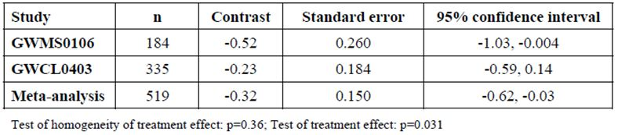

Analysis of Potential Unblinding in Early Pivotal Studies
The sponsor submitted a 56 page report in which the potential for unblinding in the first round Phase 3 studies was considered.
The sponsor introduced this analysis with the comment “There are several possible ways that the double blind nature of the trials could be compromised. These include:
- Subjects with previous experience of cannabis might be able to determine whether they are receiving Sativex or placebo.
- The occurrence of AEs, combined with the information given to the subject on the known AE profile, might enable some subjects to assume they are on Sativex.”
The sponsor then performed an analysis of whether prior cannabis use affected spasticity scores; their reasoning behind this approach was that if unblinding occurred it would be more likely to occur in previous cannabis users, and this might have affected their spasticity ratings. They also analysed the doses used in experienced versus naïve subjects, reasoning that those with a history of recreational use might alter their dose in recognition of the presence or absence of an active ingredient. Finally, they analysed AEs in relation to spasticity ratings to see if AEs could have lead to unblinding and hence to altered spasticity ratings.
Unfortunately, framing the discussion in this way simplifies what is actually a more complex issue. The psychoactive effects of cannabis are not necessarily so subtle that it takes experience to recognise them. Unblinding could therefore occur in both naïve and experienced users, and if the rate of unblinding was balanced in the two groups then comparisons between the two groups would not reveal it. Recreational users familiar with party level doses might even show tolerance to some of the milder side effects of lower doses – offsetting the effect of their greater familiarity. Furthermore, while AEs could lead to unblinding, not all side effects would necessarily be reported as AEs, especially if they were mild, transient or pleasant. By emphasising a comparison between experienced versus naïve users, the sponsor’s analysis systematically discounts all of those unblinding factors that are common to both groups. Even worse, by concentrating on whether the difference between potential unblinding factors in experienced and naïve users was statistically significant, the sponsor has neglected to consider whether strong unblinding trends might have been present which, while not significant in their own right, added to the apparent significance of an otherwise weak efficacy signal.
To a very large extent, the entire analysis is superfluous because it is already known that unblinding was prevalent in the largest of the first round studies (Study 403) where investigators were able to guess the assigned treatment far more often than expected by chance, as discussed above.
With these limitations in mind, the sponsor’s analysis is summarised below.

Association between prior use and efficacy
The sponsor performed a pooled analysis of the three first round Phase 3 studies (only two of which were pivotal), in which they assessed whether prior cannabis use had an influence on spasticity scores. The data were analysed with a general linear model, using change in spasticity as the dependent variable. Fixed factors were treatment group (Sativex/placebo) (TG), prior use of cannabis (Yes/No) (PC), and study (ST), as well as the interaction terms TG*PC, TG*ST, PC*ST, TG*PC*ST. Baseline spasticity (BS) was included as a covariate. This analysis did not find that prior cannabis use significantly affected spasticity scores, suggesting that unblinding, if it occurred, was either balanced across the experienced and naïve subpopulations or did not lead to biased spasticity assessments.

Association between prior use and dose
Table 42 shows the mean number of sprays in each treatment group for each pivotal study, according to whether the subjects had experience with cannabis. There was a big difference between the active and placebo groups, with placebo recipients taking more sprays, possibly because of poor efficacy or better tolerability. There was also a difference between studies. Prior cannabis use, on the other hand, did not appear to influence the dose and the more formal statistical analysis with the general linear model confirmed this.
Table 42: Summary of drug dosing by study, treatment and prior use of cannabis.
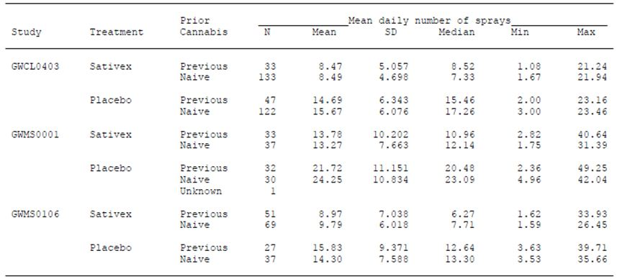

Association between tell tale AEs and efficacy
The ten most common AEs are shown in Table 43. There is a clear, significant excess of many AEs in the Sativex group, most of which would be interpreted by patients and clinicians as a likely indicator of active drug. In particular, dizziness, fatigue, nausea, somnolence and asthenia were more likely in recipients of active drug, and often this was significant, with the 95% CI for the odds ratio not including 1.0. Naïve users were four times more likely to be dizzy, and experienced users nearly six times more likely to be somnolent, with active treatment in comparison to placebo. The differences in AE incidence according to prior use were generally not significant, but this merely indicates that these unblinding factors were not confined to experienced users. The exception was somnolence, about which the sponsor wrote:
“The PC*TG [prior cannabis * treatment group] interaction was not significant for any AE. When the PC*TG interaction was removed and the model contained only the main effects there was only one AE where the effect of PC was statistically significant at the nominal 5% level (somnolence: p = 0.017).”
Table 43: AEs by treatment and prior use of cannabis.
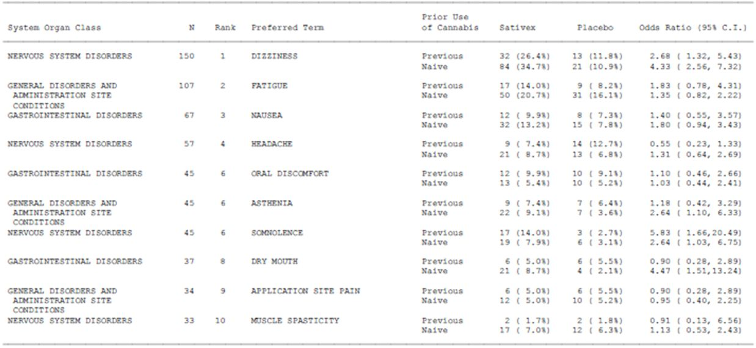
Note that this p value does not reflect the increased incidence of somnolence with active treatment, just the effect of prior cannabis use on the increased incidence.
The sponsor also analysed the effect of AEs on efficacy, with a logistic regression model, using AE incidence, study, treatment group and their interactions as terms, and by ANCOVA. This analysis seemed designed to fail. The sponsor chose to analyse three AEs in particular (dizziness, somnolence and headache), ostensibly because these were the most common AEs (Table 44). Note that the inclusion of ‘headache’ in the sponsor’s cluster of three AEs was not particularly helpful. This AE was not notably more common with active therapy and would not be interpreted by many subjects as indicative of active treatment, so its inclusion inevitably weakens this analysis. Headache AEs would tend to dilute the incidence of AEs that were likely to cause unblinding, hiding the very effect the analysis was ostensibly trying to detect.
Table 44: Analysis of efficacy adjusting for the 3 most frequent nervous system disorder AEs.
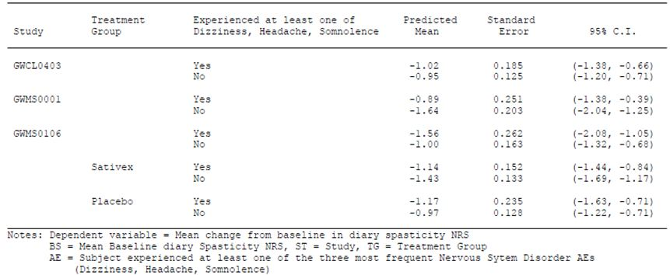
In the ANCOVA, there was a relationship between efficacy and the incidence of AEs, but the relationship was in different directions in different studies. In Study 001, the absence of one of the sponsor’s three AEs was associated with a greater reduction in spasticity, while in Study 106, the presence of one of these AEs was associated with greater apparent efficacy. In Study 403, there was no apparent effect of AEs on efficacy. A non parametric analysis did not confirm the presence of an overall relationship between efficacy and the study by AE interaction, so the findings are unclear and difficult to interpret. A straightforward effect of AEs on efficacy was not detected, but this does not exclude the possibility side effects leading to unblinding and ultimately affecting efficacy scores – subjects experiencing side effects had additional information not captured in a simple AE incidence rate, such as the timing and nature of the side effect and its relationship to individual doses of study drug. Of even greater concern, this analysis did not include the new pivotal Study 604, on which the new submission rests.

Conclusion about the potential for unblinding
In conclusion, it remains almost certain that the pivotal studies were susceptible to some unblinding, and the sponsor’s analysis merely casts doubt on a simple scenario in which prior cannabis use or AEs had a dominant effect on unblinding. The inclusion of headache AEs in their AE cluster seems designed to sabotage this analysis. In a much more direct assessment of potential unblinding in Study 403, investigators were far more likely to guess the correct treatment of their subjects than chance would predict.
The PK/PD study program suggested that even moderate doses of Sativex were associated with intoxication in at least some subjects, and “likeability” of the drug was greater than placebo even for a dose of 4 sprays, but especially for a dose of 8 sprays (Study GWCP0605). This is within the range recommended for daily use (1-12 sprays), and even if patients divided the maximum recommended daily dose into two divided doses, they would be taking 6 sprays at once. Many of the submitted efficacy studies suggested a maximum single dose of 8 sprays in a three hour period, within the range known to produce intoxication and “likeable” side effects in some subjects. Many patients may have been tempted to take even more than this, simply because they knew they had access to a restricted substance, or had fond memories of previous recreational use. It thus seems very likely that at least some subjects took enough sprays to experience positive recreational effects at least once during the pivotal studies, with subsequent unblinding.
A detailed blinding analysis for the latest, second round pivotal study was not submitted, and the design of this study increases, rather than decreases the potential for unblinding. Firstly, if any patient was inclined to respond to telltale side effects with an improved spasticity rating, then that patient would have a higher chance of ending up in the enriched population than a patient inclined to more objective self rating. Secondly, the potential experience of a withdrawal syndrome in placebo recipients added new opportunities for unblinding on top of the dose by dose occurrence of telltale side effects.

Supportive efficacy studies
Table 45 lists all of the submitted efficacy studies, including the three pivotal studies already considered (Studies 106, 403 and 604). Non pivotal efficacy studies included two Phase 2 studies (Studies 902 and 904) and four Phase 3 studies (Studies 001, 702, Extension-001, Extension-102).
Table 45: Overview of clinical trials with Sativex: pivotal and supportive studies.
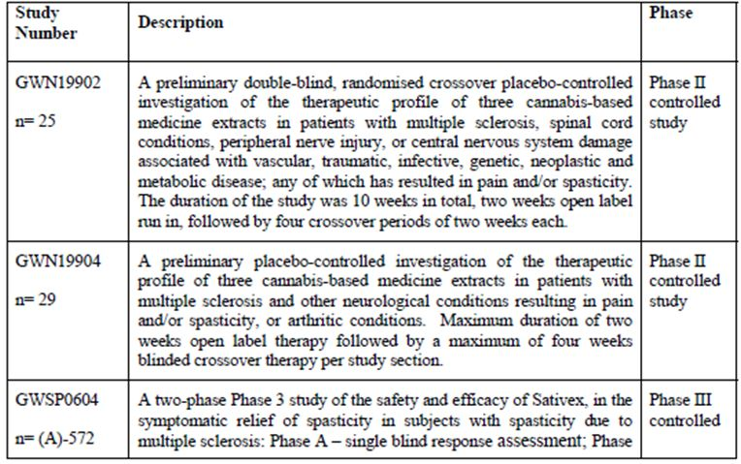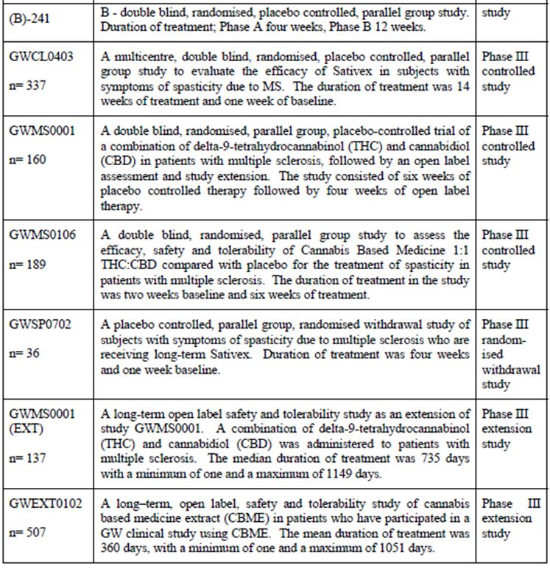
Most of these studies (Studies 902, 904, 001, Extension-102, Extension-001) were not specifically directed against the target indication of spasticity, and the Phase 2 studies (902 and 904) were not even restricted to diseases of the central nervous system, so they are only described briefly. The extension studies were unblinded, and thus provided no clear indication of efficacy. Study 702 was a second round supportive efficacy study designed to address the deficiencies in long term efficacy data in the first, unsuccessful submission of Sativex for spasticity, and it is described in more detail, but it was a brief withdrawal study unable to distinguish efficacy from withdrawal symptoms.
Thus, in summary, not one of the additional efficacy studies can be considered truly supportive.

Additional phase 3 efficacy studies (702, Extension-001, Extension-0102)

Study 702

Design
One flaw in the original unsuccessful submission for Sativex was that it did not assess the long term efficacy of Sativex, except in unblinded extension studies. The MHRA suggested that long term efficacy could be assessed with a withdrawal design:
“A randomised withdrawal trial following a period of open label treatment in patients considered to be responders would provide such information and could satisfy the need for controlled long term efficacy data”.
The problem with this advice, and with the subsequent design of Study 702, is that the production of a symptom upon withdrawal of a drug does not prove that the symptom was being adequately treated by the drug.
A classic example of withdrawal effects not being reliable as an indicator of efficacy is the use of short acting analgesics in chronic daily headache. Many patients with chronic daily headache receive only partial, temporary amelioration of their headaches with paracetamol, and in fact have their headache cycle fuelled by regular withdrawal symptoms. They often suffer less headaches in the long term if they manage to cease the ineffective analgesics, but they need to be encouraged to persevere through the early withdrawal symptoms, which include a temporary increase in headache. Another example is epilepsy, which can be exacerbated by acute withdrawal effects even when the drug being withdrawn is largely ineffective. An extreme example is alcohol, which generally exacerbates epilepsy, but also causes a temporarily increased risk of seizures during withdrawal.
As a consequence of the advice from MHRA, the sponsor consulted a register of patients with MS spasticity who were receiving long term Sativex, and patients were invited to enter a study in which they would be randomised to continue with Sativex or with placebo. The study was short (just 4 weeks) and small (just 36 patients).

Inclusion criteria
Patients were eligible of they were 18 years or over and taking at least two sprays per day of Sativex for relief of MS related spasticity, for at least 12 weeks prior to study entry.

Treatment
Sativex containing THC 27 mg/ml and CBD 25 mg/ml, delivered in 100 μl actuations by a pump action oromucosal spray. Subjects self administered study medication at the same dose they used prior to the study, up to a maximum dose of eight actuations in any three hour period or 48 actuations in 24 h (maximum daily dose THC 130 mg and CBD 120 mg).

Endpoints
The primary efficacy endpoint of the study was the time to treatment failure, with treatment failure defined as:
- cessation of the randomised treatment before the Day 28 visit; or
- a worsening of spasticity at any visit (defined as an increase in the mean spasticity NRS over the previous 7 days of at least 20% and at least 1 unit from baseline); or
- a clinically relevant increase in anti spasticity medicines or disease modifying medications after randomisation.
Note that this endpoint exacerbates the potential problem of interpreting acute withdrawal effects as efficacy, because “failing” patients were given no chance to recover from any acute withdrawal effects. If they quit because they did not like withdrawal symptoms, or if they showed a temporary increase in spasticity, or even temporary mood changes that changed their self rating, this was necessarily counted as a treatment failure, even if they were actually destined to return to their pre withdrawal spasticity levels with continued abstinence.
Several secondary endpoints were also assessed: changes in spasticity severity (assessed by NRS), daily sleep disruption (by NRS), Modified Ashworth Scale, Timed 10 Metre Walk, Motricity Index, CGIC and SGIC.

Statistical analysis
The primary endpoint was analysed with Kaplan Meier survival analysis methodology and proportional odds modelling, with randomised withdrawal treatment as a factor. Secondary endpoints were analysed using a linear model, apart from CGIC and SGIC, which were analysed with ordinal logistic regression using the cumulative proportional odds model.
No formal sample size calculation was performed. It was estimated that approximately 60 subjects (30 per group) would be randomised into the study, but only 36 patients were recruited.

Results

Baseline characteristics
The 36 randomised subjects were quite disabled, with a mean EDSS of almost 7 (Table 46). The baseline spasticity score was less than in the Phase 3 studies, which the clinical expert interpreted as follows:
“This helps to confirm that they had been receiving benefit from Sativex.”
Given the lack of any control group for this baseline observation, and the voluntary opt in design, this interpretation is unjustified. Patients with more severe spasticity might have been unwilling to face randomised withdrawal of a drug they believed to be of benefit.
Table 46: Demographics of subjects, Study 702.
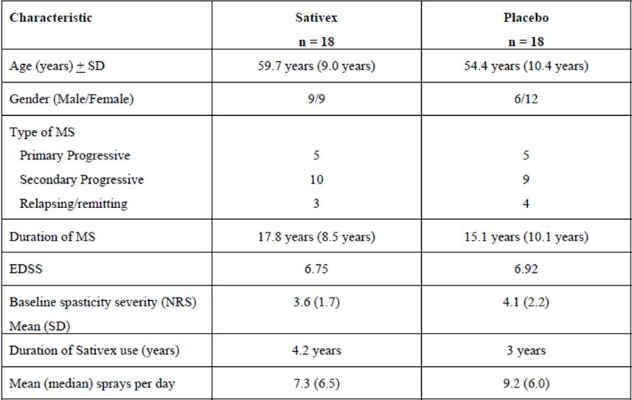

Primary endpoint
The primary efficacy endpoint, time to treatment failure, was in favour of Sativex (p = 0.013). Withdrawal is displayed for each group in the Kaplan Meier plot (Figure 25).
Figure 25: Time to “Treatment Failure”, Study 702.
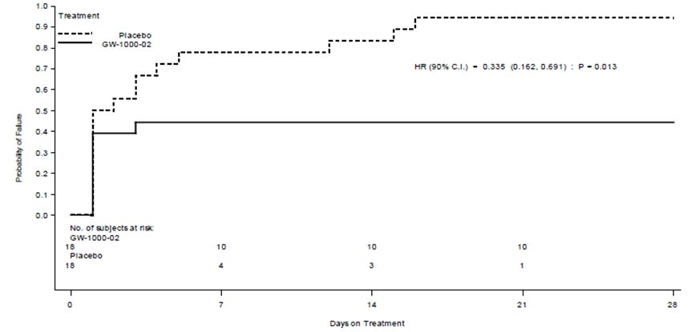
Almost all (17/18, 94%) of the placebo recipients failed treatment, whereas 8 of the 18 Sativex recipients (44%) failed treatment. The reason for failure in the majority of subjects (76%) was a worsening of spasticity (that is, a ≥ 20% increase in NRS score from baseline). Only two subjects (11%) receiving Sativex ceased treatment due to AEs during the randomised withdrawal phase, compared to nine subjects (50%) receiving placebo, suggesting that withdrawal symptoms might have played a role in the excess treatment failures observed in the placebo group.
The occurrence of apparent treatment failures in 44% of the subjects who actually continued their normal treatment constitutes a negative placebo effect, and highlights the subjectivity of the spasticity scores; it suggests that the mere thought that they might be withdrawing caused nearly half of the patients to rate their spasticity as worsened.
The difference between groups indicates that Sativex has some biological activity when used chronically, but the nature of that activity remains unclear. Patients could have withdrawn from the study or changed their spasticity rating for a variety of reasons, including mood changes, other withdrawal effects, or even a temporary worsening of spasticity that would have settled if they had persisted. The design of the study prevents any firm conclusions from being drawn. Furthermore, even if the treatment failure truly reflected long term efficacy, it should be noted that this was a highly selected group, representing a subset of treated patients who had decided to stay on Sativex in the long term because they believed it was helping.

Secondary endpoints
Both the SGIC and the Carer Global Impression of Functional Ability were significantly in favour of Sativex. The majority of patients in both groups felt that they had become slightly worse, but the majority was more substantial in the placebo group (Sativex 67% and placebo, 94%). The odds of being unchanged were greater in the Sativex group than the placebo group (odds ratio 4.55, p = 0.017; 90% CI: 1.59, 14.00).
For the CGIC, of 18 carers in each treatment group, only 10 and 14 completed the CGIC in the Sativex and placebo groups, respectively. All 14 carers of placebo subjects categorised the subject’s functional ability as worsening, compared to 70% of carers (7/10) of Sativex subjects, which was statistically significant (p = 0.001).
The other secondary endpoints – changes in spasticity severity (assessed by NRS), daily sleep disruption (assessed by NRS), Modified Ashworth Scale, Timed 10 Metre Walk, and Motricity Index – showed no significant difference between Sativex and placebo. The adjusted mean spasticity NRS showed an increase (deterioration) of 1.00 point in the Sativex group from a mean baseline score of 3.60 points, compared with an increase of 1.21 points from a baseline of 4.13 points for placebo. The estimated treatment difference was therefore -0.21 points (90% CI: -1.22, 0.79 points) but this was not statistically significant (p = 0.720). Table 47, copied from the clinical expert report, is notable because it emphasises the only two secondary endpoints that achieved statistical significance, the SGIC and CGIC. Those endpoints were not marked as key endpoints prospectively.
Table 47: Results for key secondary efficacy measures in Study 702.
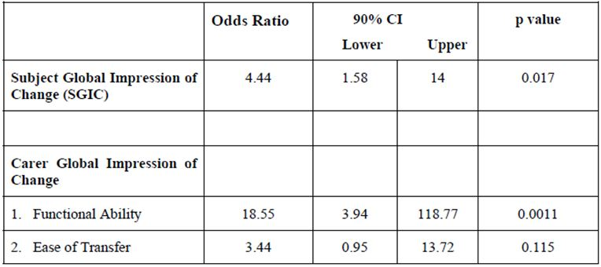
In summary, this study showed that subjects taking Sativex in the long term were more likely to rate their spasticity as 20% worse or report an AE if they were subjected to withdrawal than if they continued treatment.

Study 001

Design
The primary objective of Study 001 was “to investigate the use of Sativex compared with placebo in the alleviation of key symptoms of multiple sclerosis (pain, spasticity, spasms, bladder problems, tremor) in subjects with MS.” Although designated as a Phase 3 study, it was clearly exploratory in nature because:
- it did not have a clearly defined biological rationale for treatment;
- it did not have a clearly defined symptom complex it was attempting to alleviate; and
- it lacked a unified endpoint.
The endpoint meant different things for different patients. Patients were asked to identify their primary symptom from any of the following: spasticity, pain, spasms, tremor and bladder problems. The subsequent primary efficacy endpoint was a composite score based on a 0-100mm VAS of “the primary symptom”, whatever that happened to be, with all five types of primary symptom included in one free for all analysis. Only 39 patients designated spasticity as their primary symptom.
Patients (n = 160) were treated with Sativex or placebo for 6 weeks during the double blind portion of the study, administered as 100 μl sprays. The maximum permitted dose was eight sprays (22 mg THC, 20 mg CBD) within three hours and 48 sprays (130 mg THC, 120 mg CBD) in 24 h.

Results
A total of 130 subjects were planned, but 160 were randomised, 80 to Sativex and 80 to placebo. A total of 147 subjects completed the study and 13 withdrew.
This study was negative for its primary endpoint. The adjusted mean change from baseline for the “composite primary impairment” VAS score at the end of blinded treatment was a decrease of 25.29 mm in the Sativex group and a decrease of 19.35 mm for the placebo group. The estimated treatment difference was 5.93 mm in favour of active treatment, but this was not significant (p = 0.124; 95% CI: –13.52, 1.65 mm).
In the 39 patients for whom spasticity was the primary symptom, the results for the spasticity VAS were significantly in favour of Sativex (p = 0.001 by ANCOVA) (Table 48). This has to be considered a hypothesis generating observation rather than the result of a clearly defined pre hoc hypothesis due to two reasons:
- because it is a subgroup analysis; and
- because spasticity VAS was not the primary endpoint of the study.
The estimated treatment difference was ~23mm on the VAS, from a baseline severity approaching 70mm.
Table 48: Analysis of VAS Scores at Week 6, Primary Spasticity Subjects, Study 001.
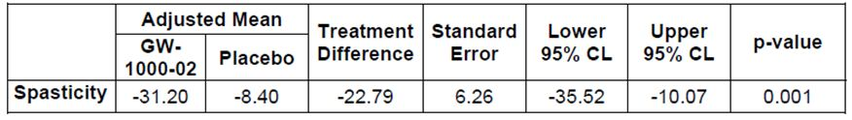
In the broader group of patients who had spasticity of any severity, but not necessarily as their “primary symptom”, there was a favourable but non significant between group difference in the mean change in spasticity score (p = 0.062; n = 140).
At the end of the 6 week randomised treatment period, all subjects were transferred to open label Sativex for 4 weeks. After 4 weeks, the subjects who had previously received placebo showed an improved mean spasticity rating on the VAS (decrease of 8.84 mm, p = 0.005; 95% CI: -14.86, -2.82 mm); this includes the placebo effect.

Study GWMS0001Ext (Extension Study)

Design
This long term, open label extension study recruited patients who had completed Study 001. Patients initially entered a four week open label treatment period on Sativex, as described above. At the end of this short term open label treatment, subjects who were deemed likely to gain clinical benefit from continued Sativex were offered a long term open label study of Sativex.
The main objective was to assess the long term safety and tolerability of Sativex, and it cannot be considered an acceptable efficacy study because of its open label, non randomised design and its mixed set of 5 indications. Symptom severity was monitored throughout the study by means of VAS scores, but no formal hypothesis testing was performed and the statistics were merely descriptive.
A drug interruption sub study was also performed in 25 of the patients in this study who had MS. After two weeks of abstinence, subjects were asked to rate their MS symptoms as “much worse”, “worse”, “no change”, “better”, or “much better.”

Results
Most subjects (137/160, 89%) entered the long term study. The median duration of treatment was at least two years, but about 67 withdrew after a median duration of 120 days.
The VAS symptom severity scores for spasticity, muscle spasms, pain, and bladder problems all showed an improvement during the initial four weeks treatment, which was broadly maintained for at least two years. The median daily dose (8 sprays / 24h at the end of the study) did not increase with time. The investigators’ assessment of subjects’ overall condition showed that less than half (40%) of subjects appeared “better” or “much better” on their last study visit compared to study entry; the majority were the same or worse. Without a control group, this observation has no context.
The 25 subjects in the withdrawal sub study showed that majority (68%) felt their MS symptoms were “worse” or “much worse” following Sativex withdrawal (Table 49).
Table 49: Patient assessment of global outcome of MS symptoms.
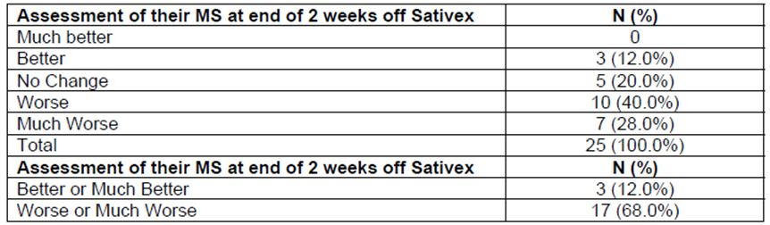
Assessments in this study may have been influenced by acute withdrawal symptoms. Five subjects resumed Sativex early, ostensibly because of worsening MS symptoms, and about half experienced a symptom known to occur following withdrawal of recreational cannabis. According to the sponsor’s Summary of Clinical Safety:
“No subject met the criteria for a cannabis withdrawal syndrome. Almost half (46%) experienced at least one symptom listed among the Budney criteria, such as hot and cold feelings, interrupted sleep, emotional lability, tiredness, intoxication or vivid dreams.”
It is not clear how the sponsor derived the figure of 46%, because each subject constituted 4% of the 25 patients, and the study report did not refer directly to this observation.
Overall, this study does little to characterise the long term efficacy of Sativex. The high prevalence of withdrawal symptoms strongly suggests that some unblinding is likely to have occurred in the main pivotal study on which the submission rests (Study 604), because it also used a withdrawal design.

Study GWEXT0102 (Extension Study)

Design
This study was a long term, open label, safety and tolerability study of Sativex (containing THC 27 mg/ml and CBD 25 mg/ml).
Eligible patients were those who had participated in a clinical study of Sativex, but not including Study 001. They were not required to have MS or spasticity, so their relevance to the proposed indication is marginal. Some of them continued Sativex as they entered the study, and others commenced it having had placebo in the parent study.
The primary objective of the study was to assess the safety and tolerability of long-term Sativex.
Secondary objectives were:
- to detect evidence of tolerance with long term CBME therapy;
- to assess the dosing profile of long term use of CBME;
- to investigate the maintenance of efficacy;
- to continue supplies of CBM for those gaining apparent clinical benefit.
Subjects had a range of conditions, some of which might be expected to cause spasticity: multiple sclerosis, spinal cord conditions, or central nervous system damage. Subjects with peripheral nerve injury were also included – these patients have lower motor neuron weakness and would not be expected to have spasticity; their inclusion highlights the heterogeneous nature of the population and the lack of any clear focus on a defined indication.
Subjects were required to complete a diary noting their daily dosing details and weekly “primary symptom” severity. The primary symptom was inferred from the parent study, as follows:
- GWBP0101: NP related to brachial plexus injury.
- GWMS0106: Spasticity related to MS.
- GWMS0107: NP related to MS.
- GWMS0208: Episodes of urinary incontinence, related to MS.
- GWNP0101: NP characterised by allodynia.
- GWPS0105: Pain due to MS or other neurological defect.
- GWSC0101: NP related to non acute spinal cord injury.
Visits occurred during Weeks 2, 4 and 12, and then every 8 weeks. Every 6 months, subjects were examined physically. Continuation within the study was conditional on satisfactory reports of tolerability, efficacy and dosing regime.
Since this was a non comparative study, no formal hypothesis testing was performed and the statistics are descriptive.

Results
A total of 507 subjects were recruited and analysed, of whom 262 (52%) withdrew over the duration of the study. The mean duration of treatment, for subjects included in this analysis, was 360 days, with a minimum of one and a maximum of 1051 days. The single largest cohort of subjects entering this study came from the pivotal spasticity Study GWMS0106, where 146 subjects out of a possible 189 elected to join the long-term extension study; of these 94 had received Sativex and 52 had received placebo in the parent study. Most of the other subjects who entered the study suffered primarily from neuropathic pain or bladder symptoms.
For most individual symptoms, the mean NRS scores showed a moderate decrease (improvement) during the study. Only the spasticity scores are relevant, and these are shown in Figure 26. Note that the improvement includes the placebo effect, and cannot be interpreted without a control group.
Figure 26: Mean Spasticity Score, Study GWEXT0102.
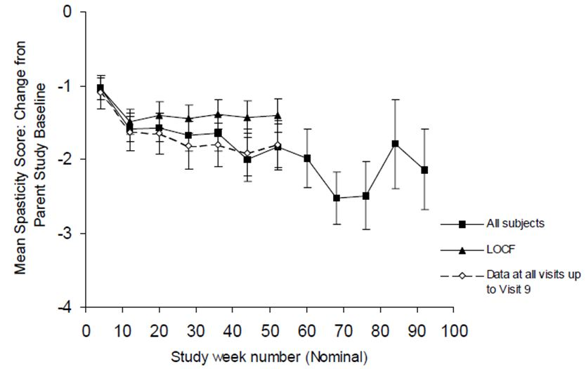

Phase 2 efficacy studies

Study GWN19902

Design
This study was entitled:
“A preliminary double blind, randomised crossover, placebo controlled investigation of the therapeutic profile of three cannabis based medicines in subjects with multiple sclerosis, spinal cord conditions, peripheral nerve injury or central nervous system damage associated with vascular, traumatic, infective, genetic, neoplastic and metabolic disease; any of which has resulted in pain and/or spasticity.”
As indicated in the title, this was an exploratory study looking for signs of efficacy in a range of neurological conditions in both the central and peripheral nervous system. The symptoms for which it hoped to show efficacy were broad, and included “relieving pain and spasticity and improving general well being in subjects with MS, spinal cord injury, peripheral nerve injury or central nervous system damage”.
A secondary objective was to identify the likely therapeutic range in which subjects might benefit from CBMEs without unwanted effects.
The study was randomised, double blind and placebo controlled. It used an “N = 1” within subject crossover design to compare three CBMEs with placebo in the treatment of these wide ranging symptoms. The four treatments being compared were:
- GW-1000 (1:1 THC:CBD, that is, Sativex). Each actuation delivered 100 μl (THC 2.5 mg and CBD 2.5 mg);
- GW-2000 (THC extract). Each actuation delivered 100 μl (THC 2.5 mg);
- GW-3000 (CBD extract). Each actuation delivered 100 μl (CBD 2.5 mg); and
- Placebo.
Patients self titrated their dose. The maximum permitted dose was 48 actuations in any 24 h period, but no more than eight actuations in any 3 h period.
The study duration was ten weeks (two weeks run in, followed by a four period crossover stage with two weeks for each of the four randomised treatments). It seems unlikely that this allowed adequate adaptation to each treatment before moving on to the next.
Subjects nominated up to five symptoms that were assessed throughout the study by recording daily symptom scores for each of their identified symptoms on a 0-100mm VAS. Efficacy analysis was based on the last seven days of each two week treatment period, giving just seven days to adjust to cessation of the last treatment before beginning to record efficacy on the next.
The primary endpoint was not clearly stated. Two endpoints emphasised in the study report were:
- “The average severity of all patient nominated symptoms as recorded on daily diary cards.”
- “The average severity of all patient nominated symptoms as recorded on daily diary cards and broken down into classifications of pain, urinary, spasm, spasticity, coordination and other.”
Thus, it was not clear whether the main endpoint was an average VAS across different symptom domains or simply a collection of different endpoints for different symptoms of interest. The symptom most relevant to the proposed spasticity indication was “spasm”, which is not equivalent to spasticity.
Of note, the sponsor reports that:
“No statistical analysis plan (SAP) was produced before the analysis of the efficacy variables,” and “no formal sample size calculation was performed.”
VAS scores, whether considered on average or for individual symptom domains, were compared using ANOVA in a four treatment, four period crossover model, using patient, period and treatment as factors. No adjustment appears to have been made for the multiple competing endpoints. The study was intended to enrol a maximum of 30 patients with MS, 30 patients with spinal cord injury and 30 patients with peripheral nerve injury, but recruitment was terminated early. Note that the study did not have a fixed termination criterion, and patient results were unblinded as each finished, so there was ample opportunity to finalise the study at a time that was advantageous to the sponsor. No statistical adjustment was made for the flexible termination point.

Results
Twenty five subjects entered the study but only 20 continued through the crossover phase and the formal comparisons of efficacy between double blind periods include only these 20 patients. Seventeen of the 25 subjects had MS, while 6 had spinal cord conditions, and 2 had peripheral neuropathy.

Overall treatment effect
The treatment effect for the overall analysis of VAS scores in the active phases reached statistical significance for the symptom of pain (p = 0.019), with non significant trends for spasm (p = 0.052), spasticity (p = 0.096), and average symptom score (p = 0.091).

Individual active treatments
The following differences were noted in favour of active treatment.

GW-1000 (1:1 THC:CBD, that is, Sativex)
For spasm, the difference of 8.4 mm between the mean VAS during the Sativex period and the mean VAS during the placebo period was statistically significant (p = 0.044, 95% CI: 0.2, 16.6 mm).

GW-2000 (THC extract)
For pain, the difference of 10.1 mm was statistically significant (p = 0.0096, 95% CI: 2.6, 17.5 mm). Treatment differences of 11.1 mm for spasm and 14.1 mm for spasticity were also statistically significant (p = 0.0082, 95% CI: 3.0, 19.2 mm and p = 0.023, 95% CI: 2.2, 26.1 mm, respectively). For the composite score for all assessed symptoms, the comparison with placebo showed a significant treatment difference of 6.9 mm in favour of THC (p = 0.019, 95% CI: 1.2, 12.7 mm).

GW-3000 (CBD extract)
For pain, the treatment difference was 11.2 mm compared with placebo (p = 0.0046, 95% CI: 3.7, 18.7 mm). For spasm, the treatment difference of 7.0 mm failed to reach significance (p = 0.087, 95% CI: -1.1, 15.1 mm). For the composite score for all assessed symptoms, the treatment difference compared with placebo was significant (5.8 mm, p = 0.048, 95% CI: 0.1, 11.6 mm).
Overall, this study can only be considered hypothesis generating. It suggests that Sativex might be useful for the treatment of spasm. It also suggests that THC monotherapy might be more effective than Sativex.

Study GWN19904

Design
Similar to Study 902, this study was entitled:
“A preliminary placebo controlled investigation of the therapeutic profile of three cannabis based medicines in subjects with multiple sclerosis and other neurological conditions resulting in pain and/or spasticity, or arthritic conditions.”
As such, it assessed a mixture of conditions and indications. Note that this study was not even confined to neurological patients, but also considered patients with arthritis. Of a total of 29 patients, less than half (14) had MS, and only 5 had spasticity.
It employed an “N = 1” design similar to the previous study, with a run in phase followed by a crossover period in which one of the 3 possible CBM extracts was compared with placebo.
The four treatments intended to be compared were as follows:
- GW-1000, 1001 - THC 25 mg/ml : CBD 25 mg/ml, 2.5 mg : 2.5mg per 100 μl actuation, up to 48 actuations per day (THC 120 mg : CBD 120 mg)
- GW-2000, 2001 - THC 25 mg/ml, 2.5 mg per 100 μl actuation, up to 48 per day (THC 120 mg)
- GW-3001, 3002 - CBD 50 mg/ml, 5 mg per 100 μl actuation, up to 96 per day (CBD 480 mg)
- Matching placebo: GW-4000, 4001.
(Peppermint was used to maintaining blinding in the double blind phase, but not the open label phase, and so each treatment was given two numbers; the second listed number being the peppermint free form.)
The study commenced with a one to two week baseline period. The investigator then chose which CBME was to be used in the run in and crossover phases. Patients then entered a 1-2 week run in, followed by a randomised two period crossover phase (maximum four week duration), without washout, of the chosen CBME and placebo. In practice, all but one patient was assigned to receive GW-1000 (Sativex), so the statistical analysis was restricted to an evaluation of GW-1000/1001 (Sativex) treatment.
Patients nominated their five main symptoms and scored them with a VAS. The primary efficacy variable was the composite VAS severity score for the five identified symptoms. Because this composite combined symptoms with different anatomical and biological substrates, different pharmacological sensitivities, and potentially different test dynamics, it is doubtful that ordinary statistical analysis can be meaningfully applied or that a positive result could be meaningfully interpreted.
All statistical hypotheses tests were two sided, with a significance level of 5% (p <0.05).

Results
For the open label run in phase, using Sativex without peppermint, significant reductions were observed in the composite symptom score, pain, spasm and ‘other’ symptom severities, compared with baseline. The mean difference in daily VAS composite symptom severity, between open label run in Sativex and baseline, was 14.8 mm and this was statistically significant in favour of Sativex (95% CI: 9.0, 20.7 mm, p <0.0001). Favourable differences were also noted for a range of other self reported individual symptoms: happiness, relaxation, energy, how the patients felt they had slept the previous night, how patients felt in the morning and frequency of nocturia. These are unblinded, uncontrolled observations of little value, which include the placebo effect.
In the blinded phase, for GW-1000 (Sativex with peppermint) compared to placebo, significant benefit was only observed for the composite symptom score, and not for any individual symptom domain. The difference between GW-1000 and placebo in the double blind period was 3.8 mm (much smaller than the unblinded comparison with baseline), and this was statistically significant in favour of GW-1000 (95% CI: 0.1, 7.6 mm, p = 0.046). No firm conclusions can be drawn about what this actually means in terms of the efficacy of Sativex for more specific indications. For spasm, the mean difference between GW-1000 and placebo in the double blind period was in favour of GW-1000 but was not statistically significant (p = 0.13). For spasticity, the symptom of interest, patient numbers were too small (n = 5) and no analysis was performed.
The SOMC scores showed a statistically significant difference in favour of placebo compared with double blind Sativex. Assessments of fatigue, spasm frequency, overall severity of spasticity and pain showed no major differences between treatments. The frequency of incontinence during double blind GW-1000 was increased when compared with placebo (p = 0.030).
The question:
“Taking everything into account, how has today been?”
produced statistically significant improvements in favour of GW-1000/1 when compared to placebo (p = 0.025, blinded) and when compared to baseline (p = 0.043, unblinded).

Evaluator’s conclusions on clinical efficacy of Sativex for the treatment of MS related spasticity
The submission rests on three pivotal studies. The other studies were either uncontrolled or lacked a clear spasticity related primary endpoint. Many of the early studies were exploratory in nature, testing Sativex in a range of conditions in the hope that efficacy might be discovered, and thus can only be considered hypothesis generating. One new study (Study 702) merely assessed Sativex withdrawal in long term users, and thus provided only indirect evidence of efficacy – the study provided no way of distinguishing a temporary withdrawal syndrome from long term worsening of spasticity on ceasing Sativex. A couple of extension studies suggested that patients can remain on Sativex without substantial dose escalation, but are difficult to interpret because they were uncontrolled.
All three pivotal studies used a subjective spasticity rating scale, the NRS, which offers some advantages over more objective but less sensitive scales, such as the Ashworth scale. The big problem with the NRS, not adequately acknowledged in the sponsor’s submission, is its susceptibility to confounding factors, particularly in unblinded patients. The adequacy of blinding was assessed in Study 403 by asking investigators what treatment they thought subjects had received. The investigators guesses were far more successful than predicted by chance, which casts some suspicion on all of the efficacy results, even in the other pivotal studies where blinding was not assessed. Unblinding is not always a fatal methodological defect: it can obviously occur when a treatment is very effective (because patients receiving active treatment show a favourable response). However, Study 403 did not even reach statistical significance for its primary efficacy endpoint, so other explanations of unblinding, such as telltale side effects, seem much more likely. Reviewing the incidence of CNS AEs show that these were very different in the two groups, in a manner likely to lead to unblinding, but the sponsor’s analysis of these AEs was unhelpful.
The two first round pivotal Studies 106 and 403 were not considered sufficiently convincing in the first round submission to the EU, and reviewing them in the context of this second round submission does not cast them in a more favourable light. The first study was relatively small (n = 189) and brief (6 weeks), and suffered from protocol deviations. The NRS change on an 11 point scale was -1.11 for the Sativex group, and -0.52 for the placebo group. The estimated between group treatment difference (0.52 points) was in favour of active treatment, and this was only barely statistically significant at the p <0.05 level (p = 0.048; 95% CI: -1.029, -0.004 points). A revised data set excluding an outlier led to a more favourable result (p = 0.013), but raises substantial methodological concerns. The internal validity of this study is also questionable because secondary endpoints were negative.
The second pivotal study, Study 403, was relatively large (n = 337) and it had a more appropriate study duration (14 weeks on treatment), so it would be expected to be more reliable than Study 106. It was negative for its primary endpoint, and for all secondary endpoints. For the spasticity NRS, it showed a weak trend in favour of active treatment, some of which could have been due to unblinding and other confounding factors. The magnitude of this favourable trend was not substantial: the treatment difference was only 0.23 points on an 11 point scale (p = 0.219; 95% CI: -0.59, 0.14 points).
The efficacy of Sativex therefore rests almost entirely on the third pivotal study, which was designed after the first round submission to overcome the perceived problem of poor responsiveness in an unselected population hiding the true efficacy of Sativex in a subgroup of potential responders. The study involved a 4 week single blind treatment trial, following which the patients with at least 20% improvement in NRS spasticity scores were recruited into a double blind placebo controlled phase. Sativex or placebo was then continued for 14 weeks. Less than half of the patients progressed to randomisation: 572 patients received single blind Sativex for four weeks, but only 241 (42%) patients met the entry criterion of a reduction of at least 20% in the NRS.
A substantial problem with this design is that placebo recipients may have experienced a withdrawal syndrome at the end of single blind treatment, leading to unblinding, to more negative NRS assessments unrelated to spasticity, or to short term worsening in spasticity that was secondary to withdrawal but not reflective of the true efficacy of Sativex. The treatment period did, at least, extend well beyond the usual duration of withdrawal symptoms, which typically occur in the first 4 weeks after ceasing cannabis according to the limited literature on this subject. It remains possible, however, that NRS scores were affected by a withdrawal syndrome and carried forward.
Another problem with this enrichment design is that all of the concerns about the subjective nature of the NRS are exacerbated because the population entering the randomised phase is necessarily enriched not just with true responders but with patients inclined to a strong placebo effect as well as unblinded patients prone to reporting improved NRS scores.
With these limitations in mind, the study appeared to be strongly supportive of the notion that Sativex improves spasticity in a selected group of responders. The primary endpoint was the change in spasticity from the start of the double blind phase (randomisation) to the end of treatment. The mean baseline scores at randomisation were 3.87 and 3.92 points for the Sativex and placebo groups, respectively, which had already improved from the start of the single blind treatment phase. Following randomisation, there was a further improvement of 0.19 units in the Sativex group by the end of the treatment phase, and a deterioration of 0.64 units in the placebo group. The adjusted mean difference between the groups was 0.84 units, which was significantly in favour of Sativex (p = 0.0002, 95% CI: -1.29 to -0.40).
There is, therefore, no doubt that continued active treatment led to better NRS scores, as compared to withdrawal (placebo substitution), and if the NRS scores could be trusted to faithfully reflect spasticity this would be considered a clear result. The internal validity of the study was at least supported by positive findings for most secondary endpoints, including spasm frequency and global assessments of change by patients and carers. The objective Ashworth scale, known to be relatively insensitive, showed a favourable trend, as did the Timed 10 Metre Walk and carers’ assessments of ease of transfer (Table 50).
Table 50: Summary of primary and secondary endpoints, enrichment design Study 604.
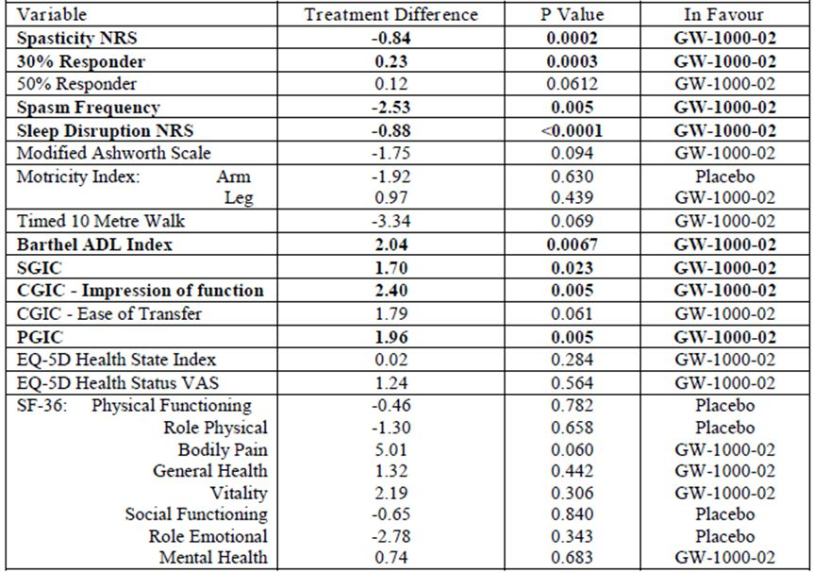
This study provides a rough model of how clinicians will need to use Sativex in the treatment of spasticity. Given that Sativex did not show convincing efficacy in the first two pivotal studies, which recruited a broad population of patients with MS related spasticity, clinicians would need to use a similar therapeutic trial approach to identify potential responders. On the basis of this study and responder analyses of the earlier studies, a 4 week trial seems likely to identify most eventual responders. Clinicians would only be justified in proceeding to long-term treatment if there was a clear improvement in spasticity.
The downside of this approach is that non responders would be exposed to 4 weeks of treatment for no therapeutic gain, and only a minority will proceed to long term treatment, and only a minority of those will show major benefit. From the PI:
“Of those patients who had a 20% reduction from screening in NRS score at Week 4 and who continued in the trial to receive randomised treatment, 74% (Sativex) and 51% (placebo) achieved a 30% reduction at Week 16.”
That is, 51% of them were capable of showing a 30% reduction even without active treatment, and only an additional 23% appeared to achieve this level of response as a result of active treatment. From the original cohort entering the therapeutic trial, the attributable response rate is therefore 23% of 42%, or 9.6%. That is, less than one in ten patients subjected to the therapeutic trial achieved a substantial reduction in spasticity as a result of active treatment. If the response rate was inflated by unblinding, as seems likely, the proportion of true responses attributable to active treatment could be even less than this. Of the ten patients subjected to a therapeutic trial, about two (51% of 42%) will appear to improve because of the placebo effect or spontaneous recovery, and another seven will show continued spasticity.
In summary, following this third pivotal study, it appears very likely that Sativex has some useful anti spastic efficacy in selected patients. There are residual uncertainties about whether the effect that has been demonstrated relates primarily to a true therapeutic effect, or whether NRS scores in the placebo group deteriorated for additional reasons, such as unblinding, or a temporary worsening of spasticity secondary to withdrawal. On balance, although it is likely that some bias has affected the scores, the therapeutic effect seems robust enough across multiple endpoints that the positive results in this study are not likely to have been solely due to bias. A more significant issue is that the magnitude of the clinical benefit is small and variable, with less than one in ten patients initiating a trial of treatment ultimately showing a substantial (>30%) improvement that can be attributed to that treatment. An additional two patients in ten can be expected to show a placebo response, progressing to long term therapy without actually having a response attributable to active treatment.

Safety

Studies providing evaluable safety data

Integrated analysis
All of the PK, PD and efficacy studies in the submitted dossier and described in the preceding sections provided safety data. In addition, safety data has been collected from a variety of non MS studies, including studies performed in cancer patients where Sativex was assessed for its potential use as a neuropathic pain treatment. All of this data contributed to the integrated safety analysis.
In the sponsor’s Summary of Clinical Safety, the safety data was analysed in three main populations: the MS subpopulation, the non MS subpopulation, and the cancer subpopulation.
The studies contributing safety data to each of these groups are listed in Table 51.
Table 51: Summary of Clinical Trials Included in the Integrated Safety Populations.
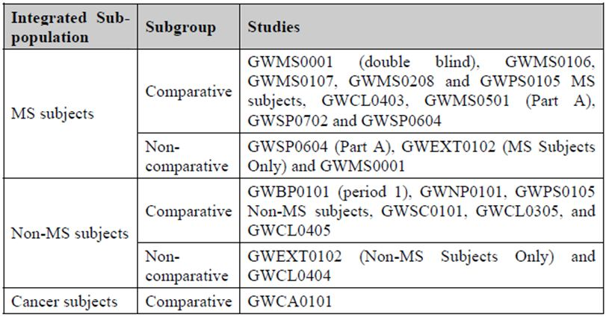

Safety in pivotal efficacy studies
In the pivotal efficacy studies, the standard approaches to safety evaluation were used. AEs were assessed by asking patients about symptoms at every visit, monitoring laboratory investigations for abnormal values, and recording unscheduled consultations.
PAEs were recorded along with other AEs, but were considered as a group of particular interest, as discussed below.
Laboratory tests included full blood counts, renal function and electrolytes, and liver function tests.

Pivotal studies that assessed safety as a primary outcome
Not applicable.

Patient exposure
Patient exposure is summarised in Table 52. Comparative studies in the target population have produced 148 patient years of exposure in 805 patients, which is acceptable for a new medicinal compound. Non comparative exposure in the MS population (n = 1016) and exposures in the non MS population also contributed to the safety analysis.
Table 52: Summary of drug exposure for the MS, non MS, and cancer subpopulations.
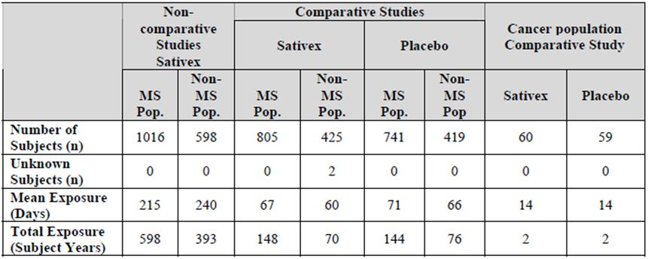
In addition, there is a growing body of post marketing safety data on Sativex, which is licensed in Canada for the treatment of neuropathic pain in MS, and has been used in the UK on a named patient basis. At the time of preparation of the Summary of Clinical Safety, there were 5500 patient years of post marketing data, and further data has been collected since the product was recently registered for the treatment of spasticity symptoms in Europe, though this additional data is not yet available.
Finally, many decades of recreational marijuana use provide insights into the safety of cannabis. This background of illicit use raises some significant concerns about the psychiatric morbidity of cannabis – although it should be acknowledged that recreational use involves higher doses and more rapid absorption than seen with Sativex and therefore would be expected to produce more substantial side effects.
As shown in Table 53, most of the placebo controlled exposure was short to medium term (up to 182 days), but non comparative data extends beyond one year in 231 MS patients.
Table 53: Number of subjects categorised by exposure in Phase 3 integrated comparative and non comparative studies.
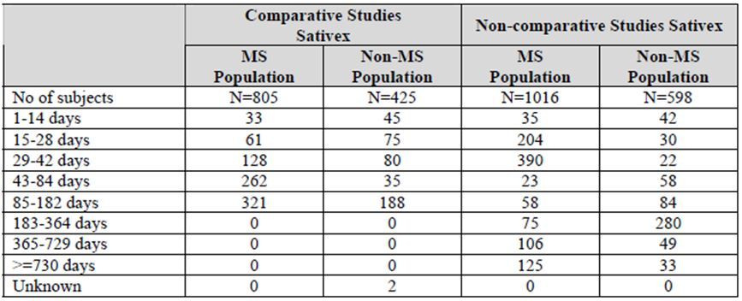
Exposures to different doses largely reflected the proposed clinical use of Sativex, but also extended beyond recommended doses. The permitted daily maximum number of sprays was initially 48, which is four times the currently proposed maximum dose, but this was gradually reduced during the development program to reach 12 sprays. In the pooled MS population, the Sativex subjects used a mean of 9.1 (SD 5.07) sprays per day, with an inter quartile range of 11.3 to 5.7, compared with 13.7 sprays (SD 7.49) in placebo recipients. In the non comparative MS studies, the mean number of sprays per day was 7.2 (SD 4.3).
The demographics of the exposed group reflect the target population: about two-thirds of subjects were female, in keeping with the greater susceptibility of women to MS. The mean age was 49 years (range 19-77). There were no subjects less than 18 years of age, because all studies excluded subjects <18 years. Given the relative rarity of MS in children this is acceptable, but it means that Sativex should not be considered for paediatric use at this stage.
In the cancer population, subjects were generally older (mean age 60 years, range 25-88).
It is very likely that, in clinical practice, Sativex would be combined with a variety of agents active in the CNS, including antidepressants, analgesics and anti spasm agents. In the pooled database, there was a reasonable representation of patients taking these medications, as shown in Table 54.
Table 54: Concomitant medications for subjects on Sativex during comparative studies.
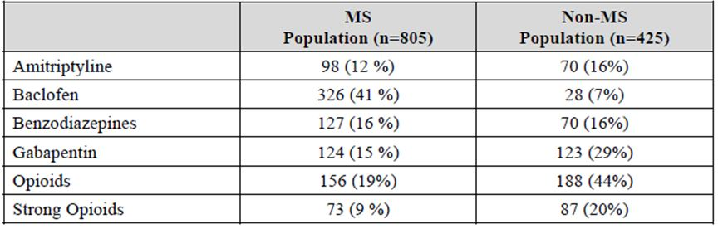

Adverse events

All adverse events (irrespective of relationship to study treatment)
AEs were reported for each individual efficacy study, but this analysis had relatively low power compared to the integrated safety analysis, and added no new insights. Therefore, the following discussion is based on the pooled safety data. These can be divided into comparative data, where the rate of AEs can be compared to placebo, and non comparative data, which are difficult to interpret given that AEs are very common in the MS and cancer populations.
AEs are listed below by System Organ Class (Table 55), and by individual ‘preferred term’ for the AE (Table 56).
Table 55: All causality AEs by System Organ Class.
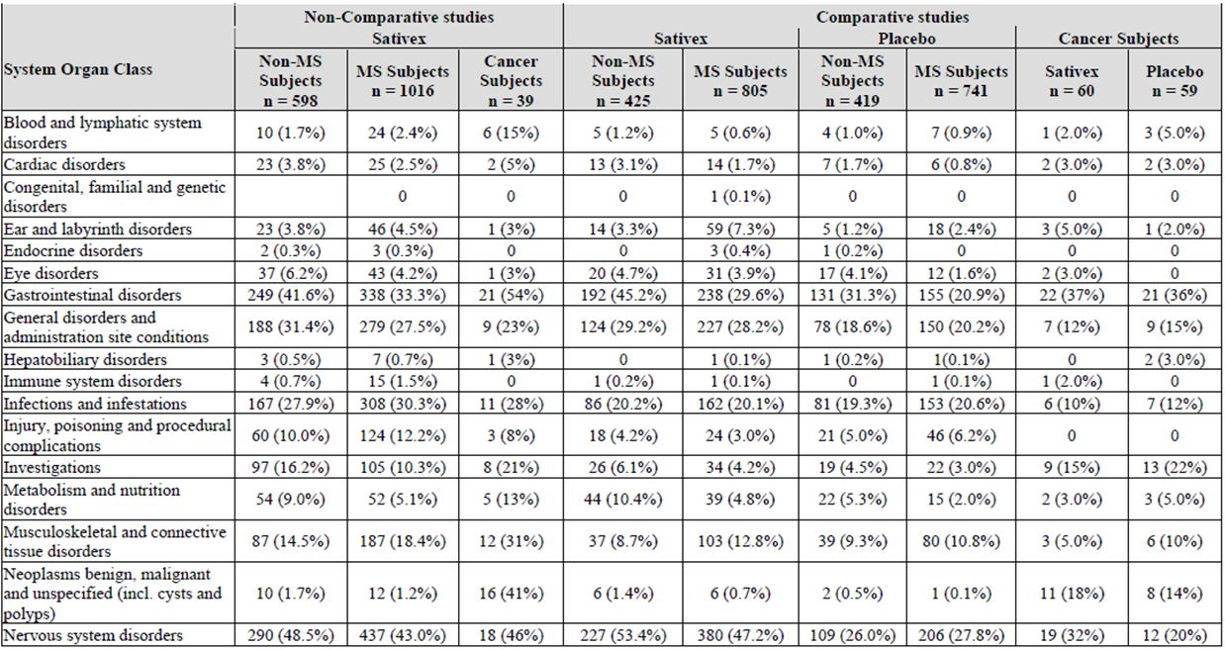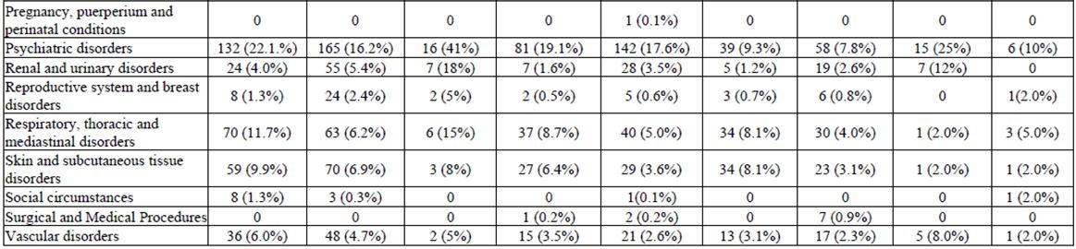
Table 56: Treatment Emergent all causality AEs (TEAEs) compared to SAEs.
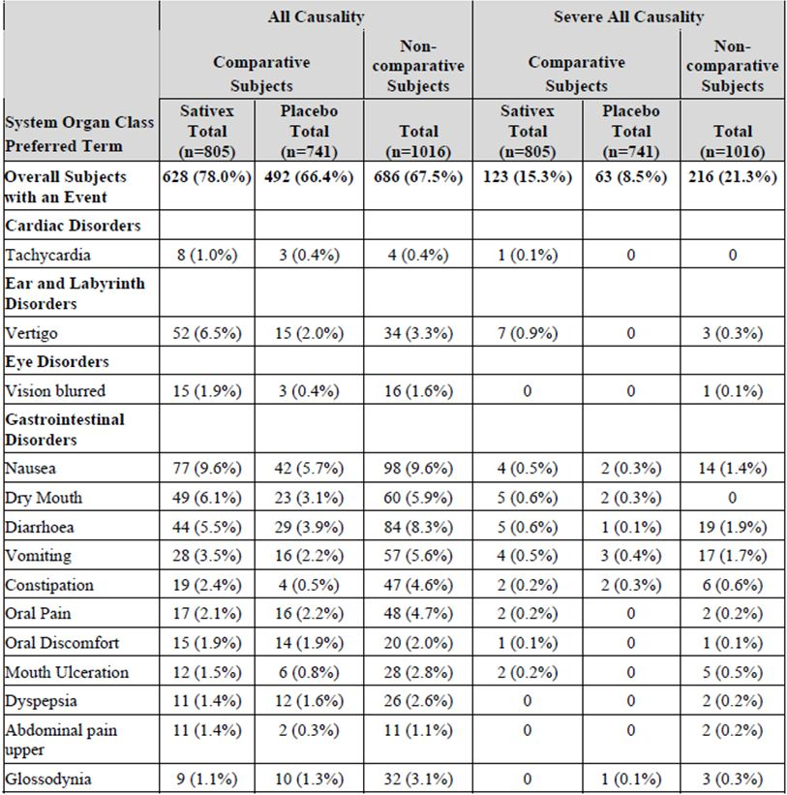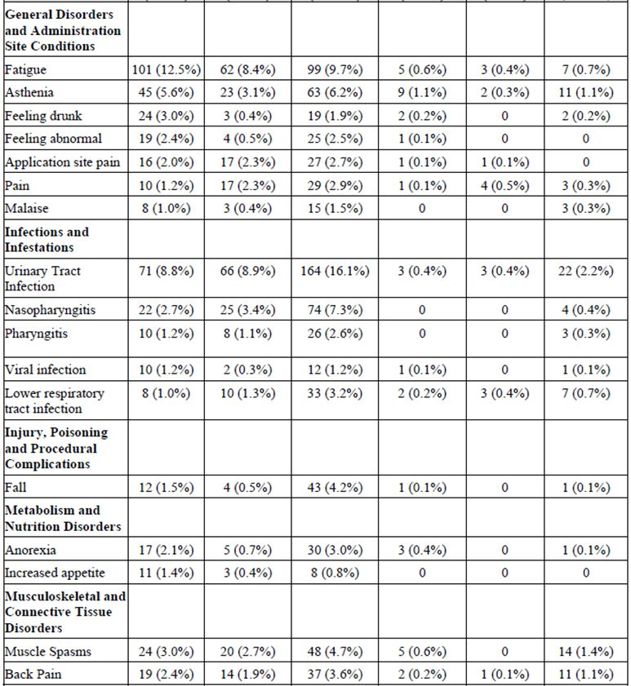
Table 56 (continued): Treatment Emergent all causality AEs (TEAEs) compared to SAEs.
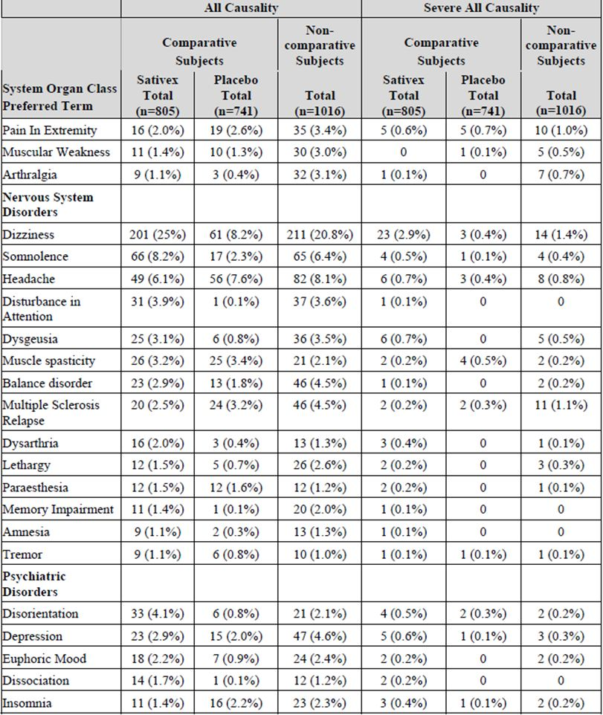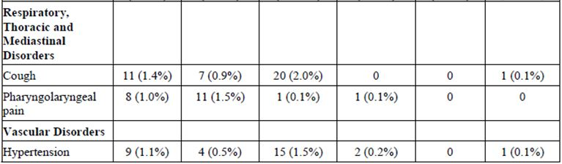
Note that the sponsor’s analysis of AEs was largely restricted to TEAEs. These were defined as those that appeared or showed significant worsening during treatment. Note that, for the largest pivotal study, Study 604 (n = 572, randomised n = 241), the study design produced a clear distortion of the AE rate relative to placebo. In the first phase, when subjects were exposed to single blind active treatment, there was no placebo comparator. In the second phase, when some patients were randomised to a blinded placebo crossover, those continuing active treatment were relatively unlikely to report their tolerability issues again, and investigators are not likely to have considered ongoing symptoms as treatment emergent. Furthermore, placebo recipients are likely to have had some side effects related to withdrawal of active therapy, so the true underlying placebo rate of AEs is unknown.
The sponsor acknowledged these limitations but then dismissed them, making the claim:
“In summary, these findings show that in the setting of a therapeutic trial, the AE profile after the first four weeks on active medication is essentially similar to that of placebo.”
This claim is not defensible, because it is unknown how many Sativex were still suffering AEs that had emerged in the first 4 weeks, and how many placebo recipients were suffering from withdrawal symptoms.
Given that this study, with its major interpretive issues, contributed a significant amount of data to the data pool, the pooled safety analysis is likely to under estimate the proportion of patients with treatment emergent symptoms. A comparison of the overall event rate nonetheless shows a moderate excess of AEs with active treatment (Sativex 78.0% of subjects, placebo 66.4%).
Individual AEs that were more common in the Sativex group were, in descending order of incidence:
- dizziness (Sativex 25% versus placebo 8.2%);
- fatigue (Sativex 12.5% versus placebo 8.4%);
- nausea (Sativex 9.6% versus placebo 5.7%);
- somnolence (Sativex 8.2% versus placebo 2.3%);
- vertigo (Sativex 6.5% versus placebo 2.0%);
- dry mouth (Sativex 6.1% versus placebo 3.1%);
- asthenia (Sativex 5.6% versus placebo 3.1%);
- diarrhoea (Sativex 5.5% versus placebo 3.9%);
- disorientation (Sativex 4.1% versus placebo 0.8%);
- disturbance in attention (Sativex 3.9% versus placebo 0.1%);
- dysgeusia (Sativex 3.1% versus placebo 0.8%);
- feeling drunk (Sativex 3.0% versus placebo 0.4%);
- depression (Sativex 2.9% versus placebo 0.8%); and
- feeling abnormal (Sativex 2.4% versus placebo 0.5%).
Several of these AEs showed a consistent trend across related terms, with dizziness and vertigo both clearly increased by active treatment, as well as the symptom complex of fatigue/asthenia/somnolence, and a range of terms consistent with intoxication.
Urinary tract infection was common in both groups (Sativex 8.8% versus placebo 8.9%), as was headache (Sativex 6.1% versus placebo 7.6%).
As shown in Table 57, relatively few events were rated as severe, but there was a clear excess of severe dizziness (Sativex 2.9% versus placebo 0.4%) and asthenia (Sativex 1.1% versus placebo 0.3%) with active treatment.
Table 57: Treatment Emergent, All Causality AEs (TEAEs) versus Treatment Related AEs (TRAEs) (MS comparative studies).
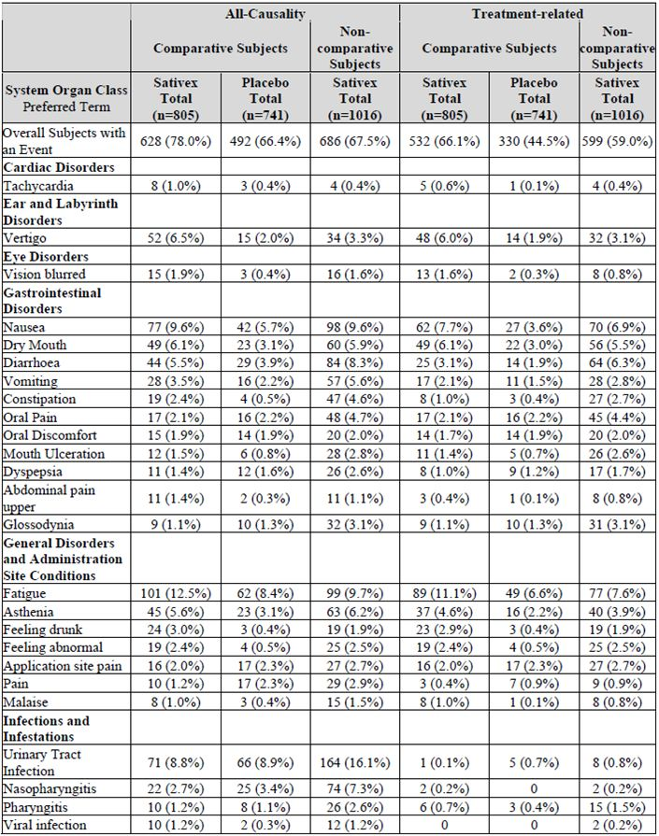
Table 57 (continued): Treatment Emergent, All Causality AEs (TEAEs) versus Treatment Related AEs (TRAEs) (MS comparative studies).
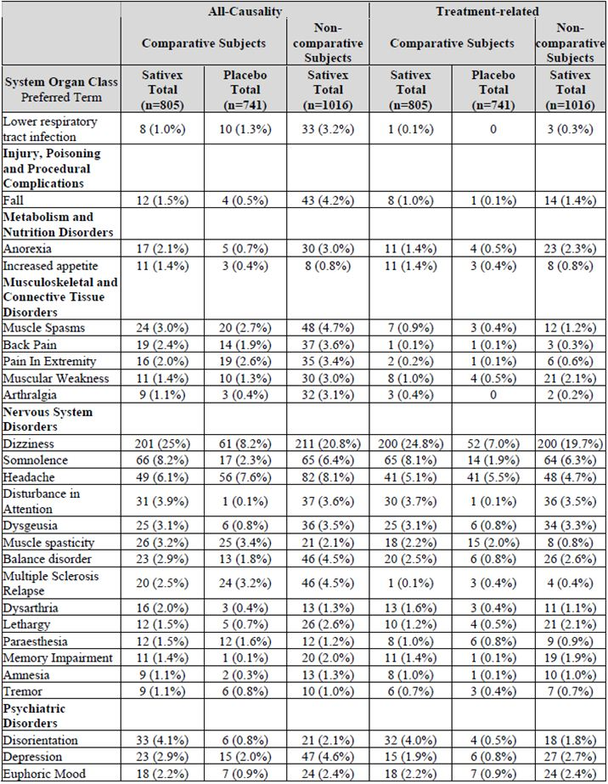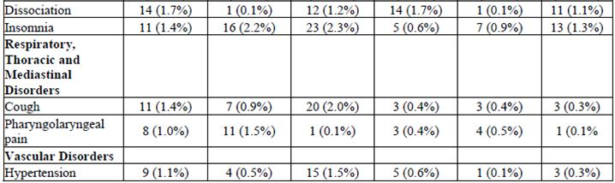
The sponsor suggests that the excess of CNS events, though partly expected with a cannabinoid treatment, may have been made worse by rapid up titration in the earlier studies. In the more recent studies, such as Study GWSP0604 (the second round pivotal enrichment design study in MS related spasticity) and Study GWMS0501 (a neuropathic pain study), a slower titration was employed, and the AE profile was better. In the single blind phase of Study 604, the main TEAEs in the single blind phase were dizziness, (14%), fatigue (5.9%), somnolence (5.1%), dry mouth, (4.2%), nausea (4.0%), and vertigo (3.7%). Without a placebo group, it is difficult to interpret the clinical significance of the reported rates. In the later, double blind phase, the rate of AEs was lower, but this is likely to reflect the removal of intolerant patients, adaptation to the side effects, or simply the failure to report an ongoing symptom that had already been documented in the earlier phase of the study.
There was a similar distribution of AEs in the non MS population, including the cancer population.
On balance, then, Sativex treatment is associated with a wide range of undesirable CNS side effects including dizziness, fatigue and disorientation, which might, for many patients, offset any symptom gains in relation to spasticity. The AE profile is broadly consistent with expectations, given the pharmacological profile of cannabis, but the pooled safety analysis demonstrates that tolerability issues remain significant despite the slower absorption and lower dose of cannabinoids administered as Sativex compared to recreational cannabis.
The issues primarily relate to tolerability rather than safety. None of the AEs raise major safety concerns, with the possible exception that dizziness, drunken feelings and impaired concentration might increase the risk of falls and injury. The observed AEs do raise concerns about the overall impact of Sativex on quality of life, however. Of particular concern, Sativex clearly worsens fatigue (and the related symptoms of asthenia and somnolence) in a patient population for whom MS related fatigue is often the most significant symptom degrading quality of life.

Treatment related adverse events
When reporting AEs, investigators were required to indicate whether they thought the event was related to treatment. This is often an unreliable exercise, as the blinded investigator treating individual subjects in ignorance of whole-study trends usually does not have sufficient context to make a sensible judgement about causality. The attempt to guess at causal relations inevitably reflects pre conceived views of causal relations rather than providing a reliable guide as to which adverse events were truly over represented in subjects receiving active treatment. Thus, a drug expected to produce a particular side effect might lead individual investigators to consider all episodes of that side effect as likely to be related to treatment, even in placebo recipients, while other unexpected AEs might be dismissed as causally unrelated even when they are suspiciously over represented.
With these limitations in mind, AEs considered to be treatment related are listed in Table 54 alongside the all causality incidence. There was a substantial excess of treatment related AEs (TRAEs) in the Sativex group, with 66.1% of Sativex recipients reporting a TRAE, compared to 44.5% of the placebo group – this comparison may be an underestimate of the true rate of TRAEs in the Sativex group because of the design of Study 604.
For individual AEs, similar trends were observed in the TRAE analysis as in the treatment emergent AE analysis, with most potential CNS side effects being marked as treatment related, regardless of whether they occurred in the active or placebo groups. For instance, dizziness was reported as a TRAE (Sativex 24.8% versus placebo 7.0%) compared to an AE rate (Sativex 25% versus placebo 8.2%) in the all causality analysis.

Severe adverse events
Severe AEs were generally uncommon. They have already been listed in the discussion of all AEs and the associated table (Table 54). As already noted, there was an excess of severe dizziness (Sativex 2.9% versus placebo 0.4%) and severe asthenia (Sativex 1.1% versus placebo 0.3%) with active treatment.

Serious adverse events
In comparative MS studies, treatment emergent serious adverse events (SAEs) were slightly more common in Sativex recipients (4.6%) compared placebo recipients (3.2%). PAEs were seven times more common in the active group (Sativex 0.7% versus placebo 0.1%), but this observation is based on a low absolute incidence (6 patients affected in the Sativex group, and 1 in the placebo group).
With the exception of psychiatric disorders, AEs grouped by affected organ class did not show any consistent trends suggesting greater SAEs in the active group. The highest SAE rate was in ‘Infections and Infestations’ (Sativex 1.6% versus placebo 1.5%), followed by the ‘Nervous System Disorders’ System Organ Class (Sativex 0.7% versus placebo 0.9%). In the Infections and Infestations category, the most common SAE was urinary tract infection (Sativex 0.6% versus placebo 0.5%), and amongst nervous system SAEs, multiple sclerosis relapse was the most common (Sativex and placebo 0.4% each).
The overall incidence of treatment emergent SAEs amongst Sativex recipients in the non MS population (6.6%) was higher than in the MS population (4.6%). In both populations, however, the incidence of treatment emergent SAEs in Sativex recipients was less than 1% in all System Organ Classes, except in the Infections and Infestations (1.6% for MS and non MS populations). The placebo group also showed more SAEs in the non MS population (5.5%) than the MS population (3.2%), partly reflecting the recruitment of patients with cancer or diabetic neuropathy.
A broadly similar pattern was observed in the non comparative studies: SAEs were slightly more common in the non MS population (10.5%) compared to the MS population (8.3%).
Reassuringly, accidents were not over represented in the Sativex group, and only one serious fall was observed in comparative MS studies.
The tables below show the all causality treatment emergent SAEs (Table 58), followed by the treatment related SAEs (Table 59).
Table 58: Treatment Emergent SAEs.
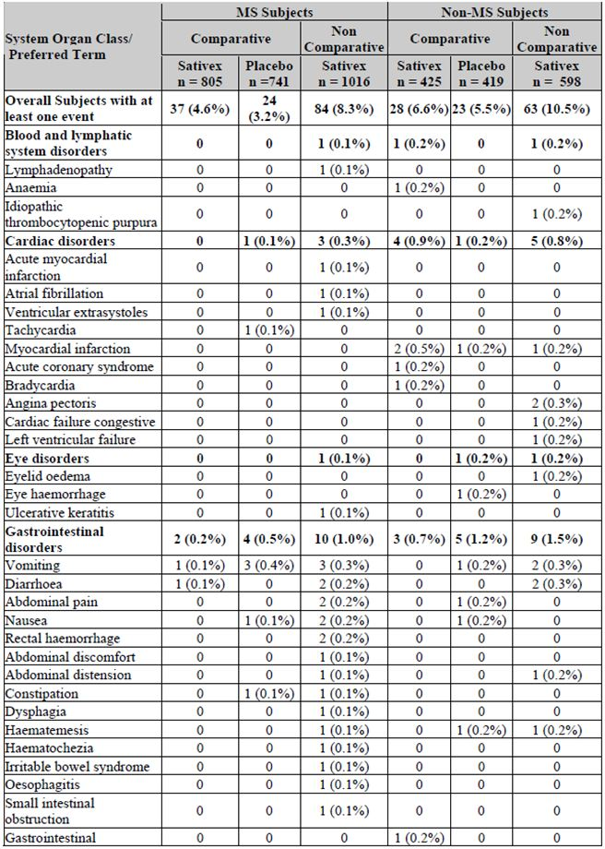
Table 58 (continued): Treatment Emergent SAEs.
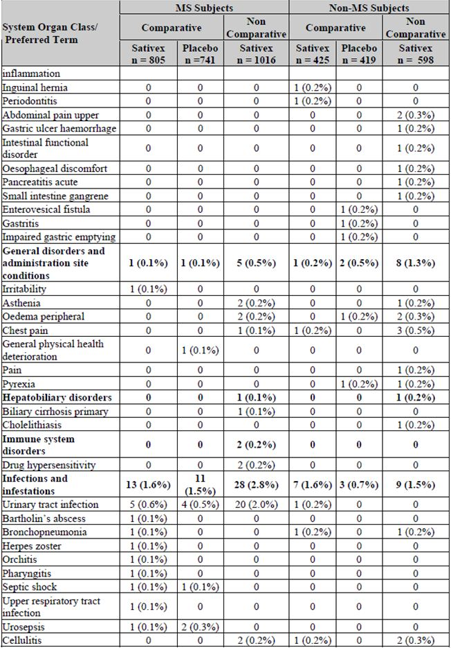
Table 58 (continued): Treatment Emergent SAEs.
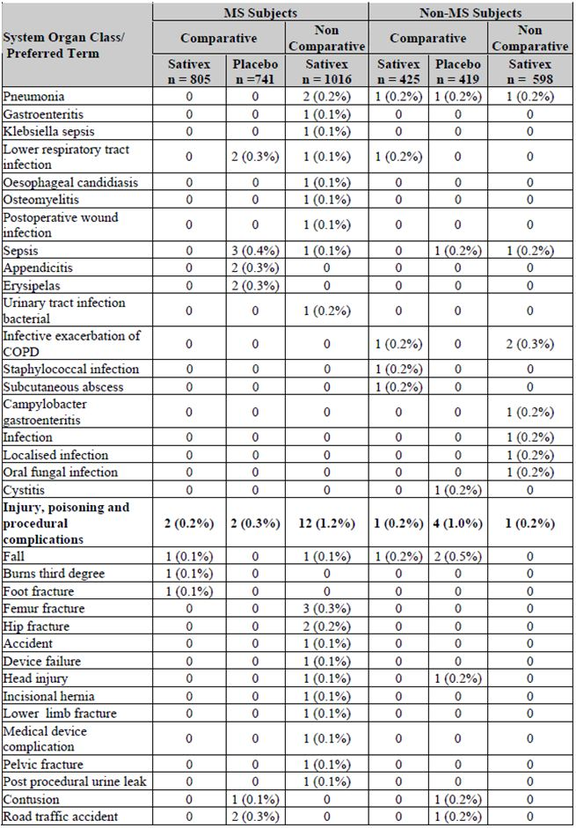
Table 58 (continued): Treatment Emergent SAEs.
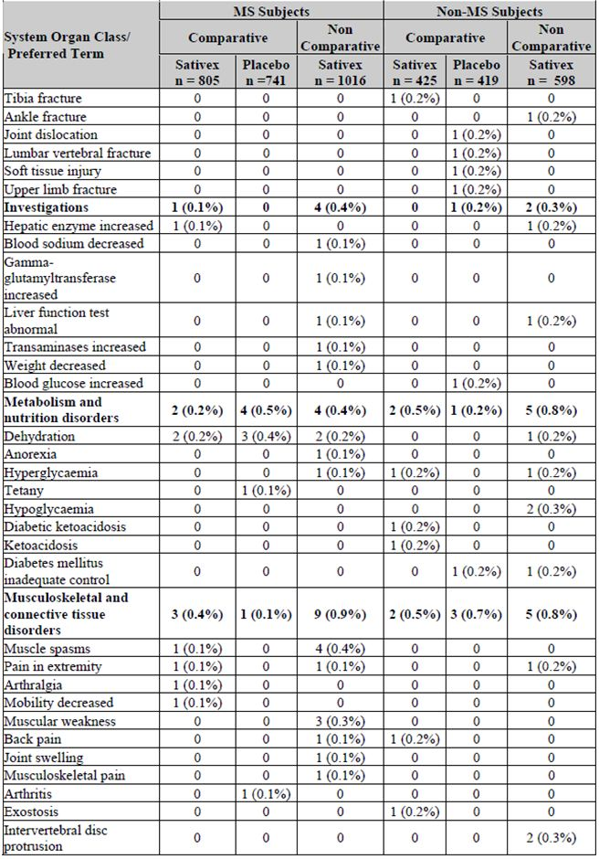
Table 58 (continued): Treatment Emergent SAEs.
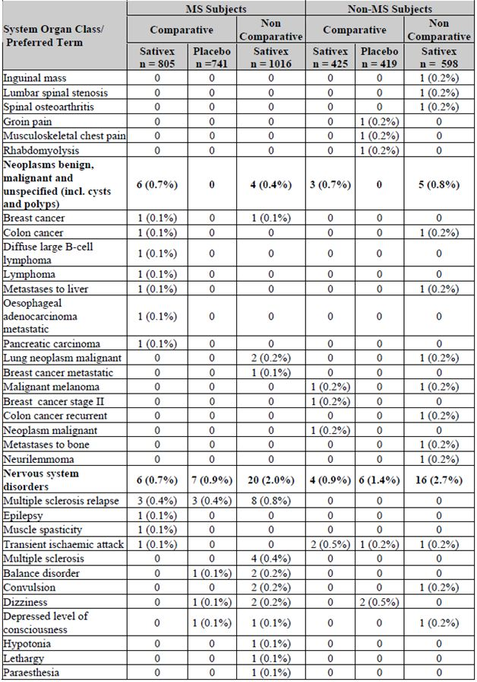
Table 58 (continued): Treatment Emergent SAEs.
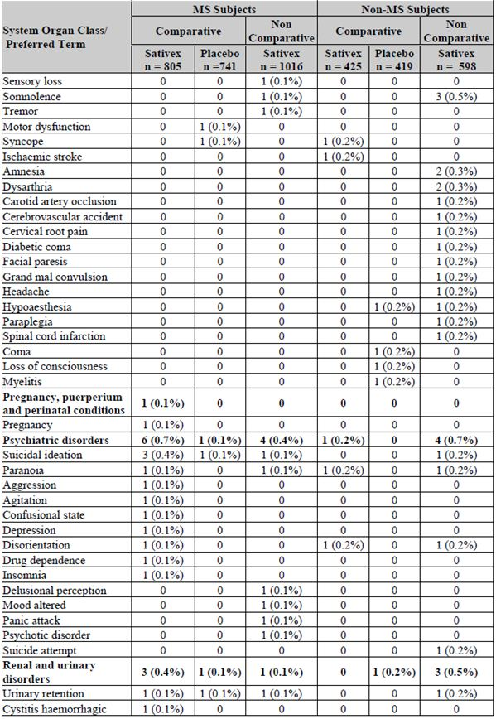
Table 58 (continued): Treatment Emergent SAEs.
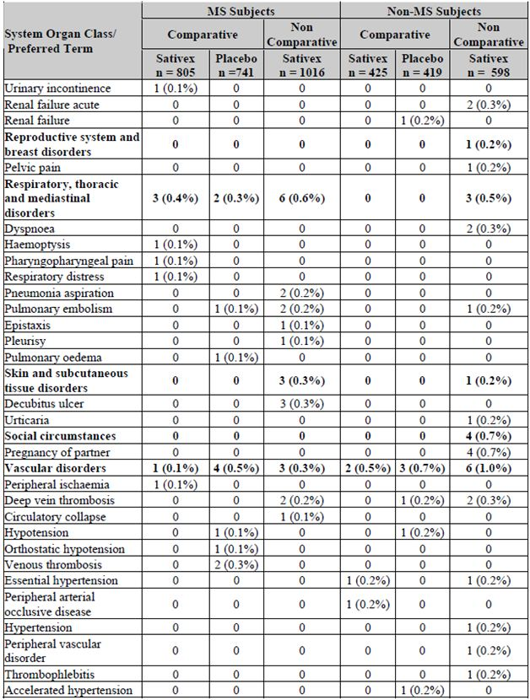
Table 59: Treatment Related SAEs.
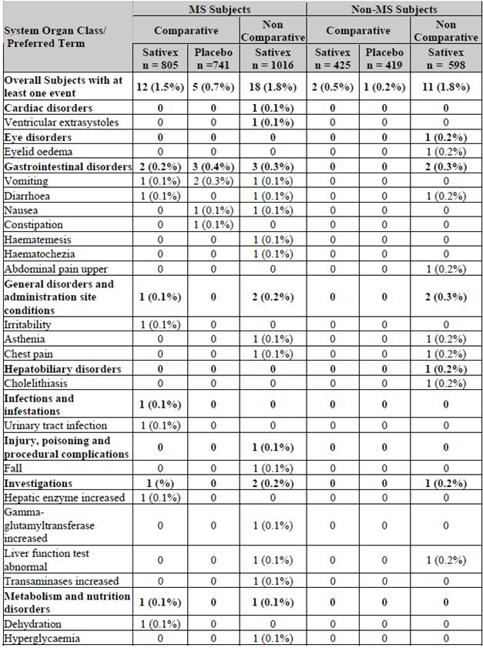
Table 59 (continued): Treatment Related SAEs.
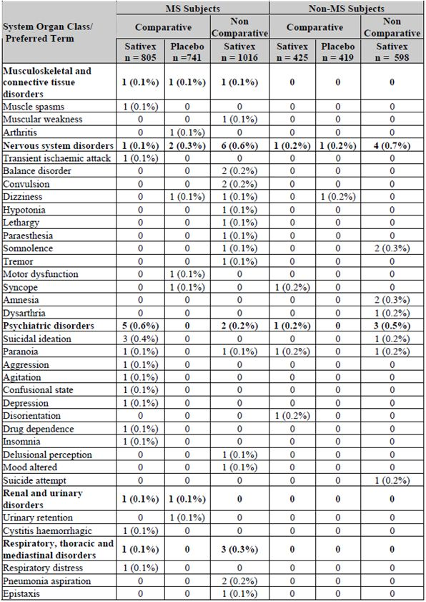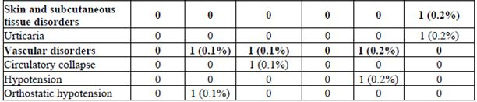

Deaths
A total of 73 deaths were reported in Sativex recipients in the integrated safety summary, many of which occurred in subjects with cancer or other major co morbidities (n = 49 cancer, n = 24 non cancer). All but four deaths were considered unrelated to study drug. There was a slight excess of deaths in the Sativex group in comparative studies in MS (Sativex 0.6% versus placebo 0.1%) but not in the non MS population (Sativex and placebo 0.2% each), and there were no consistent or concerning trends (Tables 60-65).
Of the four cases where a causal relation with Sativex was considered possible, none seemed particularly likely to have been caused by Sativex or raised significant concerns about hidden toxicity. Two occurred in MS subjects in non comparative studies, and two in non MS subjects, as follows:
- One subject with MS died of aspiration pneumonia. This patient had also had brain surgery, in addition to their MS, and a causal role of Sativex does not seem likely;
- One subject died from aspiration pneumonia, presumed to be a complication of a prolonged seizure. The investigator considered the seizures to be possibly related to study medication, so that Sativex was considered to have played a possible indirect role. There was no evidence of increased seizures in the broader Sativex population;
- One non MS subject developed lung cancer eight months after receiving his last dose of Sativex and subsequently died of carcinoma of the lung with mediastinal involvement. He had a history of smoking and possible asbestos exposure;
- Another non MS subject died from acute renal failure due to acute tubular necrosis, in the setting of pulmonary sepsis. There was no overall increase in renal or pulmonary problems in the Sativex group, and a causal role of Sativex in this case seems unlikely.
Table 60: Fatal SAEs.
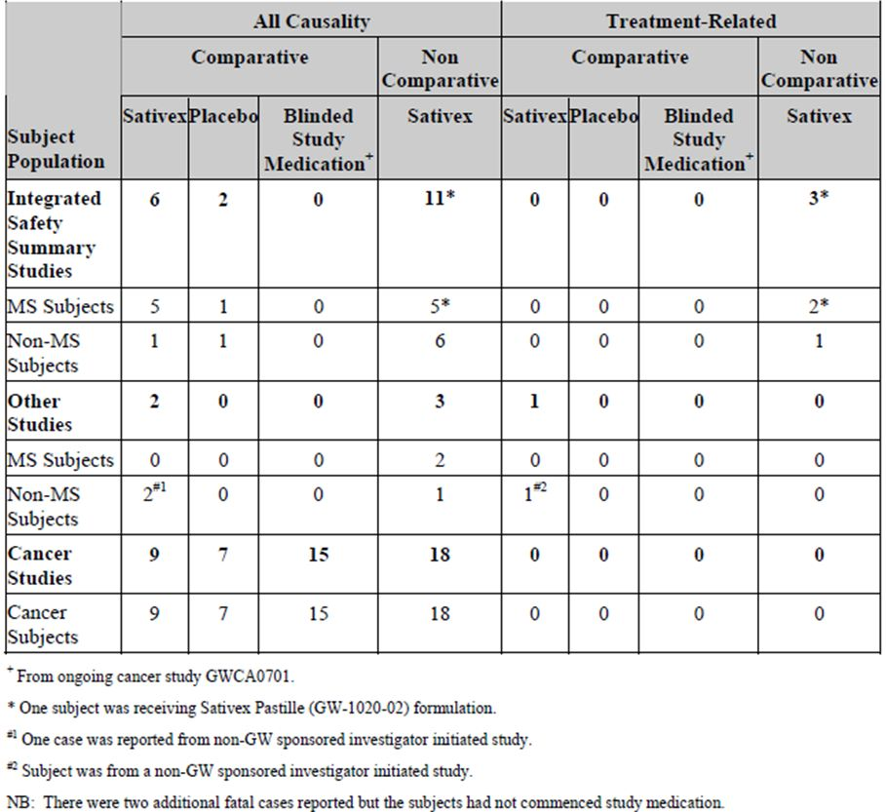
Table 61: Treatment Emergent Fatal SAEs (ISS Population).
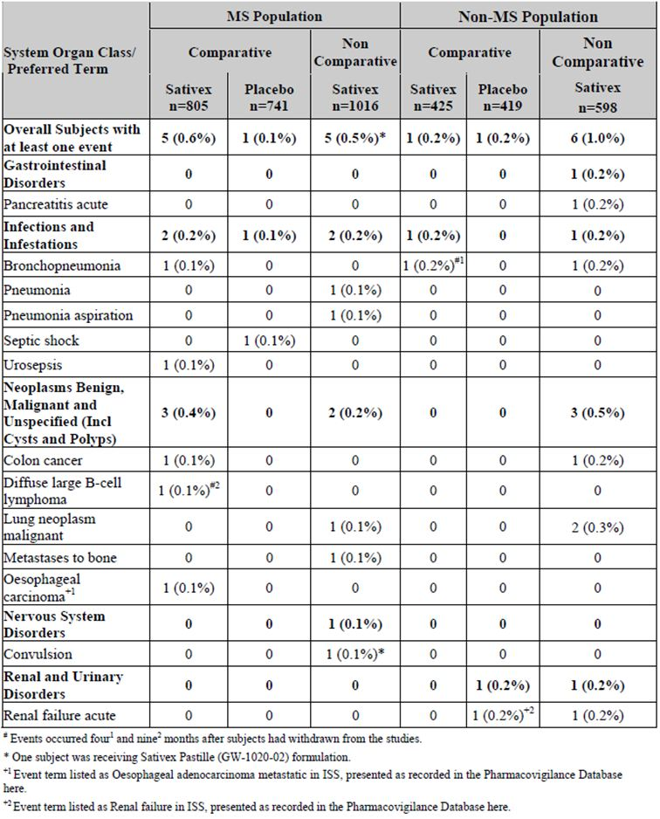
Table 62: Treatment Emergent Fatal SAEs (Non ISS).
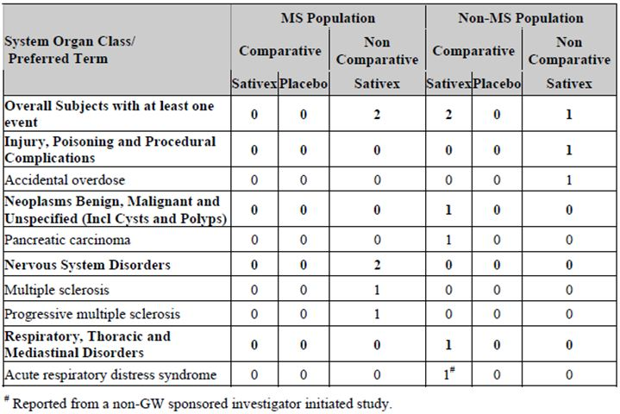
Table 63: Treatment Emergent Fatal Events (Cancer Studies).
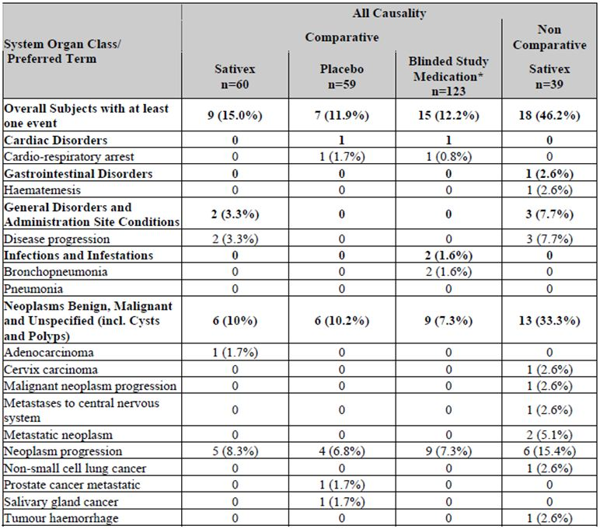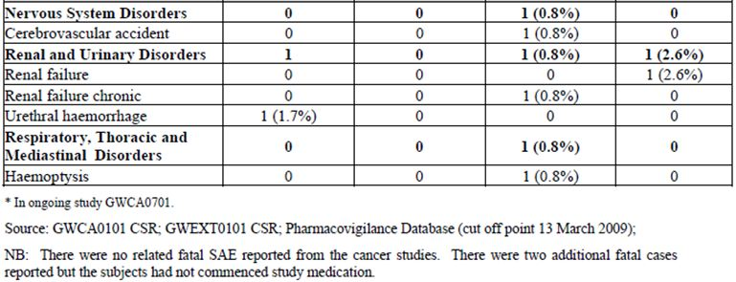
Table 64: Treatment Emergent, Treatment Related Fatal SAEs (ISS).
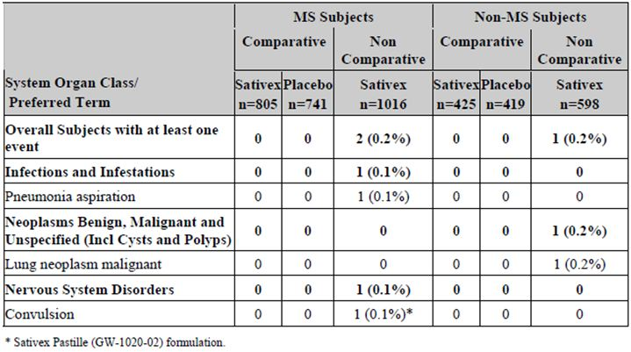
Table 65: Treatment Emergent, Treatment Related Fatal SAEs (non ISS).
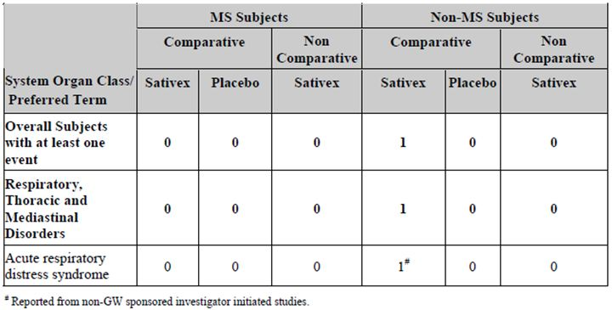

Discontinuation due to AEs
Of the 1230 pooled Sativex recipients (n = 805 MS, n = 425, non MS), 148 subjects withdrew due to AEs (12%; n = 79 MS, n = 69, non MS). In the placebo group, of 1160 subjects (n = 741 MS, n = 419, non MS) 57 withdrew (6%; n = 35 MS, n = 22, non MS), so that the withdrawal rate was about half that seen with Sativex.
Considering just the MS comparative studies, 79 of 805 subjects (9.8%) in the Sativex group withdrew, and 35 of 741 placebo recipients (4.7%) withdrew.
AEs in non comparative MS studies led to withdrawal in 105 of 1016 subjects (10.3%).
In the non MS comparative studies, withdrawal rates due to AEs were 16.2% in the Sativex population, compared to 5.3% in the placebo population. The incidence of AEs leading to withdrawal in the non MS, non comparative studies was even higher (20.9%).
Withdrawals due to AEs were increased by active therapy in all major subgroups, including those defined by age, gender, prior cannabis use and presence or absence of MS, as shown in Table 66.
Table 66: Withdrawal Rates in the Integrated MS and non MS Population by Gender, Age and Cannabis Experience.
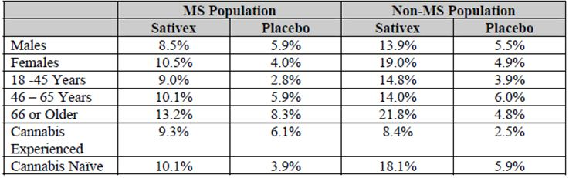
The distribution of AEs leading to withdrawal was similar to the overall analysis of AEs (Table 67). Apart from dizziness and nausea, no individual AEs led to withdrawal in 2% or more of subjects. In the MS comparative studies, dizziness led to withdrawal in 1.9% of Sativex subjects versus 0.7% of placebo recipients, and nausea led to withdrawal in 1.6% of Sativex subjects versus 0.4% of placebo recipients.
Table 67: Common AEs Leading to Withdrawal.
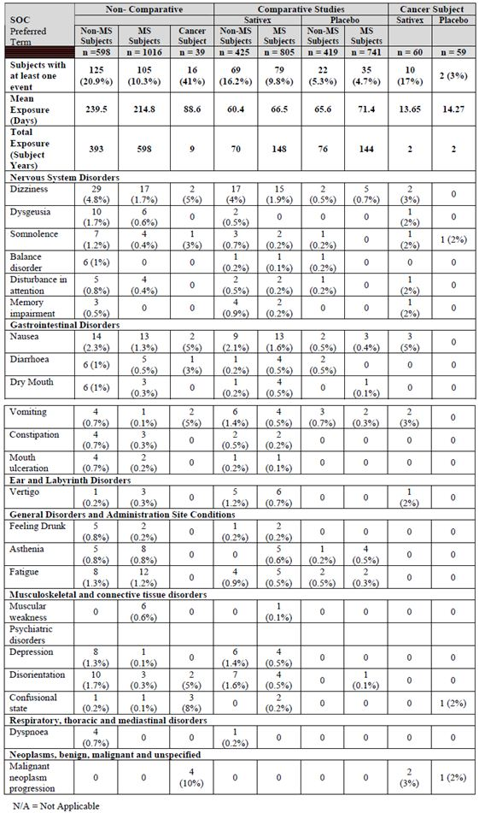
This supports the prior observation of a high rate of mild to moderate dizziness in Sativex recipients, with relatively few patients sufficiently disturbed by dizziness that they withdrew. No new concerns are raised by this evidence.

Laboratory tests
Patients were monitored for changes in haematological parameters, renal and hepatic function, and the main results are shown in Table 68.
Table 68: Treatment Emergent All Causality AEs of Laboratory Values.
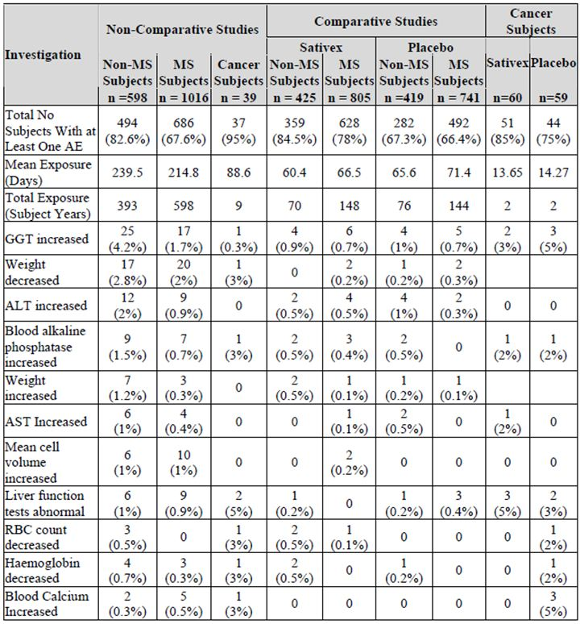
Some minor disturbances of liver function were noted in both the Sativex and the placebo groups. In particular, elevated γ-GT and bilirubin levels were observed, without an accompanying rise in transaminases or alkaline phosphatase. These changes might be related to concomitant medications, including anticonvulsants used for neuropathic pain and beta interferons, or to concomitant diseases. There was, however, a mild numerical excess of ‘abnormal liver function tests’ reported as an AE in the Sativex group, compared to the placebo group, which is appropriately mentioned in the proposed PI.

Vital signs
Vital signs were monitored in the pivotal and supportive studies, and in many of the Phase 1 studies. Generally, no concerning results were obtained. The data for the integrated MS population in comparative studies is shown in Table 69. (This does not include the main pivotal study, where all subjects began on Sativex.) There was a mildly increased incidence of decreased systolic blood pressure with active treatment during the second hour after treatment, but this was generally of minimal clinical consequence. There were no consistent between group changes with diastolic blood pressure and pulse.
Table 69: Clinically significant changes in vital signs following dose introduction during comparative studies.
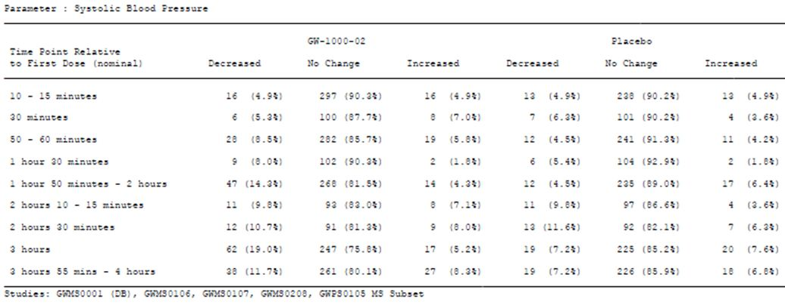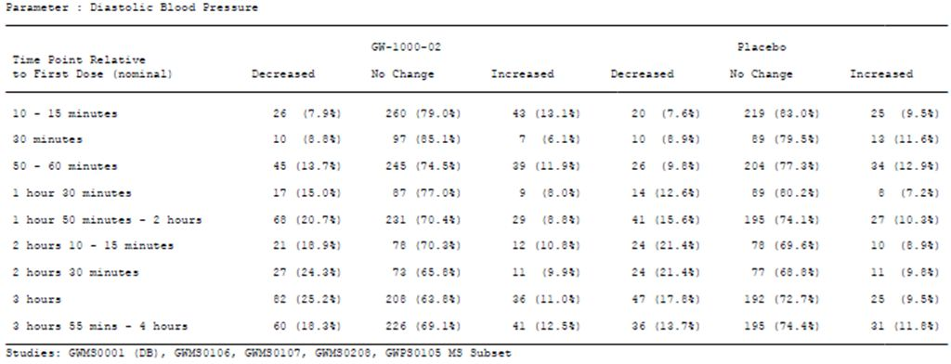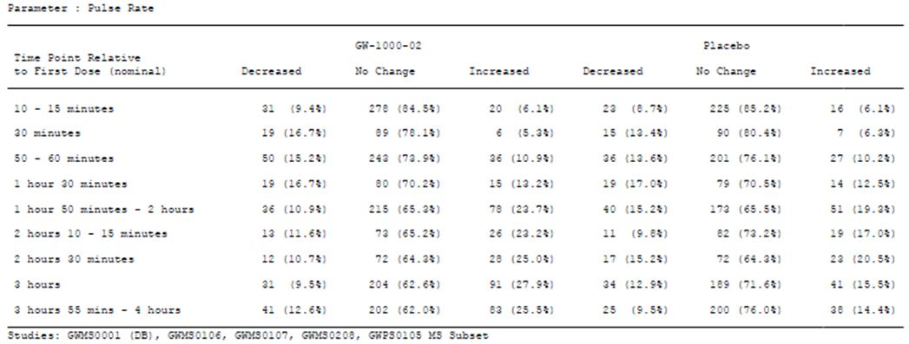

ECG parameters

Pooled safety analysis
Serious cardiac events were rare in comparative MS studies, affecting one placebo recipient and no Sativex recipient. Abnormal ECGs were also rare, with no apparent increase in the Sativex group. Tachycardia was more common with Sativex (1.0%) than placebo (0.4%) in the comparative MS studies.

ECG/QT studies
The QT study in healthy volunteers (Study GWCP0607) showed no significant cardiac effect.

Specific safety issues related to cannabinoids

Psychiatric AEs (PAEs)
There is a substantial literature suggesting a risk of psychiatric complications from cannabinoids. These include transient psychosis in susceptible individuals repeatedly exposed to large recreational doses, which usually resolves within a week of abstinence. Transient psychotic episodes may also occur as a component of acute intoxication. Regular long term cannabis smoking may increase the risk of schizophrenia in later life, though the issue remains controversial partly because it is not clear to what extent psychiatric factors lead to cannabis abuse; overall the causal link between cannabis smoking and schizophrenia remains unclear.
A review of the available evidence was performed by the Advisory Council on the Misuse of Drugs, for the UK Home Office, and some of their key conclusions were:
- “Cannabis is harmful and its consumption can lead to a wide range of physical and psychological hazards.”
- “Individuals with schizophrenia are particularly vulnerable to the deleterious effects of cannabis on their mental health.”
- “A substantial research programme into the relationship between cannabis use and mental health should be instituted.”
As already noted, the overall AE profile showed an excess of AEs related to the central nervous system, including dizziness, fatigue and intoxication, and a small absolute excess (but high relative excess) of serious PAEs (0.7% versus 0.1%). About 2% of MS subjects (17/805) withdrew because of PAEs. Considering all psychiatric AEs (Table 70), the absolute attributable risk of a PAE was about 10% (incidence 17.6% versus 7.8%), implying that 1 in 10 patients is likely to suffer a psychiatric side effect of Sativex – not counting fatigue or asthenia, which may also have an affective component. Note that this comparison is further distorted by the practice of counting somnolence as a non PAE, and insomnia as a PAE. By encouraging sleepiness, Sativex may have decreased the risk of insomnia at the expense of increased somnolence.
Table 70: All Causality PAEs.
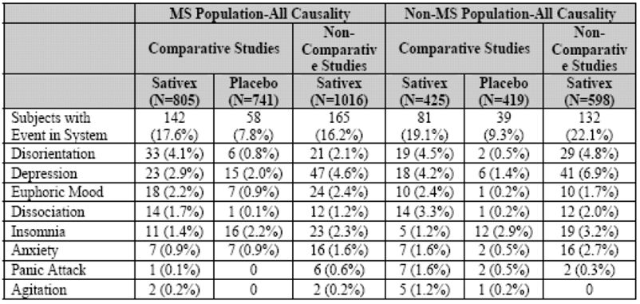
In addition to the above AEs, the sponsor also reported 5 cases of psychosis in Sativex recipients, one of which was attributed to Sativex withdrawal, and 4 which occurred on treatment. All resolved with cessation of the treatment.
Hallucinations were counted separately, and occurred in 11 patients. All cases resolved within 2 weeks. In comparative studies, paranoia was reported in 12 Sativex recipients, including one of the psychotic cases, but in only one placebo recipient. Five cases of paranoia occurred in the non comparative MS studies, amongst 1016 Sativex recipients. This evidence suggests that paranoia is causally related to Sativex, but the risk appears low and the problem usually reverses on cessation of treatment. Higher doses are associated with a substantially greater risk, as discussed below in the context of the ECG (long QT) study.
Depression was slightly more common in Sativex recipients (2.9%) than placebo recipients (2.0%), in the overall comparative data pool for MS subjects. There was also an excess of depression with active treatment in the non MS studies (4.2% versus 1.4%). In the randomised phase of the most recent pivotal study (Study 604), the incidence of depression was 1% in the uncontrolled phase, when all subjects received Sativex, and 1.6% in those who continued Sativex, compared to 0.9% in those who switched to placebo. This data is difficult to interpret, given that only a selected group progressed to randomisation, but it might reflect actual clinical practice.
Two suicides occurred in the MS study program, including one in a comparative study and another in a non comparative study. Suicidal ideation was over represented in the Sativex group (3 patients) compared to the placebo group (1 patient), but this is based on low numbers and it is difficult to draw firm conclusions.
Overall, this evidence suggests a minimally increased risk of depression with Sativex, and the drug should be avoided in those with a significant history of moderate or severe depression.
Cannabanoid levels are generally higher in recreational cannabis smoking, as discussed in the PK section, and this is likely to increase the risk of psychiatric morbidity in recreational users. The clinical trial data suggest that even the lower exposure in Sativex users nonetheless increases the risk of psychosis. The proposed PI mentions this risk, but the actual long term risk of psychiatric complications remains poorly characterised. The risk is likely to be higher in subjects with premorbid psychiatric abnormalities, or a family history of schizophrenia, and Sativex should be avoided in these subjects.

Acute psychiatric morbidity at higher doses
Four serious PAEs occurred in Study GWCP0607, which was an ECG study in healthy volunteers. All occurred in recipients of high dose Sativex (18 sprays twice daily), and in three of them it occurred on the first day of dosing, after just 18 sprays. There were only 41 subjects in this dose group, so 9.8% of subjects had a serious PAE.
The most concerning was recorded with the preferred terms: “Delusional disorder, persecutory type; Paranoia; Suicidal behaviour; Homicidal ideation; and Suicidal ideation.” On the second day of receiving 18 actuations twice daily, this 25 year old male subject believed himself to be the elderly leader of a kingdom, and thought himself under threat from competing kingdoms. During his grandiose rants the following behaviour occurred:
“At 11:30 the subject began to have homicidal thoughts, saying that one of the staff members ‘should die’, and that another staff member ‘should kill her’. The subject grabbed the staff member whom he previously stated ‘should die’ and attempted to put his hands around her throat but was restrained by other staff members. The subject made persistent and repeated requests that one staff member should kill another but that it should be done painlessly because the subject was personally fond of the staff member who ‘should die’.”
At one stage it took four staff members to physically restrain him.
Another SAE, occurring in a 30 year old male after 18 Sativex sprays, was recorded with the preferred terms “Suicidal ideation (co manifestation: depression)” but this under estimates the severity of the event: the ideation was quite well formed and the subject actually asked a staff member to help end his life.
Another SAE occurred after 18 sprays in a 28 year old woman, and was recorded as “Psychotic disorder”. It was described as follows:
“The subject subsequently began to scream and thrash in bed. She was reported to experience visual and auditory hallucinations and required two people to restrain her. The subject was transported on a wheelchair and isolated due to the escalation of her symptoms of erratic behaviour which continued till 13:12. She was reported to have displayed very unpredictable behaviour including screaming, outbursts of laughter, singing, dancing, crying, and incoherent mumbling with fluctuating periods of unresponsiveness.”
The final SAE was recorded as “Delusional disorder, persecutory type”, and occurred after 18 sprays in a 24 year old male. The subject became agitated, believed he was in an evil science fiction setting being held against his will, and secretly called ‘911’, the emergency phone number, leading to police involvement.
The relatively high incidence of these serious psychiatric disturbances suggests that high dose Sativex should be avoided, and that the therapeutic window is relatively narrow. The maximum recommended daily dose is 12 sprays, and these events occurred after acute ingestion of 150% of that maximum. The PI does not explicitly suggest a maximum number of sprays for a single treatment. (Although it implies doses should be spread over the day, the titration schedule shows 7 sprays given in the evening, and some subjects may take the daily dose of 12 sprays at once.) The PI should be revised to specify a maximum number of consecutive sprays, such as 8 sprays within a 3 h period.

Tolerance, withdrawal and abuse potential
Many drugs acting on the CNS show a waning PD effect with prolonged use, with users often developing tolerance to side effects as well as reduced efficacy requiring increased doses. This is not necessarily a significant clinical problem, though it does require monitoring and sometimes dose escalation. For some CNS drugs, adaptation is substantial enough that long term efficacy is severely compromised. If it becomes necessary to cease the drug, some of the same pharmacological adaptation can lead to rebound or withdrawal effects; if these withdrawal effects are severe then the patient may find it difficult or impossible to quit using the drug. This is particularly likely for drugs that are taken recreationally, because of pleasurable pharmacological effects. In this respect, some degree of tolerance to Sativex is to be expected.
It is unclear to what extent recreational cannabis produces tolerance and withdrawal effects. One estimate is that about 1% of recreational cannabis users have some degree of dependence, but this is often dismissed as ‘psychological’ dependence. The evidence suggesting that cannabis can produce a withdrawal syndrome has been reviewed, concluding that such a syndrome is real and can be recognised by the criteria shown in Table 71.
Table 71: Proposed cannabis withdrawal syndrome criteria.
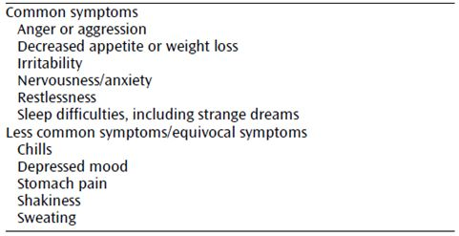
Included in the reviewed evidence were two studies showing the time course of withdrawal associated discomfort and irritability (Figure 27). Essentially, the symptoms are most marked in the first few days but gradually settle over the course of a month.
Figure 27: Change from baseline in irritability and withdrawal discomfort in two studies of effects of 28 days of abstinence of cannabis in outpatient marijuana users.
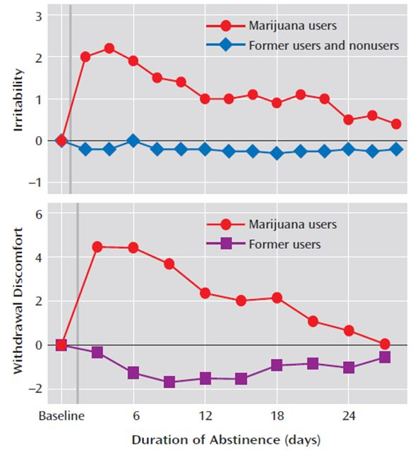
The applicability of these findings to Sativex is uncertain given that THC levels obtained with Sativex use are much lower than with recreational cannabis, as already discussed in the PK section.
In the long term clinical studies of Sativex, there was little evidence of dose escalation: the median dose of Sativex in long term extension studies was 8 sprays in Study 001. This is very similar to that observed in the pivotal study, where the mean dosing at the end of Phase A for randomised subjects was 8.9 for males and 8.4 for females, and the median doses were 9.4 and 9.0 sprays, respectively. This is indirect evidence against a substantial tolerance effect, but dose escalation might also have been limited by the trial setting and the patients’ perceptions that their use was being closely monitored.
The response to Sativex withdrawal was assessed directly in one small sub study of Study GWMS0001Ext (n = 25). MS patients who had been on Sativex for at least a year in the open label extension study were asked to cease Sativex for 2 weeks, and all AEs were recorded. Five of the 25 subjects restarted Sativex prematurely because of ‘MS related symptoms’, which might have included withdrawal symptoms, though this could also simply indicate removal of an efficacious drug. According to the sponsor’s Summary of Clinical Safety, about half of them reported at least one of the symptoms that would be expected of a cannabis withdrawal syndrome: hot and cold feelings, insomnia, emotional lability, tiredness, a sense of intoxication, or vivid dreams.
In general, these withdrawal symptoms were mild and manageable, but they add to the risk profile for Sativex. They also raise the possibility that users habituated to Sativex might experience unblinding in any study that attempted to perform randomised blinded withdrawal. Given that the only new pivotal study in the current submission (Study 604) used an enrichment design, followed by randomised placebo crossover versus continuation, it is possible that a significant number of patients switching to placebo were partially unblinded by withdrawal effects, which might have affected their NRS ratings.
Abuse potential was specifically studied in Study GWCP0605, which showed that Sativex was associated with a number of ‘likeable’ effects in a dose dependent fashion. At 4 sprays, this was not significantly different from placebo, but at 8 sprays there was a moderate effect, significantly different from placebo, and the results were even more marked at 16 sprays. Recommended Sativex doses range up to seven sprays at once, which would be expected to produce similar effects to the 8 sprays tested in Study GWCP0605.
The abuse potential is likely to be even higher if patients horde their medication for recreational binges. The sponsor has not even mentioned the possibility that patients might open the bottle, soak tobacco in solution, and then smoke the modified tobacco, but it would not be long before this idea occurred to someone. If they liked the resulting high, they would have a strong incentive to report that their spasticity was improved when they next met their treating clinician. No data is available on whether this approach would produce drug levels similar to recreational cannabis smoking, but it seems likely. The study by Huestis, previously discussed in the PK section, involved cannabis cigarettes containing 33.8 mg of THC; this is a small portion of a Sativex bottle, which contains 270 mg of THC.

Effects on ability to drive and operate machinery
No good data is available on the degree to which Sativex at therapeutic doses would interfere with motor skills and reaction times and therefore affect driving ability. It seems likely that some users would experience impairment at higher doses, however, particularly as MS itself can impair processing speed. Also, there were a number of CNS AEs in Sativex recipients, including dizziness, somnolence and disorientation, which occurred at substantially higher incidences than with placebo. The same criticism could be directed against all other pharmacological approaches to spasticity. The proposed PI contains appropriate warnings about this risk.

Effects on cognition
Disorientation was more common in Sativex recipients, along with a number of other terms related to intoxication. The expected cognitive side effects of Sativex are discussed in the context of the RMP.

Post marketing experience
No unexpected safety concerns have arisen during post marketing surveillance in Canada, where Sativex is licensed for the treatment of neuropathic pain in MS, or in the UK, where it has been available on a named patient basis for some years, and is now registered for MS related spasticity. The sponsor’s Summary of Clinical Safety only lists a single serious adverse drug reaction arising from post marketing surveillance, an episode of vasovagal syncope.

Safety issues with the potential for major regulatory impact

Liver toxicity
There was no evidence of significant risk of liver toxicity, and ‘abnormal liver function tests’ was rare as a TEAE, occurring in none of the MS subjects who received Sativex in comparative studies, and 3 of the placebo recipients. There were additional cases of individual liver enzymes being abnormal, but no concerning trends.

Haematological toxicity
The studies showed no evidence of haematological risk, with haematological AEs being rare in the MS population, and not different between the active and placebo groups in comparative studies.

Serious skin reactions
None reported.

Cardiovascular safety
Vital signs did not suggest a significant clinical effect of Sativex on blood pressure or pulse rate. The QT study (Study GWCP0607) showed no significant effect of Sativex in the QT interval, even with doses of 18 sprays twice daily, whereas the positive control, moxifloxacin, showed the expected increase.

Unwanted immunological events
None reported.

Other safety issues

Safety in special populations
Sativex has not been extensively assessed in the elderly. Only 38 MS subjects >65 years old received Sativex in placebo controlled clinical studies. In the non MS studies, 110 subjects >65 years have been exposed to Sativex.
It is expected that elderly patients would be more likely to be susceptible to central nervous system side effects, as is the case for most CNS active drugs, and this was observed in the pooled safety analysis. As shown in Table 72, elderly patients were three times more likely to have a CNS AE on Sativex than on placebo, and more than a third of all elderly subjects on active treatment had a CNS AE.
Table 72: TEAEs by Age: Excerpt with CNS AEs.
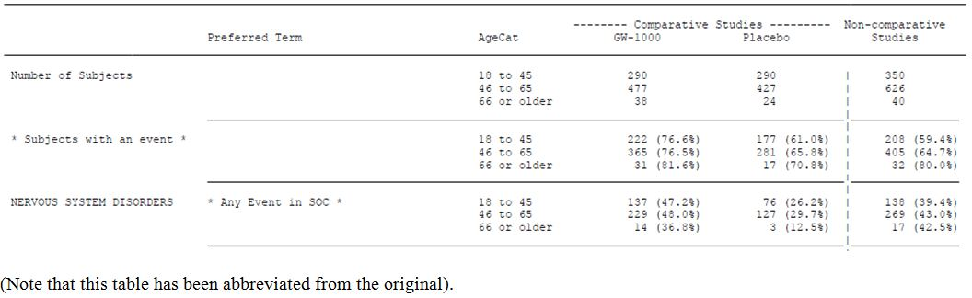
The proposed PI states:
“No specific studies have been carried out in elderly patients, although patients up to 90 years of age have been included in clinical trials. However, as elderly patients may be more prone to develop some CNS adverse reactions, care should be taken in terms of personal safety such as preparation of hot food and drinks.”
This is a broadly appropriate warning, but it should be strengthened from “may be more prone” to “are more prone”. Clinicians will have to use judgement in this population, as with other available anti spastic medication.
Safety has not been assessed in the paediatric population, or in subjects with hepatic or renal failure. The drug should not be used in children, and it should be used with caution in the presence of liver or kidney disease.

Safety related to drug-drug interactions and other interactions
Drug interaction studies have shown only minor PK changes, which are unlikely to be clinically relevant. These are discussed in the PK section of this report. Theoretical concerns have been raised by in vitro studies, which showed that cannabinoids (particularly CBD) inhibit P-glycoprotein mediated drug transport, which could mean that CBD could influence the absorption and disposition of drugs that are P-glycoprotein substrates, such as digoxin. The magnitude of the effect is small, and this is also unlikely to be clinically relevant.
There are likely to be PD interaction when multiple CNS drugs are combined, with an increased risk of sedation, dizziness and other CNS side effects. This is already the case for existing anti spasticity medications, and clinicians treating MS patients are likely to be familiar with the need for monitoring such interactions.

Oromucosal reactions
Some Sativex recipients reported minor oral discomfort that could have been related to oromucosal application of Sativex. In most cases, the reaction was mild. Two cases of leukoplakia were observed. Both cases occurred in smokers, and resolved upon cessation of treatment. The proposed PI carries appropriate warnings about this issue.

Evaluator’s overall conclusions on clinical safety
The safety of long term recreational cannabinoids is somewhat controversial but most authorities agree that they pose a moderate risk of psychological or psychiatric morbidity in susceptible individuals. These risks are likely to be less with prescribed Sativex, because of the lower serum levels achieved and the slower PK profile. Nonetheless, in the controlled studies, the absolute attributable risk of a PAE was about 10% (incidence 17.6% versus 7.8% in MS subjects), implying that 1 in 10 patients is likely to suffer a psychiatric side effect of Sativex. In most cases this would be identified and would be expected to resolve on cessation of the drug, but it lessens the appeal of a drug that only offers substantial efficacy for a minority of recipients.
The issues surrounding psychiatric morbidity are discussed in detail in the comments on the RMP. In general, although the sponsor argues that the risks are minimal, the actual long term psychiatric risk remains poorly characterised because of the lack of long term data, particularly controlled data. Psychosis, depression, and other psychological morbidity are likely to be increased in long term Sativex recipients, and it is important that susceptible individuals not be exposed. These include subjects with a personal or family history of psychiatric disease (not counting the mild depression that most MS subjects experience as a reaction to their illness), but some susceptible individuals are likely to have no overt history. The PI carries appropriate warnings about psychiatric risk, but defining the risk more accurately will be an important part of the proposed post marketing surveillance program. The abuse potential of Sativex is likely to be small, but significant.
Cannabinoids also cause short term CNS side effects, including intoxication, dizziness, cognitive impairment, and motor impairment. The cognitive side effects of Sativex at prescribed doses appear to be mild but they are still poorly characterised, particularly in the MS population who already have a significant load of cerebral pathology. Phase 1 studies in volunteers have shown relatively mild cognitive changes (Study GWPK0110,), but several AE terms were over represented in the active group in controlled studies, including disturbance in attention (seen in 31 Sativex recipients, or 3.9%, but only one placebo recipient, or 0.1%). Dizziness was seen in a quarter of the active group (Sativex 25% versus placebo 8.2%). These acute effects might be expected to increase the risk of falls but this was not actually observed in the MS group, and successful treatment of spasticity could even reduce the risk of falls.
From the incidence of dizziness and impaired concentration seen in the controlled studies, it would be expected that Sativex would impair the user’s ability to operate machinery and to drive. This would be particularly likely if it were combined with alcohol, and further expert advice by driving authorities on the appropriate regulatory response to Sativex is recommended.
Some users are likely to experience mild, reversible application site reactions. This could include leukoplakia, a potentially pre malignant condition. The PI contains appropriate warnings and the incidence of leukoplakia will be monitored as part of post marketing surveillance.
In other respects, cannabinoids appear to be safe, with no evidence of significant hepatic, renal, or cardiological effects.

First round risk-benefit assessment

First round assessment of benefits
The benefits of Sativex in the treatment of refractory MS related spasticity are:
- It appears to work in some subjects where other treatments have failed, with about one in ten subjects showing a 30% improvement in subjective spasticity ratings that can be attributed to treatment.
- Non-responders can usually be identified with a four week therapeutic trial.
- The benefit is modest, even in the subgroup progressing to long term use. In the main pivotal study using a therapeutic trial approach, the adjusted mean difference between the groups was 0.84 units on an 11 point scale (p = 0.0002, 95% CI: -1.29 to -0.40). In prior pivotal studies with a non enrichment design, the benefits were marginal: the primary endpoint was narrowly positive in one study and negative in a larger, longer study.
- The reported benefits are likely to have been inflated by unblinding and other confounding effects, given the subjective nature of the spasticity assessments used in all of the pivotal studies, though it is acknowledged that there is no suitable objective spasticity scale.
- Use of Sativex has been associated with improved ratings on carer and clinician global assessments of change, and improved spasm frequency.
- Some subjects have continued the drug for prolonged periods and felt that they obtained ongoing benefit, reporting worsening on randomised withdrawal (the evidence for sustained efficacy is therefore indirect, and possibly confounded by a withdrawal syndrome).

First round assessment of risks
Two different patient groups are put at risk by the sponsor’s proposed ‘therapeutic trial’ approach to Sativex: the apparent non responders (~58% as demonstrated in the pivotal enrichment study), and the apparent initial responders (~42%). The former are expected to be exposed to the drug for 4 weeks with no gain. The latter, smaller group are potentially exposed to the drug for many months or years, for modest gains in spasticity, at the risk of short term CNS side effects and an unclear risk of long term psychiatric morbidity.
The risks of Sativex when used for the treatment of refractory MS related spasticity are:
- An attributable risk of a psychiatric side effect of about 10% in medium term treatment, with an unknown but probably higher risk in the long term setting;
- An attributable risk of dizziness of about 17% (25% versus 8.2%);
- A risk of impaired concentration of about 4%, which is about 40 fold higher than seen with placebo;
- Other significant but reversible CNS tolerability issues, with an overall attributable risk of a CNS adverse event of about 20%. Mild cognitive impairment not detected by subjects and hence not reported as an AE is also possible; the incidence of this is unclear;
- An unknown potential for diversion of the drug to recreational use, through hording, and the theoretical possibility of changing the route of administration to enhance the recreational effect;
- Some potential for addiction and abuse, with ‘likeability’ of the drug being detectable at clinical doses, though this is much less than for recreational cannabis; and
- Some potential regulatory and social complications, including the possibility that prescribed Sativex could interfere with roadside testing for cannabinoids in drivers.

First round assessment of risk-benefit balance
The risk-benefit balance of Sativex, given the proposed usage, is only marginally favourable.
To put the risks and benefits into the context of a therapeutic trial, the following statement in the PI is useful:
“Of those patients who had a 20% reduction from screening in NRS score at Week 4 and who continued in the trial to receive randomised treatment, 74% (Sativex) and 51% (placebo) achieved a 30% reduction at Week 16.”
This means that within the 42% of patients progressing to long term treatment, 51% would be expected to improve by 30% with placebo, an additional 23% would be expected to have a response attributable to Sativex, and the remaining 26% would not be expected to reach a 30% improvement despite their initial promising start. Thus, of the 10 patients initially subjected to a therapeutic trial, about 6 will not show a substantial improvement worthy of pursuing further; 1 (26% of 42%) will seem to improve initially but not then reach a 30% improvement despite continued treatment; 2 (51% of 42%) will apparently improve by 30% but would have improved even on placebo; and 1 one patient (23% of 42%) will show an attributable 30% response.
The efficacy is therefore only modest, even when studied with an enrichment design, and especially when considering that the apparent benefit in the main pivotal study is very likely to have been inflated by unblinding and other confounders. Even taking the efficacy results at face value, only about one in ten subjects can be expected to gain a substantial attributable improvement in their subjective spasticity ratings, and another two will merely show a placebo response (but probably continue treatment anyway), compared to one in ten patients having an attributable PAE (see Table 55) and two in ten having an attributable CNS side effect. A much smaller proportion might be expected to have serious adverse psychiatric side effects associated with long term use. A significant but unknown proportion might also be expected to have subtle cognitive dulling that they might not even report to their clinician (because they are not aware of it, or because they falsely attribute it to their MS).
On balance, then, if all subjects initiating therapy remained on it, more would be expected to suffer harm from Sativex than benefit. Given that subjects experiencing side effects can discontinue the drug, however, and only those reporting worthwhile efficacy would be expected to continue the drug, the risks can be minimised and the benefit maximised. That means the long term benefit risk balance can probably be favourable if clinicians exercise vigilance in monitoring for side effects, for non responsiveness and for reported improvements that are not matched by functional gains. In this respect, the situation with Sativex is not greatly different from many CNS drugs prescribed by neurologists, though its ‘likeablity’ and the lack of change in objective spasticity assessments could confound assessments of its risk-benefit balance in some individual patients. A similar situation is already familiar to clinicians who prescribe narcotics for subjective pain. There is always room for misjudgement when prescribing a likeable drug on the basis of patient reported subjective symptoms, and it seems inevitable that some patients will misrepresent their spasticity response because they want Sativex for other reasons.
The delicacy of this risk-benefit balance suggests that Sativex, if approved, should only be prescribed by neurologists or rehabilitation physicians experienced in the treatment of MS and spasticity, with close monitoring of all recipients. Post marketing surveillance will need to ensure that the drug is not associated with unacceptable psychiatric risks or diversion to recreational use. Specific studies should be performed to define the incidence of Sativex induced cognitive impairment in MS subjects, because this could substantially modify the apparent risk-benefit balance. It could even be appropriate to perform quantitative cognitive testing on all recipients to ensure that their cognition is not being sacrificed to help their spasticity; the need for such monitoring could be established after proposed cognitive studies are completed.
Finally, a major residual issue that has not been addressed at all by the submitted dossier is whether the risk-benefit balance of Sativex could be improved by removing the CBD component or modifying the THC:CBD ratio. There are no grounds for supposing that the proposed formulation is optimal in terms of its risk-benefit balance, because the individual components have not yet been assessed in Phase 3 efficacy studies, and neither have different ratios of THC and CBD.

First round recommendation regarding authorisation
This evaluator’s personal view is that Sativex should not be approved until the proposed formulation can be justified in terms of its THC:CBD composition. An adequate justification would be based on theoretical, preclinical grounds, as well as appropriate Phase 3 comparative studies of THC versus various combinations of THC and CBD, comparing the efficacy, tolerability and safety of the various formulations. That is, it should treated like any other combination therapy.
This opinion is clearly a minority one, in the sense that Sativex has already been approved in a number of countries including the EU despite the lack of any clear justification for the proposed formulation. It should be noted, however, that the EU evaluation took a different view of the likelihood of unblinding in the pivotal studies, in particular drew different conclusions about the blinding assessment of Study 403, and this may have changed their perspective on the other deficiencies of the submission.
The sponsor has argued that Sativex should be accepted “as is”: as a plant product with a certain complement of cannabinoids, which can be regularised but which do not require individual justification. If this argument is accepted, and the issue of the arbitrary THC:CBD ratio is put aside, the overall submitted evidence is weakly in favour of the registration of Sativex.
Because the risk-benefit balance is marginal, care would need to be taken after registration to ensure that patients only continue to receive Sativex if they are responding, and if they lack significant cognitive or psychiatric side effects.
The following recommendations are proposed:
- Sativex should not be approved until the proposed formulation is justified by further preclinical and clinical studies, including comparisons of the efficacy and safety of THC with and without CBD.
- If this recommendation is not followed, and Sativex is approved anyway, it should be subject to a rigorous post marketing surveillance program, including:
  - Placebo controlled studies of the cognitive side effects of Sativex in MS patients, with quantitative cognitive assessments.
  - Monitoring the incidence of serious psychiatric morbidity through a patient registry.
  - Monitoring of falls risk.
  - Monitoring of the incidence of leukoplakia.
  - Monitoring of diversion of Sativex to recreational use.
- Prior to any registration, expert advice should be sought about road safety and driving issues, the appropriateness of consuming alcohol with Sativex prior to driving, and the impact of registration on roadside testing for recreational cannabis. The outcome of such deliberations should be included in the PI and CMI.
- The proposed PI and CMI should be modified as suggested below.
- Once the cognitive side effects of Sativex are better characterised, a decision should be made by the TGA about the need for quantitative cognitive testing in Sativex recipients.
- Prescription of Sativex should only be authorised for neurologists and rehabilitation physicians used to assessing MS related spasticity, and continued supply to patients should be subject to continued review by an appropriate specialist.
- Any future placebo controlled studies of Sativex in spasticity should include an explicit assessment of blinding, including direct questions to patients and clinicians about what they think they received.

First round comments on clinical aspects of the safety specification in the draft RMP
The Safety Specification in the draft RMP is not satisfactory.

General Comments on the draft RMP
The opening paragraphs of the RMP include the following statement:
“The hallmark pathology of multiple sclerosis is demyelination, leading to nerve damage.”
Similar statements are found throughout the sponsor’s submission, and in the clinical expert report. This reveals a major misunderstanding about the nature of MS, which is a disease of the CNS, not the peripheral nervous system. It is not a disease of nerves. The only nerve affected by MS is the optic nerve, which is only called a nerve because it is elongated and neural; in every other respect (immunological, functional, embryological and pathological) it is part of the brain. MS predominantly affects white matter of the central nervous system and, to a lesser extent, the gray matter of the central nervous system (because even gray matter contains some myelin). If MS were a disease of the nerves, it would not cause spasticity, because nerves only carry lower motor neurons, never upper motor neurons (and never the associated inhibitory fibres responsible for “upper motor neuron” clinical features). Any Australian version of the RMP should have this error corrected.

Sponsor’s list of identified risks in the RMP
In the sponsor’s RMP, a number of risks are tabulated:
- The Potential for Abuse, Misuse, Tolerance and Addiction
- The Potential for Suicide
- The Potential for Long Term Psychiatric Effects, Particularly the risk of psychosis
- Psychiatric [Cognitive] Side Effects
  - Memory impairment
  - Confusion/Disorientation and the impact on driving and operating heavy machinery
- The Potential for Falls
- The Potential of Application Site Reactions
Each identified potential problem is discussed separately below.

The potential for abuse, misuse, tolerance and addiction
The sponsor argues that the potential for abuse as minimal. Firstly the sponsor points out that the PK of Sativex are expected to reduce the risk of abuse, in comparison with inhaled recreational cannabis.
- “The maximum plasma concentration of THC is reached very quickly following smoked administration, a feature which is accepted to maximise the psychoactive effects and facilitate abuse; this is in marked contrast to Sativex.
- The maximum plasma concentration of THC is about 50 times greater after smoked cannabis compared with Sativex.
- In conclusion, it is highly unlikely on PK grounds that the THC in Sativex will have the same CNS effects as are seen with smoked cannabis.”
There are two reasons why this line of reasoning is only partially reassuring. The first is that being less prone to causing abuse than recreational cannabis is not much of a claim, given that the latter is an illegal substance with a risk of dependence and known psychological morbidity. The risks of recreational cannabis are not well characterised, and remain somewhat controversial, but most researchers have concluded that they are substantial. In terms of abuse potential, Sativex could be safer than recreational cannabis and still pose risks.
The second reason PK arguments are only partially reassuring is that it would not take users very long to realise that Sativex could be inhaled, possibly by applying it to tobacco and then smoking it. Users could also horde considerable quantities if they sought to use it as an intermittent recreational substance.
In arguing against the risk of abuse and other CNS morbidity, the RMP also contains the following assertion:
“Sativex contains 2.5mg/ml CBD, a cannabinoid which is conspicuously absent from cannabis used for recreational purposes. Cannabidiol is able to modify a number of physiological and psychological responses to THC.”
No adequate data were submitted in support of this claim, and an assessment of the pharmacology of CBD+THC versus THC monotherapy is beyond the scope of this evaluation.
The subsequent paragraph makes the following claim:
“Subjects who take Sativex for therapeutic purposes are ‘in search’ of symptom relief and are not seeking psychoactivity; subjects who use smoked cannabis for recreational purposes are in search only of the psychoactive effects. For this reason also the effects of THC in each population is unlikely to be comparable.”
There are indeed likely to be differences in motivation for most subjects, but there is also likely to be overlap in the two populations. MS is a common neurological condition, and interest and experience in recreational cannabis is common in the MS population (41% in the first pivotal study, Study 106), just as it is common in the general population. It is therefore misleading to talk of two distinct populations of users. Many patients prescribed Sativex would have a history of previous (or even recent) cannabis use, and some would be tempted to explore its psychoactive properties.
In the abuse potential study, Study GWCP0605, abuse potential was detectable as a trend at 4 sprays, was statistically significant at 8 sprays and was moderate at 16 sprays – compared to a maximum recommended daily dose of 12 sprays. There is, therefore, enough Sativex in each bottle to provide multiple recreational doses for patients curious enough to try this. It would be naïve to think it would not be diverted to recreational uses; the question is to what extent this will happen, not whether it will happen.
In relation to this, the sponsor writes:
“The administration of a complete vial of Sativex [via the oromucosal route] would result in a maximum plasma concentration substantially lower, and with a substantially longer T_{max} than the use of even a single cannabis cigarette (‘joint’).”
This is partially reassuring, but does not address the possibility of inhaling Sativex.
In the RMP, the following claim is made in relation to Study GWCP0605:
“However the abuse potential was no different to placebo in terms of the primary endpoints at 4 sprays taken at one time.”
This statement is not justified. The likeability of 4 sprays was numerically greater than placebo. The absence of a statistically significant difference is not the same as a finding of no difference.
The sponsor points out that:
“The cost of cannabis is likely to be far less than that of Sativex, making it unlikely that people will prefer Sativex to smoked cannabis.”
This may not be true if Sativex is subsidised by the government or private medical insurance, as happens with most Australian medications. Middle aged MS patients are also more likely to feel comfortable obtaining Sativex via a script than marijuana via an illegal transaction, and this could offset the motivating effects of any price differential.
The sponsor also makes the following points, which are accepted:
- “Abuse of, and addiction to, cannabinoids is not identified as a major risk for those cannabinoids already in widespread therapeutic use. For example, in the UK, nabilone, a synthetic cannabinoid with high affinity for the CB1 receptor, is not scheduled. In the US, dronabinol (delta-9-THC) has been available for more than 25 years. There are very few instances of apparent abuse, and it is in Schedule 3.
- No serious or severe adverse events relating to drug abuse were experienced in the clinical studies.
- No reported SAEs of tolerance to Sativex have been reported in clinical studies.”
Finally, the sponsor points out that dose escalation was not observed in the long term follow up studies (see Study GWMS0001Ext, for instance, where the mean daily dose fell slightly). The requirement for higher doses to achieve the same psychoactive effect is a common feature of drugs with abuse potential, but it is not a defining feature. Addiction to a constant dose would be only marginally less concerning than addiction to an increasing dose.
The sponsor’s proposed solution to this risk is as follows.
- “Company Core Safety Information for Sativex has been updated with data from GWCP0605 and submitted to regulatory authorities in countries conducting trials with Sativex.
- The recommended maximum daily dose of 12 sprays is clearly identified within the SmPC.”
In RMP Section 4, the proposed pharmacovigilance activities are:
- “Routine pharmacovigilance activities
- Careful reconciliation of drug use with returned supplies in clinical trials is a matter of routine for GW.
- Records will be kept in the UK of any ‘black market’ developing with regard to Sativex.
- We monitor websites where the potential abuse of prescription medicines is addressed (that is, www.bluelight.ru)
- The Patient Registry Study asks questions which will indicate a changing pattern of drug use indicating tolerance.”

Evaluator’s comments
Overall, the sponsor’s arguments provide reasonable reassurance that the abuse potential of Sativex will be limited, but at least some diversion to recreational purposes is likely, and the likeability of clinical doses, albeit blunted by the slower PK profile compared to inhaled cannabis, may promote some users to self medicate for reasons other than their spasticity. Given that recreational cannabis is readily available in Australia anyway, diversion of Sativex is unlikely to create substantial new risks for most patients, or for the population as a whole. Also, it would perhaps be unfair to deny all patients with spasticity a potentially useful treatment on the grounds that some of them may misuse it by knowingly exceeding the recommended doses or changing the route of administration.

The potential for suicide
PAEs were more common in Sativex recipients in the pivotal studies, as already discussed in the Safety section, with an attributable risk of about 10%. Depression was also increased (Sativex 2.9% versus placebo 2.0%), and included suicidal ideation in a small number of subjects.
In relation to this risk, the sponsor writes:
- “There have been no reports of completed suicide associated with Sativex.
- There has been one report of suicide attempt, deemed unrelated to Sativex by the healthcare professional, from spontaneous reporting sources associated with Sativex.
- There have been five reports of suicidal ideation in the MS population associated with Sativex (one of these occurred during an open label non comparative study and four during comparative studies), compared with 1 subject on placebo.
- All of the reported cases resolved.”
The sponsor also notes:
“In the pivotal MS spasticity Study GWSP0604, a Beck Depression Inventory II was used. No significant shifts in the overall depression status as measured by BDI-II occurred from baseline to the end of the study. […] The results showed that 29 subjects (5%) improved from having thoughts of killing themselves (but would not carry them out) at baseline, to having no thoughts of killing themselves at the end of the study. Conversely, 20 subjects (3%) went from having no thoughts of killing themselves to having thoughts of killing themselves but would not carry them out.”
The sponsor’s proposed solution to managing this risk is to advise against the use of Sativex in patients:
“With any known or suspected history or family history of schizophrenia, or other psychotic illness; history of severe personality disorder or other significant psychiatric disorder other than depression associated with their underlying condition.”
In Section 4, the proposed pharmacovigilance activities are:
- “Routine pharmacovigilance activities
- Patient Registry Study (see Annex 5). Analyses of results will be reviewed at least twice yearly by an independent Safety Advisory Board. Suicidal ideation (and suicide) are identified as specific outcome measures in this study.
- Randomised controlled long term exposure study (see Annex 5) with the primary outcome measure being cognitive impairment.”

Evaluator’s comments
MS patients already have an increased risk of suicidal ideation and suicide, largely as a result of their actual and anticipated disability. On balance, the risk of increased potential for suicide with Sativex treatment seems small, but is still somewhat unclear, and might change with prolonged use. There is still little data on the long term psychological function of Sativex recipients. The advice to restrict use to patients without a significant psychiatric history is appropriate, and the proposed PI contains appropriate warnings about this. In addition, suicide rates should be monitored closely during post marketing surveillance.

The potential for long term psychiatric effects, particularly the risk of psychosis
The risk of psychosis is clearly increased with higher doses of Sativex, as discussed in the Safety section. In the ECG study, 3 of 41 volunteers experienced a toxic psychosis at the supra therapeutic, dose of 18 sprays twice daily. These patients needed physical restraint and one of them expressed homicidal ideation. In the pivotal studies, psychosis and paranoia also occurred in a few subjects, as discussed in the Safety section. Subjects with a history of psychiatric disease were excluded from the studies, and the risk in such patients is likely to be much higher.
As with the risk of suicidal ideation and suicide, the sponsor proposes to minimise this risk by advising against the use of Sativex in patients with a personal or family history of psychiatric disease.
In RMP Section 4, the proposed pharmacovigilance activities are:
- “Routine pharmacovigilance activities.
- Patient Registry Study (see Annex 5). Analyses of results will be reviewed at least twice yearly by an independent Safety Advisory Board. Psychiatric morbidity is identified as a specific outcome measure in this study.
- Randomised controlled long term exposure study (see Annex 5).”

Evaluator’s comments
The proposed PI contains appropriate warnings about the need to restrict Sativex in patients with a history of psychiatric disease. Warnings about exceeding the recommended dose should be strengthened in the PI and CMI, as discussed in the Sections above. Post marketing surveillance should explicitly cover psychiatric morbidity including psychosis.

Psychiatric (cognitive) side effects
The sponsor’s RMP has a section titled ‘Psychiatric side effects’ but it generally deals with acute cognitive and psychomotor impairment, including memory impairment and risks associated with driving and operating heavy machinery. Sativex almost certainly causes dose dependent cognitive impairment, but the risk of significant impairment at clinical doses is not well characterised.
In relation to memory impairment, the sponsor writes:
- “Disturbance of attention and Memory impairment were commonly reported treatment related disorders in MS subjects during the comparative studies, and were also seen commonly in non comparative studies.
- During comparative studies, disturbance in attention was reported in 3.6% of Sativex treated subjects (0.1% placebo) and memory impairment was reported in 1.4% of Sativex treated subjects (0.1% placebo). In these placebo controlled studies, only 2 of the 42 events on Sativex were deemed to be severe, and none of the events were serious.
- The observation that the AE remains common even when the rate of increase in dose is much slower suggests that it may not have a marked dose relationship of any sort. In the placebo controlled phase of Study GWSP0604 however, there was only 1 subject with this AE, compared with no subjects in the placebo group.” (Emphasis added).
The underlined comment is questionable. If the AE cannot be avoided by slow titration, this might merely suggest that the capacity for adaptation is limited, making the side effect of more concern, not less. There are no reasons for suspecting a dose relationship is lacking.
The sponsor refers to one study in which Sativex was administered to 17 subjects in a double blind crossover design. Patients self titrated and a mean of 15.16 actuations were used daily in the Sativex phase. No significant cognitive impairment was observed on the Paced Auditory Serial Additional Test (PASAT). The authors (but not the RMP) made the important observation that
“Although objective measures did not reveal any cognitive impairment, 11 patients during the Sativex administration and 2 subjects during the placebo period reported subjective drowsiness and a sense of slower thinking.”
The PASAT was not necessarily tested at the time of peak drug effect, so it may have missed the periods of “slower thinking” that the majority of subjects reported. The RMP appears to have been quite selective in its reporting of this study.
The RMP also refers to Study GWCP0605:
“Study GWCP0605 assessed the effect of substantial single doses of Sativex on various aspects of cognitive performance. At doses of 4, 8 and 16 sprays taken all at once, Sativex was not significantly different from placebo with regard to its effect on cognition.”
It should be noted that this study recruited healthy subjects with a history of cannabis use, rather than MS patients. The population studied might have had some adaptation to the cognitive side effects of cannabis. Also, the ability of MS patients to tolerate psychomotor slowing is likely to be impaired, relative to healthy subjects. Cognitive testing needs to be performed in a double blind placebo controlled study of MS patients before the true risks of cognitive side effects in this population can be estimated.
Of note, in a small preliminary study of Sativex and other potential CBMEs (Study GWN19904), memory scores (the SOMC scores) showed a statistically significant difference in favour of placebo compared with double blind Sativex.
Under “Regulatory Action Taken”, the sponsor’s table merely says “See under ‘preventability’ (above),” which in turn states that Sativex should not be used in patients with a history of psychiatric disease. This response has been repeated from the earlier section related to psychosis, and entirely misses the point under discussion.
In relation to driving and the operation of heavy machinery, the sponsor writes:
“When the terms ‘Confusional State’ and ‘Disorientation’ are combined, there were 39 MS subjects with an AE on Sativex (4.8%) compared with 6 on placebo (0.8%), during placebo controlled clinical trials.”
This is clearly of concern in relation to subjects who are driving.
Under “Regulatory Action Taken”, the sponsor refers again to the fact that Sativex should not be used in patients with a history of psychiatric disease (which is not relevant to the discussion of cognitive side effects), and adds:
“Special Warnings and Precautions for Sativex and Driving include:
Patients should be advised not to drive, operate machinery or engage in any hazardous activity until it is known that Sativex is not affecting their ability to perform these tasks. Syncope has been reported on occasions.”
In Section 4, the proposed pharmacovigilance activities are:
- “Routine pharmacovigilance activities.
- Note that Cognitive impairment is part of the natural history of the disease.
- Patient Registry Study (see Annex 5). Analyses of results will be reviewed at least twice yearly by an independent Safety Advisory Board.
- Randomised controlled long term exposure study (see Annex 5) with the primary outcome measure being cognitive impairment.”

Evaluator’s comments
Cognitive impairment is likely to be a common dose limiting side effect of Sativex when used to treat spasticity, which is already the case for other anti spasticity agents such as baclofen and valproate. In this respect, the situation with Sativex is not substantially different than with those other agents. Sativex will require individual dose titration by the patient and clinician, watching for cognitive side effects and balancing these against any efficacy. The main issue of concern is that the efficacy of Sativex is only modest – as many patients are likely to suffer cognitive impairment from Sativex as will show an improvement in spasticity. The risks will be offset by using a therapeutic trial approach, and continuing the drug only in those for whom the risk-benefit balance appears favourable. The cognitive side effect profile of Sativex in MS patients should, however, be the object of further double blind Phase 3 studies.
The proposed PI already carries warnings in relation to the risk of driving while impaired by Sativex. Patients would need to exercise judgment in deciding whether they are competent to drive, however, and there is a reasonable chance that some will be poor at making this judgment, because of the combined effects of their MS and the Sativex. In this regard, Sativex is similar to currently available anti spastic agents such as baclofen and valproate. The situation is somewhat more complex with Sativex, however, because of its mood elevating and “likeable” side effects, which might encourage some patients to take more than is appropriate prior to driving. Also, Sativex obtained through prescription could be used to disguise recreational cannabis, undermining the effectiveness of random roadside drug testing. Mixing Sativex with alcohol is likely to be particularly hazardous.

Potential for falls
MS increases the risk of falls, because patients may have weakness, spasticity, sensory impairment, cerebellar dysfunction, impaired vision, or a combination of these. The intoxicating effects of Sativex are likely to have an adverse effect on fall risk, but it is not necessarily a clear cut or predictable relationship. Spasticity itself can increase the risk of falls because of poor toe clearance, and this could improve with treatment. In some patients, however, spasticity has an antigravity function that can help overcome weakness of voluntary muscle activity.
The sponsor notes:
“In controlled clinical MS studies there were 12 AEs of fall in 805 patients taking Sativex (1.5%) compared with 4 in subjects on placebo (0.5%). Eight of the falls in subjects taking Sativex were treatment related compared with 1 of the 4 falls in subjects taking placebo.”
The sponsor adds:
“In the most recent key efficacy study, GWSP0604 however, there were no falls in either the Sativex or placebo treated groups during the placebo controlled portion of the study. In this study, the rate of increase of dose during initial dose titration was slower than in all other studies.”
The evidence to date therefore suggests that the attributable fall risk is <1%, and probably less if the dose is titrated slowly. This is acceptable, if treatment is adjusted for individual patients and only continued in those for whom the risk-benefit balance appears favourable.
Under “Regulatory Action Taken”, the sponsor writes:
“The occurrence of medically significant falls in patients taking Sativex in the long term will be one of the primary objectives of the data collection exercise within the patient registry.”
In Section 4, the proposed pharmacovigilance activities are:
- “Routine pharmacovigilance activities.
- Note that multiple sclerosis is associated with an increased risk of falls.
- The Patient registry study (Annex 5) will record and analyse falls as a targeted outcome measure.”

Evaluator’s comments
The fall risk associated with Sativex impacts upon the overall risk-benefit analysis, but does not appear to be large. This risk can be ameliorated by slow titration along with patient education and monitoring. It is appropriate that the sponsor plans to monitor fall incidence as part of the post marketing data collection process. The actual appropriateness of the proposed data collection methodology is discussed in a subsequent section.

Potential for application site reactions
Some subjects reported oral discomfort that could have been related to oromucosal application of Sativex. In most cases, the reaction was mild. Two cases of leukoplakia were observed, which is potentially a pre malignant condition. Both cases occurred in smokers, and resolved. The sponsor writes:
“Oral leukoplakia is seen in 1 to 5% of the general subpopulation, and the incidence is increased in the elderly and in cigarette smokers.”
In relation to preventability of this risk, the sponsor writes:
“Patients who observe discomfort at the site of application of the medicine are advised to vary the site of application within the mouth and should not continue spraying onto sore or inflamed mucus membrane.”
Under “Regulatory Action Taken”, the sponsor proposes post marketing data collection:
“The occurrence of leukoplakia in patients taking Sativex in the long term will be identified within the data collection exercise within the patient registry.”

Evaluator’s comments
This problem seems to be of relatively minor concern, and the steps proposed by the sponsor are appropriate.

Sponsor’s proposed pharmacovigilance studies
The sponsor’s RMP proposes two specific studies in addition to routine pharmacovigilance activities:
- “A Prospective Comparative Cohort Study of the effect of long-term treatment with Sativex on Cognitive Function and Mood of Patients with Multiple Sclerosis,
- A Patient Registry Study of Sativex.”
The sponsor describes the objectives of the registry study as follows:
Primary objective
  - The primary objective will be to capture information on adverse patient experiences notably long term psychiatric effects.
Secondary ojectives
  - To identify evidence of abuse/misuse/diversion
  - To identify an increased risk of medically significant falls
  - To identify significant impairment of driving ability

Evaluator’s comments
The first study is intended to be a randomised, placebo controlled parallel group study in patients with MS and refractory spasticity, with an initial size of 60 per group. This appears to be a modification of an earlier proposal, criticised in the EU evaluation, which would have used controls taken from a patient registry, and performed ‘baseline’ cognitive assessments after patients had already received Sativex. The study as currently proposed appears appropriate.
The second proposed study, based on a registry, is unlikely to provide robust data because of its uncontrolled design. Data will be collected by questionnaires sent to Sativex users, who will be selected by the prescribing physician after 6 months. The aim is to generate 1,000 completed questionnaires within 12 months.
It is not clear how patients will be identified, and why the questionnaire will only be sent to a selected subgroup. Without control data, and with no clear way of calculating the background rate of events such as falls and psychiatric episodes, it is difficult to see how any increase due to Sativex will be detected unless it is overwhelmingly extreme.
The EU evaluation made the following suggestions to the sponsor:
“On the basis of these deficiencies we suggest that a more effective approach would be to
- Set up a registry which captures long term data on all patients using Sativex until several thousand patients have been studied for at least a year. This could potentially be used for various studies and purposes, and would provide information on utilisation of the drug in practice (which should address abuse/misuse) and record all medical events.
- A study based on the registry to address potential risks which are measured as events (such as falls and suicide attempts) which would enable comparison with patients not treated with Sativex identified from the MS society database.
- A relatively small randomised relatively small randomised clinical trial to address concerns about effects on long term cognition and mood.”
The first two suggestions appear appropriate, but would still lead to a situation where event rates in Sativex patients lacked a clear basis for comparison with expectations. The sponsor should indicate how they would estimate event rates for this population who, by definition, are not representative of the MS population in general because they have refractory spasticity.
The last suggestion appears to have led to the design of the first proposed study, described above.
It remains unclear to what extent the sponsor has taken these previous suggestions on board.

List of questions

PK
- What are the likely PK consequences of patients attempting to inhale Sativex, either spraying the drug nasally or soaking tobacco in Sativex and then smoking it?
- How would the PK profile of inhaled Sativex compare with recreational cannabis?

PD
- What is the evidence that cannabidiol, when added to THC, has a favourable impact on the efficacy of Sativex when used for the treatment of spasticity?
- What is the evidence that cannabidiol, when added to THC, has a favourable impact on the tolerability and psychiatric safety of Sativex?

Efficacy
A blinding assessment in Study 403 showed that clinicians were very likely to guess that Sativex users were indeed receiving Sativex (83% correct guesses in the active group when clinicians actually committed to a prediction).
- Why was a similar assessment not performed in Study 604?
A complicated statistical analysis of potential blinding was performed in the first round studies by assessing AEs. This analysis was compromised by including headache as one of the AEs.
- Why was headache included in the AE cluster selected for blinding analysis?
- What results are obtained if other AE combinations are studied, not including headache but instead including AEs that were more common in Sativex recipients and more likely to be attributed to active treatment?

Safety
No questions are applicable at this stage. The need for long term safety monitoring with regard to falls, cognitive impairment and psychiatric morbidity is clear in the RMP.

Second round evaluation in response to questions

Question
- What are the likely PK consequences of patients attempting to inhale Sativex, either spraying the drug nasally or soaking tobacco in Sativex and then smoking it?

1. The reference for the response’s first 4 paragraphs is not given, in relation to the subsequent paragraph:
More than 99% of the spray droplets emitted from the nozzle are greater than 18.4 microns in diameter. This makes inhalation unfeasible.
This evaluator’s reference gives:
- Droplets of more than 40 microns in diameter will be deposited primarily in the upper airway (mouth, pharynx, trachea and main bronchi). This may be useful for keeping large airways (nose and trachea) moist and for loosening secretions. Medium sized droplets (8-15 microns in diameter) will be deposited primarily in the bronchioles and bronchi. Smaller droplets (2-4 microns in diameter) are more likely to reach the periphery of the lungs: the alveolar ducts and sacs.
- Particles smaller than about 0.6 microns are unlikely to be deposited, and will be exhaled.

Comment:
This is not as clear cut as the sponsor’s response, and is further complicated by the subsequent statement in Pharmacology for Health Professionals:
“A considerable proportion of an inhaled drug dose is swallowed. This swallowed dose can produce systemic effects or may be digested or metabolised rapidly.”
The previous evaluator has already pointed out that oral bioavailability is low.

2. Intranasal instillation. The sponsor has indicated that this route is unlikely to be attractive.

Comment:
The relevance of the comment on the nasal effect of propylene glycol on rats is difficult to place, given the rats were constantly breathing it 6 h a day, 5 days a week.

3. Smoking with tobacco.
As part of the Sativex RMP, GW monitors websites known to be sources of information regarding the diversion and inappropriate use of drugs with abuse liability, in particular www.bluelight.ru. There has been no “chat room” activity indicating any diversion of Sativex, nor any postings suggesting that Sativex can be administered via the lungs in anyway.

Comment:
The sponsor points out that not only is the result likely to be more combustible and unpleasant, but the result is less desirable a source for a cannabis user.

Question
- How would the PK profile of inhaled Sativex compare with recreational cannabis?

Comment:
Much of this has already been answered and commented on.
The provision of a comparison of oromucosal Sativex PKs versus inhaled cannabis is not helpful and has already been reviewed by the previous evaluator. The responses suggest that an acceptable form for abuse with rapid onset and high C_{max} of THC is not readily found.

Question
- What is the evidence that cannabidiol, when added to THC, has a favourable impact on the efficacy of Sativex when used for the treatment of spasticity?
The relative contribution of any of the individual components of Sativex to its efficacy as an anti spasticity agent has not been systematically evaluated during its clinical development.
The response argues on the basis of animal studies that THC acts as an agonist on CB1 receptors that inhibit glutamatergic transmission within the hippocampus. Animal models of spasticity are improved by CB1 agonists and are worse with antagonists. Adenosine facilitates the anti glutamatergic effects of CB1 agonists. Cannabidiol is an inhibitor of adenosine uptake, hence the postulated enhancement of THC effect on spasticity.

Comment:
The sponsor’s added a postulated anti inflammatory effect that has a tenuous, if any, relationship to the indication of treatment of spasticity.

Question
- What is the evidence that cannabidiol, when added to THC, has a favourable impact on the tolerability and psychiatric safety of Sativex?
GW has made no systematic effort to untangle the relative contribution of any of the individual components of the medicine to the safety and tolerability profile.
1. The response included:
- The sponsor pointed out the psychoactive effects of THC can be fully explained by its effects as a partial agonist at CB1 receptors (CB1R) in the brain. Extensive investigation revealed no evidence that cannabidiol activates CB1R.

Comment:
This implied explanation, while it may be correct, ignores the previous response that cannabidiol by an inhibition of adenosine uptake indirectly potentiates the anti glutamatergic effects of CB1 agonists.
2. The response includes:
- Human experiments involving doses up to 30 mg IV or in excess of a gram by mouth have failed to reveal any behavioural outcomes typical of THC effects such as euphoria, cognitive impairment or tachycardia.
and:
- In humans, cannabidiol has been shown to reverse or attenuate many characteristic effects of THC such as time distortion, tachycardia, euphoria, anxiety and psychotic symptoms. Further light has been thrown on the oppositional effects of cannabidiol and THC by recent studies using functional magnetic resonance imaging to explore the association of behavioural responses with the activity of specific brain centres. Examples include contrasting effects on emotional processing and the induction of psychotic symptoms. Fusar-Poli and colleagues found that THC (10 mg orally) significantly enhanced autonomic arousal induced by viewing a computer image of an intensely anxious face whereas cannabidiol (600 mg orally) tended to inhibit this response. For THC, this was associated with modulation of frontal and parietal activity, whereas cannabidiol attenuated activation in the amygdala and cingulate cortex. Bhattacharyya and colleagues showed that THC and cannabidiolave opposite effects on regional brain function. For example, THC (10 mg orally) induced psychotic symptoms in healthy subjects which were associated with attenuated activity in the ventral striatum. In contrast, cannabidiol (600 mg orally) was devoid of psychotropic effects, and augmented activity in the same region

Comment:
In support of this:
- There are several reports that at doses of up to about 400 mg PO or 30 mg IV, cannabidiol fails to produce delta9-THC like effects in man, for example, characteristic mental effects, changes in time sense or psychomotor performance, tachycardia, and conjunctival reddening.
While the other reference contains these statements:
- In the last five years there has been an explosive increase in publications on cannabidiol, with the confirmation of a plethora of pharmacological effects, many of them with therapeutic potential.
- Many interactive studies between cannabidiol and delta9-THC were accomplished by different groups, producing seemingly contradictory results both in animals, and in humans. Different schedules of drug administration used in these studies may help explain the contradictions. It seems that CBD administered before delta9-THC potentiates the effects of the latter compound. However, concomitant use of both compounds suggests that cannabidiol antagonises delta9-THC effects. This difference could be explained by PK or PD interactions between the two cannabinoids. Cannabidiol has been found to be a potent inhibitor of hepatic drug metabolism. Pre treatment of mice with high doses of cannabidiol causes an increase in delta9-THC level in the brain. Recently, evidence that cannabidiol also inhibits the metabolic hydroxylation of delta9-THC in human volunteers has been obtained. This PK interaction could explain the increased effects of delta9-THC by cannabidiol pretreatment. On the other hand, cannabidiol is not able to change delta9-THC blood level with co administration of both compounds in rats or humans volunteers. Therefore, it has been suggested that cannabidiol can antagonise delta9-THC effects pharmacodynamically.
1. The response includes:
- In a sleep laboratory study in healthy human subjects, a nocturnal electroencephologram revealed that cannabidiol is mildly alerting in contrast to THC which is sedative, and that it partially reversed some of the residual cognitive effects of THC when it was given in the morning to subjects who had taken 15 mg THC orally at 10.00pm the previous evening.

Comment:
Among the review references is:
- In humans with insomnia, high doses of cannabidiol (160 mg) increased sleep duration compared to placebo. Sedative effect was also observed in healthy volunteers with high cannabidiol dose (600 mg). This effect of cannabidiol may be biphasic, since in low doses (15 mg) the cannabinoid appears to have alerting properties in healthy volunteers, as it increases wakefulness during sleep and counteracts the residual sedative activity of 15 mg THC.
The review also made the following comments about cannabidiol:
- Therefore, similar to the data obtained in animal models, results from studies in healthy volunteers strongly suggest an anxiolytic action of cannabidiol
- This compound may act as an atypical antipsychotic drug
- Thus suggesting that cannabidiol has little effect in patients resistant to typical antipsychotics
- Clinical studies suggest that cannabidiol is an effective, safe and well tolerated alternative treatment for schizophrenic patients.
The sponsors then refer to a randomised, double blind, placebo controlled, crossover study to evaluate the subjective abuse potential and cognitive effects of nabiximols oromucosal spray in subjects with a history of recreational cannabis use. The proposal was that this study showed the abuse liability of Sativex (THC with cannabidiol) compared to that of synthetic THC.

Comment:
This was part of the submission as Study GWCP0605 comparing different doses of Sativex, dronabinol and placebo. The route of administration differs (oromucosal spray versus capsule) and even the study synopsis indicates that the profile of exposure was not the same.
See also previous evaluator’s report.

Question
- A blinding assessment in Study 403 showed that clinicians were very likely to guess that Sativex users were indeed receiving Sativex (83% correct guesses in the active group when clinicians actually committed to a prediction). Why was a similar assessment not performed in Study 604?
The response to the question provided additional data describing how the sponsor’s believed the data in Study 403 should be interpreted but not actually refuting the statement “83% correct guesses in the active group when clinicians actually committed to a prediction.”
The answer to the question is found in the last paragraph:
With regard to Study GSSP0604, the inclusion criteria for randomisation included a requirement that the investigator be sure that the patient was unaware of the treatment they had received during the single blind run in. The results of this are included in Listing 1.1.4, from the Clinical Study Report, under criterion 23. As a result of this assessment, no patient was randomised where the investigator felt that the patient was aware that they had been using Sativex during the run in period.

Question
- A complicated statistical analysis of potential blinding was performed in the first round studies by assessing AEs. This analysis was compromised by including headache as one of the AEs. Why was headache included in the AE cluster selected for blinding analysis?

Comment:
The justification for inclusion of headache was based on the unsubstantiated assumptions:
- That CNS AEs were most likely to lead the patients to guess that they were on active
- That dizziness, somnolence, and headache might be considered “typical” for cannabis exposure
from which followed
that the experience of any of these more common CNS AEs may lead patients to believe that they were taking the active drug.
While it is correct that
a patient on Sativex was more likely to experience at least one of these AEs than a patient on placebo,
the effect of having headache as one of the 3 AEs considered is to dilute the difference in likelihood of experiencing dizziness or somnolence.
The response to the next question contains:
The choice of which AEs are more likely to be attributed to active treatment involves a set of assumptions that may be entirely false.

Question
- What results are obtained if other AE combinations are studied, not including headache but instead including AEs that were more common in Sativex recipients and more likely to be attributed to active treatment?
The sponsor’s response concluded:
In summary, there is no evidence of any interaction between the treatment effect and the experience of one of these AEs.
Sensitivity analyses have also been done, using different combinations of event terms, and these provide further reassurance that there is no evidence of the presence of certain AEs causing bias in the results.
This was after looking at:
the two AEs listed as very common in the product information leaflet (dizziness and fatigue) plus those AEs that might be considered to be “typical” of intoxication with cannabis, and where there is a notable difference in frequency between the active drug and placebo groups; namely vertigo, disorientation, balance disorder, disturbance in attention, asthenia, somnolence, feeling abnormal, and feeling drunk.

Second round risk-benefit assessment
The original evaluator’s assessment is modified by the sponsor’s response on:
- An unknown potential for diversion of the drug to recreational use, which is adequately answered
- Expert advice about road safety and driving issues, the appropriateness of consuming alcohol with Sativex prior to driving, and the impact of registration on roadside testing for recreational cannabis. The Question was adequately answered but road safety and driving issues were not part of the question.
This evaluator believes that the risk benefit balance has been improved by the response on diversion potential.

Second round recommendation regarding authorisation
While agreeing with the previous evaluator that the proposed formulation is poorly justified, this evaluator does not agree that it is sufficient reason that registration not be approved. Concerns about this should be expressed in the PI.

V. Pharmacovigilance findings

Risk management plan
The sponsor submitted a Risk Management Plan that was reviewed by the TGA’s Office of Product Review (OPR).

Safety specification
The sponsor provided a summary of Ongoing Safety Concerns which are shown at Table 73.
Table 73: Ongoing Safety Concerns for Sativex.
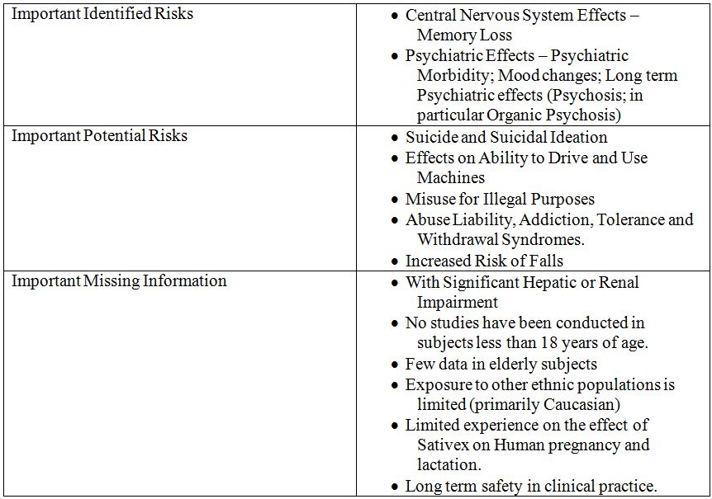

OPR reviewer comment:

General comments
The language used to describe safety concerns is often inconsistent in this RMP. For example, “psychiatric effects” is listed elsewhere in the RMP as “psychiatric symptoms” or “psychiatric morbidity”. These and other terms appear to be used interchangeably. To clarify interpretation, it is recommended that the RMP be updated to ensure consistent wording of each safety concern.
The sponsor also uses the terms “memory loss” and “memory impairment” interchangeably in the text of the RMP, with “memory loss” appearing in the summary above. It is the evaluator’s view that these terms are not equivalent and consistent use of the term “memory impairment” is recommended.

Application site reactions
The RMP states that application site reactions were raised by the MHRA as an identified safety concern in a previous application. The RMP states that this concern possibly relates to the excipients (alcohol, propylene glycol, and peppermint oil) found in the Sativex spray. In particular, there is a potential unquantified long term risk of leukoplakia related to Sativex application.
Application site reactions are listed in the company core safety information for Sativex and listed on the proposed PI as a “common” AE. They are also dealt with in some detail in the safety specifications of the RMP, and appropriately so, but are not reflected in the summary of Ongoing Safety Concerns (Table 73). It is accepted that application site reactions, in general, are probably of minor concern and of minimal impact to the patient. They are also appropriately captured in the PI and CMI. However, leukoplakia, as a pre malignant condition, in the evaluator’s view, should be considered a more important Ongoing Safety Concern. In the absence of justification for its exclusion, it is recommended to the Delegate that leukoplakia be considered for inclusion as Important Missing Information, and should be subject to appropriate pharmacovigilance measures to further elucidate its associated risk.

Interaction with other medications
The proposed indication is as an “add on” therapy for spasticity. In vitro CYP drug-drug interaction studies have been undertaken and are appropriately addressed in the RMP. However, there is a conspicuous absence of drug interaction studies with Sativex and other anti spasticity medications, which according to the proposed indication, would be used by the target population. Hence, the safety profile is substantially reliant on general clinical data based on a population taking other medications which have not been clearly characterised. The proposed PI itself states under Dosage and Administration:
In the absence of compatibility studies, this medicinal product must not be mixed with other medicinal products.
Such interactions would have potential implications for many of the current safety concerns, for instance an increase in risk of falls relating to a cumulative effect of Sativex and other muscle relaxing agents. The absence of specific clinical data relating to such foreseeable drug interactions is considered a deficiency of the RMP.
It is therefore recommended to the Delegate that interaction with other medications (specifically including anti spasticity medications) be considered for inclusion as important missing information in the ongoing safety concerns. It is further recommended to the Delegate that the sponsor be required to conduct drug-drug interaction studies to appropriately evaluate the safety profile of Sativex when used with other anti spasticity agents. This is especially important as it pertains directly to the proposed indication as an add-on combination. It is recommended that any proposed protocol for such a study would be submitted to the TGA for evaluation.
Otherwise, the above summary of the Ongoing Safety Concerns is considered acceptable.

Pharmacovigilance plan

Proposed pharmacovigilance activities
There are two studies proposed to provide additional pharmacovigilance in the post market space. Otherwise, routine pharmacovigilance activities are proposed to monitor and further elucidate the ongoing safety concerns associated with Sativex.
Section 2.3 of the RMP appears to assign the same safety concerns to both of these studies hence further clarification was sought in the Section 31 requests. In response, the sponsor provided information on the finalised study protocols (and assigned safety concerns), which has been summarised in Table 74.
Table 74: Proposed studies.
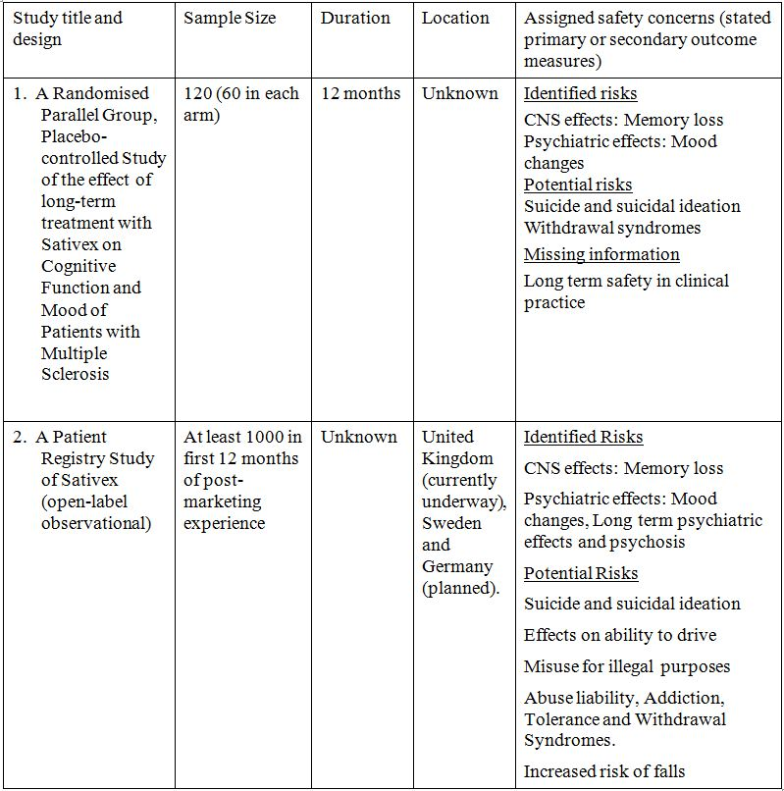

Study 1: A randomised parallel group, placebo-controlled study of the effect of long-term treatment with Sativex on cognitive function and mood of patients with multiple sclerosis.
This is a 12 month multicentre, double blind, randomised control study. There is a total of seven assessment visits proposed for each subject including a follow up visit. The primary outcome of this RCT is cognitive function, which the sponsor states addresses the risks of memory loss and safety in long term use. This will be assessed with the Paced Auditory Serial Addition Test. Secondary outcome measures are intended to assess the risks of mood changes, suicidal ideation and withdrawal syndromes. Information will also be gathered on the effects of Sativex on spasticity; however, the sponsor states this is not intended to be an efficacy study.
The sponsor confirmed in Section 31 responses that this study will not be conducted in Australia.

Study 2: A patient registry study of Sativex
The registry is designed as a multicentre observational study of patients who are treated with Sativex. Participation in the registry is linked to prescription; when a patient is prescribed Sativex, the registry administrator is notified and the patient is entered on the registry. The prescriber is then contacted and encouraged to voluntarily enter safety data (via a pre defined case report form) at 6 month intervals for up to 24 months. An alert and reminder system for reporters is in place.
According to the sponsor, any reports of SAEs made as part of the registry, will be notified to appropriate health regulation bodies in accordance with registration requirements.
The registry is currently underway in the UK and is planned in Sweden and Germany. The Sponsor states in Section 31 responses that no such registry is planned for Australia because safety information gained from a European population will, “in general be applicable to the Australian population”.

OPR reviewer comments in regard to the pharmacovigilance plan (PP) and the appropriateness of milestones:
Section 2.3 of the RMP appears to assign the same safety concerns to both proposed studies; however, this has been confirmed by the sponsor, in Section 31 responses, as incorrect. To improve clarity of the proposed PP, it is recommended to the Delegate that the RMP be appropriately updated to clearly represent which safety concerns are assigned to each study.

Study 1: A randomised parallel group, placebo-controlled study of the effect of long-term treatment with Sativex on cognitive function and mood of patients with multiple sclerosis
MS is a chronic condition and therefore the expected duration of treatment with Sativex would likely be many years. Hence, the evaluator considers that the 12 month study period cannot adequately assess “long term” effects as stated. In response to the Section 31 request querying this, the sponsor had the view that data from this study should be considered as cumulative with data already obtained, together informing long term cognitive effects. While the safety profile in other countries appears to be reassuring thus far, long term safety in clinical practice remains as missing information. This is a concern given anticipated long term use in most, if not all, patients. It is therefore recommended to the Delegate that the sponsor be directed to consider an alternative study approach that will appropriately evaluate the long term cognitive effects of Sativex. The clinical evaluator agreed that long term cognitive effects should be the subject of further study. It is further recommended that any associated study protocol be submitted to the TGA for evaluation.
Psychosis is an identified risk with Sativex, particularly associated with overdose as seen in the Thorough QT study. While somewhat controversial, it is reasonably accepted that psychosis has been linked to marijuana use and therefore THC. Given the THC content of Sativex, it would not be unreasonable to consider that psychosis, as an important identified risk should be closely monitored in the post market space. The clinical evaluator came to a similar conclusion.
In this RCT, the sponsor has included outcomes for mood and suicidality, but not particularly for psychosis. In the absence of justification for its exclusion, it is recommended the sponsor consider including psychiatric effects (including psychosis) as an outcome measure in this RCT so that they can be investigated in a more controlled environment than what would be expected with the patient registry. Alternatively, the sponsor may consider evaluation of this safety concern in a separate study.
The evaluator was concerned about the possibility of unblinding in this study related to patients who were regular users of cannabis. In response to a Section 31 request, the sponsor has confirmed that current or recent users of cannabis or cannabinoid based medications would be excluded from the study. This is considered appropriate.
It is recommended that reports of this study be submitted to the TGA for review when available.

Study 2: A patient registry study of Sativex
A stated objective of the registry study is “the potential for addiction, abuse, and misuse for illegal purposes”. Information sought from prescribers (as part of the registry case report form) does not include specifically targeted questions that refer to issues of addiction, abuse or misuse. In Section 31 responses, the sponsor argues this objective can be addressed by using the general registry data to detect changes in usage patterns of Sativex over time as well as the occurrence of adverse events typical of the cannabis withdrawal syndrome. It is the evaluator’s view that the registry cannot adequately address this safety concern, as it relies on the sponsor drawing indirect conclusions from usage patterns and reported AEs as opposed to clinicians specifically answering questions directly related to the stated objective. It is therefore recommended to the Delegate that specific questions relating to suspected addiction, abuse and misuse be included as part of the patient registry case report form to ensure this objective is addressed.
Another stated objective of the registry study is “the potential for memory impairment”. Again, the information sought from prescribers (as part of the registry case report form) does not include specifically targeted questions referring to the AE of memory impairment. There is no prompt for the clinical enquiry about memory related AEs without directly asking prescribers about events of memory impairment in patients. It is the evaluator’s view that the patient registry, for this objective, can really only be considered as effective as spontaneous reporting and therefore routine pharmacovigilance. It is recommended to the Delegate that specific questions relating to memory impairment be included as part of the patient registry case report form to ensure this objective is addressed.
The evaluator agrees that information gained from a European population would generally be applicable to the Australian population. A key difference however, is that the Australian population is naïve to prescription cannabinoids. Given this, it would not be unreasonable to consider that some safety concerns might prove to be more of a problem here than overseas, for instance, the concern of abuse and misuse. Therefore, it is recommended to the Delegate that ideally, the patient registry should be extended to include the Australian post market population.
The sponsor commits to include any information gathered in the registry within the Periodic Safety Update Reports, as well as reporting AEs according to normal statutory reporting requirements. This is considered appropriate. It is recommended that when available, reports of this study be submitted to the TGA for review.

Risk minimisation activities

Sponsor’s conclusion in regard to the need for risk minimisation activities
The sponsor does not provide a conclusion with regard to the need for risk minimisation activities as such. However, a summary table of planned actions in the RMP is provided as well as justification for whether routine risk minimisation activities are considered sufficient or not to mitigate the risks associated with Sativex.
The patient registry study is also proposed as the only additional risk minimisation activity for several safety concerns. The stated objectives of the registry are:
- The potential for addiction, abuse, and misuse for illegal purposes;
- The potential for long term psychiatric effects including suicidality and psychosis;
- The potential for mood changes/psychological effects (such as confusion/disorientation);
- The potential for memory impairment; and
- The effect on driving ability.
Routine risk minimisation activities are planned for all other safety concerns.
A paediatric study is planned for the “Important Missing Information”; however, no other studies have been conducted in subjects less than 18 years of age.

OPR reviewer comment:
The patient registry study is proposed as the only additional risk minimisation activity. The patient registry, by design, is not strictly considered to be risk minimisation per se.

Potential for medication errors
In the RMP, it is stated:
During clinical trials, there have been no medication errors reported leading to safety concerns. The PI for Sativex identifies specific areas for potential medication errors and also information on how to identify and minimise the risk to patients.

OPR reviewer comment:
Dosage and administration advice in the PI describes a titration period during which increasing the dose is presumably the decision of the patient. Due to the subjectivity associated with individual dosing, there is an inherent risk of medication error, specifically overdose. The clinical evaluator recommends that wording in the PI regarding maximum dose should be strengthened. Recommendations made by the clinical evaluator in this regard are considered appropriate to help mitigate the risk of overdose.
Also, given the proposed Section 8 classification, it is anticipated that initiating prescribers would be appropriately familiar with the drug and provide close medical supervision, particularly over the titration period. These extra measures would also help to reduce medication error.

Off label use
In the RMP, it is stated:
(The sponsor) has conducted studies in non MS subjects that include those with:
    - intractable neuropathic pain
    - peripheral neuropathic pain associated with allodynia
    - pain due to diabetic neuropathy
    - chronic pain due to brachial plexus (injury)
    - chronic refractory pain due to neurological deficit
The safety profile for these non MS population is very similar to the profile of the safety data from the MS population. In the unlicensed supply of Sativex in Europe, 80% of these patients have multiple sclerosis. Sativex is available in Canada for cancer related pain and for the relief of neuropathic pain in people with MS who have failed to gain adequate relief from existing analgesics. The spontaneous reports from Canadian post marketing experience have not revealed any new or unexpected safety signals.

OPR reviewer comment:
This is considered acceptable. Although cannabinoids have a large potential for off label use, abuse and misuse, Sativex is a prescription only medicine which, if approved, will be restricted under Section 8 to a limited prescriber population. It is accepted that the safety profile of Sativex for off label indications would likely be similar to that for the proposed indication and this appears to reflect international clinical experience thus far.

Risk minimisation plan

Planned actions
The sponsor proposes that the patient registry also acts as an additional risk minimisation activity for the safety concerns listed as part of the PP.
No other additional risk minimisation actions are planned according to the RMP.

OPR reviewer comment:

General comments:
With respect to the additional safety concerns identified, it is recommended that the sponsor provide an appropriate evaluation of the need for risk minimisation activities for each of these and commit to updating the RMP accordingly, or provide justification for their exclusion.

Additional risk minimisation:
The sponsor proposes the patient registry acts as risk minimisation as well as pharmacovigilance. This is problematic as the patient registry is by nature non interventional and as such cannot strictly be considered risk minimisation.
In Section 31 responses, the sponsor argues that the contact with prescribers as part of the patient registry acts as a risk minimisation strategy by drawing the attention of prescribers to the need for “special surveillance” of Sativex. The evaluator considers that while the registry may provide additional safety information, it does not purport to minimise risk by enhancing detection or early treatment of an adverse event nor does it necessarily provide specific patient or prescriber education. In addition, while initial entry to the registry is linked to prescription, actual prescriber participation is voluntary. This confers a significant limitation as a risk minimisation activity. The sponsor has also not provided any clear effectiveness measures of the registry as a risk minimisation activity. Furthermore, the registry will not be undertaken in Australia, so any risk minimisation argued by the sponsor will be absent in the Australian market.
It is therefore recommended to the Delegate that the patient registry, in its current form, be considered as a global pharmacovigilance activity and not a risk minimisation activity.
Therefore, in the absence of other additional risk minimisation activities, only routine risk minimisation is applicable to all safety concerns.

Routine risk minimisation:
The evaluator has concerns regarding the impact of Sativex on driving safety, which is identified as an important potential risk.
With regards to the effects on ability to drive and use machines, the PI states:
Sativex may produce undesirable effects such as dizziness and somnolence which may impair judgement and performance of skilled tasks. Patients should not drive, operate machinery or engage in any hazardous activity if they are experiencing any significant CNS effects such as dizziness or somnolence. Patients should be aware that Sativex has been known to cause a few cases of loss of consciousness.
This wording is suggestive that the individual patient should decide whether or not driving is safe while taking Sativex. Driving is a complex task which requires the reliable use of cognitive processes, sensory perception and physical dexterity. All of these domains can, to some degree, be impaired as a result of recognised adverse effects listed in the PI. In addition, any possible Sativex associated impairments of the capacity to drive are likely to be compounded by several other factors in the target population (such as concomitant medications and MS symptoms themselves). Furthermore, the effect/s of Sativex on driving or operating heavy machinery has not been specifically studied. It is therefore the evaluator’s view that the RMP underestimates the risk of Sativex use on driving safety. Similar concerns have been discussed in the CER.
It is the evaluator’s view that driving should not be recommended at all while using Sativex, unless specific safety data that proves otherwise comes to light. This recommendation concurs with that made in the CER.
Hence, in regard to the proposed routine risk minimisation activities, it is recommended to the Delegate that the draft PI and CMI documents be revised to strengthen the wording of driving precautions to appropriately represent this underestimated risk.

Summary of recommendations
It is recommended to the Delegate that once the Sativex RMP amendments and additions are agreed to and the RMP is accepted, a condition of registration be that the sponsor provides an updated RMP or an annex to the EU RMP outlining the Australian specific differences, particularly in relation to pharmacovigilance and risk minimisation activities. It would be considered acceptable that this be provided at the time of submission of the next Periodic Safety Update Report. It is also recommended that the sponsor commits to submitting an updated RMP to the TGA’s OPR at any time there is new information that may impact upon the current safety specifications, PP, or risk minimisation activities (for example, significant changes in the frequency or severity of safety events or the identification of new safety signals).
The following is a summary of specific recommendations to the Delegate regarding the Sativex RMP, version 1.0. The corresponding section of this evaluation should be referred to for further details:

Section 2 – Indications dose and route of administration
- It is recommended the sponsor clarify the exact wording of the proposed indication and ensure its consistent use within the RMP, PI, and other associated documentation.

Section 5.1 – Nonclinical
- It is recommended the sponsor consider rewriting the drug interactions section as recommended by the toxicology evaluator.

Section 7 – Summary of ongoing safety concerns:
- To clarify interpretation, it is recommended the RMP be updated to ensure consistent wording of each Ongoing Safety Concern.
- It is recommended that consistent use of the term “memory impairment” be utilised in the text of the RMP.
- In the absence of justification for its exclusion, it is recommended that leukoplakia should be considered for inclusion as Important Missing Information, and should be subject to appropriate pharmacovigilance measures accordingly.
- It is recommended that the interaction with other medicines (specifically including anti spasticity medications) be considered for inclusion as Important Missing Information, and should be subject to appropriate pharmacovigilance measures accordingly.
- It is further recommended the sponsor be required to conduct appropriate PD interaction studies to appropriately evaluate the safety profile of Sativex when used with concomitant anti spasticity agents.

Section 7.3 – OPR reviewer’s comments in regard to PP and the appropriateness of milestones
- It is recommended that the RMP be appropriately updated to clearly represent which safety concerns are assigned to each study to improve clarity of the proposed PP.
- This study claims to examine the long term cognitive effects of Sativex but is only planned for a 12 month period. It is recommended the sponsor be directed to consider an alternative approach that will more appropriately evaluate the long term effects of Sativex.
- In the absence of justification for its exclusion, it is recommended that the sponsor consider including psychiatric effects (including psychosis) as an outcome measure in this RCT so that they can be investigated in a more controlled environment than what would be expected as part of the patient registry. Alternatively, the sponsor may be directed to evaluate this concern with a separate study.
- It is recommended that specific questions relating to suspected addiction, abuse, and misuse be included as part of the patient registry case report form to ensure that this objective is properly addressed.
- It is recommended that specific questions relating to memory impairment be included as part of the patient registry case report form to ensure that this objective is properly addressed.
- It is recommended that the ideally, the patient registry should be extended to include the Australian post market population.

Section 9.1 – RMP – planned actions
- It is recommended that the patient registry, in its current form, be considered as a pharmacovigilance activity only and not a risk minimisation activity.
- In regard to the proposed routine risk minimisation activities, it is recommended that the draft PI and CMI documents be revised to strengthen the wording of driving precautions to appropriately represent this underestimated risk.

VI. Overall conclusion and risk-benefit assessment
The submission was summarised in the following Delegate’s overview and recommendations:

Quality
With regard to chemistry, manufacturing and controls, Sativex oromucosal spray is considered approvable. This submission is to be considered at the Pharmaceutical Sub Committee (PSC) meeting on 29 February 2012 and a record will be made available to the ACPM as soon as possible after that meeting.
The issues of concern to the pharmaceutical chemistry evaluator that have not been fully resolved are:
- The naming of the THC component for Sativex. The current AAN is for 9-delta-tetrahydrocannabinol is ‘dronabinol’; however, the sponsor requests this be amended to delta-9-tetrahydrocannabinol (extracted) in order to distinguish this plant derived component from synthetically derived THC. This will be further discussed prior to the ACPM meeting.
- Whether the submitted bioavailability studies are adequate. There was no absolute bioavailability study. This issue was also considered in the clinical evaluation and will be considered with reference to the clinical evaluator’s report.

Nonclinical
The nonclinical evaluator stated the submission was not supported on nonclinical grounds. Toxicity studies were conducted with oral doses resulting in high or very high systemic exposures of THC and CBD with no findings that would preclude approval of registration. The main toxicological issue with Sativex is the incomplete characterisation of impurities and metabolites. The nonclinical evaluator acknowledged that botanical products such as Sativex are not within the scope of relevant ICH impurity guidelines applied to new drug substances and new drug products but noted that a toxicological risk assessment has to be restricted to the available hard data and cannot be based on likely similarities in either composition or potential exposure to impurities and metabolites. The nonclinical evaluator recommended that should Sativex be registered, any new data on metabolites and impurities arising from ongoing work on the product post marketing should be submitted to the TGA.
A reduction in hERG currents and altered Prukinje fibre action potential in vitro was demonstrated in one study; however, no effect of treatment was seen in in vivo dog cardiovascular studies with sublingual or intraduodenal administration.
There were no toxicity studies with the proposed oromucosal route of administration but local irritation was not seen in a 28 day hamster cheek pouch test with topical application. Assessment of potential carcinogenicity was not of a standard normally required for a new chemical entity but available results suggest that a risk to humans is unlikely. The high excretion of active cannabinoids in milk should preclude use in nursing mothers. There was no evidence of teratogenicity in rat and rabbit embryofoetal developmental studies.

Clinical
The clinical evaluator’s view is that Sativex should not be approved until the proposed formulation can be justified in terms of its THC:CBD composition. An adequate justification would be based on theoretical, pre clinical grounds, as well as appropriate Phase 3 comparative studies of THC versus various combinations of THC and CBD, comparing the efficacy, tolerability and safety of the various formulations, that is, it should treated like any other combination therapy. The evaluator has noted the sponsor’s view that Sativex should be accepted “as is”, that is, as a plant product with a certain complement of cannabinoids, which can be regularised but which do not require individual justification. The clinical evaluator considered if that view is accepted, and the issue of the arbitrary THC:CBD ratio is put aside, the overall submitted evidence is weakly in favour of the registration of Sativex.

Pharmacology
Both THC and CBD are readily obtained from the cannabis plant. The sponsor has combined these actives in a single preparation at roughly equal concentrations (THC 27 mg/mL, CBD 25 mg/mL) with additional extracts. Efficacy of either of the major cannabinoid components as monotherapy, or the optimum ratio for the combination of THC and CBD have not been explored, as would be the case for a standard fixed combination product. The clinical evaluator considered that Sativex is a fixed combination product and has noted that the justification for combining the two primary actives appears deficient. The evaluator considered that regardless of whether it is required, it should have been mandatory for the sponsor to have studied both main constituents of Sativex before seeking registration of the proposed THC/CBD formulation. Without this information, it is not known whether the chosen ratio of THC to CBD is in any way optimal, or whether the presence of CBD is even marginally beneficial.
Most PK studies noted high inter subject variability. Following single-dose administration of Sativex, both THC and CBD are rapidly absorbed. In Study GWCP0601, the primary PK study in this submission, the median T_{max} for THC and CBD in the fasted state was approximately 1-1.5 h and this did not change with increasing single doses of 2, 4 or 8 sprays. The C_{max} for CBD was generally less than half that of THC. Following oromucosal absorption, any remaining drug in the oral cavity is likely to be ingested and subsequent absorption occurs in the oesophagus and stomach and is subjected to first pass hepatic metabolism. This results in the main metabolite of THC, 11-hydroxy THC, in the systemic bloodstream, along with non metabolised THC and CBD. The T_{max} for 11-hydroxy THC is ~1.5 h, though this is variable. In addition to variable first pass metabolism, it is likely that subjects vary in the extent to which they swallow the drug.
Absolute bioavailability of the active components was not investigated. Comparative bioavailability of THC and CBD from oromucosal Sativex and inhaled THC extract and smoked cannabis were estimated in published studies. Concentration/time curves for inhaled THC extract and for Sativex were also submitted. These suggest a much lower C_{max} and much longer T_{max} for THC from Sativex than from comparator inhaled products.
Food increased absorption of THC by a factor of ~3 and of CBD by a factor of ~5. The AUC of the metabolite 11-hydroxy THC was 1.3 fold higher in the fed state. The AUCs of THC and CBD were roughly dose proportional when 2 to 8 sprays of Sativex were given in the fasted state. In the fed state an approximately dose proportional increase in exposure was observed after single dose administration of 2, 4 and 8 sprays (5.4-21.6 mg THC and 5.9-20.0 mg CBD). On multiple dosing in the fed state, higher doses produced a disproportionally elevated exposure with a 4 fold dose increase giving an estimated increase of 9.8, 8.1 and 11.1fold for THC, CBD and 11-hydroxy THC AUC_{(0-t)}, respectively, and a 7.3 fold increase in C_{max} for 11-hydroxy THC. In the chronic treatment setting, there was no evidence of clinically significant accumulation of THC and CBD.
Information on the Vd of THC and CBD was provided from published studies. The most recent estimate for the Vd of THC at steady state was 75 L. There were no data on the concentrations of either THC or CBD in the CNS. Plasma concentrations are likely to correlate poorly with levels at the sites of action within the CNS, making PK/PD assessments difficult.
CBD, THC and 11-hydroxy THC are largely eliminated from plasma within a day of consumption. The sponsor did not perform studies detailing the methods of elimination, but instead referred to the literature, which suggests that elimination is due to a combination of renal and hepatic clearance and the re distribution of the cannabinoids and their metabolites to adipose tissue. Long term accumulation of Sativex in fatty tissues is expected with prolonged use.
The PK of THC and CBD in subjects with either hepatic or renal impairment was not assessed. Drug interactions with rifampicin (a CYP3A4 inducer), ketoconazole (a CYP3A4 inhibitor), and omeprazole (a CYP2C19 inhibitor) were examined. Rifampicin reduced exposure to THC and CBD and ketoconazole increased exposure to both THC and CBD. The increases were not large compared to inter subject variability. For 11-OH THC, C_{max} was 3.1 times greater after ketoconazole, and the AUC was 3.8 times greater, suggesting that 11-OH THC is metabolised by CYP3A4. Omeprazole had no effect on the metabolism of THC or CBD.
PD studies were limited to those examining the effects of Sativex on QT interval and the potential for intoxication and abuse. Abuse potential appears to be lower than for inhaled product, due to lower overall absorption and the substantially lower C_{max}. A mechanism of action of Sativex in reducing spasticity in MS was not explored in the clinical studies submitted.

Efficacy
Three studies were pivotal (Studies 106, 403 and 604). For these studies, the sponsor applied a NRS, rather than existing more objective scales for measuring spasticity. A discussion on the relative merits of assessment tools for spasticity is the CER. The NRS allows the possibility of substantial confounding. There is a high likelihood that scores are at least partially affected by other factors including pain, mood, fatigue and strength. The clinical evaluator considered the NRS was an appropriate tool to use in the pivotal studies, but that the results needed to be interpreted with some scepticism, particularly in the context of the current submission because cannabinoids can cause intoxication, have known positive effects on mood and pain, and have a well recognised side effect profile that could potentially lead to unblinding.
Study 106 (n = 189) was a randomised, double blind, placebo controlled study to investigate the efficacy, safety and tolerability of Sativex versus placebo over 6 weeks in MS patients with spasticity, when added to the patients’ existing anti spasticity medications. The primary efficacy parameter was mean change from baseline spasticity score as recorded in a diary based, 11 point NRS. This parameter was selected as the primary parameter during the study, prior to unblinding.
The maximum permitted dose of Sativex or placebo was 8 actuations in any 3 h period and 48 actuations (THC 130 mg:CBD 120 mg) in 24 h, however the mean and median doses were from 7-10 actuations daily in the Sativex group. This study enrolled a patient who had recently received interferon in the placebo group and 3 patients given Sativex who received Botulinum toxin during study.
This study showed a small difference in mean change from baseline NRS spasticity score that just reached statistical significance, favouring Sativex for the ITT population. For the ITT population, the adjusted mean NRS scores for Sativex were 5.49 at baseline and 4.31 at end of study, and for placebo were 5.39 at baseline and 4.76 at end of study; a between group difference of 0.55 favouring Sativex (p = 0.048).
Differences between treatments were more pronounced, both favouring Sativex for the analysis of patients with at least a 30% or at least a 50% reduction from baseline in NRS spasticity scores. Approximately 20% of patients given placebo and 40% given Sativex reported at least a 30% improvement in spasticity (p <0.01; NNT 5). Of the 48 patients given Sativex who had at least a 30% improvement, 44 (92%) had reported the improvement within the first 4 weeks of study. Differences between groups for spasticity assessed using the secondary efficacy measures of the Ashworth scale, spasm frequency score, motricity index, and patient global impression of change did not reach statistical significance.
Study 403 (n = 388) was a multicentre, double blind, randomised, placebo controlled, parallel group study of Sativex in MS related spasticity. It was similar in design to Study 106 but was larger, included a one week baseline assessment period and 14 weeks of double blind treatment, rather than 6 weeks as in Study 106. Botulinum toxin use within 4 months of study was an exclusion criterion. The maximum permitted Sativex or placebo dose was eight actuations in any 3 h period and 24 actuations (THC 65 mg:CBD 60 mg) in 24 h; however, the mean and median number of actuations daily were from 7-9 in the Sativex group.
For the FAS, the adjusted mean reduction in NRS spasticity score for Sativex was 1.05 points, compared to a reduction of 0.82 points for placebo, from baseline scores of 6.77 and 6.48 points, respectively. The treatment difference of -0.23 points was in favour of Sativex but is of dubious clinical utility (a quarter of a point on an 11 point scale) and was not statistically significant (p = 0.219; 95% CI: -0.59, 0.14 points).
The PP analysis was statistically significant, with an adjusted mean reduction in NRS spasticity score of 1.46 points in the Sativex group and a decrease of 0.91 points in the placebo group from baselines of 6.84 and 6.49 points, respectively (estimated treatment difference -0.46 points; p = 0.035; 95% CI: -0.88, -0.03 points). A total of 45 (27%) of the patients given Sativex and 27 (16%) given placebo were excluded from the PP analysis due to protocol violations. Responder analyses at both the 30% and 50% spasticity reduction level showed non significant treatment differences in the FAS, in favour of Sativex, with odd ratios of 1.34 (p = 0.231) and 1.21 (p = 0.569), respectively.
None of the secondary efficacy endpoints showed statistically significant differences between Sativex and placebo, though there was a trend towards less spasticity in patients given Sativex. Of note however the Quality of Life survey showed statistically significant differences, favouring placebo for cognitive function (-7.23 points) and changes in health (-9.35 points), p = 0.046, 95% CI: -14.32, -0.13, and p = 0.018, 95% CI: -17.04, -1.65, respectively.
At the end of this study, investigators were asked to indicate what treatment they thought the subject had taken during the study. Actual placebo recipients were much more likely to be identified as placebo recipients than were Sativex recipients (49% versus 13%), and actual Sativex recipients were correctly identified much more often than placebo recipients were misidentified as Sativex recipients (63% versus 35%). In the Sativex group, the group in whom side effects might lead to unblinding, investigators’ guesses were correct 106 times out of 128 guesses, a success rate of 83%.
Study 604 (n = 572) was designed after an initial submission to the EMA had been rejected. This design was intended to overcome what the sponsor contended was the main barrier to demonstration of efficacy: the long standing, pharmacologically intractable spasticity of the majority of spastic MS patients that the sponsor considered disguised and diluted the efficacy of Sativex in a subset of responsive patients.
The study was conducted in two phases. Phase A was a single (patient) blinded therapeutic trial in which all patients received Sativex for 28 days. “Responders” in Phase A were permitted to enter a randomised, placebo controlled, double blinded treatment phase, Phase B for a further 74 days. A response of at least 20% reduction from baseline NRS spasticity score was required for recruitment into Phase B. The 20% cut off was based on data from Study 403 where the vast majority of eventual 30% responders had already demonstrated at least a 20% response in the first 4 weeks of treatment. Subjects could receive up to 12 actuations of Sativex daily, as proposed for registration. The primary endpoint was the change in spasticity from the Phase B baseline (randomisation) to the end of treatment.
A total of 241 patients were randomised to Phase B: 124 to Sativex and 117 to placebo. The “enriched” Phase B population was broadly similar to the initial Phase A population, with one clear exception: they had milder spasticity, with an NRS of 3.9 compared to 6.9 in the total population. Following randomisation, the active and placebo groups were similar. For subjects entering Phase B, the overall improvement during single blind treatment, from the original Phase A baseline to the end of Phase A, was 3.01 units from a baseline of 6.91 (44%).
Mean baseline scores at randomisation were 3.87 and 3.92 points for the Sativex and placebo groups, respectively. Following randomisation, there was a further improvement of 0.19 units in the Sativex group (4.9%) by the end of the treatment phase, and a deterioration of 0.64 units in the placebo group (16.4%). The adjusted mean difference between the groups in spasticity scores was 0.84 units, which was significantly in favour of Sativex (p = 0.0002, 95% CI: -1.29 to -0.40). Between group differences in spasticity scores were apparent from Week 1 of Phase B. There was no concentration of deterioration in scores in subjects given placebo in the first weeks of Phase B which would have suggested that withdrawal affected spasticity. For the total study population (commencing in Phase A), 42% showed an initial response and 74% of these went on to show a 30% response overall. Subjects randomised to placebo in Phase B had a 51% response rate. The attributable response rate was therefore 23%, which is 9.7% of the original cohort.
Unlike Studies 106 and 403, which failed to show a significant benefit for secondary endpoints, this enrichment study showed either significant benefit or strong favourable trends for all spasticity related and functional endpoints. It did not show a significant benefit for quality of life assessments including bodily pain, general health, vitality, social functioning, emotional and mental health.
The CER describes the sponsor’s attempts to demonstrate that unblinding of Sativex was not significant in the pivotal efficacy studies. The arguments are of no consequence given the demonstrated unblinding apparent to investigators in Study 403.
Two long term extension studies were included in the submission. These were open, and thus provided no clear indication of continued efficacy. Study 702 was a second round supportive efficacy study designed to address the deficiencies in long term efficacy data in the first, unsuccessful submission of Sativex for spasticity to the EMA. It was a randomised withdrawal study conducted over 4 weeks and enrolled 36 subjects who had been taking Sativex long term. Almost all (17/18, 94%) of the placebo recipients failed treatment, whereas 8 of the 18 Sativex recipients (44%) failed treatment. The reason for failure in the majority of subjects (76%) was a worsening of spasticity (that is, ≥ 20% increase in NRS score from baseline). Only 2 subjects (11%) given Sativex ceased treatment due to AEs during the randomised withdrawal phase, compared to 9 (50%) receiving placebo.

Safety
A total of 1821 patients with MS received Sativex in the clinical studies, 1016 in non comparative studies (598 patient years) and 805 in comparative studies (148 patient years). 231 MS patients have received Sativex for longer than 12 months in clinical trials. Post market data from Canada and the UK provided a further 5500 patient years of exposure to Sativex. In the pooled clinical trial MS population, patients given Sativex used a mean of 9.1 (SD 5.07) actuations daily, with an inter quartile range of 11.3 to 5.7, compared with 13.7 (SD 7.49) actuations daily by placebo recipients. In the non comparative MS studies, the mean number of sprays per day was 7.2 (SD 4.3). The mean age for MS patients was 49 years (range 19-77).
The sponsor’s analysis of AEs was largely restricted to ‘TEAEs’, defined as those that appeared or showed significant worsening during treatment. Analysis from the placebo controlled studies is likely to underestimate the extent of AEs associated with Sativex because in Study 604, the largest comparative study, 572 patients were exposed to Sativex without a comparator in the first study phase. In the second phase, when some patients were randomised to a blinded placebo crossover, those continuing active treatment were relatively unlikely to report their tolerability issues again, and investigators are not likely to have considered ongoing symptoms as treatment emergent. Furthermore, placebo recipients are likely to have had some side effects related to withdrawal of active therapy, so the true underlying placebo rate of AEs is unknown. A comparison of the overall event rate nonetheless shows a moderate excess of AEs with active treatment (Sativex 78.0% of subjects, placebo 66.4%).
Individual AEs that were more common in the Sativex group were, in descending order of incidence: dizziness (Sativex 25% versus placebo 8.2%), fatigue (12.5% versus 8.4%), nausea (9.6% versus 5.7%), somnolence (8.2% versus 2.3%), vertigo (6.5% versus 2.0%), dry mouth (6.1% versus 3.1%), asthenia (5.6% versus 3.1%), diarrhoea (5.5% versus 3.9%), disorientation (4.1% versus 0.8%), disturbance in attention (3.9% versus 0.1%), dysgeusia (3.1% versus 0.8%), feeling drunk (3.0% versus 0.4%), depression (2.9% versus 0.8%), and feeling abnormal (2.4% versus 0.5%). Several of these AEs showed a consistent trend across related terms, with dizziness and vertigo both clearly increased by active treatment, as well as the symptom complex of fatigue/asthenia/somnolence, and a range of terms consistent with intoxication. There was an excess of severe TEAEs in patients receiving Sativex in the comparative studies (15.3% versus 8.5% for placebo). The most frequent severe AEs in patients given Sativex were dizziness (2.9% versus 0.4% for placebo) and asthenia (1.1% versus 0.3% for placebo).
In comparative MS studies, SAEs were slightly more common in Sativex recipients (4.6%) compared placebo recipients (3.2%). Serious PAEs were seven times more common in patients given Sativex (0.7% versus 0.1%), but the absolute incidence was low (6 patients given Sativex and 1 given placebo). With the exception of psychiatric disorders, there were no consistent trends suggesting greater SAEs in patients given Sativex. A similar pattern was seen in the non comparative studies.
There was a slight excess of deaths in patients given Sativex in comparative studies in MS (0.6% versus 0.1%) but not in the non MS population (0.2% for both Sativex and placebo), and there were no consistent or concerning trends. There were four deaths in which Sativex was considered a possible contributor.
The withdrawal rate due to AEs in patients given Sativex was approximately double that of placebo (9.8% Sativex versus 4.7% placebo) and was of similar magnitude for the overall study population (MS and non MS). Dizziness (1.9% of MS patients given Sativex in comparative studies) and nausea (1.6% of MS patients given Sativex in comparative studies) were the AEs most likely to lead to withdrawal. Laboratory and vital signs were examined and no large between group differences observed but there was a small excess of ‘abnormal liver function tests’ reported as an AE in the Sativex group compared to the placebo group.
The safety issue of most concern is PAEs. Serious PAEs were reported for 0.7% patients given Sativex versus 0.1% given placebo. About 2% of MS subjects (17/805) withdrew because of PAEs. Considering all PAEs, the absolute attributable risk of a PAE was about 10% (incidence 17.6% versus 7.8%), implying that 1 in 10 patients is likely to suffer a psychiatric side effect of Sativex – not counting fatigue or asthenia. There were 5 cases of psychosis in Sativex recipients, one attributed to Sativex withdrawal and 4 that occurred on treatment. Hallucinations occurred in 11 patients. All cases resolved within 2 weeks. In comparative studies, paranoia was reported in 12 Sativex recipients, including one of the psychotic cases, but in only one placebo recipient. 5 cases of paranoia occurred in the non comparative MS studies, amongst 1016 Sativex recipients.
Depression was reported in 2.9% of Sativex recipients versus 2.0 of placebo recipients in the overall comparative data pool for MS subjects. There was also an excess of depression with active treatment in the non MS studies (4.2% versus 1.4%). Two suicides occurred in the MS study program, one in a comparative study and the other in a non comparative study. Suicidal ideation was over represented in the Sativex group (3 patients) compared to the placebo group (1 patient).
At doses above those proposed the incidence of serious PAEs was higher and events occurred in healthy volunteers. In the QT assessment study, healthy subjects received 18 sprays twice daily (3x the proposed maximum dose) and 4/41 (9.8%) subjects had a serious PAE, some occurring after the first 18 actuations. The events included hallucinations, delusions, and homicidal and suicidal ideation.
There was no evidence of tolerance in the clinical trials with patients given Sativex generally titrating themselves to doses well below doses permitted on study. Withdrawal was assessed directly in a sub study (n = 25) in which MS patients who had taken Sativex for at least a year were asked to cease Sativex for 2 weeks and AEs were recorded. Five of the 25 subjects restarted Sativex prematurely because of “MS related symptoms”. These may have included withdrawal symptoms.
About half of these patients reported at least one of the symptoms that would be expected of a cannabis withdrawal syndrome: hot and cold feelings, insomnia, emotional lability, tiredness, a sense of intoxication, or vivid dreams. In general, these withdrawal symptoms were mild and manageable.
Abuse potential was specifically studied in Study GWCP0605, which showed that Sativex was associated with a number of “likeable” effects in a dose dependent fashion. At 4 sprays this was not significantly different from placebo but at 8 sprays there was a moderate effect significantly different from placebo and the results were even more marked at 16 sprays. The proposed Sativex dose range is for up to 7 sprays at once. This dose would be expected to produce similar effects to the 8 sprays tested in Study GWCP0605. The abuse potential is likely to be even higher if, as considered by the clinical evaluator, patients horde their medication for recreational binges. The evaluator also considered the possibility that patients might open the bottle, soak tobacco in solution, and then smoke the modified tobacco. The sponsor responded to this possibility in a response to prior to completion of the evaluation.

Risk management plan
The RMP evaluator has proposed approval of this submission with an amended indication of
... add on treatment for symptomatic relief of spasticity in patients with MS who have not responded adequately to other medication and who demonstrate worthwhile improvement during a 4 week trial of therapy.
The proposed amended indication is not acceptable because it does not specify the severity of the spasticity necessary to commence treatment, provides too subjective a description of the extent of improvement required for ongoing therapy, and is too restrictive in specifying a time period in which the trial of therapy must occur.
The RMP evaluator has listed recommendations for amendments to the RMP and requested an updated RMP be submitted. It is proposed that provision of a RMP acceptable to the OPR be a condition of registration.

Risk-benefit analysis

Delegate considerations

Pharmacology
The sponsor has not considered this product a fixed dose combination product but has instead regarded it as a plant based mixture of actives. This is not optimal and the benefits of either of the major active components when given alone are not able to be determined from this submission. Neither is it clear that the optimal ratio of actives has been determined. The choice of ratio appears to have been arbitrary, based on the ratio present in the plant extracts that make up Sativex. The extent of risks and/or benefits from the remaining 10% of cannabinoids in the product are not known.
Differences in absorption of both major active components in the fed and fasted state are sufficient to require consistent dosing, either in the fed or fasted state during dose titration and regular use of this product. The high inter subject variation in PK requires that the dose be titrated to response and this has been proposed by the sponsor. While this product has less abuse potential than an inhaled product, it does have potential for abuse. The extent of cognitive impairment with either short or long term use has not been adequately examined.

Efficacy
Of the 3 pivotal studies, only Study 604 used a maximum dose consistent with the maximum proposed dose proposed. The earlier studies used up to 4 fold (Study 106) and 2 fold (Study 403); however, the mean and median doses reported as consumed were consistent with the proposed dose regimen.
The major flaws in Study 106 are that:
- it permitted patients to receive other treatments that affected spasticity immediately before and during the study at different rates in the Sativex and placebo groups;
- the primary endpoint was changed during study when the active treatment could not be fully blinded due to its effects on the CNS.
Study 403 was larger, had a one week baseline assessment period, followed patients for 14 weeks rather than 6 weeks, and excluded patients who had received Botulinum toxin in the previous 4 months. These differences would be expected to make it more reliable than Study 106. It was a negative study for its primary efficacy endpoint, showing a small trend towards less spasticity for patients given Sativex in the FAS analysis. Only the PP analysis reached statistical significance. That analysis is of doubtful validity given the difference in rate of exclusion of patients in each groups from the analysis (27% given Sativex versus 16% given placebo).
Study 403 also strongly suggests that blinding cannot have been complete in any of the efficacy studies due to the ability of investigators to detect, at a rate well above chance, which patients were taking Sativex. As noted by the evaluator the detection rate in patients is likely to be even higher as they had direct experience of the CNS effects of Sativex. In that study statistically significant differences in cognitive function and overall health, favouring placebo over Sativex also suggest for the majority of patients the risks from treatment outweigh the benefit.
Study 604 was a randomised withdrawal study of a group of patients who had an initial response to Sativex. Inherent in this design is the possibility that Sativex, while not efficacious in itself, produces a withdrawal syndrome affecting spasticity, or it may be that withdrawal symptoms affect subjective spasticity scores, perhaps by increasing irritability. While this study showed what appeared to be a robust response in the selected group of patients, as noted by the clinical evaluator, the results cannot be generalised to the broader population of patients with MS related spasticity.
Only a minority of subjects in Study 604 (42%) showed an initial response and although most of these (74%) went on to show a 30% response overall, the placebo group also showed a high response rate (51%), and the attributable response rate was therefore only 23%, which is just 9.7% of the original cohort. Given the likely confounding of the efficacy results through unblinding, the actual yield is likely to be lower still. Another problem with this enrichment design is that all of the concerns about the subjective nature of the NRS are exacerbated because the population entering the randomised phase is necessarily enriched not just with true responders but with patients inclined to a strong placebo effect as well as unblinded patients who may have been prone to reporting improved NRS scores in the absence of a true reduction in spasticity. It is also notable that although all patients randomised had at least a 20% reduction in NRS score with a mean change from the start of treatment in the single blind phase of -3 when Sativex was ceased in a blinded manner over the subsequent 12 weeks the spasticity score increased by a mean of 0.64. This suggests either that the effects of Sativex are long lasting and/or that the spasticity score is responsive to factors other than Sativex administration, including the patients’ perception of treatment.
Major contributions from the extension studies were to demonstrate the subjective nature of spasticity scores and to highlight withdrawal effects on patients stabilised on Sativex. 44% of subjects who continued to receive Sativex reported reductions in spasticity scores consistent with treatment failure. It appears that when subjects thought they might be withdrawing from Sativex nearly half of them rated their spasticity as worsened. This also supports the view that the NRS score is responsive to factors other than Sativex administration.
Nine (50%) of subjects given placebo withdrew due to AEs within a few days of ceasing Sativex, suggesting withdrawal effects.
The major safety issues associated with Sativex are its relatively narrow therapeutic window and the increased incidence of PAEs. The risk of PAEs increases when the recommended dose is exceeded. The long term psychiatric risk remains poorly characterised because of the lack of long term controlled clinical trial data. Psychosis, depression and other psychological morbidity are likely to be increased in long term Sativex recipients. There is some potential for abuse that has not been well explored and many subjects will be able to detect CNS effects while taking the proposed dose however these effects would be substantially less than that experienced with recreational exposure to inhaled marihuana.
If Sativex is approved, Appendix D of the SUSMP will need to be amended such that nabiximols are included in Section 5 of Appendix D, that is, poisons for which possession without authority is illegal (for example, possession other than in accordance with a legal prescription). Nabiximols would also be removed from Section 3 of Appendix D, which provides includes poisons available only from or on the prescription or order of a medical practitioner authorised or approved by the Secretary of the Commonwealth Department of Health and Ageing under Section 19 of the Therapeutic Goods Act 1989. Section 19 refers to goods that are not included on the Australian Register of Therapeutic Goods (ARTG).

Conclusion and recommendation
The Delegate considers the major issues against approval of Sativex are:
- There is an unevenly distributed benefit from use of Sativex that requires many patients to be treated initially to identify the ~10% likely to receive clinically significant benefit in terms of reduced spasticity;
- Even with an initial treatment trial, identification of those likely to benefit from Sativex with a reduction in spasticity is likely to be inaccurate due to the likelihood some individuals will enjoy its CNS effects and either consciously or unconsciously exaggerate the effects of Sativex on their spasticity;
- Sativex is associated with an increased risk of PAEs including psychosis and possibly cognitive impairment, though the latter has not been fully explored.
The above considerations are balanced by the following:
- All patients who would be considered for treatment have a major neurological illness with spasticity that is not adequately controlled with current therapy;
- For appropriately selected individuals, when used according to the proposed dose recommendations, serious adverse events are uncommon and in most cases could be managed principally by ceasing treatment;
- Inappropriate use is likely to be limited with the proposed prescribing restrictions. The proposed reporting requirements will identify whether those restrictions adequately limit off label and/or recreational use. If widespread off label use is apparent on post market reporting, action could then be taken to further limit availability of Sativex.
The Delegate proposes to approve Sativex for the requested indication of:
Add on treatment, for symptom improvement in patients with moderate to severe spasticity due to MS who have not responded adequately to other anti spasticity medication and who demonstrate clinically significant improvement in spasticity related symptoms during an initial trial of therapy.
The ACPM’s advice is specifically requested on the following proposed conditions of registration:
- Patients being considered for treatment with Sativex should be assessed by a neurologist who should also perform initial assessment to determine eligibility and a follow up assessment 4 weeks after commencement of therapy. Only patients with a clinically significant reduction in spasticity and who did not have unacceptable side effects should be continued on treatment.
- The initial prescription for 4 weeks of treatment should be provided only by a neurologist. If at the follow up assessment the patient has a clinically significant reduction in spasticity ongoing prescriptions may be supplied by other medical practitioners.
- Patients taking Sativex should not drive. This recommendation is both because of the CNS side effects of Sativex and to avoid legal complications from driving with detectable levels of THC in the bloodstream.
- The sponsor should conform to the requirements of the RMP evaluation report, including reporting the results of the planned clinical trial of Sativex effects on cognitive function.
- The sponsor should commit to monitoring sales of Sativex in Australia, including an estimation of the extent of diversion of Sativex both for off label therapeutic uses and for recreational use. Results should be reported to the TGA annually from commencement of marketing.
The Delegate considers that by requiring assessment by a neurologist prior to ongoing treatment with Sativex legal access to Sativex will be restricted to patients with MS and moderate to severe spasticity that have a clinically significant response to initial treatment. Further control over the potential for misuse and abuse is gained by Sativex being a Medicines Schedule 8 product. The monitoring of sales to be reported by the sponsor to the TGA should give an early indication of whether widespread inappropriate use is occurring. If this is apparent then the conditions of registration including the prescribing restrictions could be reviewed.
If approved nabiximols would be removed from Appendix D of the SUSMP, it is not proposed that a registered product require approval under Section 19 of the Therapeutic Goods Act. That section of the Act applies to unregistered goods. Appendix D of the SUSMP would require amendment to remove nabiximols and to specify that THC in Appendix D as a poison available only from or on the prescription or order of a medical practitioner authorised or approved by the Secretary of the Commonwealth Department of Health and Ageing under Section 19 of the Therapeutic Goods Act 1989.
The Australian Approved Name (AAN) for THC is under negotiations and should be finalised prior to the ACPM meeting.

Response from sponsor
Presented here is the Novartis pre ACPM Response to the TGA Delegate’s overview and Request for ACPM Advice in relation to our application for registration of Sativex nabiximols. Where appropriate, our comments have been cross referenced to the Delegate’s overview (DO) and the Clinical Evaluation Report (CER).

Introduction
The TGA Delegate recommends to approve Sativex, and Novartis welcomes the Delegate’s proposal. We would propose a slight change to the wording of the indication as follows, to align with the approved indication in Europe, that is:
Treatment for symptom improvement in patients with moderate to severe spasticity due to MS who have not responded adequately to other anti spasticity medication and who demonstrate clinically significant improvement in spasticity related symptoms during an initial trial of therapy.
Further justification is provided below.
In this pre ACPM response, we respond to the issues listed by the Delegate in the ‘Conclusions and recommendation’ section of the DO against approval of the product. In addition, we comment on the proposed conditions of registration for which the Delegate has requested specific advice from ACPM and other issues.
We feel there are further considerations that lend weight to the Delegate’s reasons to approve Sativex which we expand on below. Robust evidence of long term efficacy of Sativex for treatment of spasticity in MS patients was demonstrated in the controlled randomised withdrawal study (Study 702), which showed with high statistical significance that patients in whom Sativex reduces spasticity continue to benefit from long term treatment with Sativex. Although PAEs occur more frequently with Sativex than with placebo, these are usually of only mild or moderate intensity and serious PAEs are rare. Novartis therefore believes that the significant benefits of Sativex outweigh the risks in this MS population. The spasticity of these patients is not adequately controlled with current therapy and hence there is clearly a strong unmet need for a new anti spasticity treatment (DO and CER).

Response to major issues against approval of Sativex
(a) There is an unevenly distributed benefit from use of Sativex that requires many patients to be treated initially to identify the ~10% likely to receive clinically significant benefit in terms of reduced spasticity.

Sponsor’s response:
In Study 604 (Figure 28), 572 patients entered the first, single blind, uncontrolled phase of the trial and received Sativex for four weeks. Out of this original cohort, 48% (272/572) achieved at least a 20% improvement on the NRS, which is regarded to represent a clinically relevant improvement on the patient global impression of change. Out of these 272 patients, 241 were eligible to be randomised into the second, double blind, placebo controlled phase of the trial and out of these, spasticity of 74% of patients in the Sativex group (51% in the placebo group) further improved showing at least a 30% reduction in NRS spasticity scores (DO).
Figure 28: Patient distribution in Study 604.
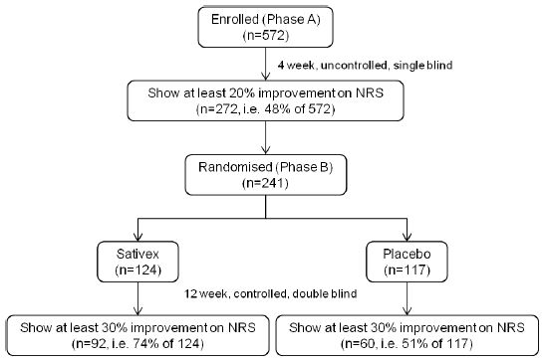
While it is correct to state that the attributable response rate was 23% and this represents ~10% of the original cohort, it does not reflect the true benefit of the medicine. In fact, nearly 50% of patients receiving Sativex showed a clinically relevant improvement of their spasticity after 4 weeks and out of the randomised patients receiving Sativex, 74% showed further improvement which is seen as “much improved” on the patient global impression of change.
Further, the response/efficacy statement made by the Delegate does not reflect the proposed indication. Any efficacy statement made in the labelling should be relevant to the population for whom the medicine is indicated. In this case, Sativex is indicated for patients who have achieved a meaningful clinical response after a trial of therapy and it is this group of patients for whom efficacy statements are appropriate.
Novartis therefore maintains that rather than the 10% mentioned above, nearly 50% of patients who enter a 4 week trial with Sativex are likely to receive clincially significant benefit in terms of reduced spasticity. These 50% of the original cohort are the patients who will continue to receive Sativex and out of these, three quarters are likely to benefit from further improvement in their spasticity.
(b) Even with an initial treatment trial, identification of those likely to benefit from Sativex with a reduction in spasticity is likely to be inaccurate due to the likelihood some individuals will enjoy its CNS effects and either consciously or unconsciously exaggerate the effects of Sativex on their spasticity.

Sponsor’s response:
The published abuse liability study shows that while very high doses of Sativex are somewhat liked, doses of 4 and 8 sprays taken all at once are actively disliked. This represents a much higher dose than is recommended in the PI (that is, wait at least 15 minutes in between sprays). No mood scales used in any of the controlled studies have shown Sativex to be mood elevating.
Also, data show that the PK of recreational cannabis and therapeutic Sativex are different. The mean C_{max} for THC when Sativex is used is consistently around 2-4 ng/mL, even when 4 sprays are given at once, compared to more than 100 ng/mL when cannabis is smoked. Furthermore, T_{max} is around 1 h, in contrast to the T_{max} of several minutes seen with smoked cannabis (DO). These very marked differences mean that the typical CNS effects of smoked cannabis are unlikely to be seen with the use of Sativex.
The concern that it is likely that some individuals will enjoy the CNS effects of Sativex is therefore without scientific basis.
(c) Sativex is associated with an increased risk of PAEs including psychosis and possibly cognitive impairment, though the latter has not been fully explored.

Sponsor’s response:
Although PAEs occur more frequently with Sativex than placebo, in a large majority of cases they are limited to mild or moderate intensity and are rapidly self limiting. Importantly, no cases of functional psychiatric illness have occurred in patients receiving Sativex, including subjects who received the drug over an extended period of more than two years. The majority of events occur early in treatment, and so can be factored into a risk-benefit assessment within a short therapeutic trial. In all trials with MS patients, only 17 out of 805 (2%) subjects withdrew from Sativex as a result of a PAE.
The incidence, severity and persistence of hallucinations and delusional beliefs in subjects receiving Sativex have been carefully monitored. There is no evidence from controlled clinical studies that Sativex poses any long-term or irreversible neuropsychiatric risk to patients.

Response to proposed conditions of registration
(A) Patients being considered for treatment with Sativex should be assessed by a neurologist (…); and
(B) The initial prescription for 4 weeks of treatment should be provided only be a neurologist.

Sponsor’s response:
In Australia, rehabilitation physicians are heavily involved in managing the symptomatic treatment of MS, including spasticity. Novartis therefore believes that the initial treatment with Sativex should not be restricted to neurologists but should include rehabilitation physicians as well. This view is shared by the clinical evaluator (CER).
(C) Patients taking Sativex should not drive.

Sponsor’s response:
Novartis concurs with the Delegate’s recommendation and has amended the PI accordingly.
(D) The sponsor should conform to the requirements of the RMP evaluation report, including reporting the results of the planned clinical trial of Sativex effects on cognitive function.

Sponsor’s response:
Novartis commits to conform to the requirements of an updated RMP which is acceptable to the OPR and the sponsor. Novartis further commits to report the results of the planned 12 month clinical trial of Sativex effects on cognitive function once available.
(E) The sponsor should commit to monitoring sales of Sativex in Australia, including an estimation of the extent of diversion of Sativex both for off label therapeutic uses and for recreational use. Results should be reported to the TGA annually from commencement of marketing.

Sponsor’s response:
Novartis commits to annually report to the TGA sales of Sativex in Australia. Novartis further commits to monitor for abnormal sales trends, which might be indicative of diversion of Sativex for off label therapeutic uses and for recreational use, and to report these to the TGA.

Other issues
Page 1, Proposed indication
Add on treatment, for symptom improvement in patients with moderate to severe spasticity (…)

Sponsor’s response
As previously indicated in our response to the consolidated questions, we are proposing to remove the words “add on” from the indication in line with a recent corresponding change made to the European SmPC for Sativex. In Europe, this change arose during a round of the Mutual Recognition (MR) procedure, where one of the six MR participants (Denmark) insisted that the indication be changed by removal of the words “add on” as there was a minority of patients in the clinical trials who were not taking any other anti spasticity medication. This proposed change to the indications would ensure that patients who have previously failed and/or who have not tolerated other spasmolytic agents, and who are no longer on such therapy would not be excluded from Sativex therapy.
Page 1, Administration
Patients should titrate the dose as needed between 1-12 sprays daily (…) in 2 or more divided doses.

Sponsor’s response
According to the proposed PI, patients are advised to wait at least 15 minutes between sprays and therefore, patients will always use only one spray at the time.
Page 3, Pharmacology, 1st paragraph
(…) it should have been mandatory for the sponsor to have studied both main constituents of Sativex before seeking registration of the proposed THC/CBD formulation. Without this information, it is not known whether the chosen ration of THC to CBD is in any way optimal, or whether the presence of CBD is even marginally beneficial.
Sponsor’s response
The underlying rationale for the development of Sativex lies in the observation that MS patients with spasticity were frequently turning to the use of illicit cannabis for symptom relief – they were not turning to isolated cannabinoids or synthetic analogues of isolated cannabinoids, which would have been available as the prescription medicines Marinol or Cesamet in overseas markets. This lead the UK House of Lords Science and Technology Select Committee and the US Institute of Medicine to recommend that proper scientific investigation should be carried out to determine whether a pharmaceutical product based on a plant extract could be shown to provide meaningful therapeutic relief to people with MS. As with any plant based medicine, Sativex is regarded as a single medicinal entity, and not a construct of its many components.
CBD has little activity at cannabinoid receptors, but does have neuroprotective properties, most likely mediated by its ability to modulate intra cellular calcium. It is also able to modulate the course of the disease in animal models of MS. The key pharmacology of CBD in MS probably relates to its ability to inhibit microglial activity and T cell proliferation.
FDA advice given for the development of Sativex was:
“The combination rule does not apply to Sativex as long as the rationale for the formulation is to consistently produce a high concentration of both THC and CBD within the product.“
Therefore, all quality data and all nonclinical and clinical studies have been carried out with the whole plant extract.
Page 7, Safety, 2nd paragraph
Analysis from the placebo controlled studies is likely to underestimate the extent of AEs associated with Sativex because in Study 604, the largest comparative study, 572 patients were exposed to Sativex without a comparator in the first study Phase.

Sponsor’s response
Novartis agrees that placebo controlled data should be given greater weight than uncontrolled data and would like to point out that the total exposure to Sativex in placebo controlled studies includes 805 patients with a mean exposure of 67 days in patients with MS (148 patient years) and 70 patient years in a non MS population. This is a considerably greater exposure than 572 patients for 4 weeks (that is, 44 patient years) and provides a more reliable overview of the safety profile of Sativex. An underestimation of the extent of AEs associated with Sativex is therefore unlikely.
Page 9, Pharmacology, 1st paragraph
The extent of risks and/or benefits from the remaining 10% of cannabinoids in the product are not known.

Sponsor’s response
The 10% of the BDS that have not yet been identified are not cannabinoids but are instead entirely part of the non cannabinoid fraction. This unidentified portion contains unknown compounds in small amounts (typically less than 0.1%w/w), and these are below the limits for reporting thresholds within the relevant ICH Q3A guideline (although herbal products are excluded from this guideline). The degree of characterisation of the BDS is considered exceptional for an herbal product.
The BDS batches as now used in Sativex have been demonstrated to possess the same chemical profile as those subjected to the full pharmaceutical development, nonclinical and clinical testing programme. It has been demonstrated by extensive chromatographic fingerprinting that the BDS batches used in nonclinical studies are comparable to BDS batches used in recently manufactured Sativex batches and that the profile of both known and unknown compounds does not change from batch to batch. The unknown fractions of the BDS have therefore been evaluated within suitable toxicological studies. Further, the same BDS has been used in the complete Sativex clinical programme with no unexpected toxicity findings.
Novartis agrees that any new data on metabolites and impurities arising from ongoing work on the product will be submitted to the TGA post registration.
Page 10, 3rd paragraph
Study 403 also strongly suggests that blinding cannot have been complete in any of the efficacy studies due to the ability of investigators to detect, at a rate well above chance, which patients were taking Sativex.

Sponsor’s r info@tga.gov.au response
The sponsor does not agree that the evidence overall, and specifically from Study 0403 supports the conclusion that unblinding was widespread, or was likely to have introduced bias.
A study by Bang and colleagues, among others, established a methodology for the analysis of this type of data, pointing out that it is not an appropriate methodology to exclude non responders (that is, responders with indefinite answers) even when using patient or investigator guesses regarding treatment allocation. In coming to his conclusion regarding blinding in this study, the TGA evaluator has disregarded all the “don’t know” responses. When including non responders (that is, all the “don’t know” responses) in the assessment of blinding, 63% of investigators in the Sativex group guessed correctly and overall (that is, including the placebo group), only 56% of investigators guessed correctly which treatment their patients were receiving.
In support of our view, we are drawing attention to the following:
- The clinical assessment made by the MHRA included the following comment:
“The investigators only guessed the treatment allocation correctly for 56% of patients. Given that complete guesswork would result in a 50% rate this is not strikingly high.”
- Professor Doug Altman, a principal author of the CONSORT (Consolidated Standards of Reporting Trials) Guidelines, has published widely in the field of clinical trials methodology in general, and assessment of blinding in particular. His investigation of the impact of potential unblinding in the Sativex pivotal trials was based on a statistical approach and concluded as follows:
“There is no evidence to suggest that the blinding has been seriously compromised in these three studies. If any subjects did become unblinded then there is no evidence in these three studies of any bias in the assessment of the treatment difference between Sativex and placebo for efficacy, adverse events or study drug dosing.”
In fact, since Study 0403 was the only Phase 3 study that failed to show a significant difference between Sativex and placebo for the ITT population, it would be difficult to conclude that even if unblinding was present, it caused bias towards Sativex.
Page 11, 2nd paragraph
(...) There is some potential for abuse that has not been well explored and many subjects will be able to detect CNS effects while taking the proposed dose; however, those effects would be substantially less than that experienced with recreational exposure to inhaled marijuana.

Sponsor’s response:
Two THC containing cannabinoid medicines (dronabinol and nabilone) have been available on prescription for decades in overseas markets. Despite this, cases of abuse or diversion have been reported as “rare and isolated” and no evidence of a street market for these drugs has been detected. A systematic review has concluded that dronabinol (Marinol) has “a very low abuse potential”.
More than 1200 patient years of clinical trial experience of Sativex have been accumulated, plus a considerable amount of post marketing and named patient (special licence) use. Intoxication scores have been low and tolerance has not been apparent (DO). There have been no reports of abuse or diversion and only a single case of psychological dependence. Four small studies involving abrupt cessation of long term Sativex dosing have failed to reveal evidence of a withdrawal syndrome.
In conclusion, although the THC component of Sativex raises the theoretical possibility of abuse or dependence, this has not emerged in clinical experience to date.
Page 12, last paragraph
The Australian Approved Name (AAN) for THC is under negotiations and should be finalised prior to the ACPM meeting.

Sponsor’s response
Novartis and the TGA have agreed to remove reference to THC (and CBD) from the product labels. An AAN for THC is hence no longer required. The updated product labels will refer to nabiximols and the total content of cannabinoids, while the PI will give more detailed information on the content of THC and CBD.

Concluding remarks
Novartis welcomes the Delegate’s recommendation to approve Sativex. We agree with the Delegate that Sativex offers a treatment choice for these very difficult to treat patients with spasticity which is not adequately controlled with current therapy. Novartis maintains that 48% rather than 10% of patients showed a clinically relevant improvement in their spasticity from Sativex in Study 604 and that this should be taken into account.

Advisory committee considerations
The application seeks to register a new chemical entity.
The ACPM taking into account the submitted evidence of efficacy, safety and quality considered this product to have an overall negative risk-benefit profile.
In making this recommendation, the ACPM considered that efficacy was not adequately demonstrated for this product due to study design problems which include the absence of adequate blinding, a large reported placebo effect and failure to demonstrate meaningful improvement in quality of life measures.
In addition, the ACPM considered that the safety risks, particularly in regard to PAEs, were unacceptable in view of the poor clear evidence of efficacy.
The ACPM considered the specific advice on the proposed conditions of registration should registration be approved and agreed in full with the Delegate.

Outcome (initial decision)
Based on a review of quality, safety and efficacy, TGA decided not to register Sativex oral mucosal spray on the grounds that on balance, the clinical benefit has not been sufficiently demonstrated to justify the risks from patient exposure in the proposed population group for the purposes for which it is to be used:
Sativex is indicated as add-on treatment, for symptom improvement in patients with moderate to severe spasticity due to multiple sclerosis (MS) who have not responded adequately to other antispasticity medication and who demonstrate clinically significant improvement in spasticity related symptoms during an initial trial of therapy.

Reasons for decision
- The mechanism by which cannabinoids may reduce spasticity has not been clearly determined.
The active components of Sativex are assumed to be THC and CBD. THC acts as a partial agonist at CB1 receptors with activation of CB1 receptors causing an inhibition of cyclic adenosine monophosphate (or cAMP), followed by phosphorylation and subsequent activation of a range of intracellular kinases. The ultimate results of this pathway are not well characterised, so the actual effects of THC on the brain and the ability of THC to modulate spasticity can only be inferred from observational studies, not deduced at the mechanistic level.
The role of CBD in Sativex is unclear. There are no clear theoretical reasons for supposing CBD would increase the anti spastic action of THC, and there are some indicators that it could play an antagonistic role. The idea that CBD modulates of THC’s psychoactivity is plausible, but that this modulation is useful remains unconfirmed.
- The optimal ratio of actives has not been determined.
Because this product has been developed as a plant extract rather than as a mixture of two known actives there has been no assessment of the optimal ratio of the actives. Particularly it is not clear if CBD makes any contribution towards activity of Sativex, though it may be associated with AEs.
- The clinical development program has not demonstrated that Sativex improved the quality of life of individuals with spasticity associated with MS. Of particular concern, Sativex clearly worsens fatigue and the related symptoms of asthenia and somnolence in a patient population for whom MS related fatigue is often the most significant symptom degrading quality of life. Effects on cognition affecting quality of life are also likely with Sativex, though this has not been formally assessed.
- Aspects of the design of the pivotal efficacy and safety study limit the demonstration of efficacy of Sativex in reducing spasticity. The primary efficacy measure in that study was a NRS to assess changes in spasticity. The NRS had a large subjective element, allowing for the possibility of substantial confounding. Scores could be at least partially affected by factors other than spasticity including pain, mood, fatigue and strength. The NRS results needed to be interpreted with caution because cannabinoids can cause intoxication, have known positive effects on mood and pain, and have a well recognised side effect profile that could potentially lead to unblinding.
- Efficacy demonstrated using the potentially confounded NRS was very limited with no more than 10% of patients likely to have a clinically significant benefit in terms of reduction in spasticity.
- Sativex was associated with an increased risk of PAEs including psychosis that appeared to be dose related. Other significant risks include abuse and withdrawal effects. While these effects may be acceptable in a medication with a clear demonstration of clinically significant efficacy, this was not the case for Sativex.
Given the above statements, it is considered that the overall risk-benefit profile of Sativex is unfavourable for any indication involving symptom improvement in patients with spasticity due to multiple sclerosis.

Final outcome (Section 60 decision)
Following the initial decision by the Delegate under Section 25 of the Therapeutics Goods Act 1989 (the Act) on 18 April 2012, on 16 July 2012 the sponsor sought a review under the provisions of Section 60 of the Act.
The sponsor’s letter seeking a review under Section 60 was to the Parliamentary Secretary to the Minister for Health and Ageing. Below is the response from the Delegate of the Minister for the purposes of the review.

Review decision

Section 60 decision
Pursuant to Section 60 of the Act, the Delegate of the Minister decided to revoke the initial decision of the Delegate under Section 25 of the Act not to register nabiximols (Sativex) and to make the following decision in substitution of the original decision:
Nabiximols (Sativex) may be registered on the ARTG for the following indication:
Treatment for symptom improvement in patients with moderate to severe spasticity due to multiple sclerosis (MS) who have not responded adequately to other anti-spasticity medication and who demonstrate clinically significant improvement in spasticity related symptoms during an initial trial of therapy.

Section 28 decision
In addition to the Section 60 decision above, the Delegate of the Minister has decided to impose the following conditions on the registration of nabiximols (Sativex) under Section 28 of the Act:
- The version of the PI supplied as part of the sponsor’s pre ACPM Response on 5 March 2012 must be amended as follows:
- A Black Box warning must be included containing the following statement:
- The maximum recommended dose of Sativex should not be exceeded. High doses of Sativex increase the risk of serious PAEs including psychosis, hallucinations, delusions, and homicidal and suicidal ideation.
- Under Mechanism of Action and Pharmacodynamic Effects, add to the end of the last paragraph about CBD, the following words: “It is unknown whether CBD in Sativex has a facilitating or antagonising effect on the anti spasticity action of THC”.
- Under CLINICAL TRIALS, to the final sentence in paragraph 7 which currently reads “Thus the attributable response rate was 23% in the randomised cohort” add “which equates to around 10% of the original cohort”.
- Under Effects on Ability to Drive and Use a Machine, amend the wording of the second sentence as follows ..........”patients taking Sativex should not drive, operate dangerous machinery and or engage in hazardous activities”.
- Restore the heading Abuse Potential, which is currently printed with strikethrough and correct the ‘typo’ in the last sentence -...........and if Sativex is being considered for these patients close monitoring of is recommended
- Under DOSAGE AND ADMINISTRATION, amend the sentence “The treatment must be initiated and supervised by a physician with specialist expertise in treating this patient population” to “The treatment must be initiated and supervised by a specialist neurologist or rehabilitation physician with expertise in treating patients with spasticity due to multiple sclerosis” and move it to come directly after the first paragraph in this sentence.
- Under this same section, add information, similar to that in the CMI, on the need for priming of the spray when first used and if not used for more than 21 days, and how to carry out the priming.
- Under Titration period, include the statement “The maximum number of consecutive sprays must not exceed 7 within a 3 hour period”
- Under Maintenance period, change the statement “Doses of greater than 12 sprays a day are not recommended” to “Doses must not exceed 12 sprays in any 24 hour period”.
- The CMI must be amended to reflect these changes to the PI.
- The product label must include the statement: “Patients taking Sativex should not drive or operate machinery”.
- An RMP acceptable to the OPR must be put in place for Sativex prior to marketing. A revised RMP must be submitted to the OPR for approval and Sativex cannot be marketed until the RMP has been agreed. The revised RMP must include the following:
- A commitment to submit to the TGA any new data on metabolites and impurities arising from ongoing work on the product post marketing.
- A commitment to provide the results of the study GWMS1137 A Randomised Parallel Group, placebo-controlled study of the effect of long-term treatment with Sativex on Cognitive Function and Mood of Patients with Multiple Sclerosis to the TGA as soon as they are available.
- A Patient Registry Study of Sativex in Australia, either separately or as part of the study currently underway in the UK and elsewhere in Europe, to gather information on adverse events especially related to the identified risks, potential risks and missing information. The registry should aim to approximate “real world” Australian use and recruitment should be automatically linked to prescription or supply to ensure that all eligible patients and doctors are able to participate.
- Development of an educational program which prescribers must undertake prior to prescribing Sativex. The program must include an assessment of the prescriber’s understanding of the safe use of Sativex and should be accredited with speciality bodies for Continuing Professional Development (CPD) points to encourage participation.
- The development of educational materials for patients to aid correct use of Sativex and to provide advice of the risks of treatment and what to do if they experience adverse events.
- The development and implementation of a mechanism that limits supply of Sativex to patients of a ‘registered’ prescriber population, this population to be limited to neurologists and rehabilitation physicians who have successfully completed the educational module (see above).
- A commitment to monitoring the sales pattern of Sativex in Australia, including an estimate of the extent of diversion for off label use and for recreational use. The results of this monitoring must be reported to the OPR of the TGA annually from commencement of marketing
- Development of targeted questionnaires for events of special interest to augment spontaneous reporting (that is, routine pharmacovigilance).
- A clear plan for how effectiveness of the additional risk minimisation activities will be measured.

Background
Nitecs Pty Ltd, as the sponsor in Australia, made a Category 1 Application to Register the New Clinical Entity, nabiximols (Sativex) oral mucosal spray, on 8 April 2011 following lodgement of a Pre Submission Planning Form on 20 January 2011.
The initial indication sought was for:
“add-on treatment for symptom improvement in patients with moderate to severe spasticity due to multiple sclerosis (MS) who have not responded adequately to other anti spasticity medication and who demonstrate clinically significant improvement in spasticity related symptoms during an initial trial of therapy.”
Sponsorship of the application was subsequently transferred to Novartis Pharmaceuticals (Novartis), with effect in the TGA records in August 2011. Novartis subsequently amended the proposed indication to:
“treatment for symptom improvement in patients with moderate to severe spasticity due to multiple sclerosis (MS) who have not responded adequately to other anti spasticity medication and who demonstrate clinically significant improvement in spasticity related symptoms during an initial trial of therapy.”

Initial decision
On 18 April 2012, the Delegate advised the sponsor that under Section 25 of the Act, the decision had been made not to register nabiximols (Sativex) oral mucosal spray for either of these indications. The grounds for the decision were that, on balance, the clinical benefit had not been sufficiently demonstrated to justify the risks from patient exposure in the proposed population group. The reasons for the decision were:
- The mechanism by which cannabinoids may reduce spasticity has not been clearly determined;
- The optimal ratio of actives has not been determined;
- The clinical development program has not demonstrated that Sativex improved the quality of life of individuals with spasticity associated with multiple sclerosis;
- Aspects of the design of the pivotal efficacy and safety study limit the demonstration of the efficacy of Sativex in reducing spasticity;
- Efficacy demonstrated using the potentially confounded NRS was very limited with no more than 10% of patients likely to have a clinically significant benefit in terms of reduction in spasticity; and
- Sativex was associated with an increased risk of PAEs including psychosis that appeared to be dose related. Other significant risks include abuse and withdrawal effects.
The Delegate further advised that while these AEs may be acceptable in a medication with a clear demonstration of clinically significant efficacy, this was not the case for Sativex. The Delegate also advised that the overall risk-benefit profile of Sativex was considered unfavourable for any indication involving symptom improvement in patients with spasticity due to multiple sclerosis.
On 16 July 2012, Novartis wrote to the Parliamentary Secretary to the Minister for Health and Ageing seeking review of the Delegate’s initial decision under Section 60 of the Act.
Section 25 of the Act sets out the matters that must be considered when evaluating therapeutic goods for registration. Paragraph 25(1)(d) of the Act requires that, if an application is made for the registration of therapeutic goods in relation to a person, the Secretary must evaluate the goods for registration having regard to whether the quality, safety and efficacy of the goods for the purposes for which they are to be used have been satisfactorily established.
Paragraph 25(1)(j) requires the Secretary to also have regard to whether the goods contain substances that are prohibited imports for the purposes of the Customs Act 1901.

International regulatory status of Sativex
The Novartis pre ACPM Response indicates that at 5 March 2012, Sativex (nabiximols) has been approved for a similar indication in the following countries: European Union - Decentralised Procedure - 17 May 2010; United Kingdom - 16 June 2010; Spain - 27 July 2010; Canada - 11 August 2010; New Zealand - 28 October 2010; European Union - Mutual Recognition Procedure - 15 March 2011; Austria - 19 January 2012; Czech Rep. - 6 April 2011; Denmark - 6 June 2011; Germany - 18 May 2011; Sweden - 15 Dec 2011; Israel - 14 February 2012.
Sativex has been used on a Named Patient basis in the UK for some years and has also been approved in Canada under a Notice of Compliance with Conditions for neuropathic pain in MS since 2005 and analgesia in advanced cancer since 2008.
Sativex (nabiximols) does not have marketing authorisation in the US; however, Marinol (dronabinol) capsules containing synthetic THC are approved for the treatment of anorexia associated with weight loss in patients with AIDS, and nausea and vomiting associated with cancer chemotherapy in patients who have failed to respond adequately to conventional antiemetic treatments.
In addition, Cesamet (nabilone), a synthetic cannabinoid, is marketed in Canada, the US, the UK, and Mexico. It was approved in 1985 by the FDA for treatment of chemotherapy induced nausea and vomiting that has not responded to conventional antiemetics. It is also approved for use in the treatment of anorexia and weight loss in patients with AIDS.

Current regulatory status of Sativex in Australia
Sativex (nabiximols) is not currently registered on the ARTG but may be approved for individual patients under the Special Access Scheme.
Nabiximols is a Controlled Drug under Schedule 8 of the Poisons Standard 2012 which consists of the SUSMP 3. Under Appendix D of the SUSMP 3, nabiximols can only be prescribed by a medical practitioner authorised or approved by the Secretary of the Commonwealth Department of Health and Ageing under Section 19 of the Therapeutic Goods Act 1989.
Section 19 does not apply to drugs on the ARTG so Sativex (nabiximols) could not be marketed by the sponsor until Appendix D is altered.

Material relied upon in making this decision
In making this decision, the following material was relied upon related to the application for registration of Sativex (nabiximols):
- Modules 2 and 5 of the original submission;
- The Consolidated Section 31 Request for Information letter to Novartis dated 28 October 2011;
- The Novartis Response to the Consolidated Section 31 Request for Information dated 21 December 2011;
- The final evaluation reports provided to Novartis with the ‘Advice of completion of 2nd round assessment phase’ letter:
  - Quality and Biopharmaceutics (Extracted Drug Substances) Summary for the ACPM for nabiximols (Sativex).
  - Nonclinical Evaluation Report for nabiximols (Sativex) dated 19 January 2012.
  - Evaluation of a RMP for Sativex (delta-9-tetrahydro-cannabinol (THC) and cannabidiol (CBD)) 27 mg/ml THC and 25 mg/ml CBD oromucosal spray submitted by Nitecs/Novartis, dated 31 January 2012. This document evaluated the Sativex RMP Version Number 1.0 dated 26 May 2010.
  - The CER for Sativex dated 26 October 2011.
- The response by Novartis to the TGA evaluation reports dated 14 February 2012;
- The Delegate’s ‘Request for ACPM Advice’ and covering letter to Novartis dated 17 February 2012;
- The pre ACPM response from Novartis dated 5 March 2012;
- The decision letter from the Delegate dated 18 April 2012;
- Emails between the TGA and Novartis dated 9 February 2012, 21 February 2012, 22 February 2012 and 23 February 2012 regarding nabiximols nomenclature;
- The material submitted by Novartis requesting reconsideration under Section 60 of the Act comprising:
  - The covering letter to the Parliamentary Secretary to the Minister of Health and Ageing from Novartis Pharmaceuticals, dated 16 July 2012;
  - The document titled ‘Appeal under section 60 of the Therapeutic Goods Act 1989’ addressed to Novartis Pharmaceuticals, dated 16 July 2012;
  - The references supplied with the appeal;
- The Expert Statements supplied with the appeal:
  - Letter from Consultant Neurologist, dated 7 July 2012
  - Updated letters from Consultant in Neurological Rehabilitation Medicine, dated 7 July 2012 and 19 October 2009
  - Letter from MS Australia, dated 2012.
- The Poisons Standard 2012 consisting of the SUSMP 3;
- MHRA Public Assessment Report for Sativex (UK/H/2462/001/DC) 21 June 2012;
- The PI for Lioresal (baclofen), Neurontin (gabapentin), Valium (diazepam), Rivotril (clonazepam) and Dantrium (dantrolene);
- The email from Novartis dated 11 September 2012 in response to my email of 7 September 2012 to Novartis requesting clarification of information in the Appeal.
- The email from Novartis dated 11 September 2012 in response to my email of 11 September 2012 to Novartis requesting clarification of information in the Appeal.

Findings on material fact
The following findings on material fact are made in relation to this decision:

Multiple sclerosis
Approximately 20,000 Australians have MS, which is a demyelinating disease, characterised by the development of inflammatory plaques in the CNS.
Spasticity, which results from increased muscle tone and disinhibition of muscle stretch reflexes, is a common symptom in MS. Prevalence and severity generally increase as the disease progresses, with associated pain and disability, however the severity of spasticity can fluctuate over time.
A recent study of people with MS living in metropolitan Sydney found that that 67% (103/156) of MS patients who were recruited through MS Australia had signs of spasticity in at least one muscle group. Of the 103 patients who had signs of spasticity, 57 (55%) were rated as having moderate (Tardieu score 3) or severe (Tardieu score 4) spasticity. These findings are in keeping with other estimates of the prevalence of spasticity in MS in the literature.
Current treatments available for spasticity include: physical treatments; oral medications; localised treatments (botulinum toxin injections) and surgical treatments. In some cases of refractory spasticity intrathecal baclofen is required.
Oral medications used to treat spasticity in MS in Australia include baclofen, gabapentin, diazepam, clonazepam, dantrolene. Another oral medication used to treat spasticity, tizanidine, is not on the ARTG and is only available through the Special Access Scheme (SAS).
These drugs are not always effective and can have significant side effects such as fatigue, dryness of the mouth, dizziness, nausea, sleepiness, cognitive impairment, PAEs, liver toxicity (dantrolene) and addiction (diazepam), which may prevent their use.
Some patients with MS use the recreational drug, marijuana (dried Cannabis sativa flowers, leaves and stems) and its derivatives on an informal (and illegal) basis to treat spasm and other symptoms.

The product – Sativex (nabiximols)
Sativex is an oromucosal spray containing extracts from Cannabis sativa L., folium cum flore (Cannabis leaf and flower) to a total of 80 mg/mL. The total cannabinoid content is 56 mg/mL with 24 mg/mL of non cannabinoid compounds.
The extracts, known collectively as nabiximols, correspond to 27 mg/mL THC and 25 CBD, and lesser amounts of other cannabinoids in each 10 mL spray container.
The other cannabinoids in Sativex include: cannabigerol, cannabichromene, cannabidiolic acid, tetrahydrocannabinolic acid, tetrahydrocannabivarol, and cannabidivarol, corresponding to a total of 4 mg/mL.
The drug product is a solution of approximately 80 mg/mL nabiximols in ethanol/propylene glycol (50:50) with added peppermint oil flavour, filled into a metering pump. The metering pump is an unpressurised, mechanically actuated system which delivers 100 µL per actuation. Each 10 mL pack size allows delivery, after priming, of 90 actuations.
Each actuation (spray) delivers 2.7 mg of THC and 2.5 mg of CBD and up to 0.04 g of alcohol.

Proposed dosage and administration of Sativex
It is proposed that patients should titrate the dose as needed between 1-12 sprays daily (which equate to 2.7-32.4 mg THC and 2.5-30 mg CBD) in two or more divided doses.
A titration schedule over 2 weeks to a maximum of 12 sprays daily is included in the draft PI and CMI. The draft PI and CMI also advise that patients should leave at least 15 minutes between sprays.
Administration is by spraying onto the oromucosal surface, either under the tongue or onto the inside of the cheek. The draft PI advises that different administration sites should be used each time.

Substances that are prohibited imports
Nabiximols contains substances (cannabinoids) that are prohibited imports for the purposes of the Customs Act 1901. Cannabinoids are classified as narcotics and an import permit and an import licence are required for their importation; these are obtained through the Office of Chemical Safety in the Department of Health and Ageing.
The fact that nabiximols contains substances that are prohibited imports does not in itself affect my decision in this matter.

Quality evaluation
There are no unresolved quality issues that would affect the suitability of Sativex for registration.
The AAN for the product is nabiximols. The TGA and the sponsor have agreed that the name “dronabinol” refers to pure, synthetically derived delta-9-tetrahydrocannabinol and not the extracted delta-9-tetrahydrocannabinol present in nabiximols and wording to this effect has been included in the draft PI.

Nonclinical evaluation
There are no considerations in the nonclinical evaluation that would preclude approval of Sativex for registration.
Nabiximols is a highly characterised botanical extract of defined chemotypes of Cannabis sativa L, but the characterisation of all impurities and metabolites is incomplete.
Any risks related to this are mitigated by the ongoing work to further characterise the product and by ensuring that the results of this work are reported to the TGA through the RMP as a condition of registration.

Efficacy and safety of Sativex
The efficacy and safety considerations for Sativex have been comprehensively discussed in the CER and summarised in the initial Delegate’s Request for ACPM Advice. The main concerns about safety and efficacy were discussed by the ACPM and the Committee’s advice has been incorporated into the initial delegate’s decision.
There are no new safety or efficacy considerations resulting from my review of the documents listed earlier, including my review of the sponsor’s appeal documents. This reconsideration is therefore focused on the initial decision on the reasons for rejection of the application cited in the initial Delegate’s letter of rejection, as detailed in the Reasons for This Decision below.
As a result of these considerations, there is sufficient evidence of the quality, efficacy and safety of Sativex (nabiximols) to meet the criteria for entry onto the ARTG under Section 25 of the Act, subject to the conditions imposed under Section 28 of the Act.

Reasons for this decision
The initial Delegate’s letter of rejection lists a number of reasons for rejection and the sponsor’s appeal documents seek to address each of those reasons. These are reproduced below, along with my consideration of each of those matters.

Initial delegate’s reason 1
“The mechanism by which cannabinoids may reduce spasticity has not been clearly determined. The active components of Sativex are assumed to be THC and CBD. THC acts as a partial agonist at CB1 receptors with activation of CB1 receptors causing an inhibition of cyclic adenosine monophosphate (or cAMP), followed by phosphorylation and subsequent activation of a range of intracellular kinases. The ultimate results of this pathway are not well characterised, so the actual effects of THC on the brain and the ability of THC to modulate spasticity can only be inferred from observational studies, not deduced at the mechanistic level. The role of CBD in Sativex is unclear. There are no clear theoretical reasons for supposing CBD would increase the anti spastic action of THC, and there are some indicators that it could play an antagonistic role. The idea that CBD modulates of THC’s psychoactivity is plausible, but that this modulation is useful remains unconfirmed.”

My consideration of reason 1
The Delegate of the Minister finds that the mechanism of action by which the cannabinoids in nabiximols may reduce spasticity has not been clearly determined. However, it is considered that the determination of the precise mechanism of action of nabiximols is not a necessary requisite for satisfactorily establishing quality, safety and efficacy of Sativex pursuant to Section 25(1)(d) of Act.

Initial delegate’s reason 2
“The optimal ratio of actives has not been determined. Because this product has been developed as a plant extract rather than as a mixture of two known actives there has been no assessment of the optimal ratio of the actives. Particularly it is not clear if CBD makes any contribution towards activity of Sativex, though it may be associated with adverse effects.”

My consideration of reason 2
Nabiximols has been developed as plant based product providing approximately equal proportions of THC and CBD.
While the determination of the optimal ratio of active ingredients is preferable in drug development as it demonstrates the most favourable risk-benefit profile for the product, the Delegate of the Minister finds it is not an absolute requirement for the registration of the plant based product, nabiximols (Sativex), provided there is satisfaction that the applicant has established the quality, safety and efficacy of the product for the purposes for which it is to be used.

Initial delegate’s reason 3
“The clinical development program has not demonstrated that Sativex improved the quality of life of individuals with spasticity associated with MS. Of particular concern, Sativex clearly worsens fatigue and the related symptoms of asthenia and somnolence in a patient population for whom MS related fatigue is often the most significant symptom degrading quality of life. Effects on cognition affecting quality of life are also likely with Sativex, though this has not been formally assessed.”

My consideration of reason 3
QOL assessment was not a primary outcome in any of the submitted studies but was considered as a secondary/tertiary outcome in two studies, GWCL0403 (Study 403) and GWSP0604 (Study 604). In the appeal, the sponsor indicates that neither of these studies was sufficiently powered to demonstrate statistically significant improvements in QOL.
In Study 403, QOL was assessed by the MSQoL-54 and EQ-ED measures. The clinical evaluator found that, in the subdomains of the MSQoL-54, the only significant findings (cognitive function and changes in health) favoured placebo while on the EQ-ED measure the estimated treatment differences on the Health Status Index and the Health Status Visual Analogue Scale (VAS) were 0.2 and 1.42 points respectively, which were only weakly in favour of active treatment and did not reach statistical significance.
In pivotal Study 604, QOL was assessed by the EQ-5D Health Status VAS and the EQ-5D Health Status Index. The clinical evaluator found that EQ-5D Health Status VAS and Health Status Index both were assessed in favour of Sativex but were not statistically significant.
In Study 403, the subdomains in the MsQoL-54 measure which favoured Sativex were physical health, pain and sexual function. In the Appeal, the sponsor draws attention to the submission data which indicated that the EQ-5D Health Status VAS showed an improvement of 8.3% in Sativex treated patients and 5.4% in placebo treated patients and the EQ-5D Health Status Index improved by 37% (corrected to 34% in email dated 11 September 2012) in Sativex treated patients whereas only a 9.3% improvement was found in placebo treated patients.
In the Appeal, the sponsor also states:
“In the pivotal Study GWSP0604, QOL was also assessed by the EQ-5D Health Status VAS and the EQ-5D Health Status Index. Significant differences in sleep and spasticity in favour of Sativex were found. For the ITT population, the EQ-5D Health Status VAS improved by 27.6% (corrected to 26.6%) during the single blind exposure, while the EQ-5D Health Status Index improved by 12.5% (corrected to 14.3%). During the randomised period, patients on Sativex performed more favourably than placebo for both these QOL measures.”
In relation to fatigue and the related symptoms of asthenia and somnolence and their effects on QOL, the initial Delegate’s statement reflects the findings of the clinical evaluator (CER) that, based on the pooled safety data, fatigue (12.5% versus 8.5%), somnolence (8.2% versus 2.3%) and asthenia (5.6% versus 3.1%) were more common among patients taking Sativex than among those taking placebo.
The initial Delegate’s view in the Request for ACPM advice is that these results may underestimate the extent of AEs with Sativex because of the influence of the largest comparative Study 604, the design of which may have resulted in a more favourable result for Sativex.
However, the Delegate of the Minister also notes that the data referred to in the sponsor’s appeal supports the view that, while fatigue was reported more frequently by those taking Sativex than placebo, it was generally transient, mild to moderate in severity. In only in a very small proportion of patients (4/805 with Sativex and 2/741 with placebo) was treatment discontinued due to this effect.
The data for asthenia and somnolence give a similar picture of increased, mainly mild, symptoms with Sativex, with few withdrawals, although there were more moderate and severe symptoms of asthenia reported for Sativex (3.6%) than for placebo (1.6%).
There was no correlation between fatigue and dose. Fatigue is a common symptom of MS and also occurs as an AE with many of the other agents used for the treatment of spasticity in MS.
In the single blind phase of Study 604, fatigue was reported by 5.9% (34/572) of patients while in the placebo controlled phase 4.8% (6/124) of patients on Sativex and 0.9% (1/117) of patients on placebo reported fatigue. Of the 6 patients with fatigue while on Sativex, the symptom severity was mild (5) or moderate (1). One patient stopped treatment, and in 4 the fatigue resolved.
In relation to the issue of the evaluation of the effect of Sativex on cognition and quality of life, the Delegate of the Minister finds that cognition has been formally assessed during the clinical development program, and that Sativex was not found to have affected cognition sufficiently to impact on QOL in the studies cited in the sponsor’s appeal.
However, the Delegate of the Minister finds that the studies were very limited in their capacity to detect significant differences in cognitive effects between Sativex and placebo for the patient group for which registration is sought.
The potential cognitive and psychiatric risks with long term use of Sativex are currently being investigated through a 12 month placebo controlled trial study (Study GWMS1137). This study is part of the RMP and it is required the sponsor, as a condition of registration, reports the results of this study to the TGA as soon as they are available.
The absence of sufficient power in the pivotal studies to assess the impact of Sativex on the QoL makes it difficult to determine whether any gains in improvement in spasticity from taking Sativex are being achieved at the expense of adverse effects which reduce the quality of life. There are some positive trends in the data and evidence that, when adverse events likely to reduce QoL are experienced, they are generally mild and either self limiting or resolved by ceasing the medication. The Delegate of the Minister does not consider that the failure to demonstrate improvements in quality of life indicates a safety or efficacy concern that would preclude the approval of Sativex for registration.

Initial delegate’s reason 4
“Aspects of the design of the pivotal efficacy and safety study limit the demonstration of efficacy of Sativex in reducing spasticity. The primary efficacy measure in that study was a NRS to assess changes in spasticity. The NRS had a large subjective element, allowing for the possibility of substantial confounding. Scores could be at least partially affected by factors other than spasticity including pain, mood, fatigue and strength. The NRS results needed to be interpreted with caution because cannabinoids can cause intoxication, have known positive effects on mood and pain, and have a well recognised side effect profile that could potentially lead to unblinding.”

My consideration of reason 4
No existing scale for measuring spasticity is ideal and the objective scales currently in use have problems with inter rater reliability, lack of sensitivity to change, inability to account for fluctuations in spasticity throughout the day and lack of relevance to patients’ subjective symptoms.
The NRS, which was used in the three pivotal studies supporting the application, is a valid and reliable tool for the measurement of spasticity and better corresponds to the patients’ daily experience of spasticity than the objective measures currently in use.
The Delegate of the Minister finds, however, that there is a valid concern that the NRS may have a large subjective element that could be affected by mood, fatigue, pain, strength and the possible unblinding of the subject, raising the possibility of substantial confounding and supporting the initial delegate’s concern that “the results need to be interpreted with caution.”
This concern is mitigated, although not completely, by supportive evidence of efficacy in the pivotal studies, such as responses on the independent PGIC and CGIC scales.
It is also reassuring that, as noted by the clinical evaluator (CER), the main symptoms that may have confounded spasticity ratings such as pain, fatigue, sleep quality and tremor, were assessed during the pivotal studies and did not move in parallel with the spasticity ratings.
In relation to mood, intoxication and AEs, the Delegate of the Minister is satisfied that there is little evidence of significant unblinding as a result of the effect of Sativex on these aspects. On the other hand, the Delegate of the Minister has not found strong evidence to refute the possibility of unblinding. The Delegate of the Minister considers there is likely to have been some unblinding and confounding, which may have impacted on the estimates of efficacy from the pivotal trials, however this is not sufficient to invalidate the efficacy estimates as discussed below.
Given the above considerations and the fact that spasticity “is primarily treated for patient comfort, and the patient’s subjective experience is at the core of what is being treated” (CER), the Delegate of the Minister finds it was appropriate to use the NRS as the primary efficacy measure in these studies.

Initial delegate’s reason 5
“Efficacy demonstrated using the potentially confounded NRS was very limited with no more than 10% of patients likely to have a clinically significant benefit in terms of reduction in spasticity.”

My consideration of reason 5
My consideration of the issue of potential confounding related to the use of the NRS is detailed under reason 4.
The Delegate of the Minister finds that the initial Delegate’s estimate that
no more than 10% of patients likely to have a clinically significant benefit in terms of reduction in spasticity
is not a misleading estimate of the proportion of all patients who will receive benefit attributable to treatment with Sativex. Given the potential for overestimation of efficacy due to confounding issues in the study design, the true value may be lower.
The results of Study 604 indicate that although 48% of patients had a 20% response in the initial trial period, only 23% of those entering the double blind phase showed a 30% improvement attributable to Sativex, that is, 10% of the overall cohort of patients who commenced in the trial.
This estimate is supported by the meta analysis of the three pivotal Sativex trials, referred to in the sponsor’s appeal. This study was based on an ITT analysis and showed that 37% of patients on Sativex achieved a 30% or more reduction from baseline in spasticity assessment compared with 26% of patients on placebo, that is, in only 11% was the improvement attributable to Sativex.
The evidence of efficacy in Study 604 based on the primary measure (the NRS) is supported by evidence from the secondary end point data (spasm frequency, sleep disruption, SGIC in spasticity, CGIC in functional ability, CGIC in ease of transfer, PGIC in spasticity/ function and Barthel ADL) which demonstrated statistically significant improvements in those taking Sativex compared with placebo (CER).
Study 604 demonstrated that 74% of patients who had a 20% improvement in NRS in the 4 week trial and continued Sativex subsequently had a 30% improvement. However, 51% of patients who were switched to placebo had the same level of improvement, so that the Sativex attributable rate of clinically significant improvement was 23%. In clinical practice, the proportion of patients who will have a clinically significant improvement when taking Sativex may reach 74%; however, as it will not be possible to determine which of these patients have improved directly as a result of the medication, it is likely to result in a high proportion of patients continuing to take Sativex without receiving a direct benefit from the medication.
However, in view of the limited therapeutic options for treatment of spasticity in the proposed treatment population and the capacity to sufficiently mitigate the potential risks from Sativex (see the risk-benefit discussion below), the Delegate of the Minister considers this response rate provides sufficient evidence of efficacy to approve the registration of Sativex.

Initial delegate’s reason 6
“Sativex was associated with an increased risk of adverse psychiatric effects including psychosis that appeared to be dose related. Other significant risks include abuse and withdrawal effects. While these effects may be acceptable in a medication with a clear demonstration of clinically significant efficacy, this was not the case for Sativex.”

My consideration of reason 6
There was a higher rate of PAEs in MS patients on Sativex compared with placebo in the pooled safety data (17.6% versus 7.8%), but these were generally mild to moderate in severity and in most cases resolved either spontaneously or when the Sativex dose was reduced or ceased, either temporarily or permanently.
PAEs rated as severe occurred more commonly among patients on Sativex than on placebo (2.9% versus 0.7% in the pooled safety data). PAEs considered to be serious were seven times more common in MS patients on Sativex than placebo (0.7% versus 0.1%) in comparative studies, but these estimates were based on a low absolute number of patients (6 in the Sativex group and 1 in the placebo group).
The most common PAEs with Sativex were disorientation, depression, euphoric mood, dissociation and insomnia, while depression and insomnia were the most commonly encountered PAEs in the placebo group. A similar trend of PAEs was observed in the open-label studies. Among the patients with serious PAEs the reactions included suicidal ideation, paranoia, aggression, agitation, confused state, depression, disorientation, drug dependence and insomnia.
The dose relationship of serious psychiatric disorders with Sativex is evidenced in Study GWCP0607, an ECG study in healthy volunteers. In this study, 4 of the 41 (9.8%) subjects in the high dose group (18 sprays twice daily) had a serious PAE, in three of whom the event occurred on the first day of dosing, that is, after 18 sprays. During the 4 week trial phase in the pivotal Study 0604, which used the dosage titration schedule and lower maximum dose recommended in the current Sativex PI , there were 47 PAEs in 572 patients (8.2%), of which 2 were deemed severe, and which resulted in 4 patients stopping treatment. During the double blind phase, two of the 124 patients taking Sativex ceased taking the study medication because of PAEs.
In the appeal, the sponsor indicates that post marketing monitoring has been ongoing since the International Birth date of Sativex on 15 April 2005. There have been 14 Product Safety Update Reports (PSURs) up to the end of the most recent PSUR period (16 April 2012) with no evidence of increased risk of PAEs and no addition of new warnings or key PAE information. Of the 11 cases of serious PAEs (with 17 event terms) reported over this time, 8 either interrupted or ceased treatment with recovery from the PAE. There has been no case with residual or long lasting psychosis and no cases of functional psychiatric illness in patients receiving Sativex, including in patients who have been administered the drug over an extended period of more than two years. In the appeal, the sponsor states:
The incidence, severity and persistence of hallucinations and delusional beliefs in subjects receiving Sativex has been carefully monitored and there is no evidence from controlled clinical studies and post market data that Sativex poses any long term or irreversible neuropsychiatric risk to patients.
Sativex studies with a withdrawal component have not demonstrated evidence of a cannabis withdrawal syndrome with either short term or prolonged use, although individual symptoms that could be expected as part of such a syndrome were seen in a small sub study of GWMS0001/Ext. These symptoms were mild and manageable and suggest the consequences of abrupt withdrawal from Sativex in clinical practice are likely to be limited to transient mild disturbances of sleep, emotion or appetite in some subjects. During the follow up phase of randomised clinical studies with Sativex, three SAEs have been reported with a withdrawal component specified; only one case met the suggested cannabis withdrawal syndrome definition.
The different PK of recreational cannabis and Sativex suggest that it is unlikely that the use of Sativex will have the typical CNS effects and resultant abuse potential of smoked cannabis.
Abuse potential was specifically addressed in Study GWCP0605, which demonstrated that Sativex was associated with a number of “likeable” effects in a dose dependent fashion., High doses of Sativex (for example, 16 sprays) had more marked likeability while, doses of 4 sprays taken all at once, were not different to placebo and were slightly disliked. This is a higher dose than recommended in the PI, which instructs patients to wait 15 minutes between doses.
This study suggests the possibility that higher doses may be associated with abuse, however, open label long term follow up studies have not demonstrated evidence of tolerance or increasing dose with ongoing use. In the appeal, the sponsor states:
No evidence of abuse, misuse or misuse for illegal purposes has been identified during post marketing monitoring.
The ongoing Registry study in the UK indicates that over the 18 months of the study to date the median dose is 4 sprays a day.
On balance, the Delegate of the Minister considers that while there is evidence of a dose related increased risk of PAEs with Sativex, these events are largely mild to moderate and, even when severe, resolve when the medication is either reduced in dose or ceased. The relative risk of serious PAEs is high but the absolute risk is very low and all have been reversible.
The Delegate of the Minister also considers that the risk of PAEs, withdrawal effects and potential abuse can be reduced through the application of the dose titration and maximum doses recommended in the PI, the appropriate scheduling of nabiximols as a Schedule 8 drug, and the range of conditions of registration that have been imposed. These include more specific warnings in the PI and CMI and the requirements as part of the RMP for prescriber and provider education; limitation of supply to patients of ‘registered’ prescribers; the establishment of a Patient Registry; and the monitoring and annual reporting to the TGA of the sales pattern of Sativex in Australia, including an estimate of the extent of diversion for off label use and for recreational use.
The potential psychiatric and cognitive risks with long term use of Sativex are currently being investigated through Study GWMS1137 A Randomised Parallel Group, placebo-controlled study of the effect of long-term treatment with Sativex on Cognitive Function and Mood of Patients with Multiple Sclerosis. The Delegate of the Minister has required the sponsor, as a condition of registration, to report the results of this study to the TGA as soon as they are available.

Initial delegate’s consideration of the overall risk-benefit profile
“Given the above statements I consider the overall risk-benefit profile of Sativex is unfavourable for any indication involving symptom improvement in patients with spasticity due to MS.”

My consideration of the overall risk-benefit profile
The Delegate of the Minister considers that Sativex results in a clinically meaningful reduction in spasticity in a small number of MS patients who have not responded to other treatments. The patients who are likely to benefit from Sativex can be identified through a 4 week trial under supervision, although there is a possibility that this identification may be inaccurate if some individuals enjoy its CNS effects and either consciously or unconsciously exaggerate the effects of Sativex on their spasticity. Among those identified as likely to benefit, 23% will have a clinically significant response due to the Sativex, over and above the 51% having a clinically significant placebo response.
The important consideration for the risk-benefit assessment of Sativex is that around half of those who commence a trial of Sativex will have no benefit but will be exposed to the potential short term risks of adverse effects. In addition, among those who continue on Sativex after the trial period, a significant proportion will not be benefitting from the drug itself but will be continuing to be exposed to the potential risks.
Sativex is associated with an increased risk of PAEs including psychosis and possibly cognitive impairment; however, when used according to the proposed dose recommendations, SAEs are uncommon and can be managed principally by lowering the dose or ceasing treatment.
All the patients who would be considered for treatment have a major neurological illness with spasticity that is not adequately controlled with current therapy. Sativex will result in a clinically significant improvement in spasticity in some of these patients. The risks of potential side effects can be minimised through the appropriate scheduling of nabiximols as a Schedule 8 drug, limiting prescribing to specialists in the management of spasticity in MS, utilising the titration and maximum dose schedule recommended in the PI and CMI, and ceasing treatment in those who do not achieve a clinically significant improvement in their spasticity during an initial trial period.
The potential risks of AEs will be further reduced through the conditions of registration that have been imposed under Section 28 of the Act, including more specific warnings in the PI and CMI and the requirements as part of the RMP for prescriber and provider education, limitation of supply to patients of ‘registered’ prescribers, and the establishment of a Patient Registry.
Inappropriate use is likely to be limited with these prescribing restrictions. The monitoring and annual reporting requirements that have also placed on the sponsor as part of the RMP will identify whether those restrictions adequately limit off label and/or recreational use. If widespread off label use is apparent on post market reporting, action could then be taken to further limit availability of Sativex.

Important note
Sativex could not be marketed in Australia until it was rescheduled within Appendix D of the Standard for the Uniform Scheduling of Medicines and Poisons. It was included under Section 3 of Appendix D, which refers to products available only from or on the prescription or order of a medical practitioner authorised or approved by the Secretary of the Commonwealth Department of Health under Section 19 of the Therapeutic Goods Act, 1989. Section 19 only applies to goods that are not included on the Australian Register of Therapeutic goods (ARTG). Accordingly, an application was made to reschedule Nabiximols within Appendix D to enable Sativex to be marketed.
The medicines scheduling delegate made a decision to amend the Standard for the Uniform Scheduling of Medicines and Poisons to reschedule nabiximols (Sativex®) from Paragraph 3 (goods that are not included on the ARTG) of Appendix D to Paragraph 1 (medicines approved on the ARTG for use in Australia) of Appendix D and confirmed an implementation date of 1 September 2013.
The product label was amended to state that patients taking the product should not drive.

Attachment 1. Product Information
The following Product Information was approved at the time this AusPAR was published. For the current Product Information please refer to the TGA website at <http://www.tga.gov.au/hp/information-medicines-pi.htm>.

Sponsor comment: “CBD is not known to be psychoactive: Pertwee RG, The Pharmacology and Therapeutic Potential of Cannabidiol, 2004. In: Cannabinoids (Ed. V. DiMarzo), Kluwer Academic/Plenum Publishers.”
At the time of submission, the dossier was being prepared for a second round through the Mutual Recognition Procedure.
Marketed since April 2005 under NOC/c approval.
Sponsor comment: “We feel this comment is conjecture.”
Sponsor comment: “The issue has been resolved and delta-9-tetrahydrocannabinol has been approved as the correct AAN.”
Equivalent to herbal drug preparation.
McPartland JM and Russo EB. (2001) Cannabis and cannabis extracts: greater than the sum of their parts. J Cannabis Ther. 1: 103-132.
Equivalent to botanical drug product.
European Medicines Agency, “Committee on Herbal Medicinal Products (HMPC): Guideline on Non-Clinical Documentation for Herbal Medicinal Products in Applications for Marketing Authorisation (Bibliographical and Mixed Applications) and in Applications for Simplified Registration (EMEA/HMPC/32116/2005)”, 7 September 2006, Web, accessed 14 December 2012 <http://www.emea.europa.eu/docs/en_GB/document_library/Scientific_guideline/2009/09/WC500003576.pdf>.
US Department of Health and Human Services, Food and Drug Administration, Center for Drug Evaluation and Research (CDER), “Guidance for Industry: Botanical Drug Products”, June 2004, Web, accessed 14 December 2012 <http://www.fda.gov/downloads/Drugs/GuidanceCompliance RegulatoryInformation/Guidances/ucm070491.pdf>.
Demuth DG and Molleman A. (2006) Cannabinoid signalling. Life Sci. 78: 549-563.
Pertwee RG. (2008) The diverse CB1 and CB2 receptor pharmacology of three plant cannabinoids: Δ⁹-tetrahydrocannabinol, cannabidiol and Δ⁹-tetrahydrocannabivarin. Br J Pharmacol. 153: 199-215.
Long LE, et al. (2005) The pharmacological actions of cannabidiol. Drugs of the Future 30: 747-753.
DiMarzo V and Petrosino S. (2007) Endocannabinoids and the regulation of their levels in health and disease. Curr Opin Lipidol. 18: 129-140.
Pertwee RG. (2007) Cannabinoids and Multiple Sclerosis. Mol Neurobiol. 153: 199-215.
Pryce G and Baker D. (2007) Control of spasticity in a multiple sclerosis model is mediated by CB1, not CB2, cannabinoid receptors. Br J Pharmacol. 150: 519-525.
Pryce G, et al. (2003) Cannabinoids inhibit neurodegeneration in models of multiple sclerosis. Brain 126: 2191-2202.
Baker D, et al. (2000) Cannabinoids control spasticity and tremor in a multiple sclerosis model. Nature 404: 84-87.
Wilkinson JD, et al. (2003) Medicinal cannabis: is Δ⁹-tetrahydrocannabinol necessary for all its effects? J Pharm Pharmacol. 55: 1687-1694.
Baker D, et al. (2012) The biology that underpins the therapeutic potential of cannabis-based medicines for the control of spasticity in multiple sclerosis. Multiple Sclerosis and Related Disorders 1: 64-75.
Lichtman AH and Martin BR. (1999) Analgesic properties of THC and its synthetic derivatives. In: Marijuana and Medicine (Nahas GC. Ed.), pp 511-526, Humana Press, Totowa.
National Toxicology Program (1996) Toxicology and carcinogenesis studies of 1-trans-delta⁹-tetrahydrocannibinol in F344/N rats and B6C3F1 mice. NIH publication 97-3362.
Watanabe K, et al. (1995) Involvement of CYP2C in the metabolism of cannabinoids by human hepatic microsomes from an old woman. Bio Pharm Bull. 18: 1138-1141.
Bornheim LM, et al. (1992) Human hepatic microsomal metabolism of Δ9-tetrahydrocannabinol. Drug Met Disp. 20: 241-246.
Huestis MA. (2005) Pharmacokinetics and metabolism of the plant cannabinoids, delta9-tetrahydrocannabinol, cannabidiol and cannabinol. Handb Exp Pharmacol. 168: 657-690.
Rosenkrantz H, et al. (1981) Toxicity of short term administration of cannabinoids to rhesus monkeys. Toxicol Appl Pharmacol. 58: 118-131; National Toxicology Program (1996) Toxicology and carcinogenesis studies of 1-trans-delta⁹-tetrahydrocannibinol in F344/N rats and B6C3F1 mice. NIH publication 97-3362.
Murphy LL, et al. (1990) Effects of delta-9-tetrahydrocannabinol, cannabinol and cannabidiol, alone and in combinations, on leutinising hormone and prolactin release and on hypothalamic neurotransmitters in the male rat. Neuroendocrinology 52: 316-321.
European Medicines Agency, “Committee on Herbal Medicinal Products (HMPC): Guideline on Non-Clinical Documentation for Herbal Medicinal Products in Applications for Marketing Authorisation (Bibliographical and Mixed Applications) and in Applications for Simplified Registration (EMEA/HMPC/32116/2005)”, 7 September 2006, Web, accessed 14 December 2012 <http://www.emea.europa.eu/docs/en_GB/document_library/Scientific_guideline/2009/09/WC500003576.pdf>.
US Department of Health and Human Services, Food and Drug Administration, Center for Drug Evaluation and Research (CDER), “Guidance for Industry: Botanical Drug Products”, June 2004, Web, accessed 14 December 2012 <http://www.fda.gov/downloads/Drugs/GuidanceCompliance RegulatoryInformation/Guidances/ucm070491.pdf>.
National Toxicology Program (1996) Toxicology and carcinogenesis studies of 1-trans-delta⁹-tetrahydrocannibinol in F344/N rats and B6C3F1 mice. NIH publication 97-3362.
National Toxicology Program (1996) Toxicology and carcinogenesis studies of 1-trans-delta⁹-tetrahydrocannibinol in F344/N rats and B6C3F1 mice. NIH publication 97-3362.
Rosenkrantz H, et al. (1981) Toxicity of short term administration of cannabinoids to rhesus monkeys. Toxicol. Appl. Pharmacol. 58: 118-131.
Asch RH and Smith CG. (1986) Effects of Δ9-THC, the principal psychoactive component of marijuana, during pregnancy in the rhesus monkey. J Reprod Med. 31: 1071-1081.
Di Marzo V. (2007) The endocannabinoid system for the development of new drugs for spasticity. Drugs Fut. 32: 341-351.
Ryan D, et al. (2009) Cannabidiol targets mitochondria to regulate intracellular Ca2+ levels. J Neurosci. 29: 2053-2063.
Carrier EJ, et al. (2006) Inhibition of an equilibrative nucleoside transporter by cannabidiol: a mechanism of cannabinoid immunosuppression. Proc Natl Acad Sci USA. 103: 7895-7900; McHugh D, et al. (2008) Inhibition of human neutrophil chemotaxis by endogenous cannabinoids and phytocannabinoids: evidence for a site distinct from CB1 and CB2. Mol Pharmacol. 73: 441-450.
Karniol IG and Carlini EA. (1973) Pharmacological interaction between cannabidiol and delta-9-tetrahydrocannabinol. Psychopharmacologia (Berl.) 33: 53-70; Zuardi AW, et al. (1984) Pharmacological interaction of the effects of delta-9-trans-tetrahydrocannabinol and cannabidiol on serum corticosterone levels in rats. Archives Internationales de Pharmacodynamie 269: 12-19.
Sponsor comment: “The opinion in this paragraph is unfounded and was not accepted in the Delegate’s final considerations.”
Huestis MA, et al. (1992) Blood cannabinoids. I. Absorption of THC and formation of 11-OH-THC and THCCOOH during and after smoking marijuana. J Anal Toxicol. 16: 276-282.
Huestis MA. (2005) Pharmacokinetics and metabolism of the plant cannabinoids, delta9-tetrahydrocannabinol, cannabidiol and cannabinol. Handb Exp Pharmacol. 168: 657-690.
McGilveray IJ. (2005) Pharmacokinetics of cannabinoids. Pain Res Manag. 10 Suppl A: 15A-22A.
Huestis MA, et al. (1992) Blood cannabinoids. I. Absorption of THC and formation of 11-OH-THC and THCCOOH during and after smoking marijuana. J Anal Toxicol. 16: 276-282; Huestis MA. (2005) Pharmacokinetics and metabolism of the plant cannabinoids, delta9-tetrahydrocannabinol, cannabidiol and cannabinol. Handb Exp Pharmacol. 168: 657-690.
Huestis MA, et al. (1992) Blood cannabinoids. I. Absorption of THC and formation of 11-OH-THC and THCCOOH during and after smoking marijuana. J Anal Toxicol. 16: 276-282.
Lemberger L, et al. (1971) Delta-9-tetrahydrocannabinol: metabolism and disposition in long-term marihuana smokers. Science 173: 72-74.
Kelly P, Jones RT. (1992) Metabolism of tetrahydrocannabinol in frequent and infrequent marijuana users. J Anal Toxicol. 16: 228-235.
Lemberger L, et al. (1971) Delta-9-tetrahydrocannabinol: metabolism and disposition in long-term marihuana smokers. Science 173: 72-74.
Wall ME, et al. (1983) Metabolism, disposition, and kinetics of delta-9-tetrahydrocannabinol in men and women. Clin Pharmacol Ther. 34: 352-363.
Lemberger L, et al. (1971) Delta-9-tetrahydrocannabinol: metabolism and disposition in long-term marihuana smokers. Science 173: 72-74; Wall ME, et al. (1983) Metabolism, disposition, and kinetics of delta-9-tetrahydrocannabinol in men and women. Clin Pharmacol Ther. 34: 352-363.
Zhu HJ, et al. (2006) Characterization of P-glycoprotein inhibition by major cannabinoids from marijuana. J Pharmacol Exp Ther. 317: 850-857; Nieri P, et al. (2006) Modulation of P-glycoprotein activity by cannabinoid molecules in HK-2 renal cells. Br J Pharmacol. 148: 682-687; Holland ML, et al. (2006) The effects of cannabinoids on P-glycoprotein transport and expression in multidrug resistant cells. Biochem Pharmacol. 71: 1146-1154.
Sponsor comment: “CBD is not known to be psychoactive: Pertwee RG, The Pharmacology and Therapeutic Potential of Cannabidiol, 2004. In: Cannabinoids (Ed. V. DiMarzo), Kluwer Academic/Plenum Publishers.”
Petitet F, et al. (1998) Complex pharmacology of natural cannabinoids: evidence for partial agonist activity of delta9-tetrahydrocannabinol and antagonist activity of cannabidiol on rat brain cannabinoid receptors. Life Sci. 63: PL1-PL6.
McPartland JM and Russo EB. (2001) Cannabis and cannabis extracts: greater than the sum of their parts. J Cannabis Ther. 1: 103-132.
Petitet F, et al. (1998) Complex pharmacology of natural cannabinoids: evidence for partial agonist activity of delta9-tetrahydrocannabinol and antagonist activity of cannabidiol on rat brain cannabinoid receptors. Life Sci. 63: PL1-PL6.
Karniol IG and Carlini EA. (1973) Pharmacological interaction between cannabidiol and delta-9-tetrahydrocannabinol. Psychopharmacologia (Berl.) 33: 53-70; Zuardi AW, et al. (1984) Pharmacological interaction of the effects of delta-9-trans-tetrahydrocannabinol and cannabidiol on serum corticosterone levels in rats. Archives Internationales de Pharmacodynamie 269: 12-19.
Karniol IG and Carlini EA. (1973) Pharmacological interaction between cannabidiol and delta-9-tetrahydrocannabinol. Psychopharmacologia (Berl.) 33: 53-70.
Fernandes M, et al. (1974) Modification of delta-9-THC-actions by cannabinol and cannabidiol in the rat. Psychopharmacologia (Berl.) 38: 329-338.
Karniol IG and Carlini EA. (1973) Pharmacological interaction between cannabidiol and delta-9-tetrahydrocannabinol. Psychopharmacologia (Berl.) 33: 53-70.
Ryan D, et al. (2009) Cannabidiol targets mitochondria to regulate intracellular Ca2+ levels. J Neurosci. 29: 2053-2063.
Carrier EJ, et al. (2006) Inhibition of an equilibrative nucleoside transporter by cannabidiol: a mechanism of cannabinoid immunosuppression. Proc Natl Acad Sci USA. 103: 7895-7900; McHugh D, et al. (2008) Inhibition of human neutrophil chemotaxis by endogenous cannabinoids and phytocannabinoids: evidence for a site distinct from CB1 and CB2. Mol Pharmacol. 73: 441-450.
Sponsor comment: “We feel this statement is conjecture.”
Ashworth B. (1964) Preliminary trial of carisoprodol in multiple sclerosis. Practitioner 192: 540-542.
Pandyan AD, et al. (1999) A review of the properties and limitations of the Ashworth and modified Ashworth Scales as measures of spasticity. Clin Rehabil. 13: 373-383.
Pandyan AD, et al. (1999) A review of the properties and limitations of the Ashworth and modified Ashworth Scales as measures of spasticity. Clin Rehabil. 13: 373-383.
Francis HP, et al. (2004) Does reducing spasticity translate into functional benefit? An exploratory meta-analysis. J Neurol Neurosurg Psychiatry 75: 1547-1551.
Shakespeare DT, et al. (2003) Anti-spasticity agents for multiple sclerosis. Cochrane Database Syst Rev. (4): CD001332; Beard S, et al. (2003) Treatments for spasticity and pain in multiple sclerosis: a systematic review. Health Technol Assess. 7: iii, ix-x, 1-111.
Rizzo MA, et al. (2004) Prevalence and treatment of spasticity reported by multiple sclerosis patients. Mult Scler. 10: 589-595.
Farrar JT, et al. (2008) Validity, reliability, and clinical importance of change in a 0-10 numeric rating scale measure of spasticity: a post hoc analysis of a randomized, double-blind, placebo-controlled trial. Clin Ther. 30: 974-985.
Bland JM, Altman DG. (2002) Statistics Notes: Validating scales and indexes. BMJ 324: 606-607.
Farrar JT, et al. (2008) Validity, reliability, and clinical importance of change in a 0-10 numeric rating scale measure of spasticity: a post hoc analysis of a randomized, double-blind, placebo-controlled trial. Clin Ther. 30: 974-985.
Anwar K, Barnes MP. (2009) A pilot study of a comparison between a patient scored numeric rating scale and clinician scored measures of spasticity in multiple sclerosis. NeuroRehabilitation 24: 333-340.
Anwar K, Barnes MP. (2009) A pilot study of a comparison between a patient scored numeric rating scale and clinician scored measures of spasticity in multiple sclerosis. NeuroRehabilitation 24: 333-340.
Bramanti P, et al. (1998) Enhanced spasticity in primary progressive MS patients treated with interferon beta-1b. Neurology 51: 1720-1723.
Sponsor comment: “We feel this statement is conjecture.”
Budney AJ, et al. (2004) Review of the validity and significance of cannabis withdrawal syndrome. Am J Psychiatry 161: 1967-1977.
Sponsor comment: “The Phase B population were only responders; obviously the NRS would be lower, otherwise they were non responders and excluded from the Phase B population. Phase B is a follow up of Phase A; in other words, not a new population, but rather a subpopulation of responders.”
Budney AJ, et al. (2004) Review of the validity and significance of cannabis withdrawal syndrome. Am J Psychiatry 161: 1967-1977.
Budney AJ, et al. (2004) Review of the validity and significance of cannabis withdrawal syndrome. Am J Psychiatry 161: 1967-1977.
Sponsor comment: “We feel this statement is conjecture.”
Budney AJ, et al. (2004) Review of the validity and significance of cannabis withdrawal syndrome. Am J Psychiatry 161: 1967-1977.
Johns, A. (2001) Psychiatric effects of cannabis. Br J Psychiatry 178: 116 -122
Hall W, et al. (2004) Cannabis use and psychotic disorders: an update. Drug Alcohol Rev. 23: 433-443.
Arseneault L, et al. (2004) Causal association between cannabis and psychosis: examination of the evidence. Br J Psychiatry 184: 110-117.
Degenhardt L and Hall W. (2002) Cannabis and psychosis. Curr Psychiatry Rep. 4: 191-196.
Budney AJ, et al. (2004) Review of the validity and significance of cannabis withdrawal syndrome. Am J Psychiatry 161: 1967-1977.
Budney AJ, et al. (2004) Review of the validity and significance of cannabis withdrawal syndrome. Am J Psychiatry 161: 1967-1977.
Huestis MA, et al. (1992) Blood cannabinoids. I. Absorption of THC and formation of 11-OH-THC and THCCOOH during and after smoking marijuana. J Anal Toxicol. 16: 276-282.
Aragona M, et al. (2009) Psychopathological and cognitive effects of therapeutic cannabinoids in multiple sclerosis: a double-blind, placebo controlled, crossover study. Clin Neuropharmacol. 32: 41-47.
Sciubba JJ. (1995) Oral leukoplakia. Crit Rev Oral Biol Med. 6: 147-160.
Bryant B and Knights K. (2010) Pharmacology for Health Professionals (3rd Ed.), Mosby, Sydney.
Zuardi AW. (2008) Cannabidiol: from an inactive cannabinoid to a drug with wide spectrum of action. Rev Bras Psiquiatr. 30: 271-280.
Fusar-Poli P, et al. (2009) Distinct effects of {delta}9-tetrahydrocannabinol and cannabidiol on neural activation during emotional processing. Arch Gen Psychiatry 66: 95-105.
Bhattacharyya S, et al. (2010) Opposite effects of delta-9-tetrahydrocannabinol and cannabidiol on human brain function and psychopathology. Neuropsychopharmacology 35: 764-774.
Pertwee RG. (2004) The pharmacology and therapeutic potential of cannabidiol, in Cannabinoids (Di Marzo V. ed.) pp. 32-83, Kluwer Academic/Plenum Publishers, New York.
Zuardi AW. (2008) Cannabidiol: from an inactive cannabinoid to a drug with wide spectrum of action. Rev Bras Psiquiatr. 30: 271-280.
Zuardi AW. (2008) Cannabidiol: from an inactive cannabinoid to a drug with wide spectrum of action. Rev Bras Psiquiatr. 30: 271-280.
Zuardi AW. (2008) Cannabidiol: from an inactive cannabinoid to a drug with wide spectrum of action. Rev Bras Psiquiatr. 30: 271-280.
Schoedel KA, et al. (2011) A randomized, double-blind, placebo-controlled, crossover study to evaluate the subjective abuse potential and cognitive effects of nabiximols oromucosal spray in subjects with a history of recreational cannabis use. Hum Psychopharmacol. 26: 224-236.
Plasma concentrations of THC and 11-OH-THC demonstrated similar overall exposure on a dose per dose basis between Marinol and Sativex, although peak concentrations associated with Marinol were higher and declined more rapidly. Plasma CBD levels were detectable with Marinol and placebo but exposure was very low compared to Sativex, and there were no significant carryover effects on the primary PD variables.
Page 37 of the RMP.
This potential interaction is actually hypothesised by the sponsor on page 50 of the RMP.
As confirmed by MS Australia.
Bang H, et al. (2004) Assessment of blinding in clinical trials. Control Clin Trials 25: 143-156.
Hoang P, et al. Musculoskeletal Physiology and Pathophysiology in Multiple Sclerosis, Neuroscience Research Australia 21 February 2012; Fernández-Ruiz J, et al. (2012) Cannabidiol for neurodegenerative disorders: important new clinical applications for this phytocannabinoid? Br J Clin Pharmacol. 75: 323-333; Wright S, Etges T. (2012) An Observational Post Approval Registry Study of Patients Prescribed Sativex. Results from Clinical Practice. Multiple Sclerosis J. 18: S30.
<http://www.comlaw.gov.au/Details/F2012L01200>
<http://www.mhra.gov.uk/home/groups/par/documents/websiteresources/con084961.pdf>
Hoang P, et al. Musculoskeletal Physiology and Pathophysiology in Multiple Sclerosis, Neuroscience Research Australia 21 February 2012.
Wade DT, et al. (2010) Meta-analysis of the efficacy and safety of Sativex (nabiximols), on spasticity in people with multiple sclerosis. Mult Scler. 16: 707-714.
Wright S, Etges T. (2012) An Observational Post Approval Registry Study of Patients Prescribed Sativex. Results from Clinical Practice. Multiple Sclerosis J. 18: S30.

