January 2012

Australian Public Assessment Report for Milnacipran hydrochloride
  - Proprietary Product Name: Joncia
  - Sponsor: Pierre Fabre Medicament Australia Pty Ltd
About the Therapeutic Goods Administration (TGA)
- The Therapeutic Goods Administration (TGA) is part of the Australian Government Department of Health, and is responsible for regulating medicines and medical devices.
- The TGA administers the Therapeutic Goods Act 1989 (the Act), applying a risk management approach designed to ensure therapeutic goods supplied in Australia meet acceptable standards of quality, safety and efficacy (performance), when necessary.
- The work of the TGA is based on applying scientific and clinical expertise to decision-making, to ensure that the benefits to consumers outweigh any risks associated with the use of medicines and medical devices.
- The TGA relies on the public, healthcare professionals and industry to report problems with medicines or medical devices. TGA investigates reports received by it to determine any necessary regulatory action.
- To report a problem with a medicine or medical device, please see the information on the TGA website <http://www.tga.gov.au>.
About AusPARs
- An Australian Public Assessment Record (AusPAR) provides information about the evaluation of a prescription medicine and the considerations that led the TGA to approve or not approve a prescription medicine submission.
- AusPARs are prepared and published by the TGA.
- An AusPAR is prepared for submissions that relate to new chemical entities, generic medicines, major variations, and extensions of indications.
- An AusPAR is a static document, in that it will provide information that relates to a submission at a particular point in time.
- A new AusPAR will be developed to reflect changes to indications and/or major variations to a prescription medicine subject to evaluation by the TGA.
Copyright
© Commonwealth of Australia 2012
This work is copyright. You may reproduce the whole or part of this work in unaltered form for your own personal use or, if you are part of an organisation, for internal use within your organisation, but only if you or your organisation do not use the reproduction for any commercial purpose and retain this copyright notice and all disclaimer notices as part of that reproduction. Apart from rights to use as permitted by the Copyright Act 1968 or allowed by this copyright notice, all other rights are reserved and you are not allowed to reproduce the whole or any part of this work in any way (electronic or otherwise) without first being given specific written permission from the Commonwealth to do so. Requests and inquiries concerning reproduction and rights are to be sent to the TGA Copyright Officer, Therapeutic Goods Administration, PO Box 100, Woden ACT 2606 or emailed to <tga.copyright@tga.gov.au>.

Contents
I. Introduction to product submission 4
Submission details 4
Product background 4
Regulatory status 5
Product Information 5
II. Quality findings 5
Drug substance (active ingredient) 5
Drug product 6
Bioavailability 6
Quality summary and conclusions 7
III. Nonclinical findings 7
Introduction 7
Pharmacology 7
Pharmacokinetics 9
Toxicology 10
Nonclinical summary and conclusions 16
IV. Clinical findings 18
Introduction 18
Pharmacokinetics 18
Pharmacodynamics 28
Efficacy 32
Safety 50
List of questions 62
Clinical summary and conclusions 62
V. Pharmacovigilance findings 69
Risk management plan 69
VI. Overall conclusion and risk/benefit assessment 71
Quality 71
Nonclinical 72
Clinical 72
Risk management plan 77
Risk-benefit analysis 77
Advisory committee considerations 80
Outcome 81
Attachment 1. Product Information 81

I. Introduction to product submission

Submission details
Type of Submission | New chemical entity
Decision: | Approved
Date of Decision: | 4 November 2011

Active ingredient(s): | Milnacipran hydrochloride
Product Name(s): | Joncia
Sponsor’s Name and Address: | Pierre Fabre Medicament Australia Pty Ltd  1 Richardson Place, North Ryde NSW 2113
Dose form(s): | Capsules
Strength(s): | 25, 50 and 100mg
Container(s): | Blister packs and bottles
Pack size(s): | 14, 28 & 56 capsules (bottles and blisters)
Approved Therapeutic use: | Management of fibromyalgia
Route(s) of administration: | Oral (PO)
Dosage: | 50 mg twice daily with provision to increase the dose to a maximum of 100 mg twice daily after a 7 day dose titration period.
ARTG Number (s) | 176514, 176515, 176519, 176521 and 176513

Product background
Milnacipran is a serotonin and noradrenalin reuptake inhibitor (SNRI). Other SNRIs currently registered in Australia are venlafaxine, desvenlafaxine and duloxetine. The indications for these medicines include treatment of depression, Generalised Anxiety Disorder (GAD), Social Anxiety Disorder (SAD), panic disorder and diabetic peripheral neuropathy (duloxetine only).
Fibromyalgia(FM) is a disorder characterised by chronic widespread musculoskeletal pain, stiffness, paraesthesia, disturbed sleep, and easy fatigability as well as multiple painful tender points which are widely and symmetrically distributed. Affected individuals may also have episodes of light headedness, dizziness, anxiety or depression. Symptoms are made worse by stress or anxiety, cold, damp weather and overexertion. Fibromyalgia affects predominantly women in a ratio of 9:1 compared to men. The course of fibromyalgia is variable and marked by remissions and exacerbations in some patients while in others pain and fatigue are persistent regardless of therapy.
There are no medicines currently registered specifically for the treatment of fibromyalgia in Australia. Medical treatments regularly used in the treatment of fibromyalgia in Australia include tricyclic antidepressants (TCAs), paracetamol, non steroidal anti inflammatories (NSAIDS) and stronger analgesics as required. Non pharmacological treatments are also employed.
This AusPAR describes the application by Pierre Fabre Medicament Australia Pty Ltd to register the new chemical entity milnacipran (Joncia) for the “Management of fibromyalgia”.

Regulatory status
Table 1 provides a summary of the current regulatory status of milnacipran 25, 50 and 100 mg capsules.
Table 1. Current regulatory status 25, 50 and 100 mg capsules
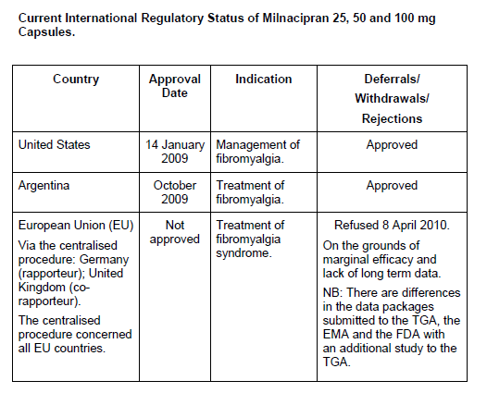

Product Information
The approved product information (PI) current at the time this AusPAR was prepared can be found as Attachment 1.

II. Quality findings

Drug substance (active ingredient)
The structure of the drug substance is shown in Figure 1.

Figure 1. Drug substance structure.
It is a racemic mixture of two of the four possible stereoisomers; specifically, a 1:1 mixture of the two Z (cis) isomers.
The drug substance is a crystalline powder, with no known polymorphs. It has a pKa of 9.65 and is freely soluble in aqueous buffers over the entire physiological pH range. The particle size of the active pharmaceutical ingredient (API) is not controlled.
The API specifications include a limit of 0.10% for each of two specified impurities and for any unspecified impurity. A limit of 0.1% is applied to ethanolamine, a reagent used during the synthesis of the drug substance. Due to concerns regarding the toxicity of ethanolamine, the proposed limit was referred to the Nonclinical Evaluation Section for advice.
Adequate stability data have been provided to support a retest period for the drug substance of 4 years with storage below 25°C.

Drug product
The three capsule strengths are direct scales.
The limit of 0.3% proposed for the major degradant exceeds the applicable the International Conference on Harmonisation (ICH) qualification threshold, and was referred to the Nonclinical Evaluation Section for advice.
The product shows excellent stability and a shelf life of 3 years with storage below 30°C has been established.

Bioavailability
The absolute bioavailability of an early capsule formulation (PF-C1) was shown to be about 86% (Study M038). Food was shown to have no significant effect on the rate or extent of absorption of the drug from the PF-C5 capsule proposed for registration (Study MLN-PK-04).
The PF-C5 registration formulation was used in all Phase III clinical studies apart from one safety study.
Study M115 assessed the pharmacokinetics of the individual enantiomers when they were given individually (as capsules containing either the D or the L enantiomer) or as the racemate. The area under the plasma concentration time curve (AUC) of the L enantiomer was significantly lower (by about 45%) than that of the D enantiomer but results were not affected by whether the enantiomers were given alone or together. When L-milnacipran was given together with the D enantiomer, its maximal plasma concentration (C_{max}) was lowered significantly (by about 16%). When given alone, the maximal plasma concentration (C_{max}) for L-milnacipran was similar to that for D-milnacipran.

Quality summary and conclusions
This application was considered at the 186th meeting of the Pharmaceutical Subcommittee of the Advisory Committee on Prescription medicines (ACPM) in May 2011. The PSC endorsed the questions that TGA had raised with the sponsor.
There were no objections in respect of Chemistry, Manufacturing and Controls to registration of this product. All issues raised during the initial evaluation of this application were satisfactorily resolved. This includes an adequate explanation for the apparent discrepancies in protein binding estimates between Studies M115 and M013. The sponsor concluded that the figure given in the PI (corresponding to 13% protein binding) based on Study M013 is the more accurate estimate.

III. Nonclinical findings

Introduction
Milnacipran has been studied since the early 1980s. A large number of studies of varying quality and a significant number that were not Good Laboratory Practice (GLP) compliant were submitted with the current Australian submission. However, sufficient recent good quality studies were available to address any deficiencies in the older studies. Pharmacokinetic studies were not available for a number of repeat dose and reproduction studies, although in some cases additional studies have been undertaken to address this issue.

Pharmacology

Primary pharmacodynamics

Mechanism of action and efficacy
Milnacipran is a specific inhibitor of both noradrenaline (NA) and serotonin (5-HT) reuptake systems. In this regard, it is similar to other SNRI compounds; however, its inhibitory action is more balanced between serotonin and noradrenalin than other SNRIs. In a range of animal studies, milnacipran activity was shown to involve the serotoninergic system but did not inhibit monoamine oxidase (MOA) activity in vivo. The proposed use of milnacipran for the treatment of fibromyalgia is based on demonstrating that it is both an effective NA/5-HT reuptake inhibitor, as well as having the ability to alleviate chronic pain and to minimise mood disorders and sleep disturbances.

In vitro / ex vivo studies
In vitro studies have confirmed the inhibitory action of milnacipran on the reuptake of NA and 5-HT in a variety of test systems, including hypothalamic slices with 50% inhibitory concentration (IC₅₀) values in the range of 10–100 nM for NA and 40–200 nM for 5-HT. The D enantiomer had similar or higher IC₅₀ values to the parent compound while the L enantiomer had lower IC₅₀ values. In rat brain cortex synaptosomes, repeated administration did not alter uptake or accumulation of NA or 5-HT, suggesting that tolerance did not develop during milnacipran treatment.

In vivo studies
None of the currently available animal models are considered predictive for the efficacy of compounds against fibromyalgia syndrome (FMS) in humans. The animal models therefore focus on demonstrating that the activity of milnacipran in vivo is consistent with the inhibition of noradrenaline and serotonin uptake as well as it being an active analgesic. In mice, milnacipran (0.3–2.5 mg/kg PO) and the D enantiomer antagonised hypothermia induced by oxotremorine (50% effective dose (ED₅₀) was ~0.8 mg/kg orally (PO)). Milnacipran (3 mg/kg PO) also prevented tetrabenazine induced palpebral ptosis in mice (ED₅₀ = 0.55 mg/kg PO) which did not alter with 5 days of treatment. Milnacipran also potentiated yohimbine toxicity in mice (ED₅₀ = 0.5 mg/kg PO), which did also not change with 5 days of treatment.
In a variety of rodent models of pain induction including the abdominal writhing test, L5 nerve ligation, tail clamp test, acetic acid-induced writing test, tail immersion test and the paw pressure test, milnacipran was shown to produce significant antinociceptive effects at dose levels between 3 and 100 mg/kg PO or between 2.5 and 10 mg/kg IP in rats. The available data support the proposed use of milnacipran.

Secondary pharmacodynamics
Secondary pharmacodynamic effects of milnacipran were examined in relation to alleviation of mood disorders and minimising effects on appetite and sleep deprivation. Milnacipran and the L enantiomer were effective in reducing immobility in the forced swim test (EC₅₀ ~10 mg/kg PO and ~3 mg/kg PO, respectively) compared with D enantiomer (EC₅₀ ≥100 mg/kg PO). Milnacipran was also effective in the learned helplessness test in rats and in the tail suspension test in mice. In relation to appetite, milnacipran did not suppress appetite following single (100 mg/kg PO) or repeated (30 mg/kg PO) administration to rats. In relation to sleep, milnacipran did not reduce paradoxical sleep in rats over 24 h compared with the TCA imipramine, and did also not significantly affect rapid eye movement (REM) sleep.

Safety pharmacology
A large number of safety pharmacology studies were conducted to examine the potential for central nervous system (CNS), cardiovascular, respiratory, renal and gastrointestinal effects. Not all of these studies were GLP compliant, however, there were sufficient GLP compliant studies to support the results reported. Toxicokinetic measurements were not made for these studies; approximate estimates of exposure relative to clinical exposure (below) have been based on separate pharmacokinetic studies within the current Australian submission.
In radioligand binding assays using tissues from different species (rat, guinea pig, human) involving 160 receptors, ion channels and transporters, milnacipran showed affinity only for NA and 5-HT transporters with inhibition of 92% and 100%, respectively. Milnacipran lacked affinity for α-adrenergic, β-adrenergic, muscarinic, histamine, dopamine and GABA-benzodiazepine receptors.
In vivo, CNS effects were measured in a primary observation study (Irwin test) in mice and rats: behaviour was modified at ≥30 mg/kg PO (approximately 10 times the clinical C_{max}). Motor coordination was affected at ED₅₀ values of 100 mg/kg PO (approximately 30 times the clinical C_{max}). In phenobarbitone induced narcosis in mice, sleeping time was increased at 30 mg/kg PO. In monkeys, there was reduced locomotor activity and restlessness at 75 mg/kg PO (>20 times the clinical C_{max}). There was no evidence of psychological dependence in monkeys after 0.5 mg/kg IV or any evidence of drug seeking behaviour after involuntary injections. There is a low potential for CNS related effects related to milnacipran treatment.
In relation to cardiovascular effects, significant inhibition of hERG channel activity was seen only at 30 µM (approximately 15 times the clinical exposure of 2 µM). Milnacipran produced an increase in blood pressure and a decrease in heart rate following intravenous (IV) administration to rats (0.3 mg/kg) and dogs (0.01 mg/kg). Similar effects were seen with the D enantiomer (reduced effects with the L enantiomer). In the monkey, milnacipran also increased blood pressure and reduced heart rate at 1 mg/kg IV. These effects are consistent with the pharmacological effects of milnacipran on inhibition of NA and 5-HT uptake and have been further examined following oral exposure in the repeat dose studies where no clinically significant effects were noted.
Milnacipran and its enantiomers caused a decrease in respiration (increase in carbon dioxide partial pressure (pCO2) and decreased pH) at 36 mg/kg IV. In monkeys, there were no changes in respiration rate or depth at 4 mg/kg IV.
In relation to renal effects, milnacipran increased sodium and water excretion but not potassium excretion after 5 mg/kg PO. Milnacipran did not reduce micturition cycle parameters in the rat bladder at 10 mg/kg IV. Gastrointestinal (GI) effects following oral administration in mice, rats and monkeys were restricted to a decrease in volume of gastric secretion (without a change to pH) at 2 mg/kg PO in rats (less than clinical exposure, based on AUC). There was no effect on gastric motility at doses up to 20 mg/kg IV in rats. In monkeys, endoscopy revealed no treatment related effects at 50 mg/kg PO (6 times the clinical AUC exposure).

Pharmacodynamic drug interactions
Interaction of milnacipran with compounds that affect the CNS were tested in mice using the rotarod test and the forced swim test. In the rotarod test, potentiation effects were only seen at ≥30 mg/kg PO (approximately 10 times the clinical C_{max}), mainly with tricyclics antidepressants. In the forced swim test, no potentiation effects were seen at 90 mg/kg PO with imipramine (>20 times the clinical C_{max}). Interactions with compounds that affect the cardiovascular system were tested in spontaneous hypertensive and normotensive rats and in guinea pigs. In rats, there was no evidence of potentiation in relation to blood pressure (BP) or heart rate (HR). In guinea pigs with digoxin induced ventricular tachyarrhythmias, milnacipran at 3 mg/kg and 10 mg/kg IP significantly lowered the digoxin dose necessary to induce extra systoles, ventricular tachyarrhythmias and cardiac arrest, indicating a possible interaction with heart glycosides. No pharmacokinetic data for guinea pigs were available for comparison with clinical exposures and this effect warrants further assessment in clinical studies. The Interactions with other medicines section of the draft PI contains a cautionary statement regarding concomitant use of digitalis (digoxin).

Pharmacokinetics
Nonclinical pharmacokinetic studies were conducted in the mouse, rat and monkey, with more limited studies in the rabbit and dog, to support the pharmacology and toxicity studies conducted in the mouse, rat and monkey.
Absorption of milnacipran following a single oral administration was rapid in all species: time to maximal plasma concentration (T_{max}) was reached in less than 1 h in mice, rats, dogs and rabbits, and after 2-4 h in monkeys. The rate of absorption was not affected by dose and the C_{max} and AUC were higher than dose proportional, suggesting saturable elimination. In the rat, absolute bioavailability was 61%, while in mice it was 50–60%, based on urinary radioactivity. The volume of distribution indicated significant tissue distribution. The plasma half-life (t _{½}) was rapid in all species (1.5–2.5 h). Similar pharmacokinetic parameters were observed with the D and L enantiomers. No gender differences were apparent.
Following repeat exposure, there was higher exposure in mice at Week 13 compared to Day 1 but there was no evidence of accumulation in rats over 27 days or in monkeys over 14 days. The D and L enantiomers showed similar results in rats over 28 days. Similar pharmacokinetics was observed in the 26 week carcinogenicity study in transgenic mice. In repeat dose studies with the major degradant F1612 (1-Phenyl-3-azabicyclo[3-1-0]hexane-2-one), absorption was rapid (T_{max} 0.5 h) and the C_{max} and AUC increases were greater than dose proportional.
Plasma protein binding was limited (15–26%), non saturable and similar between species, including humans. There was also similar distribution between red blood cells and plasma at all concentrations. Tissue distribution was rapid to a wide range of tissues, which declined by 0.5 h. Most persistent radioactivity was in melanin rich structures (uveal tract and skin).
The metabolism of milnacipran was limited and resulted in three metabolites detected in plasma and urine of mice, rats, monkeys and humans, namely N-desethyl milnacipran and the D- and L-milnacipran carbamoyl O-glucuronide. Distribution was qualitatively similar for all species, although the L glucuronide was more abundant in human plasma than in mouse and rat plasma. Summary information provided on in vitro studies with human hepatocytes or their microsomes indicated that biotransformation was slow but there was rapid transformation to the glucuronide upon the addition of uridine 5’-diphospho-glucuronic acid (UDPGA) and carbon dioxide. Further in vitro studies did not provide any evidence that milnacipran could significantly induce or inhibit cytochrome P450 enzymes.
Excretion of milnacipran was rapid with the majority of radioactivity excreted in urine within 24 h in all species including humans (93%). Excretion was predominantly as unchanged milnacipran. In humans, the % radioactivity excreted as glucuronides was higher than in other species. In rats, there was evidence of enterohepatic circulation of milnacipran or its metabolites.

Pharmacokinetic drug interactions
In vitro studies conducted with human hepatocytes or microsomes from human hepatocytes indicate that milnacipran neither induces nor inhibits cytochrome P450 enzymes (summary data only provided; details are provided in the clinical studies). This question has been examined further in vivo in the clinical studies.

Relative exposure
The systemic bioavailability of milnacipran has been studied in clinical trials. Exposure ratios have been calculated based on the animal/human AUC values and C_{max} values.

Toxicology
The acute toxicity of milnacipran has been examined in mice and rats by oral and IV routes. Systemic toxicity has been examined in mice, rats, dogs and monkeys by the oral route (mostly gavage). In mice, studies were up to 13 weeks, in rats up to 52 weeks, in dogs up to 4 weeks and in monkeys up to 52 weeks duration.

Acute toxicity
Milnacipran had moderate toxicity by the IV route in both the mouse and the rat. The oral toxicity was lower; by approximately 4 to 5 fold. The D and L enantiomer had similar oral toxicity. The milnacipran degradant F1612 had moderate toxicity by the IV route and low toxicity by the oral route. Signs were indicative of CNS toxicity.
Table 2. Plasma exposure comparisons. Repeat dose toxicity
Species | Study duration (weeks) | Dose  (mg/kg/day) | C_{max}  (ng/mL) | C_{max} Exposure ratioª | AUC_{0-24 h} (ng∙h/mL) | AUC Exposure ratioª
Mouse^{b} | 13 weeks | 100 | 1249 | 2.3 | 21378 | 3.2
Mouse^{b} | 13 weeks | 200 | 3423 | 6.3 | 51369 | 7.7
Mouse^{b} | 13 weeks | 400 | 8823 | 16 | 142292 | 21
Mouse^{b} | 13 weeks | 600 | 11696 | 22 | 185581 | 28
Mouse | 6 months | 25 | 4089 | 7.6 | 7329 | 1.1
Mouse | 6 months | 50 | 6115 | 11 | 17456 | 2.6
Mouse | 6 months | 125^{c} | 11995 | 22 | 49774 | 7.5
Rat | 4 weeks | 5 | 438 | 0.81 | 949 | 0.14
Rat | 4 weeks | 20^{d} | 1937 | 3.6 | 5498 | 0.83
Rat | 4 weeks | 80 | 6307 | 12 | 32968 | 5.0
Monkey | 14 days | 25e | 3710 | 6.9 | 27114 | 4.1
Monkey | 14 days | 45 | 5701 | 11 | 35245 | 5.3
Monkey | 14 days | 60 | 11857 | 22 | 88551 | 13
ª Margins based on human PK data (Study no. MLN-PK 01) at 100 mg bd: C_{max} = 539 ng/mL; AUC = 6650 ng·h/mL.
^{b} NOAEL was <100 mg/kg/day in corresponding 13-week toxicity study.
^{c} NOAEL based on gross pathology (no histopathology) and tumour incidence in carcinogenicity study in Tg.rasH2 mouse.
^{d} Comparison based on NOAEL of 35 mg/kg/day in 4-week study (T004) and NOAEL of 10 mg/kg/day in a 26-week study (T005).
^{e} Comparison based on NOAELs of 7.9, 15, 15 and 10 mg/kg/day in a 52 week, 26 week, 13 week and 4 week studies, respectively.
Table 3. Plasma exposure comparisons. Embryofetal development studies.
Species | Study | Dose (mg/kg/day)  PO (gavage) | C_{max}  ng/ml^{b} | C_{max} Exposure ratioª | AUC _{0-inf}  ng·h/ml^{b} | AUC Exposure ratioª
Mouse | Embryofetal toxicity | 5 | - |  | -
Mouse | Embryofetal toxicity | 25 | - |  | -
Mouse | Embryofetal toxicity | 125 | 12531 | 23.2 | 48255 | 7.3
Rabbit | Embryofetal toxicity | 5 | - |  | -
Rabbit | Embryofetal toxicity | 15 | - |  | -
Rabbit | Embryofetal toxicity | 60 | 4674 | 8.7 | 14956 | 2.2
ª Margins based on human PK data (Study no. MLN-PK 01) at 100 mg bd: C_{max} = 539 ng/mL; AUC = 6650 ng·h/mL.
^{b} Derived from separate TK study in NMRI mice and NZW rabbits (Section 11.1).

Repeat dose systemic toxicity
Repeat dose toxicity with milnacipran racemate mixture was examined in one mouse study (dietary dosing), in several rat and monkey studies (gavage dosing) and one dog study (gavage). Repeat dose toxicity with the separate D and L enantiomers was also examined in rats (gavage).
In rodents, the main effects observed were in the liver, including liver weight increases, changes in some clinical chemistry parameters and histopathological evidence of centrilobular hepatocellular hypertrophy at the higher dose levels. Bodyweight gain was also evident at the high dose levels. The D and L enantiomers produced qualitatively similar toxicity to the racemate, however, the effects were less severe with the L enantiomer. Relative weight changes in other organs were more sporadic and not consistently related to treatment. There were no other significant histopathological changes in rodent liver. The No Observable Adverse Effect Level (NOAEL) after 52 weeks gavage treatment was 3 mg/kg/day. The Lowest Observable Adverse Effect Level (LOAELs) for hepatocyte vacuolation and hypertrophy were 10 mg/kg/day (52 week study) and 35 mg/kg/day (26 week study) (approximately equivalent to the clinical exposure based on AUC). Hepatic changes were reversible in the 13 week dose range finding study during the recovery period.
In monkeys, treatment related vomiting and mydriasis was observed at the higher dose levels (>25 mg/kg/day) (4 and 7 times the clinical exposure based on AUC and C_{max}, respectively). Other treatment related effects included decreased bodyweight gain and increased relative liver weight; the latter was generally seen at animal/human exposure ratios (AUC) of approximately 5, with more severe changes (vacuolation, necrosis) only at very high exposures (AUC exposure ratios >25). Hepatic effects were reversible in the 13 week study during the recovery period. Potential cardiovascular effects were examined in monkeys with no evidence of treatment related changes in blood pressure or in electrocardiogram (ECG) parameters at 45 mg/kg/day (5 and 11 times the clinical exposure based on AUC and C_{max}, respectively). The CNS histopathological changes in the 13 week monkey study at 45 mg/kg/day were not observed in the 26 week and 2 week studies; the changes were graded very slight to slight and not considered to be of clinical significance.
A 28 day repeat dose study in mice on the degradant F1612 produced inflammation of the glandular stomach with a NOAEL of 15 mg/kg/day (AUC 1 µg.h/mL). There are no clinical kinetic data for F1612; assuming disposition similar to parent, the AUC at the maximum recommended human dose (MRHD) of milnacipran may be estimated as approximately 6650 ng.h/mL x 0.3% = 20 ng.h/mL, or one-fiftieth the mouse exposure at the NOAEL. A comparison based on mg/m² dosing gives an even greater margin.

Genotoxicity and carcinogenicity
Genotoxicity studies on milnacipran were conducted in vitro (bacterial gene mutation, mammalian gene mutation in mouse lymphoma cells, chromosome aberrations in Chinese hamster lung (CHL cells and human lymphocytes) and in vivo (micronucleus assay in mouse bone marrow) and gave negative results. Genotoxicity studies were also conducted on the degradant F1612 in vitro (bacterial gene mutation, mammalian gene mutation in mouse lymphoma cells, chromosome aberrations in human lymphocytes) and in vivo (micronucleus assay in mouse bone marrow) and gave negative results. The studies were conducted appropriately and were considered adequate to assess the potential genotoxicity of milnacipran and its degradant F1612.
Carcinogenicity studies were conducted in mice and rats via dietary administration. In mice, the 2 year study at doses up to 100 mg/kg/day produced no evidence of a treatment related increase in tumours. Kinetic data from a separate 13 week dietary study indicated exposures at 100 mg/kg/day of 3 times the clinical exposure based on AUC. However, a subsequent 13 week repeat dose dietary study in mice showed minimal bodyweight changes at 100 mg/kg/day, with reduced weight gains only apparent at ≥ 200 mg/kg/day, and therefore it is considered that the maximum tolerated dose had not been achieved in the 2 year study. A 26 week study was subsequently undertaken in TG.rasH2 transgenic mice, where there was no evidence of an increase in treatment related tumours at 125 mg/kg/day (7.5 times the clinical exposure based on AUC and 22 times the clinical exposure based on C_{max}). In rats, the 2 year carcinogenicity study at doses up to 50 mg/kg/day produced no evidence of a treatment related increase in tumours. No adequate kinetic data were available from this study.

Reproductive toxicity
Fertility was examined in Sprague-Dawley (SD) rats. Embryofetal development was examined in NRMI mice, SD and Wistar rats and in New Zealand White (NZW) rabbits, while peri- and postnatal development was examined in Wistar rats. Dose levels in rabbits were determined by an appropriate dose range finding study.
Placental transfer of milnacipran and/or its metabolites to the fetus was examined by a tissue distribution study in pregnant rats, rabbits and in one monkey. In all species, only a small fraction of the radioactivity crossed the placental barrier and it was subsequently eliminated. Evidence of excretion of milnacipran into milk was demonstrated by its presence in the stomach of newborn rats 1 h after administration to the dams. However, the amount was low compared to the administered dose, although not quantified.
There was no evidence of a treatment related effect on fertility in rats at PO doses up to 80 mg/kg/day (associated with maternal and paternal toxicity). No kinetic data were available in pregnant rats but from repeat dose gavage studies the exposure (AUC) at this dose was estimated to be approximately 5 times the clinical exposure. In embryofetal development studies, there was no evidence of a treatment related increase in visceral or skeletal variations or malformations in mice at dose levels up to 125 mg/kg/day (7 and 23 times the clinical exposure based on AUC and C_{max}, respectively), in rats at dose levels up to 60 mg/kg/day (approximately 4 and 9 times the clinical exposure based on AUC and C_{max}, respectively, from repeat dose studies) and in rabbits at dose levels up to 60 mg/kg/day (2 and 9 times the clinical exposure based on AUC and C_{max}, respectively); with exposure margins estimated from separate studies.
Peri and post natal development was examined in two studies in Wistar rats over two generations. The first study showed significant maternal toxicity at 20 and 80 mg/kg/day, accompanied by decreased pup survival at 4 days and evidence of developmental delays during lactation. The second study at lower dose levels, up to 5 mg/kg/day, produced maternal toxicity (reduced bodyweight gain) at 5 mg/kg/day but no effects on reproductive parameters, 4 day pup survival or development parameters. The observed effects on pups are most likely due to maternal toxicity at doses of 5 mg/kg/day and above although a direct effect of milnacipran cannot be excluded. The LOAEL of 20 mg/kg/day is approximately 1 and 3 times the clinical exposure based on AUC and C_{max}, respectively, in a separate 4 week repeat dose study.

Pregnancy categorisation
While there is no direct evidence for a treatment related effect on pup development, the available studies do not rule out this possibility at exposures which may be comparable to clinical exposure. The relative exposure could not be determined accurately in the absence of appropriate kinetic data. A cautious approach therefore justifies the use of Pregnancy Category B for milnacipran.
The sponsor has reported a neonatal risk after exposure during pregnancy with serotonin reuptake inhibitors. Signs include tachypnea, feeding difficulties, tremors, hypertonicity or hypotonia, sleeping disorders, and hyperexcitability. These signs are generally of short duration.
The above effects justify a pregnancy categorisation of B3 (also proposed by the sponsor).

Use in children
The indications for milnacipran do not include paediatric use; therefore no studies in juvenile animals were conducted.

Local tolerance, immunotoxicity, impurities, other studies
There was no evidence of sensitisation induced by milnacipran. Based on the results from the repeat dose toxicity studies, there was no evidence that milnacipran had a suppressive effect on the immune system.
In a study to examine the effects of pre treatment with milnacipran on mortality, there was no evidence of a self inducing effect by milnacipran.

F1612
There was an extensive range of studies conducted with F1612 per se in the current Australian submission, including a genotoxicity test battery and a 28 day repeat dose study in mice. The results of these studies have been discussed in the relevant sections above and did not raise any toxicological concerns. The proposed specification was acceptable.

Ethanolamine
The specification sought for ethanolamine is NMT 0.1% in the API. At the milnacipran MRHD of 200 mg/day (4 mg/kg/day in a 50 kg person), the maximum daily intake of this impurity would be 200 µg/day (4 µg/kg/day), if present at 0.1%. A Toxnet search on ethanolamine revealed there are limited data on which to assess its carcinogenic and genotoxic potential. International Agency for Research on Cancer (IARC) regards ethanolamine as a Group 3 substance (Not classifiable as to its carcinogenicity to humans). With regard to genotoxicity, a National Sanitation Foundation (NSF) International review concludes: “the weight of evidence suggests that ethanolamine has some genotoxic potential in vitro but no in vivo genotoxicity data were identified.” It is not positive in standard Ames assays but there is some limited evidence that it may be a weak inducer of chromosome breaks. The available data indicate that ethanolamine would not be classified as genotoxic in the standard test battery. There was therefore not sufficient concern to evaluate ethanolamine as a potential carcinogenic or genotoxic impurity. The impurity, ethanolamine, was considered qualified at the proposed level.

Benefit-risk assessment

Benefits
- Based on the pharmacology data, milnacipran is an effective and balanced NA/5-HT reuptake inhibitor both in vitro and in vivo.
- The in vivo animal data also indicated that milnacipran is effective in alleviating chronic pain while reducing mood disorders and minimising effects on appetite and sleep deprivation.
- Based on the nonclinical data, there is reasonable evidence that milnacipran will provide the benefits claimed.

Risks:
- There is potential for mild effects related to the pharmacological effects of milnacipran such as increased blood pressure and reduced heart rate.
- There is potential for milnacipran to interact with heart glycosides leading to arrhythmias and cardiac arrest.
- The potential for milnacipran to induce or inhibit cytochrome P450 enzymes has not been examined comprehensively in the nonclinical data.
- There is potential for hepatic effects, including hepatocellular vacuolation and/or hypertrophy following repeated use, given the low relative exposure between animal studies and clinical exposure.
- There is potential for treatment induced vomiting and mydriasis (pupil dilation), given the low relative exposure between animal studies and clinical exposure.
- There is potential for treatment related effects on postnatal development which have not been conclusively linked with maternal toxicity in the reproduction studies.
- While not identified in the nonclinical data, the sponsor has reported a neonatal risk after exposure during pregnancy with serotonin reuptake inhibitors.
On the basis of the currently available nonclinical data, the potential benefits of using milnacipran outweigh the potential risks. The clinical data will provide further clarification of the potential risk and potential benefits to humans.

Nonclinical summary and conclusions
- Primary pharmacodynamics studies were conducted both in vitro and in vivo. The in vitro studies confirm the inhibitory action of milnacipran on the reuptake of NA and 5-HT in a variety of test systems. The in vivo studies confirm that the activity of milnacipran is consistent with inhibition of NA and 5-HT reuptake as well as showing analgesic activity in animal models.
- Secondary pharmacology studies have examined the potential for milnacipran to alleviate mood disorders and to minimize the effects on appetite and sleep deprivation.
- Safety pharmacology studies have examined the potential for CNS, cardiovascular and renal effects. CNS effects were noted at relatively high exposure levels (≥10 times the clinical exposure) and were related to the pharmacological effects of milnacipran. Cardiovascular effects following IV administration included changes to blood pressure and reduced heart rate, consistent with the pharmacological effects of milnacipran. Relative exposure was difficult to assess and cardiovascular effects were further examined in repeat dose studies (see below). There were no clinically significant renal effects. Pharmacodynamic drug interaction was noted at high dose levels, mainly with tricyclics antidepressants. Noted also was the potential for milnacipran to interact with heart glycosides.
- Pharmacokinetics was examined mainly in the mouse, rat and monkey. Absorption was rapid in all species following oral administration, with C_{max} achieved in less than 1 h. Both C_{max} and AUC were higher than dose proportional and in rats the bioavailability was 61%. Tissue distribution was significant and excretion was rapid in all species. The pharmacokinetics was similar for the D and L enantiomer and no gender differences were apparent. There was no evidence of accumulation after repeat exposure. The major degradant F1612 showed similar kinetics. Metabolism of milnacipran was limited, with three metabolites detected in plasma and urine; desethyl milnacipran and D and L carbamoyl O-glucuronides. There was a similar metabolite profile in plasma and urine of animals and humans. There was no significant transformation of milnacipran by human hepatic microsomes or evidence that milnacipran could induce or inhibit cytochrome P450 enzymes. Radioactivity following dosing was excreted rapidly in urine, mainly as unchanged milnacipran.
- The general toxicity of milnacipran was examined after single and repeated exposure in mice and rats. Acute oral toxicity was low, with signs indicative of CNS toxicity. Repeat dose toxicity was examined mainly in rats and monkeys. In rats, the main effects were observed in the liver, with evidence of reversible hepatocellular vacuolation and hypertrophy at approximately the clinical exposure. In monkeys, there was treatment related vomiting and mydriasis and increased liver weight at exposures 4 to 5 times the clinical exposure. Cardiovascular effects (blood pressure and ECG) were not observed at 5 times the clinical exposure. A 28 day study on the degradant F1612 did not identify any clinically relevant effects.
- There was no evidence of genotoxicity in adequately conducted in vitro and in vivo studies on milnacipran and its degradant F1612. Carcinogenicity was examined in mice and rats following dietary administration. There was no evidence of a treatment related increase in tumours in mice or rats in long term dietary studies or in a 26 week study in TG.rasH2 transgenic mice. Respective exposures in mice and rats were 7.5 and 2 times the clinical exposure, respectively, based on AUC.
- Reproductive toxicity studies examined fertility, embryofetal development and peri and post natal development in rats and rabbits. A low level of placental transfer (unquantified) was demonstrated in a tissue distribution study in rats, rabbits and in one monkey. A low level (unquantified) of excretion of milnacipran into milk was also demonstrated. There was no evidence of a treatment related effect on fertility in rats at exposures 5 times the clinical exposure. There was no evidence of a treatment related increase in visceral or skeletal variations or malformations in mice, rats or rabbits (7, 4 and 2 times the clinical exposure, respectively). Treatment related postnatal developmental delays during lactation were noted in rats at dose levels close to the clinical exposure; although these were accompanied by clear maternal toxicity (particularly at higher dose levels) a direct effect of milnacipran cannot be excluded based on the current data. A pregnancy classification of B3 is recommended.
- Other studies provided no evidence of sensitisation by milnacipran, no evidence that milnacipran had a suppressive effect on the immune system and no evidence of a self inducing effect by milnacipran, based on examination of mortality.

Conclusions and recommendations

Nonclinical evidence for efficacy
Overall, the pharmacodynamic studies provided adequate evidence that milnacipran inhibits the reuptake of noradrenaline and serotonin. There was also reasonable evidence from the nonclinical studies that it can alleviate pain and minimize mood disorders and sleep disturbances, although these conclusions would need to be verified in the clinical studies.

Toxicological findings impacting on safety
The safety pharmacology studies identified some potential for adverse effects but there were largely related to the pharmacological effects of milnacipran. There is a reasonable margin between the exposure at which the CNS effects occurred and the clinical exposure. The potential cardiovascular effects observed in the safety pharmacology studies were not observed in the repeat dose toxicity studies in monkeys. There was evidence, however, of vomiting and mydriasis in monkeys at 4 times the clinical exposure. In rats, the major effects were on the liver, with hepatocellular hypertrophy observed at exposures similar to the clinical exposure. Although fully reversible upon cessation of treatment, these rat findings suggest that assessment of the clinical data for potential hepatotoxicity is warranted. There was no evidence of a treatment related increase in tumours in mice and rats. There was little evidence of treatment related reproductive effects, although in the rat study the delayed development in lactating pups could possibly be a direct treatment related effect, however, the cause is more likely to be maternal toxicity.
A cautious approach justifies a B pregnancy classification for milnacipran. This, together with the sponsor’s reported neonatal risk after exposure during pregnancy with serotonin reuptake inhibitors, justifies a B3 classification.

Benefit/ risk conclusion
On the basis of the currently available nonclinical data, the potential benefits for milnacipran outweigh the risks.

Hazard/risk analysis
The adverse effects observed with milnacipran are generally well characterised and can be related to its pharmacological activity. The effects observed on the liver are generally mild and reversible even though the exposure margin is small. There is potential for vomiting and mydriasis at exposure levels close to the clinical exposure. There is also a potential for increased blood pressure and reduced heart rate which are related to its pharmacological activity.
The potential for drug interactions with other antidepressants is well understood and needs to be examined in clinical studies. Also the potential for milnacipran to interact with heart glycosides needs to be examined in clinical studies.
Although the possibility of a direct effect of milnacipran on postnatal development cannot be excluded, it is likely that the effects observed were the result of maternal toxicity. Nevertheless, this, together with the sponsor reported potential for neonatal risk associated with serotonin reuptake inhibitors, warrants a discontinuation of use of milnacipran during pregnancy.

Conclusion
Based on the nonclinical data provided for milnacipran and evaluated in this report, the registration of milnacipran was supported.

IV. Clinical findings

Introduction
Nine fibromyalgia studies were submitted with the current Australian submission; three of these were considered pivotal. The current submission also included post-marketing data and published papers.
No concerns regarding Good Clinical Practice (GCP) or related regulatory and ethical requirements. Data completeness and protocol compliance were acceptable.

Pharmacokinetics
Milnacipran is a racemate of two enantiomers: F2695 and F2696. Both were tested and compared with milnacipran (racemate). F2695 had slightly higher potency than milnacipran, whereas F2696 was less potent or inactive.
The summary (mean ± SD) PK parameters of milnacipran in bioavailability and bioequivalence studies was presented in the sponsor’s current Australian submission.
There were seven in vitro studies, and 28 human pharmacokinetic (PK) studies. Study PK F2207 101 was a combined analysis of steady state PK data from 4 clinical studies done in healthy subjects (Study M37, Study M146, Study MLN-PK-01 and Study MLN-PK-10). There were two Genetic Polymorphism Studies (one in vivo).
There were also seven pharmaceutical bioavailability, bioequivalence and dissolution studies.

Summary of PK Studies
The key results of single and multiple dose studies in healthy subjects are summarized in Table 4 below.
Table 4. Summary (mean±SD) of milnacipran PK parameters in single and multiple dose studies in healthy subjects.
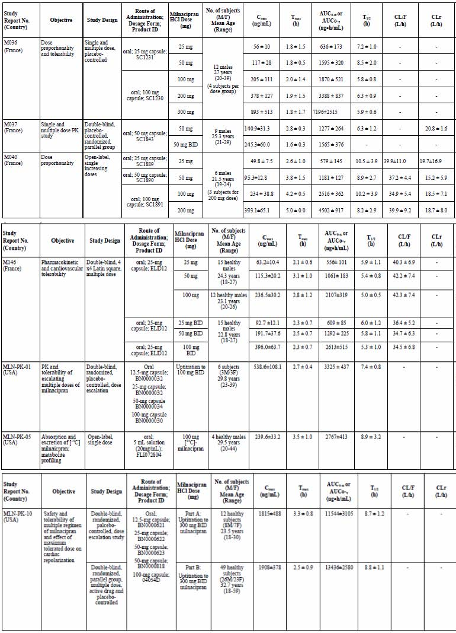
The PK/pharmacodynamic (PD) model that best described the data was a Maximum Effect (E_{max}) relationship. However, in many individual cases, the E_{max} plateau was not apparent at the measured concentrations, and only the linear part of the PK/PD curve could be determined.

Methods

Analytical methods
All the bioanalytical methods and quality control were utilized and/or developed, and then validated, in the nonclinical studies. PK and Absorption / Distribution / Metabolism / Excretion (ADME) studies were conducted using milnacipran (either [¹⁴C]-labelled or unlabelled form) and milnacipran enantiomers.
In studies using high performance liquid chromatography (HPLC) with fluorimetric detection or enantioselective gas chromatography with mass spectrometry method (GC/MS), milnacipran plasma concentrations were reported in terms of the hydrochloride salt, while in studies using elucidated using HPLC and tandem mass spectrometry (LC-MS/MS) methods, milnacipran plasma concentrations were expressed in terms of milnacipran freebase. Most results are presented in terms of the freebase. The conversion factor from milnacipran HCl (ng/mL) to milnacipran freebase (ng/mL) is 0.87.

Pharmacokinetic data analysis
Preliminary pharmacokinetics of milnacipran were first evaluated in vitro and then in healthy subjects after intravenous (IV) and oral administrations. A crossover design was used in the bioavailability studies.

Statistical analysis
Plasma concentrations and derived PK parameters were summarized using standard descriptive statistics. The relationships between the administered dose and the PK parameters were assessed using the power model of the linear mixed effects method, done on log transformed parameters. The 90% confidence interval calculated from the power model was compared to a reference interval calculated from the high/low dose ratio and bioequivalence limits (0.8 – 1.25).
Additional analyses were done in order to classify subjects as per the FDA Guidance Pharmacokinetics in Patients with Impaired Renal Function, 1998. The relationship between PK parameters and creatinine clearance was also explored. Statistical comparisons for PK parameters evaluating the effect of hepatic function on milnacipran single dose PKs were performed using an analysis of variance (ANOVA) model with study group as a factor.

Absorption
Milnacipran is rapidly absorbed following oral administration, with maximum plasma concentrations occurring at approximately 2 to 4 hours after dosing. Food had no effect on the rate of absorption and bioavailability of milnacipran (see Study MLNPK-04 and Study M039/M124). In most of the Phase I studies, milnacipran was administered with food because results from initial studies suggested this may improve gastrointestinal tolerability (Study M039/M124).

Bioavailability
Absolute bioavailability of milnacipran, determined by comparing IV and oral milnacipran 50 mg given as two 25 mg capsules (Study M038) is high (85% -90%). Absorption was rapid, T_{max} was 2 hours. Results are described in Table 5.
Table 5. Pharmacokinetic parameters (mean ±SD) of milnacipran.
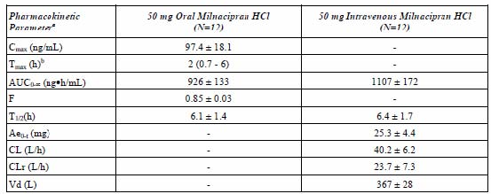

Bioequivalence
There were three bioequivalence studies (Study M048, Study M112 / M113, and M140, M141), total 97 subjects, comparing 2 capsule and 2 tablet formulations, 50-100 mg, with comparable bioequivalence demonstrated across the range of PK variables. Results are described in Table 6.
Table 6. Intersubject variability (%CV) for milnacipran in bioavailability/bioequivalence studies.
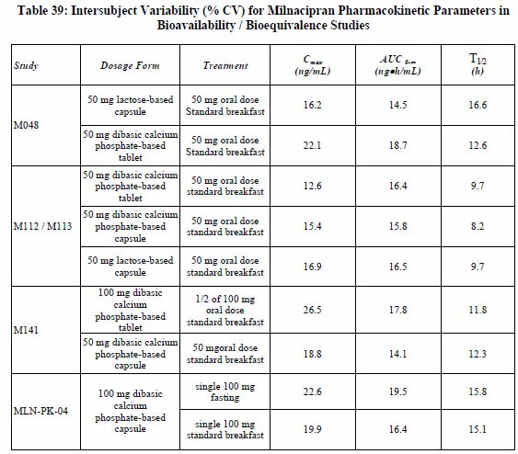

Influence of food
Concomitant food intake had no effect on the bioavailability of milnacipran (Study MLN-PK04).

Distribution
The mean volume of distribution of milnacipran is approximately 400 L and total plasma clearance is about 40 L/h. Plasma protein binding is minimal (13%) and not saturable in a very large concentration range (Study M013).
After oral administration the dose of milnacipran is predominantly excreted by the renal route (about 93%), with 55% of the dose eliminated in urine as unchanged drug. Some 19% of the dose was eliminated as milnacipran carbamoyl O-glucuronides and 8% as N-desethyl milnacipran.

Metabolism
There is some (45%) biotransformation. The metabolic pathway is predominantly a Phase II metabolism, producing milnacipran carbamoyl O-glucuronide compounds. N-desethyl milnacipran (F2800) is the only measurable Phase I metabolite.

Interconversion
The milnacipran enantiomers had very similar PK profiles. The D-enantiomer is eliminated more slowly than the L-enantiomer, with higher C_{max} and AUC values. The elimination half life (T_{1/2}) was approximately 9 h for D-milnacipran and 6 h for L-milnacipran. AUC_{0-∞} of D-milnacipran was about 85% greater than that of L-milnacipran. Plasma clearance was approximately 2 times greater for L-milnacipran than for D-milnacipran. The PK parameters of the individual enantiomer were not affected by whether they were administered separately or together as a racemate, with the same amount of each enantiomer excreted in the urine as unchanged compound. So no evidence of interconvertion or interaction with administered of the racemate (Study M115). Results are summarised in Table 7.
Table 7. Pharmacokinetic parameters (mean ±SD) of d-milnacipran and L-milnacipran following a single dose administration of 50 mg milnacipran HCl or 25 mg of each enantiomer.
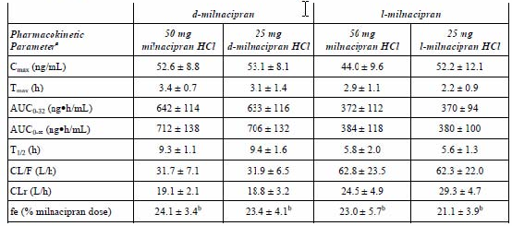

Pharmacokinetics of metabolites
Nonclinical studies had identified six milnacipran metabolites: F1567, F1612, F2782, F2800, F2941, and M3. Of these, only the para-hydroxy metabolite of milnacipran, F2782, inhibited NA and 5-HT uptake in vitro. F1612 was identified as a degradant of milnacipran rather than a metabolite. No human studies investigating the PK or PD effects of these metabolites were done.

Consequences of possible genetic polymorphism
There is no evidence of genetic polymorphism; there were no differences in steady state PKs of milnacipran when comparing poor and extensive metabolisers of cytochrome P450 (CYP) 2D6 and CYP2C19.

Elimination
Terminal elimination half-life (T_{1/2}) is 6 to 8 hours, supporting a twice daily administration.

Excretion
The CYPs involved in the Phase I metabolism of milnacipran were not studied “because of its low rate of biotransformation using various in vitro models (human hepatic microsomes, human hepatocytes and c-DNA cells over expressing the main human CYPs)”. Results from Studies PK07MXH1, XT083018, and BDM-00051 support this contention.

Dose proportionality and time dependency
Twice a day (bd) administration of milnacipran achieved steady state levels within 36 to 48 hours. As milnacipran PKs are time independent, multiple dose parameters were predicted from single dose data. Compared with a single dose, bd dosing leads to higher plasma levels of milnacipran at steady state (approximately 70% higher). PKs were dose proportional following multiple doses between 25 mg bd and 300 mg bd.
PK data from repeat dosing (Study M036) are shown in Table 8.
Table 8. Pharmacokinetic parameters (mean ±SD) of milnacipran following single oral increasing doses of milnacipran HCl.
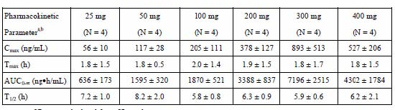
PK data for increasing single dosage (Study M040) are shown in Table 9.
Table 9. Pharmacokinetic parameters (mean ±SD) of milnacipran following single increasing oral doses of milnacipran HCl.
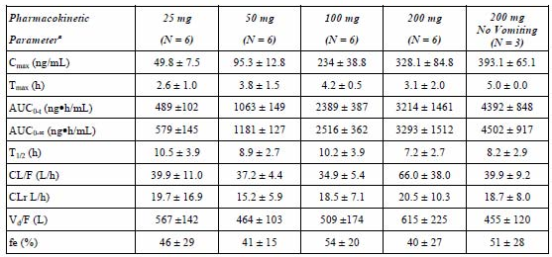

Intra and inter individual variability
Within and between subjects variability on PK parameters is low to moderate, and independent of the administered dose.

Pharmacokinetics in target population
Those with FM syndrome are typically female, middle aged and overweight. They may suffer higher rates of depression, migraine and other headaches. Co administration with other analgesics, and possibly antidepressants can be expected. Those with impaired renal function can be expected to have accumulation and possible increased plasma concentrations.
Nearly all of the PK studies were done in young healthy males. However, elderly patients and those with renal and liver impairment were adequately studied, and these populations did include a reasonable proportion of women (and including middle aged). The effects of co administered drugs were adequately studied.

Special populations

Children
No studies in children were submitted.

Elderly
After oral administration of milnacipran to elderly healthy subjects (aged >65 years), PK parameters Cmax, AUC and T_{1/2} were moderately higher compared with healthy young subjects. PK parameters of both D-milnacipran and L-milnacipran after multiple dosing were similarly affected, with a 31% and 38% increase in Cmax and a 27% and 39% increase in AUC, respectively. The differences were attributed to the reduced renal function of elderly subjects (see Study M042, an open label, single dose, 50 mg, study in elderly subjects, for which creatinine clearance (CrCL) ranged from 49 to 62 mL/min) PK parameters were summarized in Table 10.
Table 10. Pharmacokinetic parameters (mean ±SD) for milnacipran after single oral administration of 50 mg milnacipran HCl in elderly male and female subjects.
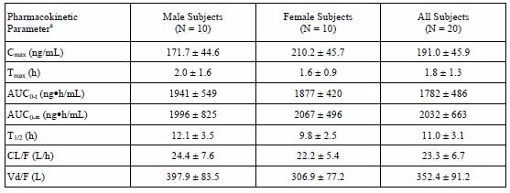
PK parameters of milnacipran indicated linear PK behaviour of milnacipran in the elderly with multiple dosing, with similar AUC_{0-∞} and AUC_{0-τ} values (Study M116; Figure 2 and Table 11).
Figure 2. Plasma concentrations (mean±SD) of d- and l-milnacipran following multiple oral doses of 50 mg bd milnacipran HCl in young and elderly subjects.
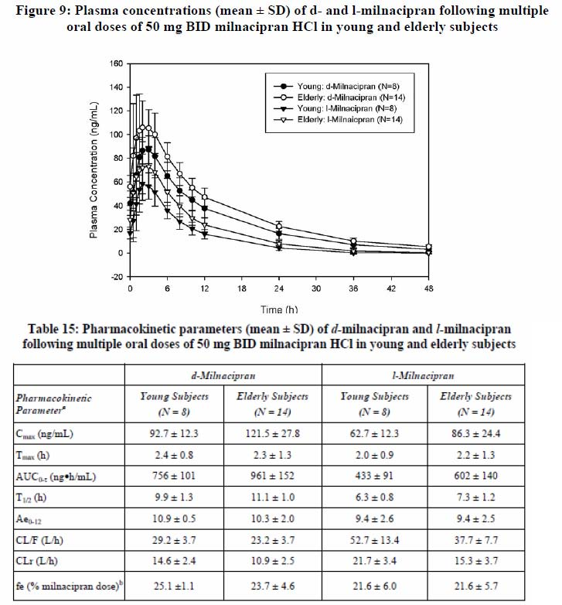
Table 11. Pharmacokinetic parameters (mean ±SD) of d-and l-milnacipran following multiple oral increasing doses of 50 mg bd milnacipran HCl in young and elderly subjects.

Gender
Female subjects had similar or perhaps slightly higher plasma exposure to milnacipran and a similar difference, ranging from 20% to 30%, in the PK parameters of both D-milnacipran and L-milnacipran.

Weight
PK was not specifically studied in obese subjects

Race
Study populations in the Phase III studies were representative of their respective geographical locations (mostly US and Europe), with no apparent racial differences reported. Around 51.0% were non Caucasian. No specific racial PK data were presented.

Impaired renal function
From Studies MLN-PK-02 and M045 (single oral dose, 50 mg), the renal clearance of milnacipran is reduced proportionally to the reduction of the creatinine clearance. This reduction in milnacipran clearance leads to higher plasma exposure, 16%, 52% and 199% in mild, moderate and severe renal impairment, respectively. No dosage adjustment is considered necessary for patients with mild and moderate renal impairment.

Impaired hepatic function
From Studies MLN-PK-11 and M046 (single oral dose, 50 mg), the PKs of milnacipran is not significantly affected by liver impairment. Absolute bioavailability was 90% for control subjects and about 110% for subjects with hepatic impairment. Following IV administration and relative to control group, mean AUC_{0-∞}increased by 13% and 31% in Child-Pugh Groups B and C, respectively relative to control. Total plasma clearance decreased by 7% and 20% in the moderate and severe groups, respectively. Subjects with severe hepatic impairment had a 31% higher AUC and a 55% higher T_{1/2} than healthy subjects.
Milnacipran undergoes minimal Phase I metabolism, with the majority of the dose excreted in urine as unchanged drug or glucuronide conjugates. The potential for interactions with drugs that are substrates, inhibitors or inducers of CYP isoenzymes is considered to be low.

Evaluator's overall comments on pharmacokinetics in special populations
Whilst FM is a disease of (mainly) middle aged women, most of the PK data are derived from young healthy males. Nevertheless there are sufficient age/sex data to exclude meaningful departures for the PKs in the FM population. There are no PK data for children.
Caution should be exercised in elderly subjects and dosage adjustment is required in those with severely impaired renal function (say, creatinine clearance <30 mL/min).

Interactions

In vitro
There is little if any effect of milnacipran on inducible CYP activities (CYP1A2, CYP2B6, CYP2C8, CYP2C9, CYP2C19 and CYP3A4/5), so very unlikely to be a clinically relevant inducer of CYP isoenzyme activities. The 50% inhibitory concentration (IC₅₀) of milnacipran on the activity of CYP isoenzymes in pooled human hepatic microsomes was at least 25 times higher than C_{max} following 100 mg bd milnacipran.

In vivo
In nonclinical studies, milnacipran PKs were not affected by the co administration of known Phase I isoenzymes inducers (such as carbamazepine) or inhibitors (levomepromazine, clomipramine, fluoxetine) or by the co administration of alcohol.
There were no PK interactions with potentially co-administered cardiovascular (digoxin, warfarin) and CNS (lorazepam) drugs or the renal excretion of lithium.
Human studies were largely consistent with these findings. Investigations of potential drug-drug interactions for lithium (Study M125), levomepromazine (Study M126), carbamazepine (Study 130), lorazepam (Study M138), clomipramine (Study M213), fluoxetine (Study 212) and amitryptiline (Study M217 [+alcohol]), all done in young healthy adults, revealed minimal interactions that could lead to clinical effects.
In Study M167, testing the effect of alcohol ingestion on amitryptiline-milnacipran interaction, in which all subjects achieved blood alcohol levels in the 0.5 – 0.7 g/L there were no significant effects on a psychometric test, or PK parameters of milnacipran or amitriptyline with or without concomitant administration of a single dose of alcohol. The 90% confidence intervals (Cis) for milnacipran and F2800 PK parameters (Cmax, AUC and trough plasma concentration (Cmin)) with co administration of alcohol were within the equivalence limits of 80% -125% indicating no effect of alcohol on the PK of milnacipran (racemate and individual enantiomers) or its F2800 metabolite.
The evaluator believed that potential selective serotonin reuptake inhibitors (SSRI) interaction is of particularly relevance. Study 212, which investigated the effect of decreasing concentrations of fluoxetine from steady state levels on the PKs of milnacipran, for switching from fluoxetine treatment to milnacipran, found no evidence of adverse effects or intolerance and no effect on the PK of milnacipran. This has direct clinical relevance because it is likely that FM patients are receiving SSRI therapy or have ceased SSRI for their condition (FM) or related condition (depression).
No studies testing interactions with tramadol were done. This is relevant to the proposed clinical indication for which tramadol may be co administered. In view of the lack of data, tramadol should be contraindicated.

Exposure relevant for safety evaluation
There is minimal (15%) biotransformation of milnacipran. It is not a clinically relevant inducer or inhibitor of CYP450 isoenzymes activities. Milnacipran has modest (25%) protein binding to albumin, and negligible (9%) to alpha1-glycoprotein.
Milnacipran has linear, dose proportional PKs over the dose range of 25 mg to 300 mg. For a single 50 mg dose the C_{max} is about 100 ng/mL ; this ranges up to 400 ng/mL for a 200 mg dose. All subjects who received the single 400 mg dose vomited and two of the subjects who received the 300 mg dose vomited (Study M036); this gives some indication of the C_{max} at which a lack of tolerability occurs with a single oral dose: around 850 ng/mL. Repeat dose studies were done with dose escalation and these indicated a dose of up to 300 mg/day (with a C_{max} of around 1900 ng/mL) was tolerated.
Steady state plasma milnacipran levels are reached within 1 to 2 days. Steady state C_{max} was about 1.5 times higher than C_{max} following single dose administration. Multiple daily (given bd) doses of 50 mg, 100 mg, and 200 mg resulted in a C_{max} of 100, 200 and 400 ng/mL. Dose proportionality is mildly lost at 300 mg, where C_{max} deviated by 22% (Study PK F2207 1 01).
C_{max} and AUC_{0-∞} values were approximately 35-60% higher in the elderly subjects. As stated above, these increases are most likely due to decreased renal function. Mean C_{max} and AUC_{0-∞} values increased in subjects with renal impairment compared to healthy subjects, by 12% and 16% respectively in mild impairment, by 26% and 52% in moderate impairment and by 59% and 199% in severe renal impairment. The mean T_{1/2} was increased by 38%, 41%, and 122% in subjects with mild, moderate, and severe renal impairment, respectively. The decreases in mean total clearance in the renal impaired groups compared with the healthy subjects were 14%, 28%, and 65% for subjects with mild, moderate, and severe renal impairment, respectively.
The AUC_{0-∞} is around 1000 ng.h/mL for milnacipran 100 mg/day, and 3000 ng.h/mL for 200 mg/day.
There were no PK data for co administered tramadol.

Evaluator’s overall conclusions on pharmacokinetics
Milnacipran has high oral biovailability, undergoes some biotransformation without CYP variability, has minimal stereospecificity, is excreted by the kidneys (mostly unchanged drug) and has dose proportional pharmacokinetics.
The evaluator’s main concerns related to hypotension,tachycardia and the potential to cause ventricular arrhythmias. The PKs of milnacipran, with the exception of tramadol co-administration, have been adequately studied in humans. The variance in the PK estimates in young healthy adults is small and there are modest changes seen in special populations and with co administration of cardiovascular and psychotropic drugs. The major issue lies with accumulation in impaired renal function.
The PK information provided in the sponsor’s draft Australian Product Information document is supported by the study program data.

Pharmacodynamics

Introduction
There were 19 PD or PK/PD human studies.
A key PK/PD study investigating the effect of milnacipran 100 mg bd on sensitivity to stimulus evoked pain in patients with FM (Study F02207 GE 2 04), included functional Magnetic Resonance Imaging (fMRI) neuroimaging, compared milnacipran 200 mg/day with placebo on pain perception and changes in pain evoked brain activity. It was a Phase II, multicentre, double blind, randomised trial enrolling 92 FM patients. Patients with a minimum average baseline Visual analogue scale (VAS) pain score of ≥40 were randomised to treatment with placebo or milnacipran 200 mg/day bd (1:1). Patients entered a 3 week dose escalation phase followed by a 9 week stable dose treatment period. Milnacipran induced a 5.2-mm VAS downward shift of the mean S-R curve from the placebo curve over the entire panel of applied pressures (p=0.11). With probable significant improvements in analgesia in FM patients with milnacipran and fMRI evidence of relevant central (brain) effects, this study formed the basis of the Phase III program.

Mechanism of action
The main underlying pathophysiological mechanism underlying FM is believed to be dysfunctional pain processing in the central nervous system and/or decreased pain inhibition within the spinal cord mediated by serotoninergic and noradrenergic descending pathways.

Noradrenaline and serotonin effects
Measurement of NA and 5-HT reuptake cannot be directly made in humans. Indirect methods, using ³H-serotonin uptake in platelets (using blood samples from humans), fMRI and known cardiovascular changes, were done to characterise such drug effects.
The pharmacodynamic action of milnacipran was first confirmed in human studies (Studies C001, 002, 003), with a dose dependent inhibition of [³H] 5-HT reuptake by normal platelets following incubation with plasma from milnacipran treated subjects with single dose (25-400 mg) and multiple dose (25-200 mg bd) administration of milnacipran. Maximum inhibition of 5-HT reuptake averaged 57% at 50 mg bd, 84% at 100 mg bd, and 91% at 200 mg bd (Study C001). The IC₅₀ value for inhibition of 5-HT reuptake was 61.8 nmol/L.
There were dose related effects on nausea and vomiting but none on cognitive or psychomotor functioning. Dose related changes were also identified in the cardiovascular and fMRI studies (see below).

Primary pharmacology
The human platelet studies showed that single or multiple doses of milnacipran in the dose range 50-200 mg bd inhibited serotonin reuptake in a dose dependent fashion (Study C001, Study C002, and Study C003). Similar, consistent results were obtained for inhibition of NA reuptake when using plasma from milnacipran treated subjects in rat brain tissue (Study C001, Study C002, and Study C003 ).
There was no evidence of serotonin syndrome at any dose tested. Some cardiovascular adverse effects were observed, and these were dose-dependent (see below).
Tolerability becomes questionable in doses greater than 300 mg/day, at least in single-dose studies.

Secondary pharmacology

Cardiovascular (CV) effects of milnacipran
It is expected that inhibition of 5-HT and NA reuptake inhibition will increase blood pressure and heart rate. After single oral administration of 50 and 100 mg milnacipran to healthy volunteers, increases in systolic and diastolic blood pressure (BP) generally peaked between 2 to 4 hours post dose (corresponding to Tmax). An increased heart rate (HR) peaked around 4 to 6 hours, indicating possible hysteresis relative to peak plasma concentration. BP and HR changes following single oral dose administration of milnacipran are presented in Table 12.
Table 12. BP and HR changes.
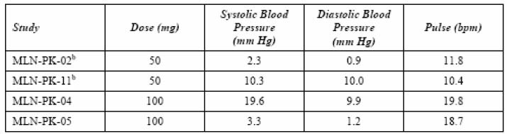
The increased BP seen in the CV studies were generally small and not dose related. A large increase from baseline was observed following administration of 100 mg milnacipran in Study MLN-PK-04. However, in two other studies, the observed increases in BP from baseline were small, both following administration of 50 mg (Study MLN-PK-02, N = 8) and 100 mg (Study MLN-PK-05, N = 20) doses. Changes from baseline in pulse were greater for the 100 mg dose than the 50 mg dose.
Following repeated administration, the increases in BP tended to decrease over time. This effect was more prominent in elderly subjects.
Nonclinical studies suggested that milnacipran may delay cardiac repolarisation (prolonging QTc) and increase ventricular arrhythmias; perhaps similar to tricyclic antidepressants. Doses of milnacipran 3 to 6 times higher than the therapeutic dose for FM were shown not to cause QTc prolongation (Study MLN-PK-10). There was no evidence of arrhythmogenicity.

Cognitive and psychomotor effects
The treatment of depression and FM with tricyclic antidepressants is limited by the psychomotor and cognitive effects seen with their use. As expected from the absence of receptor interactions with milnacipran shown in vitro, no significant effects of milnacipran on psychomotor and cognitive measures were found in healthy volunteers (Study C015, Study C029, Study C197, Study C221, and Study F2207 95 GE103). Alertness as measured by critical flicker fusion tests, was perhaps improved with milnacipran treatment (Study C029). In addition, milnacipran (50 mg bd) reduced the sedative effects of levomepromazine (15 mg bd) (Study C221).
The effect of milnacipran/alcohol co-administration on driver’s neurosensorial alertness were evaluated (Study C205 and Study F2207 95 GE 103). Overall milnacipran did not have a significant effect on psychomotor and cognitive measures. In fact, milnacipran had a tendency to increase alertness and to decrease the effects of co administered sedative drugs, at least in one study (Study C197).
A trend for improved quality of sleep and easiness to get to sleep was observed following single oral administration of milnacipran (25 mg, 50 mg, and 100 mg) in Study C015. No effect on sleep was observed in Study C029 or Study C197 (50 mg bd milnacipran for 7 days).

Dry mouth
The sensation of dry mouth has been associated with milnacipran treatment in numerous studies and in clinical practice. This effect which is normally due to anticholinergic activity is in the case of milnacipran the result of noradrenergic stimulation. Direct measurement of saliva production in human volunteers, rather than evaluation of the subjective sensation of dry mouth, found that milnacipran had a tendency to increase salivation compared to placebo, while amitriptyline decreased the secretion as expected (Study C012).

Gastrointestinal tolerability of milnacipran
The incidence of nausea and vomiting was dose related, being higher after a single oral dose of 100 mg milnacipran than for the 50 mg dose. Increase in milnacipran dose from 50 mg to 100 mg had a greater impact on the incidence of vomiting than nausea, with vomiting rates increasing from about 10% to 58%. Nausea rates were high at 50 mg milnacipran (around 50%). The increase in dose to 100 mg only led to a small increase in nausea rates. Food appeared to reduce the rates of nausea and vomiting and delay the onset of these adverse events (Study MLN-PK-04).
Repeated administration with progressive increase of the dose improved gastrointestinal tolerability. This allowed the use of higher doses (Study C241 [M146]).

Biochemistry
No significant effects on blood chemistry or the hormonal profile were seen following either single or repeated dose studies (see Study C016).

Relationship between plasma concentration and effect
Study GE 204 was a randomised, double blind, placebo controlled, 12-week Phase II exploratory study using stimulus response curve and fMRI analyses. The dose was 100 mg bd. Although PK data were not collected in this study, comparable dose studies would suggest that steady-state C_{max} of 400 ng/mL, and AUC_{0-∞} 3000 ng.h/mL.
At Week 12, there was a 5.2 mm VAS downward shift of the milnacipran mean S-R curve from the placebo curve over the entire panel of applied pressures, that is, from pain threshold to pain tolerance threshold (p=0.11). Considering the exploratory nature of the trial (not powered to detect a difference) and the relative small analysable sample size (n = 74), this result is compatible with a clinically relevant effect of milnacipran in decreasing FM patients’ sensitivity to evoked pain. This led to the Phase III study program (see below).

Pharmacodynamic interactions with other medicinal products or substances
The sponsor has conducted several pharmacodynamic interaction studies using a combination of central nervous system and cardiovascular system drugs in animals. In the rotarod test in mice, only the highest dose of 30 mg/kg PO potentiated the effects of pentobarbital and haloperidol. No effect was observed with ethanol, diazepam, fluoxetine, imipramine, levomepromazine, clomipramine, prazosin, clonidine, propranolol, nifedipine, or quinidine (in rats).
Importantly however, in a model of digoxin induced ventricular tachyarrhythmias in anaesthetised guinea pigs, milnacipran at 3 and 10 mg/kg IV, significantly lowered the digoxin dose that produced extra systoles, ventricular tachyarrhythmia and cardiac arrest. The sponsor noted that the digoxin doses used in this study were in the toxicological range.
However there was no apparent interaction between milnacipran and digoxin at therapeutic levels of both compounds in a study with healthy volunteers receiving digoxin (MLN-PK08).
Co administration of milnacipran with alcohol did not result in any potentiation of the psychomotor effects of alcohol (Study M167 and Study C205).
Switching between clomipramine and milnacipran did not induce a serotonin syndrome or affect PKs (Study M213).

Genetic differences in pharmacodynamic response
There were no differences in the PK characteristics of 50 mg bd milnacipran in subjects who were poor metabolisers of sparteine (CYP2D6 deficiency) or mephenytoin (CYP2C19 deficiency) compared with extensive metabolisers of these cytochrome P450 enzymes (Study M244). The various models representing the activity of cytochrome P450 enzymes, namely sparteine (CYP2D6), mephenytoin (CYP2C19), caffeine (CYP1As2), and endogenous 6b-hydroxycortisol excretion (CYP3A4) were unaffected by milnacipran 50 mg bd (Study M244).

Evaluator’s overall conclusions on pharmacodynamics
When considering the nonclinical studies that included the PK study results of near linear dose proportionality, modest effects of age and renal function, HR and BP effects, tolerability, and the (expected) EC₅₀ required, the likely safe and effective dose is 50 to 200 mg per day. Results from the Phase I and II studies suggested that dose escalation could avoid some of the more common adverse effects (nausea, vomiting and headache). Co administration with food may also help.
The definitive PD study was Study GE 204, a 12 week Phase II exploratory trial in FM patients using pain sensitivity and fMRI to characterise pain pathways/responsiveness. The strong indication of an improvement in pain (a 5.2-mm VAS downward shift in pain sensitivity) with milnacipran over the entire panel of applied pressures supported the likely potential analgesic efficacy of this drug.
Dose ranging studies were minimal and a comprehensive dose response curve analysis could not be undertaken. This is not unreasonable given the coherent information provided from the nonclinical and PK studies. It is appropriate that the dose range 50-400 mg were tested and it is most likely that a dose of 100-200 mg/day will provide the best balance of efficacy and safety.
The sponsor’s Clinical Overview is an accurate representation of the drug development program. It failed to highlight some of the potentially relevant toxicology and adverse effects. These include haemodynamic effects (HR, BP), effects on cardiac repolarisation (QTc) and arrhythmias, nausea and vomiting, headache and the difficulty of single drug therapy to be able to control the important symptoms of a syndrome (FM).
Special populations were adequately studied. These included the elderly, those with renal and hepatic impairment and those with depression. There is no evidence of genetic polymorphism or racial PK differences.
The critical issues include the actual analgesic efficacy in a broader group of FM patients, its acceptability/tolerability of the drug in view of its adverse effect profile in the early PK/PD studies, particularly in the elderly and those with renal impairment, those patients on (other) analgesic therapies, antidepressant medication, antihypertensive and other cardiovascular medications and an incomplete knowledge of its safety profile. The answers to these critical issues require Phase III studies. FM is a chronic disease/syndrome with variable manifestations, therefore long term studies were required.

Efficacy

Introduction
The clinical efficacy studies were placebo controlled. This is acceptable given that there are no approved drug treatments for FM in Australia although expert FM guidelines include the following ‘evidence-based’ treatments: tricyclics antidepressants (TCAs) (amitryptiline), pregabalin, and tramadol,.
Milnacipran is approved as an antidepressant in some European Union (EU) countries and Japan. Milnacipran has been approved for the treatment of FM in the USA but the European Medicines Agency (EMA) rejected the submission in 2009 due to marginal efficacy and lack of long term data in the European population concluding that the benefits did not outweigh the risks of treatment.
FM is a syndrome, defined by criteria from the American College of Rheumatology (ACR) in 1990. FM is defined as widespread musculoskeletal pain for more than 3 months involving all four quadrants of the body as well as the axial skeleton and the presence of ≥11 out of 18 tender points on examination. The ACR diagnostic criteria are widely used in epidemiological studies and clinical trials and were adopted in all of the submitted studies. FM is common, has high levels of disability and responds poorly to existing treatments.
Nine studies were performed in outpatients with FM. Patients were aged 18-70 years and both male and females were eligible for inclusion. Patient populations were similar across all studies. FM patients with major depression at the screening visit were mostly excluded from the clinical trials.
Three pivotal efficacy studies were submitted: MLN-MD-02, GE 302 and MLN-MD-03. The primary objective of these randomised, double blind, placebo controlled, Phase III studies was to evaluate the safety and efficacy of milnacipran relative to placebo for 3 months in the treatment of FM. But because FM is a chronic condition, one 6 month and several extension studies were done: Study MLN-MD-04 (the extension to Study MLN-MD-02), Study GE 304 (the extension to Study GE 302), and Study FMS 034 (the extension to Study FMS 031).
The supportive randomised, double blind, placebo controlled Phase III study FMS 031 provides some additional safety and efficacy data compared to placebo over 6 months.
Two randomised, double blind placebo controlled Phase II studies are also included in the Efficacy section (Study FMS 021 and Study GE 204). Study GE 204 was outlined above (Phase II, PD section). The objective of Study FMS 021 (Phase II) was to characterize the effect of milnacipran administered either once daily (qd) or twice daily (bd) in the treatment of FM. An independent meta-analysis of most of these studies has recently been published.
Table 13. Summary of clinical efficacy studies.
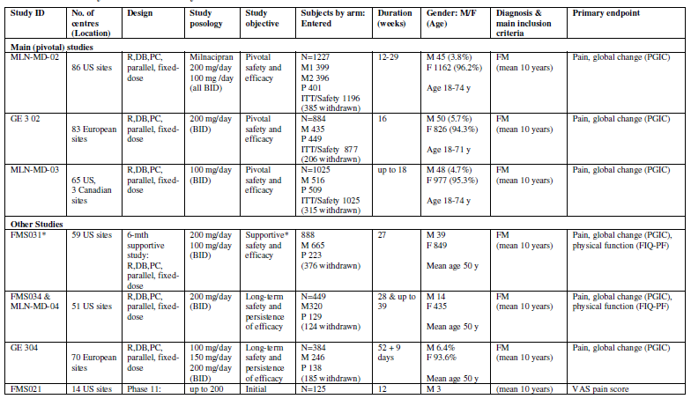
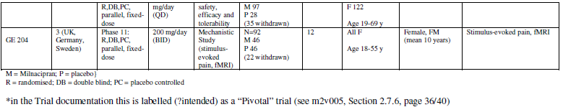

Dose response studies
The PK/PD studies indicated that a dose range of 50 to 200 mg per day was likely to be required to achieve efficacy.
Study MLN-MD-02 (Pivotal) compared milnacipran 100 mg and 200 mg with placebo. Study GE 304 (Supportive) evaluated milnacipran 100 mg, 150 mg, and 200 mg with placebo. Study FMS 024 (Supportive) evaluated milnacipran 100 mg and 200 mg, with placebo.
FMS 021 ( a supportive study) was the most complete analysis of dose responsiveness. It was a randomised, double blind, placebo controlled, 12 week study, using patient self reported pain scores as the primary endpoint recorded on an electronic diary. Patients allocated to the active group were started on a dose of 25 mg/day and this was increased over weeks to a maximum dose of 400 mg/day if tolerated. Treatment with milnacipran bd (flexible dose of 50-100mg bd) resulted in greater improvement in pain compared with placebo. The improvement in weekly recall pain at endpoint achieved statistical significance (p = 0.025) for random prompt pain and daily pain. In addition, both milnacipran treatment groups (flexible dosages of 100 and 200mg/day given once daily (qd) or divided dose (bd) showed a statistically significant difference (p = 0.017 for the bd dose group and p = 0.03 for the qd dose group) compared with the placebo group in mean final score for the Patient Global Impression of Change (PGIC). The milnacipran 100 mg bd group reported greater pain relief than the milnacipran 200 mg qd group. The difference between milnacipran bd and qd was greater than the difference between placebo and milnacipran qd.

Main (pivotal) studies
There were three pivotal studies:
- Study MLN-MD-02: A Phase III Pivotal, Multicenter, Double Blind, Randomised, Placebo-Controlled Monotherapy Study of Milnacipran for Treatment of Fibromyalgia
- GE 302: A European Phase III, Multicentre, Double-Blind, Randomised, Placebo-Controlled, Monotherapy Study of Milnacipran for the Treatment of the Fibromyalgia Syndrome
- MLN-MD-03: A Phase III, Pivotal, Multicenter, Double-blind, Randomised, Placebo-Controlled Monotherapy Study of Milnacipran for the Treatment of Fibromyalgia
In addition, another study (MLN-MD-02/FMS 031) is labelled as ‘pivotal’ but was not submitted or summarised by the sponsor. This latter study does however use comparable methods and has results consistent with that of the three submitted pivotal studies; it had included subjects with a Beck Depression Inventory (BDI) >25 (potentially severe depression) and those with an Fibromyalgia Impact Questionnaire Physical Function (FIQ-PF) <4 (milder FM).
Several amendments were made to each study, largely based on results from Study FMS-031 and in consultation with the FDA. These were acceptable.
All Phase III studies were done in accordance with ethical principles and GCP. Protocol specified inclusion/exclusion criteria conformed to current regulatory and ethical guidelines.

Objectives
For each of the pivotal studies, the primary outcome measure was a clinically important reduction in daily pain scores and improvement in perceived pain relief. A dose range of 100 mg/day to 200 mg/day (as bd) was compared with placebo after 3 months of treatment.

Study participants
All the Phase III studies included adults aged 18 to 70 years with an ACR-guided diagnosis of FM. The average duration of symptom was around 10 years in each study. Nearly all studies required at least moderate daily pain, using a baseline average visual analogue scale (VAS) pain score greater than 40 for inclusion. The patients included in each of the clinical studies reflect the general FM population.
Patients were required to withdraw from central nervous system (CNS) active therapies for FM and discontinue non pharmacological treatments for FM; current major depressive episode was ruled out using the Mini International Neuropsychiatric Interview (MINI).
Exclusion criteria included severe depression (except Study MFMS-031), suicide ideation, cardiovascular disease, active renal or hepatic disease, autoimmune disease, prostatism(males) and genitourinary disorders, and current drug therapies that included digoxin, steroids (prednisolone >10 mg/day), SSRI and TCAs and antiepileptics.
The studies allowed stable doses of aspirin, paracetamol and NSAIDs. Hydrocodone was used for rescue medication.

Treatments
Patients entered a 2 week baseline, then a 3 to 6 week dose escalation period and then received placebo or active drug, 100 mg or 200 mg daily. All randomised medications (placebo and milnacipran) were administered orally twice a day. All patients were scheduled to receive a total of 12 weeks of treatment after the 3 weeks of the dose escalation phase, for a total of 1518 weeks of drug exposure.
Study MLN-MD-02 was a multicentre, randomised, double blind, placebo controlled, three arm parallel group study to investigate the safety and efficacy of milnacipran 200 mg/day and 100 mg/day by mouth (PO) in patients with FM conducted at 86 study centres in the USA. Eligible patients were randomised to either placebo or 100 mg/day or 200 mg/day of milnacipran (1:1:1), bd dosing. Patients who successfully completed this study were eligible to join an extension study (MLN— MD-04) for up to 39 weeks of placebo controlled treatment.
Study GE 302 was a multicentre, randomised, double blind, placebo controlled, two arm parallel group study to investigate the safety and efficacy of milnacipran 200 mg/day in patients with FM conducted at 83 active sites in 13 European countries. The study featured a 4 week dose escalation phase, a 12-week fixed dose period and a 9 day down titration period, for a total of 17 weeks (+ 2 days) of drug exposure. Patients who successfully completed this study were eligible to join an extension study (GE3-04) for one year of additional treatment.
Study MLN-MD-03 was a multicentre, randomised, double blind, placebo controlled, two arm parallel-group study to investigate the safety and efficacy of milnacipran 100 mg/day in patients with FM conducted at 68 sites in North America. Patients received up to 12 weeks of treatment after a 4 to 6-week dose escalation phase, for a total of up to 18 weeks of drug exposure. The stable dose phase was then followed by a 2 week re-randomised discontinuation phase. At Visit TX12, milnacipran treated patients were re-randomised so that 50% were abruptly discontinued from milnacipran therapy and treated with placebo for the final two weeks of the study in a blinded fashion to assess durability of efficacy and possible withdrawal effects. Patients who successfully completed this double blind study were eligible to enter an extension Study (MLN-MD-06).

Outcomes/endpoints
Patients were required to complete electronic assessments on a patient experience diary (PED), as well as additional assessments that were completed either on paper or by means of an electronic device specifically designed for the completion of site-based patient questionnaires.

Efficacy
In each of the pivotal studies the primary response criterion was a composite of pain (PED24h-Recall) and the PGIC. These are optimal measures for response to treatment for the pain of FM. During the study, patients were asked to rate their average level of pain over the last 24 hours (PED 24 h-Recall Pain) every morning, using a 100 unit VAS, for which 0 = “no pain” to 100 = “worst possible pain”. The PGIC was done at the weekly visits, using a 7 point Likert scale: “Since the start of the study, overall my fibromyalgia is:”
- very much improved
- much improved
- minimally improved
- no change
- minimally worse
- much worse
- very much worse
The Pain VAS and global ratings of analgesic response and satisfaction with care are widely used, established and validated in pain conditions. They are recommended by the IMMPACT (consensus from an international expert pain management group) for use in chronic pain clinical trials. It is widely accepted that a demonstration of at least a 30% reduction in pain VAS intensity is needed before concluding that a clinically important response to treatment has occurred. A similarly important change in PGIC is considered to be a response of “very much improved” and “much improved”. The PGIC has been shown to discriminate treatment effect in FM.
In many of the studies a secondary analysis was done on the rate of “responders” to treatment. This was defined as a satisfactory amount of follow up data, a meaningful change in the Pain VAS and PGIC, and without co administration of strong analgesics. This is useful and aids clinical interpretation of the studies. A number needed to treat (NNT) can then be readily calculated.

Secondary efficacy parameters
Numerous secondary parameters were evaluated, consistent with the typical symptoms of FM. Change on fatigue (using MFI), sleep disturbance (using MOS sleep and the refreshing sleep VAS), the “impact of fibromyalgia” (using the FIQ), physical functioning (using SF-36 Physical Component Summary (PCS)), emotional functioning (SF-36 Mental Component Summary MCS), cognition (using Multiple Ability Self-Report Questionnaire (MASQ)), mood (using BDI), and morning stiffness (using a subscale of the FIQ) were recorded.
These are helpful secondary measures of response to treatment for the distress and functional impairment associated with FM.

Sample size
A sample size estimation was provided for each study, and these were acceptable. In each pivotal study a response rate for placebo was expected to be about 20%, and milnacipran about 30%, using the composite endpoint for pain. This required about 350-500 patients per treatment group, for ≥80% (for MLN-MD-02) or ≥90% power, alpha 0.05.

Randomisation
All were stratified by site, 1:1:1 random allocation for the first study and 1:1 for the latter two.

Blinding (masking)
All were double blind, matched placebo controlled.

Statistical methods
All patients that received at least one dose of double blind study medication were included in the Efficacy and Safety populations, and analysed as treated (intent-to-treat (ITT)). All statistical tests were two sided hypothesis tests performed at the 5% level of significance. All confidence intervals were two sided 95% CIs.
The proportion of responders with treatment for the pain of FM was analysed using a logistic regression model with treatment group and baseline pain score (and sometimes baseline SF36-PCS) score as explanatory variables. A sequential, gate keeping, multiple comparisons procedure was used to control the overall Type I error for comparisons of two dosages of milnacipran used in Study MLN-MD-02. Logistic regression model on the responder rate on the primary composite criterion with baseline pain score as covariate and treatment as fixed factor. FIQ total score change from baseline to V8-Week 16: analysis of variance with covariate (ANCOVA) with baseline value as covariate and treatment and country as fixed factors.
Missing data are not uncommon in pain studies, particularly when conducted over several months. Data imputation is required and there is no universally agreed method of this. Several methods were included in the studies including the last observation carried forward (LOCF) technique. In addition, FM is a chronic condition and the study participants are likely to have tried many therapies in the past without success. FM has a substantial subjective and emotional component, and the variety of secondary symptoms may confound detection of drug related adverse effects. Self-rating scores are likely to be overlooked in a more than 15 week long study. The study protocols incorporated appropriate methods for (missing) data imputation and sensitivity analyses. All analyses were ITT.

Recruitment
Patients who met the 1990 American College of Rheumatology criteria for FM were eligible for enrolment. There was a washout period for antidepressants, benzodiazepines etcetera followed by a baseline measurement period before randomisation to Groups.

Conduct of the study
Several amendments were made to each study, largely based on results from Study FMS-031 and in consultation with the FDA. These were acceptable.

Baseline data
There were comparable demographic characteristics, duration of FM (typically 10 years) and depression scores (BDI) in each of the studies.

Numbers analysed
A total of 1540 patients were randomised to active treatment and 1359 patients were randomised to placebo in the pivotal studies. A total of 3098 were included in the Safety and ITT Populations. Patient flow is summarised in Figures 3-5.

Figure 3. Participant flow: MLN-MD-02

Figure 4.
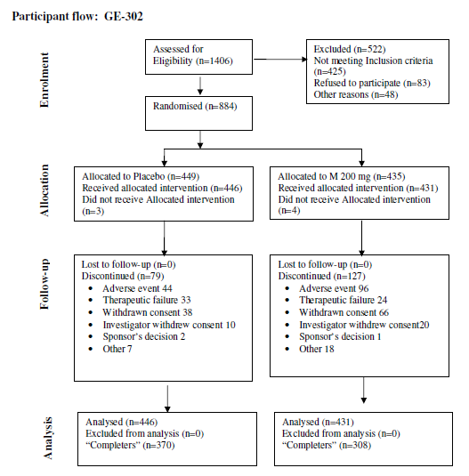
Figure 5.
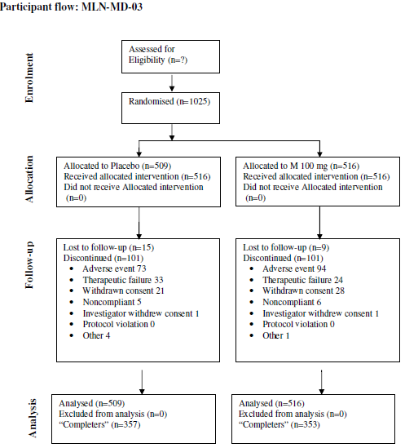

Follow up
Results of the composite responder analyses (Pain + PGIC) for the pivotal studies are presented in Table 14 and Figure 6 using different methods of missing data imputation. Treatment with milnacipran (both 100 mg/day and 200 mg/day) resulted in a statistically and clinically meaningful significant increase in the number of responders relative to placebo at the 3 month landmark for the management of FM.
Using the LOCF approach, the composite response rate varies from 23.2% to 29.5% in the milnacipran 100 mg/day group and from 24% to 25.4% in the milnacipran 200 mg/day group, compared with 14.2% to 18.2% for placebo.
The sponsor reports odds ratios (OR) for response rates (which will over rate the risk ratio somewhat): OR 1.9 for 200 mg/day in GE 302, OR 1.6 and 1.8 for doses 100 mg/day and 200 mg/day in MLN-MD-02 and OR 1.9 for the dose 100 mg/day in MD-03. The sponsor included another interpretation using the percentages of response observed, being 67.8% for 200 mg/day in GE 302, 43.2% and 56.8% for 100 mg/day and 200 mg/day in MLN-MD-02, and 62.1% for 100 mg/day in MD-03. There was no evidence of dose heterogeneity across the studies (p=0.46 for 100 mg/day, and p=0.74 for 200 mg/day).
For ‘completers’, the composite response rate varies from 32.4% to 39.4% in the milnacipran 100 mg/day group and from 31.5% to 35.8% in the milnacipran 200 mg/day group. Other sensitivity analyses confirmed these relative effects.
Table 14. response on composite criterion (Pain/PGIC) on valid evaluations on PED by study-Description by Approaches.
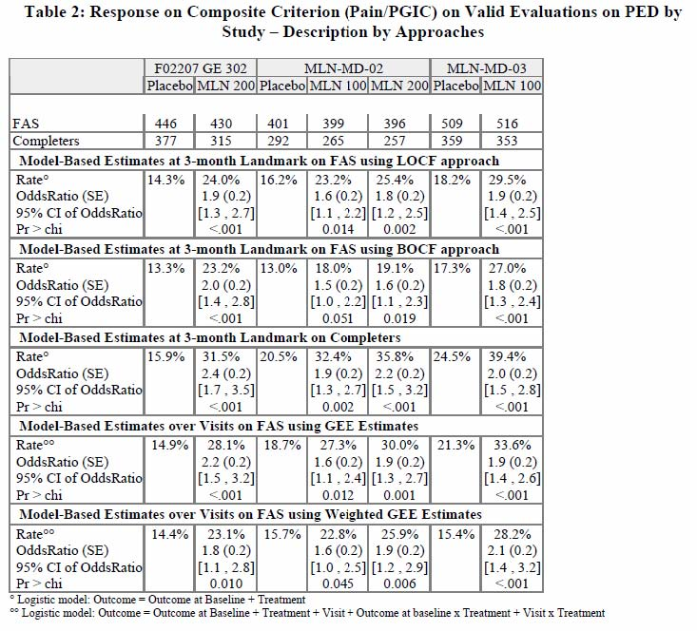
Figure 6. Study MLN-MD-02
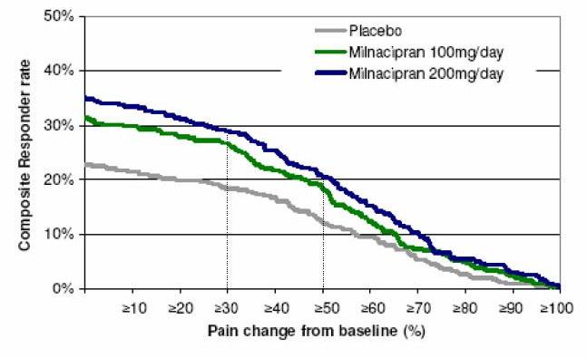
The percentage of patients in Study GE 302 achieving various degrees of improvement in pain from baseline to the 3 month landmark who also rated themselves as very much improved or much improved on the PGIC is presented in Figure 7.

Figure 7. Study GE-302.
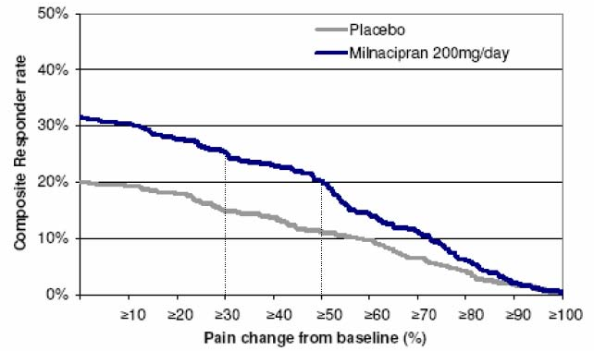
The percentage of patients in Study MLN-MD-03 achieving various degrees of improvement in pain from baseline to the 3 month landmark who also rated themselves as very much improved or much improved on the PGIC is presented graphically in Figure 8.
Figure 8. Study MLN-MD-03
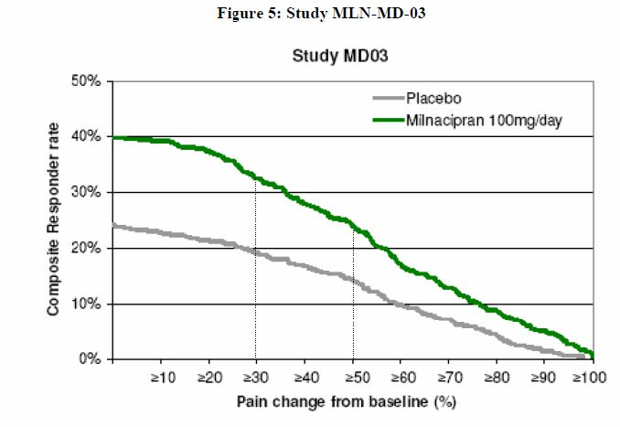
Analyses of PGIC response, based on a rating of 1 or 2 (“very much improved” or “much improved”), shows a significant effect between milnacipran and placebo in all pivotal studies. The percentage of responders was around 40% for milnacipran 100-200 mg/day, compared with a 25% responder rate with placebo. The responder rate was higher (50%) in ‘completers’.
The application makes the point that the higher response rate observed for PGIC relative to the composite criterion response rate reflects the global improvement obtained with milnacipran and a global improvement in patients with improvement in pain less than 30%. They suggest that FM patient may feel better with, for example, 20% improvement of pain and/or by an additional effect on the other symptoms of FM (such as fatigue). The evaluator did not think the first proposition is supported by previous literature exploring the relationship between changes in pain scores and clinically important reductions in pain (as perceived by the patient) and so overstates the modest effect sizes. Numerous studies illustrate that a ‘clinically important’ reduction in pain intensity requires at least a 30-50% decrease in pain score,, . Using such a guide, the milnacipran and placebo responder rates are about 30% and 15-20%, respectively. Thus, there is an absolute risk reduction of around 10-15%, so an NNT of between 6 and 10. The second proposition is reasonable and has some support given the improvements seen in secondary endpoints such as quality of life (QoL) and fatigue.
Treatment with either dose of milnacipran reduced fatigue at 3 months, with a score separation of milnacipran and placebo in the range 1.5-2.0. The difference is statistically significant for the milnacipran 100 mg/day group (p=0.029 in MLN-MD-02 and p=0.046 in MLN-MD-03), for the milnacipran 200 mg/day group in GE 302 (p=0.008) and approaches significance for the milnacipran 200 mg/day group in MLN-MD-02. This effect size is clinically important.
Sleep was assessed by the Medical Outcomes Study (MOS) sleep problems index. Treatment with either dose of milnacipran did not show any impact on sleep when using this index. However in Study GE 302 patients were asked to complete a weekly VAS measurement when asked “is your sleep refreshing?” At the 3 month landmark milnacipran appeared to improve this endpoint, with a separation of 4.2 over placebo (p=0.009). This suggests a beneficial effect of milnacipran on refreshing sleep. This is one of several sleep endpoints analysed and this is the only result (and only study) that was significantly different. It remains an uncertain benefit.
Measures of fatigue, fibromyalgia impact and quality of life generally favoured milnacipran (MLN). These were statistically significant for the FIQ total score, the SF-36 PCS (except for MLN 200g/d in MLN-MD 02), and SF-36 MCS (except for both MLN groups in MLNMD02). It was not statistically significant for MASQ (except in Study GE 302).
Persistence of efficacy was demonstrated in several extension studies; FMS 031, FMS 034, MLN-MD-04 and GE 304.
When applying the Uniform program analysis (PGIC = 1,2 instead of PGIC = 1,2,3) methodology used for all pivotal studies, at 6 months the composite response rates were 25.6% in the milnacipran 200 mg/day group (p =0.034) and 25.9% in the 100 mg/day group, compared with 18.4% for placebo. Using ITT, the difference in absolute risk suggests a NNT of 13 for long term treatment.
Patients who remained on therapy for the full 6 months had composite responder rates (using an OC approach) of 45.2% of patients in the milnacipran 200 mg/day treatment group and 43.8% of patients in the 100 mg/day treatment group, compared with 27.9% on placebo.
In Study MLN-MD-02, a total of 38.3% (458/1196) of the population completed 29 weeks of treatment, and a further 19.6% (234/1196) completed a variable duration of additional treatment before being terminated administratively. The differences between both 100 mg/day and 200 mg/day milnacipran treatment groups and placebo were statistically significant for the majority of comparisons at both 15 weeks and 29 weeks. There was little change in response in 24 hour recall pain and PGIC between Weeks 15 and 29, demonstrating that the benefit of treatment was sustained over time.

Ancillary analyses
The statistically significant improvements in the primary efficacy endpoints were reinforced by improvements in several secondary endpoints related to fatigue, function and aspects of quality of life in both dose groups in all pivotal studies. In Study GE 302, an improvement in refreshing sleep with milnacipran was shown. P values were not corrected for multiple comparisons.

Clinical studies in special populations

Gender
The ITT FAS study population were mostly female; 95.4% (2954/3097). No statistically significant treatment group by sex interactions were found (p = 0.43 for dose 100 mg/day and p=0.86 for dose 200 mg/day). Owing to the predominance of females in the study sample, which is representative of the population of patients with FM, there is sparse data supporting efficacy (and safety) in males. The lack of a treatment sex interaction limits such a concern.

Age
The mean age of patients in the pooled studies (FAS Population) was about 50 years; 18.3% were between 18 and 40 years, 75.5% between 40 and 65 and only 6.2% were more than 65 years. No treatment group by age interactions were noted for the treatment of FM (p = 0.77 and p =0.59 for the 100 mg/day and 200 mg/day milnacipran treatment groups, respectively). These results indicate that milnacipran is efficacious in both younger and older patients.

BMI
The FM population is generally overweight. The mean BMI score of patients in the pooled studies (ITT FAS Population) was 29.6 kg/m²; 28.2% with a BMI <25, 30.2% between 25 and 30 and 41.5% with a BMI ≥30. No treatment treatment group by BMI score groups interactions were found (p = 0.81 and p =0.19 for the 100 mg/day and 200 mg/day milnacipran groups, respectively). These results indicate that treatment with milnacipran 100mg/day or 200 mg/day is efficacious across the range of body mass index.

Depression
Depression is a common condition in FM. A BDI score of 0 to 9 is considered normal; scores of 18 to 29 are indicative of moderate to severe depression, and scores of 30 or higher indicate severe depression. The McGill illness narrative interview (MINI) was used to exclude patients with a major depressive episode and a baseline BDI >25 was added as an exclusion criterion during the development plan. The mean BDI score of patients in the pooled studies ITT FAS Population was 11.3; 18.4% patients had a BDI ≥18. There was no treatment by BDI interaction (p = 0.65 and p =0.44 for the 100 mg/day and 200 mg/day milnacipran groups, respectively). The response seen across the range of baseline BDI scores demonstrates that the beneficial effect of milnacipran on FM is not due only to the antidepressant effects of milnacipran.

Analysis performed across trials (pooled analyses and meta-analysis)
Formal pooled analyses were not provided but the results of each of the pivotal and supporting studies were consistent and apparently homogenous. Composite response rates in the extension studies were similarly homogeneous. Several meta analyses have subsequently been published.

Supportive studies
Several supportive studies were done, largely to demonstrate sustained (≥6 months) efficacy of milnacipran at dosages of both 100 and 200 mg/day:
Study FMS031 was a Phase III, multicenter, randomised, double blind, placebo controlled, three arm, parallel group study to investigate the safety and efficacy of 100 mg/day and milnacipran 200 mg/day in patients with FM. Patients were treated orally with study drug (milnacipran or placebo) for a total of 27 weeks (3 weeks in a Dose Escalation phase and 24 weeks in a Stable Dose period). Eligible patients were randomised to placebo, or to 100 mg or 200 mg daily doses of milnacipran (1:1:2), bd dosing. A total of 888 patients were randomised, all were included in the Safety and ITT FAS population. Analgesic benefit was partly demonstrated (Table 15). The study results have borderline p values for the ITT analysis at 3 and 6 months, slightly more definitive at the higher dose, 200 mg/day. Although the OC (‘completers’) analysis reports a larger effect size and clearly significant p values, this ignores the dropouts and missing data. Nevertheless, the main purpose of the study was to evaluate longer term treatment and there does not appear to be any evidence of loss of effect in such circumstances.
Table 15. FMS 031: Summary of composite responder rates at 3 and 6 months.
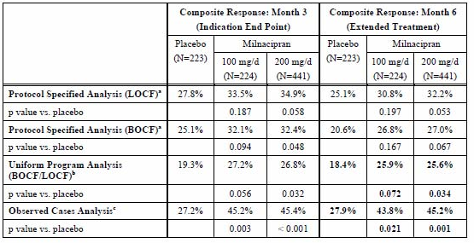
Study MLN-MD-04 was a Phase III, randomised, double blind, 2 arm, multicentre extension study of MLNMD-02. Patients who entered Study MLN-MD-04 received up to 39 weeks of milnacipran therapy. The study consisted of two milnacipran treatment groups: 100 mg/day (50 mg bd) and 200 mg/day (100 mg bd). No patients experienced dose reduction from their final dose in lead in Study MLN-MD-02. Patients who received 200 mg/day in MLNMD-02 continued to receive 200 mg/day in Study MLN-MD-04. Patients who had received either placebo or 100 mg/day of milnacipran during Study MLN-MD-02 were randomised in a ratio of 1:4 to either 100 mg/day or 200 mg/day of milnacipran in this extension study. To maintain blinding integrity, sham escalations were performed if no actual dose escalation occurred. The primary efficacy parameters in Study MLN-MD-04 were the changes from baseline in VAS assessments of daily and weekly pain recall, FIQ total score; and the PGIC.
A total of 384 patients were enrolled, of whom 32.3% (124/384) discontinued prematurely. The main reason for discontinuation was an adverse event (AE) (18.0%), see Safety section below. Treatment with milnacipran 100 mg/day or 200 mg/day for up to 39 weeks maintained the beneficial effects observed in lead in Study MLN-MD-02 in pain assessment, PGIC, and physical function (measured by FIQ total score). These results are consistent with Study FMS031, but also confirm a high dropout rate because of AEs.
Study FMS034 was a Phase III, randomised, double blind, multicentre extension study to investigate the long term safety and efficacy of milnacipran included patients who successfully completed Study FMS031. Patients received up to 28 weeks of milnacipran therapy. The study consisted of two milnacipran treatment groups: 100 mg/day (50 mg bd) and 200 mg/day (100mg bd). Patients who received 200 mg/day in lead in Study FMS031 continued to receive 200 mg/day in Study FMS034. Patients who received either placebo or 100 mg/day of milnacipran during Study FMS031 were randomised in a ratio of 1:4 to either 100 mg/day or 200 mg/day of milnacipran in Study FMS034. Similar sham escalations were done. The primary efficacy parameters in Study FMS034 were the changes from baseline in VAS assessments of daily and weekly pain recall, FIQ total score, and the PGIC.
A total of 449 patients were enrolled. Treatment with milnacipran for 28 weeks maintained the beneficial effects in pain assessment, PGIC, and global impact of the condition (measured by FIQ total score).
Results for pain are depicted in Figure 9 (note the Y axis does begin at zero [no pain]). The sponsor interpreted the findings as follows: patients on placebo during the first part of the study and randomised to 200 mg showed a significant reduction in their baseline pain scores, those maintained on milnacipran 200 mg maintained an analgesic benefit, and in those converted from 100 mg/day during the first part to a dose of 200 mg/day during the extension induced a further reduction in pain score. The evaluator agreed that the degree of pain control is maintained for up to 6 months. But the effect size, the % reduction in pain when switching from placebo to milnacipran 200 mg/day, is around 20%. This indicates borderline efficacy when using the guideline of 30% reduction in pain score being the minimal clinically important difference.
Figure 9. 24 h pain VAS during the extension study.
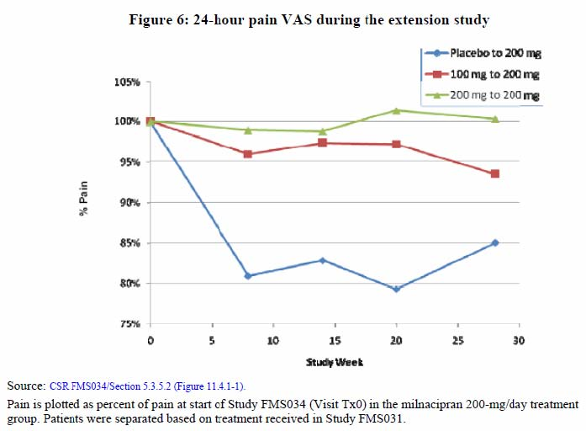
In Study GE304 a total of 468 patients were randomised from lead-in Study GE 302 into this extension study, all of whom were included in the Safety and ITT FAS populations. The primary efficacy parameters in Study GE304 were the VAS paper and the PGIC. Treatment with milnacipran 100 mg/day, 150 mg/day or 200 mg/day for 52 weeks maintained the beneficial effects observed in lead-in Study GE 302 in PGIC response and pain assessment (Figure 10).

Figure 10. GE 304 Durability of milnacipran treatment effect on pain.
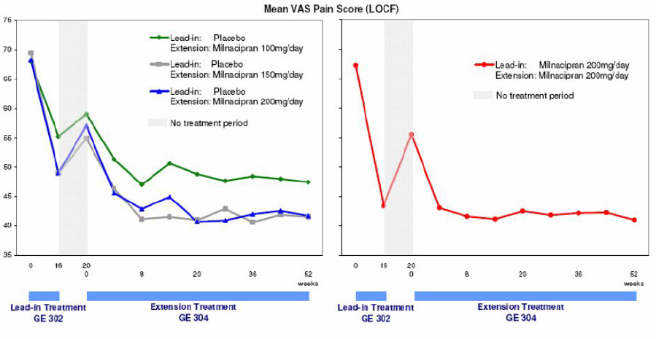
This long term extension study shows the beneficial effect of milnacipran in FM and the maintenance of this effect over a 1 year period. The pattern of pain scores suggests benefit from the lower doses, 100 mg/day or 150 mg/day. These data are more compelling than the previous studies; the change in pain scores in the group transferring from placebo to milnacipran 200 mg/day was from 68 (of 100 mm scale) to around 40 – a 28 mm (41%) difference is a clinically important reduction in pain intensity. But this effect is diluted to some extent when appreciating that the placebo group had a reduction in pain of about 32% (regression to the mean and/or improvement in underlying condition?).
Study FMS021 was a Phase II, multicenter, randomised, double blind, placebo controlled study comparing two dosing regimens of milnacipran (flexible dose to a maximum of 200 mg/day administered qd or bd) with placebo in patients with FM at 14 study sites in the US. Eligible patients were randomised to treatment with milnacipran administered either bd or qd or to placebo (1.5:1.5:1). A total of 125 patients were randomised, all of whom were included in the Safety and ITT FAS population. Patients randomised to active treatment received 25 mg of milnacipran in one (25 mg qd) or two (12.5mg bd) daily doses during Week 1 of this flexible dose study. If the dose was tolerated, it was increased to a total daily dose of 50 mg for Week 2, 100 mg for Week 3 and 200 mg for Week 4 (or matching placebo). If the dose was not tolerated, it was lowered to the previous week’s dose and maintained at that dose for the remainder of the study. Patients continued to take their maximum tolerated dose for an additional 8 weeks so that patients who completed the dose escalation and the treatment and observation phases of the study received a total of 12 weeks of study drug. Patients received 8 weeks of treatment at their maximum tolerated dose after the 4 week dose escalation period for a total of 12 weeks of drug exposure.
Milnacipran 100 and 200 mg/day (as bd) led to greater improvement in recall pain compared with placebo (p=0.025). Both milnacipran treatment groups (100 and 200mg/day given as qd or bd) were significantly different (p= .017 for the bd dose, and p=0.03 for the qd dose) compared with the placebo group in mean final score for the PGIC.
Study GE 204 was briefly outlined in the PD section. This Phase II, multicentre, randomised, double blind, placebo controlled, two arm parallel group study investigated the safety and efficacy on stimulus evoked pain of milnacipran 200 mg/day in patients with FM conducted at 3 study centres in Europe. Eligible patients were randomised to treatment with milnacipran 200mg/day or to placebo (1:1). All patients were scheduled to receive a total of 13 weeks of milnacipran exposure (3 week dose escalation phase, a 9 week fixed dose period and 9 day down titration phase). Experimental pain testing was performed at a neutral body site (thumbnail) at baseline and at Week 12. fMRI scans were performed at baseline and at Week 12. A total of 92 patients were randomised, all of whom were included in the Safety and 90 in the ITT FAS population. A trend of improved analgesic benefit was demonstrated.

Evaluator’s overall conclusions on clinical efficacy
The study program was valid and GCP compliant. Study methods and outcome assessments were consistent with the European Agency for the Evaluation of Medicinal Products (EMEA, 2002). On optimal dose range was studied. Adequate randomisation procedures and concealment, double blinding, ITT analyses and treatment of missing data were good.
The study populations were appropriate for FM (demographics, race). Given that many FM patients will have features of anxiety and depression, there were a limited amount of baseline and outcome assessments of such conditions. There was however adequate measures of fatigue, sleep, and aspects of quality of life.
There was no evidence of tachyphylaxis or tolerance and no evidence of withdrawal.
The sponsor’s Clinical Overview provides an accurate summary of the studies, but the evaluator did not think it properly considers the clinical interpretation of the results (discussed below).
The evaluator particularly considered the following issues:
- The extent and adequacy of long term data and the applicability of study results to the Australian population.
There are sufficient long-term studies, each with consistent findings, and no evidence of loss of efficacy over time. The study populations could be equated to the Australian population. The evaluator had no concerns with either of these aspects.
- Whether there is an identifiable population that gains clinically significant benefit from use of this product and whether this population can be identified from the data. If so, do these patients continue to benefit with longer term use.
Most data are derived from female patients with FM. There has been no evidence of sex heterogeneity in the PD studies and therefore no reason to suppose that efficacy differs between the sexes but the evaluator could not be certain about this. It would be reassuring to see sub group plots and statistical tests for interaction in the pooled dataset. The evaluator had no other concerns regarding efficacy in sub-populations.
- Is the majority of benefit due to one element of a combined endpoint such as “improved sleep” or “lower depression scores”?
There is a consistent albeit modest effect on pain intensity and pain relief, with some significant benefits with some secondary endpoints measuring fatigue, quality of life and sleep. There is no evidence of adverse effects on such endpoints. The overall rated benefit can be explained by such benefits over and above the analgesic response. Depression seems unaffected.
The results of each pivotal study individually support the claim of efficacy of milnacipran in the treatment of FM. The primary endpoint measures of pain intensity, perceived analgesic efficacy (PGIC) and the secondary classification into responders and non responders indicate that milnacipran is an effective treatment FM. Other evaluations done to explore other symptoms typically associated with FM, such as fatigue, functional activity, sleep disturbance, and quality of life, were supportive.
A finding from the study program is the high rate of withdrawals in the 15 week and long term studies. Around 30% of participants in the pivotal studies and a similar proportion in the supporting studies were withdrawn compared with 10% of the placebo participants. Although many of these withdrawals reported adverse effects or were non compliant because of poor response to treatment, there were also substantial rates of AEs in the placebo group. It is likely that this reflects the study patient population for which the syndrome of FM can include numerous ill defined symptoms and the pain and tenderness are treatment resistant. As emphasised above, all studies were double blind and ITT analyses were used.
The evaluator made the point several times in this section of the evaluation that a statistically significant reduction in a pain score or fatigue or other parameter represented on a numerical scale, should not be confused with a clinically useful or important change. There is a substantial body of opinion and supportive data that emphasises this distinction (8-10). If using a 100 mm VAS scale, a clinically important reduction in pain requires an absolute change of at least 20 mm and a relative change of at least 30% (some say 50%). In fact to support this view, in many of the studies a secondary analysis was done on the rate of ‘responders” to treatment, which required, amongst other criteria, a ‘meaningful change’ in the Pain VAS, which they defined as ≥30% change.
It is possible that smaller relative changes in scale scores are required to demonstrate meaningful changes in health status (fatigue, quality of life, sleep). Published data devoted to this subject suggest that at least a 1 point (10%) change in any item is required to demonstrate the ‘minimal clinically important difference’.
Thus, the evaluator’s interpretation of the efficacy studies is that milnacipran provides a modest benefit that in some patients can be translated into meaningful improvement in the symptoms of FM. The number needed to treat appears to be around 6 to 10. In view of the limited drug treatment options currently available for FM, the evaluator believed that milnacipran offers a useful treatment option.
On the basis of clinical efficacy, the recommended therapeutic dose of milnacipran is 100mg/day; bd dosing, with a one week titration period. A higher dose may provide additional efficacy, and so in the setting of an inadequate response to the lower dose, and if well tolerated, titration up to 200 mg/day can occur over two additional weeks.

Safety

Introduction
The nonclinical studies identified some potential safety issues with milnacipran. There was an indication that milnacipran may delay cardiac repolarisation (prolonging QTc) and increase ventricular arrhythmias (in rats). PK studies found that milnacipran clearance is reduced in elderly subjects and in those with impaired renal function (especially say, creatinine clearance <30 mL/min).The PD studies found no evidence of QTc prolongation or arrhythmogenic potential, and no substantive drug interactions.
All nine Phase II and III clinical studies were pooled in the global FM database including the five placebo controlled studies (Studies FMS021, FMS GE204, FMS031, MLN-MD-02, MLN-MD-03 and F02207 GE 302) and extension studies (FMS034, MLN-MD-04 and F02207 GE 304); a specific analysis was also performed in the patients from the extension studies who were exposed to milnacipran for at least one year.
Safety data, including post marketing reports, for milnacipran use in treating depression were also reviewed.

Patient exposure
The Group 1 studies were the nine Phase II and III studies in FM patients. This is the core safety data set.
The Group 1A studies are data from the lead in period. Data up to the 3 months visit from the 6 Phase II and III studies (FMS-021, FMS GE204, FMS-031, MLN-MD-02, MLN-MD-03, FMS GE302) were included; 1653 patients received placebo, 1139 patients received milnacipran 100 mg/day and 1411 patients received milnacipran 200 mg/day (a total of 2550 patients).
The Group 1B studies include data up to 6 months from the patients included in studies FMS031 and MLN-MD-02; 526 patients received placebo, 544 patients received milnacipran 100 mg/day and 742 patients received milnacipran 200 mg/day (a total of 1286 patients).
The Group 1C studies include data collected up to at least 12 months in the three Phase III trials and their extensions (FMS-031/FMS-034, MLN-MD-02/MLN-MD-04, FMS GE302/FMS GE304). Only patients entering the extension studies and actually receiving milnacipran were included in this data set. A total of 1301 patients were randomised in the extension studies, 764 patients were treated with milnacipran for one year and 537 patients received placebo first then switched to milnacipran in the extension studies.
Overall, 2550 patients received milnacipran for a 3 month period (1139 at 100 mg/day, and 1411 at 200 mg/day) and 1653 received placebo. The mean duration of exposure was similar across the 3 treatment groups: 94.4 days for placebo, 89.5 days for milnacipran 100 mg/day and 85.8 days for milnacipran 200 mg/day. The cumulative exposure was 420 patient years for placebo, 273 patient-years for milnacipran 100 mg/day and 324 patient-years for milnacipran 200 mg/day.
Table 16. Studies included in the pooled global FM database.
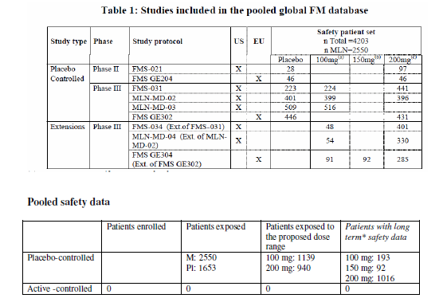
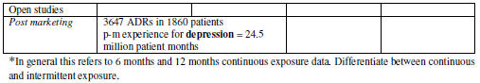
The majority of patients were female; less than 5% were male. The mean age was around 50 years, ranging from 18 to 74 years. These demographics reflect the known epidemiology of FM. There were no clinically relevant differences across the treatment groups and across exposure duration for any demographic variable.

Non FM clinical data (group 2)
The sponsor reported a data set of 13 non FM clinical studies, including 5 placebo controlled studies, conducted relatively recently and following GCP guidelines but these study reports were not submitted. The dataset was 3059 patients, including 502 patients on placebo and 2557 patients on milnacipran at different dose regimens. The mean duration of exposure was 58 days, 89 days, and 62 days in the placebo, milnacipran 100 mg/day and milnacipran 200 mg/day groups, respectively. No new or concerning adverse events were reported in this dataset.

Adverse events
Around 30% of participants in the Phase III clinical studies withdrew, and more than half of these were attributed to adverse events (AEs). The number of patients who withdrew due to AEs from each of the pivotal studies was as follows:
- MLN-MD-02: Placebo (n=38 [9.5%]), milnacipran 100 mg (n=78 [19.5%]), milnacipran 200 mg (n=94 [23.7%])
- GE-302: Placebo (n=44 [9.8%]), milnacipran 200 mg (n=96 [22.0%])
- MLN-MD-03: Placebo (n=73 [14.3%]), milnacipran 100 mg (n=94 [18.2%])
In Study MLN-MD-04, an extension study from Study MLN-MD-02, patients who had been treated with placebo and then treated with active drug had higher rates of discontinuation because of an AE (placebo to milnacipran 100 mg/day, 21.9%; placebo to milnacipran 200 mg/day, 27.4%) than did patients who remained at the same dose of milnacipran (100 mg/day, 9.1%; 200 mg/day, 14.0%); or who were increased from milnacipran 100 mg/day to 200 mg/day (13.6%). A similar pattern was observed in the other extension studies (Study FMS034, Study GE304).
The percentage of patients with at least one treatment emergent AE (TEAE) was similar in the two milnacipran groups (86% and 85.6% in the milnacipran 100 mg/day and 200 mg/day groups, respectively), showing no apparent dose effect and this was lower in the placebo group (75.4%). Compared to the placebo group, the milnacipran group had significantly higher rates of gastrointestinal disorders (in particular nausea and constipation), vascular disorders (in particular hot flush), cardiac disorders (in particular palpitations), skin and subcutaneous tissue disorders (in particular hyperhidrosis), nervous system disorders (in particular headache), and laboratory investigations summarised in Table 17 below.
Table 17. Number of patients with at least one TEAE by System Organ Class (SOC). Group 1As
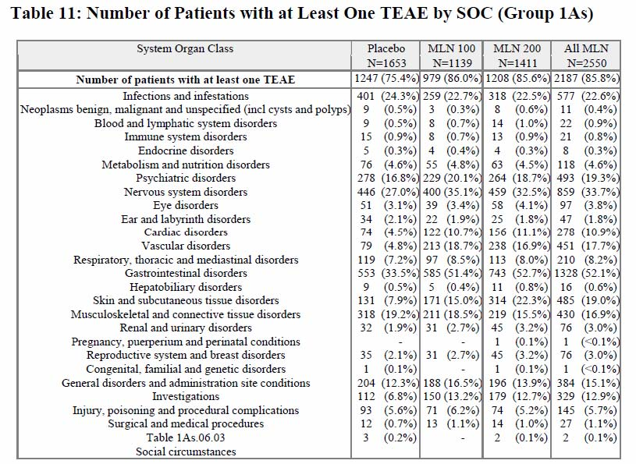
The number of patients with at least one TEAE in the 3 month studies is presented in the following table (18) and is as presented in the section Undesirable Effects of the European Summary of Product Characteristics (SPC).
Table 18. Table of Adverse Reactions. Table continued across 2 pages.
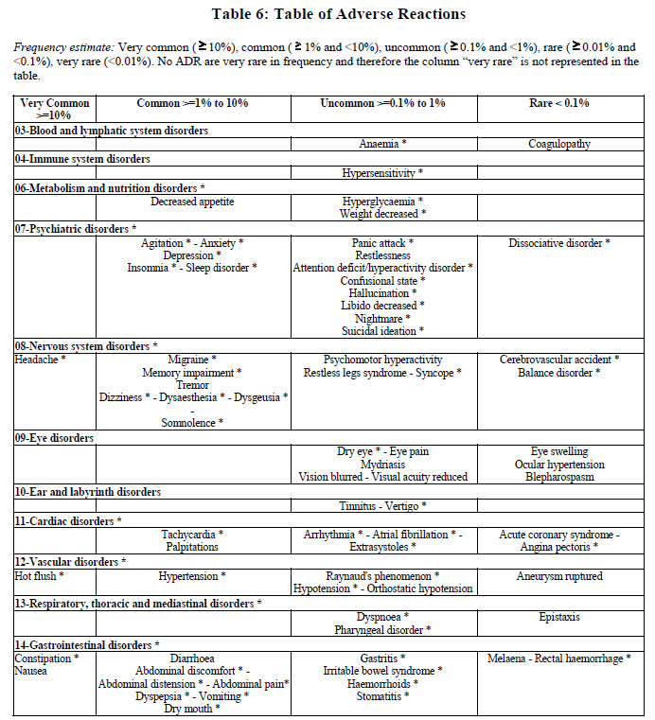
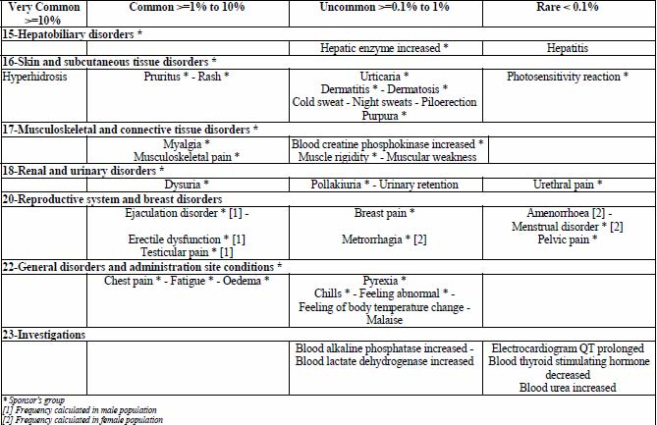
Patients on milnacipran reporting nausea mostly had an onset of symptoms before Week 4. The same pattern was found for most other very common and common AEs. But increases in BP and hypertension had onsets throughout the period of drug exposure for all treatment groups (including placebo).
Most TEAEs were mild or moderate in severity. The percentage of patients with at least one severe TEAE was similar between the 100 mg/day milnacipran group and the 200 mg/day milnacipran group. The most common severe TEAEs were nausea (in 2.5% of patients in all milnacipran groups versus 0.8% in placebo group), headache (2% of patients in all milnacipran groups versus 1.1% in placebo group), and migraine (1.2% of patients in all milnacipran groups versus 0.8% in placebo group).
There were few differences in incidence between the two doses of milnacipran for the most common TEAEs. The main exception to this was hyperhidrosis: 1.8% in the placebo group, 7.5% in the milnacipran 100 mg/day group, and 13.6% in the milnacipran 200 mg/day group.
No specific TEAEs, in particular hypertension and tachycardia, appeared to be increased in incidence with milnacipran 200 mg/day compared with 100 mg/day throughout.
The profile of AEs leading to discontinuation was generally similar to the TEAE profile. The most common AEs leading to discontinuation were as follows: nausea, palpitations, headache, hyperhidrosis, depression, vomiting, insomnia, heart rate increased, constipation and fatigue. The incidence of nausea leading to discontinuation was dose related: 1.0% on placebo, 3.5% on milnacipran 100 mg/day, and 5.7% on milnacipran 200 mg/day. A clinical dose relationship was also observed for headache, hyperhidrosis, insomnia, heart rate increased, vomiting, and constipation leading to discontinuation.
In addition, the reasons for discontinuation in patients exposed to milnacipran at 1 year were similar to those observed in the 3 month and 6 month exposures. The incidence of TEAE in 1 year exposure group was higher (96.3%) than in the 3 months studies (85.8%) and the 6 month studies (90.4%) due to the longer treatment duration. In addition, the most common TEAEs reported in the 6 month and 12 month exposure are similar to that observed in the 3 month exposure.

Effects on blood pressure and heart rate
In the lead in studies, milnacipran caused an increase in supine systolic blood pressure (SBP) (+3 mmHg), diastolic blood pressure (DBP) (+ 3.1 mmHg) and HR (7.8 bpm). No dose response relationship was observed. The results were similar for standing vital signs (+1.9 mmHg for SBP, +2.7 mmHg for DBP and +7.9 bpm for HR).
In the 3 month studies, hypertension was reported in 4.2% of milnacipran patients versus 1.8% on placebo, tachycardia was reported in 3.6% of milnacipran patients versus 0.7% on placebo. The data from the extension studies and from the patients exposed to milnacipran for 1 year confirmed that milnacipran produces small increases in supine SBP, DBP and HR, but these stabilised over time. In patients who switched from placebo to milnacipran 100 or 200 mg/day, increases in BP and HR were noted. However, in patients who took milnacipran throughout the lead in and extension studies there were no further increases in these parameters in the extension studies, even when patients switched from milnacipran 100 mg/day to 200 mg/day.
The data from the specific study (Study MLN-MD-12) support the tolerability of milnacipran up to 200 mg daily in the population of both “normotensive” and “hypertensive” patients with FM; the treatment of FM patients with milnacipran (up to 200 mg/day) resulted in mean increases in BP and HR. In the 2 weeks following discontinuation of milnacipran, BP and HR decreased considerably but were still above baseline values.

Effects on electrocardiogram (ECG) parameters
HR increased from baseline with milnacipran, at all the different daily dosages (by approximately 8-10 bpm) and was unchanged with placebo. The effect on cardiac repolarisation depended on which method was used to correct for HR. The mean QTcB (Bazett method) increased from baseline with milnacipran (by 7.3 ms and 9.0 ms with milnacipran 100 mg/day and 200 mg/day, respectively) and was unchanged with placebo (a decrease of -0.9 ms). Conversely, the mean QTcF (Fridericia method) was slightly decreased with milnacipran (by -0.1 ms and -0.3 ms with milnacipran 100 mg/day and 200 mg/day respectively) but also slightly increased with placebo (0.6 ms).
The QT prolongation interval was specifically investigated in a dedicated QTc study, (Study MLN-PK-10); at doses 3 to 6 times greater than the intended therapeutic dose of milnacipran for FM, milnacipran did not cause QTc prolongation. This suggests that milnacipran should not affect cardiac repolarization under conditions of increased systemic exposure such as renal impairment or drug drug interactions.
Arguments regarding the correct or most appropriate method of correcting QT for heart rate continue. There seems to be some consensus for the Fredericia method for tachycardia,. The Bazett's heart rate correction formula does not remove the effect of heart rate and may overcorrect at high heart rates and therefore the Fredericia formula is preferable in this circumstance¹⁷. The sponsor has done this, resulting in no evidence of QTc prolongation. The evaluator accepted this approach and its conclusions.

Withdrawal syndrome
There is no evidence of withdrawal syndrome at treatment cessation (Study GE 302 and GE 304), the latter following 12 months of exposure with a progressive down titration. In all other FM studies, the study drugs were withdrawn without tapering and without evidence of a withdrawal/discontinuation syndrome. The incidence of newly TEAEs during the discontinuation phase was 19.2% for placebo-placebo patients, 16.3% for milnacipran-placebo patients and 18.0% for milnacipran-milnacipran patients.

Overdose
There is no reported case of milnacipran overdose in FM patients. All available overdose data are derived from the postmarketing surveillance of milnacipran in Major Depressive Disorder (MDD). A total of 115 cases of overdose have been reported in MDD. The maximum dose ingested was 5600 mg. All fatal overdose cases occurred with ingestion of several medications. There was no fatal outcome for the patients who committed suicide with milnacipran alone. The symptoms reported were tachycardia, diarrhoea, vomiting, somnolence and disordered consciousness. Severe arrhythmia were rarely reported and observed with co ingestion with psychotropic drugs.

Potential for abuse
There is no reported case of milnacipran abuse in FM patients and no data suggesting a potential for drug abuse.

Serious adverse events (SAEs) and deaths
Three deaths were reported, two cases during the clinical studies (acute renal failure and septic shock [placebo group], metastatic renal cancer 6 days after initiation of treatment with milnacipran, and suicide 2 months after the end of study [milnacipran group]); none were considered treatment related.

Analysis at 3 months (Group 1As)
For Group 1As, 42 SAEs were reported in 28 patients of the placebo group and 51 SAEs in 34 patients of the two milnacipran groups; and 4 SAEs were reported in 4 patients before first study drug intake (milnacipran 200 mg/day in GE-302 study). The incidence of SAEs was similar across the 3 treatment groups: at least one SAE was reported in 1.7% of patients (28/1653) in the placebo group, 1.1% of patients (12/1139) in the milnacipran 100 mg/day group, and 1.6% of patients (22/1411) in the milnacipran 200 mg/day group. The number of SAEs per 100 patient years was 10.0 in the placebo group, 7.0 in the milnacipran 100 mg/day group and 9.9 in the milnacipran 200 mg/day group. Thus no dose response relationship was observed for SAEs.
No single SAE was reported with an incidence greater than 0.2%; the most common SAE was chest pain, reported in 1 patient on placebo, 2 patients on milnacipran 100 mg/day and 3 patients on milnacipran 200 mg/day. The majority of SAEs were not considered drug related.

Analysis at 6 months (group 1Bs)
In the extension studies, 12 additional SAEs (in 5 patients) were reported in the placebo group and 14 additional SAEs (in 13 patients) were reported in the milnacipran group.

Analysis at 12 months (group 1Cs)
Some 33 SAEs were reported in 23 patients of the placebo-to-milnacipran group and 42 SAEs were reported in 32 patients of the milnacipran-to-milnacipran group.

Laboratory findings
There were no clinically relevant changes in any haematology or biochemistry parameter in the 3 month exposure except for slight increases in liver enzymes, aspartate transaminase AST (+7%) and alanine transaminase (ALT) (+10.8%). In extension studies, 3.5% of patients had increases in ALT and 2.2% of patients had L-pyroglutamic acid (PCA) increases in AST. Similar liver enzyme increases have previously been observed with milnacipran in non FM patients.

Safety in special populations

Gender
The distribution of TEAEs in the male patients (less than 5% of the study population) was quite different from that of the overall population. Common AEs in males included dysuria, ejaculation disorder, testicular pain and increased BP.
- Dysuria: reported in 17.9% of male patients on milnacipran 100 mg/day and 26.4%
- of male patients on milnacipran 200 mg/day (no patient had this TEAE on placebo).
- Ejaculation disorder: reported in 5.1% of male patients on milnacipran 100 mg/day and 5.7% of male patients on milnacipran 200 mg/day (no patient had this TEAE on placebo).
- Testicular pain: reported in 2.6% of male patients on milnacipran 100 mg/day and 7.5% of male patients on milnacipran 200 mg/day (no patient had this TEAE on placebo).
There was no reported sexual dysfunction in females.

Age
At least one TEAE was reported for 81.9% (59/72) of elderly patients on placebo, 85.7% (36/42) of elderly patients on milnacipran 100 mg/day and 88.4% (76/86) of elderly patients on milnacipran 200 mg/day. This was not notably different from that of the overall patient population.

Use in pregnancy and lactation
No clinical studies with milnacipran have been performed in pregnant women, lactating mothers, or neonates. In the FM clinical trials, 4 pregnancies were reported and there were no milnacipran attributed adverse consequences. There is no evidence of teratogenicity in the post marketing surveillance period.

Safety related to drug-drug interactions and other interactions
Migraine is a frequent occurrence in patients with FM and so concomitant use of triptans was allowed in the Phase III program. In the global study population, 134 patients out of 2034 patients received concomitantly triptans and milnacipran. There was no case of serotonin syndrome or other evidence of drug interaction.
Other relevant drug classes, such as SSRIs, MAO inhibitors, tramadol, St.John’s wort, adrenaline, noradrenaline and clonidine, were not allowed. Safety therefore cannot be determined.
The risk of using milnacipran in combination with other CNS active medicinal products has not been systematically evaluated.

Discontinuation due to adverse events
Rates of study withdrawal were related to active drug (milnacipran) exposure and dose, being around 10%, 20% and 25% at 3 months for placebo, milnacipran 100 mg, and milnacipran 200 mg, respectively.

Postmarketing experience
Milnacipran was previously developed for the treatment of major depressive disorder (MDD) in adults and marketed since 1997 for this indication in several European countries, Japan, as well as in Latin America and in some Asian countries. Milnacipran has been approved for the treatment of FM in the USA since January 2009.

For fibromyalgia (USA)
The sponsor’s report covers the period from 14 April 2009 (date of market introduction) to 31 December 2009. A total of 1410 Adverse Drug Reactions in 584 patients have been reported. The most frequent were:
- Nervous System disorders with 234 adverse drug reactions
- Gastrointestinal disorders with 228 adverse drug reactions
- Psychiatric disorders with 197 adverse drug reactions
- General disorders and administration site conditions with 179 adverse drug reactions.
There were some reports of serotonin syndrome: 10 adverse drug reactions with 9 considered as serious.
Two cases of suicide attempt were reported. Both cases referred to intentional overdose of benzodiazepine alone. One case was not medically confirmed and was poorly documented. The second one concerned a 51 year old woman with underlying depression, concomitantly treated with one other NSRI (duloxetine) and one SSRI (escitalopram), who committed suicide 20 days after milnacipran initiation.
Twenty-one cases of suicidal ideation were reported of which 11 patients had a current underlying psychiatric disease such as depression, panic attack and anxiety and 2 patients had a past history of suicide attempt. Four patients had neither medical history of depression nor history of suicide attempt. It is known that there is an overlap between the FM and depression, which could explain these findings.
There were 8 cases of arrhythmia (including atrial tachycardia, supraventricular tachycardia, cardiac flutter, QT prolonged) reported; 6 of these were considered as serious. Two cases of QT prolonged were reported. One was associated with heart failure; the second case was a female who had a QT interval just over the normal value (452 ms) associated with tachycardia (136/min) 3 weeks after milnacipran initiation. Tachycardia resolved after milnacipran discontinuation. No QT interval value was provided before treatment and after milnacipran withdrawal. However this patient was concomitantly treated with triamterene/hydrochlorothiazide (known to induce QT prolongation). Both cases were assessed as doubtful. In most of cases, there was no evidence of a possible role of milnacipran in the occurrence of cardiac adverse drug reactions. However, the causal relationship could not be ruled out. In all cases, the evolution was favourable with milnacipran discontinuation.

For depression
Post marketing exposure in patients with depression is estimated to involve 24.5 million patient months. The current European SPC of milnacipran recommended dose in depression is 100 mg/day; about 10% of patients are treated with 200 mg/day. In Japan doses used are lower (average 58 mg/day).
Undesirable effects are observed mainly during the first weeks of treatment and subsequently regress. Such effects generally are mild and only rarely result in discontinuation of therapy. The most commonly reported AEs are vertigo, excessive sweating, anxiety, hot flush and dysuria. Patients with a history of cardiovascular disorder or concomitant cardiac medication appear to have a higher incidence of cardiovascular adverse events (such as hypertension, hypotension, postural hypotension, tachycardia and palpitations).
In rare instances other events may occur which include serotonin syndrome, when combined with other serotonergic agents, urinary retention, convulsions (particularly in patients with past history of epilepsy), testicular pain, ejaculation disorders and moderate elevation of transaminases. Cases of cytolytic hepatitis have also been reported with milnacipran during post marketing. Hyponatraemia, ecchymosis and other cutaneous or mucous bleeding have been reported.
Some AEs were reported that are considered to be more related to the depressive illness: suicidal risk, mood switch, mania, reactivation of a delirium in psychotic patients, paroxystic symptoms of anxiety (with psychostimulant antidepressants).

Updated literature review
Mease et al did a population based analysis to compare the risk of serious cardiovascular (CV) events such as myocardial infarction, stroke, and heart failure with milnacipran compared with venlafaxine and amitriptyline. They used data from the French Thales electronic health record database from 2001 to 2007, in a retrospective, matched cohort design. The incidence rates of CV events between cohorts receiving milnacipran, venlafaxine and amitriptyline were compared using unadjusted incidence rate ratio (IRR) and adjusted conditional IRR based on Poisson regression. They had 4452 milnacipran-venlafaxine and 3761 milnacipran amitriptyline matched pairs, with comparable baseline characteristics. The unadjusted IRRs of any CV events, comparing milnacipran with venlafaxine or amitriptyline, were 1.02 (95% CI: 0.73 to 1.44) and 1.30 (95% CI: 0.90 to 1.89), respectively. Adjusted IRRs were similar. These data show that the risk of CV events was not significantly different between milnacipran and venlafaxine or amitriptyline.
Roskell et al did a meta analysis of trials to ascertain the risk of drug dose related discontinuation because of AEs. These were significant for milnacipran 100 and 200 (p<0.009 and p=0.001, respectively), and pregabalin 300 and 450 (p<0.001). All other treatments, except fluoxetine, showed numerically increased risk over placebo for discontinuation because of AEs. In the indirect comparisons, no pairwise comparison of active treatments reached significance. They also found that all eight treatments showed evidence of improvement over placebo in the treatment of pain in FM patients. Indirect comparison of active treatments found no strong differences.
Another meta analysis¹¹ focussed on symptom reduction (pain, fatigue, sleep disturbance and reduced health related quality of life [HRQOL]) and acceptability (total dropout rates). Ten amitryptiline studies (612 patients), four duloxetine studies (1411 patients) and five milnacipran studies (3 Pivotal trials plus FMS021, FMS031; 4,129 patients) met the inclusion criteria. Pooled effect sizes for milnacipran were (using standardised mean difference [0-1.0], except for pain reduction [RR]:
- Pain -0.19 (95% CI: -0.25 to -0.14) P<0.0001
- Fatigue -0.13 (-0.19 to -0.07) P<0.0001
- Sleep disturbance -0.03 (-0.09 to 0.04) P=0.43
- HRQOL -0.18 (-0.23 to -0.12) P<0.0001
30% pain reduction 1.30 (1.17 to 1.44) P<0.0001
In adjusted indirect comparisons, amitryptiline was superior to milnacipran in reduction of pain, sleep disturbances, fatigue and limitations of HRQOL. Duloxetine was superior to milnacipran in reducing pain, sleep disturbances and limitations of HRQOL. Milnacipran was superior to duloxetine in reducing fatigue. There were no significant differences in acceptability of the three drugs.

Evaluator’s overall conclusions on clinical safety
The application provides sufficient tolerability and safety data to support the approval of milnacipran up to 200 mg/day. Nausea, headache, constipation, and tachycardia were the most frequently reported side effects (both sexes), and in men: dysuria, testicular pain and ejaculation disorders.
The evaluator particularly considered the following issues:
- Weight gain was a feature of treatment with pregabalin; what is the distribution of changes in weight in subjects given milnacipran, in particular in the longer term studies. Nausea is dose related and common; how severe was it and did it persist with ongoing exposure?
Nausea is common, can be minimised if taken with food and dose escalation over 1 to 3 weeks. It tends to resolve over time (or else the subjects withdrew from therapy). There was no evidence of weight gain (Table 19).
Table 19. Changes on Weight (Group ICs, All treatment Sequences).
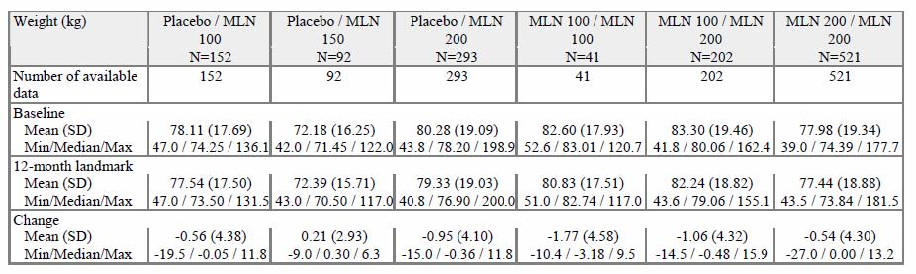
- Hypertension, HR, serotonin syndrome, sexual function and interactions with other medicines likely to be given to subjects with fibromyalgia, and whether withdrawal syndrome occurs.
See above sections. Exacerbation of hypertension is not uncommon, Genito-urinary AEs may limit its usefulness in male patients with FM; given the modest benefit in pain reduction, serious consideration should be given to limiting its use to female patients. There is no evidence of drug interactions but, as stated above, such use was mostly an exclusion criteria in the studies. There was a very small risk of withdrawal syndrome, even with acute cessation of therapy. It is advised however that when milnacipran treatment is to be discontinued a gradual dose tapering over a period of one to two weeks should be used.
There is cause for concern when using milnacipran in hypertensive patients because of the potential to induce tachycardia in patients with known coronary artery disease.
The possible effects of delayed cardiac repolarisation (QTc) seen in the nonclinical studies, with the exception of tachycardia, do not seem to be clinically important.
The majorities of adverse reactions occur in the first four weeks of therapy and were mild to moderate in severity. Milnacipran dose reduction can be assessed before the patient is withdrawn from treatment. There were no clinically relevant increases in the incidence and severity of TEAEs in the extension studies up to 1 year. This suggests an absence of any cumulative toxicity.
Milnacipran is contraindicated in male patients with urinary problems (such as prostatic hypertrophy).
Dosage adjustment is not necessary if renal function is normal in elderly patients.
Milnacipran has shown uncertain evidence of clinically significant hepatotoxicity. Reports of hepatitis in the post marketing experience have been uncommon and of uncertain relationship to milnacipran. While milnacipran has caused mild elevations of transferases in some patients in the clinical studies, these elevations have not been associated with concomitant elevations of bilirubin.
Milnacipran has no significant affinity for serotonergic (5HT1-7), α-or β-adrenergic, muscarinic (M1-5), histamine (H1-4), dopamine (D1-5), opiate, benzodiazepine or γ-aminobutyric acid (GABA) receptors in vitro. Also, milnacipran has no significant affinity for calcium, potassium, sodium or chloride channels and does not inhibit the activity of human monoamine oxidases (MAO-A and MAO-B) or of acetylcholinesterase. There was no evidence of drug interaction

List of questions

Pharmacokinetics
Does the sponsor have PK drug interaction data for tramadol?

Pharmacodynamics
Does the sponsor have PD drug interaction data for tramadol?

Clinical summary and conclusions

Pharmacokinetics
Milnacipran has high oral biovailability, undergoes some biotransformation without CYP variability, has minimal stereospecificity, is renally excreted (mostly unchanged drug), and has dose-proportional pharmacokinetics.
There were a few safety signals from the nonclinical studies. The evaluator’s main concerns relate to hypotension and tachycardia and the potential to cause ventricular arrhythmias. The PKs of milnacipran, with the exception of tramadol co-administration, have been adequately studied in humans. The variance in the PK estimates in young healthy adults is small and there are modest changes seen in special populations and with co- administration of cardiovascular and psychotropic drugs. The major issue lies with accumulation in impaired renal function.

Pharmacodynamics
When considering the nonclinical studies, PK study results of near linear dose proportionality, modest effects of age and renal function, HR-and BP-effects, tolerability, and the (expected) EC₅₀ required, the likely safe and effective dose is 50 to 200 mg per day. Results from the Phase I and II studies suggested that dose escalation could avoid some of the more common adverse effects (nausea, vomiting and headache). Co administration with food may also help.
The definitive PD study was Study GE 204, a 12 week Phase II exploratory trial in FM patients using pain sensitivity and fMRI to characterise pain pathways/responsiveness. The strong indication of an improvement in pain (a 5.2-mm VAS downward shift in pain sensitivity) with milnacipran over the entire panel of applied pressures supported the likely potential analgesic efficacy of this drug.
Dose ranging studies were minimal, and a comprehensive dose response curve analysis could not be undertaken. This is not unreasonable given the information provided from the nonclinical and PK studies. It is appropriate that the dose range 50-400 mg were tested and it is likely that a dose of 100-200 mg/day will provide the best balance of efficacy and safety in the Phase III program.
The sponsor’s Clinical Overview is an accurate representation of the drug development program. However, it failed to accurately highlight some of the potentially relevant toxicology and adverse effects. These include haemodynamic effects (HR, BP), effects on cardiac repolarisation (QTc) and arrhythmias, nausea and vomiting, headache and the difficulty of single drug therapy to be able to control the important symptoms of a syndrome (FM).
Special populations were adequately studied. These included the elderly, those with renal and hepatic impairment and those with depression. There is no evidence of genetic polymorphism or racial PK differences.
The critical issues include the actual analgesic efficacy in a broader group of FM patients, its acceptability/tolerability of the drug in view of its adverse effect profile in the early PK/PD studies, particularly in the elderly and those with renal impairment, and those on (other) analgesic therapies, antidepressant medication, antihypertensive and other cardiovascular medications, and an incomplete knowledge of its safety profile. The PK and PD studies were sufficient. The answers to these critical issues required Phase III studies.
FM is a chronic disease/syndrome with variable manifestations and therefore long-term studies were required. A clinically important response to treatment, avoidance or tolerance of adverse effects and compliance will ultimately determine its eventual clinical effectiveness.

Clinical efficacy
The study program was valid and GCP compliant. Study methods and outcome assessments were consistent with the European Agency for the Evaluation of Medicinal Products (18). On optimal dose range was studied. Adequate randomisation procedures and concealment, double blinding, ITT analyses and treatment of missing data were good.
The study populations were appropriate for FM (demographics, race). Given that many FM patients will have features of anxiety and depression, there were a limited amount of baseline and outcome assessments of such conditions. There was however adequate measures of fatigue, sleep, and aspects of quality of life.
There are no study data investigating the additive or synergistic effects of an exercise or cognitive behaviour regimen.
There was no evidence of tachyphylaxis or tolerance, and no evidence of withdrawal.
There are sufficient long term studies, each with consistent findings, and no evidence of loss of efficacy over time. The study populations can be equated to the Australian population. The evaluator had no concerns with either of these aspects.
Most data are derived from female patients with FM. There has been no evidence of sex-heterogeneity in the PD studies, so there is no reason to suppose that efficacy differs between the sexes but the evaluator was not certain about this. The evaluator would be interested in seeing subgroup plots and statistical tests for interaction in the pooled dataset. The evaluator had no other concerns regarding efficacy in sub populations.
The results of each pivotal study individually support the claim of efficacy of milnacipran in the treatment of FM. The co primary endpoint measures of pain intensity and perceived analgesic efficacy (PGIC) and the secondary classification into responders and non responders indicate that milnacipran is an effective treatment FM. Other evaluations done to explore other, typically associated symptoms of FM, such as fatigue, functional activity, sleep disturbance, and quality of life were supportive.
A finding from the study program is the high rate of withdrawals in the 15 week and long term studies. Around 30% of participants in the pivotal studies (with a similar proportion in the supporting studies) were withdrawn. Although many of these withdrawals reported adverse effects or perhaps were non compliant because of poor response to treatment, it must be said that there were substantial rates of AEs in the placebo group. It is likely that this reflects the study patient population for which the syndrome of FM can include numerous ill defined symptoms and the pain and tenderness are treatment resistant. As emphasised above, all studies were double blind and ITT analyses were used.
The evaluator made the point several times in the evaluation that a statistically significant reduction in a pain score, or fatigue or other parameter represented on a numerical scale, should not be confused with a clinically useful or important change. There is a substantial body of opinion and supportive data that emphasizes this distinction (8-11). If using a 100 mm VAS scale, a clinically important reduction in pain requires an absolute change of at least 20 mm and a relative change of at least 30% (some say 50%). In fact, to support this view, in many of the studies a secondary analysis was done on the rate of ‘responders” to treatment, which required amongst other criteria, a ‘meaningful change’ in the Pain VAS, which they defined as ≥30% change.
Perhaps smaller relative changes in scale scores are required to demonstrate meaningful changes in health status (fatigue, quality of life, sleep). There are a lot of published data devoted to this subject and most agree that at least a 1 point (10%) change in any item is required to demonstrate the ‘minimal clinically important difference’.
Thus, the evaluator’s interpretation of the efficacy studies is that milnacipran provides a modest benefit that in some patients can be translated into meaningful improvement in the symptoms of FM. The number needed to treat appears to be around 6 to 10. In view of the limited drug treatment options currently available for FM, the evaluator believes that milnacipran offers a useful treatment option. A recently published meta analysis support its modest analgesic efficacy¹⁹.
On the basis of clinical efficacy, the recommended therapeutic dose of milnacipran is 100mg/day; bd dosing, with a one week titration period. A higher dose may provide additional efficacy; in the setting of an inadequate response to the lower dose and if well-tolerated, a titration up to 200 mg/day can occur over two additional weeks.
The American Pain Society (APS) and the European League Against Rheumatism (EULAR) both recommend exercise and education interventions alone and in combination for people with FM , .

Clinical safety
The Group 1 studies were the nine Phase II and III studies in FM patients. The Group 1A studies are data from the lead in period. Data up to the 3 months visit from the 6 Phase II and III studies (FMS-021, FMS GE204, FMS-031, MLN-MD-02, MLN-MD-03, FMS GE302) were included. Some 1653 patients received placebo, 1139 patients received milnacipran 100 mg/day and 1411 patients received milnacipran 200 mg/day (a total of 2550 patients).
The Group 1B studies include data up to 6 months from the patients included in studies FMS031 and MLN-MD-02. 526 patients received placebo, 544 patients received milnacipran 100 mg/day and 742 patients received milnacipran 200 mg/day (a total of 1286 patients).
The Group 1C studies include data collected up to at least 12 months in the 3 Phase III trials and the extensions (FMS-031/FMS-034, MLN-MD-02/MLN-MD-04, FMS GE302/FMS GE304). Only patients entering the extension studies and actually receiving milnacipran were included in this data set. A total of 1301 patients were randomised in the extension studies, 764 patients were treated with milnacipran for one year and 537 patients received first placebo then switched to milnacipran in the extension studies.
Overall, 2550 patients received milnacipran for a 3 month period (1139 at 100 mg/day and 1411 at 200 mg/day) and 1653 received placebo. The mean duration of exposure was similar across the 3 treatment groups: 94.4 days for placebo, 89.5 days for milnacipran 100 mg/day, and 85.8 days for milnacipran 200 mg/day. The cumulative exposure was 420 patient years for placebo, 273 patient years for milnacipran 100 mg/day and 324 patient-years for milnacipran 200 mg/day.
The current Australian submission provides sufficient evidence of tolerability and safety data to support the approval of milnacipran up to 200 mg/day. Nausea, headache, constipation, and tachycardia were the most frequently reported side effects in both sexes whereas dysuria, testicular pain and ejaculation disorders were reported in men.
The mild changes in some liver enzymes and the increases in BP and HR were reversible on cessation of milnacipran therapy. There is no evidence of weight gain in the longer term studies.
Genitourinary AEs may limit its usefulness in male patients with FM. Milnacipran should be contraindicated in male patients with urinary problems (such as prostatic hypertrophy).
There is cause for concern when using milnacipran in hypertensive patients, and because of the induced tachycardia also in those with known coronary artery disease.
The possible effects of delayed cardiac repolarisation (QTc) seen in the nonclinical (and perhaps PD) studies, with the exception of tachycardia, do not seem to be clinically important.
The majorities of adverse reactions occur mainly in the first four weeks of therapy and were mild to moderate in severity. Milnacipran dose reduction can be attempted before patient discontinuation. There were no clinically relevant increases in the incidence and severity of TEAEs in the extension studies up to 1 year. This suggests an absence of any cumulative toxicity.
Dosage adjustment is not necessary as long as renal function is normal in elderly patients.
While milnacipran has caused mild elevations of transferases in some patients in the clinical studies, these elevations have not been associated with concomitant elevations of bilirubin. Milnacipran has not shown evidence of clinically important hepatotoxicity in clinical studies. Reports of hepatitis in the postmarketing experience have been uncommon and of uncertain relationship to milnacipran.
Milnacipran has no significant affinity for serotoninergic (5HT1-7), α-or β-adrenergic, muscarinic (M1-5), histamine (H1-4), dopamine (D1-5), opiate, benzodiazepine or γ-aminobutyric acid (GABA) receptors in vitro. Also, milnacipran has no significant affinity for calcium, potassium, sodium or chloride channels and does not inhibit the activity of human monoamine oxidases (MAO-A and MAO-B) or of acetylcholinesterase. There was no evidence of drug-interaction in the PK or PD studies.

Benefit risk assessment

Benefits
FM is a fairly common (2-4% of population) syndrome characterised by chronic widespread pain and tenderness but also secondary features such as fatigue, sleep disturbance, depression and functional impairment. Current therapeutic options for FM are limited in their effectiveness.
The efficacy studies used a composite measure of pain and pain relief, as well as a variety of secondary outcomes such as fatigue and sleep. Benefit can be summarized by analgesic responder status at 3 months for the pivotal studies (here using the LOCF method, OR and 95% CI):
- GE 302: MLN 200 mg versus placebo OR 1.9 (1.3-2.7), p<0.001
- MLN-MD-02: MLN 200 mg versus placebo OR 1.8 (1.2-2.5), p=0.002 MLN 100 mg versus placebo OR 1.6 (1.1-2.2), p=0.014
- MLN-MD-03: MLN 100 mg versus placebo OR 1.9 (1.4-2.5), p<0.001
The long-term (6 and 12 month) studies demonstrate persistence of benefit. The supporting studies are consistent with these findings and report similar effect sizes.
Several meta analysis of FM treatments have been recently published, one of which focussed on symptom reduction (16). This included five milnacipran studies (the three pivotal trials plus FMS021, FMS031; 4,129 patients). Pooled effect sizes for milnacipran were:
- Pain: SMD -0.19 (95% CI: -0.25 to -0.14) P<0.0001 (benefit)
- Fatigue: SMD -0.13 (-0.19 to -0.07) P<0.0001 (benefit)
- Sleep disturbance: SMD -0.03 (-0.09 to 0.04) P=0.43 (no effect)
- HRQOL: SMD -0.18 (-0.23 to -0.12) P<0.0001 (benefit)
- At least 30% pain reduction: RR 1.30 (1.17 to 1.44) P<0.0001 (benefit)
The strength of the study program is the focus on a widely supported and preferential measure of ‘outcome’ in chronic pain (FM in particular) and the consistency of the findings. Randomised ITT data are used. An emphasis on the primary endpoint, and reporting of useful supportive secondary endpoints was done well. Withdrawals and their reasons were clearly presented.
A statistically significant reduction in a pain score or fatigue or other parameter represented on a numerical scale, should not be confused with a clinically useful or important change. The above efficacy results suggest modest benefit to those with FM. The sizes of the effects are small to medium. When defining a ‘responder’ as a reduction in pain of at least 30% and patient rating of pain relief of at least ‘much improved’, the proportion of responders is about 35-40% when compared with a placebo response rate of about 20-25%; that is an absolute risk reduction of 10-20% (NNT 6-10). But because of the limited drug treatment options currently available for FM, and the likely benefit from small improvements across a large number of people seeking any relief for their condition, the evaluator believed milnacipran offers a useful treatment option.

Risks
Some 2550 patients received milnacipran for a 3 month period and 1653 received placebo. The cumulative exposure was 420 patient years for placebo, 273 patient years for milnacipran 100 mg/day, and 324 patient years for milnacipran 200 mg/day.
Adverse effects include small increases in blood pressure, tachycardia, and nausea. Nausea generally occurred early and its prevalence decreased with time. Other AEs included palpitations, constipation, headache, insomnia, hyperhidrosis and vomiting. There are no apparent drug interactions, including alcohol (PD or clinical safety). There is no potential for abuse or dependence.
Around 30% of participants in the Phase III clinical studies withdrew from study and more than half of these were due to AEs.
- MLN-MD-02: Placebo (9.5%), milnacipran 100 mg (19.5%) and milnacipran 200 mg (23.7%)
- GE-302: Placebo (9.8%) and milnacipran 200 mg (22.0%)
- MLN-MD-03: Placebo (14.3%) and milnacipran 100 mg (18.2%)
In the extension studies, those who had been treated with placebo and then treated with active drug had a 2 to 3 fold higher rate of discontinuation because of an AE.
The percentage of patients with at least one TEAE was similar in the two milnacipran groups (86% and 85.6% in the milnacipran 100 mg/day and 200 mg/day groups, respectively) and there was therefore no apparent dose effect. This number was lower in the placebo group (75.4%).
The most common severe TEAEs were nausea (in 2.5% of patients in the milnacipran groups versus 0.8% in placebo group), headache (2% of patients in milnacipran groups versus 1.1% in placebo group), and migraine (1.2% of patients in milnacipran groups versus 0.8% in placebo group).
In the lead in studies, milnacipran caused an increase in supine SBP (+3 mmHg), DBP (+ 3.1 mmHg) and HR (7.8 bpm). No dose response relationship was observed. The results were similar for standing vital signs (+1.9 mmHg for SBP, +2.7 mmHg for DBP and +7.9 bpm for HR).
SAEs were reported in 1.7% of patients in the placebo group, 1.1% of patients in the milnacipran 100 mg/day group, and 1.6% of patients in the milnacipran 200 mg/day group. The number of SAEs per 100 patient years was 10.0 in the placebo group, 7.0 in the milnacipran 100 mg/day group and 9.9 in the milnacipran 200 mg/day group.
Male patients had high rates of some TEAEs. These included dysuria, ejaculation disorder, testicular pain, and increased BP.
- Dysuria: reported in 17.9% of male patients on milnacipran 100 mg/day and 26.4% of male patients on milnacipran 200 mg/day (no patient had this TEAE on placebo).
- Ejaculation disorder: reported in 5.1% of male patients on milnacipran 100 mg/day and 5.7% of male patients on milnacipran 200 mg/day (no patient had this TEAE on placebo).
- Testicular pain: reported in 2.6% of male patients on milnacipran 100 mg/day and 7.5% of male patients on milnacipran 200 mg/day (no patient had this TEAE on placebo).
Rates of study withdrawal were related to active drug (milnacipran) exposure and dose, being around 10%, 20% and 25% at 3 months for placebo, milnacipran 100 mg, and milnacipran 200 mg, respectively.
Several meta-analyses of FM treatments have been recently published, all providing safety data^{19, 20, 11}. The unadjusted incidence rate ratio (IRR) of any CV events, indirectly comparing milnacipran with venlafaxine or amitriptyline, were 1.02 (95% CI: 0.73 to 1.44) and 1.30 (95% CI: 0.90 to 1.89), respectively (15). Adjusted IRRs were similar. Another meta-analysis investigating the risk of drug dose related discontinuation because of AEs²⁰ were significant for milnacipran 100 mg (p<0.009) and 200 mg (p=0.001). In the indirect comparisons found no strong differences with other currently used drugs.
Post marketing experience is reassuring.
The size and completeness of the safety data were good. It included appropriate PK/PD studies, and has the benefit of post-marketing experience for its use in depression.
The PK and PD safety profile of milnacipran is similar to or better than that of the many drugs acting via serotonin or noradrenaline reuptake inhibition. There were no cognitive or psychomotor effects. Dose adjustment is required for patients with severe renal impairment.
BP monitoring should be recommended when starting milnacipran therapy and during treatment. Caution is required in those with hypertension and those at risk or with known coronary artery disease (CAD). The risk of nausea can be reduced if taken with food, if there is dose escalation over 1-3 weeks, and in any case may resolve.
The potential harms are significant, albeit mostly mild to moderate in severity. The number needed to harm is about 10. AEs appear to be reversible on cessation of therapy. The evaluator found it hard to justify the risks in male patients and in those with CAD but it may well be acceptable to those with daily symptoms and disability from FM. The evaluator could accept that such persons may want to have a trial of therapy and if drug-related AEs occur they can stop treatment and the symptoms should resolve.

Balance
Milnacipran can reduce the pain of FM and patients can detect meaningful improvements in pain relief. The reduction in pain is relative (about a 30% improvement). Pain or other symptoms of FM are unlikely to be entirely resolved; milnacipran mostly converts severe pain to moderate pain, or moderate pain to mild to moderate pain (on most days). This may be helpful in allowing patients to function better. There was a small (10-15%) relative benefit for physical quality of life measures, fatigue and quality of sleep and each of these add to the disability and distress of FM. But the overall benefit is modest (NNT 6-10).
The minimal clinically important difference when using a 100 mm VAS to measure pain intensity is about 20 or a relative reduction of about 30%. Milnacipran just achieves this benchmark.
The improvement in pain control needs to be considered alongside analgesic efficacy for other conditions. For example, for moderate or severe acute pain, paracetamol typically reduces pain intensity by about 20%, NSAIDs by about 30%, and morphine 10 mg about 50%. When compared with morphine 10 mg, the NNT for paracetamol and NSAIDs is about 12 and 6, respectively. Both paracetamol and NSAIDs have an important role in acute pain medicine but they often don’t provide sufficient relief when used as single therapy. Their value is in reducing opioid requirements and opioid related side effects¹⁶. A relative analgesic treatment effect of 30%, with an NNT of 6-10, is clinically useful.
In the setting of chronic pain and disability, small improvements can have important benefits to the patient and community. The evaluator believed that the modest benefit to the patient has the potential to allow better involvement with their family and friends, their social and working lives. Effective control of symptoms may reduce the need for other drug therapies, including opioids. There is thus likely to be several community benefits.
Alternative drug treatments have limited success. Although milnacipran is unlikely to be a cure, it offers another alternative to those with poor responses to treatment and/or intolerable AEs from existing drugs.
Withdrawals from treatment were more common in the milnacipran groups. Given about half were due to AEs, it is reasonable to conclude that such patients had little or no effective response to treatment. This will be mirrored in the post marketing experience but it should not be a cause for great concern because nearly all AEs were mild or moderate and were reversible. The most common AE was nausea and this can be easily managed. More important are the risks of increased BP and HR. For those with hypertension or CAD, the benefit risk ratio is too high to justify inclusion for indication. At the very least a caution and recommendation for close monitoring are required.
The study populations are quite representative of the FM population but with a lower representation of those with concomitant depression. The investigation of long term efficacy was satisfactory. The evaluator was confident the analgesic efficacy will occur in other settings. The evaluator expects a moderate rate of cessation of therapy (as occurred in the studies) because of inadequate analgesic response and/or side effects.

Conclusions
The overall benefit risk balance of milnacipran for the management of FM, partly because of the limited effectiveness of existing drug treatments, is positive.

V. Pharmacovigilance findings

Risk management plan
The following table (Table 20) summarises the Ongoing Safety Concerns as proposed by the sponsor:
Table 20. Ongoing Safety Concerns as proposed by the sponsor
Routine Pharmacovigilance was proposed for all the Identified and Important Risks and Missing Information listed in Table 20 except for Suicide related events (Enhanced Pharmacovigilance), Global cardiovascular risk/cerebrovascular risk (Enhanced Pharmacovigilance and Ongoing long term clinical trials in FM), Neonatal risk (US pregnancy registry), Pediatric Use (Monitoring of milnacipran prescriptions and Pediatric study planned) and Long term Cardiovascular effects (Ongoing FM long term clinical trials). Routine Risk Minimisation Activities were proposed for all Ongoing Safety Concerns listed in Table 20 except for Hepatic Disorders (No Risk Minimisation Activities proposed; Adverse Drug Reactions mentioned in Adverse Effects) and Pharmacodependence (No Risk Minimisation Activities proposed).
The OPR provided the following recommendations in the context that the submitted RMP is supportive to the application; the implementation of a RMP satisfactory to the TGA is imposed as a condition of registration; and the submitted RMP is applicable without modification in Australia unless so qualified:
- The sponsor was advised by the TGA that long term safety, in particular effects on blood pressure, liver enzyme abnormalities and sexual dysfunction was important. In principle there is no objection to the sponsor implementing additional pharmacovigilance activities to further monitor the specified Ongoing Safety Concerns.
- The sponsor should provide copies of the specific postmarketing notification forms requesting precise data on blood pressure and heart rate for cardiovascular/cerebrovascular suspected adverse drug reactions (ADRs) and the specific reporting forms used to further monitor the important identified risk: ‘Suicide related events’ as an annex to the RMP.
- Given the advised timing of the initiation of Study MLN-MD-14, it is not considered to be part of the planned clinical studies in the pharmacovigilance plan. Therefore the related study protocol has not been reviewed. Nevertheless an update on the progress/results/analysis of this study, as to be outlined in the RMP (see above), will be expected in future PSURs.
- No assessment can be made of the proposed “Drug monitoring” to estimate co prescribing of specified concomitant medicines and to estimate drug use in paediatric population, as no information concerning this additional pharmacovigilance activity has been provided in the RMP. The sponsor should provide such information to the TGA for review.
- The sponsor’s conclusion of the need for risk minimisation activities appears to be contrary to the FDA decision that a Medication Guide will be necessary due to the risk of suicide and depression associated with NSRI antidepressant drugs. The sponsor should provide a justification as to why a similar additional risk minimisation activity should not be implemented in Australia, while a risk evaluation and mitigation strategy (REMS) is required in the US.
- Given the post marketing exposure of milnacipran in 54 countries since 1996 for the treatment of depression and in the US since 2009 for the management of fibromyalgia (FM), the sponsor should provide information on the occurrence and frequency of medication errors from related PSURs. This part of the RMP should then be amended accordingly.
- The sponsor’s proposed routine risk minimisation activities would appear to be reasonable, although it is noted that no specific warning statements in the ‘Precautions’ section of the Australian PI have been proposed for the important identified risk: ‘Hepatic disorders’. This is contrary to the approved US monograph, which has an extensive section on ‘Hepatotoxicity’.
The OPR reviewer made a number of recommendations concerning the PI and the Consumer Medicine Information but these are beyond the scope of this AusPAR.

VI. Overall conclusion and risk/benefit assessment
The submission was summarised in the following Delegate’s overview and recommendations:

Quality
There are no quality objections to registration. Milnacipran was discussed at the PSC on 23 May 2011 and recommendations for amendments to the draft PI were made.
The quality evaluator has noted that the 3 capsule strengths are direct scales. The product shows excellent stability and a shelf life of 3 years with storage below 30°C has been established. Milnacipran is a racemic mixture of 2 of the 4 possible stereoisomers; specifically a 1:1 mixture of the 2 Z (cis) isomers. The API specifications include a limit of 0.10% for each of 2 specified impurities and for any unspecified impurity. A limit of 0.1% is applied to ethanolamine, a reagent used during the synthesis of the drug substance. Ethanolamine is genotoxic and the proposed limit was referred to the nonclinical evaluation unit.

Nonclinical
There were no nonclinical objections to registration. The nonclinical evaluator noted that safety pharmacology studies examined the potential for CNS, cardiovascular and renal effects. CNS effects were seen at exposure levels ≥ 10 times the clinical exposure. Cardiovascular effects following IV administration included increases to blood pressure and reduced heart rate. There were no clinically significant renal effects. There is potential for vomiting and mydriasis at exposure levels close to the clinical exposure. There is also potential for increased blood pressure and reduced heart rate related to the pharmacological activity of milnacipran. The evaluator considered that milnacipran had potential to interact with cardiac glycosides.
There was no evidence of genotoxicity or carcinogenicity. Reproductive studies showed treatment related postnatal developmental delays during lactation in rats at dose levels close to the clinical exposure; although accompanied by clear maternal toxicity (particularly at higher dose levels), a direct effect of milnacipran could not be excluded based on nonclinical data.
Milnacipran did not inhibit or induce cytochrome P450 enzymes in vitro.

Clinical

Pharmacology
Milnacipran is a racemate of 2 enantiomers: F2695 and F2696. F2695 has a slightly higher potency than milnacipran (racemate) whereas F2696 was less potent or inactive. Absolute bioavailability is high (85% - 90%), absorption is rapid with a mean T_{max} 2 h. T_{½} was 6 to 8 h. Bioavailability is not affected by food. The mean volume of distribution (V_{d}) is ~ 400 L and the mean total plasma clearance is 40 L/h. With the proposed twice daily administration steady state is achieved in 36 to 48 h. Pharmacokinetics were dose proportional following multiple doses between 25 mg twice a day (bd) and 300 mg bd. Within and between subject variability on PK parameters is low to moderate and independent of the administered dose. Protein binding was 25% and 9% to albumin and alpha₁-glycoprotein, respectively.
Elimination is predominantly via renal excretion (about 93%) with 55% of the dose eliminated in urine as unchanged drug. Some 19% is eliminated as milnacipran carbamoyl O-glucuronides and 8% as N-desethyl milnacipran. Approximately 45% of a dose undergoes biotransformation with the predominant metabolic pathway a Phase II metabolism, producing milnacipran carbamoyl O-glucuronide compounds.
N-desethyl milnacipran is the only Phase I metabolite. There is no evidence of genetic polymorphism in CYP2D6 or CYP2C19 affecting metabolism. The d-enantiomer is eliminated more slowly than the l-enantiomer. Mean T_{½} was ~ 9 h for D-milnacipran and ~ 6 h for L-milnacipran. Plasma clearance was approximately 2 times faster for L-milnacipran than for D-milnacipran. The PK parameters of the individual enantiomers were not affected by whether they were administered separately or together as a racemate. There is no evidence of interconvertion or interaction between the enantiomers. Pharmacokinetic parameters for the 2 enantiomers are shown in the clinical evaluation report (CER).
Renal impairment reduces clearance proportionally to the reduction of creatinine clearance with ~200% reduction in clearance of with severe renal impairment. Hepatic impairment had little effect with Child-Pugh Group C (severe impairment) having a 31% increase in mean AUC_{0-∞} compared with healthy control subjects. Exposure is slightly higher in the elderly, correlating with reduced renal function. Gender differences were minimal.
Milnacipran did not induce CYP1A2, CYP2B6, CYP2C8, CYP2C9, CYP2C19 or CYP3A4/5 in vitro. There was no interaction with lithium, levomepromazine, carbamazepine, lorazepam, clomipramine, fluoxetine, amitryptiline or alcohol. The evaluator noted the absence of an interaction study with tramadol and suggested that in the absence of such a study tramadol should be contraindicated with milnacipran.
Milnacipran showed no affinity for ion channels, some weak activity at the glutamate NMDA receptor (52% inhibition) and essentially no affinity for α-adrenergic, β-adrenergic, muscarinic, histaminic, dopaminergic or gabaergic receptors. It metabolites had minimal NSRI activity. Milnacipran had no direct effect on dopamine reuptake and no effect on monoamine oxidases.
Dose dependent cardiovascular effects were observed with increases in heart rate and blood pressure in healthy volunteers after single doses of 50 and 100 mg. The extent of increase was variable with mean increases in systolic BP from 2.3 to 10.3 for the 50 mg dose and from 3.3 to 19.6 for the 100 mg dose. Heart rates increased ~10 beats per minute (bpm) for the 50 mg dose and 19 bpm for the 100 mg dose. With repeated dosing these changes reduced. Doses of milnacipran 300 mg bd were not associated with significant QT prolongation. This was assessed in a placebo and active (moxifloxacin) control study in which 88 healthy volunteers given milnacipran were assessed up to day 38 of exposure (clinical summary).
Milnacipran had no significant effects on psychomotor and cognitive measures in healthy volunteers. Dry mouth and dose related nausea and vomiting were noted with vomiting in 58% of volunteers given single 100 mg dose and in 10% given a 50 mg dose. Repeated administration was associated with an improvement in gastrointestinal tolerability.

Efficacy
Nine efficacy/ safety studies were performed in patients with fibromyalgia. The clinical evaluator considered three of these as pivotal. The pivotal studies were multicentre, double blind, randomised, and placebo controlled studies in adults to 70 years with an ACR-guided diagnosis of fibromyalgia. Milnacipran doses of either 100 mg or 200 mg daily given bd were assessed. Patients were required to withdraw from CNS active therapies for fibromyalgia and discontinue non pharmacological treatments. Major exclusion criteria were: a current major depressive episode; cardiovascular disease; genitourinary disorders; use of SSRIs, TCAs, steroids (prednisolone > 10 mg/day) and/ or antiepileptic medicines.
Aspirin, paracetamol and NSAIDs were permitted with hydrocortisone as rescue medication. Studies GE-302 and MLN-MD-03 excluded patients with Beck Depression Inventory (BDI) >25, indicating moderate/ severe symptoms. After a 2 week baseline assessment period patients commenced a 3 to 6 week dose escalation period and then received either placebo or milnacipran 50 or 100 mg bd for the next 12 weeks. The primary efficacy parameter in each of these studies was a composite of pain that combined ratings from a Patient Experience Diary (PED) and the Patients’ Global Impression of Change (PGIC). Patients were asked to rate their average level of pain over the last 24 hours (PED 24h- Recall) every morning using a 100 unit VAS where 0 = no pain and 100 = worst possible pain. The PGIC was recorded weekly using a 7 point Likert scale where 1 = very much improved and 7 = very much worse. An analysis of composite responders, defined as a ≥ 30% reduction from baseline in Pain VAS and a PGIC of 1 (very much improved) or 2 (much improved) was also performed.
The principle analysis was of the ITT population with LOCF. A total of 1540 patients were random
ised to milnacipran and 1359 to placebo in these studies. The major demographic characteristics of patients in each of these studies are summarised in Table 21 below (from clinical summary):
Table 21. Demographic characteristics of patients in each study.
Characteristic | MD-02 | GE-302 | MD-03
Mean Age (± SD) yrs | 50.2 (10.6) | 48.9 (9.8) | 48.9 (10.7)
Sex (% female) | 96.2% | 94.3% | 95.3 %
Race (% Caucasian) | 93.5% | 99.2% | 90.9
Mean BMI | 30.7 | 26.7 | 30.9
Mean duration FM yrs | 9.7 | 9.5 | 11.1
Mean BDI | 13.8 Pbo;13.6 MLN | 10.9 Pbo; 10.3 MLN | 10.9 Pbo;  10.3 MLN
Mean baseline VAS | 64 | 65 | 63
*BDI = Beck Depression Inventory (0-9 = normal; 18 – 29 moderate to severe depression; ≥ 30 = severe depression)
Completion rates were similar in the placebo and active arms in each study with completion rates of 67% in MD-02, 77% in GE-302 and 69% in MD-03. Response rates at EOS for each of these studies are shown in the CER. In the milnacipran arms, across studies, the composite responder rates varied from 23.2% to 29.5% for milnacipran 100 mg daily and from 24% to 25.4% for milnacipran 200 mg daily. Placebo composite responder rates were from 14.2% to 18.2%. Each of the three studies showed statistically significant differences from placebo for both the 100 mg and 200 mg daily milnacipran doses. At the end of study, the NNT for an additional composite responder given 100 mg/day milnacipran was 9 in MD-03 and 14 in MD-02. The NNT for an additional responder given 200 mg/day milnacipran was 10 in GE302 and 11 in MD-02. Sensitivity analyses supported these results. Secondary efficacy endpoints also generally supported the efficacy of milnacipran. Statistically significant treatment group interactions were not seen for sex, age, BMI or depression scores.
The lack of statistical significance for treatment group by sex interactions may be in part due to the low numbers of men enrolled. The pooled response rate for men given 100 mg/day milnacipran in studies MD-02 and MD-03 was 17.7% (n=28) versus 17.3% (n=53) for placebo (OR 1.0; 95%CI 0.3; 3.5) and for the 200 mg/day dose in studies GE302 and MD-02 was 12.6% (n=33) versus 7.8% (n=50) for placebo (OR 1.7 ;95%CI 0.4, 7.6). Response rates in women in these same studies were around 25 to 27% for milnacipran versus 15 to 17% for placebo. Differences of this magnitude were not seen for BMI or age subgroup analyses.
Persistence of efficacy to 24 weeks of placebo controlled treatment was examined in Study FMS031. In that study at 6 months the composite responder rates (ITT, LOCF) were 25.6% in the milnacipran 200 mg/day arm (p=0.034) and 25.9% in the 100 mg/day arm (p = 0.072) compared with 18.4% for placebo. The observed cases analysis of responder rates was statistically significant for both milnacipran doses at 6 months. The overall completion rate was 57.7% (512/888): 65% placebo; 42.9% milnacipran 100 mg/day; and 45.8% milnacipran 200 mg/day. The responder rate in the placebo arm in this study was higher than in the pivotal studies.
Study MD-02 also had some data to Week 29 of study. It was initially planned that blinded treatment continue to Week 29 in this study but this was reduced to Week 15 when the FDA advised that 6 month placebo controlled efficacy data were not required. A total of 458 (38.3%) of patients completed 29 weeks of treatment. The sponsor’s Clinical Summary reported that the mean change from baseline in weekly average pain scores at Week 29 of study were -11.54 for patients given placebo; -14.35 for 100 mg/day milnacipran and -16.07 for milnacipran 200 mg/day. The differences in change from baseline in mean average pain scores between each dose of milnacipran and placebo were statistically significant.
Additional efficacy data to 6 months were available from three double blind extension studies (MD-04, FMS034, and GE 304). These extensions compared efficacy of 100 mg/day milnacipran with 200 mg/day milnacipran. The primary efficacy parameters were: mean change from baseline in VAS pain scores; the Fibromyalgia Impact Questionnaire; and Patients Global Impression of Change. These studies supported continued efficacy in patients who’d responded to milnacipran.

Safety
In the pooled Phase II and III studies 2079 patients received either 100 mg/day or 200 mg/day milnacipran (MLN). Mean exposure was 89.5 days for the 100 mg/day dose and 85.8 days for the 200 mg/day dose. Fewer than 5% of patients were male. Longer term safety data were available for 1201 patients. Post marketing data for patients treated for depression were also presented.
Approximately 30% of study subjects withdrew from the Phase III studies with about half of these withdrawals due to adverse events. The incidence of adverse events was higher in the active arms and was dose related. The most frequent treatment emergent adverse events (TEAEs) with an incidence higher in the active than placebo arms were: nausea (35.3% MLN versus 17.5% placebo (pbo)), constipation (14.4% MLN versus 3% pbo), hyperhidrosis (10.9% MLN versus 1.8 pbo), hot flush (10.4% versus 1.7% pbo), palpitations (6.8% MLN versus 2.4% pbo) and vomiting (5.6% MLN versus 2.5% pbo), HR increased (4.5% MLN versus 0.8% pbo) and HT (4.2% MLN versus 1.8% pbo). A clear dose response for adverse events was apparent only for hyperhidrosis (7.5% with 100 mg/day versus 13.6% with 200 mg/day). A list of TEAEs reported in ≥ 2% of patients is shown in Table 22.
Table 22. Number of patients with TEAEs reported in ≥2% of patients (either group) by SOC and Preferred term (PT) (Group 1As).
Milnacipran was associated with an increase in BP of approximately 3 mmHg and increase in HR of 7.8 bpm in the developmental studies. Increases are sustained while on therapy and occurred in both normotensive and hypertensive individuals. Milnacipran did not cause QT prolongation.
Withdrawal syndrome does not appear to be of concern. Milnacipran has low potential for abuse. Some 115 cases of overdose have been reported for the major depressive disorder (MDD) indication with a maximum dose of 5600 mg. There were no fatal overdose cases where milnacipran alone was taken.
Three deaths were reported in the clinical trial population (acute renal failure and septic shock in a patient given placebo; metastatic renal cancer 6 days after initiation of treatment and a suicide 2 months after end of study in patients given milnacipran). None of these deaths were considered treatment related. No signal serious AE was reported with an incidence > 0.2%. Chest pain was the most frequently reported serious event (in 1 patient on placebo and in 5 patients on milnacipran).
Slight increases in liver enzymes were seen with 3.5% of patients in the extension studies with increases in ALT and 2.2% with increases in AST.
Post marketing ADR reports include: serotonin syndrome, suicidal ideation and cardiac arrhythmia (including atrial tachycardia, supraventricular tachycardia, cardiac flutter and QT prolonged), urinary retention, convulsions, testicular pain, ejaculation disorders, hepatitis, hyponatraemia and bleeding disorders. The QT prolonged cases did not provide firm evidence of an association with milnacipran.

Risk management plan
The proposed RMP for Joncia was discussed by Advisory Committee on the Safety of Medicines (ASCOM) on 13 May 2011 and the Committee made several recommendations.
In their response, the sponsor proposed drug use monitoring in Australia to estimate use in paediatric patients and to estimate use in co prescription with other serotonergic drugs, triptans, MOAIs, opioids and opioid derivatives. The RMP evaluator was satisfied with the proposed RMP but noted that no assessment can be made of the proposed “Drug Use Monitoring” study to estimate use in the paediatric population and to estimate co prescribing of other serotonergic drugs, triptans, MAOIs, opioids and opioid derivatives because insufficient information was provided in the updated RMP.
ACSOM was concerned about the balance of safety and efficacy of milnacipran in the management of fibromyalgia because: efficacy appeared marginal; safety in patients with fibromyalgia and depression is uncertain; there is potential for off label use of milnacipran for depression; there is potential to significantly increase the risk of cardiovascular adverse events; and a lack of clarity regarding dose adjustment in patients with renal impairment.

Risk-benefit analysis

Delegate considerations
No dose reduction for patients with renal impairment has been proposed. Given the results of the PK studies in subjects with renal impairment and noting the recommendations in the US PI, the Delegate proposed that milnacipran should have the same dose restrictions for patients with renal impairment as apply in the USA, that is, use with caution in moderate impairment; 25 mg bd for patients with estimated creatinine clearance (CrCL) 5 – 29 mL/min and not recommended for use in patients with end stage renal disease.
Milnacipran increases heart rate and blood pressure and is associated with nausea and vomiting. These events are dose related and reduce to some extent with time. Milnacipran does not cause clinically significant QT prolongation. Milnacipran has a low likelihood of being associated with pharmacokinetic drug interactions but may have additive pharmacodynamic effects.
Milnacipran has not been assessed in individuals with significant cardiovascular disease. Patients with hypertension were included in clinical trials and had an increase in HR and BP of similar magnitude to normotensive individuals. Therefore heart rate and blood pressure should be assessed prior to and soon after commencement of treatment and periodically thereafter in all patients. Because of the additive effects of other serotonergic and/ or adrenergic medicines the sponsor proposed that milnacipran be contraindicated with these medicines and the Delegate agreed, while noting that this is a more stringent stance than has been taken in the USA. The clinical evaluator has recommended that tramadol be added to the list of medicines contraindicated with milnacipran and the Delegate concurred.
Given the limited number of men assessed for efficacy in clinical trials, the reduced apparent efficacy in men relative to women and that the genitourinary adverse effects including urinary retention and dysuria were seen more frequently in men than women, the Delegate did not consider that a favourable risk/ benefit profile has been established for men and proposed to restrict the indication to women.
Efficacy as monotherapy in fibromyalgia has been adequately assessed. A modest benefit was apparent at 3 months which continued at a similar level at 6 months. The NNT for clinically significant benefit is around 10 - 13. Individuals not benefiting should not continue treatment. As fibromyalgia tends to vary in severity over time it would be reasonable to periodically reassess the need for ongoing treatment. Withdrawal syndrome does not appear to be associated with milnacipran.
Treatment of fibromyalgia tends to involve multiple modalities. Adjuvant therapy with aspirin, paracetamol and NSAIDs was permitted in the pivotal studies but use of milnacipran with other treatments for fibromyalgia, including opioids has not been examined. Milnacipran should not be given with tricyclics antidepressants which have been used off label for fibromyalgia as this may precipitate serotonin syndrome.
Because milnacipran has been in use for some years as an antidepressant in other countries, its side effect profile has been reasonably well explored and large numbers of individuals have received milnacipran in clinical settings.

Conclusion and recommendation
The Delegate proposed to approve milnacipran for the management of fibromyalgia in women. The PI should be amended as proposed. The advice of the Advisory Committee on Prescription Medicines (ACPM) was requested particularly concerning the following:
- Are the proposed dose adjustments for patients with renal impairment reasonable?
- Is it appropriate to limit use to women?
- Is the modest efficacy sufficient to warrant the proposed indication?
- Is it appropriate to contraindicate use with tramadol?

Response from sponsor
In their pre ACPM response, the sponsor addressed the Delegate’s two main concerns relating to milnacipran's modest efficacy and the appropriateness of limiting milnacipran's use in women.
The two other questions relating to dose adjustments for patients with renal impairment and contraindicating its use with tramadol were addressed along with the response to the Delegate’s recommendations for the Product Information.
- Is the Modest Efficacy Sufficient to Warrant the Proposed Indication?
The clinical evaluation document stated that “Milnacipran provides a modest benefit that in some patients can be translated into meaningful improvement in the symptoms of Fibromyalgia.” Considering the pathology and the consequences of the chronic pain in fibromyalgia, the sponsor agreed with the clinical evaluator that: “In the setting of chronic pain and disability, small improvements can have important benefits to the patient and the community. The clinical evaluator believes that the modest benefit to the patient has the potential to allow better involvement with their family and friends, their social and working lives. Effective control of symptoms may reduce the need for other drug therapies, including opioids. There is thus likely to be several community benefits.”
It should be stressed that the results of each pivotal study individually support the claim of efficacy for the management of fibromyalgia with statistically significant results whatever the type of missing data imputations (LOCF, BOCF, GEE and WGEE). This set of results provides robust evidence of the efficacy of milnacipran in patients with fibromyalgia. Beyond robustness of the efficacy on the primary criterion in all studies, it should be emphasized that other signs and symptoms known to have a significant impact on the functioning and quality of life of fibromyalgia patients are also significantly improved on milnacipran (including fatigue, refreshing sleep (Study GE 302)).
Regarding the modest efficacy, as pointed out by the clinical evaluator, “because of the limited drug treatment options currently available for FM, and the likely benefit from small improvements across a large number of people seeking any relief for their condition, the evaluator believes milnacipran offers a useful treatment option”. The physician will be given a treatment option that has demonstrated its benefit in the proposed indication, “management of fibromyalgia”.
In conclusion, the sponsor believed that the efficacy data submitted in the application supports the approval of Joncia for the indication “management of fibromyalgia” and will constitute the first registered treatment option available to Australian physicians for the treatment of fibromyalgia that will benefit patients in their social and working lives.
- Is it Appropriate to Limit Use to Women?
The distribution of gender in the overall population suffering from fibromyalgia is clearly unbalanced, with an overall sex ratio of 9:1 (F/M). This may be partly explained by the ACR classification criteria that request 11 tender points out of 18 and thus favours inclusion of women.
All studies performed with milnacipran were designed to demonstrate efficacy and evaluate safety in the overall population. No restriction on gender on inclusion was applied and therefore the population studied is representative of the distribution of fibromyalgia patients which is unbalanced in favour of female patients. The results for efficacy and safety are, as a consequence, obtained from a patient dataset which is representative of the Australian population which includes fibromyalgia male patients.
As expected, a limited number of men have been assessed in the pivotal clinical studies (3.8%, 5.7% and 4.7% for MD-02, GE-302 and MD-03 respectively). The clinical evaluator and the Delegate were uncertain about the effect of the product in men, “The lack of statistical significance for treatment group by sex interactions may be in part due to the low number of men enrolled” (Delegate’s Proposed Action above). The sponsor concurred that for the dose of 100 mg/day (in Studies MD-02 and MD-03) the OR is 1; however, the OR in men for the dose of 200 mg/day (in Studies GE 302 and MD 02) is 1.7.
The sponsor concurred with the comments by the clinical evaluator that “there has been no evidence of sex heterogeneity in the PD studies, and no reason to suppose that efficacy differs between the sexes, but the evaluator did not think we can be certain about this”.
Regarding tolerability and safety, the distribution of domain specific treatment emergent adverse events (TEAEs) in fibromyalgia male patients was different from that in the overall population. These potential adverse events are well known and have also been observed in the major depressive disorder (MDD) population, in clinical trials and in post marketing surveys. These events are usually mild to moderate and are well addressed in the proposed Australian Joncia Product Information:
Under the heading, Precautions, Joncia should be prescribed with caution in the
following cases: “in patients with prostatic hypertrophy or other lower urinary tract obstructive disorders”;
And a special mention in the Adverse Effects section: “the urinary adverse reactions (such as dysuria) mainly occurred in male patients: dysuria was observed in 23.9% of male patients. A monitoring of the micturition disorders is necessary in patients with a history of difficult passage of urine (such as prostatic hypertrophy and other lower urinary tract obstructive disorders). However, dysuria and urinary retention were also reported in men without known prostatic disorders. Other specific adverse drug reactions observed in male patients such as testicular pain, ejaculation disorders and erectile dysfunction were reported in 8.7%, 5.4% and 3.3% of male patients, respectively.
On the basis of the above arguments, Pierre Fabre Medicament believes that Joncia should be a treatment option for male patients suffering from fibromyalgia.
In order to inform both patients and physicians, the sponsor proposed to add a specific mention in the PI Clinical Trials section stating that “the small proportion of male patients in the milnacipran clinical studies dataset is consistent with the epidemiology of the population with fibromyalgia, therefore the small number of male patients studied did not provide adequate power to show independent evidence of efficacy in this population. Efficacy and tolerability in fibromyalgia male patients should be specifically evaluated and monitored”.

Advisory committee considerations
The Advisory Committee on Prescription Medicines (ACPM), having considered the evaluations and the Delegate’s overview, as well as the sponsor’s response to these documents, advised the following:

Efficacy
The ACPM noted that fibromyalgia is a chronic pain condition which requires a multimodal treatment approach including exercise, cognitive / behavioural and pharmacological interventions.
The data submitted demonstrate milnacipran has a modest effect as a monotherapy in this chronic condition. Two of the studies submitted demonstrate continuing efficacy at 6 and 12 months. There were significant drop outs and withdrawals. This should be reflected in the Product Information.
The studies enrolled women, almost exclusively, however diagnosis is also significantly skewed by gender. The Committee was of the view that although data were limited, there was no theoretical reason for a lack of efficacy in men.

Safety
The side effect profile of this product is well known and generally manageable. The Committee noted that renal failure and renal impairment in the elderly significantly affected renal clearance rate.
It was noted that depression is a common symptom in fibromyalgia and that antidepressants are often prescribed. Milnacipran has been used in other countries for some years as an antidepressant. Tramadol is currently a common treatment for fibromyalgia. Serotonin syndrome has been associated with the combination of tramadol and milnacipran. Tramadol and antidepressants should be contraindicated with milnacipran due to the increased risk of serotonin syndrome. Use of milnacipran with other treatments for fibromyalgia, including opioids, has not been examined.
As a part of good clinical practice, individuals not benefiting from milnacipran should not continue treatment. Patients should be assessed for clinical benefit 3 months after commencing treatment and periodically thereafter.
The ACPM also recommended amendments to the Product Information (PI) and Consumer Medicines Information (CMI) which are beyond the scope of this AusPAR
The ACPM advised that the implementation by the sponsor of the recommendations to the satisfaction of the TGA, in addition to the evidence provided for milnacipran hydrochloride (Joncia) tablet 25, 50 and 100 mg would support the safe and effective use of this product.

Outcome
Based on a review of quality, safety and efficacy, TGA approved the registration of Joncia (milnacipran hydrochloride) 25 mg capsule blister pack and bottle, 50 mg capsule blister pack and bottle and 100 mg capsule blister pack and bottle for oral administration, indicated for:
Management of fibromyalgia.

Attachment 1. Product Information
The Product Information approved at the time this AusPAR was published is at Attachment 1. For the most recent Product Information please refer to the TGA website at <http://www.tga.gov.au/hp/information-medicines-pi.htm>.

Hepatitis is noted as a ‘rare’ adverse reaction in the PI and in post-marketing reports from other countries (PI).
Human dose: 200 mg/day = 4 mg/kg/day (50 kg person) = 132 mg/m²/day x 0.3% = 0.4 mg/m²/day. Mouse NOAEL: 15 mg/kg/day = 45 mg/m²/day. Mouse/human mg/m² dose ratio at NOAEL > 100.
<http://toxnet.nlm.nih.gov/cgi-bin/sis/search/f?./temp/~LP7BKO:1>
Emax: The maximum effect obtained when determining a dose effect or concentration effect relationship.
The Child-Pugh score is used to assess the prognosis of chronic liver disease. The score employs five clinical measures of liver disease. Each measure is scored 1-3, with 3 indicating most severe derangement.
Subject assessments of pain reported on a VAS of 0 to 10, where 0 = no pain and 10 = severe pain.
The QT interval is a measure of the time between the start of the Q wave and the end of the T wave in the heart's electrical cycle. The QT interval is dependent on the heart rate (the faster the heart rate, the shorter the QT interval). To correct for changes in heart rate and thereby improve the detection of patients at increased risk of ventricular arrhythmia, a heart rate-corrected QT interval QTc is often calculated.
Mease PJ, Zimetbaum PJ, Duh MS, et al. Epidemiologic evaluation of cardiovascular risk in patients receiving milnacipran, venlafaxine, or amitriptyline: Evidence from French Health Data (February). Ann Pharmacother 2011 Feb 8. [Epub ahead of print]
Carville SF, Arendt-Nielsen S, Bliddal H, et al. EULAR evidence-based recommendations for the management of fibromyalgia syndrome. Ann Rheum Dis 2008;67:536–41.
<http://www.rheumatology.org/practice/clinical/classification/fibromyalgia/1990_Criteria_for_Classification_Fibro.pdf>
Häuser W, Petzke F, Üçeyler N, Sommer C. Comparative efficacy and acceptability of amitriptyline, duloxetine and milnacipran in fibromyalgia syndrome: a systematic review with meta-analysis. Rheumatology (Oxford) 2011;50(3):532-43.
Dworkin RH, Turk DC, Wyrwich KW, et al. Interpreting the clinical importance of treatment outcomes in chronic pain clinical trials: IMMPACT recommendations. J Pain 2008;9(2):105-21.
SF-36 = Medical Outcomes Short-Form 36. The SF-36 is a validated, patient-based, measure of health-related quality of life. It is a 36-item questionnaire measuring 8 domains (physical functioning, role-physical, role-emotional, social functioning, bodily pain, mental health, vitality, and general health). Responses to questions within each dimension are summed and linearly transformed to scale scores that range from 0 (worst health) to 100 (optimal health) (Ware, 1993). In addition, 2 component scale scores, Standardized Physical Component Summary Scale and the Standardized Mental Component Scale, are computed based on weighted combinations of the 8 domain scores
Moore A, Moore O, McQuay H, Gavaghan D. Deriving dichotomous outcome measures from continuous data in randomised controlled trials of analgesics: use of pain intensity and visual analogue scales. Pain 1997; 69:311–5.
Cepada MS, Africano JM, Polo R, et al. What decline in pain intensity is meaningful to patients with acute pain? Pain 2003; 105:151-7.
Myles PS, Urquhart N. The linearity of the visual analogue scale in patients with severe acute pain. Anaesth Intensive Care 2005; 33:54-8.
Davey P. How to correct the QT interval for the effects of heart rate in clinical studies. J Pharmacol Toxicol Methods 2002;48(1):3-9.
Straus SM, Kors JA, De Bruin ML, et al. Prolonged QTc interval and risk of sudden cardiac death in a population of older adults. J Am Coll Cardiol 2006;47:362-7.
Mease PJ, Zimetbaum PJ, Duh MS, et al. Epidemiologic evaluation of cardiovascular risk in patients receiving milnacipran, venlafaxine, or amitriptyline: Evidence from French Health Data (February). Ann Pharmacother 2011 Feb 8. [Epub ahead of print]
Roskell NS, Beard SM, Zhao Y, Le TK. A meta-analysis of pain response in the treatment of fibromyalgia. Pain Pract 2010 Dec 28. doi: 10.1111/j.15332500.2010.00441.x. [Epub ahead of print]
Burckhardt DC, Goldenberg D, Crofford L, et al. APS Clinical Practice Guidelines Series. No 4. Glenview, IL: American Pain Society; 2005. Guideline for the management of fibromyalgia syndrome pain in adults and children.
Busch AJ, Schachter CL, Overend TJ, et al. Exercise for fibromyalgia: a systematic review. J Rheumatol 2008;35:1130–44.
Carville SF, Arendt-Nielsen S, Bliddal H, et al. EULAR evidence-based recommendations for the management of fibromyalgia syndrome. Ann Rheum Dis 2008;67:536–41.
Routine pharmacovigilance practices involve the following activities: - All suspected adverse reactions that are reported to the personnel of the company are collected and collated in an accessible manner; - Reporting to regulatory authorities; - Continuous monitoring of the safety profiles of approved products including signal detection and updating of labeling; - Submission of PSURs; - Meeting other local regulatory agency requirements.
Routine risk minimisation activities may be limited to ensuring that suitable warnings are included in the product information or by careful use of labelling and packaging.
LOCF=Last Observation carried forwards; BOCF=baseline observation carried forward; GEE= Generalized Estimating Equations; WGEE= Weighted GEE
Wolfe F et al. The American College of Rheumatology 1990 criteria for the classification of fibromyalgia. Arthritis Rheum 1990; 33:160 – 172.

