January 2019

Australian Public Assessment Report for Midostaurin
  - Proprietary Product Name: Rydapt
  - Sponsor: Novartis Pharmaceuticals Australia Pty. Ltd.

About the Therapeutic Goods Administration (TGA)
- The Therapeutic Goods Administration (TGA) is part of the Australian Government Department of Health and is responsible for regulating medicines and medical devices.
- The TGA administers the Therapeutic Goods Act 1989 (the Act), applying a risk management approach designed to ensure therapeutic goods supplied in Australia meet acceptable standards of quality, safety and efficacy (performance) when necessary.
- The work of the TGA is based on applying scientific and clinical expertise to decision-making, to ensure that the benefits to consumers outweigh any risks associated with the use of medicines and medical devices.
- The TGA relies on the public, healthcare professionals and industry to report problems with medicines or medical devices. TGA investigates reports received by it to determine any necessary regulatory action.
- To report a problem with a medicine or medical device, please see the information on the TGA website <https://www.tga.gov.au>.
About AusPARs
- An Australian Public Assessment Report (AusPAR) provides information about the evaluation of a prescription medicine and the considerations that led the TGA to approve or not approve a prescription medicine submission.
- AusPARs are prepared and published by the TGA.
- An AusPAR is prepared for submissions that relate to new chemical entities, generic medicines, major variations and extensions of indications.
- An AusPAR is a static document; it provides information that relates to a submission at a particular point in time.
- A new AusPAR will be developed to reflect changes to indications and/or major variations to a prescription medicine subject to evaluation by the TGA.
Copyright
© Commonwealth of Australia 2019
This work is copyright. You may reproduce the whole or part of this work in unaltered form for your own personal use or, if you are part of an organisation, for internal use within your organisation, but only if you or your organisation do not use the reproduction for any commercial purpose and retain this copyright notice and all disclaimer notices as part of that reproduction. Apart from rights to use as permitted by the Copyright Act 1968 or allowed by this copyright notice, all other rights are reserved and you are not allowed to reproduce the whole or any part of this work in any way (electronic or otherwise) without first being given specific written permission from the Commonwealth to do so. Requests and inquiries concerning reproduction and rights are to be sent to the TGA Copyright Officer, Therapeutic Goods Administration, PO Box 100, Woden ACT 2606 or emailed to <tga.copyright@tga.gov.au>.

Contents
Common abbreviations 5
I. Introduction to product submission 12
Submission details 12
Product background 13
Regulatory status 13
Product Information 14
II. Registration time line 15
III. Quality findings 15
Introduction 15
Drug substance (active ingredient) 16
Drug product 16
Biopharmaceutics 17
Quality summary and conclusions 17
IV. Nonclinical findings 18
Introduction 18
Pharmacology 19
Pharmacokinetics 24
Toxicology 28
Nonclinical summary and conclusions 38
V. Clinical findings 39
Introduction 39
Pharmacokinetics 45
Pharmacodynamics 51
Dosage selection for the pivotal studies 52
Efficacy (acute myeloid leukaemia) 53
Efficacy (advanced systemic mastocytosis) 59
Safety 67
First round benefit-risk assessment 76
First round recommendation regarding authorisation 103
Clinical questions 104
Second round evaluation 106
Second round benefit-risk assessment 117
Second round assessment of benefit-risk balance 117
Second round recommendation regarding authorisation 118
VI. Pharmacovigilance findings 118
Risk management plan 118
VII. Overall conclusion and risk/benefit assessment 121
Background 121
Quality 127
Nonclinical 127
Clinical 128
Risk management plan 157
Risk-benefit analysis 158
Outcome 175
Attachment 1. Product Information 175

Common abbreviations
Abbreviation | Meaning
%CV | Coefficient of variation
~ | Approximately, in the vicinity of
5-HT | 5-hydroxytyrosine
AdSM/ASM | Advanced systemic mastocytosis
AE | Adverse event
AGP | Alpha 1 glycoprotein
AHD | Associated haematologic disorder
AHNMD | Associated clonal haematological non-mast cell lineage disease
Al/Al | Aluminium/aluminium
ALT | Alanine transaminase
AML | Acute myeloid leukaemia
ANC | Absolute neutrophil count
ASCT | Allogeneic haematopoietic stem cell transplantation
ASM | Aggressive systemic mastocytosis
AST | Aspartate transaminase
ATP | Adenosine triphosphate
AUC | Area under the plasma/time curve
AUC_{0-t} | Area under the plasma concentration-time curve from time zero to time t
AUC_{trough} | Pre-dose C_{min} on Day 7, using predose C_{min} at each day from Day 1 to Day 7 [mass x day x volume-1]
AUC_{inf} | Area under the plasma concentration-time curve from time zero to infinity
AUC_{tau} | Area under the plasma concentration-time curve over a dosing interval
AV | Atrioventricular
BA | Bioavailability
BAD | Bcl-2-associated death promoter
BCOP | Bovine corneal opacity and permeability (assay)
BCRP | Breast cancer resistance protein (ABCG2)
BD | Twice daily
BE | Bioequivalence
BM | Bone marrow
BOR | Best overall response
BSA | Body surface area
BSEP | Bile salt export pump
CEBPA | CCAAT/enhancer-binding protein alpha
CI | Confidence interval
CID | Cumulative incidences of death
CIR | Cumulative incidences of relapse
CIV | Continuous intravenous infusion
CL/F | Apparent plasma clearance
CLp | Plasma clearance, calculated as dose/AUC_{inf} after an intravenous dose
C_{max} | Maximum plasma concentration after a single dose
CMH | Cochran-Mantel-Haenszel (test)
CMML | Chronic myelomonocytic leukaemia
CNAE | Clinically notable adverse event
CNS | Central nervous system
CR | Complete remission
CrCL | Creatinine clearance
CRF | Case record form
CRi | Complete response with incomplete blood recovery
CRR | Complete remission rate
CSR | Clinical study report
CTC | Common toxicity criteria
CYP450 | Cytochrome P450
DCR | Disease control rate
DDI | Drug-drug interaction
DFS | Disease-free survival
DOR | Duration of response
ECG | Electrocardiogram
ECOG PS | Eastern Cooperative Oncology Group performance status
EFS | Event-free survival
EOT | End of treatment
EU | European union
F | Fraction of the dose systemically available (absolute bioavailability)
FAB | French–American–British classification
FAS | Full analysis set
FDA | Food and Drug Administration (US)
FES | Tyrosine protein kinase
FGFR | Fibroblast growth factor receptor
FLT3 | FMS-like tyrosine kinase 3
FMI | Final market image
GABA | Gamma aminobutyric acid
GCP | Good Clinical Practice
GIT | Gastro-intestinal
GLP | Good Laboratory Practice
GMR | Geometric mean ratio
GPR | Good partial response
hERG | Human ether-à-go-go related gene
HPLC-MS/MS | High performance liquid chromatography coupled with tandem mass spectrometry
HR | Heart rate (toxicology)
HR | Hazard ratio (statistics)
HSCT | Haematopoietic stem cell transplant
IFN-α | Interferon-α
ILD | Interstitial lung disease
IR | Incomplete remission
ISM | Indolent systemic mastocytosis
ITDs | Internal tandem duplications
ITT | Intention to treat
IV | Intravenous
IWG | International Working Group-Myeloproliferative Neoplasms Research and Treatment (IWG-MRT)
KIT | CD117 tyrosine-protein kinase
KIT^{D816V} | Gene encoding CD117 tyrosine-protein kinase
LLOQ | Lower limit of quantitation
LVEF | Left ventricular ejection fraction
MAP | Mean arterial pressure
MATE | Multi-anion and toxin extrusion protein
MC | Mast cell
MCL | Mast cell leukaemia
MD PAS | Multiple dose pharmacokinetic analysis set
MDS | Myelodysplastic syndrome
MHRD | Maximum human recommended dose
MinR | Minor response
MPN | Myeloproliferative neoplasm
MR | Major response
MSAS | Memorial Symptom Assessment Scale
MTD | Maximum tolerated dose
MUGA | Multiple gated acquisition
NA | Noradrenaline
NOAEL | No observed adverse effect level
NPM1 | Nucleophosmin-1
OAT | Organic anion transporter
OATP | Organic anion transporting polypeptide
OCT | Organic cation transporter
ORR | Overall response rate
OS | Overall survival
PB | Peripheral blood
PCR | Pure clinical response
PD | Pharmacodynamic(s)
PD | Progressive disease
PDGFR | Platelet-derived growth factor receptor
Peak C_{min} | Highest concentration that is identified as actual pre-dose
PEG | Polyethylene glycol
PEP | Primary efficacy population
PFS | Progression-free survival
P-gp | P-glycoprotein (ABCB1)
PK | Pharmacokinetic(s)
PKC | Protein kinase C
PO | Per os (oral)
PopPK | Population pharmacokinetics
PPS | Per-protocol set
PR | Partial response
PRO | Patient reported outcome
PXR | Pregnane X receptor
QD | Once daily
QTc interval | Measure between Q wave and T wave in the ECG corrected for heart rate
R_{acc} | Accumulation index, calculated as AUC_{tau} steady-state / AUC_{tau} single dose
RBC | Red blood cell
RFS | Relapse free survival
RR | Relative risk
SAE | Serious adverse event
SCT | Stem cell transplantation
SD | Stable disease
SD PAS | Single dose pharmacokinetic analysis set
SF-12 | Short Form Health Survey
SM | Systemic mastocytosis
SM-AHNMD | Systemic mastocytosis with an associated clonal haematological non-mast cell lineage disease
SOC | System Organ Class
SSC | Study steering committee
SSM | Smouldering systemic mastocytosis
SWOG/AMLSG | South-Western Oncology Group/German AML Study Group
T_{1/2} | Apparent terminal elimination half-life
TBL | Total bilirubin
TD | Transfusion dependent
TDI | Time-dependent inhibition
TDS | Three times daily
TGA | Therapeutic Goods Administration (Australia)
TKD | Tyrosine kinase domain
T_{max} | Time to the maximum observed serum concentration
TTR | Time to response
UGT | Uridine 5'-diphospho- glucuronosyltransferase
ULN | Upper limit of normal
V/F | Apparent volume of distribution during the terminal elimination phase
VEGFR | Vascular endothelial growth factor receptor-2
Vss/F | Apparent volume of distribution at steady-state
WBC | White blood cell
WHO | World Health Organization
wt | Wild type (gene)

I. Introduction to product submission

Submission details
Type of submission: | New chemical entity
Decision: | Approved
Date of decision: | 7 May 2018
Date of entry onto ARTG: | 17 May 2018
ARTG number: | 287013
Black Triangle Scheme | Yes  This product will remain in the scheme for 5 years, starting on the date the product is first supplied in Australia.
Active ingredient: | Midostaurin
Product name: | Rydapt
Sponsor’s name and address: | Novartis Pharmaceuticals Australia Pty Ltd  54 Waterloo Road  North Ryde NSW 2113
Dose form: | Soft capsule
Strength: | 25 mg midostaurin
Container: | Aluminium/aluminium blister
Pack size: | 56 and 112 capsules
Approved therapeutic use: | Rydapt is indicated:  in combination with standard anthracycline and cytarabine induction and cytarabine consolidation chemotherapy, followed in patients in complete remission by single agent maintenance therapy for adult patients with newly diagnosed acute myeloid leukemia (AML) who are FLT3 mutation-positive  for the treatment of adult patients with aggressive systemic mastocytosis (ASM), systemic mastocytosis with associated haematological neoplasms (SM-AHN), or mast cell leukaemia (MCL)
Route of administration: | Oral
Dosage: | The recommended dose of Rydapt is 50 mg twice daily. For further details on dosage and adjustment of treatment with Rydapt please see the Product Information.

Product background
This AusPAR describes the application by Novartis Pharmaceuticals Australia Pty Ltd (the sponsor) to register midostaurin for the following indication:
- in combination with standard induction and consolidation chemotherapy followed by single agent maintenance therapy for adult patients with newly diagnosed acute myeloid leukaemia (AML) who are FLT3 mutation-positive; and
- for the treatment of adult patients with advanced systemic mastocytosis (Advanced SM).
Midostaurin is a derivative of staurosporine, a naturally occurring alkaloid. It is a potent kinase inhibitor of FMS-like tyrosine kinase 3 (FLT3), tyrosine-protein kinase KIT (c-KIT), beta-type platelet-derived growth factor (PDGFR-beta), vascular endothelial growth factor (VEGFR-2), fibroblast growth factor receptor (FGFR receptors) and protein kinase C. These are molecular targets implicated in the pathogenesis of acute myeloid leukaemia (AML), myeloproliferative neoplasms and a variety of other diseases.

Regulatory status
The product received initial registration on the Australian Register of Therapeutic Goods (ARTG) on 17 May 2018.

Orphan drug status
Midostaurin (Rydapt) was designated as an orphan drug by the TGA on 22 June 2016 for the treatment of adult patients with:
- newly diagnosed acute myeloid leukaemia (AML) who are FMS-like Tyrosine Kinase 3 (FLT3) mutation-positive and who are eligible to receive standard induction and consolidation chemotherapy.
- aggressive systemic mastocytosis (ASM) or mast cell leukaemia (MCL), with or without an associated hematologic non-mast cell lineage disorder (AHNMD).

International regulatory status
At the time the TGA considered this application; similar applications had been approved, rejected or were under consideration in other countries or regions as shown in Table 1, below.

Table 1: International regulatory status
Country/ Region  Trade-name | Status Date | Indications
USA  Rydapt | 28 April 2017 | Acute Myeloid Leukemia  Rydapt is indicated, in combination with standard cytarabine and daunorubicin induction and cytarabine consolidation chemotherapy, for the treatment of adult patients with newly diagnosed acute myeloid leukemia (AML) who are FLT3 mutation-positive, as detected by a FDA approved test.  Limitations of Use  Rydapt is not indicated as a single agent induction therapy for the treatment of patients with AML.  Advanced Systemic Mastocytosis  Rydapt is indicated for the treatment of adult patients with aggressive systemic mastocytosis (ASM), systemic mastocytosis with associated hematological neoplasm (SM-AHN), or mast cell leukemia (MCL).
EU-EMA  Rydapt | 18 September 2017 | AML  in combination with standard daunorubicin and cytarabine induction and high-dose cytarabine consolidation chemotherapy, and for patients in complete remission followed by Rydapt single agent maintenance therapy, for adult patients with newly diagnosed acute myeloid leukaemia (AML) who are FLT3 mutation-positive  ASM, SM-AHN, MCL  as monotherapy for the treatment of adult patients with aggressive systemic mastocytosis (ASM), systemic mastocytosis with associated haematological neoplasm (SM-AHN), or mast cell leukaemia (MCL).
Canada  Rydapt | 21 July 2017  AML Approved  ASM under evaluation | AML  in combination with standard cytarabine and daunorubicin induction and cytarabine consolidation chemotherapy for the treatment of adult patients with newly diagnosed FLT3-mutated acute myeloid leukemia (AML). A validated test is required to confirm the FLT3 mutation status of AML.
Switzerland  Rydapt | 4 May 2017 | AML  in combination with standard induction and consolidation chemotherapy followed by single agent maintenance therapy for adults with newly diagnosed acute myeloid leukaemia who have an FLT3 mutation.  ASM  for the treatment of adult patients with advanced systemic mastocytosis (advanced SM).

Product Information
The Product Information (PI) approved with the submission which is described in this AusPAR can be found as Attachment 1. For the most recent PI, please refer to the TGA website at <https://www.tga.gov.au/product-information-pi>.

II. Registration time line
The following table captures the key steps and dates for this application and which are detailed and discussed in this AusPAR.

Table 2: Timeline for Submission PM-2017-00871-1-4
Description | Date
Designation as Orphan | June 2016
Submission dossier accepted and first round evaluation commenced | 1 May 2017
First round evaluation completed | 12 October 2017
Sponsor provides responses on questions raised in first round evaluation | 6 December 2018
Second round evaluation completed | 29 January 2018
Delegate’s overall risk-benefit assessment and request for Advisory Committee advice | 26 February 2018
Sponsor’s pre-Advisory Committee meeting response | 12 Mar 2018
Advisory Committee meeting | 5-6 April 2018
Registration decision | 7 May 2018
Entry onto ARTG | 17 May 2018
Number of TGA working days from submission dossier acceptance to registration decision * | 213
*Statutory timeframe for standard applications is 255 working days
Evaluations included under quality findings and nonclinical findings incorporate both the first and second round evaluations.

III. Quality findings

Introduction
Midostaurin is an ATP-competitive inhibitor of multiple kinases including FLT3, KIT, protein kinase C, VEGFR < ODGFR and FGFR. These are molecular targets implicated in the pathogenesis of acute myeloid leukaemia (AML), myeloproliferative neoplasms and a variety of other diseases. The product has been designated as an orphan drug.
The maximum daily dose of Rydapt is 200 mg/day (8 capsules), taken with food (twice daily at approximately 12 hour intervals with food; swallowed whole with a glass of water).

Drug substance (active ingredient)
The drug substance midostaurin is derived from staurosporine by a semisynthetic process and has four chiral centres held in a rigid bicyclic ring system. Midostaurin is a single enantiomer chemical name is N-[2S,3R,4R,6R)-3-Methoxy-2-methyl-16-oxo-29-oxa-1,7,17-triazaoctacyclo [12.12.2.1^{2,6}.0^{7,28}.0^{8,13}.0^{15,19}.0^{20,27}.0^{21,26}] nonacosa-8,10,12,14,19,21,23,25,27-nonaen-4-yl]-N-methylbenzamide, CAS no. 120685-11-2.
Midostaurin is a white to light yellow or light green, slightly hygroscopic powder and forms three benzyl alcohol crystalline solvates: Form II, Form S_{A} and Form S_{B}. The drug substance used in Rydapt capsules is Form II.
Figure 1: Structure and absolute stereochemistry of midostaurin
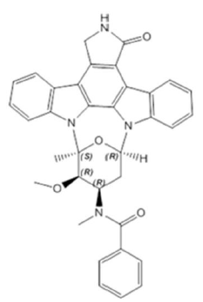
Midostaurin is a Biopharmaceutics Classification (BCS) class II compound. It has very poor, pH independent, solubility in water (< 0.001 ng/mL). It is a highly permeable, neutral, highly lipophilic and essentially a non-ionisable drug. The partition coefficient (LogP_{octanol/water}) of midostaurin is 5.5. Its solubility is other solvents include: ethanol 2.46 mg/mL, acetone 8.21 mg/mL, benzyl alcohol 215.4 mg/mL, macrogol400 102.0 mg/g and n-octane 7.17 mg/mL.
Specifications for related substances in midostaurin were qualified or consistent with the International Committee for Harmonisation (ICH) requirements for unidentified or genotoxic impurities. Residual solvents meet ICH requirements.

Drug product
The capsule is described as pale orange, oblong with red imprint ‘PKC NVR’. The capsule content was described as a yellow to greenish-yellow to very dark yellow to very dark greenish yellow solution.
The excipients in solution with midostaurin include: macrogol400, PEG-40 hydrogenated castor oil (surfactant), ethanol, corn oil PEG-6 esters and dl-alpha-tocopherol (antioxidant). The gelatin capsules contain gelatin, glycerol, titanium dioxide, iron oxide yellow, iron oxide red, and purified water and are printed with edible ink red (containing carmine, propylene glycol and hypromellose).
The capsule manufacturing process uses standard processes such as mixing and dissolving under nitrogen, homogenisation, filtering, and filling followed by encapsulation and packaging. The process has been validated and in-process controls are adequate for the dose form.
The soft capsules are packed in Al/Al (aluminium) blisters, in cartons containing 56 and 112 capsules.
Specifications for the soft capsules include dissolution testing and limits for related substances were qualified. Stability studies supported a shelf life of 36 months when stored below 30°C and protected from moisture in Al/Al blister packs.

Biopharmaceutics
The final market image (FMI) of midostaurin for registration is a soft capsule containing midostaurin 25 mg formulated as a microemulsion preconcentrate (MEPC). This was developed due to low aqueous solubility of midostaurin and a need enhance solubilising and achieve adequate exposures. The FMI formulation was used in the pivotal studies for AML (A2301/Ratify) and AdSM (D2201). The FMI formulation was developed through optimising trials of an earlier MPEC soft gelatin capsule formulation used as a clinical service form (CSF) in various clinical trials. While showing adequate exposure, the CSF showed phase separation and risk of drug precipitation on storage.
In addition, an oral solution was developed for paediatric use. This formulation is an MEPC comprising the same excipients as those used in the CSF and FMI capsule fill formulations. The oral solution is filled in a glass bottle and is diluted with water prior to administration. The oral solution was used in the relative bioavailability and food effect studies (A2108 and A2111).
An intravenous formulation was developed to determine the absolute bioavailability of midostaurin but the study was terminated due to a hypersensitivity reaction in one subject and a pharmacokinetic analysis was not be performed.
The effect of food on midostaurin was determined at a 50 mg dose (two 25 mg capsules of FMI formulation). Relative to fasting conditions, a high fat meal decreased the C_{max} by 27% (90%CI 0.59 to 0.90) and a standard meal decreased the C_{max} by 20%. The time to peak (T_{max}) was increased by 1.5 hours and 1 hour for the high fat and standard meals respectively. AUC_{inf} was increased by 59% (90%CI 1.22 to 2.08) after a high fat meal and 22% after a standard meal.
The relative bioavailability of the oral solution compared to the FMI capsule was determined to be approximately 100% when administered with a standard meal, with large inter-subject variability (CV% for AUC_{inf} 56.57%).
The extrapolated area in AUC_{inf} estimation for metabolite CGP52421 contributed to more than 20% of the total AUC_{inf} (half-life of CGP52421: 491 hours).

Quality summary and conclusions
There following are outstanding issues with the chemistry and quality control aspects of the product:
The Good Manufacturing Practice (GMP) clearance for one site expires before the expected decision phase. As another site performs this step, it will not preclude the product from registration. At least one other site performs the packaging and labelling step. The sponsor should be reminded that they should ensure that GMP is current for all overseas manufacturing sites at this time.
Registration is otherwise recommended with respect to chemistry and quality perspective.

IV. Nonclinical findings

Introduction
The sponsor has applied to register a new chemical entity, midostaurin (Rydapt) 25 mg soft capsules which are to be used:
- in combination with standard induction and consolidation chemotherapy followed by single agent maintenance therapy for adult patients with newly diagnosed acute myeloid leukaemia (AML) who are FLT3 mutation-positive; or
- for the treatment of adult patients with advanced systemic mastocytosis (ASM; particularly those with KIT mutations).
FLT3 mutations are amongst the most frequently encountered, and clinically challenging, class of AML mutations. About 30% of AML patients harbor some form of FLT3 mutation although the clinical importance of specific mutations in a specific patient depends on their nature and context. FLT3 mutations can be divided into two general categories: (1) FLT3 internal tandem duplications (FLT3 ITD) in or near the juxtamembrane domain of the receptor; and (2) point mutations within the activation loop of the FLT3 tyrosine kinase domain (FLT3 TKD mutations) resulting in constitutive activation.
KIT activation mutations in mastocytosis are often associated with mutations in the transmembrane, extracellular, and juxtamembrane domain as well as in the activation loop. The most common mastocytosis associated KIT mutation is the activation loop D816V mutation which results in constitutive activation, increased cell proliferation and reduced apoptosis.
The proposed Rydapt dosing regimens are:
- for AML: 50 mg twice daily (2 mg/kg/day based on a 50 kg body weight); Rydapt is dosed on days 8 to21 of the induction and consolidation chemotherapy cycles and then twice daily as single agent maintenance for 12 months (assumed maximum duration of treatment); and
- for ASM: 100 mg twice daily (4 mg/kg/day based on a 50 kg body weight; MHRD), and treatment is continued as long as clinical benefit is observed in the absence of unacceptable toxicity. Rydapt is intended for use in adults.

Pharmacology

In vitro primary pharmacology
Consistent with being a multi-kinase inhibitor, midostaurin displayed complex effects on the human kinome, the cell signalling milieu and neoplastic cells as well as complex interactional effects with other anticancer drugs. Its high level modes of action are cell cycle arrest and increased apoptosis. While not evaluated by the sponsor, its actions on the human kinome indicate that it may affect angiogenesis, stromal interactions, ligand-receptor mediated growth responses and other key events in carcinogenesis. Overall, the key modes of action of midostuarin on leukaemia cells and neoplastic mast cells are complex and incompletely understood.

Inhibition of protein kinases
In general, derivatisation of midostaurin from staurosporine resulted in increased kinase binding affinities, increased kinase specificities and decreased pharmacological potencies across the human kinome. Both midostaurin and staurosporine are multi-kinase inhibitors, and bind to the FLT3 ‘gatekeeper’ domain adjacent to the enzyme’s ATP binding domain. They behave competitively with ATP at the ATP binding site (that is Type I FLT3 inhibitors). Since the kinase ATP binding site is highly conserved across receptor tyrosine kinases, relatively non-selective inhibition across the human kinome is predictable (and demonstrated) for both agents.
Based on in vitro binding affinity studies using a purified human receptor tyrosine kinase panel representing > 50% of the predicted human kinome, midostaurin has binding affinity (K_{d} < 100 nM) across a broad range of kinases including FLT3 and KIT. The FLT3 binding affinity of midostaurin (K_{d} 6 to15 nM) was comparable with sorafenib (K_{d} 13 nM) but lower than sunitinib (K_{d} 0.47 nM), although the activity of midostaurin against FLT3 (wild type (wt) and ITD, IC₅₀ 13 to15 nM) was lower than that of sorafenib (IC₅₀ 2 to3 nM) and comparable with that of sunitinib (IC₅₀ 10 to 34 nM) in an autophosphorylation assay using cellular lysates. Midostaurin had mid-range human tyrosine kinase selectivity (and specifically, low to mid-range selectivity for wtFLT3) compared with the other evaluated human kinome inhibitors (including approved human pharmaceuticals).
Metabolite CGP62221 inhibited much the same range of kinases with similar IC₅₀ values compared with the parent drug whereas metabolite CGP52421 was generally less active. CGP52421 had a lower binding affinity for FLT3 (K_{d} 68 nM) and was less active against wtFLT3 and FLT ITD (wtFLT3 IC₅₀ 350 nM; FLT3-ITD 160 nM) compared with its parent molecule, although one in vitro study demonstrated similar inhibition of the purified FLT3 cytoplasmic kinase domain (midostaurin IC₅₀ 528 nM, metabolite CGP52421 IC₅₀ 643 nM).
Midostaurin also has a high binding affinity to KIT (D816V) (K_{d} ~ 8 nM). Midostaurin inhibited the c-KIT autophosphorylation in Mo-7e cells (megakaryocytic leukaemia cell line) following stem cell factor stimulation (IC₅₀ 0.3 µM). At concentrations of 1 µM, midostaurin and its metabolite CGP62221 (but not CGP52421) blocked the constitutive phosphorylation of wt KIT and the major KIT (D816V)-downstream kinase FES in human neoplastic mast cells. These effects correlated with a similar pattern of effects on human neoplastic mast cell proliferation (including on freshly obtained bone marrow or primary peripheral blood mononuclear cells from ASM patients). Based on in vitro chemical proteomic profiling, other major midostaurin targets in human neoplastic mast cells included the following kinases: KIT, SYK, FES, GSK3B, AAK1, BIKE, TBK1, PKN1, AMPK, RSK1-3 (not all cell lines), BTK (not all cell lines) and MARK2.
Midostaurin and its major human metabolites (CGP62221 and CGP52421) inhibited a range of other kinases, in addition to FLT3 and KIT, with IC₅₀ values in the nanomolar range. Kinases inhibited by midostaruin include VEGFR2 (that is KDR, IC₅₀ 86 nM), PKN1/2 (K_{d} 9 to15 nM, IC₅₀ 16 nM), JAK3 (K_{d} 12 nM), TRK (IC₅₀ 11 to 51 nM), PDGFRα/β (IC₅₀ ~ 35 nM), Aurora A (IC₅₀ 18 nM), PKC isozymes (IC₅₀ 20 to 50 nM), SYK (IC₅₀ 8 to 95 nM), and many more. It has relatively low activity against VEGFR1 and FGFR (IC₅₀ ≥ 900 nM) in kinase inhibition assays.

Effects on neoplastic cell proliferation in vitro
Midostaurin inhibited the proliferation of a large range of neoplastic human cell lines in vitro including some leukaemia cell lines (IC₅₀ mostly 0.1 to 0.6 µM), in addition to lung cancer, melanoma (some), colon cancer, mammary cancer (some), glioblastomas and other CNS cancers, lymphomas, ovarian cancers (some) and renal cancers (IC₅₀ or GI₅₀ 0.04 to < 1 µM). Midostaurin was ~ 10 times more potent in a small panel of FLT3 mutation positive (FLT3⁺) human AML cell lines (IC₈₀ 35 to 48 nM) compared with FLT3 mutation negative (FLT3 ⁻ ) cell lines (IC₈₀ 290 to 560 nM) that is somewhat selective for FLT3⁺ in some AML cells.
In AML cell lines, inhibition of cell proliferation was correlated with inhibition of the constitutive phosphorylation of FLT3 and not midostaurin’s effects on PKCβII, KIT, PDGFR, suggesting that the antiproliferative activity of midostaurin against AML cells may involve the inhibition of FTL3 phosphorylation, but not PKCβII, KIT or PDGFR.
Midostaurin is an inhibitor of the proliferation of murine neoplastic IL-3 independent pro B-cells bearing KIT D816V, KIT delVV559/560, FLT3⁺ or FLT3-ITD mutations (EC₅₀ ~ 30 to 50 nM). The presence of the FLT3-ITD or FLT⁺ mutations lowered midostaurin’s EC₅₀ (or IC₅₀) by ~ 10 to 15 fold compared with its effect in wtFLT3 cells. In this system, metabolism of midostaurin to CGP52421 increases the EC₅₀ for FLT3-ITD cells by ~ 17 fold and for wtFLT3 cells by ~ 5 to 6 fold; however metabolism to CGP62221 has little effect on the EC₅₀ for both FLT3-ITD and wtFLT3 cells. As with the parent molecule, CGP62221 is somewhat selective for FLT3-ITD with a ~ 10 times increase in EC₅₀ in wtFLT3 cells.
Midostaurin and its major metabolite CGP62221 (but not CGP52421) were inhibitors of human neoplastic mast cell line proliferation (IC₅₀ 50 to 250 nM). Similar results were obtained using freshly obtained bone marrow or primary peripheral blood mononuclear cells from patients with various subtypes of systemic mastocytosis (midostaurin IC₅₀ 0.1 to 1 µM; CGP52421 IC₅₀ 0.25 to > 1 µM; CGP62221 IC₅₀ 0.01 to 0.25 µM ). In some patient samples, the metabolite CGP62221 was more potent than the parent molecule. These results imply that some of midostaurin’s primary pharmacological activities in ASM patients may be due to its major metabolite, CGP62221. In human neoplastic mast cell lines, midostaurin and both its major metabolites (CGP52421 and CGP62221) acted synergistically with cladribine in terms of growth inhibition.

Effects of α1 acidic glycoprotein (AGP) on midostaurin inhibition of cell proliferation
Based on studies utilising human bladder carcinoma, colon carcinoma, and epidermoid carcinoma cell lines, human AGP at the physiological blood concentration (600 to 1200 µg/mL) blocked midostaurin mediated inhibition of cell proliferation by 68 to 118 fold. Similarly, AGP also blocked midostaurin’s inhibitory activity to PKCα. Rat AGP had considerably less effect, increasing IC₅₀ by ~ 2 fold (compared with. ~ 90 fold by human AGP) in the PKC inhibition assay. In the same PKC activity assay with 10% plasma, monkey plasma had half the effect of human plasma (5.5 fold increase in IC₅₀ compared with 10 fold by human plasma), and rodent plasma increased the IC₅₀ by only ~ 1.5 fold.
If true across the entire spectrum of midostaurin’s primary pharmacological effects, this finding substantially complicates risk assessment based on plasma drug concentrations. It may also influence the specific pharmacokinetic compartments where midostaurin is active in different species (for example midostaurin may be mostly inactive in peripheral blood and in tissue compartments where human AGP is present) in human patients. AGP binding may allow humans to tolerate much higher doses than those that were achievable in the repeat dose toxicology studies. This was reflected by the relatively low comparative exposures in the repeat dose toxicology studies in order to ensure adequate survival (based on high mortality in some of the non-pivotal dose ranging studies). Since human AGP is an acute phase protein, the presence of an acute phase reaction may substantially reduce drug efficacy.

Pharmacodynamic interactions
Midostaurin showed additive or synergistic cytotoxicity with most conventional anti-leukaemic agents (cytarabine, doxorubicin, idarubicin, mitoxantrone, etoposide and vincristine) in FLT3⁺ AML cell lines, but not in FLT3⁻ AML cell lines. Antagonism was observed for midostaurin with these agents (except vincristine) in the FLT3⁻ cell lines tested.
Cell cycle analysis demonstrated that midostaurin induced G1/S phase arrest and apoptosis of FLT3⁺ human AML cell lines whereas it caused G2/M phase arrest in FLT3⁻ cells, suggesting different mechanisms of action depending on the FLT3 status of the cell line. Both cytarabine and doxorubicin arrested FLT3⁺ cells in late G1 to early S phase and induced apoptosis in 10 to 20% of the total cells. When used in combination with these drugs, midostaurin enhanced apoptosis by causing cell cycle arrest in both the G1 and G2/M phases, which is the probable mechanism of midostaurin synergism with these agents. However, in FLT3⁻ cells, midostaurin reduced the induction of apoptosis by cytarabine and doxorubicin, which coincided with an accumulation of cells in the G2/M phase of the cell cycle.
Overall these in vitro data demonstrate that a thorough understanding of disease genetics in individual human AML patients is required before initiating combination treatment utilising midostaurin. Combination therapies may offer no additional benefit, or worse due to antagonism in patients with FLT3⁻AML. However, only a relatively small number of AML cell lines have been evaluated in vitro. This restricts the capacity for the evaluator to make broad statements on drug therapeutic interactions across the whole spectrum of human AML disease. Ex vivo testing of drug combinations using an individual patient’s AML cells combined with FLT3 genotyping before commencing combination drug therapy should be considered in order to reduce the risk of deleterious antagonistic drug interactions.
The different effects of midostaurin in FLT3⁺ versus wtFLT3 bearing cells and its complex interactions with conventional AML therapeutics can be partly explained by its effects on cell signalling. In FLT3⁺ cells, midostaurin inactivates Myt-1 and activates CDC25c, leading to the activation of Cdk1. Activated Cdk1 phosphorylates Bcl-2-associated death promoter (BAD) at serine-128 facilitating its translocation to the mitochondria, where it triggers apoptosis. In FLT3⁻ cells, midostaurin inactivates Cdk1 by inducing CDC25c serine-216 phosphorylation and its subsequent cytoplasmic sequestration. As a result, cells undergo G2/M arrest and do not undergo apoptosis because BAD is not activated.
While not evaluated by the sponsor, other authors have demonstrated that FLT3 inhibitors can disrupt FLT3-ITD mediated signalling cascades via the JAK/STAT, PI3K/AKT and MAPK pathways.² The overall critical effect of FLT3 inhibitors in FLT3-ITD AML cells is to alter the balance of anti-apoptotic signalling (via Bcl2/Bcl_{XL}) and pro-apoptotic signalling via BAD. An important anti-apoptotic mechanism operating in FLT3-ITD bearing cells is the sustained activation of Pim kinases via aberrant signalling down the STAT5 pathway (Pim kinases phosphorylate BAD leading to the cytoplasmic sequestration [that is inactivation] of these proteins and subsequent protection from apoptosis). Inhibition of FLT3-ITD results in a rapid loss of phospho-STAT5, and downregulation of Pim-1 resulting in a pro-apoptotic state.
Thus combinations of FLT3 and Pim-1 or Pim-2 inhibitors tend to act synergistically in FLT3⁺ AML cells and may be potentially useful for midostaurin combination treatment of FLT3⁺ AML. In particular, concurrent use of Pim kinase inhibitors may delay the onset of midostaurin resistance.

Development of midostaurin resistance in AML
Murine neoplastic IL-3 independent pro B-cells bearing FLT3-ITD cultured in the presence of increasing concentrations of midostaurin (up to 0.04 µµM) over a span of two months generated a drug resistant polyclonal subline of Ba/F3-FLT3-ITD cells by inducing FLT3-ITD overexpression.
As discussed above, FLT3 inhibitor resistant cells can also display sustained Pim-1 and/or Pim-2 activity, thus bypassing the effects of FLT3 inhibitors on BAD and apoptosis. High levels of Bcl2 (an anti-apoptotic signal) are also associated with FLT3 inhibitor resistance as is sustained phosphor-STAT5 activation. The FLT3⁺ point mutation D627 E can induce Mcl-1 independent of kinase activity with resultant anti-apoptotic activity. Maintaining an active MAPK/ERK pathway, or acquiring NRAS mutations, methylation of SHP-1 and epigenetic silencing of SOCS proteins (both negative regulators of the JAK/STAT pathway) have all been implicated in acquired resistance to FLT3 inhibitors.
Highly activated SYK occurs in a high frequency in AML patients with FLT3 ITD. Given that midostaurin is also an inhibitor of SYK (IC₅₀ 8 to 95 nM), this kinase may also be an important primary pharmacological target of midostaurin and this activity may help to delay the development of FLT3 inhibitor resistance. The effects of midostaurin on FLT3⁺ SYK⁺ cell lines were potentiated by combining with the SKY inhibitors R406 or PRT062607. These data suggest that the development of resistance to midostaurin is expected to be slower than FLT3 specific inhibitors and could be delayed by concurrent treatment with a SYK inhibitor.
As a broad spectrum multi-kinase inhibitor, midostaurin may have some advantages over more targeted FLT3 inhibitors in terms of the emergence of drug resistance. However, multi-kinase inhibitors are expected to have a higher risk of side effects.

IL3 rescue of midostaurin treated murine neoplastic pro B-cells bearing FLT3-ITD or FLT3 D835Y
Under non-cytotoxic conditions, midostaurin (0.01 to 1 µM) caused a 100% inhibition of wtFLT3 autophosphorylation and cessation of cell growth due to a combination of cell cycle arrest and apoptosis. Both cell lines could be rescued by in vitro treatment with IL-3 and the presence of IL-3 increased the midostaurin IC₅₀ by several orders of magnitude that is midostaurin does not adversely affect the kinases in the IL-3 signalling pathway in these cells. These findings also imply that the efficacy of midostaurin may be reduced under pro-inflammatory conditions resulting in increased IL-3 levels, including the presence of an acute phase reaction.

Effects of midostaurin on histamine release
Midostaurin and its major metabolites (CGP52421 and CGP62221) inhibited IgE-dependent histamine release from primary bone marrow mast cells from a patient with ASM (ex vivo), human lung mast cells and cord blood progenitor cell derived mast cells. These results imply that midostaurin treatment may have some efficacy in treating some of histamine associated symptoms or clinical signs of ASM such as facial flushing, tachycardia, hypotension, headache, nausea, vomiting and diarrhoea.

In vivo primary pharmacology
Most of the studies were performed with various immunodeficient rodent human AML models using progression of neoplasia and/or survival as the assessed endpoints. In general, the conditions of the assays optimised the chances for treatment success.
Based on studies using a transplanted human AML cell line in athymic nude mice, midostaurin displayed dose related suppression of tumour growth (40 to 50% inhibition of tumour growth at 5 to 20 mg/kg QD per os (PO), 0.25 to1times the proposed AML dose based on dose per body surface area [BSA]) and tumour regression (at 50 and 150 mg/kg QD PO, 2 to 7 times the proposed dose for AML adjusted for body surface area (BSA)).
In a lethal FLT3-ITD AML bone marrow transplant model in mice, midostaurin treatment (100 mg/kg/day QD PO; ~ 5 times the proposed AML dose by BSA) starting 25 to 30 days post-transplant resulted in significantly (p < 0.05) increased survival time, reduced spleen weight and white blood cell counts (measures of neoplastic disease), partial recovery of splenic architecture, reduced neoplastic myeloid hyperplasia and an increase in the proportion of other haematopoietic lineages in bone marrow.
In nude mice recipients of BaF3 FLT3 ITD⁺ cells engineered to stably express firefly luciferase, post–transplant midostaurin treatment at 100 mg/kg/day QD PO (~ 5 times the proposed AML dose by BSA) substantially suppressed the leukaemia burden of disease as assessed by whole body imaging. Likewise post-transplant treatment using the same dose of midostaurin significantly (p < 0.05) increased the survival of mice injected with B cell and T cell lymphoma cells derived from vav-human FLT3-ITD transgenic mice.
The studies in mouse models of human AML support the proposed treatment of AML. However, studies specifically addressing the proposed use for combination standard induction and consolidation chemotherapy were not evaluated in vivo. Midostaurin was not tested in animal models of ASM.

Secondary pharmacodynamics and safety pharmacology
As noted in the above discussion, midostaurin is a broad spectrum kinase inhibitor. As an overall generalisation, broad spectrum kinase inhibitors tend to have a higher incidence of undesirable side effects than more targeted inhibitors.
Safety pharmacology studies investigated effects on the function of CNS, cardiovascular and renal systems. No studies on the respiratory or gastrointestinal systems were performed. Of the safety pharmacology studies, only two in vitro hERG studies with the two major human metabolites (CGP62221 and CGP52421) were GLP compliant.

Central nervous system (CNS) effects
In male rat brain slices, midostaurin (10 µM) had no effects on presynaptic α2-adrenergic, 5-HT1B/1D, GABA-B, DA2 and M2 muscarinic autoreceptors, and the basal release of noradrenaline (NA) and acetylcholine. However, increased basal release of 5-HT (26%) and dopamine (81%) and inhibition of basal GABA release were observed at 10 µM (all possibly due to protein kinase C inhibition) and inhibition (25 to 40%) of NA, 5-HT and GABA uptake at 1000 µM. These results may not be clinically relevant due to the high midostaurin concentrations used in the in vitro assay (free fraction clinical C_{max} 54 nM).
Slight post-dose ataxia (persisting up to 4 h) was noted in mice dosed at ≥ 10 mg/kg PO (≥~ 0.2 times the maximum recommended human dose (MHRD) based on BSA). Transient elevations in body temperature (< 0.7 ^{O}C) compared with control was noted at 1 to 2 h at 10 to 300 mg/kg PO, but not at 4 h post-treatment. No adverse effects on rotarod, motility, locomotor activity or ethanol induced narcosis occurred in mice at up to 300 mg/kg PO. Tissue distribution studies in rats showed distribution to the CNS. Midostaurin might cause CNS effects in patients.

Cardiovascular effects
Midostaurin at concentrations up to 12 µM (limit of solubility) had no inhibition of hERG tail current in an appropriately validated in vitro study. Metabolite CGP62221 induced an 11.3% inhibition of peak hERG current at 1.2 µM (limit of solubility). Metabolite CGP52421 significantly (p < 0.05) inhibited the peak hERG current by 38.5% at 1.5 µM and 26.4% at 4.74 µM in vitro (~ 100 times the clinical free fraction C_{max} 48 nM). The in vitro hERG results suggest a low risk of QT prolongation in patients taking midostaurin.
In the canine repeat dose studies, a decrease in heart rate and PQ interval prolongation (no effects on QT interval) was seen in individual animals dosed at 10 and 30 mg/kg (in the absence of detectable myocardial toxicity).
Midostaurin (≤ 18 µM) had no adverse effect on spontaneous beating or electrically stimulated isolated guinea pig atria. At concentrations ≤ 30 µM midostaurin had no effects on contractions by rabbit isolated thoracic aorta rings induced by angiotensin II or noradrenalin (NA). However, it did almost completely counteract the vasoconstrictive effects of NA and potassium chloride on isolated and perfused rat mesenteric vascular beds (IC₅₀ 0.4 to 0.7 µM). Oral dosing of midostaurin (300 mg/kg; approximately 14 times MHRD based on BSA) had no adverse effects on femoral artery pressure or heart rate in rats for up to 6 h post dose. However, slow IV infusion of midostaurin at doses ≥ 0.27 mg/kg/min resulted in marked dose related decreases in mean arterial pressure (MAP) and heart rate. Both the bradycardic and hypotensive effects were of slow onset and long duration: the maximum decreases (approximately 30% and 50% for MAP, and approximately 10% and 20% for hazard ratio at 0.27 and 0.83 mg/kg/min, respectively) were not reached until 30 min after the completion of the 30 minute infusions, and at the end of the observation period (2 h after the end of infusion) MAP and hazard ratio were still distinctly below the baseline values. The higher IV infused dose 2.5 mg/kg/min was lethal and induced severe hypotension and respiratory arrest. Based on these findings, midostaurin should not be administered to patients by the IV route. Plasma drug concentrations were not measured in the above studies. Hypotension and bradycardia are potential adverse effects in humans.

Effects on renal function
Marginally increased sodium and chloride excretion (by 1.5 to 2.5 fold) was noted in rats after an oral dose of 100 or 300 mg/kg (no effects at 30 mg/kg). However, the maximum level of excretion was well within the normal range for rats. The hydration status of the animals was not adequately evaluated making the interpretation of these findings difficult.
Urinary electrolyte excretion was not monitored in repeat dose toxicity studies, but hypochloraemia and hyponatraemia was not detected in repeat dose toxicity studies. Overall the findings in this study are likely not clinically relevant. Potassium excretion was not affected.

Pharmacokinetics
Based on its physicochemical properties, midostaurin is classified as a BCS Type II drug (high permeability, low solubility; < 0.001 mg/mL) that is, absorption and bioavailability are strongly formulation dependent.
Oral dosing (microemulsion formulation) of rats, dogs, and rabbits resulted in relatively slow absorption (time of maximal drug-plasmas concentration (T_{max}) of 4 to 8 h). Estimated oral bioavailability of a microemulsion formulation was modest in dogs (~ 50%) and low in rats (~ 10%) and rabbits (~ 2%). Moderate plasma clearance occurred in rats and dogs (~ 1 L/h/kg), but it was slow in rabbits (0.24 L/h/kg). Plasma kinetics was biphasic with distinct distribution and elimination phases. The elimination T_{½} was ~ 3 to 5 h in rats and dogs and 10 h in rabbits by the IV route and longer by the PO route (10 to 15 h) compared with humans (~ 20 h).
As an overall generalisation, AUC increased linearly with dose across all species evaluated. Chronic repeated PO dosing of dogs resulted in a < 2 fold increase in an AUC at steady state (AUC_{ss}) compared with day 1 levels demonstrating a small level drug accumulation in dogs (consistent with higher apparent volume of distribution at steady state (V_{ss}) and possible tissue sequestration in this species).
Based on in vitro data midostaurin and its major metabolites (CGP62221 and CGP52421) are highly protein bound (~ 99%) in plasma of all species tested (rat, dog and human). High concentrations of alpha 1 glycoprotein (AGP) (up to10 µg/mL) did not alter binding in human plasma. There were no studies investigating whether midostaurin binds to albumin or AGP, although it was stated in one protein binding study report that midostaurin was highly bound to major plasma proteins including albumin (99.1 to 99.5%), AGP (98.6 to 99.5%) and lipoproteins (97.4 to 99.0%). The sponsor incorrectly concluded in the clinical and nonclinical summary and overview documents that midostaurin was mainly bound to human AGP. As noted above, binding to human AGP, resulted in drug inactivation in vitro whereas binding to the AGP of other species had minimal effects, suggesting that midostaurin has either low binding or lower affinity binding to animal AGP.
While not specifically investigated by the sponsor, other investigators have demonstrated that the AGP binding site for other members of the staurosporine drug family partly overlaps the binding site(s) for basic drugs, acidic drugs, as well as steroid hormones and their dissociation from human AGP is slower compared with its dissociation from AGP from other species., This human specific characteristic substantially alters the pharmacokinetics of this drug class. When equimolar amounts of 7-hydroxystaurosporine and human AGP were administered IV to humans, the plasma concentration of 7-hydroxy-staurosporine was substantially increased, V_{ss} was decreased, and clearance (CL) was decreased by a factor of ≥100 fold compared with dosing with 7-hydroxystaurosporine alone.
Unlike in humans, canine AGP co-administration had no effect on the pharmacokinetics of 7-hydroxystaurosporine in this species. Furthermore, human AGP reduced the hepatic extraction ratio for 7-hydroxystaurosporine by ~ 16 fold. In rat hepatocytes human AGP (10 µM) completely inhibited 7-hydroxystaurosporine uptake whereas human serum albumin (10 µM) had no effect. Thus, as with other members of the staurosporine drug family, binding to human AGP is probably of substantial pharmacokinetic importance with midostaurin and is probably the main cause of the interspecies pharmacokinetic and toxicological differences observed.
The protein binding of midostaurin and its major metabolites was independent of concentration. The presence of the metabolite CGP52421 did not result in protein displacement reactions and mild to moderate liver disease in human patients was not associated with detectable changes in protein binding ex vivo. Partitioning to human red blood cells was not studied in vitro.
Based on plasma and blood radioactivity concentrations, midostaurin and metabolites distribute into red blood cells in rats, but are mainly in plasma with minimal distribution to red blood cells in dogs. V_{ss} in rats and rabbits was ~ 1 L/kg implying wide distribution. However, V_{ss} in dogs was ~ 4 L/kg implying tissue sequestration.
Following a single IV dose in non-pigmented rats a wide tissue distribution (consistent with the drug’s V_{ss} and lipophilic, basic physicochemistry) was apparent within 5 minutes post-dosing with tissue concentrations exceeding plasma concentrations in all evaluated tissues except eye and testis. High levels of drug associated radioactivity occurred in brown fat, adrenal glands and liver following IV dosing. Distribution was similar in single IV dosed pigmented rats (no evidence of melanophilic accumulation). High tissue distribution was also observed with oral dosing. Brain penetration was evident by both dosing routes (brain: plasma ratios at T_{max}: IV dosing ~ 2.5, oral dosing ~ 0.4). Irrespective of the route of administration substantial declines in tissue drug associated radioactivity occurred by 24 h post dose and tissue drug associated radioactivity levels were negligible by 168 h. Repeated oral dosing was associated with ≥~ 50% increases in tissue drug associated radioactivity in spleen, brown fat, bone marrow, stomach and brown fat.
Consistent with the concentration of drug associated radioactivity in the liver, midostaurin is predominantly cleared by hepatic metabolism. The major pathway of midostaurin metabolism is hepatic hydroxylation at the pyrrolidine ring (producing two CGP52421 epimers) or the benzene rings of the staurosporinone moiety and O-demethylation (producing CGP62221) followed by further oxidation and/or glucuronidation of the primary metabolites.
Metabolism across the different species was qualitatively and quantitatively different. N-demethylation and amide hydrolysis occurred mainly in humans and carbonyl reduction in dogs. Glucuronidation and cysteinyl adduct formation was seen in rats and rabbits (glucuronidation only in rabbits). O- or N-demethylation metabolites (P15.5, P22.6, P23.3 and P33) in humans were not detected in animal species, but none of these metabolites were more than 10% of total drug-related materials in human plasma. Other minor human metabolites were also formed in animal species. Both major human metabolites, CGP62221 and CGP52421 were formed in all animal species used in the toxicology program, but the level of CGP62221 in rats, rabbits and dogs were much lower than in humans (not quantifiable in rat plasma, < 5% in dog plasma and ~ 2% in rabbit plasma compared with. 30% in human plasma). Plasma levels of CGP52421 in all 3 animal species were similar to those observed in humans (40 to 60% in rat plasma, ~ 30% in dog plasma, 30 to 40% in rabbit plasma and 34% in human plasma).
Based on in vitro human biomaterials studies the oxidation of midostaurin occurred via a series of hydroxylation and demethylation reactions primarily catalysed by CYP3A4. The enzymatic reactions exhibited Michaelis-Menton kinetics (K_{m} and V_{max}: 1.04 µM and 3.55 pmol/min/pmol CYP3A4 for recombinant CYP3A4 and 1.48 µM and 164 pmol/min/mg protein or ~ 1.0 pmol/min/pmol CYP3A4 for human liver microsomes). The CYP3A4 hydroxylation and demethylation reactions had similar catalytic efficiencies. CYP3A4 was also identified as the major contributor of the hepatic oxidative clearance of CGP62221 and CGP52421 with minor contributions from CYP1A1 and CYP3A5.
Based on mass balance studies using ¹⁴C-midostaurin in rats and dogs the major pathway of excretion was via the biliary system. Only very small amounts of drug associated radioactivity were detected in urine. The human mass balance study results are consistent with the results of the animal studies. The majority of excreted materials in faeces and urine were in the form of metabolites.
Overall, pharmacokinetic profiles of midostaurin in animal species generally resembled that in humans. However, the plasma levels of the major active metabolite CGP62221 were much lower in rats, rabbits and dogs compared with humans.

Pharmacokinetic drug interactions

Cytochrome P450-mediated interactions

Midostaurin and its active metabolites (CGP52421 and/or CGP62221) are predominantly metabolised by CYP3A4, and thus their clearance would be decreased by CYP3A4 inhibitors and increased by inducers.

Metabolic enzyme inhibition
Based on in vitro human biomaterials studies, midostaurin, CGP52421 and/or CGP62221 are inhibitors of CYP1A2, CYP2C8, CYP2C9, CYP2D6, CYP2E1 and CYP3A4/5 with IC₅₀ values in the micromolar range (Table 3). All 3 compounds also caused time-dependent inhibition of CYP3A4/5 (inhibitory constant (K_{i}) 1 to 2 µM), and midostaurin time-dependently inhibited CYP2C8 (K_{i} 17.8 µM). They are no inhibitors of CYP2A6, 2B6 or 2C19.

Table 3: CYP450 inhibition IC₅₀ (µM) and comparison with clinical C_{max}
 | CYP1A2 | CYP2C8 | CYP2C9 | CYP2D6 | CYP2E1 | CYP3A4
Midostaurin | ~ 3 | ~ 5 | ~ 0.5 | ~ 1 | ~ 0.5 | ~ 1.5^{m}, > 100^{t}
CGP62221 | ~ 1.5 | ~ 5 | <1 | > 100 | > 100 | < 1^{m}, ~ 1^{t}
CGP52421 | ~ 45 | ~ 15 | ~ 30 | ~ 5 | > 100 | ~ 1.5^{m}, ~ 2^{t}
Fold of C_{max}* | ≥33 | ≥110 | ≥9 | ≥19 | ≥9 | ≥19
Note: m, midazolam as the substrate; t, testosterone as the substrate; * IC₅₀ or K_{i} compared with the clinical free fraction C_{max} of 53.8, 45.2 and 47.9 nM (total C_{max} 3070, 2810 and 2516 ng/mL) for midostaurin, CGP62221 and CGP52421, respectively.
As shown in the above, the lowest IC₅₀ or K_{i} values for midostaurin or its major metabolites against CYP2C9, 2D6, 2E1 and 3A4 are 9 to19 fold higher than the clinical free fraction C_{max}. Higher IC₅₀ to C_{max} ratios were apparent for CYP1A2 and 2C9 (33 and 110 respectively). Since midostaurin and its major metabolites all inhibit most of these CYPs, their actions are probably additive. Pharmacokinetic interactions associated with inhibition of these CYPs may occur.

Metabolic enzyme induction
Midostaurin, CGP62221 and CGP052421 are PXR xenosensor ligands and could theoretically induce multiple enzymes including CYP1A, CYP2A, CYP2B, CYP2C and CYP3A. The three compounds triggered CYP3A4 induction at concentrations 1 to 50 µM, and the induction was comparable with the positive control, rifampicin.
At concentrations ≤ 10 µM midostaurin, CGP52421 and CGP62221 induced CYP1A1, CYP1A2, CYP2B6, CYP2C8, CYP2C9, CYP2C19 and CYP3A4/5 mRNA expression in human primary hepatocyte cultures, and also induced enzyme activity of these enzymes except for CYP3A4/5. The lack of significant induction of CYP3A4/5 activity (≤ 6 fold and < 40% of the positive control) despite large increases in mRNA expression (≤ 100 fold) is consistent with the time dependent inhibition properties of midostaurin and metabolites.
Based on the CYP inhibition and induction results discussed above, midostaurin and its major metabolites inhibit, as well as induce multiple CYP450 enzymes, that is, CYP1A2, 2C8, 2C9 and 3A4/5.
The effect of midostaurin on the pharmacokinetic profile of other drugs metabolised by these enzymes in patients is expected to be complex, and the in vivo consequences in humans are uncertain. Midostaurin may increase the plasma concentration of drugs that are predominantly metabolised by CYP2D6 or 2E1, and decrease the plasma concentration of drugs that are predominantly metabolised by CYP1A1, 2B6 and 2C19.

Transporter-mediated interactions
Midostaurin is not a substrate of P-glycoprotein (P-gp), major responseP2, organic cation transporter-1 (OCT1), and organic anion transporters (OAT) P1B1/3 or OATP2B1. Based on in vitro data, midostaurin is an inhibitor of P-gp (IC₅₀ 1.7 µM) and breast cancer related protein (BCRP) (IC₅₀ 0.23 µM). The effect of the active metabolites on P-gp and BCRP was not investigated. Midostaurin and both active metabolites are inhibitors of OATP1B1 (IC₅₀ 0.28 to 1.25 µM) and weak inhibitors of MATE1 (31 to 44% inhibition at 5 µM). Midostaurin and/or metabolites did not inhibit MATE2-K, OATP1B3, OAT1, OAT3, OCT 1, OCT2, or major response P2 (midostaurin only) at test concentrations up to 2.5 or 10 µM.
Midostaurin, CGP52421 and CGP62221 (all at 5, 10 µM) are not inducers of P-gp and weak inducers of major responseP2 mRNA expression and activity in human primary hepatocyte cultures. Induction of major response P2 mRNA levels was less than 3 fold and observed in hepatocytes from 1 or 2 out of 3 donors. The potential for induction of other transporters were not studied.
Based on these data, the pharmacokinetics of midostaurin is not expected to be affected by transporter inhibitors or inducers. However, midostaurin may increase exposures of P-gp and BCRP substrates, and reduce the hepatic clearance of OATP1B1 substrates.

Toxicology

Acute toxicity
Acute toxicity was evaluated in mice, rats and dogs. Mortality occurred in mice and rats and was often delayed for several days post dosing. Clinical signs were ataxia, abnormal gait, hunched posture, decreased activity and dyspnoea. The effects of a single IV dose were comparatively mild; however as noted in the safety pharmacology section, IV dosing may be associated with delayed, severe, and potentially fatal hypotension.

Oral dosing (PO)
Delayed mortality (3 to 5 days post dosing) occurred in mice following dosing at the maximum feasible (and limit) dose (2000 mg/kg, 50% split dosing with a 30 min dosing interval). Mortality did not occur following dosing at 1280 mg/kg. Key adverse effects in mice included: transiently decreased body weight gain, decreased activity, ataxia, abnormal gaits, ventral hypotonia, hunched postures, ptosis, dyspnoea, general ill thrift (piloerection, poor general condition, and recumbency) and hypothermia.
In one rat study, 4 out of 5 females died after a dose of 1280 mg/kg. Mortality was delayed to days 3 to 8 post-dosing. However, there were no deaths in the second study at the same dose although the rat strain, study design and dosing vehicle were the same as in the first study. In both of the oral dose rat studies, there was no mortality in male rats at 1280 mg/kg. Key adverse effects in rats included: emaciation, depression, pulmonary oedema, and gastric haemorrhage.
No mortality or midostaurin-related adverse effects were observed in one female beagle dog dosed at 120 mg/kg. Key adverse effects included diarrhoea, vomiting, excessive salivation and transiently reduced food intake. Because of the severity of the effects, testing at higher doses was not conducted.

IV dosing (IV)
Mortality was not observed in mice dosed at up to 60 mg/kg, in rats dosed at 10 mg/kg or in one dog dosed at 1 mg/kg. Key effects in mice occurred immediately following dosing and included: decreased activity, ataxia, dyspnoea, piloerection, cool body and hypersensitivity to touch. No adverse effects were observed in rats. The adverse effects observed in dogs were attributed to the vehicle (polysorbate 80) rather than midostaurin.

Repeat-dose toxicity
Repeat dose toxicology studies were conducted in mice, rats, dogs and monkeys for up to 52 weeks. Because of the greater sensitivity of animals compared with humans, relatively low midostaurin doses (thus low exposure levels based on AUC comparisons) were used to ensure adequate survival. Because of the low exposures to midostaurin and its major metabolites in animal studies, all findings discussed below are clinically relevant, and it is possible that the toxicity profile was not adequately characterised in the animal studies because of the very low exposure to the active human metabolite, CGP62221. While mortality was observed at higher doses in some of the initial non-pivotal dose ranging studies, the overall effects of midostaurin in the pivotal repeat dose studies were comparatively mild compared with the findings in humans noted in the sponsor’s draft Product Information (PI).

Relative exposure
Exposure ratios (Table 4) have been calculated based on the AUC_{0-24h} at the last sampling point (mean of both sexes). Direct extrapolation from animals to humans based on AUC comparisons is complicated by two factors: (a) the different effects of binding to animal and human α1-acid glycoprotein on midostaurin’s primary pharmacological activity and pharmacokinetics; and (b) the absence of toxicokinetic data on the active human metabolites in animals.
Table 4: Relative exposure to midostaurin in repeat-dose toxicity studies
Species | Study duration  [Study no.] |  | Dose (mg/kg/day) | AUC_{0–24 h} (nmol∙h/L)^ | Exposure ratio#
 |  |  |  |  | AML | ASM
Rat | 3 months  [92-6037] |  | 10 PO | 1379 (male only) | 0.018 | 0.016
Rat |  |  | 20 PO | 3885 (male only) | 0.051 | 0.044
Rat |  |  | 30 PO | 7601 (male only) | 0.1 | 0.09
Rat | 6 months  [956016] |  | 30 PO | 8008 | 0.1 | 0.09
Rat |  |  | 60 PO | 10083 | 0.1 | 0.1
Rat |  |  | 100 PO | 20167 (female only) | 0.3 | 0.2
Rat | 12 months  [936281] |  | 3 PO | 404 | 0.005 | 0.005
Rat |  |  | 10 PO | 1799 | 0.024 | 0.020
Rat |  |  | 30 PO | 6647 | 0.088 | 0.075
Rat | 3 months  [95-6015] |  | 1 IV | 1080 | 0.014 | 0.012
Rat |  |  | 3 IV | 1160 | 0.015 | 0.013
Rat |  |  | 10 IV | 2105 | 0.028 | 0.024
Dog | 3 months  [936198] |  | 0.3 PO | 217 (male only) | 0.003 | 0.002
Dog |  |  | 1.0 PO | 711 (male only) | 0.009 | 0.008
Dog |  |  | 3.0 PO | 3986 (male only) | 0.053 | 0.045
Dog | 3 months  [926041] |  | 3 PO | 933 | 0.012 | 0.011
Dog |  |  | 10 PO | 5106 | 0.068 | 0.058
Dog |  |  | 30 PO | 11164 | 0.15 | 0.13
Dog | 12 months  [946003] |  | 1 PO | 820 | 0.011 | 0.009
Dog |  |  | 3 PO | - | - | -
Dog |  |  | 10 PO | 9095 | 0.12 | 0.10
Monkey | 3 months  [956014] |  | 0.6 IV | 907 | 0.012 | 0.010
Monkey |  |  | 2.0 IV | 3184 | 0.042 | 0.036
Monkey |  |  | 6.0 IV | 12696 | 0.17 | 0.14
Human | PopPK | AML | 50 mg PO BD | 75547 | - | -
Human | PopPK | ASM | 100 mg PO BD | 88219 | - | -
^ = data are for the sexes combined at the last sampling occasion; # = animal: human plasma AUC_{0–24 h}

Major toxicities

Reductions in circulating neutrophils
In the non-pivotal mouse 4 week dose ranging study, decreased neutrophil counts (in some cases combined with decreased eosinophil and basophil counts) were noted at doses ≥ 10 mg/kg/day with panleukopaenia occurring in some animals dosed at ≥ 100 mg/kg/day. Small and reversible reductions in segmented neutrophil counts were also noted in dogs dosed at 30 mg/kg/day in the 3 month repeat dose study and in dogs dosed at 60 mg/kg/day PO and 6 mg/kg/day IV in the non-pivotal 14 day dose ranging study. Neutropaenia was observed in rats only at 300 mg/kg/day PO.
Despite the relatively mild effects and low doses used in the studies, the overall effects of midostaurin on circulating neutrophils were consistent with the occurrence of neutropaenia in human patients. These effects are likely primary pharmacologically mediated and were generally correlated with effects on the bone marrow (hypocellularity, discussed below).

Reductions in circulating lymphocytes and lymphoid depletion
Panleukopaenia combined with moderate to severe lymphoid depletion was noted in the mouse non-pivotal 4 week dose ranging study following dosing at ≥ 100 mg/kg/day. Lymphoid depletion (thymus and spleen; correlated with bone marrow depletion) was classified as severe in those animals in this study that were euthanized in extremis.
Reductions in circulating lymphocytes were observed in female rats at ≥ 3 mg/kg/day for ≥ 13 weeks and at ≥ 1 mg/kg/day in males. In some studies these finding correlated with minimal to moderate lymphoid depletion (thymus, lymph nodes, spleen). In general, these changes were dose dependent, reversible and correlated with reductions in other bone marrow cells (that is total white cell, granulocyte and erythrocyte counts). Reductions in circulating lymphocytes counts were also detected in female juvenile rats dosed at ≥ 5 mg/kg/day and in male juvenile rats dosed at 15 mg/kg/day.
Marginal, reversible reductions in circulating lymphocyte counts were also detected in the 12 month dog study (in conjunction with small reductions in neutrophil and total white cell counts) following dosing at 10 mg/kg/day. More severe lymphopaenia was observed in the dose range finding studies in dogs at higher doses (60 mg/kg/day). Slight to moderate lymphoid depletion (thymus, lymph nodes) was detected in female dogs in the pivotal 3 months study following dosing at ≥ 10 mg/kg/day and in the dose range finding studies.

Effects on the bone marrow and lymphoid system
Bone marrow depletion was noted following PO dosing at 300 mg/kg/day for 4 weeks in the mouse non-pivotal dose ranging study. It was also noted in rats following PO dosing at ≥ 60 mg/kg/day. Bone marrow depletion was accompanied by minimal increases in the myeloid: erythroid ratio in about 50% of the animals at 100 mg/kg/day in the 14 day non-pivotal dose ranging study. Severe bone marrow hypocellularity was often accompanied by bone marrow haemorrhage and mortality.
In the canine studies effects on bone marrow were only noted in the non-pivotal dose ranging studies. Dosing at 60 mg/kg/day PO for 14 days induced an extreme reduction of the myeloid compartment of the bone marrow (correlated with neutropaenia and lymphopaenia) in this species.
Suppression of extramedullary haematopoiesis in spleen and liver was detected in the dose range finding studies in rats at high doses.
The effects on bone marrow, lymphoid tissues and circulating lymphocytes and neutrophils were not associated with opportunistic infections in the rodent studies; however, the use of SPF rodents is not an adequate approach to evaluate this risk. In dogs, minimal to slight unilateral or bilateral pyelitis (probably due to bacterial infection) occurred in all midostaurin treated dogs (dosed at ≥ 3 mg/kg/day; ≥~ 0.01 times MHRD; AUC comparisons).

Effects on the erythron
Marginal reductions in circulating erythron mass were noted in most of the nonclinical pivotal repeat dose studies. In most cases, the relevant haematology measurements were either within the low range of normal or just below the lower limit of the normal range. In some cases, contraction of the erythrocyte mass was accompanied by reductions in total reticulocytes and an increase in the proportion of mature and transition stage reticulocytes. In some studies the effects were only partially reversible, likely reflecting the slow recovery of the bone marrow from the primary pharmacological effects of midostaurin.
In the 10 day canine non-pivotal repeat PO dose ranging study, abnormal erythrocyte morphology including anisocytosis, microcytes, hypochromic erythrocytes, basophilic stippling, Howell-Jolly bodies and target cells (codocytes) were noted in a single male. These findings likely reflect accelerated erythrocyte production and reduced splenic clearance of opsonised, deformed, and damaged erythrocytes. These findings were not replicated in any of the other nonclinical studies. Evidence of extravascular erythrocyte destruction (splenic haemosiderosis + increased spleen mass) was noted following repeated IV dosing in rats for 13 weeks and evidence of increased erythrocyte leakage into the intestinal lymphatics (mesenteric lymph node haemosiderosis/ erythrocytosis/erythrophagocytosis) was detected in the juvenile rat study and 6 month rat study.

Effects on the gastrointestinal tract
Post PO dosing emesis was a common finding in dogs and monkeys. Diarrhoea was a common finding in the rat and canine repeat dose studies. In most studies, these effects were present at all dose levels, although they tended be more consistently observed in the higher dose groups.
Multifocal gastric ulceration was detected in the 4 week repeat PO dose ranging study in mice following dosing at 300 mg/kg/day (~ 7 times MHRD; body surface area (BSA) comparisons). Evidence of gastric injury (hyperkeratosis of the non-glandular stomach near the junction with the glandular stomach, focal gastric hyperkeratosis with focal acanthosis, erosion and ulceration, focal gastritis and minimal to moderate mucosal atrophy of the glandular stomach) occurred following PO dosing at 100 mg/kg/day in the 14 day rat dose ranging study. These effects were potentially primary pharmacologically mediated that is secondary to adverse effects on cell cycle inhibition in the gastric epithelia.
Compromised small and large intestine mucosal integrity (enterothelial degeneration, villus atrophy, lamina propria hypocellularity, separation of the lamina propria and enterothelium, villus tip enterocyte vacuolation, villus tip hyperplasia, enterothelial hyperplasia, dilated lymphatic vessels, separation of the mucosa and muscularis) occurred following repeated PO dosing at ≥ 100 mg/kg/day (≥~ 5 times MHRD; BSA comparisons) in the non-pivotal rat dose ranging studies. This is all likely secondary to cell cycle blockade. Disruption of the small intestinal barrier function was also evident following PO dosing of at 100 mg/kg/day in the 6 month rat study and was associated with high mortality, abdominal distention and fluid accumulation in lumen of the small intestine and large intestinal oedema.
Excessive, albeit transient, salivation was consistently observed following both IV and PO dosing of rats, following PO dosing of dogs, and following IV dosing of monkeys. Given that the effect occurred following IV dosing, it is unlikely to be secondary to the PO dosing method that is, it was likely drug-related. Decreased plasma cholinesterase was detected in the non-pivotal 10 day rat dose ranging study following PO dosing at 300 mg/kg/day. This may provide a plausible pharmacological explanation for the effect (possibly by excessive stimulation of salivary gland muscarinic receptors); however the exact mode of action has not been conclusively defined.
Consistent with the animal findings, gastrointestinal disorders (stomatitis, nausea, vomiting, abdominal pain) were noted as common adverse effects of midostaurin treatment of humans in the sponsor’s draft PI.

Effects on the liver
Midostuarin induced adaptive changes in liver mass (increased liver weight) and increases in serum alanine transaminase (ALT) and aspartate transaminase (AST) (no histopathology correlates) in rats. Repeated PO dosing of rats at ≥ 30 mg/kg/day resulted in slightly to moderately elevated serum ALT and AST in the absence of elevations in serum alkaline phosphatase (ALP), implying hepatocellular toxicity without canalicular injury. Moderate to marked increases in serum AST and ALT were also observed in mice at PO doses ≥ 100 mg/kg/day. Heptatic lesions (hepatocellular apoptosis) by microscopic examination were only detected in mice at 300 mg/kg/day. There were no increases in serum ALT or AST or hepatic lesions in dogs or monkeys by IV or PO dosing.

Other findings
Hypercoagulability was observed following IV dosing in rats, shown as a ~ 25% decrease in partial thromboplastin time (PTT), a ~ 21 % decrease in thromboplastin time (TT) and a ~ 94% increase in fibrinogen (all p < 0.05; all reversible) mainly in males at 10 mg/kg/day IV. These effects were not replicated in any of the PO dosing studies and appear to be specific to the IV dosing route. Accordingly they are regarded as being of limited relevance to PO administration in humans.
Mild to moderate degranulation of exocrine pancreatic cells with atrophic acini was detected following PO dosing of rats at 100 mg/kg/day in the non-pivotal 14 day dose ranging study. These effects were not replicated in any of the pivotal toxicology studies. Serum lipase or amylase were not determined in animal studies.
Focal, right auricular chronic inflammation and myonecrosis was detected in 2 of 6 female dogs dosed at 30 mg/kg/day for 3 months. The findings did not correlate with adverse echocardiograph (ECG) effects or other cardiovascular effects. Focal sub-epicardial auricular haemorrhage was noted in the male dog following PO dosing at 60 mg/kg/day in the 14 day canine dose ranging study. Single cell necrosis of the heart was noted in 1 out of10 male rats dosed at 60 or 30 mg/kg/day of midostaurin in the 4 week impurity qualification study and an ~ 18% increase (p < 0.05) in relative heart weight was detected in male rats dosed at 30 mg/kg/day for 52 weeks. Overall there is only tenuous evidence of midostaurin associated myocardial toxicity in animals.
A 17% increase in relative lung weight (p < 0.05; no histopathology correlates) was detected in male rats following repeated IV dosing of midostaurin at 10 mg/kg/day for 13 weeks. The effect in males was dose related and a non-significant (p > 0.05) similar trend was detected in the females in this study. A similar (19% increase) significant (p < 0.05) in relative lung weight was also detected in male rats following PO dosing of midostaurin at 30 mg/kg/day for 12 months. Again, the effect was dose related and a similar, but non-significant (p > 0.05) trend was present in females at 30 mg/kg/day. All of these findings occurred in the absence of anatomic pathology abnormalities.
Dark areas in the lung consisting of areas of mixed cell infiltrates and haemorrhage were noted in juvenile rats of both sexes PO dosed at 15 mg/kg/day for 9 weeks. There were no effects on lungs in mice, dogs or monkeys. The clinical relevance of pulmonary findings in rats is uncertain.

Combination therapy
Combination treatment with PO midostaurin (≤ 30 mg/kg/day on study days 2 to 36) with IV cytarabine (2.7 mg/kg/day on study days 1 to 7) and IV daunorubicin (1.2 mg/kg/day on study days 1 to 3) was evaluated in rats. The observed effects were typical of midostaurin (that is, no change in either the spectrum or severity of effects as described above) and no specific effects attributable to cytarabine and/or daunorubicin were observed. Combination treatment had negligible effects on midostaurin pharmacokinetics.

Genotoxicity
Genotoxicity of midostaurin was tested using an appropriately validated ICH genotoxicity screening study package, and all returned negative results. Midostaurin was not mutagenic in vitro in the bacterial reverse mutation assay (Ames test; Salmonella typhimurium TA1535 not tested although strain S. typhimurium TA100 which evaluates the same hisG46 base pair substitution as TA1535 was included in the test), did not induce forward mutations in Chinese hamster V97 cells, did not induce chromosomal aberrations in Chinese hamster ovary cells and was not clastogenic in an in vivo rat bone marrow micronucleus assay when tested to the maximum tolerated dose of 200 mg/kg. Based on the available data midostaurin has low mutagenic potential.

Carcinogenicity
As per ICH S9; formal carcinogenicity studies are not required. Based on the findings of the chronic repeat dose toxicity studies and the genotoxicity screening package, midostaurin likely has a low directly genotoxic carcinogenic potential.

Reproductive toxicity
An appropriate ICH compliant screening package was supplied and the studies investigated effects on fertility, embryofetal development and pre/postnatal development in rats and embryofetal development in rabbits. However, pharmacokinetic data in pregnant animals is limited. No pharmacokinetic data was supplied for pregnant rats or the pivotal embryofetal development study in rabbits. In the embryofetal development dose ranging study in rabbits, the respective AUC_{0-24h} values were 1581, 2422, and 6320 nmol.h/L and the C_{max} values were 126.2, 189.5, and 529.3 nmol/L at 10, 30 and 75 mg/kg/day. Based on toxicokinetic data in non-pregnant rats, the systemic exposures (based on AUC) in the reproductive studies in rats were below the clinical exposure at 50 or 100 mg BD.
Tissue distribution studies in pregnant rats and rabbits showed transfer of midostaurin and/or metabolites across the placenta, with similar concentrations of midostaurin and/or metabolites in the foetus and maternal blood in both species. Excretion of midostaurin and metabolites into milk was detected in lactating rats, with milk: plasma AUC ratio of ~ 5 for total radioactivity and 7 for midostaurin.
Adequate doses were used in all pivotal reproductive studies. As for the repeat dose toxicity studies, doses were limited by toxicity. Only very low relative exposures were achievable (see Table 5). High mortalities occurred in male rats dosed at 60 mg/kg/day in the fertility study. The remaining studies utilised the highest doses that did not cause excessive mortality. The higher sensitivity of the animals is potentially due to the species differences associated with effects of midostaurin binding to AGP on the pharmacological activity of midostaurin (discussed above).

Table 5: Relative exposure in the pivotal reproductive toxicity studies
Species | Study [Study no.] |  | Dose (mg/kg/d) | AUC_{0-24h} (nmol.h/L) | Exposure ratio#
 |  |  |  |  | AML | ASM
Rat (SD) |  | Fertility and early embryonic development [964123] | 10 | 1379ª | 0.018 | 0.016
 |  | Fertility and early embryonic development [964123] | 30 | 7601ª | 0.10 | 0.086
 |  | Fertility and early embryonic development [964123] | 60 | 10083^{b} | 0.13 | 0.11
 |  | Embryofetal development [936241] | 3 | 423^{c} | 0.006 | 0.005
 |  | Embryofetal development [936241] | 10 | 2347^{c} | 0.031 | 0.027
 |  | Embryofetal development [936241] | 30 | 9283^{c} | 0.12 | 0.11
Rabbit (NZW) |  | Embryofetal development [936243] | 2 | 790^{d} | 0.011 | 0.009
 |  | Embryofetal development [936243] | 10 | 1581^{d} | 0.021 | 0.018
 |  | Embryofetal development [936243] | 20 | 2400^{d} | 0.032 | 0.027
Rat (SD) |  | Pre-postnatal development [0770270] | 5 | 1170e | 0.016 | 0.013
 |  | Pre-postnatal development [0770270] | 15 | ~ 4000e | 0.053 | 0.045
 |  | Pre-postnatal development [0770270] | 30 | 9283^{c} | 0.12 | 0.11
a, data from the 3 month study (Study no. 92-6037); b, data from the 6-month study in male and female rats (Study no. 956016); c, data from the 6-month study in female rats (Study no. 956016); d, AUC at 2 and 20 mg/kg/day were estimated from the AUC values 1581 and 2422 nmol.h/L at 10 and 30 mg/kg/day, respectively, in the dose range-finding study in pregnant rabbits (Study no. 936242); e, estimated from AUC values at 10 and 30 mg/kg/day; # Animal: human AUC (human AUC_{0-24h} 88219 nmol.h/L at 100 mg BD for AML and 75547 nmol.h/L at 50 mg BD for ASM).

Male fertility
High mortality (6 out of 24) occurred in males dosed at 60 mg/kg/day, the highest dose in the fertility study. The toxicity findings were consistent with those observed in the repeat dose toxicology studies. Surviving high dose males had significant (p < 0.05) reductions in testicular and epididymal weights, and a significantly (p < 0.05) increased incidence of seminiferous tubule degeneration and atrophy, epididymal aspermia, epididymal spermatid stasis, epididymal oligospermia and low sperm count. Testicular degeneration and atrophy was observed at all doses (10 to 60 mg/kg/day). Seminiferous tubule degeneration was also noted in male rats dosed at 100 mg/kg/day in the 26 week repeat dose toxicity study. Similar effects on the male reproductive tract and inhibition of spermatogenesis were observed in dogs in the repeat dose toxicity studies at ≥ 3 mg/kg/day. The number of pregnant females in the 60 mg/kg/day group was decreased. Treatment with midostaurin is likely to impair male fertility in patients. The reversibility of these effects is unknown.

Female fertility
Despite normal mating and ovulation parameters, a significantly (p < 0.05) reduced pregnancy rate associated with increased pre- and post-implantation losses (including total litter loss) occurred in females dosed at 60 mg/kg/day. A substantial (~ 9%) increase in food consumption during the gestation period without a concurrent increase in body weight compared with controls occurred in females dosed at 60 mg/kg/day. This implies either an increase in net caloric expenditure or a reduction in feed conversion efficiency.
Based on the available animal data, treatment with midostaurin is likely to impair female fertility and early embryonic development. It is not known if these effects are reversible.

Embryofetal development
In the pivotal rat study, a non-dose related, ~ 10% increase in food consumption in the absence of effects on body weight gain occurred in all midostaurin treated animals. This again implies either an increase in caloric expenditure or decreased feed efficiency in these animals. No other maternal effects of note were detected.
A dose related increase in the mean number of late resorptions occurred in all midostaurin treated groups and an increased number of early resorptions and % post-implantation loss occurred at the highest dose (30 mg/kg/day). Reductions in mean foetal body weights and an approximate doubling of the number of low weight foetuses (body weight ≤ fifteenth percentile of control range) were also present in this dose group.
Dilated lateral brain ventricles were observed in offspring of rats given doses ≥ 3 mg/kg/day. Severe renal pelvic cavitation (incidence exceeded historical control range), widened anterior fontanelle and extra rib were observed at the highest dose of 30 mg/kg/day. A small increase in the incidence of minor skeletal variations (incompletely or not ossified interparietal bone, vertebral centra and sternebra, extra rib) was also detected in midostaurin exposed foetuses.
Dosing of pregnant rabbits with midostaurin at ≥ 2 mg/kg/day resulted in decreased food consumption and body weight gain (≥ 12% decrease). This was accompanied by a dose related increase in the incidence of abortions and/or total litter resorptions. Other maternal toxicity included abnormal faeces (decreased, hard or dry) and decreased water intake. Decreased foetal body weights were noted at ≥ 10 mg/kg/day. An increase in minor skeletal variations (metacarpals not ossified, astragalus incompletely ossified) was detected at ≥ 10 mg/kg/day (mostly likely indicative of developmental delay). Despite the presence of maternotoxicity, an increased incidence of serious malformations was not detected.
The results of the nonpivotal and dose ranging studies generally reflected those of the pivotal studies. Severe maternotoxicity (lethality) was noted in pregnant rabbits dosed at ≥ 30 mg/kg/day.

Pre-postnatal development
Pregnant females were dosed with 5, 15 or 30 mg/kg/day midostaurin from gestation Day 6 until weaning of first generation pups. An increased incidence of excessive salivation (likely pharmacologically mediated) and dark foci in the thymus (not histologically investigated) were noted at all midostaurin doses (5 to 30 mg/kg/d). A non-dose responsive increase in gestation period food consumption (by ~ 20% at all doses compared with controls) occurred in all midostaurin dosed animals. This was not accompanied by effects on gestational body weight gain and again implies either a higher caloric expenditure or decreased feed conversion in these animals. Significant (p < 0.05) decreases in the number of implantations plus pups per litter, live born pups per litter, signs of dystocia (4 dams were euthanised during littering due to dystocia) and increased incidence of stillbirths were observed at 30 mg/kg/day.
Decreased postnatal survival to day 4 of life was noted following maternal dosing at ≥ 15 mg/kg and maternal dosing at 30 mg/kg was associated with reduced birth weights, reduced body weights at day 78 of life, delayed attainment of auricular startle in females and accelerated eye opening. Parental dosing at 30 mg/kg/day was also associated with adverse effects on F₁ generation female fertility (reduced number of implantations, reduced number of live conceptuses per litter). Parental dosing with midostaurin had no adverse effects on learning, memory, and reflex, visual or motor development in the first generation offspring.

Pregnancy classification
The sponsor has not proposed a pregnancy classification. Based on the animal data discussed above, pregnancy Category D; is considered appropriate for midostaurin.

Local tolerance
In IV tolerance studies in rabbits, midostaurin displayed acceptable local tissue tolerance when administered by this route. However, as noted in the safety pharmacology section, midostaurin should not be administered IV.
In a tier 1 mouse local lymph node assay, midostaurin was a weak skin irritant. In appropriately controlled ex vivo bovine corneal opacity and permeability (BCOP) and rabbit in vivo assays, midostaurin was not a topical corneal irritant or corrosive. However, topical application of solutions of ≥ 0.5% into the eyes of dogs resulted in severe ocular damage.
Subconjunctival injection of rabbits using a microsphere formulation of midostaurin resulted in corneal inflammation and severe damage to the periorbital structures (with subconjunctival abscess formation).

Immunotoxicity
Midostaurin was non-antigenic in an appropriately validated mouse local lymph node assay. Midostaurin also did not induce active systemic or passive cutaneous anaphylaxis in appropriately validated guinea pig assays. Anaphylaxis assays in animals may not be fully predictive of effects in humans.

Phototoxicity
In a study in hairless mice, PO dosing of midostaurin at up to 300 mg/kg was associated with mild skin reactions following sub-erythemal exposures to ultraviolet (UV) A and UVA + UVB. However, no skin reactions following UVA exposure were detected following IV dosing at up to 30 mg/kg. Midostaurin is not expected to cause phototoxicity in patients.

Metabolites
Based on in silico analysis, the major midostaurin metabolites CGP52421 and CGP62221 had Tanimoto coefficients of ≥ 0.93 implying strong molecular similarity to midostaurin that is read across assessment of toxicological properties based on the effects of the parent molecule is likely to be reasonably predictive. Derek and Sara Nexus; evaluations of the genotoxic potential of CGP52421 and CGP62221 were invalid (due to 1,3,6-oxadiazepine ring system; outside prediction domain because the structure was not present in the training set). Cramer rules assessment predicted high toxicity (category III), which is consistent with the toxicological potential of the parent molecule. Overall, these predictions were generally consistent with the findings in the nonclinical studies with midostaurin.
CGP52421 and CGP62221 displayed low genotoxic potential based on limited screening bacterial reverse mutation assays (non-GLP; not all strains tested). The safety of CGP62221 was not adequately assessed in animal studies. However, CGP62221 is expected to have a similar toxicity profile to the parent drug.

Impurities
The proposed specifications for impurities and degradants in the drug substance and finished product are below the ICH qualification thresholds or have been adequately qualified. All identified impurities have been assessed for potential mutagenicity and are either considered to be non-mutagenic or have been adequately controlled to levels below the ICH thresholds of toxicological concern (TTC).

Paediatric use
Midostaurin is not proposed for paediatric use. However, juvenile animal studies were submitted.
Dosing of juvenile rats (7 to 34 days old) at ≥ 30 mg/kg/day was associated with high mortality and early termination (at days 8 or 9 of age) in the juvenile rat dose ranging study. Key findings associated with mortality included marked weight loss, decreased activity, hypothermia and lack of food consumption. In the pivotal study, midostaurin dosing at up to 15 mg/kg/day had no effect on mortality, clinical signs, food consumption, physical development, visual function, auditory startle habituation, motor activity, learning or memory (E water maze performance), or reproductive performance. Dosing at 15 mg/kg/day resulted in a significantly (p < 0.05, > 10%) reduced overall body weight gain which was not reversible during the recovery period. There were no matching effects on food consumption, implying an effect on feed conversion (or increased caloric expenditure).
Similar to the findings in the repeat dose toxicology studies, small decreases (-18% and -24% compared with control, respectively) in absolute lymphocyte count in females dosed at 5 and 15 mg/kg/day and a small decrease (-19% compared with control) in absolute lymphocyte count in males dosed at 15 mg/kg/day were noted (likely primary pharmacologically mediated). These effects were fully reversible. Small increases in serum ALT (1.6 fold) occurred at 15 mg/kg/day. There were no histopathology correlates of liver toxicity.
A substantially increased incidence of dark areas in lungs, consisting of areas of haemorrhage and/or mixed cell infiltrates, occurred in animals dosed at 15 mg/kg/day. Evidence of increased erythrocyte leakage into the intestinal lymphatics (mesenteric lymph node erythrocytosis or erythrophagocytosis) was also present in this dose group. The NOAEL was 5 mg/kg/day (AUC ~ 1000 nmol.h/L).
The nonclinical evaluator also made comments on the nonclinical safety specification of the Risk Management Plan (RMP) and the PI but these are beyond the scope of the AusPAR.

Nonclinical summary and conclusions
- Low exposures to midostaurin and unquantifiable exposure to the active metabolite CGP62221 in animal species and differences in the effect of AGP on the activity of midostaurin between animals and humans limited the usefulness of animal studies for the assessment of risk in humans.
- There are no nonclinical objections for approval provided the safety profile has been adequately investigated in clinical studies.
- Midostaurin is a multi-kinase inhibitor with broad and complex, effects on the human kinome. Binding to wild type and mutated FLT3 and KIT, and inhibition of the proliferation of AML cells with FLT3 mutations and KIT D816V+ and KIT delVV559/560+ mast cells were demonstrated in nonclinical studies. The available limited in vitro data demonstrates that complex drug interactions, including antagonism, may occur depending on the specific genetic characteristics of the AML present and drug combination selected. Careful evaluation of the patient’s AML genetics and possibly ex vivo sensitivity testing is recommended before initiating treatment.
- Basic in vivo proof of concept for midostaurin monotherapy for AML was provided. Midostaurin combination treatment for AML was not explored in vivo and only limited in vitro data was provided. Only very limited evidence of efficacy for ASM was provided in the nonclinical dossier.
- The sponsor has not adequately explored the interactional effects between midostaurin and conventional AML drugs, particularly given that midostaurin is intended to be used as one component in combination treatment. The available limited in vitro data demonstrates that complex drug interactions, including antagonism, may occur depending on the specific genetic characteristics of the AML present. Careful evaluation of the patient’s AML genetics and possibly ex vivo sensitivity testing may be required.
- Recent published data (included in the evaluation) demonstrates that AML recurrence following midostaurin treatment is due to FLT3-ITD overexpression and/or stromal protection. Strategies to prevent or delay the emergence of midostaurin resistance have been proposed.
- Major target organs of toxicity are: GIT, bone marrow (hypocellularity and pancytopaenia), lymphoid tissues (lymphoid depletion), liver (increased ALT and AST) and spermatogenesis. There was limited evidence of myocardial and pulmonary effects.
- Reproductive toxicity was demonstrated in rats and rabbits. Pregnancy category D is recommended.9 Excretion into milk is likely very high and may adversely affect offspring development. Mothers taking midostaurin should avoid breastfeeding their infants.
- Details of recommended revisions to the PI are beyond the scope of this AusPAR.

V. Clinical findings
A summary of the clinical findings is presented in this section.

Introduction

Drug class and therapeutic indication
Midostaurin is a derivative of staurosporine, a naturally occurring alkaloid. It is a potent kinase inhibitor of FMS-like tyrosine kinase 3 (FLT3), tyrosine-protein kinase KIT (c-KIT), beta-type platelet-derived growth factor (PDGFR-beta), vascular endothelial growth factor (VEGFR-2), fibroblast growth factor receptor (FGFR receptors) and protein kinase C. These are molecular targets implicated in the pathogenesis of acute myeloid leukaemia (AML), myeloproliferative neoplasms and a variety of other diseases.
The proposed indications for Rydapt are:
- in combination with standard induction and consolidation chemotherapy followed by single agent maintenance therapy for adult patients with newly diagnosed acute myeloid leukaemia (AML) who are FLT3 mutation-positive; and
- for the treatment of adult patients with advanced systemic mastocytosis (Advanced SM).

Information on the conditions being treated

Acute myeloid leukaemia
AML is the most common type of leukaemia in adults. Among leukaemias, AML has the lowest 5 year survival rate based on November 2012 data from the Surveillance, Epidemiology, and End Results Program (SEER). In 2015, the American Cancer Society estimated that the incidence of AML was 20,830 in the US and that the estimated number of deaths due to AML was 10,460.
AML is a heterogeneous disease, characterised by the presence of acquired mutations as well as cytogenetic and epigenetic alterations that influence disease prognosis. Risk stratification in AML is evolving as a consequence of characterising cytogenetic abnormalities and mutational profiling, and the latter is especially important in patients lacking karyotypic abnormalities. Currently, the most generally recognised approach to classifying AML and predicting its prognosis considers the occurrence (or co-occurrence) of specific cytogenetic abnormalities together with mutations such as NPM1; FLT3 ITD and CEBPA. However other mutations such as DNMT3A and TP53 are also being increasingly recognised to affect clinical outcome.
Approximately 30% of patients with newly diagnosed AML have an activating mutation in the FLT3 gene, usually either an internal tandem duplication mutation (FLT3 ITD, in approximately 20% of AML patients), or a point mutation in the activating loop of the tyrosine kinase domain (FLT3 TKD, approximately 6 to 8% of AML patients). The FLT3 gene encodes a protein in the class III tyrosine kinase receptor family, and it serves a key role in the proliferation and differentiation of normal haematopoietic precursor cells. FLT3 ITD mutations, particularly when they are present at a high allelic ratio relative to wild-type FLT3, are associated with poor prognosis.,,, In patients with newly diagnosed AML, the complete remission (CR) rates in patients with FLT3 mutations are generally similar, or only slightly lower, than in those without FLT3 mutations. However, both FLT3 ITD and FLT3 TKD mutations have been shown to be associated with inferior disease-free survival (DFS) and overall survival (OS), and FLT3 ITD with a higher risk of relapse.^{12,13,14}
Australian specific information from Cancer in Australia 2017 (AIHW) relating to AML indicates that the incidence in 2013 was 957 persons, with an age standardised rate of 3.8/100, 000 persons. In 2014, there were 911 deaths due to AML, with an age standardised rate of 3.4/100,000 persons. The median age of onset of AML is 68.9 years and the median age of death due to disease is 75.0 years. Based on 2009 to 2013 data the 1 year relative survival at diagnosis was 44.4% and the 5 year relative survival at diagnosis was 26.8%.

Advanced systemic mastocytosis (AdSM)
Mastocytosis is a rare, heterogeneous disease that involves the uncontrolled proliferation of neoplastic mast cells in tissues, including the skin and/or internal organs. The clinical presentation is highly varied, depending on the location and degree of the mast cell infiltration, and the extent of release of mast cell-derived mediators, such as histamine, cytokines, and other pro-inflammatory mediators.
Patients with mastocytosis can suffer from a wide range of disabling symptoms that adversely affect their quality of life. Skin related symptoms typically include pruritus, flushing and more rarely urticaria and angioedema, while other mediator-related symptoms include nausea, vomiting, diarrhoea, abdominal pain, anaphylaxis, and osteopaenia/osteoporosis, depression, memory loss, asthenia, and other psychological and neurological symptoms also contribute to disability in mastocytosis. Advanced forms of the disease are characterised by organ dysfunction related to mast cell infiltration. The organ systems typically involved, and the associated clinical findings (called C-findings) are bone marrow (cytopaenias), liver (hepatomegaly, ascites, increased liver enzymes), bones (osteolysis, pathologic fractures), spleen (splenomegaly) and gastrointestinal tract (malabsorption, weight loss).
The classification, diagnosis, and treatment of mastocytosis is complicated by the diversity of the clinical presentation, which ranges from cutaneous, usually indolent forms to aggressive, systemic forms with shortened life expectancy. Advanced, systemic forms of the disease are often associated with an associated (clonal) haematologic non-mast cell lineage disease (AHNMD), which further complicates the diagnosis.^{17,}The most common forms of AHNMD in patients with SM are myeloid neoplasms (for example, myelodysplastic syndrome (MDS), chronic myelomonocytic leukaemia (CMML), and myeloproliferative neoplasms (MPN)), but can also be lymphoproliferative or plasma cell neoplasms.^{18,,} In patients with an AHNMD component to their disease, the clinical course relates to both components, and the standard approach to therapy is to treat each component individually. Managing both components of the disease simultaneously poses a therapeutic challenge.
Aggressive systemic mastocytosis (ASM), mast cell leukaemia (MCL), with or without an AHNMD, are advanced, systemic forms of the disease (advanced SM). According to the WHO classification (2008);, the main diagnostic criterion for systemic mastocytosis is the presence of infiltrates of mast cells in bone marrow (BM) or other extracutaneous organs. Minor criteria relate to the morphology of the mast cells, their immunophenotype (aberrant expression of CD2 and/or CD25), activating mutation of KIT at codon 816, and a serum tryptase level > 20 ng/mL. The presence of one or more clinical findings (that is, organ dysfunction) is required for the diagnosis of ASM. MCL is the leukemic manifestation of systemic mastocytosis, and is characterised by leukemic expansion of immature mast cells in the bone marrow and other internal organs.¹⁷
The background information provided by the sponsor on advanced SM is satisfactory. However, it should be noted that the term advanced systemic mastocytosis is not included in the 2016 WHO revised classification of mastocytosis.²⁶ The 2016 WHO revised classification of mastocytosis has the following categories of disease: (1) Cutaneous mastocytosis (CM); (2) Systemic mastocytosis, consisting of (a) indolent systemic mastocytosis (ISM); (b) smoldering systemic mastocytosis (SSM); (c) systemic mastocytosis with and associated haematological neoplasm (SM-AHN); (d) aggressive systemic mastocytosis (ASM); and (e) mast cell leukaemia (MCL); and (3) Mast cell sarcoma (MCS). SM-AHN is equivalent to the previously described SM-AHND, and AHN and AHNMD can be used synonymously.
The term AdSM is used by the International Working Group-Myeloproliferative Neoplasms Research and Treatment (IWG-MRT) and European Competence Network (ECNM) to include ASM, MCL and ‘SM with an associated myeloid neoplasm’. The condition ‘SM with an associated myeloid neoplasm’ was stated to constitute more than 90% of cases broadly referred to as SM with an associated haematologic non-mast cell lineage disorder (SM-AHNMD). The description of AdSM adopted by the IWG-MRT-ECNM reflects the approach to the use of the term AdSM in the current literature, with the WHO SM categories of ASM, MCL and SM-AHN (SM-AHNMD) being grouped under this condition.

Current treatment options

Acute myeloid leukaemia
Over the last 25 years there has been little change in standard therapy for newly diagnosed AML patients with adequate performance status regardless of their cytogenetic and molecular markers. Standard initial therapy has been the ‘7+3’ chemotherapy induction regimen with cytarabine and an anthracycline, followed by post remission therapy with additional intensive chemotherapy in particular high dose cytarabine. Studies have showed that modification of the chemotherapy regimen results in little additional benefit.
Patients with poor prognostic features are recommended to enrol into clinical trials and/or to undergo stem cell transplantation (SCT) following achievement of remission with standard induction chemotherapy. Significant improvements in OS and DFS for AML patients harbouring FLT3 ITD mutations have been reported with allogeneic stem-cell transplantation (allo-SCT) compared to chemotherapy or autologous SCT, especially for patients with high FLT3 ITD allelic ratios. However, these patients remain at high risk of relapse post-SCT compared to patients without FLT3 ITD mutations, with a higher 2 year relapse incidence (30% versus 16%; p = 0.006) and lower leukaemia free survival (58% versus 71%; p = 0.04) respectively. Currently there are no approved FLT3 targeted therapies. The sponsor considers that, because of the adverse prognostic impact of FLT3 gene mutations and the lack of effective therapy, an unmet medical need exists in patients with FLT3-mutated AML.

Advanced systemic mastocytosis (AdSM)
AdSM is characterised by progressive organ destruction, leading to organ failure and death, and antineoplastic therapy is required in such patients to reduce mast cell burden and prevent progressive organ destruction. While the historical literature is confounded by the diversity of patient populations and the absence of uniform response criteria, it is clear that current treatment options for ASM and MCL are suboptimal. No approved therapies exist, with the exception of imatinib, which in a few countries is approved for the treatment of patients with ASM lacking the common activating KIT D816V mutation or with an unknown KIT mutation status. However, the KIT D816V mutation, which is detected in > 90% of patients with systemic mastocytosis, is resistant to most tyrosine kinase inhibitors (TKIs), and therefore the number of patients who may benefit from therapy with a TKI such as imatinib is limited.
Cytoreductive agents such as interferon alpha (IFN-α) or cladribine are often used as initial therapy. In patients with rapidly progressing ASM, IFN-α is not suitable due to its prolonged onset of action, and responses to other cytoreductive agents are usually short lived, so early disease relapse is common. Systemic agents such as hydroxyurea, IFN-α (often with glucocorticoids), and cladribine have had only modest activity in patients with advanced SM, and their use is often complicated by toxicities preventing long-term administration.
The prognosis of patients with advanced SM remains poor. In a retrospective Mayo Clinic hospital-based case series of 342 patients with SM, the median survival was 3.5 years for the 41 patients with ASM, and 2 years for the 138 patients with SM-AHNMD, and the 4 patients with MCL had the poorest prognosis with a median survival of only 2 months. A recent review of published MCL cases confirmed the short survival time of < 6 months for MCL.

Clinical rationale
The clinical rationale for midostaurin for the treatment of FLT3 mutation-positive AML is that there are no approved therapies targeting this condition and the adverse prognostic impact of FLT3 ITD gene mutations.
The clinical rationale for midostaurin for the treatment of AdSM is that, with the exception of imatinib which has efficacy in ASM patients that do not harbour the KIT D816V mutation, no approved treatments exist for MCL patients or for the vast majority of patients with ASM. There are no effective cytoreductive therapies available. Patients with AdSM have a reduced quality of life and shortened life expectancy due to mast cell-derived mediator-related symptoms and organ damage resulting from infiltration of neoplastic mast cells. An unmet medical need exists for effective treatment options in this patient population.

Guidance
The dossier included a summary of the discussion points arising from a pre-submission meeting held between representatives of the sponsor and officers of the TGA on 14 December 2016. There were a number of unresolved issues or issues requiring further follow-up arising from the pre-submission meeting. The clinical issues included: (1) follow-up information relating to the patient with anaphylactic shock in the absolute bioavailability study; (2) information on how FLT3 testing works in Australia; (3) information on subgroup efficacy analyses based on FTL3 mutation status; (4) provision of an interim report for study CPKC412 ADE02T; (5) information on cases of secondary haematological malignancies (secondary AML) when midostaurin was used for indications other than those proposed for registration; (6) information on benefits of midostaurin in patients with AML aged > 60 years; (7) comparison of overall survival data between historical data for AdSM and data from D2201 and A2213; (8) long-term safety data in patients with AdSM; (9) information on clinical trial formulations and the marketed formulation; and (10) provision of FDA and EMA evaluation reports and sponsor’s response to questions from these regulatory authorities.

Regulatory guidelines
The TGA has adopted the EU Guideline on the evaluation of anticancer medicinal products in man, (EMA/CHMP/205/95/Rev.4 (and relevant appendices)).
Some other EU guidelines are relevant, for example ‘Points to consider on application with 1) meta-analysis; 2) single pivotal study’ (CPMP/EWP/2330/99).
Guidelines are not legally binding but variation from their recommendations may suggest a need for close examination of particular quality, efficacy and / or safety issues.

Contents of the clinical dossier
The clinical dossier included a full clinical development program of pharmacology, efficacy and safety for the two proposed indications in patients aged ≥ 18 years.
The clinical dossier included:
- 11 clinical pharmacology studies providing PK, PD and safety pharmacology data (including 1 ‘thorough QT’ study in healthy volunteers).
- 3 population PK (popPK) analyses.
- 1 Phase Ib dose finding study in patients with AML treated with midostaurin in combination with chemotherapy (Study A2106).
- 1 pivotal Phase III efficacy and safety study in patients with AML treated with midostaurin in combination with chemotherapy (Study A2301).
- 1 supportive Phase II study in patients with AML treated with midostaurin in combination with chemotherapy providing interim efficacy and safety data (Study ADE02T)
- 3 Phase I/II proof of concept studies in patients with AML treated with midostaurin (Studies A2014; A2104E1; and A2104E2).
- 1 Phase I/II study in paediatric patients with relapsed or refractory leukaemia (Study A2114).
- 1 pivotal Phase II efficacy and safety study in patients with AdSM treated with midostaurin monotherapy (Study D2201).
- 1 supportive Phase II efficacy and safety study in patients with AdSM treated with midostaurin (Study A2213).
- 1 Phase I study in patients with diabetic macular oedema treated with midostaurin (Study A0003).
In addition the following for submitted for review:
- A Summary of Clinical Efficacy (SCE) including additional analyses of efficacy data in AdSM); an analysis of Study D2201 (AdSM) data using IWG criteria); a comparison of the overall survival data from the two key AdSM studies (Studies D2201 and A2213) with those from a registry); and patient reported outcomes (PRO) analysis plan and results).
- A Summary of Clinical Safety (SCS) including ARGUS listings of deaths and serious adverse events in the ongoing studies, and definition of grouped adverse events for clinically notable adverse events (CNAEs)).
- A Summary of Clinical Pharmacology (SCP); Pooling Plan and Statistical Methodology (SCP).Human biomaterial reports (in vitro); bioanalytical and analytical method reports for human studies; pre-clinical study report (SimCYP simulations of clinical PK and CYP3A4 drug-drug interactions for midostaurin and its two main metabolites).
- Literature references.

Paediatric data
The dossier included a paediatric development plan. The plan indicated that the sponsor was not seeking approval of midostaurin for the treatment of a paediatric population. The sponsor indicated that it has Paediatric Investigation Plan (PIP) in Europe for paediatric patients with AML aged from ≥ 28 days to 17 years. The sponsor indicated that it has a waiver from having to present a PIP in Europe for a paediatric population with AML aged less than 3 months of age ‘on the grounds that clinical studies cannot be expected to be of significant therapeutic benefit to or fulfil a therapeutic need of the paediatric population’. The sponsor indicated that it has a waiver from having to present a PIP in Europe for a paediatric population from birth to less than 18 years of age for malignant mastocytosis and treatment of mast cell leukaemia ‘on the grounds that the disease or condition for which the specific medicinal product is intended does not occur in the specified paediatric subset(s)’. The sponsor indicates that it has full waiver from the US FDA based on midostaurin being an orphan drug in that jurisdiction.
The dossier included one Phase I/II study in paediatric patients with relapsed or refractory leukaemia (Study A2114), and a popPK analysis based on this study.

Good clinical practice
All studies sponsored by the sponsor have been conducted in according to the principles of Good Clinical Practice (GCP).

Pharmacokinetics

Studies providing pharmacokinetic data
The PK data have been accumulated from a large number of studies undertaken over more than 20 years since the first in humans study was initiated in 1994. In addition to AdSM and AML, the clinical program evaluated the drug in the treatment of diabetic retinopathy, chronic lymphocytic leukaemia and non-Hodgkin’s lymphoma as of 10 March 2016, approximately 1890 subjects had been enrolled into the midostaurin clinical program by the sponsor. The clinical program included 22 paediatric patients, 1144 patients with cancers, and 227 patients with diabetes mellitus. Midostaurin has been investigated both as a single agent and in combination with chemotherapy regimens in haematologic and non-haematologic malignancies, and in diabetic retinopathy.
The clinical pharmacology program for midostaurin included 11 studies in 504 healthy subjects, including a first-in-human study, a mass-balance study, a relative bioavailability study comparing solid and liquid dosage forms, a moxifloxacin-controlled thorough QTc study, drug-drug interaction studies with ketoconazole, rifampicin, and midazolam, and studies in special populations (Japanese patients and patients with hepatic impairment). An absolute bioavailability study in healthy subjects was initiated but stopped when an anaphylactic reaction occurred in a subject following administration of an intravenous formulation.
The clinical studies of midostaurin in various patient populations included PK data from subsets of the total population. The PK data from various patient populations were generally limited to trough concentrations, although some studies also included shortened post-dose plasma concentrations allowing determination of PK parameters such as C_{max}, AUC_{0-t} and T_{max}. The effect of repeated itraconazole administration (100 mg BD) on midostaurin exposure at steady-state was assessed in a subset of patients with AML (Study A2104E2). There were PK data from the three main studies supporting registration for the proposed AdSM indication (Studies D2201 and A2213) and the proposed AML indication (Study A2301).
The individual studies providing PK data evaluated in this report are summarised below.

Table 6: Studies providing PK data
ID | Primary objective | Dose | N # | Key features
A2120 | Absolute bioavailability | SD 50 mg | - | Phase I: Terminated for safety reasons - anaphylactic reaction following IV dose.
A2108 | Bioequivalence | SD 50 mg | 54 HV | Phase I: BE three oral formulations: 2 solid formulations (CSF; FMI) and 1 oral solution.
A2111 | Food effect | SD 50 mg | 48 HV | Phase I: Four treatments: FMI fasted; FMI standard meal; FMI high fat meal; oral solution standard meal.
0001 | Single-dose | SD 1-25 mg | 18 HV | Phase I: First in humans, ascending single-dose, basic PK, safety, tolerability
001 | Multiple-dose | MD 50-300 mg | 61 PT | Phase I: ascending-dose, PK, safety, tolerability patients with diabetes mellitus (retinal blood flow).
A2107 | Mass balance / ADME | SD 50 mg | 6 HV | Phase I: 14C-midostaurin 50 mg
A2109 | DDI / Ketoconazole Strong CYP3A4 inhibitor | SD 50 mg | 36 HV | Effect of multiple-dose ketoconazole (400 mg QD) on PK of single-dose midostaurin (50 mg).
A2110 | DDI / Rifampicin Strong CYP3A4 inhibitor | SD 50 mg | 40 HV | Effect of multiple-dose rifampicin (600 mg QD) on PK of single-dose midostaurin (50 mg)
A2112 | DDI / Midazolam CYP3A4 substrate | MD 50 mg | 18 HV | Effect of midostaurin (50 mg QD) on the PK of midazolam (4 mg QD).
A2104E2 | DDI /Itraconazole Strong CYP3A4 inhibitor | MD 100 mg | 23 PT | Effect of single-dose itraconazole (200 mg) on PK of midostaurin (50 mg BD) following multiple-dose (21 days) in patients with relapsed/refractory or treatment ineligible patients with AML or MDS.
2116 | Hepatic impairment | MD 50 mg | 27 | Effect of hepatic impairment compared to normal hepatic function on PK of multiple-dose midostaurin (50 mg BD).
2110 | Japanese subjects - PK and safety | SD 25-100 mg | 31 HV | PK, safety, tolerability of midostaurin following single-dose in Japanese subjects.
A2301 | AML target population PK | 50 mg BD | 188 PT | Phase III study (PK objectives were secondary) - PK objectives to assess popPK; explore relationship between PK and FLT3 status and clinical response (overall survival, event free survival); only trough concentrations assessed in the induction, consolidation and maintenance phases, data contributed to popPK analysis.
D2201 | AdSM target population PK | 100 mg BD | 87 PT | Phase II study (PK objectives were exploratory) - PK objectives were modelling; identify covariates influencing exposure; simulations of exposure metrics based on final models; sampling was pre-dose and then post-dose data 0 to12 hours on Day 1, Cycle 1, and then trough concentrations at intervals through to and including Cycle 11.
A2213 | AdSM target population PK | 100 mg BD | 26 PT | Phase II study (PK objectives were secondary) - pre-dose and then post-dose data 0 to 6 hours on Day 1, Cycle 1, and then trough concentrations at intervals in Cycles 1 and 2.
Note: SD = single-dose; MD = multiple-dose; HV = healthy volunteers; PT = patients; ADME = absorption, distribution, metabolism, excretion; BE = bioequivalence; CSF = clinical service formulation; FMI = final market image; IV = intravenous; OS = overall survival; EFS = event free survival N (PKS) = number of subjects in the PK analysis set. N# = number of subjects in the PK analysis set; NA = not applicable

Study Population PK analysis
Data from four studies (3 Phase II and 1 Phase IB trials) were used in the population pharmacokinetic (popPK) analysis in AML. Study A2301, a Phase III trial, was used for external model evaluation.
Data for analysis were available from two ASM studies, Studies A2213 (Phase I) and D2201 (Phase II). ASM is an exceedingly rare disease and therefore it is likely that numbers of patients available is extremely limited. In total, it was anticipated that 137patients would be available to provide pharmacokinetic data.

Table 7: Population pharmacokinetic studies included in the clinical dossier
ID | PK objective | Patients; observations | Key features
AML | Identify the structures and estimate parameters of PK models describing the concentration-time relationships of midostaurin, CGP62221, and CGP52421 in adult patients with AML using mixed effects modelling; estimate intrinsic and extrinsic factors that might influence exposure; perform simulations of various exposure metrics based on the final models. | 180 patients from 4 pooled studies; observations 1349, 1095, 1352 for midostaurin, CGP52421 and CGP62221, respectively. | AML population from studies A2104, A2104E1, A2410E2, and A2106; model validated with data from Study A2301.
AdSM | Same as described above for AML patients, but in patients with AdSM. | 67 patients from 2 pooled studies; observations 1829, 1766, 1832 for midostaurin, CGP5421 and CGP62221, respectively | AdSM population from 2 studies A2213 and D2201.
Paediatrics17 June 15 | Characterise concentration-time relationship of midostaurin and metabolites in paediatric patients with relapsed or refractory leukaemia in comparison to adult patients with AML; explore relationship of exposure to the three analytes to age, body weight and BSA. | 22 patients with 312 observations from 1 study in paediatric patients aged ≥ 3 months to < 18 years with either relapsed or refractory MLL-rearranged ALL or FLT3 mutated AML (Phase I/II Study A2114). | Paediatric data were fitted to base models for adults AML as of 27 March 2015.

Evaluator’s conclusions on pharmacokinetics
The PK of midostaurin are complex. However, the PK of midostaurin, CGP62221 and CGP52421 have been adequately characterised in single dose studies in healthy volunteers and multiple dose studies from the midostaurin clinical program in patients not only with AdSM and AML, but with diabetes mellitus, chronic lymphocytic leukaemia and non-Hodgkin’s lymphoma.
Midostaurin is classified as a BCS II drug (low solubility, high permeability). The absorption of the proposed FMI formulation (25 mg capsule) was rapid following oral administration (fasting) of a single 50 mg dose to healthy subjects with a median T_{max} of 1 hour (range: 1 to 3), while the median T_{max} was 3 hours (0.7 to12) following a single 100 mg dose (fed) administered to patients with AdSM.
In vitro, midostaurin was not a substrate for the active transporters considered to be important in gastrointestinal absorption (that is P-gp, ABCB1, major response P2 and BCRP). In addition, it was reported that, in vitro, midostaurin uptake into hepatocytes was mainly via passive diffusion and not facilitated by the major hepatic uptake transporters (for example OATPs or OCT1). Further in vitro studies showed midostaurin, CGP62221 and CGP52542 can inhibit CYP1A2, CYP2C8, CYP2C9, CYP2D6, CYP2C19, CYP2E1, CYP3A4/5, OATB1, OATB2, P-gp, and BCRP and induce CYP1A1, CYP1A2, CYP2B6, CYP2C8, CYP2C9, CYP2J2, CYP2C19 CYP3A4, CYP3A5, UGT1A1 and major responseP2. Midostaurin, CGP62221 and CGP52421 were shown in vitro to induce CYP3A4 transcription via activation of the pregnane X receptor (PXR).
The AUC_{inf} and the C_{max} were 26% and 3% greater for the FMI capsule relative to the oral solution. The sponsor stated that the three formulations (FMI, CSF and oral solution) can be considered to be ‘biocomparable and exchangeable in clinical practice’ considering the large inter-subject variability in AUC exposure and the comparable safety data. This is considered to be not an unreasonable conclusion.
In healthy subjects, food increased total systemic exposure to midostaurin based on the AUC_{inf} and decreased the C_{max} following single-dose midostaurin 50 mg (FMI capsule two 25 mg). Following a high fat meal, the AUC_{inf} was 59% greater relative to fasting and the C_{max} was 27% lower, while following a standard meal the AUC_{inf} was 22% greater and the C_{max} 20% lower. The median T_{max} for the capsule was 1 hour in the fasted state, 2.5 hours in the fed (standard meal) state, and 3 hours in the fed (high fat meal) state. In the key efficacy and safety studies in patients with AdSM and AML midostaurin was taken BD with a light meal in order to reduce the incidence of nausea.
In healthy subjects, pooled single-dose data showed that the PK of midostaurin were approximately dose proportional for AUC_{inf} and C_{max} over the dose range 25 to 100 mg. However, pooled multiple-dose data in patients showed that C_{min} was less than dose proportional over the range 100 to 225 mg per day. The less than dose proportionality observed following multiple-dose administration is most likely due to auto-induction of the metabolism of midostaurin.
It is postulated that the time-dependent exposures observed for midostaurin and CGP62221 are due to auto-induction, presumably mediated through induction of CYP3A4. There was little or no difference in the C_{min} values for midostaurin, CGP62221 or CGP52421 with the two doses (50 mg and 100 mg BD), and the exposure data indicated a less than proportional change in exposure within the 100 to 200 mg/day dose range.
The mean apparent volume of distribution (Vz/F) in the terminal phase was 98.9 L which is higher than the total body water (42 L), indicating extensive tissue distribution. Midostaurin, CGP62221 and CGP52421 are reported to be highly bound to plasma proteins (≥ 98%) at the therapeutic concentration range. Midostaurin was reported to be mainly bound to human α1-acid glycoprotein. Exposure to radioactivity in plasma was almost 2-fold higher than in blood, indicating that midostaurin, CGP62221 and CGP52421 are preferentially distributed to plasma rather than to red blood cells.
Midostaurin is predominantly cleared by hepatic metabolism, with unchanged midostaurin not being detected in the urine. The mean apparent plasma clearance (CL/F) was 3.79 L/h, which is low compared to human hepatic blood flow (87 L/h). Midostaurin is primarily metabolised by CYP3A4, mainly via oxidative pathways. The two major metabolites of midostaurin are CGP62221 (via O-demethylation) and CGP52421 (via hydroxylation). The major circulating components in plasma were CGP52421, CGP62221 and midostaurin, accounting for 38%, 28%, and 22% of AUC_{0-168h}, respectively. The mean terminal half-lives of midostaurin, CGP62221 and CGP52421 were 20.3 hours, 33.4 hours and 495 hours, respectively.
In a clinical study investigating the effects of hepatic impairment on the PK of midostaurin, AUC_{0-12h} and C_{max} values were 39% and 42% lower, respectively, in subjects with mild hepatic impairment relative to subjects with normal hepatic function, and 36% and 48% lower, respectively, in subjects with moderate hepatic impairment relative to subjects with normal hepatic function. PopPK analyses in patients with AdSM and AML showed no impact of hepatic impairment on the PK of midostaurin. Overall, the data suggest that midostaurin dosage adjustments are not required in patients with mild or moderate hepatic impairment. There were no clinical PK data in patients with severe hepatic impairment.
There were no clinical data on the effect of renal impairment on the PK of midostaurin, CGP62221 and CGP52421. In the two popPK analysis in patients with AdSM and AML, creatinine clearance (as a surrogate for renal function) had no significant impact on the apparent clearance of midostaurin, CGP62221 or CGP52421. Overall, the data suggest that no midostaurin dosage adjustments are required in patients with renal impairment, although data on patients with severe renal impairment are limited.
There were no dedicated PK studies on the effects of age, gender or race on the PK of midostaurin, CGP62221 and CGP52421. However, popPK modelling in patients with AdSM and AML showed that age (adults ≥ 18 years), gender, and race did not significantly affect the PK of midostaurin, CGP62221 and CGP52421. Overall, the popPK data suggest that no midostaurin dosage adjustments are required in adults based on age, gender or race.
Two studies suggest that concomitant administration of midostaurin and strong CYP3A4 inhibitors (such as itraconazole or ketoconazole) should be avoided because of the risk of toxicity due to increased exposure to midostaurin. The risk is likely to be highest in the first week of treatment when plasma concentrations of midostaurin are particularly high. Concomitant administration of midostaurin and strong CYP3A4 inducers (such as rifampicin) should be avoided due to the risk of decreased efficacy resulting from reduced exposure to midostaurin.
The popPK modelling should not be used to inform any changes in labelling in relation to predicted exposure profiles that would exceed the dose ranges used in the studies. For ASM this would limit generalisation to doses other than 100 mg BD. It is unknown if there is an effect of disease condition on the PK of midostaurin as this was not tested and hence whether the findings from AML studies can be used to inform exposure profiles in patients with ASM is unknown.
In view of the change in clearance over time the half-life data reported in the ‘Elimination’ section should be described as ‘after a single dose’.

Pharmacodynamics

Studies providing pharmacodynamic data
The pharmacodynamic data were:
- Study A2113, a dedicated study investigating the effects of midostaurin on prolongation of the QTc interval in healthy subjects; and
- Exposure-response analyses (efficacy and safety) in patients with AdSM and AML, provided in the SCP.

Evaluator’s conclusions on pharmacodynamics
Study A2113 was a Phase I, randomised, double blind, placebo controlled three way parallel group study designed to investigate the effects of midostaurin on cardiac intervals in healthy subjects. Subjects received placebo, midostaurin 75 mg BD or 75 mg QD (as three 25 mg capsules). For each subject, 12-lead digital ECGs were obtained in triplicate at 9 time points over 24 hours following midostaurin at the same relative time during baseline (Day -1) and on study Day 3, and at 2 time points on Day 1.
The results of the time-matched analysis showed that midostaurin had no significant effects on QTc prolongation, or other ECG interval parameters. The data for moxifloxacin demonstrated that the assay was sensitive enough to detect clinically significant changes in time-matched QTcF. The results for the time-matched analysis showed that placebo corrected QTcF point-estimates for midostaurin at all 9 time-points on Day 3 were < 5 ms, and that the upper-bound of the 95% CI was < 10 ms for all point-estimates. Therefore, it can be reasonably concluded that midostaurin does not give rise to regulatory concern as regards QTc prolongation.
The time-matched results for all ECG parameters (including QTcF; QTcB; QTcI; uncorrected QT interval; heart rate; PR interval; and QRS duration); do not give rise to concern. No subjects in the midostaurin group had a change in QTcF from baseline of > 30 ms which does not give rise to a significant safety signal relating to QTc prolongation on treatment with midostaurin. PK-PD modelling showed no evidence that midostaurin, CGP62221 or CGP52421 significantly effects QTc duration.
The key outcomes for the exposure-efficacy analyses in patients with AdSM for the range of exposures associated with the proposed midostaurin 100 mg BD treatment regimen were: (1) higher peak C_{min} concentrations were generally correlated with higher probability of a best overall response; (2) no clinically relevant relationship between exposure and duration of response; (3) no clinically relevant relationship between exposure and maximum % change from baseline in mast cell count; (4) trend towards higher decrease in maximum % change from baseline in serum tryptase levels and higher peak C_{min}; (5) lower serum tryptase levels associated with higher C_{min} at steady state and higher dose intensity; and (6) no clinically relevant relationship between exposure and either eosinophil counts or serum alkaline phosphatase levels.
The results for the exposure-safety analyses in patients with AdSM for the range of exposures associated with the proposed midostaurin 100 mg BD treatment regimen were: (1) no clinically relevant relationship between exposure and GI toxicity; (2) higher odds of Grade 3 or 4 liver toxicity with increasing concentration of CGP52421; (3) no clinically relevant relationship between exposure and cardiac toxicity (QTcF, heart rate, PR, QRS, left ventricular ejection fraction (LVEF)); (4) increased odds of AEs leading to dose adjustment associated with lower C_{min} on day 28 of the induction phase for midostaurin; and (5) higher risk of AEs leading to discontinuation associated with higher peak C_{min} for midostaurin.
The key outcomes for the exposure-efficacy analyses in patients with AML for the range of exposures associated with the midostaurin 50 mg BD treatment regimen were: (1) higher probability of complete remission with higher exposure to CGP62221; (2) higher dose intensity significantly improved the chances of event free survival within 60 days of starting midostaurin therapy and reduced the risk of death or relapse; (3) no clinically relevant relationship between exposure and disease free survival; and (4) higher dose intensity significantly reduced the risk of death.
The results for the exposure-safety analyses in patients with AML for the range of exposures associated with the midostaurin 50 mg BD treatment regimen were: (1) no clinically relevant relationship between exposure and duration of neutropaenia; (2) decreased exposure to midostaurin, CGP62221, or CGP5421 and decreased dose intensity reduced the risk of Grade 3 or 4 CNAEs; and (3) no clinically relevant relationship between exposure and AEs leading to discontinuation.

Dosage selection for the pivotal studies

Acute myeloid leukaemia (AML)
Study A2106 was a Phase Ib study supporting the dosing regimen of midostaurin in combination with chemotherapy used in the pivotal Phase III Study A2103. Study A2106 was a multicentre, open label study conducted in 69 patients aged 18 to 60 years with newly diagnosed AML (19 FLT3-mutated and 50 FLT3-WT). The study was designed to evaluate the safety, tolerability and PK of midostaurin administered sequentially and concomitantly in combination with standard induction and consolidation chemotherapy followed by single agent midostaurin maintenance therapy.

Evaluator’s conclusions on dose finding for the pivotal AML study
Study A2106 was directly relevant to the patient population and the dosing regimen selected for investigation in the pivotal Phase III study (Study A2301) in patients with AML. In this study, the midostaurin 50 mg BD dose was more efficacious than the midostaurin 100 mg BD dose based on the complete remission in both the sequential and concomitant treatment arms. In addition, the safety and tolerability of the midostaurin 50 mg BD regimen was better when administered sequentially with chemotherapy than when administered concomitantly. Overall, it is considered that the dose-finding data from Study A2106 supports the midostaurin dosing regimen selected for investigation in Study A2301.

Advanced systemic mastocytosis
The key study supporting registration of midostaurin 100 mg BD for the treatment of AdSM is Study D2201. The proposed dose is midostaurin 100 mg BD administered as monotherapy continuously as 28 day cycles. Dose selection for patients with ASM was initially influenced by the preliminary data collected from patients with AML/MDS. Based on the AML/MDS clinical studies (Studies A2104 core and A2104E1), both 75 mg TD (225 mg/day), and 100 mg BD (200 mg/day) had acceptable tolerability. However, the 100 mg BD dose was considered more convenient for patients than the 75 mg TD dose. Exposure to midostaurin was similar for the 75 mg td and 100 mg BD regimens.
In the AML/MDS study (A2104E1), a partial response was reported in one AML patient receiving the 100 mg BD dose regimen. In addition, there was a report from the literature of a patient with MCL with a KIT D816V mutation treated with midostaurin 100 mg BD who achieved a partial response within 3 months of the start of treatment accompanied by significant resolution of liver function abnormalities, significant decline in the percentage of peripheral blood mast cells, and a decline in the serum histamine level. In vitro data also demonstrated that midostaurin had activity against the KIT-D816V mutation with an IC₅₀ of approximately 30 to 40 nM.

Evaluator’s conclusions on dose finding for the pivotal AML study
The sponsor’s rationale for selecting the proposed dose of 100 mg BD is acceptable for the key clinical efficacy and safety study in patients with AdSM (D2201). However, the exposure data for the 100 mg BD monotherapy regimen from Study D2201 in patients with AdSM was comparable to the exposure data for the 50 mg BD monotherapy regimen from Study A2104E in patients with AML/MDS. This suggests that the 100 mg BD dose selected for patients with AdSM might not be optimal as the lower 50 mg BD dose might be equally as effective, but with a better safety profile.

Efficacy (acute myeloid leukaemia)

Studies providing efficacy data
The dossier included one pivotal Phase III study in newly diagnosed patients with FLT3 mutation-positive AML, StudyA2301. In this study, 360 patients were randomised to midostaurin plus chemotherapy for induction (cytarabine plus daunorubicin) and consolidation (high dose cytarabine) and single agent midostaurin for maintenance, and 357 patients were randomised to placebo plus chemotherapy for induction (cytarabine plus daunorubicin) and consolidation (high dose cytarabine) and single agent placebo for maintenance.
In addition to the pivotal study, the dossier included interim data from one open label, single arm Phase II study, StudyADE02T, in 145 newly diagnosed patients with FLT mutation-positive AML treated with a similar midostaurin regimen as patients in the pivotal study. The interim analysis undertaken was unplanned.

Table 8: Key features of study design of Studies A2301 and ADE02T
The main differences between the two studies were:
- In Study A2301, midostaurin was compared to placebo using a randomised double-blind design, while in Study ADE02T midostaurin was administered as single-arm treatment using an open-label design.
- In Study A2301, midostaurin was discontinued in patients who received a SCT, while in Study ADE02T midostaurin was administered as maintenance therapy for 1 year following SCT.
- In Study A2301, patients received midostaurin in the induction phase from days 8 to 21, while in Study ADE02T patients received midostaurin in the induction phase from Day 8 up to 48 hours before the start of next chemotherapy or start of conditioning therapy for SCT. Effectively this means that patients in Study ADE02T received midostaurin from Days 8 to 26 in a 28 day induction phase.
- In Study A2301, the primary efficacy endpoint was overall survival (OS), while in Study ADE02T the primary efficacy endpoint was event free survival (EFS).
- In Study A2301, complete response was defined as CR within 60 days from the start of study treatment, while in Study ADE02T complete response was considered to be both CR and CRi (complete response with incomplete blood recovery).
- In Study A2301, failure to achieve a CR within 60 days from the start of study treatment was considered to be treatment failure, while in Study ADE02T failure to achieve CR or CRi in the induction phase was considered to be treatment failure.
- In Study A2301, patients aged 18 to 60 years were included, while in Study ADE02T patients aged 18 to 70 years were included.

Evaluator’s conclusions on efficacy (acute myeloid leukaemia)
There were no analyses performed across trials (that is pooled and meta-analyses) and the two studies are discussed separately below.

Pivotal Study A2301 (Ratify)
Study A2301 (Ratify) is the pivotal Phase III study investigating the efficacy and safety of midostaurin for the treatment of patients with newly diagnosed AML and FLT3 mutation-positive disease. No other pivotal Phase III studies supporting the application to register midostaurin for the treatment of AML were included in the submission.
It is considered that Study A2301 has satisfactorily demonstrated the efficacy of midostaurin 50 mg BD in combination with cytarabine and daunorubicin for induction and in combination with high-dose cytarabine for consolidation, in the regimens used in the study for the treatment of patients with newly diagnosed FLT3 mutation positive AML. It is considered that there is no confirmatory data establishing the efficacy of single agent midostaurin 50 mg BD for continuation (maintenance) treatment following induction and consolidation.
Study A2301 included a total of 717 patients, comprising 360 randomised to the midostaurin arm and 357 randomised to the placebo arm. The median age of the total population was 47.0 years (range: 18 to 60 years), with the majority of patients being female (55.5%) and having a baseline ECOG performance score of ≤ 1 (88.3%). The racial grouping was unknown for the majority of patients (56.5%), with most of the patients for whom racial group was known being categorised as ‘White’ (38.4%). The baseline demographic characteristics of the two treatment arms were well balanced, apart from the gender distribution. In patients in the midostaurin arm, the distribution between females and males was reasonably well balanced (51.7% versus 48.3%, respectively). However, in the placebo arm there were notably more females than males (59.4% versus 40.6%, respectively). The study specifically excluded patients aged > 60 years. Consequently, there are no pivotal Phase III study data in patients with AML aged > 60 years. This is a significant limitation of the pivotal study, given that the majority of newly diagnosed patients with AML are likely to be older than 60 years.
Relevant disease characteristics were generally well balanced between the two treatment arms, apart from patients with any extramedullary disease involvement, who were more commonly represented in the placebo arm than in the midostaurin arm (23.5% versus 15.8%). In the total population, 95.0% of patients had de novo AML, 4.2% had myelodysplastic syndrome (MDS) related AML, 0.3% had treatment related AML, and 0.6% had missing information. The median time since the initial pathological diagnosis was 5 days in both treatment arms. The sponsor states that distribution of subtypes of AML based on the FAB and WHO classification systems was typical for the AML patient population included in Study A2301.
FLT3 mutation status was determined prospectively using an FDA approved assay. All patients in the study were required to be FLT3 mutation-positive, and patients who were FLT3 wild-type were excluded from the study. In the total population, 76.7% of patients were FLT3 ITD positive, and 45.9% had an ITD allelic ratio of < 0.7 and 30.8% had an ITD allelic ratio of ≥ 0.7. In the total population, 22.7% of patients were FLT3-TKD positive. The FLT3 mutation status was well balanced between the two treatment arms. No information on FLT3 mutation status was available for 4 (0.6%) patients, and 2 (0.4%) patients had an ITD allelic ratio below the cut-off point of 0.05. Randomisation was stratified based on FLT3 mutation status (TKD, allelic ITD ratio < 0.7 and allelic ratio ≤ 0.7). The study included 563 patients who were tested for NPM1 (294, midostaurin; 269, placebo) and 57.5% of these patients were NPM1 mutation positive (55.1%, midostaurin; 60.2%, placebo).
The study included three treatment phase consisting of induction, consolidation and continuation. In the induction and consolidation phases midostaurin or placebo was given with chemotherapy, while in the continuation phase single agent midostaurin or placebo was administered. There was no re-randomisation of patients at the end of the consolidation or continuation phases of the study, and all patients remained in the treatment group to which there were initially randomised (that is midostaurin or placebo). Midostaurin and placebo were both administered orally.
In the induction phase, patients were treated with cytarabine 200 mg/m²/day IV on Days 1 to 7 and daunorubicin 60 mg/m²/day IV on Days 1 to 3 followed by either midostaurin 50 mg BD or placebo on days 8 to 21. In the induction phase, 709 patients received one treatment cycle (355 midostaurin; 354 placebo), and 182 patients received 2 treatment cycles (81 midostaurin; 101 placebo). Therefore, of the 709 patients entering the induction phase all received 1 treatment cycle and 25.7% received two treatment cycles. There were no data in the study assessing alternative induction therapies.
In the consolidation phase, patients who achieved complete remission (CR) after 1 or 2 induction cycles entered the consolidation phase and received up to four 28 day cycles of consolidation therapy consisting of high-dose cytarabine 3 g/m² IV every 12 hours on Days 1, 3 and 5 of each cycle followed by either midostaurin 50 mg or placebo on Days 8 to 21. In the consolidation phase, 441 patients received 1 cycle (231 midostaurin; 210 placebo), 333 patients received 2 cycles (175 midostaurin; 158 placebo), 278 patients received 3 cycles (150 midostaurin; 128 placebo) and 232 received 4 cycles (129 midostaurin; 103 placebo). There were no data in the study assessing alternative consolidation therapies.
In the continuation phase, patients who continued to maintain complete remission after consolidation therapy received continuation therapy with either midostaurin 50 mg BD or placebo until relapse or for a maximum of twelve 28 day cycles. A total of 205 patients entered the continuation phase (120 midostaurin; 85 placebo), and 120 patients completed all 12 cycles of continuation therapy (69 midostaurin, 51 placebo). At the present time, maintenance (consolidation) chemotherapy is not part of standard AML treatment given a lack convincing evidence for such treatment.

Primary efficacy endpoint analysis
The primary efficacy endpoint was overall survival, not censored at the time of SCT, measured from the date of randomisation to the date of death due to any cause in the full analysis set. The median time from the date of randomisation to the data cut-off date of 1 April 2015 was 60.2 months in both treatment arms, and the median time from randomisation to the data cut-off date for the last patient included in the analysis was 42 months in both treatment arms. The proportion of patients who died was lower in the midostaurin than in the placebo arm (47.5 % versus 52.1%, respectively). Midostaurin treatment resulted in a statistically significant overall survival benefit compared to placebo: hazard ratio = 0.774 (95% CI: 0.629 to 0.953); p = 0.0078, 1-sided, log-rank test stratified according to the randomised FLT3 mutation factor. The hazard ratio of 0.774 indicates that the risk of death was reduced by 23% in the midostaurin arm relative to the placebo arm. The estimated median survival times were unreliable as the Kaplan-Meier curve for both treatment arms plateaued around median survival. The results of an updated overall survival analysis with an additional 15 months of follow-up and 8 additional deaths (5 midostaurin; 3 placebo) were similar to the results for the primary analysis.

Key secondary efficacy endpoint analysis
The key secondary efficacy endpoint was event free survival, not censored at the time of SCT. An event free survival event was defined as a failure to obtain a complete remission within 60 days following initiation of protocol therapy, a relapse from complete remission, or death due to any cause, whichever occurred first. Because the overall survival primary analysis was statistically significant, statistical testing of the event free survival key secondary endpoint was confirmatory as specified in the protocol. The proportion of patients experiencing an event free survival event was lower in the midostaurin arm than in the placebo arm (71.1% versus 78.4%, respectively). The proportion of patients (midostaurin versus placebo) experiencing treatment failure was 40.8% versus 46.5%, relapse 25.3% versus 25.2%, and death 5.0% versus 6.7%. Midostaurin treatment resulted in a statistically significant improvement in event free survival compared to placebo treatment: hazard ratio = 0.784 (95% CI: 0.662 to 0.930); p = 0.0024, 1-sided, log-rank test stratified according to the randomised FLT3 mutation factor. The hazard ratio of 0.784 indicates that the risk of experiencing an event free survival event was reduced by 22% in the midostaurin arm relative to the placebo arm.

Secondary efficacy endpoint analyses
There were a number of secondary efficacy endpoints. There was no statistical adjustment for the multiple pair-wise comparisons between the two treatment arm for the secondary efficacy endpoints. Therefore, based on formal statistical testing principles all statistical analyses of the secondary efficacy endpoints should be considered to be exploratory rather than confirmatory. The numerical results for the secondary efficacy endpoint analyses all favoured midostaurin compared to placebo, apart from disease free survival after completion of 1 year of continuation therapy.
Disease free survival, not censored at the time of SCT, was assessed after completion of 1 year continuation therapy. The risk of experiencing an event (relapse or death due to any cause) after completing 12 months of continuation therapy was 42% higher in the midostaurin arm than in the placebo arm (hazard ratio = 1.42 [95% CI: 0.63 to 3.22], p = 0.799). In the midostaurin arm there were 16 (27.1%) disease free survival events (all relapse) and in the placebo arm there were 9 (22.0%) disease free survival events (7 relapse, 2 death). The analysis raises concerns about the continuation therapy with midostaurin. The results from two pre-specified exploratory analysis of disease free survival and overall survival in the continuation phase were presented. The results for overall survival favoured midostaurin relative to placebo and the results for disease free survival favoured placebo relative to midostaurin. Overall, it is considered that the currently available evidence is not strong enough to support single agent continuation therapy with midostaurin.

Subgroup analyses
The study included subgroup analyses of overall survival, not censored at the time of SCT. The hazard ratios for all subgroups favoured midostaurin relative to placebo (that is hazard ratio < 1), except for female patients, patients with cytogentic profiles inv(16) (p13:q22) or t(16:16)(p13, q22), patients who were black or African American, and patients with ECOG PS ≥ 2. However, with the exception of female patients, patient numbers for all subgroups with a hazard ratio > 1 (that is favouring placebo relative to midostaurin) were too small to draw meaningful conclusions.
The effect of gender on overall survival was extensively investigated by the sponsor in a number of post hoc (exploratory) analyses. No gender effect was seen for complete remission rates, event free survival and cumulative incidence of relapse (CIR). No reason could be identified for the gender effect on overall survival, but the sponsor speculates that it may be being driven by post relapse events/post treatment failure. However, in Study A2301 the only post relapse events/post treatment failure data collected was the incidence rate for SCT. The SCT rated post relapse/post treatment failure (midostaurin versus placebo) were 55% versus 52.6% for males and 59.3% versus 49.7% for females. It is unclear whether the observed differences in SCT rates across the treatment arms for males and females contributed to the gender effect seen for overall survival.
The study included subgroup analyses of event free survival (complete remission within 60 days of study treatment), not censored at the time of SCT. The hazard ratios for all subgroups favoured midostaurin, except for patients with prior myelodysplastic syndrome and patients who were black or African American. However, patient numbers for these two subgroups were too small to draw meaningful conclusions. No gender effect was seen for event free survival, with the results favouring midostaurin relative to placebo for both male and female subgroups.
The results for all subgroup analyses of both overall survival and event free survival should be considered to be exploratory as none of the analyses were powered to detect a statistically significant difference between the two treatment arms and no adjustment was made for the significance level for the multiple-pairwise comparisons.
In a post hoc analysis, midostaurin demonstrated an overall survival benefit relative to placebo in patients who had received a SCT and in patients who had not received a SCT. Median overall survival was longer in patients who had received a SCT compared to patients who had not received a SCT in both the midostaurin and placebo treatment arms.

Subgroup analyses by mutational status
The subgroup analyses of both overall survival and event free survival, non-censored for SCT, in the full analysis set based on the FLT3 randomisation stratum favoured midostaurin relative to placebo for TKD, low allelic ratio ITD < 0.7 and high allelic ratio ITD ≥ 0.7. In addition, post hoc subgroup analyses of both overall survival and event free survival, non censored for SCT, in the NPM1 analysis set favoured midostaurin relative to placebo for both NPM1 mutated and NMP1 wild-type.

Phase II Study ADE02T
The open-label, single-arm, Phase II Study ADE02T included an unplanned interim analysis of efficacy in 145 patients from the first cohort of 153 enrolled patients. The study plans to enrol a total of 444 patients and, therefore, the unplanned interim efficacy analysis included 32.7% (n = 145) of the target number of patients. The analysis of the efficacy data in the unplanned analyses was descriptive and no statistical hypothesis testing was undertaken. For regulatory purposes, the interim efficacy data from the study are considered have limited evidentiary weight supporting the application to register midostaurin for the proposed indication. Overall, the efficacy comparison in Study ADE02T between patients aged ≤ 60 years (n = 99) and patients aged > 60 years (n = 46) generally favoured the younger cohort compared to the older cohort.
The efficacy comparison between the historical control and the patients in Study ADE02T should be interpreted cautiously due to the well-known biases associated with such comparisons. The event free survival rate at 2 years (primary efficacy endpoint) was greater in patients in Study ADE02T (all, ≤ 60, > 60) compared to the historical control. The complete remission rate was greater in patients in all patients and patients ≤ 60 years in Study ADE02T compared to the historical control, while the complete remission rate was lower in patients aged > 60 years in Study ADE02T compared to historical control. The refractory disease rate was lower in all patients in Study ADE02T compared to historical control. The allogeneic SCT rate in complete remission 1 (complete remission at 30 days) was greater in patients in all patients and patients aged ≤ 60 years in Study ADE02T compared to the historical control, while the rates were similar in patients aged > 60 years in Study ADE02T and the historical control.

Limitations of the efficacy data
- There were no pivotal efficacy data on induction and consolidation chemotherapy regimens combined with midostaurin other than those used in Study A2301. These regimens were consistent with those used in Study ADE02T for patients aged ≤ 65 years, while in Study ADE02T a lower dose of cytarabine was used for consolidation in patients aged > 65 years. It is recommended that midostaurin be used for induction and consolidation in combination with those regimens used in Study A2301, with consideration being given to a lower consolidation dose cytarabine for patients aged ≥ 65 years.
- The data from Study A2301 supporting the use of single agent maintenance treatment are unconvincing. The probability of patients in complete remission at the completion of maintenance treatment being disease free 1 year later was greater in patients treated with placebo in the maintenance phase compared to patients treated with single agent midostaurin. Therefore, in the absence of data adequately establishing the efficacy of single agent midostaurin maintenance treatment, it is recommended that patients successfully completing induction and maintenance with midostaurin in combination with chemotherapy proceed to current standard of care rather than continuing treatment with single agent midostaurin.
- There were no pivotal efficacy data from Study A2301 in patients aged > 60 years. The limited unplanned, interim efficacy data from Study ADE02T suggest that the benefits of midostaurin are inferior in patients aged ≤ 60 years of aged compared to patients aged > 60 to ≤ 69 years. The lack or pivotal efficacy data in patients aged ≥ 60 years is concerning, given that the majority of patients in Australia who would be candidates for treatment with midostaurin will be older than 60 years of age.
- In the pivotal Study A2301, patients undergoing SCT discontinued further treatment with midostaurin. Therefore, there are no pivotal data relating to the post-transplantation treatment with midostaurin. While 40 patients in Study ADE02T proceeded to maintenance therapy with single agent midostaurin following SCT there were no outcome data for these patients. In the absence of pivotal data supporting the use of midostaurin following SCT it is recommended that patients treated with SCT following successful induction with midostaurin in combination with cytarabine and daunorubicin proceed to current standard of care for such patients.
- There was no quality of life data presented in either Study A2301 or Study ADE02T establishing that the proposed midostaurin treatment regimen in the proposed patient population provides an improvement in quality of life, or at least not a detriment in quality life, compared to patients treated with a standard chemotherapy regimen.

Efficacy (advanced systemic mastocytosis)

Studies providing efficacy data
The submission included two multicentre, non-randomised, open label, single arm, Phase II studies investigating the efficacy and safety of midostaurin 100 BD for the treatment of advanced systemic mastocytosis (AdSM) in a total of 142 patients (Studies D2201 and A2213). The two studies are outlined below in Table 9.

Table 9: Studies providing evaluable data for advanced systemic mastocytosis (AdSM)
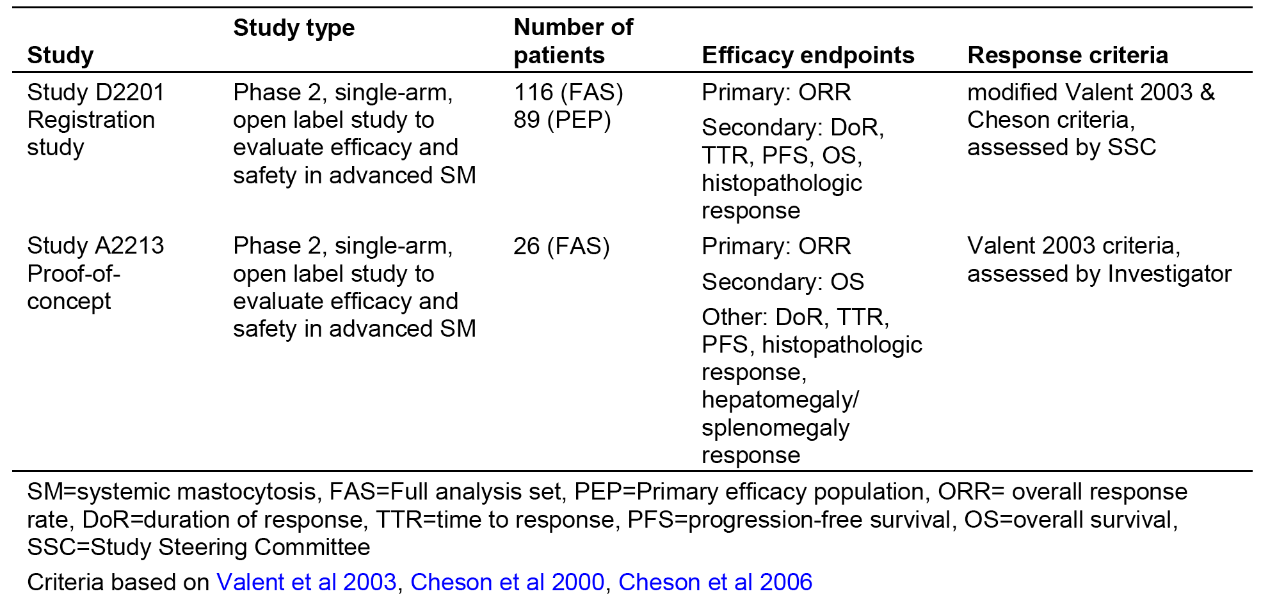
The key study supporting the application to register midostaurin for the treatment of AdSM is Study D2201. This study enrolled 116 patients with aggressive systemic mastocytosis (ASM) or mast cell leukaemia (MCL) with or without AHNMD across 29 centres in 12 countries. The primary efficacy analysis was conducted on 89 patients who were eligible for response assessment as per protocol, while all 116 patients were included in the assessment of safety. Eligibility and response status were adjudicated by a centralised study steering committee (SSC). The sponsor states that Study D2201 is the largest clinical study ever performed in patients with AdSM.
Study A2213 is a small supportive study which enrolled 26 patients with ASM or MCL, with or without AHNMD. The study was investigator-initiated and conducted at 3 centres in the US. In this study, eligibility and response status were assessed by the investigators rather than a centralised adjudication committee.

Table 10: Key differences in design between Study D2201 and Study A2213
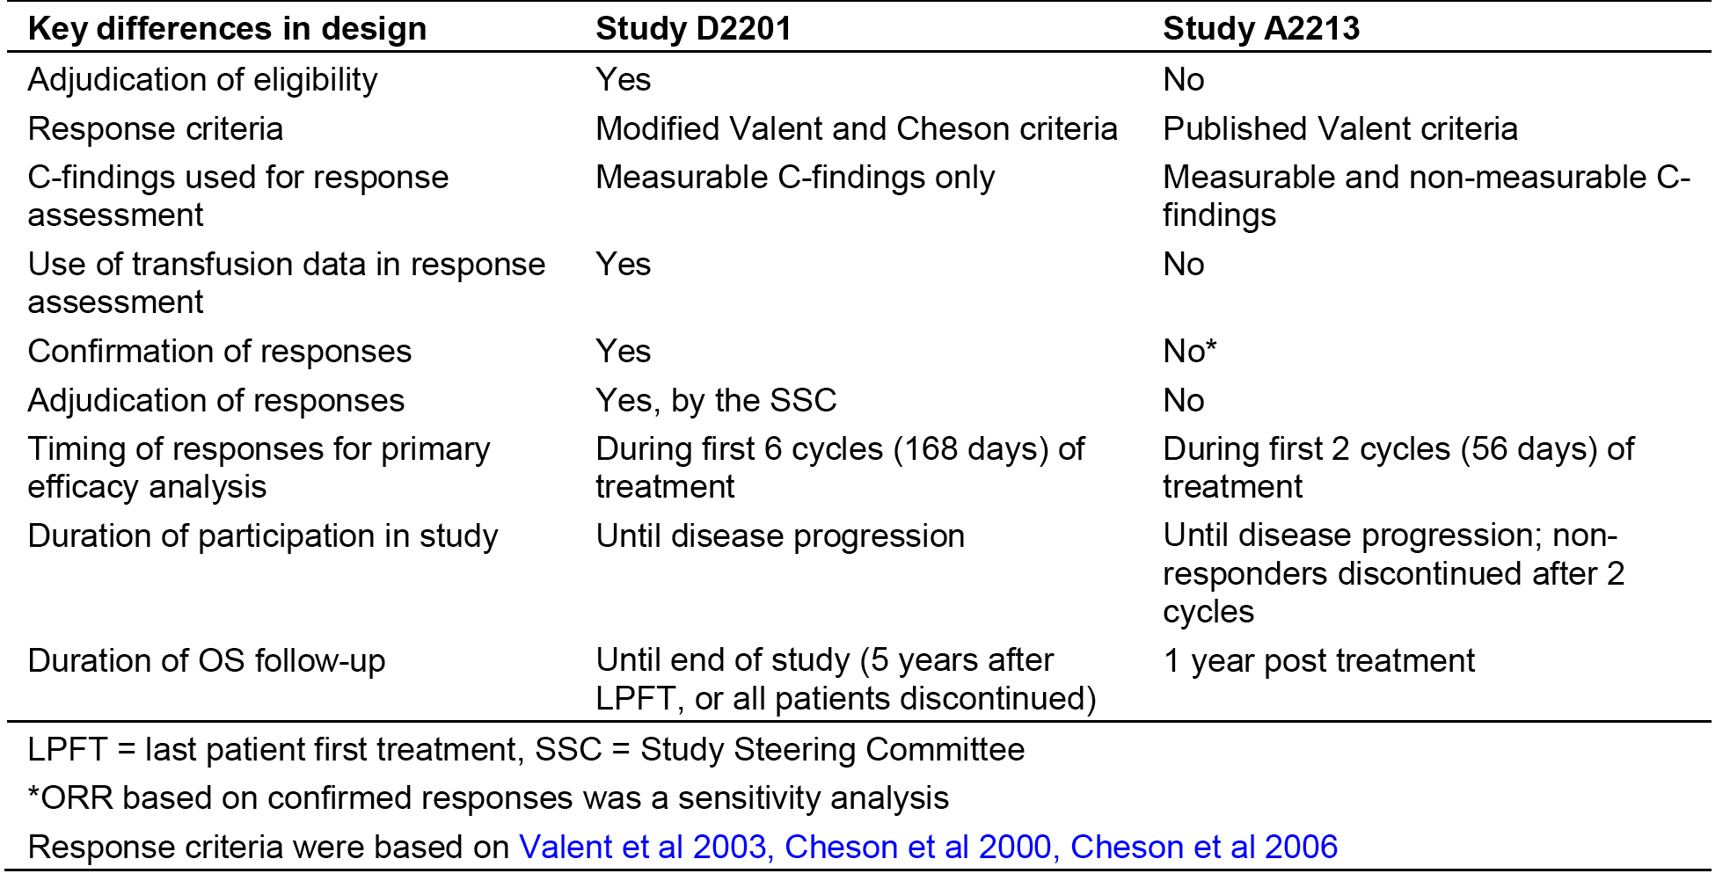
In both studies, assessment of efficacy was primarily based on the evaluation of mast cell related organ damage (clinical findings). Additional criteria were based on the degree of bone marrow mast cell infiltration and surrogate markers of mast cell infiltration (serum tryptase levels and organomegaly). The response criteria for both studies were based on the WHO criteria for mastocytosis published by Valent et al (2007).
An overview of the clinical findings that formed the foundation of the response criteria for both studies was provided. The key difference between the two studies was that in Study D2201 additional criteria for C-findings were defined for patients with anaemia and/or thrombocytopaenia who received transfusions. To be considered as clinical findings, transfusions had to be administered for anaemia and/or thrombocytopaenia attributable to mastocytosis, and not to another cause as per modified Cheson criteria., In addition, in Study A2213 non-measurable clinical findings (that is, hepatomegaly with ascites, and presence of osteolyses) could also be included as C-findings, whereas non-measurable clinical findings were not included in Study D2201 (only measurable clinical findings were used to assess response in Study D2201).

Evaluator’s conclusions on efficacy (advanced systemic mastocytosis)
The efficacy data for the proposed indication in patients with advanced SM were provided by two, multicentre, non-randomised, open label, single arm studies (Studies D2201, and A2301).

Study D2201
Study D2201 is the key efficacy study. In this study, 116 patients with AdSM were enrolled and treated with midostaurin 100 mg BD until disease progression or withdrawal due to any cause. The primary efficacy endpoint was the confirmed overall response rate (ORR), as assessed by modified Valent and Cheson criteria over the first six 28 day cycles of treatment. Treatment responses had to be confirmed at least 56 days after the initial assessment. Study eligibility and treatment response were adjudicated by a Study Steering Committee. The Study Steering Committee confirmed that 89 of the 116 patients were eligible for analysis as they had at least one measurable SM-related clinical finding. These 89 patients formed the primary efficacy population set. The 89 patients in the primary efficacy population included 16 with ASM, 57 with SM-AHNMD and 16 with MCL
Study D2201 met its primary efficacy endpoint. The null hypothesis of an overall response rate of ≤ 30% was rejected based on an overall response rate of 60.0% (95% CI: 43.3 to 75.1) among the 40 patients enrolled in Stage 1 of the study (p < 0.001). These results were confirmed in the overall population in the primary efficacy population (n = 89), which included extension patients. In the primary efficacy population (n = 89), 53 patients achieved a confirmed response (major response or PR) during the first 6 cycles of treatment, resulting in an overall response rate of 59.6% (95% CI: 48.6, 69.8); p < 0.001. Of the 53 patients in the primary efficacy population with a confirmed response, 40 (44.9%) achieved a major response and 13 (14.6%) achieved a partial response. There were a number of sensitivity analyses of the overall response rate, and the results of these analyses were consistent with the results of the primary analysis.
The overall response rate varied among the pre-specified subgroups, but was ≥ 30% in all subgroups tested. In patients with ASM (n = 16), the overall response rate was 75% (95% CI: 47.6 to 92.7). In patients with SM-AHNMD (n = 57), the overall response rate was 57.9% (95% CI: 44.1 to 70.9). In patients with MCL (n = 16), the overall response rate was 50.0% (95% CI: 24.7 to 75.3). The overall response rate analyses presented in the clinical summary report based on the updated WHO SM categories (ASM, SM-AHN (SM-AHNMD) and MCL) grouped under the term AdSM appear to be exploratory analyses.
The median duration of response for all responders was 31.4 months (95% CI: 10.8; not evaluable), with 22 (41.5%) of the 53 responders having progressed or died due to the disease. The median duration of response for patients with ASM who were responders had not been reached, with 2 (16.7%) of the 12 responders having progressed or died due to the disease. The median duration of response for patients with SM-AHNMD who were responders was 12.7 months (95% CI: 7.4 to 31.4), with 2 (25.0%) of the 8 responders having progressed or died due to the disease.
The overall response rate in SM patients who were KIT D816V positive was notably greater than in SM patients who were KIT ^{D816V} negative/unknown (63.0% (95% CI: 50.9 to 74.0) versus 43.8% (95% CI: 19.8 to 70.1), respectively). However, the number of patients in the SM KIT D816V negative group was notably lower than in the SM KIT D816V positive group (n = 16 versus n = 73, respectively), which makes it difficult to draw firm conclusions about the clinical significance of the observed difference in overall response rate based on KIT mutation status. The overall response rate in females was greater than in males (68.8% (95% CI: 50.0 to 83.9) versus 54.4% [40.7 to 67.6], respectively). The overall response rate in patients aged < 65 and ≥ 65 years was approximately 60% in both subgroups. The overall response rate in patients with and without prior therapies for SM or AHNM were similar (62.2% (95% CI: 44.8 to 77.5) versus 57.7% (95% CI: 43.2 to 71.3)). Nearly all patients were Caucasian (n = 86), and therefore no meaningful interpretation of the overall response rate result in other racial groups (n = 3) can be made.
A post-hoc exploratory analysis of the overall response rate in Study D2201 data was conducted using newer, more stringent response criteria (IWG criteria). Of the 116 patients in the full analysis set, 115 patients met the eligibility criteria for the analysis. The most frequent Clinical findings per the IWG criteria at baseline were splenomegaly (89.7%), anaemia (53.4%), and ascites (50.0%). Among the 115 patients eligible for this analysis, the overall response rate was 37.4% (95% CI: 28.5, 46.9), with 43 patients meeting the response criteria at any time during treatment. There were 2 patients (1.7%) with a complete remission, 19 patients (16.5%) with partial remission, and 22 patients (19.1%) with clinical improvement. In determining response using IWG criteria it was stipulated that an improvement in a clinical finding had to be maintained for at least 12 weeks. In a sensitivity analysis in which the confirmation period was reduced from 12 weeks to 8 weeks, the overall response rate increased to 40.0% (95% CI 31.0 to 49.6). The sponsor states that a direct comparison between Clinical findings per IWG criteria and the criteria used in the primary analysis by Study Steering Committee assessment is challenging due to differences in definitions. Furthermore, the sponsor states that analysis of the overall response rate by IWG criteria is based ‘purely on the algorithm, and unlike the study steering committee adjudicated responses in the primary analysis, does not take into account the clinical context of the patient’.
There were a number of secondary efficacy endpoints in Study D2201, but no statistical hypothesis testing was performed for these endpoints. Therefore, the results of the secondary efficacy endpoint outcomes should be considered to be exploratory rather than confirmatory. The secondary efficacy endpoints included overall survival and progression free survival, and these are considered to be the primary clinically meaningful outcomes in Study D2201.
The median overall survival in the primary efficacy population (n = 89) was 26.8 months (95% CI: 17.6 to 34.7) and the median time to censoring was 37 months. There were 54 (60.7%) deaths, and the estimated probability of being alive at 12 months was 70.2% (95% CI: 59.2 to 78.8). In the ASM group (n = 16), the median overall survival was 51.1 months (95% CI: 28.7, not evaluable), and there were 5 (31.3%) deaths. In the SM-AHNMD group (n = 57), the median overall survival was 20.7 months (95% CI: 16.3 to 33.9), and there were 39 (68.4%) deaths. In the MCL group (n = 16), the median overall survival was 9.4 months (95% CI: 7.5, not evaluable), and there were 10 (62.5%) deaths.
The median progression free survival in the primary efficacy population (n = 89) was 17.0 months (95% CI: 10.2 to 24.8) and the median time to censoring was 9 months. There were 45 (50.6%) patients with an event, and the estimated probability of being progression-free at 12 months was 55.0% (95% CI: 42.5 to 65.9). In the ASM group (n = 16), the median progression free survival had not been reached. In the SM-AHNMD group (n = 57), the median progression free survival was 11.0 months (95% CI: 7.4 to17.9), and there were 33 (57.9%) patients with an event. In the MCL group (n = 16), the median progression free survival was 11.3 months (95% CI: 2.8, not evaluable), and there were 8 (50.0%) patients with an event.
There was an improvement in bone marrow mast cell % infiltration relative to baseline in the primary efficacy population (n = 89). A total of 41 (46.1%) patients had a best bone marrow mast cell% infiltration decrease of > 50% relative to baseline, and 19 (21.3%) patients had a best bone marrow mast cell% infiltration decrease of > 0 to ≤ 50% relative to baseline.
There was an improvement in serum tryptase level relative to baseline in the primary efficacy population (n = 89). There were 52 (58.4%) patients with a > 50% decrease in serum tryptase relative to baseline, 25 (28.1%) patients with a > 0% to ≤ 50% decrease in serum tryptase relative to baseline, and 34 (38.2%) patients with a ≥ 50% decrease in serum tryptase relative to baseline for at least 56 days.
The proportion of patients in the primary efficacy population with ≥ 50% decrease in MSAS scores relative to baseline for at least 168 days was 22.5% (n = 20) for TMSAS score, 28.1% (n = 25) for the MSAS-GDI score, and 23.6% (n = 21) for the MSAS-PSYCH score.

Study A2213
Study A2213 was a small, investigator-initiated, open-label, non-randomised, single-arm, Phase II study conducted in three centres in the USA in 26 patients with AdSM. Patients received midostaurin 100 mg BD until disease progression or withdrawal due to any cause. Patients who did not achieve a response by the end of the first two 28 day cycles of treatment were to be discontinued. The primary efficacy endpoint was overall response rate (major response or partial response) analysed in the full analysis set and assessed by the investigator using Valent criteria over the first two cycles of treatment. Patients with a best overall response of ‘unknown’ were considered to be non-responders in the calculation of overall response rate. No confirmation of response was required for the primary analysis of the overall response rate.
The overall response rate (after 2 cycles, unconfirmed) was 73.1% (95% CI 52.2 to 88.4). Therefore, the null hypothesis for this study of an overall response rate ≤ 10% was rejected, and the alternative hypothesis of an overall response rate ≥ 30% was demonstrated. Among the 19 patients with a response, 13 achieved a major response, and 6 achieved a partial response. For 3 of the patients with a partial response, the response improved to major response after Cycle 2. In addition to the 19 patients who achieved a response after the first 2 cycles, 1 patient achieved a response in subsequent cycles. The number of patients in this study with ASM, SM-AHNMD and MCL based on the updated WHO SM criteria could not be identified.
In a sensitivity analysis considering only responses in the first 2 cycles that were confirmed during the 2 subsequent cycles, the overall response rate was 50.0% (95% CI: 29.9 to 70.1), with 10 patients having a confirmed major response and 3 patients having a confirmed PR. In a sensitivity analysis in the primary efficacy population, the overall response rate was identical to that in the full analysis set as the primary efficacy population and full analysis set populations were identical.
The protocol specified secondary efficacy endpoint was overall survival, defined from the start of the study to the date of death from any cause. All patients were followed for survival for up to 1 year after treatment discontinuation. At the data cut-off date of 3 December 2012, the median overall survival was 40 months (95% CI: 19.2, not evaluable), and the estimated probability of being alive at 12 months was 76.9% (95% CI: 55.7 to 88.9).
In Study A2213, no additional secondary efficacy endpoints were included in the protocol. However, the study report included the results from a number of unplanned secondary efficacy endpoints. The results of these analyses should be considered to be exploratory rather than confirmatory.

Comparison of overall survival between pooled data (Studies D2201 and A2213) and registry data
In the post-hoc analysis, the primary assessment of overall survival included 89 patients treated with midostaurin pooled from Studies D2201 and A2213 for whom the date of diagnosis was available, and 46 patients not treated with midostaurin from a German registry. The diagnostic groups included in the study were ASM with AHNMD, ASM without AHNDM, and MCL (with or without AHNMD). There were no data on diagnostic groups based on updated WHO criteria (that is ASM, SM-AHN, MCL). The disease type and KIT mutation status in patients in the pooled population and the registry were similar, with approximately two-thirds of patients having ASM-AHNMD and > 75% having a KIT D816V mutation. The proportion of patients aged > 65 years was higher in the registry (67.4%) than in pooled population (41.6%).
The comparison between the pooled data and the registry showed a statistically significant improvement in overall survival in patients treated with midostaurin compared to patients from the registry not treated with midostaurin. The median duration of overall survival was longer in the pooled population compared to the registry (42.6 months (95% CI 31.0 to 53.9) versus 24.0 months (95% CI 13.0 to 39.5), respectively). The hazard ratio for overall survival was 0.62 (95% CI: 0.39 to 0.98) in favour of midostaurin, with a nominal p-value of 0.020. The result of the multivariate Cox regression analysis after adjusting for covariates (hazard ratio = 0.512 (95% CI 0.299 to 0.877), p = 0.0147) was consistent with the result of the primary analysis. The results of two pre-specified overall survival sensitivity analyses performed to address the potential lead time bias in patients enrolled in the two studies were consistent with the primary analysis of overall survival.

Limitations of the submitted efficacy data in patients with advanced SM

No randomised controlled Phase III studies
There were no randomised, controlled studies assessing the efficacy of midostaurin for the treatment of patients with advanced SM, with both submitted studies (Studies D2201, A2213) being non-randomised, open label, and single arm in design. The absence of control treatment limits the assessment of the clinical significance of the efficacy outcomes observed for midostaurin in Studies D2201 and A2213. The sponsor justified its decision not to undertake a controlled study based on the ‘low incidence and prevalence (of the disease), heterogeneity of treatment options, historical reality of the program’s development (that is, Study A2213 undertaken before Study D2201 showed superior efficacy to published data for contemporary treatments) and physician and patient resistance'.
The sponsor's justification is considered to be acceptable. There are no effective medicines for the treatment of advanced SM that could serve as an acceptable active control arm. While it might have been possible to have designed a study comparing midostaurin to placebo, it would have been challenging to recruit a population large enough to adequately power such a study in an acceptable time-frame given the rarity of the disease. It is considered that the absence of a randomised controlled study should not prevent approval of midostaurin for the treatment of patients with ASM, given the practical difficulties of undertaking such a study.

Limited relevance of the historical control group analysis
The submission included an overall survival comparison between pooled data from Studies D2201 and A2213 in patients (n = 89) who had been treated with midostaurin and historical German registry data in patients (n = 46) who had not been treated with midostaurin. In this study, the number of patients in the historical control group was about 50% smaller than in the pooled midostaurin group, and patients in the historical control group were not matched to patients in the pooled midostaurin group. The study showed a clinically meaningful improvement in overall survival in patients treated with midostaurin compared to historical control, and the difference between the two treatment groups was statistically significant. The results from this historical control study should be interpreted cautiously due to the known limitations arising from a non-randomised, open-label analysis.

Limited long-term efficacy data
There are limited long-term efficacy data available for midostaurin 100 mg BD for the treatment of advanced SM. The sponsor is proposing that treatment with midostaurin for patients with advanced SM should continue for as long as clinical benefit is observed or until unacceptable toxicity occurs.
In Study D2201, the primary efficacy endpoint (overall response rate) was assessed by the Study Steering Committee during the first 6 cycles of treatment (each cycle was 28 days in duration) and was required to be confirmed at least 56 days later. Patients received midostaurin until disease progression, intolerable toxicity or withdrawal due to any cause, whichever occurred first. The end of study will occur five years after last patient first treatment, or when all patients have discontinued study treatment, whichever is first. Patients who remain on treatment at the end-of-study date can continue to receive midostaurin in a compassionate use program or alternative local arrangements.
In Study A2213, the primary efficacy endpoint (overall response rate) was assessed by the investigator during the first 2 cycles of treatment and did not require confirmation in subsequent cycles. The lack of central adjudication of response and the lack of confirmed response are potential biases in this study. Patients could receive up to 12 treatment cycles, but protocol-defined patient follow-up ended 1 year after the time of treatment discontinuation. In the absence of contraindications, patients with a continued response after 1 year of therapy were permitted to continue treatment with midostaurin through an extension protocol with a reduced schedule of evaluations.
In Study D2201, the median duration of exposure was 11.4 months (range 0.3 to 68.3 months), and 76 (65.5%) patients had been exposed for at least 6 months, 57 (49.1%) patients for at least 12 months, and 39 (33.6%) patients for at least 24 months. In Study A2213, the median duration of exposure was 9.8 months (range 0.8 to 80.1 months), and 15 (57.7%) patients had been exposed for at least 6 months, 12 (46.2%) for at least 12 months, and 9 (34.6%) for at least 24 months. The number of patients exposed to treatment for at least 12 months was small in both treatment arms, with the pooled number being 69 patients. However, this is considered to be acceptable for a rare disease such as advanced SM.

Primary analyses based on the overall response rate rather than overall survival or progression free survival
The primary efficacy endpoint in both Studies D2201 and A2213) was the overall response rate (major response plus partial response). It is considered that it would have been preferable to have used overall survival as the primary efficacy endpoint rather than overall response rate, given that improvement in overall survival is unequivocal evidence of a clinical benefit. However, interpretation of overall survival is difficult in single-arm studies as reliable estimation is dependent on a comparator arm, with patients being randomised to test and reference arms. Overall survival was analyses as a secondary efficacy endpoint in both studies.
In its response to the Day 120 EMA evaluation report the sponsor stated that it ‘believes that overall response rate is a good measure of clinical benefit, because the response criteria developed for SM are dependent on the presence or absence of clinical findings, which were specifically designed to capture clinical significant disease manifestations’. The sponsor stated that the clinical findings used for diagnosis and response criteria in Studies D2201 and A2213 specifically focused on clinically meaningful measures reflecting risk of infection (bone marrow and blood findings including ANC < 1,000/µL), anaemia (haemoglobin < 10 g/dL) and bleeding (platelet count < 100,000/µL). In addition, anaemia and thrombocytopaenia may also be associated with transfusion dependence.
Other clinical findings reflecting clinical significance included abnormal liver function tests, hypoalbuminaemia, hepatomegaly with ascites, palpable splenomegaly with hypersplenism-thrombocytopaenia, and malabsorption with hypoalbuminaemia and/or weight loss. The sponsor states that that ‘clinical findings are representations of end organ damage and improvement in markers of end organ damage translated into clinical benefit for the patient’. In addition the sponsor stated that the Clinical findings response criteria were updated over the course of the study to IWG criteria, and a post-hoc analysis using these criteria demonstrated that primary efficacy endpoint was met even with these more rigorous and current criteria.
To further support its argument that the overall response rate is a good measure of clinical benefit in patients with AdSM the sponsor undertook an ad-hoc analysis (Study D2201) comparing overall survival in patients who were responders (n = 29) with patients were non responders (n = 25). The analysis showed that the median duration of overall survival was 33.9 months in responders and 14.3 months in non-responders. The Kaplan-Meier plots are provided below in Figure 2.
Figure 2: Study D2201 Kaplan-Meier plots of overall survival (OS); primary efficacy population
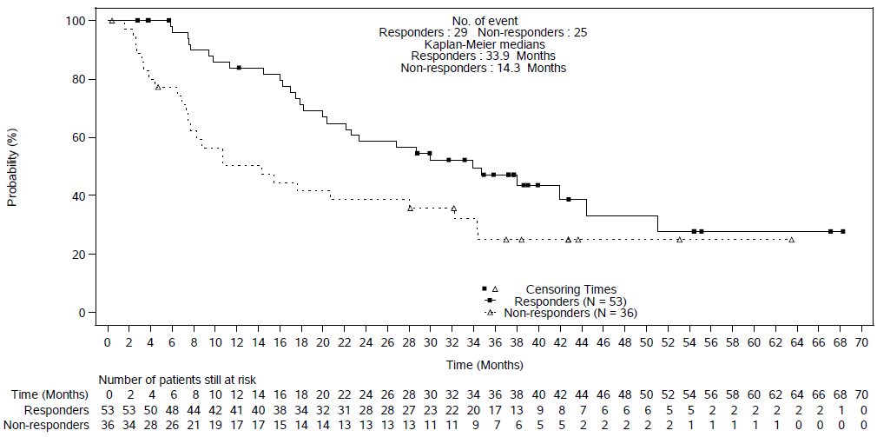
The sponsor also stated that analyses of changes in patient reported outcome scores and efficacy data for patients in Study D2201 indicate that better clinical outcomes in terms of overall response rate and duration of response are associated with more pronounced improvement in patient reported outcome scores for both the MSAS and SF-12v2 instruments. In support of this statement the sponsor undertook two post hoc analyses summarised below.
The sponsor undertook a post hoc analysis of the overall response rate for patients who had at least a 50% reduction in MSAS from baseline compared to patients who did not achieve a 50% reduction in MSAS from baseline. The results showed that the overall response rate was greater in patients with at least a 50% reduction in MSAS scores for all scales assessed compared to patients with less than a 50% reduction in MSAS scores. The results are summarised below in Table 11.

Table11: Study D2201 Overall response rate (OS) by patient reported outcome (PRO) response (MSAS) category; primary efficacy population
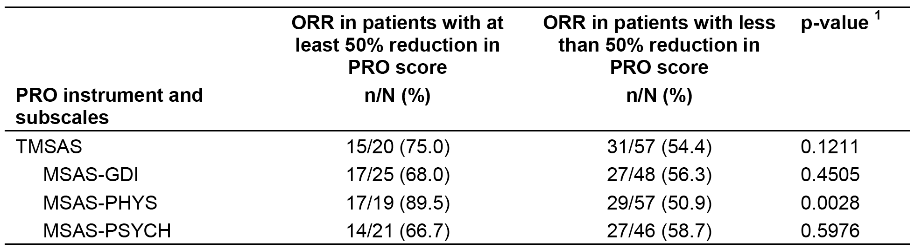
Note: 1) P value based on Fisher exact test.
The sponsor undertook an ad-hoc analysis of the overall response rate for patients who had at least a 50% reduction in SF-12v2 from baseline compared to patients who did not achieve a 50% reduction in SF-12v2 from baseline. The results showed that the overall response rate was greater in patients with at least a 50% reduction in SF-12v2 scores for both physical component summary (PCS) and mental component summary (MCS) compared to patients with less than a 50% reduction in SF-12v2 scores. The results are summarised below in Table 12.

Table12: Study D2201 Overall response rate (ORR) by patient reported outcome (PRO) response (SF-12v2) category; primary efficacy population
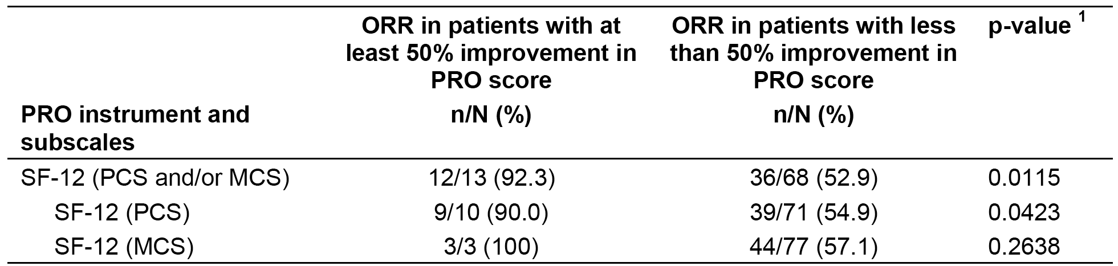
Note: 1) P value based on Fisher exact test.
Overall, it considered that the sponsor has provided a reasonable justification for selecting the overall response rate as the primary efficacy endpoint for assessing clinical outcome in patients treated with midostaurin in Studies D2201 and A2231.

Safety
The safety of midostaurin has been evaluated separately for each of the two proposed indications. For the AML indication, the clinical evaluation report primarily focuses on evaluation of the safety data from the pivotal, randomised, controlled, Phase III study (A2301) in 680 patients (n = 345, midostaurin; n = 335, placebo) and the interim safety data from the supportive, single-arm, Phase II Study ADE02T) focussing on the comparison between patients aged ≤ 60 years and > 60 years (that is > 60 to ≤ 69 years) in a total of 144 patients. For the AdSM indication, the clinical evaluation report focuses on the pooled safety data for 142 patients from the single arm, pivotal Phase II Study D2201 and the single-arm, supportive Phase II Study A2213 provided in the Summary of Clinical Safety.
Overall, the sponsor states that approximately 383 healthy volunteers and 1165 patients (various medical conditions) have received at least one dose of midostaurin in the Novartis or Alliance sponsored clinical trials in the development program. The sponsor estimates, based on the ‘rule of threes’ that any event not observed in the total exposed population (1548 individuals) has an incidence of 0.00193 (that is 1.9 per 1000 individuals).

Studies providing safety data (acute myeloid leukaemia)
In Study A2301, a total of 719 patients were randomised, comprising 360 patients to the midostaurin group (that is, midostaurin plus chemotherapy in the induction and consolidation phases and single-arm midostaurin in the continuation phase (n = 360)) and 357 patients to the placebo group (that is, placebo plus chemotherapy in the induction and consolidation phases and single-arm midostaurin in the continuation phase). A total of 37 randomised patients were never treated with the study drug and were excluded from the safety set (n = 17, midostaurin; n = 20, placebo). Two patients randomised to the placebo arm were erroneously treated with midostaurin and the data from these 2 patients were included in the midostaurin group. Consequently, the safety set included a total of 680 patients, comprising 345 patients in the midostaurin group and 335 patients in the placebo group.

Patient exposure
The overall duration of exposure is summarised below in Table 13. The total number of patients exposed for at least 6 months was higher in the midostaurin group than in the placebo group (n = 95, 27.5% versus n = 63, 18.8%, respectively), as was the total number of patients exposed for at least 12 months (n = 73, 21.2% versus n = 51, 15.2%, respectively).

Table 13: Study A2301 Overall duration of exposure to the study drugs, safety set

Table 14: Study ADE02T Duration of treatment
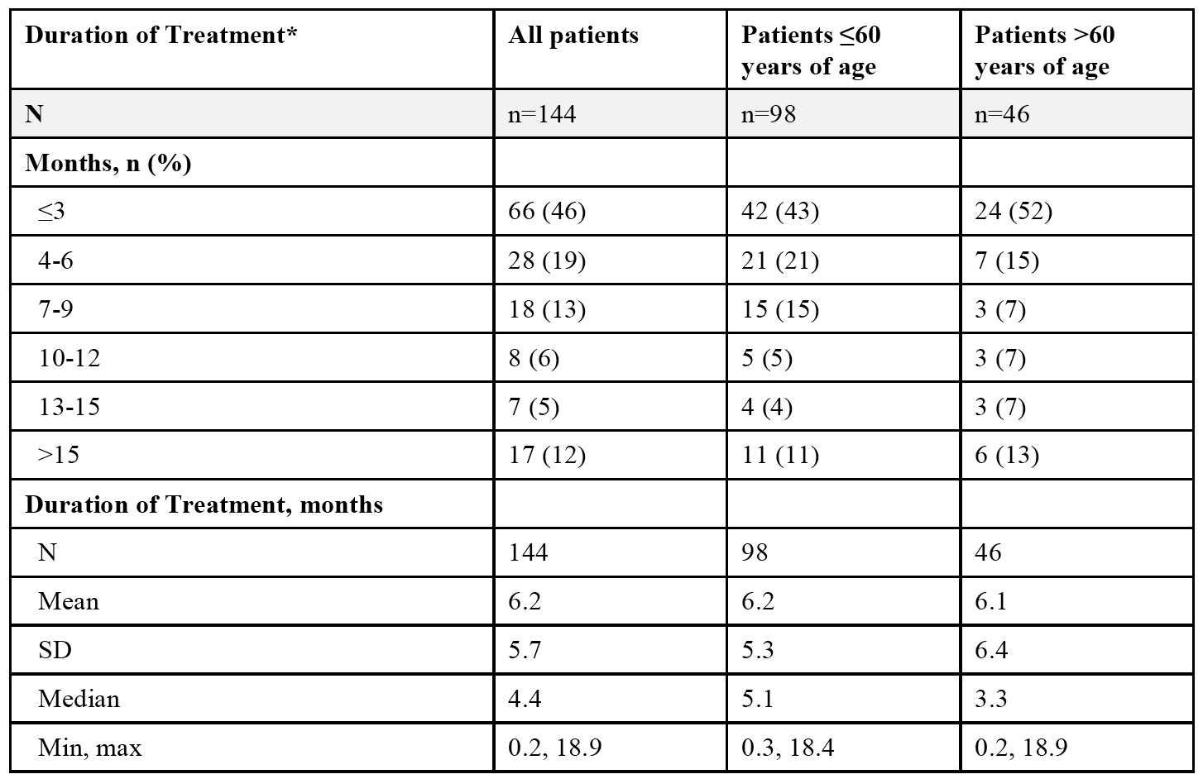

Safety issues with the potential for major regulatory impact (AML)

Liver function and liver toxicity
ALT or AST levels > 3 x upper limit of normal (ULN), > 5 x ULN and > 8 x ULN occurred more frequently in patients in the midostaurin group compared to patients in the placebo group. Of note, the proportion of patients with ALT or AST levels > 3 x ULN and total bilirubin (TBL) > 2 x ULN and ALP levels ≤ 2 x ULN was greater in the placebo group than in the midostaurin group (4.8% (15 of 314) versus 2.9% (9 of 315), respectively).
Clinically notable hepatic AEs, regardless of relationship to treatment, are summarised below in Table 15.

Table 15: Clinically notable hepatic AEs regardless of relationship to treatment; safety set
Clinically notable hepatic AEs | Hepatic AEs (all grades) -Non-NA sites |  | Hepatic AEs (Grade 3 or 4) - All sites
 | Midostaurin (n = 229), n (%) | Placebo (n = 226), n (%) | Midostaurin (n = 345), n (%) | Placebo (n = 335), n (%)
All | 120 (52.4) | 111 (49.1) | 81 (23.5) | 66 (19.7)
ALT increased | 81 (35.4) | 75 (33.2) | 44 (12.8) | 32 (9.6)
AST increased | 58 (25.3) | 55 (24.3) | 23 (6.7) | 13 (3.9)
Gamma GT increased | 37 (16.2) | 44 (19.5) | 15 (4.3) | 21 (6.3)
Hyperbilirubinaemia | 34 (14.8) | 38 (16.8) | 14 (4.1) | 14 (4.2)
Blood bilirubin increased | 29 (12.7) | 30 (13.3) | 10 (2.9) | 9 (2.7)
Prothrombin time prolonged | 12 (5.2) | 9 (4.0)
Blood fibrinogen decreased | 10 (4.4) | 11 (4.9)
Note: Includes all AEs (all grades) regardless of relationship to treatment, reported in ≥ 2% of patients in the midostaurin group at non-North American sites, and Grade 3 or 4 AEs reported in ≥ 1% of patients in the midostaurin group at all sites,
The results indicate that patients treated with midostaurin are at a greater risk of experiencing clinically notable hepatic AEs than patients treated with placebo, with the risks being primarily associated with increased ALT and AST levels. However, Grade 3 or 4 hepatic failure at all sites was reported in only 1 (0.3%) patient in each of the midostaurin and placebo groups.

Renal function and renal toxicity
Newly occurring or worsening laboratory serum creatinine levels (any grade) were reported in 8.8% (28 of 320) of patients in the midostaurin group and 9.1% (28 of 308) of patients in the placebo group, while no newly occurring or worsening Grade 3 or 4 AEs were reported in either of the two treatment groups.
At all sites, Grade 3 or 4 AEs of renal failure were reported more frequently in the midostaurin group than in the placebo group (3.5% versus 1.8%, respectively), however, the number if patients in each treatment group with events was relatively small (n = 8 versus n = 6, respectively). Serum creatinine levels remained at normal baseline levels for the majority of patients in both treatment groups, with increases during the course of the study being not notably different between the two treatment groups.

Haematological toxicity
Newly occurring or worsening haematological laboratory abnormalities were reported in a similar proportion of patients in both treatment groups, with the majority of patients experiencing Grade 3 or 4 events.

Table 16: Study A2301 Haematology parameters (overall), newly occurring or worsening laboratory abnormalities; safety set
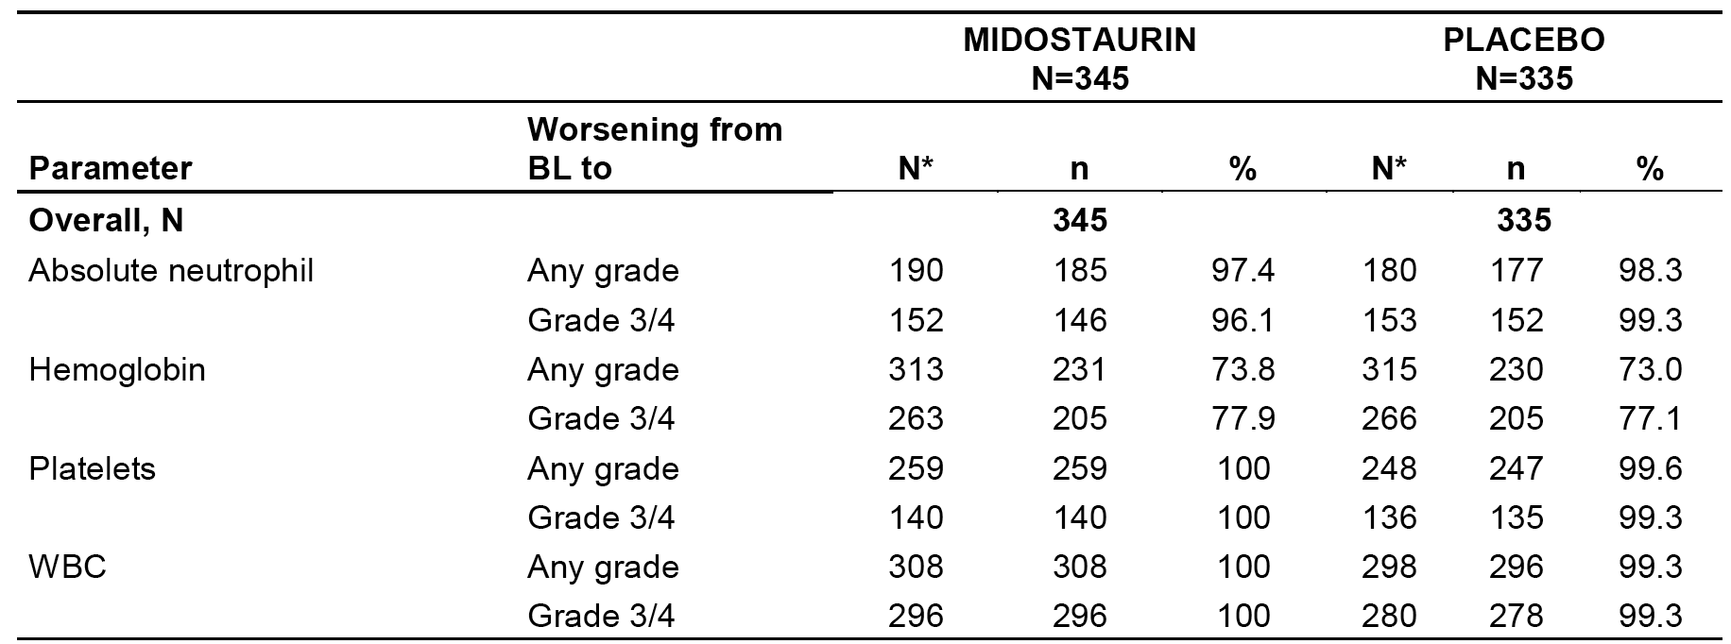
For any Grade or Grade 3 or 4, the respective * N = number of patients who had a non-missing and less than Grade 4 (or less than Grade 3) value at baseline with at least one-post baseline value. All post-baseline measures up to an including 30 days after the last dose of the study drug (scheduled, unscheduled) were considered.

Electrocardiograph findings and cardiac safety

Table 17: Study A2301 Notable ECG abnormalities (overall), safety set
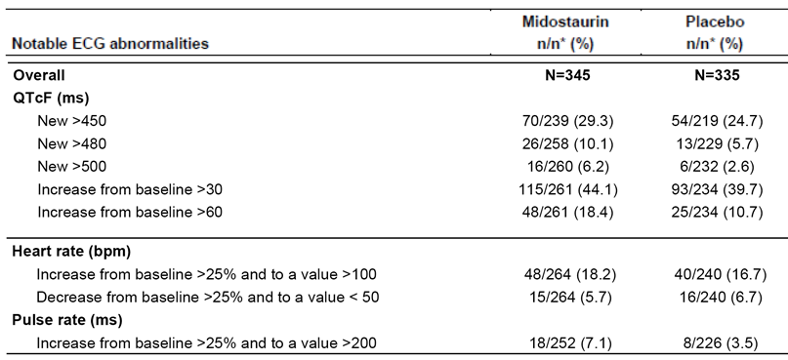
At all sites, clinically notable Grade 3 or 4 AEs grouped as QT prolongation were reported in 9.9% (n = 34) of patients in the midostaurin group and 9.0% (n = 30) of patients in the placebo group, with the main AE in both treatment groups being ECG QT prolonged (n = 19, 5.5%, midostaurin versus n = 18, 5.4%, placebo). Other Grade 3 or 4 AEs contributing to the grouping (midostaurin versus placebo) were syncope (4.6% versus 3.0%), cardio-respiratory arrest (0% versus 0.3%) ventricular fibrillation (0% versus 0.3%), and ventricular tachycardia (0% versus 0.6%). At all sites, 1 patient in each treatment group discontinued because of QT prolongation (ventricular tachycardia one, midostaurin; ventricular fibrillation one, placebo).
QTcF abnormalities were greater in the midostaurin group than in the placebo group for each of the categories of interest. ECG QT prolongation AEs (all grades) were reported more frequently in the midostaurin group than in the placebo group (19.2% versus 16.8%), while Grade 3 or 4 AEs were reported in a similar proportion of patients in both treatment groups (5.5% versus 5.4%, respectively). There were no clinically significant differences between the two treatment groups as regards as regards cardiac toxicity (arrhythmia, cardiac failure, and cardiomyopathy).

Serious skin reactions
At all sites, Grade 3 or 4 skin toxicity was reported in 17.7% (n = 61) of patients in the midostaurin group and 11.0% (n = 37) of patients in the placebo group, with the main AE in both treatment groups being exfoliative dermatitis (13.6% versus 7.8%, respectively). All discontinuations due to skin toxicity were from the midostaurin group.

Gastrointestinal
Gastrointestinal AEs (all grades) related to the higher incidence of nausea and vomiting in patients in the midostaurin group compared to the placebo group. However, Grade 3 or 4 AEs of nausea and vomiting at all sites were reported more frequently in patients in the placebo group than in the midostaurin group. Despite the high incidence of gastrointestinal AEs in patients in both treatment groups, only a small number of patients discontinued treatment due to gastrointestinal AEs.

Bleeding, regardless of relationship to treatment
The only notable differences between the two treatment groups in bleeding events was the higher incidence in the midostaurin group of petechiae (35.8% versus 27.0% placebo) and epistaxis (27.5% versus 23.5% placebo).

Interstitial lung disease (ILD)
There was a small increase in the proportion of patients experiencing acute respiratory distress syndrome in the midostaurin group relative to the placebo group (2.2% versus 0.4%), which is unlikely to be clinically significant.

Safety related to drug-drug interactions – CYP3A4 inhibitors
Based on the available data it is considered that concomitant administration of midostaurin and strong CYP3A4 inhibitors should be avoided. If CYP3A4 inhibitors are required then moderate inhibitors should be chosen in preference to strong inhibitors. If strong CYP3A4 inhibitors are required then the patient should be closely monitored for the emergence of adverse events, particularly in the first week of treatment when midostaurin exposure is high. There are no clinical data supporting a reduction in midostaurin dose when the drug is co-administered with strong CYP4A4 inhibitors.

Studies providing safety data (advanced systemic mastocytosis)
In both Studies A2213 and D2201, dose interruptions and dose adjustments were permitted for haematological and non-haematological toxicities. Dose interruptions were recommended for: (1) Grade 3 or 4 haematological toxicities in all patients without MCL or Grade 3 or 4 toxicity at baseline; (2) Grade 3 or 4 non-haematologic toxicities suspected to be drug related or clinically significant; and (3) persisting nausea and diarrhoea despite the use of corrective treatment.
Treatment discontinuation was advised in patients with recurrent Grade 3 or 4 cytopaenias suspected to be related to midostaurin. Persisting Grade 3 or 4 cytopaenias or non-haematological toxicities lasting for 2 to 3 weeks, except nausea and vomiting, were also reasons for treatment discontinuations. Following dose interruption treatment could be restarted at a reduced dose (50 mg BD) on recovery of toxicities within the timeframe of 2 to 3 weeks. Dose reductions below 50 mg BD were not allowed. Escalation to full dose (100 mg BD) was recommended for patients tolerating half dose and for whom the toxicities had occurred at the beginning of the treatment (that is within the first 1 to 2 months).
In both studies, safety assessments consisted of all AEs (severity and relationship to study drug), regular monitoring of haematology, blood chemistry, assessment of vital signs, ECG monitoring, physical examination and documentation of all concomitant therapies. Additionally, in Study D2201 cardiac LVEF was assessed by echocardiogram or multiple gated acquisition (MUGA) scan at baseline and, following Amendment 2, at the end of Cycles 3, 6, and 12 and at the end of treatment visit.

Patient exposure

Table 18: AdSM Exposure to midostaurin; pooled dataset
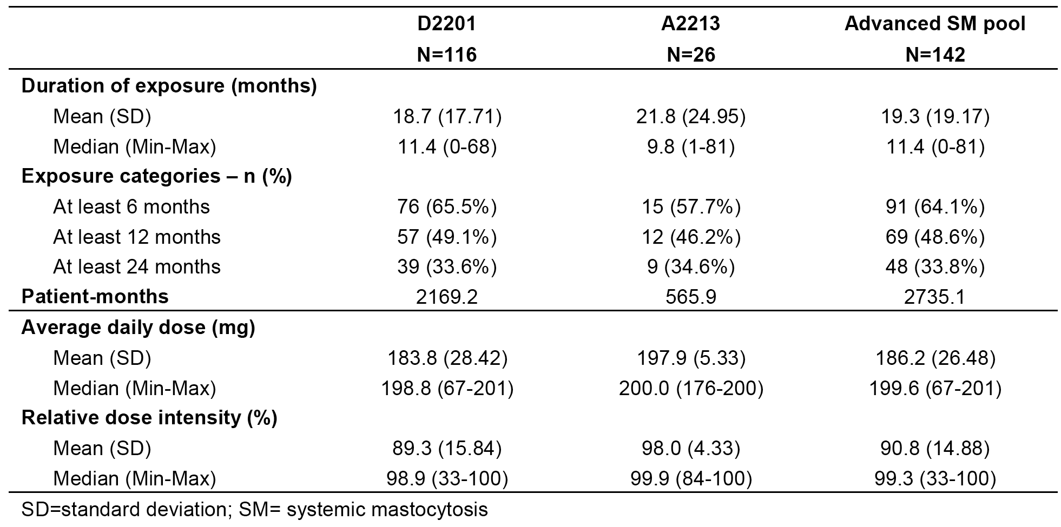

Safety issues with the potential for major regulatory impact (AdSM)

Liver function and hepatotoxicity
In the pooled dataset, increases in ALT and AST levels (all grades) from baseline were experienced by 31.0% and 31.7% of patients, respectively, with the majority being Grade 1 or 2 in severity. Increases in ALT and AST levels (Grade 3 or 4) were experienced by 3.5% and 2.8% of patients, respectively. Similar increases in total bilirubin were observed to those seen for ALT and AST. Increases in ALT or AST levels, based on multiples of the ULN do not give rise to concern. Increases above the ULN in TBL levels occurred frequently in the pooled dataset. Two patients experienced concurrent elevations in ALT or AST > 3 x ULN and TBL > 2 x ULN and ALP ≤ 2 x ULN (that is, met Hy's law criteria for potential drug induced liver injury (DILI)). The case narratives have been reviewed and it is considered that the data do not establish that midostaurin is causally associated with DILI in the two patients. Both patients had elevated LFTs at baseline considered to be Clinical findings. Increased elevations from baseline were observed during treatment in both patients, but levels fluctuated, and one patient continued treatment with midostaurin.

Renal function and renal toxicity
the clinical laboratory data showed that 24.6% of patients in the pooled dataset experienced a newly occurring or worsening increase in serum creatinine levels, and that these events were almost exclusively Grade 1or 2 in severity. The high incidence of increased serum creatine levels did not appear to translate into clinically significant outcomes. Renal failure (renal toxicity), all grades, was reported in 9.2% of patients, but the majority of these events did not appear to result in clinically significant outcomes. No patients discontinued due to renal failure (renal toxicity), and only 2 patients required a dose adjustment or interruption due to an event.

Haematology and haematological toxicity
The majority of patients (50% to 67%) in the pooled dataset experienced worsening from baseline to AE (any grade) for each of the clinical laboratory haematological parameters. Worsening from baseline to Grade 3 or 4 abnormalities were observed for absolute lymphocyte levels and haemoglobin levels in approximately 40% to 42% of patients and in approximately 18% to 22% of patients for absolute neutrophil levels, platelet count and WBC.
Regardless of relationship to study drug, all grades, relating to haematological toxicity were reported most commonly for anaemia (33.1%), followed by leukopaenia (22.5%) and thrombocytopaenia (21.8%). Grade 3 or 4 AEs were also reported most commonly for anaemia (23.2%), followed by leukopaenia (17.6%) and thrombocytopaenia (12.0%). Discontinuations and dose adjustments or interruptions due to haematological toxicities were reported uncommonly, suggesting that that nearly all events were managed without discontinuation or dose modification.

Other laboratory tests
Worsening from baseline to Grade 3 or 4 abnormalities in ≥ 5% of patients for other biochemical parameters were observed for hyperglycaemia (18.6%), increased lipase (17.6%), increased uric acid (10.7%), and increased amylase (6.4%).
Many cases of hyperglycaemia appear to be confounded by other factors (for example concomitant treatment with corticosteroids, baseline glucose dysregulation). Nevertheless, the proportion of patients with newly occurring hyperglycaemia (all grades) is considered to be unusually high.
In the pooled dataset, increased amylase (all grades), regardless of study drug relationship, was reported in 8 (5.6%) patients, with Grade 3 or 4 AEs being reported in 5 (3.5%) patients. Seven of the 8 increased amylase AEs were suspected to be related to the study drug. Increased lipase (all grades), regardless of study drug relationship, was reported in 14 (9.9%) patients, with Grade 3 or 4 AEs being reported in 8 (5.6%) patients. All 14 increased lipase AEs were suspected to be related to the study drug. Increased amylase and lipase levels appear to be associated with midostaurin treatment. However, only one case of acute pancreatitis was reported in the pooled dataset.

Electrocardiographic findings and cardiovascular safety
QT prolongation (grouped terms), were reported in 16.2% (n = 23) of patients in the pooled dataset. No patients experienced a QTcF prolongation > 500 ms. There were no reports of torsades de pointes.
Clinically notable AEs grouped as cardiac toxicities (arrhythmia) were the most frequently reported group of cardiac toxicities, and the most frequently event was ECG QT prolonged. Cardiac toxicities were reported in 7.0% of patients and the most frequently reported event was cardiac failure.
Clinically notable reductions in systolic and diastolic blood pressure were reported in 9.9% and 16.2% of patients, respectively. All other clinically notable vital signs were reported in ≤ 3 patients. No decrease was observed in systolic blood pressure in the first few months of treatment. A decrease was observed in diastolic blood pressure in the first 3 months, and this decrease was transient. The reduction in blood pressure may correlate with reports of hypotension and dizziness, which mainly occurred within the first 6 months of treatment.

Serious skin reactions
Regardless of study drug relationship, grouped as skin toxicity, all grades, were reported in 8.5% of patients in the pooled dataset. Grade 3 or 4 AEs were reported in 3.5% of patients, and comprised toxic skin eruption (2.8%) and stomatitis (0.7%). Skin toxicity suspected to be related to midostaurin were reported in 3 (2.1%) patients, and comprised 3 (2.1%) patients with toxic skin eruptions and 1 (0.7%) patient with stomatitis. SAEs were reported in 4 (2.8%) patients, and comprised 3 (2.1%) patients with toxic skin eruptions and 1 (0.7%) patient with stomatitis. No patients discontinued treatment due to skin toxicity.

Bleeding
Grade 3 or 4 AEs were reported in 14.1% of patients, and events reported in ≥ 2% of patients were gastrointestinal haemorrhage (3.5%), epistaxis (2.8%), and upper gastrointestinal haemorrhage (2.1%). AEs suspected to be related to the study drug were reported in 4 (2.8%) patients, and were ecchymosis, epistaxis, gastric haemorrhage, and pulmonary haemorrhage. AEs leading to discontinuation were reported in 3 (2.1%) patients, and were gastric haemorrhage, melaena and subdural haematoma. AEs requiring dose adjustment or interruption were reported in 7 (4.9%) patients.

Gastrointestinal toxicity
Grade 3 or 4 AEs were reported in 14.8% of patients, and events reported in ≥ 5% of patients were diarrhoea (6.3%), nausea (5.6%), and vomiting (5.6%). AEs suspected to be related to the study drug were reported in 85.9% of patients. SAEs were reported in 11.3% of patients, and events reported in ≥ 2% of patients were diarrhoea (5.6%) and vomiting (4.2%).

Post-marketing data
Not relevant to this submission.

Evaluator’s conclusions on safety
In general, the safety profiles of midostaurin (n = 345) and placebo (n = 335) in patients with AML were similar, based on the data from the pivotal controlled study (Study A2301). The median daily dose in patients in the midostaurin and placebo groups was similar (95.1 versus 94.8 mg, respectively), as was the overall relative dose intensity (95.1% versus 94.8%, respectively). However, the median duration of exposure over the full study period was longer in the midostaurin group than in the placebo group (42 days versus 34 days), as were the number of patients exposed for ≥ 6 months (95 [27.5%] versus 63 (18.8%)) and ≥ 12 months (73 (21.2%) and 51 (15.2%)). The major limitation of the safety data from the pivotal study in patients with was the absence of data relating to patients aged > 60 years.
The interim safety data for midostaurin in patients with AML from the single-arm Study ADE02T (n = 144) were consistent with safety data for midostaurin from the pivotal study. The interim safety data from Study ADE02T included data from 98 patients aged ≤ 60 years and 46 patients age 61 to 69 years. The major differences in the AE profile between patients aged ≤ 60 years and > 60 years were the higher incidence of on-treatment deaths and AEs leading to discontinuation of the study drug in the older patient group compared to the younger patient group.
The safety profile of single agent midostaurin in patients with AdSM was characterised using the pooled dataset (n = 142) from two Phase II studies (Study D2201 (n = 115) and Study A2213 (n = 26)). In Study D2201, patients continued 100 mg BD in 28 day cycles until disease progression, intolerable toxicity or withdrawal due to any cause while in Study A2213, patients continued treatment for a maximum of twelve 28 day cycles. In the total dataset, the mean duration of exposure was 19.3 months, and 91 (64.1%) patients had been treated for at least 6 months and 69 (48.6%) patients had been treated for at least 12 months. The safety profile in the AdSM has been reasonable well defined in the pooled dataset. Interpretation of the safety data for AdSM is limited due to the absence of a controlled group.

First round benefit-risk assessment

First round assessment of benefits (AML)
The benefits of treatment with midostaurin in patients with newly diagnosed FLT3 mutation-positive AML are derived from the pivotal Phase III Study A2301 (Ratify). The interim efficacy data from the unplanned interim analysis from the open-label, single-arm, Phase II Study ADE02T provided limited supportive evidence for the benefits of treatment with midostaurin. The benefits of treatment summarised below are based on the efficacy data from Study A2301.

Overall survival (not censored at the time of SCT): primary efficacy endpoint; Study A2301
- There was a statistically significant and clinically meaningful overall survival benefit in favour of midostaurin compared to placebo. The overall survival analysis was undertaken when 357 deaths had occurred, 171 in the midostaurin arm and 186 in the placebo arm. The median duration of follow-up was 60.2 months in both arms. The incidence of death was 47.5% (171 out of 360) in patients in the midostaurin arm compared to 52.1% (186 out of 357) in patients in the placebo arm. The hazard ratio was 0.774 (95% CI: 0.629 to 0.953), which represents a 23% improvement in overall survival in the midostaurin arm relative to the placebo arm. The p value was 0.0078, based on a one-sided log-rank test stratified according to the randomisation FLT3 mutation factor. The estimated median duration of overall survival was unreliable in both treatment arms as the Kaplan Meier curves had plateaued at about the time of median survival time in both arms.
- The subgroup analysis of overall survival showed a gender effect with midostaurin demonstrating an overall survival benefit compared to placebo in male patients but not in female patients. However, the gender effect was not observed for event free survival, complete remission, or cumulative index of relapse, with midostaurin demonstrating a greater overall survival benefit compared to placebo in both male and female patients for each of the efficacy outcomes.
- The subgroup analyses based on FLT3 mutation status at randomisation (TKD, ITD < 0.07, ITD ≥ 0.7) showed an overall survival benefit in the midostaurin arm compared to the placebo arm for each subgroup. The hazard ratios for these three subgroup analyses of overall survival, was consistent with the hazard ratio for the primary analysis of overall survival.
- The results of an updated overall survival, not censored at the time of SCT, with 15 months of additional follow-up were consistent with the overall survival results for the primary analysis. There were 8 additional deaths in the additional follow-up period (5, midostaurin; 3, placebo), and the incidence of death was 49.9% in the midostaurin arm and 52.9% in the placebo arm. The hazard ratio was 0.787 (95% CI: 0.641 to 0.966), and the p value was 0.0109 based on the log-rank test stratified according to the FLT3 mutation randomisation factor.

Event free survival (not censored at the time of SCT): key secondary efficacy endpoint; Study A2301
- There was a statistically significant and clinically meaningful event free survival benefit in the midostaurin arm compared to the placebo arm, with an event free survival event being defined as a failure to obtain a complete remission within 60 days following initiation of protocol therapy, a relapse from complete remission, or death due to any cause, whichever occurred first. The risk of experiencing an event free survival event was 71.1% (256 out of 360) in the midostaurin arm and 78.4% (280 out of 357) in the placebo arm, with the median duration of event free survival being 8.2 months (95% CI: 5.42, NE months) and 3.0 months (95% CI: 1.91 to 5.91), respectively. The hazard ratio was 0.784 (95% CI: 0.662 to 0.930), which represents a 22% reduction in the risk of experiencing an event free survival in the midostaurin arm compared to the placebo arm. The p value was 0.0024, based on a one-sided log-rank test stratified according to the randomisation FLT3 mutation factor. The main difference in event free survival events between the two treatment arms was a smaller incidence of treatment failure in the midostaurin arm compared to the placebo arm (40.8% versus 46.5%, respectively). The incidence of the event free survival event of relapse was similar in the two treatment arms (25.3% midostaurin versus 25.2% placebo), while the incidence of the event free survival event of death was lower in the midostaurin arm compared to the placebo arm (5.0% versus 6.7%). The subgroup analyses of event free survival were consistent with the main analysis of this endpoint.

Other secondary efficacy endpoints; Study A2301
- The protocol defined secondary efficacy endpoints were overall survival censored at the time of SCT, complete remission (CR) rate occurring within 60 days of therapy, disease free survival (DFS) in patients who achieved a complete remission, disease free survival after completing discontinuation therapy for those patients with a complete remission, and stem cell transplantation (SCT) rates. In addition to these 5 protocol defined secondary efficacy endpoints, the following 3 additional secondary efficacy endpoints were described in the clinical study report and the statistical analysis plan: event free survival censored at the time of SCT; disease free survival censored at the time of SCT; and remission duration. No statistical adjustment of the p-values was made for the multiple pair-wise comparisons for the two treatment arms for the secondary efficacy analyses. Therefore, based on formal statistical principles the reported results for all statistical analyses for the secondary efficacy endpoints are considered to be exploratory rather than confirmatory.
- The overall survival analysis, censored for SCT, showed an overall survival benefit for patients in the midostaurin arm compared to the placebo arm. The results were consistent with the results for the primary overall survival analysis. The overall survival analysis, censored for SCT, was based on a total of 152 deaths, comprising 71 in the midostaurin arm and 81 in the placebo arm. The incidence of death was 19.7% (71out of 360) in the midostaurin arm and 22.7% (81 out of 357) in the placebo arm. The hazard ratio was 0.749 (95% CI: 0.544 to 1.031), p = 0.0373, based on a one-sided log-rank test stratified according to the randomisation FLT3 mutation factor.
- The complete remission (complete remission) rate within 60 days of the start of study treatment was greater in the midostaurin arm than in the placebo arm (58.9% (n = 212) versus 53.5% (n = 191), respectively; Δ = 0.05 (95% CI: -0.2 to 0.13), p = 0.073, based on a 1-sided CMF test for two proportions adjusted for the FLT3 randomisation stratum). The majority of complete remissions in patients in both treatment arms had occurred by the end of the first induction cycle (51.7% [n = 186], midostaurin versus 43.1% [n = 154], placebo).
- Disease free survival, which was assessed in patients who achieved a complete remission, was measured from the date of complete remission to the date of relapse or death from any cause. The median duration of disease free survival, not censored at the time of SCT, was notably longer in patients in the midostaurin arm than in patients in the placebo arm (26.7 months (range: 19.35 months, upper limit not evaluable) versus 15.5 months (range: 11.33 to 23.46 months)). The hazard ratio was 0.71 (95% CI: 0.55 to 0.92) in favour of midostaurin and the p-value was 0.0051, based on a one-sided log-rank test stratified according to the randomisation FLT3 mutation factor.
- Disease free survival was also assessed in both treatment arms 1 year after completion of continuation (maintenance) treatment in patients who had achieved a complete remission within 60 days of the start of start of treatment and were still in complete remission when starting continuation treatment. The definition of disease free survival was modified to reflect time from end of continuation treatment to relapse or death from any cause, whichever occurs first. The analysis included 59 patients in the midostaurin arm and 41 patients in the placebo arm. The risk of experiencing an event (relapse or death due to any cause) after completing 12 months of continuation therapy was 42% higher in the midostaurin arm than in the placebo arm (hazard ratio = 1.42 (95% CI: 0.63 to 3.22), p = 0.799). In the midostaurin arm there were 16 (27.1%) disease free survival events (all relapse) and in the placebo arm there were 9 (22.0%) disease free survival events (7 relapse, 2 death). The analysis raises concerns about continuation therapy with single agent midostaurin. The results from two pre-specified exploratory analysis of disease free survival and overall survival in the continuation phase are presented in the following paragraph. Overall, it is considered that the currently available evidence is not strong enough to support single agent continuation therapy with midostaurin.
- In an exploratory analysis, disease free survival (relapse or death from any cause) in the continuation phase, not censored at the time of SCT, was assessed in patients with a complete remission in the 60 day window. The exploratory analysis showed a 7% increase in the risk of experiencing an event (relapse or death from any cause) in the continuation phase in the midostaurin arm relative to the placebo arm (hazard ratio = 1.07 (95% CI: 0.69 to 1.68); p = 0.6212). In the midostaurin arm there were 53 (50.5%) events (49 relapses, 4 deaths) and in the placebo arm there were 31 (44.9%) events (29 relapses, 2 deaths). In another exploratory analysis, overall survival, not censored at the time of SCT, was assessed in patients in the continuation phase. The exploratory analysis showed that the risk of death in the continuation phase was 20% lower in the midostaurin arm relative to the placebo arm (hazard ratio = 0.80 (95% CI: 0.50 to 1.28); p = 0.1754). In this analysis, there were 41 deaths (34.2%) in the midostaurin arm and 32 (37.6%) deaths in the placebo. However, a carry forward effect of overall survival benefit from midostaurin in combination with chemotherapy in the induction and maintenance phases cannot be excluded.
- Patients who proceeded to stem cell transplantation (SCT) stopped receiving study treatment. The proportion of patients proceeding to SCT was similar in the two treatment arms (59.4%, midostaurin versus 55.2%, placebo; Δ = 0.04[95% CI: -0.03 to 0.11; p = 0.250, two-sided Cochran-Mantel-Haenszel (CMH) test adjusted for the FLT3 mutation factor), and the majority of patients in both treatment arms received allogeneic SCTs. SCTs during the first complete remission were reported in a similar proportion of patients in the midostaurin and placebo arms (22.2% versus 19.3%, respectively; Δ = 0.03 (95% CI: -0.03 to 0.09)), and the median time to SCT was approximately 130 days in both treatment arms.
- Event free survival, censored for SCT, was notably longer for patients in the midostaurin arm compared to the placebo arm (8.3 months versus 2.8 months; hazard ratio = 0.81 (95% CI: 0.68 to 0.98); p = 0.0124, one-sided log-rank test stratified according to FLT3 mutation factor). The risk of experiencing an event free survival event (treatment failure, relapse or death, whichever occurred first) was 62.2% (n = 224) in the midostaurin arm and 67.8% (n = 242) in the placebo arm.
- In the disease free survival analysis, censored for SCT, the risk of experiencing an event (relapse or death, whichever came first) was reduced by 24% in the midostaurin arm relative to the placebo arm (hazard ratio = 0.76; 95% CI: 0.55 to 1.04; p = 0.0447, one-sided log-rank test stratified according to the randomisation FLT3 mutation factor). The risk of experiencing a relevant event was 36.3% (n = 77) in the midostaurin arm and 39.8% (n = 76) in the placebo arm.
- Remission duration was measured from the date of first complete remission to relapse or death due to AML, whichever occurred first. Patients who died from other causes without relapse were censored. The median duration of remission in patients who achieved complete remission within 60 days of treatment, not censored at the time of SCT, was 61.0 months (95% CI: 21.68 months, upper limit not evaluable) in the midostaurin am and 22.2 months (95% CI: 14.13 months, upper limit not evaluable) in the placebo arm. The risk of relapse or death due to AML for patients in the midostaurin arm who had achieved a complete remission was reduced by 26% relative to placebo (hazard ratio = 0.74 (95% CI: 0.56 to 0.99); p = 0.0190, one-sided log-rank test stratified according to the randomisation FLT3 mutation factor). The risk of relapse or death due to AML was 44.8% (n = 95) in the midostaurin arm and 49.7% (n = 95) in the placebo arm. Of the 95 events in the midostaurin arm, 91 were relapse of AML and 4 were death due to AML. Of the 95 events in the placebo arm, 90 were relapse of AML and 5 were death due to AML.
- The median duration of remission in patients who achieved complete remission within 60 days of treatment, censored at the time of SCT, was 20.3 months (95% CI: 16.4, NE months) in the midostaurin arm and 17.6 months (95% CI: 9.6, NE months) in the placebo arm. The risk of relapse or death due to AML for patients in the midostaurin arm who had achieved a complete remission was reduced by 20% relative to placebo (hazard ratio=0.80 (95% CI: 0.58 to 1.11); p = 0.0868, one-sided log-rank test stratified according to the randomisation FLT3 mutation factor). The risk of relapse or death due to AML was 35.8% (n = 76) in the midostaurin arm and 37.2% (n = 71) in the placebo arm. Of the 76 events in the midostaurin arm, 75 were relapse of AML and 1 was death due to AML. Of the 71 events in the placebo, 68 were relapse of AML and 3 were death due to AML.

Limitations of the data relating to benefits – studies A2301 and ADE02T
- There were no pivotal efficacy data from Study A2301 in patients aged > 60 years. The limited unplanned, interim efficacy data from Study ADE02T suggest that the benefits of midostaurin are inferior in patients aged ≤ 60 years of aged compared to patients aged > 60 to ≤ 69 years. The lack or pivotal efficacy data in patients aged ≥ 60 years is concerning, given that the majority of patients in Australia who would be candidates for treatment with midostaurin will be older than 60 years of age.
- There was no quality of life data presented in either Study A2301 or Study ADE02T establishing that the proposed midostaurin treatment regimen in the proposed patient population provides an improvement in quality of life, or at least not a detriment in quality life, compared to patients treated with a standard chemotherapy regimen.
- In the pivotal Study A2301, patients undergoing SCT discontinued further treatment with midostaurin. Therefore, there are no pivotal efficacy data relating to the post-transplantation treatment with SCT. While 40 patients in Study ADE02T proceeded to maintenance therapy with single agent midostaurin after SCT there were no outcome data for these patients. It is considered that in the absence of pivotal data supporting the use of midostaurin following SCT it is recommended that patients treated with SCT following successful induction with midostaurin in combination with cytarabine and daunorubicin proceed to current standard of care for such patients.
- There was no pivotal efficacy data on induction and consolidation chemotherapy regimens combined with midostaurin other than those used in Study A2301. These regimens were consistent with those used in Study ADE02T for patients aged ≤ 65 years, while in Study ADE02T a lower dose of cytarabine was used for consolidation in patients aged > 65 years. It is recommended that midostaurin be used for induction and consolidation in combination with those regimens used in Study A2301, with consideration being given to a lower consolidation dose cytarabine for patients aged ≥ 65 years.

First round assessment of benefits (advanced systemic mastocytosis)
- The benefits of treatment with midostaurin 100 mg BD for the treatment of patients with advanced systemic mastocytosis (AdSM) are based on the efficacy data from two open-label, single-arm Phase II studies (Studies D2201, A2213). The key data are from Study D2201, in which efficacy was assessed in 89 patients in the primary efficacy population (116 patients in the full analysis set). The supportive data are from Study A2213, a small investigator-initiated study which was undertaken prior to Study D2201 and provided efficacy data in 26 patients in the full analysis set. The observed benefits of midostaurin should be interpreted cautiously, given the absence of randomised, controlled comparative data from a confirmatory Phase III study.
- In Study D2201, the null hypothesis of an overall response rate of ≤ 30% was rejected based on an overall response rate of 60.0% (95% CI: 43.3 to 75.1) among the 40 patients enrolled in Stage 1 (p < 0.001), including 20 patients (50%) with an major response and 4 patients (10%) with a PR. These results were confirmed in the overall population in the primary efficacy population (n = 89), which includes the extension patients. In the primary efficacy population (n = 89), the overall response rate (major response + partial response) was 59.6% (95% CI: 48.6 to 69.8), with 53 patients achieving either major response (n = 40) or partial response (n = 13). No patients in the primary efficacy population achieved complete remission, while 19 (21.3%) patients achieved incomplete remission. In Study D2201, the overall response rate was defined as the best overall response (major response or partial response) in in first 6 treatment cycles (28 day cycles) as assessed by the SSC using modified Valent and Cheson criteria confirmed at least 56 days later.
- In Study D2201, exploratory analyses in subgroups based on the updated WHO SM criteria for SM patients considered to have AdSM were undertaken (that is ASM (n = 16), SM-AHNMD (n = 57), and MCL (n = 16)). The overall response rate in these groups were 75.0% (12 out of 16) 95% CI: 47.6 to 92.7) for the ASM group, 57.9% (33 out of 57) for the SM-AHNMD group, and 50.0% (8 out of 16) for the MCL group.
- In Study D2201, a post-hoc exploratory analysis of the response data was conducted using the new, more stringent IWG criteria in 115 of the 116 patients included in the full analysis set. The overall response rate (complete remission + partial remission + clinical improvement) was 37.4% (95%: 28.5 to 46.9), with 43 of the 115 patients achieving an overall response including 2 patients with complete remission, 19 patients with partial remission, and 22 patients with clinical improvement. In this analysis, best overall response was recorded at any time during treatment.
- In Study A2213 (full analysis set), the overall response rate (major response + partial response) was 73.1% (95% CI: 52.2 to 88.4), with 19 patients achieving either major response (n = 13) or partial response (n = 6). No patients achieved complete remission and 5 (19.2%) patients achieved incomplete remission. In Study D2201, the overall response rate defined as best overall response observed (major response or partial response) over the first 2 treatment cycles (28 day cycles), was based on investigator assessment and was unconfirmed.
- In Study A2213, two sensitivity analyses were performed: (1) for confirmed responses the overall response rate was 50.0% (95% CI: 29.9 to 70.1), only responses that occurred during the first two cycles and were confirmed during the two subsequent cycles were included in this analysis (10 patients with a confirmed major response, and 3 patients with a confirmed partial response); and (2) for the primary efficacy population the overall response rate was identical to the full analysis set as both populations included the same 26 patients. The sensitivity analysis based on confirmed responses reduced the overall response rate to 50.0% from the primary analysis overall response rate of 73.1%. Of the 19 patients in the primary analysis with a response (n = 13, major response; n = 6, partial response), 13 patients in the sensitivity analysis had a confirmed response (n = 10, major response; n = 3, partial response).
- Both studies included similar pre-specified subgroup analyses of overall response rate. In both studies, the results for the subgroup analyses of overall response rate were generally consistent with the primary analysis. However, there was marked inter-subject variability in the overall response rates for most of the subgroups, particularly in those with small patient numbers (for example KIT D816V mutation negative or unknown and ASM patients without AHNMD). The results for the pre-specified subgroup group overall response rate analyses of overall response rate are reviewed below for Study D2301, as the number of patients in each of these subgroups was notably greater than in Study A2213.
- In Study D2201 (subgroup analyses), the hazard ratio for the overall response rate was greater in patients with ASM (n = 73) than in patients with MCL (n = 16) (61.6 versus 50.0); greater in patients without ADHNMD (n = 15) than in patients with ADHNMD (n = 63) (73.3 versus 57.1); greater in patients who were KIT D816V positive (n = 73) than in patients who were KIT D816V negative or unknown (n = 16) (63.0 versus 43.8); greater in patients with prior therapies (n = 37) than in patients with no prior therapies (n = 52) (62.2 versus 57.7); similar in patients aged < 65 years (n = 46) and in patients aged ≥ 65 years (n = 43) (58.7 versus 60.5, respectively); greater in female patients (n = 32) than in male patients (n = 57) (68.8 versus 54.4); and greater in KIT 816 mutation positive patients (n = 77) than in KIT 816 mutation negative or unknown patients (n = 12) (63.6 versus 33.3).
- In both studies (D2201, A2213), overall survival was a secondary efficacy endpoint. In Study D2201 (full analysis set), the median time to overall survival was 28.7 months (95% CI: 20.3 to 38.0), with a median time to censoring of 38 months. A total of 67 (57.8%) patients had died at the time of the data cut-off, while the estimated probability of being alive at 12 months was 74.8% (95% CI: 65.6 to 81.9). In Study A2213 (full analysis set), the median time to overall survival was 40.0 months (95% CI: 19.2, not evaluable), with a median time to censoring of 32 months. A total of 11 (42.3%) patients had died at the time of the data cut-off for the analysis, while the estimated probability of being alive at 12 months was 76.9% (95% CI: 55.7 to 88.9).
- In Study D2201, exploratory overall survival analyses in subgroups based on the updated WHO SM criteria for SM patients considered to have AdSM were undertaken (that is ASM (n = 16), SM-AHNMD (n = 57), and MCL (n = 16)). The median overall survival in these groups was 51.1 months in the ASM group, 20.7 months in the SM-AHNMD group, and 9.4 months in the MCL group.
- Both studies included similar subgroup pre-specified analyses of overall survival. The results of the subgroup analyses of overall survival were consistent with those for the overall response rate. In D2201, the median duration of overall survival (months) was greater in patients with ASM (n = 73) compared to patients with MCL (n = 16) (28.7 versus 9.4); greater in patients without ADHNMD (n = 15) compared to patients with ADHNMD (n = 63) (51.1 versus 20.7); greater in patients who were KIT D816V positive (n = 73) compared to patients who were KITD816V negative or unknown (n = 16) (33.9 versus 10.0); greater in patients with no prior therapies (n = 52) compared to patients with prior therapies (n = 37) (28.0 versus 20.3); greater in female patients (n = 32) compared to male patients (n = 57) (29.9 versus 22.1); and greater in patients who were KIT 816 positive (n = 77) compared to patients who were KIT816 negative/unknown (n = 12) (33.9 versus 9.5). The median duration of overall survival was identical in patients aged < 65 years (n = 57) and patients aged ≥ 65 years (22.1 months).
- In Study D2201, additional secondary efficacy endpoints included duration of response (DoR), time to response (TTR), progression free survival (PFS) and histopathological response. In Study A2213, additional secondary efficacy endpoints were not specified in the protocol but results were provided in the clinical study report. In the review of clinical benefits based on the secondary efficacy outcomes presented below, only those benefits based on the results of Study D2201 have been included.
- In Study D2201 the duration of response was assessed in patients with a confirmed response of major response or partial response during the first 6 cycles of treatment (n = 53). The median duration of response was 31.4 months (95% CI: 10.8, NE), and the estimated probability of sustained response at 12 months was 65.2% (95% CI: 49.5 to 77.1). In Study D2201, exploratory duration of response analyses in subgroups based on the updated WHO SM criteria for SM patients considered to have AdSM were undertaken (that is ASM (n = 16), SM-AHNMD (n = 57), and MCL (n = 16)). The median duration of response in these groups was not reached in the ASM group, 12.7 months in the SM-AHNMD group, and not reached in the MCL group. The median TTR in all responders (n = 53) based on study steering committee assessment was 0.3 months (range: 0.1 to 3.7).
- Progression free survival was defined as the time from start of treatment to the data of first confirmed progression or death due to any cause. In Study D2201, in the primary efficacy population (n = 89), median progression free survival in the overall primary efficacy population (n = 89) was 17.0 months (95% CI: 10.2 to 24.8). At the time of the data cut-off for the analysis, 50.6% (n = 45) of patients had experienced an event. The estimated probability of being progression free at 12 months was 55.0% (95% CI: 42.5 to 65.9). In Study D2201, exploratory progression free survival analyses in subgroups based on the updated WHO SM criteria for SM patients considered to have AdSM were undertaken (that is ASM [n = 16], SM-AHNMD (n = 57), and MCL (n = 16)). The median progression free survival in these groups was not reached in the ASM group, 11.0 months in the SM-AHNMD group, and 11.3 months in the MCL group.
- In the assessment of histopathological response in Study D2201 (primary efficacy population), 46.1% (n = 41) of patients had a > 50% decrease in BM mast cell % relative to baseline and 21.3% (n = 19) patient had > 0% to ≤ 50% decrease in BM mast cell % relative to baseline, while 58.4% (n = 52) of patients had a > 50% decrease in serum tryptase relative to baseline, 28.1% (n = 25) of patients had a > 0% to ≤ 50% decrease in serum tryptase relative to baseline, and 38.2% (n = 34) had a ≥ 50% decrease in serum tryptase relative to baseline for at least 56 days.
- Study D2201 included an assessment of quality of life based on patient reported outcomes. The results showed improvement in quality of life from baseline in some patients in the primary efficacy population based on MSAS and SF-12v2 scores. However, it is difficult to interpret the results of the patient reported outcomes in midostaurin treated patients due to the absence of a control group.
- In a post-hoc analysis comparing overall survival data in patients with advanced SM from the pooled studies D2201 and A2213 (n = 89) and a German Registry (n = 48), the median overall survival was 42.6 months (95% CI: 31.0 to 53.9) for midostaurin and 24.0 months (95% CI: 13.0 to 39.5) for the historical control of no midostaurin. There were 47 (52.8%) deaths in the pooled group and 29 (63.0%) deaths in the registry group. The hazard ratio was 0.62 (95% CI: 0.39 to 0.98), in favour of midostaurin relative to the historical control of no midostaurin, with a one-sided p-value = 0.0204. The results from this post-hoc analysis showed a clinically meaningful and statistically significant overall survival benefit in the pooled midostaurin group compared to the historical control group of no midostaurin. However, time-to-event data comparing overall survival from open label, single arm studies to historical controls needs to be interpreted cautiously due to the well-known biases associated with such comparisons.

First round assessment of risks (acute myeloid leukaemia)

Study A2301
The risks of treatment with midostaurin discussed below are based on Study A2301, which is the pivotal Phase III study directly relevant to the proposed AML indication. The safety data in this study allowed comparison of the midostaurin plus chemotherapy regimen to the placebo plus chemotherapy regimen. Assessment of the risks of treatment focuses on: (1) AEs (all grades) from the non-North American sites; (2) Grade 3 or 4 AEs from all sites (North American and non-North American); (3) SAEs (all grades) from non-North American sites and SAEs (Grade 3 or 4) from all sites (North American and non- North American); and (4) AEs, regardless of relationship to study drug, unless otherwise stated.
In general, the risks of treatment with midostaurin plus chemotherapy were consistent with the risks of placebo plus chemotherapy. The major limitation of the risk assessment of midostaurin for the proposed indication in Study A2301 relates to the absence of data in patients aged > 60 years.
In interpreting the risks of midostaurin, it should be noted that he median duration of exposure (overall) to midostaurin was longer than the median duration of exposure (overall) to placebo (42 days (range: 2 to 576) versus 34 days (range: 1 to 465)). In addition, a higher proportion of patients in the midostaurin group than in the placebo group were exposed to study drug for ≥ 3 months (34.2%, n = 118 versus 24.8%, n = 83, respectively), ≥ 6 months (27.5%, n = 95 versus 18.8%, n = 63, respectively), and ≥ 12 months (21.2%, n = 73 versus 15.2%, n = 51, respectively).

Risks based on AEs (all grades), regardless of relationship to study drug, non-NA sites
At non-North American sites, all patients in the midostaurin (n = 229) and placebo (n = 226) groups experienced at least one AE. AEs (all grades) reported in ≥ 10% of patients in the midostaurin group and in ≥ 5% more patients than in the placebo group at non-North American sites are summarised below in Table 19.

Table 19: Study A2301 AEs (all grades) reported in ≥ 10% of patients in the midostaurin group and in ≥ 5% more patients than in the placebo group at non-North American sites; safety set
Preferred term | Midostaurin (n = 229), n (%) | Placebo (n = 226), n (%)
Nausea | 191 (83.4) | 159 (70.4)
Vomiting | 139 (60.7) | 119 (52.7)
Headache | 105 (45.9) | 86 (38.1)
Petechiae | 82 (35.8) | 61 (27.0)
Device related infection | 55 (24.0) | 39 (17.3)
Stomatitis | 50 (21.8) | 32 (14.2)
Back pain | 50 (21.8) | 35 (15.5)
Hyperhidrosis | 33 (14.4) | 18 (8.0)
Arthralgia | 32 (14.0) | 18 (8.0)
The most frequently occurring AEs reported in ≥ 50% of patients in the midostaurin group (versus placebo), in descending order of frequency, were platelet count decreased (97.8% versus 97.3%), haemoglobin decreased (97.8% versus 97.3%), neutrophil count decreased (96.5% versus 97.8%), nausea (83.4% versus 70.4%), febrile neutropaenia (83.4% versus 80.5%), diarrhoea (70.3% versus 71.7%), fatigue (65.9% versus 67.7%), exfoliative dermatitis (61.6% versus 60.7%), and vomiting (60.7% versus 52.7%).

Risks based on AEs (Grade 3 or 4), regardless of relationship to study drug, all sites.
At all sites, Grade 3 or 4 AEs were reported in 99.7% (n = 344) of patients in the midostaurin group and 100% (n = 355) of patients in the placebo group. Grade 3 or 4 AEs reported in ≥ 2% of patients in the midostaurin group and in ≥ 2% more patients than in the placebo group from all sites are summarised below in Table 20.

Table 20: Study A2301 Grade 3 or 4 AEs reported in ≥ 2% of patients in the midostaurin group and in ≥ 2% more patients than in the placebo group at all sites; safety set
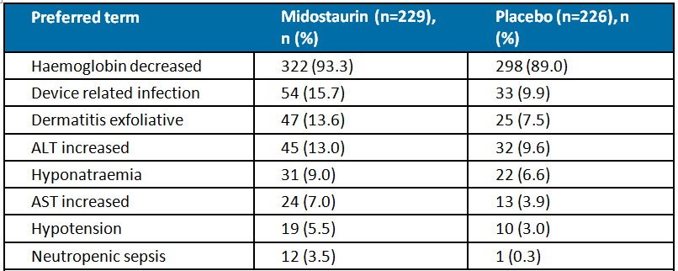
Grade 3 or 4 AEs reported in ≥ 10% of patients in the midostaurin group (versus placebo), in descending order of frequency, were platelet count decreased (99.7% versus 97.3%), haemoglobin decreased (93.3% versus 89.0%), neutrophil count decreased (95.4% versus 97.6%), febrile neutropaenia (83.5% versus 83.0%), leukopaenia (27.0% versus 30.1%), lymphopaenia (20.0% versus 22.7%), device related infection (15.7% versus 9.9%), diarrhoea (15.4% versus 15.2%), hypokalaemia (13.9% versus 17.0%), exfoliative dermatitis (13.6% versus 7.5%), ALT increased (13.0% versus 9.6%), and pneumonia (13.0% versus 14.0%).

Risk of death
On-treatment deaths were defined as all deaths that occurred within 30 days of last dose of study drug. There were fewer patients in the midostaurin group than in the placebo group who died on-treatment (15 patients (4.3%) versus 21 patients (6.3%), respectively). Of the 15 deaths in the midostaurin group, 14 occurred in the induction phase and 1 in the consolidation phase. Of the 21 deaths in the placebo group, 11 occurred in the induction phase, 9 in the consolidation phase, and 1 in the continuation phase. On-treatment deaths (overall) suspected to be related to the study drug were reported in 9 (2.6%) patients in the midostaurin group and 7 (2.1%) patients in the placebo group. In the midostaurin group, the only treatment-related AE resulting in death reported in ≥ 2 patients was multi-organ failure with all other treatment-related AEs resulting in death being reported in 1 patient each (that is, infectious colitis, acute respiratory failure, colitis, myocardial infarction, neutropaenic sepsis, pulmonary haemorrhage, and septic shock). There was no pattern in AEs resulting in treatment-related death reported in the midostaurin group.

Risks based on serious adverse events (SAEs), regardless of relationship to treatment
At non-North American sites, SAEs (all grades) were reported in 46.3% (n = 229) of patients in the midostaurin group and 51.8% (n = 117) of patients in the placebo group. SAEs (all grades) reported in ≥ 5% of patients in the midostaurin group (versus placebo), in descending order of frequency, were febrile neutropaenia (16.2% versus 15.9%), pneumonia (8.7% versus 9.7%), neutrophil count decreased (8.3% versus 9.3%), and platelet count decreased. SAEs (all grades) reported in ≥ 2% of patients in the midostaurin arm and in ≥ 2% more patients than in the placebo group were device related infection (7.4% versus 4.4%) and AST increased (2.6% versus 0%).
At all sites, Grade 3 or 4 SAEs were reported in 47.0% (n = 162) of patients in the midostaurin group and 48.7% (n = 163) of patients in the placebo group. Grade 3 or 4 SAEs reported in ≥ 5% of patients in the midostaurin group (versus placebo), in descending order of frequency, were febrile neutropaenia (15.7% versus 15.8%), neutrophil count decreased (8.1% versus 9.9%), platelet count decreased (7.0% versus 8.4%), device related infection (6.7% versus 3.9%), and pneumonia (6.7% versus 3.9%). Grade 3 or 4 SAEs reported in ≥ 2% of patients in the midostaurin group and in ≥ 2% more patients than in the placebo group are summarised below in Table 21.

Table 21: Study A2301 Grade 3 or 4 SAEs reported in ≥ 2% of patients in the midostaurin group and in ≥ 2% more patients than in the placebo group at all sites; Safety set
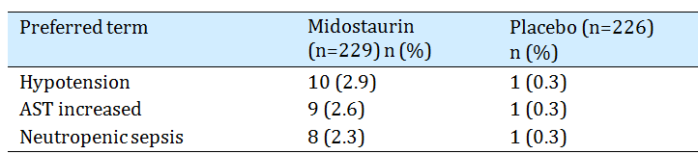
The proportion of patients requiring additional or prolonged hospitalisation during the induction phase was similar in Cycle 1 in both the midostaurin and placebo groups (53.3%, n = 184 versus 50.4%, n = 169, respectively). However, the proportion of patients requiring additional or prolonged hospitalisation if treated with a second induction cycle was notably higher in the midostaurin group than in the placebo group (56.8% (46 out of 81) versus 44.6% (45 out of 101)). Across all 4 cycles of the consolidation phase, the proportion of patients requiring hospitalisation was similar in the two treatment groups and ranged between 40% and 60% for both groups.

AEs resulting in treatment discontinuation, regardless of relationship to treatment
At all sites, AEs (all grades) leading to discontinuation of the study drug (midostaurin or placebo) were reported in 9.0% (n = 31) patients in the midostaurin group and 6.0% (n = 20) of patients in the placebo group, with the majority of discontinuations in both treatment groups being due to Grade 3 or 4 events (6.7%, n = 23 versus 5.1%, n = 17, respectively). Discontinuations due to AEs reported at all sites in ≥ 2 patients in either the midostaurin group or the placebo group are summarised below in Table 22.

Table 22: Study A2301 Discontinuations due to AEs (overall) reported in the all sites population in ≥ 2 patients in either the midostaurin or the placebo group; Safety set
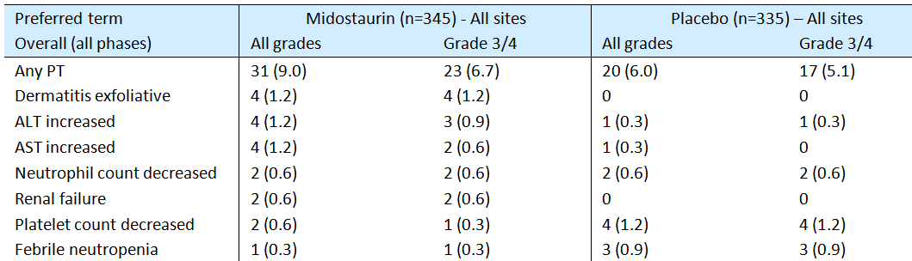
The proportion of patients discontinuing treatment due to AEs was notably lower in both treatment groups than the proportion of patients reporting AEs, which indicates that most AEs were manageable by methods other than treatment discontinuation. It is notable that nearly all patients in the study received red blood cell transfusions and platelet transfusions. Overall, approximately 50% to 65% of patients in both treatment arms received concomitant vancomycin, frusemide, aciclovir, ondansetron and paracetamol. Myeloid growth factors were not used routinely or prophylactically but were permitted as indicated by the ASCO guidelines for neutropaenic patients with prognostic factors predictive of clinical deterioration such as pneumonia, hypotension, multi-organ dysfunction (sepsis syndrome) or fungal infection. Granulocyte colony stimulation factors were used in 9 patients (6 in the midostaurin group and 3 in the placebo group). The use of epoetin or darbepoetin in this protocol was permissible but not recommended.

Risks associated of special interest, regardless of relationship to study drug
Hepatic toxicity: The safety data relating to hepatic toxicity showed that the risks or experiencing elevated ALT and AST levels were greater in the midostaurin group than in the placebo group. However, these increased risks did not translate into an increased risk of hepatic failure in the midostaurin group compared to the placebo group.
Clinical laboratory results showed that newly occurring ALT or AST levels > 3 x ULN were reported in 43.4% of patients in the midostaurin group and 36.3% of patients in the placebo group, while ALT or AST levels > 10 x ULN were reported in 3.1% and 3.7% of patients, respectively. Overall, the proportion of patients with newly occurring or worsening ALT levels (any grade) from baseline was 68.8% (n = 207) in the midostaurin group and 68.0% (n = 202) in the placebo group, while newly occurring or worsening ALT levels (Grade 3 or 4) from baseline occurred in 19.8% (n = 58) and 15.8% (n = 46) of patients, respectively. Overall, the proportion of patients with newly occurring or worsening AST levels (any grade) from baseline was 53.5% (n = 160) in the midostaurin group and 52.6% (n = 152) in the placebo group, while newly occurring or worsening ALT levels (Grade 3 or 4) from baseline occurred in 5.7% (n = 17) and 6.6% (n = 19) of patients, respectively.
At all sites, the risk of hepatic Grade 3 or 4 AEs occurred in a greater proportion of patients in the midostaurin group than in the placebo group (23.5% versus 19.7%, respectively), with the difference being driven primarily by increased ALT and AST levels in the midostaurin group (ALT increased 12.8%, midostaurin versus 9.6%, placebo; AST increased 6.7%, midostaurin versus 3.9%, placebo). At all sites, hepatic AEs leading to treatment discontinuation were reported in 1.7% of patients in the midostaurin group and 0.9% of patients in the placebo group, with AEs reported in ≥ 1% of patients in the midostaurin group (versus placebo) being ALT increased (1.2% versus 0.3%) and AST increased (1.2% versus 0.3%). Grade 3 or 4 hepatic failure was reported in 1 (0.3%) patient in each of the midostaurin and placebo groups.
Renal toxicity: Newly occurring or worsening serum creatinine levels (any grade) as assessed by clinical laboratory tests were reported in 8.8% (28 out of 320) patients in the midostaurin group and 9.1% (28 out of 308) of patients in the placebo group, while no Grade 3 or 4 AEs were reported in either of the two treatment groups. At all sites, Grade 3 or 4 AEs grouped under the term acute renal failure (renal toxicity) were reported in 3.5% (n = 8) of patients in the midostaurin group and 2.4% (n = 6) of patients in the placebo group. At all sites, renal failure resulting in treatment discontinuation was reported in 2 (0.6%) patients in the midostaurin group and no patients in the placebo group. Overall, the results indicate a small numerical increase in the proportion of patients in the midostaurin group experiencing renal failure compared to patients in the placebo group. However, there were no notable differences between the two groups as regards newly occurring or worsening serum creatinine levels.
Haematological toxicity: As expected, nearly all patients in both treatment arms experienced Grade 3 or 4 haematological toxicities and there were no clinically meaningful differences between the two treatment groups as regards these toxicities. In patients in the midostaurin and placebo groups, newly occurring or worsening from baseline Grade 3 or 4 reductions in absolute neutrophil levels were reported in 96.1% and 99.3% of patients respectively, Grade 3 or 4 reductions in haemoglobin levels in 77.9% and 77.1% of patients, respectively, Grade 3 or 4 reductions in platelets in 100% and 99.3% of patients, respectively, and Grade 3 or 4 reductions in WBC levels in 100% and 99.3%, respectively. At all sites, anaemia Grade 3 or 4 AEs (grouped terms) was reported in 93.0% of patients in the midostaurin group and 88.7% of patients in the placebo group, leukopaenia Grade 3 or 4 AEs (grouped terms) were reported in 99.7% and 100% of patients, respectively, and thrombocytopaenia Grade 3 or 4 AEs (grouped terms) were reported in 97.7% and 97.3% of patients, respectively. Nearly all patients in both treatment groups received RBC and platelet transfusions during the study.
Cardiac toxicity: At all sites, cardiac toxicities (arrhythmia) reported as Grade 3 or 4 AEs occurred in 7.8% of patients in the midostaurin group and 6.9% of patients in the placebo group, with the main contributing event in both groups being QT prolongation (5.4% versus 5.5%, respectively). At all sites, cardiac toxicities (cardiac failure) reported as Grade 3 or 4 AEs occurred in 0.9% (n = 3) of patients in each of the midostaurin and placebo groups. No cardiac toxicities (cardiomyopathy) reported as Grade 3 or 4 AEs occurred in either treatment group. Overall, cardiac toxicities resulting in treatment discontinuation were reported in 2 (0.6%) patients in the midostaurin group (AV block, ventricular, tachycardia, atrial fibrillation) and 1 (0.3%) patient in the placebo group (ventricular fibrillation). Overall, it is considered that there are no clinically significant differences in cardiac toxicity between the two treatment groups.
Immunogenicity and immune disorders: No clinically significant differences between the two treatment groups were observed in immune related AEs. At all sites, immune system disorders Grade 3 or 4 AEs were reported in 0.9% (n = 3) of patients in the midostaurin group (hypersensitivity two reports, drug hypersensitivity one report) and 1.8% (n = 6) of patients in the placebo group (hypersensitivity four reports, drug hypersensitivity two reports, anaphylactic reaction one report). There were no anaphylactic reactions in the midostaurin group, while 1 (0.4%) patient in the midostaurin group experienced cytokine release syndrome (Grade 1 to 2).
Serious skin reactions: The main difference between the two treatment groups as regards serious skin disorders was the higher incidence of exfoliative dermatitis in the midostaurin group than in the placebo group. At all sites, Grade 3 or 4 skin toxicity was reported in 17.7% (n = 61) of patients in the midostaurin group and 11.0% (n = 37) of patients in the placebo group, with the main AEs in both treatment groups being exfoliative dermatitis (13.6% versus 7.8%) followed by stomatitis (3.5% versus 2.7%). Skin toxicity resulted in 4 (1.2%) patients discontinuing treatment in the midostaurin group (all due to exfoliative dermatitis), while no patients in the placebo group discontinued treatment due to skin toxicity. No cases of Stevens-Johnsons syndrome or toxic epidermal necrolysis were reported.
Gastrointestinal AEs: Midostaurin was not associated with an increased risk of gastrointestinal Grade 3 or 4 AEs or discontinuations due to gastrointestinal AEs, but nausea (all grades) occurred more frequently in patients in the midostaurin group compared to the placebo group (83.4% versus 70.4%), as did vomiting (60.3% versus 52.7%). At all sites, Grade 3 or 4 gastrointestinal AEs were reported in 23.2% (n = 80) of patients in the midostaurin group and 24.5% (n = 82) of patients in the placebo group, with the most commonly reported AEs (midostaurin versus placebo) being diarrhoea (15.7% versus 15.2%), nausea (5.8% versus 10.1%), vomiting (2.9% versus 4.5%) and abdominal pain (3.8% versus 5.1%). Gastrointestinal AEs resulted in treatment discontinuation in 4 (1.2%) patients in the midostaurin group(vomiting x3, nausea x2) and 3 (0.9%) patients in the placebo group (vomiting one case, nausea one case, abdominal distension one case, abdominal pain one case).
At all sites, gastrointestinal haemorrhage Grade 3 or 4 AEs were reported in 2.6% (n = 9) of patients in the midostaurin group and 2.4% (n = 8) of patients in the placebo group, with the only Grade 3 or 4 AE reported in ≥ 1% of patients in the midostaurin group (versus placebo) being rectal haemorrhage (1.4% versus 0.6%). Gastrointestinal haemorrhage AEs resulting in treatment discontinuation were reported in 1 patient in the midostaurin group (upper gastrointestinal haemorrhage one case) and no patients in the placebo group.
Infection: Infection related AEs were reported frequently in both treatment groups, with the main difference between the two groups being the higher risk of device related infections in the midostaurin group than in the placebo group. At all sites, infection related Grade 3 or 4 AEs were reported in 54.2% (n = 187) of patients in the midostaurin group and 52.5% (n = 176) of patients in the placebo group, with Grade 3 or 4 AEs reported in ≥ 5% of patients in the midostaurin (versus placebo) being device related infection (16.2% versus 10.1%), pneumonia (13.0% versus 10.1%), sepsis (7.0% versus 7.5%), and neutropaenic infection (5.5% versus 5.4%). AEs resulting in treatment discontinuation were reported in 2 (0.6%) patients in the midostaurin group (staphylococcal infection one case, device related infection one case) and 2 (0.6%) patients in the placebo group (bronchitis one case, infection, pneumonia).
Bleeding: Bleeding AEs were reported in a similar proportion of patients in the two treatment groups. At all sites, Grade 3 or 4 AEs were reported in 11.9% (n = 41) of patients in the midostaurin group and 9.9% (n = 33) of patients in the placebo group, with Grade 3 or 4 AEs reported in ≥ 2% of patients in the midostaurin group (versus placebo) being epistaxis (2.6% versus 0.6%), petechiae (1.2% versus 0.6%), and rectal haemorrhage (1.4% versus 0.6%). AEs leading to discontinuation were reported in 3 (0.9%) patients in the placebo group (splenic haematoma one case, pulmonary haemorrhage one case, upper gastrointestinal haemorrhage one case) and 1 (0.3%) patient in the placebo group (haemorrhagic stroke).
Interstitial lung disease (ILD): At all sites, Grade 3 or 4 AEs categorised as ILD were reported in 7.2% (n = 25) of patients in the midostaurin group and 7.2% (n = 24) of patients in the placebo group, with Grade 3 or 4 AEs reported in ≥ 1% patients in the midostaurin group (versus placebo) being pneumonitis (4.9% versus 6.3%) and acute respiratory distress syndrome (2.3% versus 0.9%). ILD AEs leading to treatment discontinuation were reported in no patients in the midostaurin group and 3 (0.9%) patients in the placebo group (acute respiratory distress syndrome one case, pneumonitis one case, pulmonary toxicity one case).
Other laboratory abnormalities: Clinically notable laboratory abnormalities for liver function tests, serum creatinine and haematological parameters have been discussed above. As regards other clinical chemistry abnormalities, the only newly occurring or worsening parameter (all grades) reported in ≥ 10% of patients in the midostaurin group and in ≥ 5% more patients in the midostaurin group than in the placebo group was high calcium (10% (10 out of 100) versus 1.3% (1 out of 76)). No newly occurring or worsening parameters (Grade 3 or 4) were reported in ≥ 2% of patients in the midostaurin group.
Vital signs: No summaries of vital signs, other than changes relating to ECG findings, could be identified in the CSR for Study A2301. Overall, newly reported QTcF > 450 ms was reported in 29.3% (70 out of 239) of patients in the midostaurin group and 24.7% (54 out of 219) of patients in the placebo group, while newly reported QTcF > 500 ms was reported in 6.2% (16 out of 260) and 2.6% (6 out of 232) of patients, respectively. QTcF intervals were increased by > 60 ms from baseline in 18.4% (48 out of 261) of patients in the midostaurin group and 10.7% (25 out of 234) of patients in the placebo group. Patients in the midostaurin group appeared to be at an increased risk of QT prolongation compared to patients in the midostaurin group, but this increase did not appear to have significant clinical consequences. As described above, cardiac toxicities (arrhythmia) reported as Grade 3 or 4 AEs occurred in 7.8% of patients in the midostaurin group and 6.9% of patients in the placebo group, with the main contributing event in both groups being QT prolongation (5.4% versus 5.5%, respectively). There were no treatment discontinuations due to QT prolongation reported in the study. There were no reports of torsades de pointes in the study.

Study ADE02T
Study ADE02T included interim safety data in patients with newly diagnosed AML and FLT3-ITD mutations treated with midostaurin in combination with cytarabine plus daunorubicin in the induction phase (up to 2-cycles depending on response), followed by consolidation therapy with allogeneic stem cell transplantation (first priority) or cytarabine combined with midostaurin (second priority), followed by maintenance therapy with single-arm midostaurin for up to 1-year for all patients.
The study included 144 patients in the safety set, comprising 98 patients aged ≤ 60 years and 46 patients aged > 60 years. There were no patients aged ≥ 70 years. The median duration of treatment was 4.4 months (range: 0.2 to 18.9 months) in patients aged ≤ 60 years and 5.1 months (range: 0.3 to 18.4 months) in patients aged > 60 years. Treatment for ≥ 3 months was reported in 46% (n = 66) of patients aged ≤ 60 years and 43% (n = 43) of patients aged > 60 years, with treatment for > 12 months being reported in 17% (n = 24) and 15% (n = 15) of patients respectively. Treatment compliance was high in both age groups.
The safety of profile of midostaurin in older patients in this study is considered to be acceptable. The most commonly reported risks in both younger and older patients related to haematological adverse events (thrombocytopaenia, leukopaenia, and anaemia), gastrointestinal disorders (nausea, vomiting and diarrhoea) and skin disorders (rash). These adverse events were also frequently reported with midostaurin in the pivotal Phase III Study A2301. All patients in Study ADE02T experienced at least one AE, but the majority of these patients (62%) continued on treatment rather than discontinuing due to AEs. There were no data in the study relating to laboratory abnormalities, changes in vital signs or systematically collected ECG findings.

Risks of note in the Study ADE02T
Risks of note in the Study ADE02T included:
- A high incidence of patients in both treatment groups discontinued treatment with midostaurin due to AEs (27%, patients ≤ 60 years versus 33%, patients aged > 60 years). The sponsor is requested to comment on the reasons for the high discontinuation rates in this study.
- A high incidence of pulmonary haemorrhage (all grades) were reported in both younger and older patients (16% versus 11%, respectively), with 1 death due to pulmonary haemorrhage in a 49 year old male stated to be unrelated to treatment. However, in its response to the Day 120 EMA clinical evaluation report concerning a question from the EMA about the high incidence of pulmonary haemorrhage the sponsor stated that re-coding the AE data with MedDRA version 18.1 to align with the pivotal trial data resulted in 23 of the 26 cases of pulmonary haemorrhage being re-classified as epistaxis as the events were identified as nose bleed/epistaxis. Review of the data with a cut-off date of 31 December 2015 identified a total of 3 (2%) cases of pulmonary haemorrhage not suspected to be related to treatment and 1 (1%) case of pulmonary haemorrhage suspected to be related to treatment. Three of the cases were in patients aged ≤ 60 years and 1 of the cases was in a patient aged > 60 years. In the total dataset (n = 142), 1 (0.9%) SAE of treatment-related pulmonary haemorrhage was reported. None of the cases of pulmonary haemorrhage resulted in treatment discontinuation.
- Treatment-related related ECG QT prolongation was reported in a higher proportion of older patients than in younger patients, but patient numbers were small (13%, n = 6 versus 4%, n = 4, respectively).

High-level overview of risks
The high-level overview of risks in younger and older patients is summarised below in Table 23.

Table 23: Study ADE02T Overview of adverse event profile
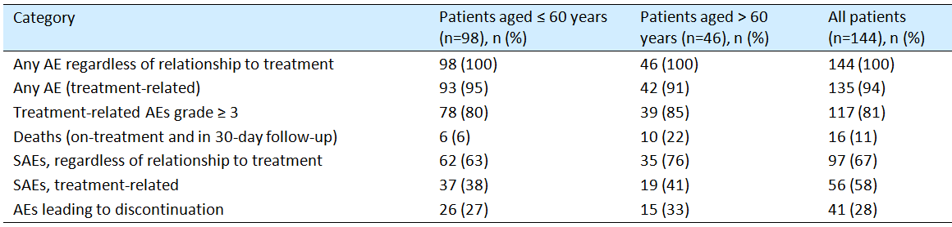

Adverse events (all grades)
All patients in both age groups experienced at least one AE, regardless of relationship to midostaurin and > 90% of patients in both age groups experienced at least at least one treatment-related AE. AEs (all grades), regardless of relationship to treatment, reported in ≥ 50% of patients in either age group are summarised below in Table 24, together with the frequencies for the corresponding treatment-related AEs.

Table 24: Study ADE02T Adverse events, regardless of relationship to treatment, occurring in ≥ 50% of patients in either age group, in descending order of frequency in younger patients, and associated treatment-related adverse events
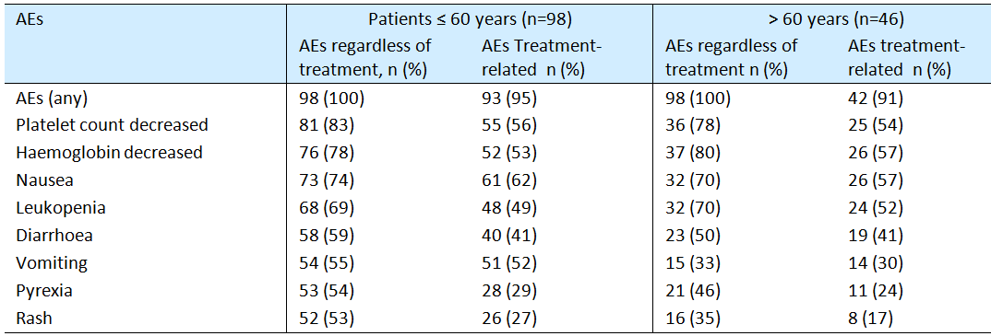
AEs, related to treatment with midostaurin, reported in ≥ 10% of younger patients and ≥ 5% more commonly than in older patients, in descending order of frequency, were nausea (62% versus 57%), vomiting (52% versus 30%), neutrophil count decreased (35% versus 26%), pyrexia (29% versus 24%), rash (27% versus 17%), gastrointestinal inflammation (23% versus 17%), abdominal pain (21% versus 9%), headache (18% versus 7%), insomnia (14% versus 7%), pulmonary haemorrhage (16% versus 11%), and abdominal pain upper (13% versus 7%).
AEs, related to treatment with midostaurin, reported in ≥ 10% of older patients and ≥ 5% more commonly than in younger patients, in descending order of frequency, were hypokalaemia (35% versus 15%), fluid retention (30% versus 19%), febrile neutropaenia (28% versus 23%), ECG QT prolonged (15% versus 5%), lung infection (15% versus 10%), hypertension (13% versus 6%), lip infection (11% versus 5%), and hypomagnesaemia (11% versus 4%).

Grade ≥ 3 AEs, related to treatment with midostaurin
Treatment related Grade ≥ AEs reported in ≥ 10% of patients in either age group and in descending order of frequency in younger patients are summarised below in Table 25.

Table 25: Study ADE02T Treatment-related Grade ≥ 3 adverse events occurring in ≥ 10% of patients in either age group, in descending order of frequency in younger patients
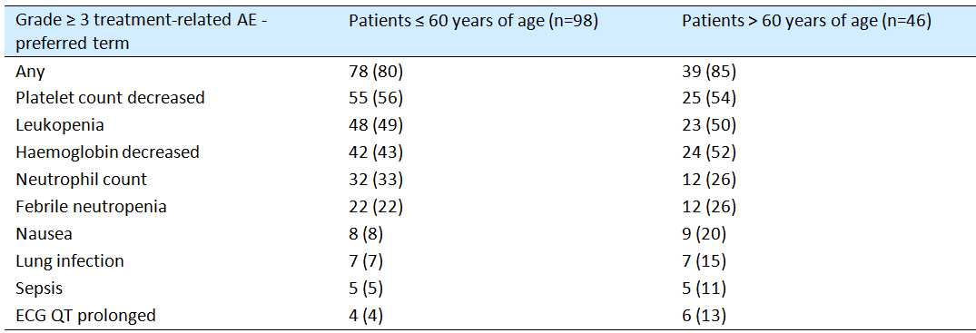
Treatment-related Grade ≥ 3 AEs were reported more frequently in older patients compared to younger patients (85% versus 80%). Treatment-related Grade ≥ 3 AEs reported in ≥ 5% of younger patients and ≥ 5% more commonly than in older patients, in descending order of frequency, were neutrophil count decreased (33% versus 26%) and hepatobiliary disease (5% versus 0%). Treatment-related Grade ≥ 3 AEs reported in ≥ 5% of older patients and ≥ 5% more commonly than in younger patients, in descending order of frequency, were haemoglobin decreased (52% versus 43%), nausea (20% versus 8%), lung infection (15% versus 7%), ECG QT prolonged (13% versus 4%), sepsis (11% versus 5%), and hypertension (7% versus 1%).

Deaths
Deaths occurring on-treatment or within 30 days of follow-up were reported in a greater proportion of older patients compared to younger patients (22% (n = 10) versus 6% (n = 6)). Of the 16 deaths, 3 deaths were reported to be treatment-related and each of these deaths occurred in patients aged > 60 years (lung infection 2 cases, sepsis 1 case). Most deaths (12 patients) were early or hypoplastic deaths occurring during the first (10 deaths) or second (2 deaths) induction cycles, 2 deaths occurred in patients in complete remission with incomplete haematological recovery and 2 deaths occurred during the maintenance phase (1 patient died while in relapse and 1 patient died while in complete remission). An increased risk of death in older patients with AML is not unexpected.

Serious adverse events (SAEs) (all grades)
SAEs (all grades), regardless of relationship to treatment, reported in ≥ 2 patients in either age group, and treatment-related frequencies for these SAEs are summarised below in Table 26.

Table 26: Study ADE02T Serious adverse events (all grades), regardless of relationship to treatment, occurring in ≥ 2 younger or older, in descending order of frequency in younger patients, and associated treatment-related serious adverse events
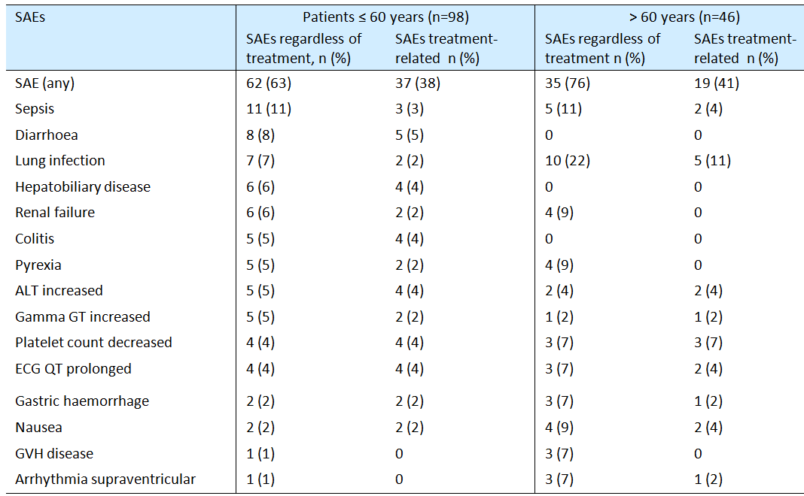
Treatment-related SAEs were reported in a similar proportion of patients in both age groups (38%, ≤ 60 years versus 41%, > 60 years). Treatment-related SAEs reported in ≥ 2% of younger patients and ≥ 2% more frequently than in older patients were diarrhoea (5% versus 0%), hepatobiliary disease (4% versus 0%), colitis (4% versus 0%), renal failure (2% versus 0%), and pyrexia (2% versus 0%). Treatment-related SAEs reported in ≥ 2% of older patients and ≥ 2% more frequently than in younger patients were lung infection (11% versus 2%), platelet count decreased (7% versus 4%), and nausea (4% versus 2%).

AEs leading to discontinuation of treatment
AEs leading to discontinuation of treatment regardless of relationship to midostaurin, reported in ≥ 2 patients in either age group, in decreasing frequency in younger patients, and corresponding frequencies for treatment-related AEs are summarised below in Table 27.

Table 27: Study ADE02T Adverse events leading to discontinuation, regardless of relationship to treatment, occurring in ≥ 2 younger or older patients, in descending order of frequency in younger patients, and associated adverse events
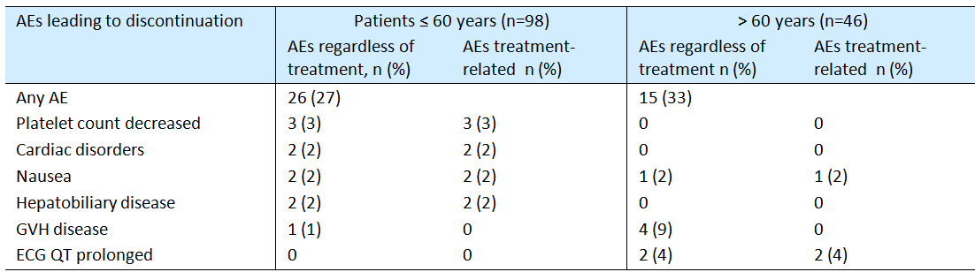
AEs leading to discontinuation of treatment occurred frequently in both younger and older patients (27% versus 33%, respectively). Treatment-related AEs leading to discontinuation of midostaurin reported in ≥ 2% younger patients and ≥ 2% more frequently than in older patients were cardiac disorders (2% versus 0%) and hepatobiliary disease (2% versus 0%). The only treatment-related AE leading to discontinuation of treatment with midostaurin reported in ≥ 2% of older patients and ≥ 2% more frequently than in younger patients was ECG QT prolonged (4% versus 0%).

First round assessment of risks (Advanced systemic mastocytosis)
The risks of monotherapy treatment with midostaurin in patients with AdSM have been evaluated based on the pooled dataset in 142 patients from two Phase II studies (Study DD201 (n = 116) and Study A2213 (n = 26)). Both studies were open-label, single-arm clinical trials in which midostaurin was administered at a dose of 100 mg BD in continuous 28 day cycles. The median duration of exposure in the pooled dataset was 11.4 months (range: 0 to 81 months). The mean age of the patients in the pooled dataset was 61.5 years (range: 24 to 82 years), with 54.9% (n = 78) being aged < 65 years and 45.1% (n = 64) being aged ≥ 65 years. The majority of patients in the pooled safety set were male (64.1%), and the major racial grouping was Caucasian (93.0%). In this risk assessment, the focus is on the incidence of AEs regardless of the relationship to the study drug, as this is considered to be the most conservative approach for a single-arm study of a new chemical entity.
With the exception of clinical laboratory abnormalities (reported as newly occurring or worsening), the sponsor did not provide treatment-emergent AEs. Therefore, the reported AEs included all collected AEs irrespective of whether they were new or worsening events relative to baseline. With the exception of 1 patient in Study D2201, all patients in the study had pre-existing medical conditions at baseline, including 83.8% of patients with gastrointestinal disorders, 78.9% of patients with blood and lymphatic disorders, 73.2% of patients with general disorders and administration site conditions (primarily fatigue).

Adverse events (high-level profile)
The high-level AE profile of midostaurin in the pooled dataset is summarised below in Table 28. The table includes AEs that were collected no later than 28 days after the last dose of the study drug. In this study, nearly AEs (all grades) were suspected to be drug related as were the majority of clinically notable AEs, while approximately 50% of Grade 3 or 4 AEs were considered to be drug related.

Table 28: High-level overview of adverse events in patients with AdSM; pooled dataset
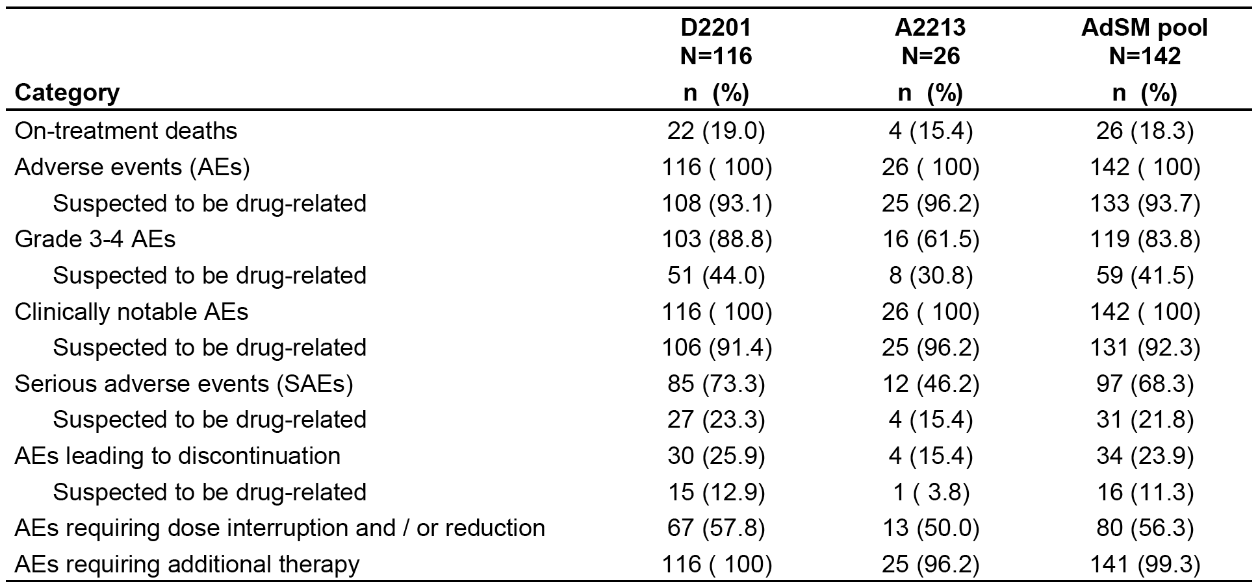

Risk of adverse event
AEs, regardless of study drug relationship, were reported in all (100%) patients in the pooled dataset, with AEs reported in ≥ 20% of patients, in descending order of frequency, being nausea (82.4%), vomiting (67.6%), diarrhoea (51.4%), peripheral oedema (35.2%), anaemia (33.1%), fatigue (31.0%), constipation (28.9%), pyrexia (26.8%), abdominal pain (26.1%), headache (26.1%), thrombocytopaenia (21.1%), and pruritus (20.4%).
AEs, Grade 3 or 4, regardless of study drug relationship, were reported in 83.8% of patients in the pooled dataset, with AEs reported in ≥ 5% of patients, in descending order of frequency, being anaemia (23.2%), thrombocytopaenia (12.0%), neutropaenia (10.6%), fatigue (8.5%), sepsis (7.7%), febrile neutropaenia (7.0%), pneumonia (7.0%), diarrhoea (6.3%), nausea (5.6%), vomiting (5.6%), lipase increased (5.6%), hyperglycaemia (5.6%) and dyspnoea (5.6%). The main risks of Grade 3 or 4 AEs related to haematological toxicity (myelosuppression) and gastrointestinal toxicities (diarrhoea, nausea and vomiting). Of note, risks of Grade 3 or 4 increased lipase serum levels and hyperglycaemia were commonly reported.

Risk of adverse events leading to discontinuation of the study drug
AEs (all grades) leading to study drug discontinuation, regardless of study drug relationship, were reported in 23.9% of patients in the pooled dataset, with AEs reported in ≥ 2 (1.4%) patients being ascites (n = 3, 2.1%), nausea (n = 3, 2.1%), ECG QT prolongation (n = 3, 2.1%), vomiting (n = 2, 1.4%), febrile neutropaenia (n = 2, 1.4%), thrombocytopaenia (n = 2, 1.4%), amylase increased (n = 2, 1.4%), pleural effusion (n = 2, 1.4%), and AML (n = 2, 1.4%). The proportion of patients discontinuing the study drug due to AEs was notably lower than the proportion of patients reporting AEs (23.9% versus 100%, respectively). This suggests that the majority of AEs were manageable by symptomatic treatment and/or midostaurin dose adjustment or interruption rather than discontinuation of the study drug.

Risk of adverse events leading to dose adjustment or interruption
AEs (all grades) requiring dose adjustment or interruption, regardless of study drug relationship, were reported in 56.3% of patients, with AEs reported in ≥ 2% of patients in the pooled dataset, in descending order of frequency, being nausea (12.0%), vomiting (9.2%), ECG QT prolonged (7.0%), neutropaenia (5.6%), diarrhoea (4.9%), pyrexia (4.2%), fatigue (3.5%), lipase increased (2.8%), amylase increased (2.1%), pneumonia (2.1%), and toxic skin eruption (2.1%).

Risk of death
On-treatment deaths were defined as deaths occurring on-treatment or up to 28 days after the last dose of study drug. There were 26 (18.3%) on-treatment deaths reported in the pooled dataset, none of which were suspected by the investigator to be related to midostaurin. Ten deaths were attributable to progression of the underlying disease and one death was due to progression of AHNMD (CMML) to AML. The remaining 15 deaths (10.6%) were most commonly related to cardiac disorders (5 patients) and infections and infestations (6 patients). The most frequently reported AEs associated with death were sepsis (5 patients), multi-organ failure (3 patients), and cardiac arrest (2 patients). All other AEs associated with death were each reported in 1 patient.
Based on updated safety data included in the sponsor’s safety database for the on-going studies (ARGUS), 4 additional deaths unrelated to treatment occurred in Study D2201 and 3 additional deaths unrelated to treatment occurred in Study A2213. In Study D2201, the 4 additional deaths included: (1) malignant neoplasm progression; (2) hepatic failure, skin infection; (3) disseminated intravascular coagulation; and (4) malignant neoplasm progression. Each of these 4 additional deaths occurred within 30 days of the last treatment dose and were reported in patients aged ≥ 70 years. In Study A2213, the 3 additional deaths included: (1) respiratory failure; (2) general physical health deterioration; and (3) sepsis due to multi-organ failure. Two (2) of the 3 deaths occurred within 30 days of the last treatment dose, and all 3 deaths were reported in patients aged ≥ 70 years.

Risk of serious adverse events
In the pooled dataset, SAEs (all grades), regardless of study drug relationship, were reported in 68.3% of patients, and SAEs reported in ≥ 2% of patients, in descending order of frequency, were pneumonia (7.0%), sepsis (7.0%), diarrhoea (5.6%), pleural effusion (4.9%), dyspnoea (4.2%), UTI (4.2%), GIT haemorrhage (4.2%), vomiting (4.2%), febrile neutropaenia (4.9%), pyrexia (4.9%), anaemia (4.2%), ascites (3.5%), upper GIT haemorrhage (2.8%), leucocytosis (2.1%), coronary artery disease (2.1%), fatigue (2.1%), general physical health deterioration (2.1%), acute kidney injury (2.1%), epistaxis (2.1%), renal failure (2.1%), toxic skin eruption (2.1%), and hypotension (2.1%). Most SAEs were Grade 3 or 4 events (that is 63.4%, Grade 3 or 4 versus 68.3%, all grades). There were 17 additional, newly reported non-fatal SAEs in the updated ARGUS database from Studies D2201 and A2113, and these SAEs were consistent with those in the original pooled dataset.

Risk of haematological toxicity
Haematological toxicities were commonly reported in patients in the pooled dataset. This was not unexpected as the inclusion criteria for patients with AdSM included significant baseline haematological clinical findings relating to neutropaenia, anaemia or thrombocytopaenia. Therefore, the reported haematological AEs related to treatment with midostaurin are likely to be significantly confounded by baseline haematological clinical findings. In Study D2201, haematological clinical findings at baseline in patients with AdSM included thrombocytopaenia (61.8%), anaemia (31.5%), transfusion-dependent anaemia (22.5%), and neutropaenia. In Study A2113, clinical findings at baseline were not collected, but were assigned after clinical review by the principal investigator and were described in the narratives of efficacy.
The interpretation of haematological AEs in patients with AdSM in the absence of a control arm is challenging as the development of new cytopaenias (anaemia, neutropaenia, thrombocytopaenia) might indicate disease progression rather than toxicity due to midostaurin. During the studies, a notable proportion of patients received RBC transfusions (for example 53.4% in Study D2201) and platelet transfusions (for example 14.7% in Study D2201). Most of the RBC transfusions administered on-treatment were reported to have been related to the underlying disease rather than midostaurin toxicity.
In the pooled dataset, 58.5% (n = 83) of patients reported haematological AEs (all grades), regardless of study drug relationship, and 42.3% (n = 60) of patients reported Grade 3 or 4 AEs. Grade 3 or 4 AEs reported in ≥ 2% of patients, in descending order of frequency, were anaemia (23.2%), thrombocytopaenia (12.0%), neutropaenia (10.6%), febrile neutropaenia (7.0%), leukopaenia (4.9%) and leukocytosis (2.1%). Despite the high incidence of haematological AEs only 7 (4.9%) patients discontinued due to AEs, and the events were febrile neutropaenia (n = 2, 1.4%), thrombocytopaenia (n = 2, 1.4%), leucocytosis (n = 1, 0.7%), neutropaenia (n = 1, 0.7%), and splenic infarction (n = 1, 0.7%). AEs requiring dose adjustment or interruption were reported in 15.5% of patients, and events reported in ≥ 2% of patients were neutropaenia (5.6%), thrombocytopaenia (4.2%), and anaemia (2.8%).
In the pooled dataset, clinical laboratory data showed that newly or worsening Grade 3 or 4 abnormalities from baseline were reported in 42.4% of patients for reductions in absolute lymphocytes, 40.2% of patients for reductions in haemoglobin, 22.1% of patients for reduction in platelet count, 20.0% of patients for reductions in absolute neutrophils, and 18.2% of patients for reductions in WBC.

Risk of hepatic toxicity
In the pooled dataset, hepatobiliary AEs (all grades), regardless of study drug relationship, were reported in 16.6% of patients and Grade 3 or 4 AEs were reported in 6.3% of patients. The Grade 3 or 4 AEs were cholelithiasis (1.4%), cholecystitis (1.4%), hepatic cirrhosis (1.4%), hyperbilirubinaemia (0.7%), portal hypertension (0.7%), hyperbilirubinaemia (0.7%), hepatic failure (1.4%) and hepatic pain (0.7%). Only 1 (0.7%) patient discontinued treatment due to a hepatobiliary AE (hepatic cirrhosis). Only 1 (0.7%) patient required dose adjustment or dose interruption due to a hepatobiliary AE (hyperbilirubinaemia). No on-treatment deaths occurred due to hepatobiliary AEs.
In the pooled dataset, ALT increased (all grades), regardless of study drug relationship, was reported in 4.2% of patients and Grade 3 or 4 events were reported in 1.4% of patients. AST increased (all grades), regardless of study drug relationship, was reported in 4.2% of patients and Grade 3 or 4 events were reported in 2.1% of patients. No patients discontinued due to increased ALT or AST, and 1 (0.7%) patient required a dose adjustment or interruption due to increased ALT.
In the pooled dataset, clinical laboratory data showed that newly or worsening Grade 3 or 4 abnormalities from baseline were reported in 3.5% of patients for ALT, 2.8% of patients for AST, and 3.6% of patients for total bilirubin. ALT or AST levels were increased > 3 x ULN in 6.4% (n = 9) of patients, > 10 x ULN in 1.4% (n = 2) of patients and > 20 x ULN in 0.7% (n = 2) of patients. TBL levels increased > ULN in 25.5% (n = 28) of patients and > 3 x ULN in 7.9% of patients. Two (2) patients experienced concurrent elevations in ALT or AST > 3 x ULN and TBL > 2 x ULN and ALP ≤ 2 x ULN (that is, meet Hy's law criteria for potential drug induced liver injury [DILI]). However, review of the cases showed that midostaurin was unlikely to be the causal factor.
On the basis of the available data it considered that clinically significant hepatoxicity due to midostaurin is unlikely in patients with AdSM treated with the drug.

Risk of renal toxicity
In the pooled dataset, renal and urinary AEs (all grades), regardless of study drug relationship, were reported in 19.0% of patients and Grade 3 or 4 AEs were reported in 4.9% of patients. Grade 3 or 4 AEs were renal failure (2.8%), acute kidney injury (1.4%), urinary retention (0.7%) and urinary calculus (0.7%). No AEs resulted in discontinuation of the study drug or death. AEs requiring dose adjustment or interruption were reported in 4 (2.1%) patients, and were acute kidney injury (n = 2, 1.4%), urinary calculus (n = 1, 0.7%) and urethral stenosis (n = 1, 0.7%)
In the pooled dataset, clinical laboratory data showed that newly or worsening abnormalities from baseline in serum creatinine (all grades) were reported in 24.6% of patients and Grade 3 or 4 AEs were reported in 0.7% of patients.
Overall, newly or worsening abnormalities from baseline in serum creatinine were frequently reported in the pooled dataset, but these abnormalities did not translate into clinical significant renal toxicity.

Cardiovascular toxicity
In the pooled dataset, ECG QT prolonged (all grades), regardless of study drug relationship, was reported in 10.6% of patients and Grade 3 or 4 AEs were reported in 0.7% of patients. AEs leading to study drug discontinuation were reported in 3 (2.1%) patients, and AEs requiring dose adjustment or interruption were reported in 10 (7.0%) patients. ECG QT prolonged AEs were unexpected, given the lack of effect on QTcF prolongation observed with midostaurin in healthy subjects in the dedicated QT study (Study A2113). There were no reports of Torsade de Point. The sponsor speculates that the ECG QT prolonged AEs were associated with factors other than midostaurin toxicity (that is electrolyte disturbance, comorbid cardiac disease). It is noted that ECG QT prolongation (all grades), regardless of study drug relationship, occurred more commonly in males than in females (13.2% versus 5.9%), which is an unusual finding given that QT prolongation generally occurs more frequently in women than in men. The reason for the frequently reported AE of ECG QT prolonged in patients with AdSM is unclear.
In the pooled dataset, cardiac AEs (all grades), regardless of study drug relationship, were reported in 25.4% (n = 36) of patients and Grade 3 or 4 AEs were reported in 7.0% (n = 10) of patients. The Grade 3 or 4 AEs were cardiac arrest (2.1%), cardiac failure (1.4%), acute myocardial infarction (1.4%), myocardial infarction (1.4%), ventricular tachycardia (1.4%), atrial fibrillation (0.7%), coronary artery disease (0.7%), mitral valve incompetence (0.7%), aortic calcification (0.7%), chronic cardiac failure (0.7%), congestive cardiac failure (0.7%), heart valve incompetence (0.7%) and mitral valve calcification (0.7%). AEs leading to discontinuation of the study drug were reported in 2 (1.4%) patients, and were cardiac arrest (n = 1, 0.7%) and ventricular tachycardia (n = 1, 0.7%). AEs requiring dose adjustment or interruption were reported in 1 (0.7%) patient (atrial fibrillation). On-treatment deaths were reported in 5 (3.5%) patients, and were cardiac arrest (two cases, 1.4%), cardiac disorder (one case, 0.7%), cardiac failure (one case, 0.7%), and congestive cardiac failure (one case, 0.7%).
In the pooled dataset, vascular AEs (all grades), regardless of study drug relationship, were reported in 26.8% (n = 38) of patients and Grade 3 or 4 AEs were reported in 6.7% (n = 9) of patients. The Grade 3 or 4 AEs were hypotension (2.1%), flushing (1.4%), haematoma (0.7%), hypertension (0.7%), aortic stenosis (0.7%), arterial occlusive disease (0.7%), haemodynamic instability (0.7%) and peripheral arterial stenosis (0.7%). No patients discontinued the study drug due to AEs, and 5 (3.5%) patients reported AEs requiring dose adjustment or interruption (primarily hypotension, n = 3, 2.2%]).

Risk of skin toxicity
In the pooled dataset, skin and subcutaneous AEs (all grades), regardless of study drug relationship, were reported in 50.0% (n = 71) of patients and Grade 3 or 4 AEs were reported in 9.2% (n = 13) of patients. Grade 3 or 4 AEs reported in ≥ 2% of patients were pruritus (2.8%) and toxic skin eruption (2.8%). No AEs resulted in discontinuation of the study drug. AEs requiring dose adjustment or interruption were reported in 7 (4.9%) patients and the only AE reported in ≥ 2 (≥1.4%) of patients was toxic skin eruption (n = 7, 2.1%).

Risk of gastrointestinal toxicity
The risk of GIT toxicity was particularly high in patients with AdSM treated with midostaurin. However, the majority of the gastrointestinal AEs appeared to be manageable by symptomatic treatment and/or dose adjustment or interruption rather than discontinuation of the study drug. In the pooled dataset, serotonin 5HT3 antagonists were used by 85.2% of patients (mostly ondansetron).
In the pooled dataset, gastrointestinal AEs (all grades), regardless of study drug relationship, were reported 96.5% of patients and Grade 3 or 4 AEs were reported in 23.2% of patients. Grade 3 or 4 AEs reported in ≥ 2% of patients, in descending order of frequency, were diarrhoea (6.3%), nausea (5.6%), vomiting (5.6%), abdominal pain (3.5%), GIT haemorrhage (3.5%), ascites (2.8%), upper abdominal pain (2.1%), and upper GIT haemorrhage (2.1%). Despite the high incidence of gastrointestinal AEs only 4 patients discontinued treatment due to an AE (ascites one case, nausea one case, vomiting one case, gastric haemorrhage one case). AEs (all grades) requiring dose adjustment or interruption, regardless of study drug relationship, were reported in 23.2% of patients, with AEs reported in ≥ 2% of patients being nausea (12.0%), vomiting (9.2%) and diarrhoea (4.9%). No deaths due to gastrointestinal AEs were reported.

Risk of infection
In the pooled dataset, infection and infestation AEs (all grades), regardless of study drug relationship, were reported in 63.8% (n = 90) of patients and Grade 3 or 4 AEs were reported in 28.9% (n = 41) of patients. Grade 3 or 4 AEs reported in ≥ 2% of patients, in descending order of frequency, were pneumonia (7.0%), sepsis (7.0%), and UTI (2.8%). AEs leading to study drug discontinuation were reported in 3 (2.1%) patients and were pneumonia (n = 1, 0.7%), sepsis (n = 1, 0.7%) and UTI (n = 1, 0.7%). AEs requiring dose adjustment or interruption were reported in 13 (9.2%) patients and events reported in ≥ 2 (≥ 1.4%) patients were pneumonia (n = 3, 2.1%), sepsis (n = 2, 1.4%), and tooth infection (n = 3, 1.4%). On-treatment deaths were reported in 6 (4.2%) patients and were due to sepsis (n = 5, 3.5%) and pneumonia (n = 1, 0.7%).

Risk of bleeding
In patients in the pooled dataset, the risk of bleeding (all AEs), grouped terms, regardless of study drug relationship, was 38 0% (n = 54) and the risk of bleeding (Grade 3 or 4) was 14.1% (n = 20). Grade 3 or 4 AEs reported in ≥ 2% of patients were gastrointestinal haemorrhage (3.5%), epistaxis (2.8%) and upper gastrointestinal haemorrhage (2.1%). AEs leading to study drug discontinuation were reported in 3 (2.1%) patients and were gastric haemorrhage (n = 1, 0.7%), melaena (n = 1, 0.7%), and subdural haematoma. AEs requiring dose adjustment or interruption were reported in 7 (4.9%) of patients and AEs reported in ≥ 2 patients were gastrointestinal haemorrhage (n = 2, 1.4%), oesophageal varices haemorrhage (n = 2, 1.4%), and upper gastrointestinal haemorrhage (n = 2, 1.4%).

Risk of pulmonary toxicity
In the pooled dataset, respiratory, thoracic and mediastinal AEs (all grades), regardless of study drug relationship, were reported in 57.0% (n = 81) of patients and Grade 3 or 4 AEs were reported in 13.4% (n = 19) of patients. Grade 3 or 4 AEs reported in ≥ 2 (≥ 1.4%) patients were dyspnoea (n = 8, 5.6%), pleural effusion (n = 6, 4.2%), epistaxis (n = 4, 2.8%), and respiratory failure (n = 2, 1.4%). AEs leading to discontinuation of the study drug were reported in 3 (2.1%) patients (pleural effusion x 2, dyspnoea x 2). AEs requiring dose adjustment of interruption were reported in 5 (3.5%) patients, and AEs reported in ≥ 2 (≥ 1.4%) patients were dyspnoea (n = 2, 1.4%) and pleural effusion (n = 2, 1.4%). Interstitial lung disease was reported in 2 (1.4%) patients and pneumonitis was reported in 1 (0.7%) patient.

Risk of neoplasms
In the pooled dataset, neoplasms benign, malignant and unspecified (including cysts and polyps) AEs (all grades), regardless of study drug relationship, were reported in 15.5% (n = 22) of patients and Grade 3 or 4 AEs were reported in 8.5% (n = 12) of patients. Grade 3 or 4 AEs were AML (4.9%), squamous cell carcinoma (0.7%), adenocarcinoma of the colon (0.7%), malignant lung neoplasm (0.7%), myelofibrosis (0.7%), and tumour compression (0.7%). AEs leading to discontinuation of the study drug were reported in 2(1.4%) patients (AML two cases). No AEs requiring dose adjustment or interruption were reported.
In Study D2201, leukaemic transformation occurred in 15 (13%) patients in the safety set, and all patients except 1 had AHNMD at baseline. The subtypes for the 14 patients with AHMND were CMML (n = 6), MDS/MPN-(U) (n = 7) and MDS (n = 1). The sponsor comments that the leukaemic transformation rate reported in Study D2201 (13%) is consistent with the rate observed in the published literature. Ten cases were reported as an AE, and only one case was suspected to be related to the study drug. No transformations to AML were reported in Study A2213.

Risk of hyperglycaemia
In the pooled dataset, clinical laboratory data showed that newly or worsening hyperglycaemia (all grades) was reported in 79.6% (n = 113) of patients while Grade 3 or 4 AEs were reported in 18.6% (n = 26) patients. The sponsor states that 13 (50%) of the 26 patients with newly or worsening Grade 3 or 4 hyperglycaemia had received concomitant corticosteroid treatment while on-treatment. In addition, of the 26 patients in the pooled dataset with Grade 3 or 4 hyperglycaemia, 12 patients were known diabetics and 3 patients had hyperglycaemia at baseline or reported in their medical history. In the remaining 9 cases, patients had isolated abnormal values, abnormal values at baseline and/or co-morbidities that are risk factors for diabetes (that is obesity, fatty liver).
In the pooled dataset, hyperglycaemia (all grades), regardless of study drug relationship was reported in 9.9% (n = 14) of patients and Grade 3 or 4 AEs were reported in 5.6% (n = 8) of patients. Diabetes mellitus (all grades) was reported in 4.2% (n = 6) patients and Grade 3 or 4 AEs were reported in 2.1% (n = 3) of patients. In the pooled dataset 8 (5.6%) patients were reported to have diabetes mellitus at baseline and 11 (7.7%) patients were reported to have had type 2 diabetes at baseline. These figures are consistent with the 12 patients known to be diabetic at baseline referred to by the sponsor.
The high rate of hyperglycaemia (all grades) in the pooled dataset (79.6%) detected by clinical laboratory testing does not appear to have resulted in comparable high rates of clinically significant AEs of hyperglycaemia or diabetes mellitus. It is unknown how many of the patients with hyperglycaemia (all grades) based on the clinical laboratory data had confounding factors. However, confounding factors appeared to have significantly contributed to the 26 cases of Grade 3 or 4 hyperglycaemia detected by clinical laboratory testing. Nevertheless, the rate or hyperglycaemia (all grades) detected by clinical laboratory testing is unusually high. Further information relating hyperglycaemia might emerge following marketing of the drug.

Risk of increased amylase and lipase levels
In the pooled dataset, clinical laboratory data showed that newly occurring or worsening amylase levels (all grades) were report 19.7% (n = 28) of patients and Grade 3 or 4 AEs were reported in 6.4% (n = 9) of patients. In the pooled dataset, increased amylase (all grades) was reported in 5.6% (n = 8) patients and Grade 3 or 4 AEs were reported in 3.5% (n = 5) patients. Increased amylase levels resulted in 3 (2.1%) patients discontinuing the study drug, and dose adjustment or interruption in 3 (2.1%) patients.
In the pooled dataset, clinical laboratory data showed that newly occurring or worsening lipase levels (all grades) were report 37.3% (n = 53) of patients and Grade 3 or 4 AEs were reported in 17.6% (n = 25) of patients. In the pooled dataset, increased amylase (all grades) was reported in 9.9% (n = 14) of patients and Grade 3 or 4 AEs were reported in 5.6% (n = 8) of patients. Increased amylase levels resulted in 1 (0.7%) patient discontinuing the study drug, and dose adjustment or interruption in 4 (2.8%) patients.
In the pooled dataset, 1 (0.7%) patient experienced pancreatitis (Grade 3 or 4) suspected to be related to the study drug, but not leading to discontinuation or requiring dose adjustment or interruption. In the pooled dataset, 1 (0.7%) patient experienced chronic pancreatitis (Grade 1 or 2), not suspected to be related to the study drug and not leading to discontinuation or requiring dose adjustment or interruption.
Based on the available data it appears that midostaurin treatment in patients with AdSM is likely to be causally associated with increased amylase and lipase levels. However, acute pancreatitis suspected by the investigator to be related to treatment with midostaurin was reported in only 1 patient. Further information relating to the risks of increased amylase and lipase levels might emerge following marketing of the drug.

Risks in special groups (elderly patients)
The safety profile in patients aged ≥ 65 years suggests that no modification of midostaurin dose for the treatment of elderly patients with AdSM is required. There were no identified safety concerns in elderly patients with AdSM that would preclude treatment with midostaurin. There were some differences in the safety profile between patients aged ≥ 65 years and < 65 years, but this was not unexpected given the naturally occurring increased morbidity and mortality in the elderly.
The risk of death in patients aged ≥ 65 years (n = 64) was greater than in patients aged < 65 years (28.1% versus 10.3%), with the main differences being the higher incidence of death in older compared to younger patients being due to progression of the underlying disease (12.5% versus 3.8%), cardiac disorders (6.3% versus 1.3%) and infections (6.3% versus 2.6%). Of note Grade 3 or 4 AEs were reported in a similar proportion of patients aged ≥ 65 years than patients aged < 65 years (85.9% versus 82.1%, respectively) as were SAEs (65.6% versus 70.5%, respectively). However, AEs (all grades) leading to discontinuation of the study drug were reported more frequently in the older compared to the younger age group (31.3% versus 17.9%), as were AEs (all grades) requiring dose adjustment or interruption (60.2% versus 51.3%).

Risks in special groups (gender)
In the pooled dataset (n = 142), there were more male than female patients (n = 91 versus n = 51) and the median duration of exposure was notably longer in females than in males (17.0 versus 11.3 months). The incidence of exposure adjusted AEs (all grades) and Grade 3 or 4 AEs was higher in males than in females, and these difference was primarily driven by a higher incidence of blood and lymphatic disorders (particularly anaemia) in males compared to females. The incidence of exposure adjusted gastrointestinal disorders (SOC), all grades, was similar in males and females, but the incidence of Grade 3 or 4 disorders was higher in females compared to males primarily due to the increased risks of nausea, vomiting and diarrhoea. Other risks of note included a higher incidence of exposure adjusted peripheral oedema in males than in females, and a higher incidence of discontinuations in males than in females (primarily due to haematological AEs). On-treatment deaths (unadjusted for duration of exposure) were reported more frequently in females than in (23.5% versus 15.4%), with the main difference being a higher incidence of death due to disease progression in females than in males (9.8% versus 5.5%). The reason for the differences in the exposure adjusted incidence rate of AEs between the genders is unknown.

Risks in special groups – impaired hepatic function, impaired renal function
In general, the safety profile of patients with normal hepatic function was comparable to that of patients with mild hepatic impairment. The numbers of patients with moderate and severe hepatic impairment were too small to make meaningful conclusions relating to safety. There were no data comparing safety in patients with normal renal function to patients with renal impairment.

Risks in special groups – race
The population was primarily Caucasian. The number of non-Caucasian patients was too small to make meaningful comparisons relating to safety to Caucasian patients.

First round assessment of benefit-risk balance - Acute myeloid leukaemia
The benefit-risk balance is favourable for midostaurin in combination with cytarabine and daunorubicin induction and high-dose cytarabine consolidation for the treatment of patients with newly diagnosed AML who are FLT-3 mutation positive. However, there are no adequate data establishing the benefits of single agent midostaurin continuation therapy following induction and consolidation with midostaurin in combination with chemotherapy. There were no data in the pivotal Study A2301 in patients aged > 60 years, but the investigator initiated study (ADE02T) included patients aged up to > 69 years. The efficacy and safety data in the relative small number of patients in the Study ADE02T considered to support midostaurin treatment in older patients with newly diagnosed AML who are FLT-3 mutation positive. However, there were no data in patients aged ≥ 70 years.
In the pivotal Phase III Study A2301, the primary efficacy endpoint was overall survival not censored at the time of SCT. In this analysis, the hazard ratio was 0.774 (95% CI: 0.629 to 0.953), which represents a 23% improvement in overall survival in the midostaurin arm relative to the placebo arm. The estimated median duration of overall survival was unreliable in both treatment arms as the Kaplan Meier curves had plateaued at about the time of median survival time in both arms. The improvement in overall survival in the midostaurin arm relative to the placebo arm was statistically significant and is considered to be clinically meaningful.
The key secondary efficacy endpoint in Study A2301 was event free survival not censored at the time of SCT. In this analysis, the hazard ratio was 0.784 (95% CI: 0.662 to 0.930), which represents a 22% reduction in the risk of experiencing an event free survival event (treatment failure, relapse, or death) in the midostaurin arm relative to the placebo arm. The median event free survival was 8.2 months in the midostaurin arm and 3.0 month in the placebo arm. The improvement in event free survival in the midostaurin arm relative to the placebo arm was statistically significant and is considered to be clinically meaningful. No formal statistical testing of the other secondary efficacy endpoints was undertaken.
Overall, the risks of treatment with midostaurin in Study A2301 were consistent with the risks of treatment with placebo. The most commonly reported Grade 3 or 4 AEs in both treatment groups (≥ 10% of patients) were haematological toxicities (thrombocytopaenia, anaemia, neutropaenia, febrile neutropaenia, and leukopaenia), which occurred in > 80% of patients in both treatment groups. Other commonly reported Grade 3 or 4 AEs with a similar incidence in both treatment groups were diarrhoea (approximately 15%) and pneumonia (approximately 13 to 14%), while commonly reported Grade 3 or 4 AEs occurring more frequently in the midostaurin group than in the placebo group were device related infection (15.7% versus 9.9%), exfoliative dermatitis (13.6% versus 7.5%) and ALT increased (13.0% versus 9.6%).
The risk of on-treatment death was lower in patients in the midostaurin group than in the placebo group (4.3% versus 6.3%). The risk of SAEs (Grade 3 or 4) was similar in the midostaurin and placebo groups (47.0% versus 48.7%), and the risk of events reported in ≥ 5% of patients in the midostaurin group (versus placebo) were febrile neutropaenia (15.7% versus 15.8%), neutrophil count decreased (8.1% versus 9.9%), platelet count decreased (7.0% versus 8.4%), device related infection (6.7% versus 3.9%), and pneumonia (6.7% versus 3.9%). The proportion of patients requiring additional or prolonged hospitalisation in first induction cycle was similar in the midostaurin and placebo groups (53.3% versus 50.4%, respectively), but in patients proceeding to a second induction cycle the proportion was higher in the midostaurin group than in the placebo group (56.8% versus 44.6%, respectively).
AEs resulting in discontinuation of the study drug were reported more frequently in the midostaurin group than in the placebo group (9.0% versus 6.7%), with events reported in ≥ 1% of patients in the midostaurin group (versus placebo) being exfoliative dermatitis (1.2% versus 0%), ALT increased (1.2% versus 0.3%), and AST increased (1.2% versus 0.3%).
Newly occurring ALT or AST laboratory abnormalities (ALT or AST ≥ 3 x ULN) were reported more frequently in the midostaurin group than in the placebo group (43.4% versus 36.3%). The incidence of patients with ALT or AST > 3x ULN, TBL > 2x ULN, and ALP ≥ 2x ULN was lower in the midostaurin arm than in the placebo arm (2.9% versus 4.8%), with none of the patients in the midostaurin arm (n = 9) meeting Hy’s law criteria for drug induced liver injury. Newly occurring or worsening serum creatinine laboratory abnormalities were reported in a similar proportion of patients in both treatment groups (8.8%, midostaurin versus 9.1%, placebo). Newly occurring or worsening Grade 3 or 4 AE laboratory abnormalities for all tested parameters were balanced between the two treatment groups. Newly occurring or worsening haematological laboratory abnormalities (all grades and Grade 3 or 4) were reported very frequently in both treatment groups, with no marked differences between the two groups.
ECG QT prolongation AEs (all grades), were reported more frequently in the midostaurin group than in the placebo group (19.2% versus 16.8%), while Grade 3 or 4 AEs were reported in a similar proportion of patients in both treatment groups (5.5% versus 5.4%, respectively). Newly occurring QTcF intervals > 500 ms were reported more frequently in the midostaurin group than in the placebo group (6.2% versus 2.6%), as were increases in QTcF from baseline of > 60 ms (18.4% versus 10.7%) The reason for the increased risk of ECG QT prolongation in the midostaurin group is unclear. The dedicated QT study in healthy volunteers showed that midostaurin had no significant effect on QTcF prolongation.

First round assessment of benefit- risk balance - Advanced systemic mastocytosis
The risk-benefit balance is favourable for midostaurin monotherapy for the treatment of AdSM. The risk-benefit assessment is based on open label, single arm midostaurin treatment from the key Study D2201 supported by Study A2213, rather than controlled efficacy and safety data. However, this is considered acceptable given that AdSM is a rare condition with high morbidity and mortality for which there is no effective treatment for the majority of patients with this condition.

First round recommendation regarding authorisation

Acute myeloid leukaemia
It is recommended that midostaurin in combination with cytarabine and daunorubicin induction and cytarabine consolidation be approved for the treatment of adult patients with newly diagnosed acute myeloid leukaemia (AML) who are FLT3 mutation positive.
It is recommended that midostaurin not be approved in combination with any other induction or consolidation regimens apart from those used in Studies A2301 and ADE02T. There are no data assessing the safety and efficacy of midostaurin in combination with other induction or consolidation regimens for treatment of the proposed indication.
It is recommended that midostaurin not be approved for single agent continuation therapy following induction and consolidation in combination with the recommended chemotherapeutic regimens. It is considered that the efficacy data supporting the use of single agent midostaurin for continuation therapy (twelve 28 day cycles) are inadequate. The reasons for this recommendation are provided below.
In a pre-specified secondary efficacy endpoint assessment, disease free survival was assessed in both treatment arms 1 year after completion of continuation treatment in patients who had achieved a complete remission within 60 days of the start of start of induction treatment and were still in complete remission when starting continuation treatment. The definition of disease free survival was time from end of continuation treatment to relapse or death from any cause, whichever occurred first. The analysis included 59 patients in the midostaurin arm and 41 patients in the placebo arm. The risk of experiencing an event (relapse or death due to any cause) after completing 12 months of continuation therapy was 42% higher in the midostaurin arm relative to the placebo arm (hazard ratio = 1.42 (95% CI: 0.63 to 3.22), p = 0.799). In the midostaurin arm there were 16 (27.1%) events (all relapse) and in the placebo arm there were 9 (22.0%) events (7 relapses, 2 deaths).
In an exploratory analysis, disease free survival (relapse or death from any cause) in the continuation phase, not censored at the time of SCT, was assessed in patients with a complete remission in the 60 day window. The exploratory analysis showed a 7% increase in the risk of experiencing an event (relapse or death from any cause) in the continuation phase in the midostaurin arm relative to the placebo arm (hazard ratio = 1.07 (95% CI: 0.69 to 1.68); p = 0.6212). In the midostaurin arm there were 53 (50.5%) events (49 relapses, 4 deaths) and in the placebo arm there were 31 (44.9%) events (29 relapses, 2 deaths). In an exploratory analysis, overall survival, not censored at the time of SCT, was assessed in patients in the continuation phase. The exploratory analysis showed that the risk of death in the continuation phase was 20% lower in the midostaurin arm relative to the placebo arm (hazard ratio = 0.80 (95% CI: 0.50 to 1.28); p = 0.1754). In this analysis, there were 41 deaths (34.2%) in the midostaurin arm and 32 (37.6%) deaths in the placebo. However, a carry ‘forward effect’ of overall survival benefit from midostaurin in combination with chemotherapy in the induction and maintenance phases cannot be excluded. In addition, the results were inconsistent for the disease free survival (favoured placebo over midostaurin) and the overall survival (favoured midostaurin over placebo) exploratory analyses, and neither of the two exploratory analyses were nominally statistically significant.

Advanced systemic mastocytosis
It is recommended that midostaurin as monotherapy be approved for the treatment of adult patients with aggressive systemic mastocytosis (ASM), systemic mastocytosis with associated haematological neoplasms (SM-AHN), or mast cell leukaemia (MCL)).
It is recommended that the three WHO terms, which in clinical practice are grouped under the term advanced systemic mastocytosis, be individually specified.

Clinical questions

Pharmacokinetics
- The popPK study report in patients with AML indicates that there were 190 patients from Study A2301 (Ratify) with PK data but the study report for A2301 (Ratify) indicates that there were 188 patients in the PK set. The sponsor is requested to comment on this apparent discrepancy
- In the synopsis of the popPK report in patients with AML the number of observations from Study A2301 (Ratify) for midostaurin, CGP52421 and CGP62221 were given as 535, 533, and 549, respectively, but data in the body of report indicate that the numbers are 527, 524, and 528, respectively (see Tables 5-1, 5-2 and 5-3). The sponsor is requested to comment on this apparent discrepancy.
- In the popPK study report in patients with AML, in justifying its decision to exclude data from Study A2301 (Ratify) from model building it was stated that the PK data from the study is very sparse with only 5 ‘informative’ PK samples out of 8 collected. Also only a small percentage of patients consented to PK samples. Moreover, dosing history as well as sampling times were not recorded at all, so it was assumed that all patients were compliant and that all samples are indeed trough samples. The sponsor is requested to: (i) clarify how much data were actually available from Study A2301 for inclusion in model building (that is, patient numbers and number of observations); (ii) clarify the meaning of ‘informative’ PK samples in the context of this popPK analysis; and (iii) comment on the statement that ‘only a percent of patients consented to PK samples’, given that the PK analysis set for Study A2301 appears to include 188 patients (that is, 52.2% of 360 patients treated with midostaurin in the full analysis set (FAS)).
- In vitro, midostaurin was reported to be a potent inhibitor of CYP1A2, CYP2C8, CYP2C9, CYP2D6, CYP2E1 and CYP3A4/5 at clinically relevant concentrations (DMPK R0300937). Please provide a justification for not undertaking clinical DDI studies investigation the effect of co-administration of midostaurin and substrates for CYP1A2, CYP2C8, CYP2C9, CYP2D6, and CYP2E1.
- In vitro, it was reported than midostaurin, CGP52421 and CGP62221 inhibit the OATP1B1 and OAT1B3 (DMPK R1500741, DMPK1200326). In the Summary of Clinical Pharmacology, it was stated that OAT1B1 transport activity was more potently inhibited than OAT1B13 suggesting a potential effect of midostaurin and metabolites on drugs whose clearance is significantly mediated by OATP1B1. The sponsor is requested to provide a justification for not undertaking a clinical DDI study investigation the effect of co-administration of midostaurin on the PK of a drug whose clearance is significantly mediated by OATP1B1.
- In vitro, midostaurin was reported to inhibit breast cancer resistance protein (BCRP) and P-gp (DMPK R0900746). In the Summary of Clinical Pharmacology, it was stated that midostaurin has the potential to affect the PK of P-gp and BCRP substrates in vivo. The sponsor is requested to provide a justification for not undertaking a clinical DDI study investigation the effect of co-administration of midostaurin on P-gp and BCRP substrates.
- In Study D2201 (key efficacy and safety study for AdSM), C_{min} exposure following the 200 mg/day monotherapy regimen (100 mg BD) was similar to C_{min} exposure following the 100 mg/day monotherapy regimen (50 mg BD) in patients with AML/MDS (Study A2104E)). The results suggest that the proposed 100 mg BD dose for the treatment of patients with AdSM might not be optimal, and that a dose of 50 mg BD might be preferable. Please comment on this matter.
- Please justify not undertaking in vivo net effect modelling on the PK of midostaurin, CGP62221 and CGP52421 of CYP enzymes known from in vitro data to be potentially clinically significant inhibitors and inducers of midostaurin.

Efficacy
- In Study A2301, the primary efficacy endpoint of overall survival (OS) was tested (null hypothesis) with a one-sided stratified log-rank test used to calculate the p-value. Please justify why a one-sided log-rank test was used to test the null hypothesis rather than a two-sided log-rank test. Please provide the p-value for the OS comparison between the two treatment arm using a two-sided log-rank test and comment on the results. It is noted that the US prescribing information for midostaurin summarises the OS data using a 2-sided test.
- In Study A2301, the key secondary efficacy endpoint of event free survival (EFS) was assessed by a stratified one-sided log-rank test. Please justify the use of a one-sided log-rank test rather than a two-sided log-rank test and provide the p-value for a two-sided log-rank test of EFS. It is noted that the US prescribing information for midostaurin summarises the EFS data using a 2-sided test.
- The sponsor’s response (AML) to the Day 120 EMA evaluation report included post hoc OS and EFS analyses (not censored at the time of SCT) for patients aged ≤ 60 years (all and FLT3-ITD mutation positive) treated with midostaurin from Study A2301 (see Tables 2-2 and 2-3, Response to Q37). Please provide similar tables for the patients treated with placebo from Study A2301 and compare the results with patients aged ≤ 60 years and > 60 years treated with midostaurin. From Study ADE02T.
- Why were patients aged > 60 years excluded from Study A2301, given that the majority of patients with newly diagnosed AML are likely to be ≥ 60 years of age?
- In Study A2213, the analysis of efficacy was in the FAS (n = 26). Please indicate how many patients in the FAS had ASM, SM-AHNMD, and MCL. Please summarise the primary efficacy endpoint best overall response (BOR) as per investigator for each of these subgroups.

Safety
- In Study ADE02T, a high incidence of patients in both age groups discontinued midostaurin due to AEs (27%, patients ≤ 60 years versus 33%, patients aged > 60 years). Please comment on the reasons for the high discontinuation rates observed in patients in this study, and compare with the patient incidence rates in studies across the midostaurin clinical program.
- In the pooled dataset for patients with AdSM, discontinuations were frequently reported in patients treated with midostaurin (23.9%). Please comment on the reasons for the high discontinuation rates observed in patients in this study, and compare with the patient incidence rates in studies across the midostaurin clinical program.

Second round evaluation

Sponsor’s response to clinical questions

Pharmacokinetics

Question 1
The popPK study report in patients with AML indicates that there were 190 patients from Study A2301 (Ratify) with PK data but the study report for A2301 (Ratify) indicates that there were 188 patients in the PK set. The sponsor is requested to comment on this apparent discrepancy.
Sponsor’s response: The initial popPK dataset aimed to contain data from 190 patients from Study A2301 (Ratify). It was shown that 188 patients out of the 190 patients fulfilled study-level requirements of the PK set. After implementing the exclusions as described in section 5.1 of the popPK study report in patients with AML and due to the fact that some patients in the initial dataset did not provide any observations, the correct number of patients from Study A2301 (Ratify) included finally in the popPK analysis is 172. Since data from Study A2301 (Ratify) were used for validation only, the observed discrepancy in number of patients has no impact on any results.
Evaluation of response: The sponsor’s response is satisfactory.

Question 2
In the synopsis of the popPK report in patients with AML the number of observations from Study A2301 (Ratify) for midostaurin, CGP52421 and CGP62221 were given as 535, 533, and 549, respectively, but data in the body of report indicate that the numbers are 527, 524, and 528, respectively (see Tables 5-1, 5-2 and 5-3). The sponsor is requested to comment on this apparent discrepancy.
Sponsor’s response: The correct numbers of observation are the numbers reported in the body of the report (527, 524, and 528). The numbers changed prior to finalisation of the report and the synopsis was not updated accordingly.
Evaluation of response: The sponsor’s response is satisfactory.

Question 3
In the popPK study report in patients with AML, in justifying its decision to exclude data from Study A2301 (Ratify) from model building it was stated that the PK data from the study ‘is very sparse with only 5 ‘informative’ PK samples out of 8 collected. Also only a small percent of patients consented to PK samples. Moreover, dosing history as well as sampling times were not recorded at all, so it was assumed that all patients were compliant and that all samples are indeed trough samples’. The sponsor is requested to: (i) clarify how much data were actually available from Study A2301 for inclusion in model building (that is, patient numbers and number of observations); (ii) clarify the meaning of ‘informative’ PK samples in the context of this popPK analysis; and (iii) comment on the statement that ‘only a percent of patients consented to PK samples’, given that the PK analysis set for Study A2301 appears to include 188 patients (that is, 52.2% of 360 patients treated with midostaurin in the FAS).
Sponsor’s response:
- The following numbers of observations (that is data without sampling and/or dosing time) were available in 172 patients (see answer to Question 1) from Study A2301 (Ratify) (as described in the popPK study report in Section 5.1):
- Midostaurin: 527 observations, 130 observations (25%) were BLQ
- CGP52421: 524 observations, 0 observations were BLQ
- CGP62221: 528 observations, 120 observations (23%) were BLQ.
- 8 PK samples were taken during Study A2301 (Ratify), but three PK samples were taken prior to the first administration of midostaurin in three different cycles of therapy. Accordingly, only 5 out of the 8 PK samples were taken during midostaurin administration and were considered as ‘informative’ for the popPK analyses (as described in popPK study report Section 4.8).
- 188 patients out of 360 randomized to the midostaurin arm (52.2%) consented to participate in the PK analysis. 345 patients received at least one dose of midostaurin, and 172 patients were finally included in the PopPK analysis. Therefore, of patients treated with midostaurin, 172 out of 345 (49.9%) contributed to the PopPK analysis. The low number of patients consenting to PK sampling, the number of PK samples that were informative (that is after start of midostaurin treatment), and the number of non-BLQ observations contributed to the fact that the available PK data from Study A2301 was limited. However, the main reason why these data were not included in the model building (and only used for validation, as described in the popPK study report) was the fact that no dosing and sampling times were collected at all. With missing information of dosing and sampling times, the necessary assumptions are that all patients were compliant (in terms of dosing as well as dosing times) and that all samples are indeed trough samples. These assumptions are acceptable for the performed model validation, but were considered as not acceptable for model building purpose due to the high risk of introducing a bias due to missing information. Furthermore, the exclusion of PK observations for which a nominal sample time is not available is consistent with the exclusion rules applied for the other studies included in model building.
Evaluation of response: The sponsor’s response is satisfactory.

Question 4
In vitro, midostaurin was reported to be a potent inhibitor of CYP1A2, CYP2C8, CYP2C9, CYP2D6, CYP2E1 and CYP3A4/5 at clinically relevant concentrations (DMPK R0300937). Please provide a justification for not undertaking clinical DDI studies investigation the effect of co-administration of midostaurin and substrates for CYP1A2, CYP2C8, CYP2C9, CYP2D6, and CYP2E1.
Sponsor’s response:
The following assessments for CYP1A2, CYP2C8, CYP2C9, CYP2D6, and CYP2E1 were conducted using in vitro data.
- CYP1A2, CYP2C8, CYP2C9:
  - Induction potential was also identified for CYP1A2, CYP2C8, and CYP2C9. Given the dual effects of inhibition and induction on these CYPs, the net effect model was used to predict a risk of clinical DDI for these CYPs based on the method described in FDA and EMA guidance (FDA 2012) (EMA 2012). The net effect model was used to calculate the area under the plasma concentration-time curve ratio (AUCR) (see for example (DMPK R1600066)). In these calculations, total C_{max} and unbound C_{max} observed from clinical studies in AML and ASM patients were used.
  - The potential of midostaurin to act as a time-dependent CYP inhibitor was also evaluated using pooled human liver microsomes (DMPK R0900508) and (DMPK R1500784). No time-dependent inhibition of these three enzymes was observed at concentrations up to 50 µM for midostaurin, CGP62221, or CGP52421.
  - Two static modelling approaches, the basic model and the net effect model, for predicting the likelihood of CYP1A2, CYP2C8, and CYP2C9 induction by midostaurin and metabolites were evaluated as recommended by the FDA and EMA (DMPK R1600066). In the worst case scenario, R3 estimated values by the basic static model were less than 0.9 for all the CYPs examined, suggesting midostaurin and its metabolites (individually) are likely to induce CYP1A2, CYP2C8, and CYP2C9, in vivo. However, the use of a net effect model which also included reversible and TDI parameters estimated 0.8 ≤ AUCRs < 1.25 (as the criteria of conducting in vivo study) indicating that midostaurin, CGP52421 and/or CGP62221 are expected to have an induction effect on CYP2C8 (AUCR < 0.8) among the CYPs evaluated ((DMPK R1600066 Table 7-3)). Thus, a cocktail-DDI study including a CYP2C8 substrate is planned (see below).
- CYP2D6:
  - Midostaurin and CGP52421 showed reversible CYP2D6 inhibition with an unbound dissociation constant (K_{i},u) value of 0.25 µM and 1.5 µM, respectively. The input data for (fm) values for desipramine was 0.9. AUCR values were determined to estimate the extent of risk with respect to CYP2D6 inhibition in vivo when inhibitor was co-administered with desipramine. AUCR values for desipramine in presence of midostaurin or CGP52421 were all less than 1.25. Based on these calculated net effect values, minimal inhibitory effects on CYP2D6 in vivo by midostaurin and its metabolites were predicted. Thus the risk being low, no in vivo DDI study may be needed. However, a cocktail-DDI study including a CYP2D6 substrate is also planned (see below).
- CYP2E1:
  - CYP2E1 is not a part of standard enzyme inhibition study in vivo, and there are very rare drugs mainly metabolised by CYP2E1. No assessment was done for CYP2E1
- Planned preclinical and clinical drug-drug interaction studies:
Following the CHMP-EMA review and the elaboration of the EU Risk Management Plan (RMP) for midostaurin (Rydapt, PKC412), Novartis has committed to perform the in-vitro and clinical studies summarized below.
  - In vitro studies:
    - In vitro investigation of the inhibition potential by midostaurin and its metabolites on CYP3A5. Results are already available and show that midostaurin and its metabolites reversibly inhibit CYP3A5, but not in time-dependent manner.
    - The impact of midostaurin and its metabolites on bile salt export pump (BSEP). Results are already available and show that midostaurin and its metabolites are in vitro inhibitors of BSEP transport activity. The likelihood of in vivo interaction for BSEP will be dependent on the unbound of intracellular concentrations (liver) of midostaurin and its metabolites that are observed clinically.
  - Physiological Based PK (PBPK) Modelling (planned)
    - OATP1B1 DDI potential will be assessed using modelling with concentration-time profiles of midostaurin and its metabolites at steady-state. The final study report is due to the EMA by December 2020.
  - Clinical drug-drug interaction studies (planned)
    - A clinical study is planned to assess the impact of a single oral dose Rydapt on P-gp, BCRP and CYP2D6 substrate pharmacokinetics in healthy adult volunteers. The study concept sheet is under development. The final clinical study report is due to the EMA by December 2019.
    - A clinical study is planned to assess the impact of multiple oral dose Rydapt on CYP2B6, CYP2C8, and CYP3A4 substrates pharmacokinetics in healthy adult volunteers. The study concept sheet is under development. The final clinical study report is due to the EMA by December 2020.
    - A clinical study is planned to assess the impact of multiple oral dose Rydapt on oral contraceptive pharmacokinetics in healthy women with no child-bearing potential. The study concept sheet is under development. The final clinical study report is due to the EMA by December 2020.
Evaluation of response: The sponsor’s response is satisfactory.

Question 5
In vitro, it was reported than midostaurin, CGP52421 and CGP62221 inhibit the OATP1B1 and OAT1B3 [DMPK R1500741, DMPK1200326]. In the Summary of Clinical Pharmacology, it was stated that OAT1B1 transport activity was more potently inhibited than OAT1B13 suggesting a potential effect of midostaurin and metabolites on drugs whose clearance is significantly mediated by OATP1B1. The sponsor is requested to provide a justification for not undertaking a clinical DDI study investigation the effect of co-administration of midostaurin on the PK of a drug whose clearance is significantly mediated by OATP1B1.
Sponsor’s response:
The in vivo inhibition potential (that is, R-value = 1 + fu*I_{max}/IC₅₀) taking into consideration the unbound fraction in human plasma was estimated to be 1.15, 1.16, and 1.34 for midostaurin, CGP62221, and CGP52421, respectively. A default value for the free fraction in plasma (0.01) for all three analytes was used as recommended by the US-FDA drug-drug interaction guidance. Furthermore, the R-value for orally administered midostaurin (100 mg) was based upon the default values for the absorption rate constant (0.10 min⁻¹) and complete absorption (that is, f_{a} = 1.0). The R-values for CGP52421 and CGP62221 and were based upon the highest predicted plasma unbound C_{max} values (that is, 0.0603 µM and 0.0938 µM, respectively). A similar calculation of the potential for an in vivo interaction due to OATP1B1 inhibition according to the EMA drug-drug interaction guideline was performed. According to this assessment midostaurin, CGP52421, and CGP62221 where shown to have the potential to increase the exposure of OATP1B1 substrates in vivo (that is 25*I_{max}, u /K_{i} values all greater than 1.0).
However, DDI simulations using a PBPK model (SimCYP V15 R1) were conducted in AML and ASM patients, where midostaurin and its metabolites were entered as perpetrators (50 mg and 100 mg BD for 28 days in patients with AML and ASM, respectively) and rosuvastatin (SimCYP file) was used as a victim (10 mg SD on Day 28). The predicted rosuvastatin geometric mean (GM) AUC ratios in presence of midostaurin in AML and ASM are all less than 1.25-fold. The preliminary simulations indicate the risk associated with OATP1B1 and OATP1B3 inhibition by midostaurin and its metabolites is likely to be low. The prediction will be further verified when concentration-time profiles of midostaurin, CGP52421, and CGP62221 at steady-state become available.
Evaluation of response: The sponsor’s response is satisfactory.

Question 6
In vitro, midostaurin was reported to inhibit breast cancer resistance protein (BCRP) and P-gp (DMPK R0900746). In the Summary of Clinical Pharmacology, it was stated that midostaurin has the potential to affect the PK of P-gp and BCRP substrates in vivo. The sponsor is requested to provide a justification for not undertaking a clinical DDI study investigation the effect of co-administration of midostaurin on P-gp and BCRP substrates.
Sponsor’s response: Inhibition of P-gp (ADME (US) R0300018) and BCRP (DMPK R0900746) with midostaurin was incomplete, representing 39.5% and 35% of the maximal P-gp and BCRP inhibition by positive control inhibitors, respectively. This indicates that the likelihood of an appreciable in vivo inhibition effect on intestinal and hepatic P-gp or BCRP is low. A clinical interaction study is planned to address this point.
Evaluation of response: The sponsor’s response is satisfactory.

Question 7
In Study D2201 (key efficacy and safety study for AdSM), C_{min} exposure following the 200 mg/day monotherapy regimen (100 mg BD) was similar to C_{min} exposure following the 100 mg/day monotherapy regimen (50 mg BD) in patients with AML/MDS (Study A2104E)). The results suggest that the proposed 100 mg BD dose for the treatment of patients with AdSM might not be optimal, and that a dose of 50 mg BD might be preferable. Please comment on this matter.
Sponsor’s response:
Summary of rationale for proposed dose (50 mg BD) and dosing regimen in AML; the proposed dosing regimen for the treatment of patients with AML is midostaurin 50 mg BD, based on the following considerations:
- In the single-agent clinical Study PKC412A2104 (75 mg TD) and Study PKC412A2104E1 (50 mg BD or 100 mg BD), 70% and 42% of patients with FLT3-mutant and FLT3-wild-type AML, respectively, had ≥ 50% peripheral blood blast reduction. The overall survival and event free survival were similar between 50 mg BD and 100 mg BD dosage regimens. In the Phase Ib Study PKC412A2106 where 50 mg BD and 100 mg BD midostaurin was administered in combination with daunorubicin and cytarabine, AML patients treated with midostaurin 50 mg BD (n = 20) displayed a relatively higher clinical response rate (60%) and overall survival (~ 1191 days) compared to patients treated with 100 mg BD (n = 7, complete remission rate = 42%, overall survival = 506 days). In addition, Grade 4 adverse events occurred in all patients (100%) receiving a midostaurin dose of 100 mg BD (200 mg/day), and in 90% of patients receiving a dose of 50 mg BD (100 mg/day). Grade 3 GI AEs (nausea, diarrhoea, vomiting) were primarily reported in the 100 mg BD cohorts (no Grade 4 GI AEs were reported). Overall, based on data from this study, the 50 mg BD dose (100 mg/day) offered a relatively better overall survival and complete remission rate, and slightly lower incidence of Grade 4 adverse events compared to the dose of 100 mg BD (200 mg/day).
- The 50 mg BD dose was utilised in the Phase III Study PKC412A2301. In this study, the primary endpoint, overall survival non-censored at the time of stem cell transplantation, was statistically significantly different between the two treatment arms (stratified log-rank test p = 0.0078) at a one-sided alpha of 0.0239, and favoured midostaurin arm with a hazard ratio of 0.77 (95% CI: 0.63 to 0.95).
- The relative dose intensity in this trial was close to 100% both during the induction/consolidation phase in combination with chemotherapy and the continuation phase as a single agent.
- Exposure-response analyses in AML patients further supported the conclusions from the studies mentioned above, and confirmed the activity of midostaurin in AML patients at 50 mg BD, including during maintenance phase.
- Within the dosage regimen and exposure range of 50 mg BD in Study A2301, a higher probability of response was associated with a higher CGP62221 exposure. Dose intensity in cycle 1 of induction therapy was positively associated with the probability of complete remission within 60 days.
- A significant effect of dose intensity on the time to event (event free survival) was observed for patients who had on-treatment and post-treatment events.
- A significant effect of dose intensity on overall survival was also observed indicating that a higher dose intensity reduces the risk of death. Furthermore, higher concentrations of CGP62221 were associated with a better overall survival.
- An increase in dose would increase probability of Grade 3 or 4 CNAEs.
- The overall conclusion emerging from the exposure-efficacy and exposure-safety analyses for Study A2301 indicated the appropriateness of 50 mg BD regimen in AML.
Summary of rationale for proposed dose (100mg BD) and dosing regimen in AdSM; historically, the lead for dose selection for patients with AdSM came from Studies A2104 core and A2104E1. In these studies, doses of 75 mg TD (225 mg/day) and 100 mg BD (200 mg/day) had acceptable tolerability and similar exposure levels at steady state.
- In AdSM patients, the higher dose level of 100 mg BD had been studied in AdSM Phase II Studies PKC412D2201 and PKC412A2213 and found to be efficacious with an acceptable safety profile.
- In Study PKC412A2213, 19/26 patients achieved a (unconfirmed) response during the first 2 cycles, for an overall response rate (ORR) of 73.1% (95% CI; 52.2 to 88.4). Among these 19 patients, 13 patients achieved a major response and 6 patients a partial response. Three of the patients with a partial response improved to major response after Cycle 2. Further improvement in individual responses was seen with continued therapy.
- In the primary efficacy population of Study PKC412D2201 (n = 89), 53 patients achieved a confirmed response (major response or partial response) during the first 6 cycles of treatment, for an overall response rate of 59.6% (95% CI: 48.6 to 69.8; p-value < 0.001). Among the 53 patients with a confirmed response, 40 patients achieved a major response, and 13 patients achieved a partial response.
- The positive efficacy results seen in Studies PKC412A2213 and PKC412D2201 were accompanied by a safety profile consistent with other studies and manageable in clinical settings.
- The median (range) average daily dose was 198.7 mg (67.0 to 271.4 mg). The majority of patients (85 patients, 73.3%) had a relative dose intensity of > 90%, and the median (range) relative dose intensity was 99.4% (33.5 to 135.7 mg).
- Among ASM patients, 26 out of 142 patients died while on-treatment (18.3%); 32 out of 142 patients (22.5%) experienced an AE leading to study discontinuation, and 80 patients (56.3%) experienced an AE required dose interruption and/or reduction.
- Exposure-efficacy analysis utilising data from Study PKC412D2201, indicated a strong relationship between exposure and select efficacy endpoints.
- Within the exposure range of a dose of 100 mg BD, a strong association between increasing peak Cmin and improved probability of a best overall response was observed.
- At this dose, serum tryptase reduction was positively associated with higher plasma concentrations and higher dose intensity of midostaurin in AdSM patients were generally associated with a larger decrease from baseline of the serum tryptase level.
- The exposure-safety data further consolidated the evidence in favour of the 100 mg BD regimen in AdSM, showing no clinically meaningful exposure-response relationship for adverse events (AE) of clinical interest within the exposure range of multiple doses of 100 mg BD. No effect of midostaurin 100 mg BD on the QTc interval was apparent. Of note, model-based analysis showed that a decrease in exposure has minimal effect on the chances of adverse events.
- At the median exposure achieved at a dose of 100 mg BD, the probability of experiencing an adverse event leading to a dose adjustment was approximately 61% (Module 2.7.2-Section 3.11). Despite this observation, the dose of 100 mg BD is associated with a positive exposure-efficacy relationship in ASM patients, for best overall response and serum tryptase levels, justifying the higher dose in these patients.
The overall conclusion emerging from the exposure-efficacy and safety analyses for ASM indicated the appropriateness of 100 mg BD regimen in ASM.
Evaluation of response: The sponsor’s rationale for selection of the 100 mg BD monotherapy regimen for the treatment of AdSM is acceptable. However, the possibility remains that a 50 mg BD monotherapy regimen for the treatment of patients with AdSM might have a better benefit-risk profile than the 100 mg BD monotherapy regimen. The sponsor’s rationale for the selection of 50 mg BD regimen for the treatment of AML is acceptable.

Question 8
Please justify not undertaking in vivo net effect modelling on the PK of midostaurin, CGP62221 and CGP52421 of CYP enzymes known from in vitro data to be potentially clinically significant inhibitors and inducers of midostaurin.
Sponsor’s response: A net effect model described in guidance (FDA 2012, EMA 2012) was used to evaluate CYP1A2, CYP2B6, CYP2C8, CYP2C9, and CYP3A4 induction potential by midostaurin, CGP62221, and CGP52421 (DMPK R1600066). In the study, in vivo CYP substrates: theophylline (1A2), bupropion (CYP2B6, repaglinide (CYP2C8), S-warfarin (CYP2C9) were used. The criteria for predicted AUC ratio of 0.8 to1.25 was used as a cut off in deciding whether in vivo studies are needed (FDA 2012). Based on the assessments, substrates for CYP2B6 and CYP2C8 showed AUC ratio < 0.8 in the presence of midostaurin or metabolites. CYP3A4 DDI potential is addressed using PBPK modelling (DMPK R1500887-01). To address this point a cocktail clinical study including CYP2B6, CYP2C8, and CYP3A4 substrates is planned.
Evaluation of response: The sponsor’s response is satisfactory.

Efficacy

Question 9
In Study A2301, the primary efficacy endpoint of overall survival was tested (null hypothesis) with a one-sided stratified log-rank test used to calculate the p-value. Please justify why a one-sided log rank test was used to test the null hypothesis rather than a two-sided log-rank test. Please provide the p-value for the overall survival comparison between the two treatment arm using a two-sided log-rank test and comment on the results. It is noted that the US prescribing information for midostaurin summarises the overall survival data using a two-sided test.
Sponsor’s response: The protocol specified that the time-to-event endpoint is to be tested with one-sided p-value calculated using stratified log-rank test. Therefore the dossier (and accordingly Table 2 and Figures 1 and 2 of the product information) reported one-sided p-values. The FDA, however, asked the sponsor to state the two-sided p-values for overall survival and event free survival. For overall survival, the one-sided p-value is 0.0078 (Core Data Sheet) and the two-sided p-value is 0.016 (US prescribing information). For event free survival, the one-sided p-value is 0.0024 (Core Data Sheet) and the two-sided is 0.005 (US prescribing information). Novartis suggests to keep the reporting of p-values as per the protocol specifications and acknowledge that this should be stated in the figures not just table.
Evaluation of response: The sponsor’s response is satisfactory.

Question 10
In Study A2301, the key secondary efficacy endpoint or event free survival was assessed by a stratified one-sided log-rank test. Please justify the use of a one-sided log-rank test rather than a two-sided log-rank test and provide the p-value for a two-sided log-rank test of event free survival. It is noted that the US prescribing information for midostaurin summarises the event free survival data using a 2-sided test.
Sponsor’s response: Please see answer to Question 1 above.
Evaluation of response: The sponsor’s response is satisfactory.

Question 11
The sponsor’s response (AML) to the Day 120 EMA evaluation report included post hoc overall survival and EFS analyses (not censored at the time of SCT) for patients aged ≤ 60 years (all and FLT3-ITD mutation positive) treated with midostaurin from Study A2301 (see Tables 2-2 and 2-3, Response to Q37). Please provide similar tables for the patients treated with placebo from Study A2301 and compare the results with patients aged ≤ 60 years and > 60 years treated with midostaurin from Study ADE02T.
Sponsor’s response: The following table outlines the results in FLT3-ITD mutated patients in Study A2301 (≤ 60 years) and Study ADE02T (≤ 60 and > 60 years, based on the first interim report from April 2016) as per post hoc analyses conducted during health authority review process. For A2301, the analysis presented below is based on FLT3-ITD status as assigned at randomization for stratification purposes.
Within Study A2301 a benefit of adding midostaurin to chemotherapy in patients with FLT3-ITD mutated patients was shown with a 20% risk reduction in overall survival (Table 29). The results in the midostaurin arm were similar to the ADE02T findings in patients ≤ 60 years with an estimated more than 70% alive at 1 year and more than 50% at 2 years. However, as can be expected, the patients > 60 years in Study AD02T had overall survival results inferior to patients ≤ 60 years.

Table 29: Overall survival by age (in FLT3-ITD mutated patients in Studies A2301 and ADE02T)
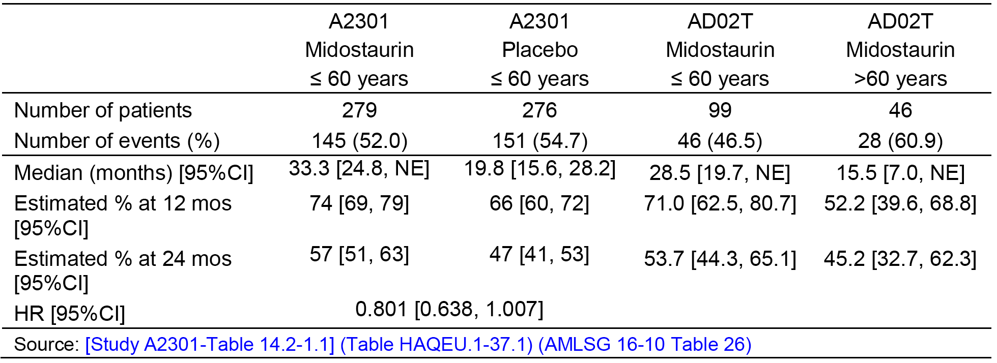
Similar results were observed for EFS when using modified definition comparable with the Ratify study (Table 30).

Table 30: Event free survival by age (in FLT3-ITD mutated patients in Studies A2301 and ADE02T)
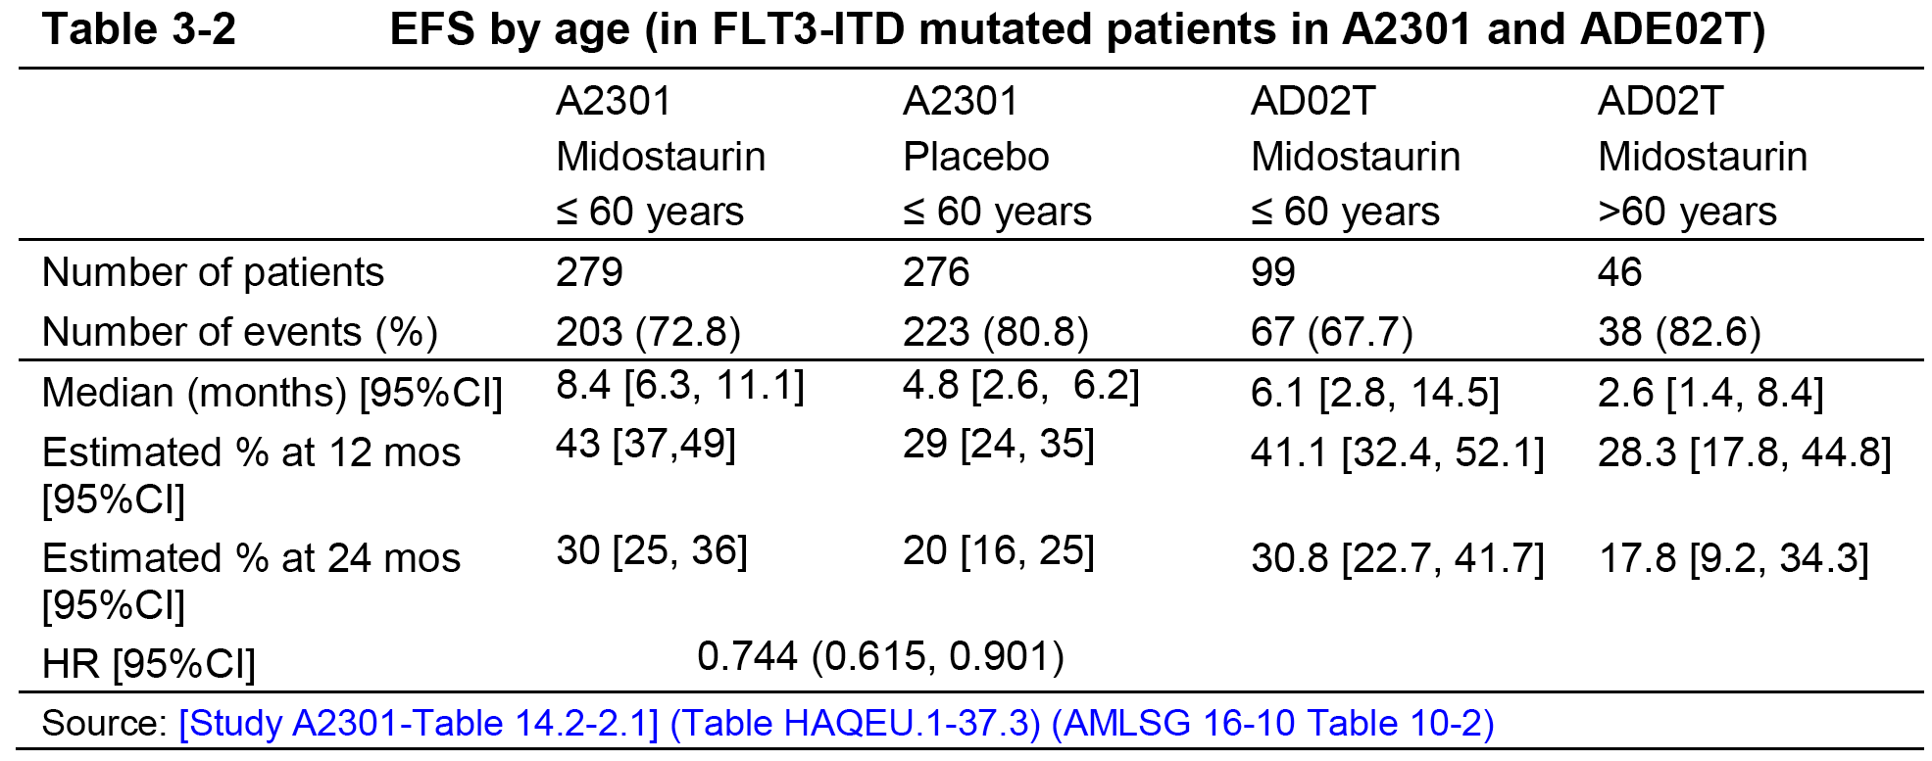
Evaluation of response: The sponsor’s response is acceptable. In Study A2301, the hazard ratio results for overall survival and event free survival for FLT3-ITD mutated patients aged ≤ 60 years numerically favoured midostaurin relative to placebo, with the results for event free survival being statistically significant (that is, 95% CI excluded 1). The overall survival and EFS data for FLT3-ITD mutated patients aged ≤ 60 years treated with midostaurin from Study A2301 were better than the corresponding data in FLT3-ITD mutated patients aged ≤ 60 years from Study ADE02T. The data from ADE02T showed that both the overall survival and EFS benefit were superior in FLT3-ITD mutated patients aged ≤ 60 years compared with FLT3-ITD mutated patients aged > 60 years. The upper age limit for patients enrolled in Study ADE02T was ≤ 70 years

Question 12
Why were patients aged > 60 years excluded from Study A2301, given that the majority of patients with newly diagnosed AML are likely to be ≥ 60 years of age?
Sponsor’s response: In Study A2301 enrolment was limited to patients under 60 years of age, as at the time the study was designed in 2006, patients older than 60 years were often not treated with intensive chemotherapy due to concerns of treatment-related morbidity and mortality in older patients. In the meantime, supportive care has improved, and practice patterns have evolved, such that in the most recent practice guidelines; age is not the critical factor in determining suitability for intensive chemotherapy.
Evaluation of response: The sponsor’s response is acceptable. However, there are no data assessing the benefit-risk profile of midostaurin in patients with AML aged ≥ 70 years.

Question 13
In Study A2213, the analysis of efficacy was in the full analysis set (n = 26). Please indicate how many patients in the full analysis set had ASM, SM-AHNMD, and MCL. Please summarise the primary efficacy endpoint (best overall response) as per investigator for each of these subgroups.
Sponsor’s Response: Of the 26 patients in Study A2213, 17 had SM-AHNMD, 6 MCL and for the remaining 3 patients the SM subtype was unconfirmed. Overall, 19 (73.1%) of patients had BOR during the first 2 cycles (regardless of confirmation of response) based on Valent criteria as per investigator:
- 13 (76.5%) of the 17 SM-AHNMD patients (95% CI (50.1 to 93.2))
- 4 (66.7%) of the 6 MCL patients (95% CI (22.3 to 95.7))
- 2 (66.7%) of the 3 remaining patients with unconfirmed subtype (95%CI (9.4 to 99.2)).
Evaluation of response: The sponsor’s response is satisfactory.

Safety

Question 14
In Study ADE02T, a high incidence of patients in both age groups discontinued midostaurin due to AEs (27%, patients ≤ 60 years versus 33%, patients aged > 60 years). Please comment on the reasons for the high discontinuation rates observed in patients in this study, and compare with the patient incidence rates in studies across the midostaurin clinical program.
Sponsor’s response: In Study ADE02T a total of 41 (28%) patients (26 (27%) younger patients and 15 (33%) older patients) discontinued study treatment due to adverse events. Overall, 32 events (78%) were reported to be related and 9 events were reported to be not related to the treatment with midostaurin.
Most frequent reasons for discontinuation were GI disorders (nausea, vomiting and diarrhoea), GVHD and thrombocytopaenia. The events of GVHD were not considered related to study drug. GVHD was the reason for discontinuation in 4 of 5 older patients and only in 1 of 14 younger patients discontinued younger patients discontinued the study treatment due to GVHD. Of note, in Study ADE02T patients who achieved complete remission or complete remission with incomplete blood recovery following induction therapy received consolidation therapy. In consolidation cycle, as a first priority an allogenic HSCT from a matched related or unrelated donor was intended for all patients. Overall, specific AEs by preferred term resulting in discontinuation were infrequent and occurred in < 5% of patients.
Among 51 patients who started maintenance treatment with midostaurin, 20 patients (39%) (14 younger and 6 older patients) discontinued treatment due to AE. Overall, the frequency of discontinuation due to AEs was similar in both age groups and no relevant differences between the treatment phases were revealed.
AEs leading to discontinuation in the overall pool across midostaurin clinical program: AEs leading to discontinuation were reported in 7.3% of healthy volunteers and these were all AEs of vomiting. In patients in the overall pool, AEs leading to discontinuation were reported in 14.5% and the most commonly reported preferred terms were generally GI related events (nausea, vomiting), increases in transaminases and febrile neutropaenia.

Table 31: Adverse events leading to study drug discontinuation in the overall pool, regardless of study drug relationship
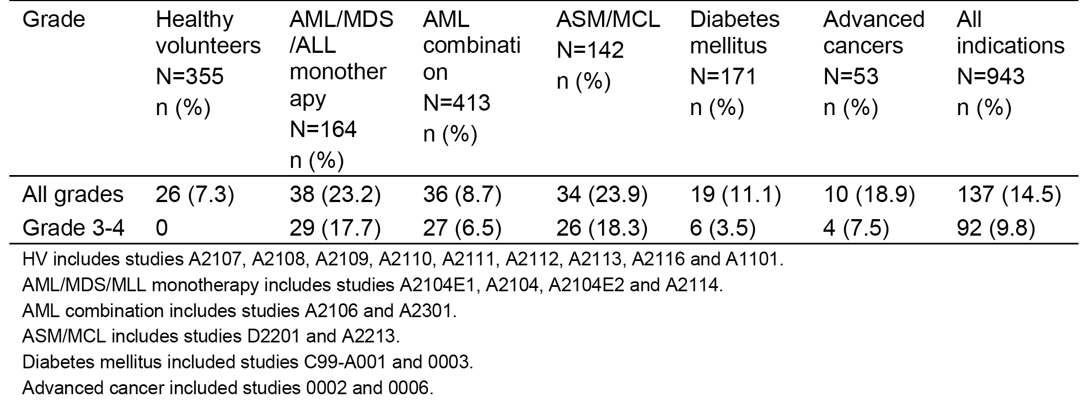
In the overall pool, AEs leading to discontinuation were more commonly reported among patients in ≥ 60 years subgroup (all grades 21.5%, Grade 3 or 4 13.2%) compared to patients in the < 60 years subgroup (all grades 10.9%, Grade 3 or 4 7.9%). A greater proportion of elderly patients discontinued treatment due to GI-related events (23 patients, 7.1%) compared to younger patients (13 patients, 2.1%); mainly nausea. However, in the overall pool these results, especially a comparison between the younger and older patients should be interpreted carefully taking into account the significant variability of these two age groups in terms of co-morbidity, underlying diseases, and treatment regimen including use of intensive chemotherapy and transplantation.
In the ASM/MCL pool (including Studies D2201 and A2213) AEs resulted in treatment discontinuation in 23.9% of patients; 18.3% of patients had Grade 3 or 4 events that led to treatment discontinuation. Specific AEs by preferred term resulting in discontinuation were infrequent and occurred in ≤ 2.1% patients. By SOC, AEs leading to treatment discontinuation were most commonly related to GI events (5.6%) followed by haematological (4.9%) and investigations (4.9%).
In Study A2301, AEs of any Grade leading to treatment discontinuation were reported in 9% patients in the midostaurin arm and 6% in the placebo arm. The Grade 3 or 4 events of exfoliative dermatitis (4 patients), ALT increased (3 patients), AST increased (2 patients) and renal failure (2 patients) that resulted in treatment discontinuation occurred at a higher frequency in the midostaurin group compared to the placebo group (all sites).
In summary, the incidence of discontinuation of midostaurin due to AEs in Study ADE02T is almost comparable to the incidence rates of discontinuation in different studies across midostaurin clinical program except for Study A2301 where a lesser incidence of discontinuation was reported. Of note, in Study A2301, AEs leading to treatment discontinuation were not recorded on the treatment CRF and AEs were determined from the reasons for treatment discontinuation and were only included if reconciled with the AE page. Furthermore, as opposed to Study A2301, the study design of ADE02T includes an intended haematopoietic SCT (HSCT) for all patients in the consolidation cycle contributing to a slightly higher rate of discontinuation due to AE. In conclusion, based on the data related to discontinuation due to AE in the overall midostaurin clinical program, no difference of safety and tolerability is noted in patients of > 60 years compared to patients < 60 years.
Evaluation of response: The sponsor’s response is acceptable.

Question 15
In the pooled dataset for patients with AdSM, discontinuations were frequently reported in patients treated with midostaurin (23.9%). Please comment on the reasons for the high discontinuation rates observed in patients in this study, and compare with the patient incidence rates in studies across the midostaurin clinical program.
Sponsor’s response: In the ASM/MCL pool (including Studies D2201 and A2213) AEs resulted in treatment discontinuation in 23.9% of patients; 18.3% of patients had Grade 3 or 4 events that led to treatment discontinuation. The most frequent AEs leading to discontinuation were nausea (2.1%), ascites (2.1%) and ECG QT prolonged (2.1%), all other AEs leading to discontinuation were reported in no more than 2 patients each. Of note, the type and frequency of AEs leading to discontinuation are not unexpected, considering the long duration of study treatment and the severity of patient’s co-morbidities including the underlying diseases. In the ASM patient population the overall discontinuation rates were higher due to disease progression (35%) than due to adverse events (23%). Discontinuations related to ADRs occurred in 13 (9.2%) patients. Hence, the progressive nature of ASM could also contribute to the treatment discontinuation in this patient population. Since, all the patients in Studies D2201 and A2213 received midostaurin, a comparison between a similar control groups could not be made. As part of clinical manifestation, systemic mastocytosis patients experiences a wide range of clinical symptoms related to skin, symptoms arising from mediator release and symptoms arising from organ infiltration. Furthermore, the role of concomitant therapies used for symptomatic treatment for this wide range of symptoms experienced by the patient population in the causation of AEs should also be taken into account.
For a detailed analysis of the AEs leading to discontinuation across midostaurin clinical program, please refer to the response for safety question 14, above.
Evaluation of response: The sponsor’s response is acceptable.

Second round benefit-risk assessment

Benefit - Acute myeloid leukaemia
The benefits of treatment with midostaurin in combination with standard daunorubicin and cytarabine induction and cytarabine consolidation for the treatment of newly diagnosed FLT3 mutation-positive AML are unchanged from those identified in the first round benefit risk assessment.

Benefit - Advanced systemic mastocytosis
The benefits of treatment with midostaurin monotherapy for advanced systemic mastocytosis are unchanged from those identified in the first round benefit risk assessment.

Risk - Acute myeloid leukaemia
The risks of treatment with midostaurin in combination with standard daunorubicin and cytarabine induction and cytarabine consolidation for the treatment of newly diagnosed FLT3 mutation-positive AML are unchanged from those identified in the first round benefit risk assessment.

Risk - Advanced systemic mastocytosis
The risks of treatment with midostaurin monotherapy for advanced systemic mastocytosis are unchanged from those identified in the first round benefit risk assessment.

Second round assessment of benefit-risk balance

Acute myeloid leukaemia
The benefit-risk balance assessment of treatment with midostaurin in combination with standard daunorubicin and cytarabine induction and cytarabine consolidation for newly diagnosed FLT3 mutation-positive AML is unchanged from that provided in the first round benefit risk assessment.

Advanced systemic mastocytosis
The benefit-risk balance assessment of treatment with midostaurin monotherapy for advanced systemic mastocytosis is unchanged from that provided the first round benefit risk assessment.

Second round recommendation regarding authorisation

Acute myeloid leukaemia
It is recommend that midostaurin in combination with standard daunorubicin and cytarabine induction and cytarabine consolidation be approved for the treatment of adult patients with newly diagnosed acute myeloid leukaemia (AML) who are FLT3 mutation-positive. There are no clinical trial data assessing the effectiveness of midostaurin in combination with induction and consolidation regimens for the proposed usage other than those assessed in the pivotal Study A2301 and the supportive Study ADE02T. Therefore, the indication should include reference to daunorubicin and cytarabine induction and cytarabine consolidation.
It is recommended that the proposed indication relating to maintenance treatment with single agent midostaurin for patients in complete remission following induction and consolidation be rejected on the grounds that the exploratory data have failed to establish a statistically significant benefit in overall survival and/or disease free survival in patients treated with single agent midostaurin compared with placebo.
The exploratory data showed numerically greater overall survival and disease free survival benefits in the single agent midostaurin arm compared with placebo in the maintenance phase, but a numerically greater risk of relapse following discontinuation of midostaurin compared with placebo. As the risk of relapse appears to be greater following discontinuation of single agent midostaurin maintenance treatment than placebo, it is considered that convincing evidence of a statistically significant overall survival and/or disease free survival benefit with single agent midostaurin compared with placebo should be demonstrated before approving single agent midostaurin for maintenance treatment.

Advanced systemic mastocytosis
It is recommended that midostaurin as monotherapy be approved for the treatment of adult patients with aggressive systemic mastocytosis (ASM), systemic mastocytosis with associated haematological neoplasms (SM-AHN), or mast cell leukaemia (MCL)). The sponsor has agreed to the recommended wording of the indication.

VI. Pharmacovigilance findings

Risk management plan

Summary of RMP evaluation
The sponsor has submitted EU-RMP version 1.1 (dated 10 February 2017; Data Lock Point (DLP) 12 March 2012/12 January 2014 (SM); 10 March 2016 (AML)); and Australian Specific Annex (ASA) version 1.0 (dated March 2017) in support of this application. In the sponsor’s first round response of 5 December 2017, the sponsor provided an amended RMP (version 1.5; dated 20 July 2017; DLP 12 March 2012/12 January 2014 (SM); 10 March 2016 (AML) and ASA (version 2.0; dated 27 November 2017).
The proposed Summary of Safety Concerns and their associated risk monitoring and mitigation strategies are summarised in Table 32, based upon the updated EU-RMP (v1.5) and ASA (v2.0).

Table 32: Summary of safety concerns
Summary of safety concerns |  | Pharmacovigilance |  | Risk Minimisation
 |  | Routine | Additional | Routine | Additional
Important identified risks | Leukopaenia |  | – |  | –
Important identified risks | Severe infections |  | – |  | –
Important identified risks | Pulmonary toxicity (including pleural effusion and interstitial lung disease) |  | – |  | –
Important identified risks | Drug-drug interactions with strong CYP3A4 inhibitors |  | ¹ |  | –
Important identified risks | Drug-drug interactions with strong CYP3A4 inducers |  | – |  | –
Important potential risks | Cardiac dysfunction |  | – |  | –
Important potential risks | Reproductive and developmental toxicity |  | – |  | –
Important potential risks | Use during lactation |  | – |  | –
Important potential risks | Effect of genomic polymorphisms of CYP3A4/ CYP3A5 on pharmacokinetics of midostaurin and potential risk of treatment related toxicity |  | ² |  | –
Important potential risks | Drug-drug interactions with OATP1B1, P-gp, BSEP and BCRP transporter substrates |  | ³ |  | –
Important potential risks | Drug-drug interactions with substrates for CYP3A4, CYP3A5, CYP2B6, CYP2D6, CYP2C8, CYP2C9, CYP2C19 and oral contraceptives |  | ⁴ |  | –
Missing information | Use in paediatric population |  | – |  | –
Missing information | Use in patients with severe hepatic impairment |  | – |  | –
¹ In vitro PK study to assess the impact of drug-drug interactions with strong CYP3A4 inhibitors ² Collect PK data and CYP3A4/5 genotyping assessment in a subset of patients from Study PKC412E2301 ³ Modelling based on steady-state data with midostaurin and PK studies. ⁴ PK studies.
Routine risk minimisation is nominated for all safety concerns as the risks are considered to have been satisfactorily addressed in the PI and CMI statements.

New and outstanding recommendations from second round evaluation
There are no outstanding issues in the second round which would impede registration. There are two new recommendations, and the response to nonclinical comments is requested below:
- The sponsor should provide a response to the nonclinical comments on the RMP.
- The sponsor should note the proposed wording for the PSUR condition of registration, which requires PSURs to be submitted to the TGA in line with EU reporting dates.
- As Rydapt is a new chemical entity it should be included in the Black Triangle Scheme as a condition of registration. The sponsor should include the black triangle symbol and accompanying text shown below at the top of the first page of the PI and CMI, respectively.
PI statement:
This medicinal product is subject to additional monitoring in Australia. This will allow quick identification of new safety information. Healthcare professionals are asked to report any suspected adverse events at www.tga.gov.au/reporting-problems.
▼
CMI statement:
This medicine is subject to additional monitoring. This will allow quick identification of new safety information. You can help by reporting any side effects you may get. You can report side effects to your doctor, or directly at www.tga.gov.au/reporting-problems.
▼

Proposed wording for conditions of registration
Any changes to which the sponsor has agreed should be included in a revised RMP and ASA. However, irrespective of whether or not they are included in the currently available version of the RMP document, the agreed changes become part of the risk management system.
- The midostaurin EU-Risk Management Plan (RMP) (version 1.5; dated 20 July 2017; data lock point 12 March 2012/12 January 2014 (SM); 10 March 2016 (AML)), with Australian Specific Annex (version 2.0; dated 27 November 2017), included with submission PM-2017-00871-1-4, and any subsequent revisions, as agreed with the TGA will be implemented in Australia.
As Rydapt is a new chemical entity it should be included in the Black Triangle Scheme as a condition of registration. The following wording is recommended for the condition of registration:
- Rydapt (midostaurin) is to be included in the Black Triangle Scheme. The PI and CMI for Rydapt must include the black triangle symbol and mandatory accompanying text for five years, which starts from the date that the sponsor notifies the TGA of supply of the product.

VII. Overall conclusion and risk/benefit assessment
The submission was summarised in the following Delegate’s overview and recommendations:

Background

Acute myeloid leukaemia (AML)
The clinical evaluator describes key features of AML from the clinical evaluation report (CER). Of note:
Approximately 30% of patients with newly diagnosed AML have an activating mutation in the FLT3 gene, usually either an internal tandem duplication mutation (ITD, in approximately 20% of AML patients), or a point mutation in the activating loop of the tyrosine kinase domain (TKD, approximately 6 to 8% of AML patients).¹²
Implications of FLT3-ITD allelic ratio (AR) are discussed by Meshinchi (2014). The ratio reflects the extent of clonal dominance, such that in those with high ITD-AR, FLT3-ITD positive leukaemic cells dominate FLT3-ITD negative leukaemic cells.
- Regarding midostaurin and FLT3-ITD, the pivotal AML study (A2301) enrolled patients with an allelic ratio ≥ 0.05, stratified randomisation by AR at a cut-off of 0.7, and analysed efficacy outcomes in sub-groups defined by allelic ratio. (The pivotal study also enrolled patients with FLT-TKD mutation, but not those with FLT3-WT AML.)
- Midostaurin has been studied in FLT3 wild-type (WT) AML; a Phase III study (Study E2301) is examining this group. There is nonclinical evidence of differential effects in FLT3 mutation-positive versus FLT3-WT cells.
- Also, midostaurin is a multikinase inhibitor and its inhibition of other kinases may contribute to activity (multiple important mutations may occur in AML).
Median age of patients at diagnosis of AML in Australia is 68.9 years (relevant since the maximum age of patients at enrolment into the pivotal study was 60 years).
The current treatment options are described. Of note:
Standard initial therapy has been the ‘7+3’ chemotherapy induction regimen with cytarabine and an anthracycline, followed by post remission therapy with additional intensive chemotherapy in particular high dose cytarabine.
Patients with poor prognostic features are recommended to enrol into clinical trials and/or to undergo stem cell transplantation (SCT) following achievement of remission with standard induction chemotherapy.
Significant improvements in overall survival (OS) and disease-free survival (DFS) for AML patients harbouring FLT3-ITD mutations have been reported with allogeneic stem-cell transplantation (allo-SCT) compared to chemotherapy or autologous SCT;, especially for patients with high FLT3-ITD allelic ratios.²⁸ However, these patients remain at high risk of relapse post-SCT compared to patients without FLT3-ITD mutations, with a higher 2-year relapse incidence (30% versus 16%; p = 0.006) and lower leukaemia free survival (58% versus 71%; p = 0.04) respectively.
Current treatment of AML does not include a ‘maintenance’ (also known as ‘continuation’) phase – patients receive induction and consolidation. In Australia, various options are endorsed by EviQ; including but not limited to:
- cytarabine and daunorubicin for induction (‘7-3’, with daunorubicin 60 mg/m² IV on Days 1 to 3 and cytarabine 100 mg/m² continuous IV infusion on Days 1 to 7, usually for 1 cycle but maybe repeated if remission is not achieved); a high dose daunorubicin (90 mg/m²) + cytarabine protocol is also endorsed.
- cytarabine and idarubicin for induction
- cytarabine consolidation:
  - HiDAC; 3000 mg/m² IV, BD, on days 1, 3, 5 of a 28 day cycle for 3 cycles
  - IDAC; 1000 mg/m² IV, BD, on days 1, 3, 5 of a 28 day cycle for 3 or 4 cycles
- cytarabine and daunorubicin consolidation
- cytarabine and idarubicin consolidation
In pivotal AML Study A2301, the chemotherapy backbone did not match any one of these protocols (for example 200 mg/m² cytarabine was used).

Systemic mastocytosis (SM)
The evaluator describes key features of SM. Of note:
‘The 2016 WHO revised classification of mastocytosis has the following categories of disease:
- cutaneous mastocytosis (CM);
- systemic mastocytosis, consisting of
  - indolent systemic mastocytosis (ISM);
  - smouldering systemic mastocytosis (SSM);
  - systemic mastocytosis with an associated haematological neoplasm (SM-AHN);
  - aggressive systemic mastocytosis (ASM); and
  - mast cell leukaemia (MCL); and
- mast cell sarcoma (MCS).’
Note: Those conditions in italics are the ones the sponsor is proposing to be indicated in this application.
‘The term ‘advanced SM’ is used by the International Working Group-Myeloproliferative Neoplasms Research and Treatment (IWG-MRT) and European Competence Network (ECNM) to include ASM, MCL and ‘SM with an associated myeloid neoplasm²³’. The condition ‘SM with an associated myeloid neoplasm’ was stated to constitute more than 90% of cases broadly referred to as SM with an associated haematologic non-mast cell lineage disorder (SM-AHNMD).’
In the CER and below, ‘advanced SM’ is abbreviated as AdSM; this is not quite the same as ASM, which as per above is a subset of AdSM.
From CER, current treatment options are described. Of note:
No approved therapies exist, with the exception of imatinib, which in a few countries is approved for the treatment of patients with ASM lacking the common activating D816V KIT mutation or with an unknown KIT mutation status. However, the KIT D816V mutation, which is detected in > 90% of patients with systemic mastocytosis, is resistant to most tyrosine kinase inhibitors (TKIs), and therefore the number of patients who may benefit from therapy with a TKI such as imatinib is limited.
Cytoreductive agents such as interferon alpha (IFN-α) or cladribine are often used as initial therapy. In patients with rapidly progressing aggressive SM, IFN-α is not suitable due to its prolonged onset of action, and responses to other cytoreductive agents are usually short lived, so early disease relapse is common. Systemic agents such as hydroxyurea, IFN-α (often with glucocorticoids), and cladribine have had only modest activity in patients with advanced SM, and their use is often complicated by toxicities preventing long-term administration.
The prognosis of patients with advanced SM remains poor. In a retrospective Mayo Clinic hospital-based case series of 342 patients with SM, the median survival was 3.5 years for the 41 patients with ASM, and 2 years for the 138 patients with SM-AHNMD, and the 4 patients with MCL had the poorest prognosis with a median survival of only 2 months.³⁰
In Australia, imatinib’s indications include:
Treatment of adult patients with aggressive systemic mastocytosis (ASM), where conventional therapies have failed
According to the Glivec PI’s Clinical Trials section, this indication is based on the study of 5 patients in Study B2225 who had ASM, and the study of 25 patients with ASM in 10 published case reports or case series. There is a further comment in that section:
Glivec has not been shown to be effective in patients with less aggressive forms of systemic mastocytosis. Glivec is not recommended for use in patients with cutaneous mastocytosis, indolent systemic mastocytosis (smoldering SM or isolated bone marrow mastocytosis), SM with an associated clonal haematological non-mast cell lineage disease, mast cell leukaemia, mast cell sarcoma or extracutaneous mastocytoma.
In vitro, cell lines and patient-derived mast cells harbouring the KIT ^{D816V} mutation were resistant to imatinib and the effectiveness of Glivec in the treatment of patients with SM who have the D816V mutation remains controversial.

Midostaurin
Doehner et al (2017);³⁸ summarise FLT3 inhibitor development in AML:
Efforts to develop protein kinase inhibitors, inhibiting mutated forms of the FLT3 receptor have led to successive generations of FLT3 inhibitors. The first generation comprised tandutinib, sunitinib, midostaurin and lestaurtinib, the second sorafenib and quizartinib, and the third crenolanib and gilteritinib. These compounds differ not only in their ability to inhibit FLT3-ITD or TKD or even the wild type receptor, but also in their selectivity for FLT3 as well as their toxicity profiles.
The clinical evaluator writes:
Midostaurin (PKC412; CGP41251; chemical name: N-benzoylstaurosporine) is a derivative of staurosporine, a naturally occurring alkaloid. It is a potent kinase inhibitor of Fms-like tyrosine kinase 3 (FLT3), tyrosine-protein kinase KIT (c-KIT), beta-type platelet-derived growth factor (PDGFR-beta), vascular endothelial growth factor (VEGFR-2), fibroblast growth factor receptor (FGFR receptors) and protein kinase C.
The nonclinical evaluation report (NCER) details kinome inhibition.
The ‘first in human’ study of midostaurin was initiated in 1994, and the drug has been studied not only in cancers but also in diabetes mellitus (for example diabetic macular oedema).
It is relevant that a study in FLT3-negative AML , Study E2301, is being conducted (this is a randomised, double-blind study of midostaurin versus placebo in combination with chemotherapy during induction and consolidation, followed by 12 months of midostaurin monotherapy in adult patients (aged ≥ 18 years) with newly diagnosed AML, without FLT3 mutation). This is to be submitted to the EMA by June 2023.

Regulation (overseas status)

US FDA
As of 8 February 2018, midostaurin (25 mg capsule) was approved for use in the USA on 28 April 2017 with the following indications:
Acute Myeloid Leukaemia
Rydapt is indicated, in combination with standard cytarabine and daunorubicin induction and cytarabine consolidation chemotherapy, for the treatment of adult patients with newly diagnosed acute myeloid leukemia (AML) who are FLT3 mutation-positive, as detected by a FDA approved test [see Dosage and Administration (2.1), Clinical Studies (14.1)].
Limitations of Use
Rydapt is not indicated as a single-agent induction therapy for the treatment of patients with AML.
Systemic Mastocytosis
Rydapt is indicated for the treatment of adult patients with aggressive systemic mastocytosis (ASM), systemic mastocytosis with associated hematological neoplasm (SM-AHN), or mast cell leukemia (MCL).
The application was not submitted to an advisory committee.
Post-marketing requirements included:
- PMR 3210-1: Establish a worldwide Pregnancy Surveillance Program (enhanced pharmacovigilance) to collect and analyse information for a minimum of 10 years on pregnancy complications and birth outcomes in women exposed to midostaurin during pregnancy. Add notice of the Pregnancy Surveillance Program and telephone contact number (and/or website) to the prescribing information. Provide a complete protocol which includes details regarding how you plan to encourage patients and providers to report pregnancy exposures (for example, telephone contact number and/or website in prescribing information), measures to ensure complete data capture regarding pregnancy outcomes and any adverse effects in offspring, and plans for comprehensive data analysis and yearly reporting. Submit yearly reports on the cumulative findings and analyses from the Pregnancy Surveillance Program. A final protocol was due to the FDA on 8/2017, a revised PI on 12/2017, interim reports yearly and a final report due 06/2027.
Post-marketing commitments included:
- PMC 3210-2: To corroborate your assertion that midostaurin induces a treatment benefit in the overall population of patients with FLT3 mutations rather than in only a subset of patients with a mutation in a different kinase inhibited by the drug, provide subgroup analyses for complete remission, overall survival and event free survival by genomic mutations that occurred concurrently with FLT3 for randomized subjects who consented for additional molecular studies in the Ratify trial. Submit a data file with results of the full mutational profiling at baseline performed by Novartis in close collaboration with Alliance and Ratify Cooperative Groups / Investigators in addition to the full study report. The final report of this analysis was due to the FDA on October 2018.
- PMC 3210-3: To demonstrate that the treatment effect of midostaurin is consistent across prognostic subgroups, provide subgroup analyses for randomized subjects with cytogenetic/molecular prognostic information in the Ratify trial for complete remission, overall survival and event free survival by cytogenetic/molecular prognostic category using an accepted consensus prognostic classification, such as that published in 2016 or later by the European Leukemia Net (ELN) or the National Comprehensive Cancer Network (NCCN). Submit a data file with results of the full karyotype description at baseline performed by Alliance and/or Novartis in addition to the full study report. The final report of this analysis was also due on October 2018.
FDA pre-registration reviews of midostaurin are available; and have been consulted on specific topics (and referenced accordingly) in this overview.

EU (EMA)
As of 8 February 2018 midostaurin was approved for use in the EU on 18 September 2017. Rydapt is indicated:
in combination with standard daunorubicin and cytarabine induction and high-dose cytarabine consolidation chemotherapy, and for patients in complete remission followed by Rydapt single agent maintenance therapy, for adult patients with newly diagnosed acute myeloid leukaemia (AML) who are FLT3 mutation-positive (see section 4.2);
as monotherapy for the treatment of adult patients with aggressive systemic mastocytosis (ASM), systemic mastocytosis with associated haematological neoplasm (SM-AHN), or mast cell leukaemia (MCL).
The EMA’s European Public Assessment Report (EPAR) is available; and has been consulted on specific topics (and referenced accordingly) in this overview.

Comparison of US, EU and proposed Australian indications
The sponsor initially proposed the use of the ‘advanced SM’ terminology, but the approved indication in both the USA and the EU uses alternative terminology.

Table 33: Comparison of International and proposed Australian indications
 | AML | Systemic mastocytosis
USA | Rydapt is indicated, in combination with standard cytarabine and daunorubicin induction and cytarabine consolidation chemotherapy, for the treatment of adult patients with newly diagnosed acute myeloid leukemia (AML) who are FLT3 mutation-positive, as detected by a FDA approved test.  Limitations of Use  Rydapt is not indicated as a single-agent induction therapy for the treatment of patients with AML. | Rydapt is indicated for the treatment of adult patients with aggressive systemic mastocytosis (ASM), systemic mastocytosis with associated hematological neoplasm (SM-AHN), or mast cell leukemia (MCL).
EMA | Rydapt is indicated in combination with standard daunorubicin and cytarabine induction and high-dose cytarabine consolidation chemotherapy, and for patients in complete remission followed by Rydapt single agent maintenance therapy, for adult patients with newly diagnosed acute myeloid leukaemia (AML) who are FLT3 mutation-positive. | Rydapt is indicated as monotherapy for the treatment of adult patients with aggressive systemic mastocytosis (ASM), systemic mastocytosis with associated haematological neoplasm (SM-AHN), or mast cell leukaemia (MCL).
Australia (proposed) | In combination with standard induction and consolidation chemotherapy followed by single agent maintenance therapy for adult patients with newly diagnosed acute myeloid leukemia (AML) who are FLT3 mutation-positive. | For the treatment of adult patients with aggressive systemic mastocytosis (ASM), systemic mastocytosis with associated haematological neoplasms (SM-AHN), or mast cell leukaemia (MCL).
In the USA, single-agent Rydapt is not approved for maintenance in FLT3-positive AML, whereas in the EMA, it is. The sponsor proposes maintenance in Australia.

Quality
Registration is recommended with respect to chemistry and bioavailability aspects. GMP status is being confirmed for one site.

Nonclinical
The second round nonclinical evaluation report (NCER) was considered. There were no nonclinical objections to registration. However the evaluator also noted:
Midostaurin is a multi-kinase inhibitor with broad and complex effects on the human kinome. Binding to wild type and mutated FLT3 and KIT, and inhibition of the proliferation of AML cells with FLT3 mutations and KIT^{D816V+} and KIT^{delVV559/560+} mast cells were demonstrated in nonclinical studies. The available limited in vitro data demonstrates that complex drug interactions, including antagonism, may occur depending on the specific genetic characteristics of the AML present and drug combination selected. Careful evaluation of the patient’s AML genetics and possibly ex vivo sensitivity testing is recommended before initiating treatment.
Ex vivo sensitivity testing is not proposed, although testing of leukemic cells for FLT3 biomarker status is required. The sponsor has agreed to include the following text in the PI, which appears to be in keeping with current clinical practice:
Careful evaluation of the patient’s leukaemia genotype should be undertaken before using midostaurin in combination with conventional chemotherapeutic agents.
The evaluator noted nonclinical evidence that α1-acid glycoprotein blocks midostaurin-mediated inhibition of cell proliferation:
If true across the entire spectrum of midostaurin’s primary pharmacological effects, this finding substantially complicates risk assessment based on plasma drug concentrations. It may also influence the specific pharmacokinetic compartments where midostaurin is active in different species (for example midostaurin may be mostly inactive in peripheral blood and in tissue compartments where human AGP is present) in human patients. AGP binding may allow humans to tolerate much higher doses than those that were achievable in the repeat dose toxicology studies. This was reflected by the relatively low comparative exposures in the repeat dose toxicology studies in order to ensure adequate survival (based on high mortality in some of the non-pivotal dose ranging studies). Since human AGP is an acute phase protein, the presence of an acute phase reaction may substantially reduce drug efficacy.

Pregnancy category
Pregnancy Category D was proposed by the sponsor and accepted by the nonclinical evaluator.⁹ The nonclinical evaluator also notes:
Excretion into milk is likely very high and may adversely affect offspring development. Breastfeeding of mothers taking midostaurin should be avoided.

Clinical

Acute myeloid leukaemia
It is recommend that midostaurin in combination with standard daunorubicin and cytarabine induction and cytarabine consolidation be approved for the treatment of adult patients with newly diagnosed acute myeloid leukaemia (AML) who are FLT3 mutation-positive. There are no clinical trial data assessing the effectiveness of midostaurin in combination with induction and consolidation regimens for the proposed usage other than those assessed in the pivotal Study A2301 and the supportive Study ADE02T. Therefore, the indication should include reference to daunorubicin and cytarabine induction and cytarabine consolidation.
It is recommended that the proposed indication relating to maintenance treatment with single agent midostaurin for patients in complete remission following induction and consolidation be rejected on the grounds that the exploratory data have failed to establish a statistically significant benefit in overall survival and/or disease free survival in patients treated with single agent midostaurin compared with placebo.
The exploratory data showed numerically greater overall survival and disease free survival benefits in the single agent midostaurin arm compared with placebo in the maintenance phase, but a numerically greater risk of relapse following discontinuation of midostaurin compared with placebo. As the risk of relapse appears to be greater following discontinuation of single agent midostaurin maintenance treatment than placebo, it is considered that convincing evidence of a statistically significant overall survival and/or disease free survival benefit with single agent midostaurin compared with placebo should be demonstrated before approving single agent midostaurin for maintenance treatment.

Advanced systemic mastocytosis
It is recommended that midostaurin as monotherapy be approved for the treatment of adult patients with aggressive systemic mastocytosis (ASM), systemic mastocytosis with associated haematological neoplasms (SM-AHN), or mast cell leukaemia (MCL)). The sponsor has agreed to the recommended wording of the indication.

Overview of data
Pharmacology was characterised in 11 clinical studies and via 3 Population PK analyses.
Efficacy and safety in AML was characterised in one pivotal study (Study A2301), one supportive study (Study ADE02T) and five other leukaemia studies (Studies A2106, A2014, A2104E1, A2104E2, and A2114). The pivotal Study A2301 and the supportive Study ADE02T were compared. The other studies were not supportive because, amongst other reasons, they did not involve the daunorubicin + cytarabine backbone (or, in the case of Study A2106, involved this backbone but not the proposed midostaurin regimen, except after protocol amendment mid-study).
Efficacy and safety in SM was characterised in one pivotal study (Study D2201) and one supportive study (Study A2213). These studies were compared briefly.

Formulation
The evaluator considered the formulation. The ‘final market image’ (FMI) formulation was used in the pivotal studies for AML (Study A2301) and AdSM (Study D2201).

Pharmacology

Pharmacokinetics (PK)
The evaluator discusses and summarises the pharmacokinetics.
Individual studies providing PK data are summarised in Table 6, while the three Population PK analyses are summarized in Table 7 above.

Key aspects of pharmacokinetics
The presence of several active metabolites (CGP6221, CGP52421) was discussed. The CGP6221 active metabolite had similar biological potency to midostaurin, while there is greater exposure to the CGP52421 ‘less active’ metabolite. The sum of exposure to active moieties was sometimes taken into account (but not in Population PK analyses).
Absolute bioavailability is unknown; bioavailability of the soft capsule formulation was 26% higher than that of an oral solution.
Exposure (AUC_{inf}) was 59% higher when midostaurin was given with a high-fat meal, and 22% higher when given with a standard meal, than when given fasted; with food, C_{max} fell by 20-27% relative to fasting. The PI recommends that midostaurin be taken with food, but this is explained as helping to prevent nausea.
After multiple dosing, midostaurin and metabolites have non-proportional increases in C_{min} with increasing dose. The evaluator noted that auto-induction of CYP3A4 by midostaurin might account for the results.
Accumulation ratios (based on trough levels) with multiple dosing differ across midostaurin and the two active metabolites. In diabetes patients, for midostaurin itself, the ratio was highly variable (ranging from no accumulation through to a > 4 fold increase). For CGP62221, ratios ranged from 1.9 to 3.6. For CGP52421 (the less potent metabolite), ratios ranged from 17 to 22. In patients with AML who received continuous BD dosing, there was an unusual pattern (see Table 34), whereby after 28 days the C_{min} had declined relative to C1D8 quite significantly for midostaurin and CGP62221, but had risen for CGP52421. This is reflected in the following figure (see Figure 3) from the FDA’s Cross-Disciplinary Review.

Table 34: Study A2104E Geometric mean (CV%) plasma C_{min} ng/mL values for the first 28 day treatment cycle for the midostaurin 100 mg/day and 200 mg/day treatment groups; PK analysis set
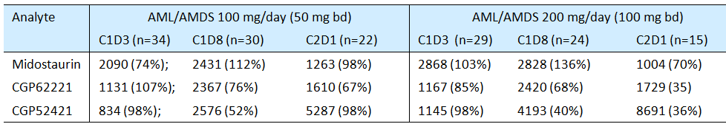
Figure 3: Study A2104E Concentration time profile of midostaurin and its metabolites after 50 mg BD dosing
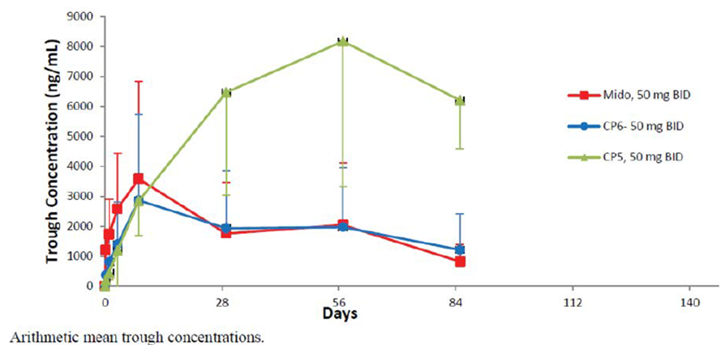
The other conspicuous finding was that C_{trough} did not increase markedly for midostaurin or CGP62221 from 100 mg/day to 200 mg/day dosing. This is reflected in the following figure (Figure 4) from the FDA’s Cross-Disciplinary Review.
Figure 4: Study A2104E Concentration time profile of midostaurin and its metabolites after 50 mg or 100 mg BD dosing
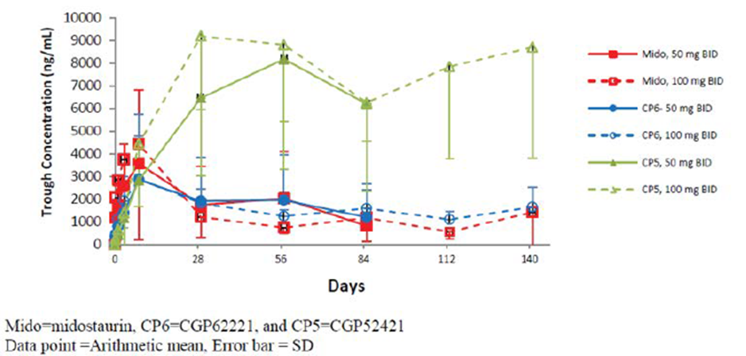
Apparent volume of distribution (98.9 L) suggested fairly extensive tissue distribution. In animals, there was also wide distribution, with concentration in fat, the adrenals, pancreas and liver; and there were detectable brain levels.
There is very high binding of midostaurin and metabolites to α1-acid glycoprotein, but also to other major plasma proteins.
Elimination is mainly via metabolism in the liver, with CYP3A4 playing a major role. The key conclusion of the AML Population PK analysis was that use in conjunction with strong CYP3A4 inhibitors would double exposure to midostaurin, and increase the sum of exposure to active moieties by about 50%. A similar analysis in AdSM found no such relationship with CYP3A4 inhibitors, but the AML analysis is probably more robust.
Mean terminal half-life of midostaurin was 20.3 hours, of CGP52421 was 495 hours and of CGP6221 was 33.4 hours.

PK in target populations
Pivotal AdSM Study D2201 enrolled n = 116 patients, of whom n = 87 were in the PK analysis set. To explore the potential for CYP3A4 auto-induction by midostaurin, the urinary ratio of 6β-hydroxycortisol to cortisol was measured. The evaluator writes that ‘no significant change in the ratio of urinary 6β-hydroxycortisol to cortisol was observed during the first cycle indicating that midostaurin is unlikely to be a strong inducer of CYP3A4’. Given that midostaurin’s effect on CYP enzymes is complex, this may not exclude that non-linear PK are due to auto-induction of CYP3A4. Midostaurin C_{min} tended to decline over time from a peak at Cycle 1 Day 3.
Pivotal AML Study A2301 randomised 360 patients into the midostaurin arm, of whom 188 patients were in the PK analysis set. It was noted that up to 62% of patients received concomitant strong CYP3A inhibitors (for example antifungal therapy), which might have affected plasma concentrations of midostaurin and metabolites. Table 35 sets out C_{min} across induction, consolidation and maintenance. Trough levels decline from a peak observed at Cycle 1 Day 21, and although patient attrition by Cycles 8 and 12 is evident, there is a decline in C_{trough} at those later time-points. The evaluator notes confounding by changing use of strong CYP3A4 inhibitors over time (62% during induction, 11% in maintenance).

Table 35: Study A2301 - Summary of midostaurin C_{min} (trough) concentrations by phase, PK set
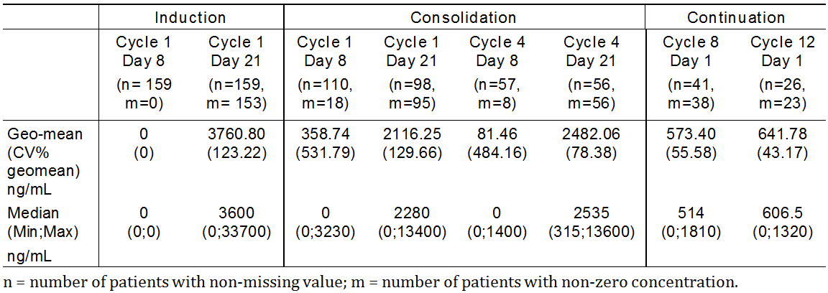
The TGA’s Population PK evaluator noted ‘there was quite a difference in the estimated half-life in the AML (15.5 days) and ASM (6.5 days) analyses’. This was based on final base model parameter estimates for rate of approach of CL to its induced steady state (0.00186 versus 0.0046 h⁻¹ respectively), and volume of distribution estimates did also vary across AML and AdSM modelling. Nevertheless, the conclusion in the Population PK evaluations that ‘appropriateness of doses used in AML and ASM need(s) to be assessed from the results of clinical efficacy studies’ is accepted.

Hepatic impairment
PK in hepatic impairment was discussed. In the hepatic impairment Study 2116, for midostaurin, mild to moderate hepatic impairment reduced exposure at Day 1 (AUC₀₋₁₂) by 36 to 39%; no subjects had severe impairment. Similar reductions were seen for active metabolites. Mild to moderate hepatic impairment reduced exposure at Day 7 (AUC_{0-tau}) by 20 to 28%. Similar reductions were seen for active metabolites.

Table 36: Study 2116 Analysis of the primary PK parameters for midostaurin at Day 7; Full dose PK set
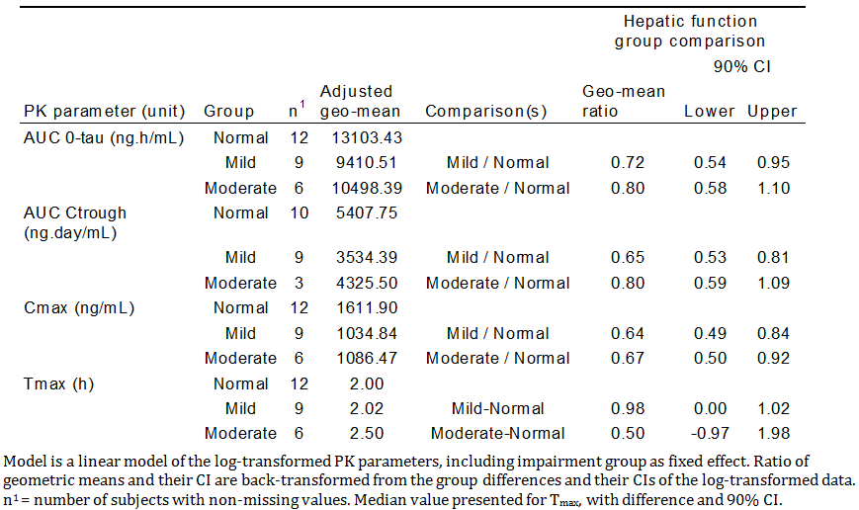
Several population PK analyses also informed use in hepatic impairment:
A Population PK analysis in AdSM was discussed. Of 141 subjects with AdSM, 21 had mild hepatic impairment and 12 had moderate hepatic impairment; none had severe impairment. The analysis concluded that there was no significant impact of hepatic impairment on midostaurin or active metabolite PK.
A Population PK analysis in AML was discussed. There were 143 patients with normal hepatic function and 37 with mild impairment (actually including 4 with moderate impairment). In this analysis, there was a pronounced effect of mild impairment on apparent plasma clearance and bioavailability of CGP62221; however on matching for other covariates, the effect disappeared.

Renal impairment
This was considered. There were no dedicated studies. In the AdSM and AML Population PK studies, creatinine clearance (as a surrogate for renal function) was not a significant covariate for apparent clearance of midostaurin or its active metabolites. There were only 4 subjects with severe impairment.

Age
This was considered. Based on Population PK analyses of AdSM and AML, no dose adjustment based on age was indicated. This outcome takes on additional importance given the need to extrapolate efficacy and safety findings in AML from Study A2301 (patients aged 18 to 60 years) to the proposed population (all adult patients).
There was a separate Population PK modelling report for paediatric patients, based on Study A2114 (n = 22 patients with relapsed/refractory ALL or AML). Dosing in Study A2114 was 30 to 60 mg/m² and the analysis concluded that exposure to the three key analytes normalised for mg/m² dose decreased with increasing weight and age, due to ‘dose being determined on the basis of BSA but clearance scaling with weight^{0.75}’ and also because the model assumed bioavailability of midostaurin was non-linear (lower at higher doses).

Drug-drug interactions
Midostaurin and daunorubicin (P-gp substrate; concomitant use in AML) interactions were considered. A pronounced fall in daunorubicin exposure was seen with concomitant use at 100 mg BD midostaurin, but not at 50 mg BD midostaurin.
Single dose midostaurin and ketoconazole (strong CYP3A4 inhibitor) interactions were considered. There was a large increase in exposure to midostaurin with concomitant ketoconazole, with the evaluator recommending concomitant use in the first week of treatment be avoided. Interactions between multiple-dose midostaurin and itraconazole were considered. The effect on midostaurin exposure was not as marked as that following single dose midostaurin.
Single dose midostaurin and rifampicin (strong CYP3A4 inducer) interactions were noted. Midostaurin exposure was markedly reduced. The sponsor conducted physiologically based PK (PBPK) simulations to predict the impact of moderate inducers. The utility of these simulations is unclear given that they did not predict (for rifampicin) the extent of change observed in the rifampicin interaction study.
Midazolam (CYP3A4 substrate) and single dose midostaurin interactions were considered. No large effect on midazolam exposure was seen.
Other interactions, for example based on 100 mg BD dosing with midostaurin, were considered via PBPK modelling.
In vitro studies were discussed. There was a signal for inhibition of CYP2C8, OATP1B1, BCRP and P-gp. There was a signal for induction of CYP2C8, amongst other enzymes, so a net effect model was used, with a net induction effect predicted. There was further discussion, with the evaluator concluding that midostaurin or its metabolites may inhibit BSEP (bile salt exporter protein).
The following clinical drug-drug interaction studies are planned:
- A clinical study is planned to assess the impact of a single oral dose Rydapt on P-gp, BCRP and CYP2D6 substrate pharmacokinetics in healthy adult volunteers. The final clinical study report is due to the EMA by December 2019.
- A clinical study is planned to assess the impact of multiple oral dose Rydapt on CYP2B6, CYP2C8, and CYP3A4 substrates pharmacokinetics in healthy adult volunteers. The final clinical study report is due to the EMA by December 2020.
- A clinical study is planned to assess the impact of multiple oral dose Rydapt on oral contraceptive pharmacokinetics in healthy women with no child-bearing potential. The final clinical study report is due to the EMA by December 2020.

Pharmacodynamics (PD)
PD studies were reported. A thorough QT study is discussed under Safety below. Exposure-response analyses are referenced in Efficacy and Safety sections below.

Efficacy in acute myeloid leukaemia (AML)

Study A2106

Dose selection
Dose selection for the pivotal AML Study A2301 was provided.
Study A2106 was a Phase Ib study supporting the dose regimen used in the pivotal Study A2301. It examined FLT3-mutated and WT AML. In induction, midostaurin was given either sequentially or concomitantly with standard daunorubicin + cytarabine. In Arm 1 (sequential), midostaurin dose was dropped via protocol amendment from 100 mg BD to 50 mg BD due to tolerability issues at 100 mg BD (gastrointestinal AEs) and also given for fewer days over the cycle, as shown in Figure 5. In Study Arm 1 (sequential) and Arm 2 (concomitant), the complete remission rate was greater with 50 mg BD than 100 mg BD (though the drop in dose was via protocol amendment, that is comparison was not of randomised groups). FLT3-mutated patients did better than FLT3-WT patients, in induction. Tolerability was better with 50 mg BD, and with sequential administration.
Figure 5: Study A2106 Dose and schedule of midostaurin during induction Cycle 1 and Cycle 2 (optional), core protocol and amendments
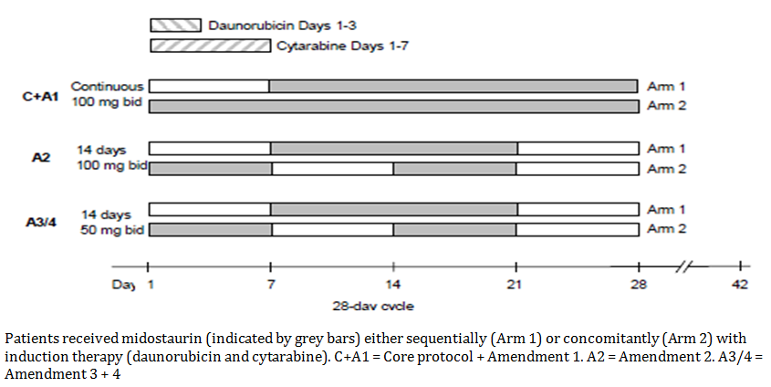

Pivotal Study A2301 (‘Ratify trial’)
Study A2301 was a randomised, double blind study of midostaurin versus placebo, added to standard induction (daunorubicin, cytarabine) and consolidation (high-dose cytarabine), in patients aged ≥ 18 years and < 60 years with newly diagnosed FLT3-mutated AML. A second cycle of induction was possible in patients who did not achieve complete remission after one cycle. Design and dose regimens are as per Figure 6.
Figure 6: Study A2301 Study design
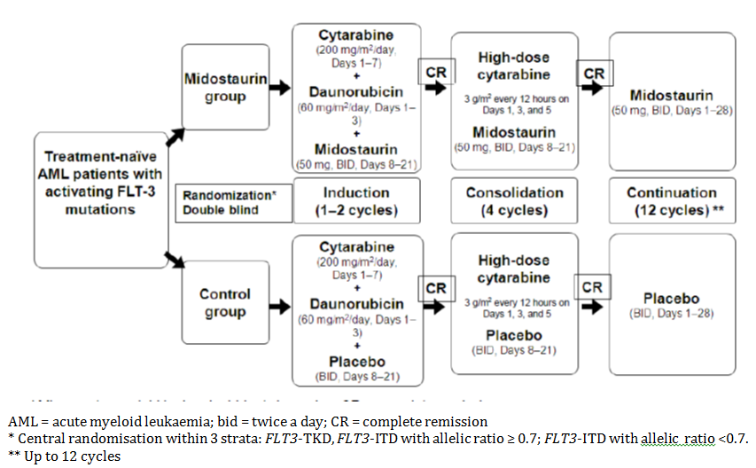
Patients could be on treatment for up to 18 cycles in total (up to 2 cycles of induction, 4 cycles of consolidation, and 12 cycles of continuation). In patients undergoing stem cell transplantation (SCT), midostaurin was discontinued at time of transplant.
The study was conducted primarily in the USA and Germany, though there were sites in 11 other countries. The data cut-off for the primary Clinical Study Report was 1 April 2015. The study has been published.
A decision to stop the trial was made in 2015, after consultation between Novartis, FDA and EMA, based on the conclusion that the required number of deaths (509) would not be achieved in reasonable time (due to plateauing of the survival curve after 3 years).
Inclusion and exclusion criteria were noted. In particular:
- A documented FLT3 mutation was required. Patients were screened for presence of a FLT3 mutation (ITD or TKD) in bone marrow or peripheral blood blast cells. Comments regarding FLT3 testing in Australia, suggesting use of FLT3 to define Australian AML patients eligible for midostaurin is practicable were made by the clinical evaluator.
- Patients > 60 years of age were not enrolled.
Participant flow was presented, and is summarised in Figure 7. Of 3279 patients screened, 717 randomised patients were analysed (360, midostaurin; 357, placebo). The following summary of disposition (Table 37) is from the FDA’s Cross-Discipline Review.
Figure 7: Study A2301 Participant flow
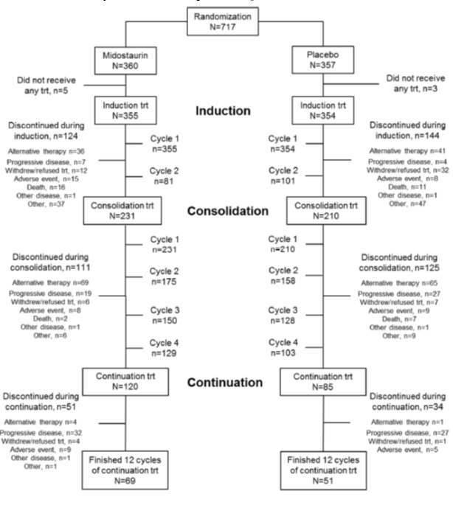

Table 37: Study A2301 AML disposition of subjects
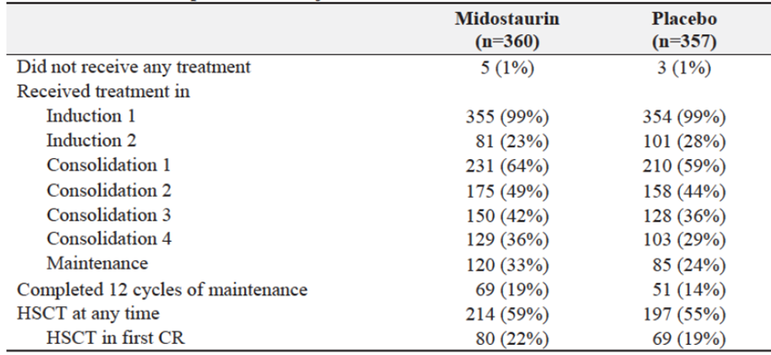
A key observation is that maintenance was initiated by only 33% of midostaurin and 24% of placebo subjects, and completed by only 19% versus 14%.
Baseline data are described in CER. Median age was 47 years; 88.3% had an ECOG performance score of 0 to1. Gender imbalance across arms is noted. 95% had de novo AML, 4.2% had MDS-related AML. Median time since diagnosis was 5 days in both arms. 55.4% had received hydroxyurea; but 8.1% had received more than the protocol-stipulated maximum of 5 days and were excluded from per protocol analysis.
76.7% had FLT3-ITD mutations (most with a lower allelic ratio, AR). Discussion of allelic ratio by Meshinchi (2014);³⁵ notes those with high allelic ratio have worse complete remission rate and poor survival, though this can be abrogated by stem cell transplantation (SCT). No difference in outcome was seen between those with low AR and those with FLT3-WT disease, pointing to the need to examine benefit in the low and high AR subgroups of Ratify. In 22.7%, there was a FLT3-TKD mutation.
The use of strong CYP3A4 inhibitors (primarily anti-fungal agents, mainly fluconazole, posaconazole and voriconazole) was well balanced between midostaurin and placebo groups in induction (61.9%, n = 190 versus 59.6%, n = 177, respectively) and consolidation (43.8%, n = 88 versus 47.5%, n = 47, respectively), while in the maintenance phase the agents were used by 10.8% (n = 20) of all patients.
Key outcomes were overall survival (OS), event-free survival (EFS) and (in patients in complete remission) disease-free survival (DFS).

Overall survival

Table 38: Primary endpoint ofoverall survival (OS); outcomes with a minimum 42 months follow-up from randomisation
Endpoint | Arm | Outcome Hazard ratio |  | Comment
Overall survival (OS)  (1 April 2015 data cut-off)  Not censored at SCT | Midostaurin  n = 360 | Median 74.7 months | HR = 0.77  (95% CI 0.63 to 0.95) | The Kaplan-Meier curve explains the pronounced and misleading imbalance in median OS
 | Placebo  n = 357 | Median 25.6 months | HR = 0.77  (95% CI 0.63 to 0.95)
Figure 8: Kaplan Meier plot of overall survival versus time (months)
Updated overall survival outcomes (5 September 2016 data cut-off; an additional 15 months of follow-up relative to the primary analysis) are referenced. Consistent with the plateauing of mortality seen above, there were few additional deaths and the hazard ratio remained similar (0.79).

Table 39: Overall survival from the start of the continuation (maintenance) phase is analysed, with a suggestion of benefit in the midostaurin arm
Endpoint | Arm | Outcome Hazard ratio
Overall Survival from the start of continuation | Midostaurin  n = 120 | Median NE | HR = 0.80  (95% CI 0.50 to 1.28)
Overall Survival from the start of continuation | Placebo  n = 85 | Median NE | HR = 0.80  (95% CI 0.50 to 1.28)
Figure 9: Overall survival during continuation phase, non-censored for SCT in patients who entered the continuation phase in Study A2301; Full analysis set
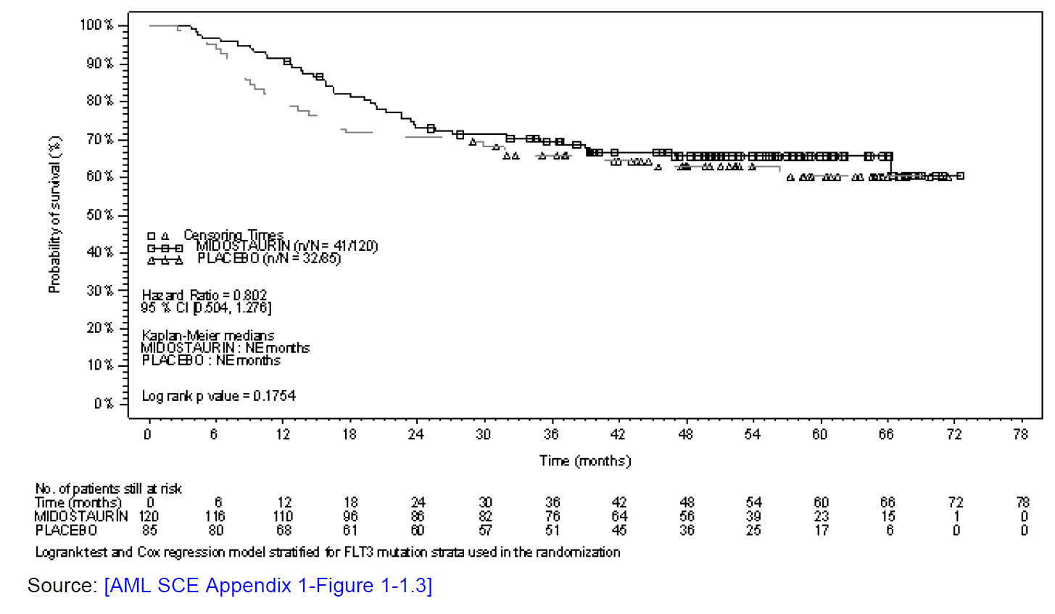
With censoring for SCT, results were more in favour of midostaurin. Analyses such as this are imperfect in that outcomes cannot be dissociated from the influence of earlier phases of treatment, that is, outcomes cannot be attributed to the maintenance approach in isolation.
Subgroup analysis for overall survival is presented in Figure 10.
There was no sign that those with a lower allelic ratio for FLT3 ITD had less benefit, although those with low allelic ratio, for example 0.1 to 0.2, were analysed in the ≤ 0.5 or ≤ 0.7 subgroups.
Of most significance was subgroup analysis by gender: the overall survival hazard ratio was 0.53 for males, but 1.01 for females (and the subgroups were reasonably sized).
Figure 10: Study A2301 Forest plot for subgroup analyses, overall survival (OS), non-censored for SCT, full analysis set
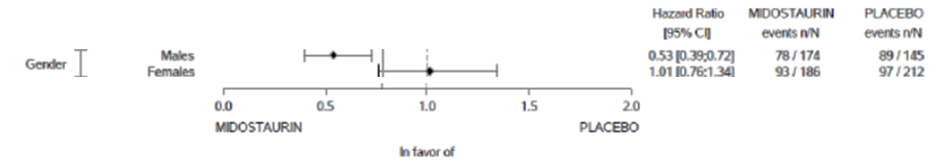
In females, overall survival Kaplan-Meier curves for midostaurin and placebo were superimposable. There was a statistically significant interaction between treatment arm, gender and FLT3 ITD AR status (see Table 40).

Table 40: Study A2301 Hazard ratios for the six subgroups defined by gender and FLT3 randomisation status; Full analysis set
HR calculated using a Cox regression model; CI = Wald confidence interval.
The sponsor drew attention to the clinical relevance of various secondary endpoints in their own right, where no gender imbalance was seen; the evaluator considered this reasonable. Another difference across gender was the frequency of NPM1 mutations (38% in males; 62% in females); preliminary evidence (not in the Dossier) points to the relevance of understanding NPM and FLT3 status.
There was evidence of overall survival benefit with midostaurin in those who received SCT and in those who did not, as per the following table (Table 41) from the EPAR (page 97).⁵⁶

Table 41: Study A2301Overall survival (non-censored for SCT) by SCT status in; Full analysis set
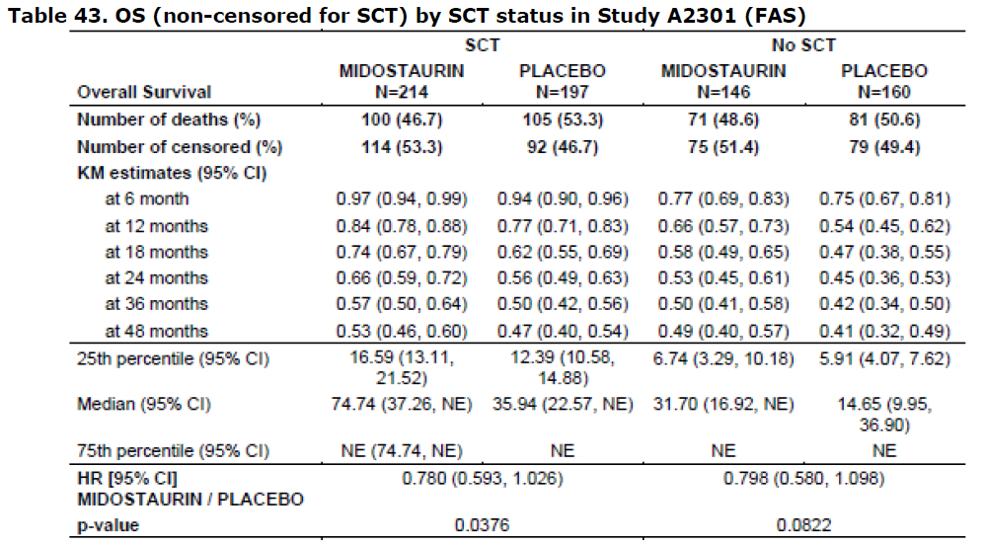

Event-free survival (EFS)
Event free survival is time until ‘failure to obtain a complete remission (CR) within 60 days of the start of therapy’, relapse or death. Different definitions of EFS were explored in the FDA’s Cross-Disciplinary Review, for example substituting ‘no complete remission any time during induction’ for ‘failure to obtain a complete remission within 60 days of the start of therapy’, with little change in hazard ratios.
The magnitude of benefit observed for overall survival was also seen for event free survival.
Of note is a description of a protocol amendment ‘promoting’ event free survival to become a ‘key’ secondary endpoint, and changing the timing of the final analysis to 1 April 2015, when around 350 deaths had occurred (instead of ‘after 509 death’ which had been predicted incorrectly to occur by May 2013).

Table 42: Study A2301 Event free survival (EFS) not censored at time of SCT, FAS
Endpoint | Arm | Outcome | Hazard ratio
Event free survival (EFS)  Not censored at SCT | Midostaurin  n/n = 256/360 | Median 8.2 months | 0.78  (95% CI 0.66 to 0.93)
Event free survival (EFS)  Not censored at SCT | Placebo  n/n = 280/357 | Median 3.0 months | 0.78  (95% CI 0.66 to 0.93)
The Kaplan-Meier curve is shown in Figure 11.
Figure 11: Kaplan-Meier curve for event free survival (EFS) not censored at the time of the SCT
Most events were treatment failure (40.8% for midostaurin versus 46.5% for placebo), then relapse (25.3% versus 25.2%), with deaths a distant third (5.0% versus 6.7%).
No gender effect was seen in the subgroup analysis for event free survival (hazard ratios were 0.79 for males, 0.81 for females).

Disease-free survival

Table 43: Disease free survival (DFS) is the time until relapse or death from any cause for patients in complete remission
Endpoint | Arm | Outcome | Hazard ratio
Disease free survival (from date of CR if by 60 days after start of induction) | Midostaurin  n/n = 109/212 | Median 26.7 months | 0.71 (95% CI 0.55 to 0.92)
 | Placebo  n/n = 114/191 | Median 15.5 months | 0.71 (95% CI 0.55 to 0.92)
Figure 12: Kaplan-Meier curve for disease free survival (DFS) considering all complete remissions within 60 days of study treatment start and non-censored at the time of SCT; Full analysis set
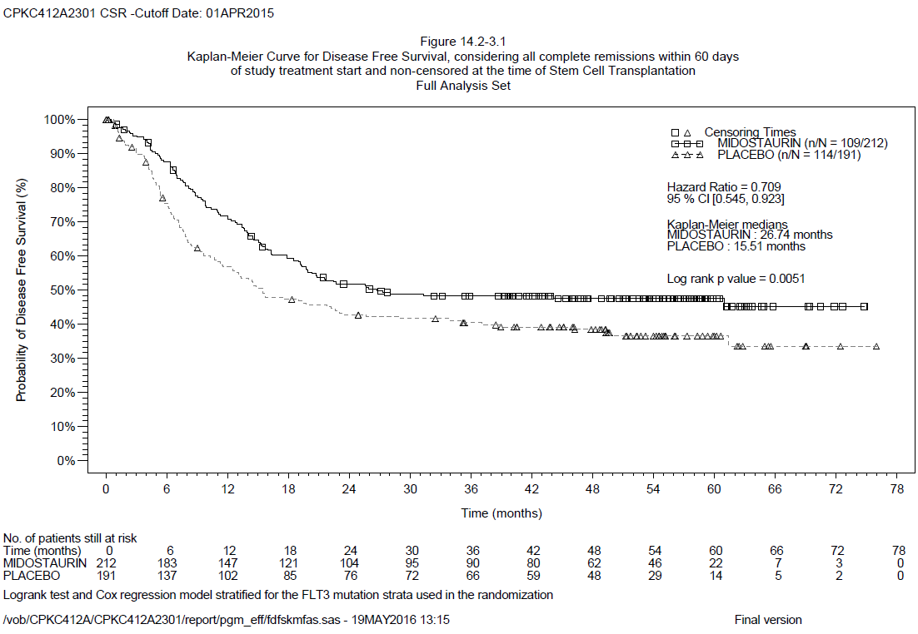
Various other analyses of disease free survival were also conducted shown in the following tables (see ‘boundaries’ in first columns of these tables).

Table 44: Disease free survival (DFS) during continuation
Endpoint | Arm | Outcome | Hazard ratio
DFS during continuation (patients who entered continuation in CR) | Midostaurin  n/n = 33/115 | Median NE | 0.71  (95% CI 0.43 to 1.18)
 | Placebo  n/n = 28/79 | Median NE | 0.71  (95% CI 0.43 to 1.18)
Figure 13: Study A2301 Disease free survival (DFS) during the continuation phase (patients who entered continuation phase in complete remission); Full analysis set
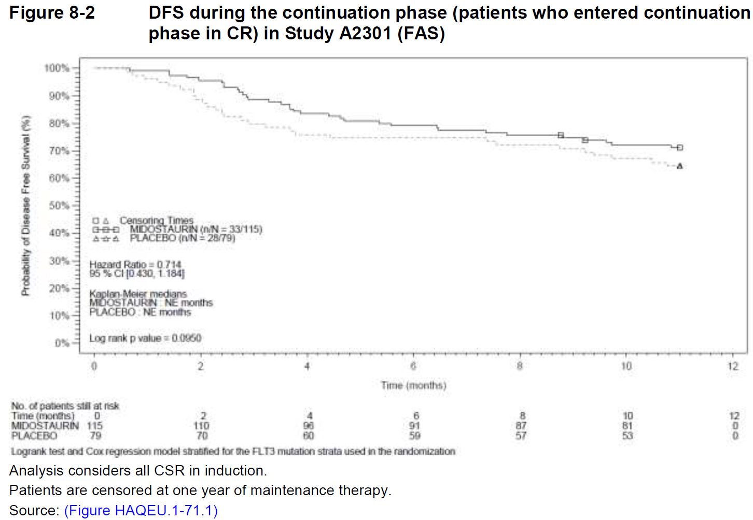

Table 45: Disease free survival during continuation (patients with complete remission within 60 days of study treatment start
Endpoint | Arm | Outcome | Hazard ratio
DFS during continuation (patients in CR within 60 days of study treatment start, entering continuation in CR) | Midostaurin  n = 105 | Relapse in 46.7%  Death in 3.8% | 1.073  (95% CI 0.43 to 1.18)
 | Placebo  n = 69 | Relapse in 42%  Death in 2.9% | 1.073  (95% CI 0.43 to 1.18)
Table 46: Disease free survival (DFS) during the 12 months after continuation
Endpoint | Arm | Outcome | Hazard ratio
DFS during the 12 months after continuation (in patients who remained in CR at the end of continuation) | Midostaurin  n = 96 | 16 DFS events for midostaurin were all relapse, and tended to occur early | 1.396  (95% CI 0.60 to 3.10)
 | Placebo  n = 73 | 9 DFS events for placebo were 7 relapses + 2 deaths. | 1.396  (95% CI 0.60 to 3.10)

Table 47: Disease free survival (DFS) after completion of continuation
Endpoint | Arm | Outcome | Hazard ratio
DFS after completion of continuation (in patients in CR within 60 days of study treatment start and still in CR at the end of continuation) | Midostaurin  n/n = 16/59 | Median not evaluable | 1.42  (95% CI: 0.63 to 3.22)
 | Placebo  n/n = 9/41 | Median not evaluable | 1.42  (95% CI: 0.63 to 3.22)
Figure 14: Study A2301 Disease free survival after completion of maintenance (in those with complete remission after induction, and still in complete remission at end of maintenance)
There is a need for formal study of the benefit of maintenance > 12 months.
There is no evidence that combined relapse or death rates were higher with maintenance midostaurin than with placebo. The counter-argument is that there is a ‘carry-over’ effect from use of midostaurin in induction and consolidation, and that these data do not support the benefit of maintenance midostaurin sufficiently.
A heightened risk of relapse is present following cessation of midostaurin, but there is no evidence that the risk reduces the benefit of midostaurin maintenance to a level ‘below’ that of patients in the placebo arm (for example, overall survival hazard ratio after start of continuation was 0.80), or to a level below what can be expected in the midostaurin arm but with no maintenance.

Other endpoints
Results for other secondary endpoints were mainly in keeping with outcomes for overall survival and event free survival. One interesting outcome was the absence of any improvement in complete remission at end of induction Cycle 2 for the midostaurin group (Table 48).

Table 48: Study A2301 Complete remission within 60 days of start of study treatment
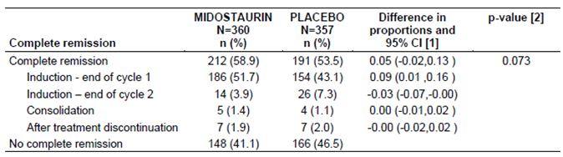
[1] Wald 95% Confidence Interval. [2] One-sided p-value calculated using Cochran-Mantel-Haenszel test for two proportions adjusted for the FLT3 randomisation stratum. Complete Remission is only considered if it occurs by 60 days after initial induction therapy started.
Should a second cycle of midostaurin induction (above and beyond backbone chemotherapy for the second cycle of induction) be recommended?
Given that the study was not designed to answer this question specifically, and given that few patients had two cycles of induction, it seems reasonable to allow this second cycle.
Health-related QoL was not assessed.

Study ADE02T (supportive; interim data)
This study is open-label, uncontrolled and, being a combination trial, does not isolate the effect of midostaurin. The CSR presented an unplanned efficacy analysis of 145 patients; the study is ongoing. Midostaurin dosing was not identical to that proposed in the PI (for example in induction, dosing started on day 8 but went to 48 hours before the start of the next cycle; and consolidation differed, with allogeneic HSCT preferred although high dose cytarabine then midostaurin was possible). In consolidation, lower dose cytarabine was given (1 g/m² BD on Days 1, 3 and 5) for patients ≥ 65 yrs. For these reasons, the study is not detailed here.
The study is of value in providing outcomes for patients ≤ 60 years and patients > 60 but ≤ 70 years of age (60 to70 years), for example deaths during induction occurred in 3.0% of patients ≤ 60 years and 17.4% of patients 60 to70 years. Outcomes in comparison to a historical cohort are presented in Table 49. Outcomes (stratified by age above or below 60 years) are compared to Ratify outcomes and generally, results were similar across studies for patients ≤ 60 years of age, while patients 60 to70 years of age had worse outcomes.

Table 49: Study ADE02T Efficacy outcomes in the historical control and study subjects
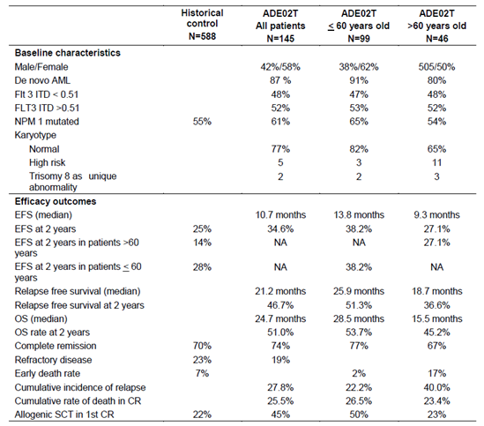

Other studies
An exposure-efficacy analysis was evaluated. In some settings, the analysis reverted to dose-response analysis (dose intensity was used as a surrogate for exposure).
- There was a higher probability of complete remission in the induction phase with a higher CGP62221 exposure, but no such relationship for midostaurin or for ‘sum of active moieties’.
- There was a positive relationship for dose intensity in cycle 1 of induction and complete remission.
- There was a relationship between dose intensity and time to event (that is failure to obtain complete remission, relapse from complete remission, or death from any cause).
- There was a relationship between dose intensity and overall survival (with higher dose intensity reducing risk of death), and a relationship between higher CGP62221 at C1D21 of induction and better overall survival.

Efficacy (AdSM)

Dose selection
Dose selection for pivotal AdSM Study D2201 is discussed. Unlike use in AML, use of midostaurin in AdSM is as monotherapy, 100 mg BD, continuously. Dosing in proof-of-concept AdSM Study A2213 was based on dosing in AML/MDS Study A2104E1 and also on a case report of a patient with mast cell leukaemia with a KIT D816V mutation. Preliminary data from Study A2213 supported the same 100 mg BD dose regimen being chosen for pivotal Study D2201. The evaluator notes that PK data suggest that exposure is not dissimilar for 100 mg BD in AdSM and 50 mg BD in AML or MDS, raising the possibility that dose could be lower in AdSM. The pivotal and supportive studies used 100 mg BD dosing.

Study D2201 (pivotal)
This study enrolled 116 patients with aggressive systemic mastocytosis (ASM) or mast cell leukaemia (MCL) with or without AHNMD (associated haematologic non-mast cell lineage disorder) across 29 centres in 12 countries, from 2009 to 2012. Primary efficacy analysis was conducted on 89 patients eligible for response assessment as per protocol (primary efficacy population set), while 116 patients were included in the assessment of safety.
The study was uncontrolled, open label, and used overall response rate (ORR) as the primary endpoint. The definition of overall response rate was specific to AdSM. The evaluator concluded that overall response rate is a reasonable primary endpoint in the context, although evaluation of response in patients with SM and AHNMD complicates interpretation. The FDA’s Cross-Disciplinary Review raised concerns about whether some types of response translate to clinical benefit (for example suggesting that only a complete remission is of any clinical benefit in MCL).
Midostaurin was given as monotherapy, at 100 mg BD, continuously. Other anticancer agents were not permitted, although some use of glucocorticoids and histamine receptor antagonists was permitted.
Baseline demographic data are: median age of the 89 primary efficacy population patients was 64 years (range 25 to 82 years); 64% were male; 82% had ASM and 18% had MCL. An associated AHNMD was detected in 57out of 73 patients with ASM and 6 out of 16 with MCL. Frequent AHNMD types were CMML and MDS/MPN-U. Therefore, 18% had ASM, 64% had SM-AHNMD and 18% had MCL. Median time from diagnosis was 86 days. KIT D816V was detected in 82%. 32 out of 89 had received prior anti-neoplastic therapy for SM.
The overall response rate was 60.0% (Table 50), with ORR from 46 to 65% across sensitivity analyses. ORR by disease type (ASM versus SM-AHNMD versus MCL) is shown in Table 51 (75% versus 57.9% versus 50% respectively). Median time to response was 0.3 months. In 53 responders, median duration of response was 31.4 months. Subgroup analysis (for example Table 52) hinted at less activity in KIT D816V negative patients (overall response rates 63% versus 44%); but there were only 16 KIT D816V negative patients.

Table 50: Study D2201 Best overall response per study steering committee adjudication; Primary efficacy population
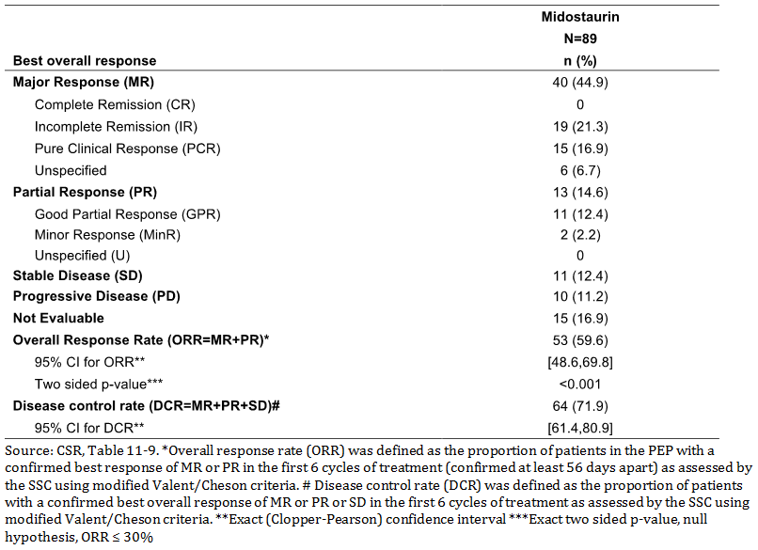

Table 51: Study D2201 Best overall response in ASM, SM-AHNMD, and MCL, primary efficacy population
Best overall response | ASM (n = 16), n (%) | SM-AHNMD (n = 57), n (%) | MCL (n = 16)
Major response (MR) | 10 (62.5) | 23 (40.4) | 7 (43.8)
Complete remission (CR) | 0 | 0 | 0
Incomplete remission (IR) | 6 (37.5) | 9 (15.8) | 4 (25.0)
Pure clinical response (PCR) | 4 (25.0) | 9 (15.8) | 2 (12.5)
Unspecified (U) | 0 | 5 (8.8) | 1 (6.3)
Partial response (PR) | 2 (12.5) | 10 (17.5) | 1 (6.3)
Good partial response (GPR) | 1 (6.3) | 10 (17.5) | 0
Minor Response (MinR) | 1 (6.3) | 0 | 1 (6.3)
Unspecified (U) | 0 | 0 | 0
Stable disease (SD) | 1 (6.3) | 7 (12.3) | 3 (18.8)
Progressive disease (PD) | 1 (6.3) | 6 (10.5) | 3 (18.8)
Not evaluable | 2 (12.5) | 11 (9.3%) | 2 (12.5)
ORR (MR + PR) | 12 (75.0) | 33 (57.9) | 8 (50.0)
95% CI for ORR | 47.6, 92.7 | 44.1, 70.9 | 24.7, 75.3

Table 52: Study D2201 Subgroup analysis of overall response rate; primary efficacy population
The overall response rate according to more stringent IWG-MRT/ECNM criteria was 37.4% (Table 53), however that included patients with ‘clinical improvement’ (presumably a less valuable outcome than complete remission or partial remission). Overall response rate counting only complete or partial remission was 18.2%; but responses were durable.
Median PFS was 17months Median overall survival was 26.8 months (51.1 months for ASM, 20.7 months for SM-AHNMD and 9.4 months for MCL).
Patient-reported outcomes were explored, with some evidence of QoL benefit; but, in the absence of a control arm, these results are difficult to interpret.

Table 53: Overall response rated per IWG criteria, eligible patients; Full analysis set
(1) Patients with all organ damages in complete remission. (2) Patients with at least one organ damage in partial remission AND no progression on any other organ damage. (3) Patients with at least one organ damage clinically improved AND patient not in complete remission AND patient not in partial remission. A clinical improvement cannot be considered if a progression started before confirmation of clinical improvement. (4) Sum of patients in complete remission, patients in partial remission and patients with clinical improvement.

Study A2213 (proof of concept)
This study was smaller than D2201 (n = 26), uncontrolled, open-label and investigator-initiated. Enrolment was from 2005 to 2010; at the 3 December 2012 data cut-off, only 7 patients remained on drug. Median age was 64.5 years. Overall response rate was 73.1% (Table 54), or 50% for confirmed responses (D2201 used confirmed responses). Overall survival analysis using a 2 December 2016 data cut-off found a median overall survival of 40 months, with 14 out of 26 patients having died.

Table 54: Study A2213 Primary efficacy analysis overall response rate; Full analysis set
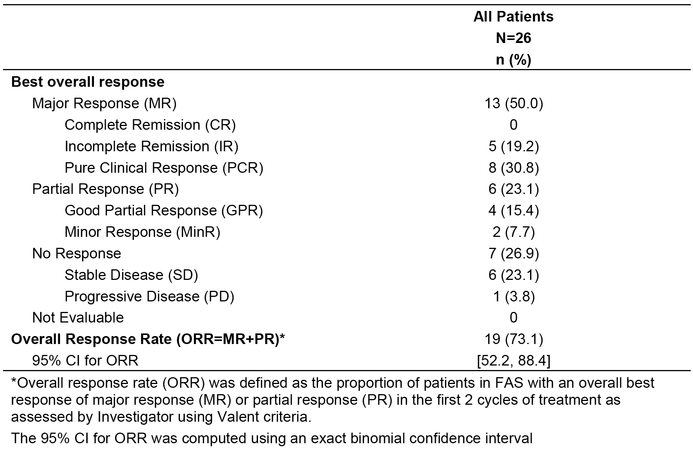

Other studies
Analysis of overall survival data pooled from Studies D2201 and A2213 versus historical controls is presented. Overall survival outcomes strongly favoured midostaurin. Limitations of the approach were noted.
An exposure-efficacy analysis was evaluated. An association was found between midostaurin ‘peak C_{min}’ (maximum C_{min} concentrations in cycle 1) and probability of major or partial response. A trend towards lower serum tryptase was seen with higher C_{min,ss}. Otherwise, no efficacy-exposure relationships were observed.

Safety

AML
In Study A2301, the safety set included 345 patients in the midostaurin group and 335 patients in the placebo group. Median duration of exposure to midostaurin (days on which midostaurin was given) was 42 days (range 2 to 576 days) versus 34 days for placebo. The evaluator explains that ‘the relative short median duration of exposure results from patients who discontinued after induction due to failure to achieve a complete remission and from patients who achieved a complete remission and discontinued due to proceeding to SCT while still in remission.’ n = 73 out of 345 midostaurin patients had ≥ 12 month exposure.
In Study A2301, at North American sites, for AEs that were not pre-specified, only Grade 3 or 4 AEs were collected. The evaluator focused on reporting from non-North American sites for this reason.
Common AEs are shown in Table 55. For these common AEs, there was often no important change in frequency across arms, indicating the influence of the AEs caused by the chemotherapy backbone. Addition of midostaurin did appear to increase the frequency of ‘all grade’ events of nausea, vomiting and stomatitis. For Grade 3 or 4 events (Table 56), the frequency of ‘device-related infection’ and ‘dermatitis exfoliative’ rose in the midostaurin arm. There was no evidence of an imbalance in other infections across arms.

Table 55: Study A2301 Pre-specified adverse events (all grades) reported in ≥ 10% of patients in the midostaurin group, by descending order of frequency, at non-North American compared to North American sites; Safety set
Preferred term | Pre-specified (North American) sites |  | Pre-specified (non-North American) sites
overall (all phases) | Midostaurin (n = 229) | Placebo (n = 226) | Midostaurin (n = 116) | Placebo (n = 109)
Platelet count decreased * | 113 (97.4) | 107 (98.2) | 224 (97.8) | 220 (97.3)
Haemoglobin decreased * | 113 (97.4) | 107 (98.2) | 224 (97.8) | 220 (97.3)
Neutrophil count decreased * | 112 (96.6) | 107 (98.2) | 221 (96.5) | 221 (97.8)
Diarrhoea* | 101 (87.1) | 90 (82.6) | 161 (70.3) | 162 (71.7)
Febrile neutropaenia * | 97 (83.6) | 97 (89.0) | 191 (83.4) | 182 (80.5)
Fatigue * | 95 (81.9) | 89 (81.7) | 151 (65.9) | 153 (67.7)
Nausea * | 93 (80.2) | 86 (78.9) | 191 (83.4) | 159 (70.4)
Dermatitis exfoliative * | 87 (75.0) | 88 (80.7) | 141 (61.6) | 137 (60.6)
Vomiting * | 74 (63.8) | 72 (66.1) | 139 (60.7) | 119 (52.7)
Radiation mucositis * | 35 (30.2) | 37 (33.9) | 98 (42.8) | 95 (42.0)
Stomatitis * | 15 (12.9) | 8 (7.3) | 50 (21.8) | 32 (14.2)
* = pre-specified AEs (all grades).

Table 56: Study A2103 Grade 3 or 4 AEs reported in ≥ 10 % of patients in the midostaurin group (versus placebo) at all sites, safety set
Grade 3/4 AEs,preferred term; overall (all phases) - all sites | Midostaurin (n = 345), n (%) | Placebo (n = 335), n (%)
Any PT | 344 (99.7) | 335 (100)
Platelet count decreased | 337 (97.7) | 326 (97.3)
Haemoglobin decreased | 322 (93.3) | 298 (89.0)
Neutrophil count decreased | 329 (95.4) | 327 (97.6)
Febrile neutropenia | 288 (83.5) | 278 (83.0)
Leukopenia | 93 (27.0) | 101 (30.1)
Lymphopenia | 69 (20.0) | 76 (22.7)
Device related infection | 54 (15.7) | 33 (9.9)
Diarrhoea | 53 (15.4) | 51 (15.2)
Hypokalaemia | 48 (13.9) | 57 (17.0)
Dermatitis exfoliative | 47 (13.6) | 25 (7.5)
ALT increased | 45 (13.0) | 32 (9.6)
Pneumonia | 45 (13.0) | 47 (14.0)
On-treatment deaths thought related to study drug are summarized in Table 57. There was no striking imbalance across arms. Deaths during study were seen in 46.4% of midostaurin arm patients and 52.8% of placebo arm patients. There was an imbalance in deaths due to pneumonitis (1.7% versus 0.3% respectively), but none of these events was attributed to study drug; and a review of interstitial lung disease AEs found no convincing evidence of any imbalance.

Table 57: Study A2103 On-treatment deaths (overall) suspected to be related to the study drug; Safety set
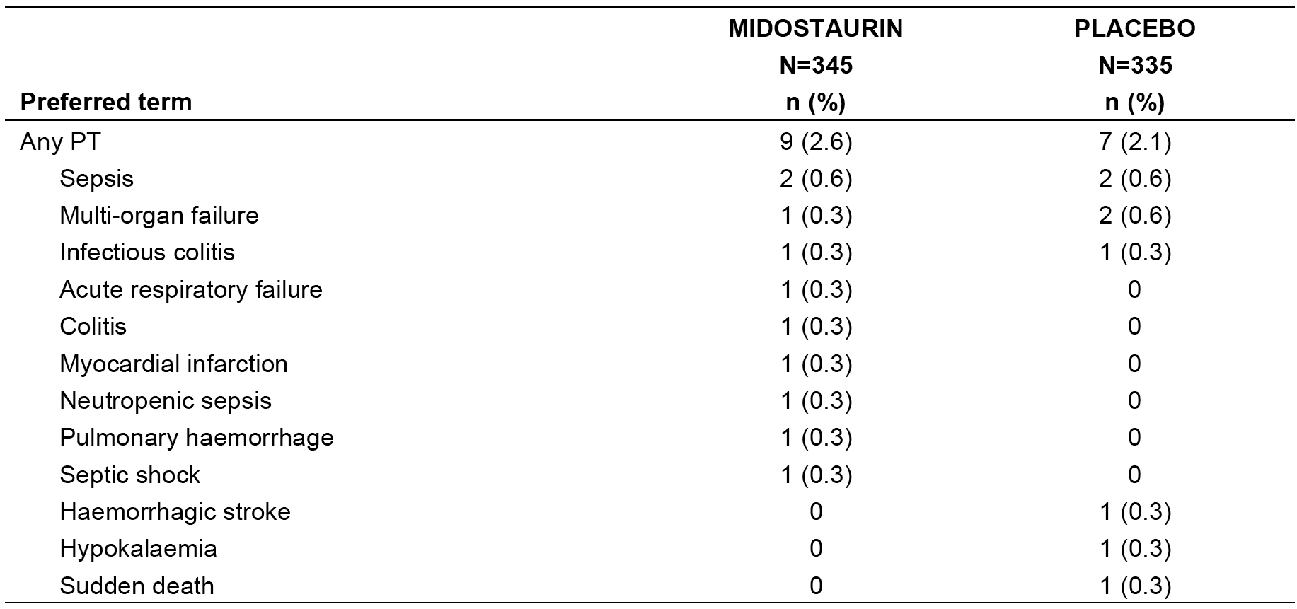 A patient can have more than one reason for death. Deaths which have a corresponding Grade 5 AE that is related to study drug are included; if there is no corresponding Grade 5 AE, then death from the follow up form where the cause of death is ‘due to protocol treatment‘ was included.
There were no large imbalances across arms in Grade 3 or 4 SAEs, although some specific events were seen more commonly with addition of midostaurin, for example, hypotension, AST and/or ALT increased and neutropaenic sepsis (Table 58). There were also no large differences in discontinuations of midostaurin or placebo due to AEs.

Table 58: Study A2103 SAEs (Grade 3 or 4), regardless of relationship to treatment, reported in ≥ 2.0% of patients in the midostaurin group at all sites; Safety set
SAEs (Grade 3/4) | All sites;SAEs Grade 3/4
Preferred term | Midostaurin (n = 345), n (%) | Placebo (n = 335), n (%)
Any PT | 162 (47.0) | 163 (48.7)
Febrile neutropaenia | 54 (15.7) | 53 (15.8)
Neutrophil count decreased | 28 (8.1) | 33 (9.9)
Platelet count decreased | 24 (7.0) | 28 (8.4)
Device related infection | 23 (6.7) | 13 (3.9)
Pneumonia | 23 (6.7) | 23 (6.9)
Sepsis | 16 (4.6) | 14 (4.2)
Haemoglobin decreased | 12 (3.5) | 9 (2.7)
Pneumonitis | 11 (3.2) | 8 (2.4)
Hypotension | 10 (2.9) | 1 (0.3)
Neutropaenic infection | 9 (2.6) | 6 (1.8)
AST increased | 9 (2.6) | 1 (0.3)
ALT increased | 8 (2.3) | 3 (0.9)
Leukopaenia | 8 (2.3) | 7 (2.1)
Renal failure | 8 (2.3) | 2 (0.6)
Neutropaenic sepsis | 8 (2.3) | 1 (0.3)
Infection | 8 (2.3) | 3 (0.9)
Colitis | 7 (2.0) | 9 (2.7)
There was a weak signal of some additional hepatotoxicity with addition of midostaurin (Table 59), for example Grade 3 to 4 hepatic AEs were reported in 23.5% in the midostaurin arm versus 19.7% in the placebo arm. With the imbalance in duration of study drug exposure across arms, this signal attenuates further.

Table 59: Clinically notable hepatic AEs, regardless of relationship to treatment, AEs (all grades) reported in ≥ 2% of patients in the midostaurin group at non-North American sites, and Grade 3 or 4 AEs reported in ≥ 1% of patients in the midostaurin group at all sites; Safety set
Clinically notable hepatic AEs | Hepatic AEs (all grades);Non-North American sites |  | Hepatic AEs (Grade 3 or 4) All sites
Clinically notable hepatic AEs | Midostaurin (n = 229), n (%) | Placebo (n = 226), n (%) | Midostaurin (n = 345), n (%) | Placebo (n = 335), n (%)
All | 120 (52.4) | 111 (49.1) | 81 (23.5) | 66 (19.7)
ALT increased | 81 (35.4) | 75 (33.2) | 44 (12.8) | 32 (9.6)
AST increased | 58 (25.3) | 55 (24.3) | 23 (6.7) | 13 (3.9)
Gamma GT increased | 37 (16.2) | 44 (19.5) | 15 (4.3) | 21 (6.3)
Hyperbilirubinaemia | 34 (14.8) | 38 (16.8) | 14 (4.1) | 14 (4.2)
Blood bilirubin increased | 29 (12.7) | 30 (13.3) | 10 (2.9) | 9 (2.7)
Prothrombin time prolonged | 12 (5.2) | 9 (4.0)
Blood fibrinogen decreased | 10 (4.4) | 11 (4.9)
An imbalance in Grade 3 to 4 renal failure across arms was observed (3.5% midostaurin versus 1.8% placebo).
No robust difference in haematological AEs was seen across arms.
There was a consistent imbalance in the potentially mechanistically related AEs of eyelid oedema (3.1% versus 0.4%), pericardial effusion (3.5% versus 1.3%), pleural effusion (5.7% versus 3.5%) and weight increased (6.6% versus 3.1%) that suggests a causal link with midostaurin.
Study ADE02T was not controlled, so emphasis is given here to Study A2301. Nevertheless, analysis of safety outcomes in ADE02T focused on differences in subjects ≤ 60 years of age and > 60 years of age. While interpretation is made difficult by confounding (for example generally greater morbidity with increasing age), key differences are noted below:
- Exposure to midostaurin was generally similar in younger and older patients.
- Deaths on treatment (and in 30-day follow-up) occurred in 6% of younger and 22% of older patients, but there were no major imbalances for other AE categories (Table 60).
- Frequencies of specific AEs were similar in younger and older patients, although a lower frequency of various AEs was seen in older patients (for example vomiting, rash pain). In older patients, QTc prolongation was much more common than in younger patients (17% versus 5%). These results should be interpreted cautiously; for example despite a lower frequency of vomiting in older patients, there was a higher frequency of Grade 3 or 4 nausea.

Table 60: Study ADE02T Overview of adverse event profile
 | Patients aged ≤ 60 years (n = 98), n (%) | Patients aged > 60 years (n = 46), n (%) | All patients (n = 144), n (%)
Any AE regardless of relationship to treatment | 98 (100) | 46 (100) | 144 (100)
Any AE (treatment-related) | 93 (95) | 42 (91) | 135 (94)
Treatment-related AEs Grade ≥ 3 | 78 (80) | 39 (85) | 117 (81)
Deaths (on-treatment and in 30-dayfollow-up) | 6 (6) | 10 (22) | 16 (11)
SAEs, regardless of relationship to treatment | 62 (63) | 35 (76) | 97 (67)
SAEs, treatment-related | 37 (38) | 19 (41) | 56 (58)
AEs leading to discontinuation | 26 (27) | 15 (33) | 41 (28)

Exposure-safety analysis in AML
An exposure-safety response analysis was evaluated. Decreasing exposure to midostaurin and its active metabolites (based on C_{min}) was associated with a reduction in Grade 3 to 4 febrile neutropaenia, cardiac failure and infection.
An analysis of AEs in patients concomitantly on strong CYP3A4 inhibitors and those not on such drugs showed a higher rate of AEs with concomitant but there is confounding by clinical need for CYP3A4 inhibitor use (for example antifungal medicine) which makes the analysis difficult to interpret in isolation.

AdSM
Dosing of midostaurin is much higher in AdSM than in AML (100 mg BD; continuous; and in a third of subjects in the AdSM studies, given for > 24 months), although concomitant chemotherapy is not used. Also, the AdSM studies were not controlled.
64 AdSM patients were ≥ 65 years of age (there is an analysis of AEs by age but differences in comorbidities and in drug exposure make this difficult to interpret). A striking difference was the frequency of on-treatment deaths (10.3% for younger versus 28.1% for older patients), n = 16 were aged 75 to 84 (see Table 61).

Table 61: AdSM ;Summary of adverse events by age; Pooled dataset
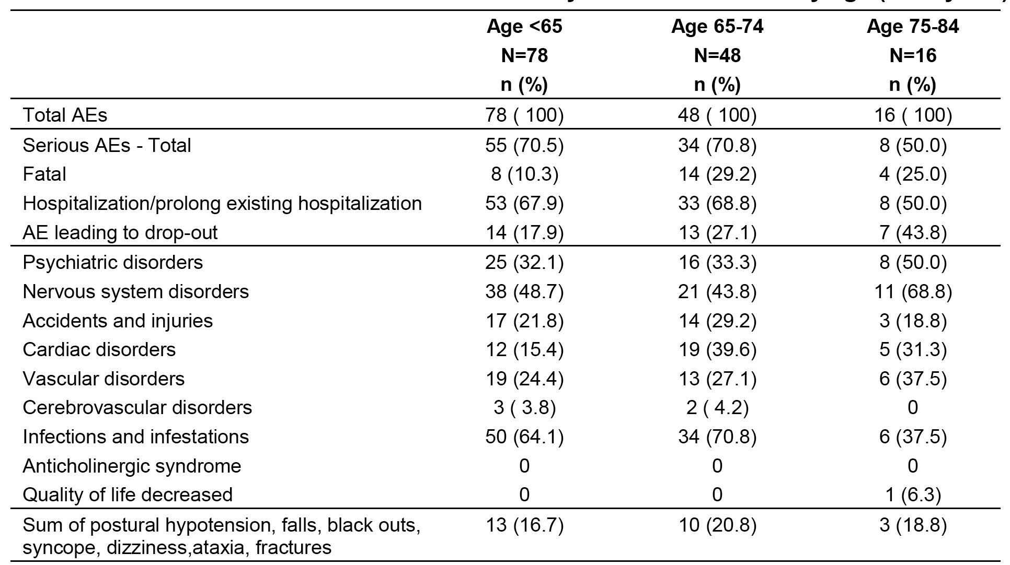
Dose interruptions (across Study D2201 and A2213) were frequent; 47.2% of the AdSM patient pool needed dose interruption at least once, and this was often due to AEs and often for > 2 weeks. Similarly, 59.2% needed dose reductions. AEs triggering these changes are noted in Table 62; the most frequent are nausea, vomiting, ECG QT prolonged and neutropaenia.

Table 62: AdSM; AEs (all grades) requiring dose adjustment to interruption in ≥ 2% of patients in the pooled dataset, regardless of study drug relationship; Pooled dataset
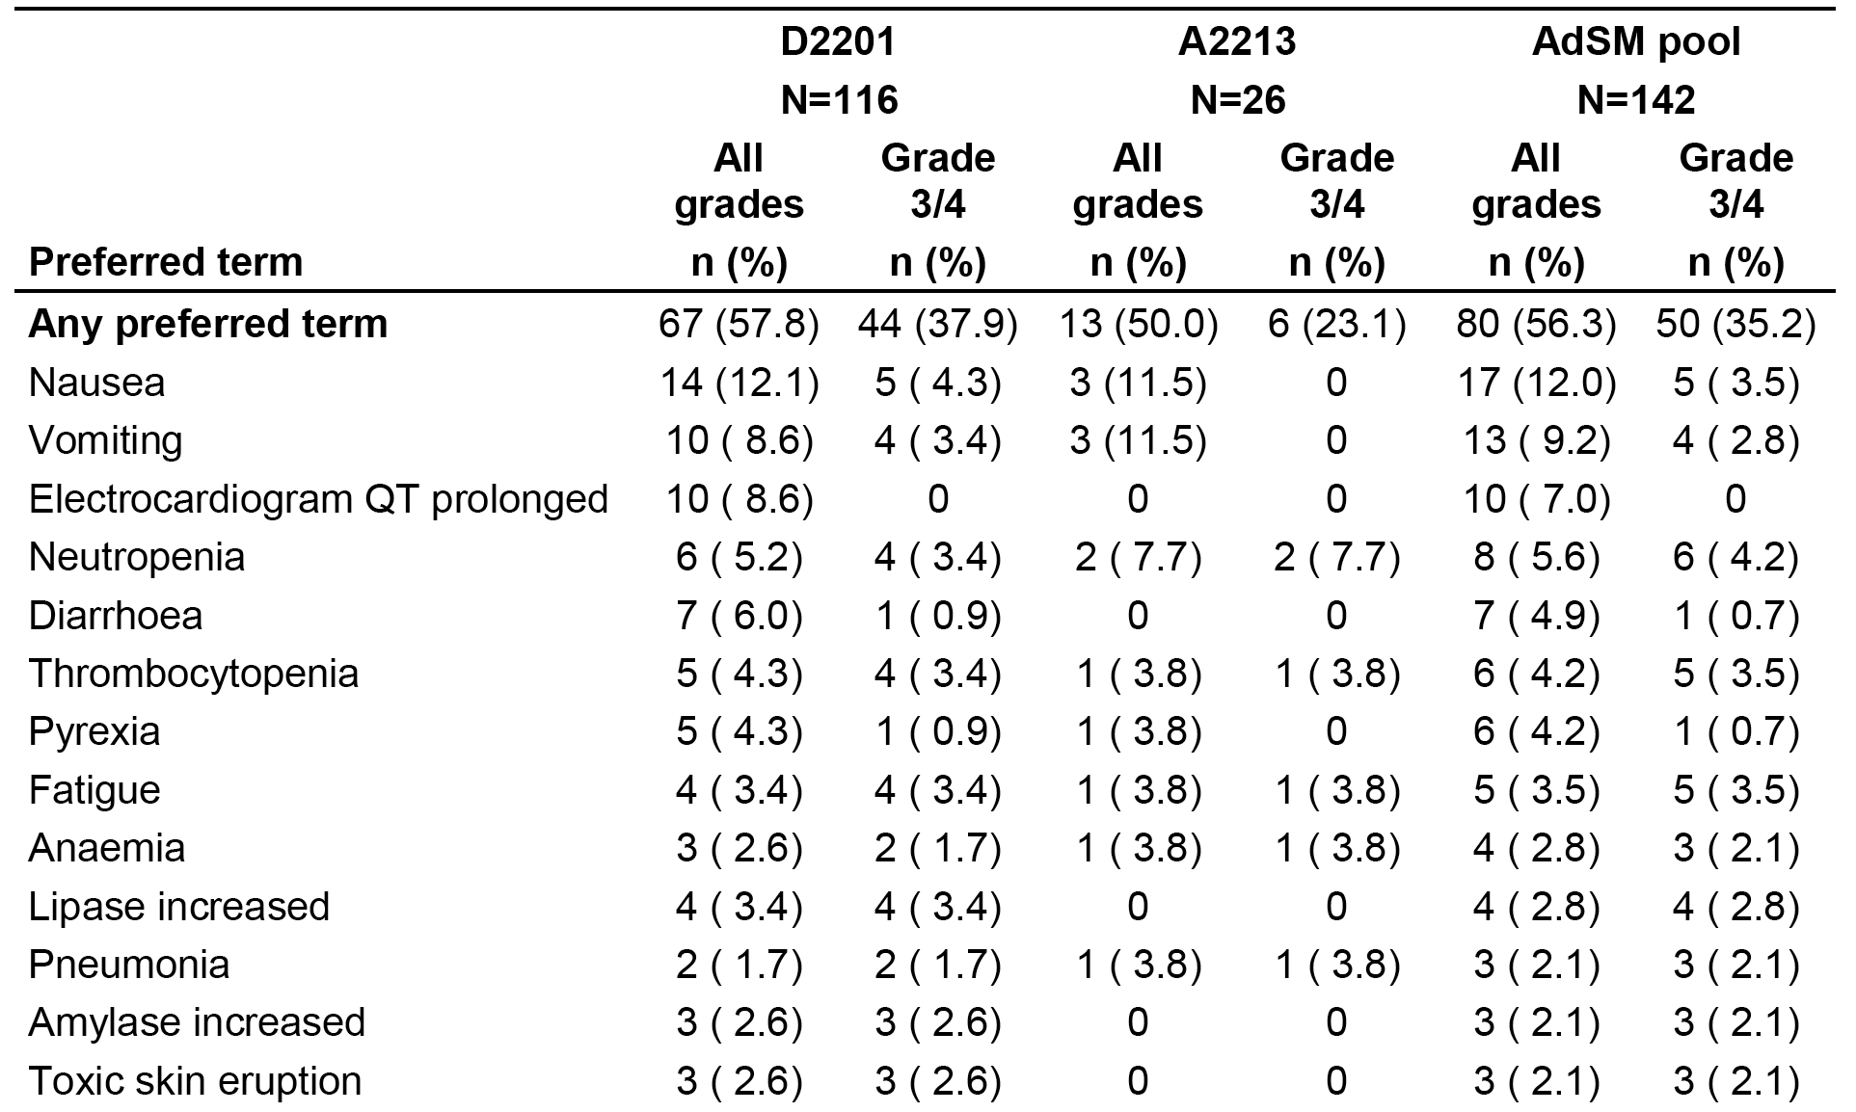
Interestingly given the picture presented in Study A2301 (of fairly minor ‘extra’ toxicity in the context of chemotherapy), the use of midostaurin monotherapy was associated with very high levels of treatment-related AEs, for example 41.5% of subjects had Grade 3 or 4 drug-related AEs; 11.3% had drug-related AEs leading to discontinuation. This could be because the full impact of midostaurin’s toxicity in AML is partially obscured by the use of daunorubicin and cytarabine, or because of higher exposure to midostaurin in AdSM, or because of differences in the treated population, or because of bias due to the uncontrolled design of the AdSM studies.
Common AEs suspected of being caused by midostaurin are shown in Table 63. Prominent are nausea, vomiting and diarrhoea; Grade 3 to 4 events occurred in < 5% of patients. Elevated lipase was reported in 9.9%, and this was very often a Grade 3 or 4 event (and in 2 out of 142 patients elevated amylase cause discontinuation). It is noted in Table 64 that 37.3% of patients had any elevation in serum amylase – and elevated amylase and lipase are not prominent signs of AdSM itself. The evaluator summarises this safety signal ‘The majority of ’worsening from baseline‘ abnormalities for other biochemical parameters were Grade 1/2 in severity. Worsening from baseline to Grade 3 or 4 abnormalities in ≥ 5% of patients for other biochemical parameters were observed for hyperglycaemia (18.6%), increased lipase (17.6%), increased uric acid (10.7%), and increased amylase (6.4%).’ One patient had acute pancreatitis. Interestingly, the signal was not obvious in A2301.

Table 63: AdSM; Treatment-related adverse events by severity reported in ≥ 20% of patients; Pooled dataset
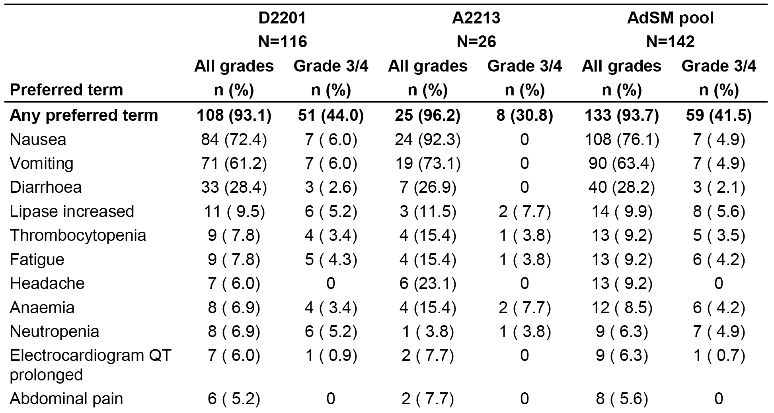

Table 64: AdSM; Newly occurring or worsening other biochemical laboratory parameters; Pooled dataset
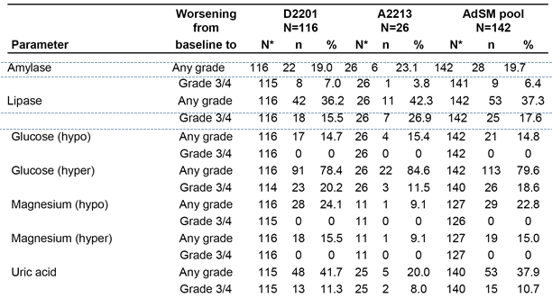
As in AML, serious skin reactions were observed. While SM often has skin manifestations, the reported serious events included ‘toxic skin eruptions’ and stomatitis. Urticaria pigmentosa (maculopaular cutaneous mastocytosis) might possibly be mistaken for a drug eruption, but events were also reported in AML studies.
There was a high rate of lab-detected hyperglycaemia, but this did not translate into a high rate of clinically reported AEs related to hyperglycaemia.
No deaths were considered by the investigator to be related to midostaurin.
In Study D2201, leukaemic transformation occurred in 15 (13%) patients in the safety set, and all patients except 1 had AHNMD at baseline. The subtypes for the 14 patients with AHMND were CMML (n = 6), MDS orMPN-(U) (n = 7) and MDS (n = 1). The sponsor comments that the leukaemic transformation rate reported in Study D2201 (13%) is consistent with the rate observed in the published literature.

Exposure-safety analysis in AdSM
An exposure-safety response analysis was evaluated. No convincing relationship was seen between exposure and the safety outcomes assessed (GI, liver and cardiac toxicity) although a slight increase in the odds of AEs leading to dose adjustment was seen with lower midostaurin C_{min} on Cycle 1 Day 28, and higher peak C_{min} was linked with a higher risk of AEs leading to discontinuation.

QT prolongation
The nonclinical evaluator noted a low risk of QT prolongation in patients.
A dedicated QT study was conducted. A 75 mg BD dose was used. Although analysis extended beyond midostaurin to its metabolites, data were gathered only to Day 3 (yet the estimated half-life of GCP52421 is 20.6 days). However, in the window observed, midostaurin had no significant impact on QT prolongation.
Interestingly, in Study A2301 (AML), notable QTcF prolongation events measured on ECGs were seen more often with midostaurin than with placebo (Table 65), and tachycardia was also more common. However, related AEs were not imbalanced across arms, and important cardiac toxicity AEs were also not imbalanced across arms. Reporting of QT prolongation and associated AEs in AdSM is described, but interpretation is difficult because of the uncontrolled nature of the studies.

Table 65: Study A2301 Notable ECG abnormalities (overall); Safety set
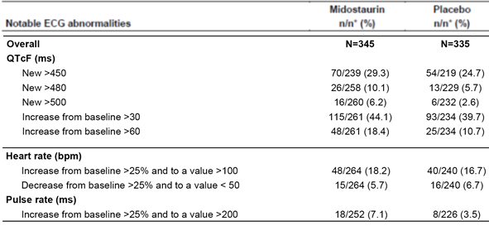

Risk management plan
There was broad agreement between the sponsor and RMP evaluator regarding proposed pharmacovigilance and risk minimisation activities. Per the Summary of Safety Concerns below, additional pharmacovigilance activities have been proposed as shown in Table 32 above.

Recommended condition/s of registration
- The midostaurin EU-Risk Management Plan (RMP) (version 1.5; dated 20 July 2017; data lock point 12 March 2012/12 January 2014 (SM); 10 March 2016 (AML)), with Australian Specific Annex (version 2.0; dated 27 November 2017), included with submission PM-2017-00871-1-4, and any subsequent revisions, as agreed with the TGA will be implemented in Australia.
- Rydapt (midostaurin) is to be included in the Black Triangle Scheme. The PI and CMI for Rydapt must include the black triangle symbol and mandatory accompanying text for five years, which starts from the date that the sponsor notifies the TGA of supply of the product.

Risk-benefit analysis

Issues
The clinical evaluator draws attention to key deficiencies of the AML efficacy evidence and these are considered below, along with some other issues raised in the course of evaluation.

Use of a single pivotal study (Study A2301)
It is considered reasonable to rely on a single pivotal study in the context of FLT3-positive AML. The TGA-adopted guideline ‘Points to consider on application with 1) meta-analysis; 2) single pivotal study’ (CPMP/EWP/2330/99) emphasises that a single pivotal study should be exceptionally compelling. In broad terms, Study A2301 provided compelling evidence of the benefit of midostaurin (for example an overall survival advantage demonstrated in a large, randomised study against an appropriate comparator), except for maintenance use and in combination with regimens other than daunorubicin plus cytarabine. Additional caution may be appropriate, though, given that other randomised trials of FLT3 inhibitors in AML have not shown compelling results.

Midostaurin maintenance
Support from Study A2301 for single agent midostaurin maintenance is not robust. The evaluator discusses the role of maintenance therapy, concluding that it is considered premature to recommend routine maintenance therapy with midostaurin.
The sponsor acknowledged that design of Study A2301 does not allow for robust assessment of the treatment benefit of maintenance therapy. The sponsor’s view is that concluding that any part of the overall risk reduction is attributable to treatment during any particular phase of the study is not justifiable. ‘The impact on efficacy, if midostaurin were to be excluded during a particular phase of treatment, cannot be estimated’.
The FDA’s position (reflected in the partially redacted Cross-Discipline Review from page 37) is that Study A2301 was not designed to test effectiveness of midostaurin as maintenance; the US label does not allow this use. The FDA reviewer was confident to conclude that the overall survival (overall survival) benefit was explained primarily by the treatment effect during initial combination therapy. Certainly, only a minority of patients entered maintenance, and even fewer received all 12 cycles of maintenance.
The EMA’s position, as reflected in the EPAR;⁵⁶ (from page 151) is that:
‘…at present the available data did not allow a firm conclusion regarding the added value of the 12 months midostaurin continuation therapy. However, there is a clear scientific rationale for following the induction and consolidation phases by a period of maintenance therapy in FLT3-mutated AML, which has a high relapse rate that can be partly attributed to FLT3 clones (although other clones also contribute to relapse). Furthermore, the efficacy of midostaurin has been demonstrated only when a continuation/maintenance phase is applied. In addition, the safety profile of midostaurin monotherapy is favourable. For these reasons, the proposed indication which includes a post-remission maintenance phase is considered acceptable.’
For a patient who has completed induction and consolidation with midostaurin, there appear to be two risks regarding maintenance:
- The risk that if maintenance with midostaurin is not used, there may be relapse of disease earlier than would otherwise occur.
The overall survival curves separate to a maximum at around 18 months. The FDA’s view was that overall survival benefit was explained primarily by the treatment effect during combination therapy (induction + consolidation). It is difficult to exclude the possibility that the curves may not stay separated if midostaurin is not used as maintenance, that is, that maintenance is needed for some patients to avoid relapse or death. Some analyses raise the prospect that maintenance beyond 12 months should be explored for benefit.
- The risk that if maintenance with midostaurin is used, there may be little or no benefit attached to that use. In addition, there may be additional risks of drug toxicity.
There is little evidence that if midostaurin is used, substantial additional harm is being conferred. Survival curves that imply a worse outcome in the midostaurin arm are analyses of survival after maintenance is finished; these outcomes can be interpreted as evidence that maintenance is delaying the onset of relapse.
Simplistically, it seems that the greater risk in this context is of relapse if midostaurin is not used in maintenance. This is an area of uncertainty, and the ACM’s view is requested.

Use in older AML patients
There is an absence of data from Study A2301 for use in patients > 60 years of age (and use of a lower cytarabine dose in Study ADE02T for patients≥ 65 years). Median age at diagnosis of AML in Australia is 68.9 years.
The clinical reviewer comments on the use of cytarabine versus ‘high dose cytarabine’; there is a suggestion that the PI allow some flexibility in this regard. The indication supported in this document does not specify high dose cytarabine in consolidation.
The FDA’s Cross-Disciplinary Review (from page 40) addresses extrapolation to older AML patients. Use in the elderly (when fit enough for chemotherapy) seems reasonable.

Absence of pivotal data supporting post-transplantation use of midostaurin
Midostaurin was not used after SCT in Study A2301. There are no grounds to recommend use in that context; and that use has not been proposed.

Absence of quality of life data
It is unfortunate that Study A2301 did not assess impacts on health-related quality of life. However, given the overall survival benefit observed, this is not a critical deficiency.

Choice of chemotherapy backbone
The clinical evaluator considers that the recommended chemotherapy backbone should be that used in Study A2301.
The EPAR notes:
‘It is unclear to which extent different induction and consolidation regimens could interact differently with midostaurin from a PK/PD perspective and in regard to the treatment effect of midostaurin. Therefore, the chemotherapy to be used in combination with Rydapt is specified in the wording of the indication.’
The US PI also specifies use of cytarabine and daunorubicin for induction.
The sponsor comments that:
‘Idarubicin (12 mg/m² Day 1 to 3) is considered to be as effective and equitoxic to daunorubicin 60 mg/m² Day 1 to 3. Based on the pharmacokinetic profile of idaurubicin, it is not expected that it would affect the activity of midostaurin in a meaningful way in any direction.
Similarly, midostaurin is expected to either have no impact on or a limited potential for drug-drug interaction with idarubicin, similar to what has been observed in the pivotal trial A2301. The fact that midostaurin is not administered concomitantly with chemotherapy, and the treatment holiday period between the end of the administration of midostaurin and the start of administration of chemotherapy between cycles further reduce the risks of potential drug-drug interactions.’
The basis for these drug-drug interaction assertions was not included in the response. Some evidence was provided regarding the assertion of equal effectiveness and toxicity:
Two large studies comparing idarubicin and daunorubicin failed to demonstrate significant differences in outcome. The Japan Adult Leukemia study group trial AML201 compared daunorubicin 50 mg/m² daily for 5 days to idarubicin 12 mg/m² daily for 3 days. Both were combined with infusional cytarabine 100 mg/m²/day for 7 days. Similar results were observed on both arms. The Acute Leukemia French Association (ALFA)-9801 study compared idarubicin 12 mg/m² for 3 or 4 consecutive days to daunorubicin 80 mg/m² for 3 consecutive days. No differences in event free survival or overall survival between the daunorubicin or idarubicin regimen were detected. A recent comprehensive literature review; compared the risks and benefits of induction chemotherapy using idarubicin rather than daunorubicin. The review included 27 RCTs involving 9549 patients and included comparable consolidation therapies. Eighteen RCTs (n = 6755) assessed idarubicin versus daunorubicin. Compared with daunorubicin in induction therapy of newly diagnosed AML, idarubicin prolonged overall survival by a modest 10% (hazard ratio 0.90, 95% CI 0.84 to 0.96, p = 0.0008). Disease free survival and complete remission rate were increased and relapse rate was reduced, but these modest benefits were at a cost of an increase in death on induction therapy (14 studies, 6349 patients; relative risk (RR) 1.18, 95% CI 1.01 to 1.36, p = 0.03) and Grade 3 to 4 mucositis.
Adding midostaurin to the ‘7+3’ backbone in A2301 did not substantially increase either:
- deaths in induction (of the 15 deaths in the midostaurin group, 14 occurred in the induction phase and 1 in the consolidation phase […] of the 21 deaths in the placebo group, 11 occurred in the induction phase, 9 in the consolidation phase, and 1 in the continuation phase), or
- frequency of mucositis (although there was a modest increase in frequency of stomatitis).
An unforeseen synergistic increase in toxicity with idarubicin + cytarabine + midostaurin versus the regimen used in A2301 cannot be ruled out, but there is no obvious reason to expect greater toxicity.
Given that induction and consolidation regimens on EviQ are fairly diverse, it is preferable to have some limitation on use in combination, for example reference to ‘standard anthracycline and cytarabine induction and cytarabine consolidation chemotherapy’, to avoid too great a departure from the chemotherapy regimen used in the pivotal study.
Given the lack of support from the clinical evaluator for expanding use beyond what was studied in Study A2301, and given the FDA and EMA stances, the ACM’s view is requested.

Overall survival imbalance across males and females
The evaluator noted the imbalance in overall survival for male and female patients, but concluded that use in females was supported by the results for secondary endpoints. This is an area of uncertainty; the ACM’s view about how to interpret this apparent imbalance is requested.

Efficacy in advanced systemic mastocytosis (AdSM)
The clinical evaluator draws attention to key deficiencies of the AdSM efficacy evidence:

No randomised, Phase III trials
The pivotal study in AdSM was an uncontrolled, Phase II study. Given the rarity of the condition, it was of reasonable size (although, in turn, the ‘condition’ is a composite of three entities, ASM, SM-AHN, and MCL). Given the absence of helpful treatments for the condition, it was reasonable to rely on an uncontrolled study, despite this clouding the interpretation of some outcomes.

Limited relevance of the historical German registry
Comparison with German registry outcomes was viewed as supportive, but not pivotal in understanding the benefit / risk balance of midostaurin in AdSM.

Limited long term efficacy data
In Study D2201, only a third of patients, n = 39, were exposed to midostaurin for ≥ 2 years. Given the natural history of the condition, this is acceptable.

Primary analysis based on overall response rate
This was a key issue in evaluation. Given doubts about the primary analysis of overall response rate, considerable emphasis was placed on outcomes based on more stringent definitions, including definitions of response that excluded ‘clinical improvement’.
Separately, reliance on overall response rate is of particular concern for the MCL component of the indication, overall response rate may not be a reliable indicator of clinical benefit in acute leukaemia.

Safety

Clinical evaluator’s recommendation
In A2301, midostaurin’s toxicity may be obscured by the toxicity of the chemotherapy backbone (and by lack of re-randomisation at start of maintenance). In the maintenance phase, several adverse events were reported distinctly more often for midostaurin than for placebo (for example nausea, 46.4% versus 17.9%; vomiting, 19% versus 5.4%).
There is also concern that safety in AdSM is not well characterised because of the absence of a control arm in the pivotal study.
Despite these misgivings, it seems that there are no major safety concerns in the context of AML and AdSM.
Study A0003 in patients with diabetic macular oedema is noted here because patients (of median age 59 years) were randomised to placebo or midostaurin 50 mg, 100 mg or 150 mg per day for 3 months. Thus there is no chemotherapy to obscure toxicities, and there is a control group. Only 32 to 38 patients were randomised into each arm; but there was a clear dose-related increase in diarrhoea (2.9%, 3.1%, 18.4%, 24.3%) and nausea (5.9%, 9.4%, 28.9%, 43.2%), and high frequency of vomiting in the 150 mg daily arm. In addition, there was a dose-related increase in ALT > ULN (0%, 6.3%, 7.9%, 16.2%), and a similar pattern for AST. Dizziness was also reported in midostaurin subjects. There was a report of bone fracture as an SAE in each of the three midostaurin arms (but not in the placebo arm); on review of the Summary of Clinical Safety in AML and AdSM, there were at least three fractures reported in the midostaurin arm of Study A2301, but none in the placebo arm.
Precautions are proposed in the PI for neutropaenia and infection, cardiac dysfunction, pulmonary toxicity and general topics such as fertility and use in pregnancy.
There are safety concerns that relate to use in pregnancy (FDA Cross-Disciplinary Review, page 45). However, risk is mitigated by categorisation as a Class D drug;⁹ by suitable PI text and recommendations, and by the sponsor’s commitment to a pregnancy registry (the outcomes of which should be shared with the TGA in step with the FDA).

Risk management plan
There was broad agreement between the sponsor and RMP evaluator regarding proposed pharmacovigilance and risk minimisation activities.

Delegate’s considerations

Indications
These indications are considered to have acceptable evidence of efficacy and safety:
The following indications are most recently proposed:
In combination with standard induction and consolidation chemotherapy followed by single agent maintenance therapy for adult patients with newly diagnosed acute myeloid leukaemia (AML) who are FLT3 mutation-positive.
For the treatment of adult patients with aggressive systemic mastocytosis (ASM), systemic mastocytosis with associated haematological neoplasms (SM-AHN), or mast cell leukaemia (MCL).
In the initial Dossier, the proposed wording of the SM indication was:
Treatment of adult patients with advanced systemic mastocytosis.

Route of administration and dosage regimens (proposed)
Midostaurin is for oral administration.

Recommended dose in AML
The recommended dose of Rydapt is 50 mg twice daily.
Rydapt is dosed on days 8 to 21 of induction and consolidation chemotherapy cycles and then twice daily as single agent maintenance for 12 months. In patients receiving haematopoietic stem cell transplant (SCT), Rydapt should be discontinued prior to the conditioning regimen for SCT.

Recommended dose in advanced systemic mastocytosis (AdSM)
The recommended starting dose of Rydapt is 100 mg twice daily.
Treatment should be continued as long as clinical benefit is observed or until unacceptable toxicity occurs.

Dose modification recommendations for toxicity
Dose modification recommendations for toxicity in both AML and advanced SM are included in Table 66, taken from the proposed PI. They relate to neutropaenia (and for SM, also nausea or vomiting).
Dose modifications are not proposed for patients with renal or hepatic impairment, the elderly, and children. The PI notes that no or limited data are available for patients with severe hepatic or renal impairment or end-stage renal disease, and that safety and efficacy in children have not been established.

Table 66: Dose modification recommendations from proposed PI
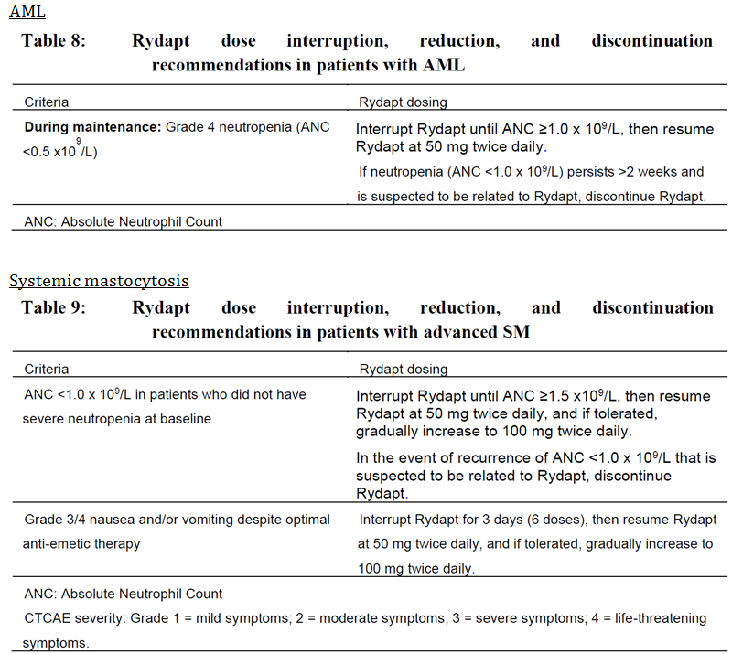

Summary of issues
There were no major manufacturing / quality control issues identified, or nonclinical issues impacting on benefit / risk balance.
- Key clinical efficacy issues in AML relate to:
  - Use of a single pivotal study (Study A2301)
  - Evidence supporting midostaurin maintenance (continuation). This issue is pivotal; the FDA and EMA have adopted different positions.
  - Use in older AML patients (the pivotal study did not enrol patients > 60 years of age)
  - Absence of pivotal data supporting post-transplantation use of midostaurin
  - Absence of quality of life data
  - Specification of the chemotherapy backbone in the AML indication
  - An imbalance in overall survival (OS) across males and females in Study A2301
- Key clinical efficacy issues in advanced systemic mastocytosis (AdSM) relate to:
  - Absence of a randomised, Phase III trial
  - The limited relevance of historical comparison
  - The limited amount of longer-term safety data
  - Reliance on overall response rate (ORR) for the primary efficacy endpoint
There were no major concerns regarding midostaurin’s clinical safety profile, in the context of its proposed use.
There were no major concerns regarding the proposed Risk Management Plan.

Questions to the sponsor
- Provide detailed support for the view that there are no anticipated drug interactions between idarubicin and midostaurin.
- Is midostaurin thought to increase the risk of bone fractures or osteoporosis, or thought to dysregulate osteoclast or osteoblast activity? Should the risk of bone fracture be included as an important potential risk in the RMP’s Safety Specification?

Proposed action
These indications are considered to have acceptable evidence of efficacy and safety:
In combination with standard anthracycline and cytarabine induction and cytarabine consolidation chemotherapy, followed in patients in complete remission by single agent maintenance therapy, for adult patients with newly diagnosed acute myeloid leukaemia (AML) who are FLT3 mutation-positive.
For the treatment of adult patients with aggressive systemic mastocytosis (ASM), systemic mastocytosis with associated haematological neoplasms (SM-AHN), or mast cell leukaemia (MCL).

Request for ACM advice
- Does the ACM recommend midostaurin be used in a maintenance (continuation) phase in FLT3-positive AML?
- Does the PI include sufficient information from Study A2301 to allow an adequate understanding of benefits / risks in maintenance?
- Does the ACM recommend that midostaurin’s AML indication be restricted to use in combination with daunorubicin and cytarabine in induction? Or, is a broader indication preferable (for example one that permits use of idarubicin and cytarabine)?
- Does the ACM consider that benefit can be extrapolated to older AML patients?
- What is the ACM’s view regarding the imbalance in overall survival by gender seen in pivotal AML Study A2301?
- In AdSM, does the ACM consider that there is acceptable evidence of efficacy and safety in all disease subgroups, that is aggressive systemic mastocytosis (ASM), systemic mastocytosis with associated haematological neoplasms (SM-AHN), and mast cell leukaemia (MCL)?

Response from sponsor

Proposed indications
The Delegate, in his overview, has proposed a revised AML (acute myeloid leukaemia) indication for Rydapt. The proposed Rydapt AML indication for ACM consideration is:
Rydapt is indicated in combination with standard anthracycline and cytarabine induction and cytarabine consolidation chemotherapy, followed in patients in complete remission by single agent maintenance therapy, for adult patients with newly diagnosed acute myeloid leukaemia (AML) who are FLT3 mutation-positive.
The proposed indication for advanced systemic mastocytosis is:
‘Rydapt is indicated for the treatment of adult patients with aggressive systematic mastocytosis (ASM), systemic mastocytosis with associated haematological neoplasms (SM-AHN), or mast cell leukaemia (MCL)’.
The sponsor believes that the proposed revised AML indication for Rydapt is appropriate and supported by the body of submitted clinical evidence and the clinical practice in Australia.

Response to questions from delegate to sponsor

Question 1
Provide detailed support for the view that there are no anticipated drug interactions between idarubicin and midostaurin.
Sponsor’s response: No relevant PK interactions with idarubicin as a concomitant chemotherapy treatment on midostaurin exposure are expected based on the in vitro drug-drug interaction (DDI) characteristics and the drug labelling for idarubicin.
Midostaurin as a perpetrator DDI: Idarubicin is mainly metabolised by aldo-keto reductases. Midostaurin and its metabolites were not identified as modulators of the enzymes. Therefore, from a pharmacokinetic perspective, the elimination of idarubicin by aldo-keto reductases is not likely to be affected when co-administered with midostaurin.
In addition, idarubicin has also been reported to be a Pgp substrate. However, based on a clinical study with another strong P-gp inhibitor valspodar, it did not show valspodar alter the idarubicin’s disposition. Moreover, valspodar showed in vitro P-gp inhibition with IC₅₀ = 0.25 µM,, C_{max} approximately 3 µM; and C_{max}/IC₅₀ = 12. Midostaurin showed in vitro P-gp inhibition with IC50 value of 1.7 µM, C_{max} ~ 7.9 µM, and C_{max}/IC₅₀ = 4.7, which is lower than for valspodar. Thus, no significant Pgp-mediated DDI between idarubicin and midostaurin is expected.
Midostaurin as a victim DDI: Midostaurin and its metabolites are known to be CYP3A4 substrates. However, the idarubicin has not been reported to be CYP3A modulator. Therefore, no effect of idarubicin on the midostaurin PK is expected.

Question 2
Is midostaurin thought to increase the risk of bone fractures or osteoporosis, or thought to dysregulate osteoclast or osteoblast activity? Should the risk of bone fracture be included as an important potential risk in the RMP’s Safety Specification?
Sponsor’s response: Preclinical safety of midostaurin has been extensively evaluated with safety pharmacology, single dose, repeat dose, genotoxicity and reproductive/juvenile studies performed in rats, rabbits, dogs and Cynomolgus monkey with dosing durations up to 52 weeks. The bone was never identified as a potential target organ in any of these studies.
Furthermore, a search was performed in the Novartis global safety database using the MedDRA (version 20.1) SMQ Osteoporosis/osteopaenia broad (data cut off 28 February 2018). This search retrieved a total of 12 cases (all from Clinical trial) cumulatively. Thirteen relevant events were reported in these 12 cases which were: Rib fracture (n = 2), Lumbar vertebral fracture (n = 2), Femur fracture (n = 2), Femoral neck fracture, Osteoporosis, Spinal fracture, Spinal compression fracture, Fracture, Cervical vertebral fracture, and Hip fracture (all n = 1).
In 8 of the 12 cases the patients were representing an elderly age group (from 65 to 77 years, mean 70 yrs). Two of these 8 cases reported patients with a medical history or concurrent conditions of osteoporosis, four were associated with either road traffic accident or fall, one reported femur fracture associated with concurrent plasma cell myeloma and in the remaining case the patient had history of renal impairment and experienced spinal fracture 10 days after initiation of midostaurin which is unlikely to be related to midostaurin therapy.
Of the remaining 4 cases, in 1 case the patient was 38 years old but the reported lumber vertebral fracture was related to his pre-existing upper plate depression fracture. In another case the patient was 58 years old and the reported hip fracture was associated with a fall. In the remaining 2 cases patient’s age was not reported, but in one case the reported cervical vertebral fracture was associated with road traffic accident and in the other case the reported spinal fracture was associated with osteoporosis.
Considering the totality of data and evidence from both preclinical and clinical studies, the sponsor believes that addition of bone fracture as an important potential risk to the RMP is not justified at this time.

ACPM advice sought on specific issues

Question 1
Does the ACM recommend midostaurin be used in a maintenance (continuation) phase in FLT3-positive AML?
The sponsor acknowledges that the Study A2301 (Ratify) study design does not allow to specifically quantify the respective contribution of each phase of therapy (induction, consolidation or maintenance) to the overall survival benefit, or to allow for a robust assessment of the treatment benefit of maintenance therapy since patients were not re-randomized at the start of maintenance. Nevertheless, comparability of the patients who enter this phase has been assessed, and the various analyses performed all support the benefit of midostaurin maintenance therapy.
The primary efficacy endpoint demonstrated in Ratify, decrease in the overall survival (OS) hazard ratio, was measured in a population of patients intended for treatment under the Ratify study design, in which midostaurin was used sequentially in combination with induction and consolidation and then as monotherapy during maintenance. Attempting to conclude that any portion or all of that risk reduction is attributable to treatment during any particular phase of the study is not justifiable statistically and unsupported by information from the pivotal study. The impact on efficacy, if midostaurin were to be excluded during a particular phase of treatment, cannot be estimated. Creating such uncertainty would interfere with the accurate translation of midostaurin’s benefits and risks, by physicians for their patients.
The well-known high incidence of relapse after the completion of induction and consolidation chemotherapy is of pertinence especially to patients with a FLT3 ITD mutation, and the reason why investigators recommended a maintenance part in the study. Furthermore, in contrast to chemotherapy, the continuous exposure to a Rydapt (midostaurin) tyrosine kinase inhibitor such as midostaurin during a period of time at high risk of relapses was considered appropriate from a mechanistic point of view. The selection of a 12-month period of midostaurin/placebo maintenance in Study A2301 was deemed appropriate by investigators guiding the study design and was addressing, in the opinion of investigators, the considerable risk of relapse during this period even among patients who remained in complete remission through the induction and consolidation treatment phases. The 12-month duration was also consistent with the safety experience with single agent midostaurin available at that time. The concept of maintenance therapy, although new in the management of newly diagnosed AML, is well established in other leukaemia’s such as acute lymphoblastic leukaemia and chronic lymphocytic leukaemia.
Continuous administration of midostaurin is also supported by scientific evidence. FLT3 ITD AML is a disease that appears to evolve between diagnosis and relapse, with leukaemia cells becoming more addicted to FLT3 signalling after recurrence following first line chemotherapy. Treatment of a patient with chemotherapy leads to high levels of FL in the plasma throughout the period of recovery and during consolidation. Ongoing exposure to midostaurin as maintenance following this upregulation of a resistance pathway is sensible from a mechanistic point of view.
Additionally, patients with FLT3 mutations who still have minimal residual disease experience rapid relapse once chemotherapy is completed. Thus, the continued administration of an oral, non-cytotoxic drug such as midostaurin after completion of chemotherapy might continue to inhibit the outgrowth or even eliminate residual FLT3 mutated blasts that are present at the end of a routine course of chemotherapy, potentially prolonging disease free survival. The observation of anti-leukemic activity when midostaurin was used as a single agent in patients with relapsed/refractory FLT3-mutated AML provided a supporting rationale. The use of targeted agents as maintenance therapy to prolong survival has been demonstrated also in newly diagnosed Philadelphia chromosome positive (Ph+) acute lymphoblastic leukaemia (ALL) by adding the anti-BCRABL drug imatinib mesylate.
Data from Study A2301 suggest that single agent maintenance therapy for 12 months was an important factor in the overall success of the study, and corroborates the scientific findings related to the interaction between FLT3 ITD receptor and FL.
Analysis of overall survival (OS) (non-censored for SCT) from the start of the continuation phase shows a survival benefit for patients treated with midostaurin compared to placebo (hazard ratio = 0.802, 95% CI: 0.504 to 1.276). This analysis included 205 patients (120 patients in the midostaurin arm, and 85 patients in the placebo arms). A comparison of baseline demographic and disease characteristics for these patients did not identify any imbalance between the midostaurin and placebo groups that would have influenced the overall survival assessment.
The Kaplan-Meier curves show clear separation during the first 18 months after start of maintenance, before getting closer together. This is consistent with the data for disease free survival (DFS), which suggest a protective effect during the 12 months of midostaurin maintenance therapy. The simplest explanation for these findings is that midostaurin administered as maintenance therapy contributes to the sustained overall survival benefit.
As demonstrated in our response submitted to TGA on 6 December 2017, the analyses of overall survival from the start of maintenance, disease free survival during maintenance, and disease free survival after maintenance, are consistent, and indicate a clear treatment benefit of maintenance therapy. The observation of disease relapse following the completion of midostaurin/chemotherapy combination and single agent maintenance therapy indicates that the leukaemia was not fully eradicated in all cases of sustained complete remission (CR).
Midostaurin single agent maintenance is also well tolerated. In Study A2301, the rate of discontinuation due to AEs in the continuation phase was low, and similar in the two arms (9 out of 120 patients (7.5%) for midostaurin versus 5 out of 85 patients [5.9%] for placebo. Furthermore, the frequency and nature of adverse events was similar in the two arms during the continuation phase. The maintenance period was associated with a high relative dose intensity of midostaurin (mean 89.8%, versus 91.5% for placebo). The median duration of exposure in the maintenance phase was the same in both treatment groups (336 days), demonstrating the tolerability of midostaurin monotherapy following chemotherapy for previously untreated AML.
Over the past 25 years, there has been little change in the standard therapy for newly diagnosed AML patients with adequate performance status regardless of their cytogenetic and molecular markers. There are no approved therapies targeting FLT3 mutation-positive AML. The Australian haematology medical community strongly support the use of midostaurin in combination with induction chemotherapy, consolidation chemotherapy and maintenance phase. The Haematology Society of Australia and New Zealand (HSANZ) and the Australasian Leukaemia and Lymphoma Group (ALLG) organisations that represent the broad haematology community familiar with the biology and treatment of AML have put forward a letter for consideration by the TGA (provided in response). The Leukaemia Foundation also support midostaurin treatment for patients with AML given the limited treatment options (provided in response).
In summary, the sponsor believes that any attempt to allocate the benefit of treatment to specific phases of the study would be flawed. The study observed a 23% reduction in risk of survival events (death) for patients assigned to the midostaurin arm. Attempting to conclude that any portion or all of that risk reduction is attributable to treatment during any particular phase of the study is not justifiable statistically and unsupported by information from the pivotal study. This position is also supported by Australian clinical practice as represented by HSANZ and ALLG (provided in response).

Question 2
Does the PI include sufficient information from Study A2301 to allow an adequate understanding of benefits / risks in maintenance?
The sponsor has revised the Rydapt PI to include the recommendations by the TGA. The details provided in the Clinical Trials section of the PI for Study A2301 accurately reflect the submitted data for efficacy and safety. The sponsor seeks ACM feedback for any further revisions to the proposed Rydapt PI.

Question 3
- Does the ACM recommend that midostaurin’s AML indication be restricted to use in combination with daunorubicin and cytarabine in induction? Or, is a broader indication preferable (for example one that permits use of idarubicin and cytarabine)?
The use of ‘7+3 cytarabine-daunorubicin induction regimen’ is a standard regimen used globally for many years. It is the reference treatment for de novo AML patients fit for intensive induction chemotherapy per the European Leukemia Net guidelines;⁴³ as well as US guidelines. Alternative drugs to replace daunorubicin, such as idarubicin (12 mg/m² Day1 to 3), have not shown a better efficacy. Idarubicin (12 mg/m² Day1 to 3) is considered to be as effective and equitoxic to daunorubicin 60 mg/m² Day 1 to 3. Based on the pharmacokinetic profile of idaurubicin, it is not expected that it would affect the activity of midostaurin in a meaningful way in any direction. Similarly, midostaurin is expected to either have no impact on or a limited potential for drug-drug interaction with idarubicin, similar to what has been observed in the pivotal Trial A2301. The fact that midostaurin is not administered concomitantly with chemotherapy, and the treatment holiday period between the end of the administration of midostaurin and the start of administration of chemotherapy between cycles further reduce the risks of potential drug-drug interactions.
As detailed in our CoLQ responses submitted to TGA on 6 Dec 2017, two large studies comparing idarubicin and daunorubicin failed to demonstrate significant differences in outcome. The Japan Adult Leukemia study group Trial AML201 compared daunorubicin 50 mg/m2 daily for 5 days to idarubicin 12 mg/m² daily for 3 days. Both were combined with infusional cytarabine 100 mg/m²/day for 7 days. Similar results were observed on both arms.⁵⁰ The Acute Leukemia French Association (ALFA)-9801 study compared idarubicin 12 mg/m² for 3 or 4 consecutive days to daunorubicin 80 mg/m² for 3 consecutive days⁵¹. No differences in event free survival or overall survival between the daunorubicin or idarubicin regimen were detected. A recent comprehensive literature review.⁵² compared the risks and benefits of induction chemotherapy using idarubicin rather than daunorubicin. The review included 27 RCTs involving 9549 patients and included comparable consolidation therapies. Eighteen RCTs (n = 6755) assessed idarubicin versus daunorubicin. Compared with daunorubicin in induction therapy of newly diagnosed AML, idarubicin prolonged overall survival by a modest 10% (hazard ratio 0.90, 95% CI 0.84 to 0.96, p = 0.0008). Disease free survival and complete remission rate were increased and relapse rate was reduced, but these modest benefits were at a cost of an increase in death on induction therapy (14 studies, 6349 patients; RR 1.18, 95% CI 1.01 to 1.36, p = 0.03) and Grade 3 to 4 mucositis.
Midostaurin is therefore not expected to be used with anything other than anthracyclines and cytarabine, which are standard in induction/consolidation. Intensive induction and consolidation schedules for anthracyclines and cytarabine will be similar to the backbone treatment used in Study A2301, and are unlikely to influence the observed activity of midostaurin. There are also no anticipated drug interactions between idarubicin and midostaurin (please also refer to Question to sponsor (Question 1)).
In Australian clinical practice, idarubicin is used as the anthracycline of choice in induction and consolidation chemotherapy. Similarly, Australasian clinical trials group studies have traditionally used idarubicin as the anthracycline of choice in induction and consolidation chemotherapy. From a cost perspective, idarubicin is the sole PBS listed anthracycline for the treatment of AML in Australia. Daunorubicin is also significantly more expensive than idarubicin that will impact the Australian hospital system. Flexibility in anthracycline choice will simplify induction approaches for all AML patients currently treated within Australian hospitals. The HSANZ and the ALLG organisations also support this view (provided in the sponsor’s response).

Question 4
Does the ACM consider that benefit can be extrapolated to older AML patients?
In Study A2301 enrolment was limited to patients under 60 years of age, as at the time the study was designed in 2006, patients older than 60 years were often not treated with intensive chemotherapy due to concerns of treatment-related morbidity and mortality in older patients. In the meantime, supportive care has improved, and practice patterns have evolved, such that in the most recent practice guidelines, age is not the critical factor in determining suitability for intensive chemotherapy.
The sponsor believes that the efficacy in patients ≥ 60 years can be substantiated by reviewing and comparing the data from Study ADE02T with data from Study A2301 Phase III trial. Study ADE02T, which enrolled patients < 60 years and ≥ 60 years of age demonstrated comparable efficacy for patients < 60 years of age, to that observed for midostaurin in Study A2301. This supports the hypothesis that the activity observed in patients > 60 years old in Study ADE02T is meaningful and clinically relevant keeping in mind that these elderly patients usually have a worse prognosis compared to patients < 60 years old. It further supports that midostaurin provides a compelling benefit risk for patients with FLT3-mutated AML, suitable for treatment with intensive induction chemotherapy, regardless of age, according to current widespread medical practice.

In conclusion, there are common pathogenic mechanisms in younger and older patients with AML, and the biological role of FLT3 is similar in the two patient populations. While there are differences in the prognosis of AML in younger and older adult patients, the poor prognosis in the elderly relates more to comorbid illness and the presence of heterogeneity in AML biology that is eliminated by indicating midostaurin treatment for FLT3- mutated AML in patients fit for intensive chemotherapy. Based on available data in both AML and advanced SM patients, the PK and safety profile of midostaurin are similar in patients below and over 60 years of age. The collective efficacy and safety observations in young and old adult patients from the interim analysis of Study ADE02T, when considered together with the observation in patients < 60 years of age in Study A2301, support the finding of a positive benefit risk assessment for midostaurin in the treatment of FLT3-mutated AML in patients suitable for intensive induction chemotherapy. Please also refer to EMA responses D120 questions provided to TGA with the Rydapt submission (Response to CHMP D120 List of Questions Clinical Aspects: – AML indication – 13 February 2017, pages 5 to 15).

Question 5
What is the ACM’s view regarding the imbalance in overall survival by gender seen in pivotal AML Study A2301?
Novartis does not have an explanation for the unexpected gender effect observed in overall survival and we cannot exclude the possibility that it is just a random effect particular just to the patients enrolled in this study. Given that the improvements seen with midostaurin in terms of complete remission rate, event free survival and cumulative index of relapse, demonstrates that midostaurin offers clinical benefit to female patients.
The results of Study A2301 demonstrate that both male and female patients benefit from midostaurin treatment as evidenced by improved complete remission, event free survival, and cumulative index of relapse rates, whereas a benefit in terms of overall survival was observed for males. Complete remission rate, event free survival, and cumulative index of relapse are all clinically significant endpoints: an increase in the complete remission rate permits a higher proportion of patients to proceed to consolidation, and lengthens event free survival. Longer event free survival and reduced cumulative index of relapse rates decrease the need for salvage chemotherapy or transplant, which are associated with high morbidity and mortality and inferior outcomes.
The fact that in females a benefit was seen in event free survival but not in overall survival suggests that salvage therapy received after treatment failure or relapse may have contributed to the gender effect. The analyses of overall survival after relapse suggest a difference in the administration of SCT after relapse between males and females and the analysis of overall survival censored for SCT shows a small increase in treatment effect as the analysis of overall survival non-censored for SCT. Due to the lack of post-treatment data other than SCT, the results are inconclusive with respect to the role of postrelapse events on the gender effect in overall survival. Full details of this response were contained within the EMA responses D120 questions provided to TGA with the Rydapt submission (Response to CHMP D120 List of Questions Clinical Aspects – AML indication – 13 February 2017. pages 19 to 31).

It should be noted that the analyses presented in this response are exploratory by nature, and may be confounded by an unknown imbalance in prognostic factor present at baseline. In the absence of a biologically, pharmacokinetically, or clinically plausible explanation for the gender difference in overall survival, we cannot exclude that the gender effect could be a random effect particular to this study. This conclusion is further supported by the following: no difference in efficacy is observed between male and female patients with advanced SM; there is no relevant gender difference in the pharmacokinetics, and the NPM1 analyses indicate that this is not due to an imbalance in NPM1 across the treatment arms.

Question 6
In AdSM, does the ACM consider that there is acceptable evidence of efficacy and safety in all disease subgroups, that is aggressive systemic mastocytosis (ASM), systemic mastocytosis with associated haematological neoplasms (SM-AHN), and mast cell leukaemia (MCL)?
The sponsor believes that there is acceptable evidence of efficacy and safety in ASM, SM-AHN and MCL. All of these diseases are subtypes and degrees of a family of rare diseases described as AdSM. They share the core feature of clinical-findings (C-findings). Such findings were adjudicated with extra care in Study D2201, the largest study to date in AdSM. The principle and compelling evidence for efficacy in this study included measures of these Clinical findings:
- A high overall response rate (59.6%) demonstrating a relevant treatment effect in the target population: one or more of the Clinical findings improved or resolved completely, and none of the other Clinical findings (if present) progressed.
- Rapid and durable responses with median time to confirmed response of 0.3 months and median duration of response of 31.4 months
- Durable responses observed in all 3 disease subtypes
- Decrease in disease burden and normalisation of organ function was seen in the bone marrow, liver, spleen, and GI tract, based on responses across all Clinical findings. Furthermore, several patients achieved reduction in transfusion dependency due to anaemia and/or thrombocytopaenia.
- Improvement in splenomegaly and hepatomegaly was seen with treatment, including a notable decrease in mean spleen volume among patients with available measurements. This is a particularly important findings as the baseline disease characteristics confirmed splenomegaly and hepatomegaly in 88.7% and 63.4% of patients, respectively.
When combining the results of Study D2201 with the results from an earlier Phase II Study A2213 and comparing them to historical controls, it could be observed that patients treated with midostaurin had a longer median overall survival (42.6 months versus 24.0 months; hazard ratio = 0.62). These results are consistent with those of another independent comparison with a historical control; who reported a 2-fold higher risk of death (hazard ratio = 2.2) in a historical control group.
It is even more difficult to characterise the individual safety observations among patients with AdSM subtypes, but a priori there is no reason to believe that they will experience midostaurin differently, much in the same way that the safety among patients with AdSM and AML (albeit at a lower dose in this population) were similar.
Among the AdSM study population, the most commonly reported AEs were mainly GI, haematological, abdominal pain and bone pain related events, all of which are characteristic of AdSM. Haematological events, psychiatric disorders, abdominal pain and bone pain are symptoms also associated with the disease and were therefore reported at baseline in these patients and were also reported as adverse events; however, the incidence of these events following treatment with midostaurin was similar to the prevalence at baseline. GI events were reported at a higher incidence than that observed at baseline in both AdSM and AML and the majority of nausea and vomiting events were related to study drug.
Taken together, these results support the sponsor’s contention that midostaurin is a safe and tolerable drug for patients with AdSM and may offer clinical benefit to patients who have Clinical findings, whether their diagnosis is ASM, SM-AHN or MCL.

Advisory Committee Considerations
The Advisory Committee on Medicines (ACM), having considered the evaluations and the Delegate’s overview, as well as the sponsor’s response to these documents, advised the following:
The ACM agreed with the Delegate and considered Rydapt soft gelatin capsules containing 25 mg of Midostaurin to have an overall positive benefit-risk profile for the indication:
In combination with standard anthracycline and cytarabine induction and cytarabine consolidation chemotherapy, followed in patients in complete remission by single agent maintenance therapy, for adult patients with newly diagnosed acute myeloid leukemia (AML) who are FLT3 mutation-positive.
For the treatment of adult patients with aggressive systemic mastocytosis (ASM), systemic mastocytosis with associated haematological neoplasms (SM-AHN), or mast cell leukaemia (MCL).
In making this recommendation the ACM:
- Noted that there is currently no single ‘gold’ standard treatment for AML in Australia. The current practice uses anthracycline and cytarabine in combination for induction followed by 2 to 4 cycles of consolidation and the doses used vary.
- Noted that the relapse rate for FLT3 positive AML is high and the prognosis poor.
- Noted that the median age for diagnosis of AML in Australia is 68.9 years which is older than the maximum age of enrolment in the pivotal Study A2301 (60 years).
- Noted that the pivotal Study A2301 was not designed to measure the efficacy of maintenance therapy and the analysis was complicated by the numbers who had stem cell transplant versus no stem cell transplant groups presented in the results of the study.
- Noted that although the pivotal study used daunorubicin, idarubicin is the anthracycline preferred in Australia. Also idarubicin is the anthracycline covered by the Pharmaceutical Benefits Scheme (PBS) for AML (whereas daunorubicin is not).

Proposed conditions of registration
The ACM agreed with the Delegate on the proposed conditions of registration.

Proposed Product Information (PI)/ Consumer Medicine Information (CMI) amendments
The ACM agreed with the Delegate to the proposed amendments to the Product Information (PI) and Consumer Medicine Information (CMI).

Specific Advice
The ACM advised the following in response to the delegate’s specific questions on the submission:
- Does the ACM recommend midostaurin be used in a maintenance (continuation) phase in FLT3-positive AML?
The committee recommended that midostaurin be used in a maintenance (continuation) phase in FLT3-positive AML. The evidence was inconclusive as the study was not designed to demonstrate efficacy in maintenance. However the risk of under-treatment and the potential of relapse in the FLT3 positive AML cohort if under-treated, together with the lack of any significant new safety signal associated with the use of midostaurin, is the rationale for this recommendation.
- Does the PI include sufficient information from Study A2301 to allow an adequate understanding of benefits / risks in maintenance?
The ACM advised that the risks and benefits in maintenance phase from Study A2301 are uncertain and the description in the PI is sufficient given the information available.
- Does the ACM recommend that midostaurin’s AML indication be restricted to use in combination with daunorubicin and cytarabine in induction? Or, is a broader indication preferable (for example one that permits use of idarubicin and cytarabine)?
The ACM advised that the indication should not be restrictive in Australia because of the use of idarubicin for AML in the local clinical setting. The ACM recommended the broader terms of the indication ‘standard anthracycline and cytarabine induction and cytarabine consolidation chemotherapy’ that permits the use of idarubicin and cytarabine.
- Does the ACM consider that benefit can be extrapolated to older AML patients?
The ACM considered that the benefit can be extrapolated to older AML patients, and age per se is less of a consideration in treatment than comorbidities.
- What is the ACM’s view regarding the imbalance in overall survival by gender seen in pivotal AML Study A2301?
The ACM agreed with the sponsor and the Delegate that the imbalance in overall survival by gender seen in the pivotal AML Study A2301 had no explanation, and it may be a statistical aberration.
- In AdSM, does the ACM consider that there is acceptable evidence of efficacy and safety in all disease subgroups, that is aggressive systemic mastocytosis (ASM), systemic mastocytosis with associated haematological neoplasms (SM-AHN), and mast cell leukaemia (MCL)?
The ACM considered that there is acceptable evidence of efficacy in all disease subgroups of AdSM given that it is a rare diseaase.
The ACM advised that implementation by the sponsor of the recommendations outlined above to the satisfaction of the TGA, in addition to the evidence of efficacy and safety provided would support the safe and effective use of this product.

Outcome
Based on a review of quality, safety and efficacy, TGA approved the registration of Rydapt (midostaurin) 25 mg soft capsules for indicated for:
- in combination with standard anthracycline and cytarabine induction and cytarabine consolidation chemotherapy, followed in patients in complete remission by single agent maintenance therapy for adult patients with newly diagnosed acute myeloid leukaemia (AML) who are FLT3 mutation-positive
- for the treatment of adult patients with aggressive systemic mastocytosis (ASM), systemic mastocytosis with associated haematological neoplasms (SMAHN), or mast cell leukaemia (MCL)
This approval is based on the evaluation of the information and data provided with the original letter of application and with any subsequent correspondence and submissions relating to the application.

Specific conditions of registration applying to these goods
- Rydapt (midostaurin) is to be included in the Black Triangle Scheme. The PI and CMI for Rydapt must include the black triangle symbol and mandatory accompanying text for five years, which starts from the date that the sponsor notifies the TGA of supply of the product.
- The midostaurin EU-Risk Management Plan (RMP) (version 1.5; dated 20 July 2017; data lock point 12 March 2012/12 January 2014 (SM); 10 March 2016 (AML)), with Australian Specific Annex (version 2.0; dated 27 November 2017), included with submission PM-2017-00871-1-4, and any subsequent revisions, as agreed with the TGA will be implemented in Australia.

Attachment 1. Product Information
The PI for Rydapt approved with the submission which is described in this AusPAR is at Attachment 1. For the most recent PI, please refer to the TGA website at <https://www.tga.gov.au/product-information-pi> .

Therapeutic Goods Administration
PO Box 100 Woden ACT 2606 Australia
Email: info@tga.gov.au Phone: 1800 020 653 Fax: 02 6232 8605
https://www.tga.gov.au

Rydapt - Midostaurin PI
Levis M. FLT3 mutations in acute myeloid leukemia: what is the best approach in 2013? Hematology Am Soc Hematol Educ Program. 2013; 2013:220-6.
Ghiaur G., Levis M. Mechanisms of resistance to FLT3 inhibitors and the role of the bone marrow microenvironment. Heamtol Oncol Clin N Am. 2017; 681-692.
Verstovsek S. Advanced systemic mastocytosis: the impact of KIT mutations in diagnosis, treatment, and progression. Eur J Haematol. 2013; 90(2):89-98.
Type II inhibitors bind directly to the ATP binding domain.
Kurata N, et al. Characterization of a binding site of UCN-01, a novel anticancer drug on alpha-acid glycoprotein. Biol Pharm Bull. 2000; 23: 893-895.
Fuse E, et al. Altered pharmacokinetics of a novel anticancer drug, UCN-01, caused by specific high affinity binding to alpha1-acid glycoprotein in humans. Cancer Res. 1999; 59: 1054-1060.
ICH S9 ICH harmonised tripartite guideline Nonclinical evaluation for anticancer pharmaceuticals.
Pregnancy Category D is classified as drugs which have caused, are suspected to have caused or may be expected to cause, an increased incidence of human fetal malformations or irreversible damage. These drugs may also have adverse pharmacological effects.
Derek and Sara Nexus: Software based predictions of toxicological endpoints and mutagenicity, designed to assist with evaluations under the ICH M7 guideline.
Patel et al., Prognostic relevance of integrated genetic profiling in AML, N Engl J Med 2012; 366(12); 1079-89
NPM1 = Nucleophosmin-1
CEBPA = CCAAT/enhancer-binding protein alpha
Papaemmanuil E et al., Genomic classification and prognosis in acute myeloid leukemia. N Engl J Med 2016; 374(23):2209-21
Kayser S and Levis MJ FLT3 tyrosine kinase inhibitors in acute myeloid leukemia: clinical implications and limitations. Leuk Lymphoma 2014; 55:243-55.
Kottaridis PD et al., The presence of a FLT3 internal tandem duplication in patients with acute myeloid leukemia (AML) adds important prognostic information to cytogenetic risk group and response to the first cycle of chemotherapy: analysis of 854 patients from the United Kingdom Medical Research Council AML 10 and 12 trials. 2001 Blood; 98:1752-9.
Whitman SP et al., Absence of the wild-type allele predicts poor prognosis in adult de novo acute myeloid leukemia with normal cytogenetics and the internal tandem duplication of FLT3: a cancer and leukemia group B study. Cancer Res 2001; 61:7233-9.
Thiede C et al., Analysis of FLT3-activating mutations in 979 patients with acute myelogenous leukemia: association with FAB subtypes and identification of subgroups with poor prognosis. 2002. Blood; 99(12):4326-35.
Pratcorona M et al., Favorable outcome of patients with acute myeloid leukemia harboring a low-allelic burden FLT3-ITD mutation and concomitant NPM1 mutation: relevance to post-remission therapy. Blood 2013; 121:2734-8.
Hermine O et al., Case-control cohort study of patients' perceptions of disability in mastocytosis. PLoS One 2008; 3:e2266
Arock M et al., Current treatment options in patients with mastocytosis: status in 2015 and future perspectives. Eur J Haematol 2015; 94:474-90.
Valent P et al., 2007 Standards and standardization in mastocytosis: consensus statements on diagnostics, treatment recommendations and response criteria. Eur J Clin Invest; 2007; 37:435-453.
Pardanani A et al., Prognostically relevant breakdown of 123 patients with systemic mastocytosis associated with other myeloid malignancies. Blood 2009; 114:3769-72.
Stoecker MM and Wang E. Systemic mastocytosis with associated clonal hematologic nonmast cell lineage disease: a clinicopathologic review. Arch Pathol Lab Med;2012; 136:832-838.
Swerdlow SH et al.; Systemic mastocytosis with associated clonal hematologic nonmast cell lineage disease: a clinicopathologic review. Arch Pathol Lab Med 2008; 136:832-8.
Arber DA et al The 2016 revision to the World Health Organization classification of myeloid neoplasms and acute leukemia. Blood 2016; 127:239-2405
GotlibJ et al., International Working Group-Myeloproliferative Neoplasms Research and Treatment (IWG-MRT) & European Competence Network on Mastocytosis (ECNM) consensus response criteria in advanced systemic mastocytosis. Blood 2013; 121:2393-401.
Gotlib J et al., Efficacy and safety of midostaurin in advanced systemic mastocytosis. NEJM 2016; 374:2530-2541.
Schiller GJ 2014 Evolving treatment strategies in patients with high-risk acute myeloid leukemia Leukemia & Lymphoma 2014; 55: 2438–2448
DeZern AE et al Role of allogeneic transplantation for FLT3/ITD acute myeloid leukemia: Outcomes from 133 consecutive newly-diagnosed patients from a single institution. Biol Blood Marrow Transplant 2011; 17:1404-9.
Brunet S et al Hematopoietic transplantation for acute myeloid leukemia with internal tandem duplication of FLT3 gene (FLT3/ITD).Curr Opin Oncol 2013;25:195-204.
Schlenk et al Differential impact of allelic ratio and insertion site in FLT3-ITD–positive AML with respect to allogeneic transplantation. Blood 2014; 124:3441-9.
Brunet S et al Impact of FLT3 internal tandem duplication on the outcome of related and unrelated hematopoietic transplantation for adult acute myeloid leukemia in first remission: A retrospective analysis. J Clin Oncol 2012; 30(7):735-41.
Lim KH et al; Systemic mastocytosis in 342 consecutive adults: survival studies and prognostic factors. Blood 2009; 113:5727-36.
Georgin-Lavialle S et al.; Mast cell leukemia. Blood 2013; 121:1285-95.
QTc interval is the time taken from the start of the Q wave to the end of the T wave, corrected for heart rate, and corresponds with the onset of depolarisation of ventricular cardiac myocytes and contraction of the ventricles (Q wave) followed by subsequent repolarisation and relaxation (T wave) of the ventricles.
QTcF interval is the QT interval corrected using Fridericia’s formula.
QTcB interval is the QT interval corrected using Barrett’s formula.
QTcI interval is the individual-specific corrected QT interval
PR interval is the time taken from the start of the P wave (atrial depolarisation) to the onset of the QRS complex.
The QRS complex represents the duration of ventricular contraction.
Gotlib J et al., Activity of the tyrosine kinase inhibitor PKC412 in a patient with mast cell leukemia with the D816V KIT mutation. Blood 2005; 106:2865-70.
Valent P et al. Standards and standardization in mastocytosis: consensus statements on diagnostics, treatment recommendations and response criteria. Eur J Clin Invest 2007; 37:435-53.
Clinical findings : TD anaemia was defined as ≥ 4 units of RBC transfusions within a period of 56 days administered in the absence of another explanation such as acute infection, gastrointestinal bleeding, surgery, haemolysis; TD thrombocytopaenia was defined as ≥ 4 units of RBC transfusions within a period of 56 days administered in the absence of another explanation than the relationship to the underlying disease For a PR (subcategory MinR), an improvement of >20% is required For C-findings of TD anaemia and TD thrombocytopaenia, a PR is not further subdivided into GPR or MinR.
Cheson BD et al. Report of an international working group to standardize response criteria for myelodysplastic syndromes. Blood 2000; 96:3671-4
Cheson BD et al. Clinical application and proposal for modification of the International Working Group (IWG) response criteria in myelodysplasia. Blood 2006; 108:419-25
Doehner H. et al. Diagnosis and management of AML in adults: 2017 ELN recommendations from an international expert panel Blood. 2017;129(4):424-447
Routine risk minimisation activities may be limited to ensuring that suitable warnings are included in the product information or by careful use of labelling and packaging. Routine pharmacovigilance practices involve the following activities: - All suspected adverse reactions that are reported to the personnel of the company are collected and collated in an accessible manner; - Reporting to regulatory authorities; - Continuous monitoring of the safety profiles of approved products including signal detection and updating of labeling; - Submission of PSURs; - Meeting other local regulatory agency requirements.
Meshinchi S Allelic ratio: a marker of clonal dominance. Blood 2014;124: 3341-3342
Schiller GJ Evolving treatment strategies in patients with high-risk acute myeloid leukemia Leukemia & Lymphoma 2014; 55: 2438–2448
DeZern AE et al Role of allogeneic transplantation for FLT3/ITD acute myeloid leukemia: Outcomes from 133 consecutive newly-diagnosed patients from a single institution. Biol Blood Marrow Transplant 2011; 17:1404-9.
Brunet S et al Hematopoietic transplantation for acute myeloid leukemia with internal tandem duplication of FLT3 gene (FLT3/ITD).Curr Opin Oncol 2013; 25: 195-204.
Brunet S et al Impact of FLT3 internal tandem duplication on the outcome of related and unrelated hematopoietic transplantation for adult acute myeloid leukemia in first remission: A retrospective analysis. J Clin Oncol 2012; 30(7):735-741.
https://www.eviq.org.au/haematology-and-bmt/leukaemias/acute-myeloid-leukaemia
https://www.accessdata.fda.gov/drugsatfda_docs/nda/2017/207997Orig1Orig2s000TOC.cfm
http://www.ema.europa.eu/ema/index.jsp?curl=pages/medicines/human/medicines/004095/human_med_002155.jsp&mid=WC0b01ac058001d124
https://www.accessdata.fda.gov/drugsatfda_docs/nda/2017/207997Orig1Orig2s000CrossR.pdf
Stone RM et al, Midostaurin plus chemotherapy for acute myeloid leukemia with a FLT3 mutation .NEJM 2017; DOI:10.1056
ASH 2017; Paper #467
https://www.accessdata.fda.gov/drugsatfda_docs/nda/2017/207997Orig1Orig2s000CrossR.pdf
Details of this scheme are at: https://www.tga.gov.au/black-triangle-scheme Essentially, it is hoped this black triangle will encourage reporting of AEs.
Dohner H et al. 2016 Diagnosis and management of AML in adults: 2017 ELN recommendations from an international expert panel Blood 2017 129: 424-447
Ohtake S. et al. Randomized study of induction therapy comparing standard-dose idarubicin with high-dose daunorubicin in adult patients with previously untreated acute myeloid leukemia: the JALSG AML201 Study. Blood. 2011: 24;117:2358-65
Pautas C. et al. Randomized study of intensified anthracycline doses for induction and recombinant interleukin-2 for maintenance in patients with acute myeloid leukemia age 50 to 70 years: results of the ALFA-9801 study. J Clin Oncol. 2010: 28(5):808-14
Li X et al. The effects of idarubicin versus other anthracyclines for induction therapy of patients with newly diagnosed leukaemia Cochrane Database Syst Rev. 2015 June 3;(6):CD010432
Hofman J, et al Anthracycline resistance mediated by reductive metabolism in cancer cells: the role of aldo-keto reductase 1C3. Toxicol. Appl. Pharmacol. 2014; 278: 238-248.
Bauer KS, et al A phase I and pharmacologic study of idarubicin, cytarabine, etoposide, and the multidrug resistance protein (MDR1/Pgp) inhibitor PSC-833 in patients, Leuk Res 2005; 29: 263-271
Melchior DL, et al Determining P-glycoprotein-drug interactions: evaluation of reconstituted Pglycoprotein in a liposomal system and LLC-MDR1 polarized cell monolayers, J Pharmacol Toxicol Methods. 2012; 65: 64-74.
Baekelandt M, et al Phase I/II Trial of the Multidrug-Resistance Modulator Valspodar Combined With Cisplatin and Doxorubicin in Refractory Ovarian Cancer. J Clin Oncol 2001; 19: 2983-2993
Levis M et al; 2011. Results from a randomized trial of salvage chemotherapy followed by lestaurtinib for patients with FLT3 mutant AML in first relapse. Blood 2011; 117: 3294-3301
Yanada M et al. Time to tune the treatment of Ph+ ALL Blood 2015 ;125(24):3674-5
Doehner H et al. Diagnosis and management of AML in adults: 2017 ELN recommendations from an international expert panel. Blood. 2017;129(4):424-447
Chandesris M. et al Midostaurin in Advanced Systemic Mastocytosis N Engl J Med. 2016;374(26):2605-7
The ACM provides independent medical and scientific advice to the Minister for Health and the Therapeutic Goods Administration (TGA) on issues relating to the safety, quality and efficacy of medicines supplied in Australia including issues relating to pre-market and post-market functions for medicines. The Committee is established under Regulation 35 of the Therapeutic Goods Regulations 1990. Members are appointed by the Minister. The ACM was established in January 2017 replacing Advisory Committee on Prescription Medicines (ACPM) which was formed in January 2010. ACM encompass pre and post-market advice for medicines, following the consolidation of the previous functions of the Advisory Committee on Prescription Medicines (ACPM), the Advisory Committee on the Safety of Medicines (ACSOM) and the Advisory Committee on Non-Prescription Medicines (ACNM). Membership comprises of professionals with specific scientific, medical or clinical expertise, as well as appropriate consumer health issues relating to medicines.

