Date of first round report: 6 May 2015
Date of second round report: 7 October 2015

AusPAR Attachment 2

Extract from the Clinical Evaluation Report for mepolizumab (rch)
  - Proprietary Product Name: Nucala
  - Sponsor: GlaxoSmithKline Australia Pty Ltd

About the Therapeutic Goods Administration (TGA)
- The Therapeutic Goods Administration (TGA) is part of the Australian Government Department of Health, and is responsible for regulating medicines and medical devices.
- The TGA administers the Therapeutic Goods Act 1989 (the Act), applying a risk management approach designed to ensure therapeutic goods supplied in Australia meet acceptable standards of quality, safety and efficacy (performance), when necessary.
- The work of the TGA is based on applying scientific and clinical expertise to decision-making, to ensure that the benefits to consumers outweigh any risks associated with the use of medicines and medical devices.
- The TGA relies on the public, healthcare professionals and industry to report problems with medicines or medical devices. TGA investigates reports received by it to determine any necessary regulatory action.
- To report a problem with a medicine or medical device, please see the information on the TGA website <https://www.tga.gov.au>.
About the Extract from the Clinical Evaluation Report
- This document provides a more detailed evaluation of the clinical findings, extracted from the Clinical Evaluation Report (CER) prepared by the TGA. This extract does not include sections from the CER regarding product documentation or post market activities.
- The words [Information redacted], where they appear in this document, indicate that confidential information has been deleted.
- For the most recent Product Information (PI), please refer to the TGA website <https://www.tga.gov.au/product-information-pi>.
Copyright
© Commonwealth of Australia 2017
This work is copyright. You may reproduce the whole or part of this work in unaltered form for your own personal use or, if you are part of an organisation, for internal use within your organisation, but only if you or your organisation do not use the reproduction for any commercial purpose and retain this copyright notice and all disclaimer notices as part of that reproduction. Apart from rights to use as permitted by the Copyright Act 1968 or allowed by this copyright notice, all other rights are reserved and you are not allowed to reproduce the whole or any part of this work in any way (electronic or otherwise) without first being given specific written permission from the Commonwealth to do so. Requests and inquiries concerning reproduction and rights are to be sent to the TGA Copyright Officer, Therapeutic Goods Administration, PO Box 100, Woden ACT 2606 or emailed to <tga.copyright@tga.gov.au>.

Contents
List of common abbreviations 5
1. Introduction 10
2. Product development and regulatory background 10
2.1. Clinical rationale 10
2.2. Guidance 11
3. Contents of the clinical dossier 11
3.1. Scope of the clinical dossier 11
3.2. Paediatric data 12
3.3. Good clinical practice 12
4. Pharmacokinetics (PK) 12
4.1. Studies providing pharmacokinetic data 12
4.2. Summary of pharmacokinetics 12
4.3. Evaluator’s overall conclusions on pharmacokinetics 19
5. Pharmacodynamics 21
5.1. Studies providing pharmacodynamic data 21
5.2. Summary of pharmacodynamics 21
5.3. Evaluator’s overall conclusions on pharmacodynamics 27
6. Dosage selection for the pivotal studies 28
6.1. Study MEA112997 (DREAM) 28
7. Clinical efficacy 41
7.1. Indication 41
8. Clinical safety 79
8.1. Studies providing evaluable safety data 79
8.2. Pivotal studies that assessed safety as a primary outcome 80
8.3. Patient exposure 80
8.4. Adverse events 81
8.5. Laboratory tests 89
8.6. Post-marketing experience 97
8.7. Safety issues with the potential for major regulatory impact 97
8.8. Other safety issues 97
8.9. Evaluator’s overall conclusions on clinical safety 100
9. First round benefit-risk assessment 100
9.1. First round assessment of benefits 100
9.2. First round assessment of risks 101
9.3. First round assessment of benefit-risk balance 101
10. First round recommendation regarding authorisation 102
11. Clinical questions 102
11.1. Pharmacokinetics 102
11.2. Pharmacodynamics 103
11.3. Efficacy 103
11.4. Safety 104
12. Second round evaluation of clinical data submitted in response to questions 105
12.1. Pharmacokinetics 105
12.2. Efficacy 106
12.3. Safety 113
12.4. Second round assessment of benefits 114
12.5. Second round assessment of risks 114
12.6. Second round assessment of benefit-risk balance 114
13. Second round benefit-risk assessment 114
14. Second round recommendation regarding authorisation 115
14.1. Second round comments on clinical aspects of the draft PI 115
14.2. Second round comments on clinical aspects of the draft CMI 115
14.3. Second round comments on clinical aspects of the Safety Specification in the draft RMP 115
15. References 115

List of common abbreviations
Abbreviation | Meaning
ACS | Asthma control score
ACQ | Asthma control questionnaire
ADA | Antidrug antibody
ADR | Adverse drug reaction
AE | Adverse event
ALT | Alanine aminotransferase
AST | Aspartate aminotransferase
AT | Aminotransferase
ATS | American Thoracic Society
AUC | Area under the concentration-time curve
AUEC_{eos(0–Day 84)} | Area under the absolute blood eosinophil time curve to Day 84 determined using the linear trapezoidal rule, for subset of subjects with blood eosinophil data to Day 84
BMI | Body mass index
BSV | Between subject variability
CI | Confidence interval
CL | Plasma clearance
CL/F | Apparent plasma clearance
C_{max} | Maximum plasma concentration
CMI | Consumer Medicines Information
CSR | Clinical study report
cumAUC_{(0–Day 84)} | Cumulative plasma mepolizumab AUC to Day 84
cumAUC_{(0–Day 140)} | Cumulative plasma mepolizumab AUC to Day 140
EC50 | Concentration associated with 50% maximal effect
ECG | Electrocardiogram
eCRF | Electronic case report form
ED | Emergency department
ED₅₀ | Dose associated with 50% maximal effect attributable to drug
eDiary | Electronic diary
EGPA | Eosinophilic granulomatosis with polyangiitis
EoE | Eosinophilic oesophagitis
ELISA | Enzyme linked immunosorbent assay
E_{max} | Maximum change from baseline in blood eosinophils
eNO | Exhaled nitric oxide
EQ-5D | EQ-5D health outcomes questionnaire
ERS | European Respiratory Society
F | Absolute bioavailability
FDA | Food and Drug Administration (USA)
FeNO | Fractional exhaled nitric oxide
FEV₁ | Forced expiratory volume in one second
GCP | Good clinical practice
GI | Gastrointestinal
GSK | GlaxoSmithKline
H | Hour/s
HES | Hypereosinophilic syndrome
IC₅₀ | Concentration associated with 50% maximal effect
ICH | International Conference on Harmonisation
ICS | Inhaled corticosteroid
IDMC | Independent Data Monitoring Committee
ID₅₀ | Dose associated with 50% of the maximal inhibition effect
IgE | Immunoglobulin E
IL-5 | Interleukin-5
IMAX | maximum inhibitory effect
IRB | Institutional Review Board
ISS | Integrated Summary of Safety
ITT | Intent to treat
IV | Intravenous
IVRS | Interactive voice response system
KA | Absorption rate constant
LABA | Long acting beta 2 agonist
LFT | Liver function test
LLQ | Lower limit of quantification
Max_{eos} | Maximum reduction from baseline in blood eosinophils (between Day 0 and last quantifiable measurement)
Max_{speos} | Maximum reduction from baseline in percent sputum eosinophils
MCID | Minimal clinically important difference
MDP1 | Mepolizumab drug product 1
MDP2 | Mepolizumab drug product 2
MDS1 | Mepolizumab drug substance 1
MDS2 | Mepolizumab drug substance 2
MedDRA | Medical Dictionary for Regulatory Activities
N/A | Not applicable
NAC | National Asthma Council (Australia)
OCS | Oral corticosteroid
OR | Odds ratio
PC | Placebo controlled multiple dose studies
PCMDA | Placebo controlled multiple dose asthma studies
PCSA | Placebo controlled asthma studies
PD | Pharmacodynamic(s)
PEF | Peak expiratory flow
PEFR | Peak expiratory flow rate
PK | Pharmacokinetic(s)
 | Area above the percent sputum eosinophil time curve to Day 84 as a proportion of the total area under the baseline percent sputum eosinophil level to Day 84
  Proportional inhibition AUEC_{speos(0–Day 84)}
PP | Per protocol
ppb | Part per billion (µg/L)
PSUR | Periodic Safety Update Report
PT | Preferred term
PY | Patient year
QOL | Quality of life
QTcF | QT interval corrected for heart rate according to Fridericia’s formula
RAP | Risk Assessment Plan
RR | Relative risk
RUCAM | Roussel Uclaf Causality Assessment Method
SABA | Short acting beta 2 agonist
SAE | Serious adverse event
SC | Subcutaneous
SD | Standard deviation
SOC | System organ class
SGRQ | St George’s Respiratory Questionnaire
SmPC | Summary of Product Characteristics
t_{½} | Terminal half life
TBL | Total bilirubin
Tmax | Time to maximum plasma concentration
Tmax_{eos} | Time to first occurrence of maximum reduction from baseline in blood eosinophil levels (between Day 0 and last quantifiable measurement)
Tmax_{speos} | Time to maximum reduction in percent sputum eosinophil levels
Trep_{eos} | Time to ≥ 50% eosinophil repletion
TSANZ | Thoracic Society of Australia and New Zealand
UK | United Kingdom
US | United States
ULN | Upper limit of normal
VAS | Visual analogue scale
V1 | Volume of central compartment
V2 | Volume of peripheral compartment
V2/F | Apparent volume of the central compartment
V3/F | Apparent volume of the peripheral compartment
WFI | Water for injection
wmean_{eos(0–Day 84)} | Weighted mean absolute blood eosinophil levels (Day 0 to 84)
wmean_{eos(84–Day 140)} | Weighted mean absolute blood eosinophil levels (Day 84 to 140)
wmean_{eos(0–tlast)} | Weighted mean absolute blood eosinophil levels (Day 0 to last quantifiable measurement)
wmean_{speos(0–Day 84)} | Weighted mean percent sputum eosinophil levels (Day 0 to 84 or last day with available eosinophil data prior to Day 84)

Introduction
This is a Category 1 submission for the registration of a new biological entity.
Mepolizumab is a humanised IgG1 monoclonal antibody inhibitor of IL-5.
The proposed indication is: ‘Nucala is indicated as an add-on treatment for severe eosinophilic asthma in patients aged 12 years and over identified by either a blood eosinophil count ≥ 150 cells/µL at initiation of treatment or a blood eosinophil count ≥ 300 cells/µL in the prior 12 months, with a history of exacerbations and/or dependency on systemic corticosteroids.’
The proposed Product Information (PI) states the following in regard to dosage and administration:
Nucala should be administered by a health care professional.
Following reconstitution, Nucala should only be administered as a subcutaneous injection (SC) (for example upper arm, thigh, or abdomen) (see Use and Handling).
- Adults and adolescents (12 years or older):
  - The recommended dose is 100 mg of Nucala administered by SC injection once every 4 weeks.
- Children (below 12 years):
  - The safety and efficacy of Nucala have not been established in children less than 12 years of age.
- Elderly (65 years or older):
  - No dosage adjustment is recommended in patients 65 years or older (see Pharmacokinetics and Special Patient Populations).
- Renal impairment:
  - Dose adjustments in patients with renal impairment are unlikely to be required (see Pharmacokinetics and Special Patient Populations).
- Hepatic impairment:
  - Dose adjustments in patients with hepatic impairment are unlikely to be required (see Pharmacokinetics and Special Patient Populations).

Product development and regulatory background

Clinical rationale
According to WHO estimates, there are up to 235 million asthmatic patients worldwide and up to 10% of these cannot achieve control with inhaled therapies alone. According to the National Asthma Council, over 2 million Australians (or approximately 1 in 10 adults and children) have asthma with up to 400 asthma-related deaths annually. The rate of asthma has declined in children but it has remained stable in adults. Asthma management plans are based on preventive therapies such as low dose inhaled corticosteroids (ICS) and reliever medications such as short and long acting inhaled beta 2 agonists (LABAs). However, despite widespread acceptance of ICS preventers in Australia, up to 5% of patients suffer severe refractory asthma with frequent exacerbations and emergency department (ED) admissions, and disproportionate use of health care resources. Oral corticosteroids (OCS) are commonly required in patients with severe asthma. However, OCS are poorly tolerated and compliance with therapy is often suboptimal, particularly when given in high doses during exacerbations. The well understood consequences of long term OCS merit any alternative therapy which allows OCS dose reduction or cessation.
Asthma is associated with airway inflammation, airway narrowing and reversible airway obstruction. It is a heterogeneous disease with several phenotypes. However, it is commonly associated with eosinophil infiltration of lung tissues and the severity of asthma is broadly correlated with airway eosinophil levels (Bousquet, 1990, see References). There is an inconsistent relationship between sputum eosinophilia and lung function and airway hyperresponsiveness (Crimi, 1998, see References). However, there is a much closer relationship between eosinophilic inflammation and the risk of severe asthma exacerbations (Green, 2002, see References). IL-5 promotes eosinophil growth, activation, survival and migration from bone marrow to the lung. Mepolizumab is the first humanised IgG1 antibody inhibitor of IL-5 which is hoped will reduce exacerbation rates in patients with severe eosinophilic asthma who have inadequate symptom control on daily OCS therapy. In support of this concept, two recently published randomised, placebo controlled, Phase III trials of reslizumab, a monoclonal antibody inhibitor of IL-5, have shown improved asthma control with reduced exacerbation rates in patients with moderate to severe eosinophilic asthma poorly controlled on high dose ICS therapy (Castro, 2015, see References).

Guidance
The Phase III clinical program for mepolizumab for severe eosinophilic asthma was developed with feedback from the regulatory authorities of the EU, Japan, United Kingdom (UK), Sweden and Canada. The approach proposed to define the 100 mg SC dose was supported. A single OCS sparing study was also supported in principle. At the United States (US) Pre-Biologics License Application Meeting in January 2014, the FDA stated that the submission package was suitable for filing. A TGA planning letter was issued on 15 December 2014.

Contents of the clinical dossier

Scope of the clinical dossier
The submission contained the following clinical information:
- 2 clinical pharmacological studies, both providing pharmacokinetic and pharmacodynamic data.
- 1 population pharmacokinetic analyses.
- Two pivotal efficacy/safety exacerbation studies (MEA112997 and MEA115588).
- One pivotal OCS reduction study (MEA115575).
- Two ongoing extension studies (MEA115666 and MEA115661).
- One dose-finding study (MEA114092).
- One Phase II study in patients with moderately severe asthma (006).
- An Integrated Summary of Efficacy and an Integrated Summary of Safety.
In addition the submission contained an Application letter, Application form, Draft Australian Product Information (PI) and Consumer Medicines Information (CMI), FDA-approved product label, European Summary of Product Characteristics (SmPC), a Clinical Overview, Summary of Clinical Efficacy, Summary of Clinical Safety and literature references.

Paediatric data
The submission included limited paediatric data.

Good clinical practice
All studies were conducted according to the principles of ICH GCP.

Pharmacokinetics (PK)

Studies providing pharmacokinetic data
- Study SB-240563/018, which assessed the bioavailability following administration at 3 SC sites and 1 intramuscular site relative to intravenous (IV) administration of single 250 mg doses of SB-240563 to healthy volunteers;
- Study SB-240563/001, which assessed the safety, PKs and effect on the early and late phase response to allergen challenge of rising doses of SB-240563 in male patients with mild asthma;
- Study SB-240563/017, which assessed tolerability and PKs of three 250 mg SC doses of SB-240563 in male and female patients with asthma;
- Study SB-240563/035, which assessed the safety and PKs of SB-240563 in male patients with mild asthma; and
- Study SB-240563/036, which assessed the effect of 750 mg SB-240563 (Anti-IL-5) on clinical features, cutaneous late phase reactions and bronchial, nasal, skin, bone marrow and blood eosinophils in male and female patients with atopic asthma.
- Study MEA114092, which assessed the ascending single and multi-SC dose, bioavailability and pharmacodynamics (PD) in adults with asthma.
- Study 2014N210473_00, which was a population PK analysis comparing asthmatic adult and paediatric pharmacokinetics following IV administration.
- Study MEA115705, which assessed the pharmacokinetics of a single ascending IV dose in healthy Japanese males.
None of the pharmacokinetic studies had deficiencies that excluded their results from consideration.

Summary of pharmacokinetics
The information in the following summary is derived from conventional pharmacokinetic studies unless otherwise stated.

Bioanalytical Methods
Human plasma samples were analysed for mepolizumab using validated enzyme-linked immunosorbent assay (ELISA) methods

Physicochemical characteristics of the active substance
Mepolizumab is a humanised monoclonal antibody (IgG1, kappa) directed against human interleukin-5 (IL-5). Mepolizumab is expressed as a soluble glycoprotein secreted from a recombinant Chinese hamster ovary cell line.
The total estimated molecular weight for mepolizumab is 149kDa.

Pharmacokinetics in healthy subjects

Absorption

Sites and mechanisms of absorption
Nucala (mepolizumab) is presented as a sterile lyophilised powder for SC injection. Although, none of the new studies examined the SC route of administration in healthy subjects, Study SB-240563/018 examined mepolizumab PKs following a single 250 mg SC dose at three different injection sites (abdomen, arm or thigh) in 12 healthy subjects. The results indicated that the mean mepolizumab plasma concentration-time profiles were similar in shape and the T_{max} values ranged from 5 to 7 days (Table 1).

Table 1: Study SB-240563/18
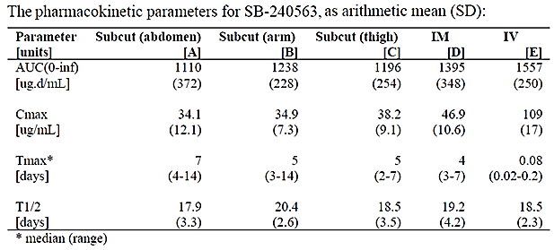
AUC: are under the curve, C_{max}: Maximum plasma concentration, T_{max}: Time to maximum plasma concentration T_{1/2}: Terminal half life

Bioavailability

Absolute bioavailability

Healthy subjects
The absolute bioavailability of a SC injection compared to IV mepolizumab in healthy subjects was also determined in Study SB-240563/018. The bioavailability of mepolizumab was 0.64, 0.75 and 0.71 following SC administration of 250 mg mepolizumab in the abdomen, arm and thigh, respectively (Table 2).

Table 2: Study SB-240563/018- bioavailability studies
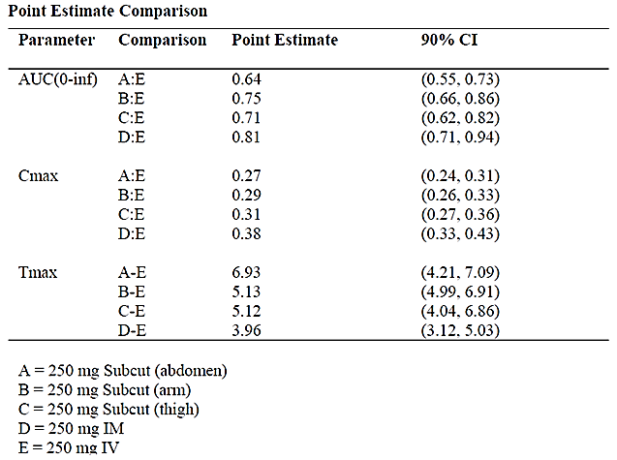

Asthmatic subjects
In subjects with asthma (Study MEA114092), the estimated absolute bioavailability, derived from the post hoc individual clearance (CL or CL/F) estimates for the SC and IV administration, of mepolizumab in the upper arm was 0.81, 0.82 and 0.64 for the 12.5, 125 and 250 mg SC cohorts, respectively (Table 3).

Table 3: Study MEA114092- estimates of absolute bioavailability for SB-240563 subcutaneous formulation
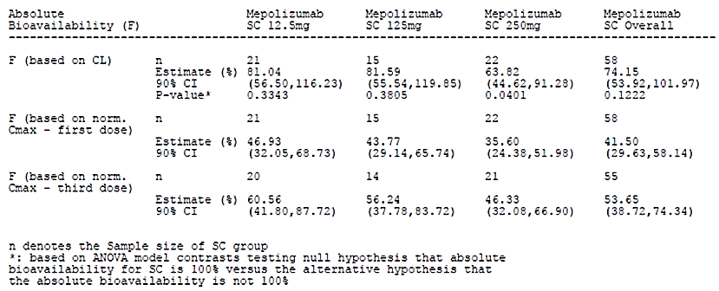
F: Absolute bioavailability CL: Plasma clearance CI: Confidence interval
Comment: This study examined mepolizumab PKs following administration of three SC dosage strengths (12.5, 125 and 250 mg). According to the sponsor the rationale for examining these doses is as follows: ‘The lowest dose was selected to be at or below the predicted dose that induced 50% of the maximum inhibition effect (ID₅₀) for the overall dose response for blood eosinophils reduction. Although this dose was expected to be below a mepolizumab dose showing clinical benefit in patients with severe asthma, it ensured that a dose response for the primary PD measure would be detected. The highest dose of 250 mg of mepolizumab was predicted to fall at the top of the dose response curve, thereby confirming the maximum response (maximum change from baseline in blood eosinophils; E_{max}).’
The Phase III Study MEA115588 also examined the absolute bioavailability of mepolizumab in subjects with severe eosinophilic asthma; the bioavailability following the proposed 100 mg SC dose of mepolizumab was estimated to be 0.80 (90% Confidence Interval [CI]: 0.76 to 0.84), which was in close agreement with the results for a 125 mg SC dose in Study MEA114092.

Bioavailability relative to an oral solution or micronised suspension
Not applicable.

Bioequivalence of clinical trial and market formulations
Comment: As mentioned in the Formulation Development section of this report, two forms of mepolizumab drug substance were primarily used in the clinical trials (MDS1 and MDS2). Both of the new studies (MEA115705 and MEA114092) and the previously evaluated studies (SB-240563/018 and SB-240563/017) used MDS1. However, no PK studies contained in the evaluation materials examined the bioequivalence between SC doses of MDS1 and the proposed commercial formulation, that is MDS2, and no biowaiver has been applied for.

Bioequivalence of different dosage forms and strengths
Not applicable.

Bioequivalence to relevant registered products
Not applicable.

Influence of food
No food studies have been undertaken as the SC administration route is unaffected by food.

Dose proportionality

Asthmatic subjects
Study MEA114092 examined dose proportionality following SC doses, administered in the upper arm, of 12.5 mg, 125 mg or 250 mg mepolizumab on three occasions (every 4 weeks) in 70 asthmatic subjects. The mepolizumab area under the concentration - time curve (AUC) and C_{max} values increased in a less than dose proportional manner following each of the three monthly SC doses, in particular between the SC doses of 125 and 250 mg (Table 4).

Table 4: Study MEA114092- mepolizumab derived pharmacokinetic parameters
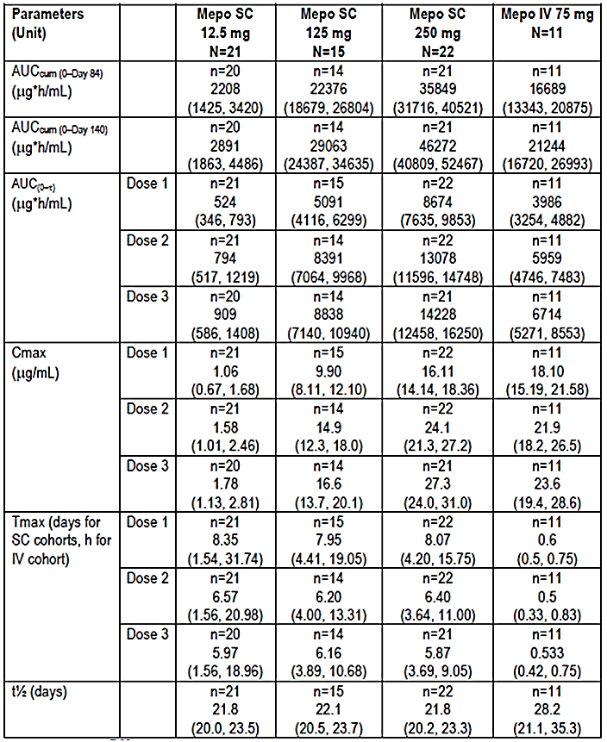

Bioavailability during multiple-dosing

Asthmatic subjects
Study SB-240563/017 examined the PKs of mepolizumab in asthmatic subjects following 3 doses of 250 mg mepolizumab injected SC in the anterior, lateral abdominal wall. The 3 doses were administered at the beginnings of Week 1, Week 6 and Week 8. The results indicated that the mean AUC and C_{max} were approximately 65% and 80%, respectively, higher after the third dose than following the first dose (Table 5).

Table 5: Mean (SD) pharmacokinetic parameters for SB-240563 following single or repeated subcutaneous administration of 250 mg SB-240563
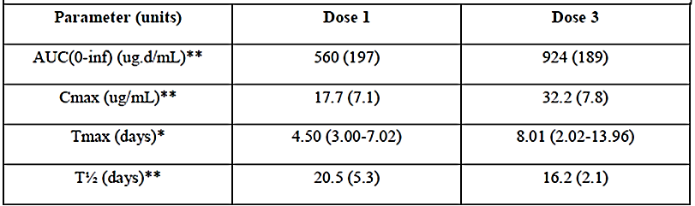

Asthmatic subjects
Study MEA114092 also examined the dose-normalised C_{max} ratio between the SC and IV route following the first and third dose administered. The results indicated that the dose-normalised C_{max} ratio after the first dose administered was 47%, 44% and 36% for the 12.5, 125 and 250 mg SC cohorts, respectively. Whereas, following administration of the third dose the dose-normalised C_{max} ratio was 61%, 56% and 46% for the 12.5, 125 and 250 mg SC cohorts, respectively (Table 4).
Comment: These results indicate that there was accumulation in C_{max} following the initial and final doses, which was most likely due to the long half-life of mepolizumab following SC administration.

Phase III studies
Two Phase III trials (MEA115575 and MEA115588) estimated mepolizumab accumulation following SC doses of 100 mg mepolizumab given every 4 weeks in subjects with severe eosinophilic asthma. In Study MEA115575, the geometric mean ratio of individual predicted C_{trough} Week 20/Week 4 was 1.98 (95% CI: 1.33 to 2.70) and for Week 24/Week 4 was 1.94 (1.19 to 2.78). In Study MEA11558 the accumulation ratio for C_{trough} at Week 16/Week 4 was 1.72 (1.05 to 2.46) and at Week 32/Week 4 was 1.65 (0.683 to 2.78).

Effect of administration timing
Not applicable.

Distribution

Volume of distribution

Asthmatic subjects
The PPK analysis undertaken as part of Study MEA114092 indicated that following SC administration of mepolizumab in subjects with asthma, the mepolizumab plasma concentration-time data could be well described by a two-compartment model with first order absorption and first order elimination. The apparent volume of distribution at steady state (4.57 L, Table 6) for a subject weighing 70 kg, was equal to the plasma volume plus the interstitial space, indicating that there was limited drug distribution into the tissues.

Table 6: Study MEA114092- mepolizumab population pharmacokinetic parameter estimates from the subcutaneous population pharmacokinetic analysis
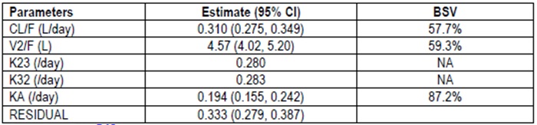
CF/L = apparent clearance, V2/F = apparent volume of central compartment, K23 = rate constant (from central to peripheral compartment), K32 = rate constant (from peripheral to central compartment), NA = not applicable, CI = confidence interval, BSV: between subject variability.

Plasma protein binding
Not applicable.

Erythrocyte distribution
Not applicable.

Tissue distribution
Based on the volume of distribution, distribution to the tissues is expected to be limited.

Metabolism

Interconversion between enantiomers
Not applicable.

Sites of metabolism and mechanisms / enzyme systems involved
Not applicable.

Non-renal clearance
Not applicable.

Metabolites identified in humans
Not applicable.

Excretion

Routes and mechanisms of excretion
Following SC administration in asthmatic subjects (Study MEA114092), mepolizumab was cleared slowly with an apparent clearance of 0.31 L/day. Mepolizumab T_{max} was reached approximately 6 to 8 days following administration and the CL/F and V/F were dose independent (Table 6.

Mass balance studies
Not applicable.

Renal clearance
Not applicable.

Intra- and inter-individual variability of pharmacokinetics
The PPK analysis undertaken as part of Study MEA114092 provided estimates of between subject variability on CL/F, V2/F and KA following SC administration of mepolizumab in the upper arm of 58%, 59% and 87%, respectively, and an estimated residual variability of 0.333(standard deviation) (Table 6).

Pharmacokinetics in the target population
Please see the preceding sections of this report.

Pharmacokinetics in other special populations

Pharmacokinetics in subjects with impaired hepatic function
Not applicable.

Pharmacokinetics in subjects with impaired renal function
Not applicable.

Pharmacokinetics according to age
Age related differences in mepolizumab PKs were not examined following SC injection of mepolizumab. However, the PPK study (2014N210473_00) examined whether adult mepolizumab PKs following IV administration are predictive of paediatric mepolizumab PKs following IV administration. The results indicated that there was a close correlation between the two populations following IV dosing using both linear and non-linear techniques to model the data set.
Comment: It is difficult to gauge whether the IV findings in Study 2014N210473_00 are predictive of mepolizumab PKs following SC injection in adult and paediatric populations as the PKs of mepolizumab following SC injection are clearly different to those following administration via the IV route (please see Table 2 and Table 5 for a comparison of mepolizumab PKs following IV and SC administration in healthy subjects and subjects with asthma, respectively).

Pharmacokinetics related to genetic factors
Differences in mepolizumab PKs related to genetic factors were not examined following SC injection.

Pharmacokinetics in other special population / according to other population characteristic

Race
Race related differences in mepolizumab PKs were not examined following SC injection. However Study MEA115705 assessed the PK of mepolizumab after single, ascending, IV doses of mepolizumab at 10, 75, 250 and 750 mg in healthy Japanese males. The results indicated that following IV injection there were proportional increases in AUC_{0-inf} and C_{max} with dose in Japanese males (Table 7).

Table 7: Study MEA115705- exploratory dose-proportionality statistical analyses for AUC (0 to ∞) and C_{max}
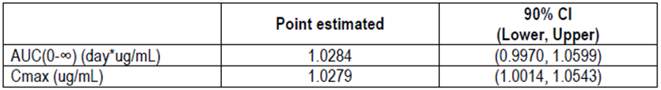
Comment: Once again it is difficult to determine the relevance of the IV results from Study MEA115705 in relation to SC dosing as the results of Study MEA114092 indicate that following SC dosing in subjects with asthma, the increases in C_{max} and AUC with dose are less than dose proportional.

Pharmacokinetic interactions

Pharmacokinetic interactions demonstrated in human studies
No drug interaction studies have been conducted because mepolizumab has a low potential for drug-drug interactions.

Clinical implications of in vitro findings
Not examined.

Evaluator’s overall conclusions on pharmacokinetics
Nucala (mepolizumab) is a humanised monoclonal IgG directed against human IL-5 and is presented as a sterile lyophilised powder for SC injection.

Absorption, distribution, metabolism and excretion
- Following a single SC administration of 250 mg mepolizumab in the abdomen, arm or thigh the mean mepolizumab plasma concentration-time profiles were similar in shape and the T_{max} ranged from 5 to 7 days.
- In healthy subjects, following SC administration of 250 mg mepolizumab in the abdomen, arm or thigh, the absolute bioavailability of mepolizumab was 0.64, 0.75 and 0.71, respectively.
- In subjects with asthma, the absolute bioavailability of mepolizumab following SC administration of 12.5, 125 or 250 mg mepolizumab in the upper arm was 0.81, 0.82 and 0.64, respectively.
- No food studies have been undertaken as the SC administration route is unaffected by food.
- In subjects with asthma, following SC doses of 12.5 mg, 125 mg or 250 mg mepolizumab in the upper arm on three occasions (every 4 weeks), mepolizumab AUC and C_{max} values increased in a less than dose proportional manner following each of the three monthly SC doses.
- In healthy subjects, following three SC doses of 250 mg mepolizumab in the anterior, lateral abdominal wall, the mean AUC and C_{max} were approximately 65% and 80%, respectively, higher after the third dose than following the first dose.
- In subjects with asthma administered three SC doses of 12.5, 125 or 250 mg mepolizumab given at monthly intervals, C_{max} was approximately 68%, 68% and 69% higher, respectively, after the third dose than the first dose and AUC_{0-tau} was 73%, 74% and 64% higher, respectively.
- PPK analysis in subjects with asthma indicated that following SC administration, mepolizumab plasma concentration-time data was well described by a two compartment model with first order absorption and first order elimination. The volume of distribution at steady state, for a subject weighing 70 kg, was equal to the plasma volume plus the interstitial space, indicating that there was limited drug distribution into the tissues.
- In asthmatic subjects following SC administration, mepolizumab was cleared slowly with an estimated clearance of 0.31 L/day and the CL/F and V/F were dose independent.

Intra- and inter-individual variability
The results of a PPK analysis indicated that the inter-subject variability on CL/F, V2/F and KA following SC administration of mepolizumab in the upper arm were 58%, 59% and 87%, respectively, and there was an estimated residual variability of 0.333.

Special populations
- No PK studies examined the effects of hepatic or renal impairment on the PKs of mepolizumab; however, as mepolizumab is an IgG these factors are unlikely to affect mepolizumab PKs.
- No studies examined the effects of age and race on mepolizumab PKs following SC injection.
- Following IV injection, there was close correlation between mepolizumab PKs in adult and paediatric populations.
- Following IV injection, increases in AUC_{0-inf} and C_{max} were dose-proportional in Japanese males.

Drug-drug Interactions
- Mepolizumab has a low potential for drug-drug interactions.

Limitations of PK studies
- None of the studies examined the PKs of mepolizumab following SC administration in healthy subjects.
- Data regarding the effects of race and age on mepolizumab PKs is available following IV administration only, even though the PKs of mepolizumab are clearly different following dosing via the SC and IV routes.
- No studies have been conducted comparing SC administration of the clinical trial form of mepolizumab (MDS1) and the formulation proposed for marketing (MDS2), nor has a request for a biowaiver been presented as part of the evaluation materials.

Questions regarding the PK studies
As mentioned in the Formulation Development section of this report, two forms of mepolizumab drug substance were primarily used in the clinical trials (MDS1 and MDS2).. Studies MEA115705, MEA114092, SB-240563/018 and SB-240563/017 all used MDS1However, no PK studies contained in the evaluation materials examined the bioequivalence between SC doses of MDS1 and the proposed commercial formulation, that is MDS2, and no biowaiver has been applied for. Can the sponsor please justify why no bridging study between the trial and commercial formulations of mepolizumab has been conducted and/or why no application for a biowaiver has been made?

Pharmacodynamics

Studies providing pharmacodynamic data
Comment: None of the PK/PD studies examined the PDs of mepolizumab following SC administration in healthy subjects or the PD effects of the proposed commercial presentation of mepolizumab (MDS2) and only Study MEA114092 examined the mepolizumab PDs following SC administration of the clinical trial formulation of mepolizumab (MDS1) in asthmatic adults.
None of the PD studies had deficiencies that excluded their results from consideration.

Summary of pharmacodynamics
The information in the following summary is derived from conventional PD studies in humans unless otherwise stated.

Mechanism of action
Mepolizumab inhibits the bioactivity of IL-5 with nanomolar potency by blocking the binding of IL-5 to the alpha chain of the IL-5 receptor complex expressed on the eosinophil cell surface, thereby inhibiting IL-5 signalling and reducing the production and survival of eosinophils.

Pharmacodynamic effects

Primary pharmacodynamic effects
Study MEA114092 examined a range of PD effects following SC administration of the clinical trial formulation of mepolizumab (MDS1) in 70 asthmatic adults with documented evidence of eosinophilia within 12 months of screening and evidence of eosinophilia at screening ( > 0.3 cells 10⁹/L or ≥ 0.2 cells 10⁹/L).

Blood eosinophils
Following a single SC administration of 12.5 mg, 125 mg or 250 mg mepolizumab, levels of blood eosinophils decreased from baseline (pre-dose on Day 1) in all 3 SC dosage groups with pronounced depletion apparent by the first post-dose measurement on Day 3 (Figure 1). The decrease, based on the area under the absolute blood eosinophil time curve to Day 84 (AUEC_{eos(0 to Day 84)}), appeared to be dose-related with the 12.5 mg SC dose having a weaker effect than the 125 mg dose (Table 8). Following the highest SC dose (250 mg) however, there was little evidence of a greater effect on blood eosinophils levels beyond that seen at the 125 mg dose level. The decrease in blood eosinophils was relatively stable up until Day 28 post-dose when the subjects received a second SC dose of mepolizumab. A third dose was administered on Day 56 and blood eosinophils levels did not begin to return to baseline until Days 70 or 84 (that is 2 to 4 weeks following the final dose) and by Day 140 (follow up) they still had not completely returned to pre-dose (baseline) levels following all 3 SC doses of mepolizumab. More specifically, the percentage of subjects who reached ≥ 50% blood eosinophil repletion by Day 140 ranged from 7% to 9% in the groups receiving SC doses of ≥ 125 mg. By contrast, 38% of subjects receiving the 12.5 mg dose had reached ≥ 50% blood eosinophil repletion by Day 140 (Table 8).
Based on the non-linear (Imax) model, the proportions of baseline blood eosinophil levels remaining at Week 12 (Day 84) were comparable between the 125 mg SC and 250 mg SC groups (0.14 and 0.12, respectively), whereas, in the 12.5 mg SC group the proportion of baseline blood eosinophil levels remaining at Week 12 was 0.43 (Table 9). The dose inducing 90% of the maximum inhibitory effect attributable to the drug at Week 12 was estimated to be 99 mg SC, whereas, the dose inducing 50% of the maximum inhibitory effect at week 12 was estimated to be 11 mg SC.
Two Phase III trials (MEA115575 and MEA115588) also examined the effects of SC mepolizumab on blood eosinophils. Both studies were conducted in subjects with severe eosinophilic asthma and although placebo had little to no effect on blood eosinophils levels 4 weeks after the first dose, following a 100 mg SC dose of mepolizumab blood eosinophils levels had decreased by approximately 80% by Week 4.
Figure 1: Study MEA114092-mean absolute blood eosinophil data
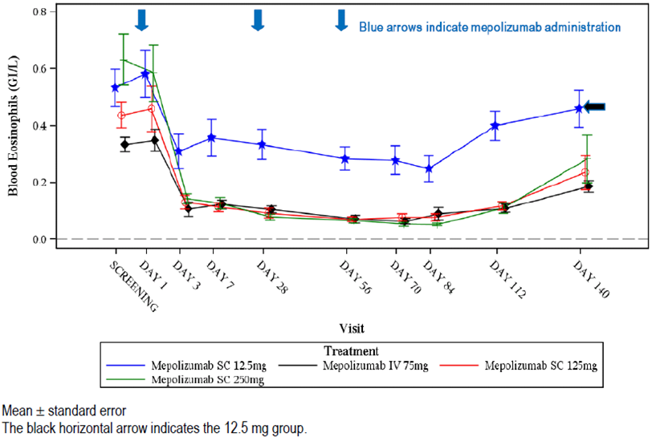

Table 8: Study MEA114092- summary of derived blood eosinophil parameters by treatment group
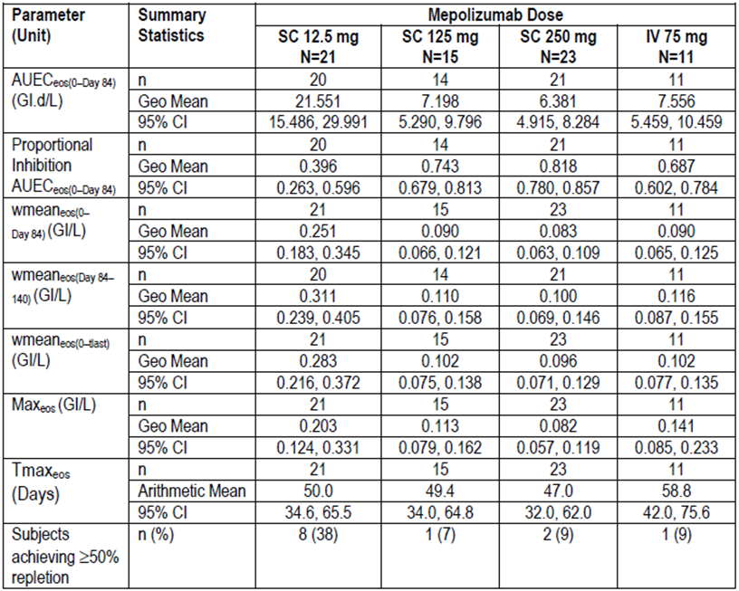
AUEC_{eos (0 to Day 84)} = area under the absolute blood eosinophil time curve to Day 84 determined using the linear trapezoidal rule, for subset of subjects with blood eosinophil data to Day 84. Geo = geometric; proportional inhibition AUEC_{eos (0-Day 84)} = area above the absolute blood eosinophil time curve to Day 84 as a proportion of the total area under the baseline blood eosinophil level to Day 84, for subset of subjects with blood eosinophil data to Day 84. Wmean_{eos (0 to Day 84)} = weighted mean absolute blood eosinophil levels (Day 0 to 84 or last day with available eosinophil data prior to Day 84. Wmean_{eos (Day 84 to 140)} = weighed mean absolute blood eosinophil levels (Day 84 to 140). Wmean_{eos (0 to tlast)} = weighed mean absolute blood eosinophil levels (Day 0 to last quantifiable measurement). Max_{eos} = maximum reduction from baseline in blood eosinophil levels (between Day 0 and last quantifiable measurement). Tmax_{eos} = time to first occurrence of maximum reduction from baseline in blood eosinophil levels (between Day 0 and last quantifiable measurement). CI = confidence interval.

Table 9: Study MEA114092- analysis of change from baseline in log₁₀-transformed blood eosinophil levels at Week 12 (Day 84): non-linear (Imax) dose-response model
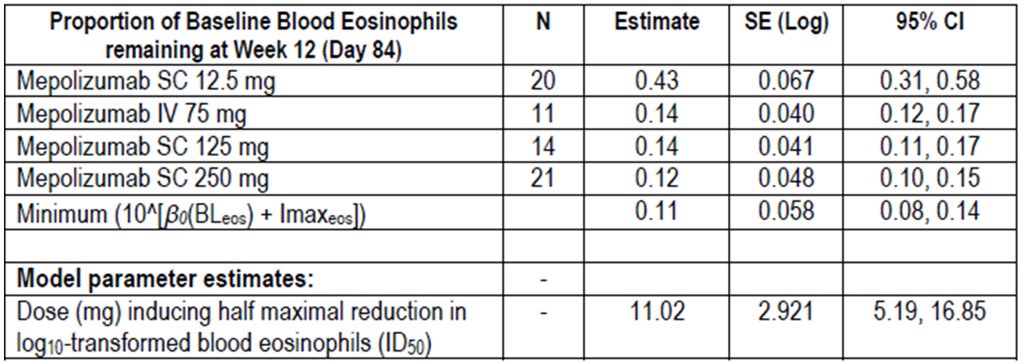
CI = Confidence interval. Mepolizumab IV 75 mg was assumed to equate with 100 mg SC with the model.

Induced sputum
The pattern of the effect of SC mepolizumab on induced sputum was similar to that seen for the effect on blood eosinophils (Figure 2). There was a dose dependent decrease in sputum eosinophils following SC doses of 12.5 mg and 125 mg mepolizumab. At the highest doses (250 mg) the decrease in sputum eosinophils was similar to that seen at the 125 mg dose. Depletion was observed from the first post-dose measurement on Day 7 to Day 84 following all 3 SC doses. Levels of sputum eosinophils started to return to pre-dose after Day 56 (third infusion) in the 12.5 mg group, however, by Day 84 they had not returned to baseline levels.
The geometric mean proportional inhibition AUEC_{speos(0 to Day 84)} was highest following the 250 mg SC dose of mepolizumab (0.693), whereas, the weighted mean_{speos(0–Day 84)} (1.368%) and Max_{speos} percent sputum eosinophil values (0.025%) were lowest following the 125 mg SC dose (Table 10).
Figure 2: Study MEA114092- induced sputum eosinophil data (%) (Post-Baseline/Baseline ratio)
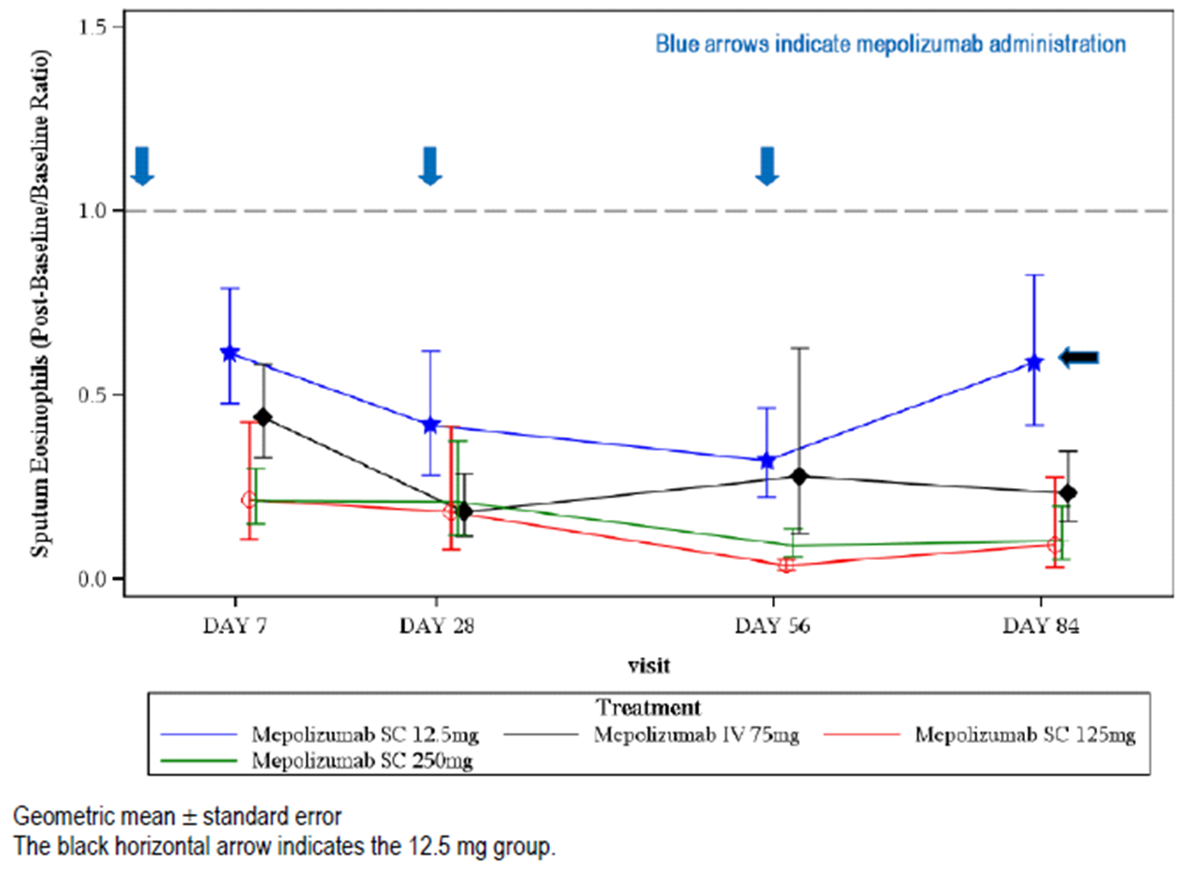

Table 10: Study MEA114092- summary of derived percent sputum eosinophil parameters by treatment group
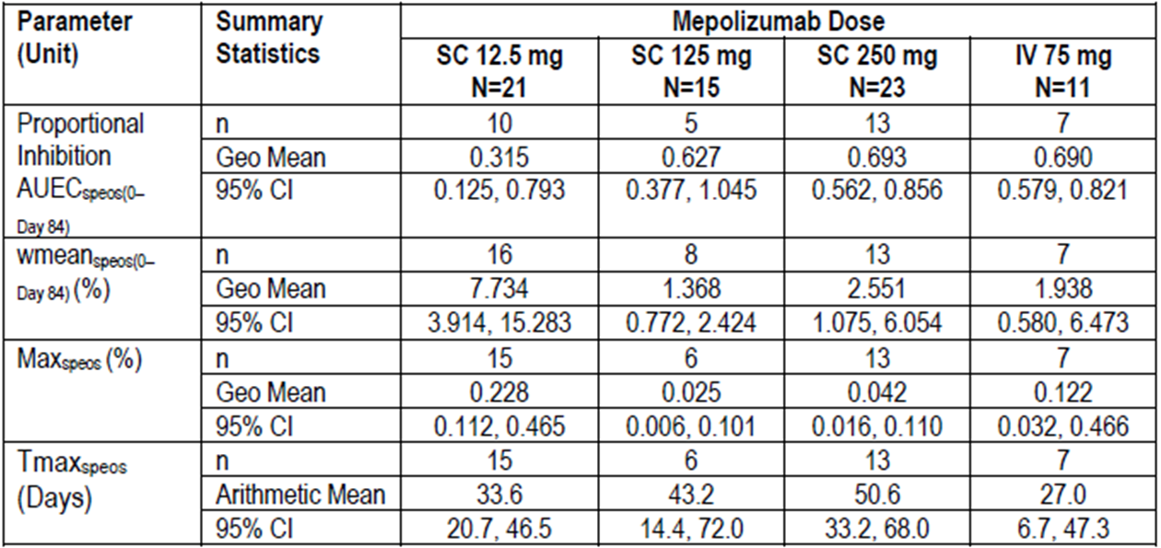
Geo = geometric proportional inhibition AUEC_{speos (0-Day 84)} = area above the absolute blood eosinophil time curve to Day 84 as a proportion of the total area under the baseline blood eosinophil level to Day 84, for subset of subjects with blood eosinophil data to Day 84. Wmean_{speos (0 to Day 84)} = weighted mean absolute blood eosinophil levels (Day 0 to 84 or last day with available eosinophil data prior to Day 84. Max_{speos} = maximum reduction from baseline in blood eosinophil levels (between Day 0 and last quantifiable measurement). Tmax_{speos} = time to first occurrence of maximum reduction from baseline in blood eosinophil levels (between Day 0 and last quantifiable measurement). CI = confidence interval.

Total and Free IL-5
Serum total IL-5 levels could not be measured at baseline in most subjects with only 14%, 13% and 4% of subjects having measurable levels at baseline in the 12.5 mg SC, 125 mg SC and 250 mg SC cohorts, respectively. Post-mepolizumab dosing, serum total IL-5 levels increased from baseline in almost all subjects up to Day 28; two subjects did not show increased serum total IL-5 levels from baseline post-mepolizumab (Subject [information redacted; mepolizumab 12.5 mg SC]: levels below LLQ throughout the study; Subject [information redacted; mepolizumab 250 mg SC]: levels decreased up to Day 28 and fluctuated thereafter) (Figure 3). Serum total IL-5 levels then remained constant up to Day 140 in all groups except in the 12.5 mg SC group. After Day 70 a decrease in serum total IL-5 levels was observed in the 12.5 mg SC cohort although levels did not return to baseline by Day 140.
No clear relationship was observed between serum total IL-5 and blood eosinophils based on the exploratory plots and correlation analyses, suggesting that total IL-5 was not a useful biomarker for monitoring eosinophilic inflammation.
Serum free IL-5 was also difficult to detect at baseline in most of the subjects examined, with only 5%, 7% and 9% of subjects having measurable levels at baseline in the 12.5 mg SC, 125 mg SC, and 250 mg SC cohorts, respectively. A general increase over time in the percentage of subjects with measurable serum free IL-5 was observed in the 12.5 mg SC group as well as on days 112 and 140 in the other treatment groups. However the majority of these values were less than three times the LLQ of the assay (3.91 pg/mL).
Figure 3: Study MEA114092- serum Interleukin-5 (Total) data (Log₁₀ scale)
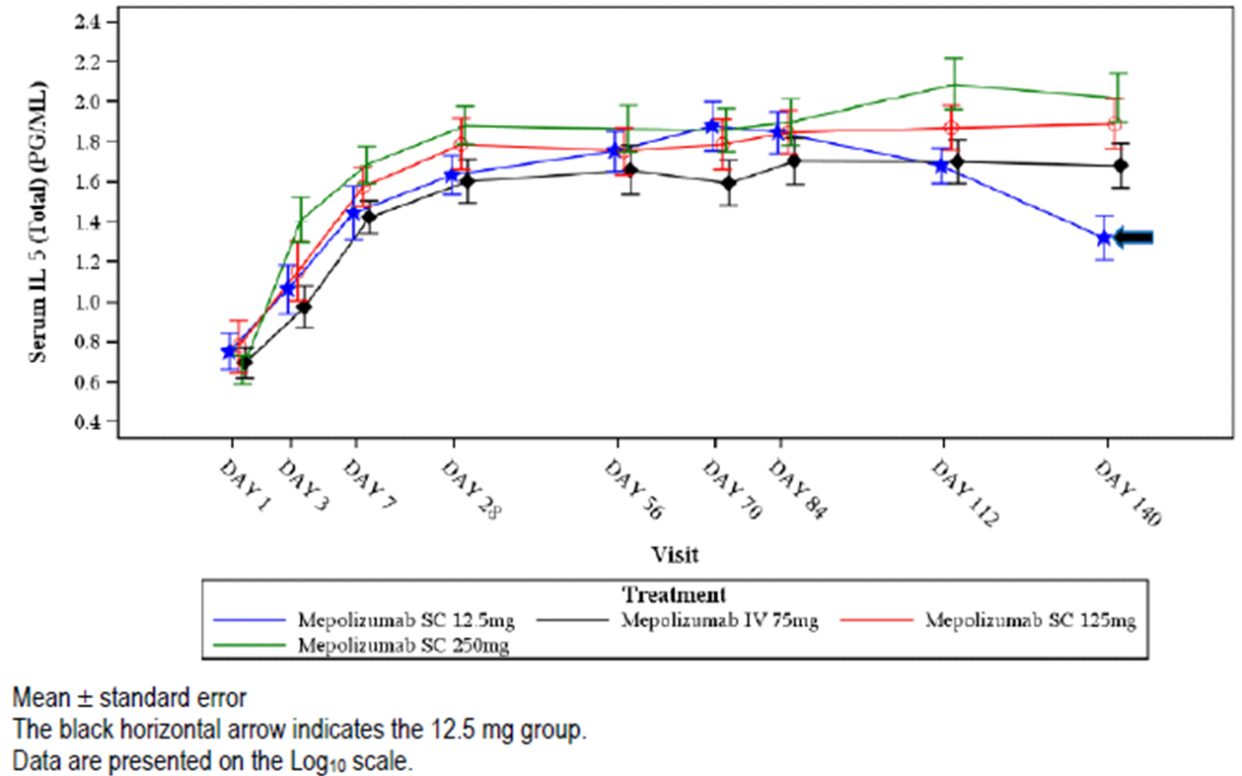

Secondary pharmacodynamic effects
Not examined.

Time course of pharmacodynamic effects
Following SC doses of 12.5 mg, 125 mg or 250 mg mepolizumab in subjects with asthma, there was a pronounced decrease in blood eosinophils levels from baseline (pre dose on Day 1) in all 3 SC dosage groups by the first post-dose measurement on Day 3 (Figure 1). The time to the maximum reduction in percent sputum eosinophil levels (Tmax_{speos}) following repeat SC administration of mepolizumab ranged from 33.6 to 50.6 days (Table 9). Similarly, a depletion in induced sputum was observed from the first post-dose measurement on Day 7 (Figure 2) following all 3 SC doses of mepolizumab.

Relationship between drug concentration and pharmacodynamic effects
There was a clear relationship between blood eosinophil levels and plasma concentrations of mepolizumab, which was further explored in a population PK/PD analysis (Figure 4). Blood eosinophil data were well described by an indirect response model. The estimate of the concentration associated with 50% maximal effect (IC₅₀) was 1.26 µg/mL (Table 12). By contrast, no clear relationship was observed between serum total IL-5 and mepolizumab plasma concentrations.
Figure 4: Study MEA114092- population, individual predicted and observed blood eosinophil levels after three subcutaneous or intravenous administrations of mepolizumab at different doses
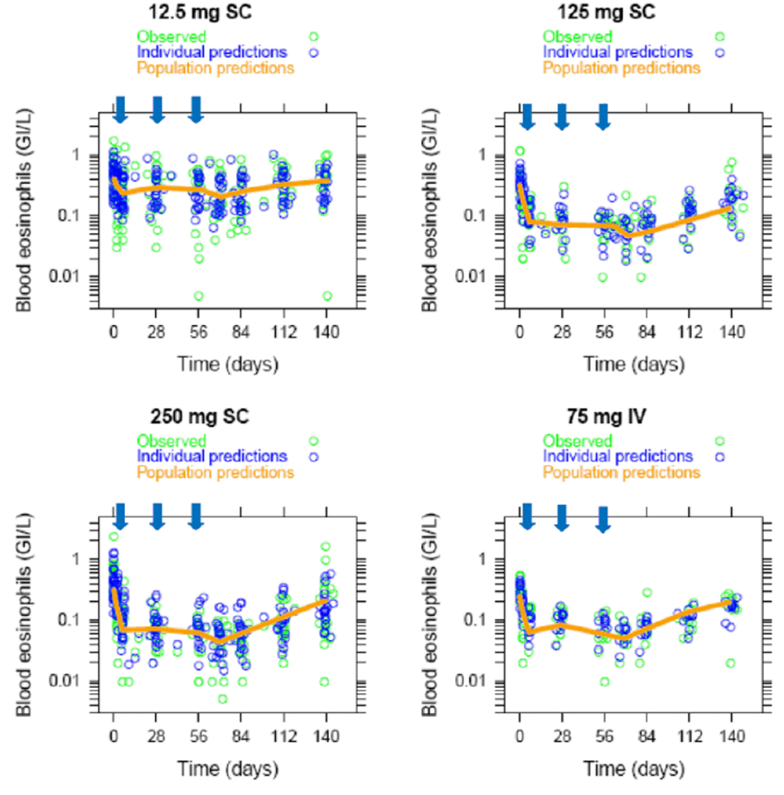
Blue arrows indicate mepolizumab administration.

Table 12: Study MEA114092- population pharmacodynamics parameter estimates from the population PK/PD analysis
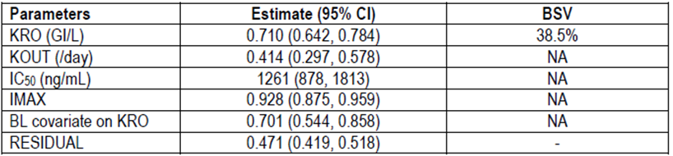
KRO = blood eosinophils baseline; KOUT = blood eosinophils rate of elimination; IC₅₀ = concentration inducing 50% of the maximum inhibitory effect; IMAX = maximum inhibitory effect; BL = baseline

Genetic-, gender- and age-related differences in pharmacodynamic response
Not examined.

Pharmacodynamic interactions
Not examined.

Evaluator’s overall conclusions on pharmacodynamics

Mechanism of action
- Mepolizumab inhibits the bioactivity of IL-5 by blocking the binding of IL-5 to the alpha chain of the IL-5 receptor complex expressed on the eosinophil cell surface, thereby inhibiting IL-5 signalling and reducing the production and survival of eosinophils.

Effect on blood eosinophils
- Following a single SC administration of 12.5 mg, 125 mg or 250 mg mepolizumab, there was a pronounced decrease in blood eosinophils levels in all 3 SC dosage groups.
- The decrease, based on AUEC_{eos(0 to Day 84)}, appeared to be dose-related with the 12.5 mg SC dose having a weaker effect than the 125 mg dose. Following the highest SC dose (250 mg) however, there was little evidence of a greater effect on blood eosinophils levels beyond that seen at the 125 mg dose level.
- The decrease in blood eosinophils was relatively stable up until Day 28 post dose when the subjects received a second SC dose of mepolizumab.
- By Day 140, following 3 doses of mepolizumab given once every 4 weeks, blood eosinophil levels had not completely returned to pre-dose and the percentage of subjects who reached ≥ 50% blood eosinophil repletion by Day 140 ranged from 7% to 9% in the groups receiving SC doses of ≥ 125 mg. By contrast, 38% of subjects receiving the 12.5 mg dose had reached ≥ 50% blood eosinophil repletion by Day 140.
- The SC dose of mepolizumab that induced 90% of the maximum inhibitory effect attributable to the drug at Week 12 was estimated to be 99 mg, whereas, the dose inducing 50% of the maximum inhibitory effect at week 12 was estimated to be 11 mg SC.

Effect on induced sputum
- There was a dose dependent decrease in sputum eosinophils following SC doses of 12.5 mg and 125 mg mepolizumab. At the highest doses (250 mg) the decrease in sputum eosinophils was similar to that seen at the 125 mg dose.
- The geometric mean proportional inhibition AUEC_{speos(0 to Day 84)} was highest following the 250 mg SC dose of mepolizumab (0.693), whereas, the weighted mean_{speos(0 to Day 84)} (1.368%) and Max_{speos} percent sputum eosinophil values (0.025%) were lowest following the 125 mg SC dose.

Effect on total and free IL-5
- Following a single SC dose of 12.5 mg, 125 mg or 250 mg mepolizumab, serum total IL-5 levels increased from baseline in almost all subjects up to Day 28. Following 3 doses, serum total IL-5 levels remained constant up to Day 140 in all groups except in the 12.5 mg SC group. After Day 70 a decrease in serum total IL-5 levels was observed in the 12.5 mg SC cohort although levels did not return to baseline by Day 140.
- A general increase over time in the percentage of subjects with measurable serum free IL-5 was observed in the 12.5 mg SC group as well as on days 112 and 140 in the other treatment groups.

Time course of PD effects
- Following SC doses of mepolizumab in subjects with asthma, there was a pronounced decrease in blood eosinophils levels from baseline by the first post-dose measurement on Day 3.
- The Tmax_{speos} following a single SC administration of 12.5 mg, 125 mg or 250 mg mepolizumab ranged from 33.6 to 50.6 days.
- A depletion in induced sputum was observed from the first post-dose measurement on Day 7.

Relationship between drug concentration and PD effects
- There was a clear relationship between blood eosinophil levels and plasma concentrations of mepolizumab.
- The IC₅₀ for the inhibition of blood eosinophils was 1.26 µg/mL.
- No clear relationship was observed between serum total IL-5 and mepolizumab plasma concentrations.

Limitations of PD studies
- No PK/PD studies have examined the PDs of the formulation of mepolizumab proposed for marketing.
- No thorough QT analysis has been conducted following SC doses of mepolizumab.

Dosage selection for the pivotal studies

Study MEA112997 (DREAM)

Study design, objectives, locations and dates
This was a Phase IIb/III, multi-centre, randomised, double-blind, placebo-controlled, parallel-group, dose-ranging study to determine the effect of mepolizumab on exacerbation rates in patients with severe uncontrolled refractory asthma. It was conducted at 81 centres in 13 countries (Argentina, Australia, Canada, Chile, France, Germany, Korea, Poland, Romania, Russia, Ukraine, UK, and USA) between November 2009 and December 2011. The primary objective was to evaluate the efficacy and safety of three doses of mepolizumab (75 mg, 250 mg and 750 mg) given IV in adult and adolescent patients aged 12 years or older over a 52 week treatment period. The study schematic is shown below in Figure 5. A total of 604 patients with a confirmed diagnosis of refractory asthma with documented pulmonary function testing were planned. They were required to have had at least two exacerbations requiring treatment with oral or systemic corticosteroids in the previous 12 months. In addition, they were required to have received treatment with high dose ICS and another controller for at least 12 months. After a 2 week run-in period, eligible patients underwent pulmonary function tests at Week 0 and were randomised to receive one of the four treatments. Visits were then scheduled every 4 weeks until Week 48 (giving 52 weeks of exposure) with an additional follow-up visit at Week 56. At each visit, exacerbations and electronic diary (eDiary) data were reviewed, spirometry was performed, and Asthma Control Questionnaires (ACQ-6) were completed. Adverse events were captured on paper diaries throughout the study and assessed at each study visit.
Figure 5: Study MEA112997 study schematic
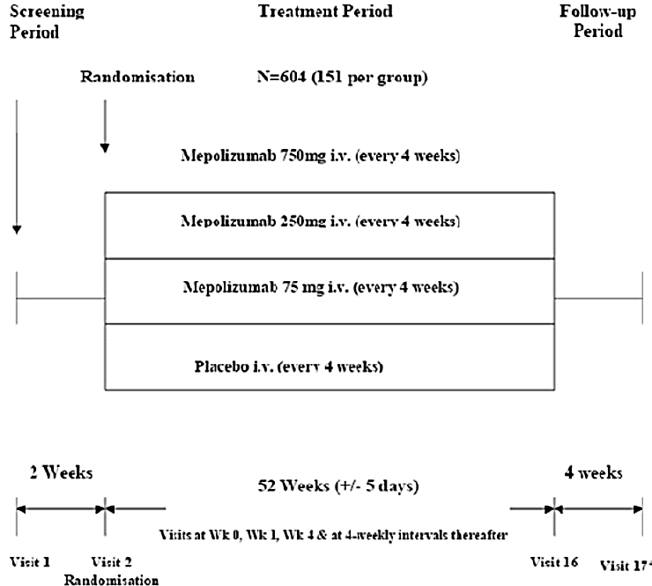
Comment: There is no universally agreed definition of severe refractory asthma but the sponsor adopted a practical working definition for use in clinical trials proposed by the American Thoracic Society (ATS) in 2000. This definition comprises two major and seven minor characteristics as shown in Table 13. The major characteristics require continuous or near continuous treatment with OCS and/or continuous treatment with high dose ICS to achieve acceptable asthma control.

Table 13: Refractory asthma: workshop consensus for typical clinical features
Drug | Dose (μg/d ) | Dose (puffs/d)
a. Beclomethasone dipropionate | > 1,260 | > 40 puffs (42 μg/inhalation  > 20 puffs (84 μg/inhalation
b. Budesonide | > 1,200 | > 6 puffs
c. Flunisolide | > 2,000 | > 8 puffs
d. Fluticasone propionate | >880 | > 8 puffs (110 μg), > 4 puffs (220 μg)
e. Triamcinolone acetonide | >2,000 | > 20 puffs
Requires that other conditions have been excluded, exacerbating factors treated, and patient felt generally adherent. Definition of refractory asthma requires one or both major criteria and two minor criteria.

Major Characteristics
In order to achieve control to a level of mild–moderate persistent asthma:
- Treatment with continuous or near continuous (⩾ 50% of year) oral corticosteroids
- Requirement for treatment with high-dose inhaled corticosteroids:

Minor Characteristics
- Requirement for daily treatment with a controller medication in addition to inhaled corticosteroids, e.g., long-acting β-agonist, theophylline, or leukotriene antagonist
- Asthma symptoms requiring short-acting β-agonist use on a daily or near daily basis
- Persistent airway obstruction (FEV1 < 80% predicted; diurnal PEF variability > 20%)
- One or more urgent care visits for asthma per year
- Three or more oral steroid “bursts” per year
- Prompt deterioration with ⩽ 25% reduction in oral or inhaled corticosteroid dose
- Near fatal asthma event in the past

Inclusion and exclusion criteria
The main inclusion criteria included: male or female patients aged 12 years or older; minimum body weight 45 kg; severe refractory asthma using ATS criteria for the previous 12 months; documented requirement for regular high dose ICS, with or without maintenance OCS for the previous 12 months; documented requirement for controller medication (long acting beta 2 agonist [LABA], leukotriene receptor antagonist or theophylline); Forced expiratory volume in one second (FEV₁) < 80% predicted or peak expiratory flow (PEF) diurnal variability of > 20% on three or more days during run-in; patients with likely eosinophilic airway inflammation (blood eosinophils ≥ 300/µL, sputum eosinophils ≥ 3%, exhaled nitric oxide [eNO] ≥ 50 parts per billion [ppb], or prompt deterioration of asthma control following a ≤ 25% reduction in regular maintenance dose of ICS or OCS in the previous 12 months); documented history of two or more exacerbations requiring oral or systemic corticosteroids in the previous 12 months; standard reversibility and airflow variability criteria; liver function tests (LFTs) ALT/AST< 2 x upper limit of normal (ULN) and ALP and bilirubin ≤ 1.5x ULN.
The main exclusion criteria were: current smokers or patients with a smoking history of ≥ 10 pack years; clinically important concomitant lung disease; malignancy; unstable liver disease; Churg-Strauss syndrome; protocol specified anti-inflammatory agents; omalizumab or other biological treatments for inflammatory disease within previous 4 months; regular use of oral or systemic corticosteroids for diseases other than asthma; treatment with other investigational drugs; any other clinically significant disease; history of alcohol abuse; parasitic infections within the previous 6 months; known immunodeficiency; previous poor compliance with controller medication.
Comment: The inclusion criteria required patients with refractory asthma with a history of at least two exacerbations in the previous year, and all were required to have maintenance high dose ICS. The study population met the ATS criteria for refractory eosinophilic asthma and the study partially addresses the proposed indication. However, although the proposed indication is for patients requiring maintenance OCS, the study population consisted of patients both with and without maintenance OCS treatment in the previous 12 months. In addition, the eosinophilia criteria were only loosely defined.

Study treatments
Patients received mepolizumab 75 mg, 250 mg, 750 mg or placebo given IV once every 4 weeks. Lyophilised mepolizumab for reconstitution was supplied as vials containing 250 mg per vial based on a withdrawal volume of 5 mL. Matching placebo vials contained normal saline solution. Randomisation and treatment preparation were performed by unblinded pharmacists.

Efficacy variables and outcomes
The occurrence of an exacerbation was assessed based on one or more of the following parameters (captured by eDiary):
- Frequency of exacerbations.
- Decrease in morning PEF.
- Increase in the use of rescue medication.
- Increase in the nocturnal awakenings requiring rescue medication.
- Increase in overall symptom score.
The primary efficacy outcome was the frequency of clinically significant exacerbations. An exacerbation was defined as worsening of asthma which in the investigator’s opinion required the use of oral or systemic corticosteroids and/or hospitalisation and/or ED visits.
Comment: This definition of exacerbation is based on a widely accepted definition proposed for use in clinical trials by Sears in 2008 (see References). It does not rely on pulmonary function tests but is broadly defined as worsening asthma of sufficient severity to require intervention from a medical professional, or require self-administration of OCS. This definition is also consistent with the joint statement on standardising endpoints for asthma clinical trials issued by the ATS and European Respiratory Society (ERS) (Reddell, 2009, see References).
Other efficacy outcomes included:
- Time to first exacerbation.
- Frequency of exacerbations requiring hospitalisation or ED visit.
- Frequency of exacerbations requiring hospitalisation.
- Mean change from baseline in FEV₁ and PEF.
- Mean change from baseline in daily short acting beta 2 agonist (SABA) use.
- Mean change from baseline in daily asthma symptom scores.
- Mean number of days with OCS.
- Mean change from baseline in ACQ-6 scores.
Comment: The ACQ consists of seven items which measure the frequency and severity of symptoms, the use of short acting rescue medications, and FEV₁ measurements. Shortened versions without FEV₁ measurement such as ACQ-6 and ACQ-5 are also commonly used in clinical trials. The minimal clinically important difference (MCID) is considered to be a change of ≥ 0.5 points.

Randomisation and blinding methods
The randomisation schedule was generated using a block size of eight, and central randomisation was performed via interactive voice response system (IVRS). Patients were stratified according to the use of maintenance OCS (Y/N). An unblinded site pharmacist prepared each assigned treatment by IVRS. Mepolizumab or matching placebo was administered by blinded site staff and all other study staff were blinded to the study treatment.

Analysis populations
The intent to treat (ITT) population included all randomised patients who received at least one dose of study medication. This population was used for the primary analysis of all efficacy and safety endpoints. The per protocol (PP) population consisted of all patients in the ITT population who did not have a major protocol violation. Criteria for violations were pre-defined and were documented before unblinding.

Sample size
A sample size of 128 patients completing each treatment arm had 90% power to detect a 40% decrease in the exacerbation rate from 1.5 events per annum for placebo and 0.9 events per annum for mepolizumab 750 mg at a 2 sided 5% significance level. To allow for a 15% withdrawal rate, a total of 151 randomised patients per treatment arm were planned. The anticipated exacerbation rates were based on previous exploratory mepolizumab studies.

Statistical methods
The statistical analyses were performed on the ITT population with the null hypothesis that there were no treatment differences between groups. The alternative hypothesis was tested using 95% CIs with a 2 sided significance level of alpha = 0.05. The exacerbation rates were analysed using a generalised linear model which assumed a negative binomial probability distribution for the number of exacerbations. Covariates in the model were treatment group, baseline maintenance OCS use (Y/N), geographical region, number of exacerbation in the previous year, and baseline disease severity measured by FEV₁. A Poisson regression sensitivity analysis was also performed using the same covariates. Time to first exacerbation in each treatment group was compared using a Cox’s proportional hazards model and Kaplan-Meier curves comparing exacerbations over time were constructed. Adverse events of special interest were summarised and the relative risks in each treatment group were calculated using the Cochran-Mantel-Haenszel method.
Multiplicity was controlled using a closed testing procedure which detected a linear trend of a decreasing exacerbation rate with increasing doses of mepolizumab. If this was significant at the 2 sided 5% significance level, each of the mepolizumab doses were compared with placebo using a one-sided Hochberg testing procedure with a 1 sided alpha of 2.5%. Multiplicity for secondary endpoints was also addressed using a hierarchical testing procedure and treatment comparisons were controlled using the 1 sided Hochberg procedure.
Comment: The importance of controlling for multiplicity was adequately addressed in the statistical analysis plan.

Participant flow
A total of 720 patients entered the run-in phase and 616 patients were randomised and received treatment (Table 14). In the ITT population, 84% of patients completed the study. The most common reasons for withdrawal were adverse events (AEs) (5%), lack of efficacy (4%), and withdrawal of consent (5%).

Table 13: Study MEA112997- summary of end of study record (Intent to Treat Population)
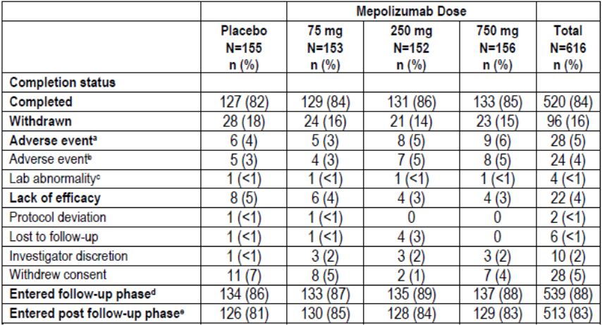
a. Subjects with an adverse event leading to permanent discontinuation of investigational product or withdrawal from study. b. Subjects with ̕Adverse event̕ as primary reason for withdrawal. c. Subjects with ̕Subject reached protocol defined stopping criteria̕ as primary reason for withdrawal and ̕lab abnormality̕ as secondary reason for withdrawal. d. Subjects who attended the Follow Up (Week 56) visit. e. Subjects who attended the Immunogenicity (Week 72) visit.

Major protocol violations/deviations
Two patients (< 1%) were withdrawn because of protocol violations and 25 (4%) patients were excluded from the PP population. The most common violation was receipt of the wrong study drug at any time point (2%).

Baseline data
Baseline demographics were well balanced as shown in Table 15. In the total population, most patients were female (63%) and White (90%) with a mean age of 48.6 years (range 15 to74). Most patients (78%) had never smoked. The mean duration of asthma was ≥ 5 years in 87% of patients. As shown in Table 16, blood and sputum eosinophilia were present in 59% and 10% of patients, respectively, and 43% of patients had high eNO concentrations. All patients were receiving high dose ICS and additional controllers, and 33% of patients were receiving long term maintenance OCS. Near fatal asthma events in the previous year had been experienced by 11% of the overall population. All except two patients (< 1%) had suffered at least two exacerbations in the previous year; 86% had exacerbations requiring two or more courses of oral or systemic corticosteroids; and 24% had at least one hospital admission (Table 16).

Table 14: Study MEA112997- summary of demographic characteristics
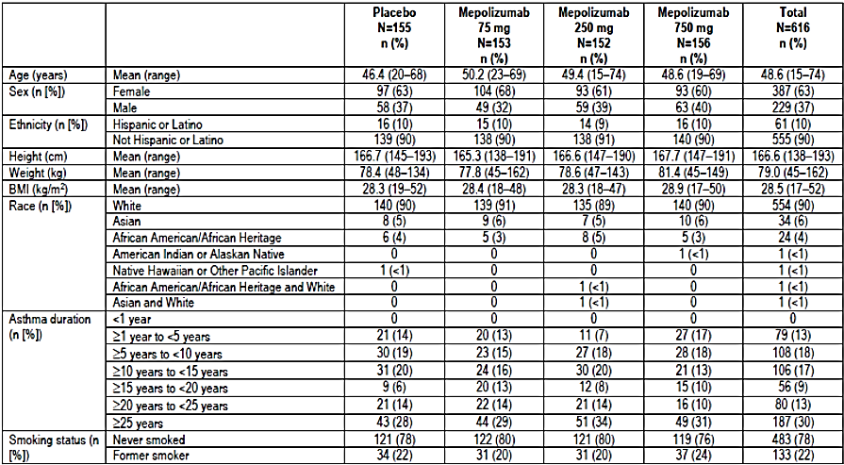
BMI: Body mass index

Table 15: MEA112997. Summary of asthma history and baseline disease characteristics
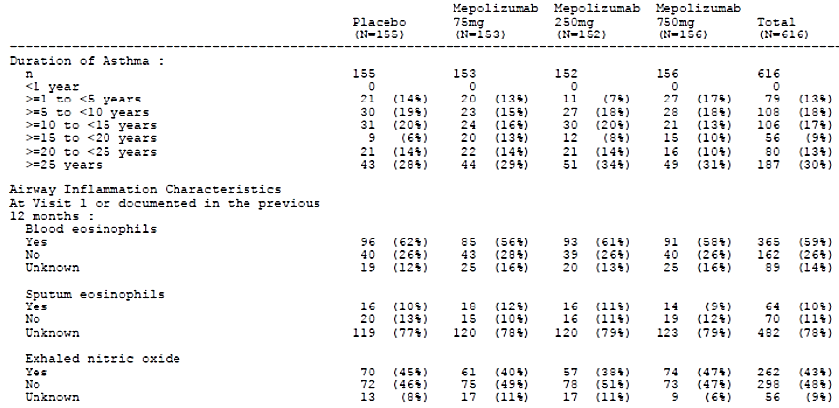
Subjects may have met more than one criterion. Note: Percentages are based on ̕n̕ for number of exacerbations requiring intubation and baseline maintenance OCS daily dose.

Table 15: cont
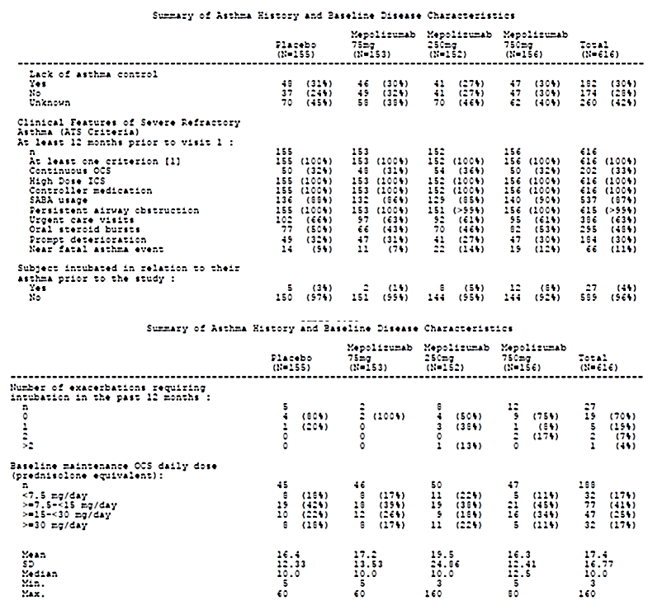

Table 16: MEA112997- summary of asthma exacerbation history
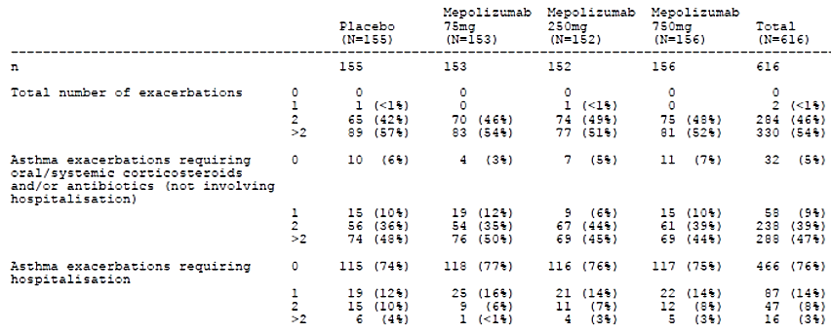
Note: Number of exacerbations reported in 12 months prior to Visit 1.
Comment: It is not clear from the tables if all patients met at least one of the inclusion criteria for severe eosinophilic asthma. In Table 18 the proportion of patients with blood eosinophils, sputum eosinophils and eNO are presented as Y/N without units of measurement. Moreover, one or more of the parameters were not present, or were unknown, in a significant proportion of patients. As an example, blood eosinophils were not recorded in 14% of the total group. This is surprising as baseline haematology was performed by a central laboratory (Quest) and presumably differential eosinophil counts were included in the panel. In the same table, the number of patients with ̕lack of asthma control̕ is reported. Presumably this refers to patients who had deterioration of asthma control following a ≤ 25% reduction in the regular maintenance dose of ICS or OCS but this should be confirmed. The observation that 11% of patients had a near fatal exacerbation in the previous year is an important factor in the overall risk-benefit assessment.

Table 17: Study MEA115588- asthma exacerbation history (ITT Population)
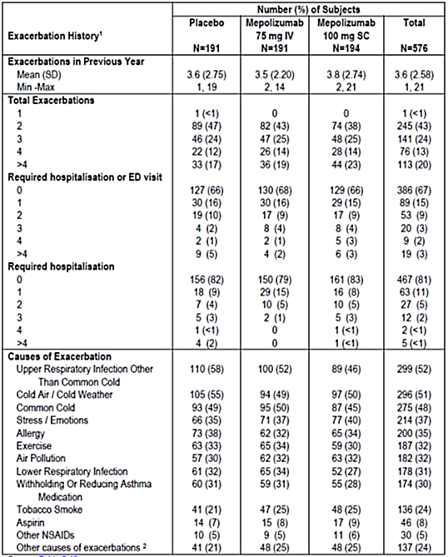
NSAIDs = Non-steroidal anti-inflammatory drugs. 1. Reported in the 12 months prior to screening (Visit 1). 2. Other causes of exacerbations were not defined and collected within the electronic case report form (eCRF).

Results for the primary efficacy outcome
The primary efficacy endpoint was achieved for all doses of mepolizumab compared with placebo (p < 0.001 for all comparisons). During the treatment period, the mean exacerbation rate in the placebo group was 2.40 per year, compared with 1.24, 1.46, and 1.15 per year in the mepolizumab 75 mg, 250 mg and 750 mg groups, respectively (Table 18). The reductions in favour of the mepolizumab groups were 48% (95% CI: 31, 61), 39% (95% CI: 19, 54) and 52% (95% CI: 36, 64), respectively. The reduction rates were similar in each mepolizumab group and no dose-response relationship was observed.
Statistical testing for multiplicity confirmed the benefit for each mepolizumab dose compared with placebo, and sensitivity analyses including the PP population confirmed the primary endpoint. All doses of mepolizumab conferred benefit irrespective of how the diagnosis of eosinophilic asthma was confirmed at baseline (blood eosinophilia ≥ 300/µL, sputum eosinophilia ≥ 3 %, eNO ≥ 50 ppb, deterioration of asthma control) (Table 19). Exploratory modelling showed that there was a significant interaction between baseline blood eosinophil count and treatment group (p = 0.002). As shown in Figure 6, patients with higher blood eosinophil counts had larger decreases in exacerbation rates. In patients with baseline blood eosinophil counts ≥ 150 cells/µL (a required component of the proposed indication), asthma exacerbation rates were reduced by 56% (95% CI: 42, 66) in the combined mepolizumab group compared with placebo (Table 20). Subgroup multivariate modelling showed that mepolizumab at all doses was superior to placebo irrespective of age, gender, geographic region, and baseline OCS use. There were no apparent racial differences although the number of patients other than White was too small to make meaningful comparisons.
The analysis based on previous OCS use is summarised in Table 21. In patients who did not previously receive maintenance OCS (69%), the mean exacerbation rate in the placebo group was 1.90 per year, compared with 0.99, 1.19 and 1.04 per year in the mepolizumab 75 mg, 250 mg and 750 mg groups, respectively. The rate ratios in the mepolizumab groups compared with placebo were 0.52 (95% CI: 0.36, 0.76), 0.63 (95% CI: 0.43, 0.91) and 0.55 (95% CI: 0.38, 0.79), respectively. In patients who did previously receive maintenance OCS (31%), the mean exacerbation rate in the placebo group was 3.14 per year, compared with 1.67, 1.76 and 1.22 per year in the mepolizumab 75 mg, 250 mg and 750 mg groups, respectively. The rate ratios in the mepolizumab groups compared with placebo were 0.53 (95% CI: 0.34, 0.83), 0.56 (95% CI: 0.37, 0.86) and 0.39 (95% CI: 0.25, 0.61), respectively.

Table 18: Study MEA112997- primary analysis of rate of clinically significant exacerbations
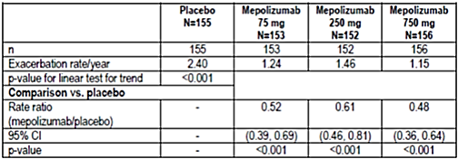
Linear test for trend test change in exacerbation rate with increasing dose of mepolizumab, with placebo assigned as dose zero.

Table 19: Study MEA112997- analysis of clinically significant exacerbations in the four sub-groups described in inclusion criterion 6
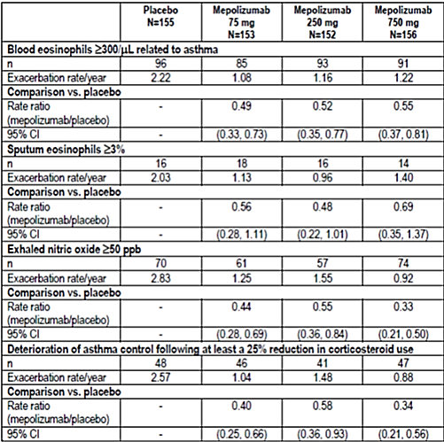
N shows number of subjects with evidence that they met the specific component of inclusion criterion 6. Criteria would be met at Visit 1 or in previous 12 months. Some subjects are included in more than one category.
Figure 6: Study MEA112997- rate of clinically significant exacerbations by baseline blood eosinophil group: ratio to placebo
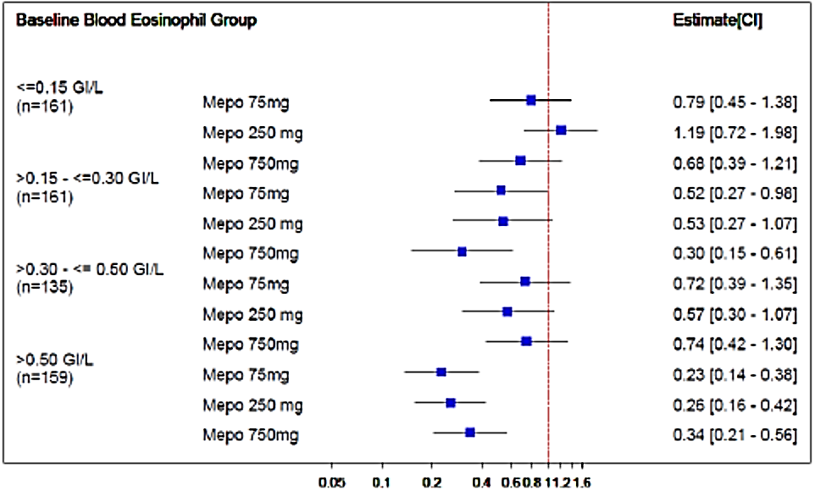

Table 20: Study MEA112997- analysis of rate of clinically significant exacerbations on subjects with elevated baseline blood eosinophils > 0.15x 10⁹ blood eosinophils/μL
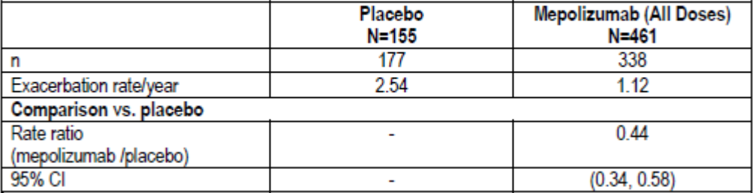

Table 21: Study MEA112997- analysis of rate of significant exacerbations by baseline oral corticosteroid therapy
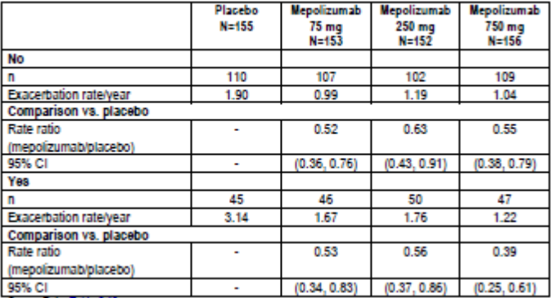
Comment: In the mepolizumab 75 mg group, similar rate ratios compared with placebo were achieved in patients with and without previous maintenance OCS. However, the mean baseline exacerbation rates/year were notably imbalanced (1.90 versus 3.14) and the achieved exacerbation rates/year were also notably different (0.99 versus 1.67).

Results for other efficacy outcomes
Compared with placebo, pre-bronchodilator FEV₁ at Week 52 increased by 61 mL (95% CI: -39, 161), 81 mL (95% CI: -19, 180), and 56 mL (95% CI: -43, 155) in the mepolizumab 75 mg, 250 mg, and 750 mg groups, respectively. None of the treatment differences were statistically significant. The rate of exacerbations requiring hospitalisation or ED visits is shown in Table 22. The rate ratios were reduced in each mepolizumab group compared with placebo [(0.40 (95% CI: 0.19, 0.81), 0.58 (95% CI: 0.30, 1.12) and 0.52 (95% CI: 0.27, 1.02)], respectively. The time to the first clinically significant exacerbation is shown in Table24. The time to first exacerbation was prolonged in each mepolizumab group compared with placebo with hazard ratios ranging from 0.45 to 0.60 (p < 0.001 for each comparison). Compared with placebo, there were modest improvements in ACQ-6 scores but this was only statistically significant in the mepolizumab 250 mg group. The number of days of OCS use associated with exacerbations is shown in Table 25. Compared with placebo, patients in the mepolizumab groups required OCS for approximately ten fewer days between baseline and Week 52.

Table 22: Study MEA112997- analysis of rate of exacerbations requiring hospitalisation or emergency department visits
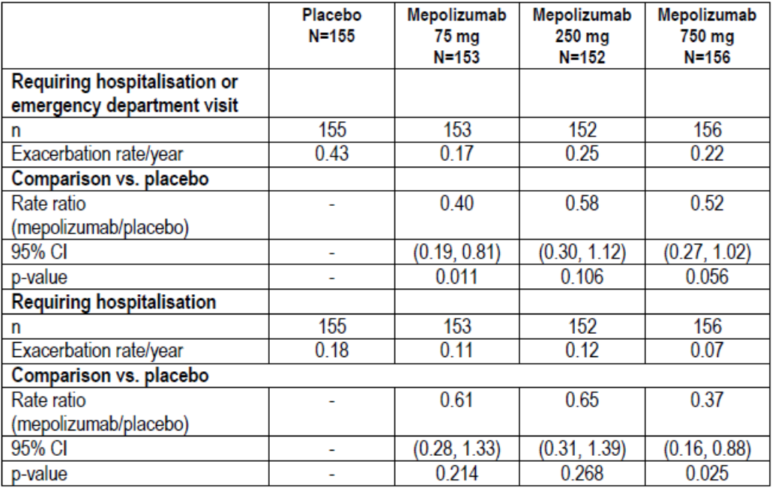

Table 23: Study MEA112997- analysis of time to first clinically significant exacerbation
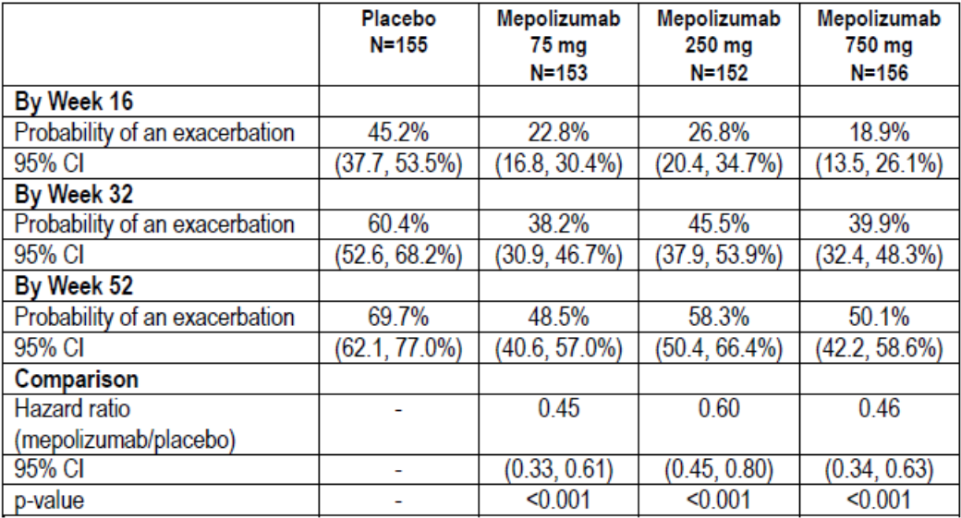

Table 24: Study MEA112997- summary of number of days with oral corticosteroid associated with a clinically significant exacerbation
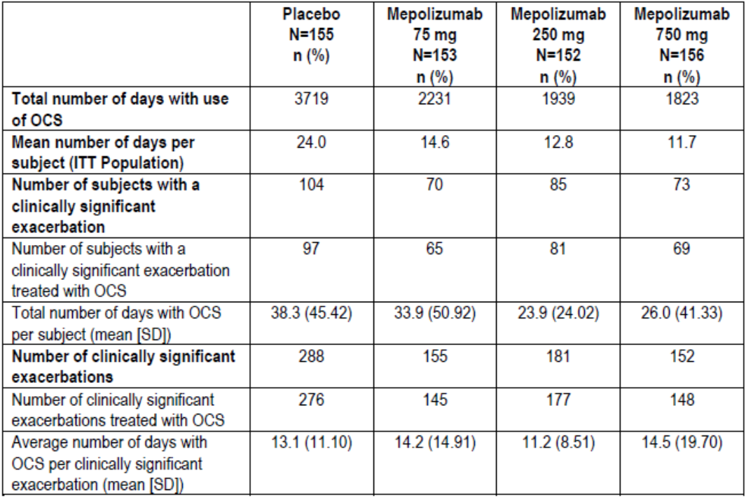
Comment: This was a dose-ranging study in patients with refractory asthma which only partially addressed the proposed indication. The criteria for eosinophilia were loosely defined and changes in blood eosinophils from baseline were not examined prospectively as secondary endpoints. Importantly, only 33% of the study population at screening required maintenance OCS. This subgroup was not identified prospectively, randomisation stratification based on OCS use was not applied, and only a limited post hoc analysis has been provided. Moreover, the proposed mepolizumab dose of 100 mg SC was not tested. The study does not meet the criteria for a pivotal study as proposed by the sponsor. However, despite its limitations it can be considered supportive as patient numbers were sufficiently large to reasonably assess both efficacy and safety.
The primary endpoint was achieved with a statistically significant benefit (p < 0.001) for the three doses of mepolizumab in the range of 75 mg of 750 mg with no dose response relationship. Exacerbations requiring hospitalisation or ED visits were also reduced although this was only statistically significant in the 75 mg IV group (p = 0.011). The lowest effective dose based on exacerbation rates was not identified but the 75 mg IV dose was selected for the Phase III studies. This was justified retrospectively based on data from MEA114092, a PK/PD study of eosinophil suppression. The data support the proposed dose of mepolizumab 100 mg SC in that it can be considered bioequivalent to the 75 mg IV dose tested in this study. Although the analysis was retrospective, the data support the use of blood eosinophil counts as a biomarker and justify the threshold of ≥ 150 cells/µL in the proposed indication. However, corticosteroids suppress eosinophilia and this potentially confounding effect in patients on maintenance OCS therapy was not addressed in this or any other study.
The outcomes were internally consistent with reductions in exacerbation rates associated with improvements in lung function. FEV₁ is considered superior to PEF for assessing lung function in clinical trials. Increases of > 50 mL can be considered clinically meaningful as they are usually associated with measurable symptom improvements. The improvements in the mepolizumab groups of 56 to 81 mL compared with placebo were meaningful although the differences were not statistically significant.
Although the proposed indication is for patients requiring maintenance OCS, exacerbation rate ratios were similarly reduced by mepolizumab in patients without maintenance OCS. However, the two patient groups were not balanced at baseline. Patients receiving OCS in the previous 12 months had a higher rate of exacerbations at baseline, and the achieved exacerbation rates were numerically fewer compared with the group not receiving OCS at baseline.

Clinical efficacy

Indication
Mepolizumab is indicated as ̕add-on treatment for severe eosinophilic asthma in patients aged 12 years and over identified by either a blood eosinophil count ≥ 150 cells/µL at initiation of treatment or a blood eosinophil count ≥ 300 cells/µL in the prior 12 months, with a history of exacerbations and/or dependency on systemic corticosteroids.’

Pivotal efficacy studies

Study MEA115588

Study design, objectives, locations and dates
This was a Phase III, multi-centre, randomised, double-blind, placebo-controlled, double-dummy, parallel-group study to determine the efficacy and safety of mepolizumab adjunctive therapy in patients with severe uncontrolled refractory asthma. It was conducted at 119 centres in 16 countries (Argentina, Australia, Belgium, Canada, Chile, France, Germany, Italy, Japan, Korea, Mexico, Russia, Spain, Ukraine, UK, and USA) between October 2012 and January 2014. The primary objective was to evaluate the efficacy of mepolizumab 75 mg IV or 100 mg SC in adult and adolescent patients aged 12 years or older over a 32 week treatment period. The study schematic is shown in Figure 7. A total of 540 patients with a confirmed diagnosis of refractory asthma with documented pulmonary function testing were planned. All patients were required to remain on their existing maintenance asthma treatment throughout the study. After a 1 to 6 week run-in period, eligible patients were randomised 1:1:1 to receive mepolizumab 100 mg SC plus placebo IV, mepolizumab 75 mg IV plus placebo SC, or placebo IV plus placebo SC. Visits were then scheduled every 4 weeks until Week 28 (giving 32 weeks of exposure) with an additional follow-up visit at Week 32. At each visit, exacerbations and eDiary data were reviewed, spirometry was performed, ACQ-5 was completed, and health outcome assessments were performed. Adverse events were captured on paper diaries throughout the study and assessed at each study visit.
Figure 7: Study MEA115588- study schematic
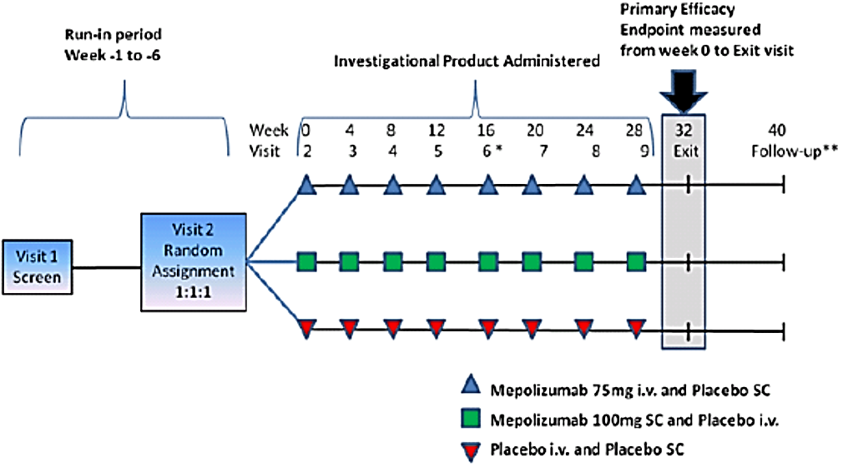

Inclusion and exclusion criteria
The main inclusion criteria were: male or female patients aged 12 years or older; minimum body weight of 45 kg; severe refractory asthma using ATS criteria for the previous 12 months; documented requirement for regular high dose ICS, with or without maintenance OCS for the previous 12 months; documented requirement for controller medication (LABA, leukotriene receptor antagonist or theophylline); FEV₁ < 80% predicted or PEF diurnal variability of > 20% on three or more days during run-in; patients with likely eosinophilic airway inflammation (blood eosinophils ≥ 300/µL in the previous 12 months, or ≥ 150/µL at baseline; documented history of two or more exacerbations requiring oral or systemic corticosteroids in the previous 12 months; standard reversibility and airflow variability criteria; no clinically significant laboratory abnormalities.
The main exclusion criteria included: current smokers or patients with a smoking history of ≥ 10 pack years; clinically important concomitant lung disease; clinically significant cardiovascular disease; malignancy; unstable liver disease; Churg-Strauss syndrome or other syndromes associated with elevated eosinophil levels; omalizumab or other biological treatments for inflammatory disease within previous 4 months; treatment with other investigational drugs; any other clinically significant disease; history of alcohol abuse; parasitic infections within the previous 6 months; known immunodeficiency; previous poor compliance with controller medication.
Comment: As in MEA112997, the inclusion criteria required patients with refractory asthma with a history of at least two exacerbations in the previous year, with or without maintenance OCS. However, unlike MEA112997, the eosinophilia criteria were based only on blood eosinophils which matches the proposed indication.

Study treatments
- Mepolizumab 75 mg IV plus placebo SC every 4 weeks
- Mepolizumab 100 mg SC plus placebo IV every 4 weeks
- Placebo IV plus placebo SC every 4 weeks
For IV administration, lyophilised mepolizumab 75 mg was reconstituted and diluted to 100 mL with normal saline. Matching IV placebo consisted of 100 mL of normal saline. The IV solutions were administered over 30 minutes via a standard drip or via an infusion pump.
For SC administration, 100 mg of reconstituted mepolizumab was drawn into a 1 mL polypropylene syringe. Matching placebo injection consisted of normal saline. All doses were given into the upper arm.

Efficacy variables and outcomes
The primary efficacy outcome was the frequency of clinically significant asthma exacerbations defined by the use of systemic corticosteroids and/or hospitalisation and/or ED visits.
Other efficacy outcomes included:
- Frequency of exacerbations requiring hospitalisation or ED visits.
- Frequency of exacerbations requiring hospitalisation
- Mean change from baseline in clinic pre-bronchodilatorFEV₁.
- Mean change from baseline in ACQ-5.
- Mean change from baseline in St George’s Respiratory Questionnaire (SGRQ).
- Mean change from baseline in nocturnal awakenings due to asthma.
- Mean number of days with OCS taken for exacerbations.
- Time to first exacerbation.

Randomisation and blinding methods
Patients were randomised 1:1:1 centrally using IVRS. Each study treatment was prepared by designated unblinded site staff members but administered by blinded staff. All other study personnel remained blind.

Analysis populations
The ITT population included all randomised patients who received at least one dose of study medication. The PP population included all patients in the ITT set who did not have pre-defined major protocol violations.

Sample size
With 180 patients in each treatment arm, the study had 90% power to detect a 40% decrease in the exacerbation rate from 2.4 events to 1.44 events per annum using a 2-sided 5% significance level. The exacerbation rate of 2.4 events per annum was based on rates observed in previous mepolizumab studies.

Statistical methods
The two primary analyses compared mepolizumab 75 mg IV versus placebo and mepolizumab 100 mg SC versus placebo using a 1 sided Hochberg testing procedure with a 1 sided alpha of 2.5%. Multiplicity was controlled using the Hochberg testing procedure and a hierarchical gatekeeping approach. The exacerbation rates were analysed using a generalised linear model which assumed a negative binomial probability distribution for the number of exacerbations. Covariates in the model were treatment group, baseline maintenance OCS use (Y/N), geographical region, number of exacerbation in the previous year and baseline disease severity measured by % predicted FEV₁. The analysis was performed on the ITT population with a sensitivity analysis performed on the PP population. The secondary endpoint 'frequency of exacerbations requiring ED visit and/or hospitalisation' was also analysed using negative binomial regression. Time to first exacerbation in each treatment group was compared using a Cox’s proportional hazards model and ACQ and FEV₁ was analysed using a mixed model repeated measures analysis of covariance (ANCOVA). SGRQ was analysed using analysis of covariance.

Participant flow
A total of 576 patients were randomised in the ITT population and received at least one dose of study medication: 539 (94%) patients completed the study and 522 (91%) entered the open label extension study (Table 25). The most common reason for withdrawal was withdrawal of consent in 3% of patients. A total of 546 (95%) patients were included in the PP population.

Table 25: Study MEA115588- disposition of subjects (ITT Population)
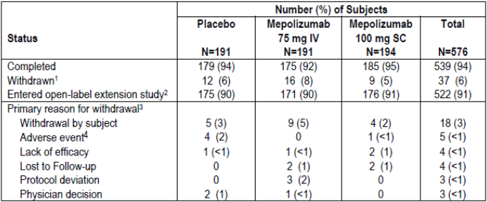
1. Four subjects were randomised and withdrawn without receiving any study mediation and are not in the ITT Population. 2. Study MEA115661. 3. Only one primary reason for withdrawal was recorded. 4. Subjects with an adverse event leading to permanent discontinuation of study drug or withdrawal from study.

Major protocol violations/deviations
A total of 30 patients had protocol deviations leading to exclusion from the PP population, mostly due to not meeting the eligibility criteria. The number and types of deviations were similar in each treatment group.

Baseline data
Baseline demographics were similar in each treatment group as shown in Table 26. Most patients were White (78%) and female (57%) with a mean age of 50 years (range 12 to 82). A total of 25 (4%) patients were adolescents and 80 (14%) patients were aged ≥ 65 years. Asthma history at baseline was similar in each treatment group (Table 27). Approximately 30% of patients were former smokers. Mean duration of asthma was 19.9 years, 69% of patients had ≥ 300 eosinophils/µL in the previous year, and 83% of patients had ≥ 150 cells/µL at screening. In the previous year, all patients had received high dose ICS, 30% of patients had required continuous OCS, and 49% had required short courses of OCS. A total of 47% had required urgent medical attention, and 7% had a near fatal asthma event. Asthma exacerbation history is shown in Table 18. In the previous year, the mean number of exacerbations was 3.6 (range 1 to 21) and 33% of patients required hospitalisation or ED visits. Screening PFT results are shown in Table 28. In the overall population, mean pre-bronchodilator FEV₁ was 1.69 L (56.7% predicted) and the mean post-bronchodilator FEV₁ was 2.11 L (70.9% predicted).

Table 26: Study MEA115588- demographics (ITT Population)
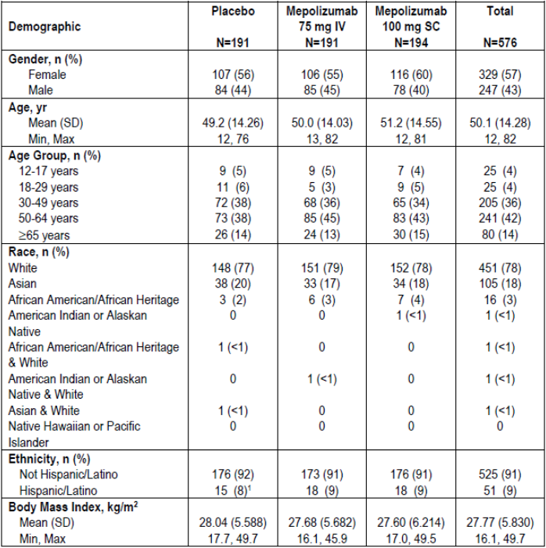
1. One subject in Korea ([information redacted] randomised to placebo) was incorrectly noted as being Hispanic/Latino.

Table 27: Study MEA115588- asthma history (ITT Population)
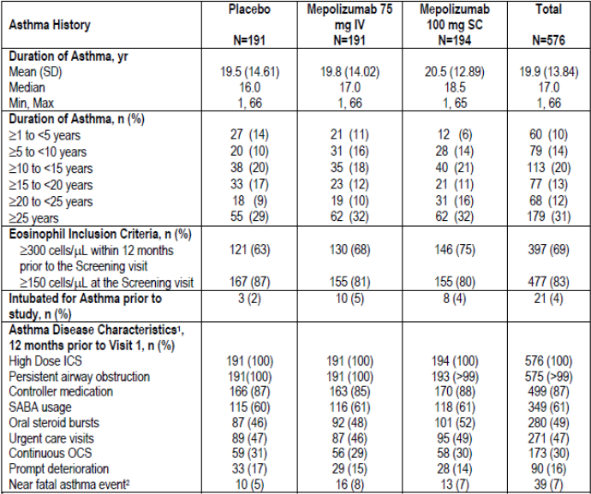
1. Subjects could have met more than one criterion. Asthma disease characteristics were self reported. 2. As defined by subject/site. Note: Elevated peripheral blood eosinophil count ≥ 150 µL at visit 1 determined from laboratory data collected at this visit.

Table 28: Study MEA115588- screening lung functional test results (ITT Population)
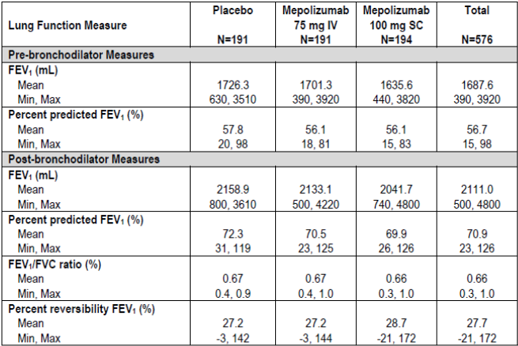
Comment: The baseline demographics and disease characteristics were similar in each treatment group and no meaningful imbalances were identified. As in MEA112997, only 30% of patients were receiving maintenance OCS at baseline.

Results for the primary efficacy outcome
The number of clinically significant exacerbations reported between baseline and Week 32 is shown in Table 29. Significant exacerbations were reported in fewer patients in the mepolizumab groups compared with placebo (placebo 55%, mepolizumab 75 mg IV 37%, mepolizumab 100 mg SC 33%). In addition, fewer patients required hospitalisation or ED visits (13%, 9% and 6% in the respective treatment groups). The primary endpoint was achieved with a reduction in the annualised frequency of clinically significant exacerbations in both mepolizumab treatment groups (Table 30). In the placebo, mepolizumab 75 mg IV and mepolizumab 100 mg SC groups, the annual rates per year of exacerbations were 1.74, 0.93, and 0.83, respectively. In the mepolizumab 75 mg IV and 100 mg SC groups, there were reductions in the exacerbation rate, the rate ratio was 0.53 (95% CI: 0.40, 0.72) and 0.47 (95% CI: 0.35, 0.64), respectively compared with placebo (p < 0.001 for both comparisons). A sensitivity analysis in the PP population confirmed the primary endpoint. The exacerbation rates in the placebo, mepolizumab 75 mg IV, and mepolizumab 100 mg SC groups were 1.72, 0.95, and 0.83, respectively. In the mepolizumab 75 mg IV and 100 mg SC groups, there were reductions in exacerbation rate ratio of 0.55 (95% CI: 0.41, 0.74) and 0.48 (95% CI: 0.35, 0.65), respectively compared with placebo (p < 0.001 for both comparisons).
There was a treatment benefit in favour of mepolizumab regardless of whether patients received maintenance OCS at baseline. An analysis based on previous OCS use is summarised in Table 31. In patients who did not previously receive maintenance OCS (75%), the mean exacerbation rate in the placebo group was 1.60 per year, compared with 0.85 and 0.55 per year in the mepolizumab 75 mg IV and 100 mg SC groups, respectively. The rate ratios in the mepolizumab groups compared with placebo were 0.53 (95% CI: 0.37, 0.76) and 0.34 (95% CI: 0.23, 0.51), respectively. In patients who did previously receive maintenance OCS (25%), the mean exacerbation rate in the placebo group was 2.16 per year, compared with 1.12, and 1.73 per year in the mepolizumab 75 mg IV and 100 mg SC groups, respectively. The rate ratios in the mepolizumab groups compared with placebo were 0.52 (95% CI: 0.30, 0.86) and 0.80 (95% CI: 0.49, 1.29), respectively.
Subgroup analyses showed no significant differences compared with the overall group. Patients in the mepolizumab groups had a treatment benefit compared with placebo irrespective of age, gender, baseline FEV₁, previous exacerbation history, region, and body weight. Only 25 adolescents were randomised (9 placebo, 9 mepolizumab 75 mg IV, 7 mepolizumab 100 mg SC) but they had a comparable reduction in exacerbation rate to the overall group (33% of patients given placebo reported exacerbations compared with 19% given mepolizumab). Exacerbation rate reductions in the 95 Japanese and Korean patients were also comparable with the overall population.
In the ITT population, there was a positive correlation between screening blood eosinophil levels and the percent reduction in clinically significant exacerbations (Figure 8). The rate of exacerbations based on the eosinophil inclusion criteria are shown in Table 32. Patients who met only the historical inclusion criterion of ≥ 300 cells/µL in the previous 12 months and did not have ≥ 150 cells/µL at screening had no effective response to mepolizumab therapy.

Table 29: Study MEA115588- clinically significant exacerbations
Severity of exacerbation |  | Number of subjects
 |  | Placebo  N =191 |  | Mepolizumab  75 mg IV N = 191 | Mepolizumab  100 mg SC N= 194
Clinically significant exacerbations¹
Number of subjects | 105 (55) |  | 70 (37) |  | 64 (33)
Number of events | 216 |  | 117 |  | 116
Incidence of Clinically Significant Exacerbations
Number of exacerbations
0 | 86 (45) |  | 121 (63) |  | 130 (67)
1 | 51 (27) |  | 38 (20) |  | 41 (21)
2 | 28 (15) |  | 23 (12) |  | 11 (6)
3 | 12 (6) |  | 7 (4) |  | 6 (3)
4 | 5 (3) |  | 0 |  | 1 (<1)
5 | 3 (2) |  | 0 |  | 3 (2)
6 | 5 (3) |  | 2 (1) |  | 0
7 | 0 |  | 0 |  | 1 (<1)
8 | 1 (<1) |  | 0 |  | 0
9 | 0 |  | 0 |  | 1 (<1)
Exacerbations Requiring Hospitalisation or ED Visit
Number of subjects | 24 (13) |  | 17 (9) |  | 11 (6)
Number of events | 33 |  | 23 |  | 20
Exacerbations Requiring Hospitalisation only
Number of subjects | 13 (7) |  | 9 (5) |  | 5 (3)
Number of events | 18 |  | 10 |  | 9
Note: Includes events that occurred from the start of treatment until Week 32 or the date of withdrawal (but no greater than 4 weeks post last dose). 1. Not all exacerbations were clinically significant exacerbations and this table excludes the two investigator related events that were not clinically significant.

Table 30: Study MEA115588- reanalysis of Study MEA115588 primary endpoint-Revised Results (changes in bold font)
 | Placebo  N =191 | Mepolizumab  75 mg IV N = 191 | Mepolizumab  100 mg SC N= 194
Exacerbation rate/year | 1.74 | 0.93 | 0.83
Comparison Mepolizumab versus Placebo
Rate Ratio (Mepolizumab / Placebo) |  | 0.53 | 0.47
95% CI |  | (0.40, 0.72) | (0.35, 0.64)
P- value¹ |  | < 0.001 | < 0.001
Note 1: Adjusted p-values resulting from strong control of type 1 error across two treatment comparisons

Table 31: Study MEA115588- analysis of rate of clinically significant exacerbations by baseline maintenance oral corticosteroid therapy (ITT Population)
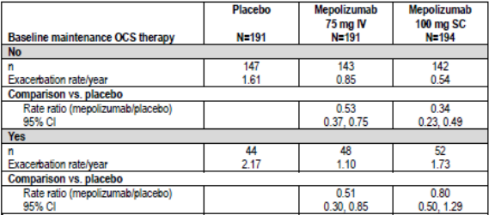
Note: Analysis of number if exacerbations performed using separate negative binominal models for each subgroup presented with covariates of treatment group, baseline maintenance OCS therapy (OCS versus no OCS), region, exacerbations in the year prior to the study (as an ordinal variable) and baseline 1% predictive FEV₁, and with logarithm of time in treatment as an offset variable. For this analysis Canada is combined with Rest of World with the covariate region.
Figure 8: Study MEA115588
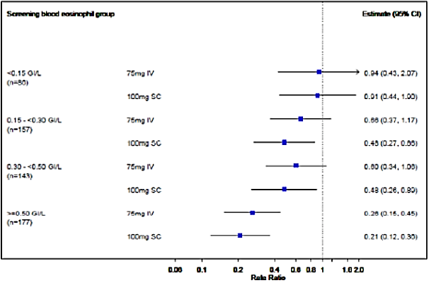

Table 32: Study MEA115588
Blood eosinophil inclusion criteria group | Placebo N = 191 | Mepolizumab  75 mg IV N = 191 | Mepolizumab  100 mg SC N = 194
≥ 300/l documented in the previous 12 months
Inclusion: No
n | 70 | 61 | 48
Exacerbation rate/year | 1.89 | 0.51 | 0.50
Comparison versus placebo
Rate ratio (mepolizumab/placebo |  | 0.27 | 0.27
95% CI |  | 0.15, 0.51 | 0.14, 0.52
Inclusion: YES
n | 121 | 130 | 146
Exacerbation rate/year | 1.64 | 1.13 | 0.94
Comparison versus placebo
Rate ratio (mepolizumab/placebo) |  | 0.69 | 0.57
95% CI |  | 0.49, 0.98 | 0.41, 0.80
≥ 150/L demonstrated at screening
Inclusion: No
n | 21 | 30 | 35
Exacerbation rate/year | 1.31 | 1.23 | 1.20
Comparison versus placebo
Rate ratio (mepolizumab/placebo) |  | 0.94 | 0.91
95% CI |  | 0.43, 2.07 | 0.44, 1.90
Inclusion: Yes
n | 167 | 155 | 155
Exacerbation rate/year | 1.75 | 0.81 | 0.67
Comparison versus placebo
Rate ratio (mepolizumab/placebo) |  | 0.46 | 0.38
95% CI |  | 0.33, 0.64 | 0.27, 0.53
≥ 300/L in previous 12 months OR ≥ 150/L at screening²
≥ 300/L documented in the previous 12 months
n | 23 | 34 | 39
Exacerbation rate/year | 1.52 | 1.62 | 1.25
Comparison versus placebo
Rate ratio (mepolizumab/placebo) |  | 1.06 | 0.82
95% CI |  | 0.49, 2.30 | 0.38, 1.77
≥ 150 L demonstrated at screening
n | 69 | 59 | 48
Exacerbation rate/year | 1.92 | 0.54 | 0.51
Comparison versus placebo
Rate ratio (mepolizumab/placebo) |  | 0.28 | 0.26
95% CI |  | 0.15, 0.52 | 0.14, 0.52
≥ 300 L in the previous 12 months AND ≥ 150/L at screening
n | 98 | 96 | 107
Exacerbation rate/year | 1.62 | 0.98 | 0.74
Comparison versus placebo
Rate ratio (mepolizumab/placebo) |  | 0.60 | 0.46
95% CI |  | 0.41, 0.88 | 0.31, 0.67
1. 13 subjects are not shown in this analysis due to having no eosinophil count measured at screening. 2. Subjects [information redacted], [information redacted] and [information redacted] did not meet either of the two blood eosinophil inclusion criteria and so are not present in this table. Note: Analysis of number of exacerbations performed using separate negative binomial models for each subgroup presented with covariates of treatment group, baseline maintenance OCS therapy (OCS versus no OCS), region, exacerbations in the year prior to the study (as an ordinal variable) and baseline % predicted FEV₁, and with logarithm of time on treatment as an offset variable. Note: For this analysis, Canada is combined with the Rest of World within the covariate of regions.
Comment: In the clinical study report (CSR), the sponsor states that patients who did not have ≥ 150 cells/µL at baseline ‘had a reduced positive response to mepolizumab in terms of exacerbation frequency’. However, in Table 32 the data suggest no meaningful response with relative risk (RR) ratios of 0.94 and 0.91 in the 75 mg IV and 100 mg SC groups, respectively. This statement requires some justification because a lack of positive response confirms the value of ≥ 150 cells/µL as an independent biomarker. Moreover, the data in the same table offer scant support for the use of ≥ 300 cells/µL as an independent biomarker in the proposed indication. In the 52 patients who received mepolizumab 100 mg SC, and who were receiving maintenance OCS at screening, the rate reduction compared with placebo was only 0.80 (95% CI: 0.50, 1.29). This modest, non-significant reduction does not support the proposed indication.

Results for other efficacy outcomes
During the 32 week treatment period, patients in the placebo group were given OCS for exacerbations for a total of 2037 days compared with 1119 and 1102 days in the mepolizumab 75 mg IV and 100 mg SC groups, respectively (Table 34). This corresponds to a an approximately 45% reduction in OCS exposure with mepolizumab therapy. Patients in the mepolizumab groups showed greater increases in pre-bronchodilator FEV₁ compared with placebo throughout the study, and at Week 32, the differences of 100 mL and 98 mL in the mepolizumab groups were statistically significant (p ≤ 0.028) (Table 35). In patients with eosinophils ≥ 500 cells/µL at baseline there were marked increases in pre- and post-bronchodilator FEV₁ in both mepolizumab treatment groups (Figure 9). At Week 32, there were statistically significant increases in SGRQ compared with placebo in both mepolizumab treatment groups (Figure 10). Changes from baseline in ACQ-5 scores are shown in Figure 11. Compared with placebo, there were statistically significant benefits in favour of both mepolizumab groups (p ≤ 0.037 for both comparisons). Compared with placebo, night time awakenings were similar in the mepolizumab 75 mg IV group and marginally reduced in the mepolizumab 100 mg SC group.
Unadjusted data are summarised above, but multiplicity testing was performed in the following order to exclude a type 1 error:
- Rate of exacerbations requiring hospitalisation or ED visits.
- Rate of exacerbations requiring hospitalisation.
- Change from baseline in pre-bronchodilator FEV₁ at Week 32.
- Change from baseline in SGRQ score at Week 32.
As shown in Table 36 the primary endpoint (rate of clinically significant exacerbations) was confirmed for both mepolizumab groups with p < 0.001 for both comparisons with placebo. However, none of the secondary endpoints was confirmed statistically for mepolizumab 75 mg IV compared with placebo, and only the rate of hospitalisation or ED visits remained statistically significant in the mepolizumab 100 mg SC group.

Table 33: Study MEA115588- summary of number of days with oral corticosteroids associated with a clinically significant exacerbation (ITT Population)
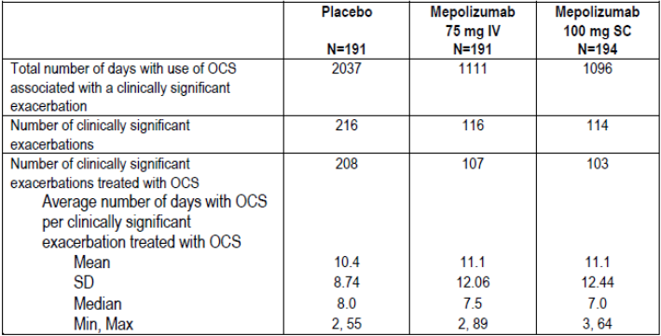

Table 34: Study MEA115588- analysis of change from baseline in pre- and post-bronchodilator FEV₁ at Week 32 (ITT Population)
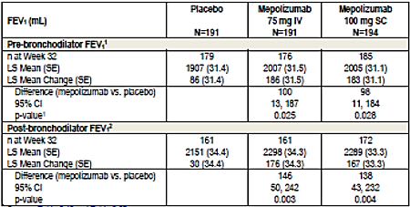
1. Analysis performed using mixed model repeated measures with covariates of baseline, region, baseline maintenance OCS therapy (OCS vs. no OCS) exacerbations in the year prior to the study (as an ordinal variable), treatment, and visit, plus interaction terms for visit by baseline, region, baseline maintenance OCS therapy (OCS vs. no OCS), exacerbations in the year prior to the study (as an ordinal variable) and treatment.
Figure 9: Study MEA115588- pre-bronchodilator FEV₁ at Week 32 measured by level of blood eosinophils at Screening (ITT Population)
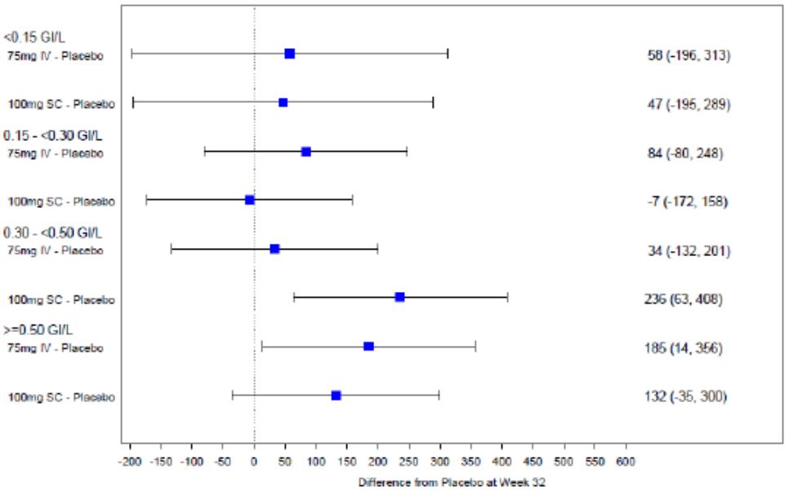
Figure 10: Study MEA115588- cumulative distribution function for change from baseline in total SGRQ score at Week 32 (ITT Population)
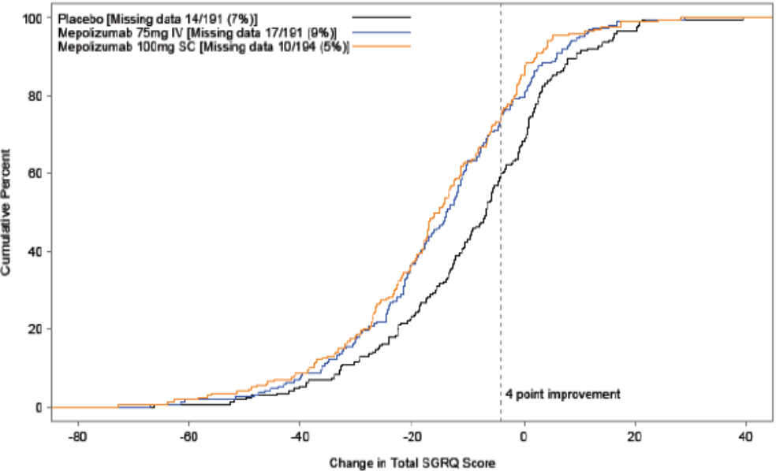
Note: Negative values indicate improvement.
Figure 11: Study MEA115588- analysis of change from baseline in ACQ-5 score (ITT Population)
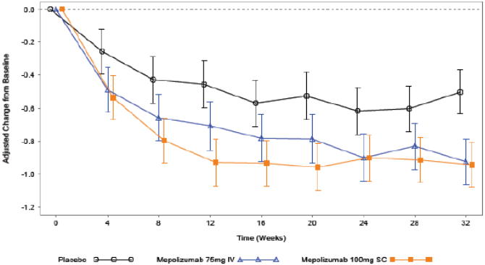
Note: Vertical bars represent 95% CI.

Table 35: Study MEA115588- summary of p values for treatment comparisons adjusted for multiplicity according to the hierarchy of endpoints (ITT Population)
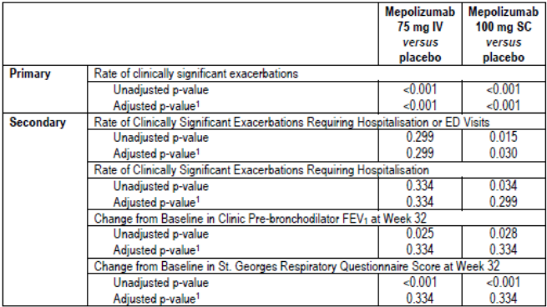
Note: All displayed p values are two sided. 1. P values adjusted for multiplicity using the truncated Hochberg procedure with gamma parameter 1.
Comment: This was a placebo controlled, pivotal Phase III study which assessed the efficacy of the mepolizumab 100 mg SC dose and the 75 mg IV dose selected from the dose ranging study. The primary endpoint was met with a reduction in exacerbation rates of 53% and 47% in the respective mepolizumab groups. The rate reduction in the mepolizumab 100 mg SC group was comparable to that in the 75 mg IV group and also comparable to the mepolizumab IV groups in MEA112997. Rates of hospitalisation or ED visits were reduced by 61% (p = 0.015) in the mepolizumab 100 mg SC group. The reduction in exacerbation rates was matched by improved lung function with increases in pre-bronchodilator FEV₁ of 100 mL and 98 ml in the IV and SC groups, respectively. There were also statistically significant improvements in symptoms measured by ACQ-5 and quality of life measured by the SGRQ. The relationship between the treatment response and biomarker blood eosinophil counts at baseline was demonstrated. Response rates to therapy could be predicted with the use of single blood eosinophil count of ≥ 150 cells/µL at baseline. However, a historical count of ≥ 300 cells/µL appeared of little value as a sole criterion. The study treatment period was only 32 weeks but 91% of patients enrolled in the ongoing OLE MEA115661 and this has demonstrated sustained efficacy. A benefit in favour of mepolizumab was achieved in patients with or without maintenance OCS at baseline. However, based on CIs, no benefit was achieved in the mepolizumab 100 mg SC group. It is hard to justify the proposed indication when only 30% of the patients were receiving maintenance OCS at baseline and the proposed 100 mg SC did not confer a significant or clinically meaningful benefit in this group.

Study MEA115575

Study design, objectives, locations and dates
This was a randomised, double-blind, placebo-controlled, parallel-group, multicentre, Phase IIIa study of mepolizumab adjunctive therapy to reduce OCS use in patients with severe refractory asthma. It was conducted at 38 centres in 10 countries (Germany, France, Czech Republic, the US, the UK, Australia, Canada, the Netherlands, Poland and Mexico) between October 2012 and December 2013. The primary objective was to compare the effects of mepolizumab 100 mg SC and placebo given 4-weekly on reducing the use of OCS in severely asthmatic patients with elevated eosinophils who were dependent on OCS. Other endpoints included asthma symptoms, pulmonary function, exacerbation rates, ACQ and SGRQ. The study included a 3 to 10 week optimisation phase during which the lowest dose of OCS required to manage symptoms (assessed by ACQ-5 scores) was identified (Figure 12). This was followed by a 4 week induction phase during which the patients received their first dose of study medication. During a 16 week OCS reduction phase, OCS doses were then progressively reduced according to a predefined algorithm (Table 36). OCS reduction was discontinued based on predefined criteria including PEF, night time awakenings, the use of rescue medication, and changes in ACQ-5 scores (Table 37). The patients then entered a 4 week maintenance phase without further OCS dose reductions after which assessment of the primary endpoint were made at Week 20-24. At Week 24 patients were offered immediate enrolment in the OLE Study MEA115661 and 93% were entered (Table 38). Patients who did not enrol in the OLE study were followed until Week 32.
Figure 12: Study MEA115575 schematic
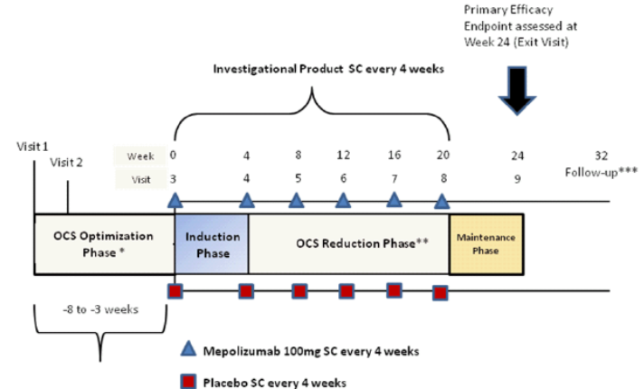
The OCS optimisation phase could be extended to 10 weeks if a subject experienced an exacerbation during this phase. ** OCS dose titration occurred throughout the optimization and reduction phases of the study. OCS titration did not necessarily coincide with the visits scheduled for the investigational product administration as indicated above. *** Only subjects who did not enter the open label extension study completed the Follow up Visit at 12 weeks post last dose.

Table 36: Study MEA115575- OCS reduction phase titration schedule
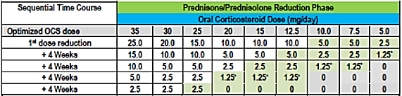
*Subject taking 1.25 mg/day should take this as 2.5 mg administered every other day.

Table 37: Study MEA115575- criteria for not following OCS dose reduction schedule
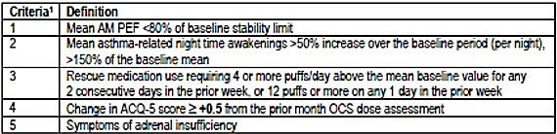
1. Baseline means for AM PEF, night time awakenings, and rescue medication use were calculated on a per night or per day basis using subject diary information from the 7 completed eDiary records prior to the Randomisation Visit (Visit 3).

Table 38: Disposition of subjects (Study MEA115575, ITT population
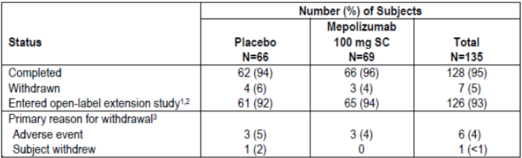
1. Study MEA115561 2. Two subjects (Subjects [information redacted]) elected not to continue in the OLE study. 3. Only the primary reason for withdrawal was recorded.

Inclusion and exclusion criteria
The main inclusion criteria were: male or female patients aged 12 years or older with severe eosinophilic asthma; a documented requirement for maintenance OCS (5.0 to 35 mg/day prednisone or equivalent) in addition to high-dose ICS. All were required to have documented blood eosinophil levels ≥ 300 cells/µL in the previous 12 months, or ≥ 150 cells/µL at screening; severe refractory asthma using ATS criteria for the previous 12 months; documented treatment with an additional controller medication (LABA, leukotriene receptor antagonist or theophylline) for at least 3 months before run-in.; FEV₁ < 80% predicted; standard reversibility and airflow variability criteria during run in; or PEF diurnal variability of > 20% on three or more days during run-in; standard reversibility and airflow variability criteria; no clinically significant laboratory abnormalities.
The main exclusion criteria were: current smokers or patients with a smoking history of ≥ 10 pack years; clinically important concomitant lung disease; clinically significant cardiovascular disease; malignancy; unstable liver disease; Churg-Strauss syndrome or other syndromes associated with elevated eosinophil levels; omalizumab or other biological treatments for inflammatory disease within previous 4 months; treatment with other investigational drugs; any other clinically significant disease; history of alcohol abuse; parasitic infections within the previous 6 months; known immunodeficiency; previous poor compliance with controller medication.
Comment: The inclusion criteria matched those of MEA115588 with the exception that all patients were required to have received maintenance OCS at baseline, and no history of exacerbations was required.

Study treatments
Patients received either:
- Mepolizumab 100 mg SC every 4 weeks
- Placebo SC every 4 weeks
For SC administration, 100 mg of lyophilised mepolizumab was reconstituted with sterile water and drawn into a 1 mL polypropylene syringe. Matching placebo injection consisted of normal saline. All doses were given into the upper arm.

Efficacy variables and outcomes
The primary efficacy outcome was the percent reduction of OCS dose during Weeks 20 to24 compared with baseline while maintaining asthma control. The OCS reductions were categorised as:
- 90% to 100%
- 75% to < 90%
- 50% to < 75%
- >0% to < 50%
- No OCS decrease, lack of asthma control during Weeks 20 to 24, or withdrawal from treatment
Other efficacy outcomes included:
- Proportion of patients achieving a reduction of ≥ 50% in their daily OCS dose.
- Proportion of patients achieving a reduction of daily OCS dose to ≤ 5.0 mg.
- Proportion of patients achieving a total reduction of daily OCS dose.
- Median percentage reduction from baseline in daily OCS dose.
- Rate of clinically significant asthma exacerbations.
- Rate of exacerbations requiring hospitalisation or ED visits.
- Mean change from baseline in clinic pre-bronchodilator FEV1 at Week 24.
- Mean change from baseline in ACQ (MCID 0.5 points) as Week 24.
- Mean change in St George’s Respiratory Questionnaire (SGRQ) (MCID 4 points).
- Mean change in nocturnal awakenings due to asthma.
- Mean number of days with OCS taken for exacerbations.

Randomisation and blinding methods
Patients were randomised 1:1 centrally using IVRS and stratified by duration of prior OCS use (< 5 years or ≥ 5 years). Each study treatment was prepared by an unblinded site staff member but administered by blinded staff. All other study personnel remained blind unless emergency unblinding was required.

Analysis populations
The ITT population included all randomised patients who received at least one dose of study medication. The PP population included all patients in the ITT set who did not have pre-defined major protocol violations.

Sample size
The sample size was based on previous corticosteroid-sparing studies in which the largest proportion of patients achieving a ≥ 50% reduction in OCS dose was 48% in the placebo group. The study was designed to detect an increase of 25% in the proportion of patients achieving ≥50 % reduction in OCS dose (placebo 48% versus mepolizumab 73% with an odds ratio [OR] of 2.9). With 60 patients in each treatment arm, the study had 90% power to detect an OR of 2.9 for mepolizumab compared with placebo.

Statistical methods
The percent reduction of OCS dose during Week 20 to 24 compared with baseline was analysed using an ordered logistic regression analysis with covariates of treatment, region, duration of OCS use at baseline, and dose of OCS at baseline. The model tested the null hypothesis of no difference between the treatment groups, and to estimate the OR for the treatment difference with 95% CIs. The analysis also examined various subgroups based on covariates in the model and blood eosinophil levels. Sensitivity analyses were performed on the PP population and patient populations with missing data or who withdrew early. The secondary endpoints were analysed using a binary logistic regression model with the same covariates as the primary endpoint. The median percentage reduction from baseline in daily OCS dose during Weeks 20 to 24 was analysed using a Wilcoxon rank-sum test.

Participant flow
A total of 135 patients were randomised in the ITT population, 128 (95%) patients completed the study, and 126 (93%) entered the open label extension study (Table 39). The most common reason for withdrawal was adverse events in six (4%) of patients, while one patient withdrew consent. A total of 122 (90%) patients were included in the PP population.

Table 39: Study MEA115575- disposition of subjects (ITT Population)
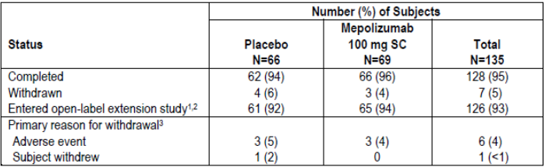
1. Study MEA115661. 2. Two subjects ([information redacted]) elected not to continue in the OLE study. 3. Only one primary reason for withdrawal was recorded.

Major protocol violations/deviations
A total of 13 patients (5 placebo and 8 mepolizumab) had protocol deviations leading to exclusion from the PP population, mostly due to entering the double-blind treatment phase on a non-optimal OCS dose.

Baseline data
With the exception of a modest gender imbalance, baseline demographics were similar in each treatment group as shown in Table 40. Most patients were White (95%) and female (55%) with a mean age of 49.9 years (range 16 to 74). Two (1%) patients (both mepolizumab) were adolescents, and 14 (10%) patients were aged ≥ 65 years. Asthma history at baseline was similar in each treatment group (Table 41). Approximately 40% of patients were former smokers. Mean duration of asthma was 18.7 years; 68% of patients had ≥ 300 eosinophils/µL in the previous year; and 90% of patients had ≥ 150 cells/µL at screening. Duration of OCS use at baseline was < 5 years in 52% of the population and ≥ 5 years in 48% (Table 42). The mean daily dose of OCS at baseline was similar in the placebo and mepolizumab groups (13.2 mg versus 12.4 mg, respectively). In the overall population in the previous year, the mean number of exacerbations was 3.1 (range 0 to 16), and 25% of patients required hospitalisation or ED visits. The mean numbers of exacerbations in the previous year were 2.9 and 3.3 in the placebo and mepolizumab groups, respectively (Table 43). Screening PFT results are shown in Table 44. In the overall population, mean pre-bronchodilator FEV₁ was 1.89 L (57.0% predicted) and the mean post-bronchodilator FEV₁ was 2.31 L (69.7% predicted).

Table 40: Study MEA115575- demographics (ITT Population)
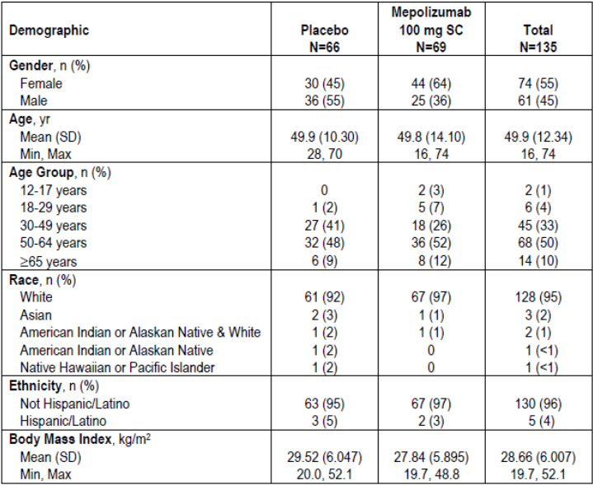

Table 41: Study MEA115575- asthma history (ITT Population)
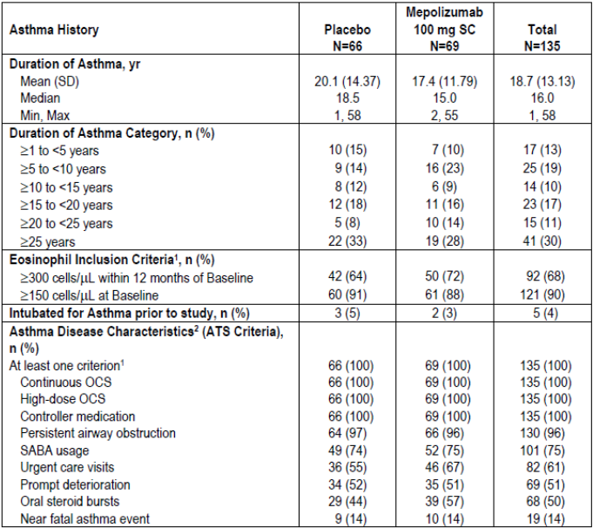
1. Subjects could have met more than one criterion. 2. Subject met criteria within 12 months prior to Screening Visit.

Table 42: Study MEA115575- OCS history and daily dose (ITT Population)
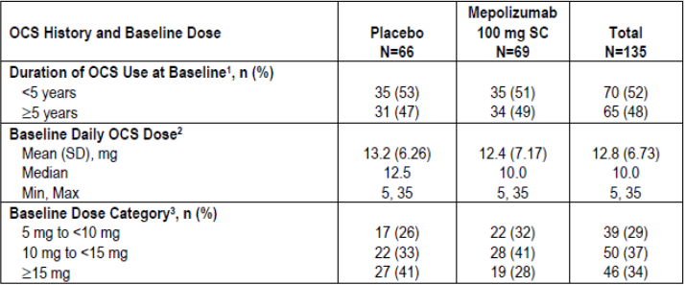
1. Actual strata; 7 subjects were randomised into the incorrect strata 2. Optimised dose at Visit 3/Randomisation 3. Prednisolone equivalent

Table 43: Study MEA115575- exacerbation history (ITT Population)
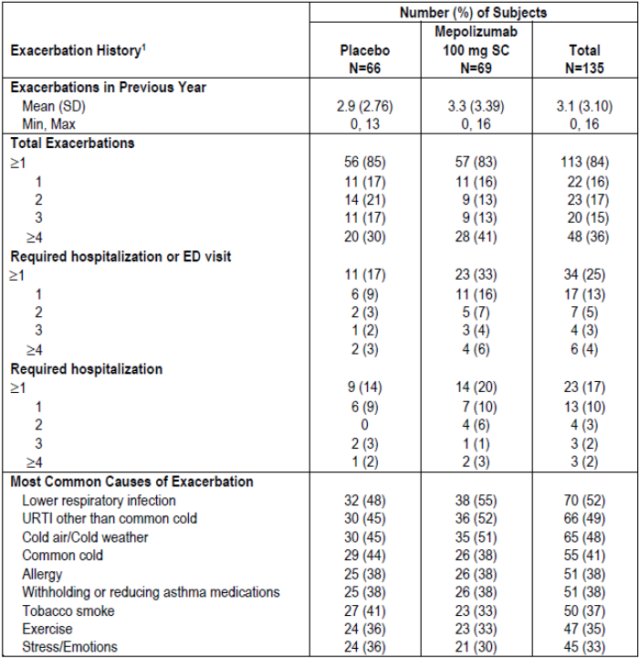
1. Experienced in the 12 months prior to Screening Visit. URTI = upper respiratory tract infection

Table 44: Study MEA115575- screening lung function test results (ITT Population)
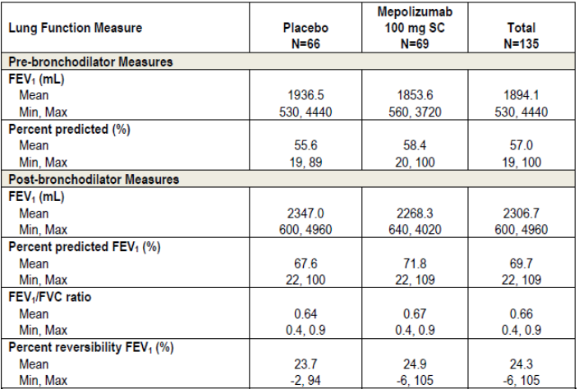
Comment: Although a history of exacerbations was not an inclusion criterion, the overall mean number of exacerbations was 3.1 in the previous year and 84% of patients reported at least one exacerbation. As such, the study population does not support the proposed indication ‘…..or dependency on systemic corticosteroids’.

Results for the primary efficacy outcome
In the ITT population, the primary efficacy endpoint was achieved with mepolizumab patients able to achieve greater reductions in OCS use compared with the placebo group while maintaining asthma control (Table 45). In the placebo and mepolizumab groups, respectively, 56% and 36% of patients had no decrease in OCS; the odds ratio for a reduction in OCS stratum was 2.39 (95% CI: 1.25, 4.56, p = 0.008). A sensitivity analysis of the PP population confirmed the primary endpoint with an OR of 2.13 (95% CI: 1.07, 4.22) in favour of mepolizumab (p = 0.030). The median percentage reduction from baseline in daily OCS dose was 0.0% (95% CI: -20.0, 33.3) in the placebo group compared with 50.0% (95% CI: 20.0, 75.0) in the mepolizumab group (p = 0.007) (Table 46). In the placebo group, the median daily OCS dose fell from 12.5 mg at baseline to 10.0 mg by Weeks 20 to 24, while in the mepolizumab group the median dose fell from 10.0 mg to 3.1 mg (falls from baseline of 20.0% and 66.7%, respectively) (Table 47). Subgroup analyses showed no relationship between mepolizumab efficacy and body weight or geographic region. Mepolizumab was more effective than placebo at reducing OCS dose in patients with OCS use < 5 years at baseline but the benefit was not statistically significant (based on CIs) in patients with OCS ≥ 5 years (Table 48). Mepolizumab was more effective than placebo at reducing OCS dose irrespective of gender although males appeared more responsive than females [OR 4.79 (95% CI: 1.72, 13.37) versus OR 1.63 (95% CI: 0.66, 4.05), respectively].
In subgroups defined by eosinophil levels, there were significant benefits in favour of mepolizumab but there was no meaningful correlation with baseline eosinophil levels. However, an analysis of efficacy based on the inclusion criteria for eosinophilia did show a meaningful benefit for mepolizumab which was correlated with baseline eosinophil levels. In patients with eosinophils ≥ 300 cells/µL in the previous year, the percentage who achieved ≥ 50% reductions in OCS at Weeks 20 to 24 was greater in the mepolizumab group compared with placebo [OR 4.35 (95% CI: 1.86, 10.17)]. However, in patients with eosinophils < 300 cells/µL, there was no benefit in favour of mepolizumab [OR 1.16 (95% CI: 0.37, 3.64)] (Table 49). In patients with eosinophils ≥ 150 cells/µL during screening, the percentage who achieved ≥ 50% reductions in OCS at Weeks 20 to 24 was greater in the mepolizumab group compared with placebo [OR 1.92 (95% CI: 0.97, 3.81)]. The number of patients who did not have eosinophils ≥ 150 cells/µL at screening was too small to make meaningful comparisons.

Table 45: Study MEA115575- primary efficacy endpoint (ITT Population)
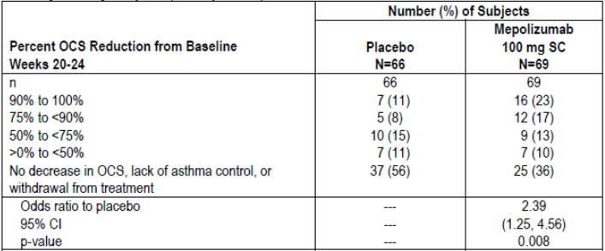

Table 46: Study MEA115575- secondary endpoints of reduction in daily OCS dose from Baseline (ITT population)
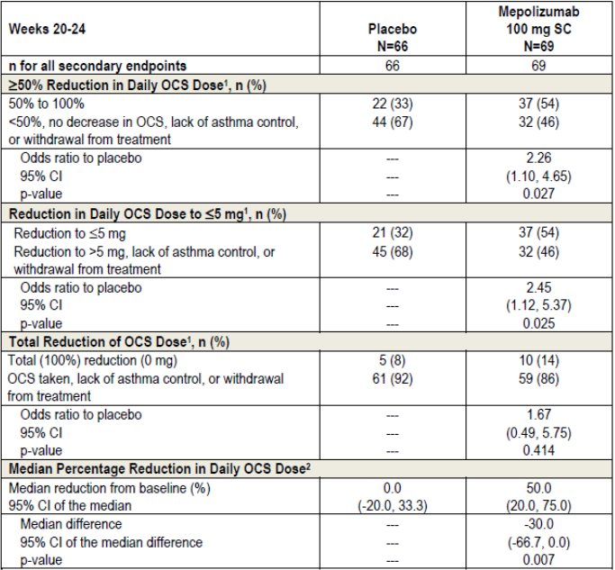
1. Analysed using a binary logistic regression model with terms for treatment group, region, duration of OCS use at baseline (< 6 years versus ≥ 5 years), and baseline OCS dose (optimised dose). 2. The median difference and associated confidence intervals are derived using Hodges-Lehman estimation. P values are from a Wilcoxon rank-sum test of mepolizumab versus placebo. For subjects who withdrew from the study prior to the Maintenance Phase, a value equal to the minimum percent reduction in OCS use across all subjects was imputed for the analysis.

Table 47: Study MEA115575- median daily OCS dose and median percent reduction from Baseline in daily OCS dose over time (ITT Population)
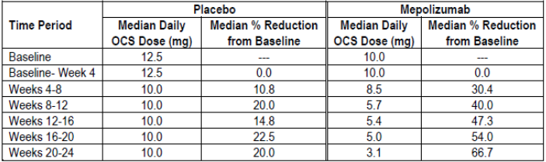
Note: Positive values indicate reduction; negative values indicate increase.

Table 48: Study MEA115575- analysis of OCS percent reduction from Baseline during Weeks 20 to 24 by duration of prior OCS use (ITT Population)
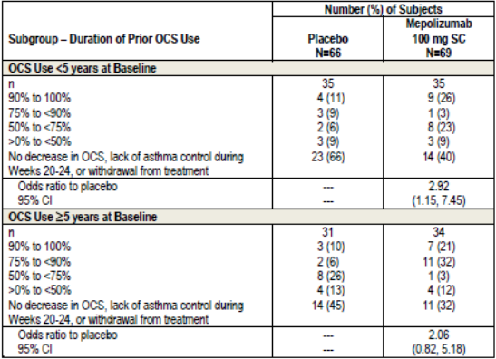
Note: Analysed using a proportional odds model (multinominal [ordered] generalized linear model), with terms for treatment group, region and baseline OCS dose (optimised dose).

Table 49: Study MEA115575- analysis of OCS percent reduction from Baseline during Week 20 to 24 by eosinophilic inclusion criteria category ≥ 300 cells/microliter in prior 12 months (ITT Population)
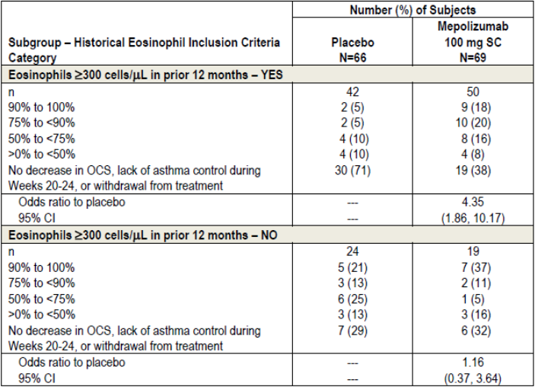
Note 1: Subjects could have met possible protocol inclusion criteria for eosinophilic asthma: 1. An elevated peripheral blood eosinophil level of ≥ 300 cells/µL that is related to asthma with the previous 12 months prior to Visit 3 (Randomisation) or 2. Peripheral baseline eosinophil level ≥ 150 cells/µL between Visit 1 and Visit 3 (pre-treatment period) that is related to asthma. Some subjects may have met both criteria. Note 2: Analysed using a proportional odds model (multinominal [ordered] logistic generalised linear model), with terms for treatment group, region, duration of baseline OCS use (< 5 years versus ≥ 5 years), and baseline OCS dose (optimised dose).
Comment: There was an inconsistent relationship between baseline blood eosinophils and the OCS dosage reduction achieved. However, the overall results suggest that OCS dose reductions are more likely to be achieved in patients with high eosinophil levels at baseline. Based on CIs, significant OCS dose reductions with mepolizumab were not achieved in patients with OCS usage ≥ 5 years and in females.

Results for other efficacy outcomes
Compared with placebo, fewer patients in the mepolizumab group experienced clinically significant exacerbations (42% versus 68%), hospitalisation or ED visits (4% versus 11%) and hospitalisation (0% versus 11%) (Table 50). The exacerbation rate in the placebo group was 2.12 events/year compared with 1.44 events/year in the mepolizumab group corresponding to a 32% reduction [RR 0.68 (95% CI: 0.47, 0.99, p = 0.042)]. The time to first exacerbation was significantly increased in patients treated with mepolizumab [Hazard ratio 0.49 (95% CI: 0.31, 0.78, p = 0.003)] (Figure 13). Mean total corticosteroid use during exacerbations was less in the mepolizumab group (17,924 mg) compared with placebo (20,559 mg). There were mean differences of 114 mL and 128 mL for pre- and post-bronchodilator FEV₁ from baseline to Week 24 in favour of mepolizumab but the changes were not statistically significant (Table 51). Baseline ACQ-5 scores were 1.99 and 2.15 in the placebo and mepolizumab groups, respectively (both scores ≥ 1.5 indicating poorly controlled asthma). At Week 24, the respective scores were 1.98 and 1.46: the difference of -0.52 was statistically significant (p = 0.004) and clinically meaningful. At Week 24, the proportion of patients with ≥ 4 point improvements in SGRQ was higher in the mepolizumab group (58%) compared with placebo (41%). The mean change from baseline in the number of night time awakenings was -0.3 in both treatment groups at Weeks 21-24.

Table 50: Study MEA115575- analysis of rate of exacerbations (randomisation through Week 24) by severity of exacerbation (ITT Population)
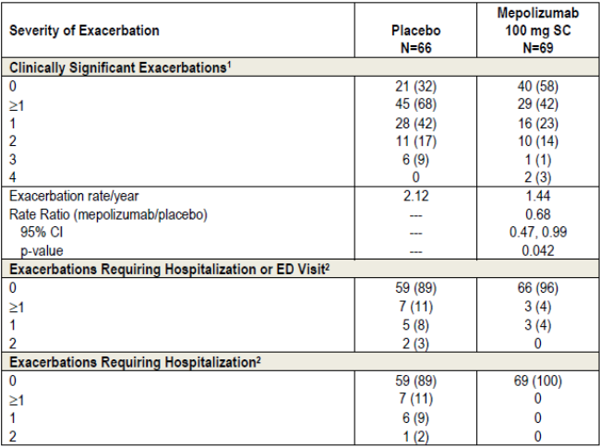
1. All investigator defined exacerbations were clinically significant exacerbations. 2. Insufficient events to perform analysis. Note: Analysis performed using a Poisson model with covariates of treatment group, duration of OCS use at baseline (< 5 years versus ≥ 5 years), region, dose of OCS at baseline (optimised dose), and with logarithm of time on treatment as an offset variable.
Figure 13: Study MEA115575- Kaplan-Meier cumulative incidence curve for time to first clinically significant exacerbation (ITT Population)
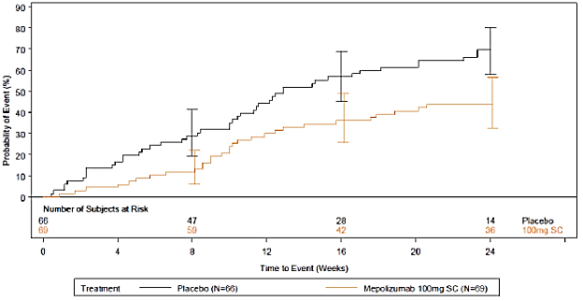
Note: Vertical bars represent 95% confidence interval.

Table 51: MEA115575- analysis of change from Baseline in pre-bronchodilator and post-bronchodilator FEV₁ at Week 24 (ITT Population)
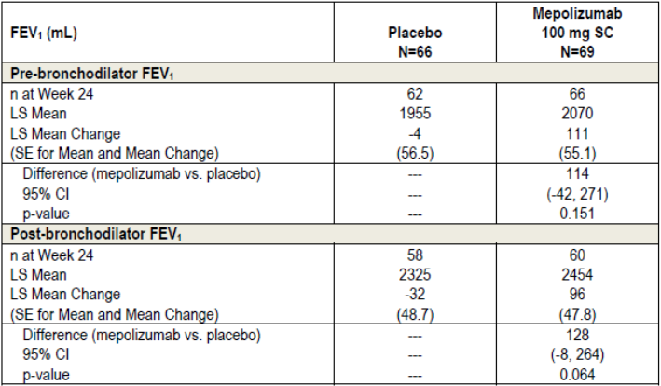
Note: For pre-bronchodilatator FEV₁, analysis performed using mixed model repeated measures with covariates of baseline, region, duration of OCS use at baseline (< 5 years versus ≥ 5 years), dose of OCS at baseline, treatment and week, plus interaction terms for week by baseline and week by treatment group. For post-bronchodilatator, FEV₁ analysis performed using analysis covariance with covariates of baseline, region, duration of OCS use at baseline (< 5 years versus ≥ 5 years), dose of OCS at baseline (optimised dose) and treatment.
Comment: The objective of this pivotal study was to enable a reduction in maintenance OCS dose in patients treated with adjunctive mepolizumab compared with placebo. The primary objective was achieved in a population of poorly controlled asthmatics with a history of numerous clinically significant exacerbations in the previous 12 months. There is no completely safe dose of maintenance OCS but 5 mg is generally accepted as a desirable target if this maintains a clinical response. In the mepolizumab group, the median daily OCS dose fell from 10.0 mg at baseline to 3.1 mg at Weeks 20 to 24. The dose reduction was 66.7% compared with 20.0% in the placebo group. The median percentage reduction from baseline in daily OCS dose was 50% in the mepolizumab group compared with 0% in the placebo group (p = 0.007) with a 32% reduction in the rate of exacerbations (p = 0.042). These benefits were associated with improved asthma control, lung function and quality of life. A weakness of this study was patient numbers which were too low to make meaningful comparisons in important subgroups. For example, based on CIs, a benefit was not observed in females or in patients with OCS use ≥ 5 years. Although a history of exacerbations was not mandated in the inclusion criteria, the overall patient population at screening had a mean 3.1 exacerbations in the previous 12 months and 84% reported at least one exacerbation. As such, the data do not support the proposed indication for patients ‘…with a history of exacerbations and/or dependency on systemic corticosteroids.’ Moreover, the study maintenance phase comprised only 4 weeks which is too short to confirm the sustainability of a steroid reduction strategy. The interim analysis of the OLE Study MEA115661 is silent on the question of whether OCS reduction was sustained long-term. A separate analysis of patients enrolled into MEA115661 from MEA115575 should be provided before the conclusions can be fully accepted.

Other efficacy studies

Study MEA115661

Study design and methodology
This was a multicentre, open label, long term safety study of mepolizumab in asthmatic patients who took part in the MEA115588 and MEA115575 studies. It commenced in May 2013 and it is being conducted at 139 centres in 19 countries. This is an interim report of the ongoing study with a data cut-off date of 28 February 2014. The primary objective is to assess the long term safety of mepolizumab with a secondary objective of long term efficacy in patients with severe refractory asthma. The primary endpoint was the frequency of AEs. The secondary endpoints included the annualised rate of exacerbations, ACQ-5, FEV₁, and anti-drug antibodies (ADAs). The last visit of the feeder studies served as the baseline visit when the first dose of study medication was given. Patients who met the inclusion criteria receive mepolizumab 100 mg SC every 4 weeks in addition to standard care for 52 weeks. A total of 651 patients have been enrolled and have received at least one dose of study drug (Table 52). At the interim cut-off date, 97% of patients remained on treatment. The most common reasons for withdrawal were AEs and withdrawal by subject (each < 1%). A total of 237 patients were previously randomised to placebo in the feeder studies and received their first dose of mepolizumab at the baseline visit. Most patients were White (81%) and female (55%) with a mean age of 51 years and a mean BMI of 28.02 kg/m². Baseline mean pre-bronchodilator FEV₁ was 1.99 L (65.6% predicted).

Table 52: Study MEA115661- summary of subject populations (ASE Population)
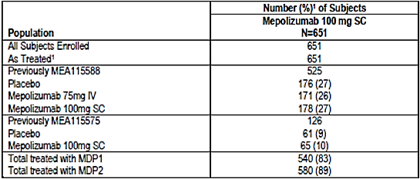
1. Percentages are based on the number of subjects in the All Subjects Enrolled Population. It is possible that subjects were administered MDP2 from Visit 1 onwards. These subjects were not treated with MDP1. Subject [information redacted] had a gap of 6 weeks between the end of MEA115575 and the start of MEA11561 (10-week gap between infusions).
Results
A total of 31% of patients experienced exacerbations with an annualised rate of 0.96 (95% CI: 0.83, 1.12) (Table 53), and 5% required hospitalisation or ED visits. Improvements in ACQ-5 scores were recorded in patients previously treated with placebo (median score -0.80 points, range -2.8 to 3.6) but not in patients previously treated with mepolizumab (median score 0.0 points, range -2.4 to 4.0). In patients previously treated with placebo, median FEV₁ increased from baseline by 105 mL (range -750 to 1790). In patients previously treated with mepolizumab, there was no further improvement in median FEV₁ from baseline (-20 mL, range -1270 to 1170).

Table 53: Study MEA115661- overview of all exacerbations (AT Population)
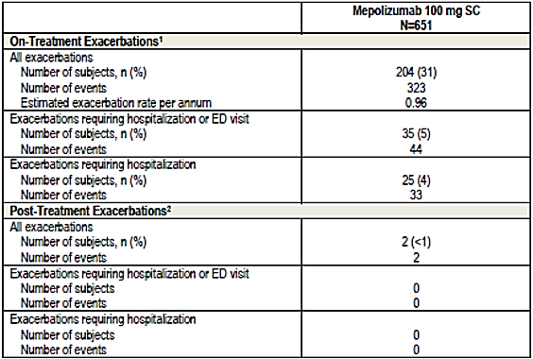
1. Includes events that occurred from the start of treatment until 28 February 2014 or the date of withdrawal, but no greater than 4 weeks post last dose. 2. Includes events that occurred in withdrawn subjects beyond their date of withdrawal or that occurred over 4 weeks after their last dose. Note: Exacerbations recorded in the electronic case report form (eCRF) were not verified using data to confirm that the exacerbation was associated with changes in peak flow, rescue medication use, nocturnal awakening due to asthma symptoms requiring rescue medication use or symptom.
Comment: A total of 65 patients received mepolizumab 100 mg SC in the steroid reduction feeder Study MEA115575 compared with 349 patients who received 75 mg IV or 100 mg SC in MEA115588 (Table 51). Overall, efficacy was sustained long term but the results are driven by patients in the MEA115588 study who did not participate in a steroid reduction protocol. Sustained efficacy cannot be determined in patients who successfully reduced the dose of OCS maintenance in the short term and further analysis is required.

Study MEA115666

Study design and methodology
This was a multicentre, open label, long term safety study of mepolizumab in asthmatic patients who took part in the MEA112997. It commenced in September 2012 and it is being conducted at 65 centres in 13 countries. This is an interim report of the ongoing study dated 28 February 2014. The primary objective is to assess the long term safety of mepolizumab with a secondary objective of long term efficacy in patients with severe refractory asthma. The primary endpoint was the frequency of AEs. The secondary endpoints included the annualised rate of exacerbations, ACQ-5, FEV1, and ADAs. Patients in MEA115666 had a gap of at least 12 months since the last dose of double blind medication in the feeder study. Patients who met the inclusion criteria receive mepolizumab 100 mg SC every 4 weeks in addition to standard care until withdrawal or until mepolizumab becomes commercially available in the participating country. A total of 347 patients have been enrolled and have received at least one dose of study drug. At the interim cut-off date 94% of patients remained on treatment. The most common reasons for withdrawal were AEs and withdrawal by subject (each 2%). No patients were withdrawn because of lack of efficacy. Most patients were White (92%) and female (65%) with a mean age of 52 years and a mean BMI of 28.62 kg/m². Baseline mean pre-bronchodilator FEV₁ was 1.81 L (60.1% predicted). The median time since completion of the feeder study was 17.8 months (range 12 to 28). Since completing the feeder study, the annual rate (SD) of exacerbations was 1.74 (2.94) and 16% had required hospitalisation.

Results
A total of 44% of patients experienced exacerbations with an annualised rate of 0.67 (95% CI: 0.57, 0.79), a 61% reduction compared with baseline. A total of 5% of patients required hospitalisation but 56% of patients remained free of exacerbations at the cut-off point. At Week 60, there was an improvement in median ACQ-5 score of -0.40 (range -4.2 to 1.8). Median FEV₁ increased from baseline by 60 mL (range -1620 to 1810). ADAs were detected in 5% of patients at any point but most were transient and of low titre. No neutralising antibodies were detected at any time point.
Comment: The study was designed to assess the effects of suspending treatment in a patient population previously treated with mepolizumab for 52 weeks. After a minimum 12 month break in treatment, patients resumed treatment with open label mepolizumab and again experienced fewer exacerbations, improved lung function and improved symptom scores compared with baseline. The treatment benefit was sustained at the cut-off point with no evidence of significant immunogenicity or tolerance.

Study 006

Study design and methodology
This was a Phase II, multicentre, double blind, randomised, placebo controlled, parallel group study comparing efficacy and safety in patients with asthma given mepolizumab 250 mg or 750 mg IV. It commenced in February 1999 and completed in October 1999. It was conducted at 55 centres worldwide of which 30 centres were in the US. The primary objective was to assess the safety of mepolizumab and efficacy measured by changes in pulmonary function and symptoms. The secondary objectives were to assess changes in pulmonary function and symptoms, and their relationship to changes in blood and sputum eosinophil numbers. After a 4 week run in period, patients were randomised 1:1:1 to receive mepolizumab 250 mg, mepolizumab 750 mg or matching placebo, each given IV every four weeks for three doses with an eight week follow-up period. The primary efficacy endpoint was the change from baseline in diary morning peak expiratory flow rate (PEFR). The secondary endpoints included the change from baseline in FEV₁, asthma summary symptom score, use of rescue medication, and eosinophil count in blood and sputum. Male and female adult patients were required to have asthma for at least 12 months with FEV₁ between ≥ 50% and ≤ 80%, ICS use of up to 1000 microgram/day, and without a history of frequent exacerbations. There were no eosinophil entry criteria. A total of 362 patients were randomised and received at least one dose of study drug, 94.2% completed the double-blind period, and 90% completed the follow-up period. The most common reasons for withdrawal were AEs (2.8%) which were reported more frequently in the placebo group (4%). No patients were withdrawn because of lack of efficacy. In the ITT population, most patients were White (81%) and male (51.7%) with a mean age of 36 years and a mean body weight of 74.88 kg. Screening mean pre-bronchodilator FEV₁ was 2.51 L with a reversibility of 68.26%

Results
No statistically significant changes from baseline were observed for morning diary PEFR or in clinic FEV₁ in either mepolizumab group compared with placebo. However, in both mepolizumab groups, there was a statistically significant, prompt and marked decrease in blood eosinophils from baseline which was sustained to Week 20 (p < 0.001) (Figure 14).
Figure 14: Mean (SEM) blood eosinophil (10⁹/L)- ITT
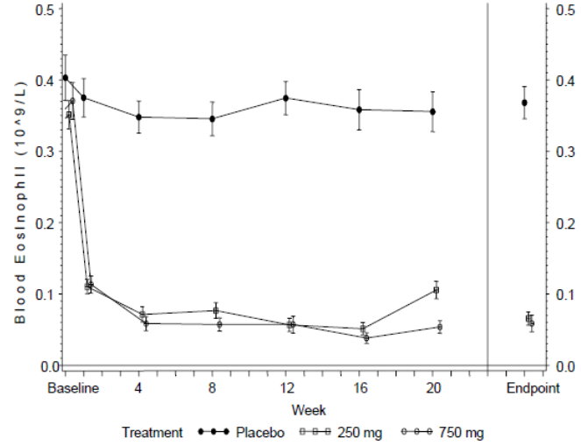
Comment: This was an exploratory study of mepolizumab in patients with moderate asthma with no blood or sputum eosinophil entry criteria and with no history of frequent exacerbations. Mepolizumab had no discernible effect on pulmonary function and symptoms compared with placebo, but there was a marked reduction in blood eosinophils which justified further studies in patients with severe eosinophilic asthma.

Analyses performed across trials (pooled analyses and meta-analyses)

Exacerbation studies: MEA112997 and MEA115588
A meta-analysis was performed on the two placebo controlled exacerbation studies. A total of 1192 patients were included in the efficacy analysis (846 given all doses of mepolizumab, 346 given placebo) (Table 54). Only in Study MEA115588 was the dose and administration route proposed for marketing assessed (194 patients were given mepolizumab 100 mg SC). However, for the purposes of the meta-analysis, the mepolizumab 75 mg IV and 100 mg SC were combined as they were considered bioequivalent.
For the primary endpoint, the meta-analysis confirmed the reduction in the rate of clinically significant exacerbations for mepolizumab compared with placebo (Figure 15). In the combined population, the annualised exacerbation rate was 1.91 in the placebo group compared with 1.01 in the mepolizumab all-dose group [RR 0.52 (95% CI: 0.44, 0.62, p < 0.001)] (Table 55). In MEA115588, patients given mepolizumab 100 mg SC had a comparable 53% reduction in the rate of clinically significant exacerbations [RR 0.47 (95% CI: 0.35, 0.64, p < 0.001)]. Changes from baseline in blood eosinophils over time are shown in Figure 16. There were significant, prompt decreases in blood eosinophils with all mepolizumab doses. In patients treated with mepolizumab 100 mg SC, there was an 84% reduction compared with placebo at Week 32 (p < 0.001).
A summary of patient numbers analysed by subgroup is shown in Table 56. Patients of both genders treated with mepolizumab had a greater reduction in the rate of clinically significant exacerbations compared with placebo. However, in patients treated with mepolizumab 75 mg IV or 100 mg SC, males had a greater rate reduction than females (58% versus 45%). Compared with placebo, patients treated with mepolizumab 75 mg IV or 100 mg SC achieved greater exacerbation rate reductions irrespective of age (< 65 and ≥ 65 years). Only 63 out of 538 patients were aged ≥ 65 years but the benefit in favour of mepolizumab was greater in this group compared with the younger population. One adolescent patient was enrolled in MEA112997 but withdrew. In MEA115588, 9 adolescent patients received placebo and 16 patients received mepolizumab 75 mg IV or 100 mg SC. In the mepolizumab group, 19% of patients reported a clinically significant exacerbation compared with 33% of the placebo group, a benefit comparable to the overall response. Only 98 out of 538 patients were of a race other than White (Koreans and Japanese) but there were no apparent differences in the exacerbation rates between racial groups. The benefit in favour of mepolizumab was higher in US patients compared with the EU and Rest of World but US patient numbers were low (63 out of 538). A meta-analysis of exacerbation rates by baseline blood eosinophils is shown in Table 57. Irrespective of baseline blood eosinophil levels, there was a greater reduction in exacerbation rates in patients treated with mepolizumab 75 mg IV or 100 mg SC compared with placebo. As the baseline eosinophil inclusion criteria for MEA112997 and MEA115588 were different, a post hoc analysis was conducted based on the proposed indication (blood eosinophil count ≥ 300 cells/µL in the previous 12 months, or ≥ 150 cells/µL at baseline). Patients who met the indication criteria had a greater reduction in the rate of clinically significant exacerbations compared with placebo (51% versus 10%).

Table 54: Efficacy meta-analysis- summary of subject populations (individual studies and meta-analysis)
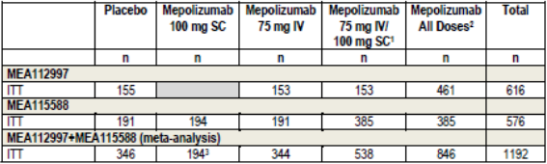
1. For MEA112997, the 75 mg IV/100 mg SC grouping is the same as the 75 mg IV grouping since MEA112997 does not include a 100 mg SC dose. 2. MEA112997 includes 75, 250 and 750 mg IV; MEA115588 includes 75 mg IV and 100 mg SC; MEA112997+MEA115588 includes 75, 250, and 750 mg IV and 100 mg SC. 3. The mepolizumab 100 mg SC group is not included as an individual; treatment group in the meta-analysis since this dose was only tested in MEA115588.
Figure 15: 15 mg IV versus placebo
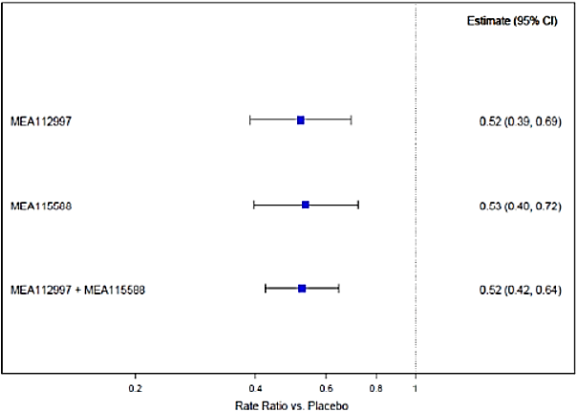
Figure 16: Efficacy meta-analysis- ratios to Baseline in blood eosinophils over time (MEA112997 and MEA 115588, ITT population
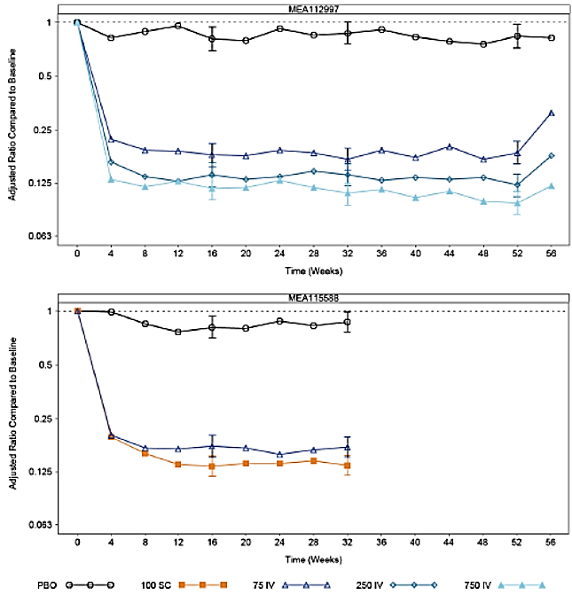
Note: Vertical bars represent 95% CIs. Note: Where a result of zero was recorded, a small value (that is, minimum of all non-missing results/2) was added prior to log transformation.

Table55: Efficacy meta-analysis- revised table
Rate of clinically significant exacerbations | Placebo  N = 346 | Mepolizumab 100 mg SC  N = 194 | Mepolizumab 75 mg IV  N = 344 | Mepolizumab 75 mg IV/ 100 mg SC⁴ N = 538 |  | Mepolizumab All Doses⁵  N = 846
MEA 112997
N | 155 |  | 153 |  | 461
Exacerbation rate/year | 2.40 |  | 1.24 |  | 1.28
Comparison versus placebo¹
Rate ratio (mepolizumab / placebo) | --- |  | 0.52 |  | 0.53
(95% CI) | --- |  | (0.39, 0.69) |  | (0.43, 0.67)
P- value | --- |  | <0.001 | <0.001 | <0.001
MEA115588
n | 191 | 194 | 191 | 385 | 385
Exacerbation rate/year | 1.74 | 0.83 | 0.93 | 0.88 | 0.88
Comparison versus placebo²
Rate ratio (mepolizumab / placebo) | --- | 0.47 | 0.53 | 0.5 | 0.5
95% CI | --- | (0.35, 0.64) | (0.40, 0.72) | (0.39, 0.65) | (0.39, 0.65)
P- value | --- | <0.001 | <0.001 | <0.001 | <0.001
MEA112997+ MEA115588
n | 346 |  | 344 | 538 | 846
Exacerbation rate/year | 1.91 |  | 1.0 | 0.98 | 1.01
Comparison versus placebo³
Rate ratio (mepolizumab / placebo) | --- |  | 0.52 | 0.51 | 0.53
95% CI | --- |  | (0.42, 0.64) | (0.42, 0.62) | (0.44, 0.62)
P- value | --- |  | <0.001 | <0.001 | <0.001
1. Analysis performed using a negative binomial regression model with covariates of treatment group, baseline maintenance OCS therapy (OCS versus no OCS), region, exacerbations in the year prior to the study (as an ordinal variable), and baseline % predicted FEV₁, and with logarithm of time on treatment as an offset variable. 2. Analysis model as in footnote [1]; estimates based on weighting applied to each level of class variable determined from observer proportions. 3. Analysis model as in footnote [2] where region is as defined for the meta-analysis and with an additional covariate of the study. 4. For MEA112997, the 75 mg IV/100 mg SC grouping is the same as the 75 mg IV grouping, since MEA112997 does not include a 100 mg SC dose. 5. MEA112997 includes 75, 250, and 750 mg IV. MEA115588 includes 75 mg IV and 100 mg SC; therefore, the All Doses grouping is the same as the 75 mg IV/100 mg SC grouping. MEA112997+MEA115588 include 75, 250, and 750 mg IV and 100 mg SC.

Table 56: Efficacy meta-analysis- summary of number of subjects by subgroup (meta-analysis, ITT Population)
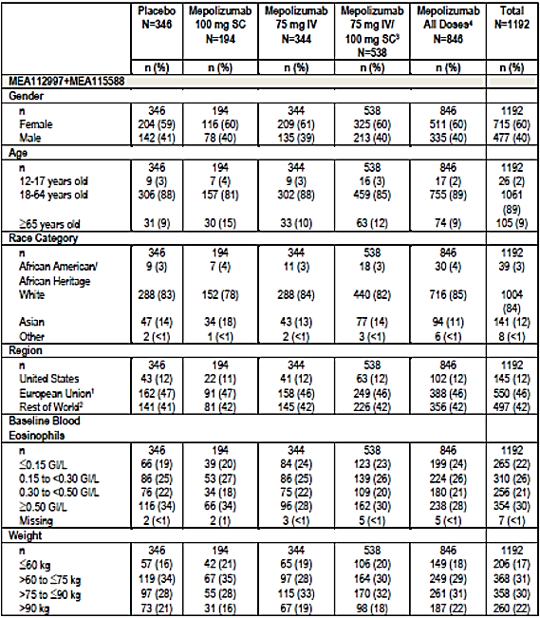
1. European Union includes Belgium, France, Germany, Italy, Poland, Romania, Spain and UK. 2. Rest of World includes Argentina, Australia, Canada, Chile, Japan, Korea, Mexico, Russia and Ukraine. 3. Only MEA115588 includes 100 mg SC dose. 4. Includes 75, 250, and 750 mg IV and 100 mg SC.

Table 57: Efficacy meta-analysis- revised table
 | Placebo N= 346 | Mepolizumab 75 mg IV / 100 mg SC² N = 538 | Mepolizumab All Doses³ N = 846
MEA 112997 + MEA 115588
< 150 cells/ μL
n | 66 | 123 | 199
Exacerbation rate/ year | 1.73 | 1.16 | 1.28
Comparison versus placebo¹
Rate ration (mepolizumab / placebo) | --- | 0.67 | 0.74
(95% CI) | --- | (0.46, 0.98) | (0.52, 1.04)
150 to < 300 cells/mL
n | 86 | 139 | 224
Exacerbation rate/ year | 1.41 | 1.01 | 0.95
Comparison versus placebo¹
Rate ration (mepolizumab / placebo) | --- | 0.72 | 0.67
(95% CI) | --- | (0.47, 1.10) | (0.45, 1.01)
300 to < 500 cells/mL
n | 76 | 109 | 180
Exacerbation rate/ year | 1.64 | 1.02 | 1.06
Comparison versus placebo¹
Rate ration (mepolizumab / placebo) | --- | 0.62 | 0.64
(95% CI) |  | (0.41, 0.93) | (0.45, 0.92)
> 500 cells/mL
n | 116 | 162 | 238
Exacerbation rate/ year | 2.49 | 0.67 | 0.75
Comparison versus placebo¹
Rate ration (mepolizumab / placebo) | --- | 0.27 | 0.30
(95% CI) | --- | (0.19, 0.37) | (0.23, 0.40)
1. Analysis performed using a negative binominal regression model with covariates of treatment group, baseline maintenance OCS therapy (OCS vs. no OCS), region, exacerbations in the year prior to the study (as an ordinal variable), baseline % predicted FEV₁, and study, with logarithm of time on treatment as an offset variable. Estimates based on weighting applied to each level of class variable determined from observed proportions. Region was as defined for the meta-analysis. 2. Only MEA115588 includes 100 mg SC dose. 3. Includes 75, 250, and 750 mg IV and 100 mg SC.
Comment: The rationale for the pooled efficacy analyses was to refine the effect size for the primary endpoint and to permit more detailed assessment of subgroups. Only 194 patients were treated with mepolizumab 100 mg SC but it was valid to pool the 75 mg IV data for the purposes of the meta-analysis. The meta-analysis confirmed an exacerbation rate reduction of approximately 50% in the mepolizumab groups compared with placebo. There were significant rate reductions in both genders but the response rate was higher in males. No age related or body weight differences were noted. No racial differences were observed but the large majority of patients were White. Exacerbation response rates were notably greater in patients with high eosinophil levels at screening. Although the correlation was imperfect, blood eosinophils are a useful biomarker which identifies patients likely to respond with reasonable accuracy. No meta-analysis of exacerbation rates in patients with and without maintenance OCS at screening was performed. This should be provided as rate ratios were notably different in MEA112997 and MEA115588.

Evaluator’s conclusions on clinical efficacy
Mepolizumab is indicated as add-on treatment for severe eosinophilic asthma in patients aged 12 years and over identified by either a blood eosinophil count ≥ 150 cells/µL at initiation of treatment or a blood eosinophil count ≥ 300 cells/µL in the prior 12 months, with a ̕history of exacerbations and/or dependency on systemic corticosteroids.’
The pivotal placebo controlled study in patients with severe eosinophilic asthma demonstrated a statistically significant and clinically meaningful benefit for mepolizumab compared with placebo. In the 100 mg SC group of MEA115588, there was an exacerbation rate reduction of 53% (p < 0.001), and a reduction of 61% in exacerbations requiring hospitalisation and/or ED visits. The treatment duration was only 32 weeks but the interim analyses of the open label extension studies demonstrated that efficacy was sustained long term. Similar exacerbation rate reductions were also demonstrated with the 75 mg IV doses in MEA115588 and MEA112997 (47% and 48%, respectively).In MEA115575, there was a 32% reduction in exacerbation rates compared with placebo despite significant OCS dosage reductions.
Blood eosinophils were suppressed by all doses of mepolizumab and this effect was sustained for at least 32 weeks. Blood eosinophils at screening have been shown to be an accurate biomarker with exacerbation rate reductions greater in patients with high eosinophil counts and most usefully in those with ≥ 150 cells/µL. Exacerbation rate reductions were associated with improved lung function. In the mepolizumab 100 mg SC group of MEA115588, pre- and post-bronchodilator FEV₁ increases of 98 mL and 138 mL were demonstrated. These differences were statistically significant and clinically meaningful. Asthma symptoms measured by ACQ and SGRQ were also improved.
The overall benefit of mepolizumab was observed in patients with or without concurrent maintenance OCS. However, in MEA115588 there was no meaningful response in patients with maintenance OCS treated with mepolizumab 100 mg SC. Mepolizumab also permitted clinically meaningful OCS dose reductions without loss of asthma control. In MEA115575, a 50% reduction in median OCS dose from baseline was achieved in the mepolizumab group compared with 0% in the placebo group during a four week maintenance period. However, a further analysis of MEA115661 is required to confirm that this benefit is sustained. There were no important differences observed in subgroups based on age, gender, race, and body weight. However, more data are required to support use in adolescents.
The efficacy of mepolizumab is supported by a recently published study of reslizumab, another monoclonal IL-5 inhibitor (Castro, 2015, see References). Two duplicate placebo-controlled Phase III studies with large patient numbers assessed exacerbation rate reductions in patients with moderate to severe asthma inadequately controlled on ICS, and with blood eosinophils ≥ 400 cells/µL. In both studies, patients receiving reslizumab had significant reductions in the frequency of asthma exacerbations [RR 0·50 (95% CI: 0·37, 0·67) and RR 0·41 (0·28, 0·59), both p < 0·0001] compared with those receiving placebo.
The efficacy outcomes in the submission appear to be based on a selection of exploratory studies rather than a coherent Phase III trial program. In the various pivotal and supportive studies, the patient populations differed with respect to eosinophil criteria, maintenance OCS use, mepolizumab dose and delivery, and efficacy outcomes. In addition, several analyses were retrospective. The dose selection process was not ideal and the lowest effective dose was determined retrospectively with a PK/PD study. Relatively few patients received the 100 mg SC dose proposed for marketing and the single pivotal study had an observation period of only 32 weeks. Despite these limitations, there appears little doubt that mepolizumab improves outcomes in patients with severe eosinophilic asthma, and that blood eosinophils are a clinically useful biomarker. However, the heterogeneous studies do not support the proposed indication in several respects. This has caused confusion with different labels proposed for the EU, US, Canada and Australia, presumably following feedback from the respective authorities.

Clinical safety

Studies providing evaluable safety data
The following studies provided evaluable safety data:

Pivotal efficacy studies
In the pivotal efficacy studies MEA115588 and MEA115575 the following safety data were collected:
- General AEs were coded using the Medical Dictionary for Regulatory Activities (MedDRA) and summarised by preferred term (PT), system organ class (SOC) and treatment group.
  - AEs of particular interest included, systemic (non-allergic and allergic/hypersensitivity) and local site reactions, serious cardiac, vascular, thromboembolic and ischemic adverse events, malignancies and infections.
- Laboratory tests, including clinical chemistries and haematology, were performed at central laboratories.
- Vital signs.
- Electrocardiogram (ECG).

Pivotal studies that assessed safety as a primary outcome
None submitted.

Dose-response and non-pivotal efficacy studies
The following dose-response and open-label extension studies provided safety data: MEA112997, MEA115661, MEA115666, and 006. A summary of all 19 mepolizumab studies performed in all doses and indications is shown in Table 58.

Other studies evaluable for safety only
Not applicable.

Table 58: Summary of safety studies- study groupings for analysis of safety
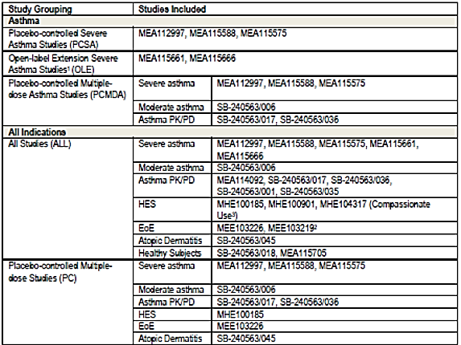
1. These studies are currently ongoing; interim safety results are presented in this Safety Summary. 2. Conducted in paediatric subjects. 3. Includes ongoing open label studies MHE112000 and MHE112562 PK/PD= pharmacokinetic/pharmacodynamics; HES = hypereosinophilic syndrome; EoE = eosinophilic esophagitis

Pivotal studies that assessed safety as a primary outcome
None submitted.

Patient exposure
In addition to patients with severe asthma, the sponsor has conducted exploratory studies of mepolizumab for other indications including moderate asthma, hypereosinophilic syndrome, eosinophilic oesophagitis, and atopic dermatitis (Table 59). In this overall population, 2022 patients (or healthy subjects) received at least one dose of mepolizumab and a further 661 received placebo. Overall, 1229 patients with severe eosinophilic asthma received at least one dose of mepolizumab. Of these, 1018 received mepolizumab 100 mg SC in randomised, placebo controlled studies, or long-term extension studies. In the 1018 patients treated with mepolizumab 100 mg SC, total treatment exposure was 789 patient years (PYs). A total of 576 patients (57%) were treated for up to 12 months and 442 patients (43%) were treated for 12 to less than 24 months. Patients who received mepolizumab 100 mg SC were given a mean of 10 treatments. A total of 915 patients were given at least one dose of mepolizumab in the severe asthma studies; 263 received mepolizumab 100 mg SC and 344 received 75 mg IV (Table 60). In the severe asthma group, the all dose treatment exposure was 687.4 patient/years with a mean of nine treatments given.

Table 59: Patient exposure
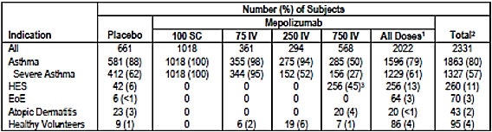

Table 60: Patient exposure- summary of duration of exposure and number of treatments administered (severe asthma studies, safety population)
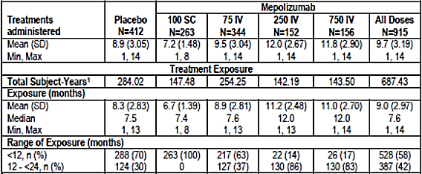
Note: Studies included MEA112997, MEA115588 and MEA115575 1. Sum across subjects of (treatment stop date to treatment start date +29)/365.25

Adverse events

All adverse events (irrespective of relationship to study treatment)

Pivotal studies
In MEA115588, a summary of AEs is shown in Table 61. The frequency of AEs irrespective of causality was similar in the placebo and each mepolizumab dose group (75 mg IV and 100 mg SC). The most frequent AEs (≥ 3% in any treatment group) are shown in Table 62. The most common AEs in each group were nasopharyngitis and headache. The frequency of nasopharyngitis was comparable in each treatment group but headache was reported more frequently in the mepolizumab groups (20 to 24% versus 17%).
In MEA115575, a summary of AEs is shown in Table 63. The frequency of AEs irrespective of causality was higher in the placebo than in the mepolizumab 100 mg SC group. The most frequent AEs (> 3% in any treatment group) are shown in Table 64. The most common AEs in each group were headache (21% placebo, 20% mepolizumab) and nasopharyngitis (15% placebo, 14% mepolizumab).

Table 61: Study MEA115588- adverse event summary (ITT Population)
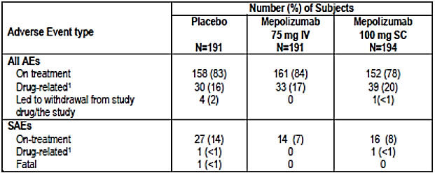
1. Investigator`s judgement of causality.

Table 62: Study MEA115588- adverse events (on-treatment) occurring in greater than or equal to 3% of subjects in any treatment group (ITT Population)
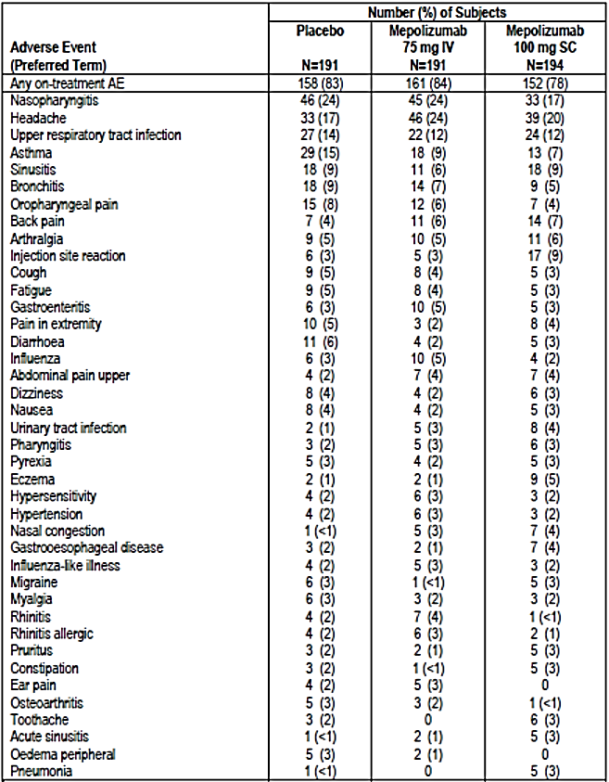

Table 63: Study MEA115575- adverse event summary (ITT Population)
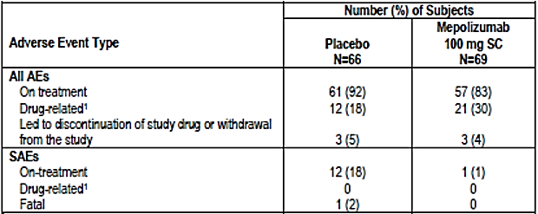
1. Investigator`s judgement of causality.

Table 64: Study MEA115575: adverse events (on-treatment) occurring in > 3% of subjects in either treatment group (ITT Population)
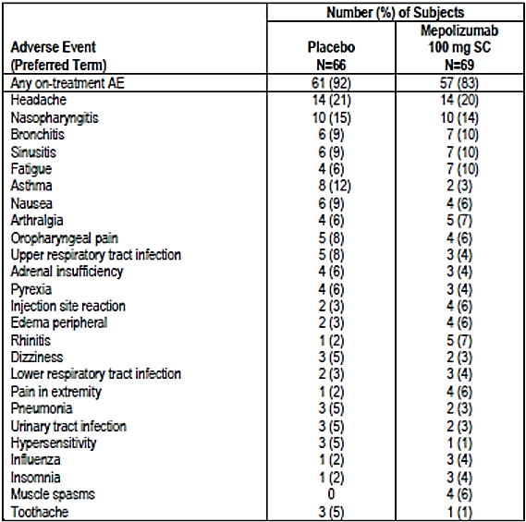

Other studies
In MEA112997, a summary of AEs is shown in Table 65. The frequency of AEs irrespective of causality was similar in the placebo and each mepolizumab dose group (75 mg, 250 mg and 750 mg IV). The most frequent AEs (≥ 2% in any treatment group) are shown in Table 66. The most common AEs in each group were headache and nasopharyngitis. Both were reported more frequently in the mepolizumab groups compared with placebo (headache 21% versus 17%, nasopharyngitis 19 to 22% versus 15%).
In an interim analysis of the open label extension Study MEA115661, 72% of patients given mepolizumab 100 mg SC experienced at least one AE. The most frequent AEs were nasopharyngitis (21%), headache (10%), upper respiratory tract infection (9%), asthma (8%), bronchitis (7%) and sinusitis (7%). Injection site reactions were reported in 4% of patients but there were no reported cases of anaphylaxis.
In an interim analysis of the open label extension Study MEA115666, 85% of patients given mepolizumab 100 mg SC experienced at least one AE. The most frequent AEs were nasopharyngitis (26%), headache (21%), upper respiratory tract infection (13%), asthma (11%), arthralgia (10%) and bronchitis (10%). Injection site reactions were reported in 8% of patients but there were no reported cases of anaphylaxis.
In Study 006, more AEs were reported in the placebo group (76.2%) compared with patients who received mepolizumab 250 mg IV (67.5%) or mepolizumab 750 mg IV (69.0%). The most frequent AEs were upper respiratory tract infections (17.5%, 19.2% and 19.8%, respectively), asthma (23.8%, 20.8%, and 17.2%, respectively) and headache (11.9%, 7.5%, and 13.8%, respectively).

Table 65: Study MEA115575- adverse events (on-treatment (occurring in > 3% of subjects in either treatment group (ITT Population)
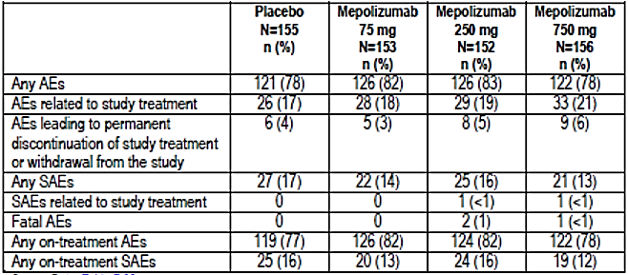

Table 66: Study MEA112997- summary of most frequent on-treatment adverse events
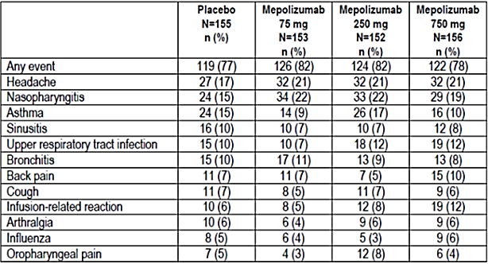

Table 66: cont.
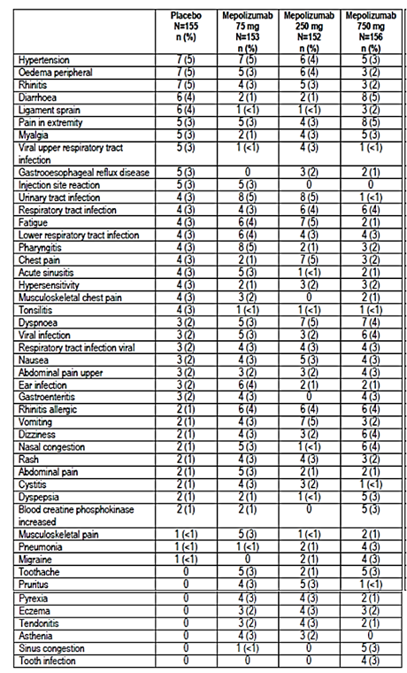
Note: On-treatment adverse events with ≥ 2% frequency (before rounding) for any treatment group are presented.

Treatment-related adverse events (adverse drug reactions)

Pivotal studies
In MEA115588, the frequency of adverse drug reactions (ADRs) was similar in the placebo (16%) and mepolizumab 75 mg IV (17%) groups. In the mepolizumab 100 mg SC group, ADRs were reported more commonly (20%) due mainly to an increased incidence of injection site reactions. The most frequent ADRs in each group were injection site reactions (placebo 3% versus mepolizumab 2 to 7%) and headache (placebo 2% versus mepolizumab 4% in each group).
In MEA115575, the frequency of ADRs was similar in the placebo and mepolizumab 100 mg SC groups. The most frequent ADRs were headache (5% versus 7%), nausea (5% versus 3%) and injection site reactions (3% versus 4%).
Comment: Table 39 in the MEA115575 CSR (table not included here) describes a higher percentage of patients with ADRs in the mepolizumab 100 mg SC group (30%) than in the placebo group (18%). However, the absolute numbers of the most frequent ADRs reported in each group appear comparable.

Other studies
In MEA112997, the frequency of ADRs was similar in the placebo (17%) and the mepolizumab 75 mg IV, mepolizumab 250 mg IV, and 750 mg IV dose groups (18%, 19%, and 21%, respectively). The most frequent AEs in each group were infusion related reactions (placebo 6% versus mepolizumab 5 to 12%) and injection site reactions (placebo 3% versus 0 to 3% mepolizumab).
In the extension Study MEA115661, 13% of patients given mepolizumab 100 mg SC experienced at least one ADR. The most frequent ADRs were injection site reactions (4%) and headache (2%). In the extension Study MEA115666, 19% of patients given mepolizumab 100 mg SC experienced at least one ADR. The most frequent ADRs were injection site reactions (8%) and headache (4%). In Study 006, probable and suspected ADRs were reported in 1.6% and 11.1% of the placebo group, in 3.3% and 6.7% of the mepolizumab 250 mg group, and in 3.4% and 9.5% of the mepolizumab 750 mg group. The most common ADRs were headache (placebo 2.4%, mepolizumab 0 to 2.6%) and nausea (placebo 0.8%, mepolizumab 0 to 1.7%).

Deaths and other serious adverse events

Pivotal studies
In MEA115588, there was one death in the placebo group due to a road traffic accident. There were more serious adverse events (SAEs) in the placebo group (14%) than in the mepolizumab 75 mg and mepolizumab 100 mg SC groups (7% and 8%, respectively). The most common SAE was asthma reported in 7%, 5% and 3% of the respective treatment groups.
In MEA115575, there was one death in the placebo group due to sepsis and gastrointestinal (GI) bleeding. In the placebo group, 18% of patients reported SAEs compared with one (1%) in the mepolizumab 100 mg SC group. The most frequent SAE was asthma, all in the placebo group.

Other studies
In MEA112997, there were three deaths, two (1%) in the mepolizumab 250 mg group, and one (< 1%) in the 750 mg group. A 56 year old patient died of acute asthma 10 hours after receiving the second dose of mepolizumab, and the other deaths were due to acute pancreatitis and suicide. None of the deaths was considered drug related. The frequency of other SAEs was similar in the placebo group (16%) and mepolizumab groups (12 to 16%). The most frequent SAE in each group was asthma, reported in 11% of the placebo group and 6 to 11% of the mepolizumab groups (Table 67). In the placebo group, serious cardiac events were reported in 1 out of 155 patients compared with 7 out of 461 in the mepolizumab groups. All but one event was ischaemic and all but one patient had a history of ischaemia at baseline. The sponsor undertook a post hoc review of the cardiac and vascular events via a Clinical Endpoint Committee. This review suggested no excess of cardiac events in the mepolizumab group (Table 68). However, based on these data, cardiac events were identified as AEs of special interest. Enhanced monitoring was provided for subsequent studies, including the use of an Independent Data Monitoring Committee.
In MEA115661, there were no deaths at the study cut-off date for the interim analysis. A total of 8% of patients reported SAEs, most commonly asthma (4%). Only two SAEs were considered possibly related to drug treatment. In MEA115666, there was one death (< 1%) due to respiratory arrest at the study cut-off date for the interim analysis. It was not considered drug related. A total of 9% of patients had SAEs but none were considered to be drug related. In 006, no deaths were reported. SAEs were reported in 4.0% of the placebo group, 2.5% of the mepolizumab 250 mg group, and 1.8% of the 750 mg group. No events were considered drug related.

Table 67: Study MEA112997- summary of all on-treatment serious adverse events
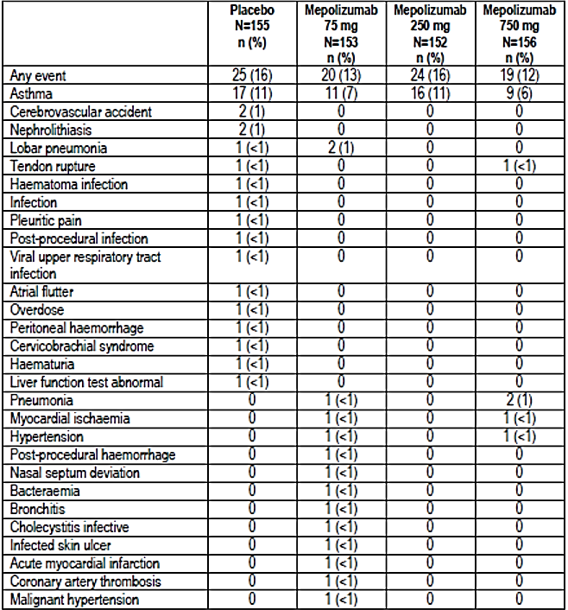

Table 67: cont.
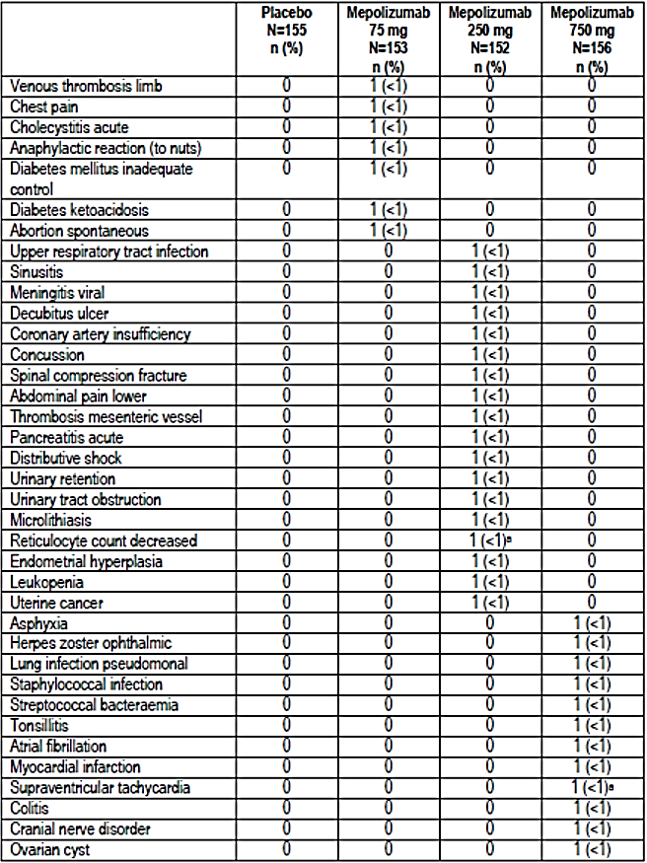
a. These events were judged to be possibly related to investigational product by the investigator.

Table 68: Study MEA112997- overview of cardiac, vascular, thromboembolic, and ischaemic serious adverse events
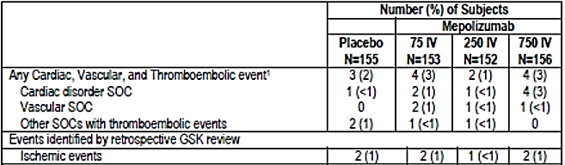
1. Some subjects have more than one event classified SOCs.

Discontinuation due to adverse events

Pivotal studies
In MEA115588, there were four (2%) withdrawals in the placebo group and one (< 1%) in the mepolizumab 100 mg SC group.
In MEA115575, there were three (5%) withdrawals due to AEs in the placebo group and three (4%) in the mepolizumab 100 mg SC group.

Other studies
In MEA112997, withdrawals due to AEs were reported in 4% of the placebo group and in 3 to 6% of the mepolizumab groups. Asthma and hypersensitivity were the most commonly reported events.
In MEA115661, eight patients (1%) were withdrawn due to AEs, and in MEA115666, eight patients (2%) were withdrawn. In 006, AEs leading to withdrawal were reported in 4.0%, 3.3% and 0.9% of the placebo, mepolizumab 250 mg, and 750 mg groups, respectively. The most common reason for withdrawal was asthma.

Laboratory tests

Liver function

Pivotal studies
In MEA115588 and MEA115575, no patients in the placebo or mepolizumab groups had AEs related to potential liver injury.

Other studies
In MEA112997, AEs related to liver function were reported in 2% of the placebo and mepolizumab 75 mg groups, and in 1% of the mepolizumab 250 mg and 750 mg groups. One patient in the mepolizumab 75 mg group had RUCAM criteria for hepatocellular injury. The patient was withdrawn and the LFTs normalised within 30 days.
In MEA115661, one patient (< 1%) in each of the mepolizumab 75 mg IV and 100 mg SC groups had liver AEs. One patient had autoimmune hepatitis and the event was not considered drug related. One 14 year old patient had a transient alanine aminotransferase (ALT) increase. No cause was found but it was not considered drug related and the patient continued in the study. In MEA115666, three patients (< 1%) developed protocol defined significant LFT abnormalities. One was reported as an AE but no patients were withdrawn. In 006, liver function test abnormalities were reported in 3 (2.4%) patients in the placebo group, and 4 (3.3%) patients in the mepolizumab 250 mg group, all mild to moderate in severity.

Kidney function

Pivotal studies
In MEA115588 and MEA115575, there were no meaningful changes in mean serum creatinine from baseline to Week 32 and Week 24, respectively. Minor isolated excursions during the treatment periods were not clinically significant.

Other studies
In MEA112997, there were no meaningful changes in mean serum creatinine from baseline to Week 52 in the placebo or mepolizumab groups. There were no clinically meaningful changes throughout the treatment period in the placebo group but isolated, highly significant increases in serum creatinine were reported in the mepolizumab groups (Table 69). These excursions require comment but none was provided in the CSR.
In MEA115661 and MEA115666, there were no meaningful changes in mean serum creatinine from baseline to the study cut off points. In 006, 12 renal AEs were reported but all but one (in the placebo group) was associated with urinary tract infections.

Table 69: Study MEA112997
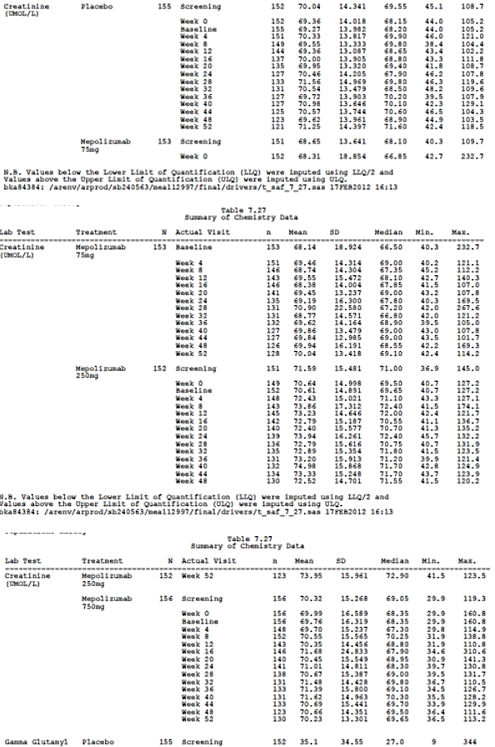

Other clinical chemistry

Pivotal studies
In MEA115588 and MEA115575, there were minimal changes in mean clinical chemistry values during the treatment period in any treatment group. The most common abnormalities related to serum glucose, cholesterol, LDL, phosphate, creatine kinase, calcium and chloride. However, in each case the abnormalities were observed more frequently in the placebo group.

Other studies
In MEA112997, no more than 1% of patients had clinically significant AEs related to any clinical chemistry value during the treatment period. There were isolated events of low glucose and both high and low potassium levels but there were no SAEs and no study withdrawals.
In MEA115661, there were no notable mean changes in clinical chemistry from baseline to the cut-off period. Cases of clinical concern were reported in only two patients, high potassium and high glucose. In MEA115666, high potassium was reported in one patient and low sodium was reported in two patients. In both extension studies, less than 1% of patients had values of clinical concern in any laboratory parameter during the observation periods. In 006, AEs related to clinical chemistry were reported in 8.7%, 4.2% and 3.4% of the placebo, mepolizumab 250 mg and 750 mg groups, respectively. These events included those related to abnormal liver, renal and haematology values.

Haematology (excluding eosinophils)

Pivotal studies
In MEA115588, there were no haematology events of protocol defined clinical concern in any placebo or mepolizumab treatment group at any time point. Treatment emergent values significantly outside the normal range were isolated and transient. In MEA115575, no patients in the placebo or mepolizumab groups had haematological changes of clinical concern. Deviations from baseline occurred with similar frequency in the placebo and mepolizumab groups.

Other studies
In MEA112997, MEA115661 and MEA115666, few patients had haematology values outside the normal range or significant changes from baseline. There were no cases of potential clinical concern. In 006, there were a few treatment-emergent haematological events of clinical concern and most occurred more commonly in the placebo group.

Electrocardiograph

Pivotal studies
In MEA115588, clinically significant ECG changes at baseline were reported in 7% of the placebo group and in 9% of patients in each mepolizumab group. During the treatment period, ECG changes were recorded in 16%, 18%, and 17% of the placebo, mepolizumab 75 mg IV and 100 mg SC groups, respectively. There were no clinically significant changes in QTcF or QTcB.
In MEA115575, clinically significant ECG changes at baseline were reported in 8% of the placebo group, and in 12% of patients in the mepolizumab 100 mg SC group. During the treatment period ECG changes were recorded in 9% of the placebo group and 13% of the mepolizumab 100mg SC group. There were no clinically significant changes in QTcF or QTcB.

Other studies
In MEA112997, the incidence of clinically significant ECG changes was similar in each treatment group. The percentages of patients with abnormal ECGs at Week 56 were 10%, 10%, 15%, and 16%, in the placebo, mepolizumab 75 mg, 250 mg and 750 mg groups, respectively. There were no meaningful changes in QTcF or QTcB during the treatment period.
In MEA115661, ECG abnormalities were reported in 7% of patients at baseline and treatment emergent ECG abnormalities were reported in 2% of patients. No AEs were reported. In MEA115666, ECG abnormalities were reported in 8% of patients at baseline. Treatment emergent ECG abnormalities were reported in 13% of patients but none were considered to be AEs. In 006, two patients in the mepolizumab 250 mg group had AEs of ECG abnormality. One patient had cardiomyopathy and the other had a multifocal ventricular ectopic arrhythmia. Both events were considered mild and unrelated to treatment. Two patients in the mepolizumab 750 mg group had ill-defined arrhythmias but both were mild and considered unrelated to treatment.

Vital signs

Pivotal studies
In Study MEA115588 and MEA115575, there were no clinically significant absolute changes or mean changes from baseline in vital signs.

Other studies
In MEA112997, MEA115661 and MEA115666, no events of potential clinical concern related to vital signs were reported in either study. In 006, AEs related to vital sign were reported in one placebo patient, one mepolizumab 250 mg patient, and two mepolizumab 750 mg patients, all related to increased systolic blood pressure.

Pooled safety analyses
Studies were grouped for pooled safety analyses as shown in Table 58. The groups comprised three placebo controlled severe asthma studies (PCSA); two open label extension studies (OLE); and six multiple dose asthma studies (placebo-controlled multiple dose asthma studies- PCMDA). In addition, nineteen studies with evaluable safety data (Group ALL) were grouped, including studies in healthy subjects and other disease indications. A final group of nine studies included all placebo controlled multiple dose studies (Group SC).
Subgroups were also assessed based on gender, age, race, geographical region, and cardiovascular history or risk. The most frequently reported AEs (≥ 3%) were provided for all asthma and severe asthma studies. In addition, a meta-analysis of SAEs, and AEs of special interested was performed.
In the PCSA analysis, the incidence of AEs was similar in the placebo, mepolizumab 100 mg SC, and mepolizumab 75 mg IV groups (82%, 79%, and 83%, respectively) (Table 70). The most common AEs (≥ 3%) were headache and nasopharyngitis. Headache was reported in 18% of the placebo group compared with 20-23% in the mepolizumab groups. Nasopharyngitis was reported in 19% of the placebo group and 16-23% of the mepolizumab groups. Injection site reactions were reported more commonly in the mepolizumab 100 mg SC group (8%) compared with placebo (3%). Most were mild to moderate and no SAEs were reported.
Three events had relative risks > 2 for mepolizumab compared with placebo and all others were < 2. The adjusted incidence for eczema was 0.5% for placebo compared with 2.6% for mepolizumab (RR 5.34; 95% CI: 1.25, 22.78). The adjusted incidence for nasal congestion was 1.0% for placebo compared with 2.5% for mepolizumab (RR 2.62; 95% CI: 0.89, 7.72). The adjusted incidence for dyspnoea was 1.1% for placebo compared with 2.3% for mepolizumab (RR 2.2; 95% CI: 0.78, 6.20). A review of 182 patients with eczema/rash, dyspnoea and nasal congestion was conducted to determine if the symptoms represented unrecognised hypersensitivity reactions. However, no cases were identified which met the criteria for hypersensitivity or anaphylactoid reactions.
The exposure adjusted AE profile is shown in Table 71. Exposure in the placebo group was 284 PYs compared with 147 and 687 PYs in the mepolizumab 100 mg SC and mepolizumab all doses groups, respectively. The sponsor has adopted a conservative approach by assessing the incidence of ADRs relating to all doses of mepolizumab in addition to mepolizumab 100 mg SC. Based on these data, ADRs identified for labelling were headache, back pain, injection site reactions, eczema, urinary tract infection, lower respiratory tract infection, pharyngitis, abdominal pain upper, pyrexia and nasal congestion. AEs in the pooled OLE studies matched those in the placebo controlled severe asthma studies, the most frequently reported AEs were nasopharyngitis (23%) and headache (14%). Injection site reactions were reported in 5% of the pooled OLE population. Overall, there were six deaths, five in the severe asthma studies and one in the OLE studies. No deaths were considered drug related, and no other deaths were reported in the ALL study population.
AEs of special interest were defined as systemic and local site reactions, cardiac events, infections, and malignancies. The RR for the AEs of special interest and on-treatment SAEs for all doses of mepolizumab compared with placebo are shown in Figure 17. The same comparison for mepolizumab 100 mg SC/75 mg IV compared with placebo is shown in Figure 18. The incidence of serious infections and opportunistic infections was similar in the mepolizumab 100 mg SC/75 mg IV (2% and 1%) and placebo groups (3% and <1%%). Helminth infections were an exclusion criterion and only one suspected infection was reported in the clinical study program. Systemic reactions and local site reactions were reported with similar frequency in the placebo and mepolizumab 100 mg SC/75 mg IV groups (5% and 3% versus 3% and 5%, respectively). There were no anaphylactic events based on protocol defined assessment criteria. Cardiac events occurred in 3% of the placebo and all dose mepolizumab groups, and in 2% of the mepolizumab 100 mg SC/75 mg IV groups. Serious cardiac disorders were reported in < 1% of any treatment group but compared with placebo the RR was 2.8 (95% CI: 0.36, 21.77) for all doses of mepolizumab and 2.69 (95% CI: 0.25, 28.58) for mepolizumab 100 mg SC/75 mg IV. The increased RR for mepolizumab was driven largely by the results of MEA112997. A retrospective review via an independent data monitoring committee (IDMC) of all cardiovascular, thromboembolic and ischaemic events summarised in Table 72. Serious ischaemic events were reported with similar frequency in the placebo and mepolizumab groups (< 1%). Neoplasms (benign and malignant) were reported infrequently (< 1%) and with similar frequency in the placebo and mepolizumab groups. The hazard ratio for all mepolizumab doses compared with placebo was 0.40 (95% CI: 0.06, 2.57).

Table 70: Pooled safety analysis- common (≥ 3% incidence in any treatment group) on-treatment adverse events (severe asthma studies, safety population)
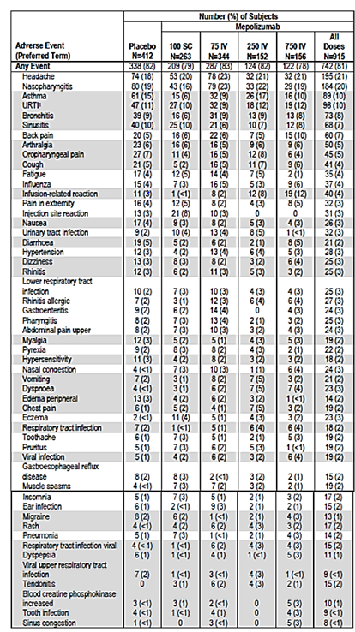

Table 71 A: Pooled safety analysis
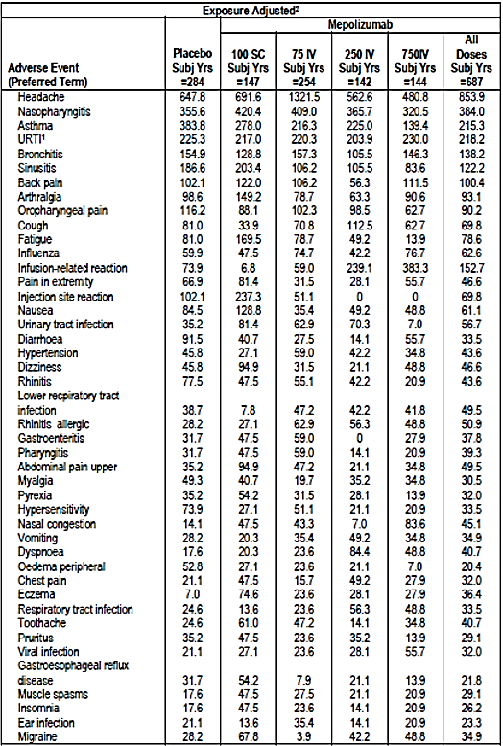

Table 71 B: Pooled safety analysis
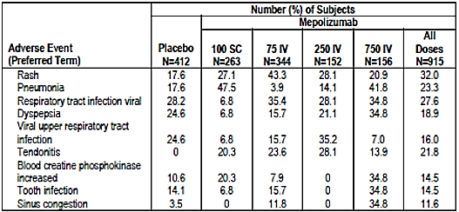
Note: Studies included: MEA112997, MEA115588 and MEA115575. Note: AEs that are shaded occurred either (i) at an incidence of < 3% in the mepolizumab 100 mg SC and 75 mg IV group or (ii) 3% or more in the mepolizumab 100 mg SC or 75 mg IV groups, but less than or equal to the incidence in the placebo group. 1. URTI = upper respiratory tract infection 2. Numbers represent the frequency of events per 100 subject-years of exposure.
Figure 17: Pooled safety analysis- on-treatment serious AEs of special interest: CMH-adjusted relative risk (all doses mepolizumab versus placebo; severe asthma studies)
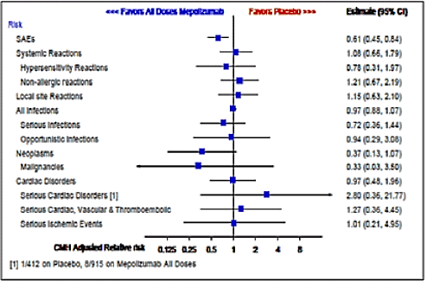
Note: Horizontal bars represent 95% confidence interval.
Figure 18: Pooled safety analysis- on-treatment serious AEs and AEs of special interest: CMH-adjusted relative risk (mepolizumab 100 mg SC/75 mg IV versus placebo; severe asthma studies)
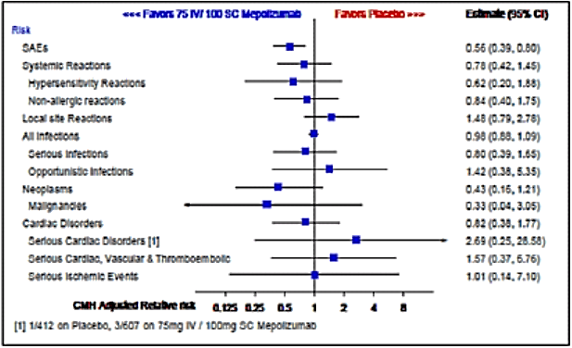
Note: Horizontal bars represent 95% confidence interval.

Table 72: Pooled safety analysis- overview of cardiac, vascular, thromboembolic, and ischemic serious adverse events (severe asthma studies)
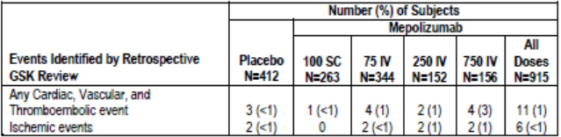
Note: Studies included: MEA112997, MEA 115588 and MEA 115575

Post-marketing experience
Not applicable.

Safety issues with the potential for major regulatory impact

Liver toxicity
No significant issues were identified. In all clinical studies, 15 (< 1%) patients were withdrawn due to potential hepatic toxicity. In the placebo-controlled severe asthma studies, standard protocol-defined LFT stopping criteria occurred in ten patients, five during treatment and five post-treatment. Three (< 1%) patients met the criteria in the placebo and mepolizumab 75 mg IV groups, and two (1%) in each in the mepolizumab 250 mg IV and 750 mg IV groups. In the OLE studies, three events were reported on-treatment, one post-treatment, and one with unknown timing. No event met the criteria for Hy’s law.

Haematological toxicity
No significant issues were identified.

Serious skin reactions
No significant issues were identified.

Cardiovascular safety
Severe cardiac events were uncommon in the placebo and mepolizumab groups of the severe asthma studies. However, safety concerns were raised by an excess of ischaemic events in the mepolizumab group compared with placebo in MEA112997. This finding was not confirmed by IDMCs in subsequent studies and the sponsor reasonably argues that this observation was a chance event.

Unwanted immunological events
No significant issues were detected. All therapeutic antibodies have the potential to induce ADAs although the incidence is usually low and of no clinical significance. In the placebo-controlled severe asthma studies, 6% of patients treated with mepolizumab 100 mg SC and 2% of patients treated with IV mepolizumab developed ADAs. However, most were transient and low titre. Stopping and restarting treatment in MEA115666 did not increase immunogenicity and ADAs were not related to hypersensitivity reactions.

Other safety issues

Safety in special populations
A summary of patient numbers of subgroups based on gender, age, race, and region is shown for the severe asthma studies in Table 73. The incidence of AEs by SOC was similar in males and females with no meaningful treatment- or dose-related effects (Table 74). No significant age related differences between treatments in the pooled severe asthma studies were observed. The numbers of adolescents and the elderly were small but the frequency and pattern of AEs in both groups were similar to the overall population (Table 75). Most patients in the severe asthma studies were White and the majority of the remainder were Asian. No significant differences between the racial groups were observed but the numbers of other racial groups were too small to make meaningful comparisons. No significant differences based on geographical region were observed.

Table 73: Pooled safety analysis- summary of number of subjects by subgroup (several asthma studies, safety population)
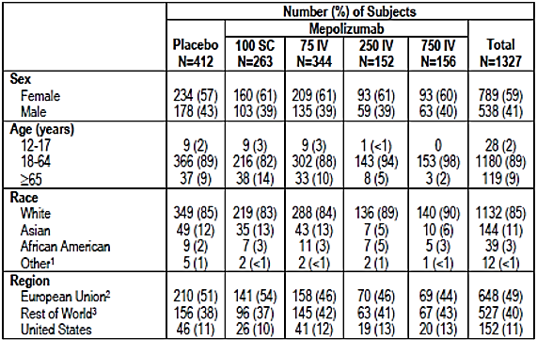
1. Other includes American Indian or Alaskan Native, Native Hawaiian or Other Pacific Islander, and Mixed Race 2. European Union incudes Belgium, Czech Republic, France, Germany, Italy, Netherlands, Poland, Romania, Spain and United Kingdom 3. Rest of World includes Argentina, Australia, Canada, Chile, Japan, Korea, Mexico, Russia and Ukraine.

Table 74: Pooled safety analysis- on-treatment system organ class adverse events (≥ 10% in any treatment group) by gender (severe asthma studies, safety population)
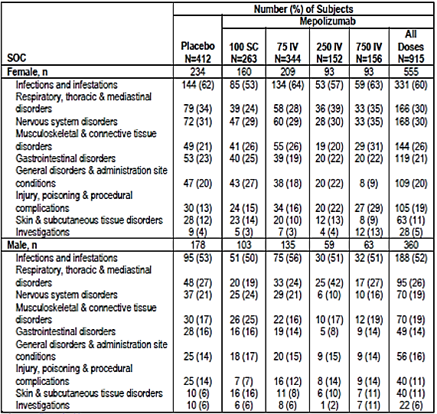
Note: Studies included: MEA112997, MEA115588 and MEA115575

Table 75: Pooled safety analysis- on- treatment system organ class adverse events (≥ 10% in any treatment group) by age (severe asthma studies, safety population)
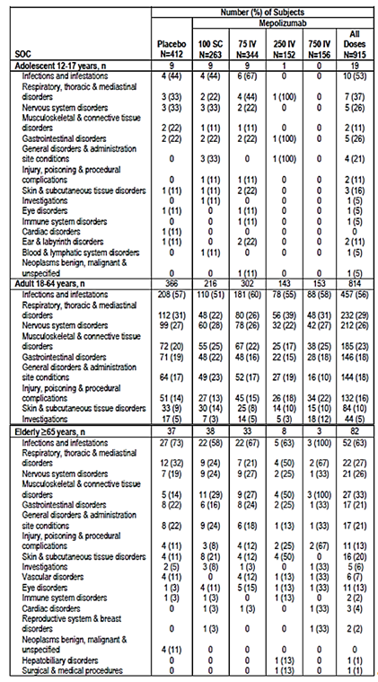
Note: Studies included MEA112997, MEA115588 and MEA115575
Comment: As noted previously, the number of adolescent patients aged 12 to17 years was small although the safety profile in this group matched that of the overall population. In the severe asthma studies, nine patients each received placebo, mepolizumab 100 mg SC or mepolizumab 75 mg IV.

Safety related to drug-drug interactions and other interactions
No studies specifically examined the drug-drug interaction between mepolizumab and other drugs; however, as mepolizumab is a humanised monoclonal antibody, its potential for drug-drug interactions is low.

Evaluator’s overall conclusions on clinical safety
In patients with severe eosinophilic asthma, the safety profile of mepolizumab was comparable to placebo. This was apparent for all doses tested with a flat dose response relationship in the 75 mg to 750 mg IV dose range. This wide safety window supports the use of a unit 100 mg SC dose without the need for mg/kg dosing.
In the pivotal Studies MEA115588 and MEA11575, and in the dose ranging Study MEA112997, the incidence of AEs was similar in the mepolizumab 75 mg IV and 100 mg SC, and placebo groups. Compared with placebo, SAEs and withdrawals due to AEs were lower in the mepolizumab groups compared with placebo. No deaths attributed to mepolizumab were reported. The most commonly observed AEs were headache and nasopharyngitis. As expected, injection site reactions were reported more frequently in the mepolizumab 100 mg SC group (8%) compared with placebo (3%). However, most were mild or moderate and no anaphylactic reactions were reported. There was no evidence of an increased risk of AEs of special interest, including serious or opportunistic infections, malignancies, cardiac, vascular, ischaemic, and thromboembolic events. ADAs were reported in 6% of patients given mepolizumab 100 mg SC but the titres were low or transient and no neutralising ADAs were reported. No differences in the safety profile of mepolizumab were observed in the OLEs. In the Phase III studies reported by Castro et al (see References), the safety profile of reslizumab was also comparable to placebo. The most common AEs were upper respiratory infections and pharyngitis.
As with most therapeutic antibodies, no significant off-target adverse reactions have been identified, and the frequency of injection site reactions was as expected. Anaphylactic reactions can always be predicted but none were reported and the risks and management are well understood by clinicians. With the exception of helminthic infections, IL-5 inhibition is not expected to increase the risk of serious infections and no other risks of special interest were observed.

First round benefit-risk assessment

First round assessment of benefits
The benefits of mepolizumab in the proposed usage are:
- An approximately 50% reduction in the rate of asthma exacerbations, including clinically significant exacerbations, exacerbations requiring ED visits, and exacerbations requiring hospitalisation. The percentage reduction equates to an absolute rate reduction of one exacerbation per year in the severe asthma population. This absolute reduction can be considered clinically meaningful as asthma exacerbations are potentially life-threatening, cause considerable morbidity and increase OCS exposure.
- At screening in MEA112997 and MEA115588, near fatal asthma exacerbations in the previous 12 months were reported by 11% and 7% of patients. Although deaths were infrequent in the study program, mepolizumab has the potential to reduce asthma deaths in patients inadequately controlled on maximal doses of other therapies.
- A useful average reduction in the daily dose of OCS was achieved in MEA115575. Compared with placebo, patients treated with mepolizumab were able to reduce their median daily OCS dose by approximately 50%, and approximately 50% of mepolizumab patients were able to reduce their daily OCS dose to ≤ 5 mg. This is a significant benefit given the well understood, dose-related toxicity of long term OCS therapy. However, whether or not this OCS reduction is sustained depends on the outcome of an analysis of long term efficacy in MEA115661.
- Compared with placebo, FEV₁ increased by > 50 ml in the pivotal studies (although the difference was not statistically significant in MEA112997). The improvement in lung function was associated with improved asthma control measured by ACQ-5, and improved quality of life measured by SGRQ.
- Efficacy rates were maintained with long term treatment with no evidence of tolerance and immunogenicity rates were low.
- The safety profile of mepolizumab was comparable to placebo. Local and systemic injection reactions were generally mild and the rates were comparable to other therapeutic antibodies.
- There is a high therapeutic index with doses of up to 750 mg sharing a safety profile similar to placebo. This is reassuring when treating patients with low body weight. It also justifies the fixed dose of 100 mg SC rather than a dosage based on mg/kg.

First round assessment of risks
The risks of mepolizumab in the proposed usage are:
- Systemic allergic reactions and local injection site reactions: however, the rates comparable to those of other therapeutic proteins and the risk of anaphylaxis is low. These reactions are now well understood and they are easily manageable in all but exceptional cases.
- Immunogenicity: however, the rates were low and no long term tolerance was observed.
- Serious and opportunistic infections: however, the rates were comparable to placebo.
- Malignancies: however, the rates were low and comparable to background levels in the general community. IL-5 inhibition is not expected to increase the rate of malignancies. However, the risk cannot be quantified without continued observation over longer time periods.
- The number of adolescents treated with mepolizumab is too small to assess efficacy or safety in patients aged 12 to 17.
- The maintenance of the effect of OCS dose reduction was not adequately evaluated with only a four week follow-up.

First round assessment of benefit-risk balance
The benefit-risk balance is favourable although further data are required to support the proposed indication. With this caveat, mepolizumab reduces the rate of clinically significant exacerbations in patients with severe eosinophilic asthma. It also enables reduction in the dose of maintenance OCS therapy but long term data are required to confirm this observation. With the exception of injection reactions, the safety profile of mepolizumab is comparable to placebo.

First round recommendation regarding authorisation
Authorisation is not recommended for the indication ‘as add-on treatment for severe eosinophilic asthma in patients aged 12 years and over identified by either a blood eosinophil count ≥ 150 cells/µL at initiation of treatment or a blood eosinophil count ≥ 300 cells/µL in the prior 12 months, with a history of exacerbations and/or dependency on systemic corticosteroids’
A favourable safety profile has been established in a large number of patients given mepolizumab in doses of up to 750 mg IV. However, insufficient efficacy data have been submitted;
- To support the indication ‘with a history of exacerbations AND dependency on systemic steroids’, the sponsor has provided a Phase IIb dose ranging study (MEA112997) in which only 33% of patients were receiving maintenance OCS at baseline. A least effective dose based on exacerbation rates was not established.
- A single pivotal Phase III study (MEA115588) was provided. The EMA guideline CPMP/EWP/2330/99 recommends that ‘in cases when the confirmatory evidence is provided by one pivotal study only, this study will have to be exceptionally compelling…’. The external validity of MEA115588 has not been established as the overall efficacy rate was driven largely by patients who were not receiving OCS. Only 144 (30%) patients were receiving maintenance OCS at screening (44 placebo, 48 mepolizumab 75 mg IV and 52 mepolizumab 100 mg SC). The treatment benefit in this population was notably less, and not statistically significant in the 100 mg SC group. The study was not powered to show a treatment difference in the maintenance OCS population and patient numbers in the other pre-specified subgroups were low. Overall, MEA115588 should be considered a Phase IIb exploratory study in a mixed patient population and it did not meet the criteria for a pivotal Phase III trial.
- Insufficient data were provided to support use in adolescents.
- The blood eosinophil criteria for initiation of treatment in the target population (patients receiving maintenance OCS) have not been convincingly established.
- No data have been provided to support the indication ‘with a history of exacerbations OR dependency on systemic steroids’. Patients in the steroid sparing study (MEA115575) had a significant history of exacerbations. Despite the encouraging results, MEA115575 should be considered an exploratory Phase II study as the effects of steroid reduction were studied in limited patient numbers for only four weeks. Insufficient long term efficacy data have been provided.

Clinical questions
Additional expert input was not required.

Pharmacokinetics
As mentioned in the Formulation Development section of this report, two forms of mepolizumab drug substance were primarily used in the clinical trials (MDS1 and MDS2). Studies MEA115705, MEA114092, SB-240563/018 and SB-240563/017 all used MDS1However, no PK studies contained in the evaluation materials examined the bioequivalence between SC doses of MDS1 and the proposed commercial formulation, that is MDS2, and no biowaiver has been applied for. Can the sponsor please justify why no bridging study between the trial and commercial formulations of mepolizumab has been conducted and/or why no application for a biowaiver has been made?

Pharmacodynamics
No questions.

Efficacy

Question 1
The study population in MEA112997 comprised patients with severe uncontrolled refractory asthma, with eosinophil markers assessed as a post hoc exploratory secondary objective. Given that mepolizumab specifically inhibits IL-5 and hence reduces eosinophil numbers and function, why was the relationship between treatment and blood eosinophil numbers not thoroughly examined prospectively?

Question 2
In MEA112997, 33% of patients reportedly received maintenance OCS at screening (Table 15). However, in Section 5.4 of the CSR, the reported number was 188 (31%). Please clarify.

Question 3
In MEA112997, it is not clear from Table 15 if all patients met at least one of the inclusion criteria for severe eosinophilic asthma. The proportion of patients with blood eosinophils, sputum eosinophils and eNO are presented as Y/N without units of measurement. Moreover, one or more of the parameters were not present, or were unknown, in a large proportion of patients. As an example, blood eosinophils were not recorded in 14% of the total group. As baseline haematology was reportedly performed by a central laboratory, and presumably eosinophil counts were included in the panel, please explain why blood eosinophil counts were not available for all patients.
In the same table, 30% of patients had ̕Lack of asthma control̕ at screening. This patient group had deterioration of asthma control following a ≤ 25% reduction in the regular maintenance dose of ICS or OCS, as defined in the inclusion criteria. However, it seems improbable that 30% of patients with severe refractory asthma would have had their ICS or OCS reduced by ≥ 25% in the previous year as part of normal clinical practice. Please confirm that Institutional Review Board (IRB) approval was given if these patients did undergo a trial of steroid reduction to meet the entry criteria.

Question 4
In MEA112997 and MEA115588, the inclusion criteria included a history of exacerbations. In MEA115575, patients were not required to have a history of exacerbations but 84% reported at least one event with a mean of 3.1 events in the previous year. Please suggest how MEA115575 study supports the specific wording of the proposed indication ̕…..or dependency on systemic corticosteroids̕.

Question 5
- In the MEA115588 CSR, the sponsor states that patients who did not have ≥ 150 cells/µL at baseline ‘had a reduced positive response to mepolizumab in terms of exacerbation frequency’. However, in Table 32 the data suggest no meaningful response with RR ratios of 0.93 (95% CI: 0.42, 2.04) and 0.90 (0.43, 1.86) in the 75 mg IV and 100 mg SC groups, respectively. Please justify the first statement. It appears that only patients with ≥ 150 cells/µL recorded at screening had a positive response in which case patients with ≥ 150 cells/µL could be used as a useful biomarker of response.
- The data in the same table offer scant support for the use of ≥ 300 cells/µL in the previous 12 months as a sole treatment criterion in the proposed indication. MEA115588 is the most useful study supporting the use of blood eosinophils as a biomarker. Based on Table 32 please provide a justification to support the use of ≥300 cells/µL as a stand-alone criterion in the proposed indication.
- In MEA112997and all other studies, the potentially confounding effect of corticosteroid-induced eosinophil suppression in patients receiving maintenance OCS was not addressed. It is possible that patients with the most poorly controlled asthma (commonly those receiving OCS) will fail to meet the eosinophil criteria in the proposed indication simply because they are receiving OCS. Please provide a comparison of eosinophil counts at screening in patients both with and without maintenance OCS use. Please use this analysis to further justify the eosinophil criteria for patients receiving OCS in the proposed indication.

Question 6
In MEA115661, a total of 65 patients received mepolizumab 100 mg SC in the steroid reduction feeder Study MEA115575 compared with 349 patients who received 75 mg IV or 100 mg SC in MEA115588 (Table 27). Overall, efficacy was sustained long term but the results are driven primarily by patients in the MEA112997 study who did not participate in a steroid reduction protocol. Sustained efficacy cannot be determined in patients who successfully reduced the maintenance dose of OCS for only 4 weeks. Please provide a separate analysis of the MEA115575 subgroup in MEA115661, including as a minimum the final maintenance dose of OCS and exacerbation rates.

Question 7
Up to 25% of asthmatics smoke but current smokers were excluded from the severe asthma studies. Please comment on eosinophil function in asthmatic smokers and the potential value of mepolizumab in this population.

Question 8
Table 39 in the MEA115575 (not included in this summary) CSR reports a higher percentage of ADRs in the mepolizumab 100 mg SC group (30%) than in the placebo group (18%). However, the absolute numbers of ADRs reported in each group appear to be comparable. Please clarify.

Question 9
In the ME115588 CSR, in the text 24% of patients were taking continuous OCS at screening but 30% are reported in the CSR Table 7 (table not included in this document). Please clarify.

Safety

Question 1
In Study MEA112997, cardiac and vascular disorders were identified a priori as AEs of special interest. Please briefly describe any theoretical cardiovascular risks specifically related to IL-5 inhibition on which this concern might have been based.

Question 2
Nasopharyngitis as a PT was amongst the most common AEs reported in the clinical trial program but it is not reported as such in the PI. Presumably the omission relates to relative risk but please confirm or otherwise.

Question 3
In MEA112997, there were no meaningful changes in mean serum creatinine from baseline to Week 52 in the placebo or mepolizumab groups. There were no clinically meaningful changes in serum creatinine throughout the treatment period in the placebo group but isolated, significant increases were reported in the mepolizumab groups (Table 68). Please provide a brief narrative for these events as no comments are provided in the CSR.

Second round evaluation of clinical data submitted in response to questions

Pharmacokinetics

Question 1
As mentioned in the Formulation Development section of this report, two forms of mepolizumab drug substance were primarily used in the clinical trials (MDS1 and MDS2). Studies MEA115705, MEA114092, SB-240563/018 and SB-240563/017 all used MDS1 However, no PK studies contained in the evaluation materials examined the bioequivalence between SC doses of MDS1 and the proposed commercial formulation, that is MDS2, and no biowaiver has been applied for. Can the sponsor please justify why no bridging study between the trial and commercial formulations of mepolizumab has been conducted and/or why no application for a biowaiver has been made?

Sponsor’s response:
A bridging PK study between MDS1/MDP1 and MDS2/MDP2 was not conducted because both products contain the same formulation of mepolizumab. Instead, an extensive analytical comparability assessment was conducted. As a result the application for a biowaiver was not considered to be required.
Nevertheless in anticipation of commercialisation, modifications to the drug substance manufacturing process (MDS2) as well as a modified drug product manufacturing process (MDP2) were introduced to produce a 100 mg/vial drug product presentation. The manufacturing changes were minor and full comparability studies were conducted to show comparability between MDS1/MDS2 and MDP1/MDP2. Based on these considerations a bioequivalence study was not warranted.
The strategy to establish mepolizumab comparability and demonstrate that the manufacturing changes had no impact on the safety or efficacy profile of mepolizumab included:
- A process comparability assessment for the potential impact of process changes on mepolizumab product quality
- A comprehensive analytical comparability assessment
- Clinical supportive evidence package and integrated summary of immunogenicity documents.
It should be noted that the 100 mg vial strength intended for commercialisation was introduced into the two open label extension studies (MEA115661 and MEA115666) that were included in the submission package documents. These studies measured blood eosinophil counts as a direct quantification of Pharmacology that obviated the need to collect PK samples.
The minor changes introduced between the presentation used in the pivotal placebo control efficacy and safety Phase II/III studies (250 mg/vial; MDP1) and the commercial presentation (100 mg/vial; MDP2) are well supported by the manufacturing experience and results from release and extended analytical characterization testing. Clinical performance comparability of the two presentation strengths was evidenced on blood eosinophil count and on the immunogenicity and adverse event profiles.

Evaluator’s comment:
Given that the 100 mg vial strength intended for commercialisation (that is MDS2) was introduced into the two open label extension studies (MEA115661 and MEA115666) and that similar outcomes were identified using both the MDS1 and MSD2 formulations in regards to quality, efficacy and safety, the evaluator is satisfied with the sponsor’s response.

Efficacy

Question 1
The study population in MEA112997 comprised patients with severe uncontrolled refractory asthma, with eosinophil markers assessed as a post hoc exploratory secondary objective. Given that mepolizumab specifically inhibits IL-5 and hence reduces eosinophil numbers and function, why was the relationship between treatment and blood eosinophil numbers not thoroughly examined prospectively?

Sponsor’s response:
The sponsor states that the PD effects of mepolizumab on eosinophils was a pre-specified secondary objective referred to in the protocol and risk assessment plan (RAP). Additional post hoc analyses for all doses of mepolizumab were performed only after an association between blood eosinophil counts and response to treatment had been established in the active treatment groups.

Evaluator’s comment:
The sponsor correctly points out that the relationship between treatment and eosinophil counts was recorded as a pre-specified secondary objective in the protocol. However, it was not included as an endpoint in the protocol, RAP or CSR. It is unclear why the PD relationships were variously identified as primary and secondary objectives but not endpoints. However, the confusion is largely semantic and probably not important in this instance.
The crux of the question was why blood eosinophil counts were not recorded at baseline in all patients. In the response to Question 3, the sponsor states that investigators had the option to record eosinophil values ≤ 300 cells/µL as ̕unknown̕. The rationale for this option is hard to understand and it is unclear how this affected the subsequent exposure-response model for blood eosinophils. However, the response does resolve the issue raised in the question.

Question 2
In MEA112997, 33% of patients reportedly received maintenance OCS at screening (Table 17). However, in Section 5.4 of the CSR text, the reported number was 188 (31%). Please clarify.

Sponsor’s response:
The sponsor states that 33% of patients received maintenance OCS in the 12 months prior to screening but only 31% were actually receiving OCS at baseline (numbers based on ATS criteria).

Evaluator’s comment:
The sponsor’s response is satisfactory.

Question 3
In MEA112997, it is not clear from Table 17 if all patients met at least one of the inclusion criteria for severe eosinophilic asthma. The proportion of patients with blood eosinophils, sputum eosinophils and eNO are presented as Y/N without units of measurement. Moreover, one or more of the parameters were not present, or were unknown, in a large proportion of patients. As an example, blood eosinophils were not recorded in 14% of the total group. As baseline haematology was reportedly performed by a central laboratory, and presumably eosinophil counts were included in the panel, please explain why blood eosinophil counts were not available for all patients.
In the same table, 30% of patients had ̕Lack of asthma control̕ at screening. This patient group had deterioration of asthma control following a ≤ 25% reduction in the regular maintenance dose of ICS or OCS, as defined in the inclusion criteria. However, it seems improbable that 30% of patients with severe refractory asthma would have had their ICS or OCS reduced by ≥ 25% in the previous year as part of normal clinical practice. Please confirm that IRB approval was given if these patients did undergo a trial of steroid reduction to meet the entry criteria.

Sponsor’s response
Blood eosinophil counts were recorded at baseline in all patients. The apparent discrepancy arose as investigators had the option to record baseline eosinophil counts ≤ 300 cells/µL as ̕unknown̕.
The sponsor corrects the typographical error of ≥ 25% rather ≤ 25% for ICS or OCS dose reductions in the previous year. The sponsor confirms that trials of steroid reduction were conducted by investigators as part of routine clinical practice and not to improve study eligibility rates.

Evaluator’s comment
The sponsor’s response is satisfactory.

Question 4
In MEA112997 and MEA115588, the inclusion criteria included a history of exacerbations. In MEA115575, patients were not required to have a history of exacerbations but 84% reported at least one event with a mean of 3.1 events in the previous year. Please suggest how MEA115575 study supports the specific wording of the proposed indication ̕…..or dependency on systemic corticosteroids̕.

Sponsor’s response:
The sponsor cites MEA115575 as support for use in patients ‘with a history of exacerbations…or dependency on systemic corticosteroids̕, claiming that there is a portion of the steroid dependent severe asthma population who achieve asthma control while maintained on OCS but who remain at risk of steroid related complications. The MEA115575 study population was considered appropriate as it was not required to have an exacerbation history in the past year at study entry.

Evaluator’s comment:
The patient population in MEA115575 was not required to have an exacerbation history while maintained on OCS in the year before entry. Nonetheless overall asthma control was poor. In the ITT population, mean annual exacerbation rates were 2.9 and 3.3 in the placebo and mepolizumab 100 mg SC groups, respectively. A total of 30% of the placebo group and 41% of the mepolizumab group reported ≥ 4 exacerbations in the previous year. Hospitalisation or ED visits ≥ 1 in the previous year were reported in 17% and 33% of the respective groups.
There was reasonable evidence of a steroid sparing effect in MEA115575, but there were no data to support use of mepolizumab in patients in whom asthma control is maintained on OCS. The proposed indication ̕…or dependency on systemic corticosteroids̕ is not supported by the data. However, few such controlled patients are encountered in practice.

Question 5
- In the MEA115588 CSR, the sponsor states that patients who did not have ≥ 150 cells/µL at baseline ‘had a reduced positive response to mepolizumab in terms of exacerbation frequency’. However, in Table 45 the data suggest no meaningful response with RR ratios of 0.93 (95% CI: 0.42, 2.04) and 0.90 (0.43, 1.86) in the 75 mg IV and 100 mg SC groups, respectively. Please justify the first statement. It appears that only patients who recorded a count of ≥ 150 cells/µL at screening had a positive response in which case ≥ 150 cells/µL could be used in isolation as a useful biomarker of response.
- The data in the same table offer scant support for the use of ≥ 300 cells/µL in the previous 12 months as a sole treatment criterion in the proposed indication. MEA115588 is the most useful study supporting the use of blood eosinophils as a biomarker. Based on Table 45 please provide a justification to support the use of a recorded count ≥ 300 cells/µL as a stand-alone criterion in the proposed indication.
- In MEA112997and all other studies, the potentially confounding effect of corticosteroid induced eosinophil suppression in patients receiving maintenance OCS was not addressed. It is possible that patients with the most poorly controlled asthma (commonly those receiving OCS) will fail to meet the eosinophil criteria in the proposed indication simply because they are receiving OCS. Please provide a comparison of eosinophil counts at screening in patients both with and without maintenance OCS use. Please use this analysis to further justify the eosinophil criteria for patients receiving OCS in the proposed indication.

Sponsor’s response:
The sponsor has provided an analysis of baseline eosinophil criteria shown below in Table 76.

Table 76: Exacerbation reduction for patients meeting the baseline blood eosinophil criteria (MEA 112997 and MEA115588, ITT Population)
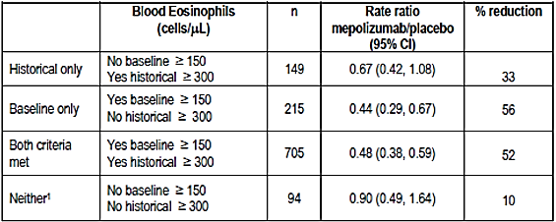
Patients who met the ≥ 150 cells/µL criterion had a 56% reduction in exacerbations, while patients who met both the ≥ 150 cells/µL and historical ≥ 300 cells/µL criteria had a 52% reduction in exacerbations. These data confirm the value of the ≥ 150 cells/µL criterion applied in isolation. However, patients who met the historical ≥ 300 cells/µL criterion but who did not have ≥ 150 cells/µL at baseline still had a meaningful 33% reduction in exacerbation rates. Patients who met neither baseline criterion had no meaningful reduction in exacerbation rates.
The sponsor has provided an analysis of blood eosinophils based on baseline maintenance OCS therapy shown below in Table 77. While blood eosinophils were somewhat lower in patients receiving maintenance OCS, the medians were generally similar in the patient groups receiving or not receiving maintenance OCS.

Table 77: Summary of blood eosinophils (cell/µL): MEA112997 and MEA115588 by baseline maintenance OCS therapy
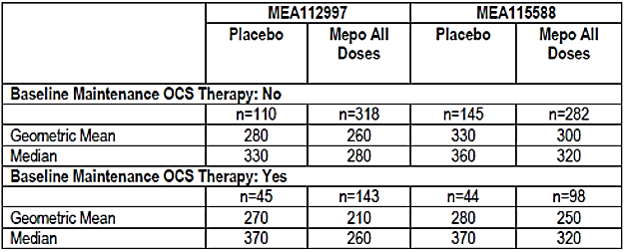
In the MEA115575 OCS-reduction study, all patients were receiving maintenance OCS. The geometric mean blood eosinophil counts were 230 cells/µL and 250 cells/µL in the placebo and mepolizumab 100 mg SC groups, respectively. These values were comparable to the geometric means for patients receiving continuous OCS treatment in the MEA112997 and MEA115588 studies. The mean and medians in all three studies were generally comparable and above the ≥ 150 cells/µL threshold criterion, suggesting the threshold does not need to be modified for OCS-dependent patients.

Evaluator’s comment:
The data confirm the value of ≥ 150 cells/µL as an isolated selection criterion. However, an isolated historical criterion of a recorded count of ≥ 300 cells/µL predicts useful efficacy even in patients who do not meet the ≥ 150 cells/µL criterion at baseline. The data confirm that OCS suppresses mean eosinophil counts compared with patients on ICS alone but the effect is modest. It is likely that some eligible patients will fall below the treatment threshold but the proposed criteria are probably acceptable. The sponsor’s response is satisfactory.

Question 6
In MEA115661, a total of 65 patients received mepolizumab 100 mg SC in the steroid reduction feeder Study MEA115575 compared with 349 patients who received 75 mg IV or 100 mg SC in MEA115588 (Table 27). Overall, efficacy was sustained long term but the results are driven primarily by patients in the MEA112997 study who did not participate in a steroid reduction protocol. Sustained efficacy cannot be determined in patients who successfully reduced the maintenance dose of OCS for only 4 weeks. Please provide a separate analysis of the MEA115575 subgroup in MEA115661, including as a minimum the final maintenance dose of OCS and exacerbation rates.

Sponsor’s response:
The sponsor has highlighted the typographical error in the question: MEA112997 should read MEA115575 as noted in the first sentence. The sponsor agrees that the results of the open label, long term extension Study MEA115661 (n = 651) were driven primarily by patients from the MEA115588 study (n = 525). However, Study MEA115661 has now been completed and an analysis of patients recruited from MEA115575 has been provided.
In MEA115575 patients who completed MEA115661 (n = 135), the median OCS dose was reduced from 12.3 mg to 10.0 mg in the placebo group, compared with 10.0 mg to 2.5 mg in the mepolizumab 100 mg SC group at Week 24. The OCS reduction in the mepolizumab 100 mg SC group was sustained long term during the open label period with a median OCS dose of 2.5 mg at Week 76. In placebo patients who entered the open label active treatment period, the median OCS dose fell from 10.0 mg at Week 24 to 5.0 mg at Week 76.
In MEA115575 patients who completed MEA115661, the annual exacerbation rate during the 24 week double-blind period was 2.20 in the placebo group and 1.25 in the mepolizumab 100 mg SC group. At the end of the open label period at Week 76, the exacerbation rates were 1.13 and 1.30, respectively.

Evaluator’s comment:
The sub-group analysis of MEA115661 is evaluated below. In summary, in MEA115575, a clinically meaningful short term reduction in median daily OCS dose was achieved in patients who received mepolizumab 100 mg SC compared with placebo. Not only was the reduction in the maintenance OCS dose sustained in Study MEA115661, it was achieved with a meaningful reduction in exacerbation rates. The sponsor’s response is satisfactory.

Study MEA115661: Sub-group analysis

Design and methodology
The double blind treatment period of MEA115575 extended to Week 24. All completing patients were then offered enrolment in the open label extension Study MEA115661, which also included patients enrolled from MEA115588. An interim analysis of MEA115661 was provided in the initial submission. The study has now been completed and data are available up to Week 76. As requested, a post hoc analysis of the patient sub-group enrolled from MEA115575 has been provided to assess the durability of the response to OCS reduction.
A total of 135 patients were eligible for enrolment from MEA115575. Of these patients, 126 (93%) entered the open label period of MEA115661, and all received mepolizumab 100 mg SC. A total of 65 patients had previously received mepolizumab 100 mg SC, and 61 patients had previously received placebo (Table 78).

Table 78: Study MEA115661- summary of MEA115661 study population
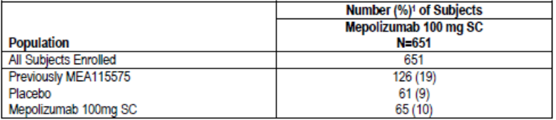
1. Percentages are based on the number of subjects in the All Subjects Enrolled Population.

Results
OCS reduction:
At the Week 20 to 24 visit, patients treated with mepolizumab 100 mg SC during the double-blind period were receiving a lower median daily OCS dose compared with patients receiving placebo (3.1 mg/day versus 10.0 mg/day Table 79). The steroid reduction achieved during the completed study is shown in Table 80. Patients previously treated with mepolizumab 100 mg SC had sustained OCS reduction to 2.5 mg/day at Week 76. Patients previously treated with placebo achieved a meaningful OCS dose reduction from 10.0 mg/day at Week 24 to 5.0 mg/day at Week 76.

Table 79: Median daily OCS dose during each reporting period (Study MEA115575, ITT Population)
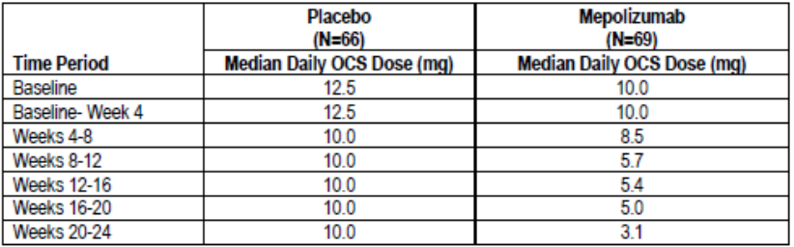

Table 80: Summary of median OCS dose (mg/day) during each reporting period by treatment allocated within MEA115575 (MEA115575 and MEA115661 combined, as treated population)
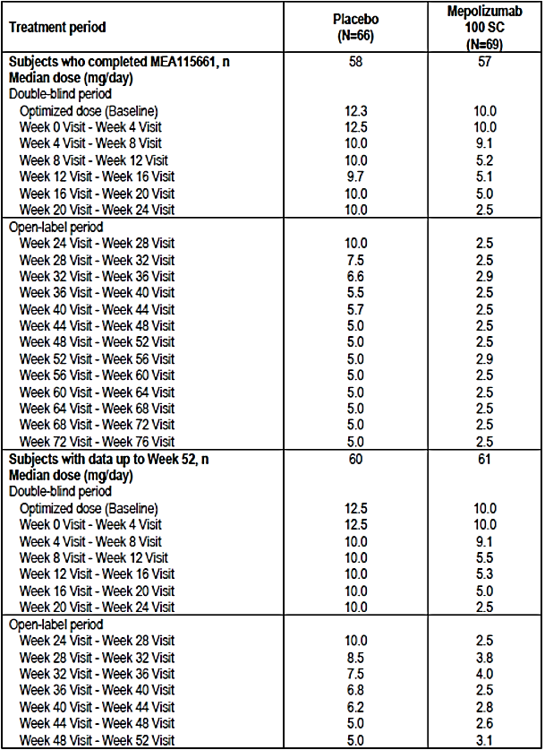
Subject [information redacted] had a gap of 6 weeks between the end of MEA115575 and the start of MEA115661. Following entry into MEA115661, the OCS doses for this subject have been shown from Week 24 visit onwards.
Exacerbation frequency:
In the year before enrolment in MEA115575, patients in the placebo group reported a mean exacerbation rate of 2.9/year compared with 3.3/year in the mepolizumab 100 mg SC group (Table 81). Patients who completed the double-blind period at Week 24 reported exacerbation rates of 2.12/year and 1.44/year in the respective groups. The reduction in exacerbation rates compared with placebo was 32% [RR 0.68 (95% CI: 0.47, 0.99, p = 0.041)] (Table 82). Exacerbation rates in patients who completed the study at Week 76 are shown in 83. In patients previously treated with placebo, the exacerbation rate at Week 76 was 1.13/year, compared with 1.30/year in patients previously treated with mepolizumab 100 mg SC.
Comment: Patient numbers were relatively low and the follow up period was open label. However, the final study data strongly support a long term efficacy benefit in favour of mepolizumab 100 mg SC. Reduced exacerbation rates were sustained despite clinically meaningful reductions in the median daily dose of OCS. The median daily OCS dose reduction from 10.0 mg to ≤ 5.0 mg would be expected to significantly reduce the burden of side effects associated with long term corticosteroid therapy.

Table 81: Exacerbation history (prior to Study MEA115575)
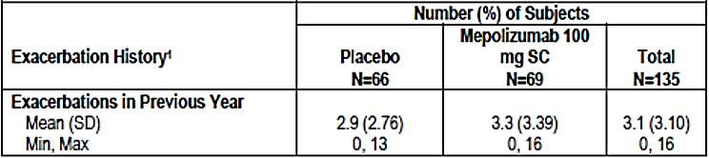
Experienced in the 12 months prior to MEA115575 Screening Visit.

Table 82: Analysis of rate of exacerbations (randomization through Week 24)(Study MEA115575, ITT Population)
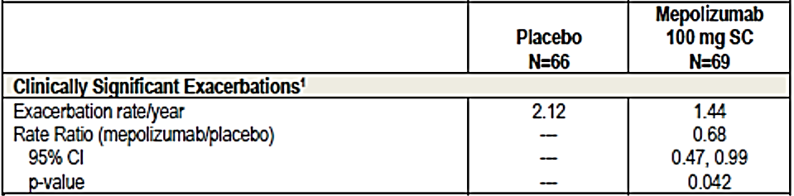
1. All investigator defined exacerbations were clinically significant exacerbations. Analysis performed using a Poisson model with covariates of treatment group, duration of OCS use at baseline (< 5 years versus ≥ 5 years), region, dose of OCS at baseline (optimised dose), and with logarithm of time on treatment as an offset variable.

Table 83: Exacerbations in MEA115575- patients who completed MEA115661 by treatment allocated in MEA115575
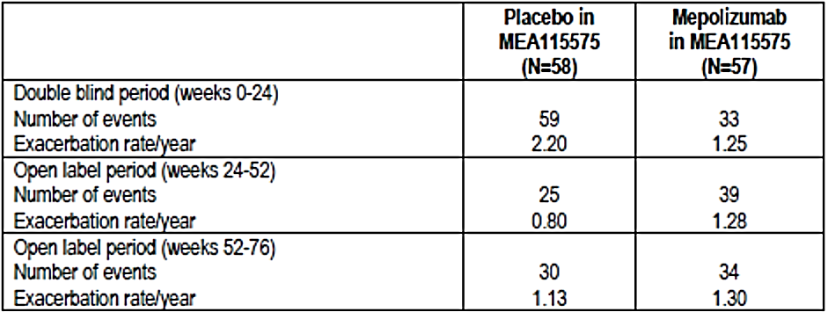

Question 7
Up to 25% of asthmatics smoke but current smokers were excluded from the severe asthma studies. Please comment on eosinophil function in asthmatic smokers and the potential value of mepolizumab in this population.

Sponsor’s response:
No direct data are available as current smokers were excluded from the asthma studies. However, a recent Phase II study of benralizumab demonstrated comparable eosinophil reductions in COPD and asthma patients. It is likely that asthmatic smokers would benefit from mepolizumab treatment.

Evaluator’s comment:
The sponsor’s response is satisfactory

Question 8
Table 39 in the MEA115575 CSR (not included in this document) reports a higher percentage of ADRs in the mepolizumab 100 mg SC group (30%) than in the placebo group (18%). However, the absolute numbers of ADRs reported in each group appear to be comparable. Please clarify.

Sponsor’s response:
Although there was a numerical increase in patients in the mepolizumab group who experienced an AE considered possibly related to study drug by the investigator, there was no specific event or SOC where a clear difference was observed between the mepolizumab or placebo treatment groups. ADRs for inclusion in the label were assessed using established GlaxoSmithKline (GSK) processes discussed in the Integrated Summary of Safety (ISS).

Evaluator’s comment:
The question relates to safety rather than efficacy but it has been left in place to avoid confusion. The sponsor’s response is satisfactory.

Question 9
In the ME115588 CSR, in the text 24% of patients were taking continuous OCS at screening but 30% are reported in the CSR Table 7 (not included in this document) Please clarify.

Sponsor’s response:
A total of 30% of patients received maintenance OCS in the year before the study based on ATS criteria. However, only 24% of patients were actually taking OCS at baseline.

Evaluator’s comment:
The sponsor’s response is satisfactory.

Safety

Question 1
In Study MEA112997, cardiac and vascular disorders were identified a priori as AEs of special interest. Please briefly describe any theoretical cardiovascular risks specifically related to IL-5 inhibition on which this concern might have been based.

Sponsor’s response:
Cardiovascular risks were identified a priori as part of standard pharmacovigilance practice. No cardiovascular safety signals were detected and the sponsor is not aware of any biological plausibility for an association with IL-5 inhibition.

Evaluator’s comment:
The sponsor’s response is satisfactory.

Question 2
Nasopharyngitis as a PT was amongst the most common AEs reported in the clinical trial program but it is not reported as such in the PI. Presumably the omission relates to relative risk but please confirm or otherwise.

Sponsor’s response:
Nasopharyngitis was one of the most common AEs reported in the mepolizumab clinical trial program. However, it did not meet the frequency criteria applied in the standard GSK processes discussed in the ISS.

Evaluator’s comment:
The sponsor’s response is satisfactory.

Question 3
In MEA112997, there were no meaningful changes in mean serum creatinine from baseline to Week 52 in the placebo or mepolizumab groups. There were no clinically meaningful changes in serum creatinine throughout the treatment period in the placebo group but isolated, significant increases were reported in the mepolizumab groups (Table 68). Please provide a brief narrative for these events as no comments are provided in the CSR.

Sponsor’s response:
A thorough review of all patients with significant increases in serum creatinine was conducted. Five patients were identified but only one patient had a serum creatinine increase reported on more than one occasion during the study. All patients continued mepolizumab treatment and three patients subsequently enrolled in the open label Study MEA115666. The single patient with increased serum creatinine on multiple occasions had malignant hypertension due to non-compliance with anti-hypertensive medication. Overall, the observed increases were considered multifactorial and unrelated to mepolizumab treatment.

Evaluator’s comment:
The sponsor’s response is satisfactory.

Second round assessment of benefits
After consideration of the responses to the clinical questions, the benefits of Nucala in the proposed usage are unchanged from those identified in Section 9.1.

Second round assessment of risks
After consideration of the responses to clinical questions, the risks of Nucala in the proposed usage are unchanged from those identified in Section 9.2.

Second round assessment of benefit-risk balance
The benefit-risk balance of Nucala, given the proposed usage, is favourable.

Second round benefit-risk assessment
Authorisation is recommended for the proposed indication with wording amended from the first version:
Nucala is indicated as an add-on treatment for severe asthma with eosinophilic inflammation in patients aged 12 years and over with a history of exacerbations and/or dependency on systemic corticosteroids. Patients should have a blood eosinophil count ≥ 150 cells/µL at initiation of treatment or a blood eosinophil count ≥ 300 cells/µL in the prior 12 months.
Most concerns raised in the first round have been addressed by the sponsor in response to the clinical questions, most notably by providing the final data for the steroid sparing effect in study MEA1155756661.
Efficacy and safety have not been established in the limited number of adolescent patients studied. However, the risks associated with maintenance OCS are well established and cannot be ignored. Despite the paucity of data, a steroid sparing effect with a reduction in exacerbation rates alters the risk-benefit balance in favour of mepolizumab treatment. This assessment applies only to adolescents receiving maintenance OCS as defined in the indication.
The sponsor has not justified use in patients with asthma well controlled by OCS as nearly all patients in MEA115575 had a history of exacerbations. Despite the lack of direct evidence in patients without exacerbations, this small sub-group can reasonably be expected to benefit from the steroid sparing effects of mepolizumab.

Second round recommendation regarding authorisation

Second round comments on clinical aspects of the draft PI
The amended indication is essentially a rewording of the original version.
The sponsor did not provide new clinical information after the first round and has not changed any clinical aspects of the draft PI. However, it is recommended that additional long-term data from MEA115661 be included in the ‘Clinical Trials’ section of the PI.

Second round comments on clinical aspects of the draft CMI
The sponsor did not provide new clinical information after the first round and has not changed any clinical aspects of the draft CMI. Minor editorial changes and correction of typographical errors have been made in line with the evaluators’ recommendations.

Second round comments on clinical aspects of the Safety Specification in the draft RMP
The sponsor did not provide new clinical information after the first round. The Safety Specification in the draft RMP has not changed although various editorial changes have been made.

References
Bousquet J, et al. Eosinophilic inflammation in asthma. N Engl J Med 1990; 323:1033-1039
Castro M, et all. Reslizumab for inadequately controlled asthma with elevated blood eosinophil counts: results from two multicentre, parallel, double-blind, randomised, placebo-controlled, phase 3 trials. Lancet Respir Med 2015; S15:42-49
Crimi E, et al. Dissociation between airway inflammation and airway hyperresponsiveness in allergic asthma. Am J Respir Crit Care Med 1998; 157:4-9
Green RH, et al. Asthma exacerbations and sputum eosinophil counts: a randomised controlled trial. Lancet 2002; 360:1715-1721
Proceedings of the ATS workshop on refractory asthma: current understanding, recommendations, and unanswered questions. Am J Respir Crit Care Med 2000; 162:2341-2351
Reddell HK, et al on behalf of the American Thoracic Society/European Respiratory Society Task Force on asthma control and exacerbations. Standardizing endpoints for clinical asthma trials and clinical practice. Am J Respir Crit Care Med 2009; 180:59-99
Sears MR. Epidemiology of asthma exacerbations. J Allergy Clin Immunol 2008; 122:662-668

Therapeutic Goods Administration
PO Box 100 Woden ACT 2606 Australia
Email: info@tga.gov.au Phone: 1800 020 653 Fax: 02 6232 8605
https://www.tga.gov.au

www.nationalasthma.org.au
Of note, age was investigated as a covariate CL/F in Study MEA115588 following SC administration, but was not retained as it was not statistically significant.
Of note, race was investigated graphically as a covariate of CL/F in Study MEA115588.
Proceedings of the ATS workshop on refractory asthma: current understanding, recommendations, and unanswered questions. Am J Respir Crit Care Med 2000; 162:2341-2351
Roussel Uclaf Causality Assessment Method: A scoring system to assess the severity of drug induced liver injury. The total score consists of points for 8 separate factors in 7 categories: 1 time of onset (+1 or +2), 2 course (-2,0,+1,+2 or+3) 3 risk factors (2 scores: 0 or +1 each) 4 concomitant drugs (0,-1,-2 or-3), 5 nondrug causes of liver injury (-3, -2, 0, +1 or +2) 6: previous information on the hepatotoxicity of the drug (0, +1, or +2) and 7 response to rechallenge (-2, 0, +1 or +3). The individual points range from -9 to +14. Danan et al: J. Clin Epidemiol 1993 Nov;46(11):1323-30
QT interval corrected for heart rate according to Fridericia’s formula (a commonly accepted method to correct QT interval for heart rate) QTcF= QT/∛RR (Frederica LS: Acta Medica Scandinavica, 1920)
QT interval corrected for heart rate according to Bazzet`s formula (a commonly accepted method to correct QT interval for heart rate): QTcB= QT/√RR (Bazzet HC: Heart, 1920)
Hy`s law: Patients with all 3 of these are Hy`s law cases: 1. Hepatocellular injury, generally shown by a higher incidence of 3-fold or greater elevations above the ULN of ALT or AST than the (non-hepatotoxic) control drug or placebo. 2. Among trial subjects showing such aminotransferase (AT) elevations, often with ATs much greater than 3xULN, one or more also show elevation of serum total bilirubin (TBL) to > 2xULN, without initial findings of cholestasis (elevated serum ALP). 3. No other reason can be found to explain the combination of increased AT and TBL, such as viral hepatitis A, B, or C; pre-existing or acute liver disease; or another drug capable of causing the observed injury. (Guidance for Industry, Drug-Induced Liver Injury: Premarketing Clinical Evaluation, U.S. Department of Health and Human Services. Food and Drug Administration, Center for Drug Evaluation and Research [CDER], Center for Biologics Evaluation and Research [CBER], July 2009)

