October 2019

Australian Public Assessment Report for Mepolizumab
  - Proprietary Product Name: Nucala
  - Sponsor: GlaxoSmithKline Australia Pty Ltd

About the Therapeutic Goods Administration (TGA)
- The Therapeutic Goods Administration (TGA) is part of the Australian Government Department of Health and is responsible for regulating medicines and medical devices.
- The TGA administers the Therapeutic Goods Act 1989 (the Act), applying a risk management approach designed to ensure therapeutic goods supplied in Australia meet acceptable standards of quality, safety and efficacy (performance) when necessary.
- The work of the TGA is based on applying scientific and clinical expertise to decision-making, to ensure that the benefits to consumers outweigh any risks associated with the use of medicines and medical devices.
- The TGA relies on the public, healthcare professionals and industry to report problems with medicines or medical devices. TGA investigates reports received by it to determine any necessary regulatory action.
- To report a problem with a medicine or medical device, please see the information on the TGA website <https://www.tga.gov.au>.
About AusPARs
- An Australian Public Assessment Report (AusPAR) provides information about the evaluation of a prescription medicine and the considerations that led the TGA to approve or not approve a prescription medicine submission.
- AusPARs are prepared and published by the TGA.
- An AusPAR is prepared for submissions that relate to new chemical entities, generic medicines, major variations and extensions of indications.
- An AusPAR is a static document; it provides information that relates to a submission at a particular point in time.
- A new AusPAR will be developed to reflect changes to indications and/or major variations to a prescription medicine subject to evaluation by the TGA.
Copyright
© Commonwealth of Australia 2019
This work is copyright. You may reproduce the whole or part of this work in unaltered form for your own personal use or, if you are part of an organisation, for internal use within your organisation, but only if you or your organisation do not use the reproduction for any commercial purpose and retain this copyright notice and all disclaimer notices as part of that reproduction. Apart from rights to use as permitted by the Copyright Act 1968 or allowed by this copyright notice, all other rights are reserved and you are not allowed to reproduce the whole or any part of this work in any way (electronic or otherwise) without first being given specific written permission from the Commonwealth to do so. Requests and inquiries concerning reproduction and rights are to be sent to the TGA Copyright Officer, Therapeutic Goods Administration, PO Box 100, Woden ACT 2606 or emailed to <tga.copyright@tga.gov.au>.

Contents
Common abbreviations 5
I. Introduction to product submission 9
Submission details 9
Product background 10
Regulatory status 10
Product Information 11
II. Registration time line 11
III. Quality findings 12
IV. Nonclinical findings 12
Introduction 12
Nonclinical summary and conclusions 14
V. Clinical findings 14
Introduction 14
Pharmacokinetics 23
Pharmacodynamics 24
Dosage selection for the pivotal studies 27
Efficacy 28
Safety 31
Use of mepolizumab in children with EGPA 47
First round benefit-risk assessment 48
First round recommendation regarding authorisation 51
Clinical questions and second round evaluation 51
Second round benefit-risk assessment 64
Second round recommendation regarding authorisation 65
VI. Pharmacovigilance findings 65
VII. Overall conclusion and risk/benefit assessment 65
Background 65
Quality 66
Nonclinical 66
Clinical 67
Risk management plan 71
Risk-benefit analysis 73
Outcome 83
Attachment 1. Product Information 84

Common abbreviations
Abbreviation | Meaning
ACM | Advisory Committee on Medicines
ACR | American College of Rheumatology
ACQ-6 | Asthma Control Questionnaire-6
ADA | Anti-drug antibody
AE | Adverse event
ALT | Alanine aminotransferase
ANCA | Anti-neutrophil cytoplasmic antibodies
ANSM | Agence Nationale de Sécurité du Médicament et des Produits de Santé (France)
AST | Aspartate aminotransferase
AUC | Area under the concentration-time curve
BMI | Body mass index
BVAS | Birmingham Vasculitis Activity Score
cEGPA | Childhood onset EGPA
CHMP | Committee for Medicinal Products for Human Use
CI | Confidence interval
CL/F | Apparent clearance
C_{max} | Maximum plasma concentration
CMI | Consumer Medicines Information
COPD | Chronic obstructive pulmonary disease
CRP | C-reactive protein
CSR | Clinical study report
CSS | Churg-Strauss syndrome
CUP | Compassionate Use Programme
CV | Cardiovascular
CVT | Cardiac, vascular, thromboembolic
DVT | Deep vein thrombosis
ECG | Electrocardiogram
eCRF | Electronic case report form
ED₅₀ | Dose associated with 50% maximal effect attributable to drug
EE | Eosinophilic esophagitis
EGE | Eosinophilic gastroenteritis
EGPA | Eosinophilic granulomatosis with polyangiitis
EMA | European Medicines Agency (EU)
ENT | Ear, nose and throat
ERA-EDTA | European Renal Association-European Dialysis and Transplant Association
ESR | Erythrocyte sedimentation rate
EU | European Union
EULAR | European League Against Rheumatism
FDA | Food and Drug Administration (USA)
FeNO | Fractional exhaled nitric oxide
FEV₁ | Forced expiratory volume in one second
GGT | Gamma-glutamyl transferase
GI | Gastrointestinal
GI/L | Giga (10⁹) per litre (blood eosinophil count)
GIT | Gastrointestinal tract
GPA | Granulomatosis with polyangiitis
h | Hour(s)
HES | Hypereosinophilic syndrome
HPF | High power field
ICH | International Conference on Harmonisation
ID₅₀ | Dose associated with 50% of the maximal inhibition effect
Ig; IgE | Immunoglobulin; immunoglobulin E
IL-5 | Interleukin-5
IV | Intravenous
LFT | Liver function test
mAb | Monoclonal antibody
MedDRA | Medical Dictionary for Regulatory Activities
MI | Myocardial infarction
MPA | Microscopic polyangiitis
MPO | Anti-myeloperoxidase
NPDE | Normalised prediction distribution errors
OCS | Oral corticosteroid (prednisone/prednisolone)
OR | Odds ratio
PD | Pharmacodynamic(s)
PDCO | Paediatric Committee
PK | Pharmacokinetic(s)
PBRER | Periodic benefit-risk evaluation report
PRAC | Pharmacovigilance Risk Assessment Committee
PSUR | Periodic safety update report
RMP | Risk Management Plan
SAE | Serious adverse event
SC | Subcutaneous
SCS | Summary of Clinical Safety
SD | Standard deviation
SOC | System Organ Class
SmPC | Summary of Product Characteristics
t_{½} | Terminal phase half life
Th-2 | T helper 2
UK | United Kingdom
USA | United States of America

I. Introduction to product submission

Submission details
Type of submission: | Extension of indications
Decision: | Approved
Date of decision: | 24 January 2019
Date of entry onto ARTG: | 29 January 2019
ARTG number: | 232028
Black Triangle Scheme | No
Active ingredient: |  | Mepolizumab
Product name: |  | Nucala
Sponsor’s name and address: |  | GlaxoSmithKline  PO Box 18095  Melbourne, VIC, 8003
Dose form: |  | Powder for injection
Strength: |  | 100 mg
Container: |  | Vial
Pack size: |  | 1
Approved therapeutic use: |  | Relapsed or refractory EGPA  Nucala is indicated as an add-on treatment for relapsing or refractory Eosinophilic Granulomatosis with Polyangiitis (EGPA) in adult patients aged 18 years and over (see section 5.1 Pharmacodynamic Properties - Clinical Trials).
Route of administration: |  | Subcutaneous
Dosage: |  | Relapsed or refractory EGPA in adults (18 years or older):  The recommended dose is 300 mg of Nucala administered by subcutaneous injection once every 4 weeks.  For further details refer to the Product Information.

Product background
‘This AusPAR describes the application by GlaxoSmithKline (the sponsor) to register Nucala (mepolizumab) 100 mg powder for injection for the following indication:
Nucala is indicated as an add-on treatment for relapsing or refractory Eosinophilic Granulomatosis with Polyangiitis (EGPA) in patients aged 6 years and over.
Eosinophilic granulomatosis with polyangiitis (EGPA), formerly called Churg-Strauss syndrome, is described as an idiopathic systemic necrotizing vasculitis that is associated with asthma and marked blood eosinophilia (frequently between 5000 and 9000 eosinophils/µL at diagnosis). The vasculitis most commonly involves the lungs but may involve multiple organ systems. Organ damage is believed to result from both vessel inflammation and eosinophilic proliferation. The aetiology of the disease and the mechanistic relation between the vasculitis and the eosinophilic proliferation is not known. Current theories are that activation of the T helper 2 (Th-2) cellular mediated inflammatory response and humoral immunity may both play important roles. EGPA is a rare disease: prevalence is estimated to range from 10.7 to 13 cases/million inhabitants and the annual incidence to be 0.5 to 6.8 new cases/million inhabitants.
Current treatment options are based on the use of glucocorticoids and immunosuppressive therapy. Most patients respond to treatment with glucocorticoids, remission in 80 to 90% occurs with initial treatment. Refractory disease in the remaining patients may require treatment with cytotoxic immunosuppressive drugs. A relapsing course may also occur despite ongoing treatment with oral corticosteroids, requiring increased corticosteroid dose or addition of other immunosuppressive agents. With treatment, the 1 year survival rate is reported to be 90% and the 5 year survival rate 62 to 80%.
Mepolizumab is a humanised monoclonal antibody (mAb; immunoglobulin G1 (IgG1) kappa) produced by recombinant DNA technology in Chinese hamster ovary cells. Mepolizumab is an interleukin-5 (IL-5) antagonist that binds to IL-5 thereby preventing it from binding to its receptor on eosinophils. As IL-5 is a major survival factor for eosinophils, it is considered a suitable target for therapy in hypereosinophilic diseases such as EGPA.

Regulatory status
The product received initial registration on the Australian Register of Therapeutic Goods (ARTG) on 2 February 2016 (PM-2014-03872-1-5) for the following indication:
Nucala is indicated as an add-on treatment for severe refractory eosinophilic asthma in patients aged 12 years and over (see Clinical Trials).
Nucala received orphan drug designation on 11 May 2017 (PM-2017-01599-1-5) for the treatment of patients with eosinophilic granulomatosis with polyangiitis (EGPA).
At the time the TGA considered this application, a similar application had been approved in USA on 28 June 2017, in Canada on 15 August 2017, and was under consideration in Switzerland (see Table 1).
Table 1: International regulatory status as of 19 November 2018
Region | Submission date | Status | Indications
USA | 28 June 2017 | Approved  December 2017 | Nucala is indicated for the treatment of adult patients with eosinophilic granulomatosis with polyangiitis (EGPA).
Canada | 15 August 2017 | Approved  July 2018 | Nucala (mepolizumab for injection) is indicated as an add-on to corticosteroids for the treatment of adult patients with eosinophilic granulomatosis with polyangiitis (EGPA).
Switzerland | 30 January 2018 | Under review | Under review

Product Information
The Product Information (PI) approved with the submission which is described in this AusPAR can be found as Attachment 1. For the most recent PI, please refer to the TGA website at <https://www.tga.gov.au/product-information-pi>.

II. Registration time line
Table 2 captures the key steps and dates for this application and which are detailed and discussed in this AusPAR.
Table 2: Timeline for Submission PM-2017-04349-1-5
Description | Date
Submission dossier accepted and first round evaluation commenced | 2 January 2018
First round evaluation completed | 1 June 2018
Sponsor provides responses on questions raised in first round evaluation | 1 August 2018
Second round evaluation completed | 31 August 2018
Delegate’s Overall benefit-risk assessment and request for Advisory Committee advice | 31 October 2018
Sponsor’s pre-Advisory Committee response | 19 November 2018
Advisory Committee meeting | 6 December 2018
Registration decision (Outcome) | 24 January 2019
Completion of administrative activities and registration on ARTG | 29 January 2019
Number of working days from submission dossier acceptance to registration decision* | 224
*Statutory timeframe for standard applications is 255 working days
Evaluations included under Quality findings and Nonclinical findings incorporate both the first and second round evaluations.
TGA guidance at pre-submission meetings is nonbinding and without prejudice.

III. Quality findings
There was no requirement for a quality evaluation in a submission of this type.

IV. Nonclinical findings

Introduction
The sponsor has applied to extend the indications for mepolizumab (a mAb against human IL-5) to include add-on treatment for relapsing or refractory EGPA in patients aged 6 years and over. The product is currently indicated as an add-on treatment for severe refractory eosinophilic asthma in patients aged 12 years and over.
The product is proposed to be administered at a higher dose for the treatment of EGPA than is currently approved for asthma (on the basis of there being a higher target burden of eosinophils in EGPA disease). Proposed and approved doses are compared in Table 3.
Table 3: Proposed and approved doses of mepolizumab
Patients |  | EGPA (proposed) | Asthma (approved)
 |  | Subcutaneous (SC) injection once every 4 weeks
Adults and adolescents (≥ 12 years old) |  | 300 mg | 100 mg
Children, 6 to 11 years old | ≥ 40 kg | 300 mg | –
Children, 6 to 11 years old | ≥ 25 kg and < 40 kg | 200 mg | –
Children, 6 to 11 years old | < 25 kg | 100 mg | –
The nonclinical dossier contained two new primary pharmacology studies, an additional pharmacokinetic validation study (on stability in human plasma at –80°C), an updated assessment on immunotoxic potential, and some background literature. The new studies are of limited relevance to the proposed extension of indications and do not alter the conclusions of the original nonclinical assessment. Briefly:
- Study 2015N262160:
  - In silico analyses indicated very low potential for cross-reactivity of mepolizumab, based on there being very little sequence homology between IL-5 and 85 other human proteins (BLAST), and between the mepolizumab-binding epitope of IL-5 and analogous structural regions in other members of the short-chain cytokine family.
- Study 2016N274215:
  - Computational analysis of the co-crystal structures of mepolizumab bound to IL-5 and IL-5 bound to the extracellular domain of IL-5Rα indicated that IL-5 would not be able to bind to the IL-5 receptor once associated with mepolizumab. The mepolizumab epitope on IL-5 overlaps substantially with the IL-5 binding site of the D2/D3 domains of IL-5Rα, with this interaction directly inhibiting the binding of the IL-5Rα with one half of the IL-5 homodimer. Additionally, mepolizumab will sterically hinder IL-5/IL-5Rα binding via the second half of the IL-5 homodimer due to a clash between the light chain complementarity-determining region L2 of mepolizumab and the second extracellular domain (D2) of the receptor.
- Study 2014N217317:
  - The updated review of immunotoxic potential raises no new concerns. Based on the physiological role of eosinophils, the potential for impaired clearance of helminth infection with mepolizumab is seen. Available evidence suggests antagonism of IL-5 signalling or eosinophil depletion is probably unlikely to appreciably compromise tumour surveillance. The absence of carcinogenicity in transgenic mice with another anti-IL-5 antibody (reslizumab; registered subsequent to mepolizumab) is noted.
- No new toxicity studies were submitted, and no dedicated studies in juvenile animals have been performed with mepolizumab.
- The 3 fold higher dose in adult and adolescent patients for the newly proposed indication is associated with a 3.1 and 3.4 fold increase in maximum plasma concentration (C_{max}) and area under the concentration-time curve (AUC) at steady state.
Table 4: Pharmacokinetics of mepolizumab in asthma and EGPA patients
Study | Patients |  | Dose; once every 4 weeks  (steady state) | C_{max}  (mg/mL) | AUC_{0–∞}  (mg·h/mL)
MEA115588 | Adults and adolescents (≥ 12 years old) | asthma | 100 mg SC | 0.0167 | 8.2
MEA115921 | Adults and adolescents (≥ 12 years old) | EGPA | 300 mg SC | 0.0525 | 28.1
- Children aged 6 to 11 years old weighing ≥ 40 kg are to receive the same dose for the treatment of EGPA as in adult and adolescents (that is, 300 mg SC); exposure in these children is 2 times higher than in adults and adolescents. The lower, weight stratified doses in younger EGPA patients are designed to yield exposure more comparable to that of adults and adolescents (Clinical Modelling Report 2014N205517).
- In terms of safety, the increased exposure to mepolizumab compared with that currently approved, and the novel use in 6 to 11 year old children, is adequately supported by existing nonclinical data. In animal studies evaluated for the product’s original registration as a new chemical entity (Submission No. PM-2014-03872-1-5), mepolizumab was found to have a very low order of toxicity and not to target developing systems. Of particular note, there were no treatment-related findings apart from the expected pharmacological effect of reduced eosinophil counts in monkeys given mepolizumab at up to 100 mg/kg intravenous (IV) once monthly for 6 months, a dose yielding high multiples of the systemic exposure in EGPA patients (ranging from 17 to 29 for the various subpopulations).

Nonclinical summary and conclusions
- No nonclinical studies in an animal model of EGPA/vasculitis were submitted. Assessment of efficacy in the proposed new indication relies on clinical data only.
- Safety at the higher exposure level associated with the increased dose for the new indication, and in the extended paediatric population (6 to 11 year olds), has been adequately demonstrated in nonclinical studies (previously submitted).
- There are no nonclinical objections to the proposed extension of indication.
- The Product Information (PI) document should be revised as directed.

V. Clinical findings
A summary of the clinical findings is presented in this section.

Introduction

Information on the condition being treated

Overview
EGPA, previously known as Churg-Strauss syndrome (CSS), was first described in 1951. The understanding of EGPA (diagnostic criteria, classification, prognostication and aetiology) continues to evolve.
EGPA is a rare disease: prevalence is estimated to range from 10.7 to 13 cases per million inhabitants and the annual incidence to be 0.5 to 6.8 new cases per million inhabitants. An estimated prevalence of 9 to 18 per million in the Australian population is provided by the sponsor, with this based on a 2008 study by Ormerod and Cook.
EGPA is described as an idiopathic systemic necrotising vasculitis that is associated with asthma and marked blood eosinophilia (frequently between 5000 and 9000 eosinophils/µL at diagnosis). The vasculitis most commonly involves the lungs but may involve multiple organ systems. Organ damage is believed to result from both vessel inflammation and eosinophilic proliferation. The aetiology of the disease and the mechanistic relation between the vasculitis and the eosinophilic proliferation is not known. Current theories are that activation of the T helper 2 (Th-2) cellular mediated inflammatory response and humoral immunity may both play important roles.
EGPA most commonly occurs in middle age (35 to 45 years) but has been reported in all age groups. The patient’s clinical picture is characterised by severe, persistent asthma and allergic rhinitis. Non-specific symptoms of malaise, fatigue, weight loss, fever, and myalgia may occur. With the onset of vasculitis, symptoms related to the affected organs occur with: pulmonary symptoms of cough and haemoptysis; rash, most commonly purpuric; cardiac manifestations including pericarditis, pericardial effusion, myocardial infarction, acute heart failure; renal injury; gastrointestinal manifestations with pain, diarrhoea, bleeding; peripheral neuropathy, most commonly mononeuritis multiplex. Cardiac involvement carries a poor prognosis and causes 50% of the deaths of these patients. Most patients respond to treatment with glucocorticoids, with remission in 80 to 90% expected with initial treatment. Refractory disease in the remaining patients may require treatment with cytotoxic immunosuppressive drugs. A relapsing course may also occur despite ongoing treatment with oral corticosteroids, requiring increased corticosteroid dose or addition of other immunosuppressive agents. With treatment, the 1 year survival rate is reported to be 90% and the 5 year survival rate 62 to 80%.

Long term follow up study
The largest long term follow up study of patients with EGPA was authored by the French Vasculitis Study Group who reported on 383 patients diagnosed between 1957 and 2009 and followed up for a median of 50.5 months.
In this study, the main clinical characteristics at diagnosis were:
- Mean ± standard deviation (SD) age was 50.3 ± 15.7 years; 48% were female.
- Main manifestations of EGPA included asthma (91.1%, duration 9.3 ± 10.8 years), peripheral neuropathy (51.4%); ear, nose, and throat signs (48.0%); skin lesions (39.7%); lung infiltrates (38.6%); and cardiomyopathy (16.4%).
- Mean ± SD Birmingham Vasculitis Activity Score (BVAS) was 19.1 ± 8.4; mean ± SD blood eosinophil count was 7569 ± 6428/mm³. 108 (28%) were anti-neutrophil cytoplasmic antibody (ANCA) positive.
- 145 out of 180 patients with biopsy had histologic findings supporting a diagnosis of EGPA.
Remission induction was by corticosteroids alone for 169 patients (44%) and combination with immunosuppressants for 214 patients (56%). Vasculitis relapse occurred in 97 patients (25.3%). One or more immunosuppressants were required by 271 patients (70.8%) in total, including both remission induction and management of relapse. These included: cyclophosphamide for 217 (56.7%), azathioprine for 98 (25.6%), methotrexate for 26 (6.8%), and rituximab for 3 (0.8%). Among the 280 patients for whom data on prednisone use at their last visit was available, 44 (15.7%) were not taking prednisone (mean ± SD duration of corticosteroid use 65.8 ± 44.5 months).
Kaplan Meier analyses found that the five year survival rate was 88.9% (95% confidence interval (CI) 84.3 to 92.2) and the 10 year relapse free survival rate was 54.4% (95% CI 45.8 to 61.6).
There were 45 deaths (5.6%), with these occurring a mean of 50.4 months (median 21.4 months) after diagnosis and attributed to cardiac events (myocardial infarction, cardiac insufficiency, or arrhythmia) in 14 patients, infections or cancers in 5 patients each, active vasculitis or respiratory events (severe asthma attacks and/or terminal chronic obstructive pulmonary disease) in 4 patients each, and miscellaneous causes in the remaining 13 patients.
During follow up, malignancies were diagnosed in 13 patients. The cancer incidence did not differ significantly from that expected in the general population of France. There were 11 solid tumours (1 colon cancer, 2 basal cell skin carcinomas, 1 bladder cancer, 1 breast cancer, and the 5 fatal cancers (1 colon, 1 ovarian, 1 lung, and 1 gastric, and 1 glioblastoma in a man who also had prostate cancer)) and 3 haematologic neoplasms (1 B-cell lymphoma, 1 polycythemia vera, and 1 myelodysplasia). Nine of these patients had received cyclophosphamide; 2 took immunosuppressants other than cyclophosphamide; and 2 had been treated with corticosteroids only.

Diagnostic criteria
There is no pathognomonic test for EGPA. Diagnosis is based on the clinical criteria: blood eosinophilia; asthma; and evidence of systemic involvement. Biopsy of an affected tissue is recommended to confirm vasculitis and/or eosinophilic infiltration and/or granulomatous inflammation. ANCA testing is usually performed, with 30 to 75% of EGPA patients testing positive.
Table 5 shows diagnostic criteria developed by different groups over time.
Table 5: Diagnostic criteria, classification, and nomenclature of EGPA during the last 20 years
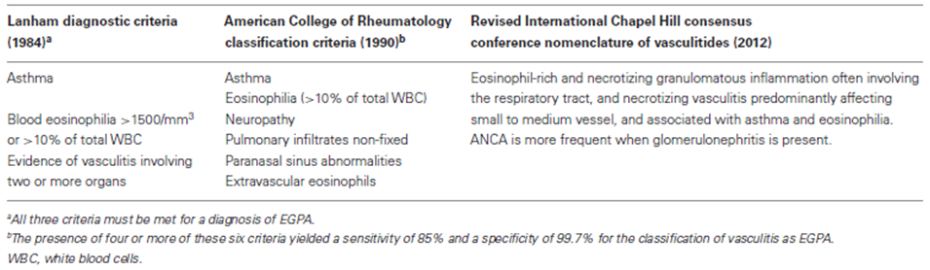
Source: Gioffredi, A. et al. (2014).
In 1990, the American College of Rheumatology described classification criteria to distinguish between the different types of vasculitides. The group identified six criteria for EGPA (Churg-Strauss syndrome) with the presence of four or more of these criteria required for the vasculitis to be classified as EGPA (see Table 5 above). In 1994, the first International Chapel Hill Consensus Conference (CHCC) on the Nomenclature of Systemic Vasculitides; proposed the definition of Churg-Strauss Syndrome shown in Table 5 above. In 2012, the second International CHCC proposed changes in nomenclature with ‘Churg-Strauss Syndrome’ replaced with ‘eosinophilic granulomatosis with polyangiitis (EGPA)’.
In 2009, the European Respiratory Society and the Foundation for the Development of Internal Medicine in Europe commissioned the EGPA Consensus Task Force to provide recommendations for the definition, diagnosis, investigation and management of EGPA. These recommendations were published in 2015; and noted that:
- Diagnostic criteria were lacking and there was no reliable biological marker to diagnose or to measure EGPA activity.
- Anti-myeloperoxidase (MPO) ANCA-(pANCA) positivity is highly suggestive of EGPA but ANCA negativity does not rule it out.
- Investigations for kidney, heart or gastrointestinal tract (GIT) involvement should be performed on diagnosis as these ‘are associated with poor prognoses and mandate immunosuppressive therapy’.
- EGPA manifestations may follow different clinical courses, with ear, nose and throat (ENT) manifestations and/or asthma flares not necessarily reflecting vasculitis activity and that immunosuppressants other than glucocorticoids may control systemic EGPA features but not ENT manifestations and/or asthma.
- Remission or relapse of EGPA was difficult to define. The definition proposed for remission was the absence of clinical systemic manifestation (excluding asthma and/ ENT at ‘minimal prednisone and/or immunosuppressant dose(s)’. The definition proposed for relapse was the new appearance or recurrence or worsening of clinical EGPA manifestation(s) (excluding asthma and/or ENT), requiring the addition, change or dose increase of glucocorticoids and/or other immunosuppressants.

Monitoring disease activity in EGPA: Birmingham vasculitis activity score (version 3)
No relationship between eosinophil level and disease activity in EGPA after diagnosis has been established. It is recognised that the blood eosinophil level is reduced by treatment (oral corticosteroid (OCS) ± immunosuppressive treatment) and will not provide an ongoing marker of disease activity. As noted by Grayson et al.; ‘absolute eosinophil count, serum immunoglobulin E (IgE), erythrocyte sedimentation rate (ESR) and C-reactive protein (CRP) are associated with disease activity in EGPA and can help inform the diagnosis. In contrast, the use of these tests as markers of disease activity over time or as predictors of disease flare has limitations when applied to the assessment of an individual patient’.
The use of the BVAS scoring system in clinical trials investigating systemic vasculitis is advocated by the European League Against Rheumatism (EULAR) and by the European Vasculitis Society to standardise disease assessment., This scoring system is used in determining the primary end-points in the main study for this submission.
The BVAS scoring system was first developed in 1994, with Version 3 described in 2009. The BVAS (v.3) lists 56 manifestations of systemic vasculitis, divided into 9 organ based systems (general, cutaneous, mucous membranes/eyes, ENT, chest, cardiovascular, abdominal, renal, nervous system). An item is marked if it has been active in the prior 4 weeks and if the physician decides to treat the abnormality with immunosuppressive therapy (that is, the item represents active disease requiring treatment and is not attributable to the sequelae of previous activity, drug induced, or due to co-morbidities). The presence of each item has a numerical weight and each organ system has a ceiling score. The scores for the 9 organ systems are summed to determine the overall score. The minimum score is 0 and indicates no disease activity that warrants treatment. The maximum score is 63. The authors note that ‘In the absence of a valid external comparator, it is difficult to interpret a change in BVAS, but a fall of over 16 units is clinically meaningful.’ The authors have provided an online calculator at BVAS – Golem (hosted by the Nuffield Department of Orthopaedics, Rheumatology and Musculoskeletal Sciences, University of Oxford).

Current treatment options
Current treatment options are based on the use of glucocorticoids and immunosuppressive therapy. Two major bodies have published guidelines on the management of patients with EGPA, the European Consensus Taskforce and EULAR.
The European Consensus Taskforce recommendations for the treatment of EGPA were largely finalised in 2013 and published in 2015.9 Glucocorticoids were considered the cornerstone of therapy and the only treatment rated as having a high level of evidence. Approximately 85% of EGPA patients were reported to require long-term prednisone (mean dose 12.9 ± 12.5 mg/day) to control asthma, rhinitis and/or arthralgias, ‘thereby highlighting the need for glucocorticoid sparing therapies’.
The EULAR recommendations for the management of small and medium vessel vasculitis, including EGPA, were initially developed in 2009. A more recent update regarding ANCA-associated vasculitides that was developed in conjunction with the European Renal Association-European Dialysis and Transplant Association (ERA-EDTA), was published in 2016.
The recommendation in the two guidelines appear to be broadly similar apart from a stronger recommendation for the use of other immunosuppressive drugs and use of rituximab in the later guideline (see Table 6).
Table 6: Management guidelines for EGPA
 | European Consensus Taskforce | EULAR
Remission induction: life- and/or organ-threatening disease  (that is, heart, GI, central nervous system, severe peripheral neuropathy, severe ocular disease, alveolar haemorrhage and/or glomerulonephritis) | Pulse methylprednisolone (7.5 to 15 mg/kg/day) together with another immunosuppressant (for example, cyclophosphamide). | Combination therapy with high dose prednisolone and either oral cyclophosphamide or rituximab, although ‘The grade of evidence for the use of rituximab in patients with EGPA is lower than for Granulomatosis with Polyangiitis (GPA)/Microscopic Polyangiitis (MPA)’. Disease that is refractory to remission-induction should be managed by switching from cyclophosphamide to rituximab or from rituximab to cyclophosphamide
Remission induction: without life- and/or organ-threatening disease | Glucocorticoids alone; additional immunosuppression can be considered for selected patients for whom the prednisone dose cannot be tapered to < 7.5mg/day after 3 to 4 months of therapy or for patients with recurrent disease | Combination therapy with glucocorticoids and either methotrexate or mycophenolate mofetil
Remission maintenance | Glucocorticoids alone or with methotrexate or azathioprine to reduce the risk of relapse. Cyclophosphamide avoided due to toxicity associated with long-term use. | Combination of low dose glucocorticoid therapy and, either azathioprine, leflunomide or methotrexate. This should be continued for at least 24 months after sustained remission. The preferred immunosuppressive in EGPA is azathioprine.
Treatment of relapse | Increased glucocorticoid dose ± other immunosuppressive drugs. | Major relapse should be treated as remission induction. Rituximab may be preferred due to toxicity related to the cumulative dose of cyclophosphamide
Glucocorticoid tapering | Induction by prednisone at 1 mg/kg/day for 2 to 3 weeks, followed by gradual tapering over 6 months to the minimal effective dose. Optimally, this maintenance dose should be < 7.5 mg/day to limit glucocorticoid-induced side effects. | The initial high dose of prednisolone 1 mg/kg/day should be gradually weaned, with a target maintenance dose of 7.5 to 10 mg daily after 3 months.
Other treatment options | Plasma exchanges can be considered for selected ANCA positive patients with rapidly progressive glomerulonephritis or pulmonary renal syndrome.  Rituximab can be considered for selected ANCA positive patients with renal involvement or refractory disease.  Second line treatment options include IV immunoglobulin, interferon-α | Plasma exchange should be considered for patients with ANCA-associated vasculitis (AAV) and a serum creatine level of > 500 µmol/L (5.7 mg/dL) due to rapidly progressive glomerulonephritis in the setting of new or relapsing disease or for patients with severe diffuse alveolar haemorrhage.
Sources: Groh et. al. (2015)8 and Yates et. al. (2016).13
The earlier more general EULAR guidelines also recommended that:
- Alternative immunomodulatory therapy choices should be considered for patients who do not achieve remission or relapse on maximal doses of standard therapy. These patients should be referred to an expert centre for further management and enrolment in clinical trials. The alternative therapy choices proposed include intravenous immunoglobulin, conventional immunosuppressants such as mycophenolate mofetil and 15-deoxyspergualin, and biologic agents such as anti-thymocyte globulin, infliximab and rituximab.

Biological agents and EGPA
Treatment of vasculitides with biological agents is being investigated, either in clinical trials or through off-label use in refractory cases. The B-cell depleting agent, rituximab, has been approved by the Food and Drug Administration (FDA), European Medicines Agency (EMA) and TGA for the treatment of GPA and MPA in combination with glucocorticoids (EGPA was an exclusion criteria in the pivotal studies).., , Mepolizumab is the only biological agent currently approved by a regulatory body (FDA) for use in EGPA.
As IL-5 is a major survival factor for eosinophils, it is considered a suitable target for therapy in hypereosinophilic diseases such as EGPA. Beneficial effects of mepolizumab in refractory EGPA have been reported in a small number of publications describing single case reports or small case series and a pilot study of 7 patients., The dose of mepolizumab reported in these studies was 750 mg/month IV. No rationale for this dose was provided in the articles. The December 2017 FDA approval for use in EGPA was based on the results of a Phase III study that compared mepolizumab 300mg SC monthly plus standard care to placebo plus standard care. This study (Study MEA115921) is the main efficacy and safety study for this submission. Two other mAb to IL-5, benralizumab and reslizumab are also being investigated in the treatment of EGPA. Both of these agents have been approved by the FDA for use in asthma.
Several low-quality studies (retrospective case series predominately) suggest that rituximab may be beneficial in EGPA. According to clinicaltrials.gov, a Phase III study comparing rituximab to cyclophosphamide in EGPA is currently recruiting.
It has been reported that omalizumab (IgE mAb), in conjunction with corticosteroids, may control the symptoms of asthma in patients with EGPA.

Clinical rationale
The sponsor’s Clinical Overview provides:
- A description of EGPA:
  - Including the range of estimated annual incidence rates of 0.5 to 3.7 per million. It notes that EGPA is even more rare in the paediatric population, with only ‘87 cases identified in the literature between 1951 and 2016’.
- A description of current therapies and unmet need:
  - This states that ‘the management of this disease is based on reduction of active inflammation, suppression of the immune response, and treatment of disease specific and/or treatment related complications’, with corticosteroid therapy as the cornerstone. Issues related to current treatment options were described, including: the side effects of long term corticosteroid use; the need for more potent immunosuppressive treatments in some patients and the side effects related to these; permanent organ damage that may result from poorly controlled relapsed or refractory disease. The unmet need in the treatment of EGPA is described as the need to ‘induce and maintain remission and preventing relapse while reducing the burden of corticosteroid usage and other immunosuppressive therapies’.
- A rationale for the use of mepolizumab in EGPA based on IL-5 as a key cytokine regulating the life cycle of the eosinophil and eosinophilia being central to the pathogenesis of EGPA. ‘Neutralization of IL-5 with mepolizumab therefore offers a potential therapeutic option for EGPA’.
- A description of the Clinical Development Programme with this consisting ‘primarily of a single Phase III study in adults (Study MEA115921)’ and that ‘Due to the low incidence and prevalence of EGPA in the paediatric population, a clinical trial was not considered feasible to support the paediatric indication; instead a full extrapolation of the EGPA adult efficacy and safety data (that is, without clinical data in paediatrics with EGPA) to the paediatric population 6 to 17 years old was undertaken.’

Guidance

General
The following EMA recommendations adopted by the TGA were referred to in this evaluation:
- Guideline on the role of pharmacokinetics in the development of medicinal products in the paediatric population.
- Note for guidance on clinical investigation of medicinal products in the paediatric population.
- Points to consider on application with 1. Meta-analyses; 2. One pivotal study.
- Concept paper on extrapolation of efficacy and safety in medicine development.
In addition, the following have been used in the development of the clinical evaluation report:
- EMA Reflection paper on extrapolation of efficacy and safety in paediatric medicine development.
- EULAR Recommendations for conducting clinical studies and/or clinical trials in systemic vasculitis.

Contents of the clinical dossier
- Clinical study reports for the following studies:
  - Study MEA115921: an efficacy and safety study for the proposed indication of EGPA. A separate post-hoc exploratory analysis of clinical efficacy for this study was also provided.
  - Study 200363 Part A: pharmacokinetic (PK)/pharmacodynamic (PD) study in children aged 6 to 11 years with severe asthma.
  - Study 200862: a completed safety and efficacy study in patients with severe asthma aged 12 years or older. This included 9 adolescent patients.
  - Study MPP111782: a completed safety and efficacy study in adult patients with severe nasal polyposis.
  - Study MEA116841/201607: a study of long-term access/compassionate use in patients with EGPA.
  - Study MHE104317: a study of long-term access/compassionate use in patients with hypereosinophilic syndrome (HES).
- 120 day safety update for mepolizumab for EGPA as submitted in support of the FDA application (covers the period 6 September 2016 to 19 June 2017).
- Population PK and PK/PD analyses for EGPA; these were included in the Study MEA115921 clinical study report.
- Clinical pharmacology modelling reports related to the paediatric extrapolation model:
  - Report 2014N205517_01, mepolizumab EGPA paediatric and adolescent dose extrapolation.
  - Report 2017N313864_00, mepolizumab paediatric full extrapolation report in the EGPA indication.
  - Report 2015N230602_00, mepolizumab paediatric severe eosinophilic asthma efficacy extrapolation analysis.
  - Report 2017N335435_00, Bayesian extrapolation analyses of mepolizumab efficacy in adolescents from severe eosinophilic asthma Studies MEA115588 and 200862.
  - Report 2015N255079_00, supplementary outputs from a population PK and PK/PD meta-analysis of combined intravenous and subcutaneous mepolizumab data. This includes analyses according to the paediatric population using the PK and PK/PD model described in Report 2015N238436_00.
- Other clinical pharmacology modelling reports included in the dossier were:
  - Report 2017N313351_00, summary document analysis plan for integrated analyses of mepolizumab (SB240563) in paediatric subjects (6 to 17 years of age) with severe eosinophilic asthma.
  - Report 2015N229246_01, mepolizumab exacerbation count and time to event exposure response analysis (using data from the studies in asthma (Studies MEA112997 and MEA115588)).
  - Report 2015N238375_00, the effect of mepolizumab on blood eosinophil count - a dose response meta-analysis. This analysis uses data from studies of mepolizumab in asthma, HES, eosinophilic oesophagitis (but not EGPA) and healthy volunteers.
  - Report 2015N238436_00, a population PK and PK/PD meta-analysis of combined intravenous and subcutaneous mepolizumab data. Data from Study MEA115921 (patients with EGPA) were not included; paediatric population not discussed. This describes the most recent PK and PK/PD models that were applied to the data from Studies MEA115921 and 200363.

Paediatric data
The sponsor has provided a paediatric extrapolation model using data from adult studies and from the small number of paediatric and adolescent patients who have received mepolizumab for conditions other than EGPA. As noted by the sponsor, this paediatric extrapolation model has not been previously reported and was developed in consultation with the EMA. This is described further in the Section ‘Use of mepolizumab in children with EGPA’.

Good clinical practice
The sponsor’s Clinical Overview states that ‘Studies MEA115921 and MEA116841 were undertaken in accordance with standard operating procedures of the GlaxoSmithKline Group of Companies, which comply with the principles of Good Clinical Practice’.
The Compassionate Use Program (CUP) was set up in Italy and Spain and led by the treating physician. According to the Clinical Overview, the treating physician was deemed the ‘sponsor’ and was responsible for the conduct of the study.

Pharmacokinetics

Studies providing pharmacokinetic data
The only study providing pharmacokinetic information in adults with EGPA is the main efficacy and safety study, Study MEA 115921.

Evaluator’s conclusions on pharmacokinetics
The sponsor has presented PK data from sparse sampling in Study MEA115921 and sought to demonstrate that mepolizumab PK in patients with EGPA is similar to that seen in patients with other eosinophilic conditions. A PK model derived from PK data from patients with a variety of eosinophilic conditions was applied to the dataset from Study MEA115921 and goodness of fit tests applied. This PK model was developed using a dataset with wide inter-individual variability and must, of necessity, have wide tolerances. The ability to predict sparse values of another wide ranging dataset is suggestive of similar PK but is not conclusive.
The sponsor has proposed that the following statement be added to the PI:
‘Mepolizumab pharmacokinetics were consistent in subjects with asthma EGPA (sic). The exposure at 300 mg in subjects with EGPA was approximately three times that observed at 100 mg in subjects with severe asthma’.
The evaluator has two concerns with these statements:
- The evaluator is not convinced that this wording is appropriate as it implies a higher level of evidence than has been presented as there is no acknowledgement that this determination was based on a population PK analysis and sparse sampling.
- The statement regarding comparative exposure is not supported by any analysis comparing exposure in subjects with EGPA to exposure in subjects with asthma that the evaluator could locate in the dossier.
The evaluator recommends that the sponsor’s proposed wording be replaced with:
‘A Population PK analysis using sparse PK sampling suggests that mepolizumab pharmacokinetics in subjects with EGPA were consistent with the PK in subjects with other eosinophilic conditions, including asthma’.
The sponsor is asked to comment of the evaluator’s proposed statement and to provide the analysis (or analyses) that demonstrates that ‘the exposure at 300 mg in subjects with EGPA was approximately three times that observed at 100 mg in subjects with severe asthma’.

Pharmacodynamics

Studies providing pharmacodynamic data
The only study providing pharmacodynamic information in adults with EGPA is the main efficacy and safety study, Study MEA115921.

Evaluator’s conclusions on pharmacodynamics

Changes in blood eosinophil level and total serum IL-5 with mepolizumab
Although eosinophil counts of 5 to 9 giga (10⁹)/L (GI/L) described in patients with EGPA at diagnosis, mean baseline eosinophil count of 0.17 GI/L were reported in Study MEA115921. This may reflect prior treatments; patients in Study MEA115921 were required to be on a dose of prednisolone equivalent of greater than or equal to 7.5 mg/day at study entry and may have been receiving other immunosuppressives.
The geometric mean reduction in blood eosinophil levels in the EGPA patients receiving mepolizumab (to 0.035 GI/L) has resulted in blood eosinophil levels that are below the normal range (assuming a normal of 0.04 to 0.4 x 10⁹/L). The mean reduction in blood eosinophil level of 83% is consistent with that reported previously; a 100 mg SC dose of mepolizumab in patients with asthma decreased blood eosinophils levels by approximately 80% by Week 4.
The long-lasting effect of mepolizumab, with reduced eosinophil count reported 3 months after cessation of mepolizumab, has also been reported previously. The clinical evaluation report extract for the new biological entity submission notes that, following all 3 SC doses of mepolizumab given monthly in patients with asthma, eosinophil levels had still not completely returned to pre-dose (baseline) levels 12 weeks after the third dose.
Of note is that changes in blood eosinophil level do not appear to be dose dependent, (above the dose of 12.5mg SC), with a similar decrease reported with doses of 75 mg IV, 100 mg SC, 125 mg SC and 250 mg SC, see Figure 1 below from the clinical evaluation report extract from the AusPAR for the new biological entity submission for mepolizumab. An absence of dose dependency was also seen in Study MEE103219, that investigated three different doses of mepolizumab in children with eosinophilic oesophagitis (see Figure 2).
Figure 1: Study MEA114092 mean absolute blood eosinophil data
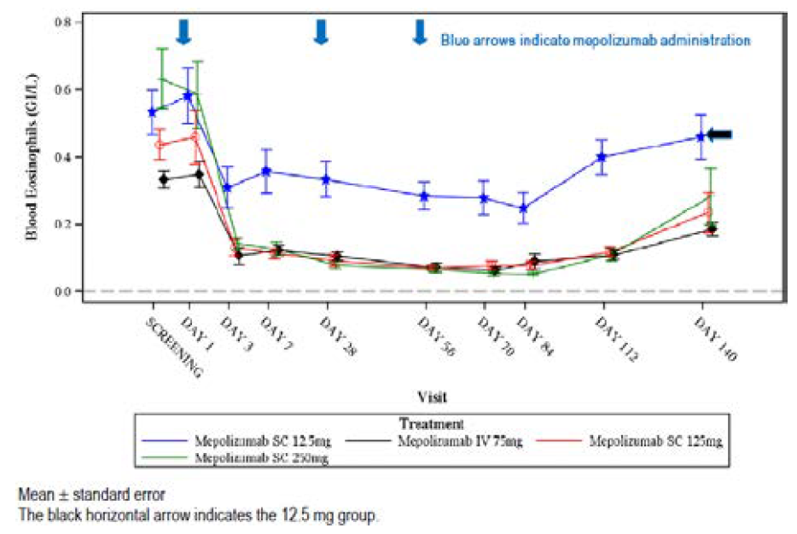
Source: clinical evaluation report extract from the AusPAR for the new biological entity submission for mepolizumab.23
Figure 2: Study MEE103219: changes in blood eosinophil level
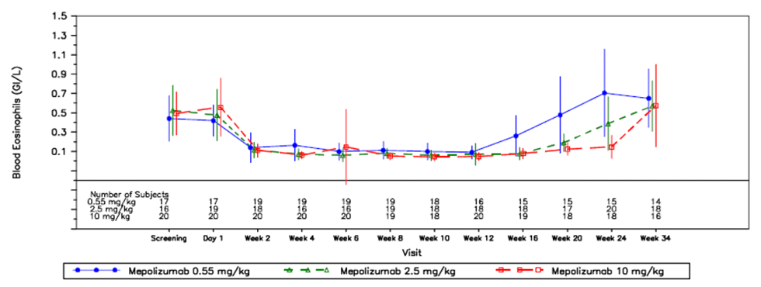
The absence of a dose -response or exposure-response relationship between mepolizumab and PD variables was described in the FDA’s Clinical Pharmacology Review for the asthma submission in 2014. This review reports that there was also a flat dose- and/or exposure response-relationship for the clinical PD measures of forced expiratory volume in one second (FEV₁) response, asthma exacerbation rate, time to first exacerbation and frequency of exacerbation.
The pattern of change in the total IL-level has been reported previously. The increase in total serum IL-5 level seen with mepolizumab treatment has been attributed to the formation of a long-lived neutralised mepolizumab-IL-5 complex rather than active IL-5.

Baseline eosinophil count and efficacy
Mean baseline blood eosinophil levels appear to be similar across disease conditions in the sponsor’s clinical studies. Report 2015N238375_00: The Effect of Mepolizumab on Blood Eosinophil Count - A Dose Response Meta-analysis states that similar baseline blood eosinophil levels were recorded in the HES Study MHE100185 and across the asthma studies. The geometric mean baseline eosinophil count in patients receiving mepolizumab in the Phase III asthma study (Study MEA115588) was 0.29 GI/L. The geometric mean baseline blood eosinophil levels in patients receiving mepolizumab in the Phase III EGPA study was 0.177 GI/L. This seems counter-intuitive given that diagnostic criteria for HES and EGPA require blood eosinophil > 1000 or 1500 cells/µL but reflect different study inclusion criteria and oral corticosteroid use. In general, the inclusion criteria for the asthma studies specified a baseline eosinophil level of ≥ 150 to 200 cells/µL (or ≥ 300/µL in the previous 12 months) whereas the inclusion criteria for the EGPA study specified an historical elevation in eosinophil count (> 1000 cells/µL) but no specific level at Baseline. All patients in the EGPA study were receiving a daily dose of ≥ 7.5 mg prednisolone equivalent at Baseline; patients in the asthma studies were receiving inhaled corticosteroids ± OCS.
Baseline eosinophil count may be predictive of mepolizumab efficacy. According to the clinical evaluation report extract for the new biological entity submission, the case study report for a Phase III severe asthma study (Study MEA115588) states that patients with baseline blood eosinophil count < 150 cells/µL at Baseline ‘had a reduced positive response to mepolizumab in terms of exacerbation frequency’, although this was not considered convincing by the evaluator of that submission. The pre-specified sub group analysis in the main EGPA study also suggests that patients with baseline eosinophil count < 150 cells/µL experienced less benefit with mepolizumab. Differing efficacy according to baseline eosinophil count appears to be a class effect for IL-5 mAbs:
- Reslizumab: The TGA approved indication specifies a blood eosinophil cut off level.
  - Reslizumab (Cinqaero): Cinqaero is indicated as add-on therapy in adult patients with severe eosinophilic asthma (blood eosinophil count greater than or equal to 400 cells/µL) (see Clinical Trials).
- Benralizumab: The FDA approved label notes that patients with a baseline blood eosinophil count ≥ 300 cells/µL showed a numerically greater response in asthma exacerbation reduction than those with counts < 300 cells/µL.

Changes in blood eosinophil level and disease activity
Tissue injury in EGPA is thought to result from vasculitis, together with a contribution from tissue eosinophilia. The mechanistic relationships between blood eosinophilia, tissue eosinophilia, vasculitis activity and tissue injury are unknown. Demonstration of a reduction in blood eosinophil count cannot be assumed to equate to a reduction in tissue eosinophils and a reduction in tissue injury. Study MEE103291 investigated changes in blood eosinophils and eosinophil count in oesophageal biopsy in 59 children (2 to 17 years) with eosinophilic oesophagitis who received 3 mepolizumab treatments. At baseline, these children had blood eosinophils largely within normal range and ≥ 20 eosinophils per high power field on oesophageal biopsy. Mean blood eosinophil levels were found to decrease around 70% from Week 2 to Week 12. Repeat oesophageal biopsies at Week 12 (4 weeks after last dose of mepolizumab) found that around 30% had a reduction in oesophageal eosinophils below baseline but that only 5 out of 59 (8.5%) met the pre-specified criteria for response (where this was defined as achieving a reduction in oesophageal eosinophils to < 5 cells per high power field). This open label, dose ranging study of 59 patients was not designed to allow for a meaningful assessment of efficacy.
There were no analyses in the dossier that explored the relationship between blood eosinophil level, tissue eosinophil levels and disease activity in patients with EGPA, for example, there was no analysis comparing blood eosinophil levels at the time of EGPA relapse in patients from the mepolizumab arm to patients in the placebo arm of Study MEA115921. The sponsor is asked to provide more information regarding the reduction in blood eosinophil levels in individual patients and if there was any relationship between this reduction and efficacy. See Clinical Questions section below.

Mepolizumab and off target effects
Off target effects of mepolizumab may result through changes in IL-5 availability, reduced blood eosinophils and impaired activation/accumulation of eosinophils. The understanding of the roles of Il-5 and eosinophils in health is continuing to evolve. IL-5 has pleiotropic effects on various cell types and controls the production and function of myeloid and lymphoid cells, only one of which is eosinophils. The role of the eosinophils as the primary effector mechanism against specific parasites is well recognised, as is their involvement in hypersensitivity reactions and the potential for tissue injury due to the release of cytotoxic proteins. More recently, other roles of the eosinophils, in both the innate and the adaptive immune system, are being recognised. These roles include effector functions, antigen presentation and immunomodulatory actions via the release of mediators. Eosinophils have also been implicated in immune homeostasis, allograft rejection, and anti-tumour immunity. Given the poorly understood roles of IL-5 and eosinophils in the immune system as a whole, and the limited number of patients treated with mepolizumab, off-target effects of mepolizumab may yet be recognised. These may relate to immunosuppression and include reduced tumour surveillance. Of note is that the FDA label for another IL-5 antagonist, reslizumab, includes malignancies in the Warnings And Precautions section:
‘5.3 Malignancy
In placebo controlled clinical studies, 6/1028 (0.6%) patients receiving 3 mg/kg Cinqair had at least 1 malignant neoplasm reported compared to 2/730 (0.3%) patients in the placebo group. The observed malignancies in Cinqair-treated patients were diverse in nature and without clustering of any particular tissue type. The majority of malignancies were diagnosed within less than six months of exposure to Cinqair.’

Proposed description of PD in the PI
The sponsor has proposed changes to the PD information be added to the PI, which are beyond the scope of this AusPAR.

Dosage selection for the pivotal studies
The following rationale for dosage selection for the main efficacy and safety study is provided in the clinical study report for Study MEA115921:
‘EGPA involves greater implication of eosinophils at multiple target organs and there is potential for a significant increase in blood eosinophils preceding relapse or during OCS taper. It was therefore considered that a higher dose of mepolizumab would be required in EGPA to confer therapeutic benefit compared with severe asthma. Thus, 300 mg SC (approximately equivalent to 225 mg intravenous (IV)) every 4 weeks was selected for this study since data from a severe asthma study showed that 250 mg IV every 4 weeks provided a greater reduction in blood eosinophils compared with 75 mg IV every 4 weeks, while a higher dose of 750 mg IV did not provide a greater reduction than the 250 mg IV dose. In addition, mepolizumab (750 mg IV every 4 weeks) was shown to be well-tolerated in previous EGPA studies,, and in other eosinophilic diseases.’
Of the articles cited in the clinical study report as supporting safety with higher doses of mepolizumab in EGPA, Kim et al.,34 and Moosig et al.,35 describe separate open label studies in which patients with EGPA were treated with 9 doses of mepolizumab 750 mg administered IV monthly (7 patients in Kim et al and 10 patients in Moosig et al). Both studies were provided with financial support by the sponsor. Neither publication provides a rationale for the selected dose. Both studies report clinical improvement during mepolizumab treatment, as shown by weaning of oral corticosteroids, and worsening of disease following completion of mepolizumab treatment. Both studies report that mepolizumab was well tolerated. There were no serious adverse events (SAEs) reported in Kim et al. There were 4 SAEs reported in 2 patients in Moosig et al.; these were not considered treatment related. Moosig et al reports on all adverse events (AEs) experienced by the patients. Of note is that 5 out of 10 had infectious AEs (urinary tract infection, norovirus infection, herpes zoster, herpes simplex, wound infection) and one patient had anaphylactic shock at Week 25 that was attributed to cefuroxime.

Efficacy

Studies providing efficacy data
Study MEA115921 is pivotal for the demonstration of efficacy and safety.
- Study title: A double blind, randomised, placebo controlled study to investigate the efficacy and safety of mepolizumab in the treatment of eosinophilic granulomatosis with polyangiitis in subjects receiving standard of care therapy.

Evaluator’s conclusions on efficacy
The demonstration of efficacy of mepolizumab for the proposed indication is based on data from a 52 week treatment clinical trial that compared mepolizumab to placebo, with both arms receiving standard care. Eligible patients were aged 18 years or more, had confirmed diagnosis of EGPA (using modified American College of Rheumatology (ACR) criteria) that was relapsing or refractory disease, were on stable OCS ± other immunosuppressive treatment and did not have life- or organ-threatening disease. The sponsor has been asked for clarification regarding the timing of the blood eosinophil level required for EGPA diagnosis.
Patients received 300 mg of mepolizumab or placebo administered SC once every four weeks for 13 treatments while continuing their stable daily OCS therapy. Tapering of OCS was allowed from Week 4. Subjects were followed up for 12 weeks after treatment completion.
The trial had two primary efficacy end points, both of which needed to be achieved for a positive study result:
- The total accrued weeks of remission, that is, the accrued number of weeks where BVAS = 0 plus prednisolone/prednisone dose ≤ 4 mg/day over the 52 week study treatment period according to 12 week blocks (0 weeks; > 0 weeks but < 12 weeks; ≥ 12 weeks but less than 24 weeks; for ≥ 24 weeks but less than 36 weeks; and for ≥ 36 weeks).
- The proportion of participants who had remission (that is BVAS = 0 and prednisolone/prednisone ≤ 4 mg/day) at both Week 36 and Week 48.
Predefined sub groups for analysis included 50 years of age, sex, treatment with other immunosuppressive drugs at Baseline, baseline blood eosinophil level 150 cells/µL. Exploratory end-points included relapse rate, changes in OCS dose from Baseline, control of asthma symptoms and quality of life measures.
The results for the primary end-points and other clinically relevant end points are shown in Table 7.
Table 7: Study MEA115921 Results for co-primary endpoints and evaluator selected end-points
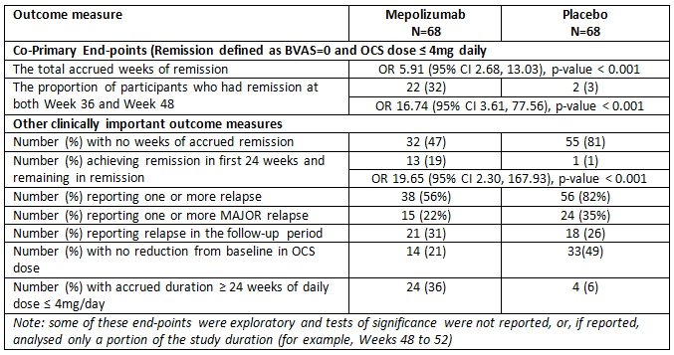
OR = odds ratio
On comparison of participants receiving mepolizumab to participants receiving placebo, Study MEA115921 shows a substantial improvement with mepolizumab treatment for the co-primary end points of accrued remission and proportion of subjects in remission at both Weeks 36 and 48. This result appears robust as all of the supportive analyses showed benefit. All secondary outcome measures (not shown in Table 7, above) also showed benefit. Sub group analysis found similar benefits for both co-primary end points for all groups, except for the group with baseline blood eosinophil level < 150 cells/µL.
The co-primary end points are novel and have not been reported in EGPA or vasculitis studies previously. The use of such complex and novel end-points limits comparison to historical controls and also limits the ability of clinicians to contextualise the results within their own experience.
More common end points are relapse rate and complete remission rate, although varying definitions have been used for remission and relapse. As shown in Table 7, mepolizumab was associated with a substantial reduction in relapse rate compared to placebo (56% compared to 82%), although the analysis of the annual relapse rate shows that this equates on average to a reduction from 2 relapses to one relapse per year. Indirect comparison of the outcomes achieved with mepolizumab to outcomes reported in the literature is limited by the very few randomised controlled trials investigating EGPA reported in the literature. Cohen et al., in a study comparing two different cyclophosphamide regimens for induction of remission, reported EGPA relapse rates of 78% and 52% during 8 years of follow-up. Hiemstra et al., , in a study investigating the use of mycophenolate mofetil and azathioprine for remission maintenance in ANCA associated vasculitis (limited to Wegener’s or MPA) reported relapse rates of 55% in the mycophenolate group and 37.5% in the azathioprine group.
Other results show clinically relevant improvements in patients receiving mepolizumab compared to placebo. There was a reduction in the number of patients experiencing more clinically important major relapses. There were fewer patients who did not achieve any reduction in OCS dose and the number of patients who accrued more than 24 weeks at an OCS dose ≤ 4mg was higher in the mepolizumab group compared to placebo. The analysis of asthma control, according to the Asthma Control Questionnaire-6 (ACQ-6), reported that subjects treated with mepolizumab had numerically greater reductions (improvement) in mean ACQ-6 scores at every 4 week time period compared with subjects who received placebo.
The results are clinically relevant and important as time in remission, reduction in the number of relapses and reduction in corticosteroid dose are goals of therapy for EGPA. The improvement in asthma control is also clinically important as asthma exacerbations may be poorly controlled by immunosuppressive treatment and require high doses of glucocorticoids.
Within these positive results there are some concerning issues.
- Non-responders
Treatment with mepolizumab did not have the same effects with all patients. There were 32 patients (47%) in the mepolizumab arm who did not achieve a remission of any duration. Studies investigating the use of mepolizumab in asthma also found that not all patients benefited. Investigators for the SIRIUS study reported that: ‘36% were unable to reduce their dose of oral corticosteroid, withdrew from treatment or had a lack of asthma control’. It is not clear why there should be this difference in effect. The related EGPA article reasonably speculates that: ‘One consideration is that eosinophilic granulomatosis with polyangiitis is a heterogeneous disease with some manifestations being non-eosinophil driven’ and ‘Alternatively, although mepolizumab reduced blood eosinophils, the dose may have been insufficient to eliminate tissue eosinophils’. The differential effects reported suggest that equating raised blood eosinophilia with disease activity that may be suppressed by mepolizumab is an over simplification, particularly given the lack of any demonstrated relationship between blood eosinophil reduction, tissue eosinophil changes and reduction in disease activity for the conditions in which mepolizumab has been investigated. A better and more predictive biomarker is required.
- Lack of efficacy in participants with baseline eosinophil count < 150 cells/µL
The pre-specified sub group analysis found no benefit for the primary outcome measures for this sub group. This did not appear to be due to the duration taken to wean from high doses of OCS as 15 out of 57 patients (26%) with baseline eosinophil count < 150 cells/uL were receiving high dose OCS (> 20 mg per day). Post hoc analyses found a similar lack of benefit for the annualised relapse rate and linear relationships between baseline eosinophil level and EGPA relapse rate and baseline eosinophil level and percentage reduction in OCS dose during Weeks 48 to 52. The baseline eosinophil count < 150 cells/µL does not identify all non-responders; there were 57 participants with baseline eosinophil count < 150 cells/µL but 32 participants who failed to achieve remission of any duration.
- Rebound after cessation of mepolizumab
A possible rebound effect, with increased disease activity following cessation of mepolizumab, is suggested by the increased number of subjects in the mepolizumab group experiencing relapses in the follow up period compared to the placebo group. Of note is that an observational study of mepolizumab in severe eosinophilic asthma with 12 month follow up after cessation of mepolizumab has reported an increase in asthma exacerbations and asthma symptoms following cessation, with the authors of the opinion that this was due to a rebound phenomenon. The sponsor has been asked to provide further information regarding possible rebound following cessation of mepolizumab in patients with EGPA.
The indication as proposed is for open-ended treatment. This presupposes that long-term use is not associated with tolerance and reduced efficacy. The main study for efficacy was limited to 13 treatments (48 weeks). The increase in EGPA relapse after mepolizumab cessation suggests that a treatment duration greater than 12 months is required. Subjects from Study MEA115921 were able to enter an open-label extension study through a Long Term Access Programme or Compassionate Use Programme, Study MEA116841/201607. The interim clinical study report for this study that was provided in the dossier was limited to exposure data and safety results. From the exposure data, 52 participants from the mepolizumab arm and 57 subjects from the placebo arm have entered the extension study (total 109 subjects) and have received a median number of treatments of 8 (range 1 to 18). There were 3 out of 109 subjects who ceased treatment with mepolizumab due to lack of efficacy; whether these patients were from the mepolizumab arm of Study MEA115921 was not reported. To provide support for the proposed long-term use of mepolizumab in patients with EGPA, the sponsor has been asked to provide interim efficacy results from Study MEA116841/201607.
The evaluator has proposed a number of changes to the description of Study MEA115921 in the draft PI, however these are beyond the scope of this AusPAR.

Safety

Studies providing safety data
Study MEA115921 is pivotal for the demonstration of efficacy and safety. Additional safety data have been gathered via a Long Term Access Programme, which is comprised of Studies MEA116841 and 201607.
Studies providing evaluable safety data:
- Study MEA115921 was a Phase III placebo controlled study investigating the use of mepolizumab in adults (age ≥ 18 years). The final clinical study report was provided in the dossier.
- Study MEA116841/201607 is an open label continuation of Study MEA115921, conducted through the sponsor’s long term access and Compassionate Use Programmes. An interim clinical study report is provided in the dossier, with data cut-off date of 5 September 2016. According to the Clinical Overview, ‘The Long Term Access Programme is ongoing at the data cut-off date for this marketing application and therefore provides interim safety data; the data collection was limited to adverse events’.
Some additional safety information is provided:
- A 120 Day Safety Update Report (dated 28 June 2017) that was provided to the FDA to support the EGPA application. This update provides updated data regarding SAEs reported in Study MEA116841/201607, ongoing studies by the sponsor; and ongoing or completed investigator sponsored studies.
- Safety data from the use of mepolizumab in patients with other conditions and from listings and narratives for fatal and non-fatal SAEs reported in the Global Safety Database for ongoing GlaxoSmithKline-sponsored studies.

Patient exposure

All diseases
According to the summary of clinical safety, ‘A total of 2,522 subjects have received at least one dose of mepolizumab across 26 studies in EGPA, asthma (including severe asthma), HES, eosinophilic esophagitis, atopic dermatitis, nasal polyposis and healthy volunteers’ in GlaxoSmithKline-sponsored clinical trials.
Participants in these studies received a range of doses, from 12.5 mg to 1500 mg, usually administered monthly. Doses ranging from 75 mg IV to 750 mg IV were investigated in asthma. The recommended dose for the approved indication of severe eosinophilic asthma is 100 mg SC monthly. Doses of 750 mg and 1500 mg IV monthly have been investigated in eosinophilic esophagitis and HES. The dose of 300 mg SC monthly has only been substantially investigated in EGPA to date.
Participants in most of the 26 studies were treated for < 12 months (2233 out of 2522, 89%). The dose for which the longest duration of treatment has been reported is 750 mg IV monthly; 122 subjects have received this dose for 60 months or longer.

EGPA

Study MEA115921
In Study MEA115921, there were 68 patients who received mepolizumab treatment and 68 patients who received placebo (safety population). There were 10 patients in the mepolizumab arm and 5 in the placebo arm who did not receive the protocol determined 13 treatments. There were 4 subjects in the study who each received one additional treatment in error. See Table 8.
Table 8: Duration of mepolizumab exposure and treatments administered (Study MEA115921, safety population)
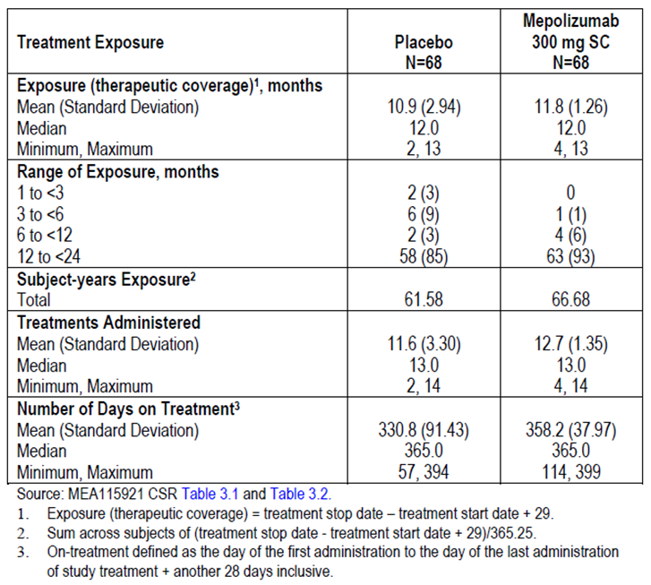
Demographics and disease characteristics of the participants in Study MEA115921 are shown in the clinical evaluation report. Of note, is that: there were no participants aged younger than 18 years and only 17 aged 65 years or older; 92% of patients were white and 59% were female; the mean body mass index (BMI) was 28 kg/m²; the mean time since EGPA diagnosis was 5.5 years; all patients were receiving oral corticosteroid as per protocol. Most (105 out of 136, 77%) had received other immunosuppressive therapy, with prior management including cyclophosphamide in 46 out of 136 (34%).

Study MEA116841/201607
There were 109 out of 136 patients (78%) from Study MEA115921 who went on to receive open label mepolizumab 300 mg SC monthly in the Long Term Access Programme/Compassionate Use Programme study. Of these, 52 had received mepolizumab in Study MEA115921 and 57 subjects had received placebo. At the data cut off, 103 out of 109 subjects were continuing to be treated with mepolizumab, and had received a mean number of 8 treatments (see Table 9). There were 6 subjects who had had discontinued treatment: 3 due to lack of efficacy, 2 due to AEs and 1 due to the subject’s decision.
Table 9: Mepolizumab exposure in Long-term access programme MEA116841 and Compassionate Use Programme 201607, safety population
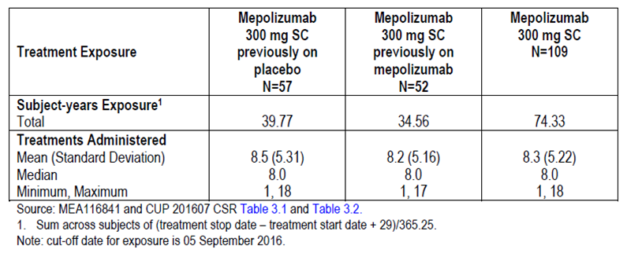
The summary of clinical safety reports that, combining exposure in Study MEA115921 and the Long Term Access Programme, there have been 125 patients with EGPA who have received at least one dose of mepolizumab, the median exposure was 12.9 months (range 1 to 28 months) and that there were:
- 43 subjects treated for < 12 months.
- 65 subjects treated for 12 to < 24 months.
- 17 (14%) subjects treated for 24 months to < 36 months.
No patients with EGPA have been treated for 36 months or longer.

Safety issues with the potential for major regulatory impact
As described above, the following ‘adverse events of special interest’ (AESIs) have been recognised as ‘identified’ or ‘potential’ risks associated with mepolizumab: systemic (non-allergic and allergic/hypersensitivity) reactions, local injection site reactions, cardiac disorders including serious cardiac, vascular, thromboembolic (CVT) and serious ischaemic events, infections (including serious and opportunistic), and malignancies. These AESIs represent AEs that may have possible regulatory impact, noting that the current PI lists Hypersensitivity and Administration Reactions, Parasitic Infections and Opportunistic Infections: Herpes Zoster as Precautions.
The following discussion presented by the evaluator uses information regarding AESIs as reported in the clinical study reports for Studies MEA115921 and Study MEA116841/201607 together with the reporting of AESIs in the clinical study report for the Compassionate Use Programme in which patients with HES were provided with long term access to mepolizumab. Information from the latter has been included below due to the relatively short durations of treatment reported in patients with EGPA.
A summary of the Compassionate Use Programme for patients with HES is provided in the clinical evaluation report, Study ZM2006/0080/05. In this ongoing study, 285 patients were included in the interim report, of whom 89 patients had had exposure > 60 months, with this including 16 patients with treatment duration > 96 months.
The sponsor has not proposed any changes to the Precautions or Adverse Effects section of the PI apart from the addition of the following statement to the Adverse Effects section:
‘EGPA
In a double-blind, placebo-controlled study in subjects with EGPA (300 mg mepolizumab n = 68, placebo n = 68), no additional adverse reactions were identified to those reported for the severe asthma studies.’

Adverse events of special interest

Anaphylaxis
‘Anaphylaxis’ was added to the to the list of reactions in the ‘Hypersensitivity and Administration Reactions’ Precaution in the PI on the basis of post-marketing data. The frequency, as reported in the ‘Post-marketing data’ section, was reported as ‘rare’ (≥ 1 out of 10,000 to < 1 out of 1,000).

Study MEA115921
There was one report of anaphylaxis in this study. This was reported as ‘anaphylactic reaction after fish meal’ occurring 16 days after the last dose of mepolizumab and not considered related to mepolizumab. Treatment was continued unchanged and without recurrence of anaphylaxis.

Study MEA116841/201607
No anaphylaxis events were reported.

Compassionate Use Programme
There were four events of possible severe hypersensitivity/anaphylaxis requiring treatment with intravenous antihistamine and corticosteroid ± adrenaline. Three of these events were considered to be related to food and the subjects continued mepolizumab treatment with no further events reported. One event was described as ‘non-serious’ although symptoms included facial swelling, pruritus, bronchospasm, chest tightness and wheeze. These symptoms were reported to resolve with systemic corticosteroids, antihistamines and albuterol nebuliser and treatment with mepolizumab was discontinued.

Systemic (hypersensitivity or non-allergic) reactions
The current PI includes ‘Hypersensitivity and Administration Reactions’ as a Precaution with:
Hypersensitivity and Administration Reactions
‘Acute and delayed systemic reactions, including hypersensitivity reactions (for example, anaphylaxis, urticaria, angioedema, rash, bronchospasm, hypotension), have occurred following administration of Nucala. These reactions generally occur within hours of administration, but in some instances had a delayed onset (i.e. days). These reactions may occur for the first time after a long duration of treatment (ADVERSE EFFECTS). In the event of a hypersensitivity reaction, Nucala should be discontinued.’

Study MEA115921
Systemic hypersensitivity reactions were reported for 4 subjects (6%) in the mepolizumab group and 1 subject in the placebo group (1%). All of the systemic reactions were considered related to study treatment by the investigators. The nature and timing of these reactions are shown in Table 10.
Table 10: Study MEA115921: Systemic hypersensitivity and non-allergic reactions
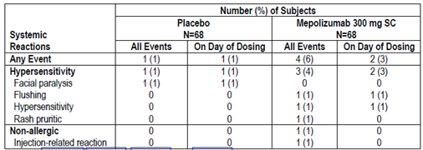
The 4 mepolizumab subjects had single events; the subject in the placebo group had three events of facial paralysis. One hypersensitivity event in a patient receiving mepolizumab was reported as serious and resulted in treatment discontinuation. This patient experienced symptoms, including dyspnoea and stridor, 15 minutes after the ninth dose of mepolizumab. These rapidly resolved with intravenous antihistamine and corticosteroid. Hypersensitivity events in other subjects were mild, self-limiting and did not recur with ongoing mepolizumab treatment.

Study MEA116841/201607
Systemic hypersensitivity reactions were reported for 3 subjects, all of whom had received placebo in Study MEA115921. Each of the reactions was mild, self-limiting and did not recur with ongoing mepolizumab treatment.

Compassionate Use Programme
Events were identified from completed ‘Hypersensitivity/Anaphylaxis Forms’ and by review of reported AEs. There were 8 completed forms submitted by investigators. In 4 of these, the reactions were severe. Mild reactions were reported in the other 4 subjects (rash and pruritus in 2 patients, conjunctivitis in one, chest tightness in one). These reactions were reported to resolve and to not recur with ongoing mepolizumab treatment. Review of reported AEs identified 6 additional subjects in whom hypersensitivity reactions occurred; some of these were attributed to other medications including metamizol drops, azathioprine, dorzalomide and ciprofloxacin. All reactions resolved and patients continued mepolizumab treatment.
AEs were also analysed according to their occurrence on the day of mepolizumab administration. This found that the overall incidence of AEs that occurred on the day of administration was 58% (163 out of 281), with the most common AEs being: fatigue (8%); cough (7%); dyspnoea, arthralgia and headache (each 6%); and nasal congestion (5%). Rash and pruritus were reported in 10 subjects (4%), with urticaria in one subject.

Local injection site reactions

Study MEA115921
Local injection site reactions (including bruising, erythema, pain and swelling) were reported for a similar proportion of subjects in each treatment group: 10 subjects (15%) in the mepolizumab group and 9 subjects (13%) in the placebo group; the majority of events were considered related to study treatment by the investigators. Most of the reactions were mild and self-limiting and no patient discontinued study treatment.

Study MEA116841/201607
Local injection site reactions were reported by 11 (11%) subjects, with 9 out of 11 considered related to study treatment. Most of the reactions were mild and self-limiting and no patient discontinued study treatment.

Compassionate use programme
Local injection site reactions were not discussed in the clinical study report. However, reports of AEs on the day of administration show infusion site bruising and infusion site induration was reported by one subject each.
The rate of injection site reactions reported here differs from that shown in Table 11, below, due to the inclusion of other preferred terms (for example, injection site pain). The incidence of injection site reactions in patients receiving mepolizumab for EGPA (15%) is higher than that reported in patients with severe asthma who received mepolizumab (8%). As noted above, this would be expected given that patients with EGPA received 3 injections per treatment compared to one injection in asthma.
Table 11: Study MEA115921 AEs by preferred term reported in 10% or more in either treatment group
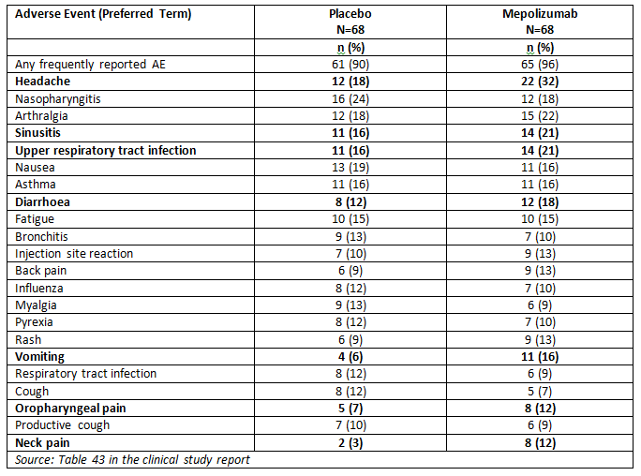
AEs that were reported more commonly (> 5% difference in incidence) in patients receiving mepolizumab are shown in bold.

Infections

Study MEA115921
On treatment AEs in the Infections and Infestations system organ class (SOC) were reported with a similar incidence in the mepolizumab (84%) and placebo (78%) groups, while serious infections were reported by 6% of subjects in the mepolizumab group and 15% of subjects in the placebo group.

Study MEA116841/201607
On treatment AEs in the Infections and infestations SOC were reported by 49 out of 109 subjects (45%), with these reported as SAEs in 9 out of 109 subjects (9%).

Compassionate use programme
On treatment AEs in the Infections and Infestations SOC were reported in 180 of 281 patients (64%), with a total of 792 events. These were reported as SAEs in 47 out of 285 (16%) of patients. The events reported by ≥ 1% of patients were pneumonia (14 out of 285, or 5%), sepsis (5 out of 285, or 2%), and bronchitis, cellulitis, device related infection, diverticulitis, gastroenteritis, urinary tract infection (each by 3 out of 285, or 1%).

Opportunistic infections
The current PI includes the following as a Precaution:
Opportunistic Infections: Herpes Zoster
In controlled clinical trials, 2 serious adverse reactions of herpes zoster occurred in patients treated with Nucala versus none in the placebo group.
The Adverse Effects section, describing clinical trials experience in asthma, also reports that 3 cases of herpes zoster occurred in subjects treated with mepolizumab 75 mg IV, compared with 2 subjects in the placebo group, and that herpes zoster was reported as a SAE in 2 subjects.

Study MEA115921
The clinical study report outlines that, since SMQs for opportunistic infections are not available, expert opinion on what constitutes opportunistic infections in the setting of biological therapy (according to the consensus group recommendations in Winthrop et al.) was used to develop a list of Medical Dictionary for Regulatory Activities (MedDRA) preferred terms (PTs) that were considered to represent opportunistic infections. The incidence of AEs identified as potentially representing opportunistic infections was higher in the mepolizumab group (7%) compared with the placebo group (3%).
Figure 3: Study MEA115921 Potential opportunistic infections, safety population
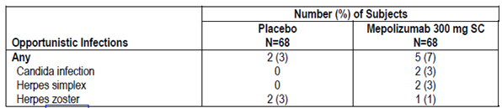
Brief narratives were provided for these patients. The cases of herpes simplex were reported as not representing opportunistic infection as there was no suggestion of invasive disease. The cases of candida were also discounted as unlikely to be invasive disease on the basis that one was thrush and the other was non-serious and mild. All cases of herpes zoster appeared to be cases of shingles, all were mild to moderate in intensity, one of the placebo cases (moderate intensity) was reported as an SAE.

Study MEA116841/201607
There was one event potentially representing an opportunistic infection reported. This was a non-serious case of herpes zoster (shingles) in a 45 year old subject who had received mepolizumab in Study MEA115921. The shingles developed after 211 treatment days and resolved within 7 days.

Compassionate use programme
Adverse events identified as potentially representing opportunistic infections were reported in 12 of 281 (4%) of subjects. Herpes zoster and Candida sepsis were reported most frequently, 8 patients (3%) and 2 patients (< 1%), respectively. All events resolved, none were considered serious, and none led to discontinuation of treatment. Two events (2 cases of herpes zoster) were assessed by the investigator as possibly related to study treatment.
It is not clear as to whether mepolizumab treatment may or may not have an immunosuppressive effect or predispose to herpes zoster reactivation. The incidence of herpes zoster in both the placebo and treatment arms of Study MEA115921 appear higher than would be expected: the CDC estimates an incidence for herpes zoster of approximately 4 cases per 1,000 U.S. population annually (0.4%). However, the reported rate in EGPA patients may reflect the use of OCS and other immunosuppressive drugs in this population, with the higher rate in the placebo group an effect of small numbers. The incidence of herpes zoster in the uncontrolled HES population was also higher than would be expected (2.8%). Again, this may be an effect of OCS and other immunosuppressive treatment but an effect of mepolizumab cannot be excluded. It seems reasonable to leave the current information in the PI unchanged, pending further information with increased use of mepolizumab.

Parasitic infections
The current PI includes Parasitic Infections as a Precaution with the advice as shown below:
Parasitic Infections
Eosinophils may be involved in the immunological response to some helminth infections. Patients with pre-existing helminth infections were excluded from participation in the clinical program. Patients with pre-existing helminth infections should be treated for their infection prior to Nucala therapy. If patients become infected whilst receiving treatment with Nucala and do not respond to anti-helminth treatment, temporary discontinuation of Nucala should be considered.
No parasitic infection AEs were reported in Study MEA115921, or in Study MEA116841/201607 or the Compassionate Use Programme to date.
A lack of effect of mepolizumab on parasitic infections cannot be concluded, given that patients with known prior infections were excluded from the clinical studies and given the difficulty in detecting and diagnosing parasitic infections without specific surveillance.

Malignancies

Study MEA115921
Treatment emergent events in Neoplasms benign, malignant and unspecified (including cysts and polyps) MedDRA SOC were reported for 1 subject (1%) in the mepolizumab group and 3 subjects (4%) in the placebo group. The event in the mepolizumab group was colon adenoma; the events in the placebo group were lipoma, Bowen’s disease, and testis cancer. Of these, only Bowen’s disease and testis cancer were considered malignant.

Study MEA116841/201607
Treatment emergent events in the Neoplasms benign, malignant and unspecified (including cysts and polyps) SOC were reported for 2 (2%) subjects. No malignancies were reported.

Compassionate use programme
Thirteen patients reported 20 AEs of malignancy while on treatment (see Table 12).
Table 12: Compassionate Use Programme: reported malignancies
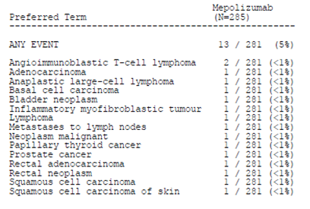
There were 7 lymphoma cases reported during the study: 3 of T cell lymphoma, 2 of angioimmunoblastic T cell lymphoma, one anaplastic large cell lymphoma and one of lymphoma. One case of T cell lymphoma was suspected clinically but had no pathological diagnosis. The duration of treatment at the time these lymphomas developed was not described (see Table 13).
Table 13: Compassionate Use Programme: reported lymphomas
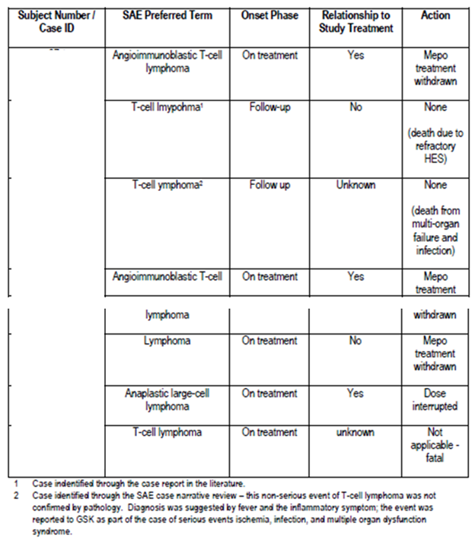
The incidence of T-cell lymphoma appears surprisingly high as this is regarded as a rare malignancy: the SEER Cancer Statistics Review 1975 to 2014 provides an annual estimate of approximately 2 per 100,000 for peripheral T cell lymphomas. The overall incidence in the Compassionate Use Programme may be 1.8% (5 out of 281) or 2.5% (7 out of 281), depending on the sub type of lymphoma for the other two patients.
The evaluator notes that:
- Eosinophils are believed to play a role in tumour surveillance in health.
- There were two malignancies and one unusual benign tumour reported in the 25 paediatric patients in the HES Compassionate Use Program.
- An increased incidence of malignancies may be a class effect. A higher number of malignancies with another IL-5 mAb is described in the FDA approved label for reslizumab. The incidence of malignancy in an open label extension study of reslizumab was 14%.
The sponsor is asked to:
- Provide a cumulative review of cases of lymphoma reported in patients who have received mepolizumab.
- Provide a cumulative review of neoplasms (benign and malignant) reported in patients who have received mepolizumab.
- Comment on whether development of lymphoma, or other malignancies, may be a risk associated with long-term use of mepolizumab.

Cardiac disorders
The clinical evaluation report extract for the new biological entity submission notes that:
‘Severe cardiac events were uncommon in the placebo and mepolizumab groups of the severe asthma studies. However, safety concerns were raised by an excess of ischaemic events in the mepolizumab group compared with placebo in MEA112997. This finding was not confirmed by Independent Data Monitoring Committees (IDMCs) in subsequent studies and the sponsor reasonably argues that this observation was a chance event.’

Study MEA115921
Cardiac AEs were closely monitored, with investigators expected to complete a specific cardiovascular (CV) page on the electronic case report form (eCRF) for cardiovascular AEs/SAEs. Cardiac events may also be expected due to the known cardiac involvement in EGPA, with this most commonly manifesting as ischaemic disease and cardiac failure.
On treatment AEs in the Cardiac disorders SOC were reported for 4 subjects (6%) in the mepolizumab group and 6 subjects (9%) in the placebo group. These included palpitations (1 subject in the mepolizumab group and 2 subjects in the placebo group) and atrial fibrillation (2 subjects in the placebo group). SAEs in the Cardiac disorders SOC were reported for 1 subject (1%) in the mepolizumab group (cardiac arrest) and 2 subjects (3%) in the placebo group (coronary artery disease; stress cardiomyopathy)
CV AEs for which the CV page was completed, and that were further assessed by the sponsor are shown in Table 14. These patients were reported to have other CV risk factors.
Table 14: Study MEA115921: Pre-specified CV events, safety population
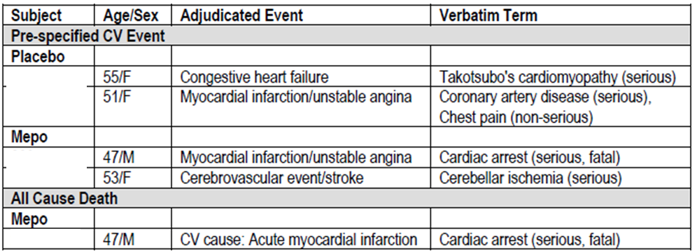
Mepo = mepolizumab
There does not appear to be an increased risk of serious cardiac disorders in the mepolizumab treated patients compared to the placebo patients, but the number of patients is small.

Study MEA116841/201607
On treatment AEs in the Cardiac disorders SOC were reported for 4 (4%) subjects, with SAEs reported in 2 subjects (arrhythmia and cardiac arrest).
Protocol specified cardiac events of arrhythmias (2 subjects) and cerebrovascular events stroke (1 subject) were reported.

Compassionate use programme
Thirty one of 285 patients (11%) reported 47 serious cardiac, vascular, and thromboembolic events while on treatment. Hypotension was reported in 4 of 285 patients (1%), cardiac failure congestive in 3 patients (1%), myocardial infarction in 3 patients (1%), and atrial fibrillation, cardiac failure, coronary artery occlusion, tachycardia, occurred in 2 patients (< 1%) for each event. There were 5 events with fatal outcome (cardiorespiratory arrest, right ventricular failure, cardiac failure, congestive cardiac failure and shock) while on treatment. Transient ischemic attack was reported in 4 of 285 patients (1%), myocardial infarction in 3 patients (1%), and cerebrovascular accident, coronary artery occlusion in 2 patients for each event.
No events were considered related to study treatment as assessed by the investigator.

Withdrawal and rebound
A theoretical risk of ‘rebound’ worsening of eosinophilic inflammation following cessation of treatment has been suggested on the basis of in vitro observations that anti–IL-5 therapy is associated with upregulation of IL-5 synthesis by Th-2 cells and upregulation of IL-5 receptor expression by eosinophils. The preformed IL-5 in complex with the drug may also act as a reservoir for IL-5 resulting in sustained levels of free IL-5. There have been a number of reports of such rebound, with adverse clinical consequences, in the literature. Haldar et al., report on a 12 month follow up of 54 patients with severe asthma, 27 of whom had received 12 months of treatment with mepolizumab, and found that the frequency of severe exacerbations increased significantly after stopping mepolizumab and that by 12 months there was no difference in exacerbation rate between the two groups. Kim et al report on 8 patients with HES or eosinophilic gastroenteritis (EGE) who were treated with another humanised antihuman IL-5 mAb, reslizumab, and followed up for 3 months after ceasing treatment. They found that rebound eosinophilia (to levels greater than or equal to pre-treatment levels) were observed in all 6 responders, with peak eosinophil counts occurring between 60 and 90 days post treatment. Rebound eosinophilia was accompanied by a severe exacerbation of symptoms, including skin rash, mucosal ulceration, angioedema, fatigue, myalgias, and arthralgias and 12 months after stopping mepolizumab, exacerbation frequency was not significantly different between subjects of the 2 study groups.
The possibility of rebound in relation to use in severe asthma was raised by the Advisory Committee on Prescription Medicines (ACPM) in relation to the new biological entity submission: ‘The ACPM noted that a recent report suggested a possible rebound effect after cessation of mepolizumab, and questioned whether it might be necessary to include mention of this in the PI.’
The summary of clinical safety reports that ‘Clinical data in severe asthma did not show evidence of symptom rebound after cessation of mepolizumab’ and describes a treatment break of a minimum of 12 months between completion of participation in the Phase III placebo controlled, severe asthma Study MEA112997 and entry into the open label extension Study MEA115666. The summary of clinical safety states that: ‘There was no increase in asthma exacerbations during the interim period between the end of Study MEA112997 and the start of Study MEA115666.’ No supporting analysis was provided.
In Study MEA115921, the occurrence of post treatment AEs was similar between the mepolizumab (49%) and placebo (51%) treatment groups and lower than the rates reported in the treatment period (97% for the mepolizumab and 94% for the placebo group). As noted above, the pattern of post treatment AEs was different between the mepolizumab and placebo groups and the evaluator has speculated that this may be consistent with the higher number of patients experiencing EGPA relapse during the follow up period.
The summary of clinical safety does not provide a discussion of the higher number of patients from the mepolizumab arm compared to the placebo arm reporting EGPA relapse during the follow up period of Study MEA115921 (21 compared to 18 patients). Given that patients from Study MEA115921 could enter the open label continuation study (Study MEA116841/201607) up to 6 months after completing Study MEA115921, the sponsor has been to provide an analysis of the relapse rate in patients from the mepolizumab arm compared to the placebo arm in this period and to comment on whether there is a rebound effect. The sponsor is also asked if any rebound effects, as shown by disease worsening, have been reported in any other mepolizumab studies and to comment on whether information regarding rebound should be included in the PI.

Immunogenicity: Study MEA115921
The clinical evaluation report extract for the new biological entity submission reports that: ‘In the placebo controlled severe asthma studies, 6% of patients treated with mepolizumab 100 mg SC and 2% of patients treated with IV mepolizumab developed anti-drug antibodies (ADAs). However, most were transient and low titre. Stopping and restarting treatment in MEA115666 did not increase immunogenicity and ADAs were not related to hypersensitivity reactions.’ The current PI provides the following information:
Immunogenicity
Consistent with the potentially immunogenic properties of protein and peptide therapeutics, patients may develop antibodies to mepolizumab following treatment. In subjects with severe asthma and EGPA who received at least one dose of 100 mg and 300 mg mepolizumab respectively, administered subcutaneously every four weeks, 15/260 (6%) and 1/68 (1%) respectively, had detectable anti-mepolizumab antibodies.
Neutralising antibodies were detected in one adult subject with severe asthma receiving mepolizumab. Anti- mepolizumab antibodies did not discernibly impact the pharmacokinetic or pharmacodynamic effects of mepolizumab treatment in the majority of patients and there was no evidence of a correlation between antibody titres and change in eosinophil level.
A total of 135 out of 136 subjects in Study MEA115921 were tested for the presence of anti mepolizumab antibodies. Two subjects in the mepolizumab group tested positive for anti-drug antibodies (ADA) at Baseline. None of their samples were positive post dosing.
At any time post baseline, 2 subjects tested positive for ADA, 1 subject in the mepolizumab group and 1 subject in the placebo group. For the subject in the mepolizumab group, a transient ADA response was detected at Week 24 with a titre of 32. For the subject in the placebo group, a persistent ADA response was detected at Weeks 52, and 60, with decreasing titre (32 and 16, respectively). Multiple AEs were reported in both subjects:
- The patient from the mepolizumab arm reported lower respiratory tract infection, upper respiratory tract infection, viral infection, restless leg syndrome, abdominal pain, epistaxis, pruritic rash, elevated alanine aminotransferase (ALT)/aspartate aminotransferase (AST)/gamma-glutamyl transferase (GGT).
- The patient from the placebo arm reported sinusitis, viral rhinitis/sinusitis, asthenia, gastro-oesophageal reflux, nausea, nasal disorder, upper respiratory tract inflammation, intertrigo, papule, cataract, vitreous floaters, ear pain, dysuria, pollakiuria (daytime urinary frequency), and vaginal haemorrhage.
The clinical study report states that neither subject had systemic or local site reactions or a SAE.
The testing of ADA for mepolizumab does not appear to be specific, given that testing was positive in 2 patients at Baseline and one placebo patient during treatment. Within this limitation, the reported rate of ADA development in the EGPA patients is lower than that reported in asthma, despite the higher mepolizumab dose. As with the asthma patients, there did not appear to be any relationship between the development of ADA and hypersensitivity reactions: systemic hypersensitivity reactions were reported for 4 subjects (6%) in the mepolizumab group and 1 subject in the placebo group (1%); these did not include the patients with ADA.

Post-marketing data
The summary of clinical safety reports that ‘During the post-marketing period, following a review of spontaneous post marketing reports of anaphylaxis, the mepolizumab label was updated to include ‘anaphylaxis’ in the existing Warning regarding hypersensitivity reactions and in the Adverse Reactions section’.
Further information related to post-marketing sources is provided in the summary of clinical safety. This was reported to be based on the most recent periodic benefit-risk evaluation report (PBRER)/EU periodic safety update reports (PSUR), which has a cut-off date of 23 September 2016. At that time, mepolizumab was approved for use in severe asthma in the United States, all EU Member States, Japan, Canada, Australia, Switzerland, South Korea, Chile, and Taiwan.
The summary of clinical safety reports that ‘Overall, AEs received from post marketing sources are consistent with what has been observed in clinical trials with severe eosinophilic asthma’.
This PBRER was not provided in the dossier and this information could not be evaluated. The sponsor was asked to provide the most recent PBRER with the second round responses.

Evaluator’s conclusions on safety
The proposed usage is open ended and the most appropriate duration of treatment is unknown. There are some indications that this is likely to be prolonged: efficacy data from Study MEA115921 demonstrates that treatment for 13 months is not associated with continuing benefit after cessation; treatment for at least 24 months is recommended when other immunosuppressive drugs are used for the maintenance of remission; the mean duration of OCS in the treatment of EGPA has been reported to be more than 5 years. The assessment of safety of mepolizumab must, therefore, take into account long term use.

Sources of safety data
The safety of mepolizumab was demonstrated using data from:
- Study MEA115921, the main safety and efficacy study.
- Study MEA116841/201607 is an open label continuation study of MEA115921.
- A 120 Day Safety Update Report (dated 28 June 2017).
- Safety data from the GlaxoSmithKline Global Safety Database.
- Safety data from the HES Compassionate Use Program.

Mepolizumab exposure
The sponsor’s summary of clinical safety states that ‘a total of 2,522 subjects have received at least one dose of mepolizumab across 26 studies in EGPA, asthma (including severe asthma), HES, eosinophilic esophagitis, atopic dermatitis, nasal polyposis and healthy volunteers’. Almost all of these study participants were treated for < 12 months (2233 out of 2522, 89%) although there have been 122 subjects who have received 750 mg IV monthly for 60 months or longer.
There were 68 adult patients with EGPA who received mepolizumab 300 mg monthly SC in Study MEA115921. There were 109 out of 136 patients (including 52 from the mepolizumab arm) from Study MEA115921 who went on to receive open label mepolizumab 300 mg SC monthly in the extension study, Study MEA116841/201607. Including both studies, a total of 125 patients with EGPA have received at least one dose of mepolizumab, with median exposure of 12.9 months (range 1 to 28 months). Most patients (108 out of 125) have been treated for < 24 months with 17 (14%) subjects treated for 24 months to < 36 months. No patients with EGPA have been treated for 36 months or longer.

Study MEA115921
AEs were reported in more than 90% of participants in each arm of Study MEA115921. The AEs of headache, sinusitis, upper respiratory tract infection, vomiting, diarrhoea, oropharyngeal pain and neck pain were reported more frequently (≥ 5%) in the patients receiving mepolizumab. Comparison to adverse reactions reported in the asthma studies shows that the AEs of headache, injection site reaction, vomiting and diarrhoea appear to be more commonly reported in patients with EGPA who received mepolizumab.
The overall incidence of on treatment SAEs was lower in the mepolizumab group (18%) compared with the placebo group (26%). Three subjects had AEs that led to permanent discontinuation of study treatment or withdrawal from the study; 2 participants from the mepolizumab arm and one from the placebo arm. The was one death reported in Study MEA115921; this was a patient from the mepolizumab arm who died due to an acute myocardial infarction (MI).
Review of AES reported during the follow-up period identified a different pattern of AEs in the mepolizumab treated patients compared to the placebo arm, with this potentially due to the higher number of patients in this arm in whom relapse following cessation of treatment was reported. Rebound in disease symptoms after cessation of mepolizumab treatment is currently listed in the Summary of Safety Concerns in the EU RMP but is not described in the PI. The sponsor has been asked to provide more information regarding relapse rates in placebo and mepolizumab patients in the time between completing Study MEA115921 and entering the extension study.

Other studies
The safety profile described in the open label extension study was consistent with that reported in the parent study. Limited review of other clinical study reports included in the dossier (Study 200862; patients with severe asthma, Study MPP111782; patients with severe nasal polyposis) did not identify any new safety signals.

Long term use
Detailed review of the HES Compassionate Use Programme was performed as this study provides data regarding longer term use of mepolizumab (up to 5 years), albeit in a small number of patients. No comparison of AEs reported with short term use compared to long term use was possible with the data as presented; this has been requested. A potential safety signal of increased lymphoma, specifically T cell lymphoma, has been identified on the basis that 5 to 7 of 285 study participants were reported to develop T cell lymphoma with this incidence (1.8% to 2.5%) being considerably higher than that reported in the SEER Cancer Statistics Review for the US population with an annual estimate of approximately 2 per 100,000. There were also 2 malignancies and one unusual benign tumour reported in the 25 paediatric patients in this study. The sponsor has been asked to provide cumulative reviews of lymphoma and neoplasm as reported in patients who have received mepolizumab.

Post-marketing use
There was limited information provided in the dossier regarding safety as reported through post marketing use. There was no PBRER provided in the dossier.

Summary
The conclusions that may be drawn regarding the safety of mepolizumab in the treatment of adults with EGPA are limited by the small number of patients and the relatively brief duration of treatment (13 months). Within these limitations, mepolizumab in short term use was well tolerated by the patients in Study MEA115921, although there was a possible rebound effect following treatment cessation. Comparison to AEs as reported for the asthma studies indicates that some AEs were reported more commonly in EGPA patients.
No new safety signals were identified in the EGPA open label extension study or in other studies that described short-term use in other conditions.
Review of long-term use, as reported in patients receiving mepolizumab for hypereosinophilic syndrome through a compassionate access programme, has identified T cell lymphoma and neoplasms as safety concerns.

Description of safety in the PI
The sponsor has not proposed any changes to the Precautions or Adverse Effects section of the PI apart from the addition of the following statement to the Adverse Effects section:
EGPA
In a double blind, placebo controlled study in subjects with EGPA (300 mg mepolizumab n = 68, placebo n = 68), no additional adverse reactions were identified to those reported for the severe asthma studies.
The evaluator agrees that there were no new adverse reactions reported. However, the rates of common adverse reactions were numerically higher in the EGPA group and this may reflect dose dependency for some AEs. It is important that healthcare providers are aware that the use of mepolizumab in patients with EGPA at the recommended dose may have more frequently reported AEs than those described for patients with asthma in the PI. The evaluator recommends that a table showing the rate of reported AEs be included in the PI.
Pending further information from the sponsor, the evaluator also proposes that lymphoma/neoplasm and rebound effect be included as Precautions in the PI.

Use of mepolizumab in children with EGPA

Background
The sponsor’s proposed indication is:
Nucala is indicated as an add-on treatment for relapsing or refractory Eosinophilic Granulomatosis with Polyangiitis (EGPA) in patients aged 6 years and over.
This indication includes children and adolescents aged 6 to 17 years. The main safety and efficacy Study MEA115921 described above excluded patients aged < 18 years.
The use of mepolizumab in the treatment of EGPA in the paediatric or adolescent population (aged 6 to 18 years) has not been investigated in the sponsor’s clinical development programme and has not been reported in the literature. There is no direct evidence to support the safety or efficacy of mepolizumab in these patients. The sponsor seeks to establish safety and efficacy in this population by extrapolation from adults with EGPA and children with other conditions.
[Information redacted]

First round benefit-risk assessment

First round assessment of benefits and risks

Adult indication
Table 15: Mepolizumab use in adults, favourable effects
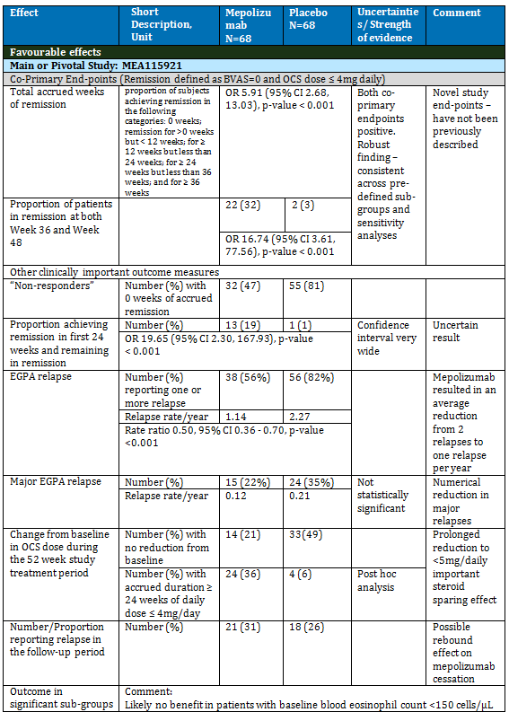

Table 16: Mepolizumab use in adults, unfavourable effects
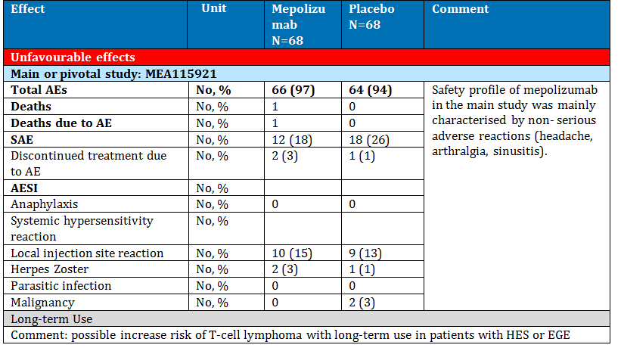
The main evidence for benefit-risk comes from the efficacy safety study, Study MEA115921. In this study, treatment with mepolizumab in adult patients with relapsed or refractory EGPA who were receiving ≥ 7.5 mg daily of prednisolone equivalent was associated with a substantial and clinically meaningful benefit with greater duration of remission, reduced relapse rate and higher proportion of patients achieving a meaningful and sustained reduction in OCS dose. Caveats to these positive results are the lack of response in almost half of the patients (47% failed to achieve any duration of remission); the lack of efficacy in the pre-specified sub group of patients with baseline eosinophil count < 150 cells/µL; possible rebound phenomenon after cessation of mepolizumab.
Review of safety results from Study MEA115921 found that mepolizumab was well tolerated in patients with EGPA, with an adverse event profile that was largely comparable to placebo and characterised by non-serious adverse reactions (headache, arthralgia, sinusitis). Comparison of reported AE rates to those reported in the asthma studies found higher rates in EGPA patients; this may indicate dose dependency for some AEs (mepolizumab dose 300 mg SC monthly in the EGPA study compared to 75 mg IV/100 mg SC monthly in asthma).
Review of other clinical study reports included in the dossier for other eosinophilic conditions (nasal polyposis, severe asthma) did not identify any new safety concerns.
Review of long term safety as reported in the HES Compassionate Use Programme identified T cell lymphoma and neoplasms as possible safety concerns with long term use.

Paediatric indication
Mepolizumab has not been investigated in the treatment of children or adolescents with EGPA. There are no clinical data upon which an assessment of benefit and risk in this population can be made.
The sponsor has sought to demonstrate safety and efficacy using a full paediatric extrapolation model that was apparently developed in consultation with the EMA. The use of such a model for regulatory purposes was described as novel and has not previously been used to support an application to the TGA for use of a prescription medicine in children. Applications that were made to the FDA and to Health Canada for the EGPA indication did not include a paediatric indication.
EGPA in children is rare. From published reports, it may be a more severe condition compared to adults, with higher cardiac involvement and higher mortality. Due to the paucity of information, treatment is extrapolated from the treatment of adults with EGPA and largely based on OCS, with prolonged courses required. Other immunosuppressive agents may also be used. There is a considerable unmet need for this population, given the consequences of prolonged corticosteroid use, including growth retardation. A randomised placebo controlled clinical trial of any specific treatment in this population would be impractical, given the rarity of the condition.
Studies conducted to date of mepolizumab in subjects aged < 17 years with severe asthma or eosinophilic oesophagitis have not been designed to demonstrate efficacy and provide limited safety information due to the small numbers and brief duration of treatment. The evaluator is particularly concerned regarding potential adverse effects with prolonged use given the lack of knowledge regarding the roles of IL-5 and eosinophils in the developing human and given the high incidence of neoplasm (benign and malignant) in patients aged < 17 years in the HES Compassionate Use Programme.
The evaluator does not find the paediatric extrapolation report to be convincing given that it is based upon layers of pharmacology modelling reports and population PK analyses, each with their own underlying assumptions. The evaluator accepts that it is not feasible to demonstrate efficacy and safety in the paediatric EGPA population but does not consider that pharmacology modelling can replace the basic requirement that efficacy and safety of mepolizumab be demonstrated in some paediatric population.
The evaluator is also concerned that the sponsor has not proposed any additional risk management activities in the paediatric population, in the event that this indication is approved.

First round assessment of benefit-risk balance

Adult indication
The benefit-risk balance favours mepolizumab for short term use, although it is recognised that almost half of the patients treated with mepolizumab may not have any benefit. There is no biomarker that identifies these non-responders, although a baseline eosinophil count < 150 cells/µL provides some indication. It may, therefore, be appropriate to include a baseline blood eosinophil level in the indication.
The proposed use is indefinite and the optimum duration of treatment is unknown. Efficacy with treatment duration longer than 13 months has not been demonstrated. Long term use of mepolizumab in another hyper-eosinophilic condition may be associated an increased risk of lymphoma and neoplasm. Use of another IL-5 mAb, reslizumab, has also been associated with an increased risk of malignancy. If there was tolerance or an increased risk of malignancy, particularly T cell lymphoma, with long term mepolizumab treatment of EGPA then the benefit-risk balance may not be positive. In particular, the development of malignancy may unfavourably change the long term survival, noting that the 5 year survival with treated EGPA is 62 to 80%.

Paediatric indication
Due to the lack of relevant data, the evaluator is unable to make an assessment of the benefits or risks of the proposed use in the paediatric population.

First round recommendation regarding authorisation

Adults
The evaluator is unable to make a recommendation at this time. Further information regarding long-term efficacy and risks has been requested. Any recommendation that authorisation should be approved would also be dependent on recommendations regarding changes to the PI, CMI and RMP, including changed wording of the indication, being agreed to by the sponsor.

Paediatric indication
The evaluator is unable to recommend approval of the use of mepolizumab for EGPA in children or adolescents (aged 6 to 17 years).
The evaluator notes that the indication of severe asthma in adolescents was approved by the TGA in the absence of evidence of efficacy and safety. A similar argument of unmet need and the benefit of reduction in OCS dose could be made for this EGPA indication, although there are more uncertainties regarding potential risks in this younger age group. If the TGA did decide to approve the use of mepolizumab in patients aged 6 to 17 years, the evaluator is of the opinion that a reliance on routine pharmacovigilance to monitor safety in this population would be unacceptable and recommends that a registry of all use in this age group be required of the sponsor, with analyses of this database provided regularly to the TGA.

Clinical questions and second round evaluation

Regulatory status

Question 1: [Information redacted]
[Information redacted]

Question 2: [Information redacted]
[Information redacted]

Pharmacokinetics

Question 3: PK in patients with EGPA
The sponsor has proposed that the following statement be added to the PI:
Mepolizumab pharmacokinetics were consistent in subjects with asthma EGPA (sic). The exposure at 300 mg in subjects with EGPA was approximately three times that observed at 100 mg in subjects with severe asthma.
On the basis of the analysis of goodness of fit of the population PK model against the observed PK variables shown in the clinical study report for Study MEA115921, the evaluator accepts that population PK model developed in patients with eosinophilic conditions accurately predicted the PK in patients with EGPA and that this would suggest that the PK of mepolizumab is similar in the two patient groups. However, the evaluator is concerned that the proposed wording suggests a higher level of certainty than can be possible given the sparse sampling in Study MEA115921 and proposes alternate wording with:
A population PK analysis using sparse PK sampling suggests that mepolizumab pharmacokinetics in subjects with EGPA were consistent with the PK in subjects with other eosinophilic conditions, including asthma.
However, the evaluator could not locate any analysis in the clinical study report for Study MEA115921 or the clinical overview that compared exposure in subjects with EGPA to exposure in subjects with asthma.
The sponsor is asked to comment of the evaluator’s proposed statement and to provide the analysis(es) that indicates that ‘the exposure at 300 mg in subjects with EGPA was approximately three times that observed at 100 mg in subjects with severe asthma’.

Sponsor’s response
The sponsor’s response acknowledged that sparse sampling was used in the EGPA study but argued that:
- The samples were collected at carefully selected time points around C_{max} and at trough, both after a single dose and at steady state.
- The model found that the predicted and observed concentrations were comparable at the 5% significance level.
The sponsor referred to two tables of mean observed plasma concentrations, one from Study MEA115588 conducted in subjects with severe asthma at 100 mg SC and one from Study MEA115921 conducted in subjects with EGPA at 300 mg SC, to support the statement that ‘the exposure at 300 mg in subjects with EGPA was approximately three times that observed at 100 mg in subjects with severe asthma’.
The relevant sections of these tables are shown below in Table 17and Table 18.
Table 17: Study MEA115588 summary of plasma mepolizumab pharmacokinetic concentration time data (observed and predicted)
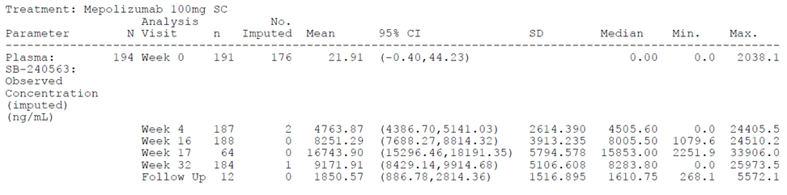
Table 18: Study MEA115921 summary of plasma mepolizumab pharmacokinetic concentration time data (observed and predicted)
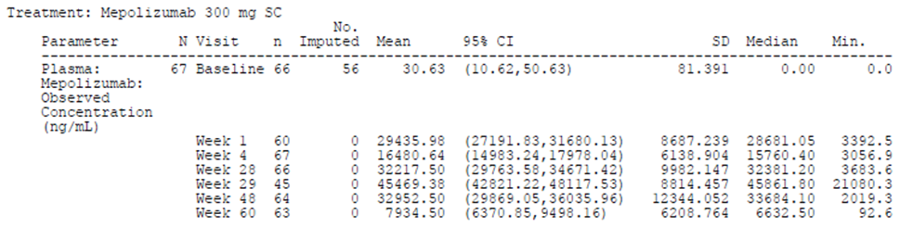

Evaluation of response
As noted in the question, the evaluator accepted that the population PK model developed in patients with eosinophilic conditions accurately predicted the PK in adult patients with EGPA. The evaluator does not consider that the two tables of observed plasma concentration in Studies MEA115588 and MEA115921 are adequate to support the sponsor’s proposed statement regarding relative exposure.
The evaluator remains of the opinion that the source and limits of information should be explicit in the PI and recommends the following wording:
A Population PK analysis using sparse PK sampling suggests that mepolizumab pharmacokinetics in subjects with EGPA were consistent with the PK in subjects with other eosinophilic conditions, including asthma. The mean plasma concentration the exposure at 300 mg in subjects with EGPA was approximately two to three times that observed at 100 mg in subjects with severe asthma.

Question 4: Effect of the developing human immune system on the PK of mepolizumab
The sponsor has proposed use in children as young as six years old. The immune system in this age group is rapidly evolving in response to multiple foreign challenges, including vaccination and infection. The sponsor is asked to comment on the PK of mepolizumab in the context of an emerging immune system.

Sponsor’s response
The sponsor referred to Study MEE103219, a paediatric study conducted in subjects 2 to 17 years old with eosinophilic oesophagitis who received 3 doses of IV mepolizumab, and to the analysis provided in the pharmacology modelling report, sponsor Document Number 2014N210473_00 report. The sponsor argues that these demonstrate that, after adjusting for bodyweight only, adult IV mepolizumab pharmacokinetics is predictive of paediatric pharmacokinetics and that ‘By implication, this data shows that across the age range 2 to 17 years, the paediatric immune system has no notable impact on the pharmacokinetics of mepolizumab.’ The sponsor acknowledged that the exposure in the paediatric Study 200363, investigating SC mepolizumab in subjects 6 to 11 years old with severe eosinophilic asthma was higher than anticipated, but argued that was explained by higher absolute bioavailability in this younger age group, rather than developmental changes in the immune system.

Evaluation of response
Study MEE103219 and the 2014N210473_00 report have been evaluated in the clinical evaluation report. The evaluator does not agree that these analyses have adequately demonstrated that adult mepolizumab IV PK predicts paediatric eosinophilic oesophagitis exposure. The failure of the PK model to accurately predict exposure in the paediatric study, Study 200363, supports the evaluator’s concerns that adult PK do not accurately predict paediatric PK. The evaluator speculates that a difference in paediatric and adult PK may reflect differences in the maturity of the immune system.

Pharmacodynamics

Question 5: Use of blood eosinophil level as a marker of PK/PD response
Dose ranging studies indicate that there is ceiling effect of mepolizumab on blood eosinophil level, with no further reduction seen despite increasing doses. Given this, the sponsor is asked to provide the rationale for the use of blood eosinophil level as a marker of PK-PD response.

Sponsor’s response
The sponsor described the analyses from the asthma studies that purport to demonstrate dose dependent reduction in blood eosinophil count by mepolizumab. The response states that ‘In this study (Study MEA114092) 11 mg and approximately 100 mg SC (corresponding to 75 mg IV) were identified as the doses inducing 50% (ID₅₀) and 90% (ID₉₀) of the maximum inhibitory effect, respectively.’ The response acknowledges that, in Study MEA112997, ‘no direct relationship between blood eosinophil reduction and efficacy was shown’.

Evaluation of response
Despite the lack of any demonstrated relationship between the reduction in blood eosinophil count and efficacy, the PK/PD analyses provided by the sponsor use reduction in eosinophil count as the PD measure. The evaluator is of the opinion that the blood eosinophil count has no demonstrated utility as a marker of PK/PD response for the following reasons:
- No relationship between a reduction in blood eosinophil count and efficacy has been demonstrated.
- No relationship between a reduction in blood eosinophil count and tissue eosinophilia has been demonstrated.
- The mechanism of action of mepolizumab in EGPA has not been fully elucidated (see sponsor’s response to next question, below) and the dependence of this mechanism of action on a reduction in blood eosinophil count is unknown.
The sponsor did not directly address the ceiling effect seen at higher mepolizumab doses, although the identification of 100 mg SC as the ID₉₀ dose would indicate that no further reduction would be seen at higher doses. This is relevant to dose selection as this suggests that the higher dose chosen for EGPA may not result in a greater reduction in blood eosinophil count. This, together with the lack of any demonstrable relationship between a reduction in blood eosinophil count and efficacy, casts doubt on the rational for the higher dose used in EGPA.

Question 6: Changes in blood eosinophil level and efficacy
A decrease in the geometric mean blood eosinophil level in patients receiving mepolizumab was demonstrated in Study MEA115921. However, the plot of individual results shows a wide range and it is not clear whether there was a reduction in blood eosinophil level in all patients who received mepolizumab.
The sponsor is asked to:
- Provide the number (%) of patients in the mepolizumab group in Study MEA115921 in whom there was no reduction in blood eosinophil level below baseline during the treatment period.
- Comment on whether there is any indication of lesser efficacy in patients in whom there was no reduction in blood eosinophil level below baseline.
- Comment on whether the purported mechanism for efficacy is through a reduction in blood eosinophil level or if other mechanism(s) may be involved.

Sponsor’s response
The sponsor reported that there was only one patient in the mepolizumab group in whom there was no reduction from Baseline in blood eosinophil count and noted that this patient was receiving prednisolone 20 mg daily and had a very low baseline blood eosinophil count (10 cells/µL). The patient did not achieve remission (defined as BVAS = 0 and prednisolone/prednisone dose ≤ 4mg/day) and experienced 3 relapses during the study treatment period. However, the patient was reported to progressively reduce their OCS dose to an average dose of 9.1 mg between Weeks 48 to 52.
The sponsor noted that ‘the precise mechanism of mepolizumab action in EGPA has not been definitively established. It remains unclear whether other mechanisms may be involved’.

Evaluation of response
The evaluator agrees that:
- There is insufficient data to enable any assessment of efficacy in patients in whom mepolizumab treatment does not result in a reduction in blood eosinophil count.
- That the mechanism of action of mepolizumab in EGPA has not been elucidated.
The sponsor provided no discussion of other potential mechanisms of action. The evaluator notes that the EMA’s Protocol Advice discussed accumulation and activation of eosinophils in target tissues in EGPA with this thought to involve pathways other than that IL-5 induced increase in blood eosinophils, with chemokine eotaxine-3, produced by epithelial and endothelial cells, and Th-1-mediated humoral response as possible contributors. The cited articles suggest that serum eotaxin-3 may be an alternative marker of disease activity, with a closer relationship to tissue involvement and steroid response. The articles also speculate that ANCA positive and ANCA negative may represent two forms of the disease.

Efficacy in adults

Question 7: Baseline eosinophil level in participants in Study MEA115921 and the inclusion criteria
The definition of EGPA used in the inclusion criteria for the study included eosinophilia with ‘a blood eosinophil level of 10% or an absolute eosinophil count of more than 1000 cells per cubic mm’. This appears to have been based on an historical eosinophil level as, according to the subgroup analysis, 57 participants were reported to have baseline eosinophil level < 150 cells/µL.
The sponsor is asked to confirm if the inclusion criteria of ‘blood eosinophil level of 10% or an absolute eosinophil count of more than 1000 cells per cubic mm’ was based on historical results and that all participants had met this inclusion criteria.

Sponsor’s response
This was confirmed by the sponsor who further stated that ‘There was no threshold eosinophil level required at the screening or randomisation visit.’

Evaluation of response
Noted.

Question 8: Baseline eosinophil count in Study MEA115921 and efficacy
The evaluator is concerned by the lack of efficacy in patients with baseline eosinophil count < 150 cells/uL and is not convinced by the sponsor’s speculation that this may be due to the number of these patients who were also receiving baseline OCS dose > 20 mg as this was only 15 out of 57 (26%) of the patients with baseline eosinophil count < 150 cells/uL. The evaluator is of the opinion that this lack of efficacy is important information for clinicians and patients and is concerned that this information is not included in the draft PI. The evaluator recommends that this information be added to the PI. This may be through re-wording the indication to include patients with baseline eosinophil count ≥ 150 cells/uL together with an explanatory statement in the Clinical Trials section that a pre-specified sub group analysis found no evidence of benefit in patients with baseline eosinophil count < 150 cells/uL.
Nucala is indicated as an add-on treatment for severe relapsing or refractory Eosinophilic Granulomatosis with Polyangiitis (EGPA) with a blood eosinophil count ≥ 150 cells/µL at initiation of treatment (CLINICAL TRIALS)
The sponsor is asked to comment.

Sponsor’s response
The sponsor confirmed that there was a greater accrued time in remission in the mepolizumab group compared with placebo, in subjects with a baseline blood eosinophil count ≥ 150 cells/μL. However, the sponsor argued that the selection of the cut off of 150 cells/µL for the sub group analysis was ‘arbitrary’ although based on prior studies in severe asthma, and states that ‘Subsequent post hoc modelling work showed increased efficacy with increasing baseline blood eosinophil count on a continuous scale, but did not define a particular subgroup of patients with loss of efficacy based on a threshold blood eosinophil count value.’
The sponsor asserted that although an improvement in remission was not demonstrated in the group with blood eosinophil count < 150 cells/µL, there was evidence of benefit in this group. This evidence of clinical benefit was said to be shown in a post-hoc analysis of a composite end-point of 3 end-points from the study:
- Remission at any time during the study period (Weeks 1 to 52).
- A ≥ 50% reduction in average oral glucocorticoid dose during Weeks 48–52.
- No relapses of EGPA during the study period (Weeks 1 to 52).
The results of this analysis are shown in Table 19.
Table 19: Summary of clinical benefit in subgroups of interest (based on remission defined as BVAS = 0 and OCS dose ≤4 mg/day), Study MEA115921, safety population
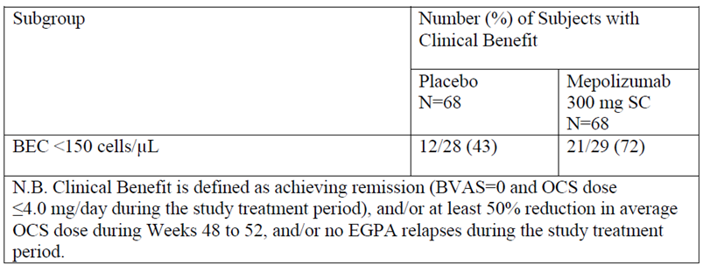
BEC = blood eosinophil counts
The sponsor has argued against the inclusion of a threshold baseline blood eosinophil level in the indication on the basis that this may prevent patients with more severe disease (as shown by higher OCS dose and lower blood eosinophil count) from accessing mepolizumab or that such patients may have their current treatments reduced such that the blood eosinophil count increases so as to qualify for treatment.

Evaluation of response
The evaluator notes the sponsor’s acknowledgement that the threshold blood eosinophil count value of 150 cells/μL was based on previous studies in severe asthma patients and that this analysis was part of a pre-specified supportive subgroup analysis for the primary outcome measures. The evaluator does not consider that post hoc analyses using arbitrarily selected composite endpoints are sufficient to demonstrate efficacy or clinical benefit in this pre-specified subgroup and recommends that this cut off of 150 cells/μL be included in the indication. The results of the sub-group analysis should also be included in the Clinical Trials description in the PI.

Question 9: Rebound effect following cessation of mepolizumab in patients with EGPA
The analysis of the number (%) of patients in whom relapse was reported in the treatment and follow-up periods , together with the plots of the proportion of patients remaining in remission during these phases of the study demonstrate a lack of any sustained effect following cessation of mepolizumab treatment, with the relapse rate in the mepolizumab arm increasing between Week 48 and 60. A rebound effect following cessation of mepolizumab is also suggested, given that more patients in the mepolizumab arm experienced a relapse during the follow-up period compared to the placebo arm. The evaluator notes that patients could enter the open label continuation study (MEA116841/201607) up to 6 months after completing (or early withdrawal from) Study MEA115921.
The sponsor is asked:
- To provide a breakdown of relapses that occurred during the follow-up period with this showing the number of subjects in each arm who experienced any relapse and the number in each arm in whom any relapse was considered major
- To provide an analysis of the relapses reported in patients from the mepolizumab arm compared to the placebo arm for the period between finishing Study MEA115921 and entering the Long Term Access Programme according to time since last dose of mepolizumab. This analysis should include a breakdown according to all relapses and to major relapses per treatment arm during the follow-up period.
- If any rebound effects, as shown by any measure of increased disease activity, have been reported in any other mepolizumab studies.
- To comment on whether a statement regarding possible rebound, with worsening of disease following cessation of mepolizumab, should be included as a Precaution in the PI

Sponsors response
The sponsor acknowledged that a higher proportion of mepolizumab patients compared to placebo patients experienced relapse during the follow up period in Study MEA115921. This was attributed to the mepolizumab patients being ‘under treated’ compared to the placebo patients on the basis that the mepolizumab patients had a lower OCS dose in general during the last 4 weeks of the treatment period and therefore received less standard of care treatment (when compared to placebo patients) once mepolizumab was discontinued. According to the sponsor, there was an imbalance of vasculitis relapse that supported this argument of ‘under treatment’.
An analysis of the annualised rate of major relapse during the follow up period found that in the mepolizumab group, the rate increased during the follow up period, compared to the study treatment period, and the rate ratio of mepolizumab versus placebo was 0.92 during the follow up period.
The evaluator had asked for an analysis of EGPA relapses during the period of time between patients completing Study MEA115921 and entering the long term access programme or compassionate access programme. The sponsor indicated that this was not possible as this data was not collected; data collection in these programmes was limited to safety data only.
The sponsor stated that ‘No rebound effect, defined as disease activity higher after cessation of mepolizumab treatment than at Baseline, has been observed in any mepolizumab program.’ The sponsor stated that during a treatment break of more than 12 months between a Phase III placebo controlled, severe asthma study and its open label extension study, there was no increase in asthma exacerbations during the interim period.

Evaluation of response
The sponsor has acknowledged the increase in disease activity on cessation of mepolizumab treatment but has argued that this does not represent a rebound effect, where this is defined as disease activity that is higher than baseline. The sponsor has not presented any analyses comparing disease activity following mepolizumab cessation to baseline disease activity, although baseline EGPA relapse rate (patient reported) was collected in Study MEA115921.
The analyses presented by the sponsor confirm an increase in disease activity following cessation of mepolizumab and do not exclude that the possibility that this activity is greater than that prior to commencement of mepolizumab.
The evaluator also notes that the most recent PBRER reports on the completion of the Post Authorisation Safety Study MEA115661, a multi-centre, open label, long term safety study of mepolizumab in asthmatic subjects who participated in the MEA112997 trial. According to the PBRER, there was an increase in disease activity during the interruption of mepolizumab treatment (that is, the gap between MEA112997 and MEA115666). This was described as the interruption ‘allowed the subject’s disease to revert with increased eosinophils and exacerbations during this period’. An analysis that compared baseline disease activity to disease activity during the interruption period was not described. The PBRER states that ‘There were no verbatim reports of ‘rebound’ of disease’.
The increase in disease activity, with possibility of rebound, on treatment interruption or cessation, is clinically important information that should be included in the PI as it indicates a need for increased vigilance following mepolizumab cessation. This increased vigilance could enable early detection and treatment of relapse, thereby addressing the potential for ‘under treatment’ raised by the sponsor.

Question 10: Efficacy with longer term use
The proposed indication and draft PI do not describe a recommended duration of treatment with mepolizumab. For such open ended treatment, some demonstration of efficacy with longer term use is essential. The sponsor is asked to provide an interim analysis of analysis of efficacy from Study MEAMEA116841/201607 to demonstrate any longer term benefit and to confirm that tolerance does not develop. The analyses could have a similar form as that used in the interim efficacy analyses for the compassionate access programme for HES. An analysis of the occurrence of rebound (increased disease activity following cessation of mepolizumab) should be included if possible.

Sponsor’s response
The sponsor stated that efficacy end points were not collected in these programmes.

Evaluation of response
It is unfortunate that the opportunity to collect data regarding long term use in the Long Term Access Programme/Compassionate Use Programme was not used by the sponsor. Data regarding efficacy of mepolizumab in EGPA is limited to a treatment duration of 12 months in Study MEA115921 although the proposed use is open ended.
The evaluator notes that the most recent PBRER (provided with the sponsor’s response) included some new information regarding long term efficacy in severe asthma. Study MEA115666, a multi-centre, open label, long term safety study of mepolizumab in asthmatic subjects who participated in the MEA112997 was completed during the reporting period. Treatment duration was up to 4.5 years. The study synopsis, provided in the PBRER states that ‘Improvements in asthma control versus baseline (eosinophil count, exacerbation rate and ACQ-5) were seen at the first time point measured and continued throughout the study, with improvements consistent with that seen in previous mepolizumab severe asthma studies’, summary of the study synopsis is provided in the clinical evaluation report. This information regarding long term efficacy is reassuring in that it suggests that tolerance dose not develop over time but should be confirmed by evaluation of the clinical study report. It is also important to remember that long term effects in asthma may differ from those in EGPA.

Safety

Question 11: Number of subjects requiring hospitalisation (ICU or general ward)
[A table] in the clinical study report for Study MEA115921 (and the source table, [table]) reports the total number of inpatient hospitalisation days (in intensive care unit (ICU) or general ward) for the mepolizumab group and the placebo group as a measure of health resource utilisation. This table does not show the number of subjects in each arm who required hospitalisation. The number of subjects requiring hospitalisation and number of subjects requiring ICU admission may provide additional safety information. The sponsor is asked to provide the number of subjects requiring inpatient hospitalisation (ICU) and the number of subjects requiring inpatient hospitalisation (general ward) for the whole of the study period, with this broken down according to treatment arm and according to on-treatment period and follow up period.

Sponsor’s response
The following information was provided, see Table 20.
Table 20: Study MEA115921: Number of subjects requiring inpatient hospitalisation (ICU and general ward)
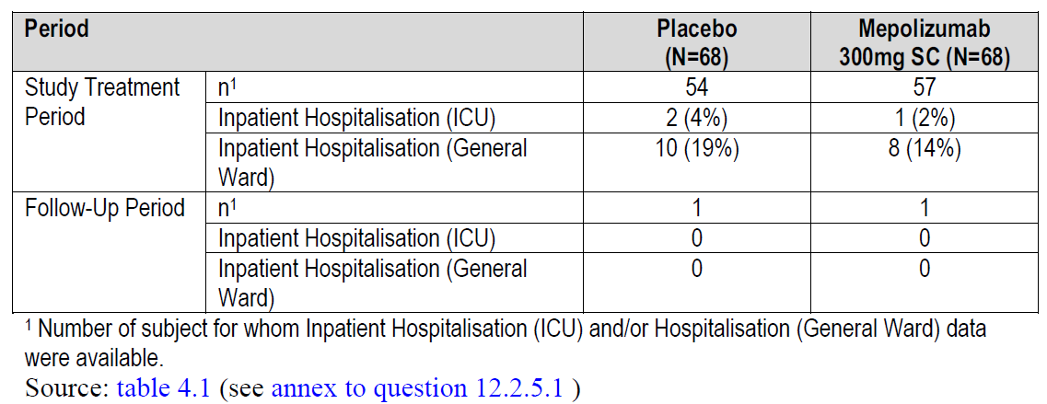

Evaluation of response
Noted. From [a table] in the clinical study report and the above information, patients admitted to ICU from both the placebo and mepolizumab arms had a stay that was longer than 2 days and the breakdown of duration of general ward stay was similar in the 2 arms.

Question 12: Safety with long-term use
The proposed indication proposes indefinite use of mepolizumab in the treatment of EGPA. The safety with indefinite duration of use has not been demonstrated in EGPA patients, with only 17 subjects having been treated with mepolizumab 300 mg SC monthly for longer 24 months, and none of these for longer than 36 months. The Compassionate Use Programme reports long term use in patients with HES. In this programme, there have been 89 patients with exposure > 60 months, with this including 16 patients with treatment duration > 96 months.
The sponsor has not presented an analysis of safety over time for patients receiving long-term mepolizumab, so it is not evident as to whether the AE profile and safety change with prolonged use. To address this lack of information, the sponsor is asked to provide an analysis of AEs by time on treatment for the HES Compassionate Use Report, this could be provided as histograms of the number of subjects experiencing any SAEs; the number of subjects experiencing any AEs; the number of subjects experiencing common AEs (for example, upper respiratory tract infection, cough, fatigue, headache) with number of subjects on the y axis and months of treatment (grouped in 4 month intervals) on the x axis. The analyses could be limited to the ‘databased patients’.

Sponsor’s response
The sponsor stated that ‘Periodic interim reports providing cumulative data for the HES compassionate use program since 2001 have been developed since 2014. An analysis of AEs over time has not been conducted. This is an uncontrolled, compassionate use study with no formal data collection system which does not permit such an analysis at this time.’
The most recent interim report (data cut off July 2016) was provided.

Evaluation of response
As noted above, it is unfortunate that the Compassionate Use Programme was not used as an opportunity for data collection in long-term use. The sponsor has provided no new information; the interim report provided with the response is the same as that provided in the original dossier.
The evaluator notes that the most recent PBRER (provided with the sponsor’s response) included some new information regarding long term safety. Study MEA115666, a multi-centre, open label, long term safety study of mepolizumab in asthmatic subjects who participated in the MEA112997 was completed during the reporting period. The PBRER reports that the study showed that the observed safety and immunogenicity profile of long-term (up to 4.5 years) SC mepolizumab treatment is similar to that seen in prior severe asthma studies with IV and SC administration and that no new safety concerns were identified in this study with long term exposure. A synopsis of the study was provided in the appendices of the PBRER and has been summarised in the clinical evaluation report. The information provided in the study synopsis regarding use for up to 4.5 years supports the conclusions in the PBRER but requires evaluation of the clinical study report for confirmation.

Question 13: T cell Lymphoma, and other neoplasms, with long-term use
There were 7 patients who developed lymphoma in the Compassionate Access Programme (HES), with this sub-typed as T cell lymphoma in 5 and not specified in 2.
See Table 13 for reported cases of lymphoma in the Compassionate Use Programme.
The incidence of T-cell lymphoma appears surprisingly high as this is regarded as a rare malignancy: the SEER Cancer Statistics Review 1975-2014 provides an annual estimate of approximately 2 per 100,000 for peripheral T-cell lymphomas. The overall incidence in the Compassionate Use Programme may be 1.8% (5 out of 281) or 2.5% (7 out of 281), depending on the sub-type of lymphoma for the other two patients.
The evaluator also notes that there were two malignancies and one unusual benign tumour reported in the 25 paediatric patients in the HES Compassionate Use Program and that an increased incidence of malignancies has been reported with another IL-5 mAb, reslizumab.
The sponsor is asked to:
- Provide a cumulative review of lymphoma, and particularly T cell lymphoma, as reported in patients receiving mepolizumab, with this broken down according to paediatric (age < 18years) and adult patients.
- Provide a cumulative review of neoplasms (benign and malignant) reported in patients who have been, or are being, treated with mepolizumab with this broken down according to paediatric (age < 18years) and adult patients.
- Comment on whether lymphoma, particularly T cell lymphoma, and neoplasms represent potential risks associated with long-term use of mepolizumab.

Sponsor’s response
The sponsor stated that ‘There has been no malignancy signal across the mepolizumab clinical development program’.
The sponsor noted that malignancies in the HES compassionate use program have been reviewed annually at the request of the ANSM regulatory agency of France since the 2014 approval of mepolizumab for severe asthma and provided the fourth and most recent report to this agency (dated September 2017).

Evaluation of response
The issue of malignancies and mepolizumab use are addressed in both the report to the ANSM and in the most recent PBRER. The PBRER noted that the types of malignancies reported were those that are common in the general population and that there was no evidence of an increased probability of occurrence with increased exposure to mepolizumab treatments compared with placebo. Patients with HES appeared to have a disproportionately high incidence of malignancy; this is not discussed in the PBRER but is discussed in the sponsor’s report to the ANSM. The report notes that most patients enrolled into the HES program ‘have very severe disease after many treatment regimens. These regimens often include various cytotoxic and broad spectrum immunosuppressant agents’. The report acknowledged the high incidence of T cell lymphoma in the HES population but reported that ‘In the mepolizumab program to date, T cell lymphoma has been reported only from patients with lymphocytic HES (L-HES) who had a pre-existing abnormal T cell phenotype, which puts them at increased risk for progression to lymphoma as part of the natural history of the disease’ The evaluator notes that lymphocytic HES is recognised as a distinct subtype of HES that is defined by the presence of a monoclonal T cell population detected in conjunction with immunophenotypically aberrant T cell populations and that progression to lymphoma is reported to occur in a median of 3 to 7 years.
The evaluator agrees that, to date and excepting the HES population, there is no clear signal for increased risk of malignancy in mepolizumab treated patients. The disproportionate incidence of malignancies in the HES population may be a complication of prior cytotoxic therapies or may represent a risk of mepolizumab treatment in this population. The evaluator acknowledges that the lymphoma reports in the HES population appear to be limited to patients with the L-HES subtype and that this sub-type has an underlying increased risk for the development of lymphoma. It is unknown whether the use of mepolizumab in this group increases this risk or shortens the time to development of lymphoma.

Question 14: Safety and post-marketing use
The sponsor is asked to provide the most recent PBRER with the Round 2 responses.

Sponsor’s response
PBRER number 5 covering the reporting period of 24 September 2017 to 23 March 2018 was provided.

Evaluation of response
The PBRER is summarised in the clinical evaluation report. Importantly, the PBRER states that no new safety signals were identified and that there were no actions (including no dosage modifications, changes in target population, formulation changes, restrictions on distribution, clinical trial suspensions, or any other actions) taken for safety reasons during the reporting period.
The reference safety information had one change, with chronic obstructive pulmonary disease (COPD) added to the existing warning regarding the contraindication to use in acute asthma attacks.
The PBRER lists the following safety concerns in Table 21, below.
Table 21: Important safety concerns at the start of the reporting period
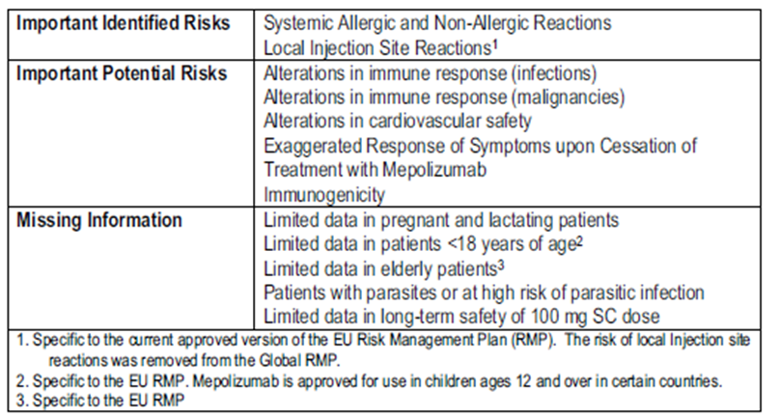
This is the same as the list of safety concerns in the EU-RMP for severe asthma provided with the original dossier.
The identified and potential risks were discussed, but largely according to data from the placebo controlled severe asthma studies only.

Use in children

Question 15: Immunogenicity of mepolizumab in children
Very high rates of ADA were reported in the paediatric Study, MEE103219 (78% of the 59 subjects aged 2 to 17 years), although very low rates have been reported in the adult population (for example, 3% in Study MEA115921) and in the other paediatric Study 200363 (5%). Could the sponsor account for the very high rates of ADA in Study MEE103219 and comment on whether this represents a different immunogenicity of mepolizumab according to age or condition?

Sponsor’s response
The sponsor reported that the ADA binding assay has evolved considerably during the clinical development of mepolizumab. The Fourth Generation Assay was used in Study MEE103219 (conducted between 2006 to 2008) whereas the Sixth Generation ADA assay was used in Studies MEA115921 and 200363. The high number of false positives recognised as occurring with the Fourth Generation Assay (see sponsor’s response for the mechanism of this) resulted in the incorporation of an anti-IL5 blocking antibody reagent in the sixth generation assays. The sponsor notes that ‘A comparison of the immunogenicity incidence between Study MEE103219 and Studies MEA115921 and 200363 is therefore not appropriate since the analytical methods used were different’.
Comparison of the incidence of ADA in the two studies using the Sixth Generation Assay found that the incidence in adults with EGPA (MEA115921) was < 2% and incidence in paediatric subjects with severe eosinophilic asthma (Study 200363) was 6%. These results were described as comparable.

Evaluation of response
The evaluator agrees that the results from assays that differ substantially in their methodology cannot be compared and that the difference in fourth and sixth generation assays is likely to account for the different results for ADA incidence in the two paediatric studies (Studies MEE103219 and 200363).

Question 16: Dosing interval in children
Observed PK data indicates that clearance is lower in children, particularly those with body weight < 40kg, and that this has resulted in higher mepolizumab plasma concentration in children. Increased bioavailability was also reported with SC administration in children. The sponsor is asked whether a longer dosing interval is indicated in the age-group in whom there is decreased clearance and increased bioavailability so as to avoid excessively high exposure and to reduce distress associated with treatment.

Sponsor’s response
The sponsor noted that to achieve a comparable exposure to adults in terms of area under the concentration time curve, either lowering the dose or extending the dosing interval are possible. The sponsor argued that if the dosing interval was extended, a higher dose would be required to maintain a similar trough concentration and associated blood eosinophil reduction to adults. The higher dose would result in a higher C_{max} and a different peak to trough ratio compared to that in adults. The sponsor stated that ‘the sponsor has therefore focused on reducing the number of injections per administration, as opposed to changing the dosing interval, to maintain similarity in exposure and response to adults’.

Evaluation of response
The sponsor’s response assumes that:
- The proposed dosing regimens in children will result in exposure that is similar to that in adults.
- Efficacy is related to the reduction in blood eosinophil count.
PK analyses provided by the sponsor have shown that exposure in children is higher than expected in comparison to adults (see Report 2015N255079_00). The sponsor has acknowledged that no relationship between efficacy and the reduction in blood eosinophil count has been demonstrated in the mepolizumab studies. The evaluator is not convinced that differences in PK between adults and children have been fully elucidated and that the proposed dosing regimen may result in excessive exposure in children.

Question 17: Dose reduction in children weighing less than 40 kg
Report 2015N255079_00: Supplementary Outputs From a Population PK and PK/PD Meta-Analysis of Combined Intravenous and Subcutaneous Mepolizumab Data, presents mepolizumab concentration-time profiles for adult, adolescent and paediatric subjects, using pooled data from 13 studies. The report notes that a number of children were found to have higher mepolizumab concentrations than adults and that all of these children weighed less than 40 kg. The report states that the dose adjustment proposed for these subjects in Report 2014N223530: Mepolizumab Severe Asthma Paediatric and Adolescent Dose Extrapolation, will result in exposure that is not higher than that in adults. The basis of the recommendation and whether the dose recommendations in the PI are aligned with the recommendations of this report are unknown. This report was not provided in the dossier and not provided in time for its inclusion in the first round evaluation by this evaluator. The sponsor is asked to provide the report for the second round evaluation.

Sponsor’s response
The sponsor noted that the requested report was included in the severe asthma application and that there had been a change in the planned application timing sequence (the severe asthma application had been intended to precede the EGPA application although the EGPA application was then submitted first). The requested report was said to have been provided.

Evaluation of response
The sponsor was asked to provide a specific population PK report (Report 2014N223530: Mepolizumab Severe Asthma Paediatric and Adolescent Dose Extrapolation) during the first round evaluation and in the TGA questions. However, Report 2014N210473_00 Population pharmacokinetics of mepolizumab in paediatric eosinophilic esophagitis patients was provided. This report was included in the original dossier and was evaluated in the first round process. The requested population PK report has not been provided. This was not requested again, as the sponsor’s responses have indicated that there is a TGA submission for extension of indication to children with severe asthma (either planned or in progress). It is the evaluator’s expectation that this report will be evaluated with this submission and that it will not change the evaluator’s recommendations regarding the EGPA submission.

Additional expert input
The evaluator recommends that expert advice be obtained regarding:
- The paediatric extrapolation model, noting that this is the first time this model has been used in a regulatory submission.
- Whether the ‘novel’ co-primary endpoints used in Study MEA115921 are clinically meaningful and relevant.
- Whether the response to existing therapies in children with EGPA in Australia is such that a lower level of evidence for use in children should be accepted.

Second round benefit-risk assessment

Second round assessment of benefits
The second round assessment of benefits in adults is unchanged from the first round.
Potential benefit in children with EGPA remains unknown.

Second round assessment of risks
The assessment of risks in adults is largely unchanged from the first round.
The possible safety concern of increased malignancy, including T-cell lymphoma, with long-term use that was raised in the first round was not supported by new information provided by the sponsor. The possible increase in the risk of malignancy appears, to date, to be limited to patients with HES and the risk of lymphoma to patients with lymphocytic HES. It is not clear at this point if this solely reflects factors specific to HES or if it may also reflect the greater duration of use of mepolizumab in this population. The risk of malignancy is identified as a potential risk in the PBRER and is monitored by the sponsor. The evaluator recommends that the annual reports provided to the ANSM also be provided to the TGA to supplement the information provided in the PBRER.
The possible safety concern of increased disease activity and possible rebound has not been discounted by further information provided by the sponsor. However, if this concern and the need for increased vigilance in monitoring for relapse following interruption or cessation of mepolizumab treatment is appropriately communicated in the PI, then the risk should be manageable clinically.
Potential risks in children with EGPA remains unknown.

Second round assessment of benefit-risk balance
The benefit-risk balance is favourable for adults with relapsed/refractory EGPA, who are currently receiving treatment and who have a blood eosinophil count ≥ 150 cells/µL.
The benefit-risk balance cannot be determined for children with EGPA.

Second round recommendation regarding authorisation
Approval of mepolizumab for the following indication is recommended:
Nucala is indicated as an add-on treatment for adults with relapsing or refractory Eosinophilic Granulomatosis with Polyangiitis (EGPA) with a blood eosinophil count ≥ 150 cells/µL at initiation of treatment (CLINICAL TRIALS).
Approval of mepolizumab for the treatment of children (aged < 18 years) with EGPA is not recommended.

VI. Pharmacovigilance findings
The TGA granted a waiver from the requirement for a Risk Management Plan for this application.

VII. Overall conclusion and risk/benefit assessment
The submission was summarised in the following Delegate’s overview and recommendations.

Background
Mepolizumab is a humanised mAb (IgG1 kappa) produced by recombinant DNA technology in Chinese hamster ovary cells. Mepolizumab is an interleukin-5 (IL-5) antagonist that binds to IL-5 thereby preventing it from binding to its receptor on eosinophils.
Mepolizumab was first registered in Australia in February 2016 for use in eosinophilic asthma.
This application is for the use of mepolizumab for eosinophilic granulomatosis with polyangitis (EGPA), previously known and Churg Strauss syndrome.
EGPA prevalence is estimated to range from 10.7 to 13 cases/million persons and the annual incidence to be 0.5 to 6.8 new cases/million persons. An estimated prevalence of 9 to 18 per million in the Australian population is provided by the sponsor.
EGPA is a systemic necrotizing vasculitis that is associated with asthma and is characterised by a marked blood eosinophilia (frequently between 5000 and 9000 eosinophils/µL at diagnosis). The vasculitis most commonly involves the lungs but may involve multiple organ systems. Organ damage is believed to result from both vessel inflammation and eosinophilic proliferation. The aetiology of the disease and the mechanistic relation between the vasculitis and the eosinophilic proliferation is not known. Current theories are that activation of the Th-2 cellular mediated inflammatory response and humoral immunity may both play important roles.
Most patients respond to treatment with glucocorticoids, remission in 80 to 90% occurs with initial treatment. Refractory disease in the remaining patients may require treatment with cytotoxic immunosuppressive drugs. Cytotoxic immunosuppressants are also used to treat life threatening disease (that is, heart, GI, central nervous system, severe peripheral neuropathy, severe ocular disease, alveolar haemorrhage and/or glomerulonephritis). A relapsing course may also occur despite ongoing treatment with oral corticosteroids, requiring increased corticosteroid dose or addition of other immunosuppressive agents. With treatment, the 1 year survival rate is reported to be 90% and the 5 year survival rate is 62 to 80%.
The diagnosis is based on the clinical criteria: blood eosinophilia; asthma; and evidence of systemic involvement. Biopsy of an affected tissue is recommended to confirm vasculitis and/or eosinophilic infiltration and/or granulomatous inflammation. ANCA testing is usually performed, with 30 to 75% of EGPA patients testing positive.
The use of the BVAS scoring system in clinical trials investigating systemic vasculitis is advocated by the EULAR and by the European Vasculitis Society to standardise disease assessment.11,12 This scoring system is used in determining the primary end points in the main study for this submission.
The BVAS scoring system was first developed in 1994, with version 3 described in 2009.13 The BVAS (version 3) lists 56 manifestations of systemic vasculitis, divided into 9 organ based systems (general, cutaneous, mucous membranes/eyes, ENT, chest, cardiovascular, abdominal, renal, nervous system). The sponsor noted that ‘in the absence of a valid external comparator, it is difficult to interpret a change in BVAS, but a fall of over 16 units is clinically meaningful.’

Quality
There was no requirement for a quality evaluation in a submission of this type.

Nonclinical
The nonclinical dossier contained two new primary pharmacology studies, an additional pharmacokinetic validation study (on stability in human plasma at –80°C), an updated assessment on immunotoxic potential, and some background literature. The evaluator considered the new studies to be of limited relevance to the proposed extension of indications. There were no nonclinical studies in an animal model of EGPA/vasculitis. Safety at the higher exposure level associated with the increased dose for the new indication and in the extended paediatric population had previously been adequately demonstrated in non-clinical studies. There were no nonclinical objections.

Clinical

Pharmacology
The PK data was limited to that collected during the clinical study and a population PK model based on sparse sampling. The exposure of mepolizumab at a dose of 300 mg monthly in patients with EGPA was approximately three times that seen in asthma, but with high variability.

Population PK analysis
The most recent population PK model from mepolizumab (Report 2015N238436) was applied directly to the data set from sparse sampling from the clinical study in EGPA (Study MEA115921). This population PK model was developed from 8,598 mepolizumab concentration values, obtained from 1,424 subjects with various eosinophilic conditions in 13 Phase I to III mepolizumab studies. A plot of dose normalised observed individual plasma concentrations shows considerable inter-individual variability. Body weight, creatinine clearance and albumin were included in the model. The model was able to accurately able to predict the mepolizumab plasma concentrations in the EGPA population.
The pharmacodynamic effect of mepolizumab is presumed to be through the binding of IL-5 which prevents the soluble cytokine IL-5 from binding to its cognate receptor (IL-5 receptor complex) and therefore inhibiting signalling, resulting in the reduction in production and survival of eosinophils. The effects of mepolizumab on IL-5, CRP, ESR and fractional exhaled nitric oxide (FeNO) were investigated in Study MEA115921. A reduction in eosinophils is seen by Week 4 after the initial dose, and by Week 48 a 83% reduction was seen (serum eosinophils below normal range). There was an increase in Il-5 but no change in ESR, CRP or FeNO. There was no correlation between mepolizumab dose and reduction in eosinophil count (that is, similar response to eosinophils is seen with doses of 75, 100 and 300 mg).
The tissue injury in EGPA is thought to result from vasculitis and tissue eosinophilia. The mechanistic relationships between blood eosinophilia, tissue eosinophilia, vasculitis activity and tissue injury are unknown. Demonstration of a reduction in blood eosinophil count cannot be assumed to equate to a reduction in tissue eosinophils and a reduction in tissue injury. There were no analyses in the dossier that explored the relationship between blood eosinophil level, tissue eosinophil levels and disease activity in patients with EGPA, for example, there was no analysis comparing blood eosinophil levels at the time of EGPA relapse in patients from the mepolizumab arm to patients in the placebo arm of Study MEA115921. In patients with eosinophilic oesophagitis, treatment with mepolizumab resulted in a 70% decrease in blood eosinophils and 30% decrease in tissue eosinophils.

Dose selection for the clinical study
A dose of 300 mg was used as it was presumed that due to the higher amount of tissue eosinophils in EGPA, a larger dose would be needed.
The dose used in asthma was not studied in EGPA.

Efficacy and safety
There was one main safety and efficacy Study, MEA 115921: Phase III randomised, placebo controlled, parallel group study in which adults with EGPA received either mepolizumab 300 mg SC monthly or placebo or 12 months (13 doses), in addition to standard care. Follow up continued for 3 months after last dose. Standard care was oral corticosteroids at a dose ≥ 7.5 mg/day and ≤ 50 mg/day. Patients receiving immunosuppressive treatment (including methotrexate, azathioprine, mycophenolate mofetil but excluding cyclophosphamide) were also recruited. During the 12 months of the study, oral corticosteroids were to be slowly weaned as able but the dose of any immunosuppressive drug was not to be increased.

Main inclusion criteria:
- Aged 18 years or older.
- History of relapsing or refractory EGPA.
- On stable corticosteroid therapy (prednisone/prednisolone ≥ 7.5 to ≤ 50 mg/day for at least 4 weeks prior to Baseline) with or without concomitant stable immunosuppressant therapy.
- Required screening with ECG measurements of QTc(F) < 450 ms or QTc(F) < 480 ms for subjects with bundle branch block.
Note: Patients with organ of life threatening disease were excluded from the study.
For study inclusion, the following definitions of EGPA, relapsing disease and refractory disease were used:
‘EGPA was defined as a history or presence of asthma, a blood eosinophil level of 10% or an absolute eosinophil count of more than 1000 cells per mm³, and the presence of two or more criteria that are typical of eosinophilic granulomatosis with polyangiitis (histopathological evidence of eosinophilic vasculitis, perivascular eosinophilic infiltration, or eosinophil rich granulomatous inflammation; neuropathy; pulmonary infiltrates; sino-nasal abnormality; cardiomyopathy; glomerulonephritis; alveolar haemorrhage; palpable purpura; or ANCA positivity).’
Co-primary outcome measures were:
- The total accrued weeks of remission, that is, the accrued number of weeks where BVAS; = 0 plus prednisolone/prednisone dose ≤ 4 mg/day over the 52 week study treatment period reported as proportion of subjects achieving remission in the following categories: 0 weeks; remission for > 0 weeks but < 12 weeks; for ≥ 12 weeks but less than 24 weeks; for ≥ 24 weeks but less than 36 weeks; and for ≥ 36 weeks.
- The proportion of participants who had remission (that is BVAS = 0 and prednisolone/prednisone ≤ 4 mg/day) at both Week 36 and Week 48.
A total of 136 subjects were enrolled, 68 in each arm. Demographic characteristics were balanced between the treatment groups. The mean age was 48.5 years (17 subjects were aged 65 years or more); 59% were female; and 92% white. The mean duration of EGPA was 5.5 years (SD 4.63) and 74% had had one or more confirmed relapse in the past 2 years. More patients in the mepolizumab arm had neuropathy or cardiomyopathy. The median baseline daily oral corticosteroid dose was 12 mg (prednisone or prednisolone equivalent) (range 7.5 to 50 mg) and 53% were receiving other immunosuppressant therapy (for example, azathioprine, methotrexate, mycophenolic acid.). At baseline, the median blood eosinophil count was 215 (range 0 to 4,450) in the placebo group and 190 (range 10 to 6,720) in the mepolizumab group.
Table 22: EGPA history (Study MEA115921, intention to treat population)
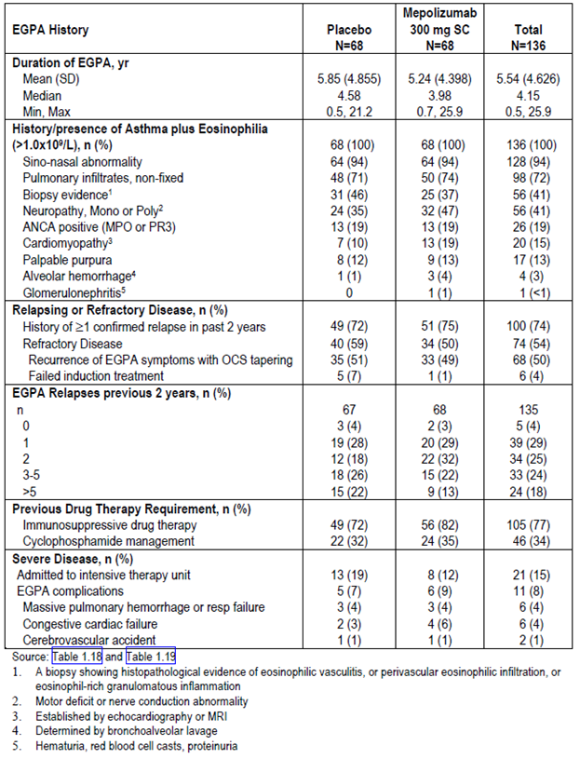
Both co-primary outcome measures show substantial improvement with mepolizumab compared with placebo. Subgroup analysis showed that there was less efficacy in patients was baseline eosinophil count < 150 x 10⁶ and those on > 20 mg prednisolone. Sensitivity analyses for the co-primary outcome measures and all secondary outcome measures were consistent. Safety outcomes for mepolizumab were similar to placebo.
The favourable effects of mepolizumab in adults were outlined by the clinical evaluator in Table 15, and the unfavourable effects in Table 16, above.
Figure 4: Analysis of accrued duration of remission (BVAS = 0 and OCS dose ≤ 4 mg/day: odds ratios, by subgroup (Study MEA115921, intention to treat population)
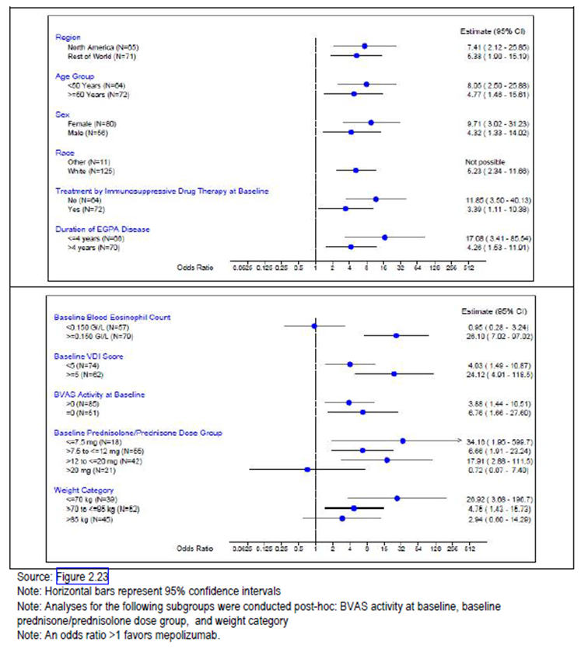
Table 23: Relationship between OCS dose and eosinophil count at baseline
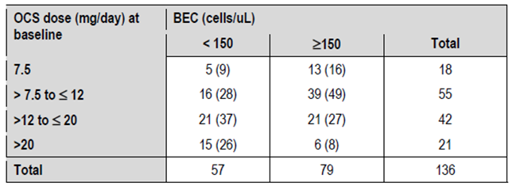
BEC = baseline eosinophil count, OCS = oral corticosteroids
The pattern of the proportion of patients in remission over time is consistent with a mepolizumab treatment effect that may take some time to develop but declines rapidly with treatment cessation. The time to treatment effect is confounded by the need to slowly wean OCS. It is noted that only 20 patients were in uninterrupted remission from Week 24 to Week 52 is of interest. It suggests a variable treatment effect with mepolizumab ranging from no effect in 32 patients (47%), to some effect but with relapses in 17 patients (25%) and to prolonged remission in 19 patients (28%).

Additional safety data
Safety was assessed from the randomised control trial (RCT), the open labelled continuation Study MEA115921, 120 day safety update report, and use of mepolizumab in other indications. According to the Summary of Clinical Safety (SCS),’A total of 2522 subjects have received at least one dose of mepolizumab across 26 studies in EGPA, asthma (including severe asthma), HES, eosinophilic esophagitis, atopic dermatitis, nasal polyposis and healthy volunteers’ in GlaxoSmithKline-sponsored clinical trials.
Participants in these studies received a range of doses (from 12.5 mg to 1500 mg) usually administered monthly. Doses ranging from 75mg IV to 750mg IV were investigated in asthma. Participants in most of the 26 studies were treated for < 12 months (2233/2522, 89%). The dose for which the longest duration of treatment has been reported is 750mg IV monthly; 122 subjects have received this dose for 60 months or longer. No patients with EGPA have been treated for more than 36 months.
The most common AEs associated with the use of mepolizumab include headache, sinusitis, URTI, diarrhoea, vomiting, oropharyngeal pain, or neck pain.
The effects of long term use unknown.
There is potential for rebound increase in eosinophils and exacerbations.
At the second round evaluation, the clinical evaluator recommended approval of the use of mepolizumab for adults with EGPA, and also recommended a number of changes to the PI.
The sponsor agreed to change the subheadings to severe refractory eosinophilic asthma and relapsed/refractory eosinophilic granulomatosis with polyangiitis.
The evaluator recommended the indication be reworded to:
Nucala is indicated as an add-on treatment for adults with relapsing or refractory Eosinophilic Granulomatosis with Polyangiitis (EGPA) with a blood eosinophil count ≥ 150 cells/μL at initiation of treatment (Clinical Trials).
The sponsor has not agreed to specifying the eosinophil count in the indication, on the basis that it would not be representative of the patient population who obtained benefit in the clinical trial. The sponsor has agreed to the following sentence in the clinical trials section.
‘There was a greater accrued time in remission in the mepolizumab group compared with placebo, in subjects with a baseline blood eosinophil count (BEC) ≥ 150 cells/µL.’
The evaluator recommended a statement of warning around risk of increase in disease activity following withdrawal of mepolizumab. The sponsor acknowledged that mepolizumab was not a disease modifying agent, and that patients may require an increase in treatment with other immunosuppressive if treatment with mepolizumab was ceased. The sponsor proposed the following addition to the precautions section.
‘EGPA: Cessation of Nucala
Nucala treated patients may experience a return of EGPA symptoms upon cessation of Nucala. As patients may decrease their other EGPA treatments during treatment with Nucala, if Nucala treatment is discontinued, then other EGPA treatments may need to be increased accordingly.’

Risk management plan
There were no changes to the RMP specific for EGPA as no additional safety concerns were identified. The current versions relevant to the submission are EU RMP version 2 (dated 26 May 2016, data lock point 10 July 2014) and ASA version 4.0 (dated November 2017).
Table 24: Summary of safety concerns
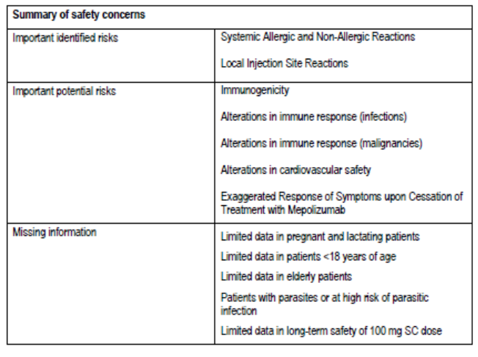
Adverse events in Australia are reported into GlaxoSmithKline’s global safety database. The studies shown in Table 25 are included in pharmacovigilance plan.
Table 25: Overview of studies for the pharmacovigilance plan
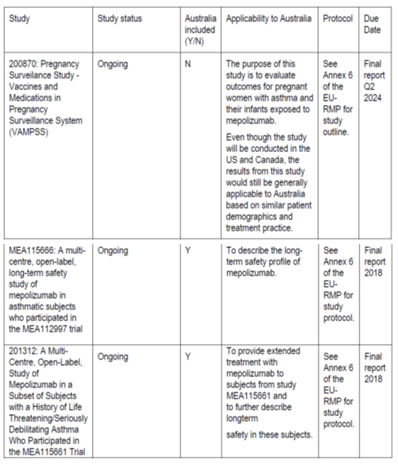
In addition, follow up questionnaires will be used to provide further information for the following adverse events: hypersensitivity, myocardial infarction, cerebrovascular events, deep vein thrombosis (DVT), peripheral arterial thromboembolism, parasitic infection.
Routine risk mitigation includes the PI and CMI. There are no additional risk mitigation activities.

Risk-benefit analysis

Delegate’s considerations

Discussion

Use in adults with EGPA
- PK model
It is unclear if and how the use of oral corticosteroids was used in the PK/PD model and how this may affect the results of the simulations used with this model.
- Dose
The sponsor’s rationale for the higher dose was that patients with EGPA have a greater eosinophilia and it was therefore assumed that higher dose of mepolizumab would be required to control this. A dose of 300 mg was efficacious in the clinical trial and relatively safe. However, the need for a higher dose is questionable for a number of reasons:
- At Baseline, patients with EGPA did not have a higher eosinophil count than those with asthma.
- PD models do not show a relationship between higher exposure and greater eosinophil reduction.
- There is no clear relationship between dose and efficacy outcomes.
The Delegate notes that patients in the HES long term Compassionate Use Program are dose less frequently than monthly. It is recommended that alternative dosing strategies be investigated.
- Place in therapy
The patient population in the clinical study had established EGPA and were on glucocorticoids. Thus, the clinical trial evidence would suggest that treatment with mepolizumab allow the dose of glucocorticoids to be weaned. It is also possible that treatment with other immunosuppressive therapy could be spared, but this was not an efficacy outcome.
There is no data on efficacy in patients not being treated with glucocorticoids, nor in patients with treated with cyclophosphamide. Efficacy was demonstrated in terms of reduced BVAS and maintenance of remission regarding need for corticosteroids. These are important outcomes. However there was no change in CRP or ESR.
- Indication
The proposed indication is:
Nucala is indicated as an add-on treatment for relapsing or refractory Eosinophilic Granulomatosis with Polyangitis in adult patients aged 18 years and over.
The evaluator recommended qualifying this with eosinophil count of > 150. The Delegate acknowledges that there was greater efficacy in patients with higher eosinophil counts at Baseline, however the Delegate is also aware that patients with EGPA by definition have high blood and tissue eosinophils, and that treatment with corticosteroids can lower these, and that the aim of treatment would be to wean the steroid dose to avoid other adverse events. Thus, for this indication the Delegate is of the opinion that eosinophil count is not required in the indication (as opposed for asthma where the Delegate believes it should be in the indication). The sponsor has agreed to add information about treatment efficacy stratified by eosinophil count to the clinical trials section.
- Safety
Adverse effects that may be associated with long-term use are unknown. The role of eosinophils in health are poorly understood. They may be involved in tumour surveillance and are involved in other aspects of the immune system. There appears to be an increased risk of lymphomas in patients with HES. It is unclear of the use of mepolizumab potentiates this.
The Delegate accepts the proposed statement in the PI around possible recurrence of disease when treatment is ceased.

Conclusion
The Delegate is of the opinion that mepolizumab should be approved for use in adults with EGPA. Approval will be conditional to the sponsor making some amendments to the PI. There were no new safety concerns identified to require a revision of the RMP.
Efficacy and safety have been demonstrated for the 300mg dose. However, lower doses have not been assessed. The sponsor is encouraged to investigate alternative dosing regimes.

Summary of issues
- The efficacy in adults with EGPA was based on a single pivotal study. The patients in the study had a diagnosis of EGPA and were on a stable dose of glucocorticoid ± other immunosuppressant (but not cyclophosphamide). Treatment with mepolizumab resulted in a statistically and clinically significant improvement in BVAS. However remission occurred in only 32%.
- The dose of 300 mg was based on an assumption that a higher dose would be required for EGPA and asthma.
- Although patients with EGPA may have had a very high eosinophil count historically, at the start of the study for many patients the eosinophil count was within the normal range (presumably due to treatment with oral corticosteroids).
- There is a risk of disease relapse when treatment is stopped.
- Data for long term use is limited.

Proposed action
The Delegate has no reason to say, at this time, that the application for mepolizumab should not be approved for registration for the treatment of adults aged 18 years and older with EGPA.

Request for Advisory Committee on Medicines (ACM) advice
Adults:
- All of the patients in the clinical trials were on glucocorticoids. Should this be included in the indication?
- Please comment on the exclusion of patients with organ threatening conditions in the clinical trial.
- What is the most clinically significant endpoint for studies in EGPA? Improvement in average BVAS or number of patients achieving remission or ability to wean steroids Is BVAS useful to assess disease in all organs, for example eye, heart, nervous system?
- How is disease activity assessed in clinical practice? Should treatment be directed by serum eosinophil count?

Response from sponsor

Executive summary
The sponsor welcomes the TGA Delegate’s pre-ACM conclusion that there are no reasons that the application for mepolizumab should not be registered for the treatment of adults aged 18 years and older with EGPA.
Mepolizumab has been registered for treatment of adults with EGPA in the USA in December 2017, and subsequently in Japan (May 2018) and Canada (July 2018).
EGPA is a rare disease which has been assigned an orphan designation in Australia. The unmet need in patients with EGPA is evident as there is no treatment currently registered in Australia or worldwide for the condition, despite use of OCS as standard of care. Even with OCS treatment, relapses are common and treatment with higher doses of OCS and the addition of immunosuppressant therapy with their associated adverse effects, are often necessary. There is a need for an efficacious treatment that improves clinical outcome while allowing a reduction in OCS exposure.
The three goals of clinical treatment in EGPA are improving remission, reducing relapses, and decreasing OCS exposure.
The efficacy of mepolizumab in 136 patients (n = 68 in each study arm) with relapsing or refractory EGPA, was clearly demonstrated in the pivotal study in adults (Study MEA115921) as follows:
- Clinically important and statistically significant differences were shown from mepolizumab treatment (mepolizumab + standard of care) compared to placebo (placebo + standard of care) in the co-primary endpoints of accrued time in remission (p < 0.001) and the proportion of subjects in remission at Weeks 36 and 48 (p < 0.001). For the primary endpoints, remission was defined as both disease control (BVAS = 0) and a reduction in steroid dose (OCS dose ≤ 4 mg/day).
- This was further supported by secondary endpoints which focused on improving remission, reducing relapses, and decreasing OCS exposure, all of which demonstrated a statistically significant and clinically relevant benefit in favour of mepolizumab compared with standard of care.
Overall, the safety profile of 300 mg SC mepolizumab in EGPA demonstrated:
- A consistent profile with that observed for the lower 100 mg SC and 250 mg (approximating to 300 mg SC) and 750 mg IV doses used in the severe asthma program.
- There were no new safety concerns associated with patients treated in the EGPA development program compared with the long term safety data available from the severe asthma program.
The sponsor believes that the proposed modified indication ‘as an add-on therapy for relapsing or refractory Eosinophilic Granulomatosis with Polyangiitis (EGPA) in adult patients aged 18 years and over (See section 5.1 Pharmacodynamic Properties - Clinical Trials)’ is supported and should not be modified to include clarifications relating to study design which are adequately addressed in the ‘Clinical Trials’ section of the PI (Refer to the response to ‘Advice sought from ACM, Question 1’, below). This approach is consistent with the approach taken by the TGA for the severe refractory eosinophilic asthma indication.
Based on the well-documented positive benefit to risk profile, the limitations associated with current therapeutic options, and the significant morbidity experienced by patients with EGPA, there is an urgent medical need for additional therapeutic options. The sponsor believes that the registration of mepolizumab will provide a significant improvement in the treatment of patients with EGPA based on the evidence presented in this application.

Specific questions raised by the TGA Delegate for the ACM’s advice
- All of the patients in the clinical trials were on glucocorticoids. Should this be included in the indication?
The sponsor believes that the most beneficial indication statement for prescribers is the proposed therapeutic indication (that is ‘Nucala is indicated as an add-on treatment for relapsing or refractory Eosinophilic Granulomatosis with Polyangiitis (EGPA) in patients aged 18 years and over’) with additional details relating to the study design and treated patient population included in the clinical trials section of the PI. The inclusion OCS in the indication would require patients to be on a treatment that is not registered for use in EGPA (in Australia and worldwide) prior to starting a treatment that is indicated for EGPA. In addition, requiring OCS in the indication statement does not account for patients that have been tapered off OCS while on mepolizumab treatment. Study MEA115921 demonstrated that mepolizumab treated patients can decrease their corticosteroid dose (18% of mepolizumab treated patients weaned completely off OCS during the last 4 weeks of treatment). Conceivably, a patient that has been weaned off OCS and has had a lapse of mepolizumab treatment could be required to restart OCS prior to restarting mepolizumab should the indication require patients to have existing OCS treatment.
The sponsor proposes to modify the EGPA indication statement by adding a cross reference to section 5.1 of the PI, which is consistent with the approach taken by the TGA for the severe asthma indication and is a clear and succinct approach to communicate the appropriate use of mepolizumab to prescribers.
- Please comment on the exclusion of patients with organ threatening conditions in the clinical trial.
As a general principle, patients with organ threatening conditions that are considered medically unstable are not included in placebo controlled trials.
The protocol for the pivotal Study MEA115921, exclusion criteria number 2 stated:
Organ threatening EGPA: Organ-threatening EGPA as per EULAR criteria, that is, organ failure due to active vasculitis, creatinine > 5.8 g/dL (> 513 µmol/L) within 3 months prior to Screening (Visit 1).
Patient safety is important to the sponsor. Subjects with organ-threatening EGPA, were excluded as these patients were considered too medically unstable for inclusion in a placebo controlled trial. These patients often require close monitoring of clinical status with eosinophil levels, which were blinded during the study. In addition, subjects with organ threatening or life threatening EGPA were excluded from the study as, according to EULAR treatment guidelines, these patients require treatment with cyclophosphamide (a treatment that was excluded from use during the study) and there are limited data to support the use of mepolizumab in these patients. Prior to the commencement of the study, external experts recommended prohibiting cyclophosphamide use during the study due to inconsistent use across regions and possible confounding effects on efficacy and safety results during the study.
- What is the most clinically significant endpoint for studies in EGPA? Improvement in average BVAS or number of patients achieving remission or ability to wean steroids. Is BVAS useful to assess disease in all organs, for example eye, heart, nervous system?
The sponsor is not aware of specific Australian therapeutic guidelines for EGPA. EULAR guidelines, accepted internationally and considered appropriate in the Australian context, identify several important endpoints for clinical trials.11 There is no priority provided for one endpoint over another. The sponsor identified remission, relapse, and corticosteroid reduction as important endpoints for a 52 week study.
EULAR guidelines define remission as the absence of disease activity. BVAS measures vasculitic activity in a number of organ systems and is presented in categories (general, cutaneous, mucous membranes/eyes, ENT, chest, cardiovascular, abdominal, renal, and nervous system). The average score of the BVAS is less clinically relevant than if there is active disease (a score > 0). The composite of BVAS = 0 and corticosteroid dose are used to define remission. Relapse is defined as a new onset or recurrence of disease activity.
The primary endpoints for the StudyMEA115921 were focused on remission with relapse and corticosteroid reduction as secondary endpoints. For remission, the sponsor utilised a more stringent corticosteroid threshold than the EULAR guidelines in order to ensure that differences between treatment groups were due to medication rather than chance fluctuations in disease activity. In discussions with regulatory agencies prior to commencement of study (FDA and EMA and PMDA), they recommended use of remission as a primary endpoint rather than a steroid reduction endpoint. As noted before, OCS are not registered for the treatment of EGPA and the reduction of an unregistered treatment could not be used to gain approval for use of mepolizumab in EGPA.
In discussion with external global experts, the three most important clinical goals were identified as: achieving remission, a decrease in OCS of at least 50% during weeks 48 to 52, and not experiencing an EGPA relapse during the 52 week treatment period. Summaries of clinical benefit for these treatment goals were derived post hoc (Table 26). The sponsor believes that this information is most relevant for clinicians and this data was presented in the clinical study report.
Table 26: Summary of clinical benefit (using remission definition: BVAS = 0 and OCS dose ≤ 4 mg/day; Study MEA115921, safety population)
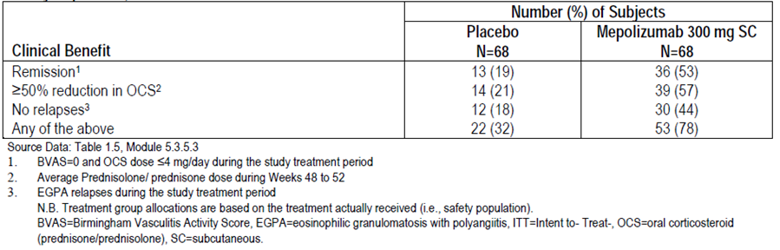
- How is disease activity assessed in clinical practice? Should treatment be directed by serum eosinophil count?
Medical management in clinical practice is focussed on assessing vasculitic activity and asthma control. Physicians follow their patient’s symptoms closely in order to determine when they may decrease corticosteroid/immunosuppressive therapy. Particular attention is paid to cardiac involvement. Standardised scoring systems, such as the BVAS, may be used or physicians may focus in on particular organ systems. Current EULAR guidelines on the management of EGPA do not recommend basing treatment decisions on only blood eosinophil levels.9 Tissue eosinophil levels may occur without blood eosinophilia and therefore other assessments of organ and vascular activity (that is spirometry and BVAS) should be utilised in conjunction with blood eosinophil levels.

Other issues raised by the TGA delegate

Summary of issues
- The efficacy in adults with EGPA was based on a single pivotal study. The patients in the study had a diagnosis of EGPA and were on a stable dose of glucocorticoid ± other immunosuppressant (but not cyclophosphamide). Treatment with mepolizumab resulted in a statistically and clinically significant improvement in BVAS. However, remission occurred in only 32%.
Typically, replicate evidence of efficacy is required to support registration. However, in this case a single study with clinically meaningful outcomes was considered acceptable for registration of this orphan designated medicine in the US, Canada and Japan, which is consistent with the recommendation by the Delegate and clinical evaluator.
The sponsor agrees that treatment with mepolizumab achieved a statistically and clinically significant greater accrued duration of BVAS = 0 over the 52 week treatment period compared with subjects who received placebo (p < 0.001). It is relevant to note that BVAS was a component of the definition of remission with remission defined in terms of a lack of vasculitis activity (that is, BVAS = 0) concurrent with an OCS dose ≤ 4 mg/day. As stated in the clinical evaluation report, ‘the pivotal Study MEA115921 shows a substantial improvement with mepolizumab treatment for the co-primary end points of accrued duration of remission and proportion of subjects in remission at both Weeks 36 and 48’ with results being clinically meaningful and statistically significant.
The durability of remission, reported as the proportion of patients who had remission at both Weeks 36 and 48, as stated by the Delegate, was 32% with mepolizumab, however, this result should be qualified with the full end point and comparison to placebo that is the 32% responders at Week 36 and 48 was a statistically significant difference when compared with 3% remission in the placebo group who were on standard of care treatment (p < 0.001).
- The dose of 300 mg was based on an assumption that a higher dose would be required for EGPA than asthma
As a rare disease, it was not deemed feasible to perform dose ranging studies in EGPA patients prior to Study MEA115921. The dose rationale for EGPA was based on an understanding of mepolizumab pharmacology (blood eosinophil reduction) gained primarily through the mepolizumab severe asthma programme, coupled with the fact that EGPA was anticipated to have a greater involvement of eosinophils at multiple target organs (with potential for significant increase in blood eosinophils preceding relapse or during OCS taper). The greater organ involvement in EGPA and higher eosinophil burden justified selecting a dose that maximises eosinophil suppression in blood and tissue. While lower doses may be effective for some patients, and higher doses may be necessary for some patients, the 300 mg mepolizumab dose was selected as the dose most likely to benefit the EGPA patients enrolled in Study MEA115921. The sponsor has no plans at this time to perform additional EGPA studies.
The mepolizumab HES expanded access program (ongoing for 13 years) permits a variety of doses and dosing frequencies, due to the severe nature of the patients in the program and the need for flexibility in dosing frequencies for some patients in long term treatment. The lowest dose in the mepolizumab HES expanded access program is 300 mg SC. Of note, based on a similar rationale, the currently ongoing mepolizumab HES Phase III study is investigating only one dosing regimen: 300 mg SC every 4 weeks.
- Although patients with EGPA may have had a very high eosinophil count historically, at the start of the study for many patients the eosinophil count was within the normal range (presumably due to treatment with oral corticosteroids).
The sponsor acknowledges that blood eosinophil counts was lower at Baseline in patients in the EGPA study compared to patients with severe eosinophilic asthma. The study did not require elevated eosinophils at screening for eligibility. It is relevant to note that tissue eosinophilia may occur without blood eosinophilia and hence the other assessments of organ and vascular activity in patients with EGPA who have relapsed or have refractory disease. As pointed out by the Delegate in the pre-ACM preliminary assessment report, OCS (100% of patients in the study) and cytotoxic immunosuppressive drugs (53% of patients in the study) can reduce blood eosinophil counts and lead to the lower blood eosinophil counts observed at Baseline in this pre-treated patient population.
- There is a risk of disease relapse when treatment is stopped
No rebound effect (defined as disease activity higher after cessation of mepolizumab treatment than at Baseline) has been observed in any mepolizumab program to date. The severe asthma development program for which data to investigate rebound effect is available, did not show evidence of symptom rebound after cessation of mepolizumab.
Results obtained during the follow up period of the pivotal EGPA study indicated that during this follow up period, 18 out of 68 (26%) placebo subjects experienced a relapse compared to 22 out of 68 (32%) of mepolizumab subjects. This was likely due to the fact that subjects that were treated with mepolizumab had significantly lower corticosteroid doses during the last 4 weeks of the treatment period when compared to placebo subjects. On stopping study treatment, the subjects who had been on mepolizumab were undertreated with corticosteroids compared to the placebo (standard of care) subjects, which is supported by the breakdown of the type of relapses, where the difference between the two treatment groups was almost entirely due to an imbalance of vasculitis relapses.
The Delegate has accepted the sponsor’s proposal to mitigate the risk of disease relapse on stopping mepolizumab treatment by including a precaution in the PI as follows: ‘Nucala treated patients may experience a return of EGPA symptoms upon cessation of Nucala. As patients may decrease their other EGPA treatments during treatment with Nucala, if Nucala treatment is discontinued then other EGPA treatments may need to be increased accordingly.’
- Data for long term use is limited.
In EGPA Study MEA115921, the safety profile of mepolizumab administered as 300 mg SC every 4 weeks for up to 52 weeks was similar to standard of care, with no new safety concerns identified. Furthermore, no new safety concerns were identified in an ongoing EGPA Long Term Access Programme MEA116841/201607 which enrolled subjects who completed Study MEA115921.
Long term safety data for mepolizumab 100 mg SC every 4 weeks are available from the open label extension studies of mepolizumab in severe refractory eosinophilic asthma, where 998 subjects were treated for a median of 2.8 years (range 4 weeks to 4.5 years). These studies showed that there was no dose tolerance developed over time and that the long-term safety profile of mepolizumab was similar to that observed in the severe asthma placebo controlled studies.
The sponsor will continue to monitor safety of mepolizumab across all indications studied, including EGPA via ongoing proactive pharmacovigilance activities. These include implementation of the RMP and ASA, spontaneous adverse event monitoring and safety reporting as required.

Attachment 1: Body of Request for ACM Advice: Discussion
The sponsor wishes to clarify specific comments made by the Delegate in the ‘Discussion’ where these have not been addressed either in the ‘Summary of issues’ or ‘Advice sought’.
  - PK model: It is unclear if and how the use of oral corticosteroids was used in the PK/PD model and how this may affect the results of the simulations used with this model.
The dose response meta-analysis described in Report 2015N238375_00 included data from 16 studies in the clinical development of mepolizumab in various eosinophilic conditions. Generally, patients entering investigational clinical trials with mepolizumab are on standard of care therapy which in the case of hyper eosinophilic conditions such as EGPA or HES, aim at controlling eosinophilia. Although the blood eosinophil counts at study entry in the meta-analysis dataset ranged from 5 to 4,690 cells/µL, there was limited observations ≥ 1000 cells/μL. Since location of the dose response (ED₅₀) and maximal mepolizumab inhibition were found to be dependent on baseline blood eosinophil counts, the dose response model from the meta-analysis was used to extrapolate beyond the baseline blood eosinophil counts range included in the meta-analysis dataset to investigate the impact of baseline blood eosinophil counts in untreated EGPA patients (that is, without OCS and cytotoxic immunosuppressants). A range of baseline blood eosinophil counts from 250 to 8,000 cells/µL was explored by simulations with values ≥ 1000 cells/µL being representative of untreated patients with HES or EGPA. This simulation was to account for the weaning of OCS and immunosuppressive therapies that could be expected during mepolizumab treatment. Since OCS and immunosuppressants reduce blood eosinophil counts, when being weaned off, the effect from these therapies would therefore need to be compensated by mepolizumab treatment.
The simulations showed that a mepolizumab dose of 300 mg SC would be required to achieve similar blood eosinophil counts reduction to that observed in patients with severe eosinophilic asthma (that is, 90% of the maximal mepolizumab inhibitory effect) in subjects with increased baseline blood eosinophil counts of > 1500 cells/µL.
- Dose: PD models do not show a relationship between higher exposure and greater eosinophil reduction.
The sponsor would like to clarify that a relationship between mepolizumab dose (exposure) and blood eosinophil count (pharmacodynamic) has been established and this relationship has been well characterised in the PK/PD Study MEA114092, submitted with the initial severe asthma application. From the model the dose resulting in 90% of the maximal mepolizumab inhibitory effect was estimated to be 99 mg SC.
Furthermore, an increase in blood eosinophil counts reduction with increase in dose was demonstrated between 75 mg IV dose (corresponding to 100 mg SC; the severe asthma dose) and 250 mg IV dose (corresponding to approximately 300mg SC; the EGPA dose) in the dose ranging severe asthma Study MEA112997.
The reduction in blood eosinophils observed with the 300 mg SC dose administered in the EGPA study was similar to that observed at 100 mg SC in patients with severe asthma, suggesting that patients with EGPA are harder to treat.
- Safety: There appears to be an increased risk of lymphomas in patients with hypereosinophilic syndrome. It is unclear if the use of mepolizumab potentiates this.
Nonclinical and clinical experience does not support a role for mepolizumab in the development of malignancies. To date, there is no signal for increased risk of malignancy in the mepolizumab treated patients. Subjects with lymphoproliferative HES or those with an abnormal T cell phenotype are at increased risk of developing T cell lymphoma as part of the natural history of the disease. While T cell lymphoma has been reported in HES patients receiving mepolizumab, it is not known if the risk of T cell lymphoma in susceptible patients is increased by treatment with immunomodulators such as mepolizumab.

Risk management plan
The sponsor will implement the Nucala European Risk Management Plan (EU RMP version 2 (dated 26 May 2017) with ASA (version 4, dated November 2017) both of which were submitted to the TGA on 30 November 2017.

Product Information (PI) and Consumer Medicine Information (CMI)
The PI has been updated as per the Delegate’s recommendations and the sponsor commits to liaising with the TGA Delegate to finalise the PI and CMI to the satisfaction of the TGA.

Conclusion
The sponsor is committed to developing and registering treatments for rare diseases such as EGPA. The sponsor supports the Delegate’s recommendation to register the use of Nucala as an add on treatment for adults with EGPA, which is aligned with the recommendation by the clinical evaluator and trusts that the ACM will align with this recommendation.
The indication as proposed by the sponsor, affords physician’s flexibility and is supported by the efficacy data which demonstrated that remission was improved both clinically and statistically significantly compared with standard of care treatment. The safety profile of mepolizumab in patients with EGPA was unchanged from the established safety profile for mepolizumab in patients with severe eosinophilic asthma, for which long term data up to 4.5 years is available.
The sponsor believes that the registration of mepolizumab will provide a significant improvement in the treatment of patients with EGPA based on the well-documented positive benefit to risk profile, the limitations associated with current therapeutic treatment options, the significant morbidity experienced by patients with EGPA and the medical need for additional therapeutic options.

Advisory Committee Considerations
The Advisory Committee on Medicines (ACM), having considered the evaluations and the Delegate’s overview, as well as the sponsor’s response to these documents, advised the following.
The ACM taking into account the submitted evidence of efficacy, safety and quality, considered Nucala, containing 100 mg mepolizumab powder for injection in a 10 mL vial, to have an overall positive benefit-risk profile for the proposed indication:
Nucala is indicated as an add-on treatment for relapsing or refractory Eosinophilic Granulomatosis with Polyangitis (EGPA) in patients aged 18 years and over.
In providing this advice the ACM noted that:
- Mepolizumab was approved in 2016 for use in eosinophilic asthma.
- EGPA is a rare condition in Australia and can be a life threatening disease.
- A dose of 300 mg was used in the clinical study due to the presumption that a larger dose would be needed due to the higher amount of tissue eosinophils in EGPA. This was the only dose used in the study.
- Patients with organ or life threatening conditions were excluded from the clinical trial.
- Treatment with mepolizumab for EGPA would likely be disease controlling rather than disease modifying.
- A number of endpoints were studied in the clinical trials, including total accrued weeks in remission, time to first relapse, and ability to wean glucocorticoids
- The clinical Study MEA115921 showed positive results for improvement in time in remission (odds ratio 5.91 in favour of mepolizumab), in addition 60% of patients receiving mepolizumab were able to decrease prednisolone use, compared to 33% of patients on the placebo.

Proposed conditions of registration
The ACM agreed with the Delegate on the proposed conditions of registration.

Proposed Product Information (PI)/ Consumer Medicine Information (CMI) amendments
The ACM agreed with the delegate to the proposed amendments to the PI and CMI and specifically advised on the inclusion of the following:
- A statement in the Precautions section of the PI and relevant sections of the CMI to reference the risk of increase in disease activity following withdrawal of mepolizumab.

Specific Advice
The ACM advised the following in response to the delegate’s specific questions on the submission:
- All of the patients in the clinical trials were on glucocorticoids. Should this be included in the indication?
The ACM advised that the indication should not be too restrictive with respect to patients on glucocorticoids. The clinical trials indicated that patients on lower doses of steroids showed a greater benefit than patients on higher doses of steroids. The ACM also advised that, although advantageous to use mepolizumab alone without steroids, patients who haven’t achieved remission are likely to be on steroids.
- Please comment on the exclusion of patients with organ threatening conditions in the clinical trial.
The ACM advised that there is a different and established treatment for patients with organ threatening conditions. For these patients, evidence supports disease management with high dose steroids and cyclophosphamide.
- What is the most clinically significant endpoint for studies in EGPA? Improvement in average BVAS or number of patients achieving remission or ability to wean steroids? Is BVAS useful to assess disease in all organs, for example eye, heart, nervous system?
The ACM advised that the BVAS was developed for clinical trials and is not routinely used by immunologists in clinical practice. Instead, clinical parameters are used and remission is measured by end organ involvement. Both BVAS and a reduction of steroid dose are clinically important endpoints.
- How is disease activity assessed in clinical practice? Should treatment be directed by serum eosinophil count?
Disease activity is assessed clinically in practice. The ACM advised that eosinophil count was not the best measure and that patients need to be able to reduce prednisolone doses to be considered in remission. For example, vasculitis may be treated by steroids but the patient may still have high eosinophilic levels.

Conclusion
The ACM advised that implementation by the sponsor of the recommendations outlined above to the satisfaction of the TGA, in addition to the evidence of efficacy and safety provided would support the safe and effective use of this product.

Outcome
Based on a review of quality, safety and efficacy, TGA approved the registration of Nucala (mepolizumab) 100 mg powder for injection vial, indicated for:
Relapsed or refractory EGPA
Nucala is indicated as an add-on treatment for relapsing or refractory Eosinophilic Granulomatosis with Polyangiitis (EGPA) in adult patients aged 18 years and over (see section 5.1 Pharmacodynamic Properties - Clinical Trials).
As such, the full indications at this time were:
Severe refractory eosinophilic asthma
Nucala is indicated as an add-on treatment for severe refractory eosinophilic asthma in patients aged 12 years and over (see Section 5.1 Pharmacodynamic Properties - Clinical Trials).
Relapsed or refractory EGPA
Nucala is indicated as an add-on treatment for relapsing or refractory Eosinophilic Granulomatosis with Polyangiitis (EGPA) in adult patients aged 18 years and over (see section 5.1 Pharmacodynamic Properties - Clinical Trials).

Specific conditions of registration applying to these goods
- Any changes to which the sponsor has agreed should be included in a revised RMP and ASA. However, irrespective of whether or not they are included in the currently available version of the RMP document, the agreed changes become part of the risk management system.
The Nucala (mepolizumab) EU-Risk Management Plan (EU-RMP), version 2, dated 26 May 2016 (data lock point 10 July 2014), with Australian Specific Annex, version 4.0, dated November 2017, included with submission PM-2017-04349-1-5, and any subsequent revisions, as agreed with the TGA will be implemented in Australia.
An obligatory component of risk management plans is routine pharmacovigilance. Routine pharmacovigilance includes the submission of periodic safety update reports (PSURs).
Reports are to be provided in line with the current published list of EU reference dates and frequency of submission of PSURs until the period covered by such reports is not less than three years from the date of this approval letter. The reports are to at least meet the requirements for PSURs as described in the European Medicines Agency’s Guideline on good pharmacovigilance practices (GVP) Module VII-periodic safety update report (Rev 1), Part VII.B Structures and processes. Note that submission of a PSUR does not constitute an application to vary the registration.

Attachment 1. Product Information
The PI for Nucala approved with the submission which is described in this AusPAR is at Attachment 1. For the most recent PI, please refer to the TGA website at <https://www.tga.gov.au/product-information-pi>.

Therapeutic Goods Administration
PO Box 100 Woden ACT 2606 Australia
Email: info@tga.gov.au Phone: 1800 020 653 Fax: 02 6232 8605
https://www.tga.gov.au

Based on plasma AUC_{0–4} week values at steady state of 809 mg·h/mL in monkeys (Study RSD-100X0L), 28.1 mg·h/mL at 300 mg SC in adult and adolescent patients (Study MEA115921) and 48.6 mg·h/mL at 300 mg SC in children ≥ 40 kg (based on linear extrapolation of the AUC obtained at 100 mg (675 µg·d/mL) in Study 200363).
See Australia Specific Annex to the EU Risk Management Plan
Ormerod, A. and Cook, M. (2008). Epidemiology of primary systemic vasculitis in the Australian Capital Territory and south-eastern New South Wales, Internal Medicine Journal, 2008; 38: 816–823.
Comarmond, C. et al. (2013), Eosinophilic granulomatosis with polyangiitis (Churg–Strauss): clinical characteristics and long-term follow up of the 383 patients enrolled in the French Vasculitis Study Group cohort. Arthritis Rheum. 2013; 65: 270–281.
Gioffredi, A. et al. (2014). Eosinophilic granulomatosis with polyangiitis: An overview. Front Immunol, 2014; 5: 1-7.
American College of Rheumatology (ACR)-endorsed criteria for rheumatic diseases. Accessed from the American College of Rheumatology website 24 July 2019.
Jennette, J. C. et al. (1994). Nomenclature of systemic vasculitides: The proposal of an international consensus conference. Arthritis Rheum. 1994; 37: 187–192.
Jennette, J.C (2013). Overview of the 2012 Revised International Chapel Hill Consensus Conference Nomenclature of Vasculitides. Clinical and experimental nephrology. 2013; 17: 603-606.
Groh, M. et al. (2015). Eosinophilic granulomatosis with polyangiitis (Churg–Strauss) (EGPA) Consensus Task Force recommendations for evaluation and management. European Journal of Internal Medicine, 2015; 26: 545–553.
Grayson, P.C. et al. (2015). Value of commonly measured laboratory tests as biomarkers of disease activity and predictors of relapse in eosinophilic granulomatosis with polyangiitis, Rheumatology, 2015; 54: 1351-1359).
Hellmich, B. et al. (2007). EULAR recommendations for conducting clinical studies and/or clinical trials in systemic vasculitis: focus on anti-neutrophil cytoplasm antibody-associated vasculitis. Ann Rheum Dis 2007; 66: 605–617.
Disease Scoring page. Accessed at the website of the European Vasculitis Society, 24 June 2019.
Mukhtyar, C. et al (2009). ‘Modification and validation of the Birmingham Vasculitis Activity Score (version 3) Ann Rheum Dis. 2009; 68: 1827-1832.
Yates, M. et al (2016). EULAR/ERA-EDTA recommendations for the management of ANCA-associated vasculitis, Annals of the Rheumatic Diseases, 2016; 75: 1583-1594.
Mukhtyar, et. al. (2009). European League Against Rheumatism (EULAR) recommendations for the for the management of small and medium vessel vasculitis. Ann Rheum Dis, 2009; 68: 310-317.
FDA approved label for Rituximab, dated 9/2013, accessed from the FDA website.
Mabthera (Rituximab), accessed from the EMA website.
TGA approved PI for Rituximab (Mabthera).
Kahn, J.E. et. al. (2010). Sustained response to mepolizumab in refractory Churg-Strauss syndrome. J Allergy Clin Immunol, 2010; 125: 267-270.
Marigowda, G. et. al. (2010). Mepolizumab as a steroid-sparing treatment option in patients with Churg-Strauss syndrome. Journal of Allergy and Clinical Immunology, 2010; 125: 1336-1343.
REOVAS study. Description accessed at the clinicaltrials.gov website, 24 July 2019.
Detoraki, A. et. al. (2016). Omalizumab in patients with eosinophilic granulomatosis with polyangiitis: a 36 month follow up study. Journal of Asthma, 2016; 53: 201-206.
European Medicines Agency (EMA), Committee for Medicinal Products for Human Use (CHMP). Guideline on the role of pharmacokinetics in the development of medicinal products in the paediatric population, 28 June 2006, EMEA/CHMP/EWP/147013/2004.
European Medicines Agency (EMA) Committee for Proprietary Medicinal Products (CPMP). Note for guidance on clinical investigation of medicinal products in the paediatric population, July 2000, CPMP/ICH/2711/99.
European Medicines Agency (EMA) Committee for Proprietary Medicinal Products (CPMP). Points to consider on application with 1. Meta-analyses; 2. One pivotal study, May 2001, CPMP/EWP/2330/99.
European Medicines Agency (EMA). Concept paper on extrapolation of efficacy and safety in medicine development. 23 April 2013, EMA/129698/2012.
European Medicines Agency (EMA). Reflection paper on the use of extrapolation in the development of medicines for paediatrics, Draft dated October 2017; not included in TGA Clinical Efficacy and Safety Guidelines.
Hellmich, B. et al. (2007). EULAR recommendations for conducting clinical studies and/or clinical trials in systemic vasculitis: focus on anti-neutrophil cytoplasm antibody-associated vasculitis. Ann Rheum Dis, 2007; 66: 605–617.
AusPAR Mepolizumab (PM-2014-03872-1-5). Accessed at the TGA website.
FDA Clinical Pharmacology Review for the asthma indication submission 2014. Accessed at the FDA website.
Stein, M.L. et al. (2018), Anti–IL-5 (mepolizumab) therapy reduces eosinophil activation ex vivo and increases IL-5 and IL-5 receptor levels. The Journal of allergy and clinical immunology. 2008; 121:1473-1483.
See ARTG entry 277279 at the TGA website.
FDA Label for Benralizumab. Accessed at the FDA website.
Kim, S. et al. (2010). Mepolizumab as a steroid-sparing treatment option in patients with Churg-Strauss Syndrome. J Allergy Clin Immunol, 2010; 125: 1336-1343.
Moosig, F. et al. (2011). Targeting interleukin-5 in refractory and relapsing Churg–Strauss Syndrome. Ann Int Med, 2011; 155: 341-343.
Cohen, P. et al. (2007). Churg–Strauss syndrome with poor-prognosis factors: a prospective multicenter trial comparing glucocorticoids and six or twelve cyclophosphamide pulses in forty-eight patients. Arthritis Rheum, 2007; 57: 686–693.
Hiemstra, T. F. et al (2010). Mycophenolate mofetil versus azathioprine for remission maintenance in antineutrophil cytoplasmic antibody-associated vasculitis: a randomized controlled trial. JAMA, 2010; 304: 2381–2388
Bel, E.H. et al. (2014); SIRIUS Investigators. Oral glucocorticoid-sparing effect of mepolizumab in eosinophilic asthma. N Engl J Med, 2014; 371: 1189-1197.
Haldar, P. et al. (2014). Outcomes after cessation of mepolizumab therapy in severe eosinophilic asthma: a 12 month follow up analysis (letter). J Allergy Clin Immunol, 2014; 133: 921-023.
Winthrop, K.L.et al. (2015). Opportunistic infections and biologic therapies in immune-mediated inflammatory diseases: consensus recommendations for infection reporting during clinical trials and postmarketing surveillance. Ann Rheum Dis, 2015; 74 :2107-2116.
Centers for Disease Control and Prevention (CDC): Herpes Zoster.; accessed Jan 2018 at https://www.cdc.gov/shingles/hcp/clinical-overview.html.
SEER Cancer Statistics Review 1975-2014, browse for Table 19.26 All Lymphoid Neoplasms With Detailed Non-Hodgkin Lymphoma Subtypes. Accessed Jan 2018 at https://seer.cancer.gov/csr/1975_2014/
FDA approved label for Reslizumab. Accessed at the FDA website.
Murphy, K. et al. (2017), Long-term Safety and Efficacy of Reslizumab in Patients with Eosinophilic Asthma, J Allergy Clin Immunol: In Practice, 2017; 5: 1572-1581.
Haldar, P. et al. (2014). Outcomes after cessation of mepolizumab therapy in severe eosinophilic asthma: A 12-month follow-up analysis, J Allergy Clin Immunol, 2014; 133: 921-923.
Kim, Y.J. et al. (2004). Rebound eosinophilia after treatment of hypereosinophilic syndrome and eosinophilic gastroenteritis with monoclonal anti-IL-5 antibody SCH55700. J Allergy Clin Immunol, 2004; 114: 1449–1455.
During the course of evaluation, this indication was subsequently changed to include adults patients only.
Polzer, K. et al. (2008). Eotaxin-3 is involved in Churg-Strauss syndrome-a serum marker closely correlating with disease activity. Rheumatology (Oxford). 2008; 47: 804-808.
Vaglio, A. et al (2013). Eosinophilic granulomatosis with polyangiitis (Churg–Strauss): state of the art. Allergy, 2013; 68: 261–273.
SEER Cancer Statistics Review 1975-2014, browse for Table 19.26 All Lymphoid Neoplasms With Detailed Non-Hodgkin Lymphoma Subtypes. Accessed Jan 2018 at https://seer.cancer.gov/csr/1975_2014/
ANSM = Agence Nationale de Sécurité du Médicament et des Produits de Santé
Khoury, P. (2017). Mini-Review: Lymphocytic variant HES, The Hematologist, 2017; 14.
BVAS is a measure of EGPA activity and 0 indicates no disease activity.
The ACM provides independent medical and scientific advice to the Minister for Health and the Therapeutic Goods Administration (TGA) on issues relating to the safety, quality and efficacy of medicines supplied in Australia including issues relating to pre-market and post-market functions for medicines. The Committee is established under Regulation 35 of the Therapeutic Goods Regulations 1990. Members are appointed by the Minister. The ACM was established in January 2017 replacing Advisory Committee on Prescription Medicines (ACPM) which was formed in January 2010. ACM encompass pre and post-market advice for medicines, following the consolidation of the previous functions of the Advisory Committee on Prescription Medicines (ACPM), the Advisory Committee on the Safety of Medicines (ACSOM) and the Advisory Committee on Non-Prescription Medicines (ACNM). Membership comprises of professionals with specific scientific, medical or clinical expertise, as well as appropriate consumer health issues relating to medicines.

