Date of CER: 10 November 2012

AusPAR Attachment 2

Extract from the Clinical Evaluation Report for Meningococcal (Groups A, C, W-135, Y) Polysaccharide Tetanus Toxoid Conjugate Vaccine
  - Proprietary Product Name: Nimenrix
  - Sponsor: GlaxoSmithKline Australia Pty Ltd

About the Therapeutic Goods Administration (TGA)
- The Therapeutic Goods Administration (TGA) is part of the Australian Government Department of Health, and is responsible for regulating medicines and medical devices.
- The TGA administers the Therapeutic Goods Act 1989 (the Act), applying a risk management approach designed to ensure therapeutic goods supplied in Australia meet acceptable standards of quality, safety and efficacy (performance), when necessary.
- The work of the TGA is based on applying scientific and clinical expertise to decision-making, to ensure that the benefits to consumers outweigh any risks associated with the use of medicines and medical devices.
- The TGA relies on the public, healthcare professionals and industry to report problems with medicines or medical devices. TGA investigates reports received by it to determine any necessary regulatory action.
- To report a problem with a medicine or medical device, please see the information on the TGA website <http://www.tga.gov.au>.
About the Extract from the Clinical Evaluation Report
- This document provides a more detailed evaluation of the clinical findings, extracted from the Clinical Evaluation Report (CER) prepared by the TGA. This extract does not include sections from the CER regarding product documentation or post market activities.
- The words [Information redacted], where they appear in this document, indicate that confidential information has been deleted.
- For the most recent Product Information (PI), please refer to the TGA website <http://www.tga.gov.au/hp/information-medicines-pi.htm>.
Copyright
© Commonwealth of Australia 2013
This work is copyright. You may reproduce the whole or part of this work in unaltered form for your own personal use or, if you are part of an organisation, for internal use within your organisation, but only if you or your organisation do not use the reproduction for any commercial purpose and retain this copyright notice and all disclaimer notices as part of that reproduction. Apart from rights to use as permitted by the Copyright Act 1968 or allowed by this copyright notice, all other rights are reserved and you are not allowed to reproduce the whole or any part of this work in any way (electronic or otherwise) without first being given specific written permission from the Commonwealth to do so. Requests and inquiries concerning reproduction and rights are to be sent to the TGA Copyright Officer, Therapeutic Goods Administration, PO Box 100, Woden ACT 2606 or emailed to <tga.copyright@tga.gov.au>.

Contents
List of abbreviations 4
1. Introduction 6
2. Clinical rationale 6
3. Contents of the clinical dossier 7
3.1. Scope of the clinical dossier 7
3.2. Paediatric data 8
3.3. Good clinical practice 8
4. Pharmacokinetics 9
5. Pharmacodynamics 9
5.1. Studies providing pharmacodynamic data 9
5.2. Summary of pharmacodynamics 9
5.3. Evaluator’s overall conclusions on pharmacodynamics 14
6. Dosage selection for the pivotal studies 15
7. Clinical efficacy 15
7.1. Pivotal efficacy studies 35
7.2. Other efficacy studies 36
7.3. Analyses performed across trials (pooled analyses and meta-analyses) 37
7.4. Evaluator’s conclusions on clinical efficacy: Conclusions on protective efficacy 39
8. Clinical safety 40
8.1. Studies providing evaluable safety data 40
8.2. Overall extent of exposure 42
8.3. Adverse events 42
8.4. Laboratory tests 48
8.5. Drug-drug interactions – co-administered vaccines 48
8.6. Pregnancy 49
8.7. Post-marketing experience 49
8.8. Safety issues with the potential for major regulatory impact 49
8.9. Other safety issues 49
8.10. Safety related to drug-drug interactions and other interactions 50
8.11. Other safety issue 50
8.12. Evaluator’s overall conclusions on clinical safety 50
9. First round benefit-risk assessment 50
9.1. First round assessment of benefits 50
9.2. First round assessment of risks 51
9.3. First round assessment of benefit-risk balance 51
10. First round recommendation regarding authorisation 51
11. Clinical questions 51
12. Second round evaluation of clinical data submitted in response to questions 51
13. References 51

List of abbreviations
Abbreviation | Meaning
AE | adverse event
anti-HA | anti-HA Anti-haemagglutinin
ATP | According To Protocol
CDC | Centers of Disease Control and Prevention
CHMP (CPMP) | Committee for Medicinal Products for Human Use
CI | Confidence Interval
D | Diphtheria
DNA | Desoxyearibonucleic Acid
DPA | Disproportionality Analyses
ELISA | Enzyme-linked immunosorbent assay
EU | European Union
eCRF | electronic Case Report Form
FDA | Food and Drug Administration
FHA | Filamentous hemagglutitnin
GBS | Guillain Barré syndrome
GCP | Good Clinical Practice
GMTs | Geometric Mean Titres
GMC/T | Geometric Mean Concentration/Titre
GSK | Bio GlaxoSmithKline Biologicals
HA | Haemagglutinin
HI | Haemagglutination Inhibition
ICH | International Conference on Harmonization
IDMC | Independent Data Monitoring Committee
IM | Intramuscular
IS | Injection site
MAA | Marketing Authorization Application
MEDRA | Medical Dictionary for Regulatory Activities
ml | milliliters
PT | Pertussis toxin
PI | Prescribing Information
PMS | Post Marketing surveillance
PRN | Pertactin
RBC | Red Blood Cells
RCC | Reverse Cumulative Curves
RNA | Ribonucleosic Acid
RR | relative risk
RT-PCR | Reverse Transcriptase Polymerase chain reaction
SAE | Serious Adverse Event
SCR | Seroconversion Rate
SCF | Seroconversion Factor
SOC | System Organ Class
SOP | Standard Operation Procedure
SPR | Seroprotection Rate
TT | tetanus toxoid
TVC | Total Vaccinated Cohort
US | United States
VE | Vaccine efficacy
WHO | World Health Organisation

Introduction
This is a submission to register a new quadrivalent meningococcal ACWY-tetanus toxoid conjugate vaccine (MenACWY-TT), Nimenrix.
The proposed indication for the MenACWY-TT vaccine is active immunisation against invasive meningococcal disease caused by N. meningitidis serogroups A, C, W-135 and Y in individuals 1- 55 years of age. The vaccine is to be administered intramuscularly (IM) as a one-dose vaccination schedule in all age groups.
Primary vaccination: A single 0.5 ml dose of the reconstituted vaccine is given intramuscularly (IM) for immunization. Each 0.5ml, after reconstitution contains the following active ingredients: Meningococcal polysaccharide – Serogroup-A1 5μg; Meningococcal polysaccharide – Serogroup-C1 5 μg; Meningococcal polysaccharide – Serogroup-W-1351 5μg; Meningococcal polysaccharide – Serogroup-Y1 5μg; conjugated to tetanus toxoid carrier protein 44 μg.
AND as a Booster vaccination in subjects who have previously been vaccinated with a plain i.e. non conjugate polysaccharide meningococcal vaccine.
Booster vaccination: A single 0.5ml dose of the reconstituted vaccine given IM in people who have previously been vaccinated with a plain, i.e. non-conjugate, polysaccharide meningococcal vaccine.. Age group for receipt is, 1-55 years of age.
This application does NOT seek approval of Nimenrix as a booster in those primed with Nimenrix or another conjugate meningococcal vaccine.

Clinical rationale
N. meningitidis (meningococcus), a gram-negative diplococcus, is the most common cause of bacterial meningitis worldwide, with ≈1.2 million cases/year and ≈135,000 deaths. The organism has generated meningitis epidemic outbreaks. Other serious sequelae include extra-central nervous system disease including sepsis due to meningococcemia with associated renal failure, shock syndromes and impaired blood supply to vital organs and the periphery. Morbidity from the disease can be devastating.
Polysaccharide vaccines have been available for serogroups A, C, W-135 and Y for many years, however, these have poorer immunogenicity in terms of inducing adequate (for protection) and sustained immunity (immune memory) for protection against disease particularly in young children. Conjugate vaccines can overcome some of these limitations. Effective conjugate vaccines have been successful in preventing meningitis and other invasive bacterial infections caused by encapsulated bacteria such as Haemophilus influenzae type b and Streptococcus pneumoniae. NIMENRIX, a quadrivalent meningococcal ACWY-tetanus toxoid conjugate vaccine, (MenACWY-TT) is composed of purified capsular polysaccharides of N. meningitidis A, C, W and Y, with each serogroup conjugated to the tetanus toxoid (TT).

Contents of the clinical dossier

Scope of the clinical dossier
The submission contained the following clinical information:
Module 5: All studies listed below.
Integrated Summary of Efficacy (immunogenicity), Integrated Summary of Safety; booster study (N=1).
Module 1: Application letter, application form, draft Australian PI/CMI/label; EU-approved product label. Risk management plan (pharmacovigilance) for Australia.
Module 2: Clinical Overview, Summary of Clinical Efficacy, Summary of Clinical Safety and literature references.
The clinical dossier (Module 5) documented a full clinical development programme in all age groups for planned use of this vaccine, in terms of pharmacology, efficacy (immune persistence) and safety. The individual studies are summarised below:

Phase II studies

Phase II studies providing data for the selection of MenACWY-TT vaccine formulation (N=2)
- Study MenACWY-TT-012 – Adolescents (Denmark)
- Study MenACWY-TT-013 – Toddlers and children (Austria, Germany)

Phase II studies in adolescents and adults (N=1)
- Study MenACWY-TT-015 – Adolescents and adults (The Philippines, Saudi Arabia)

Phase II studies in children, adolescents and adults (N=2)
- Study MenACWY-TT-052 – Children, adolescents and adults (US)
- Study MenACWY-TT-071 – Children, adolescents and adults (US, Canada)

Phase II studies in toddlers and children (N=2)
- Study MenACWY-TT-027 – Toddlers and children (Finland)
- Study MenACWY-TT-055 – Toddlers (US)

Phase II persistence and immune memory studies

Phase II persistence studies in adolescents and adults (N=6)
- Study MenACWY-TT-016 EXT-015 Y1& Y2–Adolescents and adults (Philippines, Saudi Arabia)
- Study MenACWY-TT-024 EXT-012 M18 & M30 & M42 –Adolescents and adults (Denmark)
- Study MenACWY-TT-059 EXT-052 Y1 – Adolescents and adults (US)

Phase II persistence studies in toddlers and children (N=5)
- Study MenACWY-TT-014 BST-013 –Toddlers and children (Austria, Germany)
- Study MenACWY-TT-028 EXT-027 Y1 & Y2 & Y3 –Toddlers and children (Finland)
- Study MenACWY-TT-062 EXT 055 Y1 –Toddlers (US).

Phase III efficacy vaccination studies

Studies providing efficacy and safety data for adolescent/adult (N=4)
- Study MenACWY-TT-035 (Lebanon, the Philippines)
- Study MenACWY-TT-036 (India, the Philippines, Taiwan)
- Study MenACWY-TT-037 (Denmark, Sweden)
- Study MenACWY-TT-093 (The Philippines, Thailand, Panama)

Studies providing efficacy and safety data for children (N=2)
- Study MenACWY-TT-038 (India, Lebanon, the Philippines, Saudi Arabia)
- Study MenACWY-TT-081 (France, Germany)

Studies providing efficacy and safety data for toddlers (N=3)
- Study MenACWY-TT-039 (Finland)
- Study MenACWY-TT-040 (Austria, Germany, Greece)
- Study MenACWY-TT-080 (Mexico, Taiwan)

Phase III persistence studies (N=2)
- Study MenACWY-TT-043 EXT- 036 Y2 – Adolescents (India and the Philippines)
- Study MenACWY-TT-048 EXT-039 Y2 – Toddlers (Finland)

Booster study in those already primed with a prior plain meningococcal vaccine (N=1):
- Study MenACWY-TT-021 (Lebanon):

Supportive studies:
- Study 10PN-PD-DIT-014 (Czech Republic)

Paediatric data
The submission included paediatric PD/efficacy (immune persistence)/safety data including safety data pertaining to the administration of this vaccine concurrently with other childhood vaccines both conjugate and non-conjugate, live-attenuated and killed (toxoid components).

Good clinical practice
All studies described in this application, were carried out by experienced investigators and conducted in accordance with GCP guidelines. The protocols complied with the 1996 version of the Declaration of Helsinki and with the GCP guidelines in use at the study outset. Each study was reviewed and approved by an ethical review committee (ERC). However, GCP deficiencies in the informed consent (IC) process and the review of diary card data were identified at one site in study MenACWY-TT-036 (Centre 36963, located in the Philippines; [enrolled 392 of 1025 participants)] i.e:
- IC was given by a guardian not legally authorised, deviating from the process that had been approved by the ERC: GSK and the investigator acknowledged the finding;
- The data recorded by the subjects on the diary cards had been changed without any explanation in the patient chart: GSK and the investigator acknowledged the finding. In order to determine whether exclusion of data from this site would impact the conclusions of the study, supplementary sensitivity analyses (safety/immunogenicity) excluding data from this site were performed in accordance with EMA Guidance (“Ethical Considerations for Clinical Trials Conducted with the Paediatric Population, 2008”). The result of the supplementary analysis show that the safety/immunogenicity conclusions are consistent with the results from the total study population and as such, deviations from ICH-GCP at this site, do not invalidate the study conclusions generated in MenACWY-TT-036.

Pharmacokinetics
As noted in the WHO Guidelines on Nonclinical Evaluation of Vaccines and EMEA/CPMP Note for Guidance on Preclinical Pharmacological and Toxicological testing of Vaccines (CPMP/SWP/465/95), PK testing is not required for final vaccine formulations.

Pharmacodynamics

Studies providing pharmacodynamic data
Phase II studies providing PD and safety data for MenACWY-TT and longer term follow-up of the latter (immune persistence) studies in the relevant age groups for the Phase III programme for Nimenrix are discussed. None of the PD studies had deficiencies that excluded their results from consideration. All were included in this application.

Summary of pharmacodynamics
The information in the following summary is derived from conventional PD studies in humans unless otherwise stated.

Mechanism of action
PS vaccines illicit a T-cell independent immune response and while this has been successful in prevention of Meningoccus (Men) group A and C including epidemic control (Artenstein; Wahdan 1973 & 1977; Bosmans; Soriano) immunity is relatively short-lived as these vaccine do not induce immunological memory in any age group. Moreover, immune response to capsular organisms is impaired in young children <2 years (Leach; MacDonald; Granoff, 2005 & 2009). Vaccines against the PS-encapsulated bacteria H. influenzae type B and S. pneumoniae have been successfully developed through chemical conjugation of the PS to a protein carrier. The net effect is conversion of the immune response to a T-cell independent anti-PS antibody response to a T-cell dependent response. Children <2 years can mount T-cell dependent immune responses to pathogens and this includes T-cell memory such that there is a strong anamnestic (memory) response to boosting with vaccine and we assume, actual challenge with the organism. The other advantage of the currently licensed conjugate vaccines (Hib and pneumococcus) is reduction in asymptomatic carriage of these respective bacteria, thereby reducing potential transmission to protecting unvaccinated individuals (Mohle-Boetani; O’Brien). While this could be anticipated for meningococcal conjugate vaccines, the data in this regard is yet to be provided (Trotter 2007 & 2009).

Immunological efficacy as markers of protection against disease
None of the studies in this application were powered for (sufficient numbers, sufficient duration) to explore actual efficacy of the vaccine in protecting against meningococcal disease. Hence the efficacy of the vaccine is confined to surrogate markers i.e. serum bactericidal antibody (SBA) response. The data justifying the thresholds for these SBA (either using rabbit or human complement) endpoint – including the thresholds for comparator vaccines antigens is summarised below and aligned with WHO 2011 guidelines (WHO 2011) for licensure of meningococcal vaccines.

Serum bactericidal antibody response as biomarker for protective efficacy
There is a wealth of data showing a correlation between levels of serum antibody and protection against meningococcal disease (Flexner; Goldschneider). Although there have been many deliberations regarding the source of exogenous complement for this test (human (h) or rabbit (r)), the 2011 WHO Position Paper (WHO 2011) on meningococcal vaccines states that titres of ≥1:4 in hSBA or ≥1:8 in rSBA are accepted as correlates of protection against meningococci serogroups A, C, W-135 and Y, noting that there is no clinical trial data correlating these titres and protection from actual disease. The lion share of data in terms of immunogenicity are for meningococcal serogroup C vaccines and continue to justify the use of the rSBA assay for the evaluation of new MenC-containing conjugate vaccines. Although no correlates of protection have been established for serogroups A, W-135 and Y, with either rSBA or hSBA, the licensure criteria for these 3 serogroups are inferred from the MenC experience based on similar immunogenicity criteria, and in line with the approach used for the licensure of the tetravalent meningococcal plain PS vaccines.
The GSK rSBA assays for the four serogroups were validated according to the ICH guidelines and used to register the Mencevax in 2005 and Menitorix in 2006. The GSK rSBA-MenC assay was successfully bridged with rSBA assays performed in the Health Protection Agency (HPA) and a titre of 8 shown to correlate with MCC vaccine effectiveness (Andrews). Consequently, the rSBA has been used as a primary immunological assay in the MenACWY-TT clinical development plan. The lack of consensus regarding the choice of human or baby rabbit complement for SBA assays has led to testing by GSK using hSBA assays to further characterise the immune responses to MenACWY-TT. GSK has based the submission of the MenACWY-TT file on the demonstration of immunological non-inferiority of the candidate vaccine when compared to licensed meningococcal vaccines. A serum bactericidal assay based on the CDC protocol (Maslanka) and using baby rabbit serum as source of complement for the immunological endpoint.
Primary immunogenicity endpoint= SBA to MenA, -C, -W-135, -Y was defined as follows:
Table 1. Primary immunogenicity endpoint
 | rabbit SBA (rSBA) |  | human SBA (hSBA)
age group | seronegative (rSBA titer <8 pre–vax) | seropositive (pre-vax rSBA titre ≥8) | seronegative (hSBA titre <4) | seropositive (hSBA titre ≥4)
≥2 years of age | Post vaccination rSBA titres ≥32 | 4-fold increase in rSBA titres from pre- to post-vaccination | hSBA ≥8 in subjects | At least a 4-fold increase in hSBA titres
<2 years of age | rSBA antibody titre ≥8. | N/A | N/A | N/A
The comparator vaccines, immunological assays, primary endpoints and success criteria used in the pivotal studies to demonstrate immunological non-inferiority and/or the immunogenicity of GSK Biologicals’ MenACWY-TT candidate vaccine, are summarised below. Methods used were the same as those that have been described and accepted in earlier applications from GSK Biologicals such as Infanrix hexa, Priorix tetra, Pandemrix and Twinrix.
Table 2. [Information redacted]

Randomisation and blinding
All studies were randomised, except persistence studies and study MenACWY-TT-021 (Booster study). A randomisation list was generated at GSK Biologicals’, using standard SAS program to number the vaccines. A randomisation blocking scheme was used to ensure the balance between treatments was maintained. A treatment number uniquely identified the vaccine doses to be administered to the same subject. Treatment allocation at the investigator site performed via internet using GSK Biologicals’ central randomisation system (SBIR). The randomisation algorithm used a minimisation procedure accounting for centre, and for age stratum (except in MenACWY-TT-039,-040,-080,-093 and 10PN-PD-DIT-014, as not stratified by age). When a subject was eligible, the person in charge of the vaccination/other study personnel entered the attributed subject number into the randomisation system which then determined the treatment number to be used for that subject. The treatment number used for first vaccination had to be recorded by investigators in the e-CRF.
Blinding: Lot-to-lot consistency in study MenACWY-TT-035 was evaluated in a double-blind (DB) manner as were the different formulations of MenACWY-TT vaccine tested in MenACWY-TT-012, and -013. But, in other studies, due to the route of administration (IM for MenACWY-TT and SC for Mencevax), subjects were not blinded. In other studies, blinding was not possible due to additional vaccine(s) in MenACWY-TT arm. MenACWY-TT-052 (single blind) and MenACWY-TT-071(observer blind) because of formulation difference i.e. Menactra - liquid vaccine and MenACWY-TT a lyophilised vaccine. All other studies were “open” because of different administration routes or schedules, vaccine presentation, same vaccine given to all.

Statistical analysis
For all studies, the primary cohort for the analyses of immunogenicity was the according-to-protocol (ATP) cohort. The ATP cohorts for immunogenicity were defined differently according to the timing of the immunogenicity endpoint. For the analysis of primary vaccination trial and the analysis of the induction of immune memory, the ATP cohort of immunogenicity was defined as all evaluable subjects (i.e. those meeting all eligibility criteria, complying with the procedures and intervals defined in the protocol, with no elimination criteria during the study) who had assay results available for antibodies against at least one study vaccine antigen after vaccination.
For the analysis of persistence studies, the ATP cohort for persistence included subjects who had assay results available for antibodies against at least one study vaccine antigen at the persistence time point, and excluded subjects who did not receive their study vaccine(s) according to the planned assignment, subjects who had received a vaccine not specified or forbidden by the protocol, subjects in whom the randomisation code had been broken, subjects who received additional doses of meningococcal vaccines outside of the study, subjects who developed meningococcal disease and subject who were excluded from the ATP cohort in the primary study and in all previous persistence time points, unless the reason for exclusion was either non-compliance with the protocol defined serum sampling windows or a lack of availability of immunogenicity results. Whenever >5% of the subjects with serological results were eliminated from the ATP cohort of at least one group, the primary analysis was complemented by an analysis based on all vaccinated subjects with immunogenicity results available.
The rSBA titres for the four meningococcal serogroups were assessed in all studies. In some studies, testing was limited to a random subset of subjects according to pre-specified serology plan. The size of the subset was defined in order to provide an adequate and representative sample of the immune status of the studied population. In all studies and for each group, sero-positivity/protection/vaccine response rates with exact 95% confidence interval (CI) and geometric mean antibody concentration/titre (GMC/T), with 95% CI, were calculated using standard methods. Reverse cumulative distribution curves were included in each study report.

Pharmacodynamic effects

Primary pharmacodynamic effects
Measurement of rSBA and/or hSBA titres with specified levels as detailed above to the 4 serogroups of meningococcus are surrogate markers of immunoprotection used in the Phase II and III studies presented in this application.

Phase II studies in adolescents and adults (N=1):
MenACWY-TT-015 demonstrated the non-inferiority of single dose MenACWY-TT IM with respect to immunity (at one month post vaccination) to MenA,-C, -W-135 and –Y, compared to the PS meningococcal vaccine Mencevax ACWY in the age group 11-55 years.

Phase II studies in children, adolescents and adults (N=2):
MenACWY-TT-052 demonstrated equivalent immunogenicity of MenACWY-TT (in children aged 10-<11 years; adolescents/young adults 11-25 years) to the conjugate (with DT) quadrivalent meningococcal vaccine Menactra (in 11-25 years of age) defined by titres ≥1:8 using hSBA measured one month post vaccination. One month after vaccination, the percentage of subjects with hSBA titres ≥4 against serogroups A, C, W-135 and Y were 83.0%, 96.1%, 92.1% and 95.2%, respectively in the MenACWY-TT group and 70.7%, 98.8%, 78.5% and 81.8%, respectively in the Menactra group.
Exploratory analyses on the difference in immune response between ACWY-TT and Menactra showed that the percentages of subjects with hSBA titres ≥4 and ≥8 were significantly higher in the MenACWY-TT group compared to the Menactra group for serogroups A, W-135 and Y and similar in both groups for serogroup C. The hSBA GMTs were higher for the four serogroups in the MenACWY-TT group compared to the Menactra group. A vaccine response noted in 77.9% and 66.7% of subjects for MenA, 78.3% and 66.5% of subjects for MenC, 69.6% and 44.6% for MenW-135 and 59.8% and 36.3% for MenY in the MenACWY-TT and Menactra groups, respectively. MenACWY-TT group has a statistically significantly higher hSBA vaccine response for all serogroups vs. Menactra. [The rSBA] vaccine response was noted in 93.4% and 89.7% of subjects for MenA, 95.2% and 88.9% of subjects for MenC, 99.2% and 96.3% of subjects for MenW-135 and 96.6% and 87.0% of subjects for MenY in MenACWY-TT and Menactra groups, respectively.
MenACWY-TT-071 demonstrated the immunological non-inferiority of MenACWY-TT (Lot A - COMMERCIAL) vs. Menactra one month after vaccination using hSBA titres in adolescents/young adults 11-25 years.

Phase II studies in toddlers and children (N=2):
MenACWY-TT-027 demonstrated the non-inferiority of MenACWY-TT vs. the conjugate Men-C vaccine, Meningitec for MenC in terms of rSBA MenC titres ≥8 in children aged 1-<2 years old. MenACWY-TT was immunologically non-inferior to Mencevax ref vaccine response to all 4 Men serogroups in 2-10 year olds. MenACWY-TT induced immunoprotective titres for all serogroups in those <2 years.
MenACWY-TT-055 explored immunogenicity/safety of one dose MenACWY-TT at 12 months old vs. 2 doses MenACWY-TT at 9 and 12 months of age. Both doses were immunogenic; in an exploratory evaluation the percentage with hSBA titres ≥1:8 and hSBA GMTs was significantly higher in those receiving prime-boost for all Men serogroups. No safety or tolerability cost to the prime-boost strategy.

Secondary pharmacodynamic effects
Further results on induction of immune memory, which could be viewed as a secondary pharmacodynamic effect provided in Section 5.2.2.1.
MenACWY-TT-014, MenACWY-TT-013 extension, evaluated induction of immunological memory following one-fifth of a dose of Mencevax ACWY (a plain PS meningococcal vaccine) 15 months after priming with one of 4 formulations of MenACWY-TT candidate vaccine or Meningitec (MenC-conjugate control vaccine) when aged 12-14 months. Increases in rSBA GMTs for each of the four meningococcal serogroups were observed one month post boost in MenACWY-TT vacinees. Increases in rSBA GMTs were also observed in subjects primed with the MenC-conjugate control vaccine Meningitec for Men-C.

Time course of pharmacodynamic effects
In all studies the primary response to vaccine was measured one month post-vaccination. However, several Phase II studies provided extended immune persistence and these include those in adolescents and adults i.e. MenACWY-TT-016 EXT-015 Y1& Y2; MenACWY-TT-024 EXT-012 M18 & M30 & M42; MenACWY-TT-059 EXT-052 Y1. In toddlers and children i.e. MenACWY-TT-014 BST-013, MenACWY-TT-028 EXT-027 Y1 & Y2 & Y3 and MenACWY-TT-062 EXT 055 Y1. Persistence data is presented in summary form in Section 7.

Relationship between drug concentration and pharmacodynamic effects
The full development history of this conjugate vaccine was not provided to the Module 5 Reviewer. Provided were two studies of the third generation conjugate vaccine in which an AH spacer was added to the serogroup A and serogroup C polysaccharides of the original conjugate vaccine.
In MenACWY-TT-012 immunogenicity, safety and reactogenicity of one IM dose of three different dosages of the third generation MenACWY-TT vaccine or one dosage of the second generation of the MenACWY-TT vaccine, versus one SC dose of Mencevax ACWY in 15-19 year olds was assessed.
MenACWY-TT-013 explored the immunogenicity and safety of 3 different dosages of the third generation MenACWY-TT conjugate vaccine or one dosage of the second generation MenACWY-TT conjugate vaccine in children aged 3 to 5 years [and toddlers aged 12-14 months]..
In adolescents and children, the antibody MenC antibody GMTs of the three vaccine formulations including an AH spacer for the MenC conjugate were higher compared to those of Mencevax ACWY. In toddlers, the two formulations containing 5μg of the MenC PS and the AH spacer gave significantly higher antibody GMTs vs. Meningitec. For serogroups A, W-135 and Y, there was a trend towards higher antibody GMTs for the formulations with 5μg of PS. Based on these data and on the similar safety profiles for all formulations tested (see Safety Section) the candidate vaccine for further development was a formulation containing 5μg of each PS and using an AH spacer for MenA and MenC conjugates.

Genetic-, gender- and age-related differences in pharmacodynamic response
None revealed. The studies were conducted in a variety of different country settings, and different ethnicities were well represented as a consequence. The studies were relatively well balanced for gender in all age groups.

Pharmacodynamic interactions
Several studies explored potential interaction, immunogenicity/safety of co-administered vaccines i.e. DTPa-HBV-IPV/Hib (Infanrix hexa), MMRV (Priorix tetra), 10-valent pneumococcal conjugate vaccine (Synflorix) in toddlers <two years of age, hepatitis A-hepatitis B combined vaccine (Twinrix) in adolescents; seasonal influenza vaccine (Fluarix) in adults.

Hepatitis A-hepatitis B combined vaccine (Twinrix) in adolescents 11-17 years
Explored in MenACWY-TT-037 – no evidence of differences in immune response in either direction – immunoprotection to each Men serogroup or serological response to Hep A and B post dose 1 and seven months after vaccination when vaccines co-administered.

Co-administration with seasonal influenza vaccine in adults 18 to 55 years of age
Explored in MenACWY-TT-035, no evidence of differences in immune response in either direction – immunoprotection to each Men serogroup or serological response (HI) to trivalent influenza vaccine one month post vaccination when vaccines co-administered.

Co-administration data in toddlers 12-23 months of age for DTPa-HBV-IPV/Hib (Infanrix hexa), MMRV (Priorix tetra) and 10PN-PD-DIT (Synflorix)

Immunogenicity of MenACWY-TT co-administered with or administered one month after DTPa-HBV-IPV/Hib or administered one month before DTPa-HBV-IPV/Hib
Explored in MenACWY-TT-040– overall conclusion was no evidence of clinically significant impact on immune response in either direction in terms of immunoprotection to each Men serogroup or serological response to the component antigens of Infanrix hexa vaccine if co-administered or sequential administration.

Co-administration with MMRV (Priorix tetra)
Explored in MenACWY-TT-039– overall conclusion was no evidence of clinically significant impact on immune response in either direction in terms of immunoprotection to each Men serogroup or serological response to MMRV vaccine if co-administered. However, in an exploratory analysis anti-rubella GMC was statistically significantly lower in the Co-ad group (43.1 IU/mL) compared to the MMRV group (53.2 IU/mL) but still protective.

Co-administration with 10PN-PD-DIT (Synflorix)
Explored in MenACWY-TT-080– was no evidence negative impact on immunoprotection to each Men serogroup but immune response to pneumococcal antigen serogroup 18C lower than expected. Since 100% of subjects in Co-ad group had anti-18C concentrations ≥0.2 μg/mL, and 98.2% in the Co-ad group had OPA-18C titres ≥8, the difference in GMCs and GMTs is of questionable clinical relevance.

Evaluator’s overall conclusions on pharmacodynamics
A robust series of PD studies with immunogenicity and safety data provided in studies using appropriate comparator meningococcal vaccines (including conjugate formulations) in toddlers, adolescents and adults (≤55 years old). These data supported the Phase III programme using the 3rd generation formulation of this quadrivalent conjugate meningococcal vaccine.

Dosage selection for the pivotal studies
The selected dose was 0.5 mL (after dilution) IM for age groups 1-55 years, containing the antigen and excipient components as proposed for registration.

Clinical efficacy
This section will be divided into three parts: Phase III efficacy studies in adolescents/adults (Table 3); Phase III efficacy studies in children (Table 4); Phase III studies in toddlers (Table 5). Summarised below Tables 3, 4 and 5 are the key points derived from these pivotal studies.
Table 3. Phase III studies in adolescent/adult vaccination
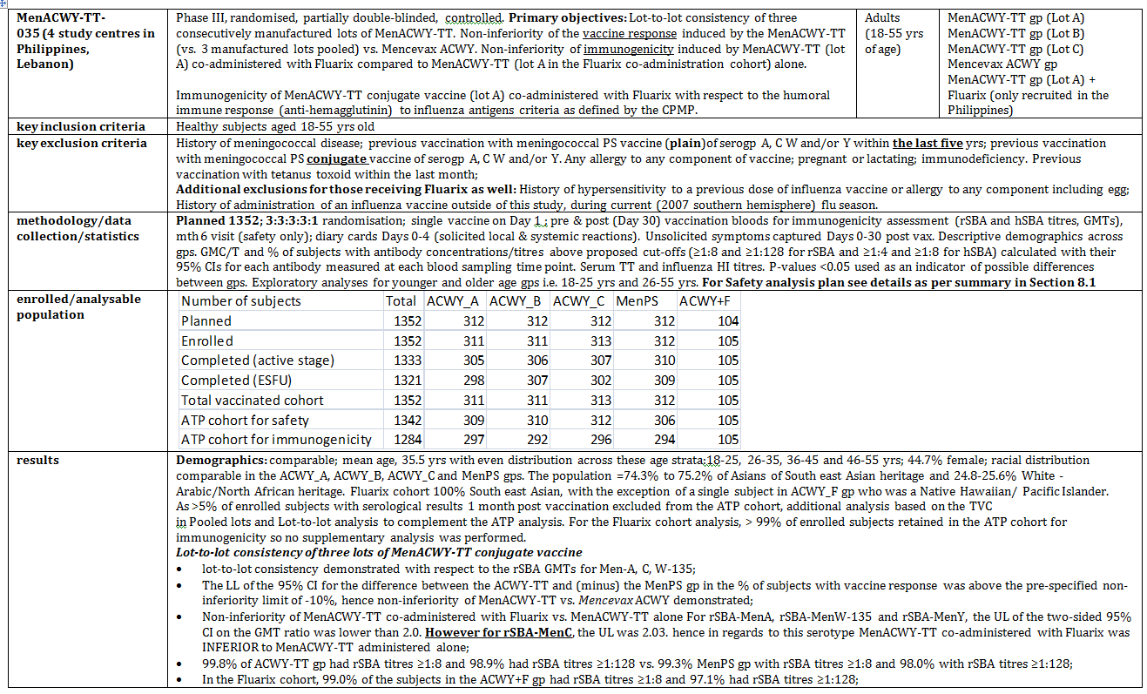
Table 3 continued. Phase III studies in adolescent/adult vaccination
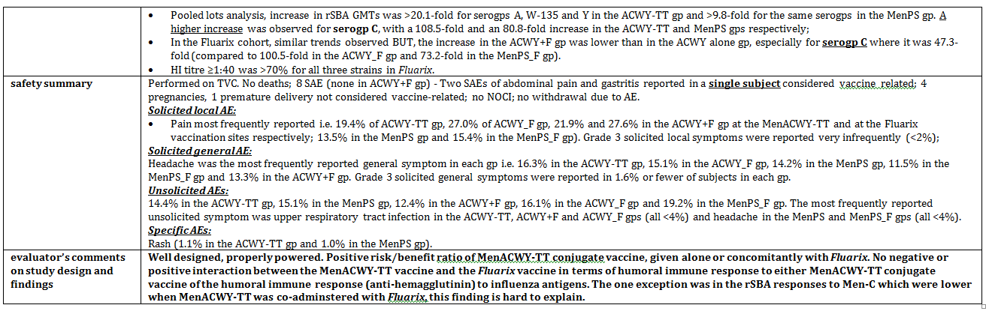
Table 3 continued. Phase III studies in adolescent/adult vaccination
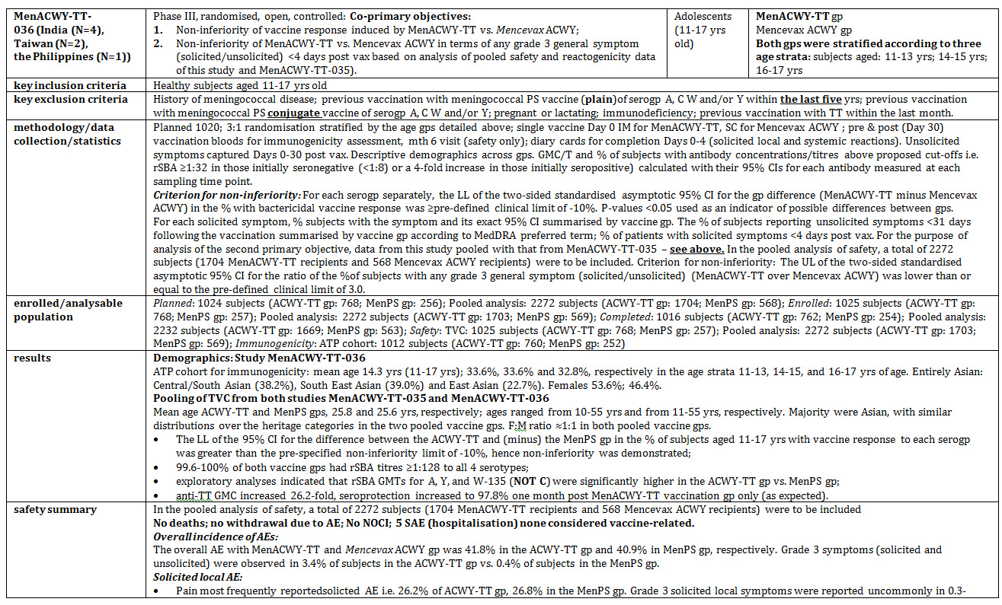
Table 3 continued. Phase III studies in adolescent/adult vaccination
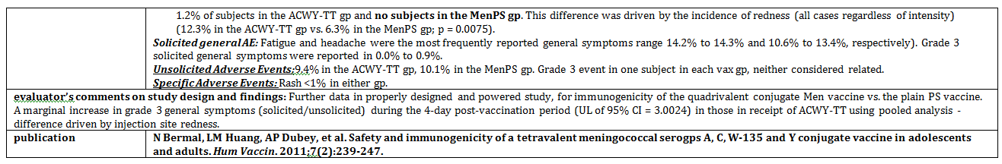
Table 3 continued. Phase III studies in adolescent/adult vaccination
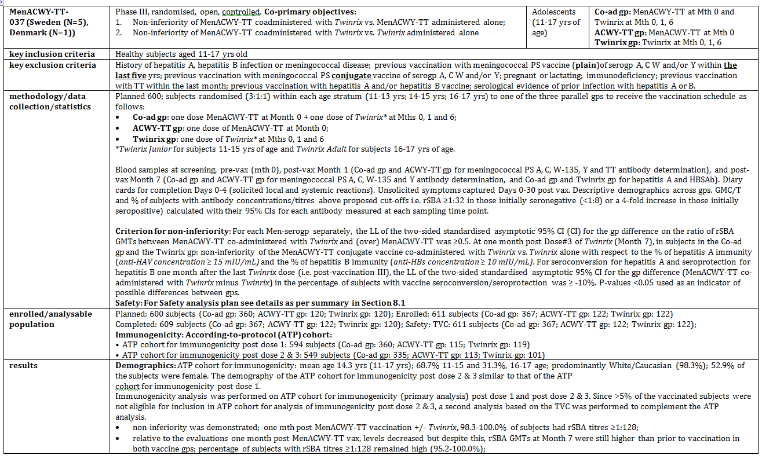
Table 3 continued. Phase III studies in adolescent/adult vaccination
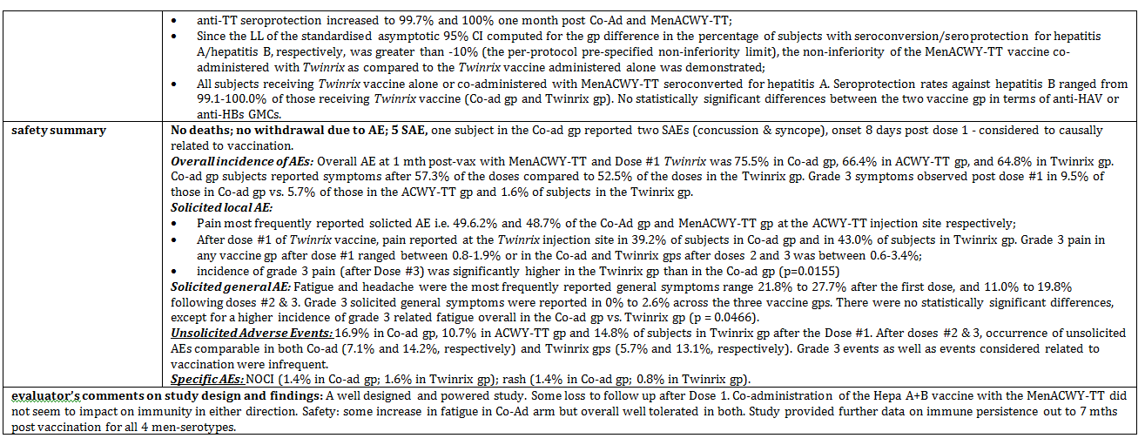
Table 3 continued. Phase III studies in adolescent/adult vaccination
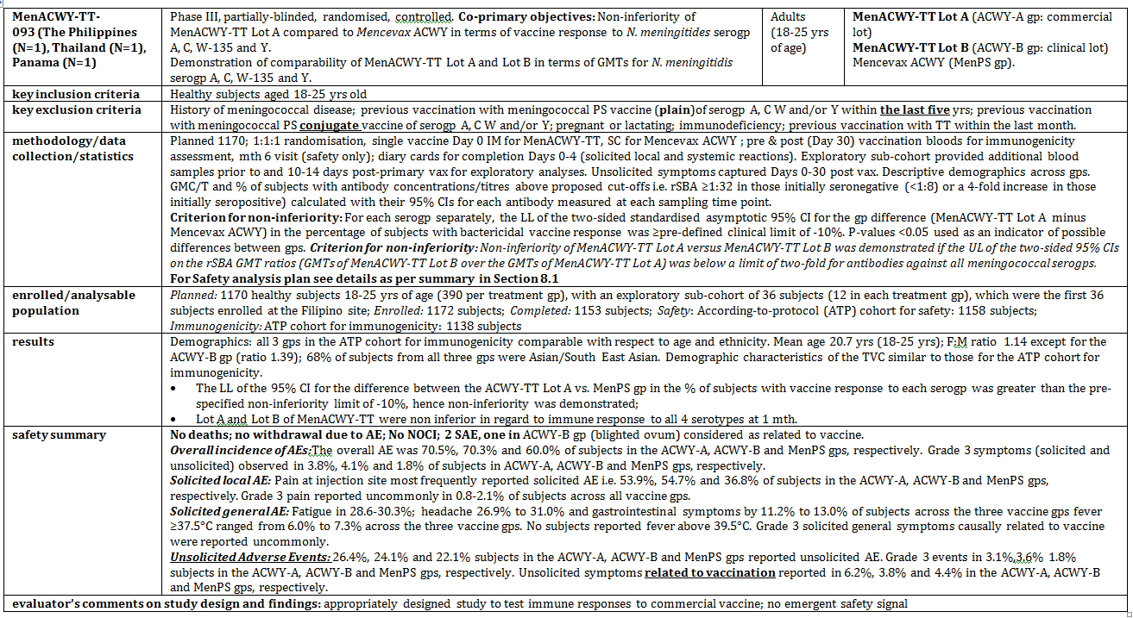
Table 4. Phase III efficacy studies in children
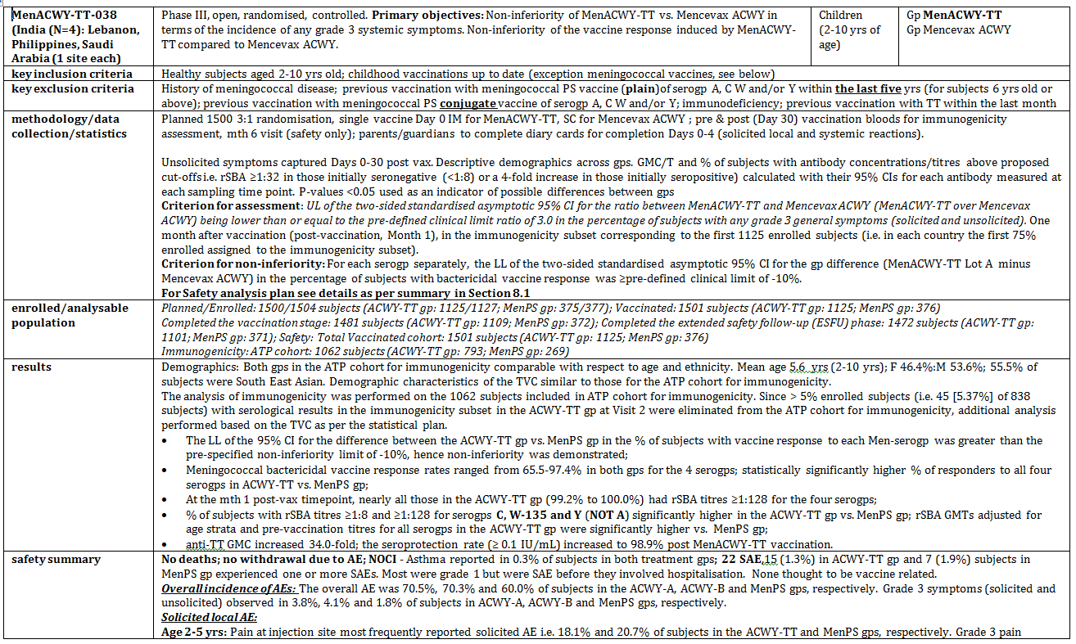
Table 4 continued. Phase III efficacy studies in children
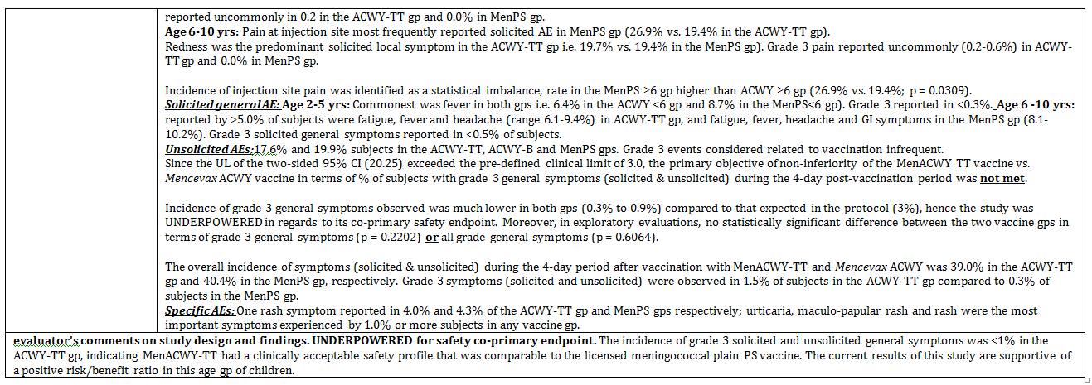
Table 4 continued. Phase III efficacy studies in children
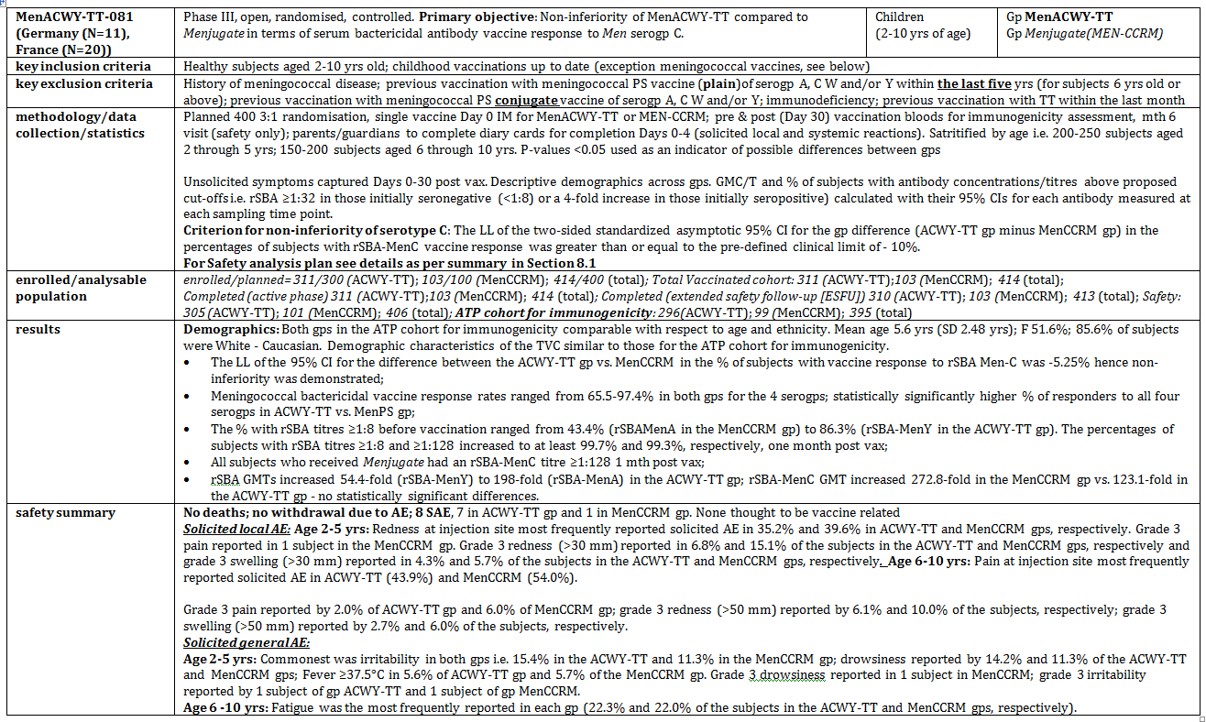
Table 4 continued. Phase III efficacy studies in children
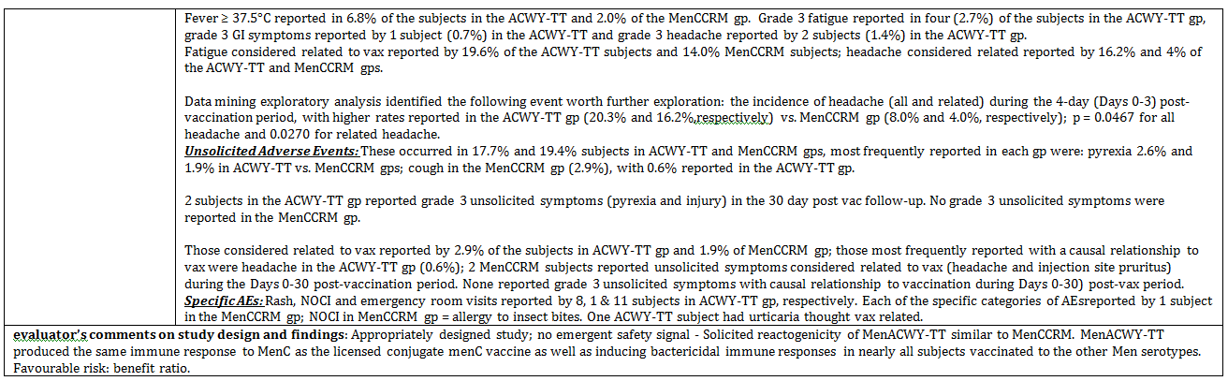
Table 5. Phase III efficacy studies in Toddlers
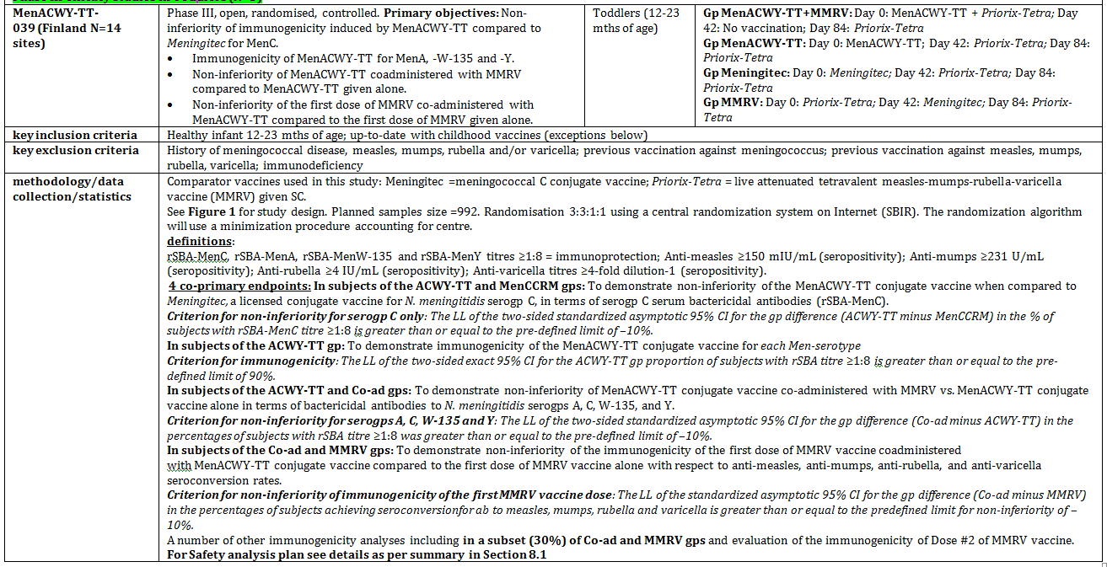
Table 5 continued. Phase III efficacy studies in Toddlers
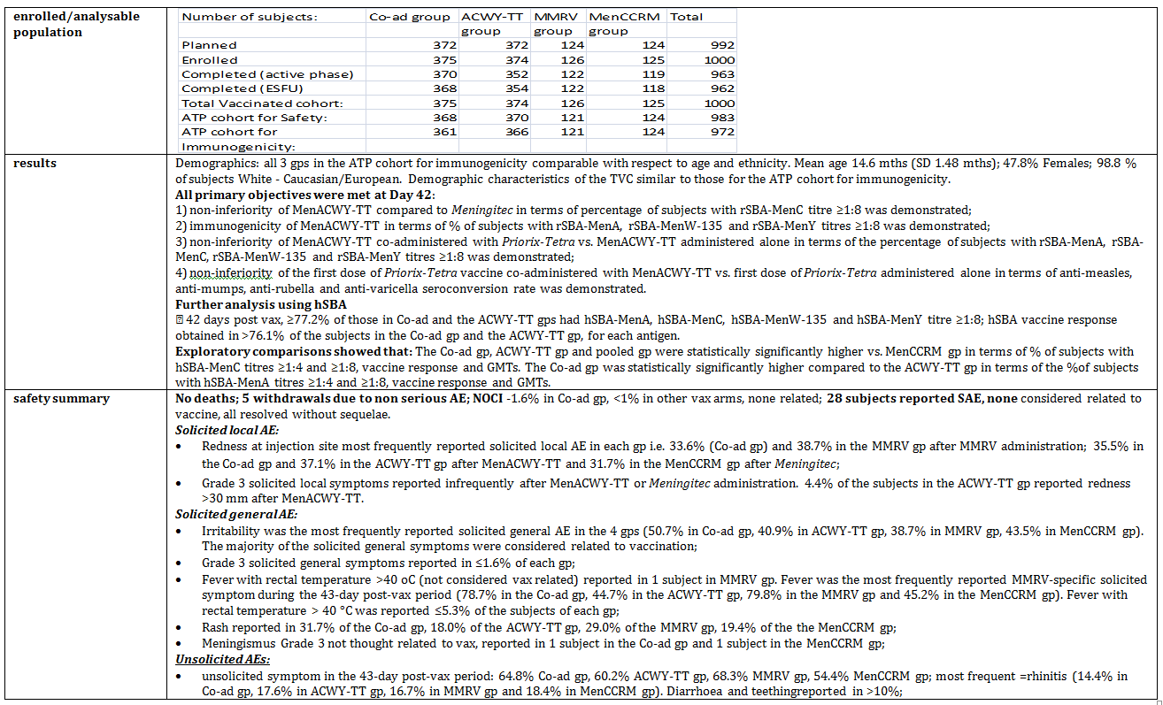
Table 5 continued. Phase III efficacy studies in Toddlers
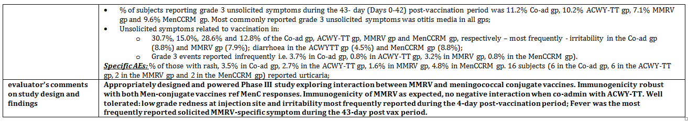
Table 5 continued. Phase III efficacy studies in Toddlers
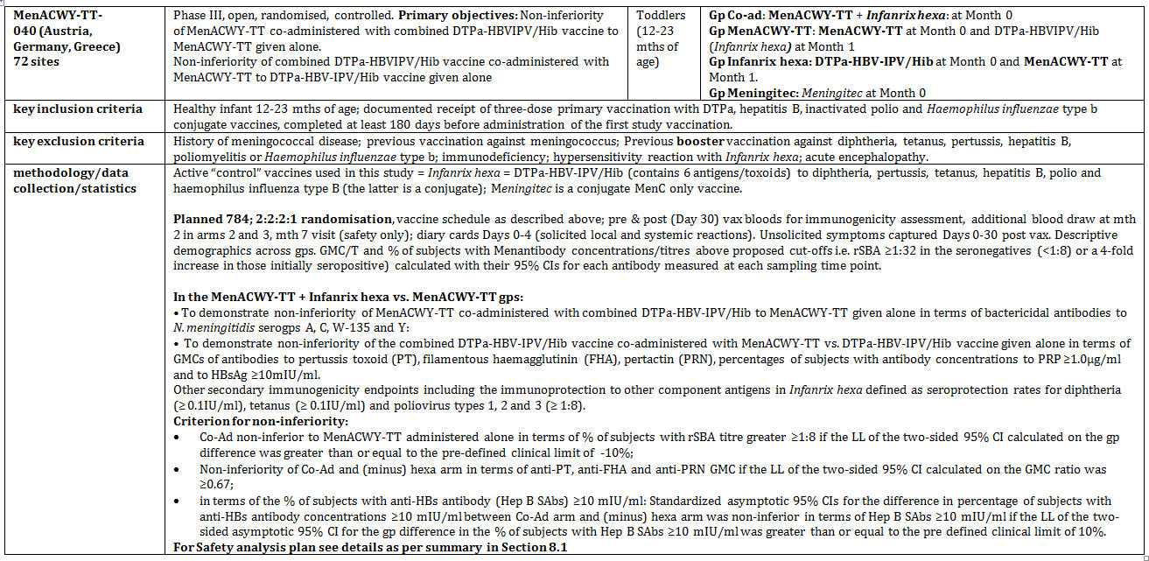
Table 5 continued. Phase III efficacy studies in Toddlers
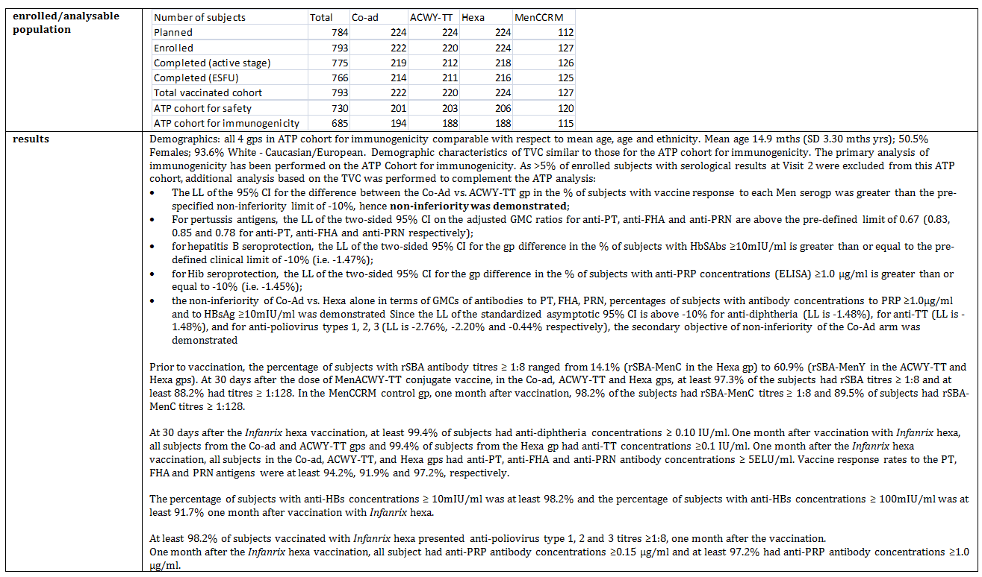
Table 5 continued. Phase III efficacy studies in Toddlers
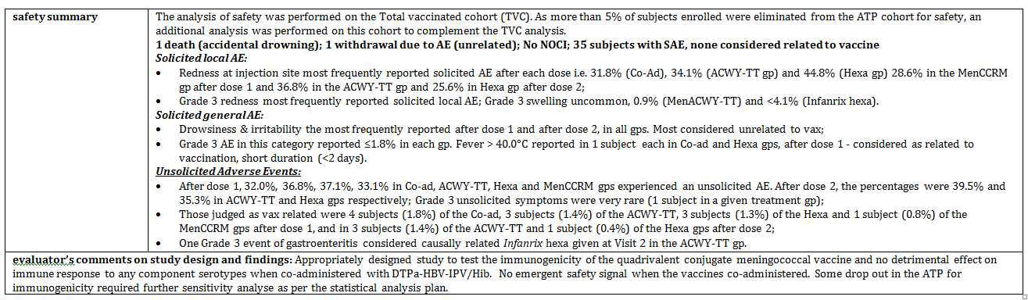
Table 5 continued. Phase III efficacy studies in Toddlers
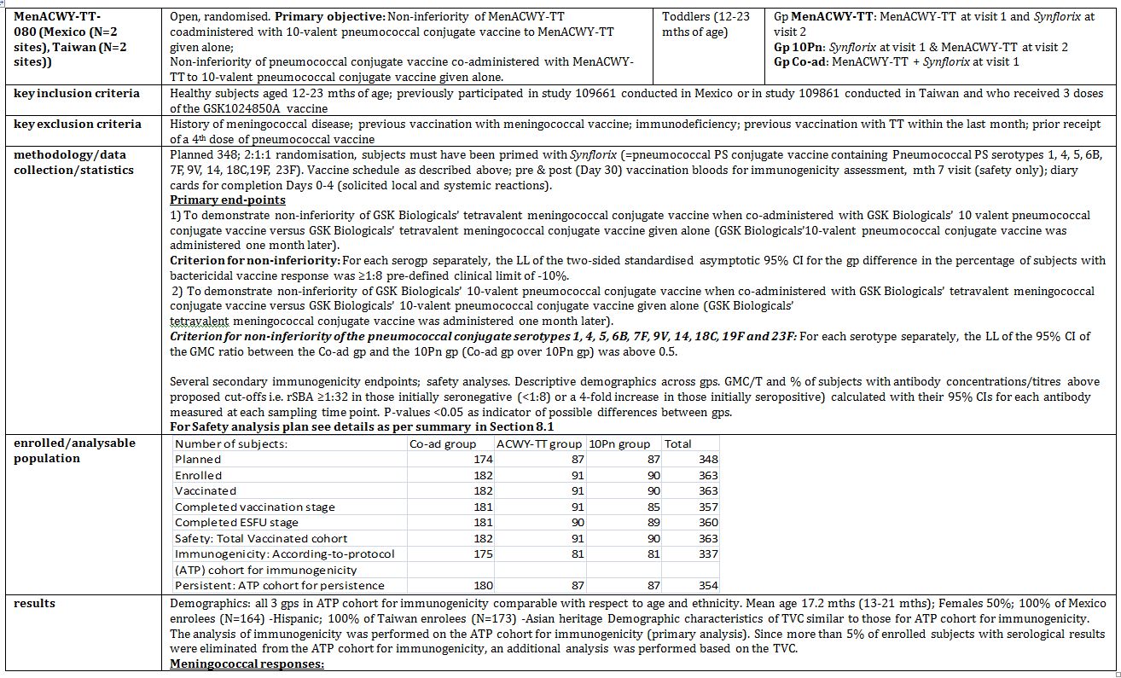
Table 5 continued. Phase III efficacy studies in Toddlers
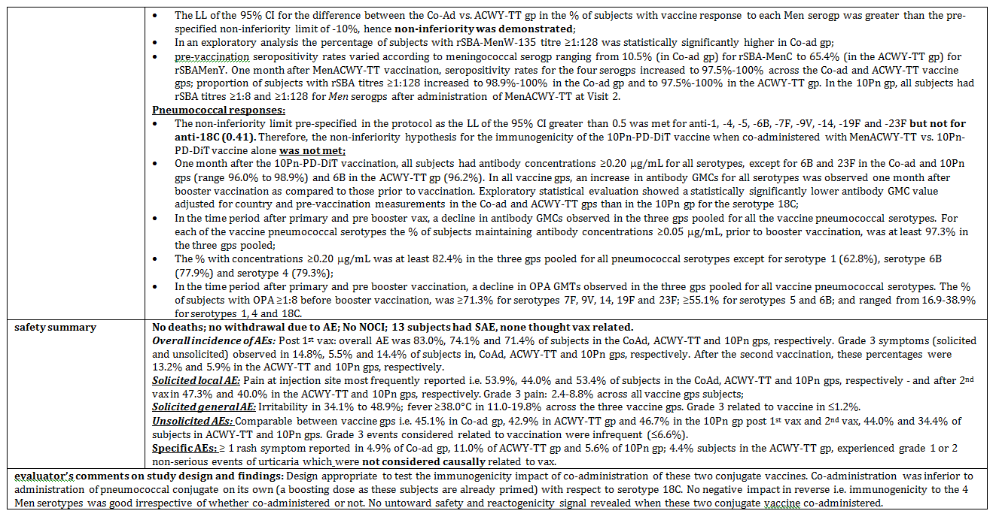

Pivotal efficacy studies

Non-inferiority compared to a licensed tetravalent meningococcal plain PS vaccine in subjects >2 years of age
Immunological non-inferiority of MenACWY-TT vs. Mencevax, in terms of serogroups A, C, W-135 and Y vaccine response was a primary objective in MenACWY-TT-038 (subjects 2 to 10 years of age), MenACWY-TT-036 (subjects 11-17 years of age), MenACWY-TT- 035 (subjects 18-55 years of age) and MenACWY-TT-093 (in subjects 18-25 years of age).
In all studies, the LL of the 95% CIs around the difference between groups in terms of percentage of subjects with rSBA vaccine response was above the pre-defined limit for non-inferiority of -10% for the four serogroups. In addition, study MenACWY-TT-093 included a powered secondary objective in terms of comparability of MenACWY-TT Lot A and Mencevax in terms of GMTs ratios for all 4 Men serogroups.
At one month after vaccination, non-inferiority in terms of rSBA GMTs was demonstrated since the upper limit of the 95% CIs on the rSBA GMT ratios (GMTs of Mencevax over the GMTs of MenACWY-TT Lot A) was below the limit of two-fold for antibodies against all meningococcal serogroups.

Immunogenicity of the MenACWY-TT vaccine compared to licensed meningococcal vaccines in toddlers 12 to 23 months of age and non-inferiority compared to a licensed monovalent MenC conjugate vaccine in toddlers 12 to 23 months of age
MenACWY-TT-039 demonstrated noninferiority of MenACWY-TT vs. Meningitec, in terms of serogroup C serum bactericidal antibodies as the difference between groups (MenACWY-TT minus Meningitec), in terms of percentage of subjects with rSBA-MenC ≥8, forty-two days after the first vaccine dose, and its 95% CI around the difference between groups in terms of percentage of subjects with rSBA-MenC ≥8 was above the pre-defined limit for noninferiority of -10%.
The second co-primary objective of this study was to demonstrate immunogenicity of the MenACWY-TT for the meningococcal serogroups A, W-135 and Y in terms of serum bactericidal antibodies, as the LL of the exact 95% CI for the percentage of those with rSBA-MenA,-W135 and –Y titre ≥8 was above the pre-defined limit of 90%, immunogenicity of MenACWY-TT vaccine with respect to these Men serogroups was confirmed.

Non-inferiority compared to a licensed monovalent MenC conjugate vaccine in children 2 to 10 years of age
The primary objective of study MenACWY-TT-081 was to demonstrate noninferiority of the MenACWY-TT vs. Menjugate, in terms of rSBA-MenC vaccine response. As the LL of the 95% CIs around the difference between groups in terms of percentage of subjects with rSBA-MenC vaccine response was above the pre-defined limit for non-inferiority of -10%, the primary objective of the study was met, hence MenACWY-TT vaccine immunologically non-inferior compared to Menjugate for the MenC response.

Non-inferiority compared to a licensed tetravalent meningococcal conjugate vaccine (Menactra) in subjects 10 to 25 years of age
The primary objective of MenACWY-TT-071 was demonstration of immunological noninferiority of MenACWY-TT (Lot A) vs. Menactra (ACWY-DT) defined as percentage with hSBA vaccine response. This was demonstrated since for each serogroup separately, the LL of the two-sided 95% CI for the difference between groups (ACWY-A minus ACWY-DT) was greater than the pre-defined clinical limit of -10%. Moreover, observed meningococcal bactericidal vaccine response rates for each of the four serogroups in the ACWY-A and ACWY-B groups following administration of MenACWY-TT vaccine ranged from 51.0% (hSBA-MenY in ACWY-B gp) to 82.5% (hSBA-MenC in ACWY-B gp). In the ACWY-DT group, vaccine response rate ranged from 39.0% (hSBA-MenY) to 76.3% (hSBA-MenC).
Exploratory analyses suggested that vaccine response rates for MenY were statistically significantly higher after MenACWY-TT Lot A vs. Menactra and with MenACWY-TT Lot B vs. Menactra, vaccine response rates in terms of hSBA-MenW-135 and hSBA-MenY were also statistically significantly higher. One month post-vaccination, exploratory analyses suggested that the GMT ratios for MenW-135 and Y were significantly higher after MenACWY-TT Lot A or Lot B vs. Menactra. In addition, percentages of subjects with hSBA-MenA,-W-135 and -MenY titres ≥4 and ≥8 were significantly higher after MenACWY-TT Lot A vs. Menactra; hSBA-MenW-135 and -MenY titres ≥4 and ≥8 were significantly higher with MenACWY-TT Lot B vs. Menactra.

Head-to-head comparison with a licensed tetravalent meningococcal conjugate vaccine (Menactra) in subjects 11-25 years of age
See Section on Primary pharmacodynamic effects above.

Other efficacy studies
Phase III persistence studies and the priming study (MenACWY-TT-021) are summarised below. Persistence by Age group is summarised in Section 7.3.

Prime-boost studies
MenACWY-TT-021 evaluated immunogenicity of MenACWY-TT vaccine given 30-42 months post a Mencevax ACWY prime given to subjects aged 2–30 years who participated in a previous study (Mencevax ACWY-004). One month post vaccination, seropositivity rates for the 4 serogroups increased to 100% in both groups; proportion with rSBA titres ≥128 increased to 97.0%-100% in the MPS group and 100% in the noMPS group. Exploratory evaluation of the differences between vaccine groups did not reveal significant differences in terms of percentages of subjects with rSBA titres ≥8 and ≥128. Vaccine response rates were 41.1-83.0% in the MPS group and 76.9-97.3% in the noMPS group for the 4 serogroups. The vaccine response in the MPS group was significantly lower than the noMPS group for all serogroups (exploratory analysis). This lower vaccine response was not surprising, since pre-vaccination titres were already high due to prior vaccination with Mencevax ACWY in that group. Nevertheless, all initially seronegative subjects in the MPS group responded to the vaccine, except one subject for serogroup C.
rSBA GMTs (all serogroups) increased from pre-vaccination to one month post in both vaccine groups (3.9- to 30.1-fold in MPS group and 11.8- to 246.0-fold in the noMPS group). rSBA GMTs adjusted for age strata for all serogroups were significantly lower in those previously vaccinated with Mencevax ACWY. The rSBA GMTs one month after vaccination with MenACWY-TT were higher than one month after vaccination with Mencevax ACWY (post-MPS time point) for serogroups W-135 and Y, similar for MenC and lower for MenA. These results confirm the relative hyporesponsiveness previously reported after primary dose of meningococcal PS vaccine followed by meningococcal conjugate vaccine (Keyserling). However, the high rSBA GMT achieved for all serogroups in the MPS group after the MenACWY-TT vaccination suggest that if sustained immunity against Men serogroups is required in subjects previously vaccinated with plain PS meningococcal vaccine, the administration of MenACWY-TT is safe and immunogenic.

Analyses performed across trials (pooled analyses and meta-analyses)

Demographics
The demographic profile (mean age, gender and racial distribution) was comparable for the MenACWY-TT and the control groups in the different studies. The distribution of race/ethnicity among the individual studies reflects the regions where the studies were conducted (Europe, Asia, Central America and North America).

Immunogenicity of MenACWY-TT in the Toddler age group i.e. 12-23 months of age
Immunogenicity in Toddlers is particular important for special review as it is this age group where conjugate vaccines have potential to prime the immune response to capsulated organisms more effectively than PS vaccines. MenACWY-TT immunogenicity was evaluated using rSBA titre changes [by age strata]. In addition, in MenACWY-TT-013, -027, -039 and -055 hSBA titres ≥4 and ≥8, hSBA GMTs and vaccine response were assessed [by age strata] (hSBA and rSBA vaccine response not analysed in -055 as blood sampling at pre vaccination time-point not planned in the protocol). The results of this age stratification (12 -15 months, 16-19 months and 20-23 months) analysis should be interpreted with caution, because these studies were not designed to assess immunogenicity by age strata and smaller sample sizes may lead to imprecision in point estimate when comparing between age strata. Co-administration studies excluded to avoid bias.

Serogroup C immunogenicity
MenC-CRM conjugate vaccine (Meningitec) was used as the control vaccine. Analyses of rSBA data indicate the immunogenicity induced by the MenC component of MenACWY-TT resulted in percentages with rSBA-MenC titres ≥8 and ≥128, rSBA MenC GMTs and rSBA vaccine response that was comparable to those elicited by Meningitec regardless of age stratum in the second year of life.
The analyses of hSBA data indicate that immunogenicity induced by the MenC component of MenACWY-TT result consistently in higher observed percentage of subjects with hSBA-MenC titres ≥8, hSBA-MenC GMTs and hSBA vaccine response vs. Meningitec, regardless of age stratum in the second year of life. Even in the youngest age stratum hSBA MenC GMTs appeared to be higher than all age strata in the Meningitec group.

Serogroups A, W-135 and Y
For serogroups A, W-135 and Y, no comparator vaccines are available in the toddler age group. However, if the responses observed in older children ((i.e. 2 to <11 years of age with rSBA; 6 to <11 years of age with hSBA) when the comparator vaccine was the quadrivalent PS vaccine (Mencevax), study MenACWY-TT-027, rSBA GMT and vaccine response observed in toddlers given MenACWY-TT-were comparable to that following Mencevax in children 2 to <11 years of age. Although hSBA GMTs were lower for the younger age group, percentages of subjects with immunoprotective Men titres and vaccine response following MenACWY-TT were higher than or close to those reported in older children (6 to <11 years) with Mencevax in study -027.

Immune persistence data by age strata

Persistence of the immune response in young children vaccinated (12-23 months of age)
Using rSBA titres: Persistence of the immune response in subjects primed at 12-23 months of age was evaluated in studies MenACWY-TT-014 (15 months after vaccination), MenACWY-TT- 028/-029/-030 (12, 24 and 36 months after vaccination) MenACWY-TT-048 (24 months after vaccination), and MenACWY-TT-062 (12 months after vaccination). The percentage of subjects with rSBA titres ≥8 after vaccination with MenACWY-TT 12, 15, 24 and 36 months after vaccination remained high for all serogroups (≥94.7% for serogroups A, W-135 and Y, and ≥87.4% for MenC). The rSBA GMTs decreased between one month after vaccination and the persistence time points but remained higher than prior to vaccination for the four serogroups. In studies including Meningitec as a control, the percentage of subjects with MenC rSBA titres ≥8 at the persistence time points were significantly higher in subjects vaccinated with MenACWY-TT than in those vaccinated with Meningitec except in study -030 – see below.
Using hSBA titres: 12-36 months post MenACWY-TT, percentages with hSBA-MenA antibody titres ≥4 and ≥8 were low i.e. 21.8-25.1% and 5.6-23.0% respectively. In contrast, hSBA MenC titres ≥4 and ≥8 ranged from 87.5-96.3% in MenACWY-TT recipients and 52.6-75.8% in Meningitec recipients. The percentage of subjects with hSBA-MenC titres ≥4 and ≥8 and GMTs were higher in the MenACWY-TT groups vs. Meningitec groups except in study -030 at month 36 – and this finding is biased by the much higher drop out from the Meningitec arm, so those left in that arm were the higher responders in that group. The percentage with hSBA MenW-135 titres ≥ 4 and ≥ 8 ranged from 79.9-100% 12 to 36 months after vaccination with MenACWY-TT. Similarly, the percentage with hSBA MenY titres ≥4 and ≥ 8 ranged from 73.6% to 96.2%. Pardoxically, in MenACWY-TT-027, hSBA to –W and -Y were higher at month 12 post vaccination and fell in subsequent visits (month 24 and 36).
Further analyses by age strata within this group, must be interpreted with caution as the numbers become rather small. Overall, the data suggest that age at vaccination in the second year of life does not generally impact the percentage of subjects with SBA titres ≥8 at persistence time-points and the persistence in terms of percentage of subjects with SBA titres above cut-off and GMTs was higher than that of MenC control group.

Persistence of the immune response in children and adolescents vaccinated between 2 and 17 years of age
Using rSBA titres: For subjects primed at 2-10 years of age, persistence of the immune response was evaluated at 15 months, and at 12, 24 and 36 months after vaccination in MenACWY-TT-014 and MenACWY-TT-028/029/030, respectively. For subjects primed at 11-17 years of age persistence of the immune response was evaluated 12 and 24 months after vaccination in studies MenACWY-TT-016/-017 and 24 months after vaccination in MenACWY-TT-043. In all persistence studies and in both age strata the percentages of subjects with rSBA titres ≥8 after vaccination with MenACWY-TT at the persistence time points remained high for all serogroups (≥98.6%). The rSBA GMTs decreased between one month post vax and the persistence time points but remained higher than prior to vaccination for all 4 serogroups.
Exploratory analyses, performed to compare immunogenicity persistence after MenACWY-TT and Mencevax showed rSBA GMTs for all 4 serogroups were higher with MenACWY-TT 15 and 24 months post vaccination in subjects vaccinated at 2-10 years of age (MenACWY-TT- 014; MenACWY-TT-029). In MenACWY-TT-043 (in subjects vaccinated at 11-17 years of age), 24 months after vaccination, the rSBA GMTs for MenA, W-135 and Y were higher in MenACWY-TT vs. Mencevax recipients, but rSBA GMTs for MenC were lower in MenACWY-TT subjects.

Persistence of the immune response in children (2 to 10 years of age)
Using hSBA titres: In studies in children 12-15 months after MenACWY-TT vaccination, the percentage with hSBA-MenA antibody titres ≥4 and ≥8 were low, ranging from 16.3 -31.0%. The percentage with hSBA-MenA antibody titres ≥4 and ≥8 following Mencevax administration were also low i.e. 0.0 to 11.4%; immunoprotective hSBA MenC titres and GMTs were higher in MenACWY-TT group vs. Mencevax group 12-15 months post vaccination. Percentage with hSBA MenC titres ≥4 and ≥8 was 94.3-98.2% (MenACWY-TT) and 32.3-77.3% (Mencevax). The percentage with hSBA-MenW-135 titres ≥4 and ≥8, 12-15 months after MenACWY-TT ranged from 95.8-100% and were higher compared to Mencevax (12.9-37.3%). Similarly, the percentage with hSBA-MenY titres ≥4 and ≥8 12-15 months following MenACWY-TT and Mencevax vaccination ranged from 90.6-100% and from 33.3% to 63.2% respectively. Increases in hSBA MenW-135 and MenY GMTs were observed 12-15 months post MenACWY-TT vaccination in studies conducted in children.

Persistence of the immune response in adults
Using rSBA titres: Persistence of the immune response in adults was evaluated 1 and 2 years after vaccination (MenACWY-TT-016 and -017) and 18, 30 and 42 months after vaccination (MenACWY-TT-024, -025 and -026). In all persistence studies, percentage with rSBA titres ≥8 after vaccination with MenACWY-TT at the persistence time points remained high for all serogroups (≥99.2%). rSBA GMTs decreased between one month post vaccination and the persistence time points but remained higher than prior to vaccination for all four serogroups.
For the persistence studies in which more than one persistence timepoint is available (studies MenACWY-TT-024/025/026, and MenACWY-TT-016/017), the highest drop in titres occurred between the post-vaccination and first persistence timepoint, with smaller declines in titres between first and subsequent persistence timepoints. Exploratory analyses showed at year 2, rSBA MenA, -W-135 and -Y GMTs were statistically significantly higher in MenACWY-TT vs. Mencevax groups (-017=persistence MenACWY-TT-015). Forty-two months after primary vaccination, MenACWY-TT recipients had significantly higher GMTs vs. Mencevax ACWY-group for serogroup MenW-135 in study MenACWY-TT-026 (persistence of MenACWY-TT-012).

Persistence of the immune response in adolescents and adults
Using hSBA titres: MenACWY-TT-025/026 evaluated immune persistence 30 and 42 months respectively after vaccination of 15 to 19 year olds with MenACWY-TT or Mencevax in MenACWY-TT-012. 42 months after vaccination with MenACWYTT, hSBA titres ≥4 and 8 persisted in ≥88.9% of subjects for serogroups C, W-135 and Y. For MenA, persistence was lower in MenACWY-TT group, i.e. 61.1% and 50.0% hSBA titres ≥4 and ≥8 respectively; hSBA titres ≥4 and 8 persisted in ≥81.3% of Mencevax subjects for all four serogroups. Note the small sample size for these data.
Twelve month persistence data in 11-25 year olds given MenACWY-TT or Menactra (MenACWY-TT-059) revealed immunoprotective hSBA titres for MenC, MenW-135, and MenY ranging from 94.9%-98.5% vs. 73.3%-86.7% for MenACWY-TT vs. Menactra recipients respectively, this difference was statistically significant. For MenA, immune persistence was lower i.e. hSBA titres ≥8 in 29.1% and 31.3% in MenACWY-TT and Menactra groups respectively; in both vaccine groups this represented a considerable titre decline since one month post vaccination levels. This contrasts with some of the paradoxical increases in MenW titres (MenACWY-TT vax) seen at one year.

Evaluator’s conclusions on clinical efficacy: Conclusions on protective efficacy
Immunogenicity studies conducted in subjects ≥12 months of age demonstrate that one IM dose MenACWY-TT vaccine induces responses similar to or higher than licensed meningococcal vaccines. MenACWY-TT induces immunological memory against the four Men serogroups even in toddlers 12-14 months of age, historically an age group not/poorly responsive to meningococcal PS vaccines.
Follow-up studies demonstrate immunopersistence similar/higher than those elicited by licensed meningococcal vaccines (Meningitec; Mencevax) using the GSK rSBA assay. Even in the youngest age group, hSBA MenC GMTs were higher compared to all age strata in the Meningitec group.
For serogroups A, W-135, and Y, although the hSBA GMTs trended lower for the younger age group, percentages of subjects with SBA titres ≥8, GMTs and vaccine response reported for the three serogroups following a single dose of MenACWY-TT were higher or very close to those reported in an older age group (6 to <11 years) with Mencevax. Although SBA titres trended to be higher at persistence time-points for the older age groups in toddlers, there is limited precision in the point estimates because of the small persistence subsets at these persistence time-points and most 95% CIs overlap for the MenACWY-TT group.
In terms of boosting with MenACWY-TT in prior recipients of a plain PS vaccine, GMTs are lower for MenA, and to a lesser extent for the other serogroups, but there is induction of strong responses (3.9-30.1-fold increase of GMTs for all serogroups) without any worrisome safety signal.
These data support both proposed indications of the MenACWY-TT vaccine. i.e. FIRST, active immunisation against invasive meningococcal disease caused by N. meningitidis serogroups A, C, W-135 and Y in individuals 1- 55 years of age. The vaccine is to be administered intramuscularly (IM) as a one-dose vaccination schedule. The SECOND proposed indication is as a Booster vaccination in subjects who have previously been vaccinated with a plain i.e. non conjugate PS meningococcal vaccine.

Clinical safety

Studies providing evaluable safety data
All the Phase II & III studies summarise safety data. Solicited and unsolicited safety information was gathered. Local AE solicited were pain, redness and swelling at the IS. General AE solicited were drowsiness, fever (≥37.5°C oral/axillary or ≥38°C rectal), irritability/fussiness, and loss of appetite in subjects < 6 years, and fatigue, fever (≥37.5°C oral/axillary), gastrointestinal symptoms (i.e. nausea, abdominal pain, vomiting, and diarrhoea), and headache in subjects ≥6 years old. Diary cards were completed for Days 0-3 and/or Days 0-7 post vaccination (MenACWY-TT 012, -013, -052 and -055); in children/toddlers, completed by parent/guardian.
Unsolicited AEs were collected Day 0-30 post vax. Intensity of solicited local/general AEs assessed by the investigator according to a standard intensity scale and these were comparable across most of the studies; the intensity scales differed in the younger age group (<6 years old).
AE, SAE, New Onset Chronic Illness (NOCI) were collected at the 6 months post the last vaccination visit (phone interview) or at a later date in persistence studies.
In terms of statistical analyses for each solicited symptom, % subjects with symptoms (days 0-3 and/or Days 0-7) and their exact 95% CI were summarised by vaccine group. The % of subjects reporting unsolicited symptoms <31 days following vax was summarised by vaccine group according to MedDRA preferred term; % of patients with solicited symptoms <4 and/or <7 days post vax was summarised/analysed by vaccine group.
- Pivotal efficacy studies
As above, note that laboratory tests did not form part of the safety assessment.
- Pivotal studies that assessed safety as a primary outcome
See Section 8.1.1.
- Dose-response and non-pivotal efficacy studies
The dose-response and non-pivotal efficacy studies providing safety data were as follows:
MenACWY-TT-012 and -013 provided immunogenicity and safety data on adolescents and Toddlers/children respectively in these Phase II MenACWY-TT vaccine formulation selection studies.
Safety data were collected in Children, adolescents and adults (MenACWY-TT-052 and -071); Toddlers and children (MenACWY-TT-027), Toddlers (MenACWY-TT-055).
MenACWY-TT-016 EXT-015 Y1& Y2 provided longer term safety data 1 and 2 years post primary vaccine exposure in adolescents and adults; MenACWY-TT-016 EXT-015 Y1& Y2 provided longer term safety data 1 and 2 years post primary vaccine exposure in adolescents and adults.
MenACWY-TT-024 EXT-012 M18 & M30 & M42 – longer term safety data at months 18, 30 and 42 post primary vaccine exposure in Adolescents and adults. MenACWY-TT-059 EXT-052 Y1 – provided longer term safety data at 1 year post primary vaccine exposure in adolescents and adults.
Study MenACWY-TT-014 BST-013 – provided longer term safety data at 15 months post primary vaccine exposure in Toddlers and children, and further safety data on boosting with a 1/5 dose of Mencevax ACWY.
MenACWY-TT-028 EXT-027 Y1 & Y2 & Y3 – provided longer term safety data at 1, 2 and 3 years post primary vaccine exposure in Toddlers and children. Study MenACWY-TT-062 EXT 055 Y1provided longer term safety data at 1 year post vaccine exposure in Toddlers.
- Other studies evaluable for safety only
Not applicable.
- Clinical pharmacology studies
Not applicable.

Pivotal studies that assessed safety as a primary outcome

Studies MenACWY-TT-015, -036, -038
MenACWY-TT-015 had a co-primary endpoint evaluating noninferiority of MenACWY-TT vs. Mencevax ACWY in terms of grade 3 general symptoms (solicited/unsolicited) within 4 days of vaccination. Grade 3 general symptoms reported by 1.3% and 0% of the MenACWY-TT and Mencevax ACWY groups respectively (P-value= 0.1921).
Study MenACWY-TT-036, which also had a similar safety co-primary endpoint as -015, showed, on pooled safety and reactogenicity data, from MenACWY-TT-036 (11-17 year olds) and MenACWY-TT-035 (18-55 year olds), marginally more grade 3 general symptoms in MenACWY-TT recipients 2.0% (vs. 1.4% in Mencevax ACWY) but this was still lower than the estimated background rate (3%) extrapolated from another meningococcal vaccine, and the difference was not statistically significantly different.
In MenACWY-TT-036, reactogenicity profiles were comparable between the MenACWY-TT and Mencevax ACWY vaccines. Pain at injection site (IS) reported in 26.2% (MenACWY-TT) and 26.8% (Mencevax ACWY). Grade 3 solicited local symptoms were uncommon, 0.3-1.2% of MenACWYTT subjects.
Solicited general symptoms were comparable across groups i.e. fatigue (14.2-14.3%) and headache (10.6-13.4%). Grade 3 solicited general symptoms were rare i.e. 0.0-0.9%. Fever reported infrequently, incidence 5.1-7.2% across the two vaccine groups.
Unsolicited AEs were comparable in MenACWY-TT (9.4%) and Mencevax ACWY (10.1%) groups. Grade 3 events as well as events considered related to vaccination infrequent i.e. 1.4% (MenACWY-TT) and 1.2% (Mencevax ACWY) groups. No clinical pattern of unsolicited AEs revealed.
A co-primary objective of MenACWY-TT-038 (children 2-10 years old) was to demonstrate non-inferiority of MenACWY-TT vs. Mencevax ACWY in terms of grade 3 general symptoms (solicited/unsolicited) within 4 days of vaccination. Whilst the pre-determined criteria for non-inferiority (UL 3.0), were not met, grade 3 general symptoms were lower in both groups (0.3-0.9%) vs. expected (3%), and the difference between groups was not statistically significant (p = 0.2202). Solicited reactogenicity data and other observed AEs were comparable to Mencevax ACWY i.e. Pain at IS was the predominant solicited local symptom post vaccination in 2 to 5 year olds (18.1-20.7%); in 6 to 10 year olds, 19.4% of MenACWY-TT vs. 26.9% in Mencevax ACWY groups experienced IS pain. Solicited general symptoms were equivalent i.e. most commonly fever in 2-5 years old (6.4-8.7%); in 6 -10 year olds, solicited general symptoms ranged from 4.6-10.2% in both vaccine groups, most commonly, headache (9.4-10.2%). Grade 3 solicited local/general symptoms uncommon; ≥1 unsolicited symptom reported in 17.6% MenACWY-TT and 19.9% Mencevax ACWY subjects. Grade 3 events and events considered related to vaccination were infrequent. Analysis of unsolicited symptoms did not reveal any particular trends.

Study completion and withdrawals
Of 10380 subjects vaccinated in the primary vaccination studies, 136 (1.3%) were withdrawn. Among 8007 subjects vaccinated with MenACWY-TT, 106 (1.3%) were withdrawn. One MenACWY-TT vacinee was withdrawn due to an SAE not considered by the investigator to be related to vaccination; five MenACWY-TT-vaccinated subjects were withdrawn due to non-serious AE.

Overall extent of exposure
Of the completed studies, 9366 subjects aged 1-55 years have been vaccinated with one dose of MenACWY-TT vaccine; data from 8108 subjects included in the pooled analysis (excludes MenACWY-TT-021(boosting), MenACWY-TT-071, 224 in MenACWY-TT-040 (group Infanrix hexa) and 90 in MenACWY-TT-080 (group Pneumococcal). A total 189 subjects in MenACWY-TT-055 (2-dose group) received 2 doses of MenACWY-TT. The pooled analysis included data from 10400 subjects vaccinated with MenACWY-TT or a comparator vaccine at first study visit. Of these 10400 subjects, 8108 vaccinated with MenACWY-TT, 1617 with Mencevax ACWY, 375 with Meningitec, 103 with Menjugate and 197 with Menactra.

Adverse events

All adverse events (irrespective of relationship to study treatment)

Pivotal studies

Summary of pooled analysis of solicited local adverse events reported during the 4 day (Days 0-3) post-vaccination period:
Methodology (see above), in addition, MenACWY-TT-039 included rash/exanthema, parotid/salivary gland swelling, meningism including febrile convulsions (Days 0-42) and fever recorded Days 0-14 and screened for Day 15-42 because of co-administration with MMRV. MenACWY-TT-040 and 10PN-PD-DIT-014 included extensive swelling reaction (i.e. swelling with a diameter >50mm) Days 0-3) post-vaccination period as DTPa-HBV-IPV/Hib vaccine co-administered.
Solicited local AE: In the <2 year olds, incidence of redness, pain and swelling at IS were 33.0%, 27.4% and 17.9%. In the 2-5, 6-10, 11-17 and 18 years age groups the following were reported i.e. pain (24.1%, 33.8%, 39.9%, and 37.3% respectively), redness (23.3%, 26.1%, 14.3% and 16.8% respectively) and swelling (13.4%, 17.7%, 11.5% and 12.5% respectively). Grade 3 solicited local symptoms low i.e. 0.2-1.5% for pain, 1.2-3.6% for redness, 1.4-2.5 % for swelling.
Data mining analyses of solicited local AEs in the pooled Meningitec controlled studies (MenACWY-TT-013, -027, -039 and -040) revealed redness as the most common ISR (39.6% in MenACWY-TT group; 31.4% in Meningitec group). There was a higher incidence of solicited pain, redness and swelling at the IS with MenACWY-TT i.e. 27.4%, 39.6% and 19.3%, respectively vs. 20.3%, 31.4% and 14.6%, respectively, with Meningitec but all P-values non significant with the exception of pain at the injection site of grade 3 intensity.
Data mining analyses (solicited local AEs) in the Menjugate controlled study (MenACWY-TT-081) revealed redness as most common ISR in 2-5 years olds and pain at IS in 6-10 year olds with no difference in incidence between the two vaccines. In the pooled Mencevax ACWY controlled studies (MenACWY-TT-012,-013,-015,-027,-035,-036,-037,-038 and -093) most frequently reported solicited local AE was IS pain in all age groups in both vaccine arms. The incidence of grade 3 redness and grade 3 swelling was higher in the MenACWY-TT group vs. Mencevax ACWY in 2-5 and the 6-10 year olds. These imbalances were also detected in the pooled 6-10 and 11-17 age groups. The incidence of redness and swelling was higher in the MenACWY-TT group vs. Mencevax ACWY in 11-17 year olds. These imbalances were also detected in the pooled 6-10 and 11-17 age groups. Incidence of local pain (any), redness (any and grade 3) and swelling (any and grade 3) was more frequent in the MenACWY-TT group compared to the Mencevax ACWY group in the 18 year olds.
No heterogeneity across studies detected (Breslow and Day test with respect to incidence of solicited local AEs reported within 4-day post-vaccination) except: IS swelling in 2-5 year olds (10.5 % in MenACWY-TT vs. 10.7% in the MencevaxACWY, P-value interact =0.036); IS swelling in ≥18 years age group (11.6 % in MenACWY-TT and 6.9% in the Mencevax ACWY, P-value interact = 0.032). Most frequent solicited local AE in both MenACWYTT and Menactra groups, in the 11-17 and 18 years age groups, was IS pain, differences non-significant.

Summary of pooled analysis of solicited general adverse events reported during the 4 day (Days 0-3) post-vaccination period
The most frequently reported solicited general AE in <2 years olds, were irritability (40.6%) drowsiness (32.1%), loss of appetite (24.8%) and fever (20.3%). In the 2-5 year olds, drowsiness (10.8%), irritability (9.2%), loss of appetite (8.2%) and fever (8.1%) were reported. In the 6-10 year olds, headache (15.6%), fatigue (15.1%), GI upset (9.1%) and fever (8.4%) reported. In 11-17 year olds, fatigue (20.9%), headache (20.8%), GI upset (8.9%) and fever (5.3%) reported. In 18 year olds, in order of frequency, headache (19.9%), fatigue (19.1%), GI symptoms (8.4%), fever (5.7%). Grade 3 events in 12-23 months and 2-5 years age groups low (0.1-0.9%); likewise, low in 6 year olds i.e. fatigue (1.0-1.4%), headache (0.7-1.0%), GI upset (0.4%), fever (0.2%). For both subjects 1-5 and 6 years of age, majority of solicited general symptoms were considered vaccine related.

Comparison with the control vaccines
In Meningitec controlled studies (MenACWY-TT-013, -027, -039 and -040), most frequently reported solicited general AE (both groups): irritability in 40.2% MenACWY-TT group and 33.2% of Meningitec group; Data mining revealed fever 37.5°C and fever >38.0°C in the MenACWY-TT group (17.6% and 5.8%) was higher vs. Meningitec (13.5% and 3.2%) respectively. Heterogeneity across studies was detected from the Breslow and Day test for the following events indicating that for these events the imbalances between the MenACWY-TT and the Meningitec groups (as measured by Relative Risks) varied across studies: Fever >38.0°C (5.8% of subjects in the MenACWY-TT group and 3.2% of subjects in the Meningitec group, P-value interact = 0.029); Irritability assessed as related to vaccination (36.5% of MenACWY-TT group vs. 28.9% of Meningitec group, P-value interact = 0.037).
In the Menjugate controlled study, MenACWY-TT-081 (in 2-5 year olds), drowsiness and irritability were reported in 14.2% and 15.4% of MenACWY-TT group and 11.3% and 11.3% of subjects in Menjugate group respectively. In 6-10 year olds, 22.3% and 22% of MenACWY-TT and Menjugate group respectively reported fatigue. Data mining analysis indicated headache (assessed as related to vaccination by investigator) in the 6-10 year olds was higher in MenACWY-TT group vs. Menjugate group, 16.2% vs. 4.0% respectively, P-value = 0.048);
In Mencevax ACWY controlled studies (MenACWY-TT-012,-013,-015,-027,-035,-036,-037,-038 and -093), in 2-5 year olds, drowsiness was the most frequently reported AE in 10.1% MenACWY-TT subjects and 8.2% Mencevax subjects followed by irritability in 7.8% and 9.6% MenACWY-TT and Mencevax ACWY subjects respectively. In 6-10 and 11-17 year olds, headache reported in 12.4% and 15.8% of subjects in MenACWY-TT and 11.1% and 12.9% in the Mencevax ACWY groups respectively. Fatigue assessed as related to vaccination by the investigator (11.1% of MenACWY-TT group and 10.2% of Mencevax ACWY group, P-value interact = 0.033) in the 6- 10 year olds. In ≥18 year olds, headache in 20.7% MenACWY-TT and 20.4% fatigue in Mencevax ACWY groups. Data mining analysis indicated headache assessed as related to vaccination in the 6-10 and 11-17 age groups was significantly higher in MenACWY-TT subjects. In ≥18 year olds, fatigue and GI symptoms (4.1% of MenACWY-TT group and 3.5% of subjects in Mencevax ACWY group, P-value interact = 0.035) were significantly more common in the MenACWY-TT group;
In the Menactra controlled study (MenACWY-TT-052), in 11-17 year olds, headache most frequently reported in both groups i.e. 27.9% in MenACWY-TT and 31.6% of Menactra subjects. In subjects ≥18 years old, fatigue reported in 32.8% and 40.0% of MenACWY-TT and Menactra subjects respectively. No significant differences between groups for any solicited general AE.

Solicited adverse events reported in study MenACWY-TT-021
There was no worrisome safety signal revealed by prime (with MencevaxACWY) boost (MenACWY-TT, 30-42 months later) in healthy 2–30 year olds compared to the reactogenicity and safety of MenACWY-TT vaccine in age-strata matched subjects who were meningococcal vaccine naïve/or no receipt for ≥10 years. However, compliance with completion of the diary cards was lower in the primed group (85.9%) than the unprimed group (97.5%) for both local and general symptoms, largely due to the conduct of the studies during religious holidays in and/or summer months where subjects were away.
Solicited local AE: IS pain was the most frequently reported solicited local AE for both groups 50.9% of primed and 35.1% unprimed; Grade 3 IS pain occurred in 4.8% (primed) and 0.0% (unprimed); redness and swelling at the injection site was 21.2% and 24.2%, respectively in the primed group and 22.1% and 26.0% in the unprimed group. Grade 3 redness and swelling uncommon i.e. 1.8% and 5.5% of subjects respectively in the primed group and 1.3% and 2.6% of subjects respectively in unprimed group. Incidence of any pain and grade 3 pain higher in the Mencevax ACWY primed group vs. unprimed group (P-values = 0.0212 and 0.0494, respectively). Bias could have been introduced with respect to pain, as an open study and pain is a subjective symptom.

Solicited general AE in study MenACWY-TT-021
Most frequently reported were fatigue and headache in both group i.e. 35.8% and 19.5% of subjects reported fatigue and 31.5% and 22.1% of subjects reported headache in the primed group and the unprimed group, respectively. Fever (≥37.5°C oral) occurred in 20.0% (primed) and 19.5% (unprimed). Two primed group subjects vs. none had grade 3 fever. GI symptoms reported in 15.8% and 13.0% of primed vs. unprimed subjects respectively. In terms of significantly higher incidence in the primed vs. unprimed groups: Fatigue (35.8% vs.19.5% P value= 0.0105); Fatigue assessed as related (32.7% vs. 11.7%, P-value = 0.0005), Fever (≥37.5° C) assessed as related (18.8% vs. 7.8%, P-value = 0.0268), Headache assessed as related (27.3% vs.11.7%, P-value = 0.0067).

Pooled analysis of unsolicited adverse events reported during the 31-day (days 0-30) post-vaccination period
Following single IM MenACWY-TT 12.3-44.5% across age groups (44.5% of subjects in the below 2 years of age group, 23.5% of subjects in the 2-5 years age group, 17.3% of subjects in the 6-10 years age group, 12.3% of subjects in the 11-17 years age group and 18.1% of subjects ≥18 years age, reported at least one unsolicited AE of any intensity 0-30 days post vaccination.
URTI most frequently reported in all age groups (ranging 1.4-6.5%). In those <2 years age, rhinitis reported by 6.5%. Unsolicited AE grade 3 intensity reported in 1.1% and 5.3% across age groups. In terms of any grade unsolicited AE considered vaccine related, 2.9%-9.9% and those of grade 3 intensity consider vaccine related in 0.1% across all age groups (Note: 0.9% in the < 2 years age stratum).
Below age 2 years: At least one unsolicited AE of any intensity reported by 44.5% of subjects below 2 years of age (MenACWY-TT-013, -027, -039, -040, -055, -080 and 10PN-PD-DIT-014). Rhinitis (6.5%) and URTI (6.5%) most frequently reported followed by diarrhoea (5.5%) and teething (4.1%). Lymphadenopathy and iron deficiency anaemia were the unsolicited AEs reported under blood and lymphatic disorders SOC (≤0.1% of subjects). The most frequently reported AE under nervous system disorder: crying (0.9%), somnolence (0.4%), headache (0.2%) and poor quality sleep (0.2%). Other nervous system disorders reported include balance disorder, clumsiness, epilepsy, febrile convulsion, and psychomotor hyperactivity (reported by one subject each).
2-5 years age group (MenACWY-TT-013, -027, -038 and -081): reported by 23.5%. URTI most frequently reported in 5.0% of subjects, followed by rhinitis (3.6%) and pyrexia (2.9%). Lymphadenitis and lymphadenopathy were reported each by 0.1%. Headache was the most frequently reported nervous system disorder (0.4%). Other nervous system disorders reported include febrile convulsion, head discomfort, and vagus nerve disorder (0.1% each).
6-10 years age group (MenACWY-TT -027, -038, -052 and -081): Reported by 17.3% of subjects in this age group with URTI (2.8%), pyrexia (2.0%) and rhinitis (1.8%). Lymphadenopathy was the only unsolicited AE reported under blood and lymphatic disorders (0.1%). The most frequently reported AE under nervous system disorder was headache (1.1%). Other nervous system disorders reported include dizziness (0.2%) and hypoaesthesia (0.1%).
11-17 years age group (MenACWY-TT -012, -015, -036, -037 and -052): Reported by 12.3% of subjects in this age stratum; URTI (1.4%) was the most frequently reported followed by nasopharyngitis (0.7) and oropharyngeal pain (0.6%). Lymphadenitis and lymphadenopathy reported by 0.1% and 0.05% respectively. Headache and dizziness the most frequently reported nervous system disorders (0.5%). Other nervous system disorders reported include presyncope and syncope reported by 0.1% of subjects and head discomfort, migraine, and paraesthesia reported each by 0.05% of subjects.
18 years of age and above (MenACWY-TT -012, -015, -035, -052 and -093): reported unsolicited AE in 18.1%, URTI most frequently (2.3%) the most frequently reported followed by headache (2.0%), nasopharyngitis (1.4%) and dysmenorrhoea (1.4%). One subject reported lymphadenopathy. Headache was the most frequently reported nervous system disorder (2.0%). Other nervous system disorders reported were dizziness (0.4%), hypoaesthesia (0.2%) and migraine (0.0%).

Comparative analyses
- Comparison with Meningitec (MenACWY-TT-013, -027, -039 and -040):
Data mining analyses indicated that unsolicited symptoms of any intensity considered vaccine related higher in MenACWY-TT subjects vs. Meningitec (14.4% vs. 7.2% respectively, P-value = 0.030). Bias may have occurred as MenACWY-TT-027, -039, -040 were open studies. Study MenACWY-TT-013 was partially DB study but only the four different formulations of MenACWY-TT candidate vaccine were administered DB. No differences were observed with respect to individual unsolicited symptoms of any intensity considered to be related to vaccination by the investigator between MenACWY-TT and Meningitec groups. There was no difference in grade 3 events, which were low between groups (1.3% of MenACWY-TT group and 0.5% Meningitec, P value non-significant).
- Comparison with Menjugate (MenACWY-TT-081):
No grade 3 unsolicited AEs considered related to vaccination in MenACWY-TT and Menjugate groups in the 2-5 & 6-10 year olds. In both age groups, one MenACWY-TT subject reported one unsolicited symptom of grade 3 intensity (pyearexia in the 2-5 years age group and injury in the 6-10 years age group). Data mining analyses in did not reveal any differences between the vaccines in regards to any intensity unsolicited AE in 2-5 and 6-10 years age groups.
- Comparison with Mencevax ACWY (MenACWY-TT-013, -027 and -038):
Reported in 24.0% and 24.1% of MenACWY-TT group and Mencevax ACWY respectively in the 2-5 years age group, with URTI most frequent. Of grade 3 intensity reported by 1.3% MenACWY-TT subjects and 0.7% of Mencevax ACWY subjects. In the 2-5 years age group one subject in MenACWY-TT group reported one unsolicited symptom of grade 3 intensity (haematoma) considered vaccine related. Data mining analysis revealed nasopharyngitis was higher in the Mencevax ACWY (1.8%) group as compared to the MenACWY-TT group (0.0%) (P-value = 0.030). In MenACWY-TT-027 and -038 (6-10 year olds), 18.5% of MenACWY-TT and 20.4% of Mencevax ACWY subjects reported any grade AE, most frequently URTI; AE of grade 3 reported by 1.7% and 2.2% of MenACWY-TT and Mencevax ACWY groups respectively.
Data mining analysis showed unsolicited AE did not differ significantly across studies MenACWY-TT-027 and -038, in the 6-10 years age group except for URTI (P-value interact=0.046) and for any unsolicited AEs considered as being related to vaccination by the investigator (P-value interact=0.012). In MenACWY-TT-012,-015 and -036, in the 11-17 years age group, no unsolicited AEs of grade 3 intensity considered to vaccine related; all grade 3 irrespective of relatedness were rare i.e. 0.1% of MenACWY-TT group and 0.3% of Mencevax ACWY group; any grade unsolicited AE reported in 8.3% of MenACWY-TT and 9.3% of Mencevax ACWY with URTI most frequent. Non significant differences in AE profile revealed.
In those ≥18 years of age (MenACWY-TT-012,-015,- 035 and -093) 18.1% of MenACWY-TT group and 18.0% Mencevax ACWY group with unsolicited AE, most frequently URTI and headache, the latter non significantly different between vaccines. Grade 3 intensity AE reported by 2.0% in the MenACWY-TT group and 1.3% in Mencevax ACWY group (P-value = 0.182). Three subjects (0.2%) from MenACWY-TT group and 2 subjects (0.3%) from Mencevax ACWY group with grade 3 reported AE considered vaccine related. Overall, myalgia (all <grade 3) was higher in the MenACWY-TT group (0.6% vs. 0.0%) (P-value = 0.040). Of note, none of the myalgia cases reported was of Grade 3 intensity.
- Comparison with Menactra (MenACWY-TT-052):
No unsolicited AEs of grade 3 intensity reported in those ≥18 years; overall, any grade AE reported in 17.4% of MenACWY-TT and 19.2% of Menactra groups in the 11-17 years age strata and by 19.7% (MenACWY-TT) and 15.0% (Menactra) in the ≥18 year olds. Data mining revealed that the incidence of URTI was higher in the Menactra group (3.4%) in 11-17 year olds vs. MenACWY-TT group (0.8%) (P-value = 0.044).

Other studies

Unsolicited adverse events reported during the 31-day (days 0-30) post-vaccination period in study MenACWY-TT-021 (boosting study)
Unsolicited AE of any grade reported in 9.9% of those previously primed with Mencevax ACWY and 13.9% of the unprimed group. Most commonly, in primed vs. unprimed respectively, tonsillitis (2.1% vs 5.1%) and dizziness (3.1% vs. 0.0%). AE of grade 3 intensity, reported by 1.6% in primed vs. none in unprimed group. These consisted of, pyrexia, tendon rupture and back pain. At least one unsolicited symptom assessed as vaccine related, reported by 3 subjects (1.6%) in the primed group i.e. pain, decreased appetite, dizziness and pallor.

Treatment-related adverse events (adverse drug reactions)

Pivotal studies
See above.

Other studies
See above.

Deaths and other serious adverse events

Pivotal studies

Deaths
No deaths reported during the 31-day post-vaccination period in any studies of MenACWY-TT vaccine. During 6-month extended safety follow-up one infant (in MenACWY-TT-040,) died of accidental drowning, 117 and 75 days after Infanrix hexa and MenACWY-TT respectively.

Serious adverse events
From 8108 MenACWY-TT vaccinated subjects, 29 (0.4%) reported ≥ 1 SAE within the 31-days post vaccination. In regards to age groups differences, 0.8% of <2 year olds, 0.3% of 2-5 year olds, 0.2% of 11-17 year olds and 0.2% of ≥18 year olds had one or more SAE. No SAEs were reported in the 6 to 10 year olds. None of the SAEs reported in those under 2 and 2-5 years age considered vaccine related. In the 11-17 years age group, two SAEs (concussion and syncope) reported by one subject 8 days after vaccination with MenACWY-TT and Twinrix vaccines in study MenACWY-TT-037, considered vaccine related. In the ≥18 year age group, three SAEs were considered vaccine related i.e: abdominal pain and gastritis reported by one subject 5 days after vaccination with MenACWY-TT in MenACWY-TT-035; SAE of blighted ovum reported by one subject 29 days after vaccination with MenACWY-TT in MenACWY-TT-093.
Of SAE not considered related (8108 subjects MenACWY-TT vaccinated), two subjects reported nervous system disorder SAEs (one case of febrile convulsion in <2 years age group and one case of syncope in 11-17 years age group). Data mining analysis in MenACWY-TT and Meningitec groups did not identify any differences between groups for any SAEs reported except bronchitis, higher in Meningitec (0.8%) vs. MenACWY-TT group (0.0%) (P-value = 0.027). No SAEs reported in Mencevax ACWY controlled studies (MenACWY-TT-027 and -038) in the 6-10 years age group during the 31-day post-vax period. Data mining analysis did not identify any differences between MenACWY-TT and Mencevax ACWY for SAEs. No SAEs reported within the 31-day post vaccination period in ≥18 year olds in the MenACWYTT or Menactra group of this study.
SAEs reported during the 31-day (Days 0-30) post-vaccination period in MenACWY-TT 021(booster study): One SAE, i.e. tendon rupture not considered vaccine related, occurring in one subject in the primed group, 22 days after vaccination.
SAEs reported during the 31-day (Days 0-30) post-vaccination period in MenACWY-TT-071: Three SAEs reported during the 31-day post-vaccination period; one subject in MenACWY-TT lot-A group reported one SAE (asthma) and one subject in Menactra group reported two SAEs (jaw fracture and post-procedural haematoma), none considered vaccine related.
SAEs reported retrospectively in immunogenicity persistence studies (Studies MenACWY-TT-014,-016,-017,-024,-025,-026,-028, -029, -030,- 043Y2, -048Y2, -059Y1, -062Y1): These are SAEs occurring between completion of vaccination studies and the start of the respective persistence studies. From 185 subjects who returned for immunogenicity persistence study 014, four subjects experienced ≥1 SAE [of which one SAE (mastoiditis) reported by 1 subject from the MenACWY-TT (3-5 year) group]. None were considered vaccination related. All resolved without sequelae. In persistence studies MenACWY-TT-016, -017, -024, -025, -026, -028, -029, -030, - 043Y2, -048Y2, -059Y1 and -062Y1 only SAEs considered vaccination were reportable and none were.

New onset chronic illness reported in the extended safety follow-up period of 6 months:
Data mining analysis in MenACWY-TT and control groups did not identify any NOCIs requiring further exploration.

Other studies

Ongoing vaccination studies
In study MenACWY-TT-057 BST, from a total of 1304 subjects vaccinated with MenACWY-TT, GSK Biologicals’ HibMenCY-TT or Infanrix, 31 subjects reported at least one SAE. One of these SAEs (floppy infant) was considered possibly related to MenACWY-TT and Infanrix and CIOMS report submitted. In MenACWY-TT-083, 103/1843 subjects vaccinated with MenACWY-TT, Menjugate or NeisVac-C, reported ≥ 1 SAE with one SAE (epilepsy) considered possibly related. In MenACWY-TT-085, 1/369 subjects vaccinated with MenACWY-TT or Mencevax, reported an SAE of fatal CVA (Mencevax recipient). Ongoing persistence studies: No SAEs considered causally related in ongoing persistence studies MenACWY-TT-018, -019, -031, -048Y3, -043Y3, -043Y4, - 059Y3, -062Y3, -088M32. In study MenACWY-TT-048Y4 in which subjects were given a MenACWY-TT booster, 4 years after vaccination in MenACWY-TT-039, two subjects reported 2 SAEs (thumb injury; allergic reaction), neither considered related.

Discontinuation due to adverse events

Withdrawals
98.7% completion (10264/10400 included in pooled analysis). Of 8108 subjects 1-55 years of age vaccinated with MenACWY-TT at the first study visit in completed clinical studies, only one subject withdrawn because of a SAE (dog bite 27 days after vaccination, not related), and 5 subjects due to non-serious AEs, one of these 5 was considered possibly related to vaccination i.e. grade 3 headache which began 2 days after vaccination and lasted in total 4 days, resolved without sequelae.

Laboratory tests
No laboratory tests or special tests (ECG) performed, not applicable.

Drug-drug interactions – co-administered vaccines
The safety of MenACWY-TT when administered concomitantly with Infanrix hexa, MMRV, Twinrix, Flurarix and Synflorix was evaluated as secondary objective in six studies.

Co-administration with MMRV (MenACWY-TT-039)
No impact on reactogenicity at either injection site. Drowsiness (related), and irritability (all and related) higher in Co-Ad vaccines vs. MMRV (Priorix tetra) alone group; fever >39.5°C was higher in MMRV group. Fever and rash between Days 5 and 12 post-vaccination were most likely to be attributable to Priorix tetra and were more frequently reported in Co-ad and Priorix tetra groups vs. MenACWY-TT alone group. This was expected because subjects in the MenACWY-TT group did not receive Priorix tetra at the first vaccination visit. Priorix-Tetra is known to induce a higher incidence of fever after the first dose, as compared to MMR co-administered with varicella vaccine.

Co-administration with DTPa-HBV-IPV/Hib (MenACWY-TT-040)
MenACWY-TT vaccine co-administered with Infanrix hexa had a similar safety profile compared to Infanrix hexa given alone except for injection site redness (all and > 30mm) and swelling (all) which were less frequently reported in the co-administered group. A separate analyses by, did not reveal any other trends in terms of incidence of any or grade 3 solicited AE by pre-vaccination anti-TT concentrations.

Co-administration with 10-valent pneumococcal vaccine (MenACWY-TT-080)
Across all vaccine groups (co-ad or MenACWY-TT and Synflorix – the 10-valent pneumococcal vaccine administered alone), pain and irritability were most commonly solicited AE; grade 3 AE uncommon. Fever in 11.0-19.8% across the three vaccine groups. Co-administration of MenACWY-TT and Synflorix boost ref AE profile, similar to that of staggered administration of these vaccines.

Co-administration with hepatitis A and B vaccine (MenACWY-TT-037)
The solicited reactogenicity data and other observed AEs did not reveal any safety signal of concern with MenACWY-TT or Twinrix vaccines, either alone or in combination.

Co-administration with Fluarix (MenACWY-TT-035)
IS Swelling (all) at MenACWY-TT vaccine lower but incidence of grade 3 pain (at any site) higher in co-ad group vs. MenACWY-TT group. Reactogenicity profiles were comparable between the co-ad group vs. MenACWY-TT alone.

Pregnancy
Pregnancy was an exclusion for participation, however a total of 38 pregnancies reported during follow-up. No deleterious safety signal in these very small numbers.

Post-marketing experience
No postmarketing data available. MenACWY-TT not licensed up to DLP of 12-Dec-2011.

Safety issues with the potential for major regulatory impact
- Liver toxicity
- Haematological toxicity
- Serious skin reactions
None reported.
- Cardiovascular safety
None revealed in any age group.
- Unwanted immunological events
None revealed in any age group.

Other safety issues

Potential hypersensitivity (HS) cases
Uncommon event, data mine was conducted nevertheless. Sixty-seven subjects vaccinated with MenACWY-TT reported symptoms which may an HS reaction; 60/67 reported during the 31-day post vaccination period albeit 31/67 events occurring >one week after vaccination (and associated with other AE suggesting an alternate aetiology), making vaccine HS unlikely.
Sixteen subjects experienced AEs considered causally related to vaccination i.e. dyspnoea (2 cases), pruritus (7 cases) and urticaria (7 cases); only two of these events classified as grade 3 (dyspnoea and urticaria). Only urticaria was reported at a frequency >0.1% (0.3% over 6-month safety follow-up period). No different between vaccine arms detected. Overall, these supplementary post-hoc analyses do not suggest an increased risk for HS AE in MenACWY-TT recipients.
Rash reported in the Extended Safety Follow-Up period of 6 months (Day 0–6 months). Data mining in the MenACWY-TT and control groups did not identify any rashes requiring further exploration; no heterogeneity across studies detected from the Breslow and Day test with respect to rashes reported from dose 1 up to study end following administration of MenACWY-TT across age groups.

Safety in special populations
The immunogenicity of the MenACWY-TT vaccine has been evaluated in the paediatric population in MenACWY-TT-013, -027, -038, -039, -040, -055, -080 and -081 for children aged 1-10 years and in adolescents 11-17 years old in MenACWY-TT-012, -015, -036, and -037. In addition, MenACWY-TT-052 included 10-17 year olds. No other specific populations have been studied during MenACWY-TT vaccine development. No particular safety concerns revealed in any age group or compared to licensed meningococcal vaccines. No data is provided for the safety and immunogenicity of this vaccine in those >55 years of age. In addition, immunodeficiency of any sort including HIV was an exclusion from MenACWY-TT studies, hence, the immunogenicity, immune persistence and safety of this vaccine in this setting is unknown.

Safety related to drug-drug interactions and other interactions
None revealed in any age group.

Other safety issue
None.

Evaluator’s overall conclusions on clinical safety
Favourable safety profile in all age groups studied.

First round benefit-risk assessment

First round assessment of benefits
The benefits of MenACWY-TT in the proposed usage are:
- Equivalent if not higher levels of protective immunogenicity to all 4 meningococcal serogroups (A,C, W-135, Y) including in the younger age group <2 years who tend to mount poorer and less persistent immune responses to PS meningococcal vaccines;
- Potential protection from invasive meningococcal disease;
- Boosting of immune responses to all 4 meningococcal serogroups in those primed with a PS vaccine which might protect better against invasive meningococcal disease.

First round assessment of risks
The risks of MenACWY-TT in the proposed usage are: Relatively small in terms of solicited local and general AE and unsolicited AE. Moreover, these are equivalent to licensed comparator meningococcal vaccines.

First round assessment of benefit-risk balance
The benefit-risk balance of MenACWY-TT, given the proposed usage, is favourable.

First round recommendation regarding authorisation
Favourable, I recommend the authorisation of this product for the indications sought in this application.

Clinical questions
None.

Second round evaluation of clinical data submitted in response to questions
Not applicable.

References
- Andrews N, Borrow R, Miller E. Validation of serological correlate of protection for meningococcal C conjugate vaccine by using efficacy estimates from postlicensure surveillance in England. Clin Diagn Lab Immunol. 2003;10(5):780-6.
- Artenstein MS, Gold R, Zimmerly JG et al. Prevention of meningococcal disease by group C PS vaccine. N Engl J Med. 1970; 282: 417-420.
- Bosmans E, Vimont-Vicary P, Andre FE et al. Protective efficacy of a bivalent (A+C) meningococcal vaccine during a cerebrospinal meningitis epidemic in Rwanda. Ann oc Belg Med Trop. 1980; 60:297-306.
- Flexner S. Influenzal meningitis serum. California State Journal of Medicine. 1913; 11(4):170.
- Goldschneider I, Gotschlich EC, Artenstein MS. Human immunity to the meningococcus. II. Development of natural immunity. J Exp Med. 1969b;129:1307-26.
- Granoff DM, Morgan A, Welsch JA. Immunogenicity of an investigational quadrivalent Neisseria meningitidis- diphtheria toxoid conjugate vaccine in 2-year old children. Vaccine 2005; 23: 4307-4314.
- Granoff DM. Relative importance of complement-mediated bactericidal and opsonic activity for protection against meningococcal disease. Vaccine. 2009; 27 Suppl 2:B117-25.
- Leach A, Twumasi PA, Kumah S et al. Induction of immunologic memory in Gambian children by vaccination in infancy with agroup A plus group C meningococcal PS-protein conjugate vaccine. J Infect Dis. 1997; 175: 200-204.
- MacDonald NE, Halperin SA, Law BJ et al. Induction of immunologic memory by conjugate vs plain meningococcal C PS vaccine in toddlers: a randomized controlled trial. JAMA. 1998; 280: 1685-1689.
- Maslanka SE, Gheesling LL, Libutti DE et al. Standardization and a Multilaboratory Comparison of Neisseria meningitidis Serogroup A and C Serum Bactericidal Assays. Clin Diagn Lab Immunol. 1997;4(2):156-167.
- Mohle-Boetani JC, Ajello G, Breneman E, et al. Carriage of Haemophilus influenzae type b in children after widespread vaccination with conjugate Haemophilus influenzae type b vaccines. Pediatr Infect. Dis J. 1993; 12: 589-593
- O’Brien KL, Millar E, Zell M, Bronsdon et al. Effect of pneumococcal conjugate vaccine on nasopharyngeal colonization among immunized and unimmunized children. J. Infect. Dis. 2007; 196: 1211-1220.
- Soriano-Gabarro M, Toé L, Tiendrebeogo S et al. Effectiveness of a trivalent serogroup A/C/W135 meningococcal PS vaccine in Burkina Faso, 2003. Vaccine. 2007;25S:A92-A96.
- Trotter CL, Ramsay ME. Vaccination against meningococcal disease in Europe: review and recommendations for the use of conjugate vaccines. FEMS Microbiol Rev. 2007; 31:101-107.
- Trotter CL, Maiden MCJ. Meningococal vaccines and herd immunity: lessons learned from serogroup C conjugate vaccine programs. Expet Rev. Vaccines.2009; 8(7); 851-861.
- Van Deuren M, Brandtzaeg P and vander Meer J. Update on meningococcal disease with emphasis on pathogenesis and clinical management. Clin Microbiol Rev. 2000;13(1):144-166.
- Wahdan MH, Sallam SA, Hassan MN, et al. A controlled field trial of a serogroup A meningococcal PS vaccine. Bull World Health Organ. 1973; 48: 667-673.
- Wahdan MH, Sallam SA, Hassan MN, et al. A second controlled field trial of a serogroup A meningococcal PS vaccine in Alexandria. Bull World Health Organ. 1977; 55: 645-651.
- World Health Organization (WHO). Meningococcal vaccines: WHO position paper, November 2011. Wkly. Epidemiol. Rec. 2011; 86:521-540.

