March 2021

Australian Public Assessment Report for Meningococcal (Groups A, C, Y, W) Polysaccharide Tetanus Toxoid Conjugate Vaccine
  - Proprietary Product Name: MenQuadfi
  - Sponsor: Sanofi-Aventis Australia Pty Ltd

About the Therapeutic Goods Administration (TGA)
- The Therapeutic Goods Administration (TGA) is part of the Australian Government Department of Health and is responsible for regulating medicines and medical devices.
- The TGA administers the Therapeutic Goods Act 1989 (the Act), applying a risk management approach designed to ensure therapeutic goods supplied in Australia meet acceptable standards of quality, safety and efficacy (performance) when necessary.
- The work of the TGA is based on applying scientific and clinical expertise to decision-making, to ensure that the benefits to consumers outweigh any risks associated with the use of medicines and medical devices.
- The TGA relies on the public, healthcare professionals and industry to report problems with medicines or medical devices. TGA investigates reports received by it to determine any necessary regulatory action.
- To report a problem with a medicine or medical device, please see the information on the TGA website <https://www.tga.gov.au>.

About AusPARs
- An Australian Public Assessment Report (AusPAR) provides information about the evaluation of a prescription medicine and the considerations that led the TGA to approve or not approve a prescription medicine submission.
- AusPARs are prepared and published by the TGA.
- An AusPAR is prepared for submissions that relate to new chemical entities, generic medicines, major variations and extensions of indications.
- An AusPAR is a static document; it provides information that relates to a submission at a particular point in time.
- A new AusPAR will be developed to reflect changes to indications and/or major variations to a prescription medicine subject to evaluation by the TGA.

Copyright
© Commonwealth of Australia 2021
This work is copyright. You may reproduce the whole or part of this work in unaltered form for your own personal use or, if you are part of an organisation, for internal use within your organisation, but only if you or your organisation do not use the reproduction for any commercial purpose and retain this copyright notice and all disclaimer notices as part of that reproduction. Apart from rights to use as permitted by the Copyright Act 1968 or allowed by this copyright notice, all other rights are reserved and you are not allowed to reproduce the whole or any part of this work in any way (electronic or otherwise) without first being given specific written permission from the Commonwealth to do so. Requests and inquiries concerning reproduction and rights are to be sent to the TGA Copyright Officer, Therapeutic Goods Administration, PO Box 100, Woden ACT 2606 or emailed to <tga.copyright@tga.gov.au>.

Contents
List of abbreviations 4
I. Introduction to product submission 6
Submission details 6
Product background 7
Regulatory status 9
Product Information 10
II. Registration timeline 10
III. Submission overview and risk/benefit assessment 11
Quality 11
Nonclinical 12
Clinical 13
Risk management plan 27
Risk-benefit analysis 28
Outcome 31
Attachment 1. Product Information 33

List of abbreviations
Abbreviation | Meaning
ACV | Advisory Committee on Vaccine
AE | Adverse event
AESI | Adverse event of special interest
ARGPM | Australian Regulatory Guidelines for Prescription Medicines
ARTG | Australian Register of Therapeutic Goods
ASA | Australian specific Annex
CDC | Centres for Disease Control and Prevention
CI | Confidence interval
CMI | Consumer Medicines Information
CPD | Certified product details
D0 | Day 0 time point
D30 | Day 30 time point
DLP | Data lock point
DTP | Diphtheria, tetanus, pertussis
EU | European Union
FDA | Food and Drug Administration (United States)
GBS | Guillain-Barre syndrome
GMT | Geometric mean titre
GVP | Good Pharmacovigilance Practices
HPV | Human papilloma virus
hSBA | Human serum bactericidal assay
IMD | Invasive meningococcal disease
ITP | Idiopathic thrombocytopenic purpura
MenACYW | Meningococcal polysaccharide serogroups A, C, Y and W
MCV | Meningococcal conjugate vaccines
N. meningitidis | Neisseria meningitidis
NIP | National immunisation program
PBRER | Periodic benefit risk evaluation report
PI | Product Information
PPAS | Per-protocol analysis set
PSUR | Periodic safety update report
RMP | Risk management plan
SAE | Serious adverse event
Tdap | Tetanus diphtheria acellular pertussis
TGA | Therapeutic Goods Administration
US(A) | United States (of America)
PRISM | Post-licensure Rapid Immunization Safety Monitoring program (Food and Drug Administration; United States)
WHO | World Health Organization

I. Introduction to product submission

Submission details
Type of submission: | New biological entity
Product name: | MenQuadfi
Active ingredients: | Meningococcal (groups A, C, Y, W) polysaccharide tetanus toxoid conjugate vaccine
Decision: | Approved
Date of decision: | 27 October 2020
Date of entry onto ARTG: | 29 October 2020
ARTG number: | 325682
Black Triangle Scheme: | Yes  This product will remain in the scheme for five years, starting on the date the product is first supplied in Australia.
Sponsor’s name and address: | Sanofi-Aventis Australia Pty Ltd  Talavera Corporate Centre, Building D, 12-24 Talavera Road, Macquarie Park NSW 2113
Dose form: | Solution for injection
Strengths: | Each 0.5 mL dose of vaccine contains: meningococcal polysaccharide* group A 10 µg, meningococcal polysaccharide* group C 10 µg, meningococcal polysaccharide* group Y 10 µg, meningococcal polysaccharide* group W135 10 µg.  * Each of the four polysaccharides is conjugated to tetanus toxoid (approximately 55 µg/dose)
Container: | Vial
Pack sizes: | One and five
Approved therapeutic use: | MenQuadfi is indicated for active immunisation for the prevention of invasive meningococcal disease caused by Neisseria meningitidis serogroups A, C, W and Y. The use of MenQuadfi should be in accordance with official recommendations.
Route of administration: | Intramuscular
Dosage: | MenQuadfi should be administered as a 0.5 mL single dose injection by the intramuscular route only.  Primary vaccination  Individuals 12 months of age and older receive a single dose.  Booster vaccination  MenQuadfi may be given as a single booster dose to adolescents and adults who have previously been primed with meningococcal vaccine at least four years prior.  Refer to official recommendations for further information regarding booster dosing.  For further information regarding dosage, refer to the Product Information (PI).
Pregnancy category: | B1  Drugs which have been taken by only a limited number of pregnant women and women of childbearing age, without an increase in the frequency of malformation or other direct or indirect harmful effects on the human fetus having been observed.  Studies in animals have not shown evidence of an increased occurrence of fetal damage.  The use of any medicine during pregnancy requires careful consideration of both risks and benefits by the treating health professional. This must not be used as the sole basis of decision making in the use of medicines during pregnancy. The Therapeutic Goods Administration (TGA) does not provide advice on the use of medicines in pregnancy for specific cases. More information is available from obstetric drug information services in your State or Territory.

Product background
This AusPAR describes the application by Sanofi-Aventis Australia Pty Ltd (the sponsor) to register MenQuadfi ((meningococcal polysaccharide group A) 10 µg/dose, (meningococcal polysaccharide group C) 10 µg/dose, (meningococcal polysaccharide group Y) 10 µg/dose and (meningococcal polysaccharide group W135) 10 µg/dose), solution for injection for the following proposed indication:
MenQuadfi is indicated for active primary and booster immunisation for the prevention of invasive meningococcal disease caused by Neisseria meningitidis serogroups A, C, W and Y. MenQuadfi is indicated for use in individuals 12 months of age and older.
The use of MenQuadfi should be in accordance with official recommendations.
Invasive meningococcal disease (IMD) is a serious illness caused by the bacterium Neisseria meningitidis (N. meningitidis), a Gram negative diplococcus found exclusively in humans. IMD occurs in several clinical forms: meningitis (50.2% of cases), bacteraemia (37.5% of cases), pneumonia (9.2% of cases), and septic arthritis (2.0% of cases). Symptoms may include intense headache, fever, nausea, vomiting, photophobia, stiff neck, lethargy, myalgia, and a characteristic petechial or purpuric rash. Seizures occur in approximately 20% of patients.
The epidemiology of N. meningitidis can be described as complex, unpredictable, geographically variable, and changing over time. Meningococcal disease occurs worldwide in both endemic and epidemic forms with seasonal variation. At least 12 distinct meningococcal groups have been classified based on the immunochemistry of the capsular polysaccharide. Some strains are more likely than others to cause infection. Worldwide, most cases of IMD are caused by serogroups A, B, C, W, X and Y. The natural habitat and reservoir of the meningococcus are the nasopharyngeal mucosal membranes. N. meningitidis is a widespread commensal organism, carried by approximately 4.5% to 25% of the normal population; the prevalence of the carriage state varies widely and does not directly predict disease. The meningococcal carriage rate varies by age and is highest in adolescents (apparently related to social behaviours such as frequent visits to bars or clubs, kissing, and cigarette or passive smoking), and is increased in populations living in close quarters, for example, students living in dormitories, military recruits, and Hajj pilgrims.
In Europe, the Americas, and Australia, serogroups B, C and Y are responsible for the majority of meningococcal disease cases, though increasing numbers of serogroup W cases have been observed in some areas.
There are currently three multivalent meningococcal conjugate vaccines available, Menactra, Menveo, and Nimenrix, which protect against 4 serogroups: A, C, Y and W. Menactra is conjugated with Diphtheria toxoid and is approved for individuals from nine months to 55 years of age. Menveo is approved for individuals from two months of age. Nimenrix is approved for individuals from six weeks of age. Menitorix is a combination vaccine which contains Haemophilus influenza type b polyribose ribitol phosphate and serogroup C meningococcal polysaccharide conjugate vaccine conjugated to tetanus toxoid.
The sponsor started the development of meningococcal polysaccharide serogroups A, C, Y and W (MenACYW) tetanus toxoid conjugate vaccine in 2006 to provide protection against four of the serogroups (A, C, Y and W) that cause IMD, in all population age groups, including infants as young as six weeks of age and including adults 56 years of age and older. The need to cover all age groups is due to the following:
- Young children from birth to four years of age have the highest incidence of disease, followed by adolescents and young adults 15 to 24 years of age, then followed by adults older than 65 years of age.
- Epidemiologic analysis in adolescents and young adults has shown a rapid increase in meningococcal carriage in the first month of the academic year, when college students are engaged in social behaviours that aid in pathogen spread. Frequent travel in this age group increases exposure to meningococcal strains prevalent in other countries. High carriage rates among adolescents and young adults increase the risk of transmission and ultimately disease in this population as well as other age groups.
- The initial symptoms of meningococcal disease mimic many other illnesses, and thus the illness is difficult to diagnose outside of epidemics. Pathognomonic symptoms manifest approximately 12 hours after initial presentation. This often leaves insufficient time for proper treatment, as death can occur rapidly. The overall case fatality ratio for meningococcal disease is 10% to 15%, while meningococcal sepsis is fatal in up to 40% of cases. 10% to 20% of IMD survivors experience permanent sequelae, including limb amputation, deafness, skin necrosis requiring skin grafting, cognitive deficits, and seizure disorders.
- Serogroup distribution can vary within specific regions as well as globally.
- Epidemiology is not only diverse but evolving globally. The emergence and global importance of serogroup W have only been recognised in recent years. Since 2003, serogroup W has replaced serogroup A in South Africa, causing sustained hypersporadic incidence rate of disease, and has recent emergence in Turkey, China, Argentina and Brazil.
Therefore, a vaccine with the broadest coverage that protects the entire population against four serogroups that cause IMD would satisfy an unmet medical need. This initial application covers ages 12 months and above with a single injection. The sponsor states that a future application will seek approval for an extension of the indication to include infants from six weeks of age.

Regulatory status
This product is considered a new biological entity for Australian regulatory purposes.
At the time the Therapeutic Goods Administration (TGA) considered this application, a similar application had been approved in the United States of America (USA) (submitted on 26 April 2019) and was under consideration in the European Union (EU) (submitted on 4 October 2019), Canada (submitted on 19 November 2019), Chile (submitted on 29 January 2020), Argentina (submitted on 29 January 2020) and Brazil (submitted on 31 January 2020).
Table 1: International regulatory status
Region | Submission date | Status | Approved indications
EU | 04 October 2019 | Under consideration | Under consideration
USA | 26 April 2019 | Approved 24 April 2020 | Meningococcal (Groups A, C, Y, W) conjugate vaccine is indicated for active immunization for the prevention of invasive meningococcal disease caused by N. meningitidis serogroups A, C, W, and Y. Meningococcal (Groups A, C, Y, W) conjugate vaccine is approved for use in individuals 2 years of age and older.
Canada | 19 November 2019 | Under consideration | Under consideration
Chile | 29 January 2020 | Under consideration | Under consideration
Argentina | 29 January 2020 | Under consideration | Under consideration
Brazil | 31 January 2020 | Under consideration | Under consideration

Product Information
The Product Information (PI) approved with the submission which is described in this AusPAR can be found as Attachment 1. For the most recent PI, please refer to the TGA website at <https://www.tga.gov.au/product-information-pi>.

II. Registration timeline
The following table captures the key steps and dates for this application and which are detailed and discussed in this AusPAR.
Table 2: Timeline for Submission PM-2019-04826-1-2
Description | Date
Submission dossier accepted and first round evaluation commenced | 2 December 2019
First round evaluation completed | 30 April 2020
Sponsor provides responses on questions raised in first round evaluation | 29 June 2020
Second round evaluation completed | 14 August 2020
Delegate’s Overall benefit-risk assessment and request for Advisory Committee advice | 31 August 2020
Sponsor’s pre-Advisory Committee response | 15 September 2020
Advisory Committee meeting | 30 September 2020
Registration decision (Outcome) | 27 October 2020
Completion of administrative activities and registration on the Australian Register of Therapeutic Goods (ARTG) | 29 October 2020
Number of working days from submission dossier acceptance to registration decision* | 183
*Statutory timeframe for standard applications is 255 working days

III. Submission overview and risk/benefit assessment
The submission was summarised in the following Delegate’s overview and recommendations.
Relevant guidelines or guidance documents referred to by the Delegate are listed below:
- National Centre for Immunisation Research and Surveillance (NCIRS), 2021, NCIRS immunisation schedules, Australia.
- World Health Organization (WHO), 2005. WHO guidelines on nonclinical evaluation of vaccines, Annex I of WHO technical report series, No. 927.

Quality
Each of the four drug substances consists of a purified N. meningitidis MenACYW covalently linked to chemically detoxified tetanus toxin protein to form a polysaccharide-protein conjugate. The structure of the serogroup A (see Figure 1), C (see Figure 2), Y (see Figure 3) and W135 (see Figure 4) conjugate drug substance is represented below:
Figure 1: The structure of the serogroup A drug substance
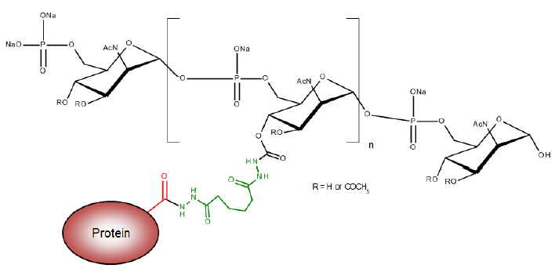
Figure 2: The structure of the serogroup C drug substance
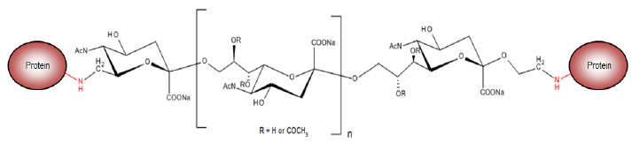
Figure 3: The structure of the serogroup Y drug substance
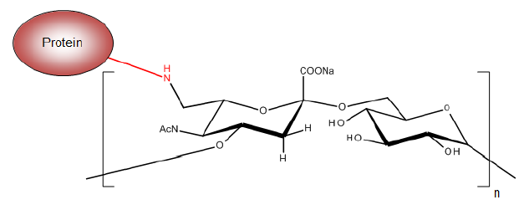
Figure 4: The structure of the serogroup W135 drug substance
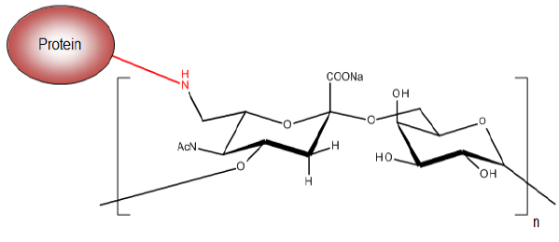
The four drug substances differ from each other by virtue of the structure of the capsular polysaccharide moiety and the chemical linkage to the protein.
All outstanding quality issues have been resolved. Details of conditions of registration have been provided.
There are no objections on quality grounds to the approval of MenQuadfi.

Nonclinical
The dossier was in accordance with WHO and EU guidelines on the nonclinical pharmacological and toxicological testing of vaccines. No vaccine related systematic toxicity or local effects were observed in repeat dose toxicity studies in rats. No juvenile animal study was conducted. The vaccine is proposed for use in children from 12 months of age. However, no toxicity studies were conducted in infant animals. In the repeat dose study, in both male and female adult rats, the vaccine was administered intramuscularly with treatment equivalent to the full human dose. This dosage was approximately13-fold higher for a 12 month old human infant weighing approximately 10 kg (based on body surface area). The dose multiple in this study was considered sufficient to cover the toxicological effects in a 12 month old human infant.
There were no efficacy studies as an adequate animal model does not exist. No genotoxicity or carcinogenicity studies were submitted; this was considered acceptable for vaccines.
The sponsor has proposed pregnancy category B1. Based on negative results in reproductive and developmental studies in rabbits, this was considered appropriate, noting that vaccines do not require two species for such studies.
There are no objections to the registration of MenQuadfi from the toxicology area, subject to satisfactory clinical data. Recommendations for PI have been provided.

Clinical
The following six studies, considered pivotal to the proposed indication:
- Study MET51 in toddlers (12 to 23 months of age; naive and primed subjects; versus Nimenrix) and conducted in EU countries;
- Study MET35 in children (two to nine years of age; naive subjects; versus Menveo) and conducted in the USA;
- Study MET50 in adolescents (10 to 17 years of age; naive subjects; versus Menveo) and conducted in the USA;
- Study MET43 in adolescents and adults (10 to 55 years of age; naive subjects; versus Menactra) and conducted in the USA;
- Study MET49 in adults and elderly (≥ 56 years of age; naive subjects; versus Menomune) and conducted in the USA;
- Study MET56 in adolescents and adults (10 to 55 years of age; primed subjects; versus Menactra) and conducted in the USA.
Results in each of the six above nominated studies are noted below. All studies were controlled trials with non-inferiority objective with respect to immune response to single vaccine dose at Day 30 post-vaccination:
As the incidence of meningococcal disease is very low, it is not practical to undertake a sufficiently powered trial for demonstrating vaccine efficacy. Hence, immunogenicity endpoint (that is, subjects achieving seroprotective titres ≥ 1/8 with human serum bactericidal assay (hSBA) is an accepted correlate of protection). Thus the clinical trials program for MenQuadfi was based on various immunogenicity variables and endpoints.
A Phase I study (Study MET28; this Canadian study found no clear trends in antibody response for the different dose groups) and a Phase I to II study (Study MET32; this Australian study in toddlers concluded that 10 μg polysaccharides per serogroup was needed for optimum response in all serogroups particularly serogroup A) resulted in the final formulation that was used in subsequent Phase II and Phase III studies conducted between 2012 and 2018:
Table 3: Summary of population groups and the corresponding Phase II and Phase III studies conducted between 2012 and 2018
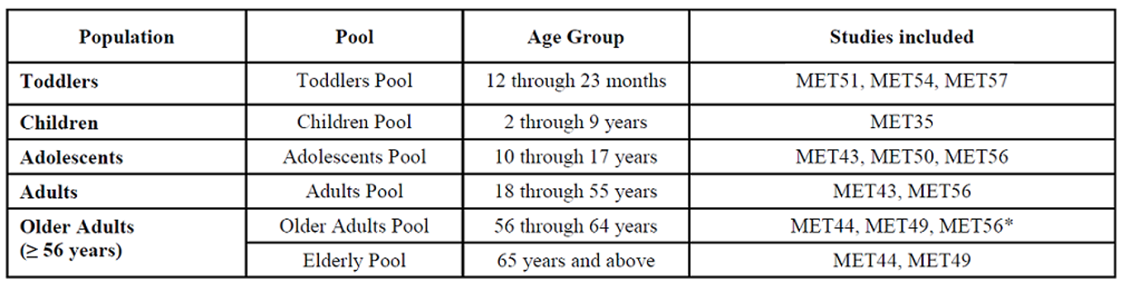
*MET56 included subjects aged 15 years through 55 years. One subject older than 55 years was erroneously included in the study and included in the database.

Study MET51 toddlers (naive and primed)
This was a study in toddlers (12 to 23 months of age) for MenQuadfi versus Nimenrix.
The geometric mean titres (GMTs) by hSBA reported in this study were as follows:
Table 4: Study MET51 Summary of the human serum bactericidal assay geometric mean titres against meningococcal serogroups A, C, Y and W (per-protocol analysis set)
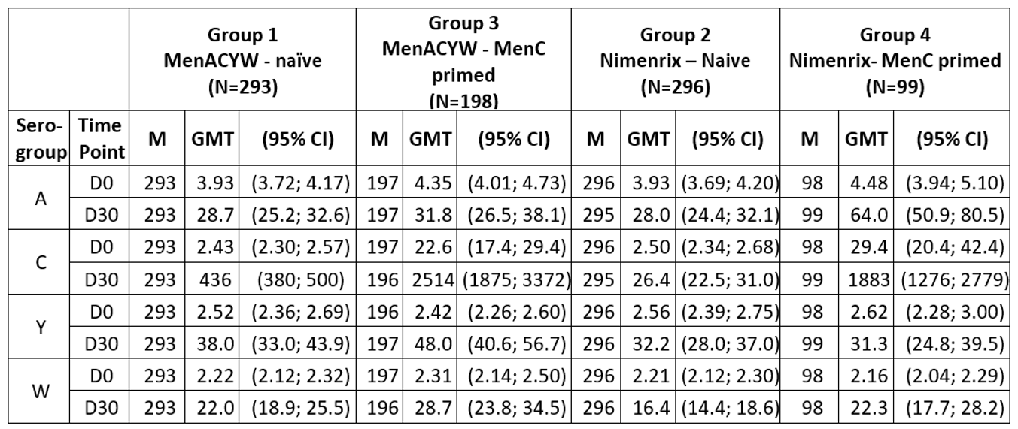
M: number of subjects with valid serology results for the particular serogroup and time point
N: number of subjects in per-protocol analysis; set (PPAS)
D0: Day 0 time point; D30: Day 30 time point; GMT: geometric mean titre; CI: confidence interval.
The GMTs in naive toddlers were similar for MenQuadfi versus Nimenrix, except for serogroup C in which very high statistically significant response was seen with MenQuadfi compared to Nimenrix:
Table 5: Study MET51 Comparison of the human serum bactericidal assay geometric mean titres for meningococcal serogroups A, C, Y and W (group 1) versus Nimenrix (group 2) at Day 30 in meningococcal vaccine naive toddlers (per-protocol analysis set)
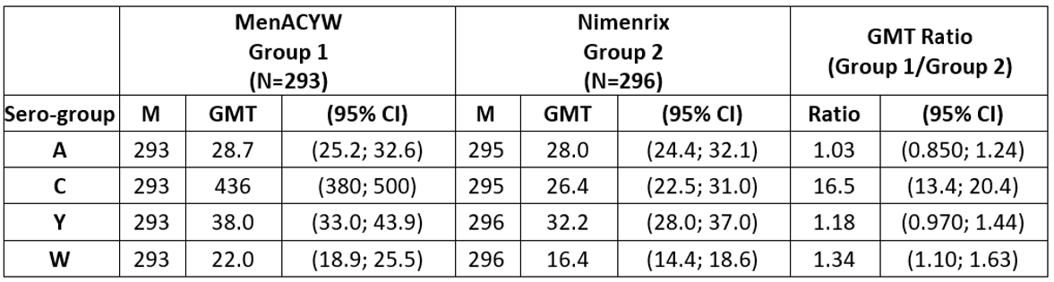
M: number of subjects with available data for the endpoint
N: number of subjects in PPAS
The proportion of naive toddlers with seroprotective hSBA titres ≥ 1/8 at Day 30 post-vaccination was high (> 90%) in MenQuadfi and non-inferior to Nimenrix for serogroups A, Y and W and superior (MenQuadfi versus Nimenrix) for serogroup C, as shown in Table 6, below.
Table 6: Study MET51 Comparison of the human serum bactericidal assay seroprotection rate (percentage of subjects ≥ 1/8) at Day 30 for meningococcal serogroups A, C, Y and W conjugate vaccine versus meningococcal control vaccine subjects
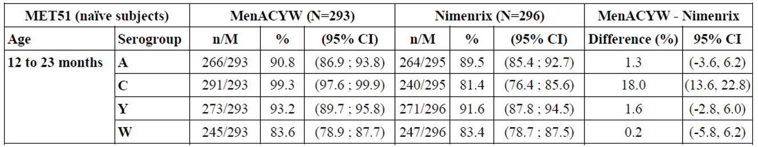
N: number of subjects in PPAS
M: number of subjects with available data for the endpoint
n: number of subjects who achieve an hSBA titres ≥ 1/8 at Day 30
In meningococcal C primed toddlers in this study, similar levels of GMTs were obtained in MenQuadfi and Nimenrix groups, except serogroup A for which concentration obtained with MenQuadfi were about 50% of those obtained with Nimenrix. The GMT ratio (MenQuadfi over Nimenrix for serogroup A) was 0.496 (95% CI 0.367, 0.672) indicating a statistically inferior response with MenQuadfi versus Nimenrix:
Table 7: Study MET51 Comparison of the human serum bactericidal assay geometric mean titres for meningococcal serogroups A, C, Y and W conjugate vaccine (group 3) versus Nimenrix (group 4) at Day 30 in meningococcal C primed toddlers (per-protocol analysis set)
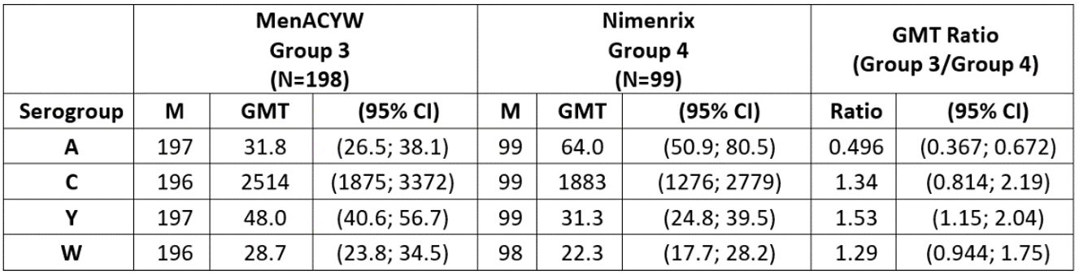
M: number of subjects with available data for the endpoint
N: number of subjects in PPAS
The seroprotective rates (primed toddlers) were comparable between the two groups. However, 89.8% primed toddlers in MenQuadfi Group achieved seroprotective hSBA titres (≥ 1/8) for serogroup A compared to 98% primed toddlers in Nimenrix group. Thus non-inferiority was not convincingly demonstrated for this serogroup, as shown in Figure 5, below.
Figure 5: Study MET51 Forest plot of human serum bactericidal assay titres ≥ 1/8 at Day 30 against meningococcal serogroup A, C, Y and W primed toddlers (per-protocol analysis set)
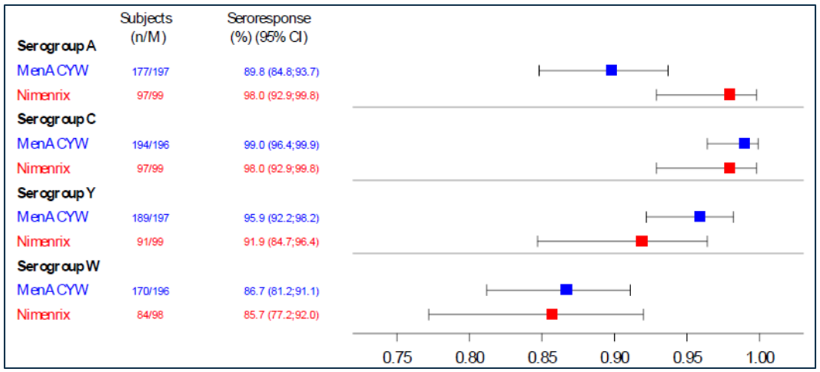
n: number of subjects who archived an hSBA vaccine titres ≥ 1/8 at Day 30
M: number of subjects with valid serology results for the particular serogroup
95% CI of the single proportion calculated from the exact binominal method
The results support the proposed use in naive toddlers, but not in primed toddlers, the excessive immunogenicity for serogroup C, creating an overall ACYW imbalance, is a concern with uncertain significance, in both naive and primed toddlers.

Study MET35 children (naive)
This was a study in children two to nine years of age for MenQuadfi versus Menveo.
The reported GMTs, by age strata, were as follows in Table 8, shown below.
Table 8: Study MET35 Comparison of the human serum bactericidal assay geometric mean titres against meningococcal serogroups A, C, Y and W at Day 30 between group 1 and group 2, by age group (per-protocol analysis set)
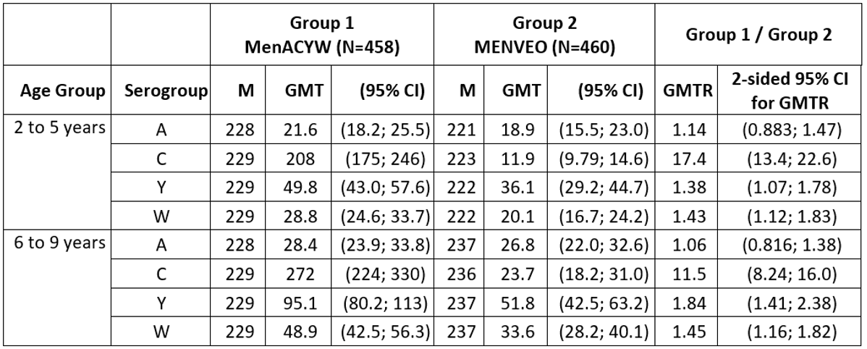
M: number of subjects with available data for the endpoint
N: number of subjects in PPAS
The GMTs indicated non-inferiority of MenQuadfi with Menveo for all four serotypes. High immunogenicity compared to Menveo was demonstrated, particularly with serogroup C, in both age strata.
The seroprotective rates, overall and by age strata, were as follows in Table 9, below.
Table 9: Comparison of human serum bactericidal assay seroprotection rate (percentage of subjects ≥ 1/8) at Day 30 for meningococcal serogroups A, C, Y and W conjugate vaccine versus meningococcal control vaccine subjects
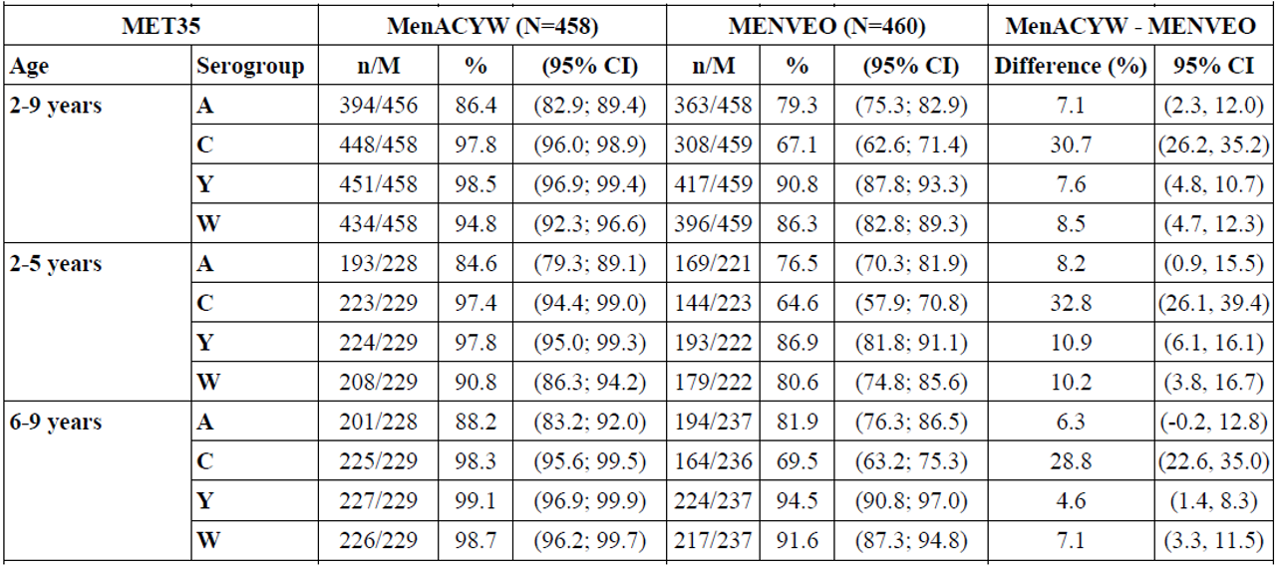
N: number of subjects in PPAS
M: number of subjects with available data for the endpoint
n: number of subjects who achieve an hSBA titres ≥ 1/8 at Day 30
Thus consistently high proportions (> 90%) achieved seroprotective titres with MenQuadfi (except in serogroup A), and generally lower proportions with Menveo (particularly in serogroup C).
The results of Study MET35 are considered acceptable.

Study MET50 adolescents (naive)
This was an immunogenicity study in naive adolescents (ten to 17 years of age) for MenQuadfi versus Menveo.
The reported GMTs were as follows in Table 10, below.
Table 10: Study MET50 Summary of the human serum bactericidal assay geometric mean titres against meningococcal serogroups A, C, Y and W (per-protocol analysis set 1)
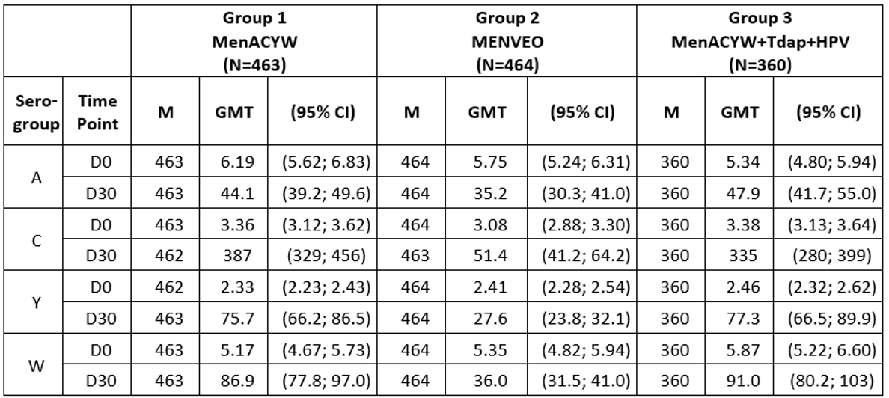
M: number of subjects with valid serology results for the particular serogroup and time point
N: number of subjects in the PPAS1
The statistical comparison could not be located but the descriptive summary of GMTs is indicative of comparable immunogenicity (consistent higher immune response in serogroups C) of MenQuadfi compared to Menveo.
This was also a co-administration study. The co-administration of tetanus diphtheria acellular pertussis (Tdap)/ human papilloma virus (HPV) vaccines with MenQuadfi did not alter ACWY immune response. For the co-administered vaccines, response to the diphtheria, tetanus, pertussis (DTP) vaccine and HPV antigens was considered non-inferior with or without concomitant MenQuadfi (results not shown).
The ACYW seroprotective rates were as follows in Table 11.
Table 11: Comparison of the human serum bactericidal assay seroprotection rate (percentage of subjects ≥ 1/8) at Day 30 for meningococcal serogroups A, C, Y and W conjugate vaccine versus meningococcal control vaccine subjects
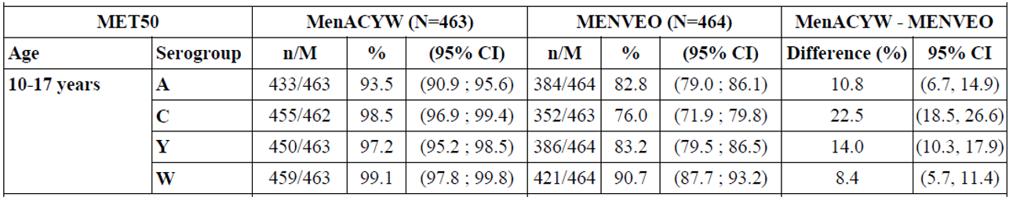
N: number of subjects in the PPAS
M: number of subjects with available data for the endpoint
n: number of subjects who achieve an hSBA titres ≥ 1/8 at Day 30
The proportion of subjects achieving protective titres were consistently higher with MenQuadfi compared with Menveo with significant results for all four serogroups.
The results of Study MET50 are considered acceptable.

Study MET43 adolescent and adults (naive)
This was a lot-to-lot consistency study of MenQuadfi in adolescents and adults (10 to 55 years of age), in which (pooled) MenQuadfi versus Menactra immunogenicity (GMTs) were also compared and indicated comparable and generally higher (particularly serogroup C) immunogenicity of MenQuadfi compared to Menactra, which is the sponsor’s currently approved quadrivalent meningococcal vaccine. Results are shown below in Table 12.
Table 12: Study MET43 Comparison of the human serum bactericidal assay geometric mean titres for meningococcal serogroups A, C, Y and W conjugate vaccine (group 1 to 3 pooled) versus Menactra (group 4) (per-protocol analysis set)
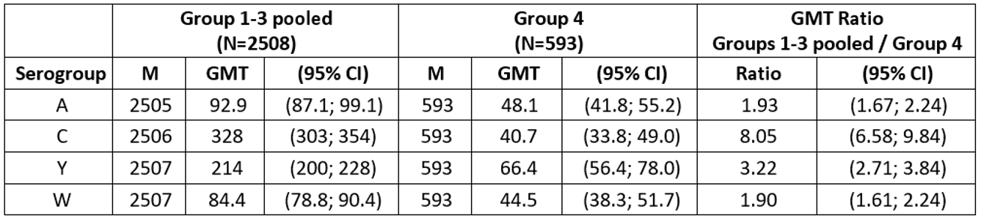
M: number of subjects with available data for the endpoint
N: number of subjects in PPAS
The hSBA seroprotective rates in adolescents (naive) and adults (naive), separately by age strata, in this study were as follows and continued to consistently show significantly higher protective rates in MenQuadfi versus Menactra in adolescent as well as adults, as shown in Table 13, below.
Table 13: Comparison of the human serum bactericidal assay seroprotection rate (percentage of subjects ≥ 1/8) at Day 30 for meningococcal serogroups A, C, Y and W conjugate vaccine versus meningococcal control vaccine subjects
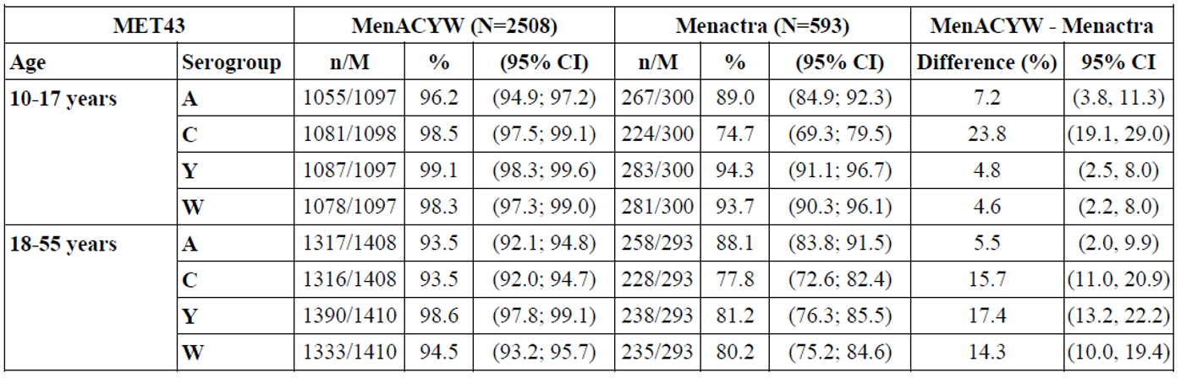
N: number of subjects in the PPAS
M: number of subjects with available data for the endpoint
n: number of subjects who achieve an hSBA titres ≥ 1/8 at Day 30
The results of Study MET43 are considered acceptable.

Study MET49 adults and elderly (≥ 56 years of age; naive)
The comparator vaccine product in this adults and elderly study was Menomune which is a plain polysaccharide ACYW vaccine (that is, not conjugated and has now been discontinued from the ARTG (commercial reasons)).
The GMTs were reported as follows in Table 14, below.
Table 14: Study MET49 Comparison of the human serum bactericidal assay geometric mean titres against meningococcal serogroups A, C, Y and W at Day 30 between group 1 and group 2 (per-protocol analysis set)
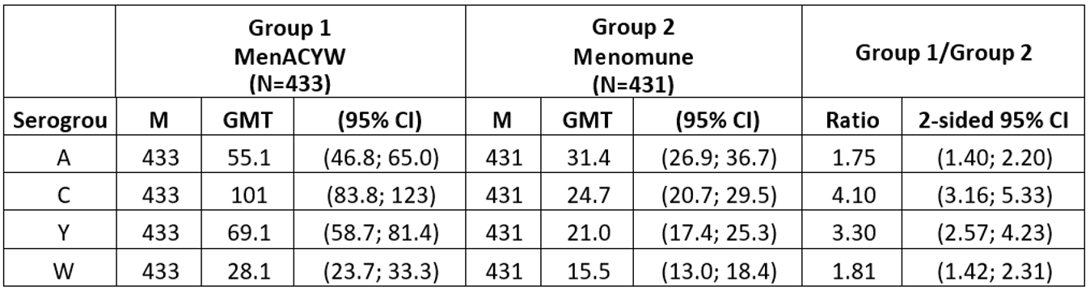
M: number of subjects with available data for the endpoint
N: number of subjects in PPAS
Thus much higher immunogenicity of MenQuadfi compared to Menomune was demonstrated for all serogroups in subjects ≥ 56 years of age.
The seroprotective rates (GMTs ≥ 1/8 by hSBA), in the overall ≥ 56 years of age population, were as follows in Table 15.
Table 15: Study MET49 Comparison of the human serum bactericidal assay seroprotection rate (percentage of subjects ≥ 1/8) at Day 30 for meningococcal polysaccharide serogroups A, C, Y and W conjugate vaccine versus meningococcal control vaccine subjects
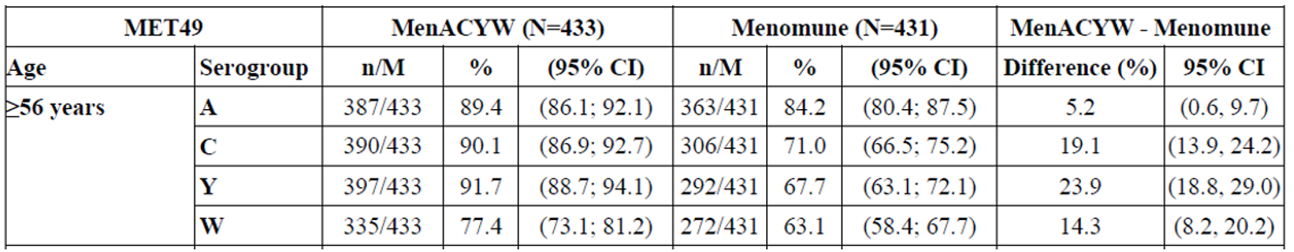
The seroprotective rates (GMTs ≥ 1/8 by hSBA), by age strata in older adults and elderly were as follows in Table 16, below,
Table 16: Study MET49 Comparison of the human serum bactericidal assay seroprotection rate (percentage of subjects ≥ 1/8) at Day 30 for meningococcal polysaccharide serogroups A, C, Y and W conjugate vaccine versus meningococcal control vaccine subjects
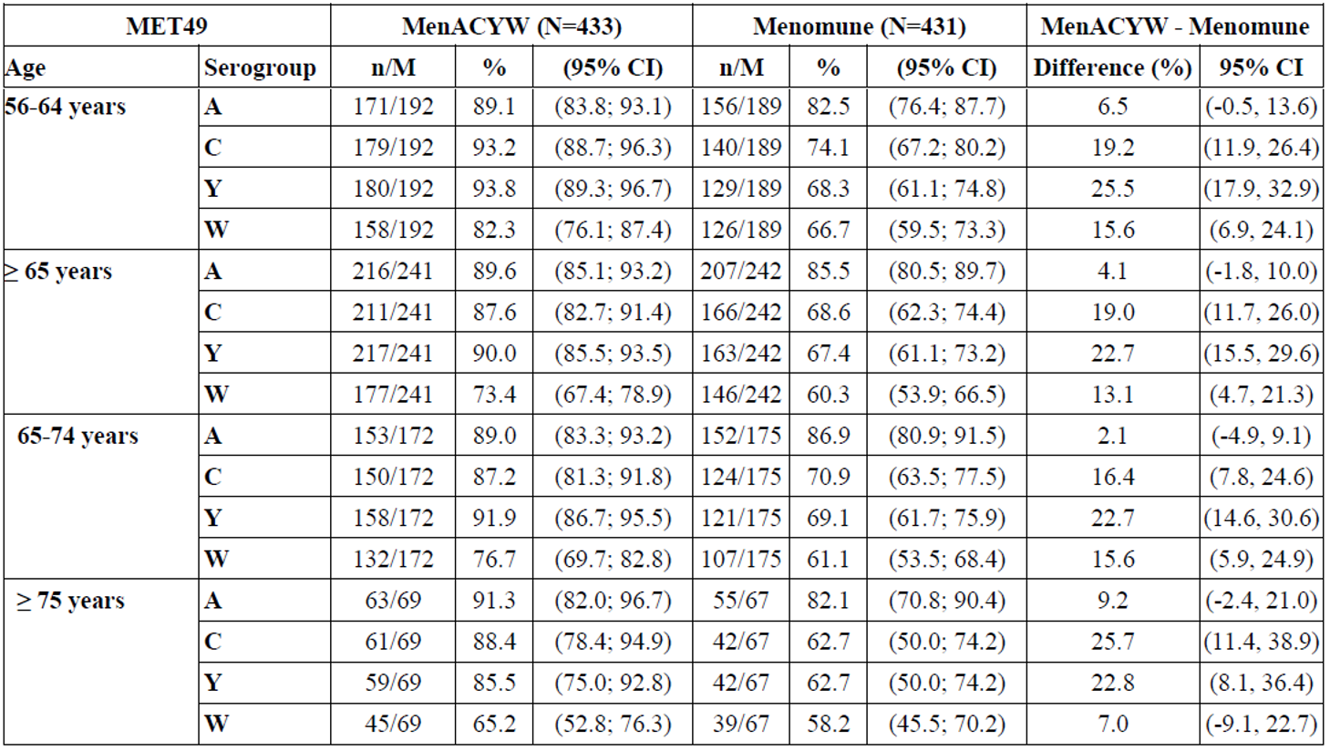
N: number of subjects in the PPAS
M: number of subjects with available data for the endpoint
n: number of subjects who achieve an hSBA titres ≥ 1/8 at Day 30
Thus seroprotective rates by age strata including ≥ 77 years of age were consistent with the results in overall population of ≥ 56 years of age population and continued to consistently show higher protective rates for MenQuadfi compared to Menomune in all serogroups.
The use of Menomune as comparator vaccine is considered acceptable in this age group.
The results study MET49 are considered acceptable.

Study MET56 adolescents and adults (≥ 15 years of age primed subjects)
This was a booster study in adolescents and adults for MenQuadfi versus Menactra (that is, a population that had received a currently available ACYW conjugate vaccine four to ten years ago).
The reported GMTs were as follows in Table 17.
Table 17: Study MET56 Summary of the human serum bactericidal assay geometric mean titres against meningococcal serogroups A, C, Y and W, in primed adolescents and adults (per-protocol analysis set)
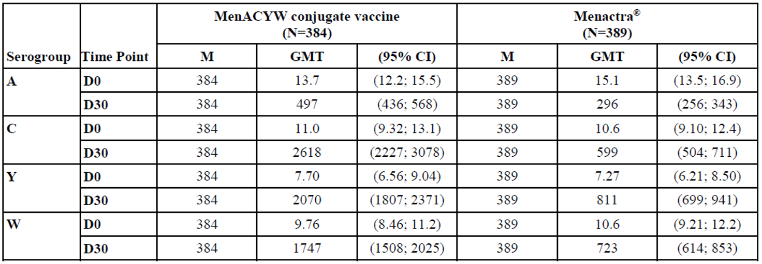
M: number of subjects with valid serology results for the particular serogroup and time point
N: number of subjects in the PPAS
The statistical comparison could not be located but indicated significantly higher immune response with MenQuadfi compared to Menactra.
The seroprotective rates (proportion ≥ 1/8 hSBA) were as follows in Table 18.
Table 18: Study MET56 Number and percentage of subjects with human serum bactericidal assay titre ≥ 1/8 in primed adolescents and adults (per-protocol analysis set)
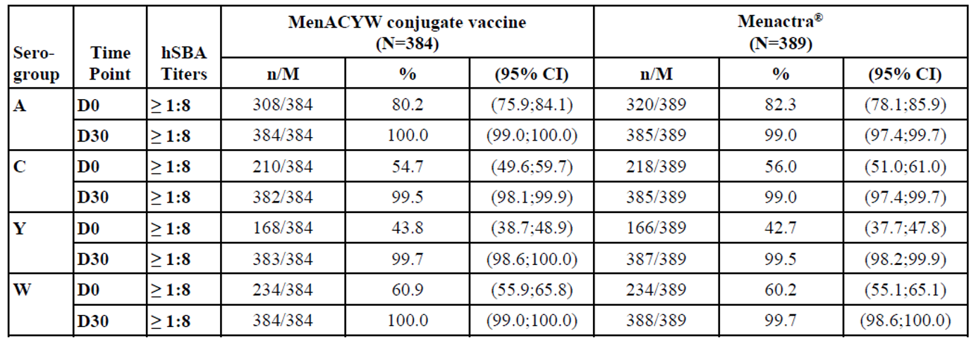
M: number of subjects with valid serology results for the particular serogroup and time point
N: number of subjects in the PPAS
n: number of subjects experiencing the endpoint listed in the first three columns.
The percentage seroprotective rates were similar in both groups (MenQuadfi versus Menactra), as shown in Figure 6, below.
Figure 6: Study MET56 Forest plots of human serum bactericidal assay vaccine immune response against meningococcal serogroups A, C, Y and W and safety (meningococcal vaccine, primed adolescents and adults)
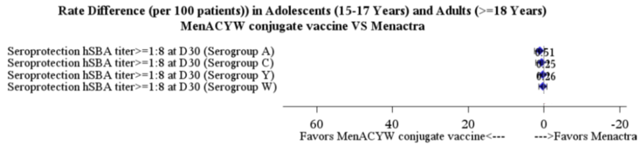
The results of Study MET56 are considered acceptable. A very high response to MenQuadfi booster compared to Menactra booster is noted.

Safety
The safety database consists of 8407 participants comprising exposure to MenQuadfi (n = 5417), Menactra (n = 1042), Menveo (n = 995), Menomune (n = 553) and Nimenrix (n = 400). The proportions of subjects experience at least one serious adverse event (SAE) are shown in Table 19, below.
Table 19: Safety overview, subjects experiencing at least one serious adverse event after vaccine injection
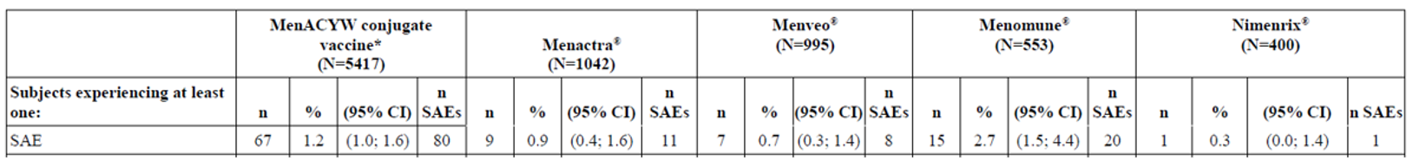
*MenACYW conjugate vaccine group only includes the subjects who received MenACYW conjugate vaccine alone at Visit 01, and excludes the subjects who received MenACYW plus Concomitant vaccines at Visit 01.
Meningococcal C primed subjects from Study MET51 were excluded from the pooled safety analysis; meningococcal conjugate vaccines (MCV) 4 primed subjects from Study MET56 were included in the pooled safety analysis
Contributing studies: Studies MET35, MET43, MET44, MET49, MET50, MET51, MET54, MET56, and MET57
The overall adverse events (AE) of MenQuadfi was similar to the current quadrivalent comparators.
The incidence of the SAEs in the total safety dataset was MenQuadfi (1.2%), Menactra (0.9%), Menveo (0.7%), Menomune (2.7%) and Nimenrix (0.3%).
Consideration of local and systemic reactogenicity, particularly in toddlers and children, is of regulatory interest. The reported rates in toddlers and children (integrated data from the relevant age pools) are reproduced below for reference and did not generally indicate higher occurrences in MenQuadfi group compared to the comparator ACYW vaccines. Data for this is shown in Table 20, below.
Table 20: Studies MET51 and MET54 Solicited injection site reactions in toddlers (safety analysis set)
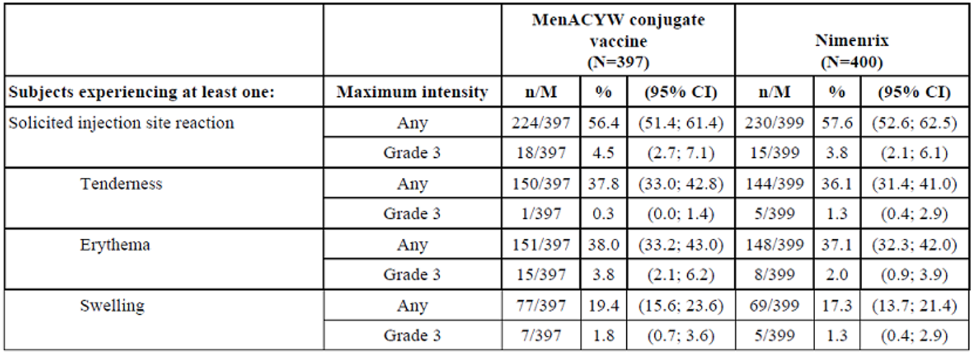
Table 21: Studies MET51 and MET54 Solicited systemic reactions in toddlers (safety analysis set)
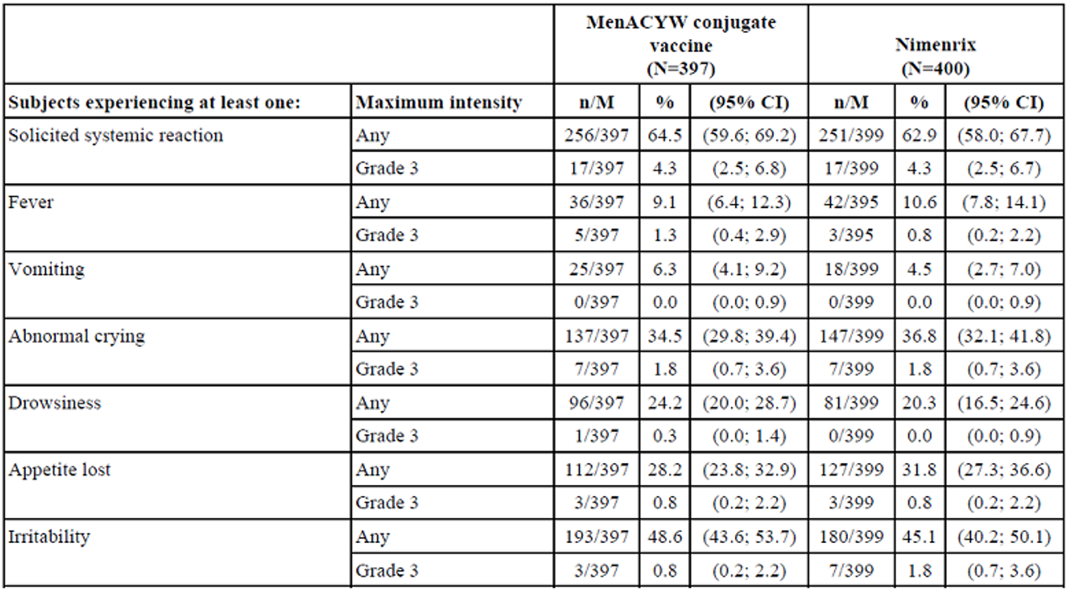
Table 22: Study MET35 Injection site reactions in children (safety analysis set)
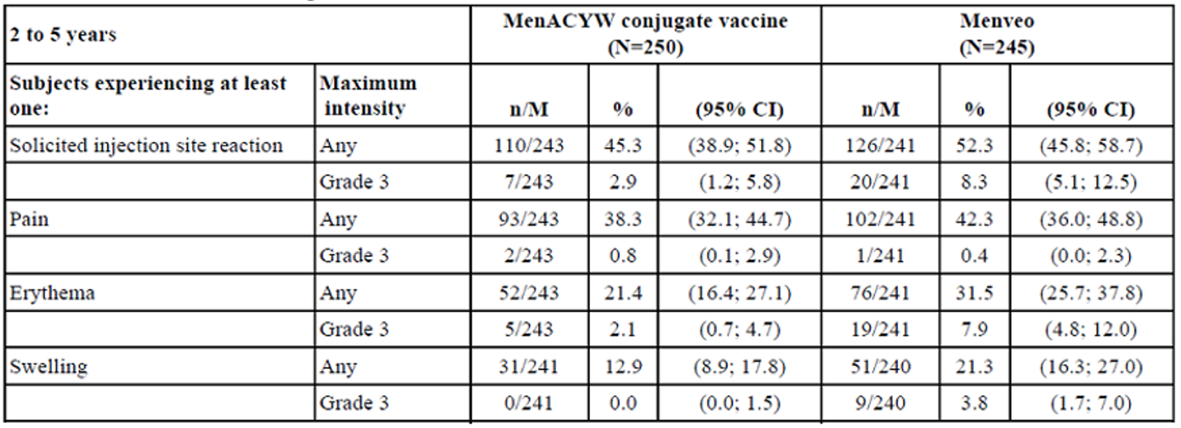
Table 23: Study MET35 Solicited systemic reactions in children (safety analysis set)
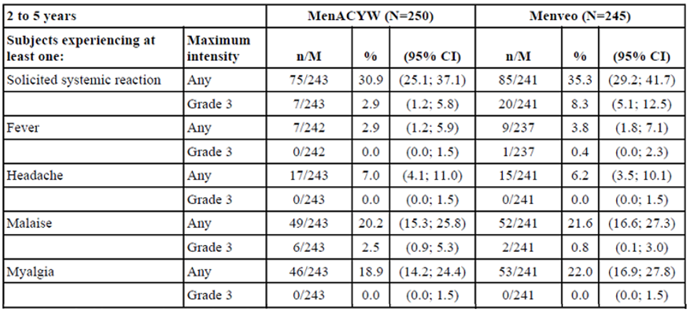
Table 24: Study MET35 Solicited injection site reactions after meningococcal vaccine in children (safety analysis set)
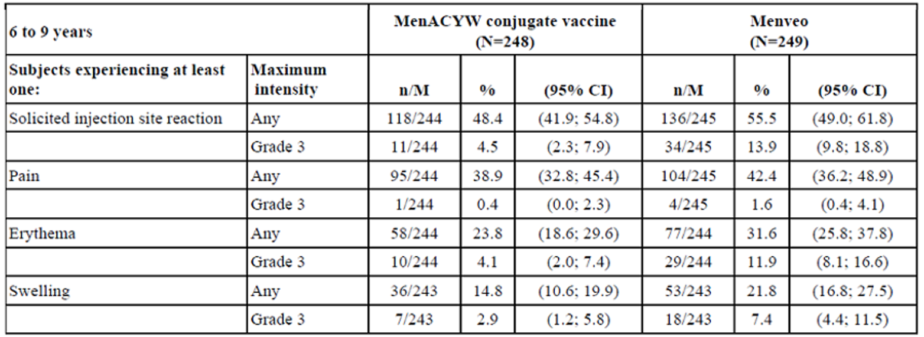
Table 25: Study MET35 Solicited systemic reactions in children (safety analysis set)
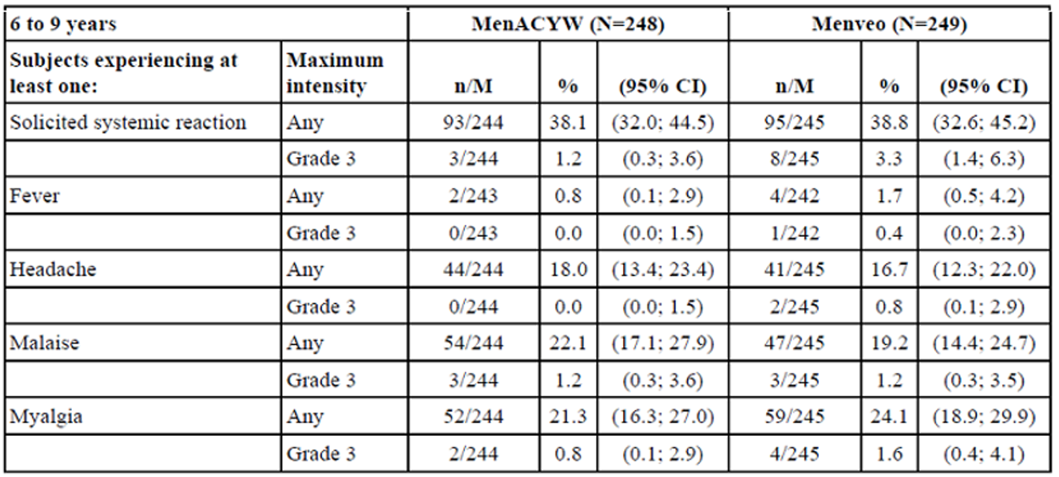
The reported rates in toddlers and children were also generally similar to the rates reports in adolescents and adults. The incidence of solicited systemic effects in overall elderly population (≥ 56 years of age) was as follows in Table 26, below.
Table 26: Any and Grade 3 solicited systemic reactions after vaccine injection, by maximum intensity during the solicited period, in older adults and elderly (safety analysis set)
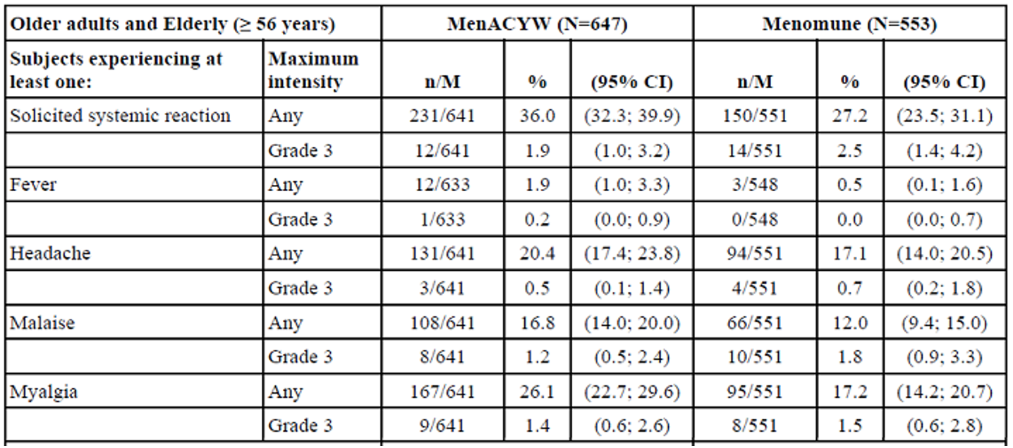
The adverse events of special interest (AESI) included Kawasaki disease, Guillain-Barre syndrome (GBS), generalised seizures (including febrile seizures), and idiopathic thrombocytopenic purpura (ITP). There were no reports of Kawasaki disease, GBS or ITP. Four AESIs of convulsions, all with MenQuadfi, were reported as follows:
An episode of febrile convulsion reported in a 17 months old female toddler with family history of febrile convulsion. The toddler had concomitant viral upper respiratory tract infection. The event occurred 23 days after receiving the vaccine in Study MET51. The subject is reported as recovered.
A report of seizure in a 12 years old female adolescent with a history of partial complex epilepsy and type 1 diabetes mellitus. The event occurred 107 days after receiving the vaccine in Study MET50. The neurologist assessed the seizure as unrelated to the subject’s diabetes and consistent with the prior history of epilepsy. The subject is reported as recovered.
An episode of status epilepticus reported in a 24 years old male adult with a history of childhood seizures and drug and alcohol abuse. The event occurred 22 days after receiving the vaccine in Study MET43. The subject is reported as recovered.
A report of seizure in a 44 years old male adult at 59 days after receiving the vaccine in Study MET43 and assessed as likely a part of alcohol withdrawal symptoms. The subject is reported as recovered.
None or the convulsion AESIs were considered related, although imbalanced occurrence with MenQuadfi is noted.
There have been no reports of anaphylaxis during the clinical development program. There were no deaths.
Note safety data are confined to within 30 to 42 days post-vaccination follow-up.
Overall, data is consistent with the current quadrivalent ACYW vaccines. The length of follow-up is very limited at this stage. No post-market data are available yet. Hence, the risk of potential AESIs or other rare effects cannot be reliably estimated due to lack of large scale use in unselected population.

Risk management plan
The sponsor has submitted EU-risk management plan (RMP) version 0.1 (dated 13 September 2019; data lock point (DLP) 15 June 2019) and Australian specific Annex (ASA) version 1.0 (dated 29 October 2019) in support of this application. With the questions raised by TGA responses the sponsor provided an updated EU-RMP version 0.2 (dated 6 May 2020; DLP 15 June 2019) and an ASA version 1.1 (dated 30 June 2020).
The summary of safety concerns and their associated risk monitoring and mitigation strategies are summarised in Table 27.¹³
Table 27. Summary of safety concerns and their associated risk monitoring and mitigation strategies
Summary of safety concerns |  | Pharmacovigilance |  | Risk Minimisation
 |  | Routine | Additional | Routine | Additional
Important identified risks | None
Important potential risks | None
Missing information | Long-term persistence of the vaccine response, and safety and immunogenicity of booster in individuals primed with MenACYW conjugate vaccine |  | * |  | -
Missing information | Co-administration with meningococcal B vaccine |  | * |  | -
Missing information | Use during pregnancy |  | # |  | -
*Overseas clinical trials
#Pregnancy registry
- Justifying the absence of important identified risks or important potential risks, the EU-RMP states that the summary of safety concerns has been prepared in accordance with Good Pharmacovigilance Practices (GVP) Module V Rev 2. The sponsor states that it will monitor and review several other risks that are relevant for this product and report through periodic safety update reports (PSURs). The summary of safety concerns is acceptable from an RMP perspective.
- Routine and additional pharmacovigilance activities have been proposed to monitor the missing information included in the safety summary. The sponsor states that the findings of these clinical trials are applicable to Australia. The proposed pharmacovigilance plan is acceptable from an RMP perspective.
- Only routine risk minimisation activities have been proposed. This is acceptable.

Risk-benefit analysis

Delegate’s considerations
- The highly virulent bacterium N. meningitidis, an obligate aerobic Gram negative cocci, is the responsible organism for IMD. That is, meningitis, septicaemia and disseminated infection which can be rapidly fatal or leave serious sequelae despite timely treatment.
The epidemiology is well known with prominent spikes in incidence in children under five years of age and in adolescents and young adults 15 to 19 years of age. However, sporadic disease can occur in all ages. Humans are the only natural host. No other reservoirs or spore forming forms exist. As much as 10% population may be asymptomatic oropharyngeal carriers.
The capsular polysaccharide vaccines confer exclusively humoral immunity.
- No particular scientific or clinical rationale has been offered for the new vaccine MenQuadfi. It appears to be a standard commercial update so that the vaccine product now has 40 µg total ACYW polysaccharide antigen content (10 µg of each).
- Establishing non-inferiority with the current polysaccharide ACYW conjugated vaccines was the objective of the clinical development program.
The comparators included Nimenrix in toddlers, Menveo in children and adolescents, Menactra in adolescents and adults, and Menomune in elderly and older adults with objective of demonstrating on-inferiority based on proportion of subjects achieving protective hSBA titres ≥ 1/8 at 30 days post-vaccination timepoint.
- The MenQuadfi final formulation, intended for commercialisation, was used in all confirmatory clinical trials. A consistent feature of MenQuadfi, in all trials across all age groups, was extremely high immune response in serogroup C against all comparators. The clinical significance of this formulation effect is unknown.
- Immunogenicity and reactogenicity data support the use of single dose for primary vaccination (implies meningococcal naive or not primed) from 12 months of age (Study MET51) and above (Studies MET35, MET50, MET43 and MET49).
However, there may be an argument for approval in naive population from 24 months of age onwards (Study MET35) and consider the toddlers and infant (not part of this submission) data together more comprehensively in a future submission.
Ongoing or future studies of MenQuadfi include Study MET41 in infants or toddlers six weeks to 12 months of age evaluating a four dose series, Study MET42 in infants or toddlers six weeks to 18 months of age evaluating a four dose series and Study MET61 in infants or toddlers six months to 23 months of age evaluating a two dose series.
- Immunogenicity and reactogenicity data support the use of MenQuadfi as single dose booster (implies meningococcal primed) in adolescents and adults from 15 years of age and above based on Study MET56.
Booster dosing in primed toddlers from 12 months of age is not supported based on poor response in serogroup A noted in Study MET51.
The children, adolescents and adults Studies MET35, MET50 and MET43 were conducted in meningococcal naive subjects only. Hence, the confirmatory data on boosting is based on Study MET56 in primed subjects ≥ 15 years of age and above.
- The safety profile in all the studies were comparable to registered ACWY vaccines. The dataset is too limited to estimate occurrence of rare adverse effects or any long-term suspected adverse effects of regulatory interest. At present, no post-market data are available.
- A simplified indication and clinical trials evidence based vaccine schedule by age is proposed by the Delegate below for consideration by the Advisory Committee on Vaccine (ACV).

Proposed action
The Delegate proposes indication as follows:
MenQuadfi is indicated for active immunisation against invasive meningococcal disease caused by Neisseria meningitidis serogroups A, C, W and Y.
The use of MenQuadfi should be in accordance with the official recommendations.
The Delegate proposed vaccination schedule as follows:
Primary vaccination
- Individuals 12 months of age and older receive a single dose.
Booster vaccination
- Individual 15 years of age and older receive a single dose.
The use of MenQuadfi should be in accordance with the official recommendations.

Advisory Committee considerations
The Advisory Committee on Vaccines (ACV) having considered the evaluations and the Delegate’s overview, as well as the sponsor’s response to these documents, advised the following.

Specific advice to the delegate
- Immunogenicity and reactogenicity data support the use of single dose for primary vaccination (implies meningococcal naive) from 12 months of age and above (Study MET51).
However, there may be an argument for approval from 24 months of age onwards (Study MET35) and consider the toddlers and infant (not a part of this submission) data together more comprehensively in a future submission. Extremely high response in serogroup C was obtained in naive toddlers instead of a more balanced response for the four serogroups. Is this a concern?
The ACV advised that the immunogenicity and reactogenicity data support the use of single dose for primary vaccination from 12 months of age and above.
No difference in immunogenicity was noted compared to other ACWY vaccines.
Regarding the high response to serogroup, the ACV advised that there was no concern to date (no increase in injection site or systemic reactions). Understanding of the mode of action of conjugate vaccine is still developing.
The ACV noted that there are several ongoing or planned studies of MenQuadfi including multi-dose studies in infants or toddlers aged from six weeks to 23 months of age (MET41, MET42, MET61) it was unclear if these studies included an assessment of the immune response after the first dose, which would be needed to support a single dose regimen at any other age.
The ACV noted that 12 months of age is the current schedule point in the National Immunisation Program (NIP) for administration of ACWY vaccine.
- Immunogenicity data support the use of MenQuadfi as a single dose booster (implies meningococcal primed) from 15 years of age and above (Study MET56) but do not support such use in primed toddlers (Study MET51).
The ACV advised that the immunogenicity and reactogenicity data support the use of single booster dose in adolescents and adults from 15 years of age and above, based on Study MET56.
Booster dosing in primed toddlers from 12 months of age resulted in poor response to serogroup A (MET51). The clinical significant of this poor response in Australia was uncertain.
The ACV advised that the use of MenQuadfi as the booster dose was not restricted by which ACWY vaccine had been used as a primary vaccination.
- Routine post market surveillance is proposed. Does ACV have any further recommendations in relation to post-market activities?
The ACV advise that routine pharmacovigilance should be sufficient for the vaccine.
The safety profile of the vaccine was similar to existing registered ACWY vaccines.
The sponsor has planned a registry in the USA to address use in pregnancy. A study using the United States Post-licensure Rapid Immunization Safety Monitoring system (PRISM) data could provide information that is more meaningful.
Whether GBS is a class risk for meningococcal vaccines was an unresolved question.
The vaccine has twice the antigen dose of most currently registered products and a higher quantity of carrier protein (55 µg). However, local and systemic reactions were no more frequent than for other ACWY vaccines.
- The Committee is also requested to provide advice on any other issues that it thinks may be relevant to a decision on whether or not to approve this application.
The ACV reviewed and acknowledged the pre-ACV response provided by the sponsor.

Conclusion
The ACV considered this vaccine to have an overall positive benefit risk profile for the indication:
MenQuadfi is indicated for active immunisation against invasive meningococcal disease caused by Neisseria meningitidis serogroups A, C, W and Y. The use of MenQuadfi should be in accordance with the official recommendations.
and for the vaccination schedule:
Primary vaccination
- Individuals 12 months of age and older receive a single dose.
Booster vaccination
- Adolescents (15 years of age and above) and adults who have been previously primed with an ACWY meningococcal vaccine may receive a single booster dose.

Outcome
Based on a review of quality, safety and efficacy, the TGA approved the registration of MenQuadfi (meningococcal polysaccharide group A) 10 µg/dose, (meningococcal polysaccharide group C) 10 µg/dose, (meningococcal polysaccharide group Y) 10 µg/dose and (meningococcal polysaccharide group W135) 10 µg/dose, solution for injection, vial, indicated for:
MenQuadfi is indicated for active immunisation for the prevention of invasive meningococcal disease caused by Neisseria meningitidis serogroups A, C, W and Y. The use of MenQuadfi should be in accordance with official recommendations.

Specific conditions of registration applying to these goods
- MenQuadfi (meningococcal (groups A, C, Y, W) polysaccharide tetanus toxoid conjugate vaccine) is to be included in the Black Triangle Scheme. The PI and Consumer Medicines Information (CMI) for MenQuadfi must include the Black Triangle symbol and mandatory accompanying text for five years, which starts from the date that the sponsor notifies the TGA of supply of the product.
- The MenQuadfi EU-RMP (version 0.2, dated 6 May 2020; DLP 15 June 2019), with Australian Specific Annex (version 1.1, dated 30 June 2020), included with submission PM-2019-04826-1-2, and any subsequent revisions, as agreed with the TGA will be implemented in Australia.
An obligatory component of risk management plans is routine pharmacovigilance. Routine pharmacovigilance includes the submission of PSURs.
Unless agreed separately between the supplier who is the recipient of the approval and the TGA, the first report must be submitted to TGA no later than 15 calendar months after the date of this approval letter. The subsequent reports must be submitted no less frequently than annually from the date of the first submitted report until the period covered by such reports is not less than three years from the date of this approval letter. The annual submission may be made up of two PSURs each covering six months. If the sponsor wishes, the six monthly reports may be submitted separately as they become available.
If the product is approved in the EU during the three years period, reports can be provided in line with the published list of EU reference dates no less frequently than annually from the date of the first submitted report until the period covered by such reports is not less than three years from the date of this approval letter.
The reports are to at least meet the requirements for PSURs as described in the European Medicines Agency’s Guideline on GVP Module VII-periodic safety update report (Rev 1), Part VII.B Structures and processes. Note that submission of a PSUR does not constitute an application to vary the registration. Each report must have been prepared within ninety calendar days of the DLP for that report
- It is a condition of registration that all independent batches of Menquadfi imported into Australia are not released for sale until samples and the manufacturer’s release data have been assessed and sponsor has received notification acknowledging release from the Laboratories Branch, TGA.
All batches of MenQuadfi supplied in Australia must comply with the product details and specifications approved during evaluation and detailed in the certified product details (CPD).
When requested by the TGA, the sponsor should be prepared to provide product samples, specified reference materials and documentary evidence to enable the TGA to conduct laboratory testing on the product. Outcomes of laboratory testing are published biannually in the TGA Database of Laboratory Testing Results http://www.tga.gov.au/ws-labs-index and periodically in testing reports on the TGA website.
For each independent batch of the product imported into Australia, the sponsor must supply the following:
  - A completed request for release form, available from vaccines@health.gov.au.
  - Complete summary protocols for manufacture and quality control, including all steps in production.
  - At least five doses (number to be confirmed) of each first consignment of product lot with the Australian approved labels, PI and packaging. Three doses (number to be confirmed) of any further consignment of already released product (including diluents) with the Australian approved labels, PI and packaging.
  - Certificate of release from any jurisdiction, for example from the country of origin, an official medicine control laboratory or equivalent (if available).
  - Any reagents, reference material and standards required to undertake testing, as requested by laboratories branch, TGA.
- An electronic copy of the CPD as described in guidance 7: certified product details of the Australian regulatory guidelines for prescription medicines (ARGPM) https://www.tga.gov.au/guidance-7-certified-product-details should be provided upon registration of the therapeutic good. In addition, an updated CPD, for the above products incorporating the approved changes is to be provided within one month of the date of approval letter. A template for preparation of CPD for biological prescription medicines and vaccines can be obtained from the TGA website https://www.tga.gov.au/form/certified-product-details-cpd-biological-prescriptionmedicines. The CPD should be sent as a single bookmarked PDF document to vaccines@health.gov.au as soon as possible after registration/approval of the product or any subsequent changes as indicated above.
- For all injectable products the PI must be included with the product as a package insert.

Attachment 1. Product Information
The PI for MenQuadfi approved with the submission which is described in this AusPAR is at Attachment 1. For the most recent PI, please refer to the TGA website at <https://www.tga.gov.au/product-information-pi>.

Therapeutic Goods Administration
PO Box 100 Woden ACT 2606 Australia
Email: info@tga.gov.au Phone: 1800 020 653 Fax: 02 6232 8605
https://www.tga.gov.au

The Black Triangle Scheme provides a simple means for practitioners and patients to identify certain types of new prescription medicines, including those being used in new ways and to encourage the reporting of adverse events associated with their use. The Black Triangle does not denote that there are known safety problems, just that the TGA is encouraging adverse event reporting to help us build up the full picture of a medicine's safety profile.
Cohn, A. C. et al. Changes In Neisseria Meningitidis Disease Epidemiology in the United States, 1998-2007: Implications for Prevention of Meningococcal Disease, Clin Infect Dis, 2010; 50: 184-191.
Harrison, L. H. et al. Meningococcal Capsular Group A, C, W and Y Conjugate Vaccines in: Vaccines. 7th ed. Philadelphia: Plotkin, S. A. et al. (editors), Elsevier; 2018: 619-643.
Harrison, O. B. et al. Description and Nomenclature of Neisseria Meningitidis Capsule Locus, Emerg Infect Dis, 2013; 19(4): 566-573.
Stephens, D. S. Conquering the Meningococcus, FEMS Microbiol Rev, 2007; 31(1): 3-14.
Centres for Disease Control and Prevention (CDC) Meningococcal Disease: Meningococcal Disease in Other Countries, 2017 (Accessed 23 January 2019). Available from the CDC website.
Menactra was first registered on the ARTG on 26 July 2011 (ARTG number: 168403).
Menveo was first registered on the ARTG on 6 August 2010 (ARTG number: 158477).
Nimenrix was first registered on the ARTG on 29 August 2013 (ARTG number: 199741 and 199742).
CDC online reports
Pregnancy category B1: Drugs which have been taken by only a limited number of pregnant women and women of childbearing age, without an increase in the frequency of malformation or other direct or indirect harmful effects on the human fetus having been observed. Studies in animals have not shown evidence of an increased occurrence of fetal damage.
The per-protocol analysis is restricted to the participants who strictly adhered to the protocol. Also known as ‘on-treatment’ analysis.
Routine risk minimisation activities may be limited to ensuring that suitable warnings are included in the product information or by careful use of labelling and packaging. Routine pharmacovigilance practices involve the following activities: - All suspected adverse reactions that are reported to the personnel of the company are collected and collated in an accessible manner; - Reporting to regulatory authorities; - Continuous monitoring of the safety profiles of approved products including signal detection and updating of labelling; - Submission of PSURs; - Meeting other local regulatory agency requirements.
A periodic safety update report (PSUR) is a systematic review of the global safety data of an approved medicine that becomes available during a defined time period. PSURs are also referred to as periodic benefit risk evaluation reports (PBRERs).
The Advisory Committee on Vaccines (ACV) provides independent medical and scientific advice to the Minister for Health and the TGA on issues relating to the safety, quality and efficacy of vaccines supplied in Australia including issues relating to pre-market assessment, post-market monitoring and safe use in national immunisation programs. The Committee is established under Regulation 39F of the Therapeutic Goods Regulations 1990 and the members are appointed by the Minister for Health. The ACV was established in January 2017, following consolidation of previous functions of the Advisory Committee on the Safety of Vaccines and the pre-market functions for vaccines of the Advisory Committee on Prescription Medicines. Membership comprises professionals with expertise in specific scientific, medical or clinical fields, or consumer health issues.
The United States post-licensure rapid immunization safety monitoring system (US PRISM), part of Food and Drug Administration (FDA)’s national system for monitoring medical products once licensed for use. ‘PRISM focuses on vaccine safety - it uses a database of health insurance claims to identify and evaluate possible safety issues for licensed vaccines.’

