October 2020

Australian Public Assessment Report for Melatonin
  - Proprietary Product Name: Slenyto
  - Sponsor: RAD Data Australia Pty Ltd

About the Therapeutic Goods Administration (TGA)
- The Therapeutic Goods Administration (TGA) is part of the Australian Government Department of Health and is responsible for regulating medicines and medical devices.
- The TGA administers the Therapeutic Goods Act 1989 (the Act), applying a risk management approach designed to ensure therapeutic goods supplied in Australia meet acceptable standards of quality, safety and efficacy (performance) when necessary.
- The work of the TGA is based on applying scientific and clinical expertise to decision-making, to ensure that the benefits to consumers outweigh any risks associated with the use of medicines and medical devices.
- The TGA relies on the public, healthcare professionals and industry to report problems with medicines or medical devices. TGA investigates reports received by it to determine any necessary regulatory action.
- To report a problem with a medicine or medical device, please see the information on the TGA website <https://www.tga.gov.au>.

About AusPARs
- An Australian Public Assessment Report (AusPAR) provides information about the evaluation of a prescription medicine and the considerations that led the TGA to approve or not approve a prescription medicine submission.
- AusPARs are prepared and published by the TGA.
- An AusPAR is prepared for submissions that relate to new chemical entities, generic medicines, major variations and extensions of indications.
- An AusPAR is a static document; it provides information that relates to a submission at a particular point in time.
- A new AusPAR will be developed to reflect changes to indications and/or major variations to a prescription medicine subject to evaluation by the TGA.

Copyright
© Commonwealth of Australia 2020
This work is copyright. You may reproduce the whole or part of this work in unaltered form for your own personal use or, if you are part of an organisation, for internal use within your organisation, but only if you or your organisation do not use the reproduction for any commercial purpose and retain this copyright notice and all disclaimer notices as part of that reproduction. Apart from rights to use as permitted by the Copyright Act 1968 or allowed by this copyright notice, all other rights are reserved and you are not allowed to reproduce the whole or any part of this work in any way (electronic or otherwise) without first being given specific written permission from the Commonwealth to do so. Requests and inquiries concerning reproduction and rights are to be sent to the TGA Copyright Officer, Therapeutic Goods Administration, PO Box 100, Woden ACT 2606 or emailed to <tga.copyright@tga.gov.au>.

Contents
Common abbreviations 4
I. Introduction to product submission 6
Submission details 6
Product background 7
Regulatory status 8
Product Information 9
II. Registration timeline 9
III. Submission overview and risk/benefit assessment 9
Quality 10
Nonclinical 10
Clinical 10
Risk management plan 28
Risk-benefit analysis 29
Outcome 36
Attachment 1. Product Information 37

Common abbreviations
Abbreviation | Meaning
6-SMT | 6-sulfatoxymelatonin
ACM | Advisory Committee on Medicines
ADHD | Attention deficit hyperactivity disorder
AE | Adverse event
ARTG | Australian Register of Therapeutic Goods
ASD | Autism spectrum disorder
AUC | Area under the plasma concentration time curve
AUC_{0-∞} | Area under the concentration time curve from time 0 to infinity
AUC_{0-τ} | Area under the concentration time curve from time 0 to the last measurable concentration
CGAS | Children’s Global Assessment Scale
C_{max} | Maximum concentration observed
COR | Comparable overseas regulator
CSDI | Composite sleep disturbance index
CYP1A1 | Cytochrome P450 1A1
CYP1A2 | Cytochrome P450 1A2
CYP2C19 | Cytochrome P450 2C19
DB | Double blind
DSM-5/4 | Diagnostic and Statistical Manual of Mental Disorders Version 5 / 4
eCRF (s) | Electronic case report form
EMA | European Medicine Agency
ESS | Epworth Sleepiness Scale
EU | European Union
GnRH | Gonadotropin-releasing hormone
HPA | Hypothalamic–pituitary–adrenal
MCID | Minimal clinically important difference
NREM | Non-rapid eye movement
OL | Open label
PD | Pharmacodynamic(s)
PI | Product information
PK | Pharmacokinetic(s)
RCT | Randomised controlled trial
RMP | Risk management plan
SAE | Serious adverse event
SDQ | Strength and Difficulties Questionnaire
SL | Sleep latency
SMS | Smith-Megenis syndrome
t_{1/2} | Biological half-life
TEAE | Treatment-emergent adverse event
TGA | Therapeutic Goods Administration
T_{max} | Time of maximum concentration observed
TST | Total sleep time

I. Introduction to product submission

Submission details
Type of submission: | Extension of indication and major variation – new strength
Product name: | Slenyto
Active ingredient: | Melatonin
Decision: | Approved
Date of decision: | 20 May 2020
Date of entry onto ARTG: | 22 May 2020
ARTG numbers: | 319503 and 319504
Black Triangle Scheme: | No
Sponsor’s name and address: | RAD Data Australia Pty Ltd  PKF Level 12, 440 Collins St  Melbourne, VIC 3000
Dose form: | Prolonged release tablet
Strengths: | 1 mg, 5 mg
Container: | Blister pack
Pack sizes: | 1 mg tablet: 30 or 60  5 mg tablet: 30
Approved therapeutic use: | Slentyo is indicated for the treatment of insomnia in children and adolescents aged 2-18 with Autism Spectrum Disorder (ASD) and / or Smith-Magenis syndrome, where sleep hygiene measures have been insufficient
Route of administration: | Oral
Dosage: | The recommended starting daily dose is 2 mg of Slenyto If an inadequate response has been observed, the daily dose should be increased to 5 mg, with a maximal dose of 10 mg.  For further information regarding dosage, refer to the Product Information.
Pregnancy category: | B3  Drugs which have been taken by only a limited number of pregnant women and women of childbearing age, without an increase in the frequency of malformation or other direct or indirect harmful effects on the human fetus having been observed.  Studies in animals have shown evidence of an increased occurrence of fetal damage, the significance of which is considered uncertain in humans.  The use of any medicine during pregnancy requires careful consideration of both risks and benefits by the treating health professional. This must not be used as the sole basis of decision making in the use of medicines during pregnancy. The TGA does not provide advice on the use of medicines in pregnancy for specific cases. More information is available from obstetric drug information services in your State or Territory.

Product background
This AusPAR describes the application by RAD Data Australia Pty Ltd (the sponsor) to register Slenyto melatonin 1 mg and 5 mg prolonged release tablets for the following extension of indication:
Slenyto is indicated for the treatment of insomnia in children and adolescents aged 2-18 with Autism Spectrum Disorder (ASD) and / or Smith-Magenis syndrome, where sleep hygiene measures have been insufficient.
Melatonin assists the thalamus in opening the ‘sleep gate’ for non-rapid eye movements (NREMs) and promotes spindle formation. Thus, melatonin has a modulatory influence on sleep onset and maintenance. Children with neurodevelopmental disorders are associated with low endogenous melatonin secretion and abnormal circadian rhythmicity. Lower melatonin concentrations have been found in blood and urine samples from children with autism which might explain the abnormal development of sleep/wake cycles, noted since the first year of life. In cases of Smith-Magenis syndrome (SMS), a genetic disorder involving mental retardation and extremely severe sleep disorder, patients manifest a severe phase shift of their circadian melatonin rhythm with the diurnal secretion of this hormone.
Sleep problems are more frequent in autism spectrum disorder (ASD) (80 to 90%) than in typically developed children and adolescents (14 to 25 %). The core symptoms of autism (that is, restricted and repetitive behaviours, communication, and social deficits) are vulnerability factors to sleep disturbances, especially when associated with environmental stressors such as fear evoking stimuli and unpredictability of the environment. An improvement in typically developed children’s sleep pattern through ages is observed, whereas in ASD children, sleep problems reach a peak in the 6 to 9 year age group, relative to the 2 to 5 and 10 to 17 year groups.
Circadin was registered in Australia in 2009. With this application the sponsor proposed that the indications for melatonin be extended to include the same paediatric indication that was approved by the European Medicine Agency (EMA), with additional strengths (1 mg and 5 mg) of melatonin tablets under the tradename Slenyto. Circadin (melatonin) is approved by EMA for the following indication:
Slenyto is indicated for the treatment of insomnia in children and adolescents aged 2-18 with Autism Spectrum Disorder (ASD) and / or Smith-Magenis syndrome, where sleep hygiene measures have been insufficient.
This application was submitted through the TGA’s Comparable Overseas Regulator approach B (COR-B) process; using evaluation reports from EMA. The full dossier was also submitted to the TGA.

Regulatory status
Circadin (melatonin) received initial registration on the Australian Register of Therapeutic Goods (ARTG) on 25 November 2009 for the following indications:
Monotherapy for the short term treatment of primary insomnia characterized by poor quality of sleep in patients who are aged 55 or over.
At the time the TGA considered this application, a similar application had been approved in the European Union (EU; approved on 20 September 2018) and Switzerland (approved on 6 June 2019).
Table 1: International regulatory status of Slenyto
Region | Submission date | Status | Approved indications
EU  Centralised Procedure | 2 January 2017 | Approved on 20 September 2018 | Slenyto is indicated for the treatment of insomnia in children and adolescents aged 2-18 with Autism Spectrum Disorder (ASD) and / or Smith-Magenis syndrome, where sleep hygiene measures have been insufficient.
Switzerland | 3 January 2019 | Approved on 6 June 2019 | Slenyto is indicated for the treatment of insomnia in children and adolescents aged 2-18 with Autism Spectrum Disorder (ASD) and / or Smith-Magenis syndrome, where sleep hygiene measures have been insufficient.

Product Information
The Product Information (PI) approved with the submission which is described in this AusPAR can be found as Attachment 1. For the most recent PI, please refer to the TGA website at <https://www.tga.gov.au/product-information-pi>.

II. Registration timeline
The following table captures the key steps and dates for this application and which are detailed and discussed in this AusPAR.
Table 2: Timeline for Submission PM-2019-02617-1-1
Description | Date
Submission dossier accepted and first round evaluation commenced | 31 July 2019
First round evaluation completed | 4 November 2019
Sponsor provides responses on questions raised in first round evaluation | 3 January 2020
Second round evaluation completed | 4 February 2020
Delegate’s Overall benefit-risk assessment and request for Advisory Committee advice | 27 February 2020
Sponsor’s pre-Advisory Committee response | 16 March 2020
Advisory Committee meeting | 21 April 2020
Registration decision (Outcome) | 20 May 2020
Completion of administrative activities and registration on the ARTG | 22 May 2020
Number of working days from submission dossier acceptance to registration decision* | 171
* The COR-B process has a 175 working day evaluation and decision timeframe.

III. Submission overview and risk/benefit assessment
The submission was summarised in the following Delegate’s overview and recommendations.
This section is a TGA summary of wording used in TGA’s evaluation report, which discussed numerous aspects of overseas evaluation reports and included some information that was commercial-in-confidence.

Quality
The quality evaluator has recommended approval.
The chemical structure of melatonin is shown in Figure 1, below.
Figure 1: Chemical structure of melatonin
The 1 mg prolonged release tablet is a pink film coated round 3 mm diameter, bi-convex tablet. The 5 mg prolonged release tablet is a yellow coated round 3 mm diameter, bi-convex tablet. The proposed container system is blister pack.
Study CHDR1742 was a dose-proportional study between the 1 mg and 5 mg tablets and a food effect study. The 1 mg and 5 mg tablets were dose-proportional under fed conditions.

Nonclinical
There are no objections on nonclinical grounds to the registration of Slenyto for the proposed indication at the proposed dose.
The following points were summarised in the nonclinical evaluation:
- The submitted nonclinical dossier was generally acceptable. No major deficiencies were identified.
- Age-related differences in exposures were seen in rats; higher exposures were seen in adult rats than in weanlings.
- Two studies in juvenile rats were submitted. Based on data in these studies and previously submitted data, no adverse effects on development are predicted in the intended patient group at the proposed clinical dose.
- The carcinogenic potential of melatonin by the oral route was assessed in transgenic Tg.rasH2 mice; following daily dosing for 26 weeks. The study was adequately conducted. There was no treatment related increase in tumour incidence observed at high relative doses.

Clinical
The clinical dossier is identical to the dossier submitted in the EU approval process. Note that in these study reports the drug product was referred to as Circadin.

Pharmacology
A single dose pharmacokinetic (PK) study was performed in adults. The findings of this study demonstrated dose proportionality for 1 mg and 5 mg prolonged-release tablets.
The Delegate comments that the relevant TGA-adopted EMA guideline; specifies that a multiple dose study is needed unless a single dose study has been performed with the highest strength which has demonstrated that the mean area under the concentration time curve from time 0 to the last measurable concentration (AUC_{0-τ}) after the first dose covers more than 90% of mean area under the concentration time curve from time 0 to infinity (AUC_{0-∞}) for both test and reference, and consequently a low extent of accumulation is expected. The sponsor has provided PK profile of 5 mg tablet (highest strength) and satisfied the requirement for not conducting a multiple dose study.
Food effect was evaluated for the 5 mg strength. There was a 51% reduction in maximum concentration observed (C_{max}); and 14% reduction in the area under the curve (AUC) when Slenyto was administered in fed condition, compared to fasted condition.
Time to maximum concentration (T_{max}) for Slenyto was comparable to Circadin at 2 mg strength. Both achieved a T_{max} at 3.11 hours in fed state, compared to 2.06 hours in fasted state.
Food effect with Slenyto does not appear to affect the overall therapeutic effect.
In the PK model, body weight did not appear to determine the optimal dose for therapeutic effect. Children in the same range of age and weight often required dose escalation to 5 and 10 mg to achieve therapeutic response. The average optimal dose for the younger children was 5.64 mg, while for the adolescents, the mean dose was 8.33 mg but the range of doses within each age range, covers all 3 doses and the response is quite similar between the age groups with no significant difference between them. This is attributed to the greater inter-individual variability in melatonin metabolism in children. Based on this finding, the Delegate agrees with the evaluator’s conclusion that age and weight-related changes to dose is not required.

Absorption
Melatonin has low oral bioavailability, typically in the range of 10 to 20%, and is associated with high inter-individual variability due to extensive first-pass metabolism.

Distribution
The in vitro serum protein binding of melatonin is 61.6%. Melatonin is mainly bound to albumin, alpha1-acid glycoprotein and high density lipoprotein. The melatonin binding was constant over the range of the studied concentrations (0.2 to 20 nM) in serum.

Metabolism
The predominant metabolic pathway is through hydroxylation at C6 via cytochrome P450 (CYP); enzymes to yield 6-hydroxymelatonin. The less significant pathway is 5-demethylation to yield a physiological melatonin precursor, N-acetylserotonin. Both 6-hydroxymelatonin and N-acetylserotonin are ultimately conjugated to sulphate and glucuronic acid, and excreted in the urine as their corresponding 6-sulphatoxy and 6-glucoronide derivatives. Over 80% is excreted in the urine as 6-SMT.
The CYP enzymes CYP1A1 and CYP1A2 are considered as the primary enzymes and CYP2C19 is also considered to be involved in melatonin metabolism

Elimination
Terminal half-life of melatonin is 3.5 to 4 hours. Melatonin is rapidly metabolised by the hepatic cytochrome P450 system;⁸ mainly to 6-hydroxymelatonin, followed by conjugation with sulphate (70%) or glucuronic acid (30%). 2% of melatonin in the systemic circulation is excreted unchanged in the urine as melatonin.

Study CHDR-1219
Study title: An open label, single ascending dose, cross-over study to assess the PK of Circadin (prolonged-release melatonin) mini tablets at 2 mg and 10 mg dose in children with neurodevelopmental disorders and sleep disturbances.
Objectives:
- To establish
  - 24-hour baseline profile of endogenous saliva melatonin concentrations and urine 6-SMT(6-sulfatoxymelatonin ) excretion.
  - Concentration-time profile of saliva melatonin concentrations and 24 hour 6-SMT urine excretion.
- To evaluate the adverse event profile of melatonin.
Key inclusion criteria:
- Children between 2 and 17 years of age.
- Documented history of ASD, confirmed according to Diagnostic and Statistical Manual of Mental Disorders Version 5 / 4 (DSM-5) criteria; or diagnosed with Smith-Magenis syndrome, Angelman syndrome or tuberous sclerosis (Bourneville’s disease).
- Current sleep problems, defined as difficulty initiating or maintaining sleep, or non-restorative sleep, for at least 1 month (DSM-5).¹⁰
Study treatment:
Single, oral dose of 2 mg (2 mini-tablets) or 10 mg (10 mini-tablets) melatonin (Circadin).
PK endpoints:
- Melatonin concentrations in saliva.
- 6-SMT concentrations in urine.
Safety endpoint: treatment-emergent adverse events (TEAE).
Baseline characteristics: PK population consisted of 14 children. The lowest age of participants was 7 years (in spite of the inclusion criteria of 2 to 17 years). Mean weight was around 42 kg and all of the children were diagnosed with ASD.
Baseline endogenous melatonin levels were measured by estimating systemic levels of 6-SMT. The mean 6-SMT levels during the day were 4.2 µg/12 daytime hours and 13.5 µg / 12 night-time hours. These measures reflect normal pattern of higher levels during the night compared to daytime but very low overall absolute endogenous levels.
The concentration-time profile of melatonin (Table 3, below) was assessed based on melatonin concentration levels in saliva. A three-fold increase in C_{max};⁷ with Circadin 10 mg, compared to 2 mg and a dose-proportional increase in AUC was noted.
Table 3: Study CHDR1219 Summary of melatonin pharmacokinetic parameters, pharmacokinetic population
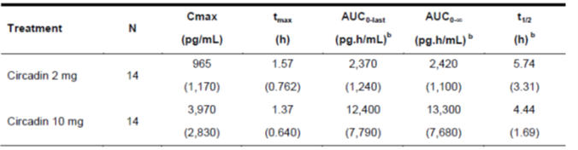
t_{max} = time to maximum concentration; t_{1/2} = biological half-life; AUC_{0-last} = area under the concentration/time curve from time 0 (dosing) to last quantifiable time point; AUC_{0-∞} = area under the concentration/time curve from time 0 (dosing) extrapolated to infinity.
The Delegate comments that children in the 2 to 6 years age group and those with Smith-Magenis syndrome were not included in the paediatric study. There is lack of PK data for these patient populations who are included the proposed indication. The low number of children (n = 14) in the PK population was noted. The sponsor provided correlation data for saliva and plasma levels following EMA’s request and was concluded as acceptable. The concentration gradient across saliva and plasma levels was reported as 1:3.

Study CHDR-1742
The results of this study demonstrated dose proportionality between 1 mg and 5 mg strengths. A significant food effect was noted on C_{max};⁷ (51% reduction), and a minor reduction of AUC (14% reduction) of oral prolonged release formulations. The Delegate commented that the food effect on Slenyto was sufficiently characterised and the PK profile was comparable between Circadin and Slenyto tablets.

Efficacy

Study NEU-CH-7911

Study design
This was a placebo-controlled randomised controlled trial (RCT) in children diagnosed with sleep disturbances and neurodevelopmental disorders.
A screening visit was conducted 4 weeks prior to randomisation. After screening, eligible children were provided with 4 weeks of sleep hygiene and behavioural intervention. This time period also facilitated washout of any hypnotics used for prior treatment. Sedative/hypnotic drugs, antipsychotics and alpa-2 agonists causing sedation were prohibited during study period. Eligible children at the end of 4 week period continued in a 2 week single blind placebo run in period and were randomised in a 1:1 ratio to receive either melatonin or placebo in a 13 week double blind treatment period.
The starting dose of melatonin (or placebo) was 2 mg (2 x 1mg tablet) once-daily. All study treatments were administered 0.5 to 1 hour(s) before desired bedtime. After 3 weeks of double blind treatment, sleep variables were assessed to determine if dose modification (an increase to 5 mg) was required. Children then continued on 2 or 5 mg of melatonin or placebo for the remaining 10 weeks of double-blind treatment, with an efficacy assessment visit at Week 15.
The double blind period was followed by a 91 week open label period. After 13 weeks of treatment in the open label period, sleep variables were assessed to determine if a potential additional dose modification was necessary; if necessary, the dose was increased to 5 mg (for patients who were still on 2 mg) or to 10 mg (for patients who were on 5 mg). Children continued at 2, 5, or 10 mg melatonin in the open label period for another 78 weeks, which included continuous safety monitoring.
Efficacy assessments were made at Weeks 41 and 54 (Visits 6 and 7). The open label period ended at Week 106 (Visit 8) and was followed by a 2 week single blind placebo run out period. An end of study visit was conducted at Week 108.

Concomitant medications
Around 30% of children were on psychoanaleptics during study period. The most common was methylphenidate hydrochloride (7.2%). 4% of children were on sertraline and 0.8% of children were on escitalopram.

Dose rationale
The sponsor has provided literature reference for studies in children with autism and developmental disorders and insomnia. Most of these studies have used doses in the range for 4 to 6 mg of Circadin.

Key inclusion criteria
- Children 2 to 17.5 years of age.
- Documented history of ASD according to or consistent with the ICD-10; or DSM-5/4¹⁰ criteria, or neurodevelopmental disabilities caused by neurogenetic diseases (Smith-Magenis Syndrome, Angelman syndrome, Bourneville’s disease (tuberous sclerosis)).
- Current sleep problems including: a minimum of 3 months of impaired sleep defined as ≤ 6 hours of continuous sleep and/or ≥ 0.5 hour sleep latency from light off in 3 out of 5 nights based on parent reports and patient medical history (the maintenance and latency problems did not necessarily have to be in the same 3 nights of the week.).
- Stable dose of non-excluded medication (anti-epileptics, anti-depressants, stimulants, mood changing drugs and beta blockers) for 3 months.

Key exclusion criteria
- Prior treatment with any forms of melatonin within 2 weeks prior to Visit 1.
- Moderate or severe sleep apnoea.

Study treatment
All children received 2 mg/day of melatonin (2 x 1 mg mini tablets) during first three weeks of the double-blind treatment period. Thereafter, the dose could be increased to 5 mg, depending on treatment response. After 13 weeks of open label treatment period with melatonin, children on 2 mg could be up-titrated to 5 mg and those who are 5 mg could be up-titrated to 10 mg, based on predefined criteria (see below).
All doses were taken postprandial and 0.5 to 1 hour(s) before bedtime. These tablets were not to be crushed and were to be swallowed whole. The mini tablets were 3 mm in dimension. These tablets could be administered in specific foods such as orange juice, semi-skimmed milk, strawberry yogurt and strawberry jam. The sponsor has provided literature reference to support that melatonin was compatible and stable for up to 6 hours in these specific food products.

Dose up-titration
Options for increase in dose included 2 mg to 5 mg at Visit 3(Week 3 of the double blind phase), and/or 2 mg to 5 mg or 5 mg to 10 mg at Visit 5 (Week 13 of the open-label phase).
Dose escalation was based on review of sleep and nap diaries and electronic case report forms (eCRF).
The following criteria were required to be satisfied:
- Absence of serious adverse events (SAE) related to study treatment.
- Absence of daytime fatigue related to study treatment.
- Compliance to treatment (received study treatment for 5 out of 7 nights/week). And patient continued to have ≤ 6 hours of continuous sleep and/or ≥ 0.5 hours of sleep latency in 3 out of 5 nights in each of the 2 weeks prior to Visit 3 or 5; or
The patient had ≤ 6 hours of continuous sleep and/or ≥ 0.5 hours of sleep latency from light off only in ≤ 2 out of 5 nights in each of the 2 weeks prior to Visit 3 or Visit 5, and did not improve from Visit 2 by at least 1 hour as measured by either shortening of sleep latency or increase in sleep duration or both.

Dose reduction
These were the criteria adopted for dose reduction:
- An unacceptable increase in daytime fatigue.
- An unacceptable behavioural change.
- If the patient stopped responding to study drug (sleep improved and then deteriorated on higher dose).

Endpoints
Primary efficacy endpoint: Total sleep time (TST). This outcome was assessed from the sleep and nap diary. Parent was expected to complete the sleep diary 2 to 3 hours after the child woke up each day.
Secondary efficacy endpoints: Sleep latency, duration of wake after sleep onset, number of awakenings, longest sleep period.
Other secondary efficacy endpoints: Social functioning, behaviour changes and sleep parameters assessed by actigraphy.
Exploratory endpoints: Caregiver’s daytime sleepiness and well-being.

Patient disposition
Out of 267 patients enrolled, 125 (46.8%) patients were randomised. 58 children were treated with melatonin. 85% and 67.7% of children in melatonin and placebo arms completed the double blind phase respectively.
Figure 2, shown below, demonstrates the patient disposition and flow through Study NEU-CH-7911.
Figure 2: Study NEU-CH-7911 study flow diagram
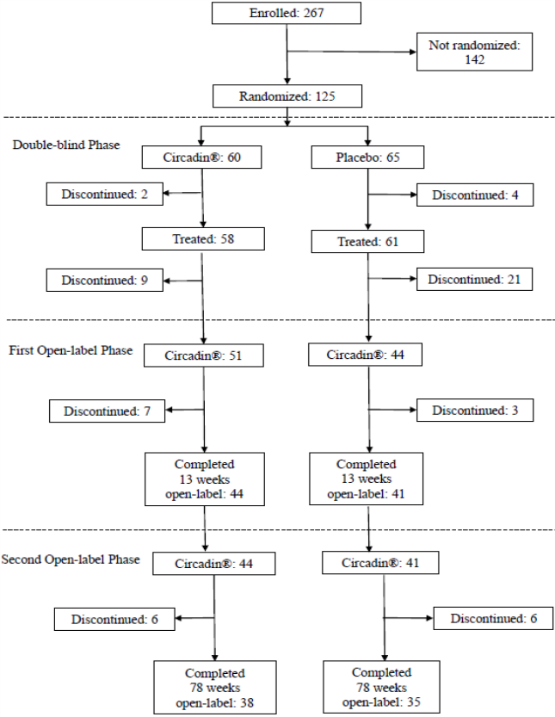

Baseline characteristics
45.6% of patients were between 7 to 12 years of age. Mean age across both treatment groups was around 9 years. There were 29 children in the 2 to 6 year old age group. Almost all of the children had a diagnosis of ASD (96.8%). 3.2% children were diagnosed with Smith-Magenis syndrome. Around 75% of children were males. 28.8% and 12.8% of children had attention deficit hyperactivity disorder (ADHD) and epilepsy as co-morbidities respectively. 65.5% of children were previously treated with melatonin at some time. 13.6% of children were being treated with melatonin at screening; all of them stopped during wash-out phase of the study. 10.4% of patients had prior ADHD treatment.

Results

Primary endpoint
At 13 weeks of double blind treatment phase, children in melatonin group achieved a mean adjusted change from baseline of 51.03 minutes of increase in TST compared to 18.71 minutes for children in placebo group (see Table 4, below). The mean TST at Baseline was 457.2 minutes and 459.9 minutes for melatonin and placebo groups respectively. The treatment difference was 32.32 minutes and was statistically significant.
In a sub-group analysis, treatment difference (32 minutes) was also reported in patients with ADHD as a co-morbid condition.
Table 5: Study NEU-CH7911 Primary endpoint, total sleep time
n = number of subjects; SD = standard deviation; SE = standard error; 95% CI = 95% confidence intervals

Secondary endpoints
At 13 weeks of double blind treatment phase, sleep latency for children in melatonin and placebo groups was around 60 minutes and 76 minutes respectively. There was a reduction of around 39 minutes and 12 minutes for children in melatonin and placebo groups respectively. The treatment difference was statistically significant (see Table 6, below).
Table 7: Study NEU-CH-7911 Secondary endpoint, sleep latency
n = number of subjects; SD = standard deviation; SE = standard error; 95% CI = 95% confidence intervals
Duration of wake time: at 13 weeks of double blind treatment phase, duration of wake time after sleep onset was around 15 minutes and 11 minutes for children in melatonin and placebo groups. The treatment difference between groups was not statistically significant.
Table 8: Study NEU-CH-7911 Secondary endpoint, duration of wake time
Number of awakenings: children in melatonin group had 0.44 mean number of awakenings, compared to 0.69 with placebo group. The treatment difference was not statistically significant.
Table 9: Study NEU-CH-7911 Secondary endpoint, number of awakenings
n = number of subjects; SD = standard deviation; SE = standard error; 95% CI = 95% confidence intervals
Longest sleep period: at Week 13 of the double blind phase, longest sleep period was around 451 minutes and 414 minutes in melatonin and placebo groups respectively.The treatment difference was not statistically significant. .
Table 10: Study NEU-CH-7911 Secondary end point, longest sleep period
n = number of subjects; SD = standard deviation; SE = standard error; 95% CI = 95% confidence intervals
Total time in bed per night: total time in bed per night was around 566 minutes and 564 minutes for children in melatonin and placebo groups respectively. The treatment difference was not statistically significant.
Table 11: Study NEU-CH-911 Secondary endpoint, total time in bed per night
n = number of subjects; SD = standard deviation; SE = standard error; 95% CI = 95% confidence intervalsSleep disturbance (composite sleep disturbance index; CSDI): At Week 13 of double blind treatment period, CSDI; score for melatonin and placebo groups were around 5.4 and 6.2 respectively. The treatment difference was not statistically significant.13..
Table 12: Study NEU-CH-911 Secondary endpoint, composite sleep disturbance index
n = number of subjects; SD = standard deviation; SE = standard error; 95% CI = 95% confidence intervals
Social functioning (Children’s Global Assessment Scale; CGAS): the mean CGAS; score was 48.3 and 51.5 in melatonin and placebo groups respectively. The treatment difference was not statistically significant.
Table 13: Study NEU-CH-7911 Secondary endpoint, Children’s Global Assessment Scale
n = number of subjects; SD = standard deviation; SE = standard error; 95% CI = 95% confidence intervals
Behaviour (Strength and Difficulties Questionnaire (SDQ) total score): the mean SDQ; score was 19.6 and 20.7 for melatonin and placebo groups respectively. The treatment difference was not statistically significant.13 .
Table 14: Study NEU-CH-7911 Secondary endpoint, Strength and Difficulties Questionnaire total score
n = number of subjects; SD = standard deviation; SE = standard error; 95% CI = 95% confidence intervals
The melatonin group achieved a mean SDQ;¹⁶ externalising score of 10.4 and placebo group had 11.4. The treatment difference was statistically significant. A similar finding was not noted with SDQ;¹⁶ impact score and individual scores.13The majority of children were not compliant with actigraphy and hence no data is available.
It was noted that the placebo group had 32% children as dropouts, compared to 15% in melatonin group. This difference was statistically significant.

Exploratory efficacy endpoints
- Responder analysis
A patient was defined as a TST responder if the mean increase from Baseline in TST was 45 minutes or greater over the 14 days prior to each scheduled visit.
A patient was defined as a sleep latency responder if the mean reduction from Baseline in sleep latency was 15 minutes or greater over the 14 days prior to each scheduled visit.
At 5 weeks of treatment phase of the study around 32% of children were responders to melatonin and at 15 weeks, a 5% increase was noted. The rate of sleep latency responders in the melatonin group increased from 50% (at Week 5) to 63.8% (at week 15)
The Delegate comments that in spite of the dose increase at Week 3, the proportion of responders was comparable throughout the treatment period.
Table 15: Study NEU-CH-9711 Responder analysis
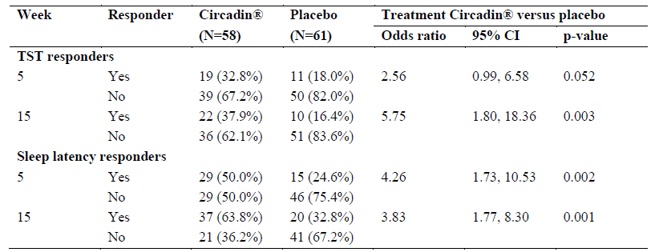
n = number of subjects; 95% CI = 95% confidence intervals
- Sleep and nap diary variables after 13 weeks of open label treatment
Children who received melatonin on both double blind and open label phase, the change from baseline (increase) in TST was around 52 minutes and sleep latency (reduction) was around 33 minutes.
The Delegate comments that it was noted that those children who were on placebo during double blind phase and on melatonin in open label phase did not achieve the same magnitude of change with both TST and sleep latency, compared to those treated with melatonin during 13 weeks of double blind phase. The mean change from baseline in TST during the placebo treatment period was 12.22 minutes and after switching to Circadin was 19.87 minutes, a difference of 7.65 minutes. There is no clear explanation for the large difference between groups in change from Baseline in TST. Also, in spite of increase in dose, the magnitude of change with both TST and sleep latency are comparable for children treated with melatonin during the 13 week double blind and open label phase.
Table 16: Study NEU-CH-7911 Sleep and nap diary variables after 13 weeks of open label treatment
SE = standard error; 95% CI = 95% confidence intervals
Around 30% increase in TST and a similar magnitude of improvement in sleep latency was noted at 26 and 39 weeks of open label treatment in children who continued to be treated with melatonin. A similar improvement in these outcomes was not observed with children who were on placebo during double-blind phase and then started on melatonin during open label phase.
- Sleep and nap variables by final dose
After 3 weeks of double blind treatment, around 60% of patients had a dose increase from 2 mg to 5 mg/day. At 15 weeks of study period (at the beginning of open label phase), 63.3% (19 out of 30) patients who were on 5mg were up-titrated to 10 mg daily dose due to sub-optimal response. At Week 52, 16 patients were on the 2 mg dose, 26 on the 5 mg dose, and 30 on the 10 mg dose.
During Week 3 to 13 of the double blind treatment period, the magnitude of improvement in all sleep variables except for number of awakenings and duration of wake time for children with dose escalation of melatonin from 2 mg to 5 mg was less than for those who continued on 2mg. The tables below illustrate the TST measures for children with up-titration of dose from 2 mg to 5 mg and for those who stayed on 2 mg. A similar finding was also observed with sleep latency. A similar trend was also seen at treatment Week 54 in children with sub-optimal response and up-titrated to 10 mg at treatment Week 28 (after 13/26 weeks of treatment with melatonin).
Discrepancy between total number of children administered with 2, 5 and 10 mg dose and the number of children from whom TST measures were taken was noted (see table below). The sponsor will be requested to clarify in the pre-Advisory Committee on Medicines (ACM) response (see sponsor’s response to Question 3 in the ‘Questions to sponsor’ section, below).
Table 17: Study NEU-CH-7911 Treatment response for children on 2mg daily dose of melatonin
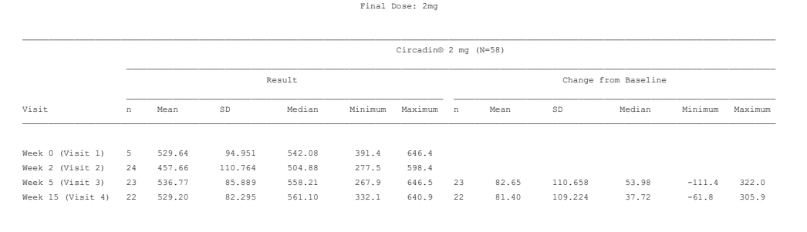
n = number of subjects; SD = standard deviation
Table 18: Study NEU-CH-7911 Treatment response for children who were up titrated to 5 mg daily dose of melatonin
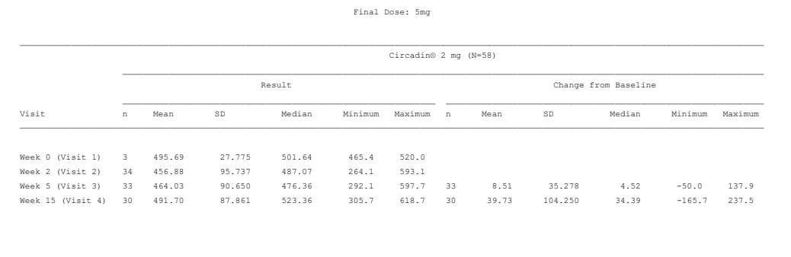
- n = number of subjects; SD = standard deviationCaregiver’s daytime sleepiness (Epworth Sleepiness Scale ;ESS)
At Week 13 of double blind treatment phase, there was significant difference in caregiver’s sleep time between treatment groups. From 13 weeks onwards until 39 weeks of open label treatment, there was a significant reduction in caregiver’s daytime sleep time for children who continued to be treated with melatonin. A similar finding was not observed with children who were on placebo for 13 weeks and changed over to melatonin during open label phase.
As a long term outcome, at 39 weeks and 91 weeks of open label treatment phase, there was no significant reduction in daytime sleepiness for caregivers for both children treated with melatonin throughout treatment period and those who changed over from placebo to melatonin after 13 weeks.
- Caregivers wellbeing
There was significant improvement in caregivers wellbeing for children treated with melatonin during double blind and open label phase of the study, compared to those who received placebo.
- Caregivers quality of sleep at night
No significant improvement in this outcome was reported for melatonin group, compared to placebo during double blind phase. A significant improvement for melatonin group was reported after 26 weeks onwards of open label phase.
- Other efficacy variables
There were no significant difference between melatonin and placebo groups in terms of quality of sleep, current alertness, feeling on awakening, number of daytime naps, or duration of daytime naps after 13 weeks of double-blind treatment.
- Sleep disturbance (CSDI);¹⁴ individual questionnaire
There were no significant difference between melatonin and placebo groups in terms of CSDI ¹⁴ individual questions. A positive trend for melatonin group was noted for ‘problem setting’ and co-sleeping questions, compared to placebo.
- Long term efficacy data for TST (Week 54)
The Delegate comments that it appears that the children who required up-titration of melatonin dose to 5 and 10 mg, in spite of the dose increase; they did not achieve the same magnitude of improvement with the TST compared to those who continued on 2 mg. In addition, the mean TST at Week 54 for those children on 10 mg dose did not reach the clinically relevant time period of 45 minutes.
Table 19: Study NEU-CH-7911 Change in total sleep time for children on treatment with 2 mg daily dose of melatonin
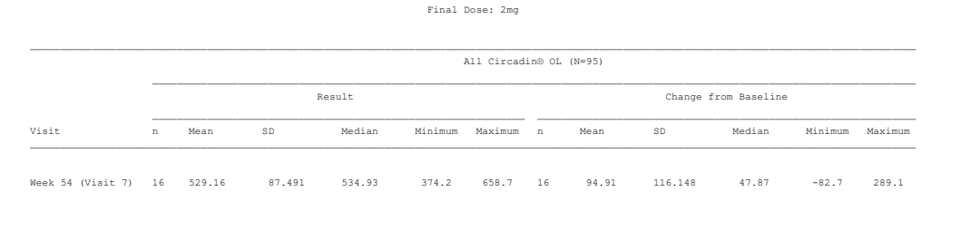
n = number of subjects; SD = standard deviation
Table 20: Study NEU-CH-7911 Change in total sleep time for children who were up titrated to 5 mg daily dose of melatonin during study period
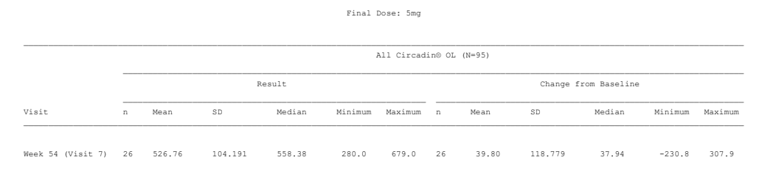 n = number of subjects; SD = standard deviation
Table 21: Study NEU-CH-7911 Changes in total sleep time for children who were up titrated to 10 mg daily dose of melatonin during study period
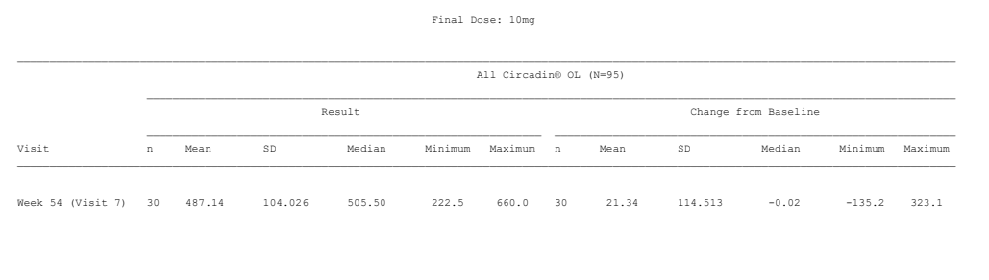 n = number of subjects; SD = standard deviationEfficacy data after 2 weeks of single blind withdrawal period (Week 106 to 108)
After 2 weeks of withdrawal period, the magnitude of improvement with most of the efficacy outcomes declined descriptively compared to end of treatment period.

Safety

Safety results from Study CHDR-1219 (pharmacokinetic study)
Fatigue was the most common adverse event (AE) reported, followed by somnolence.
Table 22: Study CHDR-1219 Summary of treatment-emergent adverse events

Safety results from Study NEU CH 7911 (pivotal study)
During the double blind phase, treatment-related AEs for patients aged 2 to 12 years were reported by 9 (19.1%) patients (24 events) in the Circadin group and 9 (16.7%) patients (14 events) in the placebo group. Overall incidence of AEs in 2 to 12 and 13 to 17 year age groups was comparable. Somnolence and fatigue were the most common reported treatment-related adverse events. 25% of children in melatonin group and 20% of children in placebo group experienced at least one SAE. Agitation, fatigue and mood swings were the commonest SAEs reported.
Table 23: Study NEU-CH-7911 Summary of treatment-emergent adverse events
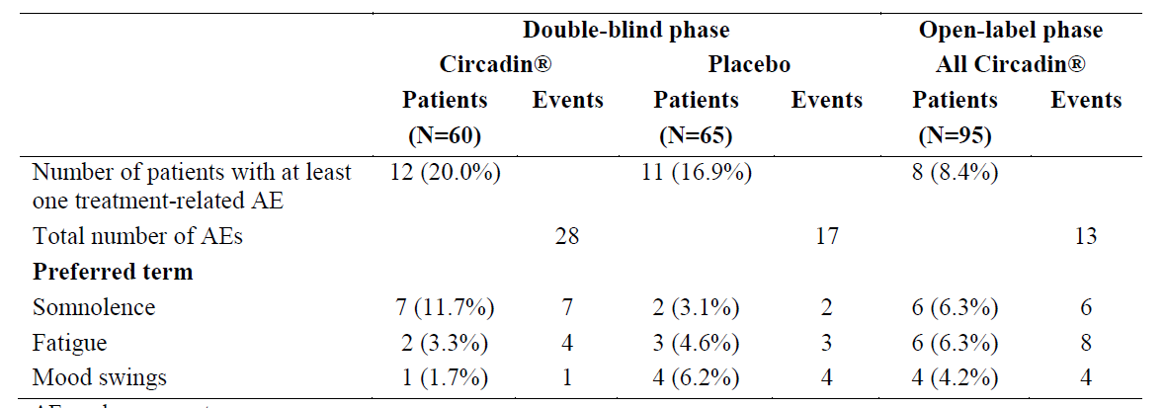

Tanner assessment of pubertal development
No apparent delay in pubertal development was observed.
Figure 3: Study NEU-CH-7911 Tanner assessment of pubertal development

Deaths
No deaths occurred during study period. No other major safety concerns were noted.

Risk management plan
The summary of safety concerns are shown in Table 24.
Table 24: Summary of safety concerns
Summary of safety concerns
Important identified risks | None
Important potential risks | Delay of sexual maturation and development
Missing information | Use in pregnancy/lactation
This submission was not subject to risk management plan (RMP) evaluation because:
- The product has been approved by the EMA (COR) in the same paediatric population.
- There is no additional risk minimisation required by the EMA or proposed by the sponsor in Australia.
- There has been off-label use of melatonin in the paediatric population in Australia, which has not been related to significant adverse reactions that would require additional risk minimisation.

Risk-benefit analysis

Delegate’s considerations
The single pivotal study in children with ASD and/or Smith-Magenis syndrome and parent/self-reported history of ‘impaired sleep’ achieved its primary endpoint (TST). This finding was supported by the significant reduction in sleep latency in children treated with melatonin, compared to placebo. The treatment difference for the majority of the secondary endpoints, including most of the quality of life measures for children and their caregivers were not statistically significant between melatonin and placebo groups. However, a positive trend in favour of treatment with melatonin was noted for most of these endpoints. These observations suggest that the criteria required by the relevant EMA guideline for ‘single pivotal study’ has been largely met.6 The primary endpoint chosen by the pivotal study reflects the predominant feature of sleep disturbance in children with ASD.
The Delegate considers the issues related to lack of PK data in children 2 to 6 years old, the proportion of patients in this age groups, and the dose proportionality to be resolved.
The sponsor defined ‘impaired sleep’ as ‘≤ 6 hours of continuous sleep AND/OR ≥ 0.5-hour sleep latency from light off in 3 out of 5 nights’ as one of the inclusion criteria to identify eligible patients for the clinical study. However, the proposed indication was for children with ‘insomnia’. The sponsor has not adequately justified the basis of their approach to define impaired sleep. It is uncertain whether this approach is in line with how insomnia is diagnosed in children in clinical practice in Australia and hence may have a negative impact on the external validity of study findings.
The Delegate considers that there was a low threshold to increase the dose of melatonin during the treatment period. In addition to children who persisted to have ‘impaired sleep’ (as defined by the sponsor) at Week 3 and 13 of the double blind treatment phase, children with < 1 hour as improvement with sleep latency and/or sleep duration were also subjected to a dose increase. The external validity of this approach is uncertain.
It was noted that the 10 mg daily dose was not included in the double blind treatment phase of the pivotal study. Hence there is lack of comparative data (with placebo) to support greater treatment benefit with this dose of melatonin. Moreover, the magnitude of improvement in TST that was achieved by those children who were treated with 10 mg melatonin during open label phase was < 50% of the magnitude of improvement for this endpoint in children who continued to be treated with 2 mg. It could be considered that these children were at the severe end of ASD and ‘impaired sleep’ spectrum and hence required the dose up-titration. However, in view of these facts, the Delegate considers that the evidence for greater benefit with 10 mg dose for the patient population indicated is modest.
The magnitude of the mean change in TST (primary endpoint) of around 51 minutes was clinically relevant. This is based on 45 minutes as the minimal clinically important difference (MCID) for this endpoint in adults. The wide variability of sleep duration in children with normal development is well recognised. This variability is exaggerated in children with ASD. The Delegate is not aware of a similar MCID in children with typical development or with ASD. The treatment difference of around 30 minutes with TST between melatonin and placebo is less than the natural variability of sleep duration in children across age groups from 2 to 18 years.20
Figure 4: Centiles for total sleep duration per 24 hours by age in two Australian cohorts
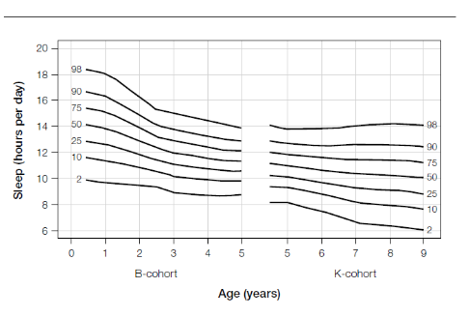
Source: Hannan and Hancock, 2015.
From patient’s perspective, a treatment difference of 30 minutes will not be beneficial to the same extent to a child aged 2 years and 18 years old with ASD. However, considering that the proposed indication is for children diagnosed with ASD, who are known to have a greater impact form insomnia, the magnitude of improvement in TST might be of clinical relevance.
It appears that the melatonin group’s increased TST would be largely attributable to the reduction in sleep latency. Sleep latency was significantly reduced in children in melatonin group, compared to placebo. It is also mechanistically supported by the PK profile of melatonin. After 13 weeks of double blind treatment, there was no significant difference between treatment groups in terms of other secondary endpoints such as duration of wake time, number of awakening, longest sleep period, total time in bed per night and sleep disturbance. There was also no significant treatment difference in quality of life measures such as social functioning and behaviour (SDQ impact and individual scores) scores. There was no significant improvement in most of the measures for parent’s/caregivers wellbeing in melatonin group, compared to placebo. It is unknown why children who were initially randomised to placebo had much smaller mean responses to melatonin during the open label treatment phase.
Non-response to treatment and treatment refractoriness to melatonin in some subjects were noted during treatment period. At Week 5 and 15 of the study period, in terms of improvement in TST, the majority of children (around 65%) were non-responders for treatment with melatonin. Similarly, those children who required up-titration from 2 mg to 5 mg or 10 mg did not achieve a similar magnitude of improvement in TST, compared to those who continued on the 2 mg dose. These findings suggest a heterogeneous treatment response to melatonin in children with ASD and ‘impaired sleep’, particularly in those children requiring a higher dose to achieve clinically relevant improvement with TST. There is a statement in PI that indicates review of treatment at 3 months and cessation of treatment if not responding.
Ideally, from a clinical and regulatory perspective (single pivotal study), improvement in all aspects of sleep (sleep latency, sleep continuity, sleep duration, feeling of restorative sleep, quality of sleep and subsequent daytime functioning in the natural setting) is expected from a treatment intervention for insomnia to be considered as an optimal treatment outcome (EMA/CHMP/16274/2009). However, it was noted that the single pivotal study failed to show significant improvements in all aspects of sleep architecture and measures of daytime functioning in children treated with melatonin, compared to placebo.6 It was considered that the children with ASD are known to have greater severity of sleep problems, change in types of sleep problems over time and greater impact on quality of life.¹² 28% of the study population were also diagnosed to have ADHD as a comorbid condition that could have a compounding effect on their sleep problems.¹¹ Interestingly, children with and without ADHD had comparable treatment difference in terms of TST. Of note, only 10.4% of the children received medication for ADHD, although 28% had been diagnosed with ADHD.
Fatigue, mood swings, irritability and somnolence were the most common TEAEs that were considered to be related to study treatment. These AEs are known effects of melatonin when used to treat the patient population in the current approved indication. It was also noted that these events were reported in a minority of children (17.9%). No events of treatment-related increased seizures were reported.
The Delegate is concerned about the lack of safety data that is related to potential effect of melatonin on hypothalamic-pituitary-adrenal (HPA) axis function. Melatonin is known to exert an inhibitory effect on gonadotropin-releasing hormones (GnRH). Accordingly, decline in melatonin during pre-pubescent stage;, triggers systemic increase in GnRH and progression of Tanner stages.^{Error! Bookmark not defined.} Evidence based on animal studies suggest that exogenous melatonin can suppress GnRH secretion;^{Error! Bookmark not defined.} and alter sexual maturation.²⁴ Taking all these into consideration, there is a mechanistic potential for exogenous melatonin to interfere with sexual maturation in children.^{Error! Bookmark not defined.} Children on long term melatonin treatment may have delayed onset of puberty and those who have stopped treatment may be at risk of precocious puberty.²⁴ Continued treatment with melatonin has the potential of nullifying the natural course of decline in systemic levels of melatonin and GnRH stimulation at pre-pubescent stage. This interaction could lead to delayed onset of puberty. On the other hand, cessation of treatment with melatonin has the potential for GnRH stimulation and lead to precocious puberty. There is lack of well-designed long term longitudinal studies that has examined this mechanistic relationship.²⁴ It was noted that there was no major variation in the Tanner stage assessment of children in the pivotal study. The sponsor indicated that there were no specific tests done to assess HPA axis function. More importantly, there is lack of long term data related to precocious puberty/sexual maturation in this submission in children who stopped treatment with melatonin. Delay of sexual maturation is included as an important potential risk in the summary of safety concerns.
In conclusion, treatment with melatonin has benefitted children with ASD and ‘impaired sleep’ with a clinically relevant improvement in TST and sleep latency. A trend towards an overall improvement in other measures of sleep architecture was also observed in children treated with melatonin. These changes do not appear to be reflected in a similar magnitude for quality of life measures of both children in melatonin group and their caregivers. Evidence for greater benefit with 10 mg daily dose of melatonin is modest. There is lack of data related to long term effects of melatonin on sexual maturation in children.

Proposed action
The Delegate has no reason to say, at this time, that the application for Slenyto should not be approved for registration.

Questions for sponsor

Question 1
What proportion of children in 2 to 6 year age group and 7 to 18 age group required up-titration from 2 to 5 mg at Week 3 and from 5 mg to 10 mg at Week 13 of double-blind treatment phase. Out of which, what proportion of them had a clinically relevant response to TST (≥ 45 minutes) and sleep latency (≤ 15 minutes reduction).

Sponsor’s response
In Study NEU-CH-7911 two optional dose-modification phases were scheduled: the first following 3 weeks of double-blind (DB) treatment (Study Week 5) and the second following 13 weeks of open-label (OL) period (Study Week 28). Table 25 represents the number of children aged 2 to 6 years and 7 to 18 years that required dose-modification from 2 to 5 mg at Week 5 and from 5 to 10 mg at Week 28.
Table 25: Proportion of patients that required dose-modification by age group
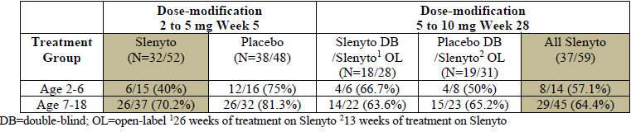
Table 26 presents responders’ analysis (≥ 45 minutes TST OR/AND ≥ 15 minutes sleep latency) following 13 week double blind period (Week 15) of patients that were escalated from 2 to 5 mg on Week 5 and of patients escalated from 5 to 10 mg on Week 28, at the end of the open label period (Week 54) divided by age. Table 27 presents number of responders separately for TST and sleep latency.
Table 26: Total sleep time and/or sleep latency responder’s analysis by age
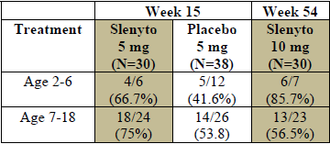
Table 27: Number of responders separately for total sleep time and sleep latency
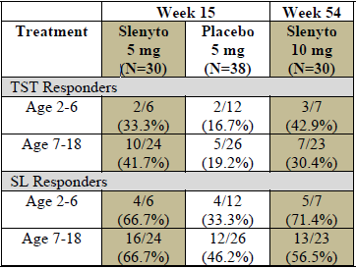
The beneficial effect of Slenyto in TST and sleep latency does not depend on age and both age groups 2 to 6 years and 7 to 18 had a higher response rate as compared to placebo in the double blind phase and a similar response rate in the open label phase. Moreover, more than 50% of those who were escalated to 5 mg or 10 mg responded to the drug (TST and/or sleep latency), regardless of age (Table 26).

Question 2
Please justify how ‘impaired sleep’ was defined (please provide reference) and adopted as a criteria for recruitment.

Sponsor’s response
According to the study protocol, the children must have had a minimum of 3 months of ‘impaired sleep’ defined as ≤ 6 hours of continuous sleep AND/OR ≥ 0.5 hour sleep latency in 3 out of 5 nights per week. These criteria are consistent with the DSM-5 criteria for insomnia disorder (307.42) ‘A predominant complaint of dissatisfaction with sleep quantity or quality associated with one (or more) of the following symptoms: difficulty initiating sleep, difficulty maintaining sleep and early morning awakening with inability to return to sleep. The sleep disturbance occurs at least 3 nights a week. The sleep difficulty is present for at least 3 months.’ According to DSM-5, in order to be defined as suffering from insomnia disorder one must have at least one complaint out of the three. All children in the study had at least one of the symptoms and 62% of the children suffered from both. Difficulty initiating sleep of more than 30 minutes is defined also in DSM-5: ‘difficulty initiating sleep is defined by subjective sleep latency greater than 20-30 minutes’ and was also a criterion in the MENDS study which was the basis of this study protocol. Sleep maintenance of ≤6 hours continuous sleep was also defined in the MENDS study. Current practices recommend parent-directed behavioural sleep interventions as first-line treatment, thus, only children who had not responded to behavioural intervention continued into the study. The inclusion criteria for impaired sleep, in the study are consistent with the DSM-5 criteria and in clinical practice clinicians would diagnose an ASD child for insomnia according to DSM-5.

Question 3
There was a discrepancy noted in the tables 14.2.18.6.1, 14.2.18.6.2 regarding the number of patients in circadin group (n = 51) and the number of patients included in data collection (n = 11). Please clarify.

Sponsor’s response
Table 14.2.18.6.1; describes the TST;¹² change from Baseline on Study Week 28 by final dose, either 2 or 5 mg. The table also distinguishes between patients who were treated with Circadin (Slenyto 3 mm coated tablets were used but were named Circadin) during the double blind (DB) phase and Circadin during the open label (OL) phase (group name Circadin DB/Circadin OL), and between patients who were treated with placebo during the DB phase and Circadin during the OL phase (group name placebo DB/Circadin OL). Altogether, 95 patients entered the first 13-week open label phase, 51 patients from the Circadin DB/Circadin OL group and 44 from the placebo DB/Circadin OL group, regardless of dose. For the group Circadin DB/Circadin OL, 19 patients received a 2 mg final dose and 29 patients received a 5 mg final dose. This sums up to 48/51 patients who completed the 13-week open label phase with SND TST¹² data at week 28. Looking at group placebo DB/Circadin OL, 11 patients received 2 mg final dose and 32 patients 5 mg final dose. This sums up to 43/44 patients who completed the 13-week open label phase with sleep and nap diary TST¹² data at week 28. The same explanation applies to Table 14.2.18.6.2 ²⁹ and Table 15, and Table 16 (in this AusPAR), that correspond to Table 14.2.18.1; ²⁹ of the clinical study report, that present the number of patients by randomisation group and final dose either 2, 5 or 10 mg.

Request for advisory committee on medicines
The committee is requested to provide advice on the following specific issues:
- There were no PK data and limited efficacy data for children younger than 7 years however it is proposed that the indication include children as young as 2 years. Does the committee have concerns regarding extrapolation of efficacy and safety data to this younger age group?
- The committee is requested to comment on the definition of ‘impaired sleep’ used in the inclusion criteria for the pivotal efficacy study. Specifically comment on whether that definition is consistent with secondary insomnia in children.
- Children who continued to have ‘impaired sleep’ as defined by the sponsor at Week 3 and 13 of double blind treatment phase, and children with < 1 hour as improvement with sleep latency and/or sleep duration were subjected to a dose increase. Does the committee consider that these criteria for dose escalation up to 10 mg are consistent with clinical practice?
- The Delegate considers that the evidence for greater benefit from 10 mg of melatonin is modest and there is lack of data to support treatment benefit of that dose, compared to placebo. ACM’s comments on the demonstration of safety and efficacy of the 10 mg dose are requested.
- The Delegate is concerned that melatonin is associated with treatment-related precocious puberty or delayed puberty, particularly when used for a long duration. The ACM’s comments on this issue are requested.
The committee is (also) requested to provide advice on any other issues that it thinks may be relevant to a decision on whether or not to approve this application.

Advisory Committee considerations

Specific advice
The ACM advised the following in response to the Delegate’s specific request for advice.
- There were no PK data and limited efficacy data for children younger than 7 years however it is proposed that the indication include children as young as 2 years. Does the Committee have concerns regarding extrapolation of efficacy and safety data to this younger age group?
The ACM considered the sponsor’s rationale that metabolic capacity, body surface area/weight, distribution sites, gastrointestinal and renal function change dramatically during the first 12 months of age and more moderately afterwards towards adulthood. Therefore, the PK/pharmacodynamic (PD) parameters of the ≥ 7 year age group are representative of the 2 to 7 years age group. While the ACM generally agreed with this point, they still had concerns regarding the ease and safety of administration in this age group, as well as the limited data on long-term effects of administration (although not on puberty, as addressed in the response to Question 5, below).
- The Committee is requested to comment on the definition of impaired sleep used in the inclusion criteria for the pivotal efficacy study. Specifically comment on whether that definition is consistent with secondary insomnia in children.
The ACM agreed with the definition, noting that the Gringras study (2012);27 had one hour delay of sleep onset for inclusion and reported that improvement greatest for those with most sleep onset delay. The ACM commented that 30 minutes sleep latency after lights off for 3 of 5 nights seems like a mild sleep problem. The ACM commented that < 6 hours continuous sleep is ‘not recommended’ for all ages, but how parents perceive this will depend on child’s awake behaviour and advised that the minimum appropriate amount of sleep for children 2 to 17 ranges from 7.5 to 9 hours per night.
- Children who continued to have ‘impaired sleep’ as defined by the sponsor at Week 3 and 13 of double blind treatment phase, and children with < 1 hour as improvement with sleep latency and/or sleep duration were subjected to a dose increase. Does the committee consider that these criteria for dose escalation up to 10 mg are consistent with clinical practice?
While the ACM generally agreed with the criteria for dose escalation, they advised that, in practice, less specific information is gathered about sleep changes and most would be guided by the parents’ perception of adequate improvement in sleep rather than specific numeric cut-offs. The ACM commented that, in clinical practice a 3 mg dose is most commonly prescribed, but that higher doses of 9 or 10 mg are sometimes used in a small number of children.
- The Delegate considers that the evidence for greater benefit from 10 mg of melatonin is modest and there is lack of data to support treatment benefit of that dose, compared to placebo. ACM’s comments on the demonstration of safety and efficacy of the 10 mg dose are requested.
The ACM agreed that the evidence for a greater benefit from 10 mg melatonin is modest. However, it appears to be of benefit in a small subgroup of patients. The ACM had some concerns regarding the uncertainty of the safety of the 10 mg dose. The ACM advised that the 10 mg dose should be included in the dosage for Slenyto. However, there should be clear directions in the PI regarding when it should be utilised. It should be stated that the magnitude of improvement in TST was lower than 2 and 5 mg doses. It should also be specified that the approval of 10 mg dose is based on limited data (with reference to the clinical trial section) and long-term effects have not been studied.
- The Delegate is concerned that melatonin is associated with treatment-related precocious puberty or delayed puberty, particularly when used for a long duration. The ACM’s comments on this issue are requested.
The ACM advised that while from a mechanistic point of view there could be effects of melatonin on GnRH, there is no evidence so far to support this association. The studies performed in humans so far are with different dosage forms of melatonin and not in comparable patient populations. The Delegate informed the ACM that ‘Delay in sexual maturation and development’ is included as an important potential risk in RMP.
- The committee is also requested to provide advice on any other issues that it thinks may be relevant to a decision on whether or not to approve this application.
The ACM advised that the safety of taking tablets under the age of 5 is uncertain. The ACM expressed concern that melatonin could be used as a first line treatment and was of the view that the PI should suggest that behavioural strategies should continue while taking melatonin.

ACM recommendation
The ACM considered this product to have an overall positive benefit-risk profile for the indication:
Slenyto is indicated for the treatment of insomnia in children and adolescents aged 2-18 with Autism Spectrum Disorder (ASD) and / or Smith-Magenis syndrome, where sleep hygiene measures have been insufficient.

Outcome
Based on a review of quality, safety and efficacy, the TGA approved the registration of Slenyto melatonin1 mg and 5mg prolonged release tablets, for the following indication:
Slenyto is indicated for the treatment of insomnia in children and adolescents aged 2-18 with Autism Spectrum Disorder (ASD) and / or Smith-Magenis syndrome, where sleep hygiene measures have been insufficient.

Specific conditions of registration applying to these goods
This approval does not impose any requirement for the submission of Periodic Safety Update reports (PSURs). Sponsor should note that it is a requirement that all existing requirements for the submission of PSURs as a consequence of the initial registration or subsequent changes must be completed.

Attachment 1. Product Information
The PI for Slenyto approved with the submission which is described in this AusPAR is at Attachment 1. For the most recent PI, please refer to the TGA website at <https://www.tga.gov.au/product-information-pi>.

Therapeutic Goods Administration
PO Box 100 Woden ACT 2606 Australia
Email: info@tga.gov.au Phone: 1800 020 653 Fax: 02 6232 8605
https://www.tga.gov.au

The Black Triangle Scheme provides a simple means for practitioners and patients to identify certain types of new prescription medicines, including those being used in new ways and to encourage the reporting of adverse events associated with their use. The Black Triangle does not denote that there are known safety problems, just that the TGA is encouraging adverse event reporting to help us build up the full picture of a medicine's safety profile.
Boafo, A., et al., Could long-term administration of melatonin to prepubertal children affect timing of puberty? A clinician's perspective. Nat Sci Sleep, 2019. 11: p. 1-10
See AusPAR for Circardin melatonin Commercial Eyes Pty Ltd PM-2008-2125-1 at https://www.tga.gov.au/auspar/auspar-melatonin-0
The TGA makes use of assessments from Comparable Overseas Regulators (CORs), where possible, in the evaluation of prescription medicines. Under the COR-B approach, the TGA regulatory decision will be mostly based on a critical review of the COR assessment reports. The COR-B process has a 175 working day evaluation and decision timeframe, allowing for TGA evaluation of certain data, in addition to the label, Product Information (PI) and Risk Management Plan (RMP). The amount and type of additional data requiring evaluation will determine whether the application is best processed under the COR-B approach or as a Category 1 application. Examples of additional data that may be considered under the COR-B process include updated stability data, validation data for an additional manufacturing site and updates to pivotal studies that support the proposed indication.
Tg-rasH2 mouse is a transgenic mouse, developed at the Central Institute for Experimental Animals (CIEA; Kawasaki, Japan), carrying the three copies of human prototype c-Ha-ras oncogenes with endogenous promoter and enhancer in tandem.
EMA, CPMP/EWP/2330/99. Points to consider on application with 1 meta-analyses; 2 one pivotal study, 31 May 2001.
C_{max}: Maximum (or peak) serum concentration that a drug achieves in a specified compartment or test area of the body after the drug has been administered and before the administration of a second dose.
Cytochrome P450 (CYP) enzymes: CYPs are the major enzymes involved in drug metabolism, accounting for large part of the total metabolism. Most drugs undergo deactivation by CYPs, either directly or by facilitated excretion from the body. Also, many substances are bioactivated by CYPs to form their active compounds. Many drugs may increase or decrease the activity of various CYP isozymes either by inducing the biosynthesis of an isozyme (enzyme induction) or by directly inhibiting the activity of the CYP (enzyme inhibition). This is a major source of adverse drug interactions, since changes in CYP enzyme activity may affect the metabolism and clearance of various drugs. Such drug interactions are especially important to take into account when using drugs of vital importance to the patient, drugs with important side-effects and drugs with small therapeutic windows, but any drug may be subject to an altered plasma concentration due to altered drug metabolism.
6-sulfatoxymelatonin (6SMT) is a major melatonin metabolite excreted through urinary route.
American Psychiatric Association. (2013). Diagnostic and statistical manual of mental disorders (5th edition). Arlington, VA: Author.
International Statistical Classification of Diseases and Related Health Problems 10th Revision
Total sleep time (TST) is the total of all rapid eye movement (REM) and non-rapid eye movement (NREM) sleep in a sleep episode.
Sponsor clarification, see Delegate’s considerations (section below) and attachment 1 Product Information section 5.1.
Composite sleep disturbance index (CSDI) is calculated based on the frequency of problems with settling at bedtime, night waking, early morning waking, co-sleeping, as well as on the duration of settling and night waking. The resulting CSI score ranges from 0 to 12, and a score of 4 or greater indicates a severe sleep problem.
The Children's Global Assessment Scale (CGAS) is a numeric scale used by mental health clinicians to rate the general functioning of youths under the age of 18. Scores range from 1 to 90 or 1 to 100, with high scores indicating better functioning.
Strength and Difficulties Questionnaire (SDQ) is developed from the sleep questionnaire and assessment of wakefulness (SQAW) of Stanford University. It is used as a screening tool for physicians to assist their clinical evaluation of insomnia. It can be used to screen for a sleep disorder.
The Epworth Sleepiness Scale (ESS) is widely used in the field of sleep medicine as a subjective measure of a patient's sleepiness. The test is a list of eight situations in which subject rates his/her tendency to become sleepy on a scale of 0, no chance of dozing, to 3, high chance of dozing. At the end of the test, add up the values of the responses. The total score is based on a scale of 0 to 24. The scale estimates whether the subject is experiencing excessive sleepiness that possibly requires medical attention.
The Tanner assessment of pubertal development is used to give a standardised way of referring to pubertal staging. For each sex there are three scores; 0 is prepubertal and 5 is postpubertal.
Routine risk minimisation activities may be limited to ensuring that suitable warnings are included in the product information or by careful use of labelling and packaging. Routine pharmacovigilance practices involve the following activities: - All suspected adverse reactions that are reported to the personnel of the company are collected and collated in an accessible manner; - Reporting to regulatory authorities; - Continuous monitoring of the safety profiles of approved products including signal detection and updating of labelling; - Submission of PSURs; - Meeting other local regulatory agency requirements.
Hannan, K. and H. Hiscock, Sleep problems in children. Australian family physician, 2015. 44(12): p. 880-883
Abramova, R., et al., Review of Melatonin Supplementation for Sleep Disorders in Pediatric Special Populations. J Pharm Pract, 2019: p. 897190019845982
Esposito, S., et al., Pediatric sleep disturbances and treatment with melatonin. J Transl Med, 2019. 17(1): p. 77.
EMA, EMA/CHMP/16274/2009. Guideline on medicinal products for the treatment of insomnia. 17 February 2011.
Doyen, C., et al., Melatonin in children with autistic spectrum disorders: recent and practical data. Eur Child Adolesc Psychiatry, 2011. 20(5): p. 231-9.
Boafo, A., et al., Could long-term administration of melatonin to prepubertal children affect timing of puberty? A clinician's perspective. Nat Sci Sleep, 2019. 11: p. 1-10.
American Psychiatric Association. (2013). Diagnostic and statistical manual of mental disorders (5th ed.). Arlington, VA: Author.
Gringras, P., Gamble, C., Jones, A. P., et al. (2012). Melatonin for sleep problems in children with neurodevelopmental disorders: randomised double masked placebo controlled trial. BMJ, 345, e6664.
Gringras, P., Nir, T., Breddy, J., et al. (2017). Efficacy and Safety of Pediatric Prolonged-Release Melatonin for Insomnia in Children With Autism Spectrum Disorder. J Am Acad Child Adolesc Psychiatry, 56(11), 948 957.e944.
Not included in this AusPAR.
The ACM provides independent medical and scientific advice to the Minister for Health and the Therapeutic Goods Administration (TGA) on issues relating to the safety, quality and efficacy of medicines supplied in Australia including issues relating to pre-market and post-market functions for medicines. The Committee is established under Regulation 35 of the Therapeutic Goods Regulations 1990. Members are appointed by the Minister. The ACM was established in January 2017 replacing Advisory Committee on Prescription Medicines (ACPM) which was formed in January 2010. ACM encompass pre and post-market advice for medicines, following the consolidation of the previous functions of the Advisory Committee on Prescription Medicines (ACPM), the Advisory Committee on the Safety of Medicines (ACSOM) and the Advisory Committee on Non-Prescription Medicines (ACNM). Membership comprises of professionals with specific scientific, medical or clinical expertise, as well as appropriate consumer health issues relating to medicines.

