Date of First Round CER: 21 November 2011
Date of Second Round CER: 18 April 2012

AusPAR Attachment 2

Extract from the Clinical Evaluation Report for Maraviroc
  - Proprietary Product Name: Celsentri
  - Sponsor: ViV Healthcare Pty Ltd

About the Therapeutic Goods Administration (TGA)
- The Therapeutic Goods Administration (TGA) is part of the Australian Government Department of Health and Ageing, and is responsible for regulating medicines and medical devices.
- The TGA administers the Therapeutic Goods Act 1989 (the Act), applying a risk management approach designed to ensure therapeutic goods supplied in Australia meet acceptable standards of quality, safety and efficacy (performance), when necessary.
- The work of the TGA is based on applying scientific and clinical expertise to decision-making, to ensure that the benefits to consumers outweigh any risks associated with the use of medicines and medical devices.
- The TGA relies on the public, healthcare professionals and industry to report problems with medicines or medical devices. TGA investigates reports received by it to determine any necessary regulatory action.
- To report a problem with a medicine or medical device, please see the information on the TGA website <http://www.tga.gov.au>.
About the Extract from the Clinical Evaluation Report
- This document provides a more detailed evaluation of the clinical findings, extracted from the Clinical Evaluation Report (CER) prepared by the TGA. This extract does not include sections from the CER regarding product documentation or post market activities.
- The words [Information redacted], where they appear in this document, indicate that confidential information has been deleted.
- For the most recent Product Information (PI), please refer to the TGA website <http://www.tga.gov.au/hp/information-medicines-pi.htm>.
Copyright
© Commonwealth of Australia 2013
This work is copyright. You may reproduce the whole or part of this work in unaltered form for your own personal use or, if you are part of an organisation, for internal use within your organisation, but only if you or your organisation do not use the reproduction for any commercial purpose and retain this copyright notice and all disclaimer notices as part of that reproduction. Apart from rights to use as permitted by the Copyright Act 1968 or allowed by this copyright notice, all other rights are reserved and you are not allowed to reproduce the whole or any part of this work in any way (electronic or otherwise) without first being given specific written permission from the Commonwealth to do so. Requests and inquiries concerning reproduction and rights are to be sent to the TGA Copyright Officer, Therapeutic Goods Administration, PO Box 100, Woden ACT 2606 or emailed to <tga.copyright@tga.gov.au>.

Contents
List of abbreviations 5
1. Clinical rationale 8
1.1. Good clinical practice 8
2. Pharmacokinetics 8
2.1. Study A4001026 - Population pharmacokinetic 8
2.2. Study A4001026 - Exposure response analysis 10
3. Pharmacodynamics 10
4. Clinical efficacy 11
4.1. Pivotal Study A4001026 – Treatment-naive 11
4.2. Pivotal Studies A4001027 and A4001028 – Treatment-experienced 19
4.3. Supportive Study A4001029 – non-CCR5-tropic 26
5. Clinical safety 28
5.1. Study A4001026 – Treatment naive 28
5.2. Studies A4001027 and A4001028 – Treatment experienced 31
5.3. Study A4001029 – Non-CCR5 tropic 33
6. Clinical questions and evaluation of responses 34
Question 1 34
Question 2 35
7. Summary and discussion 36
7.1. Summary: Study A4001026 – Treatment-naive 36
7.2. Discussion – Study A4001026 - Treatment-naive 39
7.3. Summary: Studies A4001027 and A4001028 – Treatment-experienced 41
7.4. Discussion: Studies A4001027 and A4001028 – Treatment-experienced 43
7.5. Summary: Study A4001029 – Non-tropic CCR5 44
7.6. Discussion of non-tropic CCR5 Study A4001029 44
8. First round benefit-risk assessment 44
8.1. Benefits for treatment-experienced patients 44
8.2. Risks for treatment-experienced patients 45
8.3. Benefits for treatment-naive patients 45
8.4. Risks for treatment-naive patients 45
8.5. Balance 45
9. First round recommendation regarding authorisation 45
10. Appendix 1. Statistical advice regarding multiplicity 46
Question 46
11. Supplementary evaluation 48
11.1. Introduction 48
11.2. Statistical issues – Treatment-naive patients 49
11.3. Efficacy - Treatment naive – 240 weeks 49
11.4. Clinical pharmacology 52
11.5. Virology 54
11.6. Tropism testing 55
11.7. Safety 60
11.8. Tropism and resistance – Treatment experienced – Week 48 60
11.9. Change from baseline in viral load 61
11.10. Changes in tropism result at treatment failure 63
11.11. Change in CD4 count at failure by tropism at failure 64
11.12. In study off drug (ISOD) 65
11.13. Category C Infections 66
11.14. Treatment failure with CCR5 tropic virus 66
12. Second round benefit-risk assessment 67
12.1. Benefit 67
12.2. Risk 67
12.3. Balance 68
13. Second round recommendation regarding authorisation 68

List of abbreviations
Abbreviation | Meaning
ACTG | AIDS Clinical Trials Group
AIDS | Acquired immunodeficiency syndrome
ALT | Alanine transaminase
ANCOVA | Analysis of covariance
AP | Alkaline phosphatase
AST | Aspartate transaminase
BID | Twice Daily
CCR | Chemokine receptor
CCR5 | Chemokine Co-receptor 5
CD4% | CD4 cell count as a percentage of the total lymphocyte count
CD8% | CD8 cell count as a percentage of the total lymphocyte count
CI | Confidence Interval
CSF | Cerebrospinal fluid
CSR | Clinical study report
CXCR4 | Chemokine (C-X-C motif) Receptor 4
CYP3A4 | Cytochrome P450 3A
DCT | Data Collection Tool
DM | Dual mixed (tropism)
DNA | Deoxyribose nucleic acid
DSMB | Data Safety Monitoring Board
ECGP | Electrocardiogram
EFV | Efavirenz
ESTA | Enhanced sensitivity Trofile assay
EU | European Union
FAS | Full analysis set
FID | Formulation identification number
FUM | Follow up measure
GGT | Gamma glutamyl transpeptidase
GSS | Genotypic susceptibility score
HCV | Hepatitis C virus
HDL | High density lipoprotein
HIV | Human Immunodeficiency virus
HIV-1 RNA | Viral load
ICD | Informed consent document
IEC | Independent Ethics Committee
IRB | Institutional Review Board
IVRS | Interactive voice response system
LDL | Low density lipoprotein
LFTs | Liver Function Tests
LOCF | Last observation carried forward
MCV | Maraviroc
NNRTI | Non-nucleoside reverse transcriptase inhibitor
NRTI | Nucleoside or nucleotide reverse transcriptase inhibitor
OBT | Optimised background therapy
OI | Opportunistic Infection
OSS | Overall susceptibility score
OTA | Original Trofile assay
PBMC | Peripheral blood mononuclear cells
PCP | Pneumocystitis jiroveci (carinii) pneumonia
PI | Protease inhibitor
PP | Per protocol
PSS | Phenotypic susceptibility score
QD | Once daily
QTc | QT interval corrected for heart rate
QTcB | QT interval corrected with Bazett’s correction
QTcF | QT interval corrected with Fredericia’s correction
R5 | Chemockine Receptor 5-tropic (HIV-1 virus)
RNA | Ribose nucleic acid
SD | Standard deviation
s.e | Standard error
TAD | Time averaged difference
TE | Treatment experienced
TN | Treatment naïve
TLOVR | Time to loss of virologic response
UK | United Kingdom
USA | United States of America
VL | Viral load
VL<400 | Viral load <400 copies per millilitre
VL<50 | Viral load <50 copies per millilitre
WOCBP | Women of child bearing potential

Clinical rationale
An essential step in the HIV replication cycle is attachment to both the CD4+ receptor and one of the CC chemokine receptors, either CCR5 or CXCR4. Maraviroc is a selective CCR5 co-receptor antagonist, active in vitro against a wide range of clinical isolates, including those resistant to existing drug classes.
The rationale for development of maraviroc was the finding that individuals who are heterozygous for the Δ32 mutant CCR5 allele with fewer functional CCR5 receptors, have lower serum viral loads, a better response to highly active antiretroviral therapy (HAART) and delayed progression to AIDS or death.
CCR5 is the co-receptor which predominates during the early stages of HIV-1 infection. Between 85% and 90% of treatment naive patients reportedly have only CCR5-tropic HIV-1 detectable. Thus, a CCR5 antagonist was considered to have the potential to provide benefit to a sizeable proportion of the treatment-naïve population.

Good clinical practice
The following assurances were provided.
Study A4001026 was conducted in accordance with the principles of Good Clinical Practice or the European Commission in 1991 and the Declaration of Helsinki (Hong Kong 1989 revisions), and with the local laws and regulations relevant to the use of new therapeutic agents in the country of conduct. These studies were approved by ethics/institutional review boards. Written informed consent was obtained from all participants. Regular monitoring by Pfizer or appointed Contract Research Organizations was undertaken, including regular telephone contact for review of all serious adverse events. Four study sites were audited by Pfizer.
Studies A4001027, A4001028 and A4001029 were conducted in compliance with the ethical principles derived from the Declaration of Helsinki and in compliance with all International Conference on Harmonisation Good Clinical Practice guidelines. Local regulatory requirements were followed. The final protocol, any amendments, and informed consent documentation were approved by the Institutional Review Boards and/or Independent Ethics Committees the investigational centres participating in the study.

Pharmacokinetics

Study A4001026 - Population pharmacokinetic
This 96-week, multi-national, multi-centre, double blind, randomised, non-inferiority phase 2b/3 trial compared maraviroc, 300 mg once daily (QD) and maraviroc 300 mg twice daily (BID) with efavirenz (600 mg QD). Each was taken without food restriction, in combination with zidovudine/lamivudine 300 mg/150 mg BID (Combivir).
Participants were aged at least 16 years, infected with CCR5-tropic HIV-1 and had viral load ≥ 2,000 copies/mL. Following an interim analysis of Week 16 efficacy results, enrolment in the maraviroc QD arm was ceased; however patients responding to treatment could switch to open label maraviroc 300 mg BID.
Pharmacokinetic analysis was undertaken on the 48 week data. The objective was to estimate average concentration (Cave), minimum concentration (Cmin) and equivalent constant concentration (ECC) for use in exposure response analyses and to explore the influence of covariates on maraviroc pharmacokinetic parameters. The dossier included information on sampling and analysis methods and distribution of sampling times. Most samples for the QD dose were recorded at least 9 hours post dose. Summaries of the food status was included. The majority of participants were White (63.9%) or Black (27.3%), and male 73.6%. The age range was from 20 – 70 years, median 36 years. Numbers included were:
Randomised | 917
Treated | 895
Maraviroc 300 mg QD | 174
Maraviroc 300 mg BID | 360
Efavirenz 600 mg QD | 361
Maraviroc 300 BID open label | 130
The data plotted against time were broadly consistent with the distribution of concentrations seen in phase 1/2a data but with higher variability. The A4001026 concentrations appear on average to be a little lower in the absorption phase and a little higher in the elimination phase than was seen in phase 1/2a.
Table 1 illustrates estimated exposure variables by dose regimen in comparison with results from previous analyse for phases 1/2a and 2b/3, for 300 mg maraviroc dose regimens.
Table 1. Summary statistics (median and range) for estimated Cave and Cmin by dose Frequency
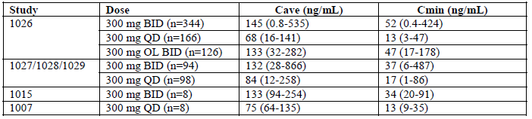
A statistically significant effect of food in reducing AUC/Cave by 11% (95% CI: 5%, 17%), p<0.001 was found using the food time window of a meal within 4 hours before and 1 hour after a dose. This food effect is deemed by the sponsor to be clinically insignificant.
“Black” participants and “Others”, females and older participants were each found to have a statistically significant reduction of hepatic extraction ratio (E_{H}) relative to reference groups when tested at p < 0.05. However, although sex and age were significant using the likelihood ratio test, they were not significant using bootstrap 95% CI and were considered borderline covariates in the investigator’s opinion. The demographic covariate effect in terms of an AUC/Cave change relative to that of a male Caucasian patient aged 36 years were as follows; none, including weight, were considered by the sponsor to be clinically relevant.
- A female Caucasian 36 years old | 13.7% higher
- A male Black patient 36 years old | 17.5% higher
- A 70 year old male Caucasian | 13.5% higher
- A 20 year old male Caucasian | 11.7% lower

Study A4001026 - Exposure response analysis
This exploratory PK-PD analysis using Generalised Additive Models (GAM) aimed to identify relationships between maraviroc 300 mg BID systemic exposure and clinical endpoints measured in Study A4001026. The aim was to develop models to determine prognostic factors that describe maraviroc effect on the clinical safety and efficacy outcomes of virologic success, CD4 count and ALT, AST and CK.
Individual viral load data expressed as binary endpoints (failure-success) were investigated for viral load < 50 copies/mL and < 400 copies/mL at 48 weeks. Change from baseline CD4 count was analysed as a continuous variable. Similar analysis was applied to assessment of ALT, AST and CK.
The exposure variables of average concentration (Cave) and minimum concentration (Cmin) were investigated in both the efficacy and safety analyses; the effective constant concentration (ECC) was investigated in the efficacy analyses only. The three exposure variables were considered highly correlated; however as average concentration is the more commonly accepted PK parameter, the final PK-efficacy models were those that included the average concentration as the exposure prognostic factor.
Clinical data were obtained up to week 48 for 360 individuals. Exposure parameters were available for 347 participants treated with maraviroc; 13 participants with no exposure data were excluded.
Automated step-wise searches to build the generalized additive logistic regression models were performed. Patients missing the clinical endpoint under investigation or one or more of the categorical or continuous prognostic factors selected in the final model were excluded. No outlier was excluded from the efficacy analysis. Prognostic factors considered to have possible impact on the concentration-effect relationships were also evaluated and included dosing information, patient disease information and patient demographics.
According to the final model, prognostic factors best explaining virologic success based on < 50 copies/mL at week 48 were: baseline tropism, maraviroc average concentration, baseline viral load, age of the patient, time since diagnosis and the CD4 count at baseline. The ECC was the best exposure prognostic factor for virologic success followed by Cave and then Cmin.
For the CD4 count change from baseline, only the Cmin was selected as an exposure prognostic factor. Other identified prognostic factors for virologic endpoints were co-infection with HBV and/or HCV, and time since diagnosis. Minor prognostic factors identified were race, hemisphere, age and clade.
An asymptotic relationship between the effect and the exposure parameters was described for each of the investigated efficacy endpoints. The likelihood of virologic success increased when exposure to maraviroc increased. The CD4 count change from baseline increased when maraviroc exposure increased. It was predicted that at maraviroc average concentration in order of 75 ng/mL in combination with zidovudine and lamivudine, the probability of success would be 80% of maraviroc net effect. In study A4001026, 13% of patients had maraviroc average concentrations less than 75 ng/mL.
For safety biomarkers ALT, AST and CK maraviroc systemic exposure was not identified as a covariate in increase from baseline at weeks 4 and 48.

Pharmacodynamics
No new studies were provided.

Clinical efficacy

Pivotal Study A4001026 – Treatment-naive
A4001026 was a Phase 2b/3 multicentre, randomised, double-blind study of treatment of antiretroviral naive CCR5-tropic HIV-1 infected patients with maraviroc 300 mg either QD or BID compared to efavirenz 600 mg QD, each in combination with zidovudine/lamivudine. Results to 96 weeks were reported. This study was unblinded to the sponsor at Week 48 and to the investigators and patients at Week 96.
Eligible patients were aged ≥ 16 years, with > 2,000 copies of HIV-1 RNA/mL. Infection with CXCR4 (X4) or dual/mixed-tropic virus and resistance to efavirenz, zidovudine or lamivudine were exclusion criteria.
Participants were stratified by screening viral load (< 100,000 or ≥ 100,000 copies/mL) and geographic location (Northern versus Southern Hemisphere) and randomised 1:1:1. A 16 week Phase 2b run-in phase followed by an interim review by the Data Safety Monitoring Board (DSMB) was planned to enable early assessment of non-inferiority for each maraviroc regimen compared to efavirenz. Following the interim analysis the maraviroc QD treatment group was discontinued due to failure to meet criteria for non-inferiority. Subsequent enrolments were randomized in a 1:1 to either the maraviroc 300 mg BID or efavirenz 600 mg QD. Participants in the maraviroc QD arm were eligible to receive unblinded maraviroc 300 mg BID based on safety criteria and virological response.
The primary objective was to assess non-inferiority of response to maraviroc compared to efavirenz in terms of viral load of < 400 and < 50 copies/mL at Week 48 done step-wise. Similar assessments were conducted at Weeks 24 and 96 as secondary objectives. Other secondary objectives included comparison of treatment effects on to time to loss of virological response, reduction of plasma log10 viral load from baseline, changes in CD4 and CD8 cell counts from baseline, Time-Averaged Difference (TAD) in log10 viral load, HIV-1 genotype and phenotype at the time of failure, HIV-1 tropism at baseline and at the time of failure, safety and tolerability.
The primary analysis was based on the difference in percentage of participants with specified viral load using a 1-sided, 97.5% CI, with adjustment for the randomization strata. If the lower bound of the CI was above - 10%, non-inferiority between maraviroc 300 mg BID and efavirenz 600 mg QD was concluded. The initially planned 1-sided significance level of 0.0125 (Bonferroni adjustment for multiple comparisons) was changed to the 1-sided 97.5% confidence interval (CI) reported, when the maraviroc QD group was discontinued. For the primary analyses, discontinuations for any reason were classified as failures/non-responders. Sensitivity analysis was performed using the time to loss of virologic response algorithm (TLOVR).
The Full Analysis Set (FAS) was defined as all randomized participants who received at least one dose of study drug.
The Per-protocol (PP) population excluded participants who had an HIV-1 RNA viral load of less than 2,000 copies/mL at the screening visit; who were Dual/ Mixed or CXCR4-tropic at screening or baseline; who had prior treatment with any antiretroviral therapy for more than 14 days at any time; who were treated for less than 14 days or discontinued before this time due to treatment failure; who were ≤ 80% compliant with treatment; and who had lamivudine, zidovudine or efavirenz resistance mutations.
The difference in the proportion of responders was calculated for the primary and secondary binary endpoints using the FAS and PP populations. An analysis adjusted for the randomisation strata was performed summarising the difference in proportions following the Cochran-Mantel-Haenszel approach.
Logistic regression was used to analyse selected secondary binary endpoints for the FAS and PP populations. Two sided 95% CIs and odds ratios and p-values were estimated. Kaplan Meier plots estimated time to event endpoints over time. Analysis of covariance was used for continuous data.
The presence of CXCR4-using virus was detected by the original Trofile™ assay (Phenosense™). Following the week 96 database lock, a more sensitive version of the assay, Enhanced Sensitivity Trofile™ Assay (ESTA) was introduced and replaced the Trofile assay in the market. Screening samples from all participants were retested post-hoc using this assay and data from the study were reanalysed based on these results.

Results

Disposition
Screened | 1730 participants
Randomised | 917 participants
Treated: | Maraviroc 300 mg once daily | 174 participants
 | Maraviroc 300 mg twice daily | 360 participants
 | Efavirenz 600 mg once daily | 361 participants
Slightly over half of the participants were White (maraviroc 56.7%; efavirenz 54.8%); approximately 35% were Black, with a similar racial mix in both treatment groups. Approximately 20% of participants in each treatment group were Hispanic/Latino. Males accounted for approximately 71% of the study population. The ratio of males to females varied by race; the majority of Whites were male (approximately 84%) whereas an equal number of male and female Blacks were recruited. The majority of participants were aged between 25 and 44 years and the mean age was 37 years in both treatment groups.
The median CD4+ cell count was ~ 250 cells/μL, and mean HIV-1 RNA of 4.9 log10 copies/mL at baseline were similar for both groups. The mean time from first HIV diagnosis was 2.5 and 2.3 years for the maraviroc and efavirenz treatment arms respectively. The proportions based on exposure route were similar; the two most common categories were heterosexual and male to male contact.
From the data on disposition to Week 48 and to Week 96: A total of 188 participants discontinued by Week 48: 26.9% of the maraviroc BID group and 25.2% in the efavirenz groups. A total of 252 participants discontinued by Week 96: 35.8% of the maraviroc BID group and 34.1% in the efavirenz groups. The main reason for discontinuation in the maraviroc BID treatment group was lack of efficacy while the main reason for discontinuation in the efavirenz group was treatment-related adverse events (Table 2, below). Substitution for zidovudine/lamivudine was permitted for toxicity; the proportion substituting zidovudine/lamivudine use was approximately 11% in both treatment groups and most commonly was tenofovir 300 mg/emtricitabine 200 mg (Truvada).
Table 2. Summary of Discontinuations from Study A4001026 at Week 48 and 96
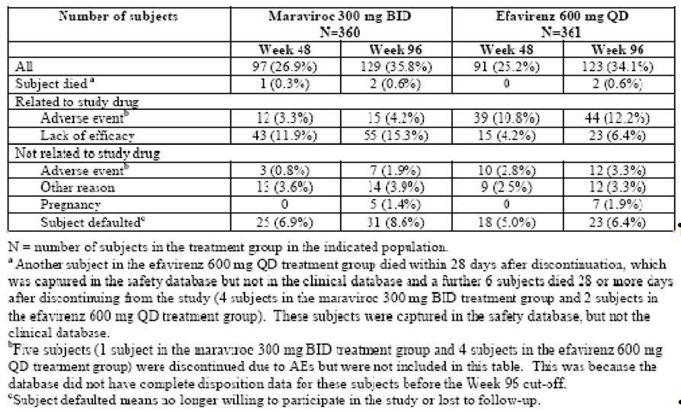
The numbers in efficacy populations is summarised in Table 3. Reasons for exclusion from the PP population: the most common reason was ≤ 80% compliance with treatment.
Table 3 Study A4001026 Number of Participants Analysed in the Efficacy Populations (Week 48)
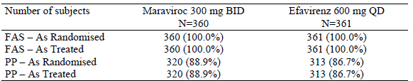
N= number of subjects in the treatment group in the indicated population
For viral load < 400 copies/mL at Week 48 the percentages of the FAS were 71% for maraviroc BID and 73% for efavirenz. The lower bound of the 1-sided 97.5% confidence interval for the difference was - 9.5%, demonstrating non-inferiority and supported by TLOVR sensitivity analysis. (see Tables 4, 5 and 6, below).
The percentages of responders with a viral load < 50 copies/mL at Week 48 were 65% for maraviiroc and 69% efavirenz. The lower bound of the 1- sided 97.5% confidence interval for the difference was -10.9%, supported by TLOVR sensitivity analysis and was not consistent with non-inferiority. (Table 6).
Table 4. Study A4001026 Viral Load at Week 48. FAS-AT Population
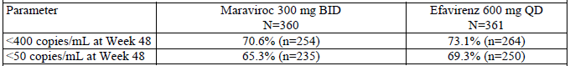
N= number of subjects in the treatment group in the indicated population
n = number of subjects contributing to the calculation of the percentage
Table 5. Summary of Statistical Analysis of Percentage of Participants with Viral Load <400 copies/mL and <50 copies/mL at Week 48. FAS-AT Population
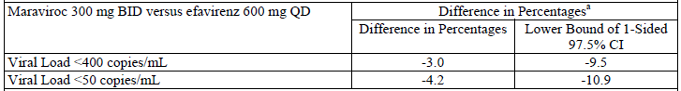
a: adjusted for randomisation strata
Table 6. Study A4001026 Week 48. Sensitivity Analysis (TLOVR). Full Analysis Set As Treated Population
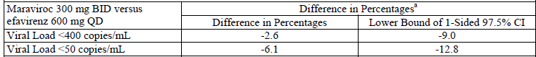
a: adjusted for randomisation strata
For the PP analysis at 48 weeks, the lower bound of the 97.5% confidence intervals in participants with undetectable viral load of < 400 copies/mL and <50 copies/mL were -10.5% and -11.2%, respectively.
At Week 96 the percentages of responders < 400 copies/mL were 61% for maraviroc BID and 65% for efavirenz. Results for viral load < 50 copies/mL were 57% and 63%, respectively. The lower bound of the 1-sided 97.5% confidence interval for the FAS treatment difference was - -10.2 for viral load < 400 copies/mL and - 12.8 for viral load < 50 copies/mL.
Based on viral load < 400 copies/mL at Week 48, virologic failure occurred in 27% of the non-responders in the maraviroc BID group compared to 5.3% of the non-responders in the efavirenz group. Virologic failure based on viral load < 50 copies/mL occurred in 32.0% of the non-responders in the maraviroc group compared to 8.8% in the efavirenz group. Rebound based on viral load < 400 copies/mL was reported for 20.8% of non-responders in the maraviroc group compared to 16.0% in the efavirenz group. For viral load < 50 copies/mL rebound was reported for 19.7% of non-responders in the maraviroc group compared to 8.8% in the efavirenz group (Table 7) Week 96 results using the TLOVR algorithm demonstrated similar patterns as summarised in Table 8, below.
Table 7. Study A4001026 Study Outcomes (TLOVR) at Week 48 for the FAS-AT Population
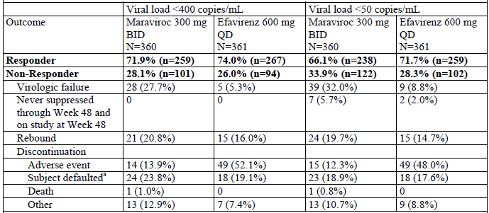
a: Subject defaulted means subject no longer willing to participate in study or lost to follow up
Table 8. Study A4001026 Outcomes (TLOVR) at Week 96 for the FAS-AT
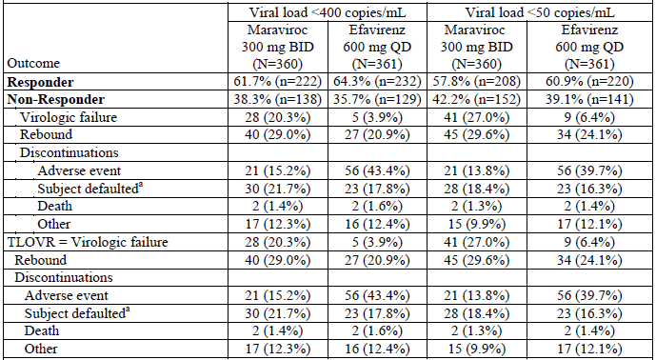
a: Subject defaulted means subject no longer willing to participate in study or lost to follow up
The mean increase from baseline in CD4+ cell count throughout the 48 weeks was greater in the maraviroc BID treatment group than in the efavirenz group. The difference was 26.3 cells/µL, 95% CI (7.0, 45.6). Results for the PP population supported this finding. At Week 96, the mean difference in CD4+ cell count between those in the maraviroc BID treatment group and those in the efavirenz group was 35.44 cells/µL. The 95% CI (13.2, 57.86) excluded zero indicating a significantly better result for maraviroc BID than for efavirenz.
The subgroup analysis by screening viral load demonstrated smaller response for the maraviroc group compared to efavirenz for viral load < 400 copies/mL and <50 copies/mL in the stratum with ≥ 100,000 copies/mL at screening as summarised in Tables 9 and 10.
Table 9. Study A4001026 Percentages with Viral Load <400 copies/mL at Week 48 by Viral Load at Screening
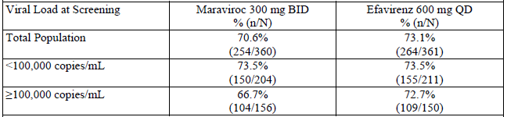
N= number of subjects in the treatment group in the indicated population
n = number of subjects with a post baseline observation used to calculate the percentage
Table 10. Study A4001026 Percentages with Viral Load <50 copies/mL at Week 48 by Viral Load at Screening
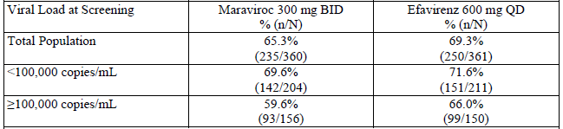
N= number of subjects in the treatment group in the indicated population
n = number of subjects with a post baseline observation used to calculate the percentage

Viral resistance

Time of treatment failure
At the Week 48 assessment of time of treatment failure, 27/43 participants (62.8%) in the maraviroc BID treatment group and 3/15 (20.0%) in the efavirenz treatment group had virus with genotypic evidence of resistance to lamivudine. In addition, 6/43 (14.0%) in the maraviroc BID treatment group had virus with zidovudine resistance, evidenced by the presence of 1 or more thymidine analogue-associated mutations (TAMs). For all 6 individuals whose virus had TAMs, lamivudine resistance was also present. None of the 15 participants who failed efavirenz had virus with TAMs at failure. Seven of 15 individuals (46.7%) in the efavirenz group had virus with genotypic evidence of drug resistance to efavirenz at time of treatment failure. No participant in the maraviroc BID treatment group had reduced susceptibility to efavirenz.
At the Week 96 assessment of the time of treatment failure, 33 (60.0%) participants in the maraviroc BID group and 8 (34.8%) of the efavirenz group had virus with genotypic and phenotypic evidence of resistance to zidovudine/lamivudine. In addition, 6 (10.9%) of the maraviroc BID group and 2 (8.7%) of the efavirenz group had virus with 1 or more TAMs.

Time of discontinuation
At Week 48 assessment, 33/97 (34.0%) in the maraviroc BID group and 3/91(3.3%) in the efavirenz 600 mg QD group had virus with genotypic evidence of resistance to lamivudine at time of discontinuation. Six of 97 participants (6.2%) in the maraviroc BID group had virus with zidovudine resistance, evidenced by presence of 1 or more TAMs. For all 6 patients whose virus had TAMs, lamivudine resistance was also present. None of the 91 participants who failed efavirenz had virus with TAMs. Eight of 91 (8.8%) in the efavirenz group had virus with genotypic evidence of drug resistance to efavirenz. No participants in the maraviroc BID group had evidence of resistance to efavirenz.
At the Week 96 assessment, 40 (31.0%) of the maraviroc BID group and 8 (6.5%) of the efavirenz group had virus with genotypic and phenotypic evidence of resistance to zidovudine/lamivudine at the time of discontinuation. Six (4.7%) participants in the maraviroc BID group and 2 (1.6%) of the efavirenz group had virus with 1 or more TAMs.

Viral tropism
Of the 694 evaluable participants, 13 (3.8%) in the maraviroc BID group and 11 (3.1%) in the efavirenz group switched from CCR5 tropic at screening to dual/mixed tropic at baseline.

Time of treatment failure
Treatment failure at Week 48 was reported by 32 participants in the maraviroc BID group and 15 in the efavirenz group with a CCR5 tropism result at baseline and an on-treatment tropism result. Of these, 10 participants, all in the maraviroc BID group, had a change in tropism result to CXCR4 or dual/mixed at time of treatment failure vs. none in the efavirenz group.
At Week 96, of the 43 participants in the maraviroc BID group and 22 in the efavirenz group with a CCR5 tropism at baseline who experienced treatment failure, 12 individuals, all in the maraviroc 300 mg BID treatment group, had a change in tropism result to CXCR4 or dual/mixed at time of treatment failure. The change in tropism result from CCR5 at baseline to dual/mixed tropic at the time of treatment failure was recorded by 20.4% of the maraviroc BID group and none of the efavirenz group.

Time of discontinuation
At Week 48, 75 patients in the maraviroc group and 74 in the efavirenz group discontinued with a CCR5 tropism result at baseline and an on-treatment result. Of these, 12 individuals all in the maraviroc group had a change in tropism result to CXCR4 or dual/mixed at the time of discontinuation.
At Week 96, one hundred and six participants in the maraviroc group and 105 in the efavirenz 600group with a CCR5 tropism result at baseline and an on-treatment tropism result, and who discontinued from the study, 14 participants (all in the maraviroc 300 mg BID treatment group) had a change in tropism result to CXCR4 or dual/mixed at the time of discontinuation.

Tropism and viral resistance
At Week 48, 7/13 (54%) who failed in the maraviroc BID group with CCR5 tropic virus had evidence of zidovudine/lamivudine resistance compared to 16 of 16 (100%) participants who failed with dual/mixed or CXCR4 tropic virus. All viruses with evidence of zidovudine/lamivudine resistance at failure contained the M184V/I mutation with or without additional NRTI resistance mutations.
At Week 96, zidovudine/lamivudine resistance mutations was reported by 10 (18.2%) participants in the maraviroc BID group and 5 (21.7%) participants in the efavirenz group who had CCR5 tropism at the time of treatment failure. Of these the M184V/I mutation was present in 10 (18.2%) of the maraviroc BID group and 5 (21.7%) in the efavirenz group. Nine (39.1%) in the efavirenz group developed efavirenz associated mutations. Of those with dual/mixed tropism at the time of treatment failure in the maraviroc BID group, 14 (25.5%) of the maraviroc group had zidovudine/lamivudine mutations and 14 (25.5%) had an M184V/I mutation.

Tropism and viral load
At Week 48, fewer participants in the maraviroc BID group who had switched tropism from CCR5 at screening to dual/mixed or NR/NP tropism at baseline, had viral load < 400 copies/mL and < 50 copies/mL than in the efavirenz treatment group. Participants who were dual/mixed tropic at baseline recorded lowest percentage with viral load < 400 copies/mL and < 50 copies/mL in both treatment groups.
At Week 96 assessment a similar percentages of those in the maraviroc BID and efavirenz who were CCR5 tropic at baseline had a viral load of < 400 copies/mL: 63% vs. 64% respectively. Fewer of the maraviroc group had a viral load of < 50 copies/mL compared with the efavirenz group: 58% vs. 62%. For individuals with dual/mixed or no result/not reportable (NR/NP) tropic virus at baseline, a lower percentage had a viral load of < 400 copies/mL and < 50 copies/mL in the maraviroc BID group compared with the efavirenz group.
Change from baseline in CD4 cell count during the 48 weeks was higher across all tropism groups for maraviroc BID compared to the efavirenz for those failing treatment. Mean CD4 cell count increases from baseline were greater in all maraviroc treatment failures (100.6 cells/µL) compared with all efavirenz treatment failures (44.3 cells/µL). Participants with mixed/dual tropic or CXCR4 virus at the time of maraviroc treatment failure had mean increases in CD4 cell count (83.3 cells/µL) that were similar to those who failed maraviroc with CCR5 tropic virus (80.3 cells/µL).
The CD4 cell count increased from baseline to Week 96 for participants in the maraviroc BID treatment group who were either CCR5 tropic or CXCR4 tropic at treatment failure. Mean increases in CD4 cell count were higher for those who were CCR5 tropic at treatment failure compared with those who were CXCR4 tropic at treatment failure.
At the Week 96 assessment, median time to treatment failure was longer for participants who were CCR5 tropic at baseline and changed tropism result to below the limit of quantitation (BLQ) at treatment failure in the maraviroc BID group compared to the efavirenz group. However, the median time to treatment failure was shorter for those who were CCR5 tropic at baseline and who remained CCR5 tropic or who were NR/NP tropic at treatment failure in the maraviroc compared to the efavirenz group. No comparison was made between treatment groups which were dual/mixed or CXCR4 tropic at baseline because the number in these categories was too small.

Maraviroc QD and off label

Disposition QD and OL
Table 11. Study A4001026 interim analysis: Participant Evaluation Groups
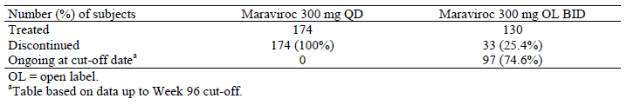

Efficacy QD and OL
The percentages of participants in the QD group with viral load < 400 and < 50 copies/mL at Week 96 were 52.9% and 48.3%, respectively while the results for those treated with open label (OL) maraiviroc 300 mg BID were 70.8% and 64.6%, respectively.
The proportion of the full analysis set discontinuing for lack of efficacy was 11/174 (6.3%). Of the open label group the proportion discontinuing for lack of efficacy was 16/130 (12.3%).

Viral resistance – QD and OL
Twenty-seven participants overall and 16 who entered open label had treatment failure due to insufficient clinical response. At time of treatment failure, 20/27 (74.1%) individuals overall and 13/16 (81.3%) who entered open label, had virus with genotypic evidence of drug resistance to lamivudine; three of whom had virus with zidovudine resistance, as evidenced by the presence of 1 or more TAMs.
Seventy-seven participants in all and 33 who entered open label discontinued study treatment. At time of discontinuation, 31/77 (40.3%) of the FAS and 19/33 (57.6%) of those OL, had genotypic evidence of drug resistance to lamivudine; three of whom had virus with zidovudine resistance, evidenced by the presence of 1 or more TAMs.

Viral tropism – QD and OL
Regarding changes in tropism between baseline and treatment failure or discontinuation: Not all participants with treatment failure had tropism results available. No participant with available results had CXCR4 tropism result at time of treatment failure or discontinuation. Five participants with dual/mixed tropism at baseline had dual/mixed tropism at the time of treatment failure. Four participants with CCR5 tropism at baseline had dual/mixed tropism at time of treatment failure.
Seven of 9 participants who failed with CCR5 tropic virus had evidence of zidovudine/lamivudine resistance as did 9 of 9 who failed with dual/mixed tropic virus. All viruses with evidence of zidovudine/lamivudine resistance at failure contained the M184V/I mutation ±NRTI resistance mutations.
Approximately 63% of participants who were CCR5 tropic at baseline had a viral load < 400 copies/mL at Week 96. Only one participant of the seven with dual/mixed tropism at baseline and neither of the two with non-reportable/non-phenotypable had viral load < 400 copies/mL at this time.

Enhanced-Sensitivity Trofile Assay (ESTA)
In June 2008, after study A4001026 completion, the Enhanced Sensitivity Trofile Assay (ESTA) replaced Trofile™ in the market, based on demonstrated increased sensitivity for detection of CXCR4-tropic virus. Data from in vitro experiments showed that ESTA detected X4 variants 100% of the time when they comprise ≥0.3% of the total viral population as opposed to 10% with the original Trofile assay.
A retrospective analysis tested the hypothesis that ESTA would have identified and excluded more participants unlikely to respond to maraviroc and therefore would have improved efficacy of maraviroc BD compared to efavirenz. The principal endpoint for this post-hoc analysis was the percentage of participants with viral load < 400 copies/mL and < 50 copies/mL at Week 96. The difference in the percentage of participants with the specified response was assessed and a 1-sided 97.5% confidence interval CI; adjusted for the randomization strata, was calculated as for the primary objective.
Of the 721 participants in both arms of the study with virus classified as CCR5 at the screening, 106 (14.7%) were re-classified as dual-mixed (DM)-tropic or X4-tropic by ESTA; 48 (13.3%) and 58 (16.1%) in the maraviroc and efavirenz arms. Selected baseline characteristics before and after reassessment of baseline HIV tropism by Trofile and Enhanced Sensitivity Trofile™ Assay generally appeared little altered.
In the original analysis 11.9% of participants in the maraviroc BID group discontinued due to lack of efficacy vs. 4% for efavienz. On re-analysis, discontinuations due to lack of efficacy were 9.3% in the maraviroc BD groups compared with 4% of the efavirenz group. However the rate of discontinuation differed depending on the analysis method used. Using the TLOVR algorithm for FAS analysis, non-responders due to virologic failure were calculated to be 21.3% in the maraviroc group compared to 4.9% in the efavirenz group. Non-responders due to rebound were 22.5% in the maraviroc group compared to 16.0% in the efavirenz group. Non-responders due to adverse event were 15.0% of the maraviroc group versus 53.1% of the efavirenz group. Similar patterns were seen for the at 96 weeks.
The original Week 48 analysis for HIV-1 RNA < 400 copies/mL showed the stratification adjusted difference between maraviroc and efavirenz to be in keeping with the conclusion of non-inferiority; however, the result was not supported by the PP results. The ESTA analysis showed a difference of + 0.6, with a LCB of - 6.4%, supported by the PP analysis.
The original FAS analysis for HIV-1 RNA < 50 copies/mL failed to demonstrate non-inferiority. The analysis with ESTA resulted in a difference of - 0.2%, with a LCB of - 7.4%, supported by the PP analysis (Table 12, below). However, various sensitivity analyses for both HIV-1 < 400 copies/mL and < 50 copies/mL at 48 and 96 weeks produced results were not supportive.
Table 12. ESTA Statistical Analyses of Treatment Differences in Primary Efficacy Endpoints by ESTA Analysis Populations
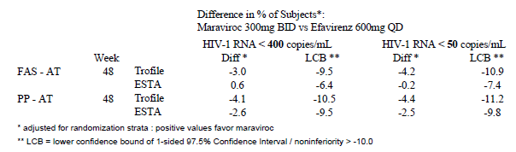

Pivotal Studies A4001027 and A4001028 – Treatment-experienced
The two identically designed studies A4001027 and A4001028 were multicentre, randomised, double-blind, placebo-controlled trials to compare maraviroc 300 mg once daily or maraviroc 300 mg twice daily in combination with optimised background therapy (OBT) to OBT plus matching placebo for the treatment of antiretroviral-experienced patients infected with CCR5 tropic HIV-1. Patients were stratified by enfuvirtide use and by screening plasma HIV-1 RNA level (< 100,000 or ≥ 100,000 copies/mL), and were randomized 2:2:1 to maraviroc QD, maraviroc BID or placebo.
The primary efficacy analysis was performed after all participants had been treated for 48 weeks. The aim was to test superiority of the two maraviroc regimens against placebo in terms of the difference in the mean change from baseline in plasma HIV-RNA, with covariates screening viral load and enfuvirtide use in OBT. The 2-sided 97.5% confidence interval (CI) for the difference was adjusted for multiplicity. Superiority of maraviroc versus placebo was concluded if the upper CI limit for the difference in treatment means was less than zero. Participants discontinuing for any reason had a change from baseline of 0 imputed. For individuals who did not discontinue, but missing the observation at the time point of interest, the last observation carried forward approach (LOCF) was used. For all individuals with a missing baseline value a change from baseline of zero was imputed. Sensitivity analyses were based on last observation carried forward, and use of the TLOVR algorithm. The FAS population was the primary population.
The primary efficacy variable was also analysed at Week 24. The sponsor was unblinded for the 24-week analysis, while investigators and participants were to remain blinded until the completion of the trial.
The secondary objectives relevant to the Week 48 report were to compare the results of viral load < 400 copies/mL and < 50 copies/mL; log10 reduction in viral load from baseline and Time Averaged Difference (TAD); time to loss of virologic response; changes in CD4 and CD8 cell counts; viral resistance and tropism at time of failure: and safety and tolerability. Information on Primary and secondary endpoints and Definition of viral failure was provided.
The studies included patients aged ≥ 16 years with plasma viral load ≥ 5,000 copies/mL with ≥ 6 months of prior treatment with at least 1 agent from 3 of the 4 antiretroviral drug classes or documented resistance to members from 3 of 4 classes, and a stable antiretroviral regimen for at least 4 weeks prior to randomisation. Infection with non-CCR5 tropic virus was an exclusion criterion.
Treatment regimens are summarised in Table 13 below. Maraviroc dose was adjusted to 150 mg QD or BID in those patients receiving a protease inhibitor other than tipranavir/ritonavir, and/or delavirdine. OBT with 3 – 6 approved antiretroviral agents was based susceptibility testing, treatment history and safety/tolerability.
Table 13. Studies A4001027 and A4001028 treatment regimen
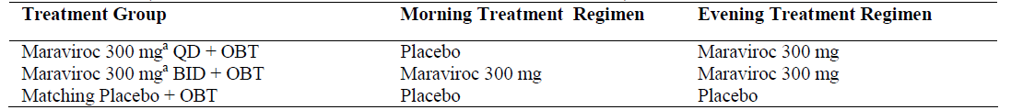
a: Patients whose OBT included a PI (except tipranavir/ritonavir) and/or delavirdine received maraviroc 150 mg QD or 150 mg BID
NB The Protocol recommended that patients with EFV in their OBT should also receive a boosting PI

Results
The number treated with maraviroc once daily totalled 414, with maraviroc twice daily totalled 426 and with placebo 209. (Figure 1 below) The majority of patients in both studies were male 87%- 91% and white 81% – 87%. Patients ranged in age from 19 – 75 years. Screening HIV-RNA levels and duration of disease since diagnosis were similar between groups. There were some minor discrepancies in the phenotypic sensitivity scores and overall sensitivity scores.
Figure 1. Studies A4001027 and A4001028 Participant disposition
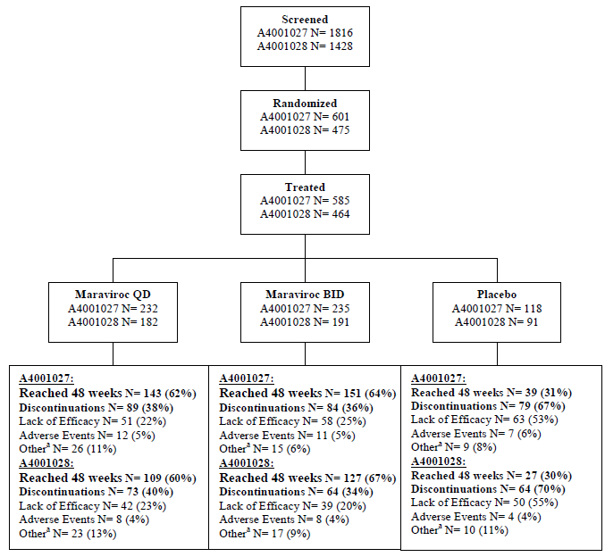
There were more discontinuations due to lack of efficacy in the placebo arm (53%) than in either maraviroc arm (20% - 25%). There were more discontinuations due to lack of efficacy in the maraviroc once daily group than in the twice daily maraviroc treated group. Discontinuations due to adverse events were similar between groups (4% - 6%).

Primary efficacy results
Both maraviroc regimens demonstrated superiority over placebo. In Study A4001027 the decrease in HIV-1 RNA from baseline to Week 48 was -1.66 for maraviroc once daily and - 1.82 for maraviroc twice daily vs. - 0.80 log10 copies/mL for placebo. Treatment differences from placebo were - 0.85 (97.5% CI - 1.22, - 0.49) for maraviroc QD and -1.02 log10 copies/mL (97.5% CI -1.39, -0.66) for maraviroc BID. For Study A4001028 the point estimates were - 1.72 and - 1.87 vs. - 0.76 log10 copies/mL for maraviroc QD, BID and placebo respectively. The treatment difference was - 0.96 (97.5% CI - 1.38, - 0.54) for maraviroc QD and - 1.11 log10 copies/mL (97.5% CI - 1.52, - 0.70) for maraviroc BID.

Secondary efficacy results
Compared with placebo, both maraviroc treatment groups recorded a higher proportion of patients with each of the following: HIV-1 RNA < 400 copies/mL; HIV-1 RNA < 50 copies/mL (Table 14, below) at least a ≥ 1.0 log10 viral load decrease or < 400 copies/mL; and at least a ≥0.5 log10 copies/mL viral load decrease or < 400 copies/mL. Table 15, below summarises the change from baseline to Week 48 in log10 HIV-RNA for which the 97.5% CIs exclude zero.
Table 14. Proportion of Patients with HIV-1 RNA Level <50 copies/mL at Week 48 (Logistic Regression) (Combined Studies A4001027 and A4001028)
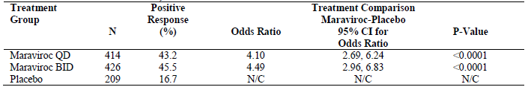
Missing values at Week 48 were classified as failures/non-responders
An odds ratio of >1 indicates a beneficial response for patients on maraviroc compared with placebo.
CI – confidence interval
Table 15. Change from Baseline to Week 48 in log10 HIV-1 RNA (Combined Studies A4001027 and A4001028)
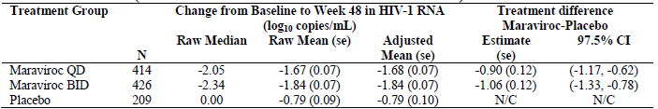
Outcomes based on viral load < 50 copies/mL are summarised in Table 16, below. Data on response and outcomes in terms of HIV < 50 copies/mL by baseline CD4 cell count were also provided in the submission.
Table 16. Studies A4001027 and A4001028 Overview of Study Outcomes for patients with viral load < 50 copies/mL at week 48
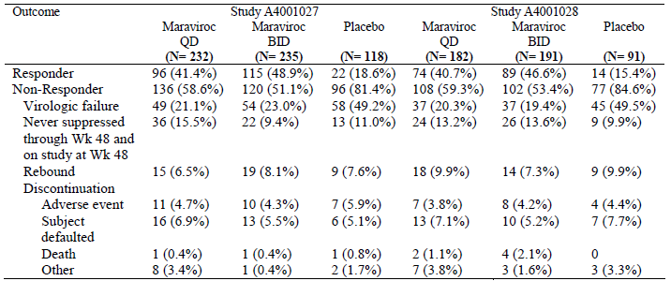
N= number of subjects in the treatment group in the indicated population
In both studies, there was a greater mean increase in CD4 and CD8 cell counts from baseline in both maraviroc groups compared with placebo.

Viral resistance
Descriptions of the overall susceptibility score (OSS), phenotypic susceptibility score (PSS) and overall susceptibility score (OSS) are included in the submission. A score of ‘1’ was assigned if resistance mutations were not detected (GSS) or if virus from patient was susceptible to drug (PSS). OSS was determined by the sum of active drugs in OBT based on combined information from genotypic and phenotypic testing. The majority of patients had either no change in GSS, PSS and OSS or had a loss of susceptibility to 1 drug. The relatively small shift in the table is consistent with the fact that most patients had GSS, PSS and OSS values of ≤2 at screening.
The primary and secondary efficacy endpoints were analysed for the combined A4001027 and A4001028 results by GSS, PSS and OSS at screening in order to assess whether the response to treatment with maraviroc was affected by the number of potentially active agents present in the OBT. For each maraviroc treatment group the percentage of patients with a viral load of < 50 copies/mL increased as GSS and OSS increased.

Viral tropism

Combined studies
For patients with baseline CCR5 tropism, Week 48 change from baseline in viral load was - 2.087 log10 copies/mL for maraviroc QD, - 2.201 log10 copies/mL for maraviroc BID and - 1.040 log10 copies/mL for placebo. For patients with dual/mixed-tropic HIV-1 at baseline, the mean change in HIV-1 RNA from baseline to week 48 was -1.495 for maraviroc QD, -1.040 log10 copies/mL for maraviroc BID and -1.442 log10 copies/mL for placebo. (Table 17, below)
Table 17. Summary of Change from Baseline in HIV-1 RNA at Week 48 by Tropism Status at Baseline (Combined Studies A4001027 and A4001028)
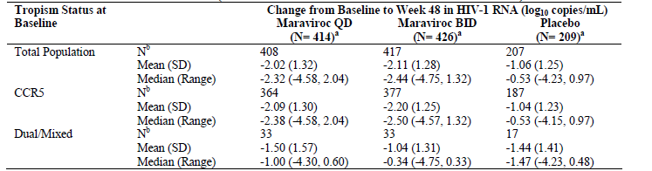
a: Number of patients in the treatment group
b: Number of patients contributing to the summary statistics, which were patients with valid values for baseline and on treatment.

Viral tropism - Study A4001027
Five participants with CXCR4 using virus were erroneously included in the study, 2 with a dual/mixed tropism result, and 2 were recorded as non-reportable/non-phenotypable. A total of 580 patients with a CCR5 tropism result at screening were included in the study. Of these, 43 (7%) had a different tropism result at baseline; all being dual/mixed. The majority who responded had no tropism result at Week 48, having either a viral load of < 500 copies/mL at all visits from Week 4 onwards or having discontinued.
At Week 48, the proportion with a change in tropism from CCR5 to CXCR4 or dual/mixed was 8/134 (6%) of the maraviroc QD group and 7/143 (5%) of the maraviroc BID group compared with 1/38 (3%) participants receiving placebo (Table 18, below). The results using LOCF are summarised in Table 19, below, and the CIs which exclude zero suggest the possibility of a significant difference.
Table 18. Study A4001027 Change in Tropism from CCR5 to CXCR4 or Dual/Mixed from Baseline and Week 48
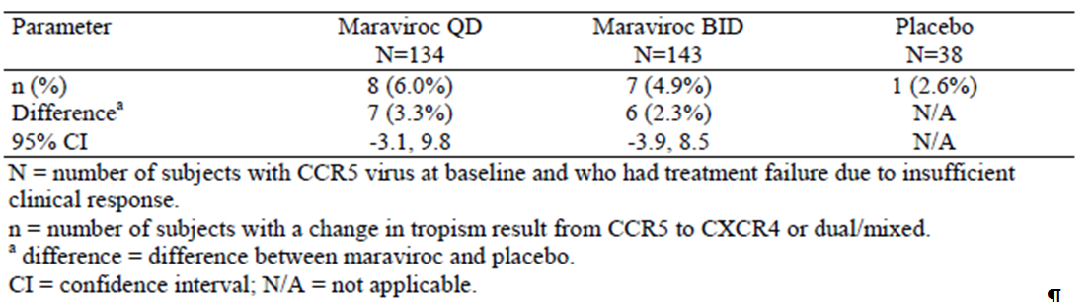
Table 19. Study A4001027 Shift from R5 to X4 or Dual Mixed Tropic from Baseline and Week 48 LOCF FAS - AT
 | Maraviroc QD  N = 204 | Maraviroc BID  N = 205 | Placebo  N = 105
n (%) | 38 (18.6%) | 41 (20.0%) | 6 (5.7%)
Difference | 32 ( | 35 | N/A
95% CI | (6.0, 19.9) | (7.2, 21.3) | N/A
N = Number of participants with CCR5 virus at baseline visit
n = Number of participants who switched to CXCR4 or dual/mixed
Difference is between active treatment and placebo
Only participants with both baseline and on-treatment tropism result were included
The last on-treatment result was used to detect a change in tropism status
If the last on-treatment assessment was recorded as NR/NP, the previous assessment was used.
Of the 145 individuals with a CCR5 tropism result at baseline who experienced treatment failure, 57 (39%) had a change in tropism result to CXCR4 or dual/mixed at time of treatment failure; all but three were in the maraviroc treatment groups (Table 20, below). The confidence intervals which exclude zero suggest the possibility of a significant difference. The finding is supported by the LOCF analysis; results are summarised in Table 21.
Table 20. Study A4001027 Change from CCR5 to CXCR4 or Dual/Mixed from Baseline to Treatment Failure
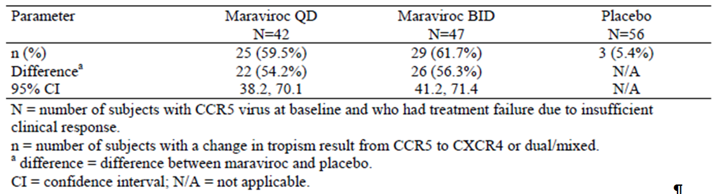

Table 21. Study 4001027 Shift from R5 Tropic to X4 or Dual Mixed from Baseline to Treatment Failure LOCF
 | Maraviroc QD  N = 34 | Maraviroc BID  N = 26 | Placebo  N = 45
n (%) | 11 (32.4%) | 14 (53.8%) | 3 (6.7%)
Difference | 8 | 11 | N/A
95% CI | (8.4%, 43.0%) | (26.7%, 67.7%) | N/A
N = Number of participants with CCR5 virus at baseline visit
n = Number of participants who switched to CXCR4 or dual/mixed
Difference is between active treatment and placebo
Only participants with both baseline and on-treatment tropism result were included
The last on-treatment result was used to detect a change in tropism status
If the last on-treatment assessment was recorded as NR/NP, the previous assessment was used.

Viral tropism - Study A4001028
A total of 462 participants with a CCR5 viral tropism at screening were included in the study. One individual in each maraviroc treatment group was erroneously included with a dual/mixed tropism result at screening. Of those with a CCR5-tropism result at screening, 36 (8%) participants had a different tropism result at baseline; all of which were dual/mixed. Most participants who responded had no tropism assignment on treatment or at Week 48.
Of the 30 participants in the maraviroc treatment groups with a dual/mixed tropism result at baseline, only 2 had a tropism result at Week 48; 1 remained dual/mixed and 1 changed to CXCR4. Of the 8 in the placebo treatment group with dual/mixed tropism result at baseline, 1 had a tropism result at Week 48, which remained dual/mixed. (Table 22, below)
A change in tropism result from CCR5 at baseline to dual/mixed or CXCR4 at Week 48 was reported by 1/13 of the maraviroc QD group, 10/22 of the maraviroc BID group and 1/8 of the placebo group. For the LOCF analysis the results were 17/158 (10.8%), 26/161 (16.1%) and 4/81 (4.9%) respectively (see Table 22).
Table 22. Study A4001028 Change in Tropism Result from CCR5 to CXCR4 or Dual/Mixed Between Baseline and Week 48
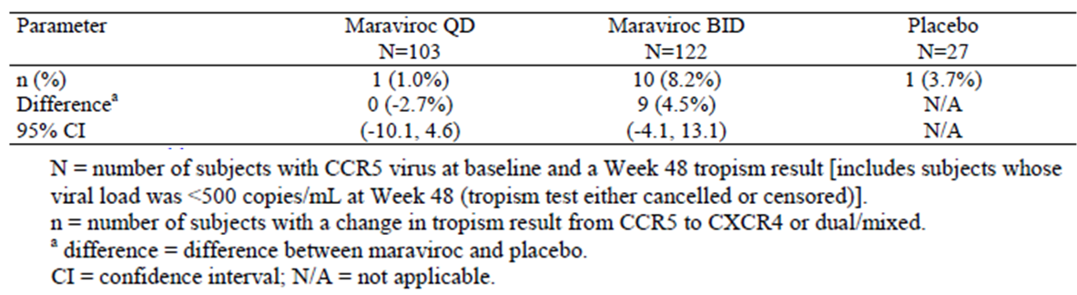
Of the 107 participants with a CCR5 tropism result at baseline and who experienced treatment failure, 25 (23%) had a change in tropism result to CXCR4 or dual/mixed at the time of treatment failure; all but 3 were in the maraviroc treatment groups. (Table 23, below). Results were also presented using LOCF.
Table 23. Study 4001028 Shift from CCR5 to CXCR4 or Dual/Mixed Tropic from Baseline to Treatment Failure
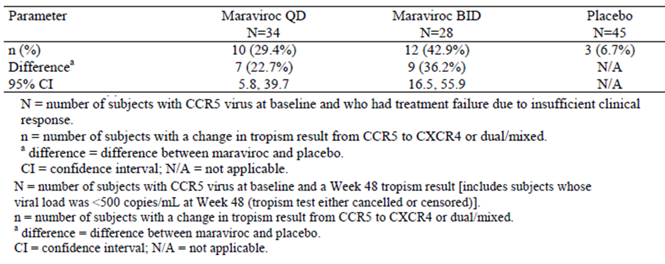

Supportive Study A4001029 – non-CCR5-tropic
Study A4001029 was a multicenter, double-blind, randomized, placebo-controlled Phase 2b study to investigate the safety and antiviral effects of two doses of maraviroc (QD and BID) in heavily treatment-experienced patients infected with non-CCR5 tropic (dual tropic, CXCR4-tropic or non-phenotypable) HIV-1. The primary objective was to assess whether maraviroc added to OBT provided an additional reduction in plasma viral load compared to OBT alone, as measured by the difference between each of the 2 maraviroc regimens versus the placebo regimen in the mean changes from baseline in plasma viral load at Week 24. The results of 24 week primary analysis were not reported in the submitted study report.
Secondary objectives included assessment as above at Week 48 and the percentage of patients achieving an HIV-1 RNA level < 400 and < 50 copies/mL, percentage of patients achieving reduction in HIV-1 level from baseline of at least 0.5 and 1.0 log10, differences in the magnitude of change in CD4 and CD8 cell count from baseline and TAD in log10 HIV-1 RNA level.
Included were individuals at least 16 years of age, infected with non-CCR5-tropic HIV-1 who had at least 3 months of prior treatment with at least 1 agent from 3 of the 4 antiretroviral drug classes or documented resistance to members from 3 of 4 classes, a stable antiretroviral regimen for at least 4 weeks prior to randomisation and a plasma viral load ≥ 5,000 copies/mL. The full list of inclusion and exclusion criteria was provided in the submission.
Table 24. Study A4001029 Treatments Administered
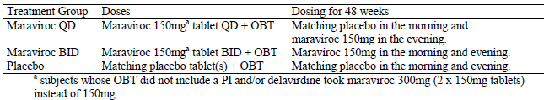
HIV-1 co-receptor tropism phenotype was assessed using the original TrofileTMAssay. Samples were not analysed if the viral load was < 500 copies/mL. V3 loop sequencing, alone or as part of gp160 sequencing, was also to be performed.
Participants were stratified at the time of randomisation by use of enfuvirtide and by screening viral load (< 100,000 or ≥100,000 copies/mL) and were randomised 1:1:1. A 2-sided 97.5% confidence interval adjusted for multiple comparisons and the difference between each maraviroc treatment group and placebo were reported for the primary endpoint of change from baseline in log10 viral load. If the 2-sided 97.5% CI was completely to the left side of zero, completely excluding zero, the superiority of maraviroc over placebo would be concluded. If this criterion was not met and the upper limit of the 97.5% CI was < 0.25 log10 copies/mL, non-inferiority to placebo would be concluded. The primary endpoint was analysed using both FAS and PP populations. Missing Data was handled similarly to Studies A4001027 and A4001028.

Results
There were 63 patients treated in the maraviroc QD group, 61 in the maraviroc BID group and 62 in the placebo group. As can be seen in Table 25, below, between three fifths and three quarters of patients had discontinued by Week 48.
Table 25. Study A4001029 Patient Disposition – Week 48
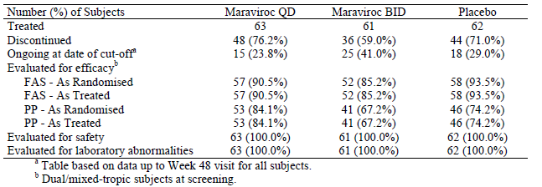
Approximately 87% of the study population was male. The majority of participants were aged between 35 and 54 years and the mean ages were similar for all treatment groups. Most of the participants were white, with a similar racial mix for the 3 treatment groups. Drug treatments including ARVs taken before and during the study were similar between groups. There were some discrepancies between groups in relation to genotype, genotype sensitivity score, phenotype sensitivity score and overall sensitivity score. There was a lower frequency of the CCR5 Δ32 wild type/deletion in the maraviroc BID (8.2%) group compared with 19% for maraviroc QD and 14.5% for placebo.
At week 48, the percentages of patients remaining in the study were: maraviroc QD 24%; maraviroc BID group 41%, and placebo 29%. The percentages discontinuing for lack of efficacy were 64% for the maraviroc QD group and 44% for both the maraviroc BID and placebo groups.
A total of 28 participants were excluded from the PP population. The most common reason for exclusion of participants from this population was CCR5 virus phenotype at the baseline visit reported for 6.3% of the maraviroc QD group, 9.8% of the maraviroc BID group and 11.3% of the placebo group.
Neither the maraviroc dose regimen demonstrated non-inferiority to placebo. At Week 48, the estimate of the treatment difference for maraviroc QD was 0.229 log10 copies/mL (97.5% CI: - 0.351, 0.810) and for maraviroc BID it was - 0.261 log10 copies/mL (97.5% CI: - 0.856, 0.333). (Table 26)
Table 26. Study A4001029 Summary of Mean Change from Baseline to Week 48 in HIV-1 RNA
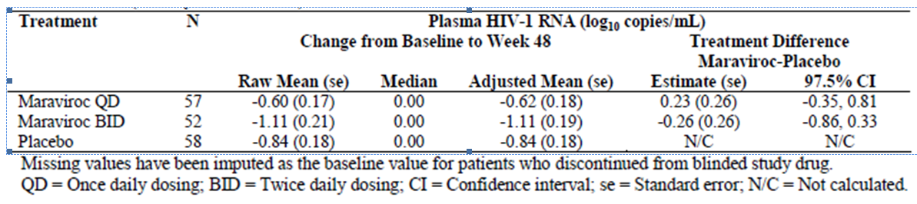
Analysis of: viral load < 400 copies/mL; viral load < 50 copies/mL; HIV-1 < 400 copies/mL or at least 1.0 log10 decrease from baseline, and HIV-1 < 400 copies/mL or at least a 0.5 log10 decrease from baseline at Week 48 showed no statistically significant differences between the maraviroc and placebo groups.

Virology
One hundred and sixty seven participants with dual/mixed tropism result at screening were included in the study, eight had a CXCR4 tropism and 10 were non-reportable/non-phenotypable. Of the 167 participants with a dual/mixed tropism result at screening, 18 (11%) had a different tropism result at baseline 4 - 6 weeks later; 16 of whom were CCR5 and 2 were CXCR4.
At Week 48, only 9 individuals had a valid tropism result; 1 in the maraviroc QD group, 4 in the maraviroc BID treatment groups and 4 in the placebo treatment group, largely due to the large number of discontinuations [114 (68%)], or patients with viral load < 500 copies/mL [42 (25%)].
Of the 37 participants in the maraviroc QD treatment group who were dual/mixed-tropic at screening and had a tropism result at time of failure, 24 failed with a dual/mixed tropism result, 12 with a CXCR4 tropism result and 1 with a CCR5 result. Of the 24 in the maraviroc BID treatment group, 10 failed with a dual/mixed tropism result, 12 with a CXCR4 tropism result, 1 with a CCR5 result and 1 participant had a tropism result that was non-reportable/non-phenotypable. Of the 26 participants on placebo, 18 failed with a dual/mixed tropism, 2 with a CXCR4 tropism, 5 with a CCR5 and 1 with non-reportable/non-phenotypable virus.

Clinical safety

Study A4001026 – Treatment naive
Safety of maraviroc 300 mg BD compared to efavirenz each in combination with zidovudine/lamivudine in treatment naive patients was assessed to Week 96. The total exposure in patient-years was 506 years for maraviroc and 507.9 years for efavirenz. The median duration of exposure was 672 days for maraviroc and 673 days for efavirenz.
All causality adverse events were reported by 399 (94.2%) of the maraviroc BID group and 342 (94.7%) of the efavirenz group. Treatment related adverse events were reported for 65.8% of the maraviroc group and 79.2% of the efavirenz group.
The most frequently reported all causality and treatment related events in both treatment groups were nausea, headache, dizziness, diarrhoea and fatigue. The incidence of dizziness was 31.0% in the efavirenz group compared to 15.6% in the maraviroc 300 mg BID group. Treatment related Grade 3 and 4 adverse events were uncommon occurring in 8.8% of the maraviroc group and 14.1% of the efavirenz group.
Twenty-seven (7.5%) participants in the maraviroc group permanently discontinued due to adverse event compared to 67 (18.6%) receiving efavirenz; The most common reasons were increased transaminases, nausea and pregnancy in the maraviroc group, and rash, pregnancy, tuberculosis, dizziness and nausea in the efavirenz group. Permanent discontinuation due treatment-related events were reported by 15 (4.2%) in the maraviroc group and 47 (13.0%) in the efavirenz group. Temporarily discontinuations were reported by 20 (5.6%) of the maraviroc group and 19 (5.3%) of the efavirenz group. Treatment related events leading to temporary discontinuation were reported by 4 (1.1%) participants receiving maraviroc and 8 (2.2%) receiving efavirenz.
Twelve participants died during the study, up to the Week 96 cut-off. Two deaths were considered to be related to the study drug by the investigator, both in the maraviroc group: one case of nasopharyngeal cancer reported on Day 502, and one case of diffuse large B-cell lymphoma reported on Day 268. Two deaths occurring on open label treatment were considered unrelated to study drug.
Forty-eight (13.3%) participants in the maraviroc group and 55 (15.2%) in the efavirenz group recorded treatment-emergent serious adverse events during the 96 week treatment period, or within 7 days of study drug discontinuation. The SAEs were considered related to the study drug for 10 (2.8%) of the maraviroc group and 15 (4.2%) of the efavirenz group and no clear pattern of events was discernable.
Fifteen hepatobiliary disorder adverse events were reported by 13 participants in the efavirenz group compared with 6 events in 6 maraviroc patients. The only hepatic serious adverse event was hepatitis in the efavirenz group. Adjusted for exposure, the incidence was 5.7 and 5.9 events per 100 years of exposure to maraviroc BID and efavirenz, respectively.
One individual in the maraviroc BID group and 1 in the efavirenz group met the criteria for Hy’s law. In both cases an alternative explanation for the LFT abnormalities was reported: one case of biliary sludge where the maraviroc treated individual recovered on the same day as meeting the definition. For efavirenz, the patient had baseline hepatitis C virus and recovered without any action.
A similar percentage of participants reported treatment related adverse events relating to Infections and Infestations.
Four individuals in the maraviroc group and 10 in the efavirenz group had treatment emergent adverse events related to malignancies. Three additional neoplasms were considered benign. Three events in the maraviroc group were considered related to the study drug: nasopharyngeal cancer; Hodgkin’s disease in; diffuse large B-cell lymphoma. No event was considered related in the efavirenz group. Adverse events related to malignancies resulted in discontinuation in 3 instances in the maraviroc group and 4 in the efavirenz group. Adjusted for exposure, the incidences for maraviroc vs. efavirenz respectively were 1.0 and 2.4 events/100 years of exposure.
There were fewer Category C events in the maraviroc group compared to the efavirenz group. The main reason for this imbalance was a higher incidence of pulmonary tuberculosis in the efavirenz group. Adjusted for exposure, the incidences in the maraviroc group vs. the efavirenz group were 1.8 and 2.4/100 years, respectively.
Two individuals reported postural hypotension during the study. Both were receiving efavirenz and both events were considered related to study drug.
Ten participants reported syncope during the study; [2 (0.6%) receiving maraviroc and 8 (2.2%) receiving efavirenz]. Both events in the maraviroc group were considered related to study drug; one event was Grade 4, resulted in discontinuation from the study and was reported as a serious adverse event. The other event was Grade 1. Of the 8 events that occurred in the efavirenz group, 5 were considered treatment related including one Grade 3 event.
The method of assessing and reporting the QT, heart rate and QTcF (Fridericia’s correction) was summarised in the submission. Mean changes from baseline in heart rate, QT interval, QTcB interval, and QTcF interval were considered by the clinical expert to be clinically insignificant for participants in both treatment groups. Mean increases from baseline in QTcF were similar for individuals in each treatment group.
The numbers of males with QTcF ≥450msec in the maraviroc BID treatment group was 7 (3.0%) vs. efavirenz 4 (1.7%) (from summary data at Week 48 and Week 96). Similar results for women are included in the submission.
Two participants in each group reported myocardial infarctions and one in the efavirenz group reported myocardial ischemia. One individual in each group reported unstable angina.
When the adverse events relating to acute pancreatitis were adjusted for exposure, the incidences were 3.9 and 4.6 events per 100 years of exposure for maraviroc and efavirenz groups respectively.
Adjusted for exposure the incidence of adverse events of interest relating blood creatine phosphokinase increased, myalgia and myositis was 0.4/100 in each group.
No adverse event of hypersensitivity including drug eruption was considered related to treatment. Adverse events with possible relation to autoimmune disease considered related to study drug included one episode each of diabetes mellitus and type 2 diabetes mellitus in the maraviroc group and diabetes mellitus; immune reconstitution syndrome and hypothyroidism in the efavirenz group.
Summaries were provided for laboratory test abnormalities reported by ≥ 20% participants in either treatment group, and for Grade 3 or 4 laboratory test abnormalities. In general incidences were similar between groups. Fewer patients in the maraviroc group than for efavirenz had maximum increases ≥ 20% in cholesterol, lipoproteins or triglycerides. (Table 27, below)
Table 27. Study A4001026 Maximum Increases from Baseline in Lipid Concentrations
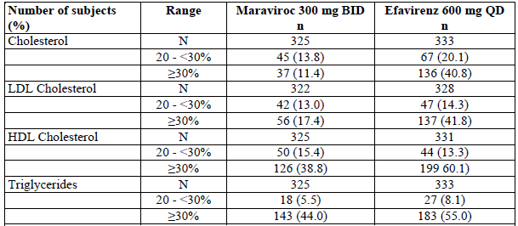
N = Number of subjects assessed; n = number of subjects in change from baseline category

Study A4001026 maraviroc QD and BID OL
Treatment-related adverse events were reported by 70.7% of patients receiving maraviroc QD and by 33.1% of participants while receiving open label maraviroc BID. Serious adverse events considered related to maraviroc were reported for 4 patients (2.3%). Skin involvement was reported for three: rash erythematosus; rash; and Stevens-Johnson syndrome.
Summaries of Grade 3 and 4 treatment related adverse events were provided. One patient receiving maraviroc 300 mg QD met the biochemical definition for Hy’s law and underwent liver transplantation following the serious adverse event of hepatitis toxic.
Category C infections and infestations were reported for 4 patients (2.3%) while receiving maraviroc 300 mg QD.
No individual receiving maraviroc 300 mg QD reported cardiac ischaemia or orthostatic hypotension or muscle related adverse event or event relating to hypersensitivity or autoimmune disease considered treatment related.
The following malignancies were reported for maraviroc QD: Kaposi’s sarcoma; non-Hodgkin’s lymphoma (resulted in death) neither was considered to be treatment related; Small cell carcinoma on Day 439 after permanently discontinuing the study when the QD arm was stopped. And for maraviroc OL: multiple myeloma.
Benign neoplasms were reported by 4 participants receiving maraviroc QD and 5 receiving open label maraviroc BID: skin papillomas for 3 and acrochordon for one in the maraviroc QD group; skin papillomas for three and rectal polyp in the open label group.
Four participants in the QD group discontinued with rash and one due to Stevens-Johnson syndrome, one due to toxic hepatitis, one due to ALT increased, one due to hepatic enzyme increased; two patients had tuberculosis.
Grade 3 or 4 ALT and AST in the maraviroc QD group were reported by, 8 (4.1%) and 5 (2.9%) reported respectively. For the maraviroc OL, 2 (1.6%) and 3 (2.4%) reported Grade 3 or 4 ALT and AST, respectively. Three individuals receiving maraviroc 300 mg QD and 1 receiving open label maraviroc 300 mg BID permanently discontinued due to abnormalities ALT or AST.
There were no reports of clinically relevant effects of maraviroc QD or OL on blood pressure or pulse rate and the incidence of postural hypotension was low. Increases from baseline in QTcF were summarised in the submission. Thirteen of the 122 (10.7%) participants in the open label group reported increases ≥ 30 msec.

Studies A4001027 and A4001028 – Treatment experienced
The pooled safety analysis population was defined as all participants randomized who received at least one dose of study medication and reporting was according to the treatment received. The numbers included were: maraviroc QD (414), maraviroc BID (426), placebo (209) and in-study on open-label (OL) maraviroc BID (117 participants). Total exposure in patient years was 300 – 308.8 for the blinded maraviroc arms and 110.7 for placebo.
Nearly 90% of participants were male, mean age was approximately 46 years and over 80% were White. Baseline disease characteristics were similar between groups although there were slightly higher proportions of patients positive for hepatitis B and C at baseline in the placebo group than in either of the maraviroc groups.
Adverse events were reported by 90.6% of the maraviroc QD group, 92.3% for maraviroc BID groups and 84.7% of the placebo group uncorrected for time on treatment. Of the 117 on open label maraviroc, 67.5% reported at least one AE. More patients in the placebo group discontinued for lack of efficacy, many of whom went on to OL maraviroc BID. Results were also presented in the submission as all-causality AEs adjusted for duration of study drug exposure.
Table 28. Summary of All Causality Adverse Events, Studies A4001027 and A4001028 (48 weeks)
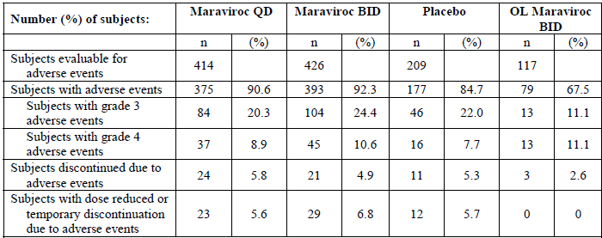
Treatment-related adverse events were reported for 49.5% for maraviroc QD, 51.4% for maraviroc BID), and 45.0% for the placebo group. The most common were nausea, diarrhoea, fatigue, headache and dizziness. Only rash, constipation, dyspepsia and cough occurred at ≥2% and at higher incidence in the maraviroc BID group than placebo.
Unadjusted for time on therapy, the proportion of participants with Grade 3 adverse events was higher in the maraviroc treatment groups compared to placebo. The proportion of Grade 4 adverse events was highest in the maraviroc BID group and lowest in the maraviroc QD group.
Two deaths were considered related to study drug: large B cell lymphoma and Cholangiocarcinoma/liver metastases/bone metastases/peritoneal metastases.
A total of 202 participants reported serious adverse events: 76/414 (18.4%) on maraviroc QD, 88/426 (20.7%) on maraviroc BID and 38/209 (18.2%) on placebo. The most common serious adverse events were vomiting and pneumonia. Serious adverse events considered related to treatment were reported by10 patients (2.4%) on maraviroc QD, 13 (3.1%) on maraviroc BID, 2 on placebo (1.0%) and 3 (2.6%) on open-label maraviroc.
Permanent discontinuations because of all-causality adverse events were reported by: 20 (4.8%) receiving maraviroc QD, 19 (4.5%) receiving maraviroc BID and 11 (5.3%) receiving placebo. Temporary discontinuations due to adverse events were reported for 72 participants in all: 26 (6.3%) receiving maraviroc QD, 34 (8.0%) receiving maraviroc BID and 12 (5.7%) receiving placebo.
Regarding liver related serious adverse events: There were more events in the maraviroc groups than in the placebo group. No patient died of a liver related adverse event. No patient fully met Hy’s law. For numbers of individuals with grade 3 or 4 LFT abnormalities: There were slightly higher numbers of Grade 3 and 4 AST abnormalities but lower numbers of ALT abnormalities in the maraviroc BID treatment group than in the placebo and maraviroc QD groups.
Median changes from baseline in key laboratory parameters were similar across the 3 treatment groups, apart from lymphocytes (absolute and percentage), cholesterol (HDL, LDL and total), and creatine kinase, where larger median increases were observed in the maraviroc treatment arms than in the placebo group.
The most commonly reported non-neoplastic Category C AIDS defining illnesses were candidiasis and herpes infections; all other AEs were reported by no more than 2 patients. For category C malignancies: Lymphoma and Kaposi’s sarcoma were reported at a slightly higher rate for the placebo group than the maraviroc groups however, numbers in both groups were small. For all-causality non-Category C neoplastic adverse events: The most commonly reported were anal cancer and skin papillomas; all others were reported by no more than 2 patients per treatment group.
There was an apparent excess of reports of myalgia and AST increased in the maraviroc treatment groups. Participants receiving maraviroc had a higher median change from baseline in CPK compared to placebo, with a median change of 22 U/L in the maraviroc QD treatment group, 19 U/L in the maraviroc BID treatment group and 6 U/L in the placebo group. There was a median decrease from baseline to last observation in AST of - 6 IU/L in the maraviroc QD treatment group, - 5 IU/L in the maraviroc BID treatment group and - 2 U/L in the placebo group.. However, when adjusted for duration of exposure, 55.6 events of CPK elevations (greater than twice the ULN; without regard to baseline abnormality) occurred per 100 participant-years in the maraviroc QD treatment group, 54.7 in the maraviroc BID group and 52.0 in the placebo group. Similarly, there was little difference between treatment groups in exposure adjusted incidence of AST abnormality: 13.8 events per 100 participant-years in the maraviroc QD treatment group, 15.7 in the maraviroc BID group, and 16.2 in the placebo group.
Postural hypotension was reported slightly more frequently in the 2 maraviroc treatment groups than in the placebo group; the highest incidence in the lowest dose maraviroc QD treatment group at the 48 week time point. When the analysis was restricted to participants who were taking concomitant antihypertensives, nitrates, alpha blockers, and PDE5 inhibitors, the incidence of postural hypotension was particularly high in patients treated with maraviroc QD at the 48 week time point [15/90 (16.7%)] compared with participants treated with maraviroc BID [2/109 (1.8%)] and placebo [2/27 (7.4%)]. The incidence of postural hypotension in participants not taking blood pressure lowering drugs was 12/137 (8.8%), 12/155 (7.7%) and 1/38 (2.6%) at 48 weeks for those receiving maraviroc QD, maraviroc BID and placebo respectively.
Adverse events with potential relationship to blood pressure: These AEs occurred with similar frequencies across all 3 treatment groups, with the exception of dizziness which trended slightly towards a higher incidence in maraviroc treated participants. From the maraviroc treatment groups, 1 episode of orthostatic hypotension (BID group), loss of consciousness (BID group), and 3 of the episodes of syncope (1 maraviroc QD, 2 maraviroc BID) were reported as serious adverse events. Dizziness was observed among maraviroc-treated participants receiving saquinavir, but not among placebo-treated participants who received saquinavir.
Mean changes in QTc interval duration from baseline were similar between maraviroc groups and the placebo group at all time points.
There were no notable discrepancies between groups with respect to grade 3 – 4 laboratory abnormalities. Median changes from baseline were similar across the 3 treatment groups, apart from lymphocytes, cholesterol (HDL, LDL and total), and creatine kinase, where larger median increases were observed in the maraviroc treatment arms than in the placebo group. However, not all patients contributed data to this assessment.
There were 21 pregnancies leading to 6 spontaneous abortions, seven induced abortions, 6 with unknown outcome and one pregnancy with outcome of normal newborn and one with “healthy delivery”.

Study A4001029 – Non-CCR5 tropic
Duration of treatment is summarised in Table 29, below.
Table 29. Study A4001029 Summary of Duration of Treatment and Treatment
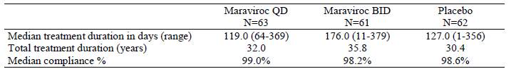
N = Number of subjects in the treatment group in the indicated population
Between 44% and 63% of patients in each treatment group reported at least 1 treatment related adverse event, the most common being diarrhoea, headache, fatigue and nausea with similar incidence across the treatment groups.
Category C AIDS defining illnesses were reported by 8% of participants receiving maraviroc QD, 7% of participants receiving maraviroc BID and 3% of participants receiving placebo. No Category C malignancies were reported.
In the maraviroc treatment groups approximately 3% of participants reported treatment related Grade 3 adverse events compared with 7% of participants in the placebo treatment group. No Grade 4 treatment related adverse events were reported. No adverse events of orthostatic hypotension and no Grade 3 to 4 adverse events of syncope were reported. Two patients in the maraviroc BID treatment group reported Grade 1 to 2 syncope.
Five patients died during the study or within 28 days of the end of treatment (2 maraviroc QD, 1 maraviroc BID and 2 placebo). Between 16% and 18% of patients in each treatment group reported treatment emergent SAEs. No deaths or serious adverse events were considered treatment related.
Approximately 2% of participants in the maraviroc treatment groups and 3% of participants in the placebo treatment group discontinued due to treatment related adverse events. Three participants temporarily discontinued due to study drug related events; 2 patients in the maraviroc BID treatment group (for oral mucosal blistering and generalised rash) and 1 in the placebo treatment group (for aphthous stomatitis, paraesthesia oral, malaise, pyrexia, pruritus and rash).
The incidence of laboratory test abnormalities was similar across groups. The overall incidence of Grade 3/4 transaminase abnormalities, was low in all treatment groups.
There were no mean changes in standing or supine systolic or diastolic blood pressure and pulse rate considered clinically relevant in any treatment group. The proportion meeting at least 1 criterion for postural hypotension at Week 2 compared with baseline was higher in the maraviroc treatment groups than in the placebo treatment group. Only 2 patients met the criteria at Week 48, both of whom were in the maraviroc BID treatment group.
There was no evidence of a mean increase from baseline in QTcF at Week 48 following treatment with maraviroc QD or maraviroc BID (mean changes from baseline of - 1.4 and + 1.2 msec, respectively) compared with placebo (mean change from baseline of - 4.6 msec).

Clinical questions and evaluation of responses

Question 1
Details of the statistical analysis undertaken at the time of interim analysis were requested.

Sponsor response
Study Protocol Section 3 Study Design
Two hundred and four patients will be treated for 16 weeks during the run-in phase. A formal interim efficacy analysis was planned to test non-inferiority of each maraviroc regiment in Time-Averaged Difference in viral load versus the efavirenz regime. Assuming a one-sided significance level of 0.25, 95% significance level (with no adjustment for multiple comparisons), a non-inferiority margin of 0.5 and common standard deviation of 0.8, 68 patients per treatment group would be required. With 68 patients per group, there would be 80% power to detect a difference between the two maraviroc regimens in time-averaged drop in viral load of 0.387 log10. Assuming a 90% response rate for percentage with HIV-1 RNA less than 400 copies/mL there was over 95% power to show non-inferiority with a non-inferiority margin of – 20%.

Evaluator comment
The lack of adjustment for multiple comparisons is queried.

Question 2
The results of the interim analysis were requested for maraviroc 300 mg QD compared to efavirenz and for maraviroc 300 mg BID compared to efavirenz for the full set analysis and per-protocol set.

Sponsor response
The formal interim analysis was only performed on the full analysis set. The following table (Table 30) summarises the result. The maraviroc BID dose demonstrated non-inferiority to efavirenz with an upper bound of the confidence interval of treatment difference of 0.31. The maraviroc QD dose failed to demonstrate non-inferiority with upper bound greater than 0.5.
Table 30. Results for time adjusted difference from baseline to Week 16 in log transformed HIV RNA levels
Treatment | Baseline  Unadjusted mean (s.d) | Week 16  Unadjusted mean (s.e.) | Week 16  Adjusted mean (s.e.) | Difference (s.e.) [95% Confidence Interval)
Efavirenz  N = 69 | 4.97 (0.07) | -2.44 (0.10) | - 2.45 (0.10)
Maraviroc BID N = 68 | 4.90 (0.08) | -2.40 (0.08) | -2.41 (1.01) | 0.04 (0.14) [-0.24, 0.31]
Maraviroc QD N = 68 | 4.96 (0.08) | -2.21 (0.11) | -2.21 (0.10) | 0.24 (0.14) [-0.04, 0.51]
N = number of participants
Adjustment was for screening viral load and geographic area (least squares mean)
Where data were missing, TAD was calculated using AUC from baseline to last available visit/time period for the last available visit.
Results for percentage of participants with plasma HIV-1 RNA below 400 copies/mL at Week 16 are summarised in Table 31, below. Again the maraviroc QD failed to demonstrate non-inferiority in the chosen terms.
Table 31. Percentage of patients with plasma HIV-1 RNA below 400 copies/mL at Week 16
Treatment | N (n) | % below LOQ | Difference | 95% Confidence Interval
Efavirenz | 69 (61) | 88.41% | -1.64 | -12.58, 9.32
Maraviroc BID | 68 (59 ) | 86.76% | -1.64 | -12.58, 9.32
Maraviroc QD | 68 (53) | 77.94% | -10.46 | -25, 2.5
N = number in treatment group
n = number with plasma HIV RNA < 400 copies/mL

Evaluator comment
The rationale for choice of delta in each case was not specified. There was no accounting for multiplicity. The results were not confirmed with analysis of per-protocol population analysis. There were no results for HIV RNA < 50 copies/mL. The results presage those of the primary analysis.

Summary and discussion

Summary: Study A4001026 – Treatment-naive

Summary of efficacy
The 96 week report of this ongoing, Phase 2b/3, multi-national, multi-centre trial was submitted in support of registration of maraviroc 300 mg BID for treatment-naive patients infected with CCR5 tropic HIV-1. Maraviroc, 300 mg QD and maraviroc 300 mg BID were evaluated in comparison efavirenz 600 mg QD. Each was taken without food restriction, in combination with zidovudine/lamivudine 300 mg/150 mg BID. The study included patients aged at least 16 years infected with CCR5-tropic HIV-1, and with a viral load ≥ 2,000 copies/mL.
An interim analysis was performed when the first 205 patients reached Week 16. Based on failure to meet noninferiority criterion, the maraviroc QD arm was discontinued; patients responding to maraviroc were given the option to switch to open label maraviroc 300 mg BID. Participants were subsequently randomised 1:1 to maraviroc BID or efavirenz. A total of 695 patients were treated: 174 in the maraviroc QD group, 360 in the maraviroc BID group and 361 in the efavirenz group.
The primary objective was assessment of non-inferiority of maraviroc compared to efavirenz in terms of viral load < 400 copies/mL and < 50 copies/mL at Week 48. The primary analysis was based on the 1-sided, 97.5% CI with adjustment for the randomization strata of screening viral load and geographic region. Non-inferiority was concluded if the lower bound of the CI was above - 10%. For the primary analysis, participants were stratified by geographic location (Northern or Southern Hemisphere) and screening viral load (< 100,000 or ≥ 100,000 copies/mL). The Full Analysis Set and the Per Protocol Population results were analysed. Sensitivity analysis was performed using the TLOVR algorithm.
The initially planned 1-sided significance level of 0.0125 (Bonferroni adjustment for multiple comparisons) was changed to the 1-sided 97.5% confidence interval (CI) when the maraviroc QD group was discontinued.
Non-inferiority for viral load < 400 copies/mL was demonstrated using FAS; the lower bounds of the 1-sided 97.5% CI was - 9.5. However, non-inferiority was not demonstrated for viral load < 400 copies/mL in the PP analysis, nor for viral load < 50 copies/mL using either the FAS or PP analyses.
Virologic failure based on viral load < 400 copies/m was more commonly reported for non-responders in the maraviroc BD group than the efavirenz group: 27% vs. 5.3% respectively. Similarly for viral load < 50 copies/mL the proportions were 32.0% vs. 8.8%. However, the mean increase from baseline in CD4 cell count throughout the 48 weeks was consistently greater in the maraviroc group than in the efavirenz group; the difference between the maraviroc and efavirenz groups was 26.3 cells/µL (95% CI 7.0, 45.6).
Subgroup analysis by screening viral load demonstrated smaller response for maraviroc treated patients compared to the efavirenz group in terms of viral load < 400 copies/mL and < 50 copies/mL in the stratum with ≥ 100,000 copies/mL at screening as summarised in Tables 9 and 10, above. While subgroup analysis results are considered observational, it appears possible that patients with high viral load at screening adversely influenced the overall result.
The percentages of participants in the QD group with viral load < 400 and < 50 copies/mL at Week 96 were 52.9% and 48.3%, respectively while the results for those treated with open label (OL) maraiviroc 300 mg BID were 70.8% and 64.6%, respectively.
Study A4001026 utilised the original Trofile™ assay, the only available tropism test at the time. Shortly after completion of the study, the Enhanced Sensitivity Trofile Assay (ESTA) was released for clinical use based on data demonstrating increased sensitivity for the detection of CXCR4-tropic virus. A post-hoc analysis using the primary analysis statistical approach was undertaken to determine whether use of ESTA would have excluded more patients unlikely to respond to maraviroc. Based in ESTA, the proportions re-classified dual-mixed-tropic or X4-tropic by were; 48 (13.3%) and 58 (16.1%) in the maraviroc 300 mg BID and efavirenz arms, respectively.
Re-analysis of the outcome of viral count < 400 copies/mL confirmed the original finding of non-inferiority using the full analysis set, supported by the per protocol analysis. For viral count < 50 copies/mL the re-analysis adjusted for randomization strata of screening viral load and geographic region resulted in a lower bound of the 97.5% CI above -10%, supported by the PP analysis. However, the 48 Week FAS and PP sensitivity analysis using the TLOVR algorithm failed to support the finding. Results for 96 weeks also resulted in lower CI bounds of less than – 10%.
The initial inequality in proportions of participants discontinuing due to lack of efficacy remained after the ESTA analysis. On re-analysis, discontinuations due to lack of efficacy were recorded for 9.3% of the maraviroc BD groups compared with 4% of the efavirenz group.

Summary of virology
At the time of treatment failure at the Week 48 assessment 27/43 (62.8%) of the maraviroc BID group and 3/15 (20%) of the efavirenz group had virus with genotypic evidence of resistance to lamivudine. In addition, 6/43 (14.0%) in the maraviroc BID treatment group had virus with zidovudine resistance as evidenced by the presence at discontinuation of 1 or more TAMs. None of the 15 participants who failed efavirenz had virus with TAMs at failure. The 48 week assessment of discontinuations and the Week 96 findings for treatment failure and discontinuations demonstrated a similar pattern.
With respect to the maraviroc QD treated participants who either discontinued or were changed to open label maraviroc BID, 27 participants overall and 16 who entered open label had treatment failure due to insufficient clinical response. At time of treatment failure, 20/27 individuals (74.1%) overall and 13/16 (81.3%) who entered open label, had virus with genotypic evidence of drug resistance to lamivudine; three of whom had virus with zidovudine resistance.
A total of 77 participants in all, and 33 who entered open label, discontinued study treatment. At time of discontinuation, 31/77 (40.3%) overall and 19/33 (57.6%) OL, had virus with genotypic evidence of drug resistance to lamivudine; three of whom had virus with zidovudine resistance, as evidenced by the presence at discontinuation of 1 or more TAMs.
Sequences of the V3 loops were obtained for 6 participants whose R5-tropic virus showed reduced susceptibility to maraviroc in study A4001026. Changes in the V3 loop sequence were identified in clones from 5/6 participants. Consistent with similar studies in treatment experienced participants, no signature mutations of maraviroc resistance were identified suggesting that there are multiple pathways to maraviroc resistance in vivo.
In the 6 week period between screening and baseline approximately 3 – 4% of participants in the maraviroc BID and efavirenz groups switched from CCR5 tropic to dual/mixed tropic. At the Week 48 assessment 10/32 participants in the maraviroc BID group with treatment failure and available results, switched to CXCR4 or dual mixed tropism; at Week 96, 12/34 in the maraviroc BID group changed tropism. None of 15 failures in the efavirenz group did so.
At Week 48, 12/75 (16%) patients in the maraviroc group who discontinued the study changed tropism from CCR5 to CXCR4 or dual/mixed tropic. At Week 96, 14/106 (13%) of patients in the maraviroc BID group who discontinued from the study changed viral tropism to CXCR4 or dual/mixed while at neither time point did any of the participants in the efavirenz group do so.
The median time to treatment failure was shorter for participants who were CCR5 tropic at baseline and who remained CCR5 tropic or who were NR/NP tropic at treatment failure in the maraviroc compared to the efavirenz group.
With respect to the maraviroc QD participants who either discontinued or were changed to open label maraviroc BID, five participants with dual/mixed tropism at baseline had dual/mixed tropism at the time of treatment failure. Four participants with CCR5 tropism at baseline had dual/mixed tropism at time of treatment failure. Seven of 9 participants who failed with CCR5 tropic virus and 9/9 who failed with dual/mixed tropic virus had evidence of zidovudine/lamivudine resistance.

Summary of pharmacology
Population PK parameters were estimated for use in exposure-response analyses and to explore the influence of covariates. Concentration versus time after dose data were compared with steady state results from Phase 2a study data and were found to be similar in distribution but with greater variability in Study A4001026 data. A significant effect of food in reducing AUC/Cave by 11% was documented (p < 0.001).
An exploratory PK-PD analysis was undertaken on 48 week data using Generalised Additive Models to identify relationships between maraviroc 300 mg BID systemic exposure and clinical endpoints in an effort to determine prognostic factors describing maraviroc effect on the safety and efficacy outcomes of virologic success, CD4 count, ALT, AST and CK. Baseline CD4 count and baseline viral load, baseline tropism and exposure to maraviroc were found to be important prognostic factors of virologic success. The results suggested that in the presence of zidovudine/lamivudine, at maraviroc average concentration of 75 ng/mL, the probability of success would be 80% of maraviroc net effect. In study A4001026, 13% of patients had maraviroc average concentrations less than 75 ng/mL. Minor prognostic factors were race, hemisphere, age and clade.

Summary of safety
The total exposure in patient-years was 506 years for maraviroc and 507.9 years for efavirenz. All causality adverse events were reported by similar proportions of the maraviroc BD and efavirenz groups. However, treatment related adverse events and discontinuations due to treatment related adverse event were more common in the efavirenz group than in the maraviroc BD group. Adverse events leading to permanent discontinuation were considered treatment-related by the investigator for 15 (4.2%) in the maraviroc group and 47 (13.0%) in the efavirenz group. The most common reasons for discontinuation were related to increased transaminases, nausea and pregnancy in the maraviroc BD group and rash, pregnancy, tuberculosis, dizziness and nausea in the efavirenz group.
There appeared no evidence relating maraviroc BID to an excess of deaths, Category C infection, serious adverse events, malignancy, hypotension, infection, hepatobiliary disorder or QTcF prolongation in comparison to efavirenz. No new or unexpected safety signal was reported.

Discussion – Study A4001026 - Treatment-naive

Discussion of efficacy
The European Union guideline on the clinical development of medicinal products for the treatment of HIV infection recommends that the proportion achieving and maintaining plasma HIV-RNA. < 50 copies/ml is the preferred primary efficacy endpoint for studies in treatment naïve populations. The EU guideline on points to consider on switching between superiority and non-inferiority states that in a non-inferiority trial, the FAS and the PP analyses are considered to have equal importance and their use should lead to similar conclusions for a robust interpretation. This guideline also states that when a one sided CI is chosen, 97.5% CI is considered appropriate.
The initially planned 1-sided significance level of 0.0125 (Bonferroni adjustment for multiple comparisons) was changed to a 1-sided 97.5% confidence interval when the maraviroc QD group was discontinued which is a matter requiring justification. It is also considered that further adjustment for multiplicity should have factored in the repeated testing related to the interim analysis.
Study A4001026 demonstrated non-inferiority only for viral count < 400 copies/mL and only for the FAS and failed to demonstrated non-inferiority based on viral count < 50 copies/mL according to the pre-planned statistical analytic plan.
The observational ESTA analysis resulted in a dropout rate of 13.3% for the maraviroc group and 16.1% of the efavirenz due to reassessment of tropism. The numbers with change of tropism between screening and baseline following re-analysis could not be located. By its nature, the analysis had the potential to unbalance confounding factors and include bias.
The findings of the ESTA analysis in relationship to the primary objective supported non-inferiority based on viral load < 400 copies/mL and < 50 copies/mL. However the findings were not uniformly supported by sensitivity analysis. In addition, the analysis used the 1-sided 97.5%, without consideration of the possible multiplicity issue related to repeat testing.
Statistical advice regarding multiplicity issues in this study was sought. The response in included in the Appendix to this report.
The selection of a comparator arm was based on the preferred regimen for the treatment of established HIV infection in antiretroviral-naïve patients at the time the study was designed (2003) and is being judged accordingly; however, this is currently recommended as an alternative regimen in the DHHS Guidelines for use of antiretroviral agents in HIV-1-infected adults and adolescents (with Australian commentary) The sponsor argued that the efavirenz response in this study was lower than that seen in other studies in which tenofovir and emtricitabine have been used as backbone, and that it is possible that the use of a more potent backbone such as tenofovir and emtricitabine would have led to an increased response rate in both treatment groups.
While it is possible that efficacy results would have been different using a different backbone regimen, or if it had been possible to prospectively plan the study using ESTA to screen for non-CCR5 tropic virus; it is not considered appropriate to make a recommendation for registration based on possibilities.

Discussion of virology
Based on the subgroup analyses it appears that maraviroc treatment failure may increase the risk of selection of non-CCR5 tropic virus. Non-CCR5 tropic, syncytium forming virus has been shown to be associated with faster rate of disease progression.
Based on subgroup analyses, it appears possible that the patients who failed treatment with maraviroc were at greater risk than those treated with efavirenz of developing resistance to background therapy of lamivudine and zidovudine. Failure to achieve viral load < 50 copies/mL may have predisposed to development of viral resistance.
With respect to the maraviroc QD group, efficacy results for the OL group were biased by inclusion of participants who were known to be responding to treatment and who voluntarily changed to open label treatment. It is presumed that the participants who discontinued maraviroc treatment were treated with other antiretroviral therapy and it appears that there was a continuing drop in the proportions with viral load < 400 or < 50 copies/mL in this group. It could be hypothesised that this represents an indication that disease progression had been adversely affected by the change of viral tropism.
Also in relation to the QD and OL groups, it appeared that early treatment failure with either CCR5 or mixed/dual tropisms may associated with an increase tendency towards development of viral resistance to the background agents in particular, lamivudine.

Discussion of pharmacology
With respect to the population PK analysis, the expert considered that the data demonstrating higher variability than found in previous studies could be expected from an outpatient study and a more heterogeneous population. The increased variability was considered likely to be the result of poor compliance, and/or inaccurate dosing histories and/or a food effect. These differences, particularly in the absorption phase, were considered possibly the result of the known interaction of maraviroc with food. The phase 1/2a data were mostly derived from dosing in the fasted state whereas in A4001026 maraviroc doses could be taken without regard to food. However, the expert considered the statistically significant food effect to be clinically insignificant.
With respect to the exploratory PK/PD analysis, in addition to baseline variables of CD4 count, viral load and viral tropism, race, sex and age were found to influence the hepatic extraction ratio but were considered clinically insignificant by the expert. However, in an effort to maximize efficacy, it may be that taking such variables into consideration in treatment of individuals, rather than in determining clinical significance in populations, may contribute to improved response to treatment. Ultimately, the aim of undertaking studies of populations of HIV-1 infected patients should be to optimise the treatment of individual patients.
This PK/PD study potentially generates the hypothesis that attention to attaining a specific average concentration results in higher probability of success in treatment. As timing of drug administration with respect to food was determined in the population PK study to significantly influence drug levels, it is considered possible that maraviroc treatment may have been more successful if given in the fasted state. It may be that maraviroc efficacy could be enhanced by monitoring therapeutic drug levels.
It also appears that patients with high viral loads were disproportionately represented amongst the treatment failures and for these patients, special attention to attaining adequate blood levels would appear wise. Additionally and hypothetically, treatment naive patients with very high viral counts may not be appropriate candidates for maraviroc treatment. The PK/PD analysis also determined that baseline CD4 cell count and baseline viral count are potential determinants of treatment failure or success. As higher viral loads and lower CD4 cell counts with steep decline are associated with greater possibility that the patient harbours X4-using virus. This may have implication for the optimal time to initiate maraviroc therapy in treatment-naive patients. It is possible that high viral loads result in competitive inhibition of maraviroc.

Discussion of safety
While efficacy is an issue, it appeared that maraviroc BD has an advantage of efavirenz with respect to safety as shown in this study to this time point. There was benefit in favour of maraviroc compared to efavirenz with respect to discontinuations due to adverse events and with respect to lipid parameters. There was no category of events in which maraviroc predominated compared to efavirenz. In particular in areas of special interest, there were no more malignancies reported, no evidence of increased in incidence of Category C events and AIDS, no excess of thyroid or muscle related adverse events.
With respect to determining the clinical significance of a change in tropism, the timing of the event is of importance as there is likely to be a lag time between change of tropism and the onset of accelerated disease progress or the adverse events related to progression to AIDS. Submission to the TGA of the results of the ongoing follow-up is considered a requirement should maraviroc be registered for use in treatment-naive patients.
With respect to QTcF interval, details of the uniformity or otherwise of collection, reading and interpretation of the ECGs could not be located in the submission dossier. Increases in QTcF of as little as 30 msec or less may be clinically relevant. Based on CPMP recommendations, 16% of patients in the maraviroc group had maximum increases in the range at least potentially of concern vs. 17% of the efavirenz group. The fact that one group did not predominate in incidence is not totally reassuring.
With respect to maraviroc QD, despite demonstrated superiority of efficacy of maraviroc 300 mg QD with OBT in treatment experience patients, albeit with a different primary outcome, its use in treatment-naive patients was found to be inferior such that discontinuation of that treatment was advised by the Data Safety Monitoring Board. While the QD dose is not the subject of the application, the apparent efficacy failure is of concern as it points to the possibility that the treatment-naive patients offer challenges in treatment not so evident in the treatment-experienced population.

Summary: Studies A4001027 and A4001028 – Treatment-experienced

Summary of efficacy
These identically designed, multicentre, randomised, double-blind, placebo-controlled trials compared maraviroc 300 mg once daily or maraviroc 300 mg twice daily in combination with optimised background therapy (OBT) versus OBT plus matching placebo for the treatment of antiretroviral-experienced patients infected with CCR5 tropic HIV-1.
The studies included patients aged ≥ 16 years with plasma viral load ≥ 5,000 copies/mL with ≥ 6 months of prior treatment with at least 1 agent from 3 of the 4 antiretroviral drug classes or documented resistance to members from 3 of 4 classes and a stable antiretroviral regimen for at least 4 weeks prior to randomisation. Infection with non-CCR5 tropic virus was an exclusion criterion.
The primary efficacy objective was to test superiority of the two maraviroc regimens vs. placebo in terms of the difference in the mean change from baseline in plasma HIV-RNA at 48 weeks. The 2-sided 97.5% confidence interval for the difference was adjusted for multiplicity. Superiority of maraviroc versus placebo was concluded if the upper CI limit for the difference in treatment mean was completely to the left side excluding zero. An interim analysis of the primary objective was undertaken at 24 weeks at which time the sponsor was unblinded.
In both studies for both maraviroc dosing regimens superiority was demonstrated compared with placebo. In Study A4001027 the decrease in HIV-1 RNA from baseline to Week 48 was -1.66 for maraviroc once daily and - 1.82 for maraviroc twice daily vs. - 0.80 log10 copies/mL for placebo. The treatment difference from placebo was - 0.85 (97.5% CI - 1.22, - 0.49) for maraviroc QD and -1.02 log10 copies/mL (97.5% CI -1.39, -0.66) for maraviroc BID. In Study A4001028 the decreases in HIV-1 RNA for maraviroc QD, BID and placebo were - 1.72 and - 1.87 vs. - 0.76 log10 copies/mL respectively. The treatment difference was - 0.96 (97.5% CI - 1.38, - 0.54) for maraviroc QD, and - 1.11 log10 copies/mL (97.5% CI - 1.52, - 0.70) for maraviroc BID.
There were more discontinuations due to lack of efficacy in the placebo arm (53%) than in either maraviroc arm (20% -25%). The proportion of patients with viral load < 50 copies/mL at Week 48, was 40.7% in the maraviroc once daily group, 46.6% in the twice daily treatment group and 15.4% in the placebo group. In both studies, there was a greater mean increase in CD4 and CD8 cell counts from baseline in both maraviroc treatment groups compared with placebo.

Summary of virology
The majority of patients had either no change in their susceptibility scores (GSS, PSS and OSS) or had a loss of susceptibility to 1 drug, with very few patients having an increase; the small shift being consistent with the fact that most patients had GSS, PSS and OSS values of ≤ 2 at screening. Subpopulation analysis showed an increase in response in terms of viral load < 50 copies/mL with increase in GSS and OSS.
In A4001027 and A4001028, 20/56 (36%) participants who experienced protocol defined treatment failure with CCR5-tropic virus to Week 48 were found to have reduced susceptibility to maraviroc with reduced maximum percentage inhibition (MPI). Amino acid changes in the V3 loop of envelope clones were identified in viruses from patients which showed a plateau in MPI after treatment with maraviroc. However, these changes were different between patients, reflecting the heterogeneity in gp160 sequence; signature mutations of maraviroc resistance were not identified.
A change in viral tropism between screening and baseline was reported for 7% of participants in Study A4001027 and 8% in Study A4001028, all changes were from CCR5 to dual/mixed. In each of the studies, most of the participants who responded to treatment had no tropism assignment at Week 48 mainly due either to having viral load < 500 copies/mL or having discontinued.
In study A4001027, of the 252 patients with a CCR5 tropism at baseline who experienced treatment failure, 82 (32.5%) had a change in tropism result to CXCR4 or dual/mixed at time of treatment failure. All but 6 of these patients were in the maraviroc treatment arms.
In Study A4001028, of the 107 participants with a CCR5 tropism result at baseline, and who experienced treatment failure, 25 (23%) had a change in tropism result to CXCR4 or dual/mixed at the time of treatment failure; all but 3 of these participants were in the maraviroc treatment groups.

Summary of safety
The numbers included in the safety analysis were: maraviroc QD (414), maraviroc BID (426), placebo (209) and in-study on open-label (OL) maraviroc BID (117 participants). Total exposure in patient years was 300 – 308.8 for the blinded maraviroc arms and 110.7 for placebo.
All causality adverse events were reported by similar proportions of the maraviroc and placebo groups, not taking into account the different lengths of exposure. The incidence of treatment-related adverse events was 49.5% for maraviroc QD, 51.4% for maraviroc BID), and 45.0% for the placebo group. The most common of these were nausea, diarrhoea, fatigue, headache and dizziness. Rash, constipation, dyspepsia and cough occurred at ≥ 2% and at a higher incidence in the maraviroc BID group than placebo.
Serious adverse events were reported by 76/414 (18.4%) on maraviroc QD, 88/426 (20.7%) on maraviroc BID and 38/209 (18.2%) on placebo. The most common serious adverse events were vomiting and pneumonia. Two deaths were considered treatment related both reported in maraviroc treated patients: large cell lymphoma, and cholangiocarcinoma with multiple metastases.
Permanent discontinuations because of all-causality adverse events were reported by: 20 (4.8%) receiving maraviroc QD, 19 (4.5%) receiving maraviroc BID and 11 (5.3%) receiving placebo.
More liver related adverse events were reported by participants in the maraviroc groups. The approved product information in the precautions section is considered adequate to cover this event.
There appeared no evidence relating maraviroc BID to an excess of deaths, Category C infection, serious adverse events, malignancy, hypotension, infection or QTcF prolongation in comparison to placebo. No new or unexpected safety signal was reported.

Discussion: Studies A4001027 and A4001028 – Treatment-experienced

Discussion of efficacy
With regard to the primary objective, superiority was demonstrated for both maraviroc regimens compared to placebo. This was achieved despite use of the original Trofile assay in determining suitability for inclusion in the study. However, it is considered unusual to undertaken an interim analysis based on the criteria for the primary analysis and to unblind any participating, interested party at that the time.
Although the significance level was adjusted for multiplicity related to comparison of two dosage regimens with placebo, the issue of repeated testing was considered in relation to the interim analysis was not addressed.

Discussion of virology
It was noted that the significance or otherwise of change of tropism appears to be dependent on the model used for analysis based on the way of handling missing values. It may be that the LOCF model may be more meaningful as there were otherwise large numbers missing values reported at Week 48. Using the LOCF model, the confidence intervals for the difference between maraviroc and placebo at Week 48 and at time of treatment failure both suggest a significant difference between maraviroc and placebo in the proportions undergoing change of tropism which is of potential concern considering the possibility of more rapid disease progression in the presence of CXCR4-using virus.

Discussion of safety
Based on Week 48 results there appears to be no change in the safety profile of maraviroc in treatment of treatment-experienced patients. A brief mention of Week 96 results made by the clinical expert leads to the conclusion that there may possibly be further safety information available to the sponsor. If so, it is recommended that the data is submitted to the TGA.

Summary: Study A4001029 – Non-tropic CCR5
Study A4001029 was a multicenter, double-blind, randomized, placebo-controlled Phase 2b study of heavily treatment-experienced patients infected with non-CCR5 tropic (dual tropic, CXCR4-tropic or non-phenotypable) HIV-1 assessed using the Trofile assay. The primary objective was to determine whether maraviroc 300 mg QD or BID added to OBT provided an additional reduction from baseline in plasma viral load compared to OBT alone at Week 24 (results not included in the submitted report). A similar analysis at Week 48 was a secondary objective.
The study included patients aged at least 16 years, infected with non-CCR5-tropic HIV-1, with ≥ 3 months of prior treatment with at least 1 agent from 3 of the 4 antiretroviral drug classes or documented resistance to members from 3 of 4 classes, a stable antiretroviral regimen for at least 4 weeks prior to randomisation and a plasma viral load ≥ 5,000 copies/mL.
Sixty-three patients were treated in the maraviroc QD group, 61 in the maraviroc BID group and 62 in the placebo group. The proportions discontinued by Week 48 were 76% of the maraviroc QD group, 59% of the maraviroc BID group and 71% of the placebo group. Approximately 87% were male and the majority were aged between 35 and 54 years. Approximately two thirds were White and one third Black. The commonest reason for exclusion from the per protocol analysis was presence of CCR5 virus only at baseline which was reported for 6.3% of the maraviroc QD group, 9.8% of the maraviroc BID group and 11.3% of the placebo group.
Neither maraviroc dose regimen demonstrated superiority or non-inferiority to placebo. The percentages discontinuing for lack of efficacy were 64% for the maraviroc QD group and 44% for both the maraviroc BID and placebo groups.
Category C AIDS defining illnesses were reported for 8% of patients receiving maraviroc QD, 7% receiving maraviroc BID and 3% of participants receiving placebo.

Discussion of non-tropic CCR5 Study A4001029
The numbers in the study were small and the proportions discontinuing were considerable. Of the patients with dual/mixed tropism at baseline and with a result available at the time of treatment failure, 26/68 (38%) patients treated with maraviroc had a CXCR4 tropism result at failure compared with 3/27 (11%) patients in the placebo group, consistent with possible selective suppression by maraviroc of CCR5 tropic virus strains in these patients. It was not clear to the evaluator whether those in the study with CXCR4 had a more rapid clinical deterioration thereafter or were more resistant to further treatment. However, the use of maraviroc in treatment of non-CCR5 tropic virus is not proposed.

First round benefit-risk assessment

Benefits for treatment-experienced patients
Superior efficacy of maraviroc 300 mg BID compared to placebo has been established in Studies A4001027 and A4001028. The Week 48 safety assessment of maraviroc use in treatment experienced patient has revealed no new or unexpected safety signals.

Risks for treatment-experienced patients
Selection pressure resulting in transition to CXCR4-using HIV-1 infection is possible. CXCR4 tropic virus has been associated with more rapid advancement of disease. The safety follow-up period of 48 months is relatively short. Rare adverse events may remain to be identified.

Benefits for treatment-naive patients
Maraviroc 300 mg BID demonstrated a better safety profile than efavirenz with respect to discontinuations due to adverse events and with respect to lipid profile (cholesterol, LDL and triglycerides).

Risks for treatment-naive patients
Non-inferiority with respect to efficacy is not considered to have been unarguably demonstrated.
In patients with viral failure there appeared to be an increased risk of development of resistance to the two agents used in the OBT, in particular to lamivudine and in particular in the presence of CXCR5 using virus.
At time of treatment failure, for those patients with available results, only participants in the maraviroc group were documented to switch from CCR5 to CXCR4 or dual/mixed virus. It is considered of concern that in the relatively early stages of illness, a patient may be put at greater risk of a change in tropism resulting in infection with a more virulent virus potentially leading to more rapid disease progression.
Patients with inadequate blood levels have been shown to be at greater risk of treatment failure and hence of development of resistance and change of tropism, which is of concern in the absence of requirement for therapeutic blood level monitoring.
Little detail regarding the enhanced Trofile assay could be located in the submission dossier. It appears that the commercially available assay requires a viral load of at least 1,000 copies/mL which may limit the early detection of X4-using virus. The length of time required for the assay is considered practical considerations as change of tropism in a short period of a few weeks has been shown to occur. In addition, cost of the assay is a practical consideration to be determined.

Balance
With respect to treatment-experienced patients and the already approved Indication, the risk benefit profile is considered to remain positive.
For treatment-naive patients, the risk benefit balance is considered to lie on the side of risk.

First round recommendation regarding authorisation
Extension of the Indication to include treatment-naive patients is not recommended.
Continued registration of maraviroc 300 mg BID for use in treatment experienced population of HIV-1 CCR5 tropic viral infection is recommended.
It is recommended that the issues raised with respect to the draft Product Information are addressed.

Appendix 1. Statistical advice regarding multiplicity

Question
Has multiplicity been appropriately dealt with in Study A4001026?

Response
There are at least five potential sources of multiplicity in Study A4001026
- Interim analysis
- Two principle endpoints: <400 copies/ml, <50 copies/ml
- Analyses on the full analysis set (FAS) and per protocol (PP)
- Primary analysis at week 48, with secondary analyses at week 96
- Re-analysis of efficacy results using the enhanced Sensitivity Trofile Assay

Source 1. Interim analysis
The protocol stated that “A Data Safety Monitoring Board (DSMB) will review the results following treatment of 75 to 100 patients for at least 8 weeks. No formal statistical tests will be performed. If the DSMB feels that either of the doses of UK-427,857 show substantial evidence of harm to patients, then the DSMB will recommend ending recruitment to this treatment arm.”
The study design was analogous to an adaptive design with dose (regimen) selection at interim analysis. The maraviroc 300mg QD arm was discontinued; and the 98.75% one-sided confidence interval (to account for comparison of maraviroc 300mg QD and maraviroc 300mg BID to efavirenz 600mg QD) was changed to 97.5% one-sided confidence interval (because only the maraviroc 300mg BID comparison was continued with). Adaptive designs have the potential to inflate type-1 error and it would have been preferable to have based inference on adjusted confidence intervals. For example, a 97.5% two-sided interval or equivalently, a 98.75% one-sided interval would have been appropriate.
Sources 2, 3 and 4. <400/50 copies/ml; FAS/PP; 48/96 week
 | Difference in percentages | Lower bound of one-sided 97.5% confidence interval
Week 48
<400 copies/mL | -3.0 | -9.5
<50 copies/mL | -4.2 | -10.9
Week 96
<400 copies/mL | -3.2 | -10.2
<50 copies/mL | -5.8 | -12.8
At the principle pre-specified analysis time-point of 48 weeks, the non-inferiority margin of 10% (for a one-sided 97.5% confidence interval) was met for the outcome of <400copies/ml, but not for the endpoint of <50copies/ml. As the evaluation report points out, “The European Union guideline on the clinical development of medicinal products for the treatment of HIV infection recommends that the proportions achieving and maintaining plasma HIV-RNA. < 50 copies/ml is the preferred primary efficacy endpoint for studies in treatment naïve populations.” Also, the EMEA advice on multiple comparisons states that, where there are two principle outcomes (i.e., <400copies/ml and <50 copies/ml), the statistical criterion should be satisfied for both outcomes. This is not the case here, where the statistical criterion is only met for <400 copies/ml and then only if we use a one-sided 97.5% confidence interval. As discussed under “Source 1. Interim analysis”, above, a one-sided 98.75% confidence interval would be more appropriate.
In short, based on these analyses and taking a purely statistical viewpoint, non-inferiority was not established at 48 weeks or at 96 weeks.

Source 5. Enhanced Sensitivity Trofile Assay
These results are difficult to interpret because of the post-hoc nature of the analysis. From a purely statistical viewpoint, post-hoc subgroup analyses have traditionally been considered to be only hypothesis generating and, strictly speaking, would need to be confirmed in a subsequent study. A related consideration is that as the number of multiple comparisons increases, the use of a 98.75% one-sided confidence interval might be too conservative; that is, a wider confidence interval might be needed to adequately account for multiplicity.

Conclusion
For the original ITT (and PP) groups, statistical non-inferiority has not been proven according to standard, commonly-used and accepted criteria for statistical non-inferiority.
Of more current clinical relevance are the results for the subgroup defined according to the enhanced sensitivity trofile assay. Such post-hoc, subgroup analyses are notoriously difficult to assess.
From a purely statistical viewpoint, the main difficulty is the problem of multiplicity. That is, multiplicity is a concern for the post-hoc subgroup analysis defined according to the enhanced sensitivity trofile assay.
11 Nov 2011

Supplementary evaluation

Introduction
Following receipt of the First Round Clinical Evaluation Report (CER), ViiV Healthcare requested a stop clock (on December 6, 2011) in order to provide supplementary data as part of the response to the CER with respect to the robustness of the efficacy data and the potential risks associated with viral resistance and change in tropism. The response included:
- Efficacy data taken from the recently available Full Clinical Study Report for the 5 year Study A4001025 in treatment naive patients, For the purpose of this response, the applicant does not believe it necessary to provide the Full Clinical Study Report; however, will supply it on request if required. The Sponsor commits to submitting the 5 year data post-approval.
- Detailed response provided to address the recommendations and questions relating to the Product Information including the following summarise the major points.
- Non-inferiority of maraviroc (MVC) vs. efavirenz (EFV) is demonstrated by the definitive enhanced sensitivity Trofile assay (ESTA) analysis of both co-primary endpoints (< 400 and <5 0 copies/ml) at the pre-specified primary time point (Week 48).
- 240 Week efficacy results of Study A4001 026 in treatment-naive patients demonstrated that the virologic responses (viral load (VL) < 50 copies/ml) were similar between the two treatment groups to Week 240.
- Multiplicity is not considered an issue with respect to the statistical analyses (interim analysis, full analysis set (FAS) and per-protocol (PP) data sets, secondary analyses at Week 96, Trofile and ESTA analyses and sensitivity analyses).
- Major predictors of lack of response to MVC treatment in study A4001026 were having the tropism result change from CCR5- tropic (R5) at screening to dual/mixed (D/M) at baseline and low (MVC Cavg or Cmin
- After taking below limit of quantification (BLQ) and the ESTA populations into consideration Cavg is not as important for predicted efficacy at the dose studied, compared to the Generalised Additive Model (GAM) analysis with the original Trofile population.
- Although food, gender, race and age have an effect on MVC PK, their influence on efficacy should be minimal given the lack of a strong exposure-response curve observed after adjusting for participants with poor adherence.
- Adjusting MVC dose based on Therapeutic Drug Monitoring (TDM) would have no benefit for patients with poor adherence.
- Between Week 96 and 5 years, tropism change was observed for only 1 MVC-treated participant who discontinued therapy due to a lack of efficacy; a further 3 MVC-treated participants discontinued with R5 virus that had a reduced MVC susceptibility during this period.
- Between Week 96 and 5 years, there was no evidence of an increased burden of resistance to reverse transcriptase inhibitors (RTI) for MVC-treated patients (compared to EFV) who discontinued therapy due to lack of efficacy: 3 MVC-treated patients were observed to have selected virus resistant to lamivudine (no participant had resistance to zidovudine) compared to 3 EFV-treated participants with virus resistant to EFV (1 of these also showed resistance to lamivudine).
- After MVC discontinuation, a reversion to R5 virus was observed for 3 of the 5 MVC treated patients who failed therapy with a tropism change to dual/mixed/CXCR4-tropic (DM/X4) virus (and whose tropism could be assessment after MVC-discontinuation); the time scale for this reversion appears to be within approximately I to 2 months, which is consistent with the selective and reversible suppression of CCR5-tropic viruses during MVC therapy.
- ESTA replaced the original Trofile test as the only commercially available phenotypic tropism assay and the regulatory approvals and associated labelling were based on the ESTA data.
- Genotypic V3 loop testing (Population Based testing) has superseded ESTA as the routine test available for tropism determination and this technology offers a rapid turnaround time. The utility of genotypic testing in terms of predicting virological outcomes with MVC treatment, has been investigated and has been shown to be comparable with ESTA
- MVC 300 mg BID demonstrated a better safety profile in treatment-naïve patients than EFV 600 mg OD, which was confirmed out to 240 weeks
- ViiV Healthcare believe that there is a favourable benefit risk profile for MVC 300 mg BID which provides treatment naive patients the option of having a highly tolerable treatment, with no long term safety concerns.
In addition, the Sponsor has provided a tabulated response to the recommendations made in the CER for the Product Information (Pl) and Consumer Medicine Information (CMI).

Statistical issues – Treatment-naive patients
The statistical response has been evaluated separately by an external statistician.

Efficacy - Treatment naive – 240 weeks

ViiV Healthcare comment
Based on ESTA analysis, at Week 240, VL < 50 copies/ml was observed for (158/31l, 50.8%) in the MVC group vs. (139/303, 45.9%) in the EFV group. Based on the original Trofile assay analysis, the results were: MCV BID (1761360, 48.9%) and EFV QD (165/361, 45.1%). (Table 11.1 and Figure 11.1 below).
At Week 240, The mean changes from baseline in CD4 cell count by visit (last observation carried forward; LOCF) were for the MVC BID group was 292.9 cells/µL vs 270.6 cells/µL and for the EFV QD group. (Table 11.2 and Figure 11.2, below).
Table 11.1. Patients with Viral Load < 50 copies/ml at Weeks 48, 96 and 240 in Study A4001026
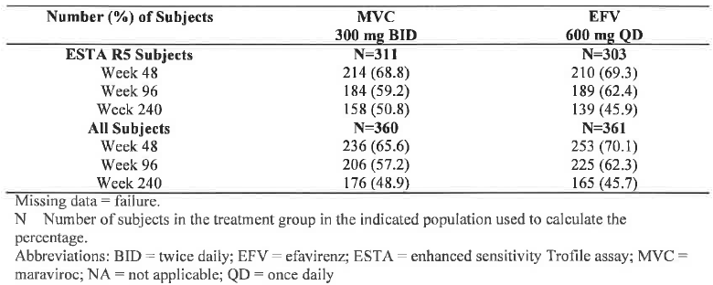
Figure 11.1. Percentage of Participants with Viral Load <50 copies/ml - ESTA R5 Participants Study A4001026
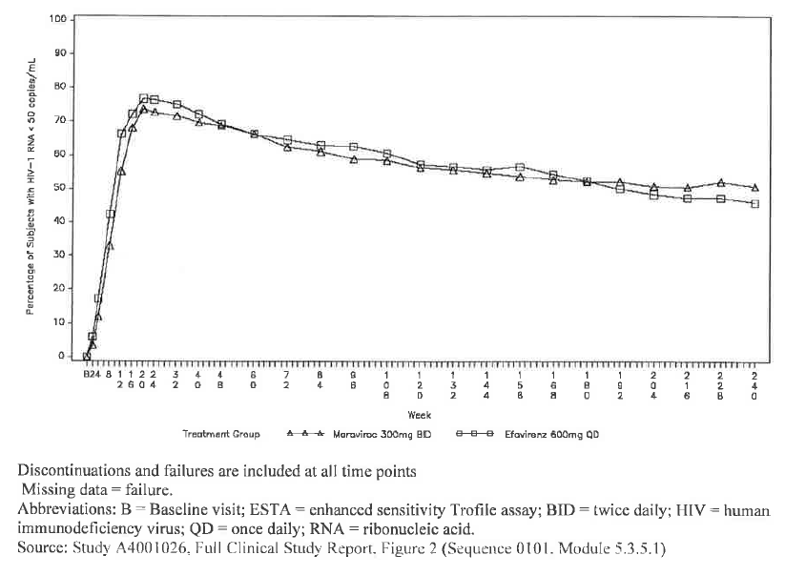
Table 11.2 Summary of Change from Baseline in CD4+ Cell Count (cells/µl) ESTA R5 Participants Study A4001026 (LOCF')
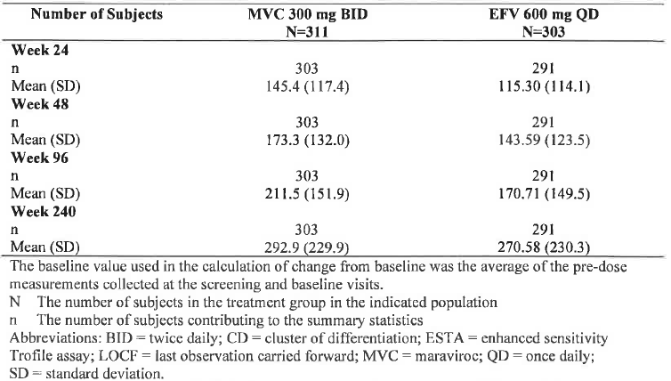
Figure 11.2. Mean Change from Baseline in CD4 Cell Count (cells/pl) G,OCF) - ESTA Participants Study A4001026
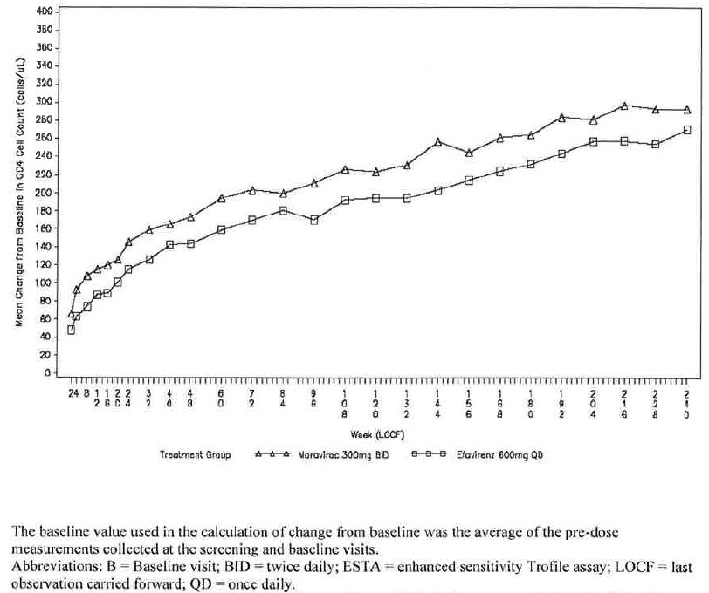

Evaluator comment
Based on the limited information supplied, efficacy in terms of VL < 50 copies/mL and CD4 cell count appears well maintained for those who responded initially The number and nature of study drop-outs and the viral tropism results for patients who failed treatment, or developed AIDS related illness died are of interest along with general safety information.

Clinical pharmacology

ViiV Healthcare comment
- Major predictors of lack of response to MVC treatment in A4001026 were having the tropism result change from R5 tropic at screening to D/M at baseline, and low MVC Cave or Cmin
- Since A4001026 was an outpatient study and MVC concentrations were measured after patients reported dosing there is confounding of low concentrations with poor adherence.
- Phase II2a data shows that BLQ observations with 300 mg BID dosing are highly unlikely whether given with or without food within 24 hours of a reported dose therefore BLQ values for MVC can be used as a measure of poor adherence.
- After taking BLQ and the ESTA population into consideration, Cavg is not as important for predicted efficacy at the dose studied, compared to the Generalised Additive Model (GAM) analysis with the original Trofile population.
- Exposure-response curve flattened at the lower exposures in the new analysis (ESTA population) where participants with BLQ values (evidence of poor adherence) were censored.
- Although food, gender, race and age have an effect on MVC PK, their influence on efficacy should be minimal given the lack of a strong exposure-response curve observed after adjusting for participants with poor adherence.

Evaluator comment
The arguments above are largely accepted. It is reasonable that patients who are non-R5 tropic will not respond and neither will patients who are not taking medication and are hence, BLQ.
The sponsor submitted concentration-time data for Study A4001007 demonstrating that in HIV-1 patients with maraviroc doses of 50 mg BID, concentrations were measurable to at least 48 hours after the last dose in 7 of the 8 participants. For those dosed with 100 mg BID, all had measurable concentrations and the majority had measureable concentrations to 72 hours. For those taking 300 mg BID, all participants had measurable concentrations to 72 hours and 5 of 8 had were above BLQ at 120 hours after the last dose. These data are taken to suggest that patients with levels BLQ are likely to have been non-compliant.
Maraviroc levels BLQ were generally associated with treatment failure in the presence of maraviroc sensitive virus and without NRTI mutations as shown in Figure 11.3 below.
Figure 11.3. Lamivudine Resistance (M184V) in Study A4001026 Based on Cavg and whether Participant had MVC BLQ values (9 participants failed with lamivudine resistance and CCR5-tropic virus)
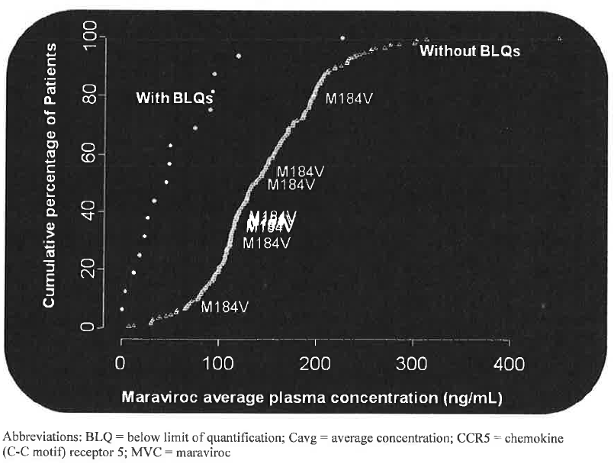
This is considered likely to be because patients who are non-compliant with one medication are also likely to be non-compliant with other medications. The figure does suggest that patients with quantifiable low average concentrations are more likely to develop lamivudine resistance; however, this exploratory finding is hypothesis generating and not definitive. Figure 11.4 illustrates the likely association of failure of treatment with CCR5 tropic virus and no mutation in the presence of maraviroc BLQ or low quantifiable Cave.
Figure 11.4. Lack of Resistance (R5NM:CCR5 tropic with no mutations) at Failure in Study A4001026 Based on Cavg and whether Participant had MVC BLQ values
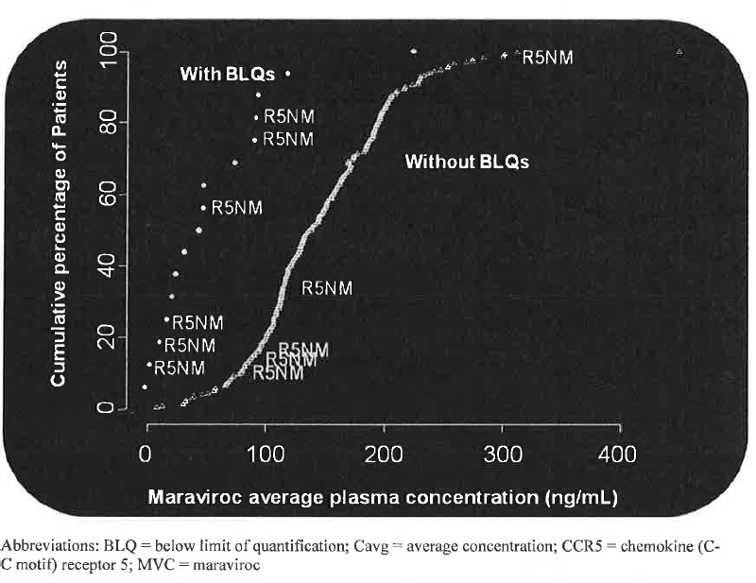
It is noted that three quarters of patients in the lowest Cmin quartile had not been recorded as having values BLQ. This may have been because of timing of sampling, or the knowledge of impending medical assessment leading to increased compliance in the days leading up to the assessment; however, it is possible that the patients in the lowest quartile have some genetically determined reason for the low level and would benefit from an increase in dose. The sponsor argues that increase in dose based on Cmin may result in unacceptable increases in Cmax which might in turn result in postural hypotension. If this were to be the case, then increased dose frequency may be required rather than increased dose, albeit a less practical dose regimen.

Virology

ViiV Healthcare comment
- In patients who developed resistance on the trial, the mutation that developed most commonly was that for lamivudine (Ml84V). The clinical significance of this mutation has been debated for years as this mutation leads to a less fit virus which is less pathogenic and most treatment guidelines suggest maintaining selection pressure for this mutation once it has been identified.
- Among patients who discontinued due to adverse events, there were more participants in the MVC treatment group (59.l%) compared to the EFV treatment group (41.1%), who achieved viral load suppression < 50 copies/ml at least at two consecutive visits prior to study drug discontinuation due to adverse events.
- Among the discontinuations, the overall duration of treatment was longer in the MVC group (range: 4-628 days, median: 173 days and mean: 208.4 days) compared to the EFV group (range: 2-480 days, median: 50 days and mean: 119.7 days).
- The earlier time to discontinuation in this group compared with the MVC group, led to a shorter time period in which to potentially observe true virological failure and the possible selection of NNRTI and NRTI resistant variants. (Hypothesis following post-hoc analysis)
- In the EFV treatment group, eight participants who were discontinued due to adverse events developed NNRTI mutations conferring resistance to EFV following study drug discontinuation. Four of these did not suppress to < 50 copies/ml while on study treatment, one of whom developed Y18l Y/C mutations while on study drug.
- For patients screened as R5, it is likely that any pre-existing DM/X4 virus has a lower replicative capacity relative to the circulating R5 virus. MVC treatment selectively inhibits the R5 virus, and (in the absence of other active antiretrovirals) the DM/X4 virus becomes relatively more fit. When MVC selective pressure is removed the circulating R5 virus regains fitness and outgrows the DM/X4 variants. The time scale for this reversion appears to be within approximately 1 to 3 months of stopping MVC treatment.
- This reversible and transient selection of pre-existing CXCR4 using virus is very different to the slow emergence of predominantly CXCR4 using virus during the natural history of HIV infection. It is likely that in later stages of HIV infection, CXCR4 using virus emerges as a result of progressive immune dysregulation rather than being a cause of it.
- A European regulatory (Follow-up Measure-[FUM] 12.1) requested follow up of viral tropism on all patients failing and remaining in study with the reversibility of X4-virus (from baseline R-5) to be specifically addressed. An analysis of tropism following failure of MVC therapy with CXCR4-using virus in patients with CCR5 virus at baseline, demonstrated that the virus population reverted back to CCR5 tropism in 33 of 36 patients with more than 35 days of follow up.

Evaluator comment
These points are accepted.

Tropism testing

Enhanced sensitivity trofile assay

ViiV Healthcare comment
The enhanced sensitivity Trofile has not been formally evaluated in large prospective clinical studies. Neither the original Trofile assay (OTA) nor ESTA are FDA-approved assays. The ESTA assay is only performed by one laboratory in San Francisco with associated inherent time delays. Like OTA, the ESTA requires stringent sample collection, storage and transport requirements as outlined by the vendor (Monogram Biosciences). A minimum volume of 3 mL of plasma is recommended. The assay is validated to a minimum viral load requirement of 1,000 HIV RNA copies/ml plasma. This poses a challenge for tropism testing in a proportion of patients, such as those with early virological failure (i.e. plasma viral loads < 1,000 copies/mL) or those with undetectable viral load who may be seeking to switch treatment for tolerability reasons. In addition, the high cost and relatively long assay turnaround time (approximately two weeks from the time of sample receipt at the Monogram laboratory facility) have also shown to be obstacles in the US to routine tropism evaluation for management of patient treatment options that could include Maraviroc but may be less of a problem in Australia in future. The Medical Services Advisory Committee is assessing the cost effectiveness of funding tropism testing. In the interim, ViiV Healthcare has been funding tests performed prior to commencement of treatment with Maraviroc. (Sept 2011).

Population genotypic tropism testing and clinical outcome

ViiV Healthcare comment
For this testing, a population-based consensus sequence is generated. A bioinformatic algorithm is used to interpret the sequence and infer drug susceptibility (Sensitive or Resistant) or tropism (R5 or non-R5). The algorithm(s) used to infer co-receptor tropism are more complex than those for drug resistance, mainly driven by the sequence diversity within the V3 loop, the lack of a signature sequence for co-receptor usage (vs MI84V is associated with resistance to lamivudine), and the lack of a gold-standard biological sample that accurately reflects HIV envelope variation within/between a patient(s). Recent advances in both laboratory methodologies to generate high quality V3 loop sequence data and bioinformatic algorithms has greatly advanced the clinical utility of genotypic tropism methods. It should also be noted that, although tropism determinants outside the V3 loop have been described their inclusion in algorithms for tropism determination has not improved prediction of clinical outcome.
Antiviral activity of MVC in treatment-naive patients was evaluated in 44001026. The clinical response was comparable with MVC vs EFV in patients classified as R5 by genotype; whereas, the response in patients classified as non-R5 was sub-optimal. (Figure 11.5 and adapted from McGovern et al. 2010) As shown in Figure 11.6 below, similar findings were obtained when patients were characterized by their ability to achieve HIV RNA < 50 copies/mL plasma.
Figure 11.5. Plasma HIV-I Reduction in Patients who Received MVC or EFV According to Genotypic Tropism Readout*
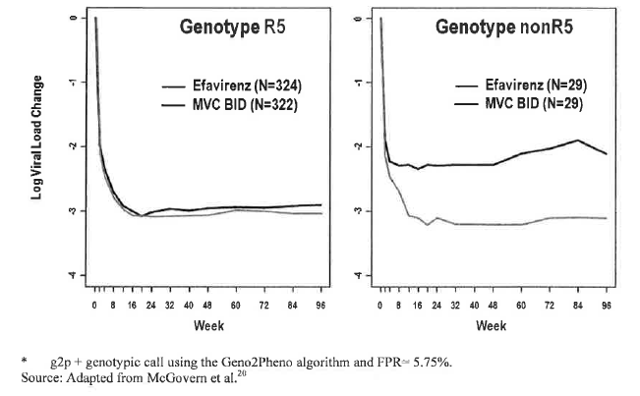
Figure 11.6 HIV-I Suppression in Patients who Received MVC or EFV According to Genotypic Tropism Readout*
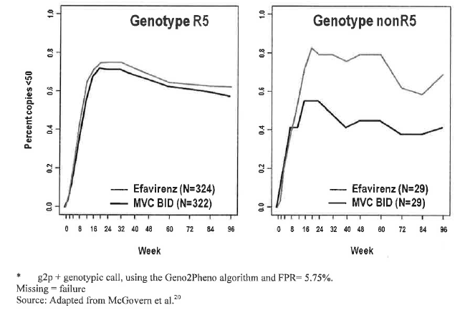
An analysis of the samples by concordance/discordance was assessed. (Figure 11.7) the concordant R5 group (R5 by both assays) had a good virologic response rate whereas the concordant non-R5 group had a poor virologic outcome. The discordant groups had response rates similar to each other and comparable to that of the R5 concordant group. This observation is taken to suggest that neither ESTA nor population genotype provides a clinically accurate assessment of tropism in every instance; there is no gold standard assay.
Figure 11.7. Virologic Outcome of Concordant R5 and Concordant Non-RS Groups
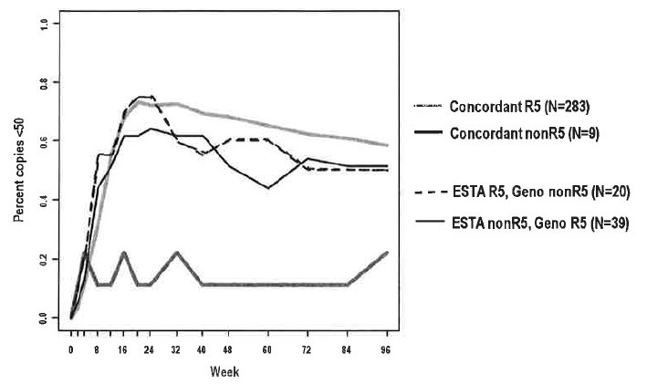
(The figures were not colour coded in the electronic versions)

Evaluator comment
According to ViiV Healthcare, genotypic V3 loop testing has superseded ESTA as the routine test available for tropism determination ... (and they state) The utility of genotypic testing in terms of predicting virological outcomes with MVC treatment has been investigated and has been shown to be comparable with ESTA.
It would have been helpful if the results of Study A4001026 had been analysed in the terms of non-inferiority. If population genotype testing is less sensitive than ESTA then the possibility exists that maraviroc would not prove to be non-inferior in terms of HIV RNA < 50 copies/L as was the case with the OTA. According to McGovern et al. in the abstract supplied with the applicant’s response, approximately 8% of patients in Study A4001026 who screened as R5 by the original Trofile assay were classed as X4 by V3-loop sequencing using population based sequencing, compared to the 13.3% - 16.1% reclassified using ESTA. The table from the McGovern et al. abstract is included in Table 11.3. However, it is unknown how closely the test used by McGovern et al. 2010 coincides with commercially available V3 loop tests.
Table 11.3. Maraviroc response by Trofile and V2-loop screening (McGovern et al 2010)
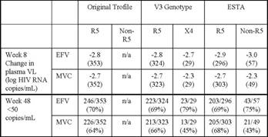
McGowan JP and Shah S suggest that genotype based testing has the advantages of lower cost than ESTA, is less technically difficult and has more rapid turnaround time but has lower sensitivity and may miss X4-using strains, may incorrectly identify highly divergent R5 as X4 and miss minority species and lacks clinical trial data.
Geretti AM and Mackie N state that prospective outcome data for the use of proviral DNA are currently limited and details of the recommendations about methodology and interpretation are likely to continue to evolve over time. However, one potential advantage of genotypic tropism testing is the ability to circumvent the high plasma viral load requirement of phenotypic assays, and evaluate tropism in virologically suppressed patients using proviral DNA. The authors state that there is limited evidence to indicate that genotypic testing of proviral DNA may actually provide better concordance with phenotypic tropism prediction than genotypic analysis of plasma.

Early tropism switch

ViiV Healthcare comment
The factors that drive the change in HIV tropism are not clearly understood. Viral evolution and overall change in host immune function and drug pressure (in the context of maraviroc-containing HAART) are potential factors involved.
In study A4001026 phylogenetic analyses demonstrated that non-R5 variants were a pre-existing viral population as opposed to a recent evolutionary event. Spontaneous tropism changes (from R5 to non-R5 or vice-versa) were observed in approximately l0% of patients between screening and study baseline in the Maraviroc clinical trials using the original Trofile assay. Where apparent phenotypic tropism changes from R5 to non-R5 occurred, non-R5 virus was generally detectable at the screening time point by more sensitive methods such as 454 “deep sequencing” (Roche) or possibly ESTA.

Safety

ViiV Healthcare comment
With respect to clinical significance of change of tropism, there was no evidence in Study A4001026 of detrimental outcomes in patients whose tropism changed and as there are currently no other antiretroviral agents in this class there is no concern about cross-resistance. There was no evidence of an increase in Category C events or AIDS defining conditions and no increased risk of development of malignancy in the patients who took MVC in Study A4001026 and no new or unexpected safety signal were reported from this study.
Although nonclinical data indicate potential for MVC to prolong QTc interval at high concentrations a thorough Phase I QT study (A4001016) did not show evidence of clinically significant QT prolongation at doses of 100mg, 300mg and 900 mg. Pooled data from Phase I and 2a studies support this finding as does Furthermore clinical data from Phase 2b studies, the pivotal 3 studies, the expanded access study A4001050 and post-marketing experience to date do not highlight that maraviroc is associated with a clinically significant effect on QTc interval. In summary, there is currently no evidence that maraviroc has an adverse effect on QT interval or risk of Torsade de Pointes at therapeutic doses. The range of in vitro, animal and clinical data has served to characterise the action of maraviroc on cardiac repolarisation and to provide reassurance that maraviroc does not increase the arrhythmogenic risk for humans, even when taking concomitant medication that would increase exposure.

Evaluator
While there is no evidence of increase in Category C events, it is possible that Category C events or deaths occurring during maraviroc treatment are more likely to occur in the presence of X4-using virus i.e. it is possible that the mechanism of development of such events may differ for patients treated with maraviroc vs. efavirenz.

Tropism and resistance – Treatment experienced – Week 48

ViiV Healthcare comment
A systematic assessment of changes in tropism and impact on virologic, immunologic and clinical outcome is being conducted in the ongoing studies A4001027 and A4001028 in treatment experienced patients. The current report is based on an assessment of these data at the Week 48. For those patients with a CCR5 tropism result at baseline, approximately twice as many patients who received maraviroc and failed therapy had a dual/mixed (D/M) or CXCR4 tropism result at failure compared to a R5-tropism result.
Assessment of CD4 count at time of failure demonstrated that there was a greater mean increase in CD4 cell count for patients who failed therapy with maraviroc, even for those patients who failed with CXCR4-using virus, compared to placebo, indicating no adverse effect on CD4 cell response.
The majority of maraviroc treated patients who had available in-study off-drug (ISOD) follow-up data had reverted back to a CCR5 tropism result at/before their last follow-up visit. This indicates that the virus population in patients failing maraviroc with CXCR4-using virus reverted back to CCR5 tropism after an appropriate time of follow up.

Evaluator comment
With respect to the statement: “ Assessment of CD4 count at time of failure demonstrated that there was a greater mean increase in CD4 cell count for patients who failed therapy with maraviroc, even for those patients who failed with CXCR4-using virus, compared to placebo, indicating no adverse effect on CD4 cell response”. This is considered a generalisation that needs substantiation. It could not be determined from the submitted data, whether the patients who failed MVC treatment with CXCR4-using virus had lower CD4 cell counts at failure than those treated with MVC who failed with R5-using virus.
With respect to the ISOD follow-up, it is likely that once a patient has X4 using virus it persists despite inability to detect it.

Change from baseline in viral load

ViiV Healthcare comment
Of the patients enrolled into studies A4001027 and A4001028 with an R5 tropism result at screening and who had a tropism result at baseline, 79 (7.6%) had a different tropism result at baseline; all of these were assigned as dual/mixed. The number of patients with a D/M or CXCR4 tropism result at baseline was similar across the three treatment groups (7.7%, 7.5% and 8.3% in the maraviroc QD, BID and placebo treatment groups, respectively).
Patients who had a change in tropism assessment from R5 to D/M between screening and baseline had lower median screening CD4 counts and a higher mean screening HIV-1 RNA compared to those whose tropism assessment remained R5. There was no apparent association for screening OSS and duration from diagnosis. (Table 11.4)
Table 11.4. HIV-1 RNA, CD4 count, overall susceptibility score and duration since diagnosis for patients with a change in tropism result from screening to baseline
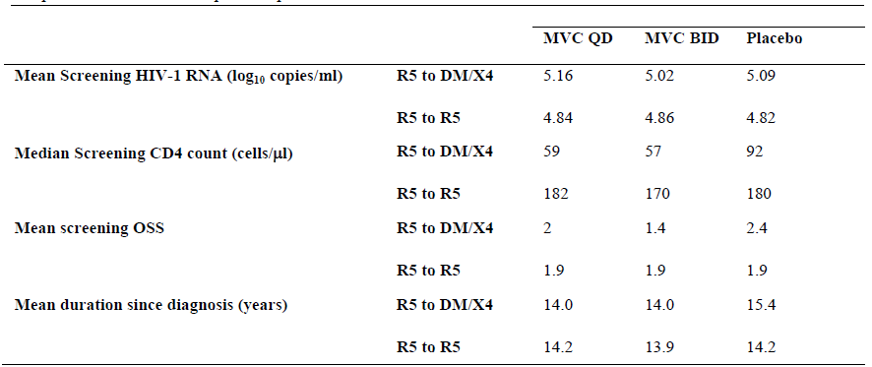
The mean change in HIV-1 RNA for patients who were CCR5 at baseline was - 2.2 in the maraviroc BID group vs. – 1.04 in the placebo group. In patients with dual/mixed-tropic HIV-1 at baseline the mean change in HIV-1 RNA from baseline to week 48 for Maraviroc vs. placebo respectively was -1.04 log10 copies/mL vs. -1.44 log10 copies/mL. (Table 11.5)
Table 11.5. Change from baseline in HIV-1 RNA Week 48 by tropism status at baseline (A4001027 and A4001028)
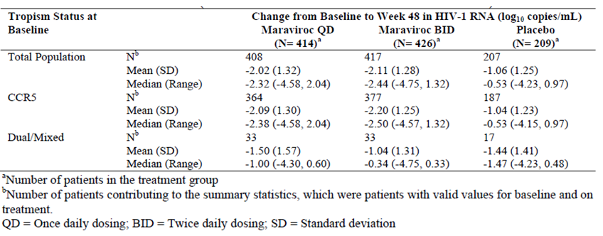

Evaluator comment
Maraviroc treatment of patients with D/M tropism at baseline is at best, similar to treatment with placebo and possibly worse. It is noted that there is discrepancy between mean and median suggesting skewed data, most likely to the left. Numbers with dual/mixed tropism at baseline were small.

ViiV Healthcare comment
For those patients receiving maraviroc, and who had D/M virus at baseline, the proportion achieving < 400 and < 50 HIV-1 RNA copies/ml is lower compared to those with R5 virus at baseline in accordance with the findings in study A4001029 in non-CCR5 tropic patients. The proportion achieving HIV RNA < 400 copies/mL by baseline tropism status was for Maraviroc BID vs. placebo respectively: CCR5 63% vs. 26.2%: Dual/mixed 27.3% vs. 29.4% (Table 11.6).
The proportion achieving HIV RNA < 50 copies/mL by baseline tropism status was for Maraviroc BID vs. placebo respectively: CCR5 49.6% vs. 19.8%: Dual/mixed 27.3% vs. 17.7% (Table 11.7).
Table 11.6. Proportion of patients with HIV-1 RNA <400 copies/ml at Week 48 by tropism status at baseline (Combined studies A4001027 and A4001028)
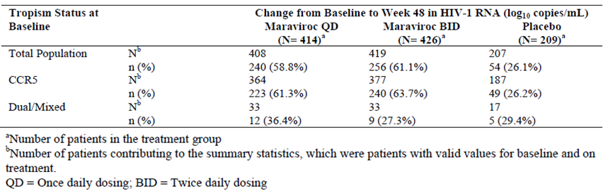
Table 11.7. Proportion of patients with HIV-1 RNA <50 copies/ml at Week 48 by tropism status at baseline (Combined studies A4001027 and A4001028)
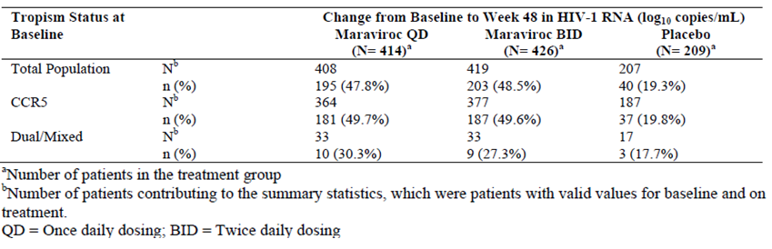

Evaluator comment
It is considered unusual that the proportion of the maraviroc BD treated group with dual/mixed tropism at baseline achieving HIV RNA < 400 copies/mL is identical to that achieving < 50 copies/mL.

Changes in tropism result at treatment failure

ViiV Healthcare
Of the 252 patients with a CCR5 tropism result at baseline, and who experienced treatment failure, 82 (32.5%) had a change in tropism result to CXCR4 or D/M at time of treatment failure. All but 6 of these patients were in the maraviroc (QD and BID) treatment arms. (Table 11.8; Table 11.9).
Table 11.8. Percentage of patients with a change in tropism result from CCR5 to CXCR4 or Dual/Mixed tropic between baseline and time of treatment failure (Week 48 A4001027 and A4001028 combined)
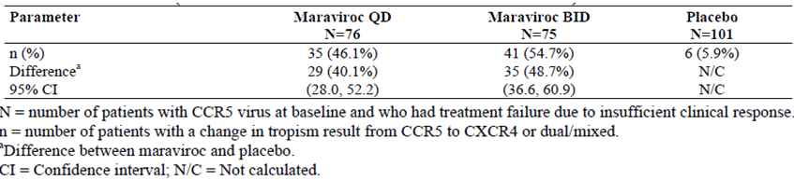
Table 11.9. Change in tropism result between baseline and time of treatment failure
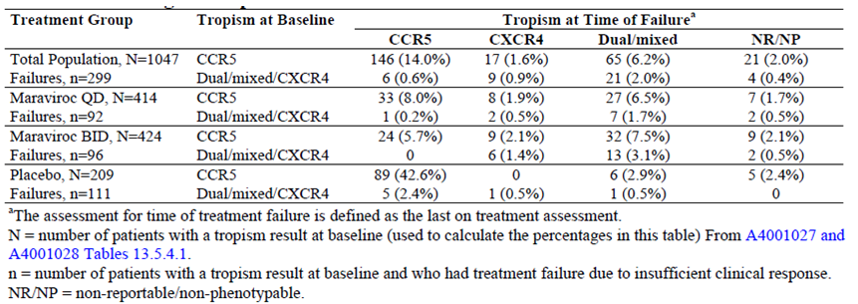

Evaluator comment
In keeping with selective pressure of treatment with CCR5 receptor antagonist

Change in CD4 count at failure by tropism at failure

ViiV Healthcare
There was a greater increase in CD4 cell count from baseline to Week 48 for both maraviroc treatment groups compared with placebo (116.0, 124.1 and 60.9 cells/μL for maraviroc QD, BID and placebo, respectively).
For those patients with a CCR5 tropism result at baseline, more patients who received maraviroc and failed therapy had a D/M or CXCR4 tropism result at failure (n=76) compared to a CCR5 tropism result (n=57). The mean increase in CD4 cell count from baseline in patients who failed with a change in tropism to D/M tropic or CXCR4, in both the maraviroc QD (47 cells/μL) and BID (57 cells/μL) groups was greater than that seen in the total placebo group who failed (25 cells/μL). Increases of mean changes in CD4 cell counts for the maraviroc treatment groups were also seen for 37 patients with a non-CCR5 tropism result at baseline (D/M, CXCR4 or non-phenotypable), and for 18 patients with a CCR5 tropism result at baseline but who had no tropism assignment at failure.
Patients failing with CXCR4-using virus fail approximately 50 days earlier than those failing with CCR5 tropic virus. (Table 11.10). Patients in the Maraviroc BID group who failed with R5 had mean CD4 cell count 133.1 compared to those who failed with dual/mixed tropism, 57.2. (Table 11.11) The sponsor considers that taken together, the results do not indicate an adverse effect on CD4 cell count in patients failing a maraviroc containing regimen compared to those failing on placebo plus OBT, even in the context of failure with a CXCR4-using virus.
Table 11.10. Median time to treatment failure for patients with CCR5 tropic virus at baseline by tropism at failure (Week 48 analysis combined studies A4001027 and A4001028)
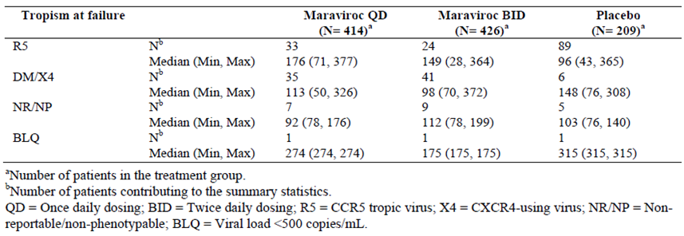
Table 11.11. Change from baseline in CD4 cell count at Week 48 (using LOCF) by tropism status at baseline and failure
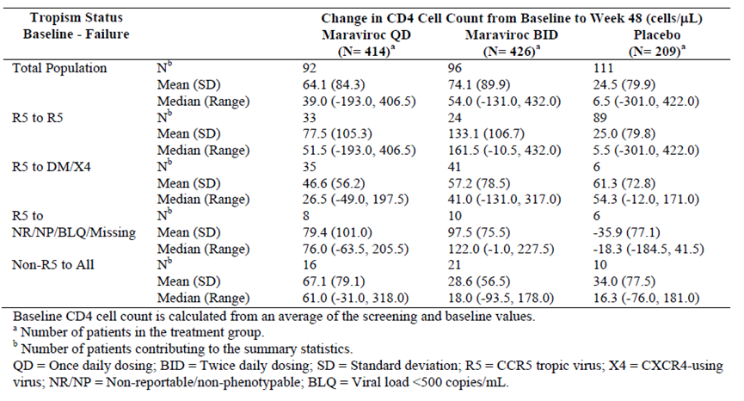

Evaluator comment
The difference between means and medians and the large SDs and wide CI suggest skewed and widely spread data and reflect small sample sizes. However, it appears likely that failure with X4-using virus is associated with a reduction in CD4 cell count. As results are based on LOCF, it is also possible that the CD4 cell count at failure is underestimated. Furthermore it would be important to know what happens to the CD4 cell count of the 2 tropism populations beyond the time of failure; i.e. whether the lower CD4 cell count represents a marker of possible reduced response to further therapy.

In study off drug (ISOD)

ViiV Healthcare comment
An analysis of tropism assessment over time (following discontinuation of study drug) was performed for all patients with CCR5 tropic virus at baseline who failed with CXCR4-using virus and remained in study off drug (ISOD), in order to evaluate rates of reversion to baseline tropism. At week 48, tropism reverted back to CCR5 in all but 3 of 36 maraviroc patients with tropism follow-up of more than 35 days duration.
Between the Week 48 and Week 96, 8 patients (who had CCR5 tropic virus at baseline) discontinued due to loss of efficacy with CXCR4-using virus. For the one patient with tropism follow-up data of more than 1 month, the virus reverted to CCR5 tropism during follow up.
These data are taken to indicate that in patients with CCR5 tropic virus at baseline, who failed in studies A4001027 and A4001028 with CXCR4 or DM tropic virus, the virus population reverted back to CCR5 tropism after an appropriate time of follow up. These data are considered consistent with the selective and reversible suppression of CCR5-tropic viruses during MVC therapy.

Evaluatorcomment
The submitted data support the conclusions that, of those patients with available tropism results, most patients whose virus changed tropism to include X4-using virus under the selective pressure of Maraviroc treatment reverted to R5 when the pressure was removed. However, not all patients were demonstrated to revert to R5 and the conclusion appears to be based on incomplete data. As tropism has previously been demonstrated to be labile within the short interval between screening and baseline, and as X4-using virus is not considered a mutation but rather a pre-existing strain, it seems likely that X4-using virus persists and the time of sampling may influence the result of tropism testing.

Category C Infections

ViiV Healthcare comment
In general, very few category C events occurred in these studies and there is no evidence of an excess of category C malignancies or infections in patients receiving maraviroc compared to placebo. A summary of CDC Category C events with baseline tropism, HIV-1 RNA and CD4 count as well as tropism at the time of the event for the Week 48 data cut was provided. Seven patients with CCR5 tropic virus at baseline and who experienced a category C event had emergence of CXCR4-using virus at the time of the event (4 on MVC QD, 2 on MVC BID and 1 on placebo). Five of these events were infections (3 patients with candidiasis, 1 with pneumonia and 1 with herpes proctitis) all occurring in patients receiving maraviroc. The other maraviroc treated patient was diagnosed with AIDS encephalopathy and the placebo patient developed Kaposi’s sarcoma. Six of the 7 patients had a baseline CD4 count of < 20 cells/μL and were therefore at high risk of developing a category C event. The 7th patient (with herpes proctitis) had a baseline CD4 count of 186 cells/μL. This analysis supports the conclusions from the week 24 data that there is no indication of a correlation between emergence of CXCR4-using virus and development of CDC category C events.

Evaluator comment
Not all patients had tropism result available for the time of diagnosis of the Category C event. Of those with available data:
- 10 of 30 (33%) in the Maraviroc QD group had non-R5 at the time of diagnosis of the event; 6 of whom had non-R5 at baseline.
- 7 of 22 (32%) patients in the Mara.viroc BID group had non-R5 at the time of diagnosis of the event; 4 had non-R5 at baseline.
- 17 of 52 (33%) overall treated with maraviroc had non-R5 at time of diagnosis; 7 of the 52 (13%) had R5 at baseline and changed tropism.
- 4 of 18 (22%) in the placebo group had non-R5 at time of diagnosis of the event; 3 had non-R5 at baseline and 1 of the 18 (6%) transitioned from R5 to non-R5.
Analysis of the data is post hoc and based on relatively small numbers and can potentially be used to support differing hypothesis. It could be argued that the proportions with non-R5 tropism at the time of Category C event appears disproportionately high considering the overall numbers at baseline and the numbers transitioning from R5 overall.

Treatment failure with CCR5 tropic virus

ViiV Healthcare comment
A preliminary investigational study of in vivo maraviroc resistance (conducted during the blinded phase of the Phase 3 clinical program) identified plateaus in dose response curves as a phenotypic marker of resistance for 4 patients who received maraviroc as part of an optimised background regimen and who failed blinded therapy with a CCR5-tropic virus. A more complete analysis has now been conducted on all 59 patients who failed maraviroc therapy with a CCR5-tropic virus by week 48.
The findings of these studies are:
- Maraviroc resistance, defined as dose response curves with plateaus in maximum percentage inhibition (MPI, <95%) in the phenotypic assay, was identified for 22/59 patients at failure.
- Shifts in IC50 (in the absence of any plateau in dose response) did not appear to be a reliable phenotypic marker of resistance.
- Clonal gp160 sequencing for 16 patients identified amino acid substitutions/mutations in the V3 loop of the maraviroc resistant viruses.
- No signature mutations of maraviroc resistance were identified, implying multiple genetic pathways to resistance may exist and the mutations may be virus-specific.
- Maraviroc resistance was primarily observed in patients who had no fully active drugs present in their OBT at baseline.
Incomplete adherence to their drug regimen, as evidenced by inspection of the maraviroc plasma concentrations (obtained during periodic PK sampling) or by documented treatment interruption, accounted for virological failure in the majority of patients who failed treatment with a CCR5 tropic virus that did not appear to be maraviroc-resistant.

Evaluator comment
These points are accepted.

Second round benefit-risk assessment

Benefit
Maraviroc 300 mg BID demonstrated a better safety profile than efavirenz with respect to discontinuations due to adverse events and with respect to lipid profile (cholesterol, LDL and triglycerides).
Depending on the criteria for identification of non-C5 tropic virus, and in combination with zidovudine/lamivudine, maraviroc efficacy in terms of viral load < 50 copies/mL was either statistically non-inferior to efavirenz or nearly so.

Risk
In patients with viral failure there appeared to be an increased risk of development of resistance to the two agents used in the OBT, in particular to lamivudine and in particular in the presence of CXCR5 using virus. However this is an observational finding and it is also accepted that the M184V mutation may not necessarily preclude useful continuing treatment with lamivudine.
The commercially available enhanced sensitivity Trofile assay requires a viral load of at least 1,000 copies/mL, which may limit the early detection of X4-using virus. The length of time required for the assay is considered practical considerations as is the cost of the assay. Use of the ESTA is specified in both the US and the Canadian Indications.
The alternative genotype based tropism test method appears to have lower sensitivity than the enhanced sensitivity Trofile assay and lacks the supporting clinical trial data.
CD4 cell counts for maraviroc treated patients who failed treatment and demonstrating transition from R5 to X4-using virus were noted to have lower CD4 cell counts than those who failed maraviroc treatment with R5-using virus.
Not all non R5-using viruses were demonstrated to revert to R5 when maraviroc treatment was stopped.
No increased risk of progression to AIDS or increased resistance to HIV treatment has been numerically demonstrated. However, the studies were not specifically designed to demonstrate individual response to change of viral tropism. The possibility that category C AIDS events in maraviroc treated patients are more likely to occur in the presence on non-R5 using virus cannot be excluded. Viral tropism for those patients who died could not be located in the submission.

Balance
The balance is considered to lie on the side of benefit.

Second round recommendation regarding authorisation
It is recommended that maraviroc is registered for use in treatment naive patients. It is recommended that the delegate considers the requirement to include the conditions specified in the US and Canadian Product Information, including the requirement for diagnosis of R5-using viral infection by means of the enhanced sensitivity Trofile assay.
Concerning the revised Product Information. There remain several minor issues, and the exact wording of the Indication is to be determined.

Hy’s Law defined as participants with total bilirubin >2 x ULN, and AST and/or ALT > 3 x ULN
Increase in either ALT or AST to greater than 3 times the upper limit of normal and a simultaneous increase in total bilirubin, without evidence of biliary obstruction and in the absence of any other evident possible explanation.
EMEA/CPMP/EWP/633/02 adopted in Australia
CPMP/EWP/482/99
<http://www.medscape.com/viewarticle/461450>
<http://ashm.org.au/projects/arvguidelines/Default.asp?PublicationID=4>
<http://eurheartjsupp.oxfordjournals.org/content/3/suppl_K/K105.full.pdf> This is an interesting article on Qtc in drug studies
Points to consider: The assessment of the potential for QT interval prolongation by non-cardiovascular medicinal products. CPMP/986/96
Details of recommended PI revisions are not included in this Extract of the CER.
Details of these are not included in this Extract from the CER.
<http://www.msac.gov.au/internet/msac/publishing.nsf/Content/2C3D39E5008C558ECA2578E100179BCF/$File/Consultation%20DAP%201174.pdf>
McGovern RA, et al. Population-based Sequencing of the V3-loop Is Comparable to the Enhanced Sensitivity Trofile Assay in Predicting Virologic Response to Maraviroc of Treatment-naive Patients in the MERIT Trial. 17th Conference on Retroviruses and Opportunistic Infections 2010 ;Paper #92British Columbia Center of Excellence, Harrigan Laboratory, Vancouver BC
McGovern RA, et al. Population-based Sequencing of the V3-loop Is Comparable to the Enhanced Sensitivity Trofile Assay in Predicting Virologic Response to Maraviroc of Treatment-naive Patients in the MERIT Trial. 17th Conference on Retroviruses and Opportunistic Infections 2010 ;Paper #92British Columbia Center of Excellence, Harrigan Laboratory, Vancouver BC
McGowan JP, Shah S. Understanding HIV Tropism. Physicians’ Research Network <http://www.prn.org/index.php/management/article/hiv_infection_in_children>
Geretti AM, Mackie N. Determining HIV-1 tropism in routine clinical practice <www.bhiva.org/documents/Guidelines/Tropism/HIV-1Tropism.doc>
Brumme CJ, Dong W, Chan D, et al. Short-term variation of HIV tropism readouts in the absence of CCR5-antagonists. Plenary and Oral Posters session (11:05 - 12:45,Nov. 8, 2010) <http://www.hiv11.com/hiv10/webcast/content/hybrid/O123/download/O123.pdf>
As recommended by the Guideline on the Clinical Development of Medicinal Products for the Treatment Of HIV Infection. Reference EMEA/CPMP/EWP/633/02, which has been adopted in Australia

