Date of first round CER: June 2013
Date of second round CER: November 2013

AusPAR Attachment 2

Extract from the Clinical Evaluation Report for lurasidone hydrochloride
  - Proprietary Product Name: Latuda
  - Sponsor: Commercial Eyes Pty Ltd
About the Therapeutic Goods Administration (TGA)
- The Therapeutic Goods Administration (TGA) is part of the Australian Government Department of Health, and is responsible for regulating medicines and medical devices.
- The TGA administers the Therapeutic Goods Act 1989 (the Act), applying a risk management approach designed to ensure therapeutic goods supplied in Australia meet acceptable standards of quality, safety and efficacy (performance), when necessary.
- The work of the TGA is based on applying scientific and clinical expertise to decision-making, to ensure that the benefits to consumers outweigh any risks associated with the use of medicines and medical devices.
- The TGA relies on the public, healthcare professionals and industry to report problems with medicines or medical devices. TGA investigates reports received by it to determine any necessary regulatory action.
- To report a problem with a medicine or medical device, please see the information on the TGA website <http://www.tga.gov.au>.
About the Extract from the Clinical Evaluation Report
- This document provides more detail of the clinical findings, extracted from the Clinical Evaluation Report (CER) prepared by the TGA. This extract does not include sections from the CER regarding product documentation or post market activities.
- The words [Information redacted] indicate confidential information has been deleted.
- For the most recent Product Information (PI), please refer to the TGA website <http://www.tga.gov.au/hp/information-medicines-pi.htm>.
Copyright
© Commonwealth of Australia 2014
This work is copyright. You may reproduce the whole or part of this work in unaltered form for your own personal use or, if you are part of an organisation, for internal use within your organisation, but only if you or your organisation do not use the reproduction for any commercial purpose and retain this copyright notice and all disclaimer notices as part of that reproduction. Apart from rights to use as permitted by the Copyright Act 1968 or allowed by this copyright notice, all other rights are reserved and you are not allowed to reproduce the whole or any part of this work in any way (electronic or otherwise) without first being given specific written permission from the Commonwealth to do so. Requests and inquiries concerning reproduction and rights are to be sent to the TGA Copyright Officer, Therapeutic Goods Administration, PO Box 100, Woden ACT 2606 or emailed to <tga.copyright@tga.gov.au>.

Contents
List of abbreviations 5
1. Clinical rationale 9
2. Contents of the clinical dossier 10
2.1. Scope of the clinical dossier 10
2.2. Paediatric data 10
2.3. Good clinical practice 10
3. Pharmacokinetics 10
3.1. Studies providing pharmacokinetic data 10
3.2. Summary of pharmacokinetics 11
3.3. Evaluator’s overall conclusions on pharmacokinetics 24
4. Pharmacodynamics 25
4.1. Studies providing pharmacodynamic data 25
4.2. Summary of pharmacodynamics 25
4.3. Evaluator’s overall conclusions on pharmacodynamics 27
5. Dosage selection for the pivotal studies 28
6. Clinical efficacy 29
6.1. Pivotal efficacy studies 29
6.2. Other efficacy studies 52
6.3. Analyses performed across trials (pooled & meta analyses) 60
6.4. Evaluator’s conclusions on clinical efficacy for schizophrenia 65
7. Clinical safety 67
7.1. Studies providing evaluable safety data 67
7.2. Pivotal studies that assessed safety as a primary outcome 69
7.3. Patient exposure 74
7.4. Adverse events 74
7.5. Laboratory tests 82
7.6. Post marketing experience 88
7.7. Safety issues with the potential for major regulatory impact 89
7.8. Other safety issues 90
7.9. Evaluator’s overall conclusions on clinical safety 92
8. First round benefit-risk assessment 94
8.1. First round assessment of benefits 94
8.2. First round assessment of risks 95
8.3. First round assessment of benefit-risk balance 96
9. First round recommendation regarding authorisation 99
10. Clinical questions 99
10.1. Pharmacokinetics 99
10.2. Pharmacodynamics 99
10.3. Efficacy 100
10.4. Safety 100
11. Second round evaluation 100
11.1. Failed studies 100
11.2. Dose rationale 101
11.3. Hepatic impairment 102
11.4. Renal impairment 102
12. Second round benefit-risk assessment 103
12.1. Second round assessment of benefits 103
12.2. Second round assessment of risks 103
12.3. Second round assessment of benefit-risk balance 103
13. Second round recommendation regarding authorisation 103

List of abbreviations
Abbreviation | Meaning
%CV | percentage of coefficient of variation
5-HT | 5-hydroxytryptamine
ADME | Absorption, Distribution, Metabolism, and Excretion
ADR | adverse drug reaction
AE | adverse event
AIMS | Abnormal Involuntary Movement Scale
ALT | alanine aminotransferase
ANCOVA | analysis of covariance
AST | aspartate aminotransferase
AUC | Area under a concentration-time curve
AUC0-12 | AUC from time 0 to 12 hours
AUC0-24 | AUC from time 0 to 24 hours
AUC0-48 | AUC from time 0 to 48 hours
AUC0-inf | AUC from time 0 extrapolated to infinity
AUC0-last | AUC from time 0 to last quantifiable concentration
AUC0-tau | AUC over a dosing interval for steady state
AUCss0–24 | AUC from time 0 to 24 hours at steady state
BA | bioavailability
BAS | Barnes Akathisia Scale
BE | bioequivalence
BID | twice daily
BMI | body mass index
BP | blood pressure
BPD | bipolar disorder
BPRSd | Brief Psychiatric Rating Scale derived
BT | bone turnover
CGI-S | Clinical Global Impression – Severity of Illness
CHMP | Committee for Medicinal Products for Human Use
CL/F | apparent oral clearance
Cmax | maximum observed plasma concentration
Cmin | minimum observed serum concentration
CNS | central nervous system
CrCl | creatinine clearance
CSR | clinical study report
CYP | cytochrome P-450
D2 | Dopamine 2
DALYs | disability-adjusted life years
DDI | drug-drug interaction
DL | drug load
DSM-IV | Diagnostic and Statistical Manual of Mental Disorders, Fourth Edition
DSP | Dainippon Sumitomo Pharma Company, Ltd.
DXA | dual-energy X-ray absorptiometry
E14 | ICH Guidance E14
EE | ethinyl estradiol
EEG | electroencephalography
EMA | European Medicines Agency
EPS | extrapyramidal symptoms
GCP | Good Clinical Practice
GFP | global field power
H1 | histamine1 receptor type
HbA1c | glycosylated hemoglobin
HCl | hydrochloride
HDL | high-density lipoprotein
HOMA-IR | homeostasis model assessment of insulin resistance
HR | hazard ratio
HSA | human serum albumin
ICH | International Conference on Harmonisation
IDB | Integrated Clinical Database
ITT | intent-to-treat
Ka | absorption constant
Ki | inhibition constant
LDH | lactate dehydrogenase
LDL | low-density lipoprotein
LOCF | last observation carried forward
LS | least squares
M1 | acetylcholine receptor
MAA | Marketing Authorisation Application
MADRS | Montgomery-Asberg Depression Rating Scale
MAV | markedly abnormal value
MBq | megabecquerel
MDR1 | multi-drug resistance 1
MedDRA | Medical Dictionary for Regulatory Activities
MMRM | mixed model repeated measures
mRNA | messenger ribonucleic acid
MSD | Merck, Sharp & Dohme
MTD | maximum tolerated dose
NGMN | norelgestromin
PANSS | Positive and Negative Syndrome Scale
PD | pharmacodynamics
PET | positron emission tomography
P-gp | P-glycoprotein
PIL | Patient Information Leaflet
PIP | Paediatric Investigation Plan
PK | pharmacokinetic
PSUR | Periodic Safety Update Report
PT | preferred term
QD | once daily
QTc | corrected QT
QTcI | individual QT interval correction
RBC | red blood cells
RMP | Risk Management Plan
SAE | serious adverse event
SAS | Simpson-Angus Rating Scale
SOC | system organ class
SPC | Summary of Product Characteristics
t1/2 | terminal phase elimination half-life
TEAE | treatment-emergent adverse event
TESAE | treatment-emergent serious adverse event
Tmax | time at maximum concentration
TQT | thorough QTc
TRAE | treatment-related adverse event
ULN | upper limit of normal
USAN | United States Adopted Name
V2/F | volume of distribution for the second peripheral compartment
WHO | World Health Organization
XR | extended release
YLD | years lived with disability
α1-AGP | alpha-1-acid glycoprotein

Clinical rationale
Schizophrenia is a severe, chronic psychiatric disorder that affects ~1% of the population throughout the world. It is known to cause a high level of disability and reduces life expectancy typically due to associated suicide. The disease is characterised by positive symptoms (delusions, hallucinations, disorganised speech, disorganised or catatonic behaviours) and negative symptoms (affective flattening, restriction in the fluency and productivity of thought and speech and in the initiation of goal directed behaviour).
Treatment options include pharmacological (antipsychotic medications) and non pharmacological (supportive) treatments. Antipsychotic agents are the mainstay of pharmacological intervention in the treatment of schizophrenia and are considered first line treatment. There is large inter individual variability in response to these drugs which are required to be taken long term and treatment is frequently a balancing act between therapeutic efficacy and adverse effects. The first generation antipsychotics (“typical” antipsychotics such as haloperidol and thioridazine) are known for causing extrapyramidal side effects (rigidity, tremor, restlessness) and may lead to tardive dyskinesia. The second generation, or “atypical”, antipsychotics generally have a lower risk of extrapyramidal side effects and tardive dyskinesia (examples are risperidone, quetiapine, aripiprazole and ziprasidone). However, they have typically been associated with higher rates of weight gain and metabolic abnormalities. QT prolongation is also reported with a number of these drugs. Schizophrenia is a condition where there is an evident medical need for effective and well tolerated treatments.
Antipsychotic agents generally all have activity via post synaptic blockade of the brain dopamine D2 receptors. Atypical antipsychotics also have activity in blocking the serotonin 5-HT2 receptor. The sponsor reported that:
In vitro receptor binding studies revealed that lurasidone is an antagonist with high affinity at dopamine D2 receptors and the 5-hydroxytryptamine (serotonin) receptors, 5-HT2A and 5-HT7; is an antagonist with moderate affinity at human α2C adrenoceptors; is a partial agonist at serotonin 5-HT1A receptors; and is an antagonist at α2A adrenoceptors. Lurasidone exhibits little or no affinity for histamine H1 and muscarinic M1 receptors.
Lurasidone has the drug codes of SM-13496 and MK-3756.

Contents of the clinical dossier

Scope of the clinical dossier
The submission contained the following clinical information:
- 31 clinical pharmacology studies, including: 4 bioavailability and bioequivalence studies; 4 healthy subject PK studies ; 3 patient PK studies; 4 intrinsic factor PK studies; 13 extrinsic factor PK studies; 2 healthy subject PD studies and 1 patient PD study.
- 4 population PK analyses.
- 21 clinical efficacy and safety studies:
  - 5 ‘pivotal’ short term, placebo controlled efficacy/safety studies (D1050006, D1050229, D1050196, D1050231, D1050233).
  - 2 other short term, placebo controlled efficacy/safety studies (D1050049, D1001002).
  - 2 Phase II, uncontrolled studies (D1001001, D1001016).
  - 3 long term, controlled studies (D1050234, D1050237 D1050254).
  - 7 uncontrolled long term clinical studies (D1050229E, D1050231E, D1001036, D1001048, D1050174, D1050199, D1050237E).
  - 2 other efficacy/safety studies (D1050289 and its extension D1050290).
- 4 clinical study protocols (D1050238, D1050307, D1001056, D1001057).
- Integrated Summary of Efficacy tables, Integrated Summary of Safety tables, data integration plan and statistical analysis plan for the Integrated Summary of Efficacy (ISE) and Integrated Summary of Safety (ISS), Council for International Organisations of Medical Sciences (CIOMS) listings in a safety appendix, 5 Periodic Safety Update Reports (PSURs) and literature references.

Paediatric data
The submission did not include paediatric data. A Paediatric Investigation Plan (PIP) was included in the dossier. This was approved by the EMA in July 2012. This plan covers the population from 13 to 18 years of age.

Good clinical practice
In all clinical study reports the sponsor stated that conduct was in accordance with Good Clinical Practice (GCP) guidelines as well as local regulatory and ethical requirements.

Pharmacokinetics

Studies providing pharmacokinetic data
Table 1 shows the studies relating to each PK topic and the location of each study summary.
Table 1: Submitted PK studies.
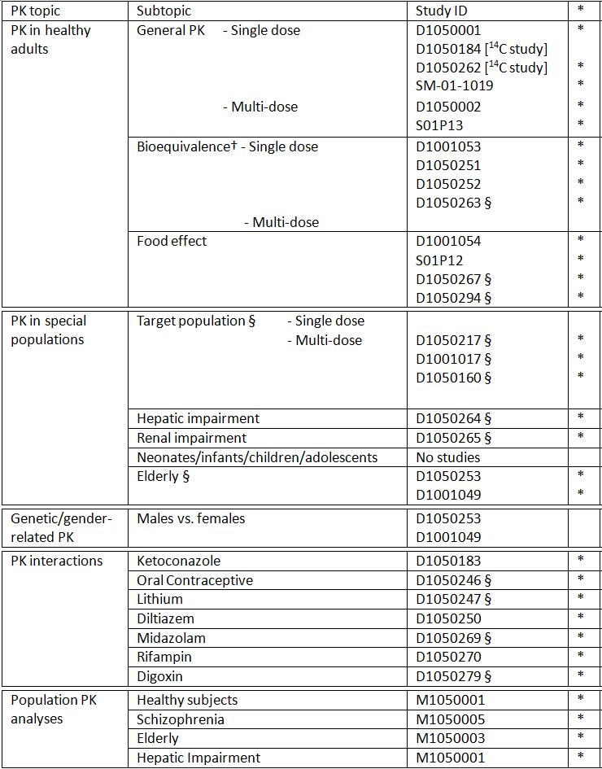
* Indicates the primary aim of the study.
† Bioequivalence of different formulations.
§ Subjects who would be eligible to receive the drug if approved for the proposed indication.
None of the PK studies had deficiencies that excluded their results from consideration.

Summary of pharmacokinetics
The information in the following summary is derived from conventional pharmacokinetic studies unless otherwise stated.

Physicochemical characteristics of the active substance
Lurasidone HCl is a single crystal form as a white to off-white powder. No polymorphisms have been observed with powder X-ray diffraction, infrared absorption spectrometry and thermal analysis under several crystallisation conditions.
The chemical structure of lurasidone HCl (including the absolute configuration) is: (3aR,4S,7R,7aS)-2-{(1R,2R)-2-[4-(1,2-benzisothiazol-3-yl)piperazin-1- ylmethyl]cyclohexyl methyl} hexahydro-4,7-methano-2H-isoindole-1,3-dione hydrochloride. Lurasidone HCl has six chiral centers. The molecular formula is C₂₈H₃₆N₄O₂S·HCl with a relative molecular mass of 529.14 (hydrochloride salt) and 492.68 (free base). The drug is very slightly soluble in water and acetone, sparingly soluble in methanol, slightly soluble in ethanol and practically insoluble in toluene. It has a single pKa of 7.6. The log P value of lurasidone HCl was 5.6.
Lurasidone HCl is an antipsychotic of the benzisothiazole derivative class.

Pharmacokinetics in healthy subjects

Absorption
The PK of single doses of lurasidone from 0.1 to 30 mg was evaluated in 38 Japanese subjects (SM-071019; Table 2). At doses below 2.5mg lurasidone, PK parameters could not be determined due to low serum concentrations. Values of T_{max} for all doses of lurasidone ranged from 1 to 4 hours, while for the active metabolites, ID-14283 and ID-14326, the range was 1 to 4 hours; mean C_{max} and AUC increased approximately proportionally with dose, similar to lurasidone. Similarly, the single dose PK of lurasidone from 10 to 100 mg was evaluated in 21 Caucasian subjects (D1050001). Mean T_{max} values ranged from 1 to 2 hours. Thus, lurasidone is absorbed rapidly and reaches C_{max} in approximately 1.5 hours (D1050001, D1050160). After multiple-dose administration, C_{max} is reached in approximately 3 hours (D1050263, M1050005).
Table 2: Single Dose PK Parameters of Lurasidone in Japanese Volunteers after Single Doses.
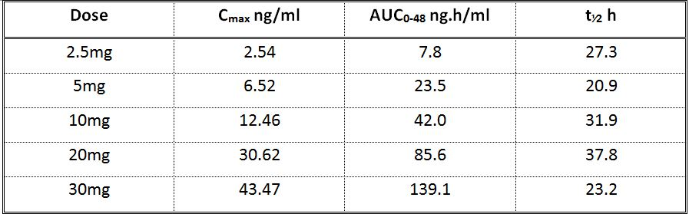

Bioavailability

Absolute bioavailability
No intravenous formulation of the drug is available so the absolute bioavailability of lurasidone was not determined.

Bioavailability relative to an oral solution or micronised suspension
Not performed.

Bioequivalence of clinical trial and market formulations
Different formulations have been evaluated throughout the lurasidone clinical development program. The DSP Formulation Group B was the same as MRL Formulation Group A. Not all other formulations were equivalent as they consisted of different formulation compositions. DSP Groups pre-A, A and B were formulations developed prior to MRL sponsorship. During MRL sponsorship, DSP provided the DSP Group B formulation for the conduct of studies during this period of time, which MRL designated as MRL Group A formulation. Also during the MRL sponsorship, MRL Groups C, D, and E, were developed in an effort to reduce tablet size and try to eliminate the food effect, respectively.
After reacquiring sponsorship, Sunovion utilised the DSP Group B formulation for the conduct of the clinical studies demonstrating the efficacy and safety of lurasidone. The DSP Group C Formulation was developed in order to reduce the size of the tablet to optimise the commercial formulation, which is currently available in the US. In vitro dissolution tests support equivalence among the three DSP lurasidone formulations.
In vivo oral bioequivalence studies comparing the DSP Group C formulation and the DSP Group B formulation are noted below. The combined results of the in vitro and in vivo tests indicate the intended market formulations of lurasidone are bioequivalent to the clinical trial formulation. Overall, in vitro and in vivo tests support bioequivalence among the three DSP formulations. Bioequivalence was achieved as the 90% CIs intervals for both C_{max} and AUC were within 80 to 125%.

Bioequivalence of different dosage forms and strengths
The lurasidone tablet commercial formulation (DSP Group C formulation) will be provided as film-coated tablets in 20 mg, 40 mg, and 80 mg dosage strengths. The manufacturing process is identical for all dosage strengths, i.e., 20 mg, 40 mg, and 80 mg, apart from the colour of the film coating. Lurasidone 20 mg and 40 mg tablets are coated with white to off-white film-coat; whereas, the lurasidone 80 mg tablet is coated with pale green colour. The 120 mg tablet used in the development program is also manufactured in the same manner as the other tablets but will not be made commercially available. The 120 mg tablet was used in the pivotal bioequivalence study (D1050263) in order to bridge the clinical (DSP Group B) formulation and the commercial (DSP Group C) formulation. Another study (D1001053), conducted in Japan, determined the bioequivalence of the 20 mg tablets (2 x 20 mg tablets, DSP Group B) against the 40 mg tablet (1 x 40 mg tablet, DSP Group C) after single-dose administration.
Study D1001053 was an open-label, randomised, single-dose, 2-period, crossover study to determine the bioequivalence of two lurasidone formulations (2 x 20 mg tablet, DSP Group B formulation [Reference], versus 1 x 40 mg tablets, DSP Group C formulation [Test]) in 36 subjects in a fed state. This study was conducted in Japanese subjects only. Analysis of variance showed that the 90% CIs for geometric mean ratios for C_{max} and AUC₀₋₄₈ of the test and reference formulations were within the 80 to 125% range, indicating bioequivalence. Mean PK parameters were essentially the same following administration of the formulations.
Study D1050263 was an open-label, randomised, three-period, 2-sequence crossover, repeat-dose, incomplete replicate study design to compare the bioequivalence of two lurasidone formulations (3 x 40 mg tablets, DSP Group B formulation [Reference], versus 1 x 120 mg tablet, DSP Group C formulation [Test]) in 48 subjects with schizophrenia, schizoaffective, or schizophreniform disorder in a fed state. The analysis of variance indicated that the two formulations were bioequivalent based on the 90% CIs of geometric mean ratios for C_{max} and [AUC_{0-tau}] of the test and reference formulations. The ratios were within the 80 to 125% range.
Study D1050252 was an open-label, randomised, four-period, crossover study to compare the PK profiles of 3 oral formulations (MRL Groups A [DSP Group B], D, and E) of 20 mg dosage strength tablets or capsules of lurasidone. The formulations were administered, as a single-dose oral, in the fed condition within Treatment Periods 1 through 3 in a crossover fashion, in healthy young subjects. The MRL Group D formulation was a lurasidone 20 mg oral compressed tablet and MRL Group E formulation was a lurasidone 20 mg dry filled capsule. Results are shown in Table 3. MRL Group D formulation was not bioequivalent to MRL Group A formulation as the 90% CI for geometric mean ratios for C_{max} of the test and reference formulations was outside the 80 to 125% range in accordance with the bioequivalence guidance. MRL Group E formulation was not bioequivalent to MRL Group A formulation as the 90% CIs for geometric mean ratios for C_{max} and AUC over the dosing interval at steady state [AUC_{0-tau}] of the test and reference formulations were outside the 80 to 125% range.
Table 3: Comparative Bioavaialabilty of Different Formulations of Lurasidone.
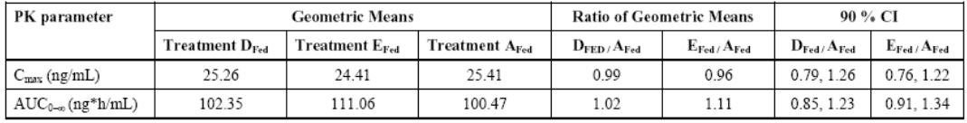

Bioequivalence to relevant registered products
There are no other registered products in Australia.

Influence of food
Study D1050251 was an open-label, randomised, four-period, crossover study to compare the PK profiles of two oral tablet formulations (MRL Group C and MRL Group A (DSP Group B)) of lurasidone in the fasted and fed conditions. Healthy young adult male and female subjects each received a single 20 mg dose of lurasidone for each period. Results are shown in Table 4. Based on the ratio of C_{max} and AUC_{0-∞} Group C and Group A (DSP Group B) formulations were equivalent under the fed condition (90% CI within 80-125%) but not under the fasted condition: C_{max} and AUC_{0-∞} from MRL Group C formulation being higher than those from MRL Group A (DSP Group B) formulation (Table 4). The C_{max} and AUC_{0-∞} of both formulations were found to be approximately 2-fold higher when dosed with a high fat meal compared with the fasted condition.
Table 4: Comparative Bioavailability of Two Formulations Of Lurasidone in Fed and Fasted State.
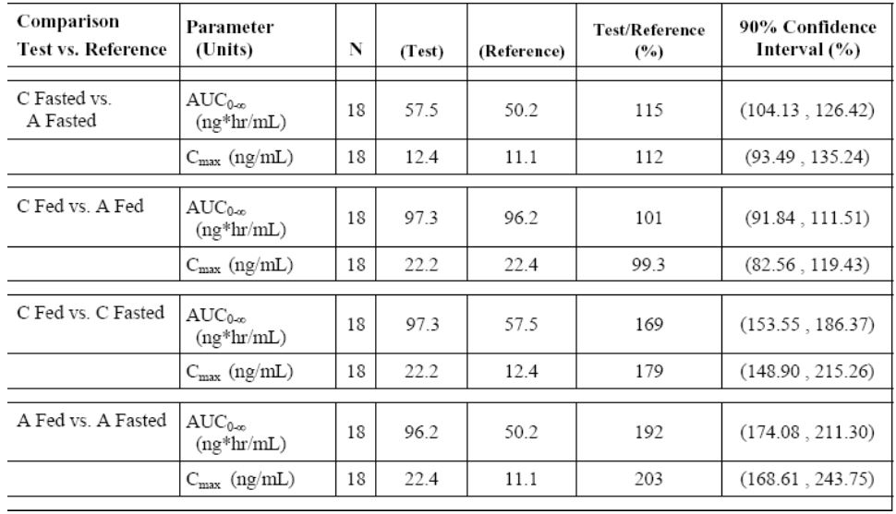
Study D1050252 was an open-label, randomised, four-period, crossover study to compare the PK profiles of 3 oral formulations (MRL Groups A [DSP Group B], D, and E) of 20 mg dosage strength tablets or capsules of lurasidone, as a single-dose oral administration, in the fed condition within Treatment Periods 1 through 3 in a crossover fashion, in 18 healthy young adult subjects. Designed with the intention of eliminating lurasidone food effects, MRL Group D formulation was a lurasidone 20 mg oral compressed tablet and MRL Group E formulation was a lurasidone 20 mg dry filled capsule. MRL Group D formulation was not bioequivalent to MRL Group A formulation as the 90% CI for geometric mean ratios for C_{max} of the test and reference formulations was outside the 80 to 125% range in accordance with the bioequivalence guidance. MRL Group E formulation was not bioequivalent to MRL Group A formulation as the 90% CIs for geometric mean ratios for C_{max} and AUC_{0-tau} of the test and reference formulations were outside the 80 to 125% range.
A randomised two-period crossover study evaluated the effects of food on the PK of lurasidone in healthy male Japanese volunteers (D1001054). A single dose of 40 mg tablet was administered after an overnight fast or within 30minutes of a high fat breakfast. While Tmax was not affected by food, C_{max} and AUC₀₋₄₈ were increased almost two-fold when dosed under fed conditions compared to fasted (Table 5). Similar results were observed for the metabolites (Table 5).
Table 5: Effect of Food on the PK of Lurasidone and Metabolites.
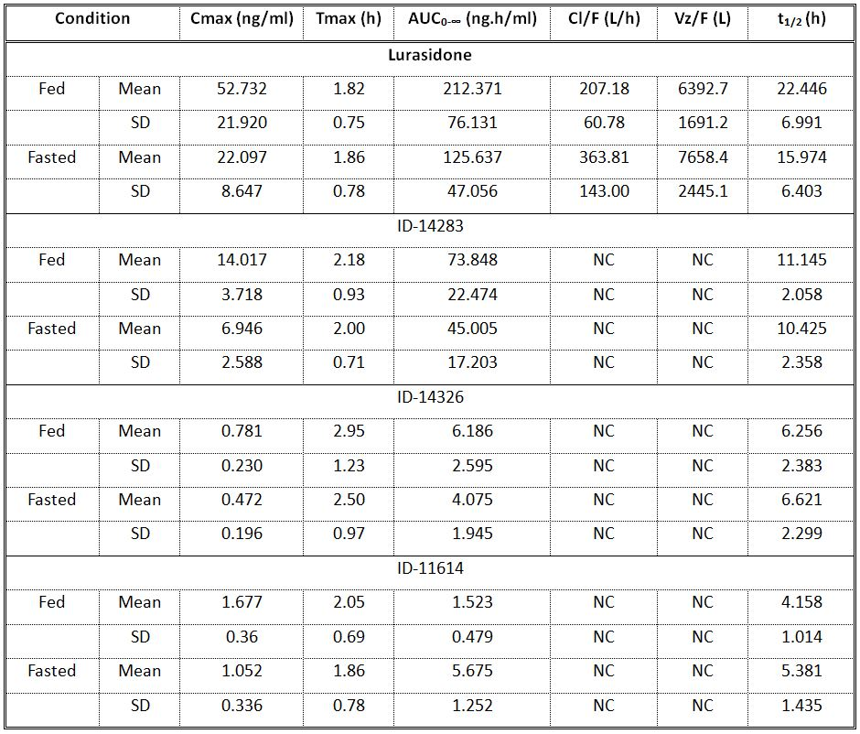
Study S01P12 was conducted to evaluate the effect of food on the comparative bioavailabilty of lurasidone in healthy male Japanese subjects. Lurasidone was administered in the fasting and fed (17% fat, 460 calories) conditions. Bioavailability (as determined by C_{max} and AUC₀₋₄₈) was higher under fed condition than the fasting condition (p<0.001). Mean C_{max} values were 26.4ng/mL for the fed group and 6.5ng/mL for the fasting. Mean AUC₀₋₄₈ values were 88.1ng•hr/mL for the fed group and 29.7ng•hr/mL for the fasting group. The C_{max} and AUC₀₋₄₈ of active metabolite ID-14283 in the fasting group were approximately 30% of the C_{max} and AUC₀₋₄₈ of the fed group.
The effect of meals with different calorie and fat content on the steady state PK profile of lurasidone versus the fasted state was examined in two studies. Study D1050267 was an open labelled six way cross-over study in patients with schizophrenia, schizoaffective or schizophreniform disorders. Different combinations of high or low calorie and high or low fat breakfast did not significantly alter the steady state PK profile of lurasidone and its metabolites with respect to C_{max} and AUC_{(0-tau)}. On the other hand, all five fed conditions showed an increased exposed to lurasidone and its metabolites compared to the fasted condition (Table 6).
Table 6: Effect of Lurasidone on the Single Dose PK of Digoxin.
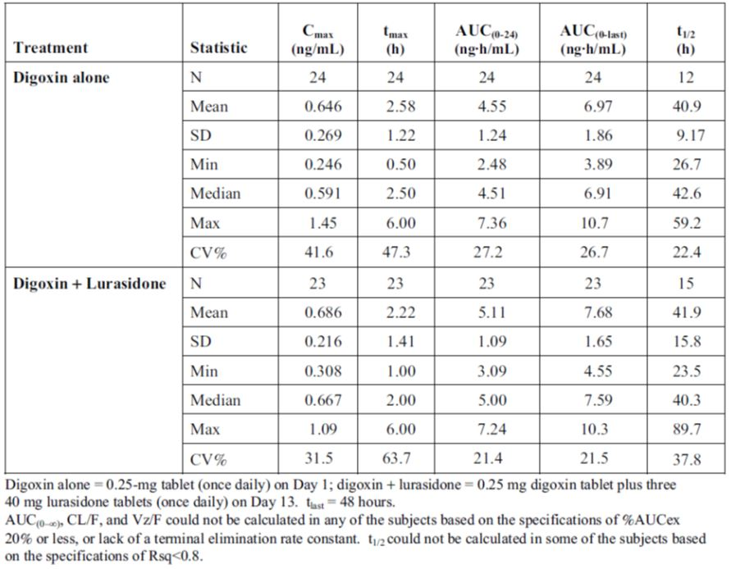
A similar study (D1050294) evaluated the effects of different calorie content meals on the systemic exposure to lurasidone and its metabolites compared to the fasted state at steady state in patients with schizophrenia, schizoaffective or schizophreniform disorders. Lurasidone serum concentrations were significantly higher when administered under fed conditions. Following fed conditions, the time to maximum serum concentration for lurasidone was delayed compared to the fasted condition and tended to increase with calorie and fat content meal composition (Table 7). Lurasidone exposure (C_{max} and AUC₀₋₂₄) increased distinctly when lurasidone was administered under fed compared to fasted conditions. Serum concentration-versus-time profiles for the metabolites (ID-14283, ID-14326, and ID-11614) followed a similar calorie/fat-related trend as lurasidone.
Table 7: Lurasidone PK Parameters After Multiple-dose Administration Under Fed (Varying Calories and Fat Content) and Fasted Conditions to Subjects with Schizophrenia.
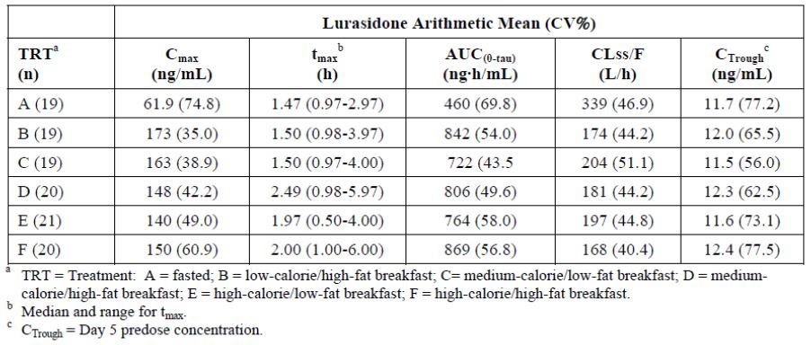

Dose proportionality
The multiple-dose PK of lurasidone is dose-proportional in the 10 mg to 160 mg dose range, based on Cmax and in the 10 mg to 600 mg dose range, based on AUC0-tau (M1050005). Model-based analysis (M1050005) from healthy subjects (10-100 mg) and subjects with schizophrenia (120-600 mg) suggests that the exposure to lurasidone is dose-proportional and extends from healthy subjects to subjects with schizophrenia. The observed geometric Cmax, AUC and Ctrough generally fell within the 5th and 95th percentile of the geometric mean simulated distribution for both healthy subjects and subjects with schizophrenia. Therefore, there is no difference in PK between healthy subjects and patients.
Lurasidone demonstrated a linear PK profile at doses of 10 mg to 100 mg in healthy subjects (Study D1050001) and at doses of 120 mg to 160 mg in subjects with schizophrenia (Study D1050160) Based upon population PK modelling analysis, lurasidone reaches 80.8% and 90.7% of steady-state AUC by Day 7 and Day 15, respectively, and reaches 90.5% of steady-state Cmax by Day 2 (M1050005). The accumulation ratio for AUC0-24 was approximately 1.6- to 1.8-fold (D1050160, M1050005).

Effect of administration timing
In study D1050233, lurasidone doses were administered in the evening compared with previous studies, which employed administration in the morning. Modelling data for D1050233 suggest that the typical predicted steady-state C_{max} was 76% of the C_{max} observed in previous studies (Report M1050005), while AUC₍₀₋₂₄₎ and C_{trough} increased by 1.10- and 1.33-fold, respectively. These differences may be associated with administration of lurasidone in the evening. As the exposure is similar between morning and evening, dosing the timing of dosing is not considered to be relevant.

Distribution

Volume of distribution
The mean apparent volume of distribution after single and multiple-dose administration ranges from 4182 L to 11236 L (D1050001, D1050160) and 3220 L and 4410 L (D1050247, D1050263), respectively.

Plasma protein binding
The in vitro protein binding of lurasidone was studied by an equilibrium dialysis technique in human serum, and in solutions of human serum albumin and human alpha-1-acid glycoprotein (α1-AGP). High protein binding was noted for lurasidone in serum 99.8%. Similarly high binding of lurasidone was noted in human serum albumin (≥99.1%) and human α1-AGP (≥99.6%). The binding of the two active metabolites of lurasidone, ID-14283 and ID-14326, was ≥98.8% in human serum.

Erythrocyte distribution
The in vitro plasma/blood partitioning indicated that distribution of lurasidone in human red blood cells (RBCs) was 9.0%.
Individual and mean percentage of radioactivity in red blood cells (%) after administration of postprandial single 40 mg (150 μCi) oral dose of [Isothiazolyl-3-¹⁴C]-lurasidone to healthy male subjects was determined in study D1050262. Mean radioactivity in RBCs was ~12% at two different time points. The result indicated the majority of the total radioactivity is not associated with blood cells and independent of time.

Tissue distribution
The high volume of distribution would suggest extensive distribution to the tissues.

Metabolism

Interconversion between enantiomers
The current formulation of lurasidone appears to contain a single enantiomeric form as noted above which seems to be responsible for the therapeutic effect. There were no studies of the potential for conversion to other enantiomeric forms of the substance.

Sites of metabolism and mechanisms / enzyme systems involved
Lurasidone is metabolised mainly by the cytochrome P450 system. The major biotransformation pathways are oxidative N-dealkylation, hydroxylation of the norbornane ring, S-oxidation, reductive cleavage of the isothiazole ring followed by S-methylation, and a combination of two or more of these pathways.

Non-renal clearance
Mean apparent oral clearance after single and multiple-dose administration ranges from 231 L/hr to 306 L/hr and 175 L/hr to 244 L/hr, respectively (D1050001, D1050160, D1050263, D1050247).

Metabolites identified in humans
Metabolite profiling as demonstrated by LC-MS qualitative analysis and radioactivity monitoring indicated that lurasidone is metabolised to several metabolites. Major metabolites, ID-20219 and ID-20220, account for approximately 49% and 31% of the parent exposure (D1050247). ID-20219 and ID-20220 also represented 24% and 11% of the dose administered (D1050184).

Active metabolites
Active metabolites, ID-14283 and ID-14326, account for approximately 24% and 3% of the parent exposure, respectively (D1050263). ID-14283 and ID-14326 also represented approximately 24% and 3% of the dose administered, respectively (D1050184, D1050262). In comparison with animal absorption, distribution, metabolism, and excretion studies, no metabolites unique to humans have been identified.

Other metabolites
Major metabolites, ID-20219 and ID-20220 are not pharmacologically active.

Pharmacokinetics of metabolites
The PK of the active metabolites of lurasidone was obtained following single and multiple dose administration of lurasidone in the majority of the studies described.

Consequences of genetic polymorphism
No studies were performed.

Excretion

Routes and mechanisms of excretion
Results from studies D1050184 and D1050262 demonstrated that faecal excretion is considered a major elimination pathway. Total urinary excretion of radioactivity suggested that at least 20% of the administered dose was absorbed after oral administration.

Mass balance studies
Two studies, D1050184 and D1050262, examined the absorption, metabolism, and excretion of [¹⁴C]-lurasidone after a postprandial, single dose was given to male subjects. Because lurasidone is cleaved via oxidative N-dealkylation, two kinds of ¹⁴C -labelled compound, [isothiazolyl-3-¹⁴C] and [carbonyl-¹⁴C]-lurasidone, were used for the metabolism studies. Total excretion of the dose recovered in urine and faeces combined was 86.2% to 89.3 %, with 67.2% to 80.1 % recovered in faeces and 9.19% to 19.1 % recovered in urine, suggesting that approximately 20% of the administered total radioactivity was absorbed after oral administration (D1050184, D1050262).

Renal clearance
Approximately 90% of a lurasidone dose was recovered with 9.2-19% in urine and 67-80% in faeces, suggesting that lurasidone is primarily eliminated via non-renal pathways.

Intra- and inter-individual variability of pharmacokinetics
Inter-subject variability (%CV) for C_{max} and AUC_{0-tau} were assessed after multiple-dose administration in healthy subjects and subjects with schizophrenia. In healthy subjects, it was 30% to 46% for C_{max} and 32 to 35% for AUC_{0-tau}. In subjects with schizophrenia, it was 33% to 54% for C_{max} and 36% to 63% for AUC_{0-tau}. A higher inter-subject variability was observed for AUC_{0-tau} in subjects with schizophrenia.

Pharmacokinetics in the target population
A multiple ascending dose study (D1001017) was conducted with 20 mg to 80 mg lurasidone administered to Japanese subjects with schizophrenia to evaluate the PK of lurasidone and its active metabolites (ID-14283 and ID-14326) at steady state. Patients received a fixed dose of lurasidone 20 mg, 40 mg, 60 mg, and 80 mg for 6 days. The C_{max}, AUC₀₋₂₄ and C_{min} of lurasidone in serum all increased almost linearly with increasing dose, and T_{max} showed no dose-dependency. The ratios of mean C_{max} and AUC₀₋₂₄ for individual metabolites to the corresponding values for lurasidone were similar across doses.
Study D1050160 was a single-centre, inpatient, single-blind, fixed and sequential dose escalation study to determine the maximum tolerated dose of lurasidone. The PK of lurasidone and its active metabolites (ID-14283, ID-14326) were assessed in 23 subjects with schizophrenia administered single and multiple doses of lurasidone 120, 140, and 160 mg, for five days. Repeated dose administration did not result in significant drug accumulation. The accumulation ratio for AUC₀₋₂₄ was approximately 1.8-fold but the comparison of steady state AUC₀₋₂₄ with Day 1 AUC_{0-inf} indicated no time dependency. The maximum tolerated dose was not achieved.
Study D1050217 was a single centre-randomised, double blind, placebo controlled, in-patient study to determine maximum tolerated dose of lurasidone. This study evaluated the PK of lurasidone and its active metabolites (ID-14283 and ID-14326) in 52 subjects with schizophrenia, who received a fixed dose (Cohort 1) of lurasidone 160 mg, 200 mg, 240 mg, 280 mg, 320 mg, 400 mg and 520 mg for 6 days and a titrated dose up to 600 mg for 8 days (Cohort 2). At doses greater than 160 mg, the mean C_{max} and AUC increased with increasing doses but was less than dose proportional. The accumulation ratio for AUC₀₋₂₄ ranged from approximately 1.2 to 3.7 for doses 160 mg to 520 mg. In the titration cohort (Cohort 2), the mean exposure at Day 7 for lurasidone 600 mg was considerably higher than for the 520 mg dose. The maximum tolerated dose was determined to be 400 mg in subjects with schizophrenia.

Pharmacokinetics in other special populations

Pharmacokinetics in subjects with impaired hepatic function
The effect of mild (Child Pugh A), moderate (Child Pugh B) and severe (Child-Pugh C) hepatic impairment on the single-dose PK of lurasidone was investigated in Study D1050264. Mean exposure (AUC_{0–last}, AUC_{0–∞}) to lurasidone and its metabolites (ID-14283 and ID-14326) were increased with increasing severity of hepatic impairment compared to an age and gender matched healthy control group. In mildly impaired patients (Child-Pugh Class A) AUC (0-last) increased 1.5-fold, 1.7-fold in subjects with moderate hepatic impairment (Child-Pugh Class B), and 3-fold in subjects with severe hepatic impairment. For the metabolite ID-11614 AUC_{0–last} was similar for the mild hepatic impairment group and was lower for moderate and severe hepatic impairment group, respectively. Mean C_{max} for lurasidone and its metabolites ID-14283 and ID-14326 was approximately similar for all of the hepatic impairment groups and the healthy matched controls, but the mean C_{max} for metabolite ID-11614 was lower in the moderate and severe hepatic impairment groups.

Pharmacokinetics in subjects with impaired renal function
The effect of varying degrees of renal impairment on the PK of lurasidone was investigated in Study D1050265. The study included groups of healthy volunteers (creatinine clearance > 80mL/min), severe renal impairment (creatinine clearance <30mL/min), moderate renal impairment (creatinine clearance >30 and <50mL/min) and mild renal impairment (creatinine clearance 50 – 80mL/min) matched by age, weight and gender to the controls. Mean exposures to total lurasidone increased with severity of renal impairment while mean lurasidone CL/F decreased. Mean lurasidone C_{max} and AUC _{(0-last)} was increased by up to 1.5-fold in subjects with mild renal impairment and up to 1.9-fold in subjects with moderate to severe renal impairment. Regression analyses confirmed these results. Compared to the matched healthy subjects, increases in total ID-14283 mean AUC_{0-last} and AUC_{0-∞} but not C_{max} were observed in the three renal impairment groups. The effect of renal impairment on AUC was confirmed by linear regression analyses. No major changes were observed for metabolite ID-14326 and metabolite ID-11614. Additionally, no difference in protein binding was noted between healthy and renally impaired subjects.

Pharmacokinetics according to age
The effect of age on lurasidone PK was investigated in two studies: D1001049 (Japanese subjects) and D1050253 (Caucasian subjects). Both were single oral dose administrations. The study in Japanese subjects in included a group of healthy younger controls while the Caucasian study compared PK parameters with historical controls.
Study D1001049 compared the PK of lurasidone and its metabolites following 20 mg after food in healthy elderly versus young Japanese adult male subjects. In elderly subjects, the median T_{max} was longer and the mean C_{max} was lower than of that in young adult subjects. The amount of drug absorbed was comparable as AUC_{0-inf} values were similar in both populations. The mean t_{1/2} was 19.9 hours for elderly subjects and 30 hours for young subjects (Table 8). Similarly, systemic exposure to the active metabolites (ID-14283 and ID-14326) was comparable between elderly and young subjects (Table 8). Overall, no apparent differences in the PK profile of lurasidone were noted between Japanese elderly (aged 65 to 79 years) and young (aged 20 to 32 years) adult subjects.
Table 8: Summary statistics for pharmacokinetic parameters of Lurasidone.
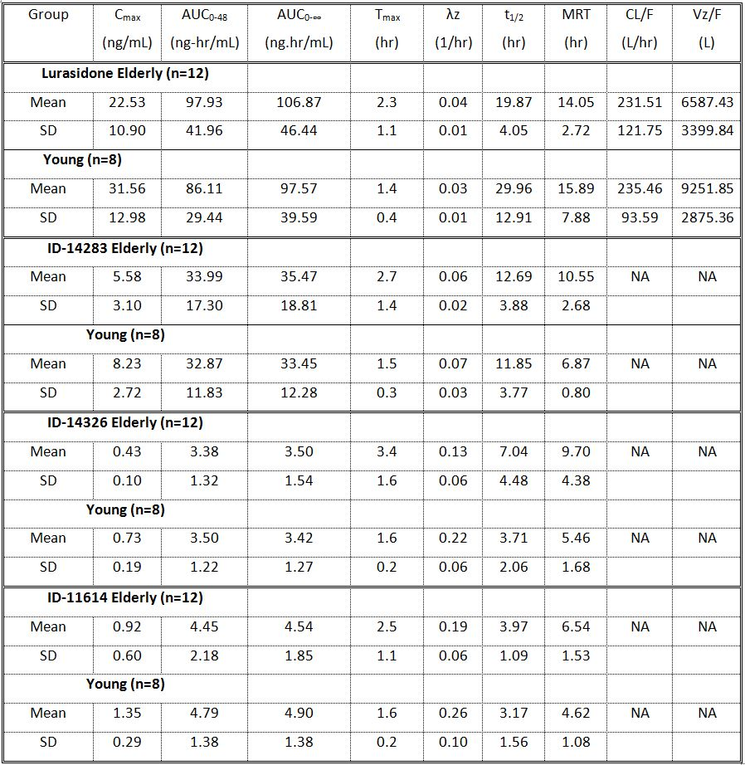
Study D1050253 was a double-blind, placebo-controlled, single dose study of the PK of lurasidone 20 mg in 9 healthy elderly men and women, ages 65 to 85 under fed conditions. Absorption appeared to be moderately delayed in elderly subjects, based on comparison to historical data. Based on the ratio of the mean AUC_{0-inf} values there was a higher systemic exposure in elderly females than for either elderly males or young females. Overall, the mean C_{max} and AUC ratio of metabolite ID-14283 was similar between elderly males and females.
Based on these results, no dose adjustment is required in elderly subjects.

Pharmacokinetics related to genetic factors
The effect of genetic polymorphism on the PK of lurasidone was not investigated in clinical studies. Lurasidone is primarily metabolised by CYP3A4 therefore the effect of genetic polymorphism is considered to be low.

Pharmacokinetics according to race and gender
Based on population PK analyses (M1050005), females have a 1.2-fold increase in exposure compared to males for a given meal status and race. Asian subjects have a 1.5-fold increase in steady-state AUC compared to non-Asian subjects. A typical Asian, female subject receiving lurasidone with a meal has a 3.1-fold increase in steady-state AUC compared to a typical non-Asian, male receiving lurasidone in the fasted state. Based on these modelling results, there was a small observed gender and race effect however these were not considered clinically meaningful. No dose adjustment for lurasidone is recommended based on gender and race.

Pharmacokinetics in paediatric and adolescent populations
Safety and effectiveness in paediatric and adolescent patients have not been evaluated. Study D1050300 appears to be a planned study in various childhood psychiatric disorders but no data were reported.

Pharmacokinetic interactions

Pharmacokinetic interactions demonstrated in human studies
The effects of repeated dose administration of oral ketoconazole (a strong CYP3A4 inhibitor) 400 mg once daily on the single dose PK of lurasidone 10 mg was evaluated in nine male subjects. There was a 6.8 fold increase in C_{max} and a 9.3 fold increase in AUC. The active metabolite, ID-14283 also increased on Day 11, but to a lesser extent than lurasidone. These results indicated a pronounced effect of ketoconazole on the PK of lurasidone. Lurasidone is contraindicated with strong CYP3A4 inhibitors such as ketoconazole.
A randomised, fixed-sequence study evaluated the effects of multiple oral doses of diltiazem 240 mg (a moderate CYP3A4 inhibitor) once daily on the PK of single dose lurasidone 20 mg and its active metabolite, ID-14283, in healthy young male and female subjects (D1050250). Concomitant administration of lurasidone and diltiazem resulted in increased lurasidone AUC_{0-∞} (2.2-fold) and C_{max} (2.1-fold) relative to lurasidone alone. Similar increases were seen for the active metabolite ID-14283. Dose adjustment of lurasidone is recommended with co-administration of moderate CYP3A4 inhibitors such as diltiazem.
An open-label study determined the effects of single and repeated doses of lurasidone 120 mg once daily on the PK of single dose midazolam 5 mg in 24 subjects with schizophrenia (D1050269). Mean midazolam exposure differed slightly when administered as a single 5 mg dose (Day 1) compared with co-administration with either a single 120 mg dose of lurasidone (Day 6) or co-administration with lurasidone 120 mg once daily. At steady state mean midazolam C_{max} and AUC₍₀₋₂₄₎ increased by approximately 21% and 44%, respectively relative to midazolam alone. The increase in exposure of midazolam was <1.5-fold suggesting a weak inhibition of midazolam PK by lurasidone. Mean steady state lurasidone exposure when coadministered with midazolam was not affected. Lurasidone can be coadministered with other CYP3A4 substrates.
The effect of repeated administration of rifampin 600 mg once daily on the single dose PK of lurasidone 40 mg was studied in 20 healthy adult subjects (D1050270). Concomitant oral administration of lurasidone and rifampin versus lurasidone alone resulted in a decrease in systemic lurasidone exposure (approximate 6.0-fold decrease in AUC_{0-last}; 6.8-fold decrease in mean C_{max}). Exposure (C_{max} and AUC) to the metabolites ID-14326 and ID-14283 also decreased. Clinically meaningful reductions of lurasidone exposures can occur with strong CYP3A4 inducers, such as rifampin.
A double-blind, placebo-controlled, 2-period crossover study investigated the effect of lurasidone 40 mg on the PK of the oral contraceptive, Ortho Tri-Cyclen in 17 healthy female subjects (D1050246). The PK of ethinyl estradiol (EE) and norelgestromin (NGMN) (active ingredient and metabolite of active ingredient norgestimate, respectively) were assessed on Day 21 after 10 days of co-administration of lurasidone or matching placebo with Ortho Tri-Cyclen. The 90% CI for C_{max} and AUC₀₋₂₄ for both EE and NGMN were within the bioequivalence range of 80% to 125%. Sex hormone binding globulin levels were not affected by coadministration of lurasidone and Ortho Tri-Cyclen. Lurasidone had no clinically or statistically meaningful effects on the PK of Ortho Tri-Cyclen or SHBG levels. Therefore, it is considered that lurasidone can be coadministered with oral contraceptives, such as Ortho Tri-Cyclen.
The effect of lithium 600 mg BID on the PK of lurasidone 120 mg once daily in 20 subjects with schizophrenia was examined in a two period study (D1050247). The 90% CI of the geometric mean ratio for the two periods (lurasidone alone and coadministration with lithium) fell within the 80% to 125% range for AUC_{0-tau} but not for C_{max} (75.52%, 112.15%). Mean exposures [AUC_{0-tau} and C_{max}] for the major (ID-20219 and ID-20220) and active (ID-14283 and ID-14326) metabolites were similar in the presence or absence of lithium. Coadministration of lurasidone (120 mg/day) and lithium (1200 mg/day) at steady state resulted in comparable mean lithium C_{max} of values on Day 4 (0.65 mmol/L) and Day 8 (0.75 mmol/L). No adjustment of lithium dose is required when coadministered with lurasidone.
An open-label study investigated the effect of repeated doses of lurasidone 120 mg once daily on the PK of orally administered digoxin 0.25 mg once daily, a P-gp substrate, in 24 subjects with schizophrenia (D1050279). Trough concentrations for lurasidone and its active metabolites (ID-14283 and ID-14326) obtained on Days 10 through 14 suggested that lurasidone and its metabolites concentrations had reached steady state at the time of the concomitant oral administration of lurasidone tablets and digoxin tablets. The 90% CI of the geometric mean ratio for digoxin alone and lurasidone plus digoxin fell within the 80% to 125% range for AUC₀₋₂₄ and AUC_{0-last} but not for C_{max} (93.1%, 128.5%). Lurasidone had clinically negligible effects on the PK of digoxin. Lurasidone can be coadministered with P-gp substrates, such as digoxin.

Clinical implications of in vitro findings
In vitro studies indicated that the metabolism of lurasidone is inhibited in the presence of strong CYP3A4 inhibitors (X1K02). Lurasidone had weak or no inhibitory effects on CYP2C8, CYP2C9, CYP2C19, CYP3A4, CYP2B6, CYP1A2, CYP2E1 and CYP2D6 (6645-128). The clinical relevance of competitive CYP inhibition of those CYPs by lurasidone is remote as [I]/Ki <0.1 and, therefore, no clinical DDI studies were deemed necessary during clinical development. At the 160 mg lurasidone dose, [I]/Ki was ≤0.1, with the exception of CYP2C8, CYP2C9 and CYP2C19 with a [I]/Ki ≤0.15.
Treatment with lurasidone (0.03, 0.3, 3, and 10 μM) once daily for three consecutive days in cultured fresh human hepatocytes had neither an inductive effect on CYP1A2, CYP2B6 and CYP3A4/5 enzyme activity nor an effect on mRNA levels. The CYP inducers (omeprazole 100 μM, phenobarbital 750 μM and rifampin 10 μM) caused increases of 37.2-, 14.9-, and 6.74-fold in CYP1A2, 2B6, and 3A4/5 activity, respectively. Therefore, a clinical DDI study was not warranted.
Studies PK003 and GE-0535-G examined the P-glycoprotein multi-drug resistance 1 transport relationships of lurasidone and its metabolites (ID-14283 or ID-20219). In LLC-PK1 cells expressing the mouse and human P-gp, lurasidone and one of its active metabolites, ID-14283, did not exhibit vectorial transport, indicating that they are not substrates of P-gp. Since lurasidone is not a substrate for P-gp, concomitant administration of lurasidone with P-gp inhibitors or inducers are not likely to impact on lurasidone PK. In LLC-PK1 cells expressing the human P-gp, lurasidone demonstrated an inhibitory effect on the digoxin transport activity at a concentration of 1 to 10 μM (IC50=1μM), while its major metabolite ID-20219 has no inhibitory effect on the digoxin transport activity up to 20 μmol/L.

Population pharmacokinetic analysis
The PK profiles for lurasidone were further characterised by a population PK analysis (M1050005). This population PK analysis consists of data from 22 Phase 1 through Phase 3 clinical studies. There were 14,605 measurable lurasidone concentrations from 1623 healthy subjects and subjects with schizophrenia included in this population PK analysis.
Intrinsic factors such as age, body weight, gender, and race and extrinsic factor such as food were evaluated. Three additional population PK analyses were completed (M1050001, M1050002 and M1050003) early in the program but these contained less than a half of the data included in Report M105005. Report M1050005 is more robust and provides a more complete characterization of lurasidone PK. Only results from M1050005 are considered.
The multiple-dose PK of lurasidone is dose-proportional in the 10 mg to 160 mg dose range, based on C_{max} and in the 10 mg to 600 mg dose range, based on AUC_{0-tau} (M1050005). Model-based analysis from healthy subjects (10-100 mg) and subjects with schizophrenia (120-600 mg) suggests that the exposure to lurasidone is dose-proportional and extends from healthy subjects to subjects with schizophrenia. There is no difference in PK between healthy subjects and patients. Based upon population PK modelling, lurasidone reaches 80.8% and 90.7% of steady-state AUC by Day 7 and Day 15, respectively, and reaches 90.5% of steady-state C_{max} by Day 2 (M1050005). The accumulation ratio for AUC₀₋₂₄ was approximately 1.6- to 1.8-fold (D1050160, M1050005).
Overall, no effect of age was observed based on the population PK of lurasidone which supports the data from the specific studies (M1050005). Conclusions are limited by the small number of subjects ≥65 years of age (n=17). Modelling data suggest that systemic availability of lurasidone is influenced significantly by food, with higher levels of lurasidone and metabolites detected in serum under fed conditions compared to fasting, further supporting the results of food effect studies S01P12, D1050251, D1050267, D1001054, and D1050294. It is recommended that lurasidone be administered with food. Modelling results suggest a small gender, race, and weight effect. However, these were not considered clinically meaningful as the difference observed was within the variability of the exposure data.

Evaluator’s overall conclusions on pharmacokinetics
A comprehensive set of studies has established the PK parameters for lurasidone in both healthy subjects and patients with schizophrenia. Lurasidone is rapidly absorbed after oral administration with T_{max} occurring at 1.3-1.8 hours. At doses of 20 to 100 mg in healthy volunteers, and at doses of 120 mg to 160 mg in patients with schizophrenia, lurasidone exhibits linear PK. In the presence of a low-fat meal/medium calorie meal, lurasidone C_{max} increased by 2.8-fold and AUC increased by 2.3-fold (relative to a fasted state). The mean apparent volume of distribution ranges from 3220 L and 4410 L. Lurasidone is highly bound (~99%) to serum proteins. The mean terminal elimination half-life of lurasidone ranged from 12.2 to 21 hours in healthy volunteers. Lurasidone’s activity is primarily due to the parent drug and, to a lesser extent, to the active metabolites ID-14283 and ID-14326 which represent 25% and 3% of the parent exposure, respectively. The major biotransformation pathways are oxidative N-dealkylation, hydroxylation of norbornane ring and S-oxidation. Approximately 90% of a radioactive dose of lurasidone was recovered with 9.2-19% in urine and 67-80% in faeces, suggesting that lurasidone is primarily eliminated via non-renal pathways. Mean apparent clearance ranges from 175 L/hr to 244 L/hr. In vitro and in vivo data suggest that lurasidone is metabolised primarily by CYP3A4. Accordingly PK parameters of lurasidone are affected by alterations in hepatic and renal function. Thus in patients with severe hepatic impairment (Child-Pugh Class C), systemic exposure is increased by up to 3-fold. In patients with severe renal impairment (creatinine clearance <30mL/min), systemic exposure is increased by up to 2-fold.
Significant drug interactions are noted for co-administration with CYP3A4 inhibitors (e.g. ketoconazole) and CYP3A4 inducers (e.g. rifampin). There is no DDI study with grapefruit juice which is well recognised to interact with drugs metabolised by CYP3A4.

Pharmacodynamics

Studies providing pharmacodynamic data
Table 9 shows the studies relating to each PD topic and the location of each study summary.
Table 9: Submitted PD studies.
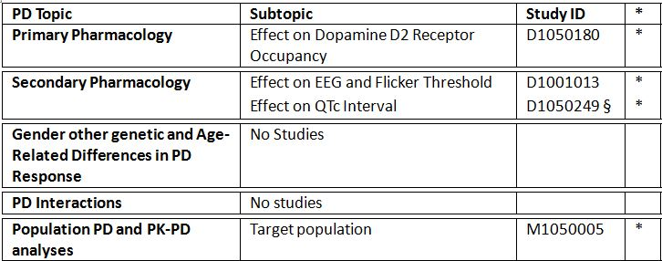
* Indicates the primary aim of the study.
§ Subjects who would be eligible to receive the drug if approved for the proposed indication.
‡ And adolescents if applicable.
None of the PD studies had deficiencies that excluded their results from consideration.

Summary of pharmacodynamics
The information in the following summary is derived from conventional pharmacodynamic studies in humans unless otherwise stated.

Mechanism of action
Studies in vitro have established lurasidone has high affinity for human D2L, 5-HT1A, 5-HT2A, 5-HT7 and α2C receptors. In vitro functional activity studies conducted with lurasidone and its metabolites ID-14283, and ID-14326 suggest that these molecules are partial agonists for human 5-HT1A receptors and potent antagonists for human D2L and 5-HT7 receptors. These two metabolites are likely to be active. All other metabolites are inactive at these relevant receptors.

Pharmacodynamic effects

Primary pharmacodynamic effects: dopamine receptor occupancy
Study D1050180 was an open-label, PET study that assessed dopamine D2 receptor occupancy of lurasidone with the radioactive tracer [¹¹C] raclopride in 20 healthy Caucasian male subjects who were administered a single oral dose of lurasidone 10 mg, 20 mg, 40 mg, 60 mg and 80 mg. The results for each dose group were similar among all 3 striatal regions (caudate, putamen, globus pallidus) of the brain that were examined. Mean D2 receptor occupancies for the 3 brain regions ranged from 41.3%-43.3% (10 mg), 51.0%-54.8% (20 mg), 63.1%-67.5% (40 mg), 77.4%-84.3% (60 mg), and 72.9%-78.9% (80 mg). A relationship between serum concentration and D2 receptor occupancy was demonstrated for lurasidone, which showed that maximal D2 receptor occupancy (80%) was observed at lurasidone doses of 60 mg and 80 mg doses of lurasidone.

Secondary pharmacodynamic effects: effects on EEG
Study D1001013 was a randomised, double-blind, single-centre, single dose per period, crossover study designed to evaluate the pharmacological effects of lurasidone 20 mg and 40 mg, or matching placebo, on the CNS penetration in 44 healthy, Japanese, adult males, using quantitative EEG and the flicker test. In comparison with placebo, lurasidone did not greatly affect global field power (GFP, %) in any frequency band (delta, theta, alpha 1, alpha 2, beta 1, beta 2, or beta 3) at a dose of 20 or 40 mg. A mildly increased GFP (%) in the alpha 1 (lower alpha-wave region) band and mildly decreased GFP (%) in the alpha 2 (higher alpha-wave region) and beta 1 bands were observed at a dose of lurasidone 40 mg, although not significantly. In the flicker test, lurasidone significantly decreased the threshold of flicker discrimination at doses of 20 and 40 mg. A similar inhibitory effect has been reported with many antipsychotic agents.

Effects of Lurasidone on QTc interval
Study D1050249 was a randomised, double-blind, double-dummy, multi-center, active control, 3-arm, parallel study to evaluate the effects of daily therapeutic doses of lurasidone 120 mg (n=23 subjects), titration to a supra-therapeutic dose of lurasidone 600 mg (n=20 subjects), or an active control (ziprasidone, titrated to 160 mg, n=23 subjects) in subjects with schizophrenia or schizoaffective disorder. Administration of lurasidone at the therapeutic dose of 120 mg daily for 11 days prolonged the heart rate corrected QT intervals in schizophrenic or schizoaffective patients. The maximum upper bound of the two-sided 90% CI dQTcI of 14.7 ms (corresponding least-squares mean of 9.4 ms) occurred at 2-hour post dose (Figure 1). Administration of lurasidone at the supratherapeutic dose of 600 mg (titrated regimen for 11 days) prolonged the heart rate corrected QT intervals, but to a lesser extent than the therapeutic dose, in schizophrenic or schizoaffective patients. The maximum upper bound of the two-sided 90% CI dQTcI of 11.5 ms (corresponding least-squares mean of 5.8 ms) occurred at 4-hour post dose. Assay sensitivity to detect QT prolongation was validated using the positive control ziprasidone (titrated regimen for 11 days to a total dose of 160 mg per day). The lower bound of the two-sided 90% CI was above 0 ms and the least-squares mean dQTcI was above 5 ms at all timepoints. In the categorical analysis for absolute QTcI and dQTcI, therapeutic (120 mg) and supratherapeutic (600 mg) doses of lurasidone did not prolong the QTc intervals to the thresholds of clinical concerns. Similar results were observed with different correction methods (QTcB, QTcF, QTcI and QTcP).
Figure 1: Least-squares Mean dQTcI Across Time (Day 11) with 90% CI for Each Treatment.
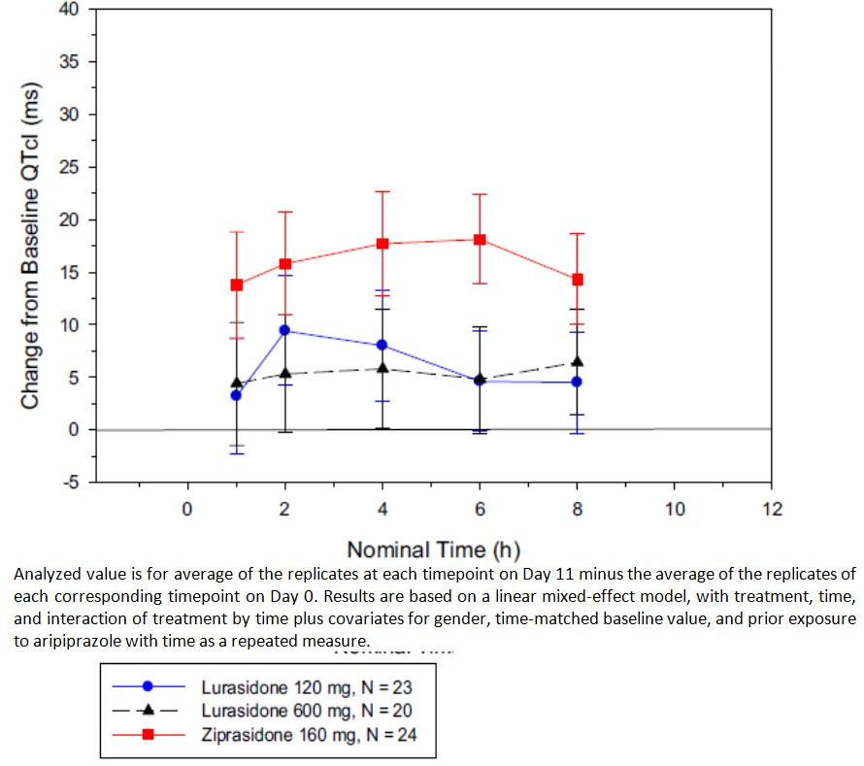
Using the data generated in this study, an Exposure-Response (ER) modelling analysis was undertaken to relate QTc responses in schizophrenic/schizoaffective subjects to serum concentrations of lurasidone (M1050004). A further aim was to predict the mean QTc effects at clinically relevant, meaningful serum concentrations and calculate the 90% two-sided confidence intervals on these mean predictions to quantify the QTc effects. The modelling data demonstrated a shallow dose response and also showed that lurasidone 120 mg/day and 600 mg/day are not associated with QTc prolongation since the upper bound of the 90% CI at each dose is <10 msec. Thus, the proposed therapeutic dose range of 40 to 80 mg per day was not associated with QTc prolongation.

Pharmacodynamic interactions
No studies were performed.

Evaluator’s overall conclusions on pharmacodynamics
The PET study showed that lurasidone had approximately 80% occupancy of the dopamine D2 receptor between 60 and 80mg after a single dose in volunteers. Generally, this level of occupancy has been shown to be necessary for therapeutic activity (against positive symptoms) in patients with schizophrenia for other antipsychotic agents. The proposed clinical dose therefore should ensure similar occupancy of this receptor. Occupancy of other receptors notably 5HT2A was not addressed. The EEG and Flicker threshold study would suggest that like other antipsychotic medications lurasidone has sedative effects. The lack of an active comparator drug with known sedative properties (e.g., another atypical antipsychotic or diazepam) is a weakness of this study.
The QTc trial compared the effects of lurasidone 120 mg and lurasidone 600 mg on the QT interval with ziprasidone 160 mg as an active control. It is noted that the FDA evaluation of this study suggests that the results were inconclusive due to the following reasons:
- The primary endpoint was inadequately defined. The QT study used time matched mean changes from baseline in QTcI (i.e. ΔQTc) as the primary endpoint. The primary variable is inappropriate because it does not account for between-day shifting for ECG signals, which can be pronounced with an 11 day difference between the observation day and baseline day. A time-matched, baseline-corrected, and placebo-adjusted QTc (ΔΔQTc) should be used as the primary variable in a parallel thorough QT study. However, this variable cannot be derived from the current trial because of the absence of the placebo arm.
- Assay sensitivity was not established in the trial. The QT study used ziprasidone as active control. The results from ziprasidone arm has two limitiations: the results were described by using ΔQTc rather than ΔΔQTc and, at the tested dose level, the QTc interval change appears to be larger than the small changed defined by ICH E14 guidance.
This identified weakness was not addressed in the data submitted here. Although ziprasidone is associated with QTc prolongation this may not be as reliable (even at the dose used) as the usual choice of moxifloxacin as an agent to induce a QTc change.

Dosage selection for the pivotal studies
Study D1050180 was a PD study which aimed to determine the dopamine D2 receptor occupancy, using positron emission tomography (PET), of SM-13496 at five single doses (10 to 80 mg) in 20 healthy male subjects. The mean D2 receptor occupancy ranged from 41-43% with 10 mg, 51-55% with 20 mg, 63-68% with 40 mg, 77-84% with 60 mg dose and 73-79% with the 80 mg dose. This indicates some dose dependent receptor occupancy rates up to the 60 mg dose. The lower doses of 10 mg and 20mg were found to have low receptor occupancy.
Study D1001016 was an early Phase II, open label, uncontrolled, 8 week exploratory study of a flexible dose regimen to 20 to 80 mg per day of SM-13496 in Japanese patients with schizophrenia. It found some evidence of efficacy as measured by change from baseline in the total score on the Brief Psychiatric Rating Scale (BPRS) and Positive and Negative Syndrome Scale (PANSS).
Study D1001001 was an 8 week, uncontrolled, double blind, fixed dose, dose response study which assessed doses of 20 mg, 40 mg, and 80 mg per day in 203 Japanese adults with schizophrenia. The study found no significant differences between doses as measured by a change from baseline to completion (or discontinuation) in total BPRS and PANSS scores. Subjects in the 40 mg and 80 mg groups had significant decreases from baseline BPRS and PANSS scores, while this was not found in the 20 mg group. The rate of safety risks increased with increasing dose and the 80 mg group had a notably higher discontinuation rate than the lower doses (47.5% versus 38.8% and 30.6%).
Study D1050049 was a Phase II randomised, double blind, placebo controlled, fixed dose study of lurasidone 20 mg, 40 mg and 80 mg, with haloperidol as the active comparator. In this study the 20 mg dose was not found to be effective as measured by change from baseline in BPRS score. However, no active group including haloperidol was found to be significantly different to placebo and so the study was deemed to have failed. Consequently, no conclusions can be drawn from this study on the lack of efficacy of the 20 mg dose.
Given the low receptor occupancy in D1050180 and the lack of efficacy in D1001001, the sponsor concluded that 20 mg was subtherapeutic in treatment of schizophrenia and doses in the range of 40, 80, 120 and 160 mg were assessed in the Phase III clinical development program. In addition, due to the higher discontinuation rate with the 80 mg dose in D1001001, the sponsor concluded that the 40 mg dose was the most appropriate commencing dose.

Clinical efficacy

Pivotal efficacy studies

Study D1050229 and D1050229E

Study design, objectives, locations and dates
D1050229 was a phase III, randomised, double-blind, placebo-controlled, 6 week study assessing the safety and efficacy of lurasidone HCl (40, 80 and 120 mg per day) in acutely psychotic patients with chronic schizophrenia. It was sponsored by DSP and conducted between October 2007 and December 2008 at 48 centres in France, India, Malaysia, Romania, Russia, Ukraine, and the US. There was a 14 day screening period during which psychotropic medication was tapered and the subjects entered a 3 to 7 day hospitalised single-blind, placebo washout period. Subjects remained hospitalised during randomised treatment for at least 21 days and, if meeting discharge criteria, could continue the next 3 weeks of treatment as an outpatient. Study assessments were at day 4 and 7 and then weekly. After 6 weeks of randomised treatment subjects could the immediately enter the 22 month open label extension study D1050229E. There is an independent data safety and monitoring board (DSMB) which reviewed unblinded data.

Inclusion and exclusion criteria
Inclusion criteria were: adult male and female subjects, in good physical health, 18 to 75 years; DSM-IV criteria for a primary diagnosis of schizophrenia (including disorganised, paranoid, and undifferentiated subtypes using the Mini-International Neuropsychiatric Interview [MINI] Plus); illness duration of the greater than one year; acute exacerbation of psychotic symptoms (no longer than 2 months) and marked deterioration of function from baseline (by history), or hospitalised for the purpose of treating an acute psychotic exacerbation for ≤two consecutive weeks immediately before screening; PANSS total score ≥80 at screening and baseline, with a score ≥4 (moderate) on two or more on the following PANSS items: delusions, conceptual disorganisation, hallucinations, unusual thought content and suspiciousness; CGI-S score ≥4 on the at screening and baseline; not be pregnant, nursing, or planning pregnancy; using acceptable methods of birth control; tested negative for selected drugs of abuse at screening; and not chronically homeless.
Exclusion criteria were: clinically significant neurological, metabolic (including type 1 diabetes), hepatic, renal, haematological, pulmonary, cardiovascular, gastrointestinal, and/or urological disorder such as unstable angina, congestive heart failure (uncontrolled), or central nervous system (CNS) infection; HIV seropositive; acute hepatitis, clinically significant chronic hepatitis or impaired hepatic function; estimated creatinine clearance <60 mL/minute; history of stomach or intestinal surgery that could interfere with medication absorption; history of malignancy <5 years prior (except adequately treated basal cell or squamous cell skin cancer or in situ cervical cancer); any pituitary tumour; chronic organic disease of the CNS other than schizophrenia; mental retardation; history of neuroleptic malignant syndrome; severe tardive dyskinesia or other severe chronic movement disorder; at risk of suicide; drug abuse; macular or retinal pigmentary disease; clinically significant abnormal laboratory parameter; prolactin >100 ng/mL; clinically significant abnormal ECG; BMI > 40 kg/m² or <18.5 kg/m²; hypersensitivity to >2 distinct chemical classes of drug; resistant to neuroleptic treatment; clonazine treatment with 4 months for refractory psychosis; depot neuroleptics given within one treatment cycle of randomisation; mood stabilisers or antidepressants within one week, MAO-inhibitors with 3 weeks, fluoxetine within one month; needing potent CYP3A4 inhibitors or inducers; electroconvulsive therapy (ECT) within 3 months; and decrease in PANSS score of ≥20% between screening and baseline.

Study treatments
During the washout period subjects received single blind placebo. Subjects were then randomised to one of 4 groups in a 1:1:1:1 ratio. The groups were lurasidone 40 mg, 80 mg, 120 mg or placebo. Subjects in the 120 mg group were commenced on 80 mg for days 1 to 3. Treatment was with lurasidone 40 mg tablets or matching placebo. Subjects took 3 tablets, once daily, in the morning with a meal or within 30 minutes of eating.
Potent inhibitors and inducers of CYP3A4 were prohibited during the study. All anti-depressants and mood stabilisers were discontinued. Treatments for movement disorders were tapered and discontinued but could restart if symptoms emerged. Allowed treatments were benztropine, biperiden, trihexyphenidyl, diphenhydramine, propranolol and amantadine. Treatment of anxiety/agitation and insomnia was limited to lorazepam (<6 mg/day), zolpidem (<10 mg/day), zolpidem CR (<12.5 mg/day) and temazepam (<30 mg/day). Administration was not to be within 6 hours prior to the PANSS rating sessions. Alcohol was to be avoided and grapefruit juice prohibited. Non-psychotropic medications were allowed if the regimen was stable for 30 days prior to randomisation.
Compliance was assessed on tablet counts and noncompliance was defined at missing >25% or taking >125% of allocated doses.
In the 22 month open label extension phase all subjects were switched to lurasidone 80 mg per day. This dose could be changed to 40 mg or 120 mg per day as the investigator’s discretion up to a maximum of 4 dose titrations. Concomitant psychotropic medication was allowed as required, except for antipsychotic medications, stimulants, D2 agonists/antagonists, and potent inhibitors or inducers of CYP3A4.

Efficacy variables and outcomes
The main efficacy variables were:
- Positive and Negative Symptom Scales (PANSS) total score
- Clinical Global Impression – Severity Scale (CGI-S)
- Montgomery-Asberg Depression Rating Scale (MADRS)
The primary efficacy outcome was the mean change from baseline in the PANSS total score at Week 6. Other efficacy outcomes included:
- functional outcome as measured by the mean change from baseline in the CGI-S at week 6;
- symptoms as measured by the mean change from baseline in PANSS total score at day 4;
- depressive symptoms as measured by the mean change from baseline in the MADRS at week 6;
- safety and tolerability of lurasidone (40, 80, or 120 mg per day) in acutely schizophrenic subjects over 6 weeks of treatment.
Tertiary outcomes included:
- responder rates (≥20% improvement) on PANSS total score, and mean change from baseline in PANSS positive subscale, PANSS negative subscale and PANSS general psychopathology subscales.

Randomisation and blinding methods
Matching placebo tablets were used. Subjects were randomised via an IVRS. The washout was single blind and the randomised period double blind.

Analysis populations
The primary analysis population was the ITT population which was defined as all randomised subjects who received at least one dose of study medication and had baseline and at least one post-baseline efficacy measurement. The per protocol (PP) population was also analysed.

Sample size
Based on studies D1050006 and D1050196, the assumed improvement with lurasidone compared to placebo in the PANSS total score was 6.8, 8.0, and 10.0 for the 40, 80, and 120 mg/day doses, respectively with a standard deviation of 19.1. A sample size of 120 subjects per group would give the study a 97.5% power at the α=0.05 level, two-sided test. Therefore, the study planned to enrol 120 subjects per treatment group and a total of 480 subjects.

Statistical methods
To control type I error at 5%, the Hommel-based tree-gatekeeping procedure was applied taking into account the one primary and two key secondary endpoints and multiple dose comparisons of lurasidone versus placebo. Hommel-adjusted p values were provided for these comparisons of lurasidone dose versus placebo.
The primary efficacy endpoint (change from baseline in PANSS total score at week 6) was analysed using a mixed model for repeated measurements (MMRM) which included factors for centre, time, baseline PANSS score, treatment and treatment by time interaction. The primary analysis was based on the ITT population with adjustment for multiplicity. Supportive analysis used the LOCF and was analysed using an analysis of covariance (ANCOVA), with effects for baseline total PANSS score, pooled centre and treatment. Key secondary endpoints were analysed with the same methods.
The study protocol was amended 4 times, the first two prior to subject enrolment. The third amendment added secondary objectives and changed tertiary objectives. Amendment 4 included adjustment for multiplicity.

Participant flow
There were 705 subjects screened and 500 randomised with 328 (66%) completing the double blind phase. There were 125, 123, 124 and 128 subjects included in the 40, 80, 120 mg and placebo groups, respectively. Discontinuation rates were greatest in the placebo group compared to lurasidone groups (43% versus 30-33%) and were mainly due to insufficient clinical response (25% versus 6-16%). Ten percent of subjects withdrew consent and 5% who discontinued to due AEs (5-7% versus 2%, lurasidone versus placebo).

Major protocol violations/deviations
Overall, 21% of subjects had a major protocol deviation leading to exclusion from ITT population to form the PP population (18-25% of the lurasidone groups and 18% of the placebo group). The most frequent reasons were <14 days continual exposure to study medication (15%) and positive test for illicit drug use (3%). The ITT population included 489, the PP population 385 and the safety population 496 subjects.

Baseline data
Demographic and baseline characteristics were similar between treatment groups. Most subjects were male (70%), with a mean age was 38.8 years (range 18 to 72 years). Most subjects were White (49%) or Black (34%), with fewer Asians (15%). Subjects had paranoid type schizophrenia (88%) and most had had 4 or more prior hospitalisations for schizophrenia (61%). The mean baseline PANSS total score was 96.3.
Most subjects (71%) had other medical conditions with the most frequent being psychiatric disorders (50%) mainly insomnia 43%, anxiety 32% and agitation (21%). Other conditions included hypertension (14%) and headache (11%). The most frequent prior medications were antipsychotics (84%), anxiolytics (63%) hypnotics/sedatives (43%), anticholinergics (28%), anti-inflammatory/antirheumatic products (15%), antidepressants (12%), and other analgesics/ antipyretics (12%). During the study, the most frequent concomitant medications were anxiolytics (64-70% versus 61%) and hypnotics/sedatives (40-45% versus 37%) in the lurasidone and placebo groups, respectively. Anticholinergic use was greater in the lurasidone groups (14-29%) than placebo group (8%). It was noted that 12-15% of the lurasidone groups and 12% of the placebo group received anti-psychotics during the double-blind treatment period.
The mean number of days hospitalised during the study was similar between groups (33.1 to 36.4 days). At day 21, the proportion of subjects eligible for discharge was 32%, 47%, 48% and 42% of the lurasidone 40 mg, 80 mg and 120 mg and placebo groups, respectively. Compliance rates were high and there were only two subjects (placebo and 120 mg lurasidone groups) who were deemed non-compliant.

Results for the primary efficacy outcome
In the ITT population, using the MMRM model for analysis, the change from baseline to week 6 in PANSS total score was -19.2, -23.4, -20.5 and -17.0 in the 40 mg, 80 mg and 120 mg lurasidone and placebo groups, respectively. Comparing the lurasidone groups to placebo, only the 80 mg group was found to be statistically significantly different (-6.4, 95% CI: -11.3, -1.5 adjusted p=0.034). The difference between the 40 and 120 mg doses and placebo (-2.1 and -3.5, respectively) was not statistically significant. There was also no significant linear test for trend (p=0.063) and no evidence of dose response on pairwise comparisons between lurasidone groups. Results were supported by the PP analysis with only the 80 mg group having a significant improvement over placebo at week 6 (-4.6, 95% CI: -9.1, -0.1, p=0.047). Likewise, the analysis using the ANCOVA model with LOCF was supportive of the MMRM model (lurasidone 80 mg versus placebo treatment difference of -6.1, 95% CI: -10.5, -1.6, p=0.007).

Results for other efficacy outcomes

Secondary outcomes
The change from baseline to week 6 in the Clinical Global Impression – Severity Scale (CGI-S) was -1.1, -1.4, -1.2 and -1.0 in the 40 mg, 80 mg, 120 mg and placebo groups, respectively, with only the 80 mg group being significantly better than placebo (difference of -0.4, 95% CI: -0.7, -0.1, adjusted p=0.034). These results were supported by the PP analysis.
The change from baseline to week 6 in MADRS score was -3.3, -4.3, -2.9 and -3.4 in the lurasidone 40 mg, 80 mg, 120 mg and placebo groups, respectively. There were no significant differences between the lurasidone and placebo groups at week 3 or at week 6. There was no dose response found and results were supported by the ANCOVA model analysis.
Analysis of the treatment difference (versus placebo) in the change from baseline in PANSS total score by visit found that the 80 mg dose group had a significant effect from week 2 to week 6 and the 120 mg group from week 2 to 3 only (and not weeks 4 to 6). There were no significant effects found at day 4 between lurasidone at any dose and placebo.

Tertiary outcomes
Subjects with a ≥20% improvement in PANSS total score from baseline to LOCF endpoint were considered responders. The PANSS responder rates were 58%, 67%, 65% and 54% in the lurasidone 40 mg, 80 mg, 120 mg and placebo groups, respectively. After adjustment for multiplicity, no comparison of response rates between the lurasidone and placebo groups was significant.
Assessment of the PANSS positive subscale found that the lurasidone 80 mg group had a significantly improved response compared to placebo from week 1 to 6. For the 40 mg group, a significant treatment difference compared to placebo was found at week 4 but at no other time point. For lurasidone 120 mg, the treatment difference was significant from day 4 to week 6. The test for linear trend was significant (p=0.001). There were no treatment differences between any of the lurasidone groups and placebo on the PANSS negative subscale or on the PANSS general psychopathology subscale.
Subgroup analysis found regional differences in the PANSS responses. It was noted that the response in North American subjects was less than in non-North American subjects which resulted in a lack of treatment differentiation. By contrast, treatment effect was seen in Europe with all three doses and in Asia with the higher two doses (Figure 2).
Figure 2: Positive and Negative Syndrome Scale (PANSS) total score change from baseline to LOCF endpoint: lurasidone difference from placebo by geographic region.
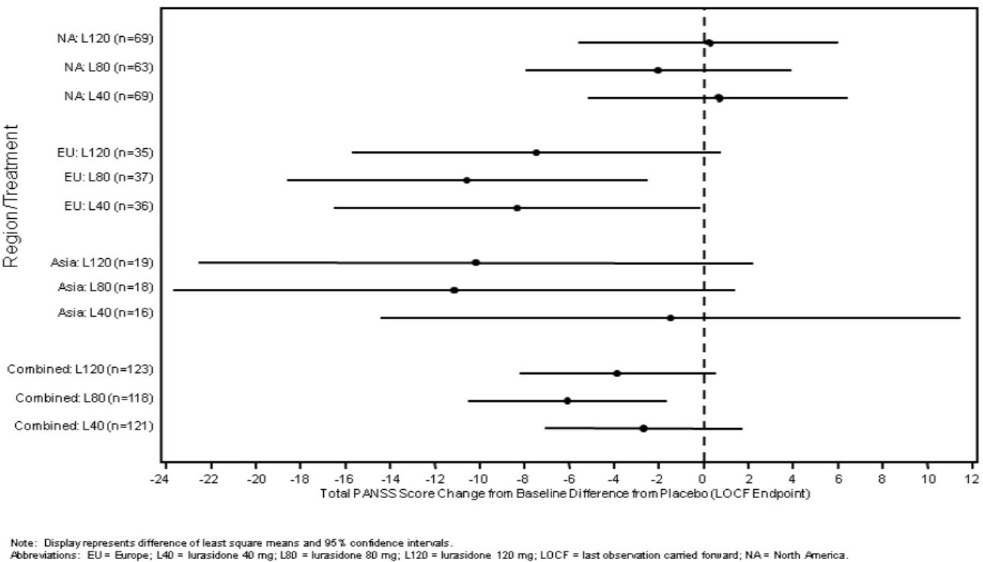
Comment: the Sponsor did not provide an explanation for these findings. It is noted that 55% of the study sample were North American.

Open label extension study
There were 251 subjects enrolled with 250 analysed and 67 (27%) completed the 22 months. The reasons for discontinuation were consent withdrawal (24%), insufficient clinical response or worsening of condition (23%) and adverse events (15%). For those completing the study (n=69), the mean change from baseline to month 24 in PANSS total score was -12.3 (95% CI: -16.2, -8.4) and in the CGI-S was -0.5 (95% CI: -0.7, -0.3). The MADRS score decreased marginally (-0.7, 95% CI: -2.2, 0.7).

Summary
Study D1050229 assessed the efficacy of lurasidone (40mg, 80mg and 120 mg) in 489 chronic schizophrenia patients with an acute psychotic exacerbation. Using a repeated measures model and adjusting for multiplicity, a lurasidone 80 mg was found to result in a significantly greater reduction in the PANSS total score after 6 weeks treatment compared to placebo (difference of -6.4, p=0.034). This result was supported by analysis using ANCOVA with LOCF, a significant decrease in the key secondary endpoint of CGI-S at week 6, as well as in a decrease in the PANSS positive subscore. Neither the 40 mg nor 120 mg lurasidone doses were found to have a statistically significant treatment effect on any measure apart from 120 mg on the PANSS positive subscore. No treatment effect was found on the MADRS, PANSS negative or PANSS psychopathology subscores.
Comment: The study provides some evidence of efficacy with lurasidone 80 mg per day but not 40 or 120 mg per day.

Study D1050231 and D1050231E

Study design, objectives, locations and dates
D1050231 was a phase III, randomised, double-blind, placebo and active-controlled, 6 week study assessing the safety and efficacy of lurasidone HCl (40 and 120 mg per day) in acutely psychotic patients with chronic schizophrenia. It was sponsored by DSP and conducted between January 2008 and June 2009 at 52 centres in Colombia, India, Lithuania, Philippines and the US. Active control with olanzapine was included for confirming assay sensitivity. The study had a DSMB.
The study design and methodology were the same as D1050229. After completing 6 weeks treatment subjects could enter the 6 month open label extension D1050231E. After a three day single-blind placebo washout period, subjects commenced treatment in the extension phase on open label lurasidone 80 mg. If necessary, subjects could be titrated to 120 mg or 40 mg after one week. PANSS and CGI-S assessments were conducted at week 8 and months 3, 6 and 8.

Inclusion and exclusion criteria
Adults subjects diagnosed with schizophrenia and experiencing an acute exacerbation of psychotic symptoms were included. Inclusion and exclusion criteria were the same as D1050229.

Study treatments
After the single-blind placebo run-in subjects were randomised to lurasidone 40 mg per day, lurasidone 120 mg per day, placebo or olanzapine 15 mg per day. Olanzapine commenced at 10 mg for the first week then was increased to 15 mg. All medication was given once daily in the morning with a meal or within 30 minutes of eating. Lurasidone was given as 40 mg tablets and olanzapine was given in capsules containing either two or three 5 mg tablets. Matching placebos were used for lurasidone tablets and over-encapsulated olanzapine. Permitted concomitant medication use was the same as D1050229.

Efficacy variables and outcomes
As with D1050229, the primary efficacy outcome was the mean change from baseline in the PANSS total score at Week 6. Secondary efficacy outcomes were mean change from baseline in CGI-S and MADRS at week 6 and PANSS at day 4. Tertiary outcomes were responder rates and efficacy of olanzapine compared to placebo on change in PANSS total score at week 6.

Randomisation and blinding methods
Subjects were randomised by an IVRS in a 1:1:1:1 ratio to the lurasidone 40 mg, lurasidone 120 mg, olanzapine 15 mg or placebo group. To maintain study blind matching placebo tablets and over-encapsulated placebo tablets were used. Subjects took 3 tablets and one capsule each day in this double-dummy design.

Analysis populations
Analysis was conducted on the ITT population as in D1050229.

Sample size
The sample size calculations were the same as D1050229 with 120 subjects per group and a total of 480 subjects.

Statistical methods
Statistical methods were the same as D1050229 with the primary endpoint being analysed in the ITT population with the MMRM. Adjustment for multiplicity was undertaken. The protocol was amended twice with the main changes being to the secondary and tertiary objectives.

Participant flow
There were 781 subjects screened, 303 screen failures and 478 randomised (120, 119, 123 and 116) in the lurasidone 40 mg, lurasidone 120 mg, olanzepine and placebo groups, respectively. There were 298 (62%) subjects who completed the 6 week study. For the 38% of subjects who prematurely discontinued double-blind treatment, the main reasons were: withdrew consent (16%), insufficient clinical response or worsening of condition (13%) and adverse event (8%). The discontinuation rate was higher with lurasidone 120 mg (45%) than with lurasidone 40 mg (36%), olanzapine (32%) or placebo (39%).

Major protocol violations/deviations
There were 109 (23%) subjects with protocol deviations leading to exclusion from the PP population. The rate of subjects with at least one major protocol deviation was greater in the lurasidone 120 mg group (29%) and placebo group (26%) compared to the lurasidone 40 mg and olanzapine group (18% and 19%, respectively). The most frequent deviation was not having 14 days of continuous study treatment exposure (15%) and positive test for illicit drugs (5%).
There were 3 subjects randomised but not dosed and ITT population included 473 subjects (99%). The PP population consisted of 364 subjects which was 81%, 71% 80% and 72% of the lurasidone 40 mg, lurasidone 120 mg, olanzepine 15 mg and placebo groups, respectively.

Baseline data
The four groups were balanced on baseline and demographic characteristics. Most subjects were male (78%) with a mean age of 37.7 years, 36% were White, 34% Black and 24% Asian with 60% of the study population from North America. Subjects had paranoid schizophrenia (86%) with 48% having had 4 or more prior hospitalisations for schizophrenia and mean disease duration of 13.5 years. The most frequent pre-existing conditions were insomnia (51%), anxiety (39%) and agitation (26%). Depressive symptoms were reported in 8%. Prior anti-psychotic use was reported in 78%.
During the study, anti-cholinergic use was highest with lurasidone 120 mg (41% versus 20%, 18% and 9% of the lurasidone 40 mg, olanzepine and placebo groups, respectively). Anti-psychotic use was similar between active groups (7-11%) and lower with placebo (5%). Concomitant anxiolytic use was high and occurred in 75% and 81% of the lurasidone 40 mg and 120 mg groups, respectively, compared to 65% of the olanzapine and 73% of the placebo groups. Sedative and hypnotic use was similar between groups (51-58%).
After 2 weeks of treatment the proportion of subjects eligible for hospital discharge was 45%, 40%, 50% and 36% of the lurasidone 40 mg, lurasidone 120 mg, olanzapine and placebo groups, respectively. Treatment compliance was high with only 3 subjects reported as non-compliant (<75% or >125%).

Results for the primary efficacy outcome
The mean baseline PANSS total score in the four groups was high at 93.6 to 98.1. Analysis using the MMRM model found that the change from baseline to week 6 in the PANSS total score was -25.7, -23.6, -28.7 and -16.0 in the lurasidone 40 mg, lurasidone 120 mg, olanzapine 15 mg and placebo groups, respectively. All three active treatment groups were significantly better than placebo as follows: lurasidone 40 mg -9.7 (95% CI: -15.3, -4.1, adjusted p=0.002), lurasidone 120 mg – 7.5 (95% CI: -13.4, -1.7, adjusted p=0.022), olanzapine -12.6 (95% CI: -18.2, -7.1 p<0.001). Comparison of results for lurasidone 40 mg and 120 mg found no significant difference (p=0.459). Improved treatment effect compared to placebo was seen from week 1 (Figure 3). The analysis using an ANCOVA model with LOCF was supportive of the primary analysis with treatment differences compared to placebo of -7.9 (95% CI: -12.7, -3.1 p=0.001) for lurasidone 40 mg, -4.8 (95% CI: -9.6, 0.0, p=0.049) for lurasidone 120 mg and -11.4 (95% CI: -16.2, -6.7, p<0.001) for olanzapine 15 mg.
Figure 3: Change from baseline (LSM ± SE) in PANSS total score in subjects treated with lurasidone 40 mg, lurasidone 120 mg, or placebo (ITT population).
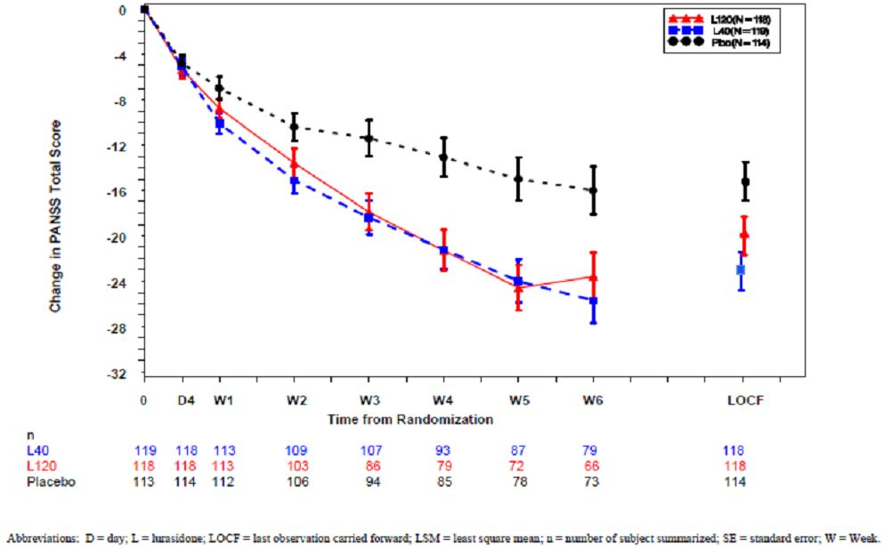

Results for other efficacy outcomes
Subgroup analysis of the PANSS total score by geographical region found significant effects for lurasidone 40 mg and 120 mg in the non-North American subjects and for lurasidone 40 mg in the US subjects, while the 120 mg group in US subjects did not reach significance (Figure 4).
Figure 4: Treatment difference (LSM and 95% CI) in PANSS total score change from baseline in subjects treated with lurasidone 40 mg and lurasidone 120 mg compared with placebo by geographic region.
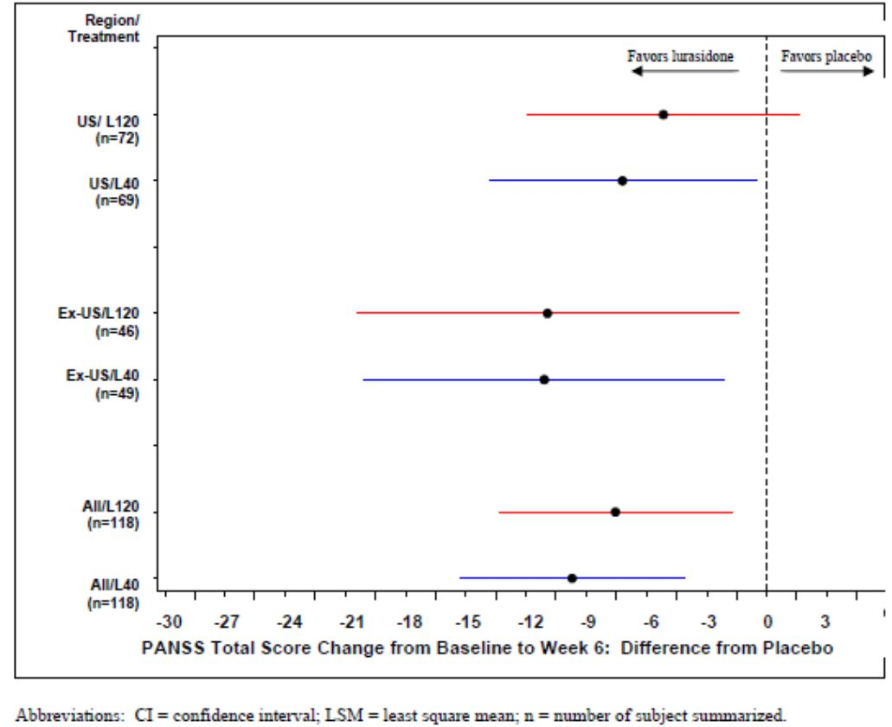
Treatment effect was consistent across gender, Whites and Blacks, while Asians responded to lurasidone 40 mg and olanzepine (PANSS decrease of -29.5 and -32.8 respectively) but not to lurasidone 120 mg where the result was similar to placebo (-22.7 and -21.3). There were too few subjects over 55 years of age (n=29) to draw conclusions.
Analysis of the PANSS positive subscore found that compared to placebo the lurasidone 40 mg dose had a significantly greater reduction at week 2 (-1.3, 95% CI: -2.5, -0.1; p=0.040) and week 6 (-2.3, 95% CI: -4.3, -0.4; p=0.018). Likewise the 120 mg dose also had a significant treatment difference at week 2 (-1.5, 95% CI: -2.7, -0.3; p=0.018) and week 6 (-2.2, 95% CI: -4.2, -0.1; p=0.035). Olanzapine also had a significant effect on the PANSS positive subscore at week 2 and week 6 (-3.9, 95% CI: -5.8, -2.0; p<0.001).
At week 6, the treatment difference on the PANSS negative subscore for lurasidone 40 mg was -2.3 (95% CI: -3.8, -0.9; p=0.004), for lurasidone 120 mg was -1.6 (95% CI: -3.1, -0.0; p=0.045) and for olanzapine was -2.6 (95% CI: -4.1, -1.2; p<0.001). There was also a statistically significant treatment effect on the PANSS general psychopathology subscore for all three groups at week 6.
The proportion of PANSS responders (≥20% improvement from baseline) was 62%, 60%, 74% and 49% in the lurasidone 40 mg, lurasidone 120 mg, olanzapine 15 mg and placebo groups, respectively. The lurasidone groups did not have a significantly greater response rate than placebo. Using a definition of ≥30% improvement in PANSS total score, the response rates were 53%, 47%, 64% and 38%, respectively, and the 40 mg lurasidone group was significant (adjusted p=0.037).
The change from baseline to week 6 in the CGI-S was -1.5, -.14, -1.5 and -1.1 in the lurasidone 40 mg, lurasidone 120 mg, olanzapine 15 mg and placebo groups, respectively. The treatment difference was statistically significant for all three active groups, however there was no significant difference between the 40 and 120 mg lurasidone doses (p=0.521) (Figure 5). There was no evidence of a dose response for the CGI-S (p=0.098). Results were generally supported by the PP analysis.
Figure 5: Change from baseline (LSM ± SE) in clinical global impression: severity scale (CGI-S) in subjects treated with lurasidone 40 mg, lurasidone 120 mg, or placebo (ITT population).
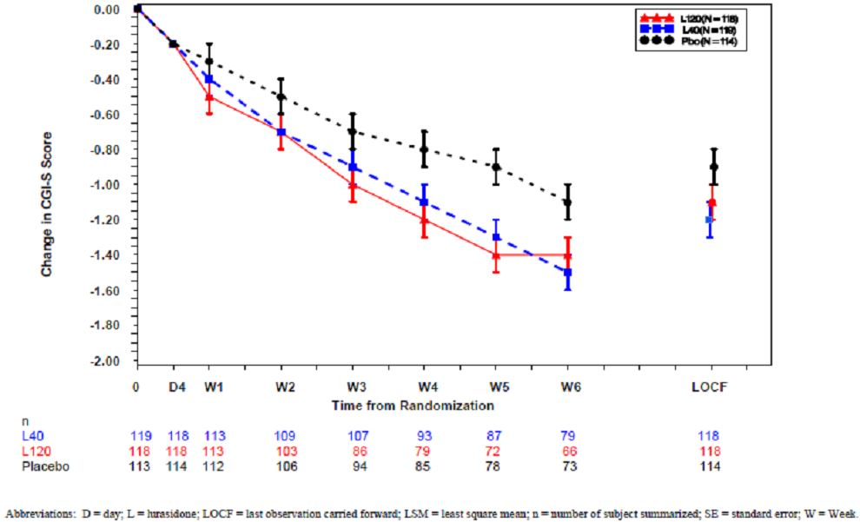
The change from basline to week 6 in the MADRS was -3.5, -3.2, -5.0 and -2.8 in the lurasidone 40 mg, lurasidone 120 mg, olanzapine 15 mg and placebo groups, respectively. Neither lurasidone groups were found to have a significantly better response compared to placebo (p=0.571 for both comparisons) while olanzapine did have a significant effect on the MADRS (p=0.003). There was no evidence of a dose response on the MADRS (p=0.682).

Open label extension study
There were 254 subjects who entered the 6 month open label extension study, 246 were analysed for efficacy and 113 (44%) completed the study. The most frequent premature discontinuation reasons were consent withdrawal (16%), adverse events (13%), loss to follow up (11%) and insufficient clinical response (7%). Major protocol deviations were reported in 33% of subjects with the most common reason being not having 14 days or more of continuous treatment.
For all subjects who completed the 8 months of treatment, the mean PANSS total score was 54.9 with a mean change from baseline (of double-blind study) of -41.9 (95% CI: -45.3, -38.5) and a mean change from open label baseline of -8.7 (95% CI: -11.3, -6.1). At month 8 the mean CGI-S was 2.7 (SD 1.0). The CGI-S continued to decrease over the open label period with a mean change from double-blind baseline to month 8 of -2.1 (95% CI: -2.3, -1.9) and from open label baseline to month 8 of -0.4 (95% CI: -0.6, -0.2). The MADRS scores remained stable over the extension period with no change from open label baseline.

Summary
Study D050231 assessed the efficacy of lurasidone (40mg and 120 mg) in 478 chronic schizophrenia patients with an acute psychotic exacerbation. Using the MMRM and adjusting for multiplicity, both the lurasidone doses were found to result in a significantly greater reduction in the PANSS total score after 6 weeks treatment compared to placebo. This result was supported by a significant reduction in the CGI-S, improvement in PANSS positive, negative and psychopathology subscores and analysis use ANCOVA. There was however no significant treatment difference on the MADRS. PANSS responder rates (using a ≥30% reduction definition) were only significant for lurasidone 40 mg. There was no evidence of dose response and no significant differences were found between the 40 mg and 120 mg doses. Assay sensitivity was confirmed by positive responses in the olanzapine group. Treatment was consistent across males and females, Whites and Blacks, while Asians had less response with lurasidone 120 mg. There were too few subjects aged over 55 years to draw conclusions for the older population.

Study D1050233 and D1050234

Study design, objectives, locations and dates
Study D1050233 was a phase III, randomised, double-blind, placebo- and active comparator-controlled, 6 week study assessing the efficacy and safety of two doses of lurasidone (80 and 160 mg per day) in acutely psychotic patients with schizophrenia. It was conducted at 63 sites in Colombia, India, Romania, Russia, Ukraine and the US between October 2008 and June 2010. Quetiapine XR 600 mg per day was used as the active comparator for assessment of assay sensitivity. The study design was the same as studies D1050229 and D1050231 with a 7 day placebo washout period and 6 weeks double blind period with the first 3 weeks as an inpatient and then, if eligible, the second three weeks as an outpatient. There was a DSMB reviewing blinded and unblinded data for both studies.
Subjects completing the 6 week double-blind study were eligible to continue in a 12 month double-blind extension study (D1050234). The extension study was conducted in 59 centres and continued until June 2011. Its objective was to assess long term maintenance efficacy of flexible dose lurasidone compared to flexible dose quetiapine XR. Subjects on lurasidone or placebo in the primary study were treated with lurasidone in the extension study while those on quetiapine continued on this medication.

Inclusion and exclusion criteria
Inclusion and exclusion criteria were the same as studies D1050229 and D1050231 with the additional exclusion criteria of type 1 diabetes or insulin dependent diabetes. Subjects with type 2 diabetes were required to have screening glucose <11.1 mmol/L, HbA1c ≤7.0%, no hospitalisations within 12 months and stable anti-diabetic medication for 4 weeks.
For the extension study, subjects need to have completed study D1050233 and be suitable for outpatient treatment. Exclusion criteria were: acute hepatitis , significant chronic hepatitis or impaired liver function; chronic organic disease of the CNS other than schizophrenia; severe tardive dyskinesia, dystonia or other movement disorder; at risk of suicide or injury to self or others; clinically significant laboratory abnormality; prolactin >100 ng.mL; abnormal ECG; requiring CYP3A4 inhibitors or inducers or a drug which prolongs the QT interval; and BMI >40 or <18.5 kg/m².

Study treatments
Over-encapuslated lurasidone 80 or 160 mg (using 40 mg tablets) and quetiapine XR 600 mg (using 300 mg tablets) and over-encapsulated placebo tablets were used. Subjects randomised to lurasidone 160 mg per day received lurasidone 120 mg on days 1 and 2 and 160 mg per day thereafter. Subjects randomised to quetiapine XR 600 mg received 300 mg per day on days 1 and 2 and 600 mg per day thereafter. All medication was taken once a day in the evening with a meal or within 30 minutes of eating. Concomitant medication use in the primary and extension studies was the same as the previous studies.
In the extension study, treatment was with lurasidone 120 mg for the first week and then could be adjusted within the range of 40 mg to 160 mg per day. In the quetiapine group, treatment commenced at 600 mg per day and could be adjusted after one week to between 200 mg and 800 mg per day. Therapy was again with over-encapsulated tablets.

Efficacy variables and outcomes
The efficacy variables and outcomes were the same as in studies D1050299 and D1050231 with the primary endpoint being the mean change from baseline in PANSS total score at week 6.
For the extension study, the primary efficacy endpoint was the time to relapse of psychotic symptoms. Relapse was defined as the occurrence of any of:
- Worsening of ≥30% PANSS total score from D1050233 day 42 and CGI-S ≥3;
- Re-hospitalisation for worsening of psychosis;
- Emergence of suicidal ideation, homicidal ideation, and/or risk of harm to self or others.
The extension study had multiple secondary endpoints including the PANSS total score, PANSS subscores, CGI-S score, MADRS total score, Negative Symptom Assessment (NSA-16) total score, Epworth Sleepiness Scale (ESS), Quality of Well-Being Scale, Self-Administered Version (QWB-SA), the CogState computerised cognitive composite score and individual domain scores and University of California San Diego (UCSD) Performance-Based Skills Assessment Brief Version (UPSA-B) total score. These were assessed at 3 monthly intervals.

Randomisation and blinding methods
Subjects were randomised via an IVRS in 1:1:1:1 ratio to the four treatment groups: lurasidone 80 mg/day, lurasidone 160 mg/day, placebo, or quetiapine XR 600 mg/day. The placebo washout period was single blind and the treatment period double-blind. In the extension study, subjects and study staff were blinded to treatment (lurasidone or quetiapine XR) but not to the dose level.

Analysis populations
The primary analysis was the ITT population with the PP population used for supportive analyses. The subjects in the ITT population had received at least one dose of study medication and had baseline and at least one post-baseline efficacy measurement taken.
In the extension study, the relapse analysis was carried out on the “Relapse population” which was enrolled subjects with a demonstrated a clinical response (CGI-S score ≤4 and a 20% or more decrease from baseline in total PANSS score after 6 weeks treatment) to lurasidone or quetiapine at 6 weeks who had at least one dose of study medication in the extension study. This population excluded those in the placebo group of the primary study. Other efficacy analyses in the extension study were carried out on the ITT population.

Sample size
Assuming a difference from placebo on the PANSS total score of 8 and 10 points with lurasidone 80 mg and 120 mg, respectively, a planned sample size of 120 per group gave the study an 82% power for all significant comparisons or 98% power for at least one significant comparison (type I error of 9%). There were no formal sample size calculations for the extension study.

Statistical methods
Statistical methods for D1050233 were the same as previous studies, D1050229 and D1050231. The protocol was amended 3 times. Changes included the exclusion of HIV seropositive subjects, some changes to non-key secondary objectives, addition of questionnaires (medication satisfaction, suicide) and change of method for multiplicity adjustment from Bonferroni to Hommel-based tree-gatekeeping.
The comparison of time to relapse was analysed using Cox proportional hazards model with country as a covariate. Time was defined as the number of days from the extension study baseline. Subjects who discontinued from the study without relapsing were censored. A non-inferiority assessment was undertaken whereby lurasidone was deemed non-inferior to quetiapine XR if the upper limit of the 95% confidence interval for the hazard ratio was not higher than the non-inferiority margin of 1.93. The Sponsor quoted a meta-analysis which found the relapse rate for second generation anti-psychotics was 19% compared to 49% for placebo. Assuming this 30% treatment difference and preservation of at least 50% of the response, a non-inferiority margin of 15% was selected with assumed relapse rates of 35% for lurasidone and 20% for quetiapine XR. This margin corresponded to a hazard ratio of 1.93.
Other efficacy endpoints in the extension study were analysed as in the primary study with the MMRM model.

Participant flow
There were 668 subjects screened and 488 were randomised with 353 completing the study. There were 482 subjects in the ITT population. The completion rates were 71%, 77%, 81% and 61% in the lurasidone 80 mg, lurasidone 160 mg, quetiapine XR 600 mg and placebo groups, respectively. In the four respective groups, the main reasons for discontinuation were insufficient clinical response (13%,10%, 5% and 23%), consent withdrawal (10%, 7%, 11% and 11%)and adverse events (4%, 3%, 3%, 4%).
There were 292 subjects who entered the extension study (83% of those completing the primary study) with 140 (48%) completing the 12 months treatment (107/207 lurasidone and 33/52 quetiapine). Completion rates were higher with lurasidone than quetiapine (52% versus 39%). The main reasons for premature discontinuation from the extension study were consent withdrawal (20% lurasidone versus 22% quetiapine), insufficient clinical response or worsening of existing condition (11% versus 22%), other adverse events (5 versus 4%) and loss to follow up (6% versus 11%). In the safety population of 292 (received at least one dose of study medication), there were 256 subjects evaluated for efficacy and 218 (75%) for relapse with 139 (67%) in the lurasidone group and 79 (93%) in the quetiapine group.

Major protocol violations/deviations
The proportion of subjects with protocol deviations leading to exclusion from the PP population was 18%, 13%, 12% and 20% in the lurasidone 80 mg, lurasidone 160 mg, quetiapine XR 600 mg and placebo groups, respectively. There were 406 (83%) subjects in the PP population. As with the previous studies, the most common reason was not having 14 days of continuous study medication exposure. One subject on quetiapine XR was unblinded due to a serious adverse event of left ventricular dysfunction.
In the extension study, the rate of major protocol deviations was similar between groups (21% versus 20%). The most frequent reason was not having a post extension study baseline efficacy measurement (12% versus 16%).

Baseline data
The groups were balanced on demographic characteristics except there were more males in the lurasidone 80 mg group (77%) compared to the other groups (64 to 68%). The mean age of 37.2 years, 57% were White, 20% Black, and 20% Asian. There were 33 (7%) subjects aged ≥55 years. Disease characteristics were balanced with 92% of subjects having paranoid type schizophrenia, 50% had 4 or more prior hospitalisations and the mean duration of schizophrenia was 11.7 years. The average duration of the current episode from onset to randomisation was 31.7 days. Other medical conditions included insomnia (31%), anxiety (25%), agitation (13%), headache (10%) and hypertension (10%).
The most frequently used concomitant medications were anxiolytics (51-54% of the active groups versus 64% of the placebo group) and hypnotics/sedative (25-27% versus 32% placebo). Anticholinergic use was higher in the lurasidone groups (16% and 17%) compared to quetiapine XR (8%) and placebo groups (<1%).
The proportion of subjects eligible for hospital discharge at day 21 of double blind treatment was 44%, 51%, 58% and 31% of the lurasidone 80 mg, lurasidone 160 mg, quetiapine XR 600 mg and placebo groups, respectively. At study end, 25%, 20%, 25% and 35% of subjects in the respective groups were still inpatients. Treatment compliance was high with only one non-compliant subject and 3 with missing data.
In the extension study, the treatment groups remained balanced on demographic and baseline characteristics apart from more subjects from India were in the lurasidone than quetiapine group (26% versus 15%). The most frequently used concomitant medications were anxiolytics (33% versus 32%), anticholinergics (20% versus 6%) and hypnotics/sedatives (15% versus 11%). The number of days admitted to hospital during the extension study was 5.0 ±10 days and 3.4 ±3.4 days for the lurasidone and quetiapine groups, respectively. Compliance was similar between groups with only 2 subjects (lurasidone) classed as non-compliant. The mean daily dose for lurasidone was 125.5 mg and for quetiapine XR was 629.6 mg.

Results for the primary efficacy outcome
After 6 weeks treatment the mean change from baseline in the PANSS total score was -22.2, -26.5, -27.8 and 0.3 for the lurasidone 80 mg, lurasidone 160 mg, quetiapine XR 600 mg and placebo groups, respectively. Both lurasidone 80 mg and 160 mg were found to have a statistically significant superior response compared to placebo the PANSS total score with the mean difference of -11.9 (95% CI: -16.9, -6.9 adjusted p <0.001) for lurasidone 80 mg and of -16.2 (95% CI: -21.2, -11.2, adjusted p<0.001) for lurasidone 160 mg. The linear test for trend was significant (p<0.001) however the comparison of lurasidone 160 mg versus 80 mg was not significant (p=0.085). Superior treatment effect with lurasidone compared to placebo was notable from day 4 (Figure 6).
Figure 6: Change from baseline (LSM ± SE) in PANSS total score in subjects treated with lurasidone 80 mg, lurasidone 160 mg, or placebo (ITT population).
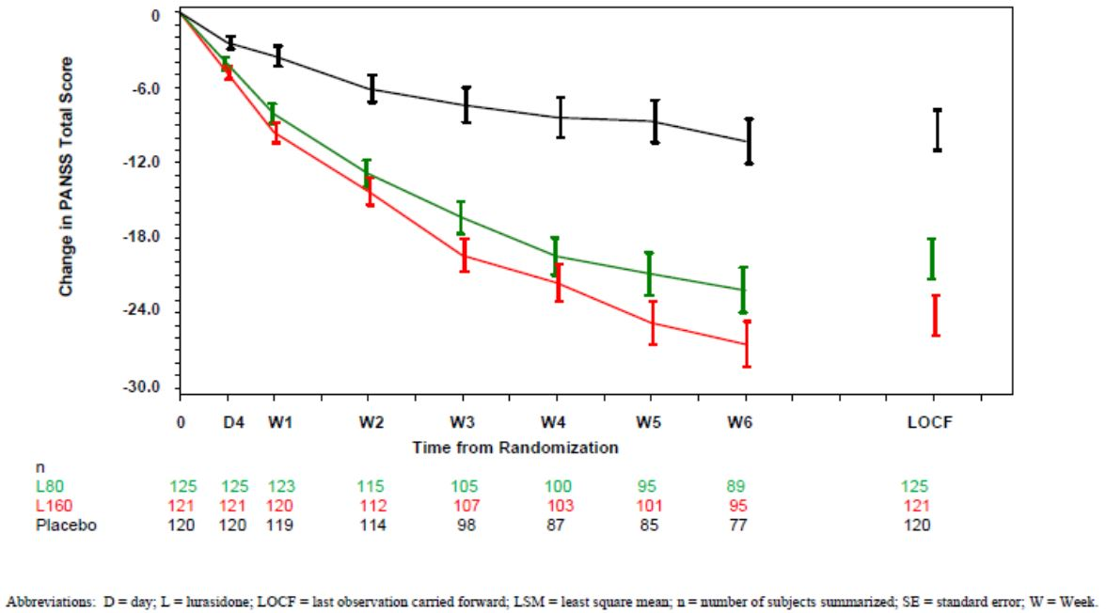
The superiority of quetiapine XR over placebo (difference of -17.5, 95%CI: -22.5,-12.4, p=0.001) confirmed assay sensitivity. Analysis, using ANCOVA, of the ITT population with the LOCF was supportive of the repeated measures analysis. Likewise, analysis of the PP population supported the primary analysis of the ITT population.

Results for other efficacy outcomes
Efficacy on the PANSS total score was demonstrated across subgroups of geographic regions except South America although there were too few subjects in this group to draw conclusions (Figure 7). Treatment effect was consistent in males and females. The effect was greater in Asian (Indian) subjects with a LS mean change from baseline in PANSS total score of -29.8, -33.2, -25.7 in the lurasidone 80 mg 160 mg and quetiapine XR 600 mg groups compared to -13.5 in the placebo group. Whites and Blacks had similar results. As there were so few subjects aged ≥55 years, analysis of this subgroup was not meaningful.
Figure 7: Treatment difference (LSM and 95% CI) in PANSS total score change from baseline to LOCF endpoint in subjects treated with lurasidone 80 mg, lurasidone 160 mg, or quetiapine XR 600 mg compared with placebo by geographic region (ITT population).
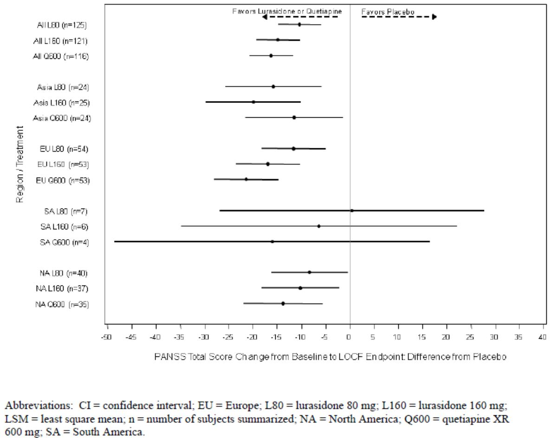
The proportion of subjects with a ≥30% improvement in PANSS total score from baseline to the LOCF endpoint was 50%, 63%, 71% and 30% in the lurasidone 80 mg, lurasidone 160 mg, quetiapine XR 600 mg and placebo groups, respectively. All three active groups had significantly better response rates than placebo (p≤0.002) (Table 10).
Table 10: PANSS total score responders (ITT population).
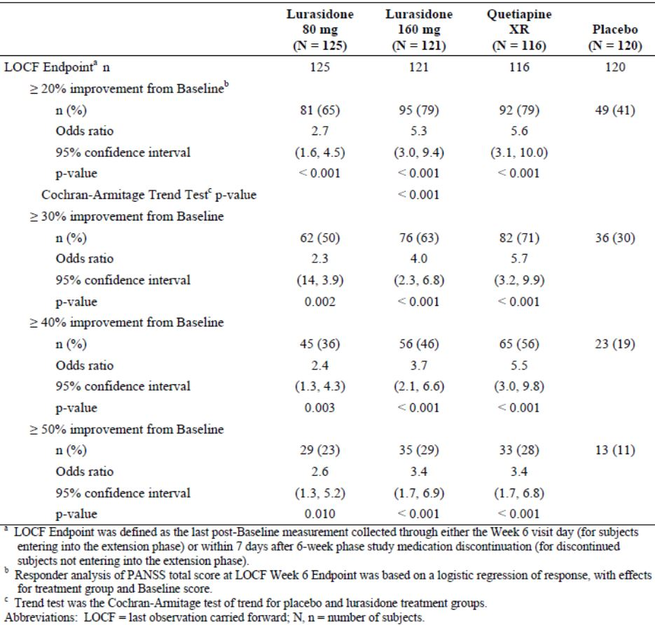
The superiority of effect over placebo with lurasidone 80 mg and lurasidone 160 mg and quetiapine XR 600 mg was seen for all the PANSS subscores (positive, negative, general psychopathology, excitability, cognition) and PANSS symptom factor scores.
The mean change from baseline to week 6 in the CGI-S score was -1.5, -1.7, -1.7 and 0.9 in the lurasidone 80 mg, lurasidone 160 mg, quetiapine XR 600 mg and placebo groups, respectively. Both lurasidone 80 mg and 160 were found to be statistically superior to placebo with mean difference of -0.6 (95% CI: -0.8, -0.3, adjusted p<0.001) and -0.8 (95% CI: -1.1, -0.5, adjusted p <0.001). The test for linear dose trend was significant (p<0.001) while there was no significant difference on pairwise comparison of 80 mg and 160 mg groups (p=0.057). The effect was notable from week 1 through to week 6 (Figure 8). Results were supported by the ANCOVA analysis as well as analysis of the PP population.
Figure 8: Change from baseline (LSM ± SE) in CGI-S in subjects treated with lurasidone 80 mg, lurasidone 160 mg, or placebo (ITT population).
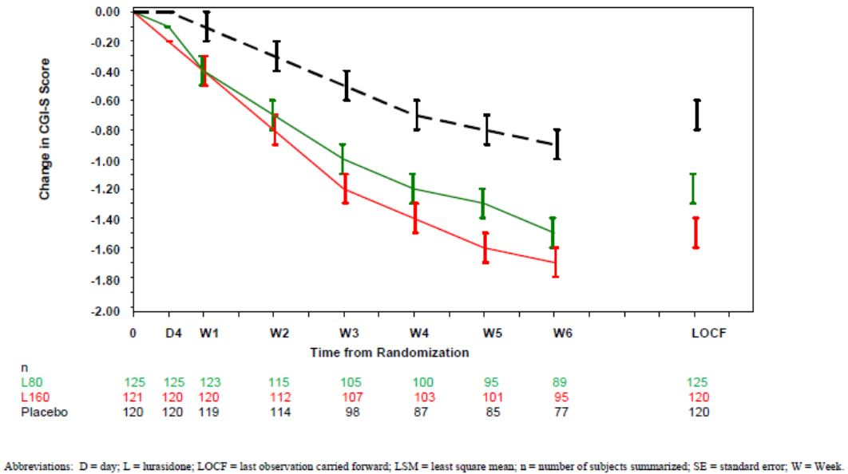
The LS mean change from baseline to week 6 in MADRS total score was -5.6, -5.4, -5.0 and -3.6 in the lurasidone 80 mg, lurasidone 160 mg, quetiapine XR 600 mg and placebo groups, respectively. All active groups had significantly greater reductions that the placebo group (p<0.027).
A statistically significant treatment difference compared to placebo was found for the 3 active groups on the Negative Symptom Assessment Scale (NSA-16). No significant treatment differences were found between the lurasidone and placebo groups on the Epworth Sleepiness Scales, while the quetiatine XR group had a significantly greater effect on daytime sleepiness compared to placebo (1.2 ± 0.5 SE, p = 0.022). Analysis of the Quality of Well-Being Scale Self Administered Version (QWB-SA) at week 6 found a significant treatment difference compared to placebo for all three active groups (p<0.03). Analysis of CogStage Computerised Cognitive Battery Composite Score showed some improvement in the lurasidone and placebo groups and no significant treatment differences.
Comment: The Sponsor stated that further reporting of the CogState analysis is to be undertaken and that there were a “large proportion of data that failed integrity checks”. Therefore no conclusions are drawn from these data presented.
The Medication Satisfaction Questionnaire (MSQ) found that there were significant increases in all groups (active and placebo) in subject satisfaction with the anti-psychotic medication with significantly greater effects in the active than placebo groups.

Results for the extension study D1050234
In the extension study, the proportion of subjects who relapsed was 21% and 27% of the lurasidone and quetiapine groups, respectively. The probability of relapse by month 12 was 23.7% and 33.6%, respectively. The relapse hazard ratio of lurasidone versus quetiapine XR was 0.728 (95% CI: 0.41, 1.29). As the upper bound of the 95% CI was less than the non-inferiority margin of 1.93, lurasidone met the criteria for non-inferiority to quetiapine XR. Analysis with baseline PANSS total score as a covariate was conducted and found similar results (HR=0.748, 95% CI: 0.421, 1.326). In addition, the Sponsor undertook several post-hoc sensitivity analyses and these were all supportive of the non-inferiority finding.
The change from baseline of the primary study (D1050233) up to day 42 (day 0 of the extension study) and to month 12 of the extension study in the mean PANSS total score was -30.0 and -34.6 in the lurasidone and -29.2 and -25.7 in the quetiapine groups. There were significant treatment differences from month 3 (-4.7, p=0.022) to month 12 (-8.9, p=0.006) when contrasting the lurasidone and quetiapine groups. In lurasidone treated subjects, the decrease in PANSS subscores from the primary study were either maintained or had a small additional decrease through to month 12 of the extension study. For quetiapine, the decrease during the core study was maintained in the extension with little evidence of continuing decrease.
During the extension study the CGI-S score remained stable after the decrease during the primary study: -1.9 at day 42 to -1.9 at month 12 in the lurasidone group and -1.8 at day 42 to -1.6 at month 12 in the quetiapine group. In lurasidone treated subjects the MADRS score remained stable over the 12 months (change from baseline of -6.2 at day 0 of the extension to – 6.0 at month 12) while there was an increase in the quetiapine group (-5.3 to -3.8). Negative symptoms (as measured by the NSA-16 score) were seen to continue to decrease from day 42 of the primary study to the end of the extension study in both the lurasidone and quetiapine groups: -11.0 to -14.7 and -10.4 to -15.0 respectively. There was no significant difference between treatment groups. Daytime sleepiness (measured by the ESS total score) remained relatively stable over the 12 months with no significant difference between groups. There was also no significant treatment difference between the groups in the subjects’ sense of well being as measured by the QWB-SA or in performance as measured by the UPSA-B total score. At month 12, the proportion of subjects extremely or very satisfied with current study medication was 61% in those who received lurasidone in the primary and extension study, 64% in the quetiapine group and 50% in those who received placebo in the primary and lurasidone in the extension study.
The CogState Computerised Cognitive Test Battery analysis found that overall 67 subjects had data that failed the integrity test. Data were analysed without these subjects and found no significant differences between groups in the composite score.
Comment: The Sponsor stated that due to failed integrity test the data must be interpreted with caution. Consequently the evaluator believes that no conclusions can be drawn.

Summary
In 482 chronic schizophrenic subjects with acute psychosis, both lurasidone 80 mg per day and 160 mg per day were found to be statistically superior to placebo in reducing the PANSS total score after 6 weeks of treatment. The treatment difference was -11.9 (95% CI: -16.9, -6.9 adjusted p <0.001) for lurasidone 80 mg and -16.2 (95% CI: -21.2, -11.2, adjusted p<0.001) for lurasidone 160 mg. A separation of effect was evident from day 4 through to week 6. Results were robust being supported by the ANCOVA analysis, analysis of the PP population and showing consistency across subgroups of gender and geographic region. Superiority of effect was also demonstrated on the CGI-S, the MADRS and the PANSS subscores. A positive effect with quetiapine confirmed assay sensitivity. While the effect with lurasidone 160 mg was numerically greater than the 80 mg dose, no significant difference was found between the doses on the PANSS total score or the CGI-S score.
In the controlled 12 month extension study (D1050234) of 292 subjects, the probability of relapse was 23.7% and 33.6% in the lurasidone and quetiapine groups, respectively. Lurasidone was found to be non-inferior to quetiapine with a HR of 0.728 (95% CI: 0.410, 1.295) which was within the non-inferiority margin of 1.93. Efficacy was maintained over the 12 months and in general comparable to quetiapine. The mean modal dose of lurasidone was 128 mg and of quetiapine was 638 mg.

Studies D1050006 and D1050196

Study design, objectives, locations and dates
D1050006 and D1050196 were phase II, double-blind, randomised, placebo-controlled, multicentre fixed dose studies, with the objectives of evaluating the efficacy, safety and tolerability of a 6-week treatment with lurasidone compared to placebo on hospitalised subjects with schizophrenia. The study design included a screening period of up to 14 days, followed by an inpatient single-blind washout period of 3-7 days, and then a 6 week double-blind treatment phase.
DI050006 assessed 40mg and 120mg of lurasidone as compared to placebo. It was a multicentre study at 15 sites in the US between 6 February 6 2001 and 18 December 2001. D1050196 assessed 80mg of lurasidone compared to placebo. It was a multicentre study at 22 sites in the US conducted between May 2004 and December 2004. Subjects who completed this study or discontinued due to lack of efficacy were eligible for a one year open-label extension study, D1050199.

Inclusion and exclusion criteria
Inclusion criteria for both studies were: DSM-IV criteria for a primary diagnosis of schizophrenia as established by the SCID-CV, (including disorganised, paranoid and undifferentiated subtypes), with an acute exacerbation of symptoms; minimum duration of illness of a year; aged 18 to 64 years; total BPRS score of > 42 (as extracted from the PANSS), with a score of at least 4 on 2 or more items on the positive symptom subcluster on the PANSS; CGI-S score of at least moderate (4) at screening; and females were non-lactating and non-pregnant.
Exclusion criteria were: DSM-IV diagnosis of schizophreniform disorder, schizoaffective disorder, or schizophrenia, residual subtype or catatonic subtype at screening; psychiatric hospitalisations (other than the hospitalisation at the time of screening) within the 3 months (D1050006) or 1 month (D1050196) prior to screening; duration of hospitalisation greater than the 3 weeks prior to screening; resistance to antipsychotic pharmacotherapy; evidence of chronic central nervous system disease; history of gastrointestinal, liver or kidney disease or other condition that would interfere with pharmacology of medications; active liver disease or evidence of active hepatitis; history of seropositivity for HIV or of diagnosed symptomatic HIV disease (AIDS); active, clinically significant cardiovascular disease; risk for suicide or injury to self or others; treatment with depot neuropleptics within 1 standard treatment cycle; history of substance abuse (excluding tobacco), or organic mental disorder within 3 months of study entry; 25% (D1050006) or 20% (D1050196) or greater decrease in total BPRS score, between washout and baseline visits; exposure to antidepressants or reversible monoamine oxidase (MAO) inhibitors within 1 week of entry (within 1 month for fluoxetine or irreversible MAO-inhibitors); electroconvulsive therapy (ECT) within 3 months; narrow-angle glaucoma, cataracts or retinal disease.
D1050006 had the additional inclusion criteria: ability to remain off antipsychotic medication for a minimum of 3 days; ratings of normal to minimal on individual items of the Simpson-Angus Scale (SAS) (≤2 acceptable) and the Abnormal Involuntary Movement Scale (AIMS) (≤3 acceptable) at screening. D1050196 excluded subjects with individual item scores of ≥2 on any SAS items or ≥3 on any AIMS items.

Study treatments
In D1050006, lurasidone at fixed doses of 40mg/day or 120mg/day or placebo was administered as tablets orally once a day over 6 weeks. Lurasidone 10 mg tablets were used therefore all subjects took 12 tablets per day. Subjects randomised to the placebo and 40 mg group began these respective treatments on Day 1 and remained on them for the duration of the study. Subjects randomised to the 120mg group were force titrated from 80mg to 120mg within the first 6 days. If titration was not possible, subjects were discontinued.
In D1050196, lurasidone at fixed doses of 80 mg or placebo was administered as two 40 mg tablets orally once daily for 6 weeks. In both studies medication was taken in the morning following breakfast. Non-compliance, as assessed by returned tablet count, was defined as <80% or >120%.

Efficacy variables and outcomes
The main efficacy variables were the BPRS, PANSS, CGI and MADRS (in D1050196 only). In contrast to the previous 3 placebo-controlled studies which assessed the PANSS total score, in these two studies the primary efficacy outcome was the reduction from baseline in total score of the BPRS.
Other efficacy outcomes included:
- Change from baseline to each assessment time point in BPRS scores.
- Change from baseline to endpoint in the PANSS, CGI-S and in D1050006, CGI-I scores.
- Proportion of responders, classified as subjects with a decrease of at least 20% from baseline in BPRS scores or a CGI-I score of 1 or 2, at each assessment time point.
In D1050196:
- change from baseline to each visit in scores for PANSS subscales (Positive and Negative Syndrome Subscales, General psychopathology Subscale and Cognition Subscale).
- Change from baseline to each visit in MADRS.

Randomisation and blinding methods
In D1050006, subjects were randomised in a 1:1:1 ratio to one of either lurasidone 40 mg daily, lurasidone 120 mg daily, or placebo daily. Study drug was packaged to provide 12 tablets once daily to each subject. In D1050196, subjects were randomised in a 1:1 ratio to either lurasidone 80 mg daily or matching placebo daily. Lurasidone 40 mg tablets were used and all subjects took 2 tablets each day.

Analysis populations
ITT populations were analysed in both studies, which included all randomised subjects who received at least 1 target dose of study medication (ie 0, 40 or 120mg in D1050006 and 80 mg in D1050196) and had at least 1 post-baseline efficacy evaluation during the double-blind treatment period from day 3 or after.

Sample size
In D1050006, it was estimated that detection of a standardised treatment difference of 0.73 between one lurasidone treatment group and the placebo group at 90% power at a two sided significance level of 0.05 would require at least 40 patients in each of the 3 treatment groups. Allowing for a 10% drop out rate, a sample of 132 (44 per group) was required.
In D1050196, based on the 2-sample t-test and assuming a standard deviation for change in BPRS of 10.5, 72 subjects per group provided 92% power to detect a 6 point difference between lurasidone and placebo. Allowing for a 10% drop out rate 80 subjects per group were required.

Statistical methods
In both studies, an analysis of covariance (ANCOVA) model was used for analysis of the primary efficacy outcome, the change from baseline in the BPRS at Day 42 (LOCF), with centre, treatment, centre-by-treatment interaction, and baseline BPRS. The centre-by-treatment interaction was dropped from the model if it was not statistically significant (p>O.1O). The centre-by-treatment interaction term was not used for the additional time points analysed. In D1050196, this analysis was also applied to the ITT population using the observed data slotted into appropriate windows (OC ITT).
In D1050006, pairwise comparisons were performed using a 2-sided, 0.050 Dunnett’s t-test and results were summarised using least square means. In D1050196, a Cochran-Mantel-Haenszel test was used to compare proportion of responders and non-responders, and a sensitivity analysis was conducted using 20% incremental decreases, comparing responders and non-responders.

Participant flow
In D1050006, 149 subjects were randomised to study medication, with 50 each to the placebo and 40mg dose, and 49 to the 120mg dose. Of these, 98 (65.8%) discontinued and 51 (34.2) completed. In the ITT population there were 49 (98%), 49 (98%) and 47 (95.9%) subjects in the placebo, 40 mg and 120 mg groups, respectively. There were 20 (40.8%) subjects who completed in the 120 mg group, compared to 15 (30%) and 16 (32%) in the placebo and 40 mg groups respectively. Withdrawal of consent was high in the trial at 26.0%, 26.5% and 22.0% in the lurasidone 40 mg, 120 mg and placebo groups, respectively. A higher proportion of subjects discontinued for lack of efficacy in the placebo group (32%) compared to the 40 mg and 120 mg lurasidone groups (22% and 12.2%).
Comment: In study D1050006 there was a very high rate of discontinuation (65.8%) which was seen across all groups (70%, 68% and 59% in the placebo, lurasidone 40 and lurasidone 120 mg groups, respectively). This rate, approximately 30 to 40% across treatment groups, is higher than seen in previously discussed studies.
In D1050196, 180 subjects were randomised and had study drugs administered, with 90 in each of the placebo and 80 mg groups. All 180 subjects formed the safety and ITT populations of which 43 (48%) from the placebo group and 38 (42%) from the 80 mg group discontinued. Lack of efficacy was the most common reason for discontinuation in the placebo group (32.2% compared to 10% of the 80 mg group), while withdrawal of consent in most common reason for discontinuation in the 80 mg group (20% versus 10% placebo group).

Major protocol violations/deviations
In D1050006, 2% of subjects had protocol violations, including 4% of placebo subjects and 4% of 40mg group and none in the 120 mg group. In addition, it was reported that 16 (10.7%) protocol waivers were granted for inclusion/exclusion criteria deviation. Mean compliance was 98.9%, 97.5%, and 99.5% for the placebo, lurasidone 40 mg and 120 mg groups, respectively.
In D1050196, the rate of major protocol violations was 16.7% and 14.4% in the lurasidone and placebo groups, respectively. The most common was the use of prohibited medication during the study and taking an improper dose of an allowed medication. Compliance was acceptable during the inpatient phase (99.2% and 99.6%) and outpatient phase (92.3% and 88.2% in the lurasidone and placebo groups, respectively).

Baseline data
In each study, demographics were similar between groups. Subjects were predominantly males, mean age of around 40 years, largely Caucasian and Blacks with small proportions of other races. There was no significant difference in height, weight, BMI and tobacco usage between groups within each study. DSM-IV Axis diagnoses were similar also, with a majority of paranoid type classification. Mean scores for efficacy assessments were similar at baseline between groups for each study.
In D1050006, a history of prior illness was common at 96% in subjects across all groups, with generally similar frequencies of types of illnesses between groups, except for musculoskeletal and connective tissue disorders, which were more common in the 120 mg group. Of concomitant medications taken, benzodiazepine derivatives were most commonly taken by 82.0-90.0% of subjects, and antipsychotics were reported by 40% of the placebo group, 52% of the lurasidone 40 mg and 40.8% of the lurasidone 120 mg groups.
Comment: In D1050006, there was a high rate of concomitant use of antipsychotics. Concomitant antipsychotics were stated to be a prohibited medication, however these cases did not appear to be included as protocol violations. The Sponsor reported that in 3 placebo subjects and 2 lurasidone subjects the antipsychotic was only taken on the last day of the study.
In D1050196, all subjects reported prior illness, which were of similar frequency between groups, other than an increased prevalence of infections and infestations in the lurasidone versus placebo group (26.7% versus 14.4%). Benzodiazepine derivatives were most common concomitant medications (85.6-87.7%). In the lurasidone group, 12.2% of subjects required anti Parkinsonian drugs, compared to 8.9% of placebo subjects.

Results for the primary efficacy outcome

D1050006
The least square (LS) mean change in BPRS score from baseline to Day 42 LOCF endpoint was -9.4, -11 and -3.8 in the lurasidone 40 mg, lurasidone 120 mg and placebo group, respectively. Using ANCOVA, both doses had a significantly greater response than placebo with a LS mean difference of -5.6 (95% CI: - 9.8, -1.4, p=0.018) and -6.7 (95% CI: -11, -2.5, p=0.004) for the 40mg and 120mg groups, respectively. Results were comparable in the Day 42 LOCF-7 analysis.

D1050196
The LS mean change in BPRS score from baseline at Day 42 LOCF was -4.2 and -8.9 in the placebo and lurasidone 80 mg groups respectively, and the LS mean difference (-4.68, 95% CI: -8.3,-1.1) was statistically significant (p=0.012).

Results for other efficacy outcomes

D1050006
At baseline the mean PANSS total score was 92.8, 89.6 and 93.3 in the lurasidone 40 mg, 120 mg and placebo groups, respectively. The LS mean change in PANSS score from baseline to Day 42 LOCF endpoint was -14, -17 and -6.2 for the lurasidone 40 mg, lurasidone 120 mg and placebo groups, respectively. While the higher lurasidone dose of 120 mg had a significantly better response than placebo (LS mean difference -11, 95% CI: -18, -3.3, p=0.009), the lower dose of 40 mg was not significantly better (LS mean difference -7.6, 95% CI: -15, -0.3, p=0.076). A significant difference over placebo was found for both dose groups on the change from baseline (LOCF) in the CGI-S and CGI-I score.

D1050196
In D1050196, the analysis of the ITT population without the LOCF found the LS mean BPRS score improved by -9.7 and -14.7 for the placebo and lurasidone groups respectively, with a LS mean difference of -5.03 (95% CI: -9.3, -0.7, p=0.023). The mean PANSS total score improved from baseline to endpoint for both groups in the ITT with LOCF, with LS means of -5.5 and -14.1 for the placebo and lurasidone groups respectively and a LS mean difference of -8.57 (95% CI: -14.4, -2.8, p=0.004).
In the ITT population with LOCF, there were improvements from baseline to endpoint for both groups in the mean scores for: PANSS Positive Syndrome Subscale, PANSS Negative Syndrome Subscale, PANSS General Psychopathology Subscale, PANSS Cognitive Subscale, CGI-S and MADRS. The difference between lurasidone and placebo for these scores was statistically significant.
In the lurasidone group, the mean scores for BPRS, PANSS total and PANSS subscales showed steady improvement to day 21 then stabilised and were maintained until the end of the study. Consistent with improved efficacy scores, the mean serum concentration of lurasidone was higher on days 21 and 42 than Day 7, and similar at Days 21 and 42.
In D1050196 at day 42, approximately half (48.9%) of the subjects in the lurasidone group had a decrease in BPRS score of >20% from baseline compared with 35.6% of subjects in the placebo group, this was not statistically significant (p=0.072).

Summary
Study D1050006 and D1050196 were phase II, randomised, placebo-controlled 6 week studies in 149 and 180 subjects, respectively, with an acute exacerbation of chronic schizophrenia. Study D1050006 assessed lurasidone doses of 40 mg and 120 mg and D1050196 assessed 80 mg. Both studies had a primary efficacy endpoint of change from baseline to endpoint with LOCF in the BPRS analysed using ANCOVA. A significantly better response on the BPRS was found with lurasidone 80 mg over placebo and these results were supported by analysis of secondary efficacy endpoints including PANSS total score and subscores and GCI-S. Similarly, the 40 mg and 120 mg doses had a significant separation from placebo on the BPRS, however only the 120 mg dose had a significant improvement on the secondary endpoint of PANSS total score.
Comment: D1050006 was a phase II trial with small sample size (approximately 50 subjects per group) and was noted to have a very high discontinuation rate of 68%, 59% and 70% in the lurasidone 40 mg, 120 mg and placebo groups, respectively. Whilst it is expected in schizophrenia trials there may be a notable discontinuation rate, the proportion seen in D1050006 was higher than the 30-40% seen in 3 previously-discussed trials. The baseline PANSS total score (89.6 to 93.3) in this study was no higher than in the other main efficacy studies indicating the subjects did not have more severe disease. There was also a high rate of concomitant use of antipsychotics (40-50%) which were prohibited in the study design, but not reported as protocol violations. For these reasons the evaluator does not agree with the Sponsor that this study provides “pivotal” efficacy data for the 40 mg or 120 mg doses and believes the positive data are only supportive.

Other efficacy studies

Study D1050049

Design and methods
D1050049 was a phase IIb, 6 week, double-blind, randomised, fixed dose parallel group study of three dose levels of lurasidone compared to placebo and haloperidol in schizophrenic patients with an acute exacerbation. The study was conducted in 2002-2003 at 33 sites in the US. The primary objective was assessment of change from baseline to study end in the BPRS total score. Secondary efficacy variables were PANSS total score, CGI-S score and MADRS. After a 14 day screening period and 3 to 4 day inpatient placebo washout period, subjects were randomised to one of 5 groups, in a 1:1:1:1:1 ratio, to 6 weeks treatment with lurasidone 20 mg, 40 mg, 80 mg, placebo or haloperidol 10 mg. Subjects remained hospitalised for the first 3 weeks of treatment.
Subjects were 18 to 64 years with schizophrenia (DSM-IV criteria) for at least one year. They needed to have been hospitalised within 3 weeks of screening, with BPRS ≥42, CGI-S ≥4 and not considered treatment resistant. Exclusion criteria were similar to previous studies.
A double dummy design was used with placebo lurasidone tablets and placebo capsules to match over-encapsulated haloperidol tablets. All subjects took 4 tablets and 2 capsules once a day in the morning after breakfast.
Analysis was using an ANCOVA model, with centre, treatment, centre-by-treatment interaction and baseline BPRS score as a covariates, in the ITT population with LOCF. Assuming an expected treated difference of 6.6 points on the BPRS, with a standard deviation of 10.5, a sample of at least 60 subjects per group gave the study an 85% power to detect a treatment difference of 0.63 between a single lurasidone group and placebo (α=0.019 adjusted). Assuming 10% attrition to day 3, as sample of 330 randomised subjects was selected.

Results
There were 356 subjects randomised, 353 received study drug (67 to 72 subjects in each group). The discontinuation rate was high (56-62% in the lurasidone groups, 59% in the haloperidol group and 50% in the placebo group) and only 151 (42%) subjects completed the study. The most common reason for discontinuation was lack of efficacy with rates higher in the lower lurasidone dose groups. There were 9 subjects with deviations on inclusion/exclusion criteria.
Comment: Further details on protocol deviations were not reported.
Mean treatment exposure duration was similar between groups. Treatment compliance while an inpatient was high (98-99.8%), however it was noted to vary widely during the outpatient period (93.2%, 156.7%, 89.0%, 124.5%, and 96.4% for the placebo, lurasidone 20 mg, 40 mg, 80 mg and haloperidol groups, respectively). Subjects were generally male with a mean age of approximately 40 years. The groups were not balanced on race with a higher proportion of Blacks and fewer Caucasians in the lurasidone 80 mg group. Baseline mean BPRS, PANSS and CGI-S scores were similar between groups. Concomitant medication use showed a higher rate of benzodiazepine use in the lurasidone (83-93%) and placebo groups (85%) than in the haloperidol group (78%).
The LS mean change from baseline to day 42 (LOCF) in the BPRS score was -7.9, -5.0, -5.2, -8.0 and -9.8 in the placebo, lurasidone 20 mg, 40 mg, 80 mg and haloperidol groups, respectively. No active group was found to have a statistically significant difference in effect compared to placebo. Analysis of observed cases at study endpoint also found no significant differences between active and placebo. Similar negative results were seen on analysis of the PANSS, CGI-S and MADRS scores.
Comment: This trial had a high discontinuation rate, some imbalances between groups, variable compliance and a notable response in the placebo group. It failed to demonstrate any statistically significant separation of effect between haloperidol and placebo, or between any lurasidone dose and placebo, on the primary and secondary efficacy endpoints. The Sponsor stated that “given this lack of sensitivity, this trial is considered to have failed from an efficacy standpoint”. The evaluator agrees with this conclusion.

Study D1001002

Design and methods
D1001002 was a Phase III, randomised, placebo and active-controlled, fixed-dose, double-blind, parallel-group study of lurasidone 40 mg or 80 mg in hospitalised patients with schizophrenia. It was conducted in 92 sites in Japan, Korea and Taiwan between June 2008 and April 2010. The primary efficacy outcome was the change from baseline in the PANSS total score at week 6. Secondary efficacy measures were the PANSS subscale scores, CGI-S score and proportion of responders by PANSS total scores. After a 14 day screening period and a 3-7 day single-blind placebo washout period, subjects were randomised to one of four groups in a 2:2:2:1 ratio, to 6 weeks of treatment with lurasidone 40 mg od, lurasidone 80 mg od, placebo or risperidone 4 mg (2m bid). Subjects remained hospitalised for the duration of treatment.
Subjects were 18 to 75 years of age with schizophrenia by DSM-IV criteria, with a PANSS total score of at least 70 and a score of 4 or more in 1 or more items of the 7 PANSS positive symptom subscale at screening, and not considered treatment resistant. Exclusion criteria were similar to previous studies.
A double-dummy method was used with placebo tablets to match lurasidone and risperidone tablets. All subjects took six tablets in the morning and two in the evening. Placebo and lurasidone 40 mg were commenced at target doses, while lurasidone 80 mg and risperidone 4 mg were uptitrated over 2 weeks from 40 mg and 2 mg, respectively.
Superiority of lurasidone over placebo, based on the primary efficacy variable of change in PANSS total score from baseline to week 6 (LOCF), was tested using the maximum contrast method at a one sided significance level of 2.5%. The risperidone group was excluded from the analysis. The FAS population was used, defined as randomised subjects who received at least 1 dose of study medication and who had at least one post-baseline PANSS assessment.
Assuming an expected treatment difference on the PANSS total score between lurasidone and placebo of -6.0 points and a standard deviation of 18, a sample size of 114 subjects per group was required to establish superiority to placebo at a one-sided significance level of 2.5% with a power of 80%. Allowing for excluded subjects, the overall target sample size was set at 441 subjects (126 in each of the lurasidone and placebo groups and 63 in the risperidone group).

Results
There were 460 subjects randomised, 455 who received study treatment with 133, 131, 131, and 65 in the placebo, lurasidone 40 mg, lurasidone 80mg and risperiodone 4 mg groups, respectively. The discontinuation rate was lower in the risperidone group (21.5%) than in the lurasidone (31.5-36.6%) or placebo (37.1%) groups. A total of 304 (66.8%) subjects completed the study. The most common reason for discontinuation in all groups was aggravation of psychiatric symptoms, occurring in 10.8% to 13.0% in the active treatment groups compared to 18.2% in the placebo group. The most common protocol deviation was the use of prohibited medication (antipsychotics, antiparkinson drugs, psychotropic drugs or hypnotic drugs) in all treatment groups. Treatment compliance was high with only 3 subjects (lurasidone 80 mg) deemed non-compliant. There were 447 (97.2%) subjects in the FAS and 414 (90%) in the PP set.
Baseline demographics were relatively well balanced between groups. Subjects were predominantly male (59%) with a mean age of 45.6 years. There were 38 subjects aged ≥65 years. There were differences in the populations by country with a higher mean age and longer disease duration in Japan compared to Korea and Taiwan, as well as a lower proportion with baseline PANSS total score <80 in Japan compared to Taiwan (13.6% versus 40.8%). Nevertheless, the baseline PANSS total score was balanced between groups.
In the FAS, the LS mean change from baseline to the LOCF endpoint in the PANSS total score was -2.5, -6.1, -4.3 and -7.1 in the placebo, lurasidone 40 mg, 80 mg and risperidone groups, respectively. The LS mean treatment differences versus placebo were -3.5, -1.8 and -4.6 in the respective groups none of which were statistically significant. Using the maximum contrast method with adjustment for multiplicity, results showed no superiority of either dose of lurasidone over placebo (adjusted p=0.145). Analysis using the repeated measures model as well as analysis of the PPS all supported the primary analysis.
Analysis by country also failed to find any statistically significant separation from placebo for either lurasidone or risperidone, apart from lurasidone 40 mg dose in Japan (LS mean difference -7.9, 95% CI: -14.8, -1.0, p=0.025). Observed values in the PANSS total scores decreased from week 1 to 6 in all groups (Figure 9). The CGI-S scores for both the lurasidone 40 mg and risperidone groups were found to separate significantly from placebo while this was not the case for lurasidone 80 mg. No significant differences were found in the odds ratio for the proportion of responders (≥20% improvement in PANSS total score) in the lurasidone or risperidone groups versus placebo (28.7% in placebo group versus 31.8-35.9% responders in active treatment groups). Subgroup analyses of change from baseline in PANSS total and CGI-S scores by sex, age, prior antipsychotic use, duration of illness, DSM-IV disease state, baseline PANSS total and subscale scores and by country of enrolment, did not reveal any consistent significant differences between active treatment and placebo groups.
Figure 9: PANSS total score: observed values (FAS).
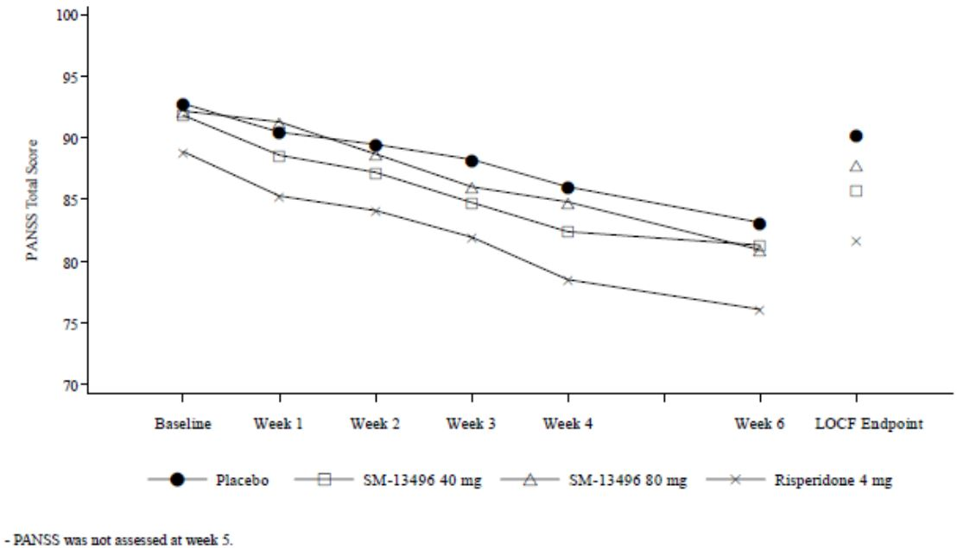

Summary
Study D1001002 was a randomised, placebo-controlled, 6 week, phase III study in 447 subjects with schizophrenia (PANSS total score >70) conducted in Asia. Neither the lurasidone 40 mg, lurasidone 80 mg or the active control risperidone 4 mg were found to result in a significant treatment difference over placebo as measured by the mean change from baseline to week 6 (LOCF) in PANSS total score. The negative findings were supported by sensitivity analyses and in general also by results on the secondary endpoints.
Comment: The Sponsor deemed this study to have “failed” and the evaluator agrees.

Study D1050289 and D1050290

Design and methods
D1050289 was a randomised, open-label, parallel-group, 6 week, phase III study evaluating the effectiveness of switching clinically stable, but symptomatic, outpatients with schizophrenia or schizoaffective disorder to lurasidone over a 6 week period. The study was conducted between June 2010 and May 2011 at 28 sites in the US.
The primary objective of the study was to evaluate effectiveness as assessed by time to treatment failure. Treatment failure was defined as discontinuation of the study due to insufficient clinical response, exacerbation of underlying schizophrenia or an adverse event. Safety evaluation was the secondary objective. Three different commencement regimens of lurasidone were assessed.
Following a 14 day screening period, subjects who continued to meet entry criteria were randomly assigned (via an IVRS) to 1 of 3 open label lurasidone arms: lurasidone 40 mg/day for 14 days, followed by flexible dosing between 40 and 120 mg/day for 4 weeks; lurasidone 40 mg/day for 7 days and then 80 mg/day for 7 days, followed by flexible dosing between 40 and 120 mg/day for 4 weeks; and lurasidone 80 mg/day for 14 days, followed by flexible dosing between 40 and 120 mg/day for 4 weeks. Subjects were stratified on whether their antipsychotic medication was “sedating” (olanzapine or quetiapine) or “non-sedating” (all other antipsychotics). The dose of this medication was halved by day 7 and discontinued by day 14. Subjects who completed the primary study could continue in a 6 month open label extension study D1050290. The primary objective of the extension study was safety and tolerability, with long term efficacy being a secondary objective.
Inclusion criteria were: adults with schizophrenia or schizoaffective disorder who were candidates for switching medication due to insufficient efficacy and/or safety or tolerability reasons; clinically stable (CGI-S ≤4, pre-switch anti-psychotic had been stable of 28 days and no exacerbation of disease for 8 weeks); not pregnant or planning pregnancy; and in good health. During the 4 weeks prior to screening the total daily dose of pre-switch anti-psychotic medication must not have exceeded the following doses: aripiprazole 30 mg, asenapine 20 mg, iloperidone 24 mg, olanzapine 20 mg, paliperidone 12 mg, quetiapine 800 mg, risperidone 8 mg, ziprasidone 160 mg, or haloperidol 12 mg/d equivalent. Subjects on 2 antipsychotics needed to cease the secondary one prior to randomisation. Exclusion criteria were similar to previous studies.
Medication was taken once a day in the evening with food or withing 30 minutes of eating. Subjects were allowed treatment with benzodiazepines, mood stabilisers and antidepressants as necessary. Subjects entering the extension study continued on the same dose taken at the primary study endpoint. Dose adjustment (40, 80 or 120 mg per day) was allowed if clinically appropriate.
Effectiveness analysis was conducted on the safety population. Time to treatment failure was summarised by descriptive statistics. The Sponsor stated that, assuming 20% of lurasidone subjects would experience treatment failure, a group size of 80 (total of 240) allowed the 95% CI for treatment failure to lie within 11 and 29%. Post-hoc analyses were carried out on the change from baseline in the PANSS, CGI-S and CDSS.
Comment: the sample size calculation did not address the study’s power, however, as the analysis is only descriptive, formal calculations would not be required. The results also show a much lower treatment failure rate (7.9%) than the anticipated rate of 20%.

Results
There were 244 subjects randomised and 198 (81.1%) completed the study. Four randomised subjects did not receive study medication. About one third of subjects (36.1%) were in the sedating anti-psychotic group pre-switch and two thirds in the non-sedating group. There were fewer subjects completing the study in the sedating compared with the non-sedating group (73.9% versus 85.3%). The main reasons for premature discontinuation were AEs (6.6%), consent withdrawal (4.1%) and loss to follow up (3.7%). The rate of significant protocol deviations was high (35.2%) but similar between groups (33.8% to 37.8%). The most frequent deviations were positive test for substance abuse (17.2%) and non-compliance with study drug (15.2%). The rate of non-compliance was similar between groups (12.6 to 17.3%) and most non-compliance was taking >125% of allocated dose. The safety population of 240 subjects was used for efficacy analysis.
Treatment groups were balanced. The mean age was 43.9 years (range 18 to 66 years), 65% were male, most subjects were Black (62.9%) or Caucasian (33.3%). Subjects had mainly paranoid-type schizophrenia (52.1%) and schizoaffective disorder (37.1%) and 41.7% had had 4 or more prior hospitalisations for schizophrenia. The most frequent anti-psychotic drugs used at baseline were risperidone (22.5%), quetipaine (29.2%), aripiprazole (19.6%), ziprasidone (11.7%) and olanzepine (10.0%).
The overall rate of discontinuation for any reason in the study was 17.5%. The overall treatment failure rate was 7.9% with rates of 6.9%, 9.2% and 7.4% in the lurasidone 40/40, 40/80 and 80/80 treatment groups, respectively. Treatment failure was most likely due to an AE (6.7%) rather than insufficient clinical response (1.3%) and in the lurasidone 40/40 mg group 4 of the 5 AEs leading to treatment failure were exacerbation of underlying disease. The median time to treatment failure was 21 days (95% CI: 7.0, 25.0) and this was similar between groups.
The treatment failure rate was higher in subjects on pre-switch sedating than non-sedating anti-psychotics (11.6% versus 5.8%), but the median time to treatment failure was similar (20.5 versus 21.0 days) and a post-hoc Kaplan Meier analysis found no significant difference (p=0.1008). Post-hoc analyses reported that the mean PANSS total score decreased significantly from baseline to LOCF endpoint (-5.8, SD 10.5). The CGI-S score remained stable with a mean change from baseline to LOCF endpoint of -0.3 (SD 0.7). A decrease in mean depression score (CDSS) was also noted (-1.3, SD 3.7).

Extension study
In D1050290, 149 subjects were enrolled, 148 treated and 98 (65.8%) completed 6 months of treatment. In the third of subjects (34.2%) who discontinued, the most frequent reasons were consent withdrawal (12.1%), adverse event (11.4% included 6% who had exacerbation of underlying disease) and lost to follow up (6.0%). The rate of significant protocol deviations was high (50.3%) with the most frequent being non-compliance (26.2%, generally taking >125% of dose), use of prohibited medication (22.8%) and positive test for substance abuse (18.1%).
The mean PANSS total score was 67.9 at the primary study baseline and 60.1 at the extension study baseline. At month 6 of the extension study, the mean change from primary study baseline was -11.7 (SD 10.9) and from extension study baseline was -3.0 (SD 7.8). The mean CGI-S score at core study baseline was 3.62 and at extension study baseline was 3.21. After 6 months, the mean decrease during the extension study was -0.14 (SD 0.50) and at LOCF endpoint was 0.02 (SD 0.63). Similarly the CDSS decreased during the core study (-1.4, SD 3.4, at week 6) and then during the extension study had a small additional decrease (-0.5, SD 2.4). The rate of discontinuation due to treatment failure was 12.8% with a median time to discontinuation of 58 days (95% CI: 22, 86).

Summary
In this 6 week, open label, uncontrolled study, 240 subjects with stable but symptomatic schizophrenia or schizoaffective disorder were switched to lurasidone. The overall study discontinuation rate was 17.5% and the treatment failure rate was low at 7.9% with a median time to failure of 21 days (95% CI: 7, 25). While direct comparison between treatment groups was not possible due to the study design, it appeared that dose initiation at 40 or 80 mg did not affect efficacy as measured by treatment failure rates although those that did not titrate to 80 mg at week 2 appeared to have a higher rate of failure due to exacerbation of underlying disease. In the extension study, one third of subjects discontinued prematurely and in those who completed 6 months of open label treatment with lurasidone, efficacy was maintained and discontinuation due to treatment failure was reported in 13% of subjects.

Other long term uncontrolled studies: D1001036, D1001048, D1050174, D1050199

D1001036
D1001036 was a 44 week, uncontrolled, open label study of flexibly dosed lurasidone in Japanese schizophrenic subjects who completed the 8 week, phase II study D1001001. It was conducted between August 2005 and June 2007 and the CSR was a translation from Japanese. The initial dose was 40 mg per day and could be adjusted in increments of 20 mg within the range of 20-120 mg per day. Other anti-psychotic drugs were prohibited. The primary efficacy endpoints were the change from core study baseline to week 52 in BPRS and PANSS total scores.
The study included 102 subjects, 3 did not receive study drug, and 63 (61.7%) completed the study. In the 35.3% of subject who prematurely discontinued, most (23.5%) were due to exacerbation of underlying disease. The FAS included 99 subjects. From a baseline of 85.5 in the primary study D1001001, the PANSS total score decreased to 74.2 at the end of dosing (mean change of -12.3, 95% CI: -16.6, -8.0). A box plot of PANSS total scores over time shows the maintenance of efficacy from week 8 to week 52 (Figure 10). The mean change in BPRS total score was also maintained during the extension study.
Figure 10: Change in PANSS total scores (D1001036).
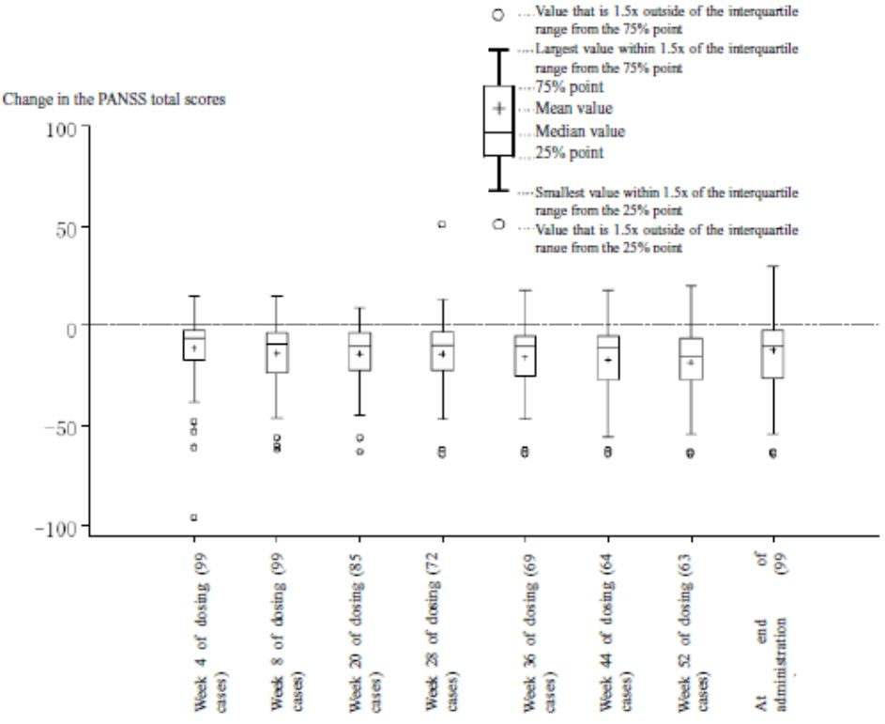

D1001048
D1001048 was also an uncontrolled, open label, flexible dose study of lurasidone in Japanese schizophrenic patients. This study had a 52 week duration and the dose was the same as D1001036. The study was conducted between January 2007 and April 2009. Subjects were included if experiencing an initial episode, a relapse, or on treatment, with any of the following symptoms (hallucinations, delusions, loss of initiative, blunted affect, neurosis-like disorder or depressed state).
There were 186 subjects included, 182 received study medication and 80 (44%) subjects completed the study. Of the 102 (56%) subjects who prematurely discontinued the most common reason was aggravation of underlying disease (24%), adverse event (18%) and other (14%). The FAS included 174 subjects with 167 in the PPS. In the FAS, the mean baseline PANSS score was 78.9 (SD 20.5) with a range of 35 to 142. The rate of concomitant antipsychotic use was 11.5%.
In the FAS, from the baseline mean score of 78.9, the PANSS total score decreased 5.7 (SD 17.2, 95% CI: -8.3, -3.1) to the end of dosing (LOCF). The mean change in BPRS total score was -3.4 (95% CI: -5.0, -1.9). Similar results were seen in the PPS. The reduction in PANSS total score continued from week 4 to week 28 and then was maintained (Figure 11). Results were similar for BPRS total score.
Figure 11: Change in PANSS total scores (D1001048).
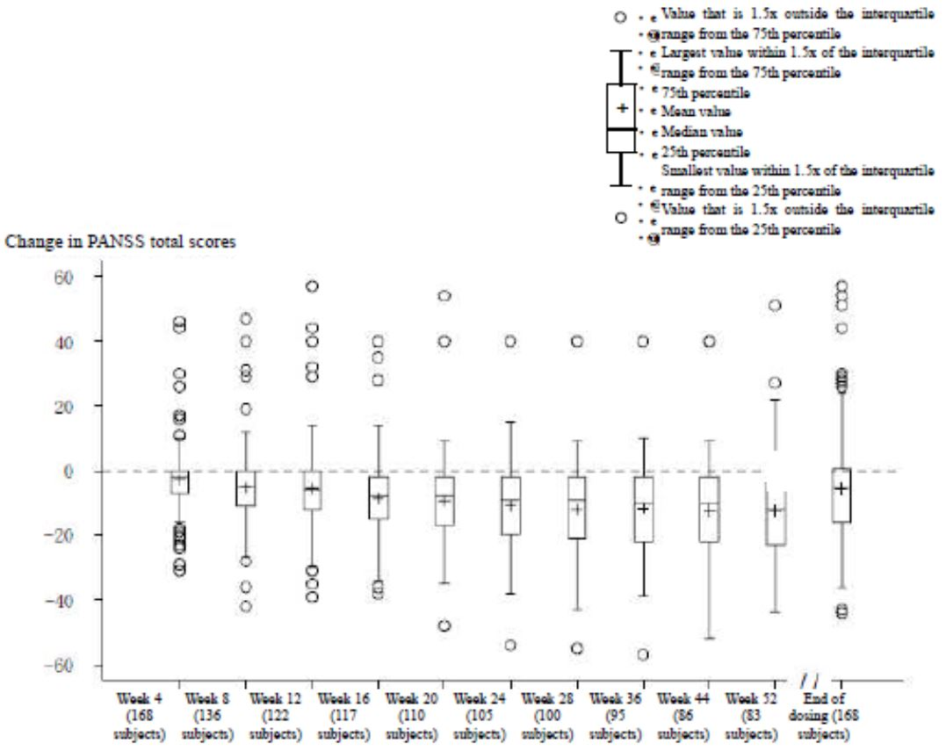

D1050174
D1050174 was an open label, dose-blinded, 6 month study of the safety and tolerability of 3 dose levels of lurasidone (20 mg, 40 mg and 60 mg) in schizophrenic patients who had successfully completed study D1050049. It was conducted in the US at 26 sites between October 2002 and November 2004. Subjects continued on the previous lurasidone dose from study D1050049. If on haloperidol or placebo they were randomly assigned to one of the 3 lurasidone doses. There were 98 subjects enrolled with 32, 33 and 33 assigned to the lurasidone 20, 40 and 80 mg doses, respectively. The overall completion rate was 43.9%. The main reasons for discontinuation were adverse events (17.3%) and consent withdrawal (12.2%). There were no efficacy assessments in the study.

D1050199
D1050199 was a phase II, open label, multicentre, 12 month study of lurasidone 80 mg in 61 subjects with schizophrenia who successfully completed study D1050196. It was conducted between July 2004 and October 2005. The primary objective of the study was safety and tolerability and the study did not have any efficacy endpoints. There was a high discontinuation rate with only seven (11.5%) subjects completing the one year study.

Safety studies

D1050237 and D1050237E

D1050237
D1050237 was a phase III, randomised, double-blind, active comparator-controlled, flexible dose, 12 month study of lurasidone compared to risperidone in 629 subjects with stable chronic schizophrenia or schizoaffective disorder. Efficacy objectives were secondary and included relapse rates and change from baseline in PANSS total score, CGI-S and MADRS. lurasidone doses were between 40 and 120 mg and risperidone between 2 and 6 mg daily.
The proportion of subjects who relapsed was 20% and 16% in the lurasidone and risperidone groups, respectively. The Kaplan Meier estimate of the probability of relapse to month 12 was 0.265 and 0.210, respectively with a hazard ratio of 1.31 (95% CI: 0.87, 1.97, p=0.194). The non-inferiority of lurasidone compared to risperidone was not demonstrated as the upper bound of the 95% confidence interval was greater than the pre-specified margin of 1.6. Similar results were seen on the PP analysis and also when baseline PANSS total score was added to the hazard model.
Comment: the relapse rates were lower than estimated for the sample size and non-inferiority margin calculations (59% lurasidone and 35% risperidone) and this may have affected results.
On the MMRM analysis, the LS mean change from baseline to month 12 in PANSS total score was -4.7 and -6.5 in the lurasidone and risperidone groups, respectively, with a non-significant difference of 1.9 (95% CI: -0.9, 4.6, p=0.181). This was supported by the ANCOVA analysis with LOCF endpoint. The change from baseline to month 12 in the CGI-S score was -0.4 in both groups with no significant difference found. By contrast the change from baseline in MADRS score showed a greater reduction with risperidone (-2.4) than lurasidone (-0.8) and this reached statistical significance (difference of 1.6, 95% CI: 0.4, 2.8 p=0.007).

Extension D1050237E
There were 223 subjects in the 6 month open label extension study (136 treated with lurasidone for 18 months and 87 treated with risperidone for 12 months then swapped to lurasidone for the open label period). Over these additional 6 months both groups showed little change in the PANSS total score (mean change of 0.6 from open label baseline in both groups). Similarly there was no change in the CGI-S score. The MADRS score remained stable over the open label period in the lurasidone group (mean change of 0.1, 95%CI: -0.7, 1.0) and increased slightly in the subjects swapping from risperidone to lurasidone (mean change 0.7, 95% CI: -0.3, 1.8).

D1050254
D1050254 was a phase Ib, randomised, multicentre, double-blind, fixed dose, parallel group study evaluating the tolerability of lurasidone 120 mg and an active comparator (ziprasidone 160 mg) over a 3 week treatment period in 301 clinically stable outpatients with chronic schizophrenia or schizoaffective disorder. The study was noted to have been prematurely terminated with the change of Sponsors.
From a baseline of 68.8 in both groups, there was a change in PANSS total score at week 3 of -6.3 and -4.5 in the lurasidone and ziprasidone groups, respectively, with a treatment difference of 1.8 (90% CI: -4.3, 0.7, p=0.229). The analysis using the repeated measures model was supported by the ANCOVA analysis and using the LOCF endpoint. There was little change over the 3 weeks in the CGI-S score and no significant difference between groups on this parameter. There was also little change in depression levels, as measured by the CDSS score, and nor any meaningful difference between groups.
Comment: Given the early phase nature of the trial, lack of specific hypotheses, a primary objective of safety, short treatment duration of 3 weeks and premature termination, the evaluator found that this study did not provide robust efficacy data for lurasidone 120 mg.

Analyses performed across trials (pooled & meta analyses)
A pooled efficacy analysis was undertaken on the five positive short term (6 week), placebo-controlled studies (D1050006, D1050196, D1050229, D1050231 and D1050233). These studies had similar methods apart from D1050233 where dosage was in the evening rather than morning. The two failed studies, D1050049 and D1001002, were not included in this pooled analysis. Data from the two controlled long term studies (D1050234 and D1050237) were not pooled for efficacy analysis. The five short term studies included 1795 subjects with 1046 treated with lurasidone across the doses of 40, 80, 120 and 160 mg. Discontinuation rates with lurasidone ranged from 23 to 41% compared to 44% in the placebo-treated subjects with the most frequent reason being lack of efficacy (10-16% versus 25%). The rate of discontinuation due to insufficient clinical response was 16%, 9%, 11% and 10% in the lurasidone 40, 80, 120 and 160 mg groups, respectively, compared to 24% of the placebo group.
Overall groups were balanced on demographic and baseline characteristics. Subjects were male (68-75%) and aged under 55 years (91-95%) with a mean age of 38-39 years. Most subjects were in North America (58-66%) (except for the lurasidone 160 mg group where most, 54%, subjects were in Europe) and were White (41-52%) or Black/African American (24-39%). There were only 4 subjects aged over 65 years. Most subjects had paranoid type schizophrenia (87-89%) with between 9% and 11% having undifferentiated type. The pooled baseline PANSS total score was in the range 95.7 to 97.5 and CGI-S score 4.9 to 5.0. The rate of concomitant antipsychotic use during the trials was 8.8% and 6.2% in the lurasidone and placebo groups, respectively.
A comparison of results on the change from baseline to week 6 in PANSS total scores for studies D1050229, D1050231 and D1050233 is shown in Table 11 and for all 5 studies using the ANCOVA analysis with LOCF endpoint in Table 12 and Figure 12. These data show positive efficacy for lurasidone 80 mg in 3 studies and 160 mg in one study, while the 40 mg and 120 mg doses only separated from placebo in one of two studies (D1050231). The response on CGI-S score change showed a similar pattern (Figure 13). Using data from studies D1050229, D1050231 and D1050233, the responder analysis (≥30% improvement from baseline in PANSS total score) found the 80 mg dose separated significantly from placebo in two studies, the 160 mg in one study, the 40 mg in one of the 2 studies and the 120 mg failed to have significant difference from placebo in either of the two studies (Table 13).
Table 11: Change from Baseline to Week 6 in PANSS Total Score, MMRM Analysis (ITT Population): Studies D1050229, D1050231, and D1050233.
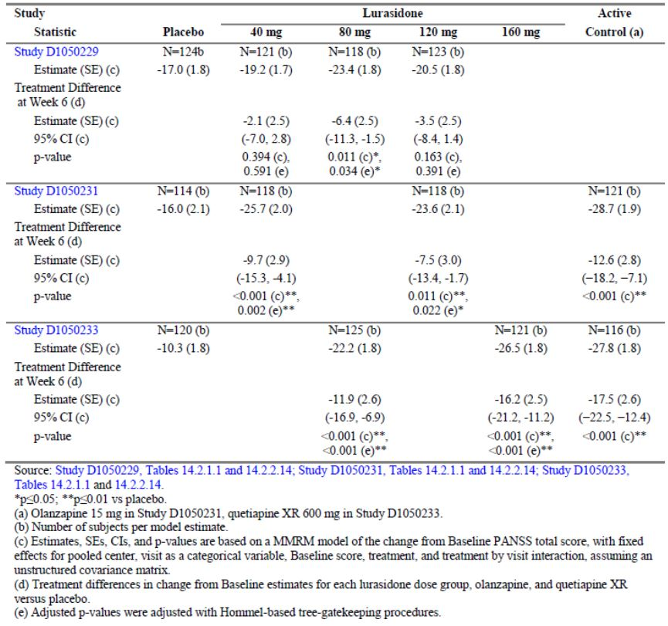
Table 12: Change from Baseline to Day 42/LOCF endpoint in PANSS Total Score: ANCOVA Analysis.
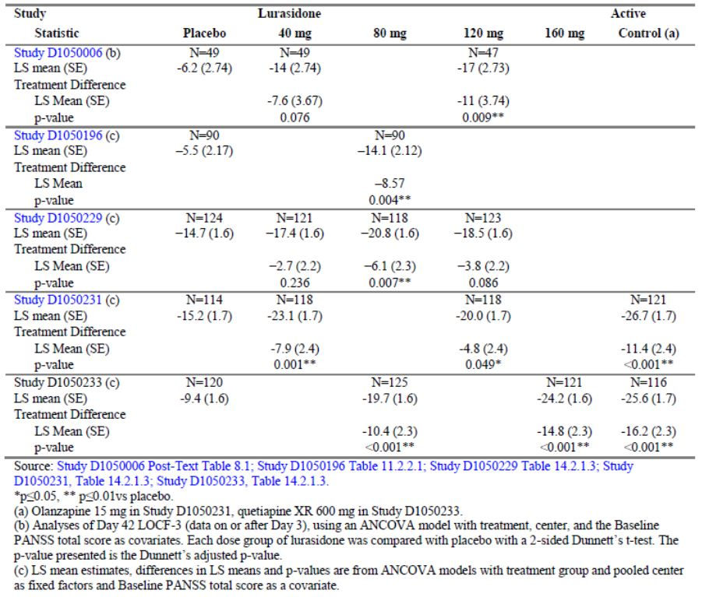
Figure 12: LS Mean Treatment Difference (95% CI) for PANSS Total Score Change from Baseline to LOCF Endpoint: ANCOVA Analysis.
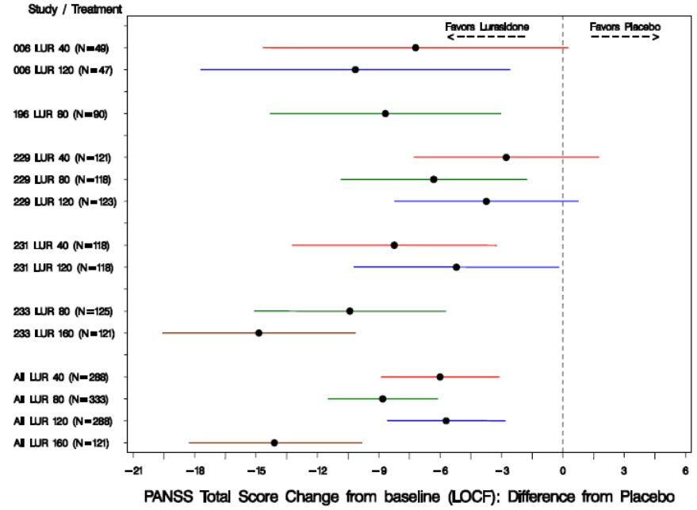
Figure 13: LS Mean Treatment Difference (95% CI) for CGI-S Score Change from Baseline to LOCF Endpoint: ANCOVA Analysis.
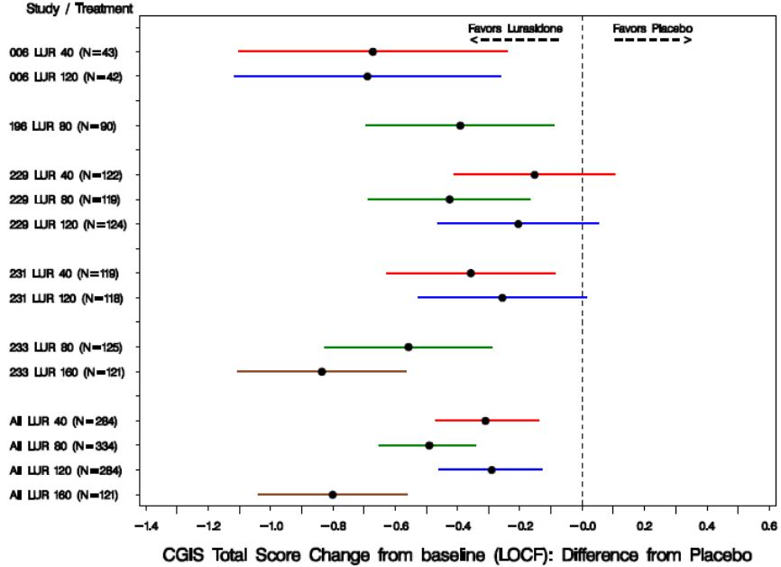
Table 13: Proportion of Responders (≥30% Improvement from Baseline) at Day 42/LOCF Endpoint (Studies D1050229, D1050231, and D1050233).
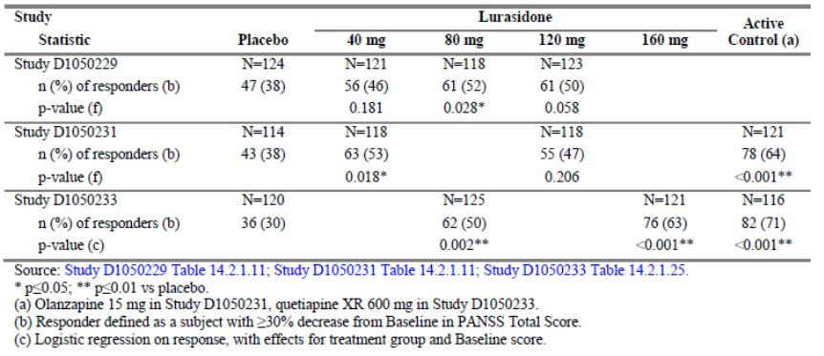
Comment: The EMA guideline for schizophrenia states that in short term trials in patients with acute or exacerbated symptoms a reduction of at least 30% in the total PANSS score compared to baseline is generally considered to be clinically relevant (EMA 2012).
Subgroup analysis of the pooled data from the five short term controlled studies found similar results between males and females on PANSS total score with no significant interaction by gender in the MMRM (p=0.731). Results were also similar on the CGI-S score. There was also no significant interaction by race or geographic region (North America and rest of world) in the analysis models for PANSS or CGI-S.
In the studies evaluated there has been no clear evidence of a dose response. Pooled data from the 5 short term trials, using both the MMRM and ANCOVA models, compared doses on PANSS total score and only the 160 mg dose was found to be significantly better than the lower doses. A similar result was seen on the CGI-S score. Discontinuation due to lack of efficacy in the 7 pooled placebo controlled studies found the highest rate in the 20 mg dose group (34%) compared to 16%, 11%, and 10% in the 40 mg, 80 mg and 160 mg dose groups, respectively.

Evaluator’s conclusions on clinical efficacy for schizophrenia
The clinical development program with lurasidone included 21 trials. There were 5 short term placebo-controlled trials on which the efficacy of lurasidone was based (D1050006, D5050196, D1050229, D1050231 and D1050233). In addition, there were two placebo controlled trials (D1050049 and D1001002) which were deemed “failed” as neither lurasidone (20, 40 and 80 mg in D1050049 and 40 and 80 mg in D1001002) nor the active control (haloperidol 10 mg and risperidone 4 mg) was found to significantly differ from placebo.
In the five studies, fixed doses of 40, 80, 120 and 160 mg were assessed over the 6 week period in adult patients who had a diagnosis of schizophrenia (DSM-IV) for at least a one year duration and who had a current acute exacerbation of psychotic symptoms. To be eligible subjects were required to have a minimum score on the PANSS (≥80) or BPRS (≥42) (depending on the study) with a score of ≥4 on two or more of the Positive Symptom Scale Subscores. All subjects needed a score of ≥4 on the CGI-S. Overall, 1795 subjects were included with 506 treated with placebo, 1046 with lurasidone, 123 with olanzapine 15 mg and 120 with quetiapine XR 600 mg. The active comparator in D1050231 and D1050233 was included to assess the study’s sensitivity. Study drug was given in the morning (except in D1050233 when it was given in the evening) with a meal or within 30 minutes of eating.
In studies D1050229, D1050231 and D1050233, the primary endpoint was change from baseline to week 6 in the PANSS total score. This was analysed using a MMRM on the ITT population (randomised subjects who have taken ≥1 dose of study medication with baseline and ≥1 post-baseline efficacy measurement). The MMRM did not use imputed data and missing values were retained as missing. Multiplicity was controlled in the analysis of the primary and key secondary variables. Studies D1050006 and D1050196 used the BPRS as the primary efficacy endpoint which was analysed using ANCOVA in the ITT population with LOCF.
These short term trials were designed in accordance with relevant guidelines (EMA 2012) with fixed doses of lurasidone, 6 week duration, an appropriate validated endpoint (PANSS total score and BPRS) and with suitable supporting efficacy parameters (CGI-S).
A summary of the primary efficacy endpoints in the five studies is presented below in Table 14.
Table 14: Summary of results for primary efficacy endpoints.
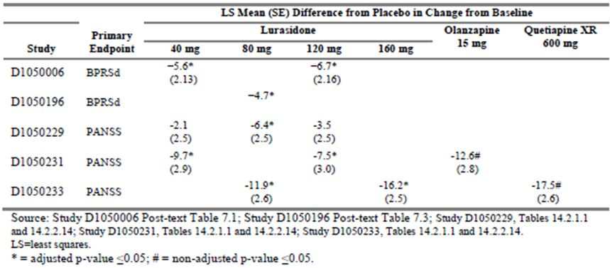
Study D1050229 assessed the efficacy of lurasidone 40mg, 80mg and 120 mg in 500 chronic schizophrenia patients with an acute psychotic exacerbation. Lurasidone 80 mg was found to result in a significantly greater reduction in the PANSS total score after 6 weeks treatment compared to placebo (difference of -6.4, p=0.034). This result was supported by analysis using ANCOVA with LOCF, a significant decrease in the key secondary endpoint of CGI-S at week 6, as well as in a decrease in the PANSS positive subscore. Neither the 40 mg nor 120 mg lurasidone doses were found to have a statistically significant treatment effect on any measure, apart from 120 mg on the PANSS positive subscore. No treatment effect was found on the MADRS, PANSS negative or PANSS psychopathology subscores.
By contrast, study D050231 assessed 478 patients and both the lurasidone 40 mg and 120 mg were found to result in a significantly greater reduction in the PANSS total score compared to placebo. This result was supported by a significant reduction in the CGI-S, improvement in PANSS positive, negative and psychopathology subscores and analysis using ANCOVA. There was no significant treatment difference on the MADRS. PANSS responder rates (using a ≥30% reduction definition) were only significant for lurasidone 40 mg. There was no evidence of dose response and no significant differences found between the 40 and 120 mg doses. Assay sensitivity was confirmed by positive responses with the olanzapine group.
In D1050233, which assessed 488 subjects, both lurasidone 80 mg and 160 mg per day were found to be statistically superior to placebo in reducing the PANSS total score after 6 weeks of treatment. The treatment difference was -11.9 (95% CI: -16.9, -6.9 adjusted p <0.001) for lurasidone 80 mg and -16.2 (95% CI: -21.2, -11.2, adjusted p<0.001) for lurasidone 160 mg. A separation of effect was evident from day 4 through to week 6. Results were robust, being supported by the ANCOVA analysis and the PP population analysis. Superiority of effect was also demonstrated on the CGI-S, the MADRS, PANSS subscores and PANSS responder rates (≥30% improvement). A positive effect with quetiapine confirmed assay sensitivity. While the effect with lurasidone 160 mg was numerically greater, there were no significant differences found between the doses on the PANSS or CGI-S scores.
In D1050196, a phase II study in 180 subjects, a significantly better response was found with lurasidone 80 mg over placebo as measured by a change from baseline in the BPRS score in the ITT population with LOCF. Results were supported by analysis of secondary efficacy endpoints including PANSS total score and subscores and GCI-S.
In D1050006, a smaller phase II study (n=149), lurasidone 40 mg and 120 mg doses had a significant separation from placebo on the BPRS, however only the 120 mg dose had a significant improvement on the secondary endpoint of PANSS total score. This study was noted to have a very high discontinuation rate of (59%-70%) which was higher than the 30-40% seen in the three previously-discussed trials. In addition, there was a reported high rate of concomitant antipsychotic use. Given these factors and the small sample size in each group (15-20 subjects), the evaluator does not agree with the Sponsor that this study provides “pivotal” efficacy data for the 40 mg or 120 mg doses.
Subgroup analysis on pooled data found that treatment effect was consistent across males and females, race and geographic region (North America and rest of world) There were too few subjects aged over 55 years to draw conclusions for the older population.
There was no clear dose response in the individual trials and pooled data from the 5 short term study comparing doses on PANSS total score and CGI-S score found that only the 160 mg dose was significantly better than the lower doses. The rate of discontinuation due to insufficient clinical response also showed no dose-related trend between 40mg and 160 mg although there was a notably higher rate in the 20 mg group. Evidence from pharmacodynamic studies on receptor occupancy and an early dose response study also support the conclusion that 20 mg is subtherapeutic.
There were 2 long term, active-controlled studies (D1050234, D1050237) which provided the main long term efficacy data. Both studies found comparable efficacy to the active controls on PANSS total score and CGI-S scores. The probability of relapse over 12 months was non-inferior to quetiaine XR but non-inferiority to risperidone was not demonstrated.
D1050234 was a 12 month extension study of D1050233 in 292 subjects and assessed the non-inferiority of lurasidone compared to quetiapine XR on the time to relapse. The proportion who relapsed was 21% and 27% in the lurasidone and quetiapine groups, respectively and lurasidone was found to be non-inferior to quetiapine with a HR of 0.73 (95% CI: 0.41, 1.29) which was within the non-inferiority margin of 1.93. Efficacy was maintained over the 12 months and in general comparable to quetiapine. The mean modal dose of lurasidone was 128 mg and of quetiapine was 638 mg.
Study D1050237 was a randomised controlled 12 month safety study in 629 subjects with stable chronic schizophrenia or schizoaffective disorder. It compared lurasidone to risperidone and assessed relapse and efficacy as secondary endpoints. The proportion of subjects who relapsed was 20% and 16% in the lurasidone and risperidone groups, respectively, with a hazard ratio of 1.31 (95% CI: 0.87, 1.97, p=0.194) which did not meet the non-inferiority criteria of 1.6. The relapse rates were lower than estimated (59% lurasidone and 35% risperidone) and this may have affected results. There was, however, no significant treatment difference on change in total PANSS or CGI-S scores.
There were 7 long term uncontrolled studies D1050229Ext, D1050231Ext, D1001036, D1001048, D1050174, D1050199 and D1050237Ext which found in general that efficacy was maintained although the studies were subject to high withdrawal rates.
Efficacy of lurasidone when switched from another antipsychotic was assessed in a 6 week, open label, uncontrolled study 240 subjects with stable but symptomatic schizophrenia or schizoaffective disorder (D1050289 and its extension D1050290). Dose was initiated at 40 or 80 mg. The overall study discontinuation rate was 17.5% and the treatment failure rate was low at 7.9% with a median time to failure of 21 days (95% CI: 7, 25). Those that did not titrate to 80 mg at week 2 appeared to have a higher rate of failure due to exacerbation of underlying disease.
Study D1050254 was an early phase exploratory safety study of 120 mg compared to ziprasidone 160 mg over a 3 week treatment period in chronic stable schizophrenics. The study was not found to provide robust efficacy data.
Overall, efficacy has been demonstrated for the four doses, 40 mg, 80 mg, 120 mg and 160 mg. The 80 mg dose had had its efficacy replicated, the 40 mg and 120 mg doses have shown efficacy in two of three studies although one of these studies was noted to have methodological issues. The 160 mg dose has only had efficacy confirmed in one trial. Lurasidone shows not evident dose response in terms of efficacy and there were no significant benefits in terms of enhanced efficacy with higher over lower doses, apart from 160 mg. The 20 mg dose shows evidence of being subtherapeutic.

Clinical safety

Studies providing evaluable safety data
The summary of clinical safety covered data from 52 clinical trials which included 5607 subjects with schizophrenia (3473 treated with lurasidone, 724 treated with placebo and 1410 treated with other medications). Study duration ranged from 3 weeks to 22 months and evaluated doses of lurasidone from 20 to 160 mg/day.
Data were pooled in the following groups:
- P23STC: Short term phase II/III double blind placebo controlled studies (D1050006, D1050196, D1050229, D1050231, D1030233, D1001002, D1050049). These 7 studies included 1508 subjects treated with lurasidone, 708 with placebo and 378 with the comparators.
- P23LTC: Long term, 52 week, phase III, double-blind active-controlled studies (D1050234, D1050237). These included 624 subjects treated with lurasidone and 284 with active comparators.
- P23AU: Uncontrolled phase II/III studies (D1001061, D1001001, D1001036, D1001048, D1001017, D1050174, D1050199, D1050229E, D1050231E, D1050237E, D1050289, D1050290). These included 1071 subjects treated with lurasidone.
- P23STO: Other phase II/III studies (D1050254) which included 150 subjects treated with lurasidone and 151 treated with ziprasidone.
- P23ALL: The above 4 groups of phase II/III studies combined. These included 3202 lurasidone-treated subjects.
- P1NON: Phase I non-schizophrenia (21 studies, 371 lurasidone-treated subjects).
- P1SCH: Phase I schizophrenia (9 studies, 300 lurasidone-treated subjects).
In the short term placebo-controlled efficacy studies, the following safety data were collected: adverse event (AE) monitoring, physical examination, blood pressure, body weight, body mass index (BMI), 12 lead electrocardiogram (ECG), laboratory safety studies including prolactin, the Barnes Akathisia Scale (BAS), the Abnormal Involuntary Movement Scale (AIMS) and the Simpson-Angus Scale (SAS).
The other phase II/III studies provided data on AEs, clinical chemistry and haematology, physical examination and vital signs, ECGs, the BAS and the AIMS.
Adverse events were reported as treatment emergent AEs (TEAEs) which were defined as AEs (newly occurring or an exacerbation of pre-existing conditions) with a start date on or after the date of the first dose of study medication through seven days after study medication discontinuation.
Laboratory tests included clinical chemistry, prolactin, fasting lipids, fasting glucose, haematology and urinalysis.
AEs of particular interest included extrapyramidal symptoms (EPS), metabolic events (effects on glucose, lipids, etc.), neurological events (eg. somnolence, dystonia) and hypersensitivity events. Preferred terms were clustered to capture these events. EPS events included akathisia, bradykinesia, cog wheel rigidity, drooling, dystonia, extrapyramidal disorder, hypokinesia, muscle rigidity, oculogyric crisis, oromandibular dystonia, parkinsonism, psychomotor retardation, restlessness, tongue spasm, torticollis, tremor and trismus.
Metabolic events included blood glucose increased, blood triglycerides increased, diabetes mellitus, glucose tolerance impaired, glycosuria, glucose urine present, HbA1c increased, hyperglycemia, hyperlipidemia, hypertriglyceridemia, metabolic syndrome, impaired fasting glucose, type 2 diabetes mellitus and weight increased.
All cases of confirmed bone fracture regardless of seriousness were reported as SAEs. If possible a dual energy X-ray absorptiometry (DEXA) scan was performed together with urine and blood collection for vitamin D, C-telopeptide, N-telopeptide, osteocalcin and bone alkaline phosphatise (ALP).
The Columbia Suicide Severity Rating Scale (C-SSRS) was assessed in the short-term, double-blind, placebo-controlled study (D1050233), in the long-term controlled study (D1050237) and in recent studies in the P23ALL study grouping (D1050229E, D1050231E, D1050234, D1050237E, D1050289, and D1050290).
Opthalmological examination including fundoscopy and biomicroscopy was conducted in study D1050006 and D1050237.
Measures of bone turnover were assessed for all subjects in studies D1050049, D1050174, D1050196, D1050199, D1050237, D1050237E, D1001001, and D1001036.

Pivotal studies that assessed safety as a primary outcome

Study D1050237 and D1050237Ext

Study design, objectives, locations and dates
D1050237 was a phase III, randomised, double-blind, active comparator-controlled long term study of lurasidone compared to risperidone (2:1 ratio) in subjects with stable chronic schizophrenia or schizoaffective disorder. It was conducted in 68 sites in South America, Croatia, Israel, South Africa, Thailand and the US between March 2008 and July 2010 with the extension study being completed in January 2011. A DSMB reviewed blinded safety data.
The primary objective was safety and tolerability of lurasidone during 12 months of double-blind treatment followed by 6 months of open label treatment. Secondary objectives included: changes in weight, body mass index (BMI), waist circumference, serum prolactin, testosterone, N-telopeptide (NTx), osteocalcin, bone alkaline phosphatase, parathyroid hormone (PTH), and ECG parameters; evaluation of changes in BMD for subjects treated with lurasidone and risperidone after 6, 12 and 18 (lurasidone only) months using dual-energy x-ray absorptiometry (DXA) scans; ophthalmologic assessments (at selected centres) for lurasidone and risperidone groups after 6, 12, and 18 (lurasidone only) months of treatment. Efficacy, as measured by the PANSS total and subscale scores, CGI-S, MADRS and relapse rates, was also a secondary objective.
After 12 months of double blind treatment subjects could continue in the 6 month open label extension study, D1050237Ext. The CSR stated a sub-study assessing cognitive impairment was conducted at selected centres in the US and was reported separately.
Comment: This document was not located in the dossier.

Inclusion and exclusion criteria
For inclusion subjects were 18-75 years of age with schizophrenia or schizaffective disorder (DSM-IV criteria) for at least 1 year and be clinically stable for 8 weeks prior to baseline. Clinically stable required a CGI-S ≤ 4, no change in antipsychotic medications for at least 6 weeks, no hospitalisation for psychiatric illness for at least 8 weeks, and moderate or less (≤4) severity rating on PANSS Positive Scale Items. Subjects were also non-pregnant, non-lactating, using contraception and negative on a urine drug test. Exclusion criteria were essentially the same as the pivotal efficacy trials (see D1050229).

Study treatments
Subjects were tapered off antipsychotic medication over 1 to 7 days and then randomised to either lurasidone 80 mg per day or risperidone 2 mg per day. Risperidone 2 mg continued for 2 days then was increased to 4 mg per day. From day 8, if indicated, medication doses could be adjusted to between 40 mg/day and 120 mg/day for lurasidone or between 2 mg/day and 6 mg/day for risperidone. Treatment was once daily in the morning with a meal or within 30 minutes of eating.
Concomitant treatment with medications for movement disorders, which had been discontinued prior to randomisation, could be reinstated if symptoms emerged. Other antipsychotics were not allowed and if required the subject was discontinued.
Subjects from both treatment groups who contined in the 6 month open label extension study received 3 days of placebo washout then commenced on lurasidone 80 mg. This could be adjusted between 40 and 120 mg per day after one week.

Safety variables and outcomes
The main safety variables were adverse events, discontinuation due to AEs and SAEs. Other safety measures included vital signs, ECGs, laboratory values, markers of bone metabolism, bone mineral density (BMD) assessments, ophthalmologic assessments, and physical examinations. Other safety assessments included the movement disorder scales (BAS, AIMS and SAS) the Columbia Suicide Severity Rating Scale (C-SSRS) and menstrual cyclicity (female subjects). All bone fractures were to be reported as SAEs.
Efficacy variables included the PANSS, CGI-S and the MADRS. Pharmacokinetic measurements were taken on day 7, week 6, month 6, 12 and 18.

Randomisation and blinding methods
Subjects were randomised in a 2:1 ratio to lurasidone or risperidone using an IVRS with stratification based on treatment with prior antipsychotic agents (conventional and atypical) at cognition sub-study centres. To maintain the study blind matching placebo film-coated tablets were provided for lurasidone and placebo for risperidone was provided as over-encapsulated capsules to match the risperidone capsules.

Analysis populations
Efficacy was analysed on the ITT population (randomised, received at least one dose of study medication and had at least one post-baseline measurement on the PANSS or CGI-S). Safety was analysed on the Safety population which was all randomised subjects who received at least one dose of study medication.

Sample size
The sample size calculation was based around the efficacy of lurasidone in preventing relapse compared to risperidone. Assumptions were an estimated relapse rate over 1 year of 50% for lurasidone and 35% for risperidone and a margin of 15% difference which corresponded to hazard rates of 0.058 for lurasidone and 0.036 for risperidone and a non-inferiority hazard ratio margin of 1.6. A sample of 400 lurasidone and 200 risperidone gave the study an 85% power to demonstrate non-inferiority of lurasidone relative to risperidone at a significance level of 0.025.
Comment: in study D1050234 the non-inferiority margin was set at 1.6 but was altered prior to database lock to 1.93 due to lower relapse rates than anticipated on review of blinded data. The margin of 15% for the difference in relapse rates was preserved and the revised assumed rates were 35% for lurasidone and 20% for quetiapine XR.

Statistical methods
Statistical methods for safety analysis were descriptive. The change from baseline value for selected laboratory parameters and bone turnover markers was evaluated using a nonparametric rank ANCOVA with adjustment for baseline at month 12 LOCF endpoint. The change from baseline for DXA parameters was evaluated at each planned visit and month 12 LOCF endpoint using an ANCOVA, with effects for baseline parameter score, pooled centre and treatment.
Relapse was defined as the earliest occurrence of any of the following: worsening of >30% PANSS total score from Baseline CGI-S >3; re-hospitalization for worsening of psychosis; and emergence of suicidal ideation, homicidal ideation, and/or risk of harm to self or others. This was assessed using a Cox regression survival model including terms for treatment and pooled centre. Non-inferiority for lurasidone relative to risperidone was assessed by comparing the upper bound of the 95% confidence interval (CI) for the hazard ratio from a Cox proportional hazards model with the non-inferiority margin of 1.6. Efficacy variables (PANSS, CGI-S and MADRS) were analysed using the MMRM as well as by ANCOVA with LOCF.

Participant flow
There were 1090 subjects screened and 629 randomised of whom 427 received lurasidone and 202 risperidone. The ITT population consisted of 608 subjects and the safety population 621 subjects (419 and 202 in the lurasidone and risperidone groups, respectively ).There were 236 (38%) who completed the double-blind phase, with a lower rate in the lurasidone group (34% versus 44%) and 233 continued in the extension study. Premature discontinuation was higher with lurasidone than risperidone (65% versus 52%). The most frequent reasons were consent withdrawal (17% versus 15%), AEs (17% versus 11%) and insufficient clinical response or worsening of condition (10% versus 8%).

Major protocol violations/deviations
The rate of protocol deviations leading to exclusion from the PP population was high but similar between groups (39% versus 40%) with the most frequent violation being not having 6 weeks or more of continuous exposure (22% versus 24%). Compliance was similar between groups (98% versus 99%) however there were a notable number with missing compliance data (28% versus 26%). The PP population consisted of 370 subjects (59% in each group).

Baseline data
There were more males in the lurasidone than risperidone group (72% versus 62%). The groups were balanced on other baseline characteristics. The mean age was 41.7 years, half the subjects were Black/African American and 38% White. Most subjects has paranoid type schizophrenia (72%) with a mean disease duration of 16.7 years. The mean exposure duration was 197 and 221 days in the lurasidone and risperidone groups, respectively, with an average daily dose of 84.7 mg and 4.3 mg, respectively.

Results for the primary safety outcome
The rate of TEAEs was similar between groups (84.5% versus 84.7%). The rate was also similar for drug-related TEAEs (70.2% versus 74.8%), EPS-related TEAEs (12.9% versus 15.8%) and serious TEAEs (11.0% versus 9.9%). The lurasidone treated subjects had a higher rate of discontinuations due to AEs (21.5% versus 14.4%) (Table 15).
Table 15: Summary of TEAEs (Safety Population).
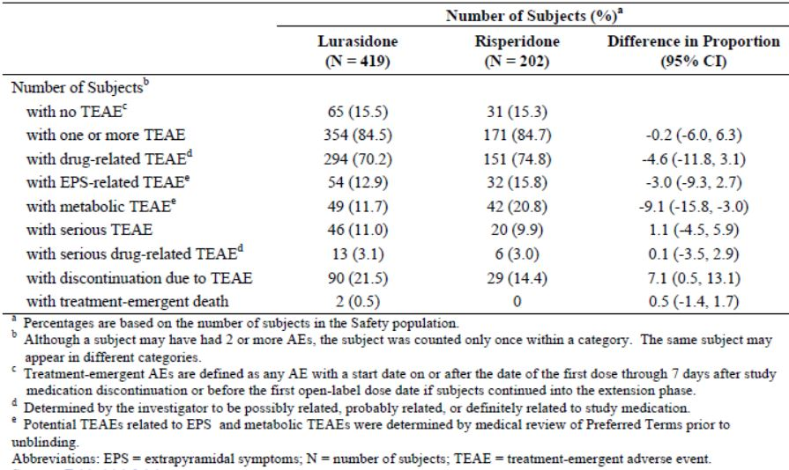
Within gastrointestinal disorders SOC, more lurasidone subjects reported nausea (16.7% versus 10.9%) and vomiting (10.0% versus 3.5%) while fewer reported constipation (1.9% versus 6.9%). Lurasidone subjects had a lower rate of weight increased (9.3% versus 19.8%) but higher rates of akathisia (14.3% versus 7.9%). EPS-related TEAEs were similar (12.9% versus 15.8%) (Table 16) and there was a lower rate of metabolic TEAEs with lurasidone (11.7% versus 20.8%).
Table 16: Incidence of TEAEs reported in which there was a ≥2% difference between treatment groups at the preferred term level (Safety Population).
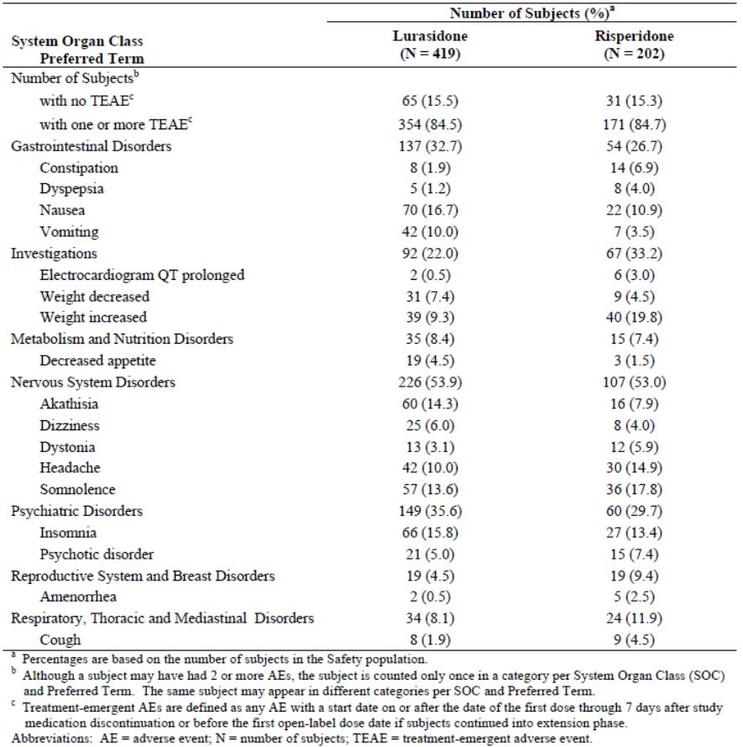
The rates of mild (68.0% versus 69.8%), moderate (49.9% versus 50.5%) and severe (11.5% versus 11.4%) TEAEs were similar between groups. Three subjects died all in the lurasidone group (hypertensive heart disease in 52 year old, gastroduodenal ulcer and haemorrhage in 44 year old, sudden death with possible pulmonary embolism in 73 year old).

Results for other safety outcomes
The median time to discontinuation for any cause for the lurasidone group was 181 and 293 days for the risperidone group. The Kaplan-Meier estimate of the probability of discontinuation for any cause at month 12 was 0.643 and 0.522 respectively with a significant treatment difference (p = 0.018). When discontinuation due to insufficient clinical response and discontinuation due to AEs were combined, the probability of discontinuation by month 12 was 0.315 for lurasidone and 0.218 for risperidone with a significant treatment difference (p = 0.048).
There was little change in prolactin levels with lurasidone and larger increases with risperdone (mean change from baseline 3.28 versus 18.62 ng/mL) resulting is a significant difference (p<0.01). The shift from normal to high prolactin was also notable with risperidone (12.2% versus 37.5%). There was also a significant difference in mean weight change (-0.97 versus 1.47 kg). Lurasidone had a significantly smaller effect on increasing mean glucose (2.4 versus 4.8 mg/dL). There were no significant differences in markers of bone turnover. DXA scans and ophthalmogical assessments were unremarkable and changes on movement disorder scales showed no major differences.

Summary
D1050237 was a phase III, randomised, double-blind, active comparator-controlled, long term study assessing the safety and tolerability of lurasidone compared to risperidone (2:1 ratio) in subjects with stable chronic schizophrenia or schizoaffective disorder. The rates of TEAEs, drug-related TEAEs, EPS-related TEAEs and serious TEAEs were similar between the lurasidone and risperidone groups. The lurasidone-treated subjects had a higher rate of discontinuations due to AEs (21.5% versus 14.4%) and a significantly increased likelihood of treatment discontinuation at 12 months. The rate of metabolic TEAEs, increased weight and increased prolactin was less than seen with risperidone.

Patient exposure
The P23STC studies included 1508 subjects who received lurasidone with a mean exposure of 31.7 days (SD 14.4 days). The P23LTC studies included 624 subjects who received lurasidone with a mean (SD) exposure of 216.4 (14.54) days. Most subjects in this grouping received lurasidone 40 mg (43.8%) or 80 mg (36.1%). In P23ALL, the mean exposure duration to lurasidone was 138 days (range: 1 to 729 days), median exposure was 45 days and 471 subjects had ≥364 days exposure. Total exposure was 1212 patient-years.
There were 671 subjects exposed to lurasidone in the phase I studies. Single doses ranged from 0.1 mg to 100 mg and repeated doses up to 600 mg per day for <1 week. The mean duration of exposure to lurasidone in non-schizophrenia subjects was 2.4 days and in schizophrenia subjects was 12.4 days.
In the P23STC studies, the mean age of subjects receiving lurasidone was 40 years with 89% aged under 55 years and only 29 subjects aged 65 years or older. Most subjects were male (71%) and 38% were White, 30% Black/African American and 28% Asian. Demographics were similar in the long term controlled population.

Adverse events

All adverse events (irrespective of relationship to study treatment)

P23STC studies
In the seven phase II/III short term placebo controlled (P23STC) studies the rate of TEAEs was 76.3% and 71.0% in the lurasidone and placebo-treated subjects, respectively. The rate of TEAEs in the active comparator groups was 87.5%, 82.8%, 60.5% and 81.5% in the haloperiodol 10 mg, onalzapine 15 mg, quetiapine XR 600 mg and risperidone 4 mg groups, respectively.
The rate of TEAEs in the lurasidone dose groups was 74.6%, 79.9%, 72.7%, 82.8%, and 62.8% of the 20, 40, 80, 120 and 160 mg groups, respectively. Across the dose-range examined (20, 40, 80, 120, and 160 mg) in P23STC, a dose-response relationship for lurasidone was seen with akathisia (5.6%, 10.7%, 12.3%, 22.0% and 7.4%) and somnolence (4.2%, 7.6%, 7.4%, 14.4% and 6.6%).
The most frequently reported SOCs (lurasidone versus placebo) were nervous system disorders (42.8% versus 27.0%), gastrointestinal disorders (28.6% versus 25.7%) and psychiatric disorders (24.2% versus 23.6%). The most common TEAEs (frequency of ≥5%) were headache (14.5% versus 15.0%), akathisia (12.9% versus 3.0%), nausea (10.1% versus 5.2%), insomnia (9.9% versus 8.5%), somnolence (8.6% versus 3.4%), sedation (8.5% versus 3.8%), vomiting (8.0% versus 6.2%), schizophrenia (6.8% versus 7.9%), dyspepsia (6.2% versus 4.8%), agitation (5.2% versus 3.8%), anxiety (5.1% versus 4.1%) and constipation (5.0% versus 6.1%) (Table 17).
Table 17: Incidence of TEAEs reported in ≥2% of subjects at the SOC and PT level within any lurasidone dose group, Safety Population: P23STC study group for all lurasidone, placebo, and active control treated subjects.
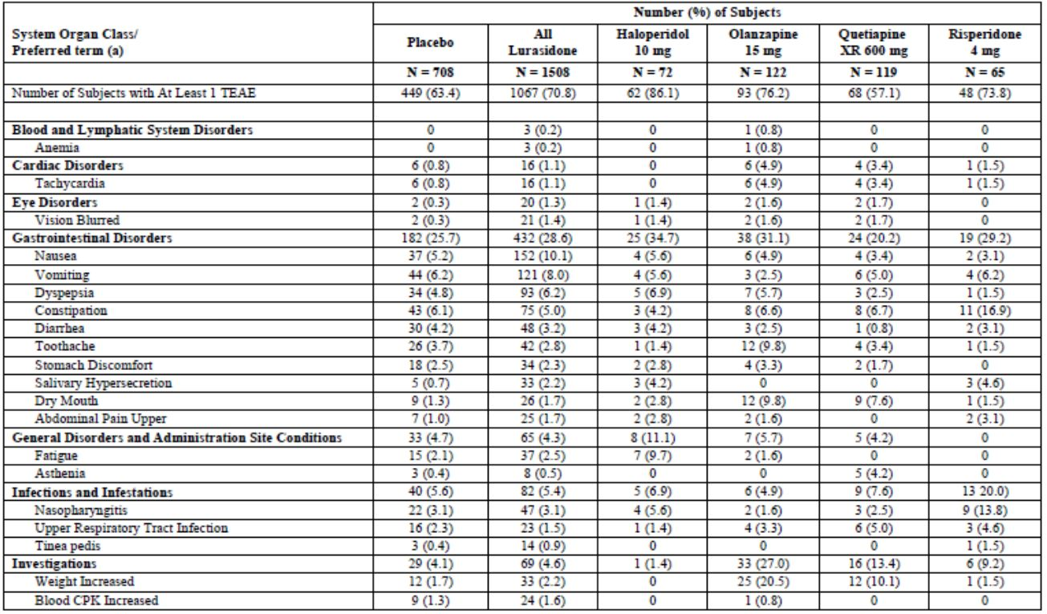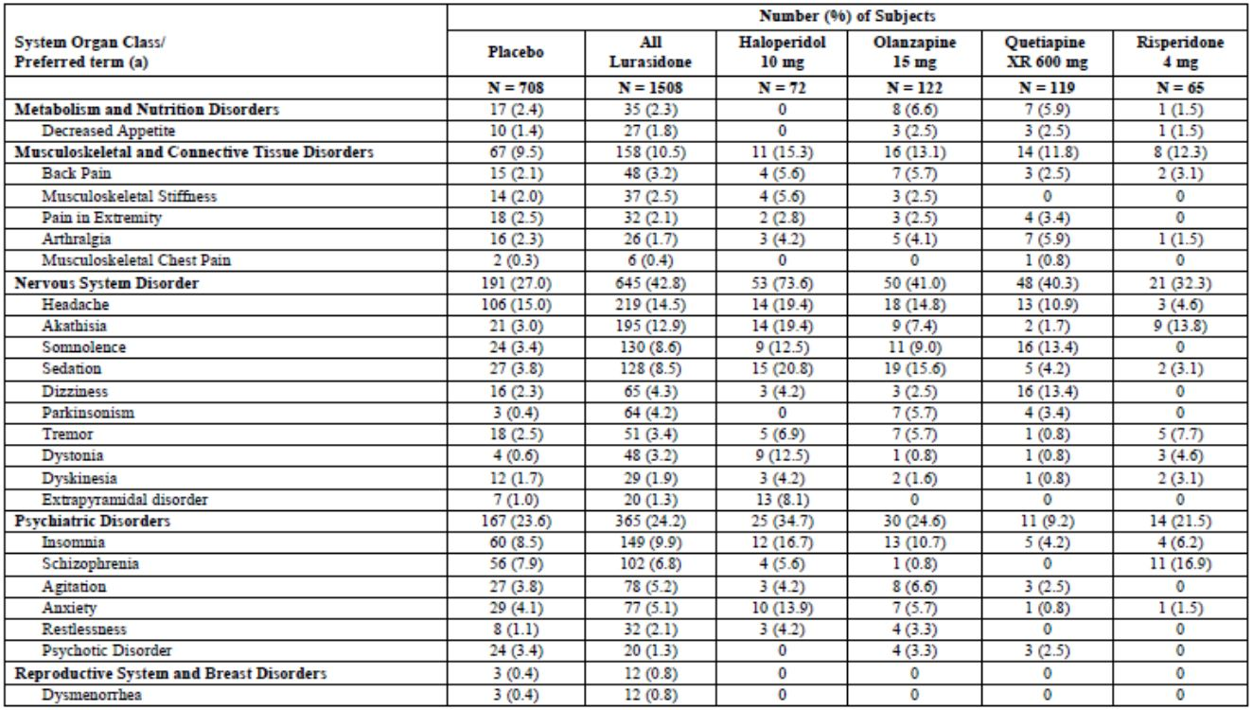
Table 17 (continued): Incidence of TEAEs reported in ≥2% of subjects at the SOC and PT level within any lurasidone dose group, Safety Population: P23STC study group for all lurasidone, placebo, and active control treated subjects.
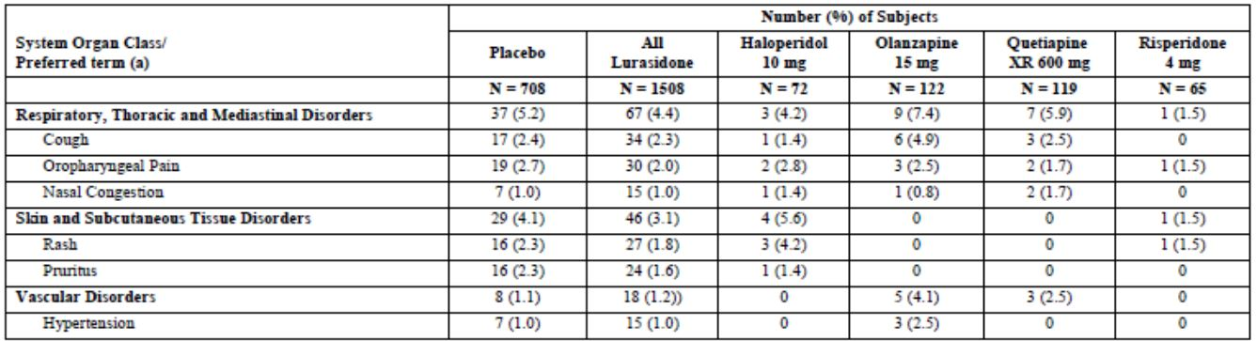
The rate of akathisia in lurasidone-treated subjects (12.9%) was greater than with placebo (3.0%), olanzapine (7.4%) and quetiapine XR (1.7%), but lower than with haloperidol (19.4%) and similar to risperidone (13.8%). Parkinsonism was reported in 4.2% of lurasidone-treated subjects compared with 0.4% for the placebo group, 0% for the haloperidol, 5.7% for the olanzapine, 3.4% for the quetiapine XR, and 0% for the risperidone group. The rate of EPS TEAEs was 24.7% in the lurasidone group compared to 9.2% in the placebo group and 54.2%, 23.0%, 7.6% and 27.7% in the haloperidol, olanzepine, quetiapine and risperidone groups, respectively.
The rate of the metabolic cluster TEAEs was 3.2% with lurasidone and 2.5% with placebo with a higher rate with olanzepine (24.6%) mainly due to increased weight (20.5%). The rate of hypersensitivity TEAEs was similar between lurasidone and placebo (4.3% versus 4.0%). In the lurasidone and placebo groups, the rate of combined dystonia terms was 4.2% versus 0.8%, combined parkinsonism terms was 10.1% versus 5.4% and combined somnolence terms was 17.0% versus 7.1% (Table 18).
Table 18: Combined dystonia, parkinsonism and somnolence terms.
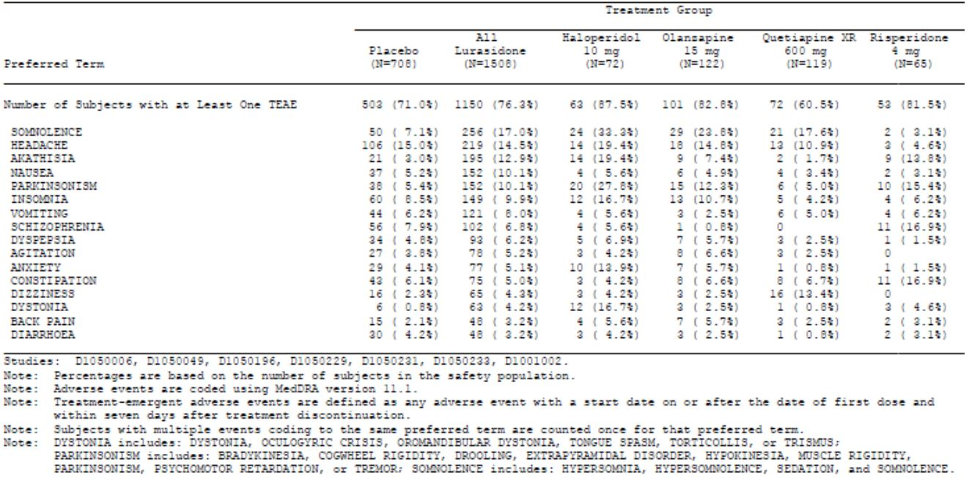
The rate of mild, moderate and severe TEAEs was 30.9%, 37.7% and 7.7% in the lurasidone group and 29.7%, 32.5% and 8.9% in the placebo group. The rate of severe TEAEs was 8.3%, 4.9%, 2.5% and 7.7% in the haloperidol, olanzepine, quetipine and risperidone groups, respectively.

Other studies
In the 3 week study D1050254, the rate of TEAEs was 57% versus 66% in the lurasidone and ziprasidone groups, respectively. Akathisia, dizziness, insomnia, sedation, and somnolence were reported more frequently in ziprasidone subjects; while insomnia and vomiting were seen more frequently in the lurasidone group. Severe TEAEs were reported in 7% of each group.
In the two long term, 52 week, flexibly dosed, controlled studies (P23LTC), the rate of TEAEs was 77.9%, 70.6% and 85.9% in the lurasidone, quetiapine XR and risperidone treated subjects, respectively. The rate of severe TEAEs in the P23LTC group was similar between the lurasidone, quetiapine and risperidone groups (10.3%, 11.8% and 11.6%).
In this long term population, the most frequent SOC reported was nervous system disorders followed by gastrointestinal and psychiatric disorders. Akasthisia was the most frequent TEAE and the rate was higher than with quetiapine or risperidone (13.6% versus 2.4%, 8.0%). Nausea was greater with lurasidone than quetiapine (13.3% versus 2.4%) and similar to risperidone (11.1%). Insomnia was reported in 12.8%, 9.4% and 13.6% of the three respective groups. Somnolence was higher with lurasidone than quetiapine XR (10.1% versus 4.7%) and less than risperidone (18.1%).
In P23LTC, the rate of EPS-related TEAEs was 25.0%, 8.2% and 22.6% in the lurasidone, quetiapine and risperidone groups, respectively. The rate of combined somnolence terms was 19.9%, 5.9% and 31.7%. The rate of combined terms for dystonia was 4.5%, 1.2% and 7.0%. The rate of combined terms for parkinsonism was 9.6%, 2.4% and 11.6%.
The percentage of lurasidone-treated subjects with metabolic TEAEs was 8.8% compared to 7.1% in the quetiapine XR and 21.1% in the risperidone group. Weight gain was highest with risperidone (20.1%) followed by lurasidone (7.4%) and quetiapine (4.7%).
The onset of TEAEs was with the first 6 days of treatment in 35.7%, 42.7% and 12.9% of the lurasidone, risperidone and quetiapine groups, respectively.
In all the phase II and III clinical studies (P23ALL) with 3202 subjects treated with lurasidone, the rate of TEAEs was 81.1%. The percentage of subjects in the P23ALL group who had at least one severe TEAE was 11.8%. The most frequent TEAEs were akasthisia (13.6%), nausea (12.9%), headache (12.4%), somnolence (10.7% and schizophrenia (10.6%) (Table 19). The rate of EPS-related TEAEs was 25.6% and of metabolic TEAEs was 6.5%.
Table 19: Incidence of TEAEs reported in ≥2% of subjects at the PT level, Safety Population: P23ALL Study Group.
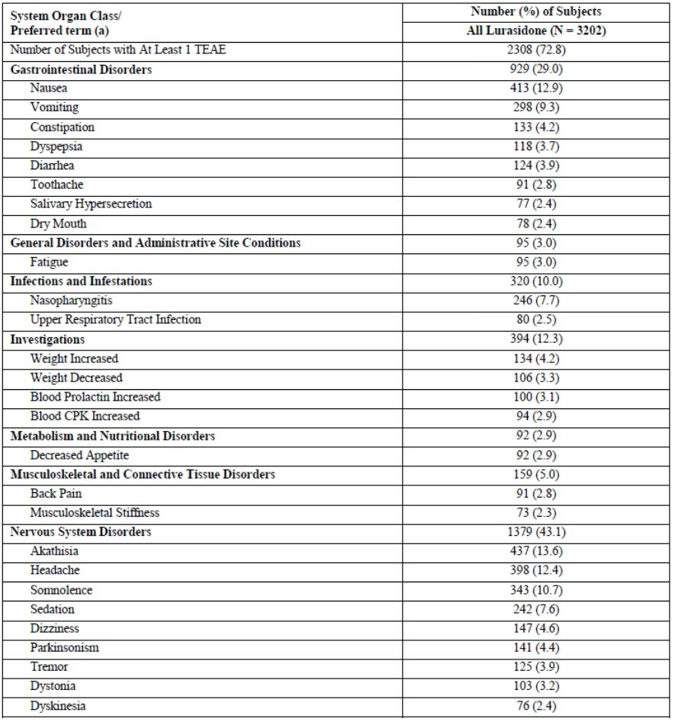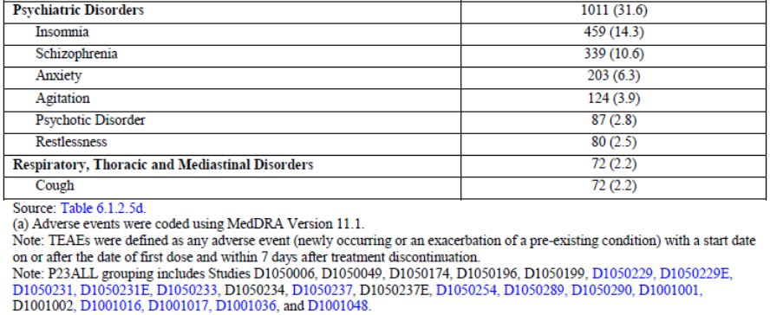
The rate of TEAEs in the healthy phase I population was 62.9% and in the schizophrenic phase I population was 96.0%. In healthy subjects, the most frequent TEAEs in the lurasidone groups were somnolence (24.0%) and increased prolactin (17.3%). In the schizophrenia phase I population, the profile of TEAEs was similar to the phase II/III studies.

Other TEAEs of interest
The rate of extrapyramidal symptoms in P23ALL was 25.6% with the most frequent being akathisia (13.6%), parkinsonism (4.4%), tremor (3.9%), dystonia (3.2%) and restlessness (2.5%) (Table 20). There was one case (<0.1%) in the P23STC and 4 (0.6%) in the P23LTC population of tardive dyskinesia. In the P23ALL population, there were 11 cases (0.3%) of tardive dykinesia in lurasidone-treated subjects, with one leading to discontinuation. There were also two cases (<0.1%) of neuroleptic malignant syndrome (one related to risperidone and one related to lurasidone).
Table 20: Treatment-emergent extrapyramidal symptoms that occurred in >0.5% of all lurasidone subjects, by PT, Safety Population: P23ALL, P23STC and P23LTC study groups.
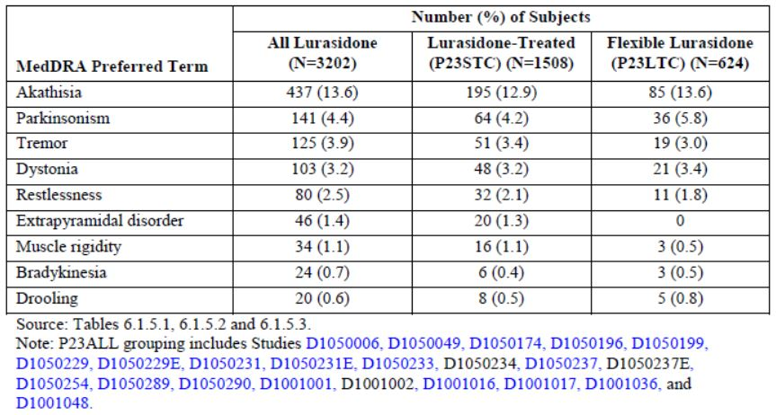
In the P23ALL population, there was one complex partial seizure (<0.1%) and 5 convulsions (0.2%). In P23ALL the rate of suicidal ideation was 0.9% (n=28). There were 5 completed suicides (0.2%), 4 suicide attempts (0.1%), 3 cases of suicidal behaviour and 2 of self-injurious behaviour.
There was one case of angioedema in P23ALL (<0.1%) which was an SAE and the subject discontinued. The rate of rash was 1.4%, pruritus 1.3%, contact dermatitis 0.4%, urticaria 0.3%, rash pruritic 0.2%, generalised pruritus 0.2% and face swelling 0.2%. One pruritic rash was also an SAE. Two of these cases (rash and pruritus) resulted in discontinuation.
In P23ALL, TEAEs suggestive of body temperature increase in the lurasidone group were: pyrexia (1.7%), increased body temperature (0.2%), feeling hot (<0.1%) and hyperthermia (0.2%). There were no clinically relevant changes in body temperature in the short of long term populations (see section Vital Signs).

Treatment-related adverse events (adverse drug reactions)

P23STC studies
The rate of treatment-related TEAEs was 44.8% with lurasidone (all doses) compared to 32.2% in the placebo group. The most frequent events were akathisia, somnolence and sedation. These events were dose related up to 120 mg then there was a lower rate with the 160 mg dose. The rate was less than haloperidol (58.3%) and olanzepine (54.9%) but higher than quetiapine (37.8%) and risperidone (38.5%) (Tables 21-22).
Table 21: Incidence of treatment-related AEs reported in ≥1% of subjects (and greater than placebo) at the PT level within any lurasidone dose group, Safety Population: P23STC study group for lurasidone and placebo-treated subjects.
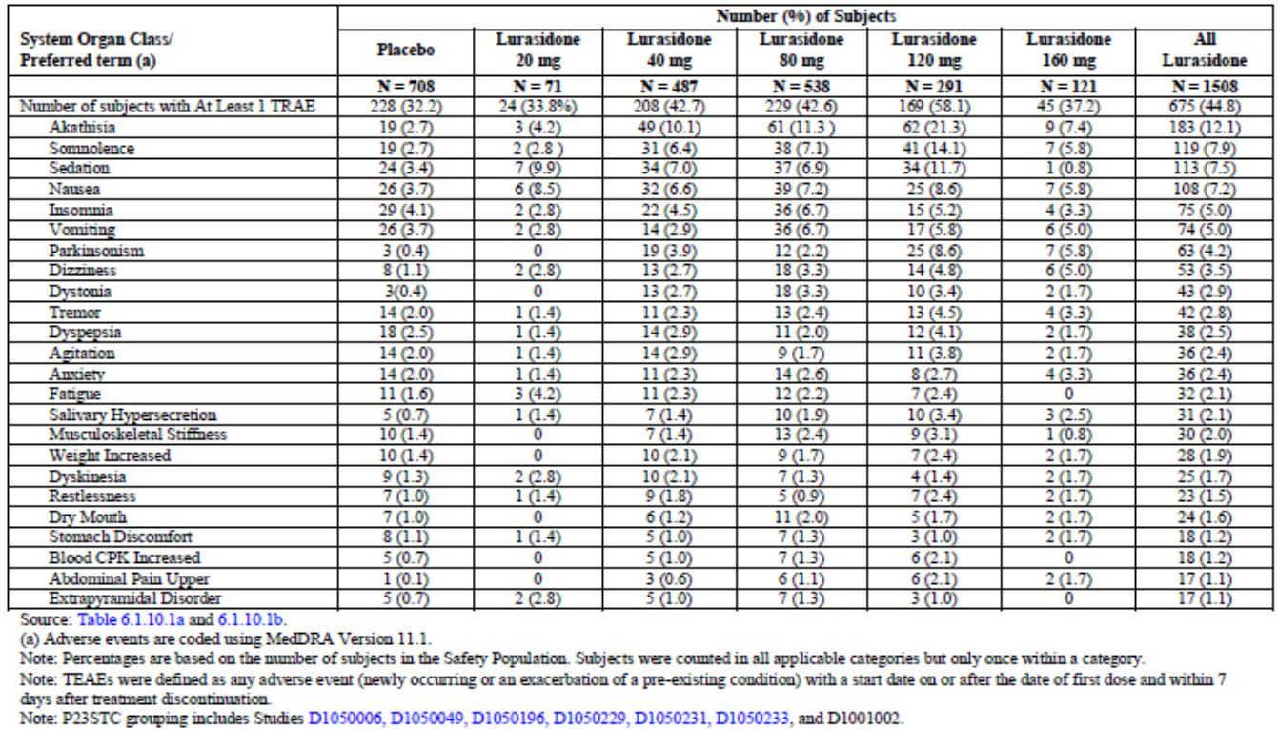
Table 22: Incidence of treatment-related AEs reported in ≥1% of subjects (and greater than placebo) at the PT level within any lurasidone dose group, Safety Population: P23STC study group for all lurasidone, placebo and active control treated subjects.
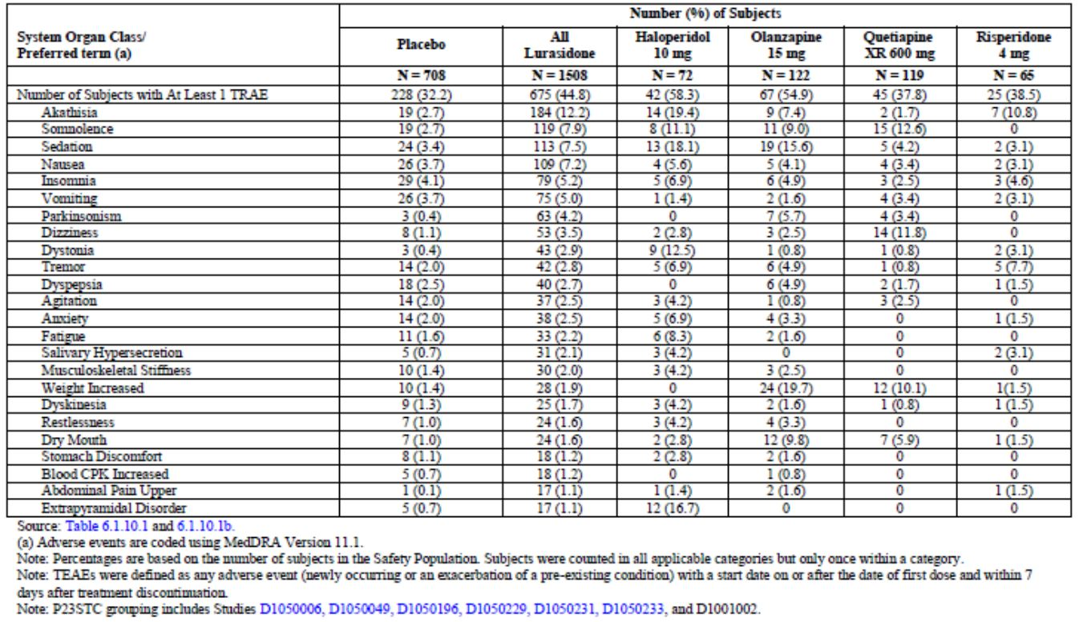

Other studies
In study D1050254, the rate of treatment-related TEAEs was 42% and 47% in the lurasidone and ziprasidone groups, respectively.
In the long term (P23LTC) population, the rate of one or more treatment-related TEAE was 63.0% in the lurasidone, 43.5% in the quetiapine XR and 75.9% in the risperidone group. The most frequent treatment-related events were akathisia (13.3%), nausea (10.4%) and somnolence (10.1%). In the P23ALL safety population the rate of treatment-related TEAEs was 63.8%.

Deaths and other serious adverse events

Deaths
To the data cut-off of 30 June 2012, there were 19 reported deaths: 13 with lurasidone that were treatment-emergent (during study medication administration or within 14 days of stopping); 2 pre-treatment deaths; 2 non-treatment emergent lurasidone deaths; and 2 deaths on comparators. The deaths on comparators were bronchopneumonia while on olanzepine and cardiac arrest on ziprasidone. There were no deaths in the placebo, haloperidol, quetiapine XR, or risperidone groups. The two deaths in lurasidone-treated subjects that occurred more than 14 days after last dose of study medication were heroin overdose and sudden death due to gastrointestinal haemorrhage. There were no deaths in the phase I studies. The Sponsor stated that deaths were reviewed by a blinded committee which adjudicated the cause of death as cardiovascular or non-cardiovascular.
In the 13 treatment emergent lurasidone deaths (0.41%), 5 were suicides, 2 were accidents (thermal burns and road traffic accident), one was septic shock with respiratory failure and 5 were adjudicated as cardiovascular. The rate of death was 1.07 per 100 patient years.
The five cardiovascular deaths were:
- Subject number [information redacted] on lurasidone 80 mg found dead in bed and post mortem revealed 70% coronary artery occlusion and diffuse ventricular interstitial fibrosis. The cause of the sudden death was stated to be hypertensive cardiovascular disease. Lurasidone treatment was for 69 days. The death was classed as unrelated to study medication.
- Subject number [information redacted] on lurasidone 80 mg with past history of a myocardial infarction who was found dead with a presumed pulmonary embolism or myocardial infarction (no post mortem for confirmation). Lurasidone treatment was for 210 days. The death was classed as unlikely to be related to study medication.
- Subject number [information redacted] on lurasidone 160 mg who died during sleep and autopsy concluded that death was due to a presumed cardiac arrhythmia secondary to congenital hypoplasia of the right coronary artery and cardiomegaly. Lurasidone treatment was for 21 days. The death was classed as unlikely to be related to study medication.
- Subject number [information redacted] on lurasidone 40-120 mg with diabetes, peripheral circulatory failure and sudden death due to presumed acute cardiac failure (no post mortem performed). Lurasidone treatment was for 360 days. The death was classed as possibly related to study medication.
- Subject number [information redacted] on lurasidone 80 mg who was reported to have died suddenly and post-mortem CT scans showed brainstem and pericardium haemorrhage. Lurasidone treatment was for 25 days. The death was classed as possibly related to study medication.

SAEs
The percentage of subjects in the P23STC group who had at least one SAE was 4.6% in the lurasidone-treated group, 5.6% in the placebo, 6.9% in the haloperidol, 4.9% in the olanzapine, 2.5% in the quetiapine XR and 3.1% in the risperidone group. The rate of SAEs in the lurasidone subjects was 5.6%, 5.1%, 3.2%, 6.2% and 4.1% in the 20, 40, 80, 120 and 160 mg dose groups. The rate of SAEs deemed treatment-related was 1.1% and 2.3% of the lurasidone and placebo groups, respectively. The most frequent SAEs were psychiatric disorders including schizophrenia, psychotic disorder and suicidal ideation.
The percentage of subjects in P23LTC who had at least one SAE was 10.6% (n=66) in the lurasidone group compared to 20.0% (n=17) in the quetiapine XR and 10.1% (n=20) in the risperidone group. The most frequent SAEs in the long term populations were psychotic disorder (3%), schizophrenia (2.1%), suicidal ideation (0.3%), agitation (0.3%), anxiety (0.3%), parkinsonism (0.3%) fall (0.5%) and rib fracture (0.3%).
The percentage of lurasidone-treated subjects in the P23ALL group who had at least one SAE was 9.5% with treatment-related SAEs occurring in 2.6% (n=82).
There were no SAEs in the phase I studies in healthy subjects (P1NON) and there were 3 SAEs in the schizophrenic subjects (P1SCH): one suicidal ideation in the placebo group (6.3%); one increased CPK (0.5%) and one increased psychosis (0.5%), both in the lurasidone ≤120 mg group.

Discontinuation due to adverse events

P23STC studies
The percentage of subjects in the P23STC group who discontinued treatment due to a TEAE was 9.5% of the lurasidone-treated group compared to 9.3%, 11.1%, 9.8%, 3.4% and 10.8% of the placebo, haloperidol, olanzapine, quetiapine XR group and risperidone groups, respectively. The rate of TEAEs leading to discontinuation was 0%. 9.9%, 8.7%, 13.7% and 6.6% in the 20, 40, 80, 120 and 160 mg dose groups, respectively.
Discontinuation due to nervous system disorders was higher with lurasidone than placebo (2.5% versus 0.4%). The most frequent events leading to discontinuation were schizophrenia (3.4%), psychotic disorder (0.9%), akasthisia (1.4%), dystonia (0.5%), agitation (0.3%), anxiety (0.2%), insomnia (0.2%), dyskinesia (0.2%), increased CPK (0.3%), nausea (0.3%) and vomiting (0.3%).

Other studies
In study D1050254, the rate of TEAEs leading to discontinuation was 12.0% and 13.2% of the lurasidone and ziprasidone groups, respectively.
In P23LTC, the rate of TEAEs leading to discontinuation was 18.4% of the lurasidone group compared to 22.4% of the quetiapine and 16.1% of the risperidone group. The profile of events was similar to the short term studies. The rate of EPS-related TEAE leading to discontinuation was 1.8%, 2.5% and 0% of the lurasidone, risperidone and quetiapine groups, respectively.
The percentage of subjects in the P23ALL group who discontinued treatment due to a TEAE was 18.4% in the “all lurasidone” group with the most frequent events being schizophrenia, agitation, anxiety, akathisia, somnolence, dystonia, nausea and vomiting. There was one subject with increased weight leading to discontinuation.
In the phase I studies, the rate of TEAEs leading to discontinuation was 2.0% of the healthy subjects and 7.3% of the schizophrenia subjects.

Laboratory tests

Liver function

P23STC studies
The mean changes from baseline to LOCF in AST, ALT were unremarkable in lurasidone-treated subjects. The olanzepine group was noted to have a mean increase from baseline to LOCF in AST, ALT and GGT of 11.3, 22 and 10.4 U/L, respectively. The rate of lurasidone-treated subjects with shifts from normal to high levels of AST, ALT, ALP was 3.1%, 4.8% and 1.0% which was similar to rates seen with placebo (4.9%, 4.1%, 0.7%). Markedly abnormal LFTs are summarised in Table 23 by dose and Table 24 against active comparators. The rates are similar to placebo and less that seen with olanzapine 15 mg. There were 2 cases of bilirubin ≥2x ULN but no cases meeting the Hy’s Law criteria. There were 2 lurasidone subjects who discontinued due to a TEAE of abnormal LFTs.
Table 23: Summary of subjects with markedly abnormal LFTs: P23STC studies for individual lurasidone and placebo treatment groups.
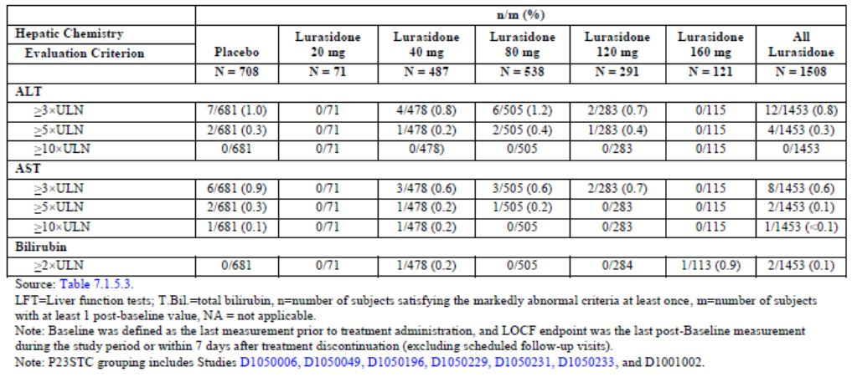
Table 24: Summary of subjects with markedly abnormal LFTs: P23STC studies for all lurasidone, placebo, and active control treated groups.
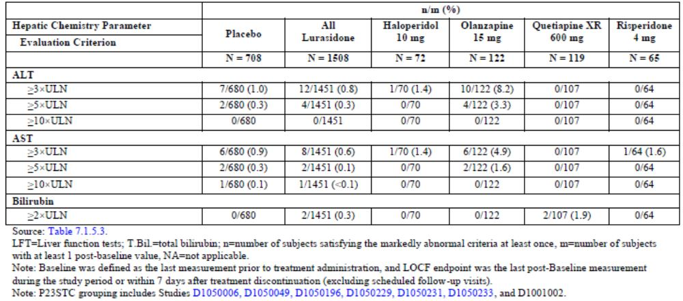

Other studies
In P23LTC population, the rate of markedly abnormal LFTs of ≥3x ULN for AST, ≥3x ULN ALT and ≥2x ULN bilirubin was 1.2%, 0.5% and 0.2%, respectively, in the lurasidone group, with no cases reported in the risperidone or quetiapine groups.
In P23ALL, the proportion of subjects with ≥3x ULN post-baseline values of ALT, AST and ALP was 1.1%, 0.8% and <0.1%, respectively. The rate of bilirubin ≥2xULN was 0.3%.There were no Hy’s Law cases. In the phase I studies in healthy subjects there were 7 cases (2.2%) and in the schizophrenia subjects one case (0.3%) with bilirubin ≥2xULN, but none met the Hy’s Law criteria.
The rate of TEAEs of increased ALT (0.5%) or increased AST (0.3%) was the same in the short term and long term population.

Kidney function

P23STC studies
There was a small increase in creatinine noted. At LOCF endpoint, mean (SD) changes in creatinine from baseline in the lurasidone 20, 40, 80, 120 and 160 mg dose groups were: 2.86 (11.93) μmol/L, 3.20 (11.42) μmol/L, 4.28 (11.12) μmol/L, 6.23 (12.10) μmol/L, and 8.89 (13.61) μmol/L, respectively. This compares to 1.46 (11.85) μmol/L for placebo. The rate of markedly abnormal creatinine (≥176.8 μmol/L) was <0.1% and 0.1% in the lurasidone and placebo groups, respectively. The effect on creatinine was dose-related with shifts from normal/low at baseline to high at LOCF endpoint of 1.4%, 1.9%, 2.2%, 5.0% and 7.3% of the 20, 40, 80, 120 and 160 mg dose groups, respectively. This compares to 1.7%, 0%, 1.7% and 1.9% in the placebo, haloperidol, olanzapine and quetiapine XR groups, respectively.
There were no TEAEs of increased creatinine, renal insufficiency or renal failure in the P23STC population.

Other studies
In P23LTC, the rate of shift from normal to high BUN was 1.1% in the lurasidone group with none in the active comparator groups. The rate of markedly abnormal creatinine was 0.2% with lurasidone with no cases reported with risperidone or quetiapine. Shifts from normal/low to high creatinine occurred in 5.2%, 2.4% and 4.3% of the lurasidone, risperidone and quetiapine groups, respectively. In the P23ALL population this shift occurred in 3.5% of lurasidone subjects and there were 3 subjects (0.1%) with markedly abnormal creatinine levels.
In P23LTC, there was one TEAE of renal failure in a lurasidone-treated subject. In P23ALL, there were 4 cases (0.1%) of increased creatinine and 2 cases (<0.1%) of renal failure TEAEs in lurasidone-treated subjects.
There were no notable findings on calcium, phosphate, chloride, potassium or sodium.

Other clinical chemistry

P23STC studies
A significant increase in total cholesterol (increase ≥1.03 mmol/L) was found with 6.3% of lurasidone-treated subjects, 6.7% with placebo group, 10.1% with haloperidol 10 mg, 13.3% with olanzapine 15 mg, 18.8% with quetiapine XR 600 mg, and 11.3% with risperidone 4 mg. The rate of markedly abnormal values for cholesterol, LDL, TG and HbA1c was similar to placebo and there was no dose response evident.
There was no meaningful change in glucose levels compared to the placebo group. There were 3 (0.2%) subjects with post baseline fasting glucose <2.5 mmol/L and the rate of fasting glucose >8.9 mmol/L was 3.8% and 2.5% in the lurasidone and placebo groups respectively compared to 5.8% with haloperidol, 6.1% with olanzapine and 1.0% with quetiapine. The rate of shift from normal to >6.1% in HbA1c was 6.4%, 4.8%, 4.3%, 7.8% and 3.2% in the lurasidone, placebo, haloperidol, olanzapine and quetiapine groups, respectively.
Shifts from normal to high creatinine kinase occurred in 18.0%, 18.2%, 19.2%, 19.1%, 14.5%, and 13.2% of subjects in the lurasidone, placebo, haloperidol 10 mg, olanzapine 15 mg, quetiapine XR 600 mg and risperidone 4 mg treatment groups, respectively. Markedly abnormal CK (≥3x ULN) occurred in 8.8% and 8.4% of lurasidone and placebo subjects which was similar to haloperidol (10%) and olanzapine (9.8%) but higher than quetiapine and risperidone (1.9% and 1.6%).

Other studies
In P23LTC the rate of markedly abnormal metabolic parameters was similar between lurasidone, risperidone and quetiapine. In P23ALL the rate of shift from normal to high total cholesterol was 2.2% and triglycerides was 6.2%. Shift to high CK was similar between the lurasidone, risperidone and quetiapine groups (18.4%, 19.2% and 15.8%). In P23ALL, the rate of markedly abnormal CK was 10.8%.
In P23ALL the rate of metabolic TEAEs was 6.5%, and 2 cases (<0.1%) led to treatment discontinuation. The rate of TEAEs of blood triglycerides increased, hypertriglyceridemia and hyperlipidemia was 1.0%, <0.1% and 0.2% of lurasidone subjects, respectively.
There were 2 TEAEs of rhabdomyolysis (<0.1%) (with a CPK of 2610 U/L in a subject on 20 mg and 1157 U/L in a subject on 120 mg lurasidone) in P23ALL. The first case was mild and the second severe, both were considered related to lurasidone and both resulted in treatment discontinuation.

Haematology

P23STC studies
Changes in haematology values with lurasidone were not remarkable and the rate of markedly abnormal values was similar to the placebo group. Subjects on olanzapine and quetiapine were noted to have a reduction in haemoglobin (mean decrease of -4.0 and -4.5 g/L, respectively).

Other studies
The main finding with regard markedly abnormal haematology was a high rate of low haematocrit with quetiapine (64.3% females, 54.8% males) with a lower rate with lurasidone (17.1 males and 23.2% females). Shifts from normal to low haemoglobin occurred in 3.9%, 1.1% and 2.9% of the lurasidone, risperidone and quetiapine XR groups, respectively.
In P23ALL, the rate of markedly abnormal haematology values was as follows: low haematocrit 6.9%, low platelets 0.2%, low neutrophils 0.3%, high eosinophils 4.5%, high WBC 1.3%, low WBC 0.8%, low haemoglobin males 1.4% and low haemoglobin females 1.9%. Haematology findings in the phase I studies were not remarkable.
In P23ALL, there was one TEAE of leukopaenia (<0.1%) and 3 cases of neutropaenia (<0.1%) in lurasidone-treated subjects.

Prolactin

P23STC studies
The median prolactin levels decreased 17.0 pmol/L in the lurasidone and 82.0 pmol/L in the placebo group. There was, however, a median increase of 143 pmol/L and 130 pmol/L in the lurasidone 120 and 160 mg groups, respectively. Greater increases were seen with haloperidol (368 pmol/L), olanzepine (161 pmol/L) and risperidone (609 pmol/L). The rate of markedly abnormal prolactin (≥5x ULN) was 2.7% with lurasidone and 1.0% with placebo. This compares to 29.7% with risperidone, 4.8% with haloperidol and 0% with olanzepine and quetiapine. The rate of markedly high prolactin in lurasidone subjects did not appear dose-related although there was a dose response in the rate of shift from normal/low to high prolactin (11.7%, 16.6%, 18.6%, 23.9%, and 28.4%, respectively in the 20, 40, 80, 120 and 160 mg groups). This rate was 19.8% in the overall lurasidone population compared to 6.1%, 46.3%, 14.3%, 10.2% and 95.5% in the placebo, haloperidol 10 mg, olanzapine 15 mg, quetiapine XR 600 mg and risperidone 4 mg treatment groups, respectively. There were 2 subjects who discontinued due to a TEAE of increased prolactin (one on 40 mg and one on 120 mg lurasidone).
Insulin levels were assayed in D1050231 and D1050233 and there was no notable changes compared to placebo.

Other studies
In P23LTC the median change in prolactin was -8.0, -17.4 and +385.0 pmol/L and the rate of markedly abnormal prolactin was 2.0%, 1.4% and 4.0% in the lurasidone, quetiapine and risperidone groups, respectively. A shift from normal/low to high prolactin was similar between lurasidone and quetiapine (14.4% versus 12.1%) and higher with risperidone (46.7%).
In P23ALL the rate of prolactin ≥5x ULN was 3.0%, with slightly higher rate in females than males (5.0% versus 2.1%). The rate of shift of prolactin from normal/low at baseline to high at study endpoint was 17.5%.
In P23ALL, the rate of TEAEs of elevated prolactin or abnormal prolactin was 3.1% and <0.1%, respectively. TEAEs of galactorrhoea, amenorrhoea and erectile dysfunction occurred in 2 (<0.1%), 11 (0.3%), and 9 (0.3%) of lurasidone subjects, respectively. There were no cases of gynaecomastia reported. The rate of bone fractures was 0.7% (24/3202) in P23ALL, there was one case of osteopaenia (<0.1%) and none of osteoporosis.

C-reactive protein

P23STC studies
C-reactive protein (CRP) was assessed in studies D1050231 and D1050233. In P23STC population, there was no relevant mean change in CRP in the lurasidone group. The proportion of subjects with markedly abnormal CRP (≥8 mg/dL) was 15.5%, 12.0%, 28.1% and 16.8% in the lurasidone, placebo, olanzepine and quetiapine groups, respectively.

Other studies
In the P23LCT population, the shift from normal/low to high CRP at LOCF endpoint occurred in 8.5%, 9.2% and 12.3% and markedly abnormal values in 26.3%, 32.4%, and 22.5% in the lurasidone, risperidone and quetiapine groups, respectively.

Urinalysis
There were no remarkable finding on urinalysis reported.

Electrocardiograph
The mean change from baseline to LOCF endpoint in RR interval, PR interval or QRS interval was not remarkable in the P23STC population.

Vital signs
There were no relevant change in SBP, DBP, pulse or temperature in lurasidone treated subjects in the short or long term controlled populations. In P23STC, the rate of markedly low SBP was 0.4%, 1.8%, 4.1% and 2.5% in the lurasidone 40, 80, 120 and 160 mg groups. In P23LTC, the rate of markedly low SBP was 2.9%, 3.0% and 6.2% in the lurasidone, risperidone and quetiapine groups, respectively.
In the phase I studies there was no notable changes in BP or pulse in the placebo-treated subjects. Healthy subjects treated with lurasidone the rate of a high standing pulse was 3.7% and low standing SBP was 15.0% and low standing DBP was 23.2%. The rate in schizophrenic phase I subjects for markedly low sitting DBP was 6.8% and low DBP (position not specified) was 4.3%.
Orthostatic hypotension was defined as ≥20 mmHg decrease in SBP (sitting to standing or supine to standing) with ≥10 bpm increase in pulse. In the P23STC population the rate at LOCF endpoint was 0.8%, 2.1%, 1.7% and 0.8% with lurasidone 40, 80, 120 and 160 mg doses (1.5% overall) which was slightly higher than placebo (0.7%), olanzepine (0.8%) and quetiapine (0.9%). The rate of orthostatic hypotension in the P23LTC population at LOCF was 1.6%, 1.0% and 1.2% in the lurasidone, risperidone and quetiapine groups.

Weight

P23STC studies
In P23STC, the mean change in weight from baseline to LOCF endpoint was 0.43 kg in the lurasidone compared to -0.02 kg in the placebo groups and the difference was statistically significant (p<0.001). The mean change in the active groups was 0.02 kg with haloperidol, 4.15 kg with olanzapine, 2.09 kg with quetiapine and 0.2 kg with risperidone. There was no significant difference in weight change between lurasidone and haloperidol, while the difference was significant against the other three active drugs (p≤0.007). The proportion of subjects with markedly low (≥7% decrease) weight change was similar to placebo (3.1% versus 3.9%) and the proportion with markedly high (≥7% increase) weight change was slightly higher with lurasidone than placebo (5.4% versus 4.3%).

Other studies
In the P23LTC population, the mean weight change to LOCF endpoint was -0.64 kg in the lurasidone group compared to 1.47 and 0.11 kg in the risperidone and quetiapine groups, respectively. In P23ALL at LOCF endpoint, the mean change in weight was -0.36 (SD 4.42) kg. In P23ALL, increased weight was reported as a TEAE in 4.2% of lurasidone subjects.

Movement disorders

Simpson-angus rating scale
The change from baseline to LOCF endpoint in the P23STC population on the SAS did not show any dose related increase and the mean change was greatest with haloperidol (0.12) and similar between the other groups (-0.01 with placebo and 0.02 with lurasidone). A shift from normal to abnormal score on the SAS was reported in 11.1% of the haloperidol group compared to 5.0%, 4.9% and 2.9% of the lurasidone, olanzapine and quetiapine groups, respectively.
In the P23LTC population, the mean change from baseline in the SAS was 0.01, -0.03 and -0.02 in the lurasidone, risperidone and quetiapine groups. The rate of shift from normal to abnormal score was 5.1%, 2.6% and 1.5%, respectively. In P23ALL, the rate of shift from normal to abnormal score was 15.4% and abnormal to normal scores was 3.6%.

Barnes akathisia rating scale
In P23STC, the mean change from baseline to LOCF endpoint in the BAS was 0.0, 0.1, 0.1, 0.5, 0.1 in the lurasidone 20, 40, 80, 120 and 160 mg dose groups, compared to 0.0 in the placebo group, 0.9 with haloperidol, 0.0 with olanzepine and -0.2 with quetiapine. The proportion of subjects who worsened on the BAS global clinical assessment also showed a dose-related increase from 11.3% with lurasidone 20 mg to 20.7% with lurasidone 120 mg, the rate then lowered with lurasidone 160 mg (10.7%) (Table 25). The rate of worsening with lurasidone (14.4%) was more than olanzepine (9.0%) and quetiapine (6.0%) but less than haloperidol (33.3%) (Table 26).
Table 25: Categorical shift from Baseline to LOCF endpoint: Barnes Akathisia Rating Scale Global Clinical Assessment, Safety Population: P23STC studies for lurasidone and placebo treated subjects.
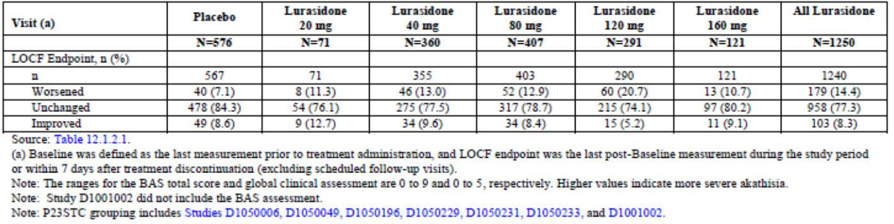
Table 26: Categorical shift from Baseline to LOCF endpoint: Barnes Akathisia Rating Scale Global Clinical Assessment, Safety Population: P23STC studies for lurasidone, placebo, and active control treated subjects.
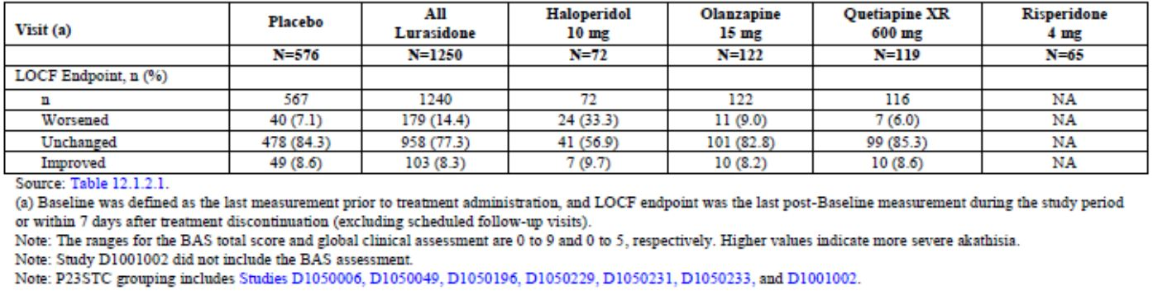
In the long term population (P23LTC), the mean change from baseline in the BAS was similar between lurasidone, risperidone and quetiapine groups (0.3, 0.3, 0.2). In P23ALL the mean change was 0.2 and the rate of worsening by LOCF endpoint was 11.9%.

Abnormal involuntary movement scale
In P23STC, there was little change in the mean AIMS total score from baseline to LOCF endpoint in the placebo group (0.1) and across the lurasidone dose groups (0.0 to 0.1) except for lurasidone 20 mg (0.6). There was also an increase in the haloperidol group (0.8). A shift from normal to abnormal AIMS score occurred in 2.3% of the placebo and 2.2% of the lurasidone group and was higher with haloperidol (12.5%) and lower with olanzapine and quetiapine (1.6% and 0%). The rate of worsened AIMS global severity score at LOCF endpoint was 7.4% with lurasidone and 12.5% with haloperidol.
A shift from normal to abnormal AIMS score in the P23LTC population occurred in 1.5%, 1.0% and 0% of the lurasidone, risperidone and quetiapine groups, respectively. In P23ALL, the rate of shift from normal to abnormal was 2.2%.

Ophthalmological assessment

D1050237 and D1050006
Ophthalmological examinations were undertaken in D1050237 and D1050237E at selected sites. At 6, 12 and 18 months (lurasidone only) with data for up to 111 lurasidone and 58 risperidone subjects. There were 3 subjects with clinically significant changes on ophthalmological parameters. One subject (0.9%) treated with lurasidone had raised intraocular pressure in both eyes due to glaucoma (stated to be present at screening), one lurasidone subject (0.9%) had corneal dystrophy in both eyes and one risperidone subject (1.8%) was noted to have a retinal haemorrhage. There were no reported clinically significant findings on fundoscopy or slit lamp examination in the 60 subjects treated with lurasidone who had day 42 assessments in study D1050006.

Bone assessment
In study D1050237, DXA scans were undertaken at 6 and 12 months and data were available of 48 risperidone and 97 lurasidone subjects. The percentage change from baseline to LOCF endpoint in average L1-L4 lumbar spine BMD was 0.3% in both the lurasidone and risperidone groups. The change in total hip and femoral neck BMD was -0.2% and 0.3%, respectively.

Post marketing experience
Lurasidone was launched in the US in February 2011 and in Canada in September 2012.The Summary of Clinical Safety summarised post-marketing data to the cut-off date of 30 June 2012. Five individual PSURs were also included in Module 5 covering the period from January 2011 to April 2012. As of 30 June 2012, the estimated exposure was 386,900 patients representing 32,241 person-years. There have been 1505 serious and non-serious adverse drug reactions reported in 723 patients. Most were in the psychiatric, nervous system, gastrointestinal and general disorders SOC. The most frequently reported reactions were nausea, akathisia, insomnia, rash and anxiety. There were 194 serious reactions with the most frequent being suicidal ideation (n=9), convulsion (n=9), death (n=7), auditory hallucination (n=6) and psychotic disorder (n=6).
There 6 serious and 151 non-serious reports of extrapyramidal symptoms. The 6 serious cases were: 3 akathisia, 2 dystonia and 1 oromandibular dystonia. The most frequent non-serious cases were akathisia, tremor, restlessness and dystonia. There were no reported cases of drug interactions. There were 4 serious and 14 non-serious reports of angioedema and related symptoms. There were 16 serious and 81 non-serious reports of neuroleptic malignant syndrome and related terms. There was one serious and 35 non-serious reports of tardive dyskinesia and related symptoms.
There were 38 pregnancies recorded of which 26 have no outcome data and 2 delivered healthy babies. In the 10 other cases, 7 were non-serious and the outcome was not reported. There were 3 serious cases: one spontaneous abortion at 6 weeks, one spontaneous abortion at unknown gestation and one exacerbation of schizoaffective disorder.
There were 8 reports of overdoses, 7 were intentional (2 of which were fatal) and in one case the patient was prescribed 360 mg per day. There were 2 bone fractures, one associated with an attempted suicide and the other following a fall.
There were 12 reported deaths. The cause was unknown in 6 cases, there were 3 suicides, one homicide, one an unspecified infection and one “ill with anaemia”.

Safety issues with the potential for major regulatory impact

Cardiovascular safety

QT Prolongation
In the P23STC population the rate of QTcB prolongation (male QTc >450 msec, female QTc >470 msec) was 3.9% and 3.5% in the lurasidone and placebo groups, respectively. The rate of QTcB prolongation was 4.5%, 5.8%, 4.7% and 6.2% in the haloperidol, olanzapine, quetiapine XR, risperidone groups, respectively. The rate of QTcF prolongation was 1.0% and 0.3% in the lurasidone and placebo groups and 1.5%, 0%, 0%, and 4.6% in the four active groups, respectively.
In the P23LTC population, the rate of QTcB prolongation with flexible dosing was 6.2%, 13.9%, 4.6% in the lurasidone, risperidone and quetiapine XR groups, respectively. In the P23ALL population, the overall rate of QTcB and QTcF prolongation was 6.0% and 1.3%.
A subgroup of subjects with increased cardiovascular risk was identified by the investigator (age ≥55 years, CV disease or prior MI). In this group in P23STC, the rate of QTcB prolongation was 10.4% and 7.7% and QTcF prolongation was 5.2% and 0% in the lurasidone and placebo groups, respectively. In the P23LTC population, this group had a rate of QTcB prolongation of 10.0%, 33.3% and 22.2% in the lurasidone, risperidone and quetiapine XR groups, respectively.
A thorough QT study (D1050249) with lurasidone 120 mg and 600 mg per day over 11 days was conducted in 73 patients with schizophrenia or schizoaffective disorder. None of the subjects in the lurasidone groups had an absolute QTc above 450 msec or change from baseline of >60 msec, however administration of lurasidone at a therapeutic dose of 120 mg prolonged the heart rate corrected QT intervals with a mean change from baseline of 9.4 msec with the maximum upper bound of the two-sided 90% CI ΔQTcI of 14.7 msec at 2-hour post dose. Supratherapeutic dose of lurasidone 600 mg (titrated regimen) prolonged the QTc intervals, but to a lesser extent than the therapeutic dose, with a mean change from baseline of 5.8 msec and the upper bound of the two-sided 90% CI ΔQTcI was 11.5 msec at 4-hour post dose. The study did not have a placebo group and due to intersubject variability the findings are not conclusive and concentration QTc response modelling was undertaken. The model demonstrated a small dose response but did not find that the doses of 120 mg or 600 mg were associated with QTc prolongation as the upper bound of the 90% CI was <10 msec.
The Sponsor also submitted an “Expert summary review of the effect of lurasidone on cardiac repolarisation” in the Summary of Clinical Efficacy which concluded that ‘lurasidone is devoid of any clinically relevant effect on QTc interval’.
In the P23ALL population (1212 patient years exposure), the following clinical cardiovascular events occurred: syncope (0.2%, n=8), loss of consciousness (<0.1%), complex partial seizures (<0.1%), convulsion (0.2%), sudden death (0.1%, n=3) and ventricular extrasystoles (0.2%, n=6). No clinically meaningful increases in the QTc duration were reported with these cases. There were no reported cases of ventricular tachycardia, fibrillation, flutter or torsades de pointes. Post-marketing data provided did not reveal any signals relating to QT prolongation.
In terms of major cardiovascular events (MACE) in P23ALL, there was one (<0.1%) myocardial infarction, 3 (<0.1%) atrioventricular block first degree, 1 (<0.1%) atrioventricular block, 1 (<0.1%) bundle branch block, and 1(<0.1%) reported left bundle branch block. There were 3 cases (<0.1%) of stroke, one cerebrovascular haematoma and 2 pulmonary embolisms (one was “possible” and was fatal, the other was associated with chest trauma). In P23STC population, orthostatic hypotension occurred in 0.3% of lurasidone subjects compared to 1.6% of the olanzapine and 2.5% of the quetiapine XR group. The rate in P23ALL was 0.3%.

Other safety issues

Safety in special populations

Gender
The rate of TEAEs was similar between males and females (75.4% versus 78.3%). Females has a higher rate of gastrointestinal disorders SOC (37.2% versus 30.6%) including nausea, vomiting and diarrhoea.

Age
There were very few subjects aged 65 years or over in the development program so no conclusions can be drawn. There were two phase I studies which enrolled 24 healthy elderly subjects who received a single 20 mg dose (D1001049 and D1050253). The notable safety finding was an increase in prolactin levels.

Race
Analysis of TEAEs by the racial groupings of White, Black/African American and Other did not reveal any significant findings.

Renal impairment
Mild and moderate renal impairment has been found to result in increased lurasidone exposure of 1.5 and 1.9 fold, respectively (D1050265). Analysis of safety data in the subgroup of renally impaired patients was not undertaken. The clinical protocols were noted to have excluded subjects with estimated creatinine clearance <60 mL/minute, i.e. moderate or worse impairment.
Comment: Subgroup analysis of safety data in patients with renal impairment should be presented in order to assess the risk-benefit balance in this patient group particularly as the Sponsor proposes in the PI that they may be treated.

Hepatic impairment
Mild, moderate and severe hepatic impairment increases the lurasidone exposure 1.5, 1.7 and 3.0 fold, respectively. Clinically significant impaired hepatic function was an exclusion criteria in the clinical trials. No subgroup analysis of safety data in subjects with hepatic impairment was undertaken.
Comment: As with renal impairment, subgroup analysis of safety data in patients with hepatic impairment should be presented in order to assess the risk-benefit balance.

Pregnancy and lactation
Lurasidone is reported to cause development toxicity in nonclinical studies and is excreted in the breast milk of rats. In the clinical studies there were 6 confirmed pregnancies in lurasidone-treated women. The outcomes were: elective abortion, spontaneous abortion, preeclampsia with premature delivery, delivery at term via caesarean and two unknown outcomes. Post-marketing data are also limited.

Safety related to drug-drug interactions and other interactions
As CYP3A4 metabolises lurasidone, the potential for drug-drug interactions is present. A summary of the effect with co-administered ketoconazole, diltiazem, rifampicin and lithium is in Table 27. Lurasidone is contraindicated with strong inhibitors or inducers of CYP3A4 and a lower dose recommended in the presence of moderate inhibitors. There were no specific safety data presented from the phase II/III program on safety issues related to drug interactions.
Table 27: Summary of effect of co-administered drugs on exposure of lurasidone to healthy subjects.
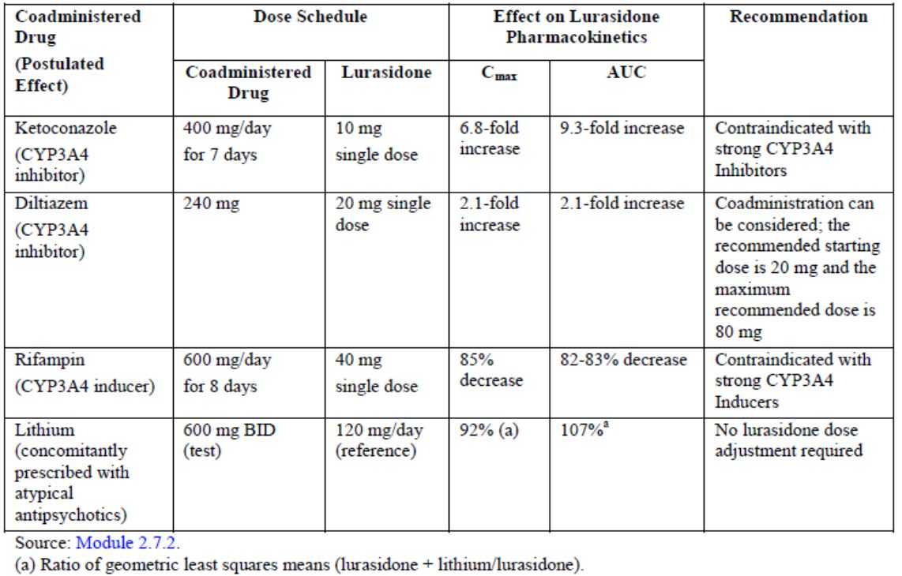

Overdose
There were 8 reported cases of drug overdose with 6 being serious. Two of the cases involved lurasidone. Five cases were suicide attempts (one with lurasidone and other medications), one was an accidental overdose, one an intentional overdose and one was identified during monitoring (lurasidone dose of 560 mg).

Withdrawal
No withdrawal syndrome was reported on discontinuation of lurasidone treatment in the phase II/III trials. There was one reported case during the placebo run-in period after withdrawal of antipsychotics. Symptoms were nausea, headache and constipation.

Evaluator’s overall conclusions on clinical safety
The safety data for lurasidone was derived from 52 clinical trials which included 5607 subjects with schizophrenia (3473 treated with lurasidone, 724 treated with placebo, and 1410 treated with other medications). Study duration ranged from 3 weeks to 22 months and evaluated doses of lurasidone from 20 mg to 160 mg/day. There were 471 subjects who had ≥364 days exposure and the total exposure was 1212 patient-years.
The main data pools were:
- P23STC: Short term phase II/III double blind placebo controlled studies (D1050006, D1050196, D1050229, D1050231, D1030233, D1001002, D1050049) which included 1508 subjects treated with lurasidone, 708 with placebo and 378 with comparators. The mean exposure duration was 31.7 days.
- P23LTC: Long term, 52 week, phase III double blind active-controlled studies (D1050234, D1050237) which included 624 subjects treated with lurasidone, 85 with quetiapine and 199 with risperidone. Dosing was flexible and the mean exposure duration was 216 days.
- P23ALL: All phase II/III studies combined (controlled and uncontrolled) which included 3202 subjects treated with lurasidone with a mean exposure duration of 138 days.
There were 19 reported deaths in the clinical development program with 13 (0.4%) in subjects treated with lurasidone that were treatment-emergent. The rate of death was 1.07 per 100 patient-years. There were 5 suicides, one thermal burn, one road traffic accident, one septic shock with respiratory failure and 5 cardiovascular deaths. These latter deaths were: coronary artery occlusion and diffuse ventricular interstitial fibrosis; sudden death due to presumed pulmonary embolism or myocardial infarction; presumed cardiac arrhythmia due to hypoplastic right coronary artery and cardiomegaly; sudden death due to presumed acute cardiac failure; and sudden death due to brainstem and pericardial haemorrhage. There was no consistent pattern to these deaths. There were two deaths on comparators: bronchopneumonia in an olanzepine-treated and cardiac arrest in a ziprasidone-treated subject.
In the short term studies, the rate of SAEs (4.6%) was comparable to placebo and active comparators (5.6% and 2.5-4.9%) apart from haloperidol which had a slightly higher rate (6.9%). While there did not appear to be a dose response in the rate of SAEs, the highest rate was with the 120 mg dose (6.2% compared to 3.2-5.6% with the other doses). In the long term controlled population, the rate of SAEs was comparable to risperidone (10.6% versus 10.1%) and less than quetiapine XR (20%). The most frequent SAEs in the long term population were psychotic disorder (3%), schizophrenia (2.1%), suicidal ideation (0.3%), agitation (0.3%), anxiety (0.3%), parkinsonism (0.3%), fall (0.5%) and rib fracture (0.3%).
The rate of discontinuation of study medication due to TEAEs was similar to the active comparators in the short term studies (9.5% versus 9.3-11.1%) except for quetiapine XR which had a lower rate (3.4%). The highest rate of TEAE-related discontinuation was in the lurasidone 120 mg dose (13.7%) compared to 6.6-9.9% in the 40, 80 or 160 mg dose. In the long term studies, the discontinuation rate was comparable to quetiapine and risperiodone (18.4% versus 22.4% and 16.1%). The most frequent events leading to discontinuation were schizophrenia, psychotic disorder, akasthisia, dystonia, agitation, anxiety, insomnia, dyskinesia, somnolence, nausea and vomiting.
The adverse event profile was as would be expected with this class of drug. The most frequent TEAEs were headache, akathisia, nausea, insomnia, somnolence, sedation, vomiting, schizophrenia, agitation, anxiety and constipation. A dose-response relationship was seen with akathisia and somnolence. Most events were mild or moderate with 7.7% of events in the short term studies deemed severe in nature.
The rate of EPS TEAEs with lurasidone was high (25% in the short term studies), greater than quetiapine (7.6%), similar to olanzepine (23%) and risperidone (28%) and less than haloperidol (54%). This was also reflected in the long term studies with similar rates to risperidone (25% versus 23%). The akathisia rate in the short term studies (12.9%) was greater than with olanzapine (7.4%) and quetiapine XR (1.7%), lower than with haloperidol (19.4%) and similar to risperidone (13.8%). In the long term studies, akathisia was the most frequent TEAE with higher rates than with quetiapine or risperidone (13.6% versus 2.4%, 8.0%).
In the P23ALL population, the rate of tardive dyskinesia was 0.3% and there was one case (<0.1%) of neuroleptic malignant syndrome. There were 5 reported convulsions (0.2%) in the P23ALL population and one complex partial seizure (<0.1%).
The risk of hypersensitivity reactions was present with one case (<0.1%) of serious angioedema, one rash and one pruritus, all of which led to treatment discontinuation.
The notable change in laboratory data was an increase in prolactin, particularly with the higher lurasidone doses of 120 and 160 mg and there appeared to be a dose-response in the shift from normal/low to high prolactin levels. In the short term studies, the rate of markedly abnormal prolactin (≥5x ULN) was 2.7% with lurasidone which was comparable to haloperidol (4.8%), higher than olanzepine and quetiapine (0%) and notably lower than risperidone (29.7%). In P23ALL, the rate of TEAEs of elevated prolactin or abnormal prolactin was 3.1% and <0.1%, respectively. TEAEs of galactorrhoea, amenorrhoea and erectile dysfunction occurred in <0.1%, 0.3% and 0.3% of lurasidone subjects, respectively. There were no cases of gynaecomastia reported.
The rate of bone fractures was 0.7% in P23ALL, there was one reported case of osteopaenia (<0.1%) and none of osteoporosis. There were no notable changes on markers of bone turnover. Bone density DXA scans were performed in one study and in 97 lurasidone subjects there was no notable mean change in BMD after 12 months treatment.
Changes in liver function, and in particular increased transaminases, were in line with placebo and there were no cases of elevated LFTs meeting Hy’s Law criteria.
Renal function showed a dose-dependent effect on increased creatinine in the short term studies, particularly with the 120 and 160 mg doses. In the long term controlled studies, the rate of markedly abnormal creatinine was 0.2% with lurasidone with no cases reported with risperidone or quetiapine. Shifts from normal/low to high creatinine occurred in 5.2%, 2.4% and 4.3% of the lurasidone, risperidone and quetiapine groups, respectively. There were 2 cases of renal failure (<0.1%) in P23ALL.
The rate of markedly abnormal CK was similar between lurasidone, placebo and the active comparators haloperiodol and olanzepine. There were 2 reported TEAEs of rhabdomyolysis, one mild, one severe, both leading to discontinuation.
There were no notable effects on lipids, glucose or haematological parameters. Urinalysis was unremarkable. Metabolic TEAEs occurred at a lower rate than olanzepine (3.2% versus 24.6%) primarily due to the higher rate of increased weight with olanzepine.
Vital signs indicated some orthostatic changes with a rate of orthostatic hypotension in the short term trials of 1.5% which was slightly higher than placebo (0.7%), olanzepine (0.8%) and quetiapine (0.9%).
Weight change was much less marked with lurasidone than with olanzepine or quetiapine. The mean weight change in P23STC was 0.43 kg compared to 4.15 kg with olanzapine, 2.09 kg with quetiapine and 0.2 kg with risperidone. In the long term studies, the mean weight change was -0.64kg and in P23ALL, increased weight was reported as a TEAE in 4.2% of lurasidone subjects.
Movement disorders were assessed using three rating scales. Shift in the Simpson-Angus rating scale was similar to olanzepine and less than with haloperidol. The Barnes Akathisia rating scale showed a dose-related increase to 120 mg, and the rate of worsening on this scale was higher than seen with olanzepine and quetiapine but less than haloperidol. The Abnormal Involuntary Movement Scale showed change from normal to abnormal in line with placebo and less than haloperidol in the short term and an overall rate of worsening of 2.2% in the P23ALL population.
Opthalmological assessment was undertaken in a subgroup of D1050237 and in this limited dataset (approximately 110 lurasidone-treated subjects) there were no notable safety signals.
In the short term studies there rate of QTcB increase was similar to placebo (3.9% versus 3.5%) and less than risperidone (6.2%) and in the P23LCT population the rate of QTcB prolongation was (6.2%) was again less than risperidone and in line with quetiapine (4.6%). A thorough QT study, which assessed doses of 120 mg and 600 mg, found that both doses prolonged the heart rate corrected QT intervals (QTcI) with the upper bound of the 90% CI at 14.7 msec and 11.5 msec, respectively. The study did not have a placebo group and due to intersubject variability the findings are not conclusive. Concentration QTc response modelling found a small dose response but no significant QTc prolongation with either dose as the upper bound of the 90% CI was <10 msec. There were no events in the clinical program considered related to QT prolongation.
Post-marketing data was provided for the period of February 2011 to June 2012 in North America and in the estimated 32,241 person years exposure there have been 1505 adverse drug reactions reported in 723 patients. The profile of events was in line with the safety database and no new signals were evident.
There are very limited data in pregnant women and due to the potential for developmental toxicity from non-clinical studies lurasidone should not be used in pregnancy or lactation. The safety of lurasidone was similar between males and females and across racial groups of White, Black and Other. There were too few subjects over 65 years to be able to draw conclusions on safety in the elderly population. Subjects with renal, hepatic or cardiac impairment were excluded from the clinical trials. There were also no safety subgroup analyses in such subjects so the potential risks in these groups are not able to be qualified.
Due to the CYP3A4 metabolism of lurasidone it is contraindicated with strong inhibitors or inducers of CYP3A4 and a lower dose recommended in the presence of moderate inhibitors.
There were no cases of withdrawal syndrome in the phase II/III clinical program although this was not specifically assessed.
Overall, the safety profile of lurasidone was in line with other atypical antipsychotics and appears comparable to risperidone.

First round benefit-risk assessment

First round assessment of benefits
The benefits of lurasidone in the proposed usage are:
- The efficacy in treatment of acute schizophrenia which was superior to placebo and demonstrated in 5 short term (6 week) controlled studies. This efficacy was comparable to active controls (olanzepine and quetiapine XR) although this was not formally assessed.
- Efficacy was demonstrated for the doses of 40 mg, 80 mg, 120 mg and 160 mg once daily. The 80 mg dose had the efficacy replicated however efficacy of the 160 mg dose was only demonstrated in one study and the study in which the efficacy was replicated for the 40 mg and 120 mg doses had methodological issues and the third study with these doses was negative.
- Long term maintenance efficacy was demonstrated in one long term controlled study where lurasidone was found to be non inferior to quetiapine XR in the time to relapse. A second long term controlled study did not, however, find that lurasidone was non inferior to risperidone in time to relapse.
- Subjects were able to switch to lurasidone from other anti-psychotics with a low treatment failure rate at 6 weeks.
- There were less metabolic effects of hyperglycaemia, increased weight and increased lipids compared to other atypical antipsychotics.
- There were no evident effects on haematological parameters.
- A safety profile in line with what is known for atypical antipsychotics.

First round assessment of risks
The risks of lurasidone in the proposed usage are:
- No consistent dose response across doses of 40 to 120 mg per day.
- Extrapyramidal symptoms, akathisia, parkinsonism, and dystonia, were present with a lower frequency than haloperidol but higher than some other atypical antipsychotics (for example, quetiapine XR).
- Neuroleptic malignant syndrome.
- Tardive dyskinesia.
- Angiooedema and hypersensitivity reactions.
- Hyperprolactinaemia. There was however no evident risks of resultant effects such as galactorrhoea, amenorrhoea, erectile dysfunction, gynaecomastia reported, or effects on bone metabolism with fractures, osteoporosis or osteopaenia.
- A modest increase in creatinine was noted particularly with the highest lurasidone doses although there was no evident risk of renal insufficiency or renal impairment. Patients with renal impairment were excluded from the clinical trials and are at risk of increased exposure. The safety risks in this population have not been elucidated.
- Somnolence and the resultant risks with impairment of judgement and motor skills and in using machinery.
- Interaction with strong CYP3A4 inhibitors and inducers.
- Low levels of QT prolongation was found in the thorough QT trial with higher doses of 120 mg and 600 mg, although this prolongation was not supported by exposure response modelling nor clinical signals in the Phase II and III program.
- Orthostatic hypotension and, as patients with cardiac impairment were excluded from trials, the risks in this population are not established.
- Patients with hepatic impairment are at risk of increased exposure and as they were excluded from the trials the risk has not been established in this population.
- Possible effects on the eye, although there were no signals in the subjects where ophthalmological assessments were undertaken.
- Possibility of withdrawal effects. This was not seen in development program although it was not specifically assessed.
- Missing data on the elderly (≥ 65 years), pregnant or lactating women, and children or adolescents.
- Dementia-related psychosis is a reported risk with atypical anti psychotics. Elderly with dementia were excluded from the trials.
- Suicide attempt in patients with schizophrenia and the risk of overdose with the medication.

First round assessment of benefit-risk balance
Over the development program of lurasidone, sponsorship has altered and there have been a number of formulations changes. The clinical efficacy and safety studies were conducted with Group B formulation and bioequivalence was demonstrated to the commercial formulation (Group C) for the 40 mg and 120 mg tablets. Based on similar dissolution profiles and linear PK, bioequivalence is assumed for the other dose strengths of 20 mg and 80 mg.
The clinical trials in the lurasidone development program were designed in line with current guidelines and relevant methodological points were: use of validated appropriate rating scales which cover a broad range of symptoms (BPRS in 2 studies and PANSS total score in 3 studies); use of CGI-S as a key secondary endpoint; use of fixed dose, parallel group design, placebo control and assay sensitivity with active controls; and an appropriate study duration of 6 weeks for a short term trial. The sponsor did however frequently use response rates defined as a ≥20% improvement in PANSS total score. This level is not felt to be a sufficient response to be clinically meaningful and ≥30% is preferred.
The efficacy of lurasidone in treatment of acute psychosis was on the whole demonstrated in the short term trials with separation from placebo on the PANSS total score and CGI-S. In addition, responder rates on PANSS total score were reported from 48% to 67% using the ≥20% improvement definition and, where available, from 47% to 63% using ≥30% improvement. Treatment effect was noted to be variable. There were two trials (one of 40 and 80 mg lurasidone with risperidone as the active control and the other of 20, 40 and 80 mg lurasidone with haloperidol as the active control) which failed to show any product separating significantly from placebo. One of these trials had a high discontinuation rate and some imbalances between groups. Apart from this, the reasons for these failures were not evident and a question has been raised. Efficacy was most consistently demonstrated with the 80 mg dose as positive data were seen in three trials. Efficacy of 160 mg was only demonstrated in one trial and efficacy of the 40 mg and 120 mg doses was demonstrated in one trial, replicated in a second trial with methodological issues and failed to separate from placebo in a third trial.
Efficacy was demonstrated in one long term controlled trial where treatment with lurasidone was found to be non inferior to quetiapine XR in time to relapse. By contrast, in the second long term controlled trials non inferiority on time to relapse was not found when compared to risperidone. This finding in the latter trial may have, in part, been a result of lower than predicted relapse rates. For maintenance therapy, subjects were required to have either successfully completed the 6 week short term study or have been clinically stable prior to entry. This needs to be reflected in the Clinical Trial section of the draft PI.
As noted by the sponsor, current data on the demographics of the Australian schizophrenic population are not available. A recent large survey of people living with psychotic illness, of which 47.0% had schizophrenia and 17.5% schizoaffective disorder, found that the highest prevalence was in males aged 25-34 years and then in those aged 35-44 and 45-54 years. Two thirds of the population surveyed had illness onset before the age of 25 and 61.5% had experienced multiple episodes. The most common symptoms were delusions and hallucinations. One quarter (24.0%) of people with psychosis was at high risk of cardiovascular disease, 30.1% had asthma and 20.5% diabetes. Almost half (45.1%) of the people with psychotic illness were obese. Smoking, alcohol and drug abuse were frequent. There are similarities between this profile and the population studied in the lurasidone program in terms of age, gender and disease characteristics. Nonetheless, the notable risk of cardiovascular disease in the Australian population with psychotic illness has not been covered in the development program due to the exclusion of subjects with clinically significant cardiovascular disease and, in some trials, of unstable diabetics.
In terms of cardiovascular safety, there was a low level of QT prolongation in the thorough QT trial with 120 and 600 mg doses although this prolongation was not supported by exposure response modelling nor any clinical signals in the Phase II and III program. It is still recommended that an appropriate precaution is included in the PI. This should state that lurasidone should not be used with other drugs which may prolong the QT interval, in patients with cardiac arrhythmias, or in patients who may be at risk of torsades de pointes or sudden death when given QTc interval prolonging drugs (for example, congenital prolongation of the QT interval).
Given the population with psychotic illness are reported to have a high cardiovascular risk, it was encouraging that there were less metabolic effects than some other atypical antipsychotics as well as less weight gain. There was a risk of orthostatic hypotension and this risk has been included in the precautions together with a statement that lurasidone should be used with caution in patients with cardiovascular disease. The evaluator recommends however that the precaution in this latter group should be more prominent and given a distinct entry.
The proposed indication is “treatment of schizophrenia”. The evaluator agrees that there are sufficient efficacy data to cover both acute and maintenance therapy so the broad indication is acceptable. As the development program was limited to an adult population this should be included in the indication, that is, treatment of adults with schizophrenia.
Across doses of 40 to 120 mg per day, no consistent dose response on efficacy parameters was demonstrated. In pooled analyses, only the 160 mg dose was found to be significant better than the lower doses, and in head-to-head comparison in individual trials there was no differentiation between doses. Given the clinical imperative to use the lowest possible effective dose with acceptable tolerability, it is not clear to the evaluator when the 120 mg dose would be used over a lower dose and in what situations a treating psychiatrist would titrate. The recommended starting dose is 40 mg and it is expected that the majority of patients will be treated with the 40 and 80 mg doses. Nonetheless, the sponsor needs to provide further justification of the benefit of the higher over lower doses and detail the situations in which up titration should be undertaken. This also needs to be covered in the PI.
The sponsor is not proposing to register the 120 mg tablet. Due to a potential benefit of increased compliance with one tablet over two or three, should the 120 mg dose be approved, the evaluator would recommend that this strength tablet be available.
The safety database of lurasidone was sufficient as the Phase II and III studies included 3202 subjects treated with lurasidone, with 1212 patient years exposure and 471 subjects had ≥364 days of exposure. Overall, the safety profile was as would be expected from an atypical antipsychotic. The adverse effect rates were notably higher than placebo, though in line with the other agents, depending on which parameter was being compared. Post-marketing data from an estimated 32,000 patient years exposure, did not reveal any new safety signals. Of the 13 (0.4%) treatment emergent deaths in lurasidone treated subjects, 5 were adjudicated as cardiovascular and the three classed as “sudden death” had probable alternative causes. Overall there was no particular pattern evident for the deaths.
Discontinuation rates in schizophrenia trials are known to be relative high, however the discontinuation rate due to adverse events was acceptable (9.5% in the short term studies) and comparable to other atypical antipsychotics assessed. The main reasons were schizophrenia and akathisia, dystonia and agitation. Extrapyramidal symptoms (such as akathisia, parkinsonism and dystonia) were found to be dose related (highest rate with 120 mg) and occurred at a lower frequency than haloperidol but higher than some other atypical antipsychotics (for example, quetiapine XR). It is important that the dose related effects on EPS and use the lowest possible dose are adequately covered in the PI. Risks of neuroleptic malignant syndrome and tardive dyskinesia were also present and have been detailed in the PI.
The risk of hyperprolactinaemia is known with this class of drug and, while seen with lurasidone, resultant adverse effects such as amenorrhoea and gynaecomastia, or effects on bone metabolism were not evident. The level of hyperprolactinaemia was less than with haloperiodol and risperidone.
A modest increase in creatinine particularly with the higher doses was noted in the clinical trials. This did not appear to result in an increased risk of renal impairment or renal failure. Patients with renal impairment were found to have higher exposure to lurasidone and the sponsor is proposing a lower starting dose of 20 mg in those with moderate to severe impairment and maximum dose of 80 mg. Given the 2 fold increase in lurasidone exposure in patients with severe renal impairment, this dose reduction is acceptable. The population of moderate or severe renal impairment were excluded from the development program and consequently, the safety profile in this group has not been elucidated. Given the proposal to treat this population further safety data on this group would be useful to assess benefit-risk balance and the population should also be monitored through the risk management system.
Similarly, mild, moderate and severe hepatic impairment increases the lurasidone exposure 1.5, 1.7 and 3.0 fold, respectively and patients with clinically significant liver disease were not studied in the development program. The proposed dosage reduction in patients with hepatic impairment (20 mg starting dose and 80 mg maximum dose in moderate impairment and 40 mg in severe impairment) is acceptable. As with renal impairment, subgroup analysis of safety data in patients with hepatic impairment should be presented in order to assess the risk-benefit and the population monitored in the risk management system.
The possibility of a suicide attempt is inherent in patients with schizophrenia. Prescriptions should be written for the smallest quantity of tablets, consistent with good patient management, in order to reduce the risk of overdose. This has been adequately covered in the PI. The risk of angiooedema and hypersensitivity reactions was low and has been covered in the Adverse Effects section of the PI. Significant drug interactions were noted for co-administration with CYP3A4 inhibitors (for example, ketoconazole) and CYP3A4 inducers (for example, rifampin) and these risks have been covered in the draft PI with contraindications with strong inhibitors or inducers and lower dosage with moderate inhibitors. The risk of concomitant grapefruit juice has not been included in the PI or CMI and this needs to be addressed.
The Adverse Effects data in the PI currently covers only adverse reactions and this needs to be amended, in line with TGA guidelines, to include all AEs.
Safety and efficacy data in the elderly (≥ 65 years), pregnant or lactating women, and children or adolescents are lacking. These issues need to be adequately covered in the PI. The possibility of withdrawal effects were not seen however this risk was not specifically assessed and should be monitored in the RMP.
There were several precautions which were not present in the draft PI and, despite the low risk seen with lurasidone, the evaluator believes they should be still listed in this section with appropriate, relevant data. These include: the risk of cerebrovascular adverse reactions in the elderly with dementia (as opposed to mortality in this group which has been included); QT prolongation and cardiovascular disease; weight gain; hyperglycaemia and diabetes; dyslipidaemia; body temperature regulation; and dysphagia.
In summary, the efficacy of lurasidone has been demonstrated at doses of 40, 80, 120 and 160 mg per day with a safety profile consistent with what is known for atypical antipsychotics and as such the evaluator finds the benefit-risk balance of lurasidone is favourable in the usage of “treatment of adults with schizophrenia”. The commencing dose of 40 mg is accepted as the lowest effective dose. The lack of dose response on efficacy parameters and lack of differentiation between doses, except for the highest dose of 160 mg, means that there is no clear evidence as to when the dose should be titrated. As with efficacy, safety risks did not always demonstrate a dose-response (notable exceptions were akathisia and somnolence). Nonetheless, the 120 mg dose did have overall a worse safety profile than the lower doses. This concern needs further explanation from the Sponsor together with a discussion on dose adjustment in the product information. Should the 120 mg dose be approved, in order to potentially aid with compliance, the evaluator recommends marketing of the 120 mg tablet.

First round recommendation regarding authorisation
As further information on dosage titration is required, the evaluator recommends that this be reviewed prior to any decision on authorisation. In addition, clinical questions in next section together with comments on the PI and CMI need to be addressed. At this stage, subject to satisfactory responses, the lower doses of 20 mg, 40 mg and 80 mg are approvable in the indication of “treatment of adults with schizophrenia”.

Clinical questions

Pharmacokinetics
None.

Pharmacodynamics
None.

Efficacy
Q1. There were two short term studies in the clinical development program which failed (D1050049 and D1001002). Can the sponsor provide any clarity as to why this occurred? If so, discuss the factors.
Q2. There was no consistent dose response across doses of 40 to 120 mg per day demonstrated with lurasidone. In pooled analyses, the 160 mg dose was found to be significant over the lower doses, however in head-to-head comparisons in individual trials there were no significant differences between doses of 40 mg and 120 mg. In addition, the safety profile of the 120 mg dose was in general worse than the lower doses. Given the clinical imperative to use the lowest possible effective dose with acceptable tolerability, it is not clear to the evaluator when the 120 mg dose would be used over a lower dose and in what situations a treating doctor would titrate. Provide further justification of the benefit of the higher over lower doses, when they should be used and detail the situations in which up titration should be undertaken. This information would also need to be reflected in the Dosage and Administration section of the draft PI.

Safety
Q3. Mild, moderate and severe hepatic impairment increases the lurasidone exposure 1.5, 1.7 and 3.0 fold, respectively. Impaired hepatic function was an exclusion criterion in the clinical trials. No subgroup analysis of safety data in subjects with hepatic impairment was undertaken. What was the number of subjects with hepatic impairment in the pooled safety population? Is it sufficient to undertake a subgroup analysis? If so, provide an analysis of safety parameters in this subgroup, with comparisons to the population with normal hepatic function, so that the benefit-risk may be assessed in this patient population.
Q4. Mild, moderate and severe renal impairment alters the lurasidone exposure 1.5, 1.9 and 2.0 fold, respectively. As in the previous question, provide a summary of this population that is present in the pooled safety database and, if sufficient in number, summarise the safety in this subgroup compared to the population with normal renal function.

Second round evaluation
The sponsor submitted a response to the first round of evaluation dated 7 October 2013. The response was compiled by Dainippon Sumitomo Pharma and Sunovion Pharmaceuticals Inc. The response also included literature references, proposed revised PI and CMI and revised Australian Specific Annex (ASA) to the EU RMP. The questions and the responses are summarised below.

Failed studies
There were two short term studies in the clinical development program which failed (D1050049 and D1001002). Can the sponsor provide any clarity as to why this occurred? If so, discuss the factors.

Sponsor response
Efficacy was demonstrated in 5 controlled trials. Two studies found no assay sensitivity and so clinical inferences or conclusions cannot be made regarding efficacy of lurasidone. The sponsor cannot provide any clarity as to why these studies failed.

Evaluator comments
No comments.

Dose rationale
There was no consistent dose response across doses of 40 to 120 mg per day demonstrated with lurasidone. In pooled analyses, the 160 mg dose was found to be significant over the lower doses, however in head-to-head comparisons in individual trials there were no significant differences between doses of 40 mg and 120 mg. In addition, the safety profile of the 120 mg dose was in general worse than the lower doses. Given the clinical imperative to use the lowest possible effective dose with acceptable tolerability, it is not clear to the evaluator when the 120 mg dose would be used over a lower dose and in what situations a treating doctor would titrate. Provide further justification of the benefit of the higher over lower doses, when they should be used and detail the situations in which up titration should be undertaken. This information would also need to be reflected in the Dosage and Administration section of the draft PI.

Sponsor response
The sponsor agreed that there did not appear to be a consistent dose response and stated:
Results of these analyses for both PANSS and CGI-S consistently showed superior efficacy of the 160 mg dose group compared to the 40, 80 and 120 mg dose groups (95% confidence interval [CI] did not include 0). Pairwise comparisons for PANSS Total and CGI-S score change indicated no significant efficacy differences between the 40, 80 and 120 mg dose groups.
A responder analysis was provided (based on ≥20% improvement from baseline in PANSS total score or BPRS score) for the 5 main studies. This showed the proportion of responders with 80 mg and 160 mg from study D1050233 was 65% and 79%, respectively. The sponsor claims this is a clinically relevant difference.
Further commentary was made on D2 receptor occupancy and that the target of 65-75% peak blockade is achieved with doses of 40 mg and higher.
Safety risks were acknowledged:
The results of the development program also support the safety and tolerability of lurasidone at 40, 80, 120 and 160 mg/day. However, there is evidence for a dose-relationship for certain adverse events, particularly akathisia and somnolence. In addition, higher overall discontinuation rates were observed in pooled short term studies at 120 mg/day compared to lower doses. Taken together, these results suggest that the initial and target daily dose of lurasidone should be 40 mg or 80 mg. Lurasidone dose may be increased up to 160 mg/day, based on clinical judgment including the severity of presenting symptoms, treatment response and tolerability, which will vary among patients.
The sponsor concludes that:
The availability of a wide effective dose range for lurasidone (40-160 mg/day) for the treatment of schizophrenia will substantially aid prescribers by permitting flexibility of dosing when making treatment decisions for individual patients.
The sponsor agreed with the evaluator to alter the Dosage and Administration section of the PI with the following wording:
The efficacy of Latuda has been established at doses of 40, 80, 120 and 160 mg/day. The recommended starting dose is 40 mg once daily. Initial dose titration is not required. Latuda is effective in a dose range of 40 mg per day to 160 mg once daily. Patients should be treated with the lowest effective dose that provides optimal clinical response and tolerability, which is expected to be 40 mg or 80 mg once daily for most patients. In the 6 week controlled trials, there was no suggestion of added benefit with the 120 mg/day dose compared to 40 and 80 mg/day. In the pooled analyses, added benefit occurred at 160 mg/day compared to lower doses. Doses above 80 mg may be considered for certain patients based on individual clinical judgement. The maximum recommended dose is 160 mg/day. Latuda should be taken with food.

Evaluator comments
The evaluator believes the benefit-risk balance of the 120 mg and 160 mg doses is marginal but acknowledges that a small group of patients may achieve a clinical response with the higher dose. It is noted again that 20% improvement in PANSS total score is lower than the CHMP recommended 30% to be classed as clinically relevant improvement. Nonetheless, the evaluator finds that the revised wording on dosage adequately explains the situation with the higher two doses and is acceptable.

Hepatic impairment
Mild, moderate and severe hepatic impairment increases the lurasidone exposure 1.5, 1.7 and 3.0 fold, respectively. Impaired hepatic function was an exclusion criterion in the clinical trials. No subgroup analysis of safety data in subjects with hepatic impairment was undertaken. What was the number of subjects with hepatic impairment in the pooled safety population? Is it sufficient to undertake a subgroup analysis? If so, provide an analysis of safety parameters in this subgroup, with comparisons to the population with normal hepatic function, so that the benefit-risk may be assessed in this patient population.

Sponsor response
The sponsor discussed study D1050264 a single dose (20 mg) PK study in 21 subjects with moderate hepatic impairment. The sponsor stated that:
No dose adjustment for Latuda is required in patients with mild hepatic impairment. Dose adjustment is recommended in moderate (creatinine clearance: 30 to <50 mL/min) and severe hepatic impairment (creatinine clearance: <30 mL/min) patients. The recommended starting dose is 20 mg. The dose in moderate hepatic impairment patients should not exceed 80 mg and the dose in severe hepatic impairment patients should not exceed 40 mg once daily.

Evaluator comments
The sponsor did not answer the question regarding the number of subjects in the pooled safety population with hepatic impairment or provide any subgroup analyses in this population. (Typographical errors regarding definitions of hepatic impairment were noted.)
Labelling is adequate regarding the need for dose reduction in patients with moderate and severe hepatic impairment. A statement should be included in the PI that there are limited clinical data in patients with hepatic impairment. Given the lack of clinical data, safety in this population must be also be monitored in the risk management system.

Renal impairment
Mild, moderate and severe renal impairment alters the lurasidone exposure 1.5, 1.9 and 2.0 fold, respectively. As in the previous question, provide a summary of this population that is present in the pooled safety database and, if sufficient in number, summarise the safety in this subgroup compared to the population with normal renal function.

Sponsor response
The sponsor discussed study D1050265 a single dose (40 mg) PK study in 27 subjects with mild, moderate and severe renal impairment. The sponsor stated that:
Minimal effect on lurasidone exposure in subjects with renal impairment was observed after administration of a single dose of lurasidone 40 mg. No dose adjustment for lurasidone is required in patients with mild renal impairment. In patients with moderate or severe renal impairment (creatinine clearance: <50 ml/min), the recommended starting dose is 20 mg and the maximum dose should not exceed 80 mg once daily.

Evaluator comments
The sponsor did not provide a safety summary for the population with renal impairment from pooled safety data. Labelling on dose reduction in the group is satisfactory. A statement should be included in the PI that there are limited clinical data in patients with renal impairment. As with hepatic impairment, safety in patients with renal impairment should be monitored.

Second round benefit-risk assessment

Second round assessment of benefits
The benefits of lurasidone in the proposed usage remain unchanged from the first round evaluation.

Second round assessment of risks
The risks of lurasidone in the proposed usage remain unchanged from the first round evaluation.

Second round assessment of benefit-risk balance
At the end of the first round evaluation the main outstanding issue with lurasidone was the lack of dose response in terms of efficacy and a potentially poorer safety profile with the higher doses. This led to a question on the benefit-risk balance for the higher doses. The sponsor agreed with the evaluator’s conclusions on this but argued that there are still patients who may derive a clinical benefit with the higher doses of 120 and 160 mg. In light of this, revised labelling was proposed to inform prescribers of these facts:
Patients should be treated with the lowest effective dose that provides optimal clinical response and tolerability, which is expected to be 40 mg or 80 mg once daily for most patients. In the 6 week controlled trials, there was no suggestion of added benefit with the 120 mg/day dose compared to 40 and 80 mg/day. In the pooled analyses, added benefit occurred at 160 mg/day compared to lower doses. Doses above 80 mg may be considered for certain patients based on individual clinical judgement.
This statement adequately covers the issues and concerns associated with dose titration and the higher doses of 120 and 160 mg per day. Given these additional warnings, the evaluator finds that the benefit-risk balance of lurasidone 20, 40, 80, 120 and 160 mg per day is favourable in the indication of “treatment of adults with schizophrenia”.

Second round recommendation regarding authorisation
The evaluator recommends authorisation of lurasidone for the “treatment of adults with schizophrenia” subject to all changes to the PI and CMI being satisfactorily addressed.

PANSS, a 30-item scale, assesses various symptoms of schizophrenia including positive and negative features.The total score of PANSS is the sum of the 7 items in Positive subscale, the 7 items of the Negative subscale, and General Psychopathology subscale. The Positive subscale consists of delusions, conceptual disorganisation, hallucinatory behaviour, excitement, grandiosity, suspiciousness/persecution and hostility. The Negative subscale consists of blunted affect, emotional withdrawal, poor rapport, passive/apathetic social withdrawal, difficulty in abstract thinking, lack of spontaneity and flow of conversation, and stereotyped thinking. The General Psychopathology subscale consists of 16 items: somatic concern, anxiety, guilt feelings, tension, mannerisms and posturing, depression, motor retardation, uncooperativeness, unusual thought content, disorientation, poor attention, lack of judgment and insight, disturbance of volition, poor impulse control, preoccupation and active social avoidance. The 30 symptoms are rated on a 7-point scale that ranges from 1 (absent) to 7 (extreme psychopathology). The PANSS interview process typically takes between 30 and 40 minutes to complete.
The CGI-S measures the global severity of illness at a given point in time. It is a clinician-rated assessment of the subject’s current illness state on a 7-point scale, ranging from 1 (no symptoms) to 7 (very severe). Following a clinical interview, the CGI-S can be completed in 1-2 minutes.
MADRS is a 10 item clinician-rated scale that assesses a range of depressive symptoms. Symptoms are rated on a 7-point scale with a range from 0 (minimal) to 6 (severe).
The MSQ is a single item, patient-rated questionnaire which uses a 7 point Likert type scale to rate satisfaction with current anti-psychotic medication.
The Brief Psychiatric Rating Scale, BPRS, is extracted from the PANSS by adding scores of items 2-9 and 15-24. It contains 18 ordered categorical items which are rated from “not present” to “extremely severe” on a 1 to 7 point scale.
The Calgary Depression Scale for Schizophrenia (CDSS) is a clinician-rated assessment of the subject’s level of depression. The measure contains 9 items that measure apparent and reported sadness, inner tension, reduced sleep, difficulty concentrating, guilt, inability to feel, and pessimistic and suicidal thoughts. All items are rated on a 0 to 4 point scale four-point scale: 0=absent; 1=mild; 2=moderate; 3=severe, with higher scores indicating increased depressive symptoms. The CDSS can be completed in approximately 15-20 minutes.
The BAS is a rating scale for drug-induced akathisia that incorporates diagnostic criteria for pseudoakathisia, and mild, moderate, and severe akathisia. The scale comprises items for rating the observable restless movements that characterise the condition, the subjective awareness of restlessness, and any distress associated with the akathisia (each on a 0- to 3-point scale from normal to severe). In addition, there is a global severity for akathisia rated on a 0- to 5-point scale (absent to severe akathisia).
The AIMS is a valid and reliable method of screening for tardive dyskinesia and measures facial, oral, extremities, and trunk movements as well as the subject's awareness of abnormal movements. The AIMS contains 10 items rated on a 0 (none) to 4 (severe) scale. There are an additional 2 items on dental status that are answered yes or no.
The SAS is a 10 item scale that rates gait, arm and head dropping, shoulder shaking, elbow and wrist rigidity, leg pendulousness, glabellar tap reflex, tremor, and salivation on a 5-point scale ranging from 0 (normal) to 4 (extreme symptoms).
Metabolic TEAEs coded to MedDRA PTs of weight increased, blood glucose increased, hyperglycemia, glycosylated hemoglobin increased, glucose tolerance impaired, impaired fasting glucose, glucose urine present, glycosuria, diabetes mellitus, type 2 diabetes mellitus, diabetic ketoacidosis, blood triglycerides increased, hypertriglyceridemia, hyperlipidemia, and metabolic syndrome.
European Medicines Agency, “Committee for Medicinal Products for Human Use (CHMP): Guideline on clinical investigation of medicinal products, including depot preparations in the treatment of schizophrenia (EMA/CHMP/40072/2010 Rev. 1)”, 20 September 2012.
European Medicines Agency, “Committee for Medicinal Products for Human Use (CHMP): Guideline on clinical investigation of medicinal products, including depot preparations in the treatment of schizophrenia (EMA/CHMP/40072/2010 Rev. 1)”, 20 September 2012.
Morgan VA, et al. (2011) People living with psychotic illness 2010. Report of the second Australian national survey. Commonwealth of Australia Department of Health and Ageing: Canberra.

