Product Information
ORKAMBI™ 200/125
(lumacaftor 200 mg and ivacaftor 125 mg)

NAME OF THE MEDICINE

The active ingredients in ORKAMBI 200/125 tablets are lumacaftor, which has the following chemical name: 3-[6-({[1-(2,2-difluoro-1,3-benzodioxol-5-yl)cyclopropyl]carbonyl}amino)-3-methylpyridin-2-yl]benzoic acid, and ivacaftor, which has the following chemical name: N-(2,4-di-tert-butyl-5-hydroxyphenyl)-1,4-dihydro-4-oxoquinoline-3-carboxamide. The empirical formula for lumacaftor is C₂₄H₁₈F₂N₂O₅ and for ivacaftor is C₂₄H₂₈N₂O₃.The molecular weights for lumacaftor and ivacaftor are 452.41 and 392.49, respectively. The pKa values of lumacaftor are 2.51 and 4.28. The log D value of lumacaftor is 2.29 at pH=7.4 and 25°C. The pKa values of ivacaftor are 9.40 and 11.60. The log D value of ivacaftor is 5.68 at pH=7.4 and 25°C.

The structural formulas are:

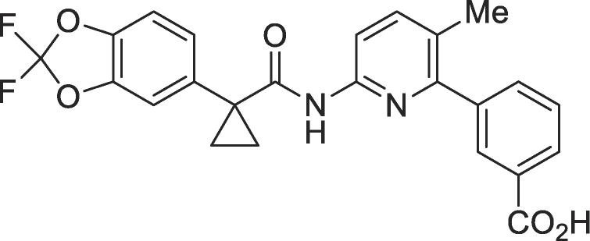
lumacaftor
ivacaftor

CAS Number:
The CAS Registry Number for lumacaftor is 936727-05-8 and the CAS Registry Number for ivacaftor is 873054-44-5.

DESCRIPTION

Lumacaftor is a white to off-white powder that is practically insoluble in water (0.02 mg/mL). Ivacaftor is a white to off-white powder that is practically insoluble in water (<0.05 microgram/mL).

ORKAMBI 200/125 is available as a pink, oval-shaped, film-coated tablet for oral administration containing 200 mg of lumacaftor and 125 mg of ivacaftor. Each tablet contains the following inactive ingredients: microcrystalline cellulose; croscarmellose sodium; hypromellose acetate succinate; povidone; sodium lauryl sulfate; magnesium stearate; Opadry II Pink 85F140026 (PI# 110227); Opacode monogramming ink S-1-17823 BLACK (PI# 12108).

PHARMACOLOGY

Mechanism of Action
The CFTR protein is a chloride channel present at the surface of epithelial cells in multiple organs. The F508del mutation impacts the CFTR protein in multiple ways, primarily by causing a defect in cellular processing and trafficking that reduces the quantity of CFTR at the cell surface. The small amount of F508del-CFTR that reaches the cell surface has low channel open probability (defective channel gating). Lumacaftor is a CFTR corrector that acts directly on F508del-CFTR to improve its cellular processing and trafficking, thereby increasing the quantity of functional CFTR at the cell surface. Ivacaftor is a CFTR potentiator that facilitates increased chloride transport by potentiating the channel open probability (or gating) of the CFTR protein at the cell surface. The combined effect of lumacaftor and ivacaftor is increased quantity and function of F508del-CFTR at the cell surface, resulting in increased chloride ion transport.

Pharmacodynamic Effects
Cardiovascular Effects:
Decrease in Heart Rate
During the 24-week, placebo-controlled, Phase 3 studies, a maximum decrease in mean heart rate of 6 beats per minute (bpm) from baseline was observed on Day 1 and Day 15. After Week 4, the mean change in heart rate ranged from 1 to 2 bpm below baseline among patients treated with lumacaftor/ivacaftor. The percentage of patients with heart rate values <50 bpm on treatment was 11% for patients who received lumacaftor/ivacaftor, compared to 4.9% for patients who received placebo.

Clinical Study Examining QT Interval
The effect of multiple doses of lumacaftor 600 mg once daily/ivacaftor 250 mg q12h and lumacaftor 1000 mg once daily/ivacaftor 450 mg q12h on QTc interval was evaluated in a randomised, placebo- and active-controlled (400 mg moxifloxacin), parallel, thorough QT study in 168 healthy subjects. No meaningful changes in QTc interval were observed with either lumacaftor 600 mg once daily/ivacaftor 250 mg q12h or lumacaftor 1000 mg once daily/ivacaftor 450 mg q12h dose group.

Pharmacokinetics
The exposure (AUC) of lumacaftor is approximately 2-fold higher in healthy adult volunteers compared to exposure in patients with CF. The exposure of ivacaftor is similar between healthy adult volunteers and patients with CF. After twice-daily dosing, steady-state plasma concentrations of lumacaftor and ivacaftor in healthy subjects were generally reached after approximately 7 days of treatment, with an accumulation ratio of approximately 1.9 for lumacaftor. The steady-state exposure of ivacaftor is lower than that of Day 1 due to the CYP3A induction effect of lumacaftor.

Absorption
Following multiple oral doses of lumacaftor given in combination with ivacaftor, the exposure of lumacaftor generally increased proportional to dose over the range of 200 mg to 800 mg every 24 hours. The exposure of lumacaftor increased approximately 2-fold when given with fat-containing food relative to fasted conditions. The median (range) t_{max} of lumacaftor is approximately 4.0 hours (2.0; 9.0) in the fed state.

Following multiple oral dose administration of ivacaftor in combination with lumacaftor, the exposure of ivacaftor generally increased with doses from 150 mg every 12 hours to 250 mg every 12 hours. The exposure of ivacaftor when given in combination with lumacaftor increased approximately 3-fold when given with fat-containing food. Therefore, ORKAMBI 200/125 should be administered with fat-containing food. The median (range) t_{max} of ivacaftor is approximately 4.0 hours (2.0; 6.0) in the fed state.

Distribution
Lumacaftor is more than 99.9% bound to plasma proteins, primarily to albumin. After oral administration of 400 mg every 12 hours in patients with CF in a fed state, the typical apparent volumes of distribution for the central and peripheral compartments (CV) were estimated to be 23.5 L (48.7%) and 33.3 L (30.5%), respectively.

Ivacaftor is approximately 99% bound to plasma proteins, primarily to alpha 1-acid glycoprotein and albumin. After oral administration of ivacaftor 250 mg every 12 hours in combination with lumacaftor, the typical apparent volumes of distribution for the central and peripheral compartments (CV) were estimated to be 95.0 L (53.9%) and 201 L (26.6%), respectively.

Metabolism
Lumacaftor is not extensively metabolised in humans with the majority of lumacaftor excreted unchanged in the faeces. In vitro and in vivo data indicate that lumacaftor is mainly metabolised via oxidation and glucuronidation, with CYP3A4 and CYP2C8 involved. The main metabolite formed, M28, is not pharmacologically active.

Ivacaftor is extensively metabolised in humans. In vitro and in vivo data indicate that ivacaftor is primarily metabolised by CYP3A. M1 and M6 are the two major metabolites of ivacaftor in humans. M1 has approximately one-sixth the potency of ivacaftor and is considered pharmacologically active. M6 has less than one-fiftieth the potency of ivacaftor and is not considered pharmacologically active.

Excretion
Following oral administration of lumacaftor, the majority of lumacaftor (51%) is excreted unchanged in the faeces. There was negligible urinary excretion of lumacaftor as unchanged drug. The apparent terminal half-life is approximately 26 hours. The typical apparent clearance, CL/F (CV), of lumacaftor was estimated to be 2.38 L/hr (29.4%) for patients with CF.

Following oral administration of ivacaftor alone, the majority of ivacaftor (87.8%) is eliminated in the faeces after metabolic conversion. There was negligible urinary excretion of ivacaftor as unchanged drug. In healthy subjects, the half-life of ivacaftor when given with lumacaftor is approximately 9 hours. The typical CL/F (CV) of ivacaftor when given in combination with lumacaftor was estimated to be 25.1 L/hr (40.5%) for patients with CF.

Special Populations
Pediatric patients 12 to less than 18 years of age
Based on population PK analysis, the mean lumacaftor (±SD) AUC_{ss} following oral administration of ORKAMBI 200/125 tablets, lumacaftor 400 mg/ivacaftor 250 mg every 12 hours, was 253 (68.6) μg/mL*h and is similar to the mean AUC_{ss} in adult patients administered ORKAMBI 200/125 tablets, lumacaftor 400 mg/ivacaftor 250 mg every 12 hours. The mean ivacaftor (±SD) AUC_{ss} was 3.84 (1.54) μg/mL*h and is similar to the mean AUC_{ss} in adult patients administered ORKAMBI 200/125 tablets, lumacaftor 400 mg/ivacaftor 250 mg every 12 hours.

Hepatic Impairment
Following multiple doses of lumacaftor/ivacaftor for 10 days, subjects with moderately impaired hepatic function (Child-Pugh Class B, score 7 to 9) had higher exposures (AUC_{0-12hr} by approximately 50% and C_{max} by approximately 30%) compared with healthy subjects matched for demographics. Therefore, the ORKAMBI 200/125 dose should be reduced to 2 tablets in the morning and 1 tablet in the evening (lumacaftor 600 mg/ivacaftor 375 mg total daily dose) for patients with moderate hepatic impairment (Child-Pugh Class B). The impact of mild hepatic impairment (Child-Pugh Class A, score 5 to 6) on pharmacokinetics of lumacaftor given in combination with ivacaftor has not been studied, but the increase in exposure is expected to be less than 50%. Therefore, no dose adjustment is necessary for patients with mild hepatic impairment.

Studies have not been conducted in patients with severe hepatic impairment (Child-Pugh Class C, score 10 to 15), but exposure is expected to be higher than in patients with moderate hepatic impairment. Therefore, use with caution at a maximum dose of 1 tablet in the morning and 1 tablet in the evening (lumacaftor 400 mg/ivacaftor 250 mg total daily dose), or less, in patients with severe hepatic impairment after weighing the risks and benefits of treatment (see PRECAUTIONS, ADVERSE EFFECTS, and DOSAGE AND ADMINISTRATION).

Renal Impairment
Pharmacokinetic studies have not been performed with ORKAMBI 200/125 in patients with renal impairment. In a human pharmacokinetic study with lumacaftor alone, there was minimal elimination of lumacaftor and its metabolites in urine (only 8.6% of total radioactivity was recovered in the urine with 0.18% as unchanged parent). In a human pharmacokinetic study with ivacaftor alone, there was minimal elimination of ivacaftor and its metabolites in urine (only 6.6% of total radioactivity was recovered in the urine). Therefore, no dose adjustments for ORKAMBI 200/125 are recommended for mild and moderate renal impairment. However, caution is recommended when administering ORKAMBI 200/125 to patients with severe renal impairment (creatinine clearance less than or equal to 30 mL/min) or end-stage renal disease.

Gender
The effect of gender was evaluated using a population pharmacokinetics analysis of data from clinical studies of lumacaftor given in combination with ivacaftor. Results indicate no clinically relevant difference in pharmacokinetic parameters for lumacaftor and ivacaftor between males and females. No dose adjustments of ORKAMBI 200/125 are necessary based on gender.

CLINICAL TRIALS

Trials 1 and 2 in Patients With CF Who are Homozygous for the F508del Mutation in the CFTR Gene
The efficacy of ORKAMBI 200/125 in patients with CF who are homozygous for the F508del mutation in the CFTR gene was evaluated in two randomised, double-blind, placebo-controlled clinical trials of 1108 clinically stable patients with CF, in which 737 patients were randomised to and dosed with lumacaftor/ivacaftor. Patients in both trials were randomised 1:1:1 to receive lumacaftor 600 mg once daily/ivacaftor 250 mg q12h; lumacaftor 400 mg q12h/ivacaftor 250 mg q12h; or placebo. Patients took the study drug with fat-containing food for 24 weeks in addition to their prescribed CF therapies (e.g., bronchodilators, inhaled antibiotics, dornase alfa, and hypertonic saline). Patients from these trials were eligible to roll over into a blinded extension study.

Trial 1 evaluated 549 patients with CF who were aged 12 years and older (mean age 25.1 years) with percent predicted FEV₁ (ppFEV₁) at screening between 40-90 [mean ppFEV₁ 60.7 at baseline (range: 31.1 to 94.0)]. Trial 2 evaluated 559 patients aged 12 years and older (mean age 25.0 years) with ppFEV₁ at screening between 40-90 [mean ppFEV₁ 60.5 at baseline (range: 31.3 to 99.8)]. Patients with a history of colonisation with organisms associated with a more rapid decline in pulmonary status such as Burkholderia cenocepacia, Burkholderia dolosa, or Mycobacterium abscessus, or who had 3 or more abnormal liver function tests at screening (ALT, AST, AP, GGT ≥3 times the ULN or total bilirubin ≥2 times the ULN) were excluded.

The primary efficacy endpoint in both studies was the absolute change from baseline in ppFEV₁ at Week 24, assessed as the average of the treatment effects at Week 16 and at Week 24. Other efficacy variables included relative change from baseline in ppFEV₁ at Week 24, assessed as the average of the treatment effects at Week 16 and at Week 24; absolute change from baseline in BMI at Week 24; absolute change from baseline in CFQ-R Respiratory Domain at Week 24; the proportion of patients achieving ≥5% relative change from baseline in ppFEV₁ using the average of Week 16 and Week 24; and number of pulmonary exacerbations (including those requiring hospitalisation or IV antibiotic therapy) through Week 24.

In both studies, treatment with ORKAMBI 200/125 resulted in a statistically significant improvement in ppFEV₁ (Table 1). The treatment difference between lumacaftor/ivacaftor 400 mg/250 mg q12h and placebo for the mean absolute change (95% CI) in ppFEV₁ from baseline at Week 24 (assessed as the average of the treatment effects at Week 16 and at Week 24) was 2.6 percentage points (1.2, 4.0) in Trial 1 (P=0.0003) and 3.0 percentage points (1.6, 4.4) in Trial 2 (P<0.0001). Mean improvement in ppFEV₁ was rapid in onset (Day 15) and sustained throughout the 24-week treatment period (Figure 1). Improvements in ppFEV₁ were observed regardless of age, disease severity, sex, and geographic region. The Phase 3 trials of lumacaftor/ivacaftor included 81 patients with ppFEV₁ <40 at baseline (including 29 who received lumacaftor 400 mg/ivacaftor 250 mg q12h). The treatment difference in this subgroup was comparable to that observed in patients with ppFEV₁ ≥40. See Table 1 for a summary of primary and key secondary outcomes in Trials 1 and 2.

Figure 1. Absolute Change From Baseline at Each Visit in Percent Predicted FEV₁ in Trial 1, Trial 2, and Pooled Data for Trials 1 and 2

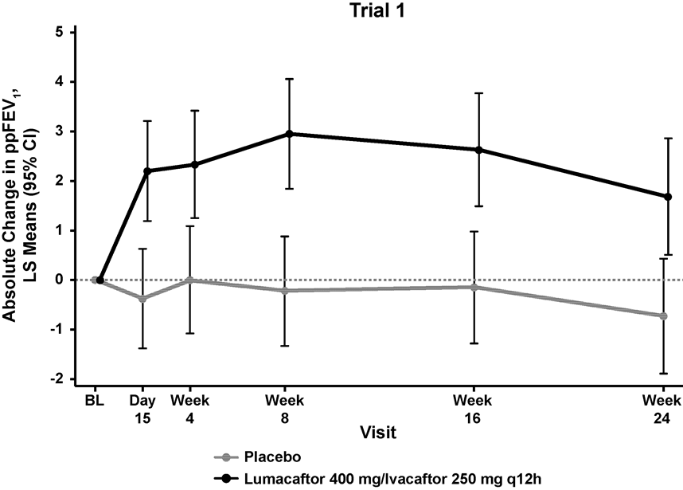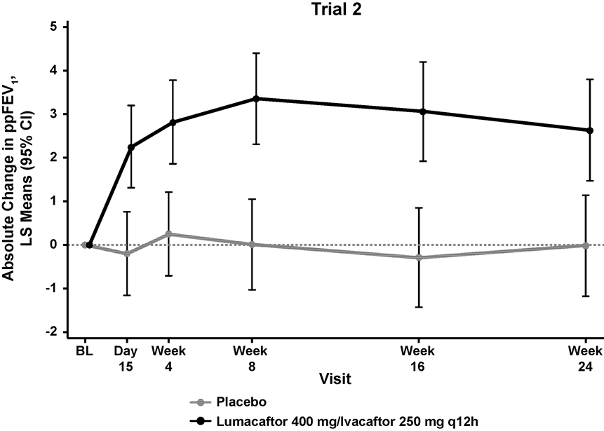

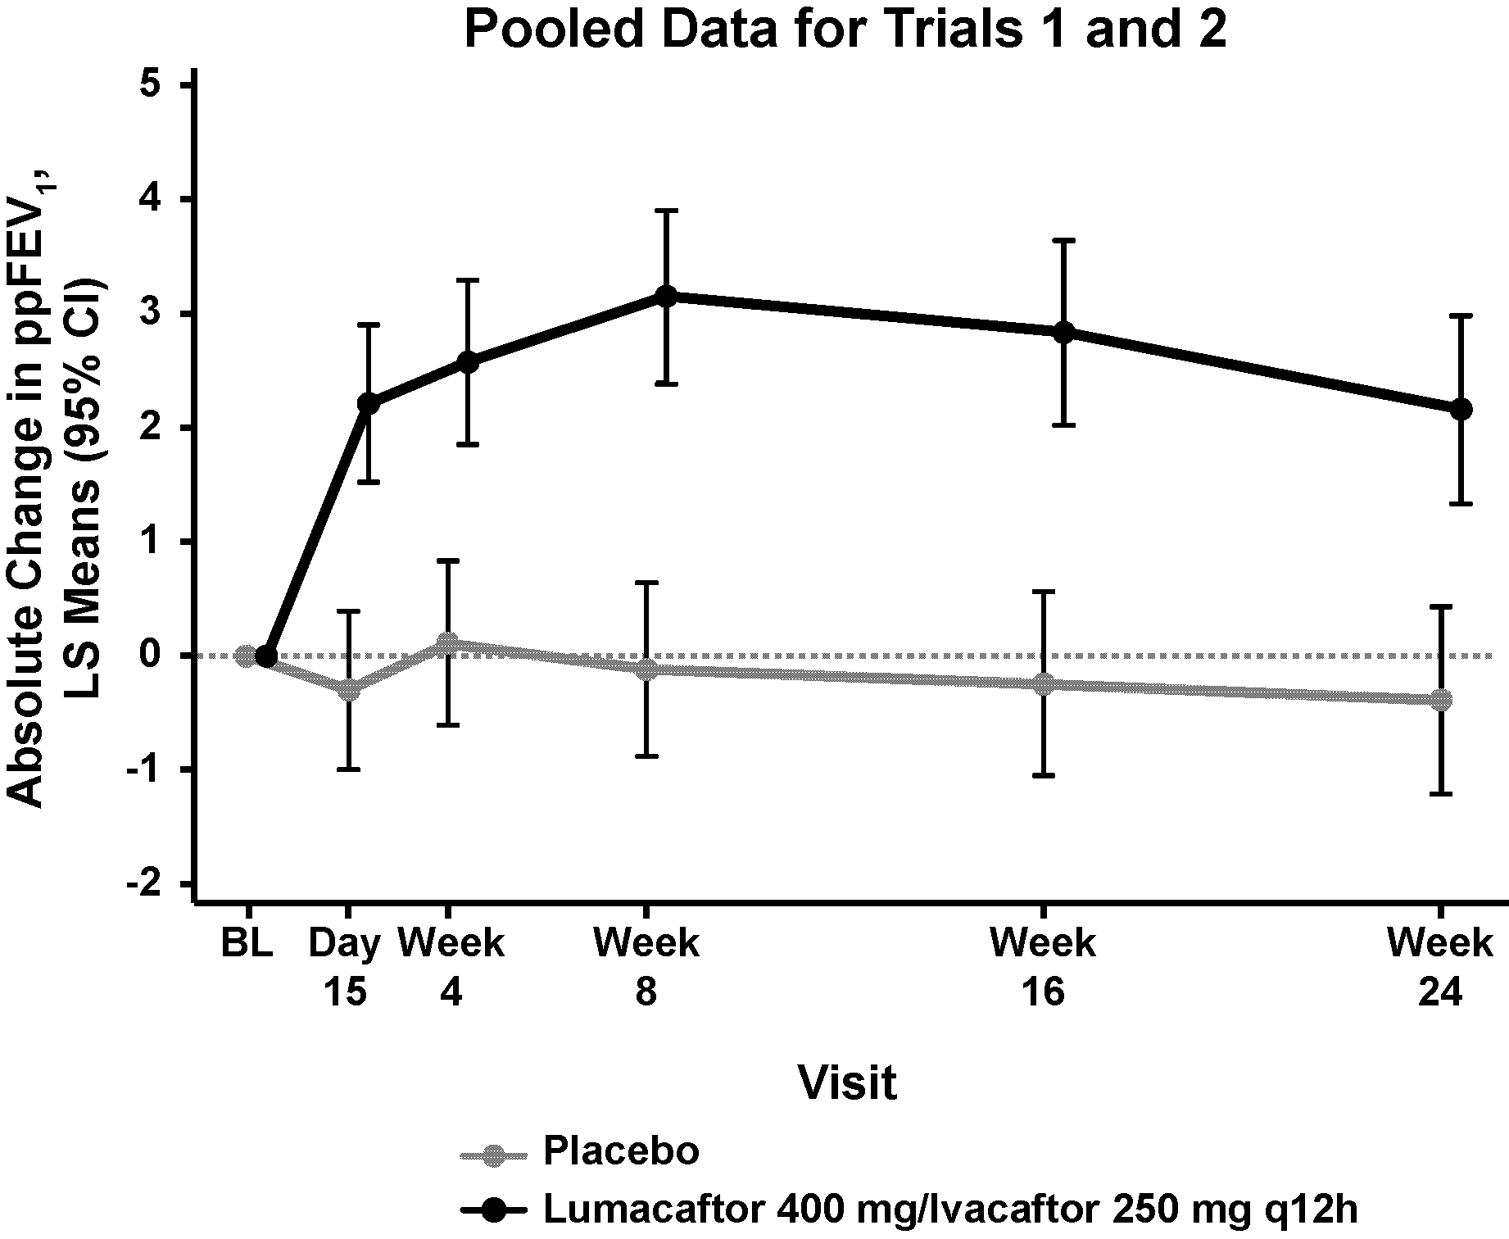

LS, least squares; q12h, every 12 hours.

Table 1: Summary of Primary and Key Secondary Outcomes in Trial 1 and Trial 2*
 |  | Trial 1 |  | Trial 2 |  | Pooled (Trial 1 and Trial 2)
 |  | Placebo  (n=184) | LUM 400 mg/IVA 250 mg q12h  (n=182) | Placebo  (n=187) | LUM 400 mg/IVA 250 mg q12h  (n=187) | Placebo  (n=371) | LUM 400 mg/IVA 250 mg q12h  (n=369)
Absolute change in ppFEV₁ at Week 24† (percentage points) | Treatment difference | – | 2.6  (P=0.0003)‡ | – | 3.0  (P<0.0001)‡ | – | 2.8  (P<0.0001)
Absolute change in ppFEV₁ at Week 24† (percentage points) | Within-group change | -0.44  (P=0.4002) | 2.2  (P<0.0001) | -0.15  (P=0.7744) | 2.9  (P<0.0001) | -0.32  (P<0.3983) | 2.5  (P<0.0001)
Relative change in ppFEV₁ at Week 24† (%) | Treatment difference | – | 4.3  (P=0.0006)‡ | – | 5.3  (P<0.0001)‡ | – | 4.8  (P<0.0001)
Relative change in ppFEV₁ at Week 24† (%) | Within-group change | -0.34  (P=0.7113) | 4.0  (P<0.0001) | 0  (P=0.9983) | 5.3  (P<0.0001) | -0.17  (P=0.8030) | 4.6  (P<0.0001)
Absolute change in BMI at Week 24 (kg/m²) | Treatment difference | – | 0.13  (P=0.1938) | – | 0.36  (P<0.0001)‡ | – | 0.24  (P=0.0004)
Absolute change in BMI at Week 24 (kg/m²) | Within-group change | 0.19  (P=0.0065) | 0.32  (P<0.0001) | 0.07  (P=0.2892) | 0.43  (P<0.0001) | 0.13  (P=0.0066) | 0.37  (P<0.0001)
Absolute change in CFQ-R Respiratory Domain Score at Week 24 (points) | Treatment difference | – | 1.5  (P=0.3569) | – | 2.9  (P=0.0736) | – | 2.2  (P=0.0512)
 | Within-group change | 1.1  (P=0.3423) | 2.6  (P=0.0295) | 2.8  (P=0.0152) | 5.7  (P<0.0001) | 1.9  (P=0.0213) | 4.1  (P<0.0001)
Proportion of patients with ≥5% relative change in ppFEV₁ using the average of Week 16 and Week 24 | % | 22% | 37% | 23% | 41% | 22% | 39%
 | Odds ratio | – | 2.06  (P=0.0023) | – | 2.38  (P=0.0001) | – | 2.22  (P<0.0001)
Number of pulmonary exacerbations through Week 24 | # of events (rate per 48 wks) | 112 (1.07) | 73 (0.71) | 139 (1.18) | 79 (0.67) | 251 (1.14) | 152 (0.70)
Number of pulmonary exacerbations through Week 24 | Rate ratio | – | 0.66  (P=0.0169) | – | 0.57  (P=0.0002) | – | 0.61  (P<0.0001)
* In each study, a hierarchical testing procedure was performed within each active treatment arm for primary and secondary endpoints vs. placebo; at each step, P≤0.0250 and all previous tests also meeting this level of significance were required for statistical significance.
† As assessed as the average of the treatment effects at Week 16 and Week 24.
‡ Indicates statistical significance confirmed in the hierarchical testing procedure.

At Week 24, the proportion of patients who remained free from pulmonary exacerbations was significantly higher for patients treated with ORKAMBI 200/125 compared with placebo. In the pooled analysis, the rate ratio of exacerbations through Week 24 in subjects treated with ORKAMBI 200/125 (lumacaftor 400 mg/ivacaftor 250 mg q12h; n = 369) was 0.61 (P<0.0001), representing a reduction relative to placebo of 39%. Treatment with ORKAMBI 200/125 significantly decreased the risk for exacerbations requiring hospitalisation vs. placebo by 61% (rate ratio=0.39, P<0.0001) and reduced exacerbations requiring treatment with intravenous antibiotics by 56% (rate ratio=0.44, P<0.0001).

Figure 2. Pulmonary Exacerbations Through Week 24

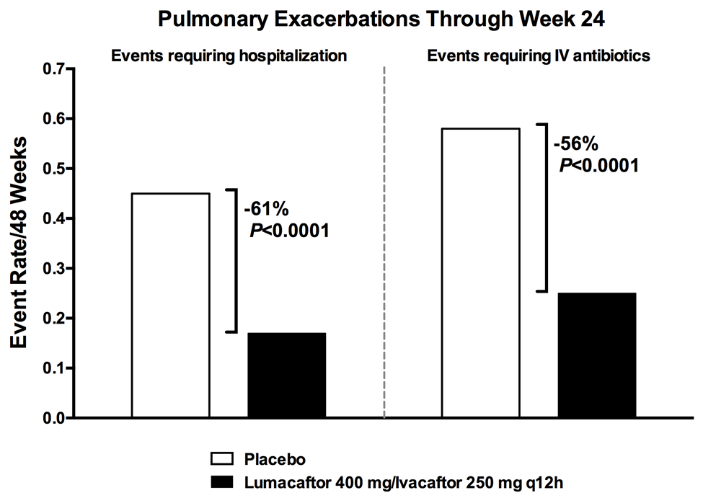

Trial in Patients With CF Who are Heterozygous for the F508del Mutation in the CFTR Gene
Trial 3 was a multicenter, double–blind, randomised, placebo–controlled, Phase 2 trial in 125 patients with CF aged 18 years and older who had a ppFEV₁ of 40 to 90, inclusive. All patients were tested for the CF genotype at screening; eligible patients had the F508del mutation on one allele plus a second allele with a mutation predicted to result in the lack of CFTR production or a CFTR that is not responsive to ivacaftor in vitro.

Patients received either ORKAMBI 200/125 (n=62) or placebo (n=63) q12h in addition to their prescribed CF therapies. The median age of patients enrolled was 28 years and the mean baseline ppFEV₁ was 61.47. Patients with a history of colonisation with organisms such as Burkholderia cenocepacia, Burkholderia dolosa, or Mycobacterium abscessus, or who had 3 or more abnormal liver function tests (ALT, AST, AP, GGT ≥3 times the ULN or total bilirubin ≥2 times the ULN) were excluded.

The primary endpoint was improvement in lung function as determined by the mean absolute change from baseline at Day 56 in ppFEV₁. Treatment with ORKAMBI 200/125 resulted in no significant improvement in ppFEV₁ relative to placebo in patients with CF heterozygous for the F508del mutation in the CFTR gene [treatment difference 0.60 (P=0.5978)]. There were no meaningful differences between patients treated with ORKAMBI 200/125 compared to placebo for the following secondary endpoints: relative change in ppFEV₁, BMI, and weight; however, there was a nominally statistically significant change in the CF respiratory symptom score.

Long-term Safety and Efficacy Rollover Trial
Trial 4 is a Phase 3, parallel-group, multicentre, rollover study in patients with CF, that includes patients from Trial 1 and Trial 2. Of the 1108 patients who received any treatment in Trial 1 or Trial 2, 1029 (93%) enrolled and received active treatment in Trial 4. This 96-week trial is designed to evaluate the safety and efficacy of long-term treatment of ORKAMBI 200/125 and is ongoing.

An interim efficacy analysis was performed after all patients who remained in Trial 4 had completed the Week 24 Visit in Trial 4 (up to 48 weeks of treatment). The improvements in ppFEV₁ observed in patients treated with ORKAMBI 200/125 in Trial 1 or Trial 2 were sustained in Trial 4 (Figure 3). At Week 24 in Trial 4, improvements in ppFEV₁ were 2.6 percentage points (P<0.0001) absolute and 4.7% (P<0.0001) relative change compared to baseline in Trial 1 or Trial 2. Patients treated with ORKAMBI 200/125 for 24 weeks in Trial 1 or Trial 2 continued to show improvements in BMI after an additional 24 weeks. The mean absolute change in BMI from baseline in Trial 1 or Trial 2 at Week 24 in Trial 4 was 0.56 kg/m² (P<0.0001).

In addition, for patients treated with placebo for 24 weeks in Trial 1 or Trial 2, the magnitude of improvement in ppFEV₁ at Day 15 of ORKAMBI 200/125 (lumacaftor 400 mg/ivacaftor 250 mg q12h) treatment in Trial 4 (Figure 3), 3.0 percentage points (P<0.0001) absolute and 4.8% (P<0.0001) relative change from Trial 4 baseline, was similar to the improvement observed in the active treatment groups in Trial 1 and Trial 2. The mean absolute change in BMI from baseline in Trial 1 or Trial 2 at week 24 in Trial 4 for patients initially treated with placebo then followed by lumacaftor/ivacaftor (lumacaftor 400 mg/ivacaftor 250 mg q12h) was 0.34 kg/m² (P<0.0001).

Figure 3. Absolute Change From Baseline in Percent Predicted FEV₁ at Each Visit in Trial 4

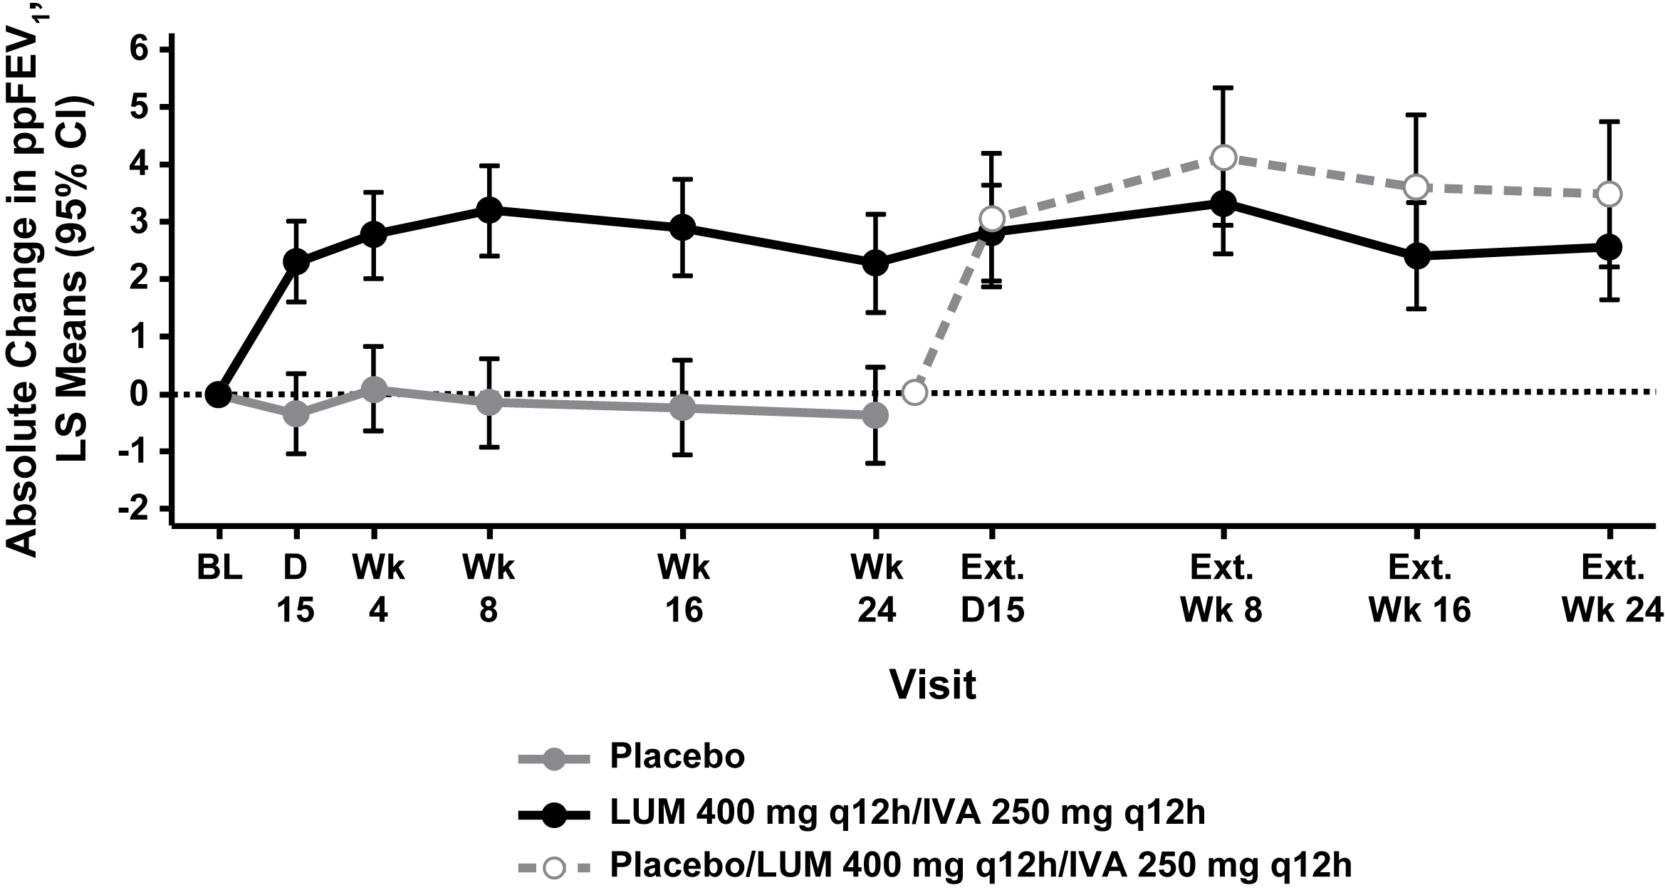

Long-term data also showed that earlier initiation of lumacaftor/ivacaftor (lumacaftor 400 mg/ivacaftor 250 mg q12h) reduced the rate of pulmonary exacerbations. For patients treated for up to 48 weeks with lumacaftor/ivacaftor, the event rate per year of pulmonary exacerbations (0.64; 95% CI: 0.55, 0.76, estimated using 48 weeks data) was lower than that in patients who received 24 weeks of placebo in Trial 1 or Trial 2 followed by up to 24 weeks of lumacaftor/ivacaftor in Trial 4 (0.96; 95% CI: 0.79, 1.17, estimated using 48 weeks data).

The impact of long-term treatment (beyond 48 weeks) with ORKAMBI 200/125 is unknown, but is being investigated in clinical trials and post-market studies.
INDICATIONS

ORKAMBI 200/125 is indicated for the treatment of cystic fibrosis (CF) in patients age 12 years and older who are homozygous for the F508del mutation in the CFTR gene.

CONTRAINDICATIONS

In cases of hypersensitivity to the active substance or to any component of this medication, patients should not be treated with this medicine.

PRECAUTIONS

Patients With CF Who Are Heterozygous for the F508del Mutation in the CFTR Gene
ORKAMBI 200/125 is not effective in patients with CF who have the F508del mutation on one allele plus a second allele with a mutation predicted to result in the lack of CFTR production or that is not responsive to ivacaftor in vitro.

Patients With CF Who Have a Gating (Class III) Mutation in the CFTR Gene
ORKAMBI 200/125 is not recommended for use in patients with CF who are heterozygous for the F508del mutation on one allele, with an ivacaftor-responsive mutation on the second allele, since the exposure of ivacaftor is very significantly reduced when dosed in combination with lumacaftor (see INTERACTIONS WITH OTHER MEDICINES).

Effects on Fertility
Lumacaftor had no effects on fertility and reproductive performance indices in male and female rats at an oral dose of 1000 mg/kg/day [approximately 3 and 8 times, respectively, the maximum recommended human dose (MRHD) of the lumacaftor component of ORKAMBI 200/125 on an AUC basis].

Ivacaftor impaired fertility and reproductive performance indices in male and female rats at an oral dose of 200 mg/kg/day (yielding approximately 11 and 7 times, respectively, the systemic exposure anticipated in patients at the maximum recommended human dose (MRHD) of the ivacaftor component of ORKAMBI 200/125 based on summed AUCs of ivacaftor and its major metabolites) when dams were dosed prior to and during early pregnancy. The pregnancy rate was decreased, oestrus cycling was disrupted and pre-implantation loss was increased. These effects occurred in the presence of significant maternal toxicity. No effects on male or female fertility and reproductive performance indices were observed at ≤100 mg/kg/day (yielding approximately 8 and 5 times, respectively, the exposure at the MRHD of the ivacaftor component of ORKAMBI 200/125 based on summed AUCs of ivacaftor and its metabolites).

Use in Pregnancy
Pregnancy Category B3
Category B3 drugs have been taken by only a limited number of pregnant women and women of childbearing age, without an increase in the frequency of malformation or other direct or indirect harmful effects on the human fetus having been observed. Studies in animals have shown evidence of an increased occurrence of fetal damage, the significance of which is considered uncertain in humans.

No adequate and well-controlled studies of ORKAMBI 200/125 in pregnant women have been conducted. Adverse effects on embryofetal development have been observed in studies in animals, conducted with the individual active components. Lumacaftor, ivacaftor, and/or their metabolites were shown to cross the placenta in rats and rabbits.

Lumacaftor produced no teratogenicity or other adverse effects on embryofetal development in rats receiving oral doses up to 2000 mg/kg/day (yielding 8 times the plasma AUC for lumacaftor in patients at the maximum recommended dose) or in rabbits at up to 100 mg/kg/day (relative exposure based on AUC, 3). At 200 mg/kg/day, treatment with lumacaftor was associated with abortions and a slight increase in the incidence of minor skeletal abnormalities in rabbits (relative exposure based on AUC, 5). This occurred in conjunction with significant maternal toxicity, and the findings are not considered to reflect a direct effect of lumacaftor on the developing fetus.

Developmental toxicity studies with ivacaftor revealed no teratogenicity in rats at oral doses up to 200 mg/kg/day (yielding 7 times the summed AUC for ivacaftor and its major metabolites anticipated in patients) or in rabbits at up to 100 mg/kg/day (relative exposure based on summed AUCs, ≥4). Fetal weight was decreased and the incidence of minor fetal skeletal abnormalities was increased in rats treated at 200 mg/kg/day; these effects were observed in conjunction with maternal toxicity.

Because animal reproduction studies are not always predictive of human response, and given the limited experience with ORKAMBI 200/125 in pregnancy, ORKAMBI 200/125 should only be used during pregnancy if the expected benefits justify the potential risks to the fetus.

Use in Lactation
It is unknown whether lumacaftor and/or ivacaftor and metabolites are excreted in human milk. Available pharmacokinetic data in animals have shown excretion of both lumacaftor and ivacaftor into the milk of lactating female rats. As such, risks to the suckling child cannot be excluded. A decision must be made whether to discontinue breast-feeding or to discontinue/abstain from lumacaftor/ivacaftor therapy taking into account the benefit of breast-feeding for the child and the benefit of therapy for the mother.

Paediatric Use
The safety and efficacy of ORKAMBI 200/125 in children aged less than 12 years have not been established. Cataracts were seen in juvenile rats treated with ivacaftor from postnatal Day 7 through 35 at oral dose levels of 10 mg/kg/day and higher, yielding exposure to ivacaftor and its major metabolites approximately 2.5–4 times lower than in patients at the maximum recommended human dose with ORKAMBI 200/125 (based on summed AUCs). This finding has not been observed in older animals. The potential relevance of these findings in humans is unknown.

Use in the Elderly
Clinical studies of ORKAMBI 200/125 did not include patients age 65 years and older. Thus, the efficacy and safety of ORKAMBI 200/125 in elderly patients have not been evaluated.

Genotoxicity
Both lumacaftor and ivacaftor were negative for genotoxicity in the following assays: Ames test for bacterial gene mutation, in vitro chromosomal aberration assay in Chinese hamster ovary cells, and in vivo mouse micronucleus test.

Carcinogenicity
A two-year study in Sprague-Dawley rats and a 26-week study in transgenic Tg.rasH2 mice were conducted to assess the carcinogenic potential of lumacaftor. No evidence of tumourigenicity by lumacaftor was observed in rats at oral doses up to 1000 mg/kg/day (yielding approximately 5 and 13 times the plasma AUC for lumacaftor in patients at the MRHD in males and females, respectively). No evidence of tumourigenicity was observed in Tg.rasH2 mice at lumacaftor oral doses up to 1500 and 2000 mg/kg/day in female and male mice, respectively. Plasma exposures to lumacaftor in mice at these doses were approximately 5- and 3.5-fold higher than the plasma levels of lumacaftor measured in humans following lumacaftor/ivacaftor therapy.

Two-year studies in mice and rats to assess carcinogenic potential of ivacaftor demonstrated that ivacaftor was not carcinogenic in either species. Plasma exposures to ivacaftor in mice at the non-carcinogenic dose (200 mg/kg/day, the highest dose tested) were approximately 15- to 28-fold higher than the plasma levels measured in humans following ORKAMBI 200/125 therapy, and at least 1.7- to 3.4-fold higher with respect to the summed AUCs for ivacaftor and its major metabolites. Plasma exposures to ivacaftor in rats at the non-carcinogenic dose (50 mg/kg/day, the highest dose tested) were approximately 64- to 117-fold higher than the plasma levels measured in humans following ORKAMBI 200/125 therapy, and 9- to 13-fold higher with respect to the summed AUCs for ivacaftor and its major metabolites.

Hepatic Impairment
Patients With Advanced Liver Disease
Abnormalities in liver function, including advanced liver disease, can be present in patients with CF. Worsening of liver function in patients with advanced liver disease has been reported in some patients with CF receiving ORKAMBI 200/125. Use ORKAMBI 200/125 with caution in patients with advanced liver disease and only if the benefits are expected to outweigh the risks. If ORKAMBI 200/125 is used in these patients, they should be closely monitored after the initiation of treatment and the dose should be reduced (see PHARMACOLOGY, ADVERSE EFFECTS, and DOSAGE AND ADMINISTRATION).

Hepatobiliary Events
Elevated transaminases have been reported in patients with CF, including some receiving ORKAMBI 200/125. In some instances, these elevations have been associated with concomitant elevations in total serum bilirubin (see ADVERSE EFFECTS).

Because an association with liver injury cannot be excluded, assessments of liver function tests (ALT, AST and bilirubin) are recommended before initiating ORKAMBI 200/125 every 3 months during the first year of treatment, and annually thereafter. For patients with a history of ALT, AST, or bilirubin elevations, more frequent monitoring should be considered.

In the event of significant elevation of ALT or AST, with or without elevated bilirubin [either ALT or AST >5 x the upper limit of normal (ULN), or ALT or AST >3 x ULN with bilirubin >2 x ULN], dosing with ORKAMBI 200/125 should be discontinued and laboratory tests closely followed until the abnormalities resolve. Following resolution of transaminase elevations, consider the benefits and risks of resuming dosing (see PHARMACOLOGY, ADVERSE EFFECTS, and DOSAGE AND ADMINISTRATION).

Respiratory Events
Respiratory events (e.g., chest discomfort, dyspnea, and respiration abnormal) were observed more commonly in patients during initiation of ORKAMBI 200/125 compared to those who received placebo. Clinical experience in patients with percent predicted FEV₁ (ppFEV₁) <40 is limited, and additional monitoring of these patients is recommended during initiation of therapy (see ADVERSE EFFECTS and CLINICAL TRIALS).

Effect on Blood Pressure
Increased blood pressure has been observed in some patients treated with ORKAMBI 200/125. Blood pressure should be monitored periodically in all patients during treatment (see ADVERSE EFFECTS).

Interactions With Medicinal Products
Substrates of CYP3A
Lumacaftor is a strong inducer of CYP3A. Administration of ORKAMBI 200/125 may decrease systemic exposure of medicinal products which are substrates of CYP3A, which may decrease their therapeutic effect. Co-administration with sensitive CYP3A substrates or CYP3A substrates with a narrow therapeutic index is not recommended (see INTERACTIONS WITH OTHER MEDICINES).

ORKAMBI 200/125 may substantially decrease hormonal contraceptive exposure, reducing effectiveness. Hormonal contraceptives, including oral, injectable, transdermal, and implantable, should not be relied upon as an effective method of contraception when co-administered with ORKAMBI 200/125 (see INTERACTIONS WITH OTHER MEDICINES).

Strong CYP3A Inducers
Ivacaftor is a substrate of CYP3A4 and CYP3A5 isoenzymes. Use of ORKAMBI 200/125 with strong CYP3A inducers, such as rifampicin, significantly reduces ivacaftor exposure, which may reduce the therapeutic effectiveness of ORKAMBI 200/125. Therefore, co-administration with strong CYP3A inducers (e.g., rifampicin, St. John’s wort [Hypericum perforatum]) is not recommended (see INTERACTIONS WITH OTHER MEDICINES).

Cataracts
Cases of non-congenital lens opacities without impact on vision have been reported in paediatric patients treated with ivacaftor monotherapy. Although other risk factors were present in some cases (such as corticosteroid use and exposure to radiation), a possible risk attributable to ivacaftor cannot be excluded. Baseline and follow-up ophthalmological examinations are recommended in paediatric patients initiating treatment with ORKAMBI 200/125.

Patients After Organ Transplantation
ORKAMBI 200/125 has not been studied in patients with CF who have undergone organ transplantation. Therefore, use in transplanted patients is not recommended. See INTERACTIONS WITH OTHER MEDICINES for interactions with ciclosporin or tacrolimus.

Driving and Operating Machinery
ORKAMBI 200/125 is not expected to have an impact on the ability to drive and use machines.

Interactions with Other Medicines

Lumacaftor is a strong inducer of CYP3A. Ivacaftor is a weak inhibitor of CYP3A when given as monotherapy. The net effect of lumacaftor/ivacaftor therapy is expected to be strong CYP3A induction.

Drug interaction studies were performed in adults with lumacaftor/ivacaftor and other drugs likely to be co-administered or drugs commonly used as probes for pharmacokinetic interaction studies.

Effects of Other Medicines on Lumacaftor/Ivacaftor
CYP3A Inhibitors
Co-administration of lumacaftor/ivacaftor with itraconazole, a strong CYP3A inhibitor, did not impact the exposure of lumacaftor, but increased ivacaftor exposure by 4.3-fold. Due to the induction effect of lumacaftor on CYP3A, at steady-state, the net exposure of ivacaftor is not expected to exceed that when given in the absence of lumacaftor at a dose of 150 mg every 12 hours, the approved dose of ivacaftor monotherapy. Therefore, no dose adjustment is necessary when CYP3A inhibitors are initiated in patients currently taking ORKAMBI 200/125. However, when initiating ORKAMBI 200/125 in patients currently taking strong CYP3A inhibitors (e.g., itraconazole), reduce ORKAMBI 200/125 dose to 1 tablet daily (lumacaftor 200 mg/ivacaftor 125 mg total daily dose) for the first week of treatment to allow for the steady-state induction effect of lumacaftor. Following this period, continue with the recommended daily dose per DOSAGE AND ADMINISTRATION. If ORKAMBI 200/125 is interrupted for more than one week, reduce ORKAMBI 200/125 dose to 1 tablet daily for the first week of treatment re-initiation. Examples of strong CYP3A inhibitors include:
- ketoconazole, itraconazole, posaconazole, voriconazole
- telithromycin, clarithromycin.

No dose adjustment is recommended when used with moderate or weak CYP3A inhibitors.
CYP3A Inducers
Co-administration of lumacaftor/ivacaftor with rifampicin, a strong CYP3A inducer, had minimal effect on the exposure of lumacaftor, but decreased ivacaftor exposure (AUC) by 57%. Therefore, co-administration of ORKAMBI 200/125 is not recommended with strong CYP3A inducers such as:
- rifampicin, rifabutin
- phenobarbital, carbamazepine, and phenytoin
- St. John’s wort (Hypericum perforatum).

No dose adjustment is recommended when used with moderate or weak CYP3A inducers.

Other Recommendations
Ciprofloxacin
Co-administration of lumacaftor/ivacaftor with ciprofloxacin had minimal to mild effect on exposures of lumacaftor and ivacaftor. Therefore, no dose adjustment is required when ORKAMBI 200/125 is used with ciprofloxacin.

Effects of Lumacaftor/Ivacaftor on Other Medicines
CYP3A and P-gp Substrates
Lumacaftor is a strong inducer of CYP3A. Co-administration of lumacaftor with ivacaftor, a sensitive CYP3A substrate, decreased ivacaftor exposure by approximately 80%.

Administration of ORKAMBI 200/125 may decrease systemic exposure of medicinal products that are substrates of CYP3A, which may decrease therapeutic effect of the medicinal product. Co-administration of ORKAMBI 200/125 is not recommended with sensitive CYP3A substrates or CYP3A substrates with a narrow therapeutic index such as:
- midazolam, triazolam
- ciclosporin, everolimus, sirolimus, and tacrolimus.

Based on in vitro results which showed P-gp inhibition and pregnane-X-receptor (PXR) activation, lumacaftor has the potential to both inhibit and induce P-gp. Additionally, a clinical study with ivacaftor monotherapy showed that ivacaftor is a weak inhibitor of P-gp. Therefore, concomitant use of ORKAMBI 200/125 with P-gp substrates may alter the exposure of these substrates. When co-administration with sensitive P-gp substrates such as digoxin is required, caution and appropriate monitoring are recommended.

CYP2B6 and CYP2C Substrates
In vitro studies suggest that lumacaftor has the potential to induce CYP2B6, CYP2C8, CYP2C9, and CYP2C19; however, inhibition of CYP2C8 and CYP2C9 has also been observed in vitro. Additionally, in vitro studies suggest that ivacaftor may inhibit CYP2C9. Therefore, concomitant use of ORKAMBI 200/125 with CYP2B6, CYP2C8, CYP2C9, and CYP2C19 substrates may alter the exposure of these substrates. When co-administration is required, monitoring is recommended, such as the international normalised ratio with warfarin.

Hormonal Contraceptives
ORKAMBI 200/125 may substantially decrease hormonal contraceptive exposure, reducing effectiveness. Hormonal contraceptives, including oral, injectable, transdermal, and implantable, should not be relied upon as an effective method of contraception when co-administered with ORKAMBI 200/125 (see PRECAUTIONS).

Antibiotics
Based on metabolism, ORKAMBI 200/125 is not expected to impact the exposure of ciprofloxacin, azithromycin, tobramycin, and levofloxacin.

Concomitant use of ORKAMBI 200/125 may decrease the exposure of clarithromycin, erythromycin, and telithromycin, which may reduce the effectiveness of these antibiotics.

Antifungals
Concomitant use of ORKAMBI 200/125 may reduce the exposure and effectiveness of itraconazole, ketoconazole, posaconazole, voriconazole, and fluconazole, and is not recommended unless the benefit outweighs the risk. If such drugs are necessary, patients should be monitored closely for breakthrough fungal infections.

Glucocorticoids
ORKAMBI 200/125 may reduce the exposure of prednisone, which may reduce the effectiveness of prednisone.

Antidepressants
Concomitant use of ORKAMBI 200/125 may reduce the exposure and effectiveness of citalopram, escitalopram, and sertraline. A higher dose of these antidepressants may be required to obtain the desired clinical effect.

Oral Hypoglycaemics
Concomitant use of ORKAMBI 200/125 may reduce the exposure and effectiveness of repaglinide, and may alter the exposure of sulfonylurea. A dose adjustment may be required to obtain the desired clinical effect. No dose adjustment is recommended for metformin.

Proton Pump Inhibitors
ORKAMBI 200/125 may reduce the exposure and effectiveness of proton pump inhibitors such as omeprazole, esomeprazole, and lansoprazole. The dose of proton pump inhibitors may need to be adjusted when used concomitantly with ORKAMBI 200/125.

ADVERSE EFFECTS

Experience From Clinical Trials
The safety profile of ORKAMBI 200/125 is based primarily on the pooled data from 1108 patients with CF 12 years and older who are homozygous for the F508del mutation in the CFTR gene and who received at least 1 dose of study drug in 2 double-blind, placebo-controlled, Phase 3 clinical studies, each with 24 weeks of treatment (Trials 1 and 2). A total of 738 patients received lumacaftor/ivacaftor (369 patients received lumacaftor 400 mg q12h in combination with ivacaftor 250 mg q12h and 369 patients received lumacaftor 600 mg qd in combination with ivacaftor 250 mg q12h) and 370 patients received placebo. Of the 1108 patients, 49% were female and 99% were Caucasian.

The proportion of patients who prematurely discontinued study drug due to adverse events was 4.2% for lumacaftor/ivacaftor-treated patients and 1.6% for placebo-treated patients. The only adverse events which resulted in discontinuation in at least 0.5% of patients receiving lumacaftor/ivacaftor were increased blood creatine phosphokinase (0.5%) and hepatobiliary events (0.5%).

The most common adverse reactions experienced by patients who received lumacaftor/ivacaftor in the pooled, placebo-controlled, Phase 3 studies were dyspnoea (14.0% versus 7.8% on placebo), diarrhoea (11.0% versus 8.4% on placebo), and nausea (10.2% versus 7.6% on placebo).

The only serious adverse reactions occurring in at least 0.5% of patients on lumacaftor/ivacaftor and greater than placebo were hepatobiliary events, including 4 reported as transaminase elevations, 2 as cholestatic hepatitis, and 1 as hepatic encephalopathy.

Table 2 shows adverse events with an incidence of at least 10% in any treatment group from the two double-blind, placebo-controlled, Phase 3 clinical studies.

Table 2. Adverse Events With an Incidence of at Least 10% in Any Treatment Group of Patients Aged 12 Years and Older Who Are Homozygous for the F508del Mutation in the CFTR Gene
 | LUM/IVA Total | Placebo
Preferred Term | N=738 | N=370
Infective pulmonary exacerbation of cystic fibrosis | 277 (37.5) | 182 (49.2)
Cough | 225 (30.5) | 148 (40.0)
Headache | 116 (15.7) | 58 (15.7)
Sputum increased | 109 (14.8) | 70 (18.9)
Dyspnoea | 103 (14.0) | 29 (7.8)
Haemoptysis | 102 (13.8) | 50 (13.5)
Diarrhoea | 81 (11.0) | 31 (8.4)
Nausea | 75 (10.2) | 28 (7.6)
Nasopharyngitis | 71 (9.6) | 40 (10.8)
Nasal congestion | 57 (7.7) | 44 (11.9)

Tabulated List of Adverse Reactions
Adverse reactions identified in patients aged 12 years and older who are homozygous for the F508del mutation in the CFTR gene are presented in Table 3 and are listed by system organ class, preferred term, and frequency. Adverse reactions are ranked under the MedDRA frequency classification: very common (≥1/10); common (≥1/100 to <1/10); uncommon (≥1/1,000 to <1/100); rare (≥1/10,000 to <1/1,000); very rare (<1/10,000); and not known (frequency cannot be estimated using the available data).

Table 3. Adverse Reactions in lumacaftor/ivacaftor-treated Patients Aged 12 Years and Older Who Are Homozygous for the F508del Mutation in the CFTR Gene
System Organ Class | Frequency Category | Adverse Reactions  (Preferred term)  N=738
Infections and infestations | common | Rhinitis, Upper respiratory tract infection
Vascular disorders | uncommon | Hypertension
Respiratory, thoracic and mediastinal disorders | very common | Dyspnoea
Respiratory, thoracic and mediastinal disorders | common | Respiration abnormal, Oropharyngeal pain, Rhinorrhoea
Gastrointestinal disorders | very common | Diarrhoea, Nausea
Gastrointestinal disorders | common | Flatulence, Vomiting
Reproductive system and breast disorders | common | Dysmenorrhoea, Menstruation irregular, Metrorrhagia
Reproductive system and breast disorders | uncommon | Amenorrhoea, Menorrhagia, Oligomenorrhoea, Polymenorrhoea
Skin and subcutaneous tissue disorders | common | Rash
Investigations | uncommon | Blood pressure increased

An interim safety analysis was performed on 1027 patients in Trial 4, a long-term safety and efficacy rollover trial. A total of 194 patients who were randomised to active drug in Trials 1 and 2 had completed the Week 24 visit (total 48 weeks on treatment). No new safety signal was identified. The overall incidence of adverse events was lower in subjects who continued on treatment in Trial 4 compared with subjects who were new to treatment in Trial 4 (see CLINICAL TRIALS).

Description of Selected Adverse Reactions
Hepatobiliary Events
During the 24-week, placebo-controlled, Phase 3 studies, the incidence of maximum transaminase (ALT or AST) levels >8, >5, and >3 x ULN was 0.8%, 2.0%, and 5.2% in the patients receiving lumacaftor/ivacaftor, and 0.5%, 1.9%, and 5.1% in the placebo-treated patients. The incidence of transaminase-related adverse drug reactions was 5.1% and 4.6% in lumacaftor/ivacaftor-treated patients and those who received placebo, respectively. Seven patients who received lumacaftor/ivacaftor had liver-related serious adverse events with elevated transaminases, including 3 with concurrent elevation in total bilirubin. Following discontinuation of lumacaftor/ivacaftor, liver function tests returned to baseline or improved substantially in all patients. While alternative etiologies were present, the potential for liver injury associated with lumacaftor/ivacaftor cannot be excluded (see PRECAUTIONS).

Among 7 patients with pre-existing cirrhosis and/or portal hypertension who received lumacaftor/ivacaftor in the placebo-controlled Phase 3 studies, worsening liver function with increased ALT, AST, bilirubin, and hepatic encephalopathy was observed in one patient. The event occurred within 5 days of the start of dosing and resolved following discontinuation of lumacaftor/ivacaftor (see PRECAUTIONS).

Respiratory Events
During the 24-week, placebo-controlled, Phase 3 studies, incidence of respiratory adverse reactions (e.g., chest discomfort, dyspnea, and respiration abnormal) was 26.3% in lumacaftor/ivacaftor-treated patients compared to 17.0% in patients who received placebo. The incidence of these events was more common in patients treated with lumacaftor/ivacaftor with lower pre-treatment FEV₁; 29.6% and 37.7% among patients with ppFEV₁ <70 and <40, respectively, compared with 21.0% and 21.4% among placebo-treated patients, respectively. Approximately three-quarters of the events began during the first week of treatment, and in most patients the events resolved without dosing interruption. The majority of events were mild or moderate in severity, non-serious, and did not result in treatment discontinuation.

Menstrual Abnormalities
During the 24 week, placebo-controlled, Phase 3 studies, the incidence of combined menstrual abnormality events (amenorrhoea, dysmenorrhoea, menorrhagia, menstruation irregular, metrorrhagia, oligomenorrhoea, and polymenorrhoea) was 9.9 % in lumacaftor/ivacaftor-treated female patients and 1.7% in placebo-treated females. These menstrual events occurred more frequently in the subset of female patients who were taking hormonal contraceptives (25.0%) compared to patients who were not taking hormonal contraceptives (3.5%) (see INTERACTIONS WITH OTHER MEDICINES). Most of these reactions were mild or moderate in severity and non-serious.

Increased Blood Pressure
During the 24-week, placebo-controlled, Phase 3 studies, adverse reactions related to increased blood pressure (e.g., hypertension, blood pressure increased) were reported in 0.9% (7/738) of patients treated with lumacaftor/ivacaftor and in no patients who received placebo.

In patients treated with lumacaftor/ivacaftor the maximum increase from baseline (114 mm Hg systolic and 69 mm Hg diastolic) in mean systolic and diastolic blood pressure was 3.1 mm Hg and 1.8 mm Hg, respectively. In patients who received placebo the maximum increase from baseline (114 mm Hg systolic and 69 mm Hg diastolic) in mean systolic and diastolic blood pressure was 0.9 mm Hg and 0.9 mm Hg, respectively.

The proportion of patients who experienced a systolic blood pressure value >140 mm Hg or a diastolic blood pressure >90 mm Hg on at least two occasions was 3.4% and 1.5% in patients treated with lumacaftor/ivacaftor, respectively, compared with 1.6% and 0.5% in patients who received placebo (see PRECAUTIONS).

Post-Marketing Experience
There are no updates from post-marketing experience.

DOSAGE AND ADMINISTRATION

If the patient's genotype is unknown, an accurate and validated genotyping method should be performed to confirm the presence of the F508del mutation on both alleles of the CFTR gene.

Adults, Adolescents, and Children Aged 12 Years and Older
The recommended dose is two tablets (each containing lumacaftor 200 mg/ivacaftor 125 mg) taken orally every 12 hours (lumacaftor 800 mg/ivacaftor 500 mg total daily dose).

ORKAMBI 200/125 should be taken with fat-containing food. Meals and snacks recommended in CF guidelines or meals recommended in standard nutritional guidelines contain adequate amounts of fat. Examples of meals or snacks that contain fat are those prepared with butter or oils or those containing eggs, cheeses, nuts, chocolate, whole milk, whole-milk dairy products, meats, avocados, oily fish, and soy-based products (tofu) (see PHARMACOLOGY, Pharmacokinetics).

Paediatric Population
No dose adjustment is required for children and adolescents aged 12 to 17 years. The safety and efficacy of ORKAMBI 200/125 in children aged less than 12 years have not been established.

Use in the Elderly
The efficacy and safety of ORKAMBI 200/125 in patients aged 65 years or older have not been evaluated.

Use in Renal Insufficiency
No dose adjustment is necessary for patients with mild to moderate renal impairment. Caution is recommended while using ORKAMBI 200/125 in patients with severe renal impairment (creatinine clearance less than or equal to 30 mL/min) or end-stage renal disease (see PHARMACOLOGY).

Use in Hepatic Insufficiency
No dose adjustment is necessary for patients with mild hepatic impairment (Child-Pugh Class A). A dose reduction to 2 tablets in the morning and 1 tablet in the evening (lumacaftor 600 mg/ivacaftor 375 mg total daily dose) is recommended for patients with moderate hepatic impairment (Child-Pugh Class B).

Studies have not been conducted in patients with severe hepatic impairment (Child-Pugh Class C), but exposure is expected to be higher than in patients with moderate hepatic impairment. Therefore, use with caution at a maximum dose of lumacaftor 400 mg/ivacaftor 250 mg total daily dose, given as 1 tablet in the morning and 1 tablet in the evening, or less, in patients with severe hepatic impairment after weighing the risks and benefits of treatment (see PHARMACOLOGY, PRECAUTIONS, and ADVERSE EFFECTS).

Use in Combination With Strong CYP3A Inhibitors
No dose adjustment is necessary when CYP3A inhibitors are initiated in patients currently taking ORKAMBI 200/125. However, when initiating ORKAMBI 200/125 in patients currently taking strong CYP3A inhibitors (e.g., itraconazole), reduce ORKAMBI 200/125 dose to 1 tablet daily (lumacaftor 200 mg/ivacaftor 125 mg total daily dose) for the first week of treatment. Following this period, continue with the recommended daily dose.

If ORKAMBI 200/125 is interrupted for more than 1 week and then re-initiated while taking strong CYP3A inhibitors, reduce ORKAMBI 200/125 dose to 1 tablet daily for the first week of treatment re-initiation (see INTERACTIONS WITH OTHER MEDICINES). Following this period, continue with the recommended daily dose.

Use in Combination With Ciprofloxacin
No dose adjustment is required when ORKAMBI 200/125 is used with ciprofloxacin (see INTERACTIONS WITH OTHER MEDICINES).

Method of Administration
For oral use. Patients should be instructed to swallow the tablets whole (i.e., patients should not chew, break, or dissolve the tablet).

OVERDOSAGE

For information on the management of overdose, contact the Poisons Information Centre on 131126 (Australia).

No specific antidote is available for overdose with ORKAMBI 200/125. Treatment of overdose consists of general supportive measures including monitoring of vital signs and observation of the clinical status of the patient.

PRESENTATION AND STORAGE CONDITIONS

ORKAMBI 200/125 (lumacaftor/ivacaftor) film-coated tablets are supplied as pink, oval-shaped tablets containing 200 mg of lumacaftor and 125 mg of ivacaftor. Each tablet is printed with “2V125” in black ink on one side and plain on the other.

ORKAMBI 200/125 tablets are packaged in a thermoform [polychlorotrifluoroethylene (PCTFE)] blister with a paper-backed foil lidding. There are four tablets in each blister strip. Seven strips are included in each weekly carton (28 tablets). Four cartons are contained in each ORKAMBI 200/125 box, totalling 112 tablets.

Store below 30ºC.

NAME AND ADDRESS OF THE SPONSOR
Vertex Pharmaceuticals (Australia) Pty Ltd
Suite 3, Level 3
601 Pacific Highway
St Leonards NSW 2065
Australia

POISON SCHEDULE OF THE MEDICINE
S4 - Prescription only medicine

Date of first inclusion in the Australian Register of Therapeutic Goods
08 March 2016

© 2016 Vertex Pharmaceuticals Incorporated
VERTEX and the VERTEX triangle logo are registered trademarks and ORKAMBI is a trademark of Vertex Pharmaceuticals Incorporated.

