First round 20 August 2015
Second round 13 November 2015

AusPAR Attachment 2

Extract from the Clinical Evaluation Report for Lumacaftor / Ivacaftor
  - Proprietary Product Name: Orkambi 200/125
  - Sponsor: Vertex Pharmaceuticals Australia Pty Ltd

About the Therapeutic Goods Administration (TGA)
- The Therapeutic Goods Administration (TGA) is part of the Australian Government Department of Health, and is responsible for regulating medicines and medical devices.
- The TGA administers the Therapeutic Goods Act 1989 (the Act), applying a risk management approach designed to ensure therapeutic goods supplied in Australia meet acceptable standards of quality, safety and efficacy (performance), when necessary.
- The work of the TGA is based on applying scientific and clinical expertise to decision-making, to ensure that the benefits to consumers outweigh any risks associated with the use of medicines and medical devices.
- The TGA relies on the public, healthcare professionals and industry to report problems with medicines or medical devices. TGA investigates reports received by it to determine any necessary regulatory action.
- To report a problem with a medicine or medical device, please see the information on the TGA website <https://www.tga.gov.au>.
About the Extract from the Clinical Evaluation Report
- This document provides a more detailed evaluation of the clinical findings, extracted from the Clinical Evaluation Report (CER) prepared by the TGA. This extract does not include sections from the CER regarding product documentation or post market activities.
- The words [Information redacted], where they appear in this document, indicate that confidential information has been deleted.
- For the most recent Product Information (PI), please refer to the TGA website <https://www.tga.gov.au/product-information-pi>.
Copyright
© Commonwealth of Australia 2016
This work is copyright. You may reproduce the whole or part of this work in unaltered form for your own personal use or, if you are part of an organisation, for internal use within your organisation, but only if you or your organisation do not use the reproduction for any commercial purpose and retain this copyright notice and all disclaimer notices as part of that reproduction. Apart from rights to use as permitted by the Copyright Act 1968 or allowed by this copyright notice, all other rights are reserved and you are not allowed to reproduce the whole or any part of this work in any way (electronic or otherwise) without first being given specific written permission from the Commonwealth to do so. Requests and inquiries concerning reproduction and rights are to be sent to the TGA Copyright Officer, Therapeutic Goods Administration, PO Box 100, Woden ACT 2606 or emailed to < tga.copyright@tga.gov.au> .

Contents
List of abbreviations 5
1. Introduction 10
2. Clinical rationale 10
3. Contents of the clinical dossier 11
3.1. Scope of the clinical dossier 11
3.2. Paediatric data 12
3.3. Good clinical practice 12
4. Pharmacokinetics 12
4.1. Studies providing pharmacokinetic data 12
4.2. Summary of pharmacokinetics 14
4.3. Evaluator’s overall conclusions on pharmacokinetics 37
5. Pharmacodynamics 41
5.1. Studies providing pharmacodynamic data 41
5.2. Summary of pharmacodynamics 42
5.3. Evaluator’s overall conclusions on pharmacodynamics 56
6. Dosage selection for the pivotal studies 59
7. Clinical efficacy 61
7.1. Pivotal efficacy studies 61
7.2. Other efficacy studies 94
7.3. Analyses performed across trials (pooled analyses and meta-analyses) 107
7.4. Evaluator’s conclusions on clinical efficacy 111
8. Clinical safety 112
8.1. Studies providing evaluable safety data 112
8.2. Pivotal studies that assessed safety as a primary outcome 115
8.3. Patient exposure 115
8.4. Adverse events 118
8.5. Laboratory tests 125
8.6. Post-marketing experience 139
8.7. Safety issues with the potential for major regulatory impact 139
8.8. Other safety issues 140
8.9. Evaluator’s overall conclusions on clinical safety 145
9. First round benefit-risk assessment 147
9.1. First round assessment of benefits 147
9.2. First round assessment of risks 148
9.3. First round assessment of benefit-risk balance 148
10. First round recommendation regarding authorisation 150
11. Clinical questions 151
11.1. Pharmacokinetics 151
11.2. Pharmacodynamics 151
11.3. Efficacy 151
11.4. Safety 151
12. Second round evaluation of clinical data submitted in response to questions 151
12.1. Pharmacokinetics Question 1 151
12.2. Pharmacokinetics Question 2 152
12.3. Pharmacodynamics 152
12.4. Efficacy Question 1 152
13. Second round benefit-risk assessment 152
13.1. Second round assessment of benefits 152
13.2. Second round assessment of risks 153
13.3. Second round assessment of benefit-risk balance 153
14. Second round recommendation regarding authorisation 153
15. References 154

List of abbreviations
Abbreviation | Meaning
ADME | absorption, distribution, metabolism, and excretion
AE | adverse event
AESI | adverse event of special interest
AIC | Akaike information criterion
ALAG | absorption lag time
ALP | alkaline phosphatase
ALT | alanine aminotransferase
ANC | absolute neutrophil counts
API | active pharmaceutical ingredient
AST | aspartate aminotransferase
AUC | area under the concentration-time curve
AusPAR | Australian Public Assessment Reports
BA | bioavailability
BMI | body mass index
BSA | body surface area
CF | cystic fibrosis
CFF US | Cystic Fibrosis Society
CFQ-R | Cystic Fibrosis Questionnaire – Revised
CFTR | CF transmembrane conductance regulator
CHMP | Committee for Medicinal Products for Human Use (EMA)
CI | confidence interval
CL/F | clearance
CLss/F | apparent clearance at steady state
C_{max} | maximum observed concentration
C_{min} | minimum concentration in the dosing interval at steady-state
CMQ | custom MedDRA Query
CPK or CK | Creatine phosphokinase
CTN | Clinical Trials Network
CV% | coefficient of variation percentage
CYP | cytochrome P450
D1 | zero order dose duration
DDI | drug-drug interaction
ddQTcF | time-matched baseline-adjusted QTcF intervals between study drug and placebo
DMC | data monitoring committee
EC50 | concentration at which effect is at half the maximum
ECFS | European Cystic Fibrosis Society
ECG | electrocardiogram
E_{max} | maximum effect
EQ-5D-3L | EuroQol 3-Level
EU | European Union
FAS | full analysis set
FDA | Food and Drug Administration
FDC | fixed dose combination
FEF | 25%-75% forced mid-expiratory flow rate
FEV₁ | forced expiratory volume in 1 second
FEV₁/FVC | forced expiratory volume (L) in 1 second over forced vital capacity
FVC | forced vital capacity
GCP | Good Clinical Practice
GLS | geometric least squares
GLSM | geometric least squares mean
h | hour/s
HBE | human bronchial epithelial
HDL | high drug load
HPRA | Healthcare Products Regulatory Authority of Ireland
HR | heart rate
HSA | human serum albumin
HSG | high shear granulation
IA | interim analysis
IBW | ideal body weight
ICH | International Conference on Harmonization
IVA | ivacaftor/KALYDECO/VX-770/VRT-813077
Ka | first-order absorption rate
L | litre
LC – MS/MS | liquid chromatography with tandem mass spectrometric detection
LFT | liver function test
LLOQ | lower limit of quantitation
LS | least squares
LUM | lumacaftor/VX-809
M1 | hydroxymethyl-ivacaftor
M6 | ivacaftor carboxylate
MAA | Marketing Authorization Application
MCID | minimal clinically important difference
MedDRA | Medical Dictionary for Regulatory Activities
MHRA | Medicines and Healthcare Products Regulatory Agency (United Kingdom)
min | minute/s
MMRM | mixed-effects model for repeated measures
MTD | maximum tolerated dose
NCA | non-compartmental analysis
NONMEM | nonlinear mixed-effects modelling
NPD | Nasal potential difference
OATP | organic anion-transporting polypeptide
PD | pharmacodynamics
P-gp | P-glycoprotein
PK | pharmacokinetics
PO | orally
popPK | population pharmacokinetics
ppFEF | 25%-75% percent predicted forced expiratory flow
ppFEV₁ | percent predicted FEV₁
ppFVC | predicted forced vital capacity
PT | preferred term
Q/F | inter-compartmental clearance
q12h | every 12 hours
QD | once daily
SAE | serious adverse event
SD | standard deviation
SDD | spray-dried dispersion
SOC | system organ class
T1/2 | terminal phase half-life
T_{max} | time of the maximum concentration
TSWG | twin screw wet granulation
UK | United Kingdom
ULN | upper limit of normal
ULOQ | upper limit of quantitation
US | United States
Vc/F | central volume of distribution
Vd | apparent volume of distribution
Vertex | Vertex Pharmaceuticals Incorporated
Vp/F | peripheral volume of distribution
VX-770 | ivacaftor
VX-809 | lumacaftor

Introduction
This is a Category 1 application for new chemical entity (lumacaftor). Orkambi 200/125 is a fixed combination medicinal product containing 200 mg lumacaftor (CFTR corrector) and 125mg ivacaftor (CFTR potentiator) for the treatment of Cystic Fibrosis (CF). Ivacaftor 150 mg is already approved in Australia as a mono therapy under the trade name Kalydeco, indicated for the treatment of Cystic Fibrosis in patients aged 6 years and older who have a G55JD or other gating (Class III) mutation in the CFTR gene.
Lumacaftor is not currently registered in Australia or any other country as an active substance in a prescription medicine.
The proposed indication is:
‘Orkambi is indicated for the treatment of cystic fibrosis (CF) in patients aged 12 years and older who are homozygous for the F508del mutation in the CFTR gene.’

Clinical rationale
Cystic Fibrosis (CF) is caused by mutations in the CF transmembrane conductance regulator (CFTR) gene that result in absent or deficient function of the CFTR protein at the cell surface (Rommens JM, 1989). F508del-CFTR has been characterised as a ‘severe’ CFTR mutation, based upon the F508del-CFTR homozygote clinical phenotype (Johansen, 1991; Kerem, 1990, Mckone, 2006) which is characterised by an early onset of clinical manifestations, a high incidence of pancreatic insufficiency, colonization with Pseudomonas aeruginosa, a more rapid rate of lung function decline, and shorter life expectancy (Kerem, 1996; Guidance for development of COPD drugs, 2007). These patients demonstrate progression of disease with advancing age and have a decreased life expectancy.
Despite advances in CF treatment, the predicted median age of survival of individuals born today with CF is approximately 40 years of age (US and UK CF patient registry) while the median age at death is generally in the 20s. The focus of most pharmacologic treatments for CF is management of the downstream effects of diminished CFTR function: controlling airway infection and inflammation, mobilizing secretions to reduce airway obstruction and correcting nutritional deficits caused by pancreatic insufficiency. Relatively few of the recommended pharmacological treatments are specifically approved for CF and only one; ivacaftor (IVA; also known as VX-770; approved as Kalydeco) targets the molecular defect in the CFTR protein that is the underlying cause of CF. Kalydeco is currently indicated for treatment of CF in a subset of patients with Class III or ‘gating’ CFTR mutations, including the G551D-CFTR mutation. Given that approximately 5% of patients with CF have these mutations (Illeck B, 1999), an approved CFTR modulator therapy is not yet available to the great majority of patients. Approximately 44 to 52% of total CF patients in US, EU, Canada (US, EU and Canada CF Registry) and Australia are homozygous for the F508del-CFTR mutation. Given that patients with CF who are homozygous for the F508del-CFTR mutation have a high unmet medical need and that none of the currently approved treatments for this population treat the underlying cause of CF, there is a substantial need to improve the treatment and outlook for these patients.
Lumacaftor (LUM; also known as VX-809) is a CFTR corrector and ivacaftor (IVA) is a CFTR potentiator. LUM acts on CFTR to facilitate the cellular processing and trafficking of CFTR, allowing the protein to reach the cell surface, where it exhibits improved chloride channel function compared to uncorrected F508del-CFTR. The channel gating activity of F508del-CFTR that has been delivered to the cell surface by LUM can be potentiated by IVA to further enhance chloride transport. The combination of a CFTR corrector and potentiator is a novel approach to enhance the amount and function of the defective CFTR protein in patients with CF who have the F508del-CFTR mutation.
In human bronchial epithelial (HBE) cells derived from homozygous F508del-CFTR donors, treatment with IVA enhanced chloride transport, while treatment with LUM resulted in an improvement in the cellular processing and trafficking of F508del-CFTR and a greater enhancement in chloride transport. Chloride transport following treatment with both IVA and LUM was further enhanced to a degree exceeding that of either IVA or LUM alone. A modest restoration of chloride secretion through the action of the combination of LUM and IVA in vitro has been shown to improve fluid regulation and ciliary beat frequency in primary cultures of human bronchial epithelial (HBE) cells derived from donors with CF who are homozygous for the F508del-CFTR mutation. In individuals with CF, this would be expected to improve the mucociliary clearance to alleviate the cycle of mucus plugging, infection, and inflammation that leads to irreversible structural changes in the lungs for patients with CF. Consistent with nonclinical observations, Phase II studies evaluating LUM monotherapy or IVA monotherapy in subjects homozygous for the F508del-CFTR mutation did not result in clinically meaningful benefit (Studies VX09-809-102 and VX08-770-104). In contrast, LUM/IVA combination therapy was beneficial in this population, consistent with the in vitro findings. The sponsors state that this supports the hypothesis that both CFTR correction and potentiation are required for maximal benefit.

Contents of the clinical dossier

Scope of the clinical dossier
Vertex began the clinical development of LUM in the US in 2007 and subsequently expanded the development to include the EU, Canada, and Australia. US Fast Track (FDA, 17 January 2008) and Breakthrough designations (FDA, 07 December 2012) were granted to LUM. The LUM/IVA combination development program consists of 17 clinical studies: 15 completed studies and 2 ongoing studies. The foregoing studies evaluated LUM monotherapy and/or LUM/ IVA combination therapy in healthy subjects and in subjects with CF who were homozygous or heterozygous for the F508del-CFTR mutation. Studies were also conducted in subjects with hepatic impairment (Study 010) and subjects with CF who are pancreatic insufficient (Study 002)). The studies in subjects with CF were developed with consultation from the US Cystic Fibrosis Foundation (CFF), the CFF Therapeutics Development Network (TDN), the European Cystic Fibrosis Society (ECFS) Clinical Trials Network (CTN) and regulatory agencies.
The submission contained the following clinical information:
- Sixteen clinical pharmacology studies, including 16 that provided pharmacokinetic data and 4 that provided pharmacodynamic data
- Four population pharmacokinetic analyses
- Two pivotal efficacy/safety studies specific for Orkambi- Studies 103 and 104
- Ongoing long-term open label Study 105
- This module also includes reference to the Kalydeco (ivacaftor) approved clinical information for ivacaftor alone for the treatment of CF and subsequent file updates. Submission ID (PM-2012-01491-3-5). Some clinical studies are cross referenced to the Kalydeco application have been previously evaluated by TGA.
The submission also contains; Clinical Overview, Summary of Clinical Efficacy, Summary of Clinical Safety and literature references. This module includes reference to the Kalydeco (ivacaftor) approved CMC, nonclinical and clinical information and subsequent file updates.
Comments: The clinical overview was written by Charlotte McKee who was Head of Cystic Fibrosis Clinical Development at Vertex Pharmaceuticals. The report was well-written and the evaluators have no major disagreements with its contents.

Paediatric data
The submission included paediatric pharmacokinetic /pharmacodynamic /efficacy /safety data for adolescents (aged 12 to 17 years).
Comments: Data in this submission did not include PK, PD, efficacy or safety data for children aged < 12 years. However, as the proposed indication is only for children aged > 12 years, this is not a limitation of the submission. Evaluation of lumacaftor in combination with ivacaftor in children 6 to 11 years of age is ongoing and further evaluation in children less than 6 years is planned.

Good clinical practice
The submitted clinical studies were conducted in full compliance with the guidelines of Good Clinical Practice and of the World Medical Assembly Declaration of Helsinki.

Pharmacokinetics

Studies providing pharmacokinetic data
Summaries of the pharmacokinetic studies were provided. Table 1 shows the studies relating to each pharmacokinetic topic.

Table 1. Summary of pharmacokinetic studies
PK topic | Subtopic | Study ID
PK in healthy adults | General PK | VX07-809-001 | Safety, tolerability and PKs of single ascending and descending doses of LUM suspension in the fasted state
 | Single dose | VX08-809-004 | PKs, route and rate of elimination and total recovery of LUM and total radioactivity after a single, oral dose of ¹⁴C-LUM
 | Multi-dose | VX12-809-008 | Safety, tolerability and PK of multiple ascending doses of LUM administered for 7 days. Evaluate the effects of LUM in combination with IVA on the QT/QTc interval
 | Bioequivalence† - Single dose | VX08-809-003 | BA of a capsule formulation of LUM relative to the suspension formulation
 |  | VX12-809-007 | Relative BA of a new tablet formulation (Form 1 HDL) of LUM compared to a reference tablet formulation of LUM (Form 1)at 2 different doses
 | Food effect | VX13-809-012 | Effect of food on the relative BA of 2 FDCs of LUM and IVA tablet
PK in special populations | Target population Multi-dose | VX08-809-101 | Safety, tolerability and PKS of LUM in subjects with CF who are homozygous for the ΔF508-CFTR mutation
 |  | VX09-809-102 | Evaluate the safety, tolerability and PK when LUM is administered alone or in combination with IVA. Effect on sweat chloride
 |  | VX12-809-103 | PKs of LUM and its metabolite, M28 (M28-LUM), and IVA and its metabolites, M1 (M1-IVA) and M6 (M6-IVA)
 |  | VX12-809-104 | To investigate the PK of LUM and its metabolite, M28 (M28-LUM), and IVA and its metabolites, M1 (M1-IVA) and M6 (M6-IVA)
 | Hepatic impairment | VX13-809-010 | PK of multiple doses of LUM in combination with IVA in subjects with moderate hepatic impairment to the PK in matched healthy subjects
 | Children-adolescents | VX13-809-011 Part A | PK of multiple doses of LUM in combination with IVA in subjects 6 through 11 years of age (inclusive) with CF who are homozygous for the F508del-CFTR mutation
 | Other special populations | VX07-809-002 | LUM PKs in pancreatic-insufficient subjects with CF
PK interactions | Ciprofloxacin, itraconazole or rifampin | VX12-809-009 | PK of LUM and IVA in the absence and presence of ciprofloxacin, itraconazole or rifampin
 | Interaction between LUM and IVA | VX08-809-005 | PKs following co-administration of IVA and LUM
 |  | VX10-809-006 | PKs following co-administration of IVA and LUM
Population PK analyses | Target population | K050 | PopPK and exposure-response of LUM and IVA in subjects with cystic fibrosis
 |  | J178 | Characterise the popPK of IVA in subjects with CF and the R117H-CFTR mutation
 | Other | K272 | Pooled Phase III VX12-809-103 and VX12-809-104 PKs and PK/PD Analyses
* Indicates the primary aim of the study. † Bioequivalence of different formulations. § Subjects who would be eligible to receive the drug if approved for the proposed indication.
None of the pharmacokinetic studies had deficiencies that excluded their results from consideration.

Summary of pharmacokinetics
The information in the following summary is derived from conventional pharmacokinetic studies unless otherwise stated.
As IVA has been previously approved for the treatment of CF by the TGA, the studies contained in this application principally focussed on the PKs of the lumacaftor component of Orkambi in healthy subjects and patients with CF. In addition, a number of studies examined the drug-drug interaction (DDI) between the two active components of Orkambi. As the sponsor is proposing registration of only the FDC, the following discussion will focus on the PKs of Orkambi rather than the PKs of its constituent active components. However, where information is not available for the FDC, and then studies regarding the free combination of LUM/IVA will be discussed.

Physicochemical characteristics of the active substance

Lumacaftor
Molecular weight: 452.41
Figure 1. Structural formula of lumacaftor
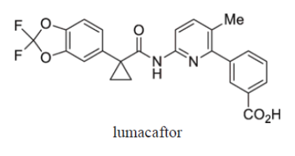
Lumacaftor is a white to off-white powder that is practically insoluble in water (0.02 mg/mL).

Ivacaftor
Molecular weight: 392.49
Figure 2. Structural formula of ivacaftor
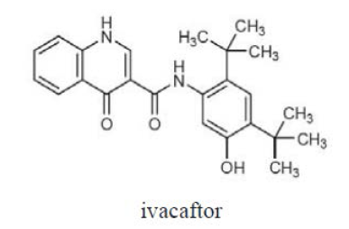
Ivacaftor is a white to off-white powder that is practically insoluble in water (< 0.05 µg/mL). The pKa values of IVA are 9.40 and 11.60. The log D value of IVA is 5.68 at pH = 7.4 and 25°C.

Pharmacokinetics in healthy subjects

Methods
The concentrations of lumacaftor (VX-809) in plasma were determined using a validated LC-MS/MS method. The lower limit of quantitation (LLOQ) for the assay was 2.00 ng/mL and the upper limit of quantitation (ULOQ) was 2,000 ng/mL. In general, the PK parameters were generated by non-compartmental (NONMEN) analysis using WinNonlin 5.1. Summary statistics were generated for the PK with WinNonlin using the bioequivalence module. Geometric least square mean ratio and 90% CI for AUC_{0-inf} and C_{max} were estimated using linear mixed effects modelling approach after log transformation.

Absorption

Sites and mechanisms of absorption
Fixed Dose Combination:
As described in the section outlining formulation development of this report, the sponsor is applying for the registration of a single dose strength (200 mg LUM/125 mg IVA) of the Orkambi FDC tablet. Following a single oral dose of 400 mg/250 mg Orkambi (that is, 2 × 200 mg LUM/125 mg IVA) to healthy males in the fed state (Study VX12-809-007) the median T_{max} values for both the lumacaftor and IVA components occurred at 4.00 h following dosing. A second dosage strength of the FDC (200 mg/ 83 mg) was also used in some Phase III trials and following a single oral dose of 600 mg/250 mg Orkambi (that is 3 × 200 mg LUM/83 mg IVA) to healthy subjects in the fed state (Study VX13-809-012), the median T_{max} for the lumacaftor component also occurred at 4 h following dosing whereas for the IVA component the median T_{max} occurred slightly earlier at 3 h.

Bioavailability

Absolute bioavailability
The absolute bioavailability of the FDC Orkambi is unknown. This is in part due to the poor solubility of the LUM component and the resulting inability to develop an IV formulation suitable for human administration. The bioavailability of IVA has been previously discussed in TGA (Submission No. PM-2012-01491-3-5).

Bioavailability relative to an oral solution or micronised suspension
Study VX08-809-003 examined the bioavailability of a capsule formulation of LUM relative to the suspension formulation, used in the initial Phase I trials, following a 200 mg oral dose in healthy fasted males. The results indicated that the capsule formulation had higher oral bioavailability as the LUM C_{max} and AUC_{0-inf} values were approximately 1.4 times higher following oral administration of the capsule formulation compared to the suspension. The median T_{max} values for the suspension and capsule formulations of 3 h and 4 h, respectively, indicated that the capsule was more slowly absorbed than the suspension.

Bioequivalence of clinical trial and market formulations

FDC verses free combination of LUM/IVA
A single study (Part B of Study VX12-809-007) examined the bioequivalence of the 200 mg LUM/125 mg IVA FDC (that is; proposed marketing formulation) and the free combination (that is Form 1 of lumacaftor and film coated IVA tablets) in healthy males in the fed state. Following a 400 mg LUM/250 mg IVA dose, the fixed and free formulations were essentially bioequivalent in regards to LUM exposure as the GLSM ratios (fixed/free) and 90% CIs were 1.00 (0.96, 1.04) for AUC_{0-inf} and 0.93 (0.86, 1.00) for C_{max}. The median T_{max} and mean t½ of LUM were also comparable for both formulations with T_{max} values of 4.00 h and t½ values of 26.61 h for the fixed and 26.95 h for the free combinations. For the IVA component, although the GLSM ratio (fixed/free) for AUC_{0-inf} indicated that the two formulations were similar (GLSM ratio: 1.14; 90% CI: 1.06 to 1.23), IVA C_{max} for the fixed combination was slightly higher than that of the free combination (GLSM ratio: 1.20; 90% CI: 1.09 to 1.33) (Table 2).

Table 2. Summary of relative bioavailability of ivacaftor between co-formulation versus co dose, Part B
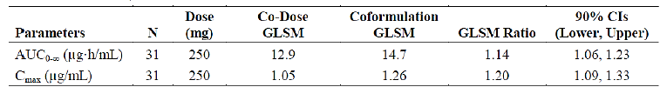
AUC_{0-∞}: area under the concentration versus time curve for the time of dosing extrapolated to infinity; C_{max}: maximum observed concentration; CIs: confidence interval; GLSM: geometric least squares mean (Co-Form/Co-Dose); N: number of subjects. Notes: co-formulation was dosed as 2 tablets of the 200 mg VX-809/125 mg VX-770 CG co-formulation. For Co-Dose, ivacaftor was dosed as one 100 mg tablet and one 150 mg tablet.
Comment: The small difference in C_{max} regarding the IVA component is unlikely to be of clinical significance.
Two Studies (VX07-809-003 and VX12-809-007) examined the bioequivalence of the various formulations of LUM used during the initial clinical trials.

Suspension form of LUM verses early tablet form of LUM
Study VX07-809-003 compared LUM PKs following a 200 mg dose of the suspension and early tablet formulations of LUM in healthy males in the fasted state.
The second Study, VX12-809-007 was a 2 part study, in which Part A examined the relative bioavailability of a new HDL tablet formulation of LUM, used during later trials, and the tablet formulation used in the Phase II Study, VX07-809-002, as well as several early Phase I studies at 2 different dose levels under fed conditions. At both dose levels (that is400 and 600 mg LUM) the C_{max}, AUC_{0-inf}, T_{max} and t½ values for LUM were similar for the two LUM formulations (Tables 4.8.3 and 4.8.5, p178). For instance, the GLSM ratios (90% CI) for C_{max} and AUC were 0.98 (0.93, 1.03) and 0.96 (0.90, 1.02), respectively, following a 400 mg dose of LUM and 1.01 (0.95, 1.07) and 1.15 (1.06, 1.24), respectively following a 600 mg dose.

Bioequivalence of different dosage forms and strengths
Study VX13-809-012 examined the PKs of LUM and IVA following doses of the FDC proposed for commercialisation and the FDC used in some Phase III trials under both fed and fasted conditions. The dose administered for the 200 mg LUM/125 mg IVA strength FDC tablets was 400 mg/250 mg, whereas, for the 200 mg LUM/83 mg IVA strength FDC tablets the dose administered was 600 mg/250 mg.
When administered in the fasted condition, the mean values of LUM AUC and C_{max} increased in a less than dose proportional manner (Table 3). For instance, dose normalised AUC_{0-inf} was approximately 1.24 fold higher following the 400 mg dose than following the 600 mg dose of LUM. IVA exposure (C_{max} and AUC) was lower by approximately 34 to 37% following 250 mg IVA dosed with 600 mg LUM compared to when 250 mg IVA was co-administered with 400 mg lumacaftor (Table 4). By contrast, under fed conditions the increase in LUM exposure was approximately proportional to dose, whereas, IVA exposure was comparable following doses of both formulations of FDC.

Table 3. Summary of lumacaftor PK parameters by FDC and fasting status Study VX13-809-012
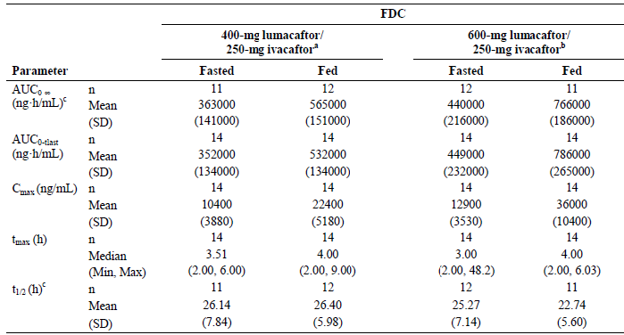
AUC_{0-∞}: area under the concentration versus time curve (AUC) from the time of dosing extrapolated to infinity; AUC_{0-tlast} : AUC from the time of dosing to the time of last measurable concentration; C_{max}: maximum observed concentration; FDC: fixed dose combination; max: maximum; min: minimum; n: number of subjects; SD: standard deviation; t_{max}: time of maximum concentration; t_{½}: terminal phase half-life. ª dosed as formulation A tablets (200 mg lumacaftor/ 125 mg ivacaftor) in Part A. ^{b} dosed as formulation B tablets (200 mg lumacaftor/ 83 mg ivacaftor) in Part B. ^{c} there were missing values for AUC_{0-∞} and t_{½} (n < 14) as some of the values could not be estimated due to insufficient data in the terminal phase.

Table 4. Summary of ivacaftor PK parameters by FDC and fasting status Study VX13-809-012
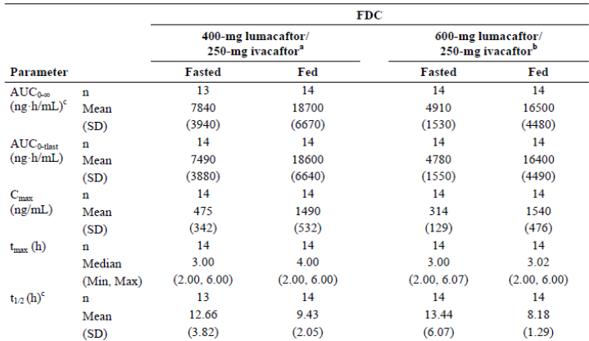
AUC_{0-∞}: area under the concentration versus time curve (AUC) from the time of dosing extrapolated to infinity; AUC_{0-tlast} : AUC from the time of dosing to the time of last measurable concentration; C_{max}: maximum observed concentration; FDC: fixed dose combination; max: maximum; min: minimum; n: number of subjects; SD: standard deviation; t_{max}: time of maximum concentration; t_{½}: terminal phase half-life. ª dosed as formulation A tablets (200 mg lumacaftor/ 125 mg ivacaftor) in Part A. ^{b} dosed as formulation B tablets (200 mg lumacaftor/ 83 mg ivacaftor) in Part B. ^{c} there were missing values for AUC_{0-∞} and t_{½} (n < 14) as some of the values could not be estimated due to insufficient data in the terminal phase.

Bioequivalence to relevant registered products
Not applicable.

Influence of food
Early clinical trials, VX08-809-003 and Part C of VX07-809-001 examined the effect of food on the PKs of LUM following tablet and suspension formulations of LUM; however, the most relevant study regarding food for the current application was Study VX13-809-012 which evaluated the effect of food on the relative bioavailability of the 2 FDCs of LUM and IVA in healthy subjects.
For the LUM component, following administration of a single oral dose of 600 mg LUM/250 mg IVA (that is; 3 × 200 mg/83 mg tablets) under fed conditions, the GLSM (90% CI) values for C_{max} and AUC_{0-inf} were approximately 2.8 fold higher (2.45, 3.26) and 2.0 fold higher (1.70, 2.24), respectively, than in the fasted state (Table 5).The median T_{max} ranged from 3.00 h to 4.00 h and the mean t½ ranged from 22.7 h to 25.3 h (Table 3). Following administration of 400 mg LUM/250 mg IVA (that is2 × 200 mg/125 mg tablets) GLSM (90% CI) values for LUM C_{max} and AUC_{0-inf} were approximately 2.2 fold (1.93, 2.57) and 1.6 fold (1.42, 1.88) higher in the fed state compared to the fasted. The median T_{max} ranged from 3.51 h to 4.00 h and the mean t½ ranged from 26.1 h to 26.40 h.

Table 5. Effect of food on lumacaftor bioavailability for the FDC tablet formulations Study VX13-809-012
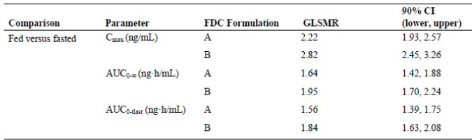
AUC_{0-∞}: area under the concentration versus time curve (AUC) from the time of dosing extrapolated to infinity; AUC_{0-tlast} : AUC from the time of dosing to the time of last measurable concentration; C_{max}: maximum observed concentration; FDC: fixed dose combination; Formulation A: 200 mg lumacaftor/ 125 mg ivacaftor, Formulation B: 200 mg lumacaftor/ 83 mg ivacaftor; GLSMR: geometric least squares mean ratio;; n: number of subjects; Notes: For C_{max} and AUC_{0-tlast} n = 14 for both Formulation A and Formulation B in the fed and fasted conditions; for AUC0-∞ n = 12 for Formulation A in the fed condition, n = 11 for Formulation A in the fasted condition n = 11 for Formulation B in the fed condition and n = 12 for Formulation B in the fasted condition.
For the IVA component, following administration of a single oral dose of 600 mg LUM/250 mg IVA (that is3 × 200 mg/83 mg) under fed conditions, the GLSM (90% CI) values for C_{max} and AUC_{0-inf} were approximately 5.2 fold higher (4.15, 6.48) and 3.4 fold higher (3.01, 3.83), respectively, than in the fasted state (Table 6). The median T_{max} ranged from 3.00 h to 3.02 h and the mean t½ ranged from 13.44 h to 8.18 h (Table 4). Following administration of 400 mg LUM/250 mg IVA (that is2 × 200 mg/125 mg) GLSM (90% CI) values for IVA C_{max} and AUC_{0-inf} were approximately 3.7 fold (3.00, 4.56) and 2.5 fold (2.22, 2.88) higher in the fed state compared to the fasted. The median T_{max} ranged from 3.00 h to 4.00 h and the mean t½ ranged from 12.66 h to 9.43 h.

Table 6. Effect of food on Ivacaftor bioavailability for the FDC tablet formulations Study VX13-809-012
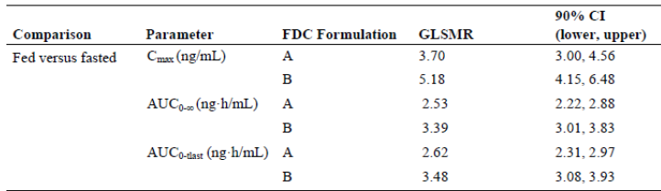
AUC_{0-∞}: area under the concentration versus time curve (AUC) from the time of dosing extrapolated to infinity; AUC_{0-tlast} : AUC from the time of dosing to the time of last measurable concentration; C_{max}: maximum observed concentration; FDC: fixed dose combination; Formulation A: 200 mg lumacaftor/ 125 mg ivacaftor, Formulation B: 200 mg lumacaftor/ 83 mg ivacaftor; GLSMR: geometric least squares mean ratio;; n: number of subjects; Notes: For C_{max} and AUC_{0-tlast} n = 14 for both Formulation A and Formulation B in the fed and fasted conditions; for AUC0-∞ n = 12 for Formulation A in the fed condition, n = 14 for Formulation A and Formulation B in the fed condition and Formulation B in the fasted condition and n = 13 for Formulation A in the fasted condition.

Dose proportionality
Studies VX12-809-008 and VX07-809-001 examined dose proportionality following a single administration of a range of LUM doses of both the LUM tablet and suspension formulations; however, the study most relevant to the current application was Study VX13-809-012. The results for this study in regards to dose proportionality have already been discussed above.

Bioavailability during multiple dosing
No studies specifically examined the bioavailability of LUM and IVA following multiple dose of the FDC formulations in healthy subjects; however, a number of Studies (VX08-809-005, VX10-809-006, VX12-809-008 Part B, VX12-809-009 and VX13-809-010) examined the PKs of LUM and IVA following multiple doses of the free combination in healthy subjects. The dose, duration and principal PK results for LUM and IVA from these studies were summarised. These studies examined a range of LUM and IVA dose strengths and 2 dose regimens for LUM administration (QD and q12h) and q12h dosing for IVA. Across these studies the median T_{max} values for LUM after multiple doses ranged from 2.00 h to 6.00 h and for IVA ranged from 2.00 h to 4.00 h. LUM t½ values (where calculated) ranged from 22.4 h to 26.3 h and for LUM ranged from 4.9 h to 11.9 h. Following multiple doses of LUM/IVA, the accumulation ratios for LUM, based on AUC, ranged from 1.55 fold to 1.9 fold and for IVA ranged from 0.38 fold to 0.74 fold. Steady levels of LUM and IVA were attained following approximately 7 days for LUM (Figure 3) and from 7 to 14 days for IVA (Figure 4).
Figure 3. Study VX08-809-005. Mean lumacaftor (VX-809) trough plasma concentration-time profiles after administration of VX-809 alone and with ivacaftor (VX-770) for 14 days
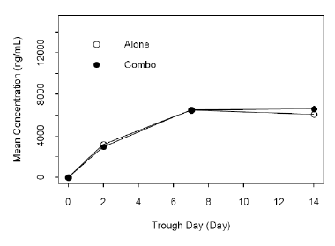
Figure 4. Study VX08-005 Mean ivacaftor (VX-770) trough plasma concentrations time profiles after administration of VX-770 alone and with lumacaftor (VX-809) for 14 days
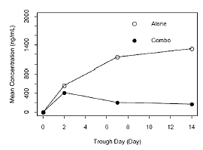

Effect of administration timing
The pooled analysis of Cohorts 2 and 3 undertaken in Study VX09-809-102 examined the effect of LUM dose strength and the timing of LUM dose on the PKs of LUM and IVA following administration of the free combination to the target population (that is; patients with CF who were homozygous for the F508del-CFTR mutation). Following doses of 400 mg LUM QD/250 mg IVA q12h, 600 mg LUM QD/250 mg IVA q12h or 400 mg LUM q12h/250 mg IVA q12h, the LUM AUC₀₋₂₄ values were 219, 290 and 371 µg.h/mL, respectively, and the LUM C_{min} values were 4.08, 5.33 and 9.76 µg/mL (Table 7). The corresponding IVA AUC_{τ} values were 3.8, 3.83 and 2.56 µg.h/mL, respectively, and IVA C_{min} values were 0.125, 0.102 and 0.078 µg/mL respectively. These results indicate that compared to the 600 mg LUM QD/250 mg IVA q12h dose, the LUM AUC and C_{min} values were 1.28 fold and 1.83 fold higher, respectively, following the 400 mg LUM q12h/250 mg IVA q12h dose, whereas, the IVA AUC and C_{min} values were 33% and 24% lower following twice daily dosing with 400 mg LUM (Table 8).
During Study VX08-809-005, evening PK samples were collected in addition to the samples taken after the morning dose of IVA to allow an assessment of the potential diurnal variation of IVA; however, no discernible differences in plasma exposures to IVA were observed.

Table 7. Effect of timing of LUM administration on LUM and IVA PK parameters by Treatment (Cohort 2 and Cohort 3) Study VX09-809-102
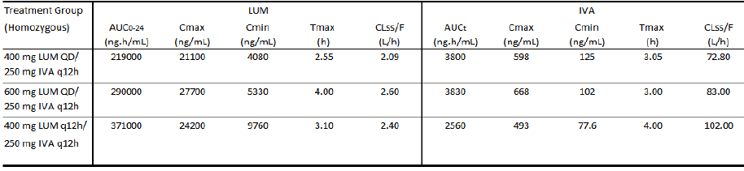

Table 8. Study VX09-809-102 Relative LUM and IVA AUC and C_{min} following different LUM doses and timing of LUM doses
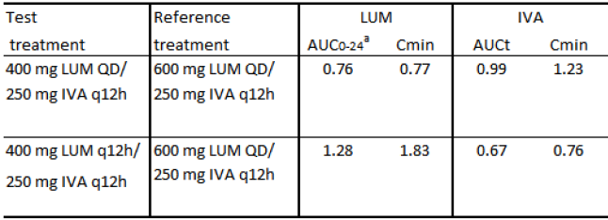
ª values represent the ratio of test: reference

Distribution

Volume of distribution
The apparent volume of distribution (Vd) for LUM and IVA were determined in both healthy subjects and subjects with moderate hepatic impairment following administration of LUM (200 mg q12h) and IVA (250 mg q12h) tablets for 10 days in the fed state in Study VX13-809-010). The mean Vd (SD) values for LUM and IVA in healthy subjects were 50.1 (17.4) L and 1000 (550) L, respectively (Table 9).

Table 9. Study VX13-809-010. Summary of pharmacokinetic parameters for total lumacaftor, ivacaftor, M28-lumacaftor, M1-ivacaftor and M6-ivacaftor in subjects with moderate hepatic impairment and in matched healthy subjects on Day 10
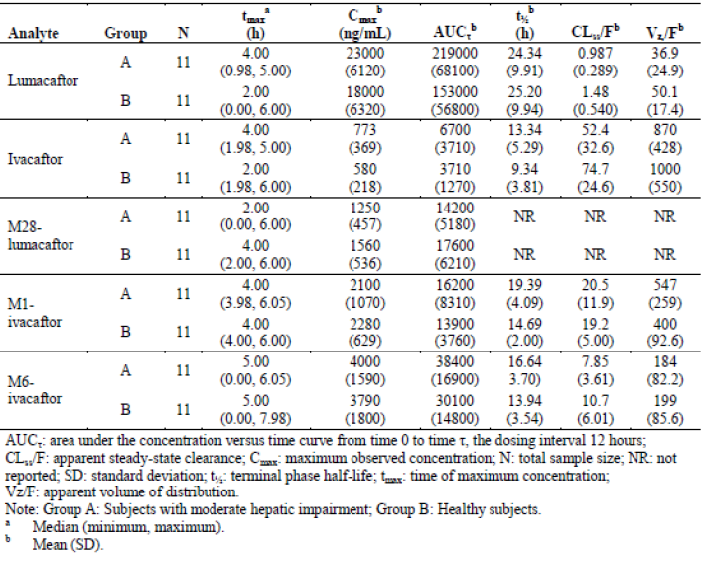

Plasma protein binding
In vitro studies indicated that the plasma protein binding of LUM was greater than 98% in all of the species examined and the mean protein binding values of ¹⁴C-LUM ranged from 99.97% to 100.00% in human plasma. LUM was highly bound to human serum albumin (HSA), with > 98% binding at all test article and HSA concentrations, whereas, alpha-1-acid glycoprotein and human gamma-globulin binding appeared to play a minimal role. IVA was also highly bound (> 98%) to proteins in human plasma at all concentrations tested.

Erythrocyte distribution
The mass balance Study, VX08-809-004 examined the rate of elimination and total recovery of LUM and total radioactivity after a single, oral dose of ¹⁴C-LUM in healthy males. Results from this study showed that the radioactivity in plasma (AUC_{0-inf} = 356 µg.h/mL) was higher than that observed in whole blood (204 µg.h/mL), suggesting that LUM does not partition into human red blood cells.

Tissue distribution
The Vd values generated in healthy subjects in Study VX13-809-010 suggest that LUM (Vd = 50.1) would be primarily distributed within the circulatory system, with a relatively low distribution into tissue in comparison to IVA (Vd = 1000 L), which would demonstrate high tissue penetration.

Metabolism
IVA metabolism has been previously discussed (as part of TGA Submission No. PM-2012-01491-3-5) therefore, the following sections will primarily focus on the metabolism of LUM.

Interconversion between enantiomers
Not applicable.

Sites of metabolism and mechanisms /enzyme systems involved
Results from Study VX08-809-004 indicate that LUM is poorly metabolised in man, as the majority of 200 mg ¹⁴C-LUM dose administered was excreted unchanged from body in the faeces. The proposed metabolic pathway for LUM in man was provided and it is believed that ¹⁴C-LUM is mainly metabolised via oxidation and glucuronidation.
In contrast to LUM, IVA is extensively metabolised in humans, primarily via CYP3A.

Non-renal clearance
As stated in the previous section LUM is primarily excreted via the faecal route with a CL/F (SD) in healthy males of 1.09 (0.29) L/h.

Metabolites identified in humans
The results of Study VX08-809-004 indicate that based on the ratio of LUM AUC₀₋₂₄ 6h/total radioactivity AUC₀₋₂₄6h approximately 52% of the radioactivity in plasma was associated with unchanged LUM. A major metabolite of LUM in plasma was identified as M28-LUM (M28) and it represented a further 13% of the circulating total radioactivity with a LUM/M28 AUC ratio of approximately 25%. Additional metabolites identified in plasma included O-VX-809-glucuronide-1 (M14), O-VX-809-glucuronide-2 (M16), VX-809-glucuronide-2 (M21), and O-VX-809-1 (M22); however, no other parent/metabolite ratios exceeded 5.4% and they were therefore considered minor metabolites.

Active metabolites
The activity of the various circulating metabolites of LUM is not clear from the information provided in the evaluation materials, whereas, the activity of the metabolites of IVA have been discussed in previous submissions to the TGA.

Other metabolites
Not applicable.

Pharmacokinetics of metabolites
Study VX08-809-005 examined the PKs of the LUM metabolite, M28 (M28-LUM), and IVA metabolites, M1 and M6 (M1-IVA and M6-IVA) following single and 14 days dosing with a free combination of LUM 200 mg QD/IVA 150 mg q12h in healthy subjects. Following a single dose of the free combination, the C_{max} and AUC₀₋₂₄ values for: M28 were 0.232 µg/mL and 3.76 µg.h/mL, respectively; for M1 were 5.34 µg/mL and 87.6 µg.h/mL, respectively and for M6 were 1.06 µg/mL and 22.0 µg.h/mL, respectively. The parent/metabolite AUC ratios (SD) for M28, M1 and M6 were 0.041 (0.011), 5.14 (1.09) and 1.42(0.55), respectively. Following 14 days of dosing, accumulation ratios (SD) for M28, M1 and M6 were 7.30 (1.63), 0.89 (0.27) and 3.36 (1.24), respectively. The parent/metabolite AUC ratios (SD) for M28, M1 and M6 following multiple doses were 0.154 (0.038), 8.43 (1.85) and 9.43 (5.05), respectively. Similar values for the metabolites were identified in Study VX10-809-006.

Consequences of genetic polymorphism
Not examined.

Excretion

Routes and mechanisms of excretion
Following a single dose of 200 mg ¹⁴C-LUM to healthy males, individual faecal recoveries of administered radioactivity ranged from 81% to 93% of the administered dose (mean of 90%) and individual urinary recoveries ranged from 6.9% to 13% (mean of 8.6%) through the last collection interval. As stated previously, unchanged ¹⁴C-LUM was the major component excreted in faeces and accounted for 42% of the radioactive dose, while a monohydroxylated metabolite (M22) accounted for a further 14%, through 216 h post dose. By contrast, only small amounts of unchanged LUM, mean of 0.12% (range 0.08% to 0.15%) of the dose, were excreted in urine). The majority of the radioactivity excreted in urine was associated with M20 (structure not elucidated), with a mean of 3.2% of the radioactive dose through a 120 h period.

Mass balance studies
Following a single dose of 200 mg ¹⁴C-LUM to healthy males, most of the administered radioactivity was recovered in the first 216 h post dose (range of 89% to 100%; mean of 96%). The overall mean recovery of radioactivity in urine and faeces samples ranged from 94% to 100% (mean of 98%) over the 480 h study period.

Renal clearance
The results of the mass balance Study VX08-809-004) indicate that renal clearance is not an important elimination pathway for LUM in humans.
Most of the radioactivity excreted in faeces was associated with unchanged LUM and a monohydroxylated metabolite (M22), accounting for means of 42% and 14% of the radioactive dose, respectively, through 216 h post-dose. These findings showed that the majority of LUM was excreted unchanged from body into the faeces.

Intra- and inter-individual variability of pharmacokinetics
The PopPK Study, K050 characterised the PKs of LUM and IVA based on data taken from studies, which had been conducted in healthy subjects and patients with CF. In this study LUM PK was described by a two compartment model with zero order delivery to the absorption compartment and subsequent first order absorption and an absorption lag time. IVA PK was described by a two compartment model with zero order delivery to the absorption compartment and subsequent first order absorption. The modelling provided inter-individual variability estimates on: CL/F of 0.0829 for LUM and 0.152 for IVA; Vc/F of 0.213 for LUM and 0.255 for IVA; and Vp/F of 0.089 for LUM and 0.068 for IVA. The intra-subject variability on bioavailability was 0.139 for LUM and 0.187 for IVA.

Pharmacokinetics in the target population
A number of studies examined the PKs of LUM and IVA following co-administration to subjects with CF who were either homozygous or heterozygous for the F508del-CFTR mutation. One such Study, VX09-809-102, examined a range of LUM doses (200 to 600 mg QD and 400 mg q12h) in combination with either 150 mg or 250 mg IVA q12h in both homozygous and heterozygous CF subjects.

Study VX09-809-102

Methodology
Phase II, multi-centre, double-blind, placebo controlled, multiple dose study of LUM monotherapy, and LUM and IVA combination therapy in subjects with CF who are homozygous or heterozygous for the F508del-CFTR mutation.

Entry criteria
Male and female subjects 18 years or older who are homozygous or heterozygous for the F508del-CFTR mutation.

Treatments

Cohort 1
Treatments groups in Cohort 1 were as follows:
- Group 1 (N = 20): Subjects homozygous for the F508del-CFTR mutation received 200 mg of LUM alone QD (Day 1 through Day 14), followed by 200 mg of LUM QD in combination with 150 mg of IVA q12h (Day 15 through Day 21)
- Group 2 (N = 20): Subjects homozygous for the F508del-CFTR mutation received 200 mg of LUM alone QD (Day 1 through Day 14), followed by 200 mg of LUM QD in combination with 250 mg of IVA q12h (Day 15 through Day 21)
- Group 3 (N = 20): Subjects homozygous for the F508del-CFTR mutation received LUM-matched placebo QD (Day 1 through Day 14), followed by LUM-matched placebo QD in combination with IVA matched placebo q12h (Day 15 through Day 21).

Cohort 2
Treatment Groups in Cohort 2 were as follows:
- Group 1 (N = 20): Subjects homozygous for the F508del-CFTR mutation received 200 mg of LUM alone QD (Day 1 through Day 28), followed by 200 mg of LUM QD in combination with 250 mg of IVA q12h (Day 29 through Day 56)
- Group 2 (N = 20): Subjects homozygous for the F508del-CFTR mutation received 400 mg of LUM alone QD (Day 1 through Day 28), followed by 400 mg of LUM QD in combination with 250 mg of IVA q12h (Day 29 through Day 56)
- Group 3 (N = 20): Subjects homozygous for the F508del-CFTR mutation received 600 mg of LUM alone QD (Day 1 through Day 28), followed by 600 mg of LUM QD in combination with 250 mg of IVA q12h (Day 29 through Day 56)
- Group 4 (N = 20): Subjects heterozygous for the F508del-CFTR mutation received 600 mg of LUM alone QD (Day 1 through Day 28), followed by 600 mg of LUM QD in combination with 250 mg of IVA q12h (Day 29 through Day 56)
- Group 5 (N = 20): Subjects homozygous or heterozygous for the F508del-CFTR mutation received LUM matched placebo QD (Day 1 through Day 28), followed by LUM matched placebo in combination with IVA matched placebo q12h (Day 29 through Day 56)

Cohort 3
Treatment groups in Cohort 3 were as follows:
- Group 1 (N = 10): Subjects homozygous for the F508del-CFTR mutation received 400 mg of LUM alone q12h (Day 1 through Day 28), followed by 400 mg of LUM q12h in combination with 250 mg of IVA q12h (Day 29 through Day 56).
- Group 2 (N = 3): Subjects homozygous for the F508del-CFTR mutation received LUM matched placebo q12h (Day 1 through Day 28), followed by LUM matched placebo q12h in combination with IVA matched placebo q12h (Day 29 through Day 56).

Cohort 4
Subjects were stratified by sex (male versus female) and forced expiratory volume in 1 second (FEV₁) severity collected at the Screening Visit (<70% versus ≥70% predicted), and then randomised (1:1) to 1 of the following treatment groups in Cohort 4:
- Group 1 (N = 60): Subjects heterozygous for the F508del-CFTR mutation received 400 mg of LUM q12h in combination with 250 mg of IVA q12h (Day 1 through Day 56).
- Group 2 (N = 60): Subjects heterozygous for the F508del-CFTR mutation received LUM in combination with IVA matched placebo q12h (Day 1 through Day 56).

Sampling and analysis
PK
For the evaluation of plasma concentrations of LUM and its metabolite, M28-LUM, as well as of IVA and its 2 metabolites, M1-IVA and M6-IVA, whole blood samples were collected from all subjects at the time points outlined below:
Cohort 1
- Monotherapy Period
  - Day 1: Pre-morning dose, 2 to 3 h, and 4 to 5 h after the morning dose
  - Day 7: Pre-morning dose
  - Day 14: Pre-morning dose and up to 12 h after the morning dose
  - Day 15: Pre-morning dose (24 h after the last dose)
- Combination Therapy Period
  - Day 21: Pre-morning dose and up to 12 h after the morning dose
  - Day 22: 24 h after the last morning dose (note that study drug was not administered in the evening of Day 21)
  - Day 23: Between 30 h (afternoon or evening of Day 22) and 60 h (afternoon or evening of Day 23) after the last dose
  - Day 26, 27, or 28 (Safety Follow-up Visit): Between 120 h (morning of Day 26) to 180 h (afternoon or evening of Day 28) after the last dose.
Cohort 2
- Monotherapy Period
  - Day 1: Pre-morning dose and 3 to 5 h after the morning dose
  - Day 14: Pre-morning dose
  - Day 28: Pre-morning dose and up to 12 h after the morning dose
  - Day 29: Pre- morning dose (24 h after the last dose).
- Combination Therapy Period
  - Day 42: Pre-morning dose
  - Day 56: Pre-morning dose and up to 12 h after the morning dose
  - Day 57: 24 h after the last morning dose (note that study drug was not administered in the evening of Day 56)
  - Day 58: Between 30 h (afternoon or evening of Day 57) and 60 h (afternoon or evening of Day 58) after the last dose
  - Day 61, 62, or 63 (Safety Follow-up Visit): Between 120 h (morning of Day 61) to 180 h (afternoon or evening of Day 63) after the last dose.
Cohort 3
- Monotherapy Period
  - Day 1: Before the morning dose, and 3 to 5 h after the morning dose
  - Day 14: Before the morning dose
  - Day 28: Before the morning dose and up to 12 h after the morning dose
  - Day 29: Before the morning dose (24 h after the last dose).
- Combination Therapy Period
  - Day 42: Before the morning dose
  - Day 56: Before the morning dose and up to 12 h after the morning dose
  - Day 57: 24 h after the last morning dose (note that study drug was not administered in the evening of Day 56)
  - Day 57 or 58: Between 30 h (afternoon or evening of Day 57) and 60 h (afternoon or evening of Day 58) after the last dose
  - Day 61, 62, or 63 (Safety Follow-up Visit): Between 120 h (morning of Day 61) to 180 h (afternoon or evening of Day 63) after the last dose.
Cohort 4
- LUM and IVA Combination Therapy:
  - Day 1: Before the morning dose, and 2, 4, and 6 h after the morning dose
  - Days 7 and 14: Before the morning dose
  - Day 28: Pre-morning dose and up to 12 h after the morning dose
  - Days 42 and 56: Before the morning dose
  - Day 56: Before the morning dose.

Efficacy Assessments
Efficacy assessments included sweat chloride tests, spirometry measurements (FEV₁; FVC; FEF25%-75% and FEV₁/FVC); CFQ-R (Cohort 2, Cohort 3, and Cohort 4); and for Cohort 4 only, BMI and weight.

Study participants
Enrolled:
- Cohort 1; Sixty-two, predominantly white (n = 61) subjects (31 females) with a mean age (range) of 29.1 years (18 to 52)
- Pooled Cohorts 2 and 3 - One hundred and twenty-four, predominantly white (n = 123) subjects (53 female) with a mean age (range) of 28.3 years (18 to 63)
- Cohort 4; One hundred and twenty-five, predominantly white (n = 120) subjects (60 female) with a mean age (range) of 29.9 years (18 to 58). A total of 62 subjects received 400 mg LUM q12h + 250 mg IVA q12h and 63 subjects received placebo.
Completed:
In Cohorts 1, 2, 3 and 4, 61, 100, 13 and 118 subjects completed treatment, respectively. The numbers of subjects who discontinued due to an AE in the 4 cohorts were 1, 6, 13 and 4, respectively.
Analysed:
The FAS included 62 subjects in Cohort 1, 109 subjects in Cohort 2, 15 subjects in Cohort 3 and 125 subjects in Cohort 4. A total of 39 subjects in Cohort 1, 79 subjects in Cohort 2, and 11 subjects in Cohort 3, and 56 subjects in Cohort 4 in the PK Analysis Set were included in PK parameter listing, summary, and statistical assessments, where applicable.

Results
PK
The PK Analysis Set included all randomised subjects who received at least 1 dose of study drug and for whom the primary PK data was considered to be sufficient and interpretable. A separate statistical analysis excluding subjects who did not finish the treatment period or had missing values for the PK parameters analysed was performed.
Following multiple doses of 200 mg LUM QD/250 mg IVA q12h in homozygous subjects the C_{max}, AUC_{τ}, C_{min} and T_{max} of LUM were 1.13, 1.23, 1.25 and 1.39 fold higher than following dosing with 200 mg LUM QD/150 mg IVA q12h (Table 10). When administered in combination with 200 mg LUM QD, the IVA exposures (AUC_{τ}, C_{max}, and C_{min}) increased in a greater than dose proportional manner with increasing IVA doses from 150 mg q12h to 250 mg q12h, for example IVA C_{max} and AUC_{τ} increased by approximately 2 and 2.3 fold, respectively, for a 1.67 fold increase in IVA dose (Table 11). When IVA dose was fixed at 250 mg IVA q12h and LUM dose was increased from 200 mg QD to 600 mg QD in heterozygous subjects the AUC₀₋₂₄h of LUM increased in a less than dose proportional manner; the coefficient of the log dose in the power model was estimated as 0.773 in combination therapy period (Table 12). For IVA, there was a decreasing trend in exposure when IVA was administered in combination with increasing doses of LUM ranging from 200 mg QD to 400 mg q12h; accordingly, IVA CLss/F increased with increasing doses of LUM during combination therapy (50.2 L/h for 200 mg LUM QD + 250 mg IVA q12h, 72.8 L/h for 400 mg LUM QD + 250 mg IVA q12h, 83.0 L/h for 600 mg LUM QD + 250 mg IVA q12h, and 102 L/h for 400 mg LUM q12h + 250 mg IVA q12h) in homozygous subjects (Table 13).

Table 10. Study VX09-809-102 Summary of lumacaftor PK parameters by treatment cohort (Cohort 1)
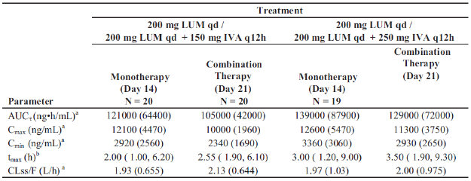
AUC_{τ}: AUC from the time of dosing to the end of the dosing interval, τ (24 hours); CLss/F: apparent clearance at steady state; C_{max} maximum observed concentration; C_{min}: minimum observed concentration; IVA: ivacaftor; q12h: every 12 hours; qd once daily; t_{max}: time of maximum concentration. ª Mean SD values are presented ^{b} Median (minimum, maximum) values are presented.

Table 11. Study VX09-809-102. Summary of Ivacaftor, M1-Ivacaftor and M6-Ivacaftor PK parameters on Day 21 by treatment group (Cohort 1)
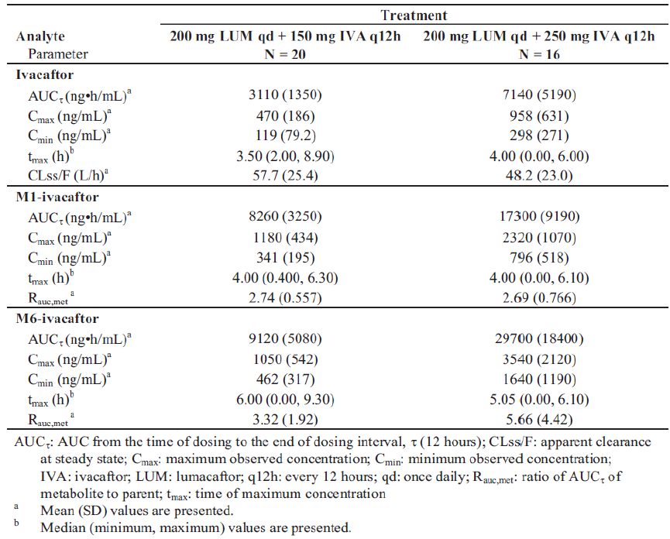

Table 12. Study VX09-809-102. Summary of lumacaftor PK parameters by treatment (Cohort 2 and Cohort 3)
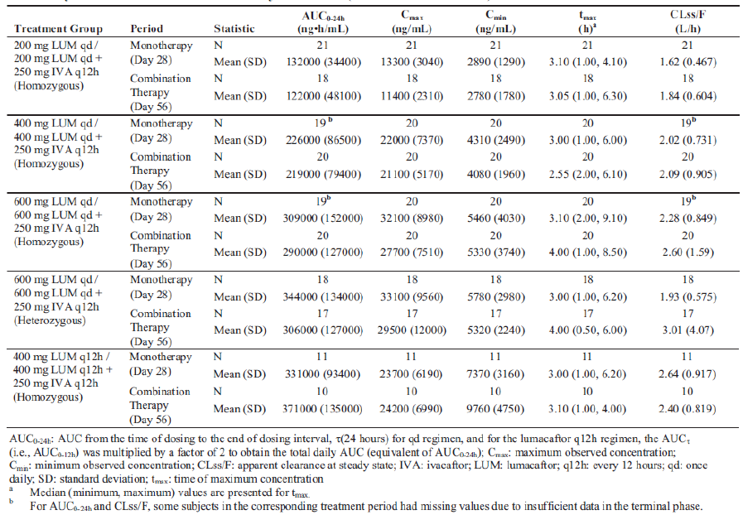

Table 13. Study VX09-809-102. Summary of ivacaftor, M1-Ivacaftor and M6-ivacaftor PK parameters on Day 56 by treatment group (Cohort 2 and Cohort 3)
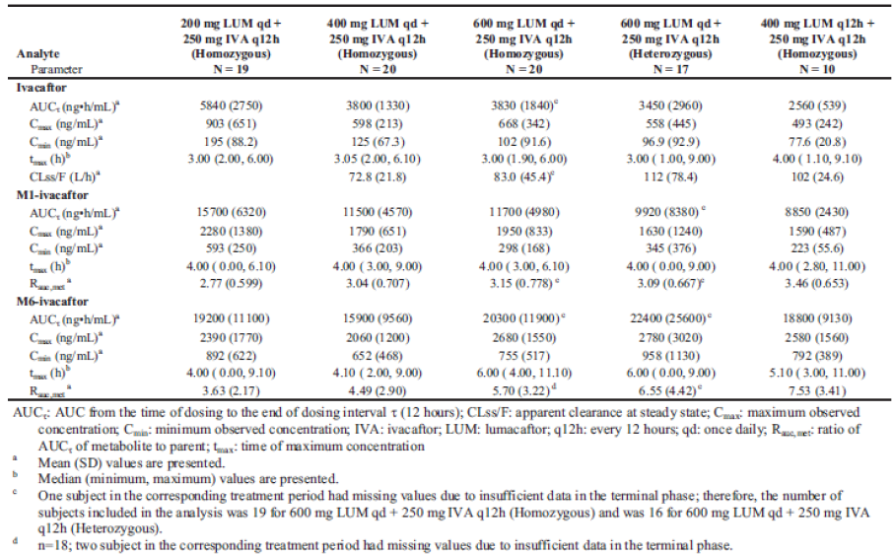

Study K272
Study K272 provided a pooled PK analysis of sparse PK data from two Phase III Studies, VX12-809-103 and VX12-809-104, in which the FDC tablets proposed for commercialisation were administered to patients with CF. This analysis indicated that the mean steady state LUM C_{trough} at each visit (except Day 1) appear higher in the LUM 400 mg q12h/IVA 250 mg q12h than the LUM 600 mg QD/IVA 250 mg q12h group and the mean steady state IVA C_{trough} at each visit (except Day 1) appear lower in the LUM 400 mg q12h/IVA 250 mg q12h compared to the LUM 600 mg QD/IVA 250 mg q12h group (Table 4.18.1, p251). In addition, following administration of the FDC proposed for commercialisation at a dose of 400 mg LUM q12h/250 mg IVA q12h, the mean LUM C_{trough} increased from 0.48 µg/mL on Day 1 to 14.1 µg/mL by Day 15 of dosing and thereafter remained relatively stable. For the IVA component, although IVA C_{trough} increased from Day 1 (0.042 µg/mL) to Day 15 (0.115 µg/mL) and then remained relatively stable, the magnitude of change for IVA C_{trough} (approximately 2.7 fold) was considerably smaller than that seen for the LUM component (approximately 29 fold).

PKs in target population compared to healthy subjects
PopPK analysis, Study K050 estimated the effects of individual specific covariate factors, such as body weight and disease status, on the PKs of LUM and IVA. Results indicated that for the LUM component, bioavailability was 1.81 times higher in healthy subjects and zero order dose duration (D1) was increased by a factor of 1.34, whereas, the first order absorption rate (Ka) and the oral absorption lag time (ALAG) were decreased by factors of 0.663 and 0.514, respectively, in healthy subjects compared to subjects with CF. For the IVA component, bioavailability was 1.53 times higher in healthy subjects than in subject with CF.

Pharmacokinetics in other special populations

Pharmacokinetics in subjects with impaired hepatic function
Study VX13-809-010 examined the PK of LUM and IVA following multiple doses of LUM (200 mg q12h) and IVA (250 mg q12h) tablets in subjects with moderate hepatic impairment and matched healthy subjects. The results indicated that following multiple doses of the study drugs, LUM C_{max} and AUC_{τ} values were higher in subjects with moderate hepatic impairment (C_{max}: 23 µg/mL; AUC: 219 µg.h/mL) than in healthy subjects (C_{max}: 18 µg/mL; AUC: 153 µg.h/mL). Similarly, IVA C_{max} and AUC_{τ} values were higher in subjects with moderate hepatic impairment (C_{max}: 0.77 µg/mL; AUC: 6.7 µg.h/mL) than in healthy subjects (C_{max}: 0.58 µg/mL; AUC: 3.71 µg.h/mL). By contrast, the CLss/F values for both LUM and IVA were lower in subjects with moderate hepatic impairment than in healthy subjects (0.987 L/h in subjects with moderate hepatic impairment versus 1.48 L/h in healthy subjects for LUM; 52.4 L/h in subjects with moderate hepatic impairment versus 74.7 L/h in healthy subjects for IVA), whereas, the median T_{max} values for both LUM and IVA were prolonged from 2.00 h to 4.00 h in the group with hepatic impairment compared to healthy subjects. For the metabolites M1-IVA and M6-IVA, the C_{max} and AUC_{τ} values for were similar in subjects with moderate hepatic impairment and matched healthy subjects; however, the exposures of M28-LUM were lower in subjects with moderate hepatic impairment than in healthy subjects.

Pharmacokinetics in subjects with impaired renal function
The effect of renal impairment on the PKs of LUM and IVA has not been examined for either of the FDC tablets, the free combination or for when LUM or IVA were administered alone. However, the results of the Mass Balance study suggest that renal clearance only plays a minor role in the elimination of LUM and previously submitted studies indicated that there was negligible urinary excretion of IVA as unchanged parent and minimal urinary excretion of parent drug plus metabolites. Therefore, the sponsor indicates that renal impairment is unlikely to affect the PKs of either the LUM or IVA component of the FDC.

Pharmacokinetics according to age
Study VX13-809-011 Part A examined the PKs of LUM and IVA following 14 days of dosing with LUM 200 mg q12h/IVA 250 mg q12h in subjects aged 6 to 11 years old with CF who were homozygous for the F508del-CFTR mutation. For the LUM component, C4h increased from 15,200 ng/mL on Day 1 to 24,500 ng/mL on Day 14 and the mean C12h increased from 8,320 ng/mL on Day 1 to 13,100 ng/mL on Day 14 (Table 14). Median LUM T_{max} values were approximately 4 hours on both Days 1 and 14. The mean M28-LUM C4h increased from 176 ng/mL on Day 1 to 2040 ng/mL on Day 14 and the mean C12h increased approximately 6 fold from 306 ng/mL on Day 1 to 1,800 ng/mL on Day 14. LUM appeared to reach steady state by approximately Day 7; however, M28-LUM levels still appear to be increasing from Day 7 to Day 14, which is consistent with the adult CF population. For the IVA component, the mean C4h decreased from 1,920 ng/mL on Day 1 to 622 ng/mL on Day 14 and decreased from 3,940 ng/mL on Day 1 to 2,380 ng/mL on Day 14 for M1-IVA (Table 15). The mean C12h decreased from 788 ng/mL on Day 1 to 222 ng/mL on Day 14 for IVA and decreased from 1,770 ng/mL on Day 1 to 704 ng/mL on Day 14 for M1-IVA. Median T_{max} values for both IVA and M1-IVA occurred at approximately 4 hours on both Days 1 and 14. The mean M6-IVA C4h increased from 1,810 ng/mL on Day 1 to 4,240 ng/mL on Day 14 and mean C12h decreased from 2,800 ng/mL on Day 1 to 2,340 ng/mL on Day 14. The median T_{max} decreased from 6.42 hours on Day 1 to 4.13 hours on Day 14 for M6-IVA. IVA, M1-IVA, and M6-IVA all appear to reach steady state by approximately Day 7, which is consistent with the adult CF population. The shape of the trough concentration versus time profile is also consistent with previous LUM and IVA interaction studies in adults, which showed a rapid decrease in the levels of IVA due to the induction of its metabolism by LUM.

Table 14. Study VX13-809-011 Part A. Summary of pharmacokinetic parameters for lumacaftor and M28-lumacaftor on Day 1 and Day 14
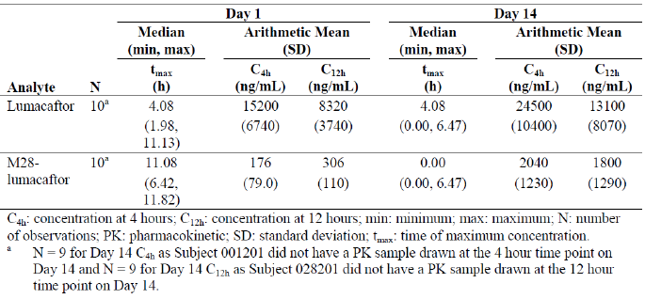

Table 15. Study VX13-809-011 Part A. Summary of pharmacokinetic parameters for ivacaftor, M1-ivacaftor and M6-ivacaftor on Day 1 and Day 14
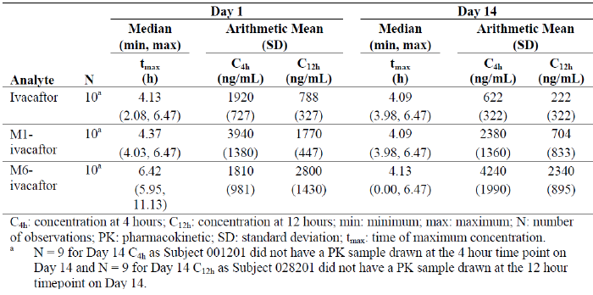
PopPK analysis undertaken in Study K050 indicated that LUM CL/F decreased with increasing age, such that the typical 12 year old has an 11% greater CL/F when compared to the reference 18 year old, and the typical 50 year old subject has a CL/F that is 24% lower than the reference 18 year old.

Pharmacokinetics related to genetic factors

Homozygous verses heterozygous
Study VX09-809-102 (described above) examined the PKs of a free combination of LUM and IVA in patients homozygous and heterozygous for the F508del CFTR mutation following doses of 600 mg LUM QD + 250 mg IVA. In homozygous patients, the LUM mean C_{max} C_{min} AUC₀₋₂₄ and CLss/F were 27.7 µg/mL, 5.33 µg/mL, 290 µg.h/mL and 2.60 L/h, respectively and the median T_{max} occurred at 4 h (Table 12 above). In heterozygous patients these values were 29.5 µg/mL, 5.32 µg/mL, 306 µg.h/mL and 3.01 L/h, respectively and the median T_{max} was 4.00 h. These results indicate that for the LUM component of the free combination, the PKs of LUM are similar in both heterozygous and homozygous patients. By contrast, for the IVA component both the IVA C_{max} and AUC_{τ} were slightly higher (approximately 1.20 and 1.1 fold, respectively) in homozygous compared to heterozygous patients, whereas, CLss/F was higher (approximately 1.35 fold) in the heterozygous group. In spite of these differences, the median T_{max} and mean C_{min} of IVA were similar in both groups suggesting that the differences identified in IVA PKs are unlikely to be clinically significant.

Pharmacokinetics {in other special population /according to other population characteristic

Gender
Study VX07-809-001 examined the effect of gender on LUM PKs following administration of the suspension formulation of LUM to healthy males and females under fasted conditions. The results indicated that following single doses the median values for both dose-normalised C_{max} and AUC_{0-inf} were 37% and 16% higher, respectively, in females (C_{max} = 36.7 ng/mL, AUC_{0-inf} = 1,024 ng.h/mL) compared to males (C_{max} = 26.7 ng/mL, AUC_{0-inf} = 881 ng.h/mL). Statistical assessment of gender effect demonstrated that the difference in AUC_{0-inf} was not statistically significant, whereas, the difference in C_{max} was (p = 0.0467). By contrast, gender was not identified as a significant covariate of either LUM or IVA PKs in the PopPK analysis K050 and the pooled analysis, K272, indicated that mean steady state LUM and IVA, C_{trough} and C_{3-6h},ave in the LUM 400 mg q12h/IVA 250 mg q12h and the LUM 600 mg QD/IVA 250 mg q12h groups were similar in both males and females. Therefore, gender is unlikely to affect the PKs of the FDC tablets.

Body weight
PopPK analysis, K050 indicated that body weight was an important predictor of variability in LUM CL/F. For example, LUM CL/F was 39% and 131% of the reference value of 1.67 L/h for the typical 20 kg and 100 kg subject, respectively, when compared to the reference subject (70 kg). Body weight was also an important predictor of variability in IVA CL/F. IVA CL/F was 39% and 131% of the reference value of 25.1 L/h for the typical 20 kg and 100 kg subject, respectively, when compared to the reference subject (70 kg).

Pancreatic insufficient subjects with CF
Study VX07-809-002 evaluated the PK of LUM in pancreatic insufficient subjects with CF following a single oral dose of 200 mg LUM in the fed and fasted states. The results indicated that the median T_{max} of LUM was prolonged under fed conditions compared to fasted (6 h versus. 4 h). In addition, C_{max} decreased significantly (by 23%) with food, whereas AUC_{0-inf} increased by 12% (Table 4.4.2, p129). However, the difference in AUC_{0-inf} was not statistically significant and the 90% CI was 98 to 128%, which was close to the acceptable range of 80 to 125%.

Pharmacokinetic interactions

Pharmacokinetic interactions demonstrated in human studies
Interaction between LUM and IVA Study VX08-809-005 examined the drug-drug interaction between LUM and IVA in healthy subjects following doses of 200 mg LUM QD given alone, 150 mg IVA q12h alone or co-administration of both for 14 days. On Days 1 and 14 of Periods 1 and 3, mean LUM plasma concentration time profiles were similar after the administration of LUM alone or in combination with IVA (Figure 5), whereas, the M28 metabolite showed slightly higher concentrations on Day 1 and Day 14 of the combination treatment period compared to when LUM was administered alone (Figure 6). Following administration of either LUM alone or in combination with IVA, the C_{trough} plasma concentrations for both LUM and M28 demonstrated accumulation over time (approximately 2 fold for LUM and 6 to 7 fold for M28 on Day 14 based on AUC) and steady state appeared to be reached by Day 7 for LUM (Figure 3 above), whereas trough plasma concentrations were still increasing on Day 14 for M28 (Figure 7).
Figure 5. Study VX08-809-05 Mean lumacaftor (VX809) plasma concentration time profiles on Day 1 and Day 14 after administration of VX-809 alone and with ivacaftor (VX-770) for 14 Days
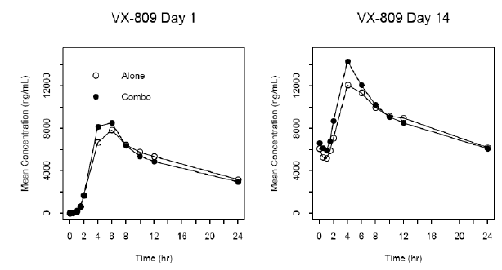
Figure 6. Study VX08-809-05 Mean M28 plasma concentration time profiles on Day 1 and Day 14 after administration of lumacaftor (VX-809) alone and with ivacaftor (VX-770) for 14 Days
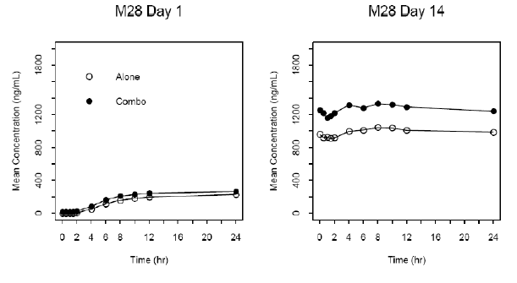
Figure 7. Study VX08-809-05 Mean M28 trough plasma concentration time profiles after administration of lumacaftor (VX-809) alone and with ivacaftor (VX-770) for 14 days
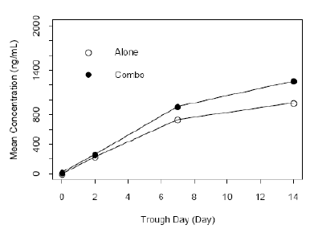
Following a single dose, the plasma concentration-time profiles of IVA and M1 were comparable after the administration of IVA alone or in combination with LUM (Figure 8), whereas, following 14 days of dosing there was a 70 to 80% reduction in IVA and M1 plasma concentrations when IVA was co-administered with LUM compared to when IVA was administered alone. The sponsor believes that the 70 to 80% decrease in IVA exposure following multi dose co-administration with LUM most likely results from a LUM mediated induction of CYP3A, the enzyme that is primarily responsible for the metabolism of IVA. When IVA was administered alone, C_{trough} values for IVA, M1, and M6 demonstrated significant accumulation over time (Figure 4 above) with accumulation ratios of approximately 3 fold for IVA and M1 , and 4 fold for M6 on Day 14. Steady state appeared to be reached by Day 7 to 14 for all 3 compounds. Following co-administration of IVA and LUM, IVA and M1 C_{trough} values initially increased; however, following continued co-administration, IVA and M1 C_{trough} values decreased to levels that were significantly lower than those seen when IVA was administered alone, indicating that LUM mediated induction occurred within the first few days of co-administration and reached a maximal effect by Day 7. By contrast, M6 C_{trough} values were similar, through to Day 7 following both administration of IVA alone and when it was co-administered; however, at later time points M6 C_{trough} values decreased by approximately 25% when the two drugs were co-administered compared to when IVA was administered alone.
Figure 8. Study VX08-809-05 Mean VX-770 plasma concentration time profiles on Day 1 and Day 14 after administration of ivacaftor (VX-770) alone and with VX-809 for 14 days
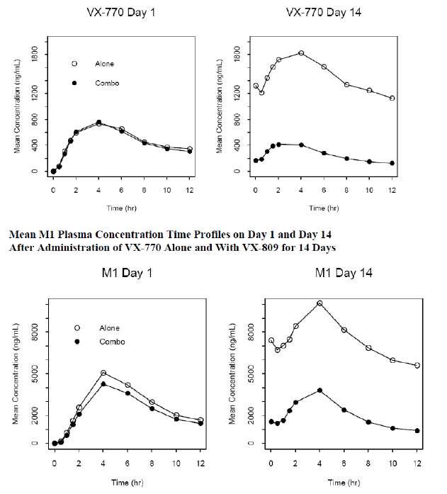
In contrast to the preceding Study VX08-809-005, when 200 mg LUM QD was co-administered with 250 mg IVA q12h for 14 days (Study VX10-809-006), LUM exposure decreased compared to when LUM was administered alone (GLSM ratios for C_{max} by 39% and for AUC₀₋₂₄h by 32%). Whereas, when IVA (250 mg q12h) was administered alone for 14 days IVA exposure increased by approximately 2.5 fold; however, following co-administration for 14 days IVA exposure decreased (0.63 fold). Similar results were identified for Cohort 2 of this study following dosing with 400 mg LUM QD and 150 mg IVA q12h either alone or in combination.

Interactions with other drugs
Study VX12-809-009 assessed the PKs of LUM and IVA following co-administration in the absence and presence of ciprofloxacin, itraconazole, rifampin and long acting bronchodilators, such as indacaterol and tiotropium.
Following co-administration of 200 mg LUM q12h and 250 mg IVA q12h, mean LUM AUC_{τ} (90% CI) values were approximately 14% (79, 95) lower in the presence of ciprofloxacin whereas, the M28 LUM concentration versus time profiles were similar in both its absence and presence. By contrast, the mean IVA AUC_{τ} was approximately 28% (111, 148) higher in the presence of ciprofloxacin. The mean plasma concentrations for the metabolites M1-IVA and M6-IVA were also higher by 126 % and 112%, respectively, in the presence of ciprofloxacin.
LUM and M28-LUM mean plasma concentrations were similar in the absence and presence of the CYP3A inhibitor itraconazole, whereas, the mean IVA AUC_{τ} was approximately 4.2 fold (3.78, 4.88) higher in its presence. The mean plasma concentration of the metabolite M1-IVA was higher (2.4 fold) in the presence of itraconazole; however, there was no change for M6-IVA.
The CYP3A inducer rifampin had little to no effect on mean LUM AUC_{τ}, whereas, the mean M28-LUM AUC_{τ} was approximately 35% (132, 140) higher in the presence of rifampin. By contrast, the mean IVA AUC_{τ} was approximately 67% (38, 49) lower in the presence of rifampin. The mean plasma concentrations of M1-IVA were also lower (approximately 35%); however, the mean plasma concentrations of M6-IVA were higher (approximately 29%) in the presence of rifampin.
Although no statistical analysis was undertaken to determine the effects of bronchodilators on LUM and IVA exposure, visual inspection of the concentration versus time profiles and summary of PK parameters indicate no effect of bronchodilator treatments on the PK parameters of LUM or IVA.

Clinical implications of in vitro findings
In vitro studies have established that LUM is an inducer of CYP3A, whereas, IVA is a weak inhibitor of CYP3A when given as monotherapy. The net effect of lumacaftor/ivacaftor therapy is expected to be strong CYP3A induction. In addition, both LUM and IVA have been shown to have no inhibitory effect on the inducible enzyme CYP2D6 and neither compound is a substrate for P-gp. By contrast, in vitro studies of interactions with digoxin, a sensitive P-gp probe substrate, indicated that both LUM and IVA are P-gp inhibitors.

Evaluator’s overall conclusions on pharmacokinetics

Absorption
- Following a single oral dose of either 400 mg/250 mg or 600 mg/250 mg Orkambi to healthy fed males the median LUM T_{max} occurred at 4 h following drug administration, whereas, the median T_{max} of the IVA component occurred at 4.00 h and 3.00 h after dosing, respectively
- The absolute bioavailability of the FDC Orkambi is unknown
- LUM C_{max} and AUC_{0-inf} values were approximately 1.4 higher following oral administration of a capsule formulation compared to a suspension. The median T_{max} values for the suspension and capsule formulations of 3 h and 4 h, respectively
- Following a 400 mg LUM/250 mg IVA dose, the fixed and free combinations of LUM/IVA were bioequivalent in regards to LUM AUC_{0-inf} and C_{max}. The median T_{max} and mean t½ of LUM were also similar with T_{max} values of 4.00 h and t½ values of 26.61 h for the fixed and 26.95 h for the free combinations. For the IVA component, although the AUC_{0-inf} was similar for both formulations, IVA C_{max} for the fixed combination was 1.2 fold higher (90% CI: 1.09, 1.33) than for the free combination
- Following administration of the FDC tablets at doses of 400 mg LUM/250 mg IVA and 600 mg LUM/250 mg IVA under fed conditions, the increase in LUM exposure was approximately proportional to dose, whereas, IVA exposure was comparable
- Following administration of a single oral dose of 600 mg LUM/250 mg IVA under fed conditions, the GLSM (90% CI) values for LUM C_{max} and AUC_{0-inf} were approximately 2.8 fold higher (2.45, 3.26) and 2.0 fold higher (1.70, 2.24), respectively, than in the fasted state. The IVA C_{max} and AUC_{0-inf} were approximately 5.2 fold higher (4.15, 6.48) and 3.4 fold higher (3.01, 3.83), respectively, in the fed compared to the fasted state. The median T_{max} and mean t½ of LUM ranged from 3.00 h to 4.00 h and 22.7 h to 25.3 h, respectively, whereas for the IVA they ranged from 3.00 h to 3.02 h and 13.44 h to 8.18 h, respectively
- When 400 mg LUM/250 mg IVA was administered with food, LUM and IVA exposure was 1.6- to 3.7 fold higher than in the fasted state; therefore, the FDC should be administered with food
- In the target population, compared to the 600 mg LUM QD/250 mg IVA q12h dose, the LUM AUC and C_{min} values were 1.28 fold and 1.83 fold higher, respectively, following a dose of 400 mg LUM q12h/250 mg IVA q12h, whereas, the IVA AUC and C_{min} values were 33% and 24% lower following twice daily dosing with 400 mg LUM
- No discernible differences in plasma exposures to IVA were observed following morning and evening dosing.

Distribution
- The mean Vd (SD) values for LUM and IVA in healthy subjects were 50.1 (17.4) L and 1,000 (550) L, respectively
- In vitro studies indicated that the plasma protein binding of LUM was greater than 98% and the mean protein binding values of ¹⁴C-LUM ranged from 99.97% to 100.00% in human plasma. LUM was highly bound to human serum albumin (HSA), with > 98% binding, whereas, binding to alpha-1-acid glycoprotein and human gamma-globulin played a minor role. IVA was also highly bound (> 98%) to proteins in human plasma at all concentrations tested
- A mass balance study indicates that LUM does not partition into human red blood cells
- Based on the Vd values, LUM is primarily distributed within the circulatory system, whereas, IVA (Vd = 1,000 L) demonstrates high tissue penetration.

Metabolism
- LUM is poorly metabolised in man, as the majority of 200 mg ¹⁴C-LUM dose administered was excreted unchanged from body in the faeces. It is believed that ¹⁴C-LUM is mainly metabolised via oxidation and glucuronidation. In contrast to LUM, IVA is extensively metabolised in humans, primarily via CYP3A
- LUM is primarily excreted via the faecal route with a CL/F (SD) in healthy males of 1.09 (0.29) L/h
- A major metabolite of LUM in plasma was identified as M28 and it represented a 13% of the circulating total radioactivity and the LUM/M28 AUC ratio was approximately 25%. Additional metabolites identified in plasma included O-VX-809-glucuronide-1 (M14), O-VX-809-glucuronide-2 (M16), VX-809-glucuronide-2 (M21), and O-VX-809-1 (M22); however, no other parent/metabolite ratios exceeded 5.4% and they were therefore considered minor metabolites
- Following a single dose of the free combination the C_{max} and AUC₀₋₂₄ values for: M28 were 0.232 µg/mL and 3.76 µg.h/mL, respectively; M1 were 5.34 µg/mL and 87.6 µg.h/mL, respectively; and for M6 were 1.06 µg/mL and 22.0 µg.h/mL, respectively. The parent/metabolite AUC ratios (SD) for M28, M1 and M6 were 0.041 (0.011), 5.14 (1.09) and 1.42(0.55), respectively. Following 14 days of dosing accumulation ratios (SD) for M28, M1 and M6 were 7.30 (1.63), 0.89 (0.27) and 3.36 (1.24), respectively. The parent/metabolite AUC ratios (SD) for M28, M1 and M6 following multiple doses were 0.154 (0.038), 8.43 (1.85) and 9.43 (5.05), respectively.

Excretion
- Individual faecal recoveries of administered radioactivity ranged from 81% to 93% of the administered dose (mean of 90%) and individual urinary recoveries ranged from 6.9% to 13% (mean of 8.6%) through the last collection interval following a single dose of 200 mg ¹⁴C-LUM to healthy males
- Unchanged LUM accounted for 42% of the radioactive dose excreted in faeces, while amonohydroxylated metabolite (M22) accounted for a further 14%, through 216 h post-dose
- Only small amounts of unchanged LUM, mean of 0.12% (range 0.08%-0.15%) of the dose, were excreted in urine, whereas, the majority of the radioactivity excreted in urine was associated with M20 with a mean of 3.2% of the radioactive dose through a 120 h period
- Following a single dose of 200 mg ¹⁴C-LUM to healthy males, most of the administered radioactivity was recovered in the first 216 h post-dose (range of 89% to 100%; mean of 96%). The overall mean recovery of radioactivity in urine and faeces samples ranged from 94% to 100% (mean of 98%) over the 480 h study period
- Renal clearance is not likely to be an important elimination pathway for LUM in humans.

Intra- and inter-individual variability
The PopPK analyses provided inter-individual variability estimates on: CL/F of 0.0829 for LUMand 0.152 for IVA; Vc/F of 0.213 for LUM and 0.255 for IVA; and Vp/F of 0.089 for LUM and 0.068 for IVA. The intra-subject variability on bioavailability was 0.139 for LUM and 0.187 for IVA.

Pharmacokinetics in the target population
- A pooled PK analysis indicated that following dosing with the FDC proposed for commercialisation at a dose of 400 mg LUM q12h/250 mg IVA q12h, the mean LUM C_{trough} increased from 0.48 µg/mL on Day 1 to 14.1 µg/mL by Day 15 of dosing and thereafter remained relatively stable. For the IVA component, although IVA C_{trough} increased from Day 1 (0.042 µg/mL) to Day 15 (0.115 µg/mL) and then remained relatively stable, the magnitude of change for IVA C_{trough} (approximately 2.7 fold) was considerably smaller than that seen for the LUM component (approximately 29 fold)
- Following doses of 600 mg LUM QD + 250 mg IVA of the free combination LUM PKs were similar in both heterozygous and homozygous patients. By contrast for the IVA component both the C_{max} and AUC_{τ} of IVA were slightly higher (approximately 1.20 and 1.1 fold, respectively) in homozygous compared to heterozygous patients, whereas, CLss/F was higher (approximately 1.35 fold) in the heterozygous group. In spite of these differences, the median T_{max} and mean C_{min} of IVA were similar in both groups suggesting that the differences identified in IVA PKs between homozygous and heterozygous patients are unlikely to be clinically significant.

PKs in target population compared to healthy subjects
A PopPK analysis indicated that following administration of LUM/IVA, LUM bioavailability was 1.81 times higher in healthy subjects and D1 was increased by a factor of 1.34, whereas, the Ka and the ALAG were decreased by factors of 0.663 and 0.514, respectively, in healthy subjects compared to subjects with CF. For the IVA component, bioavailability was 1.53 times higher in healthy subjects than in subject with CF (Table 16).

Table 16. Study K050. Parameter estimates from the ivacaftor Phase I/II final population pharmacokinetic model (Run 2023)
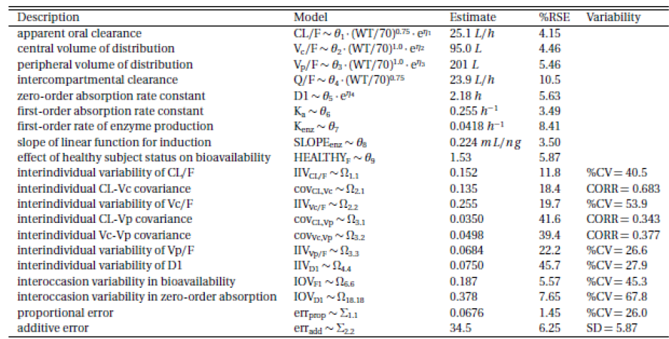

PKs in subjects with impaired hepatic function
Following multiple doses of LUM/IVA, LUM and IVA AUC was approximately 1.43 fold and 1.81 fold higher, respectively, and CLss/F was approximately 1.50 fold and 1.43 fold lower, respectively, in subjects with moderate hepatic impairment than in healthy subjects. Therefore, adequate precautions relating to the effects of moderate hepatic impairment on the PKs of LUM/IVA need to be provided in the PI.

Pharmacokinetics according to age
PopPK analysis indicated that LUM CL/F decreased with increasing age, such that the typical 12 year old has an 11% greater CL/F when compared to the reference 18 year old, and the typical 50 year old subject has a CL/F that is 24% lower than the reference 18 year old.

Gender, Body weight
The PKs of both LUM and IVA were not affected by gender. Body weight was an important predictor of variability in LUM CL/F. For example, LUM CL/F was 39% and 131% of the reference value of 1.67 L/h for the typical 20 kg and 100 kg subject, respectively, when compared to the reference subject (70 kg). Body weight was also an important predictor of variability in IVA CL/F. IVA CL/F was 39% and 131% of the reference value of 25.1 L/h for the typical 20 kg and 100 kg subject, respectively, when compared to the reference subject (70 kg).

Interaction between LUM and IVA
Co-administration of 150 mg IVA q12h and 200 mg LUM QD had little effect on LUM and M28 exposure, accumulation and attainment of steady state compared to when LUM was administered alone. By contrast, following 14 days of co-administration of LUM/IVA there was a 70 to 80% reduction in IVA and M1 exposure compared to when IVA was administered alone.
When 200 mg LUM QD was co-administered with 250 mg IVA q12h for 14 days, LUM exposure decreased compared to when LUM was administered alone (GLSM ratios for C_{max} by 39% and for AUC₀₋₂₄h by 32%). Whereas, when IVA (250 mg q12h) was administered alone for 14 days IVA exposure increased by approximately 2.5 fold; however, following co-administration for 14 days IVA exposure decreased (0.63 fold).

Ciprofloxacin
Following co-administration of 200 mg LUM q12h and 250 mg IVA q12h, mean LUM AUC_{τ} (90% CI) values were approximately 14% (79, 95) lower in the presence of ciprofloxacin, whereas, the M28-LUM concentration versus time profiles were similar in both its absence and presence. By contrast, the mean IVA AUC_{τ} was approximately 28% (111, 148) higher in the presence of ciprofloxacin. The mean plasma concentrations for the metabolites M1-IVA and M6-IVA were also higher by 126 % and 112%, respectively, in the presence of ciprofloxacin.

CYP3A inhibitor itraconazole
LUM and M28-LUM mean plasma concentrations were similar in the absence and presence of the itraconazole, whereas, the mean IVA AUC_{τ} was approximately 4.2 fold (3.78, 4.88) higher in its presence. The mean plasma concentration of the metabolite M1-IVA was higher (2.4 fold) in the presence of itraconazole; however, there was no change for M6-IVA.

CYP3A inducer rifampin
- Rifampin had little to no effect on mean LUM AUC_{τ}, whereas, the mean M28-LUM AUC_{τ} was approximately 35% (132, 140) higher in the presence of rifampin. By contrast, the mean IVA AUC_{τ} was approximately 67% (38, 49) lower in the presence of rifampin. The mean plasma concentration of M1-IVA was also lower (approximately 35%), whereas, M6-IVA AUC_{τ} was higher (approximately 29%) in the presence of rifampin.
- In vitro studies have established that LUM is an inducer of CYP3A, whereas, IVA is a weak inhibitor of CYP3A when given as monotherapy. The net effect of lumacaftor/ivacaftor therapy is expected to be strong CYP3A induction. In addition, both LUM and IVA have been shown to have no inhibitory effect on the inducible enzyme CYP2D6 and neither compound is a substrate for P-gp. By contrast, in vitro studies indicated that both LUM and IVA are P-gp inhibitors.

Limitations of the PK studies
- No studies specifically examined the bioavailability of LUM and IVA following multiple dose of the FDC formulations in healthy subjects.
- The activity of the various circulating metabolites of LUM is not clear from the information provided in the evaluation materials.
- The effect of renal impairment on the PKs of LUM and IVA has not been examined for either of the FDC tablets, the free combination or for when LUM or IVA were administered alone.

Pharmacodynamics

Studies providing pharmacodynamic data
Summaries of the pharmacodynamic studies were provided. Table 17 shows the studies relating to each pharmacodynamic topic.
Note: Almost all of the studies that contain a PD component have been previously summarised; therefore, only a single study, which represented a population exposure response analysis, is included in the following table.

Table 17. Submitted pharmacodynamic studies
PD Topic | Subtopic | Study ID | Primary aim of the study
Population PD and PK-PD analyses | Target population | K261 | Population exposure-response analysis of sweat chloride response to treatment with LUM alone or with LUM in combination with IVA in adults with CF, homozygous for the F508del-CFTR mutation
None of the pharmacodynamic studies had deficiencies that excluded their results from consideration.

Summary of pharmacodynamics
The information in the following summary is derived from conventional pharmacodynamic studies in humans unless otherwise stated.

Mechanism of action
Note: The following description of the mechanism of action is taken directly from the proposed PI.
The CFTR protein is a chloride channel present at the surface of epithelial cells in multiple organs. The F508del mutation impacts the CFTR protein in multiple ways, primarily by causing a defect in cellular processing and trafficking that reduces the quantity of CFTR at the cell surface. The small amount of F508del-CFTR that reaches the cell surface has low channel open probability (defective channel gating). Lumacaftor is a CFTR corrector that acts directly on F508del-CFTR to improve its cellular processing and trafficking, thereby increasing the quantity of functional CFTR at the cell surface. Ivacaftor is a CFTR potentiator that facilitates increased chloride transport by potentiating the channel open probability (or gating) of the CFTR protein at the cell surface. The combined effect of lumacaftor and ivacaftor is increased quantity and function of F508del-CFTR at the cell surface, resulting in increased chloride ion transport.

Pharmacodynamic effects

End points for primary PD studies
Elevated sweat chloride levels, which occur as a result of CFTR protein dysfunction, are a primary diagnostic marker for CF and a reduction in these levels is thought to occur as a result of improved CFTR function in the skin.
An improvement in lung function, which can be determined using spirometry (FEVI), is also an accepted measure of the efficacy of treatment for CF.
The Cystic Fibrosis Questionnaire-Revised (CFQ-R) is a disease specific health related qualify of life measure for children, adolescents and adults with CF.

Primary pharmacodynamic effects; effects on sweat chloride

FDC
No PK/PD studies examined the effect of the FDC on sweat chloride in the target population of patients with CF who were homozygous for the F508del-CFTR mutation.
In Cohort 4 of Study VX09-809-102 (described above), which examined patients with CF who were heterozygous for the F508del-CFTR mutation (that is; not the target population), administration of the FDC at a dose of 400 mg LUM q12h + 250 mg IVA q12h (2 x 200 mg/125 mg FDC strength) for 56 days resulted in a statistically significant reduction in sweat chloride levels in subjects who received the active FDC (-11.82 mmol/L; p < 0.0001) compared to subjects who received a FDC containing the LUM component + placebo (-11.03 mmol/L; p = < 0.0001).

Free combination
Study VX09-809-102 also examined the effect of the free combination of LUM/IVA on sweat chloride levels in subjects with CF. In subjects who were homozygous for the F508del-CFTR mutation (study Cohort 1) the primary efficacy endpoint was change in sweat chloride from Day 14 at Day 21. Results indicated that subjects who received a 200 mg LUM QD + 250 mg IVA q12h dose as a free combination (-9.626 mmol/L; 95% Cl: -14.801, -4.551; p < 0.001), but not those who received 200 mg LUM QD + 150 mg IVA q12h (-2.679 mmol/L; p = 0.267), had an adjusted mean absolute change from Day 14 at Day 21 in sweat chloride values that was statistically significant compared to the combination placebo group (that is; subjects who received placebo + placebo) (Table 18).

Table 18. Study VX09-809-102 Absolute change from baseline at Day 14 in sweat chloride (mmol/L) by ANCOVA, Full Analysis Set (Cohort 1)
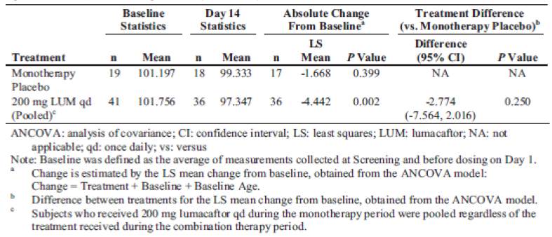
In addition, statistically significant within group adjusted mean absolute changes from baseline at Day 21 (that is; for the entire treatment period) in sweat chloride values were observed for subjects who received either 200 mg LUM QD + 250 mg IVA q12h (-12.561 mmol/L, p < 0.001) or 200 mg LUM QD + 150 g IVA q12h group (-6.741 mmol/L, p = 0.003) (Table 19). Although the treatment difference for the 200 mg LUM QD + 250 mg IVA q12h group compared to the combined placebo group in the mean absolute change from baseline at Day 21 in sweat chloride values was statistically significant (-10.86 mmol/L, p = 0.002), the treatment difference for the subjects who were administered 200 mg LUM QD + 150 mg IVA q12h group compared to the combined placebo group was not significant (-5.04 mmol/L, p = 0.126).

Table 19. 4.11.15 Study VX09-809-102. Absolute change from baseline at Day 21 in sweat chloride (mmol/L) by ANCOVA, full analysis set (Cohort 1)
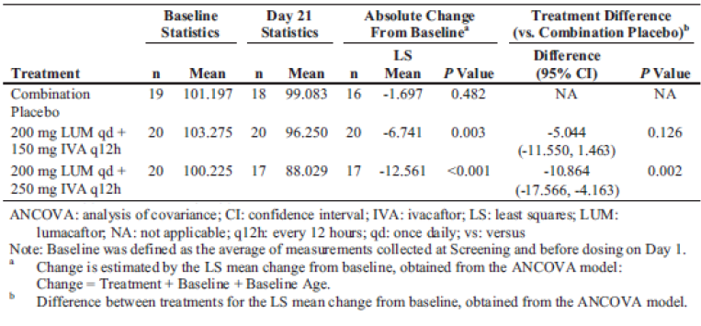
The percentage of subjects who were considered sweat chloride responders to LUM monotherapy or LUM in combination with IVA was higher in the active treatment groups compared to the monotherapy placebo group or combination placebo group (Table 20).

Table 20. Study VX09-809-102. Sweat chloride responders, full analysis set (cohort 1)
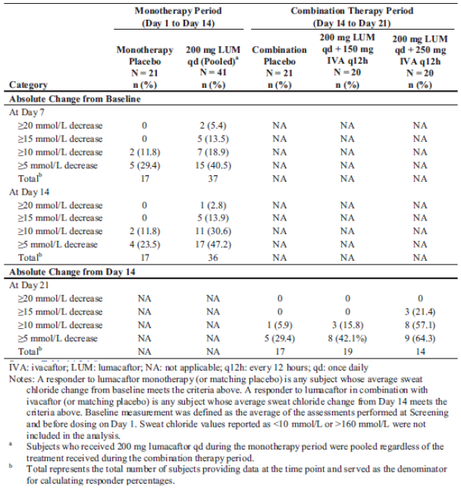
In a combined population (study Cohorts 2 and 3) of subjects with CF (that is; subjects who were homozygous and heterozygous for the F508del-CFTR mutation) who received a range of LUM doses (200 mg to 600 mg) in combination with 250 mg IVA q12h there were no statistically significant adjusted mean absolute changes in sweat chloride values from Day 28 at Day 56 in any active treatment group when analysed within group or in comparison to the combination placebo group.
Study K261 analysed the relationship between LUM exposure and sweat chloride response following treatment with LUM alone or with LUM in combination with IVA in adult subjects with CF who were homozygous for the F508del-CFTR mutation based on the results of two Phase II Studies (VX08-809-101 and VX09-809-102). The final structural model for describing sweat chloride response consisted of an E_{max} model, parameterised by E_{max} and EC50, and an additional term, E_{base}, which is the model estimated sweat chloride baseline for each subject. The effect of the presence of IVA on sweat chloride response was statistically significant and was described best by a multiplicative term (E770m) applied to E_{max}. Covariate analysis uncovered a significant effect of subject weight on E_{max}, with E_{max} decreasing with increasing weight; after controlling for the effect of weight on E_{max}, no other significant covariate effects remained (Table 21 and Figure 9).

Table 21 Study K261. Correlations between baseline covariates
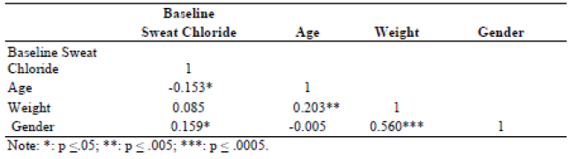
Figure 9. Study K261. Predicted sweat chloride response in studies VX12-809-103 and VX12-809-104
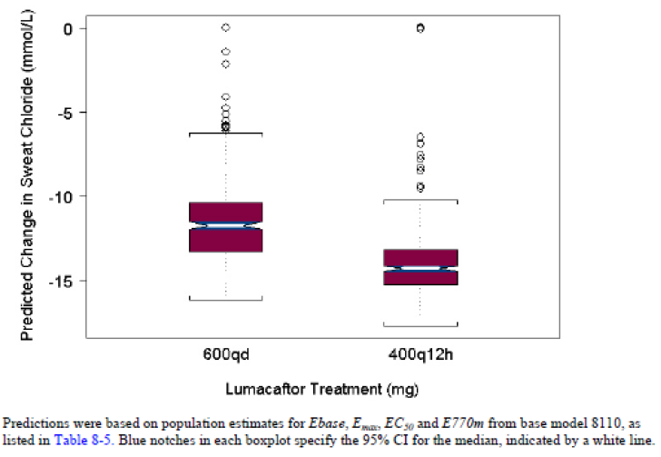

Primary pharmacodynamic effects; lung function

FDC
No PK/PD studies examined the effects of the FDC on lung function in the target population (homozygous subjects), whereas, following administration of the FDC (400 mg LUM q12h + 250 mg IVA q12h) to heterozygous CF subjects (Study VX09-809-102), there was no statistically significant LS mean absolute change from baseline at Day 56 in ppFEV₁ when analysed within-group or in comparison to the placebo group. The within group LS mean change was -0.62 percentage points (p = 0.4550). The LS mean treatment difference compared to the placebo group was 0.60 percentage points (p = 0.5978). In addition, there was no statistically significant LS mean relative change from baseline at Day 56 in ppFEV₁ following active treatment when analysed within-group or in comparison to the placebo group. The within-group LS mean was -0.69% (p = 0.6291). The LS mean treatment difference compared to the placebo group was 1.52% (p = 0.4408).

Free combination
In the homozygous cohort in Study VX09-809-102, a statistically significant within group adjusted mean absolute change from Day 14 at Day 21 in FEV₁ was identified following administration of 200 mg LUM QD + 150 mg IVA q12h group (0.128 L; p = 0.011). When compared to the combination placebo group the mean absolute change from Day 14 at Day 21 in FEV₁ was 0.174 L (95% CI: 0.042, 0.306), which was also statistically significant (p = 0.011) (Table 22). In addition, statistically significant within group adjusted mean absolute change from Day 14 at Day 21 in ppFEV₁ was observed for this active treatment group (3.46 percentage points; p = 0.010). The treatment difference for the 200 mg LUM QD + 150 mg IVA q12h group compared to the combination placebo group in the mean absolute change from Day 14 at Day 21 in percent predicted FEV₁ was 4.90 percentage points (95% CI: 1.37, 8.42), which was statistically significant (p = 0.007). By contrast, the adjusted mean absolute change from Day 14 at Day 21 in FEV₁ or ppFEV₁ for the 200 mg LUM QD + 250 mg IVA q12h group was not statistically significant when analysed within group or in comparison to the combination placebo group.

Table 22. Study VX09-809-102 Absolute change in FEV₁ and percent predicted FEV₁ by ANCOVA, Full analysis set (cohort 1)
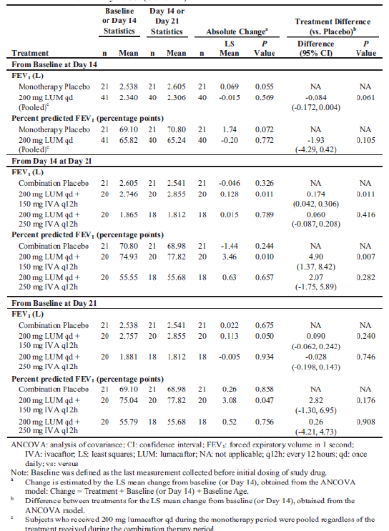
The within group adjusted mean absolute change from baseline at Day 21 (for entire treatment period) in FEV₁ was 0.113 L for in the 200 mg LUM QD + 150 mg IVA q12h group (p = 0.050); however, the treatment difference for this active group compared to the combination placebo group was not statistically significant. Similarly, a statistically significant within group adjusted mean absolute change from baseline at Day 21 (entire treatment period) in ppFEV₁ was observed for subjects administered 200 mg LUM QD + 150 mg IVA q12h group (3.08 percentage points; p = 0.047), whereas, the treatment difference for the 200 mg LUM QD + 150 mg IVA q12h group compared to the combination placebo group was not statistically significant.
The percentage of subjects who were considered FEV₁ responders to LUM monotherapy was similar between the active treatment group and the monotherapy placebo group. The percentage of subjects who were considered FEV₁ responders to LUM in combination with IVA was higher in the active treatment group compared to the combination placebo group.
In the pooled analysis of Cohorts 2 and 3, a statistically significant within group adjusted mean relative change from Day 28 at Day 56 in percent predicted FEV₁ was observed in the 600 mg LUM QD + 250 mg IVA q12h homozygous group (9.70%, p < 0.001) and the 400 mg LUM q12h + 250 mg IVA q12h homozygous group (8.24%, p = 0.012). When compared to the pooled combination placebo group, the treatment difference in the mean relative change from Day 28 at Day 56 was 11.75% (95% CI: 5.49, 18.01; p < 0.001) for the 600 mg LUM QD + 250 mg IVA q12h homozygous group, and 10.29% (95% CI: 2.53, 18.05; p = 0.010) for the 400 mg LUM q12h + 250 mg IVA q12h homozygous group.
A statistically significant within group adjusted mean absolute change from baseline at Day 56 (entire treatment period) in percent predicted FEV₁ was observed in the 600 mg LUM QD + 250 mg IVA q12h homozygous group (3.59 percentage points, p = 0.027) (Table 23). The treatment difference for this active treatment group compared to the pooled combination placebo group in the mean absolute change from baseline at Day 56 was 5.61% (95% CI: 1.21, 10.01; p = 0.013).

Table 23. Study VX09-809-102. Absolute change in percent predicted FEV₁ by ANCOVA, full analysis set (Cohort 2 and Cohort 3 pooled)
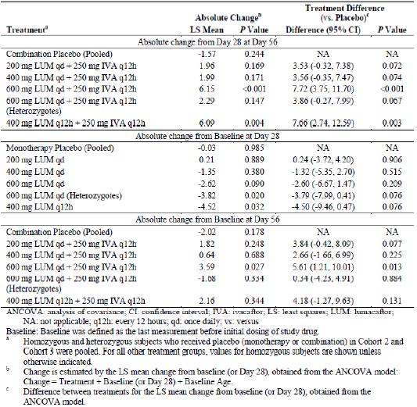
Similarly, a statistically significant within group adjusted mean relative change from baseline at Day 56 (entire treatment period) in ppFEV₁ was also observed for the 600 mg LUM QD + 250 mg IVA q12h homozygous group (5.55%, p = 0.025) and the treatment difference compared to the pooled combination placebo group in the mean relative change from baseline at Day 56 was 7.96% (95% CI: 1.27, 14.66; p = 0.020).
The percentage of subjects who were considered percent predicted FEV₁ responders to LUM monotherapy was generally low (Table 24). The percentage of subjects who were considered ppFEV₁ responders to LUM in combination with IVA was the highest in the 400 mg LUM q12h + 250 mg IVA q12h homozygous group and the 600 mg LUM QD + 250 mg IVA q12h pooled group.

Table 24. Study VX09-809-102. Percent predicted FEV₁ responders, full analysis set (Cohort 2 and Cohort 3 pooled)
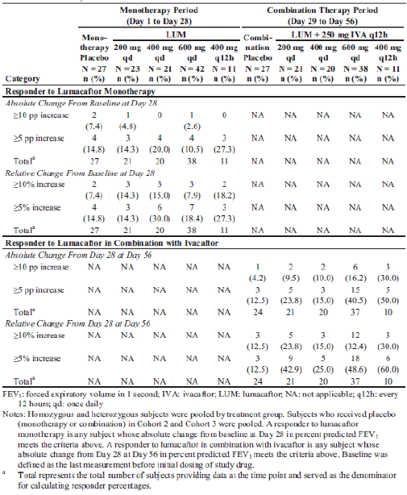

LUM alone
In Study VX08-809-101, an ANCOVA analysis of change and percent change from baseline to Day 28 in FEV₁ did not identify statistically significant results for either change from baseline, percent change from baseline, or difference between treatment and placebo for any LUM treatment group. Results of the repeated measures analyses of both mean change and mean percent change were almost identical to the ANCOVA analyses. The percentage of subjects classified as responders to treatment (having a 10% or greater increase in FEV₁) included 1 subject (5.9%) in the placebo group, 1 subject each in the 25 mg and 100 mg LUM groups (5.9% and 6.3% respectively), and 2 subjects each in the 50 mg and 200 mg groups (11.8% and 11.1% respectively).

PopPK
The exposure-response analysis of LUM and IVA in subjects with cystic fibrosis undertaken in Study K050 identified that the effects of LUM on ppFEV₁ could be described using two different exposure metrics: predicted AUC₀₋₂₄ and observed trough concentrations C_{min}. The final model was a linear model, which incorporated a linear slope for drug effects with no placebo model.

Primary pharmacodynamic effects; CFQ-R

FDC
In Cohort 4 of Study VX09-809-102, a nominally significant improvement in CFQ-R respiratory domain score was observed in the 400 mg LUM q12h + 250 mg IVA q12h group when analysed as a within group LS mean change (5.66 points; p = 0.0030) and as the treatment difference in comparison to the placebo group (6.48 points; p = 0.0131). This endpoint was not considered statistically significant within the framework of the testing hierarchy.

Free combination
Based on the pooled data from Cohorts 2 and 3 (Study VX09-809-102) no meaningful correlation between clinical outcomes and biomarker outcomes, between clinical outcomes and CFQ-R outcomes, and between biomarker outcomes and CFQ-R outcomes were observed.

LUM alone
For the CFQ-R results, at Day 28, the mean change in respiratory domain score in the placebo group was +4.5; in the LUM 25, 50, 100 and 200 mg treatment groups, the mean changes were -5.2, -6.3, -1.30, and +2.2, respectively. There were no clear or sustained improvements (that is, increase in score of ≥ 5 points, the minimal clinically important difference) in the respiratory domain or in any other domains of the CFQ-R in any dose group over time.

Secondary pharmacodynamic effects

Effects on QT interval
Study VX12-809-008 represented a ‘Thorough QT’ study and it examined the effects of therapeutic (600 mg QD/250 mg q12h) and supra therapeutic (1,000 mg QD/450 mg q12h) doses of LUM/IVA on QT interval in healthy subjects. The upper limit of the 2 sided 90% CI for the LS mean difference from placebo for the time matched, baseline adjusted QTcF interval for both the therapeutic and supra therapeutic dose regimens did not exceed 10 msec, indicating that LUM and IVA combination therapy does not prolong the QTc interval to a clinically significant degree at the therapeutic and supra therapeutic dose levels. The sex by treatment interaction effect for the analysis of the QTcF variable was not significant for either dose regimen (p values = 0.905 (therapeutic dose regimen) and 0.754 (supra therapeutic dose regimen)).
Comment: It should be noted that assay sensitivity could not be demonstrated with moxifloxacin in line with the study protocol; however, assay sensitivity was established according to ICH E14 criteria via an ad-hoc analysis.

Body weight
Study VX09-809-102 indicated that treatment with LUM in combination with IVA did not result in any improvement in BMI or weight. Similarly, in the PopPK analysis, Study K050, although several models were investigated to describe placebo and drug effects, there appeared to be a lack of relationship between changes in BMI and drug exposure.

Time course of pharmacodynamic effects

LUM alone
Study VX08-809-101 evaluated the effect of a range of LUM doses (25 to 200 mg) on sweat chloride in subjects with CF who were homozygous for the F508del-CFTR mutation. Reductions from baseline in mean sweat chloride were observed as early as Day 7 in the 50, 100, and 200 mg LUM groups and tended to be largest in the 200 mg group. The magnitude of decreases in these 3 groups did not increase with time, and the decreases were not sustained at follow-up.

Free combination
In homozygous subjects, following co-administration of 400 mg LUM q12h/250 mg IVA q12h, the LS mean difference of absolute change from baseline in sweat chloride was -2.154 and the treatment difference verses combination placebo was -3.78, whereas following administration of 400 mg LUM QD/250 mg IVA q12h these values were -1.04 and -2.67, respectively. However, none of these differences reached statistical significance with p values ranging from 0.365 to 0.664. By contrast when LUM was administered q12h in combination with IVA there were significant differences in both LS mean relative change from Day 28 (Δ = 8.24, p = 0.012) and treatment difference verses placebo (Δ = 10.3, p = 0.010) in ppFEV₁, whereas, there was no significant difference in these measures when LUM was administered QD in combination with IVA (Table 25).

Table 25. Study VX09-809-102 Relative change from Day 28 at Day 56 in percent predicted FEV₁ by ANCOVA full analysis set (Cohort 2 and Cohort 3 pooled)
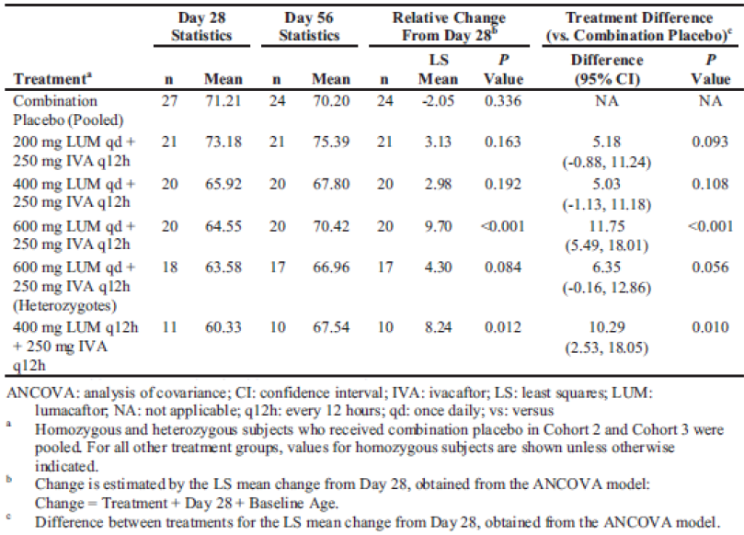

Relationship between drug concentration and pharmacodynamic effects

Sweat Chloride

FDC
No PK/PD studies examined the relationship between drug concentration and effect on sweat chloride following doses of the FDC in the target population.

Free combination
In the target population, although, LUM AUC and C_{min} values were 1.28 fold and 1.83 fold higher, respectively, following administration of 400 mg LUM q12h/250 mg IVA q12h than following 600 mg LUM QD/250 mg IVA q12h, the treatment difference for sweat chloride from Day 28 at Day 56 was lower following 400 mg LUM q12h (-3.78) than following 600 mg LUM QD (-4.53). It should be noted that neither of these treatment differences in sweat chloride were statistically significant (p = 0.365 and 0.161, respectively) and given the relatively minor improvement in sweat chloride following dosing with 600 mg LUM QD (approximately 1.2 fold), any difference in sweat chloride response between the two dosing regimens is unlikely.to be clinically significant.

LUM alone
Study VX08-809-101 evaluated the effect of a range of LUM doses (25 to 200 mg) on sweat chloride in subjects with CF who were homozygous for the F508del-CFTR mutation No mean decreases from baseline were seen in the 25 mg group, whereas, mean changes in sweat chloride from baseline to Day 28 were statistically significant for the 100 mg LUM (-5.29 mmol/L; p = 0.0173) and 200 mg (-7.38 mmol/L; p = 0.0008) groups. The differences between these treatment groups and the placebo group for the least squares mean change from baseline were also statistically significant: -6.13 mmol/L (p = 0.0498) for the 100 mg group and -8.21 mmol/L (p = 0.0092) for the 200 mg group. The linear trend was statistically significant (-2.099; p = 0.0013), suggesting a decreasing mean average sweat chloride with increasing dose.

Pulmonary function

FDC
The pooled PK/PD analysis, Study K272, which was based on the results of two Phase III trials, VX12-809-103 and VX12-809-104, could not identify any clear trends between LUM or IVA average trough concentrations versus absolute change in ppFEV₁. In an analysis of ppFEV₁ responders, who were defined as > 5% average relative change in percent predicted FEV₁ (ppFEV₁) from Week 16 to Week 24 and non-responders as < 5% average relative change in ppFEV₁ from Week 16 to Week 24 there was no clear differentiation in exposure between responders and non-responders. In addition, no differentiation in exposure between subjects with and without pulmonary exacerbation events could be identified. Nor was there a clear differentiation in exposure between subjects with and without pulmonary exacerbation hospitalisation visits.

Free combination
Despite evidence of higher LUM AUC and C_{min} values following administration of 400 mg LUM q12h/250 mg IVA q12h in the target population, following administration of 600 mg LUM QD/250 mg IVA q12h the relative change in ppFEV₁ from Day 28 at Day 56 was slightly higher (9.70 versus 8.24 for LUM QD versus q12h dosing) as was the treatment difference (11.75 versus 10.29) (Table 24). Analyses of the absolute change in ppFEV₁ and relative change in ppFEV₁ from baseline at Day 56 also indicated that 600 mg LUM QD/250 mg IVA q12h provided a slightly superior benefit to lung function in the target population than 400 mg LUM q12h/250 mg IVA q12h although these minor differences are not likely to be clinically relevant.

LUM alone
Study VX09-809-102 identified a dose dependent decline in ppFEV₁ with LUM monotherapy across the dose range evaluated, with a significant within group decline in the 400 mg LUM q12h group (p = 0.032). By contrast, In addition, there was no clear trend between LUM or IVA average trough concentrations versus absolute change in ppFEV₁.

Liver function
Study K050 also explored several models for changes in liver function markers (ALT and AST); however, a LUM exposure response relationship could not be identified. A simple offset model was implemented to describe changes in liver function markers in response to LUM and IVA administration as drug effect (as drug effect term, no exposure parameter) and placebo. Changes in ALT and AST for the LUM 400 mg q12h and 600 mg QD dose groups were similar to those observed in placebo subjects.
In Study K272, linear regression analysis of LUM C_{trough}, _{average} versus absolute change in creatinine clearance by dose groups did not identify any trends between LUM pre-dose concentration and baseline creatinine clearance. In addition, no clear trends were observed between Day 15 concentrations of LUM or IVA and absolute change in ALT or AST.

Genetic, gender and age related differences in pharmacodynamic response
The exposure-response analysis of LUM and IVA in subjects with cystic fibrosis undertaken in Study K050 identified, using an AUC₀₋₂₄ model, that the linear slope of LUM effect (SLOPE809) estimate (bootstrap 95% CI) for the reference covariate effects (male, less than 24 years) was 0.00942 (0.00702, 0.0117) %/µg/mL.h. For a typical subject, this translated to an absolute increase of 4.2% (3.13, 5.22) for a 400 mg q12h LUM dose and an increase of 3.32 % (2.48, 4.13) for the 600 mg QD dose. The slope of the drug effect was affected by age, with the slope decreasing as age increased beyond 24 years, with an effect estimate of -3.17 (-5.35, -1.76). Fitting the model using observed C_{min} produced similar results.
In contrast to these findings, population modelling combined with allometric scaling of data from a population of patients with CF who had the G551D-CFTR mutation and were treated with IVA, indicated that age was not a clinically important covariate of IVA disposition after accounting for body size (Study J178). In addition, it should be noted that the approved dosage of IVA for both adolescents and adults who have the G551D-CFTR mutation is identical (that is150 mg q12h). Therefore, given the success of this IVA dose extrapolation, the similar weights of these patients to those in the LUM/IVA development group and the expected mature metabolic capacity of the adolescent population, the sponsor has proposed that the IVA dose to be co-administered with LUM should be the same for both the adult and adolescent populations.
For the LUM component, a population exposure response Study, K261, which investigated the relationship between sweat chloride response and LUM exposure in the target population following treatment with LUM alone or with a combination of LUM and IVA, indicated that sweat chloride response could be described using an E_{max} model. Using this model, the subject’s weight was identified as a significant covariate of response, and once accounted for; no other significant covariate effects were identified. Therefore, based on these findings the sponsor believes that differences in age are unlikely to affect the activity of LUM on sweat chloride.

Pharmacodynamic interactions
In a review of the spirometry data from Cohorts 1, 2, and 3 in Study VX12-809-009, an asymptomatic, generally mild decline in FEV₁ within 4 h of treatment with LUM in combination with IVA was identified (Table 26). None of the subjects had an SAE, required treatment with concomitant medications, or had long term sequelae as a result of the decline in FEV₁. In Cohort 4, with long acting bronchodilators (indacaterol and tiotropium) largely prevented the mild decline observed in FEV₁ following dosing with LUM in combination with and treatment with short acting bronchodilators (albuterol and ipratropium) led to a reversal of the decline.

Table 26. Study VX12-809-009 summary of spirometry absolute change from baseline for percent predicted FEV₁ safety set (cohort 1, cohort 2 and cohort 3)
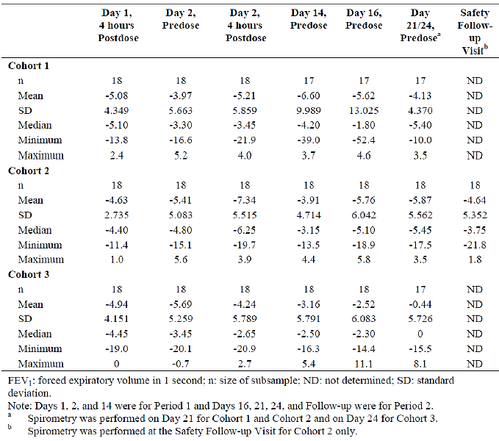

Evaluator’s overall conclusions on pharmacodynamics

Mechanism of action
The combined effect of lumacaftor and ivacaftor is to increase the quantity and function ofF508del-CFTR at the cell surface, resulting in increased chloride ion transport.

Primary pharmacodynamic effects

Sweat chloride
- No PK/PD studies examined the effect of the FDC on sweat chloride in the target population.
- In patients with CF who were heterozygous for the F508del-CFTR mutation (that is; not the target population), administration of the FDC at a dose of 400 mg LUM q12h + 250 mg IVA q12h resulted in a statistically significant reduction in sweat chloride levels in subjects who received the active FDC (-11.82 mmol/L; p < 0.0001) compared to subjects who received a FDC containing the LUM component + placebo (-11.03 mmol/L; p = < 0.0001).
- In subjects who were homozygous for the F508del-CFTR mutation, dosing with 200 mg LUM QD +250 mg IVA q12h dose of the free combination, but not 200 mg LUM QD + 150 mg IVA q12h, resulted in a statistically significant decrease in adjusted mean absolute change from Day 14 at Day 21 in sweat chloride values compared to placebo (Δ = -9.626 mmol/L; 95% Cl: -14.801, -4.551; p < 0.001).
- Statistically significant within-group adjusted mean absolute changes from baseline in sweat chloride levels over the entire treatment period were observed for subjects who received either 200 mg LUM QD + 250 mg IVA q12h (-12.561 mmol/L, p < 0.001) or 200 mg LUM QD + 150 g IVA q12h group (-6.741 mmol/L, p = 0.003) as a free combination. However, although the treatment difference for the 200 mg LUM QD + 250 mg IVA q12h group compared to the combined placebo group in the mean absolute change from baseline at Day 21 in sweat chloride values was statistically significant (-10.86 mmol/L, p = 0.002), the treatment difference for the subjects who were administered 200 mg LUM QD + 150 mg IVA q12h group compared to the combined placebo group was not significant (-5.04 mmol/L, p = 0.126).
- The percentage of subjects who were considered sweat chloride responders to LUM monotherapy or LUM in combination with IVA was higher in the active treatment groups compared to the monotherapy placebo group or combination placebo group.
- In a combined population of homozygous and heterozygous subjects who received a range of LUM doses (200 mg to 600 mg) in combination with 250 mg IVA q12h there were no statistically significant adjusted mean absolute changes in sweat chloride values from Day 28 at Day 56 in any active treatment group when analysed within group or in comparison to the combination placebo group.
- Population exposure-response analysis of sweat chloride response to treatment identified a final structural model that consisted of an E_{max} model, parameterised by E_{max} and EC50, and an additional term, E_{base}, which is the model estimated sweat chloride baseline for each subject. The effect of the presence of IVA on sweat chloride response was statistically significant and was described best by a multiplicative term (E770m) applied to E_{max}.

Lung function – target population (homozygous for F508del-CFTR mutation)
- No PK/PD studies examined the effects of the FDC on lung function in the target population (homozygous subjects).
- In the target population administered the free combination (200 mg LUM QD + 150 mg IVA q12h)statistically significant decreases in adjusted mean absolute change from Day 14 at Day 21 in FEV₁ and ppFEV₁ compared to placebo (Δ = 0.174 L and 4.9%, respectively).
- Following administration of 200 mg LUM QD + 250 mg IVA q12h to the target population absolute changes from Day 14 at Day 21 in FEV₁ and ppFEV₁ were not significantly different from placebo.
- Over the entire treatment period (from Day 1 to 21) there were no treatment differences in FEV₁or ppFEV₁ following administration of 200 mg LUM QD + 150 mg IVA q12h compared to placebo.
- The percentage of subjects who were considered FEV₁ responders was similar in both the LUM monotherapy and the placebo monotherapy groups, whereas, following administration of LUM in combination with IVA the percentage of FEV₁ responders was higher in the active treatment group than in the combination placebo group.
- Following administration of the free combination as either 600 mg LUM QD + 250 mg IVA q12h or400 mg LUM q12h + 250 mg IVA q12h, statistically significant differences in the mean relative change from Day 28 at Day 56 compared to placebo were identified. In addition, statistically significant differences in absolute change from baseline at Day 56 in FEV₁ and ppFEV₁ compared to placebo were identified following administration of 600 mg LUM QD + 250 mg IVA q12h.

Lung function – heterozygous population
Following administration of the FDC (400 mg LUM q12h + 250 mg IVA q12h) to heterozygous CF subjects there was no statistically significant LS mean absolute or relative change from baseline at Day 56 in ppFEV₁ compared to placebo.

CFQ-R
Following treatment with LUM alone there were no clear or sustained improvements in any CFQ-R domain compared to placebo.

Secondary pharmacodynamic effects

Effects on QT interval
Following therapeutic and supra therapeutic doses of LUM/IVA, the active combination did not prolong the QTc interval to a clinically significant degree.

Body weight
Treatment with LUM in combination with IVA did not result in any improvement in BMI or weight.

Time course of pharmacodynamic effects
- In subjects with CF who were homozygous for the F508del-CFTR mutation, reductions from baseline in mean sweat chloride were observed as early as Day 7 following administration of 50, 100, and 200 mg LUM alone and tended to be largest in the 200 mg group. The magnitude of decreases in these 3 groups did not increase with time, and the decreases were not sustained at follow-up.
- In homozygous subjects, following co-administration with 400 mg LUM q12h/250 mg IVA q12h as a free combination, the LS mean difference of absolute change in sweat chloride from baseline was -2.154 and the treatment difference verses combination placebo was -3.78. Following administration of 400 mg LUM QD/250 mg IVA q12h these values were -1.04 and -2.67, respectively. However, none of these differences reached statistical significance with p values ranging from 0.365 to 0.664.
- When LUM was administered q12h in combination with IVA there were significant differences in both LS mean relative change from Day 28 (Δ = 8.24, p = 0.012) and treatment difference verses placebo (Δ = 10.3, p = 0.010) in ppFEV₁, whereas, there was no significant difference in these measures when LUM was administered QD in combination with IVA.

Relationship between drug concentration and pharmacodynamic effects

Sweat chloride
In the target population, although, LUM AUC and C_{min} values were 1.28 fold and 1.83 fold higher, respectively, following administration of 400 mg LUM q12h/250 mg IVA q12h than following 600 mg LUM QD/250 mg IVA q12h, the treatment difference for sweat chloride from Day 28 at Day 56 was lower following 400 mg LUM q12h (-3.78) than following 600 mg LUM QD (-4.53). It should be noted that neither of these treatment differences were statistically significant (p = 0.365 and 0.161, respectively) and given the relatively minor improvement in sweat chloride following dosing with 600 mg LUM QD (approximately 1.2 fold), any difference in sweat chloride response between the two dosing regimens is unlikely to be clinically significant.

Pulmonary function
Despite evidence of higher LUM AUC and C_{min} values following administration of 400 mg LUM q12h/250 mg IVA q12h, the greatest improvement in lung function in the target population, based on ppFEV₁, was seen in the group receiving 600 mg LUM QD/250 mg IVA q12h. No clear trends between LUM or IVA average trough concentrations versus absolute change in ppFEV₁ were identified. In an analysis of ppFEV₁ responders, who were defined as > 5% average relative change in percent predicted FEV₁ (ppFEV₁) from Week 16 to Week 24 and non-responders as < 5% average relative change in ppFEV₁ from Week 16 to Week 24 there was no clear differentiation in exposure between responders and non-responders. In addition, no differentiation in exposure between subjects with and without pulmonary exacerbation events could be identified. Nor was there a clear differentiation in exposure between subjects with and without pulmonary exacerbation hospitalisation visits. By contrast, a dose dependent decline in ppFEV₁ was identified following a range of LUM doses when administered as a monotherapy, with a significant within group decline identified in the 400 mg LUM q12h group (p = 0.032). However, there were no clear trends between LUM or IVA average trough concentrations and absolute change in ppFEV₁.

Liver function
Linear regression analysis of LUM C_{trough}, _{ave} versus absolute change in creatinine clearance by dose groups did not identify any trends between LUM pre-dose concentration and baseline creatinine clearance. In addition, no clear trends were observed between Day 15 concentrations of LUM or IVA and absolute change in ALT or AST.

Genetic, gender and age related differences in pharmacodynamic response
An exposure response analysis of LUM and IVA based on AUC₀₋₂₄ identified that the linear slope of LUM effect (SLOPE809) estimate (bootstrap 95% CI) for the reference covariate effects (male, less than 24 years) was 0.00942 (0.00702, 0.0117) %/µg/mL.h. For the typical subject, this translates to an absolute increase of 4.2% (3.13, 5.22) for a 400 mg q12h LUM dose and an increase of 3.32 % (2.48, 4.13) for the 600 mg QD dose. The slope of the drug effect was also affected by age with the slope decreasing with increasing age beyond 24 years.

Pharmacodynamic interactions
An asymptomatic, generally mild decline in FEV₁ within 4 h of treatment with LUM in combination with IVA was identified. Long acting bronchodilators (indacaterol and tiotropium) largely prevented the mild decline observed in FEV₁ following dosing with LUM in combination with IVA, and treatment with short acting bronchodilators (albuterol and ipratropium) led to a reversal of the decline.

Limitations of the PD studies
- No PK/PD studies examined the effect of the FDC on sweat chloride in the target population of patients with CF who were homozygous for the F508del-CFTR mutation.
- No PK/PD studies examined the relationship between drug concentration and effect on sweat chloride following doses of the FDC in the target population.
- No PK/PD studies examined the effects of the FDC on lung function in the target population (homozygous subjects).

Dosage selection for the pivotal studies
Lumacaftor monotherapy has been investigated in 2 clinical studies in subjects with CF (Study VX08-809-101 (Study 101) and VX09-809-102 (Study 102)).
Study 101 was a 28 day, double blind, placebo controlled, multiple dose, dose finding study investigating lumacaftor monotherapy in subjects with CF who are homozygous for the F508del-CFTR mutation. Results from this study showed that lumacaftor monotherapy at doses up to 200 mg was well tolerated but did not show a clinically or statistically significant change in FEV₁ despite a dose-dependent decrease observed in sweat chloride levels in subjects who received lumacaftor compared with those who received placebo. Study 102 was a Phase II, double blind, placebo controlled, multiple dose, dose finding study evaluating the safety, tolerability, and efficacy of lumacaftor monotherapy and lumacaftor and ivacaftor combination therapy in subjects with CF. During the 28 day period of lumacaftor monotherapy (Cohort 2), all treatment groups either remained stable or demonstrated a modest reduction in FEV₁. Results from cohort 3 showed a dose-dependent decline in FEV₁ during treatment with lumacaftor monotherapy. This decline was statistically significant at the highest lumacaftor dose tested (400 mg q12h, within-group analysis). In contrast, during the 28 day period of combination therapy, an increase in FEV₁ was observed in the active treatment cohorts, while a decrease in FEV₁ was observed in the placebo group. The LUM 600 mg qd/IVA 250 mg q12h dosage demonstrated a significant improvement in FEV₁ in subjects with CF who are homozygous for the F508del-CFTR mutation. In subjects who received LUM 200 mg qd and LUM 400 mg qd in combination with IVA 250 mg q12h, a smaller increase in FEV₁ was observed during the period of combination therapy; however, the within-group analysis revealed that the increase in FEV₁ was not statistically or clinically significant.
The results of Study 102 were also consistent with in vitro nonclinical studies of airway epithelial cells from patients homozygous for the F508del-CFTR mutation, in which the response to lumacaftor and ivacaftor combination therapy was greater than that observed when either compound was administered alone. Given the lack of efficacy of lumacaftor monotherapy in clinical studies, coupled with a low response in vitro to lumacaftor alone in airway epithelial cells from patients homozygous for the F508del-CFTR mutation, further clinical evaluation of lumacaftor monotherapy was considered unlikely to reveal significant benefit.
Study VX08-770-104b was a Phase II, randomised, double blind, placebo controlled, parallel group, multiple dose study that evaluated the effects of ivacaftor monotherapy for 16 weeks in subjects with CF homozygous for the F508del-CFTR mutation. No significant benefit was observed from ivacaftor monotherapy treatment in this population. Overall, data from Study 102 and Study 770-104 were consistent with the hypothesis that the combination of lumacaftor and ivacaftor had additive benefits which were greater than each agent alone.
In the drug interaction study (Study VX09-809-005) between LUM 200 mg qd and the approved dosage of ivacaftor (150 mg q12h), a significant 80% reduction in the plasma concentrations of ivacaftor was observed when lumacaftor was administered in combination with ivacaftor. Based on the observed reduction in ivacaftor exposure, the dosage of ivacaftor was increased to 250 mg q12h from the approved ivacaftor dosage of 150 mg q12h when administered alone. In Study 102 Cohorts 2 to 3, the IVA 250 mg q12h dosage was shown to be safe and effective in combination with both the LUM 600 mg qd and 400 mg q12h regimens; therefore, the IVA 250 mg q12h dosage was selected for co-administration with lumacaftor in the Phase III studies.
To explore the potential for an advantageous PK profile and additional efficacy beyond the LUM 600 mg qd regimen, a LUM 400 mg q12h/ IVA 250 mg q12h dosage was added to the Phase II study (Cohort 3 of Study 102). The pooled analysis of Cohorts 2 and 3 undertaken in Study VX09-809-102 examined the effect of LUM dose strength and the timing of LUM dose on the PKs of LUM and IVA following administration of the free combination to the target population (that is; patients with CF who were homozygous for the F508del-CFTR mutation). Following doses of 400 mg LUM QD/250 mg IVA q12h, 600 mg LUM QD/250 mg IVA q12h or 400 mg LUM q12h/250 mg IVA q12h the LUM AUC₀₋₂₄ values were 219, 290 and 371 µg.h/mL, respectively, and the LUM C_{min} values were 4.08, 5.33 and 9.76 µg/mL. The corresponding IVA AUC_{τ} values were 3.8, 3.83 and 2.56 µg.h/mL, respectively, and IVA C_{min} values were 0.125, 0.102 and 0.078 µg/mL, respectively. These results indicate that compared to the 600 mg LUM QD/250 mg IVA q12h dose, the LUM AUC and C_{min} values were 1.2 fold and 1.83 fold higher, respectively, following the 400 mg LUM q12h/250 mg IVA q12h dose, whereas, the IVA AUC and C_{min} values were 33% and 24% lower following twice daily dosing with 400 mg LUM. The regimen of LUM 400 mg q12h/IVA 250 mg q12h was safe and efficacious in Cohort 3 of Study 102. The LUM 400 mg q12h regimen could not be differentiated from the LUM 600 mg qd regimen in the Phase II study and so both dosage regimens were evaluated in the pivotal Phase III studies.
Comment: Overall, the choice of 2 dosage regimens (LUM 600 mg qd/IVA 250 mg q12h and LUM 400 mg q12h/IVA 250 mg q12h) for the Phase III studies was justified.
Figure 10. Phase III Dosing Regimens
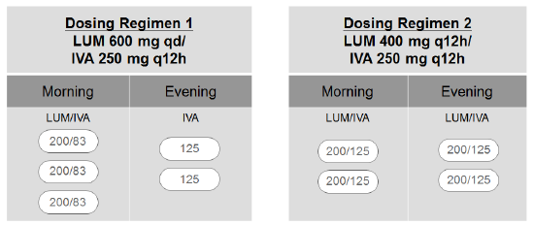
IVA: ivacaftor; LUM: lumacaftor; qd: daily; q12h: every 12 hours

Clinical efficacy
Presented is the assessment of the treatment of cystic fibrosis (CF) in patients aged 12 years and older who are homozygous for the F508del mutation in the CFTR gene.

Pivotal efficacy studies

Study VX12-809-103

Study design, objectives, locations and dates
This was a Phase III, randomised, double blind, placebo controlled, parallel group multicentre study. The primary objective was to evaluate the efficacy of lumacaftor in combination with ivacaftor at Week 24 in subjects with cystic fibrosis (CF) who are homozygous for the F508del mutation on the CFTR gene. The secondary objectives were to evaluate the safety of lumacaftor in combination with ivacaftor through Week 24 and to investigate the pharmacokinetics (PK) of lumacaftor and its metabolite, M28 (M28-lumacaftor), and ivacaftor and its metabolites, M1 (M1-ivacaftor) and M6 (M6-ivacaftor).
The study included a Screening Period (Day -28 through Day -1), a Treatment Period (Day 1 (first dose of study drug) to Week 24 ± 5 days), and a Safety Follow-up Visit (4 weeks ± 7 days after the Week 24 visit). Clinic visits occurred on Day 1 and Day 15 (± 3 days) and at Weeks 4, 8, 16, and 24 (± 5 days). Liver function testing was required while subjects were receiving study drug treatment (Day 1, Day 15, and at a minimum of every 4 weeks after Week 4). Telephone contacts were made at Day 3 (± 1 day) and at Week 12 (± 5 days) and Week 20 (± 5 days) to assess the subject's status, any adverse events, concomitant medications, treatments, and procedures. Subjects who prematurely discontinued study drug treatment were to remain in the study through the Week 24 Visit. At the Week 24 Visit, subjects who completed the Treatment Period were offered the opportunity to enrol in Study 105, which included both a double blind Treatment Cohort (active study drug administered) and an Observational Cohort (no study drug administered) (Figure 11).The study was conducted from 28, May 2013 to 29 April, 2014 at 96 sites in North America, Europe and Australia.
Figure 11. Study 103 schematic of study design
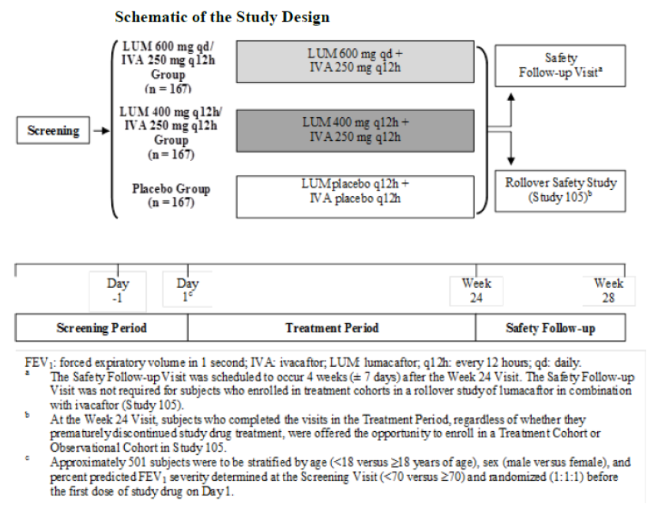

Inclusion and exclusion criteria
The main inclusion criteria were: Males and females, aged > 12 years with a confirmed diagnosis of CF defined as: sweat chloride value > 60 mmol/L by quantitative pilocarpine iontophoresis or CF causing mutations (all as documented in the subject's medical record) and Chronic sino-pulmonary disease or gastrointestinal/nutritional abnormalities. Patients had to be homozygous for the F508del-CFTR mutation, genotype to be confirmed at Screening with FEV₁ ≥ 40% and ≤ 90% of predicted normal for age, sex, and height (equations of Hankinson et al or Wang et al) at Screening; Stable CF disease as judged by the investigator. Willing to remain on a stable CF medication regimen through Week 24 or, if applicable, the Safety Follow-up Visit. Able to understand and comply with protocol requirements, restrictions, and instructions and likely to complete the study as planned (as judged by the investigator). Patients with any significant comorbidities or clinically significant diseases or laboratory abnormalities were excluded. The main exclusion criteria are summarised below.

Exclusion criteria
Subjects who met any of the following exclusion criteria were not eligible:
- History of any comorbidity that, in the opinion of the investigator, might have confounded the results of the study or posed an additional risk in administering study drug to the subject. For example: history of cirrhosis with portal hypertension, and/or history of risk factors for Torsades de Pointes (for example, familial long QT syndrome, hypokalaemia, heart failure, left ventricular hypertrophy, bradycardia, myocardial infarction, cardiomyopathy, history of arrhythmia (ventricular and atrial fibrillation), obesity, acute neurologic events (subarachnoid haemorrhage, intracranial haemorrhage, cerebrovascular accident, intracranial trauma), and autonomic neuropathy).
- Any clinically significant laboratory abnormalities at screening that would have interfered with the study assessments or posed an undue risk for the subject (as judged by the investigator).
- Any of the following abnormal laboratory values at screening: Haemoglobin < 10 g/dL Abnormal liver function defined as any 3 or more of the following: ≥ 3 × upper limit of normal (ULN) aspartate aminotransferase (AST), ≥ 3 × ULN alanine aminotransferase (ALT), ≥ 3 × ULN gamma-glutamyl transpeptidase (GGT), ≥ 3 × ULN alkaline phosphatase (ALP), or ≥ 2 × ULN total bilirubin. Abnormal renal function defined as glomerular filtration rate (GFR) ≤ 50 L/min/1.73 m² (calculated by the Modification of Diet in Renal Disease Study Equation) for subjects ≥ 18 years of age and ≤ 45 mL/min/1.73 m² (calculated by the Counahan-Barratt equation) for subjects aged 12 to 17 years.
- An acute upper or lower respiratory infection, pulmonary exacerbation, or changes in therapy (including antibiotics) for pulmonary disease within 4 weeks before Day 1 (first dose of study drug).
- Colonization with organisms associated with a more rapid decline in pulmonary status (for example, Burkholderia cenocepacia, Burkholderia dolosa, and Mycobacterium abscessus). The investigator used the following suggested criteria as a guide to determine if subjects who had a history of a positive culture in the past should be considered free of colonization: The subject should have had 2 respiratory tract cultures negative for these organisms within the past 12 months, with no subsequent positive cultures. These 2 respiratory tract cultures should have been separated by at least 3 months. One of these 2 respiratory tract cultures should have been obtained within the past 6 months.
- A 12-lead ECG demonstrating QTcF > 450 msec at Screening. If QTcF exceeded 450 msec for the screening ECG, the ECG was repeated 2 more times during the Screening Period, and the average of the 3 QTcF values was used to determine the subject's eligibility.
- History of solid organ or haematological transplantation.
- History of alcohol or drug abuse in the past year, including but not limited to cannabis, cocaine, and opiates as deemed by the investigator.
- Ongoing or prior participation in an investigational drug study (including studies investigating lumacaftor and/or ivacaftor) within 30 days of screening. A washout period of 5 terminal half-lives of the previous investigational study drug or 30 days, whichever was longer, must have elapsed before screening. A longer duration of the elapsed time was permitted if required by local regulations. Subjects who discontinued from this study or from Study VX12-809-104 after randomization were not eligible to participate in either study. Ongoing participation in a non-interventional study (including observational studies) was permitted.
- Use of strong inhibitors, moderate inducers, or strong inducers of CYP 3A, including consumption of certain herbal medications (for example, St. John's Wort) and certain fruit and fruit juices within 14 days before Day 1 (the first dose of the study drug).
- Pregnant and nursing females: Females of childbearing potential were required to have a negative pregnancy test at Screening and Day 1.
- Sexually active subjects of reproductive potential who were not willing to follow the contraception requirements.
- History of cataract or lens opacity or evidence of cataract or lens opacity determined to be clinically significant by the ophthalmologist during the ophthalmologic examination at the Screening Visit. The ophthalmologic examination did not need to be repeated if there was documentation of an examination meeting protocol criteria that was conducted within 3 months before the Screening Visit.
- The subject or a close relative of the subject was the investigator or a sub-investigator, research assistant, pharmacist, study coordinator, or other staff directly involved with the conduct of the study. An adult (aged 18 years or older) who was a relative of a study staff member may have been randomised in the study provided that the adult lived independently of and did not reside with the study staff member; the adult participated in the study at a site other than the site at which the family member was employed.

Study treatments
The treatment period lasted approximately 24 weeks. Subjects were randomised to 1 of 3 treatment groups: 2 LUM/IVA combination treatment groups and 1 placebo group. The dosing regimen for each treatment group was as follows: LUM 600 mg qd/IVA 250 mg q12h; LUM 400 mg q12h/IVA 250 mg q12h; LUM placebo q12h/IVA placebo q12h (placebo) (Table 27).

Table 27. Study 103 study drug administration
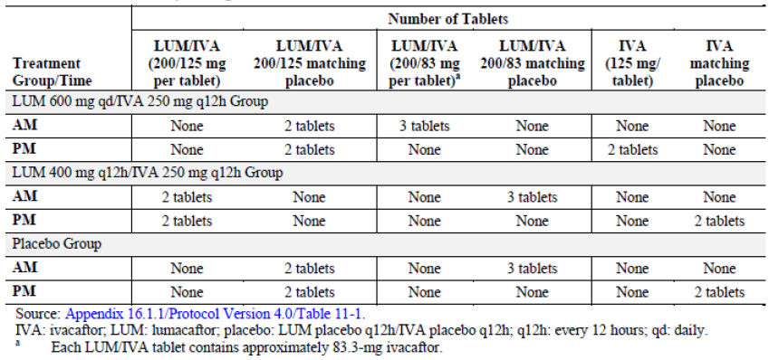
Study drug was to be administered within 30 minutes of consumption of fat containing food such as a standard ‘CF’ high fat, high calorie meal or snack. If subjects missed a dose and recalled the missed dose within 6 hours, they were to take their dose with food. If more than 6 hours elapsed after their usual dosing time, they were to skip that dose and resume their normal schedule for the following dose.
Information regarding all prior and concomitant medications, including the subject’s CF medications, other medications, herbal and naturopathic remedies administered from 30 days before the Screening Period through the Week 24 Visit or Safety Follow-up Visit, if applicable, was recorded in each subject's source documents and electronic case report form (eCRF).
The use of CYP3A, CYP2C8 and CYP2C9 substrates was not prohibited, but investigators needed to be aware that lumacaftor appears to be a strong inducer of CYP3A and also inhibits CYP2C8 and CYP2C9 in vitro. Therefore, the efficacy of drugs extensively metabolised by these isoenzymes may have been affected. Each investigator evaluated the benefit-risk ratio of using such drugs with lumacaftor. Investigators discussed any concerns regarding the use of CYP3A, CYP2C8 and CYP2C9 substrates with the medical monitor.

Efficacy variables and outcomes
The main efficacy assessments included spirometry, height, weight, Cystic Fibrosis Questionnaire–Revised (CFQ-R), EuroQol 3-Level (EQ-5D-3L) score, Treatment Satisfaction Questionnaire for Medication (TSQM), and clinical events related to outcomes (for example, pulmonary exacerbations).
The primary efficacy endpoint was the absolute change from baseline in percent predicted FEV₁ at Week 24, assessed as the average treatment effect at Week 16 and at Week 24. The primary analysis used an MMRM model that included treatment, visit, and treatment-by-visit interaction as fixed effects, with adjustments for sex (male versus female), age group at baseline (< 18 versus ≥ 18 years old), and percent predicted FEV₁ severity at Screening (< 70 versus ≥ 70).
The 5 key secondary efficacy endpoints were: (1) relative change from baseline in percent predicted FEV₁ at Week 24, assessed as the average treatment effect at Week 16 and at Week 24; (2) absolute change from baseline in body mass index (BMI) at Week 24; (3) absolute change from baseline in CFQ-R respiratory domain score at Week 24 (for the pooled ‘Adolescents and Adults’ and ‘Children Ages 12 and 13’ versions); (4) response defined as ≥ 5% increase in average relative change from baseline in percent predicted FEV₁ at Week 16 and at Week 24; and (5) number of pulmonary exacerbations through Week 24.
Additional efficacy endpoints included assessment of ‘Clinical events of interest’ such as pulmonary exacerbations, count, duration, and time to first event of hospitalizations and count and time to first event of IV courses of antibiotics for pulmonary exacerbations. CF pulmonary exacerbations are a compilation of patient signs and symptoms that often result in the need for aggressive treatment, including the use of intravenous (IV) antibiotics that may require hospitalization. To date, there is no generally accepted objective definition of a pulmonary exacerbation (Mayer-Hamblett, 2007) and large multicentre CF clinical studies have used many variations of physician-derived definitions (Fuchs HJ, 1994; Rosenfeld M, 2001; Rabin HR, 2004; Blumer JL, 2005). For data consistency, the protocol specified one definition of pulmonary exacerbation, which was based on the definition used for the other studies, including the ivacaftor monotherapy initial registration studies. Because signs and symptoms in the definition may have occurred without meeting the overall definition of a pulmonary exacerbation, the number and timing of outpatient sick visits to the clinic or hospital for CF that were unrelated to the study protocol were also collected.
Comment: Despite the lack of a standard definition, reduction in pulmonary exacerbation rate has served as a key clinical efficacy measure in definitive CF clinical studies, supporting the registration of two chronic CF pulmonary therapies (inhaled recombinant human deoxyribonuclease and inhaled tobramycin (Kerem, 1996). The evaluation of this important efficacy endpoint was adequately addressed in this study.
Other efficacy endpoints evaluated in this study included Patient Reported Outcomes (PROs) such as EQ-5D-3L, TSQM, CFQ-R (all domains) and Responder analysis in terms of clinically relevant responders for percent predicted FEV₁, BMI and weight.

Randomisation and blinding
Subjects who met eligibility criteria were randomised (1:1:1) to 1 of 3 treatment groups: lumacaftor (LUM) 600 mg daily (qd)/ivacaftor (IVA) 250 mg every 12 hours (q12h); LUM 400 mg q12h/IVA 250 mg q12h; LUM placebo q12h/IVA placebo q12h (placebo). Randomization was stratified by age (< 18 versus ≥ 18 years old), sex (male versus female) and percent predicted FEV₁ severity collected at the Screening Visit (< 70 versus ≥ 70). An interactive web response system (IWRS) was used to assign subjects to treatment.
This was a double blind study. Study drug tablets were administered orally. Subjects received the same number of tablets each day to maintain the blind. Subjects and all site personnel, including the investigator, site monitor, and study team were blinded, with some exceptions.
Subjects and their caregivers were not to be informed of their study-related spirometry results during the Treatment Period even if the subject prematurely discontinued study drug treatment. Vertex Drug Metabolism and PK laboratory personnel were not involved in the conduct of the study and were unblinded to the bioanalysis results but remained blinded to subject number and treatment assignment.

Analysis populations
A total of 559 subjects were randomised: 185 subjects to LUM 600 mg qd/IVA 250 mg q12h, 187 subjects to LUM 400 mg q12h/IVA 250 mg q12h, and 187 subjects to placebo. A total of 549 subjects received at least 1 dose of study drug (LUM/IVA or placebo). The Full Analysis Set (FAS) defined as all randomised subjects who received any amount of study drug was used for all efficacy analyses. Per Protocol Set (PPS) was defined as all FAS subjects without important protocol deviations that may have had a substantial impact on efficacy assessments. The criteria used for excluding subjects from the PPS were determined before the final database lock. The PPS was only used for supportive analyses for primary and key secondary endpoints.

Sample size
The sample size calculation was based on the protocol-defined efficacy endpoint of absolute change from baseline in percent predicted FEV₁ at Week 24, with the following assumptions:
- A treatment difference of mean absolute change from baseline in percent predicted FEV₁ of 5 percentage points between the active and placebo treatment groups, and a common standard deviation (SD) of 8 percentage points; a 10% missing data/drop-out rate; a 2 sided, 2 group, t test of equal means and an alpha of 0.025 to address the multiplicity across the 2 active doses (a parallel gatekeeping approach with Bonferroni adjusted alpha levels) to ensure an overall Type I error of 0.05.
A total sample size of 501 subjects (167 subjects for each treatment group) had approximately 99% power to detect a treatment difference of 5 percentage points in absolute change of percent predicted FEV₁ between the dose of lumacaftor in combination with ivacaftor compared with placebo. The study had approximately 98% power to detect a treatment difference of 6% in relative change of percent predicted FEV₁ between each active treatment group and the placebo group at the 0.025 level of significance. This was based on the assumption of having a relative change in percent predicted FEV₁ of 6 for the active treatment groups, an associated SD of 12%, and a sample size of 167 subjects for each treatment group (active and placebo). The assumed mean absolute/relative changes and SD were based on results from Phase II Study 102. The power calculation was based on simulation using Splus with a 2 sided t test for data sampled from the normal distribution.

Statistical methods
The primary analysis for the primary endpoint (absolute change from baseline in percent predicted FEV₁ at Week 24) was based on a mixed effects model for repeated measures (MMRM). The model included absolute change from baseline in percent predicted FEV₁ (including all measurements up to Week 24 (inclusive), both on treatment measurements and measurements after treatment discontinuation) as the dependent variable, treatment, visit, and treatment by visit interaction as fixed effects, with adjustment for sex (male versus female), age group at baseline (< 18 versus ≥ 18 years old), and percent predicted FEV₁ severity at Screening (< 70 versus ≥ 70) as a random effect. The primary result obtained from the model was the average treatment effect at Week 16 and at Week 24. No imputation on missing data was done for the primary analysis using the MMRM. Response, defined as ≥ 3, ≥ 5, and ≥ 10 percentage point increases in average absolute change from baseline in percent predicted FEV₁ at Week 16 and at Week 24, was analysed using a 2 sided Cochran-Mantel-Haenszel test. To assess the robustness of the primary analysis, sensitivity analyses were conducted using MMRM (with on treatment measurements only up to Week 24) and analysis of covariance with multiple imputation.
Subgroup analyses of the primary endpoint were performed based on the FAS in a similar manner as the primary analysis for the following subgroups: age (< 18, ≥ 18 years old), percent predicted FEV₁ severity at Screening (< 70, ≥ 70), sex (female, male)’ region (North America, Europe, and Australia), prior use of inhaled treatments (antibiotics, bronchodilators, hypertonic saline, or corticosteroids; yes and no), prior use of inhaled bronchodilator (short acting only versus (short acting and long acting) or long acting only versus (short acting and long acting)) and Pseudomonas aeruginosa status (positive and negative) at baseline.
The primary analysis for the first 3 key secondary endpoints was similar to the analysis for the primary efficacy endpoint. However, baseline BMI was added as a covariate for absolute change from baseline in BMI and baseline CFQ-R respiratory domain score was added as a covariate for absolute change from baseline in CFQ-R respiratory domain score. Response analyses, similar to those defined for the response of the absolute change from baseline in percent predicted FEV₁, were performed for the response defined as ≥ 5% increase in average relative change from baseline in percent predicted FEV₁ at Week 16 and at Week 24. Regression analysis for a negative binomial distribution, with sex, age group at baseline, and percent predicted FEV₁ severity at Screening as covariates and the log of time spent in the study as the offset was used for the treatment comparison for the number of pulmonary exacerbations.
A multiplicity adjustment approach using a simple Bonferroni correction and a hierarchical testing procedure was used to strongly control the overall Type I error rate at 0.05 for the primary endpoint and the 5 key secondary endpoints across the 2 dosing regimens of lumacaftor in combination with ivacaftor (LUM 600 mg qd/IVA 250 mg q12h and LUM 400 mg q12h/IVA 250 mg q12h groups).
The testing hierarchy was as follows: (1) average absolute change from baseline in percent predicted FEV₁ at Week 16 and at Week 24, (2) average relative change from baseline in percent predicted FEV₁ at Week 16 and at Week 24, (3) absolute change from baseline in BMI at Week 24, (4) absolute change from baseline in the CFQ-R respiratory domain at Week 24, (5) response defined as ≥ 5% increase in average relative change from baseline in percent predicted FEV₁ at Week 16 and at Week 24, and (6) number of pulmonary exacerbations through Week 24.
A sensitivity analysis to assess the robustness of the primary analysis of the key secondary variables repeated the primary analysis of the key secondary endpoints based on the on-treatment measurements up to Week 24 only. A Wilcoxon rank sum test (stratified by sex, age group at baseline, and percent predicted FEV₁ severity at Screening) was performed for the number of pulmonary exacerbations through Week 24 that included both on-treatment measurements and measurements collected after treatment discontinuation up to Week 24. Subgroup analysis of the 5 key secondary endpoints was performed in the same manner as the primary analysis of the key secondary endpoints.

Participant flow
Of the 559 subjects who were randomised, 549 subjects were included in the FAS: 183, 182 and 184 subjects in the LUM 600 mg qd/IVA 250 mg q12h, LUM 400 mg q12h/IVA 250 mg q12h and placebo groups, respectively; 17 subjects were excluded from the PPS due to important protocol deviations (4, 6 and 7 subjects, respectively). A total of 524 (95.4%) subjects completed study drug treatment and the overall treatment discontinuation rate of 4.6% was lower than anticipated in the protocol. The most common reason for discontinuation from study drug treatment across all treatment groups was an adverse event occurring in 8 (4.4%) subjects in the LUM 600 mg qd/IVA 250 mg q12h group, 6 (3.3%) subjects in the LUM 400 mg q12h/IVA 250 mg q12h group, and 4 (2.2%) subjects in the placebo group. The proportion of subjects who discontinued from the study was highest for the LUM 400 mg q12h/IVA 250 mg q12h group (6 (3.3%) subjects) compared with the LUM 600 mg qd/IVA 250 mg q12h group (4 (2.2%) subjects) and the placebo group (2 (1.1%) subjects). Overall, 523 (95.3%) subjects entered the rollover study (Study 105): 170 (92.9%) subjects in the LUM 600 mg qd/IVA 250 mg q12h group, 176 (96.7%) subjects in the LUM 400 mg q12h/IVA 250 mg q12h group, and 177 (96.2%) subjects in the placebo group (Table 28).

Table 28. Study 103 Subject disposition
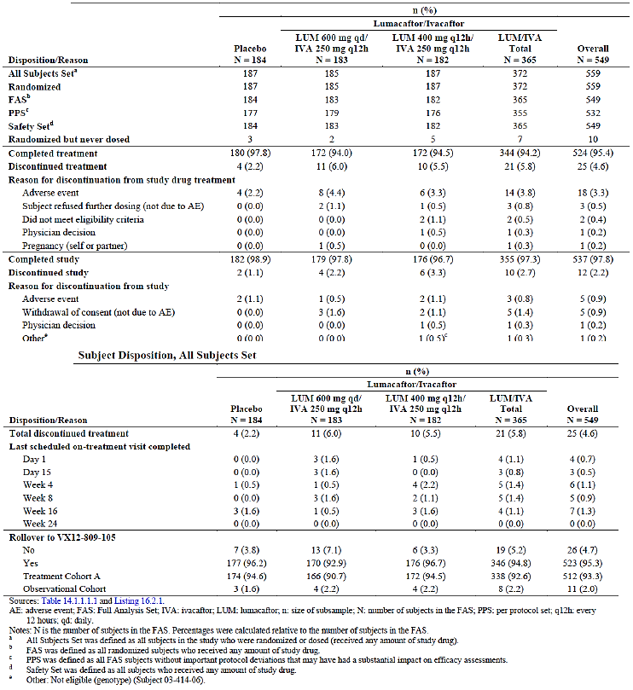

Major protocol violations/deviations
Important protocol deviations were identified from 2 sources (the clinical database and the site deviation log). The majority of the protocol deviations in this study were minor and not considered to have had substantial impact on the efficacy assessments or subject safety. Follow-up corrective actions were implemented as appropriate for major and minor deviations. The incidence of protocol deviations was generally similar across the 3 treatment groups. A total of 17 (3.1%) subjects from the FAS were excluded from the PPS and the most common major protocol violations were < 80% compliance with study drug treatment (n = 7); the other 10 subjects were not eligible: 2 were not homozygous for the F508del-CFTR mutation, 3 did not have percent predicted FEV₁ > 40% and < 90% at screening and 5 subjects had change in antibiotics and/ or an upper respiratory infection or pulmonary exacerbation within past 4 weeks.

Baseline data
Overall > 98% of subjects were White and > 95% were not Hispanic or Latino. Approximately half of the subjects were from North America and were male. The median age was 22 to 23 years (range: 12 to 64years) with 158 (28.8%) subjects overall in the 12 to < 18 years old subgroup and 391 (71.2%) subjects in the ≥ 18 years old subgroup. The distributions of all demographic and baseline characteristics were similar across all 3 treatment groups. The percentage of subjects who received any inhaled antibiotic (62.7% overall), any bronchodilator (93.6% overall), any inhaled hypertonic saline (56.3% overall), and any inhaled corticosteroid (60.3% overall) before the first dose of study drug were similar across all 3 treatment groups. The percentages of subjects who received dornase alfa before the first dose of study drug were higher in the LUM 600 mg qd/IVA 250 mg q12h group (74.3%) and placebo group (73.4%) compared with the LUM 400 mg q12h/IVA 250 mg q12h group (67.6%). The percentage of subjects with positive Pseudomonas aeruginosa status before the first dose was higher in the LUM 400 mg q12h/IVA 250 mg q12h group (83.0%) compared with the LUM 600 mg qd/ IVA 250 mg q12h group (73.2%) and the placebo group (72.8%). The baseline characteristics of subjects in the PPS were similar to those in the FAS. The incidence of medical history conditions occurring in at least 15% of subjects by PT in any treatment group was similar across the 3 treatment groups, with the exception (difference greater than 5 percentage points between groups) of higher incidence of history of chronic sinusitis and constipation in the LUM/IVA groups and higher incidence of history of clubbing and CF lung in the placebo group (Table 7.1.8, p277). The number of subjects who had positive cultures for respiratory pathogens in the 2 years before screening was similar across the 3 treatment groups, with the exception (difference greater than 5 percentage points) of higher incidence of positive Staphylococcus aureus, (methicillin sensitive) status, positive Haemophilus influenza status, positive Pseudomonas aeruginosa status and positive Stenotrophomonas status in the LUM/IVA groups while positive Aspergillus (any species) status was higher in the placebo group.
The most common prior medications overall (incidence of at least 30% of subjects) were medications indicated for CF management and included dornase alfa (71.8%), salbutamol (69.4%), pancreatin (65.9%), sodium chloride (63.4%), azithromycin (56.8%), tobramycin (39.0%), Seretide (32.1%), and pancrelipase (31.0%). All subjects used medication concomitantly with study drug and the most common concomitant medications overall (incidence of at least 30%) were indicated for management of CF complications: dornase alfa (72.3%), salbutamol (71.6%), sodium chloride (66.8%), pancreatin (66.1%), azithromycin (58.7%), tobramycin (51.9%), Seretide (33.5%), ciprofloxacin (30.8%) and pancrelipase (31.9%). The following concomitant medications were administered to subjects in the placebo group approximately 9% to 15% more frequently than the total LUM/IVA group: tobramycin, and ceftazidime. The use of all other concomitant medications was similar across all 3 treatment groups.
The mean study drug compliance was > 98% in all 3 treatment groups and was similar between the total LUM/IVA group and the placebo group. The mean study drug compliance was > 98% in all 3 treatment groups and was similar between the total LUM/IVA group and the placebo group. The proportion of subjects with < 80% study drug compliance was low in general: 1.1% in the total LUM/IVA group and 1.6% in the placebo group. Treatment interruptions of ≥ 3 days occurred in a small proportion of subjects in each treatment group: 20 (10.9%) subjects in the placebo group, 15 (8.2%) subjects in the LUM 600 mg qd/IVA 250 mg q12h group, and 12 (6.6%) subjects in the LUM 400 mg q12h/IVA 250 mg q12h group.

Results for the primary efficacy outcome
The within group LS mean average absolute change from baseline in percent predicted FEV₁ at Week 16 and at Week 24 was statistically significantly greater for the LUM 600 mg qd/IVA 250 mg q12h group (3.59 percentage points) and the LUM 400 mg q12h/ IVA 250 mg q12h group (2.16 percentage points) compared with the placebo group (-0.44 percentage points). Compared to placebo, statistically significantly greater improvements were observed for both LUM 600 mg qd/IVA 250 mg q12h (treatment diff = 4.03 percentage points, 95% CI: 2.62, 5.44; p < 0.0001) and LUM 400 mg q12h/ IVA 250 mg q12h (treatment diff = 2.60 percentage points, 95% CI: 1.18, 4.01; p = 0.0003) groups. These results were confirmed in the PPS analysis. For both active treatment groups, statistically significant mean absolute improvements in percent predicted FEV₁ were observed as early as Day 15 and were consistent and sustained across all visits during the treatment period (Table 29). The percentage of responders defined as ≥ 3 percentage point increase in the average absolute change from baseline in percent predicted FEV₁ was higher in the LUM 600 mg qd/IVA 250 mg q12h group (48.1%) and the LUM 400 mg q12h/ IVA 250 mg q12h group (37.9%) compared with the placebo group (21.7%). The odds ratio for the LUM 600 mg qd/IVA 250 mg q12h group versus the placebo group was 3.2725 (95% CI: 2.0819, 5.1441; p < 0.0001). The odds ratio for LUM 400 mg q12h/IVA 250 mg q12h group versus the placebo group was 2.2016 (95% CI: 1.3855, 3.4986; p = 0.0007). The observed trends were similar and favoured lumacaftor in combination with ivacaftor treatment for response defined as ≥ 5 percentage point (15.2%, 37.7% and 23.6% in placebo, LUM 600 mg qd/IVA 250 mg q12h and LUM 400 mg q12h/IVA 250 mg q12h groups, respectively) and ≥ 10 percentage point (4.9%, 15.3% and 12.1%, respectively) average absolute increase (Table 30). Robustness of the primary analyses was confirmed by similar results in the two sensitivity analyses.

Table 29 Study 103 MMRM analysis of absolute change from baseline in percent predicted FEV1 at each visit full analysis set
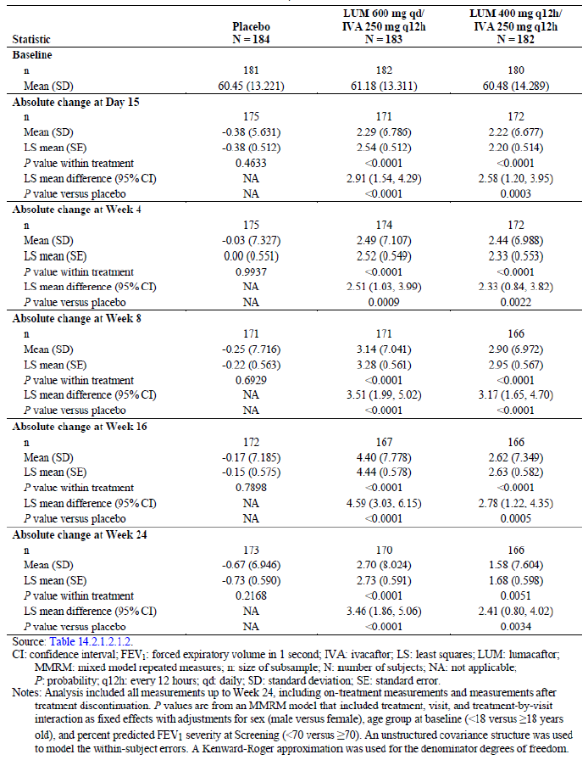

Table 30. Study 103 Response analysis of average absolute change from baseline in percent predicted FEV1 at week 16 and Week 24 Full analysis set
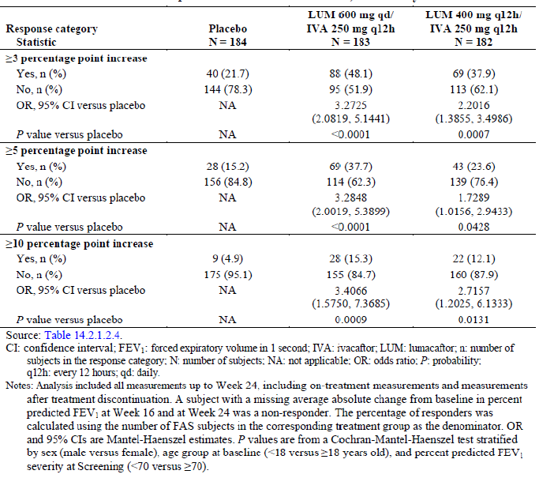

Results for other efficacy outcomes

Key secondary efficacy outcomes

Relative change from baseline in percent predicted FEV₁
The within group LS mean average relative change from baseline in percent predicted FEV₁ at Week 16 and at Week 24 was greater in the LUM 600 mg qd/IVA 250 mg q12h group (6.39%) and the LUM 400 mg q12h/IVA 250 mg q12h group (3.99%) compared with the placebo group (-0.34%). Compared to placebo, statistically significantly greater improvements were observed for both LUM 600 mg qd/IVA 250 mg q12h (treatment diff = 6.73%, 95% CI: 4.27, 9.19; p < 0.0001) and LUM 400 mg q12h/ IVA 250 mg q12h (treatment diff = 4.33%, 95% CI: 1.86, 6.80; p = 0.0006 ) groups. These results were also confirmed in the PPS analysis. For both active treatment groups, statistically significant mean relative improvements in percent predicted FEV₁ were observed as early as on Day 15 and were consistent and sustained across all visits during the treatment period (Table 31).

Table 31. MMRM analysis of relative change from baseline in percent predicted FEV1 at each visit full analysis set
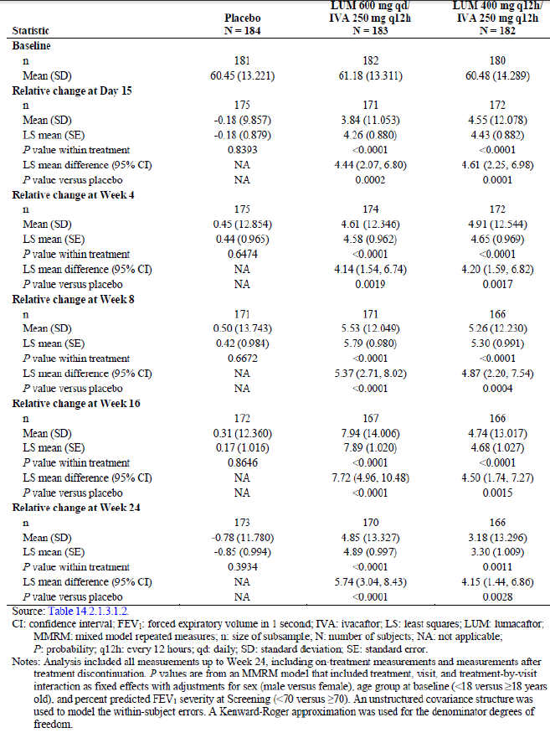

Absolute change from baseline in BMI
The within group LS mean absolute change from baseline in BMI at Week 24 was greater in the LUM 600 mg qd/IVA 250 mg q12h group (0.35 kg/m²) and the LUM 400 mg q12h/IVA 250 mg q12h group (0.32 kg/m²) compared with the placebo group (0.19 kg/m²). However, the differences with both active groups were not statistically significantly greater compared with placebo.

Absolute change from baseline in CFQ-R respiratory domain score
Three versions of the CFQ-R questionnaire were used: 2 in which the information was self-reported (‘Children Ages 12 and 13’ and ‘Adolescents and Adults’) and 1 in which the subject's parent or caregiver was the respondent (‘Parents/Caregivers’). The pooled CFQ-R ‘Children Ages 12 and 13’ and ‘Adolescents and Adults’ versions were analysed unless otherwise specified. Although, the within group LS mean absolute change from baseline in the pooled CFQ-R respiratory domain score at Week 24 was greater in the LUM 600 mg qd/ IVA 250 mg q12h group (4.98 points) and the LUM 400 mg q12h/IVA 250 mg q12h group (2.60 points) compared with the placebo group (1.10 points), the differences were not statistically significant.

Response defined as ≥ 5% increase in average relative change from baseline in percent predicted FEV₁ at Week 16 and at Week 24
The percentage of responders was higher in the LUM 600 mg qd/IVA 250 mg q12h group (46.4%) and the LUM 400 mg q12h/IVA 250 mg q12h group (36.8%) compared with the placebo group (22.3%). The odds ratio for the LUM 600 mg qd/ IVA 250 mg q12h group versus the placebo group was 2.9378 (95% CI: 1.8786, 4.5941; p < 0.0001). The odds ratio for LUM 400 mg q12h IVA 250 mg q12h group versus the placebo group was 2.0592 (95% CI: 1.2920, 3.2819; p = 0.0023) (Table 32).
Comment: As the testing hierarchy stopped for both active treatment groups before these comparisons were made, the odds ratios for responders were not considered statistically significant within the framework of the testing hierarchy. For response defined as ≥ 10% relative increase, the observed trends were similar and favoured lumacaftor in combination with ivacaftor treatment.

Table 32. Study 103 Response analysis of average relative change from baseline in percent predicted FEV1 at week 16 and at week 24, full analysis set
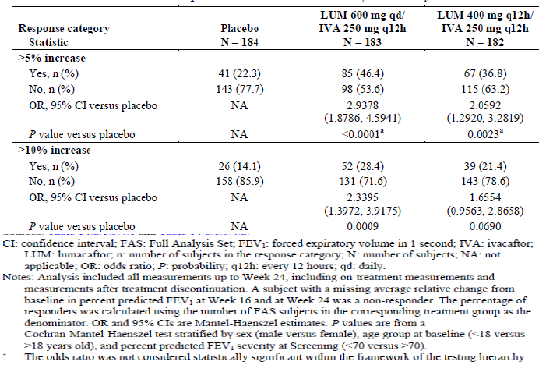

Number of pulmonary exacerbations through Week 24
The number (event rate per year) of pulmonary exacerbations was lower in the LUM 600 mg qd/IVA 250 mg q12h group (79 (0.77) events) and the LUM 400 mg q12h/ IVA 250 mg q12h group (73 (0.71) events) compared with the placebo group (112 (1.07) events). The rate ratios showed a treatment effect that was in favour of both active treatment groups, but could not be considered statistically significant as the testing hierarchy stopped before this comparison.

Other secondary and additional efficacy outcomes

Nutritional status
Although, the within group LS mean absolute change from baseline in weight at Week 24 was greater in the LUM 600 mg qd/IVA 250 mg q12h group (1.34 kg) and the LUM 400 mg q12h/IVA 250 mg q12h group (1.23 kg) compared with the placebo group (0.93 kg), the difference was not statistically significant (Table 33).

Table 33. MMRM analysis of absolute change from baseline in weight at Week 24 full analysis set
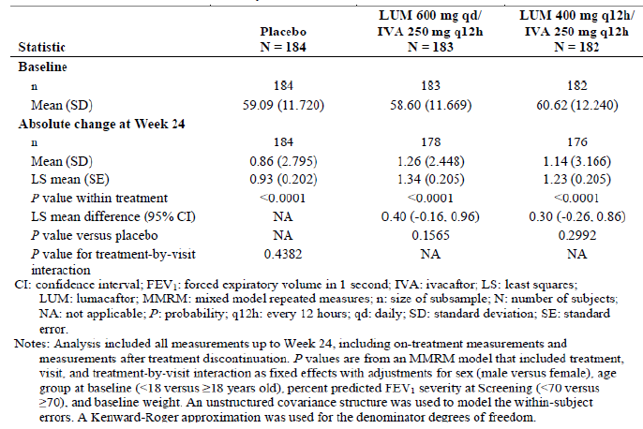
To assess changes in nutritional status in a population of boys and girls at various stages of growth, BMI z-score, weight z-score, and height z-score were calculated using the National Centre for Health Statistics growth charts for subjects less than 20 years of age. Change in height was also analysed in this population. Although improvements in BMI z-score, Weight z-score and Height z-score were observed in both active treatment groups, the treatment differences versus the placebo group were not statistically significant. No improvement in height was observed in either active treatment group when compared with the placebo group.

Clinical events of interest
Time to first pulmonary exacerbation through Week 24 was a secondary endpoint. The hazard ratios showed a treatment effect that was in favour of both active treatment groups. The percentage of subjects with at least 1 pulmonary exacerbation was numerically lower in both active treatment groups compared with the placebo group although the odds ratio was not statistically significant (p = 0.0552 and p = 0.0512 for LUM 600 mg qd/IVA 250 mg q12h group and the LUM 400 mg q12h/IVA 250 mg q12h groups, respectively). The hazard ratio for the LUM 600 mg qd/IVA 250 mg q12h group versus the placebo group was 0.692 (p = 0.0396), while the hazard ratio for the LUM 400 mg q12h/IVA 250 mg q12h group versus the placebo group was 0.691 (p = 0.0385). A numerically greater proportion of subjects remained free of pulmonary exacerbations in both active treatment groups compared with the placebo group.
The number (event rate per year) of pulmonary exacerbations requiring hospitalization was lower in the LUM 600 mg qd/IVA 250 mg q12h group (25 (0.20) events) and the LUM 400 mg q12h/IVA 250 mg q12h group (17 (0.14) events) compared with the placebo group (46 (0.36) events). The rate ratios were statistically significantly in favour of both active treatment groups. The hazard ratio for time to first hospitalisation for pulmonary exacerbation was also significantly in favour of both active treatment groups compared with placebo.
The number (event rate per year) of pulmonary exacerbations requiring IV antibiotic therapy was also lower in the LUM 600 mg qd/IVA 250 mg q12h group (31 events) and the LUM 400 mg q12h/IVA 250 mg q12h group (33 events) compared with the placebo group (62 events). The rate ratios were statistically significantly in favour of both active treatment groups. The hazard ratio for time to first hospitalisation for pulmonary exacerbation was also significantly in favour of both active treatment groups compared with placebo.
Analysis of the number of unplanned hospitalizations through Week 24 showed no discernible differences between either active treatment group and the placebo group.
The duration of clinical events of interest was analysed using a stratified Wilcoxon rank-sum test to assess the difference between treatment groups. The total duration was the total number of days that a given subject had the specified clinical event. The normalised mean total durations were shorter for both active treatment groups than the placebo group for all clinical events of interest (pulmonary exacerbations, hospitalisations due to pulmonary exacerbations, antibiotic therapy for pulmonary exacerbations) with the exception of planned and unplanned hospitalizations (Table 34).

Table 34. Normalised total duration of clinical events of interest full analysis set
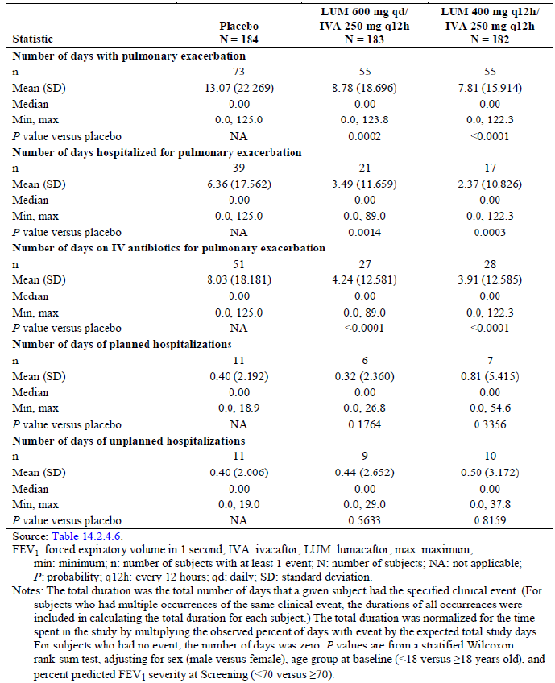

Patient-reported outcomes
No meaningful treatment difference in the absolute change from baseline in the EQ-5D-3L single utility index score between either active treatment group and placebo group were observed at Week 24. Analysis of absolute change from baseline in the EQ-5D-3L VAS score at Week 24 resulted in positive LS mean treatment differences for both active treatment groups versus the placebo group: 2.1 points (p = 0.1342) for the LUM 600 mg qd/IVA 250 mg q12h group, and 1.4 points (p = 0.3071) for the LUM 400 mg q12h/IVA 250 mg q12h group.
Absolute change from baseline in TSQM domains at Week 24 was a secondary endpoint. A total of 4 domains were analysed: effectiveness, side effects, convenience, and global satisfaction. Analysis of absolute change from baseline in the TSQM effectiveness domain (5.49 points (p = 0.0160) for the LUM 600 mg qd/IVA 250 mg q12h group, and 5.80 points (p = 0.0126) for the LUM 400 mg q12h/IVA 250 mg q12h group) and the global satisfaction domain (5.49 points (p = 0.0345) for the LUM 600 mg qd/IVA 250 mg q12h group versus the placebo group, and 6.72 points (p = 0.0109) for the LUM 400 mg q12h/IVA 250 mg q12h group) at Week 24 resulted in positive LS mean treatment differences for both active treatment groups versus the placebo group. Analysis of absolute change from baseline in the TSQM side effects domain at Week 24 resulted in negative LS mean treatment differences for both active treatment groups versus the placebo group: -4.18 points (p = 0.0074) for the LUM 600 mg qd/IVA 250 mg q12h group, and -4.74 points (p = 0.0029) for the LUM 400 mg q12h/IVA 250 mg q12h group. Analysis of absolute change from baseline in the TSQM convenience domain at Week 24 resulted in an LS mean treatment difference of 0.61 points (p = 0.7721) for the LUM 600 mg qd/IVA 250 mg q12h group versus the placebo group, and 3.08 points (p = 0.1472) for the LUM 400 mg q12h/IVA 250 mg q12h group versus the placebo group.
Absolute change from baseline in CFQ-R respiratory domain score at Week 24 for the ‘Parents/Caregivers’ version was analysed as an additional efficacy endpoint and did not show any significant improvements with active treatment groups compared with placebo: the treatment differences were 1.27 points (p = 0.8322) for the LUM 600 mg qd/IVA 250 mg q12h group and -0.35 points (p = 0.9525) for the LUM 400 mg q12h/IVA 250 mg q12h group.
Absolute change from baseline in FEV₁ at Week 24 was an additional efficacy endpoint and showed statistically significantly greater improvement in both active treatment groups compared with placebo (0.121, 0.085 and 0.0006L in LUM 600 mg qd/ IVA 250 mg q12h, LUM 400 mg q12h/IVA 250 mg q12h and placebo groups, respectively).
Across all visits, the percentage of subjects who were FEV₁ responders was consistently higher during treatment with lumacaftor in combination with ivacaftor than with placebo. At most visits, both active treatment groups had a statistically significant higher incidence of responses compared with the placebo group (Table 30).
At Week 24, the percentage of subjects who were BMI responders was numerically higher in the LUM 600 mg qd/IVA 250 mg q12h group (41.0%) and the LUM 400 mg q12h/IVA 250 mg q12h group (38.5%) compared with the placebo group (35.9%) although the odds ratios compared with placebo were not statistically significant.
At Week 24, the percentage of subjects who were weight responders was similar in the LUM 600 mg qd/IVA 250 mg q12h group (57.4%) and the LUM 400 mg q12h/ IVA 250 mg q12h group (56.6%) compared with the placebo group (54.3%).
At Week 24, the percentage of subjects who were CFQ-R respiratory domain responders was numerically higher in the LUM 600 mg qd/ IVA 250 mg q12h group (55.2%) and similar in the LUM 400 mg q12h/IVA 250 mg q12h group (46.7%) and the placebo group (45.1%). The odds ratio for the LUM 600 mg qd/IVA 250 mg q12h group versus the placebo group was 1.5079 (95% CI: 0.9990, 2.2760; p = 0.0503). The odds ratio for the LUM 400 mg q12h/ IVA 250 mg q12h group versus the placebo group was 1.0640 (95% CI: 0.7087, 1.5975; p = 0.7628).
Results of subgroup analyses were provided for demographic and baseline characteristics subgroups and for prior medication subgroups. For all subgroups, analysis of average absolute change from baseline in percent predicted FEV₁ at Week 16 and at Week 24 favoured both active treatment groups; however, some within group absolute changes and treatment differences versus the placebo group may not have been statistically significant because of variability or insufficient power due to the small sample size. However, there was a slightly greater change from baseline in active groups in subjects aged 12 to 17 years compared to those aged > 18 years. There were no treatment by subgroup interactions that was statistically significant, therefore suggesting that the treatment effect is consistent across all analysed subgroups, with the exception of the treatment by age interaction (p = 0.0889).
Subgroup analyses for the key secondary endpoint of relative change from baseline in percent predicted FEV₁ at Week 24, assessed as the average treatment effect at Week 16 and at Week 24 for each subgroup showed similar results.
Comment: The primary objective of this pivotal Phase III, double blind, placebo controlled, parallel group study was to evaluate the efficacy of lumacaftor in combination with ivacaftor at Week 24 in 549 subjects with CF who were homozygous for the F5 08del-CFTR mutation. Two dosing regimens were evaluated: LUM 600 mg qd/IVA 250 mg q12h and LUM 400 mg q12h/IVA 250 mg q12h. The primary efficacy endpoint was absolute change from baseline in percent predicted FEV1 at Week 24 (assessed as the average treatment effect at Week 16 and at Week 24), and the key secondary endpoints were relative change from baseline in percent predicted FEV1 at Week 24 (assessed as the average treatment effect at Week 16 and at Week 24), absolute change from baseline in BMI at Week 24, absolute change from baseline in CFQ-R respiratory domain score at Week 24, response defined as ≥ 5% increase in average relative change from baseline in percent predicted FEV1 at Week 16 and at Week 24, and number of pulmonary exacerbations through Week 24. The overall study design, treatment duration and efficacy endpoints of this well-conducted Phase III study complied with CHMP guidelines for evaluation of medicinal products for treatment of CF.
The primary and key secondary efficacy results are summarised in Table 35.

Table 35. Primary and key secondary efficacy results
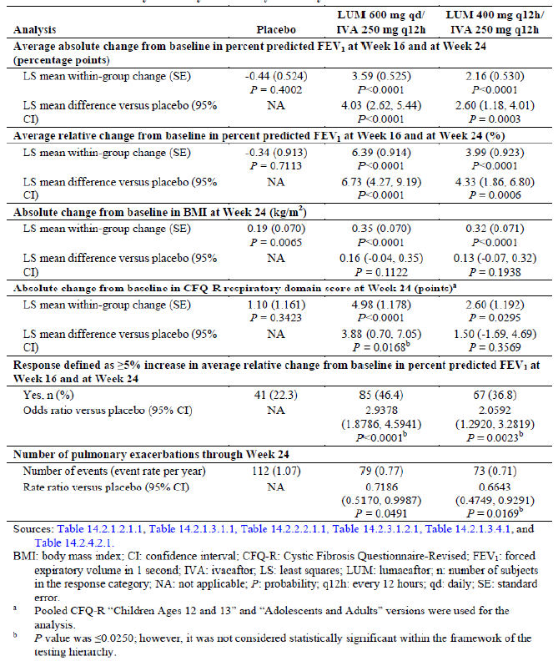
The test for treatment effect was considered statistically significant if the p value was ≤ 0.0250 and all previous tests within the testing hierarchy also met this level of significance. Based on these statistical testing procedures, the absolute change from baseline in percent predicted FEV₁ at Week 24 (assessed as the average treatment effect at Week 16 and at Week 24) and the relative change from baseline in percent predicted FEV₁ at Week 24 (assessed as the average treatment effect at Week 16 and at Week 24) were considered statistically significant within the framework of the testing hierarchy. Although, both active treatment groups showed numerical improvements over placebo in change in BMI and CFQ-R respiratory domain scores, the difference was not statistically significant.
Both active treatment groups demonstrated statistically significant treatment differences in favour of lumacaftor in combination with ivacaftor for the primary endpoint, with improvements in lung function that were consistent. The treatment effect was rapid and sustained across all visits during the treatment period. The percentage of responders (defined as > 5% increase in average relative change from baseline in percent predicted FEV₁ at week 16 and 24) was also significantly higher in both active groups compared with placebo (46.4%, 36.8% and 22.3% in LUM 600 mg qd/ IVA 250 mg q12h, LUM 400 mg q12h/IVA 250 mg q12h and placebo groups, respectively). However, no statistically significant Improvements in measures of nutritional status (BMI and weight) were observed.
There were robust reductions in the rate of pulmonary exacerbations, including statistically significant reductions in severe pulmonary exacerbations requiring hospitalization or IV antibiotic therapy. Treatment with lumacaftor in combination with ivacaftor resulted in favourable changes in the EQ-5D-3L VAS score and some TSQM domains (effectiveness and global satisfaction domains).
Compared to the LUM 400 mg q12h/IVA 250 mg q12h group, patients in the LUM 600 mg qd/IVA 250 mg q12h showed numerically greater improvements in terms of absolute and relative change from baseline in percent predicted change in FEV₁ as well as FEV₁ responders; only number of pulmonary exacerbations showed greater reduction in the LUM 400 mg q12h/IVA 250 mg q12h group (Table 35). However, interpretation of these differences was difficult as the study was not powered to detect any difference between the 2 active treatment groups.

Study VX12-809-104

Study design, objectives, locations and dates
This was a Phase III, randomised, double blind, placebo controlled, parallel group multicentre study of orally administered lumacaftor and ivacaftor in subjects with CF who are homozygous for the F508del-CFTR mutation. The study was conducted from 11, April, 2013 to 25 April, 2014 at 91 sites in North America, Europe, and Australia. The study design was identical to the other Phase III pivotal Study 103 described above.

Inclusion and exclusion criteria
These were identical to those described for Study 103 above.

Study treatments
These were identical to those described for Study 103 above.

Efficacy variables and outcomes
These were identical to those described for Study 103 above.

Randomisation and blinding methods
These were identical to those described for Study 103 above.

Analysis populations, sample size and statistical methods
These were identical to those described for Study 103 above.

Participant flow
A total of 563 subjects (more than the planned approximately 501 subjects) were randomised; 187, 189 and 187 subjects were randomised to the LUM 600 mg qd/IVA 250 mg q12h, LUM 400 mg q12h/IVA 250 mg q12h and placebo treatment groups, respectively. Four subjects discontinued the study before receiving their first dose of study drug and so the FAS included 559 subjects (185, 187 and 187 subjects, respectively). The Safety Set included 1 less subject in the placebo group and 1 additional subject in the LUM 600 mg qd/IVA 250 mg q12h group compared with the FAS because 2 subjects received the wrong study drug during the study. A total of 530 (94.8%) subjects completed study drug treatment. The overall treatment discontinuation rate of 5.2% was lower than anticipated in the protocol. A numerically higher percentage of subjects in the active treatment groups discontinued study drug treatment compared with the placebo group (4.9%, 8% and 2,7% in the LUM 600 mg qd/IVA 250 mg q12h, LUM 400 mg q12h/IVA 250 mg q12h and placebo treatment groups, respectively). The most common reason for discontinuation from study drug treatment across all 3 treatment groups was an adverse event (19 (3.4%) subjects overall) with higher rates in the active treatment groups compared with placebo (3.2%, 5.9% and 1.1%, respectively). Overall 527 (94.3%) subjects entered the rollover Study 105: 181 (96.8%) subjects in the placebo group, 173 (93.5%) subjects in the LUM 600 mg qd/IVA 250 mg q12h group and 173 (92.5%) subjects in the LUM 400 mg q12h/IVA 250 mg q12h group.

Major protocol violations/deviations
Overall, 16 subjects were excluded from the PPS due to important protocol deviations (5, 6 and 5 subjects in the LUM 600 mg qd/IVA 250 mg q12h, LUM 400 mg q12h/IVA 250 mg q12h and placebo treatment groups, respectively); 10 subjects were excluded due to < 80% treatment compliance and 6 randomised subjects were ineligible.

Baseline data
Overall, > 99% of subjects were White, > 96% were not Hispanic or Latino, > 60% were from North America, and approximately half of the subjects were female. The median age was 24.0 years (range: 12 to 55) with 132 (23.6 %) subjects overall in the 12 to < 18 years old subgroup and 427 (76.4%) subjects in the ≥ 18 years old subgroup. The LUM 600 mg qd/IVA 250 mg q12h group had a numerically lower median BMI z-score and median weight z-score compared with the placebo) and the LUM 400 mg q12h/ IVA 250 mg q12h group. The median percent predicted FEV₁, median percent predicted FVC and the median percent predicted FEF25 to 75% were similar across all 3 treatment groups. The percentage of subjects who received dornase alfa (80.3% overall), any bronchodilator (91.9% overall), and any inhaled corticosteroid (56.2% overall) before the first dose of study drug was similar across all 3 treatment groups. However, the placebo group had slightly higher percentage of patients with the following compared with the LUM/IVA groups: positive Pseudomonas aeruginosa status before first dose of study drug; receiving inhaled antibiotics and receiving hypertonic saline before first dose of study drug. The incidence of medical history conditions occurring in at least 15% of subjects in any treatment group was similar across the 3 treatment groups, with some exceptions (difference greater than 5 percentage points); there was higher incidence of history of cystic fibrosis related diabetes, asthma, drug hypersensitivity, rhinitis allergy and distal intestinal obstruction syndrome in the LUM/IVA groups while history of osteopenia was more common in placebo group (Table 36). All subjects used medication concomitantly with study drug and the most common concomitant medications (incidence of at least 30% of subjects) were indicated for management of CF complications: dornase alfa (80.5%), pancreatin (75.3%), salbutamol (69.9%), sodium chloride (68.3%), azithromycin (67.4%), tobramycin (54.9%), ciprofloxacin (36.5%), Seretide (30.8%), and aztreonam lysine (31.5%). In general, medication use remained stable before and after the subjects received study drug in all 3 treatment groups. For subjects who used inhaled antibiotics before the first dose of study drug, the majority of subjects (≥ 95.6% for the placebo group versus ≥ 93.2% for the total LUM/IVA group) continued chronic use during the treatment emergent period. For subjects with no prior use of inhaled antibiotics before the first dose of study drug, fewer subjects in the total LUM/IVA group (14.6%) had chronic use of inhaled antibiotics during the treatment emergent period compared with the placebo group (21.6%).

Table 36. Study 104 Medical history with an incidence of at least 15% of subjects by preferred term in any treatment group full analysis set
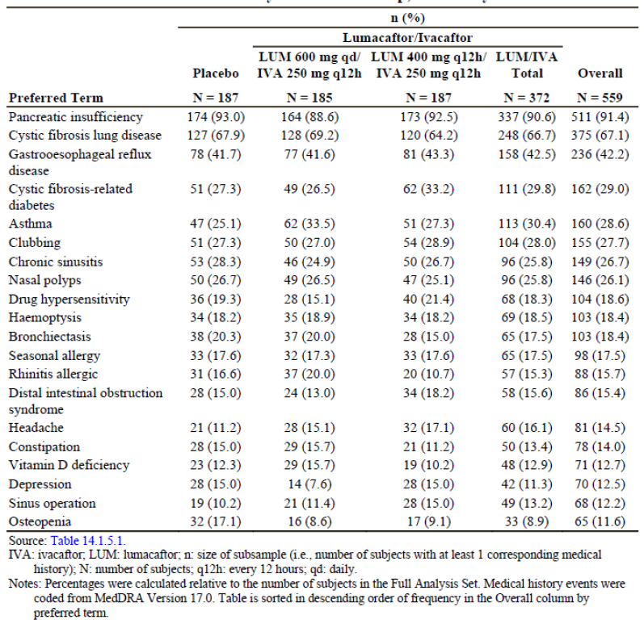
The mean study drug compliance was > 98% in all 3 treatment groups and was similar between the total LUM/IVA group and the placebo group. The proportion of subjects with < 80% study drug compliance was low in general: 1.6% in the total LUM/IVA group and 2.1% in the placebo group. Ten subjects (4 (2.1%) subjects in the placebo group, 4 (2.2%) subjects in the LUM 600 mg qd/IVA 250 mg q12h group, and 2 (1.1%) subjects in the LUM 400 mg q12h/IVA 250 mg q12h group) had < 80% overall study drug compliance rate. Treatment interruptions ≥ 3 days occurred in a small proportion of subjects in each treatment group: 21 (11.23%) subjects in the placebo group, 17 (9.19%) subjects in the LUM 600 mg qd/IVA 250 mg q12h group, and 16 (8.56%) subjects in the LUM 400 mg q12h/IVA 250 mg q12h group.

Results for the primary efficacy outcome
The within group LS mean average absolute change from baseline in percent predicted FEV₁ at Week 16 and at Week 24 was greater for the LUM 600 mg qd/ IVA 250 mg q12h group (2.46 percentage points) and the LUM 400 mg q12h/ IVA 250 mg q12h group (2.85 percentage points) compared with the placebo group (-0.15 percentage points). Compared to placebo, statistically significantly greater improvements were observed for both LUM 600 mg qd/IVA 250 mg q12h (treatment diff = 2.62 percentage points, 95% CI: 1.18, 4.06; p = 0.0004) and LUM 400 mg q12h/ IVA 250 mg q12h (treatment diff = 3.00 percentage points, 95% CI: 1.56, 4.44, p < 0.0001) groups. These results were confirmed in the PPS analysis (Table 37). For both active treatment groups, statistically significant mean absolute improvements in percent predicted FEV₁ were observed as early as Day 15 and were consistent and sustained across all visits during the treatment period (Table 38). The percentage of responders with ≥ 3 percentage point increase in the average absolute change from baseline in percent predicted FEV₁ at Week 16 and at Week 24was higher in the LUM 600 mg qd/IVA 250 mg q12h group (46.5%) and the LUM 400 mg q12h/ IVA 250 mg q12h group (42.2%) compared with the placebo group (21.9%). The odds ratio for the LUM 600 mg qd/IVA 250 mg q12h group versus the placebo group was 3.1409 (95% CI: 1.9916, 4.9536; p < 0.0001). The odds ratio for LUM 400 mg q12h/ IVA 250 mg q12h group versus the placebo group was 2.5765 (95% CI: 1.6426, 4.0413; p < 0.0001).The observed trends were similar and favoured lumacaftor in combination with ivacaftor treatment for response defined as ≥ 5 percentage point (30.8%, 29.9% and 12.8% in the LUM 600 mg qd/IVA 250 mg q12h, LUM 400 mg q12h/IVA 250 mg q12h and placebo groups, respectively) and ≥ 10 percentage point (13%, 13.4% and 5.9%, respectively) average absolute increase (Table 7.2.9, p315). Robustness of the primary analyses was confirmed by similar results in the two sensitivity analyses (Table 39).

Table 37. MMRM Analysis of average absolute change from baseline percent predicted FEV1 at Week 16 and Week 25 Full Analysis set and per protocol set
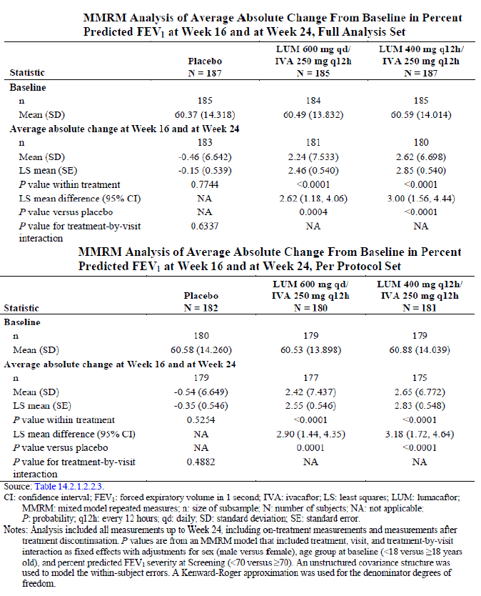

Table 38. Study 104 MMRM analysis of absolute change from baseline in percent predicted FEV1 at each visit full analysis set
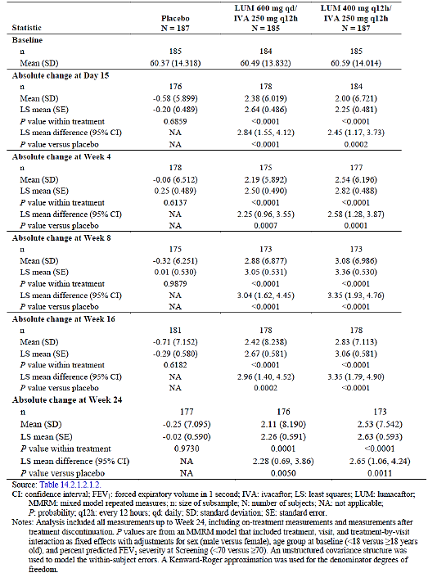

Table 39. Sensitivity analysis: average absolute change from baseline in percent predicted FEV1 at week 16 and at Week 24 full analysis set
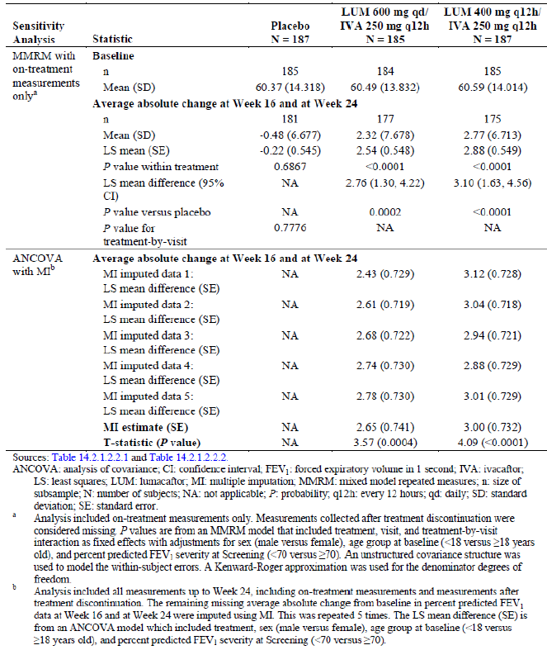

Results for other efficacy outcomes

Key secondary efficacy outcomes

Relative change from baseline in percent predicted FEV₁
The within-group LS mean average relative change from baseline in percent predicted FEV₁ at Week 16 and at Week 24 was greater in the LUM 600 mg qd/ IVA 250 mg q12h group (4.42%) and the LUM 400 mg q12h/IVA 250 mg q12h group (5.25%) compared with the placebo group (0.00%). Compared to placebo, statistically significantly greater improvements were observed for both LUM 600 mg qd/IVA 250 mg q12h (treatment diff = 4.42%, 95% CI: 1.86, 6.98; p = 0.0007) and LUM 400 mg q12h/ IVA 250 mg q12h (treatment diff = 5.25%, 95% CI: 2.69, 7.81; p < 0.0001 ) groups. These results were also confirmed in the PPS analysis. For both active treatment groups, statistically significant mean relative improvements in percent predicted FEV₁ were observed as early as Day 15 and were consistent and sustained across all visits during the treatment period.

Absolute change from baseline in BMI
The within group LS mean absolute change from baseline in BMI at Week 24 was greater in the LUM 600 mg qd/IVA 250 mg q12h group (0.48 kg/m²) and the LUM 400 mg q12h/IVA 250 mg q12h group (0.43 kg/m²) compared with the placebo group (0.07 kg/m²). Compared to placebo, statistically significantly greater improvements were observed for both LUM 600 mg qd/IVA 250 mg q12h (treatment diff = 0.41 kg/m², 95% CI: 0.23, 0.59; p < 0.0001) and LUM 400 mg q12h/ IVA 250 mg q12h (treatment diff = 0.36 kg/m², 95% CI: 0.17, 0.54; p < 0.0001 ) groups. When analysed as the treatment differences versus the placebo group, statistically significant improvements in BMI were observed in the LUM 600 mg qd/IVA 250 mg q12h group beginning at Week 8 (p = 0.0024), and in the LUM 400 mg q12h/IVA 250 mg q12h group beginning at Week 16 (p = 0.0037). BMI continued to increase through all time points in both active treatment groups (Figure 12).
Figure 12. Absolute change from baseline in BMI (kg/m²) at each visit full analysis set
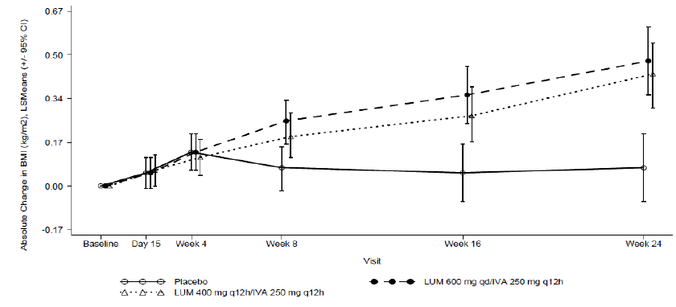

Absolute change from baseline in CFQ-R respiratory domain score
Although, the within-group LS mean absolute change from baseline in the pooled CFQ-R respiratory domain score at Week 24 was greater in the LUM 600 mg qd/ IVA 250 mg q12h group (5.02 points) and the LUM 400 mg q12h/IVA 250 mg q12h group (5.66 points) compared with the placebo group (2.81 points), the differences were not statistically significant (Table 7.2.15, p320).

Response defined as ≥ 5% increase in average relative change from baseline in percent predicted FEV₁ at Week 16 and at Week 24
The percentage of responders was higher in the LUM 600 mg qd/IVA 250 mg q12h group (45.9%) and the LUM 400 mg q12h/ IVA 250 mg q12h group (41.2%) compared with the placebo group (22.5%). The odds ratio for the LUM 600 mg qd/IVA 250 mg q12h group versus the placebo group was 2.9568 (95% CI: 1.8829, 4.6431; p < 0.0001). The odds ratio for LUM 400 mg q12h/ IVA 250 mg q12h group versus the placebo group was 2.3834 (95% CI: 1.5234, 3.7286; p = 0.0001). For response defined as ≥ 10% relative increase, the observed trends were similar and favoured lumacaftor in combination with ivacaftor treatment (Table 40).

Table 40. Response analysis of average relative change from baseline in percent predicted FEV1 at Week 16 and Week 24 full analysis set
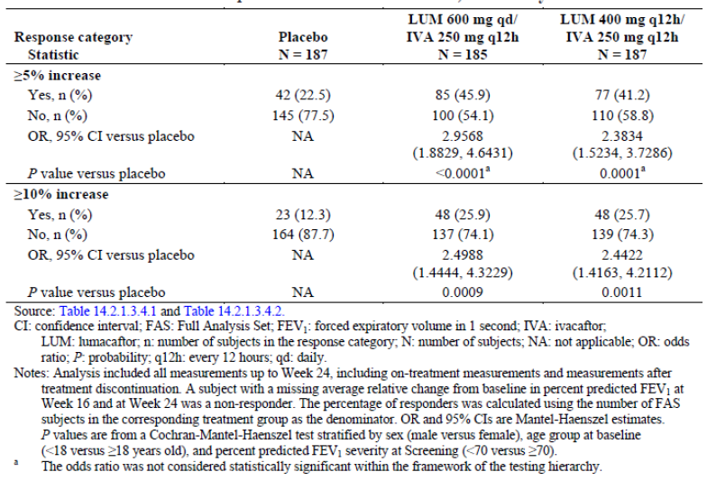

Number of pulmonary exacerbations through Week 24
The number (event rate per year) of pulmonary exacerbations was lower in the LUM 600 mg qd/IVA 250 mg q12h group (94 (0.82) events) and the LUM 400 mg q12h/IVA 250 mg q12h group (79 (0.67) events) compared with the placebo group (139 (1.18) events). The rate ratios showed a treatment effect that was in favour of both active treatment groups, but could not be considered statistically significant as the testing hierarchy stopped before this comparison.

Other secondary and additional efficacy outcomes

Nutritional status
The within-group LS mean absolute change from baseline in weight at Week 24 was greater in the LUM 600 mg qd/IVA 250 mg q12h group (1.57 kg) and the LUM 400 mg q12h/IVA 250 mg q12h group (1.38 kg) compared with the placebo group (0.44 kg). Compared to placebo, statistically significantly greater improvements were observed for both LUM 600 mg qd/IVA 250 mg q12h (treatment diff = 1.13 kg. 95% CI: 0.62, 1.64; p < 0.0001) and LUM 400 mg q12h/ IVA 250 mg q12h (treatment diff = 0.95kg, 95% CI: 20.43, 1.46; p = 0.0003 ) groups. To assess changes in nutritional status in a population of boys and girls at various stages of growth, BMI z-score, weight z-score, and height z-score were calculated using the National Centre for Health Statistics growth charts for subjects < 20 years of age. Change in height was also analysed in this population. Statistically significant improvements in the BMI z-score and weight z-score were observed for both active treatment groups compared with placebo. Compared with placebo, the height and height z-score did not show any statistically significant improvements in any of the active treatment groups.

Clinical events of interest
Analysis of time to first pulmonary exacerbation showed that a numerically greater proportion of subjects remained free of pulmonary exacerbations in both active treatment groups compared with the placebo group. The hazard ratios showed a treatment effect that was in favour of both active treatment groups. The hazard ratio for the LUM 600 mg qd/IVA 250 mg q12h group versus the placebo group was 0.716 (p = 0.0384), while the hazard ratio for the LUM 400 mg q12h/IVA 250 mg q12h group versus the placebo group was 0.533, which was statistically significant (p = 0.0003) (Figure 13).
Figure 13. 7.2.21 Time to first pulmonary exacerbation through week 24 full analysis set
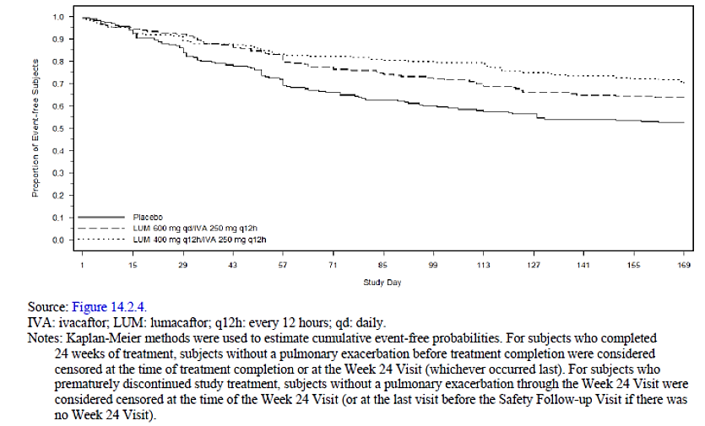
The percentage of subjects with at least 1 pulmonary exacerbation was lower in the LUM 600 mg qd/ IVA 250 mg q12h group (36.8%) and the LUM 400 mg q12h/IVA 250 mg q12h group (28.9%) compared with the placebo group (47.1%). The odds ratio for the LUM 600 mg qd/IVA 250 mg q12h group versus the placebo group was 0.6373 (95% CI: 0.4160, 0.9764), which was statistically significant (p = 0.0393). The odds ratio for the LUM 400 mg q12h/IVA 250 mg q12h group versus the placebo group was 0.4429 (95% CI: 0.2863, 0.6851), which was statistically significant (p = 0.0002).
The number (event rate per year) of pulmonary exacerbations requiring hospitalization was lower in the LUM 600 mg qd/IVA 250 mg q12h group (37 (0.30) events) and the LUM 400 mg q12h/IVA 250 mg q12h group (23 (0.18) events) compared with the placebo group (59 (0.46) events). The rate ratios showed a treatment effect that was in favour of both active treatment groups. The rate ratio for the LUM 600 mg qd/IVA 250 mg q12h group versus the placebo group was 0.6482 (95% CI: 0.4246, 0.9895), which was statistically significant (p = 0.0446). The rate ratio for the LUM 400 mg q12h/IVA 250 mg q12h group versus the placebo group was 0.3896 (95% CI: 0.2382, 0.6373), which was statistically significant (p = 0.0002). The hazard ratios for time to first pulmonary exacerbation showed a treatment effect that was in favour of both active treatment groups (Table 41).

Table 41. Number of pulmonary exacerbations requiring hospitalisation through week 24 full analysis set
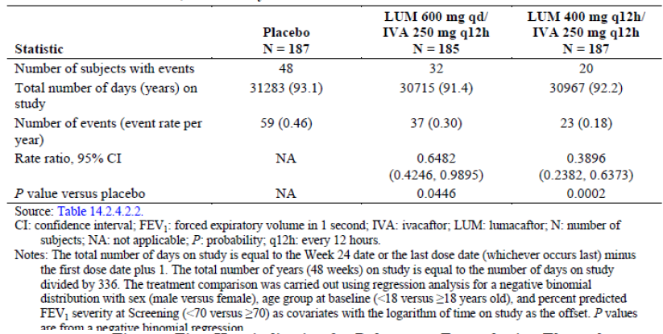
The number (event rate per year) of pulmonary exacerbations requiring IV antibiotic therapy was lower in the LUM 600 mg qd/IVA 250 mg q12h group (49 (0.37) events) and the LUM 400 mg q12h/ IVA 250 mg q12h group (31 (0.23) events) compared with the placebo group (87 (0.64) events). The rate ratios showed a treatment effect that was in favour of both active treatment groups. The rate ratio for the LUM 600 mg qd/IVA 250 mg q12h group versus the placebo group was 0.5819 (95% CI: 0.4089, 0.8281), which was statistically significant (p = 0.0026). The rate ratio for the LUM 400 mg q12h/IVA 250 mg q12h group versus the placebo group was 0.3575 (95% CI: 0.2367, 0.5400), which was statistically significant (p < 0.0001). The hazard ratios for time to first pulmonary exacerbation requiring IV antibiotics showed a treatment effect that was in favour of both active treatment groups.
There were no discernible differences between either active treatment group and the placebo group in the number of unplanned hospitalisations through week 24. The normalised mean total durations were shorter for both active treatment groups than the placebo group for all clinical events of interest with the exception of unplanned hospitalizations.

Patient reported outcomes
Both active treatment groups showed favourable changes in the EQ-5D-3L visual analog scale score at Week 24 with treatment differences of 2.4 points (p = 0.1034) for the LUM 600 mg qd/ IVA 250 mg q12h group versus the placebo group, and 3.3 points (p = 0.0262) for the LUM 400 mg q12h/ IVA 250 mg q12h group versus the placebo group. Both active treatment groups showed favourable changes in some TSQM domains at Week 24. The LUM 600 mg qd/IVA 250 mg q12h group had treatment differences of 8.64 points (p = 0.0005) for the effectiveness domain and 4.64 points (p = 0.0668) for the global satisfaction domain. The LUM 400 mg q12h/IVA 250 mg q12h group had treatment differences of 11.61 points (p < 0.0001) for the effectiveness domain and 7.16 points (p = 0.0045) for the global satisfaction domain. However, analysis of absolute change from baseline in the TSQM side effects domain at Week 24 resulted in negative treatment differences of -3.18 points (p = 0.0403) for the LUM 600 mg qd/ IVA 250 mg q12h group, and -4.29 points (p = 0.0054) for the LUM 400 mg q12h/IVA 250 mg q12h group.
The within group LS mean absolute change from baseline in FEV₁ was greater for the LUM 600 mg qd/IVA 250 mg q12h group (0.105 L) and the LUM 400 mg q12h/IVA 250 mg q12h group (0.119 L) compared with the placebo group (0.011 L). Compared to placebo, statistically significantly greater improvements were observed for both LUM 600 mg qd/IVA 250 mg q12h and LUM 400 mg q12h/ IVA 250 mg q12h groups.
Results of subgroup analyses for demographic and baseline characteristics subgroups and for prior medication subgroups were provided. For all subgroups, analysis of average absolute change from baseline in percent predicted FEV₁ at Week 16 and at Week 24 favoured both active treatment groups; however, some within-group absolute changes and treatment differences versus the placebo group may not have been statistically significant because of variability or insufficient power due to the small sample size. There were no treatment by subgroup interactions that were statistically significant, therefore suggesting that the treatment effect is consistent across all analysed subgroups, with the exception of the treatment by prior inhaled antibiotic use interaction (p = 0.0468) (Table 42).

Table 42. Treatment by subgroup interaction test: MMRM analysis of average absolute change from baseline percent predicted FEV1 at week 16 and at week 24 full analysis set
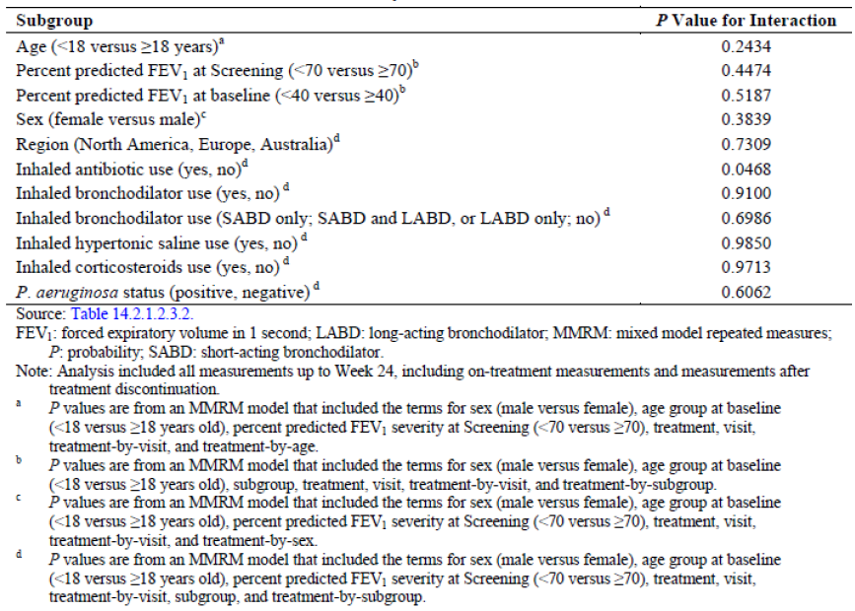
Comment: This was also a well conducted pivotal Phase III study which was identical to Study 103 described above. The primary and key secondary efficacy results are summarised in Table 43. Results were also similar to those observed in Study 103. Both active treatment groups demonstrated statistically significant treatment differences in favour of lumacaftor in combination with ivacaftor for the primary endpoint with improvements in lung function that were consistent. The treatment effect was rapid and sustained across all visits during the treatment period. Notably, there were robust reductions in the rate of pulmonary exacerbations, including statistically significant reductions in severe pulmonary exacerbations requiring IV antibiotic therapy. Furthermore, this study demonstrated statistically significant improvements in measures of nutritional status (BMI, weight, BMI z-score and weight z-score) which were not shown in Study 103. Results of all sensitivity and supportive analyses were consistent with the results of the primary analyses. For some endpoints, the treatment effect numerically favoured 1 dosing regimen versus the other. However, the study was not powered to detect statistical differences between the 2 dosing regimens.

Table 43 Study 104 Primary and key secondary efficacy results
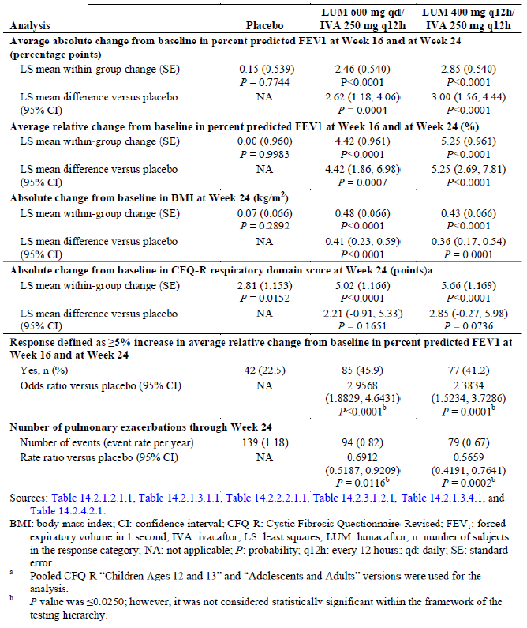

Other efficacy studies

Study VX12-809-105

Study design, objectives
This was a Phase III, parallel group, multicentre, rollover study in subjects with CF who were homozygous or heterozygous for the F508del-CFTR mutation and who participated in Study 103, Study 104, or Cohort 4 of Study 102. The study consisted of 2 parts (Part A and Part B) (Figure 14).
Figure 14. Phase III open label long term study. Schematic of the study design
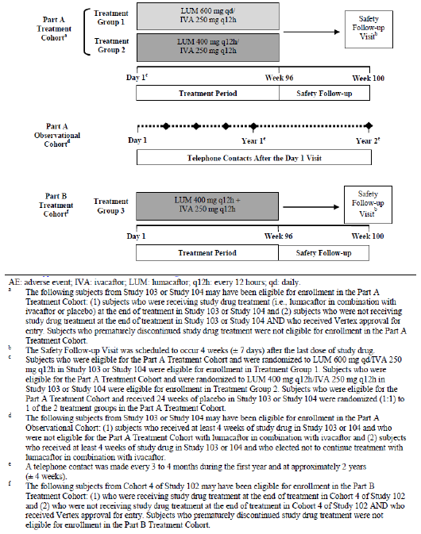

Part A
Part A enrolled subjects with CF who are homozygous for the F508del-CFTR mutation from pivotal Phase III Studies 103 and 104. Part A consisted of a Treatment Cohort and an Observational Cohort, which were enrolled in parallel.
Enrolment in the Part A Treatment Cohort was limited to subjects who met the study criteria and (1) were receiving study drug treatment at the end of treatment in Study 103 or Study 104, or (2) were not receiving study drug treatment at the end of treatment in Study 103 or Study 104, including subjects for whom study drug interruption was required to be either continued or initiated at Day 1 in Study 105, and who received approval for entry from Vertex Pharmaceuticals Incorporated (Vertex). Subjects who prematurely discontinued study drug treatment in Study 103 or Study 104 were not eligible for the Part A Treatment Cohort. The Part A Treatment Cohort was double blind in order to maintain the blind from Study 103 and Study 104, and consisted of 2 treatment groups: Treatment Group 1: lumacaftor (LUM) 600 mg daily (qd)/ ivacaftor (IVA) 250 mg every 12 hours (q12h); Treatment Group 2: LUM 400 mg q12h/IVA 250 mg q12h. Subjects who received lumacaftor in combination with ivacaftor in Study 103 or Study 104 continued to receive the same dose and regimen of study drug in a double blind fashion, as follows: Subjects who were randomised to LUM 600 mg qd/IVA 250 mg q12h in Study 103 and Study 104 were assigned to Treatment Group 1; Subjects who were randomised to LUM 400 mg q12h/IVA 250 mg q12h in Study 103 and Study 104 were assigned to Treatment Group 2. Subjects who received placebo in Study 103 or Study 104 were randomised (1:1) to Treatment Group 1 or Treatment Group 2. These subjects were stratified by sex (male versus female), age at baseline of the subject’s previous study < 18 versus ≥ 18 years old), and forced expiratory volume in 1 second (FEV₁, < 70 versus ≥ 70) severity as assessed at screening of the subject’s previous study.
Part A Observational Cohort included subjects who met the study criteria and who received at least 4 weeks of study drug in Study 103 or Study 104 and who either were not eligible for the Part A Treatment Cohort or chose not to continue treatment with lumacaftor in combination with ivacaftor. Subjects in the Part A Observational Cohort did not receive study drug.

Part B
Part B of this study enrolled subjects with CF heterozygous for F508del-CFTR who participated in a qualifying previous study of lumacaftor in combination with ivacaftor (Cohort 4 of Study 102).
Enrolment in the Part B Treatment Cohort was limited to subjects who met the study criteria and (1) were receiving study drug treatment at the end of treatment in Cohort 4 of Study 102, or (2) were not receiving study drug treatment at the end of treatment in Cohort 4 of Study 102 but received approval for entry from Vertex. Subjects in Cohort 4 of Study 102 who prematurely discontinued study drug treatment were not eligible for the Part B Treatment Cohort. The Part B Treatment Cohort was open-label and consisted of one treatment group: Treatment Group 3: LUM 400 mg q12h/IVA 250 mg q12h.
The primary objective was to evaluate the long-term safety and tolerability of lumacaftor in combination with ivacaftor in subjects with CF, homozygous or heterozygous for the F508del-CFTR mutation, who were in the Part A and Part B Treatment Cohorts. The secondary objectives were to evaluate the long-term efficacy and durability of lumacaftor in combination with ivacaftor in the Part A treatment cohort; to evaluate the post-treatment safety and tolerability of lumacaftor in combination with ivacaftor for subjects in the Part A Observational Cohort and to evaluate the long-term efficacy and durability of lumacaftor in combination with ivacaftor for subjects in the Part B Treatment Cohort. This study was conducted at 191 sites in North America, Europe, and Australia. It was initiated on 24 October, 2013 and still ongoing with results presented till 21 July, 2014.
Comment: The first Interim Analysis submitted in current dossier was conducted based on a data snapshot taken of 21 July 2014. This date was selected in order to provide long-term safety and efficacy data for at least 100 subjects who had completed the Week 24 visit in Study 105, as part of the initial Common Technical Document (CTD) to request marketing approval.
Part A and Part B Treatment Cohorts included a Treatment Period (Day 1 (first dose of study drug) through Week 96 ± 1 week) and a Safety Follow-up Visit (4 weeks ± 7 days after the last dose of study drug). Clinic visits occurred on Day 1 and Day 15 (± 3 days) and at Weeks 8, 16, 24, 36, 48, 60, 72, 84, and 96 (± 1 week). Liver function testing (ALT, AST, GGT, ALP, and total bilirubin) was performed at the scheduled visits and at Weeks 4, 12, 20, 28, 32, 40, 44, 52, 56, 60, 64, 68, 76, 80, 84, 88, and 92 (± 1 week). Telephone contact was to be made at Day 3 (± 1 day) to assess the subject's status, any adverse events (AEs), concomitant medications, treatments, and procedures. Subjects who prematurely discontinued study drug were required to complete an Early Termination Visit (within 1 week of the last dose of study drug) and the Safety Follow-up Visit. The Part A Observational Cohort included a Day 1 Visit and Long-term Follow-up (telephone contacts approximately every 3 to 4 months in the first year and approximately 2 years (± 4 weeks) after the last dose of study drug.

Inclusion/ exclusion criteria, study treatment
Subjects who completed 24 weeks of study drug treatment in Study 103 or Study 104 could elect to enrol in Part A in either the Treatment Cohort. or the Observational Cohort. Subjects who completed 56 days of study drug treatment in Cohort 4 of Study 102 could elect to enrol in the Part B Treatment Cohort. The inclusion and exclusion criteria are summarised below.

Inclusion criteria:
- Signed ICF, and where appropriate, signed assent form
- Subjects entering the Part A Treatment Cohort were required to meet both of the following criteria:
- Completed 24 weeks of study drug treatment in Study 103 or Study 104
- Subjects who had study drug interruptions, but completed study visits up to Week 24 of Study 103 or 104 were eligible. Subjects who were not taking study drug at the Week 24 Visit, including subjects that require study drug interruption to be either continued or initiated at Day 1 in Study 105, were required to have Vertex approval for enrolment/randomization in the Part A Treatment Cohort Elected to enrol in the Part A Treatment Cohort
Subjects entering the Part A Observational Cohort were required to meet the following criteria:
- Completed 24 weeks of study drug treatment in Study 103 or Study 104, but did not elect to enrol in the Part A Treatment Cohort
- Subjects who received at least 4 weeks of study drug and completed visits up to Week 24 Visit of Study 103 or 104 but were not taking study drug at the Week 24 Visit because of a drug interruption and did not receive Vertex approval for enrolment into the Part A Treatment Cohort (or elected not to enrol in the Part A Treatment Cohort)
- Subjects who permanently discontinued study drug after receiving at least 4 weeks of study drug and remained in the study from the time of discontinuation of study drug treatment through the Week 24 Visit in Study 103 or Study 104.
Subjects entering the Part B Treatment Cohort were required to meet both of the following criteria:
- Completed 56 days of study drug treatment in Cohort 4 of Study 102
- Subjects who had study drug interruptions but completed study visits up to Day 56 were eligible. Subjects who were not taking study drug at the Day 56 Visit, including subjects for whom study drug interruption was required to be either continued or initiated at Day 1 in Study 105, were required to have Vertex approval for enrolment/randomization in the Part B Treatment Cohort. Elected to enrol in the Part B Treatment Cohort
- Willing to remain on a stable CF medication regimen through the end of study (Part A and Part B Treatment Cohorts only).
- Able to understand and comply with protocol requirements, restrictions, and instructions, and likely to complete the study as planned, as judged by the investigator and Vertex, based in part on study compliance in Study 103, Study 104, and Cohort 4 of Study 102.

Exclusion criteria
- Any comorbidity or laboratory abnormality that, in the opinion of the investigator, might have confounded the results of the study or posed an additional risk in administering study drug to the subject (e.g., cirrhosis with portal hypertension).
- Pregnant and nursing females; childbearing potential females were required to have a negative urine pregnancy test at the Day 1 Visit and before they received the first dose of study drug.
- Sexually active subjects of reproductive potential who were not willing to follow the contraception requirements.
- History of drug intolerance in the previous study that would have posed an additional risk to the subject in the opinion of investigator or Vertex. Examples of subjects who may not have been eligible for any of the treatment groups include the following: Subjects with a history of allergy or hypersensitivity to the study drug; Liver function test (LFT) abnormality during study drug treatment in the previous study (Study 103, Study 104, or Cohort 4 of Study 102) for which a clear cause was not identified.; Other severe or life-threatening reactions to the study drug in the previous study.
- History of poor compliance with study drug and/or procedures in the previous study as deemed by the investigator.
- Participation in an investigational drug trial (including studies investigating lumacaftor and/or ivacaftor. NOTE: participation in a non-interventional study (including observational studies and studies requiring blood collections without administration of study drug) was permitted.
Lumacaftor and ivacaftor fixed dose combination (FDC) tablets were administered orally: LUM 200 mg/IVA 125 mg film coated FDC tablets; LUM 200 mg/IVA 83 mg film coated FDC tablets Ivacaftor 125 mg film coated tablets) were administered orally (Table 44). The study drug was to be administered within 30 minutes of consuming fat-containing food such as a standard ‘CF’ high fat, high calorie meal or snack. For the Part A Treatment Cohort, maximum subject participation is planned for up to 105 weeks (Day 1 through the Safety Follow up Visit) and study drug administration is planned for approximately 96 weeks. For the Part A Observational Cohort, maximum subject participation is planned for approximately 2 years. For the Part B Treatment Cohort, maximum subject participation is planned for up to 105 weeks (Day 1 through the Safety Follow up Visit) and study drug administration is planned for approximately 96 weeks.

Table 44. Study VX12-809-105 Study drug administration
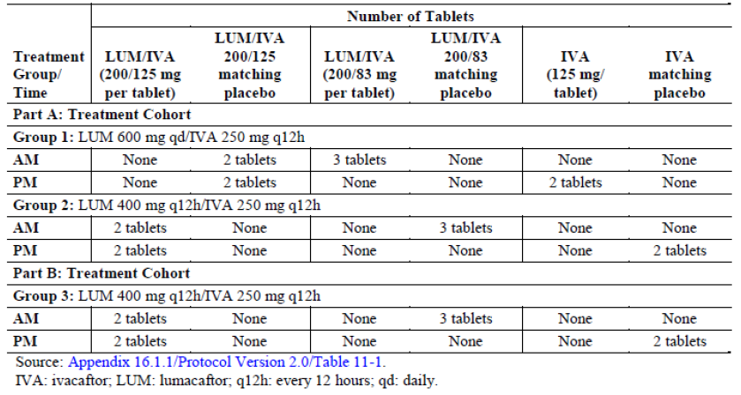
To ensure treatment compliance, the investigator or designee supervised all study drug dosing that occurred at the site. At each visit, site personnel reviewed that the subject was compliant with study drug dosing and reminded the subject of study drug dosing requirements. Compliance was assessed by ongoing study drug count.

Efficacy endpoints, sample size, statistical analysis
Efficacy assessments included spirometry, height, weight, CF Questionnaire – Revised (CFQ-R), and documentation of events related to outcomes (for example, pulmonary exacerbations). CFQ-R and events related to outcomes (for example, pulmonary exacerbations) were not analysed as part of this Interim Analysis.
Approximately 1,122 subjects were potentially eligible for enrolment: 501 subjects from Study 103, 501 subjects from Study 104, and 120 subjects from Study 102 (Cohort 4). With these 1,122 subjects, a 95% confidence interval of (0.391, 0.449) could be obtained assuming a 42% incidence of CF lung (preferred term (PT) for pulmonary exacerbation) in subjects with CF and this was considered adequate for the study objectives.
Ad hoc efficacy analyses were carried out for Part A only to gain insight into the long-term efficacy of lumacaftor in combination with ivacaftor. Lung function (absolute and relative change in percent predicted FEV₁) and measures of nutritional status (BMI and weight) were assessed.
All efficacy analyses were based on the Full Analysis Set (FAS), defined as all subjects in Part A Treatment Cohort who were exposed to any amount of study drug, using the Cumulative period which was defined as the period beginning from the initial dose of study drug in Studies 103/104 to the last dose of study drug in Study 105 excluding the period between 29 days after the last dose of Studies 103/104 and the first dose of Study 105. The following analyses were performed for the Cumulative period: Mixed model repeated measures (MMRM) analysis of absolute change from baseline in percent predicted FEV₁ at each visit for the Studies 103/104 visits (up to Week 24), and MMRM analysis of absolute change from baseline in percent predicted FEV₁ at each visit for the Study 105 visits (up to Week 24); Similar MMRM analysis of relative change from baseline in percent predicted FEV₁, absolute change from baseline in BMI and weight was also performed. An MMRM model was used to test the within-group change for each treatment group (3 treatment groups) at each visit for the Studies 103/104 visits. The analysis included all measurements up to Week 24 of Studies 103/104, including on treatment measurements and measurements after treatment discontinuation. The MMRM model included treatment, visit, and treatment by visit interaction as fixed effects, with adjustment for study (Study 103 versus Study 104), sex (male versus female), age group at baseline (< 18 versus ≥ 18 years old), and percent predicted FEV₁ severity at Screening (< 70 versus ≥ 70), and subject as a random effect. Continuous variables other than spirometry were analysed similarly, but were further adjusted for the baseline value of the dependent variable (for example, analysis of absolute change in BMI included an additional adjustment for the baseline value of BMI).
The following analysis sets were defined:
- All Subjects Set (included all subjects who signed the ICF for Study 105 Part A Observational Cohort or Part A and Part B Treatment Cohorts)
- Part A Long-term Safety Set (LTSS) included subjects in the Part A Treatment Cohort, who received active treatment in their previous study and completed visits through Week 24 or beyond in Study 105 as of 01 July 2014
- All Subjects Safety Set included all subjects in the Part A and Part B Treatment Cohorts who were exposed to any amount of study drug in Study 105.

Participant flow
In the current study period ‘All Subjects Set’, 1108 subjects received at least 1 dose of study drug (placebo or LUM/IVA) in Studies 103 or 104Of these, 1,031 subjects (93.1%) enrolled in Part A Treatment Cohort. A total of 335 subjects who received LUM 600 mg qd/IVA 250 mg q12h and 341 subjects who received LUM 400 mg q12h/IVA 250 mg q12h, in the previous study continued to receive the same treatments in Study 105. Among subjects who received placebo in the previous study, 179 subjects were randomised to receive LUM 600 mg qd/IVA 250 mg q12h and 176 subjects were randomised to receive LUM 400 mg q12h/IVA 250 mg q12h. At the time of the data snapshot (21 July 2014) more than 89% of subjects in the Part A Treatment Cohort completed at least the Week 16 Visit. Only 54 (5.3%) subjects discontinued treatment in Part A and the rate of treatment discontinuation was similar in all 4 treatment groups (range: 4.5% to 6.2%) with AEs (n = 26, 2.5%) being most common cause for treatment discontinuation.
A subset of subjects from Part A Treatment Cohort who had completed the Week 24 Visit as of 01 July 2014 was included in the Long-term Safety Set (LTSS). A total of 116 subjects were included in the LTSS. Of these subjects, 59 subjects received LUM 600 mg qd/IVA 250 mg q12h group and 57 subjects LUM 400 mg q12h/IVA 250 mg q12h group during the entire period of exposure in Studies 103/104 and 105. A total of 19 subjects (3 subjects from the placebo group, 8 subjects from the LUM 400 mg q12h/IVA 250 mg q12h group, and 8 subjects from the LUM 600 mg qd/IVA 250 mg q12h group) enrolled in the Part A Observational Cohort.
In Study 102 Cohort 4, 126 subjects were randomised and 125 were dosed. A total of 115 subjects were included in the Current study Period analysis for Part B of Study 105. A total of 55 subjects had received LUM 400 mg q12h/IVA 250 mg q12h in the previous study and 60 subjects had received placebo in the previous study; all subjects were receiving LUM 400 mg q12h/ IVA 250 mg q12h in Study 105.Most subjects completed at least 12 weeks of treatment in Study 105 and discontinuation was 7.8% with AEs (6.1%) being most common cause.

Baseline characteristics

Part A, Current study Period ‘All Subjects set’
Overall, 99.0% of subjects were White, 96.7% were not Hispanic or Latino, 57.8% were from North America, and 49.0% were female. Subject demography was similar across all 4 groups. The median age was 23.0 years (range: 12, 64) with 281 (27.4 %) subjects overall in the 12 to < 18 years old subgroup and 746 (72.6%) in the ≥ 18 years old subgroup. The distributions of the baseline disease characteristics were similar across all 4 groups with median percent predicted FEV₁ (59 to 61%), 71 to 82% receiving dornase alfa and 61 to 72% and 69 to 77% were positive for P. aeruginosa. The percentage of subjects who received any inhaled antibiotic before the first dose was higher in the placebo/LUM 600 mg qd/IVA 250 mg q12h group (72.3%) compared with the other 3 groups (range: 61.2% to 65.9%). Consistent with a diagnosis of CF, the most common conditions (incidence of at least 30% of subjects exposed to study drug) were pancreatic insufficiency (93.8%), cystic fibrosis lung (55.3%) and gastroesophageal reflux disease (GERD, 38.1%). The incidences of medical history conditions, by PT, that occurred in at least 15% of subjects in any treatment group were similar across the 4 groups. All subjects used medication concomitantly with study drug and the most common concomitant medications (incidence of at least 30%) were indicated for the management of CF complications: dornase alfa (76.6%), salbutamol (73.0%), pancreatin (69.7%), sodium chloride (68.4%), azithromycin (63.2%), tobramycin (48.4%) and seretide (32.6%).

Part A; ‘Long-term Safety Set’
Overall, 100% of subjects were White, 100% were not Hispanic or Latino, 78.4% were from North America, and 54.3% were female in the LTSS. Subject demography was similar across groups. The median age was 24.0 years (range: 12, 54) with 28 (24.1 %) subjects overall in the 12 to < 18 years old subgroup and 88 (75.9%) in the ≥ 18 years old subgroup. Baseline lung function was also similar in the 2 groups, including median percent predicted FEV₁, median percent predicted FVC, and median percent predicted FEF25-75%. The percentages of subjects who received dornase alfa (82.8% overall), any bronchodilator (98.3% overall), any inhaled hypertonic saline (68.1% overall), and any inhaled corticosteroids (60.3% overall) were similar between the 2 treatment groups. The percentage of subjects who received any inhaled antibiotic before the first dose was higher in the LUM 600 mg qd/IVA 250 mg q12h group (71.2%) compared with the LUM 400 mg q12h/IVA 250 mg q12h group (61.4%). Consistent with a diagnosis of CF, the most common conditions (incidence of at least 30% of subjects exposed to study drug) were pancreatic insufficiency (94.8%), cystic fibrosis lung (59.5%), GERD (53.4%), asthma (41.4%), and chronic sinusitis (30.2%). The PTs that had an incidence of ≥ 10% higher in the LUM 600 mg qd/IVA 250 mg q12h compared with the LUM 400 mg q12h/IVA 250 mg q12h group were CF lung, asthma, chronic sinusitis, rhinitis allergic, and osteopenia; PTs that had an incidence of ≥ 10% higher in the LUM 400 mg q12h/IVA 250 mg q12h group compared with the LUM 600 mg qd/IVA 250 mg q12h compared were CF-related diabetes and depression (Table 45). All subjects used medication concomitantly with study drug. The most common concomitant medications (incidence of at least 50%) were indicated for the management of CF complications: salbutamol (86.2%), dornase alfa (84.5%), sodium chloride (81.0%), azithromycin (73.3%), tobramycin (63.8%), and pancreatin (62.9%).

Table 45. Medical history reported for at least 15% of subjects overall in Part A by preferred term long term safety set
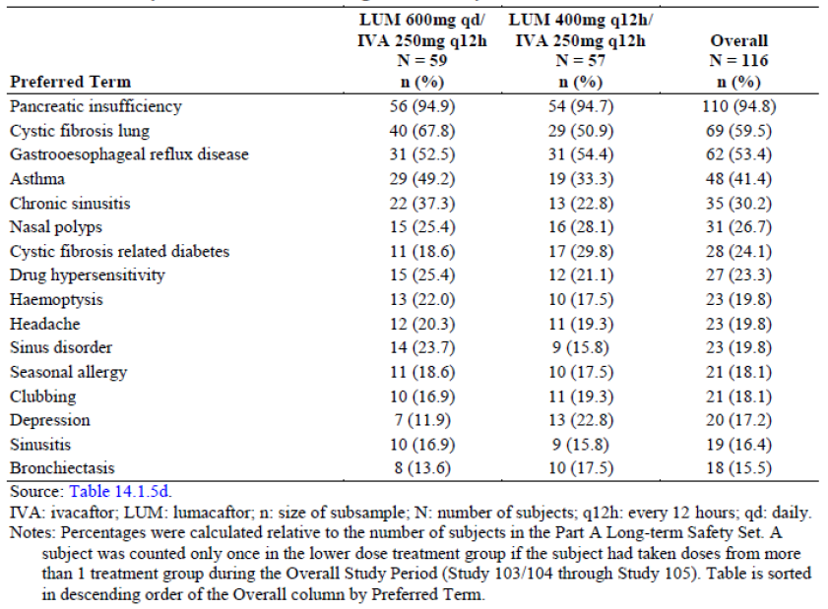

Part B; Current Study Period ‘All Subjects set’
Overall, 96.5% of subjects were White, 93.0% were not Hispanic or Latino, 72.2% were from North America, and 48.7% were female; the median age was 28.0 years (range: 19, 58) and there were no subjects in the 12 to < 18 years old subgroup. Subject demography was similar in the LUM 400 mg q12h/IVA 250 mg q12h and Placebo/LUM 400 mg q12h/IVA 250 mg q12h groups. Baseline height, weight and BMI were similar in the LUM 400 mg q12h/IVA 250 mg q12h and placebo/LUM 400 mg q12h/ IVA 250 mg q12h groups. Baseline lung function was better in the LUM 400 mg q12h/IVA 250 mg q12h group compared with the placebo/LUM 400 mg q12h/IVA 250 mg q12h group. The percentages of subjects who received any inhaled antibiotic (69.6% overall), any bronchodilator (93.9% ), any inhaled hypertonic saline (64.3%), and corticosteroids (67.8%) before the first dose were similar in the LUM 400 mg q12h/ IVA 250 mg q12h and placebo/LUM 400 mg q12h/IVA 250 mg q12h groups. The percentage of subjects with positive Pseudomonas aeruginosa status before the first dose was higher in the placebo/LUM 400 mg q12h/IVA 250 mg q12h group (88.3%) compared with the LUM 400 mg q12h/IVA 250 mg q12h group (76.4%). The percentage of subjects who received dornase alfa before the first dose was higher in the LUM 400 mg q12h/IVA 250 mg q12h group (83.6%) than in the placebo/LUM 400 mg q12h/ IVA 250 mg q12h group (73.3%). In the Part B Current Study Period, the incidence of medical history was generally similar across treatment groups. The most common concomitant medications (incidence of at least 50%) were indicated for the management of CF complications: dornase alfa (78.3%), salbutamol (72.2%), sodium chloride (71.3%), azithromycin (69.6%), pancreatin (69.6%), and tobramycin (53.9%).

Efficacy results

Lung function (Spirometry)
For the LUM 600 mg qd/IVA 250 mg q12h group, the LS mean absolute change in percent predicted FEV₁ during Study 105 ranged from 2.39 to 3.25 percentage points; the LS mean absolute change at Week 24 of Study 105 was 3.25 percentage points (p < 0.0001) versus 2.73 percentage points (p < 0.0001) at Week 24 of Studies 103/104. For the LUM 400 mg q12h/ IVA 250 mg q12h group, the LS mean absolute change in percent predicted FEV₁ during Study 105 ranged from 2.34 to 3.34 percentage points; the LS mean absolute change at Week 24 of Study 105 was 2.62 percentage points (p = 0.0002) versus 2.26 percentage points (p < 0.0001) at Week 24 of Studies 103/104. Similar trends were observed when relative change in percent predicted FEV₁ was analysed. Subjects who received placebo in Studies 103/104 had improvements in percent predicted FEV₁ upon receiving active treatment in Study 105. Improvements in percent predicted FEV₁ were observed as early as Day 15 of Study 105 and were sustained through Week 16 for the placebo/LUM 600 mg qd/IVA 250 mg q12h group and Week 24 for the placebo/LUM 400 mg q12h/IVA 250 mg q12h group.

Nutritional status (BMI and weight)
For subjects who received active treatment in Studies 103/104, both groups had improvements in BMI and weight up to and including Week 24 of Studies 103/104 that continued to improve through all visits in Study 105. At Week 24 of Study 105, improvements in BMI were larger than those observed at Week 24 of Studies 103/104 (0.56kg/m² versus 0.44kg/m²) with similar trends observed for weight (2.26kg versus 1.53kg). Of the subjects who received placebo in Studies 103/104, those who received LUM 400 mg q12h/IVA 250 mg q12h in Study 105 had improvements in BMI and weight upon receiving active treatment in Study 105 (Figures 15 and 16). The placebo/LUM 400 mg q12h/IVA 250 mg q12h group had improvements in BMI and weight throughout Study 105 that were similar to those observed for the LUM 400 mg q12h/ IVA 250 mg q12h group in Studies 103/104. The placebo/LUM 600 mg qd/IVA 250 mg q12h group had numerical improvements in BMI and weight in Study 105; however, the magnitude of improvement in both BMI and weight was smaller compared to the LUM 600 mg qd/IVA 250 mg q12h group in Studies 103/104.
Figure 15. Absolute change from baseline in BMI at each visit, Part A cumulative period full analysis set
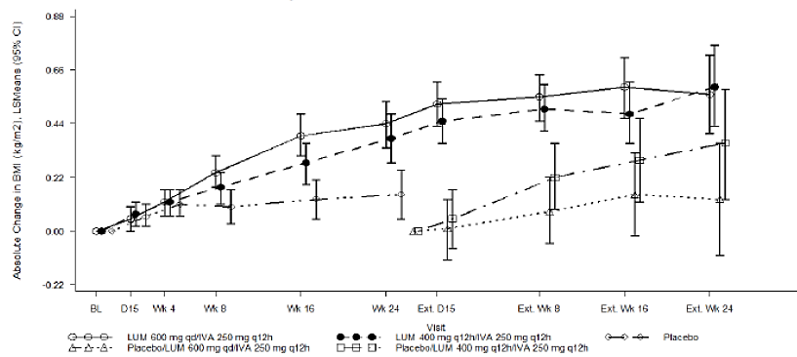
Figure 16. Absolute change from baseline in weight at each visit, Part A cumulative period, full analysis set
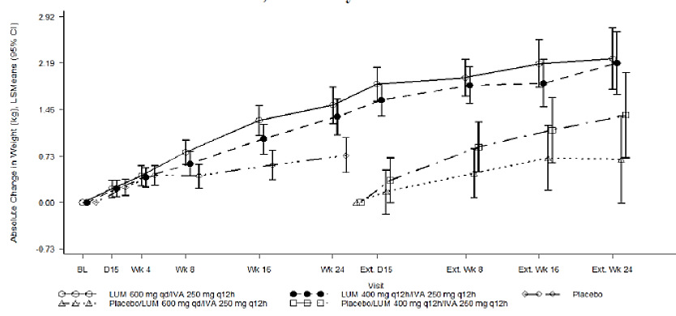
Comment: For subjects who received active treatment in Studies 103/104, both groups had improvements in percent predicted FEV₁ from Day 15, through subsequent visits up to and including Week 24 of Studies 103/104 that were sustained through all visits in Study 105. At Week 24 of Study 105, improvements in percent predicted FEV₁ were similar to those observed throughout Studies 103/104.
- Subjects who received placebo in Studies 103/104 had improvements in percent predicted FEV₁ upon receiving active treatment in Study 105. The magnitude and trend of the improvement observed in these subjects in Study 105 was similar to that observed over the same duration for subjects who received active treatment in Studies 103/104
- For subjects who received active treatment in Studies 103/104, both groups had improvements in BMI and weight up to and including Week 24 of Studies 103/104 that continued to improve through all visits in Study 105. At Week 24 of Study 105, improvements in BMI and weight were larger than those observed at Week 24 of Studies 103/104
- The CSR states that both the placebo/LUM 400 mg q12h/IVA 250 mg q12h and placebo/LUM 600 mg qd/IVA 250 mg q12h groups had improvements in BMI and weight throughout Study 105 that were similar to those observed for both the LUM/IVA treatment groups in Studies 103/104. However, interpretation of results at Week 24 of Study 105 for subjects who received placebo in Studies 103 and 104 was limited due to the small number of subjects included in the analysis relative to the analysis at Week 24 of Studies 103 and 104.

Study VX-08-770-104
This study was a Phase II, randomised, double blind, placebo controlled, parallel group study (Part A) with an open label extension (Part B) of orally administered ivacaftor (VX-770) in 140 subjects aged > 12 years with CF homozygous for the F508del-CFTR mutation. The primary objective of Part A was to evaluate the safety and efficacy of 16 weeks of treatment with VX-770 in subjects with CF who are homozygous for the F508del-CF transmembrane conductance regulator (CFTR) mutation; the secondary objective was to investigate the pharmacokinetics (PK) of 16 weeks of treatment with VX-770 and metabolitesM1 and M6 (if possible) after multiple oral doses of VX-770. The primary and secondary objectives of Part B were to evaluate the safety and efficacy, respectively of long-term VX-770 treatment in subjects with CF who are homozygous for the F508del-CFTR mutation and who were considered responders in Part A (Figure 17).
Figure 17 Study VX08-770-104 ivacaftor monotherapy Part A schematic of study designt 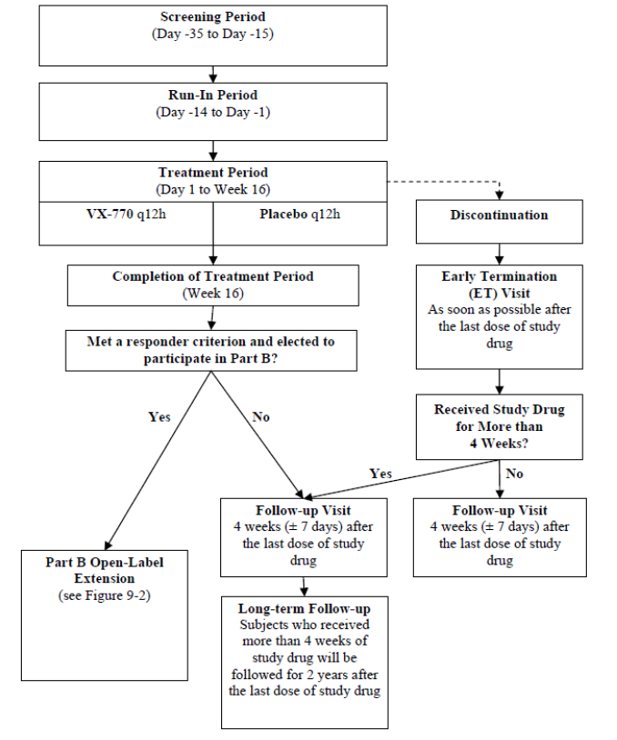
Subjects in Part A of this study were randomised to receive either 150 mg VX-770 or placebo every 12 hours (q12h) for 16 weeks. Part A included a Screening Period (Day -35 to Day -15), a Run-In Period (Day -14 to Day -1, before first dose of study drug (VX-770 or placebo)), a Treatment Period (Day 1 (first dose of study drug) to Week 16), a Follow-up Visit (4 weeks 7 days after last dose of study drug) and a long-term follow-up (for 2 years after the last dose of study drug) for subjects who received study drug for more than 4 weeks and who were not to participate in Part B Subjects who met one of the following response criteria and completed 16 weeks of study drug dosing were eligible to participate in Part B: An increase of > 10% relative to baseline in percent predicted forced expiratory volume in 1 second (FEV₁) at 1 or more time points from Day 15 through Week 16, inclusive; A decrease from baseline in sweat chloride concentration of > 15 mmol/L at both the Day 15 and Week 8 visits. Subjects in Part B were to have received open-label 150 mg VX-770 q12h for 96 weeks. Part B included an Extension Period (Week 16 through Week 112). However, the study was discontinued by the sponsor following results obtained from a pre-specified evaluation the Part B data (through Week 40).
This study enrolled 140 subjects who are homozygous for the F508del-CFTR mutation at 34 sites in the US. It was conducted from 21 Sept 2009 to 20 July 2011.
No formal sample size or power analysis was performed for this study. Based on clinical considerations, the sample size of 120 subjects was selected to provide additional safety data on VX-770 in this population.
A total of 104 (92.9%) subjects in the VX-770 group and 26 (92.9%) subjects in the placebo group completed Part A dosing. The most frequent reason for study drug dosing discontinuation was an adverse event (3 (2.7%) subjects in the VX-770 group and 2 (7.1%) subjects in the placebo group). A total of 42 (37.5%) subjects in the VX-770 group and 6 (21.4%) subjects in the placebo group were eligible for rollover to Part B of the study based on pre-specified criteria for improvement in FEV₁ or decrease from baseline in sweat chloride values. Of the eligible subjects, 33 (78.6%) subjects in VX-770 group and 5 (83.3%) subjects in the placebo group rolled over to Part B.
Majority of patients were White (99 to 100%), males (52 to 57%), mean age of 23 to 25years, mean percent predicted FEV₁ of 75 to 79%. Baseline demographics and disease characteristics were mostly similar in placebo and ivacaftor groups. The most common medical conditions and concomitant medications were those commonly associated with CF and were similar in both treatment groups.

Part A efficacy results

Primary efficacy endpoint
Although, the adjusted mean absolute change from baseline through Week 16 in percent predicted FEV₁ was greater in the ivacaftor than in the placebo group (1.54 versus -0.18%), the difference was not statistically significant.

Secondary efficacy endpoints
As the treatment effect for the primary efficacy endpoint was not statistically significant, any observed statistical significance in other efficacy endpoints was reported nominal. Although, the adjusted mean decrease from baseline through Week 16 in sweat chloride values was greater in the ivacaftor than in the placebo group (-2.74 versus 0.13 mmol/L), the difference was nominally statistically significant (p = 0.0384). The changes in sweat chloride occurred by Day 15 and were sustained for the duration of the 16 week treatment period. Ivacaftor treatment did not improve respiratory symptoms, as measured by the change in CFQ-R respiratory domain score over 16 weeks of treatment. An effect of ivacaftor administration on weight, as measured by the change in weight, weight-for-age z-score, BMI, and BMI-for-age z-score over 16 weeks of treatment was not observed in this study.

Tertiary and additional efficacy endpoints
An effect of VX-770 administration on oxygen saturation or EQ-5D score was not observed in this study. A smaller number, shorter duration, and longer time to onset of most CF related events of interest (including pulmonary exacerbations and antibiotic therapy for sinopulmonary signs/symptoms) were observed in the ivacaftor group than in the placebo group, but these differences were not statistically significant.
There were no significant improvements in relative change from baseline through Week 16 in percent predicted FEV₁ and the absolute and relative changes from baseline through Week 16 in FEV₁ and small non-significant improvements in additional spirometry parameters analysed (FVC, FEF27-75%, and FEV₁/FVC).

Part B efficacy results
All subjects in Part B received ivacaftor treatment presented is the treatment assignment in Part A/Part B of the study. For example, placebo/VX-770 for subjects who received placebo in Part A and ivacaftor in Part B and VX-770/VX-770 for subjects who received ivacaftor in both study parts.
Measures of efficacy were considered secondary endpoints in Part B and included absolute change in FEV₁, sweat chloride, CFQ-R, pulmonary exacerbations, weight, and rate of decline in percent predicted FEV₁.
For subjects treated with ivacaftor for 64 weeks (VX-770/VX-770 group), the improvement in FEV₁ from baseline to Week 16 in Part A of the study was not sustained through Week 64. The 5 subjects treated with placebo in Part A did not experience consistent FEV₁ improvement after 48 weeks of VX-770 treatment in Part B. There were no differences in the rate of decline from baseline in percent predicted FEV₁ through Week 64 between the VX-770/VX-770 group (-1.0738%) and the placebo/VX-770 group (5.7445%).
For subjects treated with VX-770 for 64 weeks (VX-770/VX-770 group), the marginal decrease in mean absolute change in sweat chloride that was observed from baseline to Week 16 in Part A was not sustained through Week 64. Treatment with VX-770 for 48 weeks in Part B did not have any additional effect on sweat chloride.
There was no effect of VX-770 on respiratory symptoms, as measured by the change in CFQ-R respiratory domain score, in subjects treated with VX-770 for 64 weeks (VX-770/VX-770 group) or in subjects treated with VX-770 for 48 weeks in Part B (placebo/VX-770 group). There was no improvement in the yearly rate of pulmonary exacerbations with prolonged treatment of ivacaftor. Subjects in both treatment groups gained weight throughout the duration of the study although there were no overall differences in weight gain between subjects treated with VX-770 for 64 weeks (VX-770/VX-770 group )or subjects treated with VX-770 for 48 weeks in Part B (placebo/VX-770 group). There was no effect of VX-770 administration on EQ-5D score during Part B.
Comment: Monotherapy with ivacaftor in CF patients homozygous for the F608del CFTR mutation did not show any improvement in lung function, nutritional status, respiratory symptoms or minimal reduction in sweat chloride observed in this study.

Analyses performed across trials (pooled analyses and meta-analyses)
Data from Studies 103 and 104 were pooled for analysis because of the similarity in the study design, population, and treatment regimens. Analysis of pooled data allowed exploration of any possible trends in subpopulations and pulmonary exacerbation endpoints.
Across both studies, a total of 1,108 subjects were evaluated for efficacy: 368 subjects in the LUM 600 mg qd/ IVA 250 mg q12h group, 369 subjects in the LUM 400 mg q12h/IVA 250 mg q12h group, and 371 subjects in the placebo group. Subject disposition data were similar for the 2 studies. Approximately 95% of subjects in each study completed 24 weeks of study drug treatment and AEs (3%) were the most frequent reason for treatment discontinuation.
Subjects were predominantly White in both studies (98.2% in Study 103 and 99.1% in Study 104). Therefore, study populations were considered representative of the population that is expected to be treated with lumacaftor in combination with ivacaftor as CF is most common within the Caucasian population. The baseline demographics and disease characteristics were similar across the 3 treatment groups.
In both studies, the most common conditions (incidence of at least 30% of subjects exposed to study drug in Study 103 and Study 104, respectively) were pancreatic insufficiency (96.2% and 91.4%), CF lung disease (42.4% and 67.1%), and GERD (33.7% and 42.2%). The treatment groups were generally balanced with respect to type of conditions and proportion of subjects with these conditions. Overall, conditions that were reported at least 5 percentage points more frequently in Study 103 included constipation, while conditions that were reported more frequently in Study 104 included CF lung, GERD, asthma, clubbing, chronic sinusitis and headache. In both studies, the most common concomitant medications overall (incidence of at least 30% of subjects exposed to study drug in Study 103 and Study 104, respectively) were medications typically used for management of CF complications: salbutamol (71.6% and 69.9%), dornase alfa (72.3% and 80.5%), pancreatin (66.1% and 75.3%), sodium chloride (66.8% and 68.3%), azithromycin (58.7% and 67.4%), tobramycin (51.9% and 54.9%), Seretide (33.5% and 30.8%) and ciprofloxacin (30.8% and 36.5%). Pancrelipase was a more common medication in Study 103 (31.9%) than in Study 104 (22.0%). Aztreonam lysine was a more common medication in Study 104 (31.5%) than in Study 103 (24.6%). During the treatment periods, there was less frequent use of a number of antibiotics in the active treatment groups than in the placebo group. This finding is consistent with the reductions in pulmonary exacerbations and related clinical events of interest observed with treatment with lumacaftor in combination with ivacaftor. The use of other concomitant medications (including dornase alfa and bronchodilators) was stable throughout the treatment period for all treatment groups. This is consistent with the protocol-specified recommendation for subjects to remain on their stable CF medication regimen. The median exposures to study drug were identical in all 3 treatment groups across both studies. The majority of subjects completed at least 16 weeks of treatment.
In both studies, analysis of the primary endpoint (absolute change in percent predicted FEV₁ at Week 24, assessed as the average of the treatment effects at Week 16 and at Week 24) showed a treatment effect that was statistically significant for both dosing regimens of lumacaftor and ivacaftor combination therapy (p ≤ 0.0004). The absolute treatment difference in percent predicted FEV₁ was 3.32 percentage points (p < 0.0001) and 2.81 percentage points (p < 0.0001) for the LUM 600 mg qd/IVA 250 mg q12h group and the LUM 400 mg q12h/IVA 250 mg q12h group, respectively. Based on the pooled analysis, the LUM 600 mg qd/IVA 250 mg q12h dosing regimen had a numerically higher improvement in percent predicted FEV₁ compared to the LUM 400 mg q12h/IVA 250 mg q12h dosing regimen. However, this trend was not consistently observed in the individual studies; in Study 104, the LUM 400 mg q12h/ IVA 250 mg q12h dosing regimen had a numerically higher improvement in percent predicted FEV₁. Furthermore, the studies were not powered to detect differences between the two active treatment groups.
In both the individual studies and the pooled analysis, improvements in percent predicted FEV₁ were rapid in onset with significant treatment differences detected for both dosing regimens by Day 15 (the first post-baseline time point assessment; p ≤ 0.0003) and were sustained at each subsequent visit (Figure 18). Similar to the improvements observed for percent predicted FEV₁, analysis of absolute change in FEV₁ (in litres) at Week 24 showed significant treatment effects for both dosing regimens. The absolute treatment difference in FEV₁ ranged from 0.079 to 0.116 L (p ≤ 0.0081) for Study 103 and ranged from 0.094 to 0.108 L (p ≤ 0.0012) for Study 104. In the pooled analysis, the absolute treatment difference in FEV₁ ranged from 0.094 to 0.105 L (p < 0.0001).
Figure 18. Studies 103 and 104: Absolute change form baseline in percent predicted FEV1 at each visit Full analysis set
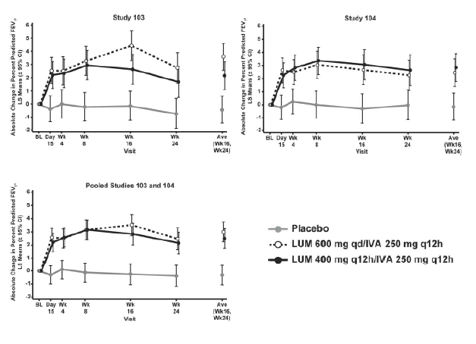
In both studies, treatment with lumacaftor in combination with ivacaftor resulted in improvements favouring active treatment over placebo in all key secondary endpoints. Treatment with both dosing regimens showed a significant improvement in the key secondary endpoint of relative change from baseline in percent predicted FEV₁ at Week 24, assessed as the average of the treatment effects at Week 16 and at Week 24 (p ≤ 0.0007).
Robust reductions in the number of pulmonary exacerbations, including severe pulmonary exacerbations requiring hospitalization or IV antibiotic therapy, were also observed following treatment with both dosing regimens of lumacaftor and ivacaftor combination therapy.
Both studies also showed improvements in BMI with both regimens, with significant increases in BMI compared with placebo observed in Study 104 (p ≤ 0.0001). The pooled analysis showed significant treatment differences of 0.28 kg/m² (p < 0.0001) and 0.24 kg/m² (p = 0.0004) for the LUM 600 mg qd/IVA 250 mg q12h group and the LUM 400 mg q12h/IVA 250 mg q12h group, respectively. The magnitude of improvement in BMI was similar with the 2 combination therapy regimens. A similar pattern was observed for absolute change from baseline in weight at Week 24 as both active treatment groups showed improvement in weight in both studies, although treatment difference compared with placebo was statistically significant only in Study 104 (p ≤ 0.0003). In the pooled analysis, the treatment difference was 0.77 kg (p < 0.0001) and 0.62 kg (p = 0.0013) for the LUM 600 mg qd/IVA 250 mg q12h group and the LUM 400 mg q12h/IVA 250 mg q12h group, respectively.
Across Studies 103 and 104, the treatment differences for both dosing regimens in the absolute change in CFQ-R respiratory domain showed improvements that were similar in magnitude (1.50 to 3.88 points) but did not meet the MCID. Although within group improvements were statistically significant for the LUM 600 mg qd/IVA 250 mg q12h group in Study 103 and both dosing regimens in Study 104, statistically significant treatment differences for patient-reported respiratory symptoms as reported in CFQ-R were only observed in the LUM 600 mg qd/ IVA 250 mg q12h group in Study 103.
In both studies, lumacaftor in combination with ivacaftor treatment resulted in improvements in percent predicted FEV₁, regardless of age, sex, disease severity, geographic region, prior use of CF medications, and P. aeruginosa status with similar results were observed in analyses of pooled data from Studies 103 and 104. Additionally, all subpopulations generally had improvements in the number of pulmonary exacerbations.
Comment: Overall, pooled efficacy analysis from the two pivotal Studies 103 and 104 provided evidence of clinical benefits of lumacaftor and ivacaftor combination therapy in patients 12 years of age and older who are homozygous for the F508del-CFTR mutation. There were significant improvements in lung function, nutritional status and respiratory symptoms (Table 46). All treatment effects demonstrated for the primary and secondary endpoints were in addition to the benefit a subject received from standard of care medications (prior and concomitant medications taken by the majority of subjects in these studies included bronchodilators, dornase alpha, inhaled antibiotics, and inhaled hypertonic saline).

Table 46. Studies 103 and 104 Primary and Key secondary efficacy analysis full analysis set
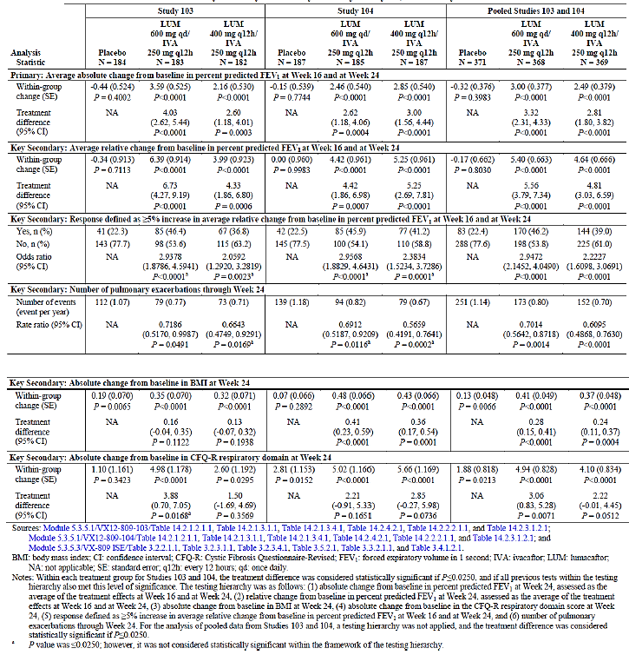

Evaluator’s conclusions on clinical efficacy
Evaluator’s conclusions on clinical efficacy for treatment of cystic fibrosis (CF) in patients aged 12 years and older who are homozygous for the F508del mutation in the CFTR gene.
Both the pivotal Phase III Studies (103 and 104) were well-conducted in over 1,000 patients representative of the target patient population for which approval is being sought in this submission. The study designs, including the treatment duration of 24 weeks, were developed in general accordance with the Committee for Medicinal Products for Human Use (CHMP) Guideline on the Clinical Development of Medicinal Products for the Treatment of Cystic Fibrosis, the Guidance for Industry for Chronic Obstructive Pulmonary Disease, and precedent from other drugs approved for CF. Furthermore, efficacy endpoints were designed to evaluate lung function (FEV₁), respiratory symptoms, pulmonary exacerbations, nutritional effects (weight and body mass index (BMI)) and sweat chloride levels.
Analysis of the primary endpoint (absolute change in percent predicted FEV₁ at Week 24, assessed as the average of the treatment effects at Week 16 and at Week 24) showed a statistically significant (p ≤ 0.0004) and consistent treatment effect in both studies for both LUM 600 mg qd/IVA 250 mg q12h (4.03 and 2.62 percentage points percentage points in Studies 103 and 104, respectively) and LUM 400 mg q12h/ IVA 250 mg q12h (2.60 and 3.00 percentage points, respectively). Statistically significant improvements in percent predicted FEV₁ were rapid in onset and sustained throughout the 24 week treatment period.
Improvements were also observed for multiple secondary endpoints:
- statistically significant improvements in relative change from baseline in percent predicted FEV₁ at Week 24
- reduction in the risk of experiencing a pulmonary exacerbation, and the frequency and duration of pulmonary exacerbations
- reduction in pulmonary exacerbations that required hospitalization or IV antibiotic therapy
- improved respiratory symptoms as measured by CFQ-R respiratory domain score
- improvements in measures of nutritional status, including BMI and weight.
The treatment effects demonstrated for the primary and secondary endpoints were in addition to the benefit a subject received from prescribed CF therapies.
Consistent treatment effects were observed in subjects with all degrees of disease severity, according to baseline percent predicted FEV₁. Subjects with baseline percent predicted FEV₁ less than 40 had improvements that were at least similar to subjects with higher baseline percent predicted FEV₁ values. Consistent treatment effects were also observed regardless of age, sex, geographic region, prior use of CF medications, and P. aeruginosa status.
For some endpoints, the treatment effect numerically favoured 1 dosing regimen versus the other. However, the pivotal studies were not powered to detect statistical differences between the 2 LUM/IVA dosing regimens. However, compared with placebo, treatment with the proposed LUM 400 mg q12h/ IVA 250 mg q12h regimen significantly decreased the risk pulmonary exacerbations by 39% (rate ratio = 0.61, p < 0.0001), reduced risk of exacerbations requiring hospitalisation by 61% (rate ratio = 0.39, p < 0.0001) and reduced exacerbations requiring treatment with intravenous antibiotics by 56% (rate ratio = 0.44, p < 0.0001).
Based on these results and the simplicity of the twice daily FDC regimen, the sponsors are seeking approval for only the lumacaftor 400 mg/ivacaftor 250 mg q12h dosing regimen administered as an FDC of 2 tablets of LUM 200 mg/IVA 125 mg every 12 hours.
The maintenance of efficacy of Orkambi was confirmed in an ad hoc efficacy analysis which was performed after 95 patients who had received Orkambi (lumacaftor 400 mg/ivacaftor 250 mg q12h) in placebo controlled Phase III Studies 103 or 104 had completed the Week 24 Visit in the rollover, long-term Study 105 (up to 48 weeks of treatment overall). However, there was no evidence of efficacy of proposed lumacaftor 400 mg/ivacaftor 250 mg q12h beyond 48 weeks. Long-term efficacy beyond 48 weeks will require confirmation from ongoing rollover, open label, 96 week Study 105 and the data should be provided for evaluation on completion of this study.
In conclusion, results from the two pivotal placebo controlled Phase III Studies (103 and 104) and a rollover Study (105) conducted in over 1,000 subjects showed that lumacaftor in combination with ivacaftor was effective in the treatment of CF, as evidenced by rapid and sustained improvements in important clinical outcomes, including FEV₁, pulmonary exacerbations, and nutritional status. Thus, lumacaftor in combination with ivacaftor is expected to have broad and meaningful clinical benefit in patients 12 years of age and older who are homozygous for the F508del-CFTR mutation patients with F508del mutation is devastating and lumacaftor plus ivacaftor combination product will provide benefit to these patients over the current standard of care treatment.

Clinical safety

Studies providing evaluable safety data
Seventeen clinical studies (as of 21 July 2014) with lumacaftor monotherapy or lumacaftor in combination with ivacaftor (Figure 19) provided evaluable safety data. The core safety data were from pooled analyses of two placebo controlled Phase III studies of LUM/IVA in subjects with CF homozygous for the CFTR-F508del mutation. The supportive analysis includes pooled safety data from 9 Phase I studies (lumacaftor monotherapy and lumacaftor in combination with ivacaftor) in healthy subjects and some Phase I and II non-pooled studies.
Figure 19. Overview of studies (n = 17) and poolings in the summary of clinical safety
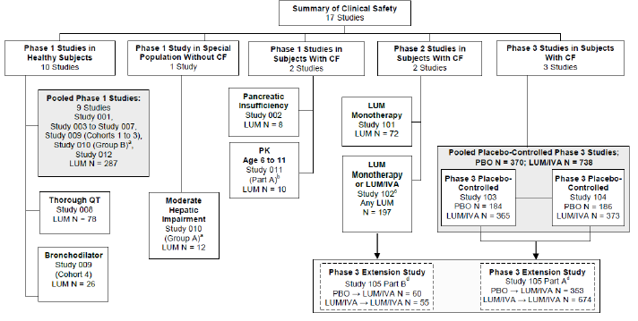

Pivotal efficacy Studies (103 and 104)
Safety data from Studies 103/104 were pooled due to similarity of study design, population and treatment regimens. The pooled analysis provided safety data for 1108 subjects with CF who received at least 1 dose of study drug.
Comment: The only difference in the safety evaluation for Studies 103 and 104 were that ambulatory electrocardiogram (ECG) assessments on a subset of subjects were collected only in Study 103.
In the pivotal efficacy studies, the safety assessments included AEs, clinical laboratory assessments (serum chemistry, haematology, coagulation studies, and urinalysis), physical examinations (PEs), vital signs, pulse oximetry, standard digital ECGs and ambulatory ECGs.
All safety analyses were conducted using the Safety Set. AEs were coded using MedDRA; (Version 17.0). The incidence of AEs that increased in severity or that newly developed at or after the initial dosing of study drug was summarised. Two grading scales were used for scoring AE severity: the Common Terminology Criteria for Adverse Events (CTCAE) grading scale and the FDA’s ‘toxicity grading scale for healthy adult and adolescent volunteers enrolled in preventative vaccine clinical trials’ (Vaccine Toxicity Grading Scale). The incidence of AEs was analysed for the following Safety Set Subgroups: (< 18, ≥ 18 years old), percent predicted FEV₁ at Screening (< 70, ≥ 70), percent predicted FEV₁ at baseline (< 40, ≥ 40), sex (female, male), region (North America, Europe, and Australia) and prior use of inhaled bronchodilator use (yes, no). Adverse events of special interest (AESIs; elevated transaminases, respiratory symptoms, and reactive airways) were defined and summarised.
The number and percentage of subjects with shift changes from baseline to the worst ECG evaluation and the lowest percent of oxygen saturation were tabulated. For subjects who had ambulatory ECGs, change from baseline at Day 1 and at Day 15 for heart rate, ventricular ectopy (VE), and supraventricular ectopy were summarised and the number and percentage of subjects who experienced abnormalities were summarised.
Number and percentage of subjects with a decrease in absolute/relative change in percent predicted FEV₁ and a decrease in absolute/relative change in FEV₁ (L) were summarised.
In addition to the final analysis, 3 unblinded safety reviews were conducted by the Data Monitoring Committee (DMC) during the course of the study. The independent DMC was constituted from the Cystic Fibrosis Foundation Data Safety Monitoring Board.
The following safety assessments were done in the long-term Study 105: AEs (coded using MedDRA Version 17), clinical laboratory assessments (serum chemistry, haematology, coagulation studies, and urinalysis), physical examinations, vital signs, standard digital electrocardiograms (ECGs), pulse oximetry, and spirometry.

Pivotal studies that assessed safety as a primary outcome
None.

Dose-response and non-pivotal efficacy studies
A list of studies that were not included in any pooling and the rationale for not pooling data from these studies is provided in Table 47.

Table 47. Enumeration of subjects exposed to lumacaftor (any regimen or dose) in the non-pooled studies and rationale for not pooling
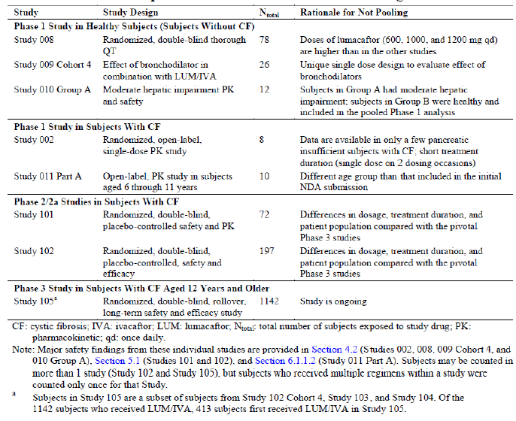

Other studies evaluable for safety only
None.

Clinical pharmacology studies
The pooled analysis of 9 Phase I studies provided safety data for 314 healthy subjects. These studies were pooled irrespective of the study design, treatment regimen, study drug dose, or formulation (Table 48). Safety data were summarised for the following groups: placebo, lumacaftor monotherapy, ivacaftor monotherapy, lumacaftor in combination with ivacaftor (includes DDI of lumacaftor and ivacaftor), lumacaftor in combination with ivacaftor DDI (includes DDI with ciprofloxacin, itraconazole, and rifampin), and overall.

Table 48. Enumeration of healthy subjects exposed to study drug in the pooled Phase I studies, safety set
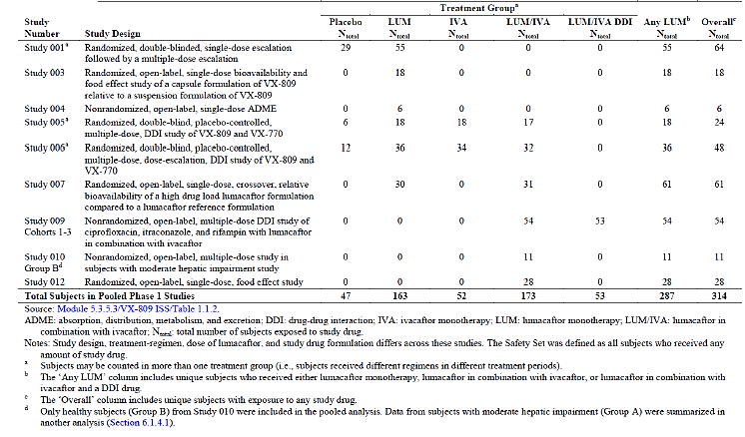

Pivotal studies that assessed safety as a primary outcome
None.

Patient exposure
Overall 1,839 subjects received at least 1 dose of lumacaftor (alone or in combination with another study drug). There were 1,615 subjects who received lumacaftor in combination with ivacaftor (with or without a DDI drug) (Table 49).

Table 49. Number of subjects exposed to lumacaftor any dose and duration
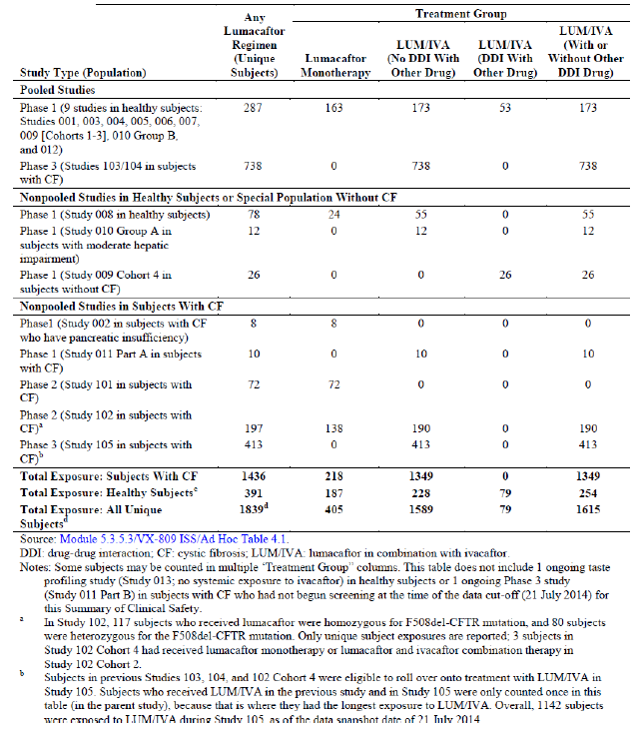

Exposure in the pooled Phase III placebo controlled pivotal Studies (103 and 104)
The mean (SD) treatment duration was similar for the placebo and active treatment groups (165.4 (17.52), 161.2 (30.23) and (161.7 (27.74) days in placebo, LUM 600 mg qd/IVA 250 mg q12h and the LUM 400 mg q12h/IVA 250 mg q12h groups, respectively). Most subjects received more than 16 weeks of treatment (364 (98.4%), 352 (95.4%) and 353 (95.7%) subjects, respectively). There were 74 (20.0%) subjects in the placebo group and 146 (19.8%) subjects in the total LUM/IVA group who had more than 24 weeks exposure; this was due to the ±5 day visit window for the Week 24 Visit. Overall, 1054 (95.1%) subjects completed treatment in the pooled pivotal, placebo controlled Phase III studies, with 693 (93.9%) subjects in the total LUM/IVA group and 361 (97.6%) subjects in the placebo group completing treatment. Subject disposition was generally similar between the LUM 600 mg qd/IVA 250 mg q12h and LUM 400 mg q12h/IVA 250 mg q12h group. A higher percentage of subjects discontinued treatment for any reason in the total LUM/IVA group (6.1%) than in the placebo group (2.4%). A higher percentage of subjects discontinued treatment due to an AE in the total LUM/IVA group (4.2%) than the placebo group (1.6%). Treatment discontinuation rates due to an AE were similar in the LUM 600 mg qd/ IVA 250 mg q12h group (3.8%) and LUM 400 mg q12h/ IVA 250 mg q12h group (4.6%).Of the 54 subjects who discontinued treatment, 26 subjects also discontinued from the study. Study discontinuation rates were similar in the LUM 600 mg qd/ IVA 250 mg q12h group (2.4%) and in the LUM 400 mg q12h/ IVA 250 mg q12h group (3.5%), both of which were higher than placebo (1.1%). A total of 1050 (94.8%) subjects (693 (93.9%) subjects in the total LUM/IVA group and 357 (96.5%) subjects in the placebo group) enrolled in the rollover study (Study 105) The distributions of the baseline characteristics were generally similar across all 3 treatment groups and there were no clinically meaningful differences in baseline characteristics that were likely to have affected the safety outcomes. Overall, there was no clinically meaningful difference in concomitant medication use that suggested an underlying trend or safety concern requiring specific treatment.

Exposure in the long-term, ongoing safety and efficacy Study 105
A total of 1,027 subjects were dosed and included in the All Subject Safety Set in Part A. As of 21 July 2014, the mean treatment duration was similar across all 4 groups (range: 131.7 days to 135 days). Most subjects received at least 16 weeks of treatment for LUM 600 mg qd/IVA 250 mg q12h group (269 (80.5%) subjects), the placebo/LUM 600 mg qd/IVA 250 mg q12h group (138 (78.0%) subjects), the LUM 400 mg q12h/IVA 250 mg q12h group (263 (77.4%) subjects), and the placebo/LUM 400 mg q12h/IVA 250 mg q12h (147 (83.5) days). A subset of subjects was included in the Study 105.
Long-term Safety Set, which included subjects who received active treatment in the previous studies (Studies 103/104) and completed visits of Week 24 and beyond in Study 105 as of 1 July 2014. Overall, the median duration of exposure in the Part A, Long-term Safety Set was 337 days (range: 324 to 360). The overall mean treatment duration (SD) was similar for the LUM 600 mg qd/IVA 250 mg q12h group (337.4 (4.73) days) and LUM 400 mg q12h/ IVA 250 mg q12h group (336.9 (6.63) days). Most subjects received at least 48 weeks of treatment: LUM 600 mg qd/IVA 250 mg q12h group (43 (72.9%) subjects) and LUM 400 mg q12h/IVA 250 mg q12h group (36 (63.2%) subjects). A total of 115 subjects were dosed and included in the All Subject Safety Set for the Current Study Period of Part B (the time from the initial dose of study drug in Study 105 to 28 days, inclusive, after the last dose of study drug in Study 105 or up to the date of the snapshot (21 July 2014), whichever was earlier). In the current study period, the mean treatment duration was similar across the 2 groups (range: 6 days to 254 days). Most subjects received at least 16 weeks of treatment.

Exposure in pooled Phase I studies
In the 9 pooled Phase I studies, 287 healthy subjects were exposed to at least 1 dose of lumacaftor. Of these subjects, 163 subjects received lumacaftor monotherapy, 173 subjects received lumacaftor in combination with ivacaftor, and 53 subjects received lumacaftor in combination with ivacaftor and a DDI drug (ciprofloxacin, itraconazole, or rifampin). Some subjects may have been included in more than 1 treatment group, depending on study design. The median treatment duration was 4 days (range: 1 to 29) for subjects in the ‘Any LUM’ group, 14 days (range: 2 to 15) for subjects in the ‘LUM/IVA’ group, and 2 days (range: 1 to 42) for subjects in the placebo group. The maximum cumulative (non-consecutive) duration of exposure to lumacaftor at any dose or regimen was 29 days (Table 50). Overall, 93% of subjects completed the assigned treatment. Treatment was discontinued in 6 (12.8%) subjects in the placebo group and 4 (2.3%) in the LUM/IVA group. Overall, the most common reason for treatment discontinuation was an AE (7 subjects, 2.2%). The baseline demographics were slightly different to the patient population in the Phase II/III studies in the target patient population. Overall, the majority of subjects were White (67.2%) and male (74.5%). Among subjects in the LUM/IVA group, 64.7% of subjects were White, 28.9% of subjects were Black or African American and 17.3% of subjects were Hispanic or Latino. All subjects were ≥ 18 years with median age of 31 to 33 years, median weight of 71 to 78kg and mean BMI of about 25kg/m².

Table 50. Study drug exposure in pooled phase I studies in healthy subjects safety set
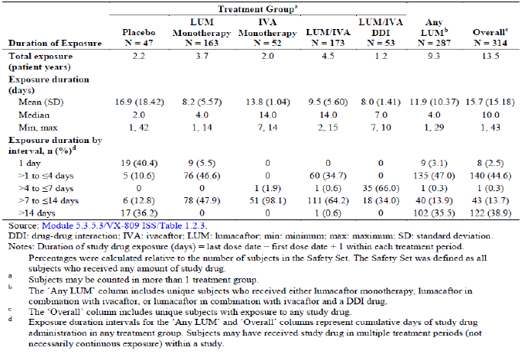
Figure 1
In the non-pooled Phase I studies, 134 subjects received any lumacaftor, with 32 subjects receiving lumacaftor monotherapy (Studies 002 and 008) and 103 subjects receiving lumacaftor in combination with ivacaftor (Studies 008, 009 Cohort 4, 010, and 011 Part A).
Comment: The overall exposure to the proposed dosing with lumacaftor in combination with ivacaftor was adequate to assess the safety for the proposed indication. However, long term safety beyond 48 weeks would require confirmation on completion of the ongoing 96 week Study 105.

Adverse events

All adverse events (irrespective of relationship to study treatment)

Pivotal studies
The incidence of AEs was similar between the placebo group (95.9%) and the total LUM/IVA group (95.8%). Overall, the most common AEs (at least 15% incidence in any treatment group) were infective pulmonary exacerbation of CF, cough, headache, and sputum increased. AEs with an incidence at least 3% higher in the total LUM/IVA group than the placebo group were dyspnoea (14.0% versus 7.8%), respiration abnormal (9.8% versus 5.9%), flatulence (6.0% versus 3.0%) and rash (5.6% versus 1.9%). AEs for which the incidence in the total LUM/IVA group was ≥ 5% and the difference in incidence was ≥ 1% higher compared with the placebo group were dyspnoea, diarrhoea, nausea, respiration abnormal, oropharyngeal pain, upper respiratory tract infection, flatulence, rhinitis, rash, rhinorrhoea and vomiting. AEs for which the incidence in the placebo group was at least 3% higher than the total LUM/IVA group were infective pulmonary exacerbation of CF (49.2% versus 37.5%), cough (40.0% versus 30.5%), sputum increased (18.9% versus 14.8%), nasal congestion (11.9% versus 7.7%) and pulmonary function test decreased (5.4% versus 1.6%). The incidence of most AEs was similar in the 2 active treatment groups. However, the following AEs had an at least 3% higher incidence in the LUM 600 mg qd/IVA 250 mg q12h group compared with the LUM 400 mg 12h/IVA 250 mg q12h group: infective pulmonary exacerbation of cystic fibrosis (39.3% versus 35.8 %), cough (32.8% versus 28.2%), oropharyngeal pain (11.9% versus 6.5%) and rhinitis (8.1% versus 4.3%). The following AEs had an at least 3% higher incidence in LUM 400 mg q12h/IVA 250 mg q12h group compared to the LUM 600 mg qd/IVA 250 mg q12h group: nausea (12.5% versus 7.9%), nasopharyngitis (13.0% versus 6.2%), upper respiratory tract infection (10.0% versus 6.5%) and blood creatine phosphokinase increased (7.3% versus 3.8%) (Table 51).

Table 51. Adverse events with an incidence of at least 5% in any treatment group by preferred term: pooled placebo controlled Phase III studies
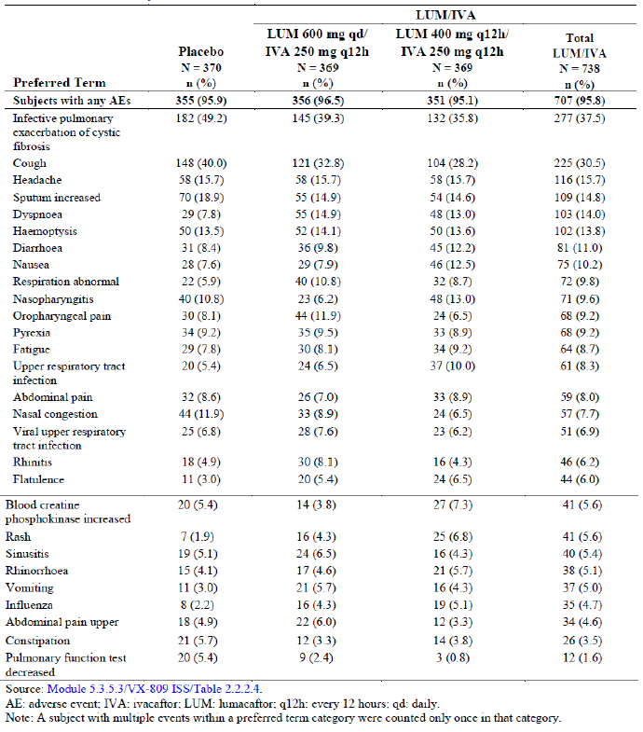
The majority of AEs across all 3 treatment groups were mild or moderate in severity. There was a similar incidence of mild (Grade 1), moderate (Grade 2) and severe (Grade 3) AEs in the total LUM/IVA group (mild: 35.5%; moderate: 46.5%; severe: 13.6%) and in the placebo group (mild: 29.2%; moderate: 50.8%; severe: 15.1%). The incidence of severe AEs was slightly lower in the LUM 400 mg q12h/ IVA 250 mg q12h group (11.9%) compared with the LUM 600 mg qd/ IVA 250 mg q12h group (15.2%). A lower percentage of subjects had Grade 3/4 AEs in the total LUM/IVA group (13.8%) compared with the placebo group (15.9%). Most of the Grade 3 or 4 AEs were respiratory and gastrointestinal events, as expected in subjects with CF. Infective pulmonary exacerbation of CF, headache and blood CPK increased were the only Grade 3 or 4 AEs that had an incidence of at least 1% in any treatment group. The incidence of Grade 3 or 4 infective pulmonary exacerbation of CF was 7.8% in the placebo group and 5.8% in the total LUM/IVA group (4.3% in the LUM 400 mg q12h/ IVA 250 mg q12h group and 7.3% in the LUM 600 mg qd/ IVA 250 mg q12h group). The incidence of Grade 3 or 4 headache was 1.1% in the LUM 600 mg qd/IVA 250 mg q12h group, 0.5% in the LUM 400 mg q12h/ IVA 250 mg q12h group, and 0.5% in the placebo group. There were no other meaningful differences in the 2 active treatment groups. Five subjects had life-threatening (Grade 4) AEs: 3 subjects in the placebo group (acute renal failure; metastatic colon cancer; and suicide attempt), 1 subject in the LUM 600 mg qd/ IVA 250 mg q12h group (cholestasis, hepatitis, and hematoma) and 1 subject in the LUM 400 mg q12h/ IVA 250 mg q12h group (haemoptysis).
An analysis of the incidence of AEs by 8 week intervals demonstrated that the onset of the majority of new AEs was generally higher in the first 8 weeks of treatment in both the LUM/IVA and placebo groups. No AEs increased in incidence more than 2% after the first 8 weeks. Compared with the first 8 week interval, the incidences of dyspnoea and respiration abnormal were lower in later intervals (> 8 to ≤ 16 weeks and > 16 to ≤ 24 weeks) in both the total LUM/IVA and placebo groups. The incidence of AEs over time was generally similar in the LUM 600 mg qd/IVA 250 mg q12h and LUM 400 mg q12h/IVA 250 mg q12h groups.

Other studies

Long-term Study 105
There was a lower incidence of AEs in subjects who received active treatment in Studies 103/104 compared with subjects who received placebo in Studies 103/104: 81.4% in the LUM 600 mg qd/IVA 250 mg q12h compared with 90.4% in the placebo/LUM 600 mg qd/IVA 250 mg q12h group; 82.1% in the LUM 400 mg q12h/IVA 250 mg q12h group compared with 88.1% in the placebo/LUM 400 mg q12h/IVA 250 mg q12h group. Overall, the most common AEs (≥ 15% overall) were infective pulmonary exacerbation of CF (28.9% of subjects) and cough (20.8% of subjects). AEs that had more than a 5% difference between the LUM 600 mg qd/IVA 250 mg q12h group and placebo/LUM 600 mg qd/IVA 250 mg q12h group were cough and respiration abnormal. Both of these adverse events had higher incidence in the placebo/LUM 600 mg qd/IVA 250 mg q12h group. The only AE that had more than a 5% difference between the LUM 400 mg q12h/IVA 250 mg q12h group and placebo/LUM 400 mg q12h/IVA 250 mg q12h group was dyspnoea, which had higher incidence in the placebo/LUM 400 mg q12h/IVA 250 mg q12h group (Table 52). Overall, in the Current Study Period the majority of subjects across the treatment groups had AEs that were mild or moderate in severity (mild: 35.2% and moderate: 39.6%). There was a similar incidence of severe AEs in all 4 groups (range: 7.1% to 11.4%). There were 2 (0.2%) subjects who had life threatening events: 1 subject in the LUM 400 mg q12h/IVA 250 mg q12h group had 2 life threatening SAEs (infective pulmonary exacerbation of cystic fibrosis with subsequent fatal respiratory failure) and 1 subject in the LUM 600 mg qd/IVA 250 mg q12h group (haemolytic anaemia).

Table 52. Adverse events with a frequency of ≥ 5% by preferred term in any treatment by system organ class and preferred term: Study 105 Part A current study period all subjects safety set
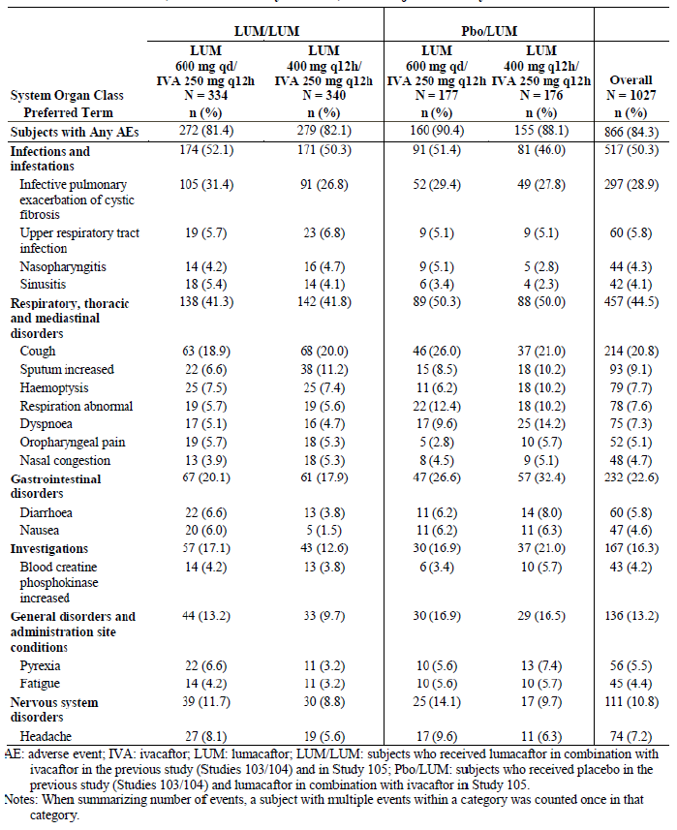
In the Long-Term Safety Set, the overall incidence of AEs was lower during the Uncontrolled Study Period in Study 105 (88.8%) compared with the Placebo controlled Study Period in Studies 103/104 (96.6%). The most common AEs (≥ 25% in any treatment group in the overall period) were infective pulmonary exacerbation of CF, cough, oropharyngeal pain, dyspnoea, nasal congestion, and respiration abnormal). These AEs were mostly expected manifestations of CF disease. By PT, the incidence of all AEs was lower or similar (< 4% higher) in the Uncontrolled Study Period compared with Placebo controlled Study Period. Overall, the majority of subjects across the treatment groups had adverse events that were mild or moderate in severity (mild: 23.3% and moderate: 55.2%). None of the subjects had life-threatening events.
Based on data available at this interim analysis from Part B Current Study Period (which included subjects who were heterozygous for the F508del-CFTR mutation), lumacaftor 400 mg q12h in combination with ivacaftor 250 mg q12h was well tolerated with continued treatment. The incidence of AEs in the LUM 400 mg q12h/IVA 250 mg q12h group (85.5%) and placebo/LUM 400 mg q12h/IVA 250 mg q12h group (80%) was similar. The most common AEs (those occurring in ≥ 15% of subjects in any treatment group) were infective pulmonary exacerbation of CF, cough, respiration abnormal, sputum increased, haemoptysis and dyspnoea.

Phase I pooled studies
Of the 173 healthy subjects in the LUM/IVA group, 95 subjects (54.9%) had at least 1 AE. Of the 47 subjects in the placebo group, 27 subjects (57.4%) had at least 1 AE. The most common AEs occurring in at least 5% of subjects in the LUM/IVA group were diarrhoea (17.3%), headache (7.5%), and cough (6.9%). AEs occurring in ≥ 3% higher incidence in the LUM/IVA group compared with the placebo group were diarrhoea (17.3% and 6.4%) and cough (6.9% and 0%). AEs occurring in ≥ 3% higher incidence in the placebo group compared with the LUM/IVA group were headache (23.4% and 7.5%), abdominal pain (8.5% and 2.9%), pain in extremity (4.3% and 0.6%) and nausea (10.6% and 1.7%). The majority of AEs were mild or moderate in severity. Of the 95 subjects in the LUM/IVA group who had an AE 1 subject (0.6%) had a severe AE (diarrhoea). Of the 27 subjects in the placebo group who had an AE, 1 subject (2.1%) had a severe AE (diarrhoea). No subjects in the LUM/IVA, LUM/IVA DDI, or placebo groups had a life-threatening AE. Overall, 4 (1.3%) subjects had a Grade 3 or 4 AE. One subject (0.6%) in the LUM/IVA group and 1 subject (2.1%) in the placebo group had a severe AE of diarrhoea. Other Grade 3 or 4 AEs that occurred during the pooled Phase I studies were lipase increased and rhabdomyolysis.

Other studies
Study 101 is a completed, Phase IIa, multiple dose (25, 50, 100, or 200 mg qd of lumacaftor or placebo) study evaluating lumacaftor monotherapy for 28 days in subjects with CF who are homozygous for the F508del-CFTR mutation. Overall, lumacaftor was well tolerated at doses of 25, 50, 100, or 200 mg for 28 days. The AEs observed were typical manifestations of CF and most AEs were considered mild or moderate in severity. Study 102 was a double blind, randomised, placebo controlled, multiple dose, dose finding, Phase II study evaluating lumacaftor monotherapy and lumacaftor and ivacaftor combination therapy in subjects with CF who are homozygous (Cohorts 1 to 3) or heterozygous (Cohorts 2 and 4) for the F508del-CFTR mutation. Subjects enrolled in Cohorts 1 to 3 received placebo or lumacaftor monotherapy followed by lumacaftor in combination with ivacaftor. Subjects enrolled in Cohort 4 received placebo or lumacaftor in combination with ivacaftor. Safety results from this study were provided.
Study 011 was an open label, 2 part study designed to evaluate the PK, safety, tolerability, and efficacy of lumacaftor in combination with ivacaftor in subjects 6 through 11 years of age with CF who were homozygous for the F508del-CFTR mutation. Data from Part A (a Phase I study in subjects aged 6 to 11 years old) were provided. Part B (a Phase III study) is ongoing and data was not provided in this submission.

Treatment-related adverse events (adverse drug reactions)

Pivotal studies
The incidence of treatment-related AEs was higher in the total LUM/IVA group (48.0%) compared with the placebo group (34.9%).

Other studies

Study 105
Phase I pooled studies: Of the 95 subjects in the LUM/IVA group who had an AE, 5 subjects (2.9%) had an AE considered to be related to study drug, and 52 subjects (30.1%) had an AE considered to be possibly related to study drug. Of the 27 subjects in the placebo group who had an AE, 3 subjects (6.4%) had an AE considered to be related to study drug, and 12 subjects (25.5%) had an AE considered to be possibly related to study drug.

Deaths and other serious adverse events

Pivotal studies
There were no deaths in the pooled placebo controlled Phase III studies. The incidence of SAEs was lower in the total LUM/IVA group (20.1%) compared with the placebo group (28.6%). The incidence of related SAEs was similar in the placebo (2.2%) and total LUM/IVA group (3.0%). A lower percentage of subjects had SAEs in the LUM 400 mg q12h/ IVA 250 mg q12h group (17.3%) compared with the LUM 600 mg qd/IVA 250 mg q12h group (22.8%), but both active groups had lower incidence than placebo. The most common SAE (at least 10% incidence) in any treatment group was infective pulmonary exacerbation of CF. The incidence of this SAE was lower in the total LUM/IVA group (13.0%) compared with the placebo group (24.1%). The only other SAEs that occurred in more than 2 subjects in any treatment group were haemoptysis and distal intestinal obstruction syndrome, both of which occurred in the placebo and LUM/IVA groups. Related SAEs that occurred in 2 or more subjects overall were: blood CPK increased (total LUM/IVA versus placebo: 0.3% versus 0%), liver function test abnormal (0.3% versus 0%), bronchospasm (0.3% versus 0%), haemoptysis (0.3% versus. 0.5%), infective pulmonary exacerbation of cystic fibrosis (0.1% versus. 1.1%), nephrolithiasis (0.3% versus. 0%), and rash (0.3% versus. 0%).

Other studies

Long-term Study 105
As of the data snapshot date, 1 death has been reported in Study 105. A 24 year old female in the LUM 400 mg q12h/IVA 250 mg q12h group (in parent and current study) died due to respiratory failure.
A total of 168 (16.4%) subjects had at least 1 SAE in Part A Current Study Period. The incidence of subjects with SAEs was similar across all 4 treatment groups (range: 15.3% to 19.9%). The most common SAE (≥ 10% overall) was infective pulmonary exacerbation of CF, which had a similar incidence in all 4 groups (range: 10.2% to 12.4%). SAEs which occurred in more than 2 subjects overall included; haemoptysis (7 subjects), distal intestinal obstruction syndrome (6 subjects), small intestinal obstruction (5 subjects), pneumonia (4 subjects), respiration abnormal (3 subjects) and CF-related diabetes (3 subjects).
In the Long-Term Safety Set, the overall incidence of SAEs was similar during the Placebo controlled Study Period in Studies 103/104 (12.9%) and the Uncontrolled Study Period (14.7%) in Study 105.

Phase I pooled studies
There were no deaths and no subjects in the LUM/IVA or placebo groups had SAEs. One subject (0.3%) in the LUM monotherapy group had an SAE of rhabdomyolysis that was considered to be possibly related to study drug.

Discontinuation due to adverse events

Pivotal studies
A higher percentage of subjects discontinued treatment due to AEs in the total LUM/IVA group (4.2%) compared with the placebo group (1.6%). The most common AEs (at least 2 subjects in any treatment group) that led to discontinuation of study drug were haemoptysis (2 subjects in the placebo group and 3 subjects in the LUM 400 mg q12h/IVA 250 mg q12h group) and blood creatine phosphokinase increased (4 subjects in the LUM 400 mg q12h/IVA 250 mg q12h group). Other AEs that led to discontinuation of study drug in at least 2 subjects overall were bronchospasm, dyspnoea, infective pulmonary exacerbation of CF and rash.
The incidence of AEs leading to treatment interruption was similar in the total LUM/IVA group (5.7%) and placebo group (6.8%). The most common AEs (at least 2 subjects in any treatment group) that led to interruption of study drug were infective pulmonary exacerbation of CF, vomiting, distal intestinal obstruction syndrome, nausea, constipation, alanine aminotransferase increased, aspartate aminotransferase increased, blood creatinine phosphokinase increased, haemoptysis, rash and headache. The only AE that led to treatment interruption with a difference of at least 1% in any treatment group was infective pulmonary exacerbation of CF, which had an incidence of 2.2% in the placebo group and 1.1% in the total LUM/IVA group. There were no clinically meaningful differences in AE incidence leading to study drug interruption in the LUM 600 mg qd/IVA 250 mg q12h group and the LUM 400 mg q12h/ IVA 250 mg q12h group.

Other studies

Long-term Study 105
The incidence of AEs leading to treatment discontinuation was higher in subjects who received active treatment in Studies 103/104 compared with subjects who received placebo in Studies 103/104: 4.5% in the placebo/LUM 600 mg qd/IVA 250 mg q12h group compared with 2.1% in the LUM 600 mg qd/IVA 250 mg q12h group; 4.0% in the placebo/LUM 400 mg q12h/IVA 250 mg q12h group compared with 1.8% in the LUM 400 mg q12h/IVA 250 mg q12h group. The most common AEs (those occurring in at least 2 subjects) leading to treatment discontinuation during treatment were dyspnoea (7 subjects), respiration abnormal (5 subjects), infective pulmonary exacerbation of cystic fibrosis (4 subjects) and blood creatine phosphokinase increased (3 subjects).

Phase I pooled studies
Overall, 7 (2.2%) subjects had an AE leading to treatment discontinuation including 1 subject in the LUM/IVA group for influenza and 1 subject in the placebo group for ALT increased.

Laboratory tests

Liver function

Pivotal studies
In pivotal Study 103, as a result of safety findings reported in CIOMS AE-2013-011098 (dated 21 January 2014), an ad hoc DMC safety review was requested by Vertex, and the protocol was amended to Version 3.0 to include additional mandatory testing to monitor the safety of liver function. Following the ad hoc DMC safety review, it was recommended that the study could continue with monitoring of LFTs every 4 weeks as implemented in the protocol. Subjects with history of any comorbidity that, in the opinion of the investigator, might confound the results of the study or pose an additional risk in administering study drug to the subject (for example, history of cirrhosis with portal hypertension) and subjects with abnormal liver function, defined as presence of any 3 or more of the following: ≥ 3 × ULN AST, ≥ 3 × ULN ALT, ≥ 3 × ULN gamma glutamyl transferase (GGT), ≥ 3 × ULN ALP, or ≥ 2 × ULN total bilirubin, were excluded from Studies 103/104.
The incidence of elevated transaminases or hepatobiliary disorder AEs was similar in the total LUM/IVA group (5.7%) and the placebo group (5.4%). Within the active treatment groups, the incidence was similar between the LUM 600 mg qd/ IVA 250 mg q12h group (5.4%) and the LUM 400 mg q12h/IVA 250 mg q12h group (6.0%). The incidence of AESIs of elevated transaminases was also similar in the total LUM/IVA group (5.1%) and the placebo group (4.6%). The AESIs of elevated transaminases with the highest overall incidence were ALT increased (1.9% in the total LUM/IVA group and 2.4% in the placebo group) and AST increased (2.0% in the total LUM/IVA group and 2.2% in the placebo group). The majority of elevated transaminases or AEs reflecting hepatobiliary disorder were mild or moderate in severity. Five subjects in the total LUM/IVA group (3 subjects in the LUM 600 mg qd/IVA 250 mg q12h group and 2 subjects in the LUM 400 mg q12h/IVA 250 mg q12h group) and 1 subject in the placebo group had elevated transaminases or hepatobiliary disorder AEs that were severe. Overall, 7 subjects (0.9%) in the total LUM/IVA group (4 subjects in the LUM 600 mg qd/IVA 250 mg q12h and 3 subjects in the LUM 400 mg q12h/IVA 250 mg q12h group) had SAEs of elevated transaminases or hepatobiliary disorders. Among these subjects, 4 (0.5%) subjects in the total LUM/IVA group (3 subjects in the LUM 600 mg qd/IVA 250 mg q12h group and 1 subject in the LUM 400 mg q12h/IVA 250 mg q12h group) discontinued treatment due to the SAE. Following discontinuation or interruption of LUM/IVA, liver function tests returned to baseline or improved substantially in all 7 subjects. The median time-to-onset of the first AESI of elevated transaminases was 59 days for the total LUM/IVA group and 61 days for the placebo group. The incidence of AESIs of elevated transaminases in 8 week treatment interval was 2.6% in the total LUM/IVA group and 1.9% in the placebo group in the first 8-week interval (> 0 to ≤ 8 weeks) and similar in the next two 8 week treatment intervals (> 8 to ≤ 16 weeks and > 16 to ≤ 24 weeks). The median duration of events in the total LUM/IVA group was 29 days compared with 22 days for the placebo group.
The mean values for transaminases (ALT and AST) and total bilirubin at baseline were similar between the total LUM/IVA group and placebo group. Both the total LUM/IVA group and the placebo had minimal changes from baseline in mean values at Week 24 that were similar in magnitude. Mean ALT values in the LUM 600 mg qd/IVA 250 mg q12h group and LUM 400 mg q12h/IVA 250 mg q12h group increased slightly at Day 15, returned to slightly below baseline values at Week 4, and remained stable around baseline values through Week 24.
Mean ALT values in the placebo group remained stable around baseline values through Week 24. Mean AST values followed a similar trend, with a slight increase at Day 15, return to baseline values at Week 4, and remaining stable through Week 24 in the 2 active treatment groups. Mean total bilirubin and mean ALP values decreased in both LUM/IVA treatment groups beginning at Day 15, stabilised by Week 4, and remained stable below baseline values through Week 24. Mean total bilirubin and ALP values in the placebo group remained stable around baseline values through Week 24 (Figures 19 and 20).
Figure 19. Total bilirubin each visit. Pooled placebo-controlled Phase III studies safety set
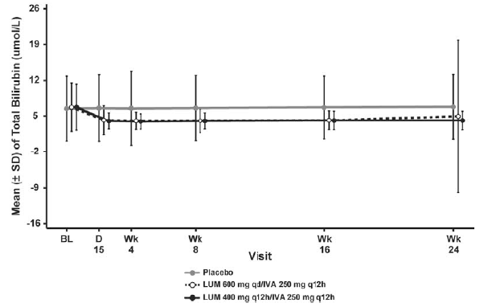
Figure 20. ALP at each visit. Pooled placebo controlled Phase III studies safety set
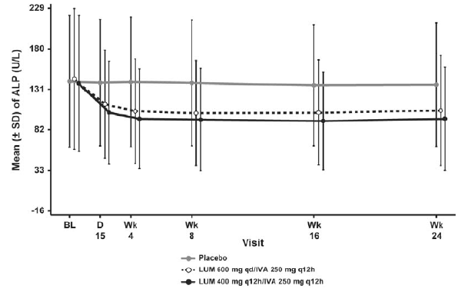
Overall, the incidence of elevated liver enzymes (> 3 ×, > 5 ×, and > 8 × ULN) was similar in the total LUM/IVA group and the placebo group. Nine subjects (1.2%) in the total LUM/IVA group had ALT or AST concentrations > 5 × ULN to ≤ 8 × ULN compared with 5 subjects (1.4%) in the placebo group. Six subjects (0.8%) in the total LUM/IVA group had ALT or AST concentrations > 8 × ULN compared with 2 subjects (0.5%) in the placebo group. Compared with no subjects in the placebo group, ALT or AST elevations associated with increases in total bilirubin concentrations occurred in 2 subjects in the LUM 600 mg qd/IVA 250 mg q12h group and 1 subject in the LUM 400 mg q12h/IVA 250 mg q12h group.
Two subjects in the LUM 600 mg qd/IVA 250 mg q12h group and 1 subject in the LUM 400 mg q12h/ IVA 250 mg q12h group had ALT and/or AST elevations > 3 x ULN associated with concomitant increases in total bilirubin concentrations > 2 x ULN. All 3 cases are complicated by numerous factors, including concurrent medical issues and underlying liver disease, suggesting alternative aetiologies, although a contributory role of LUM/IVA cannot be excluded.
The incidence of transaminase elevations > 5 × ULN was similar in the total LUM/IVA group (15 subjects, 2.0%) and the placebo group (7 subjects, 1.9%). The time to onset for these events ranged from Day 8 to Week 24 from the first dose of study drug, with no apparent pattern identified. Among subjects with transaminase elevations > 5 × ULN, 6 subjects in the total LUM/IVA group (LUM 600 mg qd/IVA 250 mg q12h, n = 4; LUM 400 mg q12h/ IVA 250 mg q12h, n = 2) had SAEs related to transaminase elevation compared with no subjects in the placebo group. Three subjects with transaminase elevations > 5 × ULN in the LUM 600 mg qd/IVA 250 mg q12h group discontinued treatment. All the subjects that had liver related SAEs had complicated clinical histories and represent a mixture of LFT patterns.
Overall, the proportion of subjects with a medical history of various hepatobiliary conditions or liver enzyme elevation was generally similar in both the total LUM/IVA group and the placebo group in the pooled placebo controlled Phase III studies. Among subjects with a history of liver disease, the baseline incidence of ALT or AST abnormalities was similar in the total LUM/IVA and placebo groups. The proportion of subjects with a medical history of liver disease that had maximum on-treatment ALT or AST levels > 2 ×, > 3 ×, > 5 ×, and > 8 × ULN was similar in the total LUM/IVA group compared with the placebo group.
Among subjects with a history of elevated liver function tests, the baseline incidence of ALT or AST abnormalities was similar in the total LUM/IVA and placebo groups. However, the proportion of subjects with a medical history of elevated liver function tests that had maximum on-treatment ALT or AST levels > 2 × ULN was higher in the total LUM/IVA group (28.1%) compared with the placebo group (19.8%). The proportion of subjects with a medical history of elevated liver function tests that had maximum on treatment ALT or AST levels > 3 ×, > 5 ×, and > 8 × ULN was similar for both the total LUM/IVA group and the placebo group.
Subgroup analyses by age (< 18 and ≥ 18 years of age) of subjects with transaminase elevations showed that the incidence of transaminase elevations within each age group was similar in the total LUM/IVA group and the placebo group.
Exploratory analyses to evaluate whether there was any association between exposure to LUM/IVA and transaminase elevations were conducted in subjects with transaminase elevations (ALT or AST) > 5×ULN. These analyses did not reveal any relationship between exposure to LUM/IVA and the occurrence of transaminase elevations in subjects exposed to LUM/IVA compared with exposure in subjects without transaminase elevations. To further evaluate whether subjects with transaminase elevations > 5 × ULN have higher exposures relative to the overall study population, ratios of individual concentrations (C_{trough, ave} and C_{3-6h,ave}) for these subjects relative to the group mean concentrations (C_{trough, ave} and C_{3-6h,ave}) were calculated. Based on the geometric mean (90% CI) summary of these individual ratios for the trough concentration and peak concentrations of lumacaftor (0.90 (0.68, 1.19) and 0.97 (0.86, 1.09)) and ivacaftor (0.55 (0.43, 0.69) and 0.68 (0.55, 0.84)), there was no apparent relationship between higher exposure to LUM/IVA and the occurrence of transaminase elevations in subjects exposed to LUM/IVA compared with exposure in subjects without transaminase elevations.
During the Phase III studies, guidance regarding management of transaminase elevations consisted of the following: Subjects with new treatment emergent ALT or AST elevations of > 3 × ULN and clinical symptoms were to be followed closely, including repeat confirmatory testing performed by the central laboratory within 48 to 72 hours of the initial finding and subsequent close monitoring of ALT and AST levels, as clinically indicated. Study drug administration was to be interrupted immediately and the medical monitor notified if any of the following criteria were met: ALT or AST > 8 × ULN; ALT or AST > 5 × ULN for more than 2 weeks; ALT or AST > 3 × ULN, in association with total bilirubin > 2 × ULN and/or clinical jaundice. If no convincing alternative aetiology (for example, acetaminophen use, viral hepatitis, or alcohol ingestion) for the elevated transaminases was identified, regardless of whether ALT or AST levels had improved, study drug treatment was to be permanently discontinued and transaminases were to be monitored closely until levels normalised or returned to baseline. The administration of the study drug was permitted when transaminases returned to baseline or were ≤ 2 × ULN, whichever was higher. Upon resumption of study drug, transaminases were to be assessed weekly for 4 weeks. If transaminase elevation > 3 × ULN occurred within 4 weeks of rechallenge with the study drug, then the study drug was to be permanently discontinued, regardless of the presumed aetiology.
Comment: The above guidelines regarding monitoring and management of transaminase/ bilirubin elevations have been incorporated into the ‘precautions’ section of proposed PI.

Other studies

Long-term Study 105
After review of the interim data (data snapshot date: 21 July 2014) from Study 105 by the sponsor and the Data Monitoring Committee, the frequency of liver function testing was reduced in Study 105 to every 12 weeks after the Week 24 Visit.
Similar to the results in the pooled placebo controlled Phase III analysis, the overall incidence of elevated liver enzymes (> 3 ×, > 5 ×, and > 8 × ULN) in Study 105 was low: 3.8% for > 3 × ULN, 1.7% for > 5 × ULN, and 0.6% for > 8 × ULN. No subject with ALT or AST elevation of > 3 × ULN had a total bilirubin concentration > 2 × ULN. During the current study period of Study 105 Part A, a total of 34 (3.3%) subjects had AESIs of elevated transaminases (Table 53). The incidence of AESIs of elevated transaminases was 5.1% in the placebo/LUM 600 mg qd/IVA 250 mg q12h group, 4.0% in the placebo/LUM 400 mg q12h/IVA 250 mg q12h group compared with 3.3% in the continuous LUM 600 mg qd/IVA 250 mg q12h group and 2.1% in the continuous LUM 400 mg q12h/IVA 250 mg q12h group. The overall incidence of elevated liver enzymes (ALT or AST > 3× and 5 × ULN) in the Long-term Safety Set of Study 105 was low: 7 (6.0%) subjects for > 3 × ULN; 1 (0.9%) subject for > 5 × ULN.

Table 53. Summary of adverse events of special interest of elevated transaminases. Study 105 part A, current study period all subjects safety set
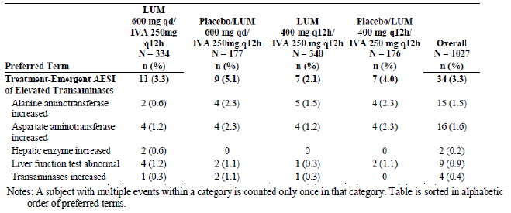
The rate of SAEs and discontinuation due to AESI of elevated transaminase was low in Study 105. One subject in the LUM 600 mg qd/IVA 250 mg q12h group and 1 subject in the placebo/LUM 600 mg qd/IVA 250 mg q12h group discontinued treatment due to an AESI of elevated transaminases. Overall, 2 subjects had SAEs (1 subject in the LUM 600 mg qd/ IVA 250 mg q12h group and 1 subject in the LUM 400 mg q12h/IVA 250 mg q12h group), and none of these events were considered by the investigator to be related to study treatment. The median time-to-onset of the first AESI of elevated transaminases was 16 days for the placebo/LUM 600 mg qd/IVA 250 mg q12h group and 29 days for the placebo/ LUM 400 mg q12h/IVA 250 mg q12h group. In addition to the AEs included in the elevated transaminase AESI, 3 subjects had AEs related to the hepatobiliary disorders (1 subject in the LUM 600 mg qd/IVA 250 mg q12h group had hepatic steatosis and hepatomegaly, 1 subject in the LUM 400 mg q12h/IVA 250 mg q12h group had biliary colic, and 1 subject in the placebo/ LUM 400 mg q12h/IVA 250 mg q12h group had cholelithiasis.
No subject had an ALT value > 5 × ULN. There were no PCS ALT elevations in the LUM 400 mg q12h/IVA 250 mg q12h group. No subject had an ALT or AST value > 3 × ULN with a total bilirubin level < 2 × ULN.

Phase I pooled studies
Mild and moderate elevations in ALT and/or AST were observed in a small number of subjects in Phase I/II studies involving LUM/IVA. Such transaminase elevations were generally not progressive and were not associated with elevations in total bilirubin. In the pooled Phase I studies (healthy subjects), AEs associated with transaminase elevations that occurred in 2 or more subjects in the LUM/IVA group included ALT increased (3 subjects (1.7%)), AST increased (2 subjects (1.2%)), and hepatic enzyme increased (2 subjects (1.2%)). Elevations in liver function test values were generally mild and transient. The majority of subjects in the LUM/IVA group had maximum ALT and AST levels of ≤ 3 × ULN. Only 2 subjects (1.2%) in the LUM/IVA group had maximum ALT or AST of > 3 to ≤ 5 × ULN. There were no subjects with elevated ALT or AST who also had an elevated total bilirubin level.

Other studies
In Study 102 Cohorts 1 to 3 (subjects with CF who are homozygous or heterozygous for the F508del-CFTR mutation), only 3 subjects in Cohort 2 had AEs associated with transaminase elevation during the combination treatment period (2 subjects had AST increased and 1 subject had LFT abnormal). In Cohort 4 (subjects with CF who are heterozygous for the F508del-CFTR mutation), 6 subjects on combination treatment had adverse events associated with transaminase elevation (4 subjects had both ALT and AST increased, 1 subject had LFT abnormal and 1 subject had transaminase increased). The majority of subjects on combination treatment (Day 28 to Safety Follow-up Visit) had maximum ALT or AST of ≤ 3 × ULN. Only 3 subjects in Cohort 2 and 2 subjects in Cohort 4 had ALT or AST of > 3 × ULN during the combination treatment.

Kidney function

Pivotal studies
There were no clinically meaningful effects on creatinine, with a similar incidence of PCS changes from baseline in creatinine (≥ 30% change from baseline) and creatinine clearance (shift from normal to mild renal impairment) across all treatment groups. Two subjects in the placebo group had a shift to moderate or severe renal impairment compared with no subjects in the total LUM/IVA group. Similarly, 1 subject in the placebo group had a PCS increase in blood urea nitrogen compared with no subjects in the total LUM/IVA group.

Other studies

Long-term Study 105
There were no clinically important trends in serum chemistry attributable to lumacaftor in combination with ivacaftor identified.

Phase I pooled studies
There were no significant changes renal laboratory parameters.

Other clinical chemistry

Pivotal studies
The incidences of PCS glucose values were common in both the total LUM/IVA and placebo groups. The incidence of PCS low glucose levels (≤ 3.9 mmol/L and below the lower limit of normal (< LLN)) was 29.7% in the total LUM/IVA group and 24.4% in the placebo group. The overall incidence of PCS changes in glucose and AEs related to glucose levels are consistent with what would be expected for CF patients, given the high proportion of subjects with a medical history of CFRD and related conditions, and do not suggest a treatment related effect.
The incidence of the AE of blood CPK increased was similar in the total LUM/IVA (5.6%) and placebo (5.4%) groups. However, the incidence of this AE was numerically higher in the LUM 400 mg q12h/IVA 250 mg q12h group (7.3%) compared with the LUM 600 mg qd/IVA 250 mg q12h group (3.8%). In addition, 2 subjects (0.5%) had an SAE of blood CPK increased in the LUM 400 mg q12h/IVA 250 mg q12h group compared with no subjects in the LUM 600 mg qd/ IVA 250 mg q12h or placebo groups. The percentage of subjects who discontinued treatment due to blood CPK increased was 1.1% (4 subjects) in the LUM 400 mg q12h/IVA 250 mg q12h group and 0% in the LUM 600 mg qd/IVA 250 mg q12h or placebo groups. The incidence of potential relevant AEs (for example, myalgia, and fatigue) was similar in subjects who had SAEs or AEs leading to discontinuations and subjects with non-serious AEs in the placebo and total LUM/IVA groups.

Other studies

Long-term Study 105
In Study 105, there were 4 discontinuations due to blood CPK increase. Of the 1,027 subjects who received LUM/IVA in Part A, 3 subjects discontinued treatment due to blood CPK increased: 1 subject in the LUM 600 mg qd/IVA 250 mg q12h group, 1 subject in the placebo/LUM 400 mg q12h/IVA 250 mg q12h group, and 1 subject in the placebo/LUM 600 mg qd/IVA 250 mg q12h group. Of the 115 subjects in Part B (entering from Study 102 Cohort 4), 1 subject in the placebo/LUM 400 mg q12h/IVA 250 mg q12h group discontinued due to blood CPK increased.

Phase I pooled studies
AEs related to laboratory abnormalities that occurred in 2 or more subjects in the LUM/IVA group were ALT increased (3 subjects), blood CPK increased (2 subjects), AST increased (2 subjects), and hepatic enzyme increased (2 subjects). The only laboratory AE that occurred in more than 1 subject in the placebo group was ALT increased (2 subjects).

Haematology

Pivotal studies
There were 2 PCS laboratory changes related to haematology with a difference of at least 3% higher incidence in the total LUM/IVA group compared with the placebo group: eosinophil increase (13.1% versus 9.2%) and monocyte increase (23.4% versus 27.6%). There were a few AEs reported and there did not appear to be any clinically meaningful trends in AEs or laboratory values related to haematology or coagulation.

Other studies

Long-term Study 105
There were no clinically relevant changes related to treatment with lumacaftor in combination with Ivacaftor in this long-term, open-label study.

Phase I pooled studies
There were no clinically relevant changes in haematology parameters.

Electrocardiograph

Pivotal studies
Subjects with a history of prolonged QTcF (> 450 ms) were excluded from the pivotal Phase III studies. No significant ECG abnormalities had been observed in healthy subjects receiving lumacaftor monotherapy at doses up to 400 mg q12h or in subjects with CF who received lumacaftor doses up to 400 mg q12h in combination with ivacaftor 250 mg q12h.
In addition to pooled data from standard 12-lead ECG assessments performed during Studies 103/104, data was also available from ambulatory ECGs in Study 103.
There were no clinically meaningful differences in any ECG parameter between the 3 treatment groups. The incidence of PCS PR interval (0.6%) or QRS interval (0.5%) was low. No subjects had a PCS QTcF prolongation (> 450 ms for males or > 470 ms for females), and the incidence of PCS QTcF increases from baseline of ≥ 30 to ≤ 60 ms was lower in the total LUM/IVA group (8.1%) than the placebo group (8.9%). Similarly, compared with the placebo group, fewer subjects in the total LUM/IVA group had a PCS QTcB prolongation (2.7% compared with 8.6%) or increase from baseline of ≥ 30 to ≤ 60 ms (16.3% compared with 24.9%). The incidence of PCS heart rate increase (≥ 120 bpm and increase from baseline ≥ 20 bpm) of was 1.6% in the placebo group and 0.7% the total LUM/IVA group, while the incidence of heart rate decrease (≤ 50 bpm and decrease from baseline ≥ 20 bpm) was 3.7% in the total LUM/IVA group and 1.4% in the placebo group. There were no clinically meaningful trends in PCS ECG events in the LUM 400 mg q12h/ IVA 250 mg q12 group compared with the LUM 600 mg qd/IVA 250 mg q12 group.
Overall, 41.3% of subjects in the total LUM/IVA group with normal ECG assessments at baseline had only normal ECG assessments during the study. For all treatment groups, most subjects who had abnormal (PCS) and abnormal (clinically insignificant (CIS)) events at baseline also had them during them the study. Shifts from normal baseline ECG to abnormal (PCS) ECG evaluations were 3.4% in the placebo group compared with 1.9% in the total LUM/IVA group). A small decreased QTcF was observed during the 24-week treatment period in the LUM 400 mg q12h/IVA 250 mg q12h and LUM 600 md qd/IVA 250 mg q12h groups compared with the placebo group. The mean maximum on-treatment change in the QTcF duration from baseline in the total LUM/IVA group occurred on Day 1 at 6 hours post dose (decrease of 5.8 ms) compared with an increase from baseline of 0.7 ms in the placebo group. Overall, maximum changes from baseline in QTcF through the treatment emergent period were variable in all treatment groups, with overlapping standard deviation ranges. No clinically meaningful differences in ECG change from baseline were observed between the LUM 400 mg q12h/ IVA 250 mg q12 and the LUM 600 mg qd/ IVA 250 mg q12h groups.
Ambulatory ECGs were collected from subjects at US sites who were enrolled in Study 103 at Screening, Day 1, and Day 15 until approximately 168 randomised subjects completed the Day 15 ambulatory ECG. Mean changes from baseline at each visit for heart rate were similar between the active treatment groups and between the total LUM/IVA group and placebo group. Results for all measures of ectopic beats were similar in the LUM/IVA group and the placebo group at all-time points. The proportion of abnormal findings between each of the active treatment groups was similar, and the overall proportion of abnormal findings between the overall treatment groups was similar to the placebo group. No clinically meaningful trends were identified in the ambulatory ECG data for the total LUM/IVA group compared with placebo or for the LUM 400 mg q12h/IVA 250 mg q12 group compared with the LUM 600 mg qd/IVA 250 mg q12 group.
Overall, the only AE related to ECG abnormalities that occurred in more than 1 subject was tachycardia (2 (0.3%) subjects in the total LUM/IVA group, 1 (0.3%) subject in the placebo group). There were no clinically meaningful differences between the LUM 400 mg q12h/ IVA 250 mg q12h and LUM 600 mg qd/IVA 250 mg q12h groups (Table 8.8.4, p415). All events were mild or moderate in severity, with the exception of 1 event of electrocardiogram T wave inversion which was severe. One subject had an SAE considered related or possibly related to ECG assessment.
One subject had a treatment related ECG adverse event.

Other studies

Long-term Study 105
There were no significant changes in ECG.

Phase I pooled studies
No clinically relevant trends in ECG results were observed in the pooled Phase I studies.

Other studies
Results from the thorough QT Study 008 showed that therapeutic (600 mg qd) and supra therapeutic (up to 1,200 mg qd) doses of lumacaftor were generally well tolerated. In Part A, there were no SAEs and the majority of AEs were mild or moderate in severity. Lumacaftor monotherapy was associated with a decline in percent predicted FEV₁ of approximately 6 percentage points in the overall active treatment group, which was evident within 4 hours of the first dose and which persisted, with only subtle improvement for most subjects, through Day 7. As the dose of lumacaftor increased, there was an increased incidence of respiratory AEs (namely, throat tightness, dyspnoea, and respiration abnormal). In Part B, there were no statistically significant relationships between QTcF changes with lumacaftor or ivacaftor concentrations, although a trend toward decreased QTcF interval was observed in the lumacaftor groups compared with the placebo group, which was not considered clinically meaningful.

Vital signs

Pivotal studies
Overall, there was a consistent trend towards increased mean weight and BMI in the total LUM/IVA group compared with the placebo group. The median BMI change from baseline to Week 24 was higher in the total LUM/IVA group (0.40 (range: -4.0 to 4.2) kg/m²) compared with the placebo group (0.0 (range: -3.6 to 4.9) kg/m²). In addition, the incidence of PCS weight increase (≥ 5% increase from baseline) was higher in the LUM/IVA group (31.9%) compared with the placebo group (20.3%), while the incidence of PCS weight decrease was lower the total LUM/IVA group (6.8%) compared with the placebo group (10.0%). Mean increases in weight and BMI were similar between the LUM 600 mg qd/IVA 250 mg q12h and the LUM 400 mg q12h/IVA 250 mg q12h group, however there was a higher incidence of PCS weight decrease in the LUM 400 mg q12h/ IVA 250 mg q12h group (9.0%) compared with the LUM 600 mg qd/ IVA 250 mg q12h group (4.6%).
The mean laboratory values for body temperature, blood pressure, pulse rate, and respiratory rate were generally within normal limits. Mean decreases in systolic/ diastolic blood pressure and pulse rate were consistently observed at all-time points in the total LUM/IVA group compared with the placebo group. The incidences of PCS increase in SBP (0.5% total LUM/IVA, 0.5% placebo) and DBP (0% total LUM/IVA, 0.3% placebo) were similar in the placebo and total LUM/IVA. Overall, AEs related to vital signs were infrequent and only AE related to vital signs that occurred in ≥ 5% subjects in any treatment group was pyrexia, which had a similar incidence in the total LUM/IVA group (9.2%) and placebo group (9.2%). There were no SAEs related to vital signs in the LUM 400 mg q12h/ IVA 250 mg q12h or placebo groups. Two subjects in the LUM 600 mg qd/ IVA 250 mg q12h group had SAEs related to vital signs: pyrexia and hypertension.
There were no clinically meaningful trends in oxygen saturation in any treatment group during the treatment emergent period. Only 1 subject reported an adverse event related to oxygen saturation; the subject was in the LUM 600 mg qd/IVA 250 mg q12h group and had hypoxia.

Other studies

Long-term Study 105
There were no clinically important trends attributable to lumacaftor in combination with ivacaftor identified from vital signs, physical examinations, standard ECGs, or pulse oximetry.

Phase I pooled studies
No clinically meaningful trends in vital signs were observed in the pooled Phase I studies in healthy subjects.

Additional analysis of specific AEs

Liver-related AEs and laboratory abnormalities
This has been discussed in detail in above.

Respiratory AEs

Pooled pivotal Phase III Studies 103 and 104
Overall, a higher percentage of subjects had respiratory AESIs in the total LUM/IVA group (26.3%) compared with the placebo group (17.0%); however, incidence was similar in the LUM 600 mg qd/IVA 250 mg q12h (26.8%) and LUM 400 mg q12h/ IVA 250 mg q12h (25.7%) groups. The incidence of AESIs of respiratory symptoms was higher in the total LUM/IVA group (22.9%) compared with the placebo group (13.8%) with similar incidence in the LUM 600 mg qd/IVA 250 mg q12h (23.8%) and the LUM 400 mg q12h/IVA 250 mg q12h (22.0%) groups. The incidence of AESIs of reactive airways was similar in the total LUM/IVA group (6.5%) compared with the placebo group (5.4%). The AESI of respiratory symptoms with the highest overall incidence was dyspnoea (11.9%), which had a higher incidence in the total LUM/IVA group (14.0% (14.9% in the LUM 600 mg qd/IVA 250 mg q12h group and 13.0% in the LUM 400 mg q12h/IVA 250 mg q12h group)) compared with the placebo group (7.8%) (Table 54). Four subjects in the LUM 600 mg qd/IVA 250 mg q12h group had SAEs of respiratory AESIs (2 subjects had SAE of dyspnoea and 2 subjects had SAE of bronchospasm). Of these, 3 SAEs (1 SAE of dyspnoea and both the SAEs of bronchospasm) were considered related to the study drug by the investigator. Five subjects in the LUM 600 mg qd/ IVA 250 mg q12h group discontinued treatment due to a non-serious respiratory AESI (2 subjects for dyspnoea, 2 subjects for bronchospasm, and 1 subject for respiration abnormal).

Table 54. Summary of respiratory adverse events of special interest: pooled placebo-controlled Phase IIII studies safety set
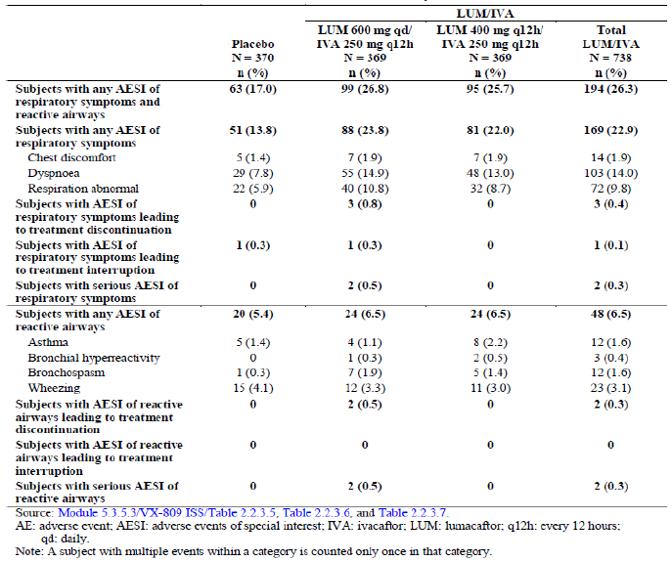
One subject in the placebo group had chest discomfort and 1 subject in the LUM 600 mg qd/IVA 250 mg q12h group had dyspnoea leading to treatment interruption.
The majority of respiratory AESIs were mild or moderate in severity. Two subjects in the placebo group (1 subject each for dyspnoea and chest discomfort) and 4 subjects in the LUM 600 mg qd/IVA 250 mg q12h group (2 subjects each for dyspnoea and bronchospasm) had severe AESIs of respiratory symptoms or reactive airways.
Of the 169 subjects in the total LUM/IVA group, who had AESIs of respiratory symptoms, 131 subjects (77.5%) had these events within the first week on treatment. In the placebo group, only 14 of 51 subjects (27.5%) who had respiratory symptoms had these events in the first week. Beyond the first week on treatment, the incidence of AESI of respiratory symptoms was similar between the total LUM/IVA group and the placebo group (Table 55). The proportion of subjects with AESIs of reactive airways in the first week on treatment was higher in the total LUM/IVA group (21 of 48 subjects (43.8%)) compared with the placebo group (6 of 20 subjects (30.0%)).

Table 55. Respiratory adverse events of special interest by treatment interval: pooled placebo controlled Phase III studies safety set
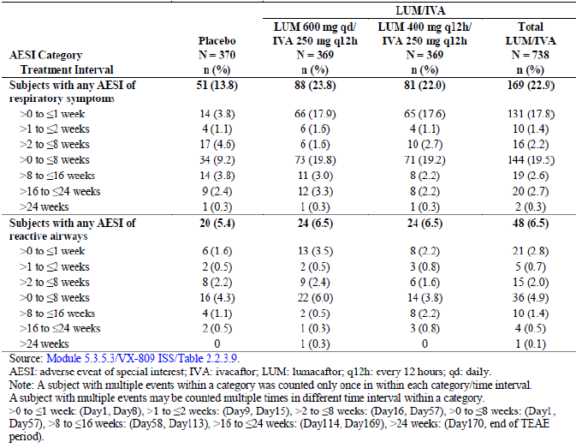
The median time to onset of the first AESI of respiratory symptoms was lower in the total LUM/IVA group (2 days) compared with the median time to onset in the placebo group (43 days). The mean duration of events was 18.5 days for the total LUM/IVA treatment group and 12.9 days for the placebo group. The median time to onset of the first AESI of reactive airways was 14 days for the total LUM/IVA group and 22 days for the placebo group. In the active treatment groups, the median time-to-onset of the first AESI of reactive airways was lower in the LUM 600 mg qd/ IVA 250 mg q12h group (5 days) compared with the LUM 400 mg q12h/ IVA 250 mg q12h group (50 days). The mean duration of events was 21.3 days for the total LUM/IVA group and 14.6 days for the placebo group.
Most subjects with respiratory AESIs were using an inhaled bronchodilator prior to first dose of the study drug in the total LUM/IVA group (94.8%) and the placebo group (98.4%). The incidence of respiratory AESIs was similar in subjects who had prior use of an inhaled bronchodilator in the total LUM/IVA group and placebo group. There were no notable differences in respiratory AEs in subgroups based on percent predicted FEV₁ ≥ 70 or < 70 at screening with the exception of dyspnoea, which was more than twice as common in subjects with percent predicted FEV₁ < 70 at Screening compared with those > 70. The incidence of dyspnoea was also twice as common in subjects in the total LUM/IVA group compared with the placebo group regardless of FEV₁ at Screening (FEV₁ < 70 and FEV₁ ≥ 70). Similar trends were observed when incidence of respiratory AEs was analysed in subgroups based on percent predicted FEV₁ < 40 or > 40 at screening. The incidence of dyspnoea and respiration abnormal was higher in subjects 18 years of age or older in both the total LUM/IVA group and the placebo group. The incidence of other respiratory AESIs was similar in subjects 18 years of age or older and subjects less than 18 years of age.
During the long-term Study 105 Part A Current Study Period, a total of 141 (13.7%) subjects had AESIs of respiratory symptoms. The incidence of AESIs of respiratory symptoms was higher in subjects who received placebo in the parent studies (20.9% and 22.2% for the placebo/LUM 600 mg qd/IVA 250 mg q12h group and placebo/LUM 400 mg q12h/IVA 250 mg q12h group, respectively) compared with subjects who received active treatment in the parent study (9.9% and 9.4% for the continuous LUM 600 mg qd/IVA 250 mg q12h group and continuous LUM 400 mg q12h/IVA 250 mg q12h group, respectively) The median time to onset of the first AESI of respiratory symptoms was 1 day for both the placebo/LUM 600 mg qd/IVA 250 mg q12h group and placebo/LUM 400 mg q12h/IVA 250 mg q12h group. The mean duration of AESI of respiratory symptoms events for the 4 treatment groups ranged from 17.2 days to 36 days. A total of 34 (3.3%) subjects had AESIs of reactive airways. The incidence of AESIs of reactive airways was similar between all 4 treatment groups (range: 2.4% to 5.1%) and the mean duration of AESI of reactive airways events ranged from 28.1 days to 40.4 days.
Five subjects (0.5%) had SAEs of AESI of respiratory symptoms (1 subject in the continuous LUM 600 mg qd/IVA 250 mg q12h group, 1 subject in the placebo/LUM 600 mg qd/IVA 250 mg q12h group, and 3 subjects in the placebo/LUM 400 mg q12h/IVA 250 mg q12h group) and 1 subject in the continuous LUM 400 mg q12h/IVA 250 mg q12h group had SAE of AESI of reactive airways. Overall, 13 (1.3%) subjects discontinued treatment due to an AESI of respiratory symptoms (3 (0.9%) subjects in the continuous LUM 600 mg qd/IVA 250 mg q12h group, 4 (2.3%) subjects in the placebo/LUM 600 mg qd/IVA 250 mg q12h group, 2 (0.6%) subjects in the continuous LUM 400 mg q12h/IVA 250 mg q12h group, and 4 (2.3%) subjects in the placebo/ LUM 400 mg q12h/IVA 250 mg q12h group). None of the AESI of reactive airways led to treatment discontinuation.

Menstrual abnormalities
In the pooled placebo controlled Phase III studies, the incidence of AEs in the system organ class reproductive and breast system disorders was higher in the total LUM/IVA group (5.4%) compared with the placebo group (1.9%). The incidence of Menstrual Abnormality CMQ events was higher in female subjects in the total LUM/IVA group (9.9%) compared with the placebo group (1.7%). An association was identified in menstrual abnormality events among subjects using hormonal contraceptives with the incidence of CMQ events in the total LUM/IVA group of 25.0% compared with 1.9% in the placebo group. The AEs that were most frequently reported in the total LUM/IVA group for female subjects using hormonal contraceptives were menstruation irregular (8.3%) and metrorrhagia (7.4%). Overall, the incidence of Menstrual Abnormality CMQ adverse events was similar in the LUM 600 mg qd/IVA 250 mg q12h group (9.3%) and the LUM 400 mg q12h/ IVA 250 mg q12h group (10.4%) (Table 56).

Table 56. Incidence of menstrual abnormality CMQ adverse events in female subjects by preferred term and hormonal contraceptive use: pooled placebo controlled Phase III studies safety set
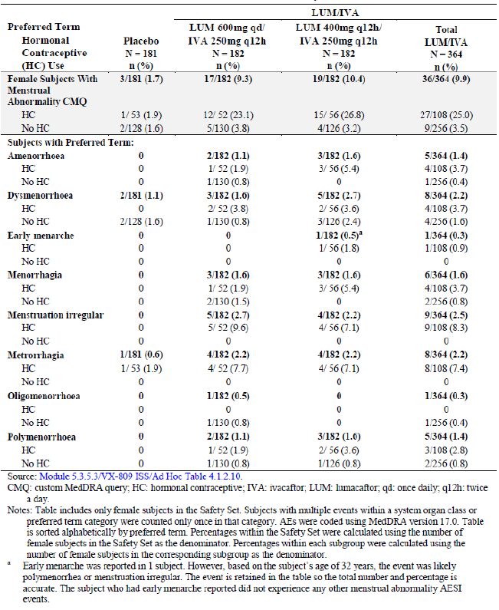
In the long-term Study 105, of the 503 female subjects, 144 subjects used hormonal contraceptives as a concomitant medication. Similar to the result of the pooled analysis of Studies 103/104, the incidence of Menstrual Abnormality CMQ in female subjects in Study 105 Part A was 8.3% in subjects using hormonal contraceptives and 1.7% in subjects not using hormonal contraceptives.
In Study 008 Part B, an increased incidence of metrorrhagia was observed (23.6% in the pooled LUM/IVA group and 5.2% in the pooled placebo group), with the majority of events in subjects using hormonal contraceptives, while receiving lumacaftor at a therapeutic (LUM 600 mg qd/IVA 250 mg q12h) or supratherapeutic (1000 mg qd/IVA 450 mg q12h) dose for 7 days.
Overall, menstrual abnormalities were predominantly observed in subjects who were using hormonal contraceptives. The effect of LUM/IVA on the PK of hormonal contraceptives is not known. However, because lumacaftor is a CYP3A inducer, it could reduce hormonal contraceptive exposure, which could result in disruption of the menstrual cycle, although the exact aetiology of this effect is not known. There was no apparent relationship for incidence of menstrual abnormalities and lumacaftor dose in Studies 008, 103, 104, or 105.

Other safety parameter: ophthalmological evaluations
During the LUM/IVA development program, ophthalmologic exams were not conducted during study conduct except in Studies 103/104, where subjects underwent an ophthalmologic examination performed by a licensed ophthalmologist at screening or within 3 months of the Screening Visit. Studies 103/104 enrolled subjects with no history of cataract or lens opacity or no evidence of cataract or lens opacity determined to be clinically significant by the ophthalmologist at the Screening Visit. Through the 24 weeks of treatment in Studies 103/104, and in available rollover Study 105 data to date, there have been no AEs related to cataracts.

Post-marketing experience
No post marketing data submitted in the current dossier.

Safety issues with the potential for major regulatory impact

Liver toxicity
In the pooled placebo controlled studies (Studies 103/104), 5.7% of subjects had elevated transaminases or hepatobiliary disorder related adverse events in the total LUM/IVA group compared with 5.4% of subjects in the placebo group. The overall incidence of elevated liver enzymes (> 3 × ULN) was low and similar in the total LUM/IVA group (5.2%) and the placebo group (5.1%). Transaminase elevations of > 5 × ULN were ≤ 2% and > 8 × ULN were < 1% in both the total LUM/IVA and placebo groups. The incidence of AESIs of elevated transaminases continued to be low in Study 105.
In the pooled placebo controlled Phase III Studies, 7 subjects in the total LUM/IVA group had SAEs associated with elevated transaminases or hepatobiliary adverse events. In 3 cases with associated clinical AEs (for example, cholestatic hepatitis, hepatitis and cholestasis, and hepatic encephalopathy) also associated with a concurrent elevation in bilirubin. Liver function tests returned to baseline or improved substantially in all 7 subjects. Underlying risk factors and alternative aetiologies complicate assessment of the SAEs, but do not exclude LUM/IVA as a potential contributory factor.
The incidence and pattern of LFT changes in Study 105 did not suggest any new findings compared with Studies 103/104 with exposure to LUM/IVA beyond 24 weeks. The incidence of AESIs of elevated transaminases in subjects new to active treatment in Study 105 was similar to the incidence in the pooled analysis of Studies 103/104.
The overall incidence and patterns of transaminase elevations observed in the studies is typical for patients with CF. Marked elevations of transaminases and associated SAEs are confounded by complicated medical histories and alternative aetiologies, though the role of LUM/IVA cannot be excluded.

Haematological toxicity
None.

Serious skin reactions
None.

Cardiovascular safety
None.

Unwanted immunological events
None.

Other safety issues

Safety in special populations

Intrinsic factors: age
In the pooled analysis of placebo controlled Phase III studies, subgroup analyses of the incidence of AEs were assessed by age group (subjects ≥ 18 years of age and subjects ≥ 12 to < 18 years of age). Of the 1,108 subjects who received study drug in the pooled, placebo controlled Phase III program, 290 subjects were aged ≥ 12 to < 18 years of age. AEs that were at least 5% more common in the total LUM/IVA group of subjects ≥ 12 to < 18 years of age compared with subjects ≥ 18 years of age were cough, headache, abdominal pain, viral upper respiratory tract infection, and productive cough. The incidence of headache and abdominal pain was increased in subjects ≥ 12 to < 18 years of age in the total LUM/IVA group compared with the placebo group, while the incidence of these events was similar in in the total LUM/IVA and placebo groups of subjects ≥ 18 years of age. AEs that were at least 5% more common in the total LUM/IVA group of subjects ≥ 18 years of age compared with subjects ≥ 12 to < 18 years of age were infective pulmonary exacerbation of cystic fibrosis, sputum increased, haemoptysis and respiration abnormal. The incidence of these events was higher in the placebo and total LUM/IVA group of subjects ≥ 18 years of age compared with subjects ≥ 12 to < 18 years of age. In general, the pattern of AEs in the LUM 600 mg qd/IVA 250 mg q12h group and the LUM 400 mg q12g/IVA 250 mg q12h group was similar in the 2 age subgroups. Among subjects ≥ 12 to < 18 years of age, the incidence of AEs was similar in the LUM 600 mg qd/ IVA 250 mg q12h group and the LUM 400 mg q12h/IVA 250 mg q12h group, with only rash occurring with at least a 10% difference between the LUM 600 mg qd/ IVA 250 mg q12h group (2.1%) and the LUM 400 mg q12h/IVA 250 mg q12h group (12.2%). Overall, the incidence of rash was similar among subjects ≥ 12 to < 18 years of age (7.2%) compared with subjects > 18 years of age (5.0%).
In the total LUM/IVA groups of subjects aged ≥ 12 to < 18 years, 25 subjects (12.9%) had Grade 3/4 AEs and 34 subjects (17.5%) had SAEs. The incidence of Grade 3/4 AEs was similar in subjects ≥ 18 years of age (14.2%) compared with subjects ≥ 12 to < 18 years of age (12.9%). The only Grade 3/4 AE that occurred in more than 1 subject aged ≥ 12 to < 18 years of age was infective pulmonary exacerbation of CF, which had an incidence of 7.3% in the LUM 600 mg qd/ IVA 250 mg q12h group, 2.0% in the LUM 400 mg q12h/ IVA 250 mg q12h group and 8.3% in the placebo group. Similarly, in the total LUM/IVA groups, the incidence of SAEs of infective pulmonary exacerbations of CF was lower among subjects ≥ 12 to < 18 years of age (9.8%) compared with subjects ≥ 18 years of age (14.2%), and the incidence of this SAE in subjects ≥ 12 to < 18 years of age was lower in the LUM 400 mg q12h/ IVA 250 mg q12h group (7.1%) compared with the LUM 600 mg qd/ IVA 250 mg q12h group (12.5%). Among subjects ≥ 12 to < 18 years of age, 3 subjects (1.0%) discontinued due to an adverse event: 2 subjects on placebo (acne, n = 1; haemoptysis, n = 1) and 1 subject in the LUM 400 mg q12h/IVA 250 mg q12h group (forced expiratory volume decrease). Overall, there were no clinically meaningful differences in the safety profile of LUM/IVA in subjects ≥ 12 to < 18 years of age compared with subjects age 18 and older.
Initial results of ongoing Study 011 in paediatric patients aged 6 to 11 years did not reveal any new safety concerns. Safety evaluation in elderly not possible as there were no patients older than 64 years enrolled in the studies due to the short lifespan associated with CF.

Percent predicted FEV₁ at baseline
The majority (65.9%) of subjects enrolled in the pooled placebo controlled Phase III studies had percent predicted FEV₁ < 70 at screening. Overall, there were no clinically meaningful differences in the pattern of AEs related to severity of lung disease at screening (defined by percent predicted FEV₁). Among subjects with percent predicted FEV₁ < 70 at screening, there was an increased incidence (at least 5%) of infective pulmonary exacerbation of CF, dyspnoea, haemoptysis, sputum increased, and diarrhoea compared with the ≥ 70 group. None of these AEs occurred at ≥ 10% increased incidence in the total LUM/IVA group compared with the placebo group, and the pattern of these events was generally similar in the 2 subgroups. The exception was diarrhoea, which was more common in the total LUM/IVA group (12.7%) than placebo group (7.8%) for subjects with percent predicted FEV₁ < 70, but was more common in the placebo group (9.2%) than the total LUM/IVA group (6.9%) for subjects with percent predicted FEV₁ ≥ 70. Among subjects with baseline percent predicted FEV₁ < 40, there was an increased incidence (at least 5%) of infective pulmonary exacerbation of CF, cough, dyspnoea, sputum increased and pyrexia compared with subjects with baseline percent predicted FEV₁ ≥ 40. In general, the pattern of these events (that is, incidence in total LUM/IVA group being higher or lower than the placebo group) was the same in subjects with percent predicted FEV₁ < 40 and subjects with percent predicted FEV₁ ≥ 40. The exception was cough, which was more common in the total LUM/IVA group (39.6%) than placebo group (25.0%) for subjects with percent predicted FEV₁ < 40, but was more common in the placebo group (41.5%) than the total LUM/IVA group (29.9%) for subjects with percent predicted FEV₁ ≥ 40. Among subjects with percent predicted FEV₁ < 40 at baseline, the only Grade 3/4 adverse event or SAE that occurred in more than 1 subject was infective pulmonary exacerbation of cystic fibrosis. For all treatment groups, the incidence of this event was higher in subjects with percent predicted FEV₁ < 40 at baseline compared with subjects with percent predicted FEV₁ ≥ 40 at baseline. In both the percent predicted FEV₁ < 40 and percent predicted FEV₁ ≥ 40 subgroups, the incidence of pulmonary exacerbation of cystic fibrosis was lower in the total LUM/IVA group than the placebo group (Table 57).

Table 57. Incidence of Grade 3 (serious) and Grade 4 (Life threatening) adverse events and serious adverse events occurring in at least 2 subjects in the total LUM/IVA group of subjects with percent predicted FEV1 < 40 at base line by preferred term and percent predicted FRV1 at baseline (≥ 40 and < 40): pooled placebo controlled Phase III studies safety set
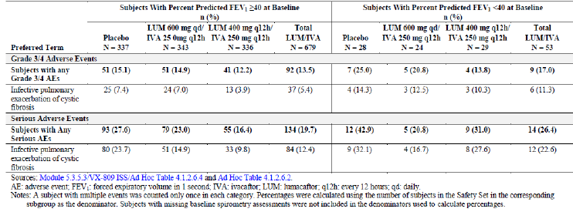

CFTR genotype
The majority of subjects exposed to LUM/IVA were homozygous for the F508del mutation in the CFTR gene. Two Studies (102 and 105) enrolled subjects who were heterozygous for the F508del mutation in the CFTR gene. The profile and incidence of AEs was similar in subjects homozygous or heterozygous for the F508del-CFTR mutation.

Hepatic impairment
In Study 010, following multiple doses of lumacaftor in combination with ivacaftor for 10 days, subjects with moderately impaired hepatic function (Child-Pugh B) had higher exposures (AUC_{τ} by approximately 50% and C_{max} by approximately 30%) compared with healthy subjects matched for demographics. Therefore, the dose should be reduced by 25% for patients with moderate hepatic impairment. Studies have not been conducted in patients with severe hepatic impairment (Child-Pugh C); however, exposure is expected to be higher than in patients with moderate hepatic impairment. Therefore, after evaluating the benefits and risks, lumacaftor and ivacaftor combination therapy is recommended to be used with caution at a maximum dose of LUM 200 mg q12h/IVA 125 mg q12h (reduced by 50%) in patients with severe hepatic impairment. The impact of mild hepatic impairment (Child-Pugh A) on the PK of lumacaftor given in combination with ivacaftor has not been studied, but the increase in exposure is expected to be less than 50%. Therefore, no dose adjustment is necessary for patients with mild hepatic impairment.

Subjects with cirrhosis and/or portal hypertension (pooled placebo controlled Phase III Studies)
Seven subjects in the total LUM/IVA group (6 subjects in the LUM 400 mg q12h/IVA 250 mg q12h group and 1 subject in the LUM 600 mg qd/IVA 250 mg q12h group) had a medical history of hepatic cirrhosis and/or portal hypertension compared with 1 subject in the placebo group. Except for 1 subject, all of these subjects completed treatment in Studies 103/104 without any transaminase or hepatobiliary disorder related AEs or elevated liver enzymes (> 3 x ULN). One subject in the LUM 400 mg q12h/IVA 250 mg q12h group had an SAE of hepatic encephalopathy at Day 6, which resolved after the study drug was withdrawn.

Renal impairment
Safety assessment of lumacaftor in subjects with renal impairment was not conducted.

Pancreatic insufficiency in CF patients (Study 002)
Study 002 evaluated the PK of lumacaftor monotherapy and the effect of food on lumacaftor PK in 8 subjects with CF who were pancreatic insufficient. Three subjects had AEs: 1 subject had nasal congestion following the fed dose, 1 subject had headache following the fasted dose, and 1 subject had pneumonia following the fasted dose. The pneumonia was an SAE and led to discontinuation of the subject from the study; the pneumonia was considered not related to study drug.

Gender
The incidence of AEs was higher for females than for males in all treatment groups. However, the overall safety profile was similar for both sexes. AEs that were at least 5% more common in females compared with males were infective pulmonary exacerbation of cystic fibrosis, cough, dyspnoea, sputum increased and nausea. These events had an increased incidence in both the placebo and total LUM/IVA groups for females compared with males, and therefore is unlikely relevant to LUM/IVA therapy, but rather suggests that these events are more common in females.
Consistent with the overall trend for the pooled placebo controlled Phase III analysis (males and females) there was a decreased incidence of infective pulmonary exacerbation of cystic fibrosis and cough for male or female subjects in the total LUM/IVA group compared with the placebo group. The were no clinically meaningful differences in AEs for the LUM 600 mg qd/ IVA 250 mg q12h group and the LUM 400 mg q12h/ IVA 250 mg q12h group when comparing the male and female subgroups. Among the 65 males and 60 females in Study 102 Cohort 4, there was a trend of increased AE incidence in females compared to males, consistent with the pooled placebo controlled Phase III studies.

Race
CF is predominantly prevalent in the Caucasian patient population and majority (98.6%) of subjects in the pooled placebo controlled Phase III analysis were White. Hence, a subgroup analysis by race was not conducted.

Extrinsic factors

Bronchodilator use
Most subjects with AESIs of respiratory symptoms or reactive airways were using an inhaled bronchodilator (short acting, long acting, or a combination of the 2) prior to first dose of the study drug. This trend was consistent with the high percentage of subjects overall (92.4%) who used bronchodilators prior to the first dose of study drug.
Safety data in Study 009 Cohort 4 were generally consistent with the pooled Phase I data. Administration of long acting bronchodilators (indacaterol and tiotropium) within 12 hours before administration of LUM/IVA ameliorated the mild decline observed in FEV₁ following dosing with lumacaftor in combination with ivacaftor. Administration of short acting bronchodilators (albuterol and ipratropium) within 4 hours after LUM/IVA administration led to a reversal of the decline.

Geographic region
Overall, 57.6% of subjects were from North America, 34.2% from the European Union (EU) and 8.2% from Australia. In North America, the only AE with an incidence of at least 5% increase in the total LUM/IVA group compared with the overall total LUM/IVA group was nasal congestion. The incidence of nasal congestion was also higher in the North American placebo group compared with the overall placebo group In the EU there was at least a 5% increase in the total LUM/IVA group compared with the overall total LUM/IVA group for nasopharyngitis, abdominal pain, and rhinitis. The incidence of nasal congestion was lower in the EU compared with the overall group for both the total LUM/IVA group and the placebo group. In Australia, there was at least a 5% increase in the total LUM/IVA group compared with the overall total LUM/IVA group for infective pulmonary exacerbation of cystic fibrosis, viral upper respiratory tract infection, and productive cough. There was a decreased incidence of at least 5% in the Australian total LUM/IVA group compared with the overall total LUM/IVA group for sinusitis, sputum increased, haemoptysis, nasal congestion, pyrexia, fatigue, and blood creatine phosphokinase increased. In general, the trend of AEs was similar across all geographic regions. The incidence of AEs in the LUM 600 mg qd/IVA 250 mg q12h group or the LUM 400 mg q12h/IVA 250 mg q12h group was also similar across geographic regions.

Safety related to drug-drug interactions and other interactions
In patients with CF, it is likely that lumacaftor in combination with ivacaftor will be given with inducers and inhibitors of CYP3A. Thus, to assess the potential for CYP3A mediated drug interaction on the lumacaftor and ivacaftor combination, the effect of inhibitors (ciprofloxacin and itraconazole) and an inducer (rifampin) of CYP3A on the pharmacokinetics (PK) of lumacaftor and ivacaftor was evaluated in Study 009 and no safety concerns were observed in this study.
The effect of lumacaftor in combination with ivacaftor on the pharmacokinetics of hormonal contraceptives has not been studied. However, because lumacaftor is an inducer of CYP3A, it is likely to reduce the effectiveness of hormonal contraceptives. Thus, subjects using hormonal contraceptives were advised to use non-hormonal contraceptives during the lumacaftor development program.

Use in pregnancy and lactation
The effect of combination treatment with lumacaftor and ivacaftor was not evaluated in human studies. Results from embryo-foetal development (EFD) reproductive toxicology studies in pregnant rats and rabbits indicated that lumacaftor is not a teratogen. Although M28 lumacaftor administration was associated with foetal malformations at the highest dose level tested in rats (800 mg/kg/day), this dose level resulted in significant maternal toxicities, and these findings were not observed at lower dose levels absent maternal toxicity. These findings were therefore attributed to the observed maternal toxicity and were observed at very high (> 100 fold) exposure-based safety margins over M28-lumacaftor in humans. Results from the fertility and embryonic development study indicated that lumacaftor does not affect the male or female reproductive systems in rats.
Overall, there were 5 pregnancies in the Phase III studies (1 during Study 103 and 4 during Study 105 (3 in Part A and 1 in Part B)). All 5 subjects were on active treatment in these studies. The duration of study drug exposure prior to the pregnancy ranged from 21 to 42 days. All 5 subjects discontinued treatment after pregnancy was confirmed. One of the subjects underwent an elective termination, and in the remaining 4 subjects the pregnancy was still ongoing.
Given the limited data on the outcomes after drug exposure during pregnancy, lumacaftor should not be used during pregnancy unless the potential benefit justifies the potential risk. Lumacaftor and ivacaftor are excreted into the milk of lactating female rats and excretion of both drugs into human milk is probable. No human studies have investigated the effects of ivacaftor on breast-fed infants.

Overdose, drug abuse, withdrawal/ rebound effects, effects on ability to drive or operate machinery
There have been no reports of overdose in subjects who received lumacaftor. The highest single dose of lumacaftor received in a clinical study was 600 mg in a tablet formulation (Study 012 and Study 007). The highest repeated dose of lumacaftor received in a clinical study was 1,200 mg qd (in a tablet formulation) for 7 days in Study 008, the thorough QT study. No subjects had SAEs. AEs that occurred at an increased incidence of ≥ 5% in the supra therapeutic dose period compared with the therapeutic dose period were headache (28.6% and 21.8%), rash generalised (10.2% and 0%), and transaminases increased (18.4% and 5.5%).
The highest ivacaftor repeated dose evaluated was 450 mg ivacaftor q12h (900 mg/day) for 4.5 days (9 doses) in Study 770-008. No subjects had serious adverse events (SAEs). The AEs reported at a higher incidence (≥ 5%) in either of the 2 ivacaftor treatments compared to placebo were contact dermatitis, dizziness, and diarrhoea. Contact dermatitis (likely from application of ECG leads) was reported at a higher incidence in the ivacaftor 450 mg q12h treatment compared to the ivacaftor 150 mg q12h treatment.
No specific antidote is available for overdose with lumacaftor in combination with ivacaftor. Treatment of overdose consists of general supportive measures including monitoring of vital signs and observation of the clinical status of the patient. It is not known if lumacaftor in combination with ivacaftor can be cleared by haemodialysis.
The abuse potential of lumacaftor or lumacaftor in combination with ivacaftor was not evaluated. There is no information regarding the dependence potential in animals or humans. Evaluation of AEs does not reveal evidence of euphoria, sedation, or mood alteration. There were no clinically meaningful central nervous system findings in the nonclinical or clinical studies of lumacaftor.
The potential withdrawal and rebound effects of lumacaftor have not been evaluated. In the pooled placebo controlled Phase III studies, subjects received lumacaftor in combination with ivacaftor for up to 24 weeks. The overall safety and tolerability profile did not appear to be negatively impacted by interruption, discontinuation or treatment completion.
No studies on the effects of lumacaftor or lumacaftor in combination with ivacaftor on the ability to drive or operate machinery have been performed. The observed incidences of AEs that may alter the ability to drive or operate machinery were similar in the total LUM/IVA and placebo groups.

Evaluator’s overall conclusions on clinical safety
Overall exposure to proposed combination of lumacaftor and ivacaftor was adequate to evaluate safety in the target patient population for the proposed indication. Safety was evaluated in 17 studies with lumacaftor including 12 completed Phase I studies, 2 completed Phase II studies, 2 completed Phase III studies, and 1 ongoing Phase III study. A total of 1,839 subjects were exposed to lumacaftor: 391 subjects without CF (excluding 12 subjects with moderate hepatic impairment) and 1,436 subjects with CF. A total of 1,615 subjects were exposed to lumacaftor in combination with ivacaftor in Phase I through Phase III studies: 254 subjects without CF (excluding 12 subjects with moderate hepatic impairment) and 1,349 subjects with CF. Overall, 738 subjects received study treatment for 24 weeks (Studies 103/104) of whom 369 patients were treated with proposed dose of LUM 400 mg q12h/IVA 250 mg q12h.
In the placebo controlled Phase III studies, AEs that occurred in ≥ 1% increase incidence in the total LUM/IVA group (compared with the placebo group) and had an incidence of at least 5% in any treatment group were dyspnoea, diarrhoea, nausea, respiration abnormal, oropharyngeal pain, upper respiratory tract infection, rhinitis, flatulence, rash, rhinorrhoea, and vomiting. The placebo group had a higher incidence of pulmonary exacerbation of cystic fibrosis, cough, sputum increased, nasal congestion, and pulmonary function test decreased. The majority of AEs were mild or moderate in severity. In the placebo controlled Phase III studies, infective pulmonary exacerbation of CF, headache, and blood CPK increased were the only severe (Grade 3) or life threatening (Grade 4) AE with an incidence of at least 1% in any treatment group. There were no deaths in the placebo controlled studies. The incidence of SAEs was higher in the placebo (28.6%) group compared with the total LUM/IVA group (20.1% subjects). The most common SAE (at least 5% incidence) in any treatment group was infective pulmonary exacerbation of CF. The rate of study drug discontinuation was higher in the total LUM/IVA group (4.2%) compared with the placebo group (1.6%). The most common AEs (> 2 subjects in any treatment group) that led to discontinuation of study drug were haemoptysis and blood CPK increased.
The safety profiles for the LUM 600 mg qd/IVA 250 mg q12h group and the LUM 400 mg q12h/IVA 250 mg q12h group were similar. No new safety signal was identified in the interim analysis of ongoing, long-term Study 105. The overall incidence of AEs was lower in subjects that were on active treatment in Studies 103/104 (and continued on treatment in Study 105) compared with subjects who received placebo in Studies 103/104 (and received active treatment in Study 105). The overall rate of treatment discontinuation was low (2.7%). There was 1 death due to infective pulmonary exacerbation of cystic fibrosis leading to respiratory failure in the LUM 400 mg q12h/IVA 250 mg q12h group that occurred approximately 1 year after the first dose of study drug. The event was considered not related to the study drug by the investigator.
Liver related safety concerns from the ivacaftor monotherapy program led to specific analyses to assess for potential liver toxicity. In the pooled placebo controlled studies, the incidence of elevated transaminases or hepatobiliary disorder related AEs was similar in the total LUM/IVA group compared with placebo (5.7% versus 5.4%) with similar results for incidence of elevated liver enzymes > 3 × ULN (5.2% versus 5.1%). The incidence of transaminase elevations > 5 × ULN and > 8 × ULN were ≤ 2% and < 1%, respectively, in both the total LUM/IVA and placebo groups. Seven subjects in the total LUM/IVA group had SAEs associated with elevated transaminases or hepatobiliary AEs and in 3 cases (for example, cholestatic hepatitis, hepatitis and cholestasis, and hepatic encephalopathy) was also associated with a concurrent elevation in bilirubin. LFTs returned to normal or improved substantially in all 7 subjects. The incidence and pattern of LFT changes in Study 105 did not suggest any new findings compared with Studies 103/104 with exposure to LUM/IVA beyond 24 weeks. The incidence of AESIs of elevated transaminases in subjects new to active treatment in Study 105 was similar to the incidence in the pooled analysis of Studies 103/104. There was no apparent relationship between higher exposure to LUM/IVA and the occurrence of transaminase elevations in subjects exposed to LUM/IVA compared with exposure in subjects without transaminase elevations. Six of the 7 subjects with portal hypertension and/or cirrhosis in the pooled Phase III studies did not have any AEs suggesting worsening of liver function while receiving LUM/IVA. One of these 7 subjects had worsened liver function after receiving LUM/IVA, manifest as hepatic encephalopathy. The role of LUM/IVA in worsening of underlying liver function in this case cannot be excluded. Overall, marked elevations of transaminases and associated SAEs were confounded by complicated medical histories and alternative aetiologies, though the role of LUM/IVA cannot be excluded and hence adequate monitoring and management recommendations have been included in the proposed PI.
As a result of dose dependent decrease in pulmonary function observed in patients who received lumacaftor monotherapy, the sponsors performed a safety analysis grouping together respiratory-related AEs. Respiratory AEs were more frequent in the total LUM/IVA group than the placebo group (LUM/IVA versus placebo: 26.3% versus 17%) particularly dyspnoea (23% versus 8%) and ‘respiration abnormal’ (10% versus 3%). The incidence of subjects with AESIs of respiratory symptoms or reactive airways was similar in the LUM 600 mg qd/IVA 250 mg q12h group (26.8%) and the LUM400 mg q12h/IVA 250 mg q12h group (25.7%). The majority of respiratory AESIs in pooled placebo controlled Phase III studies were mild or moderate in severity, with the majority of events occurring within the first week of treatment. Although the aetiology is unknown, these respiratory events are likely associated with LUM/IVA treatment. These events usually resolved within 1 to 2 weeks, and led to treatment discontinuation in only 5 subjects in the pooled placebo controlled Phase III studies (all 5 subjects were in the LUM 600 mg qd/IVA 250 mg q12h group, with no SAEs or discontinuations due to respiratory AEs in the proposed LUM 400 mg q12h/IVA 250 mg q12h group). There were no notable differences in the incidence of respiratory events in analyses by screening or baseline percent predicted FEV₁, with the exception of dyspnoea. In both the placebo group and the total LUM/IVA group, subjects with percent predicted FEV₁ < 70 at screening or percent predicted FEV₁ < 40 at baseline were approximately twice as likely to have dyspnoea compared with subjects with percent predicted FEV₁ ≥ 70 at screening and percent predicted FEV₁ ≥ 40 at baseline. For subjects new to active treatment in the long-term safety and efficacy study (Study 105), the incidence of AESI of respiratory symptoms was similar compared with the subjects receiving active treatment in the pooled placebo controlled Phase III studies, and was higher compared with subjects who continued on active treatment in Study 105. Overall, these data suggest that treatment with lumacaftor plus ivacaftor combination product can cause increased respiratory symptoms and AEs in some CF patients.
Menstrual abnormalities were also evaluated as an AESI due to observed increased metrorrhagia following treatment with lumacaftor plus ivacaftor combination product compared to placebo from early phase studies. Female patients reported more menstrual abnormalities in the lumacaftor plus ivacaftor combination product treatment arms compared to placebo (9.9% versus 1.7%) with metrorrhagia reported most commonly, These menstrual events occurred more frequently in the subset of female patients who were taking hormonal contraceptives (25.0%) compared to patients who were not taking hormonal contraceptives (3.5%) Most of these reactions were mild or moderate in severity and non-serious. Lumacaftor is a CYP3A inducer and could reduce hormonal contraceptive exposure, which could result in disruption of the menstrual cycle. There was no apparent relationship for incidence of menstrual abnormalities and lumacaftor dose in Studies 008, 103, 104, or 105.
The clinical laboratory parameters (serum chemistry, haematology, and coagulation studies) showed minor differences between the LUM 600 mg qd/IVA 250 mg q12h, LUM 400 mg q12h/IVA 250 mg q12h, and placebo groups that were not considered to be clinically meaningful. Patients with CF are chronically ill and often have associated metabolic and nutritional disorders, so minor fluctuations in chemistry parameters are common.
There were no clinically meaningful differences in any ECG parameter between the total LUM/IVA and placebo groups as measured by 12-lead standard ECGs and ambulatory ECGs.
The safety profile of LUM/IVA was similar across the different age and sex subgroups. The pattern of AEs was generally similar across the subgroups by severity of lung disease and the most common AEs within each FEV₁ subgroup were common manifestations of CF. As expected, subjects with more severe disease (percent predicted FEV₁ < 40 at baseline or percent predicted FEV₁ < 70 at screening) had a higher incidence of AEs compared to other subgroups, but LUM/IVA was well tolerated even in this more severely compromised group. Safety analysis from the pooled Phase I studies and the non-pooled Phase I studies showed similar safety results to those observed in CF patients. The incidence and pattern of AEs was similar in subjects with CF who are homozygous or heterozygous for the F508del-CFTR mutation and do not suggest any genotype specific safety risks. Subjects with moderate hepatic impairment (Child-Pugh B) and severe hepatic impairment (Child-Pugh C) may have increased exposure to LUM/IVA.
Overall, the safety of the proposed combination of LUM 400 mg q12h/IVA 250 mg q12h has been adequately established for the proposed indication of treatment of CF patients who are homozygous for the F508del-CFTR mutation. The only limitation was lack of safety data beyond 48 weeks of treatment although the ongoing 96 week open label Study 105 should be able to address that on completion of the study.

First round benefit-risk assessment

First round assessment of benefits
The benefits of Orkambi in the proposed usage are:
- LUM/IVA combination therapy demonstrated beneficial effects on pulmonary function, pulmonary exacerbations, patient reported outcomes, and nutritional measures (BMI and weight) in subjects 12 years of age and older with CF who are homozygous for the F508del-CFTR mutation. These effects were observed while subjects continued on their usual prescribed therapies for CF
- While there was no clear differentiation between the 2 combination therapy regimens in other efficacy measures, treatment with the proposed LUM 400 mg q12h/ IVA 250 mg q12h regimen significantly decreased the risk for all pulmonary exacerbations by 39%, exacerbations requiring hospitalisation by 61% and exacerbations requiring treatment with intravenous antibiotics by 56%
- The treatment effects favoured LUM/IVA across all subgroups, including subjects with severely compromised lung function (who have a percent predicted FEV₁ < 40 at baseline)
- Interim results from the rollover study (Study 105) demonstrate that the effect of LUM/IVA persisted up to approximately 48 weeks and was reproducible in subjects who were previously receiving placebo
- The PK/PD analyses of sweat chloride response in Phase II suggests that the higher lumacaftor concentrations in the presence of ivacaftor for the LUM 400 mg q12h/ IVA 250 mg q12h regimen results in a greater reduction of sweat chloride and a greater improvement in CFTR function than the LUM 600 mg qd/IVA 250 mg q12h regimen
- The proposed Orkambi is manufactured as a fixed-dose combination of lumacaftor/ Ivacaftor 200 mg/125 mg tablet and 2 tablets q12h (800 mg lumacaftor/500 mg ivacaftor total daily dose) is recommended for adults aged 12 years and older. The simplicity of this proposed dosing regimen minimises the potential of medication errors in terms of prescription and administration errors
- The safety profile of LUM/IVA was characterised by AEs that were most often mild to moderate in severity and the most common risks of LUM/IVA identified in the clinical and nonclinical studies are readily monitored and recognised, and may be managed without treatment discontinuation.

First round assessment of risks
The risks of Orkambi in the proposed usage are:
- Hepatic toxicity including elevated hepatic enzymes, although incidence was similar in LUM/IVA and placebo groups
- CF patients who received lumacaftor plus ivacaftor combination product had an increased frequency of respiratory symptoms, although there were no SAEs or discontinuations due to respiratory AEs in the proposed LUM 400 mg q12h/ IVA 250 mg q12h group
- Menstrual AEs
- LUM is a strong inducer of CYP3A and IVA is a sensitive CYP3A substrate with potential for drug-drug interactions
- Lack of adequate data on long-term efficacy and safety.

First round assessment of benefit-risk balance
F508del has been characterised as a ‘severe’ CFTR mutation, based upon the F508del-CFTR homozygote clinical phenotype (Johansen, 1991; Kerem,1990; Mckone, 2006) which is characterised by an early onset of clinical manifestations, a high incidence of pancreatic insufficiency, colonization with Pseudomonas aeruginosa, a more rapid rate of lung function decline and shorter life expectancy (Kerem,1996; Mckone, 2006.). These patients demonstrate progression of disease with advancing age and have a decreased life expectancy. According to the Australian Cystic Fibrosis Data Registry, there were 3,156 patients with CF in 2012. Of the patients with genotype data available, 51.8% are homozygous for F508del-CFTR. Given the high unmet medical need of patients with CF who are homozygous for the F508del mutation, and considering that there is no currently approved therapy to treat the underlying cause of CF in this population, there is a substantial need to improve the treatment and outlook for patients with this mutation.
The lumacaftor and ivacaftor combination development program consists of 17 clinical studies, with 16 completed clinical studies and 1 ongoing long-term efficacy and safety study. In vitro data provided evidence that a combination of lumacaftor and ivacaftor could potentially increase CFTR mediated Cl secretion in patients with CF carrying the F508del-CFTR mutation.
The Phase II Study 102 was planned to investigate lumacaftor and ivacaftor combination therapy, as well as lumacaftor monotherapy, in subjects who are homozygous or heterozygous for the F508del-CFTR mutation. Studies 005 and 006 were carried out in healthy subjects order to understand the DDI between lumacaftor (a CYP3A inducer) and ivacaftor (a sensitive CYP3A substrate) and to inform selection of the dosages used in combination therapy studies. Results from Study 102 demonstrated that pharmacologic modulation of CFTR function through treatment with lumacaftor in combination with ivacaftor can result in clinical benefit in subjects with CF who are homozygous for the F508del-CFTR mutation. Several clinical pharmacology studies were also performed in healthy subjects, including a bioavailability study of additional dosage strengths, as well as evaluations of potential DDIs identified from in vitro studies.
Based on the results from Studies 101 and 102 (Cohorts 1 to 3), and in consultation with the US and EU regulatory authorities, the pivotal, placebo controlled Phase III studies (Studies 103/104) were designed to evaluate the efficacy and safety of lumacaftor in combination with ivacaftor in subjects who are homozygous for the F508del-CFTR mutation. Two dosing regimens, LUM 600 mg qd/IVA 250 mg and LUM 400 mg q12h/IVA 250 mg q12h, were studied in pivotal Phase III clinical studies in order to determine the optimal clinical dose combination of LUM/IVA for patients 12 years and older who are homozygous for the F508del-CFTR mutation.
The Phase III clinical data showed that lumacaftor plus ivacaftor fixed dose combination product has statistically significant benefit over placebo in FEV₁ with a modest effect size of approximately 3%. Statistically significant improvements in percent predicted FEV₁ were rapid in onset and sustained throughout the 24-week treatment period. Improvements were also observed for multiple secondary endpoints including reductions in risk, frequency/ duration of experiencing a pulmonary exacerbation as well as reductions in pulmonary exacerbations that required hospitalization or IV antibiotic therapy. This suggests that the numerically small but statistical significant improvement in FEV₁ is a meaningful clinical benefit. The proposed combination also showed improvements in measures of nutritional status (BMI and weight) and in respiratory symptoms (as measured by CFQ-R respiratory domain score). Consistent treatment effects were observed in subjects with all degrees of disease severity, according to baseline percent predicted FEV₁. Subjects with severely compromised lung function (baseline percent predicted FEV₁ < 40) had improvements that were at least similar to subjects with higher baseline percent predicted FEV₁ values. Consistent treatment effects were also observed regardless of age, sex, geographic region, prior use of CF medications, and P. aeruginosa status. The treatment effects demonstrated for the primary and secondary endpoints were in addition to the benefit a subject received from prescribed CF therapies.
While there was no clear differentiation between the 2 combination therapy regimens when percent predicted FEV₁, BMI, and CFQ-R respiratory domain score were evaluated, improvements in pulmonary exacerbation-related outcomes favoured the LUM 400 mg q12h/IVA 250 mg q12h regimen. Based on these results and the simplicity of the twice-daily FDC regimen, the recommended dosing regimen (for which approval is being sought in this submission) is lumacaftor 400 mg q12h in combination with ivacaftor 250 mg q12h administered as an FDC of 2 tablets of LUM 200 mg/IVA 125 mg every 12 hours.
The maintenance of efficacy of Orkambi was confirmed in an ad hoc efficacy analysis which was performed after 95 patients who had received Orkambi (lumacaftor 400 mg/ivacaftor 250 mg q12h) in placebo controlled Phase III studies 103 or 104 had completed the Week 24 Visit in the rollover, long-term Study 105 (up to 48 weeks of treatment overall). However, there was no evidence of efficacy of proposed lumacaftor 400 mg/ivacaftor 250 mg q12h beyond 48 weeks. Long-term efficacy beyond 48 weeks will require confirmation from ongoing rollover, open label, 96 week Study 105 and the data should be provided for evaluation on completion of this study.
The contribution of the individual drugs lumacaftor and ivacaftor in the combination product were obtained from the in-vitro data suggesting additive benefit of the two and early clinical data suggest some additive benefit on FEV₁ when ivacaftor is added to lumacaftor (Study 102). The available clinical data are not adequate to determine whether lumacaftor provides additive clinical benefit over ivacaftor alone. However, demonstration of additive clinical benefit of lumacaftor is not necessary in this specific situation. The lumacaftor plus ivacaftor combination product provides benefit over placebo (standard of care background treatment in this case). The natural course of CF patients with F508del mutation is devastating with limited treatment options. Hence, the proposed lumacaftor plus ivacaftor combination product will provide benefit to these patients over the current standard of care treatment.
Overall exposure to proposed combination of lumacaftor and ivacaftor was adequate to evaluate safety in the target patient population for the proposed indication. Treatment with lumacaftor in combination with ivacaftor was safe and well tolerated in 738 subjects who received treatment for 24 weeks (Studies 103/104) of whom 369 patients were treated with proposed dose of LUM 400 mg q12h/IVA 250 mg q12h. The safety profiles for the LUM 600 mg qd/IVA 250 mg q12h group and the proposed dose of LUM 400 mg q12h/IVA 250 mg q12h group were similar. In the long-term safety and efficacy study, no new safety signal was identified. The overall incidence of AEs was lower in subjects who continued on treatment in Study 105 compared with subjects who were new to treatment in Study 105.
The safety profile of LUM/IVA was characterised by AEs that were most often mild to moderate in severity and the most common risks of LUM/IVA identified in the clinical studies (such as elevated transaminases, liver toxicity, respiratory AEs and menstrual AEs) are readily monitored and recognised, and may be managed without treatment discontinuation. Furthermore, adequate precautions have been included in the proposed PI.
Given the broad array of clinical benefits, chronic treatment with LUM/IVA combination therapy may have potential to decrease the morbidity and mortality of patients with CF who are homozygous for the F508del mutation in the CFTR gene, although this was not specifically analysed in any of the submitted studies.
Overall, the results of the clinical development program provide adequate evidence to support the use of LUM/IVA combination therapy for the treatment of CF in patients age 12 years and older who are homozygous for the F508del mutation on the CFTR gene.
The benefit-risk balance of Orkambi, given the proposed usage, is favourable.

First round recommendation regarding authorisation
It is recommended that marketing approval be granted for Orkambi for the proposed indication of;
treatment of cystic fibrosis (CF) in patients aged 12 years and older who are homozygous for the F508del mutation in the CFTR gene.
Approval is subject to incorporation of suggested changes to the proposed PI and adequate response to clinical questions in this report.

Clinical questions

Pharmacokinetics
- The values given in the Clinical Pharmacology Summary (p99 of 135) regarding the radioactivity associated with unchanged LUM and M28-LUM were approximately 10% higher than the values given in the study-report-body-VX08-809-004.pdf on page 63 (of 684) and Table 11.3 (p65 of 684) of the same document. Can the sponsor please clarify why these differences between the two documents exist?
- Can the sponsor please provide information on the activity of the plasma metabolites of LUM.

Pharmacodynamics
None.

Efficacy
- Long-term efficacy and safety of Orkambi was only established up to 48 weeks. Hence, on completion of the 96-week, long-term, open-label Study 105, data should be presented for evaluation.

Safety
None.

Second round evaluation of clinical data submitted in response to questions

Pharmacokinetics Question 1
The values given in the Clinical Pharmacology Summary (p99 of 135, Module 2.7.2) regarding the radioactivity associated with unchanged LUM and M28-LUM were approximately 10% higher than the values given in the study-report-body-VX08-809-004.pdf on page 63 (of 684) and Table 11.3 (p65 of 684) of the same document. Can the sponsor please clarify why these differences between the two documents exist?
Sponsor’s response:
The Metabolite Profiling and Identification Report (Covance 6438-849) that supported Study VX08-809-004 (Study 004) was amended as a subset of values were recalculated without correcting for extraction and/or reconstitution recoveries. Thus, the corresponding information in the original Study 004 clinical study report was updated via the Study 004 Errata. Module 2.7.2 (page 99) provides cross reference to both the original Study 004 clinical study report and the Study 004 Errata as some of the corrections are relevant to the information presented in Module 2.7.2. Although the Module 2.7.2 text only presents the final corrected information, page 5 and page 7 of the Study 004 Errata depicts the corrections that were made, which account for the differences noted in TGA Question 1 for pharmacokinetics.
For example, the following is an excerpt from corrections presented on page 5 of the Study 004 Errata:
Comparison of area under the concentration versus time curve (AUC) values in plasma for parent drug versus total radioactivity suggests that approximately 62% 52% of the radioactivity was associated with unchanged VX-809. M28 was the major metabolite in plasma which represented 21% 13% of the total radioactivity and a metabolite: parent AUC ratio of 35% 25%.
Evaluator’s Response: The evaluator is satisfied with the sponsor’s response.

Pharmacokinetics Question 2
Can the sponsor please provide information on the activity of the plasma metabolites of LUM.
Sponsor’s response:
Although M28-lumacaftor was initially categorised as a major metabolite and quantitated in subsequent clinical studies, as the relevant clinical doses increased during the clinical development program, the relative amount of M28-lumacaftor to lumacaftor became lower and in accordance with ICH M3(R2), M28-lumacaftor was classified as a minor but disproportionate human metabolite at relevant clinical doses (metabolite: parent AUC ratio < 10% at steady state exposure). In addition, M28-lumacaftor is not considered pharmacologically active.
Based on the results from Study 004, no other metabolite exposure exceeded a 5.4% metabolite ratio and thus activity was not characterised for the other plasma metabolites reported in Study 004.
Evaluator’s response: The evaluator is satisfied with the sponsor’s response.

Pharmacodynamics
There were no questions relating to the PD studies raised by the evaluator.
Comments from the PK/PD evaluator regarding the annotated PI provided with the Round 1 evaluation documents.

Efficacy Question 1
Long-term efficacy and safety of Orkambi was only established up to 48 weeks. Hence, on completion of the 96 week, long-term, open label Study 105, data should be presented for evaluation.
Sponsor’s response
The sponsor confirms that the final clinical study report for Study 105 will be submitted upon completion of the study, to provide long-term evidence on efficacy and safety, further justifying the proposed chronic treatment duration by showing conclusive evidence on maintenance of positive treatment effects over a total of 96 weeks of treatment.
Evaluator’s response: The sponsor’s response is satisfactory.

Second round benefit-risk assessment

Second round assessment of benefits
After consideration of the responses to clinical questions, the benefits of Orkambi in the proposed usage are unchanged from those identified in the first round assessment of benefits.

Second round assessment of risks
After consideration of the responses to clinical questions, the risks of Orkambi in the proposed usage are unchanged from those identified in the first round assessment of risks.

Second round assessment of benefit-risk balance
The benefit-risk balance of Orkambi in the proposed usage is favourable.

Second round recommendation regarding authorisation
It is recommended that application for marketing of Orkambi 200/125 (lumacaftor 200 mg/ ivacaftor 125mg tablets) be approved for proposed indication;
for the treatment of cystic fibrosis (CF) in patients aged 12 years and older who are homozygous for the F508del mutation in the CFTR gene.

References
Blumer, JL, Saiman L, Konstan MW, Melnick D. The efficacy and safety of meropenem and tobramycin versus. ceftazidime and tobramycin in the treatment of acute pulmonary exacerbations in patients with cystic fibrosis. Chest. 2005;128(4):2336-46
Cystic Fibrosis Australia. Cystic Fibrosis in Australia 2012: 15th Annual Report From the Australian Cystic Fibrosis Data Registry. Baulkham Hills, Australia: 2013.
Cystic Fibrosis Canada. The Canadian Cystic Fibrosis Registry: 2012 Annual Report. Toronto, Canada: 2014.
Cystic Fibrosis Foundation. Cystic Fibrosis Foundation Patient Registry: 2012 Annual Data Report. Bethesda, MD: 2013.
Cystic Fibrosis Trust. United Kingdom Cystic Fibrosis Registry: Annual Data Report 2013. Bromley, England: 2014.
European Cystic Fibrosis Society. ECFS Patient Registry: 2010 Annual Report. Karup, Denmark: 2014.
Fuchs HJ, Borowitz DS, Christiansen DH, Morris EM, Nash ML, Ramsey BW, et al. Effect of aerosolized recombinant human DNase on exacerbations of respiratory symptoms and on pulmonary function in patients with cystic fibrosis. N Engl J Med. 1994;331:637-42.
Guidance for industry for chronic obstructive pulmonary disease: developing drugs for treatment (draft). US Department of Health and Human Services Food and Drug Administration Center for Drug Evaluation and Research, November 2007
Guideline on clinical investigation of medicinal products in the treatment of chronic obstructive pulmonary disease (COPD) (Draft 3) (CPMP/EWP/562/98 Rev. 1). European Medicines Agency, 2010.
Guideline on the clinical development of medicinal products for the treatment of cystic fibrosis (EMEA/CHMP/EWP/9147/2008-corr*). European Medicines Agency Committee for Medicinal Products for Human Use, 2009.
Hankinson JL, Odencrantz JR, Fedan KB. Spirometric reference values from a sample of the general US population. Am J Respir Crit Care Med. 1999;159:179 87.
Johansen HK, Nir M, Hoiby N, Koch C, Schwartz M. Severity of cystic fibrosis in patients homozygous and heterozygous for delta F508 mutation. Lancet. 1991;337:631-4.
Kerem E, Corey M, Kerem BS, Rommens J, Markiewicz D, Levison H, et al. The relation between genotype and phenotype in cystic fibrosis—analysis of the most common mutation (delta F508). N Engl J Med. 1990;323:1517-22.
Kerem E, Kerem B. Genotype-phenotype correlations in cystic fibrosis. Pediatr Pulmonol. 1996;22:387-95.
Mayer-Hamblett N, Ramsey BW, Kronmal RA. Advancing outcome measures for the new era of drug development in cystic fibrosis. Proc Am Thorac Soc. 2007;4(4):370-7.
McKone EF, Emerson SS, Edwards KL, Aitken ML. Effect of genotype on phenotype and mortality in cystic fibrosis: a retrospective cohort study. Lancet. 2003;361(9370): 1671-6.
McKone EF, Goss CH, Aitken ML. CFTR genotype as a predictor of prognosis in cystic fibrosis. Chest. 2006;130:1441-7.
Rabin HR, Butler SM, Wohl ME, Geller DE, Colin AA, Schidlow DV, et al. Pulmonary exacerbations in cystic fibrosis. Pediatr Pulmonol. 2004;37(5):400-6.
Rommens JM, Iannuzzi MC, Kerem B, Drumm ML, Melmer G, Dean M, et al. Identification of the cystic fibrosis gene: chromosome walking and jumping. Science. 1989;245:1059-65.
Rosenfeld M, Emerson J, Williams-Warren J, Pepe M, Smith A, Montgomery AB, et al. Defining a pulmonary exacerbation in cystic fibrosis. J Pediatr. 2001;139(3):359-65.
Wang X, Dockery DW, Wypij D, Fay ME, Ferris BG. Pulmonary function between 6 and 18 years of age. Pediatr Pulmonol. 1993;15:75-88.

Therapeutic Goods Administration
PO Box 100 Woden ACT 2606 Australia
Email: info@tga.gov.au Phone: 1800 020 653 Fax: 02 6232 8605
https://www.tga.gov.au

According to the eligibility criteria for Study 105, subjects who prematurely discontinued study drug treatment were only eligible for the Observational Cohort.
Subjects and all site personnel, including the investigator, site monitor, and study team were blinded, with some exceptions which are: -Any site personnel for whom the information was important to ensure the safety of the subject in the event of a life-threatening medical emergency; -Any site personnel for whom the information was important to ensure the safety of the subject and their foetus in the event of a pregnancy; -Vertex Global Patient Safety (GPS) and Regulatory Affairs personnel to satisfy SAE processing and reporting regulations - Unblinded statistician preparing the final (production) randomization list who was not part of the study team; -Vertex Clinical operations IWRS management; -Vertex Clinical Supply Chain; - DMC; - Vendor that prepared the unblinded analysis for the DMC; - Vendor that analysed PK samples; - Vendor that conducted the population PK analysis; - Vertex medical monitor was permitted to unblind individual subjects at any time for matters relating to safety concerns.
Subjects who had less than 80% compliance with study drug treatment.; Subject is not homozygous for the F508del-CFTR mutation.; Percent predicted FEV1 at Screening was not between 40 and 90, inclusive; Subject had an acute upper or lower respiratory infection, pulmonary exacerbation, or changes in therapy (including antibiotics) for pulmonary disease within 4 weeks before Day 1 (first dose of study drug); Subject had a history of solid organ or haematological transplantation; Subject participated in an investigational drug study (including studies investigating lumacaftor and/or ivacaftor) within 30 days of screening or during the study; Subject received prohibited medication that may have confounded efficacy results (as determined by case-by-case review of data); Subject did not provide any informed consent.
10 subjects discontinued the study before receiving their first dose
A minor protocol deviation was defined as an isolated or nonsystemic deviation from the protocol that does not present significant risk
A major protocol deviation was defined as a significant deviation from the protocol that may put the subject's welfare or the product at significant risk
Overall study drug compliance (%) was defined as the ratio of the total number of days study drug was not interrupted to the duration of study drug exposure, expressed as a percentage
In the first sensitivity analysis, the MMRM approach described for the primary analysis was repeated using on-treatment measurements only. In the second sensitivity analysis, the impact of missing data was assessed using an ANCOVA model with missing data imputed using MI.
For subjects who had multiple occurrences of the same clinical event, the durations of all occurrences were included in calculating the total duration for each subject. The total duration was normalised for the time spent in the study by multiplying the observed percent of days with event by the expected total study days.
Response defined as ≥ 0.10 L and ≥ 0.15 L increase in absolute change from baseline in FEV1 Or a ≥ 5% and ≥ 10% increase in relative change from baseline in FEV1 at each visit
Response defined as ≥ 0.5 kg/m² increase in absolute change from baseline in BMI at each visit
Response defined as ≥ 1 kg increase in absolute change from baseline in weight at each visit
Response defined as ≥ 4 point increase in absolute change from baseline in pooled (Children Ages 12 and 13 Version and Adolescents and Adults Version) CFQ-R respiratory domain score at each visit
In the first sensitivity analysis, the MMRM approach described for the primary analysis was repeated using on-treatment measurements only. In the second sensitivity analysis, the impact of missing data was assessed using an ANCOVA model with missing data imputed using MI
Subjects who received lumacaftor in combination with ivacaftor in Cohort 4 of Study 102 continued to receive the same dose and regimen of study drug, as follows:- Subjects who received active study drug in Cohort 4 of Study 102 were assigned to Treatment Group 3; Subjects who received placebo in Cohort 4 of Study 102 were assigned to Treatment Group 3.
subjects who had study drug interruptions were also allowed but they must have completed study visits up to Week 24 of Study 103 or Study 104. Subjects who had study drug interruptions at the Week 24 Visit were required to have their enrolment approved by Vertex.
Subjects who received at least 4 weeks of study drug in Study 103 or Study 104 and completed visits up to Week 24 but did not take study drug at Week 24 because of a drug interruption and did not receive approval from Vertex to enrol in the Part A Treatment Cohort. Subjects who permanently discontinued study drug after receiving at least 4 weeks of study drug in Study 103 or Study 104 and remained in the study from the time of discontinuation of study drug treatment through the Week 24 Visit.
Part B Treatment Cohort Subjects who had study drug interruptions were also allowed but they must have completed study visits up to Day 56 of Study 102. Subjects who had study drug interruptions at the Day 56 Visit were required to have their enrolment approved by Vertex.
The Part A LTSS was used for defined long-term safety analyses. For subjects receiving study drug from more than 1 treatment group during the study, the treatment group allocation for the as-treated analysis was the lower dose of the active treatments assigned. LUM 600 mg qd + IVA 250 mg q12h was considered a lower dose than LUM 400 mg q12h + IVA 250 mg q12h.
Regulatory advice on the clinical development plan and the designs for Studies 103 and 104 was sought from regulatory authorities in the US and EU.
AEs were classified using MedDRA preferred terms and coded consistently across studies using Version 16.1 for Phase I ISS studies and Version 17.0 for the Phase III ISS studies. When summarizing the number and percentages of subjects, subjects with multiple occurrences of the same adverse event or a continuing adverse event were counted once. Only the maximum severity level was presented in the severity summaries, and only the worst/highest relationship level was presented in the relationship summaries.
Many of the Phase I studies in the pooled analyses were crossover studies with multiple treatment periods, where a subject either received different dose levels of lumacaftor, or received lumacaftor monotherapy in 1 period and lumacaftor with a co-administered drug (for example, ivacaftor or a DDI drug) in another period. Therefore, subjects may be included in more than 1 treatment group.
The pooled ‘Any LUM’ group includes all subjects who received at least 1 dose of lumacaftor monotherapy or lumacaftor co-administered with another drug. Exposure to study drug was defined for each treatment arm as the cumulative days of dosing (last dose date minus first dose date plus 1 day). The duration of exposure differed across studies.
One subject from the LUM 400 mg q12h/IVA 250 mg q12h group of Study 103 rolled over into Study 105 and had an SAE (infective pulmonary exacerbation of cystic fibrosis) with fatal outcome approximately 1 year after starting study drug. This event was considered unrelated to study drug by the investigator.
The subject had a life-threatening adverse event of pulmonary exacerbation on Day 344. The event was considered not related to the study drug by the investigator. Study drug was withdrawn due the adverse event. On Day 366, the subject died due to respiratory failure.
The subject (32 year old, white male) was in the LUM 400 mg q12h/ IVA 250 mg q12h group and had an asymptomatic electrocardiogram T wave inversion considered possibly related to study drug. The event occurred 168 days after the first dose of study drug and 1 day after the last dose of study drug. No treatment was administered for the event, which was found to be resolved at a safety follow-up visit 7 days after the event started. The subject enrolled in Study 105 and continued receiving treatment with the LUM 400 mg q12h/IVA 250 mg q12h.
The subject was in the LUM 600 mg qd/IVA 250 mg q12h group and had tachycardia of moderate severity that led to treatment discontinuation.
2 AESI categories (respiratory symptoms and reactive airways) were created to evaluate respiratory adverse events.
An increased incidence of several individual events related to menstrual cycles was noted during review of data from the pooled placebo-controlled Phase III studies. An ad hoc custom MedDRA query (CMQ) was defined using the following PTs from the System Organ Class (SOC) of ‘Reproductive and Breast System Disorders’ and ‘Endocrine Disorders’:- Abnormal withdrawal bleeding, Early menarche; Menstruation irregular; Amenorrhea; Hypomenorrhea; Metrorrhagia; Bleeding anovulatory; Menometrorrhagia; Oligomenorrhea; Delayed menarche; Menorrhagia; Polymenorrhagia; Dysfunctional uterine bleeding; Menstrual discomfort; Polymenorrhea, Dysmenorrhea; Menstrual disorder; Premature menopause; Menstruation delayed. The incidence of menstrual abnormalities was summarised for female subjects by treatment group and hormonal contraceptive use during the treatment-emergent period.
The patient reporting SAE of hepatic encephalopathy (mentioned above) was a 25 yearold male with a CF related liver cirrhosis, portal hypertension, splenomegaly, and thrombocytopenia. After 6 days of lumacaftor plus ivacaftor combination product treatment, the patient presented to ER with disorientation. Laboratory evaluation showed elevated transaminases and increased ammonia level, but bilirubin level was not reported. The patients improved over approximately a week on in hospital treatment. Based on the available information, causality to treatment cannot be assessed, but it is possible that the treatment could have contributed to hepatic decompensation.

