February 2020

Australian Public Assessment Report for Lorlatinib
  - Proprietary Product Name: Lorviqua
  - Sponsor: Pfizer Australia Pty Ltd

About the Therapeutic Goods Administration (TGA)
- The Therapeutic Goods Administration (TGA) is part of the Australian Government Department of Health and is responsible for regulating medicines and medical devices.
- The TGA administers the Therapeutic Goods Act 1989 (the Act), applying a risk management approach designed to ensure therapeutic goods supplied in Australia meet acceptable standards of quality, safety and efficacy (performance) when necessary.
- The work of the TGA is based on applying scientific and clinical expertise to decision-making, to ensure that the benefits to consumers outweigh any risks associated with the use of medicines and medical devices.
- The TGA relies on the public, healthcare professionals and industry to report problems with medicines or medical devices. TGA investigates reports received by it to determine any necessary regulatory action.
- To report a problem with a medicine or medical device, please see the information on the TGA website <https://www.tga.gov.au>.

About AusPARs
- An Australian Public Assessment Report (AusPAR) provides information about the evaluation of a prescription medicine and the considerations that led the TGA to approve or not approve a prescription medicine submission.
- AusPARs are prepared and published by the TGA.
- An AusPAR is prepared for submissions that relate to new chemical entities, generic medicines, major variations and extensions of indications.
- An AusPAR is a static document; it provides information that relates to a submission at a particular point in time.
- A new AusPAR will be developed to reflect changes to indications and/or major variations to a prescription medicine subject to evaluation by the TGA.

Copyright
© Commonwealth of Australia 2020
This work is copyright. You may reproduce the whole or part of this work in unaltered form for your own personal use or, if you are part of an organisation, for internal use within your organisation, but only if you or your organisation do not use the reproduction for any commercial purpose and retain this copyright notice and all disclaimer notices as part of that reproduction. Apart from rights to use as permitted by the Copyright Act 1968 or allowed by this copyright notice, all other rights are reserved and you are not allowed to reproduce the whole or any part of this work in any way (electronic or otherwise) without first being given specific written permission from the Commonwealth to do so. Requests and inquiries concerning reproduction and rights are to be sent to the TGA Copyright Officer, Therapeutic Goods Administration, PO Box 100, Woden ACT 2606 or emailed to <tga.copyright@tga.gov.au>.

Contents
Common abbreviations 4
I. Introduction to product submission 7
Submission details 7
Product background 8
Regulatory status 9
Product Information 9
II. Registration timeline 9
III. Submission overview and risk/benefit assessment 10
Quality 10
Nonclinical 11
Clinical 11
Risk management plan 22
Risk-benefit analysis 24
Outcome 27
Attachment 1. Product Information 28

Common abbreviations
Abbreviation | Meaning
ACM | Advisory Committee on Medicines
AE | Adverse event
AESI | Adverse event of special interest
ALK | Anaplastic lymphoma kinase
ALK+ | Anaplastic lymphoma kinase mutation positive
ALT | Alanine aminotransferase
ASA | Australian Specific Annex
AST | Aspartate aminotransferase
ARTG | Australian Register of Therapeutic Goods
AUC_{inf} | Area under the concentration time-curve over the time interval from 0 extrapolated to infinity
BICR | Blinded independent central review
CI | Confidence interval
C_{max} | Maximum plasma concentration
CMI | Consumer Medicines Information
CNS | Central nervous system
CR | Complete response
CrCl | Creatinine clearance
CSR | Clinical study report
CYP | Cytochrome P450
DILI | Drug-induced liver injury
DLP | Data lock point
DOR | Duration of response
EMA | European Medicines Agency (EU)
EU | European Union
EU-RMP | European Union-Risk management plan
FDA | Food and Drug Administration (USA)
FISH | Fluorescence in situ hybridisation
GVP | Good Pharmacovigilance Practice(s)
HLGT | Higher level group term
HLT | Higher level term
IC | Intracranial
IC-ORR | Intracranial overall response rate
IHC | Immunohistochemistry
ILD | Interstitial lung disease
IRC | Independent review committee
ITT | Intent to treat
IV | Intravenous
MedDRA | Medical dictionary for regulatory activities
NE | Not estimable
NEC | Not elsewhere classified
NGS | Next-generation sequencing
NSCLC | Non-small cell lung cancer
OR | Overall response
OS | Overall survival
PD | Pharmacodynamic(s)
PFS | Progression free survival
PI | Product Information
PK | Pharmacokinetic(s)
popPK | Population pharmacokinetic(s)
PR | Partial response
PSUR | Periodic safety update report
PT | Preferred Term
PXR | Pregnane X receptor
QD | Once daily, Latin: quaque die
ROS1 | c-ros oncogene 1
RT-PCR | Reverse transcription polymerase chain reaction
SAE | Serious adverse event
SCLC | Small cell lung cancer
SMQ | Standardised MedDRA Queries
TKIs | Tyrosine kinase inhibitors
T_{max} | Time of maximum plasma concentration
TTR | Time to tumour response
ULN | Upper limit of normal
USA | United States of America

I. Introduction to product submission

Submission details
Type of submission: | New chemical entity
Decision: | Approved for provisional registration
Date of decision: | 11 November 2019
Date of entry onto ARTG: | 19 November 2019
ARTG numbers: | 310778, 310779, 310780, 310781
Black Triangle Scheme | Yes  As a provisionally registered product, this medicine will remain in the Black Triangle Scheme for the duration of its provisional registration

Active ingredient: | Lorlatinib
Product name: | Lorviqua
Sponsor’s name and address: | Pfizer Australia Pty Ltd  151 Clarence Street  Sydney NSW 2000
Dose form: | Tablet, film coated
Strengths: | 25 mg and 100 mg
Containers: | Blister pack and bottle (for both strengths)
Pack sizes: | Blister pack:  - 25 mg: 9 blister strips of 10 tablets (90 tablets) per carton or 12 blister strips of 10 tablets (120 tablets) per carton.  - 100 mg: 3 blister strips (30 tablets) per carton.  Each bottle contains 30 tablets.
Approved therapeutic use: | Lorviqua has provisional approval in Australia for the treatment of patients with anaplastic lymphoma kinase (ALK) positive advanced non small cell lung cancer (NSCLC) whose disease has progressed on:  - Crizotinib and at least one other ALK inhibitor; or  - Alectinib as the first ALK inhibitor therapy; or  - Ceritinib as the first ALK inhibitor therapy.  The decision to approve this indication has been made on the basis of tumour response rate and duration of response in a single arm study. Continued approval of this indication depends on verification and description of benefit in a confirmatory trial.
Route of administration: | Oral
Dosage: | The recommended dose of Lorviqua is 100 mg taken orally once daily. Continue treatment for as long as the patient is deriving clinical benefit from therapy.  For further information refer to the Product Information.

Product background
This AusPAR describes the application by Pfizer Australia Pty Ltd (the sponsor) to register Lorviqua (lorlatinib) 25 mg and 100 mg film coated tablets for the following proposed indication:
Lorviqua is indicated for the treatment of patients with anaplastic lymphoma kinase (ALK) positive advanced non-small cell lung cancer (NSCLC) previously treated with one or more ALK tyrosine kinase inhibitors (TKIs).
Lung cancer has the highest mortality rates of any cancer in Australia. It has one of the poorest 5-year survival rates (approximately 14%) for any cancer in Australia, second only to pancreatic cancer.
The two major types of lung cancer are small cell lung cancer (SCLC) and non-small cell lung cancer (NSCLC; approximately 81% of lung cancers). At the time of diagnosis, approximately 50% to 70% of patients with NSCLC have advanced disease (Stage IIIb, IV) that is not amenable to surgical resection. The current 5-year survival for unresectable NSCLC is approximately 5%. Treatment of advanced NSCLC aims to prolong survival and maintain quality of life, while minimising side effects. Almost all patients with advanced NSCLC eventually develop progressive disease.
Anaplastic lymphoma kinase (ALK) gene rearrangements are found in approximately 4 to 5% of all patients with NSCLC, but are more common in non-smokers or light smokers with adenocarcinoma. The vast majority of lung cancers with an ALK rearrangement are adenocarcinomas. ALK gene rearrangements can be detected by various laboratory techniques, including fluorescence in situ hybridisation (FISH), immunohistochemistry (IHC) and gene sequencing techniques.
Treatment with an ALK inhibitor is recommended as first line therapy for patients with ALK mutation positive (ALK+) advanced NSCLC. At the time this submission was under consideration, four ALK tyrosine kinase inhibitors (TKIs) were registered in Australia: crizotinib (Xalkori), ceritinib (Zykadia), alectinib (Alecensa) and brigatinib (Alunbrig). Crizotinib, ceritinib and alectinib are all supported by Phase III data and can be used in the first-line setting, but alectinib is preferred based on direct comparative data demonstrating superior efficacy and lower toxicity compared to crizotinib (the ALEX trial; Study BO28984). Brigatinib was registered in March 2019, but was not yet marketed in Australia at the time this submission was under consideration.
Despite offering substantial benefits for patients with ALK+ NSCLC, use of these targeted therapies can be limited by treatment resistance, inadequate central nervous system (CNS) activity and safety issues. There remains an unmet need for effective treatment for patients who progress on current treatments, particularly patients with CNS metastases.
The new chemical entity lorlatinib is an inhibitor of ALK and c-ros oncogene 1 (ROS1) receptor tyrosine kinases and is able to cross the blood-brain barrier.

Regulatory status
Lorviqua (lorlatinib) is a new chemical entity for Australian regulatory purposes. A provisional determination for Lorviqua was made on 27 September 2018 for:
The treatment of patients with anaplastic lymphoma kinase (ALK) positive advanced non-small cell lung cancer (NSCLC) previously treated with one or more ALK tyrosine kinase inhibitors (TKls).
At the time the TGA considered this application, a similar application had been approved in the United States of America (USA) and the European Union (EU), for the indications as below.
USA: Breakthrough Therapy Designation was granted by the Food and Drug Administration (FDA) on 26 April 2017. Lorbrena (lorlatinib) was approved under accelerated approval provisions on 11 February 2018 for the following indications:
Lorbrena is a kinase inhibitor indicated for the treatment of patients with anaplastic lymphoma kinase (ALK)-positive metastatic non-small cell lung cancer (NSCLC) whose disease has progressed on:
- crizotinib and at least one other ALK inhibitor for metastatic disease; or
- alectinib as the first ALK inhibitor therapy for metastatic disease; or
- ceritinib as the first ALK inhibitor therapy for metastatic disease.
This indication is approved under accelerated approval based on tumor response rate and duration of response. Continued approval for this indication may be contingent upon verification and description of clinical benefit in a confirmatory trial.
EU: conditional marketing authorisation was granted 6 May 2019 for the following indications:
Lorlatinib as monotherapy is indicated for the treatment of adult patients with anaplastic lymphoma kinase (ALK) positive advanced non small cell lung cancer (NSCLC) whose disease has progressed after:
- alectinib or ceritinib as the first ALK tyrosine kinase inhibitor (TKI) therapy; or
- crizotinib and at least one other ALK TKI.

Product Information
The Product Information (PI) approved with the submission which is described in this AusPAR can be found as Attachment 1. For the most recent PI, please refer to the TGA website at <https://www.tga.gov.au/product-information-pi>.

II. Registration timeline
Table 1 captures the key steps and dates for this application and which are detailed and discussed in this AusPAR.
Table 1: Timeline for Submission PM-2018-04291-1-4
Description | Date
Designation: Provisional | 27 September 2018
Submission dossier accepted and first round evaluation commenced | 30 November 2018
First round evaluation completed | 3 May 2019
Sponsor provides responses on questions raised in first round evaluation | 28 June 2019
Second round evaluation completed | 24 October 2019
Delegate’s Overall benefit-risk assessment | 12 September 2019
Sponsor’s pre-Advisory Committee response | Not applicable
Advisory Committee meeting | Not applicable
Registration decision (Outcome) | 11 November 2019
Completion of administrative activities and registration on ARTG | 19 November 2019
Number of working days from submission dossier acceptance to registration decision* | 197
*Statutory timeframe for standard applications is 255 working days.

III. Submission overview and risk/benefit assessment
The submission was summarised in the following Delegate’s overview and recommendations.

Quality
Lorlatinib (structure below, Figure 1), is a small molecule potent TKI and third generation ALK inhibitor.
Figure 1: Lorlatinib structure
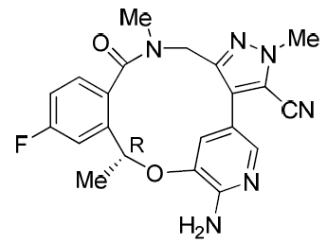
The application and the supporting data relating to the composition, development, manufacture, quality control and stability of the product have been assessed and checked for compliance, as applicable, with Australian legislation and requirements for new medicines and in accordance with pharmacopoeial standards and the technical guidelines adopted by the TGA.
The responses to TGA questions have been evaluated and the sponsor’s responses have been deemed acceptable with regard to quality. There are no outstanding issues with the chemistry and quality control aspects of the product.

Nonclinical
The Delegate summarised the following points from the nonclinical evaluation:
- The primary pharmacology studies demonstrate the ALK and ROS1 inhibitory activity of lorlatinib against ALK and ROS1 positive tumours.
- Secondary and safety pharmacology and toxicity studies indicate lorlatinib inhibits multiple other kinases and may exert central nervous and cardiovascular adverse effects in patients.
- The nonclinical studies predict embryofetal toxicity if administered to pregnant women at the proposed clinical dose.
At the time the Delegate’s overview was written, there were no nonclinical objections to the registration of lorlatinib for the proposed indication, but the nonclinical content of the PI was not yet fully resolved.

Clinical
The clinical development program for lorlatinib presented in this submission included 7 clinical pharmacology studies involving 112 healthy subjects and one Phase I/II study (Study B7461001) in 332 patients with advanced ALK-positive or ROS1-positive NSCLC. The dossier also included the protocol for Study B7461006, a Phase III randomised, controlled study comparing lorlatinib to crizotinib as first-line treatment of patients with ALK-positive advanced NSCLC. That study is underway but no efficacy data is available yet. The interim results are expected by the first quarter of 2020 and the final clinical study report (CSR) by 31 December 2021.

Pharmacology
The submission included 7 clinical pharmacology studies:
- Study B7461004 was a Phase I, open-label, single-dose, mass balance study conducted in the USA in 6 healthy subjects.
- Study B7461005 was a Phase I, randomised, open label, 3 period, crossover study performed in the USA in 20 healthy subjects to investigate the relative bioavailability, safety and tolerability of lorlatinib in tablet formulations.
- Study B7461007 was a Phase I, single dose, randomised, 2 period, crossover study performed in the USA in 11 healthy subjects to investigate the relative bioavailability, safety and tolerability of lorlatinib in intravenous (IV) administration.
- Study B7461008 was a Phase I, randomized, open label, 4 period crossover study performed in Belgium in 27 healthy subjects to assess the impact of rabeprazole, a high fat meal and overnight fasting on the pharmacokinetics (PK) of lorlatinib.
- Study B7461016 was a Phase I, randomised, single dose, 4 period, crossover study performed in Belgium in 20 healthy subjects to demonstrate the bioequivalence of 3 proposed commercial lorlatinib tablet strengths.
- Study B7461011 was a Phase I, open label, 2 period, 2 treatment, crossover study performed in the USA in 12 healthy subjects to assess the effect of rifampicin on the PK of lorlatinib under fasting conditions.
- Study B7461012 was a Phase I, open label, 2 period study performed in Belgium in 16 healthy subjects to estimate the effect of multiple doses of itraconazole on the PK of lorlatinib.

Pharmacokinetics
Lorlatinib showed dose-proportional increase in maximum plasma concentration (C_{max}) and area under the concentration time-curve over the time interval from 0 extrapolated to infinity (AUC_{inf}) across the dose range of 10 to 200 mg following a single dose. After multiple dose administration, lorlatinib C_{max} increased dose-proportionally and AUC_{inf} increased slightly less than dose-proportionally over the dose range of 10 to 200 mg once daily (QD).
Median time of maximum plasma concentration (T_{max}) was 1.2 hours following a single oral 100 mg dose and 2 hours following 100 mg orally once daily at steady state.
The mean absolute bioavailability is 81% after oral administration compared to IV administration. There was no clinically relevant difference in bioavailability based on food effect, oral solution versus immediate release tablet, administration with rabeprazole and clinical formulation versus commercial formulation.
The mean steady state volume of distribution was 305 L following a single IV 50 mg dose.
The mean plasma half-life of lorlatinib was 24 hours after a single oral 100 mg dose of lorlatinib. The mean oral clearance was 11 L/h following a single oral 100 mg dose and 18 L/h at steady state.
Following a single oral 100 mg dose of radiolabeled lorlatinib, 48% of the radioactivity was recovered in urine (< 1% as unchanged) and 41% in faeces (about 9% as unchanged).

Drug interactions
Concomitant use of lorlatinib decreases the concentration of cytochrome P450 (CYP)3A substrates, which may reduce the efficacy of these substrates. Avoiding concomitant use of lorlatinib with CYP3A substrates is recommended, where minimal concentration changes may lead to serious therapeutic failures.
Itraconazole, a strong CYP3A inhibitor, increases exposure of lorlatinib after a single dose. Avoidance of strong CYP3A inhibitors or a dose reduction to 75 mg lorlatinib is recommended based on clinical drug/drug interaction data.
Rifampicin, a strong CYP3A inducer, decreases the exposure of lorlatinib after a single dose. In addition, 10 of 12 healthy subjects in Study B7461011 who received multiple daily doses of rifampicin concomitantly with a single dose of lorlatinib had severe hepatotoxicity. The reason for this hepatotoxicity is not known, but a possible mechanism is through activation of the pregnane X receptor (PXR) by lorlatinib and rifampin, which are both PXR agonists. The risk of hepatotoxicity with concomitant use of lorlatinib and moderate CYP3A inducers is unknown. Lorlatinib is contraindicated with strong CYP3A inducers. Avoidance of the concomitant use of moderate CYP3A inducers is recommended.

Population pharmacokinetic data
The population pharmacokinetic (popPK) analysis for lorlatinib was conducted based on PK data from 95 healthy subjects in 6 healthy volunteer studies (Studies 1004, 1005, 1007, 1008, 1011 and 1016) and 330 patients with ALK-positive or ROS1-positive NSCLC in Study 1001.
No clinically meaningful differences in lorlatinib PK were observed based on age (19 to 85 years), sex, race/ethnicity, body weight, mild to moderate renal impairment (creatinine clearance (CrCl) 30 to 89 mL/min), or mild hepatic impairment (total bilirubin ≤ upper limit of normal (ULN) and aspartate aminotransferase (AST) > ULN or total bilirubin > 1.5 x ULN and any AST). No dose adjustment is needed based on these criteria. The effect of moderate to severe hepatic impairment or severe renal impairment on lorlatinib pharmacokinetics is unknown.

Dose selection
100 mg orally daily was recommended for the Phase II portion of Study B7461001 based on safety and tolerability results from the Phase I dose escalation portion of the study which assessed dosages of 10 mg to 200 mg.

Efficacy
The efficacy of lorlatinib for this application for provisional registration is derived primarily from the Phase II portion of Study B7461001. Study B7461001 is a global, Phase I/II, two-part, multi-cohort, single-arm study to evaluate dosing, safety, PK, pharmacodynamics (PD) and anti-tumour activity of lorlatinib as a single agent in patients with ALK-positive or ROS1-positive advanced NSCLC. The study, conducted in 47 centres in 14 countries including Australia, commenced in January 2014 and is ongoing. The data cut-off date for this submission was 15 March 2017.
The primary objective of the Phase II portion of the study was to evaluate overall and intracranial anti-tumour activity of lorlatinib in patients with ALK+ or ROS1+ metastatic NSCLC. The Phase II portion of the study assessed efficacy of lorlatinib 100 mg daily in 275 patients across 6 pre-specified cohorts (EXP-1 to EXP-6) defined by ALK/ROS1 status and previous treatment:
- EXP-1: ALK+, treatment-naïve, n = 30.
- EXP-2: ALK+, relapsed after prior crizotinib therapy only, n = 27.
- EXP-3: ALK+, relapsed after crizotinib therapy and 1 or 2 courses of chemotherapy (EXP-3A), n = 32, overall response (OR) after 1 ALK TKI other than crizotinib with or without chemotherapy (EXP-3B), n = 28.
- EXP-4: ALK+, relapsed after 2 previous TKIs (with or without chemotherapy), n = 65.
- EXP-5: ALK+, relapsed after 3 previous TKIs (with or without chemotherapy), n = 46.
- EXP-6: ROS1+, treatment naïve or any number of prior therapies, n = 47.
Key inclusion criteria included:
- Adult patients with histologically or cytologically confirmed metastatic NSCLC (Stage IV) with ALK rearrangement in tumour tissue confirmed by FISH (Vysis ALK Break Apart FISH Probe Kit, Abbott Molecular Inc.) or IHC (Ventana ALK (D5F3) CDx assay, Ventana Medical Systems Inc.), or ROS1 rearrangement determined by FISH, reverse transcription polymerase chain reaction (RT-PCR) or next-generation sequencing (NGS) via a local diagnostic test.
- ≥ 1 measurable extracranial target lesion (RECIST v1.1). Patients with asymptomatic CNS metastases (treated or untreated) were eligible.
- Eastern Cooperative Oncology Group (ECOG) performance status of 0 or 1 (Phase I); or 0, 1 or 2 (Phase II).
Key exclusion criteria included:
- Radiation therapy (except palliative therapy to relieve bone pain) within 2 weeks of study entry. Palliative radiation (≤ 10 fractions) must have been completed at least 48 hours prior to study entry. Stereotactic or small field brain irradiation must have been completed at least 2 weeks prior to study entry. Whole brain radiation must have been completed at least 4 weeks prior to study entry.
The primary endpoint was overall response rate (ORR) and intracranial overall response rate (IC-ORR) as assessed by independent central radiology assessment according to RECIST version 1.1. Secondary efficacy endpoints included ORR and IC-ORR as assessed by investigator, duration of response (DOR), time to tumour response (TTR), progression free survival (PFS), and overall survival (OS).
All analyses were performed on the intent to treat (ITT) population. The primary analysis for the Phase II portion of the study was performed on pre-specified pooled subgroups (Table 2). This submission focussed on cohorts EXP-2 to EXP-5 (n = 197), as cohorts EXP-1 (ALK+, no prior treatment) and EXP-6 (ROS1+) are not relevant to the proposed indication.
The FDA requested additional analyses on the ‘100 mg QD pooled group’ (all patients in Study B7461001 with ALK+ NSCLC who received lorlatinib 100 mg as a starting dose in the study). This group included 215 patients across the Phase I (n = 15), Phase II (n = 198) and Japanese lead-in cohort (n = 2) parts of the study. The FDA assessed the ‘100 mg QD pooled group’ as the primary efficacy population.
Table 2: Study B7461001 efficacy cohorts of ALK-positive NSCLC patients (Phase I, Phase II, and 100 mg once daily pooled group)
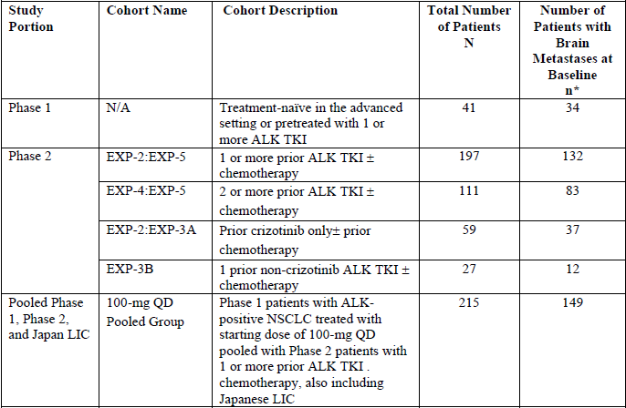
The demographic and baseline characteristics in the ‘100 mg QD pooled group’ were similar to the pooled cohorts EXP-2 to EXP-5. In the pooled cohorts EXP-2 to EXP-5, the mean age was 53.2 years (range 29 to 85 years), 59.4% were female, and most were either White (49.2%) or Asian (35.5%). 132 (67.0%) patients had brain metastases at study entry.

Efficacy results for the Phase II portion of Study B7461001

Primary efficacy endpoint
In the ‘100 mg QD pooled group’ at the 15 September 2017 data cut-off, ORR was 48% (95% confidence interval (CI): 42, 55), comprising complete response (CR) 4% and partial response (PR) 44%, and IC-ORR was 54% (95% CI: 45, 62), comprising CR 31% and PR 22% (Table 3). IC-ORR for patients with at least 1 measurable intracranial lesion was 60% (CR 21%, PR 38%). Median DOR was 12.5 months (95% CI: 8.4, 23.7) and median intracranial (IC) DOR was 19.5 months (95% CI: 12.4, not estimable (NE)), as shown in Table 4.
ORR and IC-ORR based on pre-specified cohorts are listed in Table 5 and Table 6. Similar outcomes were reported in the ITT population in the Phase II portion of Study B7461001 (Table 6, Table 7, Table 8). ORR and IC-ORR were higher for patients previously treated only with crizotinib compared to those treated with a second generation TKI or multiple TKIs.
In the absence of control data, the study considered the possibility of a confounding effect of recent intracranial radiation on IC ORR. IC ORR was higher for patients with no prior brain irradiation (68%, 95% CI 55%, 88%) than for patients with prior brain irradiation (44%, 95% CI 33%, 55%).
Table 3: Study B7461001 overall response rate and intracranial overall response rate per independent review committee, 100 mg once daily pooled group, data cut—off 15 September 2017
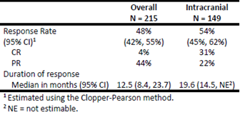
Table 4: Study B7461001 intracranial overall response rate per independent review committee in patients with measurable intracranial disease per independent review committee, 100 mg once daily pooled group, data cut-off 15 September 2017
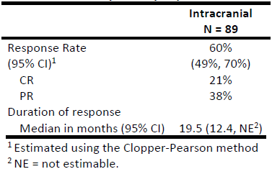
Table 5: Study B7461001 overall response rate per independent review committee by prior therapy cohorts, data cut-off 15 September 2017
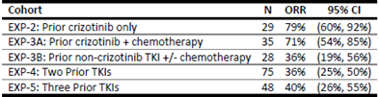
Table 6: Study B7461001 intracranial overall response rate per independent review committee by prior therapy cohorts, data cut-off 15 September 2017
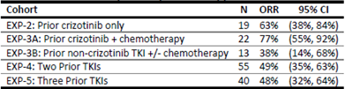
Table 7: Study B7461001 Phase II best overall response based on independent review committee assessment in patients with ALK-positive NSCLC, intent to treat population in EXP Cohorts (data cut-off date 15 March 2017)
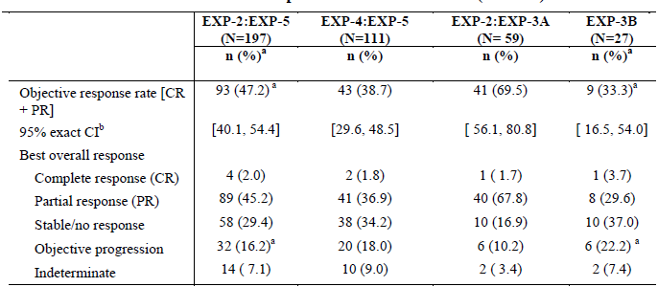
Table 8: Study B7461001 Phase II intracranial response based on independent review committee assessment in patients with ALK+ NSCLC, intent to treat population in EXP cohorts
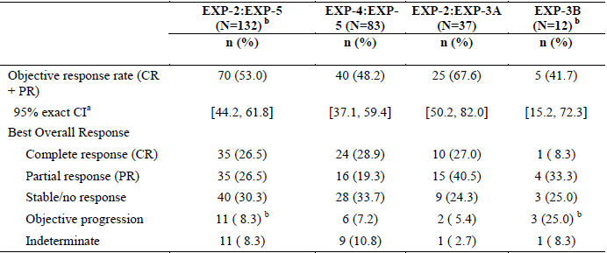
Table 9: Study B7461001 Phase II intracranial response based on independent review committee assessment in patients with ALK+ NSCLC and at least 1 measurable intracranial lesion at Baseline per independent review committee, intent to treat population in EXP cohorts
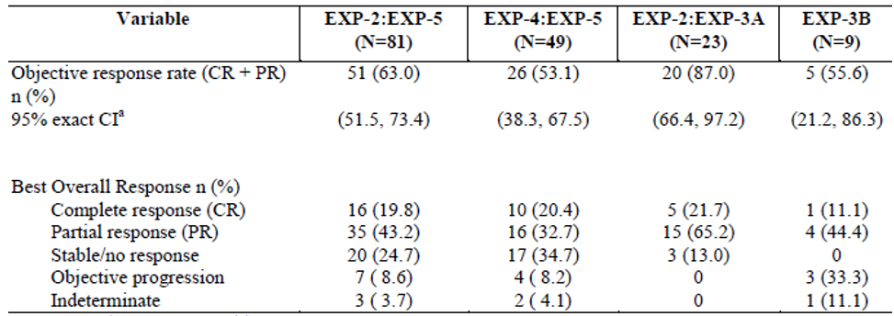
Figure 2: Study B7461001 Phase II waterfall plot of percentage change from Baseline in tumour size based on independent review committee assessment, intent to treat population in pooled cohort EXP-2: EXP-5
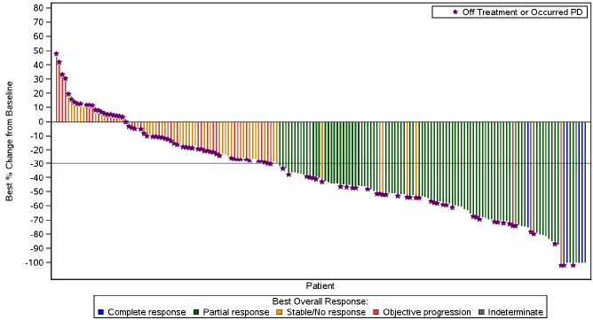
Figure 3: Study B7461001 Phase II waterfall plot of best percentage change from Baseline in intracranial tumour size based on independent review committee assessment, intent to treat population in patients with central nervous system metastases in Cohort EXP-2: EXP-5
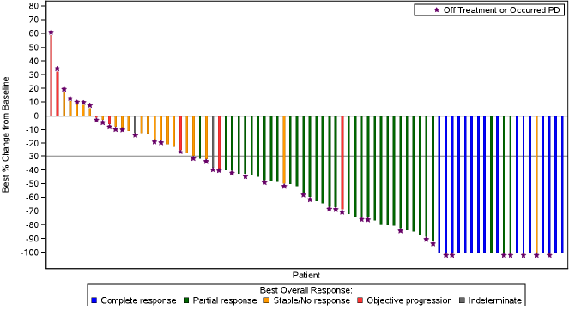

Secondary efficacy endpoints
ORR and IC-ORR per investigator were 44% and 31% respectively. The discordance between ICR and investigator was greater for IC-ORR. For the pooled EXP-2 to EXP-5 cohorts, median TTR and IC TTR were both 1.4 months. Median PFS was 7.4 months (95% CI: 5.6, 11.0). Median OS had not been reached. Estimated survival probability at 12 months was 70.2% (95% CI: 61.9, 77.1).

Safety
The evaluation of safety was based primarily on the Phase I/II Study B7461001. The submission also presented safety summaries from 7 clinical pharmacology studies (healthy subjects) and 120 Day Safety Update (data cut-off date 15 September 2017) providing updated safety data from Study B7461001 and preliminary safety data in the Phase III Study B7461006 (11 patients as at data cut-off). Updated data from Study B7461001 (cut-off date 2 February 2018) was added to the PI at the time of the response to TGA questions.
The submission presented safety data for two populations:
- The ‘all-treated group’ (332 patients who received lorlatinib in Study B7461001 at any dose, including 54 patients in the Phase I portion of the study, 17 of whom received 100 mg lorlatinib daily, 275 from the Phase II portion, and 3 from the Japanese lead-in cohort)
- The ‘100 mg QD pooled group’ (295 patients who received lorlatinib 100 mg daily in Study B7461001, including 17 patients from the Phase I portion, 275 from the Phase II portion, and 3 patients from the Japanese lead-in cohort).
The evaluation focussed on safety data for the ‘100 mg QD pooled group’. In the Safety Update data (cut-off date 15 September 2017), median duration of treatment was 12.5 months with median relative dose intensity 98%. Median duration of treatment was 16.3 months as at 2 February 2018.
As at 15 September 2017, 294 (99.7%) of the 295 patients had at least 1 adverse event (AE; Table 10). The most common AEs were hypercholesterolaemia, hypertriglyceridaemia, oedema, peripheral neuropathy, cognitive effects, dyspnoea, fatigue, increased weight, arthralgia, mood effects and diarrhoea.
107 (36.3%) patients had serious adverse events (SAEs). 202 (68.5%) patients had Grade 3 or 4 AEs. 71 (24.1%) patients had a dose reduction associated with AEs. 23 (7.8%) patients permanently discontinued lorlatinib in association with AEs. 281 (95.3%) patients had at least 1 treatment-related AE. 23 (7.8%) patients had treatment-related SAEs. 133 (45.1%) patients had Grade 3 or 4 treatment-related AEs and none had Grade 5 treatment-related AEs. 67 (22.7%) patients had a dose reduction in association with treatment-related AEs. 8 (2.7%) patients permanently discontinued lorlatinib in association with treatment-related AEs, the majority being CNS effects.
As at 15 September 2017, there were 90 deaths in the ‘100 mg pooled group’, mostly (90%) due to disease progression. None of the deaths were assessed as related to lorlatinib treatment.
Table 10: Study B7461001 all-causality and treatment-related adverse events in decreasing frequency (> 10%), 100 mg QD pooled group, data cut-off date 15 September 2017
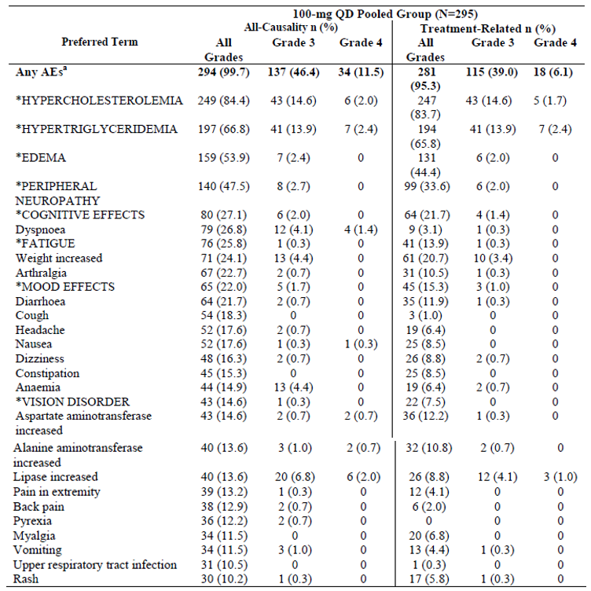
* Cluster terms defined in Table 11, below.
Table 11: List of Preferred Terms that comprise each cluster term
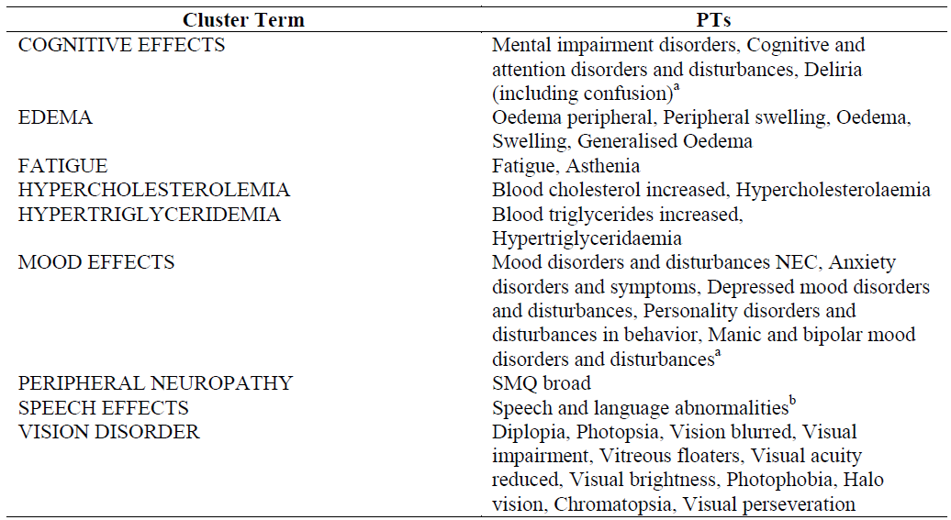
Abbreviations: HLGT(s) = higher level group term(s); HLT(s) = higher level terms; MedDRA = medical dictionary for regulatory activities; NEC = not elsewhere classified; PT(s) = preferred term(s); SMQ = Standardised MedDRA Queries. a. HLGTs rather than PTs for COGNITIVE EFFECTS and MOOD EFFECTS. b. HLTs rather than PTs for SPEECH EFFECTS.
Adverse events of special interest (AESIs) assessed in Study B7461001 included hyperlipidaemia, peripheral neuropathy, CNS effects (including mood effects, cognitive effects and speech effects), vision disorders, oedema, weight gain, QTc prolongation, atrioventricular block, interstitial lung disease (ILD)/pneumonitis, liver tests increased, and pancreatitis.
All-causality hyperlipidaemia AEs were reported for 259 out of 295 (87.8%) patients in the ‘100 mg pooled group’, with the cluster terms hypercholesterolaemia reported in 249 (84.4%) patients and hypertriglyceridaemia in 197 (66.8%) patients. These AEs were primarily managed by the use of standard treatments and there were no permanent discontinuations of lorlatinib.140 (47.5%) patients had all-causality peripheral neuropathy AEs, including 8 (2.7%) Grade 3 AEs. 14 (4.7%) patients required dose reduction and 15 (5.1%) required temporary discontinuation.
Eighty (27.1%) patients experienced cognitive effects, 65 (22.0%) experienced mood effects and 28 (9.5%) experienced speech effects. The majority of CNS effects were Grade 1 or 2 in severity and reversible. 2 patients permanently discontinued treatment, 13 (4.4%) required temporary discontinuation and 12 (4.1%) required dose reduction.
One hundred and fifty nine (53.9%) patients had oedema AEs, including oedema peripheral (44.7%), oedema (7.8%), and peripheral swelling (6.1%). There were 7 Grade 3 oedema AEs. 1 patient permanently discontinued, 18 (6.1%) required dose reduction and 17 (5.8%) required temporary discontinuation.
Pneumonitis was reported in 3 patients (1 each at Grades 2, 3 and 4) and ILD was reported in 1 patient (Grade 3). Lorlatinib was discontinued permanently for the Grade 4 pneumonitis and temporarily discontinued for the Grade 3 ILD.
Atrioventricular block occurred in 3 patients (1.0%); one of these events (atrioventricular block complete) was Grade 3 in severity and required temporary discontinuation and pacemaker placement. 14% of patients with a baseline PR interval; of less than 200 msec had PR prolongation greater than 200 msec after starting treatment with lorlatinib. The prolongation of PR interval occurred in a concentration-dependent manner. Patients with second-degree or third-degree atrioventricular block (unless paced) or any atrioventricular block with PR interval > 220 msec were excluded from Study B7461001. Maximum QTcF; increase from Baseline of ≥ 60 msec was observed in 5 (1.7%) patients. No large mean increases in the QTcF interval (that is, > 20 msec) were detected. Lorlatinib did not prolong the QTc interval; to a clinically relevant extent.
Forty-three (14.6%) patients had aspartate aminotransferase (AST) increased AEs (2 patients Grade 3, 2 patients Grade 4) and 40 (13.6%) patients had alanine aminotransferase (ALT) increased AEs (3 patients Grade 3, 2 patients Grade 4). Two potential Hy’s law; cases were identified, 1 during the Phase I portion of the study and 1 during the Phase II portion. One case had disease progression in the peritoneum and pancreas as the likely cause of the liver abnormalities. The other case was consistent with drug-induced liver injury (DILI) but there were other contributory factors so the degree of contribution from lorlatinib is uncertain. Lipase increase was reported in 40 (13.6%) patients and amylase increase was reported in 28 (9.5%) patients. 1 patient had an AE of pancreatitis, managed with a dose reduction and then temporary discontinuation.

Risk management plan
The sponsor submitted European Union-risk management plan (EU-RMP) version 0.1 (11 December 2017; data lock point (DLP) 15 March 2017) and Australian Specific Annex (ASA) version 0.1 (11 April 2018) in support of this application. The EU-RMP version 1.0 (26 February 2019; DLP 2 February 2018) with the response to TGA questions, then ASA version 0.2 (26 August 2019) were subsequently submitted.
The sponsor proposes to submit Study B7461006 in the fourth quarter of 2021 to support full registration. Study B7461006 is a Phase III, randomised, controlled, open-label study of lorlatinib versus crizotinib as first-line treatment in 280 patients with advanced ALK-positive NSCLC. The primary endpoint is PFS based on blinded independent central review (BICR) assessment (RECIST v1.1).² The primary completion date is planned by the fourth quarter of 2020.
There were 4 new recommendations in the second round of evaluation, relating to updating the ASA to align with recent changes to the EU-RMP and recommended changes to the Consumer Medicines Information (CMI).
The proposed summary of safety concerns and their associated risk monitoring and mitigation strategies are summarised below in Table 12.
Table 12: Summary of safety concerns
Summary of safety concerns |  | Pharmacovigilance |  | Risk minimisation
 |  | Routine | Additional | Routine | Additional
Important identified risks | CNS effects† | * | – |  | –
Important identified risks | Interstitial lung disease/pneumonitis‡ |  | – |  | –
Important potential risks | Pancreatitis |  | – |  | –
Important potential risks | Atrioventricular block |  | – |  | –
Important potential risks | Embryo-foetal toxicity |  | – |  | –
Missing information | Patients with moderate or severe hepatic impairment |  | – |  | –
Missing information | Patients with severe renal impairment |  | – |  | –
† Included in the EU-RMP but not in the ASA – inclusion in the ASA has been requested. ‡ Categorised as an important identified risk in the EU-RMP but as an important potential risk in the ASA – re-categorisation in the ASA has been requested. * Specific adverse drug reaction follow-up questionnaire

Recommended conditions of registration
- The Lorviqua EU-Risk Management Plan (RMP) (version 1.0, dated 26 February 2019, data lock point 2 February 2018), with Australian Specific Annex (version 0.1, dated 11 April 2018), included with submission PM-2018-04291-1-4, to be revised to the satisfaction of the TGA, will be implemented in Australia.
Reports are to be provided in line with the current published list of EU reference dates and frequency of submission of PSURs until the period covered by such reports is not less than three years from the date of this approval letter.
The reports are to at least meet the requirements for PSURs as described in the European Medicines Agency’s Guideline on Good Pharmacovigilance Practices (GVP) Module VII-periodic safety update report (Rev 1), Part VII.B Structures and processes. Note that submission of a PSUR does not constitute an application to vary the registration.
- Lorviqua (lorlatinib) is to be included in the Black Triangle Scheme. The PI and CMI for Lorviqua must include the black triangle symbol and mandatory accompanying text for the products entire period of provisional registration.
- Confirmatory trial data (as identified in the sponsor’s plan to submit comprehensive clinical data on the safety and efficacy of the medicine before the end of the 6 years that would start on the day that registration would commence) must be provided.
Specifically the sponsor must conduct studies as described in the clinical study plan submitted with version 0.1 (date 11 April 2018) of the Australia-Specific Annex. The following study report(s) should be submitted to TGA.
  - Study B7461006; A Phase III, randomised, open-label study of lorlatinib (PF-06463922) monotherapy versus crizotinib monotherapy in the first-line treatment of patients with advanced ALK-positive non-small cell lung cancer; by the fourth quarter of 2021.
Further guidance for sponsors is available on the TGA website.

Risk-benefit analysis

Delegate’s considerations

Efficacy
Efficacy for the proposed provisional indication is based on the single-arm Phase I/II Study B7461001. The primary endpoint was ORR and IC-ORR (by ICR). Efficacy was assessed across multiple cohorts based on prior treatment, including prior crizotinib, prior second generation ALK TKI, 2 prior ALK TKIs and 3 prior ALK TKIs. No comparative efficacy data are available but a confirmatory Phase III study is in progress.
In the ‘100 mg QD pooled group’, ORR was 48% (4% CR, 44% PR) and IC-ORR in patients with measurable IC disease was 60% (21% CR, 38% PR). Median DOR was 12.5 months (95% CI: 8.4, 23.7) and median IC DOR was 19.5 months (12.4, NE).
In the Phase II portion of Study B7461001, ORR was 47.2% in patients who had received at least one ALK TKI (EXP-2: EXP-5), 33.3% in patients who had received one second-generation ALK TKI (EXP-3B) and 38.7% in patients who had received 2 or more ALK TKIs (EXP-4: EXP-5). IC-ORR was 53.0% in patients who had received at least one ALK TKI (EXP-2: EXP-5), 41.7% in patients who had received one second-generation ALK TKI (EXP-3B) and 48.2% in patients who had received 2 or more ALK TKIs (EXP-4: EXP-5).
Study B7461001 provides promising preliminary evidence of the efficacy of lorlatinib in metastatic ALK-positive NSCLC, particularly for patients with intracranial metastases, a population with substantial unmet need for improved treatments.

Proposed indication
This application for provisional registration is based on tumour response rates and duration of response in a single arm study. Alectinib, ceritinib and crizotinib are currently registered in Australia for the treatment of advanced ALK+ NSCLC on the basis of Phase III data. Given the lack of comparative efficacy data for lorlatinib and the consequent uncertainty regarding the relative efficacy and safety of lorlatinib, provisional registration should be considered only for scenarios where current treatments have failed and there is substantial unmet need. On the available data, it would be reasonable to consider lorlatinib following progression on alectinib or ceritinib. Given that there are Phase III data demonstrating superiority of alectinib over crizotinib, the provisional indication should specify that patients who receive crizotinib as first-line treatment should be treated with another ALK TKI before being considered for treatment with lorlatinib. The proposed provisional indication should be amended accordingly.
The proposed provisional indication specifies advanced NSCLC, whereas Study B7461001 enrolled patients only with metastatic NSCLC. The confirmatory Phase III study is enrolling patients with locally advanced or metastatic NSCLC. The Delegate’s original position was that, given the limitations of the preliminary data presented in this submission, it would be preferable for the provisional indication to be restricted to metastatic NSCLC. The inclusion of patients with locally advanced NSCLC could then be considered during the evaluation of the confirmatory Phase III data if the sponsor decides to pursue full registration. The Delegate reconsidered their position on this issue after receiving independent clinical expert advice (see ‘Independent clinical expert advice’, below) and they are now inclined to accept the sponsor’s proposal for the provisional indication to apply in the setting of ALK-positive advanced NSCLC.

Safety
The safety database comprises 332 patients, 295 of whom received the proposed dose for registration (100 mg QD). Median duration of treatment in the Phase II study was 12.5 months. These data are sufficient to characterise the safety profile of lorlatinib for the purpose of provisional registration. Comparative safety data will be provided in the confirmatory Phase III study.
Nearly all patients experienced at least 1 AE. The most common AEs were hypercholesterolaemia, hypertriglyceridaemia, oedema, peripheral neuropathy, cognitive effects, dyspnoea, fatigue, increased weight, arthralgia, mood effects and diarrhoea. Other AEs of note included PR interval prolongation/atrioventricular block and ILD/pneumonitis. The most common Grade 3 to 4 events were hypercholesterolaemia and hypertriglyceridaemia.
Severe hepatotoxicity was observed in healthy subjects in Study B7461011 when lorlatinib was administered with rifampicin, a strong CYP3A inducer. The risk of hepatotoxicity with concomitant use of lorlatinib and moderate CYP3A inducers is unknown. Lorlatinib is contraindicated with strong CYP3A inducers. Avoidance of the concomitant use of moderate CYP3A inducers is recommended.
The majority of AEs were manageable with dose interruptions, dose reductions and/or standard medical therapy. 7.8% of patients permanently discontinued lorlatinib in association with AEs, with approximately 3% permanently discontinuing due to treatment-related AEs. In the context of the morbidity and mortality associated with metastatic NSCLC, the safety profile of lorlatinib in the proposed indication is acceptable.

Dosage
The proposed dosage, 100 mg orally daily, was the recommended Phase II dose based on safety and tolerability findings from the dose escalation portion of Study B7461001. This dosage is also being used in the ongoing Phase III study. The proposed dosage is acceptable based on the demonstrated efficacy and safety profile in Study B7461001.
No dose adjustment is needed for patients with mild hepatic impairment. The PK of lorlatinib in patients with moderate and severe hepatic impairment is unknown.

Clinical study plan for provisional registration
Provisional registration requires a clinical study plan detailing the clinical data that will be provided to support an application for full registration. The sponsor proposes to submit Study B7461006 by the fourth quarter of 2021 to support full registration. This is a Phase III randomised, controlled, open-label study of lorlatinib versus crizotinib as first-line treatment in 280 patients with advanced ALK-positive NSCLC. The primary endpoint is PFS based on BICR assessment (RECIST v1.1). The study commenced in April 2017 and the primary completion date for PFS is planned by the fourth quarter of 2020.
The choice of crizotinib as the comparator in Study B7461006 was appropriate at the time of the planning and initiation of the confirmatory study, but it does not reflect the current preference for alectinib as first-line therapy for advanced ALK-positive NSCLC based on the ALEX study. The start date of Study B7461006 was 14 April 2017, prior to the publication of the primary analysis of the ALEX trial in the New England Journal of Medicine in August 2017. Study B7461006 will not provide direct comparative data against alectinib, but the study design will allow indirect comparison of lorlatinib against other ALK TKIs through cross-trial analyses. This approach is acceptable given the timeline of the confirmatory study.

Deficiencies of the data
Efficacy is based on tumour response rates and duration of response in a single arm study. Comparative efficacy data are not yet available. The data presented in this submission are sufficient to support an application for provisional registration.
Study B7461001 included only patients with metastatic (Stage IV) disease, so there are no efficacy data in Stage III disease. The pivotal study, Study B7461006, is recruiting patients with locally advanced or metastatic ALK-positive NSCLC.
The recommended dose in patients with moderate and severe hepatic impairment and severe renal impairment has not been established. Clinical studies of lorlatinib in patients with moderate or severe hepatic impairment (Study B7461009) and severe renal impairment (Study B7461010) are being performed as post-marketing commitments to the FDA and European Medicines Agency (EMA) to inform dosing in these populations. Study B7461010 is anticipated to be completed in 2020 and Study B7461009 in 2023. The clinical study reports for these studies should be submitted to TGA when available.

Conclusion
Study B7461001 provides promising preliminary evidence of efficacy of lorlatinib in patients with metastatic ALK+ NSCLC who have progressed on other ALK TKIs, particularly patients with intracranial metastases. The tumour responses were clinically meaningful and durable, and are considered likely to predict clinical benefit.
Given the limitations of data from a single-arm study and uncertainty regarding the relative efficacy of lorlatinib compared to registered ALK TKIs, provisional registration should be restricted to patients whose disease has progressed on alectinib or ceritinib as first-line therapy, or progressed on crizotinib and at least one other ALK TKI. The data from Study B7461001 support the use of lorlatinib in these scenarios to address unmet need, particularly for patients with intracranial metastases. In this setting, the benefit of early access to lorlatinib based on preliminary clinical data outweighs the uncertainty arising from less comprehensive data than would be required for standard registration.

Proposed action
The proposed clinical study plan is acceptable. At the time the Delegate’s overview was written outstanding issues from the quality and nonclinical evaluations will be reviewed prior to proceeding to a decision on this submission. There are no outstanding clinical questions.

Independent clinical expert advice
Independent clinical expert advice was received on 4 September 2019.
The proposed usage after progression on crizotinib and at least 1 other ALK inhibitor, or after progression on alectinib or ceritinib, was considered appropriate.
The lack of data in patients with locally advanced disease was acknowledged, but from a clinical practice perspective, it is preferred that the indication specify ‘advanced’ rather than ‘metastatic’ disease.
With regard to the confirmatory study, alectinib would be a preferred comparator based on the current treatment algorithm, but crizotinib was an appropriate comparator when the Phase III study commenced.
No further clinical questions or concerns were raised.

Advisory Committee considerations
The Delegate did not refer this application to the Advisory Committee on Medicines (ACM) for advice.

Outcome
Based on a review of quality, safety and efficacy, the TGA approved the provisional registration of Lorviqua (lorlatinib) 25 mg and 100 mg film coated tablets, indicated for:
Lorviqua has provisional approval in Australia for the treatment of patients with anaplastic lymphoma kinase (ALK) positive advanced non small cell lung cancer (NSCLC) whose disease has progressed on:
- Crizotinib and at least one other ALK inhibitor; or
- Alectinib as the first ALK inhibitor therapy; or
- Ceritinib as the first ALK inhibitor therapy.
The decision to approve this indication has been made on the basis of tumour response rate and duration of response in a single arm study. Continued approval of this indication depends on verification and description of benefit in a confirmatory trial.
The provisional registration period for the above medicine is two years starting on the day specified in the ARTG certificate of registration.

Specific conditions of registration applying to these goods
- Lorviqua (lorlatinib) is to be included in the Black Triangle Scheme. The PI and CMI for Lorviqua must include the black triangle symbol and mandatory accompanying text for the products entire period of provisional registration.
- Confirmatory trial data (as identified in the sponsor’s plan to submit comprehensive clinical data on the safety and efficacy of the medicine before the end of the 6 years that would start on the day that registration would commence) must be provided. Specifically the sponsor must conduct studies as described in the clinical study plan submitted with version 0.1 (date 11 April 2018) of the Australia-Specific Annex. The following study report(s) should be submitted to TGA:
  - B7461006; A Phase III, randomised, open label study of lorlatinib (PF-06463922) monotherapy versus crizotinib monotherapy in the first-line treatment of patients with advanced ALK-positive non-small cell lung cancer; by the fourth quarter of 2021.
- The Lorviqua European Union-Risk Management Plan (EU-RMP) (version 1.0, dated 26 February 2019, data lock point 2 February 2018), with Australian Specific Annex (version 0.2, dated 26 August 2019), included with submission PM-2018-04291-1-4, to be revised to the satisfaction of the TGA, will be implemented in Australia.
An obligatory component of risk management plans is routine pharmacovigilance. Routine pharmacovigilance includes the submission of periodic safety update reports (PSURs).
Reports are to be provided in line with the current published list of EU reference dates and frequency of submission of PSURs until the period covered by such reports is not less than three years from the date of this approval letter.
The reports are to at least meet the requirements for PSURs as described in the European Medicines Agency’s Guideline on Good Pharmacovigilance Practices (GVP) Module VII periodic safety update report (Rev 1), Part VII.B Structures and processes. Note that submission of a PSUR does not constitute an application to vary the registration.

Attachment 1. Product Information
The PI for Lorviqua approved with the submission which is described in this AusPAR is at Attachment 1. For the most recent PI, please refer to the TGA website at <https://www.tga.gov.au/product-information-pi>.

Therapeutic Goods Administration
PO Box 100 Woden ACT 2606 Australia
Email: info@tga.gov.au Phone: 1800 020 653 Fax: 02 6232 8605
https://www.tga.gov.au

Peters S, et al. Alectinib versus Crizotinib in Untreated ALK-Positive Non–Small-Cell Lung Cancer. N Engl J Med, 2017; 377: 829-838
RECIST; Response evaluation criteria in solid tumors.
PR interval: The PR interval is the time from the beginning of the P-wave to the end of the PR-segment immediately before the start of the corresponding QRS wave complex on an ECG and is normally 120 to 200 msec in duration.
QTcF: The QT interval corrected for heart rate according to Fredericia’s formula. The QT interval is the time from the start of the QRS wave complex to the end of the T-wave. It expresses the time required for the ventricular myocardium to depolarize and re-polarize. A QTcF > 450 msec (males) and > 470 msec (females) is considered prolonged.
QTc: The QT interval corrected for heart rate.
Hy’s Law: Evidence of hepatocellular injury with ALT and/or AST > 3 x ULN and total bilirubin > 2 x ULN, and no other reason to explain rise in aminotransferases and total bilirubin.
Routine risk minimisation activities may be limited to ensuring that suitable warnings are included in the product information or by careful use of labelling and packaging. Routine pharmacovigilance practices involve the following activities: - All suspected adverse reactions that are reported to the personnel of the company are collected and collated in an accessible manner; - Reporting to regulatory authorities; - Continuous monitoring of the safety profiles of approved products including signal detection and updating of labeling; - Submission of PSURs; - Meeting other local regulatory agency requirements.
Peters, S. et al (2017). Alectinib versus Crizotinib in Untreated ALK-Positive Non–Small-Cell Lung Cancer, NEJM, 2017; 377: 829-838.
The ACM provides independent medical and scientific advice to the Minister for Health and the Therapeutic Goods Administration (TGA) on issues relating to the safety, quality and efficacy of medicines supplied in Australia including issues relating to pre-market and post-market functions for medicines. The Committee is established under Regulation 35 of the Therapeutic Goods Regulations 1990. Members are appointed by the Minister. The ACM was established in January 2017 replacing Advisory Committee on Prescription Medicines (ACPM) which was formed in January 2010. ACM encompass pre and post-market advice for medicines, following the consolidation of the previous functions of the Advisory Committee on Prescription Medicines (ACPM), the Advisory Committee on the Safety of Medicines (ACSOM) and the Advisory Committee on Non-Prescription Medicines (ACNM). Membership comprises of professionals with specific scientific, medical or clinical expertise, as well as appropriate consumer health issues relating to medicines.

