February 2016

Australian Public Assessment Report for Lipegfilgrastim (rbe)
  - Proprietary Product Name: Lonquex
  - Sponsor: Teva Pharma Australia Pty Ltd

About the Therapeutic Goods Administration (TGA)
- The Therapeutic Goods Administration (TGA) is part of the Australian Government Department of Health and is responsible for regulating medicines and medical devices.
- The TGA administers the Therapeutic Goods Act 1989 (the Act), applying a risk management approach designed to ensure therapeutic goods supplied in Australia meet acceptable standards of quality, safety and efficacy (performance) when necessary.
- The work of the TGA is based on applying scientific and clinical expertise to decision-making, to ensure that the benefits to consumers outweigh any risks associated with the use of medicines and medical devices.
- The TGA relies on the public, healthcare professionals and industry to report problems with medicines or medical devices. TGA investigates reports received by it to determine any necessary regulatory action.
- To report a problem with a medicine or medical device, please see the information on the TGA website <https://www.tga.gov.au>.
About AusPARs
- An Australian Public Assessment Report (AusPAR) provides information about the evaluation of a prescription medicine and the considerations that led the TGA to approve or not approve a prescription medicine submission.
- AusPARs are prepared and published by the TGA.
- An AusPAR is prepared for submissions that relate to new chemical entities, generic medicines, major variations and extensions of indications.
- An AusPAR is a static document; it provides information that relates to a submission at a particular point in time.
- A new AusPAR will be developed to reflect changes to indications and/or major variations to a prescription medicine subject to evaluation by the TGA.
Copyright
© Commonwealth of Australia 2016
This work is copyright. You may reproduce the whole or part of this work in unaltered form for your own personal use or, if you are part of an organisation, for internal use within your organisation, but only if you or your organisation do not use the reproduction for any commercial purpose and retain this copyright notice and all disclaimer notices as part of that reproduction. Apart from rights to use as permitted by the Copyright Act 1968 or allowed by this copyright notice, all other rights are reserved and you are not allowed to reproduce the whole or any part of this work in any way (electronic or otherwise) without first being given specific written permission from the Commonwealth to do so. Requests and inquiries concerning reproduction and rights are to be sent to the TGA Copyright Officer, Therapeutic Goods Administration, PO Box 100, Woden ACT 2606 or emailed to <tga.copyright@tga.gov.au>.

Contents
Common abbreviations 5
I. Introduction to product submission 9
Submission details 9
Product background 9
Regulatory status 10
Product Information 11
II. Quality findings 12
Drug substance (active ingredient) 12
Drug product 13
Biopharmaceutics 14
Quality summary and conclusions 14
III. Nonclinical findings 15
Introduction 15
Pharmacology 15
Pharmacokinetics 16
Pharmacokinetic drug interactions 17
Toxicology 17
Nonclinical summary and conclusions 21
Nonclinical conclusions and recommendation 22
IV. Clinical findings 22
Introduction 22
Pharmacokinetics 24
Pharmacodynamics 26
Dosage selection for the pivotal studies 28
Efficacy 31
Safety 32
First round benefit-risk assessment 34
First Round Recommendation Regarding Authorisation 34
Clinical Questions 35
Second Round Evaluation of clinical data submitted in response to questions 36
Second round recommendation regarding authorisation 36
V. Pharmacovigilance findings 36
Risk management plan 36
VI. Overall conclusion and risk/benefit assessment 47
Quality 47
Nonclinical 47
Clinical 47
Risk management plan 55
Risk-benefit analysis 55
Outcome 59
Attachment 1. Product Information 59
Attachment 2. Extract from the Clinical Evaluation Report 59

Common abbreviations
Abbreviation | Meaning
γ-GT | γ-glutamyl-transferase
ADA | Anti-drug-antibody
AE | Adverse Event
ALAT | Alanine aminotransferase
ALP | Alkaline phosphatase
ALT | Alanine aminotransferase
ANC | Absolute neutrophil count
ANOVA | Analysis of variance
aPPT | Activated partial thromboplastin time
ASAT | Aspartate aminotransferase
ATC | Anatomical therapeutic chemical
AUC | Area under the curve
AUC_{0-t} | Area under the curve from the time of dosing to the time of the last observation
AUC_{last} | Area under the curve from the time of dosing to the last measurable concentration
AUC_{0-∞} | Area under the curve from the time of dosing extrapolated to infinity, based on the last observed concentration
BW | Body weight
CHMP | Committee of Human Medicinal Products
CI | Confidence interval
CK | Creatine kinase
CL | Total body clearance
C_{max} | Highest observed plasma concentration
CML | Chronic myelogenous leukemia
CPA/CTX | Cyclophosphamide
CYP450 | Cytochrome P450
DNA | Deoxyribonucleic acid
DNS | Duration of severe neutropenia
DPF | Dose proportion factor
EC70 | Effective concentration of drug substances that lead to a 70% viability of the NFS-60 cells
ECG | Electrocardiography
ECL | Electro-chemiluminescence
EMA | European Medicines Agency
EORTC | European Organisation for Research and Treatment of Cancer
FN | Febrile neutropenia
G-CSF | Granulocyte colony stimulating factor
GalNAc | N-Acetylgalactosamine
GD | Gestation day
GLDH | Glutamate-dehydrogenase
HCT | Haematocrit
HD | High dose
HGB | Haemoglobin content
IA | Intra-arterial
IgG | Immunoglobulin G
IgM | Immunoglobulin M
IM | Intramuscular
IP | Intraperitoneal
ISS | Integrated Summary of Safety
ITT | Intent-to-Treat
IV | Intravenous
LC/MS/MS | Liquid chromatography/tandem mass spectrometry
LD | Low dose
LDH | Lactate dehydrogenase
LDS | Loading-dye sample buffer
LI | Lobularity index
LLOD | Lower limit of detection
LLOQ | Lower limit of quantification
LOD | Limit of detection
LLOQ | Limit of quantification
LPS | Lipoplysaccharides
LS | Least square
MCH | Mean corpuscular haemoglobin
MCHC | Mean corpuscular haemoglobin concentration
MCV | Mean corpuscular volume
MD | Medium dose
MedDRA | Medical Dictionary for Regulatory Activities
MFI | Median fluorescent intensity
mPEG | Methoxypolyethylene glycol
MSR | Minimal significant ratio
NFS60 | Mouse myelogenous leukaemia cell line adapted to respond to recombinant G-CSF (lipegfilgrastim/Neulasta)
NMP | Normal monkey plasma
NOAEL | No Observed Adverse Effect Level
NRP | Normal rat plasma
NRS | Naïve rat serum
NZW | New Zealand white
PBS | Phosphate buffered saline
PCT | Number of platelets
PEG | Polyethylene glycol
PK | Pharmacokinetics
PNRS | Pooled naïve rat serum
PP | Per-Protocol
PRbS | Pregnant rabbit serum
PV | Paravenous
QC | Quality control
RBC | Red blood cells (erythrocytes)
r-metHuG-CSF | Recombinant N-methionyl granulocyte-colony stimulating factor
SC | Subcutaneous
SD | Standard deviation
SDS-PAGE | Sodium dodecylsulfate-polyacrylamide gel electrophoresis
SAE | Serious Adverse Event
SPR | Surface plasmon resonance
T_{1/2} | Terminal half-life-ln(2)/λ_{z}
t_{1/2elim} | Plasma elimination half-life
t_{max} | Time of C_{max}
TEAE | Treatment Emergent Adverse Event
TPT | Thromboplastin time
ULOQ | Upper limit of quantification
V_{ss} | Volume of distribution at steady state
V_{z} | Volume of distribution based on the terminal phase
WBC | White blood cell (leucocytes)
XM21 | Recombinant human G-CSF, equivalent to Filgrastim, precursor of lipegfilgrastim
XM22 | Glyco-pegylated recombinant human G-CSF, glycoPEG-XM21; Lipegfilgrastim

I. Introduction to product submission

Submission details
Type of submission: | New chemical entity
Decision: | Approved
Date of decision: | 29 October 2015
Date of entry onto ARTG | 12 November 2015

Active ingredient(s): | Lipegfilgrastim (rbe)
Product name(s): | Lonquex
Sponsor’s name and address: | Teva Pharma Australia Pty Ltd, 7 Clunies-Ross Ct,  Eight Mile Plains, Queensland 4113
Dose form(s): | Solution for injection,
Strength(s): | 6 mg/0.6 mL
Container(s): | Prefilled syringe
Pack size(s): | On pre-filled syringe with or without safety device (which prevents needle stick injury and re-use). For syringes without safety device, a plunger rod (polypropylene) is attached. Each syringe is supplied in its own blister and carton.
Approved therapeutic use: | For reduction in the duration of neutropenia and the incidence of febrile neutropenia in adult patients treated with cytotoxic chemotherapy for malignancy (with the exception of chronic myeloid leukaemia and myelodysplastic syndromes).
Route(s) of administration: | Subcutaneous (SC) injection
Dosage: | One 6 mg dose of Lonquex (a single pre-filled syringe of Lonquex) is recommended for each chemotherapy cycle, given approximately 24 hours after cytotoxic chemotherapy. The maximum amount of Lonquex that can be safely administered as a single dose has not been determined.
ARTG number (s): | 231016

Product background
This AusPAR describes the application by the sponsor, Teva Pharma Australia Pty Ltd, to register a new chemical entity, lipegfilgrastim (Lonquex®).
Lipegfilgrastim is a covalent conjugate of recombinant N-methionyl human granulocyte-colony stimulating factor (G-CSF) and a single polyethylene glycol (PEG) moiety and belongs to the pharmacotherapeutic group Immunostimulants, colony stimulating factors.
Human G-CSF is a glycoprotein that regulates the production and release of functional neutrophils from the bone marrow. Stimulating the G-CSF receptor can raise neutrophil count in some conditions and has been used in cancer to reduce neutropenia, a risk factor for infection and for increasing delay in the next chemotherapy cycle.
The sponsor has proposed the following indications for Lonquex:
Lonquex is indicated for the treatment of cancer patients following chemotherapy, to decrease the duration of severe neutropenia and so reduce the incidence of infection, as manifest by febrile neutropenia.
The following is the EU approved indications:
Reduction in the duration of neutropenia and the incidence of febrile neutropenia in adult patients treated with cytotoxic chemotherapy for malignancy (with the exception of chronic myeloid leukaemia and myelodysplastic syndromes).
The TGA Delegate proposed the following indications:
The reduction in the duration of neutropenia and the incidence of febrile neutropenia in adult patients treated with cytotoxic chemotherapy for malignancy (with the exception of chronic myeloid leukaemia and myelodysplastic syndromes).
The recommended dose is 6 mg for each chemotherapy cycle (3 weeks per cycle).
Filgrastim binds to the G-CSF receptor, promoting the proliferation and differentiation of progenitor cells within the bone marrow and the release of mature neutrophils into the peripheral blood. Pegfilgrastim (Neulasta) is filgrastim conjugated to polyethylene glycol (PEG) which increases its pharmacodynamic effect offering the option of a single injection per chemotherapy cycle.
Registration dates of other G-CSF stimulating factors on the Australian Register of therapeutic Goods (ARTG)
Table 1: List of tradenames and ARTG inclusion dates
Active ingredient | Trade names | Date of inclusion on the ARTG
Pegfilgrastim | Neulasta | 18 May 2010
Filgrastim | Neupogen  Tevagrastim  Nivestim  Zarzio | 6 September 2001  29 August 2011  8 September 2011  7 May 2013
Lenograstim | Granocyte | 12 February 2007
Lipegfilgrastim is a covalent conjugate of an E. coli produced G-CSF (equivalent to filgrastim) and a single PEG molecule. The difference between pegfilgrastim and lipegfilgrastim is between the linkage between the filgrastim and PEG molecules.
XM22 is the company code used in the sponsor dossier for lipegfilgrastim.

Regulatory status
This is an application to register a new chemical entity in Australia.
The overseas regulatory status of lipegfilgrastim is summarised in the following table.
Table 2: International regulatory status of lipegfilgrastim.
Regulator | Date submitted or approved | Registered indication
EU | Approved in July 2013 by centralised procedure | Reduction in the duration of neutropenia and the incidence of febrile neutropenia in adult patients treated with cytotoxic chemotherapy for malignancy (with the exception of chronic myeloid leukaemia and myelodysplastic syndromes).
Swiss Medic | Submission withdrawn due to negative preliminary assessment | Not applicable.
Health Canada | Submitted July 2013 | Not yet registered.
FDA | Submission withdrawn due to ‘commercial reasons’ | The sponsor has no plans to resubmit Lonquex in the US.
Russia | Approved June 2014 | Same as EU
Israel | Approved January 2015 | Same as EU
Brazil | Approved November 2013 | Same as EU
Chile | Approved October 2014 | Same as EU
Serbia | Approved Feb 2015 | Same as EU
The sponsor states that submissions have been made to Korea (2013), South Africa (2013), Argentina (2014), Peru (2014), Kazakhstan (2014) and Ukraine (2014) but none of these had decisions at the time of this AusPAR.
The withdrawal of the submission to SwissMedic is discussed in the CER (Attachment 2). The Delegate has considered these reasons, below, and considers the issues surmountable.

Product Information
The approved Product Information (PI) current at the time this AusPAR was prepared can be found as Attachment 1. For the most recent PI, please refer to the TGA website at <https://www.tga.gov.au/product-information-pi>.

II. Quality findings

Drug substance (active ingredient)

Structure
Lipegfilgrastim (company code: XM22) is a covalent conjugate of recombinant human N-methionyl granulocyte-colony stimulating factor (G-CSF, Filgrastim, company code: XM21), a carbohydrate linker and a single methoxy polyethylene glycol (PEG) molecule (Figure 1). The average molecular mass of lipegfilgrastim is approximately 39,000 Dalton (Da) which comprises 18 798 Da of filgrastim augmented by 203 Da for GalNAc, 338 Da for glycylsialic acid and the mean of 20,000 Da for PEG (Figure 1).
The primary and higher order structure including disulphide bonds of XM21 and XM22 were fully characterised (Figure 1). The protein contains one sialic acid molecule which is included as a part of carbohydrate linker.
Figure 1: Chemical structure of lipegfilgrastim.
Filgrastim (XM21) is the drug substance intermediate for the manufacture of lipegfilgrastim. The XM21 is produced in Escherichia coli (E.coli) by recombinant Deoxyribonucleic acid (DNA) technology. The primary structure of XM21 is same as that of human granulocyte colony-stimulating factor plus one additional amino acid, an N-terminal methionine (r-met HU G-CSF). In contrast to its natural counterpart, filgrastim is not glycosylated. Filgrastim contains a free cysteine at position 18 and two disulphide bonds between Cys37-Cys43 and Cys65-Cys75. From the crystal structure analysis of recombinant G-CSF it is known that the molecule consists of a four-helix bundle with an up-up-down-down configuration.
Lipegfilgrastim is similar to another PEGylated filgrastim molecule currently marketed as Neulasta (International Nonproprietary Name (INN):pegfilgrastim). Pegfilgrastim is different on the molecular level from lipegfilgrastim in the way the PEG moiety is attached to filgrastim. In lipegfilgrastim, the PEG moiety is attached enzymatically through a glycolinker (glycyl-sialyl-GalNac) to the amino acid Threonine¹³⁴ whereas in pegfilgrastim the PEG moiety is bound chemically to the N-terminal methionine.
The manufacturing process of lipegfilgrastim consists of two parts; manufacture of filgrastim intermediate (XM21) and production of lipegfilgrastim (XM22) (Figure 2).
Figure 2: Overview of enzymatic pegylation reaction to manufacture XM22
All viral/prion safety issues have been addressed, including use of animal-derived excipients, supplements in the fermentation process and in cell banking.
Major product related impurities include methionine oxidised species, non-pegylated XM21-GalNac, deamidated species and XM22 multimers. Biological activities of impurities and charge variants were characterised. Impurity levels are effectively controlled by appropriate testing methods during the manufacture and at release. Potency of ipegfilgrastim determined by in vitro cell-based assay is approximately 50% lower than that of unmodified Filgrastim (XM21). This reduction of in vitro potency is caused PEG-moiety attached to filgrastim molecule. However, PEG moiety increases the half-life of the molecule, thereby allowing a less-frequent dosing schedule while maintaining an acceptable safety and efficacy profile.
Separate specifications for XM21 and XM22 were provided. The proposed specifications are adequate to control essential quality attributes including identity, content, potency, purity and other biological and physical properties of the drug substance relevant to the dose form. In-house test methods were validated according to relevant guidelines and the batch data indicated a consistent good quality of manufactured drug substance batches.
Stability data have been generated under real time and various stress conditions to characterise the stability/degradation profile of the drug substance.

Drug product
Lonquex is a sterile, preservative-free aqueous solution for subcutaneous administration, presented in a 1 mL pre-filled syringe. Each syringe contains 6 mg of lipegfilgrastim (based on protein content) in 0.6 mL acetate buffer at pH 5.0. The Drug Product is manufactured with a 5% overfill to ensure an extractable volume of 0.6 mL for each syringe. Formulation does not contain overage. The composition of the liquid formulation and the fill volume for the pre-filled syringe are provided in Table 3. A tray or blister containing one syringe is packaged in cardboard carton of the appropriate size, together with the leaflets.
Table 3: Composition of Drug Product in Pre-Filled Syringe
The final drug product manufacture does not involve formulation as the drug substance is formulated at the end of down-stream manufacturing process of the drug substance. Manufacturing process of XM22 drug product pre-filled syringes involves pooling of already formulated XM22 drug substance, sterile filtration and filling, visual inspection, release testing and labelling and packaging.
The proposed release and shelf-life specifications provide adequate control of identity, potency, purity, dose delivery and other physical, chemical and microbiological properties relevant to the clinical use of the product. The analytical methods used for the quality control of final drug product are essentially the same as those used for the drug substance. The analytical procedures were adequately validated and the proposed specifications were justified.
Stability data have been generated under stressed and real time conditions to characterise the stability profile of the product. Photostability data indicates that the product is not photostable. The proposed shelf life is 24 months when stored at 5 ± 3 °C protected from light. The temperature excursion stability data indicate that the product can be exposed to up to 25ºC for less than 48 hours during shipping. Frozen/melted products or products exposed to temperature above 25ºC would have to be discarded. The product is for single use only so the storage conditions adequately control the in-use purposes.

Biopharmaceutics
Biopharmaceutic data are not required for this product because only one route of administration is used.

Quality summary and conclusions
The administrative, product usage, chemical, pharmaceutical, and microbiological data submitted in support of this application have been evaluated in accordance with the Australian legislation, pharmacopoeial standards and relevant technical guidelines adopted by the TGA.
The quality evaluator recommends that Lonquex, lipegfilgrastim (rbe) 6 mg/0.6 mL solution for injection, prefilled syringe should be approved.

Proposed conditions of registration: batch release testing
It is a condition of registration that, as a minimum, the first five independent batches of Lonquex lipegfilgrastim (rbe) 6 mg/0.6 mL solution for injection, prefilled syringe imported into Australia are not released for sale until samples and/or the manufacturer’s release data have been assessed and endorsed for release by the TGA.

III. Nonclinical findings

Introduction

General comments
The sponsor has submitted an adequate dossier to support the registration of Lonquex. All toxicity studies were Good Laboratory Practice (GLP) compliant. The pharmacology of G-CSF has been well established and the submitted studies aimed to ascertain that lipegfilgrastim demonstrates the pharmacological activity of G-CSF with an extended action like other long acting products such as Neulasta and to establish its toxicity profile.

Pharmacology

Primary pharmacology
In vitro studies confirmed the expected potency of stimulating the proliferation of cells expressing the G-CSF receptor, although lipegfilgrastim has a 2 fold lower potency than the non-pegylated intermediate G-CSF molecule, XM21, in the production of lipegfilgrastim. Binding affinity of lipegfilgrastim and Neulasta to amine-coupled hG-CSF receptor were similar (Lipegfilgrastim K_{D} 481 nM; Neulasta: K_{D} 516 nM) but around 4 fold lower than the affinity of XM21 (K_{D} 121 nM).
Primary pharmacological activity was demonstrated in rats and monkeys. In a cyclophosphamide (CPA)-induced cytopenic rat model, lipegfilgrastim given 4 h post neutropenia induction prevented the depression of blood leucocyte counts. When lipegfilgrastim was administered 24 h post induction of neutropenia, a quick increase of leucocytes was observed. The effect was long lasting, similar to Neulasta; high blood leucocytes counts were still observable on Day 10. The dose-dependent increases of leucocytes (mainly neutrophilic granulocytes) were followed by transient depression 2 to 3 days after the lipegfilgrastim (and Neulasta) dose before a rebound from Day 4. The transient decrease in peripheral leucocytes was probably due to a combination of depletion of the bone marrow storage pool, depletion of white blood cell (WBC) precursors in the maturation phase and short half-life of neutrophils. Lipegfilgrastim, as for other G-CSFs, also induced elevations in monocyte counts and marginal increases in eosinophilis, basophilic granulocytes and large unstained cells. Lymphocytes were not affected.
The pharmacological activity of lipegfilgrastim was also demonstrated in normal rats and monkeys. Lipegfilgrastim, Neulasta or XM21 (100 µg/kg) resulted in a pronounced increase of blood leukocytes, principally neutrophilic granulocytes. Maximum increase in neutrophilic granulocytes was evident 24 to 48 h post-lipegfilgrastim administration. No differences were observed between lipegfilgrastim and Neulasta, with prolonged effects for both lipegfilgrastim and Neulasta in comparison to XM21. The prolonged activity corresponded the longer elimination half-life (t_{1/2}) of lipegfilgrastim (and Neulasta) compared to XM21 (see below under Pharmacokinetics). Repeat-dose studies in rats and monkeys with weekly lipegfilgrastim dosing also demonstrated significant, dose-dependent increases in leukocytes. Results from the 26 week study in rats revealed a time and dose dependent pharmacodynamic effect of lipegfilgrastim, with maximal induction observed at the end of the study (approximately 24 h post-final dose). Leukocyte levels returned to baseline by the end of the recovery period. Repeat-dose studies in monkeys demonstrated only variable increases in leucocytes with no specific dose-dependence despite a clear dose-dependent increase in plasma lipegfilgrastim concentration. The leukocyte increase was already maximal at the low dose (100 μg/kg), and only marginal increments were observed at higher doses (500 to 1500 μg/kg), indicating a possible saturation of the response.
Overall, the nonclinical studies demonstrated that lipegfilgrastim induces proliferation and mobilisation of granulocytic cells in both normal and neutropenic animals, consistent with the pharmacological effects of G-CSF products. The magnitude and duration of the effects observed with lipegfilgrastim are similar to Neulasta.

Secondary and safety pharmacology
One secondary pharmacodynamic study evaluated the potential proliferative effects of lipegfilgrastim and three other G-CSF products (Neupogen, Neulasta and Granocyte) in human cancer cells. The tested G-CSF materials produced little to no effects on the proliferation and survival of 7 human cancer cell lines.
Two safety pharmacology studies investigated effects on central nervous system (CNS) (rats) and cardiovascular (Beagle dogs) functions. At up to 10 mg/kg SC, lipegfilgrastim had no effects on CNS or cardiovascular functions including blood pressure (BP) and electrocardiogram (ECG). ECG monitoring, blood pressure and heart rate measurements in repeat dose toxicity studies showed no treatment related abnormalities in monkeys. Serum lipegfilgrastim peak plasma concentration (C_{max}) in the 13 week monkey study was up to 36 times the clinical value. Lipegfilgrastim is unlikely to affect CNS and cardiovascular functions in patients.

Pharmacokinetics
The pharmacokinetic profile of lipegfilgrastim was studied in rats and monkeys, where blood neutrophilic granulocytes were also measured. In both species, lipegfilgrastim had a longer elimination t_{1/2} than the non-pegylated moiety, XM21 (6.4 compared to 2.1 h in rats and 10.6 compared to 7.8 h in monkeys) and comparable half-life to Neulasta (6.9 h in rats and 10.5 h in monkeys) after a single SC dose of 100 μg/kg. Lipegfilgrastim resulted in pronounced increases in neutrophilic granulocyte and monocyte counts as well as marginal increases in eosinophilic and basophilic granulocyte and large unstained cell counts (discussed above). The absorption was slower for lipegfilgrastim and Neulasta than for XM21 (time to peak plasma concentration (T_{max}) 9 to 12 h compared to 1 to 4 h).
Tissue distribution and metabolism of lipegfilgrastim were not studied. This is acceptable considering the biological nature of the protein moiety and extensive clinical experience with the PEG molecule. In rats receiving lipegfilgrastim by the intravenous (IV) route, the volume of distribution (Vz) was calculated to be 28 mL/kg (at steady state (Vss) 52 mL/kg), similar to rat plasma volume, suggesting distribution within the intravascular space.
One metabolism study demonstrated that lipegfilgrastim was more resistant to degradation by human neutrophil elastase compared to XM21 and Neulasta, which were quickly degraded and lost activity. However, pharmacokinetic studies in rats and monkeys (discussed above) showed similar elimination t_{1/2} between lipegfilgrastim and Neulasta. The findings suggest that degradation by neutrophil elastase plays a minor role in the clearance of G-CSFs.
One excretion study comparing clearance in intact and bilaterally nephrectomised rats showed that the contribution of renal clearance to total body clearance for lipegfilgrastim was very small (approximately 1%), compared with 38% for Neulasta and 82% for Neupogen. However, since there was morbidity and mortality in all nephrectomised animal groups the reliability of the study results was compromised.
The kinetics of lipegfilgrastim was non-linear in rats and monkeys at 100 to 1500 μg/kg and increased in a more than dose proportional manner, which is consistent with a saturable elimination pathway. Literature has reported neutrophil and receptor-mediated clearance of G-CSFs. However, as discussed above it appears that neutrophil elastase plays a minor role in the elimination of lipegfilgrastim as does renal clearance. The elimination pathway for lipegfilgrastim is unclear but cleavage of PEG from the protein and subsequent degradation of the G-CSF moiety by proteinases are probably responsible for the elimination of lipegfilgrastim.
The area under the plasma concentration versus time curve from time 0 to the last time point of sampling (AUC_{0-t last}) values in repeat-dose studies were generally lower after the last administration of the study than after the first dose, particularly in monkeys, which was associated with the emergence of anti-drug antibody (ADA) in monkeys. In rats the time-dependent decrease in plasma drug levels was small, consistent with low ADA positive incidences.
Overall, rat and monkey studies with lipegfilgrastim demonstrated the expected delay in absorption and prolonged clearance compared to the non-pegylated moiety and the pharmacokinetic profile of lipegfilgrastim was similar to the profile of Neulasta. Pharmacokinetics was characterised by a non-linear response at the dose range of 100 to 1500 µg/kg indicative of saturable elimination.

Pharmacokinetic drug interactions
One study investigated the direct effect of lipegfilgrastim on cytochrome P450 (CYP450) activities or indirect effects through the stimulation of cytokine production using human hepatocytes. In vitro incubation of hepatocytes with lipegfilgrastim (20 to 250 ng/mL) or human plasma from whole blood exposed to the drug (500 ng/mL) showed no effects on isozymes CYP1A2, CYP2B6, CYP2C8, CYP2C9, CYP2C19 and CYP3A4/5 activity. The study results indicate lipegfilgrastim is unlikely to affect the activity of CYP450 in humans.

Toxicology
There were no specific single dose toxicity studies. In safety pharmacology studies in rats and dogs, lipegfilgrastim was well tolerated at a single SC dose of 10 mg/kg. An IV dose of 250 μg/kg was also well tolerated in the renal excretion study in rats.
Three GLP compliant repeat-dose toxicity studies in rats for up to 26 weeks and two GLP studies in monkeys for up to 13 weeks have been conducted. In the 4 week studies the doses were 100 to 1500 µg/kg/week and 100 to 1000 µg/kg/week in longer term studies in both species. All studies had a recovery period of 4 or 8 weeks.

Relative exposure
The animal/human relative exposures achieved in the repeat-dose toxicity studies were high (up to 92 in rats and 76 in monkeys) at the highest dose based on AUC (see Table 4 below). Lower exposures and larger variability after repeated dosing, particularly in monkeys, after the first dose were most likely a result of the development of neutralising antibodies to lipegfilgrastim in some animals. Animal/human exposure ratios based on C_{max} were generally lower (≤ 2 fold) than the exposure ratio based on AUC.
Table 4: Relative exposure in repeat-dose toxicity studies
Species | Study period | Weekly dose  (μg/kg) | AUC_{0–t last} (μg∙h/mL) |  |  |  | Exposure ratio#
Species | Study period | Weekly dose  (μg/kg) | Day 1 |  | Last dose day |  | Day 1 |  | Last dose day
Species | Study period | Weekly dose  (μg/kg) | Male | Female | Male | Female | Male | Female | Male | Female
Rat | 4  weeks | 100 | 3.69 | 5.49 | 1.11 | 3.55 | 0.8 | 1.2 | 0.2 | 0.8
Rat | 4  weeks | 500 | 78.0 | 104.4 | 33.4 | 74.9 | 17 | 23 | 7.4 | 17
Rat | 4  weeks | 1500 | 324 | 370 | 258 | 413 | 72 | 82 | 57 | 92
Rat | 13 weeks | 100 | 2.89 | 4.65 | 0.95 | 2.48 | 0.6 | 1.0 | 0.2 | 0.6
Rat | 13 weeks | 500 | 53.8 | 69.1 | 21.9 | 41.9 | 12 | 15 | 5 | 9
Rat | 13 weeks | 1000 | 158 | 199 | 109 | 170 | 35 | 44 | 24 | 38
Rat | 26 weeks | 100 | 2.97 | 5.53 | 0.169 | 1.55 | 0.7 | 1.2 | <0.1 | 0.3
Rat | 26 weeks | 500 | 43.9 | 48.3 | 8.92 | 63.2 | 10 | 11 | 2.0 | 14
Rat | 26 weeks | 1000 | 149 | 152 | 47.5 | 133 | 33 | 34 | 11 | 30
Monkey | 4 weeks | 100 | 5.80 | 9.18 | 2.34 | 1.94 | 1.3 | 2.0 | 0.5 | 0.4
Monkey | 4 weeks | 500 | 90.1 | 716 | 67.9 | 18.3 | 20 | 16 | 15 | 4.1
Monkey | 4 weeks | 1500 | 191 | 250 | 147 | 138 | 42 | 56 | 33 | 31
Monkey | 13 weeks | 100 | 12.0 | 7.01 | 1.63 | 2.82 | 2.7 | 1.6 | 0.4 | 0.6
Monkey | 13 weeks | 500 | 129 | 122 | 39.6 | 17.4 | 29 | 27 | 8.8 | 3.9
Monkey | 13 weeks | 1000 | 229 | 299 | 1.74 | 176 | 51 | 67 | 0.4 | 39
Human  healthy volunteers* | Single dose | 6 mg (cycle 1) | 13.5 |  |  |  | –
# animal AUC × 3:human AUC_{0–last}; * Estimated AUC_{0-t} 13500 ng.h/mL and C_{max} 168 ng/mL after a single dose of 6 mg (100 μg/kg) from Summary of Clinical Pharmacology Studies, Table 11.
Treatment with lipegfilgrastim was well tolerated. Toxicity findings were associated with the pharmacological activity. Blood counts showed increased leukocytes, primarily of neutrophils in rats and monkeys at all doses. In addition, decreases in red cell count, haematocrit and haemoglobin, as well as a corresponding increase in reticulocytes occurred in both species. Associated with changes in blood counts were myeloid hyperplasia in several organs such as bone marrow, spleen, liver and lymph nodes, consisting primarily of neutrophilic granulocytes, as well as dose-dependent extramedullary haematopoiesis in spleen, enlarged spleen and increases in the myeloid/erythroid ratio of bone marrow. In rats, marked, dose dependent increases in plasma Alkaline phosphatase (ALP) (group mean values up to 7.7 fold compared to the control group) and slight increases in Gamma glutamyltransferase (GGT) (up to 2 fold) were observed in all dose groups, probably secondary to the effects on bone (bone effects discussed below) and increased leukocytes. Only minor increases in ALP (< 2 fold) were observed in monkeys. There were small increases in plasma globulin and total protein level (by up to 40%) in monkeys at > 500 μg/kg/week in the 4 week study and only at 1000 μg/kg/week in the 13 week study.
Dose related atrophy of trabecular bone (reduction in the amount and density of trabecular bone near the cartilaginous growth plate in the spongiosa of the femur) was seen in high dose male rats (1000 μg/kg/week) in the 13 week study and in all treated male groups and the mid and high dose female groups in the 26 week rat study. This finding is a class effect of G-CSF products specific to rodents because of continuous bone remodelling. The same effects were not seen in monkeys. The bone effects in rats are unlikely to be relevant to adult humans.
There was a trend of decreased plasma cholesterol in both species, which have been previously described for other G-CSF products possibly attributable to cytokine induced activation of the liver. All changes except the bone finding were completely reversible after a recovery period of 4 to 8 weeks. Atrophy of trabecular bone in rats was partially reversible.
Lipegfilgrastim was highly immunogenic in monkeys and rabbits with minimal immunogenicity observed in rats. ADA developed after repeated dosing in monkeys and rabbits and reduced both exposure and pharmacodynamic responses. The development of ADA limited the usefulness of monkeys for studying long term effects beyond 13 weeks. Immunogenicity was low in rats. ADA was detected in only a few treated animals in the rat studies. The low ADA did not affect exposure or pharmacological activity. Therefore, long term studies were conducted only in rats, which are considered adequate.
Overall, the toxicity profile is very similar to that of other G-CSFs and all findings were class effects of G-CSFs.

Genotoxicity and carcinogenicity
Genotoxicity and carcinogenicity were not investigated since mutagenic potential is not expected for lipegfilgrastim. The PEG moiety is common to many pegylated drug substances, and pegylation of filgrastim is not likely to alter the genotoxicity of the drug, which was shown to be negative in a battery of in vitro and in vivo genotoxicity studies. The lack of genotoxicity and carcinogenicity studies is acceptable. However, G-CSF has been reported to stimulate tumour growth and intratumoural vessel density in animal tumour models.

Reproductive toxicity
No fertility or postnatal development studies were conducted. Effects on embryofetal development were investigated in one species, rabbits. This is acceptable given the known toxicity profile of filgrastim and pegfilgrastim, the absence of effects on reproductive organs in repeat dose studies with lipegfilgrastim, clinical experience with the PEG moiety present in other drug substances, embryofetal findings in rabbits (consistent with filgrastim, see below) and the proposed use in cancer patients with chemotherapy.
Effects on embryofetal development were investigated in rabbits at 10 to 200 μg/kg administered SC every other day during organogenesis, gestation Day 8-19. Every other day dosing in rabbits resulted in continuous exposure to the drug although anti-drug antibodies were raised after repeated dosing, leading to lower exposure after the last dose than after the first dose (see Table 5 below). Exposures to lipegfilgrastim based on C_{max} were up to 6 times the clinical exposure, while exposures based on AUC after a single dose were around 2.5 times the clinical exposure.
Table 5: Relative exposure in the embryofetal development study
Species | Study | Dose  (µg/kg) | C_{max}  (ng/mL) |  | AUC_{0–t}  (ng∙h/mL) |  | Exposure ratio#
 |  |  |  |  |  |  | C_{max} |  | AUC
Species | Study | Dose  (µg/kg) | GD8 | GD21 | GD8 | GD21 | GD8 | GD21 | GD8 | GD21
Rabbit | Embryofetal development | 10 | 10.2 | 3.29 | 236 | 108 | 0.06 | 0.02 | 0.02 | 0.01
Rabbit | Embryofetal development | 50 | 93.2 | 12.0 | 2,758 | 255 | 0.6 | 0.07 | 0.2 | 0.02
Rabbit | Embryofetal development | 200 | 981 | 203 | 32,218 | 5,760 | 5.8 | 1.2 | 2.4 | 0.4
Human  healthy volunteers | steady state | 6 mg  (cycle 1) | 168 |  | 13,500 |  | – |  | –
# animal: human C_{max}, or animal AUC: human AUC; * Estimated AUC_{0-t} 13500 ng.h/mL and C_{max} 168 ng/mL after a single dose of 6 mg (100 μg/kg) from sponsor’s Summary of Clinical Pharmacology Studies .
Increased leucocyte counts were observed in all dose groups, indicating lipegfilgrastim is pharmacologically active in rabbits. Administration of 200 µg/kg lipegfilgrastim to pregnant rabbits during organogenesis caused abortions and increased resorptions (post-implantation loss). The fetal mortality rate (including deaths over a 6 h ‘incubator stay’) and the number of runts were increased at 50 and 200 μg/kg, and fetal weights decreased in all dose groups. The observed maternal body weights and placenta weights at 200 μg/kg were significantly lower than the control group. Lipegfilgrastim was not teratogenic in rabbits. The incidences of visceral (pale and small kidney) and skeletal variations (enlarged fontanelle, unossified or incomplete ossification of skull and talus) were increased at 200 μg/kg and the incidence of incomplete ossification of skull was also increased at 50 μg/kg.

Pregnancy classification
The sponsor has proposed Pregnancy Category B3. This is considered appropriate and consistent with experimental animal data showing an increased incidence of post-implantation loss, abortion and fetal variations, and the Pregnancy Category for filgrastim and pegfilgrastim.

Local tolerance
A local tolerance study in rabbits revealed no macroscopic or microscopic changes at the intra-arterial (IA), intra-muscular (IM), IV, paravenous (PV) or SC administration sites indicating lipegfilgrastim was compatible for the intended clinical route of administration.

Nonclinical summary and conclusions
- In vitro studies confirmed the expected potency and activity of lipegfilgrastim as a G-CSF. The affinity of lipegfilgrastim for the recombinant human G-CSF receptor was lower than the unconjugated moiety (XM21) but similar to pegfilgrastim [Neulasta] (respective KD values: 481, 121 and 516 nM). In vivo studies in rats and monkeys showed dose dependent increases in neutrophils and prolonged activity than the non-pegylated intermediate, XM21.
- Secondary pharmacodynamic study showed that lipegfilgrastim (and comparators, filgrastim [Neupogen] and pegfilgrastim [Neulasta]) had little/no effect on the proliferation/viability of human cancer cell lines that do not express G-CSF receptor.
- Safety pharmacology studies found no effects on CNS (rats) or cardiovascular (dogs) functions.
- Pharmacokinetic studies in rats and monkeys showed prolonged elimination t1/2 and delayed absorption than the non-pegylated moiety. The pharmacokinetic profile of lipegfilgrastim was similar to the profile of Neulasta. Pharmacokinetics in rats and monkeys was non-linear at the dose range of 100 to 1500 μg/kg; indicative of saturable elimination. The volume of distribution in rats was close to rat plasma volume, suggesting distribution within the intravascular space.
- Repeat-dose toxicity studies were all GLP compliant. Lipegfilgrastim was well tolerated with SC administration of 100 to 1500 µg/kg/week for up to 26 weeks in rats and 13 weeks in monkeys. ADA developed after repeated dosing in monkeys and rabbits and reduced both exposure and pharmacodynamic responses. The development of ADA limited the usefulness of monkeys for studying long term effects beyond 13 weeks. Immunogenicity was low in rats. Therefore, long term studies were conducted only in rats, which are considered adequate.
- All toxicity findings were class effects of G-CSFs. Findings included increased leukocytes, primarily of neutrophils, decreases in red cell count, haematocrit and haemoglobin (and a corresponding increase in reticulocytes), myeloid hyperplasia in bone marrow, spleen, liver and lymph nodes (consisting primarily of neutrophilic granulocytes), extramedullary haematopoiesis in spleen (and enlarged spleen), and increased myeloid/erythroid ratio of bone marrow. In addition, marked, dose-dependent increases in plasma ALP and slight increases in GGT occurred in rats, probably secondary to the effects on bone (atrophy of trabecular bone) and increased leukocytes. There was a trend of decreased plasma cholesterol in both species. All changes except the bone were completely reversible after a recovery period of 4 to 8 weeks. Atrophy of trabecular bone in rats was partially reversible.
- No genotoxicity and/or carcinogenicity studies were submitted. The lack of genotoxicity and carcinogenicity studies is acceptable. It is noted that G-CSF has been reported to stimulate tumour growth and intra-tumoural vessel density in animal tumour models.
- An embryofetal development study in rabbits showed increased post-implantation loss and abortions at 200 μg/kg, runts and fetal deaths at SC doses of 50 to 200 μg/kg every other day, and decreased fetal weights at all doses (10 to 200 μg/kg). The incidences of visceral and skeletal variations (pale, small kidney, enlarged fontanelle, unossified or incomplete ossification of skull and talus) were increased at 200 μg/kg. The incidence of incomplete ossification of skull was also increased at 50 μg/kg. Lipegfilgrastim was not teratogenic. These findings are consistent with results from G-CSF and pegylated G-CSF.
- No fertility or postnatal development studies were conducted. This is acceptable given the known toxicity profile of filgrastim and pegfilgrastim, the absence of effects on reproductive organs in repeat dose studies with lipegfilgrastim, clinical experience with the PEG moiety present in other drug substances, embryofetal findings in rabbits (consistent with filgrastim and pegylated filgrastim) and proposed use in cancer patients with chemotherapy.
- Local tolerance study in rabbits revealed no macroscopic or microscopic changes.

Nonclinical conclusions and recommendation
- Primary pharmacology studies in vitro and in animal species confirmed the expected potency and pharmacological activity of lipegfilgrastim.
- Secondary pharmacodynamic and safety pharmacology studies raised no safety concerns.
- Toxicity profile of lipegfilgrastim is consistent with those of G-CSF and pegylated G-CSF. Findings were related to the pharmacological activities of G-CSF and were completely or partially reversible.
- Embryofetal toxicity was observed in rabbits, similar to the effects of other G-CSFs. Pregnancy Category B3 is appropriate.
- There are no nonclinical objections to registration.
- Amendments to the draft PI were recommended to the Delegate but these are beyond the scope of this AusPAR.

IV. Clinical findings
A summary of the clinical findings is presented in this section. Further details of these clinical findings can be found in Attachment 2.

Introduction

Clinical Rationale
Human G-CSF is a glycoprotein that regulates the production and release of functional neutrophils from the bone marrow. Stimulating the G-CSF receptor can raise neutrophil count in some conditions and has been used in cancer to reduce neutropenia, a risk factor for infection and for increasing delay in the next chemotherapy cycle. Filgrastim is an un-glycosylated recombinant methionyl human G-CSF which binds to the G-CSF receptor, promoting the proliferation and differentiation of progenitor cells within the bone marrow and the release of mature neutrophils into the peripheral blood. Pegfilgrastim (INN Neulasta®) is filgrastim conjugated to PEG which increases its pharmacodynamic effect offering the option of a single injection per chemotherapy cycle.
XM22 is a covalent conjugate of a 19 000 Da E. coli produced r-metHuG-CSF (company code: XM21, equivalent to filgrastim) and a single, 20 000 Da PEG molecule. XM22 is the company code used in the sponsor submission for drug substance and drug product. The INN for XM22 is lipegfilgrastim.
XM22 differs from pegfilgrastim, in that its PEGylation occurs enzymatically through a glycolinker to the amino acid Thr134 rather than chemically to the terminal methionine, referred to as ‘glycoPEGylation’. Lipegfilgrastim is thus a structurally distinct molecule to pegfilgrastim, however it binds to human the G-CSF receptor like filgrastim and pegfilgrastim.

Guidance
The relevant European Union (EU) Guideline which has been adopted by the TGA is the Committee for Medicinal Products for Human Use (CHMP) Guideline on Clinical Trials with haematopoietic growth factors for the prophylaxis of infection following myelosupressive or myeloablative therapy; London, 22 March 2007Doc. Ref. EMEA/CPMP/555/95 Rev. 1
Specifically referred to in evaluation and interpretation of the clinical trial data was Section 7 from this guideline;
Pegylated products should be evaluated using, double blind, randomised, controlled trials in the patient population and compare weight based and/or fixed doses of pegylated versus non-pegylated products. These should demonstrate non-inferiority with the comparator. Trial design should also take into account the incidence of febrile neutropenia. An appropriate primary endpoint .. would include duration of severe neutropenia.
The guidance from Compliance with Good Clinical Practices as described in International Conference on Harmonization (ICH) E6 (1996), under the principles of the Declaration of Helsinki, and in accordance with any regional regulations was referred to for the two Phase III studies.

Contents of the clinical dossier

Scope of the clinical dossier
The data provided in this submission is identical to the updated and approved EU dossier. The only differences being minor amendments made following a pre-submission meeting with the TGA. These issues include concerns over Good Manufacturing Sites (GMP) sites, pre-submission final meeting minutes and patient narratives for deaths which have now been provided.
The submission contained the following clinical information:
- Literature references which varied from topics of ‘back and neck pain’ in children with cancer, to G-CSF given in patients with sickle cell disease, and were used as supporting evidence in the submission.
- Bioanalytic data, human pharmacokinetic studies (XM22-01,05, 06) in healthy patients and efficacy and safety studies in patients (XM22-02,03,04), population PK/PD for XM22 in healthy and oncology subjects, statistical tables, an integrated summary for safety, efficacy and Risk Management Plan (RMP) and two 6 month Periodic Safety Update Reports (PSURs) from July 2013 to June 2014.
The following studies were evaluated:
Phase I studies of PK, PD and safety
  - XM22-01-CH. Dose escalation study in healthy subjects
  - XM-22-05-CH. Single dose parallel group study in healthy subjects
  - XM22-06. Open label three-way crossover study in healthy subjects
Phase II study of efficacy, PK, PD and safety, dose-finding study
  - XM22-02-INT. Randomised double-blind parallel group active-controlled dose-finding study in patients with Stage II, III or IV breast cancer receiving doxorubicin/docetaxel for 4 cycles.
Phase III studies of efficacy, PK, PD and safety
  - XM22-03. Non-inferiority study: randomised double-blind parallel-group active controlled study in patients with high risk Stage II, III or IV breast cancer scheduled to receive IV doxorubicin/docetaxel as routine chemotherapy for 4 cycles. Comparison of 6 mg Lonquex versus 6 mg pegfilgrastim on Day 2 of each cycle.
  - XM22-04. Superiority study: randomised double-blind parallel-group placebo-controlled study in Patients with Stage IIIb/IV non-small cell lung cancer scheduled to receive IV cisplatin/etoposide cyclophosphamide (CTX) for 4 cycles. Comparison of single injection of 6mg Lonquex versus placebo on Day 4 of each cycle.

Paediatric data
The submission included no paediatric pharmacokinetic, pharmacodynamic, efficacy or safety data. In the application form to the ‘are there are paediatric formulations for this product or have paediatric data been submitted?’ question the ‘no’ box is ticked. Yet to the following question ‘If there are no paediatric formulations for this product or paediatric data have not been submitted, is there a formal justification as to why the product is not appropriate for use in children ‘ there is no selection.
In the RMP it is stated that studies with the use of lipegfilgrastim in children have been agreed and described in the Paediatric Investigation Plan (PIP); these studies are Study XM22-07 and XM22-08 (agreed in September 2011, this first of which was started in September 2012). The planned date for submission of final data is March 2018 although the first date of submission of a report conducted as part of the PIP is Nov 2014.
There is no paediatric plan submitted to the USA and no data has been submitted to the FDA.
Comment: The sponsor is requested to provide the PIP data from November 2014 provided to the EMA.

Good clinical practice
GMP certification has been provided and the study reports for the new submitted clinical trial included assurances that it was conducted in accordance with the International Conference on Harmonization (ICH) Good Clinical Practices (GCP) guidelines and any regulations applicable in the countries where the trials were conducted. Independent ethics committees reviewed all documentation.

Pharmacokinetics

Studies providing pharmacokinetic data
A summary of the pharmacokinetic study is presented in Table 6 and under Pharmacokinetics in Attachment 2.
There were three Phase I studies in healthy volunteers examining pharmacokinetics; XM22-01, XM22-05 and XM22-06. In brief, after a single SC injection of 6 mg at three different sites (upper arm, abdomen and thigh) in healthy volunteers with lipegfilgrastim, the maximum blood concentration was reached after a median of 30 to 36 hours and the average terminal t_{1/2} ranged from approximately 32 to 62 hours. The C_{max} and AUC were lower after SC injection in the thigh compared to SC injection in the abdomen and in the upper arm.
In the limited Study XM22-06, concentrations of lipegfilgrastim and observed differences among the injection sites were higher in males compared to female subjects however the pharmacodynamics were similar, independent of gender and injection site.
There was one Phase II study in cancer which also had pharmacokinetic data. This was XM22-02 in which breast cancer patients received lipegfilgrastim and concurrent docetaxel or doxorubicin. Mean maximum blood concentrations of 227 and 262 ng/ml were reached after median times to maximum concentration (T_{max}) of 44 and 48 hours. The mean terminal half-lives were approximately 29 and 31 hours after a single SC injection of 6 mg lipegfilgrastim during the first cycle of chemotherapy. After a single SC injection of 6 mg lipegfilgrastim during the fourth cycle, the maximum blood concentrations were lower than observed in the first cycle (mean values 77 and 111 ng/ml) and were reached after median t_{max} of 8 hours. The mean terminal t_{1/2} in the fourth cycle was longer than in Cycle 1, approximately 39 and 42 hours.
There was a Phase III study (XM22-04) with some pharmacokinetic data in patients with non-small cell lung cancer receiving chemotherapy consisting of cisplatin and etoposide. Here the mean maximum blood concentration of 317 ng/ml was reached after a median T_{max} of 24 hours and the mean terminal t_{1/2} was approximately 28 hours after a single SC injection of 6 mg lipegfilgrastim during the first cycle of chemotherapy. After a single SC injection of 6 mg lipegfilgrastim during the fourth cycle, the mean maximum blood concentration of 149 ng/ml was reached after a median T_{max} of 8 hours and the mean terminal t_{1/2} was approximately 34 hours.
Table 6: Submitted pharmacokinetic studies.
PK topic | Subtopic | Study ID | *
PK in healthy adults | General PK - Single dose | XM22-01
PK in healthy adults | General PK - Single dose | XM22-05
PK in healthy adults | General PK - Single dose | XM22-06
PK in special populations | Target population - breast cancer  Non-small cell lung cancer | XM22-02 and XM22-03  XM22-04
Population PK analyses | Healthy subjects
Population PK analyses | Target population | PKPD analysis of XM22 undertaken
None of the pharmacokinetic studies had deficiencies that excluded their results from consideration.

Evaluator’s conclusions on pharmacokinetics
Overall, there are concerns about the paucity of pharmacokinetic evidence to guide choice of dose for future studies, the translatability of the data from healthy subjects to cancer patients (and the variability within those populations such as breast versus lung cancer patients). There is no pharmacokinetic knowledge to guide treatment in clinical trial populations such as the elderly, the obese and the undernourished. The population pharmacokinetic data is helpful but several groups with altered pharmacokinetics were not documented, such as more than mild liver disease or comorbidity. The lack of individual data between body size and concentration, or of concentration and effect on absolute neutrophil count (ANC) makes extrapolation to other cancers, to the ANCs and people of different ethnicity, gender and age difficult.
Data in particular looking at patients over 75 years (where cancer is more common statistically for most cancers), the obese and those with organ impairment, with both PK and linked PK/PD information in particular would be very helpful. For example, it is difficult to see how a dose of 6 mg in an elderly woman weighing 50 kg with breast cancer should result in the same effect on ANC as a younger male weighing 90 kg having a mildly myelotoxic regimen (with different drugs) another cancer. Similarly there is a paucity of pharmacokinetic data for patients of non-Caucasian descent.

Pharmacodynamics

Studies providing pharmacodynamic data
There were three Phase I studies (XM22-01-CH: dose escalation study in healthy subjects; XM-22-05-CH: single dose parallel group study in healthy subjects; XM22-06: open label three-way crossover study in healthy subjects) and one Phase II study of efficacy, PK, PD and safety, dose-finding (XM22-02-INT: randomised double-blind parallel group active-controlled dose-finding study in patients with Stage II, III or IV breast cancer receiving doxorubicin/docetaxel for 4 cycles), providing new pharmacodynamic data in this application.
There were also two Phase III studies which had PD data.
Table 7 shows the studies relating to each pharmacodynamic topic and the location of each study summary.
Table 7: Submitted pharmacodynamic studies.
PD Topic | Subtopic | Study ID
Primary Pharmacology | ANC and duration of severe neutropenia (DSN) | XM22-01-CH
Primary Pharmacology | ANC and AOBEC of XM22 and Neulasta given as fixed single 6 mg SC administrations to healthy subjects. | XM-22-05-CH
Primary Pharmacology | PKs of XM22 after single SC dosing at three different administration sites in healthy subjects. | XM22-06
Primary Pharmacology | Identification of the optimal fixed dose of XM22 compared to 6 mg Neulasta in patients with breast cancer receiving CTX. | XM22-02-INT
Primary Pharmacology | DSN, defined as Grade 4 neutropenia with an ANC <0.5 x 109/L. | XM22-03
Primary Pharmacology | Incidence of FN in the first cycle. | XM22-04
Secondary Pharmacology | Effect on PK and immunogenicity, tolerability and safety | XM22-01-CH
Secondary Pharmacology | Evaluation of efficacy, safety, PKs, CD34+ cell mobilisation, and immunogenicity of XM22 in patients with breast cancer under CTX. | XM22-02INT
Secondary Pharmacology | Comparison of the respective PDs and PKs among body weight strata and evaluation of immunogenicity, tolerability and safety data of XM22 and Neulasta. | XM-22-05-CH
Secondary Pharmacology | Comparison of the PDs (ANC, CD34+ cell count), PKs in male vs. female subjects and evaluation of immunogenicity, tolerability and safety data of the three single doses of 6 mg XM22. | XM22-06
Secondary Pharmacology | Efficacy, safety, tolerability, PKs, CD34+ cell mobilisation, and immunogenicity of XM22 in patients with breast cancer under CTX. | XM22-03
Secondary Pharmacology | Evaluation of efficacy, safety, tolerability, PKs, CD34+ cell mobilisation, and immunogenicity of XM22 in patients with non-small cell lung cancer under CTX. | XM22-04
Gender other genetic and Age-Related Differences in PD Response | Effect of gender | XM22-06, XM22-04
 | Effect of ethnicity | Population model (numbers too small in PD studies)
 | Effect of age | XM22-04
PD Interactions |  | Population model
Population PD and PK-PD analyses | Healthy subjects | Population model
Population PD and PK-PD analyses | Target population | Population model

There were no other pharmacodynamic studies submitted in this application.

Evaluator’s conclusions on pharmacodynamics
Overall, the PD parameters were difficult to comments on because of small numbers in each of the groups (females, age over 65, obese, for example). Formal studies on patients and PK and on PK and PD outcomes were seemingly not undertaken. This would have been very helpful as the sponsor proposes to move from a weight-based dosing regimen to a fixed dose (0.6 mg) regimen for all patients.
There was a high rate of withdrawal in several studies which are sources of bias, for example in Study XM22-04, 250 patients completed and 128 patients discontinued. In XM22-03, 2 patients stopped after the first dose because of pain.
The sponsor is requested to provide information on the patients who developed hyperleucocytosis, and withdrawal (see Clinical questions below). The patient narratives are noted but specifically extra information such as the body size and concentrations of XM22 at the time of the PD effects would be helpful to understand if there is a correlation of factors with PD outcomes. This is especially pertinent as the proposed dose of lipegfilgrastim is not weight (total, lean) or other PK factor based.

Dosage selection for the pivotal studies
Dose selection for the pivotal studies was undertaken in Studies XM22-01 and XM22-02, with PK simulation with data from healthy subjects used for sensitivity analyses. It was acknowledged that PK and PD data in response to G-CSF is different in a population receiving myeloablative therapy to healthy subjects.
XM22-01 was a single-blind, single centre, randomized Phase I study in 3 (planned 4) parallel groups which was preceded by a pilot cohort (25 μg/kg XM22). The primary objective was to compare the PDs of 3 different ascending doses of XM22 (50, 100 and 200 μg/kg) and 100 μg/kg Neulasta given as single SC doses to healthy subjects. A total of 53 healthy male and female Caucasian subjects were included in the treatment groups, 45 subjects were allocated to Group 1 (n = 15; 50 μg/kg XM22), Group 2 (n = 15; 100 μg/kg XM22) and Group 4 (n = 15, control group; 100 μg/kg Neulasta, divided in 3 cohorts of 5 subjects). Subjects entered into Group 3 received only Neulasta. Figure 3 shows the synoptic plots of G-CSF serum concentrations following single SC injection of the 3 dose levels of XM22 and Neulasta, respectively, to healthy subjects.
Figure 3: G-CSF serum concentrations after single SC administration of 3 doses XM22 and 1 dose Neulasta to healthy subjects.
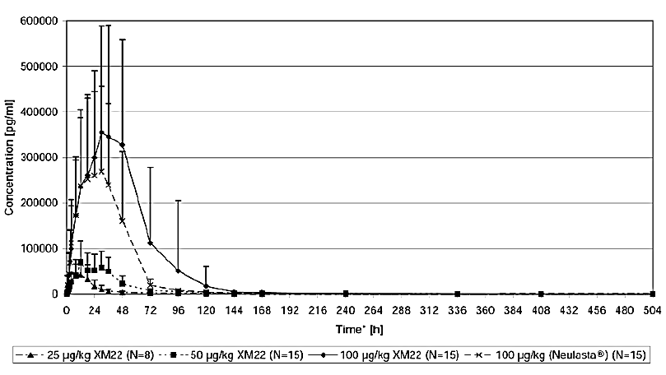
Figure 4 shows the synoptic a plot of the ANC count following single SC injection of the 3 dose levels of XM22 and Neulasta, respectively, to healthy subjects. It can be seen that the 50 µg/kg group has a similar ANC to Neulasta, and reached the same peak concentration at 100 µg/kg.
Figure 4: ANC plot following SC injection at three dose levels of XM22 and Neulasta
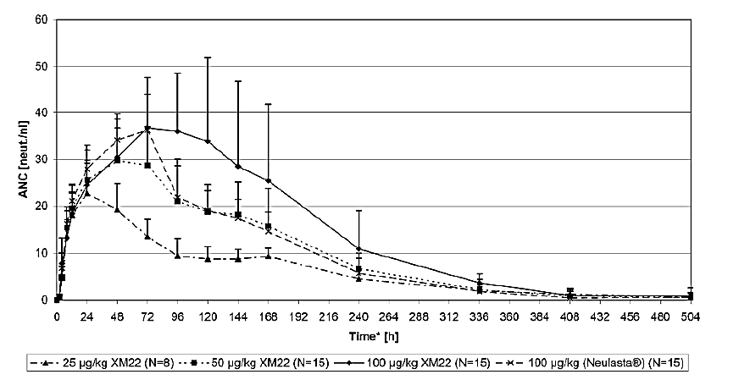
XM22-02 was a multinational, multicentre, randomised, double-blind, controlled study on the efficacy and safety of a fixed dose of three fixed dose levels of XM22 (3 mg, 4.5 mg and 6 mg) on the duration of severe neutropenia (DSN) to 6 mg Neulasta in patients with breast cancer receiving 4 cycles of chemotherapy with doxorubicin 60 mg/m² and docetaxel 75 mg/m². The primary objective was to identify the optimal fixed dose of XM22 compared to 6 mg Neulasta in patients with breast cancer receiving CTX for future clinical trials. Overall, the mean DSN was highest in the 3 mg XM22 group (1.1±1.1), followed by 6 mg Neulasta (0.9±1.0), 4.5 mg XM22 (0.8±1.1) and 6 mg XM22 (0.8±1.1). Mean and median DSN were very similar across all treatment groups and greatly reduced from that expected in non-G-CSF treated patients.
Figure 5: G-CSF serum concentrations after single SC administration of 3 doses XM22 or 1 dose Neulasta in Cycle 1. PK population.
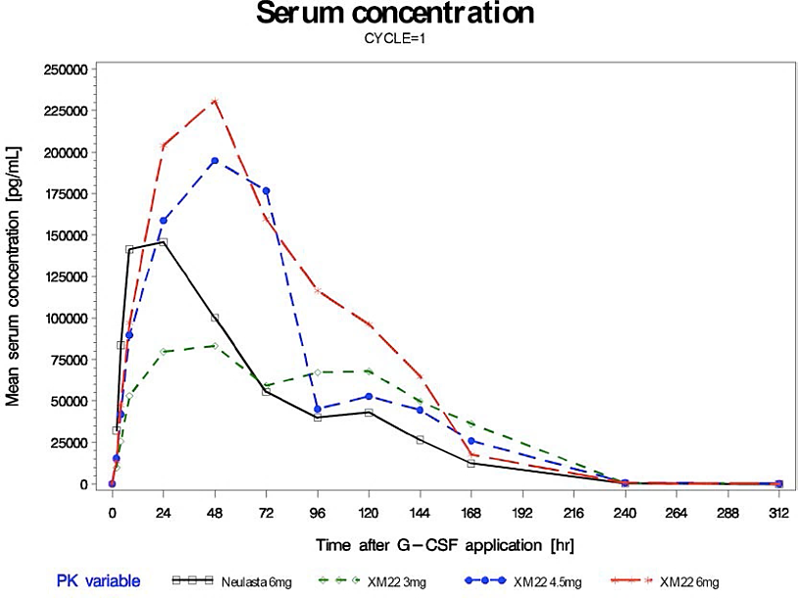
Figure 6: G-CSF serum concentrations after single SC administration of 3 doses XM22 or 1 dose Neulasta in Cycle 4. PK population.

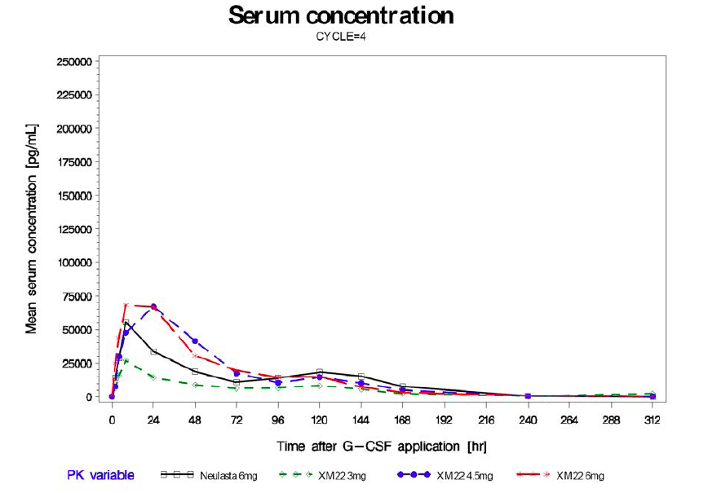

Pharmacodynamic results.
The primary objective of this study was the rate of DSN in Cycle 1 in a fixed dose of XM22 compared to 6 mg Neulasta in patients with breast cancer receiving CTX defined as Grade 4 neutropenia (ANC <0.5 x 10⁹/L). Figure 7 shows the synoptic plots of ANC following single SC injections of 3 mg, 4.5 mg or 6 mg XM22 or 6 mg Neulasta in patients with breast cancer receiving CTX in Cycle 1and shows that the ANC is higher with the 6 mg lipegfilgrastim than with the same dose of Neulasta.
Figure 7: Time course of measured ANC. ITT population.
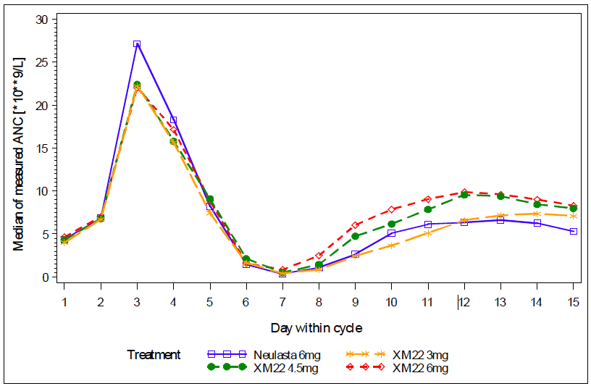
It can be seen that mean and median ANC were very similar across all treatment groups in this cancer population.
Comment: The benefit of 6 mg over 3 mg or 4 mg lipegfilgrastim on ANC is not clearly defined.

Population pharmacokinetic model
Here the proportionality of XM22 over the range of 25 through 100 μg/kg was evaluated using data from healthy subjects. The results in this population suggest that systemic exposure increases in a greater than proportional manner over this range.
Figure 8: Dose Normalized Observed AUC0-inf for XM22 Following Single Doses of 25, 50, or 100 μg/kg.
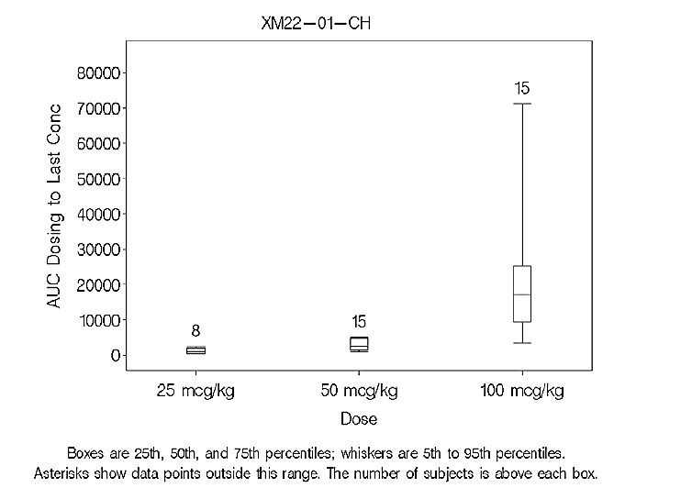
Further modeling was not done on the dose choice as the 1 therapeutic dose (a fixed 6 mg dose) had already been selected for further development.
Pharmacokinetic data obtained in the initial studies demonstrated that overall exposure (as assessed by AUC from time 0 to infinity (AUC_{0-∞})) was about 60% higher and peak exposure (C_{max}) about 30% higher following administration of 100 μg/kg or 6 mg dose of XM22 as compared to that following the 6mg dose of Neulasta (Study XM22-01-CH and XM22-02- INT). The decline of serum concentrations from peak longer for XM22 resulting in longer mean residence time (approximately 58 hours). The pharmacodynamic data from these studies demonstrated that, at these doses, XM22 had a greater effect on ANC apolipoprotein B mRNA editing enzyme, catalytic polypeptide-like (AOBEC) (approximately 30% higher) and CD34+ AOBEC (approximately 80% higher) than with Neulasta.
Comment: In XM22-02, the average DSN was highest in the 3 mg XM22 group (1.1±1.1), followed by 6 mg Neulasta (0.9±1.0), 4.5 mg XM22 (0.8±1.1) and 6 mg XM22 (0.8±1.1). Mean and median DSN were very similar across all treatment groups and greatly reduced from that expected in non-G-CSF treated patients. The difference from the 3 mg group to the 6 mg groups is 0.3 of a day. The clinical significance of this is not stated but is unlikely to be clinically relevant.
Ideally the modeling would have occurred on the XM22-01 and XM22-02 data to choose the dose, to drive the Phase III lipegfilgrastim versus placebo study rather than model doing that retrospectively. Based on the efficacy data; the clinical data suggests that 3 mg would be an effective dose for the study. The increase in AUC with the 6 mg lipfilgrastim compared to 6mg Neulasta is correlated with a 30% higher ANC.

Efficacy

Studies providing efficacy data Overview of clinical studies
The two studies to be discussed are the Phase III studies. Other clinical studies have been discussed above.

Evaluator’s conclusions on efficacy for treatment of cancer patients following chemotherapy to decrease DSN and FN
In the pivotal studies (XM22-03 and XM22-04) DSN and febrile neutropenia (FN) data were collected. This is important as the indication refers to both reduced FN and a shortened DSN. In XM22-03, non-inferiority of 6 mg Lonquex® to 6 mg pegfilgrastim for the primary endpoint, (DSN) in the first cycle of chemotherapy was seen. There was a 2% less incidence in FN but the statistical and clinical interpretation of this is not clear.
In XM22-04, XM22 6 mg was seen to be no more effective than placebo in reducing FN at the end of Cycle 1, the primary endpoint.
In XM22-04, XM22 appeared superior in achievement of some of the secondary endpoints. However the clinical relevance of these was unclear. Neutropenia per se is important if it affects the next course of treatment or causes FN. FN was not affected but there was a statistically significant reduction in number of CTX treatments that were delayed with XM22 in Cycles 2-4 but not in dose reduction or omission. Duration of severe neutropenia was significantly different between the two groups (1 to 2 days extra DSN) and the Incidence of severe neutropenia, defined as Grade 4 (ANC <0.5 x 10⁹/L). This was statistically significantly different between the two groups.
Comment: Overall, the relevant endpoints clinically need to be clarified, as does the relationship between these and the indication. Overall FN appears to be one of the two most significant endpoints as this is associated with morbidity and mortality, as well as neutropenia that cause a delay in next chemotherapy cycle. These are in fact both noted in the indication. Thus the trials need to show that both DSN and FN are reduced.
In terms of DSN, XM22-03 has shown non inferiority to Neulasta. XM22-04 showed a statistically significant difference when analysed as a secondary endpoint. The clinical relevance of the 1 to 2 days was not discussed however.
In terms of the FN, there was a numerical difference in XM22-03 but numbers were small and it was also a secondary endpoint. In the Intent-to-Treat (ITT) population, 2 patients in the Neulasta® group and 1 patient in the XM22 group were hospitalised due to FN or infection. All 3 patients were hospitalised during Cycle 1 (the XM22 patient for 1 day in the intensive care unit (ICU)) and received antibiotics; the XM22 patient also received antipyretics. The incidence of very severe neutropenia over all cycles was low and non-statistically different in both groups (11.7% Neulasta® patients, 6.4% XM22 patients; p=0.2066). There was no difference in FN in Study XM22-04 in the first or the following cycles.
Overall it appears then that lipegfilgrastim 6 mg is non-inferior to pegfilgrastim 6 mg in breast cancer in terms of DSN. Also that lipegfilgrastim is not superior to placebo for reducing febrile neutropenia in non-small cell lung cancer (NSCLC), nor has the superiority of XM22 over Neulasta in FN been demonstrated in XM22-03, although it does have a statistically significant effect at reducing the ANC nadir (lowest point ) and time to recovery.
These facts suggest the data does not support the indication.

Safety

Studies providing safety data Studies providing evaluable safety data
Detailed descriptions of the safety analysis of individual studies are provided in the respective study reports of which there are six. The evaluation of safety will focus on the findings from the 2 completed Phase III studies in cancer patients (XM22-03, XM22-04) and the 1 completed dose-finding Phase II study in cancer patients (XM22-02-INT). Supportive data from the Phase I studies in healthy subjects (XM22-01-CH, XM22-05-CH, XM22-06) will be presented as relevant.

Pivotal efficacy studies
XM22-03 and XM22-04.

Pivotal studies that assessed safety as a primary outcome
Nil.

Dose-response and non-pivotal efficacy studies
There were three Phase I and one Phase II dose-response and non-pivotal efficacy studies providing safety data.

Patient exposure
Table 8: Cumulative exposure to lipegfilgrastim in clinical studies.
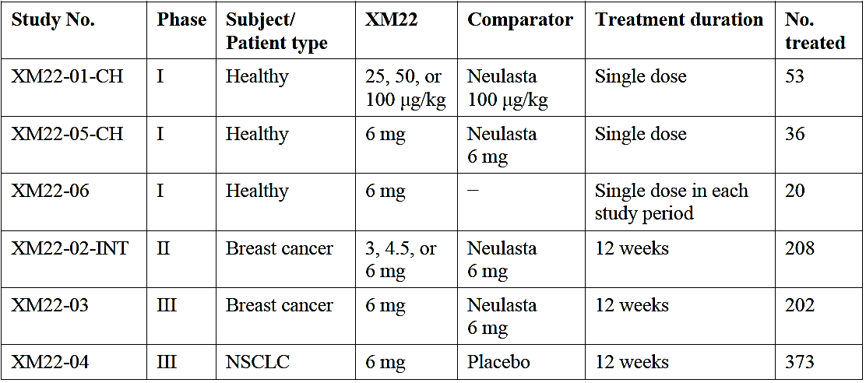
In all clinical studies, XM22 was administered as an SC injection. In the Phase II and III studies in cancer patients, XM22 was administered as a fixed dose once per CTX cycle, approximately 24 hours after CTX infusion. In the Phase I clinical studies in healthy subjects, XM22 was administered as a single weight-based dose in Study XM22-01-CH, as a single fixed dose in Study XM22-05-CH, and as a single fixed dose per treatment period in Study XM22-06 (up to 3 doses in total per subject).

Safety issues with the potential for major regulatory impact

Cardiovascular safety
No signal apart from the comments above with respect to the ECG.

Unwanted immunological events
Immnunogenicity is a long standing issue with these agents and there is an immunogenicity database collecting any new information. There were no significant issues within the submitted studies however.

Postmarketing data
Two PSURS reporting up to the middle of 2014 were provided and there were no new concerns raised.

First round benefit-risk assessment

First round assessment of benefits
The benefits of lipegfilgrastim in the proposed usage are:
- Less doses of G-CSF therapy
- Non-inferior to pegfilgrastim in DSN in breast cancer treatment
- May reduce delays in CTX
- May reduce neutropenia severity and time to recover from the nadir (although the clinical relevance was not clear).
Overall it appears then that lipegfilgrastim 6 mg is non-inferior to pegfilgrastim 6 mg in breast cancer and that lipegfilgrastim is not superior to placebo for reducing febrile neutropenia in NSCLC, although it does have a statistically significant effect at reducing the ANC nadir and time to recovery. The drug does not meet efficacy criteria for reduction of both DSN and FN.

First round assessment of risks
- May worsen survival in NSCLC
- May increase disease progression in NSCLC
- Equivalent to placebo in FN prevention in NSCLC
- May cause hyperleucocytosis
- Causes a number of side effects, including bone pain and elevations in ALP, GGT and lactate dehydrogenase (LDH).

First round assessment of benefit-risk balance
This drug appears to be non-inferior to one already registered (Neulasta) for which there are several years of pharmacovigilance data on DSN in breast cancer patients. The drug may not be any better than placebo at preventing FN in lung cancer and may worsen survival and worsen disease free progression in this disease. It also has side effects which are not insignificant. The benefits in the secondary outcomes are around ANC, much of which has not yet been shown to translate into a clinical benefit (as opposed to a change in the ANC number).
The data from the release of Phase IV study in the UK and the paediatric data would be helpful.

First Round Recommendation Regarding Authorisation
The proposed indication is not justified from the data presented; authorisation is not recommended.
Evaluation of the data in Phase IV studies in the EU and the paediatric data is needed to satisfy concerns over the effect this drug has on cancer progression and survival.

Clinical Questions

Pharmacokinetics
- The sponsor was requested to provide any additional data it holds regarding pharmacodynamic effect(s) according to gender, age (dichotomised at 65 years), body weight and body mass.
- The sponsor was requested to perform an analysis of PK and PD parameters, comparing: (i) patients that withdrew from treatment versus patients that continued treatment, and (ii) patients that survived following treatment versus patients that died on study.
- How did the sponsor decide on the drug dose for the study? Concentration data indicate that the 3 mg looks similarly effective.
- The sponsor should justify why a weight based dosing regimen recommendation has not been made bearing in mind there was pharmacokinetic data submitted which used at least a weight based dosing regimen and the large (and increasing) number of cancer patients that are overweight, obese or are cachectic or underweight (such as patients with lung cancer and underlying airways disease).

Efficacy
- The sponsor is requested to provide the comments of Swiss Medic which resulted in withdrawal of the submission to that regulator.
- The sponsor is requested to provide the PIP data from November 2014 submitted to the EMA.
- The sponsor is requested to provide an explanation regarding the lack difference in both dose reductions and omitted treatments seen in Study XM22-04 given these are considered clinically relevant end-points.
- Although the upper limit for number of injections is not stated this should be indicated based on the current efficacy or safety data?
- The sponsor is requested to provide a summary of the reasons as to why patients withdrew from XM-22-04.
- What does the sponsor consider to be the clinical benefit of a DSN reduction of 1.6 days as seen in XM22-04?
- The sponsor was requested to provides the statistical and clarify the clinical significance of the efficacy data presented in the clinical study report (CSR) for Study XM22-04?
- The sponsor should be requested to provide references to support the assumptions of the incidence rate of FN under treatment with placebo and the incidence under treatment with XM22 as the actual incidence was much lower.
- The sponsor was requested to explain proposed benefit of lipegfilgrastim for patients with NSCLC from, given they were observed to have worsened survival, disease progression and similar incidence of febrile neutropenia as compared to those exposed to placebo.

Safety
- What was the percentage of women compared to men who developed hyperleukocytosis and was this associated with elevated plasma concentration of lipegfilgrastim?
- What was the cause of ‘pain’ in the two patients that withdrew from Study XM22-03?
- Given that Study XM22-04 failed to meet the primary efficacy end-point of reduction in incidence of febrile neutropenia, does the sponsor have evidence of safety and efficacy to demonstrate a benefit to continued administration of Lonquex in an individual patient once febrile neutropaenia has occurred?
- The sponsor should identify if the patients who developed ECG abnormalities were concomitantly receiving doxorubicin.
- The sponsor was requested to provide the data and the study investigator’s stated reasons for the purported relationship to Lonquex for all patients who died.

Second Round Evaluation of clinical data submitted in response to questions
The details of the sponsor’s responses to the Clinical questions and the evaluator’s comments on these responses are detailed in Attachment 2.

Second round assessment of benefits
After consideration of the responses to clinical questions, the benefits of lipegfilgrastim in the proposed usage are unchanged from the first round clinical evaluation.

Second round assessment of risks
After consideration of the responses to clinical questions, the risks of lipegfilgrastim in the proposed usage are:
- The apparent risk of worsening survival for patients in Study XM22-04 may be plausibly accounted for due to an imbalance in baseline disease characteristics rather than exposure to lipegfilgrastim.
- Injection site pain sufficient to lead to treatment withdrawal was identified in a small number of patients

Second round assessment of benefit-risk balance
The benefit-risk balance of lipegfilgrastim is unfavourable given the proposed usage, but would become favourable if the changes recommended in the clinical evaluation are adopted.

Second round recommendation regarding authorisation
The evaluator recommends to the Delegate that lipegfilgrastim is approvable, providing the changes to the PI are implemented. The evaluator considers that the indication should be worded as per that approved in the EU.

V. Pharmacovigilance findings

Risk management plan
The sponsor submitted a Risk Management Plan (EU-RMP version 7.1 dated 10 April 2014 (data lock point 31 December 2013) and an Australian Specific Annex (ASA; dated 15 October 2014) which was reviewed by the RMP evaluator.

Safety specification
The sponsor provided a summary of Ongoing safety concerns which are shown at Table 9.
Table 9: Sponsor’s summary of Ongoing safety concerns
Important identified risks | Musculoskeletal pain-related symptoms
Important identified risks | Allergic type reactions
Important identified risks | Pulmonary adverse effects (pulmonary interstitial lung disease, ARDS)
Important identified risks | Thrombocytopenia
Important identified risks | Leukocytosis
Important potential risks | Immunogenicity which manifest as lack of effect.
Important potential risks | Sweet’s syndrome
Important potential risks | Sickle cells crisis in patients with Sickle cell disease
Important potential risks | Cutaneous vasculitis
Important potential risks | Splenomegaly, splenic rupture
Important potential risks | Risk in off label use
Important potential risks | Overdose
Important potential risks | Reduced pharmacodynamic effect in overweight patients >95 kg weight
Important potential risks | Progression of underlying malignancy
Important potential risks | Capillary leak syndrome
Important missing information | Risk in children <18 years of age
Important missing information | Risk in patients ≥65 years of age
Important missing information | Risk in pregnant and lactating women
Important missing information | Risk in patients with renal or hepatic impairment
Pharmacovigilance plan
The following table summarises the pharmacovigilance activities presented in the EU-RMP and the ASA:

Table 10: Summary of pharmacovigilance presented by the sponsor
Identified risks | Pharmacovigilance activities
Musculoskeletal pain-related symptoms | Routine pharmacovigilance;
Allergic type reactions | Routine pharmacovigilance;
Pulmonary adverse effects (including interstitial lung disease, ARDS) | Routine pharmacovigilance;
Thrombocytopenia | Routine pharmacovigilance;
Leucocytosis | Routine pharmacovigilance;
Important potential risks
Immunogenicity which may manifest as lack of effect | Routine pharmacovigilance;  Additional pharmacovigilance activity: study XM22-07 and study XM22-08;
Sweet’s syndrome | Routine pharmacovigilance;
Sickle cell crisis in patients with sickle cell disease | Routine pharmacovigilance;
Cutaneous vasculitis | Routine pharmacovigilance;
Splenomegaly, splenic rupture | Routine pharmacovigilance;
Risks in off-label use | Routine pharmacovigilance including a follow-up questionnaire;  Additional pharmacovigilance activity: a drug utilisation study;
Overdose | Routine pharmacovigilance including a follow-up questionnaire;
Reduced pharmacodynamics effect in patients > 95kg body weight | Routine pharmacovigilance including a follow-up questionnaire;
Progression of underlying malignancy | Routine pharmacovigilance;  Additional pharmacovigilance activity: a PASS to evaluate the risk of disease progression;
Capillary leak syndrome | Routine pharmacovigilance;
Important missing information
Risks in children < 18 years of age | Routine pharmacovigilance;  Additional pharmacovigilance activity: study XM22-07 and study XM22-08;
Risks in patients ≥ 65 years of age | Routine pharmacovigilance;
Risks in pregnant and lactating women | Routine pharmacovigilance;
Risks in patients with hepatic or renal impairment | Routine pharmacovigilance.

Risk minimisation activities
Routine risk minimisation through the Australian PI and Consumer Medicine Information (CMI) documents is proposed for all the safety concerns. No additional risk minimisation activities have been proposed by the sponsor.

Reconciliation of issues outlined in the RMP report
Table 11 summarises the first round evaluation of the RMP, the sponsor’s responses to issues raised by the RMP evaluator and the evaluation of the sponsor’s responses.
Table 11: Reconciliation of issues outlined in the RMP Evaluation Report (Round 1)
Recommendation in RMP evaluation report | Sponsor’s response | RMP evaluator’s comment
1. Safety considerations may be raised by the non-clinical and clinical evaluators through the TGA’s consolidated request for further information and/or the Nonclinical and Clinical Evaluation Reports respectively. It is important to ensure that the information provided in response to these includes a consideration of the relevance for the Risk Management Plan, and any specific information needed to address this issue in the RMP. For any safety considerations so raised, the sponsor should provide information that is relevant and necessary to address the issue in the RMP. | The applicant acknowledges the evaluators request to consider and address aspects of the clinical and non-clinical responses that may impact the Risk Management Plan. | The sponsor’s response is satisfactory.
2. The sponsor should clarify whether it considers ‘progression of underlying malignancy’ includes ‘worsening of underlying malignancy’. It should be noted that disease progression is a natural course for malignancies while worsening of underlying condition does not have to be. | The applicant acknowledges that it might be desirable to differentiate between natural courses of malignancies and other courses. However, MedDRA does not offer such kind of differentiated wording to characterise those cases.  MedDRA does include the following Preferred Terms (PTs) (which are laid down in section SVII.3 of the RMP to define the Potential Risk: ‘Progression of underlying malignancy‘):  • Concomitant disease progression  • Disease progression  • Neoplasm progression  However MedDRA does not include terms like ‘worsening of underlying malignancy’ or ‘worsening of neoplasm’, neither as PTs nor as Lowest Level Terms (LLTs) or on any other level.  Therefore in practice all case reports for worsening of underlying malignancy will be coded with either ‘Concomitant disease progression’, ‘Disease progression‘ or ‘Neoplasm progression‘ in the safety database of the applicant.  In periodic reports evaluating the Risk: ‘Progression of underlying malignancy‘(RMP wording) therefore all cases will be available, irrespectively of natural or other course and will be used to monitor the risk. | The sponsor’s response is acceptable. It is noted that in post-authorisation spontaneous adverse event reporting, it could be difficult to determine whether progression of malignancy is due to lipegfilgrastim or the disease trajectory.
3. The following is a list of risks associated with the use of other filgrastim (rbe) products. The sponsor should provide justification to why these are not relevant to lipegfilgrastim (rbe). In particular, why it does not expect these adverse events to occur given the pharmacological similarity between filgrastim (rbe) and lipegfilgrastim (rbe). Otherwise, they should be added to the list of safety concerns in the ASA:  Immune system disorders: acute and chronic Graft versus Host Disease (GvHD) including transformation to leukaemia or MDS;  Haematological malignancy;  Carcinogenicity;  Exacerbation of rheumatoid arthritis; and  Osteoporosis in severe chronic neutropenia patients. | a. The applicant acknowledges that immune system disorders can be regarded as a risk in recipients of allogeneic peripheral blood progenitor stem cells (PBPC) mobilised with filgrastim. Current data indicate that immunological interactions between the allogeneic PBPC graft and the recipient may be associated with an increased risk of acute and chronic Graft versus Host Disease (GvHD) when compared with bone marrow transplantation  This is relevant for Filgrastim (rbe) since it is indicated for the mobilisation of peripheral blood progenitor cells, in normal volunteers, for use in allogeneic peripheral blood progenitor cell transplantation.  However, the applicant does not seek approval for lipegfilgrastim in this indication. ‘Risks in off-label use’ are included in the Lonquex RMP as an important potential risk. However, as per current guidelines the RMP should not explicitly list individual risks that can be connected with off-label use.  b. As far as the applicant aware this risk is only applicable in connection with use in severe chronic neutropenia patients or in in normal donors. This is reflected in the following safety concern wordings:  • ‘Malignant cell growth (haematological malignancy and myelodysplastic syndrome) in patients with severe chronic neutropenia.’ ( AusPAR Filgrastim/Nivestim, January 2011, page 55)  • ‘ Haematological and lymphoid malignancy in normal donors’ (AusPAR Filgrastim/Zarzio, October 2013, page 24)  This is relevant for filgrastim (rbe) since it´s approved indication includes - the mobilisation of peripheral blood progenitor cells, in normal volunteers, for use in allogeneic peripheral blood progenitor cell transplantation.  - chronic administration to increase neutrophil counts and to reduce the incidence and duration of infections in patients with severe chronic neutropenia.  However, the applicant does not seek approval for lipegfilgrastim in these indications. ‘Risks in off-label use’ are included in the Lonquex RMP as an important potential risk. However, as per current guidelines the RMP should not explicitly list individual risks that can be connected with off-label use.  c. The applicant is not aware of carcinogenicity as being as safety concern of any G-CSF.  Carcinogenicity studies with lipegfilgrastim were not performed as there is no evidence for a genotoxic effect of these cytokines. There is no indication for a potential carcinogenicity of lipegfilgrastim from chronic toxicity studies.  d. Exacerbation of rheumatoid arthritis was not observed in lipegfilgrastim studies. In clinical Studies XM22-02, XM22-03 and XM22-04 no cases of MedDRA PT ‘rheumatoid arthritis’ (includes, amongst others, the LLTs ‘progression of rheumatoid arthritis’, ‘rheumatoid arthritis aggravated’) or MedDRA PT ‘juvenile idiopathic arthritis’ (includes, amongst others, the LLTs ‘juvenile arthritis aggravated’, ‘juvenile idiopathic arthritis aggravated’) have been seen.  Exacerbation of rheumatoid arthritis does not appear in the Neulasta (Pegfilgrastim) European SmPC.  The reports concerning cases of exacerbation of rheumatoid arthritis following G-CSF therapy refer to filgrastim, given to rheumatoid arthritis patients for stem cell mobilisation as a preparation for autologous haemopoietic stem cell transplantation. The population in this report (non-cancer patients) is different than that of lipegfilgrastim, as is the indication (stem cell mobilisation) which is not labelled for lipegfilgrastim. Therefore, the applicant regards that risk as non-relevant to lipegfilgrastim, and do not see it necessary to include it within its list of safety concerns.  e. Cases of decreased bone density and osteoporosis have been reported commonly in children with Severe Chronic Neutropenia (SCN) receiving chronic treatment with filgrastim. Decreased bone mineral density has been attributed primarily to the underlying disease. However, chronic filgrastim treatment may further accelerate bone loss. This is relevant for filgrastim (rbe) since it is indicated for chronic administration to increase neutrophil counts and to reduce the incidence and duration of infections in patients with SCN. However, the applicant does not seek approval for lipegfilgrastim in this indication. ‘Risks in off-label use’ are included in the Lonquex RMP as an important potential risk. However, as per current guidelines the RMP should not explicitly list individual risks that can be connected with off-label use. | The sponsor’s response is acceptable. If future application to extend the indication is sought, risks relevant to the indications should be included in the RMP.
4. Study XM22-07 is an open-label study to assess the pharmacokinetics, pharmacodynamics, efficacy, safety, tolerability and immunogenicity of lipegfilgrastim (rbe) in children with Ewing Family of Tumour or rhabdomyosarcoma. Final data was scheduled to be submitted in October 2014. The sponsor should provide a brief update on significant safety findings from this study. | The EU paediatric investigation plan consists of two studies in paediatric cancer patients with CTX-induced neutropenia. The first Study XM22-07 (Phase I study, investigating the pharmacokinetics of a single dose of XM22) is completed (except for follow-up data) and the study report for the treatment period was submitted to EMA in December 2014. The report for Study XM22-07 is included with this response. Follow-up data for the study, including results of immunogenicity testing, survival status, and G-CSF therapy will be summarised in a separate addendum report.  21 paediatric patients (aged 2 to 16 years) were treated with a single dose of XM22 in this study. The doses were weight-adjusted for each patient (100 μg/kg body weight).  Brief summary of results:  The primary objective of evaluating pharmacokinetic endpoints was met and the results raised no concerns regarding the pharmacokinetic, efficacy, or safety profile of XM22. The evaluations indicated a safety profile consistent with that seen in adult trials of XM22.  This summary is included in section III.3 of the latest EU RMP Version 8.2 (sign off date 30 April 2015).  A synopsis of the study is available in Annex 9 of the EU RMP Version 8.2.  Whilst the sponsor acknowledges that a separate application will be required in Australia in order to have these data reported in the Product Information, for the TGA’s reference the sponsor detailed the SmPC revisions recently agreed with the EMA following their evaluation of the XM22-07 Phase I findings | The sponsor’s response is satisfactory.
5. Benefit-risk assessment is beyond the scope of the RMP evaluation. As a post-authorisation safety study (PASS) has been planned to monitor the risk of ‘progression of underlying malignancy’, the sponsor’s pharmacovigilance plan is considered adequate. The sponsor should undertake to report any significant safety findings from the PASS to the TGA. | TEVA confim that the sponsor will report any significant safety findings from the PASS study to the TGA. | The sponsor’s response is satisfactory.
6. In regard to the proposed routine risk minimisation activities, it is recommended to the Delegate that the draft PI be revised as follows:  Use in paediatric patients: the sponsor states: ‘The safety and efficacy of Lonquex® in children and adolescents aged up to 17 years have not yet been established. No data are available.’ It is recommended that the Delegate considers adding a statement ‘treatment in this patient group is not recommended’. Myeloid leukaemia and Myelodysplastic syndrome: the sponsor has advised in the Australian PI that patients with these conditions should not use lipegfilgrastim. This advice is provided under ‘Precaution’ in the middle of a long paragraph. In comparison, the same advice is included under ‘indication’ in the approved SmPC. It is recommended that this advice is included under ‘indication’ in the PI to ensure healthcare professionals’ awareness. | The recommendations of the RMP Evaluator in relation to the draft PI are noted. The sponsor commits to working with the Delegate to ensure that the PI effectively communicates important safety information. | The sponsor’s response is satisfactory. It is noted that the TGA’s Advisory Committee on Safety of Medicines (ACSOM) advice supports the recommendations. The recommendations on PI remain for consideration by the Delegate.
7. In regard to the proposed routine risk minimisation activities, it is recommended to the Delegate that the incorrect reference to Neulasta in the draft consumer medicine information (CMI) document be revised. | The recommendations of the RMP Evaluator in relation to the Consumer Medicine Information (CMI) document are noted. The sponsor has revised the CMI to remove references to Neulasta as requested. The updated CMI (clean and tracked copies) are presented with this response. | The sponsor’s response is satisfactory.

Summary of recommendations
It is considered that the sponsor’s response to the TGA has adequately addressed most of the issues identified in the RMP evaluation report. Outstanding issues are discussed below.

Outstanding issues

Issues in relation to the RMP
Details on the sponsor’s response to the RMP evaluation report are in Table 11, Reconciliation of issues outlined in the RMP Evaluation Report.

Additional recommendations
- ACSOM Recommendation 4: (see below)
- Study XM22-04 should be included in the Product Information (PI) as a Precaution to notify clinicians of a biologically plausible mortality signal that is being investigated via further study.
- Nonclinical evaluator’s recommendations.
Results and conclusions drawn from the nonclinical program for lipegfilgrastim detailed in the sponsor’s draft Risk Management Plan are in general concordance with those of the nonclinical evaluator. Minor differences should be corrected:
- Decreased red blood cells (RBC) (and haematocrit (Hct) and/or haemoglobin (Hb)) was observed throughout the 26-week study in rats. Thus ‘a transient decrease in red blood cells’ described by the sponsor is not correct. However, the decreases in RBC and related parameters were reversible after cessation of dosing.
- Atrophy of trabecular bone in rats was seen in both the 13 week and 26 week studies.’

Advice from the Advisory Committee on the Safety of Medicines (ACSOM)
ACSOM Recommendation 1: The committee advised that the safety concern list provided by the sponsor could not be considered adequate until it incorporated safety issues that have been identified for filgrastim: immune system disorders (acute and chronic Graft versus Host Disease including transformation to leukaemia or myelodysplastic syndrome); haematological malignancy; carcinogenicity; exacerbation of rheumatoid arthritis; and osteoporosis in severe chronic neutropenia patients.
RMP evaluator comment: The sponsor has provided justification to why some risks related to filgrastim are not included in the current RMP (see sponsor’s response to Recommendation 3 in Table 11). This is acceptable. If future application to extend the indication is sought, risks relevant to the indications should be included in the RMP.
ACSOM Recommendation 2: The committee advised that routine pharmacovigilance was appropriate for the remaining issues. However, it was noted that as the proposed indications in Australia are wider than the indications approved by the EMA, the Australian Annex to the RMP and its pharmacovigilance plans needs to address these additional indications (chronic myeloid leukaemia and myelodysplastic syndromes) and include a drug utilisation study relevant to the wider Australian indications.
RMP evaluator comment: In the updated ASA submitted with the sponsor’s response, the sponsor states:
In contrast to the indication for Lonquex® in the EU, the proposed indication for Lonquex® in Australia does not specifically exclude chronic myeloid leukaemia and myelodysplastic syndromes. However, the proposed product Prescribing Information (Pl) (PRECAUTIONS) states that 'the safety and efficacy of Lonquex® administration in patients with myelodysplasia or chronic myeloid leukaemia have not been established'. This is consistent with the Australian prescribing information for other PEGylated recombinant human N-methionyl granulocyte-colony stimulating factors (G-CSFs) including pegfilgrastim (Neulasta®, marketed by Amgen Australia Pty Ltd).
This is acceptable in the context of risk minimisation.
ACSOM Recommendation 3: Noting that lipegfilgrastim is not distributed beyond the lymphatic/vascular system, there was no a priori evidence that different doses should be needed based on body weight. Investigation of a potential reduced pharmacodynamics effect in patients > 95 kg body weight via routine pharmacovigilance including a follow up questionnaire, as prescribed in the EU RMP, was sufficient.
ACSOM Recommendation 4:
- In the absence of paediatric data, use in the paediatric population was not appropriate. Data from XM22-07 should be considered before any use in children (< 18 years) could be acceptable.
- It would also be prudent if ‘use only in adults’ (or non-use in children) was specified in the approved Indications, to assist side-by-side comparisons with the use of other G-CSF molecules.
- It would also be useful if, like in the European Union (EU), the exclusion of patients with chronic myeloid leukemia and myelodysplastic syndromes was addressed explicitly in the approved indications as well as in the Precautions.
- Study XM22-04 should be included in the Product Information (PI) as a Precaution to notify clinicians of a biologically plausible mortality signal that is being investigated via further study.
RMP evaluator comment: As requested, the sponsor has provided an update on findings from Study XM22-07 (see sponsor’s response to Recommendation 4 in Table 11).
In addition, the sponsor states in the updated ASA:
Whilst the proposed indication for Lonquex® in Australia is not specifically limited to adult patients, the section on Paediatric Use in the proposed Pl (PRECAUTIONS) does preclude use in paediatric patients since the safety and efficacy of Lonquex® in children and adolescents up to 17 years have not yet been established. As noted in the Clinical Overview, paediatric studies (Studies XM22-07 and XM22-08) are initiated as part of the XM22 Paediatric Investigation Plan (PIP), approved by the EU Paediatric Committee on the 6th May 2011. It is therefore expected that following submission of the paediatric studies to the TGA, the Australian Pl will be updated in due to course.
The recommendations on PI appear to support the recommendations made by the RMP evaluator for consideration by the Delegate (see Recommendation 6 in Table 11).

Key changes to the updated RMP
In their response to the TGA the sponsor provided updated EU-RMP version 8.2 dated 30 April 2015 (data lock point 25 January 2015) with the Australian Specific Annex dated 26 June 2015. Key changes from the version evaluated in the first round evaluation are summarised below.
Table 12: Key changes to the EU-RMP and ASA
 | Key change
Safety specification | Capillary leak syndrome has been upgraded from ‘important potential risk’ to ‘important identified risk’;  Cytokine release syndrome and extra-medullary haematopoiesis have been added as ‘important potential risks’.
Pharmacovigilance activities | Targeted follow-up questionnaires have been added to monitor the following:  Important identified risk: capillary leak syndrome  Important potential risk: immunogenicity which may manifest as lack of effect, cytokine release syndrome and extra-medullary haematopoiesis.
RMP evaluator’s comments: The evaluator has no objection to the above changes and recommends to the Delegate that the updated version is implemented (see below).

Suggested wording for conditions of registration

RMP
Any changes to which the sponsor agreed become part of the risk management system, whether they are included in the currently available version of the RMP document, or not included, inadvertently or otherwise.
The suggested wording is:
Implement EU-RMP version 8.2 dated 30 April 2015 (data lock point 25 January 2015), Australian Specific Annex dated 26 June 2015 and any future updates as a condition of registration.

VI. Overall conclusion and risk/benefit assessment
The submission was summarised in the following Delegate’s overview and recommendations:

Quality
There was outstanding GMP clearance for three of the four manufacturing sites at the time of the second round chemistry evaluation (24 July 2015). There were no other objections to registration.

Nonclinical
The nonclinical evaluator did not object to registration; the PI changes recommended at in the first round evaluation report were satisfactorily resolved.

Clinical
The sponsor states that the dossier presented to the TGA is identical to that presented to the EMA on 20 November 2011, with the exception of updates, addressing issues during the EU evaluation and the pre-submission meeting with the TGA. Overview of submitted clinical studies of lipegfilgrastim and post-marketing reports
Table 13: Details of clinical studies and post-marketing reports submitted
Study No. | Type of study | Design | Dosage regimen
XM22-01 | PK, PD and safety, Healthy subjects | Phase I, single-centre, single-blind, randomised dose escalation study | Pilot cohort: single SC dose of 25 μg/kg Lonquex Main study: single SC dose of 50 or 100 μg/kg Lonquex or 100 μg/kg pegfilgrastim
XM22-05 | PK, PD and safety, Healthy subjects | Phase I, single-centre, single-blind, randomised, parallel-group study | Single SC dose of 6 mg Lonquex or 6 mg pegfilgrastim
XM22-06 | PK, PD and safety, Healthy subjects, Three different injection sites tested | Phase I, single-centre, open-label, randomised, three-way crossover study | Single SC dose of 6 mg Lonquex at 3 different injection sites (upper arm, abdomen, thigh), separated by 3-week washout
XM22-02-INT | Efficacy, PK, PD and safety, Breast cancer patients, Dose finding study | Phase II, multinational, multicentre, randomised, double-blind, parallel-group, active-controlled, dose finding study | Single SC injection of 3 mg, 4.5 mg or 6 mg Lonquex or 6 mg pegfilgrastim on day 2 of each chemotherapy cycle
XM22-03 | Efficacy, PK, PD and safety, Breast cancer patients, Active-controlled study | Phase III, multinational, multicentre, randomised, double-blind, parallel-group study | Single SC injection of 6 mg Lonquex or 6 mg pegfilgrastim on day 2 of each chemotherapy cycle
XM22-04 | Efficacy, PK, PD and safety, NSCLC patients, Placebo-controlled study | Phase III, multinational, multicentre, randomised, double-blind, parallel-group study | Single SC injection of 6 mg Lonquex or placebo on day 4 of each chemotherapy cycle
PSUR |  | Pertains to use between
PSUR-765-02-14 |  | 25 July 2013- 25 January 2014
PSUR-765-08-14 |  | 26 January 2014-25 July 2014

Pharmacology
Three Phase I studies of PK in healthy subjects were presented in the CER (Attachment 2).

Absorption
A single formulation of lipegfilgrastim is presented for SC use only.
In healthy volunteers, maximal serum concentration after a single dose was observed at approximately35 hours after administration. By contrast, after repeat dosing of 4 cycles maximal concentration in healthy subjects was achieved between 8 and 24 hours.
In the Phase II Study XM22-02, 3 mg, 4.5 mg and 6 mg Lonquex or 6 mg Neulasta was SC administered to patients with breast cancer receiving cancer chemotherapy. In Cycle 1, lipegfilgrastim or pegfilgrastim serum concentrations rose to a transient maximum and returned to pre-dose values by 240 h. In the Lonquex groups, the peak serum concentrations occurred around 46 to 48 h after dosing and were elevated with increasing Lonquex dose in a roughly dose-dependent manner. In Cycle 4, lipegfilgrastim and pegfilgrastim serum concentrations reached a maximum between 8 to 16 h after dosing, and returned to pre-dose values by 240 h. Overall, mean serum concentrations were markedly lower in Cycle 4 than in Cycle 1 for all treatment groups.
In the both the Phase III studies in patients with breast cancer (XM22-03) and lung carcinoma study (XM22-04), in Cycle 1, mean serum concentrations of Lonquex and reached a maximum between 24 and 48 h after dosing and returned to approximately pre-dose values by 240 h.

Bioavailability
Absolute bioavailability was not assessed given that the SC route of administration is the only one proposed.
Relative bioavailability between SC injections in upper arm, abdomen and thigh was assessed in Study XM-22-06. The evaluator states ‘no clinically relevant differences in PD parameters were observed between dosing at the three different administration sites’.

Distribution
Lonquex has a volume of distribution of 70mL/kg, approximating to the lymphatic and blood volume.
No data was presented on plasma protein binding, erythrocyte distribution or tissue distribution.
Effect of body weight: for categories of body weight dichotomised as < 60kg or > 80kg, there was a decrease in exposure of approximately 30% from the lowest to highest weight groups. There was no difference in pharmacodynamic effect for patients did not show a difference across patients according to weight <60, 60 to80 or >80 kg.

Metabolism
Lipegfilgrastim is metabolised via intra or extracellular degradation by proteolytic enzymes. Lipegfilgrastim is internalised by neutrophils (non-linear process), then degraded within the cell by endogenous proteolytic enzymes. This pathway is dependent upon the absolute neutrophil count and is saturable during the nadir of ANC count associated with cytotoxic chemotherapy.
Extracellular protein degradation pathway is likely due to by neutrophil elastase and other plasma proteases, which is linear.
Longer terminal half-lives and mean residence times were seen for lipegfilgrastim than pegfilgrastim, indicating that metabolism and clearance were significantly slower for lipegfilgrastim.

Excretion
Excretion is via the mechanisms of metabolism described above.

Special populations
Paediatric population: the sponsor’s response to TGA’s request for further information contained the clinical study report for a Phase I PK study in 21 children, with secondary end-points of safety and efficacy. This study represents only part of the paediatric development program and does not provide sufficient evidence to satisfactorily demonstrate the safety and efficacy of lipegfilgrastim in such patients. The restriction of use to adults should remain until the sponsor submits a full application for use in this population.
No separate studies in hepatic impairment were submitted. The effect of hepatic impairment in cancer patients has not been studied and this is documented in the PI.
No separate studies in renal impairment were submitted.
The effect of renal impairment was reported in the population PK modelling, with 31 patients with normal renal function, 20 patients having mild renal impairment and 2 having moderate renal impairment. The PI appropriately states (page 6) that: ‘There was no meaningful effect of mild renal impairment (CrCl: 62-87 mL/min; n=20) on the pharmacokinetics of lipegfilgrastim in cancer patients.’
The PI states that the impact of moderate or severe renal impairment has not been studied.
Patient data was only available for those aged <75 years. The lack of data available for patients that are ≥75 years of age is documented in the PI.
Very limited data was available for non-Caucasian patients, which precludes any specific dosing advice.

Pharmacodynamics
The studies providing pharmacodynamic data are summarised in the CER (Attachment 2).
The primary pharmacodynamic effect was maximum ANC count

Choice of drug dose
Weight based dosing of lipegfilgrastim and pegfilgrastim was compared in XM-22-01; doses of 100 µg/kg of each yielded comparable concentration-time profiles.
Study XM-22-02 compared three fixed-doses doses of lipegfilgrastim (3 mg, 4.5 mg and 6 mg) in patients with breast cancer receiving 4 cycles of chemotherapy. Although a difference in concentration-time profile was observed between 6 mg pegfilgrastim and 6 mg lipegfilgrastim, with C_{max} being approximately 30% higher for lipegfilgrastim, the observed pharmacodynamic effect on time-course of ANC count was similar.

Efficacy
The clinical evaluator did not recommend registration in the first round evaluation, but did so following the second round evaluation.
One dose-finding and two randomised controlled studies of efficacy were presented for evaluation.
Study XM22-03 was a Phase III non-inferiority Study XM22-03 with active control in 202 patients with Stage II to IV breast cancer receiving up to 4 cycles of chemotherapy consisting of doxorubicin and docetaxel. Patients were randomised 1:1 to receive 6 mg lipegfilgrastim or 6 mg pegfilgrastim.
On an intention to treat analysis, this study showed non-inferiority of 6 mg Lonquex® to 6 mg pegfilgrastim for the primary endpoint, duration of severe neutropenia (DSN) in the first cycle of chemotherapy.
The depth of ANC nadir was comparable for Cycle 1 but higher for the lipegfilgrastim arm in subsequent cycles.
The incidence of very severe neutropaenia was not different between the treatment arms (11.4% pegfilgrastim versus 6.4% lipegfilgrastim, p=0.21).
The incidence of febrile neutropaenia was low in both treatment arms.
Study XM-22-04 was a placebo-controlled superiority study in 375 non-small cell lung cancer patients receiving up to 4 cycles of chemotherapy consisting of cisplatin and etoposide.
This combination of chemotherapy is associated with a low risk of requiring G-CSF administration. The primary end point of the ability of this study (to assess superiority of lipegfilgrastim over placebo) was predicated upon an assumed background incidence of febrile neutropaenia of 7 to 10% in the placebo arm.
Patients were randomised 2:1 to receive either 6 mg Lonquex® or placebo. The primary end point was the incidence of febrile neutropaenia. Randomisation yielded comparable baseline demographic characteristics, stage of disease and median duration since first diagnosis. More than 85% of both arms had the Eastern Cooperative Oncology Group (ECOG) status 0 or 1. There was, however, an imbalance in the proportion of patients across tumour histological type:
Table 14: Baseline disease characteristics
This study did not meet its primary end point; the incidence of febrile neutropaenia was not different between the placebo and lipegfilgrastim arms (odds ratio 0.39, 95% CI 0.121, 1.260, p=0.115). The incidence of febrile neutropaenia was not different between the treatment arms for Cycles 2 to 4.
However, the secondary outcomes of the study (incidence and duration of severe neutropaenia) both favoured the lipegfilgrastim arm.
Despite the lack of difference in incidence of febrile neutropaenia in this study, the incidence of hospitalisation due to febrile neutropaenia was significantly better in the lipegfilgrastim arm.
The secondary end points of chemotherapy dose reduction or omission was not different between the two treatment arms for Cycles 2 to 4. However there was a significant reduction in chemotherapy dose delays in the lipegfilgrastim arm for Cycles 2 to 4.

Safety
In Study XM22-03, the incidence of adverse events was comparable between the patients exposed to lipegfilgrastim and pegfilgrastim, with the listing of preferred terms being comparable between agents (see Table 15 below).
Table 15: Incidence of adverse events listed by MedDRA* Preferred Term
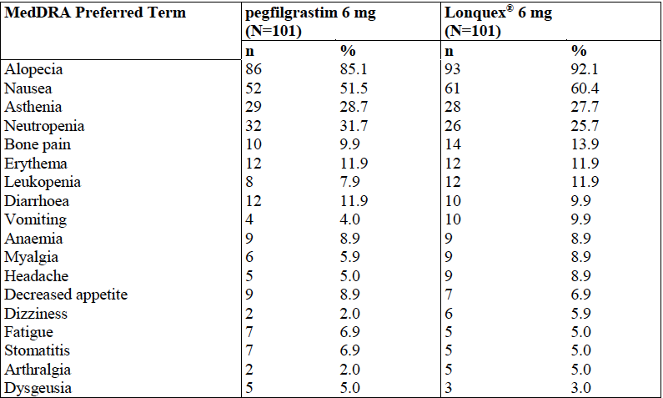
*MedDRA or Medical Dictionary for Regulatory Activities is a clinically validated international medical terminology dictionary (and thesaurus) used by regulatory authorities in the pharmaceutical industry during the regulatory process, from pre-marketing to post-marketing activities, and for data entry, retrieval, evaluation, and presentation. In addition, it is the adverse event classification dictionary endorsed by the International Conference on Harmonization of Technical Requirements for Registration of Pharmaceuticals for Human Use (ICH).
In the placebo-controlled Study XM22-04, treatment-emergent AEs of alopecia, anaemia, hypokalaemia, fatigue and pain were reported in the lipegfilgrastim arm.
Table 16: Study XM22-04, treatment-emergent AEs
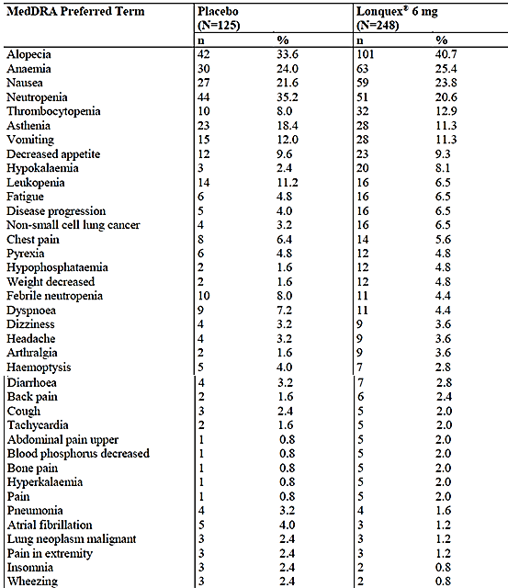

Deaths
In XM22-04, there was an imbalance in mortality during the treatment-emergent phase of the study, however as discussed above, there was an imbalance at baseline in tumour histology type between the treatment arms, with neither survival nor disease progression being assessed a priori. The sponsors responses demonstrated that no deaths in this study were assessed as being ‘likely’ to be related to study medication, but were due to either the underlying disease or associated morbidity.
Mortality was not statistically significantly worse for the lipegfilgrastim arm during the period of administration, as demonstrated in the explorative survival analysis, with one year follow-up. The 95% confidence intervals of hazard of death for each treatment arm do not separate (Figure 9).
Figure 9: Kaplan-Meier plot of survival probability versus day after Cycle 1 Day 1
Furthermore, data requested at the pre-submission meeting of hazard of survival split at treatment cycle demonstrates that the 95% CI of the hazard ratios for each treatment arm do not separate across each of the four cycles. This additional analysis is supportive of registration.
One death occurred in Study XM22-03 as a result of enterocolitis but was considered not related to lipegfilgrastim exposure.

Discontinuations
Among the patients in XM22-03, there was a comparable, low incidence of premature discontinuation for patients exposed to lipegfilgrastim and placebo.
In Study XM22-04, the proportion of patients discontinuing due to adverse events were comparable between placebo and lipegfilgrastim.
With respect to laboratory tests, there were no reported significant changes in liver or renal function across the studies.

Immunogenicity
The evaluator states that ‘there were no significant issues within the studies’. The PI reports a risk of ‘skin reactions’, ‘rash’ and ‘injection site reactions’, which are consistent with the class of medicine.

Leukocytosis
Three patients were identified as experiencing the MedDRA term leucocytosis; two patients had Grade II and one Grade I and all events resolved.
The reported incidence of leucocytosis >100x10⁹/L from pegfilgrastim exposure (as per the currently approved PI) is <0.5%. No patients experienced a white cell count >100x10⁹/L with lipegfilgrastim exposure.
Ten patients were identified as experiencing a white cell count >50x10⁹/L, an incidence of 10/785 (1.3%): nine were exposed to lipegfilgrastim and one to placebo.
No subjects were reported as experiencing leukostasis syndrome.

ECG changes
In Study XM22-03, the incidence of ST-T wave changes and increases in QTcF duration were seen in similar proportions of the lipegfilgrastim and pegfilgrastim arms.

Risk management plan
The second round RMP evaluation was supportive of registration. The evaluator suggested PI amendments to the Delegate:
- Regarding use in children, it is recommended that the Delegate considers adding a statement ‘treatment in this patient group is not recommended.’ The Delegate agrees with this advice.
- The indication should reflect that of the SmPC, in that patients with Myeloid leukaemia or myelodysplastic syndrome should not be treated, and reflected in the indication. The Delegate agrees with this advice (see below).

Risk-benefit analysis

Delegate’s considerations
In Australia, the currently approved products filgrastim and pegfilgrastim are the standard of care for patients requiring treatment for the myelosuppressive effects of cytotoxic chemotherapy. Given the clinical experience of use of filgrastim and pegfilgrastim, with the benefit of the safety and efficacy of lipegfilgrastim has to be measured against these currently approved therapies.

Efficacy
The totality of evidence presented favours the registration of lipegfilgrastim.
The observed incidence of febrile neutropaenia in Study XM22-04 was lower (1%) than was anticipated in the statistical analysis plan (7 to 10%), precluding the study from being able to satisfactorily assess a difference in incidence of febrile neutropaenia. However, the secondary end-points of this study were supportive of the efficacy benefit of lipegfilgrastim. Study XM22-03 demonstrated non-inferiority of lipegfilgrastim to pegfilgrastim.
The sponsor confirms in their response to clinical Question 4 that no efficacy data exists for the use of lipegfilgrastim when used in more than four consecutive cycles of cytotoxic chemotherapy.
The reports of post-marketing efficacy experience of lipegfilgrastim in the EU did not yield any new concerns for efficacy.

Safety
In regard to the imbalance in mortality during the placebo controlled period of the randomised controlled Study XM22-04, the sponsor sates in their response to clinical Question 9 that despite randomisation ‘unfavourable prognostic factors, risk factors and baseline covariate were not necessarily equally distributed between the two treatment groups’. This study neither assessed survival nor disease progression as a primary outcome measure and thus any observed differences are not necessarily due solely to the difference in effect of lipegfilgrastim and placebo.
Lipegfilgrastim and pegfilgrastim both contain the parent molecule filgrastim. According to their respective product information documents, for patients who develop hypersensitivity to either filgrastim or pegfilgrastim, cessation of the drug is mandated; these patients with hypersensitivity cannot be subsequently treated with lipegfilgrastim (as per the proposed PI) and as such this product does not offer a new therapeutic option to them.
The sponsor confirms in their response to clinical Question 4 that no safety data exists for the use of lipegfilgrastim when used in more than four consecutive cycles of cytotoxic chemotherapy. The safety data presented in the two Periodic Safety Update Reports (PSURs) were supportive of registration.

Indication
The proposed indication is dissimilar to that is approved in all other jurisdictions.
The TGA’s Pharmaceutical Subcommittee (PSC) advised that (in the event of registration) the wording of the proposed Australian indication should include the exception of use in patients with CML and myelodysplastic syndromes as included in the EU indication.

The Delegate considers the appropriate indication to be:
‘Lonquex is indicated for:
The reduction in the duration of neutropenia and the incidence of febrile neutropenia in adult patients treated with cytotoxic chemotherapy for malignancy (with the exception of chronic myeloid leukaemia and myelodysplastic syndromes).’

Deficiencies of the data
The safety and efficacy of lipegfilgrastim in patients treated in the studies presented for evaluation were for a maximum of four cycles (that is, four doses of study drug). In the sponsor’s response to clinical Question 4, the sponsor states that ‘no data are available for higher number of injections’.
The data as presented in clinical trials section of the PI contains biologically implausible values for the duration of severe neutropaenia. The data for duration of severe neutropaenia in Tables 1 and 2 [of PI] reports the mean ± SD for data which is non-normally distributed, leading to a negative 95% confidence interval. The appropriate measure of spread of data should be used.
The effect of moderate and severe renal impairment on PK of lipegfilgrastim has not been studied.
The effect of hepatic impairment on PK of lipegfilgrastim has not been studied.
No studies of pharmacokinetic interactions were submitted.
The effect on the PK of lipegfilgrastim in patients > 95kg compared to those below this weight has not yet been established.

Summary of Issues
The Delegate disagrees with wording of the sponsors’ proposed indication.
The maximum dosage of Lonquex that can be safely administered has not been established (4 cycles are the maximum studied)
The effects of moderate or severe renal impairment or any degree of liver impairment have not been studied

Proposed regulatory action
The Delegate considers that given the data presented in the dossier and in response to the TGA’s questions, there is sufficient evidence that the safety and efficacy of lipegfilgrastim has been satisfactorily established for registration to proceed.
Therefore, the Delegate had no reason to say, at this time, that the application for the product should not be approved for registration.

Conditions of Registration
Consistent with the action of the sponsor in agreeing to provide the results of PASS studies to the EMA and Israeli regulator, these studies should be submitted for evaluation to the TGA when available.

Request for ACPM advice
The committee is requested to provide advice on any issues that it thinks may be relevant to a decision on whether or not to approve this application.

Response from sponsor
The main part of the sponsor’s Pre-Advisory Committee on prescription Medicines (ACPM) response dealt with the TGA’s comments on the PI documentation.
Indications
The clinical evaluator does not support the wording of the proposed indication. The clinical evaluator recommends to the Delegate that the wording of the EU indication is appropriate.

Sponsor’s response (17 August 2015):
The applicant has amended the indication as follows:
Lonquex® is indicated for reduction in the duration of neutropenia and the incidence of febrile neutropenia in patients treated with cytotoxic chemotherapy for malignancy (with the exception of chronic myeloid leukaemia and myelodysplastic syndromes)
This is identical to the wording used in the current EU SmPC (16 June 2015) with one exception: the indication in the EU SmPC specifies ‘adult patients’ whereas this limitation is addressed under ‘Precautions, Paediatric use’ in the proposed Australian PI. In the sponsor’s response to the RMP Evaluation Report, the evaluator acknowledged that paediatric studies (Studies XM22‐07 and XM22‐08) are initiated as part of the XM22 Paediatric Investigation Plan (PIP), approved by the EU Paediatric Committee on the 6 May 2011. Furthermore the results of Study XM22-07 were included with the sponsor’s response (except for follow-up data) along with the revisions to the EU SmPC agreed with the EMA to include the paediatric population following their evaluation of this study. The applicant acknowledges that a separate post-approval variation application will be required in Australia in order to have these data reported in the PI. However, the applicant considers that the proposed text in the proposed PI explicitly excludes paediatric use and adequately minimises the potential for off-label use in this population.

Sponsor’s response (9 September 2015):
Further to the response provided with our submission on the 17 August, the sponsor agrees to adopt identical wording of the EU indication (that is, restricted to ‘adult’ patients, should this be the Delegate's preferred approach to identifying the data limitations in children). The indication has been amended as follows:
Lonquex® is indicated for reduction in the duration of neutropenia and the incidence of febrile neutropenia in adult patients treated with cytotoxic chemotherapy for malignancy (with the exception of chronic myeloid leukaemia and myelodysplastic syndromes)

Advisory Committee Considerations
The Advisory Committee on Prescription Medicines (ACPM), having considered the evaluations and the Delegate’s overview, as well as the sponsor’s response to these documents, advised the following:
The ACPM resolved to recommend to the TGA Delegate of the Minister and Secretary that:
The ACPM, taking into account the submitted evidence of efficacy, safety and quality, considered Lonquex solution for injection containing 6 mg/0.6 mL of lipegfilgrastim to have an overall positive benefit–risk profile for the amended indication;
Lonquex is indicated for the reduction in the duration of neutropenia in adult patients with malignancy (except chronic myeloid leukaemia and myelodysplastic syndromes) treated with cytotoxic chemotherapy regimens determined to be of significant risk of prolonged neutropenia and infection or when individual patient risk factors justify its use.
In making this recommendation the ACPM;
- Was of the view that the indication should not include ‘reduction of febrile neutropenia’ reflecting the results of Study XM-22-04, where the primary endpoint, incidence of febrile neutropenia, was not met.
- Advised that limiting the indication to adults was appropriate as there were limited data for use in the paediatric population.
Proposed conditions of registration
The ACPM agreed with the Delegate on the proposed conditions of registration.
Proposed Product Information (PI)/Consumer Medicine Information (CMI) amendments
The ACPM agreed with the Delegate to the proposed amendments to the Product Information (PI) and Consumer Medicine Information (CMI) and specifically advised on the inclusion of the following:
- Under Pharmacokinetics: Absorption, clarify whether the repeated administration (Cycle 4) information relates to healthy subjects or patients.
- Review the placement of Figure 1, as it comes under the title of ‘Patients with renal or hepatic impairment’ which is confusing.
- In the CMI:
  - Under ‘What is Lonquex used for’ change ‘….and this will reduce your chance of developing infections’ to ‘…and this may reduce your chance of developing infections’.
  - Under ‘When you must not use it’ remove ‘any other substances, such as foods, preservatives or dyes’ after the wording ‘If you have an allergies to…’
Specific Advice
The ACPM advised the following in response to the Delegate’s specific questions on this submission:
- The committee is requested to provide advice on any issues that it thinks may be relevant to a decision on whether or not to approve this application.
The ACPM had some concerns regarding the pharmacokinetic data and the dose selected and queried whether the 6 mg dose was the most appropriate dose for lipegfilgrastim.
The ACPM was concerned that the efficacy data did not strictly support the indication. The ACPM noted that the primary endpoint of Study XM-22-04, the incidence of febrile neutropenia, was not met. However, the secondary outcomes, the incidence and duration of severe neutropenia, were met. The ACPM also noted that the chemotherapy used in this study did not normally require the administration of G-CSF. Study XM-22-03, where the primary endpoint, duration of severe neutropenia, lipegfilgrastim demonstrated non-inferiority to pegfilgrastim. The ACPM advised that the indication should be modified to better reflect the results of the clinical trials and suggested removal of ‘…incidence of febrile neutropenia’.
The ACPM was of the view that use of lipegfilgrastim should be limited to use in adults as insufficient data were presented for use in the paediatric population.
The ACPM advised that implementation by the sponsor of the recommendations outlined above to the satisfaction of the TGA, in addition to the evidence of efficacy and safety provided would support the safe and effective use of this product.

Outcome
Based on a review of quality, safety and efficacy, TGA approved the registration of Lonquex solution for injection, prefilled syringe containing lipegfilgrastim rbe 6 mg/0.6 mL, indicated for:
For reduction in the duration of neutropenia and the incidence of febrile neutropenia in adult patients treated with cytotoxic chemotherapy for malignancy (with the exception of chronic myeloid leukaemia and myelodysplastic syndromes).

Specific conditions of registration applying to these goods
- The Lonquex EU-RMP version 8.2 dated 30 April 2015 (data lock point 25 January 2015), Australian Specific Annex dated 26 June 2015, and any subsequent revisions, as agreed with the TGA will be implemented in Australia.
- It is a condition of registration that, as a minimum, the first five independent batches of Lonquex lipegfilgrastim (rbe) 6 mg/0.6 mL solution for injection, prefilled syringe imported into Australia are not released for sale until samples and/or the manufacturer’s release data have been assessed and endorsed for release by the TGA Office of Laboratories and Scientific Services (OLSS).

Attachment 1. Product Information
The PI approved for Longquex at the time this AusPAR was published is at Attachment 1. For the most recent PI, please refer to the TGA website at <https://www.tga.gov.au/product-information-pi>.

Attachment 2. Extract from the Clinical Evaluation Report

Therapeutic Goods Administration
PO Box 100 Woden ACT 2606 Australia
Email: info@tga.gov.au Phone: 1800 020 653 Fax: 02 6232 8605
https://www.tga.gov.au

Okasaki K., Funato M., Kashima M., Nakama K., Inoue T., Hiura M., Kato Y. and NagataR. Twenty-six-week repeat-dose toxicity study of a recombinant human granulocyte colony-stimulating factor derivative (Nartograstim) in Cynomolgus monkeys. Toxicological Sciences. 2002;65:246-255.
Keller P. and Smalling R. Granulocyte colony stimulating faator: Animal studies for risk assessment. International Review of Eperimental Pathology. 1993;34A:173-188; Okasaki K., Funato M., Kashima M., Nakama K., Inoue T., Hiura M., Kato Y. and NagataR. Twenty-six-week repeat-dose toxicity study of a recombinant human granulocyte colony-stimulating factor derivative (Nartograstim) in Cynomolgus monkeys. Toxicological Sciences. 2002;65:246-255.
Okasaki K., Ebihara S., Asada M., Kanda A., Sasaki H. and Yamaya M. Granulocyte colony-stimulating factor promotes tumor angiogenesis via increasing circulating endothelial progenitor cells and Gr1+CD11b+ cells in cancer animal models. International Immunology. 2005;18:1-9.
Pregnancy Category B3: Drugs which have been taken by only a limited number of pregnant women and women of childbearing age, without an increase in the frequency of malformation or other direct or indirect harmful effects on the human fetus having been observed. Studies in animals have shown evidence of an increased occurrence of fetal damage, the significance of which is considered uncertain in humans.
Snowden et al, (1998) Bone Marrow Transplantation 22 (11): 1035-41
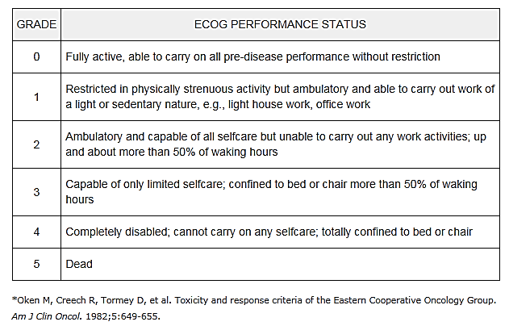
In cardiology, the QT interval is a measure of the time between the start of the Q wave and the end of the T wave in the heart's electrical cycle. The QT interval represents electrical depolarisation and repolarisation of the ventricles. A lengthened QT interval is a marker for the potential of ventricular tachyarrhythmias like torsades de pointes and a risk factor for sudden death. The QT interval is dependent on the heart rate (the faster the heart rate the shorter the R-R Interval and QT interval) and may be adjusted (QTcF) to improve the detection of patients at increased risk of ventricular arrhythmia.

