First round evaluation: February 28 2015
Second round evaluation: 5 August 2015

AusPAR Attachment 2

Extract from the Clinical Evaluation Report for Lipegfilgrastim (rbe)
  - Proprietary Product Name: Lonquex
  - Sponsor: Teva Pharma Australia Pty Ltd

About the Therapeutic Goods Administration (TGA)
- The Therapeutic Goods Administration (TGA) is part of the Australian Government Department of Health, and is responsible for regulating medicines and medical devices.
- The TGA administers the Therapeutic Goods Act 1989 (the Act), applying a risk management approach designed to ensure therapeutic goods supplied in Australia meet acceptable standards of quality, safety and efficacy (performance), when necessary.
- The work of the TGA is based on applying scientific and clinical expertise to decision-making, to ensure that the benefits to consumers outweigh any risks associated with the use of medicines and medical devices.
- The TGA relies on the public, healthcare professionals and industry to report problems with medicines or medical devices. TGA investigates reports received by it to determine any necessary regulatory action.
- To report a problem with a medicine or medical device, please see the information on the TGA website <https://www.tga.gov.au>.
About the Extract from the Clinical Evaluation Report
- This document provides a more detailed evaluation of the clinical findings, extracted from the Clinical Evaluation Report (CER) prepared by the TGA. This extract does not include sections from the CER regarding product documentation or post market activities.
- The words [Information redacted], where they appear in this document, indicate that confidential information has been deleted.
- For the most recent Product Information (PI), please refer to the TGA website <https://www.tga.gov.au/product-information-pi>.
Copyright
© Commonwealth of Australia 2016
This work is copyright. You may reproduce the whole or part of this work in unaltered form for your own personal use or, if you are part of an organisation, for internal use within your organisation, but only if you or your organisation do not use the reproduction for any commercial purpose and retain this copyright notice and all disclaimer notices as part of that reproduction. Apart from rights to use as permitted by the Copyright Act 1968 or allowed by this copyright notice, all other rights are reserved and you are not allowed to reproduce the whole or any part of this work in any way (electronic or otherwise) without first being given specific written permission from the Commonwealth to do so. Requests and inquiries concerning reproduction and rights are to be sent to the TGA Copyright Officer, Therapeutic Goods Administration, PO Box 100, Woden ACT 2606 or emailed to <tga.copyright@tga.gov.au>.

Contents
Common abbreviations 5
1. Introduction 9
2. Clinical rationale 9
3. Contents of the clinical dossier 9
3.1. Scope of the clinical dossier 9
3.2. Paediatric data 10
3.3. Good clinical practice 10
4. Pharmacokinetics 11
4.1. Studies providing pharmacokinetic data 11
4.2. Summary of pharmacokinetics 12
4.3. Pharmacokinetic interactions 17
4.4. Summary of pharmacokinetics 17
4.5. Evaluator’s overall conclusions on pharmacokinetics 18
5. Pharmacodynamics 18
5.1. Studies providing pharmacodynamic data 18
5.2. Summary of pharmacodynamics 19
5.3. Evaluator’s overall conclusions on pharmacodynamics 21
6. Dosage selection for the pivotal studies 21
6.1. XM22-01 22
6.2. XM22-02 23
7. Clinical efficacy 25
7.1. Overview of clinical studies 25
7.2. Pivotal efficacy studies 26
7.3. Analyses performed across trials 43
7.4. Evaluator’s conclusions on clinical efficacy for treatment of cancer patients following chemotherapy to decrease DSN and FN. 45
8. Clinical safety 46
8.1. Studies providing evaluable safety data 46
8.2. Adverse events 47
8.3. Laboratory tests 54
8.4. Post-marketing experience 56
8.5. Safety issues with the potential for major regulatory impact 56
8.6. Other safety issues 56
9. First round benefit-risk assessment 57
9.1. First round assessment of benefits 57
9.2. First round assessment of risks 57
9.3. First round assessment of benefit-risk balance 57
9.4. First round recommendation regarding authorisation 57
10. Clinical questions 58
10.1. Pharmacokinetics 58
10.2. Efficacy 58
10.3. Safety 58
11. Second round evaluation of clinical data submitted in response to questions 59
11.1. Pharmacokinetics 59
11.2. Efficacy 67
11.3. Safety 82
12. Second round benefit-risk assessment 90
12.1. Second round assessment of benefits 90
12.2. Second round assessment of risks 90
12.3. Second round assessment of benefit-risk balance 90
13. Second round recommendation regarding authorisation 91
14. References 91

Common abbreviations
Abbreviation | Meaning
γ-GT | γ-glutamyl-transferase
ADA | Anti-drug-antibody
AE | Adverse Event
ALAT | Alanine aminotransferase
ALP | Alkaline phosphatase
ALT | Alanine aminotransferase
ANC | Absolute neutrophil count
ANOVA | Analysis of variance
aPPT | Activated partial thromboplastin time
ASAT | Aspartate aminotransferase
ATC | Anatomical therapeutic chemical
AUC | Area under the curve
AUC_{0-t} | Area under the curve from the time of dosing to the time of the last observation
AUC_{last} | Area under the curve from the time of dosing to the last measurable concentration
AUC_{0-∞} | Area under the curve from the time of dosing extrapolated to infinity, based on the last observed concentration
BW | Body weight
CHMP | Committee of Human Medicinal Products
CI | Confidence interval
CK | Creatine kinase
CL | Total body clearance
C_{max} | Highest observed plasma concentration
CML | Chronic myelogenous leukemia
CPA/CTX | Cyclophosphamide
CYP450 | Cytochrome P450
DNA | Deoxyribonucleic acid
DNS | Duration of severe neutropenia
DPF | Dose proportion factor
EC70 | Effective concentration of drug substances that lead to a 70% viability of the NFS-60 cells
ECG | Electrocardiography
ECL | Electro-chemiluminescence
EMA | European Medicines Agency
EORTC | European Organisation for Research and Treatment of Cancer
FN | Febrile neutropenia
G-CSF | Granulocyte colony stimulating factor
GalNAc | N-Acetylgalactosamine
GD | Gestation day
GLDH | Glutamate-dehydrogenase
HCT | Haematocrit
HD | High dose
HGB | Haemoglobin content
IA | Intraarterial
IgG | Immunoglobulin G
IgM | Immunoglobulin M
IM | Intramuscular
IP | Intraperitoneal
ISS | Integrated Summary of Safety
ITT | Intent-to-Treat
IV | Intravenous
LC/MS/MS | Liquid chromatography/tandem mass spectrometry
LD | Low dose
LDH | Lactate dehydrogenase
LDS | Loading-dye sample buffer
LI | Lobularity index
LLOD | Lower limit of detection
LLOQ | Lower limit of quantification
LOD | Limit of detection
LLOQ | Limit of quantification
LPS | Lipoplysaccharides
LS | Least square
MCH | Mean corpuscular haemoglobin
MCHC | Mean corpuscular haemoglobin concentration
MCV | Mean corpuscular volume
MD | Medium dose
MedDRA | Medical Dictionary for Regulatory Activities
MFI | Median fluorescent intensity
mPEG | Methoxypolyethylene glycol
MSR | Minimal significant ratio
NFS60 | Mouse myelogenous leukaemia cell line adapted to respond to recombinant G-CSF (lipegfilgrastim/Neulasta)
NMP | Normal monkey plasma
NOAEL | No Observed Adverse Effect Level
NRP | Normal rat plasma
NRS | Naïve rat serum
NZW | New Zealand white
PBS | Phosphate buffered saline
PCT | Number of platelets
PEG | Polyethylene glycol
PK | Pharmacokinetics
PNRS | Pooled naïve rat serum
PP | Per-Protocol
PRbS | Pregnant rabbit serum
PV | Paravenous
QC | Quality control
RBC | Red blood cells (erythrocytes)
r-metHuG-CSF | Recombinant N-methionyl granulocyte-colony stimulating factor
SC | Subcutaneous
SD | Standard deviation
SDS-PAGE | Sodium dodecylsulfate-polyacrylamide gel electrophoresis
SAE | Serious Adverse Event
SPR | Surface plasmon resonance
T_{1/2} | Terminal half-life-ln(2)/λ_{z}
t_{1/2elim} | Plasma elimination half-life
t_{max} | Time of C_{max}
TEAE | Treatment Emergent Adverse Event
TPT | Thromboplastin time
ULOQ | Upper limit of quantification
V_{ss} | Volume of distribution at steady state
V_{z} | Volume of distribution based on the terminal phase
WBC | White blood cell (leucocytes)
XM21 | Recombinant human G-CSF, equivalent to Filgrastim, precursor of lipegfilgrastim
XM22 | Glyco-pegylated recombinant human G-CSF, glycoPEG-XM21; Lipegfilgrastim

Introduction
This is an application to register a New Chemical Entity.
Lonquex® is the Teva Pharmaceuticals Ltd. trademark for lipegfilgrastim (rbe), a long-acting form of recombinant human granulocyte colony-stimulating factor (G-CSF). It belongs to the Pharmacotherapeutic Group of Immunostimulants, Colony stimulating factors, ATC code: L03AA14
The sponsor has proposed the following therapeutic indication:
Lonquex® is indicated for the treatment of cancer patients following chemotherapy, to decrease the duration of severe neutropenia and so reduce the incidence of infection, as manifest by febrile neutropenia.

Clinical rationale
Human G-CSF is a glycoprotein that regulates the production and release of functional neutrophils from the bone marrow. Stimulating the G-CSF receptor can raise neutrophil count in some conditions and has been used in cancer to reduce neutropenia, a risk factor for infection and for increasing delay in the next chemotherapy cycle. Filgrastim is an un-glycosylated recombinant methionyl human G-CSF which binds to the G-CSF receptor, promoting the proliferation and differentiation of progenitor cells within the bone marrow and the release of mature neutrophils into the peripheral blood. Pegfilgrastim (Neulasta®) is filgrastim conjugated to polyethylene glycol (PEG) which increases its pharmacodynamic effect offering the option of a single injection per chemotherapy cycle.
XM22 is a covalent conjugate of a 19 kDa E. coli produced r-metHuG-CSF (company code: XM21, equivalent to filgrastim) and a single, 20 kDa PEG molecule. XM22 is the company code used in the sponsor dossier for Drug Substance and Drug Product. The INN for XM22 is lipegfilgrastim.
XM22 differs from pegfilgrastim, in that its PEGylation occurs enzymatically through a glycolinker to the amino acid Thr134 rather than chemically to the terminal methionine, referred to as ‘glycoPEGylation’ . Lipegfilgrastim is thus a structurally distinct molecule to pegfilgrastim, however it binds to human the G-CSF receptor like filgrastim and pegfilgrastim.

Contents of the clinical dossier

Scope of the clinical dossier
The data provided in this Category 1 Application is identical to the updated and approved European Union dossier. The only differences being minor amendments made following a pre-submission meeting with the TGA as described - these issues include concerns over GMP sites, pre submission final meeting minutes and patient narratives for deaths which have now been provided.
The submission contained the following clinical information:
- Literature references which varied from topics of ‘back and neck pain’ in children with cancer, to G-CSF given in patients with sickle cell disease, and were used as supporting evidence in the submission.
- Bioanalytic data, human pharmacokinetic studies (XM22-01,05, 06) in healthy patients and efficacy and safety studies in patients (XM22-02,03,04), population PK/PD for XM22 in healthy and oncology subjects, statistical tables, an integrated summary for safety, efficacy and RMP, and two 6 month PSURs from July 2013 to June 2014.
- The following studies for evaluation:
  - Phase I studies of PK, PD and safety
    - XM22-01-CH – dose escalation study in healthy subjects
    - XM-22-05-CH – single dose parallel group study in healthy subjects
    - XM22-06 – open label three-way crossover study in healthy subjects
  - Phase II study of efficacy, PK, PD and safety, dose-finding study
    - XM22-02-INT – randomised double-blind parallel group active-controlled dose-finding study in patients with Stage II, III or IV breast cancer receiving doxorubicin/docetaxel for 4 cycles.
  - Phase III studies of efficacy, PK, PD and safety
    - XM22-03 – Non-inferiority study: randomised double-blind parallel-group active controlled study in patients with high risk Stage II, III or IV breast cancer scheduled to receive IV doxorubicin/ docetaxel as routine chemotherapy for 4 cycles. Comparison of 6 mg Lonquex versus 6 mg pegfilgrastim on Day 2 of each cycle
    - XM22-04 Superiority study: randomised double-blind parallel-group placebo-controlled study in Patients with Stage IIIb/IV non-small cell lung cancer scheduled to receive IV cisplatin/etoposide CTX for 4 cycles. Comparison of single injection of 6 mg Lonquex versus placebo on day 4 of each cycle.

Paediatric data
The submission included no paediatric pharmacokinetic / pharmacodynamic / efficacy / safety data. In the application form (Module 1) to the ‘are there are paediatric formulations for this product or have paediatric data been submitted?’ question the ‘no’ box is ticked. Yet to the following question ‘If there are no paediatric formulations for this product or paediatric data have not been submitted, is there a formal justification as to why the product is not appropriate for use in children ‘ there is no selection.
In the RMP it is stated that studies with the use of lipegfilgrastim in children have been agreed and described in the Paediatric Investigation Plan – these studies are Study XM22-07 and XM22-08 (agreed in September 2011, this first of which was started in September 2012). The planned date for submission of final data is March 2018 although the first date of submission of a report conducted as part of the PIP is Nov 2014.
There is no paediatric plan submitted to the USA and no data has been submitted to the FDA.
Comment: The sponsor is requested to provide the PIP data from November 2014 to the EMA

Good clinical practice
GMP certification has been provided and the study reports for the new submitted clinical trial included assurances that it was conducted in accordance with the International Conference on Harmonisation (ICH) Good Clinical Practices (GCP) guidelines and any regulations applicable in the countries where the trials were conducted. Independent ethics committees reviewed all documentation.

Pharmacokinetics

Studies providing pharmacokinetic data
A summary of the pharmacokinetic study is presented in Table 1 and Section 4.2 of this report.
There were three Phase I studies in healthy volunteers examining pharmacokinetics. These are XM22-01, XM22-05, XM22-06 and are summarized in Section 18. In brief, after a single subcutaneous injection of 6 mg at three different sites (upper arm, abdomen and thigh) in healthy volunteers with lipegfilgrastim, the maximum blood concentration was reached after a median of 30 to 36 hours and the average terminal half-life ranged from approximately 32 to 62 hours. The peak concentration and area under the curve was lower after subcutaneous injection in the thigh compared to subcutaneous injection in the abdomen and in the upper arm.
In the limited Study XM22-06, concentrations of lipegfilgrastim and observed differences among the injection sites were higher in males compared to female subjects however pharmacodynamics were similar, independent of gender and injection site.
There was one Phase II study in cancer which also had pharmacokinetic data. This was XM22-02 in breast cancer where patients received lipegfilgrastim and concurrent docetaxel or doxorubicin. Mean maximum blood concentrations of 227 and 262 ng/ml were reached after median times to maximum concentration (Tmax) of 44 and 48 hours. The mean terminal half-lives were approximately 29 and 31 hours after a single subcutaneous injection of 6 mg lipegfilgrastim during the first cycle of chemotherapy. After a single subcutaneous injection of 6 mg lipegfilgrastim during the fourth cycle, the maximum blood concentrations were lower than observed in the first cycle (mean values 77 and 111 ng/ml) and were reached after median Tmax of 8 hours. The mean terminal half-lives in the fourth cycle were longer than Cycle 1, approximately 39 and 42 hours.
There was a Phase III study (XM22-04) with some pharmacokinetic data in patients with non-small cell lung cancer receiving chemotherapy consisting of cisplatin and etoposide. Here the mean maximum blood concentration of 317 ng/ml was reached after a median Tmax of 24 hours and the mean terminal half-life was approximately 28 hours after a single subcutaneous injection of 6 mg lipegfilgrastim during the first cycle of chemotherapy. After a single subcutaneous injection of 6 mg lipegfilgrastim during the fourth cycle, the mean maximum blood concentration of 149 ng/ml was reached after a median Tmax of 8 hours and the mean terminal half-life was approximately 34 hours.

Table 1: Submitted pharmacokinetic studies.
PK topic | Subtopic | Study ID
PK in healthy adults | General PK - Single dose | XM22-01
PK in healthy adults | General PK - Single dose | XM22-05
PK in healthy adults | General PK - Single dose | XM22-06
PK in healthy adults | - Multi-dose | Nil
PK in healthy adults | Bioequivalence† - Single dose | Nil
PK in healthy adults | - Multi-dose | Nil
PK in healthy adults | Food effect | Nil
PK in special populations | Target population - breast cancer  Non-small cell lung cancer | XM22-02 and XM22-03  XM22-04
PK in special populations | - Multi-dose | NIL
PK in special populations | Hepatic impairment | NIL
PK in special populations | Renal impairment | NIL
PK in special populations | Neonates/infants/children/adolescents | NIL
PK in special populations | Elderly | NIL
Genetic/gender related PK | Males versus females | NIL
Population PK analyses | Healthy subjects
Population PK analyses | Target population | PKPD analysis of XM22 undertaken
Population PK analyses | Other
None of the pharmacokinetic studies had deficiencies that excluded their results from consideration.

Summary of pharmacokinetics
The Phase I studies with pharmacokinetic data are described briefly as follows:

Study XM22-01
This was a Phase I dose escalation study that evaluated the PK and PD parameters, along with safety (including immunogenicity) of a weight-based single subcutaneous ascending doses of Lonquex, dosed by body weight (BW) at three different levels (25, 50 and 100 μg/kg) as compared with Neulasta (pegfilgrastim) administered as a single subcutaneous dose of 100 μg/kg in healthy male and female subjects. A total of 38 subjects received Lonquex (25 μg/kg: 8 subjects, 50 μg/kg: 15 subjects, 100 μg/kg: 15 subjects), and 15 subjects received Neulasta. A single dose of 100 μg/kg Lonquex resulted in a 56% higher area under curve (AUC) and in a significantly higher AUC area over baseline effect curve (AOBEC) compared to 100 μg/kg Neulasta.

Study XM22-05
Study XM22-05 was a Phase I study that evaluated the PK and PD parameters along with safety (including immunogenicity) of a fixed single dose of 6 mg of Lonquex compared to a fixed single dose of 6 mg of Neulasta in healthy male and female subjects. 18 subjects received a single dose of Lonquex and 18 subjects received a single dose of Neulasta. In the Lonquex group, the ANC AOBEC was about 30% higher than that for Neulasta, whereas the AUC for Lonquex increased by about 64% compared to Neulasta.

Study XM22-06
Study XM22-06 was a Phase I three-way crossover study that evaluated PK and PD parameters along with safety (including immunogenicity) of a single dose of 6 mg Lonquex administered at three different subcutaneous injection sites (upper arm, abdomen and thigh), separated by a three-week washout period. This study was design to determine if there are any clinically relevant differences in the PK and PD of subcutaneous doses of Lonquex on the choice of injection site. 20 healthy subjects received at least one single dose of Lonquex and 12 subjects received Lonquex for all three treatment periods. Bioavailability was lowered following subcutaneous injection in the thigh compared to abdomen and upper arm. Nevertheless no clinically relevant differences in PD parameters were observed between dosing at the three different administration sites.

Physicochemical characteristics of the active substance
The following information is derived and considered from the Sponsor’s summaries in
Module 2.

Pharmacokinetics in healthy subjects

Absorption

Sites and mechanisms of absorption
After a single subcutaneous administration of lipegfilgrastim maximum serum concentrations are attained at approximately 35 hours after dose administration. Lipegfilgrastim is presumed to be absorbed into the lymphatic system into the blood due to its size. After 4 cycles, maximal serum concentrations are attained at 8-24 hours, earlier than that after a single dose, with lower average serum concentrations also than after a single dose.
Lipegfilgrastim has a volume of distribution of 70ml/kg, consistent with lymphatic and blood volume. Pharmacokinetic studies in bilateral nephrectomised rats (XM22-1619-029 – not evaluated) also suggested that in rats XM22 distributes throughout the vascular space.
Lipegfilgrastim is metabolised and eliminated by enzymatic cleavage both within the neutrophil after internalisation and externally via proteases. The intracellular elimination is dependent on the ANC, thus clearance is dependent on the ANC. Clearance also varies between cancer populations and healthy volunteers. This was modeled in the population PK study in Section 7.

Bioavailability
Standard bioavailability studies were not conducted for lipegfilgrastim. The sponsor justified this by stating that lipegfilgrastim is for subcutaneously administration only and that pharmacokinetic measurements were taken in Study XM22-01 and XM22-05 to estimate pharmacokinetic parameters.
Therefore data on absolute bioavailability, bioavailability relative to an oral solution, bioequivalence data and dose-response in terms of timing of injection was not available to be evaluated.
The relative bioavailability of lipegfilgrastim after subcutaneous injection at three different sites of administration was undertaken in Study XM22-06.

Distribution

Volume of distribution
Lipegfilgrastim has a volume of distribution of 70ml/kg, consistent with distribution in the lymphatic and blood volume. Plasma protein binding, erythrocyte distribution and tissue distribution data was not able to be located although there was a rat reference from 1993 to distribution across the placenta in a rat model.

Metabolism
Lipegfilgrastim is metabolised and eliminated by enzymatic cleavage both within the neutrophil after internalisation and externally via proteases. The intracellular elimination is dependent on the absolute neutrophil count (ANC). This ANC neutrophil-mediated clearance becomes saturated at higher doses, that is, the serum concentration of lipegfilgrastim increases during the chemotherapy-induced transient neutrophil nadir and rapidly at the following onset of neutrophil recovery.

Sites of metabolism and mechanisms / enzyme systems involved
In vitro data suggests that lipegfilgrastim has little effect on CYP1A2, CYP2B6, CYP2C8, CYP2C9, CYP2C19, and CYP3A4/5 activity. Although human data was not available, due to its pharmacokinetic profile, the likelihood of drug interactions involving this system is low.

Non-renal clearance
This occurs both intracellularly and extraceullarly by proteases.

Metabolites identified in humans
Nil.

Excretion

Routes and mechanisms of excretion
Excretion is predominantly via proteases – intracellular and extracellularly.

Intra- and inter-individual variability of pharmacokinetics
Clearance is partially dependent on the ANC, and thus clearance varies between cancer populations and healthy volunteers. Rat studies (XM22-1619-029) suggests that renal clearance has very low contribution to overall clearance. Pharmacokinetics between cycles differ, it is suggested that this is related to the ANC.

Pharmacokinetics in the target population
The target population for this submission is patients with cancer having moderate myeloablative chemotherapy. This is a very heterogeneous population with large differences in pharmacokinetic parameters.
Comment: The drug is given as a ‘one dose fit all.’ Populations in the different cancer groups are likely to have different body sizes (for example, postmenopausal women with breast cancer versus patients with lung cancers), ages and genders. Thus all-encompassing statements about the pharmacokinetics in the targeted population are difficult.

Pharmacokinetics in other special populations

Pharmacokinetics in subjects with impaired hepatic function
The impact of hepatic impairment on the pharmacokinetics of lipegfilgrastim in cancer patients was not studied. However in the population PK model, concentrations of lipegfilgrastim in hepatic failure were simulated. This showed that was a trend towards reduced exposure, however it wasn’t statistically significant. Therefore it is predicted that mild hepatic impairment is unlikely to result in an increase in exposure to XM22. Statements on the pharmacokinetics in moderate to severe hepatic disease are unable to be made.

Pharmacokinetics in subjects with impaired renal function
Impaired renal function was not formally studied in this submission, however in a manuscript cited in the submission, AUC did not different significantly in people with impaired renal function.

Table 2: Pharmacokinetic parameter values of pegfilgrastim after SC administration of 6 mg pegfilgrastim to subjects with various degrees of renal function.
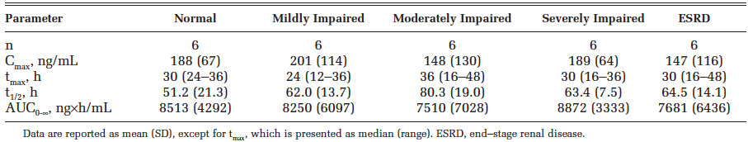

Pharmacokinetics according to age and gender
No pharmacokinetic data are available in patients ≥75 years. No consistent trends or statistically significant differences in exposure were observed between men and women. In the population PK-PD model, there was no significant differences in AUC_{0-last} between subjects aged <65 years and ≥ 65 years. The assumptions made in the model were noted.
A covariate analysis was undertaken to assess the effect of gender and weight category (<60 kg, 60 kg to 80 kg, >80 kg) on the Emax and EC50 parameters for ANC AOBEC. Gender was identified as a significant covariate however - Refer Figure 1 and Figure 2AB Whisker plot.
Figure 1: Overlay Plot of Final Covariate Model and Observed ANC and AOBEC.
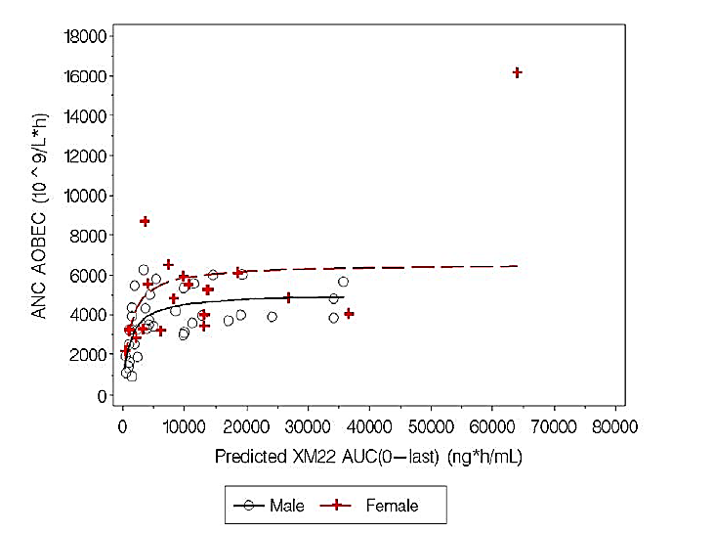

Figure 2A: Box and Whisker plot of XM22 AUC_{0-last} computed using linear trapezoidal rule applied to model-based predictions of XM22 concentrations in all subjects receiving 6 mg or 100 µg doses in pharmacokinetic analysis, stratified by age group and ANC_{avg} values
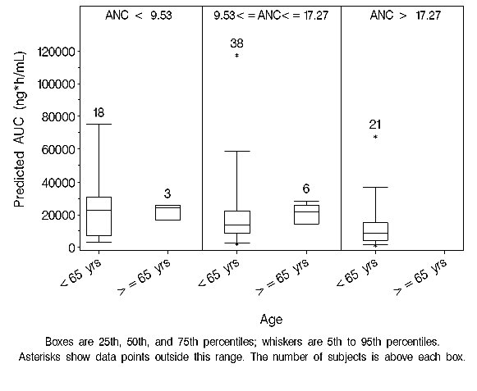

Figure 2B: Box and Whisker plot of XM22 AUC_{0-last} computed using linear trapezoidal rule applied to model-based predictions of XM22 concentrations in all subjects receiving 6 mg or 100 µg doses in pharmacokinetic analysis, stratified by sex and ANC_{avg} values
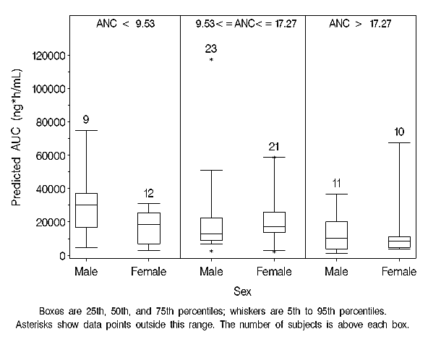

Pregnancy and Lactation
This drug has not been studied in these groups. This protein crosses from the subcutaneous tissue into the lymphatic and then into the vascular space so an effect on human embryology is possible.
Comment: It is recommended that this should be noted in the PI with wording such as ‘this drug has not been studied in these groups and therefore should not be used in pregnancy nor lactation until further evidence is available’.

Pharmacokinetics related to genetic factors
There was no data for this section. Almost all of the patients in the clinical studies were Caucasian.

Pharmacokinetic in obesity
A trend towards a decrease in lipegfilgrastim exposure was observed with increase in weight in the population PK model. However, the only statistically significant difference in weight was observed between the heaviest (>80 kg) and the lightest (<60 kg) groups in the lowest ANC category. In this category, exposure in the heaviest individuals was approximately 30% of the exposure in lightest individuals.
This may result in lowered pharmacodynamic responses in heavy patients. A decrease in efficacy in these patients from a theoretical lower exposure cannot be excluded on current dosing regimens, nor can an increased toxicity in patients (for example, as may exist in NSCLC patients).
Comment: A lack of data on effect of body weight on medicine is problematic bearing in mind the large (and increasing) number of cancer patients that are overweight or obese, and those that are cachectic or underweight (for example, lung cancer patients with underlying airways disease). The sponsor should justify why a weight-based dosing regimen recommendation was not supported for this indication, bearing in mind there was pharmacokinetic data submitted which used at least a weight based dosing regimen.

Pharmacokinetics in ethnic groups
There is no data on the effect of race on the pharmacokinetics of lipegfilgrastim. Within the population assessed, data were available for only 1 African American subject and 1 Asian subject, all others were Caucasian. Although the African American subject’s C_{max} was higher than that of the Caucasians, his AUC_{0-last} was within the range of that for the Caucasian population. In contrast, for the Asian subject, C_{max} and AUC_{0-last} were lower than that of Caucasians.
Comment: As discussed in the PI, due to the limited data in the population studied, conclusions regarding the impact of race on the pharmacokinetics of XM22 cannot be made.

Pharmacokinetic interactions

Pharmacokinetic interactions demonstrated in human studies
Nil studies undertaken in humans.

Summary of pharmacokinetics
Pharmacokinetic data was provided on dose-concentration, T_{max} and clearance data for healthy populations and two target cancer groups. It did not provide data on special groups of paediatric, organ dysfunction, the elderly, gender and age.
A model was developed to simulate some of the predicted pharmacokinetics although there are complexities with the modeled populations and drug dose (units/kg versus set dose). The PKPD relationships in the model were based on the PD outcome of ANC and in the healthy (not cancer) population.
The number of patients studied was small.

Evaluator’s overall conclusions on pharmacokinetics
Overall, there are concerns about the paucity of pharmacokinetic evidence to guide choice of dose for future studies, the translatability of the data from healthy subjects to cancer patients (and the variability within those populations such as breast versus lung). Pharmacokinetic knowledge to guide non clinical trial populations - the elderly, the obese and the undernourished is not available. The population pharmacokinetic data is helpful, but several groups with altered pharmacokinetics were not documented, such as more than mild liver disease or comorbidity. The lack of individual data between body size and concentration, or of concentration and effect on ANC makes extrapolation to other cancers, to the ANCs, and people of different ethnicity, gender and age difficult.
Data in particular looking at patients over 75 years (where cancer is more common statistically for most cancers), the obese and those with organ impairment, with both PK and linked PKPD information in particular would be very helpful. For example, it is difficult to see how a dose of 6 mg in an elderly woman weighing 50 kg with breast cancer should result in the same effect on ANC as a younger male weighing 90 kg having a mildly myelotoxic regimen (with different drugs) another cancer. Similarly there is a paucity of pharmacokinetic data for patients of non-Caucasian descent.

Pharmacodynamics

Studies providing pharmacodynamic data
There were three Phase I studies (XM22-01-CH – dose escalation study in healthy subjects; XM-22-05-CH – single dose parallel group study in healthy subjects; XM22-06 – open label three-way crossover study in healthy subjects) and one Phase II study of efficacy, PK, PD and safety, dose-finding (XM22-02-INT – randomised double-blind parallel group active-controlled dose-finding study in patients with Stage II, III or IV breast cancer receiving doxorubicin/docetaxel for 4 cycles), providing new pharmacodynamic data in this application.
There were also two Phase III studies of which had PD data, these will be evaluated in Section 7.
Table 3 shows the studies relating to each pharmacodynamic topic.

Table 3: Submitted pharmacodynamic studies.
PD Topic | Subtopic | Study ID
Primary Pharmacology | ANC and DSN |  | XM22-01-CH
Primary Pharmacology | ANC and AOBEC of XM22 and Neulasta given as fixed single 6 mg SC administrations to healthy subjects. |  | XM-22-05-CH
Primary Pharmacology | PKs of XM22 after single SC dosing at three different administration sites in healthy subjects. |  | XM22-06
Primary Pharmacology | Identification of the optimal fixed dose of XM22 compared to 6 mg Neulasta in patients with breast cancer receiving CTX. |  | XM22-02-INT
Primary Pharmacology | DSN, defined as Grade 4 neutropenia with an ANC <0.5 x 10⁹/L. |  | XM22-03
Primary Pharmacology | Incidence of FN in the first cycle. |  | XM22-04
Secondary Pharmacology | Effect on PK and immunogenicity, tolerability and safety |  | XM22-01-CH
Secondary Pharmacology | Evaluation of efficacy, safety, PKs, CD34+ cell mobilisation, and immunogenicity of XM22 in patients with breast cancer under CTX. |  | XM22-02INT
Secondary Pharmacology | Comparison of the respective PDs and PKs among body weight strata and evaluation of immunogenicity, tolerability and safety data of XM22 and Neulasta. |  | XM-22-05-CH
Secondary Pharmacology | Comparison of the PDs (ANC, CD34+ cell count), PKs in male versus female subjects and evaluation of immunogenicity, tolerability and safety data of the three single doses of 6 mg XM22. |  | XM22-06
Secondary Pharmacology | Efficacy, safety, tolerability, PKs, CD34+ cell mobilisation, and immunogenicity of XM22 in patients with breast cancer under CTX. |  | XM22-03
Secondary Pharmacology | Evaluation of efficacy, safety, tolerability, PKs, CD34+ cell mobilisation, and immunogenicity of XM22 in patients with non-small cell lung cancer under CTX. |  | XM22-04
Gender, other genetic and age related differences in PD response | Effect of gender |  | XM22-06, XM22-04
 | Effect of ethnicity |  | Population model (numbers too small in PD studies)
 | Effect of age |  | XM22-04
PD Interactions |  |  | Population model
Population PD and PK-PD analyses | Healthy subjects |  | Population model
Population PD and PK-PD analyses | Target population |  | Population model
There were no other pharmacodynamic studies submitted in this application.

Summary of pharmacodynamics
The information in the following summary is derived from conventional pharmacodynamic studies in humans, summarised from the non-clinical evaluation summary, and the study reports (CSR) unless otherwise stated.

Mechanism of action
Lipegfilgrastim (XM22) is pegfilgrastim with a different covalent attachment between the PEG molecule and the recombinant r-met-Hu-GCSF. Pegfilgrastim itself is a PEGylated recombinant N-methionyl form of human G-CSF (PEG-r-metHuG-CSF, trade name: Neulasta®) that is modified at the N-terminal methionine and is an FDA and EMEA registered product. It is used to reduce the duration of severe neutropenia (DSN) and the incidence of FN in patients treated with cytotoxic chemotherapy for malignancy (excluding chronic myeloid leukaemia and myelodysplastic syndromes). It has been shown to increase white blood cell counts, decrease the duration of neutropenia, and to reduce the incidence of FN.
XM22 is a glycoPEGylated r-metHuG-CSF that has been developed for prevention of chemotherapy-induced neutropenia. It is produced by enzyme mediated covalent attachment of a 20 kDA polyethylene glycol (PEG) molecule via a glycolinker to the O-glycosylation site at threonine residue (Thr134) of recombinant r-met-Hu-G-CSF.
The requested indication for XM22 is ‘decreasing the risk of infection in patients receiving myelosuppressive anticancer treatment, as evidenced by reduction in the incidence of febrile neutropenia and shortening of the duration of severe neutropenia’. The pharmacodynamic effects of interest are thus 1) decreasing the risk of infection, evidenced by 2) reduced FN and 3) shortened DSN. Improved cancer outcomes and cancer related/overall survival are also of interest. However, this evaluation is focusing on the efficacy of achieving the three outcomes, particularly the two needing evidence (reduced FN and shortened DSN) as requested in the indication.

Pharmacodynamic effects

Primary pharmacodynamic effects
The primary pharmacodynamic parameters used in the submission were as shown in Table 4 below.

Table 4: Primary pharmacodynamic parameters used
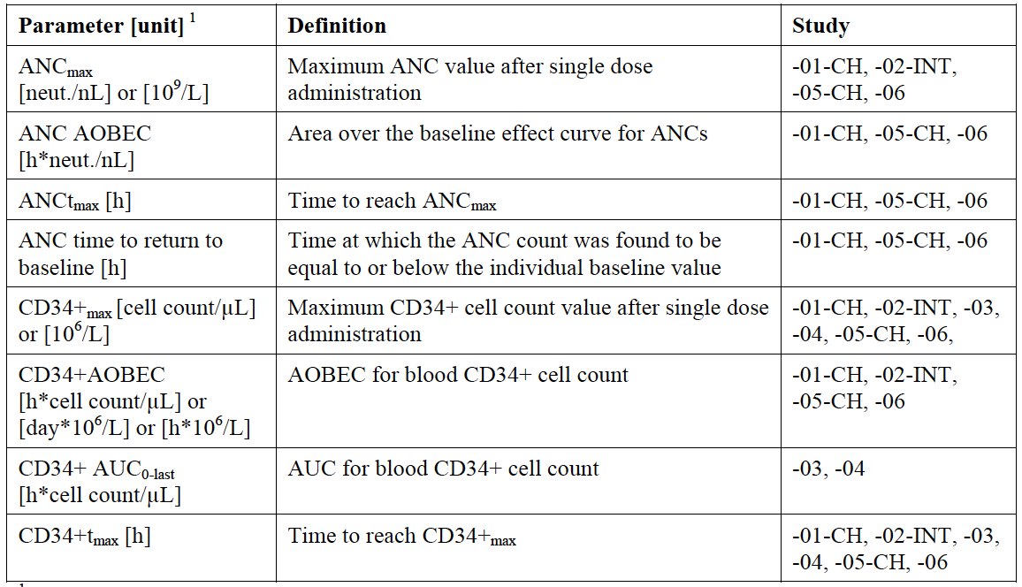

Secondary pharmacodynamic effects
In cancer studies these are usually response rates, relapse, survival and quality of life. These were not routinely collected. Incidence of FN and duration and severity of DSN were collected either as primary or secondary endpoints.

Time course of pharmacodynamic effects
The time course of the effect on ANC showed a peak effect on cell count within 48 hours and resolved within 5 days.

Relationship between drug concentration and pharmacodynamic effects
There was a relationship between exposure and ANC.

Genetic-, gender- and age-related differences in pharmacodynamic response
The effect and interaction of weight and body composition on gender was not formally studied in the clinical trials. In Study XM22-06, it was observed that no significant gender effects occurred in ANC and CD34+ counts. However, in that study a 28 year-old female had an excessive hyperleukocytosis of 72.93 neutrophils/nL in period 2 and a further rise of 75.66 neut./nL.
In Study 22-01, two of the subjects of the 100 μg/kg XM22 dose groups had a neutrophil concentration higher than the 70 neutrophils/nL considered as the CHMP limit for excessive hyperleukocytosis.
Comment: Although no difference in gender on ANC or CD 34+ was noted overall, the relationship between body size, age, concentration and neutrophil response would be interesting.

Pharmacodynamic interactions
Nil studied. The PK model in Section 7 models the dual covariates of gender and age but these are not formally modelled with ANC and other PD outcomes.

Evaluator’s overall conclusions on pharmacodynamics
Overall, the PD parameters were difficult to comments on because of small numbers in each of the groups (females, age over 65, obese, for example). Formal studies on patients and PK and on PK and PD outcomes were seemingly not undertaken. This would have been very helpful when moving from a weight-based dosing regimen to a fixed dose (0.6 mg) as requested in the submission for all patients.
There was a high rate of withdrawal in several studies which are sources of bias, for example, in XM22-04 250 completed and 128 discontinued. In XM22-03, 2 patients stopped after the first dose because of pain.
The sponsor is requested to provide information on the patients who developed hyperleucocytosis, and withdrawal – see Clinical questions. The patient narratives are noted but specifically extra information such as the body size and concentrations of XM22 at the time of the PD effects would be helpful to understand if there is a correlation of factors with PD outcomes. This is especially pertinent as the proposed dose of lipegfilgrastim is not weight (total, lean) or other PK-factor based.

Dosage selection for the pivotal studies
Dose selection for the pivotal studies was undertaken in Study XM22-01, XM22-02, with PK simulation with data from healthy subjects used for sensitivity analyses. It was acknowledged that PK and PD data in response to GCSF is different in a population receiving myeloablative therapy to healthy subjects.

XM22-01
This was a single-blind, single-centre, randomised Phase I study in 3 (planned 4) parallel groups preceded by a pilot cohort (25 μg/kg XM22). The primary objective was to compare the PDs of 3 different ascending doses of XM22 (50, 100 and 200 μg/kg) and 100 μg/kg Neulasta given as single SC doses to healthy subjects. A total of 53 healthy male and female Caucasian subjects were included in the treatment groups, 45 subjects were allocated to Group 1 (n = 15; 50 μg/kg XM22), Group 2 (n = 15; 100 μg/kg XM22) and Group 4 (n = 15, control group; 100 μg/kg Neulasta, divided in 3 cohorts of 5 subjects). Subjects entered into Group 3 received only Neulasta. Figure 3 shows the synoptic plots of G-CSF serum concentrations following single SC injection of the 3 dose levels of XM22 and Neulasta, respectively, to healthy subjects.
Figure 3: GCSF serum concentrations after single sc administration of 3 doses XM22 and I dose Neulasta to healthy subjects.
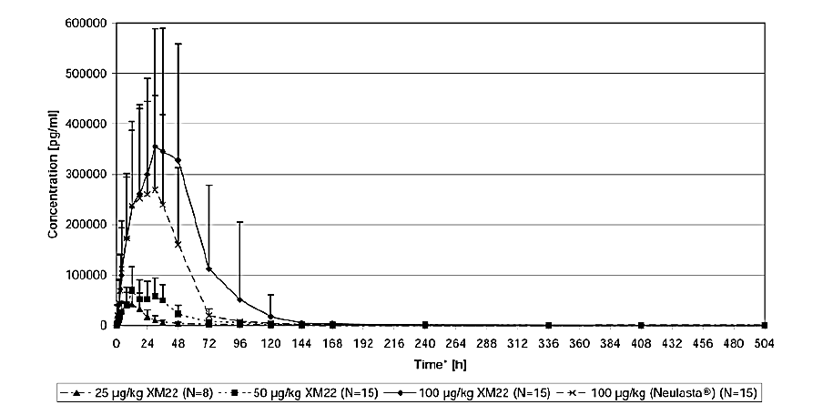
Figure 4 shows the synoptic a plot of the ANC count following single SC injection of the 3 dose levels of XM22 and Neulasta, respectively, to healthy subjects. It can be seen that the 50 µg/kg group has a similar ANC to Neulasta, and reached the same peak concentration at 100 µg/kg.
Figure 4: ANC plot following sc injection at three dose levels of XM22 and Neulasta
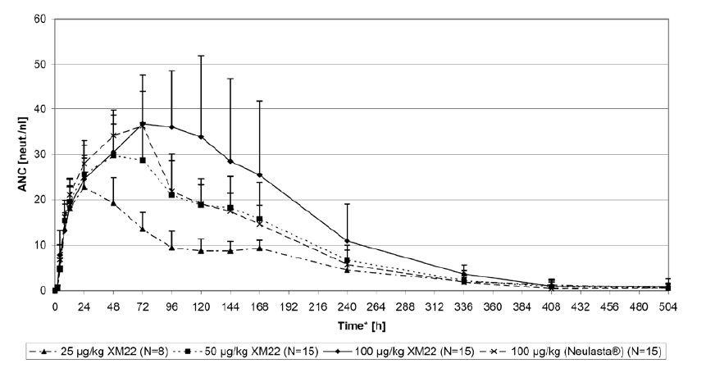

XM22-02
This was a multinational, multicentre, randomised, double-blind, controlled study on the efficacy and safety of a fixed dose of three fixed dose levels of XM22 (3 mg, 4.5 mg, and 6 mg) on the DSN to 6 mg Neulasta in patients with breast cancer receiving 4 cycles of chemotherapy with doxorubicin 60 mg/m² and docetaxel 75 mg/m². The primary objective was to identify the optimal fixed dose of XM22 compared to 6 mg Neulasta in patients with breast cancer receiving CTX for future clinical trials. Overall, the mean DSN was highest in the 3 mg XM22 group (1.1±1.1), followed by 6 mg Neulasta (0.9±1.0), 4.5 mg XM22 (0.8±1.1) and 6 mg XM22 (0.8±1.1). Mean and median DSN were very similar across all treatment groups and greatly reduced from that expected in non-G-CSF treated patients.
Figure 5: G-CSF serum concentrations after single SC administration of 3 doses XM22 or 1 dose Neulasta in Cycle 1 - PK population.
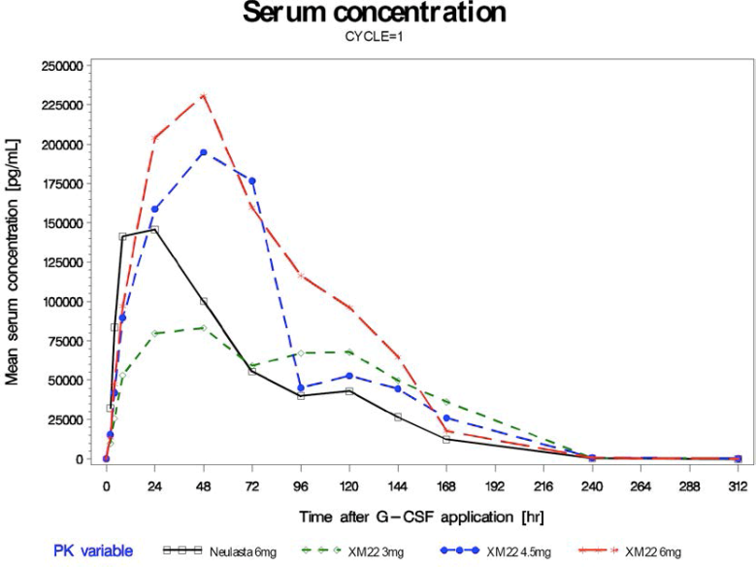
Figure 6: G-CSF serum concentrations after single SC administration of 3 doses XM22 or 1 dose Neulasta in cycle 4 - PK population.
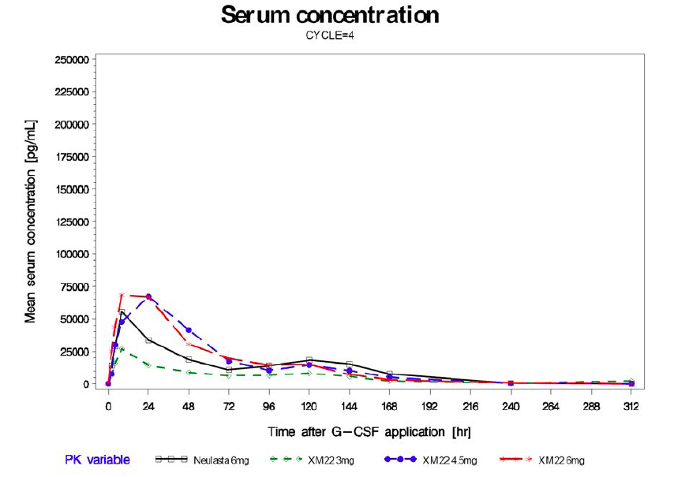

Pharmacodynamic results.
The primary objective of this study was the rate of DSN in Cycle 1 in a fixed dose of XM22 compared to 6 mg Neulasta in patients with breast cancer receiving CTX defined as Grade 4 neutropenia (ANC <0.5 x 10⁹/L). Figure 7 shows the synoptic plots of ANC following single SC injections of 3 mg, 4.5 mg or 6 mg XM22 or 6 mg Neulasta in patients with breast cancer receiving CTX in Cycle 1 and shows that the ANC is higher with the 6 mg lipegfilgrastim than with the same dose of Neulasta.
Figure 7: Time course of measured ANC – ITT population
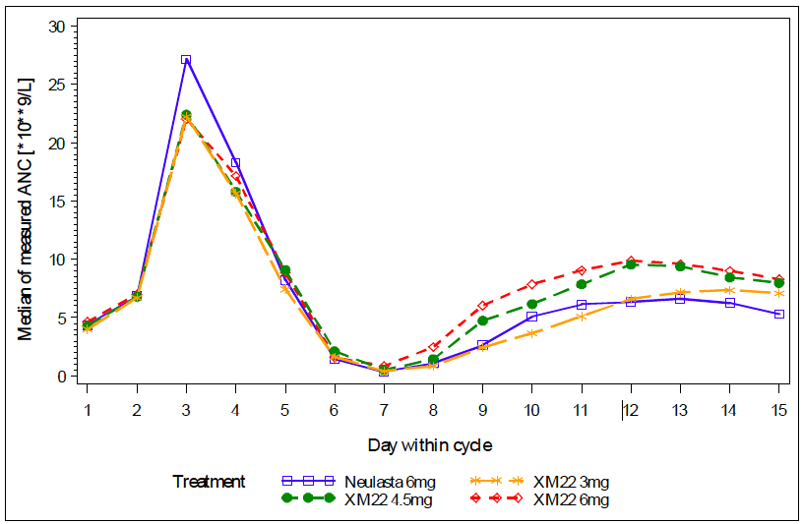
It can be seen that mean and median ANC were very similar across all treatment groups in this cancer population.
Comment: The benefit of 6 mg over 3 mg or 4 mg lipegfilgrastim on ANC is not clearly defined.

Population pharmacokinetic model
Here the proportionality of XM22 over the range of 25 through 100 μg/kg was evaluated using data from healthy subjects. The results in this population suggest that systemic exposure increases in a greater than proportional manner over this range.
Figure 8: Dose Normalized Observed AUC0-inf for XM22 Following Single Doses of 25, 50, or 100 μg/kg.
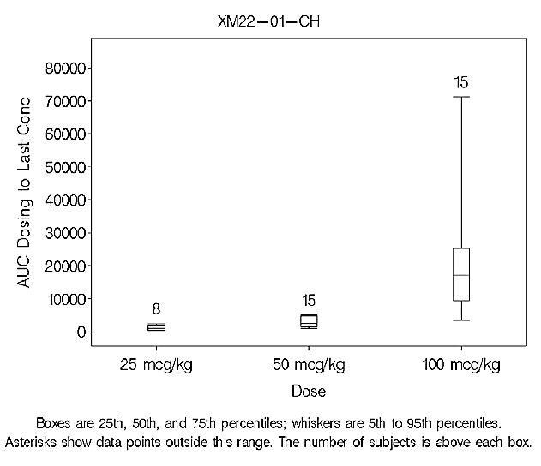
Further modeling was not done on the dose choice as the 1 therapeutic dose (a fixed 6 mg dose) had already been selected for further development.
Pharmacokinetic data obtained in the initial studies demonstrated that overall exposure (as assessed by AUC_{0-∞}) was about 60% higher and peak exposure (C_{max}) about 30% higher following administration of 100 μg/kg or 6 mg dose of XM22 as compared to that following the 6 mg dose of Neulasta (Study XM22-01-CH and XM22-02- INT). The decline of serum concentrations from peak longer for XM22 resulting in longer mean residence time (approximately 58 hours). The pharmacodynamic data from these studies demonstrated that, at these doses, XM22 had a greater effect on ANC AOBEC (approximately 30% higher) and CD34+ AOBEC (approximately 80% higher) than with Neulasta.
Comment: In XM22-02, the average DSN was highest in the 3 mg XM22 group (1.1±1.1), followed by 6 mg Neulasta (0.9±1.0), 4.5 mg XM22 (0.8±1.1) and 6 mg XM22 (0.8±1.1). Mean and median DSN were very similar across all treatment groups and greatly reduced from that expected in non-G-CSF treated patients. The difference from the 3mg group to the 6 mg groups is 0.3 of a day. The clinical significance of this is not stated but is unlikely to be clinically relevant.
Ideally the modeling would have occurred on the XM22-01 and XM22-02 data to choose the dose, to drive the Phase III lipegfilgrastim versus placebo study rather than model doing that retrospectively. Based on the efficacy data; the clinical data suggests that 3 mg would be an effective dose for the study. The increase in AUC with the 6 mg lipfilgrastim compared to 6 mg Neulasta is correlated with a 30% higher ANC.

Clinical efficacy

Overview of clinical studies
The two studies to be discussed in this section are the Phase III studies. Other clinical studies have been discussed in Section 6.

Pivotal efficacy studies
Once-per-cycle dosing of Lonquex® was studied in both pivotal randomised, double-blind clinical studies in patients undergoing myelosuppressive chemotherapy – XM22-03 and XM22-04. The first pivotal (Phase III) clinical Study XM22-03 was an active-controlled study in 202 patients with Stage II-IV breast cancer receiving up to 4 cycles of chemotherapy consisting of doxorubicin and docetaxel. Patients were randomised 1:1 to receive 6 mg Lonquex® (lipegfilgrastim) or 6 mg Neulasta (pegfilgrastim). On an intention to treat analysis, this study showed non-inferiority of 6 mg Lonquex® to 6 mg pegfilgrastim for the primary endpoint, duration of severe neutropenia (DSN) in the first cycle of chemotherapy (refer Table 5).
SN =severe neutropenia and FN = febrile neutropenia.

Table 5: Duration of Severe Neutropenia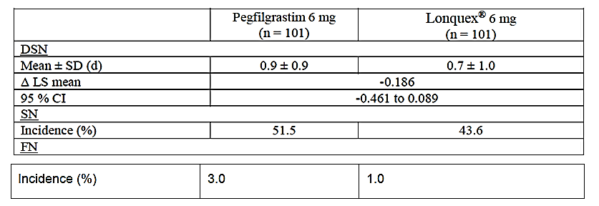
Comment: Based on the dose-finding studies in Section 6, 6 mg lipegfilgrastim has non-equivalent (that is, greater) exposure to 6 mg pegfilgrastim (Neulasta) – therefore the difference in DSN may have been expected to favour Lonquex more.
The second pivotal (Phase III) clinical Study XM22-04 was a placebo-controlled study in 375 non-small cell lung cancer patients receiving up to 4 cycles of chemotherapy consisting of cisplatin and etoposide. Patients were randomised 2:1 to receive either 6 mg Lonquex® or placebo. A summary of results of the study are presented in Table 6.

Table 6: Placebo versus lipegfilgrastim in lung cancer
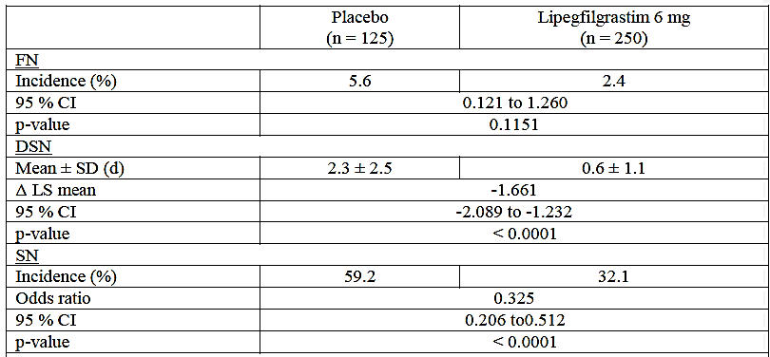
Overall there was no difference with lipegfilgrastim to placebo on the primary endpoint (FN). There was a difference of 1.6 days with severe neutropenia and significant incidence of severe neutropenia (secondary endpoints).
Comment: The relevant endpoint clinically is FN, as this is associated with morbidity and mortality, as well as delay in next chemotherapy cycle; which is also associated with morbidity and mortality. DSN can also be relevant if it delays the next cycle. Therefore the clinical relevance of a DSN for 1.6 days needs to be discussed.

Study XM22-03

Study design, objectives, locations and dates
Design: multinational, multicentre, randomised, double-blind controlled study.
Objectives: Primary: The primary objective of this study was demonstration of non-inferiority of XM22 versus pegfilgrastim (Neulasta ®) in patients with breast cancer during the first cycle of chemotherapy with respect to the duration of severe neutropenia (DSN), defined as Grade 4 neutropenia with an absolute neutrophil count (ANC) <0.5 x 10⁹/L.
The secondary objectives of this study were demonstration of efficacy and safety of XM22 in comparison to pegfilgrastim in patients with breast cancer under chemotherapy.
Locations: 2 countries (Russia and Ukraine, 27 centres).
Dates: first subject enrolled: 18 May 2010, Study Completion Date (last subject completed): 9 Dec 2010.

Inclusion and exclusion criteria

Inclusion criteria
- Signed and dated written consent
- Men and women aged ≥18 years.
- Able to understand and follow instructions and able to participate in the study for entire period
- Breast cancer high risk Stage II, III or IV (classification according to American Joint Committee on Cancer [AJCC]).
- Planned and eligible to receive 4 cycles of treatment with docetaxel/doxorubicin as routine chemotherapy for their breast cancer disease.
- Chemotherapy-naïve.
- ECOG performance status ≤2.
- ANC ≥1.5 x 10⁹/L.
- Platelet count ≥100 x 10⁹/L.
- Adequate cardiac function (including left-ventricular ejection fraction ≥50% assessed by echocardiography or equivalent method within 4 weeks prior to randomisation).
- Adequate hepatic function, that is, alanine aminotransferase and aspartate aminotransferase (ALT and AST) <2.5 x upper limit of normal (ULN), alkaline phosphatase (AP) <5 x ULN, bilirubin <ULN.
- Adequate renal function, that is, creatinine <1.5 x ULN.

Exclusion Criteria:
- Participation in a clinical trial within 30 days before randomisation.
- Previous exposure to filgrastim, pegfilgrastim or lenograstim or other G-CSFs in clinical development less than 6 months before randomisation.
- Known hypersensitivity to docetaxel or doxorubicin, filgrastim, pegfilgrastim or lenograstim.
- Underlying neuropathy of grade 2 or higher.
- Treatment with systemically active antibiotics within 72 hours before CTX.
- Treatment with lithium at inclusion or planned during the entire study.
- Chronic use of oral corticosteroids.
- Prior radiation therapy or tumour surgery within 4 weeks before randomisation.
- Prior bone marrow or stem cell transplantation.
- Prior malignancy within the previous 5 years other than basal cell or squamous cell carcinomas or in situ carcinoma of the cervix.
- Any illness or condition that in the opinion of the investigator may affect the safety of the patient or the evaluation of any study endpoint.
- Pregnant or nursing women. Women of child-bearing potential who did not agree to use a highly effective method of birth control during the entire duration of the study.

Study treatments
The patients were randomised (1:1) to one of the 2 following treatment groups:
- XM22 (lipegfilgrastim 6 mg)
- Neulasta® (pegfilgrastim 6 mg)
On Day 2 of each cycle, approximately 24 hours after start of CTX, patients received one SC injection (abdomen, upper arm or thigh) of the assigned study drug. Administration of the study drug took place after blood sampling for determination of the ANC and body temperature measurements.
XM22 was produced according to Good Manufacturing Practice (GMP). XM22 was supplied in pre-filled syringes, each containing 0.6 mL of sterile, clear, preservative-free solution for injection, consisting of 6 mg XM22 as well as excipients in the formulation in this submission (acidic sodium acetate buffer, sorbitol [E420], polysorbate 20, and water for injection). The solution is stated to be indistinguishable from colourless with the naked eye.

Efficacy variables and outcomes
The main efficacy variable was the DSN in Cycle 1, with severe neutropenia (SN) defined as Grade 4 neutropenia (ANC<0.5 x 10⁹/L).

Secondary endpoints included pharmacokinetic endpoints and safety data.
- Incidence of severe neutropenia, defined as Grade 4 (ANC <0.5 x 10⁹/L).
- Duration of very severe neutropenia (DVSN) (ANC <0.1 x 10⁹/L), measured in days.
- Incidence of very severe neutropenia (ANC <0.1 x 10⁹/L).
- Depth of ANC nadir. The patient’s lowest ANC in each cycle was to be determined.
- Time to ANC nadir, defined as the time in days from CTX administration until the nadir.
- Time to ANC recovery, defined as the time in days from CTX administration until the patient’s ANC increased to ≥2.0 x 10⁹/L after the expected nadir.
- Time to ANC recovery from ANC nadir, defined as difference in days between the day of the occurrence of ANC nadir to the first day after ANC nadir with an ANC value ≥1.5 x 10⁹/L.
- Time in days in hospital and time in the Intensive Care Unit (ICU) due to FN or connected infections.
- Incidence of treatment with IV antibiotics due to FN or connected infections,
- Defined as the number of patients receiving IV antibiotics per cycle and across all cycles.
- Percentage of actually delivered versus scheduled cumulative CTX dose per patient.
- Proportion of patients with CTX doses reduced, omitted, or delayed
- Number of days of delay of CTX
- Overall QoL, as assessed using the EORTC QLQ-C30 (version 3) and the breast cancer specific module EORTC QLQ-BR23.
PK properties of XM22 were to be measured in a total of up to 20 patients per treatment group in selected centres chosen due to logistic considerations and were not necessarily the same as those recruited for the CD34+subgroup. Blood sampling for the determination of serum concentrations of XM22 and Neulasta® were scheduled in Cycle 1 and cycle 4. Samples were to be taken pre-dose; 2, 4, and 8 h after administration of study drug on Day 2; and 24 h (day 3), 48 h (Day 4), 72 h (Day 5), 96 h (Day 6), 120 h (Day 7), 144 h (Day 8), 168 h (Day 9), 240 h (Day 12), and 312 h (Day 15) after administration of study drug. Standard PK parameters (area under the curve [AUC], C_{max}, T_{max} and so on) were derived and calculated. PK profile analysis was performed using WinNonlin®6.0.

Randomisation and blinding methods
Randomisation was performed by Biostatistics Merckle GmbH at a ratio of 1:1. Randomisation was done in blocks with a block size of two, stratified by country, randomization numbers 1 to 1000. Country-Stratification was: 1. Russia and 2. Ukraine.
The patients were randomised to the two treatment groups by IVRS with a second randomisation performed for packaging of study medication to assign the two treatment groups to the box numbers (2001 to 5000). If a patient met all eligibility criteria, the investigator was to initiate randomisation. The investigator documented the necessary patient details (patient number, date of birth, initials, gender, availability of laboratory results, participation in PK and/or CD34+ sub-study). The study drug administrator randomised the patient via IVRS per phone or internet and documented the randomisation on the randomisation worksheet as well. The IVRS gave the study drug administrator information about the box number the patient was to be randomised to on the basis of the computer-generated randomisation list provided by Biostatistics Merckle GmbH. The study administrator called the IVRS at cycle 2, 3 and 4 to receive the information regarding allocation of the next box number.

Analysis populations
There were three analysis populations, according-to-protocol [ATP], safety population [SP] and intent-to-treat [ITT]). Demographic data were analysed for all populations. Efficacy data were analysed for the ITT and ATP populations. The safety endpoints were analysed for the SP population. Demographic and baseline characteristics were also presented for the PK population and CD34+ population.
Included not randomised (INR) set: All patients enrolled but not randomised.
Full analysis population (intent-to-treat [ITT] population): All patients who were randomised to one of the study treatments at the baseline visit. Patients with major protocol violations were included in this population.
Safety population (safety population [SP]): All randomised patients who received at least one dose or partial dose of IMP. This population was used to analyse safety data; AEs of INR patients were to be considered separately. NOTE: The ITT and SP populations were identical because all randomised patients were treated at least once with the study medication.
Per protocol population (according-to-protocol [ATP] population): All patients of the ITT set for whom no major protocol violation occurred.
The main population for the efficacy analysis was the ATP population.

Sample size
The aim of the study was to confirm the non-inferiority of XM22 compared to Neulasta® in the DSN, defined as days with ANC <0.5 x 10⁹/L in CTX Cycle 1. The non-inferiority margin Δ was set to 1 day. Allowing for a difference between XM22 and Neulasta® of 0.25 days in favour of Neulasta® and assuming a common standard deviation of about 1.5 days it was calculated that to assure a power of 90%, at least 86 patients per treatment group should be available for the statistical analysis in the non-inferiority test. Because the confirmation of non-inferiority was planned to be performed in the ATP population and it was expected that up-to 10% of the randomised patients would not be available for the ATP population, it was planned to randomise about 100 patients to each of the two treatment groups in the study.
The sample size calculation assumed normal distribution but it was expected that the primary endpoint DSN, would possibly be better modelled by a Poisson distribution. Several Monte-Carlo simulations with different parameters for the Poisson distributions were performed. The nominal sample size for each of the 2 treatment groups in these simulations was set to 100, and a drop-out rate of 10% (missing completely at random) was implemented to simulate the ATP population as closely as possible It was concluded that randomising 100 patient per treatment group will give the non-inferiority test a power of at least 90% if DSN for XM22 is not more than 0.25 days longer than the expected DSN under treatment with Neulasta®.
Comment: justification of samples size, assumptions made on dropout and significance of choice of pre-specified non-inferiority margins seems reasonable.

Statistical methods
The statistical analyses performed in this study were initially specified in the study protocol and a separate statistical analysis plan, as are the amendments and clarifications that arose during the study period. This was finalised on 11 March 2011, before database closure and data unblinding on the same day. The statistical analysis was performed almost exactly as planned in the protocol. All computations for the statistical analysis were performed using the computer software package Statistical analysis system (SAS®) version 9.2. A separate SAP was written for the evaluation of immunogenicity; this SAP is part of the ‘Antibody Report XM22’.

Participant flow
218 patients were enrolled in the study. The numbers of patients entering and leaving each stage of the study are summarised in Figure 9.
Figure 9: Subject disposition Study XM 22-03

Major protocol violations/deviations
Major protocol violations were:
- Unblinding of investigator or patient.
- No informed consent signed.
- No treatment with docetaxel/doxorubicin in CTX Cycle 1.
- ANC <1.5 x 10⁹/L at baseline of CTX Cycle 1.
- Bone marrow or stem cell transplantation before study start.
- Less than 6 ANC values measured in CTX Cycle 1 between Day 5 and 15 (limits included).
- No treatment with randomised study medication in CTX Cycle 1.
- Treatment with wrong study medication in CTX Cycle 1.
- CTX dose in Cycle 1 not according to plan (absolute deviation from planned dose 60 mg/m2 for doxorubicin and 75 mg/m2 for docetaxel >20%).
Other protocol violations that may also have qualified as major (per individual decision during the BRC meeting) were defined in the SAP as follows:
- Use of G-CSFs as rescue medication during the study.
- Not breast cancer high risk group II/III or IV.
- Participation in a clinical study within 30 days before randomisation.
- Treatment with systemic antibiotics within 72 h before CTX in Cycle 1.
- Treatment with lithium at any time during the study.
- Chronic use of corticosteroids.
- Malignancy within the previous 5 years other than basal cell or squamous cell carcinomas or in situ carcinoma of the cervix.
- Any illness or condition possibly affecting the safety or efficacy.
- Possible problem in evaluation of the main endpoint: Missing main endpoint or missing class or co-variable in the Poisson or analysis of variance (ANOVA).

Demographic and baseline data
Data is summarised in Table 7. All patients were Caucasian and all female. Subgroup analyses were performed stratified by country, body weight class, and reason for CTX. Average BMI and body surface area were similar between the two treatment groups. The frequencies of the breast cancer stages (II, III or IV) were comparable between the treatment groups. The majority of the patients had Stage III or high-risk Stage II disease; 19.8% of Neulasta® patients and 13.9% of XM22 patients had Stage IV disease. Tumour location was comparably distributed to the left and right breast. The majority of patients (53.5% Neulasta®, 55.4% XM22) had an ECOG performance status of 1 at baseline. The median time since first diagnosis was 1 month in the Neulasta® group and 2 months in the XM22 group.

Table 7: Demographic data in the breast cancer XM22-03 study
Comment: Demographic characteristics are comparable between the treatment groups. The lipegfilgrastim arm had fewer patients in the Stage IV group which can bias overall survival data (amongst other outcomes); the XM22-exposed patients had their diagnosis longer at baseline than the Neulasta arm.

Results for the primary efficacy outcome
The primary objective of this study was the demonstration of non-inferiority of XM22 versus pegfilgrastim (Neulasta®) in patients with breast cancer during the first cycle of CTX in the DSN, defined as Grade 4 neutropenia with an ANC <0.5 x 10⁹/L.

Table 8: Results for DSN for XM22 versus pegfilgrastim (Neulasta®) in breast cancer patients
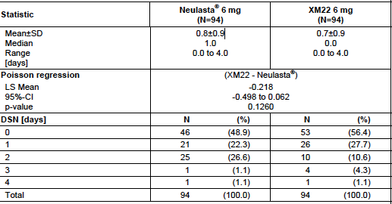
The DSN in Cycle 1 was comparable in both treatment groups, with a mean (SD) DSN of 0.8±0.9 days in the Neulasta® group and 0.7±0.9 days in the XM22 group. Poisson regression analysis (XM22 - Neulasta®) yielded a 95% CI of -0.498 to 0.062 with p=0.1260 and non-inferiority is achieved.
Comment: This suggests that XM22 at a 6 mg dose is not inferior to the currently registered Neulasta for the primary efficacy endpoint of DSN.

Results for other efficacy outcomes
In the ATP population only 3 patients had investigator-assessed FN during the study, all in the Neulasta® group during Cycle 1. Severe neutropenia occurred in 51.1% of Neulasta® patients, and 43.6% XM22 patients; p=0.3409). However in the ITT population, 2 patients in the Neulasta® group and 1 patient in the XM22 group were hospitalised due to FN or infection. All 3 patients were hospitalised during Cycle 1 (one Neulasta® patient for 6 days and the other for 5 days, but not in the ICU; the XM22 patient for 1 day in the ICU) and received antibiotics; the XM22 patient also received antipyretics. One other patient in the Neulasta® group required antibiotics due to FN in Cycle 1 but was not hospitalised.
The incidence of very severe neutropenia over all cycles was low in both groups (11.7% Neulasta® patients, 6.4% XM22 patients; p=0.2066).
The depth of ANC nadir in Cycle 1 was comparable in both treatment groups, with p=0.2539. In cycles 2, 3 and 4, the mean depth of ANC nadir was higher in the XM22 group compared to the
Neulasta® group (2.6 versus 2.0, 2.5 versus 2.0, and 2.7 versus 2.3 10⁹/L), with p=0.0189, p=0.0353 and p=0.1122, respectively.
The majority of patients in both treatment groups received CTX as scheduled, with the mean percentage of doxorubicin and docetaxel actually applied reaching over 98% in each group in each cycle. For the assessments of QoL, there were no relevant differences between the two groups.
Comment: XM22 resulted in a higher nadir, but there was no difference in severe neutropenia either in cycle one of over the whole study. The statistical significance of the FN rate in the ITT group is unable to be commented on due to small numbers and comparable numbers of events, but is noted.

Study XM22-04. Efficacy and safety of XM22 in patients with non-small cell lung cancer receiving cisplatin/etoposide chemotherapy

Study design, objectives, locations and dates

Design
Phase III multinational, multicentre, randomised, double-blind controlled study.

Objectives
The primary objective of this study was demonstration of superiority of XM22 versus placebo when administered for up to a maximum of four cycles in patients with non-small cell lung cancer receiving cisplatin/etoposide chemotherapy (CTX). The primary endpoint was the incidence of febrile neutropenia (FN) in the first cycle.
The secondary objectives of this study were evaluation of efficacy, safety and tolerability of XM22 in comparison to placebo in patients with non-small cell lung cancer receiving cisplatin/etoposide CTX.

Locations
Eight countries (Belarus, Bosnia-Herzegovina, Bulgaria, Poland, Romania, Russia, Serbia, Ukraine; 72 centres).

Dates
Date of first patient enrolled: 10 May 2010, Date of last patient completed: 05 April 2011.

Inclusion and exclusion criteria
Inclusion criteria
- Signed and dated written consent
- Men and women aged ≥18 years with NSCLC
- Able to understand and follow instructions and able to participate in the study for entire period
- Stage IIIb/IV receiving cisplatin/etoposide-based, myelosuppressive CTX
- Chemotherapy-naïve.
- ECOG performance status ≤2.
- ANC ≥1.5 x 10⁹/L.
- Platelet count ≥100 x 10⁹/L.
- Adequate cardiac function (including left-ventricular ejection fraction ≥50% as assessed by echocardiography or equivalent method within 4 weeks prior to randomisation).
- Adequate hepatic function, that is, alanine aminotransferase and aspartate aminotransferase (ALT and AST) <2.5 x upper limit of normal (ULN), alkaline phosphatase (AP) <5 x ULN, bilirubin <ULN.
- Adequate renal function, that is, creatinine <1.5 x ULN.
Exclusion Criteria:
- Participation in a clinical trial within 30 days before randomisation.
- Previous exposure to filgrastim, pegfilgrastim or lenograstim or other G-CSFs in clinical development less than 6 months before randomisation.
- Known hypersensitivity to filgrastim, pegfilgrastim, lenograstim, cisplatin or etoposide.
- Planned for non-myelosuppressive CTX.
- Individual high risk for FN with regard to the cisplatin/etoposide CTX according to the assessment of the investigator. Risk factors were age >65 years, low performance status, poor nutritional status and liver, renal or cardiovascular disease.
- Meeting any contraindication for the chosen CTX regimen.
- Treatment with systemically active antibiotics within 72 hours before CTX.
- Treatment with lithium at inclusion or planned during the entire study.
- Chronic use of oral corticosteroids.
- To be treated with combined chemo-/radiotherapy during the foreseen participation in this study.
- Prior radiation therapy or tumour surgery within 4 weeks before randomisation.
- Prior bone marrow or stem cell transplantation.
- Prior malignancy within the previous 5 years other than basal cell or squamous cell carcinomas or in situ carcinoma of the cervix.
- Any illness or condition that in the opinion of the investigator may affect the safety of the patient or the evaluation of any study endpoint.
- Pregnant or nursing women. Women of child-bearing potential who did not agree to use a highly effective method of birth control during the entire duration of the study.

Study treatments
The patients were randomised (2:1) to one of the 2 following treatment groups:
- XM22 6 mg
- Placebo
On Day 4 of each cycle, approximately 24 hours after the last infusion of CTX, patients received one SC injection (abdomen, upper arm or thigh) of the assigned study drug after blood sampling for determination of the ANC and body temperature measurements.
Patients who experienced FN were to receive prophylactic open treatment with XM22 during further cycles of CTX, regardless of assigned, double-blind study medication, and were not to be withdrawn from the study unless deemed necessary by the investigator. The randomised study treatment of the patient was not to be unblinded.
XM22 was produced according to Good Manufacturing Practice (GMP). XM22 was supplied in pre-filled syringes, each containing 0.6 mL of sterile, clear, preservative-free solution for injection, consisting of 6 mg XM22 as well as excipients in the formulation in this submission (acidic sodium acetate buffer, sorbitol [E420], polysorbate 20, and water for injection). The solution is indistinguishable from colourless with the naked eye.

Efficacy variables and outcomes
The main efficacy variable was the incidence of FN in the first cycle, defined to have occurred if at least one of the following conditions held true during a CTX cycle:
- Oral body temperature >38.5°C for at least 1 h (2 consecutive measurements on the same day, at least 60 minutes apart) and an observed severe neutropenia (that is, ANC value <0.5 10⁹/L) on the day before, on the same day or on the day after the temperature readings
- Documentation of neutropenic sepsis, that is, a sepsis in combination with an ANC value <0.5 x 10⁹/L
- Documentation of serious or life-threatening neutropenic infection, that is, a life-threatening infection in combination with an ANC value <0.5x 10⁹/L.
Secondary endpoints
- Incidence of FN in cycles 2, 3, and 4 and across all cycles.
- The following secondary efficacy endpoints were evaluated in cycles 1, 2, 3, and 4:
  - Duration of severe neutropenia (DSN). Severe neutropenia was defined as Grade 4 neutropenia with an ANC <0.5 x 10⁹/L
  - Incidence of severe neutropenia, defined as Grade 4 (ANC <0.5 x 10⁹/L). The incidence of severe neutropenia is equivalent to the frequency of ANC nadir <0.5 x 10⁹/L.
  - Duration of very severe neutropenia (DVSN) (ANC <0.1 x 10⁹/L), measured in days
  - Incidence of very severe neutropenia (ANC <0.1 x 10⁹/L). The incidence of very severe neutropenia is the same as the frequency of ANC nadir <0.1 x 10⁹/L.
  - Depth of ANC nadir.
  - Time to ANC nadir, defined as the time in days from CTX administration until the occurrence of the ANC nadir.
  - Time to ANC recovery, defined as the time in days from CTX administration until the patient’s ANC increased to ≥2.0 x 10⁹/L after the expected nadir
  - Time to ANC recovery from ANC nadir.
  - Time in days in hospital and time in the Intensive Care Unit due to FN or connected infections.
  - Incidence of treatment with IV antibiotics due to FN or connected infections, defined as the number of patients receiving IV antibiotics per cycle and across all cycles.
  - Percentage of actually delivered versus scheduled cumulative CTX dose (for both cisplatin and etoposide) per patient.
  - Proportion of patients with CTX doses reduced, omitted, or delayed
  - Number of days of delay of CTX
  - Overall quality of life, as assessed using the European Organisation for Research and Treatment of Cancer (EORTC) QLQ-C30 (version 3) and the EORTC QLQ-LC13

Randomisation and blinding methods
Block randomisation (size of two) was performed by Biostatistics Merckle GmbH at a ratio of 2:1 (XM22, placebo). Blocks were stratified by country, randomization numbers 1 to 1998. Country-Stratification was 1.Belarus 2. Bosnia-Herzegovina 3. Bulgaria 4.Poland 5. Romania 6. Russia 7. Serbia 8. Ukraine.
The patients were randomised to the two treatment groups by IVRS (Phase Forward, Waltham, USA) with a second randomisation was performed to assign the two treatment groups to the box numbers (5001 to 6998). If the patient met all eligibility criteria, the investigator could randomise. The investigator documented necessary patient details (patient number, date of birth, initials, gender, availability of laboratory results, participation in PK and/or CD34+ sub-study). Randomisation was then performed via IVRS per phone or internet and documented on the randomisation worksheet. During randomisation IVRS assigned the next available randomisation number with the respective randomised treatment group to the patient. The IVRS then checked the availability of boxes at site and informed the investigator about the next available number the patient was to be randomised to. The investigator called the IVRS at cycle 2, 3 and 4. Dependent on the presence of febrile neutropenia IVRS allocated either the next syringe of the previously randomised box randomisation number or - in case of febrile neutropenia - the box number of the prophylactic open treatment XM22.

Analysis populations
There were three analysis populations, according-to-protocol [ATP], safety population [SP] and intent-to-treat [ITT]). Demographic data were analysed for all populations. Efficacy data were analysed for the ITT and ATP populations. The safety endpoints were analysed for the SP population. Demographic and baseline characteristics were also presented for the PK population and CD34+ population.
Included not randomised (INR) set: All patients enrolled but not randomised.
Full analysis population (intent-to-treat [ITT] population): All patients who were randomised to one of the study treatments at the baseline visit. Patients with major protocol violations were included in this population. The main population for the efficacy analysis was the ITT population.
Safety population (safety population [SP]): All randomised patients who received at least one dose or partial dose of IMP. This population was used to analyse safety data; AEs of INR patients were to be considered separately.
Per protocol population (according-to-protocol [ATP] population): All patients of the ITT set for whom no major protocol violation occurred.
Excluded patient (EP) set: All patients with very severe protocol violations according to BRC decision.

Sample size
Assuming the incidence rate of FN under treatment with placebo is in the range from 7% to 10% and the incidence under treatment with XM22 is at most 1% sample size requirements can be specified for a statistical test with a two-sided significance level α of 5%, a required power of at least 80% and a sampling rate of 2:1 (XM22: placebo). As the actual incidence rate for placebo was expected to be closer to 10% than to 7% having available about 375 patients in the statistical analysis, a test power of at least 90% should detect the assumed placebo excess risk for FN. As the test was intended to confirm the superiority of XM22 over placebo (as compared to the non-inferiority Study of 003), the statistical analysis has been performed with the data from the ITT population (all randomised patients), and therefore no dropouts had to be taken into account in estimating the sample size. The actual analysis was performed with a logistic regression analysis with treatment, region, sex, body weight class and baseline ANC as explanatory variables. The planned statistical methodology ensured that the power of the statistical analysis would be about 90% if the placebo excess risk for FN was in the range of 6% to 9% and the actual incidence rate for XM22 was at most 1%.
Comment: The justification seems reasonable but the expected incidence rates for XM22 and the placebo incidence rates would be stronger with references.

Statistical methods
The statistical analysis of the PD and PK endpoints were based on all subjects having received the study drug and completed the sampling for ANC determination. Additionally PK and PD parameters were compared for the body weight and gender defined strata. For safety (covered in Section 8), analysis was descriptive and included all subjects having received the test or the reference.
Continuous variables were summarized by descriptive statistics per group or frequency tables for categorical variables.
For the primary endpoint as well as for ANC_{max}, CD34+ cells AOBEC, and CD34+max, 95% confidence intervals were calculated for the ratio of geometric means of values in both arms.
For ANCTmax, and CD34+Tmax 95% confidence intervals were calculated for the difference of median values.
For ANC time to return to baseline, 95% confidence intervals were calculated for the median value in both arms.
For AUC_{0-tlast}, AUC_{0-∞}, C_{max}, 90% confidence intervals were calculated for the ratio of geometric means of values in both arms.
For Tmax, 90% confidence intervals were calculated for the difference of median values for both arms.

Participant flow
427 patients were enrolled in the study and screened at 72 centres in 8 European countries. The first patient was enrolled on 10 May 2010 and the last patient entered on 30 November 2010. Participant flow is summarized in Figure 10.
Figure 10: Patient Flow –XM22-04

Major protocol violations/deviations
Major protocol violations were:
- Unblinding of investigator or patient
- No signed informed consent
- Treatment with open-labelled XM22 only.
- No treatment with cisplatin/etoposide in CTX Cycle 1.
- ANC <1.5 x 10⁹/L at baseline of CTX Cycle 1.
- Bone marrow or stem cell transplantation before study start.
- Less than 6 ANC values measured in CTX Cycle 1 between Day 5 and 15 (limits included).
- No treatment with randomised study medication in CTX Cycle 1.
- Treatment with wrong study medication in CTX Cycle 1.
- CTX dose in Cycle 1 not according to plan
Other protocol violations that may also have qualified as major (were defined in the SAP as follows:
Use of G-CSFs as rescue medication, not NSCLC Stage IIIB/IV, participation in a clinical trial, treatment with systemic antibiotics within 72 h before CTX in Cycle 1, treatment with lithium at any time during the study, chronic use of corticosteroids, malignancy within the previous 5 years other than basal cell or squamous cell carcinomas or in situ carcinoma of the cervix, Any illness or condition possibly affecting the safety or efficacy, Possible problem in evaluation of the main endpoint: missing main endpoint or missing class or co-variable in the Poisson or analysis of variance (ANOVA).
Major and minor protocol violations were defined in the study protocol and further specified in the SAP.

Demographic and baseline data
Data is summarized in Tables 9 and 10. Ethnic origin was Caucasian in all patients, except for 1 patient in the XM22 group.

Table 9: Demographic characteristics for XM22-04

Table 10: Characteristics of NSCLC (ITT population)
Comment: Demographic characteristics are comparable between the treatment groups.

Results for the primary efficacy outcome
The primary endpoint was the incidence of investigator assessed FN in in NSCLC patients being treated with cisplatin and etoposide in the first cycle (ITT population).

Table 11: Results of the primary analysis of the percentage of FN in Cycle 1.
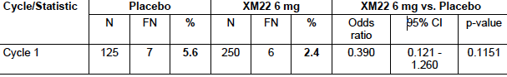
Comment: This suggests XM22 6 mg is no more effective than placebo in preventing FN at the end of Cycle 1. Reducing FN is one of the indications for this drug.

Results for other efficacy outcomes
Incidence of FN over Cycles 2-4. The incidence of FN between the treatment groups in Cycles 2, 3, and 4 were not statistically significantly different.
- Duration of severe neutropenia (DSN). This was significantly different between the two groups (1-2 days extra DSN).
- Incidence of severe neutropenia, defined as Grade 4 (ANC <0.5 x 10⁹/L). This was statistically significantly different between the two groups.

Table 12: Incidence of severe neutropenia per cycle and across cycles (ITT population).
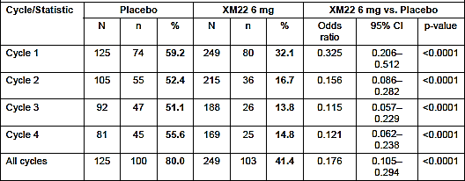
- Duration of very severe neutropenia (DVSN) (ANC <0.1 x 10⁹/L), measured in days. Although the report states that this was less with XM 22, the data is descriptive. Although there looks to be a lesser number in the XM22 group, the maximal difference if basing it on the means is only part of a day.
Comment: Can the sponsor clarify on Table 23 [copied below for AusPAR reader] of the CSR what the statistical and clinical significance of this descriptive data is.
- Incidence of very severe neutropenia (ANC <0.1 x 10⁹/L). This was statistically significantly improved with XM22 in Cycle 4 only (13.6% versus 4.7%, p=0.0068), however the clinical significance of this is unclear.
- Depth of ANC nadir. Significantly improved with XM22 across all cycles although the relevance of maximal difference (in Cycle 4, 1.63 x 10⁹ cells) is unclear.
- Time to ANC nadir. This is statistically significantly shorter (4-5 days) in the XM22 group, but the relevance and in fact the clinical benefit or not of this is unclear.
- Time to ANC recovery. This is statistically significantly shorter in the XM22 group, but the relevance and in fact the clinical benefit or not of this is unclear
- Time to ANC recovery from ANC nadir. This is statistically significantly shorter (up to 2 days) in the XM22 group, but the relevance and in fact the clinical benefit or not of this is unclear
- Time in days in hospital and time in the Intensive Care Unit due to FN or connected infections. In the ITT population, 5 patients in the placebo group (4 in Cycle 1, 1 in cycle 3) and 3 patients in the XM22 group were hospitalised due to FN or connected infection the higher incidence of hospitalisation due to FN in the placebo group compared to the XM22 group. All patients hospitalised due to FN received antibiotics. Four additional placebo patients (2 in Cycle 1, 2 in cycle 4) and 5 additional XM22 patients (received antibiotics due to FN but were not hospitalized
- Incidence of treatment with IV antibiotics due to FN or connected infections. There was no difference between the two groups (4 in the placebo versus 5 in the XM22).
- Proportion of patients with CTX doses reduced, omitted, or delayed. There was a statistically significant reduction in number of CTX treatments that were delayed with XM22, but not dose reduced or omitted treatments.
- Overall quality of life, as assessed using the European Organisation for Research and Treatment of Cancer (EORTC) QLQ-C30 (version 3) and the EORTC QLQ-LC13. There was no difference between the two groups.

Table 23: Descriptive statistics for DVSN in Cycles 1, 2, 3 and 4 (ITT population)
Cycle/Statistic |  | Placebo | XM22 6 mg
1 | Mean ± SD | 0.3 ± 0.9 | 0.2 ± 0.6
 | Median | 0.0 | 0.0
 | Range (min to max) | 0.0 to 5.0 | 0.0 to 4.0
2 | Mean ± SD | 0.2 ± 0.6 | 0.0 ± 0.2
 | Median | 0.0 | 0.0
 | Range (min to max) | 0.0 to 3.0 | 0.0 to 2.0
3 | Mean ± SD | 0.3 ± 0.7 | 0.1 ± 0.4
 | Median | 0.0 | 0.0
 | Range (min to max) | 0.0 to 4.0 | 0.0 to 3.0
4 | Mean ± SD | 0.3 ± 0.8 | 0.1 ± 0.5
 | Median | 0.0 | 0.0
 | Range (min to max) | 0.0 to 4.0 | 0.0 to 3.0

DVSN (days) | Parameter | n | % | n | %
Cycle 1 | 0 | 107 | 85.6 | 223 | 89.2
 | 1 | 4 | 3.2 | 16 | 6.4
 | 2 | 7 | 5.6 | 6 | 2.4
 | 3 | 5 | 4.0 | 4 | 1.6
 | 4 | 1 | 0.8 | 1 | 0.4
 | 5 | 1 | 0.8 | 0 | -
 | Total | 125 | 100.0 | 250 | 100.0
Cycle 2 | 0 | 105 | 86.1 | 234 | 95.9
 | 1 | 9 | 7.4 | 9 | 3.7
 | 2 | 6 | 4.9 | 1 | 0.4
 | 3 | 2 | 1.6 | 0 | -
 | 4 | 0 | - | 0 | -
 | 5 | 0 | - | 0 | -
 | Total | 122 | 100.0 | 244 | 100.0
Cycle 3 | 0 | 104 | 85.2 | 229 | 93.5
 | 1 | 9 | 7.4 | 9 | 3.7
 | 2 | 5 | 4.1 | 5 | 2.0
 | 3 | 3 | 2.5 | 2 | 0.8
 | 4 | 1 | 0.8 | 0 | -
 | 5 | 0 | - | 0 | -
 | Total | 122 | 100.0 | 245 | 100.0
Cycle 4 | 0 | 103 | 83.7 | 227 | 92.3
 | 1 | 8 | 6.5 | 11 | 4.5
 | 2 | 7 | 5.7 | 4 | 1.6
 | 3 | 3 | 2.4 | 4 | 1.6
 | 4 | 2 | 1.6 | 0 | -
 | 5 | 0 | - | 0 | -
 | Total | 123 | 100.0 | 246 | 100.0
Mean ± SD (median), minimum to maximum
Comment: Overall, of the many secondary outcomes, there was statistical significant improvement in some of them, in the XM22 group. These include duration of severe neutropenia (DSN), incidence and duration of severe neutropenia, duration of very severe neutropenia, the incidence of very severe neutropenia in the final cycle when treatment is complete only, depth of ANC nadir, time to ANC nadir, time to ANC recovery and time to ANC recovery from ANC nadir.
There was no difference in the very important Incidence of FN over Cycles 2-4 (as required for the proposed indication), time in days in hospital and time in the Intensive Care Unit due to FN or connected infections, incidence of treatment with that is, antibiotics due to FN or connected infections and proportion of patients with CTX doses reduced or omitted, and overall quality of life, as assessed using the European Organisation for Research and Treatment of Cancer (EORTC) QLQ-C30 (version 3) and the EORTC QLQ-LC13.

Analyses performed across trials
An Integrated Summary of Efficacy was provided as well as population simulations and integrated report on the immunogenicity and safety (evaluated in Section 8).
The integrated Summary was very thorough. However the tables did not provide additional information to the individual studies or to consideration of the claims of efficacy and safety made in the Submission. The Summary was used to check data and hypotheses.
A non-compartmental and population analysis approach was used to model data from studies in which healthy subjects, patients with breast and lung cancer received XM22. The model predicted parameters and the parameters from the non-compartmental analyses were judged to be comparable and the population PK model was used to characterize the pharmacokinetics of XM22.
Analyses which were performed include evaluation of the effect of various covariates of interest such as age, weight and gender on the pharmacokinetics and pharmacodynamics of XM22 and assessment of exposure-response and exposure-safety relationships. Due to the possible relationship of ANC concentrations and clearance of XM22, ANC values were modeled into these analyses also. The pharmacokinetics and pharmacodynamics of XM22 and Neulasta® (pegfilgrastim) were thus compared using population (not individual data).
In order to assess the appropriateness of the 6 mg dose, as much of the data came from the 100 μg/kg dose, the final population pharmacokinetic model was used to compare the effects of fixed 6 mg dose administration to weight-based dose administration (100 μg/kg) in healthy subjects and cancer patients.
The two major relevant findings are around the effect of weight and of weight-based dosing. With the exception of weight >95 kg, which in many countries for males is overweight or obese, there was no consistent trend in predicted exposure and no consistent trend in observed ANCavg values with increasing weight for either the fixed or weight-based dosage regimens. In both healthy subjects and cancer patients, individuals at the extreme upper end of the weight range (>95 kg) tended to have lower exposure and ANCavg values weight >95kg would include a large number of the male population.
Interestingly, there was more variability with the weight-based dose administration than with fixed dose administration. Similarly for the cancer patients (all of whom received 6 mg doses) there was no clear trend in exposure or ANCavg values in the majority of the population.
The main other relevant findings from this study for this analysis are:
- In general, the linear clearance percentage increases when ANC decreases vice versa
- The patterns for healthy volunteers and cancer patients differ
- No consistent trends or statistically significant differences in XM22 exposure were observed for age or gender
- The population studied within the XM22 program lacked the diversity required to perform a formal assessment of the effect of race on the PK and PD of XM22
- No consistent trends or statistically significant differences in XM22 exposure were observed for subjects with renal impairment or liver dysfunction at baseline
- No statistically significant differences in ANC_{max} were observed between Neulasta and XM22 when assessed either by study or in pooled breast cancer patients
- Very light (<60 kg) subjects tend to have higher values and very heavy subjects (>95 kg) tend to have lower values of ANC AOBEC and ANC_{max}.
- The Emax model of ANC AOBEC for the XM22 exposure-response data from healthy volunteers suggests that there is a plateau in response despite continued increase in exposure.
- In cancer patients, ANC AOBEC values do not show an apparent exposure-related increase, and they tend to have lower responses than those for the healthy volunteers across the entire exposure range.
- The Emax model of CD34+ AOBEC for the XM22 exposure-response data from healthy volunteers and cancer patients suggests that there is a plateau in response despite continued increase in exposure.
Comment: This simulated data is helpful as supporting data and hypothesis generation for the clinical findings but its limitations in terms of its retrospective nature (based on independent data points) and simulation rather than an iterative loop with real patient fieldwork are acknowledged.

Evaluator’s conclusions on clinical efficacy for treatment of cancer patients following chemotherapy to decrease DSN and FN.
In the pivotal studies (XM22-03 and XM22-04) DSN and FN data were collected. This is important as the indication refers to both reduced FN AND a shortened DSN. In XM22-03, non-inferiority of 6 mg Lonquex® to 6 mg pegfilgrastim for the primary endpoint, (DSN) in the first cycle of chemotherapy was seen. There was a 2% less incidence in FN but the statistical and clinical interpretation of this is not clear.
In XM22-04, XM22 6 mg was seen to be no more effective than placebo in reducing FN at the end of Cycle 1, the primary endpoint.
In XM22-04, XM22 appeared superior in achievement of some of the secondary endpoints. However the clinical relevance of these was unclear. Neutropenia per se is important if it affects the next course of treatment or causes FN. FN was not affected but there was a statistically significant reduction in number of CTX treatments that were delayed with XM22 in Cycles 2-4, but not in dose reduction or omission. Duration of severe neutropenia (was significantly different between the two groups (1-2 days extra DSN) and the Incidence of severe neutropenia, defined as Grade 4 (ANC <0.5 x 10⁹/L). This was statistically significantly different between the two groups.
Comment: Overall, the relevant endpoints clinically need to be clarified, as does the relationship between these and the indication. Overall FN appears to be one of the two most significant endpoints, as this is associated with morbidity and mortality, as well as neutropenia that causes a delay in next chemotherapy cycle. These are in fact both noted in the indication. Thus the trials need to show that both DSN and FN are reduced.
In terms of DSN, XM22-03 has shown non inferiority to Neulasta. XM22-04 showed a statistically significant difference when analysed as a secondary endpoint. The clinical relevance of the 1-2 days was not discussed however.
In terms of the FN, there was a numerical difference in XM22-03 but numbers were small; it was also a secondary endpoint. In the ITT population, 2 patients in the Neulasta® group and 1 patient in the XM22 group were hospitalised due to FN or infection. All 3 patients were hospitalised during Cycle 1 (the XM22 patient for 1 day in the ICU) and received antibiotics; the XM22 patient also received antipyretics. The incidence of very severe neutropenia over all cycles was low and non-statistically different in both groups (11.7% Neulasta® patients, 6.4% XM22 patients; p=0.2066). There was no difference in XM22-04 in FN in the first or following cycles.
Overall it appears then that lipegfilgrastim 6 mg is non-inferior to pegfilgrastim 6 mg in breast cancer in terms of DSN. Also that lipegfilgrastim is not superior to placebo for reducing febrile neutropenia in NSCLC, nor has the superiority of XM22 over Neulasta in FN been demonstrated for XM22-03, although it does have a statistically significant effect at reducing the ANC nadir and time to recovery.
These facts suggest the data does not support the indication.

Clinical safety

Studies providing evaluable safety data
Detailed descriptions of the safety analysis of individual studies are provided in the respective study reports of which there are six. The evaluation of safety will focus on the findings from the 2 completed Phase III studies in cancer patients (XM22-03, XM22-04) and the 1 completed dose-finding Phase II study in cancer patients (XM22-02-INT). Supportive data from the Phase I studies in healthy subjects (XM22-01-CH, XM22-05-CH, XM22-06) will be presented as relevant.

Pivotal efficacy studies
XM22-03 and XM22-04

Pivotal studies that assessed safety as a primary outcome
Nil.

Dose-response and non-pivotal efficacy studies
There were three Phase I and one Phase II dose-response and non-pivotal efficacy studies providing safety data.

Other studies evaluable for safety only
Nil.

Pivotal studies that assessed safety as a primary outcome
XM22-03 and XM22-04.

Patient exposure
Table 13 summarises the patient exposure in the clinical studies submitted.

Table 13: Cumulative exposure to lipegfilgrastim in clinical studies.
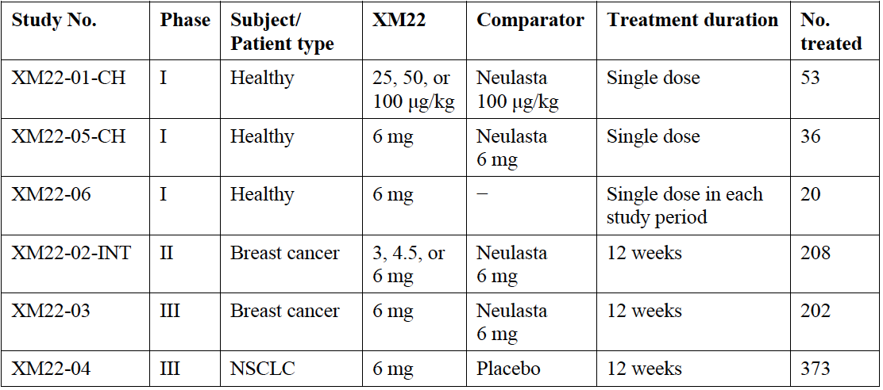
In all clinical studies, XM22 was administered as an SC injection. In the Phase II and III studies in cancer patients, XM22 was administered as a fixed dose once per CTX cycle, approximately 24 hours after CTX infusion. In the Phase I clinical studies in healthy subjects, XM22 was administered as a single weight-based dose in Study XM22-01-CH, as a single fixed dose in Study XM22-05-CH, and as a single fixed dose per treatment period in Study XM22-06 (up to 3 doses in total per subject).

Adverse events

All adverse events (irrespective of relationship to study treatment)
In the two pivotal studies, the most frequent adverse effects were musculoskeletal pains.

Pivotal Study XM22-03
A summary of adverse events with an incidence ≥5% of patients in either treatment group in Study XM22-03 (breast cancer patients) is shown below.

Table 14: summary of adverse events with an incidence ≥5% of patients in either treatment group in Study XM22-03 (breast cancer patients)
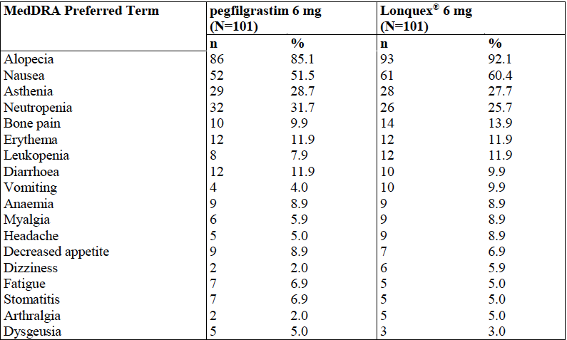

Pivotal Study XM22-04
A summary of Adverse Events with an incidence ≥2% of patients in either treatment group in Study XM22-04 (NSCLC patients) is shown below. This table does not include TEAEs with onset after start of prophylactic open-labeled Lonquex® treatment.

Table 15: Summary of Adverse Events with an incidence ≥2% of patients in either treatment group in Study XM22-04 (NSCLC patients)
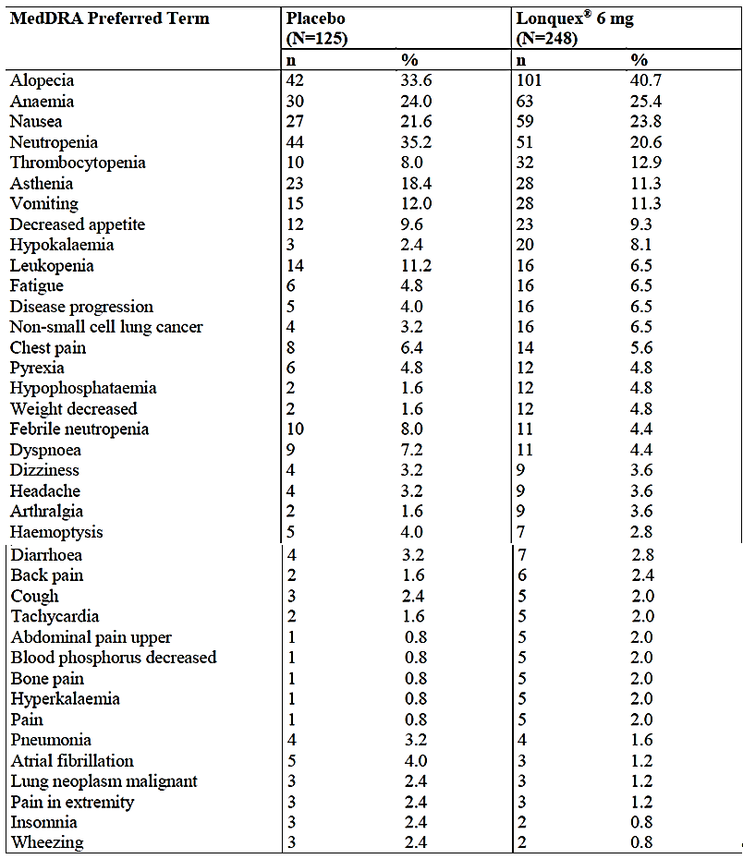

Other studies
Nil additional to add from the Phase I and II studies.

Treatment-related adverse events (adverse drug reactions)

Pivotal studies

Study XM22-04 (SP).
The following table is a summary of the most common SOCs for TEAEs (incidence of ≥2% of patients in either treatment group) in Study XM22-04 (SP).

Table 16: The most common SOCs for TEAEs (incidence of ≥2% of patients in either treatment group) in Study XM22-04 (SP).
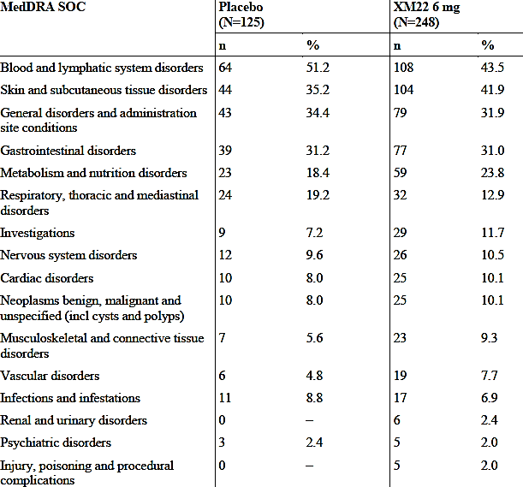
Severe TEAEs occurring at least 1% more frequently in the XM22 group were alopecia, anaemia, NSCLC, disease progression (0.8% placebo, 3.2% XM22), hypokalemia, cardio-respiratory arrest, fatigue, and pain.
Comment: neutropenia was less but disease progression increased 4 fold in the XM22 group.

XM22-04.
Most common SOCs for TEAEs (incidence of ≥2% of patients in either treatment group) − Study XM22-03 (SP): The most commonly affected preferred term (PT) (incidence ≥10% in either treatment group) were alopecia (85.1% Neulasta, 92.1% XM22), nausea (51.5%, 60.4%), asthenia (28.7%, 27.7%), neutropenia (31.7%, 25.7%), bone pain (9.9%, 13.9%), erythema (11.9%, 11.9%), leukopenia (7.9%, 11.9%), and diarrhea (11.9%, 9.9%). Alopecia, nausea, asthenia, diarrhea, neutropenia, and leukopenia are known to be associated with the CTX or the underlying disease. Bone pain and erythema are known to be common undesirable effects related to treatment with G-CSF.
Frequencies of PTs were comparable between the treatment groups. The only PTs that differed in frequency by ≥5% between the treatment groups were alopecia (85.1% Neulasta, 92.1% XM22), nausea (51.5%, 60.4%), neutropenia (31.7%, 25.7%), and vomiting (4.0%, 9.9%).
Three Neulasta-treated patients and 1 XM22-treated patient reported AEs of FN (all in Cycle 1).
The most commonly affected SOCs were musculoskeletal and connective tissue disorders (14.9% Neulasta, 19.8% XM22) and skin and subcutaneous tissue disorders (3.0%, 8.9%); musculoskeletal and connective tissue disorders SOC is mainly attributable to bone pain and arthralgia and in the skin and subcutaneous tissue disorders SOC it is mainly attributable to erythema.

Other studies

XM22-02
In this study, frequencies of SOCs were generally comparable between the treatment groups, except for the incidence of skin and subcutaneous tissue disorders, metabolism and nutrition disorders, blood and lymphatic system disorders, and investigations. The study report suggested they were not clinically relevant however there is a dose-response relationship, especially noticeable with the SOCs ‘Investigations’ and ‘Infections and infestations’ which increased with dose in the XM22 groups.
Also, the incidence of TEAEs in the SOC ‘Cardiac disorders’ was higher (difference of ≥5%) in the 6 mg Neulasta group than in the 6 mg XM22 group (13.0% versus 6.0%). Incidences of the following PTs were higher (difference of ≥5%) in the 6 mg Neulasta group than in the 6 mg XM22 group: fatigue (18.5% versus 8.0%), alopecia (9.3% versus 4.0%), asthenia (5.6% versus 0%), dysgeusia (7.4% versus 2.0%), and peripheral sensory neuropathy (7.4% versus 2.0%). Chest pain was the only PT that occurred more frequently (difference of ≥5%) in the 6 mg XM22 group than in the 6 mg Neulasta group (6.0% versus 0%).

Other studies
There were no new events in the XM22-01, 05 and 06 studies. AEs did occur, but they were consistent with the known AE of this class and other lipegfilgrastim AE.

Deaths and other serious adverse events

Pivotal studies
Overall in XM22-04 the incidence of death was 7.2% (placebo) and 12.5% (6 mg Lonquex®). Overall most deaths were not thought to be related to the study drug.

Table 17: TEAEs leading to death by SOC − Study XM22-04 (SP)
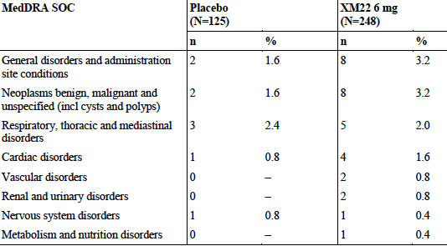
Most of the increased death rate is due to the increased TEAE causing death of NSCLC. The patient narratives given the cause of death in the XM22 versus placebo group as:
XM22:
- [information redacted]: haemoptysis, acute respiratory failure, autopsy: not performed
- [information redacted]: massive pulmonary haemorrhage, autopsy: pulmonary insufficiency, pneumonia around the cancerous tumour, cause of death lung haemorrhage grade 5, respiratory insufficiency
- [information redacted]: pneumonia (chest X-ray, resolved 2 months before death), disease progression, autopsy: not performed
- [information redacted]: haemoptysis, pulmonary embolism, autopsy: thromboembolism pulmonary artery
- [information redacted]: haemoptysis, cardio-respiratory failure, autopsy: not performed
- [information redacted]: pulmonary bleeding, autopsy: not performed
- [information redacted]: haemoptysis, autopsy: haemorrhages and lung oedema, cardiopulmonary failure
Placebo:
- [information redacted]: multiple organ failure, autopsy: metastatic pleuritis
- [information redacted]: pulmonary oedema, autopsy: post pulmonectomy status right lung, serous oedema left lung
- [information redacted]: pulmonary embolism, autopsy: thromboembolism pulmonary artery, serous oedema in the lung.
Although there was an increase in deaths was seen between the XM22 and placebo treatment groups during the XM22-04 study period, by the 360-day follow-up, survival was comparable in both groups.
Only one TEAE leading to death was assessed by the investigator as related to study medication (patient [information redacted], XM22, cardio-respiratory arrest on day 13 of Cycle 1, relationship assessed by investigator as ‘unlikely’).
Review of the individual AE data listing for patients who died (Sponsor suggests refer to: Listing 16.2.7.1.2-1 but unable to locate these) did not give any indication that the higher incidence of death in the XM22 group was affected by factors such as patient age, geographical location, study centre, study day of onset of AE, or CTX cycle at onset of AE. Thorough examination by the sponsor of the individual data for all patients who died suggested that the deaths reported do not currently indicate a relationship to study medication, but ‘rather a relationship to the underlying cancer and/or other underlying conditions’.
Comment: there was a significantly higher death rate with active treatment. Review of the individual data for all patients who died was unable to be located.

XM22-02.
There was a single death in this group, thought unlikely to be related to lipegfilgrastim by the investigator. This death occurred 8 days after the patient received her only dose of study medication.
An autopsy proved enterocolitis as the cause of death. Enterocolitis (Grade 4) was documented by the investigator as an SAE, assessed as life-threatening, important medical event with outcome death, and with no relationship to the study medication.

XM22-03.
There was a single death of a patient on XMN22 due to FN and enterocolitis
Comment: Full narratives were unable to be located for the deaths for searching in XM 22-03. On searching this topic in the CSR, Section 14 is referred to, particularly CSR-XM22-02-INT-14-3 for the full narrative which did not seem easy to locate. Similarly, in the other pivotal Study XM22-04, review of the individual data for all patients who died was unable to be located. However, the sponsor states that deaths unlikely to be due to lipegfilgrastim, ‘rather a relationship to the underlying cancer and/or other underlying conditions.’ The investigator documentation of the drug-AE relationship should be sighted.

Other studies
There were no deaths in the Phase I studies (healthy subjects).

Discontinuation due to adverse events

Pivotal studies

XM22-03
A summary of all reasons for premature discontinuation is tabulated below.

Table 18: All reasons for premature discontinuation of study medications
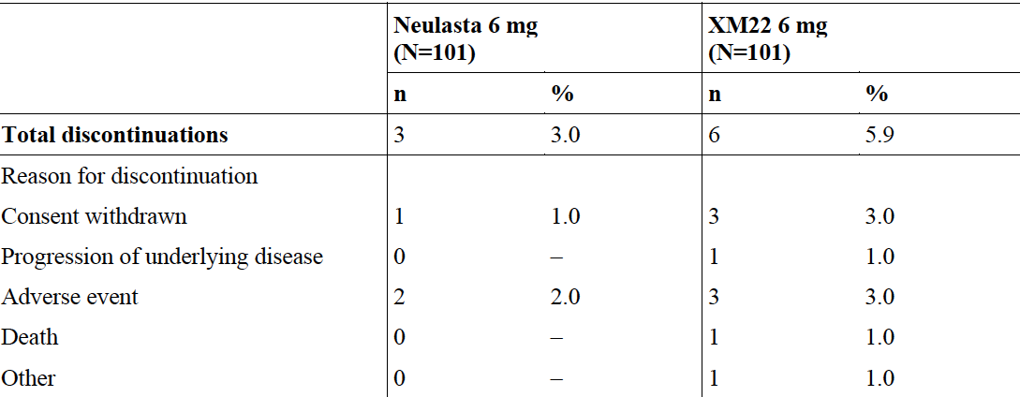

XM22-04
A summary of all reasons for premature discontinuation is tabulated below.

Table 19: All reasons for premature discontinuation of study medications
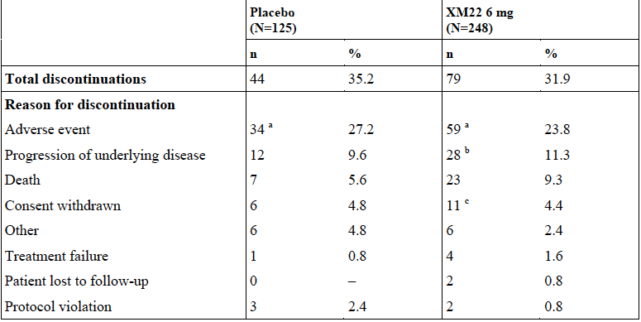
The observed increase in progression of underlying disease and death in the XM22 compared to the placebo group is noted. In addition, three of the 125 treated patients in the placebo group and 7 of the 248 treated patients in the XM22 group were switched to prophylactic open-labeled treatment with 6 mg XM22 after Cycle 1. Safety findings for these 10 patients while they were on open-labeled treatment with 6 mg XM22 were described.

Table 20: Most frequent PTs for TEAEs leading to discontinuation of study participation (incidence of >1 patient in either treatment group) – Study XM22-04 (SP).
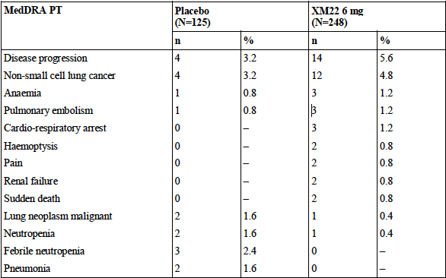

TEAEs leading to discontinuation in active-controlled Study XM22-03
TEAEs leading to discontinuation of study participation were reported in 2 (2.0%) Neulasta patients and in 3 (3.0%) XM22 patients.
- Patient [information redacted] in the Neulasta group discontinued due to alanine aminotransferase (ALT) increased and aspartate aminotransferase (AST) increased in cycle 2
- Patient [information redacted] in the Neulasta group discontinued in Cycle 1 due to tachycardia paroxysmal, deep vein thrombosis (serious, not related) and cardiac failure
- Patient [information redacted] in the XM22 group discontinued due to hepatitis toxic in Cycle 3.
- Patient [information redacted] in the XM22 group discontinued due to enterocolitis (death, not related) in Cycle 1.
- Patient [information redacted] in the XM22 group discontinued in cycle 3 due to AST increased and ALT increased (both non-serious, not related).

Other studies

XM 22-02 INT
All reasons for premature discontinuation of study medications are summarised below.

Table 21: All reasons for premature discontinuation of study medications.
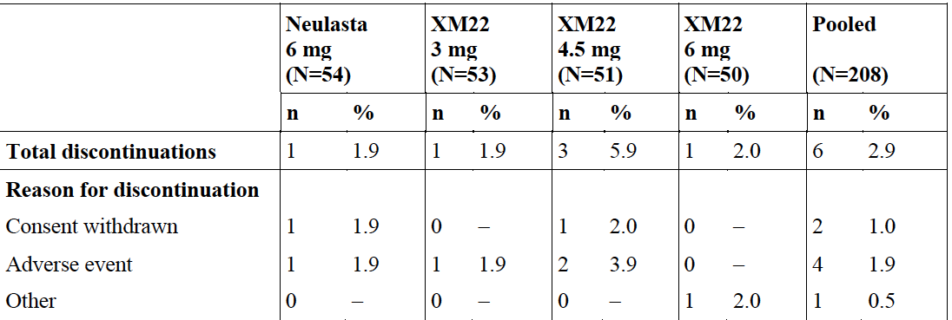
In Table 12 of the Summary of Clinical Safety, it would have been helpful to have had in the summary the list of withdrawal of medications in the placebo group to the XM22 group to examine if withdrawal may have been due to disease rather than XM22.

TEAEs leading to discontinuation in dose finding Study XM22-02-INT
TEAEs leading to discontinuation of study participation were reported in 4 (1.9%) patients in this study.
- 1 patient ([information redacted]) in the 6 mg Neulasta group in Cycle 1 due to headache, malaise, and discomfort.
- 1 patient ([information redacted]) in the 3 mg XM22 group in cycle 3 due to pyrexia.
- 2 patients ([information redacted]) in the 4.5 mg XM22 group: 1 patient in cycle 3 due to thrombocytopenia, FN, mucosal inflammation, and hemorrhagic disorder; 1 patient in cycle 2 due to pneumonia.
None of the TEAEs leading to premature discontinuation were TEADRs.

Table 22: Listing of patients with serious TEADRs. Pooled XM22 6 mg analyses: All cancer patients. [patient identifiers have been deleted from this table]

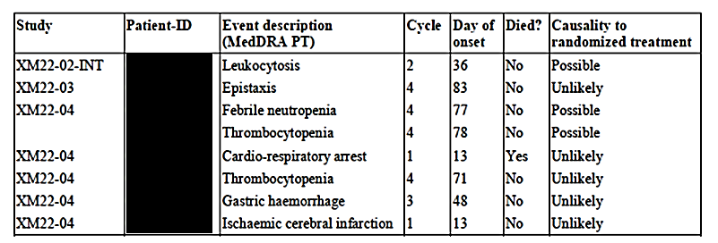

Laboratory tests

Liver function

Pivotal studies
No specific differences between the groups.

Other studies
No specific differences between the groups.

Kidney function

Pivotal studies
No specific differences between the groups.

Other studies
No specific differences between the groups.

Other clinical chemistry

Pivotal studies
The laboratory safety data revealed a higher frequency of patients with decreases in potassium to <LLN in the XM22 group than in the placebo group (22.2% versus 9.1%). However, only 1 case of hypokalemia as a TEAE (in the XM22 group) was assessed by the investigator as related to study medication (relationship to study medication classed as ‘unlikely’).
In Studies XM22-01-CH and XM22-05-CH, values outside the reference range were reported for many of the clinical chemistry and hematology variables measured. The clinical chemistry parameters with the most frequent increases were AP and LDH. Reversible mild to moderate elevations in these parameters are known uncommon side effects of G-CSF treatment.
Overall about 28% of the patients in the 6 mg Neulasta group showed values >ULN compared to 57% in the 2 highest XM22 dose groups. 1 patient in the 4.5 mg XM22 group had a value >3 x ULN. Reversible mild to moderate elevations in AP are listed as uncommon side effects of Neulasta.
- GGT, phosphate, and potassium: percentages of patients with values >ULN were higher in the XM22 dose groups than in the 6 mg Neulasta group. GGT values >3 x ULN were found in 3 patients (1 in each of the 6 mg Neulasta, 3 mg XM22, and 4.5 mg XM22 groups).
- LDH: about 43% of the patients in the 6 mg Neulasta group had values >ULN compared to 60 to 70% in the XM22 groups with a slight dose-dependent trend. No patients had values >3 x ULN. Reversible mild to moderate elevations in LDH are listed as uncommon side effects of Neulasta.
Comment: Increases in clinical chemistry for ALP, GGT and LDH were seen in the XM22 patients compared to Neulasta 6 mg.

Other studies
No specific differences between the groups.

Haematology

Pivotal and Phase I studies
A transient and slight decrease in Hb was noted on Day 3 in two of the healthy subject Phase I Studies XM22-01 and XM22-05. It was considered that blood loss due to the study procedures and a hypothetical depression of erythropoiesis by G-CSF could potentially elicit Hb fluctuations to the extent observed in our studies. It is a parameter to be monitored however. The lack of the effect in the highest XM22 dose group makes it unlikely to be a dose-response issue.

Electrocardiograph

Pivotal studies
The ECG data in the XM22-04 study revealed no clear effect of XM22 on heart rate, atrio-ventricular nodal conduction as measured by PR interval duration, cardiac depolarization as measured by QRS duration or morphology. There was also no clear signal of an effect on cardiac repolarization. However in the XM22-03 breast cancer group some of whom received cardiotoxic chemotherapy, nonspecific ST-T wave changes were noted at a low frequency (<5%) comparably for both agents. The QTcF duration was increased in both treatment arms (XM22 and Neulasta) by approximately equal durations of 10- 15 ms, and an increase in nonspecific change from baseline of 30-60 ms in the 6-15% range forXM22 and 4-25% range for Neulasta was observed.
Comment: The sponsor should identify if the patients that developed ECG abnormalities were concomitantly receiving doxorubicin.

Other studies
Nil of note in the non-chemotherapy studies.

Vital signs

Pivotal studies
Heart rate findings reported as TEAEs were infrequent and mild or moderate in all cases, except for 1 case of tachycardia and 1 case of atrial fibrillation in the XM22 group which were assessed as severe by the Investigator. The case of atrial fibrillation was serious. TEAEs of hypertension were reported only in patients receiving XM22 and should be monitored.

Other studies
Nil or note in the Phase I studies.

Post-marketing experience
Two PSURS reporting up to mid-2014 were provided and there were no new concerns raised.

Safety issues with the potential for major regulatory impact

Liver toxicity
Nil signal.

Haematological toxicity
Nil. signal.

Serious skin reactions
Nil signal.

Cardiovascular safety
Nil signal apart from the comments above with the ECG.

Unwanted immunological events
Immnunogenicity is a long standing issue with these agents and there is an immunogenicity database collecting any new information. There were no significant issues within the studies however.

Other safety issues

Safety in special populations
Nil studied.

Safety related to drug-drug interactions and other interactions
Nil studied.

Safety issues with the potential for major regulatory impact
Nil.

Safety in special populations
To date there is no data on: paediatric patients, the elderly, pregnant or breast feeding women, hepatic and renal impairment. These details should be made more strongly in the PI.

Safety related to drug-drug interactions and other interactions
Nil signal in this submission.

First round benefit-risk assessment

First round assessment of benefits
The benefits of lipegfilgrastim in the proposed usage are:
- Less doses of GCSF therapy
- Non-inferior to pegfilgrastim in DSN in breast cancer treatment
- May reduce delays in CTX
- May reduce neutropenia severity and time to recover from the nadir (although the clinical relevance wasn’t clear).
Overall it appears then that lipegfilgrastim 6 mg is non-inferior to pegfilgrastim 6 mg in breast cancer and that lipegfilgrastim is not superior to placebo for reducing febrile neutropenia in NSCLC, although it does have a statistically significant effect at reducing the ANC nadir and time to recovery. The drug does not meet efficacy criteria for reduction of both DSN and FN.

First round assessment of risks
- May worsen survival in NSCLC
- May increase disease progression in NSCLC
- Equivalent to placebo in FN prevention in NSCLC
- May cause hyperleucocytosis
- Causes a number of side effects, including bone pain and elevations in ALP, GGT and LDH.

First round assessment of benefit-risk balance
This drug appears to be non-inferior to one already registered (Neulasta) and which we have several years of pharmacovigilance data on for DSN in breast cancer. The drug may not be any better than placebo at preventing FN in lung cancer and may worsen survival and worsen disease free progression in this disease. It also has side-effects which are not insignificant. The benefits in the secondary outcomes are around ANC, much of which has not yet been shown to translate into a clinical benefit (as opposed to a change in the ANC number).
The data from the release of Phase IV study in the UK and the paediatric data would be helpful.

First round recommendation regarding authorisation
The proposed indication is not justified from the data presented; authorisation is not recommended.
Evaluation of the data in Phase IV studies in the EU and the paediatric data is needed to satisfy concerns over the effect this drug has on cancer progression and survival.

Clinical questions

Pharmacokinetics
- The sponsor is requested to provide any additional data it holds regarding pharmacodynamic effect(s) according to gender, age (dichotomised at 65 years), body-weight and body mass.
- The sponsor is requested to perform an analysis of PK and PD parameters, comparing (i) patients that withdrew from treatment versus patients that continued treatment, and (ii) patients that survived following treatment versus patients that died on study.
- Why did the sponsor decide the choice of drug dose in the study when on concentration data the 3 mg looks similarly effective?
- The sponsor should justify why they haven’t made a weight based dosing regimen recommendation, bearing in mind there was pharmacokinetic data submitted which used at least a weight based dosing regimen, bearing in mind the large (and increasing) number of cancer patients that are overweight or obese, and those that are cachectic or underweight (for example, lung cancer patients with underlying airways disease).

Efficacy
- The sponsor is requested to provide the comments of Swiss Medic which resulted in withdrawal of the submission to that regulator.
- The sponsor is requested to provide the PIP data from November 2014 submitted to the EMA.
- The sponsor is requested to provide an explanation regarding the lack difference in both dose reductions and omitted treatments, seen in Study XM22-04, given these are considered clinically relevant end-points.
- Although the upper limit for number of injections is not stated, can this be stated on the current efficacy or safety data?
- The sponsor is requested to provide a considered summary of the reasons that patients withdrew from XM-22-04
- What does the sponsor consider to be the clinical benefit of a DSN reduction of 1.6 days as seen in XM22-04?
- What is the statistical and clinical significance of the efficacy data presented in Table 23 in the CSR for Study XM22-04?
- Please provide references for the assumptions of incidence rate of FN under treatment with placebo and the incidence under treatment with XM22 as the actual incidence was much lower.
- The sponsor is requested to explain proposed benefit to patients with NSCLC from lipegfilgrastim, given they were observed to have worsened survival, disease progression and similar incidence of febrile neutropenia, as compared to those exposed to placebo.

Safety
- What was the percentage of women to men who developed hyperleukocytosis and did they have elevated plasma concentration of lipegfilgrastim?
- What was the cause of ‘pain’ in the two patients that withdrew from Study XM22-03?
- Given that Study XM22-04 failed to meet the primary efficacy end-point of reduction in incidence of febrile neutropenia, what safety and efficacy evidence does the sponsor hold to demonstrate a benefit to continued administration of Lonquex in an individual patient once febrile neutropaenia has occurred?
- The sponsor should identify if the patients that developed ECG abnormalities were concomitantly receiving doxorubicin.
- The sponsor is requested to provide the individual data and investigator stated purported relationship to Lonquex, for all patients who died in the pivotal studies, which was unable to be located in the dossier.

Second round evaluation of clinical data submitted in response to questions

Pharmacokinetics

Question 1:
The sponsor is requested to provide any additional data it holds regarding pharmacodynamic effect(s) according to gender, age (dichotomised at 65 years), body-weight and body mass.

Sponsor response
The effects of covariates on the pharmacodynamics of XM22 were explored in all patients treated with the 6 mg dose of XM22 during Cycle 1 of the chemotherapy regimen. Covariates included gender, age (<65 years versus ≥65 years), and various ranges of body weight (<60 kg versus 60-80 kg versus < 80 kg, and ≤95 kg versus >95kg). Pharmacodynamic (PD) parameters included the maximum value and area over the baseline effect curve (AOBEC) for the absolute neutrophil count (that is, ANC_{max} and ANC AOBEC) and CD34+ cell count (that is, CD34+max and CD34+ AOBEC). The distributions of PD parameters are represented by the boxplots shown below, with each box representing the 25th, 50th, and 75th percentile (from bottom to top), the whiskers representing the 5th and 95th percentiles, and the asterisks representing outliers – data points outside the 5th and 95th percentiles.
The distributions of ANC AOBEC and CD34+ AOBEC stratified by gender in pooled cancer patients treated with XM22 (6 mg) during Cycle 1 from Studies XM22-02INT, XM22-03, and XM22-04 are shown in Figure 11. There was no appreciable gender difference in either the median value or distribution of ANC AOBEC values (left panel) or in the median value of CD34+ AOBEC (right panel), although, with fewer data points, the distribution of CD34+ AOBEC data was skewed and more variable than that of ANC AOBEC data. Likewise, similar distribution patterns were observed for ANC_{max} and CD34+max values grouped by gender.
Figure 11: Distribution of ANC AOBEC and CD34+ AOBEC for XM22 (6 mg) in Pooled Cancer Patients stratified by Gender from Studies XM22-02-INT, XM22-03, and XM22-04.
The distributions of ANC AOBEC and CD34+ AOBEC stratified by age (<65 years versus ≥65 years) in pooled cancer patients treated with XM22 (6 mg) during Cycle 1 from Studies XM22- 02INT, XM22-03, and XM22-04 are shown in Figure 12. There was no appreciable age difference in either the median value or distribution of ANC AOBEC values (left panel) or CD34+ AOBEC values (right panel), although the CD34+ AOBEC data were more variable due to the smaller sample size. Likewise, similar distribution patterns were observed by age group with respect to ANC_{max} and CD34+max.
Figure 12: Distribution of ANC AOBEC and CD34+ AOBEC for XM22 (6 mg) in Cancer Patients stratified by Age (< 65 versus ≥65 years) from Studies XM22-02-INT, XM22- 03, and XM22-04
The distributions of ANC AOBEC and CD34+ AOBEC stratified by body weight (<60 kg versus 60- 80 kg versus ≥80 kg) in pooled cancer patients treated with XM22 (6 mg) during Cycle 1 from Studies XM22-02INT, XM22-03, and XM22-04 are shown in Figure 13. In general, there was considerable overlap in the distribution of ANC AOBEC and CD34+ AOBEC among the weight groups. Similar distributions were observed with ANC_{max} and CD34+max.
Figure 13: Distribution of ANC AOBEC and CD34+ AOBEC for XM22 (6 mg) in Pooled Cancer Patients stratified by Body Weight (<60 kg versus 60-80 kg versus ≥80 kg) from Studies XM22-02-INT, XM22-03, and XM22-04

Evaluator comment
The effect of covariates (gender, age, body weight) on the pharmacodynamics (ANC and CD34+) of XM22 was explored in all patients treated with the 6 mg-dose of XM22 during Cycle 1 of the chemotherapy regimen. There was a large amount of variability (and wide D) but no clear gender difference in the median value or distribution of ANC, nor CD 34+ AOBEC values.
The distributions of ANC AOBEC and CD34+ AOBEC stratified by age group in pooled cancer patients treated with XM22 (6 mg) during Cycle 1 from Studies XM22- 02INT, XM22-03, and XM22-04 similarly didn’t show any clear difference in either the median value or distribution of ANC nor CD31+ AOBEC values.
The distributions of ANC AOBEC and CD34+ AOBEC stratified by body weight in pooled cancer patients treated with XM22 (6 mg) during Cycle 1 from Studies XM22-02INT, XM22-03, and XM22-04 showed overlap in the distribution of ANC and CD34+ AOBEC

Question 2:
The sponsor is requested to perform an analysis of PK and PD parameters, comparing (i) patients that withdrew from treatment versus patients that continued treatment, and (ii) patients that survived following treatment versus patients that died on study.

Sponsor response
With respect to comparing PK/PD parameters between patients that died following treatment and those that survived and between patients who withdrew from treatment and those that continued, the sponsor recently performed an in-depth analysis to investigate the influence of PK and PD parameters on 3-month survival (mortality) and disease progression in response to a request by EMEA . The analysis utilized data from Study XM22-04. The term ‘disease progression’ was used to categorize patients in whom assessments by investigators lead to adverse event reports or reports of premature termination of study participation due to ‘disease progression’ or similar terms at the discretion of the investigator. In this summary, the term ‘disease progression’ is intended to provide an adequate sample size to provide a meaningful comparison of PK and PD parameters between groups of patients, also stratified by active (XM22) versus placebo treatment group with respect to assessment of PD parameters.
With respect to the PK of XM22 and mortality, the mean, the median, and geometric mean values for C_{max} and AUC_{inf} following XM22 (6 mg) are shown in Table 23. The PK estimates were highly variable but also incoherent in the sense that the mean, median, and geometric mean C_{max} and AUC_{inf} values were not consistently higher in one group or the other. With respect to PD parameters and mortality, there was no more than an 11% difference in any of the average values of ANC AOBEC between patients that died and those that survived, both with respect to the XM22 treatment group as well as the placebo group.

Table 23: Summary statistics for XM22 PK and PD Parameters from Cycle 1 and Mortality. Safety Population
With respect to the PK XM22 and disease progression, the mean, median, and geometric mean values for C_{max} and AUC_{inf} following XM22 (6 mg) are shown in Table 24. The PK variability was greater in the patients categorized as having disease progression compared with those that were not. However, there was no evidence of a consistent or significant difference in PK between patient groups. Likewise, there was no evidence of a consistent or significant difference in PD between patient groups.

Table 24: Summary statistics for XM22 PK and PD Parameters from Cycle 1 and Disease Progression (Yes versus No), including patient withdrawal. Safety Population

Evaluator comment
The sponsor recently performed an in-depth analysis to investigate the influence of PK and PD parameters on 3-month survival (mortality) and disease progression in response to a request by EMEA. The analysis utilized data from Study XM22-04.
With respect to the PK of XM22 and mortality, the mean, median, and geometric mean values for C_{max} and AUC_{inf} following XM22 (6 mg) were provided. The PK estimates were variable but also inconsistent for example, the C_{max} was lower but the AUC_{inf} higher in those who progressed (one would expected both to be lower unless it is the C_{max} rather than exposure that is important and it is biologically plausible that it is C_{max} that affects the hematopoetic cycle but no evidence presented to support that). There was less than 11% difference in any of the average values of ANC AOBEC between patients that died and those that survived in both groups (refer Table 23).
The increased death rate that was noted in the NSCLC study could have been due to another effect, such as the imbalance of histology at baseline, rather than the effect of Lonquex on ANC.

Question 3:
Why did the sponsor decide the choice of drug dose in the study when on concentration data the 3mg looks similarly effective?

Sponsor response
A comparison of the serum concentration data (Studies XM22-01-CH, XM22-05-CH, XM22-02- INT, and XM22-03) revealed that the bioavailability (that is, AUC_{0-t}) of XM22 is approximately 34- 64% higher than that of Neulasta, suggesting that the 3 mg dose of XM22 would be pharmacologically comparable to the 6 mg dose. However, the difference in bioavailability between XM22 and Neulasta can be attributed to XM 22 having a slightly prolonged PK disposition compared with Neulasta, even though both drugs share a common elimination pathway. Ultimately, the choice of the 6 mg dose of XM22, however, was based not on the concentration data or PK differences between XM22 and Neulasta, but on the XM22 efficacy and safety data from the randomised, double-blind Phase II dose-ranging study (XM22-02-INT) as well as the subsequent population PK/PD analyses across all studies (Report CP-12-002). The analysis of the primary and the secondary efficacy endpoints from Study XM22-02-INT showed a dose-dependent trend across the four treatment groups of XM22 with 6 mg being the most effective dose. Despite this trend in favour of increasing XM22 doses in most efficacy parameters, no clinically relevant dose-dependent trend for XM22 was observed for any of the safety parameters. No clinically relevant differences in safety variables were found between the 6 mg pegfilgrastim and the 6 mg XM22 dose group. There were no new, unexpected safety findings. Differences between the treatment groups in any of the AE categories were not statistically significant and not considered to be clinically relevant. Furthermore, there was no significant dose-dependent trend for the XM22 dose groups in any of the AE categories. Based on these findings, 6 mg XM22 was selected for Phase III as the dose with the best benefit-risk ratio.
In addition, as part of the PK/PD analysis, maximum response (Emax) models were evaluated using ANC AOBEC data from the healthy volunteer studies and CD34+ AOBEC data from the combination of healthy volunteer studies and cancer clinical trials. An Emax model adequately fit the XM22 data from the healthy volunteer studies. The model indicated that there was an increase in the PD response with increasing exposure level (AUC_{0-last}) of XM22. Maximum response (Emax) was reached at approximately 5000 10⁹ /L*h, with EC50 and EC90 values of approximately 1300 ng h/mL and 11,600 ng h/mL, respectively.
In general, healthy volunteers were more responsive to the granulopoietic effects of XM22 than the cancer patients. When the XM22 AUC_{0-last} and ANC AOBEC values for cancer patient are overlaid on those for the healthy volunteers, the patient data fall almost entirely below Emax (Figure 14). Nevertheless, it can be seen that the maximum granulopoietic response occurred at an AUC_{0-last} level substantially higher than that associated with the 3 mg dose (11,600 ng h/mL versus 3,476 ng h/mL).
Figure 14: Individual Cycle 1 ANC OEBEC versus XM22 AUC 0-last for Healthy Volunteers Overlaid with Data from Cancer Patients
In contrast to the analysis with ANC AOBEC which was done in healthy volunteers, the Emax model with CD34+ using data from all studies estimated EC50 to be approximately 2,100 ng h/mL and EC90 to be approximately 19,000 ng h/mL. The EC90 in this analysis was comparable to the mean AUC_{0-last} value associated with the 6 mg dose of XM22 (19,000 ng h/mL versus 19,748 ng h/mL). To further illustrate the PK/PD relationship for XM22, the distribution of XM22 AUC_{0-last} values is shown by dose in contrast with the EC50 and EC90 reference lines (Figure 15).
Figure 15: Distribution of XM22 AUC_{0-last} Values by Dose and Study Number in Cancer Patients in Contrast with EC50 and EC90 for CD34+ AOBEC.
Overall, the PK/PD analysis indicated that the optimal dose of XM22 is 6 mg (Report CP-12- 002).

Evaluator comment
The sponsor agrees in part when it states that on comparison of the serum concentration data (Studies XM22-01-CH, XM22-05-CH, XM22-02- INT, and XM22-03) it appeared that the bioavailability (ie, AUC_{0-t}) of XM22 is approximately 34- 64% higher than that of Neulasta, suggesting that the 3 mg dose of XM22 would be pharmacologically comparable to the 6 mg dose.
However the sponsor states the choice of the 6 mg dose of XM22 was based on the XM22 efficacy and safety data from the randomised, double-blind Phase II dose-ranging study (XM22-02-INT) as well as the subsequent population PK/PD analyses across all studies (Report CP-12-002) which showed that 6 mg was the most effective dose and without a dose-dependent safety trend for XM22 being observed.
In addition, as part of the PK/PD analysis, maximum response (Emax) models were evaluated using ANC AOBEC data from the healthy volunteer studies and CD34+ AOBEC data from the combination of healthy volunteer studies and cancer clinical trials. Although the model suggested there was an increase in the PD response with increasing exposure level, the relevance of this is unknown when examining both Table 23 and Table 2 below [sic] which appeared to show no relationship between PD parameter and survival. The maximum granulopoietic response occurred at an AUC_{0-last} level substantially higher than that associated with the 3 mg dose (11,600 ng h/mL versus 3,476 ng h/mL).
The EC90 in this analysis was comparable to the mean AUC_{0-last} value associated with the 6 mg dose of XM22 (19,000 ng h/mL versus 19,748 ng h/mL).

Question 4
The sponsor should justify why they haven’t made a weight based dosing regimen recommendation, bearing in mind there was pharmacokinetic data submitted which used at least a weight based dosing regimen, bearing in mind the large (and increasing) number of cancer patients that are overweight or obese, and those that are cachectic or underweight (for example, lung cancer patients with underlying airways disease).

Sponsor response
As described in the response to Question 3, the dose of XM22 was derived from the response data from the randomised, double-blind Phase II dose-ranging study (XM22-02-INT) and the subsequent PK/PD analyses. As described in response to Pharmacokinetic Question 1, there were no significant PD differences between the pre-defined weight categories (<60 kg versus 60-80 kg versus ≥80 kg) following treatment with 6 mg of XM22. As shown in Figure 16 (left panel), even patients who were significantly underweight (that is, <60 kg) demonstrated a PD response that was comparable to that in patients who were within the 60-80 kg weight range. Likewise, patients who were significantly overweight (that is, ≥80 kg) demonstrated a PD response that was comparable to that in patients who were within the 60-80 kg weight range (left panel). While there was some evidence to suggest that patients at the extreme upper end of the weight range had a PD response slightly less than that of the rest of the population (right panel), the overlap in the distribution of values between the two groups suggests that the difference is not clinically significant.
Figure 16. Distribution of ANC AOBEC for XM22 (6 mg) in Pooled Cancer Patients stratified by Body Weight from Studies XM22-02-INT, XM22-03, and XM22-04
In addition, the population PK model was used to compare the PK/PD of the high-end weight based dose of 100 μg/kg originally tested in Study XM22-01-CH to the fixed 6 mg dose utilized in healthy subjects in Studies XM22-05-CH and in cancer patients in Studies XM22-02-INT, XM22-03, and XM22-04. The predicted AUC_{0-last} and observed ANCavg values versus body weight for both healthy subjects and cancer patients are illustrated in Figure 17.
In the final analysis, there was no consistent trend in either the XM22 exposure or PD response to XM22 over the weight range from 48 to 127 kg with either fixed dosing or body-weight dosing in healthy volunteers. Likewise, there was no predictable or clinically significant PK or PD trend in the cancer patients.
Figure 17: Predicted XM22 AUC_{0-last} and Observed ANC_{avg} by weight for a fixed dose (6 mg) and a weight adjusted dose (100 µg/kg) of XM22
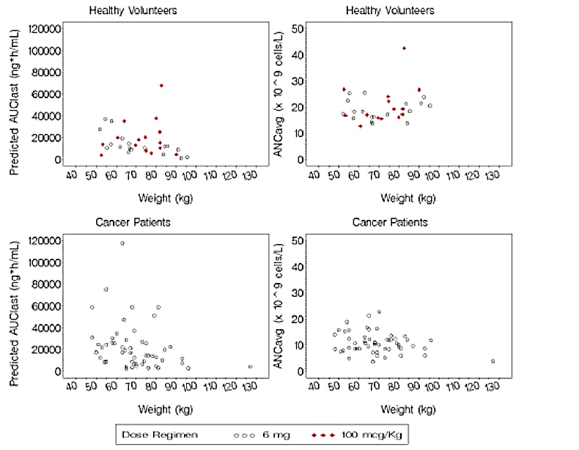

Evaluator comment
The sponsor notes that as described in the response to Question 3, the response was very variable over the weight range. In the absence of weight based dosing in the cancer population, this data appears inconsistently related to total body weight.

Efficacy

Question 1
The sponsor is requested to provide the comments of Swiss Medic which resulted in withdrawal of the submission to that regulator.

Sponsor response
The list of questions of Swiss Medic is provided with this response. The majority were resolved however the main concerns which were raised by the agency and triggered the withdrawal of the submission by Teva are as follows:
- Causality of Lonquex® in mortality imbalance observed in clinical trial XM22-04 cannot be excluded.
- Exposure is 30% higher with Lonquex® and there are more G-CSF-related AE (than Neulasta).
- Data showing efficacy with doses lower than 6 mg are not sufficient (no pivotal clinical study available).
TEVA is planning to resubmit the dossier to Swiss Medic when the additional data expected to exclude the above concerns is available (approximately in 2018, after the finalisation of the post approval studies, which are currently ongoing).
Please note that similar concerns were also raised by the EMA and by the Israeli MOH during the evaluation period. Nevertheless, both agencies approved the product based on Teva's commitment to provide the results of the PASS studies.

Evaluator comment
It is recommended to the Delegate that the post authorisation data to be supplied to Swiss Medic is also submitted for evaluation by the TGA as a condition of registration.

Question 2
The sponsor is requested to provide the PIP data from November 2014 submitted to the EMA.

Sponsor response
The PIP data is included in this response. Please note that the data was submitted to the EMA on
December 2014.
The PIP data include Study XM22-07, included with this response. Study XM22-07 is a Phase I, open-label study aimed at assessing the pharmacokinetics, pharmacodynamics, efficacy, safety, tolerability, and immunogenicity of a single subcutaneous injection of XM22 in children with Ewing family of tumors or rhabdomyosarcoma scheduled to receive chemotherapy.
A Clinical Overview of Study XM22-07 is included with this response. A declaration of the Clinical Expert responsible for preparing the Clinical Overview is also presented.

Evaluator Comment
This is acknowledged.

Question 3
The sponsor is requested to provide an explanation regarding the lack difference in both dose reductions and omitted treatments, seen in Study XM22-04, given these are considered clinically relevant end-points.

Sponsor response
The sponsor agrees that dose reductions/omissions and delays of the next chemotherapy cycle are clinically relevant endpoints for a G-CSF study. Dose reductions/omissions was a combined secondary endpoint in Study XM22/04, as dose omission was regarded as a 100% dose reduction when one chemotherapy treatment was not given at all and the next cycle treatment was as scheduled.
Main reasons for such dose reductions/omissions or delays are hematologic side effects of the previous chemotherapy cycle. Both of these endpoints have to be assessed in combination as the oncologist decides to either reduce the dose of the following chemotherapy cycle or postpones the next cycle to allow sufficient time for recovery from neutropenia or thrombocytopenia.
The chemotherapy regimen used in this study was a cisplatin/etoposide combination. In the label of etoposide a delay of the next cycle is proposed instead of a dose reduction for such patients:
‘The occurrence of a platelet count below 50,000/mm³ or an absolute neutrophil count below 500/mm³ is an indication to withhold further therapy until the blood counts have sufficiently recovered.’
Also the study protocol of Study XM22-04 requested that ‘to begin full dose CTX on day 1 of each subsequent cycle, the patient must have recovered to an ANC of ≥1.5 x 10⁹/L and a platelet count of ≥100 x 10⁹/L. A delay of the subsequent cycle for up to 14 days is acceptable.’
As dose reduction/omission or dose delays are alternative options for an oncologist and as the label for etoposide, as well as the study protocol, proposed to delay the next dose instead of reduce the dose, the result of the study for these secondary endpoints is as expected.
There were only few dose reductions numerically in favour of XM22 (6 in the placebo group and 9 in the XM22 group) but a much high number of delays (refer to CSR XM22-04 table below). There was a statistically significant reduction in number of chemotherapy treatments that were delayed with XM22. The proportion of patients with delays in the administration of chemotherapy was higher for the placebo group in each of Cycles 2 to 4, with p<0.05 in each case.
In summary, the low number of dose reductions and omissions are as expected in this clinically setting but are nevertheless in favour of XM22. In combination with the secondary endpoint of dose delays a clear clinical advantage of XM22 6 mg versus placebo was shown in this study in allowing the next cycle of chemotherapy to be administered without any dose reductions or delays.

Table 25: Number (%) of patients with reduced, omitted or delayed doses of CTX (ITT population).

Evaluator comment
The sponsor agrees that dose reductions/omissions and delays of the next chemotherapy cycle are clinically relevant endpoints for a G-CSF study. Dose reductions/omissions were a combined secondary endpoint in Study XM22/04. There was no difference in the proportion of patients requiring a dose reduction or omission between the placebo and XM22 arms.
There was a statistically significant reduction in number of chemotherapy treatments that were delayed with XM22 exposure. The proportion of patients with delays in the administration of chemotherapy was higher for the placebo group in each of cycles 2 to 4, with p<0.05 in each case.

Question 4
Although the upper limit for number of injections is not stated, can this be stated on the current efficacy or safety data?

Sponsor response
In the Phase II and III studies in cancer patients, more than 300 patients received a total of 4 injections of 6 mg XM22 but no data are available for higher number of injections. To predict the potential effect of higher number of injections the sponsor assessed efficacy and safety over the 4 cycles of chemotherapy.
- Efficacy over time
In patients not treated with a G-CSF, neutropenia is stable or even worsening during consecutive chemotherapy cycles (see also results for the placebo group in Study XM22-04). The below table provides an overview of relevant efficacy parameters (duration of severe neutropenia, incidence of severe neutropenia and incidence of febrile neutropenia) over the four cycles of chemotherapy for patients treated with XM22 6 mg in the three Phase II and III studies.
Efficacy in general was lowest in the first cycle of chemotherapy and increased to a stable effect in Cycles 2 to 4. A potential explanation for this higher effect in the following cycles could be that patients treated with a G-CSF in a Cycle 1 might already have higher neutrophil counts at the beginning of the following cycle.

Table 26: Duration of neutropenia and incidence of severe neutropenia and febrile neutropenia
Comparable efficacy was observed in all four chemotherapy cycles in all studies. No tolerance effect with loss of efficacy over time was observed. Tolerance effects are also not known for other G-CSFs and have not been observed with XM22. It can be concluded that efficacy of XM22 is expected to be stable also for a higher number of injections.
- Safety over time
A search of the clinical database related to Adverse Events (AE) per cycle was performed.
The table below provides an overview of total AE occurrence over the four cycles of chemotherapy for patients treated with XM22 in the pivotal studies (XM22-02, XM22-03 and XM22-04).

Table 27: Overview of total AE occurrence over the four cycles of chemotherapy for patients treated with XM22 in the pivotal studies (XM22-02, XM22-03 and XM22-04).
The number of AEs as well as the number of patients reporting AEs showed a continuously decreasing trend during the following treatment cycles. Accordingly, decreasing number of AEs and patients reporting AEs during following treatment cycles was observed within the individual SOCs. With particular focus on the SOCs ‘Skin and subcutaneous tissue disorder’, ‘Musculoskeletal and connective tissue disorders’, and ‘Infections and infestations’, number of AEs and patients reporting AEs decreased during following treatment cycles. Also, AEs under the SOC ‘Immune system disorders’ were single events with stable numbers during treatment cycles.
An analysis of serious Treatment Emergent Adverse Drug Reactions (TEADR) per cycle was performed. No pattern of increase during following treatment cycles was detected. In general, the number of serious TEADRs was low and no trend related to a specific SOC was detected.
Based on the safety data of pivotal studies comprising four cycles of chemotherapy, there is no evidence of an increased risk to the patient during following treatment cycles. To date, there is no evidence to conclude that the risk to patients receiving more than four subsequent injections is increased. Therefore, based on the current safety data, an upper limit for the number of injections seems not to be applicable for Lonquex.
Pivotal studies were based on treatment regimens of 4 cycles of chemotherapy as routine chemotherapy for the specific cancer disease, however, the ongoing studies (XM22-ONC-305) are based on 6 cycles which should provide more evidence to the fact of benefit of XM22 beyond 4 doses.

Evaluator comment
The sponsor states that in the Phase II and III studies in cancer patients, more than 300 patients received a total of 4 injections of 6 mg XM22 but no data are available for higher number of injections.
The sponsor states that loss of efficacy over the 4 cycles was not observed. The sponsor states it can be concluded that efficacy of XM22 is expected to be stable also for a higher number of injections.
It is reasonable to acknowledge that loss of efficacy was not observed over the 4 cycles. However, in the absence of evaluable data, it is a leap of faith to assume that this continues long-term.
In regard to safety over time, the sponsor conducted a search of the clinical database related to Adverse Events (AE) per cycle. The number of AEs as well as the number of patients reporting AEs showed a slight decrement in incidence during the 4 treatment cycles. No pattern of increase in AEs was detected. The ongoing study (XM22-ONC-305) is based on 6 cycles which should provide more evidence to the benefit of XM22 up to 6 doses.

Question 5
The sponsor is requested to provide a considered summary of the reasons that patients withdrew from XM-22-04.

Sponsor response
The MAH retrieved 17 patients that withdrew informed consent from XM22-04 study. As reasons for withdrawal of consent were not requested and therefore not provided, the applicant reviewed CRFs and searched the database for Adverse Events (AE) that occurred until withdrawal with special focus on ‘not resolved’ or events that were outcome ‘unknown’ at the date of withdrawal. In most of the cases, AEs that were recorded as not resolved started in close temporal relationship of informed consent withdrawal by patients. In some cases, physical examination around withdrawal date showed deteriorating physical situation compared to previous examinations. The following information was provided in the CRFs:
- Patient [information redacted], 47 years old male patient on placebo, withdrew consent on 03 Jan 2011 after his first cycle reporting thoracic pain and asthenia Grade II, which were not resolved and may have contributed to withdrawal in this patient.
- Patient [information redacted], 65 years old male patient treated with Lonquex, withdrew consent after diagnosis of superior vena cava syndrome due to underlying cancer disease on 22 Nov 2010 and after his 2nd chemotherapy cycle. Diagnosis of superior vena cava syndrome and associated symptoms may have contributed to withdrawal of this patient.
- Patient [information redacted], 39 years old female patient treated with Lonquex, died on 24 Jan 2011 after having withdrawn consent on 16 Dec 2010 and after being diagnosed with NSCLC disease progression. Deteriorating physical situation in context of disease progression may have contributed to withdrawal of this patient.
- Patient [information redacted], 56 years old male patient on placebo, withdrew consent on 04 Oct 2010 after his 3rd cycle and after being noted suffering from chest pain exacerbation, weakness and ongoing nausea and dizziness.
- Patient [information redacted], 47 years old male patient treated with Lonquex, withdrew consent after reporting exacerbation of symptoms including severe dyspnea, chest pain and weakness after his 3rd cycle.
- Patient [information redacted], 60 years old male patient treated with Lonquex, withdrew consent on 11 Nov 2010 after metastatic spinal cord compression occurred after his first chemotherapy cycle. The situation of metastatic spinal cord compression may have contributed to withdrawal in this patient.
- Patient [information redacted], 68 years old male patient treated with Lonquex, withdrew consent on 14 Oct 2010 after his 3rd cycle. Withdrawal cannot be linked to an AE, examination result or other conditions.
- Patient [information redacted], 42 years old male patient treated with Lonquex, withdrew consent on 20 Sep 2010 during his end of cycle 2 review examinations on 20 Sep 2010. No reason for withdrawal was forwarded; withdrawal cannot be linked to an AE, examination result or other conditions.
- Patient [information redacted], 52 years old male on placebo, withdrew consent on 03 Dec 2010 during his end of cycle 3 review examination on 03 Dec 2010. No reason for withdrawal was forwarded, withdrawal cannot be linked to an AE, examination result or other conditions.
- Patient [information redacted], 66 years old male patient on placebo, withdrew consent on 17 Aug 2010 after first treatment cycle without returning to the end of cycle visit. Cough and blurred vision were ongoing AEs at withdrawal. However, situation of withdrawal cannot be fully understood with regard to the AEs and may have been due to further reasons not forwarded.
- Patient [information redacted], 50 years old male patient treated with XM22, withdrew consent on 04 Sep 2010 after his first chemotherapy cycle during the Cycle1 Day 15 visit, refusing any further contacts. NSCLC progression was diagnosed on 01 Sep 2010; also nausea, vomiting and headache were reported as not resolved at the time of withdrawal. The situation of diagnosed NSCLC progression may have contributed to withdrawal in this patient.
- Patient [information redacted], 57 years old male patient on placebo, withdrew consent on 21 Dec 2010 after his second cycle and was reported as having left the site on 06 Dec 2010 due to his own reasons after completing Cycle2 Day 15 examinations. No reason for withdrawal was forwarded; withdrawal cannot be linked to an AE, examination result or other conditions.
- Patient [information redacted], 74 years old male patient treated with XM22, withdrew consent on 08 Oct 2010 after his first cycle. No reason for withdrawal was forwarded; withdrawal cannot be linked to an AE, examination result or other conditions.
- Patient [information redacted], 60 years old male patient treated with Lonquex, withdrew consent on 30 Nov 2015 after his first cycle before end of Cycle 1 review examinations. Incomplete right bundle branch block was diagnosed on 30 Oct 2010, however, no reason for withdrawal was forwarded, withdrawal cannot be linked to an AE, examination result or other conditions.
- Patient [information redacted], 52 years old male patient treated which Lonquex, withdrew consent on 22 Nov 2010 after his 3rd cycle on date of end of cycle 3 review examinations. Alopecia, nausea and fatigue were AEs that were reported as ongoing on date of withdrawal and might have played a role to withdrawal.
- Patient [information redacted], 62 years old male patient on placebo, withdrew consent on 28 Dec 2010 after his 2nd cycle. During his treatment course, the patient experienced neutropenia Grade II and leukopenia Grade IV, however, events were resolved until date of withdrawal. No reason for withdrawal was forwarded; withdrawal cannot be linked to an AE, examination result or other conditions.
- Patient [information redacted], 72 years old female patient treated with Lonquex, withdrew consent on 14 Feb 2011 after her 3rd cycle. Alopecia is the only AE that was reported as not being resolved at date of withdrawal. No reason for withdrawal was forwarded; withdrawal cannot be linked to an AE, examination result or other conditions.
Based on the overall picture of AEs reported in correlation with withdrawal date, neither lack of efficacy or AEs attributable to study drug treatment seem plausible for withdrawal of consent from XM22-04 study. Most likely, physical health deterioration in correlation with underlying tumour disease and individual situation triggered withdrawal from Study XM22-04.

Evaluator comment
There are three patients on Lonquex which are of note in the 17 retrieved:
2. 65 year old male patient treated with Lonquex, withdrew consent after diagnosis of superior vena cava syndrome due to underlying cancer disease on 22 Nov 2010 and after his 2nd chemotherapy cycle. Diagnosis of superior vena cava syndrome and associated symptoms may have contributed to withdrawal of this patient.
3. 39 years old female patient treated with Lonquex, died on 24 Jan 2011 after having withdrawn consent on 16 Dec 2010 and after being diagnosed with NSCLC disease progression. Deteriorating physical situation in context of disease progression may have contributed to withdrawal of this patient.
5. 47 years old male patient treated with Lonquex, withdrew consent after reporting exacerbation of symptoms including severe dyspnea, chest pain and weakness after his 3rd cycle.
Comment: Based on the overall picture of AEs reported in correlation with withdrawal date, AEs attributable to study drug treatment are plausible however these could be due to underlying tumour disease and not contributed to by Lonquex.

Question 6
What does the sponsor consider to be the clinical benefit of a DSN reduction of 1.6 days as seen in XM22-04?

Sponsor response
Duration of severe neutropenia (DSN) in the first cycle of chemotherapy is a commonly used and accepted primary endpoint for pivotal studies with G-CSFs. DSN can be regarded as a surrogate endpoint for the incidence of febrile neutropenia as shown by Blackwell and Crawford, 1994.
DSN reflects the time a patient is on high risk to get an infection. The risk for an infection depends on both the duration of low ANC values (DSN) and on how low these ANC values are (ANC nadir).
The sponsor agrees that the clinical benefit of a mean difference of 1.6 days between XM22 and placebo is not obvious, despite this difference being highly significant. Below Table 28 from CSR XM22-04 provides the patients individual DSN values which were the basis for calculation of the mean DSNs. The clinical benefit of the 1.6 days difference becomes more evident by this way of data presentation.
First, the incidence of patients with no severe neutropenia (DSN=0 days) is clearly different.
68.0 % of patients treated with XM22 had no severe neutropenia, whereas only 41.6% in the placebo group had no severe neutropenia. So even in the clinical setting of XM22-04 with a modestly myelosuppressive chemotherapy, additional 25% of patients did not get a severe neutropenia when treated with XM22.
Second, in case patients had a severe neutropenia, the most frequent duration was 1-2 days with a maximum of 5 days with XM22 treatment, whereas under placebo most patients had a duration of 2-4 days and a maximum duration of 11 days.
It can be concluded that the clinical benefit of a difference of 1.6 days of DSN was a 25% fewer incidence of patients with a severe neutropenia and in case a severe neutropenia developed a clearly shorter duration.

Table 28: Individual DSN values-Basis for calculation of the mean DSNs
For the clinical assessment of the XM22-04 efficacy results, it should be always taken into consideration that because of the placebo-group, the study had to be performed in a setting with a low risk for febrile neutropenia for ethical reasons and it can be expected that the difference to placebo would become more pronounced and clinically relevant in the clinical situation where a G-CSF is used according to current treatment recommendations.

Evaluator comment
The sponsor agrees that the clinical benefit of a mean difference of 1.6 days between XM22 and placebo is not obvious, despite this difference being statistically significant. Table 28 (above) from CSR XM22-04 was re-presented to reinterpret the significance (or lack of) for the 1.6 days of difference in DSN. The sponsor notes that in patients who had a severe neutropenia, the most frequent duration was 1-2 days with a maximum of 5 days with XM22 treatment, whereas under placebo most patients had a duration of 2-4 days and a maximum duration of 7 days (0-1 had a DSN of 8-11 days).
However this chart also shows that a DSN of 1 day is 2.5 times more likely in the XM22 group. The sponsor states the study had to be performed in a setting with a low risk for febrile neutropenia for ethical reasons and thus the difference to placebo could become more pronounced and clinically relevant in the clinical situation where a G-CSF is used according to current treatment recommendations.

Question 7
What is the statistical and clinical significance of the efficacy data presented in table 23 in the CSR for Study XM22-04?

Sponsor response
As mentioned in CSR for XM22-04 the study was performed in a setting of low risk for neutropenia population for ethical reasons, resulting in higher risk patients being underrepresented. As the result of such selected population the duration of very severe neutropenia (DVSN) as presented in Table 23 of the CSR XM22-04 (inserted above on pages 41-42) has to be assessed with caution as the majority of patients (>80%) did not experience very severe neutropenia (VSN) defined as an ANC <0.1 * 10⁹/L.
Nonetheless, it should be noted that Table 23 (see above pages 41-42) indicates that the number of patients who did not experience VSN in the placebo group throughout the cycles remained approximately the same, that is, in the range of 83.7% to 86.1% (indicated as DVSN of length of 0 days), this is in contrast to the XM22 group with ranges of 89.2% to 95.9%. This confirms clinical improvement and statistical superiority of XM22 over placebo discussed in CSR specifically indicating that the incidence of very severe neutropenia over all cycles was lower in the XM22 group compared to the placebo group (16.1% versus 26.4%; p=0.0170). Similar pattern is observed in by cycle summaries.
In addition, the underrepresentation of the population to be eventually treated with XM22 in clinical practice, that is, patients with risk for febrile neutropenia, results in very skewed distributions of numerical values of DVSN as the patients not experiencing the event were set the value to 0 for the duration. The below histogram illustrates distribution of DVSN patient counts per treatment group in Cycle 1. Similarly skewed shapes are observed for all cycles.

Figure 18: Distribution of DVSN patient counts per treatment group in Cycle 1
The mathematical property of majority of patients having value of DVSN equal to 0 resulted in small mean values for both groups, hence the results for ITT population should be interpreted with caution. Despite this, Table 23 (see above) still shows shorter duration for VSN in XM22 in comparison with placebo. A lower mean DVSN indicates that fewer patients had a very severe neutropenia at all and/or that the duration of very severe neutropenia was shorter. The upper limit of the ranges given for DVSN in Table 23 show that the maximum DVSN in the placebo group is 1 day longer compared to the XM22 group. This means that treatment with XM22 reduced the maximum time of high risk to get an infection by 1 day in all cycles. For most patients with VSN in Cycle 1 the most frequent duration was 2 days with placebo and only 1 day with XM22.
In summary, from the analysis presented in Table 23 it can be concluded that despite the inclusion of population at lower risk of neutropenia in XM22-04 study in all cycles, less patients in the XM22 group had a phase of very high risk for an infection and that in case there was a VSN the duration was shortened by treatment with XM22.

Evaluator comment
As mentioned in CSR for XM22-04 the study was performed in a setting of low risk for neutropenia population for ethical reasons, resulting in higher risk patients being under-represented.
Nonetheless, it should be noted that the incidence of very severe neutropenia over all cycles was lower in the XM22 group compared to the placebo group (16.1% versus 26.4%; p=0.0170), and a similar pattern is observed in by cycle summaries.
The sponsor notes that upper limit of the ranges given for DVSN show that the maximum DVSN in the placebo group is 1 day longer compared to the XM22 group.

Question 8
Please provide references for the assumptions of incidence rate of FN under treatment with placebo and the incidence under treatment with XM22 as the actual incidence was much lower.

Sponsor response

Expected incidence rate for FN in the XM22 arm in Study XM22-04
For the sample size calculation in the XM22-04 study protocol, it was estimated that the incidence rate for FN in the XM22 group would be approximately 1%. As no literature data were available during planning of the study for the FN incidence rate in NSCLC patients receiving cisplatin/etoposide chemotherapy and G-CSF prophylaxis, the estimated 1% rate was not datadriven.
The actual incidence rate of FN in Cycle 1 was 2.4%, which results from 6 out of 250 patients in the XM22 treatment group having FN. Compared to the expected rate of 1% the difference is only 1.4% but the expected rate used in the sample size calculation was obviously too low.

Expected incidence rate for FN in the placebo arm of Study XM22-04
NSCLC patients in Study XM22-04 were treated with cisplatin/etoposide chemotherapy. The expected incidence of FN for this chemotherapy regimen and the dosages administered (cisplatin 80 mg/m² / etoposide 120 mg/m²) was in the range of 8 to 18% according to published studies using a less strict definition of FN than the one used in XM22-04 (Bonomi et al 2000; Cardenal et al 1999; Eckardt et al 2006; Hanna et al 2006; Mavroudis et al 2001).
To follow a conservative approach for the sample size calculation, it was assumed that the incidence rate of FN under treatment with placebo is in the range from 7% to 10%.
The actual incidence of FN in Cycle 1 of the placebo group was even lower than expected (5.6%). The lower than expected incidence of FN under placebo treatment is probably due to a less strict definition of FN in the published studies than the one used in this study and the exclusion of patients with an individual high risk of FN from this study upon request of CHMP in the scientific advice.
In the following efficacy of XM22 in reducing the incidence FN in patients administered is discussed in more detail for lung cancer patients (treated in XM22-04) and for breast cancer patients (treated in XM22-02-INT and XM22-03).

Discussion of the efficacy of XM22 in reducing the incidence of FN in patients administered cytotoxic chemotherapy
Study XM22-04 in NSCLC with cisplatin/etoposide chemotherapy
As treatment with G-CSFs is only recommended in CTX regimens with an FN incidence of at least 20%, the chemotherapy regimen and patient population in this study should be considered a model setting that facilitates the use of a placebo control group (EMEA/CPMP/555/95 Rev. 1 2007); this is not a clinical setting in which G-CSFs would be used for prophylaxis in routine clinical practice
In Study XM22-04 the incidence of FN in Cycle 1 was lower in the XM22 group (2.4%) compared to the placebo group (5.6%) with an odds ratio of 0.39. Although the incidence of FN in the XM22 group was less than half of that in the placebo group, the difference was not statistically significant, with p=0.1151 as the study was not powered for these incidences.
The actual incidences of FN in this study were lower than expected for placebo based on the results of published lung cancer studies using the same chemotherapy combination with the same or similar cisplatin and etoposide dosages. The lower than expected incidence of FN under placebo treatment is probably due to a less strict definition of FN in the published studies than the one used in this study and the exclusion of patients with a high risk of FN from this study.
Risk factors are age >65 years, low performance status, poor nutritional status and liver, renal or cardiovascular disease’. This is supported by a subgroup analysis showing that in patients with an age above 65 years the incidence of FN in Cycle 1 was 13.3% (4 out of 30) in the placebo group and 0% in the XM22 group (p=0.0064). This difference in patients older than 65 years who have a higher FN risk than younger patients is regarded as clinically relevant.
Hospitalization due to FN was a predefined secondary endpoint in Study XM22-04. In Cycle 1, a statistically significant higher incidence of hospitalization due to FN was observed in the placebo group compared to the XM22 group (3.2 versus 0.4%, p=0.0262), which is considered a clinically meaningful difference.
FN was reported as an adverse event in 10 (8.0%) placebo patients and 11 (4.4%) XM22 patients. FN reported as an adverse event led to premature discontinuation from the study in 3 of the 10 placebo patients but none of the 11 XM22 patients. Also the incidence of adverse event ‘febrile neutropenia’ was reduced by about 50% by treatment with XM22 compared to placebo.
A systematic review and meta-analysis of the use of G-CSFs for FN prophylaxis following chemotherapy has been published (Cooper et al 2011). Although a broad range of studies was included in the meta-analysis, no study in non-small cell lung cancer patients receiving cisplatin/etoposide chemotherapy was included, probably as this is not an setting were G-CSF is given to patients. The meta-analysis results from this publication report a risk ratio for FN of 0.30 (95% CI: 0.14, 0.65) for pegfilgrastim and of 0.57 (95% CI: 0.48, 0.69) for filgrastim. The odds ratio for FN in Cycle 1 of 0.39 (95% CI: 0.121, 1.260) observed for the comparison of XM22 to placebo in Study XM22-04 is in line with these results. Primary prophylaxis with pegfilgrastim or filgrastim in studies using a more myelotoxic chemotherapy clearly lead to a similar reduction of FN as was observed for XM22 in the experimental setting of Study XM22- 04.
In conclusion, patients treated with cisplatin/etoposide chemotherapy which has a risk for FN of less than 20% would not receive prophylactic G-CSF according to current treatment standards except if they have an individual high risk for FN.
The reduction in the incidence of FN in Cycle 1 of more than 50% in the XM22 did not reach statistical significance but can be regarded as clinically relevant, particularly when considering the potential serious impact of FN on patients’ health. The difference to placebo for FN in Cycle 1 did not reach significance because the observed incidence for FN in the placebo group was lower than expected, probably because of the exclusion of patients with a high individual risk. For the subgroup of patients older than 65 years (high risk patients), XM22 treatment resulted in a statistically significantly lower FN incidence in Cycle 1 compared to placebo. Hospitalizations due to FN in Cycle 1 were also statistically significantly higher in the placebo group. The effect size for the reduction in the incidence of FN in studyXM22-04 was comparable with what was shown for pegfilgrastim and filgrastim in a meta-analysis covering different chemotherapies.

Studies in breast cancer with doxorubicin/docetaxel chemotherapy
In the two breast cancer studies XM22-02-INT and XM22-03 the efficacy of XM22 was compared to 6 mg Neulasta in patients receiving doxorubicin/docetaxel chemotherapy. The expected incidence of FN with this chemotherapy regimen without G-CSF support is approximately 40% (Brain et al 2005). The patient population included in these studies, breast cancer patients receiving doxorubicin/docetaxel chemotherapy, is routinely treated prophylactically with G-CSFs and is the population most commonly used in clinical studies testing G-CSFs in adults.
In Study XM22–03, only 3 patients in the ATP population had investigator-assessed FN during the study. In Study XM22–02–INT, only a single patient, treated with Neulasta, had an observed FN during the study.
In the ITT population, 3 patients in the Neulasta group and 1 patient in the XM22 group had investigator-assessed FN during Study XM22-03. In Study XM22–02–INT, results in the ITT population were similar to those in the ATP population.
‘Febrile neutropenia’ was also documented as an adverse event based on the clinical evaluation by the investigator. An investigator could record an adverse event ‘febrile neutropenia’ also in cases where not all of the strict criteria for FN as an efficacy endpoint had been fulfilled.
In Study XM22-03, ‘febrile neutropenia’ was reported as an adverse event in 3 (3.0%) Neulasta patients and in 1 (1.0%) XM22 patient, all in Cycle 1. FN reported as an adverse event did not lead to premature discontinuation from the study in any case. FN reported as an adverse event was documented as a serious adverse event in 2 Neulasta patients and in 1 XM22 patient.
In Study XM22-02, ‘febrile neutropenia’ was reported as an adverse event for 7 (3.4%) patients over all cycles. Six (2.9%) patients developed FN reported as an adverse event in Cycle 1: 2 in the 6 mg Neulasta group, 1 in the 4.5 mg XM22 group, and 3 in the 6 mg XM22 group. One discontinued the study prematurely.
In conclusion, the efficacy of XM22 6 mg in reducing the incidence of FN with a highly myelosuppressive chemotherapy with an expected FN rate of about 40% was clearly demonstrated. The extent of reduction of the FN incidence was clinically relevant and comparable to the reduction seen with 6 mg Neulasta.

Overall Conclusion
A clear reduction in the incidence of febrile neutropenia was shown in all clinical studies performed in patients treated with cytotoxic therapy performed so far. Although the primary endpoint was formally not reached in the total population investigated in XM22-04, a post-hoc evaluation of the high risk group of elderly patients, showed a statistically significant reduction of febrile neutropenia. Furthermore, there is a wealth of evidence that the clinical effect, as measured by duration of severe neutropenia and many other parameters, of XM22 is at least as strong as the one of pegfilgrastim.

Evaluator comment
The observed incidence of FN in both arms of Study XM22-04 was acknowledged as being too low, in comparison with that predicted in the sample size calculation.
[NSCLC patients expected incidence of FN for this chemotherapy regimen and the dosages administered (cisplatin 80 mg/m² / etoposide 120 mg/m²) was in the range of 8 to 18% according to published studies cited by the sponsor.]
To follow a conservative approach for the sample size calculation, it was assumed that the incidence rate of FN under treatment with placebo is in the range from 7% to 10%. The actual incidence of FN in Cycle 1 of the placebo group was even lower than expected (5.6%).
The assumptions of incidence are reasonable however it is acknowledged that the definition of FN in the XM22 studies were stricter than in clinical practice. It does however raise the issue of the translatability of the data.
The sponsor states that Study XM22-04 in NSCLC with cisplatin/etoposide chemotherapy the patient population in this study should be considered a model setting that facilitates the use of a placebo control group (EMEA/CPMP/555/95 Rev. 1 2007); this is not a clinical setting in which G-CSFs would be used for prophylaxis in routine clinical practice.
Hospitalization due to FN was a predefined secondary endpoint in Study XM22-04. In Cycle 1, a statistically significant higher incidence of hospitalization due to FN was observed in the placebo group compared to the XM22 group (3.2 versus 0.4%, p=0.0262), which is considered a clinically meaningful difference.
FN was reported as an adverse event in 10 (8.0%) placebo patients and 11 (4.4%) XM22 patients. FN reported as an adverse event led to premature discontinuation from the study in 3 of the 10 placebo patients but none of the 11 XM22 patients; the withdrawal of patients with FN as greater in the placebo versus the XM22 arm is acknowledged.
The sponsor states that the difference in incidence between XM22 to placebo for the secondary endpoint FN in Cycle 1 did not reach significance because the observed incidence for FN in the placebo group was lower than expected.
The benefit of XM22 in a high-risk setting for FN was provided in the studies in breast cancer with doxorubicin/docetaxel chemotherapy, not in XM22-04.

Question 9
The sponsor is requested to explain proposed benefit to patients with NSCLC from lipegfilgrastim, given they were observed to have worsened survival, disease progression and similar incidence of febrile neutropenia, as compared to those exposed to placebo.

Sponsor response

Survival and disease progression of XM22 versus placebo in patients with NSCLC from Study XM22-04
During the main part of Study XM22-04, 9 of 125 (7.2%) placebo patients and 31 of 248 (12.5%) XM22 patients died. The death rate observed in the XM22 group is not unexpected in a population of NSCLC patients receiving cisplatin/etoposide, as considerably higher death rates at 3 months have been reported in the literature for this patient population (Cardenal 1999; ten Bokkel Huinink 1999; Bonomi 2000).
With few exceptions, the TEAEs leading to death were manifestations of the underlying condition (NSCLC) or respiratory AEs. Examination of the individual data for all patients who died suggests that the deaths reported in the XM22 group have diverse etiologies that do not currently indicate a relationship to study medication, but rather a relationship to the underlying cancer and/or other underlying conditions.
Study XM22-04 was solely planned to investigate the prophylactic effect of XM22 versus placebo on the myelotoxicity of the chosen chemotherapy combination using clinical parameters such as incidence of febrile neutropenia, duration of severe neutropenia etc. The study was not designed to investigate any potential difference in disease progression or survival between the two treatment groups. Therefore, no systematic clinical investigations allowing a reliable and valid assessment of ‘disease progression’ were planned in the protocol. Importantly, no standardised CT or MRI was required at the screening or baseline visits or after a pre-specified time on-study treatment. Study XM22-04 was therefore not designed to meet the usual requirements to determine ‘disease progression’ in a manner consistent with those clinical studies that investigate an effect on progression-free survival. The reports of ‘disease progression’ in Study XM22-04 should be interpreted with great caution.
XM22-04 used a randomised design, however, because survival or disease progression was not an endpoint, a stratified randomization as typically used in oncology clinical trials was not implemented. Therefore, unfavourable prognostic factors, risk factors and baseline covariates were not necessarily equally distributed to the two treatment groups as would have been the case if stratified randomization typical for oncology trials had been implemented. frequent in the XM22 treatment group at baseline in Study XM22-04, which is a potential explanation for the observed unadjusted differences in mortality between XM22 and placebo in the main part of the study, especially considering that the survival analysis of the entire 360-day follow-up period did not show any difference in mortality between the treatment groups after one year.
Analysis of data from the total 360 day observation period demonstrate comparable survival curves and mortality rates in both the XM22 (52.4%) and placebo (54.4%) groups. The Kaplan-Meyer curve analysis for the 360 day follow up of Study XM22-04 (see below) is not conclusive. The shape of the Kaplan-Meyer survival curve for XM22 is in line with expectations, however the placebo curve shows an unexpected profile with a low mortality rate until Day 90 and an increased mortality before Day 150.
Figure 19: Kaplan-Meier plot with number of subjects at risk and 95% confidence limits
From a clinical perspective it is not plausible that a growth factor such as G-CSF could induce early mortality within only the first 2 or 3 months after start of treatment, as was observed in Study XM22-04, because this assumption is clearly not in line with the further course of the survival curve from 3 to 12 months.
Benefit of XM22 versus placebo in patients with NSCLC from Study XM22-04 For the assessment of the XM22-04 study results, it should be taken into consideration that because of the placebo group, the study had to be performed in a setting with a low risk for febrile neutropenia for ethical reasons (see also response to Efficacy Question 8). Patients with a high risk of FN were excluded from this study upon request of CHMP in the scientific advice. The patient population of this study would no receive prophylactic G-CSF in clinical practice. The observed reduction in the incidence of FN in Cycle 1 of more than 50% in the XM22 group was not statistically significant but is regarded as clinically relevant, particularly when considering the potential serious impact of FN on patients’ health.
As a consequence of exclusion of patients of with a high individual risk for FN, the study included only 31 patients in the placebo group and 57 patients in the XM22 group older than 65 years. In this subgroup with individual higher risk the incidence of FN in Cycle 1 was 13.3% (4 out of 30) in the placebo group and 0% in the XM22 group. Data on the incidence of FN in this patients at higher risk demonstrated a clinically relevant reduction when treated with XM22 as compared to placebo (p=0.0064).
A systematic review and meta-analysis published by Cooper et al (BMC Cancer 2011, 11:404) assessed the effectiveness of G-CSFs in reducing FN incidence in patients undergoing chemotherapy. G-CSFs were compared with placebo in a broad range of studies. The observed incidence of 2.4% in the XM22 group of Study XM22-04 is in the range of the results from this meta-analysis, where an observed incidence of FN of 3.7% (38 events in 1032 patients) for patients treated with pegfilgrastim was derived.
Also for the predefined secondary endpoint ‘hospitalization due to FN` a higher incidence of hospitalization due to FN in the placebo group was observed compared to the XM22 group (see table below, 3.2 versus 0.4%, p=0.0262).
Analyses of the secondary efficacy endpoints of the study, particularly the DSN in Cycle 1, which is a commonly used primary endpoint in G-CSF studies, demonstrated both clinically meaningful differences between the XM22 and placebo, indicating the superiority of XM2 over placebo (see table below).

Table 29: Secondary Endpoints from Study XM22-04

Overall Conclusion
Taking into consideration the totality of efficacy information from Study XM22-04, a clear clinical benefit versus placebo was shown in NSCLC patients treated with XM22. XM22 patients showed clearly preferable ANC related efficacy outcomes, a lower incidence of hospitalization due to FN and a more than 50% reduced incidence of FN.
Most deaths observed in Study XM22-04 were related to NSCLC or to other underlying conditions and were not considered to be related to lipegfilgrastim treatment. Several unfavourable prognostic factors were numerically more frequent in the XM22 treatment group at baseline, which is a potential explanation for the observed unadjusted differences in mortality. Deaths occurred early and did not increase during the study; no difference in mortality was observed at the end of the 12 month follow-up, suggesting that the difference in mortality between the lipegfilgrastim and placebo groups at the end of the study was likely a chance effect.
Despite the fact that Study XM22-04 was performed in a setting that does not reflect the clinical situation when a G-CSF is used, the sponsor regards the benefit risk ratio for the NSCLC patients in this study as positive.
The sponsor acknowledges a biological rationale for a potential induction of tumour progression by G-CSFs and therefore, early or late mortality induced by any G-CSF cannot totally be excluded. Taking into account these data, the EMA asked the sponsor, for the Risk Management Plan to perform a Post Authorization Safety Study (PASS) with 3 arms, that is, XM22 versus Neulasta versus placebo to prove false a potential pro-tumour effect, bearing in mind that the primary endpoint of the study is not to test the statistical hypothesis that the risk is not higher for patients treated with Neulasta or placebo, but to collect comparative data including exhaustive descriptions of tumour progression, whether the progression results in death or not, in the aim of performing a detailed clinical review.

Evaluator comment
The sponsor states that individual data for all patients who died suggests that the deaths reported in the XM22 group have diverse aetiologies that do not currently indicate a relationship to study medication, but rather a relationship to the underlying cancer and/or other underlying conditions. It is acknowledged that the study was not designed to investigate any potential difference in disease progression or survival between the two treatment groups. Therefore, no systematic clinical investigations allowing a reliable and valid assessment of ‘disease progression’ were planned in the protocol. There is an imbalance in the baseline histology of the two treatment arms which may plausibly account for the difference in outcomes. Furthermore, the sponsor discusses a post hoc analysis showed that several unfavourable prognostic factors were numerically more frequent in the XM22 treatment group at baseline in Study XM22-04.
The sponsor states ‘from a clinical perspective it is not plausible that a growth factor such as G-CSF could induce early mortality within only the first 2 or 3 months after start of treatment, as was observed in Study XM22-04, because this assumption is clearly not in line with the further course of the survival curve from 3 to 12 months. The evaluator believes this is possible – some patients with specific protein expression may well have a growth in tumour when a growth factor is given, once this high risk group dies, the survival curves may become similar.
It is noted that the EMA asked the sponsor for the Risk Management Plan to perform a Post Authorization Safety Study (PASS) with 3 arms, that is, XM22 versus Neulasta versus placebo to prove false a potential pro-tumour effect, bearing in mind that the primary endpoint of the study is not to test the statistical hypothesis that the risk is not higher for patients treated with Neulasta or placebo, but to collect comparative data including exhaustive descriptions of tumour progression, whether the progression results in death or not, in the aim of performing a detailed clinical review.

Safety

Question 1
What was the percentage of women to men who developed hyperleukocytosis and did they have elevated plasma concentration of lipegfilgrastim?

Sponsor response
The applicant Clinical Trial Database of the pivotal Studies XM22-02, XM22-03 and XM22-04 was searched using the following search strategy:
- MedDRA Preferred Term (PT) ‘Leukostasis syndrome’, or (PT) ‘Leukocytosis’, or (PT) ‘White blood cell count increased’ or
- White Blood Cell (WBC) results higher than 50.000/µl (>50 x10⁹/L) in the laboratory results
Using the search strategy as mentioned above, no case reporting ‘leukostasis syndrome’ or ‘white blood cell count increased’ was retrieved in the integrated AEs database.
The search strategy as mentioned above identified 2 patients matching the search criteria leukocytosis from Study XM22-02 and one patient from Study XM22-04. Leukocytosis up to Grade II was reported in 2 female and 1 male patient.
Leukocytosis was reported as SAE in a female patient [information redacted]. The patient developed leucocytosis Grade II since 15 Nov 2008, start date as SAE was 26 Nov 2008 due to prolongation of hospitalisation for dynamic observation and antibiotic therapy. Relevant test results forwarded to the Pharmacovigilance included WBC 87.2 x10⁹/L on 15 Nov 2008 and WBC 35.6 x10⁹/L on 25 Nov 2008. Leucocytosis was accompanied by weakness Grade 1. The last chemotherapy prior to the event was performed on 11 Nov 2008, study drug was last administered prior to the event on 12 Nov 2008. The patient recovered. Cases matching the search criteria AE ‘leukocytosis’ are presented in the following table.

Table 30: AE ‘leukocytosis’ cases [patient identifiers have been redacted from this table].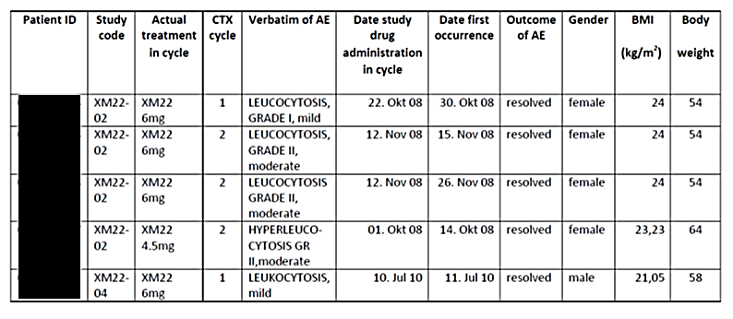
The search strategy as mentioned above identified White Blood Cell (WBC) results higher than 50.000/µL (>50 x10⁹/L) in the laboratory results for 7 patients, 6 treated with XM22 and 1 with placebo, all from XM22-04 study. WBC up to 69.1 x10⁹/L were retrieved in 6 male and 1 female patient.
Cases matching the search criteria ‘White Blood Cell results higher than 50.000/μL (>50 x10⁹/L) in the laboratory results’ are presented in the following table.

Table 31: Cases with White Blood Cell results higher than 50.000/μL (>50 x10⁹/L) in the laboratory results [patient identifiers have been redacted from this table]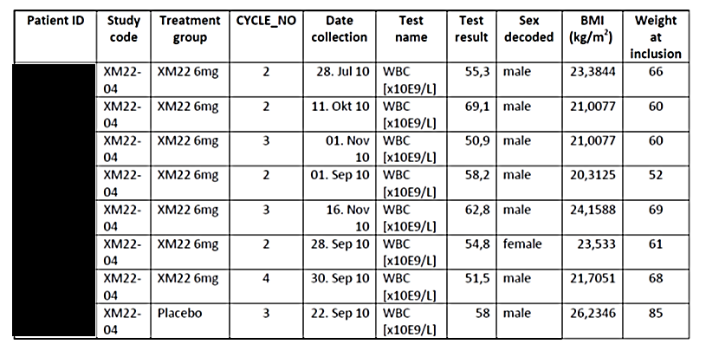
Cumulatively, 3 of 10 patients matching the above mentioned search criteria were female.
Related to the cumulative number of patients in the pivotal studies, 3 of 460 (0.65%) female patients and 7 out of 325 (2.15%) male patients were detected having experienced elevated WBC or leukocytosis.
According to EMEA/CPMP/555/95 Rev. 1, hyperleucocytosis (>70,000 x10⁹/L) should be avoided in healthy subjects, therefore, trials in patients may be required. The use of Lonquex in patients with diagnosed cancer disease in the pivotal studies XM22-02, XM22-03 and XM22-04 undergoing chemotherapy is in line with this suggestion.
According to CTCAE criteria, leukocytosis is defined as Grade 3 if leukocytes >100,000/mm³, without depicting further grading below Grade 3. Hyperleukocytosis is arbitrarily defined as a white blood cell count of >100 x10⁹/L (Gong et al, 2014) in patients with leukaemia.
Hyperleukocytosis in correlation with G-CSF treatment is rarely reported and mainly in correlation with peripheral blood progenitor cell mobilization. It is believed that patients are ‘protected’ from the complications of hyperleukocytosis by the prior cumulative toxic effects of chemotherapy and/or radiation on the bone marrow (Salloum E et al., 1998). Based on the current data, one patient was reported with SAE of leukocytosis due to prolongation of hospitalization ([information redacted]), however, none of the patients reached the CTCAE Grade 3 definition or WBC >100x 10⁹/L, or was diagnosed with leukostasis syndrome. Elevated WBC in the above listed patients was not accompanied by further concerning events or events being suspicious for leukostasis syndrome. Female gender was not associated with increased risk for leukocytosis, based on the search strategy applied on the data of the pivotal studies for Lonquex. Pharmacokinetic analysis was performed only in a subset of all patients in all Phase II/III studies.
In Study XM22-04, pharmacokinetic was analysed in 28 patients out of the 250 patients in the XM22 group. Plasma concentration data are not available for any of the patients identified with increased WBCs.

Evaluator comment
The search strategy as documented by Sponsor identified White Blood Cell (WBC) results higher than 50.000/µL (>50 x10⁹/L) in the laboratory results for 7 patients, 6 treated with XM22 and 1 with placebo, all from XM22-04 study. Female gender was not associated with increased risk for leukocytosis.
As pharmacokinetic analysis was performed only in a subset of all patients in all Phase II/III studies for example, pharmacokinetic was analysed in 28 patients out of the 250 patients in the XM22 group in XM22-04. Plasma concentration data are not available for any of the patients identified with increased WBCs.

Question 2
What was the cause of ‘pain’ in the two patients that withdrew from Study XM22-03?

Sponsor response
The applicant screened the clinical database for patients who withdrew from Study XM22-03 experiencing pain. The applicant reviewed CRFs and available information related to the retrieved patients.
Two patients who experienced pain (under questioner of pain) but completed the study were found:
- Patient [information redacted] experienced injection site pain Grade 1 (painful on touch) after study drug was injected in the abdomen in the first cycle. No further pain episodes were reported. Adverse events in this patient were reported being nausea, neutropenia and alopecia.
- Patient [information redacted] experienced injection site pain Grade 1 (painful on touch) after study drug was injected in the abdomen in the first cycle. No further pain episodes were reported. Adverse events in this patient were reported being alopecia and pain at injection site.
The following 3 patients who withdrew consent from the study were found:
- Patient [information redacted] withdrew consent after the first cycle, no adverse events were provided.
- Patient [information redacted] withdrew consent after the second cycle. The following adverse events were reported: neutropenia Grade IV, alopecia, dizziness and generalized weakness Grade II. Pain was not reported.
- Patient [information redacted] withdrew consent after the second cycle. The following adverse events were reported: general weakness, diarrhoea, neutropenia Grade II, alopecia and thrombosis of superficial veins left leg. Pain was not reported.
The following 3 patients who completed 1 cycle and early terminated the study (for any reason - pain was not the primary reason for early termination from the study) were found:
- Patient [information redacted], treated with Neulasta, early terminated the study on 23 Sep 2010 due to paroxysmal tachycardia Grade III on 05 Sep 2010 (serious adverse event) and deep vein thrombosis on 08 Sep 2010 (serious Adverse event). On 08 September 2010 in the morning the patient complained of acute pain in the left leg. The pain was significant and increased during palpation examination. The reason for pain was diagnosed as acute magistral veins trombosis of left inferior extremity (deep vein thrombosis) and acute venous insufficiency Grade 3. Ultrasound performed on 08 Sep 2010 confirmed complete thrombosis of left inferior extremity. The patient was operated and cava filter was implanted on 14 Sep 2010.
- Patient [information redacted], treated with XM22, early terminated the study due to death on 08 Jul 2010. On 04 July 2010 the patient had new complaints of diarrhoea Grade 2 and moderate abdominal pain. On 06 July 2010 the patient’s health status worsened, abdominal pain became more severe, dyspnea appeared and fatigue became more severe. On 07 Jul 2010 the patient was hospitalised for symptomatic treatment. During this day the patient’s health status got worse and finally she was transferred to the intensive care unit. Despite treatment the patient's health status further worsened leading to death on 08 Jul 2010. Autopsy was performed and entercolitis Grade 4 was proven as cause of death. The autopsy report revealed pseudomembranous enterocolitis with extensive erosions and fibrinous coverings along all of the mucous membrane of intestine, being causative for the development of serofibrinous peritonitis with significant intoxication that caused death of the patient. Pain was due to enterocolitis in this patient.
• Patient [information redacted] no relevant findings related to pain.
The applicant was not able to detect the patients precisely according to the information provided in the question from Australia TGA. If TGA could forward further information to the cases of interest, the applicant will undertake further efforts to detect the cases and forward available information.

Evaluator comment
Injection site pain Grade 1 (painful on touch) after study drug for both subjects.

Question 3
Given that Study XM22-04 failed to meet the primary efficacy end-point of reduction in incidence of febrile neutropenia, what safety and efficacy evidence does the sponsor hold to demonstrate a benefit to continued administration of Lonquex in an individual patient once febrile neutropaenia has occurred?

Sponsor response
Study XM22-04 formally did not meet the primary efficacy endpoint but it should be kept in mind that patients treated with cisplatin/etoposide chemotherapy which has a risk for febrile neutropenia (FN) of less than 20% would not receive prophylactic G-CSF according to current treatment standards except if they have an individual high risk for FN. The reduction in the incidence of FN in Cycle 1 of more than 50% in the XM22 group was not statistically significant but is regarded as clinically relevant, particularly when considering the potential serious impact of FN on patients’ health.
To address the efficacy of Lonquex in patients who experienced FN, the sponsor performed new post-hoc analysis for Study XM22-04.
No patient in Study XM22-04 experienced febrile neutropenia more than once during the study.
Table 32 shows DSN values for all cycles only for patients who experienced FN in any cycle. In all cycles mean DSN was at least 1.5 days shorter in the XM22 treatment group compared to placebo. Also for patients with febrile neutropenia there is a clear benefit in regards to DSN in comparison to placebo.

Table 32: Mean DSN for patients with FN
Table 33 shows DSN values for cycles after patients have experienced an FN in any former cycle.
In all cycles mean DSN was at least 2 days shorter in the XM22 treatment group compared to placebo. Also for patients who experienced FN there is a clear benefit to continue treatment with XM22 in comparison to placebo.

Table 33: Mean DSN for patients after they have experienced FN
As the number of patients with FN was low, no dedicated analysis for safety was performed.
There is no reason to assume that safety might be worse in patients who experienced FN and continuing treatment with XM22 compared to placebo patients.

Evaluator comment
Study XM22-04 did not meet the primary efficacy endpoint.
To address the efficacy of Lonquex in patients who experienced FN, the sponsor performed new post-hoc analysis for Study XM22-04. No patient in Study XM22-04 experienced febrile neutropenia more than once during the study. However it seems as if patients with FN could go on to have SN in future cycles (Tables 32 and 33).
The Table 32 presented by the sponsor shows DSN values for all cycles only for patients who experienced FN in any cycle. However Descriptive Statistics of Duration severe neutropenia using possibly imputed ANC values [no. days] and it is not clear if this was in response to reduced dose. Also the same number of patients in each cycle had SN after FN (10 in each of placebo versus treated group), so the XM22 appears to have no comparative benefit in this study.
Similarly, Table 33 showed subjects who had Febrile Neutropenia (FN) and SN after FN- with similar numbers in each group. That is that patients with FN still had SN despite XM22.
The sponsor states that as the number of patients with FN was low, no dedicated analysis for safety was performed.

Question 4
The sponsor should identify if the patients that developed ECG abnormalities were concomitantly receiving doxorubicin.

Sponsor response
In Study XM22-04, all patients were treated per protocol with cisplatin/etoposide chemotherapy.
Only 3 patients of the placebo group ([information redacted]) had a concomitant treatment with doxorubicin. All their registered ECGs were normal, except one for patient [information redacted] in Cycle 1, 24 hours after placebo dose, which showed a sinus tachycardia as abnormality.
The cardiac safety report concluded that ECG data in this trial revealed no clear effect of XM22 on heart rate, AV nodal conduction as measured by PR interval duration, cardiac depolarisation as measured by QRS duration or morphology. There was also no clear signal of an effect on cardiac repolarisation. Hence this trial does not provide any signal that XM22 has any cardiac safety liability as determined by ECG data.
In Study XM22-03, all patients were treated per protocol with doxorubicin/docetaxel chemotherapy (60 mg/m² doxorubicin IV, 75 mg/m² docetaxel IV).
The ECG related findings were nonspecific ST-T wave changes at a low frequency (<5%) comparably for both treatment groups (XM22 and Neulasta), an increased QTcF duration in both treatment groups by approximately equal durations of 10-15 ms and an increase in nonspecific change from baseline of 30-60 ms in the 6-15% range for XM22 and 4-25% range for Neulasta.
The role of chemotherapy and concomitant medications was discussed in the cardiac safety report. The results indicate that the study medication, including chemotherapy, may affect cardiac repolarisation. Doxorubicin, belonging to the group of anthracyclines, is well known for cardiac toxicity (Keefe 2002). Doxorubicin, which was given to both treatment groups at a dose of 60 mg/m2 two days before ECG monitoring in Cycle 1 and 4, is known to prolong QTc as a function of the cumulative dose (Nousianen 1999). In addition, antiemetic 5-HT3 receptor antagonists are known to have a cardiac effect (Keefe 2002). More than 90% of patients (Neulasta 98%, XM22 95%) in Study XM22-03 received the antiemetic ondansetron during chemotherapy.

Evaluator comment
In Study XM22-04, 3 patients of the placebo group had doxorubicin.
In Study XM22-03, all patients were treated per protocol with doxorubicin/docetaxel chemotherapy (60 mg/m² doxorubicin IV, 75 mg/m² docetaxel IV).
The ECG related findings were nonspecific ST-T wave changes at a low frequency (<5%) comparably for both treatment groups (XM22 and Neulasta), an increased QTcF duration in both treatment groups by approximately equal durations of 10-15 ms and an increase in nonspecific change from baseline of 30-60 ms in the 6-15% range for XM22 and 4-25% range for Neulasta.
The role of chemotherapy and concomitant medications was discussed in the cardiac safety report. These results suggest that the study medication, including chemotherapy, may affect cardiac repolarisation.
The changes are most likely due to the anthracycline however it should be itemized in the RMP.

Question 5
The sponsor is requested to provide the individual data and investigator stated purported relationship to Lonquex, for all patients who died in the pivotal studies, which was unable to be located in the dossier.

Sponsor response
The MAH reviewed the data available in the safety database related to patients who died in the pivotal studies. Forty-three death cases were retrieved; one from Study XM22-03 and 42 from Study XM22-04. The available information, including the information forwarded in the narratives, related to the relationship of death to treatment with study drug, is shown in Table 34.

Table 34: Cause of death in individual patients

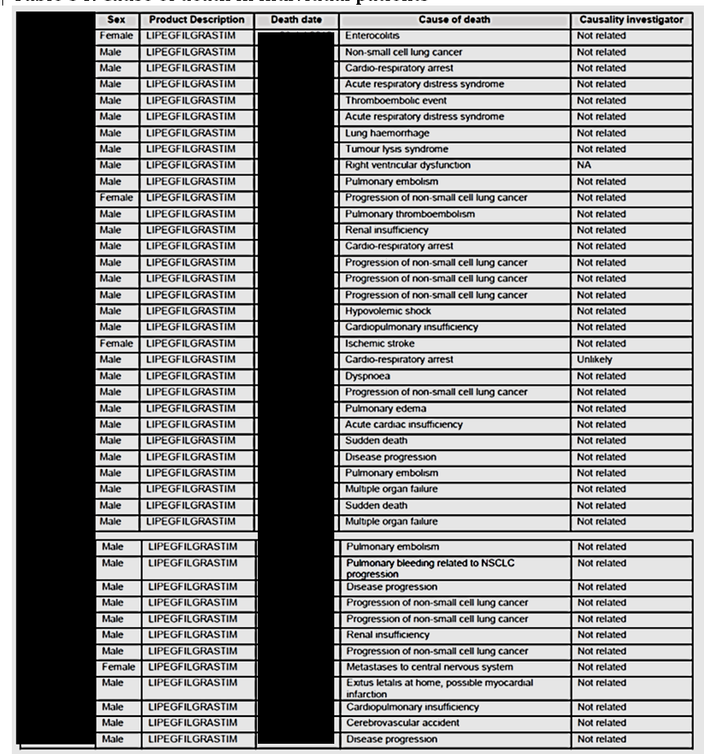
Only for patient [information redacted], who was reported having died from right ventricular dysfunction, a clear causal relationship to the reported event leading to death cannot be provided. According to the investigator, this patient developed NSCL progression on 13 Aug 2010. The patient developed moderate amnesia and moderate dysgraphia. Brain metastases were suspected. On 16 Aug 2010, the patient consulted a neurosurgeon and agraphia was diagnosed. A chest X-ray on 16 Aug 2010 showed increase of right side hydrothorax, on 19 Aug 2010 the patient´s health situation deteriorated and he developed sopor and right ventricular dysfunction on 21 Aug 2010 leading to death. The investigator reported the outcome for NSCLC progression being fatal and the patient having died from right ventricular dysfunction. The investigator´s assessment for study drug related with NSCLC progression leading to death was ‘not related’. Based on the available information, it can be assumed that the event leading to death ‘right ventricular dysfunction’ was related to the situation of NSCLC progression, which was rated as ‘not related’ by the investigator.
According to study protocols XM22-04 and XM22-05, ‘all deaths, regardless of cause, had to be reported starting from the time of signed informed consent until 30 days after the last study drug injection. Patients were to be followed up for 30 days after the last study drug administration to evaluate AEs. All newly occurring serious adverse events (SAEs) and deaths within this period, regardless of their causal relationship, were to be reported’. Based on these protocol requirements, death and investigator causality assessment of relatedness to study drug was not requested after this period. For the design and objectives of the studies, general safety parameters were considered as sufficient in view of adverse effects known from other G-CSF products. As there was no indication for a potentially increased risk from clinical use of G-CSF products, death was only documented as a potential explanation for drop-outs without further investigating in causality to Lonquex if occurred later than 30 days after the last study drug administration.
During the three Follow-up visits after Visit D85 in Study XM22-04 and XM22-03, only very limited information was collected. Notably, it was not requested to forward a causality assessment to study drug from the investigator in case of death. The only reason why the patients were asked to report to the study site at the follow-up visits up to Visit D360 was a blood sample for the immunogenicity assay. Therefore, in Study XM22-03 and XM22-04, mortality was planned to be assessed until the end of study visit on Day 85 (Visit D85 (+/- 1day). During the follow-up visits Visit D180 on Day 180 (+/- 5 days), Visit D270 on Day 270 (+/- 5 days) and Visit D360 on Day 360 (+/- 5 days) only blood sampling for determination of antibodies was planned. On the respective pages of the CRF the investigator was asked to document the ‘patient status’ with the question ‘Did the patient complete the Antibody Follow-up visit?’. In case of a negative answer there were three options to document either ‘death, date of death, cause of death’ or ‘patient lost to follow-up’ or ‘other, please specify’. Assessing causal relationship to study drug in case of death was not requested.

Evaluator comment
Forty-three death cases were retrieved: one from Study XM22-03 and 42 from Study XM22-04.
As there was no indication for a potentially increased risk from clinical use of G-CSF products, death was only documented as a potential explanation for drop-outs without further investigating in causality to Lonquex if occurred later than 30 days after the last study drug administration.

Second round benefit-risk assessment

Second round assessment of benefits
After consideration of the responses to clinical questions, the benefits of lipegfilgrastim in the proposed usage are unchanged from the first round clinical evaluation.

Second round assessment of risks
After consideration of the responses to clinical questions, the risks of lipegfilgrastim in the proposed usage are:
- The apparent risk of worsening survival for patients in Study XM22-04 may be plausibly accounted for due to an imbalance in baseline disease characteristics rather than exposure to lipegfilgrastim
- Injection site pain sufficient to lead to treatment withdrawal was identified in a small number of patients

Second round assessment of benefit-risk balance
The benefit-risk balance of lipegfilgrastim is unfavourable given the proposed usage, but would become favourable if the changes recommended below are adopted.

Second round recommendation regarding authorisation
The evaluator recommends to the Delegate that lipegfilgrastim is approvable, providing the changes to the product information are implemented. The evaluator considers that the indication should be worded as per that in the EU.

References
Bonomi P, Kim KM, Fairclough D, et al.: Comparison of survival and quality of life in advanced non-small-cell lung cancer patients treated with two dose levels of paclitaxel combined with cisplatin versus etoposide with cisplatin: results of an eastern cooperative oncology group trial. J Clin Oncol 2000; 18: 623-631.
Brain EGC, Bachelot T, Serin D, et al.: Life-threatening sepsis associated with adjuvant doxorubicin plus docetaxel for intermediate-risk breast cancer. JAMA 2005; 294 (19): 2367- 2371.
Cardenal F, López-Cabrerizo MP, Antón A, et al.: Randomised Phase III Study of Gemcitabine- Cisplatin Versus Etoposide-Cisplatin in the Treatment of Locally Advanced or Metastatic Non- Small-Cell Lung Cancer. J Clin Oncol 1999; 17: 12-18.
Cooper KL, Madan J, Whyte S, Stevenson MD, Akehurst RL. Granulocyte colony-stimulating factors for febrile neutropenia prophylaxis following chemotherapy: systematic review and meta analysis. BMC Cancer. 2011 Sep 23;11: 404.
Eckardt JR, von Pawel J, Papai Z, et al.: Open-Label, Multicenter, Randomised, Phase III Study Comparing Oral Topotecan/Cisplatin Versus Etoposide/Cisplatin As Treatment for Chemotherapy-Naïve Patients With Extensive-Disease Small-Cell Lung Cancer. J Clin Oncol 2006; 24: 2044-2051.
EMEA/CPMP/555/95 Rev 1: Guideline on clinical trials with haematopoietic growth factors for the prophylaxis of infection following myelosuppressive or myeloablative therapy. 2007: 1-9.
Gong J, Wu B, Guo T, Zhou S, He B, Peng X. Hyperleukocytosis: A report of five cases and review of the literature. Oncology Letters. 2014;8(4):1825-1827.
Hanna N, Bunn Jr PA, Langer C, et al.: Randomised Phase III Trial Comparing Irinotecan/Cisplatin With Etoposide/Cisplatin in Patients With Previously Untreated Extensive- Stage Disease Small-Cell Lung Cancer. J Clin Oncol 2006; 24: 2038-2043.
Keefe DL. The cardiotoxic potential of the 5-HT3 receptor antagonist antiemetics: is there cause for concern? Oncologist. 2002;7(1): 65-72.
Mavroudis D, Papadakis E, Veslemes M, et al.: A multicenter randomised clinical trial comparing paclitaxel-cisplatin-etoposide versus cisplatin-etoposide as first-line treatment in patients with small-cell lung cancer. Annals of Oncology 2001; 12: 463-470.
Nousiainen T, Vanninen E, Rantala A, Jantunen E, Hartikainen J. QT dispersion and late potentials during doxorubicin therapy for non-Hodgkin’s lymphoma. J Intern Med. 1999 Apr;245(4):359-64.
Salloum E, Stoessel KM, Cooper DL. Case report - Hyperleukocytosis and retinal hemorrhages after chemotherapy and filgrastim administration for peripheral blood progenitor cell mobilization. Bone Marrow Transplantation. 1998; 21: 835 - 837
ten Bokkel Huinink WW et al. Single-agent gemcitabine: an active and better tolerated alternative to standard cisplatin-based chemotherapy in locally advanced or metastatic non-small cell lung cancer. Lung Cancer. 1999;26: 85-94.

Therapeutic Goods Administration
PO Box 100 Woden ACT 2606 Australia
Email: info@tga.gov.au Phone: 1800 020 653 Fax: 02 6232 8605
https://www.tga.gov.au

Yang et al 2008. Pharmacokinetics and Pharmacodynamics of Pegfilgrastim in Subjects With Various Degrees of Renal Function, Journal of Clinical Pharmacology

