First round evaluation: 11 June 2015
Second round evaluation: 21 October 2015

AusPAR Attachment 1

Extract from the Clinical Evaluation Report for Levomilnacipran (as hydrochloride)
  - Proprietary Product Name: Fetzima
  - Sponsor: Pierre Fabre Australia Pty Ltd

About the Therapeutic Goods Administration (TGA)
- The Therapeutic Goods Administration (TGA) is part of the Australian Government Department of Health, and is responsible for regulating medicines and medical devices.
- The TGA administers the Therapeutic Goods Act 1989 (the Act), applying a risk management approach designed to ensure therapeutic goods supplied in Australia meet acceptable standards of quality, safety and efficacy (performance), when necessary.
- The work of the TGA is based on applying scientific and clinical expertise to decision-making, to ensure that the benefits to consumers outweigh any risks associated with the use of medicines and medical devices.
- The TGA relies on the public, healthcare professionals and industry to report problems with medicines or medical devices. TGA investigates reports received by it to determine any necessary regulatory action.
- To report a problem with a medicine or medical device, please see the information on the TGA website <https://www.tga.gov.au>.
About the Extract from the Clinical Evaluation Report
- This document provides a more detailed evaluation of the clinical findings, extracted from the Clinical Evaluation Report (CER) prepared by the TGA. This extract does not include sections from the CER regarding product documentation or post market activities.
- The words [Information redacted], where they appear in this document, indicate that confidential information has been deleted.
- For the most recent Product Information (PI), please refer to the TGA website <https://www.tga.gov.au/product-information-pi>.
Copyright
© Commonwealth of Australia 2016
This work is copyright. You may reproduce the whole or part of this work in unaltered form for your own personal use or, if you are part of an organisation, for internal use within your organisation, but only if you or your organisation do not use the reproduction for any commercial purpose and retain this copyright notice and all disclaimer notices as part of that reproduction. Apart from rights to use as permitted by the Copyright Act 1968 or allowed by this copyright notice, all other rights are reserved and you are not allowed to reproduce the whole or any part of this work in any way (electronic or otherwise) without first being given specific written permission from the Commonwealth to do so. Requests and inquiries concerning reproduction and rights are to be sent to the TGA Copyright Officer, Therapeutic Goods Administration, PO Box 100, Woden ACT 2606 or emailed to <tga.copyright@tga.gov.au>.

Contents
Common abbreviations 5
1. Introduction 11
2. Clinical rationale 11
3. Contents of the clinical dossier 12
3.1. Scope of the clinical dossier 12
3.2. Paediatric data 12
3.3. Good clinical practice 12
4. Pharmacokinetics 12
4.1. Studies providing pharmacokinetic data 12
4.2. Summary of pharmacokinetics 14
4.3. Pharmacokinetics in healthy subjects 15
4.4. Evaluator’s overall conclusions on pharmacokinetics 33
5. Pharmacodynamics 36
5.1. Studies providing pharmacodynamic data 36
5.2. Summary of pharmacodynamics 36
5.3. Genetic-, gender- and age-related differences in pharmacodynamic response 43
5.4. Pharmacodynamic interactions 43
5.5. Evaluator’s overall conclusions on pharmacodynamics 43
6. Dosage selection for the pivotal studies 44
7. Clinical efficacy 45
7.1. Major depressive disorder 45
8. Clinical safety 84
8.1. Studies providing evaluable safety data 84
8.2. Pivotal studies that assessed safety as a primary outcome 86
8.3. Patient exposure 86
8.4. Adverse events 87
8.5. Deaths and other serious adverse events 89
8.6. Discontinuation due to adverse events 89
8.7. Laboratory tests 90
8.8. Post-marketing experience 97
8.9. Safety issues with the potential for major regulatory impact 98
8.10. Other safety issues 98
8.11. Evaluator’s overall conclusions on clinical safety 99
9. First round benefit-risk assessment 101
9.1. First round assessment of benefits 101
9.2. First round assessment of risks 101
9.3. First round assessment of benefit-risk balance 101
9.4. First round recommendation regarding authorisation 103
10. Clinical questions 103
11. Second round evaluation of clinical data submitted in response to questions 105
11.1. Clinical questions 105
12. Second round benefit-risk assessment 110
12.1. Second round assessment of benefits 110
12.2. Second round assessment of risks 110
12.3. Second round assessment of benefit-risk balance 110
12.4. Second round recommendation regarding authorisation 111
13. References 111

Common abbreviations
Abbreviation | Meaning
%Dose | % of compound excreted in urine relative to administered dose
(1S,2R)-F2782 | p-hydroxy levomilnacipran
(1S,2R)-F2782 glucuronide | p-hydroxy levomilnacipran glucuronide
5HT | serotonin
5-HT | 5-hydroxytryptamine (serotonin)
AAG | α1-acid-glycoprotein
Ae | cumulative amount of unchanged compound excreted into the urine from time zero to time t
AE | adverse event
ALT | alanine aminotransferase
ANCOVA | analysis of covariance
ASEX | Arizona Sexual Experiences
AST | alanine aminotransferase
AUC | area under the plasma concentration versus time curve
AUC_{0-∞} | area under the plasma concentration versus time curve from time 0 to infinity
AUC_{0-inf} | area under the plasma concentration versus time curve from time zero to infinity
AUC_{0-t} | area under the plasma concentration versus time curve from time zero to time t
AUC_{0-τ} | area under the plasma concentration versus time curve from time 0 to the end of the dosing interval, τ
AUC_{0-τ,ss} | area under the plasma concentration versus time curve during the dosing interval, τ, at steady-state
AUMC_{0-inf} | area under the first moment of the plasma concentration versus time curve from time zero to infinity
AUMC_{0-t} | area under the first moment of the plasma concentration versus time curve from time zero to time t
b.i.d. | twice daily
BA | bioavailability
BE | bioequivalence
BMI | body mass index
BP | blood pressure
BSA | body surface area
C_{12h} | observed plasma concentration 12h after drug administration
C_{24h} | observed plasma concentration 24h after drug administration
Cav,ss | average plasma drug concentration at steady-state
CFB | change from baseline
CGI-I | Clinical Global Impressions–Improvement
CGI-S | Clinical Global Impressions–Severity
CI | confidence interval
CL/F | apparent clearance
Clast | last measurable plasma drug concentration
CLcr | creatinine clearance
CLr | renal clearance of the drug from plasma
C_{max} | maximum plasma drug concentration
C_{max},ss | maximum steady-state plasma drug concentration
C_{min},ss | minimum plasma drug concentration during a dosing interval at steady-state
CSR | clinical study report
CV | coefficient of variation
CYP | cytochrome P-450 enzyme
D | day
DBP | diastolic blood pressure
DBP | diastolic blood pressure
ECG | electrocardiogram
ECT | electroconvulsive therapy
F | bioavailability
F17400 | N-desethyl levomilnacipran
F2695 | levomilnacipran
F2696 | the opposite enantiomer to levomilnacipran
FETZIMA | levomilnacipran hydrochloride/F2695
GG | γ-globulins
h | hour/s
HAMD-17 | 17-item Hamilton Rating Scale for Depression
HAS | human serum albumin
HBcAb | hepatitis B core antibody
HBs | hepatitis B antigen
HbsAg | hepatitis B surface antigen
HCV | hepatitis C virus
HIV | human immunodeficiency virus
HR | heart rate
HSA | human serum albumin
IBW | ideal body weight
ICH | International Conference on Harmonisation of Technical Requirements for Registration of Pharmaceuticals for Human Use
IR | immediate-release
ISE | Integrated Summary of Efficacy
ISS | Integrated Summary of Safety
ITT | intention to treat
IUD | intrauterine
IVRS | interactive voice response system
IWRS | interactive web response system
Ka | absorption rate constant
LB | lower bound
LC/MS-MS | liquid chromatography with tandem mass spectrometry
LLOQ | lower limit of quantification
LOQ | limit of quantification
LS | least squares
LVM | levomilnacipran
MADRS | Montgomery-Åsberg Depression Rating Scale
MADRS-CR | Montgomery-Åsberg Depression Rating Scale, Clinician Rated
MDD | major depressive disorder
MEI-SF | Motivation and Energy Inventory –Short Form
Min | minute/s
MR | modified-release
ms | millisecond
NADPH – β | nicotinamide adenine dinucleotide phosphate, reduced
NE | norepinephrine
NEAE | newly emergent adverse event
PCS | potentially clinically significant
PD | pharmacodynamics
PK | pharmacokinetics
PMM | pattern mixture model
PopPK | population pharmacokinetic analysis
PW | premature withdrawal
QD | once daily
QTc | QT interval corrected for heart rate
QTcB | QT intervals using Bazett’s correction
QTcB | QT interval corrected for heart rate using the Bazett formula (QTcB = QT/(RR)^{½})
QTcF | QT intervals using Fridericia’s correction
QTcF | QT interval corrected for heart rate using the Fridericia formula (QTcF = QT/(RR)^{⅓})
QTcNi | QT intervals using individual correction
QTcNi | QT interval corrected for heart rate using an individual correction
R² | coefficient of determination
SAE | serious adverse event
SBP | systolic blood pressure
SD | standard deviation
SDS | Sheehan Disability Scale
SNRI | serotonin-norepinephrine reuptake inhibitor
SR | sustained release
SSRI | selective serotonin reuptake inhibitor
SVES | supraventricular extrasystoles
T₀ | time of drug administration
t_{½} | terminal elimination half-life
TBM | to-be-marketed
TCA | tricyclic antidepressant
TEAE | treatment-emergent adverse event
T_{lag} | lag time (time delay between drug administration and first observed concentration above LOQ in plasma)
T_{max} | time of maximum plasma drug concentration
UB | upper bound
ULN | upper limit of normal
Vc/F | apparent volume of the central compartment
Vd/F | apparent volume of distribution based on the terminal phase after oral administration
WOCBP | women of child bearing potential
WT | body weight

Introduction
This is a Category 1 type A submission to register levomilnacipran hydrochloride 20, 40, 80 and 120 mg extended release capsules for treatment of major depressive disorder (MDD).
The submission proposes registration of the following dosage forms and strengths: extended release hard capsules containing 20, 40, 80 and 120 mg of levomilnacipran.
Levomilnacipran is a selective serotonin and noradrenaline reuptake inhibitor (SNRI). It is reported to inhibit both the norepinephrine (NE) and 5-hydroxytryptamine (5-HT, serotonin) reuptake with an approximate two fold more potent inhibition of NE reuptake than 5-HT reuptake transporters. It is the more active enantiomer of the racemate milnacipran. Milnacipran has been approved in the US, Argentina, South Korea and Australia for fibromyalgia and in 49 countries for depression.
The Australian approved indication for milnacipran is management of fibromyalgia.

Clinical rationale
Current treatment of MDD include tricyclic antidepressants (TCAs, for example, amitriptyline), selective serotonin reuptake inhibitors (SSRIs, for example, fluoxetine), selective serotonin and norepinephrine reuptake inhibitors (SNRIs, for example, duloxetine) and some other agents. As there are still patients who have an insufficient response to current antidepressants, there is a clinical need for further therapies.
With respect to the SNRIs, the sponsor’s rationale for the NE and 5-HT activity is that targeting both systems may produce improvements in components of MDD that are associated with both noradrenergic (for example, alertness, energy, pain, attention) and serotonergic (for example, mood, anxiety, obsessive-compulsive behaviors) neurotransmission (sponsor’s Clinical Overview). The sponsor states that as levomilnacipran has a greater potency at inhibiting NE compared to 5-HT. This is in contrast to other SNRIs which have a greater effect on 5-HT than NE reuptake. Levomilnacipran was therefore developed to provide MDD patients with a safe and effective alternative to the current drug treatment options (sponsor’s Introduction and Clinical Overview).
All studies were conducted in the US and Canada and sponsored by Forest Research Institute Inc apart from Study F02695 LP2 02 which was sponsored by Pierre Fabre Medicament. It was stated that the two companies partnered for the clinical development of levomilnacipran.
Levomilnacipran has the drug code of F2695. There are 3 other SNRIs approved for treatment of MDD in Australia; duloxetine, venlafaxine and desvenlafaxine.
The proposed dosage is:
The recommended dose range for Fetzima is 40 mg to 120 mg once daily, with or without food. Fetzima should be initiated at 20 mg once daily for 2 days and then increased to 40 mg once daily. Based on efficacy and tolerability, Fetzima may then be increased in increments of 40 mg at intervals of 2 or more days. The maximum recommended dose is 120 mg once daily.
FETZIMA should be taken at approximately the same time each day. Fetzima should be swallowed whole. Do not open, chew or crush the capsule.

Contents of the clinical dossier

Scope of the clinical dossier
The submission contained the following clinical information:
- Nineteen clinical pharmacology studies, including 19 that provided pharmacokinetic data and 1 that provided pharmacodynamic data
- One population pharmacokinetic analysis
- One population pharmacokinetic/pharmacodynamics study
- Four short term (8 week double-blind treatment, doses 40-120 mg/day) placebo-controlled studies in adult patients with MDD (LVM-MD-01, LVM-MD-02, LVM-MD-03, LVM-MD-10).
- One short term (10 week double-blind treatment, doses 75-100 mg/d) placebo-controlled study (F02695 LP 2 02).
- One relapse prevention study (LVM-MD-05).
- One open-label 48 week extension study (LVM-MD-04).
- Two studies in other indications (fatigue associated with MDD, generalised anxiety disorder).
- Five periodic adverse drug experience reports (October 2013 to July 2014), literature references, table for the Integrated Summary of Efficacy, an Integrated Summary of Safety, and a Cardiovascular Analyses Report.

Paediatric data
The submission did not include paediatric data. The sponsor stated that in the US there is a waiver for paediatric studies in the 0 to 6 year age group and a deferral for ages 7 to 17 in the treatment of MDD until 2018.
Comment: The sponsor has been asked to outline the paediatric clinical development plan.

Good clinical practice
The sponsor stated in the Clinical Overview that all studies were conducted in accordance with ICH GCP and the Declaration of Helsinki.

Pharmacokinetics

Studies providing pharmacokinetic data
Table 1 shows the studies relating to each pharmacokinetic (PK) topic.

Table 1: studies providing PK data
PK topic | Subtopic | Study ID | *
PK in healthy adults | General PK | F02695 GE 1 01 | PKs following single and repeated oral administrations of an IR form
PK in healthy adults |  | F02695 GE 1 02 | PKs of 3 SR versus the IR formulation
PK in healthy adults |  | F02695 LP 1 01 | In vitro/in vivo correlation of SR form and absolute BA compared to IV form
PK in healthy adults |  | LVM-PK-12 | BE of 120 mg dose of the TBM and clinical trial SR forms and effect of food
PK in healthy adults |  | LVM-PK-19 | BE of 120 mg dose of the TBM and clinical trial SR forms
PK in healthy adults |  | LVM-PK-14 | BE of 120 mg dose of the Elan-TBM and clinical trial SR formulations
PK in healthy adults |  | LVM-PK-16 | Comparison of SR formulation and oral solution
PK in healthy adults |  | LVM-PK-06 | Effect of food on the BA of 40 mg levomilnacipran capsules
PK in healthy adults |  | LVM-PK-01 | PKs following administration of single and multiple escalating doses
PK in healthy adults |  | LVM-PK-15 | PKs following oral administration of 40, 80 or 120 mg
PK in healthy adults |  | F02695 LP 1 02 | Interconversion of enantiomers
PK in healthy adults |  | LVM-PK-03 | Mass balance and metabolism of [¹⁴C] levomilnacipran
Population PK | Healthy and MDD | LVM-MS-01 | Population PK analysis
Special populations | Hepatic Impairment | LVM-PK-05 | Effect of hepatic impairment on single-dose PKs
Special populations | Renal  Impairment | LVM-PK-02 | Effect of renal impairment on single-dose PKs
Special populations | Age/Gender | LVM-PK-04 | Effects of age and gender on PKs
PK interactions | CYP3A4/5 inhibition | LVM-PK-08 | Effects of ketoconazole at steady state on the PKs of a single dose of levomilnacipran
PK interactions | CYP3A4/2B6 inducer | LVM-PK-09 | Effect of carbamazepine XR on the PKs of levomilnacipran SR
 | CYP3A4 substrate | LVM-PK-10 | Effect of a levomilnacipran SR at steady state on the PKs of alprazolam
* Indicates the primary aim of the study.
None of the pharmacokinetic studies had deficiencies that excluded their results from consideration.

Summary of pharmacokinetics
The information in the following summary is derived from conventional pharmacokinetic studies unless otherwise stated.

Physicochemical characteristics of the active substance
The following information is derived from the sponsor’s summaries in Module 2.
Levomilnacipran (F2695) is a selective and potent norepinephrine (NE) and serotonin (5-HT) reuptake inhibitor.
Figure 1: Chemical structure
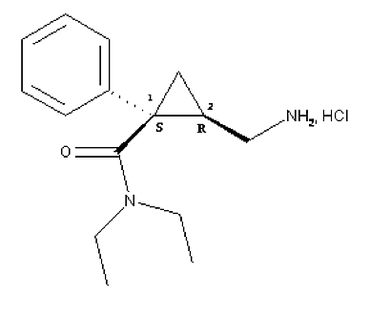
CAS number: 175131-60-9
Molecular formula: C15H22N2O, HCl
MW: 282.8
Description: Levomilnacipran hydrochloride is a white to almost white powder. It is freely soluble in water, aqueous media from pH 1 to 7, ethanol 96% and butanol, and sparingly soluble in acetonitrile. It is non-hygroscopic with a pKa value of 9.65. The partition coefficient is predominantly hydrophilic at neutral and acidic pH.

Analytical methods for detection

Plasma
A validated LC-MS/MS method was used to determine plasma levels of levomilnacipran and F17400 in the studies. Using this method, the lower limit of quantification (LLOQ) of levomilnacipran in human plasma was 1 ng/mL with mean accuracy and precision of –5.0% and 5.2%, respectively. The LLOQ of F17400 in human plasma was 1 ng/mL with mean accuracy and precision of –4.0% and 3.7%, respectively. The dynamic range of the assay for both analytes was from 1 to 200 ng/mL.
A modification of this method, which had a wider dynamic range (1 to 500 ng/mL), was used to determine plasma levels in the following studies: LVM-PK-07, LVM-PK-09, LVM-PK-10, LVM-PK-12, LVM-PK-15, LVM-PK-16, and LVM-PK-19.

Urine
A validated LC-MS/MS method was used to determine urine levels of the free bases of F2695 and F17400 in the following studies: LVM-PK-01, LVM-PK-02 and LVM-PK-05. The LLOQ for F2695 and F17400 in human urine was 100 ng/mL with accuracy and precision of less than or equal to ± 3.5% and 1.9%, for F2695 and less than or equal to ± 9.7% and 3.5%, for F17400. The dynamic range of the assay was 100 to 5000 ng/mL for both F2695 and F17400.

Pharmacokinetics in healthy subjects

Absorption

Sites and mechanisms of absorption
Following a single 120 mg, oral dose of the TBM-formulation of levomilnacipran SR in healthy subjects, the T_{max} occurred at 6.0 h following dosing and the t_{1/2} was 13.8 h (Table 2).
Table 2: Mean ±SD pharmacokinetic parameter values of levomilnacipran
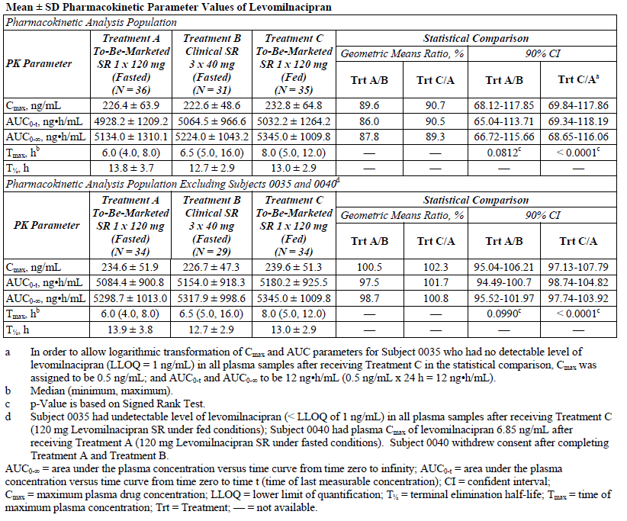

Bioavailability

Absolute bioavailability
The absolute bioavailability (range) of the SR2 formulation of levomilnacipran, that is, the formulation primarily used in the clinical trials, was calculated to be 100% (82 – 114%; Table 3).
Table 3: Main pharmacokinetic parameters of F2695 after single oral dose of 50 mg SR1, SR2 and SR3 formulations (expressed as geometric mean (geometric CV%) and [range]
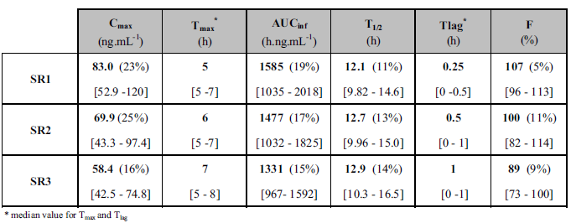

Bioavailability relative to an oral solution or micronised suspension
Study LVM-PK-16 compared the PKs of levomilnacipran following administration of 120 mg dose of the SR capsule and a 40 mg dose of levomilnacipran oral solution in 21 healthy subjects. Following dose normalisation, the C_{max} value for the SR capsule formulation was 40.4% lower than for the oral solution with 90% CIs being outside of the 80-125% range, whereas, the AUC_{0-t} and AUC_{0-inf} values for the SR capsule formulation were only 9% and 7.5% lower, respectively, than for the oral solution (Table 4). Median T_{max} of the SR formulation was statistically significantly greater (+2 h, p < 0.01) and the mean t_{1/2} of 13.7 h for the SR formulation was longer than that for the solution formulation (10.6 h).
Table 4: PK parameters (mean ±SD) for levomilnacipran in healthy male and female subjects after oral single dose administration of levomilnacipran oral solution and SR capsule formulation. PK analysis population
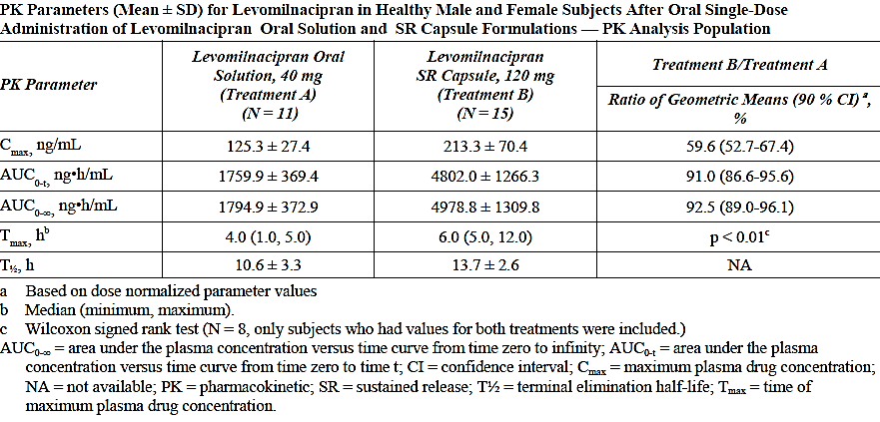

Bioequivalence of clinical trial and market formulations
As stated in the Formulation Development section of this report, two manufacturing facilities have been identified for the production of the TBM-formulation of levomilnacipran SR. Studies LVM-PK-12 and LVM-PK-19 examined the bioequivalence between the TBM-formulation manufactured at the primary facility [information redacted] and the clinical trial SR formulation, whereas, Study LVM-PK-14 compared the PKs between the TBM formulation from the secondary manufacturing site [information redacted] and the clinical trial SR formulation.
The studies indicated that following a 120 mg dose in healthy subjects, the TBM SR formulations from both [information redacted] were bioequivalent with the clinical trial formulation of SR levomilnacipran as the 90% CIs for C_{max} and AUC fell within the predefined confidence limits of 80 - 120% (Tables 5, 6 and 7). Although the T_{max} and t_{1/2} values for the Forest-TBM formulation were similar to those of the clinical formulation, the T_{max} value for the Gant-TBM formulation was statistically significantly different to the T_{max} of the clinical formulation (p = 0.037) and occurred approximately 60 min earlier.
Table 5: Mean ±SD pharmacokinetic parameter values of levomilnacipran
Table 6: Mean ±SD pharmacokinetic parameter values of levomilnacipran
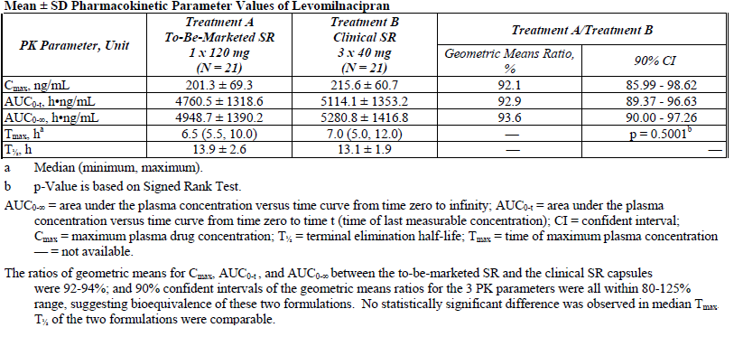
Table 7: PK parameters (mean ±SD) for levomilnacipran in after a 120 mg single oral administration of levomilnacipran sustained release capsule in healthy subjects. PK pharmacokinetic analysis population
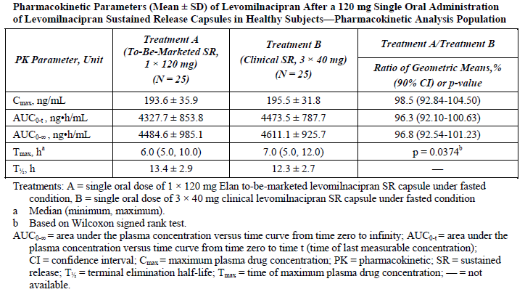
Comment: No studies directly compared the Forest- and Gant-TBM SR formulations and although these 2 formulations would most likely be bioequivalent, it may help explain the difference in Tmax identified between the Gant-TBM SR and the clinical trial SR formulations seen in Study LVM-PK-14. There were differences in AE profiles between the Elan and clinical trial formulations (see Section All adverse events (irrespective of relationship to study treatment) Other studies) and a question has been raised.
Study F02695 GE 1 02 compared the PKs following a 25 mg dose of the initial IR formulation of levomilnacipran and 50 mg dose of 3 moderate release (MR) formulations, including the clinical trial SR formulation, in healthy subjects. This study identified that the plasma concentration-time profiles were modified for the 3 MR formulations when compared to the IR formulation (Figure 2) and that all three MR formulations displayed prolonged absorption compared to the IR formulation (Table 8). For the clinical trial formulation (that is, SR2/MR2), the median T_{max} occurred 5.5 h later and the t_{1/2} was approximately 3.6 h longer than for the IR form.
Figure 2: Plasma concentration-time profile of F2695 (expressed as geometric means) were obtained after single oral administration of F2695 as IR formulation (25 mg) or as MR1, MR2 and MR3 formulation (50 mg) in fasting conditions (n=10 subjects)
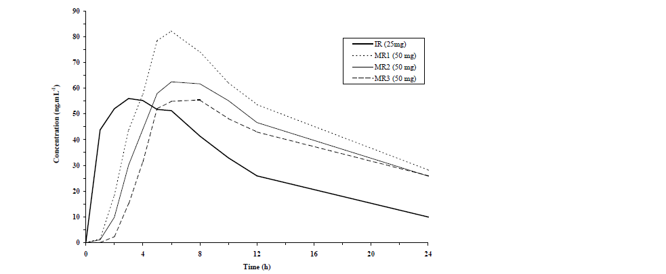

Table 8: Main PK parameters of F2695 (expressed as geometric mean (geometric CV%) and [range]
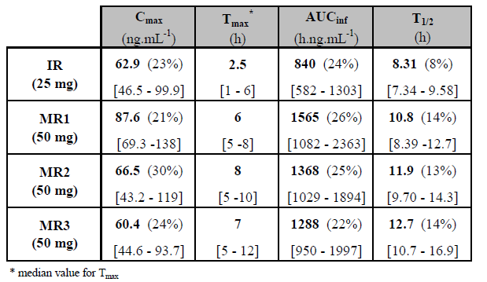

Bioequivalence of different dosage forms and strengths
No studies specifically examined the bioequivalence of the proposed strengths of the TBM SR levomilnacipran capsules.

Bioequivalence to relevant registered products
Not applicable.

Influence of food
Study LVM-PK-12 compared the PKs of levomilnacipran following a single 120 mg dose of the TBM SR formulation in healthy subjects following an overnight fast of at least 10 h and a high fat breakfast. The results indicated that the ratios of geometric means for C_{max}, AUC_{0-t}, and AUC_{0-inf} were between 100.8-102.3% and 90% CIs of the ratios were in the range of 97.13-107.79%, suggesting that food had no effect on the bioavailability of the TBM levomilnacipran SR formulation.
Similarly, following a 40 mg dose of the clinical trial formulation of SR levomilnacipran under fasted and fed conditions in healthy subjects (Study LVM-PK-06), the 90% CIs of the geometric mean ratios of C_{max}, AUC_{0-t} and AUC_{0-inf} fasted/fed were all within the range of 80% to 125%.

Dose proportionality
No studies specifically examined dose proportionality for the proposed strengths of the TBM SR levomilnacipran capsules; however, two studies (LVM-PK-01 and LVM-PK-15) examined dose proportionality following a single administration of a range of doses of the levomilnacipran SR clinical trial formulation in healthy subjects.
Study LVM-PK-01 examined the PKs of levomilnacipran following single doses of 25 mg (1 x 25 mg capsule), 50 mg (1 x 50 mg) or 100 mg (2 x 50 mg) of the clinical trial SR formulation manufactured by Pierre Fabre Médicament. Following a single dose, levomilnacipran C_{max} and AUC_{0-inf} values increased dose-proportionally with R² values 0.9638 of 0.9808, respectively. By contrast, the median T_{max} of levomilnacipran after a single oral administration of all three dosage strengths was 6 h and mean t_{1/2} values ranged from 11.1 to 11.8 h (Table 9).
Table 9: Main pharmacokinetic parameters of F2695 and F17400 in healthy male and female subjects after single oral dose of 50 mg of F2695 SR PK population
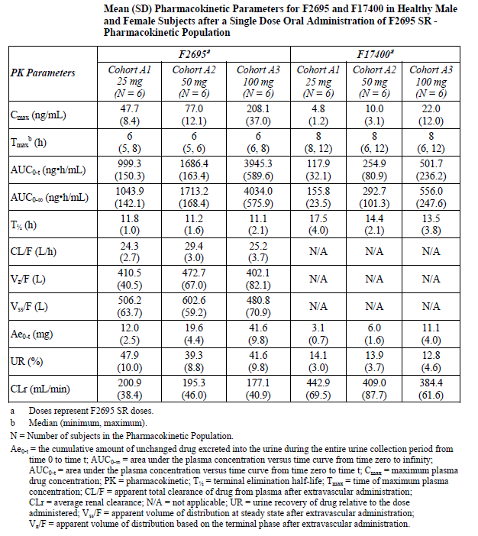
Dose proportional increases in levomilnacipran C_{max} and AUC were also identified in Study LVM-PK-15 which examined levomilnacipran PKs following 40 mg (1 x 40 mg capsule), 80 mg (2 x 40 mg) and 120 mg (3 x 40 mg) of the clinical trial SR formulation. As in the previous study, T_{max} values for 3 doses were similar and ranged from 6 to 8 h and t_{1/2} values ranged from 12.4 to 12.9 h (Table 10).
Table 10: Arithmetic mean (SD) plasma PK parameters of levomilnacipran excluding subjects who reported a TEAE of vomiting within 24 hours after dosing
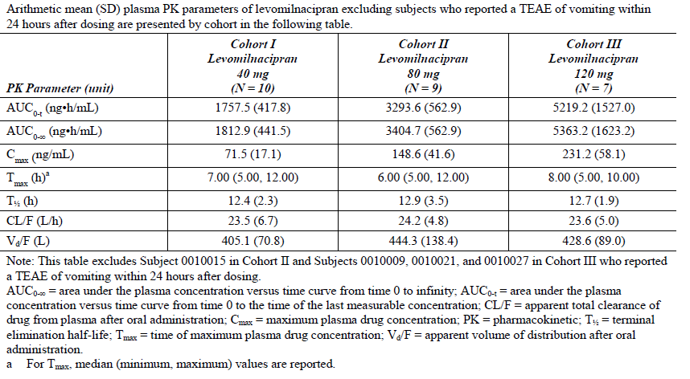

Bioavailability during multiple-dosing
Study LVM-PK-01 also examined levomilnacipran PKs following administration of multiple escalating doses of the clinical trial SR formulation, ranging from 25 mg to 300 mg. As in the single dose studies described previously, levomilnacipran C_{max}, AUC_{0-τ} and C_{min} values increased dose-proportionally following treatment with multiple escalating QD doses as indicated by the R² values of 0.9743, 0.9808, and 0.9665, respectively .The median T_{max} ranged from 5-6 h and mean t_{1/2} values following multiple doses of 100 mg and 300 mg QD were 15 h and 11.3 h, respectively (Table 11). Steady-state was achieved by the third dose on Day 3 and the accumulation indices were fairly stable over the dose range examined, ranging from 1.296 following the 300 mg dose to 1.486 at the 25 mg dose.
Table 11: Mean (SD) PK parameters for F2695 and F17400 healthy male and female subjects after escalating multiple-dose oral administration of F2695 SR capsule formulation. PK analysis population
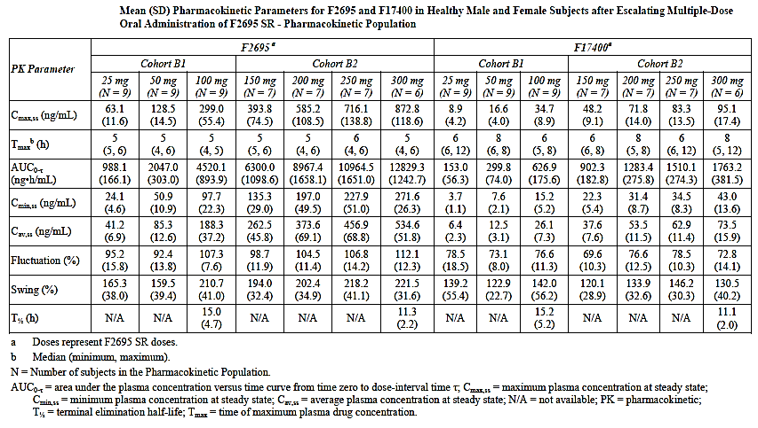

Effect of administration timing
Not examined.

Distribution

Volume of distribution
The Vd/F values following single doses of 40 mg, 80 mg and 120 mg of the clinical trial SR formulation in healthy subjects were 405 L, 444 L and 429 L, respectively (Table 10).

Plasma protein binding
Study CEPC 05-0164, which examined the in vitro binding of [¹⁴C]-F2695 to human blood cells and plasma indicated that [¹⁴C]-F2695 plasma protein binding was low (~22 %) and that binding to human serum albumin (HSA) and to α1-acid-glycoprotein (AAG) was very low, with values of 12.78% and 6.30 % respectively, whereas, no binding to GG was detected.

Erythrocyte distribution
Binding of [¹⁴C]-F2695 to blood cells in buffer was low and non-saturable with the percentage bound ranging from 48% to 57% (Study CEPC 05-0164).

Tissue distribution
The volume of distribution following a single 40 mg dose of levomilnacipran was 405 L (Table 10) which suggested that distribution of levomilnacipran to the tissues is extensive.

Metabolism

Interconversion between enantiomers
Study F02695 LP 1 02 examined the potential for interconversion of levomilnacipran to its opposite enantiomer (F2696) after a single oral administration of 50 mg in healthy male volunteers. The results indicated that F2696 plasma concentrations were below the LOQ for all subjects over the whole sampling period (from 1h up to 72h post-dosing), indicating the absence of interconversion of levomilnacipran to its opposite enantiomer in human plasma.

Sites of metabolism and mechanisms/enzyme systems involved
The in vitro study, XT104114, examined the role of human cytochrome P450 (CYP) enzymes in the N-dealkylation of levomilnacipran to F17400 in human liver microsomes. NADPH was found to be an essential component in this reaction. Based on three approaches to reaction phenotyping (correlation analysis, antibody inhibition and recombinant human CYP enzymes) multiple CYP enzymes (namely CYP2C8, 2C19, 2D6, 2J2 and 3A4) were implicated in the transformation of F2695 to F17400 with CYP3A4 being one of the major enzymes involved in this transformation.

Non-renal clearance
The mass balance study, LVM-PK-03, identified that non-renal clearance was low with only 3.7% of a 60 mg oral dose of [¹⁴C]F2695 being excreted in the faeces of healthy males.

Metabolites identified in humans

Active metabolites
The sponsor states that the principal circulating metabolite of levomilnacipran, F17400, is inactive.

Other metabolites
The mass balance study, LVM-PK-03 identified three circulating levomilnacipran metabolites (that is, levomilnacipran glucuronide, N-desethyl levomilnacipran [F17400] and N-desethyl levomilnacipran N-carbamoyl glucuronide [F17400 glucuronide]) in healthy males. The plasma exposure of levomilnacipran glucuronide, F17400 and F17400 glucuronide represented 10.7%, 14.4% and 21.8%, respectively, of the plasma exposure of levomilnacipran and 5.64%, 7.48% and 11.3%, respectively, of the plasma exposure of total radioactivity (Table 12).

Table 12: Plasma PK parameters of F2695, F17400 and their respective conjugates
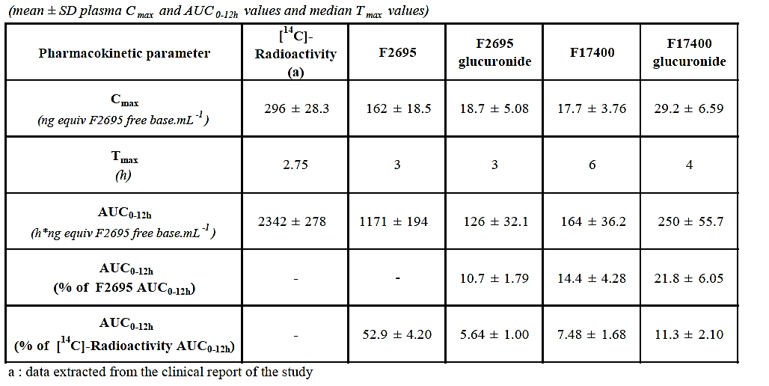

Pharmacokinetics of metabolites
Study LVM-PK-03 indicated that the Cmax, AUC0-12 and Tmax values of levomilnacipran glucuronide in plasma following the administration of 60 mg oral dose of [¹⁴C]F2695 were 18.7 ng/mL, 126 ng.h/mL and 3 h, respectively. For F17400 these values were 17.7 ng/mL, 164 ng.h/mL and 6 h, respectively, and for F17400 glucuronide were 29.2 ng/mL, 250 ng.h/mL and 4 h, respectively (Table 12).
Based on the results of six studies (LVM-PK-01, LVM-PK-02, LVM-PK-05, LVM-PK-07, LVM-PK-08 and LVM-PK-09), which examined the PKs of both levomilnacipran and F17400 following the administration of a range of single and multiple dose strengths, the ratios of C_{max} and AUC between the metabolite and the parent were in a range of 8.5% - 14.1% for C_{max} and 11.3% - 17.1% for AUC.

Consequences of genetic polymorphism
Not examined.

Excretion

Routes and mechanisms of excretion

Mass balance studies
The mass balance study, LVM-PK-03 identified that 93.4 % and 3.8% of total radioactivity following a single 60 mg oral dose of [¹⁴C] F2695 was excreted in the urine and faeces, respectively. While in circulation, radioactivity was equally distributed between plasma and cellular component of the blood. The mean ratio of levomilnacipran to total radioactivity based on AUCinf was 45.1%, whereas, the mean ratio of F17400 to total radioactivity was 8.00%.

Renal clearance
Renal clearance was identified as the primary route of excretion with 93.4% of a 60 mg oral dose of [¹⁴C]F2695 excreted in the urine, with 58% representing unchanged levomilnacipran and 18% representing F17400, whereas, <5% corresponded to each of the other metabolites (Figure 3).
Figure 3: Metabolite profiling of study F02695 PO 101”study of the mass balance and the metabolism of [14C]-F2695 administered as a single oral 60 mg dose in healthy subjects
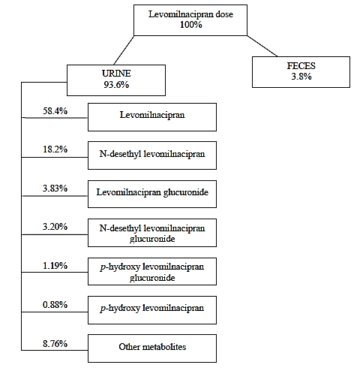

Intra- and inter-individual variability of pharmacokinetics
The PopPK study, LVM-MS-01, which modelled the data from 13 Phase I studies conducted in healthy subjects and 3 Phase III studies undertaken in patients with MDD (Table 13) provided estimates of the inter-individual variability of 26.0%, 25.6% and 55.4% for CL/F, Vc/F and Ka, respectively. The model included separate additive and proportional residual error terms for Phase I data of 13% and 43%, respectively.

Table 13: Clinical studies used in the population PK analyses
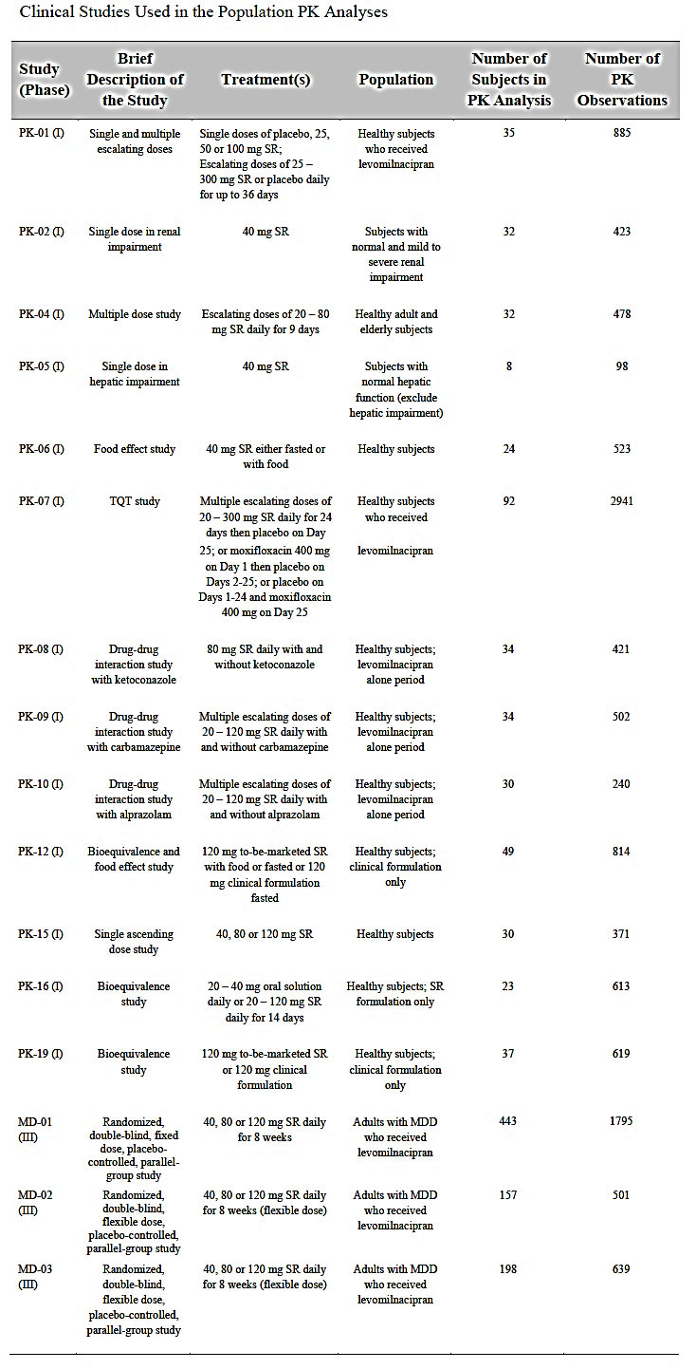

Pharmacokinetics in the target population
No studies specifically examined the PKs of levomilnacipran in subjects with MDD. Three Phase III studies (LVM-MD-01, LVM-MD-02 and LVM-MD-03) conducted in patients with MDD collected sparse PK data, which was included in the data set used to define the one compartment model described in the PopPK Study LVM-MS-01; however, the effect of MDD was not investigated as a covariate in this study.
Comment: The effect of MDD on levomilnacipran is unknown.

Pharmacokinetics in other special populations

Pharmacokinetics in subjects with impaired hepatic function
Study LVM-PK-05 examined levomilnacipran PKs following a single 40 mg dose of the clinical trial SR formulation in subjects with normal hepatic function and with mild, moderate and severe hepatic impairment. Levomilnacipran C_{max} was 26%, 8% and 28% higher in patients with mild, moderate and severe hepatic impairment, respectively, in comparison to healthy subjects (Tables 14 and 15), whereas, AUC_{0-inf} was -1%, 9% and 32% higher, respectively. Median T_{max}, mean t_{1/2} and mean % dose excreted unchanged in urine increased marginally in moderate and severe hepatic impaired patients compared to healthy subjects.
Table 14: PK parameters Mean ±SD for F2695 (N=32) PK population
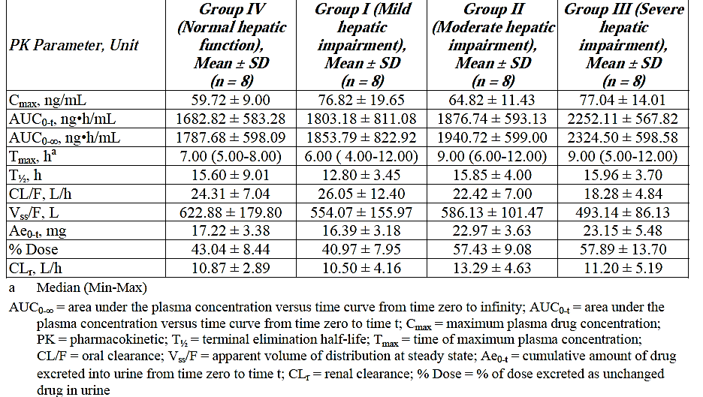

Table 15: Comparison of pharmacokinetic parameters of F2695 in hepatic impaired patients versus subjects with normal hepatic function
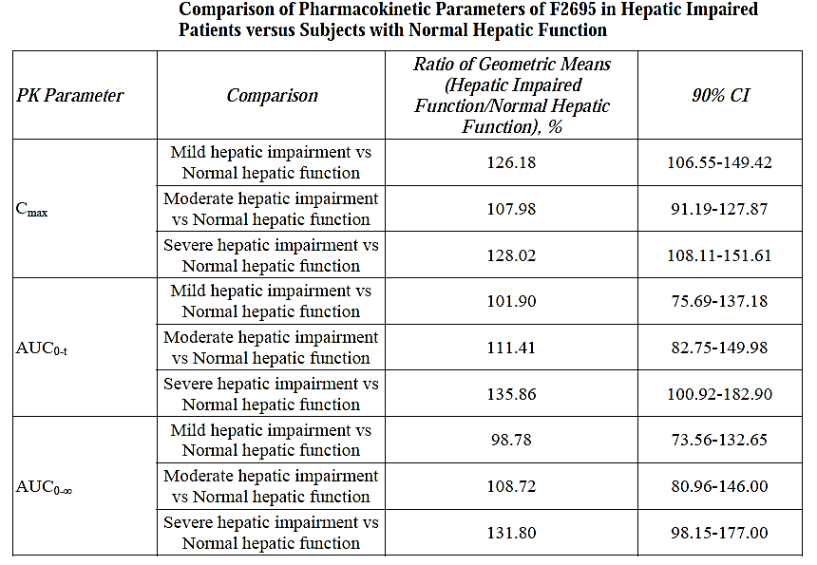

Pharmacokinetics in subjects with impaired renal function
Study LVM-PK-02 examined levomilnacipran PKs following a single 40 mg dose of the clinical trial SR formulation in subjects with normal renal function and with mildly, moderately or severely impaired renal function. In subjects with mild, moderate and severe renal impairment, levomilnacipran C_{max} was 4% lower and 19% and 44% higher, respectively, compared to subjects with normal renal function, whereas, AUC_{0-inf} was 23%, 93% and 180% higher for the 3 groups with renal impairment compared to normal subjects (Table 16). The median T_{max} of levomilnacipran was delayed by 1.5, 3.5, and 1.5 h in subjects with mild, moderate, and severe renal impairment, respectively, and mean t_{1/2} was longer in patients by 17.3, 19.1, and 27.7 h, respectively. Renal clearance of levomilnacipran was 114.7, 69.9, and 28.6 mL/min in patients with mild, moderate, and severe renal impairment, respectively, compared to 175.9 mL/min in subjects with normal renal function. These findings were supported by the PopPK Study LVM -MS-01, which identified that renal impairment significantly influences exposure to levomilnacipran.

Table 16: Mean (SD PK parameter values of F2695
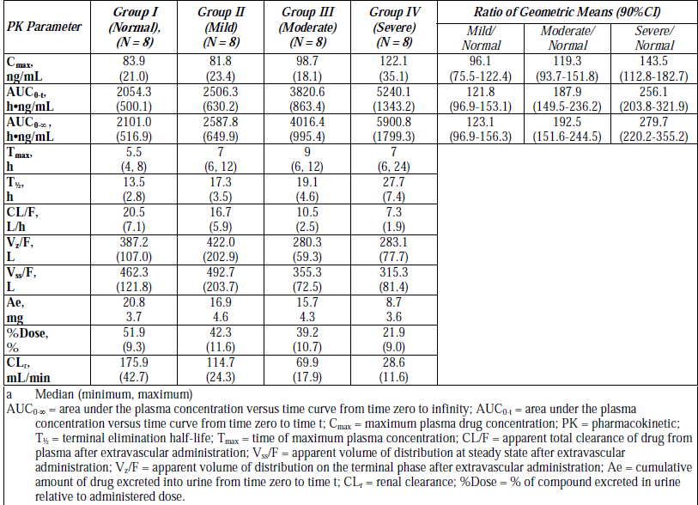

Pharmacokinetics according to age and gender
Study LVM-PK-04, evaluated the effects of age and gender on the PK of levomilnacipran following multiple-dose administration in healthy young adult and elderly male and female subjects. In this study, the subjects received escalating doses following a standard breakfast according to the following schedule: Day 1: 20 mg single dose; Days 2 through 4: 40 mg once daily; and Days 5 through 9: 80 mg (2 x 40 mg) once daily. The sponsor stated that neither age nor gender had a statistically significant effect on levomilnacipran C_{max} or AUC_{0-τ} (Tables 17 and 18); however, in section 9.7 entitled ‘STATISTICAL METHODS’ in the sponsor’s report it states that ‘no age or gender effect would be concluded if the corresponding 90% CIs of the ratios of geometric means were within the range of 70% to 143%.’ If we examine the data using the more commonly accepted 90% CI limits of 80 to 125% the data suggests that there is an increase in levomilnacipran C_{max} (24%↑), AUC (26%↑) and C_{min} (35%↑) in elderly compared to young subjects and that C_{max} (17%↑) is higher in female than male subjects (Table 18).
Table 17: Summary of Mean (SD) plasma PK parameters for F2695 PK Analysis Population
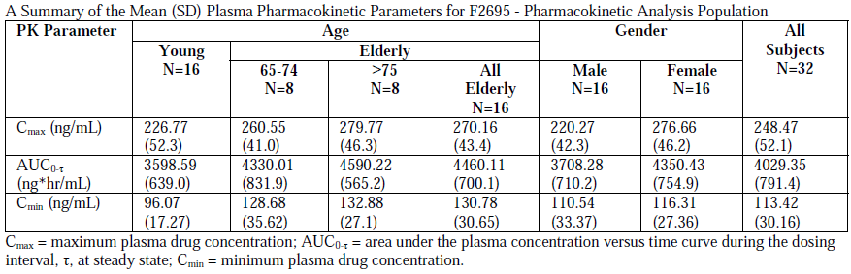

Table 18: Summary of geometric mean (90% CI) for F2695 PK Analysis Population
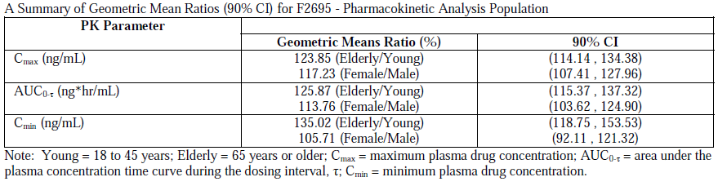
Comment: Why was 90% CI acceptance range of 70% to 143% used in Study LVM-PK-04 rather than the more typical 80-125% range as specified in Guideline on the investigation of bioequivalence (CPMP/EWP/QWP/1401/98 Rev. 1/ Corr)?

Pharmacokinetics related to genetic factors
Not examined.

Pharmacokinetics in other special population/according to other population characteristic
Not examined.

Pharmacokinetic interactions

Pharmacokinetic interactions demonstrated in human studies

CYP3A4/5 inhibitors
Study LVM-PK-08 assessed the effects of the strong CYP3A4 inhibitor ketoconazole at steady state on the PKs of a single dose of 80 mg levomilnacipran SR in healthy subjects. Co-administration of levomilnacipran with steady-state ketoconazole increased the mean levomilnacipran C_{max} by about 39%, and the mean AUC_{0-t} and AUC_{0-inf} by about 57% each (Table 19). In addition, co-administration delayed the median T_{max} of levomilnacipran from 6 to 8 h and caused a reduction of the clearance from 22 to 14 L/h. By contrast, the mean t_{1/2} was similar between treatments.
Table 19: Pharmacokinetic parameters (mean ± SD) for F2695 following a single dose administration of 80 mg F2695 alone (Treatment A) and in combination with 400 mg ketoconazole at steady state (Treatment B) PK Analysis Population
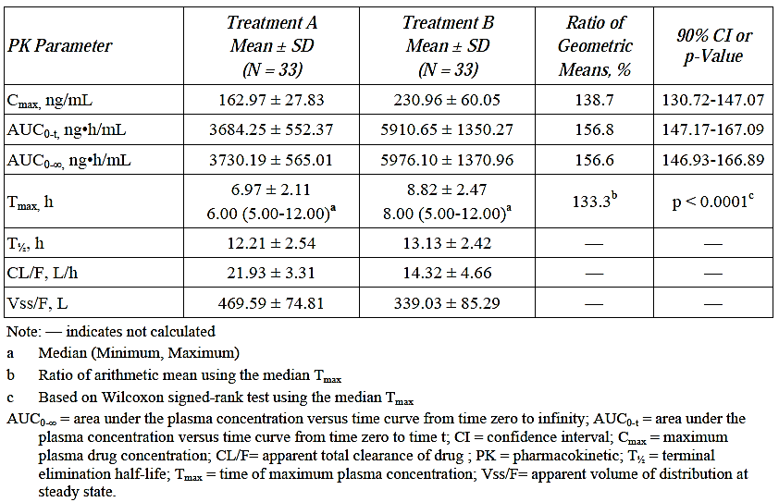

CYP3A4 and CYP2B6 inducers
Study LVM-PK-09 evaluated the effect of steady state levels of the strong CYP3A4 inducer carbamazepine XR bd on the steady-state PKs of levomilnacipran following escalating multiple dose of levomilnacipran SR (up to 120 mg QD) in healthy subjects. Levomilnacipran C_{max} and AUC_{0-τ} were 26.4% and 28.9% lower, respectively when administered concomitantly with carbamazepine XR compared to when levomilnacipran SR was administered alone (Table 20). By contrast, the steady state C_{max} and AUC_{0-τ} for carbamazepine were only slightly lower (by 3.9% and 1.7%), respectively, when carbamazepine XR was administered concomitantly with levomilnacipran SR, compared to when carbamazepine XR was administered alone (Table 21).

Table 20: Mean (SD) PK parameters of F2695 and F17400 after escalating multiple doses of F2695 SR at steady state (up to 120 mg QD) in the absence (Treatment A) and presence (Treatment C) of 200mg BD carbamazepine 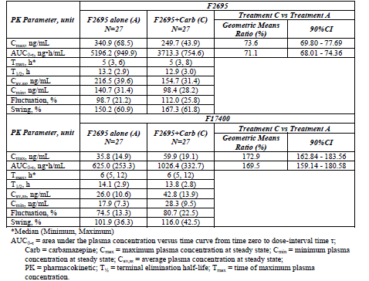

Table 21: Mean (SD) PK parameters of carbamazepine and carbamazepine-10,11-epoxide following 200 mg carbamazepine XR at steady state (200 mg BD) in the absence (Treatment B) and presence (Treatment C) of 200mg BD carbamazepine.
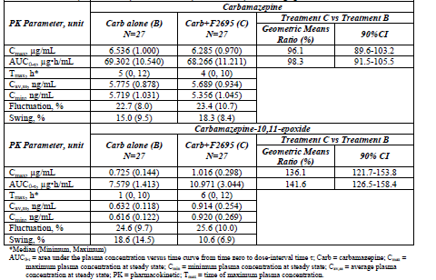

CYP3A4 subtrate
Study LVM-PK-10 assessed the effect of a levomilnacipran SR capsule at steady state (up to 120 mg QD) on the PKs of the benzodiazepine and CYP3A4 substrate alprazolam following a single-dose administration of a 1 mg alprazolam XR tablet. In this study neither drug appeared to significantly affect the PKs of the other co-administered component.

Clinical implications of in vitro findings
Please see Section entitled Sites of metabolism and mechanisms/enzyme systems involved for more information.

Population PK studies
The PopPK Study LVM-MS-01 analysed the PK data from 13 Phase I studies conducted in healthy subjects and 3 Phase III studies undertaken in patients with MDD (Table 13). The results indicated that the data were best described by a one compartment PK model with first order absorption of drug from an oral dosing compartment. Absorption was delayed by a median lag period of 1.73 h after dose administration (Table 22). A number of covariates significantly influenced levomilnacipran PKs including the effects of dose on Ka, food on Ka and Vc/F, age and race on Vc/F and sex on relative F; however, only creatinine clearance on CL/F and body weight on Vc/F were identified as relevant to the final PK model, with creatinine clearance explaining 34% of the inter-individual variability in CL/F and body weight explaining 13% of the inter-individual variability in Vc/F.
Table 22: Parameter estimates for the final levomilnacipran PPK model
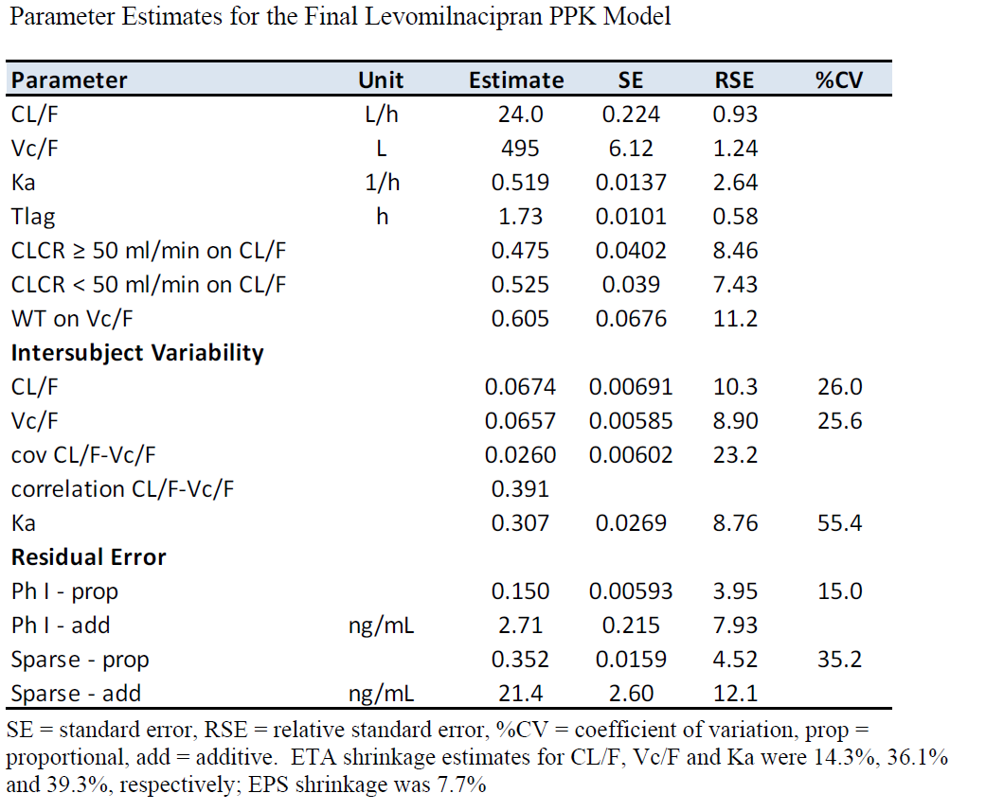

Evaluator’s overall conclusions on pharmacokinetics

Background
Levomilnacipran is a selective and potent norepinephrine and serotonin reuptake inhibitor for the treatment of MDD.

Absorption
Following a single120 mg, oral dose of the TBM-formulation of levomilnacipran SR in healthy subjects the T_{max} occurred at 6.0 h following dosing and the t_{1/2} was 13.8 h.
The absolute bioavailability of the clinical trial SR formulation of levomilnacipran was 100% (82 – 114%).
Following dose normalisation, the C_{max}, AUC_{0-t} and AUC_{0-inf} values for the SR capsule formulation were 40.4%, 9% and 7.5% lower, respectively, than for an oral solution.
TBM SR formulations from both Forest and Elan (the primary and secondary manufacturing sites) were bioequivalent with the clinical trial formulation of SR levomilnacipran as the 90% CIs for C_{max} and AUC fell within the predefined confidence limits of 80 - 120%.
No studies specifically examined the bioequivalence of the proposed strengths of the TBM SR levomilnacipran capsules.
Food had no effect on the PKs of the TBM SR formulation.
Following single doses of the clinical trial SR formulation, C_{max} and AUC_{0-inf} values increased dose-proportionally.
Levomilnacipran C_{max}, AUC_{0-τ} and C_{min} values increased dose-proportionally following treatment with multiple escalating once daily (QD) doses. Steady-state was achieved by the third dose on Day 3 and the accumulation indices were fairly stable over the dose range examined, ranging from 1.296 following the 300 mg dose to 1.486 at the 25 mg dose.

Distribution
The volume of distribution (Vd/F) values following single doses of 40 mg, 80 mg and 120 mg of the clinical trial SR formulation in healthy subjects were 405 L, 444 L and 429 L, respectively.
Binding of radiolabelled [14C]-F2695 to plasma proteins was low (~22 %) and binding to human serum albumin (HAS) and to alpha 1-acid glycoprotein (AAG) was very low, whereas, no binding to GG was detected.
Binding of [¹⁴C]-F2695 to blood cells in buffer was low and non-saturable with the percentage bound ranging from 48% to 57%.
Given the volume of distribution following a single 40 mg dose of levomilnacipran is 405 L this would suggest that distribution of levomilnacipran to the tissues is extensive.

Metabolism
There was no interconversion of levomilnacipran to its opposite enantiomer in human plasma.
NADPH was found to be an essential component in levomilnacipran metabolism.
Multiple CYP enzymes (namely CYP2C8, 2C19, 2D6, 2J2 and 3A4) were implicated in the transformation of F2695 to F17400 with CYP3A4 being one of the major enzymes involved in this transformation.
Non-renal clearance was low with only 3.7% of a 60 mg oral dose of [¹⁴C]F2695 being excreted in the faeces of healthy males.
The sponsor states that principal circulating metabolite of levomilnacipran, F17400, is inactive.
Circulating metabolites of levomilnacipran identified in healthy males were levomilnacipran glucuronide, F17400 and F17400 glucuronide. The plasma exposure for these metabolites represented 10.7%, 14.4% and 21.8%, respectively, of the plasma exposure of the parent drug.
The C_{max}, AUC₀₋₁₂ and T_{max} values of levomilnacipran glucuronide in plasma following the administration of 60 mg oral dose of [¹⁴C]F2695 were 18.7 ng/mL, 126 ng.h/mL and 3 h, respectively. For F17400 these values were 17.7 ng/mL, 164 ng.h/mL and 6 h, respectively, and for F17400 glucuronide were 29.2 ng/mL, 250 ng.h/mL and 4 h, respectively.

Excretion
93.4% and 3.8% of total radioactivity following a single 60 mg oral dose of [¹⁴C]F2695 was excreted in the urine and faeces, respectively.
Renal clearance was identified as the primary route of excretion with 93.4% of a 60 mg oral dose of [¹⁴C]F2695 excreted in the urine, with 58% representing unchanged levomilnacipran and 18% representing F17400, whereas, <5% corresponded to each of other metabolites.
Variability of pharmacokinetics
Estimates of the inter-individual variability on CL/F, Vc/F and Ka were 26.0%, 25.6% and 55.4%, respectively. Additive and proportional residual error terms for Phase I data of 13% and 43%, respectively.
Pharmacokinetics in the target population
No studies specifically examined the PKs of levomilnacipran in subjects with MDD.

Impaired hepatic function
Levomilnacipran C_{max} was 26%, 8%, and 28% higher in patients with mild, moderate and severe hepatic impairment, respectively, in comparison to healthy subjects (Tables 14 and 15), whereas AUC_{0-inf} was -1%, 9% and 32% higher, respectively.
Impaired renal function
In subjects with mild, moderate and severe renal impairment, levomilnacipran C_{max} was 4% lower and 19% and 44% higher, respectively, compared to subjects with normal renal function, whereas, AUC_{0-inf} was 23%, 93%, and 180% higher, respectively, for the 3 groups with renal impairment compared to normal subjects. Median T_{max} was delayed by 1.5, 3.5 and 1.5 h in subjects with mild, moderate, and severe renal impairment, respectively, and mean t_{1/2} was longer by 17.3, 19.1, and 27.7 h, respectively.
Age and gender
The sponsor states that neither age nor gender had a statistically significant effect on levomilnacipran C_{max} or AUC_{0-τ}; however, on examining using the more commonly accepted 90% CI limits of 80 to 125%, the data suggest that there is an increase in levomilnacipran C_{max} (24% increase), AUC (26% increase) and C_{min} (35% increase) in elderly compared to young subjects and that levomilnacipran C_{max} (17% increase) is higher in female than male subjects.
Drug-drug interactions
Co-administration of levomilnacipran with steady state ketoconazole increased the mean levomilnacipran C_{max} by about 39%, and the mean AUC_{0-t} and AUC_{0-inf} by about 57% each. In addition, co-administration delayed the median T_{max} of levomilnacipran from 6 to 8 h and caused a reduction of the clearance from 22 to 14 L/h.
Levomilnacipran C_{max} and AUC_{0-τ} were 26.4% and 28.9% lower, respectively when administered concomitantly with carbamazepine XR compared to when levomilnacipran SR was administered alone. By contrast, the C_{max} and AUC_{0-τ} for carbamazepine were only slightly lower following co-administration.
Steady-state levomilnacipran had no effect on the PKs of alprazolam following a single-dose administration of a 1 mg alprazolam XR tablet. Co-administration of alprazolam had no effect on the steady-state PKs of levomilnacipran.
Population PK studies
The PopPK analysis indicated that PK data were best described by a one compartment PK model with first order absorption of drug from an oral dosing compartment. Creatinine clearance on CL/F and body weight on Vc/F were identified as significant covariates in the final PK model.
Limitations of the PK studies
No studies specifically examined the bioequivalence of the proposed strengths of the TBM SR levomilnacipran capsules.
No studies specifically examined dose proportionality for the proposed strengths of the TBM SR levomilnacipran capsules.
No studies specifically examined the PKs of levomilnacipran in subjects with MDD.
Questions arising from the PK studies
Why was 90% CI acceptance range of 70% to 143% used in Study LVM-PK-04 rather than the more typical 80-125% range as specified in Guideline on the investigation of bioequivalence (CPMP/EWP/QWP/1401/98 Rev. 1/ Corr)?

Pharmacodynamics

Studies providing pharmacodynamic data
Table 23 below shows the studies relating to each pharmacodynamic topic and the location of each study summary.
Table 23: Submitted pharmacodynamic studies
PD Topic | Subtopic | Study ID | *
Primary Pharmacology | PopPK/PD in patients with MDD | LVM-MS-04 | Effect on MADRS-CR score following 8 weeks treatment
Secondary Pharmacology | Thorough QT | LVM-PK-07 | Effects on cardiac repolarisation in healthy subjects
* Indicates the primary aim of the study.
None of the pharmacodynamic studies had deficiencies that excluded their results from consideration.

Summary of pharmacodynamics
The information in the following summary is derived from conventional pharmacodynamic studies in humans unless otherwise stated.

Mechanism of action
Levomilnacipran is a potent and selective SNRI. The exact mechanism of the antidepressant effect of levomilnacipran is unknown but it is thought to be related to the potentiation of serotonin and noradrenaline in the central nervous system through inhibition of reuptake at serotonin and noradrenaline transporters.

Pharmacodynamic effects

Primary pharmacodynamic effects

MDD
PopPK/PD Study LVM -MS-04 examined PK, PD and safety data taken from 3 Phase III clinical trials (LVM-MD-01, LVM-MD-02 and LVM-MD-03, Table 24).
Table 24: Clinical studies used in the population PKPD analysis
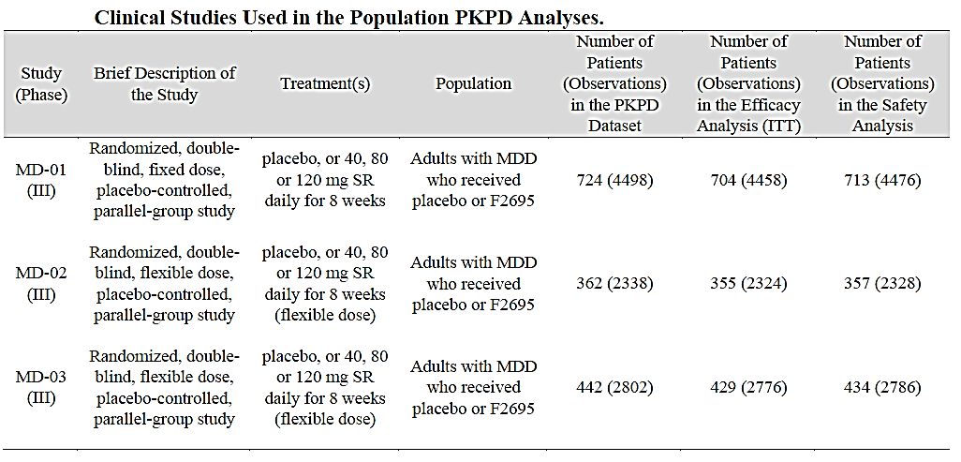
Efficacy modelling in this study focused on describing the longitudinal response of Montgomery-Åsberg Depression Rating Scale, Clinician Rated (MADRS-CR). A summary of the raw MADRS-CR scores by visit for the combined efficacy data set indicates that the raw mean baseline estimate of MADRS score was 35.6 points and following 8 weeks of treatment either with levomilnacipran or placebo the mean percentage change from baseline (CFB) in MADRS-CR was -41.2% (median = -38.2%) indicating an overall improvement in MDD.
Modelling of the efficacy data set provided an estimate for the placebo effect (that is, median change from baseline MADRS-CR score following treatment with placebo) of -12.4 (Table 25). Following 8 weeks treatment with 120 mg levomilnacipran SR the decrease in baseline score over placebo was 3.25.
Table 25: Typical drug effect at median AUCss by Levomilnacipran dose
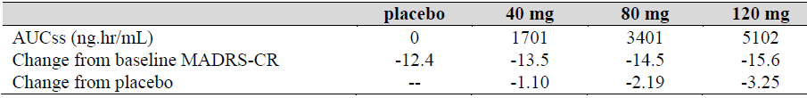
Comment: Based on the results provided in Table 25 it would appear that levomilnacipran SR is providing a relatively modest improvement in MADRS-CR score over and above what is achieved with placebo alone.

Secondary pharmacodynamic effects

QT effects
Study LVM-PK-07 assessed the effects of sequential multiple-dose regimens of levomilnacipran SR, administered at the maximum therapeutic dose (120 mg/d) and a supratherapeutic dose (300 mg/d), on cardiac repolarisation in 170 healthy subjects. In this study, moxifloxacin was used as a positive control to verify assay sensitivity.
For the primary endpoint, which utilised Day -1 exercise data for heart-rate correction, the upper limit of the two-sided 90% CI of the time-matched ΔΔQTcNi was higher than 10 ms at 2, 3, 8 and 16 h post-dose of 120 mg/day levomilnacipran SR on Day 11, whereas, the upper limit of the two-sided 90% CI of the time-matched ΔΔQTcNi for levomilnacipran 300 mg/day on Day 24 was higher than 10 ms only at 16 h post-dose (Table 26).
Table 26: PD-Primary endpoint, largest time-matched ΔΔQTcNi (individual linear correction using Day -1 data (with exercise) for Group 1 and Day -2 (supine) for placebo in Groups 2 and 3
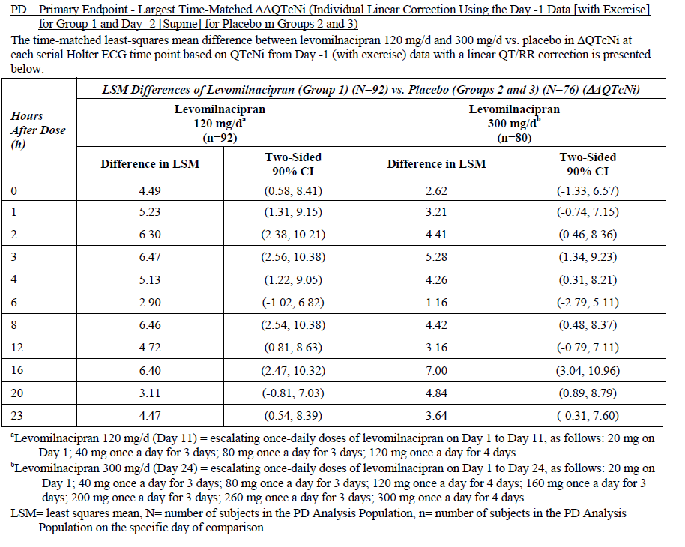
By contrast, three secondary QT analyses did not support the findings of the pre-specified primary analysis. For instance: a secondary QT analysis, which used Day -2 (supine) data with a linear QT/RR correction method, identified a largest time-matched ΔΔQTcNi of +4.39 ms (UB of 90% CI: 7.89 ms) at 3 h following a 120 mg/day dose of levomilnacipran and +3.97 ms (7.52) at 16 h following a 300 mg/day dose (Table 27); a secondary analysis that used Fridericia’s correction method identified a largest time-matched ΔΔQTcNi of -3.14 ms (LB of 90% CI: -6.28 ms) at 20 h following a 120 mg/day dose of levomilnacipran and -3.06 ms (-6.23) at 6 h following a 300 mg/day dose (Table 28); and a secondary analysis, which used Day -1 (exercise) data with a linear lnQT/lnRR correction method, identified a largest time-matched ΔΔQTcNi of -3.32 ms (LB of 90% CI: -7.07 ms) at 6 h following a 120 mg/day dose of levomilnacipran and -5.13 ms (-8.92) at 6 h following a 300 mg/day dose (Table 29).
Table 27: PD sensitivity analysis, largest time-matched ΔΔQTcNi between levomilnacipran (individual linear correction using the Day -2 data (supine) and placebo (individual linear correction using Day -2 data (supine)
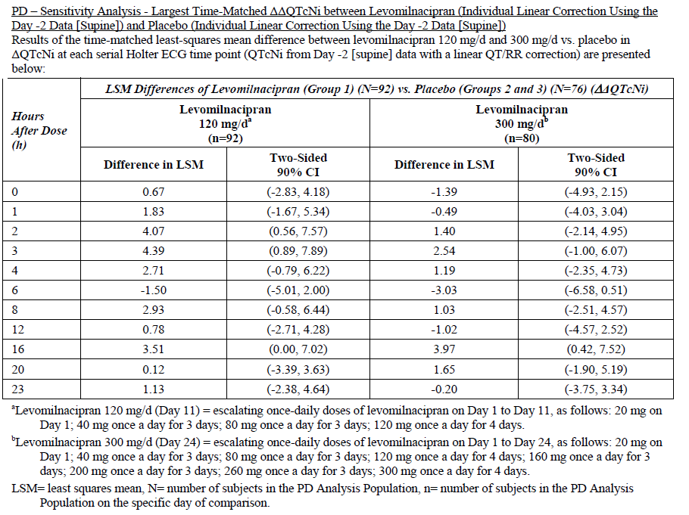
Table 28: PD Secondary endpoints QTcF intervals
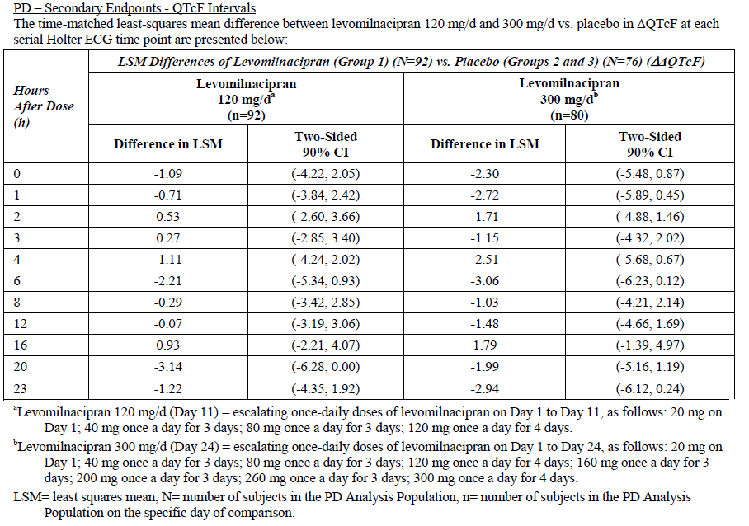
Table 29: PD sensitivity analysis, QTcL intervals (individuals linear correction using Day -1 data (exercise) for Group 1 Day -2 data (supine) for placebo in Groups 2 and 3
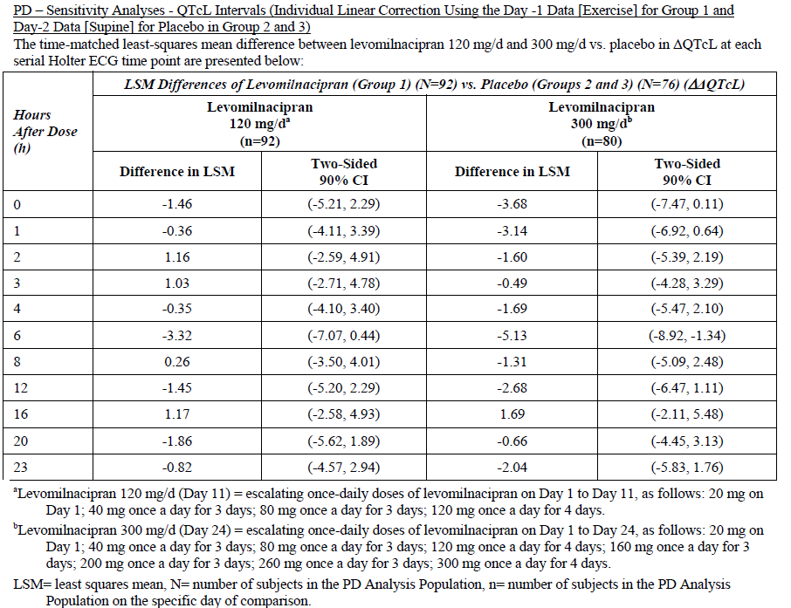
Comment: The sponsor states the following in regards to the primary endpoint:
‘The results found in the pre-specified primary analysis are believed to be due to inappropriate correction of QT for RR. An exercise baseline day was included in this study with the intent of providing a greater range of heart rate at baseline than would normally be obtained from supine subjects administered a placebo. However, there was not any adjustment for QT/RR hysteresis in the selection of ECGs to be used from the exercise data (heart rates increased and fell relatively quickly after the treadmill exercise). As heart rate changes, the instantaneous QT/RR relationship may differ from a subject’s true underlying QT/RR relationship. The relationship during period of stable heart rate has been shown to vary across individuals, hence, the need for individual adjustment, but remain stable within individuals across different periods of time, hence, the robust utility of individual adjustment. However, stabilization of heart rate for at least two minutes has been hypothesized to be necessary for a subject’s concurrent QT/RR relationship to return to its underlying true relationship. Although used as the primary analysis in this study, there is little reported in the literature regarding the successful use of exercise data for establishing QT/RR relationships for use in TQT studies of drugs that change heart rate. To the contrary, one study found that there was a lack of correlation between exercise-induced and drug-induced changes in heart rate corrected QT interval.’
Question: Given the sponsor’s justification for the aberrant results of the primary endpoint analyses in Study LVM-PK-O7 (please see section Secondary pharmacodynamic effects of this report for more information), why was the Day -1 exercise data for heart-rate correction chosen for the primary endpoint analysis at the study’s outset?

Other effects
The PI (version D01-030215) states the following based on the results of non-clinical, in vitro binding studies:
Levomilnacipran has no significant affinity for serotonergic (5HT1-7), α- or β-adrenergic, muscarinic (M1-5), histamine (H1-4), dopamine (D1-5), opiate, benzodiazepine and γ-aminobutyric acid (GABA) receptors in vitro. Levomilnacipran has no significant affinity for Ca++, K+, Na+ and Cl– channels and does not inhibit the activity of human monoamine oxidases (MAO-A and MAO-B) or acetylcholinesterase.
Therefore it is unlikely that levomilnacipran will have secondary effects via any of these pathways.

Time course of pharmacodynamic effects
Based on the results of the Pop PK/PD analysis (Study LVM-MS-04) it would appear that the decrease in MADRS-CR score identified following the initial treatment with levomilnacipran SR or placebo gradually increased over the following weeks of treatment. For instance, the mean percentage change from baseline in the MADRS-CR following 1 week of treatment was -12.7%, whereas, by week 8 the decrease was -41.2% (Table 30).
Table 30: Summary of MADRS data by visit
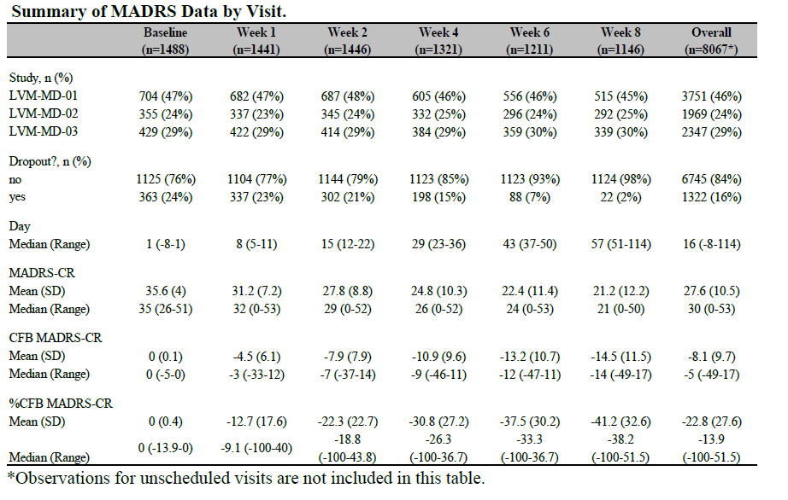

Relationship between drug concentration and pharmacodynamic effects

Primary PD effects
The PopPK analysis (Study LVM-MS-04), explored both linear and nonlinear models to describe a possible relationship of drug effect to exposure. Changes in MADRS-CR showed a statistically significant linear relationship with exposure, specifically, two-week lagged steady-state area-under-the-curve (AUCss). The final model was then to estimate the typical decrease in change from baseline (CFB) in MADRS-CR score over and above the effect of placebo. This analysis indicated that following 8 weeks of treatment with 40 mg, 80 mg and 120 mg levomilnacipran SR the placebo corrected change in CFB-MADRS-CR score for the 3 doses were -1.10, -2.19 and -3.25, respectively (Table 25).

Secondary PD effects

Vital Signs
The PopPK analysis (Study LVM-MS-04) also examined the possible relationships with exposure for changes in vital signs and incidence of the AE most frequently experienced in the pooled Phase III dataset. For each of the vital signs (that is, PR, SBP, and DBP), within the clinical dose range of 40 to 120 mg once daily, no relationship with levomilnacipran exposure was found, indicating that steady-state changes in vital signs were comparable across the clinical doses in the levomilnacipran patient population (Table 31). The respective placebo-adjusted changes from baseline in vital signs following treatment with any of the 3 doses of levomilnacipran SR were +7.15 bpm for pulse rate, +2.83 mmHg for SBP, and +2.72 mmHg for DBP.
Table 31: Summary of model predicted drug effects on continuous safety outcomes
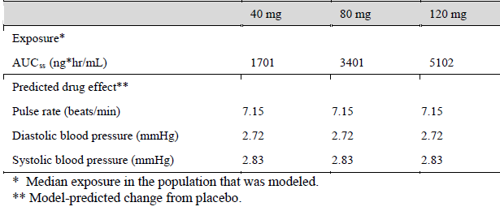

Adverse Events
The relationship between commonly experienced AEs, such as nausea, vomiting, dizziness, headache, hyperhidrosis, constipation, dry mouth, urinary hesitation and erectile dysfunction/related events, and levomilnacipran exposure was investigated as part of the PopPK/PD analysis (Study LVM-MS-04) using logistic regression models. Two separate time frames were examined: the initial dosing period of days 1 and 2, when AEs were most prevalent and the maintenance phase (that is, Day 3 until the end of treatment). During the initial phase of treatment, a statistically significant relationship was only identified between nausea and exposure; however, the incidence of vomiting, dizziness, headache, urinary hesitation in males and erectile dysfunction also appeared to demonstrate some evidence of a weak positive correlation with exposure (Table 32). During the maintenance phase of treatment incidence of nausea, vomiting, dizziness, hyperhidrosis and erectile dysfunction were all higher in the active treatment population over the placebo population, but were not significantly correlated with exposure (Table 33). By contrast, the incidence of constipation and male urinary hesitation demonstrated statistically significant positive correlations with exposure; however, the increase in incidence over the therapeutic dose range was only modest (less than 7%).
Table 32: Comparison of predicted and observed mean incidence of AE by median C_{max} on Day 1
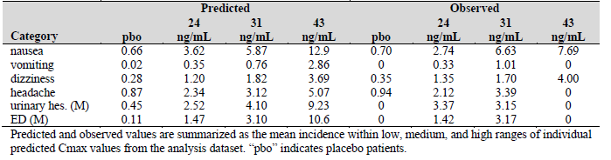
Table 33: Comparison of predicted and observed mean incidence of AE by median AUC_{ss}
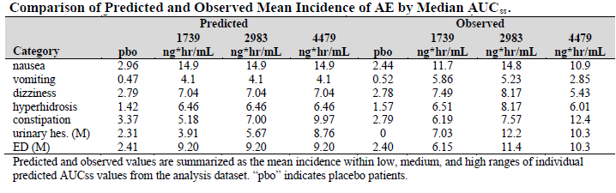

Genetic-, gender- and age-related differences in pharmacodynamic response
Not examined.

Pharmacodynamic interactions
Not examined.

Evaluator’s overall conclusions on pharmacodynamics

Background
Levomilnacipran is a potent and selective SNRI.
The exact mechanism of the antidepressant effect of levomilnacipran is unknown.

Primary PD
PopPK/PD modelling of data from patients with MDD provided the following estimates: following 8 weeks of treatment either with levomilnacipran or placebo the mean percentage change from baseline in MADRS-CR was -41.2%, indicating an overall improvement in MDD; the median change from baseline MADRS-CR score following 8 weeks treatment with placebo was -12.4; and following 8 weeks treatment with 120 mg levomilnacipran SR the decrease in baseline score over placebo was 3.25.

Secondary PD
Thorough QT analysis in healthy subjects identified the following: for the primary endpoint of the study, which utilised Day -1 exercise data for heart-rate correction, the upper limit of the two-sided 90% CI of the time-matched ΔΔQTcNi was higher than 10 ms at 2, 3, 8 and 16 h post-dose of 120 mg/day levomilnacipran SR on Day 11, whereas, the upper limit of the two-sided 90% CI of the time-matched ΔΔQTcNi for levomilnacipran 300 mg/day on Day 24 was higher than 10 ms only at 16 h post-dose; and the upper limits of the 90% CI for the largest time-matched ΔΔQTcNi following three further analyses, which used different forms of QT correction, were under 10 ms for both levomilnacipran 120 mg/day and 300 mg/day.

Time course of pharmacodynamic effects
The decrease in Montgomery-Åsberg Depression Rating Scale, Clinician Rated (MADRS-CR) score identified following the initial treatment with levomilnacipran SR or placebo gradually increased over the following weeks of treatment.

Relationship between drug concentration and PD effects
Changes in MADRS-CR showed a statistically significant linear relationship with exposure, specifically, two-week lagged steady-state area-under-the-curve (AUCss).
Following 8 weeks of treatment with 40 mg, 80 mg and 120 mg levomilnacipran SR the placebo corrected change in change from baseline (CFB)-MADRS-CR scores for the 3 doses were -1.10, -2.19 and -3.25, respectively.
Treatment with levomilnacipran SR resulted in placebo-adjusted changes from baseline in vital signs of +7.15 bpm for pulse rate, +2.83 mmHg for systolic blood pressure (SBP) and +2.72 mmHg for diastolic blood pressure (DBP). These changes were not dose dependent.
During the initial phase of treatment, a statistically significant relationship was identified between nausea and exposure. In addition the incidence of vomiting, dizziness, headache, urinary hesitation in males and erectile dysfunction also appeared to demonstrate some evidence of a weak positive correlation with exposure.
During the maintenance phase of treatment incidence of nausea, vomiting, dizziness, hyperhidrosis, and erectile dysfunction were all higher in the active treatment population over the placebo population, but were not significantly correlated with exposure.
Although there was a statistically significant relationship between the incidence of constipation and male urinary hesitation and exposure, the increase in incidence over the therapeutic dose range was only modest (less than 7%).

Limitations of PD studies
No PD studies, other than the combined PopPK/PD study, specifically examined the effects of levomilnacipran SR on MDD.
No studies examined the PD interaction of levomilnacipran with other drugs.

Questions arising from the PD studies
Given the sponsor’s justification for the aberrant results of the primary endpoint analysis in Study LVM-PK-O7 (please see section Secondary pharmacodynamic effects of this report for more information), why was the Day -1 exercise data for heart-rate correction chosen for the primary endpoint analysis at the study’s outset?

Dosage selection for the pivotal studies
The Phase III program selected 40, 80 and 120 mg per day which included doses lower and higher than the 75 mg and 100 mg per day flexible dosing which was assessed in the earlier Phase II study F02695 LP 2 02 (see Section Study F02695 LP 2 02 for study summary together with Table 34 and Figure 4). The doses of milnacipran approved for use in fibromyalgia are 100 to 200 mg per day.
Table 34: F02695 LP 2 02 MADRS Total score: Change from baseline MMRM analysis (FAS)
Figure 4: F02695 LP 2 02 MADRS Total score: Values over time (FAS)
Comments: Study F02695 LP 2 02 was a supportive efficacy study and not a dose-finding study. There was no detailed discussion in the dossier on how the decision was made to select the 40, 80 and 120 mg doses for the Phase III program. The Sponsor has been asked to comment on this.

Clinical efficacy

Major depressive disorder

Pivotal efficacy studies

Study LVM-MD-01

Study design, objectives, locations and dates
Study LVM-MD-01 was a phase III, multicentre, randomised, double-blind, placebo-controlled, parallel-group, fixed-dose study of levomilnacipran in adult patients with MDD. After a one week single blind placebo run-in period, there was an 8 week double–blind treatment period, followed by a two week, double-blind down-taper period. Subjects who prematurely discontinued also entered the 2 week tapering down period (Figure 5).
Figure 5: Study LVM-MD-01 design
The study was conducted at 38 sites in the US between September 2009 and May 2011. It used central laboratories for clinical laboratory assessments and ECG processing. An IVRS was used for the Columbia–Suicide Severity Rating Scale (C-SSRS) and the Montgomery-Åsberg Depression Rating Scale, Self–Rated (MADRS-SR).
The objective was to evaluate the efficacy, safety, and tolerability of fixed doses of levomilnacipran sustained release (SR) compared with placebo in the treatment of adult patients with MDD.

Inclusion and exclusion criteria
Included subjects were 18-65 years, meeting the Diagnostic and Statistical Manual of Mental Disorders, Fourth Edition, Text Revision (DSM-IV-TR) criteria for MDD, confirmed on the Mini International Neuropsychiatric Interview (MINI), with a major depressive episode of at least 8 weeks duration and a score of ≥30 on the Montgomery-Åsberg Depression Rating Scale–Clinician Rated (MADRS-CR). Subjects required a normal physical examination, normal clinical laboratory test results and ECG, a BMI between 18 and 40 kg/m² and women of child bearing potential (WOCBP) needed a negative serum pregnancy test. At baseline, the MADRS-CR needed to be ≥30, the MADRS-SR (self-rated) ≥26 and the urine drug screen negative.
Exclusion criteria were:
- DSM-IV-based diagnosis of an Axis I disorder other than MDD within 6 months before Visit 1 (secondary diagnoses of comorbid generalised anxiety disorder, social anxiety disorder, and/or specific phobias were acceptable).
- History of meeting DSM-IV-TR criteria for manic or hypomanic episode, depressive episode with psychotic features, substance abuse, obsessive compulsive disorder, schizophrenia, schizoaffective or other psychotic disorders, bulimia or anorexia nervosa, borderline or antisocial personality disorder, mental retardation, dementia or other cognitive disorders.
- Non-response to ≥2 antidepressants.
- Intolerance of other SNRIs, SSRIs or selective noradrenergic reuptake inhibitors.
- Suicide risk: suicide attempt within past 1 year, score on >5 on item 10 of the MADRS-CR, and/or significant risk judged by the investigator based on psychiatric interview or information collected in the Columbia–Suicide Severity Rating Scale (C-SSRS).
- Psychotherapy for depression within 3 months, vagus nerve stimulation treatment within 6 months, ECT during current episode of MDD, history of inadequate response to ECT.
- Required concomitant treatment with any prohibited medications, supplements, herbal remedies, or any drug with psychotropic activity or potentially psychotropic component (except eszopiclone, zolpidem, zolpidem extended release, or zaleplon for sleep).
- Taken any psychoactive drug or psychoactive herbal remedy, including antidepressants, anxiolytics, monoamine oxidase inhibitors, or anticonvulsants/mood stabilisers within 2 weeks or 5 half-lives (whichever is longer) before Visit 1 (5 weeks for fluoxetine), or had ever been treated with a depot antipsychotic.
- Hypothyroidism or hyperthyroidism (unless on stable medication for 2 months).
- History of seizure disorder, stroke, significant head injury, tumour of the CNS or a condition that predisposes toward risk for seizure.
- History of narrow angle glaucoma.
- History of syndrome of inappropriate antidiuretic hormone secretion.
- Any cardiovascular disease that is clinically significant, unstable, or decompensated. This included : history of congenital QTc prolongation (screening ECG with QTcF ≥ 450 ms for men or QTcF ≥ 470 ms for women); 2nd or 3rd degree AV block; clinically manifest ischaemic heart disease within 6 months (12 months for MI); HR of ≤50 or ≥120 if symptomatic; atrial fibrillation (AF) or flutter (onset within 12 months, unknown onset, uncontrolled, requiring anticoagulation or symptomatic); premature ventricular contraction (PVC) with symptoms; clinically significant BP, or supine systolic BP >140 mmHg or <90 mmHg, or diastolic BP >90 mmHg or <50 mmHg.
- History of serotonin syndrome or neuroleptic malignant syndrome.
- Significant concurrent medical conditions that could interfere with the study conduct or results.
- Male patients with history of obstructive voiding symptoms, including urinary retention.
- LFTs >1.5x ULN, HIV or hepatitis B/C infections;
- Gastric bypass or any condition that affects drug absorption.
- Females pregnant or breast feeding.

Study treatments
There were 4 parallel treatment groups: placebo, levomilnacipran SR 40 mg/day, levomilnacipran SR 80 mg/day or levomilnacipran SR 120 mg/day. Study medication capsules contained levomilnacipran 20 mg, levomilnacipran 40 mg or placebo. Patients took 3 capsules each day as a single dose. There was a one week single-blind, placebo run-in period, then an 8 week double-blind treatment period, followed by a two week, double-blind tapering down period. The dose was force titrated every two days from 20 to 40 to 80 to 120 mg. Dose reduction or discontinuation for tolerability issues was only allowed for a 2 day period.
Psychotropic agents were prohibited and anti-insomnia agent use was limited to 3 times a week. Alcohol was limited to no more than two drinks per week.

Efficacy variables and outcomes
The main efficacy variable was the MADRS-CR. The MADRS-CR was administered only by an experienced rater who had specific training (from the designated training vendor) and met specific qualifications.
Other efficacy variables included:
- Sheehan Disability Scale (SDS)
- Hamilton Rating Scale for Depression (17 item) (HAMD-17)
- Clinical Global Impression-Improvement (CGI-I)
- Clinical Global Impression-Severity (CGI-S)
- The Pain Inventory
The primary efficacy outcome was the change from baseline to week 8 in the MADRS-CR total score. The secondary efficacy outcome was the change from baseline to week 8 in the SDS total score.
Additional efficacy outcomes included the MADRS-CR response rate (≥50% reduction in total score) and remission rate (total score ≤10) as well as change from baseline, response rate and remission rate (score ≤7) on the HAMD-17.

Randomisation and blinding methods
Subjects were randomised in a 1:1:1:1 ratio to one of 4 parallel groups. Blinding was achieved by use of identical placebo and levomilnacipran SR capsules.

Analysis populations
The primary analysis was conducted on the ITT population which was defined as all randomised subjects who took at least one dose of double-blind study treatment and who had at least one post-baseline assessment of the MADRS-CR total score.

Sample size
A sample size of 175 randomised patients in each of the 4 groups gave the study a 90% power to detect a treatment group difference of 0.38 between placebo and each of the 3 treatment groups (levomilnacipran SR 40 mg/day, 80 mg/day, and 120 mg/day) after adjusting for multiple comparisons. This assumed a correlation of 0.7 between the repeated measures, effect sizes of 0.03, 0.20, 0.34, 0.37, and 0.38 for post-baseline visits and a dropout rate of 20%.

Statistical methods
The primary efficacy analysis used a mixed model for repeated measures (MMRM) with treatment group, pooled study centre, visit, and treatment group–by-visit interaction as fixed effects and the baseline and baseline-by-visit interaction as the covariates. Analysis was based on observed values of post-baseline scores. There was no imputation for missing values. To control the type 1 error rate the Hochberg multiple comparison procedure was used.
There were two sensitivity analyses: an ANCOVA model with LOCF to impute missing post-baseline values; and a pattern mixture model (PMM) which imputated future missing values assuming a linear relationship with prior measurements. Response and remission rates were analysed using a logistic model. Other efficacy variables were analysed using the MMRM and LOCF.
There were 3 protocol amendments. The most relevant changes are summarised. The first allowed the C-SSRS to be administered via an IVRS. The second added that efficacy assessments were not to be conducted on patients who were off study treatment for 3 days or more (visit 7 or early termination) and changed the CGI-I to an additional efficacy parameter. The third added the PMM sensitivity analysis for the primary outcome.

Participant flow
There were 1567 patients screened, 724 randomised, 713 who received study treatment (safety population) and 704 who had at least one post-baseline MADRS-CR assessment. There were 506 who completed the study and 492 who entered the down-taper period. There were 175 to 177 subjects in each treatment group in the ITT population (Figure 6 and Table 35).
Figure 6: Study design
Table 35: Study LVM-MD-01 Patient population
The most frequent reasons for discontinuation were consent withdrawal, adverse events and lost to follow-up with a statistically significant higher incidence of AE discontinuations in the active groups compared with placebo (Table 36).
Table 36: Study LVM-MD-01 Number of patients discontinued from the study Safety population

Major protocol violations/deviations
The rate of protocol deviations was similar between groups (22.7% placebo versus 24.2% to 28.9% levomilnacipran groups). The most frequent deviation was taking a prohibited concomitant medication (7.8% to 11.7%; Table 37). Compliance of >90% during double-blind treatment was high with a mean rate across groups of at least 98%.
Table 37: Study LVM-MD-01 Protocol deviations Safety population

Baseline data
The groups were relatively well balanced on baseline demographic characteristics. The mean age was 41 years, 62.7% were female (slightly more in the 40 mg group than other groups 68.5% versus 58.9% to 62.0%), 73.8% were White and the mean BMI was 28.8 kg/m². The most frequent baseline medical condition was headache (26.7% to 31.3%). Hypertension was more frequent in the levomilnacipran groups (9.4-11.8%) compared to the placebo group (6.3%).
Most subjects (76%) had recurrent depression with mean disease duration of 10-12 years. The rate of previous antidepressant non-responders ranged from 22% to 26% and the rate of those previously intolerant to at least one antidepressant ranged from 8% to 12% (Table 38). The baseline scores for MADRS-CR, SDS, HAMD-17, CGI-S and average pain level were comparable between treatment groups (Table 39).
Table 38: Study LVM-MD-01 Psychiatric history Safety population
Table 39: Study LVM-MD-01 Baseline efficacy assessment ITT population
Concomitant medication use was similar between treatment groups with the most frequent being analgesics (27-38%) and anti-inflammatories (28-33%).

Results for the primary efficacy outcome
After 8 weeks of double-blind treatment in the ITT population, the LS mean change from baseline in the MADRS-CR total score was -14.8, -15.6 and -16.5 in the levomilnacipran 40, 80 and 120 mg groups, respectively, compared to -11.6 in the placebo group. The LS mean difference from placebo for all three dose groups was statistically significant (p<0.02) (Table 40). The treatment response started to separate from placebo at week 2 (Figure 6).
Table 40: Study LVM-MD-01 Primary efficacy analysis Change from baseline to Week 8 in the MADRS-CR total score (MMRM) ITT population
Figure 6: Study LVM-MD-01 Mean change in MADRS-CR total score (MMRM) from baseline to Week 8 ITT population
Comment: While there appears to be a small dose response, confidence intervals indicate little difference between doses. No formal between dose comparisons were made.
Results were supported by the sensitivity analyses (Table 41).
Table 41: Study LVM-MD-01 Sensitivity analyses: Change from baseline to Week 8 in the MADRS-CR total score (LOCF and PMM) ITT population

Results for other efficacy outcomes
The LS mean change from baseline to week 8 in the SDS total score was -8.6, -9.7 and -9.7 in the levomilnacipran 40, 80 and 120 mg groups, respectively, compared to -7.2 in the placebo group. Only the 80 mg and 120 mg groups were found to have a statistically significant difference compared to placebo.
There was a significantly greater reduction in the LS mean change from baseline in the HAMD-17 total score in the levomilnacipran 80 mg and 120 groups compared to placebo, while no significant difference was found with the 40 mg dose (p=0.1994). Similarly, a significant effect was found on the CGI-I and CGI-S scores for the higher doses but not for the 40 mg dose).
The MADRS-CR response rates (≥50% reduction from baseline) were 36.4%, 37.3% and 41.5% in the levomilnacipran 40, 80 and 120 mg groups, respectively, compared to 29.1% in the placebo group. Only the 120 dose group had a significantly better response rate (OR=1.79, p=0.011. The MADRS-CR remission rates (total score ≤10) were similar across all treatment groups (19.4% to 21.6%) with no significant difference between active and placebo groups.
There were no significant differences between any dose group and placebo for HAMD-17 response rates (≥50% reduction from baseline), HAMD-17 remission rates (total score ≤7) or for CGI-I response rates (CGI-I score ≤2).
Comment: The 40 mg dose met the primary endpoint however these data for this lower dose were not supported by secondary endpoints or MADRS response or remission rates.
The sponsor stated that the lack of response on MADRS remission was due to the higher disease severity at study entry (MADRS ≥30).

Study LVM-MD-10

Study design, objectives, locations and dates
Study LVM-MD-10 was a phase III, double-blind, placebo-controlled, parallel group, fixed dose study of levomilnacipran SR in adults with recurrent MDD. It was conducted between June 2011 and March 2012 at 47 US and 4 Canadian sites. There were central laboratories for clinical laboratory assessments and ECG reading and specific training for staff undertaking efficacy assessments.
The study design was the same as LVM-MD-01 with a one week single blind run-in period and an 8 week double-blind treatment period. This was followed by a 1 week (rather than 2 week) double-blind tapering down period (Figure 7). In contrast to LVM-MD-01, only the fixed doses of 40 mg and 80 mg per day were compared to placebo.
Figure 7: Study LVM-MD-10 Design

Inclusion and exclusion criteria
Inclusion criteria were:
- Adults 18 to 75 years
- DSM-IV-TR criteria for recurrent MDD, confirmed on MINI and with an ongoing depressive episode of at least 6 weeks but no longer than 12 months
- Five or less major depressive episodes within the previous 5 years
- A score of ≥ 26 on the MADRS
- A score of ≥ 4 on the Clinical Global Impressions-Severity (CGI-S) scale
- Normal, or abnormal but not clinically significant, physical examination, clinical laboratory tests and ECG
- BMI 18-40 kg/m²
- Negative serum pregnancy test for WOCBP.
- At baseline, the MADRS needed to be ≥26, the CGI-S ≥4 and the urine drug screen negative.
Exclusion criteria were similar to LVM-MD-01.

Study treatments
The three treatment groups were levomilnacipran 40 mg, levomilnacipran 80 mg and placebo. Levomilnacipran was supplied in 20 mg and 40 mg capsules. Patients in the levomilnacipran groups commenced on 20 mg/day and were force titrated to the 40 or 80 mg dose over the first week of treatment. Subjects took two capsules once each day. Psychotropic medications, or medication with psychotropic activity were prohibited.

Efficacy variables and outcomes
Efficacy variables were the same as LVM-MD-01. The primary efficacy outcome was the change from baseline to week 8 in the MADRS total score. The secondary efficacy outcome was the change from baseline to week 8 in the SDS total score.

Randomisation and blinding methods
Patients were randomised in a 1:1:1 ratio to one of the 3 parallel groups using an IWRS. Blinding was achieved by supplying Levomilnacipran and placebo in identical capsules and packaging.

Analysis populations
As with LMV-MD-01 the primary analysis was conducted on the ITT population.

Sample size
Sample size calculations used the same assumptions as LVM-MD-01 and, as there were three groups rather than 4, the sample size per group was 170.

Statistical methods
Statistical methods were the same as LVM-MD-01. The primary analysis of the MADRS used a mixed effects model for repeated measures (MMRM), the Hochberg multiple comparison procedure for controlling type I error and the same sensitivity analyses.

Participant flow
There were 959 subjects screened and 586 randomised. Of these, 6 were lost to follow-up or withdrew consent leaving 562 subjects receiving at least one dose of study medication (safety population) and 557 with who had a post-baseline MADRS assessment (ITT population). The completion rate was 79% (n=441) (Figure 8). The number of patients per group in the analysis populations is shown in Table 42).
Figure 8: Study LVM-MD-10 Patient population and disposition
Table 42: Study LVM-MD-10 Patient populations
The premature discontinuation rate was higher in the levomilnacipran 40 mg and 80 mg groups compared to the placebo group (22.9%, 24.5% versus 17.2%) and in particular discontinuation due to an AE (6.4%, 10.1% versus 1.6%).

Major protocol violations/deviations
The rate of protocol deviations was 17.6%, 12.2% and 11.3% in the levomilnacipran 40 mg, levomilnacipran 80 mg and placebo groups, respectively. The rate of discontinuation due to a protocol violation was 5.3%, 3.2% and 2.2% in the respective groups.
Non-compliance (<90% of assigned treatment) rates were similar between groups (1.6%, 2.1%, 1.6% in the levomilnacipran 40 mg, levomilnacipran 80 mg and placebo groups, respectively).

Baseline data
Baseline demographic characteristics were balanced between groups. The mean age of subjects was 42.8 years, 63.5% were female and 74% White. Headache was the most frequent medical condition at baseline (18.6% - 25.3%). Insomnia was less frequent in the 40 mg group (4.8%) compared to 80 mg (9.0%) or placebo (10.8%).
Patients had recurrent MDD with a mean of 3.5 major depressive episodes and mean disease duration of 12.8 to 14.7 years. The proportion of non-responders to at least one prior antidepressant was 20.2-25.0%. Anxiety disorders were reported in 4.6% and substance related disorders in 4.4%. Baseline efficacy measures were similar between groups. The mean baseline MADRS total score was 30.8-31.2 and SDS total score was 16.4-17.6.

Results for the primary efficacy outcome
The LS mean change from baseline to week 8 in the MADRS total score was -14.6, -14.4 and -11.3 in the levomilnacipran 40mg, levomilnacipran 80 mg and placebo groups, respectively. The improvement in MADRS score was statistically significantly different to placebo for both doses (difference of -3.3 [p-0.0027] and -3.1 [p=0.0043] for the 40 mg and 80 mg groups, respectively (Table 43). The results were supported by the two sensitivity analyses (Table 43). The effect separated from placebo at week 4. There was no evident difference between the 40 mg and 80 mg doses (Figure 9).
Table 43: Study LVM-MD-10 Primary efficacy parameters Change from baseline to Week 8 in MADRS total score ITT population
Figure 9: LVM-MD-10 By-visit mean change from baseline in MADRS total score (MMRM) ITT population

Results for other efficacy outcomes
The LS mean change from baseline in the SDS total score was -7.3, -8.2 and -5.4 in the levomilnacipran 40mg, levomilnacipran 80 mg and placebo groups, respectively. Both doses had a statistically significant effect on the SDS total score over placebo, however the effect was only significant on the work/school subscale.
Both levomilnacipran doses had a statistically significant response on the HAMD-17 total score (LS mean difference of -2.18 and -1.62, for the 40 mg and 80 mg doses, respectively. This effect was seen on the depressed mood item, psychomotor retardation subscale and the melancholia subscale. The LS mean difference versus placebo for the CGI-S score was -0.31 and -0.33 for the 40 mg and 80 mg doses, respectively, with both being statistically significant.
The rate of MADRS responders was 48.6%, 46.5% and 33.5% in the levomilnacipran 40mg, levomilnacipran 80 mg and placebo groups, respectively. The response rates were significantly greater compared to placebo for both doses. The MADRS remission rate was 29.7%, 31.6% and 18.4% in the respective groups with a statistically significant difference for both comparisons against placebo.
The HAMD-17 response rate (44.8%, 39.3% and 31.0%) was only statistically significant over placebo in the 40 mg per day group while the HAMD-17 remission rate (30.2%, 30.3% and 20.1% in the respective groups) was significantly greater with both levomilnacipran doses compared to placebo (Table 44).
Table 44: Additional efficacy parameters MADRS response and remission rate at Week 8 (LOCF) ITT population
Comment: The positive effect of these lower doses together with the effect on MADRS response and remission rates compared to Study LVM -MD-01 may be due to the lower disease severity at study entry (MADRS >26 versus >30).

Study LVM-MD-03

Study design, objectives, locations and dates
Study LVM-MD-03 was a phase III, double-blind, placebo-controlled, parallel group, flexible dose study of levomilnacipran SR in adults with recurrent MDD. The objective was to evaluate the efficacy, safety, and tolerability of levomilnacipran SR versus that of placebo in the treatment of patients with MDD.
It was conducted between December 2009 and December 2011 at 23 sites in the US. There were central laboratories for clinical laboratory assessments and ECG reading. The C-SSRS was administered to patients via an IVRS and there was centralised rater training for the MADRS.
The study design was the same as LVM-MD-01 apart from patients were randomised to either placebo or levomilnacipran which was given as a flexible dose of 40 mg to 120 mg (Figure 10).
Figure 10: Study LVM-MD-03 design

Inclusion and exclusion criteria
Inclusion criteria were:
- Adults 18 to 80 years
- DSM-IV-TR criteria for MDD with an ongoing depressive episode of at least 4 weeks based on the MINI, information from the computerised diagnostic assessment (DxV MDD) and clinician report on this assessment and patient’s medical history.
- A score of ≥30 on the MADRS-CR.
- Normal, or abnormal but not clinically significant, physical examination, clinical laboratory tests and ECG.
- BMI 18-40 kg/m².
- Negative serum pregnancy test for WOCBP.
- At baseline, the MADRS-CR needed to be ≥30, the MADRS-SR ≥26 and the urine drug screen negative.
Exclusion criteria were essentially the same as LVM-MD-01.

Study treatments
Patients were given levomilnacipran 20 mg/day for two days and then increased to 40 mg/d. The dose could then be increased to 80 mg at end of week 1, 2 or 4. The dose could also be increased to 120 mg at end of week 4 but no further dose increases were allowed after this time point. Dose increase was based on response and tolerability and in addition at the end of week 4 patients with <50% improvement in the MADRS-CR total score were eligible for a dose increase if no dose-limiting AEs (Table 45).
Table 45: Study LVM-MD-03 Titration regimen for the double blind treatment period
Levomilnacipran was supplied in 20 mg and 40 mg capsules. Psychotropic medications, or medication with psychotropic activity were prohibited.

Efficacy variables and outcomes
Efficacy variables were the same as LVM-MD-01. The primary efficacy outcome was the change from baseline to week 8 in the MADRS-CR total score. The secondary efficacy outcome was the change from baseline to week 8 in the SDS total score.
Additional efficacy variables assessed in this trial which were not undertaken in the previous two trials included cognitive tests and Motivation and Energy Inventory–Short Form (MEI-SF)

Randomisation and blinding methods
Patients were randomised in a 1:1 ratio to either the active or placebo groups via randomisation numbers. Blinding was achieved by supplying Levomilnacipran and placebo in identical capsules and packaging.

Analysis populations
As with previous studies, the primary analysis was conducted on the ITT population (randomised subjects who took at least one dose of double-blind medication and had at least one post baseline assessment of the MADRS-CR).

Sample size
A sample size of 220 per group gave the study a 90% power to detect an effect size of 0.33 between placebo and active groups. This assumed a correlation of 0.7 between the repeated measures, effect sizes of 0.03, 0.17. 0.30, 0.32 and 0.33 for post baseline visits and a dropout rate of 20%.

Statistical methods
Statistical methods were the same as LVM-MD-01 with the primary analysis of the MADRS using a MMRM. Analysis used observed data without any imputation for missing values. The same sensitivity analyses were undertaken as previous studies. Inferential analysis of secondary endpoint of SDS was only undertaken if the primary endpoint was statistically significant (p<0.05).
There were two protocol amendments: the first altered the secondary endpoint (removing CGI-I and MEI-SF) and added that efficacy was not to be assessed in patients who had been off medication for ≥3 days; the second increased the sample size and added the PMM sensitivity analysis.

Participant flow
There were 899 subjects screened and 442 randomised. Of these, 8 were lost to follow-up, withdrew consent or had an AE leading to discontinuation, leaving 434 subjects receiving at least one dose of study medication (safety population) and 429 who had a post-baseline MADRS assessment (ITT population). There were 172 (79.3%) and 163 (75.1%) patients who completed the study in the placebo and levomilnacipran groups, respectively (Figure 11). The number of patients per group in the analysis populations is shown in Table 42.
Figure 11: Study LVM-MD-03 Patient population and disposition
The premature discontinuation rate was higher in the levomilnacipran compared to the placebo group (24.9% versus 20.7%). The most frequent reasons were AE (7.8% versus 3.2%) and loss to follow-up (7.4% versus 6.5%, levomilnacipran versus placebo).

Major protocol violations/deviations
The rate of protocol deviations was 29.4% and 21.2% in the levomilnacipran and placebo groups, respectively. The rate of discontinuation due to a protocol violation was 3.2% and 4.6% in the respective groups. The most frequent violation was use of prohibited concomitant medication (8.3% versus 6.9%). There was one patient who was enrolled in the study twice at separate sites. Non-compliance (<90% of assigned treatment) rates were 2.8% and 2.3%, respectively.

Baseline data
Baseline demographic characteristics were balanced between groups. The mean age of subjects was 44.8 years, 65.2% were female and 82.7% White. Seasonal allergy (20.7% versus 18.9%) and headache (18.9% versus 26.7%) were the most frequent medical conditions at baseline.
Most patients had recurrent MDD (81.1% versus 82.5%) and the mean number of episodes was similar (5.7 versus 5.8). The mean disease duration was approximately 14 years for both groups. The non-responder rate to at least one prior antidepressant was 24.0% versus 21.2%. Prior intolerance to an antidepressant was higher in the levomilnacipran group (11.1% versus 5.1%). Anxiety disorders were the most frequent secondary psychiatric disorders (11.5% versus 8.3%). Baseline efficacy measures were comparable between groups and the mean baseline MADRS total score was 35.
The final daily dose of 40 mg, 80 mg and 120 mg was reported in 21.2%, 34.1% and 44.2% of levomilnacipran-treated subjects, respectively.

Results for the primary efficacy outcome
The LS mean change from baseline to week 8 in the MADRS-CR total score was -15.3 and -12.2 in the levomilnacipran and placebo groups, respectively, with a statistically significant LS mean difference of -3.095 (95% CI: -5.26, -0.94, p=0.005). The results were supported by the two sensitivity analyses (Table 46). A separation of effect was seen from week one and continued over the 8 week treatment period (Figure 12).
Table 46: Study LVM-MD-03 Primary efficacy parameter Change from baseline to Week 8 in MADRS-CR total score ITT population
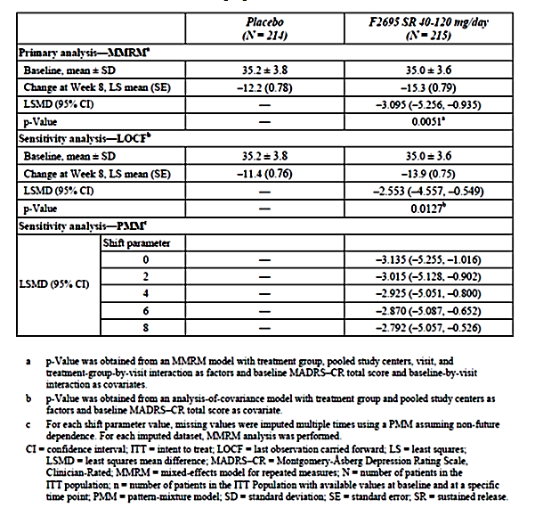
Figure 12: Study LVM-MD-03 By-visit mean change from baseline in MADRS-CR total score (MMRM) ITT population

Results for other efficacy outcomes
There was a positive effect on the SDS total score with a LS mean change from baseline of -8.0 versus -5.4 and difference of -2.63 (95% CI: -4.2, -1.1, p=0.001).
The HAMD-17 total score (including anxiety, psychomotor retardation and melancholia subscales), CGI-S score and MEI-SF total score all showed statistically significant improvements over placebo. However, the HAMD-17 subscales of depressed mood and sleep disturbance and the CGI-I were not significantly improved over placebo. The cognitive testing which assessed power of attention, continuity of attention, cognitive reaction time, reaction time variability, alertness of attention, calmness and contentment found no significant differences between active and placebo (apart from continuity of attention).
The MADRS-CR response rate (41.9% versus 29.4%), the HAMD-17 response rate (38.6% versus 28.0%) and the CGI-I response rate (44.7% versus 32.7%) were all significantly higher with levomilnacipran than placebo. However, the remission rates for MADRS-CR (17.2% versus 18.2%) and HAMD-17 (16.7% versus 17.8%) showed no difference.
Comment: This flexible dose study, which enrolled patients with a baseline MADRS total score of ≥30, also failed to show a separation of effect on MADRS remission rates. MADRS response rates were similar to Study LVM -MD-01.

Other efficacy studies

Study LVM-MD-02

Design and Methods
LVM-MD-02 was a phase III, double-blind, placebo-controlled, parallel group, flexible dose study of levomilnacipran SR (40 to 120 mg/d) in adults with recurrent MDD. The objective was to evaluate the efficacy, safety, and tolerability of levomilnacipran SR versus that of placebo in the treatment of patients with MDD. It was conducted between September 2009 and October 2010 at 24 sites in the US.
The study design, methodology and inclusion/exclusion criteria were the same as Study LVM -MD-03. As with that study, the duration was 11 weeks with an 8 week double-blind treatment period with flexible dosing between 40 and 120 mg/d.

Participant flow and characteristics
There were 793 patients screened and 362 randomised with 5 lost to follow-up or who did not receive treatment. The safety population included 357 and the ITT population 355 patients. The numbers completing were 135 (76%) and 149 (81%) in the levomilnacipran and placebo groups, respectively (Figure 13). The premature discontinuation rate was 22.9% and 18.1% in the respective groups, with a higher rate of AE-related discontinuation in the levomilnacipran group (8.0% versus 2.2%). The protocol deviation rate was 22.9% versus 21.4% and discontinuation due to a protocol violation was slightly higher in the levomilnacipran group (6.9% versus 4.9%). The non-compliance rate was 3.4% and 3.8% in the respective groups.
Figure 13: LVM-MD-02 Patient population and disposition
The mean patient age was 43 years. There were slightly more males in the levomilnacipran than placebo group (43% versus 36%) and slightly more non-Whites (24% versus 18%). Most subjects had recurrent depression (68.6% versus 75.3%) with a mean number of episodes of 4.8 and 4.2 in the levomilnacipran and placebo groups, respectively. Disease duration was similar (10.2 versus 11.5 years), as was the rate of previous treatment non-responders (29.1% versus 30.8%). Baseline efficacy assessments were balanced. Prior psychotropic medication use was higher in the placebo group (49.7% versus 60.4%). Concomitant medication use was similar between groups.

Results
This study failed to meet its primary endpoint. The LS mean change from baseline to week 8 in the MADRS total score was -15.7 and -14.2 in the levomilnacipran and placebo groups, respectively, with a non-significant difference of -1.49 (95% CI: -4.02, 1.05, p=0.249). This result was also found on the two sensitivity analyses. The two groups had similar results across the 8 week treatment period (Figure 14).
Figure 14: LVM-MD-02 By visit mean change from baseline in MADRS_CR total score (MMRM) ITT population
There was also no significant difference from placebo on the secondary endpoint of SDS total score (LS mean difference of -0.54, p=0.562). Similarly, on the further efficacy endpoints of HAMD-17 total score, CGI-S, CGI-I and pain scores there were no significant differences from placebo. There were also no significant differences on the MADR-CR response rate (38.5% versus 34.8%), MADRS-CR remission rate (25.3% versus 23.8%), HAMD-17 response rate (37.4% versus 34.3%), HAMD-17 remission rate (21.8% versus 18.2%) or the CGI-I response rate (44.3% versus 38.7%).

Study F02695 LP 2 02

Design and Methods
Study F02695 LP 2 02 was a phase II, double-blind, placebo-controlled, parallel group study of flexible dose levomilnacipran (75-100 mg/day) in adults with moderate to severe MDD. It was conducted between December 2006 and October 2007 at 68 sites in Europe, India and South Africa. The primary objective was to assess the clinical efficacy of levomilnacipran SR in patients with MDD. This study was sponsored by Pierre Fabre Medicament. There was a 10 week active treatment period which included a 2 week progressive titration period. This was then followed by a 1 week down titration period (Figure 15).
Figure 15: F02695 LP 2 02 Study scheme

Inclusion criteria
Adults 18 to 70 years, DSM-IV-TR major depressive episode diagnosed using the MINI which was moderate to severe, unipolar and without psychotic features; episode duration of ≥1 month; HAMD-17 total score of >22; SDS total score of ≥10 with at least one score of ≥6 on the subscale; and no clinically relevant abnormalities on examination, laboratory tests or ECG.

Exclusion criteria
Significant suicide risk; resistance to two anti-depressants during current episode; bipolar disorder; psychotic episode or disorder; panic disorder, generalised anxiety, obsessive compulsive disorder, social phobia, post-traumatic stress disorder; major personality disorder; drug or alcohol abuse or dependence; fibromyalgia, chronic fatigue syndrome; severe systemic disease; seizures; cardiovascular disease; cardiac rhythm or conduction disorder; prostatic disorder or dysuria; acute glaucoma; hepatic insufficiency; stroke or cerebral disease; pregnancy or breast feeding; haemostasis disorder; ALT/AST >1.5x ULN, creatinine >150 µmol/L, QT or QTc >ULN; chronic use of neuroleptics, anxiolytics, hypnotics; depot neuroleptic within 12 months; ECT within 3 months; antidepressants within 1-3 weeks of inclusion depending on the required washout period; prior non-response to milnacipran.

Treatment
All treatment was taken once daily in the morning. Subjects were up-titrated from 25 mg to 50 mg to 75 mg over the first 11 days. On day 12 the dose could be maintained at 75 mg or increased to 100 mg. Levomilnacipran SR was supplied in 25 mg or 50 mg capsules. Placebo was in matching capsules. Subjects were randomised via and IVRS and randomisation was stratified by MADRS severity (<30, ≥30).

Efficacy endpoints
The primary endpoint was the change from baseline to week 10 (day 70) in the MADRS total score. Secondary endpoints included the HAMD-17, CGI-S, SDS and somatic complaints using a visual analogue scales (VAS).

Analysis population
The analysis of efficacy was on the full analysis set (FAS) which was defined as all randomised subjects who received at least one dose of study medication and had at least one post baseline MADRS assessment.
Comment: This analysis excluded subjects from site 1108 which is discussed below. The FAS is the same population as the ‘ITT’ which was used in the other studies.

Statistical methods and sample size
The primary analysis used a MMRM with treatment, centre and visit as main effects, MADRS total score baseline as covariate, and treatment-by-visit and baseline-by-visit interactions. There was no imputation for missing values. Supportive analysis was conducted on the per protocol (PP) population. The FAS was also analysed using the LOCF approach. There was no adjustment for multiplicity.
A sample of 506 patients (253 per group) gave the study an 80% power to detect 2.5 points of difference on the MADRS total score assuming a standard deviation of 10 on two sided test and α=0.05. Allowing for 5% exclusion from the FAS, a total of 534 patients (267 per group) were required.
There were two general and two local amendments. The changes were all minor apart from in general amendment two, the addition of social phobia to the exclusion criteria and updating references to DSM-IV to DSM-IV-TR.

Participant flow
There were 659 patients screened, 563 randomised with 282 and 281 in the levomilnacipran SR and placebo groups, respectively. There were 4 subjects without post-baseline MADRS scores. The premature withdrawal rate was 20.2% and 24.9% in the levomilnacipran and placebo groups, respectively. The most common reason was consent withdrawal (10.3% versus 13.2%), therapeutic failure (7.8% versus 14.2%) and AE (9.2% versus 6.0%).
There were six patients (2 placebo, 4 active) at site 1108 in South Africa who were excluded from the data analysis. The sponsor stated that there were concerns regarding GCP compliance at the site and therefore all data were invalidated. With these subjects excluded, the safety dataset included 557, the FAS 553 and the PP population 505 subjects.
Comment: The sponsor has been asked to confirm that there were no other issues with GCP compliance in the clinical development program.
At the end of the dose escalation period most patients were on 100 mg (71.6% versus 81.4%, levomilnacipran and placebo groups, respectively). The rate of major protocol deviations in the FAS was 9.1% versus 8.3%. Study treatment compliance was high with a mean compliance of 97.8% versus 98.1% in the levomilnacipran and placebo groups, respectively.

Baseline characteristics
Treatment groups were balanced on demographic characteristics. The mean age was 44.1 years, 66.5% of subjects were female and 91.1% Caucasian. Disease characteristics (MADRS, HAMD, SDS, and CGI-S) were also balanced. The mean baseline MADRS total score was 30.9 versus 30.5, the mean number of previous major depression episodes was 2.6, 82% had previously taken an antidepressant and about half the patients were receiving treatment for the current episode.

Results
The LS mean change from baseline to day 70 in the MADRS total score was -18.7 and -14.5 in the levomilnacipran and placebo groups, respectively. The LS mean difference of -4.2 (95% CI: -5.7, -2.6) was statistically significant (p<0.0001). Separation of effects was seen from day 21 through to Day 70 (Figure 16). The MMRM analysis of the PP population also found a significant treatment difference of -4.2 (95% CI: -5.8, -2.7. p<0.0001). Further analysis using ANCOVA of the FAS with LOCF was supportive (difference in the adjusted mean change in MADRS of -3.7 [95% CI: -5.2,-2.1]).
Figure 16: F02695 LP 2 02 Total score Values over time FAS
MADRS responder rates (≥50% decrease total score) were higher with levomilnacipran (59.1% versus 42.2%) with a significant odds ratio of 2.15 (95% CI: 1.48,3.11, p<0.0001). MADRS remission rates (total score ≤10) were also greater in the levomilnacipran group (46.4% versus 26.0%, OR=2.73, p<0.0001).
There was also a significant improvement in the LS mean change from baseline in HAMD-17 with levomilnacipran (-14.9 versus -11.5, LS mean difference of -3.4, p<0.0001). As with the MADRS, the proportion of HAMD-17 responders (56.2% versus 38.6%) and HAMD-17 remitters (33.3% versus 20.6%) was significantly improved with levomilnacipran compared to placebo. The LS mean difference in the change form baseline in CGI Improvement score was also in favour of levomilnacipran (LS mean difference -0.4, 95% CI: -0.6,-0.3, p<0.0001). CGI responder rates (CGI change of 1 or 2) were 68.0% versus 46.2% in the levomilnacipran and placebo groups, respectively. The LS mean change from baseline in the SDS total score was -11.1 and -7.7 in the levomilnacipran and placebo groups respectively with a significant treatment difference of -3.4 (p<0.0001). There were no significant differences in the mean change from baseline in the VAS for back pain, chest pain, dizziness, joint paint and heart beating. There was a positive effect on weakness.
Comment: This earlier study assessed a different dose (flexible 75-100 mg), had slightly different selection criteria (based on HAMD and SDS rather than MADRS), no documented rater training, and had one site with GCP non-compliance. For these reasons efficacy data from this study are only considered supportive.

LVM-MD-05 (Relapse Prevention Study)

Design and Methodology
Study LVM-MD-05 was a phase III, multicentre, randomised, double-blind, placebo-controlled, relapse prevention study in adults with MDD. It was conducted between March 2010 and October 2011 at 30 centres in the US and 6 in Canada (5 of the Canadian sites randomised subjects). MADRS rater training was undertaken by a CRO and there were central laboratories for clinical laboratory assessments and ECGs.
The study was 39 weeks duration. This included a one week, no drug screening period, a 12-week open-label levomilnacipran SR 40 mg to 120 mg/day treatment period (commencing at 20 mg per day for 2 days), a 24 week double-blind treatment period (40/80/120 mg levomilnacipran SR or placebo), and a 2 week double-blind down-taper treatment period (Figure 17)
Figure 17: LVM-MD-05 Study design
At the end of the open-label period, patients who met the criteria for MADRS response (MADRS total score of ≤12 and CGI-I score of ≤2 at weeks 10 and 12) were randomised (at week 12) in a 2:1 ratio to levomilnacipran SR or placebo. Patients continued on the dose (40, 80 or 120 mg/day) that was being taken at the end of the open-label period and this dose was fixed during the double-blind 24 week treatment period. Placebo-treated patients had their open-label levomilnacipran dose tapered down during the first week of double-blind treatment.
Inclusion criteria were: adults; 18-65 years; DSM-IV-TR criteria for MDD, confirmed on MINI with the depressive episode of at least 4 weeks; MADRS ≥22 (visits 1 and 2); negative urine drug and alcohol screen and normal or not clinically significant examination, laboratory and ECG results. Exclusion criteria were essentially the same as Study LVM -MD-01.
Treatment was with levomilnacipran SR 20 mg and 40 mg capsules or matching placebo once daily at the same time of day. Up titration to 80 or then to 120 mg/day was based on investigator judgement of patient response and the absence of dose-limiting AEs. Dose decrease during the open-label period was allowed for tolerability reasons.
The primary efficacy endpoint was the time to relapse from randomisation during the double-blind treatment period. Relapse was defined as 1 or more of the following:
- MADRS total score ≥22 at 2 consecutive visits, or
- Increase of 2 or more points in CGI-I score compared with the CGI-I score at visit 9 (end of open-label treatment period) at 2 consecutive visits, or
- Premature discontinuation due to insufficient therapeutic response, or
- MADRS item 10 score ≥4.
The time to relapse comparison between the active and placebo groups used a Cox proportional hazard regression model. Kaplan Meier estimates were calculated for the cumulative relapse rate. Analysis was on the ITT population. There were no set secondary endpoints. Additional efficacy endpoints were MADRS, CGI-S, CGI-I and SDS. These were analysed using an MMRM.
For the sample size calculation, the assumed relapse rate was 38% and 20% in the placebo and levomilnacipran SR groups, respectively. With a 20% discontinuation rate during double-blind treatment, a sample of 360 (240 levomilnacipran and 120 placebo) gave the study a 90% power to detect this assumed difference (α=0.05). The study required 700 patients with an assumed responder rate of 52% in the open-label period.

Participant flow and characteristics
Of the 1066 patients screened, 734 were enrolled and received medication during the open-label period, 724 had at least one MADRS assessment and 494 completed open-label treatment. There were 348 patients randomised (235 and 113 in the levomilnacipran and placebo groups, respectively). Of these, 342 (230 and 112) received study medication and had at least one post-randomisation MADRS assessment (double-blind ITT population) (Figure 18).
Figure 18: LVM-MD-05 Patient populations and disposition
Comment: This number (342) is slightly lower than the 360 required from the sample size calculation.
The premature discontinuation rate during open-label treatment was 32.7% with the most common reasons being adverse events (10.9%) and consent withdrawal (7.2%). During double-blind treatment the premature discontinuation rate was 24.0% and 17.9% in the levomilnacipran and placebo groups, respectively. The most common reasons were consent withdrawal (9.4% versus 9.8%) and lost to follow-up (7.3% versus 3.6%).
The rate of protocol violations was moderately high at 36.6% and 36.3% in the levomilnacipran and placebo groups, respectively. The most frequent violations were taking a concomitant medication for longer than allowed (22.2% in both groups).There were three patients who were enrolled twice (separate study sites). Compliance with study medication was high (>98%) in both groups during the double-blind period as well as during the open-label period.
Demographics and baseline characteristics of the double-blind population were balanced between treatment groups. The mean age was 43 years, 58% female and 75% were White. Most patients had recurrent depression (76.8% versus 73.2%) with mean disease duration of 12 years in both groups. Mean baseline MADRS total score was 30.7 in the open-label period and 6.0 and 5.9 in the levomilnacipran and placebo groups, respectively, in the double-blind period. The final daily dose of levomilnacipran at the end of the open-label period was 20, 40, 80 and 120 mg/day in 1.6%, 19.9%, 31.7% and 46.7% of patients, respectively.

Results
The proportion of patients who relapsed during double-blind treatment (ITT population) was 13.9% and 20.5% in the levomilnacipran and placebo groups, respectively.
Comment: These relapse rates are notably lower than those used in the sample size calculations (20% and 38%, respectively).
The hazard ratio for the time to relapse was 0.68 (95% CI: 0.40, 1.17) which was not statistically significant (p=0.165) indicating that the study failed to meet its primary objective. (Figure 19) shows the Kaplan Meier plot. Relapse rates were similar across the levomilnacipran dose subgroups (13.3%, 11.7% and 15.4% for the 40, 80 and 120 mg/day subgroups, respectively).
Figure 19: LVM-MD-05 Plot for Kaplan-Meier estimate of cumulative rate of relapse during double blind treatment period ITT population
During double-blind treatment, the mean change from baseline in the additional efficacy endpoints of MADRS, CGI-S, CGI-1 and SDS showed no significant difference between the levomilnacipran and placebo groups (Table 47).
Table 47: LVM-MD-05 Change from baseline to end of open-label and double blind treatment periods for additional efficacy parameters (observed cases) ITT populations
Comments: The study may have been underpowered due to relapse rates being lower than the estimated ones used in the sample size calculations.
The US FDA clinical evaluation stated that the study may have been hampered by an insufficient time of clinical stability (2 week) prior to the randomised withdrawal phase. The FDA has asked the sponsor to repeat this study with altered design. The sponsor has been requested to comment on these issues.

LVM-MD-04 (Long term, open-label study)

Design and Methodology
LVM-MD-04 was a phase III, open-label, flexible dose 52 week extension study assessing safety and tolerability in 828 patients who has participated in LVM-MD-01, -02 and -03. Patients who completed double-blind treatment and tapering down periods of the feeder studies were eligible. The study had a 48 week treatment period and a 4 week tapering down period. Treatment commenced at 20 mg on days 1 and 2 then increased to 40 mg on day 3. Following this there were further weekly increments (to a maximum of 120 mg/d) based on patient response and absence of dose-limiting adverse events (Figure 20). The study was conducted at 68 centres in the US between December 2009 and June 2012.
Figure 20: LVM-MD-04 Study design
No psychotropic medications were permitted. The following anti-insomnia agents were permitted up to 3 times a week: zolpidem (maximum 10 mg/day); zolpidem extended release (maximum 12.5 mg/day); zaleplon (maximum 10 mg/day) and eszopiclone (maximum 3 mg/day).
Efficacy assessments (MADRS-CR, CGI-S and CGI-I) were only undertaken as further endpoints. Efficacy analysis was on the ITT population with LOCF and also using observed cases.

Participant flow
There were 828 patients enrolled with 825 in the safety and 813 in ITT populations. Only 384 (46.5%) completed the open-label period and 490 entered down taper period (59.4%). The reasons for premature discontinuation were consent withdrawal (14.3%), adverse event (13.0%), lost to follow-up (10.5%), protocol violation (8.1%) and insufficient therapeutic response (6.8%). Protocol violations were high (40.5%) with the main reason be taking prohibited concomitant medication (18.5%).

Results
The mean change from baseline in the feeder study to week 48 of the extension study in the MADRS total score was -23.6 using LOCF in the ITT population (n=813) and -27.6 using observed cases (OC) (n=381). The mean change from baseline to week 48 in the CGI-S score was-2.5 and -3.0 in the LOCF and OC analyses, respectively. In the LOCF analyses, the MADRS remission rate was 53.3%, the MADRS response rate was 73.4% and the CGI-I response rate was 74.8%.
Comment: The efficacy data from Study LVM -MD-04 are of limited value due to the open-label nature of the study, the lack of a comparison group and the high discontinuation rate (53%).

Other indications

LVM-MD-06 (Fatigue with MDD)

Design and Methodology
LVM-MD-06 was a pilot Phase II, double-blind, randomised, placebo- and active-controlled, parallel group study of levomilnacipran SR in adult patients with fatigue associated with MDD. The study was conducted between April 2011 to July 2012 at 20 sites in the US (19 randomised subjects).
The study duration was 11 weeks. After a 1 week single-blind placebo run-in period, patients who met all eligibility criteria were randomised (1:1:1) to 1 of 3 groups: placebo, levomilnacipran (flexible dose 40-120 mg/d), or SSRI (fluoxetine, paroxetine, sertraline, or citalopram). The double-blind treatment period was 8 weeks and was followed by a 2 week, double-blind, down-taper period. Subjects were randomised by an IVRS. For blinding, all treatment was supplied in identical capsules.
In the original protocol citalopram was included as 1 of 4 SSRIs. Due to a change in citalopram labelling limiting the maximum recommended dose to 40 mg the protocol was amended (60% of patients had been enrolled) and patients on citalopram were prematurely discontinued from the study and no additional patients were administered citalopram. Following the amendment patients were randomised in a 4:4:3 ratio to placebo, levomilnacipran or SSRI.
The study included patients 18 to 65 years with DSM-IV-TR criteria for MDD and the current depressive episode was at least 4 weeks. At screening and baseline they were required to have an MADRS-CR total score ≥22, a CGI-S fatigue score ≥4, and a PGI-S fatigue score ≥4.
The co-primary efficacy endpoints were change from baseline to week 8 in the CGI-S fatigue score and PGI-S fatigue score. Secondary endpoint was the Cognitive and Physical Functioning Questionnaire (CPFQ).

Results
The study randomised 262 patients with 248 in the ITT population. This included 71, 72 and 62 in the placebo, levomilnacipran and SSRI groups, respectively. Premature discontinuation rates were 20.2%, 15.3% and 19.5% in the respective groups. Protocol deviation rate ranged from 15.2 to 21.1% across the three groups. The demographic baseline characteristics were relatively well balanced. Across the three groups, baseline CGI-S fatigue score was 4.7 and PGI-S fatigue score was 4.8-4.9.
The mean reduction in CGI-S fatigue score and PGI-S fatigue score was similar between the levomilnacipran and SSRI groups and slightly lower in the placebo group (Table 48).
There was a slightly greater reduction in the CPFQ score from baseline to week 8 in the levomilnacipran group compared to SSRI or placebo (Table 48). There was little difference in the mean change from baseline to week 8 (LOCF) in the MADRS-CR total score (-13.9, -15.7 and -15.4 in the placebo, levomilnacipran and SSRI groups respectively).
Table 48: LVM-MD-06 Primary efficacy analyses Change from baseline to Week 8 in the CGI-S fatigue score and PGI-S score for fatigue ITT population
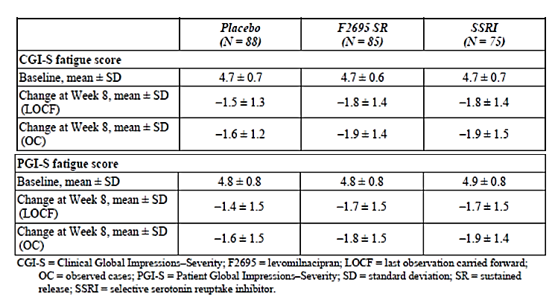
Comment: No statistical comparisons were made between groups. The study did not provide evidence that levomilnacipran has any efficacy in the treatment of fatigue associated with MDD. This indication is not being sought in the draft product information.

F02695 LP 2 01 (GAD)
F02695 LP 2 01 was a phase II, randomised, double-blind, multinational, placebo-controlled, parallel group, 8 week study of the efficacy and safety of levomilnacipran SR (25mg, 50mg and 75 mg/day groups) in 33 patients with generalised anxiety disorder (GAD). It was conducted between 2005 and 2006 at 16 sites in France. The study was sponsored by Pierre Fabre Medicament. It was planned to randomise 556 patients however only 33 subjects were randomised and treated due to premature termination of the study by the sponsor. The rationale given in the CSR was: Consequently to new pharmacological data on animal models non [sic] further supporting any expected efficacy of F2695 in treating GAD, the study recruitment was prematurely stopped, upon the sponsor’s decision, on 20 December 2005.

Analyses performed across trials (pooled analyses and meta-analyses)
Post-hoc subgroup analyses were carried out on data from four studies (LVM-MD-01, LVM-MD-10, LVM-MD-03 and F02695 LP 2 02) on the primary endpoint of change from baseline to week 8 in the MADRS total score. Data from the trials were not pooled.
The mean treatment difference between levomilnacipran and placebo on the MADRS varied between males and females in the 4 studies. In Study LVM -MD-01 and -10 the treatment difference was greater in males, in study F02695 LP 2 02 the difference was similar, while in LVM-MD-03 females has a greater treatment difference (Table 49). Analysis of those aged <55 years and ≥55 years generally found a better response in the younger patients (Table 50). There also appeared to be a lower response in non-white racial groups (Table 51).
Table 49: Summary of change from baseline to endpoint in the MADRS total score by sex (LOCF) in Studies LVM-MD-01, LVM-MD-10, LVM-MD-03 and F02695 LP 2 02 ITT population
Table 50: Summary of change from baseline to endpoint in the MADRS total score by age group (LOCF) in Studies LVM-MD-01, LVM-MD-10, LVM-MD-03 and F02695 LP 2 02 ITT population

Table 51: Summary of change from baseline to endpoint in the MADRS total score by race group (LOCF) in Studies LVM-MD-01, LVM-MD-10, LVM-MD-03 and F02695 LP 2 02 ITT population
Comment: The number of patients aged 55 years or older, as well as those of non-White race, was small which makes drawing conclusions difficult.
Analysis of those with a baseline MADRS score <35 or ≥35 tended to show a higher response in those with more severe depression (Table 52).
Table 52: Summary of change from baseline to endpoint in the MADRS total score by baseline MADRS total score (LOCF) in Studies LVM-MD-01, LVM-MD-10, LVM-MD-03 and F02695 LP 2 02 ITT population
Comment: There was no assessment of response by previous antidepressant use despite the fact that at least 40% of study participants had not previously been treated with an antidepressant. The sponsor has been asked to comment on this.

Evaluator’s conclusions on clinical efficacy for MDD
All short term studies had 8 weeks of double-blind treatment apart from the Phase II study which had 10 weeks. Dose titration in the Phase III studies started at 20 mg/day for 2 days and in the fixed dose studies was titrated to 40 at Day 3-4, 80 by Day 5-7 and 120 mg (only Study LVM-MD-01) from Day 8. In the flexible dose studies, titration to 40 mg was at Day 3 to 7, 80 mg at Day 8-28 and 120 mg from Day 29.
The primary efficacy endpoint in all studies was the change from baseline to study endpoint (8 weeks in the Phase III studies and 10 weeks in the Phase II study) in the MADRS total score as rated by a trained clinician. The SDS total score was the key secondary endpoint and used as a measure of functional impairment. The change from baseline to Week 8 was analysed on the intent-to-treat (ITT) population which was defined as all randomised patients who took at least one dose of study medication and had at least one post baseline efficacy assessment. There was consistency of design and analyses across the studies.
Patients had MDD meeting the DSM-IV-TR criteria with an MADRS total score of ≥ 30 in Studies LVM-MD-01, LMV-MD-02 and LVM-MD-03 and a MADRS total score of ≥ 26 in Study LVM-MD-10. The Phase II study eligibility was based on the HAMD-17 (>22).
Four of the short term studies were positive and one was negative (LVM-MD-02). The Phase II study, which was positive, is only considered supportive primarily due to differences in doses assessed and inclusion criteria. The least squares (LS) mean difference (levomilnacipran versus placebo) in the change from baseline to Week 8 in the MADRS total score was in the range of -3 to -5 (Table 53). Results were robust being supported by sensitivity analyses and the secondary endpoint of SDS total score (Table 54).
Table 53: Primary efficacy parameter’ Change from baseline to end point in the MADRS total score (MMRM) in the positive studies-ITT population
Table 54: Secondary efficacy parameter Change from baseline to end point in the SCS score (MMRM) in the positive studies-ITT population
Levomilnacipran was found to have a positive effect on MADRS response and remission rates in studies LVM-MD-01 (only the 120 mg dose), LVM-MD-10 and F02695 LP 2 02. However no significant effects on these clinically relevant endpoints were found in studies LVM-MD-02 and LVM-MD-03 (Table 55). The sponsor states this is due to the higher MADRS entry criteria in studies LVM-MD-01, -02 and -03 and the short trial duration. The evaluator agrees that these are possible explanations for the lack of effect.
Table 55: MADRS response rates at end point (LOCF) in the positive studies-ITT population
Subgroup analyses of age (< 55/≥ 55 years) and race (White/non-White) were hampered by small numbers is some groups. The responses in males and females showed variation between studies. Those with more severe depression (MADRS ≥35) tended to have a higher treatment response.
The dossier included one 52 week, open-label extension study (LVM-MD-04) which primarily assessed safety. Due to the open-label design, lack of comparison group and the high discontinuation rate (53%) no long term efficacy conclusions can be drawn from this study.
There was one relapse prevention study (LVM-MD-05) which was negative. Consequently, there are no data demonstrating persistence of efficacy beyond 8 weeks (limited supportive evidence to 10 weeks from Study F02695 LP 2 02). EMA (2013) guidelines on products for treatment of depression state that for authorisation it should be shown that a short-term effect can be maintained during the index episode. It is noted that the FDA has requested that the sponsor conduct another relapse prevention study with altered design. The sponsor has been asked to comment on this.
The dossier included two other studies, one on generalised anxiety disorder which was terminated prematurely due to non-supportive preclinical data, and the other on fatigue associated with MDD which indicated no positive effect.
The data from the fixed dose Study LVM-MD-01 pointed towards increased efficacy with increasing dose (40, 80, 120 mg/day). This was more noticeable in those with more severe depression (MADRS ≥ 35). The dose response was not evident in Study LVM-MD-10 when only 40 and 80 mg/day were assessed (Figure 3). These studies were not powered for inter-dose comparisons and there were no statistical analyses of this. With a flexible dosing regimen in Study LVM-MD-03, 44% of patients were titrated to the highest dose of 120 mg. The other flexible dose study was negative. The data in the dossier have not characterised the minimum effective dose.
The clinical development program did not include any active control groups despite guidelines recommending their inclusion (EMA 2013).
Figure 21: Treatment differences and 95% CIs of change from baseline in MADRS total score endpoint (MMRM)-ITT population

Clinical safety

Studies providing evaluable safety data
There were no pivotal safety studies.
The studies which provided evaluable safety data were allocated into 5 groups (Table 56). Group 1 included the 5 short term placebo controlled studies, Group 2 the single long term (48 weeks) safety study, Group 3 the single relapse prevention study, Group 4 the healthy subject studies (19 studies) and Group 5 the two studies in other indications. Groups 1, 2 and 3 were pooled to provide the ‘all levomilnacipran-treated patient’ group.
Safety analyses were conducted on the Safety Population which was defined as all randomised subjects who received at least one dose of study medication. The end of double-blind treatment was defined as the last dose prior to commencing the down-titrated double-blind medication (or the last non-missing value if there was no down titration).
Table 56: Levomilnacipran clinical studies
There were 26 identified patients who participated in more than one levomilnacipran study. Data from these subjects were included in the safety analyses.
In the short-term, placebo-controlled studies the following safety data were collected:
General adverse events (AEs) which were assessed at all visits. Data on treatment emergent AEs (TEAEs) were provided.
AEs of particular interest, including cardiovascular, suicidality, genitourinary, narrow angle glaucoma, abnormal bleeding, serotonin syndrome/neuroleptic malignant syndrome, hyponatraemia and hepatoxicity, were analysed by standardised MedDRA queries.
Clinical laboratory tests, including haematology, chemistry and urinalysis (not in F02695 LP 2 02), and pregnancy tests which were assessed at screening and weeks 4 and 8 (or 10 in F02695 LP 2 02).
Vital signs (including orthostatic blood pressure and body weight) at all visits and physical examination (at screening and final visits).
ECGs at screening and weeks 4 and 8 (or 10 in F02695 LP 2 02).
Columbia–Suicide Severity Rating (C–SSRS) (not in F02695 LP 2 02) at all visits.
Arizona Sexual Experiences (ASEX) as a measure of sexual dysfunction in Study LVM-MD-02.
The open-label, long-term and relapse prevention studies collected the same safety data at regular intervals during the studies. The healthy subject studies provided data on serious AEs (SAEs).

Pivotal studies that assessed safety as a primary outcome
There were no pivotal safety studies.

Patient exposure
There were 1583 patients in Group 1 (short term studies), 825 in Group 2 (long term extension study), 734 in Group 3 open-label (233 double-blind period) and 637 in Group 4 (clinical pharmacology and biopharmaceutic studies) who received levomilnacipran (Table 57 below). In the phase I studies, 371 subjects received a single dose, 209 multiple doses and 57 both single and multiple doses. Doses ranged from 20 to 300 mg per day for up to 36 days.
Table 57: Distribution of subjects in the levomilnacipran studies-Safety population
In Groups 1, 2 and 3 (MDD patients) there were 2673 patients who received levomilnacipran (40 to 120 mg/day) with a total treatment exposure of 941.7 patient-years. There were 367 patient exposed to levomilnacipran for 48 weeks or longer (Table 58).
Table 58: Summary of overall exposure (Groups 1, 2 and 3), safety population
Group 1 = 5 short term studies. Group 2 = long term open-label extension study (LVM-MD-04). Group 3 = relapse prevention study (LVM-MD-05)
Comment: Table 58 states that in Group 2 there were 296 patients exposure for ≥ 48 weeks while in Groups 1, 2 and 3 there were 367 patients with this exposure duration. Given there were no other studies apart from LMV-MD-04 that had ≥ 48 weeks treatment duration (Study LVM-MD-05 was 38 weeks), the evaluator is unsure how the number exposed to ≥ 48 weeks from Groups 1,2 and 3 can be greater than the number exposed in Group 2. In addition, the exposure numbers provided in the sponsor’s Summary of Clinical Safety are different to those in the FDA clinical evaluation report. The sponsor has been asked to comment on these points. The numbers, as they are reported, meet the ICH E1 requirements for a safety data base.
The mean treatment duration in the short term studies (Group 1) was 50.3 days (range 3 to 77 days). In the flexible dose studies (LVM-MD-02 and -03), 46% received 120 mg, 34% 80 mg and 19% 40 mg as the final daily dose. In the long term study (Group 2), the mean treatment duration was 222 days and the mean daily dose was 83 mg with a final daily dose of 120 mg, 80 mg, 40 mg and 20 mg in 47%, 26%, 27% and 0.4%, respectively. In study LMV-MD-04 open-label period, the mean daily dose was 79 mg and 47% had a final daily dose of 120 mg.

Adverse events

All adverse events (irrespective of relationship to study treatment)

Group 1 studies
In the short term, placebo-controlled studies, the rate of TEAEs was higher with levomilnacipran than placebo (77.2% versus 61.4%). The TEAEs which occurred at a notably higher rate than placebo were nausea (17.1% versus 5.6%), constipation (8.5% versus 2.5%), tachycardia (grouped terms) (5.9% versus 1.7%), increased heart rate (5.7% versus 1.0%), palpitations (4.7% versus 1.3%), vomiting (4.8% versus 0.8%), dizziness (8.1% versus 4.8%), urinary hesitation (4.0% versus 0%), hyperhidrosis (8.5% versus 1.9%), increased BP (2.8% versus 1.2%), erectile dysfunction (5.7% versus 1.3%), ejaculation disorder (3.1% versus 0%) and testicular pain (3.1% versus 0.3%).
The rates of mild (26.4% versus 16.5%), moderate (26.7% versus 17.8%) and severe TEAEs (5.6% vs2.8%) were consistently greater with levomilnacipran than placebo.
In the fixed dose short term studies, the rate of TEAEs in the placebo, 40 mg, 80 mg and 120 mg groups was 59.4%, 71.9%, 80.9% and 76.7%, respectively. Erectile dysfunction had an evident dose response relationship: 2.2%, 5.5%, 8.3% and 9.5% in the placebo, 40 mg, 80 mg and 120 mg groups, respectively. Dose response was also seen with urinary hesitancy: 0%, 3.6%, 4.9% and 6.1% in the respective groups.
Comment: An overall dose-response relationship with TEAEs was not evident except for erectile dysfunction and urinary hesitancy.

Other studies
In the long-term, extension study (Group 2), the rate of TEAEs was 86% during the 48 weeks treatment period. The most frequent events were headache (22.2%), nausea (16.2%), URTI (13.2%) and hyperhidrosis (11.0%). The rate of TEAEs was highest in the first 8 weeks of treatment (73.9%) and then remained steady for the remaining trial period at 35-38.5%. The rate of mild, moderate and severe TEAEs was 25.7%, 47.7% and 13.0%, respectively.
TEAEs reported in the relapse prevention study (Group 3 both the open-label and double-blind periods) were of a similar profile to those reported in Groups 1 and 2. The rate of severe TEAEs during open-label treatment was 8% and during double-blind treatment was 6.4% and 9.8% in the levomilnacipran and placebo groups, respectively.
In Group 4 (clinical pharmacology and biopharmaceutic studies) the most frequent TEAEs were nausea, vomiting, headache, somnolence and dizziness. Other notable events included hyperhidrosis, urinary hesitation, dysuria and testicular pain.
Study LVM-PK-14 assessed the bioequivalence of the proposed to-be-marketed Elan site SR formulation with the clinical trial SR formulation (120 mg single dose crossover study) in 61 healthy subjects. In this study it was noted that the to-be-marketed formulation had a higher rate of TEAEs than the clinical trial formulation (86.2% versus 67.8%) with higher rate of nausea (69.0% versus 62.7%), vomiting (44.8% versus 32.2%), dizziness (13.8% versus 8.5%), dysuria (6.7% versus 1.7%) and testicular pain (5.2% versus 0%).
Comment: The data on C_{max}, AUC_{0-t} and AUC_{0-∞} from this study (LVM-PK-14) indicated that the formulations were bioequivalent, however the Elan formulation had a statistically significant shorter T_{max} and a slightly longer T_{½}. The number of subjects in the study is small and this may account for some variability in the AE rates. Nonetheless, the sponsor has been asked to discuss this finding of possible poorer tolerability and PK differences with the Elan to-be-marketed formulation.
In Study LVM -MD-06 in patients with fatigue associated with MDD, the rate of TEAEs was 81.2% with levomilnacipran compared to 73.0% in the placebo group and 71.4% in the SSRI group. Nausea was more common with levomilnacipran (40-120 mg/d) than placebo or SSRI (16.5% versus 4.5% and 7.8%), as was increased heart rate (7.1% versus 3.4% and 0%) and dizziness (7.1% versus 2.2% and 1.3).

Treatment-related adverse events (adverse drug reactions)

Group 1 studies
In the short term, placebo-controlled studies, the rate of treatment-related TEAEs was higher with levomilnacipran (63.7% versus 40.8%). The most frequent treatment-related TEAEs were headache (12.6% versus 8.4%), hyperhidrosis (7.7% versus 1.9%), dizziness (6.8% versus 4.1%) erectile dysfunction (5.2% versus 1.3%) and increased heart rate (5.2% versus 0.8%).

Other studies
In the long-term, extension study (Group 2), the rate of treatment-related TEAEs was 67.8%. The most frequent events were headache (14.1%), nausea (12.1%), hyperhidrosis (10.5%), tachycardia (7.6%) and constipation (7.4%).
In the relapse prevention study (Group 3), the rate of treatment-related TEAEs in the open-label period was 75.3% and during the double-blind period was not notably greater than placebo (27.9% versus 25.0%).

Deaths and other serious adverse events

Deaths
There were 2 deaths in the clinical development program. The first occurred during screening (pre-randomisation) for Study LVM -PK-10 and was due to drowning. The second occurred in a 54 year old female who had participated in LVM-MD-02 where she received placebo. She entered Study LVM -MD-04 and was diagnosed with gastric adenocarcinoma stage IV on day 223 (224 days of treatment with levomilnacipran). She was discontinued and died 42 days later.

Serious Adverse Events
There were 25 patients with SAEs in Group 1. The proportion of patients with any SAE was lower in the levomilnacipran than placebo group (0.7% versus 1.3%). No SAE occurred at a frequency of over 1 in the levomilnacipran group. The comparative SAE rates were 5.0 versus 9.2 per 100 patient-years exposure. During the double-blind period of the short term trials, there were 11 patients treated with levomilnacipran with 16 SAEs for which 2 temporarily stopped medication and 6 discontinued the study. SAEs deemed treatment-related in the levomilnacipran group included aggression/violent outburst, suicidal ideation, prostatitis, seminal vesiculitis and non-cardiac chest pain. There was also one post study case of a premature and small-for-dates baby which was considered treatment-related.
During the down taper period there were 4 patients in the levomilnacipran and one in the placebo group with an SAE. The SAEs in the levomilnacipran group were suicide attempt, hypertension, and non-cardiac chest pain and suicide ideation. The SAEs of non-cardiac chest pain and hypertension were reported as treatment-related. There was also a post study case of treatment-related preeclampsia in a patient previously treated with levomilnacipran
In the 48 week long-term, open-label study (Group 2), the SAE rate was 4.4% (36 patients with 52 SAEs) (7.2 per 100 patient-years). The SAEs that were reported more than once were chest pain (0.4%), ventricular extrasystoles, appendicitis, hypertension, overdose, depression, suicidal ideation and suicide attempt (all 0.2%). Treatment-related SAEs were mania, chest pain, hypertension (2 patients), angina pectoris/increased heart rate (one patient), pulmonary mass, convulsion/encephalopathy (one patient) and supraventricular extrasystoles/ventricular extrasystoles/tachycardia (one patient). There were 13 patients (1.6%) with an SAE that led to discontinuation.
In Group 3, the rate of SAEs during the open-label period was 0.8% and the rate during double-blind treatment was lower with levomilnacipran than placebo (0.9% versus 3.6%). No specific SAE was reported more than once. Treatment related SAEs were hypertension and chest pain.
In Group 4, there were two subjects with SAEs. One was appendicitis, the other was treatment-related atrial fibrillation on day 11 in a 39 year old male subject (Study LVM -KD-09) treated with 120 mg levomilnacipran which led to discontinuation. In Study LVM -MD-06 (fatigue with MDD) there was only one SAE (pneumonia) in a 49 year old female treated with levomilnacipran.

Discontinuation due to adverse events

Group 1 studies
In the short term studies, the premature discontinuation rate from any cause was 25.4% versus 19.8% in the levomilnacipran and placebo groups, respectively. The rate of TEAEs that led to discontinuation was higher with levomilnacipran (8.8% versus 3.2%) and the rate per 100 patient years was 63.7 versus 21.7. The most frequent events were nausea (1.5% versus 0.4%), vomiting (0.8% versus 0%), dizziness (0.4% versus 0.1%), headache (0.4% versus 0.1%), rash or urticaria (0.8% versus 0%), urinary disorders of hesitation, retention or dysuria (1.1% versus 0%), tachycardia (0.4% versus 0.1%) and palpitations (0.3% versus 0%). Additional TEAEs leading to discontinuation in males were testicular pain (0.9% versus 0%) and erectile dysfunction (0.7% versus 0%).

Other studies
In the long-term, open-label study (Group 2), the discontinuation rate from any cause was 53.5% with discontinuation due to an AE occurring in 13.0% (21.3 per 100 patient years). The most frequent TEAEs leading to study discontinuation were nausea (1.2%), tachycardia (0.8%), hyperhidrosis (1.0%), hypertension (0.7%) and headache (0.6%).
In Group 3 (relapse prevention study), the discontinuation rate during the open-label period was 32.7% with 10.9% due to AEs. In the double-blind period the discontinuation rate was 24.0% versus 17.9% and due to AEs was 3.4% versus 2.7% in the levomilnacipran and placebo groups, respectively. The profile of TEAEs leading to discontinuation during open-label treatment was similar to that reported above. During double-blind treatment, the TEAEs leading to discontinuation were headache, dizziness, palpitations, hyperhidrosis, epididymitis, lethargy and neutropaenia.
In Group 4 (phase I studies) there were 24 subjects on levomilnacipran with AEs leading to discontinuation. Events included: 2 tachycardia, 2 testicular pain, headache, dysuria, ventricular extrasystoles, supraventricular arrhythmia, chest pain, 2 non cardiac chest pain, hypotension, 2 drug eruption, 3 T wave inversion, atrial fibrillation/palpitations/chest pain, urinary tract obstruction, dysuria/testicular pain/bilateral flank pain, bladder discomfort/cystitis, 2 headache/nausea and nausea/vomiting.
In Study LVM -MD-06, the rate of TEAEs leading to discontinuation was 3.5% in the levomilnacipran group compared to 5.6% in the placebo and 2.6% in the SSRI group. The TEAEs in the levomilnacipran group were urinary hesitation, testicular pain and hypertension.

Laboratory tests

Liver function
In Group 1A, compared to placebo-treated, the levomilnacipran-treated patients had small mean increases in ALT, AST, ALP and GGT over the 8 weeks of treatment. In the fixed dose studies this increase did not appear to be dose dependent. The proportion of patients with clinically significant increase in ALT and/or AST of ≥3x ULN was higher with levomilnacipran (0.7% versus 0.1%). There was one case of raised LFTs and rhabdomyolysis. In general the LFTs were seen to reduce despite ongoing treatment.
In Group 2, a small (2.1-2.3 U/L) increase in AST, ALT and ALP was also noted. There were 5/748 (0.7%) patients with ALT or AST ≥3x ULN. Two of these patients had TEAEs reported, all continued treatment.
In Group 3, the rate of increases ALT and AST ≥3x ULN was 0.3% and 0.4%, respectively. There were no patients with this increase in the double-blind phase. There were 2 cases with an increase >10x ULN; one had an increase in AST only and neither had increases in bilirubin. Both patients had reduction of levels while continuing on treatment.
The rate of TEAEs associated with LFT abnormalities in all short term studies (Group 1) was 1.1% versus 0.5% (levomilnacipran versus placebo) and in the long term study (Group 2) was 1.1%). In Group 3, there were 5 TEAEs related to liver enzyme increase in levomilnacipran-treated patients, none of which were >3x ULN.
There were two premature discontinuations due to LFT abnormalities in Group 1 (LFTs abnormal and hepatic enzymes increased) and two in Group 2 (AST increased and ALT/AST increased, in both the increase was less than 3x ULN). There were no cases meeting Hy’s Law criteria for drug-induced liver injury in the development program.

Kidney function
In the Group 1 population, there were no significant changes from baseline, or proportion with potentially clinically significant levels, in creatinine or blood urea nitrogen. In Group 2, the rate of creatinine >1.3x ULN was 0.1% and BUN >1.2x ULN was 1.6%. There was one patient with increased creatinine and BUN who had an associated TEAE (increased blood creatinine). Levels resolved with ongoing treatment. A second patient with clinically significant raised BUN had a TEAE of renal cyst. There were no relevant changes in Group 3.

Other clinical chemistry
In Group 1A, there was no relevant shift in total cholesterol or fasting glucose level compared to placebo. In Group 2, there was little change in mean cholesterol or glucose over the treatment year. There was one discontinuation (day 190) due to increase glucose. This patient received placebo in the lead-in study. In the double-blind period of Group 3, there was a higher rate of cholesterol >1.3x ULN with levomilnacipran than placebo (7.8% versus 3.9%).
In Group 1A, there were no remarkable changes post-baseline in mean electrolyte or calcium levels. The rate of potassium >1.1x ULN was higher with levomilnacipran (1.2% versus 0.7%). There were two TEAEs of increased potassium. There were no potentially clinically significant changes in sodium levels. Changes in study F02695 LP 2 02 and in Group 3 were unremarkable. In the long term study (Group 2), the rate of potassium >1.1x ULN was 2%. Increases were found to be transient. In this study there was one SAE of hypokalaemia (also with dizziness and hypoesthesia) in a 47 year old female patient who was taking hydrochlorothiazide and lisinopril for hypertension. There was one patient with clinically significant low serum sodium (121 mmol/L) together with low chloride and normal potassium at Week 36. The patient completed the study. There were no TEAEs of hyponatraemia.

Haematology
There were no clinically relevant changes in mean haematology parameters or in rates of potentially clinically significant levels in Group 1A. The rate of low haemoglobin (<0.9x LLN) was 2.4% in Group 2 and in Group 3 (double-blind period) was 3.1% and 1.9% in the levomilnacipran and placebo groups, respectively. There was one TEAE of worsening anaemia in a patient with a history of anaemia. In Group 2, there was one patient with SAE of CMV mononucleosis who had a high WBC and lymphocyte counts.

Urinalysis
In Group 1, there was no difference between levomilnacipran and placebo groups in the rate of potentially clinically significant urinalysis parameters. There were 3 patients with TEAEs of urinary glucose in Group 2, two of whom had increased blood glucose TEAEs.

Vital signs

Heart rate
Across the studies there was a consistent increase in heart rate associated with levomilnacipran treatment. In Group 1, the mean change from baseline to study endpoint in heart rate was 7.4 bpm in the levomilnacipran groups compared to -0.3 bpm in the placebo groups. In Group 2, the mean change was 9.1 bpm and increases in Group 3 (open-label and double-blind periods) were in the order of 7 bpm (Table 59).
Table 59: Change from baseline to end of treatment in blood pressure and heart rate (Groups 1, 2 and 3) Safety population
The rate of potentially clinically significant (PCS) increase in HR in the levomilnacipran groups ranged from 0.4 to 0.9% (Table 60).
Table 60: Overall summary of number (%) of patients with potentially clinically significant blood pressure and heart rate values (Groups 1, 2 and 3) Safety population
The sponsor submitted a Cardiovascular Analyses Report with the Integrated Summary of Safety. In these analyses, increase in HR showed a relationship with increasing dose: 9.1 versus 7.2 bpm in the 120 mg versus 40 mg or 80 mg dose groups, respectively.
In Group 1, TEAEs of tachycardia (4.9% versus 1.4%) or increased heart rate (5.7% versus 0.9%) were relatively frequent and occurred at a rate notably greater than in the placebo group. Discontinuations due to these events was however less common (0.6% versus 0.1%). In Group 2, there was one SAE of tachycardia (together with supraventricular extrasystoles and ventricular extrasystoles) and another SAE of increased heart rate (together with angina pectoris). Both patients were prematurely discontinued. The rate of TEAEs of tachycardia or increased heart rate in Group 2 was 14.6%. Tachycardia leading to discontinuation occurred in 0.8% (Table 61).
Table 61: Treatment emergent adverse events, SAEs and AE discontinuations associated with vital signs (Group 2) Safety population

Blood pressure
There was also a consistent increase in systolic BP (3.0 to 4.3 mmHg) and diastolic BP (3.1 to 3.6 mmHg) across the studies in Groups 1, 2 and 3 (Table 57). Despite this, the rate of potentially clinically significant increase in BP in Group 1 was 0.2% versus 0% for SBP and 0.4% versus 0.3% for DBP in the levomilnacipran and placebo groups, respectively (Table 60). In the Cardiovascular Analyses Report, the mean increase in BP did not appear dose related (Table 62). Sustained hypertension in Group 1 occurred in 1.8% versus 1.2% patients in the levomilnacipran and placebo groups, respectively. The rate in the long term extension study (Group 2) was 0.8%.
Table 62: Change from baseline to end of double blind treatment in systolic and diastolic blood pressures in fixed dose studies Safety populations
In Group 2, there were 2 SAEs of hypertension. The first also had non-serious increased heart rate and completed the study, the second patient was discontinued. The rate of TEAEs of hypertension was 6.3% and increased BP was 5.3% (Table 61).
The rate of orthostatic hypotension (any single event) in Group 1A was 11.6% versus 9.7% in the levomilnacipran and placebo groups, respectively, and this increased in the longer term study (Group 2) to 21.1%. There was no evident dose response for orthostatic hypertension with rates of 9.8-11.9% across the three dose groups in the fixed dose studies. TEAEs related to orthostatic hypertension occurred more than with placebo, however were relatively infrequent. In Group 2, TEAEs associated with orthostatic hypotension were: postural orthostatic tachycardia syndrome (2.3%), orthostatic hypotension (2.5%), postural dizziness (1.1%), presyncope (0.1%), and syncope (0.1%). The presyncope case was an SAE.
Comment: These findings on HR and BP are consistent with the mechanism of action of levomilnacipran.

Body weight
In Group 1, there was a small decrease in mean body weight in the levomilnacipran group compared to no change in the placebo group (-0.59 versus 0.02 kg). The rate of potentially clinical significant decrease (≥7%) in body weight was 1.6% versus 1.0%, respectively. An increase in body weight (≥7%) was similar between groups (0.6% versus 0.9%). In Group 2, 10.0% had an increase of body weight of ≥7% and 16.9% had a decrease of ≥7%. In Group 3, in patients treated with levomilnacipran, there was also a small decrease in body weight of -0.49 and -0.54 kg during the open-label and double-blind periods.

Electrocardiograph

Group 1 studies
In Group 1A, the increased heart rate was notable compared to placebo (12.5 versus 1.6 bpm). With this there was a decrease in PR, QT and QRS intervals. In Group 1A, there was an increase in QTcB with levomilnacipran (9.5 versus 0.1 ms) (Table 63) which was dose dependent: 0.5, 7.7, 8.0 and 10.5 ms for the placebo, 40 mg, 80 mg and 120 mg doses, respectively). There was no notable change in QTcF compared to placebo. The findings were similar in study F02695 LP 2 02.
Table 63: Change from baseline to end of treatment in selected electrocardiographic parameters (Groups 1A, 2 and 3) Safety populations
In Group 1A, there was one (0.1%) patient with QTcB >500 ms (Table 64). This patient had a TEAE of increase heart rate and QTcB of 513 (from a baseline of 485 ms). The patient completed the study and the TEAE of prolonged QTcB resolved on the day it was detected. In Group 1, the rate of ECG QT prolonged TEAEs was marginally higher with levomilnacipran (0.4% versus 0.2%).
Table 64: Summary of post baseline clinically significant electrocardiogram values (Groups 1 A, 2 and 3) Safety population

Other studies
In Group 2, there was an increase of 13 bpm in mean heart rate, a concomitant decrease in PR, QRS and QT intervals, with an increase of 11.2 ms in QTcB and minimal change in QTcF (-1.1 ms). There was one patient with QTcB increase of >500 ms and none with QTcF >500 ms (Table 64). This resolved and no TEAE was reported. An increase in QTcB of 30 to <60 ms was frequent (37.3%), QTcB ≥60 ms was found in 4.5% of patients while only 2 patients (0.2%) had QTcF increase of ≥60 ms.
In Group 2, there were 2 SAEs: one supraventricular extrasystoles, ventricular extrasystoles and tachycardia which led to discontinuation; and one of ventricular extrasystoles where treatment was continued. There were two other premature discontinuations due to ECG findings: T wave inversion and right bundle branch block.
Group 3 findings were consistent with other studies. There was an increase in heart rate (12.3 versus 3.6 bpm), an increase in mean QTcB (10.5 versus 5.1 ms) and little change in mean QTcF (levomilnacipran versus placebo). There were no cases of QTcB or QTcF >500 ms (Table 64).
Data from the Thorough QT study (LVM-PK-07) are discussed in Section Secondary pharmacodynamic effects.
Comment: A modest QTc prolongation (highest upper bound of the 2 sided 90% CI for the mean difference between levomilnacipran 120 mg and placebo was 10.8 ms) was noted on the primary analysis of the thorough QT study which was not supported by further analyses.
The sponsor stated in the Summary of Clinical Safety that levomilnacipran did not appear to have a clinically significant impact on the QTc at either the maximum therapeutic dose of 120 mg/day or the supratherapeutic dose of 300 mg/d.
The FDA evaluation by the Interdisciplinary Review Team (IRT) for QT studies noted a modest increase in QTc (approximately 7 ms) which was not considered dose or concentration dependent.
The ECG findings from the Phase III program showed an increase in QTcB but not on QTcF.
In subjects with increased heart rates (as is the case with levomilnacipran), Fridericia’s correction is more accurate as Bazett’s correction is more affected by altered heart rate (ICH E14). The evaluator agrees with the sponsor that the increased heart rate is likely to have impacted on the QTcB interval increases noted.
Overall, the data do not point towards an appreciable effect on QTc interval and the effect on heart rate and blood pressure is of greater clinical relevance.

AEs of Special interest
The rate of any mydriasis related TEAE was 0.9% versus 0.2% in Group 1 (levomilnacipran versus placebo) and 1.2% in Group 2. In Group 3, the rate of blurred vision was 1.4% during open-label treatment. There were no reports of narrow angle glaucoma in the three safety populations.
There were no reported events of serotonin syndrome or neuroleptic malignant syndrome. There were no cases of seizures or convulsions in Groups 1 and 3 and one case of convulsion in Group 2 with associated encephalopathy.
The rate of mania/hypomania TEAEs was comparable between levomilnacipran and placebo groups in Group 1 (0.2% both) and low in Group 2 (0.6%). The rate of hostility or aggression TEAEs was 0.1% and 0.2% in the levomilnacipran and placebo groups, respectively in Group 1, and 0.4% in Group 2. There was one case in each treatment group in the Group 3 population.
In Group 1, the rate of TEAEs related to abnormal bleeding was similar between levomilnacipran and placebo groups 1.9% v 1.6%. There was a slightly higher rate of haematuria (0.6% versus 0.3%). This was on a background haematuria history rate of 0.5% versus 0.1%. The rate of haematuria in Group 2 was 0.2% and the overall abnormal bleeding TEAE rate was 3.8%. There were no SAEs of abnormal bleeding and there was one discontinuation due to menorrhagia.
There was a notably higher rate of obstructive uropathy related TEAEs with levomilnacipran (7.9% versus 0.9%; Table 65). Urinary hesitancy showed a dose relationship with rates of 0%, 3.6%, 4.9% and 6.1% in the placebo, 40 mg, 80 mg and 120 mg levomilnacipran groups, respectively (Group 1A). While the events were not serious, they did result in treatment discontinuation with a rate of 1.1% (vs 0% in the placebo group) in the total Group 1 population. The rate in the Group 2 population was 9.0% and the rate of discontinuation was 1.1%. Urinary hesitancy was reported in 4.9% of patients during open-label treatment in Group 3.
Table 65: Incidence of obstructive uropathy TEAEs (Group1 ) Safety population
Discontinuation syndrome was assessed via analysis of newly emergent AEs (NEAEs) during the tapering down period and via SMQs. The overall rate of NEAEs in Group 1 was 7.6% versus 8.7%, in Group 2 was 9.1% and in Group 3 (double-blind period) was 5.2% versus 6.3%. The most frequent NEAE was headache - 1.4% versus 1.3% in Group 1 and 1.5% in Group 2.
There were no suicides during the clinical development program. Suicidality was assessed via the C-SSRS and SMQs. The rate of suicidality TEAEs was similar to placebo in Group 1 (0.5% versus 0.7%). In Group 2, the rate was 1.1%. From the investigators’ assessment of the C-SSRS responses (Group 1A) there was little difference between the levomilnacipran and placebo groups in suicidal ideation (24.1% versus 22.4%), while the rate of suicidal behaviour was slightly higher (0.4% versus 0.1%). The rates were similar in the long term Group 2 population. There was one case of suicidal behaviour (also an SAE) during the tapering down periods.
Sexual dysfunction predominantly in male patients was higher with levomilnacipran than placebo. The notable TEAEs (in Group 1 males) were erectile dysfunction (5.9% versus 1.3%), ejaculation disorder (4.7% versus 0.3%) and testicular pain (3.8% versus 0.3%). The findings were similar in the other safety populations.
There was one TEAE of rhabdomyolysis in a 27 year old male with onset one day after completing double-blind treatment (Study LVM -MD-01). LFTs were also elevated. The event resolved and the sponsor stated that physical stress or viral syndrome were possible causes.
There were three overdose TEAEs in Group 1 (1 suicide attempt and 2 accidental). In Group 2, there were two suicide attempts with overdoses of other products. In addition, in Study LVM -MD-04, one patient took 360 mg daily for 7 days (instead of 120 mg/d). The patient completed the study and no TEAE was reported.
Cardiovascular events were assessed in the Cardiovascular Analyses Report appended to the Integrated Summary of Safety. In the short term studies and the long term extension study there were no events of cardiac failure or myocardial infarction. Effects on blood pressure, heart rate and EGC have been discussed in Section 8.5.6 and 8.5.7. The higher incidence of TEAEs of tachycardia, increased heart rate, palpitations, increased blood pressure, hypertension, hot flush and orthostatic hypotension in patients treated with levomilnacipran has already been noted. There was one (0.1%) major adverse cardiac event (MACE) in the levomilnacipran group of the short term studies and none in Group 2. The event was a non-serious intracranial haemorrhage, the patient recovered and treatment was not ceased.

Post-marketing experience
There were five quarterly Periodic Adverse Drug Event reports in the dossier covering the period from 25 July 2013 (US authorisation date) to October 2014. The Summary of Clinical Safety included a review of these for the first year (to 23 July 2014). During this time the estimated exposure was 10,237 patient-years. There were 659 adverse drug reaction reports in 322 patients. Psychiatric disorders were most frequent (20%) with the most common being anxiety, insomnia, agitation and suicidal ideation (11 cases). There were 3 suicides, one after 2 days levomilnacipran treatment and data in the others were lacking.
Thirteen per cent of ADRs were gastrointestinal with nausea being the most frequent event. There were two casas of intestinal haemorrhage (data lacking on these cases). The most frequent neurological ADRs were dizziness and headache. There were two cases of serotonin syndrome, one of whom was also taking bupropion. There was one seizure reported 4 days after commencing levomilnacipran. Other events reported included fatigue and asthenia and drug ineffective.
There was one case of ‘drug withdrawal syndrome’ reported which was described as sadness and weeping after abrupt cessation of levomilnacipran 40 mg. Of the 12 cases of hypertension, 4 were serious. There were 17 cases of tachycardia/increased HR of which two were serious. There was one cardiac failure and three cases of atrial fibrillation. One patient with AF died. This 75 year old female had an artificial heart valve and history of AF. The cause of death was not confirmed.
There was one case of raised liver enzymes. Renal and urinary ADRs (5.5%) were most frequently urinary hesitation and urinary retention with one case being serious and requiring catheterisation.
In the period 25 July to 24 October 2014 there were 224 events reported of which 29 were serious. There were 4 new cases of serotonin syndrome. Overall, there were no new findings and the events were consistent with those from the prior reporting periods.

Safety issues with the potential for major regulatory impact
Safety issues relating to the SNRI class effects have been discussed in relevant prior sections. There were no additional major safety signals.

Other safety issues

Safety in special populations

Age
Comparisons of patients aged <55 years to those aged ≥55 years found no appreciable differences in TEAEs rates in Group 1, while in Group 2 the older population had increased rates of hypertension (10% versus 5%) and constipation (18% versus 7%).

Gender
In Group 1, the rate of TEAEs was similar between males and females (77.6% versus 76.9%), as were the most frequent events, apart from nausea which was more common in females (20.9% versus 10.6%). In Group 2, headache, hyperhidrosis and URTI were more common in females and urinary hesitancy was more common in males.

Race
TEAE rates in Whites and ‘all other races’ were comparable in Group 1 and in Group 2.

Pregnancy
There were 15 reported pregnancies in the clinical program with two SAEs (both in LVM-MD-01). In the first case, pregnancy was diagnosed at visit 5 and study treatment (80 mg levomilnacipran) ceased. Preeclampsia was diagnosed 150 days later. Labour was induced early and a healthy baby delivered. In the second case, pregnancy was noted during the tapering down period after treatment with 120 mg levomilnacipran. Study medication was ceased. After an uneventful pregnancy a premature and small-for-dates (2.6 kg) baby (SAE) was delivered. For the other 13 pregnancies: 4 were lost to follow up, 4 were live births with no complications, 3 were elective terminations, one was a false positive and one was withdrawn prior to randomisation.

Safety related to drug-drug interactions and other interactions
There is a drug interaction with strong inhibitors of CYP3A4 such as ketoconazole. Concomitant medications in Group 1, 2 and 3 and the most frequent were anti-inflammatories, analgesics and vitamins. No safety issues related to concomitant treatments were reported.

Evaluator’s overall conclusions on clinical safety
In the MDD studies there were 2673 patients exposed to levomilnacipran with 367 exposed for 48 week or longer (this number is to be confirmed by the sponsor). The total MDD patient exposure was 941.7 patient-years.
Group 1 studies included the 5 short term, placebo controlled studies (1583 levomilnacipran and 1040 placebo-treated patients), Group 2 included the single long term (48 weeks) safety study (825 patients), and Group 3 the single relapse prevention study (734 open-label and 233 levomilnacipran and 112 placebo-treated in the double-blind period). There were also 637 healthy subjects in the clinical pharmacology and biopharmaceutic studies.
The mean treatment duration in the short term studies was 50 days. In the long term study, the mean treatment duration was 222 days and the mean daily dose was 83 mg with a final daily dose of 120 mg, 80 mg, 40 mg and 20 mg in 47%, 26%, 27% and 0.4%, respectively.
There was one death in the clinical development program post-randomisation. A 54 year old female was diagnosed with stage IV gastric adenocarcinoma after 223 days of levomilnacipran treatment in the extension Study LVM -MD-04. She had received placebo in the feeder study. The other death (from drowning) occurred during screening.
The rate of SAEs was slightly lower with levomilnacipran than placebo in the short term studies (0.7% versus 1.3%) with a comparative rate of 5.0 versus 9.2 per 100 patient-years exposure. The SAE rate in the 48 week study was 7.2 per 100 patient years. SAEs deemed treatment-related included aggression/violent outburst, suicidal ideation, prostatitis, seminal vesiculitis and non-cardiac chest pain, plus one post-study case of a premature and small-for-dates baby. There was one case of a seizure with encephalopathy classed as not treatment-related.
The rate of TEAEs that led to discontinuation was higher with levomilnacipran than placebo (8.8% versus 3.2%) in short term studies and in the long term study the rate was 13%. The most frequent events were nausea, vomiting, dizziness, headache, hyperhidrosis, rash or urticaria, urinary disorders (hesitation, retention, and dysuria), tachycardia, palpitations, hypertension, testicular pain and erectile dysfunction.
The adverse event profile was consistent with other SNRIs. TEAEs which occurred at a notably higher rate than placebo were nausea, constipation, tachycardia, increased heart rate, palpitations, vomiting, dizziness, urinary hesitation, hyperhidrosis, increased BP, erectile dysfunction, ejaculation disorder and testicular pain.
No increased risk was found of the class effects of serotonin syndrome, mania/hypomania, hostility or aggression, discontinuation syndrome, suicidality (also assessed using the C-SSRS) or abnormal bleeding. There was one case of rhabdomyolysis with elevated LFTs for which other causes were postulated but not confirmed.
Dose response on AE rates was not evident, apart from with erectile dysfunction and urinary hesitancy.
TEAEs were generally mild to moderate. Severe TEAEs occurred in 6% of short term and 13% of long term study patients treated with levomilnacipran.
Mild mean increases in liver enzymes were noted however there was no evident dose response and levels generally reduced despite ongoing treatment. Clinically significant increases in ALT and/or AST of ≥3x ULN occurred in <1% of subjects. Discontinuation due to LFT abnormalities was infrequent (2 in Group 1) and there were no cases meeting Hy’s law criteria for potential drug-induced liver injury. There were no other remarkable findings on laboratory analyses.
Levomilnacipran was seen to increase the mean heart rate (7 bpm in Group 1 and 9 bpm in Group 2). The rate of potentially clinically significant increase in HR in the levomilnacipran groups ranged from 0.4 to 0.9%. This resulted in a moderately high rate of TEAEs of tachycardia or increased heart rate although discontinuation from this cause was less common (0.6% in group 1). There were two SAEs relating to increased heart rate in the long term study. In the fixed dose studies, increased heart rate was greater with 120 mg than with 40 to 80 mg.
Over the short term treatment period, there were also increases in mean SBP (3.0 mmHg) and mean DBP (3.2 mmHg). This increase did not appear dose related. The increase with longer term treatment was similar (3-4 mm Hg). Sustained hypertension in Group 1 occurred in 1.8% versus 1.2% patients in the levomilnacipran and placebo groups, respectively and was 0.8% in Group 2. The rate of orthostatic hypotension was only marginally higher than placebo (11.6% versus 9.7%) and no dose response was evident.
While there was a small decrease in mean body weight in the short term studies and the rate of potentially clinically significant weight decrease was not markedly different (1.6% versus 1.0%).
While the upper bound of the 90% CI for the primary QTc endpoint in the thorough QT trial for levomilnacipran 120 mg and 300 mg was slightly greater than the 10 ms threshold, this was not confirmed on secondary endpoints. The ECG findings from the phase III program showed an increase in QTcB but not on QTcF. The effect on QTcB is likely due to the increased heart rate associated with levomilnacipran and in such cases QTcF is the more reliable correction. Overall, the data from the phase III program do not point towards an appreciable effect on QTc interval and the effect on heart rate and blood pressure is believed to be of greater clinical relevance.
Subgroup analysis found increased constipation and hypertension in those aged 55 years and over. Nausea was more frequent in females.
There were 15 pregnancies during the clinical development program with two SAEs – preeclampsia and premature/small-for-dates baby.
Treatment with levomilnacipran was tapered down prior to ceasing. During this period there was no evidence of a discontinuation syndrome as assessed by comparing rates of newly emergent AEs between the levomilnacipran and placebo groups. Due to the importance of withdrawal effects and rebound depression, the sponsor has been asked to provide further information on this safety issue.
Post-marketing data for the period from July 2013 to October 2014 with an estimated 10,000 patient-years exposure was presented. The most frequent events reported were psychiatric disorders (anxiety, insomnia, agitation and suicidal ideation) followed by gastrointestinal disorders (nausea) and neurological (dizziness and headache). No new safety signals were identified during this period.
Long term safety was consistent with data from the short term studies. However, drawing definitive conclusions is difficult due to the lack of a comparison group.
There is an increased exposure with moderate to severe renal impairment which will impact on dosing recommendations. There is also a requirement for a lower dose when co-administration with strong CYP3A4 inhibitors (such as ketoconazole).
Safety has not been established in patients with other psychiatric conditions, clinically significant or unstable cardiovascular disease, pregnancy or breastfeeding due to clinical trial exclusions.
The rate of adverse events with the Elan site to-be-marketed formulation was higher than the clinical trial formulation and this signal needs further clarification.

First round benefit-risk assessment

First round assessment of benefits
The benefits of levomilnacipran SR in the proposed usage are:
- Efficacy over placebo for short term treatment of major depressive disorder as measured by the MADRS total score (3 pivotal and one supportive study). Efficacy over placebo was also found on functional impairment as measured by the secondary endpoint of SDS total score.
- Safety was in line with that of other SNRIs and no new safety signals were evident.

First round assessment of risks
The risks of levomilnacipran SR in the proposed usage are:
- Common adverse events of nausea, constipation, hyperhidrosis, vomiting, increased heart rate, tachycardia, palpitations and erectile dysfunction.
- Treatment discontinuation due to adverse events (approximately 9-13% compared to 3% with placebo).
- Cardiovascular effects of hypertension and increased heart rate. Data on the use of levomilnacipran in patients with significant cardiovascular disease are lacking.
- Urinary retention and hesitation.
- Sexual dysfunction adverse events particularly in males.
- Mild increases in liver enzymes although there was no evidence of drug-induced liver injury.
- Other SNRI class-related effects: suicidal thoughts and behaviour, serotonin syndrome, abnormal bleeding, mania, discontinuation syndrome, mydriasis and risk of narrow angle glaucoma.
- Lack of efficacy data on long term maintenance and relapse prevention.
- Drug-drug interactions with strong CYP3A4 inhibitors such as ketoconazole which will require lower levomilnacipran dosing.
- Moderate to severe renal impairment needs a reduced dose.
- Tapering down of dose required due to the risk of discontinuation syndrome.
- Due to clinical trial exclusions there are no data on patients <18 years or >80 years, with suicide risk, or pregnant or lactating women.

First round assessment of benefit-risk balance
Levomilnacipran extended release capsules (40 to 120 mg per day) demonstrated statistically significant short term efficacy (as measured by MADRS-CR) in adult outpatients with MDD in three of 4 placebo-controlled studies. Two of the positive studies were fixed dose (40, 80 and 120 mg) and one had flexible dosing (40-120 mg). One short term flexible dose study was negative. There was one additional phase II short term study which provided supportive efficacy data. The studies found a LS mean difference (levomilnacipran – placebo) in the change from baseline to week 8 in the MADRS total score of between -3 and -5. Overall, the results were robust, confirmed on sensitivity analyses and supported by secondary endpoints, in particular the SDS as a measure of functional impairment. Data were suggestive of greater response with the highest dose of 120 mg/d, however there were no formal inter-dose comparisons.
By contrast, separation from placebo on the clinically relevant endpoints of MADRS response (≥50% reduction) and remission (total score ≤10) rates was variable. Significantly higher rates were found with levomilnacipran compared to placebo in studies LVM-MD-10 and F02695 LP 2 02, while this positive effect was not seen in LVM-MD-02 and LVM-MD-03 nor with the lower two doses in LVM-MD-01. The sponsor stated this is due to the short trial duration and the higher MADRS entry criteria (MADRS ≥30) in studies LVM-MD-01, -02 and -03 compared to MADRS ≥26 in Study LVM -MD-10. The evaluator agrees that these are possible explanations for the lack of effect.
The only controlled, long term efficacy data comes from the relapse prevention study which was negative. Levomilnacipran and placebo failed to separate in the rate of relapse (14% versus 21%). These rates were lower than anticipated over the 24 month period (20% versus 38%). It is noted that the FDA have requested a repeat of the relapse prevention study with longer period of stabilisation prior to randomisation.
The Australian and New Zealand clinical practice guidelines for the treatment of depression state that treatment duration following a first episode of depression should be for 12 months and for recurrent episodes should be 3 years or more following discussion of the potential benefits and burden of treatment (RANZCP 2004). In addition, the Australian Therapeutic Guidelines on psychotropics state that for treatment of depression antidepressants should be continued for at least 6 months, and preferably up to 12 months. For treatment of recurrent depression longer term prophylactic treatment is recommended and this should probably be continued for at least 3 to 5 years (Therapeutic Guidelines Limited 2013).
Efficacy of levomilnacipran has been established for a treatment duration of 8 weeks, however there are no comparative, long term efficacy data. In light of EMA guidelines on depression which state that longer double-blind trials are necessary to demonstrate that the acute effect is maintained during an episode (EMA 2013), this is a major gap in the efficacy data submitted.
In addition, the development program did not include any active controls despite three arm trials which include placebo and active controls being recommended (EMA 2013). The sponsor has been asked to comment on this.
The dosage in the clinical efficacy and safety studies commenced at 20 mg and was titrated up to 40 mg within days. The recommended dosage range is 40 to 120 mg. In the fixed dose studies, efficacy was seen with the lowest dose of 40 mg, however the minimum effective dose was not characterised. It is acknowledged that the population PK–exposure response showed a trend for increased clinical response with increased exposure without an increase in adverse events or changes in vital signs. Nonetheless, the sponsor has been asked to comment on the minimum effective dose and discuss whether there should be further clinical assessment of the 20 and 40 mg doses.
The safety of levomilnacipran was assessed in approximately 2600 patients with MDD of who around 300 received treatment for up to 48 weeks. There are notable safety risks with levomilnacipran, however the data were consistent with the class effects of SNRIs and no new safety signals were evident. The numerous risks associated with the product have been adequately covered in the draft product information. One issue is the higher rate of TEAEs in the bioequivalence study comparing the Elan site to-be-marketed formation with the clinical trial formulation. This finding needs further elucidation and a question has been raised.
The positive efficacy data, together with a safety profile which is similar to currently approved drugs in the same class, suggest that levomilnacipran has a positive benefit-risk balance for short term treatment of depression. In spite of this, the evaluator finds that at present the overall benefit-risk balance of levomilnacipran is unfavourable due to the following issues:
- The lack of long term, controlled data on efficacy in relapse prevention given treatment of depression is recommended for at least 6 to 12 months duration.
- The need for further elucidation of the minimum effective dose.
- The need for further information on the possible increased rate of adverse events with the Elan site to-be-marketed formulation compared to the clinical trial formulation.
- Comments on the draft Product Information and Consumer Medicines Information need to be addressed.

First round recommendation regarding authorisation
It is currently not recommended to authorise levomilnacipran SR 40-120 mg in the treatment of major depressive disorder until the questions raised in Section 12.2, and comments on the draft Product Information and Consumer Medicines Information in Section 12.2.5, have been satisfactorily addressed.

Clinical questions

Pharmacokinetics

Question 1
Why was 90% CI acceptance range of 70% to 143% used in Study LVM-PK-04 rather than the more typical 80-125% range as specified in Guideline on the investigation of bioequivalence (CPMP/EWP/QWP/1401/98 Rev. 1/ Corr)?

Pharmacodynamics

Question 1
Given the sponsor’s justification for the aberrant results of the primary endpoint analysis in Study LVM-PK-O7 (please see section Secondary pharmacodynamic effects of this report for more information), why were the Day -1 exercise data for heart-rate correction chosen for the primary endpoint analysis at the study’s outset?

Efficacy

Question 1
The Phase II study F02695 LP 2 02 assessed flexible dosing 75-100 mg/day and the Phase III program assessed doses lower and higher than this from 40 to 120 mg/day. It is not clear from the dossier how the decision was made to select this dose range for the Phase III program. Please discuss.

Question 2
The dossier does not contain clinical efficacy studies which assessed the minimum effective dose of levomilnacipran. There were also no inter-dose comparisons in the fixed dose short term studies. In the flexible dose studies, the majority of the active treatment group were titrated to the highest possible dose. The design would result in subjects with no or little response to active treatment being escalated to the highest dose. Nonetheless, there was a lack of clear evidence of a dose response with levomilnacipran. Please discuss these points and comment on whether there are any plans to assess the efficacy and safety of a lower dose such as 20 mg per day.

Question 3
In Study P02695 LP 2 02, there was GCP non-compliance noted at one site in South Africa with a resultant exclusion of data from this site in the analysis. Please discuss if there were any other issues with GCP compliance in the clinical development program.

Question 4
Study LVM-MD-05 failed to show a significant effect on relapse prevention. It was noted that the relapse rates were lower than the estimated ones used in the sample size calculations. It is also noted that the US FDA clinical evaluation stated the study may have been hampered by an insufficient time of clinical stability (2 weeks) prior to the randomised withdrawal phase. Consequently, there has been a request by the FDA to repeat this study with altered design. Please discuss any insights on the reasons for the failure of this study, the planned future studies in relapse prevention and rationale for design changes.

Question 5
The development program did not include any active controls in the efficacy studies despite three arm trials which include placebo and active controls being recommended in European guidelines on the clinical investigation of medical products in the treatment of depression (EMA 2013). Please comment on the rationale for omitting active controls.

Question 6
Efficacy analyses in subgroups did not include an assessment of response by previous antidepressant use despite the fact that at least 40% of study participants had not previously been treated with an antidepressant. Please discuss the efficacy in treatment naïve patients compared to those who had previously received antidepressants.

Question 7
Please outline the plans for paediatric development.

Safety

Question 1
In the sponsor’s Summary of Clinical Safety it states that in Group 2 (Study LVM-MD-04) there were 296 patients exposed for ≥ 48 weeks while in Groups 1, 2 and 3 there were 367 patients. Given there were no other studies apart from LMV-MD-04 that had ≥ 48 weeks treatment duration, the evaluator is unsure how the number exposed for ≥ 48 weeks from Groups 1, 2 and 3 can be greater than the number exposed in Group 2. In addition, the exposure numbers provided in the sponsor’s Summary of Clinical Safety are different to those in the FDA clinical evaluation report. Please comment on these points and discuss how the exposure to levomilnacipran was calculated.

Question 2
Study LVM-PK-14 assessed the bioequivalence of the proposed to-be-marketed SR formulation (Elan site formulation) with the clinical SR formulation (120 mg single dose crossover study). In this study it was noted that the to-be-marketed formulation had a higher rate of TEAEs than the clinical trial formulation (86.2% versus 67.8%) with higher rates of vomiting, dizziness, dysuria and testicular pain. While bioequivalence was demonstrated on C_{max} and AUC, there was a significantly shorter median T_{max} and also a longer t_{½} with the Elan formulation. Please discuss these findings and whether there should be further clinical investigation of this particular formulation if its use is still proposed.

Question 3
During the tapering down period it was noted that there was no evidence of a discontinuation syndrome as assessed by comparing rates of newly emergent AEs between the levomilnacipran and placebo groups. Nonetheless, due to the known risks of withdrawal effects and rebound depression with this class of medications, could the sponsor please discuss further if there is any evidence of these important safety issues with levomilnacipran.

Second round evaluation of clinical data submitted in response to questions

Clinical questions
The sponsor submitted a response to the Consolidated Section 31 Request for Information Clinical Questions dated 22nd September 2015. The questions, Sponsor’s responses and Evaluator’s comments have been summarised below.

Pharmacokinetics

Question 1
Why was 90% CI acceptance range of 70% to 143% used in Study LVM-PK-04 rather than the more typical 80-125% range as specified in Guideline on the investigation of bioequivalence (CPMP/EWP/QWP/1401/98 Rev. 1/ Corr)?

Sponsor’s response
The study objectives were to evaluate effects of age and gender on the pharmacokinetics of levomilnacipran using an open-label and parallel-group design in healthy human subjects. Because there was no prior knowledge on the variability of PK parameters in the subgroup subjects, the sample size selected was an arbitrary justification, that is,, 16 subjects aged 18-45 years versus 16 subjects aged >65 years; and 16 male subjects versus 16 female subjects. It is different from a bioequivalence study where the variability of PK parameters in a target population is known and a randomized and cross-over design is commonly implemented. The typical 80-125% range for bioequivalence study which requires statistically powered sample size, therefore, is not appropriate for this study. Rather, the range of 70-143% was used as predefined in the study protocol to support the number of subjects to be included.

Evaluator’s response
Given that ICH Guidance on studies in support of special populations: geriatrics (CPMP/ICH/379/95) states the following: ‘The initial PK study can be a pilot trial of limited size conducted under steady-state conditions to look for sizable differences between older and younger subjects or patients’; and the updated proposed PI (ver. D02-030215300915) on page 3 now specifically refers to the findings of Study LVM-PK-04 with the following statement: ‘In a multiple-dose clinical pharmacokinetic study, elderly subjects (> 65 years) had a slightly higher exposure (C_{max} by 24% and AUC by 26%) of levomilnacipran than younger subjects (18-45 years)’ the evaluator is satisfied with the sponsor’s response.

Pharmacodynamics

Question 1
Given the sponsor’s justification for the aberrant results of the primary endpoint analysis in Study LVM-PK-O7 (please see section 5.2.2.2 of this report for more information), why were the Day -1 exercise data for heart-rate correction chosen for the primary endpoint analysis at the study’s outset?

Sponsor’s response
The rationale of collecting QT data with an elevated heart rate in this TQT study was because of the clinical observation that the treatment with levomilnacipran could result in an increase in heart rate that is believed due to its pharmacological mechanism of action. The study collected increased heart rate baseline QT data on Day -1 under exercise conditions, along with conventional baseline QT data on Day -2 under rest supine conditions. The primary endpoint was intended to use a similar heart rate at baseline for a better assessment of QT prolongation potential with the drug treatment. The study protocol was submitted to FDA for comment and approval prior to the study start in order to satisfy regulatory requirements for this assessment.

Evaluator’s response
The evaluator is satisfied with the sponsor’s response.

PI and CMI
The evaluator’s comments numbered 2 and 3, which relate to the proposed PI (version D01-030215) and are in reference to the sections concerning Renal Impairment and Population PKs have been adequately addressed by the sponsor in the revised PI version D02-030215300915.

Efficacy

Question 1
The phase II study F02695 LP 2 02 assessed flexible dosing 75-100 mg/day and the phase III program assessed doses lower and higher than this from 40 to 120 mg/d. It is not clear from the dossier how the decision was made to select this dose range for the phase III program. Please discuss.

Sponsor’s response
The sponsor stated that after having assessed 75-100 mg/day in phase II, the dose range was chosen to be lower and higher than this. In addition, the dose range of 40-120 mg/day of levomilnacipran was estimated to result in concentrations comparable to the approved milnacipran dose of 100-200 mg/d.

Evaluator’s response
The evaluator accepts the sponsor’s explanation.

Question 2
The dossier does not contain clinical efficacy studies which assessed the minimum effective dose of levomilnacipran. There were also no inter-dose comparisons in the fixed dose short term studies. In the flexible dose studies, the majority of the active treatment group were titrated to the highest possible dose. The design would result in subjects with no or little response to active treatment being escalated to the highest dose. Nonetheless, there was a lack of clear evidence of a dose response with levomilnacipran. Please discuss these points and comment on whether there are any plans to assess the efficacy and safety of a lower dose such as 20 mg per day.

Sponsor’s response
The sponsor stated that ‘patients with more severe disease would likely benefit more from the higher doses’. The data presented to support this from Study LVM -MD-01 were: the positive, dose-dependent, numerical improvement on the primary efficacy parameter; the higher responder rates with the 120 mg dose which was maintained, compared to a decline with the lower doses, in more severe patients; and the lack of effect on the SDS with the 40 mg dose. The sponsor acknowledged the lack of dose response in Study LVM -MD-10 (40 and 80 mg doses). The sponsor stated that the ‘observation from fixed dose studies of higher doses providing more efficacy than lower dose provides justification for titration up non-responders at lower dose to more effective higher dose in flexible dose studies.’
The sponsor also stated that there is no plan to assess whether 20 mg is the minimum effective dose as the 40 mg dose has efficacy at the lower range of a clinically meaningful affect based on MADRS (LSMD -3.30 and -3.23 versus placebo in LVM-MD-10 and LVM-MD-01) and SDS (LSMD -1.83 and -1.41 versus placebo in the respective studies).

Evaluator’s response
The evaluator accepts the rationale for the sponsor not assessing the 20 mg/day dose due to the level of efficacy demonstrated with the 40 mg dose. It is agreed that the data are suggestive of a better response with the 120 mg dose.

Question 3
In study P02695 LP 2 02, there was GCP non-compliance noted at one site in South Africa with a resultant exclusion of data from this site in the analysis. Please discuss if there were any other issues with GCP compliance in the clinical development program.

Sponsor’s response
The sponsor stated they are waiting for feedback from their compliance department. It was also stated that no issues were identified in the CSRs of the Forest studies.

Evaluator’s response
The sponsor still needs to respond fully to this question.

Question 4
Study LVM-MD-05 failed to show a significant effect on relapse prevention. It was noted that the relapse rates were lower than the estimated ones used in the sample size calculations. It is also noted that the US FDA clinical evaluation stated the study may have been hampered by an insufficient time of clinical stability (2 weeks) prior to the randomised withdrawal phase. Consequently, there has been a request by the FDA to repeat this study with altered design. Please discuss any insights on the reasons for the failure of this study, the planned future studies in relapse prevention and rationale for design changes.

Sponsor’s response
The sponsor agreed that LVM-MD-05 was a failed study. At FDA request another relapse prevention study (LVM-MD-15) is being conducted and is scheduled for completion in 2017. The design has been altered with a longer open-label treatment phase (20 weeks) and response stabilisation phase (12 weeks). The inclusion criteria have also been changed with patients needing to have a minimum of 3 episodes of MDD, with 2 in the past 5 years, and a MADRS baseline score of ≥26. The sample size is 640 in the open-label treatment phase and 308 in the double-blind treatment phase (1:1 levomilnacipran versus placebo). The primary efficacy endpoint is the time to first relapse during double-blind treatment.

Evaluator’s response
The design is acceptable and the data from this study are a necessary component for efficacy determination.

Question 5
The development program did not include any active controls in the efficacy studies despite three arm trials which include placebo and active controls being recommended in European guidelines on the clinical investigation of medical products in the treatment of depression (EMA 2013). Please comment on the rationale for omitting active controls.

Sponsor’s response
The sponsor stated the development program was based on the 1997 FDA guidelines for the clinical evaluation of antidepressant drugs. The sponsor stated that ‘the effect size for the primary efficacy parameter observed from the pivotal studies are comparable to those of other approved antidepressants.’ Active controls have been included in the two paediatric studies.

Evaluator’s response
The clinical development program did not fully follow the European guidelines, which have been adopted by the TGA, in respect to this issue of active comparators and this is a deficiency of the program.

Question 6
Efficacy analyses in subgroups did not include an assessment of response by previous antidepressant use despite the fact that at least 40% of study participants had not previously been treated with an antidepressant. Please discuss the efficacy in treatment naïve patients compared to those who had previously received antidepressants.

Sponsor’s response
The sponsor tabulated the change from baseline in the MADRS-CR total score for those previously treated and not previously treated with antidepressants from 5 clinical studies. This shows that the response to levomilnacipran was numerically greater in patients previously treated with antidepressants compared to those not previously treated in studies LVM-MD-01 and F02695 LP 2 02, while the converse was found in studies LVM-MD-02, -03 and -10.

Evaluator’s response
The evaluator accepts the sponsor’s conclusion that there is no trend for a difference of effect based on a patient’s previous antidepressant use.

Question 7
Please outline the plans for paediatric development.

Sponsor’s response
The sponsor stated that Forest Research Institute is planning two double-blind, placebo and active controlled studies in paediatric patients. Study LVM-MD-11 will assess approximately 660 adolescents aged 12-17 years in a fixed dose (40 or 80 mg per day), parallel group design. Fluoxetine 20 mg/day is the active comparator. Study LVM-MD-14 will be a double-blind, placebo and active (fluoxetine) controlled parallel group study of approximately 480 seven to 17 year olds. In both, the primary efficacy endpoint is the change from baseline to week 8 in the Children’s Depression Rating Scale-Revised (CDRS-R) total score with CGI-S as the key secondary endpoint. A non-clinical juvenile rat study is also planned.

Evaluator’s response
No comments.

Safety

Question 1
In Table 5.1-1 in the Summary of Clinical Safety it states that in Group 2 (Study LVM -MD-04) there were 296 patients exposed for ≥48 weeks while in Groups 1, 2 and 3 there were 367 patients. Given there were no other studies apart from LMV-MD-04 that had ≥48 weeks treatment duration, the evaluator is unsure how the number exposed for ≥48 weeks from Groups 1, 2 and 3 can be greater than the number exposed in Group 2. In addition, the exposure numbers provided in the Summary of Clinical Safety are different to those in the FDA clinical evaluation report. Please comment on these points and discuss how the exposure to levomilnacipran was calculated.

Sponsor’s response
The sponsor explained that the greater number exposed to ≥48 weeks treatment duration was due to the addition of the 8 week double-blind lead in treatment period to the open label treatment period of Study LVM -MD-04.
The difference in exposure between the US and Australian submitted data was due to the fact that the open-label, long term Study LVM -MD-04 had not been completed at the time of US submission. The total exposure to levomilnacipran was 460 patient-years in the US dossier compared to 502 patient-years in the current dossier Summary of Clinical Safety.

Evaluator’s response
The evaluator accepts the sponsor’s explanation regarding long term exposure numbers. The explanation for the difference in exposure data between the US and Australian dossiers is also acceptable.

Question 2
Study LVM-PK-14 assessed the bioequivalence of the proposed to-be-marketed SR formulation (Elan site formulation) with the clinical SR formulation (120 mg single dose crossover study). In this study it was noted that the to-be-marketed formulation had a higher rate of TEAEs than the clinical trial formulation (86.2% versus 67.8%) with higher rates of vomiting, dizziness, dysuria and testicular pain. While bioequivalence was demonstrated on C_{max} and AUC, there was a significantly shorter median T_{max} and also a longer T_{½} with the Elan formulation. Please discuss these findings and whether there should be further clinical investigation of this particular formulation if its use is still proposed.

Sponsor’s response
The sponsor presented data from Study LVM -PK-14 and stated that ‘Taking into account the nature of the formulation (SR capsule) and the magnitude of the observed differences on the T_{max} and T½, no impact is anticipated in terms of safety and efficacy.’ The higher rate of TEAEs was acknowledged however it was stated that the study was not powered to assess safety, no placebo group was included, and there were no unexpected AEs. It was concluded that the ‘limited difference in the TEAEs rate should be considered as a random observation’ and as such no further investigation is planned.

Evaluator’s response
The evaluator accepts that the higher TEAE rate with the Elan site formulation may be a chance finding, however recommends that this is monitored should the product be approved.

Question 3
During the tapering down period it was noted that there was no evidence of a discontinuation syndrome as assessed by comparing rates of newly emergent AEs between the levomilnacipran and placebo groups. Nonetheless, due to the known risks of withdrawal effects and rebound depression with this class of medications, could the sponsor please discuss further if there is any evidence of these important safety issues with levomilnacipran.

Sponsor’s response
Since marketing in the US there have been two cases recorded in the post-marketing database. Both cases were considered non-serious. In the first abrupt withdrawal could not be ruled out and in the second case the patient had been instructed to open the capsule and take half the dose. The sponsor stated that withdrawal effects are identified in the RMP and PI.

Evaluator’s response
The risks have been adequately included in the PI and RMP.

General

Question 1
What is the regulatory status of levomilnacipran SR in Europe? Is there a submission or planned submission of the product for the treatment of MDD?

Sponsor’s response
There is no planned submission for the product in Europe.

Second round benefit-risk assessment

Second round assessment of benefits
After consideration of the responses to clinical questions, the benefits of levomilnacipran in the proposed usage are unchanged from those identified in Section 9.1.

Second round assessment of risks
After consideration of the responses to clinical questions, the risks of levomilnacipran in the proposed usage are unchanged from those identified in Section 9.2.

Second round assessment of benefit-risk balance
The predominant issues after the first round of evaluation were in relation to the lack of long term, controlled data on efficacy in relapse prevention; lack of assessment of the minimum effective dose; possible increased adverse event rate with the Elan site to-be-marketed formulation compared to the clinical trial formulation; and a number of comments on the draft PI and CMI.
The evaluator believes that the clinical program did not adequately define the minimum effective dose, however it is accepted that the lower response to the 40 mg dose points to little additional benefit being derived from further assessment of doses lower than this. The evaluator agrees that that the data are suggestive of a better response with the highest dose of 120 mg, although this is only a numerical trend due to the lack of formal inter-dose comparisons.
No further information was provided on the possible increased rate of adverse events with the Elan site to-be-marketed formulation compared to the clinical trial formulation. The evaluator accepts the bioequivalence of the two formulations and that the higher TEAE rate with the Elan site formulation may be a chance finding due to the study not being powered to assess such effects. Nonetheless, it is recommended that this is monitored should the product be approved.
Comments on the draft Product Information and Consumer Medicines Information have largely been addressed and only a few minor points remain which are listed in Section 16.1.
There was GCP non-compliance at a single site in one study and, while no further issues were identified in the clinical study reports, the sponsor has yet to provide confirmation that this was the only case for the clinical development program.
The clinical development program did not fully follow the European guidelines, which have been adopted by the TGA, in respect to use of active comparators in assessment of clinical efficacy. This is an inadequacy in the program.
The main deficiency in the clinical data remains the lack of long term, controlled data on efficacy in relapse prevention given treatment of depression is recommended for at least 6 to 12 months duration. A second relapse prevention study has been planned with the FDA and is scheduled for completion in 2017. The design is acceptable and the data from this study are a necessary component for efficacy determination.
In summary, as concluded after the first round evaluation, while the data indicate that levomilnacipran has a positive benefit-risk balance for short term treatment of depression, until there is provision of positive longer term efficacy data, the evaluator finds that the overall benefit-risk balance of levomilnacipran is unfavourable given the proposed usage.

Second round recommendation regarding authorisation
It is not recommended to authorise levomilnacipran SR 40-120 mg in the treatment of major depressive disorder due to the lack of positive longer term efficacy data. In addition, data still need to be provided regarding GCP compliance in the clinical development program and two comments in Section 16.1 need to be addressed.

References
EMA (2013). Guideline on clinical investigation of medicinal products in the treatment of depression. EMA/CHMP/185423/2010 Rev 2. May.
ICH E14 (2005). Clinical Evaluation of QT/QTc interval prolongation and proarrhythmic potential for non-antiarrhythmic drugs.
RANZCP (2004). Royal Australian and New Zealand College of Psychiatrists Clinical Practice Guidelines Team for Depression. Australian and New Zealand clinical practice guidelines for the treatment of depression. Aust NZ J Psychiatry. 38:389–407.
Therapeutic Guidelines Limited (2013). Psychotropic Expert Group. Therapeutic guidelines: psychotropic. Version 7. Melbourne.

Therapeutic Goods Administration
PO Box 100 Woden ACT 2606 Australia
Email: info@tga.gov.au Phone: 1800 020 653 Fax: 02 6232 8605
https://www.tga.gov.au

FDA standardised high-fat breakfast (approximately 50% of the total caloric content of the meal is fat).
Malik et al. Correction for QT/RR Hysteresis in the Assessment of Drug-Induced QTc Changes—Cardiac Safety of Gadobutrol. Ann Noninvasive Electrocardiol 2009; 14(3); 242-250.
Batchvarov et al. QT-RR relationship in healthy subjects exhibits substantial inter-subject variability and high intrasubject stability. Am J Heart Circ Physiol 2002; 282:H2356-H2363.
Fossa et al. Dynamic Beat-to-Beat Modeling of the QT-RR Interval Relationship: Analysis of QT Prolongation during Alterations of Autonomic State versus Human Ether a-go-go-Related Gene Inhibition. Journal of Pharmacology and Experimental Therapeutics 2005; 312(1) 1-11.
Newbold et al. Lack of correlation between exercise and sibenadet-induced changes in heart rate corrected measurement of the QT interval. British Journal of Clinical Pharmacology 2007; 63(3):279-287.
This is a ten-item diagnostic questionnaire which psychiatrists use to measure the severity of depressive episodes in patients with mood disorders.
MADRS–CR was used to assess depressive symptomatology in the previous week. Patients were rated on 10 items to assess feelings of sadness, lassitude, pessimism, inner tension, suicidality, reduced sleep or appetite, difficulty concentrating, and lack of interest. Each item was scored on a 7-point scale. A score of 0 indicated the absence of symptoms, and a score of 6 indicated symptoms of maximum severity.
The SDS is a 3-item clinician-rated questionnaire used to evaluate impairments in the domains of work, social life/leisure, and family life/home responsibility. All items were rated on an 11-point continuum (0 = no impairment to 10 = most severe).
The HAMD-17 is a clinician-rated scale used to rate the patient’s depressive state based on feelings of depression, guilt, suicidality, anxiety, agitation, level of insight, patterns of insomnia, loss of interest in work and other activities, weight loss, hypochondriasis, degree of psychomotor retardation, and genital and somatic symptoms. This instrument was administered by an experienced rater who was trained specifically to assess depression using the HAMD-17.
The CGI-I is a clinician-rated scale used to rate total improvement or worsening of mental illness from Visit 2 (Baseline), regardless of whether the Investigator considers it to be a result of drug treatment or not. The CGI-I was used to rate the patient’s improvement on a scale from 1 to 7, with 1 indicating that the patient was very much improved and 7 indicating that the patient was very much worse. The CGI-I was administered by the Investigator or a Sub-Investigator with training and experience in assessing mental illness.
The CGI-S is a clinician-rated scale used to rate the severity of the patient’s current state of mental illness compared with a patient population with MDD. The patient is rated on a scale from 1 to 7 with 1 indicating a ‘normal state’ and 7 indicating ‘among the most extremely ill patients.’
The Pain Inventory is a patient-rated instrument consisting of 5 items from the Brief Pain Inventory that allowed the patients to rate on 11-point Likert scales their average pain (0 = no pain, 10 = ‘pain as bad as you can imagine’) and how the pain interfered with their enjoyment of life, general activity, sleep, and mood (0 = does not interfere, 10 = completely interferes) during the previous week.
Patients were instructed to complete a computer-administered diagnostic assessment (DxV MDD) at Visit 1 (Screening) that assessed 5 dimensions of MDD: (1) characteristics of at least 1 qualifying depressive episode, (2) age of onset of first affective episode, (3) course of illness, (4) response and exposure to previous treatments, and (5) family history. This was done on a dedicated computer provided by an independent vendor. The responses were evaluated by a clinician at this CRO.
The Cognitive Tests were completed by the patient using a dedicated computer and response box and included the Cognitive Drug Research System for Attention and the Bond-Lader Visual Analogue Scales of Mood and Alertness. The Cognitive Drug Research System for Attention included 3 computerized tasks (The Simple Reaction Time, Digit Vigilance, and Choice Reaction Time). Parallel forms of each task were used to allow for repeated assessment by presenting different, but equivalent, stimuli at each administration. Speed and accuracy measured from the tasks were used to derive 4 composite scores (power of attention, continuity of attention, cognitive reaction time, and reaction time variability). In the computerised version of the Bond-Lader Visual Analogue Scale of Mood and Alertness, the participant used the computer mouse to indicate on a series of 16 visual analogue scales how he or she was feeling right now. Three factors were derived that assessed self-rated alertness, calmness, and contentment.
The Motivation and Energy Inventory-Short Form (MEI-SF) is an 18-item scale based on the 27-item Motivation and Energy Inventory designed to measure changes in patient motivation and energy following antidepressant treatment. A higher MEI-SF total score indicated greater motivation and energy. The scale allowed the patient to rate his or her motivation and energy during the previous week on 5-point (from never to every day or from not at all interested to extremely interested) or 7-point Likert scales (from none of the time to all of the time or from never to always). The instrument provided cognitive and social subscores.
CGI-I response rate was defined as a CGI-I score of ≤2.
The C–SSRS is an instrument that reports the severity of both suicidal ideation and behaviour. Suicidal ideation is classified on a 5-item scale: 1 (wish to be dead), 2 (nonspecific active suicidal thoughts), 3 (active suicidal ideation with any methods [not plan] without intent to act), 4 (active suicidal ideation with some intent to act, without specific plan), and 5 (active suicidal ideation with specific plan and intent). The C–SSRS also captures information about the intensity of ideation, specifically the frequency, duration, controllability, deterrents, and reasons for the most severe types of ideation. Suicidal behaviour is classified on a 5-item scale: 0 (no suicidal behaviour), 1 (preparatory acts or behaviour), 2 (aborted attempt), 3 (interrupted attempt), and 4 (actual attempt). More than 1 classification can be selected provided they represent separate episodes. For actual attempts only, the actual or potential lethality is classified for the initial, most lethal, and most recent attempts.
PCS criteria: Heart rate high = ≥120 and increase ≥15 and heart rate low = ≤50 and decrease ≥15 beats per minute.
PCS criteria are: SBP high = ≥180 and increase ≥20; SBP low = ≤90 and decrease ≥20; DBP high = ≥105 and increase ≥15; DBP low = 105 and increase ≥15; DBP low is ≤50 and decrease ≥15 (mmHg).
Sustained hypertension was defined as SBP ≥140 mm Hg AND increase ≥15 mm Hg OR DBP ≥90 mm Hg AND increase ≥10 mm Hg for at least 3 visits.
Orthostatic hypotension was defined as a reduction in SBP of ≥20 mm Hg or reduction in DBP of ≥10 mm Hg while changing from the supine to standing position.
MACE was defined as a composite of CV death, nonfatal myocardial infarction and nonfatal stroke.

