ZURAMPIC®
lesinurad
PRODUCT INFORMATION

NAME OF THE MEDICINE
The active ingredient in ZURAMPIC is lesinurad, a selective uric acid reabsorption inhibitor.

The chemical name for lesinurad is: 2-((5-bromo-4-(4-cyclopropylnaphthalen-1-yl)-4H-1,2,4-triazol-3-yl)thio)acetic acid
The chemical structure of lesinurad is:
CAS number: 878672-00-5
Molecular formula: C₁₇H₁₄BrN₃O₂S
Molecular weight: 404.28

DESCRIPTION
ZURAMPIC is available as film-coated tablets for oral administration containing lesinurad 200 mg as the free acid and the following inactive ingredients: lactose, microcrystalline cellulose, hypromellose, crospovidone and magnesium stearate. ZURAMPIC tablets are coated with the proprietary ingredient Opadry Blue 03K105000 (containing hypromellose, titanium dioxide, triacetin, indigo carmine and brilliant blue FCF).

PHARMACOLOGY

Mechanism of action
Lesinurad inhibits the uric acid transporter URAT1. URAT1 is responsible for the majority of the reabsorption of filtered uric acid from the renal tubular lumen. By inhibiting URAT1, lesinurad increases uric acid excretion and thereby lowers serum uric acid (sUA). Lesinurad also inhibits OAT4, a uric acid transporter involved in diuretic-induced hyperuricaemia.

Pharmacodynamics
Effects on serum uric acid and urinary excretion of uric acid
In healthy subjects, ZURAMPIC 200 mg lowered sUA levels and increased renal clearance and fractional excretion of uric acid. Mean sUA reductions following ZURAMPIC 200 mg administration alone were approximately 46% and 26% at 6 hours and 24 hours post-dose, respectively. When ZURAMPIC 200 mg was added to a xanthine oxidase inhibitor (i.e. febuxostat), additional 25% and 19% of sUA reductions were observed at 6 hours and 24 hours post-dose, respectively.
Effect on cardiac repolarisation
The effect of lesinurad on cardiac repolarisation as assessed by the QTc interval was evaluated in normal healthy subjects and patients with gout. Lesinurad at doses up to 1600 mg did not demonstrate an effect on the QTc interval.

Pharmacokinetics

Absorption
The absolute bioavailability of lesinurad is approximately 100%. Lesinurad is rapidly absorbed after oral administration. Following administration of a single oral dose of lesinurad in either fed or fasted state, maximum plasma concentrations (C_{max}) were attained within 1 to 4 hours. C_{max} and AUC exposures of lesinurad increased proportionally with single doses of lesinurad from 5 to 1,200 mg. Following multiple once daily dosing of lesinurad, there was no evidence of time dependent changes in pharmacokinetic properties and dose proportionality was preserved. In the fed state, after a single dose of lesinurad 200 mg geometric mean lesinurad C_{max} and AUC were 6 μg/mL and 29 μg·hr/mL, respectively, after a single dose of 200 mg.

Food Effects
Administration with a high-fat meal decreases lesinurad C_{max} by up to 18% but does not alter AUC as compared with fasted state. In clinical trials, lesinurad was administered with food.

Distribution
Lesinurad is extensively bound to proteins in plasma (greater than 98%), mainly to albumin. Plasma protein binding is not meaningfully altered in patients with renal or hepatic impairment. The mean steady state volume of distribution of lesinurad was approximately 20 L following intravenous dosing.

Metabolism
Lesinurad undergoes oxidative metabolism mainly via cytochrome P450 CYP2C9. Metabolite plasma exposures are minimal (<10% of unchanged lesinurad). Metabolites are not known to contribute to the uric acid lowering effects of lesinurad. A transient oxide metabolite is rapidly eliminated by microsomal epoxide hydrolase in the liver and not detected in plasma.

Excretion
Within 7 days following single dosing of radiolabeled lesinurad, 63% of administered radioactive dose was recovered in urine and 32% of administered radioactive dose was recovered in faeces. Most of the radioactivity recovered in urine (>60% of dose) occurred in the first 24 hours. Unchanged lesinurad in urine accounted for approximately 30% of the dose. The elimination half-life (t½) of lesinurad was approximately 5 hours following a single dose. Lesinurad does not accumulate following multiple doses.

Special populations

Age, gender, race and ethnicity
Based on population pharmacokinetic analysis, age, gender, race and ethnicity do not have a clinically meaningful effect on the pharmacokinetics of lesinurad.

Renal impairment
ZURAMPIC is contraindicated in patients with severe renal impairment (CrCL <30 mL/min), (see CONTRAINDICATIONS).
The population pharmacokinetic analysis of clinical data in gout patients treated for up to
12 months estimated increases in lesinurad exposure of approximately 12%, 31% and 65% in patients with mild, moderate, and severe renal impairment, respectively, compared with patients with normal renal function.
Following administration of a single dose of lesinurad to individuals with renal impairment compared to those with normal renal function lesinurad C_{max} and AUC, respectively, were 36% and 30% higher (200 mg) in patients with mild renal impairment (eCrCL 60 to
89 mL/min), 20% and 73% higher (200 mg) and 3% and 50% higher (400 mg) in patients with moderate renal impairment (eCrCL 30 to 59 mL/min), and 13% and 113% higher (400 mg) in patients with severe renal impairment (eCrCL <30 mL/min).

Hepatic impairment

Following administration of a single dose of lesinurad at 400 mg in patients with mild (Child-Pugh class A) or moderate (Child-Pugh class B) hepatic impairment, lesinurad C_{max} was comparable and lesinurad AUC was 7% and 33% higher, respectively, compared to individuals with normal hepatic function. There is no clinical experience in patients with severe (Child-Pugh class C) hepatic impairment.

CLINICAL TRIALS
The efficacy of ZURAMPIC 200 mg and 400 mg once daily was studied in 3 multicentre, randomised, double-blind, placebo controlled clinical studies in 1,537 adult patients with hyperuricaemia and gout in combination with a xanthine oxidase inhibitor, allopurinol (CLEAR1 and CLEAR2) or febuxostat (CRYSTAL). All studies were of 12 months duration and patients received prophylaxis for gout flares with colchicine or non-steroidal anti-inflammatory drugs (NSAIDs) during the first 5 months of ZURAMPIC treatment.
ZURAMPIC as add-on to allopurinol in inadequate responders
CLEAR1 and CLEAR2 enrolled patients with gout who were on a stable dose of allopurinol of at least 300 mg (or 200 mg for moderate renal impairment), had sUA levels greater than 387 µmol/L (6.5 mg/dL) and reported at least 2 gout flares in the previous 12 months. Across both studies, 61% of patients had mild or moderate renal impairment (eCrCL <90 mL/min) and 19% had moderate renal impairment (eCrCL <60 mL/min) at baseline. Approximately 5% of patients had eCrCL 30 to 44 mL/min. In addition, 19% had tophi. Patients continued their allopurinol dose and were randomised 1:1:1 to receive ZURAMPIC 200 mg, ZURAMPIC 400 mg, or placebo once daily.
The primary efficacy endpoint in both CLEAR1 and CLEAR2 was the proportion of patients achieving a sUA target level of less than 357 µmol/L (6 mg/dL) by Month 6. In both studies, significantly more patients treated with ZURAMPIC 200 mg in combination with allopurinol achieved the target sUA level of less than 357 µmol/L (6 mg/dL) by Month 6 compared with patients receiving placebo in combination with allopurinol (see Table 1).
Table 1 Proportion of patients who achieve target sUA levels
(<357 µmol/L) (6 mg/dL) with ZURAMPIC in combination with allopurinol
 |  | Proportion of patients who met sUA target (<357 µmol/L) (6 mg/dL)  N (%) |  | Difference in proportion  (95% C.I.)
Study | Timepoint | Placebo + allopurinol | ZURAMPIC 200 mg + allopurinol | ZURAMPIC 200 mg vs placebo
CLEAR1  (N = 603) | Month 6 | 56 (28%) | 109 (54%) | 0.26  (0.17, 0.36)
CLEAR2  (N = 610) | Month 6 | 48 (23%) | 113 (55%) | 0.32  (0.23, 0.41)

Subgroup analyses of the combined study populations by age, weight, sex, ethnicity, degree of renal impairment (within mild or moderate impairment), use of aspirin or thiazides and presence of tophi show consistency of efficacy across these subgroups.
Serum uric acid reduction from baseline was observed at Month 1 and was stable for the duration of the 12-month treatment period with ZURAMPIC in combination with allopurinol (see Figure 1).
Figure 1 Mean sUA levels in pooled clinical studies with ZURAMPIC in combination with allopurinol in patients with inadequate sUA response to allopurinol alone
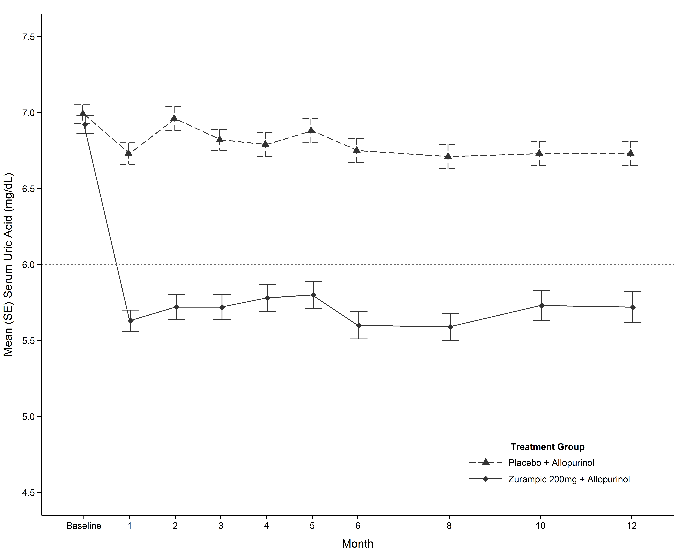
In each of the studies, a greater proportion of patients treated with ZURAMPIC 200 mg in combination with allopurinol compared with placebo in combination with allopurinol achieved a sUA level less than 297 µmol/L (5 mg/dL) by Month 6 (CLEAR1: 29% versus 10%; CLEAR2: 35% versus 5%).
ZURAMPIC in combination with febuxostat in tophaceous gout
In a randomised, double blind, placebo-controlled study 324 patients with tophaceous gout were randomised 1:1:1 to receive lesinurad (200 or 400 mg) or placebo once daily for 12 months in combination with febuxostat 80 mg daily. Sixty-six percent of patients had mild or moderate renal impairment (eCrCL from 30 to 89 mL/min).
The mean (SD) duration since gout diagnosis was 14.70 (10.87) years. Overall, prior urate-lowering therapy (ULT) was low. The mean (SD) sUA level at screening was 8.71 (1.62) mg/dL (518 µmol/L) for total subjects. At baseline (after 21 days of treatment with febuxostat alone), the mean (SD) sUA level had decreased to 5.27 (1.63) mg/dL (313 µmol/L) for all subjects.
The primary efficacy endpoint in CRYSTAL was the proportion of patients achieving a sUA target level of less than 297 µmol/L (5 mg/dL) by Month 6. A greater proportion of patients treated with ZURAMPIC 200 mg in combination with febuxostat had a sUA level less than 297 µmol/L (5 mg/dL) by Month 6 compared with patients receiving placebo in combination with febuxostat (see Table 2).
In the subgroup of patients with a baseline sUA ≥297 µmol/L (5 mg/dL) after 3 weeks of treatment with febuxostat alone (50% patients), a statistically significant difference was achieved at all study visits for ZURAMPIC 200 mg in combination with febuxostat compared with placebo in combination with febuxostat.

Table 2 Proportion of patients who achieve target sUA levels
(<297 µmol/L) (5 mg/dL) with ZURAMPIC in combination with febuxostat
 | Proportion of patients who met sUA target (<297 µmol/L) (5 mg/dL)  N (%) |  | Difference in proportion  (95% C.I.)
All patients
Timepoint | Placebo + febuxostat 80 mg  (N=109) | ZURAMPIC 200 mg + febuxostat 80 mg  (N=106) | ZURAMPIC 200 mg vs placebo
Month 6 | 51 (47%) | 60 (57%) | 0.10  (-0.03, 0.23)
Patients with baseline sUA ≥297 µmol/L (5 mg/dL)
Timepoint | Placebo + febuxostat 80 mg  (N=51) | ZURAMPIC 200 mg + febuxostat 80 mg  (N=59) | ZURAMPIC 200 mg vs placebo
Month 6 | 12 (24%) | 26 (44%) | 0.21  (0.03, 0.38)

Serum uric acid reduction from baseline was observed at Month 1 and was stable for the duration of the 12-month treatment period with ZURAMPIC in combination with febuxostat (see Figure 2).
Figure 2 Mean sUA levels with ZURAMPIC in a febuxostat combination study in tophaceous gout
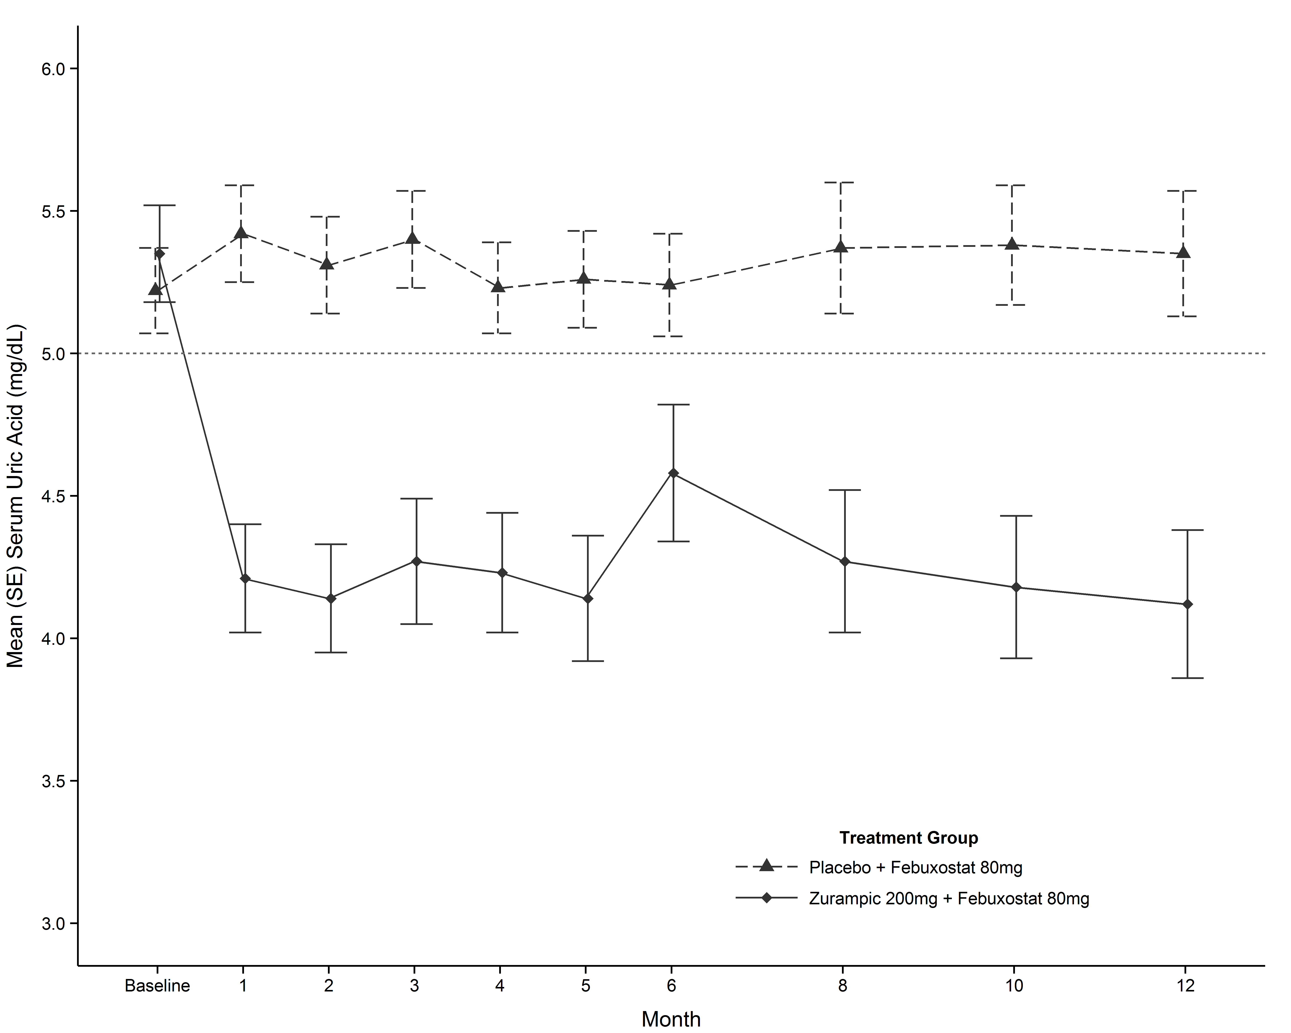
By Month 6, a greater proportion of patients treated with ZURAMPIC 200 mg in combination with febuxostat compared with patients treated with placebo in combination with febuxostat achieved a sUA level less than 238 µmol/L (4 mg/dL) (44% versus 19%) and less than
178 µmol/L (3 mg/dL) (26% versus 2%).
Primary end-point in patients with renal impairment
The efficacy of ZURAMPIC in patients with mild or moderate renal impairment
(eCrCl <90 mL/min) was consistent with the overall population in each of the 3 clinical studies of ZURAMPIC in combination with a xanthine oxidase inhibitor. In CLEAR1 and CLEAR2 combined, the proportion of patients with mild or moderate renal impairment who achieved target sUA levels with ZURAMPIC 200 mg in combination with allopurinol was greater than those on placebo in combination with allopurinol by Month 6 (56% versus 29%) and Month 12 (49% versus 27%). In CRYSTAL, the proportion of patients with mild or moderate renal impairment who achieved target sUA levels (less than 297 µmol/L (5 mg/dL)) with ZURAMPIC 200 mg in combination with febuxostat was greater than those on placebo in combination with febuxostat by Month 6 (55% versus 49%) and Month 12 (54% versus 44%).

Clinical outcomes – gout flares requiring treatment
In CLEAR1 and CLEAR2, the rate of gout flares requiring treatment in the last 6 months of study was a key secondary endpoint. There was no statistical difference between ZURAMPIC 200 mg in combination with allopurinol and placebo in combination with allopurinol.
Clinical outcomes – tophus resolution and reduction
In CLEAR1, CLEAR2, and CRYSTAL, the proportion of patients with complete resolution of at least 1 target tophus was a key secondary endpoint. The proportion of patients with complete or partial resolution was an additional key secondary endpoint in CRYSTAL. There was no statistical difference favoring ZURAMPIC combination therapy compared with allopurinol or febuxostat alone for any of these endpoints.
ZURAMPIC 200 mg in combination with febuxostat resulted in greater tophus burden reduction as measured by target tophi area compared to those patients treated with placebo in combination with febuxostat (p<0.05 at Month 12) (see Figure 3).
Figure 3 Percent change in target tophus area from baseline to Months 3, 6, 9, and 12, in a ZURAMPIC and febuxostat combination study in tophaceous gout
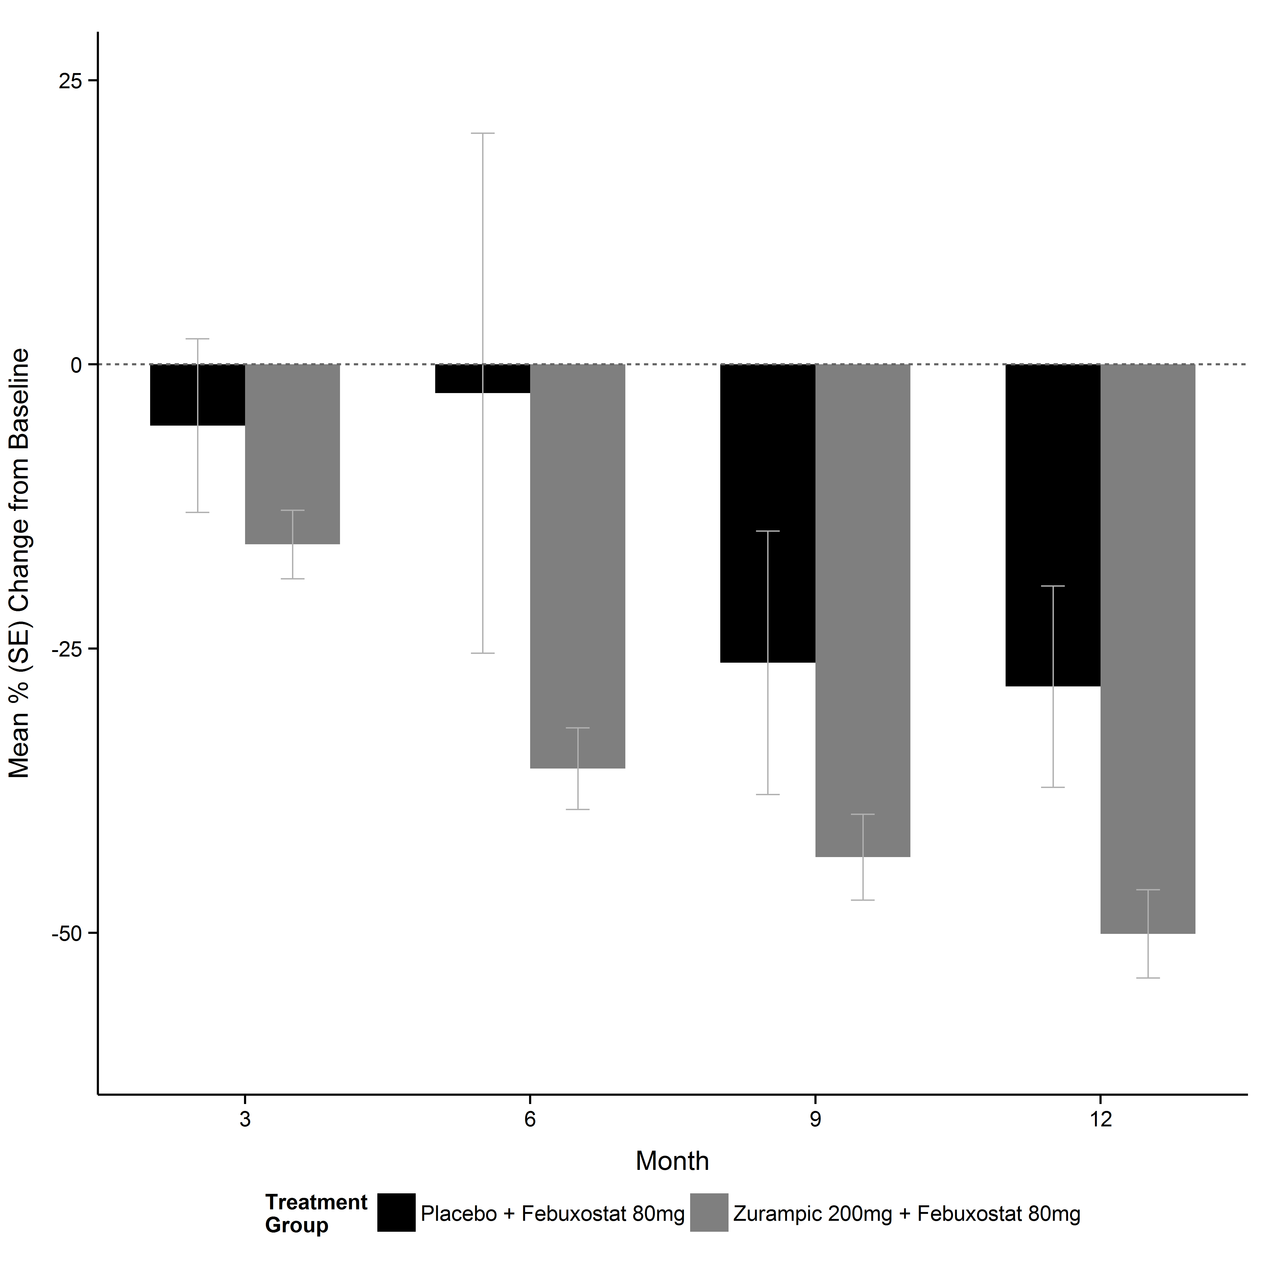
Across the 3 studies of ZURAMPIC in combination with a xanthine oxidase inhibitor, lower median sUA levels were associated with greater percent reductions in total tophus area.

INDICATIONS
ZURAMPIC is indicated in combination with a xanthine oxidase inhibitor for the treatment of hyperuricaemia associated with gout in patients who have not achieved target serum uric acid levels with an adequate dose of a xanthine oxidase inhibitor alone.

CONTRAINDICATIONS
ZURAMPIC is contraindicated for use by any patient with a known serious hypersensitivity to this product, including its excipients.
ZURAMPIC is contraindicated in patients with tumour lysis syndrome or Lesch-Nyhan syndrome.
ZURAMPIC is contraindicated in patients with severe renal impairment (CrCL <30 mL/min), end stage renal disease, a kidney transplant, or in patients on dialysis (see DOSAGE AND ADMINISTRATION).

precautions

Renal events
Acute renal failure has occurred with ZURAMPIC and was more common when ZURAMPIC was given alone.
ZURAMPIC must not be given as monotherapy. A higher incidence of serum creatinine (sCr) elevations and renal-related adverse reactions including serious adverse reactions (e.g. acute renal failure) was observed with ZURAMPIC 400 mg (twice the maximum daily dose) when given alone or in combination with a xanthine oxidase inhibitor, with the highest incidence when ZURAMPIC 400 mg was given as monotherapy. This effect is likely due to the increased amount of uric acid being handled and excreted by the kidney. If while taking ZURAMPIC a patient experiences signs or symptoms suggestive of acute renal failure (reduced urinary output, generally feeling unwell, fatigue, nausea, vomiting, metallic taste, loss of appetite) or nephrolithiasis (flank pain, hematuria) renal function should be assessed.
Treatment with ZURAMPIC 200 mg in combination with a xanthine oxidase inhibitor was associated with an increased incidence of transient sCr elevations. There was no association between baseline renal function and the incidence of these sCr elevations. Adverse reactions related to renal function can occur after initiating ZURAMPIC (see ADVERSE EFFECTS).
ZURAMPIC should not be initiated in patients with CrCL <45 mL/min.
Renal function should be evaluated prior to initiation of ZURAMPIC and periodically thereafter. Interruption of ZURAMPIC should be considered if sCr is elevated to greater than 2 times the pre-treatment value. Interrupt treatment in patients who report symptoms that may indicate acute uric acid nephropathy including flank pain, nausea or vomiting, and measure sCr promptly. ZURAMPIC may be resumed when sCr returns to pre-treatment levels.

Nephrolithiasis
As ZURAMPIC increases the amount of uric acid excreted in urine it may be associated with an increased risk of nephrolithiasis.

Gout attacks (gout flares)
Gout flares may occur after initiation of urate lowering therapy, including therapy with ZURAMPIC. This is due to reduction in sUA levels resulting in mobilisation of urate from tissue deposits. Gout flare prophylaxis with colchicine or an NSAID is recommended for at least 5 months when starting ZURAMPIC therapy (see DOSAGE AND ADMINSTRATION).
ZURAMPIC does not need to be discontinued because of a gout flare. The gout flare should be managed concurrently as appropriate for the individual patient. Continuous treatment with ZURAMPIC decreases the frequency of gout flares. ZURAMPIC has not been demonstrated to reduce the incidence of gout flares in the first 12 months of treatment compared with a xanthine oxidase inhibitor alone.

Cardiovascular events
In clinical studies, major adverse cardiovascular events (defined as cardiovascular deaths, non-fatal myocardial infarctions, or non-fatal strokes) were observed with ZURAMPIC. A causal relationship with ZURAMPIC has not been established.

Effects on fertility
The effect of lesinurad on fertility in humans has not been studied. In rats, there was no effect on mating or fertility with lesinurad. Lesinurad at oral doses up to 300 mg/kg per day (approximately 36 times the human plasma exposure) had no effect on fertility and reproductive performance of male and female rats.

Use in pregnancy – Category B1
There are no data from the use of ZURAMPIC in pregnant women. There was no evidence of teratogenicity or direct embryo-fetal toxicity in rats or rabbits following maternal dosing of lesinurad during the period of organogenesis at oral doses of up to 300 mg/kg per day (rat) and 25 mg/kg per day (rabbit). This corresponds to approximately 49 and 4 times the human plasma exposure, respectively. Decreased embryo-fetal survival occurred only in association with maternal toxicity.

As a precautionary measure, it is preferable to avoid the use of ZURAMPIC during pregnancy.

Use in lactation
Available pharmacodynamic/toxicological data in rats have shown excretion of lesinurad in milk. Lesinurad administration to rats during pregnancy and lactation at doses of 200 mg/kg/day (18 times the human plasma exposure) had adverse effects on pup survival, suckling, growth and development secondary to maternal toxicity. A risk to the newborns/infants cannot be excluded. ZURAMPIC should not be used during breast-feeding.

Paediatric use
The safety and efficacy of ZURAMPIC in children and adolescents under 18 years of age has not been established. No data are available.

Use in the elderly
Based on population pharmacokinetic analysis, age does not have a clinically meaningful effect on the pharmacokinetics of lesinurad and no dose adjustment is necessary based on age.

Genotoxicity
Lesinurad was negative in the in vitro Ames assay and chromosomal aberration test in Chinese hamster ovary (CHO) cells, and in vivo micronucleus assay in rat bone marrow. Nonclinical data reveal no special hazard for humans based on conventional studies of genotoxicity.

Carcinogenicity
There was no evidence of carcinogenicity when lesinurad was administered to rats for two years or TgrasH2 mice for 26 weeks. The doses in rats were up to 200 mg/kg/day (35 times the human plasma exposure). In male and female mice doses were up to 125 and 250 mg/kg/day (33 and 63 times the human plasma exposure), respectively.

INTERACTIONS WITH OTHER MEDICINES
Based on drug interaction studies in healthy subjects or gout patients, ZURAMPIC does not have clinically significant interactions with colchicine, naproxen, indomethacin, atorvastatin, warfarin, repaglinide or tolbutamide.

CYP2C9 inhibitors, CYP2C9 poor metabolisers, and CYP2C9 inducers
Lesinurad exposure is increased when ZURAMPIC is co-administered with inhibitors of CYP2C9, and in CYP2C9 poor metabolisers. ZURAMPIC should be used with caution in patients taking moderate inhibitors of CYP2C9 (e.g. fluconazole, amiodarone) and in CYP2C9 poor metabolisers.
Lesinurad exposure is decreased when ZURAMPIC is co-administered with moderate inducers of CYP2C9 (e.g. rifampicin, carbamazepine), which may decrease the therapeutic effect of ZURAMPIC (see Table 3).
Table 3 Effects of concomitant medications on the pharmacokinetics of lesinurad
Co-administered medications | Lesinurad dose | Fold change and 90% CI |  | Recommendation
Co-administered medications | Lesinurad dose | C_{max} | AUC | Recommendation
CYP2C9 inhibitor
Fluconazole 200 mg qd | 400 mg | 1.38  (1.20-1.58) | 1.56  (1.41-1.73) | Caution with moderate inhibitors of CYP2C9
CYP2C9 inducer
Rifampicin 600 mg qd | 400 mg | 0.761  (0.696-0.833) | 0.624  (0.578-0.672) | Monitor for potential reduction in efficacy
Abbreviations: AUC, area under the concentration-time curve; CI, confidence interval; C_{max}, maximum observed concentration; qd, once daily.

CYP3A substrates
In interaction studies conducted in healthy subjects with ZURAMPIC and CYP3A substrates, lesinurad reduced the plasma concentrations of sildenafil and amlodipine. Although there was not a clinically significant interaction with atorvastatin, HMG-CoA reductase inhibitors that are sensitive CYP3A substrates may be affected. The possibility of reduced efficacy of concomitant drugs that are CYP3A substrates should be considered and their efficacy (e.g. blood pressure and cholesterol levels) should be monitored (see Table 4).
Table 4 Effects of lesinurad on the pharmacokinetics of concomitant medications
Co-administered medications | Lesinurad dose | Fold change and 90% CI |  | Recommendation
Co-administered medications | Lesinurad dose | C_{max} | AUC | Recommendation
CYP3A substrates
Sildenafil | 200 mg | 0.661  (0.453-0.965) | 0.664  (0.559-0.788) | Monitor for potential reduction in efficacy
Amlodipine | 400 mg | 0.604  (0.553-0.660) | 0.575  (0.525-0.631) | Monitor for potential reduction in efficacy
Abbreviations: AUC, area under the concentration-time curve; CI, confidence interval; C_{max}, maximum observed concentration; qd, once daily.

Epoxide hydrolase inhibitors
In vitro studies suggest that lesinurad is not an inhibitor of epoxide hydrolase; however, inhibitors of epoxide hydrolase (e.g. sodium valproate) may interfere with metabolism of lesinurad. ZURAMPIC should not be administered with inhibitors of epoxide hydrolase.

Salicylates
ZURAMPIC with allopurinol was as effective in reducing sUA to target levels in patients taking low dose aspirin to a similar extent as in the general population. Salicylates at doses higher than 325 mg per day may decrease the sUA lowering activity of lesinurad in combination with allopurinol. There are no restrictions for doses of salicylates of 325 mg or less per day (i.e. for cardiovascular protection).

Hormonal contraceptives
Hormonal contraceptives, including oral, injectable, transdermal, and implantable forms, may not be reliable when ZURAMPIC is co-administered. Females should practice additional methods of contraception and not rely on hormonal contraception alone when taking ZURAMPIC.

Thiazide diuretics
Thiazide diuretics are known to increase sUA levels. Consistent sUA lowering was observed in patients who were receiving thiazide diuretics in the placebo-controlled clinical studies in combination with allopurinol or febuxostat.

Indomethacin
ZURAMPIC increases exposure to indomethacin by about 30%. Increased adverse effects may result requiring reduction in the dose of indomethacin.

ADVERSE EFFECTS
The safety of ZURAMPIC was evaluated in 1,331 patients receiving ZURAMPIC 200 mg or 400 mg in combination with a xanthine oxidase inhibitor, allopurinol or febuxostat, and is based on data from three clinical studies with a median treatment duration of 11.3 months. In addition, safety was evaluated in a 6-month monotherapy study of ZURAMPIC 400 mg (see PRECAUTIONS and DOSAGE AND ADMINSTRATION).
ZURAMPIC 200 mg in combination with a xanthine oxidase inhibitor was generally well tolerated. The most commonly reported Adverse Drug Reactions (ADRs) with ZURAMPIC (≥5%) were headache and influenza.
Although other doses have been studied, the recommended dose of ZURAMPIC is 200 mg once daily. Table 3 summarises ADRs identified in clinical studies with patients receiving ZURAMPIC 200 mg once daily in combination with allopurinol at doses from 200 mg to 900 mg daily or febuxostat at a dose of 80 mg once daily.
Table 3 Adverse events occurring in ≥2% of ZURAMPIC 200 mg treated patients and at least 1% greater than seen in patients receiving placebo in controlled studies in combination with a xanthine oxidase inhibitor (XOI)
Adverse event | Placebo + XOI  (N=516) | ZURAMPIC 200 mg + XOI  (N=511)
Headache | 4.1% | 5.3%
Influenza | 2.7% | 5.1%
Blood creatinine increase | 2.3% | 4.3%
Gastro-oesophageal reflux disease | 0.8% | 2.7%

Renal events
ZURAMPIC causes an increase in renal uric acid excretion, which may lead to transient increases in serum creatinine, renal-related adverse reactions and kidney stones. In three 12-month placebo-controlled studies of ZURAMPIC in combination with a xanthine oxidase inhibitor versus a xanthine oxidase inhibitor alone (placebo), sCr elevations 2-fold or greater over baseline occurred in 1.8% of patients on ZURAMPIC 200 mg, 6.7% of patients on ZURAMPIC 400 mg and 0% on placebo. These sCr elevations generally resolved, most without treatment interruption.
As ZURAMPIC increases the amount of uric acid excreted in urine, it may be associated with an increased risk of nephrolithiasis. Patients with a history of kidney stones were permitted entry into the 12-month studies of lesinurad in combination with a xanthine oxidase inhibitor. In these studies, kidney stone-related adverse reactions (nephrolithiasis being the most frequent) were reported in patients treated with ZURAMPIC 200 mg (0.6%), ZURAMPIC
400 mg (2.5%), and placebo (1.7%).

Cardiovascular safety
Cardiovascular events and deaths were adjudicated as major adverse cardiovascular events (cardiovascular death, non-fatal myocardial infarction, and non-fatal stroke) in the Phase 3 randomised controlled studies of ZURAMPIC. In the randomised controlled studies, the numbers of patients with adjudicated MACE events (incidences per 100 patient-years of exposure) were: 3 (0.71) for placebo, 4 (0.96) for ZURAMPIC 200 mg, and 8 (1.94) for ZURAMPIC 400 mg when used in combination with a xanthine oxidase inhibitor.

Monotherapy
In a 6-month double-blind, placebo-controlled monotherapy study, renal failure (9.3%), blood creatinine increased (8.4%), and nephrolithiasis (0.9%) were reported in patients receiving ZURAMPIC 400 mg alone and in no patients receiving placebo. Serum creatinine elevations 1.5-fold or greater occurred in 24.3% of patients receiving ZURAMPIC 400 mg and in no patients receiving placebo.

DOSAGE AND ADMINISTRATION
ZURAMPIC tablets are for oral use and should be co-administered with a xanthine oxidase inhibitor, including allopurinol or febuxostat.
ZURAMPIC is recommended at 200 mg once daily. This is also the maximum daily dose. ZURAMPIC should be taken by mouth, in the morning with food and water.
ZURAMPIC may be added when target serum uric acids levels are not achieved on the medically appropriate dose of the xanthine oxidase inhibitor alone.
ZURAMPIC is not recommended for patients taking daily doses of allopurinol less than
300 mg (or less than 200 mg in patients with eCrCL <60 mL/min).
Take ZURAMPIC at the same time as the morning dose of xanthine oxidase inhibitor. If treatment with the xanthine oxidase inhibitor is interrupted, ZURAMPIC should also be interrupted. Failure to follow these instructions may increase the risk of renal events (see PRECAUTIONS).
Patients should be instructed to stay well hydrated (e.g. 2 L of liquid per day).

Special populations

Paediatric population
Safety and efficacy of ZURAMPIC have not been established in paediatric patients.

Use in the elderly
No dose adjustment of ZURAMPIC is necessary based on age (see Pharmacokinetics).

Dosage in patients with renal impairment
No dose adjustment is necessary in patients with mild or moderate renal impairment. No overall differences in safety and effectiveness were observed in patients with mild or moderate renal impairment (CrCL of 30-89 mL/min) compared to patients with normal renal function (see Pharmacokinetics).
ZURAMPIC is contraindicated in patients with severe renal impairment
(CrCL <30 mL/min), end stage renal disease, a kidney transplant, or on dialysis (see CONTRAINDICATIONS).
ZURAMPIC is not recommended for patients with CrCL <45 mL/min due to limited data in this population.

Dosage in patients with hepatic impairment
No dose adjustment is necessary in patients with mild or moderate hepatic impairment (Child-Pugh classes A and B) (see Pharmacokinetics). ZURAMPIC has not been studied in patients with severe hepatic impairment.

Secondary hyperuricaemia
No studies have been conducted in patients with secondary hyperuricaemia (including organ transplant recipients).

OVERDOSAGE
Lesinurad was studied in healthy subjects given single doses up to 1,600 mg without evidence of dose-limiting toxicities. Chronic dosing with doses of 400 mg per day or greater was associated with an increased risk of renal toxicity. In case of overdose, patients should be managed by symptomatic and supportive care including adequate hydration.
Contact the Poisons Information Centre on 13 11 26 for advice on management.

PRESENTATION AND STORAGE CONDITIONS
ZURAMPIC 200mg tablets are blue, oval, film-coated tablets in PCTFE/PVC/Aluminium blisters in pack sizes of 10 and 30 tablets.
ZURAMPIC tablets are debossed with “LES200” on one side and are blank on the other side.
The tablets should be stored below 30°C.

NAME AND ADDRESS OF THE SPONSOR
AstraZeneca Pty Ltd
ABN 54 009 682 311
Alma Road
NORTH RYDE NSW 2113

POISON SCHEDULE OF THE MEDICINE
Schedule 4 – Prescription Only Medicine

DATE OF first inclusion in the australian register of therapeutic goods (THE ARTG)
1 June 2016

date of MOST RECENT amendment
N/A
ZURAMPIC® is a registered trade mark of the AstraZeneca group of companies.
© AstraZeneca 2016

