January 2017

Australian Public Assessment Report for Kaldyeco
  - Proprietary Product Name: Ivacaftor
  - Sponsor: Vertex Pharmaceuticals Australia

About the Therapeutic Goods Administration (TGA)
- The Therapeutic Goods Administration (TGA) is part of the Australian Government Department of Health and is responsible for regulating medicines and medical devices.
- The TGA administers the Therapeutic Goods Act 1989 (the Act), applying a risk management approach designed to ensure therapeutic goods supplied in Australia meet acceptable standards of quality, safety and efficacy (performance) when necessary.
- The work of the TGA is based on applying scientific and clinical expertise to decision-making, to ensure that the benefits to consumers outweigh any risks associated with the use of medicines and medical devices.
- The TGA relies on the public, healthcare professionals and industry to report problems with medicines or medical devices. TGA investigates reports received by it to determine any necessary regulatory action.
- To report a problem with a medicine or medical device, please see the information on the TGA website <https://www.tga.gov.au>.
About AusPARs
- An Australian Public Assessment Report (AusPAR) provides information about the evaluation of a prescription medicine and the considerations that led the TGA to approve or not approve a prescription medicine submission.
- AusPARs are prepared and published by the TGA.
- An AusPAR is prepared for submissions that relate to new chemical entities, generic medicines, major variations and extensions of indications.
- An AusPAR is a static document; it provides information that relates to a submission at a particular point in time.
- A new AusPAR will be developed to reflect changes to indications and/or major variations to a prescription medicine subject to evaluation by the TGA.
Copyright
© Commonwealth of Australia 2016
This work is copyright. You may reproduce the whole or part of this work in unaltered form for your own personal use or, if you are part of an organisation, for internal use within your organisation, but only if you or your organisation do not use the reproduction for any commercial purpose and retain this copyright notice and all disclaimer notices as part of that reproduction. Apart from rights to use as permitted by the Copyright Act 1968 or allowed by this copyright notice, all other rights are reserved and you are not allowed to reproduce the whole or any part of this work in any way (electronic or otherwise) without first being given specific written permission from the Commonwealth to do so. Requests and inquiries concerning reproduction and rights are to be sent to the TGA Copyright Officer, Therapeutic Goods Administration, PO Box 100, Woden ACT 2606 or emailed to <tga.copyright@tga.gov.au>.

Contents
Common abbreviations 5
I. Introduction to product submission 10
Submission details 10
Product background 10
Regulatory status 11
Product Information 12
II. Quality findings 12
III. Nonclinical findings 12
Introduction 12
Pharmacology 12
Nonclinical summary and conclusions 14
IV. Clinical findings 14
Introduction 14
Pharmacokinetics 17
Pharmacodynamics 18
Dosage selection for the pivotal studies 18
Efficacy 19
Safety 21
First round benefit-risk assessment 23
First round recommendation regarding authorisation 26
Clinical questions 26
Second round evaluation of clinical data submitted in response to questions 27
Second round benefit-risk assessment 27
V. Pharmacovigilance findings 28
Risk management plan (RMP) 28
VI. Overall conclusion and risk/benefit assessment 37
Quality 38
Nonclinical 38
Clinical 38
Safety 44
Risk management plan 45
Risk-benefit analysis 45
Outcome 52
Attachment 1. Product Information 52
Attachment 2. Extract from the Clinical Evaluation Report 52

Common abbreviations
Abbreviation | Meaning
ADR | adverse drug reaction
AE | adverse event
ALT | alanine aminotransferase
AST | aspartate aminotransferase
AUC | area under the concentration-time curve
AUCτ | area under the concentration versus time curve for the dosing interval
AusPAR | Australian Public Assessment Reports
bid | twice daily
BMI | body mass index
CCS | complete case set
CF | cystic fibrosis
CFF | Cystic Fibrosis Foundation (US)
CFQ-R | Cystic Fibrosis Questionnaire-Revised
CFQ-R RSS | CFQ-R respiratory symptoms scale
CFTR | Cystic fibrosis transmembrane conductance regulator
CHMP | Committee for Medicinal Products for Human Use (EMA)
CI | confidence interval
CL/F | apparent (oral) clearance
CMI | Consumer Medicines Information
C_{min} | minimum observed concentration
CV% | coefficient of variation percentage
D | Day
D1 | zero order dose duration
DIOS | distal ileal obstruction syndrome
ECG | electrocardiogram
EMA | European Medicines Agency
EU | European Union
F508del or F508del-CFTR | CFTR gene mutation with an in-frame deletion of a phenylalanine codon corresponding to position 508 of the wild-type protein
FAS | full analysis set
FDA | Food and Drug Administration (US)
FEV₁ | forced expiratory volume in 1 second
GGT | Gamma glutamyl transpeptidase
G1244E CFTR | missense gene mutation that results in the replacement of a glycine residue at position 1244 of CFTR with a glutamic acid residue
G1349D CFTR | missense gene mutation that results in the replacement of a glycine residue at position 1349 of CFTR with an aspartic acid residue
G178R CFTR | missense gene mutation that results in the replacement of a glycine residue at position 178 of CFTR with an arginine residue
G551D or G551D CFTR | CFTR missense gene mutation that results in the replacement of a glycine residue at position 551 of CFTR with an aspartic acid residue
G551S CFTR | missense gene mutation that results in the replacement of a glycine residue at position 551 of CFTR with a serine residue
G970R CFTR | missense gene mutation that results in the replacement of a glycine residue at position 970 of CFTR with an arginine residue
h | hour/s
IL-8 | interleukin-8
IRT | Immunoreactive trypsinogen
Ivacaftor | KALYDECO/ VX-770/VRT-813077
LTSS | Long‐term safety study
K_{a} | first-order absorption rate
M1 | hydroxymethyl-ivacaftor
M6 | ivacaftor carboxylate
MCID | minimal clinically important difference
MMRM | mixed-effects model for repeated measures
NA | not available
NR | not reported
P aeruginosa | Pseudomonas aeruginosa
PD | pharmacodynamic(s)
PI | Product Information
PK | pharmacokinetic(s)
PopPK | population pharmacokinetics
pp | percentage point
ppFEV₁ | percent predicted forced expiratory volume in 1 second
PPS | per perotocol set
PSUR | Periodic Safety Update Report
PT | preferred term
Q/F | inter-compartmental clearance
q12h | every 12 hours
qd | once daily
QTc | QT interval corrected for heart rate according to Fridericia’s formula
QTcB | QT interval corrected for heart rate according to Fridericia’s formula
QTcF | QT interval corrected for heart rate according to Fridericia’s formula
R | regulatory domain
R117C or R117C CFTR | a missense mutation that results in the replacement of an arginine residue at position 117of CFTR with a cysteine residue
R117H or R117H CFTR | a missense mutation that results in the replacement of an arginine residue at position 117of CFTR with a histidine residue
R117H-5T CFTR | allele with both an R117H mutation and a 5T poly-T variant
R117H-7T CFTR | allele with both an R117H mutation and a 7T poly-T variant
R117H-9T CFTR | allele with both an R117H mutation and a 9T poly-T variant
S1251N CFTR | missense gene mutation that results in the replacement of a serine residue at position 1251 of CFTR with an asparagine residue
S1255P CFTR | missense gene mutation that results in the replacement of a serine residue at position 1255 of CFTR with a proline residue
S549N CFTR | missense gene mutation that results in the replacement of a serine residue at position 549 of CFTR with an asparagine residue
S549R CFTR | missense gene mutation that results in the replacement of a serine residue at position 549 of CFTR with an arginine residue
SAE | serious adverse event
SD | standard deviation
SEM | standard error of the mean
SS | safety set
UK | United Kingdom
ULN | upper limit of normal
URTI | upper respiratory tract infection
US | United States
USPI | US Prescribing Information
Vc/F | central volume of distribution
Vertex | Vertex Pharmaceuticals Incorporated
Vp/F | peripheral volume of distribution
W | week

I. Introduction to product submission

Submission details
Type of submission: | Extension of indications
Decision: | Approved
Date of decision: | 5/February/2016
Date of entry onto ARTG | 29/March/2016
Active ingredient(s): | Ivacaftor
Product name(s): | KALDYECO
Sponsor’s name and address: | Vertex Pharmaceuticals Australia Pty Ltd  101 Miller street, North Sydney NSW 2060
Dose form | Film-coated tablet
Strength(s): | 150 mg
Container(s): | Blister pack and bottle
Pack size(s): | 56
Approved therapeutic use: | KALYDECO is indicated for the treatment of cystic fibrosis (CF) in patients aged 6 years and older who have an R117H mutation in the CFTR gene.
Route(s) of administration: | PO
Dosage: | The recommended dose for adults and paediatric patients is 150 mg taken orally every 12 h (300 mg total daily dose).
ARTG number (s): | 198654, 198655, 235759, 267390, 269661

Product background
This AusPAR describes the application by the Vertex Pharmaceuticals to register ivacaftor (Kaldyeco) for the following indication:
Kaldyeco is indicated for the treatment of cystic fibrosis (CF) in patients age 18 years and older who have an R117H mutation in the CFTR gene
Ivacaftor is an orally bioavailable small molecule that targets the underlying defect in CF and represents the first in a new class of drugs, known as CF transmembrane conductance regulator (CFTR) modulators, that provide a new therapeutic approach to the treatment of CF by restoring the function of the CFTR protein. Ivacaftor is highly selective for CFTR protein in vitro and acts on the CFTR protein to enhance chloride transport by increasing the channel open probability.
Ivacaftor is currently indicated for the treatment of CF in patients age 6 years and older who have a G551D mutation in the CFTR gene.
CF is an autosomal recessive disease with serious, chronically debilitating morbidities and high premature mortality and no cure is available at present. CF affects approximately 70,000 individuals worldwide and is more common in the Caucasian populations of North America and Europe than in Asian and African populations. Approximately, 3,100 individuals in Australia have CF.
CF is caused by mutations in the CFTR gene that result in absent or deficient function of the CFTR protein at the cell surface. The CFTR protein is an epithelial chloride channel responsible for aiding in the regulation of salt and water absorption and secretion. CFTR protein is located in the apical membrane of epithelial cells in multiple organs, including lungs, pancreas, intestinal tract, biliary tract, sweat glands and vas deferens. The failure to regulate chloride transport in these organs results in the multisystem pathology associated with CF. Elevated sweat chloride concentrations are a hallmark of CF and is used for diagnostic purposes; sweat chloride concentrations ≥ 60 mmol/L is considered indicative of CF, whereas a sweat chloride concentration < 39 mmol/L is considered normal; intermediate sweat chloride values in the range of 40 to 59 mmol/L are also observed in patients with CF.

Regulatory status
The product received initial registration on the Australian Register of Therapeutic Goods (ARTG) on 9/July/2013.
At the time the TGA considered this application, a similar application had been approved in the European Union (EU) in November, 2015 for the:
Treatment of patients with Cystic Fibrosis (CF) aged 18 years and older who have an R117H mutation in the CFTR gene.
Dates of approval in EU, US and Canada are included in Table 1.

Table 1: Dates of approval in the EU, US and Canada
Country |  | Approval date | Approved indication
Europe (EU) | 16 November 2015 |  | Treatment of patients with Cystic Fibrosis (CF) aged 18 years and older who have an R117H mutation in the CFTR gene.
USA (FDA) | 29 December 2014 |  | Treatment of cystic fibrosis (CF) in patients age 6 years and older who have an R117H mutation in the CFTR gene.
Canada | 13 March 2015 |  | Treatment of cystic fibrosis in patients age 18 years and older with an R117H mutation in the CFTR gene

Product Information
The Product Information (PI) approved with the submission which is described in this AusPAR can be found as Attachment 1. For the most recent PI, please refer to the TGA website at <https://www.tga.gov.au/product-information-pi>.

II. Quality findings
There was no requirement for a quality evaluation in a submission of this type.

III. Nonclinical findings

Introduction
One new primary pharmacology study was submitted and is evaluated. Relevant information contained in the two primary pharmacology studies evaluated in the original application to register ivacaftor as a new chemical entity (Submission No. PM-2012-01491-3-5) were considered.

Pharmacology
Mutations of the CFTR gene are classified by their functional consequence. Class I and II mutations affect protein production and processing, and lead to little or no CFTR protein on the cell surface. Class V mutations reduce the amount of protein,- but the protein itself is normal. Class III mutations affect the gating of the CFTR protein, reducing the time the ion channel is open and thereby decreasing chloride transport. Class IV mutations reduce the conductance of the ion channel thereby leading to defective chloride transport.
The R117H mutation of CFTR is classified as both a Class III and Class IV mutation, as both gating and conductance are decreased in comparison to normal CFTR. The data provided by the sponsor indicated a more marked effect of the R117H mutation on gating compared to conductance (78% compared to 12% impairment of normal activity, respectively).
Ivacaftor increased total chloride transport in Fischer rat thyroid cells expressing R117H-CFTR with an 50% effective dose (EC₅₀) of 82 to 151 nM. The increase in total chloride transport was due to an increase in the open probability of the channel gate (from 22% to 42% of normal in the presence of 3 μM ivacaftor). There was no effect of ivacaftor on conductance (current amplitude). In the presence of ivacaftor (3 μM), total chloride transport by R117H-CFTR was increased from 26% of that of normal CFTR to 38% (statistically significant). In cells expressing the G551D mutant form of CFTR, ivacaftor increased chloride transport with EC50 values ranging from 36 to 312 nM, with total chloride transport increased from 5% of normal CFTR to 48%.
The in vitro studies support the use of ivacaftor in CF patients bearing a R117H mutation of CFTR and indicate that the mechanism of action is by increasing the open-probability of the ion channel. Ivacaftor appeared to have similar potency in increasing chloride transport by R117H- and G551DCFTR mutants.
The sponsor has proposed several modifications and corrections to the draft Product Information (PI).
Comment: A separate submission to update the PI has recently been considered by the TGA. The sponsor should ensure the recommended changes for exposure ratios in the effects on fertility, use in pregnancy, paediatric use and carcinogenicity sections are incorporated here.

Study K139
Normal, R117H and G551D variants of the CFTR gene were expressed in Fischer rat thyroid (FRT) cells. Single-channel gating activity (as open probability) and conductance (as current amplitude) were then measured using single-channel patch-clamp electrophysiology (3 to 5 replicates). For gating and conductance experiments, CFTR was activated by 75 nM protein kinase A in the presence of 1 mM ATP. Forskolin (10 μM) was used to investigate the effects of the mutations and/or ivacaftor on total chloride transport. Ivacaftor (3 μM) was added during the recordings.
Ivacaftor increased the open probability in FRT cells expressing R117H-CFTR leading to an increase in total chloride transport. There was no effect on conductance (Table 2 and Figure 1).

Table 2: Relative effects of CFTR mutations and ivacaftor on CFTR function in Fischer rat thyroid cells
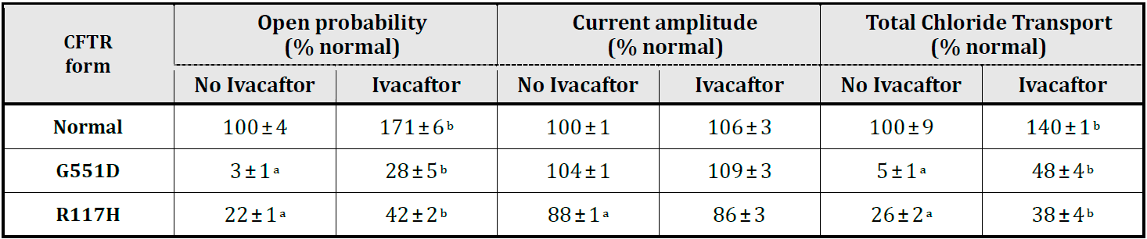
Data are presented as mean± SEM; a: statistically significant (P < 0.001) compared to normal CFTR; b: statistically significant (P < 0.05) compared to no ivacaftor
Figure 1: Single-channel gating activity and conductance in normal and mutant CFTR forms in the presence and absence of ivacaftor
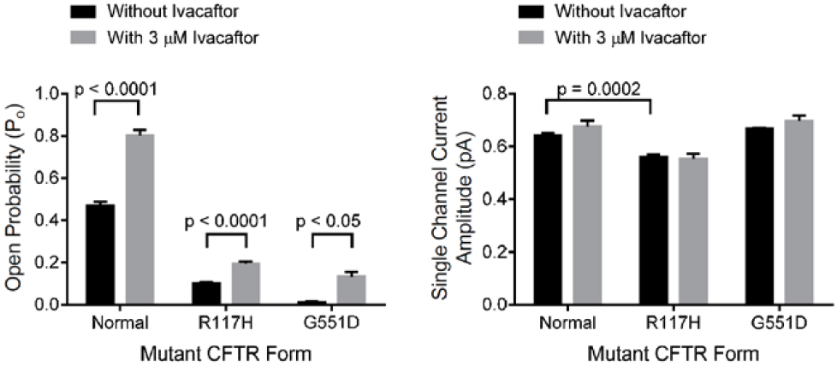

Studies C166 and G205
These studies were evaluated in a previous submission.

Nonclinical summary and conclusions
The nonclinical submission contained one new primary pharmacology study. Two previously submitted pharmacology studies (from the original application to register ivacaftor as a new chemical entity) also contained relevant data.
The R117H mutation affects both gating and conductance of the CFTR protein, leading to decreased total chloride transport.
Ivacaftor was shown to increase chloride transport by the R117H mutant form of CFTR by almost 50% (from a background of 26% of that of normal CFTR to 38%) in in vitro experiments with transfected cells. The drug increased the open-probability of the ion channel (gating) of R117HCFTR without affecting chloride ion conductance. The EC₅₀ value for the increase in chloride transport was comparable to that previously reported for ivacaftor at the G551D mutant form of CFTR.
The nonclinical data support the extension of indication in the proposed patient group.
The evaluator recommended amendments to the draft Product Information but these are beyond the scope of this AusPAR.

IV. Clinical findings

Introduction
This is a submission to:
- extend indications for ivacaftor for an additional subset of cystic fibrosis (CF) patients.
The following dosage forms and strengths are currently registered:
Ivacaftor (Kaldyeco) film-coated tablets are supplied as light blue, capsule-shaped tablets (16.5 mm x 8.4 mm in modified caplet shape) containing 150 mg of ivacaftor. Each tablet is printed with 'V 150' in black ink on one side only. Kaldyeco tablets are packaged in a blister pack or a child-resistant bottle with desiccant. The following pack sizes are available: blister pack containing 56 film-coated tablets, bottle containing 56 film-coated tablets.
The currently approved indication is:
‘Kaldyeco is indicated for the treatment of cystic fibrosis (CF) in patients aged 6 years and older who have a G551D or other gating (class III) mutation in the CFTR gene.’
The proposed indication is:
Kaldyeco is indicated for the treatment of cystic fibrosis (CF) in patients:
- Age 6 years and older who have a G551D or other gating (class III) mutation in the CFTR gene.
- Age 6 years and older who have an R117H mutation in the CFTR gene.

Clinical rationale
CF is an autosomal recessive disease with serious, chronically debilitating morbidities and high premature mortality and no cure available at present. CF affects approximately 70,000 individuals worldwide and is more common in the Caucasian populations of North America and Europe than in Asian and African populations. Approximately, 3,100 individuals in Australia have CF.
CF is caused by mutations in the CF transmembrane conductance regulator (CFTR) gene that result in absent or deficient function of the CFTR protein at the cell surface. The CFTR protein is an epithelial chloride channel responsible for aiding in the regulation of salt and water absorption and secretion. CFTR protein is located in the apical membrane of epithelial cells in multiple organs, including lungs, pancreas, intestinal tract, biliary tract, sweat glands and vas deferens. The failure to regulate chloride transport in these organs results in the multisystem pathology associated with CF. Elevated sweat chloride concentrations are a hallmark of CF and is used for diagnostic purposes; sweat chloride concentrations ≥ 60 mmol/L is considered indicative of CF, whereas a sweat chloride concentration < 39 mmol/L is considered normal; intermediate sweat chloride values in the range of 40 to 59 mmol/L are also observed in patients with CF.
More than 1900 mutations in the CFTR gene have been identified which result in reduced quantity of CFTR at the cell surface or reduced CFTR function leading to a decrease in epithelial chloride transport. Reduced CFTR function can be due to defects in channel gating (opening and closing of CFTR channel) or channel conductance (rate of chloride travel through the open channel). As for other ion channels, gating of the CFTR channel is measured by open probability, and conductance of the CFTR channel is measured by current amplitude. By definition, a CFTR form that has lower open probability than normal CFTR has a gating defect. By definition, a CFTR form that has lower current amplitude than normal CFTR has a conductance defect. Some CFTR mutations cause more than 1 type of functional defect (for example, R117H) or reduce both the quantity and function of CFTR (for example, F508del). The amount of chloride transported by CFTR is a function of the quantity of CFTR on the cell surface, the open probability of the CFTR, and the current amplitude of the CFTR. Regardless of the type of defect(s) caused by the CFTR mutation, CF disease severity generally correlates with the severity of the loss of chloride transport.
The R117H-CFTR mutation is present in approximately 2 to 3% of patients with CF. In Europe, North America, and Australia, approximately 1,600 people with CF aged 6 years and older have at least 1 copy of an R117H-CFTR mutation. In the EU, approximately 744 people have the R117H-CFTR mutation, of whom more than half (n = 360) are aged > 18 years (Vertex data on file). In the US, approximately 729 people have the R117H-CFTR mutation, of whom approximately 300 are aged > 18 years (Vertex data on file). The prevalence of the R117H-CFTR mutation in patients with CF in individual countries is presented in the Table 1 in Attachment 2; in Australia only 91 of the 3156 total patients with CF (2.8%) have the R117H-CFTR mutation which is the subject of this submission.
According to data from the US Cystic Fibrosis Foundation (CFF) Registry, there is an evident progression in lung function decline (as measured by percent predicted FEV₁) with age. Among CF patients with an R117H-CFTR mutation who are 19 to 30 years of age, 34% of patients have a percent predicted FEV₁ < 80%, and that number increases to 55% for patients aged more than 30 years (Figure 1 in Attachment 2). A decrease in lung function is also observed over time in these patients, with 90% of patients aged > 18 years having respiratory disease compared with 48% of patients aged 6 to 11 years. Additional Cystic Fibrosis Foundation (CFF) registry data also show a clear progression of CF related symptoms as patients with an R117H-CFTR mutation age; CF related symptoms were observed in 54% and 93% of patients aged 6 to 11 years and > 18 years, respectively (Figure 2 in Attachment 2). Although the R117H-CFTR mutation results in CF disease, the severity of CF per age group is generally less than that caused by the G551D-CFTR mutation or other CFTR mutations associated with a severe phenotype. Many patients with an R117H-CFTR mutation have clinical evidence of preserved pancreatic exocrine function (potentially associated with a better body mass index [BMI]) and sweat chloride in the range of 60 to 80 mmol/L (compared with 90 to 120 mmol/L in patients with the G551D-CFTR mutation or who are homozygous for the F508del-CFTR mutation).
Despite advances in CF treatment, the predicted median age of survival of individuals born today with CF is 41.1 to 48.5 years. Most pharmacologic treatments for CF (including R117H patients) such as dornase alfa, inhaled tobramycin, inhaled aztreonam and exocrine pancreatic enzyme supplementation are focused on managing the downstream consequences of diminished CFTR function: controlling airway infection and inflammation, mobilising secretions to reduce airway obstruction and correcting nutritional deficits caused by pancreatic insufficiency. The increasing availability of therapies to treat CF lung disease, while improving the patients’ survival, has resulted in a high therapeutic burden.
Many individuals with an R117H-CFTR mutation were not diagnosed with CF until the late childhood or adult years, when the disease had progressed and symptoms became much more evident although this has changed recently due to advances in newborn screening for CFTR mutations. Given the unmet medical need of the population of CF patients with an R117H-CFTR mutation, and considering that there is no drug currently approved to treat the underlying cause of CF in this population, there is a substantial need to improve the treatment and outlook for CF patients with this CFTR mutation. These patients demonstrate progression of disease with advancing age and have a decreased life expectancy.
Ivacaftor (KALYDECO) is currently the only approved therapy that targets the molecular defect that underlies the pathophysiology of CF. Ivacaftor is also the only approved therapy for CF that has evaluated safety and efficacy in small subsets of CF patients based on their genetic profile. Ivacaftor is an orally bioavailable small molecule that targets the underlying defect in CF and represents the first in a new class of drugs, known as CFTR modulators, that provide a new therapeutic approach to the treatment of CF by restoring the function of the CFTR protein. As a type of CFTR modulator, ivacaftor restores the function of the CFTR protein. Ivacaftor is highly selective for CFTR protein in vitro and acts on the CFTR protein to enhance chloride transport by increasing the channel open probability.

Contents of the clinical dossier
The submission contained the following clinical information:
- One clinical pharmacology study (VX11-770-110), which provided pharmacokinetic data.
- One population pharmacokinetic analyses (J178).
- Efficacy, safety and PK results from a pivotal, Phase III, placebo controlled, parallel-group, study (Study VXll-770- 110 or Study 110) to evaluate ivacaftor treatment in subjects with CF who have an R117H-CFTR mutation.
  - Efficacy and safety results of an interim analysis of an ongoing, open-label, rollover study (Study VX12-770-112 [Study112]) enrolling subjects from Study 110.
  - Periodic Safety Update Reports (PSURs).
  - There were no pooled analysis, meta-analysis, and integrated summary of efficacy or safety.

Paediatric data
The submission included paediatric pharmacokinetic/pharmacodynamics/efficacy/safety data. The paediatric ages groups evaluated were adolescents (12 to 17years) and children aged 6 to 11 years.

Good clinical practice
All clinical studies were performed in compliance with Good Clinical Practices.

Pharmacokinetics

Studies providing pharmacokinetic data
Table 3 shows the studies providing pharmacokinetic data.

Table 3: Submitted pharmacokinetic studies
PK topic | Subtopic | Study ID | Primary aim of the study
PK in Target populations* | Multi-dose PK | VX11-770-110 | Efficacy, safety and PK in subjects with CF who have the R117H-CFTR mutation
Population PK analyses | Target population* | J178 | Characterise the population pharmacokinetics (popPK) of ivacaftor in subjects with CF and the R117H-CFTR mutation.
* Subjects who would be eligible to receive the drug if approved for the proposed indication.
None of the pharmacokinetic studies had deficiencies that excluded their results from consideration.

Evaluator’s conclusions on pharmacokinetics
The following conclusions relate to the results of the PopPK study J178.
- Ivacaftor is administered orally and its PKs are best fit using a two-compartment model with zero-order delivery to the absorption compartment and subsequent first order absorption.
- For a reference subject (70 kg, male, 18 years, CF subject with non-R117H mutation), the zero-order dose duration (90% CI) was estimated to be 2.96 h (2.88 to 3.17) and the first-order absorption rate constant (k_{a}) was 0.721 h⁻¹ (0.530 to 0.765)
- In subjects with CF with non-R117H mutation, mean ivacaftor minimum observed concentration (C_{min}) ranged from 545 ng/mL to 1190 ng/mL and mean area under the concentration-time curve (AUC) ranged from 8550 ng.h/mL to 18400 ng.h/mL. In subjects with CF who have an R117H-CFTR mutation, the mean ivacaftor C_{min} was 810 ng/mL and AUC was 12100 ng.h/mL.
- The typical central volume of distribution (90% confidence interval[CI]) in a reference subject was 246 L (196 to 254) and the typical peripheral volume of distribution was 150 L (48.1 to 362).
- For a reference subject the apparent (oral) clearance (CL/F) was 18.2 L/h (16.9 to 19.3) and inter-compartmental clearance was 3.09 L/h (1.98 to 14.0). Ivacaftor CL/F was reduced 21% for subjects with the R117H mutation, relative to CF subjects with a gating mutation or homozygous for F508del, with an estimate of 14.3 L/h (12.7 to 16.0).
- It is difficult to judge whether ivacaftor PKs are consistent across both CF populations (that is reference CF subjects and subjects with the R117H mutation) as the reported C_{min} and AUC values from Study 110 fall within the range of values identified in reference CF patients. Based on the decrease in oral clearance identified in subjects with the R117H mutation however, it is possible that AUC and t_{1/2} would be increased in this CF population.
- Inter-individual variabilities on CL/F, central volume and k_{a} were 0.197, 0.143 and 1.11, respectively. Unexplained random variability for CL/F was 46.7 CV%.
- Body weight was the most important predictor of ivacaftor PKs, with a change in ivacaftor CL/F of 39% and 131% for the typical 20 kg and 100 kg subject, when compared to the reference subject.
- Gender and patient status (that is healthy versus CF) did not account for variability in ivacaftor PKs and age was also not a clinically important covariate, after accounting for body size.

Limitations of the PK studies
Lack of a full non-compartmental PK analysis of the results of Study 110 (which examined ivacaftor PKs in CF subjects with the R117H mutation) was considered a limitation.

Questions related to the PK studies
- Can the sponsor please provide the estimates of ivacaftor C_{min} and AUC for Studies 007 and 010, which were undertaken in healthy subjects, as they have done for the studies in patients with CF (Tables 4 and 5 in Attachment 2)?
- As it is difficult to judge whether ivacaftor PKs are consistent across both CF populations (that is reference CF subjects and subjects with the R117H mutation) a full non-compartmental PK analysis of the results of Study 110, which includes typical PK parameters such the time taken to reach the maximum concentration (T_{max}), maximum concentration (C_{max}), AUC, plasma half-life of the drug (t_{1/2}) and so on may help answer this question. Therefore, can the sponsor please provide a full non-compartmental analysis of the ivacaftor PK parameters for Study 110?

Pharmacodynamics
No new studies specifically examined ivacaftor PDs in the current submission.

Dosage selection for the pivotal studies
Studies 102, 103, and 111 evaluated ivacaftor 150 mg every 12h (q12h) which is the recommended ivacaftor (Kaldyeco) dosage for CF patients 6 years of age and older.
Similar PK parameter estimates between healthy subjects and subjects with CF suggested that exposure to ivacaftor in subjects with the R117H-CFTR mutation would be similar to the exposure in subjects with other CFTR mutations. The in vitro potency of ivacaftor towards the R117H mutation relative to other mutations that cause gating defects, as well as the efficacy and safety results obtained in Studies 102, 103, and 111 supported evaluation of 150 mg q12h in Study 110. Hence, the dose of 150 mg q12h, which was well tolerated and resulted in robust treatment effects in subjects with other CFTR mutations that cause gating defects, was chosen for pivotal study 110 in CF patients with R117H-CFTR mutation.

Efficacy

Indication 1
Ivacaftor (Kaldyeco) is indicated for the treatment of cystic fibrosis (CF) in patients: aged 6 years and older who have an R117H mutation in the CFTR gene.
Two clinical studies evaluated the efficacy of ivacaftor in subjects with an R117H-CFTR mutation. Study 110 was a placebo-controlled study and Study 112 is an ongoing open-label rollover study in which subjects from Study 110 could enrol. Results of the final analysis of Study 110 and interim analysis of Study 112 are included in this submission.

Study 110
For details see Attachment 2.

Studies providing efficacy data

Study 112
For details see Attachment 2.

Evaluator’s conclusions on efficacy
The pivotal study submitted to support use of ivacaftor for the extended indication was a well-conducted, Phase III, double-blind, placebo-controlled, parallel group study in 69 CF patients aged > 6years with R117H-CFTR mutation. The dose of ivacaftor (150 mg 12 hourly for 24 weeks) was the same as that approved for treatment of CF in patients aged > 6 years with G551D or other gating (Class III) mutations. The efficacy endpoints evaluated effect of ivacaftor on lung function (change from baseline in % predicted FEV₁ was primary endpoint) as well as effects on growth/ nutrition (change in BMI), markers of CF such as sweat chloride, pulmonary exacerbations and inflammatory markers. The study design and endpoints complied with the European Medicines Agency (EME) guidelines on evaluation of drugs for treatment of cystic fibrosis.
Results for the primary endpoint (the absolute change in percent predicted FEV₁ through Week 24 in full analysis set [FAS]) favoured ivacaftor but failed to reach statistical significance (ivacaftor-placebo treatment difference = 2.1%, 95% CI: 1.13, 5.35, p = 0.1979). Similarly, results for the secondary endpoints rate of change in BMI and time-to-first pulmonary exacerbation favoured ivacaftor, but treatment differences were not statistically significant. However, there were statistically significant and clinically relevant improvements in secondary endpoints of sweat chloride and Revised Cystic Fibrosis Questionnaire (CFQ-R) respiratory domain score (Table 50 in Attachment 2).
Results favouring ivacaftor treatment were observed for event rate for pulmonary exacerbations, number of pulmonary exacerbations requiring hospitalisation or IV antibiotics, duration of pulmonary exacerbations, changes from baseline in CFQ-R non-respiratory domain scores, weight, immunoreactive trypsinogen (IRT), faecal elastase-1-, and inflammatory mediator concentrations. The treatment effect was statistically significant for the CFQ-R emotion, social, and eating domains (Table 51 in Attachment 2). No analysis of CF-related complications was performed because no episodes of pancreatitis or DIOS occurred during the study.
Despite the lack of statistical significance for absolute change from baseline in the primary endpoint of percent predicted FEV₁, the following results from Study 110 suggested a beneficial effect of ivacaftor on lung function:
- Treatment differences for the FAS favoured ivacaftor at all treatment period time points during the 24-week study.
- The percent predicted FEV₁ responder analysis of showed that the number of responders favoured ivacaftor at all thresholds (3.5%, 5%, 7.5%, and 10%), with approximately twice as many responders in the ivacaftor group as the placebo group.
- Gains in percent predicted FEV₁ in the ivacaftor group during the Treatment Period reversed in the Follow-up Period when the subjects were no longer receiving ivacaftor.
- Analyses of additional spirometry parameters including absolute and relative change from baseline through Week 24 in FEV₁ (L), FVC (L), FEF25% to 75% (L/sec), FEV₁/FVC, percent predicted FVC, percent predicted FEF25% to 75%, and percent predicted FEV₁/FVC showed greater mean changes from baseline through Week 24 for the ivacaftor group than the placebo group; other than relative change in FEF25% to 75% and percent predicted FEF25% to 75% these differences were not statistically significant.
In the pre-defined subgroup of subjects aged > 18 years, improvements in spirometry were statistically and clinically significant, rapid in onset-, and durable through Week 24. Statistically significant treatment differences for percent predicted FEV₁ were observed by Week 2 (first post-baseline time point assessed) and were sustained through Week 24. There was a statistically significant difference in the responder rate between placebo and ivacaftor at the thresholds of 3.5% (P = 0.0176), 5% (P = 0.0066)-, and 7.5% (P = 0.0094). Results for the secondary endpoints rate of change in BMI and time-to-first pulmonary exacerbation favoured ivacaftor, but treatment relevant and consistent improvements in the secondary endpoints of absolute change from baseline in sweat chloride and the CFQ-R respiratory domain score; in fact the treatment difference for ivacaftor versus placebo in mean absolute change from baseline in the CFQ-R respiratory domain score through Week 24 for subjects aged ≥ 18 years was 12.64 points, which is more than triple the defined minimal clinically important difference (MCID) of 4 points (Table 52 in Attachment 2). The efficacy in subjects aged 6 to 11 years was summarised in Table 53 in Attachment 2 and ivacaftor failed to show evidence of efficacy for any of the primary or secondary endpoints with exception of reduction in sweat chloride levels.
Analysis of efficacy in subgroups based on demographics and baseline disease characteristics showed the following trends:
- absolute and relative change in percent predicted FEV₁ favoured ivacaftor treatment across subgroups, with the exception of the baseline percent predicted FEV₁ > 90% subgroup.
- sweat chloride response was consistent across all subgroups.
- absolute change in the CFQ-R respiratory domain favoured ivacaftor treatment across subgroups, with the exception of the baseline percent predicted FEV₁ > 90% subgroup no significant BMI or BMI-for-age z-score treatments differences were found in any of the subgroups the ivacaftor treatment effect was larger for subjects with the R117H-5T variant than for subjects with the R117H-7T variant mean absolute change from baseline in percent predicted FEV1 from subjects ≥ 18 years of age by R117H poly-T variant suggest evidence of a response to ivacaftor therapy in both R117H poly-T variant subgroups. The response was larger in subjects with the R117H-5T variant than in subjects with the R117H-7T variant. No evidence of a spirometry response to ivacaftor therapy was seen in subjects 6 to 11 years of age with either of the R117H poly-T variants.
The results from the subgroup analyses reflected the significant differences in spirometry and CFQ-R respiratory domain scores observed in subjects aged ≥ 18 years and those aged 6 to 11 years. Overall, subgroups including a significant number of subjects 6 to 11 years of age had smaller spirometry and CFQ-R respiratory domain treatment benefits. The demographics and baseline characteristics of subjects 6 to 11 years of age showed that these patients appeared to have more favourable features and lesser underlying lung dysfunction as follows: 12 out of 13 subjects with baseline percent predicted FEV₁ > 90%: were 6 to 11 years of age; 15 of 35 patients with no P aeruginosa infection status at baseline were 6 to 11 years of age and 8 of 19 patients with the less severe Poly-T variant, 7T were 6 to 11 years of age.
Supportive evidence for efficacy was provided by results from an interim analysis of Study 112. After a 3 to 4 week washout period at the end of Study 110, the positive treatment effect of ivacaftor in these subjects who were previously treated with ivacaftor in Study 110 was replicated in Study 112; treatment response was also observed in ivacaftor-naïve subjects in Study 112 (that is, subjects who were treated with placebo in Study 110). However, the interim analysis was conducted after only 12 weeks of treatment, while the study duration is 104 weeks.
Overall, there was adequate evidence to support use of ivacaftor for treatment of CF patients aged > 6 years with a R117H gene defect, especially in patients aged > 18 years with significant underlying lung disease. In patients aged 6 to 11 years, ivacaftor did not show any improvement in any of the lung function or other efficacy endpoints (with exception of improved sweat chloride levels); interpretation may have been confounded by fact that the younger patients did not have significant underlying lung disease or other symptoms as CF with R117H is a progressive disease with more symptoms as patients age.

Safety

Studies providing safety data
The following studies provided evaluable safety data:
- One completed placebo-controlled, parallel-group, Phase III Study 110
- Interim analysis from an ongoing Phase III, multicentre, 2-arm, open-label study (112) in subjects with CF who participated in Studies 110, 111, or 113. The duration of Study 112 is approximately 104 weeks. Interim results (12 weeks treatment) were provided till cut-off at 07 April 2014.

Patient exposure
This submission includes safety data from 69 subjects with CF who received at least 1 dose of study drug in Study 110: 34 subjects received ivacaftor, and 35 subjects received placebo. As of 07 April 2014, all 35 subjects who received placebo in Study 110 enrolled in the ongoing extension study (Study 112) and received at least 1 dose of ivacaftor.
In the Study 110, the mean (SD) treatment duration was similar for placebo (155.8 [40.00] days) and ivacaftor (151.1 [46.18] days). The maximum study drug exposure was 193 days for placebo and 192 days for ivacaftor. Most subjects received at least 24 weeks of treatment; all but 3 subjects received at least 4 weeks of treatment. A total of 67 subjects (32 in the ivacaftor group and 35 in the placebo group) completed their full assigned duration of dosing (Tables 54 to 55 in Attachment 2). Two subjects in the ivacaftor group discontinued treatment prematurely: 1 because of noncompliance with the ophthalmologic examination, and 1 because of pregnancy. Of the 67 subjects who completed the assigned duration of dosing, 59 subjects (28 in the ivacaftor group and 31 subjects in the placebo group) completed the full 24 week Treatment Period. The remaining 8 subjects had not completed 24 weeks of treatment at the time the sponsor stopped the study; however, these subjects were considered to have completed their assigned treatment duration and were eligible to enrol in Study 112.
A total of 65 subjects from Study 110 (35 subjects from the placebo arm and 30 subjects from the ivacaftor arm) enrolled in Study 112 and all 65 subjects enrolled in the ivacaftor arm.

Safety issues with the potential for major regulatory impact

Liver toxicity
In the pivotal Study 110, adverse events (AEs) associated with abnormal liver function tests (LFTs) occurred in 3 (8.6%) subjects in the placebo group and 1 (2.9%) subject in the ivacaftor group. At the majority of visits through Week 24, mean absolute changes from baseline in all LFT parameters (alanine aminotransferase [ALT], aspartate aminotransferase [AST], total bilirubin and gamma glutamyl transpeptidase [GGT]) were minimal and were generally comparable between the ivacaftor and placebo groups. No subjects in either ivacaftor or placebo group had a maximum ALT or AST value that was > 5 x upper level of normal (ULN) or a maximum total bilirubin value that was > 2 x ULN.

Postmarketing data
A cumulative and interval summary tabulation of serious and non-serious adverse reactions was provided by the sponsor. A total of 1954 subjects (747970 person-days) received at least 1 dose of ivacaftor during the time period from the International Birth Date of ivacaftor (31 January 2012) to 23 January 2014. The post-marketing data are consistent with those from clinical studies and the established safety profile of ivacaftor and no new safety concerns identified.

Evaluator’s conclusions on safety
Ivacaftor was well tolerated when administered at 150 mg q12h for 24 weeks to 69 subjects in the target patient population of subjects with the R117H-CFTR mutation. The overall incidence of AEs was 94.1% in the ivacaftor group and 100% in the placebo group. The most commonly occurring AEs were consistent with those expected for patients with CF including infective pulmonary exacerbation of CF (ivacaftor versus placebo 38.2% versus 40.0%) and cough (29.4% versus 25.7%).
The number of subjects evaluated for safety of ivacaftor for the proposed indication was adequate considering the low prevalence of this specific form of CF (about 90 CF patients with R117H mutation in Australia); however, the duration of exposure was not adequate (only 24 weeks) and only limited interim results (up to 12 more weeks) was available to evaluate long term safety of ivacaftor for proposed indication. However, the open label Study 112 is still ongoing with expected duration of up to 104 weeks and should provide additional data on long term safety which should be submitted by the sponsors when available.
The favourable safety profile of ivacaftor was evident by the lower incidence of AEs, severe AEs and SAEs in the ivacaftor group as compared to the placebo group and was also supported by the fact that there were no deaths and no subjects discontinued study drug or withdrew from the study for a safety-related reason. Most AEs were of mild or moderate severity in both treatment groups and were considered by the investigator to be unlikely related or not related to the study drug. The incidence of serious AEs (SAEs) was lower in the ivacaftor group (11.8%) than in the placebo group (17.1%). The most common SAE in both treatment groups was infective pulmonary exacerbation of CF (8.8% [3 subjects] in the ivacaftor group and 17.1% [6 subjects] in the placebo group). All SAEs of infective pulmonary exacerbation of CF resolved without study drug discontinuation and none were considered to be related to the study drug.
In Study 110, subgroup analyses did not suggest any notable treatment-related differences in safety based on age, sex, baseline FEV₁ severity, or geographic region.
The safety profile of the ≥ 18 years subgroup was consistent with expectations for patients with CF and with the safety profile established in previous clinical studies. Similar to the overall population, the incidence of AEs and SAEs was lower in the ivacaftor group than in the placebo group. In the ≥ 18 years subgroup the most common AEs in the ivacaftor group were infective pulmonary exacerbation of CF and cough.
The safety profile of the 6 to 11 years subgroup was also consistent with the safety profile established in previous clinical studies. All subjects in the 6 to 11 years subgroup had at least 1 AE; none of the AEs occurred in more than 2 subjects in either the ivacaftor or placebo treatment group. The incidence of infective pulmonary exacerbation of CF and cough was lower in the 6 to 11 years subgroup than in the ≥ 18 years subgroup, which is not unexpected given the greater baseline disease severity for subjects that are ≥ 18 years.
As expected, the incidence of infective pulmonary exacerbation of CF and cough was higher in the FEV₁ < 70% predicted subgroup than in the FEV₁ ≥ 70% to ≤ 90% predicted subgroup and the FEV₁ > 90% predicted subgroup. The incidence of haemoptysis was higher among subjects treated with placebo in the FEV₁ < 70% predicted subgroup than in the ≥ 70 subgroup and an interpretation of these differences in AEs were confounded by the small number of subjects.
The incidence of LFT elevations was low and similar in both treatment groups. The majority of subjects had maximum on-treatment ALT and AST results > 2 x ULN. There were no total bilirubin values > 2 x ULN. Results of the other laboratory assessments, vital signs, and ECGs were generally similar in the ivacaftor and placebo groups, were consistent with the results of other clinical trials, and did not raise any safety concerns.
A total of 1954 subjects (747970 person-days) received at least 1 dose of ivacaftor during the time period from the International Birth Date of ivacaftor (31 January 2012) to 23 January 2014. The postmarketing safety data are consistent with those from clinical studies and the established safety profile of ivacaftor with no new safety concerns.
As expected based on ivacaftor’s mechanism of action, the safety profile of ivacaftor in subjects with the R117H-CFTR mutation was similar to the safety profile of ivacaftor in subjects with the G551D-CFTR mutation and other mutations that cause severe defects in channel gating.

First round benefit-risk assessment

First round assessment of benefits
The benefits of ivacaftor in the proposed usage are:
- Ivacaftor produced clinically relevant and statistically significant improvements in percent predicted FEV₁, CFQ-R respiratory domain and sweat chloride in subjects with sufficient disease severity (in subjects that were ≥ 18 years of age). The lack of benefit in subjects 6 to 11 years of age may be due to lack of significant lung disease at baseline in this age group due to progressive nature of a milder disease profile in this subgroup.
- Treatment differences for the FAS favoured ivacaftor at all treatment period time points during the 24-week pivotal study and there were twice as many responders (with > 3.5%, 5%, 7.5%, and 10% improvement in percent predicted FEV₁ over placebo) in the ivacaftor group as the placebo group.
- Gains in percent predicted FEV₁ in the ivacaftor group during the Treatment Period reversed in the Follow-up Period when the subjects were no longer receiving ivacaftor.
- Supportive evidence for efficacy was provided by results from an interim analysis of Study 112. However, the interim analysis was conducted after only 12 weeks of treatment, while the study duration was 104 weeks.
- No new safety concerns or adverse drug reactions (ADRs) were identified following 24 weeks treatment with ivacaftor 150 mg q12h to 69 subjects with CF who have at least 1 allele of an R117H-CFTR mutation. Compared with placebo treatment, treatment with ivacaftor led to lower incidences of serious and non-serious AEs. The observed AEs were consistent with the known safety profile of ivacaftor and of patients with CF. The safety profile of Kaldyeco was consistent and comparable across the age subgroups.

First round assessment of risks
The risks of ivacaftor in the proposed usage are:
- Common AEs include nasopharyngitis, upper respiratory tract infection (URTI), headache, nasal congestion, oropharyngeal pain, rash, abdominal pain and diarrhoea. Most of these are mild to moderate in severity, did not result in ivacaftor discontinuation, and resolved spontaneously without treatment.
- Other potential risks include elevated transaminases and drug-drug interactions. Therefore, the product labelling specifically recommends close monitoring of unexplained elevations in transaminase levels until resolution and proper dose adjustments when ivacaftor is used concomitantly with moderate or strong cytochrome P450 (CYP) 3A inhibitors.
- Study 110 failed to meet the primary outcome measure (a statistically significant absolute change from baseline through 24 weeks of treatment in percent predicted FEV₁).
- There was no evidence of efficacy in CF patients aged 6 to 11 years and only 2 subjects aged 12 to 17 years were evaluated in the submitted clinical studies.
- Lack of evidence for long term efficacy and safety of ivacaftor when used for treatment of CF patients with R117H mutation. The pivotal Study 110 had only 24 week treatment period compared to 48-week studies submitted for ivacaftor in CF patients with G551D and other gating mutations. There is an ongoing long term (104 weeks) open label Study 112, but this submission only included results of the 12 week interim analysis.

First round assessment of benefit-risk balance
CF is an autosomal recessive disease with serious, chronically debilitating morbidities and high premature mortality and there is no available cure for CF at present. Although the R117H mutation is in the less severe spectrum of CF, it is associated with severe disease when compared to a normal population and there remains a clear and substantial unmet need in this population. These patients demonstrate progression of disease with advancing age and have a decreased life expectancy.
Study 110 evaluated efficacy and safety of ivacaftor 150 mg twice a day (bid) for 24 weeks in 69 subjects (50 were aged > 18 years and 19 were 6 to 17 years old) with CF with a R117H mutation in the CFTR gene. Results of the primary endpoint (change in % predicted FEV₁) favoured ivacaftor compared with placebo but treatment difference was not statistically significant for the FAS. However, responder analysis revealed that the proportion of patients showing > 5% and 7.5% and 10% improvement in % predicted FEV₁ following 24 weeks treatment with ivacaftor was almost double that observed with placebo. Statistically, clinically relevant and consistent treatment effects were observed in the secondary endpoints of absolute change from baseline in sweat chloride and CFQ-R respiratory domain score. However, there were no statistically significant improvements in BMI, pulmonary exacerbations or other endpoints.
In the pre-defined subgroup analysis in subjects aged ≥ 18 years, ivacaftor resulted in a robust, positive, clinically relevant, and statistically significant improvements in pulmonary function (% predicted FEV₁) compared to placebo through 24 weeks of treatment. Treatment with ivacaftor also resulted in substantial and statistically significant improvements in CFTR activity as measured by sweat chloride, and in respiratory symptoms as measured by the CFQ-R respiratory domain score, compared to placebo through 24 weeks of treatment.
Although the subgroup of subjects 6 to 11 years of age showed a comparable sweat chloride response to the patients aged ≥ 18 year subgroup, this age group did not show any other meaningful response to ivacaftor treatment. Results for the 6 to 11 year old subjects did not show any safety signal but it is not known if CFTR default correction actually translates into a long-lasting clinical benefit in these younger patients with well-preserved lung function.
Overall, results from the subgroup analyses indicated that ivacaftor was able to show a positive clinical benefit in subjects who have sufficient underlying disease that can be modulated by ivacaftor treatment.
Improvement in pulmonary function was observed in the open-label, long-term, rollover Study 112 for subjects in the ≥ 18 years subgroup regardless of study drug treatment in Study 110. These improvements were consistent with what was observed in Study 110. Improvements in sweat chloride and CFQ-R respiratory domain scores observed from summary statistics in Study 112 were consistent with those observed in Study 110. However, this submission only included interim analysis following 12 weeks of treatment in Study 112. Hence, long term maintenance of efficacy will have to be confirmed by evaluation of the final results from Study 112 (with proposed duration of 104 weeks) which should be provided by the sponsors when the study is completed.
Results from Study 110 and Study 112 did not reveal any new ADRs or any additional risks associated with ivacaftor treatment. Compared with placebo treatment, treatment with ivacaftor led to lower incidences of serious and non-serious AEs. The common AEs associated with ivacaftor treatment were URTI, headache, nasal congestion, oropharyngeal pain, rash, abdominal pain and diarrhoea. Most of these are mild to moderate in severity and did not result in ivacaftor discontinuation, and resolved spontaneously without treatment. No treatment-limiting toxicities were identified, although the size of the safety database may have precluded detection of rare or uncommon events. No age-specific risks were identified. Other potential risks include elevated transaminases and drug-drug interactions. Therefore, the product labelling specifically recommends close monitoring of unexplained elevations in transaminase levels until resolution and proper dose adjustments when ivacaftor is used concomitantly with moderate or strong CYP 3A inhibitors. The ADRs and potential risks are readily identified clinically or with routine laboratory monitoring. The safety profile of ivacaftor has been well characterised. The observed AEs were consistent with the known safety profile of ivacaftor and of patients with CF.
Treatment with ivacaftor targets the underlying pathophysiology of CF and has systemic benefit including substantial improvements in pulmonary measures with corresponding improvements in CFTR function (indicated by significant reduction in sweat chloride levels). Although ivacaftor did not produce statistically significant improvements in primary efficacy endpoint in the pivotal study, there was enough evidence to suggest it could provide clinical benefits in subjects who have sufficient underlying disease as shown by subgroup analysis in patients aged > 18 years who had significantly greater disease manifestations compared to the younger patients (6 to 17years).
CF patients with an R117H-CFTR mutation demonstrate progression of disease with advancing age and have a decreased life expectancy. Many individuals with an R117H-CFTR mutation were not diagnosed with CF until the late childhood or adult years, when the disease had progressed and symptoms became much more evident although this has changed recently due to advances in newborn screening for CFTR mutations. However, there is no drug currently approved to treat the underlying cause of CF in this population and ivacaftor would provide a useful option to improve the treatment and outlook for CF patients with this CFTR mutation.
Overall, the benefit-risk profile of ivacaftor is favourable for proposed use in CF patients aged 6 years or older with a R117H-CFTR mutation.

First round recommendation regarding authorisation
It is recommended that application for marketing of ivacaftor for proposed indication ‘for the treatment of cystic fibrosis (CF) in patients aged 6 years and older who have an R117H mutation in the CFTR gene’ be approved. However, approval should be conditional to the following:
- Amendments to the proposed PI
- Adequate response to questions of this evaluation report
- Sponsor agrees to provide final results of long-term (104 weeks) open label Study 112 for evaluation when the study is completed.

Clinical questions

Pharmacokinetics

Question1
Can the sponsor please provide the estimates of ivacaftor C_{min} and AUC for Studies 007 and 010, which were undertaken in healthy subjects, as they have done for the studies in patients with CF (Tables 4 and 5 in Attachment 2)?

Question2
As it is difficult to judge whether ivacaftor PKs are consistent across both CF populations (that is reference CF subjects and subjects with the R117H mutation) a full non-compartmental PK analysis of the results of Study 110, which includes typical PK parameters such T_{max}, C_{max}, AUC, t_{1/2} etc may help answer this question. Therefore, can the sponsor please provide a full non-compartmental analysis of the ivacaftor PK parameters for Study 110?

Pharmacodynamics
No questions posed.

Efficacy

Question1
In the Study 110, the baseline characteristics seem to indicate that patients in the ivacaftor group had a slightly better profile with less severe disease manifestations at baseline (higher precent predicted FEV₁, BMI, lower sweat chloride and P. aeruginosa infection and lower prevalence of the more severe R117H-5T variant) (Table 9 in Attachment 2). Could the sponsors clarify if this slight imbalance had any effect on the efficacy results?

Question2
The efficacy and safety data from ongoing, long-term, 104 week, open-label Study 112 must be provided for evaluation when the study is completed.

Safety
No questions posed.

PI and CMI
The evaluator proposed amendments to the PI but these are beyond the scope of this AusPAR.

Second round evaluation of clinical data submitted in response to questions
For details of the sponsor’s responses and the evaluation of these responses please see Attachment 2.

Second round benefit-risk assessment

Second round assessment of benefits
After consideration of the responses to clinical questions, the benefits of ivacaftor in the proposed usage are unchanged from those identified in the first round assessment.

Second round assessment of risks
After consideration of the responses to clinical questions, the risks of Ivacaftor in the proposed usage are unchanged from those identified in the first round assessment.

Second round assessment of benefit-risk balance
The benefit-risk balance of ivacaftor in the proposed usage is favourable.

V. Pharmacovigilance findings

Risk management plan (RMP)
The sponsor submitted a Risk Management Plan (EU-RMP version 3.0 dated 27 July 2014 (data lock point 23 July 2013) with Australian Specific Annex version 2.0 dated 31 March 2015 which was reviewed by the RMP evaluator.

Safety specification
The sponsor provided a summary of ongoing safety concerns which are shown at Table 4.

Table 4: Summary of ongoing safety concerns
Safety concerns
Important identified risks | None
Important potential risks | Effects on liver function tests  Cataract  Concomitant use of ivacaftor with strong CYP3A inhibitors or inducers  Cardiac arrhythmias  Off-label use in children not of an approved age and in patients without an approved CFTR mutation
Missing information | Use in pregnant and lactating women  Pulmonary exacerbations and bacterial sputum colonization with long-term ivacaftor treatment  Use in children between 6 to 11 years old  Patients with FEV1 <40%  Safety in patients with cardiac disease  Long-term safety  Clinical relevance of P-gp inhibition by ivacaftor  Patients with moderate or severe hepatic impairment
CFTR: cystic fibrosis transmembrane conductance regulator; CYP: cytochrome P450; FEV₁: forced expiratory volume in 1 second; P-gp: permeability glycoprotein

Pharmacovigilance plan

Proposed pharmacovigilance activities
Table 5 and 6 summarise the pharmacovigilance activities. The content of the tables are based on the information provided in the EU-RMP and the ASA:

Table 5: Pharmacovigilance activities (important identified risks)
Important identified risk | Pharmacovigilance activities
Effects on liver test function tests | - Routine pharmacovigilance;  - Study 105, two-year follow-up Study 102, 103, 104.
Cataract | - Routine pharmacovigilance;  - Study 115;  - Detailed opthalmological examinations introduced to the clinical development plan
Concomitant use of ivacaftor with strong CYP3A inhibitors or inducers | - Routine pharmacovigilance;  - Study 105, two-year follow-up from Study 102, 103, 104;  - An observational study to evaluate long-term, safety.
Off-label use in children not of an approved age and in patients without an approved CFTR mutation. | - Routine pharmacovigilance;  - An observational study to evaluate long-term, safety.

Table 6: Pharmacovigilance activities (missing information)
Missing information | Pharmacovigilance activities
Use in pregnant and lactating women | - Routine pharmacovigilance;  - An observational study to evaluate long-term, safety.
Pulmonary exacerbations and bacterial sputum colonisation with long-term ivacaftor treatment. | - Routine pharmacovigilance;  - Study 105, two-year follow-up from Study 102, 103, 104;  - An observational study to evaluate long-term, safety.
Use in children between 6 and 11 years of age | - Routine pharmacovigilance;  - Study 105, two-year follow-up from Study 102, 103, 104, Study 110, Study 111, Study 112;  - Analysis of PK data from studies on the need to perform a dose-finding study in children 6 to 11 years of age;  - An observational study to evaluate long-term, safety.

Reconciliation of issues outlined in the RMP report
Table 7 summarises recommendation of the RMP evaluation report and the sponsor’s responses to the issues raised.

Table 7: Reconciliation issues outlined in the RMP Evaluation Report
Recommendation in RMP evaluation report | Sponsor’s response | RMP evaluator’s comment
1. Safety considerations may be raised by the non-clinical and clinical evaluators through the consolidated section 31 request and/or the non-clinical and clinical evaluation reports respectively. It is important to ensure that the information provided in response to these includes a consideration of the relevance for the RMP, and any specific information needed to address this issue in the RMP. For any safety considerations so raised, the sponsor should provide information that is relevant and necessary to address the issue in the RMP. | Vertex has taken the comments of the non-clinical and clinical evaluators into consideration and there are no resulting changes to the RMP. | The sponsor’s response is satisfactory.
2. The sponsor should provide an update to the status of its overseas applications. Explanations need to be provided for any decision of rejection, deferral or withdrawal. | An updated foreign regulatory status table was submitted. No applications have been rejected, deferred or withdrawn internationally with respect to Kaldyeco 150 mg film‐coated tablets. | The evaluator has noted the update of overseas regulatory status. Similar applications have been approved in the EU and Canada. The sponsor’s response is satisfactory.
3. As the TGA has previously evaluated RMPs for ivacaftor (Kaldyeco) (the latest submission is PM-2013-03648-1-5), the focus of this evaluation is on the differences between the RMP versions that could have an impact on the safety profile and any new safety related information since the last evaluation. | TGA comments are noted. | n/a
4. As outlined in the ASA, all the studies listed as additional pharmacovigilance activities have been completed except Study 112, Study 115 and the observational long-term safety study, which are ongoing. The sponsor should provide an update on any significant safety findings from studies since 23 July 2013 (data lock point of the EU-RMP). | Study 112, Study 115, and the observational long-term safety study are ongoing. However, the first and second annual interim analysis of the long‐term safety study were submitted to the TGA on 1 July 2015, and the second annual interim analysis of Study 115 was submitted to the TGA on 30 October 2015.  A summary of relevant safety finding from the studies are below.  Study VX12‐770‐115 (ocular safety study)  The second annual interim analysis of Study 115 was completed in September 2015. The primary objective of the study is to evaluate the risk of cataracts (lens opacities) and associated vision‐related effects in ivacaftor treated paediatric patients with CF who are ≤ 11 years of age.  Cumulatively, 19 subjects had vision related adverse events (AEs), including 17 subjects with cataracts, and 2 subjects with other vision related AEs (blurred vision and vitreous degeneration), without cataract. Of the 17 subjects with cataract, 12 were diagnosed at Day 1, with 6 considered congenital in nature. The remaining 5 subjects had cataracts diagnosed after Day 1, with 1 considered congenital in nature.  None of the cataracts were visually significant, all subjects continued with ivacaftor treatment, and there was no evidence of increased prevalence of cataract with increased duration of prior ivacaftor exposure. In 3 subjects with Day 1 diagnosis of cataract, the lens was reported as normal in follow‐up ophthalmological exams. Risk factors were present in subjects with non-congenital cataract.  Additionally, there was no difference in LOCS III (Lens Opacity Classification System) scores on Day 1 among subjects with different durations of prior ivacaftor therapy, and no worsening in average LOCS III scores from Day 1 at the Months 6, 12, or 18 Ophthalmological Exams (OE). Similarly, there was no worsening of best‐corrected visual acuity from Day 1 at Month 6, 12, or 18 OEs.  While the role of ivacaftor in contributing to cataract development in subjects with non‐congenital cataract reports cannot be fully excluded, their clinical characteristics did not follow any apparent pattern and did not suggest any similarity with the nonclinical juvenile rat findings. In all of the subjects with non-congenital cataracts, cataract aetiology was confounded by a number of risk factors including prolonged steroid use, impaired glucose tolerance, radiation exposure, or family history of cataract. Coupled with the high background prevalence of lens opacities in CF patients, the subtlety of the ophthalmological findings with no impact on visual acuity, and, most importantly, lack of progression based on the sensitive and more objective LOCS III grading, the non-congenital lens abnormalities identified may represent background findings rather than suggest an association with ivacaftor.  Observational Long‐term safety study (LTSS)  The second annual report of the 5‐year LTSS was completed in December 2014. The primary objectives of the second annual LTSS report are to evaluate the safety of ivacaftor in patients with CF, the outcomes of pregnancy in ivacaftor treated patients, to examine ivacaftor drug utilisation in 2013 and CF disease progression in ivacaftor treated patients.  The UK CF Registry and the US CFF (Cystic Fibrosis Foundation) Patient Registry data from 2013 were used to address all the primary objectives. Additionally, 2013 data from CF Patient Registries in Ireland and France were used to address the drug utilization patterns objective.  In the UK Ivacaftor Safety Cohort, the risk of death, organ transplantations, hospitalisations, pulmonary exacerbations, and the composite measure of serious safety outcomes tended to be lower, relative to the Comparator Safety Cohort (results did not reach statistical significance). There was no difference in the risk of complications-, and no statistically significant differences in the frequency of pregnancy or pregnancy outcomes between the cohorts.  The mean percent predicted FEV₁ (annual assessment value for each year) improved in the Ivacaftor Disease Progression Cohort from 69.9% in 2012 to 75.2% in 2013, while it decreased from 70.5% in 2012 to 69.7% in 2013 in the Comparator Disease Progression Cohort.  In the US Ivacaftor Safety Cohort, the risk of death, organ transplantations, hospitalisations, pulmonary exacerbations, complications, and the composite measure of serious safety outcomes, were all statistically significantly lower relative to the Comparator Safety Cohort. In addition, the risk of depression in the Ivacaftor Safety Cohort was lower than that in the Comparator Safety Cohort. There were no statistically significant differences in the frequency of pregnancy or pregnancy outcomes between the cohorts.  The mean percent predicted FEV₁ (best available value for each year) improved in the Ivacaftor Disease Progression Cohort from 79.3% in 2011 (pre‐ivacaftor baseline) to 81.7% in 2012, and 82.6% in 2013, while it decreased from 79.3% in 2011 to 78.2% in 2012 and 76.5% in 2013 in the Comparator Disease Progression Cohort.  The results of this second annual LTSS report from both UK and US registries revealed consistent favourable findings with respect to clinically important outcomes in ivacaftor treated patients and indicated no new safety concerns. In both UK and US registries, patients who were treated with ivacaftor demonstrated improved lung function as compared with the comparator cohorts. Findings are consistent with the current understanding of the ivacaftor safety profile and clinical benefits, and for the first time, demonstrate a statistically significant reduction in the risk of death (US CFF Patient Registry only), as well as positive effects against disease progression, supporting disease modification in real‐world use.  Study VX12‐770‐112  The primary objective of the study is to evaluate the safety of long‐term ivacaftor treatment in subjects 6 years of age and older with CF and a non‐G551D CFTR mutation. Study 112 enrolled subjects from previously completed Studies 110, 111 or 113, for treatment with ivacaftor or in the observational arm for a period up to 108 weeks, or until commercial availability and reimbursement of Kaldyeco.  Through 6 October 2015, 26 subjects had completed at least 104 weeks of ivacaftor (final protocol‐defined study visit), and 59 subjects transitioned to commercial ivacaftor. Twenty subjects remain on ivacaftor treatment in the study.  Safety in subjects from Study 112 was evaluated by examining serious adverse events (SAEs) reported in the Vertex Global Patient Safety Database. As of 6 October 2015 a total of 52 SAEs were reported in subjects participating in the ivacaftor treatment arm of the study. The most commonly reported SAEs (≥ 2) were: Infective pulmonary exacerbation of CF (33), pneumonia (3), angioedema (2), and gastroenteritis (2). All SAEs were considered not related to ivacaftor by study investigators, with the exception of 1 SAE of Infective pulmonary exacerbation of CF. Subjects recovered or were recovering in all cases, and ivacaftor treatment was continued in nearly all reports. One subject with prior medical history of idiopathic angioedema, had 2 SAEs of angioedema during Study 112, both considered not related to ivacaftor.  The safety profile of ivacaftor in Study 112 is consistent with the safety profile observed in Studies 110, 111 and 113, and with previous studies of ivacaftor in CF subjects, and no new safety findings were identified.

Outstanding issues

Issues in relation to the RMP
There are no outstanding issues in relation to the RMP for this submission.

Advice from the Advisory Committee on the Safety of Medicines (ACSOM)
ACSOM advice was not sought for this submission.

Suggested wording for conditions of registration

RMP
Any changes to which the sponsor agreed become part of the risk management system, whether they are included in the currently available version of the RMP document, or not included, inadvertently or otherwise.
The suggested wording is:
Implement EU-RMP version 3.0 dated 27 July 2014 (data lock point 23 July 2013) with Australian Specific Annex version 2.0 dated 31 March 2015 and any future updates as a condition of registration.

VI. Overall conclusion and risk/benefit assessment
The submission was summarised in the following Delegate’s overview and recommendations:

Quality
There was no requirement for a quality evaluation in a submission of this type.

Nonclinical
The nonclinical evaluator recommended approval conditional on amendments to the PI.
One new primary pharmacology study and two previously evaluated pharmacology studies were submitted. Ivacaftor was shown to increase chloride transport by the R117H mutant form of CFTR by almost 50% (from a background of 26% of normal CFTR to 38%) in in-vitro experiments with transfected cells. The drug increased the open-probability of the ion channel (gating) of R117H CFTR without affecting chloride ion conductance. The EC₅₀ value for the increase in chloride transport was comparable to that previously reported for the Ivacaftor at the G551D mutant form of CFTR.
The R117H mutation of CFTR is classified as both a Class III and Class IV mutation as both gating and conductance are decreased.
Ivacaftor increased total chloride transport in Fischer rat thyroid cells expressing R117H-CFTR with an EC₅₀ of 82 to 151nM. The increase in total chloride transport was due to an increase in the open probability of the channel gate (from 22 to 42% of normal in the presence of 3μM Ivacaftor). There was no effect of ivacaftor on conductance. In contrast, in cells expressing the G551D mutant forms of CFTR, ivacaftor increased chloride transport with EC₅₀ values ranging from 36 to 312nM, with total chloride transport increased from 5% of normal CFTR to 48%.

Clinical
The clinical evaluator recommended approval for the proposed indication.

Pharmacology
The new data submitted included a population PK study in subjects with R117H mutation. The population PK study was conducted using a two-compartment model with zero-order delivery to the absorption compartment and subsequent first order absorption (Table 8).

Table 8: Population PK study
 | Conventional studies |  | Population PK
 | Healthy subjects | Other CF subjects | Other CF | R117H
C_{max} (ng/mL) | 768 (± 233)
C_{min} (ng/mL) |  |  | 545 to 1190 | 810
AUC ng*hr/mL | 10600 (±5260) |  | 8550 to 18400 | 12100
V_{d} | 353L |  |  | Central 246L Peripheral 150L
T_{max} (fed) | 4 hours
Clearance | 17.3 (children 10) |  | 18.2 | 14.3
Ivacaftor Cl/F was reduced by 21% in patients with the R117H mutation compared to CF subjects with the gating mutation, this change is not claimed to be clinically significant.
Body weight is the most important factor affecting ivacaftor disposition. C_{min} and AUC were higher in children than in adolescents and adults.
Ivacaftor is 99% bound to plasma proteins, primarily to alpha 1 acid glycoprotein and albumin. It is extensively metabolised in humans, primarily by CYP3A. M1 and M6 are the major metabolites. M1 has one sixth of the potency and considered pharmacologically active. M6 has less than one fifth of the potency and is considered pharmacologically inactive.
Following oral administration, 88% of ivacaftor is eliminated in the faeces after metabolic conversion. There is negligible urinary excretion. The apparent terminal half-life is 12 hours.
Clinical effects of Ivacaftor do not correlate with the pharmacodynamic effects on sweat chloride (Table 9).

Table 9: Ivacaftor treatment effects
Study population | Study length | No | Sweat chloride mmol/L | PP FEV1⁵ | CFQ-RSS | Weight (BMI) | Relative risk of exacerbations
G551D  ≥ 12 yo | 48 wksª | 213 | -48 (-51, -45) | 10.6% (8.6, 12.6) | 8.1 (4.7, 11.4) | +2.8 kg (1.8, 3.7) | RR = 0.4b (0.23, 0.71)
G5551D  6 to 11 yo | 48 wksª | 52 | -54 (-62, -47) | 12.5% (6.6, 18.3) | 6.1 (-1.4, 13.5) | +1.9 kg (0.9, 2.9) | NA
Other gating  ≥ 6 yo^{d} | 8 wks | 39 | -49 (-57, -41) | 13.8% (9.9, 17.6) | 12.8 (6.7, 18.9) | +0.66 kg/m² (0.34, 1.32) | NA
F508 del ≥ 12 yo | 16 wks | 112 | -2.9 (-5.6, -0.2) | 1.7% (-0.6, 4.1) | 1.3 (-2.9, 5.6) | -0.16 kg (-1.1, -0.7) | NA
R117H6 11 yo | 24 wks | 69 | -24 (-28, -20) | 2.1 (-1.1, 5.4) | 8.4 (2.2, 14.6) | +0.26 kg/m² (-1.6, 2.1) | HR = 0.93^{c}
a: Primary efficacy was assessed at Week 24 b: relative risk of exacerbation c: time-to-first exacerbation, hazard ratio d: includes G1244E, G1349D, G178R, G551S, S1251N, S1255P, S549N or S549R mutations in the CFTR gene. (Sources: ivacaftor patient labelling: NDA 2093-188 Primary clinical review dated Jan 17, 2012 and Primary Statistical Review Jan 13 2012. FDA statistical analyses)

Efficacy in patients aged 6 years and older with R117H mutations in the CFTR gene
Studies 110 and 112 are summarised in Table 10 and 11 respectively.

Table 10: Study 110
Summary of Study 110
Design | Phase III, randomised, double blind, placebo controlled, parallel group study.  The study was conducted between July 2012 and October 2013 at 27 sites in the USA and Europe.
Aims | 1. Efficacy- primary endpoint was absolute change from baseline in FEV₁. Secondary endpoints were absolute change in sweat chloride, change in BMI, time to first exacerbation, CFQ-R. Tertiary endpoints included pulmonary exacerbations, CF related complications, IRT, faecal elastase.  2. Safety.  3. PK at steady state of Ivacaftor and M1 and M6 metabolites.
Treatment | Placebo or ivacaftor 150 mg q12 hr for 24 weeks.  And usual CF treatment (which was to remain stable).
Inclusion criteria | 1. Male and female subjects aged ≥ 6 years who had the R117H-CFTR mutation on at least 1 allele and a confirmed diagnosis of CF, defined as chronic sinopulmonary disease and a sweat chloride ≥ 60mmol/L by quantitative pilocarpine iontophoresis or two CF causing mutations.  2. FEV₁ 40 to 90% for subjects > 12 years; 40 to 105% for subjects 6 to11 years.
Exclusion criteria | Other CFTR mutations.  Acute respiratory infection in the past 4 weeks.
Populations | Full analysis set and safety set: 69 subjects.  Per protocol set: 63 subjects without major protocol variations.  Clinical case set: 61 patients who completed treatment. 8 subjects did not complete 24 weeks of treatment as the study was terminated early by the sponsor. (The rationale given was that they had achieved their aim of 40 to 80 patients in each arm, and now had recruited around 18% of the eligible population in the centres where the study was being conducted. The Committee for Medicinal Products for Human Use (CHMP) disagreed with this decision as it meant the study was underpowered).  The sample size had a 70% power to detect an improvement of at least 5% in predicted FEV₁ with ivacaftor over placebo.
Baseline data | Median age was 32.7 years (range 6 to 68 years) for the placebo group and 29.2 years (range 6 to 55 years) for the ivacaftor group. A total of 19 were less than 18 years. Overall, 76.8% had F508 in the second allele.  The ivacaftor and placebo groups were not well matched in terms of baseline disease characteristics, those in the ivacaftor group tended to have higher FEV₁ and lower sweat chloride. There were more subjects with the 5T variant in the placebo group. The average FEV₁ in the adults > 18 years was 65.4% at baseline, where as in those < 18 years it was 95.8%.
Primary efficacy | The mean absolute change from baseline in ppFEV₁ through to Week 24 was numerically but not statistically greater in the Ivacaftor group than placebo (2.57 versus 0.46 percentage point [pp]). The gains were reversed when treatment was stopped.  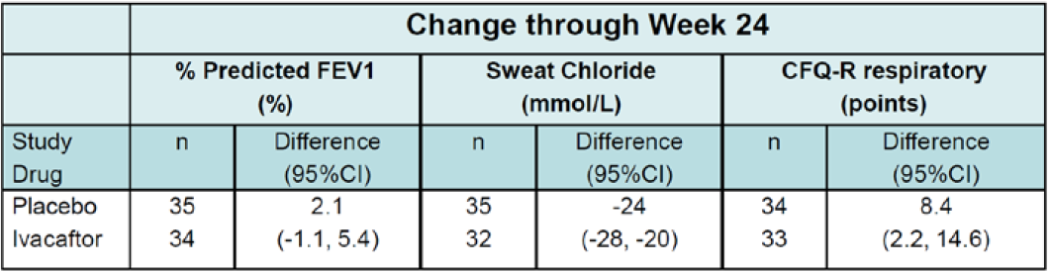  Mixed-effects model for repeated measures (MMRM) analysis with treatment, age, week, baseline value, treatment by week, and subject as a random effect. Source: FDA statistician.  Modelled absolute change from baseline in percent predicted FEV₁ by treatment up to follow-up visit, full analysis set  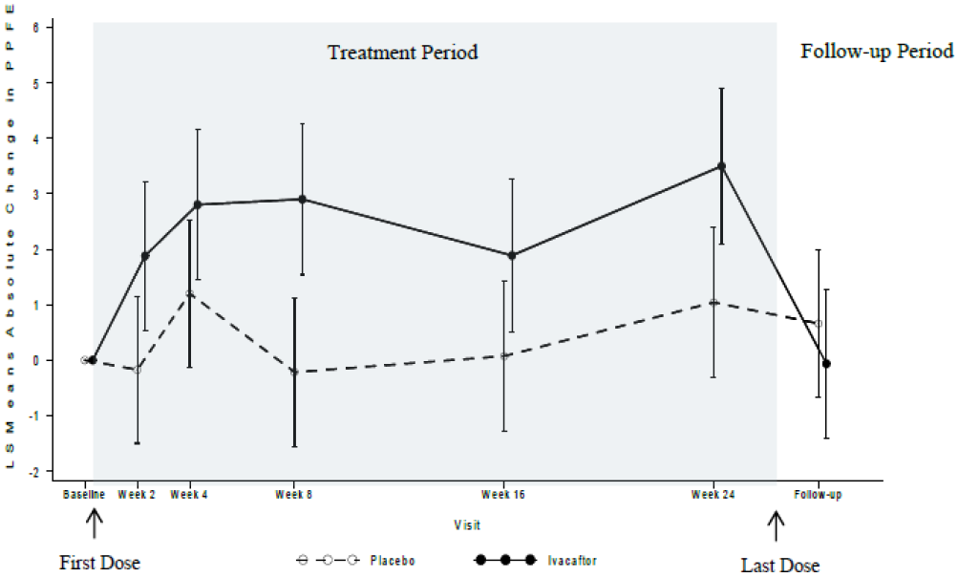
Secondary endpoints | The mean absolute change from baseline in sweat chloride decreased more in the ivacaftor than the placebo groups (-26.28 versus -2.31mmol/L, p < 0.0001). These effects reversed when treatment was stopped.  There were non-significant trends to greater increases in BMI in the ivacaftor groups.  The calculated hazard ratio of 0.928 for time to first pulmonary exacerbation favoured ivacaftor, but was not statistically significant. Survival curves by treatment group for time-to-first pulmonary exacerbation, pulmonary exacerbation requiring hospitalization, and pulmonary exacerbation requiring intravenous antibiotics showed no significant difference between ivacaftor and placebo groups.  The mean absolute change from baseline in the pooled CFQ-R respiratory domain was significantly greater in the ivacaftor (7.56 points) than the placebo group (-0.83). When analysed for age, the differences were significant for adults but not children. These differences were reversed when patients no longer received ivacaftor.  There were greater small decreases in inflammatory mediators in the ivacaftor than the placebo group.
Subgroup analysis | Age: The mean absolute change from baseline in percent predicted FEV₁ through Week 24 for the 50 subjects ≥ 18 years of age was statistically and clinically significantly greater for the Ivacaftor group than the placebo group (4.51% versus 0.46%; treatment difference = 4.96%; 95% CI: 1.15, 8.78; p = 0.0119). In children 6 to 11 years, the absolute change from baseline in FEV₁ was 2.82% for the placebo group (n = 8) and -3.51% for the ivacaftor group (n = 9) that is worse in the treatment group.  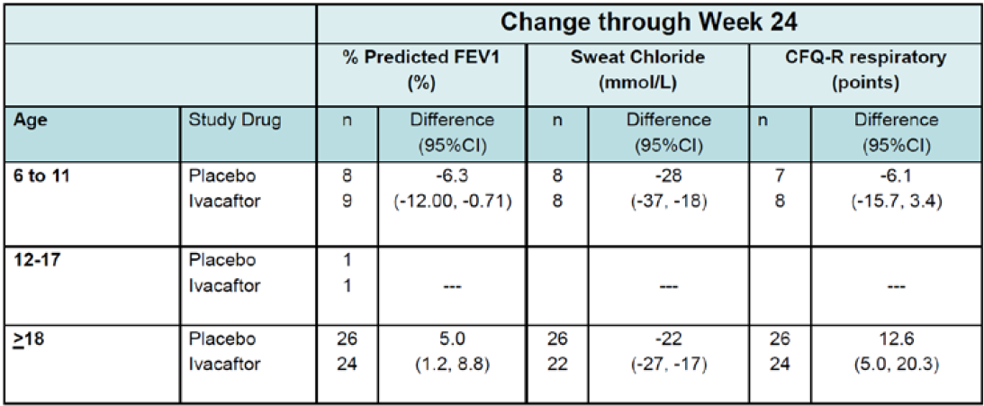  MMRM analysis with treatment, age, week, baseline value, treatment by week, and subject as a random effect.  Pseudomonas: Subjects without p.aeruginosa at baseline had a slightly larger treatment difference (infected 4.32% versus not infected 5.73%).  Lung function: The greatest gains in FEV₁ were seen in those with FEV₁ < 70% predicted.  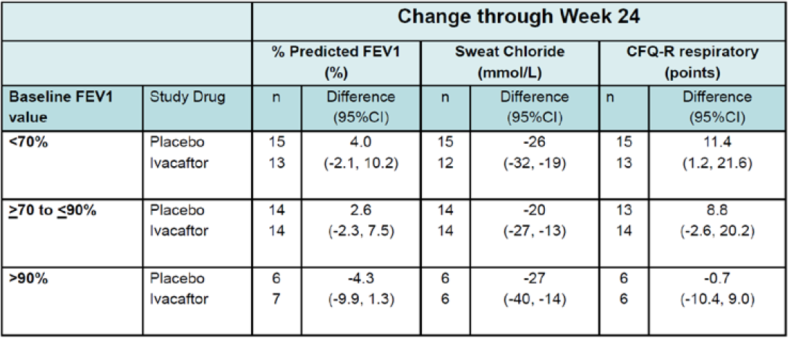  Site: Larger treatment differences in clinical outcomes were observed in Europe versus North America (possibly as there were more children in the American cohort).  Genetics: The changes in sweat chloride were the same for the R117H-5T and -7T variants, however changes in FEV₁ and CFQ-R were greater in those with the -5T variant.  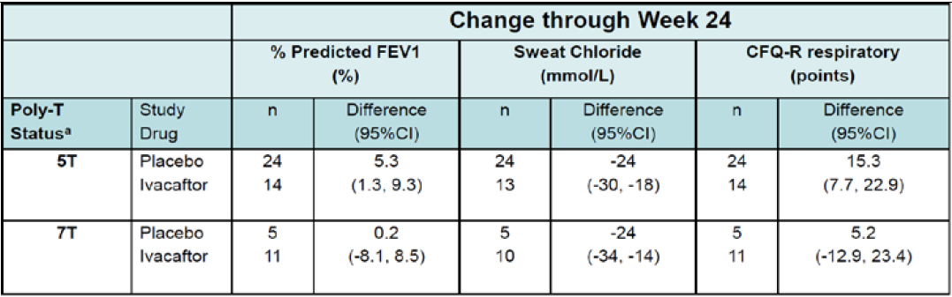

Table 11: Study 112
Summary of Study 112
Design | Phase III, ongoing, multicentre, roll over study. Results from 13/2/2013 until 25/4/2014 are reported below
Inclusion criteria: | Subjects from VX11-770-110 with R117H-CFTR mutation  VX12-770-111 with non-G551D-CFTR mutation  VX12-770-113 with phenotypic or molecular evidence of residual CFTR function
Objectives | Safety and long term efficacy
Groups | Ivacaftor arm: Subjects receive ivacaftor 150 mg BD, included subjects previously treated and those in the placebo arm from 110 or 111, who completed all study related treatments and met at least 1 responder criteria from study 113.  Observational arm: This group included patients from Studies 110 and 111 who either prematurely discontinued after receiving at least 4 weeks of treatment; completed the previous study and enrolled in the observational arm; completed the previous study but did not reach inclusion criteria for the ivacaftor arm.
Results | ** These should be interpreted with caution due to the small numbers and short (12 week) period of follow up.  Of the 69 subjects in Study 110, 65 entered the ivacaftor group, 2 the observational group, and 2 did not enrol.  Absolute change from Baseline to Week 2 and Week 12 in percent predicted FEV₁, full analysis set  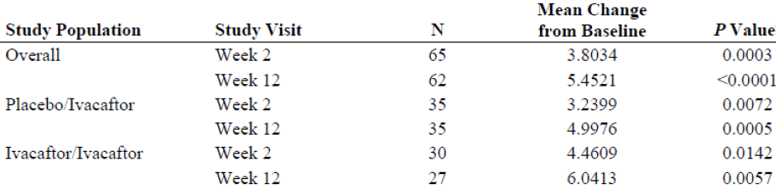  Absolute change from Baseline to Week 2 and Week 12 in percent predicted FEV₁; full analysis set, subjects 6 to 11 years.  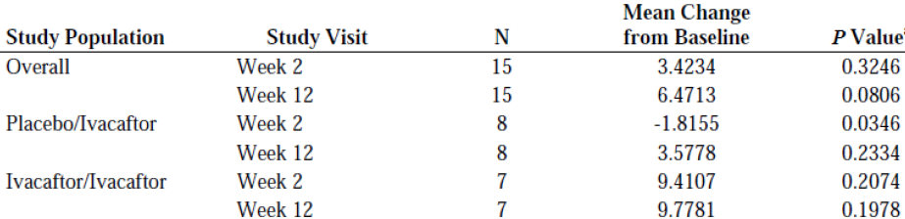

Safety
Additional safety data was available from Study 110 and the interim analysis of 112.
Overall, there were less AE in those taking ivacaftor than those in the placebo arm. The most common reported AE were symptoms or signs seen commonly in patients with CF. There were no problems with LFT’s, ophthalmological examinations or electrocardiogram (ECG).
AE for which the incidence was at least 5% higher with ivacaftor treatment than with placebo treatment included nasal congestion, oropharyngeal pain, wheezing, and upper airway cough syndrome.
The sponsor also submitted a cumulative and interval summary tabulation of serious and non-serious adverse reactions. A total of 1954 subjects (747 970 person-days) who received at least 1 dose of ivacaftor during the time period from the international birth date of ivacaftor (31 January 2012) to 23 January 2014. Post marketing data are consistent with those from clinical studies and the established safety profile of ivacaftor. No new safety concerns were identified.

Additional details from the EU report
- There were a number of patients in the placebo group who had large changes in sweat chloride. This may be due to variability in the measurement. (However the accuracy of this outcome could be questioned).
- Genetics of the R117H mutation: The clinical and functional analysis of the R117H mutation shows that it has variable expression or penetrance. This may be due to the presence of polypyrimidine (poly tract) variant located in another region of the CFTR gene in cis with R117H. There are three forms, 5T, 7T, or 9T. The 5T variant is the more severe form. The 9T variant is usually phenotypically normal. The 7T variant has variable phenotypes. It was not possible to collect information on the phase of the poly-T variant in all subjects. Subgroup analysis showed a greater treatment difference in FEV₁ in those with the 5T variant (5.3 pp) compared with the 7T variant (0.2 pp). The EU considered excluding those with the 7T phenotype from the indications, but instead has issued a warning to physicians that there may be less treatment benefit in this group.
- The EU noted the trial was underpowered and failed in terms of showing a significant different in primary efficacy outcome. There was a decision to register it in adults as subgroup analysis showed a benefit in this population.

Risk management plan
The EU-RMP version 3.0 dated 27 July with ASA version 2.0 dated 31 March 2015 was evaluated. Routine and additional pharmacovigilance activities have been proposed to monitor the safety concerns. Studies 112, 115 and an observational long term safety study are ongoing. The summary of safety concerns are in Table 4.
There only concerns raised by the RMP evaluator were that the sponsor had not submitted the most recent version of the EU-RMP. This was clarified with the sponsor. The implementation of a RMP satisfactory to the TGA is imposed as a condition of registration; the submitted EU-RMP is applicable without modification in Australia unless so qualified.

Risk-benefit analysis

Delegate’s considerations
There is only a small group of patients in Australia who may benefit from the extension of indications of ivacaftor into those with the R117H mutation. The sponsor has submitted the results of a clinical trial with a number of limitations: it was underpowered, the follow up period was relatively short, the placebo and treatment groups had significantly different baseline parameters, although there was some correction for multiplicity- the number of different outcomes measured and subgroups evaluated is a concern. Despite significant changes in sweat chloride, there were small and non-statistically significant changes in clinical endpoints in adults. The changes seen in FEV₁ and exacerbations were much less than the outcomes seen when ivacaftor is used in other gating mutations and when ORKAMBI is used in the F508 mutation. These changes were most significant in those with more severe lung disease and the -5T genotype.
The changes among children were small. However these children had very mild disease at baseline, so significant changes in clinical endpoints would have been difficult to detect, particularly in such a small sample size.
Ivacaftor was well tolerated. There were no major safety concerns.

Impression
The inability of the clinical trial to demonstrate a benefit may have been due to the design of the trial rather than any lack of true benefit of the drug. Of particular importance is the efficacy of ivacaftor on long term lung function, which was not assessed.
The risk benefit ratio for the use of ivacaftor in patients > 18 years in favourable based on the trend to improvements in FEV₁ and CFQ-R. This is different to the risk-benefit balance in children aged 6 to 11 years where there were no significant clinical benefits observed, despite an improvement in sweat chloride. However the lack of efficacy in children may have been due to the relatively good lung function in this group.

Proposed action
The Delegate had no reason to say, at the time, that the application for ivacaftor (Kalydeco) as an extension of indications to include patients with R117H mutation should not be approved for registration, pending advice on specific details of the indications and labelling.
Proposed conditions of registration:
- Submission to the TGA with the outcomes of long term clinical studies when available.
- Implementation of the Risk Management Plan version most recently approved by the TGA’s Office of Product Review.
- Finalisation of the Product Information to the satisfaction of the TGA.
Amendments as proposed to the Clinical Trials and Precautions sections of the PI as detailed.

Request for ACPM advice
The Delegate stated that patients with CF and the R117H allele represent only a small number of patients with CF in Australia (around 90 of 3100). In general it is a mild to moderate phenotype.
In the Delegate’s view the issues of concern are:
- The pivotal efficacy/safety study was small (69 subjects)
- There were small gains in efficacy (sweat chloride, FEV₁, CFQ-R) in adults
- In children < 18 years, there was no significant change in any efficacy parameters except for sweat chloride.
The Delegate requested ACPM advice on any other issues that the ACPM thinks may be relevant to a decision on whether or not to approve this application, including the proposed changes to the Product Information (PI) and Consumer Medicine Information (CMI); the requirements for an acceptable Risk Management Plan (RMP), the clinical significance and likely place of the product in clinical practice and the comments from the sponsor in the pre-ACPM response.
In addition, the Delegate requested advice on the following specific issues from the committee:
- The need to restrict the indications further to better define the patient population that is more likely to benefit.

Response from sponsor

Patients with CF and the R117H allele represent only a small number of patients with CF in Australia (around 90 of 3100). In general it is a mild/moderate phenotype.
Although the disease expression is relatively heterogeneous, the R117H-CFTR mutation is associated with reduced lung function, gradually progressive obstructive lung disease, recurrent sinusitis and bronchitis, and increasing frequency of hospitalisations over the course of the lifespan due to pulmonary disease. As illustrated in Figure 2 below, which plots the distributions of percent predicted FEV₁ in individuals with an R117H-CFTR mutation by age cohorts in the US Cystic Fibrosis Foundation (CFF) Registry (used as the largest single source of such data), there is an evident progression in lung function decline (as measured by percent predicted FEV₁) with age. Among CF patients with an R117H-CFTR mutation who are 19 to 30 years of age, 34% of patients have a percent predicted FEV₁ < 80%, and that number increases to 55% for patients aged more than 30 years.
Additional US CFF registry data also show a clear progression of CF-related symptoms as patients with an R117H-CFTR mutation age. Among patients aged 6 to 11 years, 54% have CF-related symptoms, while among patients 18 years of age and older, 93% have CF-related symptoms. A decrease in lung function is also observed over time in these patients, with 90% of patients 18 years of age and older having respiratory disease compared with 48% of patients aged 6 to 11 years.
Available data about life expectancy in CF patients with a less severe CF phenotype, such as those with the R117H-CFTR, also have a markedly reduced median life expectancy of just 50 years with the median age of death being 38 years in the US and 32 years in the UK. In contrast, the life expectancy for non-Hispanic white males in the US is 76 years, and for males in Europe is 72 years. Due to the small number of CF patients with an R117H-CFTR mutation who have contributed data to searchable registries and the likelihood that many subjects with mild CF are not genotyped at their time of death; it is difficult to estimate the impact of the R117H-CFTR mutation on life expectancy. Based on a simple numerical comparison, CFTR mutations associated with a less severe phenotype appear to result in a disease process that is approximately 10 years slower than for CF patients who have mutations associated with severe disease (approximate median age of death of 26 years for severe CF, and 38 years for less severe CF). Thus, while the R117H mutation is in the less severe part of the spectrum of CF, it is associated with severe disease when compared to a normal population. There is therefore a clear and substantial unmet need in this population. Although less devastating than some CFTR mutations, the R117H mutation is associated with clear evidence of premature mortality. It is useful to note that currently there are 6 R117H patients in Australia receiving ivacaftor through a compassionate use program due to the severity of their disease.
Although patients with CF and the R117H allele represent only 3.8% of the total Australian CF population, there remains a considerable high unmet medical need. Considering that there is no drug currently approved to treat the underlying cause of CF in this population in Australia, there is a substantial need to improve the treatment and outlook for CF patients with this CFTR mutation. As described above, these patients demonstrate progression of disease with advancing age and have a decreased life expectancy.
Figure 2: Percent predicted FEV₁ by age cohorts for CF patients with an R117H-CFTR mutation
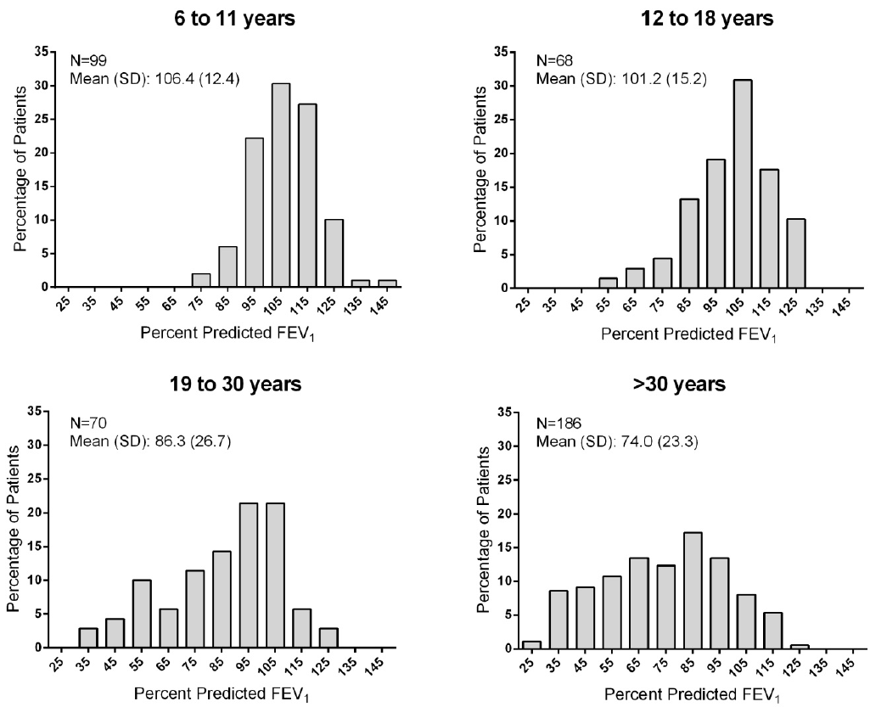

The pivotal efficacy/safety study was small (69 subjects).
Given the rarity of this disease and population, the study size is consistent with expectations for an orphan drug. Further, the total number of subjects in Study 110 is equivalent to approximately 75% of the relevant eligible Australian population. The study therefore represents a substantial part of the available patient population. Furthermore, the study was sufficiently large to demonstrate changes in the adult population in key end points such as percent predicted FEV₁ and sweat chloride associated with p < 0.05. The study may therefore be regarded as of sufficient size in a mutation which represents about 3.8% of a small orphan disease population.

There were small gains in efficacy (sweat chloride, FEV₁, CFQ-R) in adults.
The efficacy gains in adults were substantial in the context of a severe life-shortening disease for which there is nothing to address the underlying cause of the disease. Table 12 provides a summary of the results for adults in Study VX-770-110.

Table 12: Study 110- efficacy endpoint results, full analysis set, subjects ≥ 18 years of age
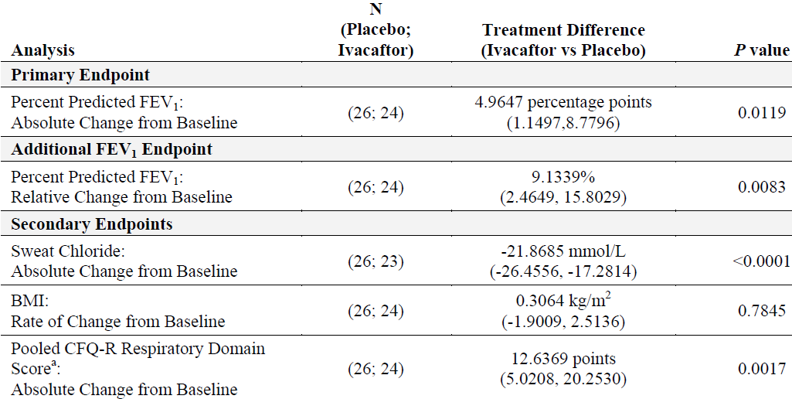
vs: versus. a: Pooled was defined as all questionnaire versions except for the Parent/Caregiver version.
The absolute increase in percent predicted FEV₁ in adults is larger than observed for treatments such as inhaled tobramycin and DNAse. For comparison, Table 13 presents pulmonary outcomes in well-established treatments for the symptoms of CF. The majority of measures are reported as relative change in percent predicted FEV₁ but absolute change in percent predicted FEV₁ is provided when available.

Table 13: Pulmonary outcomes in well-established treatments for the symptoms of CF measured as relative change in percent predicted FEV₁
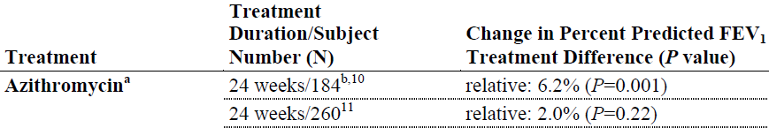

Table 13: cont.
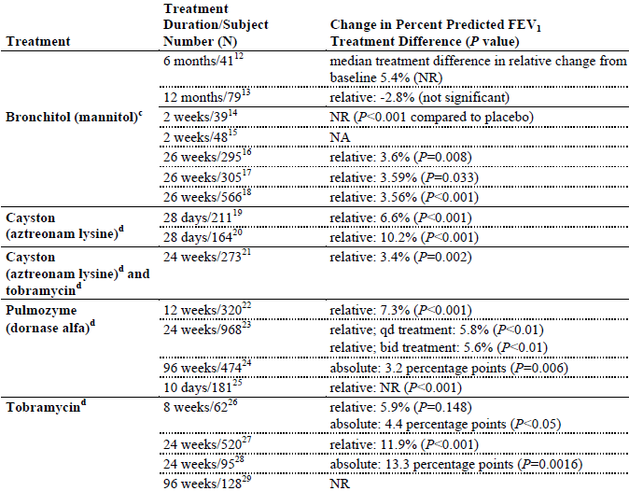
NA: not available; NR: not reported; qd: once daily; bid: twice daily a: azithromycin is not approved in the US or the EU to treat CF but is approved in both regions to treat bacterial infections caused by microorganism sensitive to azithromycin. b: Study was in patients chronically infected with P. aeruginosa. c: Bronchitol is an approved therapy for CF in Australia, and the EU but not in the US. d: Approved therapy for CF in Australia, Canada, the EU and the US.
The improvement in sweat chloride is of a magnitude expected to be associated with clinical benefit (-22 mmol/L) and the population mean on treatment was only just above the diagnostic threshold (that is, dropping from 71 mmol/L to a range of 41 to 47 mmol/L during treatment). The CFQ-R gain in adults was triple the minimal clinically important difference of 4 points which should not be characterised as small.
Thus the gains in efficacy are clinically important improvements. In addition, there is growing evidence in a real-world setting that the ability to treat the underlying cause of the disease by correcting CFTR function is associated with both systemic benefits (such as improving gastrointestinal [GI] disease) and also reducing the rate of lung function decline and improving mortality. These data are represented in Figure 3 below.
Figure 3: Ivacaftor modifies course of disease
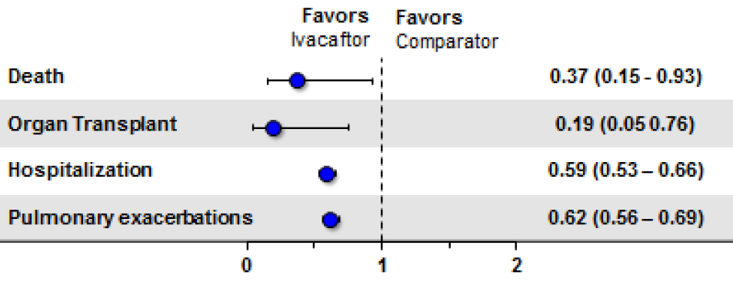
Additional clinical benefits of ivacaftor: improved FEV₁, decreased rate of lung function decline (FEV₁), improved nutritional status, reduced P. aeruginosa culture rate
Due to the high treatment burden, morbidity, and shortened life-expectancy of R117H CF patients, there remains a significant unmet medical need for more effective treatments. Attempts to correct the underlying defect in CF through gene therapy have shown limited success to date. Treatments that target the underlying ion-transport defect by restoring the function of the CFTR protein may decrease the morbidity and increase the lifespan of individuals with CF. In addition, the opportunity to intervene at an earlier stage in the progression of disease may further limit organ damage, further reduce the morbidity, and prolong life. Additionally, chronic use of interventional therapies approved for improvement in FEV₁ and reduction in pulmonary exacerbation rate (that is mannitol and dornase alfa) have subsequently been associated with reduced mortality.

In children < 18 years, there was no significant change in any efficacy parameters except for sweat chloride.
This is accepted and was addressed within the submission documents.
The data indicate that ivacaftor is effective in treating the underlying cause of the disease (CFTR dysfunction, as shown by the sweat chloride improvement). Efficacy may be extrapolated from the older patients in whom the disease process in sufficiently established to permit clinical changes to be demonstrated, whereas such data could not be readily demonstrated in the small population in the 6 to 11 age group with well-preserved lung function.
Vertex believes that the data support extrapolation of efficacy to the 6 to 11 age group. This is also supported by the data from the GOAL-E2 study presented by S Rowe at NACF 2015 which showed a positive response to ivacaftor treatment in the real world setting in the US.
These data are presented in the Figure 4 graphic below and provide evidence that clinicians are able to select and successfully treat children with the R117H mutation in real world clinical practice.
Figure 4: 1 month changes in FEV₁ % by age
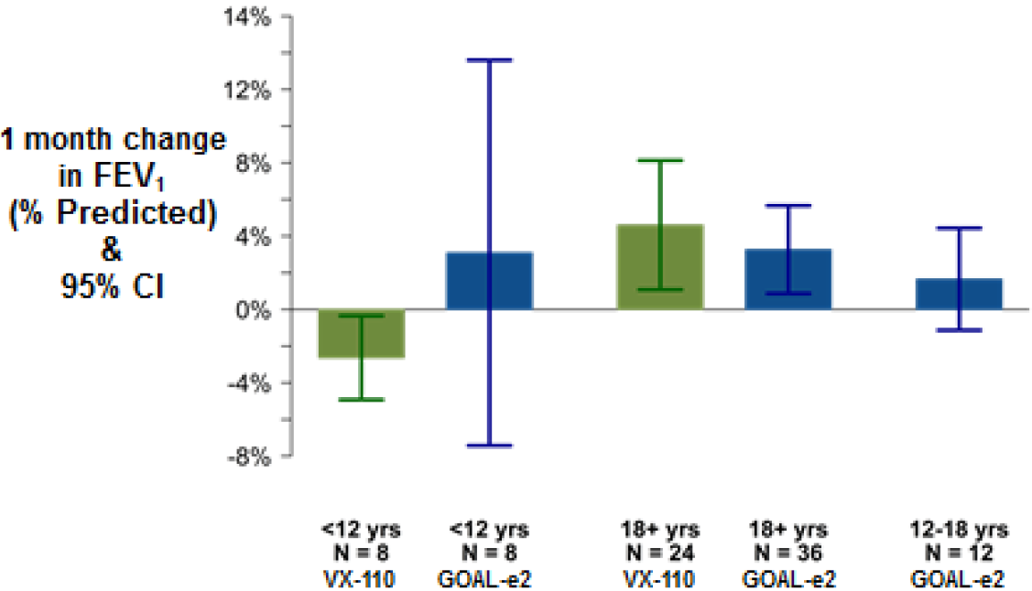

Advisory committee considerations
The ACPM, taking into account the submitted evidence of efficacy, safety and quality, considered KALYDECO tablet containing 150 mg of ivacaftor to have an overall positive benefit–risk profile for the amended indication;
Kalydeco is indicated for the treatment of cystic fibrosis (CF) in patients:
      - Age 18 years and older who have an R117H mutation in the CFTR gene
In making this recommendation the ACPM noted that Study 110, was terminated early by the sponsor. The reasoning for this was unclear.
Proposed Product Information (PI)/Consumer Medicine Information (CMI) amendments
The ACPM agreed with the Delegate to the proposed amendments to the Product Information (PI) and Consumer Medicine Information (CMI) and specifically advised on the inclusion of the following;
- the indication could include a statement that treatment should be ceased in non-responders (those showing no response at 12 weeks)
- a statement in the PI and relevant sections of the CMI to highlight that there may be less treatment benefit in the poly T7 group, similar to that in the EU SmPc
- a table in the PI showing the efficacy in patients with the various polyT polymorphisms would be potentially useful to prescribers. The ACPM agreed with the CHMP advice that the PI should contain a statement
- the statement of use in pregnancy was considered to be poorly worded.
Specific advice
The ACPM advised the following in response to the Delegate’s specific questions on this submission:
- Does the committee advice the need to restrict the indications further?
The ACPM noted that, overall, the absolute change from baseline FEV₁ (the primary efficacy endpoint) through Week 24 was numerically but not statistically greater in ivacaftor group compared to the placebo group. Secondary endpoints were also not significant. The data demonstrates no clinically meaningful efficacy in the paediatric patients but some in the adults. The submitted evidence provided supports only efficacy in adults 18 years and over who have the R117H CF gene mutation.
It was not possible to collect information on the poly-T variant in all subjects in the trial. However, subgroup analysis showed a greater treatment difference in FEV₁ in those with the 5T variant (5.3 pp) compared with the 7T variant (0.2pp).
Due to the variability in penetrance/expression of the R117H gene mutation the ACPM was of the view that the decision on the use of the proposed treatment should be based on objective symptomatic grounds rather than only genotyping. So it was considered necessary that there should be evidence of chronic suppurative lung disease as well as genotyping to support the decision.
A table in the PI showing the efficacy in patients with the various polyT polymorphisms would be potentially useful to prescribers. The ACPM agreed with the CHMP advice that the PI should contain a statement that there may be less treatment benefit in the T7 group.
The ACPM was of the view that the small changes in sweat chloride seen in this mutation, and considered this not be clinically significant. The committee noted the very modest improvements in parameters compared to the effects of ivacaftor on gating mutations.
The ACPM advised that implementation by the sponsor of the recommendations outlined above to the satisfaction of the TGA, in addition to the evidence of efficacy and safety provided would support the safe and effective use of this product.

Outcome
Based on a review of quality, safety and efficacy, TGA approved the registration of ivacaftor (Kaldyeco) 150 mg film coated tablets indicated for:
The treatment of cystic fibrosis (CF) in patients aged 6 years and older who have an R117H mutation in the CFTR gene
The full indications are now:
Kaldyeco is indicated for the treatment of cystic fibrosis (CF) in patients aged 6 years and older who have a G551D or other gating (class III) mutation or an R117H mutation in the CFTR gene.

Specific conditions of registration applying to these goods
The Kalydeco (ivacaftor) EU Risk Management Plan (RMP) version 3.0 dated 27 July 2014 (data lock point 23 July 2013) with Australian Specific Annex version 2.0 dated 31 March 2015, and any subsequent revisions, as agreed with the TGA will be implemented in Australia.

Attachment 1. Product Information
The PI for Kaldyeco approved with the submission which is described in this AusPAR is at Attachment 1. For the most recent PI, please refer to the TGA website at <https://www.tga.gov.au/product-information-pi>.

Attachment 2. Extract from the Clinical Evaluation Report

Therapeutic Goods Administration
PO Box 100 Woden ACT 2606 Australia
Email: info@tga.gov.au Phone: 1800 020 653 Fax: 02 6232 8605
https://www.tga.gov.au

CF affects approximately 30.000 individuals in the US, 36000 individuals in the EU and 3900 individuals in Canada
Sheppard DN et al. Mutations in CFTR associated with mild-disease-form Cl- channels with altered pore properties. Nature. 1993; 362(6416): 160–164.
Hammerle MM et al. Disease-associate mutations in the extracytoplasmic loops of cystic fibrosis transmembrane conductance regulator do not impede biosynthetic processing but impair chloride channel stability. J. Biol. Chem. 2001; 276: 4848–4854.
CF affects approximately 30.000 individuals in the US, 36000 individuals in the EU, 3900 individuals in Canada
Percent Predicted FEV₁ (pp FEV₁):FEV₁ of the patient divided by the average FEV₁ in the population of similar age, sex and body composition (www.nationalasthma.org.au)
The clinical and functional translation of CFTR (CFTR2). Available at: http://cftr2.org (Accessed 28 May 2014). Nat Genet 2013:45 (10); 1160-7
McCloskey M et al: Clinical features associated with a delayed diagnosis of cystic fibrosis. Respiration. 2000;67:402-7
McKone EF et al: CFTR genotype as a predictor of prognosis in cystic fibrosis. Chest 2006;130:1441-7
Comer DM et al: Clinical phenotype of cystic fibrosis patients with the G551D mutation. Q J Med. 2009;102:793-98
CFQ-RSS: Revised Cystic Fibrosis Questionnaire, Respiratory symptoms scale (Quittner AL et al: Psychometric evaluation of the Cystic Fibrosis Questionnaire-Revised in a national, US sample. Qual Life Res 2012;21:1279-1290.
Sagel SD et al: Effect of ivacaftor in R117H patients following FDA approval: Early results of the G551D observational-expanded and extended (GOAL-E2) study. Poster session Abstracts. Pediatr. Pulmonol., 2015;50(S41): Abstract 190.
SmPC: Summary of Product Characteristics

