First round evaluation: 5 August 2015
Second round evaluation: 12 November 2015

AusPAR Attachment 2

Extract from the Clinical Evaluation Report for Kaldyeco
  - Proprietary Product Name: Ivacaftor
  - Sponsor: Vertex Pharmaceuticals Australia Pty Ltd

About the Therapeutic Goods Administration (TGA)
- The Therapeutic Goods Administration (TGA) is part of the Australian Government Department of Health, and is responsible for regulating medicines and medical devices.
- The TGA administers the Therapeutic Goods Act 1989 (the Act), applying a risk management approach designed to ensure therapeutic goods supplied in Australia meet acceptable standards of quality, safety and efficacy (performance), when necessary.
- The work of the TGA is based on applying scientific and clinical expertise to decision-making, to ensure that the benefits to consumers outweigh any risks associated with the use of medicines and medical devices.
- The TGA relies on the public, healthcare professionals and industry to report problems with medicines or medical devices. TGA investigates reports received by it to determine any necessary regulatory action.
- To report a problem with a medicine or medical device, please see the information on the TGA website <https://www.tga.gov.au>.
About the Extract from the Clinical Evaluation Report
- This document provides a more detailed evaluation of the clinical findings, extracted from the Clinical Evaluation Report (CER) prepared by the TGA. This extract does not include sections from the CER regarding product documentation or post market activities.
- The words [Information redacted], where they appear in this document, indicate that confidential information has been deleted.
- For the most recent Product Information (PI), please refer to the TGA website <https://www.tga.gov.au/product-information-pi>.
Copyright
© Commonwealth of Australia 2016
This work is copyright. You may reproduce the whole or part of this work in unaltered form for your own personal use or, if you are part of an organisation, for internal use within your organisation, but only if you or your organisation do not use the reproduction for any commercial purpose and retain this copyright notice and all disclaimer notices as part of that reproduction. Apart from rights to use as permitted by the Copyright Act 1968 or allowed by this copyright notice, all other rights are reserved and you are not allowed to reproduce the whole or any part of this work in any way (electronic or otherwise) without first being given specific written permission from the Commonwealth to do so. Requests and inquiries concerning reproduction and rights are to be sent to the TGA Copyright Officer, Therapeutic Goods Administration, PO Box 100, Woden ACT 2606 or emailed to <tga.copyright@tga.gov.au>.

Contents
1. Common abbreviations 5
1. Introduction 10
2. Clinical rationale 10
3. Contents of the clinical dossier 13
3.1. Scope of the clinical dossier 13
3.2. Paediatric data 14
3.3. Good clinical practice 14
4. Pharmacokinetics (PKs) 14
4.1. Studies providing pharmacokinetic data 14
4.2. Summary of pharmacokinetics 15
4.3. Evaluator’s overall conclusions on pharmacokinetics 18
5. Pharmacodynamics 19
6. Dosage selection for the pivotal studies 19
7. Clinical efficacy 19
7.1. Indication 1 19
8. Clinical Safety 67
8.1. Studies providing evaluable safety data 67
8.2. Patient exposure 68
8.3. Adverse events 69
8.4. Laboratory tests 75
8.5. Post-marketing experience 77
8.6. Safety issues with the potential for major regulatory impact 77
8.7. Other safety issues 78
8.8. Evaluator’s overall conclusions on clinical safety 83
9. First round benefit-risk assessment 84
9.1. First round assessment of benefits 84
9.2. First round assessment of risks 84
9.3. First round assessment of benefit-risk balance 85
10. First round recommendation regarding authorisation 86
11. Clinical questions 87
11.1. Pharmacokinetics 87
11.2. Pharmacodynamics 87
11.3. Efficacy 87
11.4. Safety 87
11.5. PI and CMI 87
12. Second round evaluation of clinical data submitted in response to questions 88
12.1. Pharmacokinetics 88
12.2. Efficacy 89
13. Second round benefit-risk assessment 90
13.1. Second round assessment of benefits 90
13.2. Second round assessment of risks 90
13.3. Second round assessment of benefit-risk balance 90
14. Second round recommendation regarding authorisation 90
15. References 90

- Common abbreviations
Abbreviation | Meaning
ADR | adverse drug reaction
AE | adverse event
AIC | Akaike information criterion
ALT | alanine aminotransferase
API | active pharmaceutical ingredient
AST | aspartate aminotransferase
ATP | adenosine triphosphate
AUC | area under the concentration-time curve
AUCτ | area under the concentration versus time curve for the dosing interval
AusPAR | Australian Public Assessment Reports
bid | twice daily
BMI | body mass index
CCS | complete case set
CF | cystic fibrosis
CFF | Cystic Fibrosis Foundation (US)
CFQ-R | Cystic Fibrosis Questionnaire-Revised
CFTR | Cystic fibrosis transmembrane conductance regulator
CHMP | Committee for Medicinal Products for Human Use (EMA)
CI | confidence interval
CL/F | apparent (oral) clearance
CMI | Consumer Medicines Information
C_{min} | minimum observed concentration
CV% | coefficient of variation percentage
D | Day
D1 | zero order dose duration
DIOS | distal ileal obstruction syndrome
DMC | Data Monitoring Committee
ECG | electrocardiogram
ECL | extracellular loop
EMA | European Medicines Agency
EU | European Union
F508del or F508del-CFTR | CFTR gene mutation with an in-frame deletion of a phenylalanine codon corresponding to position 508 of the wild-type protein
FAS | full analysis set
FDA | Food and Drug Administration (US)
FEV₁ | forced expiratory volume in 1 second
G1244E CFTR | missense gene mutation that results in the replacement of a glycine residue at position 1244 of CFTR with a glutamic acid residue
G1349D CFTR | missense gene mutation that results in the replacement of a glycine residue at position 1349 of CFTR with an aspartic acid residue
G178R CFTR | missense gene mutation that results in the replacement of a glycine residue at position 178 of CFTR with an arginine residue
G551D or G551D CFTR | CFTR missense gene mutation that results in the replacement of a glycine residue at position 551 of CFTR with an aspartic acid residue
G551S CFTR | missense gene mutation that results in the replacement of a glycine residue at position 551 of CFTR with a serine residue
G970R CFTR | missense gene mutation that results in the replacement of a glycine residue at position 970 of CFTR with an arginine residue
h | hour/s
HBE | human bronchial epithelial
ICL | intracellular loop
IL-8 | interleukin-8
IRT | Immunoreactive trypsinogen
Ivacaftor | Kalydeco/ VX-770/VRT-813077
K_{a} | first-order absorption rate
LC | MS/MS - liquid chromatography with tandem mass spectrometric detection
M1 | hydroxymethyl-ivacaftor
M6 | ivacaftor carboxylate
MCID | minimal clinically important difference
MedDRA | Medical Dictionary for Regulatory Activities
MHRA | Medicines and Health Care Products Regulatory Agency (UK)
MMRM | mixed-effects model for repeated measures
MSD | membrane-spanning domain
NA | not available
NONMEM | nonlinear mixed-effects modelling
NR | not reported
P aeruginosa | Pseudomonas aeruginosa
PCR | polymerase chain reaction
PD | pharmacodynamic(s)
PI | Product Information
PK | pharmacokinetic(s)
PopPK | population pharmacokinetics
ppFEV₁ | percent predicted forced expiratory volume in 1 second
PPS | per protocol set
PSUR | Periodic Safety Update Report
PT | preferred term
Q/F | inter-compartmental clearance
q12h | every 12 hours
qd | once daily
QTc | QT interval corrected for heart rate according to Fridericia’s formula
QTcB | QT interval corrected for heart rate according to Fridericia’s formula
QTcF | QT interval corrected for heart rate according to Fridericia’s formula
R | regulatory domain
R117C or R117C CFTR | a missense mutation that results in the replacement of an arginine residue at position 117of CFTR with a cysteine residue
R117H or R117H CFTR | a missense mutation that results in the replacement of an arginine residue at position 117of CFTR with a histidine residue
R117H-5T CFTR | allele with both an R117H mutation and a 5T poly-T variant
R117H-7T CFTR | allele with both an R117H mutation and a 7T poly-T variant
R117H-9T CFTR | allele with both an R117H mutation and a 9T poly-T variant
S1251N CFTR | missense gene mutation that results in the replacement of a serine residue at position 1251 of CFTR with an asparagine residue
S1255P CFTR | missense gene mutation that results in the replacement of a serine residue at position 1255 of CFTR with a proline residue
S549N CFTR | missense gene mutation that results in the replacement of a serine residue at position 549 of CFTR with an asparagine residue
S549R CFTR | missense gene mutation that results in the replacement of a serine residue at position 549 of CFTR with an arginine residue
SAE | serious adverse event
SD | standard deviation
SDD | spray-dried dispersion
SEM | standard error of the mean
SOC | system organ class
UK | United Kingdom
ULN | upper limit of normal
URTI | upper respiratory tract infection
US | United States
USPI | US Prescribing Information
Vc/F | central volume of distribution
Vertex | Vertex Pharmaceuticals Incorporated
Vp/F | peripheral volume of distribution
W | week

Introduction
This is a submission to:
Extend indications for ivacaftor for an additional subset of cystic fibrosis (CF) patients.
The following dosage forms and strengths are currently registered:
Ivacaftor (Kaldyeco) film-coated tablets are supplied as light blue, capsule-shaped tablets (16.5 mm x 8.4 mm in modified caplet shape) containing 150 mg of ivacaftor. Each tablet is printed with “V 150” in black ink on one side only. KALYDECO tablets are packaged in a blister pack or a child-resistant bottle with desiccant. The following pack sizes are available: blister pack containing 56 film-coated tablets, bottle containing 56 film-coated tablets.
The approved indication is:
‘KALYDECO is indicated for the treatment of cystic fibrosis (CF) in patients aged 6 years and older who have a G551D or other gating (class III) mutation in the CFTR gene.’
The proposed indication is:
Kaldyeco is indicated for the treatment of cystic fibrosis (CF) in patients:
- Age 6 years and older who have a G551D or other gating (class III) mutation in the CFTR gene.
- Age 6 years and older who have an R117H mutation in the CFTR gene.

Clinical rationale
Cystic fibrosis (CF) is an autosomal recessive disease with serious, chronically debilitating morbidities and high premature mortality and no cure available at present. CF affects approximately 70,000 individuals worldwide and is more common in the Caucasian populations of North America and Europe than in Asian and African populations. Approximately, 3,100 individuals in Australia have CF.
CF is caused by mutations in the CF transmembrane conductance regulator (CFTR) gene that result in absent or deficient function of the CFTR protein at the cell surface. The CFTR protein is an epithelial chloride channel responsible for aiding in the regulation of salt and water absorption and secretion. CFTR protein is located in the apical membrane of epithelial cells in multiple organs, including lungs, pancreas, intestinal tract, biliary tract, sweat glands and vas deferens. The failure to regulate chloride transport in these organs results in the multisystem pathology associated with CF. Elevated sweat chloride concentrations are a hallmark of CF and is used for diagnostic purposes; sweat chloride concentrations ≥ 60 mmol/L is considered indicative of CF, whereas a sweat chloride concentration < 39 mmol/L is considered normal; intermediate sweat chloride values in the range of 40 to 59 mmol/L are also observed in patients with CF.
More than 1900 mutations in the CFTR gene have been identified which result in reduced quantity of CFTR at the cell surface or reduced CFTR function leading to a decrease in epithelial chloride transport. Reduced CFTR function can be due to defects in channel gating (opening and closing of CFTR channel) or channel conductance (rate of chloride travel through the open channel). As for other ion channels, gating of the CFTR channel is measured by open probability, and conductance of the CFTR channel is measured by current amplitude. By definition, a CFTR form that has lower open probability than normal CFTR has a gating defect. By definition, a CFTR form that has lower current amplitude than normal CFTR has a conductance defect. Some CFTR mutations cause more than 1 type of functional defect (for example, R117H) or reduce both the quantity and function of CFTR (for example, F508del). The amount of chloride transported by CFTR is a function of the quantity of CFTR on the cell surface, the open probability of the CFTR, and the current amplitude of the CFTR. Regardless of the type of defect(s) caused by the CFTR mutation, CF disease severity generally correlates with the severity of the loss of chloride transport.
The R117H-CFTR mutation is present in approximately 2 to 3% of patients with CF. In Europe, North America, and Australia, approximately 1,600 people with CF aged 6 years and older have at least 1 copy of an R117H-CFTR mutation. In the EU, approximately 744 people have the R117H-CFTR mutation, of whom more than half (n = 360) are aged > 18 years (Vertex data on file). In the US, approximately 729 people have the R117H-CFTR mutation, of whom approximately 300 are aged > 18 years (Vertex data on file). The prevalence of the R117H-CFTR mutation in patients with CF in individual countries is presented in Table 1; in Australia only 91 of the 3156 total patients with CF (2.8%) had the R117H-CFTR mutation which is the subject of this submission.

Table 1: Prevalence of the R117H-CFTR mutation in patients with cystic fibrosis
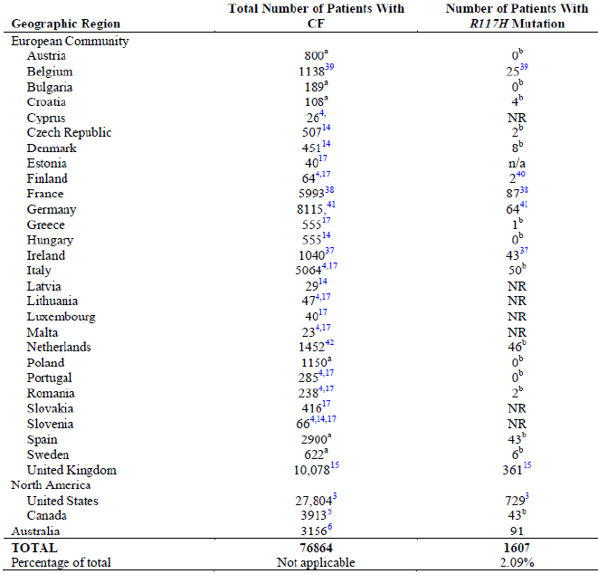
According to data from the US Cystic Fibrosis Foundation (CFF) Registry, there is an evident progression in lung function decline (as measured by percent predicted FEV₁) with age. Among CF patients with an R117H-CFTR mutation who are 19 to 30 years of age, 34% of patients have a percent predicted FEV₁ < 80%, and that number increases to 55% for patients aged more than 30 years (Figure 1). A decrease in lung function is also observed over time in these patients, with 90% of patients aged > 18 years having respiratory disease compared with 48% of patients aged 6 to 11 years. Additional Cystic Fibrosis Foundation (CFF) registry data also show a clear progression of CF-related symptoms as patients with an R117H-CFTR mutation age; CF-related symptoms were observed in 54% and 93% of patients aged 6 to 11 years and > 18 years, respectively (Figure 2). Although the R117H-CFTR mutation results in CF disease, the severity of CF per age group is generally less than that caused by the G551D-CFTR mutation or other CFTR mutations associated with a severe phenotype (Mcloskey M, 2000; McKone EF, 2006; Comer, 2009, see References). Many patients with an R117H-CFTR mutation have clinical evidence of preserved pancreatic exocrine function (potentially associated with a better body mass index [BMI]) and sweat chloride in the range of 60 to 80 mmol/L (compared with 90 to 120 mmol/L in patients with the G551D-CFTR mutation or who are homozygous for the F508del-CFTR mutation).
Figure 1: Precent predicted FEV₁ by age cohorts for CF patients with an R117H-CTFR mutation
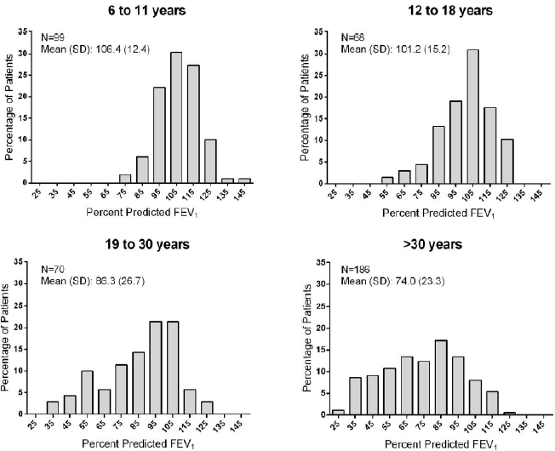
Figure 2: CF-related symptoms by age cohort for patients with R117H-CFTR mutation
Despite advances in CF treatment, the predicted median age of survival of individuals born today with CF is 41.1 to 48.5 years. Most pharmacologic treatments for CF (including R117H patients) such as dornase alfa, inhaled tobramycin, inhaled aztreonam and exocrine pancreatic enzyme supplementation are focused on managing the downstream consequences of diminished CFTR function: controlling airway infection and inflammation, mobilizing secretions to reduce airway obstruction and correcting nutritional deficits caused by pancreatic insufficiency. The increasing availability of therapies to treat CF lung disease, while improving the patients’ survival, has resulted in a high therapeutic burden.
Many individuals with an R117H-CFTR mutation were not diagnosed with CF until the late childhood or adult years, when the disease had progressed and symptoms became much more evident although this has changed recently due to advances in newborn screening for CFTR mutations. Given the unmet medical need of the population of CF patients with an R117H-CFTR mutation, and considering that there is no drug currently approved to treat the underlying cause of CF in this population, there is a substantial need to improve the treatment and outlook for CF patients with this CFTR mutation. These patients demonstrate progression of disease with advancing age and have a decreased life expectancy.
Ivacaftor (KALYDECO) is currently the only approved therapy that targets the molecular defect that underlies the pathophysiology of CF. Ivacaftor is also the only approved therapy for CF that has evaluated safety and efficacy in small subsets of CF patients based on their genetic profile. Ivacaftor is an orally bioavailable small molecule that targets the underlying defect in CF and represents the first in a new class of drugs, known as CFTR modulators, that provide a new therapeutic approach to the treatment of CF by restoring the function of the CFTR protein. As a type of CFTR modulator, ivacaftor restores the function of the CFTR protein. Ivacaftor is highly selective for CFTR protein in vitro and acts on the CFTR protein to enhance chloride transport by increasing the channel open probability.

Contents of the clinical dossier

Scope of the clinical dossier
The submission contained the following clinical information:
  - One clinical pharmacology study (VX11-770-110), which provided pharmacokinetic data.
  - One population pharmacokinetic analyses (J178).
  - Efficacy, safety and PK results from a pivotal, Phase III, placebo controlled, parallel-group, study (Study VXll-770- 110 or Study 110) to evaluate ivacaftor treatment in subjects with CF who have an R117H-CFTR mutation.
  - Efficacy and safety results of an interim analysis of an ongoing, open-label, rollover study (Study VX12-770-112 [Study112]) enrolling subjects from Study 110.
  - Periodic Safety Update Reports (PSURs).
  - There were no pooled analysis, meta-analysis, and integrated summary of efficacy or safety.

Paediatric data
The submission included paediatric pharmacokinetic/pharmacodynamics/efficacy/safety data. The paediatric ages groups evaluated were adolescents (12 to 17years) and children aged 6 to 11 years.

Good clinical practice
All clinical studies were performed in compliance with Good Clinical Practices.

Pharmacokinetics (PKs)

Studies providing pharmacokinetic data
Table 2 shows the studies providing pharmacokinetic data.

Table 2: Submitted pharmacokinetic studies
PK topic | Subtopic | Study ID | Primary aim of the study
PK in Target populations* | Multi-dose PK | VX11-770-110 | Efficacy, safety and PK in subjects with CF who have the R117H-CFTR mutation
Population PK analyses | Target population* | J178 | Characterise the population pharmacokinetics (popPK) of ivacaftor in subjects with CF and the R117H-CFTR mutation.
* Subjects who would be eligible to receive the drug if approved for the proposed indication.
None of the pharmacokinetic studies had deficiencies that excluded their results from consideration.

Summary of pharmacokinetics
The information in the following summary is derived from conventional pharmacokinetic studies unless otherwise stated.

Physicochemical characteristics of the active substance
The following information is derived from the Sponsor’s summaries in Module 2.
- Chemical name: N-(2,4-di-tert-butyl-5-hydroxyphenyl)-1,4-dihydro-4-oxoquinoline-3-carboxamide.
- Empirical formula: C₂₄H₂₈N₂O₃
- Molecular weight: 392.49.
- Structural formula is in Figure 2.
- Description: ivacaftor is a white to off-white powder that is practically insoluble in water (< 0.05 microgram/mL). The pKa values of ivacaftor are 9.40 and 11.60. The log D value of ivacaftor is 5.68 at pH = 7.4 and 25°C.
Figure 2: The structural formula of ivacaftor
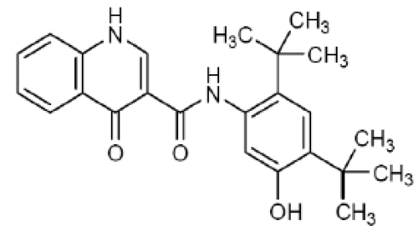

Pharmacokinetics in healthy subjects
Comment: No new studies examined the PKs of ivacaftor in healthy subjects; therefore, the following discussion will in most cases relate to the PKs in the target population. In addition, although Study VX11-770-110 examined the plasma PKs of ivacaftor and its metabolites in subjects with CF who have the R117H-CFTR mutation, the results of the PK analysis was presented as part of the population pharmacokinetics (PopPK) Study J178. Only new information (that is not previously presented to the TGA) will be reported in the following discussion.

Absorption

Sites and mechanisms of absorption
Ivacaftor is administered orally and PopPK analyses indicate that ivacaftor PKs are best fit using a two-compartment model with zero-order delivery to the absorption compartment and subsequent first order absorption. For a reference subject (70 kg, male, 18 years, CF subject with non-R117H mutation), the zero-order dose duration (90% CI) was estimated to be 2.96 h (2.88, 3.17) and the first-order absorption rate constant (k_{a}) was 0.721 h-1 (0.530, 0.765) (Table 3).

Table 3: Study J178- parameter estimates from the ivacaftor final population pharmacokinetic model (Run 1010)
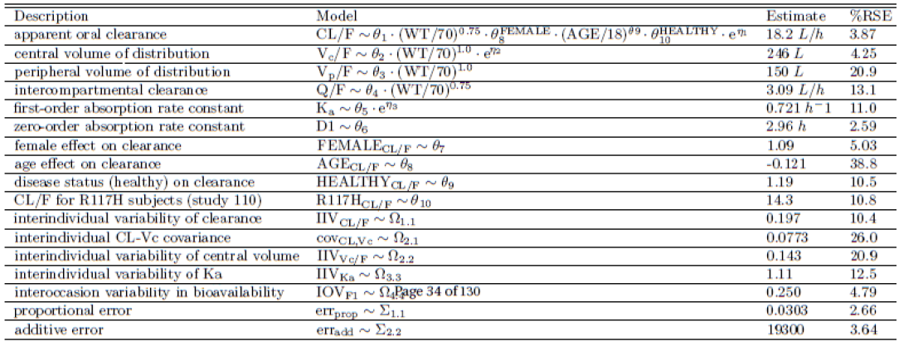

Bioavailability
The bioavailability of ivacaftor has been previously discussed in TGA submission No. PM-2012-01491-3-5; however, a sub-analysis presented as part of the PopPK study provided estimates of ivacaftor minimum observed concentration (C_{min}) and area under the concentration-time curve (AUC), stratified by age and study number in patients with CF. In the studies included in the PopPK analysis (which examined subjects with CF with non-R117H mutation), mean ivacaftor C_{min} ranged from 545 ng/mL to 1190 ng/mL (Table 4) and mean AUC ranged from 8550 ng.h/mL to 18400 ng.h/mL (Table 5). In Study 110, which examined the plasma PKs of ivacaftor at steady state in subjects with CF who have an R117H-CFTR mutation, the mean ivacaftor C_{min} was 810 ng/mL and AUC was 12100 ng.h/mL (Tables 4 and 5).

Table 4: Study J178- summary statistics for ivacaftor C_{min} (ng/mL) for 150 mg every 12 hours (q12h) subjects by study
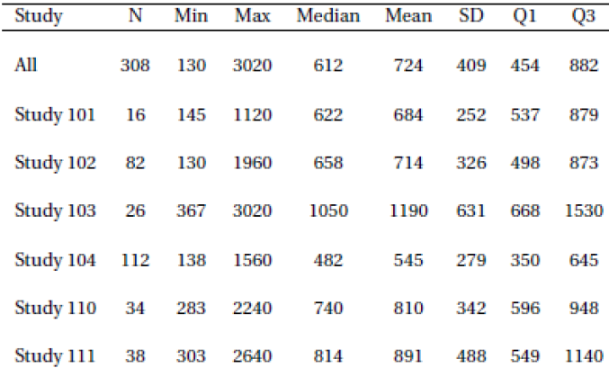

Table 5: Study J178- summary statistics for ivacaftor AUC (ng/mL.h) for 150 subjects by study
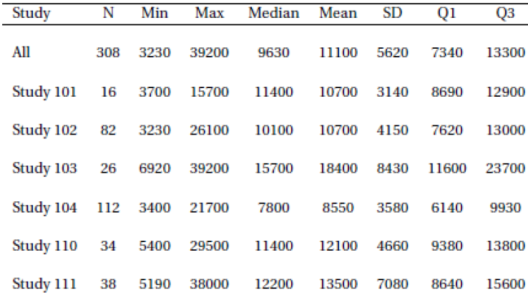
Safety: Not applicable. Evaluator`s comments: The study design, conduct and analysis were satisfactory.
Comment: Can the sponsor please provide the estimates of ivacaftor C_{min} and AUC for Studies 007 and 010, which were undertaken in healthy subjects, as they have done for the studies in patients with CF in Tables 4 and 5?

Distribution

Volume of distribution
PopPK analysis indicated that the typical central volume of distribution (90% CI) in a reference subject was 246 L (196 to 254) and the typical peripheral volume of distribution was 150 L (48.1 to 362) (Table 3).

Metabolism
Ivacaftor metabolism has been previously discussed as part of TGA Submission No. PM-2012-01491-3-5. No further information was provided in this submission.

Excretion
For a reference subject, the apparent oral clearance (CL/F) was estimated to be 18.2 L/h (16.9 to 19.3) and inter-compartmental clearance was 3.09 L/h (1.98 to 14.0) (Table 3). Ivacaftor CL/F was reduced 21% for subjects with the R117H mutation, relative to CF subjects with a gating mutation or homozygous for F508del, with an estimate of 14.3 L/h (12.7 to 16.0).

Intra- and inter-individual variability of pharmacokinetics
Based on the PopPK analysis, the inter-individual variabilities on CL/F, central volume and first-order absorption rate (k_{a}) were 0.197, 0.143 and 1.11, respectively (Table 3). Unexplained random variability for CL/F was 46.7 CV%.

Pharmacokinetics in the target population
Based on the reported C_{min} and AUC values (Tables 4 and 5) it is difficult to determine whether ivacaftor PKs in subjects with CF who have the R117H mutation are consistent with the PKs in CF subjects with a gating mutation or homozygous for F508del, as the values given for Study 110 (R117H mutation) fall within the range of C_{min} and AUC values identified for CF subjects without R117H mutations. However, the PopPK results indicating that CL/F is reduced by 21% in subjects with the R117H mutation, relative to the reference CF subject would suggest that AUC may be increased and t_{1/2} lengthened in subjects with R117H mutations.
Comment: As it is difficult to judge whether ivacaftor PKs are consistent across both CF populations (that is reference CF subjects and subjects with the R117H mutation) a full non-compartmental PK analysis of the results of Study 110, which includes typical PK parameters such T_{max}, C_{max}, AUC, t_{1/2} and so on may help answer this question. Therefore, can the sponsor please provide a full non-compartmental analysis of the ivacaftor PK parameters for Study 110?

Pharmacokinetics (in other special population / according to other population characteristic)
The PopPK analysis estimated that body weight was the most important predictor of the PKs of ivacaftor, with a change in ivacaftor CL/F of 39% and 131% for typical 20 kg and 100 kg subjects, respectively, when compared to the reference subject (70 kg). Gender and patient status (that is healthy versus CF) did not account for variability in ivacaftor PKs and age was also not a clinically important covariate, after accounting for body size.

Pharmacokinetic interactions
No new information was provided regarding drug-drug interactions between ivacaftor and other drugs.

Evaluator’s overall conclusions on pharmacokinetics
The following conclusions relate to the results of the PopPK study J178.
- Ivacaftor is administered orally and its PKs are best fit using a two-compartment model with zero-order delivery to the absorption compartment and subsequent first order absorption.
- For a reference subject (70 kg, male, 18 years, CF subject with non-R117H mutation), the zero-order dose duration (90% CI) was estimated to be 2.96 h (2.88 to 3.17) and the first-order absorption rate constant (k_{a}) was 0.721 h⁻¹ (0.530 to 0.765)
- In subjects with CF with non-R117H mutation, mean ivacaftor C_{min} ranged from 545 ng/mL to 1190 ng/mL and mean AUC ranged from 8550 ng.h/mL to 18400 ng.h/mL. In subjects with CF who have an R117H-CFTR mutation, the mean ivacaftor C_{min} was 810 ng/mL and AUC was 12100 ng.h/mL.
- The typical central volume of distribution (90% CI) in a reference subject was 246 L (196 to 254) and the typical peripheral volume of distribution was 150 L (48.1 to 362).
- For a reference subject the CL/F was 18.2 L/h (16.9 to 19.3) and inter-compartmental clearance was 3.09 L/h (1.98 to 14.0). Ivacaftor CL/F was reduced 21% for subjects with the R117H mutation, relative to CF subjects with a gating mutation or homozygous for F508del, with an estimate of 14.3 L/h (12.7 to 16.0).
- It is difficult to judge whether ivacaftor PKs are consistent across both CF populations (that is reference CF subjects and subjects with the R117H mutation) as the reported C_{min} and AUC values from Study 110 fall within the range of values identified in reference CF patients. Based on the decrease in oral clearance identified in subjects with the R117H mutation however, it is possible that AUC and t_{1/2} would be increased in this CF population.
- Inter-individual variabilities on CL/F, central volume and k_{a} were 0.197, 0.143 and 1.11, respectively. Unexplained random variability for CL/F was 46.7 CV%.
- Body weight was the most important predictor of ivacaftor PKs, with a change in ivacaftor CL/F of 39% and 131% for the typical 20 kg and 100 kg subject, when compared to the reference subject.
- Gender and patient status (that is healthy versus CF) did not account for variability in ivacaftor PKs and age was also not a clinically important covariate, after accounting for body size.

Limitations of the PK studies
Lack of a full non-compartmental PK analysis of the results of Study 110 which examined ivacaftor PKs in CF subjects with the R117H mutation.

Questions related to the PK studies
- Can the sponsor please provide the estimates of ivacaftor C_{min} and AUC for Studies 007 and 010, which were undertaken in healthy subjects, as they have done for the studies in patients with CF in Tables 4 and 5?
- As it is difficult to judge whether ivacaftor PKs are consistent across both CF populations (that is reference CF subjects and subjects with the R117H mutation) a full non-compartmental PK analysis of the results of Study 110, which includes typical PK parameters such T_{max}, C_{max}, AUC, t_{1/2} etc may help answer this question. Therefore, can the sponsor please provide a full non-compartmental analysis of the ivacaftor PK parameters for Study 110?

Pharmacodynamics
No new studies specifically examined ivacaftor PDs in the current submission.

Dosage selection for the pivotal studies
Studies 102, 103, and 111 evaluated ivacaftor 150 mg q12h which is the recommended ivacaftor (Kaldyeco) dosage for CF patients 6 years of age and older.
Similar PK parameter estimates between healthy subjects and subjects with CF suggested that exposure to ivacaftor in subjects with the R117H-CFTR mutation would be similar to the exposure in subjects with other CFTR mutations. The in vitro potency of ivacaftor towards the R117H mutation relative to other mutations that cause gating defects, as well as the efficacy and safety results obtained in Studies 102, 103, and 111 supported evaluation of 150 mg q12h in study 110. Hence, the dose of 150 mg q12h, which was well tolerated and resulted in robust treatment effects in subjects with other CFTR mutations that cause gating defects, was chosen for pivotal study 110 in CF patients with R117H-CFTR mutation.

Clinical efficacy

Indication 1
Ivacaftor (Kaldyeco) is indicated for the treatment of cystic fibrosis (CF) in patients: aged 6 years and older who have an R117H mutation in the CFTR gene.
Two clinical studies evaluated the efficacy of ivacaftor in subjects with an R117H-CFTR mutation. Study 110 was a placebo-controlled study and Study 112 is an ongoing open-label rollover study in which subjects from Study 110 could enrol. Results of the final analysis of Study 110 and interim analysis of Study 112 are included in this submission.

Pivotal study 110

Study design, objectives, locations and dates
Study design, objectives, locations and dates
This was a Phase III, randomised, double-blind, placebo-controlled, parallel group study to evaluate the efficacy (primary objective) and safety (secondary objective) of ivacaftor in subjects with CF who have the R117H-CFTR mutation. The tertiary objective was to characterize the plasma pharmacokinetics (PK) of ivacaftor and metabolites [hydroxymethyl-ivacaftor (M1) and ivacaftor carboxylate (M6)] at steady state in subjects with CF who have an R117H-CFTR mutation.
Subjects were randomized to receive either placebo or ivacaftor 150 mg q12h for 24 weeks. The study included a Screening Period (Day -35 to Day -15), a Run-In Period (Day -14 to Day -1 relative to the first dose of study drug), a Treatment Period (Day 1 [first dose of study drug] to Week 24), and a Follow-up Period. Study visits during the Treatment Period occurred on Day 1, Weeks 2, 4, 8, 16, and 24 (Figure 3). Subjects who prematurely discontinued study drug treatment had an Early Termination Visit. These subjects were not required to complete the Follow-up Visit if the Early Termination Visit occurred 3 weeks or later after the last dose of study drug.
Figure 3: Study 110- schematic of study design VX11-770-110
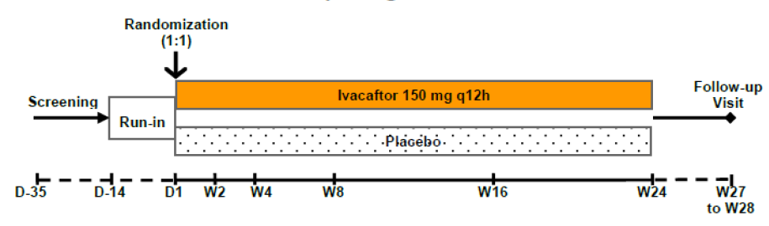
D: day; q12h: every 12 hours, W:week. Since the study was terminated early by the sponsor, study drug was administered for periods of up to 24 weeks.
Subjects who completed study drug treatment were offered the opportunity to enrol in the open-label treatment arm of Study 112; subjects who choose not to enrol in the open-label treatment arm were offered enrolment in the observational arm of Study 112.
In the event of early study termination, subjects who had not had their Week 24 Visit were considered to have completed their assigned study drug treatment duration and were to have completed the Follow-up Visit. These subjects were offered enrolment in the open-label treatment arm of Study 112; subjects who chose not to enrol in the open-label treatment arm were offered enrolment in the observational arm of Study 112.
An independent Data Monitoring Committee (DMC) was formed using the CF Foundation Data Safety Monitoring Board. As part of its responsibilities, the DMC conducted planned reviews of the study data. The DMC reviewed the unblinded interim analysis results for safety and efficacy after 40 subjects had completed Week 8 Visit and based on the results and rules pre-specified by Vertex provided guidance on whether further enrolment could have been stopped due to strong efficacy results. The DMC did not recommend any changes to study conduct as a result of their review.
The study was conducted from July 2012 to October 2013 at 27 sites in the United States and the European Union.

Inclusion and exclusion criteria
The main inclusion criteria were: male and female subjects with CF aged > 6 years who have the R117H-CFTR mutation on at least 1 allele and a confirmed diagnosis of CF, defined as chronic sinopulmonary disease and a sweat chloride value ≥ 60 mmol/L by quantitative pilocarpine iontophoresis or two CF-causing mutations. Subjects must have had percent predicted forced expiratory volume in 1 second (FEV₁) of 40% to < 90% for subjects aged > 12 years or 40% to < 105% for subjects aged 6 to 11 years. Patients with other CFTR mutations and acute respiratory infections in past 4 weeks were excluded from the study. Other exclusion criteria are listed in Table 6.

Table 6: Exclusion criteria for study 110
 | Exclusion criteria
1. | CFTR gene mutation leading to CFTR channel with gating defect (that is any 1 of the following mutations: G551D, G178R, G551S, S549N, G970R, G1244E, S1251N, S1255P, or G1349D)
2. | History of any illness or condition that, in the opinion of the investigator, might have confounded the results of the study or posed an additional risk in administering study drug to the subject
3. | An acute upper or lower respiratory infection, pulmonary exacerbation, or changes in therapy (including antibiotics) for pulmonary disease within 4 weeks before Day 1 (first dose of study drug)
4. | Pregnant, planning a pregnancy, breastfeeding, or not willing to follow contraception requirements
5. | Hemoglobin < 10 g/dL at screening
6. | Abnormal liver function at screening, defined as ≥ 3 X upper limit of normal (ULN), of any 3 or more of the following: serum aspartate transaminase (AST), serum alanine transaminase (ALT), gamma-glutamyl transpeptidase (GGT)
7. | Abnormal renal function at screening, defined as glomerular filtration rate (GFR) ≤ 30 mL/min/1.73 m² (calculated by the Modification of Diet in Renal Disease [MDRD] Study Equation) for subjects ≥ 18 years of age; ≤ 45 ml/min/1.73 m² (calculated by the Counahan-Barratt equation) for subjects aged 6 to 17 years (inclusive)
8. | History of solid organ or haematological transplantation
9. | History of alcohol, medication, or illicit drug abuse within 1 years before Day 1 (first dose of study drug)
10. | Colonization with organisms associated with a more rapid decline in pulmonary status (for example Burkholderia cenocepacia, Burkholderia dolosa, and Mycobacterium abscessus) at screening
11. | Ongoing participation in another therapeutic clinical study or prior participation in an investigational drug study within 30 days before screening. A washout period of ≥ 5 terminal half-lives of the previous investigational study drug, or 30 days, whichever is longer, must have elapsed before Screening.
12. | Any 'non-CF-related' illness within 2 weeks before Day 1 (first dose of study drug). 'Illness' was defined as an acute (serious or non-serious) condition (for example gastroenteritis).
13. | Use of any inhibitors or inducers of cytochrome P450 (CYP) 3A, including consumption of certain herbal medications (for example St. John`s Word) and grapefruit/grapefruit juice. Subjects must have stopped consuming these items from 14 days before Day 1 (first dose of study drug).
14. | Evidence of cataract or lens opacity at Screening.

Study treatments
Ivacaftor 150-mg tablets or matching placebo tablets were administered orally at a dosage of 150 mg q12h. It was recommended to take ivacaftor with fat containing food such as a standard 'CF' high-fat, high calorie meal or snack. The planned duration of study drug administration was 24 weeks. Excluding the Screening and Run-in Periods, each subject was planned to participate in the study for approximately 28 weeks (Day 1 through the Follow up Visit).
Comments: As with Studies 102, 103, and 111 (evaluated in initial submission PM-2012-01491-3-5), treatment in Studies 110 and 112 was in addition to the subject's usual prescribed CF therapy (which had to remain stable during the study). Subjects were encouraged to remain on their prescribed CF therapies, such as high-dose ibuprofen, dornase alfa, azithromycin, and inhaled antibiotics. Specific guidelines were provided for inhaled antibiotics to minimize confounding effects of concomitant use on the results of the study. For Study 110, subjects who were taking inhaled hypertonic saline at the time of study entry should have remained on hypertonic saline through the Follow-up Visit; subjects who were not taking inhaled hypertonic saline at the time of study entry should have remained off hypertonic saline through the Follow-up Visit.

Efficacy variables and outcomes
The main efficacy variables were: Spirometry, BMI, sweat chloride test, Cystic Fibrosis Questionnaire-Revised (CFQ-R), pulmonary exacerbations, weight, height, CF-related complications (for example pancreatitis, distal ileal obstruction syndrome [DIOS]), inflammatory mediators, microbiological cultures, immunoreactive trypsinogen (IRT) and faecal elastase-1.
The primary efficacy endpoint was the absolute change from baseline in FEV₁ through Week 24 in the Full Analysis Set (FAS). Additional supportive analyses of the primary endpoint were conducted by repeating the primary analysis on the Per Protocol Set (PPS) and the Complete Case Set (CCS). A responder analysis was also conducted by categorizing the absolute change from baseline in percent predicted FEV₁ at Week 24 as ≥ 3.5% or < 3.5, ≥ 5% or < 5%, ≥ 7.5% or < 7.5%, and ≥ 10% or < 10%.
Secondary efficacy variables were absolute change from baseline in sweat chloride, rate of change from baseline in BMI, time-to-first pulmonary exacerbation and absolute change from baseline in the respiratory domain of the CFQ-R.
Subgroup analyses of the primary and secondary endpoints were performed in the same manner as the primary analysis for the following subgroups: age at baseline (> 18 years and 6 to < 11 years); percent predicted FEV₁ at baseline (< 70%, 70% to < 90%, and > 90% of the predicted value); geographic region (North America and Europe); sex (female and male); Pseudomonas aeruginosa (P aeruginosa) infection status at baseline (yes and no); and R117H allele poly-T variant (5T, 7T, or 9T). A subgroup analysis for subjects aged 12 to < 17 years was not conducted because there were only 2 subjects in that age group.
The tertiary efficacy variables included pulmonary exacerbations (count and duration), change from baseline in non-respiratory domains of the CFQ-R through 24 weeks of treatment, rate of change from baseline in weight, rate of change from baseline in height, CF-related complications (pancreatitis or DIOS), change from baseline in inflammatory mediators, change from baseline in qualitative microbiology cultures, change from baseline in IRT and change from baseline in faecal elastase-1.
The following additional spirometry endpoints (through Week 24) were analysed in a similar manner to that of the primary analysis of the primary efficacy endpoint (no sensitivity analyses were performed): relative change in percent predicted FEV₁ from baseline, absolute and relative change from baseline in FEV₁ (L), FVC (L), FEF25%-75% (L/sec), FEV₁/FVC, percent predicted FVC, percent predicted FEF25% to 75% and percent predicted FEV₁/FVC.
Comments: The primary and other efficacy endpoints complied with the EMEA guidelines on clinical development of medicinal products for the treatment of CF (2009). The primary endpoint evaluated lung function in terms of change in % predicted FEV₁. Secondary and other endpoints evaluated effect of study drug on growth / nutrition and other markers of CF such as sweat chloride, inflammatory markers and pulmonary exacerbations. Spirometry was performed according to the American Thoracic Society Guidelines.

Randomisation and blinding methods
Subjects were randomized in a 1:1 ratio, stratifying for age (≥ 18 years, 12 to < 17 years, and 6 to < 11 years) and FEV₁ severity (< 70%, ≥ 70% to ≤ 90%, and > 90%). The randomization codes were produced by Vertex or a designated vendor. To protect the study blind and maintain the scientific integrity of the data, 3 biostatisticians were involved in the randomization process. A copy of the final randomization list (in sealed tamper evident envelopes) was archived at Vertex.
This was a double-blind study. The subjects, all site personnel including the investigator, the study monitor, and the Vertex study team remained blinded to treatment assignments until database lock and study unblinding with some exceptions (not included in this summary).

Analysis populations
The Full Analysis Set (FAS) and the Safety Set (both defined as all randomized subjects who received at least 1 dose of study drug) included 69 subjects. The Per Protocol Set (PPS) included the 63 FAS subjects without major protocol violations. The Complete Case Set (CCS) included the 61 FAS subjects who had the opportunity to complete 24 weeks of treatment. The FAS was used for all efficacy analyses. PPS analyses were performed for primary endpoint to provide supportive evidence for efficacy; CCS analyses were performed for primary and secondary endpoints to assess the impact of early termination of the study.

Sample size
Enrolment was planned for a minimum of 40 and a maximum of approximately 80 subjects in total who have the R117H-CFTR mutation on at least 1 allele. The estimated study power for detecting different treatment effect sizes between the ivacaftor and placebo groups in the absolute change in percent predicted FEV₁ from baseline through the Week 24 Visit, assuming 40, 60, or 80 randomized subjects was summarised in Table 7. The treatment effect sizes and standard deviation are based on the results of Studies 102 and 103 and a review of the clinical CF literature.

Table 7: Study 110- power estimates (%) under possible scenarios of treatment effect and number of randomized and evaluable subjects
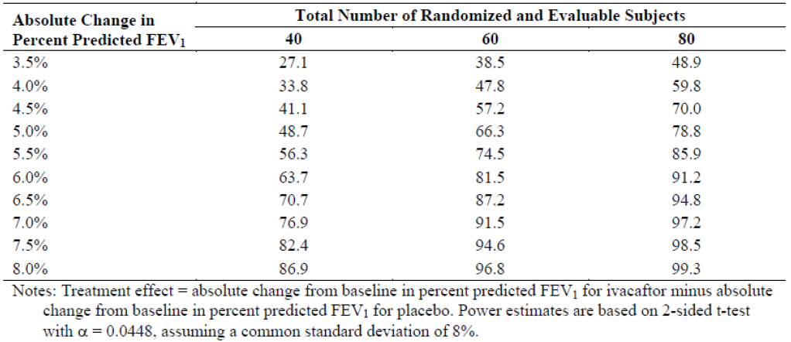
Comment: The sample size of this study had an estimated 70% power to detect an improvement of at least 5% in percent predicted FEV₁ with ivafactor treatment over placebo.

Statistical methods
The primary analysis for the primary efficacy variable was based on a mixed-effects model for repeated measures (MMRM). Data were assumed missing at random and no imputation of missing data was done for the primary analysis. The consistency of treatment effect over different visits was evaluated using the primary MMRM with treatment by visit interaction added to the model. To assess the robustness of the primary analysis, sensitivity analyses including pattern mixture model, dropout reason-based multiple imputation (using ANCOVA) and stratified Wilcoxon rank-sum test were implemented.
The analysis for rate of change from baseline in BMI was based on a linear mixed effects model (LMM). The primary analyses for change from baseline in sweat chloride value and change from baseline in the CFQ-R respiratory domain score were similar to that of the primary efficacy endpoint. Time to first pulmonary exacerbation was analysed using Cox regression; additionally, Kaplan-Meier methods were used to produce graphical presentations of the survival curves by treatment and to estimate cumulative survival rates by treatment. A sensitivity analysis of the rate of change from baseline in BMI was conducted by analysing the rate of change from baseline in BMI-for-age z-score as calculated using the Centers for Disease Control and Prevention (CDC) growth charts. Additional supportive analyses of the secondary endpoints were based on the CCS.
Responder analyses for BMI were conducted by categorizing the change from baseline in BMI (kg/m²) as either ≥ 0.46 kg/m² or <0.46 kg/m²; those for sweat chloride were conducted by categorizing absolute change from baseline in sweat chloride values at Week 24 as ≥ 5 or < 5 mmol/L decrease, ≥ 10 or < 10 mmol/L decrease, ≥ 15 or < 15 mmol/L decrease, ≥ 20 or < 20 mmol/L decrease; and those for CFQ-R respiratory domain score by categorizing the absolute change from baseline in the pooled CFQ-R respiratory domain score through Week 24 as either ≥ 4 points or < 4 points.
The primary analysis for tertiary efficacy variables was performed for the FAS only. Pulmonary exacerbations were analysed using negative binomial regression (count) and Wilcoxon rank-Sum test (duration). CFQ-R non-respiratory domains were analysed in the same manner as the primary analysis of the secondary efficacy variable of CFQ-R respiratory domain score. Weight and height were analysed in the same manner as the primary analysis of the secondary efficacy variable of BMI. Analysis of inflammatory mediators was conducted on the raw change from baseline result and the log transformed change from baseline result in a similar manner as for the primary efficacy variable. CF-related complications were only summarized; qualitative levels of microbiological cultures were only summarized by shift tables. Change from baseline in IRT and faecal elastase-1 were analysed using ANCOVA with change from baseline as the dependent variable.

Participant flow
A total of 69 subjects (35 in the placebo group and 34 in the ivacaftor group) were randomised and received at least one dose of study drug; 67 completed their full assigned duration of dosing; 59 of these subjects (28 in the ivacaftor group and 31 subjects in the placebo group) completed the 24-week treatment period. The remaining 8 subjects did not complete 24 weeks of treatment because the study was terminated early by the sponsor (Table 8). The overall treatment compliance was similar in the ivacaftor (98.97%) and placebo (98.43%) groups.

Table 8: Subject disposition
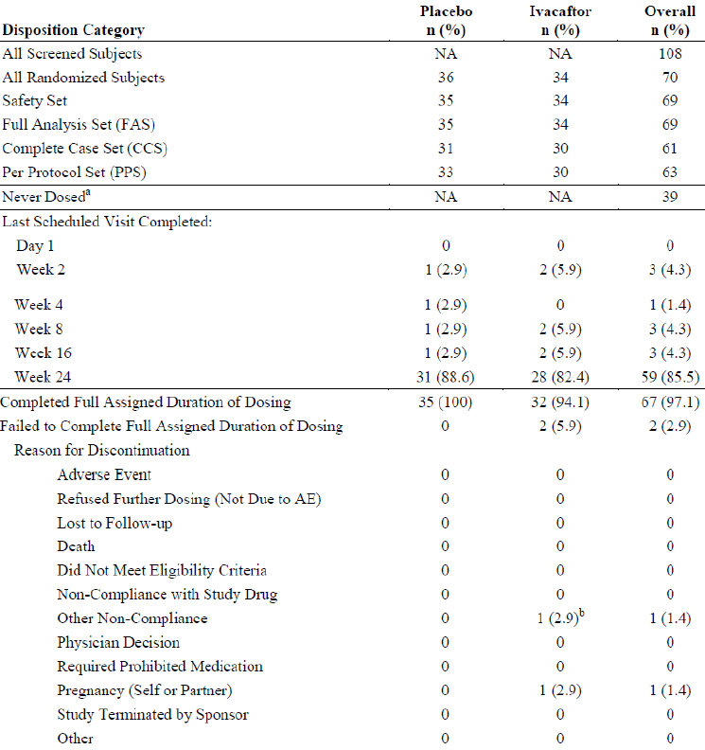
NA: not applicable; AE: adverse event. Percentages are calculated relative to the number of subjects in the FAS. FAS is defined as all randomised subjects who received at least 1 dose of study drug. Safety Set is defined as all subjects who received at least 1 dose of study drug. CCS is defined as all FAS subjects who had the opportunity to complete the full 24 week treatment period. PPS is defined as all FAS subjects without major protocol violations that could affect efficacy data. A: The 39 subjects counted as 'never dosed' were screen failures. In addition, 1 subject [information redacted] was randomised to the placebo group but not dosed (reason: PI decision due to high percent predicted FEV₁ value on Day 1). b: Subject [information redacted] was discontinued from the study due to non-compliance in completing the required ophthalmologic examination at Screening.

Major protocol violations/deviations
Overall, 57 major protocol deviations were reported in 32 subjects (15 subjects on placebo and 17 subjects on ivacaftor) and the most common deviations included those that were related to use of a prohibited medication (ciprofloxacin, clarithromycin, fluconazole, prednisolone and prednisone), study drug compliance, eligibility and entry criteria not met. However, only 6 subjects who had major protocol violations (defined as major protocol deviations that may have had a substantial impact on efficacy assessment) were excluded from the PPS: 4 subjects in the ivacaftor group (3 subjects for prohibited medications- prednisone; 1 subject for missing 2 or more primary endpoint visits) and 2 subjects in the placebo group (1 subject discontinued inhaled antibiotic treatment during treatment period and 1 subject with treatment compliance < 80%).

Baseline data
All subjects in both treatment groups were White, and the majority of subjects in both treatment groups were of non-Hispanic or Latino ethnicity (placebo: 100%; ivacaftor: 97.1%). The mean age was 32.7 years (range: 6 to 68 years) for the placebo group and 29.2 years (range: 6 to 55 years) for the ivacaftor group. There were 19 subjects overall in the < 18 years subgroup (2 of whom were 12 to 17 years of age) and 50 subjects overall in the ≥ 18 years subgroup. Baseline percent predicted FEV₁ and BMI were slightly higher in the ivacaftor group than in the placebo group, and baseline sweat chloride and P aeruginosa infection rate were slightly lower for the ivacaftor group than the placebo group. In data from subjects for whom the R117H allele poly-T variant was confirmed or derived, the R117H-5T variant was more prevalent in the placebo group (placebo: 27 of 34 subjects; ivacaftor: 21 of 33 subjects). Overall, 53 (76.8%) of subjects had F508del mutation in the second allele. The mean sweat chloride value of about 70 mmol/L for the FAS is consistent with the residual function phenotype generally associated with the R117H-CFTR mutation. Overall, there were no significant differences between the ivacaftor and placebo groups (Table 9).
Comment: Overall, the baseline characteristics seem to indicate that patients in the ivacaftor group had a slightly better profile with less severe disease manifestations at baseline (higher precent predicted FEV₁, BMI, lower sweat chloride and P. aeruginosa infection and lower prevalence of the more severe R117H-5T variant) (Table 9). The effect of this slight imbalance on interpretation of efficacy of ivacaftor was not discussed. Clarification regarding this has been sought from sponsors (see efficacy questions in Section 12).

Table 9: Demographics and baseline characteristics, full analysis set
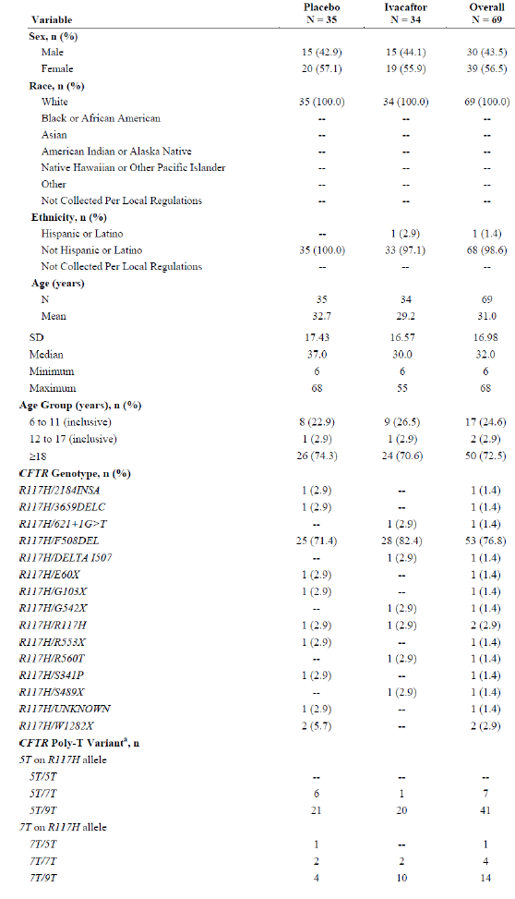

Table 9: continued
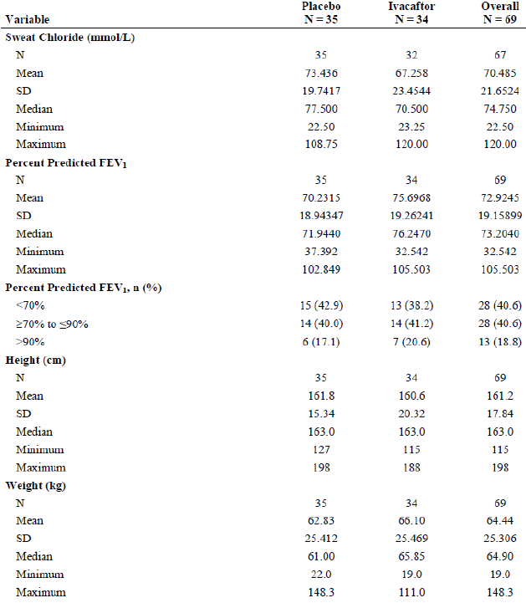

Table 9: continued
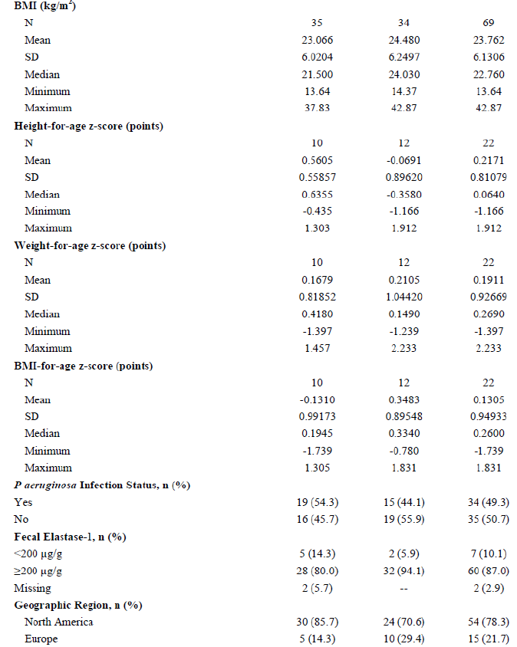
All results displayed are Baseline results. Baseline was defined as the most recent measurement before intake of the first dose of study drug. Baseline sweat chloride was the average of Day-14 and Day 1. Weight for age z-score and BMI for age z-score were calculated by using National Center for Health Statistics (NCHS) growth charts. Z-scores were defined as missing if the subject is over 240 months old at the time of assessment. a: The poly-T variant for the R117H allele was derived for subjects where this information was missing and the subject had either R117H/F508DEL or R117H/R117H.
For subjects > 18 years of age, all subjects were White with mean age of 40.6 and 37.5 years for the placebo and ivacaftor groups, respectively. The mean overall baseline percent predicted FEV₁ was 64.53%, and mean overall baseline sweat chloride value was 71.29 mmol/L. Baseline percent predicted FEV₁ was slightly higher and baseline sweat chloride slightly lower for the ivacaftor group than the placebo group (Table 10A). For subjects aged 6 to 11 years, the mean age was 9.0 and 8.8 years for the placebo and ivacaftor groups, respectively. The mean overall baseline percent predicted FEV₁ was 95.84%, and mean overall baseline sweat chloride value was 69.41 mmol/L. Baseline percent predicted FEV₁ was slightly higher and baseline sweat chloride slightly lower for the ivacaftor group than the placebo Group (Table 10B).

Table 10A: Demographics and baseline characteristics; full analysis set, subjects ≥ 18 years of age
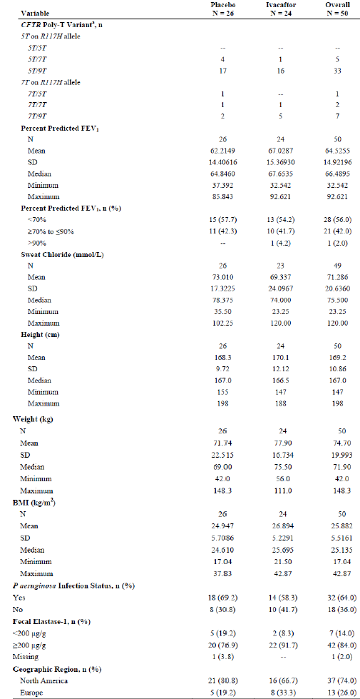

Table 10B: Demographics and baseline characteristics; full analysis set, subjects 6 to 11 years of age (inclusive)
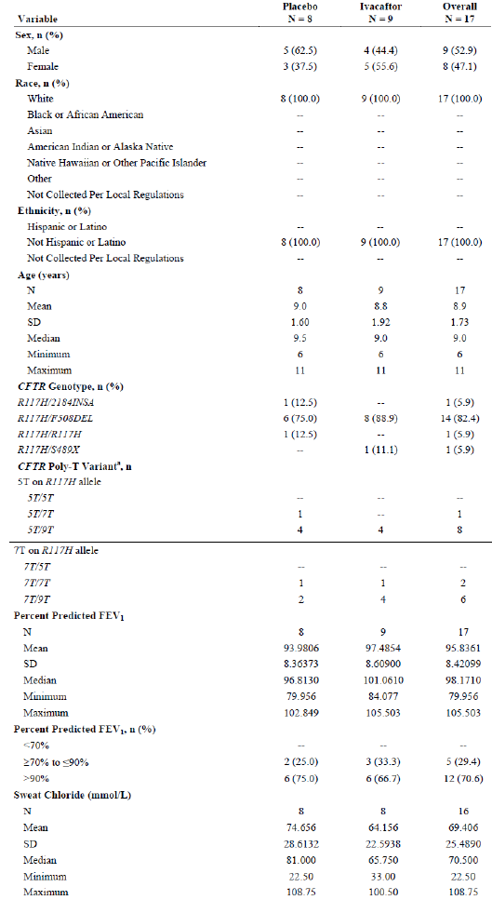

Table 10B: Continued
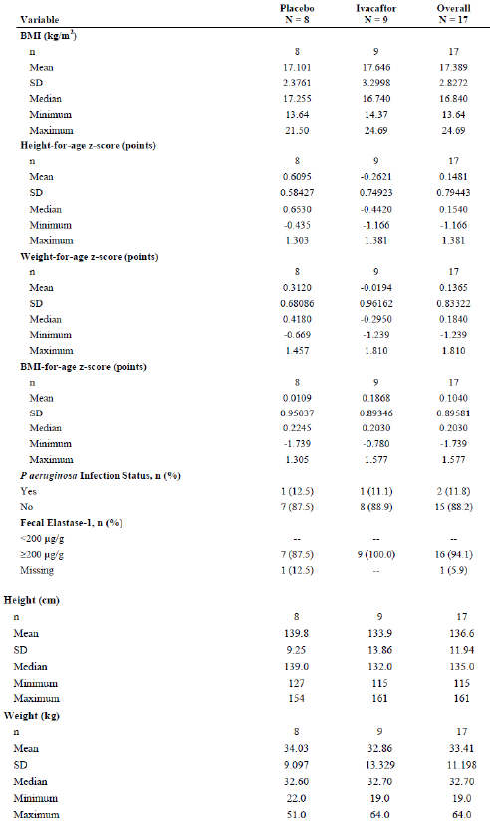
The incidence of medical history conditions occurring in at least 15% of subjects was similar in the 2 treatment groups with the exception of asthma (placebo: 14.3%; ivacaftor: 35.3%), pancreatic insufficiency (placebo: 28.6%; ivacaftor: 8.8%), and drug hypersensitivity (placebo: 34.3%; ivacaftor: 17.6%). The rate of faecal elastase-1 ≥ 200 μg/g was slightly higher in the ivacaftor group (placebo: 80.0%; ivacaftor: 94.1%) (Table 11). The mean number of hospitalizations (planned and unplanned) and clinic visits in the past year were similar for the 2 groups (Table 12). The most commonly reported concomitant medications were indicated for management of CF complications. The use of concomitant medications received by at least 15% of subjects was similar in both treatment groups with the exceptions of paracetamol (placebo: 37.1%; ivacaftor: 11.8%) and pancreatin (placebo: 20.0%; ivacaftor: 2.9%) (Table 13).

Table 11: medical history consistent with a diagnosis of CF with an incidence of at least 15% of subjects in any treatment group, full analysis set
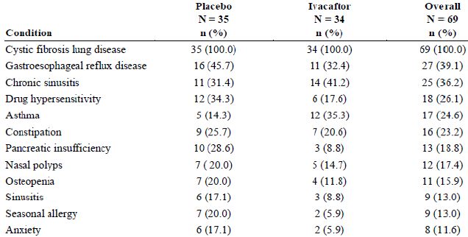

Table 12: hospitalisations (planned and unplanned) and clinic visits in the past year full analysis set
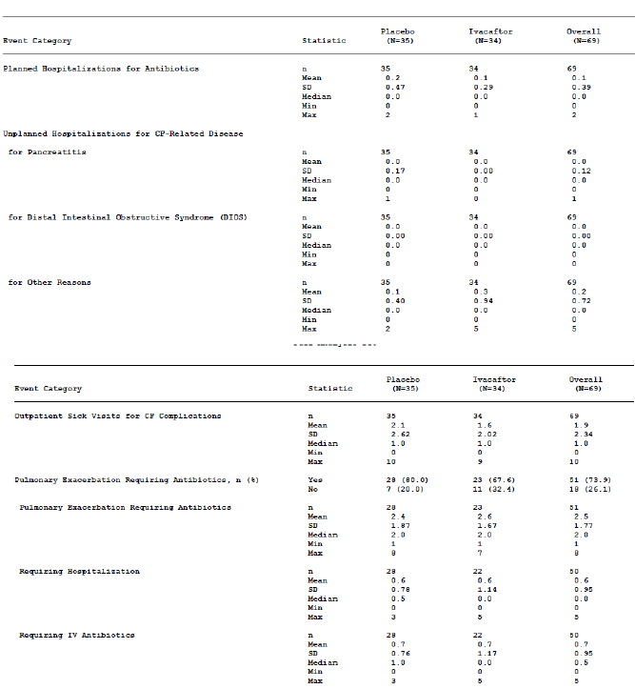

Table 13: concomitant medications received by at least 15% of subjects in any treatment group, full analysis set
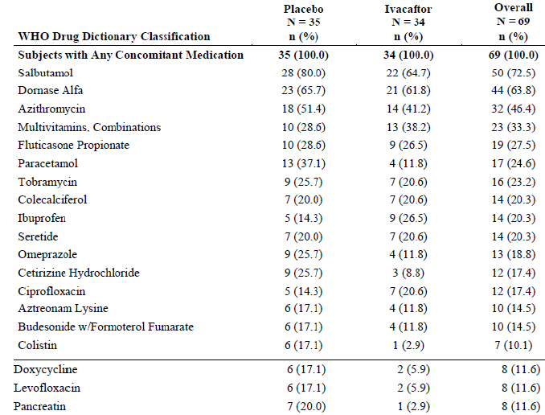
Preferred Terms (PT) are sorted in descending order of frequency in the Overall column. A subject with multiple concomitant medications within Anatomical Therapeutic Chemical (ATC) level or PT is counted only once within the ATC level or PT. Concomitant medications were coded from the WHHO Drug Dictionary Enhanced, March 2012.

Results for the primary efficacy outcome
Although the mean absolute change from baseline in percent predicted FEV₁ through Week 24 by MMRM for the FAS was greater for the ivacaftor group than the placebo group (2.57 versus 0.46 percentage points), the difference was not statistically significant (difference for ivacaftor versus placebo was 2.11 percentage points; (95% CI: -1.13, 5.35; p = 0.1979). Although not statistically significant, the differences favoured ivacaftor at all treatment period time points; the trend in treatment effect observed at Week 8 was consistent with that observed at Week 24 (Table 14-15). The gains seen in percent predicted FEV₁ for the ivacaftor group during the treatment period reversed in the follow-up period when the subjects were no longer receiving ivacaftor (Figure 3).
The results of the sensitivity analyses were consistent with the results of the primary analysis; the absolute change from baseline was greater for the ivacaftor group than the placebo group for all analyses, but was not statistically significant (Table 16).
A responder analysis was conducted by categorizing the absolute change from baseline in percent predicted FEV₁ through Week 24 as ≥ 3.5% or < 3.5%, ≥ 5% or < 5%, ≥ 7.5% or < 7.5%, ≥ 10% or < 10%. The number of responders favoured ivacaftor at all thresholds, with approximately twice as many responders in the ivacaftor group as the placebo group; however, these differences were not statistically significant (Table 17).

Table 14: Absolute change from baseline in predicted FEV₁ by MMRM, full analysis set
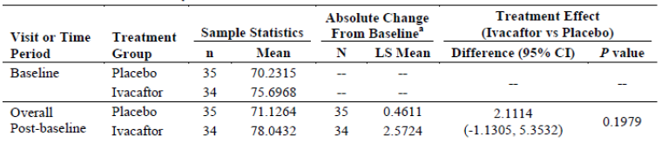

Table 15: Absolute change from baseline in percent predicted FEV₁ by MMRM, consistency of treatment effect over visits, full analysis set
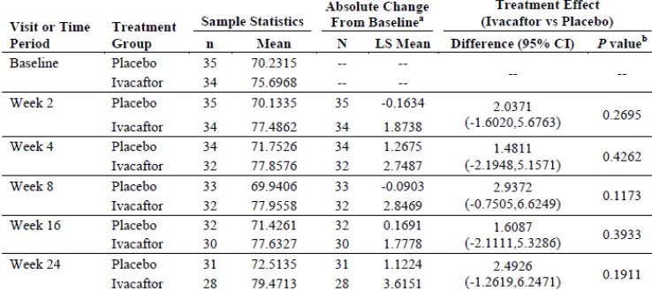
Sample statistics are unadjusted results. Difference is ivacaftor- placebo. A positive difference favors ivacaftor. A: Estimates were obtained from MMRM with absolute change from baseline as the dependent variable; with treatment, categorical visit (Weeks 2,4,8 and 16) and treatment by visit interaction as fixed effects; with subject as a random effect; and with adjustment for the continuous baseline value of age and percent predicted FEV₁ using compound symmetry covariance matrix. b: P value for overall post-baseline is from the main treatment effect; p values at individual visits are from linear contrasts between the 2 treatments at the given visit.
Figure 3: modelled absolute change from baseline in percent predicted FEV₁ by treatment up to follow-up visit, full analysis set
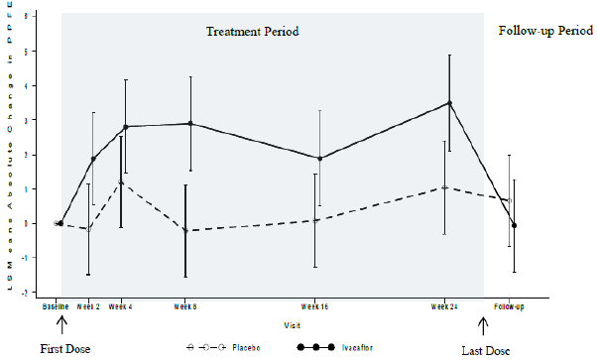

Table 16: Absolute change from baseline in percent predicted FEV₁, sensitivity analysis, full analysis set
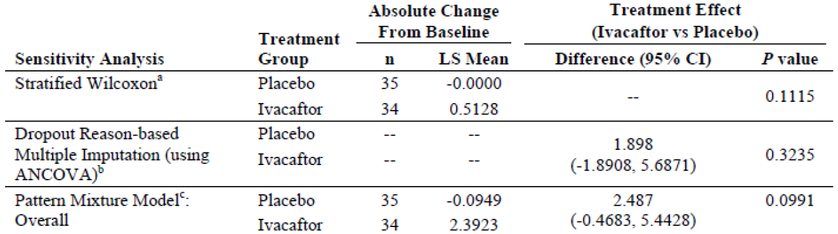
a: Stratified (by age group and percent predicted FEV₁ at baseline) Wilcoxon rank-sum test of the mean change from baseline. Medians are displayed in the LS Mean column. b: ANCOVA model with drop-out reason based method. c: Estimates from MMRM with the dependent variable absolute change from baseline; with fixed effects for visit, treatment, dropout pattern, interaction between dropout pattern and treatment, and interaction between dropout pattern and visit; and adjustment for continuous baseline value of percent predicted FEV₁ using compound symmetry covariance matrix. The overall treatment effect adjusting for dropout patterns was obtained from pattern-specific estimates by a weighted average.

Table 17: Responder analysis of absolute change through Week 24 in percent predicted FEV₁, full analysis set
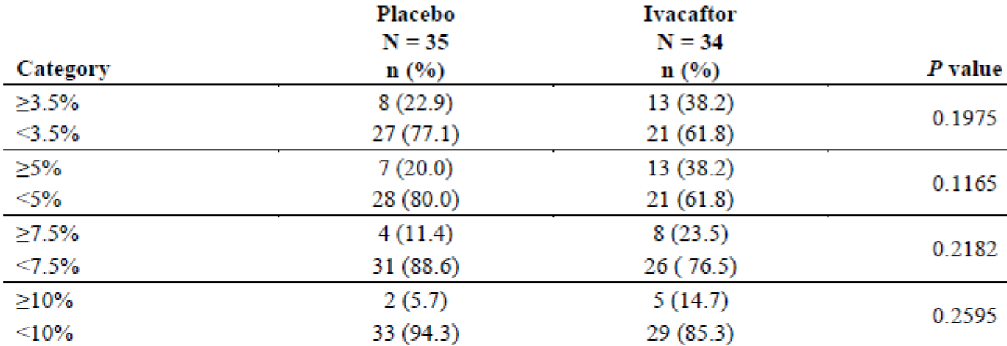
Absolute change through Week 24 is the average change from baseline over 24 weeks for percent predicted FEV₁.
Comment: The sponsors state that the magnitude of change observed in pulmonary function (that is percent predicted FEV₁) in subjects ≥ 18 years of age is within a clinically relevant range observed in established treatments approved to treat CF. However, the treatment difference (ivacaftor-placebo) of around 4 to 5% was much lesser than the 10 to 12% treatment difference observed in the pivotal studies 103 and 104 in that observed in 213 subjects with CF who had a G551D mutation in the CFTR gene (PM-2012-01491-3-5).

Results for other efficacy outcomes

Secondary efficacy results
The mean absolute change from baseline in sweat chloride showed statistically significantly greater reduction with ivacaftor compared to placebo (-26.28 versus -2.31 mmol/L; treatment difference for ivacaftor versus placebo was -23.97 mmol/L; 95% CI: -28.01, -19.93; p < 0.0001). The treatment effect was highly consistent from Week 2 through Week 24. Furthermore, the decrease seen in sweat chloride for the ivacaftor group during the Treatment Period reversed in the Follow-up Period when the subjects were no longer receiving ivacaftor (Figure 4).
The majority of subjects in the ivacaftor group who had ≥ 5 mmol/L decrease in sweat chloride at Week 24 also had ≥ 15 mmol/L decrease at Week 24. Only 1 subject (2.9%) in the placebo group achieved a ≥ 15 mmol/L decrease in sweat chloride compared to 21 subjects (61.8%) in the ivacaftor group. None of the subjects in the placebo group achieved a ≥ 20 mmol/L decrease in sweat chloride compared to 9 subjects (26.5%) in the ivacaftor group (Table 18).
The rate of increase in BMI from baseline was greater in the ivacaftor groups compared with placebo although the treatment difference was not statistically significant (diff = 0.26 kg/m²; 95% CI: -1.57, 2.09; p = 0.7780). BMI-for-age z-scores were calculated using the CDC growth chart for the 22 subjects who were 20 years of age or younger and showed similar results (Table 19-20).
The calculated hazard ratio of 0.928 for time to first pulmonary exacerbation favoured ivacaftor, but was not statistically significant (p = 0.8556). Survival curves by treatment group for time-to-first pulmonary exacerbation, pulmonary exacerbation requiring hospitalization, and pulmonary exacerbation requiring IV antibiotics showed no significant difference between ivacaftor and placebo groups (Figure 5-6-7).
The mean absolute change from baseline in the pooled CFQh-R respiratory domain score through Week 24 was greater for the ivacaftor group (7.56 points) than the placebo group (-0.83 points). The treatment difference for ivacaftor versus placebo was 8.39 points (95% CI: 2.17 to 14.61), which is approximately double the defined minimal clinically important difference (MCID) of 4 points and was statistically significant (p = 0.0091). Ivacaftor showed better scores at all treatment period time points. Furthermore, the gains seen in the CFQ-R respiratory domain score for the ivacaftor group during the Treatment Period reversed in the Follow-up Period when subjects were no longer on ivacaftor (Figure 8). The percentage of subjects with the clinically important ≥ 4 point increase from baseline in the CFQ-R respiratory domain score through Week 24 was greater for the ivacaftor group (41.2%) than the placebo group (28.6%).
The mean absolute change from baseline in the CFQ-R respiratory domain score through Week 24 was lower for the ivacaftor group than the placebo group in the Children Ages 6 to 11 Years version and in the Parent/Caregiver version but the treatment difference was not statistically significant (Table 21). The Children Ages 12 to 13 Years version was not analysed with MMRM due to sample size constraints. The mean absolute change from baseline in the CFQ-R respiratory domain score through Week 24 in the Adolescents and Adults version was greater for the ivacaftor group (12.10 points) than the placebo group (-0.26 points). The treatment difference of 12.36 points (95% CI: 5.03, 19.69) was statistically significant (P = 0.0014) and larger than that seen in the pooled analysis. The mean absolute change from baseline for the CFQ-R respiratory domain score through Week 24 was lower for the ivacaftor group (-3.72 points) than the placebo group (-2.10 points), but the treatment difference of -1.62 points (95% CI: -13.65, 10.41) was not statistically significant (p= 0.7766).
Figure 4: Mean absolute change from baseline in sweat chloride (mmol/L) by treatment up to follow-up visit, full analysis set
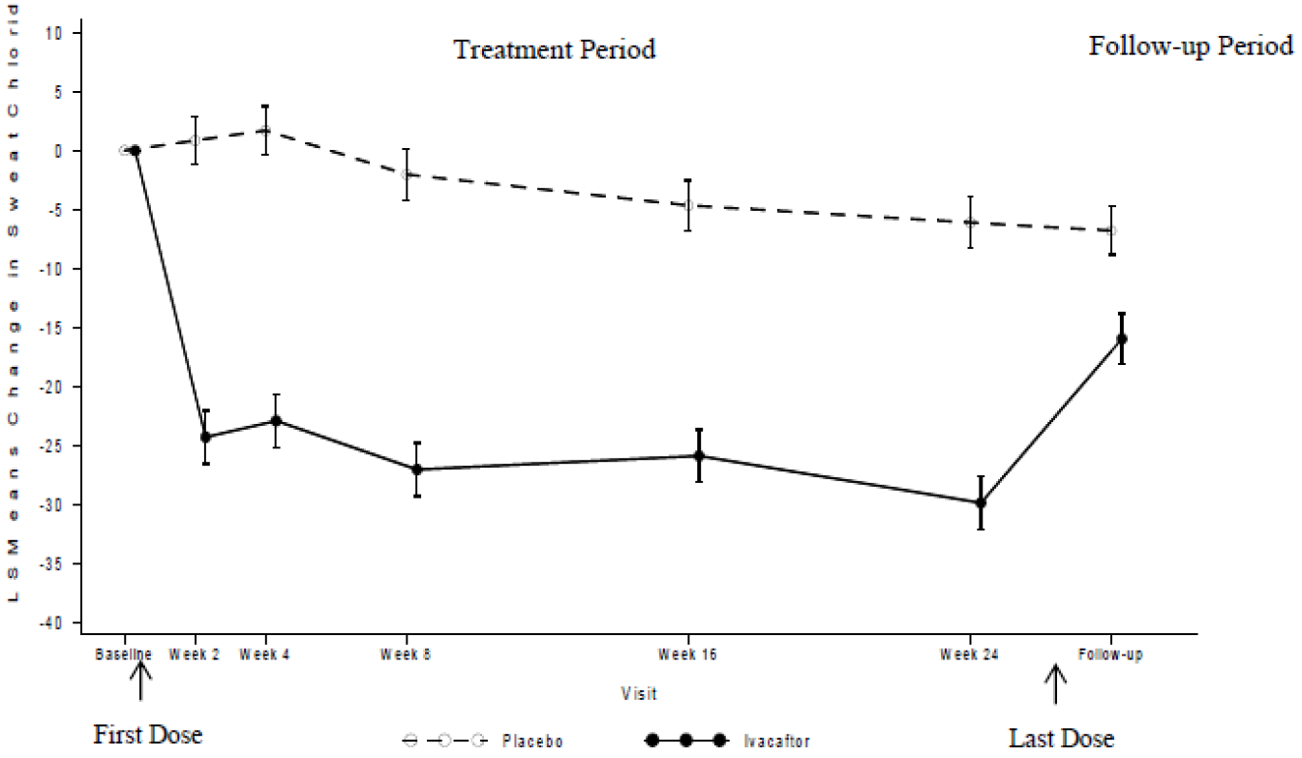

Table 18: responder analysis of absolute change through week 24 of sweat chloride (mmol/L), full analysis set
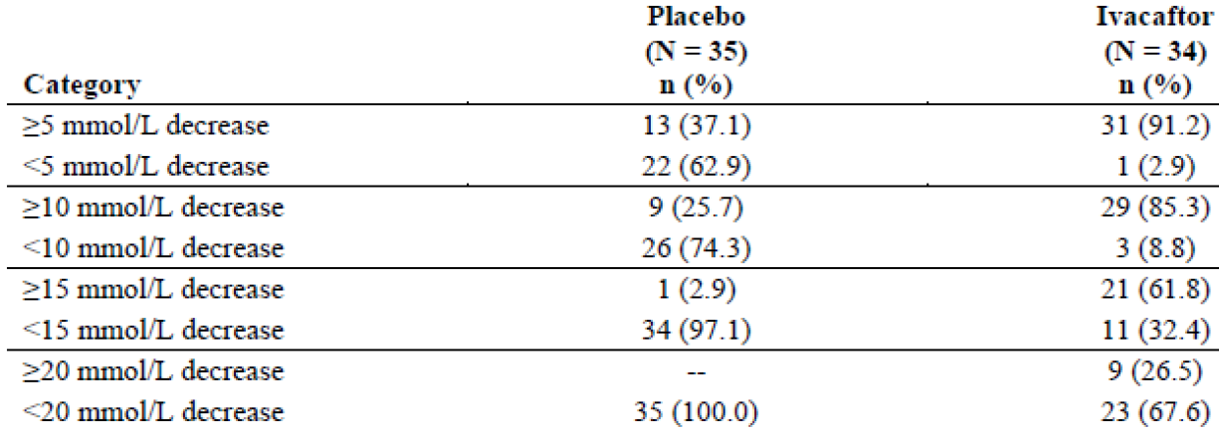
Absolute change through Week 24 is the average change from baseline over 24 weeks for sweat chloride.

Table 19: rate of change from baseline in BMI (kg/m²) by LMM, full analysis set
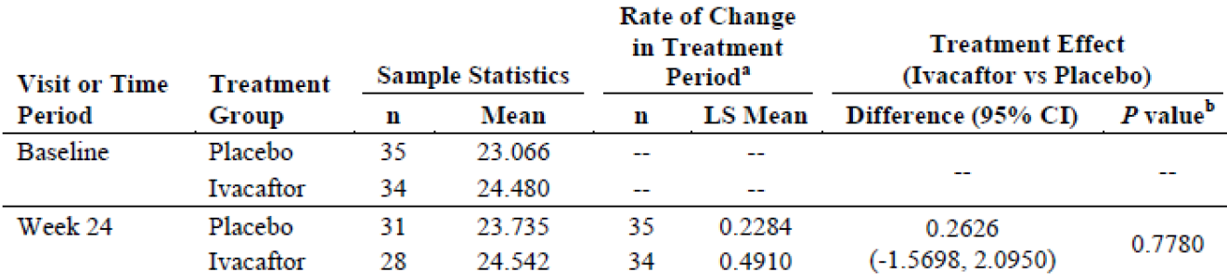
Sample statistics are unadjusted results. a: Estimated change from baseline per 168 days was obtained from a linear mixed model, with BMI as the dependent variable; with treatment as a fixed effect; with intercept and visit (days on study, including all visits through Week 24) as random effects; and with adjustment for baseline percent predicted FEV₁, age, and visit by treatment interaction included as covariates in the model. b: p value for the treatment effect is from the slope of BMI (kg/m²) versus time (days).

Table 20: Rate of change from baseline in BMI-for-age Z-score by LMM, full analysis set
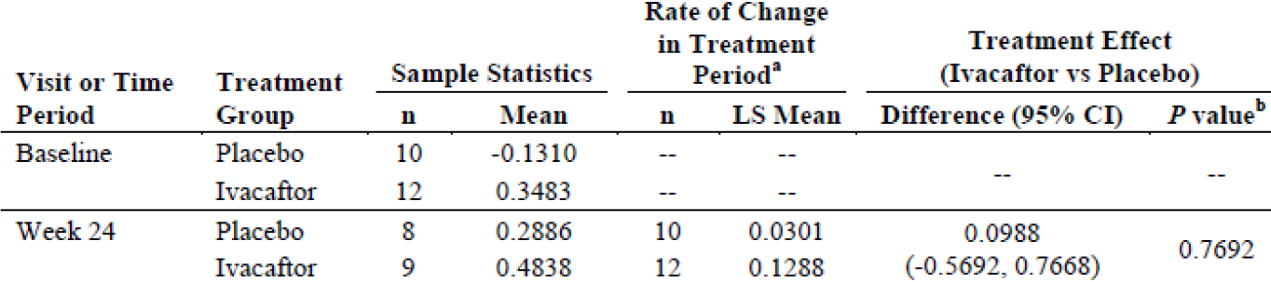
Sample statistics are unadjusted results. BMI-for-age z-scores were calculated using National Center for Health Statistics (NCHS) growth chart. Z-scores are defined as missing if the subject was over 240 months old at the time of assessment. a: Estimated change from baseline per 168 days was obtained from a linear mixed model, with BMI-for-age z-score as the dependent variable; with treatment as a fixed effect; with intercept and visit (days on study, including all visits through Week 24) as random effects; and with adjustment for baseline percent predicted FEV₁, age, and visit by treatment interaction included as covariates in the model. b: p value for the treatment effect is from the slope of BMI-for-age z-score versus time (days).
Figure 5: time-to-first pulmonary exacerbation, full analysis set
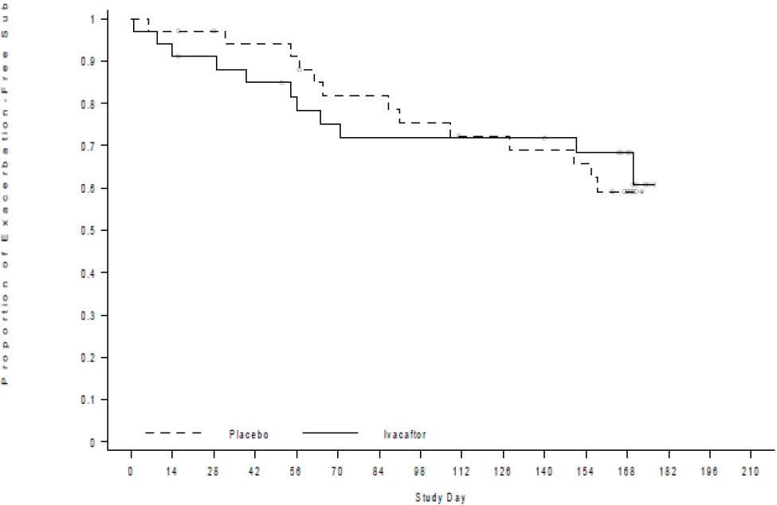
The open circles on the plot denote censored objects.
Figure 6: time-to first pulmonary exacerbation requiring hospitalisation, full analysis set
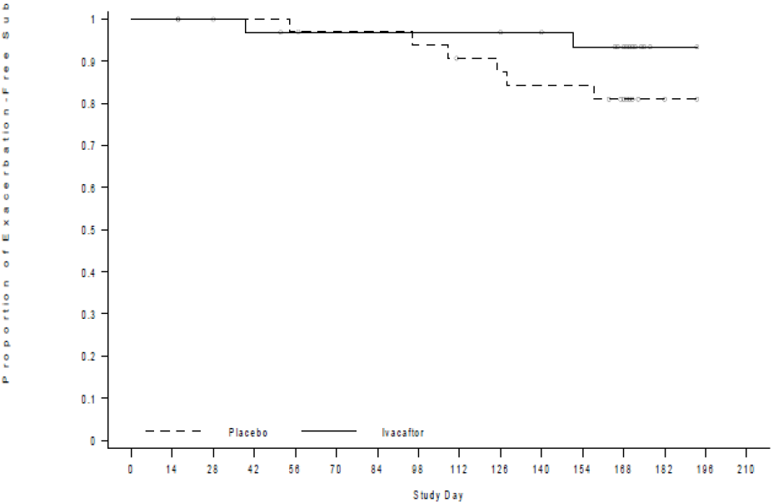
The open circles on the plot denote censored objects.
Figure 7: time-to-first pulmonary exacerbation requiring IV antibiotics, full analysis set
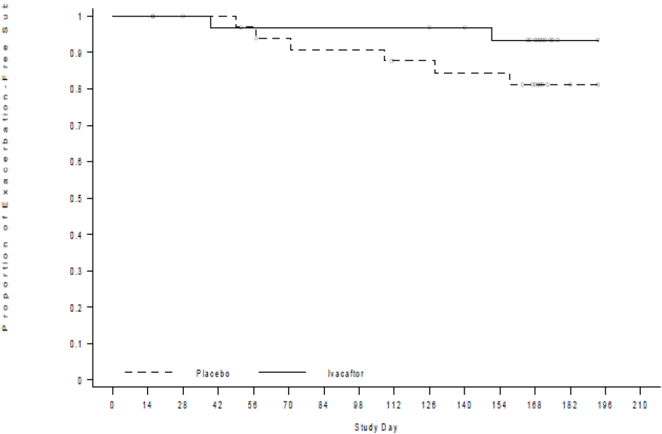
The open circles on the plot denote censored objects.
Figure 8: mean absolute change from baseline in pooled CFQ-R respiratory domain score by treatment up to follow-up visit, full analysis set
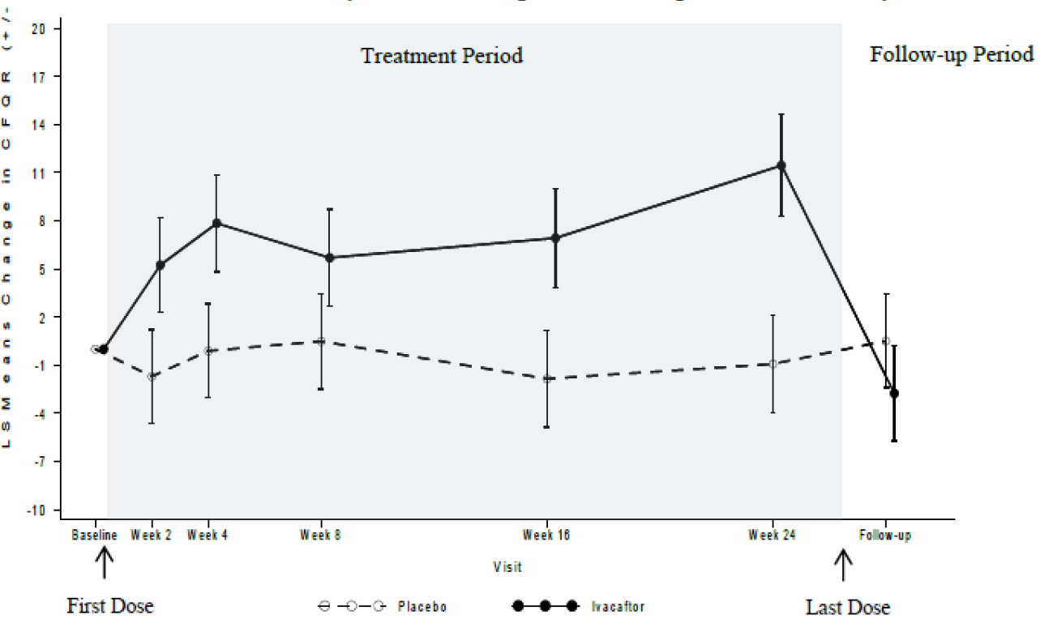

Table 21: absolute change from baseline in CFQ-R respiratory domain score by MMRM, full analysis set
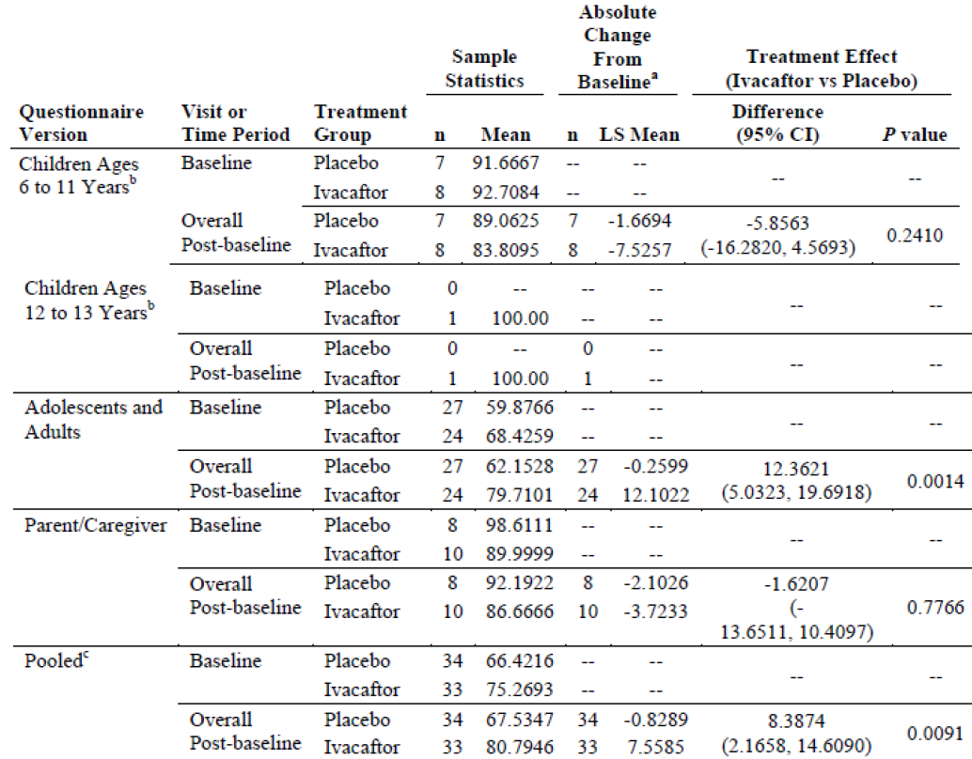
Sample statistics are unadjusted results. Analysis was conducted only when the number of subjects with results in each treatment group ≥ 5. Difference is ivacaftor- placebo. A positive difference favours ivacaftor. a: Estimates were obtained from MMRM, with absolute change from baseline as the dependent variable; with treatment group, categorical visit (Weeks 2, 4, 8, 16 and 24), and treatment by visit interaction as fixed effects; with subject as a random effect, and with adjustment for the continuous baseline values of age, percent predicted FEV1, and CFQ-R respiratory domain score using a compound symmetry covariance matrix. b: The Childen Ages 6 to 11 Years (interviewer format) CFQ-R instrument response option cards may not have been used. C: Pooled was defined as all questionnaire versions except for the Parent/Caregiver version.

Tertiary efficacy results:
The event rate of pulmonary exacerbations was slightly lower in the ivacaftor group compared to placebo, but the difference was not statistically significant (0.249 versus 0.295; rate ratio = 0.843, 95% CI: 0.409, 1.737; p = 0.6432). Rates for subcategories of pulmonary exacerbations (that is requiring hospitalization and requiring IV antibiotics) were not calculated due to low event incidence, however, the number of events requiring hospitalization or IV antibiotics was notably lower for the ivacaftor group (Table 22). The mean (SD) duration of pulmonary exacerbations was non-significantly (p = 0.8472) lower for the ivacaftor group (5.92 [11.006] days) than the placebo group (8.20 [14.371] days).
The treatment differences favoured ivacaftor in the pooled analysis for the CFQ-R non-respiratory domains (physical, emotional, social, eating and digestion), but were statistically significantly better in ivacaftor group for the emotional, social and eating domains (Table 23).
Although patients treated with ivacaftor showed greater increase in weight compared to placebo through week 24, the difference was not statistically significant (1.85 versus 0.92kg; treatment difference = 0.93 kg; 95% CI: -5.97, 7.82, p = 0.7912). For subjects 20 years of age or younger, weight-for-age z-scores were calculated using the CDC growth chart and it showed similar results (Table 24-25). Rate of change from baseline in height was slightly lower for the ivacaftor group with no statistically significant difference from placebo and similar results for height for age-z-scores calculated using CDC growth charts for subjects < 20years old (Table 26-27).
No analysis of CF-related complications was performed because no episodes of pancreatitis or distal ileal obstruction syndrome (DIOS) occurred during the study.
Generally, subjects had a greater decrease in inflammatory mediator (leukocytes, CRP, IgG, and IL-8) concentrations for the ivacaftor group than the placebo group; the treatment difference for the log-transformed data was statistically significant for each of the inflammatory mediators except for log-transformed CRP which was near statistical significance (Table 28).
Shift from baseline in qualitative microbiology cultures from throat swabs and sputum samples for the following common or important microbiological organisms that affect patients with CF in general, shifts to higher or lower amounts of each microbe were sporadic and did not show any patterns across the treatment groups; however, this analysis is limited by the small number of subjects and a high incidence of unknown results for sputum samples.
Change from baseline in immunoractive trypsinogen (IRT) through Week 24 showed a decrease for the ivacaftor group (-9.2588 ng/mL) and an increase for the placebo group (3.9988 ng/mL), but the treatment difference of -13.2576 ng/mL (95% CI: -27.5323 to 1.0171) was not statistically significant (p = 0.0679). A decrease from baseline in faecal elastase-1 through Week 24 was seen for the placebo group (-15.2619 μg/g) while there was a slight increase for the ivacaftor group (0.1587 μg/g). However, the treatment difference of 15.4206 μg/g (95% CI: -29.4148, 60.2560) was not statistically significant (P = 0.4922).

Table 22: number of pulmonary exacerbations, full analysis set
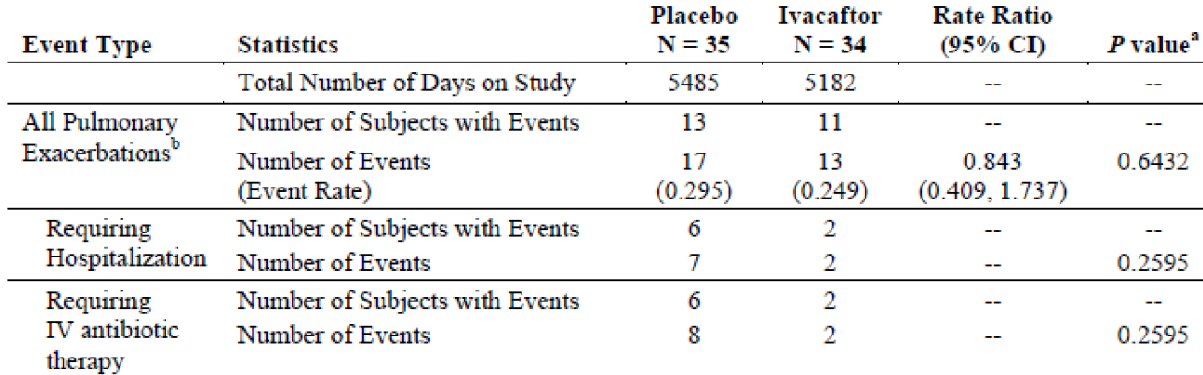
Estimates were obtained from negative binomial regression with the number of events as the dependent variable, treatment as a fixed effects, and adjustment for baseline percent predicted FEV₁ and age, with log (time on study) as an offset. Negative binomial regression was conducted only when the number of subjects with events in each treatment group was ≥ and the models converged. a: When estimates are presented, p values are from the treatment effect in negative binomial regression; otherwise, p values are from Fisher`s Exact test. b: Pulmonary exacerbation includes events that met the protocol definition of pulmonary exacerbations (that is treatment with new or changed antibiotic therapy for ≥ 4 sinopulmonary signs/symptoms).

Table 23: absolute change from baseline in pooled CFQ-R non-respiratory domain scores by MMRM, full analysis set
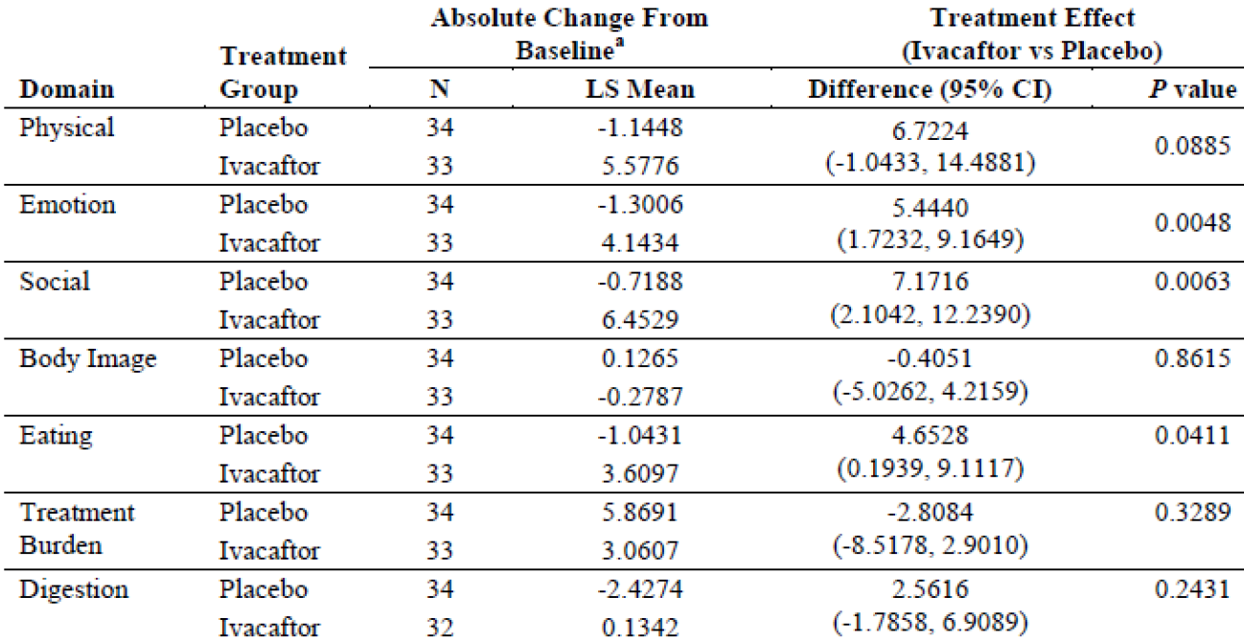
Analysis was conducted only when the number of subjects with results in each treatment group was ≥ 5. Pooled is defined as all questionnaire versions except for the Parent/Caregiver version. The Children Ages 6 to 11 Years (interviewer format) CFQ-R instrument response option cards may not have been used. A: Estimates were obtained from MMRM with absolute change from baseline as the dependent variable; with treatment group, categorical visit (Weeks 2, 4, 8, 16 and 24) and treatment by visit interaction as fixed effects; with subject as a random effect; and with adjustment for the continuous baseline value of age, percent predicted FEV₁, and domain score, using compound symmetry covariance matrix.

Table 24: rate of change from baseline in weight (kg) by LMM, full analysis set
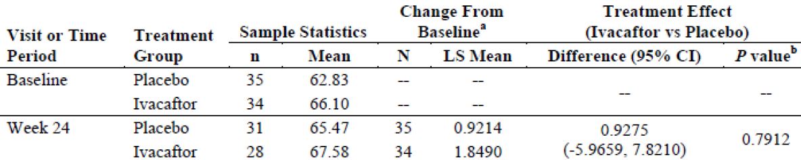
Sample statistics are unadjusted results. a: Estimated change from baseline per 168 days were obtained from a linear mixed model with the dependent variables weight and treatment as a fixed effect; with adjustment for baseline percent predicted FEV₁, age and visit by treatment interaction as covariates in the modek; and with intercept, visit (days on study, including all visits through Week 24) as random effects. b: p value for the treatment effect is from the slope of weight (kg) versus time (days).

Table 25: rate of change from baseline in weight-for—age z-score by LMM, part 1, full analysis set
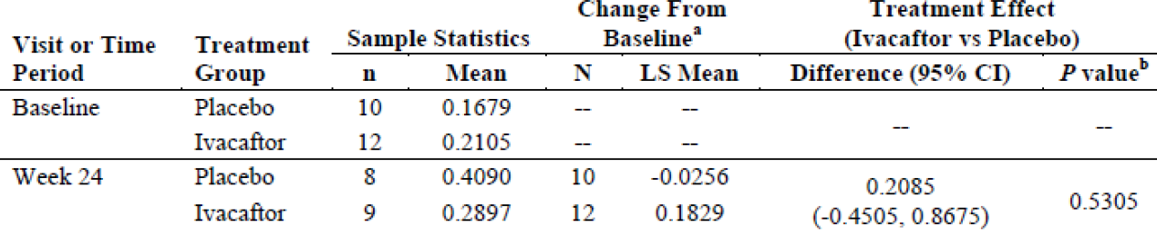
Sample statistics are unadjusted results. Weight-for-age z-scores were calculated using NCHS growth charts. Z-scores are defined as missing if the subject is over 240 months old at the time of assessment. a: Estimated change from baseline per 168 days were obtained from a linear mixed model with the dependent variable weight-for-age z-score and treatment as a fixed effect; with adjustment for baseline percent predicted FEV₁, age, and visit by treatment interaction as covariates in the model, and with intercept, visit (days on study, including all visits through Week 24) as random effects. b: p value for the treatment effect is from the slope of weight-for-age z-score versus time (days).

Table 26: rate of change from baseline in height (cm) by LMM, full analysis set
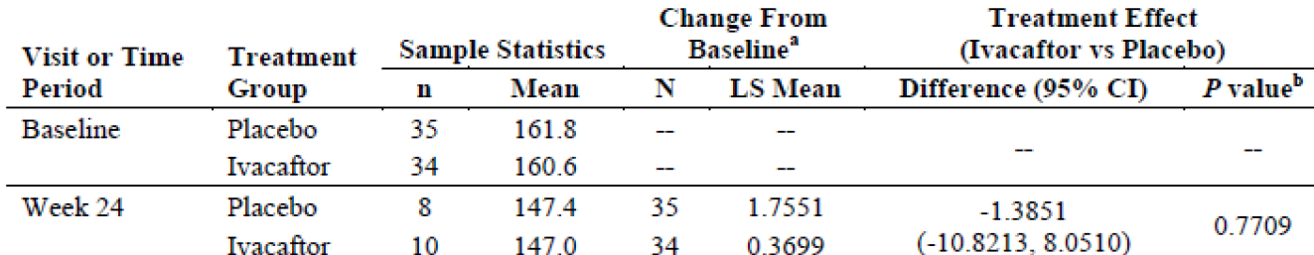

Table 27: rate of change from baseline in height-for-age Z-score by LMM, full analysis set
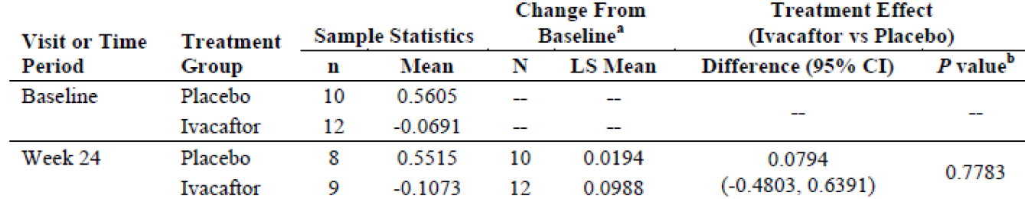

Table 28: absolute change from baseline in inflammatory mediator and log-transformed inflammatory mediator concentrations by MMRM, full analysis set
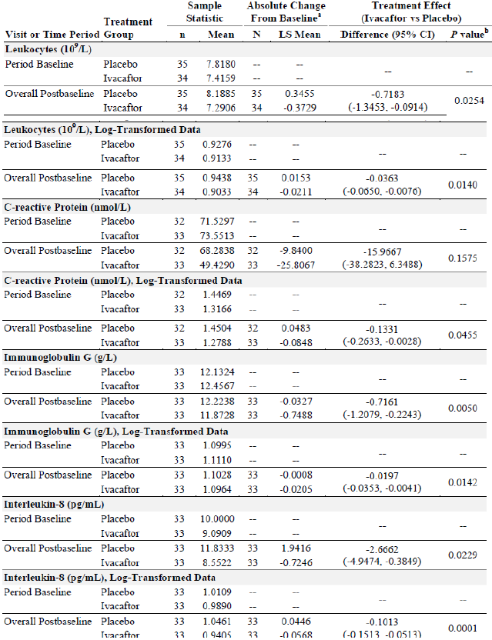
Sample statistics are unadjusted results. a: Estimates were obtained from MMRM with absolute change from baseline as the dependent variable; with treatment group, categorical visit (Weeks 2, 4, 8, 16 and 24) and treatment by visit interaction as fixed effects; with subject as random effect; and with adjustment for the continuous baseline value of age, percent predicted FEV₁, and baseline inflammatory mediator as covariates using compound symmetry covariance matrix. b: P value is the from the main treatment effect.

Additional efficacy results:
The mean relative change from baseline in percent predicted FEV₁ through Week 24 was greater for the ivacaftor group than the placebo group (4.83 versus -0.21 percentage points), but the treatment difference did not reach statistical significance (difference = 5.04 percentage points; 95% CI: -0.24, 10.31; p = 0.0611). Treatment differences favoured ivacaftor at all Treatment Period time points, and achieved statistical significance at the Week 8 Visit (p = 0.0396). Furthermore, difference from week 24 to follow-up visit showed significantly greater reduction in % predicted FEV₁ in the ivacaftor group compared with placebo (Table 29-31). There was a statistically significant difference (p = 0.0118) in the responder ^{k} rate between placebo and ivacaftor at the 10% threshold; the number of responders also favoured ivacaftor at the lower thresholds, with approximately twice as many responders in the ivacaftor group as the placebo group (Table 32).

Table 29: relative change from baseline through Week 24 in percent predicted FEV₁ by MMRM, full analysis set
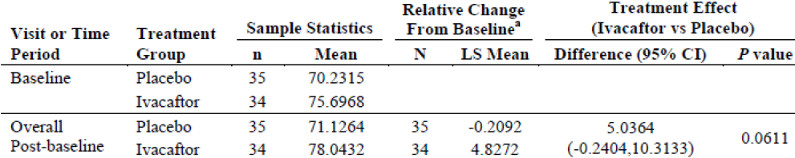

Table 30: relative change from baseline in percent predicted FEV₁ by MMRM, consistency of treatment effect over visits, full analysis set
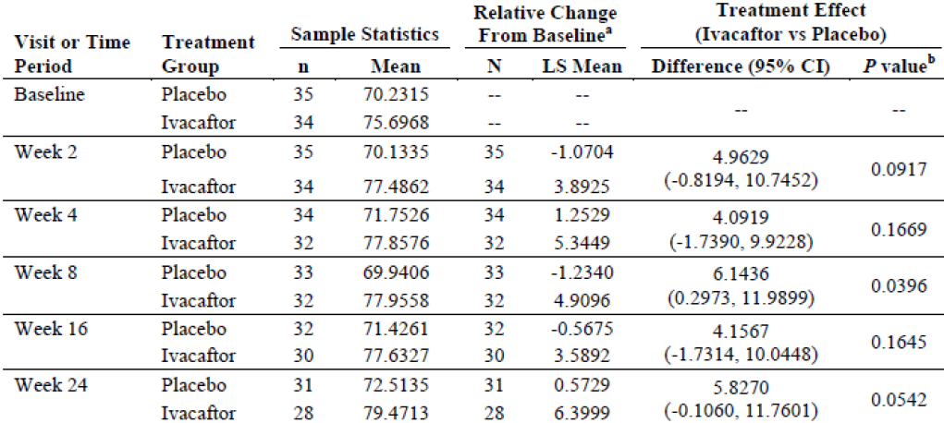
Sample statistics are unadjusted results. Difference is ivacaftor- placebo. A positive difference favours ivacaftor. a: Estimates were obtained from MMRM with relative change from baseline as the dependent variable; with treatment, categorical visit (Weeks 2, 4, 8, 16 and 24), and treatment by visit interaction as fixed effects; with subject as a random effect; and with adjustment for the continuous baseline value of age and percent predicted FEV₁ using compound symmetry covariance matrix. b: P values at individual visits are from linear contrasts between the 2 treatments at the given visit.

Table 31: Relative change from Week 24 through the Follow-Up Visit in percent predicted FEV₁ by mixed model, full analysis set
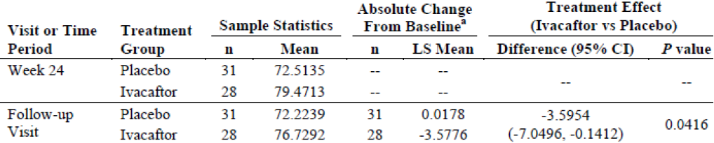
Sample statistics are unadjusted results. Difference is ivacaftor- placebo. a: Estimates were obtained from mixed model with dependent variable relative change in percent predicted FEV₁, with treatment group as fixed effect, subject as random effect, and with adjustment for the continuous baseline value of age and percent predicted FEV₁.

Table 32: responder analysis of relative change through Week 24 in percent predicted FEV₁, full analysis set
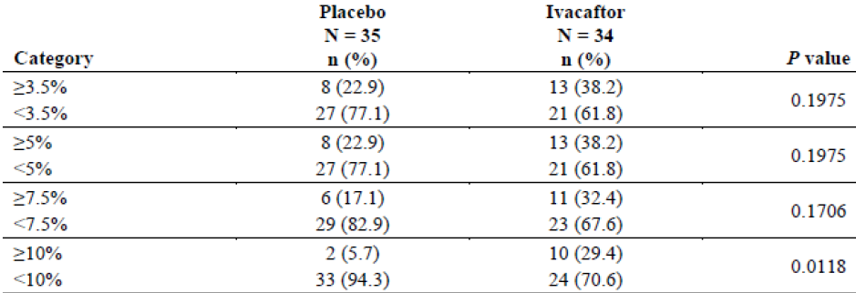
Relative change through Week 24 is relative change from baseline over 24 weeks for percent predicted FEV₁. Percentages are calculated using the category totals as the denominator.

Subgroup analysis of efficacy:
In addition to a pre-planned subgroup analysis of efficacy by age, subgroup analyses for other baseline and disease characteristics were pre-planned for the primary and secondary endpoints. The selection of the other subgroups was based on standard demographic factors (geographic region and sex) and those likely to affect disease severity/ response (baseline lung function, P aeruginosa infection, R117H allele poly-T variant).

Effect of age on efficacy:

Efficacy in subjects > 18 years of age:
The mean absolute change from baseline in percent predicted FEV₁ through Week 24 for the 50 subjects ≥ 18 years of age was statistically and clinically significantly greater for the ivacaftor group than the placebo group (4.51% versus 0.46%; treatment difference = 4.96% ; 95% CI: 1.15, 8.78; p = 0.0119). Statistically significant treatment differences were observed by Week 2 (first post-baseline time point assessed and were sustained through Week 24. During the Follow-up Period, a greater decline in percent predicted FEV₁ occurred in the ivacaftor group (-3.15%) than the placebo group (-1.13%) (Figure 9).
Figure 9: modelled absolute change from baseline in percent predicted FEV₁ by treatment, subject ≥ 18 years of age, full analysis set
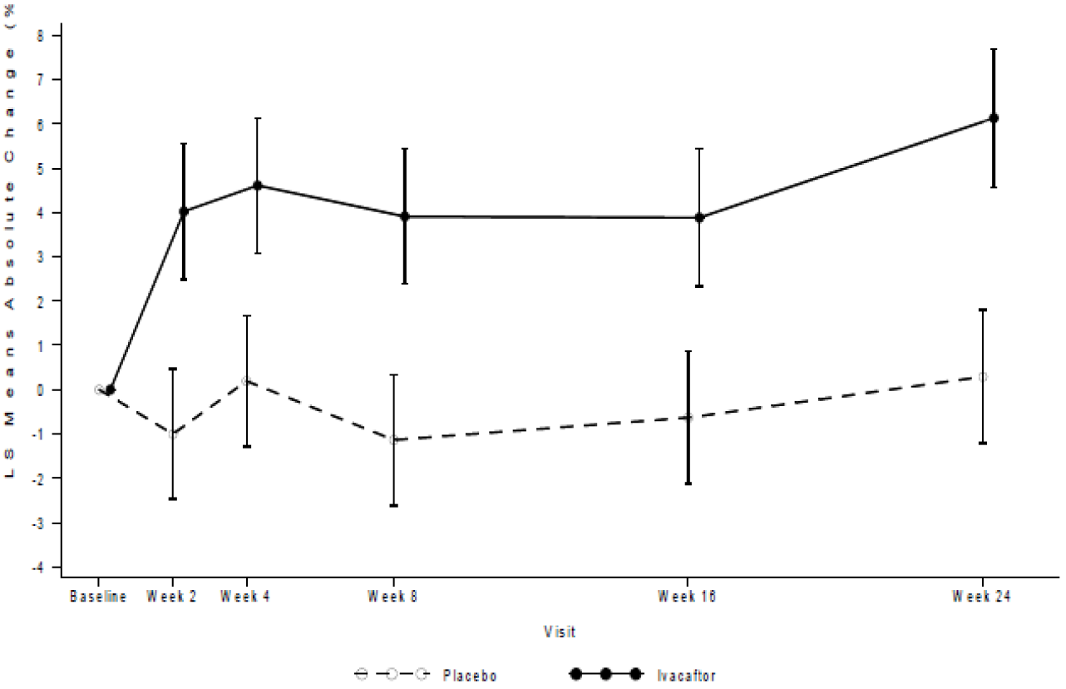
Comments: During the design and execution of Study 110, it was anticipated that children and adolescents could show different efficacy profiles in response to ivacaftor treatment primarily because of the differences in the manifestation of disease at different ages. Specifically, CF patients with the R117H-CFTR mutation have less advanced disease in childhood and adolescence compared to older subjects (. McCloskey M, et al, 2000; McKone EF, et al 2006- see references). Therefore, it was anticipated that a positive effect of ivacaftor would more likely be observed in adult patients (that is subjects > 18 years). Thus, in addition to the primary analysis using the full dataset (that is the FAS), a pre-planned subgroup analysis by subject age was included for the primary and secondary endpoints.
Among this subgroup of patients aged > 18 years, those with a baseline percent predicted FEV₁ of ≥ 70% to ≤ 90% showed a statistically significant response to ivacaftor treatment in percent predicted FEV₁ (p = 0.0090). Female subjects had a larger treatment difference in favour of ivacaftor than male subjects (females: 6.96%; males: 2.10%). The treatment differences were similar in North America and Europe (North America 4.81%; Europe: 4.51%).Subjects without P aeruginosa infection at baseline had a slightly larger treatment difference in favour of ivacaftor than subjects with P aeruginosa infection at baseline (infected: 4.32%; not infected: 5.73%) (Table 33).

Table 33: absolute change from baseline through Week 24 in percent predicted FEV₁ by MMRM: presented by percent predicted FEV1 at baseline, sex, geographic region, and P aeruginosa infection status at baseline, subjects ≥ 18 years of age, full analysis set
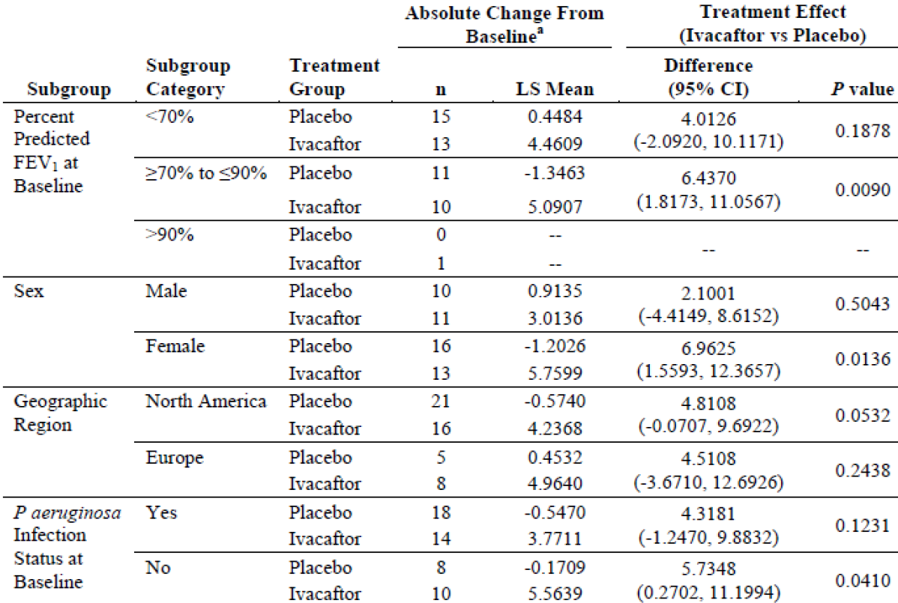
Sample statistics are unadjusted results. Analysis conducted only when the number of subjects with results in each treatment group ≥ 5. Difference is ivacaftor- placebo. A positive difference favours ivacaftor. a: Estimates were obtained from MMRM with absolute change from baseline as the dependent variable; with treatment group, categorical visit (Weeks 2, 4, 8, 16 and 24), and treatment by visit interaction as fixed effects; and with adjustment for the continuous baseline value of age and percent predicted FEV₁ using compound symmetry covariance matrix. For the subgroup percent predicted FEV₁, severity, no adjustment was made for baseline percent predicted FEV₁.
Comments: The above subgroup analysis should be interpreted with caution due to small sample sizes.
The mean absolute change from baseline in sweat chloride was statistically significantly greater for ivacaftor compared to placebo group (25.89 versus 4.03 mmol/L; treatment difference = 21.87 mmol/L; 95% CI: -26.46, -17.28, p < 0.0001). Statistically significant treatment differences were detected by Week 2 (first post-baseline time point assessed) and were sustained through Week 24. The mean rate of change from baseline in BMI and BMI for age z-scores did not show any statistically significant improvement with ivacaftor. The pattern of the survival curve was consistent with the time-to-first pulmonary exacerbation survival curves in FAS.
The improvement with ivacaftor in the mean absolute change from baseline in CFQ-R respiratory domain score through Week 24 for subjects ≥ 18 years of age was much greater than that observed in the FAS. In subjects aged > 18 years, treatment difference for ivacaftor versus placebo was 12.64 points (95% CI: 5.02, 20.25), which is more than triple the defined MCID of 4 points and was statistically significant (p = 0.0017). Statistically significant treatment differences were detected at Week 2 (first post-baseline time point assessed), Week 16 and Week 24. Furthermore, ivacaftor group shows a greater decline in CFQ-R respiratory domain score in the Follow-up Period than the placebo group providing further evidence of the ivacaftor treatment effect on CFQ-R score (Figure 10).
Figure 10: Mean absolute change from baseline in pooled CFQ-R respiratory domain score by treatment; full analysis set, subjects ≥ 18 years of age
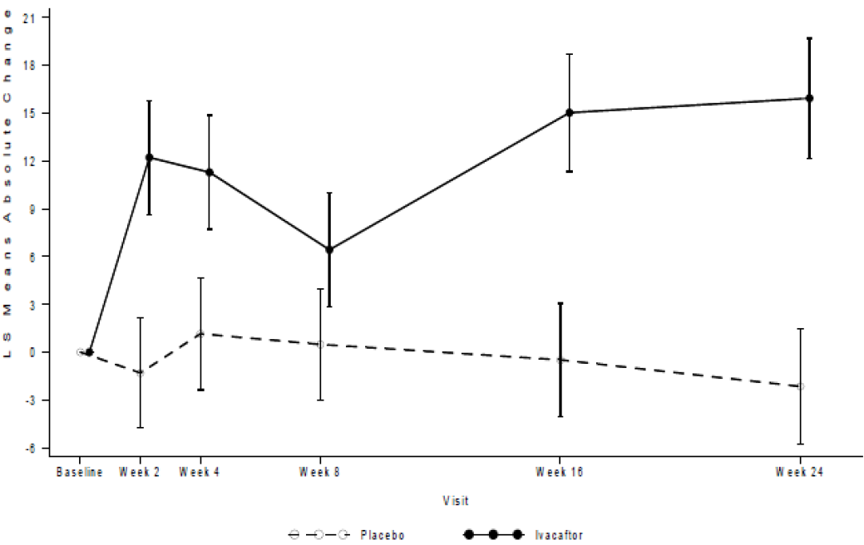
The mean relative change from baseline in percent predicted FEV₁ through Week 24 was clinically and statistically significantly greater in the ivacaftor group compared with placebo (7.68 versus - 1.46 percentage points; difference = 9.13 percentage points; 95% CI: 2.46, 15.80; p = 0.0083). The significant difference was observed from week 2 and maintained till week 24 (Figure 11). The responder analysis categorizing the relative change from baseline in percent predicted FEV₁ through Week 24 shows that there is a statistically significant difference in the responder rate between placebo and ivacaftor at all thresholds (p ≤ 0.02). Only a single subject on placebo had a ≥ 10% response compared to 41.7% of the ivacaftor subjects (Table 34).
Figure 11: Mean relative change from baseline in percent predicted FEV₁ by treatment; full analysis set, subjects ≥ 18 years of age
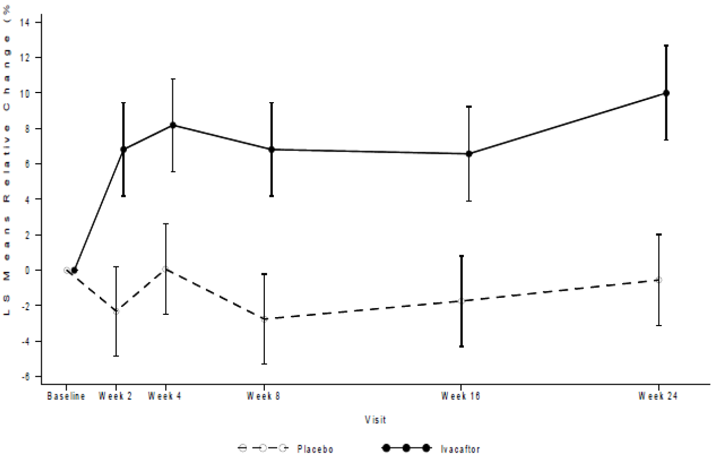

Table 34: Responder analysis of relative change through Week 24 in percent predicted FEV₁; full analysis set, subjects ≥ 18 years of age
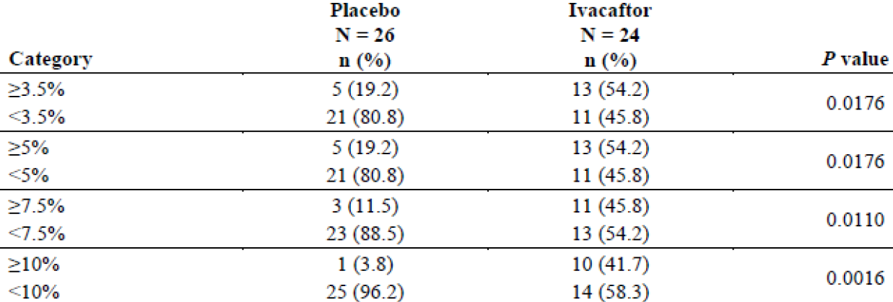
Relative change through Week 24 is relative change from baseline over 24 weeks for percent predicted FEV₁. Percentages are calculated using the category totals as the denominator.

Efficacy in subjects in other age groups <18 years:
There were only 2 subjects (1 in each treatment group) aged 12 to 17years enrolled in the study and so no statistical analysis was done for this age group.
There were 17 subjects aged 6 to 11 years in the study. The primary efficacy endpoint of change from baseline to week 24 in mean % predicted FEV₁ showed a statistically significant greater increase in the placebo group compared with ivacaftor; however, the treatment difference between the ivacaftor and placebo groups was statistically significant only at Week 2 and Week 4. Analysis of individual subject response to ivacaftor and placebo, up to Week 24 (Figure 12-13) suggested a stable pattern in the ivacaftor group with no overall negative effect and a notable increase in the placebo group during the first few weeks of treatment that was sustained through the 24 weeks of treatment. The mean absolute change from baseline in sweat chloride through Week 24 for subjects 6 to 11 years of age showed statistically significant greater reductions in ivacaftor group compared with placebo which were similar to those observed for subjects aged > 18 years. The mean absolute change from baseline in BMI and the CFQ-R respiratory domain score through Week 24 favoured placebo but difference was not statistically significant. No protocol-defined pulmonary exacerbations occurred in subjects 6 to 11 years of age. The mean relative change from baseline in percent predicted FEV₁ through Week 24 significantly favoured placebo (Table 35).
Figure 12: Percent predicted FEV₁ up to Week 24, placebo group; full analysis set, subjects 6 to 11 years of age (inclusive)
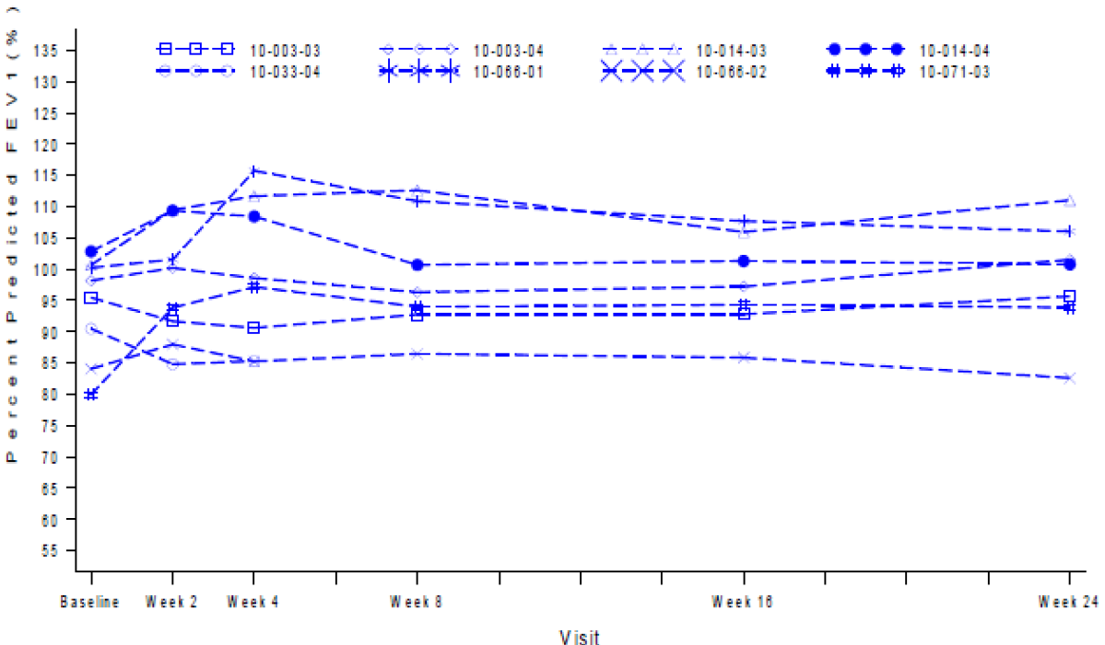
Figure 13: Percent predicted FEV₁ up to Week 24, ivacaftor group; full analysis set, subjects 6 to 11 years of age (inclusive)
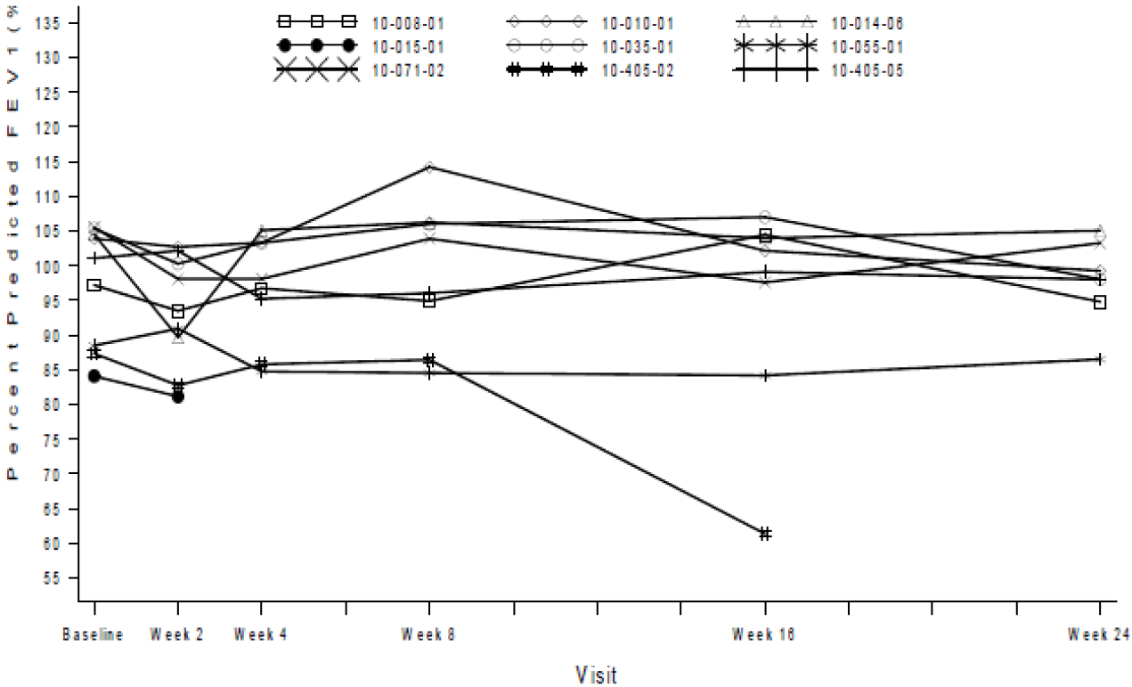

Table 35: Absolute change from baseline in sweat chloride (mmol/L) by MMRM; full analysis set, subjects 6 to 11 years of age (inclusive)
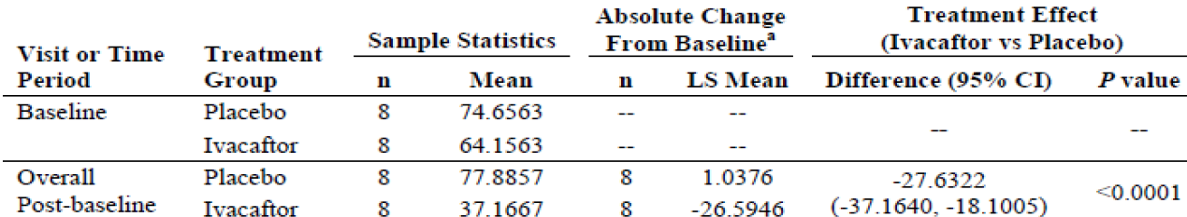
Sample statistics are unadjusted results. Difference is ivacaftor- placebo. A negative difference favors ivacaftor. a: Estimates were obtained from MMRM with absolute change from baseline as the dependent variable; with treatment group, categorical visit (Weeks 2, 4, 8, 16 and 24) and treatment by visit interaction as fixed effects; with subject as a random effect; and with adjustment for the continuous baseline value of percent predicted FEV₁, and sweat chloride, using a compound symmetry covariance matrix.
Comments: Interpretation of results in this subgroup of subjects aged 6 to 11 years was limited by small number of patients in each treatment group. Overall, results from this pivotal study suggested that ivafactor did not improve lung function, BMI or CFQ-R score in patients aged < 18 years and the only significant improvement group was observed in terms of reduction in sweat chloride.

Efficacy in subgroups by baseline percent predicted FEV₁
Pre-planned analyses were conducted for subgroups of baseline percent predicted FEV₁ < 70%, ≥70% to ≤90%, >90%. The greatest treatment differences were seen in the < 70% subgroup, with treatment differences of 4.01 percentage points (95% CI: -2.09, 10.12) in absolute change in percent predicted FEV₁, 9.87 percentage points (95% CI: -1.52, 21.25) in relative change in change in percent predicted FEV₁ and 11.38 points (95% CI: 1.17, 21.59) in absolute change in the CFQ-R respiratory domain. Smaller treatment differences that still favoured ivacaftor were seen in the ≥ 70% to ≤ 90% subgroup. In the percent predicted FEV₁ > 90% subgroup, 12 of 13 subjects were 6 to 11 years of age and this subgroup did not show evidence of efficacy in absolute change in percent predicted FEV₁ relative change in percent predicted FEV₁, or absolute change in the CFQ-R respiratory domain. However, the treatment difference in sweat chloride response was similar to that seen in the percent predicted FEV₁ < 70% and ≥ 70% to ≤ 90% subgroups (Table 36-37).

Table 36: subgroup analyses by percent predicted FEV₁ at baseline and geographical region- treatment difference versus placebo (95% CI) p value
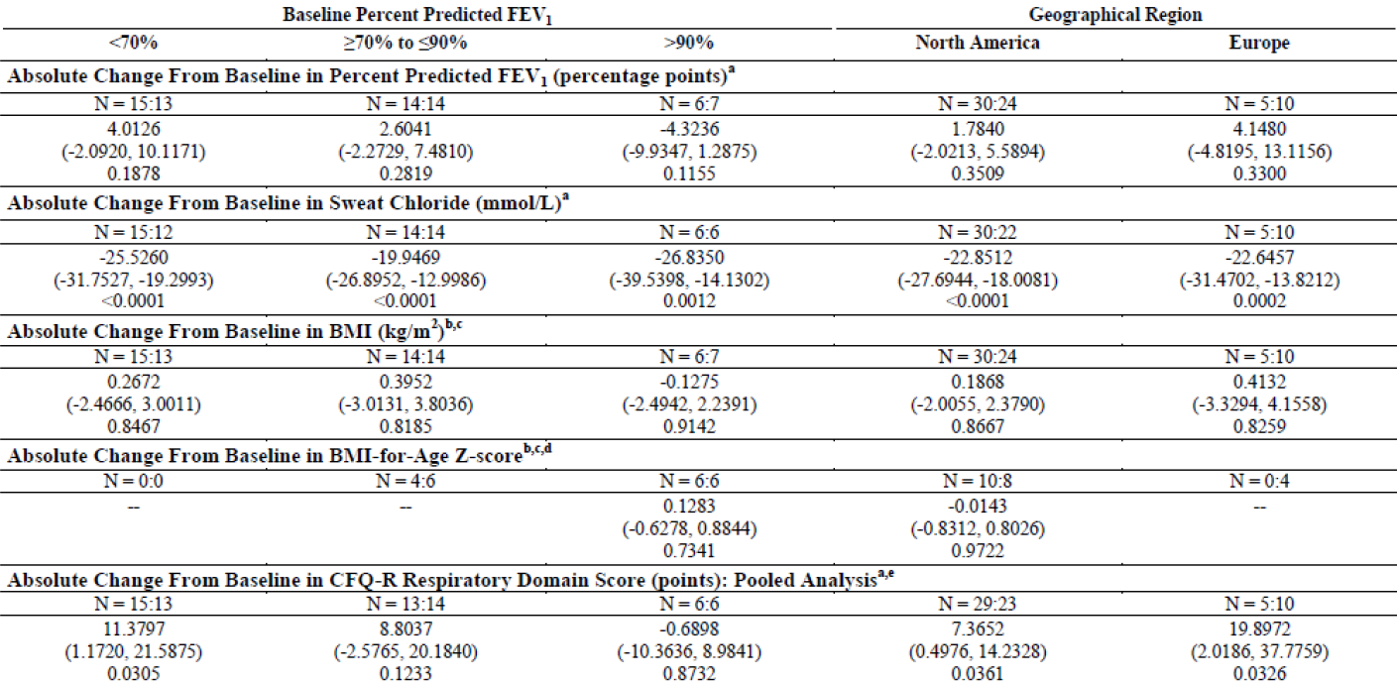

Table 37: subgroup analyses by percent predicted FEV₁ at baseline and geographical region- treatment difference versus placebo (95% CI) p value
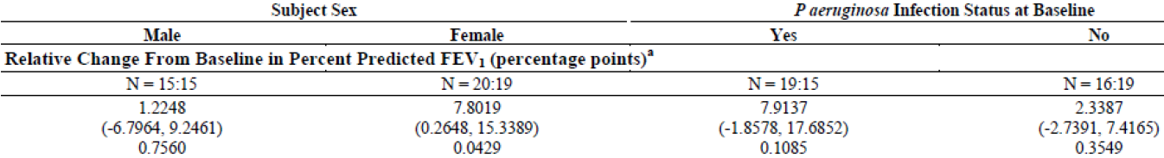
Number of subjects (n) is presented as placebo: ivacaftor. Analysis conducted only when the number of subjects with results in each treatment group was ≥ 5. a: Estimates were obtained from MMRM, with absolute or relative change from baseline as the dependent variable; with treatment, visit, and treatment by visit corresponding baseline value of the analysed variable, using a compound symmetry covariance matrix. For the subgroups of percent predicted FEV₁ severity, no adjustment was made for baseline percent predicted FEV₁. b: Estimated change from baseline per 168 days were obtained from linear mixed models conducted by subgroup with dependent variable weight and treatment intercept, visit (days on study, including all visits through Week 24) included as random effects. With the baseline percent predicted FEV₁ subgroups models did not include adjustment for baseline percent predicted FEV₁. c: p value for the treatment effect is from the slope of BMI (kg/m²) or BMI-for-age z-score versus time (days). d: BMI-for-age z-score is calculated using NCHS growth charts. e: Pooled is defined as all.

Geographical region
Larger treatment differences were seen in Europe than North America for the absolute change in percent predicted FEV₁ (Europe versus North America: 4.15 versus 1.78 percentage points), relative change in percent predicted FEV₁ (5.66 versus 5.17 percentage points) and absolute change in CFQ-R respiratory domain (19.90 versus 7.37 points). The treatment differences for change from baseline in sweat chloride (-22.65 versus -22.85 mmol/L) were similar for both geographic regions. In North America, 15 of 54 subjects were 6 to 11 years of age, while in Europe only 2 of 15 subjects were 6 to 11 years of age. When the geographical region subgroup analysis was limited to subjects ≥18 years of age, the absolute change in percent predicted FEV₁ was similar between the 2 subgroups (4.51 versus 4.81 percentage points) (Table 36-37).

Gender and P. aeruginosa infection status at baseline
Larger treatment differences were seen in females than males for absolute change in percent predicted FEV₁ (females versus males: 3.66 versus 0.087 percentage points), relative change in percent predicted FEV₁ (7.81 versus 1.22 percentage points) and CFQ-R respiratory domain score (13.87 versus 2.44 points); the reason for the difference is unclear but the sponsor states that is most likely driven by random factors in a small population. The treatment differences for absolute change from baseline in sweat chloride (females: -25.43 mmol/L; males: -24.05 mmol/L) were similar for both sexes There were no substantial imbalances in age or R117H poly-T variant between the male and female subjects. The patterns of the survival curves for time-to-first pulmonary exacerbation do not reveal any clinically important signal (Table 38).

Table 38: Subgroup analysis by subject sex and P. aeruginosa infection status at baseline- treatment difference versus placebo (95% CI) p value
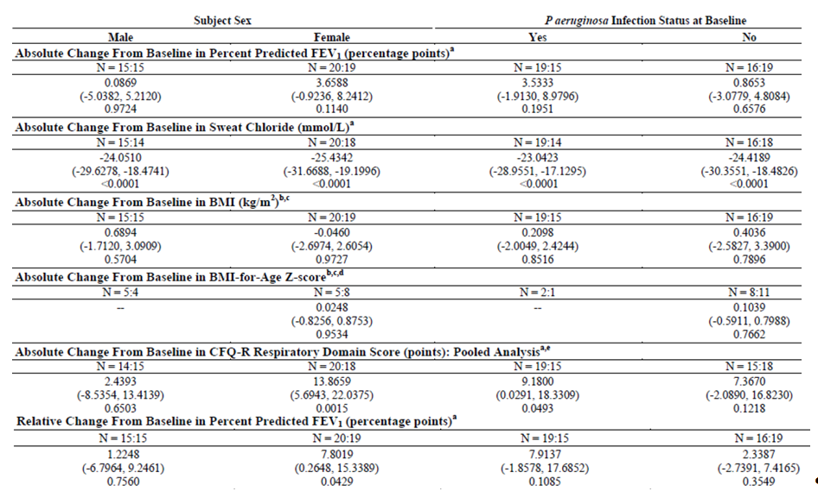
Number of subjects (n) is presented as placebo: ivacaftor. Analysis conducted only when the number of subjects with results in each treatment group was ≥ 5. a: Estimates were obtained from MMRM, with absolute or relative change from baseline as the dependent variable; with treatment, visit and treatment by visit interaction as fixed effects; with subject as a random effect; and with adjustment for the continuous baseline values of age, percent predicted FEV₁ and corresponding baseline value of the analysed variable, using a compound symmetry covariance matrix. For the subgroup of percent predicted FEV₁ severity, no adjustment was made for baseline percent predicted FEV₁. b: Estimated change from baseline per 168 days were obtained from linear mixed models conducted by subgroup with dependent variable weight and treatment as a fixed effect; with adjustment for baseline percent predicted FEV₁, age, and visit treatment interaction included as covariates in the model; and with intercept, visit (days on study, including all visits through Week 24) included as covariates in the model; and with intercept, visit (days on study, including all visits through Week 24) included as random effects. With the baseline percent predicted FEV₁ subgroups models did not include adjustment for baseline percent predicted FEV₁. c: p value for the treatment effect is from the slope of BMI (kg/m²) or BMI-for-age z-score versus time (days). d: BMI-for-age z-score is calculated using NCHS grow charts. e: Pooled is defined as all questionnaire versions except for the Parent/Caregiver version. The Children Ages 6 to 11 (interview format) CFQ-R instrument response option cards may not have been used.
Larger treatment differences were seen in subjects infected with P aeruginosa at baseline than in subjects not infected with P aeruginosa for absolute change in percent predicted FEV₁ (infected: 3.53 percentage points; not infected: 0.87 percentage points), relative change in percent predicted FEV₁ (infected: 7.91 percentage points; not infected: 2.34 percentage points), and CFQ-R respiratory domain score (infected: 9.18 points; not infected: 7.37 points). The treatment differences for absolute change from baseline in sweat chloride (infected: -23.04 mmol/L; not infected: -24.42 mmol/L) were similar for both subgroups. In the subgroup not infected with P aeruginosa at baseline, 15 of 35 subjects were 6 to 11 years of age (inclusive), while in the subgroup infected with P aeruginosa at baseline, only 2 of 34 subjects were 6 to 11 years of age When the P aeruginosa subgroup analysis was limited to subjects ≥ 18 years of age, a larger treatment difference in the absolute change in percent predicted FEV₁ was seen for the subjects not infected with P aeruginosa than those infected (infected: 4.32 percentage points; not infected: 5.74 percentage points (Table 38).

R117H Poly-T Variant
The poly-T variant affects splice efficiency during synthesis of CFTR protein, and for patients with the R117H allele, the poly-T variant on the R117H allele affects the severity of their CF disease (Chu C et al, 1993; Kieswetter S et al, 1993; Massie RJH et al, 2001, see references). R117H-5T results in a more severe disease phenotype than R117H-7T and R117H-9T is highly unlikely to cause disease. All subjects enrolled in this study would have had the R117H-5T or R117H-7T alleles because the study entry criteria required that subjects have CF, as evidenced by sinopulmonary disease and a sweat chloride ≥ 60 mmol/L or two CF-causing mutations.
In both the primary and supportive analysis, the treatment difference for absolute change from baseline in percent predicted FEV₁ was larger for subjects with the R117H-5T variant than for subjects with the R117H-7T variant. In the supportive analysis, a treatment effect favouring placebo was observed for subjects with R117H-7T. However, 8 of the 19 subjects with R117H-7T were 6 to 11 years of age (inclusive) and which may have influenced the finding (Table 39). The treatment differences for absolute change from baseline in sweat chloride were similar and statistically significant for subjects with either the R117H-5T or R117H-7T variants, indicating that both groups have a relevant pharmacodynamic response (Table 740). The treatment differences for change from baseline in BMI at week 24 favoured ivacaftor for subjects with either the R117H-5T or R117H-7T variants. None of the treatment differences were statistically significant. Similar results were seen in subjects ≥ 18 years of age with R117H-5T (Table 41). The treatment difference for mean absolute change from baseline in the pooled CFQ-R respiratory domain score through Week 24 was larger for subjects with the R117H-5T variant than for subjects with the R117H-7T variant. Eight of the 19 subjects with R117H-7T were 6 to 11 years of age (inclusive), and this may have influenced the finding (Table 42).

Table 38: Absolute change from baseline in percent predicted FEV1 by MMRM, R117H Poly-T variants; full analysis set
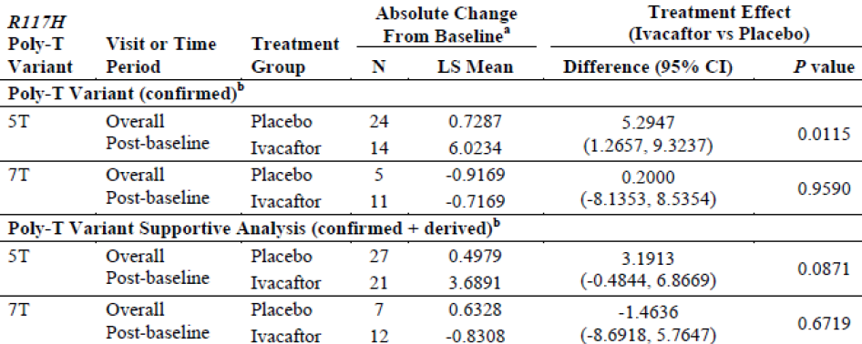
a: Estimates were obtained from MMRM with absolute change from baseline as the dependent variable; with treatment group, categorical visit (Weeks 2, 4, 8, 16 and 24) and treatment by visit interaction as fixed effects; with subject as a random effect; and with adjustment for the continuous baseline value of age and percent predicted FEV₁ using a compound symmetry covariance matrix. b: The poly-T variant for the R117H allele was derived for subjects where this information was missing and the subject had either R117H/F508DEL or R117H/R117H.

Table 40: Absolute change from baseline in sweat chloride (mmol/L) by MMRM, R117H allele Poly-T variants, full analysis set
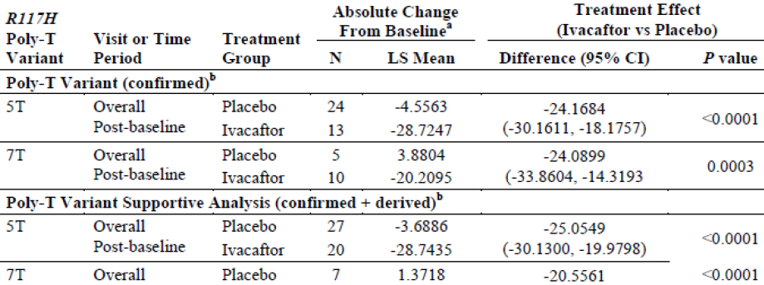
a: Estimates were obtained from MMRM with absolute change from baseline as the dependent variable; with treatment group, categorical visit (Weeks 2, 4, 8, 16 and 24) and treatment by visit interaction as fixed effects; with subjects as a random effect; ad with adjustment for the continuous baseline value of age, percent predicted FEV₁, and sweat chloride, using a compound symmetry covariance matrix. b: The poly-T variant for the R117H allele was derived for subjects where this information was missing and the subject had either R117H/F508FRL or R117H/R117H.

Table 41: Rate of change from baseline in BMI (kg/m²) by LMM, R117H Poly-T variants, full analysis set
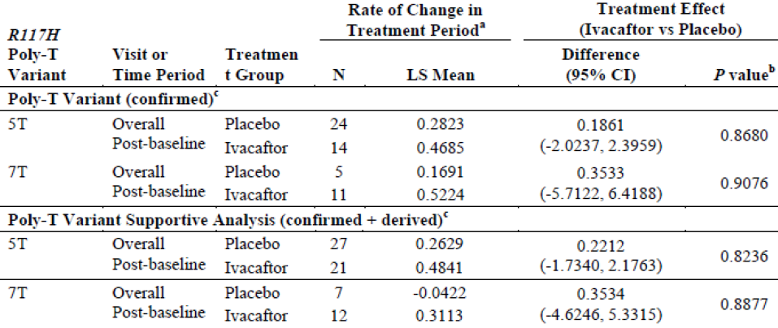
Source table refers to the 'supportive analysis' as 'sensitivity analysis'. a: Estimated change from baseline per 168 days was obtained from a linear mixed model, with BMI as the dependent variable; with treatment as a fixed effect; with intercept and visit (days on study, including all visits through Week 24) as random effects; and with adjustment for baseline age, predicted FEV₁, and visit by treatment interaction included as covariates in the model. B: p value for the treatment effect is from the slope of BMI (kg/m²) versus time (days). c: The poly-T variant for the R117H allele was derived for subjects where this information was missing and the subject had either R117H/F508DEL or R117H/R117H.

Table 42: Absolute change from baseline in pooled CFQ-R respiratory domain score (points) by MMRM, R117H poly-T variants, full analysis set
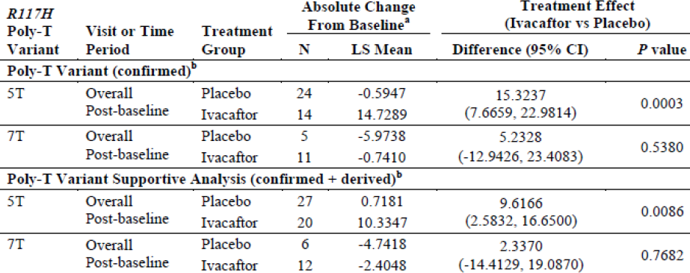
Pooled is defined as all questionnaire versions except for the parent/caregiver version. The Children Ages 6 to 11 Years (interviewer format) CFQ-R instrument response option cards may not have been used. Difference is ivacaftor- placebo. A positive difference favours ivacaftor. Source table refers to the 'supportive analysis' as 'sensitivity analysis'. b: Estimates were obtained from MMRM with absolute change from baseline as the dependent variable; with treatment group, categorical visit (Weeks 2, 4, 8, 16 and 24) and treatment by visit interaction as fixed effects; with subjects as a random effect; and with adjustment for the continuous baseline value of age, percent predicted FEV₁, and CFQ-R respiratory domain score, using compound symmetry covariance matrix. b: The poly-T variant for the R117H allele was derived for subjects where this information was missing and the subject had either R117H/F508DEL or R117H/R117H.

Other efficacy studies
Study 112 is an ongoing Phase III, two-arm, multicentre, open-label, rollover study conducted in subjects with CF who had previously been enrolled in Study VX11-770-110 (Study 110; subjects with an R117H-CFTR mutation), Study VX12-770-111 (Study 111; subjects with a non-G551D-CFTR gating mutation), or Study VX12-770-113 (Study 113; subjects who have phenotypic or molecular evidence of residual CFTR function). The study was initiated on 13 Feb, 2013 and is still ongoing. End of week 12 interim analysis (25 April, 2014) was the last date of results included in analysis submitted in the current dossier. The primary objective of study 112 was to evaluate the safety of long-term ivacaftor treatment in subjects with cystic fibrosis (CF); the secondary objective was to evaluate the efficacy of long-term ivacaftor treatment in subjects with CF.
This study enrolled male and female subjects, aged > 6 years, with CF and a non-G551D CFTR mutation, who completed their assigned study drug treatment duration in earlier studies 110, 111 or 113 into one of the following arms:

Ivacaftor arm:
These subjects are being treated with ivacaftor 150 mg q12h (same dosage used in Study 110). The ivacaftor arm of Study 112 includes those subjects who:
- - completed their assigned study drug treatment duration in Study 110 or Study 111;
- - completed all study-related treatments through the Follow-up Visit in Study 113 and met at least 1 of the Study 113 responder criteria during the 8-week open-label period of that study.

Observational arm:
The observational arm only includes subjects from Studies 110 and 111 who:
- - prematurely discontinued study drug treatment and received at least 4 weeks of treatment in the previous ivacaftor study;
- -completed the previous study and enrolled in the observational arm; or
- -completed the previous study but did not meet the inclusion criteria of the ivacaftor arm.
The Follow-up Visit of Study 110 served as the baseline visit for Study 112.
Subjects received ivacaftor 150 mg tablets orally at a dosage of 150 mg q12h with fat-containing food such as a standard 'CF' high-fat, high-calorie meal or snack. The planned duration of study drug administration for subjects in the ivacaftor arm is the shorter of either approximately 108 weeks or Kalydeco (commercially available ivacaftor) being clinically indicated for the subject and reimbursed for that indication in the subject’s country. Subjects in the observational arm will participate in the study for approximately 2 years.
Efficacy evaluations for interim analysis included spirometry, sweat chloride test, and the respiratory domain of the Cystic Fibrosis Questionnaire-Revised (CFQ-R). Subjects were analysed overall and according to the study drug (ivacaftor or placebo) to which they were randomised in Study 110. Efficacy analyses were conducted using the FAS consisting of subjects from Study 110 who received at least 1 dose of ivacaftor during Study 112. All summaries and figures were generated for all subjects in the FAS, as well as for 2 FAS subgroups: subjects 6 to 11 years of age (inclusive) at Study 110 baseline and subjects ≥ 18 years of age at Study 110 baseline. The following additional ad hoc analyses for evaluation of absolute change from baseline in percent predicted FEV₁ using the following methods for the overall population, subjects aged ≥ 18 years and subjects aged 6 to 11 years were conducted:
- - Change from the Study 112 baseline to Week 12 for the FAS using a one-sample t-test;
- - Change from Study 112 baseline to Week 12 for subjects who were treated with placebo in Study 110 (placebo/ivacaftor group) using a one-sample t-test; and
- - Change from Study 112 baseline to Week 12 for subjects who were treated with ivacaftor in Study 110 (ivacaftor/ivacaftor group) using a one-sample t-test.
Of the 69 subjects enrolled in Study 110, 65 subjects enrolled in the ivacaftor arm of Study 112 and were included in the Study 112 FAS, 2 subjects enrolled in the observational arm of Study 112, and 2 subjects did not enrol in Study 112 due to early discontinuation of treatment in Study 110. Of the 65 subjects in the ivacaftor arm of Study 112, 64 subjects completed at least 12 weeks of treatment in Study 112, and 1 subject (in the ivacaftor/ ivacaftor group) discontinued between Week 2 and 12 because she was moving from the UK to the US (discontinuation was not due to an AE. Three other subjects (1 subject in the placebo/ ivacaftor group and 2 subjects in the ivacaftor/ ivacaftor group) discontinued treatment in Study 112 after Week 12.
Demographic and baseline characteristics of the 65 subjects in study 112 is summarised in Table 43. For the FAS in Study 112, mean baseline percent predicted FEV₁ values were comparable for the placebo/ivacaftor and ivacaftor/ivacaftor groups; baseline sweat chloride levels were lower in the ivacaftor/ivacaftor group than in the placebo/ivacaftor group. In the 6 to 11 years subgroup, baseline percent predicted FEV₁ values were lower in the ivacaftor/ivacaftor group than in the placebo/ivacaftor group and baseline sweat chloride levels were comparable for the ivacaftor/ivacaftor and placebo/ivacaftor groups. In the ≥ 18 years subgroup, baseline percent predicted FEV₁ values were higher in the ivacaftor/ivacaftor group than in the placebo/ivacaftor group and baseline sweat chloride levels were lower in the ivacaftor/ivacaftor group than in the placebo/ivacaftor group. The 1 placebo/ivacaftor subject in the 12 to 17 years subgroup had a baseline percent predicted FEV₁ of 96.477% and a sweat chloride value of 71.0 mmol/L.

Table 43: Study 112- demographics and baseline characteristics, full analysis set
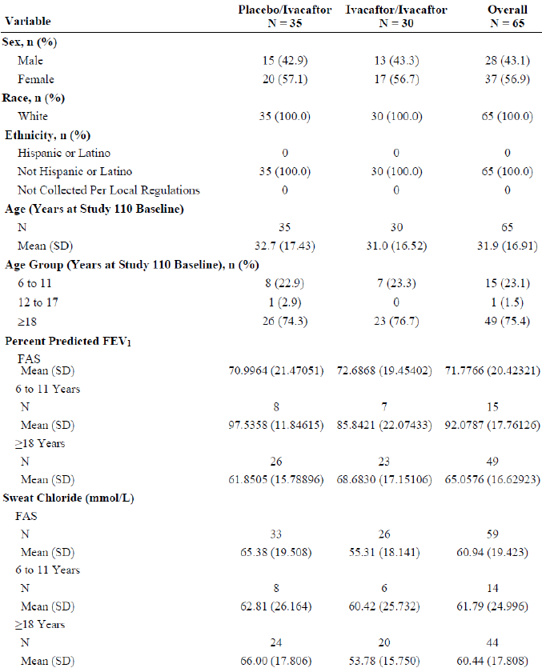
FEV₁: forced expiratory volume in 1 second; SD: standard deviation. All results displayed are baseline results in Study 112, except for subject age, which is the baseline age in Study 110. N is the number of subjects with non-missing assessment at baseline. Baseline is defined as the most recent measurement before the first dose of study drug.

Results:
For the FAS and for the ≥ 18 years subgroup, statistically significant increases in percent predicted FEV₁ occurred for the overall population, for the placebo/ ivacaftor group, and for the ivacaftor/ ivacaftor group (Table 44-46). Although an overall mean increase in percent predicted FEV₁ was observed for subjects 6 to 11 years of age, this was not statistically significant and was influenced by 1 subject in the ivacaftor/ ivacaftor group who had a substantial increase in percent predicted FEV₁ (absolute change: 49.72 percentage points) following resolution of a pulmonary exacerbation in Study 110. When spirometry summary statistics and figures were re-run with this subject excluded, the overall mean absolute change from baseline to Week 12 for the 6 to 11 years subgroup was 3.38 percentage points. The results do not suggest any deleterious effect of ivacaftor treatment in this age subgroup.

Table 44: Absolute change from Baseline to Week 2 and Week 12 in percent predicted FEV1, full analysis set
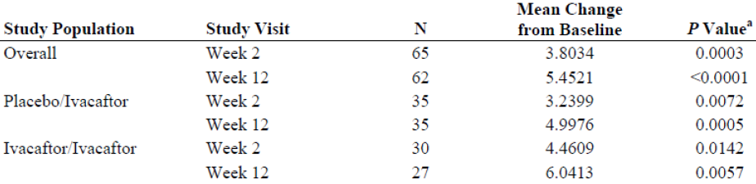
Baseline is defined as the most recent measurement prior to intake of the first dose of study drug. Age is based on age at the Study 110 baseline. a: p values are based on the one-sample t-test.

Table 45: Absolute change from Baseline to Week 2 and Week 12 in percent predicted FEV1, full analysis set, ≥ 18 years
Baseline is defined as the most recent measurement prior to intake of the first dose of study drug. Age is based on age at the Study 110 baseline. a: p values are based on the one-sample t-test.

Table 46: Absolute change from Baseline to Week 2 and Week 12 in percent predicted FEV₁; full analysis set, subjects 6 to 11 years
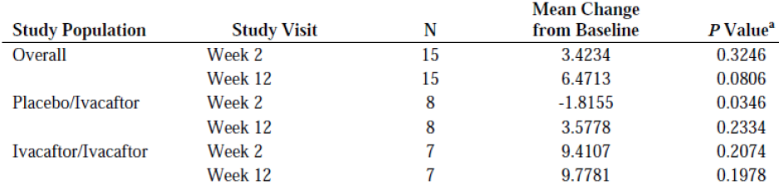
Baseline is defined as the most recent measurement prior to intake of the first dose of study drug. Age is based on age at the Study 110 baseline. a: p values are based on the one-sample t-test.
Comment: The above results should be interpreted with caution as these are just interim results from an open label study with no control group. The ‘statistical significance’ was compared to baseline value of study 112 using single-side t-test. The proposed duration of treatment in this open label study is 104 weeks and this submission only has interim results up to 12 weeks.
Summary statistics for relative change in percent predicted FEV₁, absolute change in sweat chloride, and absolute change in CFQ-R respiratory domain score for all FAS subjects (Table 47), the ≥ 18 years of age subgroup (Table 48) and the 6 to 11 years (Table 49) subgroup. The results observed in absolute change from baseline in percent predicted FEV₁ for the FAS and both age subgroups were also reflected in the relative change from baseline in percent predicted FEV₁. Decreases in sweat chloride values from baseline were observed at Week 2 for the FAS and for subjects in both age subgroups. For the FAS and for the ≥ 18 years subgroup, absolute decreases from baseline sweat chloride values were slightly greater in the placebo/ivacaftor group than in the ivacaftor/ivacaftor group. For the 6 to 11 years subgroup, comparable decreases from baseline sweat chloride values were observed for the placebo/ivacaftor and ivacaftor/ivacaftor groups. The overall CFQ-R respiratory domain scores increased from baseline at Weeks 2 and 12 for the FAS and for subjects in both age subgroups; these increases were all greater than the defined minimal clinically important difference (MCID) of 4 points. The overall increase in pooled CFQ-R respiratory domain scores for subjects 6 to 11 years of age was greater than the increase observed for the FAS and for the ≥ 18 years subgroup at the 2 study visits although this was driven by one subject. For all age subgroups, increases in CFQ-R respiratory domain scores were lower at Weeks 2 and 12 for subjects in the placebo/ivacaftor group than for those subjects in the ivacaftor/ ivacaftor group.

Table 47: Results for efficacy endpoints- mean (SD) change from Study 112 baseline, full analysis set
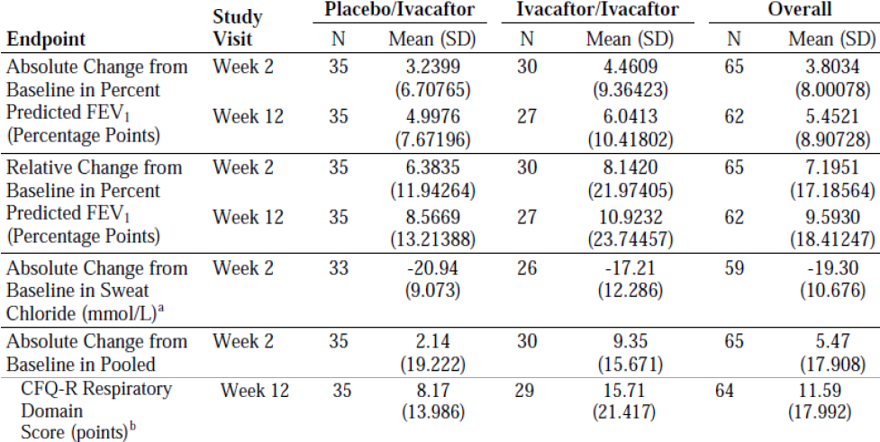
CFQ-R: Cystic Fibrosis Questionnaire- Revised; FEV₁: forced expiratory volume in 1 second. Baseline is defined as the most recent measurement before the first dose of study drug in Study 112. a: Sweat chloride was only collected at the Baseline and the Week 2 visit. b: Pooled was defined as all questionnaire version except for the parent/caregiver version.

Table 48: Results for efficacy endpoints- mean (SD) changes from Study 112 Baseline, age ≥ 18 years, full analysis set
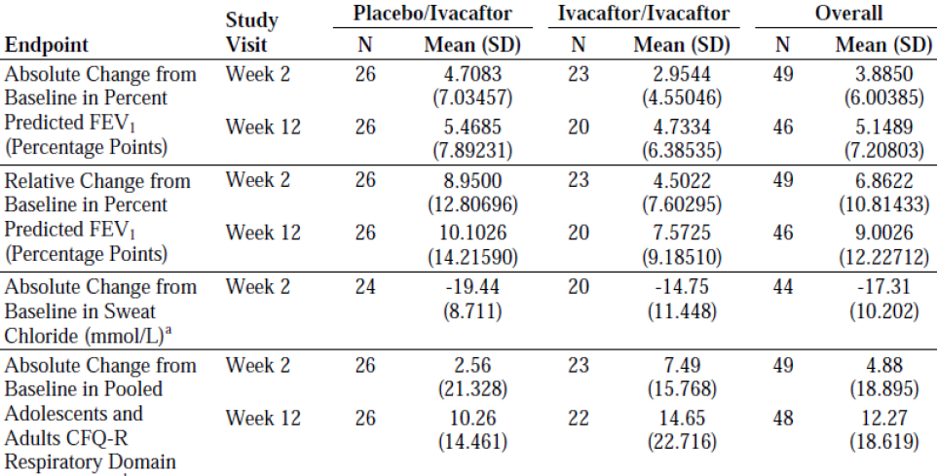
CFQ-R: Cystic Fibrosis Questionnaire- Revised; FEV₁: forced expiratory volume in 1 second. Baseline is defined as the most recent measurement before the first dose of study drug in Study 112. Age is the baseline age in Study 110. a: Sweat chloride was only collected at the Baseline and the Week 2 visit. b: Pooled was defined as all questionnaire version except for the parent/caregiver version.

Table 49: Results for efficacy endpoints: Mean (SD) changes from Study 112 Baseline, age 6 to 11 years, full analysis set
CFQ-R: Cystic Fibrosis Questionnaire- Revised; FEV₁: forced expiratory volume in 1 second. Baseline is defined as the most recent measurement before the first dose of study drug in Study 112. Age is baseline age in Study 110. Placebo/ivacaftor = subjects who received ivacaftor in Study 110 and 112. a: Sweat chloride was only collected at the Baseline and the Week 2 visit. b: Pooled was defined as all questionnaire versions except for the parent/caregiver version.
Comments: Improvements in pulmonary function were observed in Study 112 for subjects in the ≥ 18 years subgroup regardless of study drug treatment in Study 110. These improvements were consistent with what was observed in Study 110. Improvements in sweat chloride and CFQ-R respiratory domain scores observed from summary statistics in Study 112 were consistent with those observed in Study 110. However, this submission only included interim analysis following 12 weeks of treatment in study 112. Hence, long term maintenance of efficacy will have to be confirmed by evaluation of the final results from study 112 which should be provided by the sponsors when the study is completed.

Analyses performed across trials (pooled analyses and meta-analyses)
Not applicable.

Evaluator’s conclusions on clinical efficacy for {indication 1}
The pivotal study submitted to support use of ivacaftor for the extended indication was a well-conducted, Phase III, double-blind, placebo-controlled, parallel group study in 69 CF patients aged > 6years with R117H-CFTR mutation. The dose of ivacaftor (150mg 12 hourly for 24 weeks) was the same as that approved for treatment of CF in patients aged > 6 years with G551D or other gating (class III) mutations. The efficacy endpoints evaluated effect of ivacaftor on lung function (change from baseline in % predicted FEV₁ was primary endpoint) as well as effects on growth/ nutrition (change in BMI), markers of CF such as sweat chloride, pulmonary exacerbations and inflammatory markers. The study design and endpoints complied with the EMEA guidelines on evaluation of drugs for treatment of cystic fibrosis.
Results for the primary endpoint (the absolute change in percent predicted FEV₁ through Week 24 in FAS) favoured ivacaftor but failed to reach statistical significance (ivacaftor-placebo treatment difference=2.1%, 95% CI: 1.13, 5.35, p = 0.1979). Similarly, results for the secondary endpoints rate of change in BMI and time-to-first pulmonary exacerbation favoured ivacaftor, but treatment differences were not statistically significant. However, there were statistically significant and clinically relevant improvements in secondary endpoints of sweat chloride and CFQ-R respiratory domain score (Table 50).

Table 50: efficacy endpoint results, full analysis set
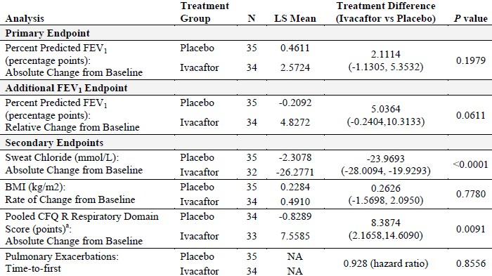
NA: not applicable. a: Pooled is defined as all questionnaire versions except for the parent/caregiver version. The children ages 6 to 11 (interview format) CFQ-R instrument response option cards may not have been used.
Results favouring ivacaftor treatment were observed for event rate for pulmonary exacerbations, number of pulmonary exacerbations requiring hospitalization or IV antibiotics, duration of pulmonary exacerbations, changes from baseline in CFQ-R non-respiratory domain scores, weight, IRT, faecal elastase-1, and inflammatory mediator concentrations. The treatment effect was statistically significant for the CFQ-R emotion, social, and eating domains (Table 51). No analysis of CF-related complications was performed because no episodes of pancreatitis or DIOS occurred during the study.

Table 51: tertiary efficacy endpoint results, full analysis set
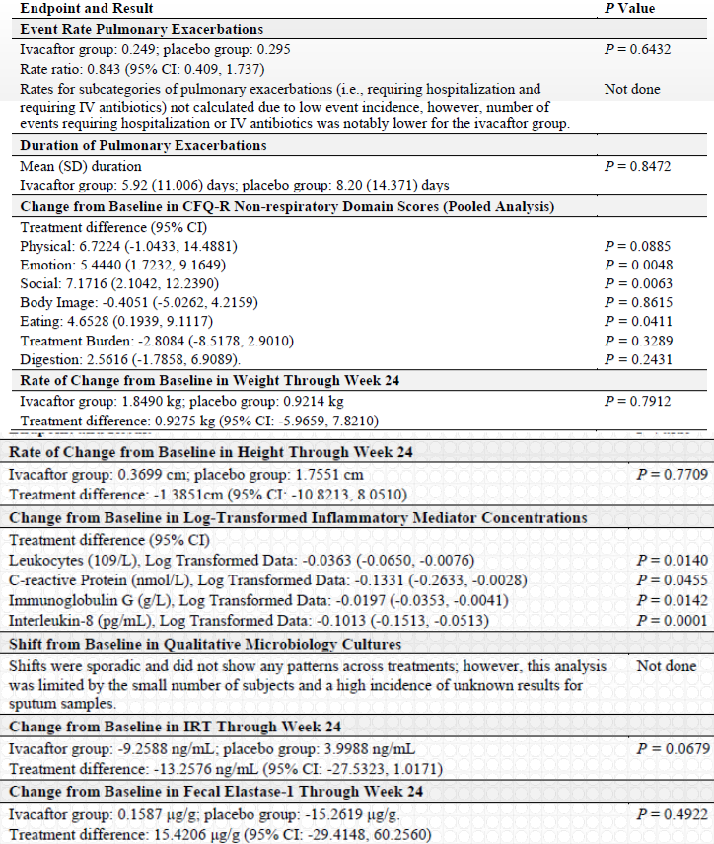
Despite the lack of statistical significance for absolute change from baseline in the primary endpoint of percent predicted FEV₁, the following results from pivotal study 110 suggested a beneficial effect of ivacaftor on lung function:
- - Treatment differences for the FAS favoured ivacaftor at all treatment period time points during the 24-week study.
- - The percent predicted FEV₁ responder analysis of showed that the number of responders favoured ivacaftor at all thresholds (3.5%, 5%, 7.5%, and 10%), with approximately twice as many responders in the ivacaftor group as the placebo group.
- -Gains in percent predicted FEV₁ in the ivacaftor group during the Treatment Period reversed in the Follow-up Period when the subjects were no longer receiving ivacaftor.
- -Analyses of additional spirometry parameters including absolute and relative change from baseline through Week 24 in FEV₁ (L), FVC (L), FEF25%-75% (L/sec), FEV₁/FVC, percent predicted FVC, percent predicted FEF25%-75%, and percent predicted FEV₁/FVC showed greater mean changes from baseline through Week 24 for the ivacaftor group than the placebo group; other than relative change in FEF25%-75% and percent predicted FEF25%-75% these differences were not statistically significant.
In the pre-defined subgroup of subjects aged > 18 years, improvements in spirometry were statistically and clinically significant, rapid in onset, and durable through Week 24. Statistically significant treatment differences for percent predicted FEV₁ were observed by Week 2 (first post-baseline time point assessed) and were sustained through Week 24. There was a statistically significant difference in the responder rate between placebo and ivacaftor at the thresholds of 3.5% (P = 0.0176), 5% (P = 0.0066), and 7.5% (P = 0.0094). Results for the secondary endpoints rate of change in BMI and time-to-first pulmonary exacerbation favoured ivacaftor, but treatment relevant and consistent improvements in the secondary endpoints of absolute change from baseline in sweat chloride and the CFQ-R respiratory domain score; in fact the treatment difference for ivacaftor versus placebo in mean absolute change from baseline in the CFQ-R respiratory domain score through Week 24 for subjects aged ≥ 18 years was 12.64 points, which is more than triple the defined MCID of 4 points (Table 52). The efficacy in subjects aged 6 to 11 years was summarised in Table 53 and ivacaftor failed to show evidence of efficacy for any of the primary or secondary endpoints with exception of reduction in sweat chloride levels.

Table 52: efficacy endpoint results, full analysis set, subjects ≥ 18 years of age
a: Pooled is defined as all questionnaire versions except for the parent/caregiver version.

Table 53: efficacy endpoint results, full analysis set, subjects 6 to 11 years of age (inclusive)
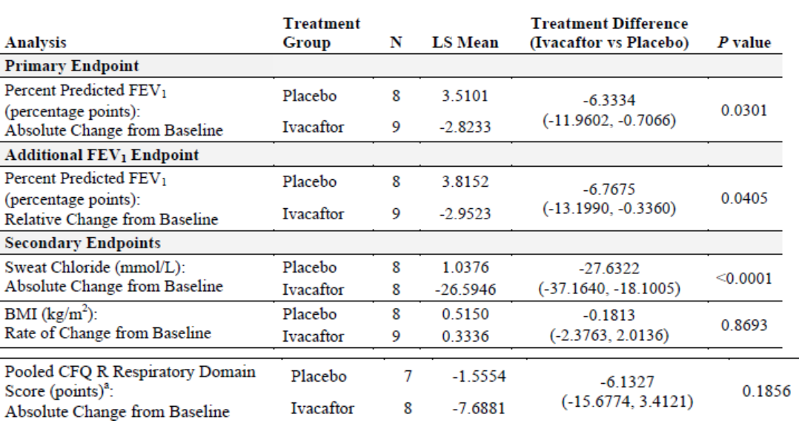
NA: not applicable. a: Pooled is defined as all questionnaire versions except for the parent/caregiver version. The children ages 6 to 11 (interviewer format) CFQ-R instrument response option cards may not have been used.
Analysis of efficacy in subgroups based on demographics and baseline disease characteristics showed the following trends:
- absolute and relative change in percent predicted FEV₁ favoured ivacaftor treatment across subgroups, with the exception of the baseline percent predicted FEV₁ > 90% subgroup.
- sweat chloride response was consistent across all subgroups
- absolute change in the CFQ-R respiratory domain favoured ivacaftor treatment across subgroups, with the exception of the baseline percent predicted FEV₁ > 90% subgroup no significant BMI or BMI-for-age z-score treatments differences were found in any of the subgroups the ivacaftor treatment effect was larger for subjects with the R117H-5T variant than for subjects with the R117H-7T variant mean absolute change from baseline in percent predicted FEV1 from subjects ≥ 18 years of age by R117H poly-T variant suggest evidence of a response to ivacaftor therapy in both R117H poly-T variant subgroups. The response was larger in subjects with the R117H-5T variant than in subjects with the R117H-7T variant. No evidence of a spirometry response to ivacaftor therapy was seen in subjects 6 to 11 years of age with either of the R117H poly-T variants.
The results from the subgroup analyses reflected the significant differences in spirometry and CFQ-R respiratory domain scores observed in subjects aged ≥ 18 years and those aged 6 to 11 years. Overall, subgroups including a significant number of subjects 6 to 11 years of age had smaller spirometry and CFQ-R respiratory domain treatment benefits. The demographics and baseline characteristics of subjects 6 to 11 years of age showed that these patients appeared to have more favourable features and lesser underlying lung dysfunction as follows: - 12 of 13 subjects with baseline percent predicted FEV₁ > 90%: were 6 to 11 years of age; 15 of 35 patients with no P aeruginosa infection status at baseline were 6 to 11 years of age and 8 of 19 patients with the less severe Poly-T variant, 7T were 6 to 11 years of age.
Supportive evidence for efficacy was provided by results from an interim analysis of Study 112. After a 3- to 4-week washout period at the end of Study 110, the positive treatment effect of ivacaftor in these subjects who were previously treated with ivacaftor in Study 110 was replicated in Study 112; treatment response was also observed in ivacaftor-naïve subjects in Study 112 (that is, subjects who were treated with placebo in Study 110). However, the interim analysis was conducted after only 12 weeks of treatment, while the study duration is 104 weeks.
Overall, there was adequate evidence to support use of ivacaftor for treatment of CF patients aged > 6 years with a R117H gene defect, especially in patients aged > 18 years with significant underlying lung disease. In patients aged 6 to 11 years, ivacaftor did not show any improvement in any of the lung function or other efficacy endpoints (with exception of improved sweat chloride levels); interpretation may have been confounded by fact that the younger patients did not have significant underlying lung disease or other symptoms as CF with R117H is a progressive disease with more symptoms as patients age.

Clinical Safety

Studies providing evaluable safety data
The following studies provided evaluable safety data:
- - One completed placebo-controlled, parallel-group, Phase III study 110
- - Interim analysis from an ongoing Phase III, multicentre, 2-arm, open-label study (112) in subjects with CF who participated in Studies 110, 111, or 113. The duration of Study 112 is approximately 104 weeks. Interim results (12 weeks treatment) were provided till cut-off at 07 April 2014.

Pivotal efficacy studies
In the pivotal efficacy study 110, the following safety data were collected: Adverse events (AEs) were coded using Medical Dictionary for Regulatory Activities (MedDRA; Version 15.1). The incidence of AEs that started at, started after or increased in severity after the initial study drug dosing was summarized by treatment group. The incidence of AEs was analysed for the following Safety Set Subgroups: age at baseline (≥ 18 years, 12 to 17 years [inclusive], and 6 to 11 years [inclusive]); percent predicted FEV₁ at baseline (< 70%, 70% to 90% [inclusive], and ≥ 90% predicted); geographic region (North America and Europe); sex (female and male).
Descriptive statistics (raw values) were summarized for clinical laboratory values, ECG parameters, vital signs, and ophthalmologic examinations. Change from baseline and shift from baseline analyses were performed for clinical laboratory values, ECG parameters and ophthalmologic examinations. Maximum on-treatment alanine transaminase (ALT), aspartate transaminase (AST), and total bilirubin results were categorized (for example, ≤ 2xULN, > 2xULN to ≤ 3xULN, > 3xULN to ≤ 5xULN, > 5xULN to ≤ 8xULN, > 8xULN) and the number and percentage of subjects in each category presented by treatment group. In addition to the final analysis, an unblinded safety review was conducted by the DMC after 40 subjects had completed 8 weeks of treatment.
In the open-label study 112, AEs were not evaluated. Only SAEs were reported up to the cut-off date for interim analysis.

Pivotal studies that assessed safety as a primary outcome
None.

Dose-response and non-pivotal efficacy studies
None.

Other studies evaluable for safety only
None.

Patient exposure
This submission includes safety data from 69 subjects with CF who received at least 1 dose of study drug in pivotal study 110: 34 subjects received ivacaftor, and 35 subjects received placebo. As of 07 April 2014, all 35 subjects who received placebo in Study 110 enrolled in the ongoing extension study (Study 112) and received at least 1 dose of ivacaftor.
In the pivotal study 110, the mean (SD) treatment duration was similar for placebo (155.8 [40.00] days) and ivacaftor (151.1 [46.18] days). The maximum study drug exposure was 193 days for placebo and 192 days for ivacaftor. Most subjects received at least 24 weeks of treatment; all but 3 subjects received at least 4 weeks of treatment. A total of 67 subjects (32 in the ivacaftor group and 35 in the placebo group) completed their full assigned duration of dosing (Table 54-55). Two subjects in the ivacaftor group discontinued treatment prematurely: 1 because of noncompliance with the ophthalmologic examination, and 1 because of pregnancy. Of the 67 subjects who completed the assigned duration of dosing, 59 subjects (28 in the ivacaftor group and 31 subjects in the placebo group) completed the full 24-week Treatment Period. The remaining 8 subjects had not completed 24 weeks of treatment at the time the sponsor stopped the study; however, these subjects were considered to have completed their assigned treatment duration and were eligible to enrol in Study 112.
A total of 65 subjects from Study 110 (35 subjects from the placebo arm and 30 subjects from the ivacaftor arm) enrolled in Study 112 and all 65 subjects enrolled in the ivacaftor arm.

Table 54: study drug exposure

Table 55: Study 110- subject disposition and reasons for discontinuation
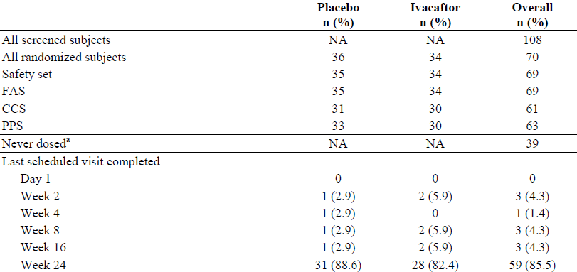
Percentages are calculated relative to the number of subjects in the FAS. FAS is defined as all randomised subjects who received at least 1 dose of study drug. Safety set is defined as all subjects who received at least 1 dose of study drug. CCS is defined as all FAS subjects who had the opportunity to complete the full 24 week treatment period. PPS is defined as all FAS subjects without major protocol violations that could affect efficacy data. a: The 39 subjects counted as 'never dosed' were screen failures. In addition, 1 subject [information redacted] was randomised to the placebo group but not dosed (reason: PI decision due to high predicted FEV₁ value [115.318%] on Day 1). b: Subject [information redacted] was discontinued from the study due to noncompliance in completing the required ophthalmologic examination at Screening.

Adverse events

All adverse events (irrespective of relationship to study treatment)

Pivotal studies
The incidence of AEs was lower in the ivacaftor group compared with placebo (94.1% versus 100%). By preferred term (PT), the AEs with the highest incidence in both treatment groups were infective pulmonary exacerbation of CF (38.2% [13 subjects] in the ivacaftor group and 40.0% [14 subjects] in the placebo group) and cough (29.4% [10 subjects] in the ivacaftor group and 25.7% [9 subjects] in the placebo group). Other AEs that occurred in at least 10% of subjects in the ivacaftor group included sputum increased, nasal congestion, oropharyngeal pain, wheezing, diarrhoea, abdominal pain and headache. AEs for which the incidence was at least 5% higher with ivacaftor treatment than with placebo treatment included nasal congestion, oropharyngeal pain, abdominal pain, wheezing, upper airway cough syndrome, bacterial disease carrier, influenza-like illness and abdominal discomfort. AEs for which the incidence was at least 5% higher with placebo treatment than with ivacaftor treatment included haemoptysis, arthralgia, pyrexia, rales, sinusitis, nasal mucosal disorder, sinus congestion, viral upper respiratory tract infection, pain, dizziness, blood potassium increased, dehydration, attention deficit/hyperactivity disorder, hypersensitivity and constipation (Table 56).
In the ≥ 18 years subgroup, 26 subjects received placebo treatment, and 24 subjects received ivacaftor treatment. The incidence of AEs was 95.8% (23 subjects) in the ivacaftor group and 100.0% (26 subjects) in the placebo group. AEs that occurred in at least 15% of subjects in the ≥ 18 years subgroup of either treatment group for which the incidence was higher (> 2 subjects difference) with ivacaftor than placebo were nasal congestion, oropharyngeal pain and wheezing. AEs that occurred in at least 15% of subjects in either treatment group for which the incidence was higher (> 2 subjects difference) with placebo than ivacaftor were upper respiratory tract infection and haemoptysis (Table 57).
Among subjects aged 6 to 11 years, 8 subjects received placebo treatment and 9 subjects received ivacaftor treatment. All subjects in this subgroup had at least 1 AE. There were no AEs that occurred in at least 15% of subjects in either treatment group for which the difference between treatment groups was > 2 subjects (Table 57).
Consistent with the results for the overall population, infective pulmonary exacerbation of CF and cough were the most common AEs in subjects ≥ 18 years in both treatment groups; the incidence of both events was higher for subjects ≥ 18 years than for subjects 6 to 11 years. The incidence of infective pulmonary exacerbation of CF in the ≥ 18 years subgroup was 45.8% (11 subjects, 14 events) in the ivacaftor group and 50.0% (13 subjects, 23 events) in the placebo group. In the 6 to 11 years subgroup, the incidence of infective pulmonary exacerbation of CF was 22.2% (2 subjects, 3 events) in the ivacaftor group and 12.5% (1 subject, 1 event) in the placebo group.
The incidence of cough in the ≥ 18 years subgroup was 37.5% (9 subjects, 12 events) in the ivacaftor group and 26.9% (7 subjects, 8 events) in the placebo group, compared to 11.1% (1 subject, 2 events) in the ivacaftor group and 12.5% (1 subject, 2 events) in the placebo group in the 6 to 11 years subgroup.

Table 56: Study 110- summary of adverse events, safety net

Table 57: Study 110- adverse events occurring in at least 15% of subjects in either treatment group by system organ class, preferred term and age subgroups, safety set
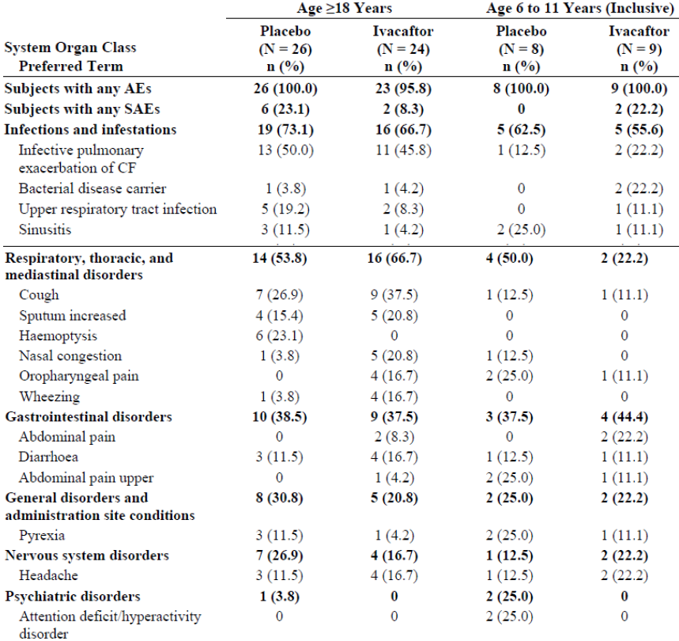
A subject with multiple events within an SOC or within a PT was counted only once within an SOC or PT, respectively. Adverse events were coded from MedDEA, Version 15.1
Comments: The higher incidence of infective pulmonary exacerbation of CF and cough in the ≥ 18 years subgroup compared to the 6 to 11 years subgroup is not unexpected because subjects in the ≥ 18 years subgroup had a worse baseline disease severity as evident by the lower mean percent predicted FEV₁. Additionally, the incidence of haemoptysis was higher among subjects ≥ 18 years compared to subjects 6 to 11 years. The incidence of haemoptysis in the placebo group of subjects ≥ 18 years was 23.1% (6 subjects, 10 events), compared to no subjects in the 6 to 11 years subgroup. In the ivacaftor group, none of the subjects in the ≥ 18 years or 6 to 11 years subgroups had haemoptysis. The other AEs showed no consistent trend between the ≥ 18 years and 6 to 11 years subgroups, and interpretation of any differences were confounded by the small number of subjects in the subgroups.
In both treatment groups, the majority of subjects had AEs that were mild or moderate in severity. Compared with placebo, ivacaftor was associated with a lower incidence of moderate events (41.2% [14 subjects] in the ivacaftor group versus 57.1% [20 subjects] in the placebo group) and severe events (2.9% [1 subject] in the ivacaftor group versus 14.3% [5 subjects] in the placebo group). There were no life-threatening AEs in this study (Table 58). The most common severe AE, infective pulmonary exacerbation of CF, occurred in 3 (8.6%) subjects in the placebo group and 1 (2.9%) subject in the ivacaftor group. The other severe events were ALT increased and hypokalemia (each in 1 [2.9%] subject) in the placebo group. Consistent with their greater baseline disease severity, the incidence of severe AEs was greater for subjects in the ≥ 18 years subgroup than for subjects in the < 18 years subgroup. In the ≥ 18 years subgroup, 4 (15.4%) subjects of the placebo group and 1 (4.2%) subject in the ivacaftor group had severe AEs. In the placebo group, 3 (11.5%) subjects had severe infective pulmonary exacerbation of CF, and 1 (3.8%) subject had a severe hypokalemia. In the ivacaftor group, 1 (4.2%) subject had a severe infective pulmonary exacerbation of CF. One subject in the 12 to 17 years subgroup of the placebo group had a severe increased ALT; however, only 2 subjects were aged 12 to 17 years with no severe AE reported in the other subject who was treated with ivacaftor. No severe AEs occurred in the 6 to 11 years subgroup.

Table 58: Study 110- severity of adverse events by treatment, safety set
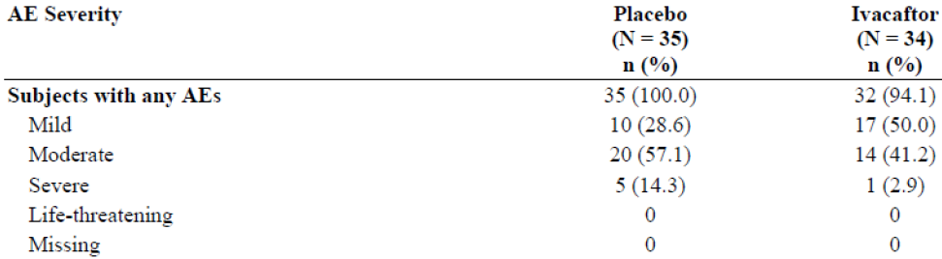
SOC and PT within SOC were sorted in descending order of frequency in the ivacaftor column. A subject with multiple items within an SOC or within PT was counted only once within an SOC or PT, respectively. A subject with multiple severities for the same AE is counted only under the AE with the maximum severity (where the order of increasing severity is from Mild to Life Threatening). Adverse events were coded from MedDRA Version 15.1.

Other studies
In the open label study 112, AEs were not evaluated. Only SAEs were reported up to the cut-off date for interim analysis.

Treatment-related adverse events (adverse drug reactions)

Pivotal studies
The majority of AEs were considered by the investigator to be not related or unlikely related to the study drug. The incidence of AEs considered by the investigator to be related or possibly related to the study drug was lower in the ivacaftor group (8.8% [3 subjects]) than in the placebo group (20.0% [7 subjects]). One (2.9%) subject in the ivacaftor group had an AE of increased C-reactive protein (CRP) that was considered by the investigator to be related to the study drug. In both treatment groups, all related or possibly related events occurred in only 1 subject each (Table 59-60).

Table 59: Study 110- relationship of adverse events to study drug by treatment safety set
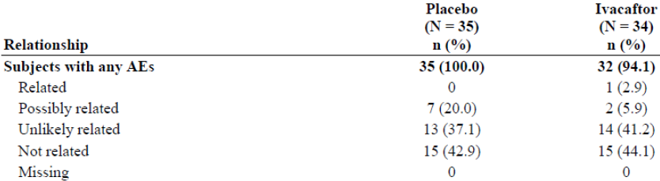
SOC and PT within SOC were sorted in descending order of frequency in the ivacaftor column. A subject with multiple events within an SOC or within a PT was counted only once within a SOC or PT, respectively. A subject with multiple severities for the same AE is counted only under the AE with the maximum severity (where the order of increasing severity is from mild to life threatening). Adverse events were coded from MedDRa, Version 15.1.

Table 60: Study 110- related or possibly related adverse events by system organ class, preferred term, safety net
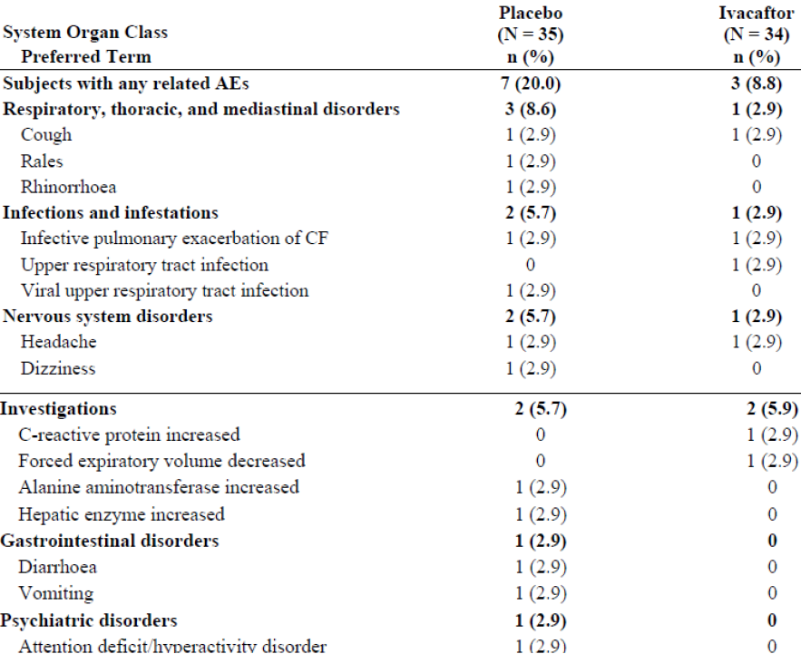
SOC and PT within SOC were sorted in descending order of frequency in the ivacaftor column. A subject with multiple events within an SOC or within a PT was counted only once within a SOC or PT, respectively. A subject with multiple severities for the same AE is counted only under the AE with the maximum severity (where the order of increasing severity is from mild to life threatening). Adverse events were coded from MedDRa, Version 15.1.

Other studies
Not applicable.

Deaths and other serious adverse events

Pivotal studies
There were no deaths reported in pivotal study 110. The incidence of SAEs was lower in the ivacaftor group (11.8% [4 subjects]) than in the placebo group (17.1% [6 subjects]). Overall, by PT, the most common SAE in both treatment groups was infective pulmonary exacerbation of CF (8.8% [3 subjects] in the ivacaftor group and 17.1% [6 subjects] in the placebo group). SAEs of cellulitis and constipation each occurred in 1 (2.9%) subject in the ivacaftor group. None of the SAEs were considered related to the study drug (Table 61).
In the ≥18 years subgroup, the incidence of subjects with at least 1 SAE in the ivacaftor group (8.3% [2 subjects]) was lower than in the placebo group (23.1% [6 subjects]). The most common SAE in both treatment groups was infective pulmonary exacerbation of CF (8.3% [2 subjects] in the ivacaftor group and 23.1% [6 subjects] in the placebo group). One (4.2%) subject in the ivacaftor group had an SAE of cellulitis. In the 6 to 11 years subgroup of the ivacaftor group, 2 (22.2%) subjects had at least 1 SAE. One (11.1%) subject had an SAE of infective pulmonary exacerbation of CF and 1 subject had an SAE of constipation. None of the subjects in the 6 to 11 years subgroup of the placebo group had an SAE.

Table 61: Study 110- serious adverse events by system organ class, preferred term, and treatment, safety set
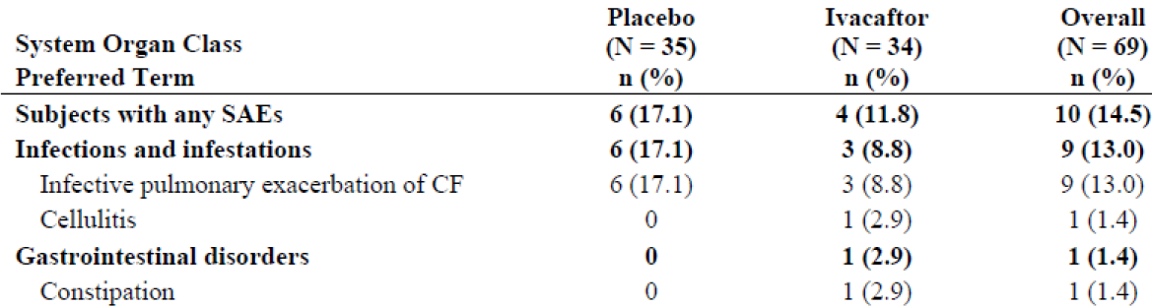
SOC and PT within SOC were sorted in descending order of frequency in the ivacaftor column. A subject with multiple events within an SOC or within a PT was counted only once within a SOC or PT, respectively. Adverse events were coded from MedDRA, Version 15.1.

Other studies
A total of 65 subjects from Study 110 (35 subjects from the placebo arm and 30 subjects from the ivacaftor arm) enrolled in Study 112. All 65 subjects enrolled in the ivacaftor arm. As of 07 April 2014, 12 SAEs occurred in 8 subjects in the ivacaftor arm (Table 62). Nine of these 12 SAEs were infective pulmonary exacerbations of CF, 8 of which were considered by the investigators as not related to the study drug. One SAE of infective pulmonary exacerbation of CF was considered by the investigator as possibly related to the study drug. The remaining 3 SAEs (influenza, angioedema and urticaria) were considered by the investigators as not related to the study drug. None of the subjects in the observational arm had an SAE up to the time of the data cut-off.

Table 62: Study 112- serious adverse events for subjects who completed assigned treatment duration in Study 110, ivacaftor arm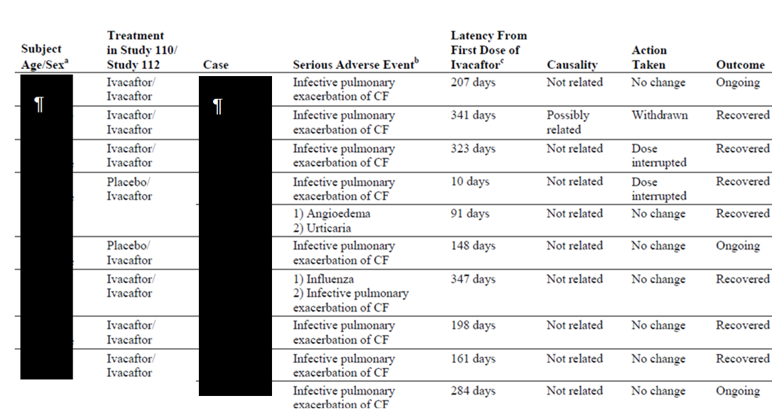
a: subject age/sex and case identifiers have been replaced with a black boxes. b: SAEs are reported by preferred term. c: Study 110 ivacaftor treatment was included in the latency calculation.

Discontinuation due to adverse events

Pivotal studies
There were no subjects in either treatment group with AEs that resulted in the discontinuation of study drug. One subject had an AE of infective pulmonary exacerbation of CF that led to interruption of ivacaftor treatment, and 2 subjects had AEs that led to interruption of placebo. One additional subject in the ivacaftor group missed 1 dose as a result of infective pulmonary exacerbation of CF.

Other studies
Not applicable.

Laboratory tests
AEs associated with abnormal chemistry, haematology, and urinalysis values were infrequent and none resulted in the discontinuation of study drug. Overall, the mean results over time and the incidence in categorical shifts from baseline for the clinical laboratory parameters (serum chemistry, haematology, and coagulation studies) showed minor differences between the treatment groups that were not considered to be clinically meaningful.

Liver function

Pivotal studies
AEs associated with abnormal liver function tests (LFTs) occurred in 3 (8.6%) subjects in the placebo group and 1 (2.9%) subject in the ivacaftor group. At the majority of visits through Week 24, mean absolute changes from baseline in all LFT parameters (ALT, AFT, total bilirubin and GGT) were minimal and were generally comparable between the ivacaftor and placebo groups (Table 63). The majority of subjects had maximum on-treatment ALT, AST, and total bilirubin results > 2 × ULN, and no differences > 5% were noted between the placebo and ivacaftor treatments for any category (Table 64). No subjects in either group had a maximum ALT or AST value that was > 5 × ULN or a maximum total bilirubin value that was > 2 × ULN. In the placebo group, 1 (2.9%) subject had at least 1 maximum ALT value > 2 xULN to > 3x ULN, and 1 (2.9%) subject had at least 1 maximum ALT value > 3 xULN to > 5x ULN. In the ivacaftor group, 2 (5.9%) subjects had at least 1 maximum ALT value > 2x ULN to > 3x ULN, and 1 (2.9%) subject had at least 1 maximum ALT value > 3 x ULN to > 5 x ULN; this subject also had at least 1 maximum AST value > 2 x ULN to > 3 x ULN.

Table 63: Study 11- liver function test parameter absolute changes from Baseline to Week 24, safety set
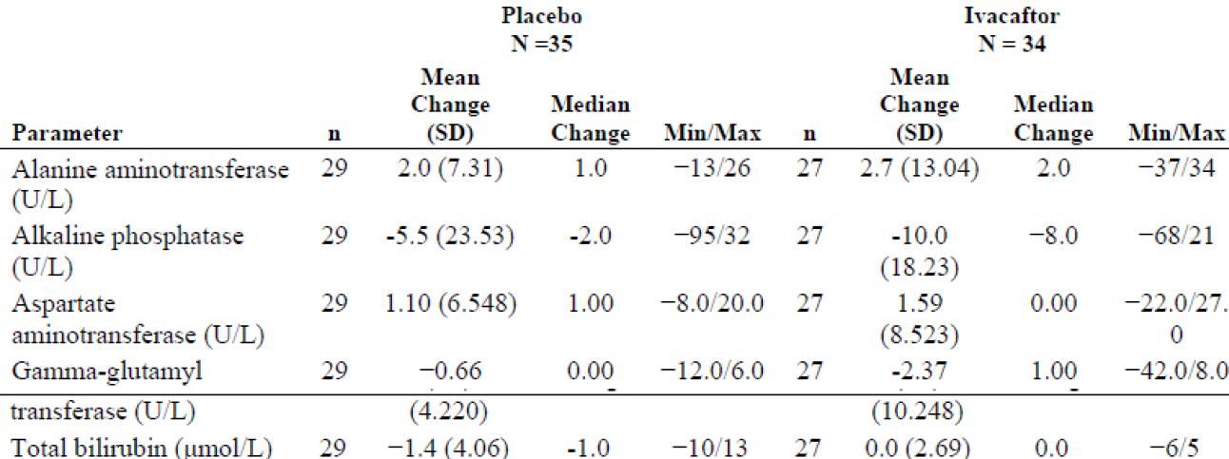
Baseline is defined as the most recent measurement before intake of the first dose of study drug.

Table 64: Study 11- maximum on-treatment liver function test results, safety set
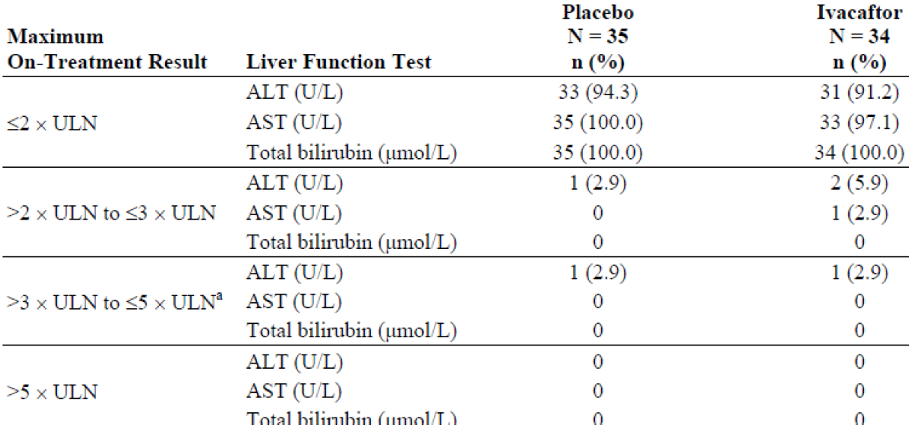

Other studies
No data available for study 112.

Kidney function

Pivotal studies
No significant changes were reported in kidney function laboratory parameters in study 110.

Other studies
No data available for study 112.

Other clinical chemistry

Pivotal studies
No other significant changes were reported in other clinical chemistry parameters in study 110.

Other studies
No data available for study 112.

Haematology

Pivotal studies
No significant changes were reported in haematology laboratory parameters in study 110.

Other studies
No data available for study 112.

Electrocardiograph

Pivotal studies
In the ivacaftor group, maximum increases into the category of > 450 to ≤ 480 msec in QTcB were observed for 2 (5.9%) subjects. No subject had a QTc value greater than 500 msec. No subject had a maximum on-treatment increase from baseline in QTc interval > 60 msec. Maximum increases of > 30 to ≤ 60 msec in QTcB were observed in 1 (2.9%) subject in the placebo group and 4 (11.8%) subjects in the ivacaftor group. No subjects in the placebo group and 2 (5.9%) subjects in the ivacaftor group had maximum increases of > 30 to ≤ 60 msec in QTcF. There were no AEs associated with ECG abnormalities in Study 110.

Other studies
No data available for study 112.

Vital signs

Pivotal studies
No clinically meaningful trends were observed over time in heart rate, blood pressure, body temperature, and respiratory rate. One subject in the placebo group had an AE of increased blood pressure. No other AEs associated with abnormal vital signs occurred, and none of the subjects discontinued study drug as a result of abnormal vital signs. There were no clinically meaningful changes in physical findings.

Other studies
None.

Ophthalmological examination

Pivotal studies
Due to the finding of a dose-related increase in cataracts in juvenile rats in a nonclinical study, the protocol for Study 110 was amended to add an ophthalmologic examination at Screening for all subjects. Subjects aged 6 to 11 years also had a follow-up ophthalmologic examination at Week 24. Visual acuity of the left and right eyes was measured at baseline for all subjects and at follow-up for subjects who had a follow-up examination. Changes from baseline to follow-up were minimal in both treatment groups and no clinically important trends attributable to ivacaftor treatment were observed. There were no shifts to abnormal in slit lamp examination of lens for either treatment group and no subjects developed lens opacities during the study.

Other studies
No data available for study 112.

Post-marketing experience
A cumulative and interval summary tabulation of serious and non-serious adverse reactions was provided in Module 5.3.5.3. A total of 1954 subjects (747970 person-days) received at least 1 dose of ivacaftor during the time period from the International Birth Date of ivacaftor (31 January 2012) to 23 January 2014. The post-marketing data are consistent with those from clinical studies and the established safety profile of ivacaftor and no new safety concerns identified.

Safety issues with the potential for major regulatory impact

Liver toxicity
In the pivotal study 110, AEs associated with abnormal liver function tests (LFTs) occurred in 3 (8.6%) subjects in the placebo group and 1 (2.9%) subject in the ivacaftor group. At the majority of visits through Week 24, mean absolute changes from baseline in all LFT parameters (ALT, AFT, total bilirubin and GGT) were minimal and were generally comparable between the ivacaftor and placebo groups. No subjects in either ivacaftor or placebo group had a maximum ALT or AST value that was > 5 × ULN or a maximum total bilirubin value that was > 2 × ULN.

Haematological toxicity
None.

Serious skin reactions
None.

Cardiovascular safety
None.

Unwanted immunological events
None.

Other safety issues

Safety in special populations
In Study 110, the incidence of AEs was summarized for subgroups based on age at baseline (6 to 11 years, 12 to 17 years and ≥ 18 years at baseline), sex (female and male), percent predicted FEV₁ severity at baseline (< 70%, ≥ 70% to ≤ 90% and > 90% predicted), and geographic region (North America and Europe).

Age:
Results of the analyses of AEs by age subgroups are discussed in sections 8.4.1.1. Safety results in the subgroups > 18 years were similar to those in the overall FAS population and also similar to those aged 6 to 11 years. There were only 2 subjects aged 11 to 17 years.

Gender:
The incidence of AEs was lower for female subjects than for male subjects in the ivacaftor group (89.5% [17 subjects, 75 events] versus 100.0% [15 subjects, 81 events], respectively) and was the same for female and male subjects in the placebo group. The incidence of infective pulmonary exacerbation of CF was higher in male subjects than in female subjects in the ivacaftor group (53.3% [8 subjects, 11 events] versus 26.3% [5 subjects, 6 events]); however, in the placebo group, the incidence of infective pulmonary exacerbation of CF was lower in male subjects than in female subjects (26.7% [4 subjects, 4 events] versus 50.0% [10 subjects, 20 events]). The other AEs showed no consistent trend between the male and female subgroups, and any differences were likely caused by the small number of subjects in the subgroups (Table 65).

Table 65: Study 11- adverse events occurring in at least 15% of subjects in either treatment group by system organ class, preferred term, and sex, safety set
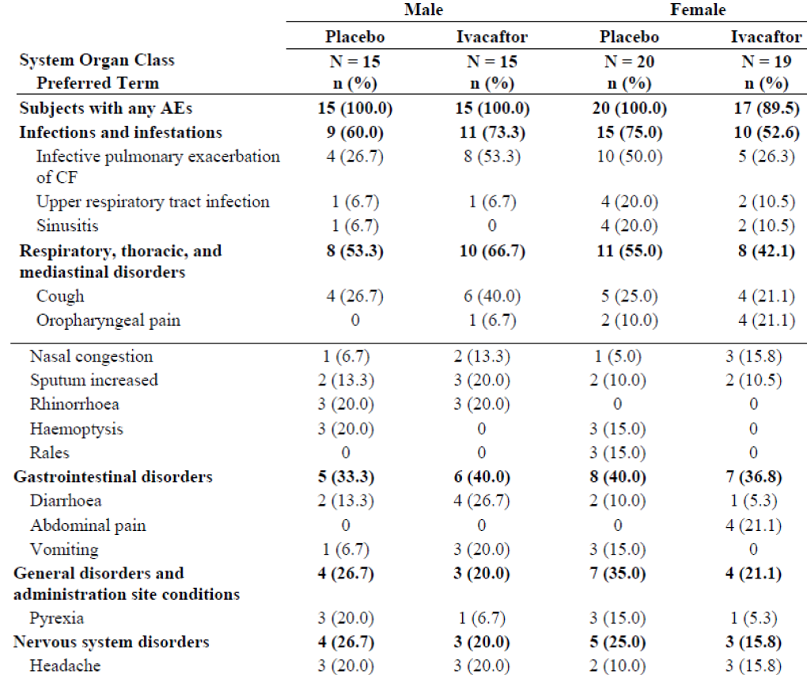

Baseline percent predicted FEV₁:
The overall incidence of AEs in the ivacaftor group was lower in the FEV₁ ≥ 70% to ≤ 90% predicted subgroup compared to the FEV₁ < 70% and FEV₁ > 90% predicted subgroups. All subjects in the FEV₁ < 70% and FEV₁ > 90% predicted subgroups of the ivacaftor and placebo groups had AEs. The overall incidence of AEs in the FEV₁ ≥ 70% to ≤ 90% predicted subgroup was lower in the ivacaftor group (85.7% [12 subjects, 53 events]) than in the placebo group (100.0% [14 subjects, 75 events]). Consistent with disease severity, the incidence of infective pulmonary exacerbation of CF and cough were higher in the FEV₁ < 70% predicted subgroup compared to the FEV₁ ≥ 70% to ≤ 90% and FEV₁ > 90% predicted subgroups. Within the FEV₁ < 70% predicted subgroup, the incidence of pulmonary exacerbation of CF was similar in both treatment groups, while the incidence of cough was slightly higher in the ivacaftor group. Additionally, the incidence of haemoptysis was higher among subjects treated with placebo in the FEV₁ < 70% predicted subgroup as compared to the ≥ 70% to ≤ 90% and > 90% predicted subgroups. None of the subjects in the ivacaftor group had haemoptysis. The other AEs showed no consistent trend in the FEV₁ < 70%, FEV₁ ≥ 70% to ≤ 90%, and FEV₁ > 90% predicted subgroups, and any differences were likely caused by the small number of subjects in the subgroups (Table 66).

Table 66: Study 11- adverse event occurring in at least 15% of subjects in either treatment group by system organ class, preferred term, and baseline percent predicted FEV₁, safety set
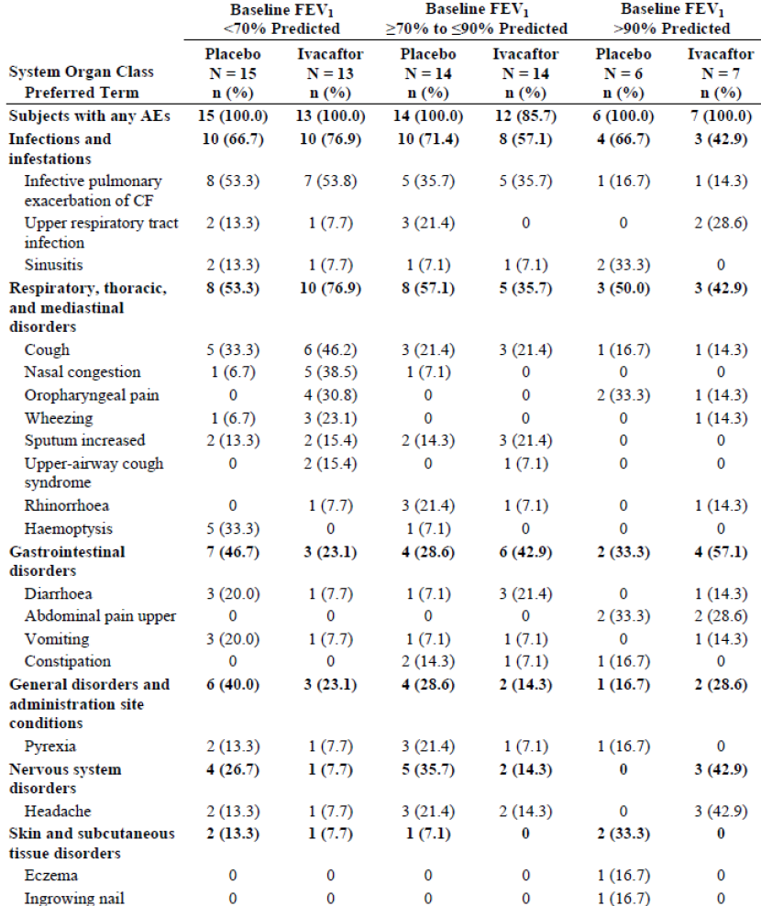
A subject with multiple events within an SOC or within a PT was counted only once within a SOC or PT, respectively. Adverse events were coded from MedDRA, Version 15.1.

Geographical regions:
The overall incidence of AEs in North America and Europe was lower in the ivacaftor group (North America: 95.8% [23 subjects, 119 events]; Europe: 90.0% [9 subjects, 37 events]) than in the placebo group (North America: 100.0% [30 subjects, 173 events]; Europe: 100.0% [5 subjects, 31 events]). In the ivacaftor group, there was no meaningful difference between North America and Europe in the incidence of any AEs, including infective pulmonary exacerbation of CF, cough, or haemoptysis. However, in the placebo group the incidence of infective pulmonary exacerbation of CF, cough, and haemoptysis was higher in Europe compared to North America. In the placebo group, the incidence of infective pulmonary exacerbation of CF group was 80.0% (4 subjects, 11 events) in Europe and 33.3% (10 subjects, 13 events) in North America. The incidence of cough was 60.0% (3 subjects, 3 events) in Europe and 20.0% (6 subjects, 9 events) in North America. The incidence of haemoptysis was 40.0% (2 subjects, 2 events) in Europe and 13.3% (4 subjects, 8 events) in North America. The higher incidence of infective pulmonary exacerbation of CF, cough, and haemoptysis in Europe in the placebo group is likely a function of the small number of subjects in this subgroup and the fact that all 5 subjects in the Europe placebo subgroup were ≥ 18 years of age. Subjects ≥ 18 years of age had a higher baseline disease severity as evidenced by a lower mean percent predicted FEV₁ at baseline (64.53%) compared to subjects 6 to 11 years of age (95.84%). By comparison, the North America placebo subgroup included subjects 6 to 11 years of age (8 subjects), 12 to 17 years of age (1 subject), and ≥ 18 years of age (21 subjects). The other AEs showed no consistent trend between North America and Europe and any differences were likely caused by the small number of subjects in the subgroups (Table 67).

Table 67: Study 110- adverse events occurring in at least 15% of subjects in either treatment group by preferred term and geographic region, safety set
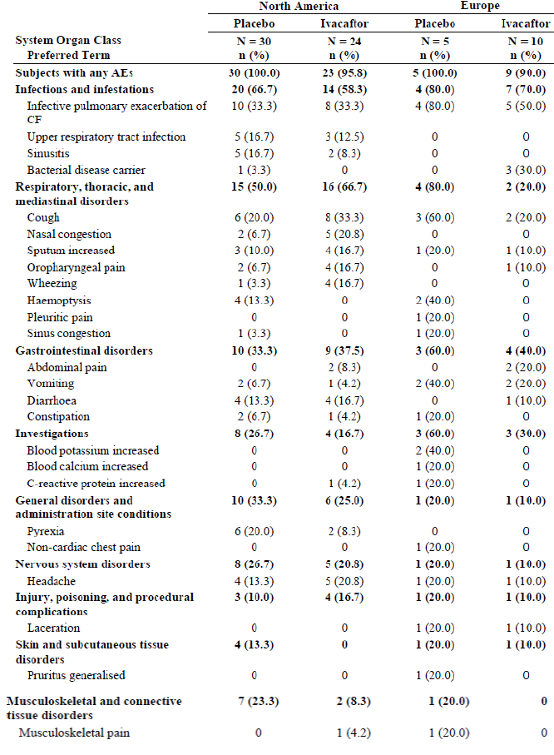

Safety related to drug-drug interactions and other interactions
No new data was provided.

Adverse drug reaction assessment and analysis
The safety data from Study 110 were reviewed for potential adverse drug reactions (ADRs). Among the AEs for which the incidence was at least 5% higher in ivacaftor-treated subjects than placebo, nasal congestion, oropharyngeal pain, abdominal pain, and wheezing (USPI only) are established ADRs. The difference for the other AEs of abdominal discomfort, bacterial disease carrier, influenza-like illness, and upper-airway cough syndrome was no more than 3 subjects between the ivacaftor and placebo groups. In the significantly larger (213 subjects) and longer (48 weeks) placebo-controlled Phase III studies in subjects with the G551D-CFTR gating mutation (Study 102 and Study 103), abdominal discomfort, bacterial disease carrier, influenza-like illness, and upper-airway cough syndrome all occurred in a small (< 3%) and generally comparable proportion of ivacaftor- and placebo-treated subjects. As Study 110 enrolled a relatively small number (N = 69) of subjects treated for 24 weeks, the ability to identify true ADRs is rather limited, unless a very significant difference in the incidence of AEs is noted. Therefore, the incidence of these 4 AEs was further evaluated by pooling with AEs reported from Studies 102 and 103. The pooled data showed that the incidence of abdominal discomfort, bacterial disease carrier, influenza-like illness, and upper-airway cough syndrome were all lower than 5% and generally comparable between the ivacaftor- and placebo-treated subjects (Table 68).

Table 68: the incidence of abdominal discomfort, bacterial disease carrier, influenza-like illness and upper-airway cough syndrome in the pooled Study 102 and 103
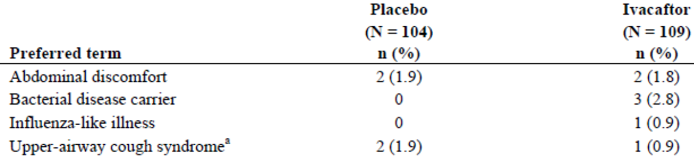
a: PT 'Postnasal drip' in MedDRA Version 12.0 in the Module 5.3.5.3/VX-770 ISS/Table 2.3.3.1 was demoted to lowest level term (LLT) in MedDRA Version 15.1, in which the correspondent PT is upper-airway cough syndrome.
Comments: Overall, the safety profile in subjects with the R117H mutation in CFTR protein who participated in Study 110 was similar to that of the prior Phase III studies in G551D gating subjects (Study 102 and Study 103) and no new ADRs were identified.

Use in pregnancy/ lactation
There was 1 pregnancy in Study 110 who received her first dose of ivacaftor on 28 September 2012 and her last dose on 31 January 2013 (Study Week 16); no doses were missed. On 01 February 2013, the subject informed the investigator that she was pregnant and was discontinued from study on 13 Feb, 2013. The subject delivered a healthy baby at 28 weeks gestation via caesarean section due to premature rupture of membranes.

Overdose, drug abuse, withdrawal/ rebound, effects on ability to drive or operate machinery
No new information was provided.

Evaluator’s overall conclusions on clinical safety
Ivacaftor was well tolerated when administered at 150 mg q12h for 24 weeks to 69 subjects in the target patient population of subjects with the R117H-CFTR mutation. The overall incidence of AEs was 94.1% in the ivacaftor group and 100% in the placebo group. The most commonly occurring AEs were consistent with those expected for patients with CF including infective pulmonary exacerbation of CF (ivacaftor versus placebo 38.2% versus 40.0%) and cough (29.4% versus 25.7%).
The number of subjects evaluated for safety of ivacaftor for the proposed indication was adequate considering the low prevalence of this specific form of CF (~90 CF patients with R117H mutation in Australia); however, the duration of exposure was not adequate (only 24 weeks) and only limited interim results (up to 12 more weeks) was available to evaluate long term safety of ivacaftor for proposed indication. However, the open label study 112 is still ongoing with expected duration of up to 104 weeks and should provide additional data on long term safety which should be submitted by the sponsors when available.
The favourable safety profile of ivacaftor was evident by the lower incidence of AEs, severe AEs and SAEs in the ivacaftor group as compared to the placebo group and was also supported by the fact that there were no deaths and no subjects discontinued study drug or withdrew from the study for a safety-related reason. Most AEs were of mild or moderate severity in both treatment groups and were considered by the investigator to be unlikely related or not related to the study drug. The incidence of SAEs was lower in the ivacaftor group (11.8%) than in the placebo group (17.1%). The most common SAE in both treatment groups was infective pulmonary exacerbation of CF (8.8% [3 subjects] in the ivacaftor group and 17.1% [6 subjects] in the placebo group). All SAEs of infective pulmonary exacerbation of CF resolved without study drug discontinuation and none were considered to be related to the study drug.
In study 110, subgroup analyses did not suggest any notable treatment-related differences in safety based on age, sex, baseline FEV₁ severity, or geographic region.
The safety profile of the ≥ 18 years subgroup was consistent with expectations for patients with CF and with the safety profile established in previous clinical studies. Similar to the overall population, the incidence of AEs and SAEs was lower in the ivacaftor group than in the placebo group. In the ≥ 18 years subgroup, the most common AEs in the ivacaftor group were infective pulmonary exacerbation of CF and cough.
The safety profile of the 6 to 11 years subgroup was also consistent with the safety profile established in previous clinical studies. All subjects in the 6 to 11 years subgroup had at least 1 AE; none of the AEs occurred in more than 2 subjects in either the ivacaftor or placebo treatment group. The incidence of infective pulmonary exacerbation of CF and cough was lower in the 6 to 11 years subgroup than in the ≥ 18 years subgroup, which is not unexpected given the greater baseline disease severity for subjects ≥ 18 years.
As expected, the incidence of infective pulmonary exacerbation of CF and cough was higher in the FEV₁ < 70% predicted subgroup than in the FEV₁ ≥ 70% to ≤ 90% predicted subgroup and the FEV₁ > 90% predicted subgroup. The incidence of haemoptysis was higher among subjects treated with placebo in the FEV₁ < 70% predicted subgroup than in the ≥ 70 subgroup and an interpretation of these differences in AEs were confounded by the small number of subjects.
The incidence of LFT elevations was low and similar in both treatment groups. The majority of subjects had maximum on-treatment ALT and AST results > 2 × ULN. There were no total bilirubin values > 2 × ULN. Results of the other laboratory assessments, vital signs, and ECGs were generally similar in the ivacaftor and placebo groups, were consistent with the results of other clinical trials, and did not raise any safety concerns.
A total of 1954 subjects (747970 person-days) received at least 1 dose of ivacaftor during the time period from the International Birth Date of ivacaftor (31 January 2012) to 23 January 2014. The postmarketing safety data are consistent with those from clinical studies and the established safety profile of ivacaftor with no new safety concerns.
As expected based on ivacaftor’s mechanism of action, the safety profile of ivacaftor in subjects with the R117H-CFTR mutation was similar to the safety profile of ivacaftor in subjects with the G551D-CFTR mutation and other mutations that cause severe defects in channel gating.

First round benefit-risk assessment

First round assessment of benefits
The benefits of ivacaftor in the proposed usage are:
- Ivacaftor produced clinically relevant and statistically significant improvements in percent predicted FEV₁, CFQ-R respiratory domain and sweat chloride in subjects with sufficient disease severity (in subjects ≥ 18 years of age). The lack of benefit in subjects 6 to 11 years of age may be due to lack of significant lung disease at baseline in this age group due to progressive nature of a milder disease profile in this subgroup.
- Treatment differences for the FAS favoured ivacaftor at all treatment period time points during the 24-week pivotal study and there were twice as many responders (with > 3.5%, 5%, 7.5%, and 10% improvement in percent predicted FEV₁ over placebo) in the ivacaftor group as the placebo group.
- Gains in percent predicted FEV₁ in the ivacaftor group during the Treatment Period reversed in the Follow-up Period when the subjects were no longer receiving ivacaftor.
- Supportive evidence for efficacy was provided by results from an interim analysis of Study 112. However, the interim analysis was conducted after only 12 weeks of treatment, while the study duration was 104 weeks.
- No new safety concerns or ADRs were identified following 24 weeks treatment with ivacaftor 150 mg q12h to 69 subjects with CF who have at least 1 allele of an R117H-CFTR mutation. Compared with placebo treatment, treatment with ivacaftor led to lower incidences of serious and non-serious AEs. The observed AEs were consistent with the known safety profile of ivacaftor and of patients with CF. The safety profile was consistent and comparable across the age subgroups.

First round assessment of risks
The risks of ivacaftor in the proposed usage are:
- Common AEs include nasopharyngitis, URTI, headache, nasal congestion, oropharyngeal pain, rash, abdominal pain and diarrhoea. Most of these are mild to moderate in severity, did not result in ivacaftor discontinuation, and resolved spontaneously without treatment.
- Other potential risks include elevated transaminases and drug-drug interactions. Therefore, the product labelling specifically recommends close monitoring of unexplained elevations in transaminase levels until resolution and proper dose adjustments when ivacaftor is used concomitantly with moderate or strong cytochrome P450 (CYP) 3A inhibitors.
- Study 110 failed to meet the primary outcome measure (a statistically significant absolute change from baseline through 24 weeks of treatment in percent predicted FEV₁).
- There was no evidence of efficacy in CF patients aged 6 to 11 years and only 2 subjects aged 12 to 17 years were evaluated in the submitted clinical studies.
- Lack of evidence for long term efficacy and safety of ivacaftor when used for treatment of CF patients with R117H mutation. The pivotal study 110 had only 24 week treatment period compared to 48-week studies submitted for ivacaftor in CF patients with G551D and other gating mutations. There is an ongoing long term (104 weeks) open label study 112, but this submission only included results of the 12-week interim analysis.

First round assessment of benefit-risk balance
CF is an autosomal recessive disease with serious, chronically debilitating morbidities and high premature mortality and there is no available cure for CF at present. Although the R117H mutation is in the less severe spectrum of CF, it is associated with severe disease when compared to a normal population and there remains a clear and substantial unmet need in this population. These patients demonstrate progression of disease with advancing age and have a decreased life expectancy.
The pivotal study 110 evaluated efficacy and safety of ivacaftor 150mg bid for 24 weeks in 69 subjects (50 were aged > 18 years and 19 were 6 to 17 years old) with CF with a R117H mutation in the CFTR gene. Results of the primary endpoint (change in % predicted FEV₁) favoured ivacaftor compared with placebo but treatment difference was not statistically significant for the FAS. However, responder analysis revealed that the proportion of patients showing > 5% and 7.5% and 10% improvement in % predicted FEV₁ following 24 weeks treatment with ivacaftor was almost double that observed with placebo. Statistically, clinically relevant and consistent treatment effects were observed in the secondary endpoints of absolute change from baseline in sweat chloride and CFQ-R respiratory domain score. However, there were no statistically significant improvements in BMI, pulmonary exacerbations or other endpoints.
In the pre-defined subgroup analysis in subjects aged ≥ 18 years, ivacaftor resulted in a robust, positive, clinically relevant, and statistically significant improvements in pulmonary function (% predicted FEV₁) compared to placebo through 24 weeks of treatment. Treatment with ivacaftor also resulted in substantial and statistically significant improvements in CFTR activity as measured by sweat chloride, and in respiratory symptoms as measured by the CFQ-R respiratory domain score, compared to placebo through 24 weeks of treatment.
Although the subgroup of subjects 6 to 11 years of age showed a comparable sweat chloride response to the ≥ 18 year subgroup, this age group did not show any other meaningful response to ivacaftor treatment. Results for the 6 to 11-year-old subjects did not show any safety signal but it is not known if CFTR default correction actually translates into a long-lasting clinical benefit in these younger patients with well-preserved lung function.
Overall, results from the subgroup analyses indicated that ivacaftor was able to show a positive clinical benefit in subjects who have sufficient underlying disease that can be modulated by ivacaftor treatment.
Improvement in pulmonary function was observed in the open-label, long-term, rollover study 112 for subjects in the ≥ 18 years subgroup regardless of study drug treatment in Study 110. These improvements were consistent with what was observed in Study 110. Improvements in sweat chloride and CFQ-R respiratory domain scores observed from summary statistics in Study 112 were consistent with those observed in Study 110. However, this submission only included interim analysis following 12 weeks of treatment in study 112. Hence, long term maintenance of efficacy will have to be confirmed by evaluation of the final results from study 112 (with proposed duration of 104 weeks) which should be provided by the sponsors when the study is completed.
Results from Study 110 and Study 112 did not reveal any new ADRs or any additional risks associated with ivacaftor treatment. Compared with placebo treatment, treatment with ivacaftor led to lower incidences of serious and non-serious AEs. The common AEs associated with ivacaftor treatment were URTI, headache, nasal congestion, oropharyngeal pain, rash, abdominal pain and diarrhoea. Most of these are mild to moderate in severity and did not result in ivacaftor discontinuation, and resolved spontaneously without treatment. No treatment-limiting toxicities were identified, although the size of the safety database may have precluded detection of rare or uncommon events. No age-specific risks were identified. Other potential risks include elevated transaminases and drug-drug interactions. Therefore, the product labelling specifically recommends close monitoring of unexplained elevations in transaminase levels until resolution and proper dose adjustments when ivacaftor is used concomitantly with moderate or strong cytochrome P450 (CYP) 3A inhibitors. The ADRs and potential risks are readily identified clinically or with routine laboratory monitoring. The safety profile of ivacaftor has been well characterized. The observed AEs were consistent with the known safety profile of ivacaftor and of patients with CF.
Treatment with ivacaftor targets the underlying pathophysiology of CF and has systemic benefit including substantial improvements in pulmonary measures with corresponding improvements in CFTR function (indicated by significant reduction in sweat chloride levels). Although ivacaftor did not produce statistically significant improvements in primary efficacy endpoint in the pivotal study, there was enough evidence to suggest it could provide clinical benefits in subjects who have sufficient underlying disease as shown by subgroup analysis in patients aged > 18 years who had significantly greater disease manifestations compared to the younger patients (6 to 17years).
CF patients with an R117H-CFTR mutation demonstrate progression of disease with advancing age and have a decreased life expectancy. Many individuals with an R117H-CFTR mutation were not diagnosed with CF until the late childhood or adult years, when the disease had progressed and symptoms became much more evident although this has changed recently due to advances in newborn screening for CFTR mutations. However, there is no drug currently approved to treat the underlying cause of CF in this population and ivacaftor would provide a useful option to improve the treatment and outlook for CF patients with this CFTR mutation.
Overall, the benefit-risk profile of ivacaftor is favourable for proposed use in CF patients aged 6 years or older with a R117H-CFTR mutation.

First round recommendation regarding authorisation
It is recommended that application for marketing of ivacaftor for proposed indication ‘for the treatment of cystic fibrosis (CF) in patients aged 6 years and older who have an R117H mutation in the CFTR gene’ be approved. However, approval should be conditional to the following:
- incorporation of the suggested changes to the proposed PI,
- adequate response to questions in section 12.2 of this evaluation report, and
- sponsors agree to provide final results of long-term (104 weeks) open label study 112 for evaluation when the study is completed.

Clinical questions

Pharmacokinetics

Question1
Can the sponsor please provide the estimates of ivacaftor C_{min} and AUC for Studies 007 and 010, which were undertaken in healthy subjects, as they have done for the studies in patients with CF in Tables 4 and 5.

Question2
As it is difficult to judge whether ivacaftor PKs are consistent across both CF populations (that is reference CF subjects and subjects with the R117H mutation) a full non-compartmental PK analysis of the results of Study 110, which includes typical PK parameters such T_{max}, C_{max}, AUC, t_{1/2} etc may help answer this question. Therefore, can the sponsor please provide a full non-compartmental analysis of the ivacaftor PK parameters for Study 110?

Pharmacodynamics
Not applicable.

Efficacy

Question1
In the pivotal study 110, the baseline characteristics seem to indicate that patients in the ivacaftor group had a slightly better profile with less severe disease manifestations at baseline (higher precent predicted FEV₁, BMI, lower sweat chloride and P. aeruginosa infection and lower prevalence of the more severe R117H-5T variant) (Table 9). Could the sponsors clarify if this slight imbalance had any effect on the efficacy results?

Question2
The efficacy and safety data from ongoing, long-term, 104 week, open-label study 112 must be provided for evaluation when the study is completed.

Safety
None.

PI and CMI
Kindly address the issues mentioned in section 11.1.

Second round evaluation of clinical data submitted in response to questions

Pharmacokinetics

Question1
Can the sponsor please provide the estimates of ivacaftor C_{min} and AUC for Studies 007 and 010, which were undertaken in healthy subjects, as they have done for the studies in patients with CF in Tables 4 and 5?

Sponsor’s Response:
Simulations to estimate ivacaftor C_{min} and AUC using the population‐PK model were performed only for studies in CF patients and did not include subjects from Phase I studies (including Studies 007 and 010). However, the following PK parameters are provided from the non-compartmental analysis for these studies (Table 69). The results indicate similar exposure of ivacaftor in these studies relative to that observed in CF patients, which aligns with the population‐PK model finding of similar ivacaftor CL/F in healthy subjects and CF patients.

Table 69: mean (SD) ivacaftor AUC and C_{min} in healthy subjects following ivacaftor 150 mg single-dose (Study 007) and 150 mg q12h at steady-state (Study 010)
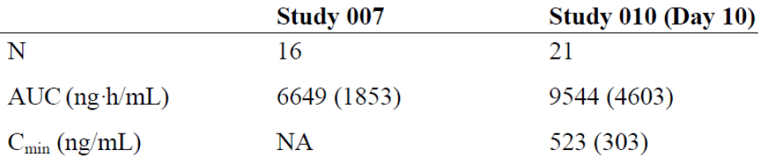
AUC: area under the concentration versus time curve; AUC from time of dosing to infinity (AUC_{0-inf}) for Study 007 and AUC from the time of dosing to 12 hours after dosing (AUC₀₋₁₂) for Study 010; C_{min}: minimum concentration within a dose interval; N: number of observations; NA: not applicable

Evaluator’s response:
The evaluator is satisfied with the Sponsor’s response.

Question2
As it is difficult to judge whether ivacaftor PKs are consistent across both CF populations (that is reference CF subjects and subjects with the R117H mutation) a full non-compartmental PK analysis of the results of Study 110, which includes typical PK parameters such T_{max}, C_{max}, AUC, t_{1/2} and so on may help answer this question. Therefore, can the sponsor please provide a full non-compartmental analysis of the ivacaftor PK parameters for Study 110?

Sponsor’s response:
As described in Report J178, the approximately 20% difference in ivacaftor Cl/F in CF patients with R117H versus a gating mutation may be due to the fact all R117H data comes from a separate study and therefore reflects differences in study design and inherent inter‐study variability.
PK sampling in Study 110 and other Phase III studies was not designed for the purposes of performing non‐compartmental analysis (NCA). However, sparse PK samples obtained at the Week 2 Visit in Study 110 were analysed using NCA to provide approximate PK values (Table 70), which are compared to that of Studies 102, 103, and 111 conducted in patient with G551D or other gating mutation (Table 71). Given the scarcity of the PK sample collection, parameters such as T_{max} and t_{1/2} could not be accurately estimated using NCA. Ivacaftor exposure in patients with the R117H‐CFTR mutation is similar to that observed in patients with a gating mutation when compared by age group.

Table 70: Study 11: mean (SD) steady-state ivacaftor PK parameters in CF patients with the R117H-CFTR mutation following ivacaftor 150 mg q12h
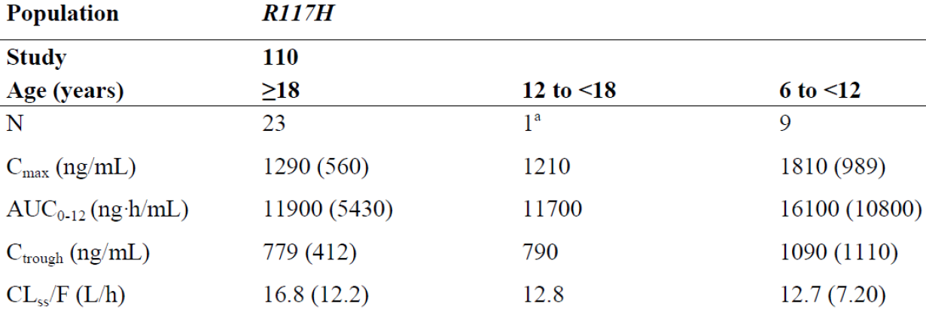
AUC₀₋₁₂: area under the concentration versus time curve from the time of dosing to 12 hours after dosing; C_{max}: maximum observed concentration; C_{trough}: trough concentration; CL_{SS}/F: oral clearance; N: number of observations. PK sampling in Study 110 was conducted at Week 2 and includes predose, 1, 2, 3, 4, and 6 to 8 hours postdose samples. The predose sample was recycled and used for C₁₂ for the estimation of AUC₀₋₁₂; as such, AUC₀₋₁₂ values are considered approximate. a: Individual values are reported; no summary statistics.

Table 71: Studies 102, 103, and 111- mean (SD) steady-state ivacaftor PK parameters in CF patients with a gating mutation following ivacaftor 150 mg q12h
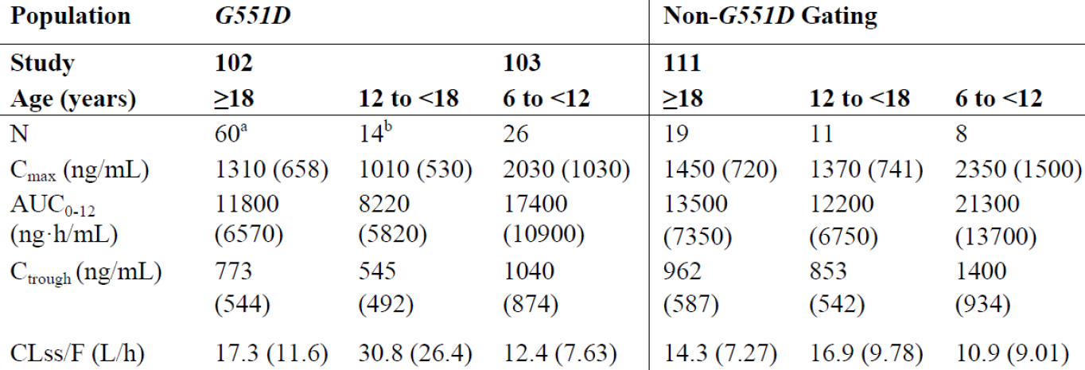
AUC₀₋₁₂: area under the concentration versus time curve from the time of dosing to 12 hours after dosing; C_{max}: maximum observed concentration; C_{trough}: trough concentration; CL_{SS}/F: oral clearance; N: number of observations. PK sampling in Study 110 was conducted at Week 2 or Week 14 and includes predose, 1, 2, 3, 4, and 6 to 8 hours postdose samples. The predose sample was recycled and used for C₁₂ for the estimation of AUC₀₋₁₂; as such, AUC₀₋₁₂ values are considered approximate. a: N=63 for C_{max} b: N=17 for C_{max}

Evaluator’s response:
The evaluator is satisfied with the Sponsor’s response.

Efficacy

Question 1
In the pivotal study 110, the baseline characteristics seem to indicate that patients in the ivacaftor group had a slightly better profile with less severe disease manifestations at baseline (higher percent predicted FEV₁, BMI, lower sweat chloride and P. aeruginosa infection and lower prevalence of the more severe R117H‐5T variant) (Table 9). Could the sponsors clarify if this slight imbalance had any effect on the efficacy results?

Sponsor response:
Although there was a slight imbalance in baseline characteristics in Study 110 as described, the analysis model incorporated continuous baseline value of age and the dependent variable being analysed to adjust for such differences. Because of this, this slight imbalance is not considered to have a substantial effect on the overall efficacy results.

Evaluator’s response:
The response is acceptable.

Question 2
The efficacy and safety data from ongoing, long‐term, 104 week, open-label study 112 must be provided for evaluation when the study is completed.

Sponsor’s response:
Vertex agrees to provide the CSR from Study 112 when it is complete.

Evaluator’s response:
The response is acceptable.

PI and CMI
The sponsor has provided satisfactory response to all the queries, comments in section 11.1 of the first round report and has also incorporated all suggested changes in the modified draft of PI (dated 26 Oct 2015).

Second round benefit-risk assessment

Second round assessment of benefits
After consideration of the responses to clinical questions, the benefits of ivacaftor in the proposed usage are unchanged from those identified in Section 9.1.

Second round assessment of risks
After consideration of the responses to clinical questions, the risks of Ivacaftor in the proposed usage are unchanged from those identified in Section 9.2.

Second round assessment of benefit-risk balance
The benefit-risk balance of ivacaftor in the proposed usage is favourable.

Second round recommendation regarding authorisation
It is recommended that application for marketing of ivacaftor be approved for proposed indication ‘for the treatment of cystic fibrosis (CF) in patients aged 6 years and older who have an R117H mutation in the CFTR gene’.

References
Chu C-S, Trapnell BC, Curristin S, Cutting GR, Crystal RG. Genetic basis of variable exon 9 skipping in cystic fibrosis transmembrane conductance regulator mRNA. Nat Genet. 1993;3:151-6.
Comer DM, Ennis M, McDowell C, Beattie D, Rendall J, Hall V, et al. Clinical phenotype of cystic fibrosis patients with the G551D mutation. Q J Med. 2009;102:793-98.
Kiesewetter S, Macek Jr. M, Davis C, Curristin SM, Chu C-S, Graham C, et al. A mutation in CFTR produces different phenotypes depending on chromosomal background. Nat Genet. 1993;5:274-8.
Massie RJH, Poplawski N, Wilcken B, Goldblatt J, Byrnes C, Robertson C. Intron-8 polythymidine sequence in Australasian individuals with CF mutations R117H and R117C. Eur Respir J. 2001;17:1195-200.
McCloskey M, Redmond AO, Elborn JS. Clinical features associated with a delayed diagnosis of cystic fibrosis. Respiration. 2000;67:402-7
McKone EF, Goss CH, Aitken ML. CFTR genotype as a predictor of prognosis in cystic fibrosis. Chest. 2006;130:1441-7.

Therapeutic Goods Administration
PO Box 100 Woden ACT 2606 Australia
Email: info@tga.gov.au Phone: 1800 020 653 Fax: 02 6232 8605
https://www.tga.gov.au

CF affects approximately 30.000 individuals in the US, 36000 individuals in the EU, 3900 individuals in Canada
The clinical and functional translation of CFTR (CFTR2). Available at: http://cftr2.org (Accessed 28 May 2014). Nat Genet 2013:45 (10); 1160-7.
Study J178: PopPK data, including ivacaftor plasma concentrations, dosing histories, event times, and covariate factors were included from Phase1, 2 and 3 studies (007, 010, 101, 102, 103, 104, 110 and 111). In total 369 subjects were included who contributed 4806 ivacaftor concentration readings.
pKa: logarithmic form of the acid dissociation constant
Log D value: a distribution constant to describe the lipophilicity of a molecule
This was pre-specified as per the Statistical Analysis Plan however, as the subjects recruited into study were either 5T or 7T (ie no 9T), poly T analyses and summaries based only on 5T and 7T were conducted.
A study biostatistician who was blinded to the actual treatment code, an unblinded biostatistician not associated with the study, and an unblinded quality check (QC) biostatistician. The study biostatistician created the randomization specification and dummy randomization codes, which were reviewed and approved by the unblended biostatistician. After approval, the unblinded biostatistician generated the final randomization list. The QC unblinded biostatistician reviewed and approved the final randomization list. The unblinded biostatistician provided the final randomization list to the interactive web response system (IWRS) vendor.
For subjects who either had DNA samples that could not be analysed or did not consent to the optional DNA samples, the poly-T variant for the R117H allele was derived if the subject had either a R117H/F508DEL or R117H/R117H genotype. All subjects who had the R117H/F508DEL genotype had one 9T variant; it was assumed that the 9T was on the F508DEL allele, and therefore the other variant (5T or 7T) was on the R117H allele. This assumption was considered valid because: (1) if a subject had R117H-9T they would have had a very mild disease phenotype (for example sweat chloride <60 mmol/L) and would not have qualified for entry into the study, and (2) a survey of the scientific literature indicates that the F508DEL allele has always been reported with the 9T variant except in some Lebanese Maronites,1 North Iranian individual and 1 Hispanic individual. For subjects who did not have either a R117H/F508DEL or R117H/R117H genotype, the 5T/7T status for the R117H allele could not be derived.
Culture outcomes were qualified as negative, light, moderate, heavy, or unknown.
Achromobacter xylosoxidans; Haemophilus influenzae; P aeruginosa, small colony variant; P aeruginosa, mucoid; P aeruginosa, non-mucoid; Staphylococcus aureus; and Stenotrophomonas maltophilia.
A responder analysis was conducted by categorizing the relative change from baseline in percent predicted FEV₁ through Week 24 for subjects ≥ 18 years of age as ≥ 3.5% or < 3.5%, ≥ 5% or < 5%, ≥ 7.5% or < 7.5%, and ≥ 10% or < 10%.
The number and percentage of subjects with shift changes from baseline based on the overall ECG evaluation will be tabulated by treatment group and visit. In addition, the number and percentage of subjects by maximum on-treatment value of QT/QTc intervals, categorized as ≤ 450 msec, > 450 msec and ≤ 480 msec, > 480 msec and ≤ 500 msec, and > 500 msec, as well as maximum on-treatment change from baseline value of QT/QTc intervals, categorized as ≤ 30 msec, > 30 msec and ≤ 60 msec, and > 60 msec.
2 subjects had AEs that led to interruption of placebo: dehydration, gastroenteritis, and hypokalemia in 1 subject; diarrhoea, and vomiting in the other subject.
QT interval corrected for heart rate according to Bazzet`s formula (a commonly accepted method to correct QT interval for heart rate): QTcB= QT/√RR (Bazzet HC: Heart, 1920)
QT interval corrected for heart rate according to Fridericia’s formula (a commonly accepted method to correct QT interval for heart rate) QTcF= QT/∛RR (Frederica LS: Acta Medica Scandinavica, 1920)
At the Early Termination Visit on 13 February 2013, the subject had a positive urine pregnancy test and a low value (< 0.1 mIU/mL) for follicle stimulating hormone (normal range 1.2 to 153 mIU/mL). Based on the subject’s history of premature rupture of membranes, she had a cervical cerclage procedure performed at 14 weeks and 2 days of gestation. She was admitted for cervical insufficiency at 15 weeks gestation and developed gestational diabetes mellitus at 25 weeks and 5 days. The investigator confirmed that cervical insufficiency and gestational diabetes were not AEs.

