Date of CER: December 2012

AusPAR Attachment 2

Extract from the Clinical Evaluation Report for Japanese Encephalitis Vaccine (live, attenuated)
  - Proprietary Product Name: Imojev
  - Sponsor: Sanofi-Aventis Australia Pty Ltd
About the Therapeutic Goods Administration (TGA)
- The Therapeutic Goods Administration (TGA) is part of the Australian Government Department of Health, and is responsible for regulating medicines and medical devices.
- The TGA administers the Therapeutic Goods Act 1989 (the Act), applying a risk management approach designed to ensure therapeutic goods supplied in Australia meet acceptable standards of quality, safety and efficacy (performance), when necessary.
- The work of the TGA is based on applying scientific and clinical expertise to decision-making, to ensure that the benefits to consumers outweigh any risks associated with the use of medicines and medical devices.
- The TGA relies on the public, healthcare professionals and industry to report problems with medicines or medical devices. TGA investigates reports received by it to determine any necessary regulatory action.
- To report a problem with a medicine or medical device, please see the information on the TGA website <http://www.tga.gov.au>.
About the Extract from the Clinical Evaluation Report
- This document provides a more detailed evaluation of the clinical findings, extracted from the Clinical Evaluation Report (CER) prepared by the TGA. This extract does not include sections from the CER regarding product documentation or post market activities.
- The words [Information redacted] indicate confidential information has been deleted.
- For the most recent Product Information (PI), please refer to the TGA website <http://www.tga.gov.au/hp/information-medicines-pi.htm>.
Copyright
© Commonwealth of Australia 2012
This work is copyright. You may reproduce the whole or part of this work in unaltered form for your own personal use or, if you are part of an organisation, for internal use within your organisation, but only if you or your organisation do not use the reproduction for any commercial purpose and retain this copyright notice and all disclaimer notices as part of that reproduction. Apart from rights to use as permitted by the Copyright Act 1968 or allowed by this copyright notice, all other rights are reserved and you are not allowed to reproduce the whole or any part of this work in any way (electronic or otherwise) without first being given specific written permission from the Commonwealth to do so. Requests and inquiries concerning reproduction and rights are to be sent to the TGA Copyright Officer, Therapeutic Goods Administration, PO Box 100, Woden ACT 2606 or emailed to <tga.copyright@tga.gov.au>.

Contents
List of abbreviations 5
1. Clinical rationale 8
2. Contents of the clinical dossier 8
2.1. Scope of the clinical dossier 8
2.2. Paediatric data 9
2.3. Good clinical practice 9
3. Pharmacokinetics 9
3.1. Studies providing pharmacokinetic data 9
3.2. Summary of pharmacokinetics 9
3.3. Evaluator’s overall conclusions on pharmacokinetics 9
4. Pharmacodynamics 10
4.1. Studies providing pharmacodynamic data 10
4.2. Summary of pharmacodynamics (background information) 10
4.3. Evaluator’s overall conclusions on pharmacodynamics 13
5. Dosage selection for the pivotal studies 13
6. Clinical efficacy 14
6.1. Clinical data to support current submission 14
6.2. Other efficacy studies 35
6.3. Analyses performed across trials (pooled & meta analyses) 35
6.4. Evaluator’s conclusions on clinical efficacy 35
7. Clinical safety 36
7.1. Studies providing evaluable safety data 36
7.2. Pivotal studies that assessed safety as a co-primary outcome 36
7.3. Patient exposure 41
7.4. Adverse events 41
7.5. Laboratory tests 42
7.6. Post-marketing experience 43
7.7. Evaluator’s overall conclusions on clinical safety 43
8. First round benefit-risk assessment 43
8.1. First round assessment of benefits 43
8.2. First round assessment of risks 43
8.3. First round assessment of benefit-risk balance 44
9. First round recommendation regarding authorisation 44
10. Clinical questions 44
11. References 44

List of abbreviations
Abbreviation | Meaning
ADEM | Acute Disseminated Encephalomyelitis
AE | Adverse event
ANOVA | Analysis of variance
ATC | Anatomical Therapeutic Chemical
BIKEN | Research Foundation for Microbial Diseases of Osaka University
BMI | Body mass index
C | Capsid
CDC | Centres for Disease Control and Prevention
CFR | Code of Federal Regulations
CI | Confidence interval
CSR | Clinical Study Report
CTX | Clinical Trial Exemption
CVD | Centre for Vaccine Development (Mahidol University at Salaya, Nakhonpathom, Thailand)
DSMB | Data and Safety Monitoring Board
E | Envelope protein
ELISPOT | Enzyme-linked immunosorbent spot
EMA | (previously EMEA) European Medicines Agency
EPI | Expanded Program on Immunisation
FAS | Full Analysis Set
FDA | Food and Drug Administration
GBS | Guillain-Barré Syndrome
GCP | Good Clinical Practice
GMT | Geometric mean titre
GPO-MBP | Government Pharmaceutical Organization—Mérieux Biological Products
ICH | International Conference on Harmonisation
IDMC | Independent Data Monitoring Committee
IFNγ | Gamma-interferon
IND | Investigational New Drug
ITT | Intent to treat
JE | Japanese encephalitis
JE-CV | Japanese encephalitis chimeric virus vaccine (also referred to as ChimeriVax-JE)
JE-VAX | Trade name of a Japanese encephalitis vaccine Sanofi-Pasteur
LNI | Log neutralisation index
M | Membrane protein
MBDV | Mouse brain-derived vaccine
MMR | Measles Mumps Rubella
NS | Nonstructural (protein)
PBMC | Peripheral blood mononuclear cells
PFU | Plaque-forming units
PD | Pharmacodynamics
PHK | Primary hamster kidney
PK | Pharmacokinetics
PP | Per Protocol
prM | Pre-membrane protein
PRNT | Plaque reduction neutralisation test
PRNT50 | 50% plaque reduction neutralisation test
PSUR | Periodic Safety Update Reports
RNA | Ribonucleic acid
SA14 | 14-2 Live attenuated JE vaccine
SAE | Serious adverse event
STAMARIL | Trade name of a yellow fever 17D vaccine
TEAE | Treatment emergent adverse event
Thai FDA | Thai Food and Drug Administration
WHO | World Health Organisation
YEL-AND | Yellow Fever vaccine Associated Neurotropic Disease
YEL-AVD | Yellow Fever vaccine Associated Viscerotropic Disease
YF | Yellow fever
YF-VAX | Trade name of a yellow fever 17D vaccine
Zmin | Minimum z-value

Clinical rationale
The clinical development aimed to demonstrate the efficacy and safety of JE-CV in the prevention of JE. Efficacy in adult populations was shown by demonstrating non-inferiority to a standard-of-care JE vaccine based on a serological correlate of protection accepted by the WHO. A protective immune response was also demonstrated in paediatric populations. The safety of JE-CV was assessed in all of the clinical studies during the JE-CV clinical development where JE-CV was administered. JE-CV was well tolerated and there was no evidence of any safety concerns in adult and in paediatric populations.
JE-CV was initially evaluated in nine clinical studies (Phase I/II to Phase III) in healthy adult populations in the USA and Australia and five clinical studies (Phase II and Phase III) in healthy infants, toddlers and children in India, Thailand and the Philippines. JE-CV was administered subcutaneously as a liquid formulation in adult studies H-040-001, H-040-003, H-040-005, and H-040-006, or as a lyophilized (or freeze dried) formulation in adult studies H-040-007, H-040-008, H-040-009, and H-040-010. Study H-040-002 was a study without JE-CV administration to assess the memory immune response in adults. The clinical development in adults was completed with pivotal Phase III studies of immunogenicity and safety (study H-040-009) and safety (study H-040-010). The safety and immunogenicity of the lyophilized formulation of JE-CV was subsequently assessed in the clinical development in paediatric populations in studies H-040-004, JEC01, JEC02, JEC05, and JEC15. In adults, JE-CV was mainly administered as a single dose of 4.0 log₁₀ plaque-forming units (PFU)/0.5-mL dose, based on safety and immunogenicity data obtained with dose-ranging studies (H-040-003 and H-040-007) and with repeated dose schedules (studies H-040-003 and H-040-005). The single-dose schedule (4.0 log₁₀ PFU/0.5-mL) was maintained in paediatric populations.
The clinical documentation supports the administration of JE-CV for the prevention of JE in individuals from 12 months of age and it allowed registration in Thailand and Australia in 2010.
A total of 3476 adult subjects were involved, and among these, 2486 were randomly assigned to JE-CV. At the time of registration the need and timing of booster vaccination was being assessed in paediatric populations. Since then, data on the persistence of immunity and the immune response after a JE-CV booster dose have become available and support the recommendation of a booster dose in paediatric populations. These paediatric studies are ongoing.

Contents of the clinical dossier

Scope of the clinical dossier
This clinical dossier contains clinical information relating to the development program of JE-CV including the pharmacodynamic, dose finding, pivotal and other clinical trials. It contains the final addendum report for the adult Study H-040-005 and interim results for three paediatric studies, JEC01, JEC05 and JEC015 (the latter two are follow on trials for JEC02) which relate to the proposed change of scheduling.
The clinical study reports supporting the long term immunity data in adults and the booster dose in paediatric populations consist of the following:
- H-040-005: Randomised, Double Blind, Phase II Study of the Safety, Immunogenicity, and Duration of Immunity of ChimeriVax-JE, Live Attenuated Vaccine in Healthy Adults (Final Addendum dated 9 November 2009)
The final clinical study report was provided in the original application submitted for registration in 2009 (Category 1 Submission). This application includes a copy of this report again together with the Final Addendum dated 9 November 2009, which includes information pertaining to the persistence of immunity up to 5 years after a single dose of Imojev in adults.
- JEC01: A Controlled Study of the Safety and Immunogenicity of ChimeriVax-JE Vaccine in Thai Toddlers and Children (Interim Report version 5.0, 10 February 2012)
- The preliminary safety and immunogenicity data from JEC01 was submitted during the evaluation of Category 1 submission in 2009. This application includes the Interim Clinical Study Report, which includes immunogenicity and safety data up to 3 years after a single dose of Imojev. This study is ongoing.
- JEC05: Long Term Follow Up of Immunogenicity of a Single Dose of Japanese Encephalitis Chimeric Virus Vaccine in Toddlers in Thailand and the Philippines (Interim Report version 2.0,12 May 2011)
- JEC15: Assessment of the Memory Immune Response, Safety of Japanese Encephalitis Chimeric Virus Vaccine (JE-CV) in Children Previously Immunised with a Single Dose of JE-CV and Long Term Follow Up (Interim Report version 2.0, 11 April 2012)

Paediatric data
The submission included paediatric efficacy/safety data.

Good clinical practice
GMP clearance and licensing requirements have been met prior to original submission. Copies of the GMP clearances are not included in this application for a major variation to the dosage.

Pharmacokinetics

Studies providing pharmacokinetic data
Consistent with published guidelines, the pharmacodynamic profile for JE-CV was defined by its immunogenicity profile and no pharmacokinetic studies were conducted.

Summary of pharmacokinetics
Not relevant to this submission.

Evaluator’s overall conclusions on pharmacokinetics
Not relevant to this submission.

Pharmacodynamics

Studies providing pharmacodynamic data
The clinical pharmacology program in an adult population consisted of five Phase I/II studies: H-040-001, H-040-003, H-040-005, H-040-006, and H-040-007. Studies H-040-008 and H-040-009 also contained immunogenicity assessments, but as the aims of these studies were to evaluate the efficacy (based on a serological correlate of protection) they are presented in the ‘Clinical Efficacy’ section.
Immunogenicity data in paediatric populations are available from studies H-040-004, JEC01, JEC02, JEC05, and JEC15. Data from study H-040-004 are presented in this section since this study was designed to provide safety data and local immunogenicity data of JE-CV in paediatric populations. By contrast, the aim of the immunogenicity assessments in studies JEC01 and JEC02 was to evaluate the efficacy (based on a serological correlate of protection) of JE-CV in paediatric populations; thus, immunogenicity results from these studies are presented in the ‘Clinical Efficacy’ section. Repeated administration of JE-CV was evaluated in two studies in adults. Administration of a second dose 28 days after the first JE-CV dose was assessed in study H-040-003 to determine the benefit of more than one dose of vaccine. Moreover, to assess the need for a booster dose, study H-040-005 evaluated the administration of a second dose at Month 6 after the first JE-CV vaccination.
The development of the lyophilized formulation started with a dose-ranging study (H-040-007) testing doses between 3.0 log₁₀ PFU/0.5-mL dose and 5.0 log₁₀ PFU/0.5-mL dose. Based on immunogenicity and safety results, a dose with a lower potency limit of 4.0 log₁₀ PFU/0.5-mL dose was chosen.
The assessment of the immunogenicity profile of JE-CV in the Clinical Development Program was based on the measurement of neutralizing antibodies (seroconversion rates and GMTs). The PRNT50 titre ≥1:10 was defined as protective according to WHO recommendations. The persistence of the antibody response was assessed in a 5-year follow-up study after one or two JE-CV vaccinations (single dose of liquid formulation JE-CV and a single dose of placebo in a crossover study with vaccinations on Day 0 and Day 28, followed by a vaccination booster 6 months later for a subset of the subjects) in study H-040-005.
Results of GMTs to homologous JE-CV virus following JE-CV administration are detailed for studies H-040-005, H-040-006, and H-040-007. The GMTs observed following vaccination with the liquid formulation of JE-CV (studies H-040-005 and H-040-006) were similar to the GMTs observed following vaccination with the lyophilized formulation of JE-CV (study H-040-007). All three studies showed that JE-CV elicits an immune response 30 days after a single-dose administration. Subjects who fulfilled the criteria for seroconversion have a protective level of neutralizing antibodies (PRNT50 titres ≥1:10). The rate of seroconversion/seroprotection is therefore more clinically relevant than the absolute level of neutralizing antibodies expressed as GMTs.

Summary of pharmacodynamics (background information)
The information in the following summary is derived from conventional pharmacodynamic studies in humans unless otherwise stated.

Mechanism of action (background information)

Viraemia
This vaccine works by producing a viraemia which results in the production of protective antibodies. Viraemia was assessed in 302 adult subjects vaccinated subcutaneously with the liquid formulation (studies H-040-001, H-040-003, and H-040-005) and 96 adult subjects vaccinated subcutaneously with the lyophilized formulation (study H-040-007). The designs of these studies varied with regard to flavivirus immunity in the study population (immune or non-immune to YF at baseline), dosages of vaccine (1.8 to 5.8 log₁₀ PFU/0.5-mL dose), time points after vaccination for measuring viraemia (Days 2 to 11 in study H-040-001, Days 1 to 8 in study H-040-003, and Days 1 to 14 in study H-040-007), and number of vaccinations (single or repeated administrations). Study H-040-005 measured viraemia at Days 14 and 42 after vaccination with JE-CV but showed no viraemia at either of these time points, indicating that any viraemia after vaccination had ceased within 2 weeks of JE-CV administration. Table 1 summarises viraemia in adult studies H-040-001, H-040-003, H-040-007, and the paediatric study JEC01.
Table 1: Viraemia Occurrence After Administration of JE-CV, in Studies H-040-001, H-040-003, H-040-007 in Adult Populations, and JEC01 in Paediatric Populations (Safety Population).
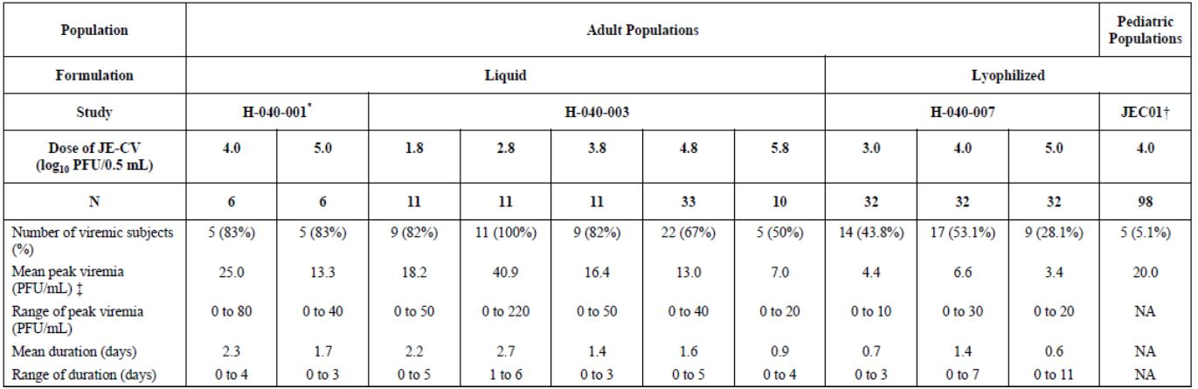
NA: not applicable. No viraemia was observed in the 202 subjects in study H-040-005 and in the 50 children in study JEC01; therefore, these data are not presented. * Data are quoted for subjects not immune to YF at baseline in study H-040-001 (i.e. results for 12 subjects not displayed). † Data are quoted for toddlers who received JE-CV as first vaccination in the crossover in study JEC01. ‡ The plaque assay used in adult studies had a limit of detection of 10 PFU/mL and the plaque assay in study JEC01 had a lower limit of quantitation of 20 PFU/mL. The calculation of mean peak viraemia in adult studies included non-viraemic subjects, therefore the mean could be lower than the limit of detection
The results of studies H-040-001, H-040-003, and H-040-007 showed that viraemia was observed up to 11 days after JE-CV administration in adults, with 50% to 100% of subjects (liquid formulation) and 28% to 53% of subjects (lyophilized formulation) experiencing viraemia on at least one day (Table 1). The data showed a trend for peak viraemia to occur around Day 4 to Day 6 after a single dose of JE-CV. The magnitude and duration of viraemia after JE-CV vaccination was similar to the viraemic pattern after administration of the marketed vaccine YF-VAX (studies H-040-001 and H-040-003). The number of viraemic subjects following administration with the lyophilized formulation of JE-CV in adults (study H-040-007) was slightly lower than with the liquid formulation (studies H-040-001 and H-040-003). No viraemia was observed in 202 subjects 14 days after JE-CV vaccination in study H-040-005.
Viraemia was assessed in paediatric populations in study JEC01. The viraemia assessment was made at only one time point and only in subjects who received JE-CV as first vaccination in the crossover design in order to minimize the blood sampling. This time point, 4 days after JE-CV vaccination, was selected on the basis of the time of peak viraemia observed in adult populations. A small proportion of paediatric subjects were viraemic 4 days after administration of JE-CV. Children aged 2 to 5 years (N=50) who were previously vaccinated against JE and had a pre-vaccination seroprotection rate of 90.0% did not present viraemia on Day 4. Toddlers aged 12 to 24 months (N=98) who were not previously vaccinated against JE and had a pre-vaccination seroprotection rate of 11.6% presented viraemia just above the lower limit of quantitation (20.0 PFU/mL) at this time point.

Pharmacodynamic effects (background information)

Primary pharmacodynamic effects: Study H-040-004

Seroconversion
In summary, study H-040-004 showed that a single dose of JE-CV induced a protective response in paediatric populations (≥9 months to <10 years), which was as good as the response after two doses of MBDV.

Geometric mean of antibody titres
GMTs after JE-CV vaccination in study H-040-004 were 226.3 in children aged ≥5 to <10 years, 254.0 in children aged ≥2 to <5 years and 490.2 in toddlers/infants aged ≥9 months to <2 years after vaccination with JE-CV. The GMTs were lower after MBDV vaccination with GMTs of 34.1 in children aged ≥5 to <10 years, 74.1 in children aged ≥2 to <5 years, and 55.1 in toddlers/infants aged ≥9 months to <2 years.

Effect of a Second Vaccination

In adult populations
The repeated administration of JE-CV in an adult population was investigated in two studies where a second dose was administered 30 days after a first dose in study H-040-003 and 5 or 6 months after a first dose in study H-040-005. These two studies were run to investigate whether the WHO recommendations for the administration of a booster dose within 6 months to one year after the completion of the primary vaccination, are appropriate for JE-CV. The two studies H-040-003 and H-040-005 investigated the best immunization schedule for the primary vaccination, and the benefit of the administration of a booster dose at Month 6 after the completion of the primary vaccination.

Determination of the primary vaccination schedule
In study H-040-005, a first dose of JE-CV was found immunogenic in all dose-groups and resulted in high seroconversion rates. The seroconversion rates after two doses were similar to those observed after a single dose. Seroconversion was shown to be in the range of 82% to 100% 14 days after the second dose and still high 30 days after the second administration (between 64% and 100%) in both groups. Administration of a second dose of JE-CV 30 days after the first dose did not significantly increase either the seroconversion rate or the mean antibody. This was a small study.
All the subsequent studies (including H-040-005, which also evaluated a repeated dose schedule) were designed as a single-dose JE-CV primary immunization schedule.

Evaluation of a booster dose
Half of the subjects enrolled in study H-040-005 were randomly assigned at Month 6 to two groups, one received a second dose of JE-CV and the other did not. Overall, 161 (98.8%) of the 163 subjects seroconverted to the homologous JE-CV virus 28 days after the first vaccination. Seroconversion rates remained high (96.8%) at the time of booster dose. There were four subjects who were seronegative at the time of booster; they all showed more than a 4-fold increase in neutralizing titres after the second immunization. This second dose, which was given about 6 months after the first one, is in accordance with the recommendations of the WHO panel of experts who considered a booster dose should be evaluated 6 months after the completion of a primary immunization. Although there was a trend for higher seroconversion rates after the booster dose, the difference was not statistically significant between the single-dose and booster-dose groups when evaluated at 6, 12, and 24 months after. For subjects who received a single dose, the seroconversion rate (PRNT50 ≥1:10, PP population) was 97.4% at Month 6, 95.0% at Month 12, and 91.4% at Month 24. Subjects who received two doses had a seroconversion rate (PRNT50 ≥1:10, PP population) of 96.3% at Month 6, 100.0% at Month 7, 98.5% at Month 12, and 98.3% at Month 24. The GMTs remained high in the two groups at the 6-month evaluation (ITT population) and increased in the booster dose group one month after the booster dose. At Month 12, GMT values were 180.5 versus 97.4 (p=0.0018) for the booster dose and single dose groups, respectively. Subsequent booster dose group values were 137.4, 213.9, and 141.3 at Months 24, 36, and 48, respectively, while single dose group values at Months 24, 36, and 48 were 82.9, 91.2, and 87.7, respectively. The statistically significant difference persisted at these time points. However, at Month 60 the GMTs in the two groups were similar with a GMT at 78.8 in the booster dose group and a GMT at 61.5 in the single dose group, which was no longer statistically different. In addition, the majority of subjects maintained antibody levels above the seroprotection threshold in the single dose group, hence the clinical relevance of the observed difference of GMTs is unclear.

Time course of pharmacodynamic effects
In all the studies for the original submission in adult populations, the assessments of the immune response were based on the homologous JE-CV virus and were performed usually 30 days after the administration of a single dose of JE-CV. This is in agreement with the recommendations made by a panel of WHO experts; the time of serum collection after a primary series of vaccination should be within 4 to 6 weeks. In this submission, there is long term follow-up of immunogenicity in these studies.

Pharmacodynamic interactions (background information)

Interactions between JE-CV and Yellow Fever vaccines in adult populations
In study H-040-001, it was shown that previous YF immunity did not interfere with the JE-CV vaccine response. The interaction with YF vaccines (YF-VAX and STAMARIL, both live attenuated YF 17D vaccines) was further evaluated in studies H-040-003, and H-040-006, and assessed both effect on JE-CV and YF response. In study H-040-003, prior vaccination with YF-VAX did not suppress response to JE-CV. Study H-040-006 assessed different schedules of immunization combining JE-CV and YF vaccine, GMT levels were high overall (to both vaccines) and there was no difference between vaccine groups in proportion of subjects who seroconverted to JE.

Evaluator’s overall conclusions on pharmacodynamics
The information in this section is all by way of background (apart from long term immunogenicity) and these studies were formally assessed in the original licensing submission. They do, however, provide important information about the immunogenicity of the chosen dose, preliminary information about the durability of the response. They also provide data showing no clinically significance interference with YF vaccination or interference with the response to JE-CV from prior YF immunity (either from infection or vaccination).

Dosage selection for the pivotal studies
Varying doses of JE-CV were compared in three studies: H-040-001, H-040-003, and H-040-007. The seroconversion results in study H-040-001 were consistent between the 4.0 and 5.0 log₁₀ PFU/0.5-mL dose groups. In studies H-040-003 and H-040-007, there were no dose responses observed in the seroconversion rates at Day 30. Nearly 100% of subjects overall had seroconverted to the homologous JE virus at one month after a single vaccination with JE-CV: 100% (all the subjects, whatever their previous immune status to YF, and the dose administered) in study H-040-001, 82% to 100% (varying, depending on the dose) in study H-040-003, 98.8% (161 out of the 163 JE-CV recipients) in study H-040-005, and 100% (in subjects who did not receive in the previous month another flavivirus vaccine) in study H-040-006. In the first study where JE-CV was presented in a lyophilized formulation (study H-040-007), the seroconversion rate 30 days after the JE-CV single dose administration appeared to be similar whatever the dose, and varied between 93.5% and 100.0% (PRNT50 ≥1:20). Based on these results, the immunogenicity of the two JE-CV formulations was considered comparable.
The dose evaluated during the late phase of the clinical development of JE-CV was chosen based on the two dose-ranging studies H-040-003 and H-040-007, which used liquid and lyophilized formulations of vaccine, respectively. In study H-040-003, 82 of 87 subjects (94%) who underwent primary immunization with a single injection of JE-CV at all dose levels (from 1.8 to 5.8 log₁₀ PFU/0.5-mL dose) seroconverted to JE by neutralization test within 30 days. In study H-040-007, no apparent difference between the doses administered (from 3.0 to 5.0 log₁₀ PFU/0.5-mL dose) was observed. At all doses and across all clinical pharmacology studies, seroconversion rates one month after vaccination were high and more than 90% in all but one JE-CV group (the 2.8 log₁₀ PFU/0.5-mL dose group in study H-040-003 where the seroconversion rate was 82%), irrespective of the formulation (lyophilized or liquid) used, and no dose relationship was apparent.
The response tended to be faster after the 3.8, 4.8, or 5.8 log₁₀ PFU/0.5-mL dose in study H-040-003 and after the 4.0 log₁₀ PFU/0.5-mL and 5.0 log₁₀ PFU/0.5-mL dose in study H-040-007 compared to the lower doses. Thus, a dose with a lower potency limit of 4.0 log₁₀ PFU/0.5-mL dose, representing the lowest tested dose with optimal results (high seroconversion rate, rapid onset of immunity, and a good safety profile of JE-CV in a single dose administration), was chosen for the Phase II study H-040-008 as well as the Phase III studies which completed the development of JE-CV in adults (H-040-009 and H-040-010).
The primary immunization schedule of JE-CV for the studies assessing the clinical efficacy (based on a correlate of protection) is a single-dose vaccination. A single dose of JE-CV was shown to be highly immunogenic against the homologous JE-CV virus, demonstrating over 90% seroconversion one month after vaccination; this is considered to be sufficient for primary immunization.
The same dose and primary immunization schedule were maintained for the clinical development in paediatric populations; this is consistent with the licensed YF 17D vaccine, another live flavivirus vaccine, which is administered at the same immunization schedule and dose level to both children and adults. JE-CV in a single dose regimen for primary immunization was therefore the schedule of immunization for all of the studies assessing the clinical efficacy of JE-CV. However, the need of a JE-CV booster dose was evaluated during the clinical development in paediatric populations and this data is assessed in the ‘Clinical Efficacy’ section.

Clinical efficacy

Clinical data to support current submission

Pivotal efficacy studies

Study H-040-005

Study design, objectives, locations and dates
The initial study was a randomised, double-blind, phase II Study of the safety, immunogenicity, and duration of immunity of ChimeriVax-JE, Live Attenuated Vaccine (JE-CV) in Healthy Adults The objectives of the Long term Immunogenicity Follow-up Period (LIFP) were to assess the durability of the immune response, based on PRNT using JE-CV virus and 4 different wild-type strains, in adult volunteers up to 60 months following one or two doses of JE-CV. The initial clinical study report (CSR), covered all data generated under study H-040-005 through the Month 24 follow-up visit. The current CSR Final report has data on all three of the LIFP clinic visits that were conducted subsequent to the Month 24 visit and represent the remainder of the five year immunogenicity follow-up. This study was conducted in Australia. The treatment phase of the study was conducted between 14 April 2003 and 05 January 2004. Analysis of the seroconversion rates over time was performed at the protocol defined threshold, which required that subjects must either experience a 4-fold rise in neutralising antibody titres between pre- and post-immunisation samples or subjects who were seronegative at baseline [i.e., 50% plaque-reduction neutralisation test (PRNT50) <1:10] were required to have a PRNT50 titre of ≥1:20 to meet the criteria for seroconversion. In addition seroconversion rates were analysed at the World Health Organisation (WHO) defined threshold for protection, which required that subjects who were seronegative at baseline (i.e., PRNT50 <1:10) required a PRNT50 titre of ≥1:10 to meet the criteria for seroconversion. For subjects who had pre-existing neutralising antibody to JE at baseline (i.e., PRNT50 titre of ≥1:10), seroconversion was defined as a ≥4-fold rise in neutralising antibody titre between pre- and post-immunisation.

Inclusion and exclusion criteria
Follow on from original study. These are summarised below.

Inclusion criteria
- The subject had all aspects of the protocol explained and written informed consent was obtained from the subject.
- The subject was ≥18 to <55 years of age.
- The subject was in good general health, without significant medical history, physical examination findings, or clinically significant abnormal laboratory results.
- The subject would be available for the study duration, including all planned follow-up visits.
- The subject agreed to take the following precautions to avoid insect bites for 7 days following vaccination:
- Wear long-sleeved shirts and trousers
- Apply N, N-Diethyl-meta-Toluamide (DEET)-containing insect repellents
- Sleep in a screened enclosure
- For female subjects of childbearing potential: had a negative serum pregnancy test when required. An efficacious hormonal (i.e., oral, implantable, or injectable) or barrier method of birth control was required for at least 1 month before Screening and Month 6, and for at least 1 month after Day 28 and Month 6. The subjects were required to sign an agreement that birth control would be practised during the specified periods and specify the method used. Female subjects unable to bear children had this documented (e.g., tubal ligation or hysterectomy).

Exclusion criteria
- A history of vaccination to JE. Previous vaccination was determined by history (interview of subject) and/or by reviewing the subject’s vaccination card or other official documentation (either a history of or documentation of vaccination fulfils the criterion for exclusion).
- Known or suspected immunodeficiency [e.g., human immunodeficiency virus (HIV) infection, primary immunodeficiency disorder, leukaemia, lymphoma], use of immunosuppressive or antineoplastic drugs (corticosteroids >10 mg prednisone, or equivalent, for more than 14 days in the last 3 months).
- Clinically significant abnormalities on laboratory assessment.
- Serious adverse reactions (SAEs) characterised by urticaria or angioedema to a prior vaccine.
- Transfusion of blood or treatment with any blood product, including intramuscular or intravenous serum globulin, within 6 months of the Screening Visit or up to Day 56.
- Administration of another vaccine within 30 days preceding the Screening Visit or up to Day 56 (these subjects were to be rescheduled for vaccination at a later date).
- Physical examination indicating any clinically significant medical condition.
- Body temperature >38.1°C (100.6°F) or acute illness within 3 days prior to inoculation (subject may be rescheduled).
- Intention to travel out of the area prior to the study visit on Day 56.
- Seropositive to Hepatitis C virus (HCV) or HIV, or positive for hepatitis B virus (HBV) antigen.
- Lactation or intended pregnancy in female subjects.
- Excessive alcohol consumption, drug abuse, or significant psychiatric illness.
- A known or suspected physiological or structural condition that compromises the integrity of the blood-brain barrier (e.g., significant hypertensive cerebrovascular disease, trauma, ischaemia, infection, or inflammation of the brain).

Study treatments
In treatment phase, study participants received either the vaccine; each dose of JE-CV on Day 0, the vaccinator administered 0.5 mL of vaccine to each subject in Group A. On Day 28, the vaccinator administered 0.5 mL of vaccine to each subject in Group B. Booster injections at Month 6 were administered to approximately half of the subjects in each group. All vaccinations were given by subcutaneous injection in the deltoid region of the arm.
No treatments were given during this follow up phase of the study.

Efficacy variables and outcomes
The objectives of the Long term Immunogenicity Follow-up Period (LIFP) were to assess the durability of the immune response, based on PRNT using JE-CV virus and 4 different wild-type strains, in adult volunteers up to 60 months following one or two doses of JE-CV.
The initial clinical study report (CSR), covered all data generated under study H-040-005 through to the Month 24 follow-up visit. The CSR reports for this submission includes data on all three of the clinic visits that were conducted subsequent to the Month 24 visit and represent the remainder of the five year immunogenicity follow-up period; Months 36, 48, and 60.
Safety outcomes are discussed below.

Randomisation and blinding methods
Not relevant to this submission, subjects stayed in allocated groups.

Analysis populations
The Safety population included all subjects who received at least 1 vaccination of study medication. The intent-to-treat (ITT) population included all subjects who received at least 1 dose of JE-CV and had pre- and post-vaccination blood samples for antibody analysis (Day 28 Group A; Day 56 Group B). The Per Protocol population included all flavivirus naïve subjects who received at least 1 dose of JE-CV vaccine, had baseline and post vaccination blood samples for antibody analysis (Day 28 Group A; Day 56 Group B) and had no significant protocol deviations identified by the Sponsor prior to unblinding. Significant protocol deviations that would warrant withdrawal from the Per Protocol population included non-eligible subjects, and subjects having randomisation errors, missed mandatory visits, or visits out of the study window.

Sample size
In the active phase of this study, a total of 202 adults were recruited into this crossover study to receive randomised (Group A or Group B), double-blind treatment. Subjects randomised to Group A were to receive JE-CV vaccine on Day 0 and vaccine diluent on Day 28 of the treatment period. Subjects randomised to Group B were to receive vaccine diluent on Day 0 and JE-CV vaccine on Day 28 of the treatment period. Approximately half the subjects in each treatment group were selected to receive a JE-CV booster vaccination at Month 6. One hundred and forty were available were recruited into the long term follow-up immunogenicity period.

Statistical methods
The duration of immune response (PRNT50 results for homologous JE-CV virus) was summarised using descriptive statistics over time. For subjects who were seropositive at Month 6, the Kaplan-Maier method was used to estimate the proportion of subjects who maintained a PRNT50 ≥1:10 (seropositive) over time, with separate analyses for two dose and single dose subject groups. The GMTs at Months 36, 48, and 60 were compared between the two dose and single dose groups to the data obtained at Months 6, 7, 12, and 24. The Kaplan-Meier analysis was based on subjects who were seropositive at Month 6 with replacement of missing data. To measure the robustness of the Kaplan-Meier analysis results, sensitivity analyses were performed. These analyses were performed on different subject populations, depending on their immune status (seropositive/seronegative) at different time points and without replacement of missing values.

Participant flow
This is summarised in Table 2.
Table 2: Participant flow in the LTFP of Study H-040-005.
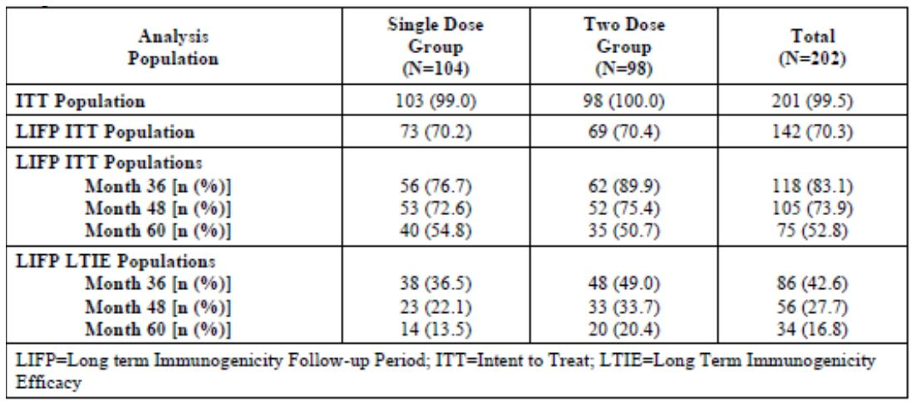

Major protocol violations/deviations
Not relevant to this submission.

Baseline data
Approximately 70% of participants from both groups were recruited into the long term follow up period.

Results for the primary efficacy outcome
The Kaplan-Meier seroconversion estimates demonstrate that the expected protection provided by JE-CV in subjects seropositive at Month 6 is sustained for up to 60 months in 95.7% of vaccinated subjects in the two dose treatment group and 86.6% in the single dose treatment group. Statistical comparison of the distribution of the two Kaplan-Meier survival curves from Month 6 to Month 60 for the two dose and single dose groups using the log-rank test yielded a Chi-square of 3.99 on one degree of freedom with a resulting p-value of 0.046. These data demonstrate that by the Month 60 time point, the proportion of seropositive single dose subjects was significantly less than the proportion of seropositive two dose subjects. The month 60 was the first time point at which a difference between the single dose and two dose groups was observed.
At the Month 12 follow up visit, the GMT for the two dose group was 180.5 and for the single dose group the value was 97.4. Subsequent two dose group values were 137.4, 213.9, and 141.3 at Months 24, 36, and 48, respectively, while single dose group values at Month 24, 36, and 48 were 82.9, 91.2, and 87.7, respectively. At Month 60, the treatment group values were comparable with the two dose GMT at 78.9 and the single dose GMT at 61.5 and no longer different statistically.
The addendum to the final report contains the long-term follow-up date up to 5 years after vaccination. This was evaluated with a Kaplan-Meier estimate analysis. Kaplan-Meier estimates (ITT population) showed that for a subject with a booster dose, the probability of remaining with titre ≥1:10 was 100.0% (Month 6), 98.8% (Month 12), 98.8% (Month 24), 98.8% (Month 36), 98.8% (Month 48), and 95.7% (Month 60). For the single-dose treatment group, the Kaplan-Meier estimates of seroprotection (and corresponding 95% CI) at the Month 24 to Month 60 visits appeared somewhat lower that observed for the group who received a booster dose, i.e. 100.0% (Month 6), 97.5% (Month 12), 93.2% (Month 24), 91.5% (Month 36), 89.6% (Month 48) and 86.8% (Month 60). Statistical comparison of the distribution of the Kaplan-Meier survival curves for the single dose and booster dose groups using the log-rank test showed no significant difference between the groups for the curves up to Month 48. A difference between groups was observed for the curve from Month 6 to Month 60. Interestingly, at this time point the two groups had comparable GMTs. It was concluded that the difference between the groups is small and from a medical viewpoint it does not justify a booster dose at 5 years, since the persistence of immunity is considered sufficient in the single dose. Even the GMTs in the single dose group are well above those thought to be clinically important.

Results for other efficacy outcomes
Not applicable.

Study JEC01 (up to Year 3 of follow-up)

Study design, objectives, locations and dates
Randomized, cross-over, open, active controlled (Hepatitis A vaccine), multi-centre trial in 100 children and 200 toddlers in Thailand. Subjects received one single dose of Japanese encephalitis chimeric virus vaccine (JE-CV, also referred to as JE-CV in the trial protocol) and one dose of Hepatitis A vaccine one month apart, and were to receive a second dose of Hepatitis A 6 months later. There will be a 5-year follow-up. Enrolment was sequential in two age cohorts.
STEP 1: children aged 2 to 5 years who received two primary doses of a mouse-brain derived Japanese encephalitis (JE) vaccine according to the Thai Expanded Program on Immunization for JE and who were within the age range of receiving a booster dose received:
STEP 2: flavivirus naïve toddlers aged 12 to 24 months received:

Stepwise approach for vaccination:
- Step 1: vaccination of children aged 2 to 5 years
- Safety review of D14 data post-first vaccination.
- Step 2: vaccination of toddlers aged 12 to 24 months
Before proceeding to Step 2, D0 to D14 safety data after the first vaccination for all subjects aged 2 to 5 years were reviewed by a Safety Committee.

Trial halting rules:
- Confirmed diagnosis of acute viscerotropic disease
- Confirmed diagnosis of neurotropic disease
- Occurrence of serious adverse events (SAEs) in at least 20% of the subjects in the period of 28 days after administration of JE-CV

Follow-up of JE antibody status
The Investigators are informed about subjects having antibody titres below the level of seroprotection during the course of the trial up to the end of the long-term follow-up, so that these subjects can be vaccinated with a licensed JE vaccine and then withdrawn from the trial.
The immunogenicity objectives were:
- To describe the immune response to JE before and after a single dose of JE-CV in two age cohorts: children aged 2 to 5 years previously vaccinated with two doses of mouse-brain-derived inactivated JE vaccine according to the national immunization schedule, and toddlers aged 12 to 24 months previously not vaccinated with any JE vaccine
- To describe the yearly persistence of immune response to JE after a single dose of JE-CV in the study population.

Inclusion and exclusion criteria

Inclusion criteria
Inclusion criteria were checked at screening only (Scr.), at the first vaccination visit (V01), and/or at the 6-month follow-up visit (V07). A potential subject had to meet all of the following criteria to be considered for trial enrolment:

All subjects
- Provision of consent form signed by at least one parent or another legally acceptable representative, and by at least one independent witness (Scr. and V07)
- Completion of vaccinations according to the national immunization schedule (Scr.)
- Subject and parent/legally acceptable representative able to attend all scheduled visits and comply with all trial procedures (Scr. and V01)
- Completion of the present study up to V07 (V07)

Criteria specific for children 2 to 5 years of age
5) Previous receipt of two doses of a mouse-brain-derived JE vaccine at 12 to 24 months of age and at least 6 months before the planned JE-CV vaccination, according to the national immunization schedule (Scr.) 6) Aged 2 to 5 years on the day of inclusion (V01)

Criterion specific for toddlers 12 to 24 months of age
7) Aged 12 to 24 months on the day of inclusion (V01) and have not received any JE vaccine.

Exclusion criteria
Exclusion criteria were checked either at screening only (Scr.), at screening and at the first vaccination visit (Scr. and V01), or at the first vaccination visit only (V01). A potential subject meeting any of the following criteria was ineligible for trial enrolment:

All subjects
- Participation in another clinical trial investigating a vaccine, drug, medical device, or a medical procedure in the 4 weeks preceding the first trial vaccination (Scr. and V01)
- Known or suspected congenital or acquired immunodeficiency, immunosuppressive therapy such as anti-cancer chemotherapy or radiation therapy within the preceding 6 months, or long-term systemic corticosteroids therapy (Scr.)
- Known systemic hypersensitivity to any of the vaccine components or history of a life-threatening reaction to the trial vaccine or to a vaccine containing any of the same substances (Scr.)
- Chronic illness, at a stage that could interfere with trial conduct or completion, in the opinion of the Investigator (Scr.)
- Receipt of blood or blood-derived products in the past 3 months, that might interfere with the assessment of the immune response (Scr.)
- Receipt of Hepatitis A vaccine (Scr.)
- History of flavivirus infection (confirmed either clinically, serologically or microbiologically) (Scr.)
- Administration of any anti-viral within 2 months preceding Scr. (Scr.)
- Administration of any anti-viral within 2 months preceding V01 (V01)
- History of central nervous system disorder or disease (Scr.)
- Personal or family history of thymic pathology (thymoma), thymectomy, or myasthenia (V01)
- Planned participation in another clinical trial up to the first year of the follow-up in the present trial (V01)
- Receipt of any vaccine in the 4 weeks preceding the first trial vaccination (V01)
- Planned receipt of any vaccine in the 4 weeks following any trial vaccination (V01)
- Personal human immunodeficiency virus, hepatitis B surface antigen, or hepatitis C seropositivity in the blood sample taken at screening (V01)
- Thrombocytopenia, bleeding disorder or anticoagulants in the 3 weeks preceding inclusion contraindicating intramuscular vaccination (V01)

Criteria specific for children 2 to 5 years of age
- Previous vaccination against flavivirus disease at any time before the trial other than a mouse-brain-derived JE vaccine given in a two-dose regimen at 12 to 24 months of age, in accordance with the national immunization schedule (V01) 18) Febrile illness (temperature ≥37.5°C) or any acute illness/infection on the day of vaccination, according to investigator judgment (V01)

Criteria specific for toddlers 12 to 24 months of age
- History of seizures (Scr.)
- Previous vaccination against flavivirus disease (Scr.)
- Febrile illness (temperature ≥38°C) or any acute illness/infection on the day of vaccination, according to investigator judgment (V01)

Study treatments
A single dose of JE-CV and two doses of Hepatitis A vaccine were administered according to the above schedule.
Groups 1 and 3: nine blood samplings (at screening, D4, D28, 6 months after the last vaccination, and 1, 2, 3, 4, and 5 years after the first vaccination). Groups 2 and 4: eight blood samplings (at screening, D56, 6 months after the last vaccination, and 1, 2, 3, 4, and 5 years after the first vaccination). The planned duration of each subject’s participation in the trial is approximately 5 years.
JE antibody assessments were performed using a homologous JE-CV virus (for all time points up to the end of the 5-year follow-up), one or more wild type virus strains (genotypes I to IV) relevant for Thailand (for all time points up to 6 months after the last vaccination).

Efficacy variables and outcomes
There were safety and immunogenicity objectives for this study:

Immunogenicity
- To describe the immune response to JE before and after a single dose of JE-CV in two age cohorts: children aged 2 to 5 years previously vaccinated with two doses of mouse-brain derived inactivated JE vaccine according to the national immunization schedule, and toddlers aged 12 to 24 months previously not vaccinated with any JE vaccine
- To describe the yearly persistence of immune response to JE after a single dose of JE-CV in the study population.
Immunogenicity was assessed by:
- Seroconversion 28 days after vaccination with JE-CV. Seroconversion was defined as a JE plaque reduction neutralization test (PRNT50) neutralizing antibody titre ≥10 1/dil in subjects who were seronegative at baseline (<10 1/dil). Subjects seropositive (≥10 1/dil) at baseline will require a ≥four-fold rise in neutralizing antibody titre
- Neutralizing antibody titres at screening and 28 days after vaccination with JE-CV measured by JE PRNT50
- Proportion of subjects with antibody titre ≥10 1/dil and geometric mean titres (GMT) 6 months after the last vaccination, and each year after the first vaccination
- Observational Endpoints
- Neutralizing antibody levels against flavivirus infection (dengue and JE) in a blood sample taken at screening
- Measurement of the size of viral plaques and sequencing of viral ribonucleic acid (RNA) isolated from sera collected 4 days after vaccination with JE-CV from selected subjects with detectable vaccinal viraemia in Groups 1 and/or 3 (maximum of 10 subjects per group)
- Occurrence of confirmed cases of JE during the 5-year follow-up (from 6 months after the last vaccination until 5 years after the first vaccination)
(Only results obtained up to the second year of follow-up after the first vaccination are presented in this report).

Randomisation and blinding methods
Children were enrolled and given a sequential number, according to the treatment centre, then centrally randomised to one of 4 groups (via telephone to voice response system).

Analysis populations
As summarised in Table 3.
Table 3: Population Definitions for Studies JEC01 and JEC02 and the Integrated Analysis of Immunogenicity.
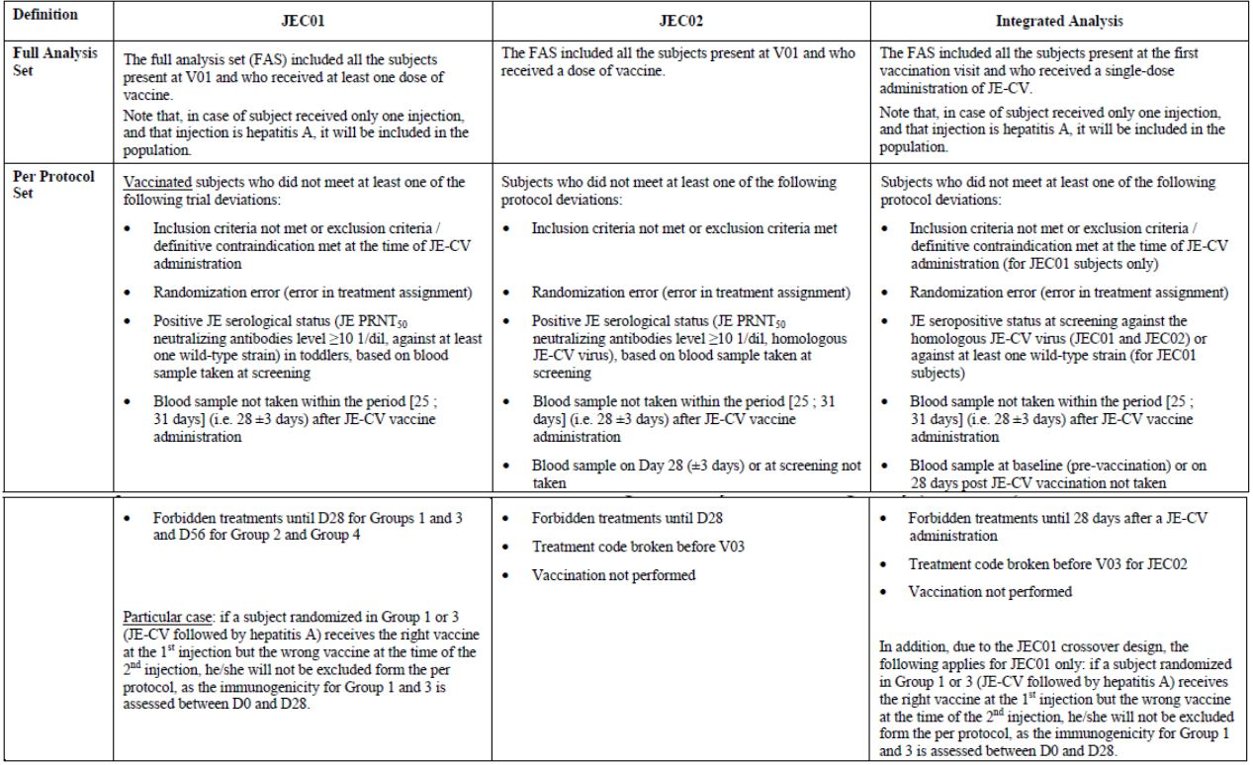

Sample size
The sample size was arbitrarily set to 50 subjects in Groups 1 and 2 and 100 subjects in Groups 3 and 4, so that there was a 95% probability of observing an event that had a true incidence of 5.9% in Groups 1 and 2 and 3% in Groups 3 and 4.

Statistical methods
All the main analyses were descriptive. For all the paediatric studies, the main parameters, 95% confidence intervals (CI) of point estimates were calculated using normal approximation for quantitative data and exact binomial distribution (Clopper-Pearson method) for proportions. Seven statistical analyses will be performed. The first five interim analyses have been performed:
- 28 days after the last injection on safety data collected up to 28 days after any vaccination, and immunogenicity data collected 28 days after JE-CV vaccination
- 6 months after the last injection on the safety and immunogenicity data collected at the 6-month follow-up visit
- 1 year, 2 years and 3 years after the first injection on immunogenicity data and confirmed JE cases reported at the Year 1, Year 2, and Year 3 follow-up visits, respectively
One subsequent interim analyses will be performed at 4 years after JE-CV injection on the safety and immunogenicity data collected yearly Final analysis of safety and immunogenicity data will be performed at the end of the 5-year follow-up.

Participant flow
Children: A total of 100 children (Group 1 [JE-CV/Hepatitis A vaccination]: 50 subjects and Group 2 [Hepatitis A/JE-CV vaccination]: 50 subjects) previously vaccinated with two primary doses of a JE MBDV at 12 to 24 months of age and aged between 1.9 and 4.9 years at screening received at least one dose of vaccine and were included in the Safety Analysis set and in the Full Analysis Set (FAS). Among these, 97 subjects were included in the Per Protocol (PP) set. All randomized children received the two vaccines according to their randomized group and completed the study up to 6 months after the last vaccination (V07) with the following exceptions: two subjects had pre-existing exclusion criteria not reported at screening. The flow is summarised in Table 4. A small number of subjects were withdrawn for various technical errors, exclusions or inability to get appropriate consent. No children were withdrawn with V10 (Year 3 follow-up visit) as the last visit performed.
Table 4: Participant flow in JEC01.
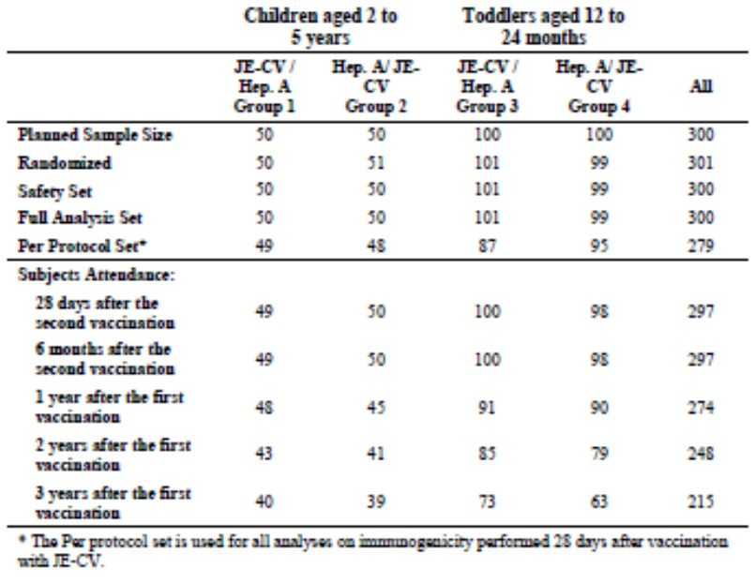
Toddlers: A total of 200 toddlers (Group 3 [JE-CV/Hepatitis A vaccination]: 101 subjects and Group 4 [Hepatitis A/JE-CV vaccination]: 99 subjects) previously not vaccinated against JE and aged between 11 and 23 months at screening received at least one dose of vaccine and were included in the Safety Analysis set and in the FAS. Among those, 182 subjects were included in the PP set. All randomized toddlers received the two vaccines according to their randomized group and completed the study up to 6 months after the last vaccination (V07) with the following exceptions: one subject was withdrawn since she had received a JE vaccine before inclusion in the present study and one subject was lost to follow-up.
A total of 49 toddlers discontinued the trial before V10 (Year 3 follow-up). For 65 subjects V10 or a preceding visit was the last visit performed. Nine more toddlers were withdrawn with V08 (Year 1 follow-up visit) as the last visit performed: five subjects were withdrawn due to JE neutralizing antibodies below the level of seroprotection (according to the protocol), one subject was withdrawn because he had received an additional JE vaccine approximately one year after the injection of JE-CV, and three subjects voluntarily withdrew (for reasons other than AE). Twenty-four toddlers were withdrawn with V09 (Year 2 follow-up visit) as the last visit performed: 23 subjects were withdrawn as they received a licensed JE vaccine due to JE neutralizing antibody titres below the level of seroprotection and one subject voluntarily withdrew since she moved to another province. Fourteen toddlers were withdrawn with V10 (Year 3 follow-up visit) as the last visit performed: 13 subjects were withdrawn as they received a licensed JE vaccine due to JE neutralizing antibody titres below the level of seroprotection and 2 subjects were withdrawn as their parents could not be contacted to consent.

Major protocol violations/deviations
These are not excessive.

Baseline data
At screening, the mean age of randomized children was 2.4 years (in the FAS) and all subjects were Asian. There were more male (66.0%) than female (34.0%) subjects in Group 1, while in the Group 2 there were more female (70.0%) than male (30.0%) subjects. At screening, the mean age of randomized toddlers was 16.2 months (in the FAS) and all subjects were Asian. There were similar proportions of male and female subjects in Group 3 and Group 4. Of the children, all subjects had received a previous JE vaccination. A majority (92.9%) were flavivirus positive at screening.

Results for the primary efficacy outcome
Twenty-eight days after JE-CV vaccination, all children (PP set) were seroprotected and 92.8% had seroconverted to the homologous JE-CV virus. The GMTs (95% CI) increased from the baseline level of 44.8 1/dil (33.8; 59.4) to a post-vaccination level of 2634 1/dil (1928; 3600), with slightly higher post-vaccination levels in Group 2 (3568 1/dil [2361; 5394]) than in Group 1 (1957 1/dil [1227; 3120]). The immune response in terms of seroprotection and seroconversion to wild-type JE virus strains was similar to that observed with the homologous JE-CV virus, while the post-vaccination GMTs to wild-type strains was generally lower than to the homologous JE-CV virus (Table 5).
Table 5: JEC01, Immune Response in Children (2 to 5 Years) in the Per Protocol Population.
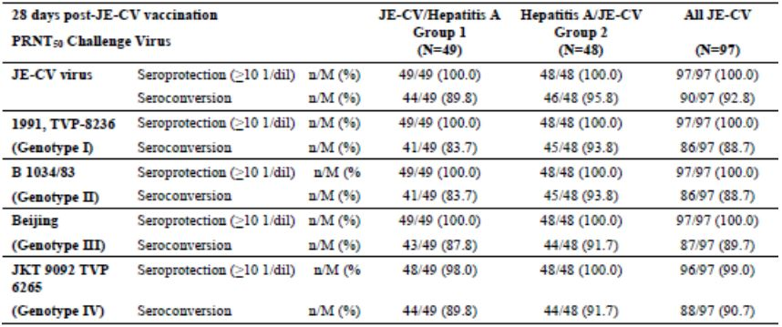
The response to the JE-CV virus (FAS) persisted at least up to 3 years after vaccination with a seroprotection rate of 100.0% 6 months after vaccination, 96.8% 1 year after vaccination, 97.6% 2 years after vaccination, and 100.0% 3 years after vaccination. In the analysis from year 1 onwards, the following rule for replacement of missing values was implemented: if a subject was withdrawn at a visit (or missed a yearly visit) during the long-term follow-up and she/he was seronegative at the previous visit, the subject is assumed to be seronegative for subsequent visits for which no titre is available (which is appropriate). The sensitivity analyses in the FAS performed at Year 1, Year 2, and Year 3 showed seroprotection rates (and GMTs) similar to that of the main analysis as the vast majority of children was protected against JE at the visits preceding the visits considered for the sensitivity analysis. The seroprotection rates (95% CI) in the sensitivity analysis were 96.8% (90.9; 99.3) 1 year after vaccination, 97.6% (91.7; 99.7) 2 years after vaccination and 97.5% (91.3; 99.7) 3 years after vaccination (Table 6).
Table 6: JEC01, Immune Response in Children Aged 2 to 5 Years - FAS.
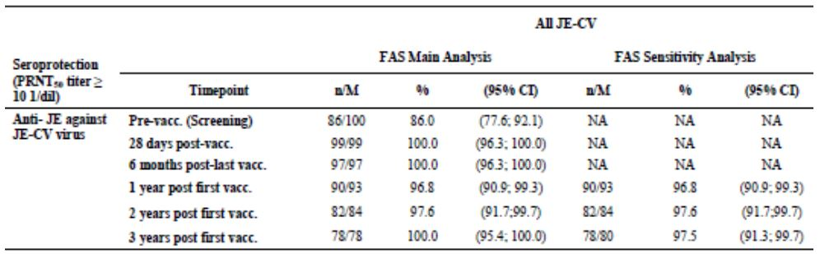
Toddlers: Seroprotection rate in toddlers (all subjects) was 96.0% (PP set). The GMTs (95% CI) increased from the baseline level of 5.41 1/dil (5.14; 5.69) to a post-vaccination level of 281 1/dil (219; 362) with slightly higher postvaccination levels in Group 3 (500 1/dil [353; 708]) than in Group 4 (167 1/dil [120; 233]).
The immune response to the JE-CV virus (FAS) persisted at least up to 3 years after vaccination. In the main analysis in the FAS, although the seroprotection rate decreased from 96.4% of subjects 28 days after vaccination to 86.8% 6 months after vaccination, it remained stable at 84.4% 1 year after vaccination and at 84.1% 2 years after vaccination, and increased to 95.2% 3 years after vaccination (Table 7). The increased seroprotection rate 3 years after vaccination was mainly due to the withdrawal from the study of subjects presenting with neutralizing antibody titres below the threshold for protection as per protocol, (so is essentially an artefact), as suggested by the results from the sensitivity analysis presented below.
Table 7: JEC01, Immune Response in Toddler Aged 12 to 24 Months - FAS.
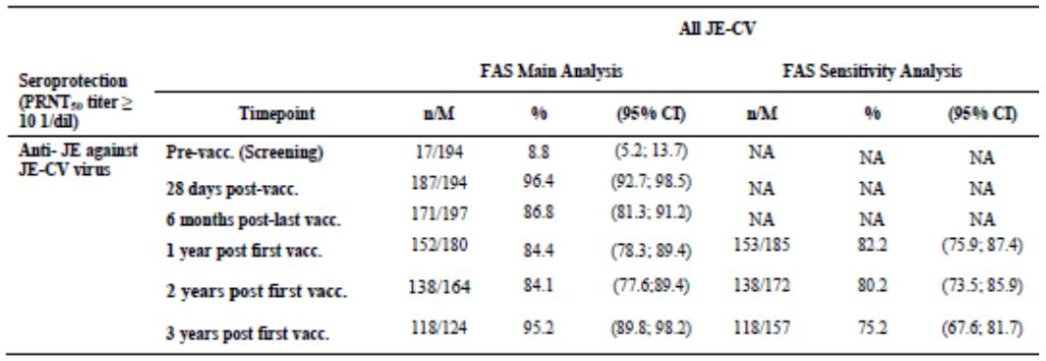
The seroprotection rate obtained with the sensitivity analysis was similar to that of the main analysis in the FAS one year after vaccination, but slightly lower 2 years after vaccination and markedly lower 3 years after vaccination, mainly due to subjects with antibody titres below seroprotection who were withdrawn from the trial. This difference between analyses indicated that the sensitivity analysis is the most relevant and realistic one for the assessment of persistence of immune response as it takes into account subjects with antibody titres below the seroprotection threshold who were withdrawn from the trial (and thus the main analysis in the FAS) to receive a licensed JE vaccine. Based on the sensitivity analysis the seroprotection rates decreased over time to 82.2% one year after vaccination, 80.2% 2 years after vaccination, and 75.2% 3 years after vaccination. The immune response decreased for the four tested wild-type JE virus strains 6 months after vaccination.

Results for other efficacy outcomes
Children: GMTs against the JE-CV virus (FAS) were lower at 6 months (1055.4 1/dil [771.4; 1444.0] than 28 days (2707.5 1/dil [1987.9; 3687.5] after JE-CV vaccination and persist over time at similar levels at Month 6, Year 1 (454 1/dil [327; 632], Year 2 (521 1/dil [364; 744], and Year 3 (461 1/dil [345; 616]). Based on the sensitivity analysis, GMTs remained on similar levels at 454 1/dil (327; 632) 1 year after vaccination, 521 1/dil (364; 744) 2 years after vaccination, and 461 1/dil (345; 616) 3 years after vaccination. At all assessed time points, the neutralizing antibody titres remained above the threshold considered for protection for the vast majority of subjects, as shown by the seroprotection rates.
Toddlers: GMTs against JE-CV virus (FAS) were lower at 6 months (69.5 1/dil [55.6; 86.4]) than 28 days (295.8 1/dil [231.6; 377.9]) after JE-CV vaccination, and persisted over time at similar level at Month 6, Year 1 (62.3 1/dil [49.5; 78.3]), Year 2 (80 1/dil [62.0; 103]), and Year 3 (118 1/dil [91.0; 152]). Based on the sensitivity analysis, GMTs remained on a similar level at 58.2 1/dil (46.2; 73.3) one year after vaccination, 70.3 1/dil (54.3; 91.1) 2 years after vaccination, and 60.6 1/dil (45.5; 80.7 3 years after vaccination. At all assessed time points, the neutralizing antibody titres remained above the threshold considered for protection for the majority of subjects, as shown by the seroprotection rates.

Study JE CO5

Study design, objectives, locations and dates
This was a multicentre, multinational, Phase III long-term follow-up trial, in approximately 700 subjects in Thailand and the Philippines who were vaccinated at 12 to 18 months of age with one dose of Japanese encephalitis chimeric virus vaccine (JE-CV) in JEC02. Randomized, cross-over, open, active controlled (Hepatitis A vaccine), multi-centre trial in 100 children and 200 toddlers in Thailand. Subjects received one single dose of JE-CV and one dose of Hepatitis A vaccine one month apart, and were to receive a second dose of Hepatitis A 6 months later. The active treatment period was between 2 March 2008 and 31 May 2011. There will be a 5-year follow-up.

Inclusion and exclusion criteria

Inclusion criteria
- Provision of Informed Consent Form signed by at least one parent or other legally acceptable representative.
- Subject who was vaccinated with JE-CV in JEC02 trial and had a pre-vaccination blood sample at baseline in JEC02 trial.
- Subject and parent/legally acceptable representative able to attend all scheduled visits and comply with all trial procedures.

Exclusion criteria
- Receipt of any JE vaccine other than JE-CV during JEC02 trial and during the period up to inclusion in JEC05 trial.
- Planned participation in another clinical trial during the present trial period.

Study treatments
No JE vaccine is administered in the present study. JE-CV was administered in JEC02 trial.
- There are 5 visits and 5 blood samplings (1 visit with blood sampling per year).
- Phone calls/home visits were to be performed twice yearly (i.e. every 4 months) between the yearly visits. Additional phone calls every 2 months were to be arranged during the first year of the study if judged necessary by the Investigator.

Efficacy variables and outcomes
The primary efficacy outcome was the yearly persistence of humoral immune response to Japanese encephalitis (JE) after a single dose of JE-CV. The measure primary endpoint was the number of subjects with neutralizing antibody titre ≥ 10 1/dil and geometric mean titre (GMT) using a homologous JE-CV virus measured by JE 50% plaque reduction neutralization test (PRNT50) assessed each year during 5 years after vaccination with JE-CV in JEC02.
Other efficacy outcomes included:
- The number of confirmed cases of JE from the end of JEC02, i.e. 6 months after vaccination with JE-CV in JEC02, until 5 years after vaccination, i.e. until the end of the present trial.

Randomisation and blinding methods
Not relevant to this study.

Analysis populations
As above.

Sample size
A sample size estimate of 700 subjects for the persistence of immunity enabled to have CIs with a length less than 10% (distance between the estimate and a bound less than 5%) whatever the estimates.

Statistical methods
All the analyses are descriptive. For the main parameters, 95% confidence intervals (CIs) of point estimates are calculated using normal approximation for quantitative data and exact binomial distribution (Clopper-Pearson method) for proportions. The statistical analyses are performed each year and at the end of the 5-year follow-up.

Participant flow
A total of 596 subjects who received a single dose of JE-CV in JEC02 came to V01 (Year 1 visit) in JEC05. Out of these, 591 subjects (99.2%) were included (in the FAS) in JEC05. Eight subjects present at V01 were withdrawn since they had received a JE vaccine (other than JE-CV) before coming at V01. Six subjects (1.0%) in the FAS were excluded from the Year 1 PP set, mainly because they had received a JE vaccine since the last visit (i.e. 6-month follow-up) in JEC02 and so were not eligible to the trial. Between V01 and V02, two additional subjects discontinued the trial due to voluntary withdrawal. A total of 571 subjects were present at V02 (Year 2 visit). Fifty-one subjects (8.6%) in the FAS were excluded from the Year 2 PP set, mainly because they did not provide any blood sample at V02 or had received a JE vaccine at V02. One subject was present at V01 but did not provide blood sample due to post-surgical procedures. This subject came back at V02 and provided a blood sample as planned in the protocol. Consequently, he was included in the Year 2 PP set. As Investigators were provided with listing of subjects presenting with JE neutralizing antibody titres below the threshold considered for protection (<1/10 1/dil), those subjects might have received a vaccination with a licensed JE vaccine and were withdrawn from the trial.

Major protocol violations/deviations
As above.

Baseline data
At inclusion in JEC05, the mean age of the subjects included in the Year 1 PP set was 26.2 months, and similar proportions of male and female subjects were present. All subjects except one were of Asian origin.

Results for the primary efficacy outcome
A total of 2.6% of subjects enrolled in JEC05 (PP set) had pre-existing neutralizing antibody titres before vaccination with JE-CV in JEC02. All subjects (100.0%) were seroprotected 28 days after a single dose of JE-CV, and the majority (88.2% [95% CI 85.3; 90.7]) was seroprotected 1 year after vaccination (Year 1 PP set and FAS). Two years after vaccination with JE-CV, 90.0% (95% CI: 87.2; 92.4) of the subjects who attended the Year 2 visit were still seroprotected (Year 2 PP set). For evaluation of the long-term persistence of immune response, a sensitivity analysis is performed with the same rule for missing values as for JEC01, any seronegative subject will be assumed to be seronegative at the next visits. Consequently, more subjects appear in the denominator for the sensitivity analysis as subjects known for having antibody titres below the threshold of protection are taken into account. This analysis is to be produced using the FAS and the PP set, from Year 2.
The sensitivity analysis performed at Year 2 in the FAS showed a slight difference for seroprotection rate and GMT compared to those of the main analysis performed in the FAS. According to the sensitivity analysis at Year 2, 85.9% (95% CI: 82.8; 88.6) of subjects were seroprotected 2 years after a JE-CV single dose administration and the GMT was 71.4 1/dil (95% CI: 62.7; 81.3).

Results for other efficacy outcomes
The GMT was 252 1/dil (95% CI: 224; 284) at 28 days after vaccination and contracted to 76.8 1/dil (95% CI: 67.4; 87.6) 1 year after vaccination, and then was persistent at 81.4 1/dil (95% CI: 71.7; 92.6) 2 years after vaccination (Year 2 PP set). The results were similar in the FAS: 90.1% (95% CI: 87.3; 92.5) of the subjects present at the Year 2 visit were seroprotected 2 years after JE-CV vaccination and the GMT was 81.4 1/dil (95% CI: 71.7; 92.4).

Confirmed JE cases
No confirmed JE cases were reported from 6 months to 2 years after JE-CV administration in JEC02.

Study JEC15

Study design, objectives, locations and dates
This is an open, controlled, multicentre, Phase III trial in the Philippines in approximately 505 children aged 36 to 42 months. Subjects were to be enrolled in 3 groups:
- Group 1: A maximum of 400 children who were previously vaccinated at 12 to 18 months of age with a single dose of Japanese encephalitis chimeric virus vaccine (JE-CV) in JEC02 were to receive a second dose of JE-CV at Visit 1, D0.
The 105 JE vaccine naïve control children were to be randomized into 2 groups:
- Group 2: (immunogenicity control group): 45 children were to receive one single dose of JE-CV on D0
- Group 3: (safety control group): 60 children were to receive a varicella vaccination on D0
Follow-up:
There will be a safety follow-up of 6 months after vaccination for Groups 1 to 3. In addition, for Group 1, there will be an immunogenicity follow-up for 5 years after the JE-CV vaccination. During the follow-up from 6 months up to 5 years after the JE-CV vaccination in Group 1, only related serious adverse events (SAEs), including related deaths, will be collected. Specimen collection.
- Group 1: Subjects provided blood samples for immunogenicity assessment at baseline (pre-vaccination on D0), and after JE-CV vaccination on D7, D28, and will provide blood samples at Year (Y) 1, Y2, Y3, Y4, and Y5.
- Group 2: Subjects provided blood samples at baseline (pre-vaccination on D0), on D7, and on D28.
- Group 3: No blood samples were provided by subjects included in this group.
The active treatment phase was conducted between 25 August 2010 and 24 March 2011. The date of last visit/last contact of the last subject in Group 1 (Year [Y] 1 visit): 24 October 2011

Inclusion and exclusion criteria

Inclusion criteria
An individual had to fulfil all of the following criteria in order to be eligible for trial enrolment:

All subjects
- Aged 36 to 42 months on the day of inclusion
- Provision of Informed Consent Form signed by at least one parent or other legally acceptable representative.
- Subject and parent/legally acceptable representative or guardian able to attend all scheduled visits and to comply with all trial procedures
- In good general health, based on medical history and physical examination
For Group 1 only
- Subject who was vaccinated with JE-CV in JEC02 trial

Exclusion criteria
An individual fulfilling any of the following criteria was excluded from trial enrolment:

All subjects
- Participation in another clinical trial investigating a vaccine, drug, medical device, or medical procedure in the 4 weeks preceding the trial vaccination
- Planned participation in another clinical trial during the D0-M6 period and for Group 1 up to 5 years for any flavivirus vaccine trial
- Receipt of any vaccine in the 4 weeks preceding the trial vaccination, except for pandemic influenza vaccination, which may be received at least 2 weeks before study vaccines
- Planned receipt of any vaccine in the 4 weeks following the trial vaccination, except for pandemic influenza vaccine. In the event of local or national immunization program with a pandemic influenza vaccine, subjects who receive a pandemic influenza vaccine at any time during the trial will not be withdrawn from the trial
- Planned receipt of any JE vaccine during the course of the trial
- Administration of any anti-viral within 2 months preceding the trial vaccination and up to 4 weeks following the trial vaccination
- Receipt of blood or blood-derived products in the past 3 months, which might interfere with assessment of the immune response
- Known or suspected congenital or acquired immunodeficiency; or receipt of immunosuppressive therapy such as anti-cancer chemotherapy or radiation therapy within the preceding 6 months; or long-term systemic corticosteroid therapy (prednisone or equivalent for more than 2 consecutive weeks within the past 3 months)
- Seropositivity for human immunodeficiency virus (HIV), hepatitis B, or hepatitis C, as reported by the parent/legally acceptable representative
- History of central nervous system disorder or disease, including seizures and febrile seizures
- Known systemic hypersensitivity to any of the vaccine components, or history of a life-threatening reaction to the vaccine used in the trial or to a vaccine containing any of the same substances
- Chronic illness or any underlying illness (such as cardiovascular, kidney, liver, or haematological disease or developmental abnormalities) that, in the opinion of the investigator, is at a stage where it might interfere with trial conduct or completion
For Group 1 only
- Receipt of any JE vaccine other than JE-CV during JEC02 trial and since the end of JEC02 trial
For Group 2 and Group 3 only
- Previous vaccination against flavivirus disease including JE
- History of flavivirus infection either based on clinical suspicion or laboratory proven
- Previous vaccination against varicella
- Previous vaccination with JE-CV in JEC02 study
- History of varicella, confirmed either clinically, serologically, or microbiologically
- Known systemic hypersensitivity or anaphylactic/anaphylactoid reaction to neomycin.
- Known history of thrombocytopenia or idiopathic thrombocytopenic purpura.

Study treatments
Japanese encephalitis chimeric virus vaccine (JE-CV) manufactured by Sanofi pasteur or OKAVAX , varicella live attenuated virus vaccine manufactured by Biken These were given by SC injection into the deltoid region of the upper arm.
For Group 1
Vaccination: All subjects received one dose of JE-CV on D0. All subjects had three visits (Visit [V] 01 on D0, V02 on D7, and V03 on D28) and two phone calls/home visits (3 days and 14 days after the vaccination) during the vaccination period. All subjects also had one phone call/home visit planned for the 6-month safety follow-up (6 months after the JE-CV vaccination). During the 5-year follow-up, all subjects will have one visit per year (V04 to V08). Additional phone calls/home visits could be made between as necessary by the Investigator.
Blood samples: All subjects will provide 8 blood samples: one blood sample before the vaccination, then 7 days and 28 days after the JE-CV vaccination, and one blood sample every year during the 5-year follow-up.
For Group 2
As for group 1, but blood only taken sample before the vaccination, then 7 days, and 28 days after the JE-CV vaccination.
For Group 3
Vaccination: All subjects received one dose of varicella vaccine on D0.
Visits/Phone Calls: All subjects had three visits (V01 on D0, V02 on D7, and V03 on D28), 2 phone calls/home visits (3 days and 14 days after the varicella vaccination) during the vaccination period. All subjects also had one phone call/home visit planned for the 6-month safety follow-up (6 months after the varicella vaccination).
No blood samples were drawn for this group.

Efficacy variables and outcomes
Primary efficacy outcome was to describe in subjects previously vaccinated with JE-CV (Group 1):
- The JE immune status before a JE-CV booster dose
- The memory immune response 7 days after a JE-CV booster dose
- The immune response 28 days after a JE-CV booster dose
- The persistence of the immune response yearly from Y1 to Y5 after a JE-CV booster
- Dose by using the homologous JE-CV virus plaque reduction neutralization test (PRNT50);
- Dengue immune status before a JE-CV booster dose (dengue serotypes 1 to 4) by using the dengue ELISA and the dengue PRNT50.
To describe in subjects receiving JE-CV in Group 2:
- The immune status before the JE-CV vaccination (JE and dengue serotypes 1 to 4) using the homologous JE-CV virus PRNT50 , the dengue ELISA and the dengue PRNT50
- The immune response 7 days and 28 days after the JE-CV vaccination using the homologous JE-CV virus PRNT50
Other efficacy outcomes included:

Immunogenicity
- Neutralizing antibody titres before JE-CV vaccination (on D0), and after JE-CV vaccination (on D7, D28, Y1, Y2, Y3, Y4, and Y5 for Group 1 and on D7 and D28 for Group 2)
- Individual ratio of antibody titres: D28/D0 and D7/D0 (for Groups 1 and 2)
- Seroprotection status for antibody levels against JE virus before (on D0) and after JE-CV vaccination (on D7, D28, Y1, Y2, Y3, Y4, and Y5 for Group 1 and on D0, D7 and D28 for Group 2)
- Seroconversion 7 and 28 days after JE-CV vaccination (on D7 and D28, respectively for Groups 1 and 2).
Seroconversion is defined by JE virus neutralizing antibody titres ≥ 10 (1/dil) in subjects who are seronegative at baseline (< 10 [1/dil]) and by a ≥ 4- fold rise in neutralizing antibody titres in subjects who are seropositive (≥ 10 [1/dil]) at baseline.
Serological status of flavivirus infection at baseline (for Groups 1 and 2 only):
- Group 1: Neutralizing antibody levels against flavivirus infection (dengue) in a blood sample taken at D0.
- Group 2: Neutralizing antibody levels against flavivirus infection (dengue and JE) in a blood sample taken on D0.

Randomisation and blinding methods
This was an open-label study. Participants not in Group 1 were randomised by the central voice recognition system.

Analysis populations
As shown in Table 8.
Table 8: Population Definitions for Studies JEC05 and JEC15.
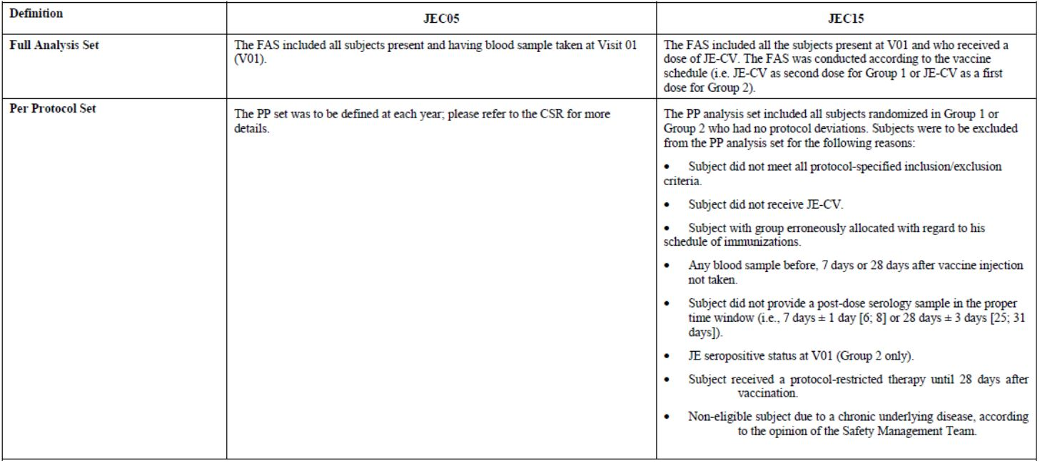

Sample size
The sample size for this study was arbitrarily defined. For the assessment of antibody persistence, it enabled to have CIs with a width less than 10% (less than 5% around the point estimate) for estimates greater than 70% (based on 85% of evaluable subjects). For safety, it provided a 95% probability of observing events which have an occurrence of 0.75%. A total of 45 subjects were expected to be included in Group 2. A total of 60 subjects were expected to be included in Group 3, which would provide a 95% probability of observing events which have an occurrence of 4.9%.

Statistical methods
There will be 6 statistical analyses: the first two interim analyses were performed on 28 days post vaccination data and 12 months post vaccination data; the 4 next analyses will be done respectively after the 24-month, 36-month, 48-month, and 60-month visits post-JE-CV vaccination. All the analyses are descriptive. The memory immune response assessed on D7 was described using Groups 1 and 2 immunological data. Additionally, the immune responses of subjects from Group 1 are summarized according to their immune response following their first vaccination in JEC02. Persistence of immune response assessed at Y1 post vaccine administration in JEC15 was described using Group 1 immunological data. For the main parameters, 95% confidence interval (CI) of point estimates was calculated using normal approximation for quantitative data and exact binomial distribution for proportions (Clopper-Pearson method).

Participant flow
A total of 456 subjects were enrolled in the trial. Among these, 349 subjects who were previously vaccinated with a single dose of JE-CV (in JEC02 trial) at 12 to 18 months of age were enrolled into Group 1 to receive a second dose of JE-CV 2 years after the first administration in JEC02. A total of 105 JE vaccine naïve subjects were randomized: 46 subjects were randomized to Group 2 to receive JE-CV and 59 subjects were randomized to Group 3 to receive Okavax. Among the 454 subjects enrolled to Group 1 or randomized to Groups 2 or 3 on D0, all but 4 subjects in Group 1 were vaccinated as planned. A majority of subjects, 449 out of 454 (98.9%), completed the trial between D0 and D28. Five subjects (1.1 %) in Group 1 did not complete the trial between D0 and D28: 4 subjects were discontinued before vaccination. One year after the vaccination, 339 subjects attended the visit.

Major protocol violations/deviations
Protocol deviations leading to exclusion from the PP Set were reported for 9 subjects (2.6%) in Group 1 with mainly inclusion/exclusion criteria deviations, lacking pre-or post-vaccination blood samples and vaccination not performed, and for 7 subjects (15.2%) in Group 2, all 7 with pre-existing JE neutralizing antibodies.

Baseline data
The mean age at inclusion (D0) was similar in the 3 vaccine groups in the FAS (Groups 1 and 2) and in All Injected Subjects (Group 3), i.e., between 39.3 months and 39.6 months. The percentages of male and female subjects were similar in the 3 vaccine groups. All subjects were Asian. In Group 2 (PP set), 7 subjects (17.9%) were seropositive (dengue PRNT50 titres ≥ 10 1/dil) to dengue (17.9% to serotypes 1 and 2, 12.8% to serotypes 3 and 4) before vaccination on D0; none had JE antibodies. In the FAS, 14 subjects (30.4%) were flavivirus seropositive before vaccination on D0; 7 subjects (15.2%) presented with pre-existing JE neutralizing antibodies and 11 subjects (23.9%) were seropositive to any dengue serotype (23.9% to serotypes 1 and 2, 19.68% to serotypes 3 and 4).

Results for the primary efficacy outcome

Immunogenicity:

Seroprotection and seroconversion rates up to 28 days after JE-CV vaccination
The seroprotection rate on D0 and seroprotection and seroconversion rates 7 and 28 days after a booster dose of JE-CV (“JE-CV Dose 2”) are presented in Table 9 for subjects in Group 1 previously vaccinated with JE-CV in JEC02 and after a first dose of JE-CV (“JE-CV Dose 1”) for the JE vaccine naïve control subjects in Group 2, as assessed by JE-CV virus PRNT50 (PP set).
Table 9: JEC15, Summary of Seroprotection and Seroconversion up to Day 28 after Vaccine Injection – Per Protocol Set.
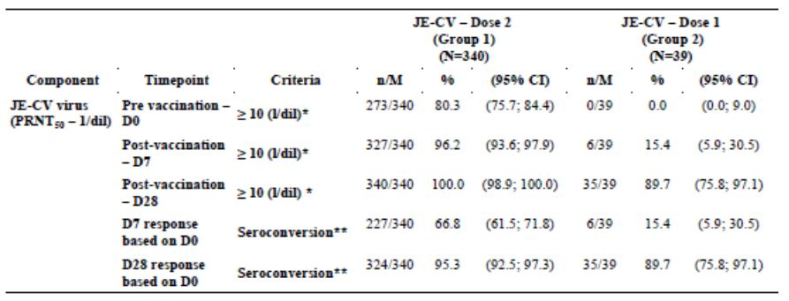
M: number of subjects with available data for the endpoint; * Corresponds to seroprotection, i.e., a titre ≥ 1/10; ** Seroconversion: subjects with a pre-vaccination titre < 1/10 and post vaccination titre ≥ 1/10, or subjects with pre-vaccination titre ≥ 1/10 and 4-fold increase from pre to post-vaccination; %: percentages and 95% CI are calculated according to the subjects with available data for the endpoint.
All subjects in Group 1 had received a single dose of JE-CV in JEC02 trial 2 years prior to the second dose (“JE-CV Dose 2”) administered in JEC15 trial. When participating in JEC02, 336 out of 344 Group 1 subjects (97.7%) presented with levels of antibodies below the threshold of protection before vaccination (FAS). Twenty-eight days after JE-CV vaccination, 330 of 344 subjects (95.9%) had obtained protective levels of antibodies and the seroconversion rate was 95.3% (FAS Group 1 JEC02). When enrolled in JEC15, 273 out of 340 subjects (80.3%) in Group 1 still had protective levels of antibody titres (PP set JEC15) 2 years after the JE-CV administration. Subjects in Group 2 were without previous JE vaccination. The PP set in Group 2 was comprised exclusively of subjects with JE antibody titres below the threshold of seroprotection before vaccination (i.e., 39 subjects). However, 15.2% of subjects (7 out of 46) in the FAS presented with pre-existing JE neutralizing antibodies before vaccination with JE-CV. In Group 1, 96.2% of subjects were seroprotected 7 days after receiving the second dose of JE-CV, and all (100.0%) were seroprotected 28 days after the second dose (PP set). The majority of subjects also seroconverted: 66.8% on D7 and 95.3% on D28. In Group 2, 7 days after receiving for the first time a single dose of JE-CV (“JE-CV Dose 1”), 15.4% of subjects presented with protective levels of antibodies, and 28 days after JE-CV vaccination the rate of seroprotected (and seroconverted) subjects increased to 89.7% (PP set).
Subjects previously vaccinated with a first dose of JE-CV showed a memory immune response 7 days after a second vaccination with JE-CV: 96.2% (95% CI: 93.6; 97.9) of subjects in Group 1 who had received a previous dose of JE-CV presented protective levels of antibodies after Dose 2 compared with 15.4% (95% CI: 5.9; 30.5) of JE vaccine naïve subjects in Group 2 (PP set). Furthermore, the titre increase was more marked in Group 1 with a D7/D0 GMTR of 5.87 (95% CI: 5.06; 6.80) than in Group 2 with a D7/D0 GMTR of 1.28 (95% CI: 1.02; 1.61). Results in the PP set were confirmed in the FAS.

Persistence of seroprotection up to 1 year after booster vaccination
Seroprotection up to 1 year after the booster dose of JE-CV in Group 1 (FAS) as assessed by JE-CV virus PRNT50 is presented in Table 10.
Table 10: JEC05, Summary of Seroprotection up to Year 1 after Vaccine Injection – FAS.
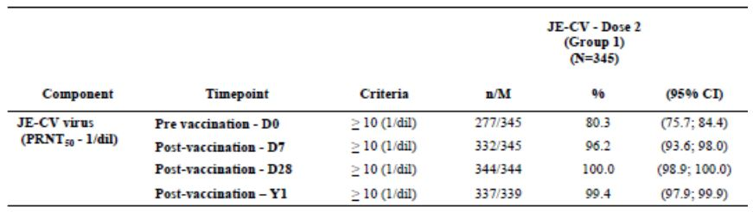
M: number of subjects with available data for the endpoint; %: percentages and 95% CI are calculated according to the subjects with available data for the endpoint; Only Group 1 remains in the trial for the 5 year follow up (V04-V08).
The immune response to JE-CV persisted at least up to 1 year after the second dose JE-CV vaccination in nearly all of the subjects in Group 1: 99.4% of subjects remained seroprotected 1 year after receiving the second dose of JE-CV; only 2 subjects presented with antibody titres below the threshold considered for protection.

Results for other efficacy outcomes

Persistence of Neutralizing Antibody Titres up to 1 Year after Booster Vaccination
GMTs of neutralizing antibody titres up to 1 year after the booster dose of JE-CV in Group 1 (FAS) as assessed by JE-CV virus PRNT50 are presented in Table 11. In Group 1, the GMT was 596 1/dil at Y1. The GMT was lower 1 year after vaccination than 28 days after vaccination (2259 1/dil); the Y1/D28 GMTR was 0.263 (95% CI: 0.230; 0.300). The GMTs at Y1 in Group 1 showed that the antibody levels had decreased from D28 levels, but most subjects (99.4%) remained seroprotected.
Table 11: JEC05, Summary of Geometric Means of Titres of Antibodies up to Year 1 – FAS.
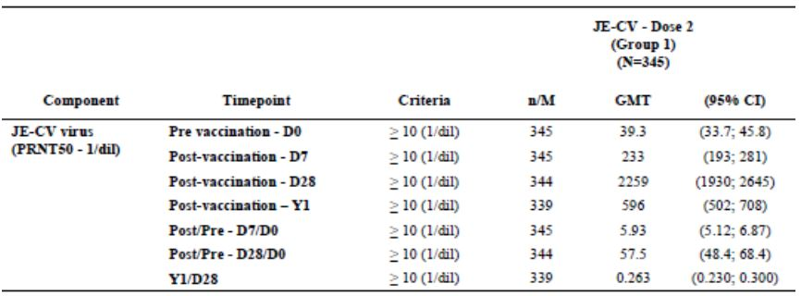
M: number of subjects with available data for the endpoint; 95% CI are calculated according to the subjects with available data for the endpoint

Other efficacy studies
Not applicable.

Analyses performed across trials (pooled & meta analyses)
There were no analysis done across trials for this change in indication/scheduling, but there are some comparisons which allow examination of duration of seropositivity from the different paediatric studies. These results show that the immune response after a single dose of JE-CV given as a booster vaccination persisted at least three years after vaccination of children who were previously immunized with an inactivated JE vaccine (MBDV). Approximately 97% of subjects were seroprotected, and at least 1 year after the booster vaccination in children who received a primary immunization with JE-CV approximately 99% were seroprotected. Long-term immunity is currently being assessed up to 5 years after a booster dose administered following primary vaccination with two doses of an MBDV in study JEC01, as well as up to 5 years after a JE-CV booster dose administered following primary vaccination with JE-CV in study JEC15. The immune response to a single dose of JE-CV given as a primary vaccination to toddlers without previous JE immunization decreased slightly 6 months after vaccination (approximately 87% seroprotected subjects), but subsequently remained stable up to two years after the first vaccination (approximately 80% of seroprotected subjects). A modest decrease in seroprotection rate occurred three years after vaccination, however the majority of subjects (approximately 75%) were seroprotected. Long-term immunity is currently being assessed up to 5 years after a single dose administered as primary vaccination in studies JEC01 and JEC05, and after a booster dose administered following primary vaccination with a first dose of JE-CV in study JEC15.

Evaluator’s conclusions on clinical efficacy
In adults, vaccination with JE-CV demonstrated high and sustained seroconversion rates with both the single and two dose vaccination schedules with no statistically significant differences in seroconversion rates between the two schedules prior to the end of the 60 month LIFP study. The differences in GMTs between the two dose and single dose regimens during the first 48 months of the LIFP are unlikely to be clinically relevant (given that both a well above cut-off levels).
The paediatric study data shows that a single dose of JE-CV induces a protective immune response in both JE-naïve and -immune paediatric subjects. The immune response of a single dose of JE-CV in toddlers is high both in terms of seroconversion and GMT. A high protective immune response persists up to at least 3 years after a single dose administration of JE-CV, in children previously vaccinated against JE. A protective immune response after a single dose persists in the majority of subjects up to at least 3 years after a single dose administration of JE-CV with a seroprotection rate of 75.2% (sensitivity analysis in the FAS) in toddlers not previously vaccinated against JE (studies on the long-term persistence up to 5 years are still ongoing), but it does seem to decrease over time. JE-CV was administered as a booster dose in study JEC01 to children aged 2 to 5 years who previously completed a two-dose primary vaccination regimen with an MBDV in accordance with the Thai immunization schedule. One dose of JE-CV provided a good booster response in all subjects: 100.0% of children were seroprotected after JE-CV vaccination and the response persisted at least up to three years after vaccination. A booster dose of JE-CV was administered in study JEC15 to children aged 36 to 42 months who received 2 years earlier a first dose of JE-CV in study JEC02 at the age of 12 to 18 months resulted in 100.0% seroprotection 28 days after administration of the booster dose. This confirms the induction of immune memory by the first dose and suggests a booster effect on neutralizing antibody titres. Long-term persistence of immunity up to 5 years after the booster dose is ongoing.
So, in toddlers and children, it would appear that a single dose of JE-CV would be adequate in children previously immunised with either a live or inactivated (two-dose) JE vaccine, but in previously unimmunised children/toddlers, a two-dose course of vaccination with JE-CV will provide long-term immunity (although we are still awaiting immunogenicity results out to 5 years).

Clinical safety

Studies providing evaluable safety data
The following studies provided evaluable safety data:

Pivotal efficacy studies
In the pivotal efficacy studies, H-040-005, JECV01, JECV015, the following safety data were collected:
- General and specific adverse events (AEs) were recorded and assessed by investigators as relevant, either by observation, diary or telephone call. There was a list of specific (solicited) local and systemic symptoms and participants were also asked to record any other AEs in a diary (and investigators in the eCRF).
- AEs of particular interest, including viscerotropic disease were assessed by investigators.

Pivotal studies that assessed safety as a primary outcome
Safety was a co-primary outcome in Study H-040-005, JEC01 and JEC15.

Other studies evaluable for safety only
Not applicable.

Pivotal studies that assessed safety as a co-primary outcome

Study H- 040-005
The primary safety outcome evaluated the TEAE incidence rates between the treatment groups 28 days postvaccination. Secondary endpoints described TEAE rates according to flavivirus immunity status at screening and at Days 14, 28, 42, and 56.

Results for the primary safety outcome
In terms of safety, study H-040-005 obtained additional safety information for a single, fixed dose of JE-CV compared with placebo. A total of 202 healthy subjects were initially enrolled in this study. The AE profile during the 28-day period after initial vaccination was similar for subjects who received JE-CV or placebo (50.7% versus 55.3% of subjects reported at least one AE, respectively). The most common systemic AEs in both groups were headache (reported by 13.4% of subjects after JE-CV and 10.1% of subjects after placebo), upper respiratory tract infection (reported by 11.9% of subjects after JE-CV and 17.6% of subjects after placebo), and lethargy (reported by 5.5% of subjects after JE-CV and 2.5% of subjects after placebo). Injection site AEs were infrequent and of comparable frequency after a vaccination with JE-CV or placebo. The most common injection site AEs were injection site pain (reported by 3.5% of subjects after JE-CV and 2.5% of subjects after placebo), injection site reaction (reported by 3.0% of subjects after JE-CV and 2.0% of subjects after placebo), injection site erythema (reported by 2.0% of subjects after JE-CV and 2.5% of subjects after placebo), and injection site swelling (reported by 1.0% of subjects after JE-CV and 3.0% of subjects after placebo). Study H-040-005 also evaluated subjects who received a booster injection of JE-CV 6 months after the first vaccination (in approximately half of the study population). The safety profile during the 28 days after the booster vaccination with JE-CV indicated that the second vaccination was better tolerated than the initial vaccination with JE-CV in terms of AE incidence, relatedness, severity, the effects on vital signs, the effects on laboratory parameters, and the absence of any vaccine-related allergic reactions. Specifically, after the 6-month booster injection, 12.2% of the 98 subjects who received a booster reported AEs. No related SAEs were reported. The long term follow up report relevant to this submission did not add anything to the above safety findings.

Study JECO1
The details of this study are described in the ‘Clinical Efficacy’ section.

Safety objectives
- To describe the safety of a single dose of JE-CV in comparison with Hepatitis A control vaccine in two age cohorts: children aged 2 to 5 years previously vaccinated with two doses of a mouse-brain-derived inactivated JE vaccine according to the national immunization schedule, and toddlers aged 12 to 24 months previously not vaccinated with any JE vaccine

Safety endpoints
- Occurrence, nature, duration, and intensity of any unsolicited systemic adverse events (AEs) reported in the 30 minutes after each vaccination
- Occurrence, time to onset, number of days of occurrence, and intensity of solicited injection site reactions up to 7 days after each vaccination
- Occurrence, time to onset, number of days of occurrence, and intensity of solicited systemic reactions up to 14 days after each vaccination
- Occurrence, nature, time to onset, duration, intensity, and relationship to vaccination (for systemic AEs only) of unsolicited (spontaneously reported) AEs up to 28 days after each vaccination
- Occurrence of any SAEs up to 6 months after the last vaccination
- Occurrence of out-of-normal-range biological test results 4 days and 28 days after vaccination with JE-CV in Groups 1 and 3
- Occurrence and level of JE-CV viruses in sera collected 4 days after vaccination with JE-CV in Groups 1 and 3 measured by JE plaque assay
- Occurrence of JE-CV and flavivirus viraemia and out-of-normal-range biological test results in the event of severe fever, or suspicion of neurotropic disease or acute viscerotropic diseases within 14 days after any vaccination

Results for the primary safety outcome
Table 12 summarises the incidence of solicited and unsolicited AEs in the safety set in JEC01. No immediate AEs were reported. No subject was withdrawn from the study for an AE. The most frequently reported solicited injection site reaction in children (2 to 5 years) after both JE-CV and Hepatitis A vaccination was injection site pain, followed by injection site erythema and injection site swelling (the incidence is shown in the table below). In toddlers (12 to 24 months), the most frequently reported injection site reaction after both JE-CV and Hepatitis A vaccination was injection site tenderness, followed by injection site erythema and injection site swelling. The majority of the solicited injection site reactions were of grade 1 intensity, occurred within 3 days after vaccination, and had between 1 and 3 days of occurrence. In children, the most frequently reported solicited systemic reaction after both JE-CV and Hepatitis A vaccination was malaise. Fever was slightly more frequent after JE-CV (22.0%) than Hepatitis A (13.3%) vaccination.
Table 12: JEC01, Safety Results in Subjects in the Safety Set.
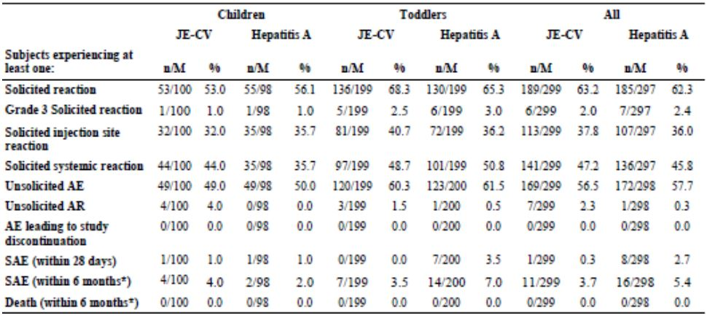
* Events reported from D0 up to 6 months after the last vaccination
In toddlers, the most frequently reported solicited systemic reactions after both JE-CV and Hepatitis A vaccination were irritability and appetite lost. Fever was reported as frequently after JE-CV (21.1%) as after Hepatitis A (20.6%) vaccination. The majority of the solicited systemic reactions were of grade 1 or grade 2 intensity, occurred within 7 days after vaccination, and had between 1 and 3 days of occurrence. These are summarised in Table 13. A grade 3 solicited injection site reaction was reported in one toddler (injection site tenderness) after Hepatitis A vaccination. Grade 3 solicited systemic reactions were reported in two children after JE-CV vaccination (fever) and after Hepatitis A vaccination (fever), and in five toddlers after JE-CV vaccination and six toddlers after Hepatitis A vaccination (appetite lost, fever, vomiting, crying abnormal and/or irritability). The incidences of unsolicited AEs 28 days after vaccination were comparable after JE-CV and Hepatitis A vaccination overall and in each age group. The most frequent events were upper respiratory tract infection, rhinorrhoea, and nasopharyngitis. Unsolicited reactions were reported by few subjects (seven subjects after JE-CV and one subject after Hepatitis A vaccination) and were mainly injection site reactions; no reaction was of grade 3 intensity. A total of 27 subjects reported 32 SAEs up to 6 months after the last vaccination: 6 children experienced 7 SAEs and 21 toddlers experienced 25 SAEs. None of the SAEs were considered related to vaccination. No death was reported.
Table 13: JEC01, Solicited Injection Site Within 7 Days and Systemic Reactions Within 14 Days After Vaccination in the Safety Set.
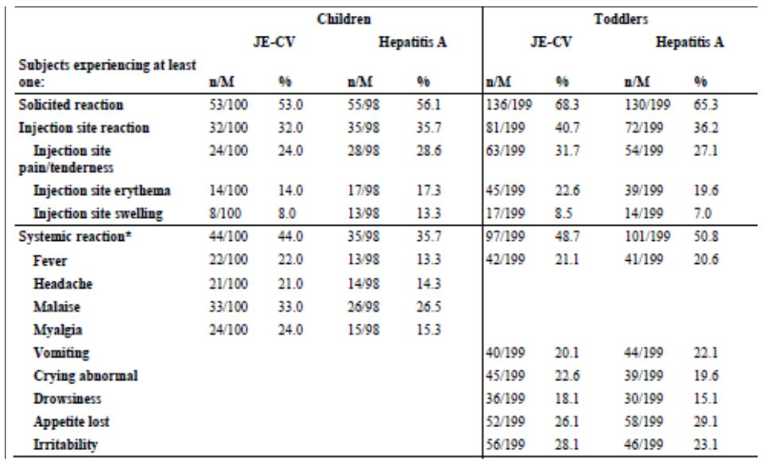
During the follow-up period (from 28 days to 6 months after the last vaccination) 20 subjects reported 23 SAEs: 4 children experienced 5 SAEs and 16 toddlers experienced 18 SAEs. No subject experienced any SAE considered as related to vaccination in the period from the 6 months follow-up visit after the last vaccination and up to the Year 3 follow-up visit after the first vaccination. Biological parameters were measured at screening, D4 and D28. The majority of subjects had values within normal ranges throughout the study. However, no change was judged clinically significant. Hypersensitivity/allergic reactions, neurological events, and vaccine failure reported up to 28 days after vaccination were considered events of specific interest in the present study. One case of febrile convulsion was reported after Hepatitis A vaccination, while no hypersensitivity reaction, vaccine failure or other neurological event were observed up to 28 days after any vaccination. During the entire study, 5 subjects reported 6 episodes of febrile convulsion: one toddler within 28 days after Hepatitis A vaccination, and one child and three toddlers during the 6-month follow-up period (53 to 117 days after the last of two vaccinations with JE-CV and Hepatitis A, respectively). No subject had confirmed neurotropic or acute viscerotropic disease. No subject presented with confirmed JE during the long-term follow-up period after the 6-month follow-up visit.

Results for other safety outcomes

Viraemia
Viraemia was assessed on D4 in subjects who received JE-CV at the first vaccination (Group 1 and Group 3). No child in Group 1 presented quantifiable JE-CV viraemia, while 5 toddlers (5.1%) presented with low level viraemia just over the level of quantitation (20.0 PFU/mL).

Study JEC15
The details of this study are described in the ‘Clinical Efficacy’ section.

Safety objectives
- To describe the safety of the vaccination in all JE-CV recipients (Groups 1 and 2) up to 28 day after the JE-CV vaccination and in all varicella recipients (Group 3) up to 28 days after varicella vaccine administration.
- To describe all SAEs up to 6 months after vaccination in all subjects.
- To describe all related SAEs and related deaths from 6 months to 5 years after vaccination in Group 1.
The safety endpoints are:
- Occurrence, nature, duration, intensity, and relationship to vaccination of any unsolicited systemic AEs reported in the 30 minutes after vaccination
- Occurrence, time to onset, number of days of occurrence, and intensity of solicited (pre-listed in the subject’s diary and electronic case report form [eCRF]) injection site reactions up to 7 days after vaccination
- Occurrence, time to onset, number of days of occurrence, and intensity of solicited (pre-listed in the subject’s diary card and eCRF) systemic reactions up to 14 days after vaccination
- Occurrence, nature, time to onset, duration, intensity, and relationship to vaccination (for systemic AEs only) of unsolicited (spontaneously reported) AEs up to 28 days after vaccination
- Occurrence, nature, seriousness, outcome, and relationship to vaccination of any SAEs up to 6 months after the vaccination.
- Occurrence, nature, seriousness, outcome of related SAEs and related deaths from the 6-month follow-up to the end of the trial (only for Group 1).

Results for the primary safety outcome
The incidence of solicited reactions within 14 days of vaccination are summarised in Table 14. No immediate AEs were reported. No subject was withdrawn from the study for an AE. Solicited injection site reactions were reported in a similar percentage in subjects who received a JE-CV booster dose (JE-CV Dose 2 recipients) and in varicella vaccine recipients and were slightly more frequent in subjects who received JE-CV for the first time as primary immunization (JE-CV Dose 1 recipients). Injection site pain was the most frequently reported solicited injection site reaction across the 3 groups. Injection site erythema was reported by a low percentage of subjects in all groups. Injection site swelling was reported only by subjects receiving JE-CV booster dose and varicella vaccine groups. Most solicited injection site reactions were of Grade 1 intensity (none were of Grade 3), all had a time to onset within 3 days after vaccination, and most had between 1 to 3 days of occurrence. The incidence of solicited injection site reactions did not increase after administration of a booster dose of JE-CV, given 2 years after primary vaccination, versus a single primary administration of JE-CV or varicella vaccine. Solicited systemic reactions were reported by a similar percentage of subjects in JE-CV booster dose and varicella vaccine groups and were less frequent in JE-CV primary immunization group. Fever, malaise, and headache were the most frequently reported solicited systemic reactions in JE-CV booster dose group. Malaise and headache were the most frequently reported solicited systemic reaction in JE-CV primary immunization group; only one subject in this group reported fever. Fever, headache, and malaise were also the most frequently reported solicited systemic reactions in the varicella vaccine group. The majority of the solicited systemic reactions were of Grade 1 or 2 intensity, had a time to onset within 3 days after vaccination (except for fever in JE-CV booster dose group, which had time to onset between 8 and 14 days after vaccination), and had between 1 to 3 days of occurrence. Grade 3 solicited systemic reactions were reported by 7 subjects (2.0%) in JE-CV booster dose group, 1 subject (2.2%) in JE-CV primary immunization group, and by none of the subjects in the varicella vaccine group. Most Grade 3 systemic reactions were fever (in 7 out of 8 subjects). The incidence of solicited systemic reactions was similar after administration of a booster dose of JE-CV versus a single administration of JE-CV for primary immunization or varicella vaccine, except for fever that was more frequently reported after the booster dose and varicella vaccine than after a single dose of JE-CV for primary immunization. The incidence of fever after the booster dose of JE-CV was not higher than after the administration of varicella vaccine. No subjects reported any unsolicited ARs. In the period from Day 0 to Day 28, 2 subjects (0.5%) reported 2 non related SAEs (febrile convulsion and dengue fever). One additional non related SAE, was reported in the JE-CV booster dose group during the 6-month follow-up period. The safety profile is generally similar across the JE-CV vaccinees and the varicella vaccine recipients.
Table 14: Study JEC15 Solicited Reactions within 7/14 Days* After Vaccine Injection - Safety Analysis Set.
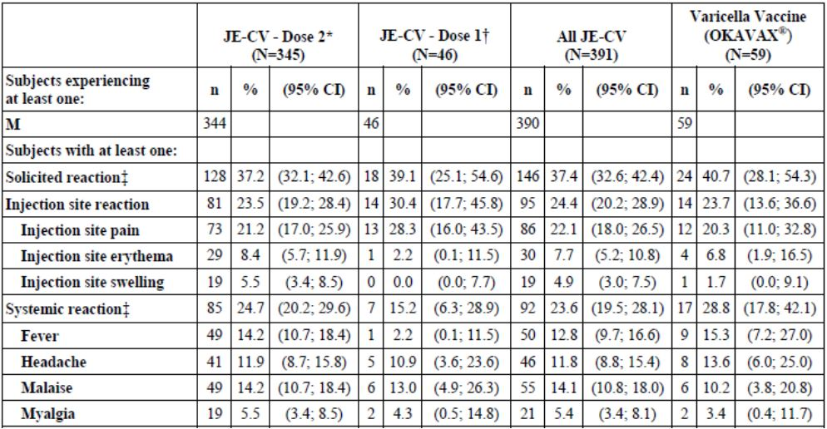
* Dose 2: subjects primed with JE-CV (in study JEC02) who received a booster dose of JE-CV. † Dose 1: JE-vaccine naïve subjects who received JE-CV for the first time. ‡ Solicited injection site reactions are collected daily over 7 days. Solicited systemic reactions are collected daily over 14 days. M: number of subjects with available data for the relevant endpoint n: number of subjects experiencing the endpoint listed in the first column.

Results for other safety outcomes
Not applicable.

Patient exposure
Safety was assessed in original submission. In the key safety studies, 2046 subjects received a single dose of JE-CV. Although safety data from Studies H-040-008 and H-040-009, and JEC02 are also contained in current submission, there were no new safety issues identified and no changes to the indication, PI or CMI in relation to safety.
In the safety program in paediatric populations, 1490 subjects received at least one dose of JE-CV (lyophilized formulation) in four clinical studies.

Adverse events

All adverse events (irrespective of relationship to study treatment)

Pivotal studies
The details are described in the ‘Clinical Efficacy’ section.

Other studies
Not applicable.

Treatment-related adverse events (adverse drug reactions)

Pivotal studies
In adults, the most commonly reported systemic AEs in all the key studies were headache, fatigue, malaise, and myalgia, irrespective of vaccine group (JE-CV, comparator or placebo). The most common local injection site AE, was injection site pain and then erythema. Generally, the AEs (both systemic and injection site) were of short duration and were mild to moderate in intensity.

Other studies
Not applicable.

Deaths and other serious adverse events

Pivotal studies
There were no deaths.

Other studies
There were no deaths.

Discontinuation due to adverse events

Pivotal studies
Nil.

Other studies
Not applicable.

Laboratory tests

Liver function

Pivotal studies
Not applicable.

Other studies
Not applicable.

Kidney function

Pivotal studies
Not applicable.

Other studies
Not applicable.

Other clinical chemistry

Pivotal studies
Not applicable.

Other studies
Not applicable.

Haematology

Pivotal studies
Not applicable.

Other studies
Not applicable.

Post-marketing experience
JE-CV is registered in Thailand and Australia. However, no post-authorization safety data are currently available since the JE-CV vaccine is not yet marketed in any country.

Evaluator’s overall conclusions on clinical safety
The safety data submitted with this application, does not contain any new triggers or safety concerns. In particular, in adults, the booster dose appeared to be at least as well tolerated as the first dose of JE-CV and in the paediatric population, was as well tolerated as the comparators (Hepatitis A and varicella vaccines).

First round benefit-risk assessment

First round assessment of benefits
The benefits of JE-CV in the proposed usage are:
- Protective efficacy one month after vaccination in more than 99% of the subjects from a single dose vaccine.
- Sufficient level of seroprotection in adults 5 years after JE-CV single dose for primary immunisation is sufficiently high to consider that no JE-CV booster is needed before 5 years.
- In paediatric populations not previously JE primed, JE-CV provides a protective immune response in more than 95% of toddlers (aged 12 to 24 months). Long term follow up of the persistence of the seroprotection rate after administration of a single dose of JE-CV in paediatric populations has shown some decline of the seroprotection rates to 84.4% seroprotection at 1 year, 80% seroprotection at 2 years, and 75% seroprotection at 3 years.
- A second dose of JE-CV (2 years after the first) resulted in seroprotection of 99.4% of children measured1 year after the JE-CV booster vaccination.
- All the children who previously received a JE primary immunisation with an inactivated JE vaccine and were then boosted with a JE-CV were seroprotected 3 years later. Hence, a booster dose of JE-CV is highly recommended in paediatric populations after primary vaccination (with either JE-CV or an inactivated JE vaccine) in order to provide long term protection (supported by data up to 3 years). The booster dose should be given preferably 12 months after primary vaccination with JE-CV and can be given up to 24 months after primary vaccination (according to available data).

First round assessment of risks
The potential risks of JE-CV in the proposed usage include hypersensitivity reactions (allergic, anaphylactic/anaphylactoid), neurological disorders including convulsions, encephalopathy, encephalitis, Acute Disseminated Encephalomyelitis (ADEM), myelitis, Guillain-Barré Syndrome (GBS), peripheral neuropathy, facial (Bell’s) palsy (based on experience with other attenuated and inactivated) JE vaccines.
The sample size of the studies conducted in paediatric populations allowed the detection of events with a rate of 0.2% or more (with 95% probability). Overall, 1444 children aged 9 months to 10 years received JE-CV in three clinical studies conducted in Thailand, the Philippines, and India.
The overall safety profile of JE-CV in adult populations is similar to that of the inactivated MBDV and placebo.
The safety profile in paediatric populations is similar to that of a registered inactivated Hepatitis A vaccine. No safety issue has been identified in clinical studies in adult and paediatric populations (including the long term follow up assessments). JE-CV either as a primary or booster vaccination appears to be safe at a dose which elicits a protective immune response.
Overall, JE-CV was well tolerated and there was no evidence to indicate any new concerns in this submission.

First round assessment of benefit-risk balance
The benefit-risk balance of JE-CV, given the proposed usage, is favourable.

First round recommendation regarding authorisation
Overall, a single dose of JE-CV for primary immunisation in adults demonstrated high SCRs, rapid onset of immunity, and a good safety profile. The data obtained so far supports the recommendation of vaccination from 12 months of age in populations at risk. The single dose vaccination schedule in adults is expected to favour compliance to treatment and lessen exposure and post vaccinal side effects. This will be particularly useful in Australia where it tends to be given as a pre travel vaccination for people travelling to endemic areas. The recommendation of two doses of JE-CV in children (if not previously vaccinated) or of JE-CV as a long term booster dose, for children previously immunised will increase the rate of long term seroprotection from 75% at three years (for a single unprimed dose). The final data (out to 5 years) from the paediatric studies (JEC01, JEC05 and JEC15) is pending.

Clinical questions
None.

References
EMEA Guideline on Clinical Evaluation of New Vaccines EMEA/CHMP/VWP/164653/2005 dated 18 October 2006.
WHO Expert Committee on Biological Standardization Geneva - 8 to 12 October 2007. Proposed revision recommendations for Japanese encephalitis vaccine, inactivated, for human use. WHO/BS/07.2064

European Medicines Agency, “Committee for medicinal products for human use (CHMP): Guideline on clinical evaluation of new vaccines (EMEA/CHMP/VWP/164653/2005)”, 18 October 2006, Web, accessed 8 January 2014 <www.ema.europa.eu/docs/en_GB/document_library/Scientific_guideline/2009/09/ WC500003870.pdf>.
World Health Organisation Expert Committee on Biological Standardisation, “Proposed revision recommendations for Japanese encephalitis vaccine, inactivated, for human use (WHO/BS/07.2064)” Geneva, 8-12 October 2007, Web, accessed 8 January 2014 <www.who.int/biologicals/publications/ trs/areas/vaccines/jap_encephalitis/Japanese%20Encephatis%20guidelines%202007%20revised% 20211207%20rev07.pdf >.
Except in case of national immunization days with oral polio vaccine.
Except in case of national immunization days with oral polio vaccine.

