September 2013

Australian Public Assessment Report for IVIg
  - Proprietary Product Name: Flebogamma 10% DIF
  - Sponsor: Grifols Australia Pty Ltd

About the Therapeutic Goods Administration (TGA)
- The Therapeutic Goods Administration (TGA) is part of the Australian Government Department of Health and Ageing, and is responsible for regulating medicines and medical devices.
- The TGA administers the Therapeutic Goods Act 1989 (the Act), applying a risk management approach designed to ensure therapeutic goods supplied in Australia meet acceptable standards of quality, safety and efficacy (performance), when necessary.
- The work of the TGA is based on applying scientific and clinical expertise to decision-making, to ensure that the benefits to consumers outweigh any risks associated with the use of medicines and medical devices.
- The TGA relies on the public, healthcare professionals and industry to report problems with medicines or medical devices. TGA investigates reports received by it to determine any necessary regulatory action.
- To report a problem with a medicine or medical device, please see the information on the TGA website <http://www.tga.gov.au>.
About AusPARs
- An Australian Public Assessment Record (AusPAR) provides information about the evaluation of a prescription medicine and the considerations that led the TGA to approve or not approve a prescription medicine submission.
- AusPARs are prepared and published by the TGA.
- An AusPAR is prepared for submissions that relate to new chemical entities, generic medicines, major variations, and extensions of indications.
- An AusPAR is a static document, in that it will provide information that relates to a submission at a particular point in time.
- A new AusPAR will be developed to reflect changes to indications and/or major variations to a prescription medicine subject to evaluation by the TGA.
Copyright
© Commonwealth of Australia 2013
This work is copyright. You may reproduce the whole or part of this work in unaltered form for your own personal use or, if you are part of an organisation, for internal use within your organisation, but only if you or your organisation do not use the reproduction for any commercial purpose and retain this copyright notice and all disclaimer notices as part of that reproduction. Apart from rights to use as permitted by the Copyright Act 1968 or allowed by this copyright notice, all other rights are reserved and you are not allowed to reproduce the whole or any part of this work in any way (electronic or otherwise) without first being given specific written permission from the Commonwealth to do so. Requests and inquiries concerning reproduction and rights are to be sent to the TGA Copyright Officer, Therapeutic Goods Administration, PO Box 100, Woden ACT 2606 or emailed to <tga.copyright@tga.gov.au>.

Contents
I. Introduction to product submission 4
Submission details 4
Product background 4
Regulatory status 5
Product Information 5
II. Quality findings 6
Drug product 6
Stability 6
Biopharmaceutics 6
Advisory committee considerations 6
Quality summary and conclusions 8
III. Nonclinical findings 8
IV. Clinical findings 9
Introduction 9
Pharmacokinetics 9
Efficacy 11
Safety 14
List of questions 17
Clinical summary and conclusions 18
V. Pharmacovigilance findings 21
Risk management plan 21
VI. Overall conclusion and risk/benefit assessment 26
Quality 26
Nonclinical 26
Clinical 26
Risk management plan 27
Risk-benefit analysis 28
Outcome 34
Attachment 1. Product Information 35

I. Introduction to product submission

Submission details
Type of submission: | Major Variation (New Strength)
Decision: | Approved
Date of decision: | 11 January 2013

Active ingredient: | Human Normal Immunoglobulin for Intravenous Administration
Product name: | Flebogamma 10% DIF
Sponsor’s Name and Address: | Grifols Australia Pty Ltd  PO Box 795  Mount Waverley VIC 3149
Dose form: | Injection, solution
Strengths: | 5 g/50 mL, 10 g/100 mL, 20 g/200 mL
Containers: | Type II glass vial/bottle closed with a chloro butyl rubber stopper
Approved Therapeutic use: | Replacement therapy indications:  - Primary Immunodeficiency (PI) Diseases  - Symptomatic hypogammaglobulinaemia secondary to underlying disease or treatment.  Immunomodulation indications:  - Idiopathic Thrombocytopaenic Purpura (ITP), in patients at high risk of bleeding or prior to surgery to correct the platelet count  - Guillain Barré syndrome  - Kawasaki disease.
Route of administration: | Intravenous
ARTG Numbers: | 184353, 182358, 182359

Product background
This AusPAR describes an application by the sponsor, Grifols Australia Pty Ltd, to register Flebogamma 10% DIF, a new 10% (100mg/mL) dosage form of human normal Intravenous Immunoglobulin (IVIg), which is currently registered in a 5% (50mg/mL) strength (Flebogamma 5% DIF).
Flebogamma 10% DIF consists mainly of immunoglobulin G (IgG) and contains the IgG antibodies present in the normal population. It is usually prepared from pooled plasma from not fewer than 1,000 donors from the USA. It has a distribution of immunoglobulin G subclasses closely proportional to that in native human plasma.
The donor pool includes healthy individuals who are subjected to medical examinations, laboratory tests, and a review of their medical history. Donations are screened using:
- serology screening for the hepatitis B surface antigen (HBsAg), anti human immunodeficiency virus 1 and 2 (HIV-1/HIV-2), and anti hepatitis C virus (HCV) antibodies; and
- nucleic acid testing for the ribonucleic acid (RNA) of HCV, RNA of HIV-1, and deoxyribonucleic acid (DNA) of hepatitis B virus (HBV).
Additionally, the manufacturing plasma pool is tested and found non reactive for viral markers of infection (anti HIV 1/2, anti HCV and HBsAg, and for RNA of HIV, RNA of HCV, and DNA of HBV).
There are many primary immunodeficiency diseases, characterised by hypogammaglobulinaemia and/or defective antibody production and a consequent increased susceptibility to infection. The most common of these is IgA deficiency (1:700 in the Caucasian population). Secondary immunodeficiencies are linked to a wide range of diseases, and are much more common than primary disorders.
Chronic refractory ITP is an autoimmune disorder characterised by a persistent platelet count of < 50,000 µL for at least 3 months with no concurrent causative or contributory illness. The sponsor provides an estimated incidence of 1 new patient per 100,000 persons per year. The incidence may be lower in children as 80% have resolution of disease within 2 months.
Guillain Barré syndrome is an acute inflammatory polyneuropathy characterised by an ascending paralysis. It is thought to be a reactive autoimmune disorder directed at Schwann cell membranes usually triggered by a preceding viral or bacterial infection. The reported rate worldwide is 0.6-4 cases per 100,000 population. Immunoglobulin is a commonly used therapy.

Regulatory status
The international regulatory status for Flebogamma 10% DIF is summarised in Table 1.
Table 1: Current international marketing approval for Flebogamma 10% DIF.
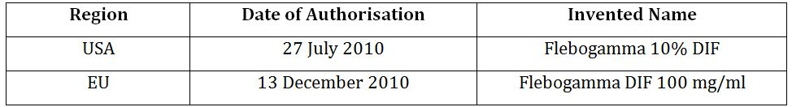

Product Information
The approved Product Information (PI) current at the time this AusPAR was prepared can be found as Attachment 1.

II. Quality findings

Drug product

Manufacture
Flebogamma 10% DIF shares the same manufacturing process up to the final concentration step as the Flebogamma 5% DIF product. This application includes an additional site of manufacture for the intermediate Fraction II+III not currently approved for Flebogamma 5% DIF.
The Plasma Master File (PMF) for the additional site of manufacture was not provided for this application as the sources and processes used are described by the Instituto Grifols PMF which has been accepted by the TGA. The plasma is from source plasma from renumerated donors.

Stability
Stability data have been generated under stressed and real time conditions to characterise the stability profile of the product.
The proposed shelf life is 2 years when stored below 30°C (protected from light, do not freeze).
The data supports the proposed shelf life.

Biopharmaceutics
Biopharmaceutic data are not required for this product.

Advisory committee considerations
The evaluator asked the Pharmaceutical Subcommittee (PSC) of the Advisory Committee on Prescription Medicines (ACPM) to review the quality evaluation report(s) and to advise the TGA as follows:
- Does the PSC consider that the evaluation of the quality and biopharmaceutic data has been carried out satisfactorily and that reasonable conclusions have been drawn?
- Would the PSC please consider and advise on the following specific matter(s) relating to this application:
The company has had a limited opportunity as a result of the Business Process Reform process to address issues associated with pro coagulant activities in immunoglobulin products. The requirement to assess the level of pro coagulant activity in the product and to demonstrate that the manufacturing process has steps that are effective in their removal has arisen recently as a result of events in late 2010. Proposed changes to the monograph covering this product will be introduced in 2012.
The studies the company is undertaking are ongoing with several aspects outlined below are considered critical for the company to address in order to satisfy the evaluator that the steps in manufacture are able to remove all pro coagulant activity in a worst case scenario.
The evaluator considers that the following issues are required to be addressed to permit assessment of the capacity of the process to remove pro coagulant activity:
  - The effectiveness of the pasteurisation process in removing Factor XI activity. The current studies have shown that there is a time and concentration dependence of the pasteurisation process in removing FXI activity. The pasteurisation process did not remove all of the spiked 100pM FXI; justification is required that the capacity of the pasteurisation process to remove FXI will be effective to ensure that product supplied is safe. The company is requested to provide evidence or justification that the capacity of the pasteurisation process is sufficiently robust.
  - The results of the ongoing study (which is scheduled to conclude at the end of 2011), focused on the partitioning of FXI during the fractionation process to Fraction II+III, taking into account the optional steps during the fractionation process.
  - Data normalised to an international standard where feasible.
  - The PSC is requested provide advice as to how to proceed with this application given the circumstances.
- Does the PSC consider that any additional issues need to be explored and/or raised with the sponsor before the evaluation is finalised?
- Does the PSC wish to reconsider this application or to review the resolution of any specific matters relating to the quality and biopharmaceutic data prior to the application being considered by the ACPM and/or the Clinical Delegate?
- Does the PSC wish to highlight any particular aspects of this product or the application data for consideration by the ACPM and/or the Clinical Delegate before a decision to approve or reject the application is made?
At the 142nd (2011/7) meeting of the PSC, the Committee made the following recommendation (no 2241)
- The PSC endorsed all the questions raised by the TGA in relation to the quality and pharmaceutic aspects of the submission by Grifols Australia Pty Ltd to register Flebogamma 10% DIF solution for injection containing 5 g/50 mL, 10 g/100 mL and 20 g/200 mL of human normal immunoglobulin. In particular, the Committee agreed that the sponsor should provide:
  - Evidence or justification that the capacity of the pasteurisation process is sufficiently robust to remove all Factor XI activity from the proposed products.
  - The results of an ongoing study (scheduled to conclude at the end of 2011) focused on the partitioning of Factor XI during the fractionation process to Fraction II+III, taking into account the optional steps during the fractionation process.
  - Data normalised to an international standard where feasible.
- The Committee advised that all outstanding issues should be addressed to the satisfaction of the TGA. The PSC noted recent regulatory events associated with this class of products that arose subsequent to this submission. Consequently, the Committee endorsed the evaluator’s opinion that the sponsor should unequivocally address the identified issues in relation to the removal of all pro coagulant activity from the proposed products.
- In the PI:
This document should be reviewed to ensure consistency with the abbreviations for units, for example, the references to:
  - “ml” should be changed to much preferred “mL” to be consistent to the abbreviation ‘L’ used for litre in other parts of the document.
  - “dl” should be expressed in terms of mL.
- The PSC was of the consensus that the outstanding issues in relation to Factor XI activity may have safety implications. The PSC therefore concluded that this submission has insufficient evidence to support acceptance on quality and pharmaceutic grounds.
- The Committee agreed that this submission should be presented again when additional information to address the identified issues is available.

Quality summary and conclusions
The administrative, product usage, chemical, pharmaceutical, microbiological and biopharmaceutic data (as applicable) submitted in support of this application have been evaluated in accordance with the Australian legislation, pharmacopeial standards and relevant technical guidelines adopted by the TGA.
It is recommended that as a condition of registration that the first five independent batches of
- Flebogamma 10% DIF, Human Normal Immunoglobulin 5 g/50 mL, injection vial for Intravenous Administration (Aust R 184353)
- Flebogamma 10% DIF, Human Normal Immunoglobulin 10 g/100 mL, injection vial for Intravenous Administration (Aust R 182358)
- Flebogamma 10% DIF, Human Normal Immunoglobulin 20 g/200 mL, injection vial for Intravenous Administration (Aust R 182359)
imported into Australia are not released for sale until samples and/or the manufacturer’s release data have been assessed and endorsed for release by the TGA Office of Laboratories and Scientific Services (OLSS).
The sponsor should supply:
- Certificates of Analysis of all active ingredient (drug substance) and final product.
- Information on the number of doses to be released in Australia with accompanying expiry dates for the product and diluents (if included).
- Evidence of the maintenance of registered storage conditions during transport to Australia.
- Three vials/ampoules/cartridges/syringes of each batch for testing by the TGA OLSS together with any necessary standards, impurities and active pharmaceutical ingredients (with their Certificates of Analysis) required for method development and validation.
These batch release conditions will be reviewed and may be modified on the basis of actual batch quality and consistency.

III. Nonclinical findings
There was no requirement for a nonclinical evaluation in a submission of this type.

IV. Clinical findings

Introduction
Reports of three studies were included. Study IG304 was designed to investigate safety, efficacy and pharmacokinetics of Flebogamma 10% DIF in patients with primary immunodeficiency disease (PID). Studies IG202 and IG0601 investigated treatment of idiopathic thrombocytopenic purpure (ITP), which is an abnormally low platelet count due to unknown cause.
The sponsor made the following statements with regard to Good Clinical Practice (GCP):
- Study IG304: The protocol and all protocol amendments were reviewed and approved by the Institutional Review Boards (IRBs) of the study sites. The study was conducted in accordance with GCP principles of the International Conference on Harmonisation (ICH) and the ethical principles in the Declaration of Helsinki. Signed informed consent was required.
- Studies IG202 and IG0601: These were performed in accordance with the ethical principles stated in the Declaration of Helsinki, US Food and Drug Administration (FDA) regulation 21 CFR Parts 50, 56 and 312, ICH GCP, European Union guidelines of clinical investigation of IVIG and standard clinical operating procedures for Instituto Grifols, S.A. and CROfessionals, LLC. Signed informed consent was required.

Pharmacokinetics

Study IG304

Design
Study IG304 was a Phase III, multi centre, open label, historically controlled study of use of IVIG31 Grifols 10% in replacement therapy of primary immunodeficiency disease. Patients with PID who were at least 3 years of age, with minimum weight 27.5 kg were eligible for the study.
The primary objective was to determine efficacy with respect to the FDA minimal requirements of no more than one serious bacterial infection per patient per year including bacterial pneumonia, bacteraemia or sepsis, osteomyelitis, septic arthritis, visceral abscess and bacterial meningitis.
Secondary objectives were to assess safety and tolerability, and pharmacokinetics (PK) compared to comparable intact IgG. Secondary efficacy endpoints were:
- Number of days of work/school missed per patient year;
- Number and days of hospitalisations per patient year;
- Number of visits to physicians for acute problems and/or number of visits to hospital emergency rooms per patient year;
- Other infections per patient per year, documented by positive radiograph and fever;
- Number of infectious episodes per patient year, which includes both serious bacterial infections and other infections; and
- Number of days on antibiotics, prophylactic or therapeutic, both oral and parenteral.
Safety was assessed by the recording of the number and percent of infusions with at least one adverse event (AE) occurring during an infusion or within one hour after the infusion stopped; vital signs; the nature, severity, and frequency of AEs; effects on hepatic, renal and haematological function; transmission of HBV, HCV, HIV; Parvovirus B19, and Coombs’ testing.
Study treatment: Planned dose was 300-600 mg/kg treatment every three or four weeks for 12 months.
Patients were not given routine premedication. Adequate hydration was given to all patients prior to initiation of infusion with IGIV3I Grifols 10%. If a patient had previously required premedication, they were to start this protocol without routine premedication. If AEs that may have been prevented by the use of a premedication occurred two or three times, use of the premedication other than a corticosteroid could be resumed for the remaining infusions of the study.
Statistical methods: The primary efficacy variable was the number of episodes of serious bacterial infections per patient per year. To estimate the infection rate and develop the appropriate one sided 98% upper confidence bound, a generalised linear model for Poisson regression was used. The rate of serious bacterial infections per patient per year was estimated by dividing the total number of serious bacterial infections observed in the study by the total patient years (patient years = days on study/365).
Rates for secondary efficacy endpoints were calculated by dividing the total number of events observed in the study by the total patient years.
All AEs were summarised. The upper bound of the one sided 95% confidence interval for the percent of patients who experienced any AE was calculated by using normal approximation. A similar analysis was performed for treatment related AEs. AEs that occurred during an infusion or within 1, 24, 48, or 72 h of an infusion were also summarised.
No adjustments for covariates were made to the statistical analysis. No adjustments were made to the statistical analyses to account for multiple centres. Data for patients who withdrew from the study were censored at the last recorded visit date. Missing data were not imputed.
PK analysis was performed on a subset of 19 of the 37 participants with PID, enrolled in efficacy and safety Study IG304. The PK samples were collected after Infusion 7 for patients on a 28 day schedule and after Infusion 9 for patients on a 21 day schedule. Samples were collected during the sixth month after initiation of treatment.
PK parameters for IgG, IgG subclasses, and antibodies to four specific antigens, CMV, tetanus toxoid, pneumococcal polysaccharides, HBV were determined and results summarised based on the individual plasma concentration time data and the actual sampling times. IgG trough levels were compared with those before the trial.
The levels of total IgG and IgG subclasses were plotted on a log scale against time; antibody titres to specific antigens were also plotted on a log scale against time. The parameters C_{max} (maximum observed concentration), t_{max} (time of occurrence of C_{max}), elimination rate constant (λz), t_{½} (half life), AUC_{(0- last)}, (area under the concentration curve from time zero to time of last measurable concentration), AUC_{(0-inf)} (area under the concentration curve from time zero to infinity), CL (clearance) of total IgG only, and Vd (volume of distribution) of total IgG, IgG subclasses, and IgG antibodies against specified antigens were measured or derived by using non compartmental methods and summarised descriptively.

Results
All patients were adult Caucasians with mean age 37.2 years; 47.4% were female.
Overall, the patterns observed in the PK behaviour for Total IgG levels, IgG subclass levels, and the IgG antibody levels to specified antigens were similar for the two dosage regimens.
For patients on the 21 day infusion schedule, the mean C_{max} was 1950.00 mg/dL, the mean t_{max} was 0.2167 days (~5 h from the start of infusion), the mean AUC_{(0-last)} was 33951.41 day*mg/dL, the estimated serum t½ was 33.76 days, the mean CL was 114.53 mL/day, and the mean estimated Vd was 5.39 L.
For patients on the 28 day infusion schedule, the mean C_{max} was 2092.22 mg/dL, the mean t_{max} was 0.0137 days (approximately 0.33 hours from the start of infusion), the mean AUC_{(0-last)} was 34236.70 day*mg/dL, the estimated serum t_{½} was 37.14 days, the mean CL was 143.83 mL/day, and the mean estimated Vd was 7.47 L.
Trough total IgG and IgG subclass concentrations were maintained at or near pre study levels throughout the treatment period with IVIG31 Grifols 10%, as evidenced by both the relatively small changes in these parameters observed over the course of the study and the absence of any patients recording decreases in trough total IgG > 50% from screening or first infusion (Figure 1).
Figure 1: Summary of trough IgG concentrations (intention-to-treat patients, mean values and SD) during the trial (Study IG304).
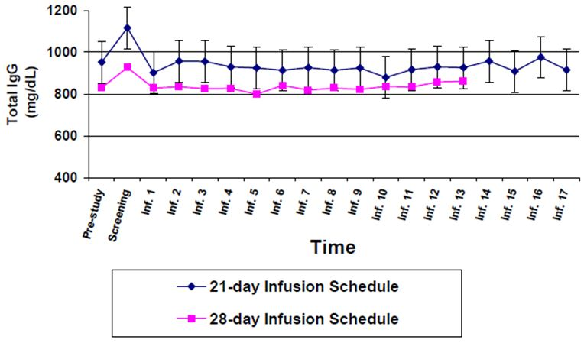

Efficacy

Efficacy in primary immunodeficiency disease (PID): Study IG304

Results
Forty-six patients were enrolled and received at least one infusion of study product. This group constituted the intention to treat (ITT) population used in all efficacy and safety calculations. A total of 37/46 (80.4%) completed the study. Four participants were less than 18 years of age.
Nine patients (19.6%) withdrew from the study. The most common reasons for early withdrawal were patient/parent or legal guardian decision (four patients, 8.7%) and AE (three patients, 6.5%). One patient became pregnant and one patient was lost to follow up. Twenty-five patients (54.3%) recorded protocol deviations.
The mean number of days in study was 321 (range: 15-379). The mean volume of IGIV3I Grifols 10% infused per patient per infusion was 351 mL (range: 100-650 mL), and the mean dose of IGIV3I Grifols 10% infused per unit of baseline body weight per infusion was 461 mg/kg (range: 307-597 mg/kg).

Primary efficacy outcome
One serious bacterial infection (pneumonia) was reported giving a rate of 0.025 infections/patient/year (98% CI [Confidence Interval] = 0.001-0.133), which satisfied the FDA efficacy criterion of ≤ 1 serious bacterial infection/patient/year.

Secondary outcomes
Infections documented by positive radiograph or fever occurred in 15% of patients. The median number of all infectious episodes per patient year was 1.0 and the mean number was 2.4.
Twenty patients (43%) missed at least one day of work/school. The mean number of days of work/school missed was three (median = 0 days; range: 0-29 days). This compares favourably with statistics reported by the Work Loss Data Institute, which show that on average, the typical, non immune compromised U.S. worker missed 8.5 days of work in 2000.
Five patients (11%) were hospitalised at least once. The mean number of days of hospitalisation was 0.6 (median = 0.0 days; range: 0-13 days).
The proportion of patients with any episode of infection during this 12 month study was 61%, compared with 48% of patients who reported an infection in the 6 months prior to study entry.
During the study, a total of 37 patients (80%) used at least one therapeutic antibiotic, whether oral, parenteral, other, or multiple types. Eleven patients had therapeutic antibiotic use but did not have an infectious episode; two patients had at least one infectious episode but no therapeutic antibiotic use (leaving the 28 patients [61%] with at least one infectious episode). Among the 11 patients who had therapeutic antibiotic use without a reported infectious episode, the reported indication for the treatment was not recorded as an AE for four patients. Most of the AEs and indications associated with antibiotic use were characterised as cold and flu like symptoms and none were considered serious.
A total of 25 patients (54%) visited a physician or the emergency room at least once. The mean number of visits was 2.1 (median = 1.0 visits; range: 0-22 visits). This value is similar to those reported by the National Center for Health Statistics, which show that 3.0 physician visits per patient and approximately 0.4 emergency room visits per patient were made by US residents in 2000.

Efficacy in idiopathic thrombocytopenic purpure (ITP): Studies IG202 and IG0601

Design
Two ongoing, multicentre, prospective, open-label studies of treatment of patients with chronic ITP with IGIV3I Grifols 10% were collated. ITP was diagnosed according to the American Society of Hematology (ASH) Guidelines on ITP. Chronic disease was defined as the lack of a complete remission (platelet count ≥ 150 x 109/L) after 3 months (IG202) or 6 months (IG0601) from diagnosis of ITP.
The primary objective of the two studies IG202 and IG0601 was to demonstrate that IGIV3I Grifols 10% is safe and effective in raising platelet counts in patients with ITP. There were no secondary objectives described (there were secondary endpoints).
Primary efficacy endpoint was response to therapy defined as a platelet count ≥ 50 x 10⁹/L at any time during the study period (IG202) or by Day 8 ± 1 (IG0601). The primary efficacy criterion was the proportion of responder patients. Analyses were performed on the modified intent to treat population (MITT), those participants who received at least one infusion at any dose. For patients who initiated medication which could affect the response rate during the study, only the efficacy measurements taken prior to use of prohibited medication were included in the analysis.
With respect to results, it was generally not possible to discern to which study the patients belonged, except for the paediatric patients who must have been included in IG0601.

Results
A total of 27 patients were screened and enrolled; 18 adults and 9 paediatric patients. All patients received at least one dose of study drug. Four patients, one child and three adults, all from Study IG0601, prematurely withdrew due to progression of disease. There were no withdrawals for AEs.
All 27 patients in the two studies completed treatment with IGIV3I Grifols 10%. Twenty-two patients (4 in IG202 and 18 in IG0601) received study drug as 2 infusions of 1 g/kg/day over Day 1 and 2, and five patients in IG202 received study drug as five infusions of 0.4 g/kg/day over Days 1-5, for an overall total of 69 infusions.
All patients who received at least one infusion (at any dose) of IGIV3I Grifols 10% were included in the MITT analysis population. The MITT population was used for efficacy and safety analyses and for summarisation of demographic data and baseline characteristics.
One patient positive for HCV at study entry met exclusion criteria. Six patients had platelet count above the scheduled limit as per protocols before the first infusion. These patients were included in the MITT population.
None of the protocol deviations was considered by the investigators to have a relevant effect on the global results of the studies.
Adult patients were predominately female (61%) and White/Caucasian (89%), with a mean age of 49 years. Paediatric patients were predominately female (56%) and White/Caucasian (78%), with a mean age of 11 years.
All except four patients presented with some bleeding/haemorrhagic sign at the onset of the baseline episode of ITT. One patient tested positive for anti nuclear antibodies (ANA). Anti platelet antibodies were positive for three of eight patients tested at baseline.
A total of 24 patients (89%) were responders with platelet count increase to ≥ 50 x 10⁹/L. The proportion of adult responders was 83% (15/18); the proportion of paediatric responders was 100% (9/9).
The mean time to response was ≤1.6 days among all patients. In adult responders it was ≤1.7 days and in paediatrics ≤1.4 days. Median time to response was ≤2 days for the all subjects set and adults, and ≤1 day for paediatrics. The mean duration of response was ≥14.0 days among all subjects, ≥13.1 days in adult responders and ≥ 15.6 days in paediatrics. The median duration of response was ≥13 days in the all subjects set, ≥9 days in adults and ≥15 days in paediatrics.
Responders showed a mean maximum platelet count of 290.0 x 10⁹/L. The median maximum platelet count was 202 x 10⁹/L in adult responders, 402 x 10⁹/L in children and 237 x 10⁹/L in all responders. Mean time to maximum platelet count was 6.6 days in adult responders and 5.1 days in paediatric responders. All responders had a mean time to maximum platelet count of 6.0 days and median time to maximum platelet count was five days.
The mean maximum increase in platelet count among all responders was 274.4 x 10⁹/L, 229.7 x 10⁹/L in adult responders, and 348.9 x 10⁹/L in paediatric responders. All responders had a median maximum increase in platelet count of 225 x 10⁹/L. All non responders were in the adult population, for which mean and median maximum platelet count were 45.3 x 10⁹/L and 45 x 10⁹/L, respectively.
Most adults (14/18, 78%) and all paediatric patients (9/9, 100%) presented with some sign of bleeding/haemorrhage at Day 1 before first infusion of the investigational medicinal product. All these patients, whether or not they were responders in terms of platelet counts, were considered to experience improvement in diathesis during the follow up period.

Safety

Safety in primary immunodeficiency disease (PID): Study IG304
Study IG304 was a Phase III, multi centre, open label, historically controlled study of use of IVIG31 10%² in replacement therapy of primary immunodeficiency disease. Patients with PID who were at least 3 years of age, with minimum weight 27.5 kg were eligible for the study. A total of 46 patients were enrolled and received at least one infusion.
A total of 38 patients (83%) experienced 309 treatment related AEs. The most commonly reported were headache (58.7%) and hypotension (19.6%) (Tables 2-3).
Table 2: Summary of treatment related AEs (ITT population) (Study IG304).
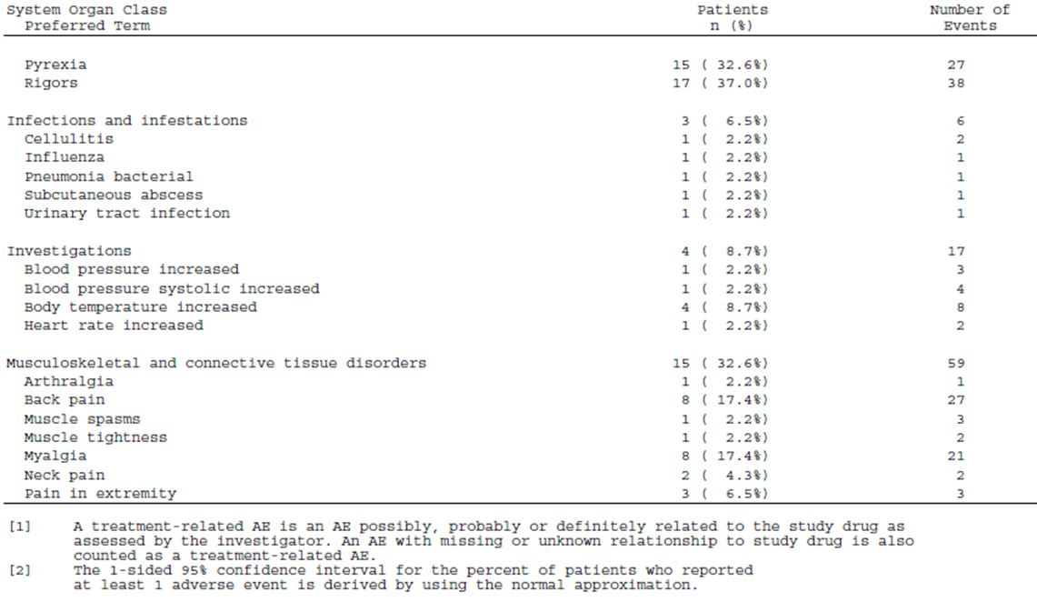
Table 3: Summary of AEs reported by at least 15% of patients (ITT population) (Study IG304).
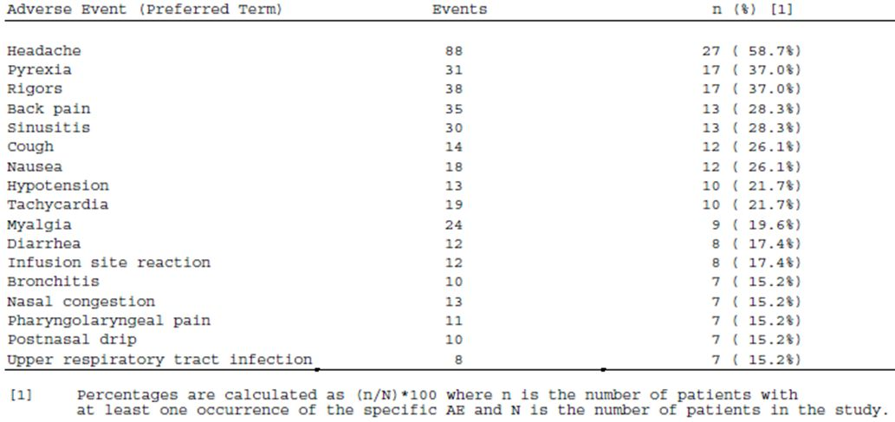
There were no deaths. Four patients experienced 8 serious AEs. Three patients experienced four serious AEs that were considered unrelated to the study drug, and one patient experienced four events that were reported by the investigator as unrelated to the study drug but are being considered as possibly related to study drug for regulatory purposes. These serious AEs were bacterial pneumonia, subcutaneous abscess and two episodes of cellulitis. Three patients discontinued the study because of AEs one of whom developed multiple areas of cellulitis. Most of these events were considered to be related to study drug.
AEs reported by >20% of patients were headache, pyrexia, rigors, back pain, sinusitis, cough, nausea, hypotension, and tachycardia. Treatment related AEs reported by >10% were headache, rigors, pyrexia, tachycardia, hypotension, back pain, and myalgia.
Of the 601 infusions administered, AEs occurred during 29% (one sided 95% CI upper bound = 35.7%), and treatment related events occurred during 20% (one sided 95% CI upper bound = 27.0%). The total number of AEs that occurred during an infusion was 292 (0.49 per infusion), and the total number of AEs that occurred during an infusion or within 72 hours of an infusion was 408 (0.68 per infusion). The total number of treatment related AEs that occurred during an infusion was 206 (0.34 per infusion), and the total number of treatment related AEs that occurred during an infusion or within 72 hours of an infusion was 291 (0.48 per infusion). The upper one sided 95% confidence limit of infusions with one or more associated AE, regardless of attribution, occurred at a rate below the FDA threshold during infusion or up to one hour after completion of the infusion (39.7%) and over the FDA’s suggested threshold during infusion or up to 72 hours after completion of the infusion (47.0%).

Laboratory abnormalities
Clinically significant abnormalities of aspartate aminotransferase (AST) were reported by four participants (9%) on 12 occasions, five patients (11%) experienced 20 abnormalities of alanine aminotransferase (ALT), five patients (11%) experienced 20 lactate dehydrogenase (LDH) abnormalities, and three patients (7%) experienced nine instances of bilirubin abnormalities. No patient tested positive for Hepatitis B, Hepatitis C or HIV. No patients tested positive for Parvovirus B19 at baseline; two patients tested positive post baselinebut each of these results was determined by the laboratory to be a false positive. No patients experienced clinically significant abnormalities of serum creatinine. Thirteen patients had positive Coombs’ tests.

Vital signs
A total of 33 patients (72%) experienced 302 clinically significant vital signs abnormalities. Eighteen patients (39%) experienced 85 systolic blood pressure (SBP) abnormalities: five SBP values were ≤70 mmHg, one SBP value was >180 mm Hg, and 79 SBP values represented increases that were ≥ 30 mm Hg. Seventeen patients (37%) experienced 171 diastolic blood pressure (DBP) abnormalities: 144 DBP values were <50 mmHg, one DBP value was >150 mm Hg, and 28 DBP values represented an increase that was ≥30 mmHg.
Nineteen patients (41%) experienced 60 pulse abnormalities: six pulse values were >120 beats per minute (bpm), 34 pulse values were <50 bpm, 12 pulse values represented increases that were ≥ 30 bpm and eight pulse values represented decreases that were ≥30 bpm.
Three patients (7%) experienced five temperature abnormalities: four values were temperatures > 38.3°C, and one value represented an increase ≥ 1.1°C.
Concomitant medications
The most frequently used concomitant medications (those reported by ≥ 10% of patients) were paracetamol (52%), amoxicillin/clavulanate (33%), azithromycin (28%), ibuprofen (26%), levofloxacin (26%), prednisone (20%), fluticasone/salmeterol (17%), amoxicillin (17%), diphenhydramine (15%), ibuprofen (Motrin) (15%), levosalbutamol (15%), ibuprofen (Advil) (13%), albuterol (13%), fenoxfenadine (13%), cough and cold preparations (13%), pseudoephedrine (Sudafed) (11%), gatifloxacin (11%), and hydrocodone/paracetamol (11%).

Safety in idiopathic thrombocytopenic purpure (ITP): Studies IG202 and IG0601
All 27 patients in the two studies of efficacy and safety of treatment of chronic ITP completed treatment with IGIV3I Grifols 10%. Twenty-six of the 27 (96.3%) patients in both studies reported at least one AE. A total of 133 AEs were reported, with 64 reported for paediatric patients and 69 reported for adult patients. Of these, the most common was headache (28 events), followed by nausea, pyrexia, and petechia (eight events each); chills (six events); vomiting (five events), hypertension and ecchymoses (four events each).
The majority of patients with at least one AE (51.8%) reported the event to be mild in severity, with 33.3% of patients with at least one AE reporting them a moderate. Three patients (11.1%) reported at least one event as severe; these were chills, an infusion related reaction, and thrombosis.
One AE was reported as definitely related to study drug while 16 (59.3%) were classified as probably related to study drug. The most common of these were headache (11 events), chills and pyrexia (six events each), and nausea (five events).
There were no deaths in either study. Two patients reported a serious AE. These were leucopoenia and decreased haemoglobin considered probably related to study drug, and thrombosis considered possibly related.
Fourteen bleeding/hemorrhagic AEs were reported. These included petechiae (8 events), ecchymoses (4 events), and epistaxis (2 events).
Apart from the patient with anaemia and leukopenia laboratory parameters considered clinically relevant included decreased erythrocytes on Day 2 (in the same patient), increased haemoglobin, decreased haptoglobin, a positive direct antiglobulin test on Day 1 and abnormal platelets count (< 20 x 10⁹/L) on Day 24. These results were reported as AEs for these patients. Clinically relevant findings for blood chemistries included a slight elevation in ALT in one patient and an increase in LDH in another patient. These abnormal findings were reported as AEs, as per protocol. No clinically relevant findings were present in the urinalysis results. No evidence of clinical haemolysis was seen in all patients from both studies. No change occurred in viral serology results. There was one report of decreased diastolic blood pressure and one report of blood pressure systolic increased. There were four reports of hypertension and two of hypotension.

List of questions
During 2010, the TGA began to change the way applications were evaluated. As part of this change, after an initial evaluation, a List of Questions to the sponsor is generated.

Question 1
The investigator could not determine whether the investigational product used in the studies, IGIV31 Grifols 10%, and Flebogamma 10% DIF, are identical. The clinical expert states that the production process of Flebogamma 10% DIF is the same than for Flebogamma 5% DIF. The only difference being the final concentration step in which the yield is adjusted to the desired 5% or 10% product strength. In the sponsor clinical data submission, the following is stated:
“Many components used for the production of Flebogamma and IGIV3I Grifols 10% are similar, although the manufacturing process for IGIV3I Grifols 10% incorporates new components that are associated to the additional viral elimination steps.”

Sponsor’s response:
IGIV3I Grifols 10% and Flebogamma 10% DIF are the same products. The only difference is the name of the product used during the investigational phase (IGIV3I Grifols 10%) and the commercial name (Flebogamma 10% DIF). In addition, there is another concentration for the same product (IGIV3I Grifols 5% or Flebogamma 5% DIF, again considering the investigational phase) that has the same manufacturing process and same concentration of excipients (for example, sorbital which is at 5%) but half concentration of the active ingredient (IgG molecule). Finally, the former product of Flebogamma DIF was Flebogamma which was launched in Germany in November 1992 and still marketed in some countries (for example Spain, Italy and Mexico). The manufacturing process of Flebogamma is similar but not identical as Flebogamma only includes one step for virus inactivation which is a pasteurisation for 10 hours at 60°C and Flebogamma DIF (at both concentrations) has two more steps: a solvent detergent treatment, and a nanofiltration through 35 and 20 nm filters.

Question 2
The sponsor is requested to clarify the numbers presenting with bleeding and the numbers with regression of bleeding. The number of patients with bleeding manifestations at commencement of treatment was variously reported to be:
- All but one
- All children, and all except four of the adults.
The number experiencing improvement in bleeding is stated in the text to be all patients responding, whereas the data table shows three patients not responding, and this table is considered possibly incomplete as the number of adults in the table doesn’t equal the number of adult responders.

Sponsor’s response:
The apparent discrepancies in the number of subjects presenting with bleeding/haemorrhage and the number of subjects with regression of bleeding/haemorrhage seems to be due to the data being presented globally (data from the two Studies IG202 and IG0601 together) or separate (data from individual studies) in different sections of the clinical study report.
Three adult subjects are presented as being non responders according to the secondary efficacy endpoint “regression of haemorrhage/bleedings”. These three subjects actually did not have any bleeding/haemorrhage at Day 1; therefore they have not been counted in calculation of percentage of subjects with improvement of bleeding diathesis (response) during follow up period.

Question 3
The reason for manufacturing the 10% formulation has not been made clear by the sponsor in this submission, nor explained to the patients included in the studies as judged by the submitted consent forms. The sponsor is requested to supply the reason for manufacturing and requesting to register, a 10% product.

Sponsor’s response:
With the availability of a new concentration (10%) a low volume of infusion is used and this may be an advantage for some patients. There are other advantages as a small reduction in infusion time may improve patients' quality of life, optimises health resources and even reduces complications associated to the hospital stay.

Clinical summary and conclusions
In support of the application, summary of Study IG304 of efficacy, safety and pharmacokinetic results of treatment of primary immunodeficiency, and an integrated interim summary of Studies IG202 and IG0601 assessing treatment of ITP were submitted in accordance with guidance on the clinical investigation of human normal IVIg. Each study was observational, prospective and open label.

Study IG304
Study IG304 examined 12 month use of IGIV31 Grifols 10% in treatment of primary immunodeficiency disease. A total of 46 patients were enrolled, three of whom were less than 16 years of age. Thirty-seven (80.4%) of those enrolled completed the study. The primary objective was to determine efficacy with respect to the FDA minimal requirements of no more than one serious bacterial infection per patient per year according to FDA criteria. The primary objective was met; one serious bacterial infection, pneumonia, was documented.
The total number of AEs that occurred during an infusion in Study IG304 was 292 (0.49 per infusion), and the total number of AEs that occurred during an infusion or within 72 hours of an infusion was 408 (0.68 per infusion). The total number of treatment related AEs that occurred during an infusion was 206 (0.34 per infusion), and during an infusion or within 72 hours of an infusion was 291 (0.48 per infusion). The upper one sided 95% confidence limit of infusions with one or more associated AEs occurred at a rate below the FDA threshold during or up to one hour after completion of an infusion (39.7%), and over and above the FDA’s suggested threshold during infusion or up to 72 hours after completion of the infusion (47.0%).
Most frequently reported events were headache, pyrexia, rigors, back pain, sinusitis, cough, nausea, hypotension, and tachycardia and myalgia. No deaths were reported. One patient experienced serious AEs of bacterial pneumonia, subcutaneous abscess and two episodes of cellulitis that were reported by the investigator as not related to the study drug but are being considered as possibly related to study drug for regulatory purposes. Three patients including this one discontinued the study because of AEs; most of which were considered to be related to study drug.
In comparing the incidence of AEs reported in Study IG304 to those reported in the Australian Product Information for Flebogamma 5% DIF, it appears that the incidence of AEs considered related to treatment is higher in relation to the 10% formulation than the registered formulation. The incidence of AEs occurring within 72 h of commencement of infusion was higher than the FDA recommendation.
The study design by its nature, and despite the best will, is subject to the possibility of bias, in particular in determining the number of bacterial infections and also the relatedness or otherwise of AEs as highlighted in the FDA questions relating to infections and to antibiotic use.

Sponsor’s comment regarding safety
With respect to the AE profile, the sponsor considers that a protocol required forced upward titration of the infusion rate may be associated with an apparent greater incidence of AEs. The sponsor states that there was clear evidence that patients more frequently reported AEs as the infusion rate increased. The current study utilised a 10% formulation of the drug product, thereby requiring a smaller volume of infusate; thus, it stands to reason that infusion times would intrinsically be decreased compared with administration of the same amount of active drug product in a 5% formulation.
The sponsor also states that although safety data on 10% IVIg products have not been published extensively in the literature, anecdotal evidence from investigators who have administered both 5% and 10% formulations suggests that higher AE incidences may be expected with 10% IVIg products, particularly at higher infusion rates. To date, only a few 10% IVIg products have been approved for marketing, and the number of publications associated with these products is small. Comparisons between products are not clinically meaningful, since the types of safety information available for each product do not follow any global convention.

Studies IG202 and 0601
An integrated, interim report of these two studies of the efficacy and safety of use of IGIV31 Grifols 10% in treatment of chronic ITP was presented. The two observational studies were conducted under separate protocols. The decision to combine them for interim analyse constituted a change in the planned analysis, that is, the results provided were based on post hoc analysis. There were multiple design differences resulting in an amalgamated report that lacked clarity and was difficult to interpret. In addition, the inclusion in Study IG202, of participants known to be responsive to previous IVIg, is considered contentious.
The primary objective of both studies was to demonstrate that IGIV3I Grifols 10% is safe and effective in raising platelet counts in patients with chronic ITP. The primary efficacy endpoint was response to therapy, defined as a platelet count ≥50 x 10⁹/L at any time during the study period (IG202) or by Day 8 ± 1 (IG0601). The primary efficacy criterion was the proportion of responders. It was generally difficult to discriminated results of one study from the other with the exception of results for children who were included only Study IG0602.
A total of 27 patients were enrolled and treated, 18 adults and 9 paediatric patients with age range 3-15 years. One child and three adults were withdrawn prematurely from Study IG0601 due to progression of disease. Six patients were said to have platelet counts at baseline above those specified in the protocols. No patients were excluded from the MITT analysis. There were no withdrawals for AEs. All 27 patients in the two studies were stated to have completed treatment.
Twenty-four of the 27 patients (89%) were responders with platelet count increase to ≥50 x 10⁹/L: The proportion of adult responders was 83% (15/18). The proportion of paediatric responders was stated to be 100% (9/9); however, one child was withdrawn from the study because of disease progression.
Regression of haemorrhages was reported. The criteria for regression in Study IG202 appeared to allow subjective evaluation and the criteria for regression in Study IG0601 could not be located.
Twenty-six of the 27 (96.3%) ITP patients reported at least one AE. A total of AEs were reported, with 64 reported for paediatric patients and 69 reported for adult patients. On a per capita basis it appears that paediatric patients experienced a higher incidence of AEs than adults.
The most commonly reported AEs were headache, nausea, pyrexia, and petechiae; chills; vomiting; hypertension and ecchymoses. The majority were reported as mild, 33.3% were moderate, and 11.1% were severe. One event was reported as definitely related while 59.3% were classified as probably related to study drug.
There were no deaths in either study. Two patients reported a serious AE: leukopenia and decreased haemoglobin considered probably related to study drug, and thrombosis considered possibly related.
The Note for Guidance on the Clinical Investigation of Human Normal Immunoglobulin for Intravenous Administration specifies a low level of evidence for efficacy in the treatment of ITP. The decision regarding the indications of Guillain Barré Syndrome, Kawasaki disease and allogeneic bone marrow transplantation are contingent on establishment of efficacy in ITP according to the guideline. The level of evidence supplied is considered in keeping with the spirit of the guideline. It is concerning that low level of evidence is required for a product with inherently high rates of associated AEs.

Benefit risk assessment

Benefits
PID and ITP are conditions with potential to cause significant morbidity or mortality. The submitted studies demonstrated efficacy with respect to prevention of serious bacterial infection and platelet response in patients with chronic ITP.

Risks
An apparent increase in the incidence of drug related AEs compared with the registered 5% product Flebogamma 5% DIF has been reported in treatment of primary immunodeficiency disease and chronic ITP. In the ITP study, the paediatric patients appeared to be disproportionately affected. While it is plausible that the reduction in infusion time may play a part, it cannot be ruled out that the new formulation is inherently more likely to cause AEs.
There exists a potential risk of transmission of infection associated with the large number of donors contributing product.

Balance
The balance is felt to lie on the side of benefit. The benefit is considered to be specific for patients in whom fluid restriction is a medical imperative. The benefit of slight reduction in time of delivery as a convenience is not considered sufficient to sway the balance in favour of the 10% product.

Recommendation
Registration of Flebogamma 10% DIF is recommended based on the results of the submitted studies and with reference to the Note for Guidance.⁸
With respect to the treatment of ITP, it is recommended that the Dosage and Administration section includes a statement that studies of efficacy were performed on patients with chronic ITP and that the product has not been studied in treatment of acute ITP.
It is recommended that the Precautions section includes a statement with regard to the apparent increase in rate of AEs. The statement should be separate from the existing precaution that rate of AEs may be related to rate of infusion.
A number of changes to the proposed Product Information have been recommended. In particular, it is recommended that there is no change to the TGA approved wording of the Indication and Dosage and Administration sections.

V. Pharmacovigilance findings

Risk management plan
The sponsor submitted a Risk Management Plan which was reviewed by the TGA’s Office of Product Review (OPR).

Safety specification
The sponsor provided a summary of Ongoing Safety Concerns (Table 4).
Table 4: Ongoing Safety Concerns for Flebogamma 10% DIF.
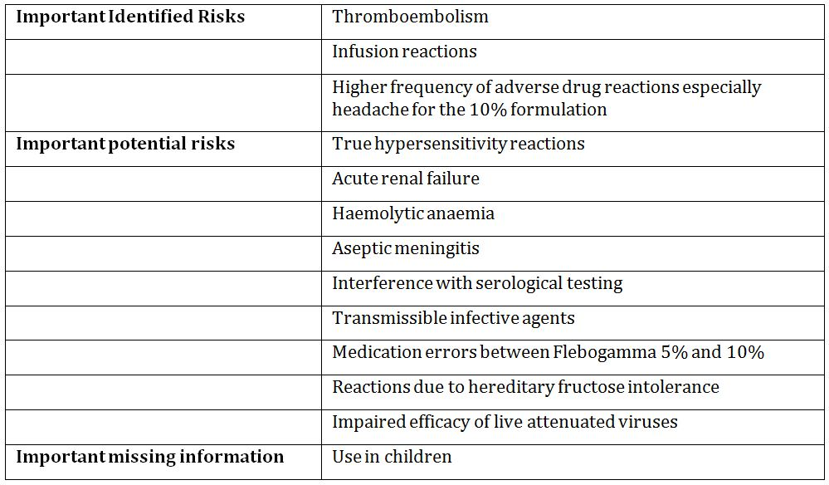

OPR reviewer comment:
The sponsor has provided clarification regarding the inclusion of ‘Use in children’ as important missing information despite the product having a paediatric indication.

Recommendations:
Transfusion Related Acute Lung Injury (TRALI) is an uncommon AE following IVIg treatment and is included as a potential safety concern in the US Product Information in the precautions section. The sponsor response argues that it is not necessary to mention that concern in the Australian Product Information as it has not been reported in the pre authorisation phase or in past cases. The evaluator disagrees with the sponsor’s response. The number of patients in the studies is small, and an uncommon or rare event may not be captured. Prescribers should be aware of the possibility, and it should be mentioned in the Product Information as a class effect.
‘Use in the elderly’ should be included as ‘Important missing Information’. The sponsor notes ‘only a limited number of subjects over the age of 65 enrolled and therefore, the information available on them is limited’. The sponsor has provided additional information that in the last Periodic Safety Update Report (PSUR) of Flebogamma 10% DIF with the data lock point of 31 May 2011 the AEs reported in patients over the age of 65 would not suggest there is a specific safety concern in this group. It is recommended the sponsor undertake routine pharmacovigilance activities for this group but give specific consideration to AEs in the elderly in future PSURs, and undertake routine risk minimisation in the form of labelling. A short statement in the Product Information indicating there is limited experience in the elderly in clinical trials but no specific safety concerns have been identified in post marketing experience to date, or words to that effect, would suffice.

Pharmacovigilance plan

Proposed pharmacovigilance activities
A summary of safety concerns and planned pharmacovigilance activities is shown in Table 5.
Table 5: Summary of safety concerns and planned pharmacovigilance activities for Flebogamma 10% DIF.
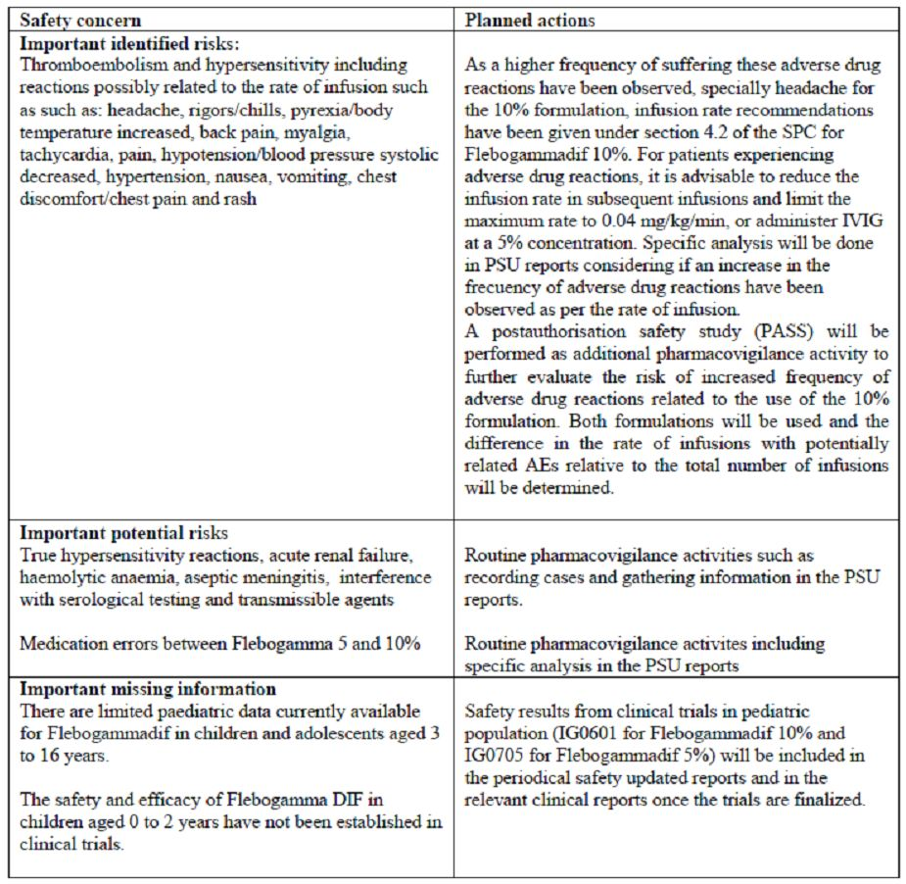
Routine pharmacovigilance activities, such as recording cases and gathering information in the PSUR, have been proposed for all important identified and potential safety risks. Specific analysis of the frequency of adverse drug reactions that may be related to the rate of infusion, and medication errors between Flebogamma 5% and 10% will be provided in the PSUR.
Safety results from Study IG0601 for Flebogamma 10% and Study IG 0705 for Flebogamma 5% to provide data for the paediatric population will be included in the PSURs and clinical reports once the trials are finalised. These trials had commenced at the time of issue of the RMP.
The sponsor proposes a post authorisation safety study as an additional pharmacovigilance activity to better define the safety profile of Flebogamma 10% DIF. This is a prospective, observational, non randomised/non stratified study, open labelled, multicentre study of the safety of Flebogamma DIF 50 mg/mL and 100 mg/mL. There are not restricted indications for the inclusion of patients beyond the authorised indications.
Safety and efficacy data will be collected. From a safety viewpoint all AEs will be recorded. This will be a relatively small study in that it is anticipated 225 infusions will be included, however the study would seem to be sufficiently powered to detect a 20% difference between the two groups (5% and 10% solutions). Updates and a final summary of the study should be provided with PSURs.

OPR reviewer’s comments in regard to the pharmacovigilance plan and the appropriateness of milestones:
Routine pharmacovigilance activities are acceptable but unlikely to adequately quantify the important identified and potential risks. The data from spontaneous adverse reactions are unlikely to be sufficient to assess the ongoing safety concerns raised by the sponsor in the RMP due to the under reporting and the lack of reliable exposure (usage) data associated with spontaneous reporting systems. Also, the information gained from adverse reaction reporting is often incomplete. It is anticipated the post authorisation safety study mentioned above will contribute to the understanding of the safety profile of Flebogamma 10% DIF.
The specified ongoing and initiated studies are not considered to be part of the planned clinical studies in the pharmacovigilance plan, therefore the related study protocols have not been requested for review. However, the sponsor is requested to include summary data from Study IG0601 and a summary report for Study IG0705 with the next PSUR.

Risk minimisation activities

Sponsor’s conclusion in regard to the need for risk minimisation activities:
The sponsor has concluded that routine risk minimisation activities in the form of warnings included in the Product Information are sufficient as no specific safety concerns have arisen with the use of the product.

OPR reviewer comment:
If the change of age range in the indication in the proposed Product Information is accepted, it is recommended the sponsor provide additional educational materials which could be in the form of a Dear Health Care Professional (DHCP) letter provided to immunologists, oncologists and paediatricians (via the Royal Australian College of Physicians) advising them of the different age range in the indications for the 10% product compared with the 5% product. This will be considered an additional risk minimisation activity and should be noted in any update of the RMP or the Australian specific annexe mentioned earlier in this evaluation report.

Potential for medication errors
To reduce confusion between Flebogamma 10% DIF and Flebogamma 5% the new boxes will have different coloured lines. The sponsor notes confusion between the two strengths may result in under dosing of the patient or potential fluid overload, particularly in the elderly and those with renal impairment. Furthermore, faster infusion rates are associated with more frequent adverse reactions and may inadvertently occur if 10% solution was delivered instead of 5%.
The sponsor notes the rate of infusion is an important correlate with adverse reactions and provides guidance in the Product Information around the infusion rates to be used to minimise such events. In the updated Product Information the infusion rates are provided as ml/kg/min and mg/kg/min to reduce the chance of medication error from incorrect infusion rate.

OPR reviewer comment:
The abovementioned strategies as outlined are acceptable.
If the sponsor’s suggested modification to the age range for the Product Information for is approved, Flebogamma 5% and Flebogamma 10% will have different age recommendations in the indications. This could cause confusion for the prescribers, and raises the potential for prescribing errors.

Summary of recommendations
The OPR provides these recommendations in the context that the submitted RMP is supportive to the application; and the implementation of a RMP version 4.4 dated 3 November 2010 is imposed as a condition of registration when so qualified.
It is recommended that an Australian specific annexe to the RMP be provided. This would be a suitable method to identify differences between the European and Australian indications for this product and should indicate any differences in the Pharmacovigilance and Risk Minimisation Plans specific to Australia including references to the Australian Product Information in relevant sections of the RMP.
It is anticipated there may be some concerns that have implications for the safety specifications for Flebogamma 10% DIF. It is requested that information regarding any new safety concern identified in this report be forwarded to OPR for consideration of additional pharmacovigilance and risk minimisation activities that may be required.
Transfusion Related Acute Lung Injury is an uncommon AE following IVIg treatment and is included as a potential safety concern in the US Product Information in the precautions section. The sponsor argues that it is not necessary to mention that concern in the Australian Product Information as it has not been reported in the pre authorisation phase or in past cases. The evaluator disagrees with the sponsor’s response. The number of patients in the studies is small, and an uncommon or rare event may not be captured, prescribers should be aware of the possibility and it should be mentioned in the Product Information as a class effect.
Timelines have not been provided for the preparation and submission of PSURs. Six monthly PSURs are recommended. The specified ongoing and initiated studies are not considered to be part of the planned clinical studies in the pharmacovigilance plan, therefore the related study protocols have not been requested for review. However, the sponsor is requested to include summary data from Study IG0601 and a summary report for Study IG0705 with the next PSUR. In addition, PASS Protocol IG 1004 study updates and a final summary at conclusion of the study should be provided with the PSURs.
If the proposed age range for use in the paediatric population, as presented in the modified Product Information is approved by the Delegate, it is recommended that a letter is forwarded to known prescribers of Flebogamma 5% and the Royal Australian College of Physicians for distribution to their fellows highlighting the difference to reduce the risk of medication errors.

VI. Overall conclusion and risk/benefit assessment
The submission was summarised in the following Delegate’s Overview and recommendations:

Quality
The manufacturing process for Flebogamma 10% DIF and the currently registered Flebogamma 5% DIF is same except the final concentration step to achieve higher concentration. However, this application includes an additional site of manufacture for the intermediate fraction which is currently not approved for Flebogamma 5% DIF.
The issue of pro coagulant activity in IVIg products came about in late 2010 in relation to another registered IVIg product after reports of thromboemolytic events (TEE). Since, the regulators have established a need to demonstrate that the manufacturing process included steps that are effectively remove pro coagulant activity. The changes to the monograph are proposed, which are going to be introduced in 2012.
During evaluation of this submission, the sponsor has had a limited opportunity to address this issue. The studies the company is undertaking are ongoing. The biochemistry evaluation area considers these outstanding aspects as critical.
The pharmaceutical subcommittee (PSC) advice is expected to be available to the Advisory Committee on Prescription Medicines (ACPM) by the time it considers this submission. The Delegate also intends to be guided by the PSC recommendations.

Nonclinical
There was no requirement for a nonclinical evaluation in a submission of this type.

Clinical
Two standard single arm studies – one in PID in patients currently on IVIg therapy and one combined analysis of two separate studies in ITP - were included as supporting clinical data. A total of 46 patients participated in the PID study (3 patients < 16 years of age) and 27 patients in the ITP studies (9 paediatric patients).

Pharmacokinetics

PID study
The PID study consisted of 12 months (observed mean 321 days) of treatment (300-600 mg/kg every 3 or 4 weeks; observed mean dose 461mg/kg/infusion) with Flebogamma 10% DIF. The primary efficacy outcome was incidence of serious bacterial infection in the treated patients. One serious bacterial infection (pneumonia) was documented giving a rate of 0.025 infections/patient/year (98% CI 0.001, 0.133) which fulfilled the predefined minimal requirement of no more than one serious bacterial infection/patient/year.
Notably the proportion of patients with any infection during the 12 months treatment in the study was 61% compared with 48% of patients who reported any infection in the 6 months prior to the study.
Pharmacokinetic data were also collected in a subset of 19 patients in the PID study. The samples were collected during the sixth month of the study following seven infusions in patients on 28 day schedule and nine infusions in patients on 21 day schedule. The trough levels of total IgG were maintained at or near pre study levels, and above the generally quoted therapeutic level of 5-6g/L (see Figure 1).
The observed mean PK parameters are shown in Table 6.
Table 6: Mean pharmacokinetic parameters for Flebogamma 10% DIF.
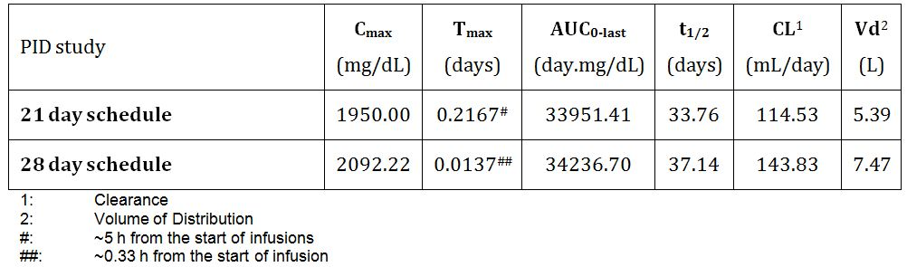

ITP study
The primary objective was to demonstrate that Flebogamma 10% DIF was effective in raising platelet count in patients with chronic ITP to ≥ 50 x 10⁹/L with respect to proportion of responders. Notably in Study IG202 (conducted in Russia and Spain), the primary outcome of platelet count ≥50 x 10⁹/L was assessed during 90 days compared to nine days in Study IG0601 (conducted in Canada and USA). The median overall (n = 18) platelet count at baseline was 15 x 10⁹/L (range 6-39 x 10⁹/L). All except four patients presented with some bleeding haemorrhagic sign at the onset of baseline episode of ITP.
A total of 27 patients participated, 18 adults and 9 paediatric (age range 3-15 years) patients. A total of 22 patients received study drug as two infusions of 1g/kg/day over two days, and five patients received drug as five infusions of 0.4g/kg/day for five days.
A total of 24/27 (89%; 95% CI 74%, 97%) patients were responders with platelet count increased to ≥50 x 10⁹/L. There were 15/18 (83%; 95% CI 62%, 95%) adult responders and 9/9 (100%; 95% CI 72%, 100%) paediatric responders.

Clinical safety
AEs reported by at least 15% patients in the PID study are given in Table 3. Three patients experienced serious AEs that were bacterial pneumonia, subcutaneous abscess, and cellulitis. No patients tested positive for hepatitis B, hepatitis C or HIV. Thirteen patients tested positive Coombs’ test.
The incidence of treatment related AEs considered with the 10% formulation was stated to be higher than the registered 5% formulation.
A total of 26/27 (96.3%) ITP patients reported at least one AE. A total of 133 AEs were reported. The most commonly reported were headache, chills/pyrexia and nausea. Two patients reported serious AEs which were leukopenia/decreased haemoglobin and thrombosis. Fourteen bleeding/haemorrhagic events were reported consisting of petechiae (eight events), ecchymoses (four events) and epistaxis (two events).
No evidence of clinical haemolysis, change in viral serology or deaths were reported in either study.
The TGA review included PSUR for Flebogamma 5% DIF from Dec 2009 to May 2010.

Risk management plan
The implementation of RMP version 4.4 dated 3 November 2010 is recommended as a condition of registration. It is also recommended that an Australian specific annexe to the RMP be provided.

Risk-benefit analysis

Delegate considerations
The critical outstanding issue in regard to this submission is monitoring of pro coagulant activity in the final product which is pending advice from the PSC and clearance from the Office of Biological Science.
The clinical efficacy and safety issues which require comment from the sponsor in its pre ACPM response are as follows:
- Explanation of discordance noted between Tmax with the 21 day dosing compared to the 28-day dosing in PK subset of the PID study. Is more information available with respect to rates of infusion in the two groups?
- Comments with respect to the finding in the PID study where proportion of patients with any infection during the 12 months treatment in the study was 61% compared with 48% of patients who reported any infection in the 6 months prior to the study.
- When are the individual final clinical study reports for the two ITP studies expected to become available and likely to be provided to the TGA for review?
- Comments with respect to the clinical evaluator’s recommendation that the Precautions section should include a statement with regard to the apparent increase in rate of AEs with the 10% product separate from the existing precaution that rate of AEs may be related to rate of infusion.
- Comments with respect to the RMP evaluator’s recommendation with respect to the proposed Product Information, PSURs and the ongoing studies
Furthermore, at its 278th meeting in 5th August 2011, the ACPM made the following recommendations in relation to human normal immunoglobulin products:
- The statement of indications should be aligned with therapeutic criteria of the National Blood Authority;
- The product class should all have a similar statement of indications;
- The replacement indication “Congenital AIDS with recurrent bacterial infections” should be deleted as the condition is inaccurate and of historical interest only; and
- The immunomodulatory indication “allogenic bone marrow transplantation” should be deleted as results in randomised clinical trials are conflicting.
In light of the ACPM recommendations, the Office of Medicines Authorisation is in the process of streamlining therapeutic indications for the IVIg products. The following indications are currently supported based on standard studies conducted in PID and ITP:

Replacement therapy indications:
- Primary Immunodeficiency Diseases (PID).
- Symptomatic hypogammaglobulinaemia secondary to underlying disease or treatment.

Immunomodulation indications:
- Idiopathic Thrombocytopaenic Purpura (ITP), in patients at high risk of bleeding or prior to surgery to correct the platelet count.
- Guillain Barre Syndrome
- Kawasaki disease
The sponsor was invited to amend the ‘Indications’ section of the proposed Product Information. Consequently, the ‘Dosage and Administration’ section will require corresponding modifications.

Delegate’s proposed action
The progression of this submission is contingent on further information received from the sponsor in its pre ACPM response. It is further anticipated that finalisation of this submission will be informed by advice received from the PSC and the ACPM and clearance from the Office of Biological Science.
The sponsor is requested to provide annotated and clean copies of the proposed Product Information in its pre ACPM response incorporating recommendations from all evaluation areas as well as those outlined in this Overview.
Advice from the ACPM was requested.

Response from sponsor
The Delegate’s considerations are noted in quoted italics, with sponsor’s response below.
“The critical outstanding issue in regard to this submission is monitoring of pro coagulant activity in the final product which is pending advice from the PSC and clearance from the Office of Biological Science.”
During the Flebogamma DIF manufacturing process, the Pasteurisation step has an important role in order to eliminate the procoagulant activity of the product. However, this is not the only step that is involved in this process, other previous steps also participate.
As it is shown in our report, the Flebogamma DIF process eliminates completely markers of activated coagulation factors in the final product.
Table 7 shows the reduction of FXI:C and FXI:Ag in different steps of the process compared to the content in Fraction II+III suspension (starting point of the process).
Table 7: Reduction of FXI:C and FXI:Ag in different steps of the process compared to the content in Fraction II+III suspension.
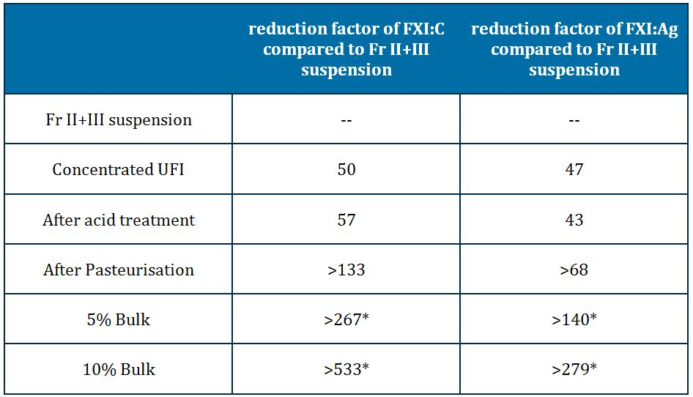
* The differences between both bulks are related to the different protein content.
For the calculations, mean values of FXI:C (IU/g prot) and FXI:Ag (PEU/g prot) in Fr II+III suspension are taken. For the FXI:Ag, a calculation has been done previously to convert the PEU/ml of FXI:Ag to PEU/g protein, considering the protein concentration at these steps.
For the rest of process steps, the higher value (as worst case condition) of the three lots analysed for each step has been taken for the calculations. In those cases where the values are below the limit of quantitation, the limit has been taken for calculations.
As it is mentioned before, pasteurisation is not the only step involved in the procoagulant activity removal, and there is an important elimination in previous steps in the process. Both tests (FXI:C and FXI:Ag) results are in very good agreement for every studied step, showing the high capacity to remove FXI during the purification process.
All 28 lots of Flebogamma DIF final product analysed (15 lots of Flebogamma 5% DIF and 13 lots of Flebogamma 10% DIF) covering the different production options (with and without previous PTC extraction) showed no presence of thrombin generation peak (using TGT-FXI).
Regarding the forced spiking experiments conducted for the pasteurisation step, three different spike conditions have been used: Fr II+III spike, 100pM FXIa spike and 10pM FXIa spike. Among these conditions, Fr II+III (actual process intermediate starting material) is the one that more corresponds to the conditions of a normal process. Up to a 20% volume (1/5 volume Fr II+III/final mixture volume) of extracted Fr II+III was spiked in the intermediate for pasteurisation (which is near 100% pure IgG) representing a very worst case scenario, impossible in practice, taking into account the purification capacity of the previous steps (PEG precipitation and ion exchange chromatography).
The procoagulant activity of the spike mixtures is around 5 (spike 1/20), 7 (spike 1/10) and 11 (spike 1/5) times higher than the procoagulant activity found normally before pasteurisation in a conventional process. After pasteurisation, no signs of procoagulant activity were detected.
In the spike experiments, we demonstrated that starting with a sample with FXI:Ag content between 5 to 11 times higher than a conventional process, the pasteurisation eliminate the procoagulant markers, using relevant assays such as TGT and NaPTT (specially taking into account the assays performed using FXI deficient plasma).
In addition, the pasteurisation kinetics experiments after spiking the intermediate before Pasteurisation sample 1/5 (v/v) with a Fr II+III suspension, demonstrated that 5 h incubation is enough to get a reduction of more than 90% (more than 15 times) in the thrombin generation peak with values comparable to those of the vehicle, which were confirmed in the following timepoint assayed (10 h). In a conventional Flebogamma DIF process, where the intermediate is nearly 100% pure IgG, the 10 h pasteurisation step gives 5 h of additional safety margin to ensure the complete elimination of pro coagulant activity.
The pasteurisation kinetics experiments, after spiking the sample with 100 pM of a commercial FXIa, show values of NaPTT-FXI of 0.87 (ratio between seconds of sample and control) and values of TGT-FXI of 101 nM of peak of thrombin.
Using the same commercial FXIa, in the NaPTT-FXI assays the FXIa detection limit was established at 20 pM of FXIa. Furthermore, with the preliminary validation results of the TGT-FXI, the detection limit could be established approximately at 0.17 pM of FXIa.
A value of peak of thrombin generation around 100 nM corresponds approximately, according to the preliminary validation of the method, to 2-5 pM FXIa. Moreover, according to the results presented in the FDA Workshop (Risk Mitigation Strategies to Address Procoagulant Activity in Immune Globulin Products, May 2011), values around 100 nM of peak of thrombin are clearly lower than the peak of thrombin obtained with the IVIG lots involved in thromboembolic adverse events with values approximately between 225 nM and >500 nM. (Ovanesov, FDA and J. Roemisch, Octapharma).
In conclusion, the different purification steps of the Flebogamma DIF production process guarantee a final product with a complete removal of procoagulant activity ensuring a relevant safety margin.
“The clinical efficacy and safety issues which require comment from the sponsor in its pre ACPM response are as follows:
1. Explanation of discordance noted between T_{max} with the 21 day dosing compared to the 28-day dosing in PK subset of the PID study. Is more information available with respect to rates of infusion in the two groups?”
Instituto Grifols did not perform an analysis of the rate of infusions between the two groups because the infusion rate titration was the same for both groups. The definition of Tmax is the time of occurrence of C_{max}, calculated from the infusion completion. The infusion rate of the product had to be the same in both groups as the protocol pointed out that all infusion were initiated at 0.01 ml/kg/min and a double rate was increased in 30 minutes if the patients tolerated well the infusion. If a patient had an adverse event, the rate of infusion was decreased or, if necessary, stopped until the patient recovered. Patients were assigned to their respective treatment group depending on their previous infusion schedule and trough IgG history.
It is true that mean (SD) T_{max} is different in patients in the 21 day infusion schedule (0.2167 (0.6415) days) than in the 28 day infusion schedule (0.0137 (0.0206)) as well as for the ranges (0.000-2.042 for the first group and 0.000-0.042 for the second one). However, the median was 0.0000 for both groups indicating a highly asymmetric distribution and that most of the patients have a similar T_{max} independently of the schedule. All of the actual values for each patient but one had T_{max} of 0.000 or 0.042 days. One patient had an anomalous T_{max} of 2.042 and this value has contributed to increase the mean from almost 0 to 0.2.
Data to estimate the pharmacokinetic profile came from very few points soon after the infusion (for example, 0 and 1 h and 1, 2, 4 and 7 days, then weekly until Day 28). As stated before T_{max} was defined as the time of occurrence of C_{max} and C_{max} was the maximum observed serum concentration. As it is an intravenous solution, in most cases C_{max} is found just at the end of the infusion or 1 h after the infusion as it happened with all but one subject. However, most of the Ig tends to remain in the circulation for some days. So it is not completely unexpected that in a sporadic case we may find levels around the maximum for several days. In this case patient 1.61 had levels of 1780 mg/dl after the infusion, 1730 1 h later, 1630 24 h later and 1880 2 days later. Therefore, C_{max} was 1880 and T_{max} 2 days.
We do not believe this strange result indicates that the behaviour of the medicine is different in the two scheduled regimens. In addition, all other pharmacokinetic parameters are quite similar between groups, as well as the overall graph.

“2. Comments with respect to the finding in the PID study where proportion of patients with any infection during the 12 months treatment in the study was 61% compared with 48% of patients who reported any infection in the 6 months prior to the study.”
All patients were treated with study drug for a full 12 months of therapy that elapsed since their first infusion. This time period for the treatment and follow up of the patients is used to eliminate any seasonal bias. It is assumed that the incident rate of infectious episodes is higher during the autumn months. The history of the patients recruited was recorded only for 6 months in advance, that is, these data did not cover a full year of exposure of the patients to the seasonal rate of infections. Therefore, as not all patients included had historical data from the autumn months, it is possible that a difference in the proportion of the patients with an infectious episode is found. In addition, the fact that nearly half (48%) of patients had infections in the previous 6 months does not imply (nor should be inferred) that in a 1 year study, you would expect twice as many patients (96%) to have experienced clinical infections. It seems more reasonable to expect a figure higher than 48% but much lower than just the double (96%). So the actual proportion observed (61%) is not unexpected as it is in between those extreme values.
“3. When are the individual final clinical study reports for the two ITP studies expected to become available and likely to be provided to the TGA for review?”
It is expected that the final clinical study report for the Study IG202 is available in the first quarter of 2013 and for Study IG0601 is expected for the last quarter of 2014.
“4. Comments with respect to the clinical evaluator’s recommendation that the Precautions section should include a statement with regard to the apparent increase in rate of AEs with the 10% product separate from the existing precaution that rate of AEs may be related to rate of infusion.”
A statement about the apparent increase in the rate of adverse events observed in clinical trials was included in the ‘Precautions’ section. As Instituto Grifols has the opinion that this apparent increase in the rate of adverse events is probably related to the infusion rate (also described in the scientific literature), a summary of the titration of the infusion rates, at least during the initial infusions, was also included in the same section, following the statement. In the ‘Method of administration’ section, it also included a paragraph to describe the relationship between the frequency of adverse reactions and the infusion rate.
In addition, in the adverse effects section, a statement is included to warn that the product at 10% is likely, but not certain, to cause higher rates of adverse events than a 5% product due to the increased rate of infusion likely to occur with the use of more concentrated product. Because the 10% product contains more IgG per volume than a 5% product, the higher AE rates are likely due not to the mL/kg infused, but rather the mg/kg.
“5. Comments with respect to the RMP evaluator’s recommendation with respect to the proposed Product Information, PSURs and the ongoing studies.”
Instituto Grifols, S.A. committed to add the requested documentation in the final version of the RMP which will be submitted after the approval of the product and together with the next PSUR.
The current version of the RMP is the version numbered as 4.4 of 3 November of 2010 that was submitted with the dossier in September 2010. Instituto Grifols will include an Australian specific annexe to the current RMP with specific data in some parts of the document, considering the PI of the drug in Australia. The version will be named as “version 4.4_AU”. Regarding the PSUR and the ongoing studies, the current version of RMP already includes revision and the analysis of the trials until they are finalised as a proposed pharmacovigilance activity.
“Furthermore, at its 278th meeting in 5th August 2011, the ACPM made the following recommendations in relation to human normal immunoglobulin products:
- The statement of indications should be aligned with therapeutic criteria of the National Blood Authority;
- The product class should all have a similar statement of indications;
- The replacement indication “Congenital AIDS with recurrent bacterial infections” should be deleted as the condition is inaccurate and of historical interest only; and
- The immunomodulatory indication “allogenic bone marrow transplantation” should be deleted as results in randomised clinical trials are conflicting.
In light of the ACPM recommendations, the Office of Medicines Authorisation is in the process of streamlining therapeutic indications for the IVIg products. The following indications are currently supported based on standard studies conducted in PID & ITP:

Replacement therapy indications:
- Primary Immunodeficiency Diseases (PID).
- Symptomatic hypogammaglobulinaemia secondary to underlying disease or treatment.

Immunomodulation indications:
- Idiopathic Thrombocytopaenic Purpura (ITP), in patients at high risk of bleeding or prior to surgery to correct the platelet count.
- Guillain Barre Syndrome
- Kawasaki disease
The sponsor is invited to amend the ‘Indications’ section of the proposed Product Information. Consequently, the Dosage & Administration section will require corresponding modifications.”
The Delegate’s proposed action is noted and the ‘Indications’ section and consequently the ‘Dosage & Administration’ section have been amended according to the currently supported indications based on standard studies conducted in PID and ITP. Therefore, updated Product Information and Consumer Medicine Information files (annotated and non annotated versions) are provided.

Advisory committee considerations
The ACPM, having considered the evaluations and the Delegate’s overview, as well as the sponsor’s response to these documents, advised the following:

Efficacy
The ACPM agreed with the Delegate that the submission demonstrated clinically relevant efficacy.

Safety
The ACPM noted that one pivotal trial reported two major thrombotic events and 14 bleeding or stroke events within 27 enrolled patients. While this may have been due to the underlying ITP condition, the possible presence of pro coagulant activity in the new product with the change in manufacturing process was noted.

Indication
The ACPM considered this product to have a positive benefit-risk profile for the indication of:
Replacement therapy indications:
- Primary Immunodeficiency Diseases (PID).
- Symptomatic hypogammaglobulinaemia secondary to underlying disease or treatment.
Immunomodulation indications:
- Idiopathic Thrombocytopaenic Purpura (ITP), in patients at high risk of bleeding or prior to surgery to correct the platelet count.
- Guillain Barré syndrome.
- Kawasaki disease.

Product Information/Consumer Medicines Information
The ACPM agreed with the amendments proposed by the Delegate to the Product Information and Consumer Medicines Information.

Conditions of registration
The ACPM advised that the quality issues, as advised by the PSC in regard to pro coagulant activity should be clarified, and the robustness of the manufacturing process to remove this activity from the final product should be demonstrated to the satisfaction of the TGA.
The ACPM advised that the implementation by the sponsor of the recommendations outlined above to the satisfaction of the TGA, in addition to the evidence of efficacy and safety provided for Flebogamma 10% DIF would support the safe and effective use of this product.

Outcome
Based on a review of quality, safety and efficacy, TGA approved the registration of Flebogamma 10% DIF normal immunoglobulin (Human) 5 g/50 mL, 10 g/100 mL, 20 g/200 mL (intravenous administration). The approved indication reads as follows:
Replacement therapy indications:
  - Primary Immunodeficiency (PI) Diseases
  - Symptomatic hypogammaglobulinaemia secondary to underlying disease or treatment.
Immunomodulation indications:
  - Idiopathic Thrombocytopaenic Purpura (ITP), in patients at high risk of bleeding or prior to surgery to correct the platelet count.
  - Guillain Barré syndrome
  - Kawasaki disease.

Specific conditions of registration applying to these therapeutic goods:
- The implementation in Australia of Flebogamma 10% human normal immunoglobulin Risk Management Plan (RMP), dated 3 November 2010, included with submission PM-2010-03276-3-2, and any subsequent revisions, as agreed with the TGA and its OPR.

Attachment 1. Product Information
The Product Information approved at the time this AusPAR was published is at Attachment 1. For the most recent Product Information please refer to the TGA website at <http://www.tga.gov.au/hp/information-medicines-pi.htm>.

The Instituto Grifols global corporate headquarters is located in Sant Cugat del Valles, Barcelona.
IGIV3I Grifols 10%; 300-600 mg/kg/infusion; Lot # IBGM3XP001, IBGM4A6001, IBGM4GJ001.
The June 2008 FDA Guidance for Industry recommends use of the one sided 99% confidence interval (CI), and it appears that two sided 98% CI was actually calculated.
<www.disabilitydurations.com/pr_repmdc.htm>
<www.cdc.gov/nchs/fastats>
The FDA took issue with the sponsor’s choice to list as not related, three infections occurring in one patient, leading to change from investigational product to commercial product for one patient. The FDA requested that the infections be “possibly related”. The FDA had questions regarding the reporting of safety data with regard to the number of infections based on discrepancy between the number treated with antibiotics and the number reported to have infection.
In Study IG202, regression of haemorrhages during the first 10 or 14 days was by definition: No occurrence of any important spontaneous bleeding and in patients with bleeding symptoms at the moment of the first infusion at least one of the following conditions will take place: - Reduction of the size of large ecchymoses, and no spontaneous appearance of new ecchymoses; - The number of cutaneous petechiae or the extension of the affected parts of the body decrease; or - Active mucosal bleedings presented at the moment of the infusion stop without rebleeding and no occurrence of new spontaneous mucosal haemorrhages (for example, gingival bleeding, epistaxis). Regression of haemorrhages in Study IG0601 was defined by the proportion of treated patients with haemorrhage/bleedings at Day 1 (that is, the day of the first infusion, pre infusion) who improve their diathesis during the clinical follow-up period ending on Day 15 ± 1. Assessment of regression is made according to a categorised rating scale defined in advance.
European Medicines Agency, “Note for Guidance on the Clinical Investigation of Human Normal Immunoglobulin for Intravenous Administration (IVIg)”, June 2000, Web, accessed 16 April 2012 <http://www.tga.gov.au/pdf/ euguide/bwp038895en.pdf>.
Routine pharmacovigilance practices involve the following activities: - All suspected adverse reactions that are reported to the personnel of the company are collected and collated in an accessible manner; - Reporting to regulatory authorities; - Continuous monitoring of the safety profiles of approved products including signal detection and updating of labeling; - Submission of PSURs; - Meeting other local regulatory agency requirements.
Routine risk minimisation activities may be limited to ensuring that suitable warnings are included in the product information or by careful use of labelling and packaging.
MV Ovanesov. Laboratory of Hemostasis, Division of Hematology, Office of Blood Research and Review, CBER, US Food and Drug Administration, FDA Workshop: Risk Mitigation Strategies to Address Procoagulant Activity in Immune Globulin Products, 17 May 2011, Bethesda, MD; J Roemisch, Senior Vice President R&D Plasma, Octapharma PPGmbH Vienna, Austria, Workshop: Risk Mitigation Strategies to Address Pro coagulant Activity in Immune Globulin Products, 17 May 2011, Bethesda, MD.

