PRODUCT INFORMATION

NAME OF THE MEDICINE
VASTREKA® (ivermectin) 10mg/g cream

Australian Approved Name (AAN): ivermectin

Chemical Names: 5-O-demethyl-22,23-dihydroavermectin A_{1a}; 5-O-demethyl-25-de(1-methylpropyl)-25-(1-methylethyl)-22,23-dihydroavermectin A_{1a}

Molecular Formula and Molecular Weight:
22, 23-dihydroavermectin B_{1a} C₄₈H₇₄O₁₄ (R=C₂H₅) 875.10
22, 23-dihydroavermectin B_{1b} C₄₇H₇₂O₁₄ (R=CH₃) 861.07

CAS Number:
70288-86-7 (ivermectin)
71827-03-7 (ivermectin B_{1a})
70209-81-3 (ivermectin B_{1b})

Structural Formula: ivermectin

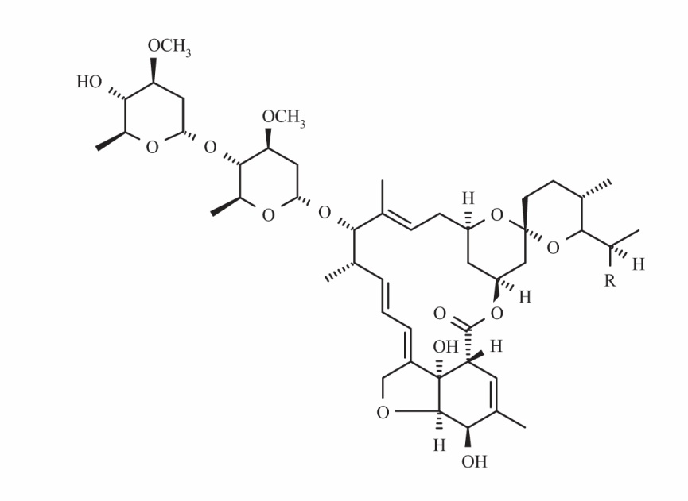

Ivermectin contains a minimum of 90% of 22, 23-dihydroavermectin B1a (where the R group is ethyl) and a maximum of 10% of 22, 23-dihydroavermectin B1b (the R group is methyl).

DESCRIPTION
Ivermectin is a white or yellowish-white crystalline powder. It is freely soluble in methylene chloride, soluble in ethanol (96%) and practically insoluble in water. It presents a specific optical rotation between -20 to -17 measured at 20ºC. It is a semi-synthetic product derived from fermentation of the bacterium Streptomyces avermitilis.

VASTREKA is a white to pale yellow hydrophilic cream. One gram of VASTREKA cream contains 10mg (or 1.0% w/w) of ivermectin. VASTREKA also contains the excipients glycerol, isopropyl palmitate, carbomer copolymer (type B), dimethicone-20, disodium edetate, citric acid monohydrate, cetyl alcohol, stearyl alcohol, ceteareth-20, sorbitan stearate, methyl hydroxybenzoate (E218), propyl hydroxybenzoate (E217), phenoxyethanol, propylene glycol, oleyl alcohol, sodium hydroxide and purified water.

PHARMACOLOGY

Mechanism of action
The mechanism of action of VASTREKA cream in treating rosacea lesions is unknown.
Ivermectin is a member of the avermectin class. Avermectin has been reported to exert anti-inflammatory effects by inhibiting lipopolysaccharide-induced production of inflammatory cytokines. Anti-inflammatory properties of cutaneous ivermectin have also been observed in animal models of skin inflammation. Ivermectin also causes death of parasites, primarily through binding selectively and with high affinity to glutamate-gated chloride channels, which occur in invertebrate nerve and muscle cells. The mechanism of action of VASTREKA in treating the inflammatory lesions of rosacea may be linked to anti-inflammatory effects of ivermectin as well as causing the death of Demodex mites that have been reported to be a factor in inflammation of the skin.

Pharmacokinetics

Absorption
The absorption of ivermectin from VASTREKA was evaluated in a clinical trial in adult participants with severe papulopustular rosacea under maximal use conditions. At steady state (after 2 weeks of treatment), the highest mean (± standard deviation) plasma concentrations of ivermectin peaked within 10 ±8 hours post-dose (C_{max}: 2.10 ± 1.04 ng/mL range: 0.69 - 4.02 ng/mL) and the highest mean (± standard deviation) AUC_{0-24hr} was 36.14 ± 15.56 ng.hr/mL (range: 13.69-75.16 ng.hr/mL). In addition, systemic exposure assessment in longer treatment durations (Phase 3 studies) evidenced that there was no plasma accumulation of ivermectin over the 52-week treatment period.

Distribution
An in vitro study demonstrated that ivermectin is greater than 99% bound to plasma proteins and is bound primarily to human serum albumin. No significant binding of ivermectin to erythrocytes was observed. Ivermectin distribution into the brain, retina, and testis and distribution across the placenta is limited by ABC B1 (p-glycoprotein) efflux transporters. Pharmacokinetic interactions at these efflux transporters may increase the distribution of ivermectin into these tissues.

Biotransformation
In vitro studies using human hepatic microsomes and recombinant CYP450 enzymes have shown that ivermectin is primarily metabolized by CYP3A4.
In vitro studies show that ivermectin does not inhibit the CYP450 isoenzymes 1A2, 2A6, 2B6, 2C8, 2C9, 2C19, 2D6, 3A4, 4A11 or 2E1. Ivermectin does not induce CYP450 enzyme expression (1A2, 2B6, 2C9 or 3A4) in cultured human hepatocytes.
Two major metabolites of ivermectin were identified in a maximal use clinical pharmacokinetic study and assessed during Phase 2 clinical studies (3’’-O-demethyl ivermectin and 4a-hydroxy ivermectin). Similar to the parent compound, metabolites reached steady state conditions by 2 weeks of treatment, with no evidence of accumulation up to 12 weeks. Furthermore, the metabolites systemic exposures (estimated with C_{max} and AUC) obtained at steady state were much lower than those observed following oral administration of ivermectin.

Elimination
The apparent terminal half-life averaged 6 days (mean: 145 hours, range 92-238 hours) in subjects receiving a once daily topical application of the medicinal product for 28 days, in the maximal use clinical pharmacokinetic study.

CLINICAL TRIALS
VASTREKA applied once daily at bedtime was evaluated in the treatment of inflammatory lesions of rosacea in two randomised, double-blind, vehicle-controlled clinical studies, which were identical in design. The studies were conducted in 1371 participants aged 18 years and older who were treated once daily for 12 weeks with either VASTREKA or vehicle.

Overall, 96% of participants were Caucasian and 67% were female. Using the 5-point Investigator Global Assessment (IGA) scale, 79% of participants were scored as moderate (IGA=3) and 21% scored as severe (IGA= 4) at baseline.

The co-primary efficacy endpoints in both clinical studies were the success rate based on the IGA outcome (percentage of participants “clear” and “almost clear” at Week 12 of the study) and absolute change from baseline in inflammatory lesion counts. The IGA scale is based on the following definitions:

Table 1: Investigator Global Assessment (IGA) scale

Grade | Score | Clinical Description
Clear | 0 | No inflammatory lesions present, no erythema
Almost Clear | 1 | Very few small papules/pustules, very mild erythema present
Mild | 2 | Few small papules/pustules, mild erythema
Moderate | 3 | Several small or large papules/pustules, moderate erythema
Severe | 4 | Numerous small and/or large papules/pustules, severe erythema

The results from both clinical studies demonstrated that VASTREKA applied once daily for 12 weeks was significantly more effective than vehicle in clearing lesions (as demonstrated by IGA success rate) and reduction in inflammatory lesion counts (p<0.001; see table 2 and figures 1,2,3 and 4). VASTREKA demonstrated a significantly superior efficacy versus vehicle on both coprimary endpoints (reduction of inflammatory lesions and IGA success rate) which occurred as early as Week 4 and continued up to and including the 12-week time point.

The following table and figures present efficacy outcomes from both studies.

Table 2: Efficacy Results

 | Study 1 |  | Study 2
 | VASTREKA  (N=451) | Vehicle  (N=232) | VASTREKA  (N=459) | Vehicle  (N=229)
Investigator Global Assessment
Number (%) of Participants Clear or Almost Clear in the IGA at Week 12 | 173  (38.4)* | 27  (11.6) | 184  (40.1)* | 43  (18.8)
Difference in success  (95% CI) | 26.7% (20.3%, 33.1%) |  | 21.3% (14.2%, 28.4%)
Inflammatory Lesions
Mean Inflammatory Lesion Count at Baseline | 31.0 | 30.5 | 33.3 | 32.2
Mean Inflammatory Lesion Count at Week 12 | 10.6 | 18.5 | 11.0 | 18.8
Mean Absolute Change in Inflammatory Lesion Count from Baseline at Week 12 ±SD (% Change) | -20.5±16.0*  (-64.9) | -12.0±13.6  (-41.6) | -22.2±14.9*  (-65.7) | -13.4±14.5  (-43.4)
Least Square Mean difference (95% CI) | -8.1 (-10.1, -6.1) |  | -8.2 (-10.2, -6.3)
*p<0.001 compared to vehicle

Figures 1 and 2: IGA Success Rates Over Time in weeks

Study 1
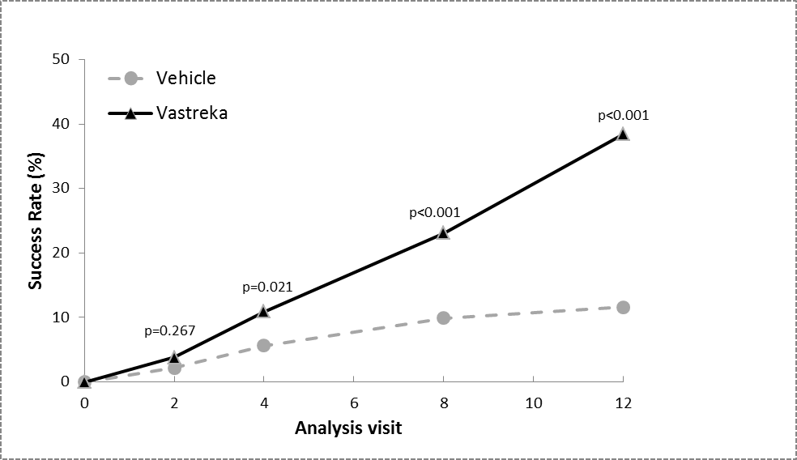

Study 2
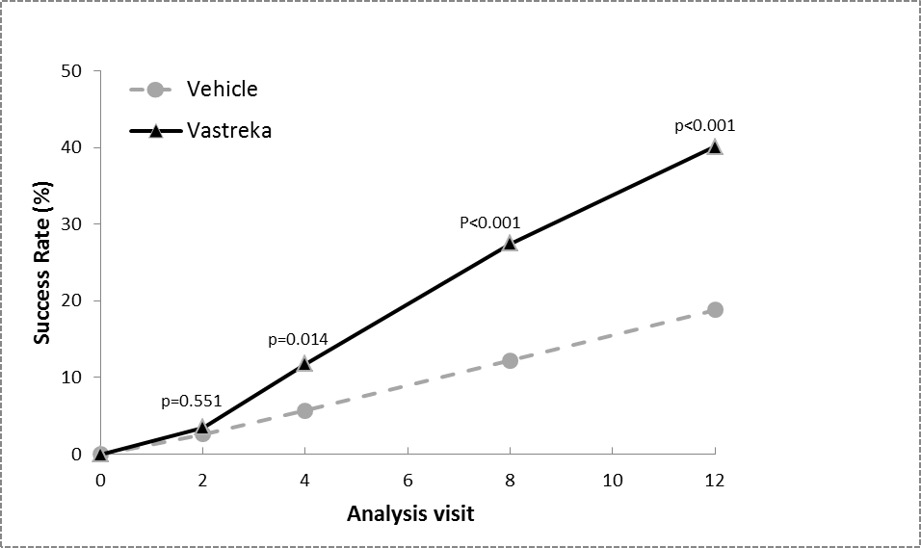

Figures 3 and 4: Mean Absolute Change in Inflammatory Lesion Counts from Baseline Over Time in weeks

Study1
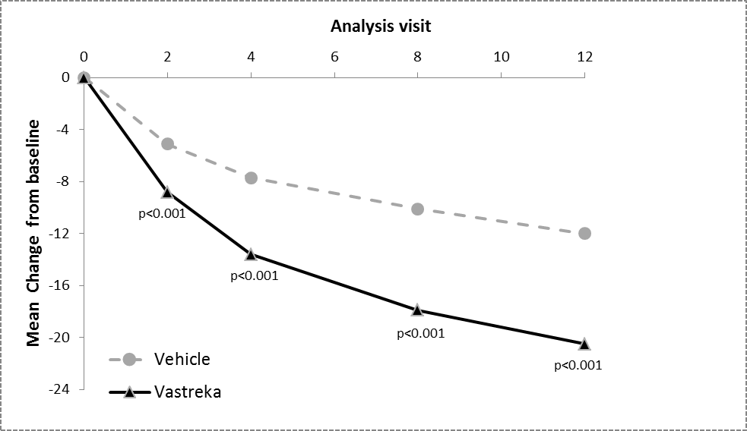

Study 2
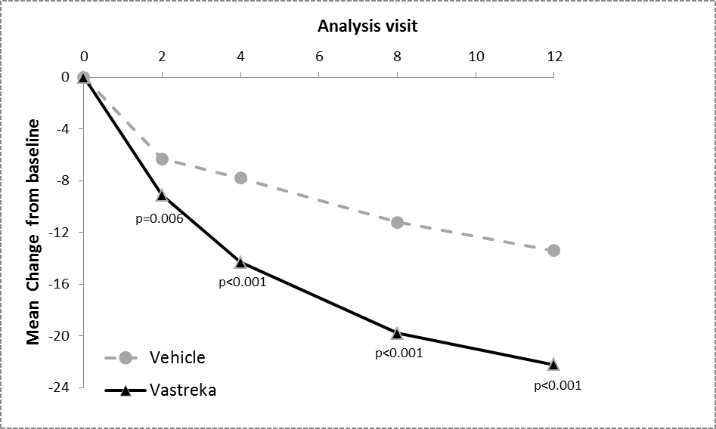

IGA was assessed during the 40-week extension of the two clinical studies and the percentages of participants treated with VASTREKA achieving an IGA score of 0 or 1 continued to increase up to Week 52. The Success Rate (IGA=0 or 1) at Week 52 was 71% and 76% in Studies 1 and 2, respectively.

The efficacy and safety of topical ivermectin in the treatment of inflammatory lesions of rosacea was also evaluated in a randomised, investigator-blinded, active-controlled clinical study. Study 3 was conducted in 962 participants aged 18 years and older who were treated for 16 weeks with either VASTREKA once daily or Metronidazole 7.5 mg/g cream twice daily. In this study, 99.7% of participants were Caucasian and 65.2% were female; on the IGA scale, 83.3% of participants were scored as moderate (IGA=3) and 16.7% scored as severe (IGA=4) at baseline (see figure 5).

The results of Study 3 demonstrated that VASTREKA was statistically more effective than Metronidazole 7.5 mg/g cream on the primary efficacy endpoint (Mean Percent Change in Inflammatory Lesion Counts) with a reduction of 83.0% and 73.7% from baseline after 16 weeks of treatment for the ivermectin and metronidazole groups respectively (p<0.001). The superiority of VASTREKA at Week 16 was confirmed on Success Rate based on IGA and Absolute Change in Inflammatory Lesion Counts (secondary endpoints (p<0.001).

Figure 5 Mean percent change over time in weeks in Study 3 of VASTREKA compared to metronidazole 7.5 mg/g cream.

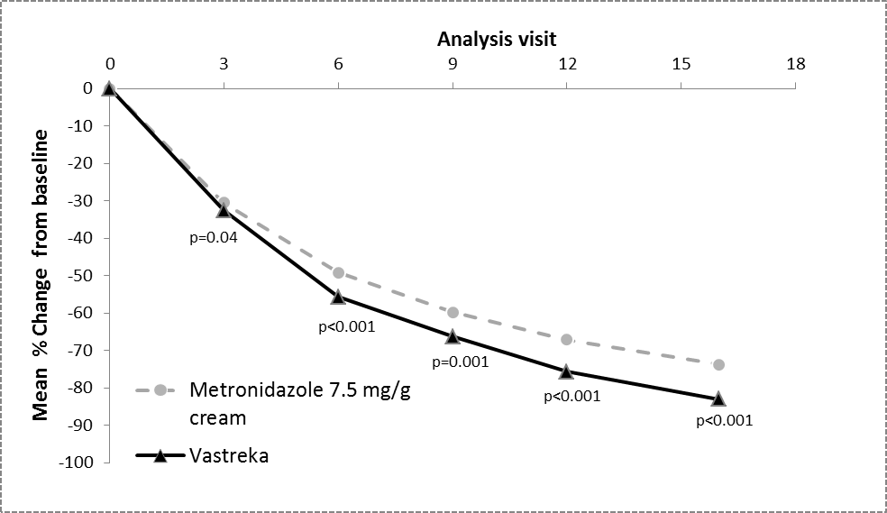

The safety profile remained stable with long-term use for up to one year (see ADVERSE EFFECTS).

INDICATIONS
VASTREKA is indicated for the topical treatment of inflammatory lesions of rosacea (papulo-pustular) in adult patients 18 years and over.

CONTRAINDICATIONS
Hypersensitivity to the active substance or to any of the excipients.

PRECAUTIONS
VASTREKA contains cetyl alcohol and stearyl alcohol which may cause local skin reactions (e.g. contact dermatitis), methyl hydroxybenzoate (E218) and propyl hydroxybenzoate (E217) which may cause allergic reactions (possibly delayed), and propylene glycol which may cause skin irritation. If severe irritation or contact allergy occurs, treatment with VASTREKA should be discontinued.

Safety and efficacy have not been established in patients suffering a particular forms of rosacea (rosacea conglobata, rosacea fulminans, isolated rhinophyma, isolated pustulosis of the chin) or other facial dermatoses that may be confounded with papulopustular rosacea, such as peri-oral dermatitis, facial keratosis pilaris, seborrheic dermatitis and acne.

High sunscreen protection factor (SPF) sunscreens or other sun-exposure reduction methods should be used when VASTREKA is applied to the face or other sun-exposed areas.

Patients should wash their hands immediately after applying VASTREKA.

As VASTREKA has not been studied in patients with renal or hepatic impairment, caution should be used with such patients.

Effects on fertility
No human data on the effect of ivermectin on fertility are available. Ivermectin was found to have no effect on the fertility of male and female rats at oral doses up to 9 mg/kg/day (animal:human AUC ratio ≈ 484).

Use in Pregnancy (Category B3)
There are no adequate and well-controlled studies in pregnant women. VASTREKA should be used during pregnancy only if the potential benefit justifies the potential risk to the fetus.
Oral terategenotoxicity studies in the rabbit demonstrated maternal toxicity and carpal flexures in the fetus at a dose of 4.5mg/kg/day. The NOAEL was established at 3.5 mg/kg/day, a dose corresponding to plasma levels 68 times higher than those obtained at the maximum recommended human dose by topical route (1g application of VASTREKA once daily).
In the rat, cleft palates were observed at the oral dose of 12 mg/kg/day. The dose of 4 mg/kg/day was the NOAEL for maternal toxicity and embryofetal development, a dose corresponding to plasma levels 334 times higher than those obtained at the maximum recommended human dose by topical route (1g application of VASTREKA once daily).

Use in Lactation
Following oral administration, ivermectin is excreted in human milk in low concentrations. Excretion in human milk following topical administration has not been evaluated. Available pharmacokinetic/toxicological data in animals have also shown excretion of ivermectin in milk. A risk to a breast-feeding child cannot be excluded. A decision must be made whether to discontinue breast-feeding or to discontinue/abstain from VASTREKA therapy taking into account the benefit of breast-feeding for the child and the benefit of therapy for the woman.

Paediatric Use
The safety and efficacy of VASTREKA in children aged less than 18 years have not been established.

Use in the Elderly
Approximately 300 participants aged 65 years and older were treated over all clinical trials with the medicinal product. No meaningful differences in the efficacy and safety profile were observed between elderly participants and participants18 to 65 years of age. In pivotal trials, effectiveness and safety in participants ≥ 65 were found to be comparable to the < 65 year old adults.

Use in renal or hepatic impairment
VASTREKA has not been studied in patients with renal or hepatic impairment. Thus, caution should be used in treating such patients.

Genotoxicity
Ivermectin was not mutagenic in vitro in bacterial and photo-bacterial reverse mutation assays, in the mouse lymphoma assay, in the photochromosomal aberration assay in Chinese Hamster Ovary cells, and in vivo in the oral micronucleus test in rats.

Carcinogenicity
Chronic (1 year) repeated topical application of VASTREKA enhanced simulated solar ultraviolet radiation-induced non-melanoma skin carcinogenesis in albino Skh HR-1 hairless mouse (tumour potency factor in both sexes combined was 1.69; and 1.74 in male mice and 1.51 in female mice; compared with an expected no adverse effect tumour potency factor of 1.00). The albino Skh HR-1 hairless mouse is more sensitive to ultraviolet radiation-induced carcinogenesis than humans. Accordingly the clinical relevance of these findings is uncertain. However repeated unprotected exposure of Vastreka-treated skin to ultraviolet radiation sources (including sunlight) should be avoided (see Precautions).

In a 2-year topical carcinogenicity study in mice (without simulated solar light exposure), VASTREKA was not tumorigenic when applied daily at doses corresponding to up to 10 mg/kg/day of ivermectin. At this dose, the plasma AUC in mice was 645.54 (m)/352 (f) times the human plasma AUC associated with the maximum recommended topical use of VASTREKA.

In a 2-year oral carcinogenicity study in rats, ivermectin was considered not tumorigenic when administered daily at doses up to 3 mg/kg/day. At this dose, the plasma exposure of animals represented at least 282 times the human plasma AUC associated with the maximum recommended topical use of VASTREKA.

At the oral dose of 9 mg/kg/day (corresponding to 832(m)/924(f) times the humanplasma AUC associated with the maximum recommended topical use of VASTREKA ), an increase in the incidence of benign hepatocellular adenomas and related hepatic pre-neoplastic changes were reported in males only. There was also a higher incidence of pancreatic benign islet cell adenomas in males, and islet cell carcinoma with no evidence of distant metastasis in females. These neoplastic changes in rodents are not currently considered to be relevant to humans.

Effect on Ability to Drive and Use Machinery
VASTREKA has no or negligible influence on the ability to drive and use machines.

INTERACTIONS WITH OTHER MEDICINES
No interaction studies have been performed. Concomitant use of VASTREKA with other topical or systemic medicinal products for the treatment of rosacea has not been investigated.

ADVERSE EFFECTS
Overall, VASTREKA gel was shown to be well tolerated, with the most commonly reported adverse drug reactions being skin burning sensation, skin irritation, pruritus and dry skin, all occurring in 1% or less of patients treated during clinical trials. They are usually transient, mild to moderate in severity, and usually do not require discontinuation of treatment. No meaningful differences in the safety profile were observed between participants 18 to 65 years and participants ≥ 65 years of age.

During clinical trials, 2047 participants with inflammatory lesions of rosacea received VASTREKA once daily. A total of 1555 participants were treated once daily for more than 12 weeks, and 519 for approximately one year.

Tabulated list of adverse events reported in ≥1% of patients during treatment with VASTREKA in 2 Phase 3 vehicle-controlled studies, by System Organ Class, Preferred Terms and frequency (Table 3):

Table 3: Adverse Events Reported by ≥1% of patients during treatment with VASTREKA in 2 Phase 3 vehicle-controlled studies

System Organ Class  Preferred Term | Vastreka Cream (N=910)  n (%) | Vehicle Cream (N=461)n (%)
Immune system disorders
Seasonal allergy | 12 (1.3) | 4 (0.9)
Infections and infestations
Nasopharyngitis | 22 (2.4) | 12 (2.6)
Upper respiratory tract infection | 18 (2.0) | 10 (2.2)
Sinusitis | 14 (1.5) | 7 (1.5)
Urinary tract infection | 14 (1.5) | 3 (0.7)
Injury, poisoning and procedural complications
Muscle strain | 10 (1.1) | 1 (0.2)
Musculoskeletal and connective tissue disorders
Back pain | 9 (1.0) | 1 (0.2)
Nervous system disorders
Headache | 22 (2.4) | 7 (1.5)
Skin and subcutaneous tissue disorders
Skin burning sensation | 9 (1.0) | 10 (2.2)

Adverse reactions (considered as related) reported by <1% of patients during treatment with SOOLANTRA in 2 Phase 3 vehicle-controlled studies:

Skin and subcutaneous tissue disorders
uncommon (≥ 1/1,000 to < 1/100)
- Skin irritation
- Pruritus
- Dry skin

DOSAGE AND ADMINISTRATION
One application a day for up to 4 months. VASTREKA should be applied daily over the treatment course. The treatment course may be repeated.
In case of no improvement after 3 months, the treatment should be discontinued. For optimal facial treatment, it is recommended that five small pea-size amounts, the total estimated to be no more than 1 g, are applied to the main areas of the face (i.e. forehead, chin, nose, each cheek) daily. The cream should be spread as a thin layer across the entire face, avoiding the eyes and lips.

After VASTREKA has dried, a high sunscreen protection factor (SPF) sunscreen should be applied to treated areas that are likely to be exposed to the sun, or other sun-exposure reduction methods should be used (e.g. hats, clothing). Cosmetics and sunscreens may also be applied after VASTREKA has dried.

VASTREKA should be applied only to the face.
Hands should be washed after applying VASTREKA.

VASTREKA is not for oral, ophthalmic, or intravaginal use.

Special populations
Elderly patients
No dosage adjustment is necessary in the geriatric population (see PRECAUTIONS, Use in the elderly).

Paediatric population
The safety and efficacy of VASTREKA in children and adolescents aged less than 18 years have not been established. No data are available.

OVERDOSAGE
There are no reports of overdosage with VASTREKA.

In accidental or significant exposure to unknown quantities of veterinary formulations of ivermectin in humans, either by ingestion, inhalation, injection, or exposure to body surfaces, the following adverse effects have been reported most frequently: rash, oedema, headache, dizziness, asthenia, nausea, vomiting, and diarrhoea. Other adverse effects that have been reported include: seizure, ataxia, dyspnea, abdominal pain, paresthesia, urticaria, and contact dermatitis.

In case of accidental ingestion, supportive therapy, if indicated, should include parenteral fluids and electrolytes, respiratory support (oxygen and mechanical ventilation if necessary) and pressor agents if clinically significant hypotension is present. Induction of emesis and/or gastric lavage as soon as possible, followed by purgatives and other routine anti-poison measures, may be indicated if needed to prevent absorption of ingested material.

For information on the management of overdose, contact the Poison Information Centre on 13 11 26 (Australia).

PRESENTATION AND STORAGE CONDITIONS
One gram of VASTREKA cream contains 10 mg (or 1.0%) of ivermectin.

VASTREKA is supplied in laminated (PE/Al/PE) plastic tubes with a high density polyethylene (HDPE) head and polypropylene (PP) cap for the 2 g, 15 g, 30 g, 45 g or 60 g tubes. The PP cap is a child resistant closure for tube sizes 15 g and larger.
Not all pack sizes may be marketed.

Storage:
Store below 30°C. Do not freeze.

NAME AND ADDRESS OF SPONSOR
Galderma Australia Pty Ltd
Suite 4, 13B Narabang Way
Belrose NSW 2085
Ph. 1800 800 765

Distributed in New Zealand by:
Healthcare Logistics
58 Richard Pearse Drive
Airport Oaks
Auckland

POISON SCHEDULE OF THE MEDICINE
S4 – PRESCRIPTION ONLY MEDICINE

® Registered Trademark

AUST R 227242

DATE OF FIRST INCLUSION IN THE AUSTRALIAN REGISTER OF THERAPEUTIC GOODS (THE ARTG)
14-SEP-2015

