CER first round 10 Nov 2014
CER second round 7 April 2015

AusPAR Attachment 2

Extract from the Clinical Evaluation Report for Ivermectin
  - Proprietary Product Name: Soolantra and Vastreka
  - Sponsor: Galderma Australia Pty Ltd

About the Therapeutic Goods Administration (TGA)
- The Therapeutic Goods Administration (TGA) is part of the Australian Government Department of Health, and is responsible for regulating medicines and medical devices.
- The TGA administers the Therapeutic Goods Act 1989 (the Act), applying a risk management approach designed to ensure therapeutic goods supplied in Australia meet acceptable standards of quality, safety and efficacy (performance), when necessary.
- The work of the TGA is based on applying scientific and clinical expertise to decision-making, to ensure that the benefits to consumers outweigh any risks associated with the use of medicines and medical devices.
- The TGA relies on the public, healthcare professionals and industry to report problems with medicines or medical devices. TGA investigates reports received by it to determine any necessary regulatory action.
- To report a problem with a medicine or medical device, please see the information on the TGA website <https://www.tga.gov.au>.
About the Extract from the Clinical Evaluation Report
- This document provides a more detailed evaluation of the clinical findings, extracted from the Clinical Evaluation Report (CER) prepared by the TGA. This extract does not include sections from the CER regarding product documentation or post market activities.
- The words [Information redacted], where they appear in this document, indicate that confidential information has been deleted.
- For the most recent Product Information (PI), please refer to the TGA website <https://www.tga.gov.au/product-information-pi>.
Copyright
© Commonwealth of Australia 2016
This work is copyright. You may reproduce the whole or part of this work in unaltered form for your own personal use or, if you are part of an organisation, for internal use within your organisation, but only if you or your organisation do not use the reproduction for any commercial purpose and retain this copyright notice and all disclaimer notices as part of that reproduction. Apart from rights to use as permitted by the Copyright Act 1968 or allowed by this copyright notice, all other rights are reserved and you are not allowed to reproduce the whole or any part of this work in any way (electronic or otherwise) without first being given specific written permission from the Commonwealth to do so. Requests and inquiries concerning reproduction and rights are to be sent to the TGA Copyright Officer, Therapeutic Goods Administration, PO Box 100, Woden ACT 2606 or emailed to <tga.copyright@tga.gov.au>.

Contents
List of abbreviations 5
1. Background 6
1.1. Submission type 6
1.2. Drug class and therapeutic indication 6
1.3. Dosage forms and strengths 6
1.4. Dosage and administration 6
2. Clinical rationale 6
3. Contents of the clinical dossier 7
3.1. Scope of the clinical dossier 7
3.2. Paediatric data 8
3.3. Good clinical practice 8
4. Pharmacokinetics 8
4.1. Studies providing pharmacokinetic data 8
4.2. Summary of pharmacokinetics 10
4.3. Evaluator’s overall conclusions on pharmacokinetics 11
5. Pharmacodynamics 11
5.1. Studies providing pharmacodynamic data 11
6. Dosage selection for the pivotal studies 11
6.1. Dose-finding studies 11
7. Clinical efficacy 14
7.1. Pivotal efficacy studies 14
7.2. Other efficacy studies 30
7.3. Analyses performed across trials (pooled analyses and meta-analyses) 38
7.4. Evaluator’s conclusions on clinical efficacy for the claimed indication 38
8. Clinical safety 39
8.1. Studies providing evaluable safety data 39
8.2. Pivotal studies that assessed safety as a primary outcome 43
8.3. Patient exposure 43
8.4. Adverse events 44
8.5. Laboratory tests 66
8.6. Post-marketing experience 69
8.7. Other safety issues 69
8.8. Evaluator’s overall conclusions on clinical safety 69
9. First round benefit-risk assessment 70
9.1. First round assessment of benefits 70
9.2. First round assessment of risks 70
9.3. First round assessment of benefit-risk balance 70
10. First round recommendation regarding authorisation 70
11. Clinical questions 70
12. Second round evaluation of clinical data submitted in response to questions 70
13. Second round benefit-risk assessment 70
14. References 70

List of abbreviations
Abbreviation | Meaning
AE | Adverse event
CII | Cumulative irritancy index
CMH | Cochran-Mantel-Haenszel
GCP | Good clinical practice
HPLC | High performance liquid chromatography
IDMC | Independent data monitoring committee
IGA | Investigator global assessment
ITT | Intention to treat
LLQ | Lower limit of quantification
LOCF | Last observation carried forward
MI | Multiple imputation
PP | Per protocol
PPR | Papulo-pustular rosacea
SAE | Serious AE
SARI | Subject’s assessment of rosacea improvement

Background

Submission type
This is a full submission to register a new indication and dosage form of ivermectin.

Drug class and therapeutic indication
Ivermectin is a member of the drug class antiparasitic.
The approved indication for the currently registered oral 3 mg tablet is:
Stromectol (ivermectin) is indicated for the treatment of:
- onchocerciasis and intestinal strongyloidiasis (anguillulosis).
- crusted scabies in conjunction with topical therapy.
- human sarcoptic scabies when prior topical treatment has failed or is contraindicated.
Treatment is only justified when the diagnosis of scabies has been established clinically and/or by parasitological examination. Without formal diagnosis, treatment is not justified in case of pruritus alone.
The proposed indication proposed for Soolantra is:
SOOLANTRA is indicated for the topical treatment of inflammatory lesions of rosacea in adult patients.

Dosage forms and strengths
The submission proposes registration of the following dosage forms and strengths: Cream containing 1% ivermectin.

Dosage and administration
Once daily topical application. For optimal facial treatment, it is recommended that five small pea size amounts, the total estimated to be no more than 1 g, are applied to the main areas of the face (that is, forehead, chin, nose, each cheek) daily. The cream should be spread as a thin layer across the entire face, avoiding the eyes and lips.

Clinical rationale
The sponsor explains that the efficacy of ivermectin in human and animal demodicidosis and its anti-inflammatory properties suggested that ivermectin could also be effective in the treatment of inflammatory lesions of rosacea. This prompted the development of a Soolantra. Note that no particular evidence is offered in the present clinical dossier that the mode of action of Soolantra in the indication for which approval is now sought depends upon its antiparasitic properties.

Contents of the clinical dossier

Scope of the clinical dossier
The clinical dossier included;
- 2 clinical pharmacology studies, including 2 that provided pharmacokinetic data and 0 that provided pharmacodynamic data.
- 0 population pharmacokinetic analyses.
- 2 pivotal efficacy/safety studies.
- 1 dose finding study.
- 10 other efficacy/safety studies.
The submission also contained;
- Clinical Overview, Summary of Clinical Efficacy, Summary of Clinical Safety and literature references.

Table 1. Studies presented in the dossier, not previously evaluated.
Study no. | Title
RD.03.SRE.19055 | Evaluation of the cumulative irritancy potential of Ivermectin 1% cream compared to vehicle in healthy volunteers
RD.03.SRE.19081 | Evaluation of the cumulative irritancy potential of different vehicle prototypes of Ivermectin after repeated applications in healthy subjects
RD.03.SRE.40023 | Evaluation of the irritation and sensitization potential of 4 concentrations of CD5024 cream 0.03%, 0.1%, 0.3%, 1% and of its vehicles following repeated applications to the skin of healthy subjects
RD.03.SRE.40007 | Plasma pharmacokinetics of CD5024 (1%) cream following single and repeated topical applications in healthy subjects
RD.03.SRE.40064 | Plasma pharmacokinetics study of CD5024 1% cream in subjects with papulo-pustular rosacea
RD.03.SRE.40006 | Exploratory clinical study comparing the efficacy of a twice-daily application of Ivermectin 1% cream versus its vehicle and metronidazole 0.75% cream (Rozex ) in subjects with papulo-pustular rosacea
RD.03.SRE.40027 | Assessment of the efficacy and safety of three concentrations: 1%, 0.3%, 0.1% of CD5024 cream once daily and CD5024 1% cream twice daily, versus its vehicle and versus Metronidazole (0.75% cream Rozex ), in patients with papulo-pustular rosacea over 12 weeks
RD.03.SRE.40106 | A double-blind, vehicle-controlled, parallel group study assessing the activity of CD5024 1% cream in subjects with papulopustular rosacea over 12 weeks treatment
RD.03.SRE.40173 | Efficacy and safety of CD5024 1% cream versus metronidazole 0.75% cream in subjects with papulo-pustular rosacea over 16 weeks treatment, followed by a 36-week extension period
RD.06.SRE.18170 | A Phase III randomized, double-blind, 12-week vehicle-controlled, parallel-group study assessing the efficacy and safety of CD5024 1 % cream versus vehicle cream in subjects with papulo-pustular rosacea, followed by a 40-week investigator-blinded extension comparing the long-term safety of CD5024 1% cream versus azelaic acid 15% gel
RD.06.SRE.18171 | A Phase III randomized, double-blind, 12-week vehicle-controlled, parallel-group study assessing the efficacy and safety of CD5024 1 % cream versus vehicle cream in subjects with papulopustular rosacea, followed by a 40-week investigator-blinded extension comparing the long-term safety of CD5024 1% cream versus azelaic acid 15% gel
RD.03.SRE.40051 | A multicentre, open-label study to evaluate the long-term safety and efficacy of CD5024 1% cream treatment for up to 52 weeks in subjects with papulo pustular rosacea
RD.06.SRE.18120 | A positive and placebo controlled, double-blind, parallel, single dose, thorough QTc study of oral Ivermectin at a supra-therapeutic dose in healthy subjects
RD.03.SRE.40037 | An exploratory study to evaluate relapses following an initial 12 weeks dose-range study with CD5024 cream versus its vehicle and versus metronidaxzole 0.75% cream in papulo-pustular rosacea − a 6 month follow-up treatment-free study
RD.03.SRE.2894 | Clinical study comparing the efficacy of a twice daily application of Ivermectin 1% cream versus its vehicle and metronidazole 0,75% emulsion (Rozex) in subjects with papulo-pustular rosacea

Paediatric data
The submission did not include paediatric data.

Good clinical practice
Good clinical practice (GCP) compliance was asserted for all studies included in the dossier.

Pharmacokinetics

Studies providing pharmacokinetic data
Summaries of the pharmacokinetic studies were provided. Table 2 shows the studies relating to each pharmacokinetic topic and the location of each study summary.

Table 2. Submitted pharmacokinetic studies.
PK topic | Subtopic | Study ID
PK in healthy adults | General PK
PK in healthy adults | Single dose | RD.03.SRE.40007‡
PK in healthy adults | Multi-dose | RD.03.SRE.40007‡
PK in healthy adults | Bioequivalence†
PK in healthy adults | Single dose | None
PK in healthy adults | Multi-dose | None
PK in healthy adults | Food effect | Not relevant
PK in special populations | Target population §
PK in special populations | Single dose | RD.03.SRE.40064
PK in special populations | Multi-dose | RD.03.SRE.40064  RD.03.SRE.40027
PK in special populations | Renal impairment | None
PK in special populations | Neonates/infants/children/adolescents | None
PK in special populations | Elderly | None
Genetic/gender-related PK | Males vs. females | None
PK interactions |  | None
Population PK analyses | Healthy subjects | None
Population PK analyses | Target population | None
* Indicates the primary aim of the study. † Bioequivalence of different formulations. ‡ Formulation proposed for registration not studied in this trial. § Subjects who would be eligible to receive the drug if approved for the proposed indication.
Table 3 lists pharmacokinetic results that were excluded from consideration due to study deficiencies.

Table 3. Pharmacokinetic results excluded from consideration.
Study ID | Subtopic(s) | PK results excluded
RD.03.SRE.40007 | General PK - Multi-dose | All
Evaluator’s comments: The study design, conduct and analysis were satisfactory. However, it should be noted that the product used was not the formulation proposed for registration.

Summary of pharmacokinetics
The information in the following summary is derived from conventional pharmacokinetic studies unless otherwise stated.

Pharmacokinetics in healthy subjects
No reports were presented of the PK in healthy subjects using the formulation to be marketed.

Pharmacokinetics in the target population

Absorption
PK following single and repeated dosage in patients with severe PPR were examined in Study RD.03.SRE.40064 (see Table 4). AUCs were similar at Weeks 2 and 4, suggesting that steady state conditions were achieved by Week 2. Ivermectin measurements were also made during chronic dosing in Studies RD.03.SRE.40027, RD.03.SRE.40106, RD.03.SRE.40051, RD.06.SRE.18170 and RD.06.SRE.18171, and results are shown in the Table 5 below.

Table 4 Study RD.03.SRE.40064 PK results.
Parameter |  | Day 0² |  | Day 7³ |  | Day 14⁴ |  | Day 21 | Day 28
C_{min} ¹: Mean (SD) (ng/mL) |  | 0.37 (0.21) |  | 1.17 (0.88) |  | 1.26 (0.53) |  | 1.36 (0.66) | 1.36 (0.63)
C_{max} : Mean (SD) (ng/mL) |  | 0.69 (0.49) |  |  |  | 2.10 (1.04) |  |  | 1.74 (0.77)
C_{max} : Range (ng/mL) |  | 0.19 to 1.76 |  |  |  | 0.69 to 4.02 |  |  | 0.58 to 3.36
T_{max} : Mean (SD) (h) |  | 9 (6) |  |  |  | 10 (8) |  |  | 11 (4)
AUC_{0-24h} : Mean (SD) (h.ng/mL) |  | 9.29 (5.40) |  |  |  | 36.14 (15.56) |  |  | 35.43 (14.42)
AUC_{0-24h} : Range (h.ng/mL) |  | 3.16 to 21.28 |  |  |  | 13.69 to 75.16 |  |  | 12.89 to 70.08
¹ Pre-dose | ² N=17 |  | ³ N=13 |  | ⁴ N=14

Table 5. Ivermectin measurements during chronic dosing in Studies RD.03.SRE.40027, RD.03.SRE.40106, RD.03.SRE.40051, RD.06.SRE.18170 and RD.06.SRE.18171.
Treatment duration | Ivermectin concentration (ng/mL): mean±SD (range)
Treatment duration | 40064¹ | 40027 N=50 | 40051 N=79 | 40106² | 18170 N=109 | 18171 N=105
Week 2 | 1.26±0.5 (0.58 to 2.34) |  |  | 0.77±0.71 (to 3.66)
Week 4 | 1.36±0.6 (0.53 to 3.00) | 0.72±0.7 (to 4.05) |  | 0.95±0.88 (to 4.55)
Week 6 |  |  |  | 1.07±0.97 (to 5.78)
Week 8 |  |  |  | 1.11±1.06 (to 5.66)
Week 10 |  |  | 0.90±0.90 (to 5.48) | 1.13±1.25 (to 6.66)
Week 12 |  | 0.77±1.05 (to 6.13) |  | 1.06±1.12 (to 6.75) | 0.46±0.70 (to 5.95) | 0.43±0.49 (to 2.81)
Week 32 |  |  |  |  | 0.35±0.44 (to 3.13) | 0.40±0.49 (to 2.89)
Week 52 |  |  |  |  | 0.31±0.40 (to 2.15) | 0.41±0.61 (to 3.80)
¹ N=14 (Week 2), N=15 (Week 4). Sampled pre-dose. ² N=101 (Week 2), N=99 (Weeks 4, 6, 8, 10).

Evaluator’s overall conclusions on pharmacokinetics
The data submitted are sufficient to characterise the PK following topical application of the product in patients with PPR, and to provide reassurance that accumulation is not likely to be significant.

Pharmacodynamics

Studies providing pharmacodynamic data
None submitted.

Dosage selection for the pivotal studies

Dose-finding studies

Study RD.03.SRE.40027
The objective of this study was selection of dose and regimen for further study. Design was multicentre, randomised, investigator blinded, parallel group with 6 arms:
- Group 1: ivermectin 1% cream (formulation proposed for registration) BD
- Group 2: ivermectin 1% cream (formulation proposed for registration) daily
- Group 3: ivermectin 0.3% cream daily
- Group 4: ivermectin 0.1% cream daily
- Group 5: vehicle cream daily
- Group 6: metronidazole 0.75% cream (Rozex) BD.
Treatment was applied for 12 weeks in patients with PPR. The study was conducted at 26 locations in Australia, Czech Republic, Germany, Hungary, and the Russian Federation, 30 June 2006 to 18 June 2007. Entry criteria: Patients ≥ 18 years old diagnosed PPR, with ≥ 15 inflammatory facial lesions and at least mild erythema. Baseline characteristics are shown in Table 6.

Table 6. Study RD.03.SRE.40027 Baseline characteristics.
Characteristic | Ivermectin |  |  |  | Metro | Veh
Characteristic | 0.1% daily | 0.3% daily | 1% daily | 1% BD | 0.75% BD | daily
Number | 51 | 47 | 52 | 48 | 48 | 50
Sex | 20M, 31F | 18M, 29F | 19M, 33F | 9M, 39F | 14M, 34F | 15M, 35F
Skin phototype
I | 4 | 6 | 4 | 7 | 3 | 7
II | 26 | 20 | 27 | 28 | 29 | 28
III | 18 | 17 | 14 | 12 | 14 | 15
IV | 3 | 4 | 7 | 1 | 2 | 0
Race
Caucasian | 51 | 47 | 51 | 48 | 48 | 50
Other | 0 | 0 | 1 | 0 | 0 | 0
Age, years: mean (SD) | 52.7 (14) | 53.4 (14) | 50.4 (14) | 50.9 (12) | 52.2 (16) | 52.2 (14)
No. inflammatory lesions (SD) | 31.1 (15) | 35.1 (20) | 35.8 (18) | 37.3 (39) | 37.4 (24) | 35.8 (20)
Primary efficacy endpoint was percentage change in inflammatory lesion counts (papules, pustules) at week 12. The ITT population numbered 296, and the per protocol population numbered 271. Some 23 discontinued the study medication prematurely, eight due to AEs and nine on subject’s request, three for protocol violation, two for lack of efficacy and one for other reasons.
Percent reductions from baseline in inflammatory lesion counts at endpoint (Week 12, ITT, LOCF), and Week 12 (per protocol) are tabulated below (Table 7).

Table 7. Study RD.03.SRE.40027; Percent reductions from baseline in inflammatory lesion counts at endpoint.
Measurement | Ivermectin |  |  |  | Metro | Veh
Measurement | 0.1% daily | 0.3% daily | 1% daily | 1% BD | 0.75% BD | daily
Week 12, LOCF (ITT)
Number | 51 | 47 | 52 | 48 | 48 | 50
Mean % reduction (SD) | 65.5 (31) | 67.5 (37) | 70.0 (38) | 69.2 (34) | 59.9 (52) | 46.5 (59)
Week 12, (Per proto)
Number | 48 | 45 | 48 | 43 | 44 | 43
Mean % reduction (SD) | 66.3 (32) | 72.2 (28) | 76.5 (24) | 77.0 (24) | 68.4 (33) | 51.9 (61)
Statistical tests were based on the distributions of the percent change in inflammatory lesion counts from Baseline and were interpreted stepwise from the highest dose to the lowest dose to minimise multiplicity issues. At Week 12; LOCF (ITT), efficacy of ivermectin 1% daily and BD was statistically superior to that of the vehicle (p = 0.006 and p = 0.014); ivermectin 0.1% daily and 0.3% BD were not statistically different from the vehicle (p values > 0.06), the per protocol analysis confirmed these findings. None of the ivermectin doses was statistically different from metronidazole 0.75% BD.
Additional blood sampling was performed at Week 4 and 12 to investigate the systemic exposure to ivermectin (Table 8).

Table 8. Study RD.03.SRE.40027: PK measurements in plasma samples.
 | Ivermectin concentration (ng/mL)
 | 0.1% daily | 0.3% daily | 1% daily | 1% BD
Week 4
Number | 49 | 44 | 50 | 40
Plasma conc: mean (SD) | 0.126 (0.16) | 0.305 (0.33) | 0.716 (0.75) | 0.815 (0.54)
Min, max | 0.05, 1.0 | 0.05, 1.5 | 0.05, 4.0 | 0.05, 2.1
Week 12
Number | 49 | 45 | 50 | 46
Plasma conc: Mean (SD) | 0.092 (0.07) | 0.294 (0.29) | 0.769 (1.0) | 0.879 (0.70)
Min, max | 0.05, 0.41 | 0.05, 1.5 | 0.05, 6.1 | 0.05, 2.9
Comment: This provides some evidence that;
- significant systemic accumulation does not occur
- that with chronic treatment, the relationship between product concentration and systemic exposure is somewhat less than linear (that is, is convex upward) and
- that increasing application frequency from daily to BD does not cause a major increase in systemic exposure.

Clinical efficacy
Clinical efficacy was assessed for topical treatment of inflammatory lesions of rosacea.

Pivotal efficacy studies

Study RD.06.SRE.18170

Study design, objectives, locations and dates

Design
Multicentre, randomised, parallel group study. Up to and including Week 12, the design was double blind and vehicle controlled. After Week 12 the design was investigator blind and active controlled. See Figure 1.
Figure 1. Study RD.06.SRE.18170: Planned participant flow.
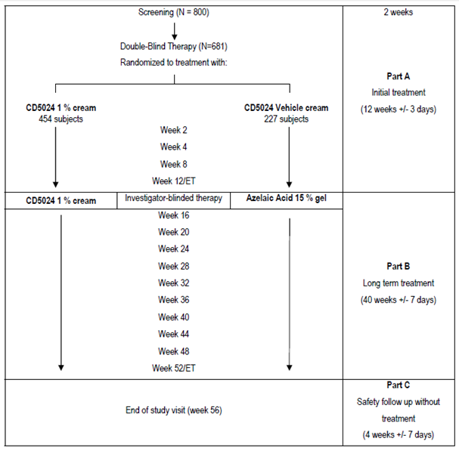

Objectives
The first, 12 week part of the study (part A) assessed the efficacy and safety of ivermectin 1% cream versus vehicle cream in subjects with papulopustular rosacea. This was followed by a second, 40 week extension (part B) comparing the long term safety of ivermectin 1% cream versus azelaic acid 15% gel. The final part of the study (part C) was a 4 week follow up period assessing safety after treatment cessation. Thus, the total study duration was 56 weeks.

Locations
Fifty investigational sites enrolled subjects in this study. These sites were located in the US and Canada. The data derived from these investigational sites were analysed by 37 analysis centres at a total of 50 sites.

Dates
13 December 2011 to 18 July 2013

Inclusion and exclusion criteria
Inclusion criteria. In order to be eligible for the study subjects were required to fulfil all of the following criteria:
- The subject is 18 years of age or older at the Screening Visit (Week -2).
- The subject has PPR with an IGA score of 3 (moderate) or 4 (severe), at both Screening and Baseline visits.
- The subject has at least 15 but not more than 70 inflammatory lesions (papules and pustules) on the face, at both Screening and Baseline visits.
- Females are required to return negative urine pregnancy tests (UPTs) if they are of childbearing potential (including pre-menarche subjects), or be of non childbearing potential, defined as post-menopausal (absence of menstrual bleeding for one year), hysterectomy or bilateral oophorectomy, at both Screening and Baseline visits.
- The subject is willing and able to comply with the requirements of the protocol. In particular, the subject must adhere to the visit schedule, concomitant therapy prohibitions and must be compliant with the treatment.
- The subject has understood and signed an Informed Consent Form at the Screening visit, prior to any investigational procedure. If applicable, the subject must willingly sign the photo consent form.
- The subject is apprised of the Health Insurance Portability and Accountability Act in the US or Personal Information Protection and Electronic Documents Act in Canada and is willing to share personal information and data as verified by signing a written authorization.
Exclusion criteria: subjects who met one or more of the exclusion criteria listed below were deemed potentially ineligible for inclusion in this study. Notably, subjects who failed screening for exclusionary medications were to be granted one opportunity to re-screen.
- The subject has particular forms of rosacea (rosacea conglobata, rosacea fulminans, isolated rhinophyma, isolated pustulosis of the chin) or other facial dermatoses that may be confounded with papulopustular rosacea, such as peri-oral dermatitis, facial keratosis pilaris, seborrheic dermatitis and acne.
- The subject has rosacea with more than two nodules on the face at Screening or Baseline visits.
- The subject has already been enrolled in another investigational study where ivermectin cream was tested as a topical treatment.
- The subject has an underlying known disease or a surgical or medical condition, which in the judgment of the investigator would put the subject at risk (for example uncontrolled chronic or serious diseases which would normally prevent participation in any clinical study, such as a cancer, leukaemia or hematologic dyscrasia) or might confound the study assessments (for example other dermatological diseases) or might interfere with the subject’s study participation (for example planned hospitalization during the study).
- The subject has clinically significant abnormal laboratory values according to the investigator at either Screening visit (Week - 2 or Week- 1).
- The subject has a beard which would interfere with the study treatment and study assessment.
- The subject has known allergies or sensitivities to any components of the formulation of the study products being tested (either ivermectin 1% cream or azelaic acid 15% gel).
- The subject is breast feeding, pregnant, or plans to become pregnant within 13 months of the Baseline visit.
- The subject is currently enrolled in another investigational drug or device study or has participated in such a study in the month prior to Baseline or is in an exclusion period from a previous study.
- The subject has been exposed to excessive UV radiation within 2 weeks prior to the Baseline visit, or the subject is planning exposure during the study (for example occupational exposure to the sun, planned holidays in the sun during the study, phototherapy, tanning salon).
- Use of prohibited medications prior to the study, and an unwillingness to refrain from use during the study (see exclusion criterion 13).
- The subject has a known history of substance abuse (drugs or alcohol).
- The subject has not undergone washout periods of sufficient duration for the treatments shown below, at Baseline (see Table 9)

Table 9. Study RD.06.SRE.18170. Exclusion criteria treatments and required washout periods.
Treatments | Washout required
Topical treatments on the face:
Astringents or abrasives (scrubs, exfoliating cleansers and products containing salicylic acid and alcohol | 2 days
Benzoyl peroxide | 4 weeks
Antibiotics (for example metronidazole or macrolides) | 4 weeks
Anti-rosacea drugs (for example azelaic acid) | 4 weeks
Immunomodulators | 4 weeks
Corticosteroids | 4 weeks
Retinoids | 4 weeks
Systemic treatments:
Antibiotics (for example cyclines, macrolides, metronidazole) | 4 weeks
Corticosteroids | 4 weeks
Oral ivermectin | 4 weeks
Other drugs used for the treatment of rosacea | 4 weeks
Other on the face:
Laser or Intense Pulsed Light (IPL) or light treatment | 6 weeks
Electrocoagulation | 6 weeks
Dermabrasion | 6 weeks
Facial peels | 6 weeks
Any procedure on the face (such as Thermage, etcetera.) | 6 weeks

Study treatments
In Part A of the study, ivermectin 1% cream or vehicle alone cream was self-administered by the patient once daily, at bedtime. The application method was demonstrated to the subject by the site personnel, and verbal and written instructions were provided at the Baseline visit.
In Part B of the study, subjects initially treated with ivermectin 1% cream daily at bedtime were to continue on this treatment. Subjects initially treated with vehicle cream daily at bedtime were to switch to azelaic acid 15% gel BD, in the morning and evening.
The subject was instructed to apply a thin film of study drug on the entire face (even if some areas did not have rosacea). An approximately pea sized amount (that is, about 0.2 g) was to be applied on each of the following facial regions: right and left cheeks, forehead, chin and nose, avoiding contact with the eyes, lips, mouth and mucous membranes.

Efficacy variables and outcomes
The main efficacy variables were:
- IGA score (preferably but not necessarily determined by the same investigator for each given subject at each time point)
- Inflammatory lesion count (preferably but not necessarily determined by the same investigator for each given subject at each time point)
- Subject’s Assessment of Rosacea Improvement (SARI) score.
The primary efficacy outcomes were percentage of subjects with an IGA score of 0 (= ‘Clear’) or 1 (= ‘Almost Clear’) at Week 12 (ITT-LOCF), and absolute change in inflammatory lesion counts. By way of an amendment to the initial planned statistical analysis, ‘time to onset of efficacy analysis’ was changed from being a secondary endpoint to a ‘supplemental analysis of co-primary endpoints at earlier time points’. The secondary efficacy endpoint assessed in the study was percent change in inflammatory lesion counts from Baseline at Week 12 (ITT-LOCF).
All efficacy measurements were collected in Part A. In Part B, only IGA was evaluated.

Efficacy variable data acquisition methodology

IGA score
The investigator evaluated the subject’s rosacea at every study visit, using the scale shown below in Table 10.

Table 10. IGA score derivation.
Grade | Score | Clinical Description
Clear | 0 | No inflammatory lesions present, no erythema
Almost clear | 1 | Very few small papules/pustules, very mild erythema present
Mild | 2 | Few small papules/pustules, mild erythema
Moderate | 3 | Several small or large papules/pustules, moderate erythema
Severe | 4 | Numerous small and/or large papules/pustules, severe erythema

Inflammatory lesion count
The investigator determined the subject’s inflammatory lesion counts at the following sub-set of study visits: Week -2 (Screening visit 1), Week 0 (Baseline), Week 2, Week 4, Week 8 and Week 12.
Inflammatory lesions are defined as follows:
- Papule: A small, solid elevation less than one centimetre in diameter.
- Pustule: A small, circumscribed elevation of the skin, which contains yellow to white exudates.
Papules and pustules were counted, separately, on each of the five following facial regions: forehead, chin, nose, right cheek, left cheek.

Subject’s assessment of rosacea improvement
At Week 12, subjects evaluated their own rosacea score as compared to their rosacea condition at Baseline, according to the scale shown below in Table 11.

Table 11. Subject’s assessment of rosacea improvement (SARI) score derivation
Score | Clinical Description
0 | Excellent improvement
1 | Good improvement
2 | Moderate improvement
3 | No improvement
4 | Worse

Randomisation and blinding methods

Randomisation
Prior to the start of the study, a randomisation list was transmitted to the assigned clinical supplies unit organization for packaging, labelling and shipping;
- (i) ivermectin 1% cream, or
- (ii) vehicle (in Part A) and azelaic acid 15% gel (in Part B)
were allocated at a ratio of 2:1 for treatment (i):treatment (ii).
At the Screening visit, after each patient signed the Informed Consent Form, the designated study personnel entered the Interactive Web Response System (IWRS) and obtained a Subject Identification Number (SIN). Throughout the study, the subject was represented by that SIN in all documentation and discussion.
At the Baseline visit, if the subject was eligible according to the Inclusion/Exclusion criteria, the designated study personnel entered the IWRS to randomise the subject and obtain a kit for Part A of the study. After all of the Week 12 assessments had been completed, the designated study personnel entered the IWRS and obtained the subject’s new kit number for Part B of the study.

Blinding
During Part A (Baseline to Week 12), the study preparations were all packaged in the same type of tubes, and there was no visible difference between the ivermectin 1% cream and the corresponding vehicle alone cream. The randomisation list was maintained secured in a locked cabinet and/or an electronic file, with access restricted to the designated personnel directly responsible for labelling and handling the study preparations. The independent statistician providing analyses requested by the IDMC was permitted access to the randomisation list. During Part B of the study, the study materials (study drug and comparator product) differed in appearance, dosage form and regimen. All products were dispensed by designated trained study personnel independent from the investigator/evaluator that assessed the subject. The study personnel dispensing the study drug instructed each subject not to discuss the appearance of the study drug or the dose regimen with the investigator.

Analysis populations
The study populations analysed were an ITT population, a PP population and a safety population. All efficacy measurements were collected in Part A. In Part B, only IGA was evaluated.

ITT population
The ITT population consisted of all subjects who were randomised and to whom the study materials were dispensed. This was the primary population used to assess efficacy; all primary efficacy variables and secondary efficacy variables were analysed based on the ITT population.

PP population
The PP population was defined as the ITT population, after exclusion of subjects deemed non evaluable for efficacy due to major deviations from the protocol. Major deviations were categorised into four categories:
- Entrance criteria deviations
- Noncompliance
- Concomitant therapies taken during the study, potentially interfering with efficacy
- Administrative errors such as un-blinding or medication dispensing errors.
The primary efficacy analysis was repeated based on the PP population, to confirm the results of the analysis of the ITT population.

Safety population
The safety population is defined as the ITT population who applied the study drug at least once. In practice, only the subjects who returned their study drug unopened were excluded from the safety population.

Sample size
To maximize the exposure to (ivermectin) 1% cream for safety reasons, a randomization ratio of 2:1 is chosen for active and vehicle respectively. A sample size of 681 randomised subjects with 454 subjects in the active group and 227 subjects in the vehicle group ensure a 92% power to detect a statistically significant difference between (ivermectin) and Vehicle on Success Rate, using a two-sided test at 0.050 alpha levels with adjustment for 15% of subjects being excluded from the Per Protocol analysis. This sample size of 681 subjects is sufficient to ensure an at least 99% power to detect a statistically significant difference in the changes in Inflammatory Lesion Counts.

Statistical methods

Primary efficacy analyses
The co-primary efficacy endpoints were Success Rate (defined as the percentage of subjects with ‘0 = Clear’ or ‘1 = Almost Clear’ on the IGA) and absolute change in inflammatory lesion counts from Baseline to Week 12 (ITT-LOCF), of which missing Week 12 data in the ITT population were imputed by the last observation carried forward (LOCF) approach. The primary analyses were comparisons between ivermectin and Vehicle-alone for the co-primary endpoints, Success Rate and absolute change in inflammatory lesion count at Week 12 (ITT-LOCF).
By way of an amendment to the initial planned statistical analysis, ‘Time to onset of efficacy analysis’ was changed from being a secondary endpoint to a ‘supplemental analysis of co-primary endpoints at earlier time points’.
Success Rates were analysed by the CMH test stratified by analysis site. Changes in Inflammatory Lesion Counts were analysed by ANCOVA including Baseline inflammatory lesion count as a covariate, and treatment and analysis centre as factors. Both analyses at Week 12 (ITT-LOCF) were required to be significant at the 0.050 level for the study to be deemed positive with regard to efficacy.

Supportive efficacy analyses
Similar analysis for Success Rate and absolute change in Inflammatory Lesion Counts from Baseline at Week 12 (PP-LOCF) were conducted as supportive analyses. To assess the robustness of the primary efficacy results, the following sensitivity analyses were also conducted:
- The ITT analysis of Success Rate assigning ‘failure’ to the missing IGA data at Week 12.
- The ITT analysis of Success Rate assigning ‘success’ to the missing IGA data at Week 12.
- The ITT analysis assigning ‘median change from failure in each treatment group’ to the missing absolute change in Inflammatory Lesion at Week 12 in the corresponding treatment group.
- The ITT analysis assigning ‘median change from success in each treatment group’ to the missing absolute change in Inflammatory Lesion at Week 12 in the corresponding treatment group.

Patient disposition
A total of 875 subjects was screened in the US and Canada, of whom 683 subjects were randomised. The patient disposition is displayed in Figure 2.
Figure 2. Study RD.06.SRE.18170: Patient disposition.
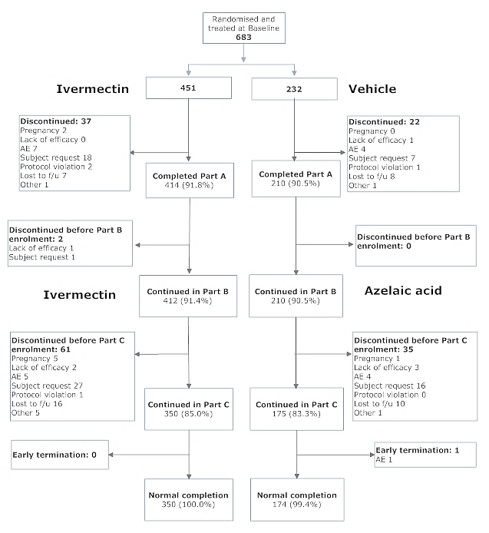

Major protocol violations/deviations

Subject deviations
A total of 77 subjects (11.3%) had protocol deviations that were classified as major at the Blind Review Meeting: 49 subjects (10.9%) in the ivermectin 1% Cream daily group and 28 subjects (12.1%) in the Vehicle Cream daily group.
The frequencies of the different types of protocol deviations resulting in exclusion from the PP population in Part A of the study are shown below in Table 12.

Table 12. The frequencies of the different types of protocol deviations resulting in exclusion from the PP population in Part A of Study RD.06.SRE.18170.
Major Protocol Deviations | Ivermectin 1% Cream daily (Part A and Part B) (n = 451) | Vehicle Cream daily/  Azelaic Acid 15% Gel BD (Part A/Part B) (n = 232) | Total  (N = 683)
Number of subjects with major protocol deviations, n (%) | 49 (10.9) | 28 (12.1) | 77 (11.3)
Administrative error | 3 (0.7) | 2 (0.9) | 5 (0.7)
Non-compliance ª | 31 (6.9) | 20 (8.6) | 51 (7.5)
Entrance criteria deviation | 2 (0.4) | 0 (0.0) | 2 (0.3)
Prohibited medication | 16 (3.5) | 7 (3.0) | 23 (3.4)
ª Non-compliance, refers to insufficient number of applications or to non-compliance with the protocol.
A subject was counted once even if the subject had more than one major protocol deviation.

Deviations from the planned analyses
As noted above, by way of an amendment to the initial planned statistical analysis, ‘Time to onset of efficacy analysis’ was changed from being a secondary endpoint to a ‘supplemental analysis of co-primary endpoints at earlier time points’.

Baseline data
Demographic and Baseline disease characteristics were similar between treatment groups. The majority of subjects were female (68.2%) and White (96.2%). The mean overall age was 50.4 years. Hispanic/Latino subjects comprised 11.4% of all enrolled subjects, and most subjects (77.3%) had a skin phototype of II or III. All subjects presented with a Baseline IGA score of 3 (moderate) or 4 (severe) and most subjects (560 subjects, 82.0%) had a Baseline IGA score of 3. The overall mean inflammatory lesion count was 30.9 ± 14.33 lesions at Baseline.

Demographic data
Summary of subject demographics at Baseline (ITT Population) is shown in Table 13.

Table 13. Study RD.06.SRE.18170. Subject demographics at Baseline (ITT Population).
Variable | Ivermectin 1% Cream daily (Parts A and B) (n = 451) | Vehicle Cream daily/ Azelaic Acid 15% Gel BD (Part A/Part B) (n = 232) | Total  (N = 683)
Gender n (%)
Male | 137 (30.4) | 80 (34.5) | 217 (31.8)
Female | 314 (69.6) | 152 (65.5) | 466 (68.2)
Total | 451 (100.0) | 232 (100.0) | 683 (100)
Age (years)
Mean | 49.9 | 51.6 | 50.4
SD | 12.2 | 11.9 | 12.1
Median | 49.0 | 52.0 | 50.0
P25, P75 | 42, 58 | 43, 60 | 42, 59
Min, Max | 19, 88 | 26, 86 | 19, 88
18–64, n (%) | 402 (89.1) | 200 (86.2) | 602 (88.1)
65 and above, n (%) | 49 (10.9) | 32 (13.8) | 81 (11.9)
Total (%) | 451 (100.0) | 232 (100.0) | 683 (100)
Race n (%)
White | 437 (96.9) | 220 (94.8) | 657 (96.2)
Black or African American | 6 (1.3) | 3 (1.3) | 9 (1.3)
Asian | 3 (0.7) | 3 (1.3) | 6 (0.9)
Other | 5 (1.1) | 6 (2.6) | 11 (1.6)
Total | 451 (100.0) | 232 (100.0) | 683 (100)
Ethnicity, n (%)
Hispanic/ Latino | 55 (12.2) | 23 (9.9) | 78 (11.4)
Not Hispanic/ Latino | 396 (87.8) | 209 (90.1) | 605 (88.6)
Total | 451 (100.0) | 232 (100.0) | 683 (100)
Skin Phototype n (%)
I | 39 (8.6) | 16 (6.9) | 55 (8.1)
II | 185 (41.0) | 90 (38.8) | 275 (40.3)
III | 167 (37.0) | 86 (37.1) | 253 (37.0)
IV | 51 (11.3) | 26 (11.2) | 77 (11.3)
V | 8 (1.8) | 11 (4.7) | 19 (2.8)
VI | 1 (0.2) | 3 (1.3) | 4 (0.6)
Total | 451 (100.0) | 232 (100.0) | 683 (100)

Results for the primary efficacy outcome
The statistically significant and clinically meaningful superiority of ivermectin 1% Cream daily versus its vehicle at Week 12 was demonstrated in the ITT Population with respect to the two co-primary endpoints, Success Rate based on IGA and Absolute Change in Inflammatory Lesions Counts from Baseline. Statistical superiority of ivermectin 1% Cream daily versus its vehicle at Week 12 in the ITT Population for both co-primary endpoints was also confirmed in the PP Population and in all sensitivity analyses.

IGA
Success Rate based on IGA was 38.4% for ivermectin 1% Cream daily and 11.6% for Vehicle Cream daily at Week 12 (ITT-LOCF), a statistically significant difference (p < 0.001). In addition to the LOCF method, the MI method was used to impute missing data for Success Rate in the ITT Population at Week 12 and at intermediate visits up to end of treatment in Part A. In this analysis, at Week 12 the Success Rate for ivermectin 1% Cream daily was also statistically significantly superior to the vehicle alone in the ITT-MI population (p < 0.001).
Sensitivity Analysis 1 (missing data imputed as failures) and Sensitivity Analysis 2 (missing data imputed as successes) were performed on the ITT Population at Week 12. Success rates in the ITT population wherein missing data were imputed as ‘failures’ were similar to those obtained by LOCF at Week 12. The Success rates obtained when missing data were imputed as ‘successes’ were also similar to those obtained by LOCF at Week 12; however, the Success Rates for subjects in the both treatment groups were higher than those obtained by LOCF at Week 12. Overall, statistically significant differences (p < 0.001) between the ivermectin 1% Cream daily group and the Vehicle Cream daily group in the ITT population were observed using both Sensitivity Analyses 1 and 2, thus supporting the data obtained using LOCF and MI methods.

Inflammatory lesion count
At Week 12 (ITT-LOCF), the mean (± SD) Absolute Change in Inflammatory Lesion Counts from Baseline was - 20.5 ± 15.95 in subjects treated with ivermectin 1% Cream daily versus - 12.0 ± 13.55 in subjects treated with Vehicle Cream daily, and the difference was statistically significantly in favour of ivermectin 1% Cream daily (p < 0.001). Results using the LOCF method of imputation were confirmed using the MI method on the ITT Population. The treatment effect at Week 12 (ITT-LOCF) (that is, mean difference adjusted for analysis centre and for Baseline lesion count) was - 8.13 lesions with p < 0.001 and 95% CI of (- 10.12, - 6.13) in favour of ivermectin 1% Cream daily over Vehicle Cream daily.

Results for other efficacy outcomes
The time to onset of efficacy, defined as the earliest time point at which a statistically significant difference between treatment groups was seen for both primary endpoints and was sustained until Week 12, was observed beginning at Week 4 (p < 0.001 at Week 4 (ITT-LOCF) for Absolute Change in Inflammatory Lesion Counts and p = 0.021 at Week 4 (ITT-LOCF) for Success Rate). This statistically significant time to onset of efficacy favouring ivermectin 1% Cream daily over Vehicle Cream daily was clinically meaningful, as it was the first evaluated time point when statistically significant efficacy was consistently observed for both co-primary endpoints. At Week 12 (ITT-LOCF), the median Percent Change in Inflammatory Lesions from Baseline was statistically significantly in favour of ivermectin 1% Cream daily (- 76%) over its vehicle (- 50%) (p < 0.001). Furthermore, this statistically significant difference favouring ivermectin 1% Cream daily was observed as early as Week 2 (p < 0.001) and continued until Week 12. Results in the ITT Population were confirmed in the PP Population.

SARI score
The SARI was performed at Week 12. For the ITT population, in the Soolantra group, 149 subjects (34.3%) reported excellent improvement and 151 subjects (34.7%) reported good improvement in their rosacea with use of the study drug. In the Vehicle group, 21 subjects (9.5%) reported excellent improvement and 64 subjects (29.1%) reported good improvement in their rosacea with use of the study drug. There was a statistically significant difference (p < 0.001) favouring Soolantra over its vehicle. Results in the ITT Population were confirmed in the PP Population.

Study RD.06.SRE.18171

Study design, objectives, locations and dates

Design, Objectives
As for RD.06.SRE.18170.

Locations
Fifty investigational sites enrolled subjects in this study. These sites were located in the US and Canada. The data derived from these investigational sites were analysed by 35 analysis centres, as follows: Analysis centres 1 to 17; data from 17 US sites, analysis centres 18 to 28; data from 23 US sites, Analysis centres 29 to 35; data from 10 Canadian sites. Total = 50 sites.

Dates
20 December 2011 to 1 August 2013.

Inclusion and exclusion criteria
As for RD.06.SRE.18170.

Study treatments
As for RD.06.SRE.18170.

Efficacy variables and outcomes
As for RD.06.SRE.18170.

Randomisation and blinding methods
As for RD.06.SRE.18170.

Analysis populations
As for RD.06.SRE.18170.

Sample size
As for RD.06.SRE.18170.

Statistical methods
As for RD.06.SRE.18170.

Patient disposition
Patient disposition is shown in Figure 3.
Figure 3. Study RD.06.SRE.18171: Patient disposition.
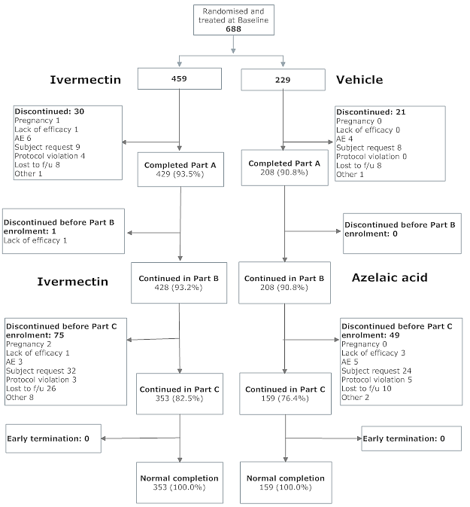

Major protocol violations/deviations

Subject deviations
A total of 92 subjects (13.4%) had protocol deviations that were classified as major at the Blind Review Meeting: 61 (13.3%) in the ivermectin 1% Cream daily group and 31 (13.5%) in the Vehicle Cream daily group. The frequencies of the different types of protocol deviations resulting in exclusion from the PP population in Part A of the study are shown in Table 14.

Table 14. Study RD.06.SRE.18171. The frequencies of the different types of protocol deviations resulting in exclusion from the PP population in Part A.
Major Protocol Deviations | Ivermectin 1% Cream daily (Parts A and B) (n = 459) | Vehicle Cream daily/ Azelaic Acid 15% Gel BD (Part A/Part B) (n = 229) | Total (N = 688)
Number of subjects with major protocol deviations, n (%) | 63 (13.3) | 31 (13.5) | 92 (13.4)
Administrative error | 11 (2.4) | 5 (2.2) | 16 (2.3)
Non-compliance ª | 27 (5.9) | 21 (9.2) | 48 (7.0)
Entrance criteria deviation | 3 (0.7) | 1 (0.4) | 4 (0.6)
Prohibited medication | 22 (4.8) | 5 (2.2) | 27 (3.9)
ª Non-compliance refers to insufficient number of applications or to non-compliance with the protocol. A subject was counted once even if the subject had more than one major protocol deviation.

Deviations from the planned analyses
As noted above, by way of an amendment to the initial planned statistical analysis, ‘Time to onset of efficacy analysis’ was changed from being a secondary endpoint to a ‘supplemental analysis of co-primary endpoints at earlier time points’.

Baseline data
Demographic and Baseline disease characteristics were similar between treatment groups. In the ITT Population, the majority of subjects were female (66.7%) and White (95.3%), and the mean age was 50.2 years (range: 18 to 89 years). Most subjects were of skin phototypes II or III (skin phototype II: 307 subjects, 44.6%; skin phototype III: 210 subjects, 30.5%) and proportions were similar between the treatment groups. Overall, 12.6% of subjects were Hispanic/Latino in ethnicity. There was no significant difference between the treatment groups with respect to gender, age, race, ethnicity or skin phototype. All subjects presented with a Baseline IGA score of 3 (moderate) or 4 (severe), and most (522 subjects, 75.9%) had an IGA score of 3 at Baseline. Overall, at Baseline, the mean inflammatory lesion count was 32.9, with a range of 14 to 70 lesions. Baseline papule and pustule counts were similar across the treatment groups.
Summary of subject demographics at Baseline (ITT Population) is shown in Table 15.

Table 15. Study RD.06.SRE.18171. Summary of subject demographics at Baseline (ITT Population).
Variable | Ivermectin 1% Cream daily (Part A and Part B) (n = 459) | Vehicle Cream daily/ Azelaic Acid 15% Gel BD (Part A/Part B) (n = 229) | Total (N = 688)
Gender n (%)
Male | 145 (31.6) | 84 (36.7) | 229 (33.3)
Female | 314 (68.4) | 145 (63.3) | 459 (66.7)
Total | 459 (100) | 229 (100) | 688 (100)
Age (years)
Mean | 50.5 | 49.5 | 50.2
SD | 12.35 | 12.16 | 12.29
Median | 50.0 | 50.0 | 50.0
P25, P75 | 42, 60 | 40, 57 | 41, 59
Min, Max | 21, 89 | 18, 81 | 18, 89
18–64, n (%) | 399 (86.9) | 200 (87.3) | 599 (87.1)
65 and above, n (%) | 60 (13.1) | 29 (12.7) | 89 (12.9)
Total (%) | 459 (100) | 229 (100) | 688 (100)
Race n (%)
White | 438 (95.4) | 218 (95.2) | 656 (95.3)
Black or African American | 6 (1.3) | 4 (1.7) | 10 (1.5)
Asian | 10 (2.2) | 5 (2.2) | 15 (2.2)
Other | 5 (1.1) | 2 (0.9) | 7 (1.0)
Total | 459 (100) | 229 (100) | 688 (100)
Ethnicity n (%)
Hispanic/ Latino | 56 (12.2) | 31 (13.5) | 87 (12.6)
Not Hispanic/ Latino | 403 (87.8) | 198 (86.5) | 601 (87.4)
Total | 459 (100) | 229 (100) | 688 (100)
Skin Phototype n (%)
I | 48 (10.5) | 22 (9.6) | 70 (10.2)
II | 211 (46.0) | 96 (41.9) | 307 (44.6)
III | 139 (30.3) | 71 (31.0) | 210 (30.5)
IV | 50 (10.9) | 31 (13.5) | 81 (11.8)
V | 11 (2.4) | 7 (3.1) | 18 (2.6)
VI | 0 | 2 (0.9) | 2 (0.3)
Total | 459 (100) | 229 (100) | 688 (100)

Results for the primary efficacy outcome
The statistically significant superiority of ivermectin 1% Cream QD versus its vehicle at Week 12 was demonstrated in the ITT Population with respect to the two co-primary endpoints, Success Rate based on IGA and Absolute Change in Inflammatory Lesions Counts from Baseline. Statistical superiority of ivermectin 1% Cream daily versus its vehicle at Week 12 in the ITT Population for both co-primary endpoints was also confirmed in the PP Population and in all sensitivity analyses.

IGA
Success rates, where success was defined as achieving a ‘clear’ (IGA = 0) or ‘almost clear’ (IGA = 1) outcome at Week 12 (ITT-LOCF), were 40.1% for the ivermectin 1% Cream daily group and 18.8% for the Vehicle Cream daily group. The difference between the two treatment groups was statistically significant at Week 12 (ITT-LOCF; p < 0.001). This statistical significance favouring the ivermectin 1% Cream daily group was confirmed in the PP Population. The treatment effect at Week 12 (ITT-LOCF) was 21.3% in favour of ivermectin 1% Cream daily over Vehicle Cream daily. Statistical analysis of the ITT Population using the MI method of imputation confirmed the superiority of ivermectin 1% Cream daily observed with the LOCF method. Sensitivity analyses performed on the ITT Population also confirmed the robustness of the conclusions of superiority of ivermectin 1% Cream daily over Vehicle Cream daily.

Inflammatory lesion count
Both active and vehicle treatment groups had reduced inflammatory lesion counts compared to Baseline at each post Baseline time point up to the end of Part A. At Week 12 (ITT-LOCF), the mean (± SD) Absolute Change in Inflammatory Lesion Counts from Baseline was - 22.2 ± 14.87 for the ivermectin 1% Cream daily group and - 13.4 ± 14.48 for the Vehicle Cream daily group. The difference between the two treatment groups was clinically relevant and statistically significant at Week 12 (ITT-LOCF; p < 0.001). This statistical significance favouring the ivermectin 1% Cream daily group was confirmed in the PP Population. The treatment effect at Week 12 (ITT-LOCF) (that is mean difference adjusted for analysis centre and for Baseline lesion count) was - 8.22 lesions with p < 0.001 and a 95% CI of (- 10.18, - 6.25) in favour of ivermectin 1% Cream daily over Vehicle Cream daily. Statistical analysis of the ITT Population using the MI method of imputation confirmed the superiority of ivermectin 1% Cream daily observed with the LOCF method. Sensitivity analyses performed on the ITT Population also confirmed the robustness of the conclusions of superiority of ivermectin 1% Cream daily over Vehicle Cream daily.

Results for other efficacy outcomes
Based upon satisfying the two co-primary endpoints, an analysis was conducted to determine time to onset of efficacy. A statistically significant difference in both efficacy endpoints was seen as early as Week 4, and was sustained through to Week 12 (ITT-LOCF). Results in the ITT Population were confirmed in the PP Population. Results using the MI method of imputation also confirmed those results obtained using the LOCF method.

SARI score
The SARI was performed at Week 12. For the ITT Population, in the Soolantra group, 143 subjects (32.0%) reported excellent improvement and 153 subjects (34.2%) reported good improvement in their rosacea with use of the study drug. In the Vehicle group, 16 subjects (7.3%) reported excellent improvement and 59 subjects (27.1%) reported good improvement in their rosacea with use of the study drug. There was a statistically significant difference (p < 0.001) favouring Soolantra over its vehicle. Results in the ITT Population were confirmed in the PP Population.

Other efficacy studies

Study RD.03.SRE.40006
This was a preliminary efficacy and safety study of ivermectin 1% cream (formulation proposed for registration). Design was multicentre, randomised, investigator blinded, parallel group with 3 arms: active cream, vehicle, and Rozex, applied BD for 9 weeks in patients with PPR. Study was conducted at 10 locations (6 France, 3 Germany, 1 Iceland), 2 September to 20 December 2004. Entry criteria: Patients ≥ 18 years, diagnosed mild to moderate PPR, with 8 to 50 inflammatory facial lesion (papules and pustules) and ≤ 2 nodules. Baseline characteristics are shown in Table 16.

Table 16. Study RD.03.SRE.40006. Baseline characteristics.
Characteristic | Ivermectin | Metronidazole | Vehicle
Number (Sex) | 49 (16M, 33F) | 48 (15M, 33F) | 50 (15M, 35F)
Skin phototype
I | 1 | 2 | 4
II | 28 | 22 | 24
III | 19 | 22 | 20
IV | 1 | 2 | 2
Race | All Caucasian | All Caucasian | All Caucasian
Age, years: mean (SD) | 48.8 (10) | 49.7 (13) | 50 (12)
No. of papules (SD) | 17.0 (10) | 14.4 (8) | 12.5 (7)
No. of pustules (SD) | 2.4 (3) | 3.5 (4) | 3.7 (5)
IGA severity grade
2 | 33 | 32 | 33
3 | 15 | 16 | 17
4 | 1
The ITT population numbered 147. Of these, 93.2% continued treatment ≥ 50 days (ivermectin 89.8%, metronidazole 97.9%, vehicle 92%). Percent reductions from baseline in inflammatory lesion counts at endpoint (Week 9, ITT, LOCF), and Week 9 (Per protocol) are presented in Table 17.

Table 17. Study RD.03.SRE.40006. Percent reductions from baseline in inflammatory lesion counts at endpoint (Week 9, ITT, LOCF), and Week 9 (Per protocol).
Measurement | Ivermectin | Metronidazole | Vehicle
Week 9, LOCF (ITT)
Number | 49 | 48 | 50
Mean % reduction (SD) | 57.0 (46) | 47.1 (53) | 41.9 (53)
Week 9, (Per protocol)
Number | 41 | 45 | 42
Mean % reduction (SD) | 64.8 (39) | 48.3 (52) | 46.1 (49)
The differences between ivermectin and vehicle, and between ivermectin and metronidazole, did not reach statistical significance, for either the ITT or the per protocol set.

Study RD.03.SRE.40027
Efficacy in this dose finding study is discussed in Section 6.1.1.

Study RD.03.SRE.40037
This was a treatment free extension of Study RD.03.SRE.40027. Its objective was to evaluate relapses in patients successfully treated in Study RD.03.SPR.40027. Design was multicentre, randomised, investigator blinded, conducted over a 6 month observation period. Subjects were enrolled at 25 locations (25 Australia, 29 the Czech Republic, 22 Germany, 46 Hungary, and 22 the Russian Federation). Entry criterion: Patients successfully treated in Study RD.03.SRE.40027; IGA score 0 or 1 (that is, ‘clear’ or ‘almost clear’) on completing participation in that study.
Of the 296 subjects enrolled in Study RD.03.SRE.40027, 273 completed (271 per protocol), and 192 were eligible for Study RD.03.SRE.40037. Of these, 149 subjects were enrolled, of whom 101 completed. Study dates were: 13 October 2006 to 19 November 2007. The baseline characteristics are shown in Table 18.

Table 18. Study RD.03.SRE.40037 Baseline characteristics.
Characteristic | Ivermectin |  |  |  | Metro | Veh
Characteristic | 0.1% daily | 0.3% daily | 1% daily | 1% BD | 0.75% BD | daily
Number | 28 | 27 | 31 | 26 | 20 | 17
Sex | 9M 19F | 8M 19F | 10M 21F | 6M 20F | 7M 13F | 3M 14F
Skin phototype
I | 3 | 5 | 3 | 4 | 0 | 1
II | 12 | 11 | 16 | 15 | 14 | 10
III | 11 | 10 | 9 | 6 | 5 | 6
IV | 2 | 1 | 3 | 1 | 1 | 0
Race
Caucasian | 28 | 27 | 31 | 26 | 20 | 17
Other | 0 | 0 | 0 | 0 | 0 | 0
Age, years: mean (SD) | 53.6 (15) | 53.2 (15) | 51.3 (15) | 50.5 (10) | 54.7 (16) | 55.2 (11)
No. inflammatory lesions (SD) | 4.7 (4.5) | 3.8 (4.1) | 4.6 (5.5) | 4.7 (5.2) | 4.4 (4.3) | 3.3 (2.8)
IGA†: score (% subjects)
0 | 3 (10.7) | 11 (40.7) | 10 (32.3) | 6 (23.1) | 5 (25.0) | 4 (23.5)
1 | 25 (89.3) | 16 (59.3) | 21 (67.7) | 20 (76.9) | 15 (75.0) | 13 (76.5)
† 0 = Clear. No inflammatory lesions present. 1 = Almost clear. Very few small papules/pustules.
The main efficacy endpoints stipulated on the Protocol were (1) Time to relapse, and (2) Relapse rate, according to any of the following definitions of relapse:
- Definition 1: an IGA score equal ≥ 2.
- Definition 2: a 2 point difference in the IGA score compared to baseline.
- Definition 3: failure to maintain at least 50% of the improvement achieved at the end of the initial study RD.03.SPR40027 (improvement being defined as the difference between baseline and Week 12 total inflammatory lesion count).
For subjects who discontinued the study prematurely without relapse, two analysis conventions were adopted:
- Convention Analysis 1: subjects were considered as censored the day of last evaluation
- Convention Analysis 2: subjects were considered as relapse 30 days after the day of last evaluation (sensitivity analysis).
For both conventions, subjects who completed the study or who had not relapsed were considered as censored. Numbers of subjects (%) who discontinued prematurely are given in Table 19 below, with reasons.

Table 19. Study RD.03.SRE.40037. Numbers of subjects (%) who discontinued prematurely.
 |  |  | Ivermectin |  |  |  | Metro | Veh
 |  |  | 0.1% daily | 0.3% daily | 1% daily | 1% BD | 0.75% BD | daily
 | No. enrolled |  | 28 | 27 | 31 | 26 | 20 | 17
 | No. completed |  | 18 (64.3) | 18 (66.7) | 21 (67.7) | 21 (80.8) | 12 (60.0) | 11 (64.7)
Days  29-56 | Premature discontinuation | All | 1 (3.6) | 2 (7.4) | 2 (6.5) |  | 3 (15.0) | 1 (5.9)
Days  29-56 | Premature discontinuation | Other |  | 1 (3.7)
Days  29-56 | Premature discontinuation | Protocol violation |  |  |  |  | 1 (5.0)
Days  29-56 | Premature discontinuation | Subject request | 1 (3.6) | 1 (3.7) | 2 (6.5) |  | 2 (10.0) | 1 (5.9)
Days  57-84 | Premature  discontinuation | All | 3 (10.7) | 1 (3.7) | 3 (9.7) | 1 (3.8) | 3 (15.0) | 2 (11.8)
Days  57-84 | Premature  discontinuation | Other | 2 (7.1) |  |  |  | 2 (10.0) | 1 (5.9)
Days  57-84 | Premature  discontinuation | Subject request | 1 (3.6) |  | 3 (9.7) | 1 (3.8) | 1 (5.0) | 1 (5.9)
Days  85-112 | Premature discontinuation | All | 4 (14.3) | 3 (11.1) | 3 (9.7) | 2 (7.7) | 2 (10.0) | 3 (17.6)
Days  85-112 | Premature discontinuation | Other |  |  | 2 (6.5) | 1 (3.8)
Days  85-112 | Premature discontinuation | Subject request | 4 (14.3) | 3 (11.1) | 1 (3.2) | 1 (3.8) | 2 (10.0) | 3 (17.6)
Days 113-140 | Premature discontinuation | All |  | 2 (7.4) |  | 2 (7.7)
Days 113-140 | Premature discontinuation | Subject request |  | 2 (7.4) |  | 2 (7.7)
Days  ≥ 141 | Premature discontinuation | All | 2 (7.1) | 1 (3.7) | 2 (6.5)
Days  ≥ 141 | Premature discontinuation | Other |  | 1 (3.7) | 2 (6.5)
Days  ≥ 141 | Premature discontinuation | Subject request | 2 (7.1)

Results
With Definition 1 and Convention 1, 36 (24.8%) subjects had relapsed by Day 84 whatever the treatment in study RD.03.SRE.40027; this number increased to 53 (37.9%) subjects by Day 168. In other words, > 75% of patients remained ‘clear’ and ‘almost clear’ three months after an initial successful treatment and > 60% remained so even six months after the initial treatment was stopped. Using the other definitions of relapse, relapse free periods are even higher.
With Definition 1 of relapse (IGA ≥ 2) on Convention Analysis 1, until Day 84, relapse free rates with ivermectin 0.3% daily, ivermectin 1% daily and ivermectin 1% BD were higher compared to that observed with the ivermectin 0.1% daily, metronidazole 0.75% BD and vehicle. The authors of the CSR argue that these results suggest that subjects previously treated with ivermectin 0.3% daily, 1% daily or BD tended to a delayed onset of relapse compared to subjects treated with ivermectin 0.1%, vehicle or metronidazole 0.75% BD. However, these results were not confirmed by Definition 2 and 3 and none of the analyses was statistically significant.
With Definition 1 of relapse, Convention analysis 2 provided a ranking of the six groups similar to that obtained with Convention 1. Therefore, drop outs had little influence on the results; on the contrary, the ranking was not consistent between Conventions for both Definitions 2 and 3. The authors of the CSR suggest that this can be explained by the more demanding criterion of relapse with these 2 definitions, many drop outs occurring before the criterion can even be observed. Also, the observation that the ranking was similar across definitions when convention 2 was used can be explained by the fact that drop outs are all considered relapses with the 3 definitions, thereby tending to equalize the results whatever the definition.

Study RD.03.SRE.40106
The primary safety objective of this Phase II study was to investigate a potential effect of ivermectin 1% Cream on the induction of neutropenia in subjects with PPR in comparison to its vehicle. Co-primary efficacy objectives were to assess the product in terms of
- Investigator Global Assessment score from Baseline, and
- Absolute change in inflammatory lesion count from Baseline.
The protocol stipulated:
- Success Rate based on IGA score will be defined as the percentage of subjects who achieve at least a 2-grade improvement, from Baseline to each visit
- Change in absolute change in inflammatory lesion counts from Baseline to each visit.
The primary time point for analysis is Week 12 (ITT-LOCF). To claim efficacy of (ivermectin) in this trial, both endpoints will need to show significance versus vehicle.
The rationale for the study was the early termination of the long term safety study of ivermectin cream (Study RD.03.SRE.40051) in January 2009 due to the occurrence of 3 unexpected mild to moderate cases of low neutrophil cell counts whose causal relationship with the drug could not be established or disproved.
Design was multicentre, randomised, double-blind, vehicle-controlled, parallel group. There were 2 treatment arms: ivermectin 1% cream (formulation proposed for registration), or vehicle. Each patient was treated once daily in the evening, approximately 1 ‘pea-size’ dose of product (that is, about 0.2 g) being administered to each of 5 facial regions. Duration of treatment was 12 weeks. Study was conducted at 24 locations in France, Germany, Czech Republic, Hungary, Finland and Slovakia, 28 September 2010 to 2 May 2011.

Entry criteria
Patients ≥ 18 years old, diagnosed PPR and presenting with ≥ 15 inflammatory lesions and an IGA score of 3 (moderate) or 4 (severe) on a 5 point scale. Subjects with ocular rosacea requiring systemic or an interfering treatment, subjects with underlying diseases putting them at risk, or subjects with clinically significant neutrophil cell count abnormalities, were excluded.

Routine safety monitoring
Routine safety monitoring included:
- neutrophil count every 2 weeks during the month prior to Baseline, every 2 weeks during the 12 week treatment period, and one month after study treatment discontinuation
- clinical chemistry assessed at Screening and at Baseline, then every 4 weeks; and
- AE inquiry at every visit, with neutropenia recorded as an AE of special interest.

Baseline characteristics
Baseline characteristics are shown in Table 20.

Table 20. Study RD.03.SRE.40106 Baseline characteristics.
Characteristic | Ivermectin | Vehicle
Number (Sex) | 104 (34M, 70F) | 106 (32M, 74F)
Race
Caucasian | 104 | 105
Asian | 0 | 1
Age, years: mean (SD) | 55.4 (13) | 55.4 (12)
No. of papules (SD) | 26.4 (14) | 30.0 (25)
No. of pustules (SD) | 8.9 (9) | 10.0 (10)
No. of inflammatory lesions: Mean (SD) | 35.2 (17) | 40.0 (28)
IGA severity grade†
3 | 84 | 85
4 | 20 | 21
† Investigator assessment: 0 Clear; 1 Almost clear; 2 Mild; 3 Moderate; 4 Severe
Median number of days treated was 85 and 84 in the ivermectin and vehicle groups, respectively.

Primary efficacy outcomes
Percentage of subjects who achieved at least a 2 grade improvement, from Baseline to Week 12 is shown in Table 21.

Table 21. Study RD.03.SRE.40106. Percentage of subjects who achieved at least a 2 grade improvement, from Baseline to Week 12.
Measurement | Ivermectin | Vehicle | p-value
Week 12, (ITT-LOCF)
Number | 104 | 106
Success | 55 (55.8%) | 36 (34.0%) | 0.002
Failure | 46 (44.2%) | 70 (66.0%)
Change in absolute change in inflammatory lesion counts from Baseline to Week 12 is shown in Table 22.

Table 22. Study RD.03.SRE.40106. Change in absolute change in inflammatory lesion counts from Baseline to Week 12.
Measurement | Ivermectin | Vehicle | p-value†
Week 12, (ITT-LOCF)
Number | 104 | 106
Mean reduction from Baseline (SD) | 26.6 (16) | 22.8 (18) | 0.001
† Based on ANCOVA including treatments and pseudo-centre as factors and Baseline as covariate.
Thus, the planned criteria for efficacy were met.

Study RD.03.SRE.40173
The objective of this study was to evaluate the efficacy and safety of once daily application of ivermectin 1% cream versus twice daily application of metronidazole 0.75% cream (Rozex) in subjects with papulo pustular rosacea, for 16 weeks with a 36 week extension period. The report submitted is complete for the first 16 weeks of the study (‘Period A’), and provides preliminary data on the extension (‘Period B’) up to the cut-off date of 8 April 2013.
Design was multicentre, active controlled, randomised, investigator blinded, parallel group. It was conducted at 64 locations in France, Germany, UK, Russia, Bulgaria, Czech Republic, Romania, Poland, Hungary and Ukraine, 6 April 2012 to 8 April 2013 (Period A). At each treatment application, approximately one small pea size amount of product was applied per facial region (right and left cheeks, forehead, chin and nose), either once daily in the evening (ivermectin) or twice daily (metronidazole). Treatment was to be continued irrespective of the IGA score until Week 16 visit. At the Week 16 visit, if the subjects had an IGA at ‘0’ or ‘1’, they were eligible for Period B; otherwise they were not eligible. In Period B, study drug was not given, but patients were monitored for relapse.
Entry criteria: Patients ≥ 18 years diagnosed PPR and presenting with 15 to 70 inflammatory lesions on the face (papules and pustules).

Baseline characteristics
The baseline characteristics are shown in Table 23.

Table 23 Study RD.03.SRE.40173. Baseline characteristics.
Characteristic | Ivermectin | Metronidazole
Number (Sex) | 478 (167M, 311F) | 484 (168M, 316F)
Race
"White" | 475 | 484
"Asian" | 3
Age, years: mean (SD) | 51.2 (13) | 51.9 (13)
Skin phototype
I | 18 | 17
II | 245 | 234
III | 178 | 213
IV | 36 | 19
V | 1 | 1
No. of nodules
0 | 432 | 449
1 | 38 | 30
2 | 8 | 5
No. of papules (SD) | 25.7 (12) | 24.3 (10)
No. of pustules (SD) | 7.2 (7.4) | 7.7 (7.6)
IGA severity grade†
3 | 398 | 403
4 | 80 | 81
† Investigator assessment: 0 Clear; 1 Almost clear; 2 Mild; 3 Moderate; 4 Severe
Median number of days treated was 113 in both groups. Mean (SD) number of days treated was 108 (17) and 107 (20) in the ivermectin and metronidazole groups, respectively.

Primary efficacy outcome
Primary efficacy endpoints were:
- Percent change in inflammatory lesions from Baseline to Week 16 (ITT-LOCF).
- Time to first difference between treatment, determined by sequentially analysing preceding time points, once there was a statistically significant difference between groups in percent change in inflammatory lesion count. Superiority analysis was stipulated.
Results, shown in Table 24 demonstrate superiority of ivermectin in terms of the defined efficacy endpoint. Also shown are results of analysis using the MI method for imputation of missing data.
Analysis of the PP set led to similar results.

Table 24. Study RD.03.SRE.40173. Summary of efficacy results.
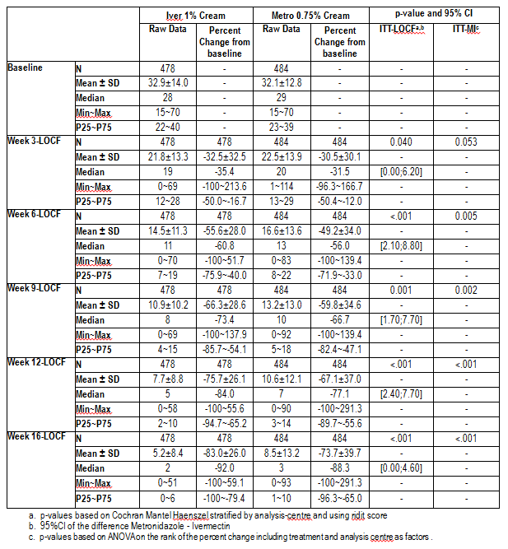

Analyses performed across trials (pooled analyses and meta-analyses)
None

Evaluator’s conclusions on clinical efficacy for the claimed indication
In the pivotal studies RD.06.SRE.18170 and RD.06.SRE.18171, Soolantra was shown to be superior to vehicle; consistent with the Phase II studies RD.03.SRE.40027and RD.03.SRE.40106. The Phase III study RD.03.SRE.40173 provided statistically significant evidence of the superiority of daily Soolantra over BD Rozex. Data on relapse rates from the 36 week extension of study RD.03.SRE.40173 are awaited.
No convincing evidence was presented of superiority of different dosages of ivermectin cream versus other dosages (see Study RD.03.SRE.40027).

Clinical safety

Studies providing evaluable safety data
The following studies provided evaluable safety data. Neutropenia was classified as an AE of special interest in studies RD.03.SRE.40106, RD.03.SRE.40173, RD.06.SRE.18170, and RD.06.SRE.18171.

Pivotal efficacy studies
In the pivotal efficacy studies, the following safety data were collected:
- General AEs were assessed by asking open questions at each visit.
AEs of particular interest:
- suspected sensitization with cutaneous signs (allergic contact dermatitis)
- suspected photosensitivity reactions
- cutaneous AE related to study product leading to permanent study drug discontinuation
- abnormal neurological signs (such as tremors, ataxia, myoclonus, nystagmus, convulsions) and
- all systemic AEs related to the study drug (including out-of-range laboratory results) identified as clinically significant and related to the study drug
were assessed by examination and blood testing in accordance with the event schedule provided in the study.

Pivotal studies that assessed safety as a primary outcome
Studies RD.06.SRE.18170 and RD.06.SRE.18171 were pivotal studies that assessed safety as well as efficacy as a primary outcome. These studies are described above in Section 7.

Dose-response and non-pivotal efficacy studies
The dose response and non pivotal efficacy studies provided safety data, as follows:
Studies RD.03.SRE.40027, RD.03.SRE.40106 and RD.03.SRE.40173 provided data on AE monitoring including AEs of special interest.
Regular laboratory monitoring was carried out in Studies RD.03.SRE.40106 and RD.03.SRE.40173, and at screening and Week 12 in Study RD.03.SRE.40027. Study RD.03.SRE.40173 provided full data on routine AE monitoring for Period A only. For Period B, relevant safety events, defined as related SAEs, AEs of special interest, and neutrophil counts below the threshold of 1.5 x10⁹/L whether considered AEs or not, were reported in the present CSR when they were observed up to the cut-off date of 8 April 2013, without any statistical analyses.
- Study RD.03.SRE.40006 provided data on AE monitoring.

Other studies evaluable for safety only

Study RD.03.SRE.19055

Aim
The aim of this study was to assess cumulative irritancy potential of ivermectin 1% cream versus vehicle and white petrolatum, applied for 21 days under occlusive conditions to the upper back of healthy volunteers. The study was conducted at a single location in France, October to November 2002.

Method
Investigator blinded, randomised, intra individual comparison. Three zones were selected on the upper back of each subject, and subjects were randomised to receive the 3 products (ivermectin 1% cream (note: Not the formulation now proposed for registration), vehicle, and white petrolatum) under occlusive dressings 5 days/week (Monday to Friday) for 3 weeks, dose 50 µL per zone. Skin was assessed before each treatment and at the final visit on Day 21. During the study, subjects were required to avoid showering the upper back; sun exposure or use of cosmetics on the study zone; and swimming or vigorous exercise.

Subjects
Eighteen healthy adults (5 male, 13 female) with white skin, aged 24 to 59. All completed the study.

Study RD.03.SRE.19081

Aim
The aim of this study was to assess cumulative irritancy potential of 2 new proposed vehicles versus the initial vehicle and white petrolatum, applied for 21 days under occlusive conditions to the upper back of healthy volunteers. The study was conducted at a single location in France, November to December 2003.

Method
Investigator blinded, randomised, intra individual comparison. Four zones were selected on the upper back of each subject, and subjects were randomised to receive the 4 products (formulation 575.754 vehicle, formulation 575.214 vehicle, formulation 575.702 vehicle, and white petrolatum) under occlusive dressings 5 days/week (Monday to Friday) for 3 weeks, dose 50 µL per zone. Skin was assessed before each treatment and at the final visit on Day 21. During the study, subjects were required to avoid showering the upper back, sun exposure or use of cosmetics on the study zone; and swimming or vigorous exercise.

Subjects
Nineteen healthy adults (5 male, 14 female) with white skin, aged 22 to 71. All completed the study.

Study RD.03.SRE.40023

Aim
The aim of this study was to assess the potential of repeated applications of 4 concentrations of ivermectin cream (none of which was the product for which registration is sought), or vehicle, to induce irritation or sensitisation in the skin of healthy subjects. The study was conducted at a single location in France, October to December 2005.

Method
Investigator blinded, randomised, intra individual comparison. The study comprised a screening period followed by 3 phases:
- induction phase (3 weeks)
- rest period (2 weeks)
- challenge phase (1 week)
The 6 products used in the study were: 0.03% cream formulation 0575.0766, 0.1% cream formulation 0575.0764, 0.3% cream formulation 0575.0765, 1% cream formulation 0575.0755, vehicle formulation 0575.0755P and white petrolatum ointment. These products, coded A to F, were applied in accordance with the randomisation scheme to 6 zones of each subject's upper back identified as zones Z1 to Z6, as follows (as represented in Figure 4):
Figure 4. Study RD.03.SRE.40023. Representation of zones used on subject’s upper back.
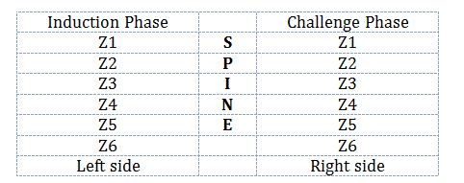
The method used (Marzulli and Maibach 1976) is designed to study delayed T cell reactions. A sensitisation reaction observed in the first 7 days after product application cannot be linked to the study product, since the minimum delay between induction and clinical appearance of a de novo sensitisation reaction is approximately 10 days. An earlier reaction would reflect previous sensitisation. Therefore at induction all sensitisations, recorded between Days 1 to 7 inclusive, required subject discontinuation.
Evaluator’s Comment: This rule could have presented difficulty, dependent as it was on distinguishing an irritancy reaction from a reaction resulting from previous sensitisation. However, in view of the very low frequency of any reaction, there was no such difficulty in practice. Another reason it is fortunate that sensitisation reactions occurred rarely or not at all is that trial subjects were apparently not warned about the possibility of sensitisation.
During the induction phase, there were 3 applications per week for 3 weeks: two 48 hour applications (starting Monday and Wednesday) and one 72 hour application (starting Friday). The challenge phase comprised one 48 hour application. Dose of each product was 50 µL, covered by an occlusive dressing.
During the study, subjects were required to avoid wetting the study zones, exposure to excessive UV radiation, and strenuous activities.

Subjects
Some 218 enrolled and treated: 36 male, 182 female; 217 Caucasian, 1 Asian; median age 36.8 (range 18 to 65). 12 were withdrawn (5 AE; 4 subject request; 1 lost to follow-up; 2 participating in another trial).

Assessment
In the Induction phase, evaluations were performed 15 to 30 minutes after removal of dressings. In the Challenge phase, evaluations were performed 15 to 30 minutes, and 48 hours, after removal of dressings.

Study RD.03.SRE.40051

Aim
The primary objective as originally planned was to document the long term safety of ivermectin 1% cream once daily, for up to 52 weeks of topical treatment in subjects with PPR. This objective was changed to an evaluation up to subject's termination as a result of the sponsor's decision to discontinue the study prematurely, following adverse laboratory findings in some patients: at Week 10 of treatment, the neutrophil cell count had decreased in 3 subjects below the threshold value of 1.5x10⁹/L defining a neutropenia.
The study commenced on 27 August 2008, and was halted on 16 January 2009 when all study subjects were required to stop treatment immediately, and were asked to participate in a 1 month safety follow-up. The study was conducted at 52 sites in Europe (France, Germany, Czech Republic, Hungary, Bulgaria, Romania, and Iceland) and Australia.

Method
Phase III, uncontrolled, open label. The product used was ivermectin 1% cream as proposed for marketing.
Entry criteria: Adults ≥ 18 years, with a diagnosis of PPR, presenting with 15 to 70 inflammatory lesions, and having an IGA score of 3 (moderate) or 4 (severe) on a 5 point scale.

Subjects
Some 484 enrolled and treated (151 male, 333female); mean age 50.8 (SD 12); 399 with IGA score 3, 85 with IGA score 4; mean inflammatory lesion count 31.9 (SD 12).

Outcome
Mean duration of study treatment was 84.3 days (range 4 to 196), and mean duration of the follow up period was 32.8 days.

Study RD.06.SRE.18120

Aim
The primary objective was to evaluate the effect of a single orally administered dose of ivermectin on ventricular repolarisation in healthy adult subjects. The study was conducted at a single location in USA, 12 September to 3 November 2008.

Method
Phase I, single dose, randomised, double blind, parallel group, with active and placebo controls. Subjects were randomised to 1 of 3 arms, and treated with one of the following using a double dummy technique: ivermectin 6 mg; moxifloxacin 400 mg; or placebo. Treatment was administered in the fasting state on Day 1. ECGs were extracted from Holter recordings at pre-morning dose (-30 minutes), and 0.5, 1.0, 2.0, 3.0, 4.0, 5.0 6.0, 8.0, 12, 16, and 23 hours post morning dose. Blood for ivermectin measurement was drawn 15 minutes pre-dose, and immediately following the 10 minutes window of ECG extractions post dosing at 42 minutes post dose, 1 hour 12 minutes, 2 hours 12 minutes, 3 hours 12 minutes, 4 hours 12 minutes, 5 hours 12 minutes, 6 hours 12 minutes, 8 hours 12 minutes, 12 hours 12 minutes, 16 hours 12 minutes, and 23 hours 12 minutes. Ivermectin (H2B1a form) was quantified in plasma using a validated HPLC method with LLQ 0.05 ng/mL.

Subjects
Some 166 randomised and treated (81 male, 85 female); mean age 24.8 years (SD 7.7); mean weight 72.5 kg (SD 11).

Outcomes
The primary endpoint variable was the time matched change from Day -1 (baseline) in QTcF (dQTcF). The primary analysis endpoint (ddQTcF) was derived from a one way analysis of variance of dQTcF that included the effect of treatment group. A separate analysis was performed for each scheduled ECG Day 1 time. Results for ivermectin and for the active comparator moxifloxacin were provided. PK measurements were also provided. A concentration versus QT analysis was performed, using a linear mixed effects model. The trialists concluded that that no repolarisation change was demonstrated in this study for ivermectin.

Clinical pharmacology studies
Study RD.03.SRE.40007 and Study RD.03.SRE.40064. See section 4.

Pivotal studies that assessed safety as a primary outcome
For details of the studies see sections 7.1.1 and 7.1.2.

Patient exposure
Note: Only studies in which at least 1 subject was treated with the formulation proposed for registration (Soolantra, formulation 575.754) contribute data to the Tables 25 and 26 below.

Table 25. Exposure to Soolantra and comparators in clinical studies.
Study type/  Indication | Controlled studies |  |  |  | Un-controlled studies | TotalSool
Study type/  Indication | Sool | Vehicle | Other iver cream | Other active cream | Sool | TotalSool
Clinical pharmacology |  |  |  |  | 17 | 17
Indication 1
Pivotal | 909 | 461 | 0 | 418 | 0 | 909
Other | 731 | 206 | 146 | 532 | 484 | 1215
Subtotal Indication 1 | 1640 | 667 | 146 | 950 | 484 | 2124
TOTAL | 1640 | 667 | 146 | 950 | 501 | 2141

Table26. Exposure to Soolantra in clinical studies according to dose and duration.
Study type/  Indication | Proposed dose |  |  |  | Other dose
Study type/  Indication | ≥ 3 mo. | ≥ 6 mo. | ≥ 12 mo. | Any dur’n | ≥ 3 mo. | ≥ 6 mo. | ≥ 12 mo. | Any dur’n
Clinical pharmacology |  |  |  | 17 |  |  |  | 0
Indication 1
Vehicle-controlled¹ |  |  |  | 104²
Active-controlled | 839 | 784 | 717 | 1439⁴ |  |  |  | 97
Uncontrolled |  |  |  | 484³
Subtotal Indication 1 | 839 | 784 | 717 | 2027 |  |  |  | 97
TOTAL | 839 | 784 | 717 | 2044 |  |  |  | 97
1 Excluding studies controlled by both vehicle and active. 2 Study RD.03.SRE.40106, median exposure 84 days. 3 Study RD.03.SRE.40051, median exposure 82 days. 4 Includes 478 subjects in Study RD.03.SRE.40173, with median exposure 113 days.
The sponsor states:
‘A total of 2431 of the 3999 subjects in the clinical development program were exposed to Ivermectin 1% Cream: 268 healthy subjects and 2163 subjects with PPR. The figure of 2163 subjects with PPR includes 116 subjects exposed to Ivermectin 1% Cream BID, which was explored in Phase II before the QD regimen was confirmed for the Phase III program. Consequently, a total of 2047 subjects with PPR were exposed to the to-be-marketed formulation and regimen: Ivermectin 1% QD.’

Adverse events
Note: In this section, a semicolon is used to separate observations relating to different patients.

All adverse events (irrespective of relationship to study treatment)

Pivotal studies

Study RD.06.SRE.18170
AE’s Study RD.06.SRE.18170 (see Table 27).

Table 27. All AE’s Study RD.06.SRE.18170.
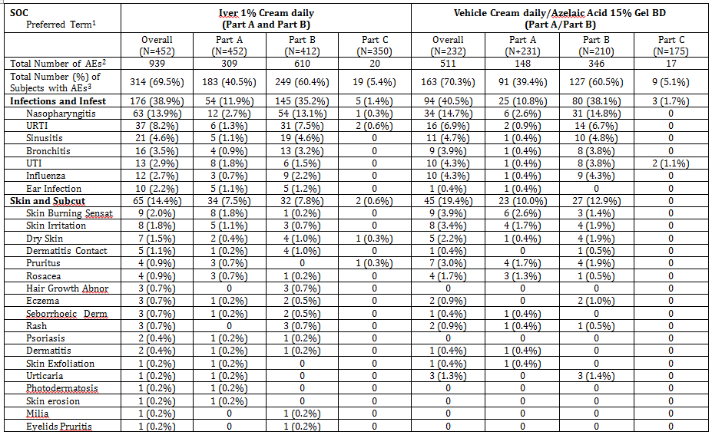

Table 27 (continued). All AE’s Study RD.06.SRE.18170.
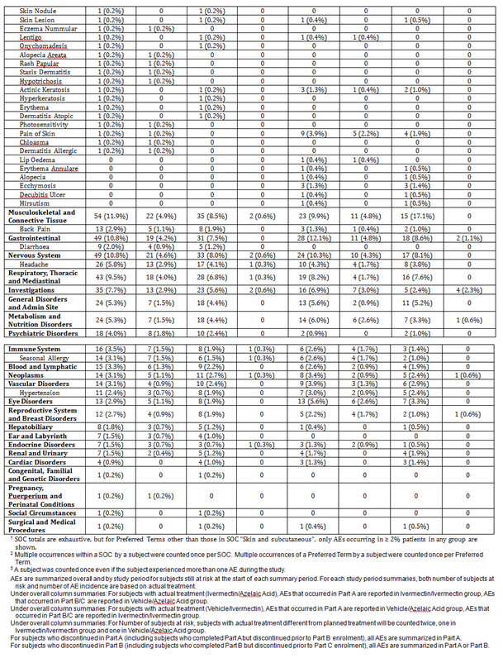

Study RD.06.SRE.18171
AE’s Study RD.06.SRE.18171 (see Table 28).

Table 28. Study RD.06.SRE.18171 All AE’s.
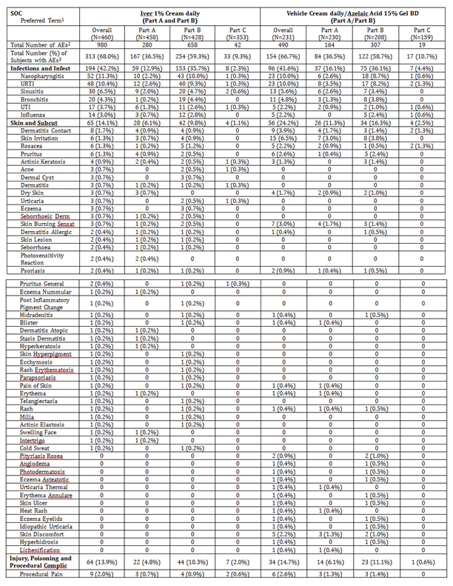

Table 28(continued). Study RD.06.SRE.18171 All AE’s.
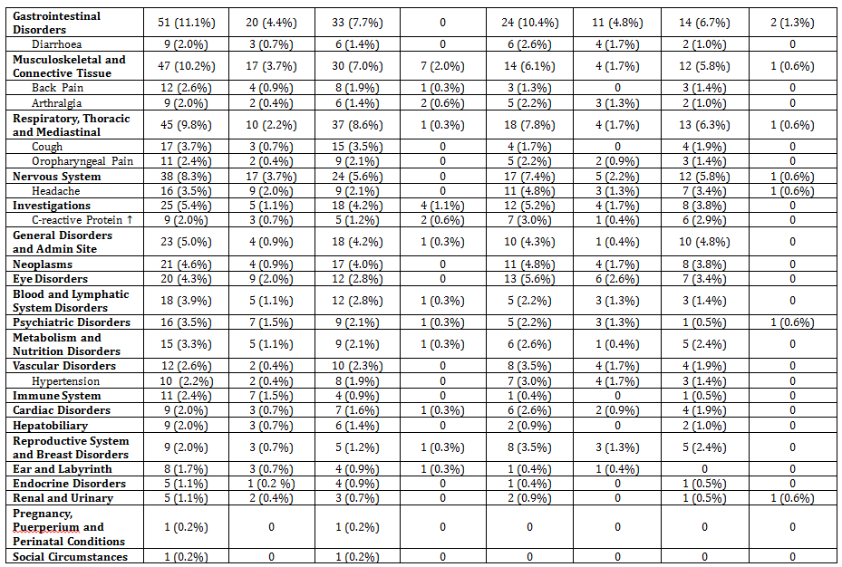

Other studies

Study RD.03.SRE.19055
Note that the ivermectin formulation used in this study was not the one proposed for registration.

Local erythema or oedema
Erythema was assessed using the scale: 0 No reaction; 0.5 Erythema barely visible; 1 Mild erythema; 2 Moderate erythema; 3 Severe erythema. Oedema was assessed using the scale: 0 No induration; 1 Slight tenseness of the skin; 2 Moderate thickening of the skin with oedematous feel; 3 Firm resistance to distortion, non-distensible.
CII (Cumulative Irritancy Index) was calculated for each treatment for each subject as:
(Sum of all erythema scores read from Day 1 to Day 21)/(Number of readings).
The mean CII across all subjects is tabulated below in Table 29.

Table 29. Study RD.03.SRE.19055. The mean cumulative irritancy index (CII) across all subjects.
 | Ivermection cream 1% | Vehicle | White petrolatum
Mean CII (SD) | 0.13 (0.03) | 0.07 (0.02) | 0.12 (0.04)
The worst erythema score in each subject is tabulated below in Table 30.

Table 30. Study RD.03.SRE.19055. The worst erythema score in each subject.
 | Ivermection cream 1% | Vehicle | White petrolatum
0 = no erythema | 3 | 7 | 5
0.5 = barely visible | 9 | 9 | 9
1 = slight | 4 | 1 | 3
2 = moderate | 2 | 1 | 1
3 = severe | 0 | 0 | 0
1 subject had an oedema score of 1 on the zone treated with ivermectin 1% cream at Day 14. All other oedema scores were 0.

Other AEs
Local reactions. A description of local reactions in subjects is shown in Table 31.

Table 31. Study RD.03.SRE.19055. A description of local reactions in subjects
 | Ivermection cream 1% |  | Vehicle |  | White petrolatum
Reaction | Number of subjects | Frequency of reaction | Number of subjects | Frequency of reaction | Number of subjects | Frequency of reaction
Papules | 2 | 7 | 3 | 5 | 2 | 2
Pustules | 7 | 18 | 7 | 18 | 8 | 23
Hyperpigmentation | 3 | 3 | 4 | 4 | 7 | 24
Marked reaction to plaster | 2 | 2 | 1 | 1 | 2 | 3
Occlusive patch lost during first 12 hours |  |  |  |  | 1 | 1
Non-local AEs:
22 such AEs were reported in 15 subjects, none serious: 4 headache, 3 pharyngitis, 3 rhinitis, 2 pruritus, 2 eczema, 2 herpes simplex, 1 laryngitis, 1 tooth disease, 1 colitis, 1 conjunctivitis, 1 dysmenorrhoea.

Study RD.03.SRE.19081
Note that no formulation used in this study contained ivermectin.

Local erythema
Erythema was assessed using the same scale as in Study RD.03.SRE.19055 above. The mean CII across all subjects is tabulated below in Table 32.

Table 32. Study RD.03.SRE.19081. The mean cumulative irritancy index (CII) across all subjects.
 | Vehicle 575.754 | Vehicle 575.214 | Vehicle 575.720 | White petrolatum
Mean CII (SD) | 0.151 (0.029) | 0.148 (0.043) | 0.049 (0.016) | 0.110 (0.028)
The worst erythema score in each subject is tabulated below in Table 33.

Table 33. Study RD.03.SRE.19081. The worst erythema score in each subject.
 | Vehicle 575.754 | Vehicle 575.214 | Vehicle 575.720 | White petrolatum
0 = no erythema | 3 | 5 | 8 | 7
0.5 = barely visible | 10 | 7 | 8 | 8
1 = slight | 5 | 6 | 2 | 3
2 = moderate | 1 | 1 | 1 | 1
3 = severe | 0 | 0 | 0 | 0

Other AEs
Local reactions
Table 34. Study RD.03.SRE.19081. A description of local reactions in subjects.
 | Vehicle 575.754 |  | Vehicle 575.214 |  | Vehicle 575.720 |  | White petrolatum
Reaction | Number of subjects | Freq. of reaction | Number of subjects | Freq of reaction | Number of subjects | Freq of reaction | Number of subjects | Freq of reaction
Papules | 1 | 1 | 0 | 0 | 0 | 0 | 0 | 0
Pustules | 4 | 16 | 0 | 0 | 5 | 7 | 4 | 7
Non-local AEs:
13 such AEs were reported in 12 subjects, none serious: 3 headache, 2 pharyngitis, 2 skin infection, 1 pustular rash, 1 eczema, 1 tooth disorder, 1 diarrhoea, 1 flu syndrome, 1 sweating increased.

Study RD.03.SRE.40023
Note that the ivermectin formulation used in this study was not the one proposed for registration.

Local erythema
Erythema was assessed using the scale: 0 No reaction; 1 Mild erythema; 2 Moderate erythema; 3 Severe erythema or erythema with oedema; 4 Erythema with vesicles or erosion or bullae.
Induction phase:
The mean CII across all subjects is tabulated below in Table 35(all patients treated, less 4 who lacked post-baseline observations).

Table 35. Study RD.03.SRE.40023. The mean cumulative irritancy index (CII) across all subjects (less 4 who lacked post-baseline observations).
 | 1% cream 0575.0755 | 0.3% cream 0575.0765 | 0.1% cream 0575.0764 | 0.03% cream 0575.0766 | White petrolatum |  | Vehicle 0575.0755P
N | 214 | 214 | 214 | 214 |  | 214 | 214
Mean CII (SD) | 0.12 (0.19) | 0.11 (0.19) | 0.13 (0.21) | 0.12 (0.21) |  | 0.14 (0.21) | 0.12 (0.19)
The distribution of worst scores is tabulated below in Table 36.

Table 36. Study RD.03.SRE.40023. The worst erythema score in each subject.
Worst score | 1% cream 0575.0755 | 0.3% cream 0575.0765 | 0.1% cream 0575.0764 | 0.03% cream 0575.0766 | White petrolatum | Vehicle 0575.0755P
 | n (%) | n (%) | n (%) | n (%) | n (%) | n (%)
0 | 127 (59) | 133 (62) | 132 (62) | 132 (62) | 116 (54) | 117 (55)
1 | 87 (41) | 81 (38) | 81 (38) | 81 (38) | 98 (46) | 97 (45)
2 | 0 | 0 | 1 (0.5) | 1 (0.5) | 0 | 0
3 | 0 | 0 | 0 | 0 | 0 | 0
4 | 0 | 0 | 0 | 0 | 0 | 0
Total | 214 (100) | 214 (100) | 214 (100) | 214 (100) | 214 (100) | 214 (100)
Challenge phase:
The individual scoring of skin irritation did not exceed 1 for any treatment on Week 6 Day 3 (207 subjects assessed) or 0 on Week 6 Day 5 (205 subjects assessed). Thus there was no evidence of sensitisation.

All AEs
25 AEs were reported in 11 subjects: 14 skin irritation, 2 headache, 1 dermographism, 1 gastroenteritis, 1 gastroenteritis viral, 1 influenza, 1 joint sprain, 1 nasopharyngitis, 1 pharyngolaryngeal pain, 1 salivary gland calculus, 1 urticaria.

Study RD.03.SRE.40007
Note that the ivermectin formulation used in this study was not the one proposed for registration.
Group 1
2/8 subjects reported AEs, all mild: 1 diarrhoea, 1 flu-like illness, 1 headache.

Study RD.03.SRE.40064
5/17 subjects reported AEs: tachycardia; gastroenteritis; nasopharyngitis; sinusitis; chromaturia.

Study RD.03.SRE.40006
The adverse events in the study are presented in Table 37.

Table 37. Study RD.03.SRE.40006. Adverse events.
SOC Preferred Term | Iver | Metro | Veh
 | N=49 | N=48 | N=50
Number of patients reporting any AE¹ | 16 | 10 | 13
Gastrointestinal disorders | 3 | 1 | 0
Gastritis | 2
General disorders and admin site | 1 | 3 | 1
Flu like illness | 1 | 3 | 1
Immune system disorders | 1 | 1
Infections and infestations | 5 | 4 | 5
Nasopharyngitis | 1 | 2 | 1
Injury, poisoning and procedural | 2
Musculoskeletal and connective tissue | 1 | 2
Respiratory, thoracic and mediastinal | 1 |  | 1
Skin and subcutaneous tissue | 5 | 2 | 3
Skin irritation | 2
Rosacea |  | 2 | 2
Eye disorders |  | 1
Surgical and medical procedures |  | 1 | 2
Cardiac disorders |  |  | 1
Psychiatric disorders |  |  | 1
¹ SOC totals are exhaustive, but for Preferred Terms only AEs occurring in ≥ 2 patients in any group are shown. Multiple instances of the same AE in the same patient are counted only once. Different AEs in the same SOC in the same patient are counted only once in the SOC total.

Study RD.03.SRE.40027
A list of adverse event for this study was provided.

Study RD.03.SRE.40106
A list of AEs for this study is provided in Table 38.

Table 38. Study RD.03.SRE.40106: AEs.
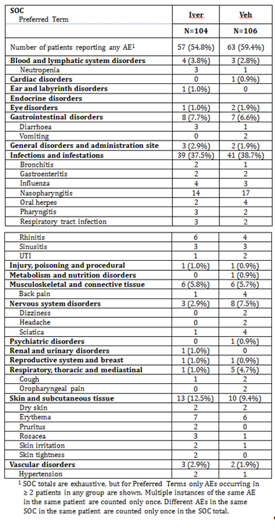

Study RD.03.SRE.40173
Note: For Period B, relevant safety events, defined as related SAEs, AEs of special interest, and neutrophil counts below the threshold of 1.5 x10⁹/L whether considered AEs or not, were reported in the present CSR when they were observed up to the cut-off date of 8 April 2013, without any statistical analyses.
Period A: See Table 39.

Table 39. Study RD.03.SRE.40173: AEs reported by ≥ 1% subjects, Period A.
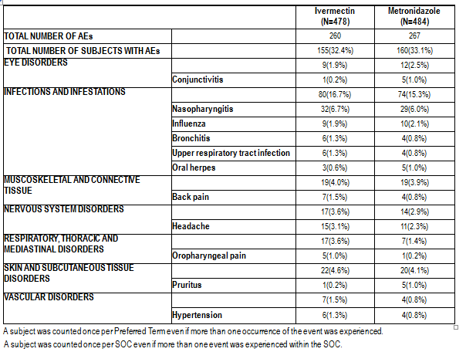
During the treatment free extension Period B, up to the cut-off date of 8 April 2013, 2 subjects randomised to metronidazole in Period A of the study reported 2 relevant AEs: 1 severe erythema in a female subject having resumed her treatment for rosacea due to relapse; and a neutrophil count below 1.5 x10⁹/L reported as AE neutropenia by 1 male subject remaining untreated at the time of reporting cut-off date. There was no additional case of neutrophil count < 1.5 x10⁹/L during Period B before the April 8th cut-off date.

Study RD.03.SRE.40051
A list of AEs for Study RD.03.SRE.40051 is provided (see Table 40).

Table 40. Study RD.03.SRE.40051: AEs.
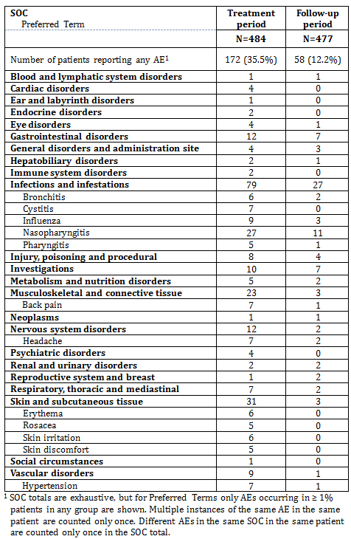

RD.06.SRE.18120
A list of AEs in Study RD.06.SRE.18120 is provided (see Table 41).

Table 41. Study RD.06.SRE.18120: AEs.
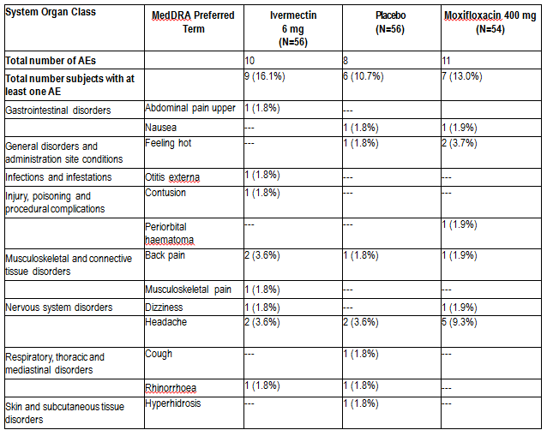

Treatment-related adverse events (adverse drug reactions)

Pivotal studies

Study RD.06.SRE.18170
A list of AEs classified as related to study drug for Study RD.06.SRE.18170 is provided (see Table 42).

Table 42. Study RD.06.SRE.18170: AEs classified as related to study drug.
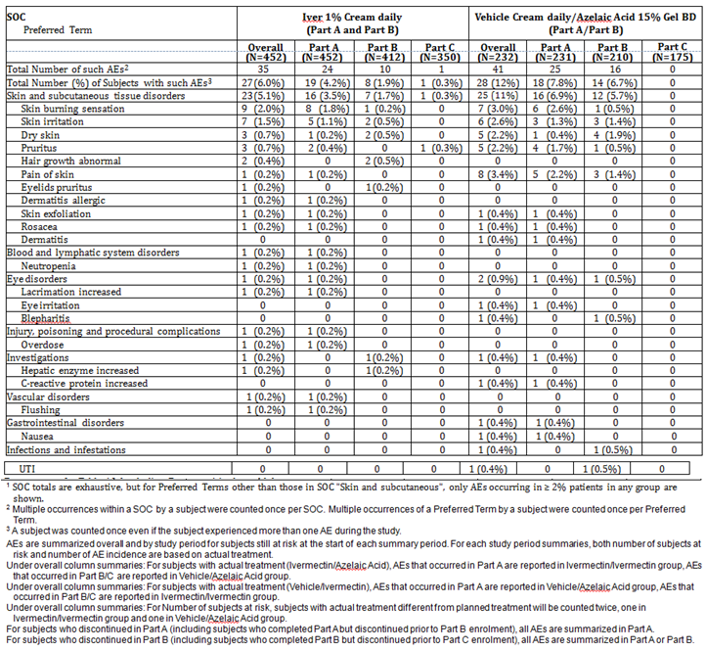

Study RD.06.SRE.18171
A list of AEs classified as related to study drug for Study RD.06.SRE.18171 is provided (see Table 43).

Table 43. Study RD.06.SRE.18171: AEs classified as related to study drug.
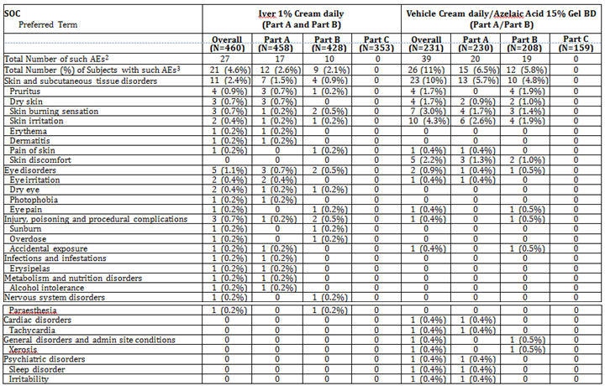

Other studies

Study RD.03.SRE.40006
A list of AEs classified as related to study drug for Study RD.03.SRE.40006 is provided (see Table 44).

Table44. Study RD.03.SRE.40006: AEs classified as related to study drug.
SOC Preferred Term | Iver | Metro | Veh
 | N=49 | N=48 | N=50
Number of patients reporting any such AE¹ | 3 | 2 | 3
Skin and subcutaneous tissue | 3 | 1 | 3
Eczema | 1
Skin irritation | 1
Skin oedema | 1
Rosacea |  | 1 | 2
Seborrheic dermatitis |  |  | 1
Eye disorders |  | 1
Conjunctivitis |  | 1
¹ Multiple instances of the same AE in the same patient are counted only once. Different AEs in the same SOC in the same patient are counted only once in the SOC total.

Study RD.03.SRE.40027
A list of AEs classified as related to study drug for Study RD.03.SRE.40027 is provided (see Table 45).

Table 45. Study RD.03.SRE.40027: AEs classified as related to study drug.
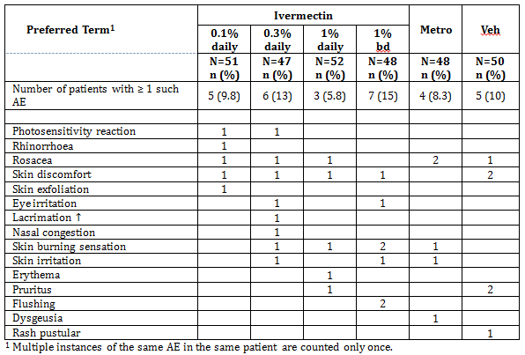

Study RD.03.SRE.40106
A list of AEs classified as related to study drug for Study RD.03.SRE.40106 is provided (see Table 46).

Table 46. Study RD.03.SRE.40106: AEs classified as related to study drug.
SOC Preferred Term | Iver | Veh
 | N=104 | N=106
Number of patients reporting any such AE¹ | 5 (4.8%) | 5 (4.7%)
Skin and subcutaneous tissue | 5 (4.8%) | 5 (4.7%)
Dry skin | 0 | 1
Erythema | 4 | 3
Skin irritation | 1 | 1
Skin tightness | 1 | 0
¹ Multiple instances of the same AE in the same patient are counted only once. Different AEs in the same SOC in the same patient are counted only once in the SOC total.

Study RD.03.SRE.40173
A list of AEs classified related to study drug, for Study RD.03.SRE.40173 Period A is provided (see Table 47).

Table 47. Study RD.03.SRE.40173: AEs classified related to study drug, Period A.
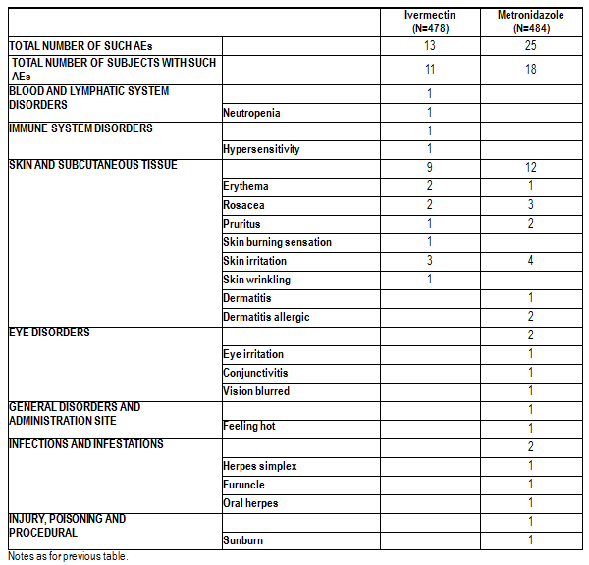
The case of neutropenia classified as treatment-related was reported at the Week 16 visit. The subject had low neutrophil count at Screening, Baseline and Week 9 visits, albeit above the 1.5 x109/L threshold. This moderate neutropenia was not associated with any clinical signs of infection, and the neutrophil count had returned to normal 10 days after treatment cessation. The IDMC concluded that neutropenia was unlikely related to the study drug.
Part B: The case of severe erythema described at section 8.4.1.2.9 was classified as treatment related.

Study RD.03.SRE.40051
A list of AEs classified related to study drug for Study RD.03.SRE.40051 is provided (see Table 48).

Table 48. Study RD.03.SRE.40051: AEs classified related to study drug.
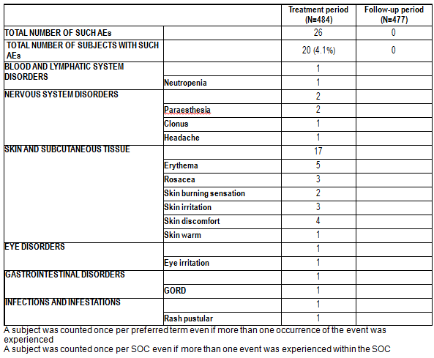

RD.06.SRE.18120
Only 1 AE in the ivermectin group was classified as treatment-related: abdominal pain upper.

Deaths and other serious adverse events

Pivotal studies

Study RD.06.SRE.18170
No deaths.
SAEs for Study RD.06.SRE.18170 are shown in Table 49.

Table 49. Study RD.06.SRE.18170: SAEs.
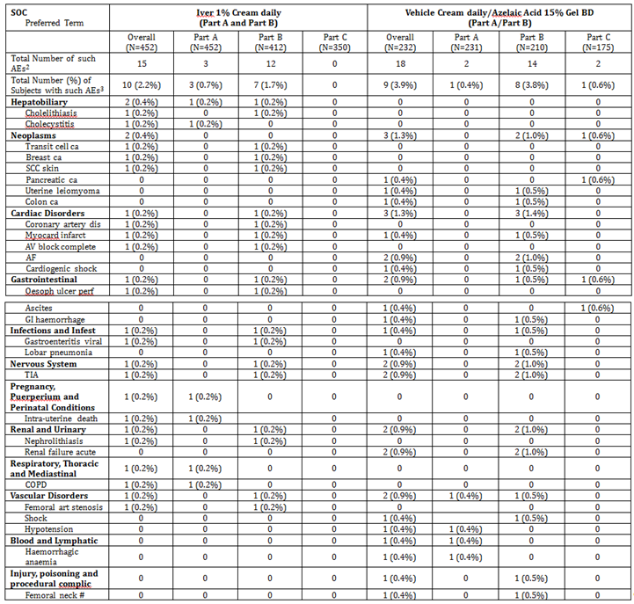

Study RD.06.SRE.18171
No deaths.
SAEs for Study RD.06.SRE.18171 are shown in Table 50.

Table 50. Study RD.06.SRE.18171: SAEs.
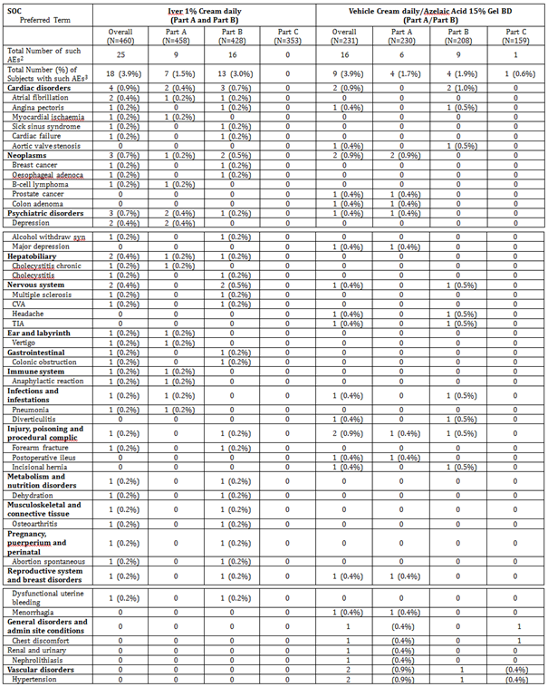

Other studies

Study RD.03.SRE.19055
None.

Study RD.03.SRE.19081
None.

Study RD.03.SRE.40023
None.

Study RD.03.SRE.40007
Group 1: None.

Study RD.03.SRE.40064
None.

Study RD.03.SRE.40006
No deaths. 1 SAE (pneumonia) in the vehicle group.

Study RD.03.SRE.40027
No deaths. 4 SAEs were reported, all classified unrelated:
Ivermectin 0.1% daily group: 1 (collapse secondary to bradycardia)
Ivermectin 1% BD group: 2 (chest pain; abdominal pain)
Metronidazole 0.75% BD group: 1 (pneumonia).

Study RD.03.SRE.40106
No deaths. 9 SAEs were reported, all classified unrelated:
Ivermectin group: 6 SAEs in 4 patients (1 each inguinal hernia, fall, ligament rupture, intervertebral disc protrusion, urethral stenosis, vasculitis).
Vehicle group: 3 SAEs in 2 patients (1 each fall, traumatic brain injury, TIA).

Study RD.03.SRE.40173
No deaths in Period A or Period B.
13 treatment-emergent SAEs were reported in 13 subjects during Period A, none considered related to treatment:
Ivermectin: 8 subjects (1 each abdominal pain, inguinal hernia, chronic sinusitis, pneumonia, whiplash injury, psoriatic arthropathy, spinal column stenosis, hypertensive crisis).
Metronidazole: 5 subjects (1 each inguinal hernia, musculoskeletal chest pain, coronary artery disease, cataract, breast cancer).
No SAE considered related to treatment occurred in Period B.

Study RD.03.SRE.40051
No deaths. 6 subjects had SAEs, none classified as treatment-related:
5 subjects had SAEs during the treatment period (1 aortic valve disease; 2 inguinal hernia; 1 forearm fracture; 1 breast cancer).
1 subject had SAE during the follow up period (appendicitis).

RD.06.SRE.18120
No deaths or SAEs.

Discontinuation due to adverse events

Pivotal studies

Study RD.06.SRE.18170
Overall, 12 subjects (2.7%) in the Soolantra (Part A and Part B) group prematurely discontinued the study due to AEs and 9 subjects (3.9%) in the Vehicle/Azelaic Acid group prematurely discontinued the study due to AEs. For both treatment groups, the majority of subjects who discontinued the study did so due to AEs in the SOC Skin and subcutaneous tissue disorders: 8 subjects (1.8%) in the Soolantra (Part A and Part B) group and 6 subjects (2.6%) in the Vehicle/Azelaic Acid group. All remaining subjects who discontinued the study reported isolated incidences of AEs that occurred in various other SOC categories. 6 subjects (1.3%) in the Soolantra (Part A and Part B) group reported 8 AEs leading to discontinuation that were considered by the investigator to be related to the study drug: Dermatitis allergic, Pain of skin, Skin burning sensation (2 events), Skin irritation (3 events), and Flushing. 5 subjects (2.2%) in the Vehicle/Azelaic Acid group reported 7 AEs leading to discontinuation that were considered by the investigator to be related to the study drug: Rosacea, Skin irritation (3 events), Eye irritation, Irritant dermatitis, Pain of skin, and Skin burning sensation.

Study RD.06.SRE.18171
Overall, 9 subjects (2.0%) in the Soolantra (Part A and Part B) group prematurely discontinued the study due to AEs and 9 subjects (3.9%) in the Vehicle/Azelaic Acid group prematurely discontinued the study due to AEs. For the Soolantra (Part A and Part B) group, the majority of subjects who discontinued the study did so due to AEs in the SOC Neoplasms: 3 subjects (0.7%). For the Vehicle/Azelaic Acid group, the majority of AEs leading to discontinuation were in the SOC Skin and subcutaneous tissue disorders: 6 subjects (2.6%). All remaining subjects who discontinued the study reported isolated incidences of AEs that occurred in various other SOC categories. 1 subject (0.2%) in the Soolantra (Part A and Part B) group reported an AE leading to discontinuation, Facial dry skin, that was considered by the investigator to be related to the study drug. 6 (2.6%) subjects in the Vehicle/Azelaic Acid group reported 7 AEs leading to discontinuation that were considered by the investigator to be related to the study drug: Skin irritation (2 episodes), Tachycardia, Skin burning sensation (2 episodes), Skin discomfort, and Pruritus.

Other studies

Study RD.03.SRE.19055
None.

Study RD.03.SRE.19081
None.

Study RD.03.SRE.40023
10 AEs reported in 5 subjects led to discontinuation: 6 skin irritation in 1 subject; 1 dermographism; 1 salivary gland calculus; 1 gastroenteritis; 1 joint sprain. Of these, only the dermographism was considered possibly related to study drug. The skin irritation was thought to result from adhesive tape.

Study RD.03.SRE.40007
Group 1: None.

Study RD.03.SRE.40064
None.

Study RD.03.SRE.40006
AEs in 7 patients led to discontinuation:
- Ivermectin group: 3 (2 skin irritation; 1 eczema)
- Metronidazole: 1 (rosacea)
- Vehicle: 3 (2 rosacea; 1 seborrheic dermatitis).

Study RD.03.SRE.40027
AEs in 8 patients led to discontinuation. In 6 patients, the AEs were classified as related to study treatment:
- Ivermectin 0.3% daily group: 2 (irritative dermatitis; watery eyes, burning of eyes, swelling of mucosa of nose)
- Ivermectin 1% daily group: 1 (facial pruritus in the application site, facial burning)
- Ivermectin 1% BD group: 1 (skin irritation)
- Metronidazole 0.75% BD group: 2 (flare of rosacea, local irritation; burning sensation on the face).

Study RD.03.SRE.40106
- Ivermectin group: 2 (deterioration of rosacea symptoms; worsening of lymphocytic vasculitis)
- Vehicle group: 1 (irritative dermatitis)
Of these 3, only the last was classified as related to study treatment.

Study RD.03.SRE.40173
1 AE (spinal column stenosis in a subject treated with ivermectin) led to discontinuation.

Study RD.03.SRE.40051
7 patients withdrew due to 10 AEs; 9 AEs during the treatment period (aortic valve disease, GORD, rash pustular, neutrophil count ↓, breast cancer, headache, dermatitis atopic, skin discomfort, skin irritation) and 1 AE during the follow up period (sinusitis).
5 of these AEs were classified as treatment related and led to discontinuation of 3 subjects (skin discomfort; skin irritation; GORD, rash pustular, headache).

RD.06.SRE.18120
No discontinuation due to AE.

Laboratory tests

Haematology

Study RD.03.SRE.40051
3 cases of neutrophil cell counts < 1.5x10⁹/L were observed under treatment, without any associated clinical signs or symptoms (for example fever), corresponding to an incidence of 0.98%. This was reversible in all 3 subjects. One subject’s neutropenia reversed while under active treatment.
This was the only notable safety observation in the study. The sponsor comments:
- ‘One event, a count of 0.79 G/L was close to the threshold of 0.50 G/L where life threatening complications can occur.
- No serious infection was reported and neutropenia was reversible in the three subjects even under treatment for one of them.
- No obvious cause of neutropenia was identified in past medical history, concurrent diseases or concomitant treatments of the 3 subjects with neutropenia.
- Neutrophil cell counts decreased by 6.6% (median at Week 10 of treatment) in the study:
60.2% of the subjects experienced a decrease in neutrophil counts from screening to Week 10 of treatment.
17.9% of the subjects experienced a decrease of more than 30% of their neutrophil counts from screening to Week 10 of treatment.
- Conversely, 39.8% of the subjects experienced some increase in neutrophil counts and 7.1% of the subjects experienced an increase of more than 42.9% of their neutrophil counts, from Screening to Week 10 of treatment.
- The study population - demographics, disease severity and plasma drug levels - was comparable to the previous studies conducted with CD5024 cream.
- No correlation between CD5024 plasma concentration and individual neutrophil counts could be established.’

Study RD.03.SRE.40106
The primary rationale for this study was to investigate whether the product proposed for registration may be causally associated with neutropenia. Thus, it is of particular interest in that blood samples were drawn frequently for laboratory assessment.

Neutropenia
Percent changes from Baseline in NCCs were compared at each post Baseline visit between ivermectin cream and its vehicle, and also for the lowest value observed after Baseline (retests and unscheduled visits included). At each time point, no meaningful between group differences were observed.
Overall, there were 5 subjects reported with neutrophil counts below 1.5 x10⁹/L, 4 (3.9%) in the ivermectin group and 1 (0.9%) in the vehicle group. One of these subjects in the active treatment group also had a neutrophil count below 1.5 x10⁹/L at Baseline before treatment; a retest performed two days later (after one application of study drug) also produced a low neutrophil count and this subject discontinued study participation. Subsequent neutrophil counts obtained at two re-tests were all within the normal range. Therefore, four subjects had single treatment-emergent neutrophil counts below 1.5 x10⁹/L. Among the 4 ‘treatment emergent’ cases of neutrophil counts below 1.5 x10⁹/L, the neutrophil count had normalised under treatment for 3 cases and after a temporary discontinuation of the treatment in the other case. In this subject from the ivermectin group, study drug was temporarily stopped (as specified in the protocol) due to the presence of infectious signs and re-administered after normalisation of the neutrophil count at retest, without any recurrence of the neutropenia. No subject reported severe (< 0.5 x10⁹/L) neutropenia. At no point during the study did the IDMC consider it necessary to un-blind the data or to definitely stop the treatment. All cases of neutrophil count ≤ 1.5 x10⁹/L were assessed as ‘not related’ to the study drug by the IDMC and by the investigators.

General consideration of laboratory measurements
Mean values of haematology and clinical chemistry measurements were tabulated by time (every 2 weeks during the study, the last routine measurement being at Week 16). The clinical evaluator agrees with the sponsor's opinion that no unusual trends were observed.
Individual laboratory measurements were listed primarily by patient. This listing showed at each time point a list of parameters with corresponding values, which comprised 1726 pages of data without convenient tabulation. The sponsor did not include in the relevant Safety section of the CSR any opinion on these data. The clinical evaluator found these data un-evaluable.

General analysis of neutrophil counts
The Clinical Overview states:
‘Throughout the whole clinical program, values of NCC < 1.5 G/L, whether considered clinically significant or not, were reported for 27 of 2047 subjects (1.3%) randomized to Ivermectin 1% Cream QD, 1 of 98 subjects (1.0%) randomized to lower concentrations of Ivermectin Cream, 5 of 617 subjects (0.8%) in the vehicle group, 9 of 418 subjects (2.2%) in the azelaic acid group, and 4 of 532 subjects (0.8%) in the metronidazole group. Therefore, the incidence of low NCCs was comparable across the treatment groups, without any indication of a trend towards a higher incidence in subjects treated with Ivermectin Cream. During the long term part of the pivotal studies, the incidence of NCCs < 1.5 G/L was similar or lower in the ivermectin group compared to the azelaic group across the 3 quarters of Part B of the studies. After 1 year of exposure, the cumulative incidence of NCCs < 1.5 G/L adjusted for drop outs was 2.18% in the ivermectin group and 2.36% in the vehicle/azelaic group.
Observations made at the individual subject level for low NCCs and variations of these NCCs under treatment showed that in almost all instances, and in particular for subjects presenting with a TEAE of neutropenia considered related to treatment by the Investigators, NCCs returned to normal values under treatment.
Exploratory analyses showed that there is no correlation between plasma levels of ivermectin and NCCs. Retrospective analyses of NCCs in repeat-dose toxicology studies, investigational in vitro experiments with ivermectin on neutrophils, retrospective analyses of NCC data in 4 clinical studies (Studies 18120, 40027, 40064, and 40051) all showed that there was no treatment related effect on neutrophils or NCCs in any study.’
Thus, there appears to be no evidence of a causal relationship between treatment with ivermectin 1% cream and neutropenia.

Other laboratory tests
The Clinical Overview states:
‘No unusual trends were observed in (1) comparative studies up to 16 weeks of treatment, including the supportive Phase III Study 40173 and the pivotal Studies 18170 and 18171, and (2) in the long term extension of the pivotal studies, for the clinical chemistry and haematology parameters in any treatment group.
Some shifts were noted for transaminases in all treatment groups (ivermectin, vehicle, metronidazole, and azelaic acid groups) in the Phase III studies. However, further evaluation of these data showed that no subject met the criteria for study drug-induced liver injury as stated in 2009 FDA guidance (Drug Induced Liver Injury: Pre-Marketing Clinical Evaluation).’

Electrocardiograph
See Study RD.06.SRE.18120.

Cutaneous toxicity
Local tolerance was generally assessed via AE reports. Cumulative irritancy potential was assessed specifically in studies RD.03.SRE.19055 (which, however, did not use the formulation proposed for registration) and RD.03.SRE.19081 (which used vehicles only). Study RD.03.SRE.40023 assessed irritation and sensitization potential (but did not use the formulation proposed for registration). Thus, the specific studies, RD.03.SRE.19055, RD.03.SRE.19081 and RD.03.SRE.40023, contributed little useful information.
Specific phototoxicity studies have not been presented.

Post-marketing experience
Not relevant.

Other safety issues

Safety in comparison to topical metronidazole
The approved PI for Rozex is somewhat guarded on the question of long term safety:
‘Animal studies with oral metronidazole showed increased incidences of tumour in the lung, liver, testes, reticulum, mammary gland and pituitary gland in certain rodent species. Evidence of photocarcinogenicity of metronidazole has also been reported in mice. Although there is no evidence to date of a carcinogenic effect in humans it is prudent to avoid unnecessary and prolonged use of Rozex cream and to avoid or to minimise exposure of sites treated with Rozex cream to the sun.
Metronidazole has shown evidence of mutagenic activity in several bacterial systems. In addition, a dose response increase in the frequency of micronuclei was observed in mice after intraperitoneal injection and an increase in chromosome aberrations has been found in human lymphocyte cultures. The benefit/risk ratio should therefore be carefully assessed in each case particularly in relation to the severity of the disease and the age of the patient.
Oral metronidazole caused hypo-spermatogenesis, infertility and abnormal spermatozoa in mice and rats with a NOEL in rats being about 200 times the estimated human metronidazole dose contained in the Rozex cream, based on body surface area.’
And,
‘The average period of treatment is three to four months. If a clear benefit has been demonstrated continued therapy for a further three to four months period may be considered by the prescribing physician depending upon the severity of the condition. Clinical experience with Rozex cream over prolonged periods is limited at present. Patients should be monitored to ensure that clinical benefit continues and that no local or systemic events occur.’
Corresponding text in the draft PI for Soolantra is less guarded. Whether stronger warnings should be incorporated in the Soolantra PI depends largely on the pre-clinical toxicity evaluation. If such warnings are not warranted, then this gives Soolantra a distinct advantage on long term toxicity.

Evaluator’s overall conclusions on clinical safety
In assessing safety information which comprises the results of clinical trials done with different product formulations; particularly topical products, in which the vehicle may have a major effect; a cautious approach is to maintain vigilance for an adverse signal from any formulation, but to accept reassurance regarding lack of toxicity only from studies done with the formulation proposed for marketing. The clinical evaluator has adopted this approach in the present CER.
Specific studies of photosafety have not been presented. However, it is likely that any problem of this nature would have emerged in the pivotal studies.
Studies of topical ivermectin in patients with renal or hepatic disease have not been presented.
At the present stage of product development, no specific safety concerns remain.

First round benefit-risk assessment

First round assessment of benefits
The benefits of Soolantra in the proposed usage are:
- Proven efficacy.
- Convenience of once daily application.
Note that no convincing evidence has been presented that the 1% cream is significantly more efficacious than 0.3% cream (RD.03.SRE.40027).

First round assessment of risks
The risks of Soolantra in the proposed usage are:
- Hypothetical effects of systemic exposure. The difference in systemic exposure between 0.3% and 1% creams (Study RD.03.SRE.40027) is noted.
- Possible skin toxicity; in particular, photosensitivity or photoallergy, contact allergy.

First round assessment of benefit-risk balance
The benefit-risk balance of Soolantra, given the proposed usage, is favourable.
However, some doubt remains as to whether the benefit-risk balance would have been more favourable with the 0.3% cream.

First round recommendation regarding authorisation
I recommend approval of the application.

Clinical questions
None.

Second round evaluation of clinical data submitted in response to questions
None.

Second round benefit-risk assessment
No new clinical information was submitted in response to questions. Accordingly, the risks of Soolantra are unchanged from those identified in the first round benefit-risk assessment.

References
Marzulli FN and Maibach HI. Contact allergy: Predictive testing in man. 1976. Contact Dermatitis 2:1-17.

Therapeutic Goods Administration
PO Box 100 Woden ACT 2606 Australia
Email: info@tga.gov.au Phone: 1800 020 653 Fax: 02 6232 8605
https://www.tga.gov.au

