Date of CER: 22 November 2012

AusPAR Attachment 2

Extract from the Clinical Evaluation Report for Ivacaftor
  - Proprietary Product Name: Kalydeco
  - Sponsor: Vertex Pharmaceuticals Australia Pty Ltd

About the Therapeutic Goods Administration (TGA)
- The Therapeutic Goods Administration (TGA) is part of the Australian Government Department of Health, and is responsible for regulating medicines and medical devices.
- The TGA administers the Therapeutic Goods Act 1989 (the Act), applying a risk management approach designed to ensure therapeutic goods supplied in Australia meet acceptable standards of quality, safety and efficacy (performance), when necessary.
- The work of the TGA is based on applying scientific and clinical expertise to decision-making, to ensure that the benefits to consumers outweigh any risks associated with the use of medicines and medical devices.
- The TGA relies on the public, healthcare professionals and industry to report problems with medicines or medical devices. TGA investigates reports received by it to determine any necessary regulatory action.
- To report a problem with a medicine or medical device, please see the information on the TGA website <http://www.tga.gov.au>.
About the Extract from the Clinical Evaluation Report
- This document provides a more detailed evaluation of the clinical findings, extracted from the Clinical Evaluation Report (CER) prepared by the TGA. This extract does not include sections from the CER regarding product documentation or post market activities. Minor errors in this report as notified by the sponsor have been corrected.
- The words [Information redacted], where they appear in this document, indicate that confidential information has been deleted.
- For the most recent Product Information (PI), please refer to the TGA website <http://www.tga.gov.au/hp/information-medicines-pi.htm>.
Copyright
© Commonwealth of Australia 2013
This work is copyright. You may reproduce the whole or part of this work in unaltered form for your own personal use or, if you are part of an organisation, for internal use within your organisation, but only if you or your organisation do not use the reproduction for any commercial purpose and retain this copyright notice and all disclaimer notices as part of that reproduction. Apart from rights to use as permitted by the Copyright Act 1968 or allowed by this copyright notice, all other rights are reserved and you are not allowed to reproduce the whole or any part of this work in any way (electronic or otherwise) without first being given specific written permission from the Commonwealth to do so. Requests and inquiries concerning reproduction and rights are to be sent to the TGA Copyright Officer, Therapeutic Goods Administration, PO Box 100, Woden ACT 2606 or emailed to <tga.copyright@tga.gov.au>.

Contents
List of abbreviations 4
1. Introduction 8
2. Clinical rationale 9
3. Contents of the clinical dossier 9
3.1. Scope of the clinical dossier 9
3.2. Paediatric data 10
3.3. Good clinical practice 10
3.4. Guidance 10
4. Pharmacokinetics 10
4.1. Studies providing pharmacokinetic data 10
4.2. Summary of pharmacokinetics 11
4.3. Evaluator’s overall conclusions on pharmacokinetics 19
5. Pharmacodynamics 19
5.1. Studies providing pharmacodynamic data 19
5.2. Pharmacodynamic interactions 22
5.3. Evaluator’s overall conclusions on pharmacodynamics 22
6. Dosage selection for the pivotal studies 22
7. Clinical efficacy 23
7.1. Pivotal efficacy studies 23
7.2. Other efficacy studies 42
7.3. Analyses performed across trials (pooled analyses and meta-analyses) 46
7.4. Evaluator’s conclusions on clinical efficacy 46
8. Clinical safety 49
8.1. Studies providing evaluable safety data 49
8.2. Pivotal studies that assessed safety as a primary outcome 51
8.3. Patient exposure 51
8.4. Adverse events 54
8.5. Laboratory tests 56
8.6. Post-marketing experience 58
8.7. Safety issues with the potential for major regulatory impact 59
8.8. Other safety issues 59
8.9. Evaluator’s overall conclusions on clinical safety 63
9. First round benefit-risk assessment 65
9.1. First round assessment of benefits 65
9.2. First round assessment of risks 65
9.3. First round assessment of benefit-risk balance 66
10. First round recommendation regarding authorisation 66
11. Clinical questions 66
12. Second round evaluation of clinical data submitted in response to questions 66
13. References 67

List of abbreviations
Abbreviation | Meaning
ADR | adverse drug reaction
AE | adverse event
ALT | alanine transaminase
ANCOVA | analysis of covariance
ANOVA | analysis of variance
AST | aspartate transaminase
AUC | area under the concentration versus time curve
AUC₀₋₁₂ | area under the concentration versus time curve from time of dosing to 12 hours postdose
AUC_{0-∞} | area under the concentration versus time curve from time of dosing extrapolated to infinity
AUC_{0-tlast} | area under the plasma concentration-time curve up to time ‘t last’
BfArM | Bundesinsitut für Arzenimittel und Medizinprodukte (Germany)
BLQ | below lower limit of quantitation
BMI | body mass index
CDC | Centers for Disease Control and Prevention (US)
CF | cystic fibrosis
CFQ-R | Cystic Fibrosis Questionnaire-Revised
CFRD | cystic fibrosis-related diabetes
CFTR | cystic fibrosis transmembrane conductance regulator gene
CFTR | cystic fibrosis transmembrane conductance regulator protein
CHMP | Committee for Medicinal Products for Human Use (EMA)
CI | confidence interval
CL/F | apparent clearance
Cmax | maximum observed concentration
Cmin | minimum observed concentration
Cmin,ss | minimum observed concentration at steady state
Ctlast | plasma concentration associated with tlast
Ctrough,ss | trough concentration at steady state
CV | coefficient of variation
CYP | cytochrome P450
DDI | drug-drug interaction
DL | drug load
EC | European Regulations
ECFS | European Cystic Fibrosis Society
ECG | electrocardiogram
ECx | concentration at which effect is at x% maximum
EE | ethinyl estradiol
EMA | European Medicines Agency
Emax | maximum effect
EU | European Union
F508del | CFTR gene mutation with an in-frame deletion of a phenylalanine codon corresponding to position 508 of the wild-type protein
F508del | CFTR protein lacking the phenylalanine normally found at position 508 of the wild-type protein
FDA | Food and Drug Administration
FEV1 | forced expiratory volume in 1 second
G551D | missense mutation that results in the replacement of a glycine codon at position 551 of with an aspartic acid residue
G551D | CFTR protein with the replacement of a glycine residue normally found at position 551 of the wild-type protein with an aspartic acid residue
GCP | Good Clinical Practice
GLSM | geometric least squares means
GLSMR | geometric least squares means ratio
ICH | International Conference on Harmonisation
IQR | inter-quartile range
IV | intravenous
Ki | inhibition constant
LC/MS/MS | liquid chromatography and tandem mass spectrometry
LDH | lactose dehydrogenase
LS mean | diff. least squares mean difference
M1 | hydroxymethyl-ivacaftor (also known as VRT-837018 during clinical development)
M6 | ivacaftor carboxylate (also known as VRT-842917 during clinical development)
MAA | marketing authorization application
MCID | minimal clinically important difference
MHRA | Medicines and Healthcare Products Regulatory Agency (UK)
MMRM | mixed model for repeated measures
MPA | Medical Products Agency (Sweden)
n/a | not available
NA | not analyzed
NDA | new drug application
NDS | New Drug Submission
NE | norethisterone
NPD | nasal potential difference
OGYI | Országos Gyógyszerészeti Intézet (Hungary)
PA | protocol assistance
PD | pharmacodynamic, pharmacodynamics
PDCO | Pediatric Committee (EU)
P-gp | P-glycoprotein
PI | Product Information
PIP | paediatric investigation plan
PK | pharmacokinetic, pharmacokinetics
PRO | patient reported outcome
Q1 | first quartile
q12h | every 12 hours
Q3 | third quartile
QC | quality control
qd | once daily
QT | QT interval
QTcB | QT interval corrected for heart rate using Bazett’s formula
QTcF | QT interval corrected for heart rate using Fridericia’s formula
R | reference formulation, fasted state
SAE | serious adverse event
SD | standard deviation
SDD | spray-dried dispersion
SEM | standard error of the mean
SSC | special search category
T | test formulation, fasted state
T1 | test formulation of ivacaftor containing 80% drug load spray-dried dispersion evaluated in Study 007
t½ | apparent terminal half-life
TF | test formulation, fed state
tlast | time point representing the last measurable concentration
tmax | time of maximum concentration
UK | United Kingdom
ULN | upper limit of normal
URTI | upper respiratory tract infection
US | United States
Vc/F | apparent volume of distribution of the central compartment
Vertex | Vertex Pharmaceuticals Incorporated
Vp/F | apparent volume of distribution of the peripheral compartment
VX-770 | Code number for ivacaftor. [Note: Ivacaftor and VX-770 are used interchangeably in this report.]
VX-809 | an investigational CFTR corrector, which enhances chloride transport by increasing the delivery and amount of functional CFTR protein to the cell surface
Vz/F | apparent volume of distribution
λz | terminal elimination rate constant

Introduction
Ivacaftor is a cystic fibrosis (CF) transmembrane conductance regulator (CFTR) modulator, which provides a new therapeutic approach to the treatment of CF by restoring the function of the CFTR protein.
Kalydeco is proposed for “the treatment of cystic fibrosis in patients age 6 years and older who have the G551D mutation in the CFTR gene”. It is a chronic treatment at a dose of 150 mg every 12 hours (300 mg daily dose). This indication is based on 48 weeks data in 2 randomised, double-blind, placebo-controlled trials involving 109 ivacaftor treated patients (26 patients 6-12 years of age and 83 patients ≥ 12 years of age). The drug product is presented in bottles and blister packs. The G551D mutation of the CFTR gene is classified as a gating mutation.
KALYDECO (Ivacaftor) was granted Orphan Drug Designation on 14th March 2012 in relation to the following indication: “Treatment of Cystic fibrosis (CF) in patients who have a gating or an R117H mutation in the CFTR gene.”
KALYDECO should only be prescribed by physicians with experience in the treatment of cystic fibrosis. If the patient's genotype is unknown, an accurate and validated genotyping method should be performed to confirm the presence of the G551D mutation in at least one allele of the CFTR gene before starting treatment.
The recommended dose for adults and paediatric patients is 150 mg taken orally every 12 hours (300 mg total daily dose).

Clinical rationale
CF is an autosomal recessive disease with serious, chronically debilitating morbidities and high premature mortality. CF is caused by mutations in the CFTR gene that result in absent or deficient function of the CFTR protein at the cell surface. Gating mutations result in a CFTR protein with a primary defect of low channel open probability compared to normal CFTR. The G551D mutation is the most common gating mutation worldwide and, when paired with another mutation associated with minimal CFTR function, will most often result in a severe CF clinical phenotype.
Ivacaftor is a selective potentiator of the CFTR protein, which targets the underlying defect of CF. Ivacaftor acts by increasing the CFTR channel opening probability to enhance chloride transport. Currently, in Australia, there are no marketed drugs in this pharmacological class and no approved drugs targeting the dysfunctional CFTR channel.
In 2006, Vertex Pharmaceuticals Incorporated (Vertex) began the clinical development of ivacaftor in the US and subsequently expanded the development to include the EU, Canada, and Australia. Ivacaftor was granted orphan medicinal product status in the EU (EC Decision No: EU/3/08/556, 08 July 2008) and in the US and Australia. The local Australian applicant (sponsor) on behalf of Vertex Pharmaceuticals Incorporated is TudorRose Consulting Pty Ltd.

Contents of the clinical dossier

Scope of the clinical dossier
The submission contained the following clinical information:
Module 5
- Clinical pharmacology studies, including 15 that provided pharmacokinetic data and 2 that provided pharmacodynamic data.
- Population pharmacokinetic analyses.
- Two pivotal phase 3 efficacy/safety studies (102, 103).
- Two Phase 2 studies (101 and 104).
- One open, uncontrolled long term study (105).
- Other, e.g. pooled analyses, meta-analyses, Integrated Summary of Efficacy, Integrated Summary of Safety, etc.
Module 1
- Application letter, application form, draft Australian PI and CMI, FDA-approved product label, European Summary of Product Characteristics.
Module 2
- Clinical Overview, Summary of Clinical Efficacy, Summary of Clinical Safety and literature references.

Paediatric data
The submission included paediatric pharmacokinetic / pharmacodynamic / efficacy / safety data in children aged 6 years and over.

Good clinical practice
All clinical studies were performed in compliance with Good Clinical Practices (GCP).

Guidance
The studies were developed in general accordance with the EMA Guideline on the Clinical Development of Medicinal Products for the Treatment of Cystic Fibrosis, the Guidance for Industry for Chronic Obstructive Pulmonary Disease, the ICH Topic E11 and precedent from other drugs approved for CF. A Paediatric Investigation Plan (PIP) was also developed for ivacaftor in accordance with Article 7 of the European Regulation (EC) 1901/2006.

Pharmacokinetics

Studies providing pharmacokinetic data
Table 1 below shows the studies relating to each pharmacokinetic topic.
Table 1. Submitted pharmacokinetic studies.
PK topic | Subtopic | Study ID
PK in healthy adults | General PK - Single dose | VX06-770-002  VX08-770-007  VX10-770-012  VX05-770-001
PK in healthy adults | Multi-dose | VX05-770-001
PK in healthy adults | Mass balance study | VX06-770-003
PK in healthy adults | Food effect | VX-06-770-002  VX08-770-007  VX10-770-012
PK in special populations | Target population§
PK in special populations | Multi-dose
PK in special populations | Hepatic impairment | VX10-770-013
PK in special populations | Renal impairment | No studies
PK in special populations | Neonates/infants/children/adolescents | VX08-770-103
PK in special populations | Elderly | No studies
Genetic/ gender-related PK | Males vs. Females | VX05-770-001  VX09-770-008  VX08-809-005  VX06-770-101  VX08-770-102  VX08-770-103  VX08-770-104
PK interactions | Oral contraceptives | VX08-770-005
PK interactions | ketoconazole | VX08-770-006
PK interactions | Rifampicin | VX09-770-009
PK interactions | Midazolam, rosiglitazone, fluconazole | VX09-770-010
PK interactions | Desipramine | VX10-770-011
PK interactions | VX08-809 | VX08-809-005
Population PK analyses | Target population | Report G198
§ Subjects who would be eligible to receive the drug if approved for the proposed indication.
Pharmacokinetics data were also determined in Study VX09-770-008 which investigated the effect of ivacaftor on the electrocardiogram (ECG) QT interval.
None of the pharmacokinetic studies had deficiencies that excluded their results from consideration.

Summary of pharmacokinetics
PK studies were performed in healthy subjects to evaluate dose-proportionality (Study 001); effect of food (Studies 001, 002, 007, 012); bioavailability from different formulations (Studies 002, 007, 012); absorption, distribution, metabolism, and excretion (Study 003); and the effect of moderate hepatic impairment (Study 013). Several drug-drug interaction (DDI) studies were performed to examine the potential of ivacaftor as a substrate of CYP3A and as a potential inhibitor of CYP3A, CYP2C8, or CYP2D6 (Studies 005, 006, 009, 010, 011). The effect of ivacaftor on the electrocardiogram (ECG) QT interval was also studied (Study 008). Standard non-compartmental methods were used to determine PK parameters in studies where intensive sampling was conducted. Sparse sampling data were obtained from 2 Phase 2 studies (Studies 101, 104) and 2 Phase 3 studies (Studies 102, 103) to assess the effects of demographic characteristics and other covariates on ivacaftor PK and to characterize the exposure-response relationships for FEV1 and sweat chloride using population PK and PK/PD nonlinear mixed-effects modelling in NONMEM. In early clinical studies, plasma concentrations of ivacaftor were determined using validated LC/MS/MS methods (Studies 001, 002, and 003). In subsequent clinical studies, ivacaftor metabolites M1 and M6 were also measured using validated LC/MS/MS methods.
Ivacaftor is orally available and food increases the bioavailability of ivacaftor tablet formulations approximately 2- to 4-fold. The mean apparent volume of distribution (Vz/F) of ivacaftor after a single dose was similar for healthy subjects and subjects with CF (Vz/F was 220 L in healthy subjects and 203L in subjects with CF). Ivacaftor is extensively metabolised and the major metabolites (M1 and M6) were detected in plasma, urine, and faeces. In urine and faeces, M1 and M6 metabolites accounted for approximately 65% of total administered radioactivity. There was negligible urinary excretion of ivacaftor as unchanged parent drug. Following a single oral dose in the fed state, the apparent terminal half-life was approximately 12 hours. The mean (SD) apparent clearance (CL/F) of ivacaftor was 12.1 L/hr in healthy subjects and 12.4 L/hr in subjects with CF. When administered as a solution formulation in the fasted state, over a single dose range of 25 to 800 mg in healthy male subjects, the AUC of ivacaftor increased proportionally to the dose. Ivacaftor 150 mg every 12 hours (q12h) in healthy subjects reached steady-state by Day 5 with a median accumulation ratio of 2.2 to 2.9 across studies. Ivacaftor PK was similar in healthy controls and patients with CF. Population PK analyses also predict steady-state ivacaftor exposure (AUC and minimum observed concentration [Cmin]) in adult subjects with CF that are similar to those obtained in healthy adult subjects. Children (6-11 years) with CF had approximately 52% and 8% higher mean and median Cmin of ivacaftor, and approximately 2-fold higher mean and median AUC of ivacaftor than adults. Ivacaftor PK were generally similar between males and females. Moderate hepatic impairment (Child-Pugh Class B) had an approximately 2-fold increase in ivacaftor AUC_{0-∞}, compared with healthy subjects matched for demographics. Renal impairment has not been studied since renal excretion is not a major route of elimination. Ivacaftor is a sensitive CYP3A substrate. Ivacaftor is a weak CYP3A inhibitor, and is not a CYP2C8 or CYP2D6 inhibitor. In vitro studies suggested that ivacaftor is not a P-gp substrate, but is a P-gp inhibitor.
The proposed Product Information adequately reflects the findings of the studies presented and issues appropriate precautions based on the experimental findings.

Bioavailability

Absolute bioavailability
The absolute bioavailability of ivacaftor in humans has not been determined because ivacaftor is insoluble (<0.001 mg/mL in water) and no intravenous formulation was available.

Bioavailability relative to an oral solution or micronised suspension
The Solution and the 50% DL tablet used in early Phase 1 studies were compared in a randomized, open-label, single 150-mg dose, crossover relative bioavailability study in healthy subjects, with the drug administered in the fasted state (VX06-770-002). The tablets resulted in lower AUC_{0-∞} (GLS mean ratio of 0.43) and lower Cmax (GLS mean ratio of 0.28), when compared to the solution formulation. However, the solid tablet formulation administered with food was used in clinical studies.

Bioequivalence of different dosage forms and strengths
The 50% DL-SDD tablet was compared with the T1 and the T2 tablets in a randomized, open-label, single 150-mg dose, crossover study in healthy subjects, with the drug administered in the fasted state (VX08-770-007). Both T1 and T2 tablets had similar relative bioavailability to the 50% DL-SDD tablet. Similar results were obtained for metabolites M1 and M6 (VX08-770-007). The T1 formulation was chosen as the core tablet for future formulations. The film-coated tablets used in Phase 3 studies were similar in composition to the T1 tablet, with the exception of the non-functional film-coat, the printing, and the carnauba wax. These changes were shown to have no impact on the dissolution of the tablets and were not expected to impact on the relative bioavailability compared to the T1 formulation.

Influence of food
In a study using a solution formulation and small subject numbers (8 per group), a high-fat breakfast resulted in a statistically significant increase (~36%) in AUC_{0-∞} (P = 0.044) but not in Cmax (~16%; P = 0.175) compared to fasted state in healthy subjects (VX05-770-001). In a study comparing exposure in pancreatic insufficient subjects with CF between the fed (standard breakfast) and fasted states, food also increased the exposure to ivacaftor after a solution formulation by 30% and 23%, based on median AUC0-∞ and Cmax, respectively (VX05-770-001). However, the sample size (n = 4) was too small for statistical assessment.
A high-fat breakfast resulted in higher AUC_{0-∞} (GLS mean ratio 2.06) and higher Cmax (GLS mean ratio 2.28), when compared to the fasted state using 50% DL-SDD tablets in healthy subjects (VX06-770-002). Using either T1 or T2 80%DL-SDD tablets in healthy subjects, a high-fat breakfast resulted in an increase in AUC0-∞ of ivacaftor (GLS mean ratios 2.34 to 2.55) and Cmax of ivacaftor (GLS mean ratios 2.38 to 2.83) when fed and fasted states were compared (VX08-770-007). Similarly using film-coated 150-mg tablet in healthy subjects, a high-fat breakfast significantly increased the AUC_{0-∞} (GLS mean ratio 2.98) and Cmax (GLS mean ratio 3.89) (VX10-770-012). Based on a comparison of the effect of food in tablet studies (VX06-770-002; VX08-770-007; VX10-770-012) compared with solution formulations (VX05-770-001), food consistently increased ivacaftor exposure, with a more marked effect in the tablet formulations.
Based on these results, it was recommended that ivacaftor is taken with food, following a diet appropriate for subjects with CF.

Dose proportionality
Following single-dose (25 to 800 mg) administrations of an ivacaftor solution formulation, the AUC_{0-∞} of ivacaftor increased proportionally with dose, and Cmax increased less than proportionally at doses greater than 375 mg (VX05-770-001). The apparent terminal half-life was estimated to be approximately 12 hours.

Distribution

Volume of distribution
Non-compartmental PK analysis in healthy subjects in the fed state determined a mean (SD) Vz/F of ivacaftor after a single dose of 275 mg of ivacaftor as a solution formulation was 220 (61) L and after multiple-dose administration of ivacaftor 250 mg q12h was 206 (47) L (VX05-770-001). A similar mean (SD) Vz/F of ivacaftor was obtained after a single dose of 275 mg of ivacaftor in the fed state in subjects with CF: 203 (82) L (VX05-770-001). Ivacaftor therefore has a large Vz/F, suggesting penetration of ivacaftor into tissues.
A 2-compartment population model that included weight, age, gender, and CF status as covariates to describe data that included pooled Phase 1, 2, and 3 studies provided PK estimates for ivacaftor as a tablet formulation: for an 18-year-old, 70-kg male subject with CF, the population mean estimate (95% CI) was 186 (170, 200) L for Vc/F (Vz/F of the central compartment), and 118 (77.2,187) L for Vp/F (Vz/F of the peripheral compartment) (Report G198). These results are consistent with data from Phase 1 studies in which intense plasma sampling and non-compartmental analysis techniques were used.

Plasma protein binding
Ivacaftor, M1, and M6 were highly bound to proteins in human plasma at all concentrations tested in vitro (>98%). Serum albumin was the main plasma component involved in the binding of ivacaftor and its metabolites in human plasma. The high degree of binding of ivacaftor, M1, and M6 through a range of serum albumin concentrations suggests that variations in albumin concentrations associated with age or disease states may have little effect on the clinical PK of ivacaftor, M1, and M6.
The potential for protein binding interactions between ivacaftor, M1, and M6 and warfarin was also evaluated in human plasma. Protein binding of warfarin was high (99%) and unaltered in the presence of ivacaftor, M1, or M6. Similarly, the protein binding percentages of ivacaftor, M1, or M6 were not affected by the presence of warfarin. No plasma protein binding-related DDIs would be expected.

Erythrocyte distribution
The observation that radioactivity in plasma was higher than in blood in clinical absorption, distribution, metabolism, excretion suggests that ivacaftor does not bind to human red blood cells (VX06-770-003).

Metabolism
Ivacaftor was extensively metabolized in humans. Mean Cmax, AUC_{0-last}, and AUC_{0-∞} values for ivacaftor in plasma were much lower than mean values for total radioactivity in plasma, indicating that the majority of circulating total radioactivity was related to ivacaftor metabolites (VX06-770-003). Mean recovery of total radioactivity was 95% (6.6% in urine and 88% in faeces). Negligible amount of total radioactivity were excreted as unchanged ivacaftor in urine and 2.5% of total radioactivity was excreted as unchanged ivacaftor in faeces. On average, 86% of total radioactivity was excreted from the body in 7 days (168 hours) after oral administration. After oral administration, the majority of ivacaftor is excreted from body via faeces after metabolic conversion.

Metabolites identified in humans
The major metabolic pathway involved oxidation of ivacaftor to M1 (hydroxymethyl-ivacaftor) and M6 (ivacaftor carboxylate). These metabolites accounted for approximately 65% of total dose excreted, with 22% as M1 and 43% as M6. Small amounts of M1-sulfate and M4 (hydroxyquinolone-ivacaftor) were detected in faeces, each accounting for 1.2% and 3.3%, respectively, of the total administered radioactivity. The major urinary metabolite M5 (hydroxy-ivacaftor glucuronide) accounted for 3.5% of the total dose. In plasma, ivacaftor, M1, and M6 were the main circulating radioactive components detected. Small amounts of M5 were detected in plasma at 6, 12, and 24 hours after dosing. After a single dose of the T1 tablet formulation (150 mg, film-coated) in the fed state, the mean exposure (AUC_{0-last} metabolite/AUC_{0-last} ivacaftor) ratio was approximately 5 for M1 and 2 for M6 (VX08-770-007). After 150 mg q12h of the commercial tablet formulation in the fed state, the mean exposure (AUC metabolite/AUC ivacaftor) ratio was approximately 6 for M1 and 2 for M6 (VX09-770-008). M1 and M6 also are major metabolites of ivacaftor in children 6 to 11 years of age, consistent with results in adult subjects from other studies (VX08-770-103).

Active metabolites
The M1 metabolite is active, but ~a sixth of that of ivacaftor, the parent drug.

Other metabolites
The M6 metabolite is inactive.

Excretion
Following a single oral dose of 500 mg ivacaftor, the maximum cumulative excretion of unchanged ivacaftor in the urine up to 24 hours post-dose was 0.002% of the dose (VX05-770-001). The result suggested that the majority of ivacaftor is excreted from body via faeces after metabolic conversion. The mean terminal half-life of ivacaftor was similar after a single dose and steady-state (e.g., 14.08 hours at steady-state in VX08-809-005).

Routes and mechanisms of excretion
Elimination in the faeces was the predominant route of elimination for ivacaftor and its metabolites, with minimal renal excretion (VX06-770-003). Following administration of a single oral dose of 133 mg ¹⁴C-ivacaftor in healthy subjects, mean recovery of total radioactivity was 95% (88% in faeces and 6.6% in urine). On average, 86% of total radioactivity was excreted from the body by 7 days (168 hours) after oral administration. There was negligible urinary excretion of ivacaftor as unchanged parent. Following a single oral dose of 133 mg ¹⁴C-ivacaftor, most urine concentrations of ivacaftor were below the limit of quantitation.

Renal clearance
There is minimal renal clearance of ivacaftor.

Intra- and inter-individual variability of pharmacokinetics
The inter- and intra-subject variability of AUC was estimated for the waxed, film-coated 150-mg tablet formulation from the data derived in studies VX10-770-012 and VX09-770-008. Both were single oral dose studies in healthy volunteers. The log-transformed AUC values were analyzed using linear mixed-effects model with treatment, period, and sequence as fixed effects and subject as a random effect. The variance parameter estimates obtained for the fixed effect and random effect (residual) were used to estimate the inter- and intra-subject variability, respectively. Variability was expressed in terms of coefficient of variation. Inter-subject variability was 43% and intra-subject variability was 28% in study VX10-770-012. Inter-subject variability was 41% and intra-subject variability was 19% in study VX09-770-008.

Pharmacokinetics in the target population
When a single dose of 275 mg of ivacaftor was administered as solution in the fed state, the PK of ivacaftor in subjects with CF was similar to that in healthy subjects (VX05-770-001). PK parameter estimates from Part A of Study 103, in which 9 subjects with CF, aged 6 to 11 years, received a single oral dose of a 100-mg film-coated tablet of ivacaftor following a standard high-fat, high-calorie CF breakfast, was consistent with PK parameters in adults, after dose normalization (VX08-770-103). CF subjects 6 to 11 years of age had faster elimination than adults with a shorter apparent half-life, although the precision of the estimates may not be reliable due to limited sampling. Ivacaftor 125 mg q12h to 150 mg q12h reached steady-state within 3 to 7 days, with a median accumulation ratio of approximately 2.2 to 2.9 (VX05-770-001; VX08-770-005; VX08-809-005; VX09-770-008).
Ivacaftor administered in the fed state as solution at 125 mg q12h for 14 days reached steady-state by Day 3, with a median accumulation ratio of 2.3 (VX05-770-001). When ivacaftor was administered in the fed state as solution at 250 mg q12h for 14 days, the median accumulation ratio was 2.9 (VX05-770-001). When ivacaftor was administered in the fed state as the 50% DL-SDD tablet at a dose of 150 mg q12h for 28 days, the median accumulation ratio was 2.2 (VX08-770-005).
Administered in the fed state as the 50% DL-SDD tablet at a dose of 150 mg q12h, ivacaftor exposure reached steady-state by Day 7 (the earliest PK assessment after Day 1), with a median accumulation ratio of 2.7 on Day 14 (VX08-809-005). When ivacaftor was administered in the fed state as the waxed, film-coated tablet at a dose of 150 mg q12h, ivacaftor exposure reached steady-state by Day 5, with a median accumulation ratio of 2.2 on Day 5 (VX09-770-008).

Pharmacokinetics in other special populations

Pharmacokinetics in subjects with impaired hepatic function
The effect of hepatic impairment on the systemic exposure to ivacaftor and metabolites was examined in a single oral dose study (VX10-770-013). The PK was examined following of 150mg of the drug and compared to a normal control group. Subjects with moderate hepatic impairment (Child–Pugh Class B) had similar Cmax concentrations but the AUC_{0-∞} (GLSMR for ivacaftor was 1.96 (90% CI: 1.43; 2.67) was about double that of the healthy controls. Exposure to the two metabolites was also similarly affected in moderate hepatic impairment. Simulations were performed based on the data obtained in this study for the prediction of steady state exposure to ivacaftor in moderately hepatically impaired patients. The simulation predicted that reduction of the dose of ivacaftor from 150mg every 12 hours to 150mg once daily would provide similar systemic exposures in impaired patients to that of non-impaired patients receiving ivacaftor 150mg every 12 hours.
Other degrees of hepatic impairment (mild or severe) were not investigated. It would seem reasonable to suggest that higher exposures to ivacaftor and metabolites would result in patients with severe impairment compared to controls. Mild hepatic impairment is likely to result in some higher exposure but probably less that the two-fold increase observed in patients with moderate impairment although this was not evaluated.

Pharmacokinetics in subjects with impaired renal function
No studies were reported in renal impairment as the mass balance study showed that ivacaftor and its metabolites were only minimally excreted in urine. The lack of studies seems justified and no dose adjustment would appear to be necessary for mild to moderate renal impairment. The situation in severe renal impairment (CrCL<30ml/min) or end stage renal disease is not clear. Dosage adjustments could be necessary but the lack of data makes recommendations uncertain.

Pharmacokinetics according to age
A single dose PK study was conducted in nine children aged 6-11years (VX08-770-103). One subject received a single dose of ivacaftor on two occasions. The dose of ivacaftor was 150mg (tablet formulation) taken in the fed state. Mean PK parameters are reported in Table 2 however due to ethical considerations limited samples were collected and the results need to be interpreted cautiously. Overall, subjects aged 6 to 11 years with CF appeared to have faster elimination than adults with a shorter apparent half-life. M1 and M6 are major metabolites of ivacaftor in children 6 to 11 years of age, consistent with results in adults.
Table 2. Study VX08-770-103: PK Data for ivacaftor and metabolites in children
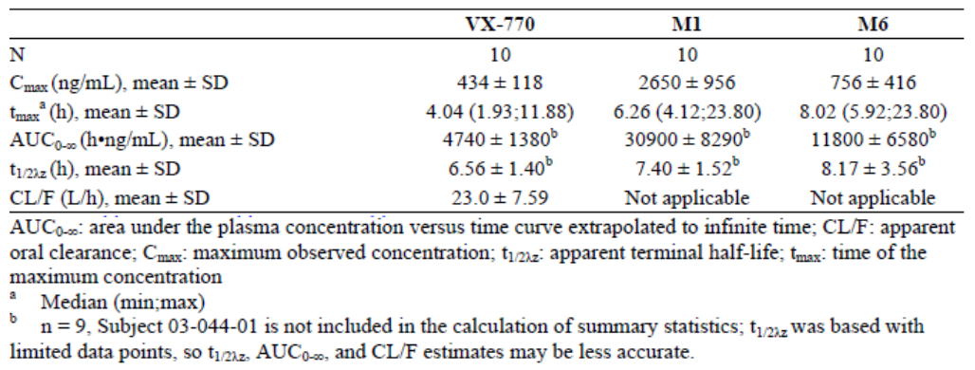
Population PK analysis was conducted and predicted steady-state Cmin and AUC estimates for ivacaftor and its metabolites M1 and M6 by age groups (Report G198). The dataset included subjects aged 6 to 53 years. Compared to adult subjects, children (age 6 to 11 years) had approximately 52% and 8% higher mean and median Cmin of ivacaftor, and approximately 2-fold higher mean and median AUC of ivacaftor. The PK variability in subjects aged 6 to 11 years was greater than in older subjects, especially for Cmin. Because subjects aged 6 to 11 years have a lower absolute clearance than adults, the AUC is expected to be higher at the same dose and dose interval compared to adults. However, because subjects aged 6 to 11 years have faster elimination than adults, the same dose and dose interval was needed to achieve similar Cmin in 6- to 11-year-old subjects as in adults.

Gender
Single-dose ivacaftor PK parameters were similar for male and female subjects (VX05-770-001). No effect of gender was seen for ivacaftor or M1 metabolite, but a gender effect was observed for M6 (an inactive metabolite) (VX08-809-005). After multiple doses of ivacaftor (Day 14), Cmax and AUC0-12 of M6 were approximately 3-fold higher in female subjects than in male subjects (VX08-809-005). Mean exposures of ivacaftor and M1 were similar in male healthy subjects (N = 38) and female healthy subjects (N = 32), and mean exposures of M6 were higher in female healthy subjects (VX09-770-008). There was no difference on the median time to reach the maximum concentrations of ivacaftor after dosing, indicating no gender effect on drug absorption. On Day 5, after administration of ivacaftor at 150 mg q12h or 450 mg q12h, the mean Cmax and AUC for M6 in females were approximately 1.55 to 1.74-fold higher than in males.
The effect of gender on PK was also analyzed by population PK analyses on pooled data from Phase 2/3 studies (101, 102, 103 and 104) and Phase 1 studies (002, 007, and 010). No effect of gender on CL/F of ivacaftor, M1, or M6 was detected in the population model. One potential reason for the apparent difference from single and multiple dose PK studies could be that the population PK model included weight as a covariate, and that weight and gender are correlated, with females generally having lower weights. The population estimates resulted in a good fit of the individual data (Report G198).

Pharmacokinetics related to genetic factors
No data was provided.

Pharmacokinetic interactions

Pharmacokinetic interactions demonstrated in human studies
The effects of multiple doses of the CYP3A inhibitor ketoconazole on the single-dose PK of 150 mg of ivacaftor in the fasted state were evaluated in 24 healthy male volunteers (VX08-770-006). Ketoconazole increased ivacaftor AUC_{0-∞} by about 8.5-fold and Cmax 2.7-fold. The M1 metabolite AUC increased 1.7-fold while Cmax was decreased by 77%, and decreased both the AUC and Cmax of M6 by approximately 70% and 94%, respectively. These results show that CYP3A is a CYP isozyme responsible for ivacaftor metabolism.
A similar study examined the effects of multiple doses of fluconazole on the multi-dose PK profile of ivacaftor in the fed state (VX09-770-010). Ivacaftor AUC₀₋₁₂ increased approximately 3-fold and Cmax approximately 2.5-fold; M1 AUC₀₋₁₂ increased approximately 1.9-fold and Cmax approximately 1.5-fold, and M6 AUC₀₋₁₂ decreased by approximately 17% and Cmax by approximately 16%.
Based on these results, ivacaftor should not be co-administered with strong inhibitors of CYP3A.
Co-administration of ivacaftor with the strong inducer of CYP3A rifampicin reduced ivacaftor exposure. A single dose of ivacaftor (150 mg) was administered with or without rifampicin (600 mg qd for 10 days) (VX09-770-009). Ivacaftor AUC_{0-last} decreased by 89% and Cmax by 80%. M1 AUC_{0-last} was decreased by 75% and Cmax by 39%. M6 Cmax was increased to 4.8-fold and AUC_{0-last} to 1.9-fold. Thus, co-administration of ivacaftor with inducers of CYP3A is likely to lead to decreased systemic exposure with possible loss of efficacy.
The effect of steady-state ivacaftor on the PK parameters of a single dose of midazolam and its metabolite 1’-hydroxy-midazolam was investigated in healthy male and female volunteers (VX09-770-010). Ivacaftor increased midazolam AUC_{0-∞} about 1.5-fold and Cmax 1.4-fold. Exposure to 1’-hydroxy-midazolam was unaffected. The results confirm ivacaftor as a CYP3A inhibitor.
The PK of rosiglitazone was assessed when administered with ivacaftor during multiple dosing to steady-state (VX09-770-010). Systemic exposure to rosiglitazone was unaffected. Ivacaftor does not inhibit CYP2C8. Similarly desipramine single dose PK was not affected when administered during a multiple dose administration of ivacaftor (VX10-770-011). Conversion of desipramine to its 2-hydroxy metabolite is dependent on CYP2D6 and was not altered by ivacaftor suggesting that ivacaftor is not an inhibitor of CYP2D6.
The potential interaction between ivacaftor (150 mg q12h for 28 days) and a hormonal oral contraceptive containing ethinyl estradiol [EE] (35 µg) and norethisterone [NE], (500 µg) was evaluated in healthy female volunteers (VX08-770-005). Each subject received a 21-Day cycle of the OC alone and a 21-Day cycle of the OC in combination with ivacaftor. Co-administration of ivacaftor with OC showed no statistically significant effects on the AUC 0-τ or total exposure of EE and NE, although there was an increase in the Cmax for EE of 1.2-fold compared with OC administered alone. Overall, progesterone levels indicated that ovulation suppression was achieved for both OC alone and OC plus ivacaftor administrations. Measurement of surrogate markers of the PD effectiveness of OC, including LH, FSH, and progesterone, is mildly suggestive of a potential for increased effect when co-administered with ivacaftor. The point estimates of GLSMRs were 22.4%, 29.5%, and 11.5% lower in FSH, LH, and progesterone levels, respectively, after administration of ivacaftor + OC as compared with administration of OC alone at Day 21. The alteration suggests increased potential for ovulatory suppression; however, the clinical relevance of this finding is not clear. These results suggest that the clinical effect of OC would not likely be adversely impacted by co-administration with ivacaftor. Co-administration of OC with ivacaftor did not appear to affect the exposure of ivacaftor and its metabolites M1 and M6.

Clinical implications of in vitro findings
Ivacaftor and M1 were metabolized in vitro by recombinant cytochrome P450 (CYP) 3A4 and 3A5; whereas M6 was metabolically stable in a panel of 9 recombinant CYP isozymes (Report H191). In vitro studies showed that ivacaftor as well as M1 have a potential for drug interactions through inhibition of CYP2C8, CYP2C9, and CYP3A. M6 was not a substantive inhibitor of CYP isozymes in vitro. In vitro studies showed that ivacaftor and M6 may be metabolism-dependent inhibitors of CYP2D6 (Reports VX-770-DMPK-DM-039). The primary Phase I metabolism occurred by oxidation, and the primary Phase II metabolism occurred by glucuronic acid conjugation of metabolites.
In vitro studies of ivacaftor, M1, and M6 on isozyme-selective CYP activities in cultured human hepatocytes indicated that ivacaftor, M1, and M6 were not inducers of CYP1A2, CYP2A6, CYP2B6, CYP2C8, CYP2C9, CYP2C19, or CYP3A4/5 (Report VX-770-DMPK-DM-038).

Evaluator’s overall conclusions on pharmacokinetics
The sponsor has provided an extensive range of PK studies evaluating single and multiple doses of ivacaftor in healthy subjects and in patients with the target condition, cystic fibrosis. Generally, the majority of studies have been performed to a high standard and a priori power analysis has been undertaken to justify sample sizes. There were some studies where power was inadequate and these have been acknowledged by the sponsor. Principally these were in studies of the PK in children, where relatively small numbers participated and sampling times were probably inadequate to reliably assess the parameters (particularly terminal elimination half-life). Drug-drug interaction studies have primarily focused on the medications with effects on CYP3A, as ivacaftor is primarily metabolised by this cytochrome subgroup. Special population PK studies have been conducted but there were no studies in renal impairment. This was justified by the sponsor on the basis that ivacaftor is only minimally excreted in the urine. On the other hand, a study in severe renal failure or End Stage Renal Disease might be useful. It seems unlikely that there would be any major changes in PK that could affect clinical outcome but there are no data. Given that the treatment of CF is likely to involve the concomitant use of multiple medications (at times) the DDI studies presented did not appear to focus specifically on such poly-pharmacy situations and the assessment of either the PK (or PD) effects on ivacaftor.
The proposed PI reflects adequately the PK studies that have been performed and provides suitable warnings about the potential for drug-drug interactions based on the studies that have been performed as well as theoretical possibilities given the known metabolic pathways for ivacaftor. However, lack of evaluation in patients with mild hepatic impairment needs to be stated more clearly in the PI.

Pharmacodynamics

Studies providing pharmacodynamic data
Table 3, below shows the studies relating to each pharmacodynamic topic.
Table3. Submitted pharmacodynamic studies.
PD Topic | Subtopic | Study ID
Primary Pharmacology | Effect on FEV1 and sweat Chloride ion | VX06-770-101
Secondary Pharmacology | Effect on QTc interval | VX09-770-008
Gender other genetic and Age-Related Differences in PD Response | No studies
PD Interactions | No studies
Population PD and PK PD analyses | Target Population§ | Report G198
§ Subjects who would be eligible to receive the drug if approved for the proposed indication.
Adult subjects with CF who had at least 1 G551D-CFTR allele treated with ivacaftor had increased forced expiratory volume in 1 second (FEV1; clinical endpoint) and responses of biomarkers of CFTR function (decreases in both sweat chloride and nasal potential difference [NPD]). Ivacaftor did not affect the QTcF of the ECG at either therapeutic or supra-therapeutic doses. A PK/PD model was developed to describe the minimum concentration of ivacaftor required to produce clinically significant alterations in FEV1 and sweat chloride. Based on the modelling a dose of 150mg every 12 hours would achieve the Cmin of ~423ng/ml needed to achieve an EC₉₀ for FEV1 in adults and children.

Mechanism of action
CFTR is an epithelial chloride channel responsible for aiding in the regulation of salt and water absorption and secretion in various tissues. Although CF affects multiple organs, the leading cause of mortality is the progressive loss of lung function. FEV1 is a validated clinical endpoint to assess the effect of therapies in CF lung disease. As ivacaftor affects the CFTR protein and increases channel activity it should result in increased chloride transport. The CFTR protein is expressed in sweat glands and in nasal epithelium, ivacaftor is expected to potentiate CFTR function in both these tissues. A decrease in either NPD or sweat chloride concentration is indicative of increased CFTR function.
Treatment with ivacaftor from 75 to 250 mg q12h of adult subjects with CF and the G551D-CFTR mutation in at least 1 allele resulted in decreased sweat chloride and NPD values and increased FEV1 that was apparent by Day 3 for sweat chloride and FEV1 and by Day 14 for NPD [not measured earlier] and persisted through Day 14 in Part 1 and Day 28 in Part 2 (VX06-770-101). Results for all 3 PD endpoints showed a statistically significant linear trend of increasing response with increasing dose. Significant mean changes from baseline in FEV1 (absolute volume, percent predicted, and relative change in percent predicted) were observed in the 75-, 150- and 250-mg ivacaftor groups at Day ≥3, Day 14, and Day ≥14, but not in the 25-mg ivacaftor group. The treatment differences between the 150-mg group were statistically significant in the Day 14 and Day ≥14 analyses compared to placebo. A significant mean change from baseline in the zero chloride plus isoproterenol [Australian approved name isoprenaline] response phase of the NPD measurement (greater negative ion current reflecting the flow of chloride across the cell membrane mediated by CFTR) was observed in the 75-, 150-, and 250-mg ivacaftor groups in the Day 14 and Day ≥14 analyses, but not in the 25-mg ivacaftor group. The treatment differences between the 150-mg and 250-mg ivacaftor groups versus the placebo group were significant in the Day 14 and Day ≥14 analyses. A statistically significant decrease from baseline in maximum sweat chloride was observed in all ivacaftor groups (25-, 75-, 150-, and 250-mg) in the Day ≥3, Day 14, and Day ≥14 analyses which were significantly different from placebo in the Day ≥3, Day 14, and Day ≥14 analyses.

Cardiac safety
A randomized, placebo- and active-controlled, 4-treatment, double-blind, 4-period crossover study conducted in 72 healthy male and female subjects to assess the effect of ivacaftor on cardiac safety (Study VX09-770-008). ECG data were collected using continuous 12-lead ECG recording. The therapeutic dose was 150 mg ivacaftor q12h on Day 1 through the morning dose on Day 5; the supra-therapeutic dose was 450 mg ivacaftor q12h on Day 1 through the morning dose on Day 5. The placebo control was placebo q12h on Day 1 through the morning dose on Day 5; and the positive control was placebo q12h on Days 1 to 4, and a single 400-mg dose of moxifloxacin in the morning of Day 5. The adjusted mean and 90% CI of time-matched placebo-subtracted change from baseline in QTcF interval on Day 5 for the different treatments is shown in Figure 1.
Figure 1. Adjusted Mean and 90% CI of Time-Matched, Placebo-Subtracted Change From Baseline in QTcF Interval on Day 5 (Study VX- VX09-770-008)
Assay sensitivity was established as the change from baseline in QTcF and QTcB intervals for moxifloxacin exceeded 5 msec at 2, 3, 4, and 6 hours postdose on Day 5. Ivacaftor was not associated with a clinically significant effect on QTcF or QTcB intervals at either dose used. For both doses, the upper limits of the 90% 2-sided CI were below 10 msec at all postdose time points on Day 5. There no differences in effect for male and female subjects. A linear mixed-effect models demonstrated no statistical significant correlation of QTcF changes with concentrations of ivacaftor and its metabolites.

Population pharmacokinetic/pharmacodynamic modelling
A PK/PD model to describe the relationship for ivacaftor and M1 using forced expiratory volume in one second (FEV1) and sweat chloride as endpoints was examined (Report G198). The study population consisted of 196 males and 191 females with ages ranging from 6 to 53 years, but was not balanced for the distribution of races (the majority of patients were Caucasian). A population model describing the exposure-response relationship of FEV1 as an Emax model with terms for baseline, CFTR mutation, gender, age, a slope and an effect compartment was successfully developed. Age and gender influenced the FEV1 baseline estimated by the model establishing that the model is sensitive to known effects of these variables on FEV1. Gender did not significantly influence the Emax. Age effects were not well defined. Emax estimate for a G551D “typical” 18 year old male subject is 0.322 L. Ivacaftor monotherapy had no significant effect for subjects with the F508del mutation. The FEV1 Emax estimates for subjects receiving Pulmozyme or azithromycin together with ivacaftor were reduced compared to subjects not receiving the concomitant medication. The effect was estimated at 61% and 70% respectively of the subjects not receiving either concomitant medication. The reason for this reduction is unclear. A population model describing the exposure-response relationship of sweat chloride as an Emax model with terms for baseline, CFTR mutation, gender, age and an effect compartment was successfully developed. The Emax estimate for a G551D “typical” 18 year old male subject is -50.6 mM. Ivacaftor monotherapy had no significant effect for subjects with the F508del mutation. The target exposure criterion for subjects 6 years and older was that the average (median) Cmin of the population should be at least the EC₉₀ for FEV1. The predicted EC₉₀ for FEV1 in this analysis is 423ng/mL in G551D subjects. In subjects 6 years and older, a dose of 150 mg q12 achieved a median ivacaftor Cmin of at least 423 ng/mL. This dose achieved clinical efficacy and safety.

Pharmacodynamic interactions
No studies were reported.

Evaluator’s overall conclusions on pharmacodynamics
A small number of PD studies, which were generally well conducted and mostly adequately powered, were presented by the sponsor. Study 101 examined the relationship between ivacaftor concentrations and biological end points (FEV1, sweat chloride). The numbers in the study were modest but a direct Emax model with baseline effect described the relationship between ivacaftor plasma concentration and FEV1 or sweat chloride. This was confirmed by PK/PD modelling study which included data from about 400 CF adults and children with CF. The cardiovascular safety of ivacaftor was assessed in healthy volunteers. Assay sensitivity was established by using moxafloxacin as a control condition. There was no significant effect on QTcF at doses which exceeded those recommended in clinical practise. There are no PD interaction studies with alcohol or sedative agents examining impairment of cognitive or psychomotor function which might be relevant in adults / adolescents.

Dosage selection for the pivotal studies
Ivacaftor is a selective potentiator of the Cystic Fibrosis Transmembrane conductance Regulator (CFTR) protein, i.e., in vitro ivacaftor increases CFTR channel gating to enhance chloride transport. However, the exact mechanism leading ivacaftor to prolong the gating activity of some mutant CFTR forms has not been completely elucidated.
Study 101 was a 2-part, double-blind, placebo-controlled, cross-over, multiple-dose, multicentered, randomized study of up to 28 days of dosing in 39 subjects (male and female) with CF and the G551D mutation on at least 1 CFTR allele and FEV1 ≥40% of predicted normal for age, sex, and height. Enrolment occurred at 15 centers in the US, Canada, and Germany. During the study, 31 subjects received at least 1 dose of VX-770. VX-770 was administered at a dosage of 25 mg, 75 mg, 150 mg, or 250 mg every 12 hours (q12h), 30 minutes after the start of a meal or snack. VX-770 or placebo was taken for 28 days in the study (Part 1: 2 periods of 14 days; Part 2: 1 period of 28 days).
Results from Study 101 suggested that VX-770 was well tolerated, with all subjects completing dosing and study visits without discontinuations or interruptions. The secondary endpoints of the study included efficacy assessments of NPD, sweat chloride, and FEV1 (Part 1 and Part 2) and CFQ-R (Part 2 only). Part 1 was a cross-over design; thus, a linear mixed model was used to determine least square mean change from baseline, and results were presented as mean (95% CI). A linear mixed effect model including baseline, dose, time, and dose by time interaction was to have been used in Part 1. Because the carryover effect was found not to be of clinical or statistical significance, a linear mixed effect model including baseline, period, and dose as fixed effects and subject as a random effect was used. In Part 2, a parallel study design was used.
Results from Part 1 showed statistically significant changes from baseline in forced expiratory volume in 1 second (FEV1), sweat chloride levels, and nasal potential difference for the ivacaftor 75mg and 150 mg groups compared with placebo following every 12 hours (q12h) dosing for 14 days. Results from Part 2 showed statistically significant greater improvements with ivacaftor 150- and 250-mg dosing (for 28 days) compared with placebo in FEV1 sweat chloride levels and NPD. Subjects receiving ivacaftor 150- and 250-mg dosing also reported improvements greater than the minimal clinically important difference (MCID) of 4 points in the respiratory domain of the Cystic Fibrosis Questionnaire-Revised (CFQ-R, a preliminary MCID of 5 points was originally reported during the development of the protocol for the present study).
Furthermore, the number and proportion of subjects considered responders based on the criteria of >10% relative increase in FEV1, ≥ -5mV increase in zero chloride plus isoproterenol response in NPD, ≥20 mmol/L decrease in sweat chloride from the baseline measurement after 14 days of dosing (Part 1, Part 2, and Part 1 and Part 2 Combined) and after 28 days of dosing (Part 2) was consistently greater in subjects receiving 150 and 250mg ivacaftor compared with placebo.
Phase 2a study 101 established proof-of-concept for ivacaftor treatment and provided dose selection information for subjects with CF. Based on results of this study and modelling and simulations using data from a Phase 1 study (Study 007; Module 5.3.1.2), a dose of 150 mg q12h was selected for Phase 3 Study 102 and a dose of 100 mg was selected for Part A, a lead-in PK evaluation, of Phase 3 Study 103. Subsequent modelling and simulations additionally using data from Part A of Study 103 resulted in selecting the 150-mg q12h dose for subjects age 6 to 11 years in Part B of the Phase 3 Study 103.

Clinical efficacy

Pivotal efficacy studies
The efficacy of ivacaftor was evaluated in two pivotal Phase 3, placebo-controlled, 48-week studies (102 and 103) in 213 subjects with CF who had a G551D mutation in the CFTR gene and mild or moderately impaired lung function (as determined by FEV1 percent predicted of normal for age, sex, and height by the Knudson standards).

Study 102

Study design, objectives, locations and dates
Study 102 (design shown in Figure 2) was a Phase 3, randomized, double-blind, placebo-controlled, parallel-group multicenter study of orally administered VX-770 in subjects with CF. The study was conducted at 65 centres in Europe, America and Australia from 10 June 2009 to 11 Jan 2011. The primary objective was to evaluate the efficacy of VX-770 after 24 weeks of treatment in subjects with cystic fibrosis (CF) and a G551D-cystic fibrosis transmembrane conductance regulator (CFTR) mutation. The secondary objectives were to evaluate safety of VX-770 after 24 and 48 weeks of treatment and also to evaluate efficacy of VX-770 after 48 weeks of treatment. Subjects in the study were randomized to receive either 150 mg VX-770 or placebo every 12 hours (q12h) for 48 weeks. The study included a Screening Period (Day -35 to Day -15), a Run-In Period (Day -14 to Day -1 relative to the first dose of study drug [VX-770 or placebo]), a Treatment Period (Day 1 [first dose of study drug] to Week 24), and an Extension Period (Week 25 to Week 48). All subjects who completed 48 weeks of study drug treatment were offered the opportunity to enrol in an open-label safety study of VX-770 (Study 105).
Figure 2. Study 102 Schematic design

Inclusion and exclusion criteria
The main inclusion criteria were: male and female subjects with confirmed diagnosis of CF, 12 years of age and older, who have the G551D-CFTR mutation in at least 1 allele; mild or moderately impaired lung function (FEV1 40% to 90% of predicted normal for age, gender, and height (Knudson standards).
The main exclusion criteria were: subjects whose CF disease was not stable; subjects with “normal” lung function (FEV1 values above 90% predicted [or above 105% for age 6 to 11 years]) or those with severe lung disease (FEV1 less than 40% predicted); An acute upper or lower respiratory infection, pulmonary exacerbation, or changes in therapy (including antibiotics) for pulmonary disease within 4 weeks before Day 1 (first dose of study drug). History of prolonged QT/QTc interval with Fridericia’s correction (QTcF) >450 msec or QTcF > 450 msec at screening; History of solid organ or hematological transplantation; History of alcohol, medication or illicit drug abuse within one year prior to Day 1 (first dose of study drug); clinically significant medical illness; clinically significant hematology, serum chemistry, coagulation, urinalysis, LFT or RFT results; pregnancy/ lactation; Ongoing participation in another therapeutic clinical study or prior participation in an investigational drug study within 30 days prior to Screening; Any “non-CF-related” illness within 2 weeks prior to Day 1 (first dose of study drug), i.e., illness” is defined as an acute (serious or non-serious) condition (e.g., gastroenteritis); Use of inhaled hypertonic saline treatment (Subjects who had stopped inhaled hypertonic saline treatment were eligible to participate, but they must have undergone a wash-out period of 4 weeks prior to Day 1).

Study treatments
VX-770 150-mg tablet or matching placebo tablet was administered orally 150 mg q12h (recommended to take study drug 30 minutes after the start of a standard “CF” high-fat, high calorie meal or snack). Study drug was administered q12h for 48 weeks (24 weeks in the treatment period and 24 weeks in the extension period). Whenever possible, subjects should have taken the study drug at the same time each day. If subjects forgot to take a dose and remembered within 0 to 6 hours (before the halfway point of the dosing interval), they should have taken the dose at that time with a standard “CF” high fat, high calorie meal or snack, and resumed their normal schedule for the following dose. If subjects forgot to take a dose and remembered within 6 to 12 hours after the missed dose, they should have skipped that dose and resumed their normal schedule for the following dose.
To ensure treatment compliance, the investigator or designee supervised all study drug dosing that occurred at the site and also reminded the subject of study drug dosing requirements. Compliance was also confirmed by ongoing drug accountability.
It was recommended that subjects remain on stable medication regimens for their CF (including high-dose ibuprofen, dornase alfa or other inhaled antibiotics) from 6 weeks before Day 1 through the Week 48 Visit or, if applicable, the Follow-up Visit. Use of short-acting and long-acting bronchodilators was collected and documented in the source documents for each subject.

Efficacy variables and outcomes
The efficacy variables assessed in the study were Spirometry, sweat chloride test, CF Questionnaire-Revised (CFQ-R), documentation of events related to outcomes (e.g., pulmonary exacerbations, hospitalizations, antibiotic therapy for sinopulmonary signs/symptoms, and outpatient sick visits to the clinic or hospital for CF-related complications), EuroQol Questionnaire (EQ-5D), pulse oximetry, and weight. The schedule of assessments during the study, from the Screening Visit through the Follow-up Visit and the Long-term Follow-up Visits is shown in Table 4.
Table 4. Study 102 Schedule of assessments
The primary endpoint was the absolute change in percent predicted FEV1 through Week 24 of treatment. The secondary efficacy variables were absolute change from baseline in percent predicted FEV1 through Week 48, absolute change from baseline in CFQ-R score, absolute change from baseline in sweat chloride, time to first pulmonary exacerbation, and absolute change from baseline in weight. Key secondary endpoints were absolute change from baseline in pooled respiratory CFQ-R score through Week 24, absolute change from baseline in sweat chloride through Week 24, time to first pulmonary exacerbation through Week 48, and absolute change from baseline in weight at Week 48.
The tertiary efficacy variables included: absolute change from baseline in oxygen saturation, absolute change from baseline in EQ-5D, pulmonary exacerbations (count and duration), hospitalizations, outpatient sick visits to the clinic or hospital for CF-related complications, antibiotic therapy for sinopulmonary signs/symptoms, and rate of decline in FEV1.
Exploratory endpoints were assessments of the levels of inflammatory mediators in blood including C-reactive protein, immunoglobulin G, and interleukin-8.

Randomisation and blinding methods
Subjects were randomized in a 1:1 ratio, stratifying for age (< 18 versus ≥ 18 years of age) and FEV1 (< 70% versus ≥ 70% predicted) at screening. To protect the scientific integrity of the blind, 2 biostatisticians were involved in the randomization process: a study biostatistician, who was blinded to the actual treatment code, and an unblinded biostatistician who was not associated with the study. The study biostatistician created the randomization specification and dummy randomization code, which were reviewed and approved by the unblinded biostatistician. After approval, the unblinded biostatistician generated the final (production) randomization list that was provided to the Interactive Voice Response System (IVRS)/Interactive Web Response System (IWRS). A copy of the final randomization list (in sealed tamper-evident envelopes) was archived at Vertex.
The subjects, all site personnel including the investigator, the study monitor, and the Vertex study team were blinded with the exception of the following:- Any site personnel for whom this information was important to ensure the safety of the subject, in the event of a life-threatening medical emergency; Vertex Global Patient Safety and Regulatory Affairs personnel to satisfy SAE processing regulations; Unblinded statistician preparing the final (production) randomization list who was not part of the study team; IVRS/IWRS vendor; Vertex Clinical Supply Chain; DMC, and Vendor preparing the unblinded analyses for the DMC. Sweat chloride laboratory personnel, and the monitor who was reviewing the sweat chloride results, were unblinded to the sweat chloride results but remained blinded to treatment assignment.

Analysis populations
Full Analysis Set (FAS) was defined as all randomized subjects who received at least 1 dose of study drug (i.e., VX-770 or placebo). The Per protocol set (PPS) was defined as all FAS subjects without major protocol violations having at least 80% overall study drug compliance and having completed at least 80% of the analysis period. For the Week 24 PPS, subjects having more than 1 missing assessment of FEV1 or who were missing the Week 24 assessment of FEV1 were excluded; for the Week 48 PPS, subjects having more than 1 missing assessment of FEV1 were excluded. Major protocol violations were defined as violations that may have had a substantial impact on efficacy assessments. The PPS analyses were performed for the primary and secondary endpoints to provide supportive evidence for efficacy at Week 24 and Week 48. Safety Set was defined as all subjects who received at least 1 dose of study drug (VX-770 or placebo).

Sample size
The treatment effect size and standard deviation was based on the results of Study 101 and a review of the clinical CF literature, taking into consideration the likelihood of a larger variability in this study in approximately 80 sites compared with Study 101, which enrolled 39 subjects (total) at 15 sites. The estimated study power for detecting different treatment effect sizes between VX-770 and placebo in the absolute change in percent predicted FEV1 from baseline through Week 24, assuming 80 randomized subjects (total) is summarised in Table 5.
Table 5. Power estimates under possible scenarios of treatment effects, given a total of 80 randomised and evaluable subjects
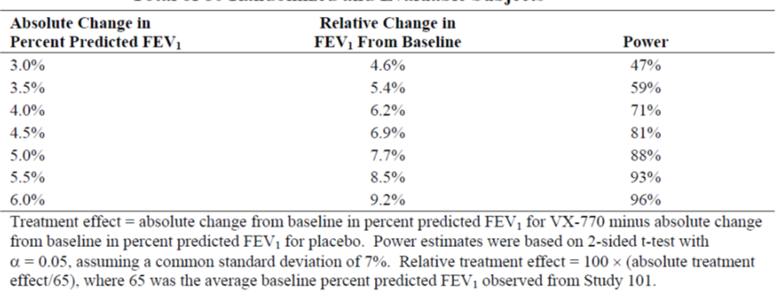

Statistical methods
The primary efficacy endpoint was the absolute change from baseline in percent predicted FEV1 through Week 24. The primary analysis for this endpoint was based on a Mixed-Effects Model for Repeated Measures (MMRM). No imputation on missing data was done for the primary analysis using the MMRM. In addition to the primary analysis based on FAS, a supportive analysis based on the PPS was conducted. To assess the robustness of the primary analysis, analyses were conducted using different variance-covariance matrices in MMRM, nonparametric analysis, and analysis of covariance (ANCOVA) with missing data imputed using 3 methods: the last observation carried forward (LOCF), worst-case, and dropout reason-based.
The secondary efficacy variables were absolute change from baseline in percent predicted FEV1 through Week 48, absolute change from baseline in CFQ-R score, sweat chloride, time to first pulmonary exacerbation, and weight. Key secondary endpoints were absolute change from baseline in pooled respiratory CFQ-R score through Week 24, absolute change from baseline in sweat chloride through Week 24, time to first pulmonary exacerbation through Week 48, and absolute change from baseline in weight at Week 48. Primary analysis for the first three variables was similar to that of the primary efficacy endpoint. However, change from baseline in weight was analysed using a linear mixed effect (LME) model and time to first pulmonary exacerbation was analysed using Cox regression and Kaplan-Meier methods. The primary analysis of the secondary efficacy variables was repeated based on the PPS. To assess the robustness of the primary analysis of change from baseline in weight, the following alternative endpoints were used: weight adjusted for age and sex and analysed as weight-for-age z-scores (calculated using Centers for Disease Control and Prevention [CDC] growth charts), body mass index (BMI), and BMI adjusted for age and sex, analysed as BMI-for-age z-scores (calculated using CDC growth charts). To assess the robustness of the primary analysis of other secondary endpoints for which primary analysis was performed using the MMRM, sensitivity analyses were conducted using different variance-covariance matrices in MMRM, nonparametric analysis, and analysis of covariance (ANCOVA) with missing data imputed using 3 methods: the last observation carried forward (LOCF), worst-case, and dropout reason based.
Subgroup analyses of the primary and secondary endpoints were performed for the following subgroups: age (< 18 and ≥ 18 years), percent predicted FEV1 severity at baseline (< 70% and ≥70% predicted), sex (female and male), and geographic region (North America, Europe, and Australia). Sensitivity and subgroup analyses were only performed based on the FAS.
The tertiary efficacy variables included: absolute change from baseline in oxygen saturation, absolute change from baseline in EQ-5D, pulmonary exacerbations (count and duration), hospitalizations, outpatient sick visits to the clinic or hospital for CF-related complications, antibiotic therapy for sinopulmonary signs/symptoms, and rate of decline in FEV1. The primary analysis of the tertiary variables was performed on the FAS only. Primary analysis for the first two variables was similar to that of the primary efficacy endpoint. Event variables described above were analysed as follows (as appropriate): count (negative binomial regression), duration (number of days; Wilcoxon rank-sum test), and time to first (Cox regression and Kaplan-Meier methods).
The following additional FEV1 endpoints (through Week 24 and Week 48) were analysed in a similar manner to that of the primary analysis of the primary efficacy endpoint (no sensitivity analysis was performed):- Absolute change in FEV1 from baseline, relative change in FEV1 from baseline, relative change in percent predicted FEV1 from baseline, absolute change in percent predicted forced vital capacity (FVC) from baseline, absolute change in percent predicted forced midexpiratory flow rate (FEF25-75%) from baseline, absolute change in percent predicted FEV1/FVC from baseline.
Exploratory Evaluations: Assessments of the levels of inflammatory mediators in blood included C-reactive protein, immunoglobulin G, and interleukin-8. Analysis was conducted on the raw and the log-transformed change from baseline result and was analysed using ANCOVA.

Participant flow
A total of 167 subjects were randomized; 84 subjects were randomized to VX-770 and 83 subjects were randomized to placebo treatment; 83 subjects in the VX-770 group and 78 subjects in the placebo group received at least 1 dose of the study drug. (the FAS and the safety set were identical).
A total of 80 (96.4%) subjects in the VX-770 group and 71 (91.0%) subjects in the placebo group completed dosing in the Treatment Period (through Week 24). Through Week 24, 3 (3.6%) subjects in the VX-770 group and 7 (9.0%) subjects in the placebo group discontinued study drug dosing; the most frequent reason for discontinuation was an AE (1 [1.2%] subjects in the VX-770 group and 3 [3.8%] subjects in the placebo group). A total of 77 (92.8%) subjects in the VX-770 group and 68 (87.2%) subjects in the placebo group completed dosing in both the Treatment and Extension Periods (through Week 48). Through Week 48, 6 (7.2%) subjects in the VX-770 group and 10 (12.8%) subjects in the placebo group discontinued study drug dosing; the most frequent reason for discontinuation was an AE (1 [1.2%] subjects in the VX-770 group and 4 [5.1%] subjects in the placebo group).

Major protocol violations/deviations
The majority of protocol deviations were minor, not considered to have had substantial impact on the efficacy assessments or subject safety and were related to completion of study assessments, subject visits that were out of the protocol-specified visit window, study drug administration, PK blood collection, minor, non-reportable completion errors of the ICF form, and prohibited medications. The PPS at Week 24 included 138 subjects (74 and 64 subjects in the VX-770 and placebo groups, respectively), and the Week 48 PPS included 133 subjects (69 and 64 subjects in the placebo group); the most common protocol violations leading to exclusion from the PPS were prohibited medications, overall drug compliance and missing FEV1 assessments with similar incidence in the ivacaftor and placebo groups.

Baseline data
Majority of subjects in both groups were White (VX-770 vs placebo: 97.6% vs 98.7%) of non-Hispanic or Latino ethnicity (97.6% vs 98.7%), from North America (60.2% vs 64.1%) and female (53.0% vs 51.3%). The mean age was 26.2 years (range: 12-53) with 36 (22.4%) < 18 years and 125 (77.6%) subjects in the ≥ 18 years subgroup. Baseline sweat chloride values (100.35 mmol/L in the VX-770 group and 100.13 mmol/L in the placebo group), mean percent predicted FEV1 at baseline (63.56%), and oxygen saturation (97%) were similar between the 2 treatment groups. Mean height, weight, weight-for-age z-score, BMI, and BMI-for-age z-score at screening were also similar between the 2 treatment groups. The most commonly reported continuing conditions were CF lung disease (100%), pancreatic insufficiency (92.5%), sinus disease (symptomatic; 50.9%), gastroesophageal reflux disease (GERD; 37.9 %), asthma (27.3%), and CF-related diabetes (CFRD; 18.6%) with similar incidence in both treatment groups. During 24 and 48 weeks, the most commonly reported concomitant medications were indicated for management of CF complications and the use of these medications was generally similar between the 2 treatment groups. At the start of the study, patients in the placebo group used some medicinal products at a higher frequency than the ivacaftor group which included dornase alfa (placebo vs. ivacaftor: 73.1% vs 65.1%), salbutamol (53.8% vs 42.2%), tobramycin (44.9% vs 33.7%), and salmeterol/fluticasone (41.0% vs 27.7%). During first 24 weeks, the proportion of subjects administered the following concomitant medications was at least 10% higher in the placebo group than the VX-770 group: salbutamol, seretide, ciprofloxacin, calcium carbonate, and minocycline; conversely, administration of sodium chloride was at least 10% higher in the VX-770 group than the placebo group. During 48 weeks, the proportion of subjects administered the following concomitant medications was at least 10% higher in the placebo group than the VX-770 group: tobramycin, ciprofloxacin, seretide, ceftazidime, meropenem, minocycline, prednisone, and montelukast sodium; conversely, administration of sodium chloride was at least 10% higher in the VX-770 group than the placebo group. Of the concomitant medications received by at least 10% of subjects in any group, the following medications were administered to subjects in the placebo group at least (approximately) twice as frequently as subjects in the VX-770 group: ceftazidime, meropenem, co-trimoxazole, prednisone, montelukast sodium, budesonide w/formoterol fumarate, minocycline, heparin, and calcium carbonate; these medications were also administered more frequently in the placebo group than the VX-770 group before the study, with the exception of meropenem and prednisone.
During the Treatment Period (through Week 24) the mean (SD) overall compliance was similar between the treatment groups: 95.29% (11.52) in the VX-770 group and 91.42% (17.5) in the placebo group, but a greater proportion of subjects were ≥ 85% compliant with the study drug treatment in the VX-770 group (91.6%, 76 subjects) than in the placebo group (83.3%, 65 subjects). However, the mean (SD) ‘on-study’ compliance was similar between the treatment groups (96.14% vs 95.29%) and the proportion of subjects with ≥ 85% on-study drug compliance was similar (94.0% vs 92.3%). Through Week 48, the mean (SD) overall compliance was similar between the treatment groups (91.03% vs 88.79% with a similar proportion of subjects ≥ 90% compliant with the study drug treatment (74.7% vs 78.2%). The mean on-study compliance was similar between the treatment groups (93.49% vs 96.01%) but a slightly lower proportion had ≥ 90% on-study drug compliance in the VX-770 group than in the placebo group (74.7% vs 88.5%).

Results for the primary efficacy outcome
The adjusted mean absolute change from baseline through Week 24 in percent predicted FEV1 was significantly greater in the VX-770 group than the placebo group (10.4% vs -0.18%; diff=10.58% ; 95% CI: 8.6, 12.6; P < 0.0001). Statistically significant differences between treatment groups were detected by Day 15 (first post-baseline time point assessed) and were sustained for the duration of the treatment period (Figure 3). The robustness of the primary analysis was supported by the results of sensitivity analyses (Table 6).
Figure 3. Mean absolute change from baseline in percent predicted FEV1 by treatment, Full Analysis Set.
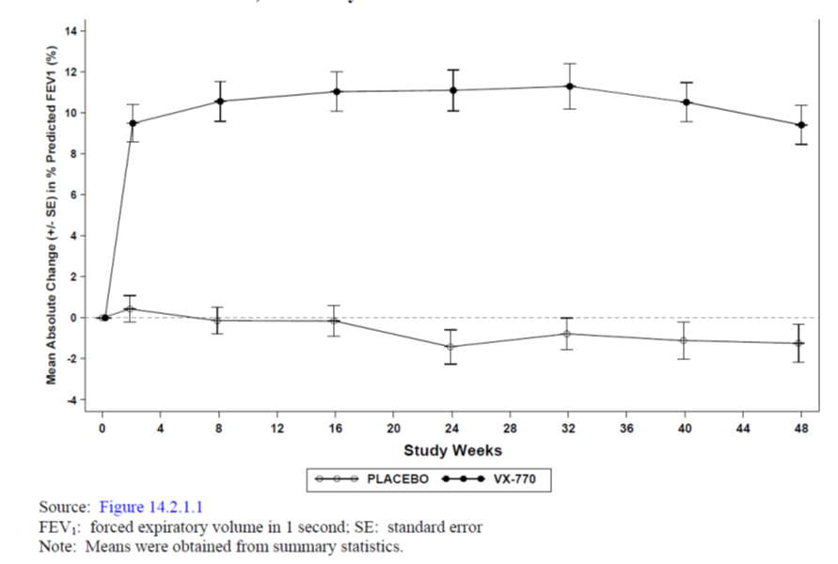
Table 6. Absolute change from baseline in percent predicted FEV₁, Week 24, Sensitivity Analysis, Full Analysis Set.
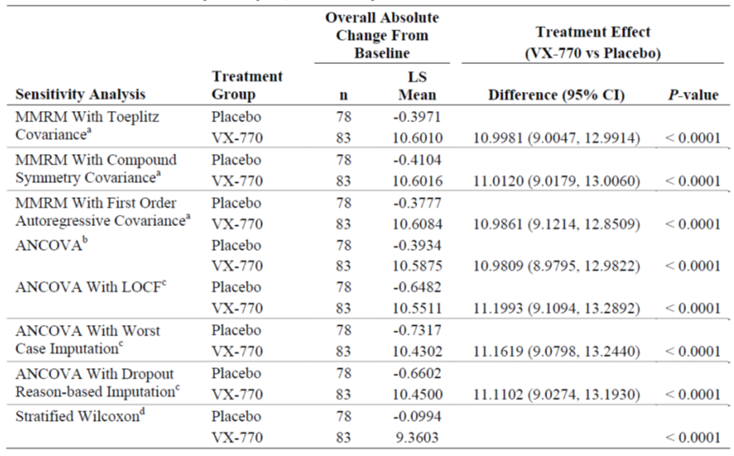

Results for other efficacy outcomes

Key secondary efficacy endpoints
Change from baseline in pooled CFQ-R respiratory domain score (in the pooled adolescents/adults and 12 to 13 year-old versions of CFQ-R) through Week 24 was a key secondary efficacy endpoint and was significantly greater in the VX-770 group than the placebo group (5.97 vs -2.10 points; difference= 8.08 points; 95% CI: 4.73, 11.42; P < 0.0001). Similar changes were observed through week 48. Improvements in CFQ-R respiratory domain scores occurred by Day 15 and were sustained for the duration of the treatment period. Sensitivity analyses included ANCOVA with no imputation of missing measurements, and ANCOVA using the last non-missing CFQ-R respiratory domain score carried forward, worst case imputation, and dropout reason-based imputation. In all of these analyses, the mean absolute change from baseline across all post-baseline visits was greater in the VX-770 group than in the placebo group, and the difference was statistically significant (P < 0.0001). These results were consistent with the results of the primary analysis. Statistically significant differences in the adjusted mean changes from baseline through Week 24 in the pooled adolescents/adults and 12 to 13 year-old CFQ-R versions were also observed for the physical, vitality, social, eating and health domains.
Change from baseline in sweat chloride through Week 24 was a key secondary efficacy endpoint and the adjusted mean absolute change from baseline through Week 24 in sweat chloride values was greater in the VX-770 group than in the placebo group (-48.70 vs -0.77 mmol/L; diff= -47.93 mmol/L; 95% CI: -51.34, -44.52; p < 0.0001). Similarly, the adjusted mean change from baseline through Week 48 in sweat chloride values was also greater in the VX-770 group than in the placebo group (-48.65 vs -0.58 mmol/L; difference= -48.07 mmol/L; 95% CI: -51.47, -44.68; p < 0.0001). The changes in sweat chloride in subjects treated with VX-770 occurred by Day 15 and were sustained for the duration of the 24-week treatment period and for the duration of the extension period (through Week 48). These results were also confirmed in the sensitivity analysis.
The estimated Week 48 pulmonary exacerbation-free rate was 67% in the VX-770 group and 41% in the placebo group. Over 48 weeks there was a 54.5% statistically significant (p = .0012) reduction in risk of a pulmonary exacerbation for subjects in the VX-770 group relative to subjects in the placebo group (hazard ratio [95% CI]: 0.455 [0.282, 0.733]). The estimated Week 24 pulmonary exacerbation-free rate was greater in the VX-770 compared to the placebo group (78% vs 51%; p = 0.0016) with a significant 60.1% reduction in risk of pulmonary exacerbation over 24 weeks (hazard ratio [95% CI]: 0.399 [0.225, 0.706]).
Change from baseline in weight at Week 48 was a key secondary efficacy endpoint and the adjusted mean change from baseline in weight at Week 48 was greater in the VX-770 group than the placebo group (3.11 vs 0.40 kg; treatment diff=2.71 kg; 95% CI: 1.33, 4.09; p = 0.0001).
The adjusted mean change from baseline in weight at Week 24 was also greater in the VX-770 group than the placebo group (2.95 vs 0.21 kg; treatment difference =2.75 kg; 95% CI: 1.76, 3.74; p<0.0001).

Other Secondary efficacy endpoints:
For the 47 subjects 20 years of age or younger, weight-for-age z-scores were calculated using the CDC growth chart and the mean change from baseline at Week 24 and 48 for weight-for-age z-score was greater in the VX-770 group than the placebo group. Similarly change in BMI was significantly greater in the ivacaftor groups compared with placebo.
The adjusted mean absolute change from baseline in percent predicted FEV1 through Week 48 was greater in the VX-770 group than in the placebo group (10.13% vs -0.37%; treatment difference= 10.5%; 95% CI: 8.5, 12.5; p< 0.0001) with consistent effects maintained through the 48 weeks of treatment. The results of the sensitivity analysis were consistent with the results of the primary analysis.

Tertiary efficacy endpoints
The estimated event-free rate was 86% in the VX-770 group and 68% in the placebo group. There was a statistically significant 66.5% reduction in risk of a pulmonary exacerbation requiring hospitalization for subjects in the VX-770 group relative to subjects in the placebo group (hazard ratio [95% CI]: 0.335 [0.161, 0.699] P = 0.0035).
For time to first sinopulmonary signs and symptoms requiring hospitalization through 48 weeks: the estimated event-free rate was higher in the ivacaftor group compared with placebo (85% vs 60%). There was a statistically significant 72.1% reduction in risk of sinopulmonary signs and symptoms requiring hospitalization for subjects in the VX-770 group compared with placebo (hazard ratio [95% CI]: 0.28 [0.140, 0.556; P = 0.0003). In addition to the secondary endpoint time to first pulmonary exacerbation, there was a reduction in the risk of all clinical events of interest, with the exception of unplanned hospitalizations for reasons other than sinopulmonary signs and symptoms (risk free at Week 24). These reductions were statistically significant, with the exception of time to first pulmonary exacerbations requiring hospitalization, time to first IV antibiotic therapy administered for pulmonary exacerbations, time to first outpatient sick visits for CF complications, time to first unplanned hospitalizations for pulmonary exacerbation.
At 24 weeks, statistically significant differences were observed for the following events: the rate of pulmonary exacerbations was 62.3 % lower in the VX-770 group than the placebo group (rate ratio [95% CI] = 0.377 [0.222, 0.641]; P = 0.0003); the rate of sinopulmonary signs and symptoms was 50.8% lower in the VX-770 group than the placebo group (rate ratio [95% CI] = 0.492 [0.339, 0.713]; P = 0.0002); and the rate of sinopulmonary signs and symptoms requiring IV antibiotic therapy was 56.1% lower in the VX-770 group than the placebo group (rate ratio [95% CI] = 0.439 [0.224, 0.859] P = 0.0163) with similar results observed at 48 weeks.
During the Treatment Period, the mean (SD) adjusted durations were shorter in the VX-770 group than in the placebo group for the following clinical events of interest: pulmonary exacerbations: 6.24 (14.42) days in the VX-770 group and 15.47 (24.53) days in the placebo group (P = 0.0016); sinopulmonary signs and symptoms: 11.44 (19.43) days versus 24.19 (26.45) days (P = 0.0003); IV antibiotic therapy administered for pulmonary exacerbations: 3.15 (10.02) days versus 4.39 (9.4) days (P = 0.12); IV antibiotic therapy administered for sinopulmonary signs and symptoms: 3.45 (10.46) days versus 5.83 (11.47) days (P = 0.0223). These differences were statistically significant, with the exception of IV antibiotic therapy administered for pulmonary exacerbations. The durations of the following events through Week 24 were similar between treatment groups for the following clinical events of interest: unplanned hospitalizations for pulmonary exacerbations: 1.82 (6.75) days in the VX-770 group versus 1.53 (4.44) days in the placebo group (P = 0.3106); unplanned hospitalizations for sinopulmonary signs and symptoms: 2.22 (7.46) days versus 1.99 (4.93) days (P = 0.1167); and unplanned hospitalizations for reasons other than sinopulmonary signs and symptoms: 0.23 (1.74) days versus 0.15 (0.95) days (P = 0.9132). Similar results were observed for duration of clinical events through 48 weeks.
The estimated rate of decline in FEV1 through Week 24 and 48 was lesser in the VX-770 group compared with the placebo group. The adjusted mean absolute change from baseline through Week 24 and week 48 in oxygen saturation was also higher in the VX-770 group than the placebo group.

Other additional efficacy endpoints:
The absolute change from baseline in FEV1 (L) through Week 24 was greater in the VX-770 group (0.367 L) than the placebo group (0.006 L); the treatment difference of 0.361 L (95% CI: 0.286, 0.436) was statistically significant (P < 0.0001) with similar results observed at week 48. Statistically significant treatment differences were observed for C-reactive protein, IgG, and IL-8 at Week 24 and Week 48 with the exception of C-reactive protein at Week 48. Taken together, these data suggest a small reduction in inflammation with VX-770 treatment through 24 weeks and 48 weeks.

Study 103

Study design, objectives, locations and dates
This was a Phase 3, 2-part, randomized, double-blind, placebo-controlled, parallel-group study to evaluate the pharmacokinetics, efficacy, and safety of VX-770 in subjects aged 6 to 11 years with Cystic Fibrosis and the G551D mutation. It was conducted at 24 sites in North America, Europe, and Australia. Part A of the study was from 5/8/2009 to 2/11/2009 and Part B was from 12/3/2010 to 28/4/2011.
The objectives of Part A of the study was to evaluate the pharmacokinetics (PK) and safety of ivacaftor and its metabolites (M1 and M6) following a single oral dose of VX-770 treatment in subjects 6 to 11 years of age with cystic fibrosis (CF) who have the G551D CFTR mutation on at least 1 allele. Part A of study 103 has been discussed in Section 4.2.7.3 of this report.
The primary objective of Part B of this study was to evaluate the efficacy of ivacaftor in subjects 6 to 11 years of age with cystic fibrosis (CF) who have the G551D CFTR mutation on at least 1 allele following 24 weeks of treatment. The secondary objectives were to determine safety and also efficacy following 48 weeks of treatment. Part B included a Screening Period (Days -35 to -15), a Run-in Period (Days -14 to -1 relative to the first dose of study drug [VX-770 or placebo]), a Treatment Period (Day 1 [first dose of study drug] to Week 24), and an Extension Period (Week 25 to Week 48). Subjects were randomized to receive either 150 mg of VX-770 or placebo q12h for 48 weeks (24 weeks in the Treatment Period and 24 weeks in the Extension Period). All subjects who completed 48 weeks of study drug treatment in Part B were offered the opportunity to enrol in an open-label safety study of VX-770 (Study VX08-770-105 [Study 105]). Subjects who did not enrol in Study 105 were required to complete the Follow-up Visit (4 weeks [±7 days] after the last dose of study drug) and were to be followed for 2 years after the last dose of study drug (Long-term Follow-up Visits).
The Multiple breath washout (MBW) was a 2-center substudy to be conducted concurrently with Part B of Study 103. Study 103 Part B subjects who consented to this substudy underwent MBW testing at 3 time points during the study (predose at Day 1 and at the Week 8 and Week 24 Visits). Data collected from MBW testing were used to calculate the lung clearance index (LCI) for the number of lung volume turnovers (cumulative expired volume divided by the functional residual capacity) required to reduce the end-tidal sulfur hexafluoride concentration to 1/40th of the starting value.

Inclusion and exclusion criteria
This study included male and female subjects with CF, 6 to 11 years of age, who had the G551D-CFTR mutation on at least 1 allele. Other inclusion and exclusion criteria were similar to those described for pivotal study 102.

Study treatments
VX-770 150-mg tablet was to be administered orally in the fed state (30 minutes after the start of a standard “CF” high-fat, high calorie meal or snack Study drug (VX-770 150 mg or placebo) was administered q12h for 48 weeks (24 weeks in the treatment period and 24 weeks in the extension period). It was recommended that subjects remain on stable CF medication regimens from 6 weeks before Part B Day 1 through Week 48 or, if applicable, the Follow-up Visit. Stable medication regimen was defined as the current medication regimen that subjects had been following for at least 6 weeks before Part B Day 1.

Efficacy variables and outcomes
These were similar to those described for pivotal study 102.

Randomisation and blinding methods
Subjects were randomized in a 1:1 ratio within each FEV1 severity strata to ensure each subgroup had a similar number of subjects.
These were also similar to those described for pivotal study 102.

Analysis populations
These were similar to those described for pivotal study 102.

Sample size
The sample size of a minimum of 30 subjects to be enrolled in Part B was based on the availability of the subject population and not on any statistical consideration. Therefore, the study was not powered to detect a statistically significant treatment effect. In the Part B MBW substudy, the expected enrolment was approximately 8 subjects. This sample size was determined based on the expected availability of the subject population at these 2 sites.

Statistical methods
These were similar to those described for pivotal study 102.

Participant flow
A total of 52 subjects were randomized; 26 subjects were randomized to VX-770, and 26 subjects were randomized to placebo treatment. All of these subjects received at least 1 dose of study drug and were included in the FAS. The FAS and the Safety Set were identical. A total of 26 (100.0%) subjects in the VX-770 group and 23 (88.5%) subjects in the placebo group completed dosing in the treatment period (through Week 24). A total of 26 (100.0%) subjects in the VX-770 group and 22 (84.6%) subjects in the placebo group completed dosing in the treatment and extension periods (through Week 48). All subjects who discontinued study drug dosing were in the placebo group. The majority of these discontinuations occurred during the treatment period with 1 additional discontinuation between Week 25 and Week 48. Through Week 24, no subjects in the VX-770 group and 3 (11.5%) subjects in the placebo group discontinued study drug dosing.

Major protocol violations/deviations
The majority of protocol deviations were related to completion of study assessments, subject visits that were out of the protocol-specified visit window, study drug administration, PK blood collection, minor non-reportable completion errors of the ICF, and prohibited medications. The majority of the protocol deviations were minor and not considered to have had a substantial impact on the efficacy assessments or subject safety.
Through Week 48, 2 subjects in the VX-770 group and 2 subjects in the placebo group had a less than 80% overall study drug compliance rate; these subjects were excluded from the Week 48 PPS.

Baseline data
The majority of study subjects in both treatment groups were White (84-88%) and of non-Hispanic ethnicity (88-92%). The VX-770 group had a higher percentage of females than the placebo group (65.4% versus 38.5%). The mean age was 8.9 years (range: 6, 12) and there were 25 (48.1%) subjects overall in the 6 to 8 years subgroup, 23 (44.2%) subjects in the 9 to 11 subgroup, and 4 (7.7%) subjects in the >11 subgroup. All subjects met the age criteria (6 to 11 years of age) as of the date of assent for Part A or Part B although 4 subjects were 12 years of age by Day 1 of Part B. Baseline values for mean height, weight, weight-for-age z-score, BMI, and BMI-for-age z-score were also similar between the 2 treatment groups.
Baseline values for sweat chloride (approximately 104 mmol/L), mean percent predicted FEV1 (83-84%), and oxygen saturation (approx. 97%) were similar between the 2 treatment groups.
All subjects met the percent predicted FEV1 criteria (FEV1 40% to 105% of predicted normal for age, gender, and height) at the screening visit). However, 4 subjects had a percent predicted FEV1 >105% on Day 1 of Part B.
While the number of subjects in the percent predicted FEV1 >90% subgroup was comparable between the treatment groups, the VX-770 group had more subjects in the ≥70% to ≤90% subgroup and fewer subjects in the <70% subgroup compared with placebo.
The FAS included 1 subject with the G551D-CFTR mutation on both alleles (VX-770 group), 1 subject with R553X/1717-1G>A (placebo), 42 subjects with G551D/F508del (22 [84.6%] subjects in the VX-770 group and 20 [76.9%] subjects in the placebo group), and 8 subjects with the G551D-CFTR mutation on 1 allele and a non-F508del-CFTR mutation on the second allele (3 [11.5%] subjects in the VX-770 group and 5 [19.2%] subjects in the placebo group)
The most commonly reported continuing conditions (>10% overall) were CF lung disease (100%), pancreatic insufficiency (96.2%), GERD (25.0%), sinus disease (symptomatic; 21.2%), and asthma (13.5%). The most commonly reported non-CF conditions (>10% overall by PT) were allergic rhinitis (17.3%), constipation (17.3%), clubbing (19.2%), and drug hypersensitivity (11.5%) with similar incidence in both treatment groups.
The most commonly reported concomitant medications were indicated for management of CF complications and the use of these medications was generally similar between the 2 treatment groups. The proportion of subjects administered the following concomitant medications was at least 10% higher in the placebo group than the VX-770 group: dornase alfa, ADEKS, Bactrim, influenza vaccine, fat/carbohydrates/proteins/minerals/vitamins, fluticasone propionate, fluticasone, lactulose, ondansetron, tocopherol, and aztreonam. With the exception of Bactrim, ondansetron, and aztreonam, these medications were also administered more frequently in the placebo group than the VX-770 group before the study. The proportion of subjects administered the following concomitant medications was at least 10% higher in the VX-770 group than the placebo group: paracetamol, ibuprofen, and ranitidine hydrochloride. With the exception of paracetamol, these medications were also administered more frequently in the VX-770 group than the placebo group before the study.
Through Week 48, the mean (SD) overall compliance was higher in the VX-770 group (94.19% [7.63]) than the placebo group (86.31% [26.22]). Through Week 48, the proportion of subjects who were ≥90% compliant with study drug treatment was higher in the VX-770 group (76.9% [20 subjects]) than the placebo group (69.2% [18 subjects]) (Table 7).
Table 7. Study 103. Part B. Study drug compliance (%), Week 48, Full Analysis Set.
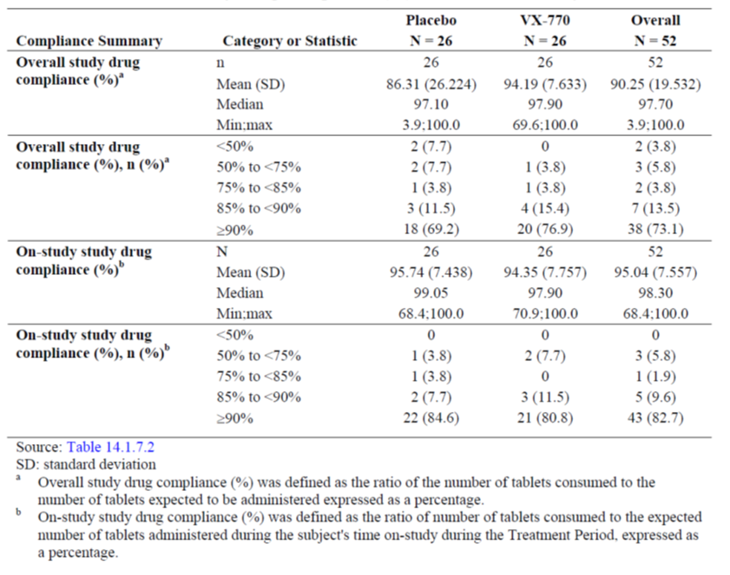

Results for the primary efficacy outcome
The adjusted mean absolute change from baseline in percent predicted FEV1 through Week 24 was statistically significantly greater in the VX-770 group than the placebo group (12.58% vs 0.13%; estimated treatment difference= 12.45%; 95% CI: 6.6, 18.34; P < 0.0001) (Table 8). Statistically significant differences between treatment groups were detected by Day 15 (first post baseline time point assessed) and at each time point up to Week 24 (Table 9 and Figure 4). Similar results were observed in the Per Protocol Set which included 26 ivacaftor and 21 placebo subjects (13.09% vs 0.50%; treatment diff= 12.59; 95% CI: 6.16, 19.01; p=0.0003).
Table 8. Part B: Absolute change from baseline in percent predicted FEV1 by MMRM, Week 24, Full Analysis Set
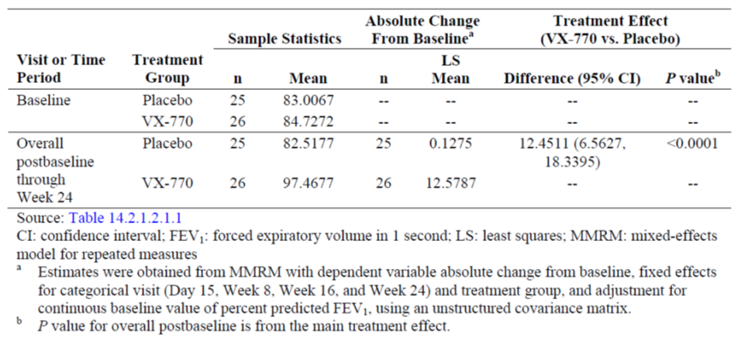
Table 9. Part B: Absolute change from baseline in percent predicted FEV₁ by MMRM, Week 24, Consistency of treatment effects over visits, Full Analysis Set
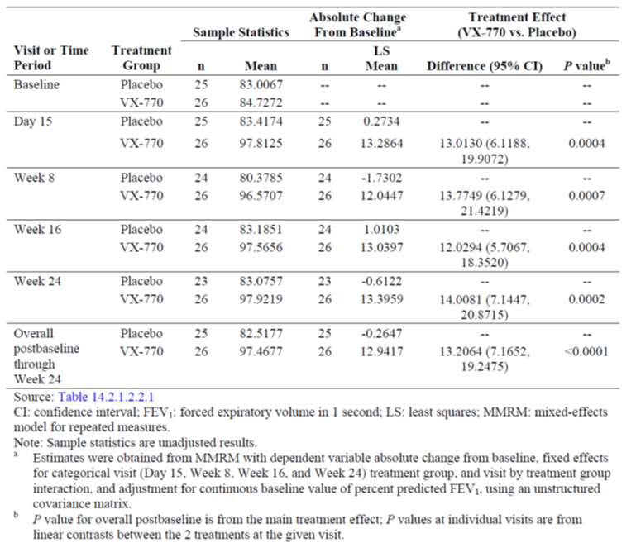
Figure 4. Part B: Mean Absolute change from baseline in percent predicted FEV₁ by treatment, Full Analysis Set
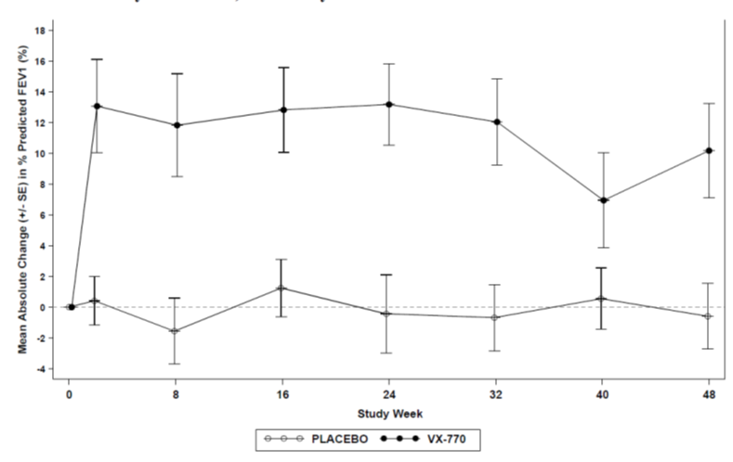
To assess the impact of missing data, ANCOVA was conducted on the mean change from baseline in percent predicted FEV1 through Week 24 with the last nonmissing percent predicted FEV1 observation carried forward (LOCF), worst-case imputation, and dropout reason-based imputation. In all of these analyses, the mean absolute change from baseline across all post baseline visits was greater in the VX-770 group than in the placebo group, and the differences were statistically significant (P ≤ 0.0007). Results of these sensitivity analyses were consistent with the results of the primary analysis (Table 10).
Table 10. Part B: Absolute change from baseline in percent predicted FEV1, Week 24, Sensitivity analysis, Full Analysis Set
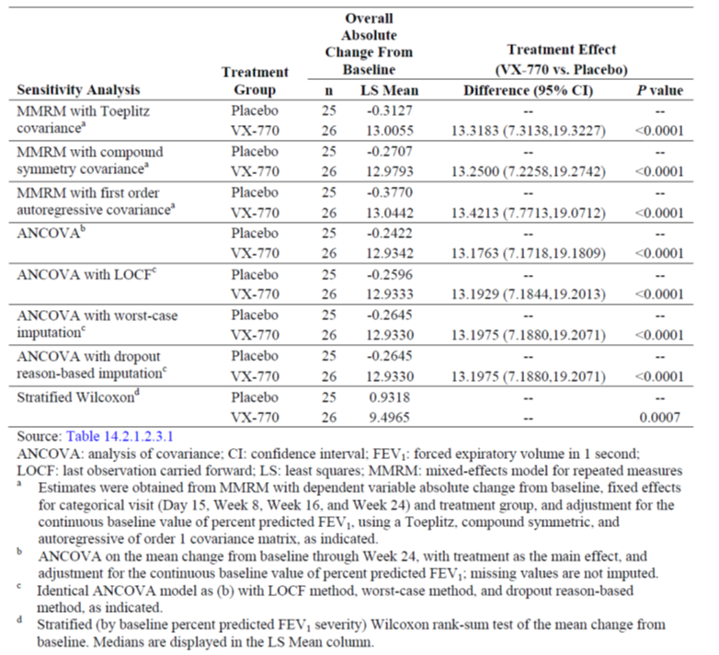

Results for other efficacy outcomes

Key secondary efficacy results:
The adjusted mean absolute change from baseline in weight at Week 24 was statistically significantly greater in the VX-770 group than the placebo group (3.69 vs 1.79 kg; estimated treatment difference = 1.90 kg; 95% CI: 0.86, 2.94; p= 0.0004) with similar results observed at week 48. Mean (SD) absolute changes from baseline in weight occurred by Day 15, increased at Week 24, and continued to increase at Week 48. The absolute change from baseline in weight-for-age z-score was statistically significantly greater with ivacaftor compared with placebo at 24 weeks (estimated treatment diff, ivacaftor - placebo=0.27 points; 95% CI: 0.151, 0.3951; P<0.0001) and at 48 weeks (diff=0.39 points; 95% CI: 0.24, 0.53; P<0.0001). The absolute change from baseline in BMI was also statistically significantly greater with ivacaftor compared with placebo at both 24 and 48 weeks. The absolute change from baseline in BMI-for-age z-scores also showed similar results.
The adjusted mean change from baseline through Week 24 in sweat chloride was statistically significantly greater in the VX-770 group than in the placebo group at 24 weeks (-55.53 vs -1.21 mmol/L; estimated treatment difference VX-770- placebo=-54.32 mmol/L; 95% CI: -61.83, -46.82; P < 0.0001) and at 48 weeks (-56.04 vs -2.57 mmol/L; diff= -53.47 mmol/L; 95% CI: -60.92, -46.02; P < 0.0001). Mean (SD) absolute changes from baseline in sweat chloride levels occurred by Day 15 and were sustained for the duration of the treatment and extension Periods (through Week 48).
The absolute change in the respiratory domain score of the CFQ-R through Week 24 was a key secondary efficacy endpoint. Two versions of the questionnaire were used: 1 in which the subject was interviewed (CFQ-R [child], key secondary endpoint) and 1 in which the subject's parent or caregiver was the respondent (CFQ-R [parent/caregiver]).Both versions of the CFQ-R showed greater improvement with ivacaftor compared with placebo at both 24 and 48 weeks.
Absolute change from baseline in percent predicted FEV1 through Week 48 was a secondary efficacy endpoint which was statistically significantly greater in the VX-770 group than the placebo group (10.67% vs 0.68%; estimated treatment difference= 9.99%; 95% CI: 4.52, 15.46; P = 0.0006). Statistically significant differences between treatment groups were detected by Day 15 (first post-baseline time point assessed) and at each time point up to Week 48. At Week 40, the magnitude of treatment effect was substantially less than that seen at the other time points; however, the magnitude at Week 48 was similar to the magnitude of the other time points. This drop coincided with several subjects having AEs related to respiratory symptoms.
Results for the primary efficacy endpoint and key secondary efficacy endpoints in the per protocol analysis were consistent with the results observed in the FAS.

Tertiary efficacy endpoints
Due to the small sample size and low incidence of clinical events observed during the study, the analysis of clinical events did not support inferential conclusions regarding the risk, frequency, or duration of CF related clinical events (including pulmonary exacerbations, hospitalizations, outpatient sick visits for CF-related complications, and antibiotic therapy for sinopulmonary signs/symptoms).
Through Week 24, the estimated rate of decline in FEV1 was -0.269 L for the VX-770 group and -0.108 L for the placebo group (a negative rate of decline is equivalent to a positive rate of change, which represents an increase in FEV1); this treatment difference (-0.161 L) was statistically significant (P = 0.0049) and the rate of decline in FEV1 showed similar results at Week 48 although the treatment difference was not statistically significant (-0.293 vs -0.185L; difference =-0.108L; P = 0.0667). Through Week 24, the adjusted mean absolute change from baseline in oxygen saturation was statistically significantly higher in the VX-770 group than the placebo group (0.7% vs 0.2%; treatment difference=0.5%; P = 0.0220) with similar results at Week 48 (0.7% vs 0.3%; difference=0.4%; P = 0.0531).
Additional Efficacy Evaluations: Consistent with the outcome of the analysis of the absolute change from baseline in percent predicted FEV1, treatment with VX-770 resulted in statistically significant improvements in the relative change from baseline in percent predicted FEV1 and absolute and relative changes from baseline FEV1 through Week 24 and Week 48. Analyses of additional spirometry parameters were also conducted (FVC, FEF25-75%, and FEV1/FVC) and the adjusted mean changes from baseline through Week 24 and through Week 48 were greater in the VX-770 group than in the placebo group for all parameters analysed. With the exception of absolute and relative changes from baseline in percent predicted FVC, the treatment differences for the majority of these parameters were statistically significant (P < 0.05).

Other efficacy studies

Phase 2 study 104
Study 104 was a Phase 2, randomized, double-blind, placebo-controlled, parallel-group study (Part A) with an open-label extension (Part B) of orally administered VX-770 in 140 subjects with CF (aged ≥12 years). The study was conducted from 21/9/2009 (start of Part A) to 20/7/2011(end of Part B) at 34 sites in USA. The main objectives of Part A of this study were to evaluate the safety/ efficacy and pharmacokinetics following 16 weeks of treatment with VX-770 in subjects with cystic fibrosis (CF) who are homozygous for the F508del-CF transmembrane conductance regulator (CFTR) mutation. The main objectives of the open-label Part B were to evaluate safety and efficacy of long-term treatment with ivacaftor for 96 weeks.
Subjects in Part A of this study were randomized to receive either 150 mg VX-770 or placebo every 12 hours (q12h) for 16 weeks. Part A included a Screening Period (Day -35 to Day -15), a Run-In Period (Day -14 to Day -1, before first dose of study drug [VX-770 or placebo]), a Treatment Period (Day 1 [first dose of study drug] to Week 16), a Follow-up Visit (4 weeks after last dose of study drug), and a Long-term Follow-up (for 2 years after the last dose of study drug) for subjects who received study drug for more than 4 weeks and who did not participate in Part B.
Subjects who met one of the following response criteria and completed 16 weeks of study drug dosing were eligible to participate in Part B:- (1) An increase of ≥10% relative to baseline in percent predicted forced expiratory volume in 1 second (FEV1)at 1 or more time points from Day 15 through Week 16, inclusive;(2) A decrease from baseline in sweat chloride concentration of ≥15 mmol/L at both the Day 15 and Week 8 visits. Subjects in Part B were to have received open-label 150 mg VX-770 q12h for 96 weeks. Part B included an Extension Period (Week 16 through Week 112). However, the study was discontinued by the sponsor following results obtained from a pre-specified evaluation the Part B data (through Week 40).
Overall 140 subjects were randomised to treatment in Part A (112 to ivacaftor 150mg and 28 to placebo) given twice daily (at 12 hour interval). Of these, 38 subjects (5 treated with placebo in Part A and 33 treated with VX-770 in Part A) were enrolled in Part B of the study. All 38 subjects in Part B received at least 1 dose of open-label VX-770 in Part B and were included in the Full Analysis Set (FAS) and the Safety set. Nine subjects discontinued treatment in Part B before the study was terminated by the sponsor.
The adjusted mean absolute change from baseline through Week 16 in percent predicted FEV1 was greater in the VX-770 group (1.54%) than in the placebo group (-0.183%), but the treatment difference was not statistically significant. The results of the sensitivity analysis confirmed results of the primary analysis.
As the treatment effect for the primary efficacy endpoint was not statistically significant, any observed statistical significance in other efficacy endpoints was reported nominal. The adjusted mean decrease from baseline through Week 16 in sweat chloride values was greater in the VX-770 group than in the placebo group (-2.74 vs 0.13 mmol/L; P = 0.0384). The changes in sweat chloride occurred by Day 15 and were sustained for the duration of the 16-week treatment period.
Ivacaftor did not have any significant effect on respiratory symptoms (measured by the change in CFQ-R respiratory domain score over 16 weeks of treatment), weight (measured by the change in weight, weight-for-age z-score, BMI, and BMI-for-age z-score over 16 weeks of treatment).
Ivacaftor did not have any significant effect on oxygen saturation or EQ-5D score. A smaller number, shorter duration, and longer time-to-onset of most CF-related events of interest (including pulmonary exacerbations and antibiotic therapy for sinopulmonary signs/symptoms) were observed in the VX-770 group than in the placebo group, but these differences were not statistically significant. Similarly, percent predicted FEV1 and additional spirometry parameters (FVC, FEF27-75%, and FEV1/FVC) showed small improvements in the VX-770 group compared with placebo group, but the differences were not statistically significant.
The mean concentration of immunoglobulin G decreased from baseline to Week 16 in the VX-770 group (adjusted change from baseline: -0.697 g/L) and increased in the placebo group (adjusted change from baseline: 0.079 g/L), but the estimated treatment difference for VX-770 versus placebo was not statistically significant. Similar results were obtained for the analysis of the log-transformed data. Ivacaftor did not have any significant effect on C-reactive protein and interleukin-8 concentrations.
In Part B there were no differences in the rate of decline from baseline in percent predicted FEV1 through Week 64 between the VX-770/VX-770 group (-1.074%) and the placebo/VX-770 group (5.74%). The rate of decline in percent predicted FEV1 from Part B baseline through Week 64 was 5.3% in the placebo/VX-770 group and -5.3% in the VX-770/VX-770 group. Although this difference was statistically significant (P = 0.0336), the clinical significance of this finding is uncertain. For subjects treated with VX-770 for 64 weeks (VX-770/VX-770 group), the marginal decrease in mean absolute change in sweat chloride that was observed from baseline to Week 16 in Part A was not sustained through Week 64. Treatment with VX-770 for 48 weeks in Part B did not have any additional effect on sweat chloride. There was no effect of VX-770 on respiratory symptoms, as measured by the change in CFQ-R respiratory domain score, in subjects treated with VX-770 for 64 weeks (VX-770/VX-770 group) or in subjects treated with VX-770 for 48 weeks in Part B (placebo/VX-770 group). There was no improvement in the yearly rate of pulmonary exacerbations with prolonged treatment of VX-770. Subjects in both treatment groups gained weight throughout the duration of the study although there were no overall differences in weight gain between subjects treated with VX-770 for 64 weeks (VX-770/VX-770 group; 2.35 [5.600] kg) or subjects treated with VX-770 for 48 weeks in Part B (placebo/VX-770 group; 3.00 [3.550] kg).
VX-770 administered at 150 mg q12h for 16 weeks resulted in no improvement in FEV1 relative to placebo in patients with CF who are homozygous for the F508del-CF transmembrane conductance regulator (CFTR) mutation. VX-770 administered at 150 mg q12h for an additional 48 weeks resulted in no improvement in FEV1 in this population. VX-770 administered at 150 mg q12h for 16 weeks resulted in a small reduction in sweat chloride relative to placebo in this study population; this difference was nominally statistically significant. The marginal improvement in sweat chloride observed in Part A of the study was not sustained with additional treatment of VX-770 from Week 16 to Week 64 in Part B. In this study, VX-770 did not have any effect on number, duration, and time-to-onset of most CF-related events of interest (including pulmonary exacerbations and antibiotic therapy for sinopulmonary signs/symptoms), on respiratory domain CFQ-R score, weight, oxygen saturation, or EQ-5D score.

Long term efficacy
Study 105 was an open-label, long-term study in patients (aged ≥6 years) with cystic fibrosis and the main objectives were to evaluate safety and efficacy. The study was conducted at 67 sites and started from 8/7/2010 with the second interim report on 22/11/2011 and it is still ongoing. This was a rollover study and planned to enrol all subjects who completed Study 102 or Study 103 and met the inclusion-exclusion criteria for this study. All subjects in Study 102 and Study 103 who completed 48 weeks of treatment and elected to roll over to Study 105 were dosed in Study 105 (N = 144 and N = 48, respectively), for a total enrolment in Study 105 of 192 subjects; 192 subjects received at least 1 dose of study drug in Study 105 and were included in the full analysis set (FAS) and the Safety Set.
Of the 144 subjects from Study 102, 137 subjects (95.2%) completed at least 48 weeks of treatment at the time of this analysis, 73 subjects in the VX-770/VX-770 group and 64 subjects in the placebo/ VX-770 group. Of the 48 subjects from Study 103, all subjects completed at least 24 weeks of treatment at the time of this analysis, 26 subjects in the VX-770/VX-770 group and 22 subjects in the placebo/VX-770. Majority of the subjects in study 105 were White with equal proportion of males and females.
For subjects in the VX-770/VX-770 group, the improvements in FEV1, CFQ-R respiratory domain scores and weight observed in the previous study were sustained in the current study; for subjects in the placebo/VX-770 group, the improvements in FEV1, CFQ-R respiratory domain scores and weight in the current study were similar to those observed in the previous study for subjects in the VX-770/VX-770 group (eg, see Table 11 and Figure 5 and Figure 6).
Table 11. Study 105. Change in baseline in percent predicted FEV1, Full Analysis set
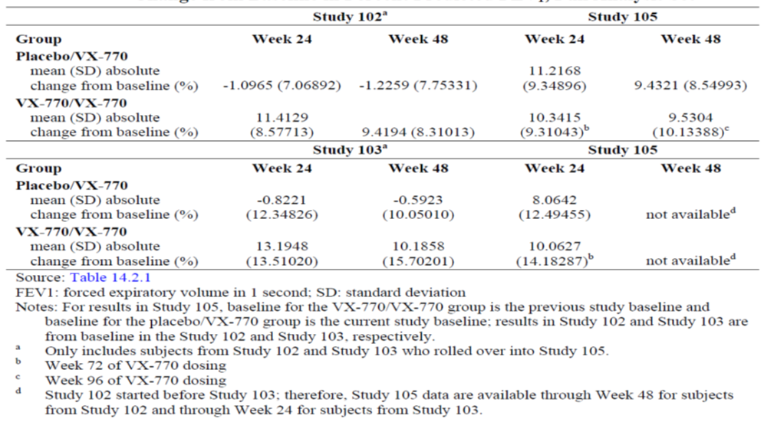
Figure 5. Study 105. Mean percent predicted FEV1, by treatment in Study 102 and 105, Full Analysis set
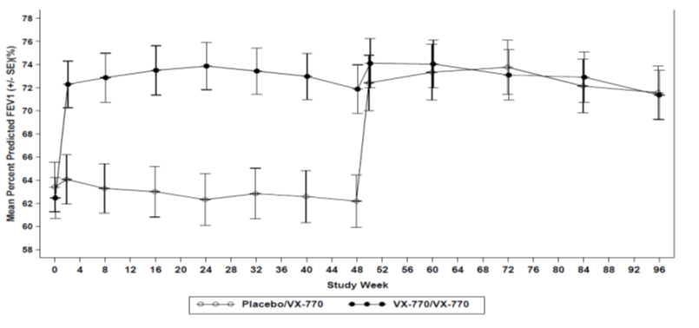
Figure 6. Study 105. Mean percent predicted FEV1, by treatment in Study 103 and 105, Full Analysis set
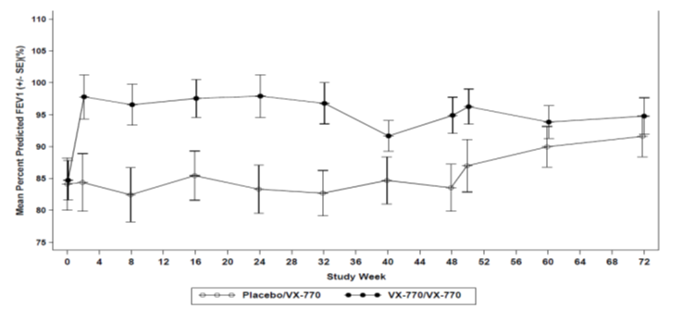
For subjects in the placebo/VX-770 group from Study 102 and Study 103, fewer subjects had pulmonary exacerbations and the duration of pulmonary exacerbations was shorter during the current study than during Study 102 and Study 103, respectively. However, for subjects in the VX-770/VX-770 group from Study 102, more subjects had pulmonary exacerbations and the duration of pulmonary exacerbations was longer in the current study than during Study 102. Among subjects in the VX-770/VX-770 group who had pulmonary exacerbations, the number of events per subject treated with VX-770 was similar in Study 102 and Study 105 and lower than the number of events per subject treated with placebo for 48 weeks in Study 102. For subjects in the VX-770/VX-770 group from Study 103, the number of subjects who had pulmonary exacerbations was similar and the duration of pulmonary exacerbations was shorter during the first 24 weeks of the current study than the first 24 weeks in Study 103.
Although subjects with less than 40% predicted FEV1 at screening were excluded from the previous studies, 8 subjects in the placebo/VX-770 group from Study 102 had less than 40% predicted FEV1 at baseline in current study 105. In these 8 subjects, improvements in percent predicted FEV1, CFQ-R respiratory domain score, and weight observed at Week 24 of VX-770 treatment were sustained at Week 48. The magnitude of improvements for these 8 subjects with severe disease was similar to the magnitude of improvements observed for all subjects in the placebo/VX-770 group.

Other studies
Study 106 was a Phase 2, randomized, double-blind, placebo-controlled, crossover study to evaluate the effect of VX-770 on Lung Clearance Index in 17 subjects aged ≥6 years with Cystic Fibrosis, the G551D Mutation, and FEV1 > 90% Predicted; other efficacy endpoints were spirometry, sweat chloride levels and CFQ-R.
Comments: However, no efficacy results were presented and only a 4-page synopsis was provided in module 5 which only listed SAEs.
Study 107 was a Phase 2, single-blind, placebo-controlled study to evaluate the effect of VX-770 on hyperpolarized Helium-3 Magnetic Resonance Imaging (3He-MRI) in 8 subjects aged >12 years with Cystic Fibrosis (CF), the G551D Mutation, and Forced Expiratory Volume in 1 Second (FEV1) ≥ 40% predicted. Other efficacy endpoints were spirometry, sweat chloride levels and CFQ-R.
Comments: However, no efficacy results were presented and only a 2-page synopsis was provided with only listing of SAEs.

Analyses performed across trials (pooled analyses and meta-analyses)
There were no pooled or meta-analyses for efficacy. However, analysis of efficacy in subgroups based on baseline disease severity, age, sex, geographic regions, and type of CFTR mutations was presented.

Efficacy in subgroups
In the 2 placebo-controlled Phase 3 studies, ivacaftor treatment resulted in improvements in percent predicted FEV1 and respiratory symptoms, reduction in the risk of a pulmonary exacerbation (analysed only in Study 102), increase in weight gain, and reduction in sweat chloride concentrations, regardless of disease severity (measured by percent predicted FEV1 at screening), age, and sex. Treatment effects were generally consistent across geographic regions. A substantial treatment effect was observed in percent predicted FEV1 across subpopulations analysed in Study 102 and Study 103. The subpopulations with wide 95% CIs reflect small sample sizes (≤10 subjects).
Subjects were required to have the G551D mutation in at least 1 allele of the CFTR gene for study eligibility. Given the rarity of individual second-allele mutations other than F508del, data for this analysis were pooled for Studies 102 and 103. Most (77%) subjects had the F508del mutation in the second allele of the CFTR gene. Except for the F508del mutation, the frequency of any given second-allele mutation was less than 4% (1 to 5 subjects in the pooled study population). Among the subgroup of subjects with the G551D mutation in 1 allele and the F508del mutation in the second allele, mean (SD) change in percent predicted FEV1 baseline to Week 24 was -0.7 (5.95) percentage points in the placebo group and 11.1 (9.11) percentage points in the ivacaftor group. Numbers of subjects in the other subgroups were too small to draw definitive conclusions. Regardless of the mutation in the second allele of the CFTR gene, little or no change in percent predicted FEV1 from baseline through Week 24 was observed in the placebo group, and improvements in percent predicted FEV1 from baseline through Week 24 were generally observed in the ivacaftor group.
For the key secondary endpoints, treatment effects were consistent and substantial across the majority of subgroups, although variation in the magnitude of treatment effect across some subgroups was observed. A comparison of effects on pulmonary exacerbations across subgroups in Study 103 was not possible given the low overall frequency of events. Evaluation of subgroups by race was not performed, as CF is predominantly a disease of the Caucasian population, which is reflected in the demographics of the subjects enrolled in Phase 3 studies.
Similar reductions in percent predicted FEV1 were observed in the various subgroups (based on baseline disease severity, age, sex, geographic region) at week 48 in studies 102 and 103, although interpretation of this subgroup analysis was limited in study 103 due to small sample sizes. No subgroup analyses were done for the secondary efficacy endpoints at 48 weeks.

Evaluator’s conclusions on clinical efficacy
Two Phase 2 studies (101 and 104) were conducted to assess the effect of ivacaftor in subjects with CF. In the dose-ranging study 101, treatment with ivacaftor with doses ranging from 75 mg to 250 mg every 12 hours (q12h) resulted in improved CFTR activity as measured by decreased sweat chloride and nasal potential difference (NPD) values as well as improved lung function as measured by increased forced expiratory volume in one second (FEV1). The randomized, double-blind, placebo-controlled, parallel-group, 16-week study 104 (Part A) with a 96-week, open-label extension (Part B) in subjects homozygous for the F508del mutation in the CFTR gene showed no apparent clinical benefit during Part A of the study or over the first 24 weeks of open-label treatment in Part B (therefore, Part B of the study was terminated early).
The recommended dosing regimen for ivacaftor is 150 mg q12h. Chronic administration of ivacaftor is required to maintain improvement in CFTR and thus clinical benefit. For Phase 2b and Phase 3 studies, plasma ivacaftor Cmin,ss was chosen as the target exposure parameter to maintain CFTR activity throughout a dose interval. The ivacaftor dose was selected to provide a median Cmin,ss of at least the predicted EC₉₀ for FEV1. Dosing recommendations were based on a combination of factors, including safety/tolerability, PK/PD modelling, simulations, and efficacy Based on safety/tolerability, PK/PD modelling, and simulations using data from Studies 101 and 007, the ivacaftor dose selected for Study 102 (subjects 12 years of age and older) was 150 mg q12h, and the ivacaftor dose selected for Study 103 Part A (lead-in PK, subjects 6 to 11 years of age) was 100 mg. Based on subsequent modelling and simulations using data from Studies 007 and 103 Part A, the ivacaftor dose selected for the placebo-controlled treatment period in Study 103 Part B (subjects 6 to 11 years of age) was 150 mg q12h. Population PK/PD exposure-response analyses indicate that 150 mg ivacaftor q12h resulted in a median Cmin,ss of at least the EC₉₀ for FEV1 across age groups ranging from 6 years of age to adults.
Two placebo-controlled Phase 3 studies were designed to assess the efficacy and safety of 24 weeks of treatment with ivacaftor 150 mg q12h in subjects age 12 years and older (Study 102) and 6 to 11 years (Study 103). Placebo-controlled treatment was continued through 48 weeks to further assess safety and to confirm the durability of response. Subjects who completed 48 weeks of treatment were eligible to enrol in a long-term open-label study (Study 105).
Since ivacaftor is a systemic therapy that targets the underlying defect in CF, Studies 102 and 103 were designed to evaluate both pulmonary effects (FEV1, respiratory symptoms, and pulmonary exacerbations) and important extrapulmonary measures associated with CF (weight, body mass index [BMI], sweat chloride levels, and inflammatory mediators).
The same primary endpoint - the absolute change from baseline in percent predicted FEV1 through Week 24 - was selected for the placebo-controlled Phase 3 studies which is the recommended primary clinical endpoint in efficacy studies for CF and chronic obstructive pulmonary disease. The efficacy assessments used in the pivotal Phase 3 studies were widely accepted and generally recognized as reliable, accurate, and relevant to the study of subjects with CF.
The duration of evaluation in Studies 102 and 103 was consistent with recent registration studies for other therapies approved for CF and with guideline recommendations establishing durability of efficacy in chronic progressive lung diseases, including CF and chronic obstructive pulmonary disease.
Based on agreement with regulatory authorities and in consideration of the small size of the population of patients who have the G551D mutation in the CFTR gene, both the studies were adequately powered to detect clinically relevant differences between ivacaftor and placebo. Study 102 was designed to enrol a minimum of 80 subjects to provide at least 80% power to detect a treatment effect of 4.5 percentage points in absolute change in percent predicted FEV1. Study 103 was designed to enrol a minimum of 30 subjects (based on feasibility due to the size of the available population) and although it was not designed to achieve statistical significance, it was anticipated to be supportive, demonstrating a treatment effect of similar magnitude as in Study 102.
In the placebo-controlled Phase 3 studies, the intended commercial formulation of ivacaftor was administered orally q12h for 48 weeks to subjects with CF age 6 years and older who have a G551D gating mutation in the CFTR gene. Subject demographics and baseline characteristics were, in general, representative of the population of patients with CF for whom ivacaftor is intended. Subjects also continued on their prescribed CF therapies during the studies (with the exception of hypertonic saline). Thus, the treatment effect of ivacaftor occurred in addition to any benefit the subjects incurred while on their already-prescribed medications. Within each study, the baseline demographics of subjects (including age, weight, sex, baseline FEV1, and use of concomitant medications) were generally comparable in the ivacaftor and placebo groups.
Analysis of the primary endpoint in the placebo-controlled Phase 3 studies (absolute change in percent predicted FEV1 through Week 24) showed a substantial and durable treatment effect (10.6 to 12.5 percentage points) that was highly significant (P <0.0001). The improvements in FEV1 were rapid in onset and durable through the 48-week treatment period. In all subgroups evaluated (including disease severity, age, sex, and geographic region), a treatment effect in percent predicted FEV1 favouring ivacaftor was observed.
According to EMA and FDA regulatory guidance, FEV1 is the recommended primary clinical endpoint in efficacy studies for CF and chronic obstructive pulmonary disease. Improvement in FEV1 has served as the primary clinical efficacy measure in definitive CF clinical studies supporting the registration of 2 chronic CF pulmonary therapies. In the pivotal clinical studies of inhaled dornase alfa and tobramycin, 24 weeks of treatment in subjects with mild to severe CF lung disease resulted in 6% (dornase alfa) and 8% (tobramycin) relative improvement in percent predicted FEV1. FEV1 was also a secondary endpoint in the pivotal studies of inhaled aztreonam, where a relative improvement in percent predicted FEV1 of 10.2% was seen after 28 days.
Analysis of other pulmonary outcomes showed clinically meaningful improvements in respiratory symptom scores (CFQ-R) in both Studies 102 and 103 and significant reduction in the risk of pulmonary exacerbations as well as substantially decreased frequency and duration of pulmonary exacerbations. Treatment with ivacaftor resulted in statistically significant improvements in measures of nutritional status, as measured by weight and BMI. The BMI-for-age z-score of subjects aged 6 to 20 years who were treated with ivacaftor in the placebo-controlled Phase 3 studies also improved compared with the score for subjects treated with placebo. At Week 48 in both Studies 102 and 103, subjects treated with ivacaftor had BMI-for-age z-scores above 50th percentile, whereas subjects treated with placebo had scores below 50th percentile.
In addition to clinically meaningful improvements in CF lung disease and nutritional measures, ivacaftor is the first treatment to demonstrate an effect on CFTR function, as measured by sweat chloride levels. The decrease in sweat chloride levels with ivacaftor treatment is consistent with the in vitro effect of ivacaftor on G551D-CFTR. Analyses of the relationship between the change in sweat chloride and clinical outcomes demonstrate that the overall improvement in CFTR activity during treatment with ivacaftor, as represented by a sweat chloride reduction of at least 20 mmol/L, was associated with significantly improved pulmonary and nutritional measures. These analyses are limited by the minimal number (2 out of 101) of any subjects treated with ivacaftor who did not have a reduction of sweat chloride that was less than 20 mmol/L and by the variability in FEV1. Thus, it remains to be determined whether a smaller magnitude of improvement in CFTR activity might also be associated with clinical benefit.
Improvements in FEV1 were similar through Week 24 and Week 48 of treatment. The treatment difference for ivacaftor versus placebo through Week 48 was 10.5 percentage points in Study 102 and 10.0 percentage points in Study 103; these differences were statistically significant (P<0.0001 for Study 102 and P = 0.0006 for Study 103). Similarly, reductions in sweat chloride concentration were durable through Week 48, consistent with a sustained improvement in CFTR function. The magnitude of observed treatment effect was similar through Week 24 and Week 48 of treatment. The treatment difference for ivacaftor versus placebo through Week 48 was -48.1 mmol/L in Study 102 and -53.5 mmol/L in Study 103;these differences were statistically significant (P<0.0001 in both studies). Substantial, durable, and consistent improvements were also observed in other clinical endpoints, including the risk of experiencing a pulmonary exacerbation, respiratory symptoms as measured by CFQ-R, weight gain, and frequency and duration of pulmonary exacerbations.
In study 105, treatment with VX-770 was durable for up to 96 weeks. For subjects previously treated with VX-770 for 48 weeks in Studies 102 and 103, the improvements in FEV1, respiratory symptoms, and weight gain in the previous study were generally sustained with an additional 48 and 24 weeks of treatment with VX-770 in the current study. VX-770–treated subjects continued to experience pulmonary exacerbations, consistent with the pathophysiology of the disease. However, VX-770 treatment delayed the onset of pulmonary exacerbations, and the reduction in the number of pulmonary exacerbations per subject observed with VX-770 treatment in Study 102 was sustained in Study 105, for a total treatment duration of 96 weeks. For subjects previously treated with placebo for 48 weeks in Study 102 and Study 103, the improvements in FEV1, respiratory symptoms, weight gain, and pulmonary exacerbations observed after VX-770 treatment were comparable to the improvements observed with VX-770 treatment in Study 102 and Study 103.
Ivacaftor is the first therapy to demonstrate an effect on both pulmonary and extrapulmonary manifestations of CF in registration studies. Ivacaftor is unique in demonstrating broad effects in both pulmonary outcomes and nutritional status after 24 and 48 weeks of treatment; and the magnitude of the improvements in all of these measures is large and clinically meaningful.
Overall, results from the Phase 3 studies of ivacaftor showed that systemic treatment with ivacaftor was highly effective in the treatment of CF, as evidenced by improvement in CFTR function and substantial, durable improvements in important clinical outcomes, including FEV1, pulmonary exacerbations, respiratory symptoms, and nutritional status. The design of the Phase 3 studies adequately demonstrated the effects of ivacaftor, evidenced by the achievement of clinically meaningful and statistically significant effects in the primary and key secondary endpoints, and by the reproducibility of these effects in the placebo group of Study 102 that enrolled in Study 105 These data support the chronic use of ivacaftor as treatment of CF in patients age 6 years and older who have a G551D mutation in the CFTR gene.

Clinical safety

Studies providing evaluable safety data
The ivacaftor development program consists of a total of 23 clinical studies, with 17 completed clinical studies and 6 ongoing studies. In addition, an expanded access program was initiated in the US to make ivacaftor available to patients in need. Studies in the Summary of Clinical Safety (SCS) are shown in Figure 7.
Figure 7. Overview of studies and poolings in the Summary of Clinical Safety (SCS).
CF: cystic fibrosis; IVA N: number of subjects who received at least 1 dose of ivacaftor; PBO N: number of subjects who received at least 1 dose of placebo; PBO/IVA N: number of subjects who received placebo in a placebo-controlled study and then received ivacaftor in an uncontrolled extension study; IVA/IVA N: number of subjects who received ivacaftor in a placebo-controlled study and then received ivacaftor in an uncontrolled extension study
Note: The number of subjects in this figure is based on the cut-off date of 01 July 2011. Studies with multiple parts (e.g., Part A and Part B) appear more than once in this figure based on the methodology within that phase of the study; however, these studies are only counted once toward the total number of studies investigating ivacaftor. Study 001 Part D enrolled 6 subjects (PBO N = 2 and IVA N = 4 subjects) with CF. Study 013 includes subjects with moderate hepatic impairment and healthy subjects. Study 103 Part A was designed to evaluate a single dose of ivacaftor to confirm the dose for Study 103 Part B and is therefore not included in this figure. Subjects in the long-term follow-up period (no administration of ivacaftor) of Study 102, Study 103 Part B, and Study 104 are not included in this figure. Shaded boxes denote analysis pooling for safety analyses.
Studies provided evaluable safety data are described in detail below (sections 8.11-8.1.5).

Pivotal efficacy studies
Three Phase 3 Studies in Subjects with CF (2 completed Phase 3 studies 102 and 103; 1 ongoing Phase 3 study 105)
In the pivotal efficacy studies, the following safety data were collected:
The Safety set included all subjects who received at least 1 dose of study drug. Adverse events were coded using Medical Dictionary for Regulatory Activities (MedDRA; Version 12.0). The incidence of AEs that started at, or after, or increased in severity after the initial study drug dosing was summarized by treatment group (VX-770 and placebo). Descriptive statistics (raw values) were summarized for chemistry, haematology, vital signs, and ECG parameters. In addition, change-from-baseline, and shift-from-baseline analyses were performed for chemistry, hematology, and ECG parameters. The number and percentage of subjects having treatment-emergent elevated liver function test (LFT) results (e.g., categorized by 3 × upper limit of normal [ULN], 5 × ULN, 8 × ULN) were summarized. The number and percentage of subjects by maximum on-treatment value and by maximum on-treatment change from baseline in QT/QT corrected for heart rate (QTc) intervals was analysed. A shift table for ECG complexes was analysed and a listing of abnormal ECG complexes from the 24-hour ambulatory recordings was compiled. In addition to the final analysis, 2 unblinded safety reviews were conducted by the Data Monitoring Committee (DMC) during the course of the study.

Pivotal studies that assessed safety as a primary outcome
Not applicable.

Dose-response and non-pivotal efficacy studies
The dose-response and non-pivotal efficacy studies which provided safety data were: - 4 Phase 2 studies in subjects with CF (1 completed Phase 2a study 101; 2 ongoing Phase 2 studies [106 and 107] and 1 ongoing Phase 2b study (Study 104).
Long-term follow-up (after stopping ivacaftor) is ongoing for subjects from Study 104 and subjects from Studies 102 and 103 Part B who did not enrol in Study 105. This follow-up is not included in the submitted dossier because no data were available till the cut-off date of 01 July 2011. The ongoing expanded access program (Study 901) in the US is not included in this submission because subjects were not enrolled in this study as of the cut-off date of 01 July 2011.

Other studies evaluable for safety only
The safety update provides data on deaths and other SAEs for Studies 104 (Part B), 105, 106, and 107, and the Expanded Access Program (VX11-770-901), as agreed at the Pre-NDA Meeting (FDA Pre-NDA Meeting Minutes, 20 June 2011). The reporting period for this update is 02 July 2011 through 01 November 2011.
Study 106 is currently blinded and the treatment assignments are blinded for individual subjects. Studies 104 Part B, and 105, and the Expanded Access Program are open-label and the treatment assignments are known for individual subjects.
In addition, an amended protocol for Study 107 was approved during the reporting period for this update. Study 107 Part A was single-blind and Part B was open-label; thus treatment assignments are known for individual subjects.

Clinical pharmacology studies
15 Phase 1 Studies in Healthy Subjects -14 completed Phase 1 studies (Studies 001, 002, 003, 004, 005, 006, 007, 008, 009, 010, 011, 012, 013, and 809-005); 1 ongoing Phase 1 study (Study 014).

Pivotal studies that assessed safety as a primary outcome
Not applicable.

Patient exposure
In studies conducted in subjects with CF, most subjects were administered ivacaftor orally at 150 mg q12h. In the initial Phase 1 (Study 001 Part D) and Phase 2a studies (Study 101), ivacaftor was administered as single doses of 25 mg to 800 mg or multiple doses of 25 mg to 250 mg q12h, respectively. In the Phase 2b study (Study 104) and other ongoing Phase 2 studies (Studies 106 and 107), the commercial formulation of ivacaftor was administered at 150 mg q12h. In the Phase 3 studies (Studies 102, 103, and 105), the commercial formulation of ivacaftor was administered at 150 mg q12h, except during the lead-in PK evaluation period of a Phase 3 study (Study 103 Part A, where subjects who were 6 to 11 years of age were administered a single dose of ivacaftor at 100 mg).
In the majority of the Phase 1 studies conducted in healthy subjects, ivacaftor was administered as a single dose of 150 mg. In the remaining Phase 1 studies, the dose range was single doses of 25 mg to 800 mg or multiple doses of up to 450 mg every 12 hours (q12h).
Ivacaftor was studied in four Phase 2b/3 studies in subjects with CF (102, 103, 105 and 104). All studies used the same dose of ivacaftor: 150 mg q12h. The pivotal, placebo-controlled Phase 3 studies 102 and 103 were designed to evaluate the efficacy and safety of ivacaftor in subjects who had the G551D mutation in the CFTR gene. Study 105, the uncontrolled Phase 3 extension study was designed to evaluate long-term treatment with ivacaftor in this population. Study 104, the Phase 2b study, was designed to augment the safety experience with ivacaftor and to evaluate the efficacy in another population of patients (subjects with CF who are homozygous for the F508del mutation on the CFTR gene). Studies 102 and 103 Part B had 48-week treatment durations, and Study 104 Part A had a 16-week treatment duration. For Study 104 Part B, data through the first 24 weeks were available and included in this SCS; this provided a total duration of 40 weeks of ivacaftor for Study 104 Part B subjects (16 weeks of ivacaftor in Study 104 Part A and 24 weeks of ivacaftor in Study 104 Part B). For Study 105, data through the first 12 weeks of treatment from subjects previously enrolled in Study 102 were available and included in this SCS; this provided a total duration of 60 weeks of ivacaftor treatment for subjects who had been treated with ivacaftor in Study 102 (48 weeks of ivacaftor in Study 102 and 12 weeks of ivacaftor in Study 105). No subjects in Study 103 had reached the 12-week point in Study 105 at the time of the cut-off date of 01 July 2011; therefore, no Study 103 subjects were included in the Study 105 safety analysis. Across the 4 pooled Phase 2b/3 studies, a total of 293 subjects were exposed to ivacaftor (Table 12 and Figure 8).
Table 12. Number of subjects unique to ivacaftor exposure: Pooled Phase 2B/3 Studies
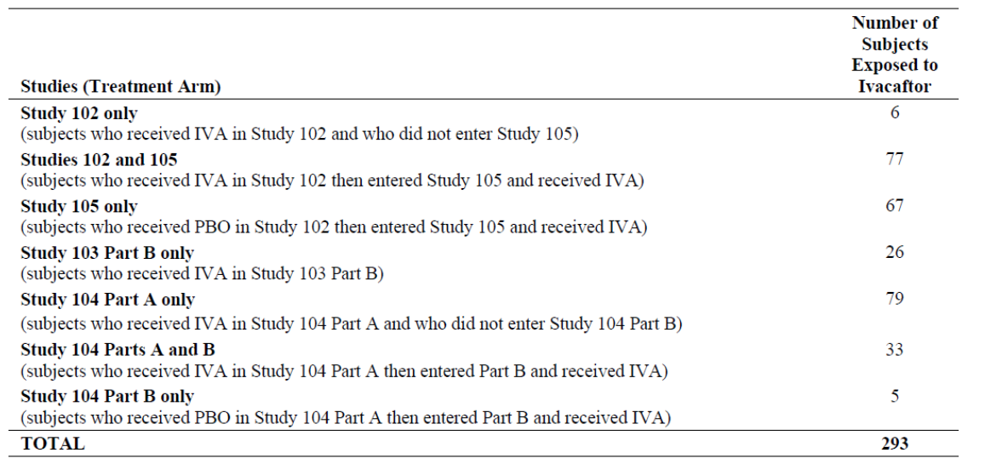
Figure 8. Number of subjects exposed to ivacaftor or placebo in Pooled Phase 2b/3 Studies
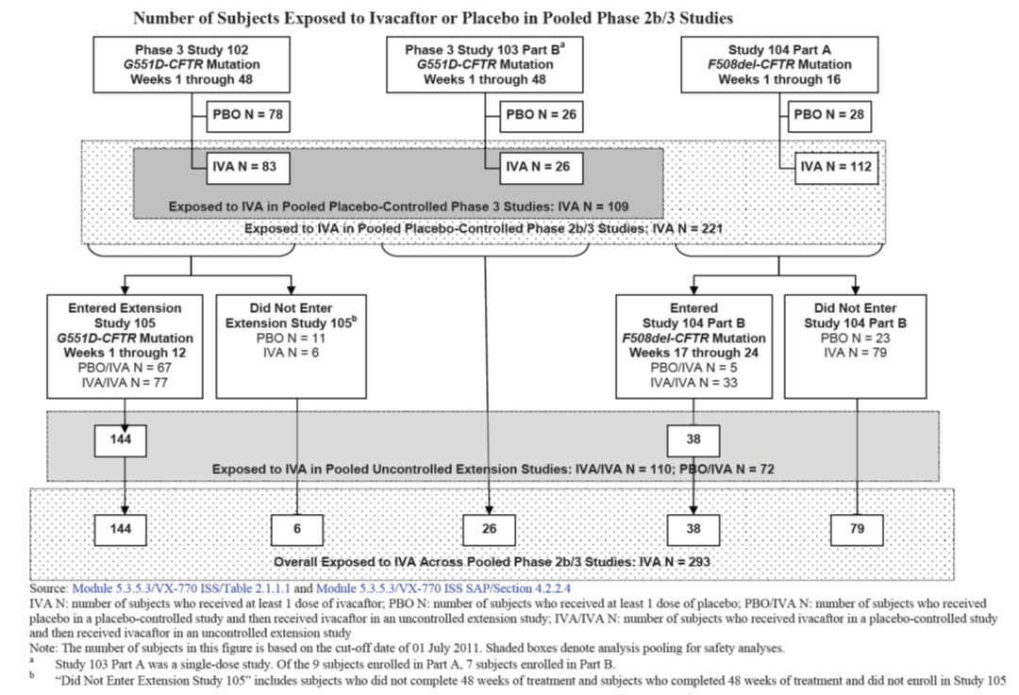
The pooled placebo-controlled studies formed the primary basis for the ivacaftor safety assessment, including assessments in subgroups. The 2 treatment arms analysed for the placebo-controlled Phase 3 pooling were placebo (104 subjects) and ivacaftor (109 subjects). This placebo-controlled Phase 3 pooling was the most directly relevant pooling to the indication sought, provided placebo-controlled data (for a treatment duration of 48 weeks) for a population of subjects in which ivacaftor has demonstrated clinical benefit. Therefore, this pooling was used for the purposes of identifying ivacaftor adverse drug reactions (ADRs).
Results from Study 104, the Phase 2b study, showed that ivacaftor did not have clinical benefit in subjects with the F508del mutation in the CFTR gene but the safety data from this study was pooled with data from the two Phase 3 studies (102 and 103 Part B) in subjects with the G551D mutation in the CFTR gene.
Comments: Pooling of data from study 104 with the 2 pivotal Phase 3 studies was considered appropriate because it allowed comparison of safety data for a regimen of ivacaftor 150 mg q12h to placebo for at least 16 weeks (i.e., through 16 weeks for Study 104 Part A, and through 48 weeks for Studies 102 and 103 Part B).
Safety data from 10 Phase 1 studies were pooled for analysis. These studies all enrolled healthy subjects, with the exception of 6 subjects with CF in Study 001 (data from these subjects were not included in the Phase 1 pooling. The studies were pooled irrespective of the study design (placebo-controlled or uncontrolled), treatment regimen (single or multiple doses of ivacaftor or placebo administered alone or coadministered with a DDI drug), or formulation (solution versus tablet). Because of the crossover design in some studies and the overlap of the treatment groups (placebo, ivacaftor alone, ivacaftor with a DDI drug, and any ivacaftor), subjects could be included in more than 1 pooled treatment arm. A list was provided showing studies that were not included in any pooling and the rationale for not pooling.
Overall, 324 patients with CF and 364 healthy subjects were exposed to ivacaftor (Table 13).
Table 13. Number of subjects exposed to ivacaftor, any dose and duration.
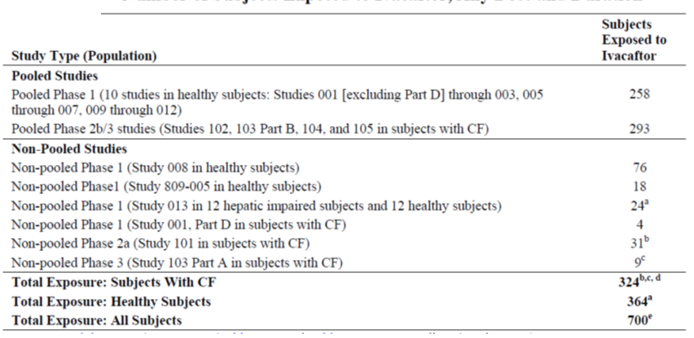
CF: cystic fibrosis
Note: This table includes unique subjects who have received at least 1 dose of ivacaftor (any dose or duration). This table does not include 2 taste profiling studies (Studies 004 and 014 [ongoing]; no systemic exposure to ivacaftor), 2 ongoing Phase 2 studies in subjects with CF (Studies 106 and 107; studies are ongoing), and 1 expanded access for an individual subject.
a Of the 24 subjects in Study 013, 12 were hepatic impaired subjects. These subjects were not included in the “Total of Healthy Subjects” row.
b Of the 31 subjects in Study 101, 11 subjects enrolled in Study 102. Ten of the 11 subjects received ivacaftor in both Studies 101 and 102, and 1 subject received placebo in both Studies 101 and 102. Safety data for these 11 subjects are included in the Phase 2b/3 poolings. The 10 subjects who received ivacaftor in Study 102 were only counted once in this table; counted in Study 102 because that is where they had the longest exposure to ivacaftor.
c Of the 9 subjects in Study 103 Part A, 2 subjects did not enroll in Study 103 Part B, and 7 subjects enrolled in Study 103 Part B (3 subjects received ivacaftor in Study 103 Part B and 4 subjects received placebo in Study 103 Part B). Study 103 Part B was included in the Phase 2b/3 pooling; therefore, the 3 subjects that enrolled in Study 103 Part B after completing Study 103 Part A are included in the total of 293 subjects exposed to ivacaftor in Phase 2b/3 studies.
d The total of 324 subjects is comprised of 293 subjects in the Phase 2b/3 poolings, 4 subjects with CF in Study 001, 21 subjects in Study 101 who did not receive ivacaftor in another study, and 6 subjects who received ivacaftor in Study 103 Part A (2 subjects who did not enrol in Study 103 Part B, and 4 subjects who enrolled in Study 103 Part B but received placebo).
e The enumeration of all subjects exposed to ivacaftor includes the total of subjects with CF, the total of healthy subjects, and 12 subjects with hepatic impairment.
In the placebo-controlled studies, 188 and 118 subjects in the ivacaftor and placebo groups, respectively completed at least 16 weeks of treatment; 106 and 94 subjects, completed at least 24 weeks of treatment, and 74 and 60 subjects, respectively completed at least 48 weeks of treatment. With inclusion of the uncontrolled extension studies, at the time of cut-off date, a total of 201 subjects received ivacaftor for at least 16 weeks; a total of 142 subjects received ivacaftor for at least 24 weeks; a total of 101 subjects received ivacaftor for at least 48 weeks; a total of 63 subjects received ivacaftor for 60 weeks of treatment.
In the 10 pooled Phase 1 studies, 258 healthy subjects were exposed to at least 1 dose of ivacaftor of which 228 subjects received ivacaftor alone at any dose and 122 subjects received ivacaftor coadministered with other drugs. For the pooled Phase 1 studies in healthy subjects, the median treatment duration was 3 days (range: 1; 14) for subjects in the ivacaftor group (subject who received only ivacaftor) and 1 day (range: 1; 14) for subjects in the placebo group. The maximum duration of exposure to ivacaftor was 18 consecutive days.
In the placebo-controlled Phase 2b/3 pooling, the 221 subjects in the ivacaftor treatment group are compared to the 132 subjects in the placebo treatment group. Overall, 91.5% of subjects in the pooled placebo-controlled Phase 2b/3 studies completed treatment (ivacaftor vs placebo: 93.7% vs 87.9%). The most common reason for treatment discontinuation was adverse events; however, this occurred at a lower incidence in the ivacaftor group compared with the placebo group (1.8% vs 5.3%). In the pooled placebo-controlled studies, the median age was 20-21 years (range: 6-53) and the majority of subjects were >18 years in age (60-63%). Among subjects in the overall ivacaftor group, 4.4% had percent predicted FEV1 values of<40%, 41.3%, had FEV1 ≥40% to <70%, 34.1%, had FEV1 ≥70% to ≤90%, and 20.1% had FEV1 >90%. Overall, the baseline demographic, disease characteristics and concomitant medications were similar in the ivacaftor and placebo groups.

Adverse events

All adverse events (irrespective of relationship to study treatment)
In the pivotal placebo-controlled studies, nearly all subjects in the ivacaftor (92.3%) and placebo (97.0%) groups had AEs. The most common AEs (at least 10% incidence) in the ivacaftor group were cough, CF lung (preferred term for pulmonary exacerbation), headache, upper respiratory tract infection (URTI), nasal congestion, oropharyngeal pain, pyrexia, productive cough, nausea, and rash. Of the AEs with an incidence of at least 3% in either treatment group, rash was the only event with a higher incidence (at least 5% difference) in the ivacaftor group. There was a slightly higher incidence (at least 2% difference) of headache, URTI, nasal congestion, rhinitis, pharyngeal erythema, and dizziness in the ivacaftor group than in the placebo group. Cough, CF lung, vomiting, hemoptysis, and decreased pulmonary function test had a lower incidence (at least 5% difference) in the ivacaftor group than the placebo group. There were no new AEs that were considered to be common or that occurred at a higher incidence (at least 2% difference) in subjects who received up to 60 weeks of ivacaftor in the overall Phase 2b/3 studies.
In the pooled Phase 2b/3 studies, majority of AEs were mild or moderate in severity and only 4 subjects who received at least 1 dose of ivacaftor and 1 subject who received placebo had events that were life threatening. In the placebo-controlled studies, the incidence of severe or life threatening events was similar between the ivacaftor and placebo groups; 3 subjects who received ivacaftor had life threatening events (hypoglycaemia; hepatic enzyme increase and fatigue; depression, and suicidal ideation) and one placebo-treated subject had a life-threatening event that was also an SAE of respiratory failure. In the uncontrolled extension studies, there was no apparent increase in the occurrence of severe events in subjects new to ivacaftor treatment or in those continuing on ivacaftor after 48 weeks of treatment in the placebo-controlled studies; only 1 subject who received placebo in Study 102 had an event of suicidal depression during ivacaftor treatment in Study 105. For subjects who received ivacaftor, CF lung was the only event that had an incidence of at least 3%. In the placebo-controlled studies, the AEs with a difference in incidence of at least 1% between the ivacaftor and placebo groups included CF lung and hemoptysis, both of which had a higher incidence in the placebo group.
The onset of the majority of new AEs was generally higher in the first 8 weeks of treatment in both the ivacaftor and placebo groups, with the exception of URTI events which were lower in the first 8 weeks of treatment. The incidence of CF lung events was generally similar across the treatment intervals. The incidence of AEs in both treatment groups throughout the remaining time intervals was similar.

Treatment-related adverse events (adverse drug reactions)
The incidence of AEs considered by the investigator to be related to the study drug was similar between the ivacaftor (33.5%) and placebo (34.1%) groups. In the placebo-controlled studies, CF lung and cough occurred at a lower incidence (at least 3% difference) in the ivacaftor group than the placebo group (Table 14).
Table 14. Adverse events related to study drug with an incidence of at least 3% in any treatment group and Preferred Term: Pooled Phase 2b/3 studies, Safety set
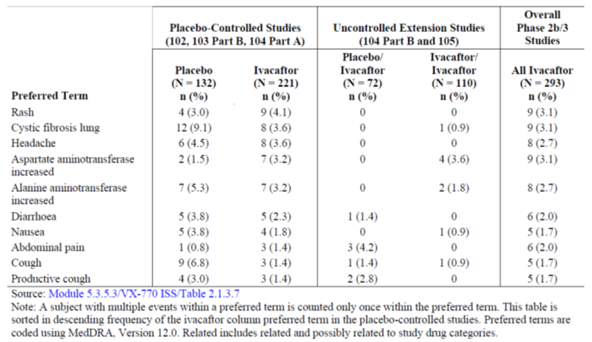

Deaths and other serious adverse events
There were no deaths in the Phase 2b/3 studies.
The most common SAEs (incidence of at least 3% in any treatment group) in the pooled Phase 2b/3 studies were CF lung and hemoptysis. In the placebo-controlled studies, the incidence of both of these events was lower in the ivacaftor group than the placebo group. SAEs that occurred in 2 or more subjects in either of the 2 treatment groups were CF lung, hemoptysis, abdominal pain, hypoglycemia, and hepatic enzyme increased. The SAEs that occurred in more than 1 subject in the ivacaftor group were CF lung, hemoptysis, hypoglycemia, abdominal pain, and hepatic enzyme increased. CF lung and hemoptysis were the only SAEs that occurred in more than 1 subject in the placebo group.

Discontinuation due to adverse events
In the pooled Phase 2b/3 studies, the only event that resulted in 2 or more subjects discontinuing study drug was ALT increased (2 in placebo group and none in ivacaftor group). In the pooled placebo-controlled studies, 4 (1.8%) subjects in the ivacaftor group discontinued for AEs (arthritis; myopathy; asthenia, fatigue, and headache; hepatic enzyme increased). In the placebo group, 7 (5.3%) subjects discontinued for AEs (feeling abnormal and cognitive disorder; ALT increased; ALT/ AST/ blood lactate dehydrogenase increased; atrioventricular block complete; adjustment/ anxiety disorder; panic attack; and respiratory failure).
In the placebo-controlled studies, AEs that led to interruption of study drug dosing occurred in 16 (7.2%) subjects in the ivacaftor group and 10 (7.6%) subjects in the placebo group. The events that led to interruption of study drug in more than 1 subject were CF lung and hepatic enzyme increased in the ivacaftor group and ALT increased and vomiting in the placebo group.

Laboratory tests

Liver function
In the pooled Phase 2b/3 studies, subjects with abnormal liver function at screening were excluded from the studies. Abnormal liver function was defined as ≥3 × upper limit of normal (ULN) of the following: serum AST, serum ALT, GGT, serum ALP, and total bilirubin. Both ivacaftor and placebo groups had minimal changes from baseline in mean values of the LFT at Weeks 16 and 48 that were similar in magnitude.
Overall, a similar proportion of subjects in the ivacaftor and placebo groups had maximum transaminase levels exceeding a range of thresholds including ≥2 ×, ≥3 ×, ≥5 ×, and ≥8 × ULN. The majority of subjects in these studies had maximum post-baseline ALT and AST levels that were <2 × ULN (ivacaftor vs placebo: 84.6%vs 83.3%). During treatment (up to 48-weeks) in these studies, the cumulative incidence of maximum transaminase (ALT or AST) increases was similar between the ivacaftor and placebo group across the different ranges of ≥3 × ULN (ivacaftor vs placebo: 6.3% vs 8.4%), ≥5 × ULN (2.7% vs 2.3%), ≥8 × ULN (1.8% vs 1.5%). The highest difference in incidence (including cumulative incidence) between the ivacaftor and placebo groups was for AST elevations ≥8 × ULN (1.8% vs 0.8%). Analyses of maximum bilirubin levels in subjects with and without transaminase elevations demonstrated that no subjects in the ivacaftor group had ALT or AST elevations of ≥3 × ULN and a maximum total bilirubin ≥2 × ULN concurrently or at any other time point.
In the ivacaftor group, the time to onset for these events [ALT or AST elevations of >5 × ULN] ranged from 8 to 52 weeks (from the first dose of study drug), with no apparent pattern identified. The majority of subjects (6 of 8) in the ivacaftor group interrupted study drug when transaminase elevations exceeded ≥5 × ULN; Six of 8 (75%) subjects who received ivacaftor and 2 of 3 (66.7%) subjects who received placebo and showed increased transaminase values, also had a medical history of elevated transaminases and/or evidence of ALT/AST elevation at baseline.
Among the 8 subjects with maximum transaminase elevations between ≥3 × ULN and <5 × ULN in the ivacaftor group, 7 subjects had improvement and resolution of transaminase elevations without interruption of ivacaftor dosing.
The majority of subjects in the ivacaftor group (6 of 8; 75%) with a transaminase elevation of ≥5 × ULN had transaminase elevations that were concurrent with or preceded by other significant clinical events (e.g., pulmonary exacerbation, flu-like illness, hemoptysis, kidney infection), use of other medications (e.g., acetaminophen, antibiotics), or other substances (e.g., alcohol). One subject had prior exposure to hepatitis C identified, which was not known previously
A higher proportion of subjects in the ivacaftor group who had a history of elevated liver enzymes had maximum on-treatment AST ≥8 × ULN, and ALT or AST levels ≥1 ×, ≥2 ×, ≥3 ×, and ≥5 × ULN, compared to those in the placebo group. Of the 34 subjects who received ivacaftor and had a history of elevated liver enzymes, 7 (20.6%) subjects had an on-treatment maximum of ALT ≥3 × ULN compared to 2 (9.1%) subjects who received placebo. The significance of this observation is uncertain due to the limited number of subjects involved, and the presence of a higher proportion of subjects randomized to the ivacaftor group who had a history of elevated liver enzymes and had elevations at baseline compared to the placebo group.
Exploratory analyses to evaluate whether there was any association between exposure to ivacaftor or its major metabolites (M1 and M6) and transaminase elevations were conducted in subjects with marked (>5 × ULN) transaminase elevations (AST or ALT). Exposure to ivacaftor, M1 and M6, as measured by minimum observed concentration (Cmin) and area under the concentration versus time curve (AUC) values in subjects with transaminase elevations >5 × ULN, were all within 1 SD of the concentrations in the subject’s study age group and generally were lower than the mean, as calculated from the population PK analysis. Thus, there is no apparent relationship between increased exposure to ivacaftor or its major metabolites and the occurrence of ALT or AST elevations >5 × ULN in subjects exposed to ivacaftor compared to exposure in subjects without ALT or AST elevations >5 × ULN. The incidence of ALT and AST levels longitudinally over time appeared similar in ivacaftor-treated subjects compared to placebo with no apparent pattern identified and no specific risk period elucidated.
In the placebo-controlled studies, the incidence of liver-related AEs was similar between the ivacaftor and placebo groups. Three subjects (1 subject in the ivacaftor group and 2 subjects in the placebo group) had liver-related events that led to study drug discontinuation. In addition, 2 subjects had liver-related SAEs.

Kidney function, haematology
Majority of the clinical laboratory parameters (serum chemistry, hematology, and coagulation studies) assessed in the pooled placebo-controlled Phase 2b/3 studies showed minor differences between the ivacaftor and placebo groups that were not considered to be clinically meaningful.

Other clinical chemistry
In the pooled placebo-controlled Phase 2b/3 studies, the mean values for glucose at baseline were similar in the ivacaftor and placebo groups and the changes from baseline to Week 16 or Week 48 were minimal for both treatment groups. Compared with the placebo group, the ivacaftor group showed a lower incidence of glucose shifts from normal to a high (15.4% vs 22.1%) or low (18.1% vs 26%). However, the incidence of shift of glucose from high to low or low to high was similar in both groups. In the placebo-controlled studies, the incidence of “blood glucose decreased” and hypoglycemia combined was comparable between the ivacaftor and placebo groups (4.1% vs 4.5%) with similar results for incidence of “blood glucose increased” and hyperglycemia (5.9% vs 4.5%).

Other laboratory test
Not applicable.

Electrocardiograph
Standard 12-lead ECG monitoring was done at baseline and at the last scheduled visit in the Phase 2b/3 placebo-controlled studies. Majority (>60%) of subjects in both treatment groups had abnormal, non-clinically significant findings and approximately 2% of subjects had potentially clinically significant abnormalities on 12-lead ECG at baseline. There were 3 (1.4%) subjects in the ivacaftor treatment group and 0 subjects in the placebo treatment group with potentially clinically significant abnormalities on 12-lead ECG at the last scheduled visit. All 3 of these subjects had non-clinically significant or potentially clinically significant abnormalities on 12-lead ECG at baseline and at end of study.
Subjects with any history of prolonged QTcF (>450 msec) were excluded from the studies as a precaution since the Thorough QT study (Study 008) was conducted in parallel with the Phase 2b/3 studies. There were no subjects with an on-treatment QTcF prolongation of >60 msec. The proportion of subjects with maximum on-treatment QTcF increases from baseline of >30 to ≤60 msec was similar between the ivacaftor and placebo treatment groups (13.6% each). There were no subjects with maximum QTcF intervals >480 msec. Four (1.8%) subjects in the ivacaftor treatment group and 2 (1.5%) subjects in the placebo treatment group had maximum on-treatment QTcF intervals of >450 to ≤480 msec during the dosing period.
In the 12-month chronic toxicity study in dogs, there was a slight increase in the incidence (3 of 40 dogs) of supraventricular premature complex (SVPC) runs, consisting of multiple events within a single ECG recording, at dosages ≥30 mg/kg/day. Hence, 24-hour ambulatory ECG monitoring was implemented in the placebo-controlled Phase 2b/3 studies to evaluate for any corresponding effects in patients. Majority (>60%) of subjects in both treatment groups had abnormal, non-clinically significant findings on 24-hour ambulatory ECG at baseline. The incidence of potentially clinically significant 24-hour ambulatory ECG findings was similar between the ivacaftor and placebo treatment groups at all study visits where 24-hour ambulatory ECG monitoring was conducted, including the last scheduled visit. There were 10 (4.7%) subjects in the ivacaftor treatment groups and 9 (7.2%) subjects in the placebo treatment groups with potentially clinically significant abnormalities on 24-hour ambulatory ECG at the last scheduled visit. The types of abnormalities observed at the last scheduled visit were similar between the treatment groups and included supraventricular ectopy, ventricular ectopy, or less commonly, 2nd degree atrioventricular block. In cases where potentially clinically significant abnormalities were observed at the last scheduled visit, similar abnormalities were generally noted at baseline. In the pooled placebo-controlled Phase 2b/3 studies, the incidence of AEs that may be associated with ECG abnormalities in the ivacaftor treatment groups (5 [2.3%] subjects) was similar to the placebo treatment groups (2 [1.5%] subjects).

Vital signs
There were no clinically relevant changes in vital signs (blood pressure and pulse rate) and physical examination results between baseline and end of study in the ivacaftor or placebo groups in the pooled Phase 2b/3 placebo-controlled studies.

Other safety parameters
Not applicable.

Post-marketing experience
Not applicable as ivacaftor has not yet been approved for marketing in any country.

Safety issues with the potential for major regulatory impact

Liver toxicity
Overall, the data does not provide unequivocal evidence supporting an association between ivacaftor and transaminase elevations. In all instances, the elevations in transaminases were reversible. While elevations in transaminases resulted in study drug discontinuation in some cases, this occurred in both the ivacaftor and placebo groups. In all remaining cases, study drug dosing was continued or resumed following brief interruptions and alternative etiologies were likely.
Subjects who have a medical history of transaminase elevations may be more likely to have transaminase elevations following ivacaftor treatment but the limited number of subjects involved does not allow for a definitive conclusion. The data suggests that moderate transaminase elevations (≥3 × ULN to 5 × ULN) often resolve without interruption or discontinuation of therapy. Since the majority of ivacaftor-treated subjects with elevations of ALT or AST ≥5 × ULN had dosing interrupted, it seems advisable to interrupt dosing at this threshold which has been incorporated into the proposed PI.

Haematological toxicity
Not applicable.

Serious skin reactions
Not applicable.

Cardiovascular safety
Treatment with ivacaftor was not associated with an increased incidence of clinically significant cardiac arrhythmias, including supraventricular and ventricular ectopy, or with a prolonged QT as measured by 12-lead standard ECGs and 24-hour ambulatory ECGs.

Unwanted immunological events
Not applicable.

Other safety issues

Safety in special populations
Subgroup analyses of AEs and laboratory evaluations were performed for the pooled Phase 2b/3 studies to assess the impact of the following intrinsic and extrinsic factors: age, sex, geographic region, history of liver disease/elevated liver function tests, history of CF related diabetes and similar terms (increased blood glucose, impaired glucose tolerance, abnormal glucose tolerance test, glycosuria, hyperglycemia, and Type 1 diabetes mellitus), FEV1 severity, and genotype (G551D mutation in the CFTR gene versus the F508del mutation in the CFTR gene).
Age: Ivacaftor has not been studied in subjects <6 or >53 years of age. In the pooled placebo-controlled Phase 2b/3 studies, subgroup analyses of AEs by age (less than 18 of age and 18 years of age or greater) revealed that within each age subgroup, the incidence of AEs was similar in the ivacaftor and placebo groups. The most common AEs (incidence of at least 20%) in subjects less than 18 years of age were cough (52.2%), CF lung (36.2%), oropharyngeal pain (24.6%), headache (22.5%) and pyrexia (22.5%). Of the commonly observed AEs, the incidence of cough, CF lung, and pyrexia was lower (at least 3% difference) in the ivacaftor group than the placebo group. The most common AEs (incidence of at least 20%) in subjects greater than 18 years of age were CF lung (38.6%) and cough (26.5%). The incidence of CF lung was lower (at least 3% difference) in the ivacaftor group than the placebo group. Overall, there were no evident age related safety findings in subjects 6 years of age and older.
Sex: Approximately equal numbers of males and females were enrolled in the pooled placebo-controlled Phase 2b/3 studies. Subgroup analyses by sex demonstrated that the incidence of AEs was similar in female and male subjects (94.9% vs 93.2%). For the males, the incidence of AEs was 98.6% in the placebo group vs. 89.6% in the ivacaftor group, but the incidence of AEs was similar in females (95.2% and 94.8%). In both male subjects and female subjects, the most common AEs (incidence of at least 20%) were cough and CF lung, which occurred less commonly in the ivacaftor group than the placebo group. There were no relevant differences in the incidence of AEs observed in male subjects or female subjects in either the ivacaftor or placebo groups.
Race: Approximately 97% of subjects were White due to the higher prevalence of CF in this demographic group. Hence, a subgroup analysis by race was not conducted as the number of subjects in the other racial subgroups was too small to enable reliable comparative analyses.
Baseline percent predicted FEV1: These studies enrolled 13, 146, 116 and 78 subjects with percent predicted FEV1 <40%, ≥40% to <70%, ≥70% to ≤90%, and >90%, respectively and the incidence of AEs was 100%, 93.2%, 94.8% and 93.6%, respectively. Many of the most common AEs within each FEV1 subgroup were common manifestations of CF. As expected based on the clinical characteristics of patients with severe CF lung disease, subjects with an FEV1 <40% had a greater number of AEs that occurred at a higher incidence (at least 20%) compared to other subgroups, although interpretation was limited by small size of the subgroup. There did not appear to be a major difference in the safety profile in this group compared to the other FEV1 subgroups. Of the AEs in the FEV1 <40%, nasal congestion, abdominal pain, rash, URTI, dizziness, and headache were reported at a higher incidence in the ivacaftor group than the placebo group. Overall, there were no notable differences in the pattern of AEs related to severity of lung disease (defined by baseline percent predicted FEV1).
Renal impairment: Ivacaftor was not evaluated in subjects with renal impairment. No dose adjustments are recommended for mild and moderate renal impairment patients because of minimal elimination of ivacaftor and its metabolites in urine (only 6.6% of total radioactivity was recovered in the urine in a human PK study), and there was negligible elimination of ivacaftor (<0.01%). However, caution is recommended when administering ivacaftor to patients with severe renal impairment (creatinine clearance less than or equal to 30 mL/min) or end stage renal disease.
Hepatic impairment: In study 013, compared with healthy subjects matched for demographics, subjects with moderate hepatic impairment had similar ivacaftor Cmax but an approximately 2-fold increase in ivacaftor AUC_{0-∞}. No subjects discontinued study drug due to AEs. The incidence of AEs was higher in subjects with moderate hepatic impairment (3 [25%] subjects had a total of 4 AEs: convulsion, headache, hydrocholecystis, seborrhoeic dermatitis) than in healthy subjects (1 [8.3%] subject had 1 adverse event: upper respiratory tract infection). No AEs (by preferred term) were reported in more than 1 subject in either of the 2 study groups, and no AEs were considered by the investigator to be related to study drug. There were no clinically meaningful trends attributed to ivacaftor in clinical laboratory evaluations, vital signs, ECGs, or physical examination findings. Because moderate hepatic impairment (Child-Pugh Class B) doubles the exposure of ivacaftor compared to that in healthy subjects, it is recommended that the dose be reduced from 150 mg q12h to 150 mg once daily. The impact of severe hepatic impairment (Child-Pugh Class C) on pharmacokinetics of ivacaftor has not been evaluated and the magnitude of increase in exposure in these patients is expected to be higher than that observed in mild or moderate hepatic impairment.
Comments: The sponsor’s statement that ‘Patients with mild hepatic impairment (Child-Pugh Class A) do not require dose adjustment because the effects on clearance are expected to be smaller than in Child-Pugh Class B patients.’ Is not justified as ivacaftor was not evaluated in patients with mild hepatic impairment.
Subjects With a Medical History of Liver Disease (Cirrhotic and Non-Cirrhotic) and a History of Liver Enzyme Elevations: In the Phase 2b/3 studies, baseline incidence of subjects with history of CF liver disease that included the terms “liver enzymes elevated” (ivacaftor vs placebo: 14.9% vs 15.2%), “liver disease without cirrhosis,” (9% vs 9.8%) and “cirrhosis with portal hypertension” (0.9% vs 1.5%) were similar in the ivacaftor and placebo groups. In the pooled placebo-controlled Phase 2b/3 studies, a higher proportion of subjects in the ivacaftor group who had a history of elevated liver enzymes had maximum on-treatment AST ≥8 × ULN, and ALT or AST levels ≥1 ×, ≥2 ×, ≥3 ×, and ≥5 × ULN compared to those in the placebo group who had a history of elevated liver enzymes. The most commonly observed AEs (incidence of at least 20%) in subjects in either subgroup (with or without a history of liver disease) were cough and CF lung. Similar to other subgroups and the population as a whole, the events of cough occurred less commonly in the ivacaftor group than the placebo group.
CFTR genotype: The placebo-controlled Phase 2b study (Study 104 Part A) enrolled subjects who were homozygous for the F508del mutation in the CFTR gene, and the placebo-controlled Phase 3 studies (Studies 102 and 103) enrolled subjects who had the G551D mutation in at least 1 allele of the CFTR gene. The most common AEs (incidence of at least 10% in any treatment group) in either population were CF lung, cough, headache, oropharyngeal pain, nasal congestion, and fatigue. Overall, there were no obvious differences in the incidence of AEs in the 2 populations. However, interpretation was limited by:-1) the small number of subjects in the placebo group in Study 104 Part A (n = 28) compared those in Studies 102 and 103 Part B (n = 104); 2) the short duration of treatment in Study 104 Part A (16 weeks total); and 3) the differences in the rates of AEs in the placebo groups for Studies 104 Part B, 102, and 104. Subgroup analyses of the Phase 3 safety data by the CFTR mutation in the second allele were not conducted because the majority (77%) of subjects enrolled in the Phase 3 studies had the F508del mutation in the CFTR gene in the second allele, and the frequency of other mutations in the CFTR gene in the second allele was less than 4% (1 to 5 subjects in the pooled Study 102 and 103 population).
Geographic factors: The incidence of AEs in the ivacaftor and placebo groups in subjects from North America, Europe, and Australia was similar. The AEs with the highest incidence (≥20%) in North America were cough and CF lung, both of which had a lower incidence in the ivacaftor group than the placebo group. The AEs with the highest incidence (≥20%) in Europe were cough, CF lung, URTI, and headache. CF lung and URTI had a lower incidence in the ivacaftor group than in the placebo group. The AEs with the highest incidence (at least 20%) in Australia were cough, productive cough, URTI, nasopharyngitis, CF lung, headache, bacteria in sputum, and abdominal pain. Cough, productive cough, bacteria in sputum, and abdominal pain had a lower incidence in the ivacaftor group than in the placebo group, whereas, URTI, and nasopharyngitis had a higher incidence in the ivacaftor group than in the placebo group.
Safety in pregnancy and lactation: The effects of ivacaftor on conception, pregnancy, and lactation in humans are not known as no adequate and well-controlled studies of ivacaftor in pregnant or lactating women have been conducted. Ivacaftor has shown no teratogenic potential in fetal developmental studies in rats and rabbits. Ivacaftor was also shown to have no effects on fertility in male or female rats. Ivacaftor was excreted into the milk of lactating female rats. Pregnancy or the potential to become pregnant and breastfeeding have been exclusion criteria in all clinical studies with ivacaftor conducted to date. Hence, there are no prospective data on the effect of ivacaftor on pregnancy or lactation. There were 3 pregnancies reported during the ivacaftor clinical development program: 2 female subjects (one of whom had a spontaneous abortion and no follow-up data on the other female patient) and 1 male subject whose female partner became pregnant during his participation in a clinical study (follow-up data not available).

Safety related to drug-drug interactions and other interactions
Study 809-005 was a Phase 1, randomized, double-blind, placebo-controlled, multiple-dose, 3-treatment period, drug-drug interaction study investigating VX-809 alone, ivacaftor alone, and VX-809 coadministered with ivacaftor in 24 healthy adult subjects. Dosing with VX-809 alone, ivacaftor alone, or VX-809 coadministered with ivacaftor was generally well tolerated with no SAEs or related adverse events resulting in study drug discontinuation. The co-administration of ivacaftor and VX-809 for 14 days did not result in an increase in AEs compared with ivacaftor or VX-809 when each was dosed alone. The most common events (i.e., reported by 3 or more subjects) in the ivacaftor alone treatment group were headache (8 subjects, 44.4%), influenza-like illness (5 subjects, 27.8%), cough (4 subjects, 22.2%), and vomiting, pharyngitis, and decreased appetite (each in 3 subjects, 16.7%). The most common AE in the placebo group were headache and abdominal pain (each in 50% of subjects). There were no clinically significant laboratory abnormalities or changes in vital signs, physical findings, or ECGs for all 3 treatment periods.

Safety in phase 1 studies
In the Phase 1 studies, 376 healthy subjects (who do not have CF) from 13 studies received at least 1 dose of ivacaftor alone or coadministered with another drug: 258 subjects were included in the 10 pooled Phase 1 studies and 118 subjects were from 3 non-pooled studies (Studies 008, 013, and 809-005). Nine subjects were included in 2 taste profiling studies (Studies 004 and 014). Majority of the AEs were mild or moderate and there were no SAEs or deaths in the Phase 1 studies. The most common AEs (at least 5% of the subjects exposed to ivacaftor) were product quality issue (21.7%) (bad taste due to initial formulation [polyethylene glycol solution]), headache (17.8%), dizziness (5.0%), diarrhoea (7.0%), nausea (6.2%), and cough (6.2%). The incidence of headache and dizziness was higher (at least 3%) in the ivacaftor group (12.3% and 3.9%, respectively) than the placebo group (9.1% and no subjects, respectively), which is consistent with the slightly higher incidence of headache and dizziness observed in the ivacaftor group in the Phase 2b/3 studies in subjects with CF. Ten (3.9%) subjects had adverse events that led to study drug discontinuation in the pooled Phase 1 studies 9 of these AEs were considered to be related or possibly related to the administered study drug. All laboratory abnormalities reported as AEs occurred in less than 1 percent of subjects who received ivacaftor alone and were mild in severity.
Treatment with ivacaftor at the therapeutic dose (150 mg q12h) or supratherapeutic dose (450 mg q12h) had no effect on the QTcF and QTcB intervals (Study 008).
In study 013, after a single dose of 150 mg of ivacaftor, subjects with moderately impaired hepatic function (Child-Pugh Class B, score 7 to 9)had similar ivacaftor Cmax, but an approximately 2-fold increase in AUC from the time of dosing extrapolated to infinity compared with healthy subjects matched for demographics. No new or otherwise clinically meaningful AEs were observed.

Safety data in ongoing and other studies
In the ongoing Phase 2 study 106, 17 subjects had started treatment in the study and 2 SAEs were reported at the time of the cut-off date (distal ileal obstruction syndrome in 1 subject and Pseudomonas infection in 1 subject). Both of these events were considered not related to study drug by the investigator and resolved without interruption or discontinuation of study drug dosing.
In the Phase2 study 107, 8 subjects were treated in the study and no SAEs were reported at the time of the cut-off date.

Other safety data
Overdose: There have been no reports of overdose in subjects who received ivacaftor. Ivacaftor doses as high as 500 mg/kg in rats and 2000 mg/kg in mice were well tolerated. These doses are 13- and 27-fold higher, respectively, than the intended daily therapeutic dose of 300 mg for ivacaftor. The highest single dose used in a clinical study was 800 mg in a solution formulation (Study 001). The highest repeated dose used in a clinical study was 450 mg (in a tablet formulation) every 12 hours for 4.5 days (9 doses) in the thorough QT study 008. No statistically significant relationships between QTcF changes with ivacaftor/M1/M6 concentrations were determined from linear mixed-effects models. Adverse events reported at a higher incidence in either of the 2 ivacaftor treatments as compared to placebo included: contact dermatitis, dizziness, and diarrhoea. Contact dermatitis (likely from application of ECG leads) was reported at a higher incidence in the ivacaftor 450 mg q12h treatment as compared to the ivacaftor 150 mg q12h treatment. No specific antidote is available for overdose with ivacaftor. Treatment of overdose with ivacaftor consists of general supportive measures including monitoring of vital signs and observation of the clinical status of the patient. It is not known if ivacaftor can be cleared by hemodialysis.
Abuse potential: The abuse potential of ivacaftor was not evaluated. Evaluation of AEs does not reveal evidence of euphoria, sedation, or mood alteration and there were no clinically meaningful central nervous system findings in the nonclinical or clinical studies of ivacaftor.
Withdrawal and rebound effects: Studies or systematic analyses to evaluate the potential withdrawal and rebound effects of ivacaftor have not been conducted. In the pooled placebo-controlled Phase 2b/3 studies, subjects were dosed with ivacaftor for up to 48 weeks. The overall safety and tolerability profile of ivacaftor did not appear to be negatively impacted by interruption, discontinuation, or treatment completion of ivacaftor.
Ability to drive or operate machinery: No studies on the effects of ivacaftor on the ability to drive or operate machinery have been performed. The observed incidence of AEs that may alter the ability to drive or operate machinery were identified in the pooled Phase 2b/3 studies of which dizziness is the only AE that might impact the ability to drive or operate machinery. Patients experiencing dizziness should be advised not to drive or operate machinery until symptoms abate.

Evaluator’s overall conclusions on clinical safety
A total of 683 subjects were exposed to ivacaftor in the ivacaftor clinical development program: 364 healthy subjects (including 12 subjects with hepatic impairment) and 307 subjects with CF who have a G551D mutation in the CFTR gene or who are homozygous for the F508del mutation in the CFTR gene. A total of 293 subjects with CF (G551D or F508del mutations in the CFTR gene) received the proposed dose of ivacaftor 150 mg q12h in the Phase 2b/3 studies. Ivacaftor was well tolerated and most subjects completed treatment (93.7% and 87.9% of subjects in the ivacaftor and placebo groups, respectively). The mean treatment duration in the pooled placebo-controlled Phase 2b/3 studies was 218.1 days for subjects in the ivacaftor group. A total of 101 subjects were treated with ivacaftor for 48 weeks and 63 subjects were treated for 60 weeks.
In the pooled Phase 2b/3 studies, the majority (89.8%) of subjects who received at least 1 dose of ivacaftor had an AE. In the placebo-controlled studies, nearly all subjects in the ivacaftor (92.3%) and placebo (97.0%) groups had AEs. The incidence of AEs considered by the investigator to be related to the study drug was similar between the ivacaftor (33.5%) and placebo (34.1%) groups. There were no deaths in any of the pooled Phase 2b/3 studies. In the placebo-controlled studies, the incidence of SAEs was lower in the ivacaftor group than the placebo group (17.6% vs 34.8%), as was the incidence of AEs leading to study drug discontinuation (1.8% vs 5.3%). The incidence of AEs leading to study drug interruption in these studies was similar between the ivacaftor and placebo groups (7.2% vs 7.6%).
The majority of AEs were mild or moderate in severity, and not serious. Interruption or discontinuation of study drug due to AEs was uncommon; discontinuation of study drug was less common in subjects receiving ivacaftor than subjects receiving placebo. There was no one dominant event that led to discontinuation. The most common AEs in the ivacaftor group were cough, CF lung (preferred term for pulmonary exacerbation), headache, URTI, nasal congestion, oropharyngeal pain, pyrexia, productive cough, nausea, and rash. Based on the higher incidence in the ivacaftor group than the placebo group, URTI events, dizziness, rash, headache, bacteria in sputum, diarrhoea, and abdominal pain were identified as likely to represent ADRs.
The safety profile in the subjects receiving ivacaftor for 60 weeks was similar to that of the first 48 weeks which supports the safety of chronic administration of ivacaftor. This population will be followed for up to 144 weeks of total treatment in the uncontrolled extension study.
The most common severe AEs and SAEs were CF lung and hemoptysis, both of which are common manifestations of CF and occurred with a lower frequency in subjects receiving ivacaftor. There were no deaths in any of the ivacaftor studies
Treatment with ivacaftor was not associated with an increased incidence of clinically significant cardiac arrhythmias, including supraventricular and ventricular ectopy, or with a prolonged QT as measured by 12-lead standard ECGs and 24-hour ambulatory ECGs. Thus, the non-clinical signal for supraventricular tachycardia in animal studies was not confirmed in the human clinical studies. Administration of ivacaftor at the therapeutic dose (150 mg q12h) or a supratherapeutic dose (450 mg q12h) had no effect on QTc interval.
SAEs of hypoglycemia were reported as possibly related to ivacaftor; these were most likely related to complications of treatment for diabetes, which is a well-known manifestation of CF. Overall, there was no effect of ivacaftor on blood glucose concentrations.
Elevations of transaminases occurred in a small number of subjects in both the placebo and ivacaftor groups. The incidence of these elevations was similar between subjects in the ivacaftor and placebo groups. The clinical features, including time to onset, concomitant factors (co-illnesses, medications), progression, and resolution of these events were similar between the ivacaftor and placebo groups. The role of ivacaftor in contributing to transaminase elevations is uncertain. In all instances, the elevations in transaminases were reversible. However, due caution is still advised in patients with hepatic impairment. Overall, treatment with ivacaftor was not associated with clinically meaningful changes in laboratory parameters.
The safety profile of ivacaftor was similar across the different age and gender subgroups. The pattern of AEs was similar across the subgroups by severity of lung disease and the most common AEs within each FEV1 subgroup are common manifestations of CF. As expected, subjects with more severe disease had a higher incidence of AEs compared to other subgroups, but ivacaftor was well tolerated even in this most severely compromised group. The pattern of AEs was similar in subjects homozygous for F508del-CFTR and subjects who have the G551D-CFTR mutation. The most common AEs in both populations were pulmonary exacerbations, cough, headache, oropharyngeal pain, nasal congestion, and fatigue. After a single dose of 150 mg of ivacaftor, subjects with moderately impaired hepatic function (Child-Pugh Class B, score 7 to 9) had similar ivacaftor Cmax, but an approximately 2-fold increase in AUC_{0-∞} compared with healthy subjects matched for demographics. A reduced dose of 150 mg once a day is recommended for these patients. The sponsor’s statement that ‘Patients with mild hepatic impairment (Child-Pugh Class A) do not require dose adjustment because the effects on clearance are expected to be smaller than in Child-Pugh Class B patients’ is not justified as ivacaftor was not evaluated in patients with mild hepatic impairment.
The safety profile of ivacaftor was adequately evaluated in an appropriate number of patients in line with the size of the targeted patient population. Administration of ivacaftor 150 mg orally every 12 hours (q12h) for up to 48 weeks was well tolerated, as evidenced by an evaluation of AEs, SAEs and AEs leading to premature discontinuation of treatment, clinical laboratory evaluations, electrocardiogram (ECG) results, vital signs, and physical examinations. Available data through 60 weeks of ivacaftor treatment did not identify new clinically important safety concerns.

First round benefit-risk assessment

First round assessment of benefits
The benefits of ivacaftor in the proposed usage are:
Ivacaftor acts by targeting the underlying cause of cystic fibrosis by increasing the CFTR channel opening to enhance chloride transport. Currently in Australia, there are no marketed drugs which target the dysfunctional CFTR channel.
Ivacaftor 150mg bid (12 hourly) showed a substantial and durable effect on absolute change in percent predicted FEV1 through Week 24 (10.6 to 12.5 percentage points) that was highly significant (P<0.0001) compared with placebo. Improvements in FEV1 were rapid in onset and durable through the 48-week treatment period in the placebo-controlled Phase 3 studies.
Durable improvements in other pulmonary outcomes were observed, including the risk of experiencing a pulmonary exacerbation, as well as the frequency and duration of pulmonary exacerbations, and respiratory symptoms as measured by CFQ-R. Durable improvements in measures of nutritional status were observed, including weight and BMI.
Ivacaftor led to sustained improvements in CFTR function, evidenced by the substantial and durable reduction in sweat chloride concentration. The overall pattern of improvement in CFTR function was consistent with that of FEV1, demonstrating that modulation of CFTR by ivacaftor is associated with clinical benefit.
The pattern and magnitude of the treatment effects of ivacaftor observed in subjects 6 to 11 years of age was consistent with the clinical benefit observed in subjects 12 years of age and older. Treatment effects were observed in subjects with all degrees of disease severity (baseline percent predicted FEV1 ranging from 32% to 134%) and were observed in subjects while continuing on their prescribed CF therapies.
The clinical benefits observed in the placebo-controlled Phase 3 studies were confirmed in the open-label rollover study 105 (currently for up to 60 total weeks of ivacaftor treatment) by the maintenance of the treatment effect in subjects initially treated with ivacaftor and replication of the rapid and substantial improvements in clinical endpoints in subjects initially treated with placebo.
Ivacaftor treatment was well tolerated for at least 60 weeks. The most common AEs were typical manifestations of CF disease; these occurred at a lower incidence in the ivacaftor than the placebo group. The incidence of SAEs was lower in the ivacaftor than the placebo group. The frequency of discontinuations due to adverse events was lower in the ivacaftor than the placebo group. The most common risks associated with ivacaftor treatment have been characterized, can be readily monitored and recognized, and may be managed without treatment discontinuation.

First round assessment of risks
The risks of ivacaftor in the proposed usage are:
- Compared to placebo, treatment with ivacaftor was associated with a higher incidence of URTI events (including URTI, nasal congestion, pharyngeal erythema, oropharyngeal pain, rhinitis, sinus congestion, and nasopharyngitis), headache, abdominal pain, rash, diarrhoea, dizziness, and bacteria in sputum.
- Elevations in transaminases were observed in subjects with CF that were common in both the ivacaftor and placebo groups, which is consistent with the natural history of CF liver disease. Patients with elevated transaminases at baseline were more likely to show clinically relevant elevations in transaminases during ivacaftor treatment compared with placebo; however, interpretation was confounded by higher proportion of patients with elevated transaminases at baseline in the ivacaftor group. Since the role of ivacaftor in these events is uncertain, monitoring, and management recommendations was included in the product labelling.
- Safety of ivacaftor was not evaluated in patients with mild and severe hepatic impairment. It was only evaluated in patients with moderate hepatic impairment which showed doubling of exposure to ivacaftor.

First round assessment of benefit-risk balance
Overall, ivacaftor was highly effective in the treatment of CF, shown by improvement in CFTR function and substantial, durable improvements in important clinical outcomes, including FEV1, pulmonary exacerbations, respiratory symptoms, and nutritional status. Thus, ivacaftor is expected to have broad and meaningful clinical benefit in patients 6 years of age and older who have a G551D mutation in the CFTR gene.
The safety of ivacaftor was also well-established in over 290 patients (appropriate sample size for the target patient population) and the risks associated with ivacaftor were reversible, not serious and easily managed.
Hence, the benefit-risk balance of ivacaftor given the proposed usage is favourable.

First round recommendation regarding authorisation
It is recommended that Ivacaftor 150 mg bid (given 12 hourly) be approved for ‘Treatment of cystic fibrosis in patients age 6 years and older who have the G551D mutation in the CFTR gene.’ However, the approval is subject to incorporation of suggested changes to the proposed PI.

Clinical questions
None

Second round evaluation of clinical data submitted in response to questions
Not applicable

References
- Guideline on the clinical development of medicinal products for the treatment of cystic fibrosis (EMEA/CHMP/EWP/9147/2008-corr*). European Medicines Agency Committee for Medicinal Products for Human Use, 2009.
- Guideline on clinical investigation of medicinal products in the treatment of chronic obstructive pulmonary disease (COPD) (Draft 3) (CPMP/EWP/562/98 Rev. 1). European Medicines Agency, 2010.

The study was conducted in 2 parts: Part 1 consisted of Group A and Group B. Subjects in Group A were randomized to receive either 25-mg VX-770 q12h, 75-mg VX-770 q12h, or placebo for 14 days. Subjects in Group B were randomized to receive either 75-mg VX-770 q12h, 150-mg VX-770 q12h, or placebo for 14 days. Following a 7- to 28-day washout period, subjects receiving VX-770 crossed over to the alternate dose strength of VX-770 for an additional 14 days. Placebo subjects continued to receive placebo for an additional 14 days. Part 2 consisted of Group C, whose subjects did not participate in Part 1. Subjects were randomized to receive 150-mg VX-770 q12h, 250-mg VX-770 q12h, or placebo for 28 days.
NPD is a direct measure of transepithelial ion transport. Electrodes are place on the nasal mucosa and the forearm to measure the transepithelial potential difference. The nasal mucosa is then bathes in a series of solutions: Ringer’s solution, amiloride, zero chloride solution, isoproterenol, and ATP. The transepithelial NPD under conditions of zero chloride perfusion solution in the presence of isoproterenol is the NPD measurement most indicative of CFTR activity. The transepithelial NPD under conditions of zero chloride concentration perfusion solution in the presence of isoproterenol was of primary interest, and was the primary PD assessment for this procedure.
Diagnosis of CF defined as:- a sweat chloride value ≥ 60 mmol/L by quantitative pilocarpine iontophoresis OR two CF-causing mutations (all as documented in the subject’s medical record) AND chronic sinopulmonary disease OR gastrointestinal/nutritional abnormalities.
Subjects whose CF was not stable e.g., subjects colonized with organisms associated with more rapid decline in pulmonary status, such as Burkholderia cenocepacia, Burkholderia dolosa, and Mycobacterium abscesses; subjects with recent acute upper or lower respiratory infection, pulmonary exacerbation, or changes in therapy for pulmonary disease.
Guidelines for stable medication regimens for CF were as follows: Subjects who were on inhaled cycling antibiotics should have taken their antibiotic in 28-day-on/28-day-off cycles; Subjects who used inhaled antibiotics without cycling should have continued their regimen as usual; Subjects who alternated 2 different antibiotics monthly should have continued alternating their antibiotics as usual.
The questionnaires provided information about demographics, general quality of life, school, work, or daily activities, and symptom difficulties (pertaining to CF).
Subjects (or the subject’s parent/caregiver) completed the EuroQol Questionnaire (EQ-5D)(for 12 years of age and older) which is a standardized self-reported questionnaire developed by the EuroQol Group for use as a measure of health outcome that consists of 5 dimensions (mobility, self-care, usual activities, pain/discomfort, anxiety/depression
Pulmonary exacerbation was defined as a change in antibiotic therapy (IV, inhaled, or oral) for any 4 or more of the following signs/symptoms. -change in sputum, new or increased hemoptysis, increased cough, increased dyspnea, malaise, fatigue, or lethargy, temperature above 38°C (equivalent to approximately 100.4°F), anorexia or weight loss, sinus pain or tenderness, change in sinus discharge, change in physical examination of the chest, decrease in pulmonary function by 10%, radiographic changes indicative of pulmonary infection.
Overall study drug compliance (%) was defined as the ratio of the number of tablets consumed to the number of tablets expected to be administered, expressed as a percentage
Duration of events was analysed using a stratified (for age group and percent predicted FEV1 severity at baseline) Wilcoxon rank-sum test to assess difference between treatment groups. In the analysis, total duration of all events was adjusted for time spent in the study by multiplying the observed percent days with the event by the total study days expected on study (i.e., 168 and 336 days for the Week 24 and Week 48 analysis, respectively.
The MBW test involves inhalation of an inert tracer gas during quiet breathing. Gas flow and volume analyzers are used to monitor how long it takes the subject to wash out this gas mixture from the lung. If there is airway narrowing, from either mucosal inflammation or mucus, it takes longer to wash out the gas mixture and this can be used as an indicator of airway disease.
While subjects were randomized based on the percent predicted FEV1 obtained on Day -14, they were assigned to FEV1 severity subgroups based on the percent predicted FEV1 severity at baseline (<70%, 70% to 90% [inclusive], >90% of the predicted value, and ≤90% of the predicted value).
Weight-for-age z-scores were calculated using National Center for Health Statistics growth charts.
Study 001 Part D included subjects with CF Study 013 also included subjects with hepatic impairment
Study 104 was a Phase 2b, 2-part study conducted in subjects with CF who are homozygous for the F508del mutation in the CFTR gene: a placebo-controlled (Part A) and an uncontrolled open-label, extension part (Part B) for subjects who completed treatment in Part A and met pre-specified criteria to participate in Part B.
Eight subjects in the placebo-controlled or uncontrolled studies who received at least 1 dose of ivacaftor had transaminase elevations ≥5 × ULN, 3 subjects had elevations occurring in the first 16 weeks of treatment, including 2 subjects in Study 104 Part A (16-week duration). The time to onset (ALT and/or AST ≥5 × ULN) from first dose of ivacaftor in the other 5 subjects occurred at Weeks 19, 31, 32, 42, and 52.
an investigational CFTR corrector, which enhances chloride transport by increasing the delivery and amount of functional CFTR protein to the cell surface
In this study, subjects received the therapeutic (150 mg q12h) and supratherapeutic (450 mg q12h) dose of ivacaftor.
The section discussing product literature including the PI is not included in this extract from the CER.

