October 2012

Australian Public Assessment Report for Ivabradine
  - Proprietary Product Name: Coralan
  - Sponsor: Servier Laboratories (Australia)

About the Therapeutic Goods Administration (TGA)
- The Therapeutic Goods Administration (TGA) is part of the Australian Government Department of Health and Ageing, and is responsible for regulating medicines and medical devices.
- The TGA administers the Therapeutic Goods Act 1989 (the Act), applying a risk management approach designed to ensure therapeutic goods supplied in Australia meet acceptable standards of quality, safety and efficacy (performance), when necessary.
- The work of the TGA is based on applying scientific and clinical expertise to decision-making, to ensure that the benefits to consumers outweigh any risks associated with the use of medicines and medical devices.
- The TGA relies on the public, healthcare professionals and industry to report problems with medicines or medical devices. TGA investigates reports received by it to determine any necessary regulatory action.
- To report a problem with a medicine or medical device, please see the information on the TGA website <www.tga.gov.au>.
About AusPARs
- An Australian Public Assessment Record (AusPAR) provides information about the evaluation of a prescription medicine and the considerations that led the TGA to approve or not approve a prescription medicine submission.
- AusPARs are prepared and published by the TGA.
- An AusPAR is prepared for submissions that relate to new chemical entities, generic medicines, major variations, and extensions of indications.
- An AusPAR is a static document, in that it will provide information that relates to a submission at a particular point in time.
- A new AusPAR will be developed to reflect changes to indications and/or major variations to a prescription medicine subject to evaluation by the TGA.
Copyright
© Commonwealth of Australia 2012
This work is copyright. You may reproduce the whole or part of this work in unaltered form for your own personal use or, if you are part of an organisation, for internal use within your organisation, but only if you or your organisation do not use the reproduction for any commercial purpose and retain this copyright notice and all disclaimer notices as part of that reproduction. Apart from rights to use as permitted by the Copyright Act 1968 or allowed by this copyright notice, all other rights are reserved and you are not allowed to reproduce the whole or any part of this work in any way (electronic or otherwise) without first being given specific written permission from the Commonwealth to do so. Requests and inquiries concerning reproduction and rights are to be sent to the TGA Copyright Officer, Therapeutic Goods Administration, PO Box 100, Woden ACT 2606 or emailed to <tga.copyright@tga.gov.au>.

Contents
I. Introduction to product submission 4
Submission details 4
Product background 5
Regulatory status 6
Product Information 6
II. Quality findings 6
III. Nonclinical findings 6
IV. Clinical findings 6
Introduction 6
Pharmacokinetics 8
Pharmacodynamics 8
Efficacy 8
Safety 37
Clinical Summary and Conclusions 50
List of Questions 59
Second Round Evaluation of Clinical Data Submitted in Response to Clinical Questions 59
V. Pharmacovigilance findings 67
Risk management plan 67
VI. Overall conclusion and risk/benefit assessment 71
Quality 72
Nonclinical 72
Clinical 72
Risk management plan 86
Risk-benefit analysis 86
Outcome 102
Attachment 1. Product Information 102

I. Introduction to product submission

Submission details
Type of Submission | Major Variation (Extension of indications)
Decision: | Approved
Date of Decision: | 9 July 2012

Active ingredient(s): | Ivabradine
Product Name(s): | Coralan
Sponsor’s Name and Address: | Servier Laboratories (Australia) Pty Ltd  8 Cato St Hawthorn VIC
Dose form(s): | Film-coated tablets
Strength(s): | 5 mg and 7.5 mg
Container(s): | Calendar packs of aluminium/polyvinyl chloride (PVC) blister strips packed in cardboard boxes.
Pack size(s): | 14 or 56
Approved Therapeutic use: | Treatment of symptomatic chronic heart failure of NYHA Classes II or III and with documented left ventricular ejection fraction (LVEF) ≤ 35% in adult patients in sinus rhythm and with heart rate at or above 77 bpm, in combination with optimal standard chronic heart failure treatment.
Route(s) of administration: | Oral (PO)
Dosage: | The recommended starting dose for patients with heart failure is ivabradine 5 mg twice daily (bd) when heart rate is at or above 77 beats per minute (bpm). This is followed by instructions (after 2 weeks of treatment and during on-going treatment) to allow for an increase to 7.5 mg b.d if required provided the resting heart rate is persistently at or above 60 bpm or to decrease to 2.5 mg b.d if the resting heart rate is persistently below 50 bpm or there are symptoms related to bradycardia. Finally, if there is persistence of either a resting heart rate of less than 50 bpm or symptoms of bradycardia, then treatment must be discontinued.
ARTG Number (s) | 107297 and 107301

Product background
Ivabradine is a heart rate lowering agent, acting by selective inhibition of the cardiac pacemaker (I_{f}) current that controls the spontaneous diastolic depolarisation in the sinus node and regulates heart rate. The cardiac effects are relatively specific to the sinus node with no effect on intra atrial, atrioventricular or intraventricular conduction times, myocardial contractility or ventricular repolarisation in humans at the therapeutic dose. The main pharmacodynamic property of ivabradine in humans is a specific dose dependent reduction in heart rate which leads to a reduction in cardiac workload and myocardial oxygen consumption.
Standard pharmacological treatment in chronic heart failure (CHF) includes an angiotensin-converting enzyme inhibitor or angiotensin II receptor blocker, a beta blocker, a diuretic in patients with fluid overload and an aldosterone antagonist in selected patients with moderately severe or severe symptoms. In patients with CHF, it has been found that a low heart rate may be a predictor or marker of better clinical outcomes. The use of beta blockers in CHF is principally to inhibit the adverse effects of the sympathetic nervous system in these patients, one of which is the effect on heart rate. However, apart from their beneficial inhibitory effects on heart rate, beta blockers also have adverse cardiac effect of decreasing myocardial contractility, slowing intra cardiac conduction and reducing blood pressure. They also have an effect on bronchial airways and may be contraindicated in some asthmatic patients.
Ivabradine is the first agent in this class of action that has been approved for clinical use and is currently indicated for the treatment of chronic stable angina pectoris in coronary artery disease patients.
This AusPAR describes the application by the sponsor to extend the current indications for Coralan. The current TGA-approved indication is:
“Treatment of chronic stable angina due to atherosclerotic coronary artery disease in patients with normal sinus rhythm, who are unable to tolerate or have a contraindication to the use of beta blockers, OR in combination with atenolol 50 mg once daily when heart rate is at or above 60 bpm and angina is inadequately controlled”.
It is proposed to extend the current indication above to also include:
“Treatment of chronic heart failure: Reduction of cardiovascular events (cardiovascular mortality or hospitalisation for worsening heart failure) in adults with sinus rhythm with symptomatic chronic heart failure and with heart rate at or above 70 bpm”
Coralan (ivabradine) was first considered by the Advisory Committee on Prescription Medicines (ACPM; then Australian Drug Evaluation Committee (ADEC)) at its 247th meeting on 4 August 2006. Resolution No. 8990 was that there should be no objection to register the new chemical entity ivabradine for the following indication:
“Treatment of chronic stable angina due to atherosclerotic coronary artery disease in patients with normal sinus rhythm who are unable to tolerate or who have a contraindication to the use of beta blockers”.
It was next considered at the 270th meeting on 4 June 2010 for the proposed indication (proposed extension of indication underlined):
“Treatment of chronic stable angina due to atherosclerotic coronary artery disease in patients with normal sinus rhythm who are unable to tolerate or who have a contraindication to the use of beta blockers, or in combination with beta blockers in patients inadequately controlled with an optimal beta blocker dose whose heart rate is > 60 bpm”.
The ACPM was of the opinion that while the improvement in total exercise duration had been shown to be statistically significant, there was an absence of meaningful clinical benefit. During the post-ACPM negotiation period the sponsor and the Delegate agreed on a slightly more restricted extension of indication specifying atenolol 50 mg once daily as the beta blocker regimen. This led to the currently approved wording, as indicated above.

Regulatory status
On 15 December 2011, the Committee for Medicinal Products for Human Use (CHMP) adopted a positive opinion recommending the adoption of a new indication for the European Union (EU) as follows:
“Treatment of chronic heart failure. Ivabradine is indicated in chronic heart failure NYHA II to IV class with systolic dysfunction, in patients in sinus rhythm and whose heart rate is ≥ 75 bpm, in combination with standard therapy including beta blocker therapy or when beta blocker therapy is contraindicated or not tolerated (see section 5.1)”.
A decision was adopted in Switzerland on 28th September 2012 for the following indication :
Treatment of chronic heart failure: Reduction of cardiovascular events (cardiovascular mortality or hospitalisation for worsening heart failure) in adults in sinus rhythm with symptomatic chronic heart failure, left ventricular ejection fraction ≤ 35 % and heart rate ≥ 70 bpm, in combination with optimal standard therapy according to the current guideline recommendations.

Product Information
The approved Product Information (PI) current at the time this AusPAR was prepared can be found as Attachment 1.

II. Quality findings
There was no requirement for a quality evaluation in a submission of this type.

III. Nonclinical findings
There was no requirement for a nonclinical evaluation in a submission of this type.

IV. Clinical findings

Introduction

Clinical rationale
One rationale given by the sponsor for exploring the use of ivabradine in CHF patients is that ivabradine reduces heart rate by selective inhibition of the sinus node activity and has been found to have no effect on the intra atrial, atrioventricular or intraventricular conduction times, myocardial contractility, ventricular repolarisation, blood pressure or bronchial airways in humans at the therapeutic dose. In addition, the sponsor has stated that clinical studies showed that heart rate remains elevated in the majority of CHF patients in clinical practice despite being on beta blockers and thus the rationale that additional heart rate lowering treatment may be needed in patients with heart failure.
Comment: The use of beta blockers in patients with CHF is principally to inhibit the adverse effects of the sympathetic nervous system in patients with CHF. Long-term activation of the sympathetic nervous system in CHF patients exerts deleterious effects such as increasing ventricular volumes and pressure by causing peripheral vasoconstriction and by impairing sodium excretion by the kidneys, thus inducing cardiac hypertrophy while restricting the ability of the coronary arteries to supply blood to the thickened ventricular wall and thereby leading to myocardial ischemia and increasing cardiac workload. Clinical studies have shown that a reduced heart rate may be associated with better clinical outcomes in CHF patients, but it is controversial if this predictive factor is independent of sympathetic system inhibition or is merely a manifestation of sympathetic system inhibition. The clinical rationale for the use of ivabradine as described by the sponsor appeared to be based on the hypothesis that a reduced heart rate is a predictive factor of better clinical outcomes in CHF patients, independent of sympathetic system inhibition, that is, that the use of an agent like ivabradine, which reduces heart rate by acting directly on the sino-atrial node independent of any inhibitory effect on the sympathetic system, will nonetheless lead to improved clinical outcomes in CHF patients.

Contents of the clinical submission
The clinical submission was confined to a single clinical study (the SHIFT study) evaluating the effect of ivabradine on cardiovascular events in patients with symptomatic CHF and left ventricular systolic dysfunction.
The submission contained the following clinical information:
- 1 pivotal efficacy/safety study
On 30 August 2011, the sponsor has sent responses to questions posed by the TGA in a “Request for Information” response to the application for extension of indication for ivabradine. These included the sponsor’s responses to the European Medicines Agency’s (EMA’s) queries regarding the SHIFT study. Parts of it will be referred to in this evaluation report, especially the sponsor’s responses to the queries by EMA, some of which are the same queries initially intended to be posed to the sponsor by this evaluator.

Paediatric data
The submission did not include paediatric data.

Good Clinical Practice (GCP)
In the presentation of the results of the SHIFT study, it was stated that all of the patients recruited in 2 centres out of 625 were excluded from all analysis sets because of “concerns over invalid data due to misconduct”. No further details were given in the Clinical Study Report (CSR). Some details were supplied by the sponsor to the EMA in response to EMA’s queries on this and it was elaborated that “following major GCP deficiencies discovered or confirmed by audits at 2 centres and (fake source documents, falsified copies of source documents in order to allow inclusion of not eligible patients), there was not enough guarantee for the accuracy and reliability of the data of the 46 patients from these centres. The closure of the centres has thus been decided.”
The clinical study reviewed in this evaluation was otherwise in compliance with GCP guidelines.

Pharmacokinetics
No new PK data was provided in this submission.

Pharmacodynamics
No new PD data was provided in this submission.

Efficacy

Dosage selection for the pivotal studies
The sponsor has stated that the starting dose of ivabradine in the pivotal SHIFT study was based on the recommended starting dose for ivabradine in patients with chronic stable angina (currently approved indication). The dose titration according to heart rate and symptoms of bradycardia was also based on the dosing guidelines for use of ivabradine in patients with chronic stable angina.

Proposed new indication for use in patients with symptomatic chronic heart failure

Pivotal SHIFT study

Study design, objectives, locations and dates
The SHIFT study was a randomised, double blind, placebo controlled, multi centre morbidity-mortality study, evaluating the effects of ivabradine on cardiovascular events in patients with symptomatic CHF and left ventricular systolic dysfunction.
The primary objective was to demonstrate the superiority of ivabradine over placebo in the reduction of cardiovascular mortality or hospitalisation for worsening heart failure (primary composite endpoint), in patients with symptomatic CHF and a reduced left ventricular ejection fraction (LVEF) and who were concurrently receiving optimal recommended therapy for CHF. The secondary objectives were to assess the effects of ivabradine compared to placebo on the primary composite endpoint in patients receiving at least half of the optimal daily dose of beta blockers at randomisation, on mortality endpoints (all-cause mortality, cardiovascular mortality, and mortality from heart failure), on morbidity endpoints (all-cause hospitalisation, cardiovascular hospitalisation and hospitalisation for worsening heart failure) and on functional capacity and clinical symptoms of heart failure.
The study was conducted at 625 centres in 37 countries, the majority of the centres being in Europe. The study started on 26 September 2006 (first visit, first patient) and was completed on 19 April 2010 (last visit, last patient).
The study design had two parallel and balanced treatment arms. Randomisation was stratified on beta blocker intake (yes/no) at time of randomisation and on centre. The study was event driven and designed to terminate after at least 1600 primary composite endpoints had occurred. The study was divided into two periods: a run-in period of two weeks (from selection visit [ASSE] to inclusion visit [D000]) to confirm the eligibility of patients and their clinical stability, and during which no study treatment was dispensed, and a post randomisation period which included a titration period and a follow-up period. The titration period had scheduled visits at 2 weeks (D014) and 4 weeks (D028). The follow-up period had a first visit at 4 months (M004) and then every 4 months thereafter until the end-of-study visit.
Figure 1. Treatment periods. Ivabradine

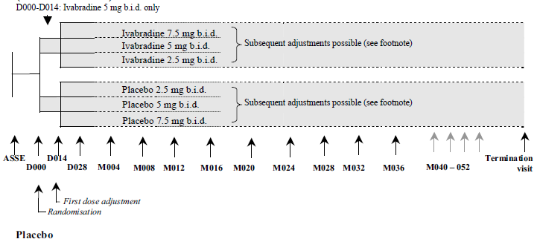
ASSE: selection visit. D000: inclusion visit

Inclusion and exclusion criteria
The main inclusion criteria were male or female adult patients (≥ 18 years of age) with symptomatic CHF, (with NYHA Class II, III or IV) for at least 4 weeks prior to the selection visit, in stable clinical condition, with optimal and unchanged CHF medications and dosages for ≥ 4 weeks prior to the selection visit, and with documented hospital admission for worsening heart failure within 12 months before the selection visit. Patients also needed electrocardiographic (ECG) documentation of sinus rhythm with resting heart rate (HR) ≥ 70 beats per minute (bpm) at study selection visit. In addition, at Visit D000 (inclusion visit at the end of the 2-week run-in period), patients had to have a documented sinus rhythm and HR ≥ 70 bpm on a recent (within 24 hours) resting standard 12-lead ECG and had documented left ventricular ejection fraction (LVEF) ≤ 35% within 3 months before Visit D000.
Main exclusion criteria were patients with recent (less than 2 months prior to selection visit) myocardial infarction or coronary revascularisation, had scheduled coronary revascularisation (percutaneous coronary intervention or coronary artery bypass graft), or had other significant cardiac or vascular conditions. Patients with moderate or severe liver disease (Child-Pugh score > 7), severe renal disease (serum creatinine > 220 μmol/L) or anaemia (blood haemoglobin < 110 g/L) were also excluded. Women who were pregnant or breast feeding and women of childbearing potential who were not on estro-progestative, progestative or intra-uterine contraception were also excluded.
Comment: The inclusion and exclusion criteria aimed to recruit a study population of adult patients with chronic heart failure with NYHA Class II to IV, on stable and optimal CHF medications and reduced LVEF. The selection of patients with stable background treatment medications is consistent with the TGA adopted EU guidelines on the clinical investigation of drugs for treatment of cardiac failure. In addition, patients needed to be in documented sinus rhythm with a resting heart rate of ≥ 70 bpm. It is unclear what rationale the criterion of a resting heart rate of ≥ 70 bpm was based on. A literature search conducted by the evaluator shows that while clinical studies generally supported the relationship between a higher heart rate and higher mortality or morbidity in CHF patients, there is no definitive conclusion on what level of heart rate constitutes increased risk. One of the currently approved indications for ivabradine is the use in patients with chronic stable angina in “combination with atenolol 50mg once daily when heart rate is >60 bpm and angina is inadequately controlled”.

Study treatments
The study drug was oral ivabradine or placebo to be taken twice daily (b.d). During the run-in period, no study treatment was dispensed. During the randomised double blind treatment period, the starting dose of study treatment (ivabradine or placebo) for all patients was 5 mg b.d at 12 hour intervals during meals. At 2 weeks (D014 visit), the dose was either maintained, up-titrated to the target dose of 7.5 mg b.d or down-titrated to 2.5 mg b.d depending on resting HR on ECG and on tolerability. An upward adjustment to 7.5 mg b.d was recommended if the resting HR was > 60 bpm or downward to 2.5 mg b.d if it was < 50 bpm or the patient was experiencing signs or symptoms relating to bradycardia. Patients with HR between 50 and 60 bpm inclusive were maintained on the 5 mg dose.
At the D028 visit and at subsequent follow-up visits or at any time between 2 scheduled visits, the study investigators could maintain the study drug dose (for patients taking 2.5 mg or 5 mg or 7.5 mg ivabradine or matching placebo) if the ECG resting HR was ≥ 50 bpm; adjust the dose to the next upper dose (for patients taking 2.5 mg or 5 mg ivabradine or matching placebo) if the ECG resting HR was > 60 bpm; adjust the dose to the next lower dose (for patients taking 5 mg or 7.5 mg ivabradine or matching placebo) if ECG resting HR was < 50 bpm or the patient was experiencing signs or symptoms relating to bradycardia; or stop the study drug (for patients taking 2.5 mg ivabradine or matching placebo) if ECG resting HR was < 50 bpm or the patient was experiencing signs or symptoms related to bradycardia. The active double-blind treatment period lasted from 12 months to 36 months and was extended later by protocol amendments up to a maximal duration of 52 months.
The study treatments were added to an existing and stable background therapy for CHF that was considered by the study investigator in-charge of the patient as being optimal. In most cases this background therapy consisted of a beta-blocker, a diuretic and an angiotensin converting enzyme inhibitor or angiotensin receptor blocker.
Concomitant drugs that were prohibited at inclusion and during the study included non-dihydropyridine calcium channel blockers (diltiazem and verapamil), Vaughan-Williams Class I anti-arrhythmics and strong cytochrome P450 3A4 (CYP3A4) inhibitors. During the study conduct, if the administration of a strong CYP3A4 inhibitor was required and no alternative treatment was possible, administration of the study drug was to be stopped. At the end of the treatment with the CYP3A4 inhibitor the study drug could be restarted after a washout interval corresponding to 5 half-lives of the CYP3A4 inhibitor and verification that the resting HR on ECG was ≥ 60 bpm. In addition, concomitant treatments known to be associated with a significant increase in the QT interval were not recommended as QT prolongation may be exacerbated by heart rate reduction. If such a medication was taken, then close cardiac monitoring was required and it was possible that the ivabradine dose (or matching placebo) would have to be decreased or stopped according to the QT interval measurement on the ECG.
Comment: The rationale for the dose of study drug in the study, based on the recommended starting dose and dose titration guidelines for use of ivabradine in patients with chronic stable angina is reasonable. The target dose of 7.5 mg b.d was based on the results of a clinical study, which the sponsor stated showed that this dose would decrease resting HR by approximately 10 bpm.
Previous clinical pharmacology and drug-drug interaction studies have shown that CYP3A4 inhibitors would increase ivabradine plasma concentrations. Given that increased plasma concentrations of ivabradine may be associated with a risk of excessive bradycardia, the prohibition of strong CYP3A4 inhibitors in the study is appropriate. The prohibition of non-dihydropyridine calcium channel blockers (diltiazem and verapamil), Vaughan-Williams Class I anti-arrhythmics and QT-prolonging medicines is consistent with the drug interactions precautions stated in the currently approved PI.

Efficacy variables and outcomes
The primary efficacy outcome was the composite endpoint of the time to first event of cardiovascular death or hospitalisation for worsening heart failure.
To determine this primary endpoint, “pre-specified events” (PSEs) were collected by investigators in the Clinical Study Record Form (CRF). PSEs were defined as “death of any cause” and “hospitalisation of any cause”. Details of the death or hospitalisation were to be indicated in the CRF. An independent Endpoint Validation Committee (EVC), blinded to treatment group and baseline heart rate, then adjudicated the clinical PSEs occurring in the study population according to the definitions of the study endpoints described in the EVC Charter. The EVC could confirm or reject an investigator-notified PSE. The EVC could also adjudicate an endpoint differently from the PSE proposed and they could create new endpoints. The results of these adjudications were used for the efficacy analyses. (Please refer to Figure 2 below).
Figure 2. Description of the adjudicated endpoints
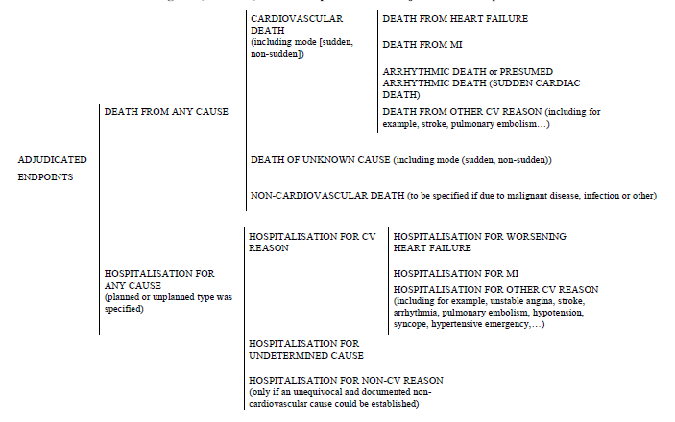
Secondary efficacy outcomes included
- non-composite endpoints on mortality: death from any cause, cardiovascular death, and death from heart failure
- non-composite endpoints on hospitalisations: hospitalisation for any cause, cardiovascular hospitalisation, and hospitalisation for worsening heart failure
- composite endpoint of the time to first event of cardiovascular death, hospitalisation for worsening heart failure, or hospitalisation for non-fatal myocardial infarction
- changes from baseline in functional capacity (NYHA class), global assessment of heart condition (Patient and Physician Global Assessment scores), and heart rates.
Comment: The TGA adopted EU guidelines on the clinical investigation of drugs for treatment of cardiac failure⁷ recommend that the primary endpoints of heart failure treatment studies be improvement in symptoms, cardiovascular morbidity and all-cause mortality. This is based on the principle that main objectives are to demonstrate improvement in cardiovascular morbidity and clinical symptoms and no adverse effect on overall mortality. The study primary endpoint differs from the recommended primary endpoint. Although the components of these recommended endpoints were present in the secondary endpoints, the study was powered for the primary endpoint. Whether the analysis of these components in the secondary endpoints allowed adequate and robust demonstration of improvement in cardiovascular morbidity and clinical symptoms, and of no adverse effect on overall mortality, will be discussed further below.
In this study, the primary endpoint allowed composite evaluation of disease-specific morbidity and mortality, while the secondary endpoints allowed analyses of all-cause as well as disease-specific morbidity and mortality and of clinical symptoms. The analysis in change of heart rate from baseline provided a marker for drug activity (a reduction in heart rate in the ivabradine group was expected, based on known pharmacodynamic effects of the drug).

Randomisation and blinding methods
The study treatments were allocated via an interactive response system either via telephone or internet, with two stratification factors: study centre and whether treated or not with beta blockers at baseline. The sponsor has stated that the stratification of randomisation on study centre was done for logistical reasons and not because of the existence of or a clinical rationale for association between centres and the primary endpoint. Treatment group allocation was blinded for patients and study investigators. Ivabradine and placebo tablets were identical in taste and appearance (a bitter tasting component was added to the placebo tablets to give a sensation similar to the active treatment). The dose level of study treatment (ivabradine and placebo) was not blinded.
Comment: Although the study treatments were blinded, there was no mention in the sponsor’s Clinical Study Report of how blinding was maintained with regards to the fact that ivabradine would lead to a reduction in heart rate while placebo would not. Study investigators and patients would be able to differentiate between ivabradine and placebo based on the presence or absence of reduction in heart rate. It is noted by the evaluator that the EVC which adjudicated the primary and secondary endpoints relating to hospitalisations and deaths was blinded to both the treatment group and baseline heart rate. This would maintain the blind for these endpoints. However, the endpoints relating to clinical symptoms (change in NYHA class and global assessment of heart condition) and the safety endpoints of adverse events reporting could have been affected.

Analysis populations
Main analyses on the efficacy endpoints were performed in the Intent-To-Treat (ITT) population. There were 2 efficacy datasets; the Randomised Set (RS) and the Randomised Set_{BBdose} (RS_{BBdose}). The RS was based on the ITT principle and was defined as all included patients with an allocated randomisation number. The RS_{BBdose} was a subset of the RS and was defined as all patients of the RS receiving at least half of recommended target daily dose of one of the specified beta blockers at randomisation. All efficacy analyses were carried out on both the RS and RS_{BBdose}.
Comment: Analysis in the ITT population is appropriate. Analysis in the RS_{BBdose} population allowed further characterisation of efficacy of ivabradine in a sub population of CHF patients who were on at least half of the optimal dose of recommended beta blockers and is relevant in the selection of patient population for which the extended indication may be applicable.

Sample size
The number of pre-specified events (PSEs) required and the sample size were estimated based on the time to occurrence of the first event of cardiovascular death or hospitalisation for worsening heart failure, in order to detect a true difference between placebo and ivabradine groups using a two-sided log-rank test at a significance level of 5%. The sample size and follow-up durations were modified by protocol amendments twice during the study to accommodate new data relating to the estimated expected rate of clinical outcomes in this patient population.
The original protocol estimated that a sample size of 5500 patients with 1220 PSEs was required for the detection of a 17% relative risk reduction of the primary composite endpoint, assuming 90% power and a significance level of 5%. This estimation assumed an annual incidence rate of the primary composite endpoint in the placebo group of 14%, and an incidence of non-cardiovascular death of 1% in both groups. The mean follow-up duration was expected to be 2 years.
A protocol amendment increased the calculated sample size to 7000 patients and proposed to continue the study until at least 1600 PSEs had occurred. This increased powering of the study was based on an anticipated smaller relative risk reduction of the primary composite endpoint of 15%, following the BEAUTIFUL study results which suggested a possible lower effect of ivabradine on heart failure endpoints than previously expected.
A later amendment was made in view of the number of primary composite endpoints already observed up until that time. As this was an event-driven trial, the amendment proposed that recruitment could be stopped when approximately 6500 patients had been randomised. This would allow the detection of a 15% relative risk reduction of the primary composite endpoint (90% power and 1600 PSEs), with an expected mean follow-up of 2.25 years.
For the subset analysis in the RS_{BBdose} population, it was anticipated that approximately 47% of the overall population would be treated with at least half of the target daily dose of beta blocker at randomisation and that there should be a minimum of 3000 patients in that group. This was expected to result in at least 633 events, allowing the detection of a relative risk reduction of 20% in favour of ivabradine, with an 80% power, when assuming an annual incidence rate of the primary composite endpoint of 14% in placebo group and an incidence of non-cardiovascular death of 1% at 2.25 years.
Comment: As the sample size adjustment was based on the results of an external trial and treatment blinding was preserved, it was congruent with the TGA adopted ICH E9 guidelines which allowed for sample size adjustments when there are changes to the assumptions which underlay the original design and sample size calculations. As the increase in sample size was based on the results of an external trial, it is not anticipated to affect the Type I error rate.

Statistical methods
For the primary composite endpoint, the superiority of ivabradine over placebo was tested using a Cox proportional hazards model, adjusted for beta blocker intake at randomisation. The treatment effect (hazards ratio) was estimated using 95% confidence interval (CI) based on the same model. A descriptive analysis of the event and Kaplan-Meier survival curves were also to be provided.
In addition to the main primary efficacy analysis, the treatment effect on the primary composite endpoint was also estimated using an unadjusted model (sensitivity analysis), and a model adjusted for baseline prognostic factors. For the sensitivity analysis, the superiority of ivabradine over placebo was tested using an unadjusted Cox proportional hazards model. In an analysis to study the impact of prognostic factors, a superiority test and estimate of treatment effect were calculated based on a Cox proportional hazards model adjusted for the following prognostic factors evaluated at baseline: beta blocker intake at randomisation, NYHA class (Class III or IV versus Class II5), LVEF, primary cause of CHF (ischaemic or not), age, systolic blood pressure, HR and creatinine clearance.
The treatment effect on the primary composite endpoint was also analysed in pre-defined subgroups of the RS population based on eight criteria of demographics (age, gender), beta blocker intake at randomisation, disease severity (baseline NYHA class, baseline HR), aetiology of chronic heart failure and coexisting medical conditions (diabetes, hypertension), as well as in the non pre-defined subgroup ≥ 75 years. For this subgroup analysis, treatment effect was estimated in each level of subgroup based on an adjusted Cox proportional hazards model with beta blocker intake at randomisation as a covariate for each subgroup level, allowing evaluation of the relative risk reduction between ivabradine and placebo groups within each subgroup. Interaction test between treatment groups and the subgroup was performed by a likelihood ratio test comparing the model including the interaction term with the model not including the interaction term, to allow evaluation of whether the difference in treatment effects observed in one subgroup compared to its complementary subgroup (for example, male versus female, ischaemic cause versus non-ischaemic cause) was statistically significant.
In the secondary efficacy analyses, for each component within the primary composite endpoint (that is, the secondary endpoints of cardiovascular death and hospitalisation for worsening heart failure), main, sensitivity and subgroups analyses planned for the primary composite endpoint were performed. For other secondary efficacy endpoints, main and sensitivity analyses were performed as for the primary composite endpoint.
For the primary and secondary efficacy outcomes, time to first event was defined as the duration between the date of randomisation and the date of the first occurrence of this event. All endpoints that occurred until the patients’ termination visit or 31 March 2010 (if the termination visit of the patient took place after this date) were considered in the efficacy analyses. If the studied event did not occur during the study, a censorship process was applied. Patient’s follow-up was censored by the earliest of its termination visit, date of death (when death or nature of death was not considered as the studied event), lost to follow-up date, date of withdrawal from the study, heart transplantation date or 31 March 2010.

Participant flow
A total of 7411 patients were screened. Out of these, 7106 who meet the selection criteria at Visit ASSE were selected and 6558 who also met the inclusion criteria at visit D000 were randomised. Of these 6558 patients, 7 (2 in the ivabradine and 5 in the placebo group) who did not meet the inclusion criteria but were given randomisation numbers were not given any study drug and were not included in the Randomised Set. A further 46 patients, all of the patients recruited in the two Polish centres were excluded from all analysis sets for concerns over invalid data due to misconduct. The total number of patients retained in the Randomised Set (RS) was therefore 6505. Of these, 3241 patients were randomised to ivabradine and 3264 to placebo. (Please refer to Figure 3 below).
Figure 3. Participant flow
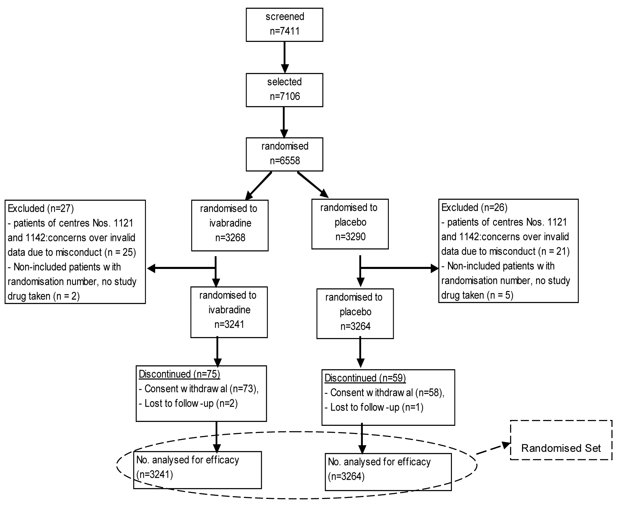
The RS_{BBdose} dataset comprised of 3181 patients (48.9% of the RS), 1581 patients (48.8% of the RS) in the ivabradine group and 1600 patients (49.0% of the RS) in the placebo group. Analysis sets and subsets are presented in Table 1.
Table 1. Analysis Sets and Subsets
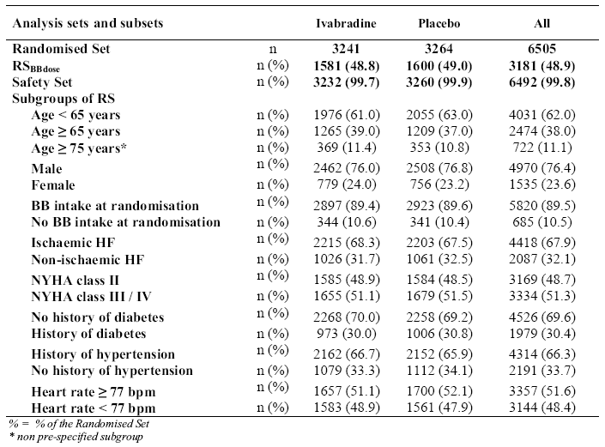
Comment: The Randomised Set (RS) is in keeping with the ITT analysis population. The exclusion from the RS of the 7 subjects who were allocated randomised numbers but were actually not included in the study due to not satisfying the inclusion criteria was appropriate. However, the exclusion from the RS of patients of the two centres which were found to have major GCP deficiencies [such as fake source documents, and falsified copies of source documents in order to allow inclusion of ineligible patients]occurred post randomisation and could potentially introduce bias to the analysis. There were no details supplied by the sponsor in the CSR or in the responses to EMA as to whether the exclusion occurred after unblinding. That the number of patients involved was small (0.70%, 46/6558) and that it was approximately evenly distributed between the 2 treatment groups, might mitigate any potential bias to a certain extent. In addition, in response to the query by EMA on this issue, the sponsor provided an analysis of the primary composite endpoint that included these 46 patients and it showed that the results were similar to the results of the analysis that excluded these 46 patients. ,

Major protocol violations/deviations
Protocol deviations were defined before study unblinding and were grouped into three categories: deviations that may affect primary efficacy criterion assessment, deviations that may affect safety assessment and other deviations that may affect study management.
Overall, 312 patients had at least one protocol deviation at inclusion: 150 patients (4.6%) in the ivabradine group compared with 162 patients (5.0%) in the placebo group. Overall, 367 protocol deviations were observed before or at inclusion, with 214 deviations relating to observations which could have impacted the efficacy assessment, 134 deviations which could have impacted the safety assessment and 19 deviations which could have impacted the study management. The incidences of the protocol deviations were comparable between the treatment groups. Among protocol deviations before or at inclusion which could have impacted the efficacy assessment, the highest incidence in both treatment groups was the deviation involving “no documented hospitalisation for worsening heart failure within 12 months prior to selection” (1.3% [43/ 3241] and 1.1% [37/ 3264] in the ivabradine and placebo treatment groups, respectively).
The disposition of protocol deviations occurring during the study, by category and by treatment group showed that overall, 132 patients presented at least one protocol deviation during the study: 69 patients (2.1%) in the ivabradine group and 63 patients (1.9%) in the placebo group. Overall, 149 protocol deviations were detected during the study, with 147 deviations which could have impacted the safety assessment and 2 deviations which could have impacted the study management. There were no deviations observed that could have affected the efficacy assessment.

Baseline data
The baseline demographic characteristics were comparable between the 2 treatment groups. The overall mean age (± SD) was 60.4 (± 11.4) years with a range from 19 to 92 years. Overall, 38.0% (2474/ 6505) were ≥ 65 years of age and 11.1% (722/ 6505) were ≥75 years of age. The majority of patients were male (76.4%) and Caucasian (88.7%). The overall mean (± SD) heart rate was 79.9 (± 9.6) bpm, with a range of 48 to 142 bpm. The baseline heart rate was < 80 bpm in 59.9% of patients, between 80 to 89 bpm in 24.4% of patients and ≥ 90 bpm in 15.6% of patients.
The main baseline CHF disease characteristics were comparable between the 2 treatment groups. The overall mean (± SD) duration of the CHF from diagnosis was 3.5 (± 4.2) years, with a median of 2.0 years. Overall, 50.2% of the study population had a duration of CHF of < 2 years, 25.7% for ≥2 to <5 years, 21.5% for ≥5 to <15 years and 2.6% for ≥15 years. The primary cause of CHF was ischaemic in 67.9% of the study population. The main non-ischaemic cause of CHF was idiopathic dilated cardiomyopathy in 20.7% of the study population. Approximately half of the study population (48.7%) was in NYHA Class II and approximately half (49.5%) was in Class III. Only 1.7% of the study population was in NYHA Class IV. The overall mean (± SD) LVEF was 29.0 (± 5.2) %. Approximately half (47.0%) of the study population had LVEF of >30 to ≤ 35%, 28.2% with LVEF of >25 to ≤0%, 15.3% with LVEF of >20 to ≤ 25%, and 9.5% with LVEF of ≤ 20%. Only 0.1% had an LVEF of > 35% (protocol violation).
Main background treatments for heart failure were comparable between the 2 treatment groups. Overall, the majority of patients (89.5%, 5820/6505) were taking a beta blocker at randomisation. The most frequent reason for the non prescription of a beta blocker at randomisation was chronic obstructive pulmonary disease (COPD) (34.5% among patients not on beta blocker at randomisation), followed by hypotension (18.5%) and asthma (10.9%). Among patients taking a beta blocker at randomisation, 98.2% were taking one of the ESC recommended drugs or metoprolol tartrate. Overall, 55.7% of these patients taking a recommended drug or metoprolol tartrate were taking at least half the target daily dose, and 26.1% were taking the recommended target daily dose. The main reasons for not being at the target daily dose were hypotension (44.6%) or fatigue (31.9%).
Overall treatment compliance, mean treatment dose and dose titration profiles showed that overall 97.8% of patients had a global compliance of between 70% and 130% and this was comparable between the 2 treatment groups (97.5% and 98.1% of patients in the ivabradine and placebo groups, respectively). The overall mean (± SD) global compliance was 96.3% ± 10.2% (96.2% ± 11.3% and 96.4% ± 9.0% in the ivabradine and placebo groups, respectively). In the ivabradine group, 60.3% of patients were up-titrated from the starting dose of 5mg b.d to 7.5 mg b.d and then maintained on this dose during the study, 7.2% of patients were down-titrated to 2.5 mg b.d and then maintained on this dose during the study and 8.7% remained on the 5 mg b.d dose during the study. In the ivabradine treatment group, the mean dose (± SD) prescribed according to treatment duration and follow-up duration were 6.4 (± 1.4) mg b.d and 5.8 (± 2.1) mg b.d., respectively.
Comment: The baseline characteristics of the study population were comparable between the 2 treatment groups and were generally comparable to those of the CHF patient population in Australia in terms of the aetiology of CHF and background treatment regimen. Ischaemic heart disease is present in over 50% of new CHF cases in Australiaand the study population represented this (main primary cause of CHF was ischaemic heart disease in 67.9%). However, the overall mean age (± SD) of the study population was relatively young, at 60.4 (± 11.4) years. The CSR did not present the breakdown proportion of the study population by age group but from the subgroup analysis, it was reported that only 38.0% (2474/ 6505) were ≥65 years of age and 11.1% (722/ 6505) were ≥ 75 years of age. In the sponsor’s response to queries from the EMA it was stated that 23.1% (1500/ 6505) were ≥ 70 years of age. The evaluator was unable to find reports of the relative proportion of CHF patients in Australia by age group, as epidemiological studies of CHF usually report the prevalence or incidence of CHF in terms of the proportion of the general population in a certain age group having CHF. However, there is general consensus that the incidence of CHF in Australia, as in other developed countries, increases with age (1 study reporting an incidence of 2.5% in people aged 55–64 years and 8.2% in those aged over 75 years), and that with people having a longer lifespan and better medical treatment which reduces mortality from ischaemic heart attacks, the incidence of CHF in the elderly population is likely to increase. As a majority (62%) of the study population was <65 years of age, this raises the question of whether the study efficacy results could be extrapolated to the CHF patient population in clinical practice. In addition, a majority of the study population (76.4%) were males, while among the CHF patient population in Australia females account for two-thirds of Australians with heart failure.
Overall study compliance was good and comparable between the study treatment groups. Approximately 60% of patients on ivabradine were up-titrated from the starting dose of 5mg b.d to 7.5 mg b.d (the target dose) and then maintained on this dose during the study, and the overall mean dose in the ivabradine group was between 5.8 to 6.4 mg b.d.

Results for the primary efficacy outcome
In the RS population, the incidence of the primary endpoint (the composite of cardiovascular death or hospitalisation for worsening heart failure) was 24.5% (793/3241) in the ivabradine group compared with 28.7% (937/ 3264) in the placebo group. This corresponded to an 18% relative risk reduction and this reduction was found to be statistically significant (hazard ratio 0.82, 95% CI 0.75–0.90, p <0.0001) (see Table 2).
Table 2. Estimate of treatment effect on primary composite endpoint in the RS -Sensitivity and prognostic factors analyses
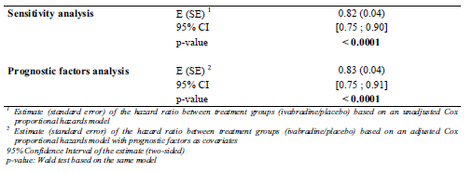
Kaplan-Meier survival curves showed a divergence between the treatment groups in favour of ivabradine by approximately 3 months after randomisation (Figure 4).
Figure 4. Kaplan-Meier survival graphs for the primary composite endpoint, RS population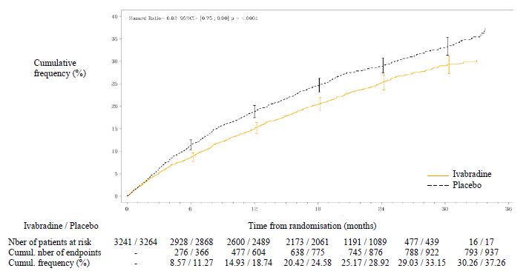

Results for other efficacy outcomes
Sensitivity and prognostic factors analyses on primary composite endpoint in the RS population were analysed. The sensitivity analysis tested the superiority of ivabradine over placebo using an unadjusted Cox proportional hazards model (in contrast with the main primary efficacy analysis, where the primary endpoint was analysed using Cox proportional hazards model that was adjusted for beta blocker intake at randomisation). The results yielded the same estimates of the hazard ratio (95% CI) of 0.82 (0.75, 0.90) as the main analysis, with a same p-value of < 0.0001.
The prognostic factors analysis consisted of a superiority test based on a Cox proportional hazards model adjusted for the prognostic factors of beta blocker intake at randomisation, NYHA class, LVEF, aetiology of CHF, age, systolic blood pressure, heart rate and estimated glomerular filtration rate. The treatment effect observed in the prognostic factors analysis was similar to that observed in the main analysis, with an estimate of hazard ratio (95% CI) of 0.83 (0.75, 0.91), the difference being statistically significantly in favour of ivabradine (p < 0.0001).
Subgroup analysis of the primary composite endpoint in the RS population showed an effect in favour of ivabradine in all the pre specified subgroups, with hazard ratios ranging from 0.68 to 0.93. No analysis for statistical significance of these treatment effects was presented. All the interaction tests had p-values higher than 0.05 except for the subgroups on baseline heart rate (< 77 bpm versus ≥77 bpm), with p=0.0288, indicating a statistically significant greater effect of ivabradine in patients with baseline HR ≥ 77 bpm (n=3357, hazard ratio = 0.75) compared to those with baseline HR <77 bpm (n=3144, hazard ratio =0.93) (Table 3). Analysis of the primary composite endpoint in the subgroup “age ≥ 75 years” (n = 722) also showed an effect in favour of ivabradine with a hazard ratio (95% CI) of 0.89 (0.70, 1.14). No analysis for statistical significance was presented.
Results of analysis of the primary composite endpoint in the RS_{BBdose} population and its components are tabulated in Table 4. Analysis in the RSBBdose population (n=3181, 48.9% of RS) of the primary composite endpoint showed that 20.9% of patients (330/1581) in the ivabradine group and 22.6% (362/1600) in the placebo group reached the primary composite endpoint. The estimate of the corresponding hazard ratio was 0.90 (95% CI [0.77, 1.04]) but the result was not statistically significant (p = 0.155).
Table 3. Primary composite endpoint in pre-defined subgroups, Randomised Set
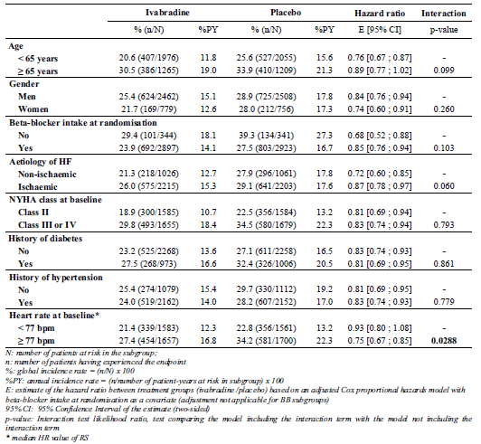
Table 4. Incidence of the primary composite endpoint and components (secondary endpoints) in the RS-BB-dose
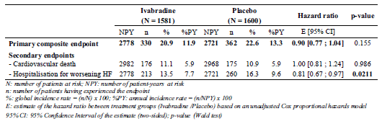
Subgroup analysis of the primary composite endpoint in the RS_{BBdose} population showed an effect in favour of ivabradine in all the pre specified subgroups except for the subgroup “age ≥ 65 years” where the hazard ratio was 1.04. In addition, the subgroup of “males” showed a negligible effect in favour of ivabradine (hazard ratio of 0.99). All the interaction tests had p-values higher than 0.05 except for the subgroup of gender, showing that the effect of ivabradine was greater in females than in males in this analysis set (p = 0.0177).
The results of the main secondary efficacy outcomes in the RS population are tabulated in Table 5. Secondary non-composite endpoints relating to mortality showed that there was a 26% reduction in relative risk in deaths from heart failure and this was found to be statistically significant (p = 0.014). There was a relative risk reduction of 10% in all-cause mortality and 9% in cardiovascular mortality but the reductions were not statistically significant (p= 0.092 and p= 0.128, respectively). Secondary non-composite endpoints relating to hospitalisations showed statistically significant reduction in relative risks in the ivabradine treatment group compared to the placebo group, for hospitalisations for worsening heart failure, for all-cause hospitalisations and for cardiovascular hospitalisation (relative risk reduction of 26% [p <0.0001], 11% [p=0.003] and 15% [p=0.0002], respectively). Kaplan-Meier survival curves for the secondary endpoints relating to heart failure (hospitalisation for worsening heart failure and death from heart failure) showed a divergence between the treatment groups in favour of ivabradine by approximately 3 months after randomisation and continued to diverge throughout the study (Figures 5 and 6).
Table 5. Primary and main secondary endpoints, RS population
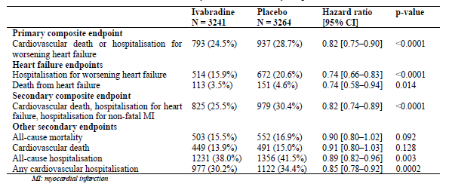
Figure 5. Kaplan Meier survival graphs for hospitalisation for worsening heart failure, RS
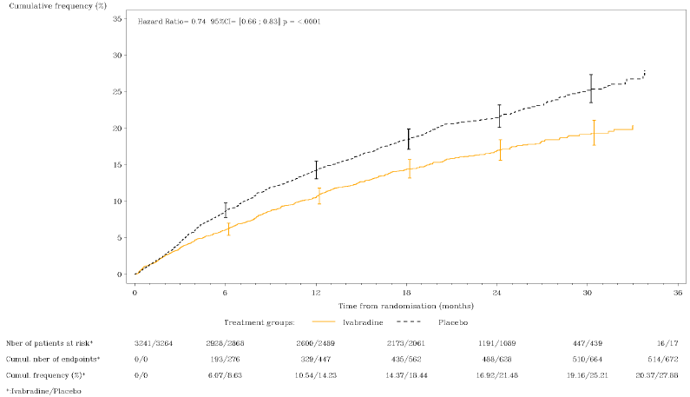
Figure 6. Kaplan-Meier survival curves for death due to heart failure, RS
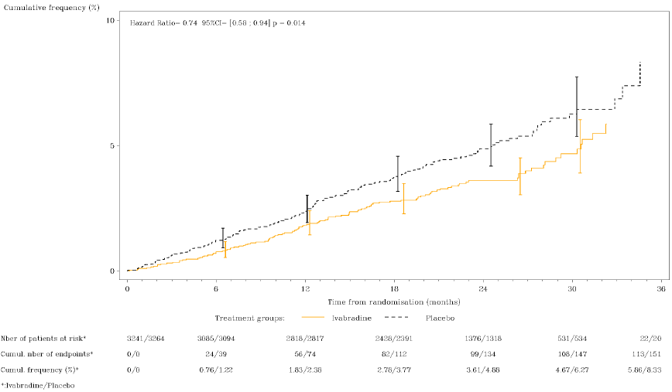
The incidence of the secondary composite endpoint (cardiovascular death, hospitalisation for worsening heart failure or hospitalisation for non-fatal myocardial infarction) was 25.5% in the ivabradine group compared with 30.0% in the placebo group. This corresponded to an 18% relative risk reduction and was found to be statistically significant (hazard ratio 0.82, 95% CI [0.74, 0.89], p<0.0001).
Subgroup analysis of the secondary endpoints relating to mortality (death from any cause, cardiovascular death and death from heart failure) in the RS population showed an effect in favour of ivabradine in all the pre specified subgroups except in the subgroup of “baseline HR <77 bpm”, for all 3 endpoints. Interaction tests results were presented only for the endpoints of death from any cause and cardiovascular death and showed p-values >0.05 in all pre-specified subgroups except for the subgroup on baseline HR (< 77 bpm versus ≥77 bpm), with p=0.0274 and p=0.0379 for each endpoint, respectively, showing a greater effect of ivabradine on the subgroup with baseline HR of ≥77 bpm than that with baseline HR of < 77 bpm. Analysis in the subgroup “age ≥ 75 years” (n = 722) was only presented for the endpoint of cardiovascular death and also showed an effect in favour of ivabradine, with an estimated hazard ratio of 0.71 (95% CI [0.51, 1.00]). No analysis for statistical significance was presented.
For endpoints relating to hospitalisation (hospitalisation for any cause, hospitalisation for cardiovascular reason and hospitalisation for worsening heart failure), only subgroup analysis on hospitalisation for worsening heart failure was presented in the CSR and showed an effect in favour of ivabradine in all the pre specified subgroups. Subgroup interaction tests on the endpoint of hospitalisations for worsening heart failure yielded p-values >0.05 in all pre specified subgroups except for the subgroup on ischaemic versus non-ischaemic cause, with p=0.0345, showing that ivabradine had a statistically significantly greater effect on patients with CHF from an ischaemic cause compared to those with CHF from a non-ischaemic cause. Analyses on hospitalisation for worsening heart failure in the subgroup “age ≥75 years” also showed an effect in favour of ivabradine, with a hazard ratio of 0.92 (95% CI [0.68, 1.23]). No analysis for statistical significance was presented.
Analysis in the RS_{BBdose} population of the secondary endpoints relating to mortality showed that differences between treatment groups in the endpoints of deaths from heart failure, cardiovascular deaths and death from any cause were all found to be not statistically significant (p=0.438 to 0.986) (Tables 6 and 7). Analysis in the RS_{BBdose} population of the secondary endpoints relating to hospitalisations showed that differences between treatment groups in the endpoints of hospitalisation for worsening heart failure and cardiovascular hospitalisation were statistically significant in favour of ivabradine (hazard ratios of 0.81 [p= 0.0211] and 0.88 [p=0.0464], respectively) but that for hospitalisation for any cause was not statistically significant (p=0.081) (Tables 8 and 9).
Table 6. Causes of deaths by treatment group in the RS-BB-dose
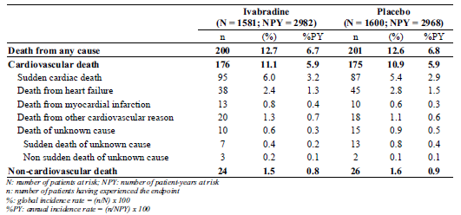
Table 7. Estimates of treatment effect on causes of death in the RS-BB-dose
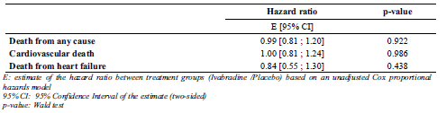
Table 8. Causes of hospitalisations* by treatment group in the RS-BB-dose
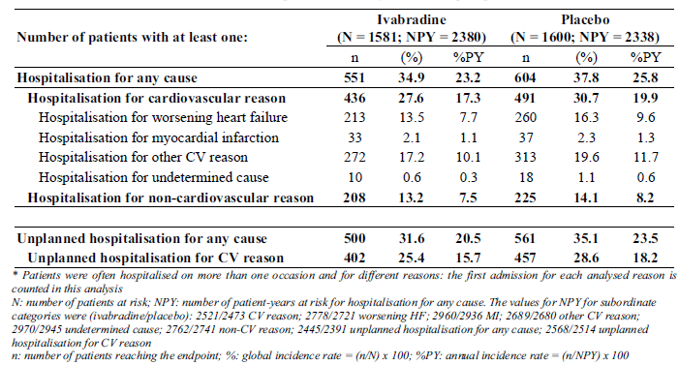
Table 9. Estimates of treatment effect on causes of hospitalisation in the RS-BB-dose
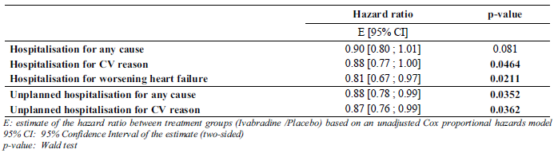
Subgroup analysis of the secondary endpoints in the RS_{BBdose} population showed that for the endpoint of all-cause mortality there was no or negligible effect in favour of ivabradine in all the pre-specified subgroups except for the subgroups of “females”, “ischaemic cause”, “NYHA Class II”, “no hypertension” and “baseline HR ≥ 77 bpm”. No analysis for statistical significance was presented. All the interaction tests had p-values higher than 0.05. For the endpoint of cardiovascular death, results were similar, showing no or negligible effect in favour of ivabradine in all the pre specified subgroups except for the subgroups of “females”, “ischaemic cause”, “NYHA Class II”, “no hypertension” and “baseline HR ≥ 77 bpm”, and in addition also in the subgroups of “age ≥65 years”, and “no DM”. No analysis for statistical significance was presented. For the endpoint of hospitalisation for worsening heart failure, subgroups analysis showed an effect in favour of ivabradine in all the pre specified subgroups except the subgroup of “age ≥ 65 years”.
Analyses of the secondary endpoints relating to effects on symptoms in the RS population showed that with regards to changes in NYHA class, 27.6% (887/ 3216) of patients in the ivabradine group improved by ≥ 1 NYHA class relative to baseline, compared with 24% (776/ 3234) of patients in the placebo group (p = 0.001). Patient-reported Global Assessment improved in 72% of patients in the ivabradine group, compared with 68% in the placebo group (p = 0.0005). The Physician-reported Global Assessment improved in 61% of patients in the ivabradine group compared with 57% in the placebo group (p = 0.0011).
With regards to effect on heart rate changes, results showed that overall in the RS population between baseline and Day 28, the mean (± SD) change in HR was -15.4 (± 10.7) bpm in the ivabradine group compared with -4.6 (± 10.6) bpm in the placebo group, giving a difference in the change in heart rate between the ivabradine and placebo groups of -10.9 (95% CI [-11.4, -10.4]) bpm after 28 days of dosing. This difference was found to be statistically significant. This difference was maintained throughout the study. At the last post randomisation visit, the difference in the change in heart rate between the ivabradine and placebo groups was - 8.1 (95% CI [-8.7, -7.5]) bpm (a mean [± SD] change in HR of -12.0 [± 13.3] bpm and -4.1 [± 12.9] bpm in the ivabradine and placebo groups respectively). Similar results were observed in the RS_{BBdose} population.
Analysis of HR changes in the subgroup “age ≥ 75 years” gave similar results. The mean (±SD) change in HR from baseline to Day 28 was -14.6 (± 10.0) bpm in the ivabradine group and -4.8 (± 10.2) bpm in the placebo group, respectively, giving a statistically significant between-group difference of -10.2 bpm (95% CI [-11.6, -8.8]). At the last post randomisation visit, the mean (± SD) change in HR from baseline was -9.6 ± 13.3 bpm in the ivabradine group and -3.5 ± 12.5 bpm in the placebo group, giving a statistically significant between-group difference of –6.7 bpm (95% CI [-8.4, -4.9]).

Other efficacy studies
Not applicable.

Analyses performed across trials (pooled analyses and meta-analyses)
Not applicable.

Evaluator’s summary and conclusions on clinical efficacy for the proposed new indication (for use in patients with symptomatic chronic heart failure)
Overall, the study design and study inclusion and exclusion criteria were appropriate and consistent with the TGA adopted EU guidelines on the clinical investigation of drugs for treatment of cardiac failure⁷, and aimed to recruit a study population of adult patients with chronic heart failure, with NYHA Class II to IV, on stable and optimal CHF medications, with reduced LVEF of ≤ 35% and who were in sinus rhythm with a resting HR of ≥ 70 bpm. No rationale was given for the choice of a baseline HR criterion of ≥ 70 bpm. The starting dose and the dose titration of the study drug, based on the recommended starting dose and dose titration guidelines for use of ivabradine in patients with chronic stable angina (currently approved indication), were appropriate. The target dose of 7.5 mg b.d was based on the result of a clinical study on ivabradine which showed that this dose would decrease resting HR by approximately 10 bpm.
The study primary endpoint (composite endpoint of time to first event of cardiovascular death or hospitalisation for worsening heart failure) differs from the primary endpoints recommended by the EMA guidelines on the clinical investigation of drugs for treatment of cardiac failure (improvement in symptoms, cardiovascular morbidity and all-cause mortality), although the recommended primary endpoints were present in the study secondary endpoints.
The main flaw in the study design was the maintenance of study treatment blinding, given that ivabradine but not placebo would lead to a reduction in heart rate. Study investigators and patients would be able to differentiate between ivabradine and placebo based on the presence or absence of reduction in heart rate. The Endpoint Validation Committee which adjudicated the primary and secondary endpoints relating to hospitalisations and deaths was blinded to both the treatment group and baseline heart rate. This would maintain the blind for these endpoints. However, the endpoints relating to clinical symptoms (change in NYHA class and global assessment of heart condition) and the safety endpoints of adverse events reporting could have been affected.
Overall, in the RS analysis population baseline demographic characteristics, baseline disease characteristics, and main background treatments for heart failure were comparable between the 2 treatment groups and generally comparable with the CHF patient profile in clinical practice in terms of the aetiology of CHF and background treatment regimen. However, the overall mean age (± SD) of the study population was relatively young at 60.4 (± 11.4) years. Only 38.0% were ≥ 65 years of age, 23.1% (1500/ 6505) were ≥ 70 years of age and 11.1% were ≥ 75 years of age. As a majority (62%) of the study population was < 65 years of age, this raises the question of whether the study efficacy results could be extrapolated to the CHF patient population in clinical practice. The majority of the patients in the study were in NYHA Classes II (48.7%) and III (49.5%), and only 1.7% (n=111) were in NYHA Class IV. Although this is consistent with the incidence of the different NYHA Classes of patients in clinical practice, it may affect the ability of the study results to be extrapolated to the sub-population of patients in NYHA Class IV.
Efficacy analysis results showed that in the RS population there was an 18% relative risk reduction in the incidence of the primary composite endpoint of cardiovascular death or hospitalisation for worsening heart failure in the ivabradine group compared to the placebo group and this reduction was found to be statistically significant at p <0.0001. The sensitivity and prognostic factors analyses supported the results of the primary efficacy outcome results. The results were consistent with the estimated anticipated relative risk reduction of 15% on which the sample size was calculated. However, when the components of the primary composite endpoint were analysed separately as secondary endpoints in the RS population, only the relative risk reduction for the endpoint of hospitalisation for worsening heart failure was statistically significant (26%, p<0.0001). The relative risk reduction for the endpoint of cardiovascular death was not statistically significant (9%, p=0.128). This suggested that the result of the primary composite endpoint in the RS population was driven more by the rate of hospitalisation for worsening heart failure than by the rate of cardiovascular death.
Analysis in the RS_{BBdose} population of the primary composite endpoint showed that although there was a relative risk reduction of 10% in favour of ivabradine, the reduction was not statistically significant (p = 0.155). When the components of the primary composite endpoint were analysed separately as secondary endpoints in the RS_{BBdose} population, results were similar to those observed in the RS population, where only the component endpoint of hospitalisation for worsening heart failure was found to be statistically significant (relative risk reduction in favour of ivabradine of 19%, p = 0.0211). There was no relative risk reduction of ivabradine over placebo in the endpoint of cardiovascular death (hazard ratio of 1.00, p= 0.986).
Subgroup analysis of the primary composite endpoint in the RS population showed an effect in favour of ivabradine in all the pre specified subgroups. This suggested that the primary efficacy main analysis result was reflected across all the pre specified subgroups. However, in the subgroups based on “on beta blockers at randomisation”, there were only 685 patients who were not on beta blockers at randomisation compared with 5820 who were on beta blockers. Interaction tests showed that there were no statistically significant difference in the treatment effect in each subgroup compared to its complementary group, except for the subgroups on baseline HR (< 77 bpm versus ≥77 bpm), showing that the higher relative risk reduction of ivabradine versus placebo in patients with baseline HR ≥77 bpm (relative risk reduction of 25%) compared to those with baseline HR < 77 bpm (relative risk reduction of 7%) was statistically significant (p=0.0288). Analysis of the primary composite endpoint in the subgroup “age ≥ 75 years” (n = 722) in the RS population also showed an effect in favour of ivabradine with a relative risk reduction of 11%. The statistical significance of this reduction was not reported in the CSR.
Subgroup analysis of the primary composite endpoint in the RS_{BBdose} population showed an effect in favour of ivabradine in all the pre-specified subgroups except for the subgroup “age ≥ 65 years” (hazard ratio 1.04), indicating that in this analysis population set ivabradine did not have a superior effect compared to placebo in patients who were ≥ 65 years of age. However, the interaction test for this subgroup showed that there was no statistically significant difference in the effect of ivabradine in patients ≥ 65 years of age compared with those < 65 years of age. In addition, the subgroup of “males” showed a negligible effect in favour of ivabradine (hazard ratio of 0.99) and interactions test showed that the greater effect of ivabradine in females than in males in this analysis set was statistically significant (p = 0.0177). In this analysis population, unlike in the RS population, interaction test results did not show any statistically significant greater effect of ivabradine in patients with baseline HR ≥77 bpm compared to those with baseline HR <77 bpm.
Analyses of the 3 secondary endpoints relating to hospitalisation (hospitalisation for any cause, hospitalisation for cardiovascular reason and hospitalisation for worsening heart failure) in the RS population showed that there were statistically significant relative risk reductions in the ivabradine group compared to the placebo group in all 3 endpoints (relative risk reductions of 11% [p=0.0027], 15% [p=0.0002], and 26% [p<0.0001], respectively). However, analyses of the 3 secondary endpoints relating to mortality (death from any cause, cardiovascular death and death from heart failure) in the RS population showed that there was a statistically significant relative risk reduction in the ivabradine group compared to the placebo group only in the disease-specific endpoint of death from heart failure (relative risk reductions of 26% [p=0.014]).
Analyses of the 3 secondary endpoints relating to hospitalisation (hospitalisation for any cause, hospitalisation for cardiovascular reason, and hospitalisation for worsening heart failure) in the RS_{BBdose} population showed that there were statistically significant relative risk reductions in the ivabradine group compared to the placebo group only in the disease-specific endpoints of hospitalisation for cardiovascular reason, and hospitalisation for worsening heart failure (relative risk reductions of 12% [p=0.0464], 19% [p=0.0211], respectively). Analyses of the 3 secondary endpoints relating to mortality (death from any cause, cardiovascular death, and death from heart failure) in the RS_{BBdose} population showed that the differences between treatment groups in all 3 endpoints were not statistically significant.
Subgroup analysis of the secondary endpoints relating to mortality (death from any cause, cardiovascular death and death from heart failure) in the RS population showed an effect in favour of ivabradine in all the pre specified subgroups except in the subgroup of “baseline HR <77bpm”, for all 3 endpoints. Interaction tests results were similar to that for the primary composite endpoint in the RS population, showing that the higher relative risk reduction of ivabradine versus placebo in patients with baseline HR ≥77 bpm compared to those with baseline HR < 77 bpm was statistically significant for the endpoints of death from any cause (p=0.0274) and cardiovascular death (p=0.0379). Subgroup analyses of the endpoint of hospitalisation for worsening heart failure showed an effect in favour of ivabradine in all the pre specified subgroups. Analysis in the subgroup “age ≥ 75 years” for the endpoints of cardiovascular death and hospitalisation for worsening heart failure showed an effect in favour of ivabradine, with a relative risk reduction of 29% and 8%, respectively, but these were not tested for statistical significance.
Subgroup analysis of the secondary endpoint of death from any cause in the RS_{BBdose} population showed that in this population dataset, in contrast to the RS population dataset, the majority of the subgroups showed no or negligible effect in favour of ivabradine, except the subgroups of “females”, “ischaemic cause”, “NYHA Class II”, “no hypertension” and “baseline HR ≥ 77 bpm” Similar results were observed for the endpoint of cardiovascular death. For the endpoint of hospitalisation for worsening heart failure, subgroup analysis showed an effect in favour of ivabradine in all the pre specified subgroups except the subgroup of “age ≥ 65 years”.
Analyses of the secondary endpoints relating to effects on symptoms in the RS population showed that a higher proportion of patients in the ivabradine group improved by ≥ 1 NYHA class relative to baseline compared with those in the placebo group (27.6% versus 24%, respectively [p = 0.001]). A higher proportion of patients in the ivabradine group compared with those in the placebo group had an improved patient-reported global assessment (72% versus 68%, respectively [p = 0.0005]), as well as an improved Physician Reported Global Assessment (61% versus 57%, respectively [p = 0.0011]).
With regards to effect on heart rate changes, results showed that overall in the RS population, between baseline and Day 28, the mean change in HR was -15.4 bpm in the ivabradine group (compared with -4.6 bpm in the placebo group). This reduction was maintained and at the last post randomisation visit, the mean change in HR was -12.0 bpm in the ivabradine group (compared with -4.1 bpm in the placebo group). Similar results were observed in the RS_{BBdose} population and in the subgroup of “age ≥ 75 years”. The results were consistent with the rationale for the target study dose of 7.5mg bd, which was based on the result of a clinical study on ivabradine showing that this dose would decrease resting HR by approximately 10 bpm. In the SHIFT study, approximately 60% of patients on ivabradine were up-titrated from the starting dose of 5mg b.d to 7.5 mg b.d (the target dose regimen) and then maintained on this dose during the study, and the overall mean dose in the ivabradine group was between 5.8 to 6.4 mg bd.
The main efficacy results are summarised in the tables (Table 10 (i)-(iii)) below.
Table 10. (i) Main efficacy results
 | Relative Risk Reduction (in favour of Ivabradine) | P value
Primary composite endpoint (composite endpoint of cardiovascular death or hospitalisation for worsening heart failure)
In RS population | 18% | <0.0001
In RS_{BBdose} population | 10% | 0.155
Secondary endpoints in RS population
All-cause mortality | 10% | 0.092
Cardiovascular death | 9% | 0.128
Death from heart failure | 26% | 0.014
All-cause hospitalisation | 11% | 0.003
Cardiovascular hospitalisation | 15% | 0.0002
Hospitalisation for worsening heart failure | 26% | <0.0001
Secondary endpoints in RS_{BBdose} population
All-cause mortality | 1% | 0.922
Cardiovascular death | 0% | 0.986
Death from heart failure | 16% | 0.438
All-cause hospitalisation | 10% | 0.081
Cardiovascular hospitalisation | 12% | 0.0464
Hospitalisation for worsening heart failure | 19% | 0.0211
Table 10. (ii) Pre-specified subgroup analysis
 | Effect in favour of ivabradine | Interaction tests- All the interaction tests had p-values higher than 0.05,
Primary composite endpoint (composite endpoint of cardiovascular death or hospitalisation for worsening heart failure)
In RS population | in all the pre-specified subgroups | except for the subgroup on baseline heart rate (p=0.0288), in favour of patients with baseline HR ≥77 bpm versus those with <77 bpm
In RS_{BBdose} population | in all the pre-specified subgroups except for the subgroup “age ≥ 65 years”.  Subgroup of “males” showed a negligible effect in favour of ivabradine (hazard ratio of 0.99). | except for the subgroup of gender (p = 0.0177), in favour of females versus males
Secondary endpoints in RS population
All-cause mortality | in all the pre-specified subgroups except in the subgroup of “baseline HR <77bpm” | except for the subgroup on baseline heart rate (p=0.0274) in favour of patients with baseline HR ≥77 bpm versus those with <77 bpm
Cardiovascular death | in all the pre-specified subgroups except in the subgroup of “baseline HR <77bpm” | except for the subgroup on baseline heart rate (p=0.0379) in favour of patients with baseline HR ≥77 bpm versus those with <77 bpm
Death from heart failure | in all the pre-specified subgroups except in the subgroup of “baseline HR <77bpm” | NA
All-cause hospitalisation | NA | NA
Cardiovascular hospitalisation | NA | NA
Hospitalisation for worsening heart failure | in all the pre-specified subgroups. | except for the subgroup on ischaemic versus non-ischaemic cause (p=0.0345) in favour of patients with CHF from an ischaemic cause versus those with CHF from a non-ischaemic cause
Secondary endpoints in RS_{BBdose} population
All-cause mortality | Only the subgroups of “females”, “ischaemic cause”, “NYHA Class II”, “no hypertension” and “baseline HR ≥ 77 bpm” | All the interaction tests had p-values higher than 0.05
Cardiovascular death | Only the subgroups of “females”, “ischaemic cause”, “NYHA Class II”, “no hypertension”, “baseline HR ≥ 77 bpm”, “age ≥ 65 years”, and “no DM” | NA
Hospitalisation for worsening heart failure | in all the pre-specified subgroups except the subgroup of “age ≥ 65 years”. | NA
NA= not available
Table 10. (iii) Analysis in subgroup of age ≥ 75 years
 | Relative Risk Reduction (in favour of Ivabradine) | P value
Primary composite endpoint in RS population | 11% | NA
Cardiovascular death in RS population | 29% | NA
Hospitalisation for worsening heart failure in RS population | 8% | NA
NA= not available

Conclusion and issues
Analysis of heart rate changes confirmed the HR reducing effect of ivabradine, showing that with the mean doses of ivabradine 5.8 to 6.4mg b.d there was a mean change in HR of approximately -15 bpm at Day 28 and -12 bpm at last post randomisation visit. Similar reductions in HR were observed in the subgroup of patients who were on at least 50% of the target doses of recommended beta blockers (RS_{BBdose} population) and in the subgroup of “age ≥ 75 years”, suggesting that the HR-reducing effect was exerted in these patient populations as well. However, the HR-reducing effect of ivabradine was expected based on its known pharmacodynamic properties. The efficacy results of this study would need to show whether this reduction in HR observed, which is mediated through a direct effect on the sino-atrial node independent of any inhibitory effect on the sympathetic system, can be translated to reduced morbidity or mortality in CHF patients.
In the main analysis in the RS population, although there was a statistically significant relative risk reduction of 18% in favour of ivabradine for the primary composite endpoint the result was driven almost entirely by the component endpoint of hospitalisation for worsening heart failure. All 3 hospitalisation endpoints of all-cause hospitalisation, cardiovascular hospitalisation and hospitalisation for worsening heart failure, had statistically significant relative risk reductions in favour of ivabradine over placebo of 11%, 15% and 26%, respectively. Although all 3 mortality endpoints of all-cause mortality, cardiovascular death and death from heart failure also showed relative risk reduction in favour of ivabradine, these were not statistically significant. In the patient population who were on at least 50% of the target doses of recommended beta blockers (RS_{BBdose} population), the relative risk reduction in favour of ivabradine for primary composite endpoint was not statistically significant. The component endpoint of hospitalisation for worsening heart failure had a statistically significant relative risk reduction in favour of ivabradine of 19%. The other hospitalisation endpoint of cardiovascular hospitalisation also had a statistically significant relative risk reduction in favour of ivabradine (12%) in this patient population. However, the analysis on the hospitalisation endpoint of all-cause hospitalisation, as well as all 3 mortality endpoints showed no statistically significant difference between the treatment groups. Of particular note, in the endpoints of all-cause mortality and of cardiovascular death there was no discernible difference between treatment groups (relative risk reduction of 1% and 0%, respectively). These results suggest that in the general study population (RS dataset) there were statistically significant relative risk reductions favour of ivabradine over placebo in terms of morbidity as measured by hospitalisations but no statistically significant difference between treatment groups in the mortality endpoints. However, the results showed that there was no increased risk of the mortality endpoints with ivabradine compared to placebo. Analyses in the sub-population of patients who were on at least 50% of the optimal beta blocker dose gave similar results of statistically significant relative risk reductions in favour of ivabradine over placebo only in the morbidity endpoints, in this case in the disease-specific morbidity endpoints. The relative risk reductions in this sub-population of patients were also smaller compared to those observed in the general population.
In the subgroup analysis in RS population, analyses of the primary composite endpoint and the component endpoint of hospitalisation for worsening heart failure showed effects in favour of ivabradine in all the pre specified subgroups. Analyses of all 3 mortality endpoints showed effects in favour of ivabradine in all the pre specified subgroups except in the subgroup of “baseline HR <77bpm”. Interaction tests in the subgroup analysis in RS population on the primary composite endpoint and the endpoints of all-cause mortality and cardiovascular death showed a statistically significant greater effect of ivabradine in patients with baseline HR ≥77 bpm versus those with baseline HR <77 bpm. These results suggest that while there were no statistically significant differences between treatment groups in the general population analysis on the mortality endpoints, for the subgroup of patients with baseline HR ≥77 bpm the treatment effect was statistically significantly more compared to that in patients with baseline HR <77 bpm.
In the subgroup analysis in RS_{BBdose} population, analysis of the primary composite endpoint and the endpoint of hospitalisation for worsening heart failure showed effect in favour of ivabradine in all the pre specified subgroups except for the subgroup “age ≥65 years”. These results suggest that although analysis in the overall general population showed that there was a statistically significant relative risk reduction in favour of ivabradine in the primary composite endpoint and in the morbidity endpoint of hospitalisation for worsening heart failure, this beneficial effect was not demonstrated in the subgroup of patients who were ≥ 65 years and on at least 50% of the optimal beta blocker dose. In addition, although the subgroup analysis in the general patient population showed effect in favour of ivabradine over placebo in both subgroups of “age < 65 years” and “age ≥ 65 years”, the relative risk reductions were greater in the subgroup of “age < 65 years” than that of “age ≥ 65 years although interaction tests showed that the differences were not statistically significant (Table 11). Subgroup analysis in RS_{BBdose} population of the endpoint of all-cause mortality also showed that there was no effect in favour of ivabradine compared to placebo. All these suggest that the beneficial effect of ivabradine appeared to be less in CHF patients ≥ 65 years old. Although analysis in subgroup of age ≥ 75 years in the RS population showed relative risk reduction in favour of ivabradine in the primary composite endpoint and the component endpoints of cardiovascular death and hospitalisation for worsening heart failure, of 11%, 29%, and 8% respectively, statistical significance was not done or presented and the sample size was small (n=722) and thus these results did not help in characterising efficacy in the elderly age group.
Table 11. Relative risk reductions in subgroups of “age < 65 years” and “age ≥ 65 years”, RS population
 | Relative risk reductions (in favour of ivabradine over placebo) |  | P value (statistical significance of difference in RRR between subgroups)
 | “age < 65 years” (n=4031) | “age ≥ 65 years” (n=2474)
Primary composite endpoint | 24% | 11% | P=0.0993
Cardiovascular death | 12% | 7% | P=0.6514
Hospitalisation for worsening heart failure | 33% | 17% | P=0.0794
RRR: Relative risk reductions
With regards to improvement in symptoms, a statistically significant higher proportion of patients in the ivabradine group compared with those in the placebo group improved by ≥1 NYHA class relative to baseline, had an improved Patient Reported Global Assessment and an improved Physician Reported Global Assessment. However, the differences between treatment groups were small (27.6% versus 24%, 72% versus 68%, and 61% versus 57%, respectively). In addition, these assessments were done by study investigators or patients who were not blinded to the heart rates or blinding could not be assured, leading to the possibility of bias.
Comment: The reply from the sponsor to EMA regarding its question on the issue of blinding in the context of the differential effects of ivabradine and placebo on HR was noted by the clinical evaluator. The sponsor has responded that “it is unlikely that knowing the change in heart rate could have jeopardized the blind of the study as the mean significant reduction in heart rate observed in the overall population of patients treated with ivabradine compared to placebo does not apply consistently at an individual level”. The sponsor presented data which showed that more than 30% of the patients in the placebo group had a heart rate reduction greater than 10 bpm at Day 28 and at 1 year, while conversely, in the ivabradine group 14% and 19% of patients had a heart rate reduction of less than 5 bpm at Day 28 and at 1 year, respectively. Although the clinical evaluator agreed that this suggested that an study investigator might not be able to unblind the treatment group of an individual patient consistently or reliably based on the change in his heart rate, it also showed that a majority of patients on the placebo group had a heart rate reduction <10 bpm at Day 28 and at 1 year, while the converse was true for those on ivabradine and that blinding could not be assured for the majority of patients.
The reply from the sponsor to EMA regarding its question on the “need for more objective measurements than global questionnaires to assess the well being and clinical status of the patients: NT-pro-BNP, 6 minute walk test, spiroergometry, or at least a regular exercise tolerance test.” was also noted by the clinical evaluator. The sponsor has responded that the EMA guidelines on the clinical investigation of drugs for treatment of cardiac failure recognises that exercise testing is “not a reliable surrogate variable for clinical symptoms” and has “poor correlation with the more important endpoints of clinical symptoms, morbidity and mortality”, and that plasma NT-pro-BNP was assessed in the SHIFT study at baseline and after 8 months of randomised treatment in a subset of patients as part of a substudy (N = 611), and results showed that there was a greater decrease from baseline in NT-pro-BNP levels in the ivabradine group compared with placebo but the between-group difference in the ratio of geometric change did not reach statistical significance (p=0.204). The clinical evaluator agreed that the EMA guidelines recognise the limitation of exercise testing. However, as there was a concern on the assurance of the maintenance of blinding due to differential effect on HR, an objective assessment of functional status might have been more appropriate. In addition, it is noted that the results for plasma NT-pro-BNP was not statistically significant and although it is not a reliable marker of clinical symptoms, the results supported initial concerns regarding the reliability of the clinical symptom assessment results of the study.
Overall, with reference to the TGA adopted EU guidelines on the clinical investigation of drugs for treatment of cardiac failure7 which recommend that the primary endpoints of heart failure treatment studies be improvement in symptoms, cardiovascular morbidity and all-cause mortality, based on the principle that the main objectives are to demonstrate improvement in cardiovascular morbidity and clinical symptoms and no adverse effect on overall mortality, the study results had managed to demonstrate improvement in cardiovascular morbidity and no adverse effect on overall mortality. It yielded results that showed an improvement in clinical symptoms but the possibility of bias in this analysis could not be excluded.
Comment: The EMA had requested from the sponsor “information on the combined endpoint of hospitalisation for HF and overall mortality” (Question 4). Additional analysis was done by the sponsor and the results presented in the sponsor’s response, showed that “the magnitude of the relative risk reduction is the same for the primary composite endpoint cardiovascular death and hospitalisation for worsening HF and for the composite endpoint all-cause mortality and hospitalisation for worsening heart failure: 18 %, p< 0.0001.”

Safety

Studies providing evaluable safety data

Pivotal efficacy study SHIFT Study (Study ID: CL3-16257-063)
In the pivotal efficacy study, safety measurements consisted of adverse events recording, blood pressure measurements, ECG heart rate and standard laboratory tests taken according to the assessment schedule below.
Table 12. Assessment schedule

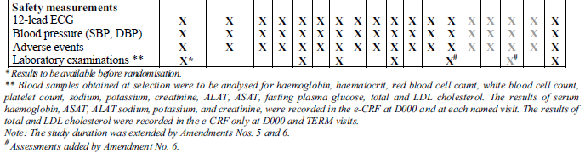
- General adverse events (AEs) were assessed by open ended questioning at each study visit.
- Blood samples were drawn for standard laboratory tests at the selection visit (or just before the inclusion visit) and at the M004, M012, M024, M036, M048 and TERM visits in a fasting state. The blood samples obtained at selection were to be analysed for haematology, clinical chemistry (sodium, potassium, creatinine, aspartate aminotransferase (AST), alanine aminotransferase (ALT)) fasting plasma glucose, total and low density lipoprotein (LDL) cholesterol.
- Systolic and diastolic blood pressures were measured in sitting position after at least a 5 minute rest.
- A standard 12-lead ECG was performed after at least a 5 minute rest. The heart rate was measured and relevant findings including cardiac rhythm were recorded at each visit. Significant ECG abnormalities were to be reported as adverse events.

Pivotal studies that assessed safety as a primary outcome
No studies were submitted that assessed safety as a primary outcome.

Dose response and non pivotal efficacy studies
Not applicable.

Other studies evaluable for safety only
Not applicable.

Patient exposure
Safety data was analysed in the Safety Dataset which comprised of all patients who took at least one dose of the study drug. In the ivabradine group, the mean (± SD) treatment duration was 20.0 (± 9) months and 65.4% of the patients had a treatment duration of at least 18 months and 35.3% of at least 24 months (Table 13). The mean (± SD) doses of ivabradine prescribed according to treatment duration and follow-up duration were 6.4 (± 1.4) mg twice daily and 5.8 (± 2.1) mg twice daily, respectively (Table 14).
Table 13. Treatment durations in the Randomised Set
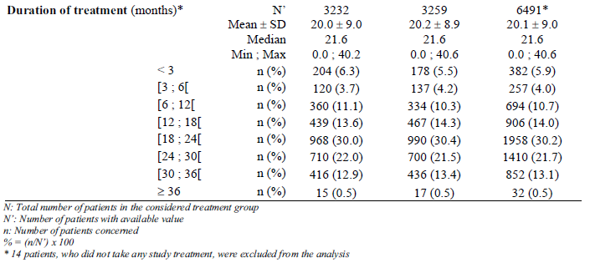
Table 14. Mean dose of study drug prescribed in the Randomised Set
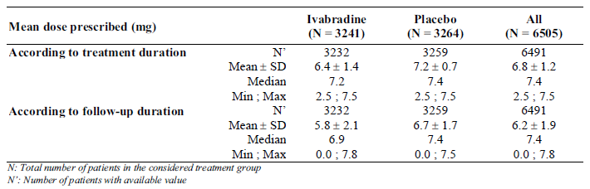

Adverse events

All adverse events (irrespective of relationship to study treatment)

Pivotal study
In the SHIFT study, the analyses of treatment emergent adverse events (TEAEs) (defined as adverse events that occurred, worsened or became serious after the first study drug intake) in the Safety Dataset were performed on clinical events “during the study” (that is, all TEAEs that occurred following first intake of study drug until database closure) and “on treatment” (that is, all TEAEs that occurred between the first study drug intake and last intake + 2 days). In the CSR, the sponsor provided only a summary of TEAEs that occurred “during the study” and more detailed analysis was presented only on the TEAEs that occurred “on treatment”.
Analysis of TEAEs that occurred “during the study” showed that in total 20142 TEAEs were reported in 4862 patients (74.9%, 41.0%PY) with similar frequencies in each treatment group (75.5% [2439/ 3232] and 74.3% [2423/ 3260], in the ivabradine and placebo groups, respectively). The most frequently reported TEAEs by System Organ Classification (SOC) in the ivabradine group were Cardiac disorders (43.0%, 23.4%PY versus 43.0%, 23.7%PY, in the ivabradine and placebo groups, respectively), Infections and infestations (22.1%, 12.0%PY versus 24.6%, 13.6%PY, respectively), Metabolism and nutrition disorders (15.5%, 8.5%PY versus 16.2%, 9.0%PY, respectively), Investigations (14.9%, 8.1%PY versus 10.9%, 6.0%PY, respectively) and Vascular disorders (14.8%, 8.0%PY versus 14.3%, 7.9%PY, respectively). The principal SOCs reported at higher incidence rates in the ivabradine group than in the placebo group where the difference was > 1% were Investigations (14.9%, 8.1%PY versus 10.9%, 6.0%PY, respectively) and Eye disorders (6.3%, 3.4%PY versus 3.4%, 1.9%PY, respectively).
Analysis of TEAEs that occurred “on treatment” showed that in total, 17496 TEAEs were reported in 4806 patients (74.0%, 44.1%PY) with similar frequencies in each treatment group (74.7% [2414/ 3232] and 73.4% [2392/ 3260], in the ivabradine and placebo groups, respectively). The most frequently reported TEAEs by SOC in the ivabradine group were similar to those in the “during study” analysis and were Cardiac disorders (41.2%, 24.7%PY versus 41.6%, 24.7%PY, in the ivabradine and placebo groups, respectively), Infections and infestations (19.6%, 11.7%PY versus 22.4%, 13.3%PY, respectively), Investigations (14.0%, 8.4%PY versus 10.0%, 5.9%PY, respectively), Metabolism and nutrition disorders (13.9%, 8.3%PY versus 14.7%, 8.7%PY, respectively) and Vascular disorders (13.5%, 8.1%PY versus 13.0%, 7.7%PY, respectively). The principal SOCs reported at higher incidence rates in the ivabradine group than in the placebo group where the difference was > 1% were Investigations (14.0%, 8.4%PY versus 10.0%, 5.9%PY, respectively), Eye disorders (6.1%, 3.7%PY versus 3.2%, 1.9%PY, respectively) and General disorders and administration site conditions (9.7%, 5.8%PY versus 8.8%, 5.2%PY, respectively).
Analysis of TEAEs that occurred “on treatment” showed that the most frequently reported TEAEs in both groups by preferred term were cardiac failure (21.7%, 13.0%PY versus 26.0%, 15.4%PY, in the ivabradine and placebo groups, respectively), atrial fibrillation (8.3%, 4.9%PY versus 6.7%, 4.0%PY, respectively) and blood pressure inadequately controlled (7.1%, 4.2%PY versus 6.1%, 3.6%PY, respectively). A plot of the 20 most frequent on-treatment TEAEs by preferred term in the ivabradine and placebo groups showedg that the principal TEAEs occurring more frequently in the ivabradine group than in the placebo group were atrial fibrillation (8.3%, 4.9%PY versus 6.7%, 4.0%PY, respectively), blood pressure inadequately controlled (7.1%, 4.2%PY versus 6.1%, 3.6%PY, respectively), asymptomatic bradycardia (HR decreased) (5.6%, 3.4%PY versus 1.4%, 0.8%PY, respectively), symptomatic bradycardia (4.6%, 2.7%PY versus 0.9%, 0.5%PY, respectively) and phosphenes (2.8%, 1.7%PY versus 0.5%, 0.3%PY, respectively).

Other studies
Not applicable.

Treatment-related adverse events (adverse drug reactions)

Pivotal study
The analysis of treatment-related TEAEs that occurred “on treatment” showed that the incidence of treatment-related TEAEs was higher in the ivabradine group than in the placebo group (17.8% [574/ 3232], 10.6%PY and 8.3% [271/ 3260], 4.9%PY in the ivabradine and placebo groups, respectively). The most frequently reported treatment-related TEAEs by SOC in the ivabradine group were Cardiac disorders (6.1%, 3.6%PY versus 2.6%, 1.5%PY, in the ivabradine and placebo groups, respectively), Investigations (5.3%, 3.2%PY versus 1.6%, 1.0%PY, respectively) and Eye disorders (3.7%, 2.2%PY versus 0.8%, 0.5%PY, respectively). The most frequently reported treatment-related TEAEs by preferred term in the ivabradine group were also those that were reported at higher incidence rates in the ivabradine group than in the placebo group (where the difference was > 1%), and were asymptomatic bradycardia (HR decreased) (4.6%, 2.8%PY versus 1.0%, 0.6%PY, respectively), symptomatic bradycardia (3.7%, 2.2%PY versus 0.7%, 0.4%PY, respectively) and phosphenes (2.7%, 1.6%PY versus 0.5%, 0.3%PY, respectively).

Other studies
Not applicable.

Deaths and other serious adverse events

Pivotal study

Serious adverse events (SAEs)
Analysis of SAEs that occurred “during the study” showed that the incidence of SAEs (fatal or not) was similar between the ivabradine group and the placebo group (44.9%, 24.4%PY versus 47.6%, 26.3%PY, respectively). The most frequently reported SAEs by SOC in the ivabradine group were Cardiac disorders (28.5%, 15.5%PY versus 30.4%, 16.8%PY, in the ivabradine and placebo groups, respectively), General disorders and administration site conditions (7.4%, 4.0%PY versus 7.8%, 4.3%PY, respectively) and Infections and infestations (6.7%, 3.6%PY versus 7.2%, 4.0%PY, respectively). The SAEs by SOC reported at higher incidence rates in the ivabradine group than in the placebo group were Investigations (2.3%, 1.3%PY versus 2.2%, 1.2%PY, respectively), Neoplasms benign, malignant and unspecified (2.1%, 1.1%PY versus 1.9%, 1.0%PY, respectively) and Renal and urinary disorders (1.6%, 0.9%PY versus 1.4%, 0.8%PY, respectively).
Analysis of SAEs that occurred “on treatment” showed that the incidence of SAEs (fatal or not) was similar between the ivabradine group and the placebo group (42.4%, 25.4%PY versus 45.4%, 27.0%PY, respectively) (Table 15). The most frequently reported SAEs by SOC in both groups were the same as those in the “during study” analysis: Cardiac disorders (26.4%, 15.8%PY versus 28.8%, 17.1%PY, in the ivabradine and placebo groups, respectively), General disorders and administration site conditions (6.2%, 3.7%PY versus 6.1%, 3.6%PY, respectively), and Infections and infestations (5.5%, 3.3%PY versus 6.1%, 3.6%PY, respectively). The SAEs by SOC reported at higher incidence rates in the ivabradine group than in the placebo group were General disorders and administration site conditions (6.2 %, 3.7%PY versus 6.1 %, 3.6 %PY, respectively), Investigations (2.0 %, 1.2%PY versus 1.9%, 1.1%PY, respectively), Neoplasms benign, malignant and unspecified (2.0 %, 1.2 %PY versus 1.7%, 1.0 %PY, respectively), Renal and urinary disorders (1.2%, 0.7%PY versus 1.0%, 0.6%PY, respectively) and Eye disorders (0.5%, 0.3%PY versus 0.4%, 0.2%PY, respectively).
Table 15. Serious emergent adverse events on treatment (all clinical events) by SOC and PT in at least 5 patients in either group (Safety Set)
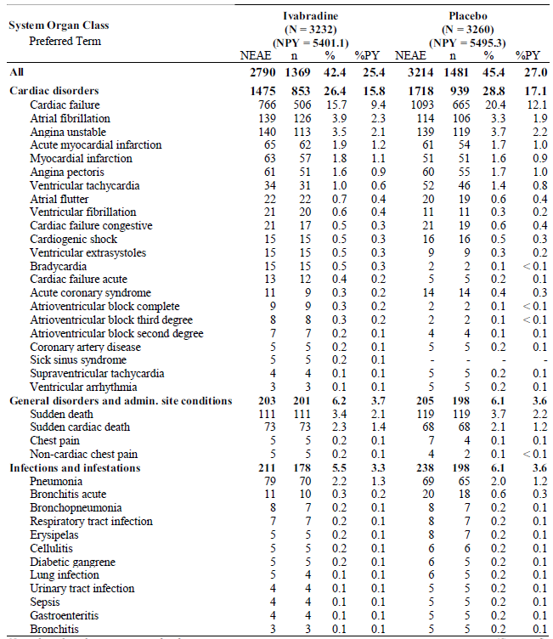
Table 15. Continued
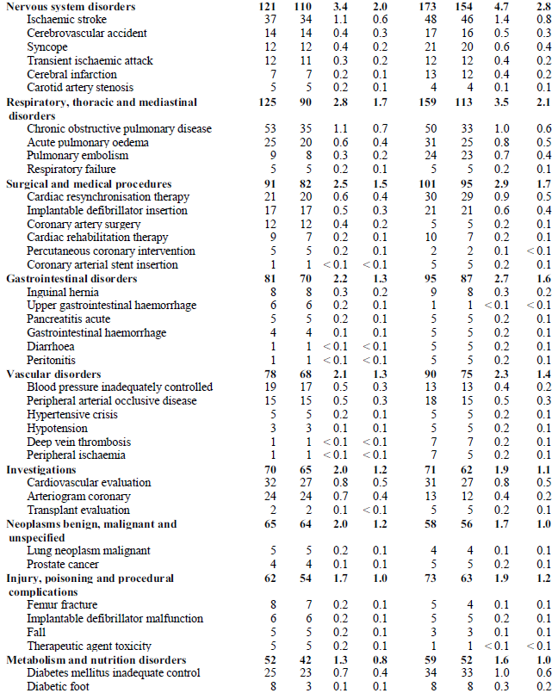
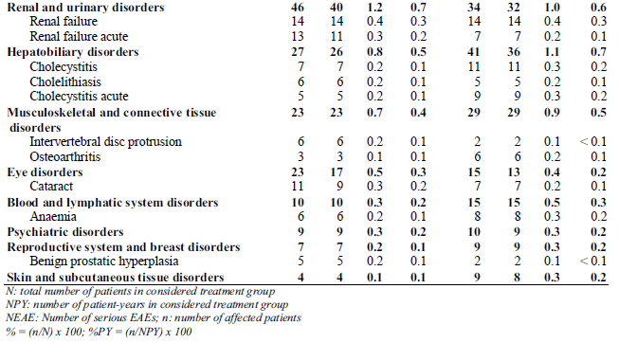
Analysis of treatment-related SAEs that occurred “on treatment” showed that overall 108 patients experienced at least 1 treatment-related SAE and that the incidence was higher in the ivabradine group compared to the placebo group (2.0% [66/3232], 1.2%PY versus1.3% [42/3260], 0.8%PY in the ivabradine and placebo groups, respectively). The most frequently reported treatment-related SAEs by SOC in both groups were Cardiac disorders (1.7%, 1.0%PY versus 0.6%, 0.4%PY, in the ivabradine and placebo groups, respectively) and Nervous system disorders (0.1%, < 0.1%PY versus 0.2%, 0.1%PY, respectively). Treatment-related SAEs in the other SOCs occurred at an incidence rate of ≤ 0.1% in either treatment group. Treatment-related SAEs (preferred term) that were reported by ≥ 5 patients in the ivabradine group (that is, an incidence rate of >0.1%) were cardiac failure (0.4% [12/3232], 0.2%PY versus 0.3% [8/3260], 0.2%PY in the ivabradine and placebo groups, respectively), symptomatic bradycardia (0.4% [12/3232], 0.2%PY versus<0.1% [1/3260], <0.1%PY, respectively), atrial fibrillation (0.2% [7/3232], 0.1%PY versus<0.1% [1/3260], <0.1%PY, respectively) and atrioventricular block complete (0.2% [5/3232], 0.1%PY versus 0% [0/3260], 0%PY, respectively).

Deaths
A total of 1074 deaths (16.5%, 9.1%PY) from any cause were reported “during the study”; 510 deaths (15.8%, 8.6%PY) and 564 deaths (17.3%, 9.5%PY) in the ivabradine and placebo groups, respectively. The main causes of deaths in both treatment groups in the “during the study” analysis were sudden death (4.0% [128/3232] versus 4.5% [146/3260] in the ivabradine and placebo groups, respectively), cardiac failure (3.1% [100/3232] versus 3.8% [124/3260], respectively) and sudden cardiac death (2.7% [86/3232] versus 2.7% [88/3260], respectively).
The sponsor has provided a tabulation of deaths to account for the difference between the numbers of deaths from any cause during the study (as described above) and results of all-cause mortality in the efficacy analyses (503 deaths in the ivabradine group versus 552 in the placebo group). Overall, 3 deaths (2 in the ivabradine group and 1 in the placebo group) were included in the efficacy analysis but not in safety analysis as they had not taken any study drugs. Twenty-two deaths were excluded from the efficacy analysis but included in safety analysis. This included 1 patient who was not randomised but were given placebo and 21 patients (9 in the ivabradine group and 12 in the placebo group) for whom the death dates were after the last visit date.
A total of 828 “on-treatment” TEAEs with a fatal outcome were reported, 400 (12.4%, 7.4%PY) and 428 (13.1%, 7.8%PY) in the ivabradine and placebo groups, respectively. The main causes in both treatment groups were sudden death (3.4% [111/3232] versus 3.7% [119/3260] in the ivabradine and placebo groups, respectively), sudden cardiac death (2.3% [73/3232] versus 2.1% [68/3260], respectively) and cardiac failure (2.1% [69/3232] versus 2.8% [91/3260], respectively).

Other studies
Not applicable.

Discontinuation due to adverse events

Pivotal study
In the analysis of TEAEs that led to study drug discontinuation, the sponsor considered two categories of events; TEAEs leading to permanent study drug discontinuation and TEAEs leading to a temporary interruption of the study drug without subsequent restart (due to reasons such as consent withdrawal, death, or temporal proximity to the last study visit). A total of 578 patients had TEAEs leading to permanent study drug discontinuation, 315 patients (9.8%, 5.8%PY) in the ivabradine group versus 263 (8.1%, 4.8%PY) in the placebo group. A total of 305 patients had TEAEs leading to temporary interruption of study drug without subsequent restart, 152 patients (4.7%, 2.8%PY) in the ivabradine group versus 153 (4.7%, 2.8%PY) in the placebo group.
The sponsor had combined these two categories of treatment withdrawal (permanent, and temporary without restart) in the analysis of TEAEs that led to study drug discontinuation. Results showed that the incidence rate of study drug discontinuation was higher in the ivadrabine group compared to the placebo group (14.5% [467/3232] versus 12.8% [416/3260], respectively). The most frequently reported TEAEs leading to study drug discontinuation in the ivabradine group (by SOC) were Cardiac disorders (9.4%, 5.6%PY versus 8.3%, 4.9%PY in the ivabradine and placebo groups, respectively) and Investigations (1.1%, 0.6%PY versus 0.3%, 0.2%PY, respectively). Within the SOC of Cardiac disorders, the commonest TEAEs (by preferred term) leading to study drug discontinuation in the ivabradine group were atrial fibrillation (4.2%, 2.5%PY versus 3.5%, 2.1%PY, respectively), cardiac failures (2.0%, 1.2%PY versus 2.4%, 1.4%PY, respectively) and symptomatic bradycardia (0.6%, 0.4%PY versus 0.2%, 0.1%PY, respectively). Within the SOC of investigations, the commonest TEAE (by preferred term) leading to study drug discontinuation in the ivabradine group was asymptomatic bradycardia (HR decreased) (0.9%, 0.5%PY versus 0.2%, 0.1%PY, respectively).

Other studies
Not applicable.

Laboratory tests

Liver function

Pivotal study
There were no clinically significant changes or differences between groups over time in the liver function tests (only AST and ALT were assessed in this study).

Other studies
Not applicable.

Kidney function

Pivotal study
There were no clinically significant changes or differences between groups over time in the kidney function tests (only sodium, potassium and creatinine were assessed in this study).

Other studies
Not applicable.

Other clinical chemistry

Pivotal study
There were no clinically significant changes or differences between groups over time in the total cholesterol and LDL-cholesterol levels.

Other studies
Not applicable.

Haematology

Pivotal study
There were no clinically significant changes or differences between groups over time in the haematology tests.

Other studies
Not applicable.

Electrocardiograph

Pivotal studies
Electrocardiograms were taken to detect the lowest heart rate on treatment present in patients on the Safety Set. An on-treatment recording of HR < 40 bpm was reported in 0.3% (10/3178) of patients in the ivabradine group versus 0.1% (3/ 3209) in the placebo group. An on-treatment recording of HR < 50 bpm was reported in 21.3% (676/ 3178) of patients in the ivabradine group versus 2.2% (70/ 3209) in the placebo group.
Overall, the proportion of patients with asymptomatic bradycardia that led to study drug discontinuation was 0.9% and 0.2% in the ivabradine and placebo groups, respectively, and that for symptomatic bradycardia was 0.6% and 0.2%, respectively. Asymptomatic bradycardia that was considered treatment-related SAEs occurred in 0.1% and 0% in the ivabradine and placebo groups, respectively. Symptomatic bradycardia that was considered treatment-related SAEs occurred in 0.4% and < 0.1% in the ivabradine and placebo groups, respectively.

Other studies
Not applicable.

Vital signs

Pivotal studies
Sitting systolic blood pressure (SBP) and diastolic blood pressure (DBP) were measured at each scheduled visit during the study. There was a small increase in mean sitting SBP between baseline and last value on treatment in both treatment groups (mean change ± SD of + 4.1 ± 16.0 mmHg in the ivabradine group and +2.0 ± 16.2 mmHg in the placebo group).
There was minimal change in mean sitting DBP between baseline and last value on treatment in both treatment groups (mean change ± SD of +0.4 ± 10.2 mmHg in the ivabradine group and +0.7 ± 10.3 mmHg in the placebo group).

Other studies
Not applicable.

Postmarketing experience
No postmarketing data was provided. The proposed PI contains data regarding postmarketing experience, which is unamended from the currently approved PI and states that “The following adverse reactions (frequency unknown) have been reported in postmarketing use with ivabradine; rash, erythema, pruritis, hypotension, malaise, syncope (possibly linked to bradycardia).”

Other safety issues

Safety in special populations
In the subgroup of patients aged ≥ 75 years (N = 720, n=367 in ivabradine group, n=353 in the placebo group), the incidence of TEAEs was comparable between the ivabradine group and the placebo group (78.8%, 50.3%PY versus 77.6%, 48.0%PY, respectively) (Table 16). The most frequently reported TEAEs by SOC were Cardiac disorders (50.1%, 32.0%PY versus 47.3%, 29.2%PY, respectively), Infections and infestations (26.2%, 16.7%PY versus 26.1%, 16.1%PY, respectively) and Vascular disorders (13.9%, 8.9%PY versus 14.2%, 8.8%PY, respectively). The most frequently reported TEAEs by preferred term were (ivabradine versus placebo) cardiac failure (28.6%, 18.3%PY versus 32.3%, 20.0%PY, respectively), atrial fibrillation (11.7%, 7.5%PY versus 11.6%, 7.2%PY, respectively), symptomatic bradycardia (7.4%, 4.7%PY versus 1.1%, 0.7%PY, respectively) and blood pressure inadequately controlled (7.4%, 4.7%PY versus 6.0%, 3.7%PY, respectively).
Table 16. Most frequently reported emergent adverse events on treatment in the subgroup of patients aged ≥ 75 years (in at least 2.5% of patients in the ivabradine group)
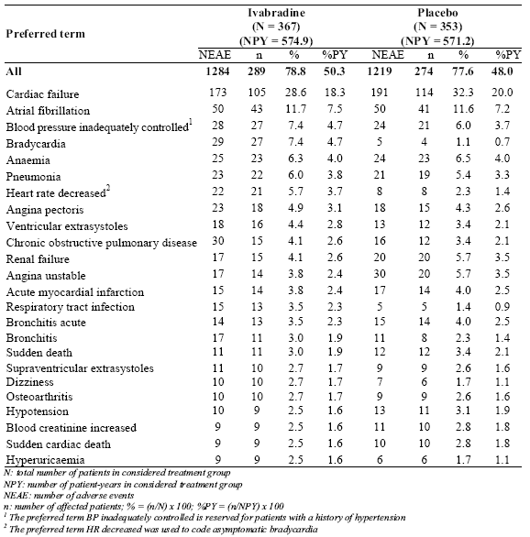
TEAEs by preferred term occurring more frequently in the ivabradine group than in the placebo group were symptomatic bradycardia (7.4%, 4.7%PY versus 1.1%, 0.7%PY, respectively), blood pressure inadequately controlled (7.4%, 4.7%PY versus 6.0%, 3.7%PY, respectively), asymptomatic bradycardia (HR decreased) (5.7%, 3.7%PY versus 2.3%, 1.4%PY, respectively), respiratory tract infection (3.5%, 2.3%PY versus 1.4%, 0.9%PY, respectively), dizziness (2.7%, 1.7%PY versus 1.7%, 1.1%PY, respectively) and arthralgia (1.6%, 1.0%PY versus zero, respectively).

Safety related to drug-drug interactions and other interactions
No safety data was submitted for the subgroup of patients who were on at least 50% of optimal doses of recommended beta blockers. Safety data in this subgroup would be relevant to the evaluation of whether there was an increased incidence of bradycardia (asymptomatic and symptomatic) or arrhythmias in this subgroup and hence assist in determining the profile of CHF patient population for which ivabradine should be indicated in terms of concomitant use of beta blockers.

Evaluator’s overall conclusions on clinical safety
Overall, the incidence of TEAEs and SAEs was comparable between the 2 treatment groups. However, the incidences of treatment-related TEAEs and treatment-related SAEs were higher in the ivabradine group than in the placebo group (17.8% versus 8.3% and 2.0% versus 1.3%, respectively) (Table 17).
Table 17. Overall summary of safety results. All clinical events on treatment (Safety Set)
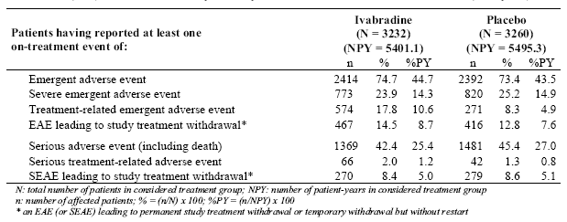
The most commonly occurring treatment-related TEAEs in the ivabradine group were known adverse effects of ivabradine stated in the currently approved PI.
In the section on SAEs in the proposed PI, it is stated that “the most frequently reported SAEs with ivabradine were Cardiac disorders, where the only SAE reported with a ≥1% incidence was unstable angina (1.5%)”. Results in the SHIFT study showed that the most frequently reported treatment-related SAEs by SOC in the ivabradine group was also cardiac disorders (1.7% versus 0.6% in the ivabradine and placebo groups, respectively). All treatment-related SAEs by preferred term occurred at an incidence rate of < 0.5%, the commonest being cardiac failure (0.4% versus 0.3% in the ivabradine and placebo groups, respectively), symptomatic bradycardia (0.4% versus <0.1%, respectively), atrial fibrillation (0.2% versus <0.1%, respectively) and atrioventricular block complete (0.2% versus 0%, respectively).
The incidence of “on-treatment” TEAEs with a fatal outcome was similar between the ivabradine and placebo groups (12.4% versus 13.1%, respectively). The incidence rate TEAEs leading to study drug discontinuation was higher in the ivabradine group compared to the placebo group (14.5% versus12.8%, respectively) but the incidence of SAEs leading to study drug discontinuation was similar between the ivabradine and placebo groups (8.4% versus 8.6%, respectively). The commonest TEAEs leading to study drug discontinuation in the ivabradine group were atrial fibrillation (4.2% versus 3.5% in the ivabradine and placebo groups, respectively) and cardiac failures (2.0% versus 2.4%, respectively).
In the subgroup of patients aged ≥ 75 years, the overall incidence of TEAEs was comparable between ivabradine and placebo groups (78.8% versus 77.6%, respectively). Compared to the overall study population, the incidence of TEAEs was higher in this subgroup of patients aged ≥ 75 years, in the ivabradine group (78.8% versus 74.7% in age ≥ 75 years and overall population, respectively), as well as placebo group (77.6% versus 73.4%, respectively). There was also a higher incidence in the ivabradine treatment group of this subgroup compared to that in the overall study safety dataset of cardiac failure (28.6% versus 21.7%, respectively), atrial fibrillation (11.7% versus 8.3%, respectively) and symptomatic bradycardia (7.4% versus 4.6%, respectively) (Table 18), although for atrial fibrillation and cardiac failure the incidences were similar between ivabradine and placebo groups in this subgroup of patients aged ≥ 75 years (atrial fibrillation: 11.7% and 11.6% in the ivabradine and placebo groups respectively; cardiac failure: 28.6% and 32.3%, respectively). The incidence of asymptomatic bradycardia was comparable between the ivabradine treatment group of this subgroup of patients aged ≥75 years and that in the overall study safety dataset (5.7% versus 5.6%, respectively).
Overall, the safety results of the SHIFT study were consistent with the known adverse effects of ivabradine. The incidence of death in the safety analysis supported the efficacy results that there was no increased risk of overall mortality compared to placebo. However, as the proposed indication is for use in CHF patients who tend to be in an older age group, the evaluation of the safety profile in this age group was considered to be important. The sample size of patients aged ≥ 75 years was small (n=720), and safety results suggested that there could be a higher incidence of cardiac failure, atrial fibrillation and symptomatic bradycardia in this age group.
In addition, no safety data was submitted for the subgroup of patients who were on at least 50% of optimal doses of recommended beta blockers. Safety data in this subgroup would be relevant to the evaluation of whether there was an increased incidence of bradycardia (asymptomatic and symptomatic) or arrhythmias in this subgroup and hence assist in determining the profile of CHF patient population for which ivabradine should be indicated in terms of concomitant use of beta blockers.
Table 18. TEAEs in the subgroup of patients aged ≥ 75 years, compared to the overall study safety dataset.
 | Safety dataset |  |  | Subgroup “age ≥ 75 years”
 |  | IVB | PLB |  | IVB | PLB
Any TEAEs |  | 74.7% | 73.4% |  | 78.8% | 77.6%
Commonest TEAEs by SOC, in ivabradine group | cardiac disorders  infections and infestations  investigations | 41.2%  19.6%  14.0% | 41.6%  22.4%  10.0% | cardiac disorders  infections and infestations  vascular disorders | 50.1%  26.2%  13.9% | 47.3%  26.1%  14.2%
Commonest TEAEs by preferred term, in ivabradine group | cardiac failure  atrial fibrillation  blood pressure inadequately controlled | 21.7%  8.3%  7.1% | 26.0%  6.7%  6.1% | cardiac failure  atrial fibrillation  symptomatic bradycardia  blood pressure inadequately controlled | 28.6%  11.7%  7.4%  7.4% | 32.3%  11.6%  1.1%  6.0%
Main TEAEs (by preferred term) that were more frequent in the ivabradine group than in the placebo group | atrial fibrillation  blood pressure inadequately controlled  asymptomatic bradycardia (HR decreased)  symptomatic bradycardia  phosphenes | 8.3%  7.1%  5.6%  4.6%  2.8% | 6.7%  6.1%  1.4%  0.9%  0.5% | symptomatic bradycardia  blood pressure inadequately controlled  asymptomatic bradycardia (HR decreased)  respiratory tract infection  dizziness  arthralgia | 7.4%  7.4%  5.7%  3.5%  2.7%  1.6% | 1.1%  6.0%  2.3%  1.4%  1.7%  0%
IVB= ivabradine; PLB= placebo

Clinical summary and conclusions

First round benefit-risk assessment

Benefits
The potential benefits of ivabradine in the proposed additional indication are a reduction in morbidity and/or mortality of CHF patients. Overall, the study results showed statistically significant relative risk reductions in cardiovascular morbidity (as measured by cardiovascular hospitalisations and hospitalisations for worsening heart failure) but failed to demonstrate efficacy for improving the outcome of cardiovascular mortality.
While the results showed that there was no increased risk of the mortality endpoints with ivabradine compared to placebo, there was no statistically significant difference in favour of ivabradine over placebo in most of the mortality endpoints analysed in the study in the general study population (RS dataset), where only the endpoint of death from heart failure was statistically significant (RRR 26%; p=0.014). There was no statistically significant difference in favour of ivabradine over placebo in all the mortality endpoints analysed in the study in the sub-population of patients who were on at least 50% of the optimal beta blocker dose (RSBBdose dataset). In fact, in the RS_{BBdose} dataset, there was no discernible difference between treatment groups in the endpoints of all-cause mortality and of cardiovascular death (relative risk reduction of 1% and 0%, respectively).
Although subgroup analysis in RS population of the mortality endpoints showed an effect in favour of ivabradine in the subgroup of patients with baseline HR ≥77 bpm and this effect was statistically significantly more than in the subgroup of patients with baseline HR <77 bpm, there was no analysis for statistical significance against placebo.
There are also concerns regarding whether study efficacy results and hence potential benefits of ivabradine can be extrapolated to CHF patient population in clinical practice. The sponsor is submitting a claim for efficacy across all age groups in the adult population. However, as described previously, the study results suggested that the beneficial effect of ivabradine was less in CHF patients aged ≥ 65 years old. In addition, in the evaluation of the efficacy claim, it is noted that in this study, the overall mean age of the study population was relatively young at 60.4 (± 11.4) years and a majority (62%) of the study population were <65 years of age, raising the question of whether the overall efficacy results could be extrapolated to the CHF patient population in clinical practice which tend to be more elderly.
Comment: The reply from the sponsor to EMA regarding the question pertaining to the “benefit/risk in the usually elderly CHF population (>65 or >70 years) is unclear” was noted by the clinical evaluator. The sponsor did an analysis of the primary composite endpoint and the secondary endpoints in the subgroups of patients “aged ≥ 70 years” (N=1500 [n=776 ivabradine, n=724 placebo]), “aged ≥ 70 years with HR ≥ 75 bpm at baseline” (N=856 [n=424 ivabradine, n=432 placebo]), “aged ≥ 65 years” (N=2464 [n=1265 ivabradine, n=1209 placebo]), “aged ≥ 65 years with HR ≥75 bpm at baseline” (N=1467 [n=721 ivabradine, n=746 placebo]) and the results are presented below together with the results in the overall study population in Tables 19 and 20. It is unclear why the HR criterion of ≥75 bpm was chosen.
Table 19. Primary and main secondary endpoints in the overall population, in patients aged ≥ 70 years and in patients aged ≥ 70 years with HR ≥ 75 bpm at baseline
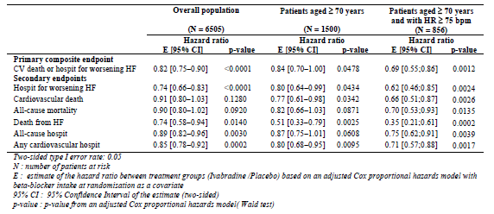
Table 20. Primary and main secondary endpoints in the overall population, in patients aged ≥ 65 years, and in patients aged ≥ 65 years with HR ≥ 75 bpm at baseline
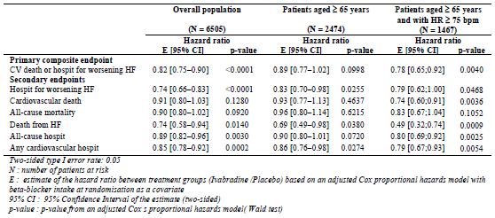
The results showed that in the subgroup of patients aged ≥ 65 years, the relative risk reduction for the primary composite endpoint was not statistically significant. Similar to the results in the overall population, the mortality endpoints were mostly not statistically significant (only the endpoint of death from heart failure was statistically significant [relative risk reduction of 31%, p=0.0380]). Analysis in the endpoint of all-cause mortality showed there was no increased risk with ivabradine compared to placebo. Only the disease-specific hospitalisation endpoints (hospitalisation for worsening heart failure and any cardiovascular hospitalisation) were statistically significant but the relative risk reductions were less than that for the overall population, with much higher p values. Approximately 60% of the subgroup of patients aged ≥ 65 years had baseline HR ≥ 75 bpm. In this subgroup the relative risk reduction in the primary composite endpoint and the secondary endpoints were all statistically significant, except for the endpoint of all-cause mortality. The appropriate comparator group in the overall population would be the subgroup of patients in the overall population with a baseline HR ≥ 75 bpm but this was not provided by the sponsor.
In the subgroup of patients aged ≥ 70 years, the relative risk reduction on the primary composite endpoint (16%) was similar to that in the overall population (18%) but the result was barely statistically significant (p=0.0478). Interestingly, unlike the results in the overall population, more mortality endpoints yielded statistically significant results, while the morbidity endpoints were mostly not statistically significant (only the endpoint of hospitalisation for worsening heart failure was statistically significant but was near the threshold of non-significance [p= 0.0434] and with a relative risk reduction that was lower than in the overall population [20% versus 26%]). The disease specific mortality endpoints were statistically significant and yielded greater relative risk reductions than in the overall population. Approximately 60% of the subgroup of patients aged ≥ 70 years had baseline HR ≥ 75 bpm, and the relative risk reduction in the primary composite endpoint and the secondary endpoints were all statistically significant, except for the endpoint of all-cause mortality. Again, the appropriate comparator group in the overall population would be the subgroup of patients in the overall population with a baseline HR ≥ 75 bpm but this was not provided by the sponsor.
Overall, these additional analyses showed that for the subgroup of patients aged ≥65 years, there were statistically significant relative risk reductions in favour of ivabradine over placebo in cardiovascular (disease-specific) morbidity endpoints, although these reductions were less than in the overall population, suggesting that the improvements in clinical outcomes may be less in this subgroup of patients. No increased risk of overall mortality was detected with ivabradine compared to placebo. Increasing the age criterion to ≥ 70 years appeared to improve the mortality outcomes but worsen the morbidity outcomes. These results need to be considered in the context of the safety results in this subgroup of elderly patients, in order to establish if the apparently lower efficacy would affect the benefit-risk balance. This will be discussed below. In addition, in the main study analyses, the apparently lower effect of ivabradine on those aged ≥ 65 years was detected in the analyses in the RS_{BBdose} population. Additional analyses on the subgroup of elderly patients in the RS_{BBdose} population were not provided by the sponsor.
With regards to the NYHA classes, only 1.7% (n=111) of the study population were in NYHA Class IV. Subgroup analysis combined patients with NYHA III and those with NYHA IV into the same subgroup, thus not allowing any analysis of the sub-population of patients with NYHA IV. It is recommended that patients with NYHA IV be excluded from the proposed indication, as the claimed efficacy was only studied in a limited number of patients with NYHA IV.
Comment: The reply from the sponsor to EMA regarding the question pertaining to “The risk/benefit balance is not established in NYHA Class IV patients” was noted by the clinical evaluator. The sponsor did an analysis of the primary composite endpoint and the secondary endpoints in the subgroup of patients with NYHA IV and the results are presented below together with the results in the overall study population in Table 21.
Table 21. Primary and main secondary endpoints in patients in NYHA Class IV at baseline (N = 111) and in the overall study population (N = 6505)
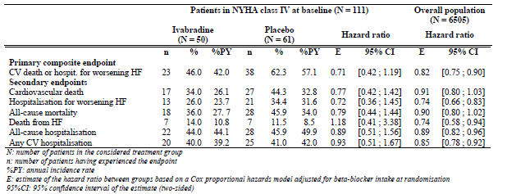
Comment: The sponsor had stated that analyses of the efficacy of ivabradine in NYHA Class IV patients showed that “the relative risk reductions observed with ivabradine for the primary composite endpoint and main secondary endpoints were similar to, and in some cases more favourable than, those in the overall study population” but that these reductions were not statistically significant. The evaluator acknowledged that this may be due to the very small sample size. However, this is the issue that was raised in the first place, that is, the sample size of this subgroup of patients was too small to make any meaningful interpretation. That the relative risk reductions observed were at least similar to those in the overall study population is not meaningful, given that the results were not statistically significant and that the sample size was too small to make any test of statistical significance meaningful.
With regards to the HR criteria, analyses in the study was done for subgroups with baseline HR < 77 bpm or ≥77 bpm (77 bpm was the median HR in the study population). Study analyses on the mortality endpoints in the RS population showed relative risk reductions in favour of ivabradine over placebo in the subgroup of patients with baseline HR ≥77 bpm but not in the subgroup with baseline HR < 77 bpm . This was also observed in the RS_{BBdose} population, for the mortality endpoints of cardiovascular death and all-cause mortality. In addition, for the endpoints of primary composite endpoint, all-cause mortality and cardiovascular death in the RS population, there were statistically significant differences in favour of patients with baseline HR ≥77 bpm versus those with <77 bpm. In view of this, it was recommended that the HR criterion for the proposed indication be set at 75bpm (This will be discussed further below). The additional analyses on the subgroup of patients aged ≥ 65 years and ≥ 70 years as described in previous paragraphs were also performed using the baseline HR criterion of ≥ 75bpm and showed that the effect of ivabradine was greater in this subset of patients.
Comment: The reply from the sponsor to EMA regarding the question that the sponsor “should discuss whether heart rate (assessed as a continuous variable) affected ivabradine effect on cardiovascular events” was noted by the clinical evaluator. In its response, the sponsor did additional analyses based on HR criterion of 75 bpm. Interaction tests were performed for the primary composite endpoint and the secondary endpoints (hospitalisation for worsening heart failure, cardiovascular death, death from any cause) using heart rate as a continuous variable in patients with baseline HR ≥ 75 bpm and yielded non significant results, showing that ivabradine effect is independent of the heart rate level in study patients with baseline HR ≥ 75 bpm (see Table 22).
Table 22. p values of the interaction tests between treatment effect and heart rate
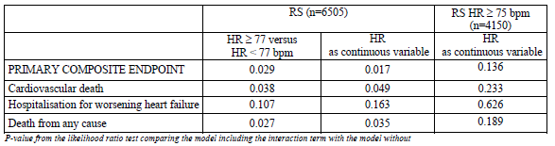With regards to the concurrent use of beta blockers, the study results suggested that the relative risk reductions in favour of ivabradine over placebo were less in the sub-population of patients who were on at least 50% of the optimal beta blocker dose. The relative risk reductions for the primary composite endpoint was lower in the RS_{BBdose} population compared to the RS population, and was statistically significant only in the latter. The relative risk reductions for the morbidity endpoints were also lower in the RS_{BBdose} population compared to the RS population. A possible reason is that the sample size of the study was calculated for an effect size on the primary composite endpoint in the RS population and that the RS_{BBdose} population size (n=3181) was not large enough to detect an effect. Although it is also plausible that patients who were on at least 50% of the optimal beta blocker dose already had a low baseline HR and hence the additional HR reduction effect of ivabradine did not exert much effect on morbidity or mortality; study results showed that the mean baseline HR was actually comparable between the RS and the RS_{BBdose} population (79.6bpm and 78.5 bpm in the ivabradine groups, respectively, and 80.0bpm and 79.3bpm in the placebo groups, respectively). The amount of change of HR from baseline at Day 28 and at last post randomisation visit was also similar between the RS and RS_{BBdose} population. However, the ratio of patients with baseline HR <77 bpm to those with baseline HR ≥77 bpm was higher in the RS_{BBdose} population compared to the RS population (1.04 [1521/1557] versus 0.94 [3144/3357], respectively). Comparison between the RS_{BBdose} population and the non- RS_{BBdose} population gave a greater difference in the respective ratios; 1.04 versus 0.85. It would be interesting to evaluate the effect of ivabradine in the RS population versus that in the RS_{BBdose} population while adjusting for any heart rate differences. However, with regards to evaluating the patient group for which the efficacy claim is made; as the relative risk reductions of ivabradine on the disease-specific morbidity endpoints of cardiovascular hospitalisation and hospitalisation for worsening heart failure were statistically significant in the RS_{BBdose} population it is not deemed necessary to restrict the proposed indication to the patient population who were on < 50% of optimal beta blocker doses, unless the safety results in the RS_{BBdose} population indicated a higher safety risk, which would then affect the benefit-risk assessment (this will be discussed further below). Nonetheless, it is interesting to note that the effect appeared to be less in those who were on ≥ 50% of optimal beta blocker doses even though both groups had similar mean baseline HR.
It was noted by the clinical evaluator that the study population were CHF patients with a reduced LVEF of ≤ 35%. It is recommended that this be added as a criterion in the proposed indication. It is also noted that in the study population, only 9.5% had an LVEF of ≤ 20%. It was recommended that additional analysis be done to evaluate the efficacy in this subgroup.

Risks
Overall, the safety results of the SHIFT study were consistent with the known adverse effects of ivabradine presented in the currently approved PI (bradycardia, atrial fibrillation, phosphenes). The incidence of death in the safety analysis supported the efficacy results that there was no increased risk of overall mortality compared to placebo. Thus, the overall results suggested that there were no additional or unexpected risks with the use of ivabradine in CHF patients.
However, as the proposed indication is for use in CHF patients, who tend to be in an older age group, the evaluation of the safety profile in this particular age group is important. The sample size of patients aged ≥ 75 years was small (n=720) and safety results suggested that there could be a higher incidence of cardiac failure, atrial fibrillation and symptomatic bradycardia in this age group.
Comment: The reply from the sponsor to EMA regarding the question pertaining to the “benefit/risk in the usually elderly CHF population (>65 or >70 years) is unclear” was noted by the clinical evaluator. The sponsor did an additional safety analysis in patients aged ≥ 65 years and ≥ 70 years. The results are summarised in Tables 23 and 24 below.
Table 23. Most frequently reported TEAEs in patients aged ≥ 65 years and ≥ 70 years, compared to overall study population
 | ≥ 65 years |  | ≥ 70 years |  | Overall population
 | ivabradine | placebo | ivabradine | placebo | ivabradine | placebo
Cardiac failure | 25.7%, 16.3%PY | 30.4%, 18.2%PY | 25.1%,  16.0%PY | 30.5%, 18.7%PY | 21.7%, 13.0%PY | 26.0%, 15.4%PY
Atrial fibrillation | 10.6%, 6.7%PY | 9.9%, 6.0%PY | 11.4%, 7.3%PY | 10.8%, 6.6%PY | 8.3%, 4.9%PY | 6.7%, 4.0%PY
Asymptomatic bradycardia | 6.5%, 4.1%PY | 1.7%, 1.0%PY | 7.2%, 4.6%PY | 1.7%, 1.0%PY | 5.6%, 3.4%PY | 1.4%, 0.8%PY
Symptomatic bradycardia | 5.7%, 3.6%PY | 1.3%, 0.8%PY | 5.9%, 3.8%PY | 1.2%, 0.8%PY | 4.6%, 2.7%PY | 0.9%, 0.5%PY
BP inadequately controlled | 8.3%, 5.3%PY | 6.5%, 3.9%PY | 8.3%, 5.3%PY | 5.9%, 3.6%PY | 7.1%, 4.2%PY | 6.1%, 3.6%PY
Table 24. Incidence of EAEs and SEAEs – Overall and in SOC Cardiac disorders – in the overall population and in the elderly sub-groups
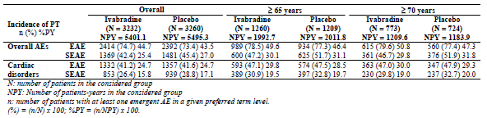
The safety results were consistent with those in the patients aged ≥ 75 years. In the subgroup of patients aged ≥ 65 years and ≥ 70 years there were higher incidences of TEAEs and SAEs in the respective ivabradine groups compared to that in the overall population. However, within each subgroup the incidence of TEAEs and SAEs were comparable between the ivabradine and placebo groups. The same pattern was seen in the cardiac disorders TEAEs and SAEs. These results suggest that the higher incidences of TEAEs and SAEs seen in the ivabradine groups in the elderly subgroups might be reflecting the generally higher TEAEs or SAEs in the more elderly age group, rather than an adverse effect of ivabradine on the subgroups. However, analysis of the incidences of specific TEAEs showed that the incidences of atrial fibrillation, asymptomatic bradycardia, symptomatic bradycardia and blood pressure inadequately controlled were higher in the elderly subgroups and not only between the respective ivabradine groups compared to that in the overall population but also higher within each subgroup in the ivabradine group compared to the placebo group. Although similar differential incidences of these TEAEs were also observed between the ivabradine and placebo groups in the overall study population, these additional analyses did not exclude or allay concerns regarding higher incidences of bradycardia or arrhythmias in the elderly patient population.
In addition, no safety data was submitted for the subgroup of patients who were on at least 50% of optimal doses of recommended beta blockers. As previously discussed safety data in this subgroup would be relevant to the evaluation of whether there was an increased incidence of bradycardia (asymptomatic and symptomatic) or arrhythmias in this subgroup and hence assist in determining the profile of CHF patient population for which ivabradine should be indicated in terms of concomitant use of beta blockers. This is especially relevant given that the efficacy results suggested that efficacy might be lower in this subpopulation compared to the overall study population.

Benefit-risk balance
The benefit-risk balance of ivabradine is unfavourable given the proposed usage but would become favourable if some changes recommended are adopted, in particular the restriction to adult CHF patients with NYHA II and III, baseline HR ≥ 75 bpm and age <65 years.
The potential benefits of ivabradine in the proposed additional indication are a reduction in morbidity and/or mortality of CHF patients. According to statistics gathered by the Australian Institute of Health and Welfare (AIHW) and the National Heart Foundation of Australia (NHFA) at least 300 000 Australians have chronic heart failure (comprising 4% of the population aged 45 years or more), with 30,000 new cases diagnosed each year. Heart failure accounted for 9.5% of hospitalisations for heart, stroke and vascular diseases. Heart failure is the third largest cause of death from heart, stroke and vascular diseases in Australia, accounting for 2729 deaths or 2.0% of all deaths in 2002. With people having a longer lifespan and with better medical treatment reducing mortality from ischaemic heart attacks, the incidence of CHF, especially in the elderly population, is likely to increase.
The TGA adopted EU guidelines on the clinical investigation of drugs for treatment of cardiac failure⁷ recommend that the primary endpoints of heart failure treatment studies be improvement in symptoms, cardiovascular morbidity and all-cause mortality based on the principle that the main objectives are to demonstrate improvement in cardiovascular morbidity and clinical symptoms and no adverse effect on overall mortality. Overall, the SHIFT study results had managed to demonstrate improvement in cardiovascular morbidity and no adverse effect on overall mortality.
The proposed indication for which this application was made is for the
“Reduction of cardiovascular events (cardiovascular mortality or hospitalisation for worsening heart failure) in adults in sinus rhythm with symptomatic chronic heart failure and with heart rate at or above 70 bpm.”
In the above proposed indication, the main aspects are the outcomes for which a claim in efficacy is made (cardiovascular mortality or hospitalisation for worsening heart failure), and the patient group for which this efficacy claim is made (CHF patients who are adults, with NYHA Class II to IV (that is, symptomatic CHF) and with sinus rhythm heart rate ≥ 70 bpm).
As discussed previously, the study efficacy results did not support the claim of efficacy for improving the outcome of cardiovascular mortality. With regards to the patient group for which the efficacy claim is made, the number of patients with NYHA IV in the study was too small for meaningful evaluation of efficacy and even when that was done by the sponsor yielded results that were not statistically significant.
With regards to the HR criterion, efficacy results suggested efficacy mostly only in the subgroup of patients with baseline HR ≥77 bpm versus those with baseline HR < 77 bpm. Additional analyses in the subgroup of patients with baseline HR ≥ 75 bpm by the sponsor in response to queries from EMA, yielded non significant interaction tests results, showing that in the subgroup with baseline heart rate ≥ 75bpm the ivabradine effect was independent of the heart rate level.
With regards to age group, it is noted that the overall mean age of the study population was relatively young at 60.4 (± 11.4) years and a majority (62%) of the study population were < 65 years of age, raising the question of whether the overall efficacy results could be extrapolated to the CHF patient population in clinical practice, which tend to be more elderly. In addition, the main study results suggested that the beneficial effect of ivabradine was less in CHF patients aged ≥ 65 years old. This was supported by the additional analyses done by the sponsor in response to queries by the EMA, showing that the relative risk reduction observed for the primary composite endpoint was not statistically significant in the subgroup of patients aged ≥ 65 years and barely statistically significant (p=0.0478) in the subgroup of patients aged ≥ 70 years. Analyses of the secondary endpoints in these subgroups also showed that although in the subgroup of patients aged ≥ 65 years there were statistically significant relative risk reductions in favour of ivabradine over placebo in cardiovascular (disease-specific) morbidity endpoints, these reductions were less than in the overall population, suggesting that the improvements in clinical outcomes may be less in this subgroup of patients. Restricting the subgroup to patients aged ≥ 65 years and with a baseline HR ≥ 75 bpm improved the results but the appropriate comparator group in the overall population would be the subgroup of patients in the overall population with a baseline HR ≥ 75 bpm and this was not provided by the sponsor.
In addition, safety results in patients aged ≥ 75 years suggested that there could be a higher incidence of cardiac failure, atrial fibrillation and symptomatic bradycardia in this age group. Additional analyses done by the sponsor in the subgroup of patients aged ≥ 65 years and ≥ 70 years in response to queries by the EMA showed that there were higher incidences of atrial fibrillation, asymptomatic bradycardia, symptomatic bradycardia and blood pressure inadequately controlled in the respective ivabradine groups compared to that in the overall population as well as within each subgroup in the ivabradine group compared to the placebo group. Overall, these additional analyses have not convincingly excluded or allayed the concern that there could be higher incidences of bradycardia or arrhythmias in the elderly patient population. Taken together with the efficacy results in this elderly subgroup, benefit-risk balance of ivabradine for the proposed indication in the age group of age ≥ 65 years is not favourable.

Recommendation regarding authorisation
It was recommended that the application for extension of indication of ivabradine for treatment of chronic heart failure
“in adults in sinus rhythm with symptomatic chronic heart failure and with heart rate at or above 70 bpm”
be rejected at this stage.
However, an extension of indication of ivabradine for treatment of chronic heart failure may be approved if it is restricted to adult CHF patients with NYHA II and III, baseline HR ≥ 75 bpm and age < 65 years. This is also subject to a satisfactory response to the recommended changes in the PI and CMI and to the clinical questions raised below. Further restrictions may need to be considered if the responses to the clinical questions change the benefit-risk balance of any particular subgroup of CHF patients.
The grounds for rejection of the submission as it stands are that:
- the study results cannot be confidently extrapolated to CHF patient population in clinical practice, with regards to the representative age range. The overall mean age of the study population was relatively young at 60.4 years and a majority (62%) of the study population were < 65 years of age. This is not representative of the CHF patient population in clinical practice which tends to be more elderly.
- Even when the subgroup of study patients aged ≥ 65 was analysed, the results suggested that the beneficial effect of ivabradine was less in CHF patients ≥ 65 years old. The results showed that in the subgroup of patients aged ≥ 65 years, the relative risk reduction for the primary composite endpoint was not statistically significant, while in the subgroup of patients aged ≥ 70 years the relative risk reduction on the primary composite endpoint was barely statistically significant (p=0.0478).
- Safety results suggested higher incidences of atrial fibrillation, asymptomatic bradycardia, symptomatic bradycardia and blood pressure inadequately controlled in the subgroup of CHF patients aged ≥ 65 years. Taken together with the efficacy results in this subgroup of patients, this resulted in an unfavourable benefit-risk profile for ivabradine in patients aged ≥ 65 years old.
- It is noted that in the analysis of the subgroup of CHF patients aged ≥ 65 years and with baseline heart rate ≥ 75 bpm, the relative risk reduction in the primary composite endpoint was statistically significant. However, the appropriate comparator group in the overall population would be the subgroup of patients in the overall population with a baseline heart rate ≥ 75 bpm but this was not provided by the sponsor. Again, together with the safety results in patients aged ≥ 65 years, a positive benefit-risk profile for ivabradine cannot be definitively or confidently concluded. 41

List of questions

Efficacy
- Please provide additional efficacy and safety analyses results on the primary composite endpoint and the secondary endpoints for the subgroup of patients in the RS_{BBdose} population who were aged ≥ 65 years.
In the main study analyses there appeared to be a lower effect of ivabradine on those aged ≥ 65 years in the RS_{BBdose} population. In the pre specified subgroup analysis in the RS_{BBdose} population on the primary composite endpoint and on the secondary endpoint of hospitalisation for worsening heart failure, results showed an effect in favour of ivabradine in all the pre specified subgroups except for the subgroup “age ≥ 65 years”.

Safety
- Please provide additional safety analyses results on the primary composite endpoint and the secondary endpoints for the subgroup of patients with LVEF of ≤ 20%.
In the study population, only 9.5% had an LVEF of ≤ 20%. Additional analysis is recommended to be done to evaluate the safety in this subgroup.
Please provide additional safety analyses results on the primary composite endpoint and the secondary endpoints for the subgroup of patients in the RS_{BBdose} population.
- The efficacy analyses in the RS_{BBdose} population, suggested a lower effect of ivabradine compared to the overall study population. Safety data in this subgroup would be relevant to the evaluation of the benefit-risk profile in this group of patients and hence assist in determining the profile of CHF patient population for which ivabradine should be indicated in terms of concomitant use of beta blockers.

For sponsor’s responses to these questions see Responses to Clinical Questions Raised in First Evaluation below.

Second round evaluation of clinical data submitted in response to clinical questions
In addition to submitting responses to the questions posed in the first Clinical Evaluation Report (CER; see above List of Questions), the sponsor has also presented arguments against the grounds for rejection stated in the first CER. In the first CER, these grounds for rejection had not been raised as clinical questions as the sponsor’s responses to the EMA, which included additional efficacy and safety analyses, had addressed the issues pertaining to the grounds for rejection in the first CER and these had been reviewed and taken into consideration in the recommendation regarding authorisation in the first CER. In this second evaluation, the sponsor’s responses to the grounds for rejection as well as to the clinical questions will be addressed.

Main premise for rejection of submission as it stands
In the executive summary of the sponsor’s response, the sponsor stated that:
“The SHIFT study supporting this application, evaluated the effects of ivabradine on cardiovascular (CV) events in patients with symptomatic CHF, left ventricular systolic dysfunction and a resting heart rate (HR) of ≥ 70bpm and in sinus rhythm. There was an 18% RRR in the primary endpoint (p<0.0001). The study meets all the requirements outlined in the relevant TGA-adopted EMA guidelines.
It would appear that the main premise for the CER’s rejection of the submission is that despite achieving a statistically significant reduction in the primary composite endpoint (PCE) in the ITT population, when the components of the PCE were analysed separately only the relative risk reduction (RRR) for the endpoint of hospitalisation for worsening heart failure was statistically significant (26%, p<0.0001) and the RRR for the endpoint of CV death was not statistically significant (9%, p=0.128). This appears to be inconsistent with previous TGA decisions, for example, the SENIORS study formed the basis of TGA registration for nebivolol, both all-cause mortality and CV hospitalisation which composed the primary composite endpoint of the study failed to individually achieve statistical significance yet nebivolol was still granted approval for treatment of heart failure.”
The main premise for the first CER’s rejection of the submission was not due to the results of the analysis of the individual components of the PCE. As stated under “grounds for rejection of the submission as it stands”, the grounds for rejection were issues related to the benefit-risk profile in patients ≥ 65 years of age.
That the overall study meets the basic efficacy requirements outlined in the relevant TGA adopted EMA guidelines was not an issue of concern raised in the first CER. As stated, the conclusion on the overall efficacy results was that:
“Overall, with reference to the TGA-adopted EU guidelines on the clinical investigation of drugs for treatment of cardiac failure which recommend that the primary endpoints of heart failure treatment studies be improvement in symptoms, cardiovascular morbidity and all-cause mortality, based on the principle that the main objectives are to demonstrate improvement in cardiovascular morbidity and clinical symptoms and no adverse effect on overall mortality, the study results had managed to demonstrate improvement in cardiovascular morbidity and no adverse effect on overall mortality. It yielded results that showed an improvement in clinical symptoms, but the possibility of bias in this analysis could not be excluded.”
However, it needs to be appreciated that meeting the basic minimal requirements in the TGA adopted EMA guidelines does not automatically lead to approval of the proposed additional indication, which need to be evaluated on the basis of the relative benefit-risk balance in the targeted patient population and in the context of the disease condition and the currently available therapeutic options. In particular, the subgroup of patient population for which the proposed additional indication will have a positive benefit-risk profile will need to be evaluated in order to clearly define the patient group for which the proposed additional indication will be approved.
The SHIFT study efficacy results showed that in the subgroup of patients aged ≥ 65 years the relative risk reduction for the primary composite endpoint was not statistically significant, while in the subgroup of patients aged ≥ 70 years the relative risk reduction on the primary composite endpoint was barely statistically significant (p=0.0478). While this efficacy result alone would not lead to an adverse benefit-risk profile in this subgroup, safety results available during the first evaluation also suggested higher incidences of atrial fibrillation, asymptomatic bradycardia, symptomatic bradycardia and blood pressure inadequately controlled in the subgroup of CHF patients aged ≥ 65 years compared to the overall population. Taken together with the efficacy results in this subgroup of patients, this had resulted in an unfavourable benefit-risk profile for ivabradine in patients that are ≥ 65 years old.
In weighing between the options of a recommendation for approval of the submission but with an age restriction or a rejection of the submission with a statement that approval may be considered if there is an age restriction, the evaluator had been of the opinion that the age restriction would significantly change the meaning of the submission as it stands (given that the majority of patients with chronic heart failure are elderly) and therefore that it would be more meaningful to recommend a rejection of the submission as it stands with a statement that approval may be considered if there is an age restriction.
As the main premise for rejection of the submission as it stands is the unfavourable benefit-risk profile in patients aged ≥ 65 years, only these aspects of the sponsor’s response will be addressed in this second evaluation.

Efficacy in patients aged ≥ 65 years
With regards to efficacy in patients aged ≥ 65 years, the sponsor supplied data showing the incidences of the primary composite endpoints and the component endpoints in the age ≥70 years subgroup, ≥ 65 years subgroup and overall population and stated that
“the relative efficacy of ivabradine was similar in both subgroups and the overall population. For example, the relative risk reduction (RRR) with ivabradine compared with placebo for the primary composite endpoint was 16%, 11% and 18% for the ≥70 years subgroup, ≥ 65 years subgroup and overall population, respectively”.
The evaluator would like to bring to attention the RRR analyses that the sponsor had presented in its response to EMA in patients aged ≥ 65 years and ≥ 70 years, which showed that the RRR in the primary composite endpoint of 11% in the ≥ 65 years subgroup was not statistically significant (p=0.0998) and the RRR of 16% in the ≥ 70 years subgroup was barely statistically significant (p=0.478). All these RRRs had already been evaluated in the first round of evaluation and had already been considered in the recommendation given in the first round of evaluation.
The results of the secondary endpoints in patients aged ≥ 65 years had also been evaluated and considered during the first evaluation and had been presented in the first CER but will be briefly described here again. In study patients aged ≥ 65 years, the mortality endpoints were mostly not statistically significant. Only the endpoint of death from heart failure was statistically significant (RRR of 31% [hazard ratio of 0.69], p=0.0380) but it had a wide hazard ratio 95% confidence interval (CI) of 0.49 to 0.98, with the upper limit close to 1.00. Analysis in the endpoint of all-cause mortality in this subgroup of patients showed no increased risk with ivabradine compared to placebo with a hazard ratio of 0.96 but the 95% CI was again wide and spanned from 0.80 to 1.14, with the upper limit exceeding 1.00. A similar result was seen in the endpoint of cardiovascular death (hazard ratio [95%CI] of 0.93 [0.77-1.13]). With regards to the morbidity endpoints in this subgroup of patients, the disease-specific hospitalisation endpoints (hospitalisation for worsening heart failure and any cardiovascular hospitalisation) were statistically significant but the 95% CI were wide (hazard ratios [95% CI] of 0.83 [0.70-0.98] and 0.86 [0.76-0.98] for endpoints of hospitalisation for worsening heart failure and any cardiovascular hospitalisation, respectively) and with upper limits close to 1.00.
The sponsor has also raised as an argument that
“65 years of age is an artificial boundary and may result in perverse prescribing practices”
With regards to 65 years of age being an artificial boundary, it should be noted that the age boundary of 65 years was not arbitrarily set by the evaluator. The subgroups of age < 65 years and ≥ 65 years were pre specified by the sponsor in the study protocol. In the study design these subgroups were pre specified, presumably based on the sponsor’s initial hypothesis that the results would demonstrate that efficacy and safety outcomes were comparable between those aged < 65 years and ≥ 65 years. Thus, allowing a statement that the efficacy and safety of Coralan is the same in both the younger patients and in the elderly patients, using the criterion of age < 65 years and ≥ 65 years to define “younger” and “elderly”. That the results subsequently obtained in the study did not support the original hypothesis is not a justification to now retrospectively state that the pre specified age boundary is artificial. If the sponsor has in mind a more clinically relevant age boundary criterion it should have been utilised prospectively in the study design and protocol.

Safety in patients aged ≥ 65 years
The sponsor has based its arguments in this aspect upon its understanding that
“The CER suggests that treatment should be restricted to patients aged < 65 years on the basis that the safety profile in this population is expected to be favourable.”
This understanding is incorrect. The first CER’s suggestion that treatment should be restricted to patients aged < 65 years was not based on an expectation that the safety profile in this population to be favourable but on the actual safety results presented in the clinical study report and on the additional analysis done in the sponsor’s response to EMA, which showed that there were higher incidences of atrial fibrillation, bradycardia (asymptomatic and symptomatic) and blood pressure inadequately controlled in the ivabradine group compared to the placebo group in patients aged ≥ 65 years as well as in the ivabradine group of patients aged ≥ 65 years compared to the ivabradine group of patients aged < 65 years. This is discussed in the CER and the pertinent text is quoted below for ease of reference:
“In the subgroup of patients aged ≥ 65 years and ≥ 70 years, there were higher incidences of TEAEs and SAEs in the respective ivabradine groups compared to that in the overall population. However, within each subgroup, the incidence of TEAEs and SAEs were comparable between the ivabradine and placebo groups. The same pattern was seen in the cardiac disorders TEAEs and SAEs. These results suggest that the higher incidences of TEAEs and SAEs seen in the ivabradine groups in the elderly subgroups might be reflecting the generally higher TEAEs or SAEs in the more elderly age group, rather than an adverse effect of ivabradine on the subgroups. However, analysis of the incidences of specific TEAEs showed that the incidences of atrial fibrillation, asymptomatic bradycardia, symptomatic bradycardia and blood pressure inadequately controlled were higher in the elderly subgroups, not only between the respective ivabradine groups compared to that in the overall population but also higher within each subgroup in the ivabradine group compared to the placebo group. Although similar differential incidences of these TEAEs were also observed between the ivabradine and placebo groups in the overall study population, these additional analyses did not exclude or allay concerns regarding higher incidences of bradycardia or arrhythmias in the elderly patient population.”
In its current response to the TGA, the sponsor has provided additional analyses giving the hazard ratios for the TEAEs in concern for the different age subgroups (< 65 years versus ≥ 65 years, < 70 years versus ≥ 70 years) and in the overall study population. This is helpful in now allowing a comparison of the differential incidences of these TEAEs between the ivabradine and placebo groups in each age subgroup. This is summarised in Table 25.
With regards to the comparison between those aged ≥ 65 years with those aged < 65 years as well as with the overall study population, the results showed that the hazard ratios were lower in the subgroup aged ≥ 65 years compared to the overall population and to the subgroup of aged < 65 years in the TEAEs of atrial fibrillation and symptomatic bradycardia. Although the hazard ratios were higher in the subgroup aged ≥ 65 years compared to the overall population and to the subgroup of aged < 65 years in the TEAEs of asymptomatic bradycardia and blood pressure inadequately controlled, the difference was not statistically significant. Analysis using the age criterion of 70 years yielded similar results. These additional analyses results suggest that the higher incidences of atrial fibrillation, bradycardia (asymptomatic and symptomatic) and blood pressure inadequately controlled seen in the ivabradine group of patients aged ≥ 65 years compared to the ivabradine group of patients aged < 65 years and to the overall study population might be reflecting the generally higher incidences of these TEAEs in the more elderly age group rather than a greater adverse effect of ivabradine on the elderly subgroup compared to those younger.
With regards to looking at the safety results between the ivabradine and placebo group in those aged ≥ 65 years and ≥ 70 years, there is a 4.5 and 5.1 times higher risk of symptomatic bradycardia with ivabradine use in patients aged ≥ 65 years and ≥ 70 years, respectively. There is a 4.2 and 4.7 times higher risk of asymptomatic bradycardia with ivabradine use in patients aged ≥ 65 years and ≥ 70 years, respectively.
Table 25. Incidence of TEAEs by age subgroups and in the Overall population.
 | Hazard Ratio | Interaction (p value)
Atrial Fibrillation
Overall study population | 1.26
Subgroup aged < 65 years  Subgroup aged ≥ 65 years | 1.42  1.12 | 0.197
Subgroup aged < 70 years  Subgroup aged ≥ 70 years | 1.33  1.11 | 0.355
Symptomatic bradycardia
Overall study population | 5.46
Subgroup aged < 65 years  Subgroup aged ≥ 65 years | 6.64  4.53 | 0.352
Subgroup aged < 70 years  Subgroup aged ≥ 70 years | 5.62  5.07 | 0.800
Asymptomatic bradycardia
Overall study population | 4.18
Subgroup aged < 65 years  Subgroup aged ≥ 65 years | 4.14  4.23 | 0.925
Subgroup aged < 70 years  Subgroup aged ≥ 70 years | 3.97  4.72 | 0.651
Blood pressure inadequately controlled
Overall study population | 1.18
Subgroup aged < 65 years  Subgroup aged ≥ 65 years | 1.05  1.37 | 0.175
Subgroup aged < 70 years  Subgroup aged ≥ 70 years | 1.09  1.48 | 0.187

Responses to clinical questions raised in first evaluation
The clinical questions that were raised in the first CER followed by the evaluator’s comments on the sponsor’s responses are shown below.

Question relating to Efficacy:
- Please provide additional efficacy and safety analyses results on the primary composite endpoint and the secondary endpoints for the subgroup of patients in the RS_{BBdose} population who were aged ≥ 65 years.
In the main study analyses, there appeared to be a lower effect of ivabradine on those aged ≥ 65 years in the RS_{BBdose} population. In the pre-specified subgroup analysis in the RS_{BBdose} population on the primary composite endpoint and on the secondary endpoint of hospitalisation for worsening heart failure, results showed an effect in favour of ivabradine in all the pre-specified subgroups except for the subgroup “age ≥ 65 years”.
No additional data has been provided by the sponsor. The sponsor has indicated that “age-related subgroup analyses were not powered to reach statistical significance. It is therefore inappropriate to analyse this BB dose subgroup within the ≥ 65 years sub-group the analysis would be of a subgroup within a subgroup.”

Questions relating to safety:
- Please provide additional safety analyses results on the primary composite endpoint and the secondary endpoints for the subgroup of patients with LVEF of ≤ 20%.
In the study population, only 9.5% had an LVEF of ≤ 20%. Additional analysis is recommended to be done to evaluate the safety in this subgroup.
Additional safety data was provided by the sponsor for this subgroup. Evaluation of this additional results showed that the safety profile in this subgroup was comparable to that in the overall study population. No significant safety issues in this subgroup were detected.
- Please provide additional safety analyses results on the primary composite endpoint and the secondary endpoints for the subgroup of patients in the RS_{BBdose} population.
The efficacy analyses in the RS_{BBdose} population, suggested a lower effect of ivabradine compared to the overall study population. Safety data in this subgroup would be relevant to the evaluation of the benefit-risk profile in this group of patients, and hence assist in determining the profile of CHF patient population for which ivabradine should be indicated, in terms of concomitant use of beta blockers.
Additional safety data was provided by the sponsor for this subgroup. Evaluation of this additional results showed that the safety profile in this subgroup was comparable to that in the overall study population. Within this subgroup, TEAEs which were relatively more frequent in the ivabradine group than in the placebo group were similar to those found in the overall study population (please see table below).
Table 26. Additional safety data for the RS_{BBdose} population
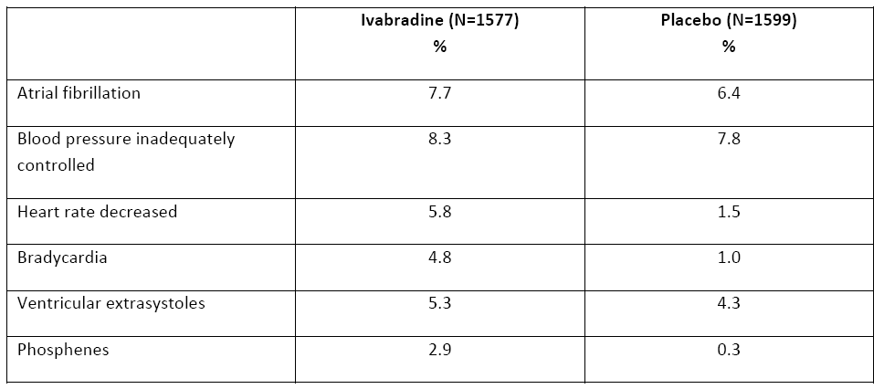

Second round benefit-risk assessment

Benefits
After consideration of the responses to the clinical questions, the benefits of ivabradine in the proposed usage are unchanged from those identified in the first round, except for the correction of an error arising from a typographical oversight (see footnote on page 49).The evaluator had been cognizant of the result that the endpoint of death from heart failure in the RS dataset was statistically significant in favour of ivabradine, and this had been taken into consideration in the first evaluation. It had not changed the conclusion that “Overall, the study results showed statistically significant relative risk reductions in cardiovascular morbidity (as measured by cardiovascular hospitalisations and hospitalisations for worsening heart failure) but failed to demonstrate efficacy for improving the outcome of cardiovascular mortality” (first CER), given that the endpoint of cardiovascular mortality was not statistically significantly different in favour of ivabradine over placebo in both the RS and RS_{BBdose} datasets.
Of particular note, the comments in the first evaluation with regards to efficacy in those aged ≥ 65 years remain unchanged. The basis for this has been elaborated in this second evaluation.

Risks
After consideration of the responses to clinical questions, the risks of ivabradine in the proposed usage are revised as follows:
Overall, the safety results of the SHIFT study were consistent with the known adverse effects of ivabradine presented in the currently approved PI ( bradycardia, atrial fibrillation, phosphenes). The incidence of death in the safety analysis supported the efficacy results that there was no increased risk of overall mortality compared to placebo. Thus, the overall results suggested that there were no additional or unexpected risks with the use of ivabradine in CHF patients.
However, as the proposed indication is for use in CHF patients who tend to be in an older age group, the evaluation of the safety profile in this particular age group is important. The sample size of patients aged ≥ 75 years was small (n=720) and safety results suggested that there could be a higher incidence of cardiac failure, atrial fibrillation and symptomatic bradycardia in this age group. The reply from the sponsor to EMA regarding the question pertaining to the “benefit/risk in the usually elderly CHF population (>65 or >70 years) is unclear” was noted by the clinical evaluator. The sponsor did an additional safety analysis in patients aged ≥ 65 years and ≥ 70 years. The results are summarised in Tables 25 and 26. In the subgroup of patients aged ≥ 65 years and ≥ 70 years there were higher incidences of TEAEs and SAEs in the respective ivabradine groups compared to that in the overall population. However, within each subgroup, the incidence of TEAEs and SAEs were comparable between the ivabradine and placebo groups. The same pattern was seen in the cardiac disorders TEAEs and SAEs. These results suggest that the higher incidences of TEAEs and SAEs seen in the ivabradine groups in the elderly subgroups might be reflecting the generally higher TEAEs or SAEs in the more elderly age group rather than an adverse effect of ivabradine on the subgroups.
Analysis of the incidences of specific TEAEs showed that the incidences of atrial fibrillation, asymptomatic bradycardia, symptomatic bradycardia and blood pressure inadequately controlled were higher in the elderly subgroups, not only between the respective ivabradine groups compared to that in the overall population but also higher within each subgroup in the ivabradine group compared to the placebo group. However, additional analyses provided by the sponsor for this second evaluation suggested that the higher incidences of atrial fibrillation, bradycardia (asymptomatic and symptomatic) and blood pressure inadequately controlled seen in the ivabradine group of patients aged ≥ 65 years compared to the ivabradine group of patients aged < 65 years and to the overall study population might be reflecting the generally higher incidences of these TEAEs in the more elderly age group rather than a greater adverse effect of ivabradine on the elderly subgroup compared to those younger.
Overall, the study results and additional analyses provided by the sponsor in this second evaluation showed that the use of ivabradine in CHF patients is associated with the known adverse effects of ivabradine such as bradycardia and atrial fibrillation. In the overall study population, the higher risks with ivabradine use compared to placebo of atrial fibrillation, symptomatic bradycardia, asymptomatic bradycardia or blood pressure inadequately controlled were 1.26, 5.46, 4.18 and 1.18 times, respectively. In the subgroup aged ≥ 65 years, the corresponding relative risks were 1.12, 4.53, 4.23 and 1.37 times, respectively. However the additional safety analyses provided by the sponsor for the second evaluation suggested that there was no increased risk of adverse effect of ivabradine in patients aged ≥ 65 years compared to those aged < 65 years. This has improved the risk profile for the use of ivabradine in the subgroup of age ≥ 65 years.

Benefit-risk balance
The overall benefit-risk balance of ivabradine was considered favourable given the proposed usage. Overall, the SHIFT study results had managed to demonstrate improvement in cardiovascular morbidity and no adverse effect on overall mortality. This is consistent with the TGA adopted EU guidelines on the clinical investigation of drugs for treatment of cardiac failure⁷ recommend that the primary endpoints of heart failure treatment studies be improvement in symptoms, cardiovascular morbidity and all-cause mortality, based on the principle that the main objectives are to demonstrate improvement in cardiovascular morbidity and clinical symptoms and no adverse effect on overall mortality.
The grounds for rejection in the first evaluation were due to the unfavourable benefit-risk profile in the subgroup of age ≥ 65 years. In this second evaluation, the additional efficacy data submitted did not change the efficacy profile in this subgroup but the safety profile has improved. This has resulted in a more favourable overall assessment as compared to the first evaluation.
However, it is noted that the safety results showed that in patients aged ≥ 65 years there is a 4.5, 4.2, 1.4 and 1.1 times higher risk of symptomatic bradycardia, asymptomatic bradycardia, blood pressure inadequately controlled or atrial fibrillation respectively, with ivabradine use compared to placebo. This needs to be weighed against the equivocal study efficacy results in this subgroup. In this subgroup, individual risk factors and characteristics will play a more important role in the final determination of whether ivabradine would be beneficial in a particular individual patient.

Recommendation regarding authorisation
It is recommended that the application for extension of indication of ivabradine for treatment of chronic heart failure be approved subject to a satisfactory response to the recommended changes in the PI and CMI, in particular to the specific precautions to be applied to patients of age ≥65 years.

V. Pharmacovigilance findings

Risk management plan
The sponsor submitted a Risk Management Plan (RMP) which was reviewed by the TGA’s Office of Product Review (OPR).

Safety specification
The sponsor provided a summary of Ongoing safety Concerns which are shown at Table 27.
Table 27. Ongoing Safety Concerns
Identified Risks | Bradycardia
Identified Risks | Phosphenes/Blurred vision
Potential risks | Atrial fibrillation and other supraventricular tachyarrhythmia (SVT)
Potential risks | Atrioventricular block 2nd and 3rd degree
Missing or limited information | Children and adolescents (<18 years old)
Missing or limited information | Pregnant and lactating women
Missing or limited information | Severe hepatic insufficiency
Missing or limited information | Severe renal impairment
Of these safety concerns, atrioventricular block is newly recognised, identified during clinical studies in chronic heart failure patients.

OPR reviewer comment
The clinical evaluation report appeared satisfied with the summary table of safety concerns. However, the report also discusses that the size of the risk of bradycardia and arrhythmias in the elderly has not been adequately defined. For this reason it is recommended that the elderly is identified has a separate Ongoing Safety Concern, either in the Potential risks or Missing information sections.

Pharmacovigilance plan
Routine pharmacovigilance practices described in the RMP are consistent with the Australian Guideline for Pharmacovigilance responsibilities of sponsors of registered medicines regulated by drug safety and evaluation branch (2005).
Table 28 outlines the additional pharmacovigilance activities being conducted for each of the Ongoing Safety Concerns identified.
Table 28. Safety Concerns and associated additional pharmacovigilance activities
Safety Concern | Pharmacovigilance Activity
Bradycardia | - Ongoing interventional clinical studies – include an assessment of cardiac rhythm through ECG and collection of adverse events at scheduled and unscheduled visits.  - CL3-083 (Signify) – further characterise risk in population of CAD patients with high risk and at dose up to 10mg bd  - Reinforcement of routine PV – excessive bradycardia (<40bpm or symptomatic) will be considered as important medical events and reported to local authority  - PSURs – addressed specifically
Phosphenes/blurred vision | - CL3-067 (Follow-Up Measure) – document findings from 3 year ophthalmic safety study
AF and other SVT | - Ongoing interventional clinical studies – include an assessment of cardiac rhythm through ECG and collection of adverse events at scheduled and unscheduled visits.  - CL3-083 (Signify) – further characterise risk in population of CAD patients with high risk and at dose up to 10mg bd  - Reinforcement of routine PV – all AF and other SVT will be considered as important medical events and reported to local authority  - PSURs – addressed specifically
AV blocks of 2nd and 3rd degree | - Ongoing interventional clinical studies – include an assessment of cardiac rhythm through ECG and collection of adverse events at scheduled and unscheduled visits.  - CL3-083 (Signify) – further characterise risk in population of CAD patients with high risk and at dose up to 10mg bd  - Reinforcement of routine PV – all AV blocks of 2nd and 3rd degree will be considered as important medical events and reported to local authority  - PSURs – addressed specifically
Missing information – all categories | - Routine PV
Annex 8 of the RMP identifies 3 ongoing clinical studies. CL3-068 is listed in the annex as an efficacy study for patients with stable angina pectoris receiving 6 weeks of treatment with ivabradine, however there was no specific further reference or discussion in the RMP. It will be assumed that this will not significantly contribute to pharmacovigilance post registration. Details of the other 2 studies are summarised below.

CL3-083 (Signify) study
- Expected completion date March 2013 with final submission of data end 2013
- Randomised double blind placebo controlled multicentre international study
- Objective: demonstrate that ivabradine reduces cardiovascular events (CV mortality or non-fatal MI) in patients with stable coronary artery disease without clinical heart failure
- Secondary objectives include safety evaluation (AE evaluation)
- Population: stable coronary artery disease without clinical HF, 11,330 patients total
- Intervention: 5, 7.5 or 10 mg ivabradine bd, 18-42 months duration.

CL3-067 (Follow up Measure; Ophthalmic safety study)
- Study initiation 2008, planned completion date 2014
- Double blind, placebo controlled multicentre international study (Australia included)
- Objective: document the absence of retinal toxicity when administered at the therapeutic dose for 36 months
- Secondary objectives include cardiac efficacy and safety measurement
- Population: chronic stable angina pectoris, 150 per treatment group (300 total), anticipate 100 per treatment arm will complete study
- Intervention: 2.5, 5 or 7.5mg ivabradine bd.

OPR reviewer’s comments in regard to the pharmacovigilance plan (PP) and the appropriateness of milestones

Cardiac related safety concerns
Neither of these ongoing clinical studies investigates the population group relevant to the extension of indication applied for here, which is chronic heart failure. The Signify study excludes clinical heart failure and the Follow up Measure focuses on stable angina pectoris. Therefore, these ongoing studies will not provide additional safety related information for this population group.
The monitoring of identified and potential cardiac safety risks will therefore rely on a “reinforcement of routine PV”, where all outlined cardiac events reported to the sponsor will be considered as “important medical events” and reported to local authority and specifically addressed in the Periodic Safety Update Reports (PSURs). All these risks are mentioned in the Australian PI.
The clinical evaluation report has highlighted that there could be higher incidences of bradycardia and arrhythmias in the elderly population with CHF. Given that the potential for use in the elderly population (under the proposed indication) is high, it is recommended that routine pharmacovigilance activities are not adequate to address these safety concerns. If the submission is successful with the proposed indication, additional pharmacovigilance activities are recommended to further define this risk in elderly patients with CHF.

Phosphenes/blurred vision
The RMP provides information that confirms the higher incidence of phosphenes and blurred vision in ivabradine treated patients as compared to placebo treated patients. In postmarketing surveillance, the sponsor reports an estimated frequency of phosphenes of 1 case per 4,959 person years of follow up (68 cases), which resolved or improved with or without treatment withdrawal. It appears this is generally well tolerated and recoverable. There is no reason to believe that the risk or frequency of visual disturbances will be greater for the new population group (CHF). Therefore, continual monitoring via PSURs and review of the final study report for the Follow-Up Measure (evaluation by the CHMP) was considered acceptable to monitor this risk.

Risk minimisation activities
Routine risk minimisation activities are proposed as sufficient for all Risks and Missing information safety concerns.

OPR reviewer comment
No additional risk minimisation activities have been required for this medication for its existing indication (registered since 2006) in Australia. In the European Union (EU) there have been Summary of Product Characteristics (SmPC) updates but no additional risk minimisation activities have been required.
Given the clinical evaluators’ recommendation that the benefit-risk balance is unfavourable in those aged over 65 years, if the submission is accepted with the current indication, it is recommended that additional risk minimisation activities are identified by the sponsor to attempt to mitigate the risk in this sub-population.

Summary of recommendations
The following recommendations are provided in the context that the submitted RMP is supportive of the application:
- the implementation of the Ivabradine Risk Management Plan Version 2, dated 10 November 2010, including changes that address the recommendations below and any future updates is included as a condition of registration,
- the elderly subpopulation is identified has a separate Ongoing Safety Concern in the summary table, either in the Potential risks or Missing information sections,
- additional pharmacovigilance activities have been included to address the possible higher incidence of bradycardia and arrhythmia in the elderly subpopulation, and
- additional risk minimisation activities are identified by the sponsor to attempt to mitigate the risk in this sub population.

VI. Overall conclusion and risk/benefit assessment
The submission was summarised in the following Delegate’s overview and recommendations:
The clinical submission was confined to a single clinical study (the SHIFT study) evaluating the effect of ivabradine on cardiovascular events in patients with symptomatic congestive heart failure and left ventricular systolic dysfunction. On 30 August 2011 the sponsor sent responses to questions posed by a TGA request for information. The latter request for information had resulted from the issuing in April 2011 by the EMA of a request for supplementary information. At that time, the EMA had “raised a major objection precluding a recommendation for marketing until resolution of the issues raised in the objection”. The sponsor’s response to the TGA’s request for information of 30 August 2011 was also evaluated by the clinical evaluator.
There is one TGA adopted European guideline (with an addendum) which is specific and relevant to this submission, besides the general guidelines:
- CPMP/EWP/235/95 Rev 1 (pdf,63kb)
Note for Guidance on the Clinical Investigation of Medicinal Products in the Treatment of Cardiac Failure
Published: TGA Internet site
Effective: 23 February 2001
- CPMP/EWP/2986/03 (pdf,210kb)
Note for Guidance on Clinical Investigation of Medicinal Products for the Treatment of Cardiac Failure. Addendum on CPMP/EWP/235/95 Rev 1
Published: TGA Internet site
Effective: 1 February 2007
Members of the Advisory Committee on Prescription Medicines (ACPM) are requested to note particularly the qualification that the heart rate should be ≥ 75 bpm (rather than the threshold sought by the sponsor, namely 70 bpm, which was an inclusion criterion of the SHIFT study). There is much discussion in this overview about this new threshold which appears to have come about as the result of a post hoc analysis. The Delegate asked the sponsor a number of questions about this issue. The sponsor gave answers to these questions in its pre-ACPM response.
The CHMP adopted a new contraindication, “unstable or acute heart failure” while at the same time removing the contraindication, “heart failure patients with NYHA functional classification III-IV”. The CHMP refined the existing contraindication, “pacemaker dependent” to read “pacemaker dependent (heart rate imposed exclusively by the pacemaker)”.

Quality
There was no requirement for a quality evaluation in a submission of this type.

Nonclinical
There was no requirement for a nonclinical evaluation in a submission of this type.

Clinical
The clinical evaluator ‘s first round recommendation was one of rejection but qualified by an opinion that the extension of indication for treatment of chronic heart failure may be approvable if the indication was restricted to adult patients with NYHA II & III degree CHF, baseline HR ≥ 75 bpm and age < 65 years. The clinical evaluator also recommended changes to the PI and asked questions of the sponsor. In the second round assessment of benefit-risk balance, the clinical evaluator stated that the grounds for rejection in the first evaluation were due to the unfavourable benefit-risk profile in the sub-group aged ≥ 65 years. The clinical evaluator then went on to say that while the additional efficacy data submitted did not change the efficacy profile in this sub-group, the corresponding safety profile had improved. The clinical evaluator’s second round recommendation was that the extension of indication could now be approved subject to satisfactory amending of the PI, particularly with regard to specific precautions applicable to the elderly age group of patients.

Pharmacokinetics
No new PK data were submitted for evaluation.

Pharmacodynamics
No new PD data were submitted for evaluation.

Efficacy

Pivotal study, SHIFT Study (Study ID: CL3-16257-063)
The SHIFT study was conducted at 625 centres in 37 countries, the majority of the centres being in Europe. There were 2 centres with 46 patients, the data from which had to be discounted because of major issues of GCP non compliance including fake source documents and falsified copies of source documents in order to permit the inclusion of non eligible patients. This was an issue of great concern to the Delegate who would like to know considerably more details of how these fraudulent activities actually came to light. The Delegate understands that they came to light during an audit of the sites. Were all sites subjected to the same degree of audit? What triggered the interest of the auditors in the source documents? Was the checking of such source documents a feature of all the audits or did the auditors at these sites act on suspicions which had been aroused in some way? What guarantees can the sponsor give that there were not the same or other irregularities or deficiencies in GCP compliance in the study. The sponsor is requested to provide a full and open accounting of this issue in its pre-ACPM response.
SHIFT was a randomised, double blind, placebo controlled, multinational trial that included 6505 patients (placebo, n = 3264 and ivabradine, n = 3241) with symptomatic chronic heart failure and a left ventricular ejection fraction (LVEF) of 35% or lower (within a 3 month period before the inclusion visit) and in sinus rhythm with heart rates of 70 bpm or higher (latter had to be documented twice on ECG, once at study selection visit and once at inclusion visit). Randomisation was stratified on beta blocker intake (either yes or no) at the time of randomisation and also on centre. The study was event driven and designed to terminate after at least 1600 primary composite endpoints had occurred. The main inclusion criteria were male or female adult patients with symptomatic CHF, that is, those with NYHA Class II, III or IV for at least 4 weeks prior to the selection visit, in stable clinical condition and the previously mentioned criteria with regard to LVEF and HR.
During the randomised, double blind treatment period, the starting dose of study treatment (ivabradine or placebo) for all patients was 5 mg bd. At 2 weeks and at any time point thereafter the dose was either maintained, up-titrated to 7.5 mg b.d (resting HR had to be > 60 bpm) or down-titrated to 2.5 mg b.d(if resting HR was < 50 bpm or patient was experiencing signs and symptoms related to bradycardia). Patients with a resting HR between 50 and 60 bpm inclusive were maintained on the 5 mg b.d dose. The active double-blind treatment period lasted from 12 months to 36 months and was later extended up to a maximum duration of 52 months. The study treatments were added to existing, stable background therapy considered by the investigator of the patient as being optimal and in most cases this background therapy consisted of a beta-blocker, a diuretic and either an ACE inhibitor or ARB.
The primary efficacy outcome was the composite endpoint of the time to first event of cardiovascular death or hospitalisation for worsening heart failure. As noted by the clinical evaluator, the preferred primary endpoint in the relevant TGA adopted EU guideline includes all-cause mortality. In the SHIFT study, the primary endpoint allowed composite evaluation of disease specific morbidity and mortality, while the secondary endpoints allowed analyses of all-cause as well as disease-specific morbidity and mortality, including clinical symptoms. The main analyses of the efficacy endpoints were performed in the Intent-to-Treat population (ITT). There were 2 efficacy datasets, the Randomised Set (RS) and the Randomised Set_{BBdose} (RS_{BBdose}). The RS was based on the ITT principle and was defined as all included patients with an allocated randomisation number. The RS_{BBdose} was a subset of the RS and was defined as all patients of the RS receiving at least half of the recommended target daily dose of one of the specified beta blockers at randomisation. All efficacy analyses were carried out on both the RS and the RS_{BBdose}.
Sample size estimations appeared to have been appropriately carried out. The final amendment proposed that recruitment could be stopped when approximately 6500 patients had been randomised which would allow the detection of a 15% relative risk reduction of the primary composite endpoint (90% power and 1600 pre-specified events) with a mean expected follow-up of 2.25 years. The total number of patients actually retained in the Randomised Set was 6505 (after screening for compliance with inclusion criteria and after elimination of the non GCP-compliant sites). A diagram displaying participant flow in the trial is shown in the clinical evaluation report (CER).
The baseline characteristics of the study population were comparable between the two treatment groups and were generally comparable with those of the CHF patient population in Australia in terms of the aetiology of the CHF and the background treatment regimen. The overall mean age (± SD) of the study population was relatively young, at 60.4 (± 11.4) years which may not be entirely consistent with the fact that in Australia, as in other developed countries, the incidence of CHF increases with age. Only 38.0% were ≥ 65 years of age and 23.1% (1500/6505) were ≥ 70 years of age. In fact the majority, 62%, of the study population was aged less than 65 years of age. Also, a majority of the study population (76.4%) were males, while among the CHF patient population in Australia females account for two-thirds of Australians with heart failure. The majority of the patients in the study were in NYHA classes II (48.7%) and III (49.5%) and only 1.7% (n=111) were in NYHA Class IV.
In the Randomised Set (RS) population, the incidence of the primary endpoint, the composite of cardiovascular death or hospitalisation for worsening heart failure was 24.5% (793/3241) in the ivabradine group compared with 28.7% (937/3264) in the placebo group. This corresponded to an 18% relative risk reduction and this reduction was found to be statistically significant (hazard ratio 0.82, 95% CI [0.75, 0.90], p < 0.0001). Table 5 of the CER displays the results for both the primary and secondary endpoints.
As noted by the clinical evaluator, the result in favour of ivabradine for the primary composite endpoint was driven almost entirely by the component endpoint of hospitalisation for worsening heart failure. In the main analysis in the RS population, all 3 hospitalisation endpoints of all-cause hospitalisation, cardiovascular hospitalisation and hospitalisation for worsening heart failure, had statistically significant relative risk reductions in favour of ivabradine over placebo of 11%, 15% and 26%, respectively. Although all 3 mortality endpoints of all-cause mortality, cardiovascular death and death from heart failure also showed relative risk reductions in favour of ivabradine (10%, 9% and 26%, respectively), only one, namely death from heart failure, was statistically significant.
Various sub-group analyses were conducted in the RS population and these were repeated in the RS_{BBdose} population. All of these have been reported exhaustively in the CER and will not be detailed by the Delegate. Table 3 of the CER presents the results for the primary composite endpoint in pre-defined sub-groups of the RS population.
Reassuringly, from the results one can observe that the event rate of the primary composite endpoint in each of the pre-defined sub-groups is less in those patients on ivabradine than in those on placebo. Thus, the results above are all consistent with the overall primary result. In the next dot couple of points, the Delegate will refer to results which are noteworthy.
- For the sub-groups defined by age, that is, either less than 65 years of age or at least 65 years of age, the effect of ivabradine appeared to be less pronounced in the older age group compared with the younger. The relative risk reductions were greater in the sub-group of “age < 65 years” than in that of “age ≥ 65 years” as can be seen in Table 11 of the CER. Interaction tests showed that the differences were not statistically significant.
- Interaction tests on the primary composite endpoint and the endpoints of all-cause mortality and cardiovascular death showed a statistically significant effect of ivabradine in patients with baseline HR ≥ 77 bpm versus those with baseline HR < 77 bpm (the latter, 77 bpm, was the baseline median heart rate). For the sub-group of patients with baseline HR ≥ 77 bpm, the treatment effect was statistically significantly greater compared to that in patients with baseline HR < 77 bpm. See the Table 3.
- In the RS_{BBdose} population, analysis of the primary composite endpoint showed that although there was a relative risk reduction of 10% in favour of ivabradine, the reduction was not statistically significant (p = 0.155). However, the Delegate assumes that since this population was about half the size of the RS population, then the study would not have been powered to test robustly any of the endpoints in the RS_{BBdose} population. The sponsor is asked to comment on this.
- As noted by the clinical evaluator, sub-group analysis of the primary composite endpoint in the RS_{BBdose} population showed an effect in favour of ivabradine in all of the pre-specified sub-groups except for the sub-group “age ≥ 65 years” (hazard ratio 1.04) indicating that in this population ivabradine did not have a superior effect compared to placebo in patients who were ≥ 65 years of age. However, the interaction test for this sub-group, as with the analysis in the RS population showed that there was no statistically significant difference in the effect of ivabradine in patients that were ≥ 65 years compared with those < 65 years of age.

Safety
Safety data were analysed in the Safety Dataset, which comprised all patients who took at least one dose of the study drug. In the ivabradine group, the mean (± SD) treatment duration was 20.0 (± 9) months and 65.4% of the patients had a treatment duration of at least 18 months and 35.4% of the patients had at least 24 months.
TEAEs occurring “on treatment” were reported with similar frequencies in each treatment group, 74.7%, (2414/3232) and 73.4% (2392/3260) in the ivabradine and placebo groups, respectively. The most frequently reported TEAEs by SOC were Cardiac disorders (41.2%, 24.7 per 100PY versus 41.6%, 24.7 per 100 PY, in the ivabradine and placebo groups, respectively), Infections and infestations (19.6%, 11.7 per 100 PY versus 22.4%, 13.3 per 100PY, respectively as before), Investigations (14.0%, 8.4 per 100PY versus10.0%, 5.9 per 100PY, respectively as before), Metabolism and nutrition disorders (13.9%, 8.3 per 100PY versus14.7%, 8.7 per 100PY, respectively as before) and Vascular disorders (13.5%, 8.1 per 100PY versus 13.0%, 7.7 per 100PY). The principal SOCs reported at higher incidence rates in the ivabradine group than in the placebo group, where the difference was > 1% were Investigations (14.0% versus 10.0%) and Eye disorders (6.1% versus 3.2%). The sponsor was requested to provide a detailed commentary on the types of ‘Eye disorders’ seen in the ivabradine group compared with the placebo group.
The most frequently reported TEAEs “on treatment” reported by preferred term were cardiac failure (21.7%, 13.0 per 100PY versus 26.0%, 15.4 per 100PY, in the ivabradine and placebo groups, respectively), atrial fibrillation (8.3%, 4.9 per 100PY versus 6.7%, 4.0 per 100PY, respectively as before) and blood pressure inadequately controlled (7.1%, 4.2 per 100PY versus 6.1%, 3.6 per 100PY, respectively as before).
The most frequently reported treatment-related SAEs by SOC in both groups were Cardiac disorders (1.7%, 1.0 per 100 PY versus 0.6%, 0.4 per 100 PY, in the ivabradine and placebo groups, respectively) and Nervous system disorders (0.1%, < 0.1 per 100 PY versus 0.2%, 0.1 per 100 PY, respectively as before). Treatment-related SAEs in the other SOCs occurred at an incidence rate of ≤ 0.1% in either treatment group. Treatment-related SAEs (preferred term) that were reported by ≥ 5 patients in the ivabradine group (that is, incidence rate of > 0.1%) were cardiac failure (0.4% or 12/3232, 0.2 per 100 PY versus 0.3% or 8/3260, 0.2 per 100 PY in the ivabradine and placebo groups, respectively), symptomatic bradycardia (0.4% or 12/3232, 0.2 per 100 PY versus < 0.1% or 1/3260, <0.1 per 100 PY, respectively as before), atrial fibrillation (0.2% or 7/3232, 0.1 per 100 PY versus < 0.1% or 1/3260, < 0.1 per 100 PY), respectively as before) and AV block complete (0.2% or 5/3232, 0.1 per 100 PY versus 0% or 0/3260, 0 per 100 PY, respectively as before).
A total of 1074 deaths (16.5%, 9.1 per 100 PY) from any cause were reported “during the study”, 510 deaths (15.8%, 8.6 per 100 PY) in the ivabradine group and 564 (17.3%, 9.5 per 100 PY) in the placebo group. A total of 828 “on treatment” TEAEs with a fatal outcome were reported, 400 (12.4%, 7.4 per 100 PY) in the ivabradine group and 428 (13.1%, 7.8 per 100 PY) in the placebo group. The main causes in both treatment groups were sudden death (3.4% or 111/3232 versus 3.7% or 119/3260 in the ivabradine and placebo groups, respectively), sudden cardiac death (2.3% or 73/3232 versus 2.1% or 68/3260, respectively as before) and cardiac failure (2.1% or 69/3232 versus 2.8% or 91/3260, respectively as before).
The incidence rate of study drug discontinuation was higher in the ivabradine group compared to the placebo group (14.5% or 467/3232 versus 12.8% or 416/3260 respectively). The most frequently reported TEAEs by SOC leading to study drug discontinuation in the ivabradine group were Cardiac disorders (9.4% or 5.6 per 100 PY versus 8.3% or 4.9 per 100 PY in the ivabradine and placebo groups, respectively) and Investigations (1.1% or 0.6 per 100 PY versus 0.3% or 0.2 per 100 PY, respectively as before). Within the SOC of cardiac disorders, the commonest TEAEs (by preferred term) leading to study drug discontinuation in the ivabradine group were atrial fibrillation (4.2% or 2.5 per 100 PY versus 3.5% or 2.1 per 100 PY, respectively as before), cardiac failure (2.0% or 1.2 per 100 PY versus 2.4% or 1.4 per 100 PY, respectively as before) and symptomatic bradycardia (0.6% or 0.4 per 100 PY versus 0.2% or 0.1 per 100 PY, respectively as before). Within the SOC of Investigations, the most common TEAE (by preferred term) leading to study drug discontinuation in the ivabradine group was asymptomatic bradycardia (0.9% or 0.5 per 100 PY versus 0.2% or 0.1 per 100 PY, respectively as before).
With regard to laboratory tests, there were no clinically significant changes or differences between groups over time in liver function, renal function, lipid or haematology tests. For ECGs, the proportion of patients with asymptomatic bradycardia that led to study drug discontinuation was 0.9% in the ivabradine group and 0.2% in the placebo group. The corresponding proportions of such patients with symptomatic bradycardia were 0.6% and 0.2%.
In the sub-group of patients aged ≥ 75 years, there was a higher incidence in the ivabradine treatment group compared to the ivabradine group in the overall safety dataset of cardiac failure (28.6% versus 21.7%, respectively), atrial fibrillation (11.7% versus 8.3%, respectively) and symptomatic bradycardia (7.4% versus 4.6%, respectively), although for atrial fibrillation and cardiac failure the incidences were similar between the ivabradine and the placebo groups in the sub-group of patients aged ≥ 75 years (atrial fibrillation: 11.7% and 11.6% in the ivabradine and placebo groups, respectively and cardiac failure: 28.6% and 32.3%, respectively).
As noted by the clinical evaluator, the safety results overall for the SHIFT study were consistent with the known adverse effects of ivabradine. Given that the incidence of cardiac failure increases with age, it is crucial that the safety profile of ivabradine for this new indication involving cardiac failure be known as accurately as possible, particularly for the elderly and very elderly. The sample size of patients aged ≥ 75 years was small (n=720) and the safety results suggested that there could be a higher incidence of cardiac failure, atrial fibrillation and symptomatic bradycardia in this age group. Also importantly, the clinical evaluator noted that no safety data was submitted for the sub-group of patients who were on at least 50% of the optimal concomitant beta blocker dose. Such data would be important to exclude an increased incidence of bradycardia, both asymptomatic and symptomatic or other arrhythmias on people taking concomitant ivabradine and beta-blocker.
As a result of the first round evaluation of the submission, the clinical evaluator recommended that the application for extension of indication of ivabradine for treatment of chronic heart failure in adults in sinus rhythm with symptomatic chronic heart failure and with heart rate at or above 70 bpm should be rejected. The grounds for rejection of the submission at that stage were as follows:
- The study results could not be confidently extrapolated to the chronic heart failure population in clinical practice. The overall mean age of the study population was relatively young, at 60.4 years and a majority (62%) of the study population were less than 65 years of age. The clinical evaluator was concerned that this was not representative of the chronic heart failure patient population in clinical practice which tends to be more elderly.
- The efficacy results of the SHIFT study suggested that the beneficial effect of ivabradine was less in chronic heart failure patients aged 65 years or more (RRR of 11% in the rate of the primary composite endpoint) compared with such patients aged less than 65 years (corresponding RRR of 24%).
- Safety results suggested higher incidences of atrial fibrillation, asymptomatic bradycardia, symptomatic bradycardia and blood pressure inadequately controlled in the subgroup of chronic heart failure patients aged 65 years or more.
- The clinical evaluator also noted that in the analysis of the sub-group of chronic heart failure patients aged 65 years or more and with baseline heart rate ≥ 75 bpm, the relative risk reduction in the rate of the primary composite endpoint was statistically significant. However, the appropriate comparator group in the overall population should have been the sub-group of patients in the overall population with a baseline heart rate of ≥ 75 bpm but this was not provided by the sponsor. This deficiency along with the other concerns expressed by the clinical evaluator about the results for patients aged 65 years or more did not permit the drawing of a definitive benefit-risk profile in this sub-group of patients.⁴¹

Second round evaluation of clinical data submitted in response to list of questions first round
In a second round evaluation, the sponsor responded not only to the questions asked as part of the consolidated list of questions but also presented arguments against the grounds for rejection in the first round evaluation. In the clinical evaluation report, the sponsor’s responses to the grounds for rejection have been addressed by the evaluator and the sponsor’s responses to the clinical questions asked have been addressed (see Clinical Findings above).
As noted by the clinical evaluator, the main premise for the first round rejection of the submission was not the fact that not all components of the primary composite endpoint achieved statistical significance but rather a number of uncertainties related to the benefit-risk profile in patients aged 65 years or more. There was no main premise cited by the clinical evaluator who was clearly expressing his concern about a number of issues relating to the population aged 65 years or more. The Delegate does not intend to go over the results for efficacy in the sub-group of patients aged 65 years or more. These results have been summarised in great detail already by the clinical evaluator and also summarised by the Delegate earlier in this overview. As we shall see when the sponsor’s responses to the clinical questions are summarised, it would appear that none of the age-related sub-group analyses was powered for statistical significance. However, the sponsor has been asked to clarify this point. The overall primary composite endpoint was achieved and the relative risk reduction for the sub-group aged 65 years or more, while not as great as that for the group aged less than 65 years was consistent with and in the same direction as that for the overall result. However, the Delegate must endorse the response of the clinical evaluator to the proposition of the sponsor that the threshold of 65 years of age is an artificial boundary. The boundary of 65 years of age was pre specified in the study protocol. It was not something plucked out of the air by the clinical evaluator.
The sponsor did provide some useful additional analyses giving the hazard ratios between various age sub-groups and the overall population for the TEAEs of concern, namely atrial fibrillation, symptomatic bradycardia, asymptomatic bradycardia and blood pressure inadequately controlled. These analyses permit comparison of the rates of these TEAEs between ivabradine and placebo in each age group and in the overall study population. The results are displayed in Table 25 of the CER. For each of the AEs of atrial fibrillation and symptomatic bradycardia, the hazard ratio for the sub-group of those aged 70 years or more (the ratio of the rate of AF in those aged 70 years or more on ivabradine to that in those aged 70 years or more on placebo and the corresponding ratio of the rate of symptomatic bradycardia) was less than the corresponding hazard ratio in the overall study population.
By contrast, for each of the AEs of asymptomatic bradycardia and blood pressure inadequately controlled, the hazard ratio (HR) for the sub-group of those aged 70 years or more was greater than the corresponding ratio in the overall study population [for asymptomatic bradycardia, HR of 4.72 versus HR of 4.18, respectively and for blood pressure inadequately controlled, HR of 1.48 versus HR of 1.18, respectively]. Various tests of interaction were carried out, all of them between the various age sub-groups and none of them was statistically significant. At one level this is reassuring. However, it must not be forgotten that this study would not have been powered for such sub-group analyses. For comparisons above and below the age threshold of 65 years, the clinical evaluator states that the results of the additional analyses suggest that the higher rates of atrial fibrillation, bradycardia (asymptomatic and symptomatic) and blood pressure inadequately controlled in the ivabradine treated patients aged 65 years or more compared to the ivabradine treated patients aged less than 65 years and compared to the overall study population, might be reflecting generally higher rates of these TEAEs in the more elderly age group, rather than a greater adverse effect of ivabradine on the elderly sub-group compared to the younger age group.
However, the results do not reliably rule out the latter possibility. In the opinion of the Delegate, one can derive some reassurance from the hazard ratio results for the AEs of atrial fibrillation, symptomatic bradycardia and asymptomatic bradycardia. The risks of AF appeared to fall with increasing age. Bradycardia results from a direct physiological effect of ivabradine and so the high values for the relevant hazard ratios are not unexpected. One cannot ignore them but bradycardia is a well known and anticipated side effect of the drug. What concerned the Delegate was the various values of the hazard ratios for the adverse event of blood pressure inadequately controlled. For the latter, the rates increase with increasing age. For example, in the sub-group aged 70 years or more, the hazard ratio for this AE was 1.48 compared with a value of 1.05 in the sub-group aged less than 65 years. One cannot totally ascribe this effect to the simple fact of increased age. There may well be an effect of the drug itself involved also. It is also instructive to examine the extra tables of safety data in the elderly sub-populations. The Delegate was of the opinion that this issue should be discussed in the PI and invites comment from both the sponsor and the ACPM. Please note that this issue of blood pressure inadequately controlled was the subject of a question by the EMA to the sponsor and the sponsor’s response is discussed further below.
The remainder of the sponsor’s response addresses specifically the clinical questions asked by the TGA as part of the consolidated list questions. No additional efficacy data has been provided by the sponsor with regard to the RS_{BBdose} population aged 65 years or more. As noted by the sponsor the latter group constituted a sub-group within a sub-group. Age-related sub-group analyses, as noted by the Delegate earlier, were not powered to achieve statistical significance even at one step down from the main population. To place any reliance on an analysis conducted at two steps down from the main population would not be feasible. The emphasis with regard to safety data is of course somewhat different.
Analyses of sub-group data can be important. While they may lack statistical rigour, they can still inform the debate and indicate areas of concern. Additional safety data was provided by the sponsor for the subjects in the study population with an LVEF of 20% or less. According to the CER, the safety profile in this sub-group was comparable to that in the overall study population. However, there are no tables provided in the CER. The sponsor was requested to provide in the pre-ACPM response a short summary of the safety in this sub-group, especially with regard to the important TEAEs discussed earlier.
Additional safety data was also provided by the sponsor for the RS_{BBdose} population and again, according to the CER, the safety profile in this sub-group was comparable to that in the overall study population. There is a relevant supportive Table 26 of the CER. The Delegate was interested in knowing whether there were any obvious age-related safety issues in this RS_{BBdose} population. The sponsor was requested in the pre-ACPM response to give a short summary of the rates of the important TEAEs in the patients aged 70 years or more in the RS_{BBdose} population compared with those in the patients aged less than 70 years in the RS_{BBdose} population and also compared with the RS_{BBdose} population itself.

Sponsor’s review of the final clinical evaluation
The sponsor reviewed the Final Clinical Evaluation Report (FCER) and wrote to the TGA advising the TGA of errors of fact and material omissions in the report. The sponsor expressed concerns that the clinical evaluator may not have evaluated all of the sponsor’s responses. This document was entitled, “Review of the Final Clinical Evaluation Report (FCER)” and was submitted to the TGA on 30 January 2012.
The first concern of the sponsor was the issue of the applicability of age as a reason for rejection. The sponsor responded that the mean age of patients in SHIFT (60.4 years) fitted well within the range reported for three Australian representative systolic heart failure audits where the mean ages ranged from 57 to 70 years. These audits were described in an appendix to the sponsor’s response (not included in the AusPAR). The three audits, WHICH, BENCH and Alfred HF Clinic had mean ages of 70, 67 and 57 years, respectively. However, the Delegate did note that two of these audits, the WHICH and the BENCH had patient groups whose mean ages were older than the mean age in SHIFT. The sponsor noted that that the population in Australian clinical practice which is most relevant to the SHIFT study population comprises patients with unpreserved systolic function. These heart failure patients are generally younger with fewer women represented, similar to those in the SHIFT study population. While the Delegate tentatively agreed with the sponsor on this issue, the Delegate nevertheless invited comments from the ACPM as to whether they agree. Also a focus on the mean age of a patient population can often mask other aspects of the age make-up. For example what was the median age of the SHIFT population and how does this median compare with the medians of each of the three audits, WHICH, BENCH & Alfred HF Clinic? We know that in the SHIFT study, 38.0% (2474/6505), well less than half of the study population, were aged ≥ 65 years and therefore that 62.0% (4031/6505) of the patients in SHIFT were aged < 65 years. The sponsor was requested to supply the corresponding percentage break-downs, based on an age threshold of 65 years, from each of the three audits, WHICH, BENCH and Alfred HF Clinic. Does a value of 38%, a little over a third, as the percentage of heart failure patients in the SHIFT study aged ≥ 65 years accord with the clinical experience in Australia? The Delegate requested both the sponsor’s and the ACPM’s views on this. It should also be noted that the study investigators in the journal article reporting the results of SHIFT did acknowledge a number of limitations to the study which meant that the study investigators were unable to generalise the effect of ivabradine to the overall population with chronic heart failure. Included among these acknowledged limitations was that the proportion of elderly patients was low. In the Delegate’s Risk/Benefit Discussion, the study investigators report on SHIFT’s limitations will be discussed.
The second point of concern of the sponsor was to do with the analysis of the sub-group of CHF patients aged ≥ 65 years and with baseline heart rate ≥ 75 bpm. The clinical evaluator had noted as a possible basis for rejection the fact that the appropriate comparator group would be the sub-group of patients in the overall population with a baseline heart rate ≥75 bpm. It would appear that the sponsor had already provided this data in its response to the first clinical evaluation report and so it provided it once more in its review of the final clinical evaluation report. The analysis provided enabled a comparison of the sub-group of patients aged ≥ 65 years with HR ≥ 75 bpm with patients from the Randomised Set (RS). The relevant table summarising the results of this analysis, which was included in the sponsor’s review, is shown below (Table 29).
One can see that the estimates of the hazard ratios of the primary and secondary endpoints are consistent between the two groups in the above table. The Delegate checked with the sponsor concerning the N-value of 2052 in the middle column. The sponsor has confirmed that this is a typographical error and the value of N should be 4510 (and not 2052). In other words, the number of subjects in the Randomized Set with a baseline HR of 75 bpm or more was 4510. To remind the members of the ACPM, the treatment effect on the primary composite endpoint was also analysed in pre-defined sub-groups of the RS population based on 8 criteria: age, gender, beta blocker intake at randomisation, baseline NYHA class, baseline HR, aetiology of chronic heart failure, co existing diabetes mellitus and co existing hypertension. Interaction tests between the treatment groups and each relevant sub-group were performed by a likelihood ratio test comparing the model including the interaction term with the model not including the interaction term.
Sub-group analysis of the primary composite endpoint in the RS population showed an effect in favour of ivabradine in all the pre-specified sub-groups, with hazard ratios ranging from 0.68 to 0.93. All the interaction tests had p-values higher than 0.05 except for the sub-groups stratified according to baseline HR (< 77 bpm versus ≥ 77 bpm), with p=0.0288 indicating a statistically significantly greater effect of ivabradine in patients with baseline HR ≥ 77 bpm [n = 3357, HR = 0.75] compared to those with baseline HR < 77 bpm [n = 3144, HR = 0.93]. This HR of 77 bpm was the baseline median HR of the study population.
Table 29. Hazard ratios of the primary and secondary endpoints
Hazard Ratio
E 95%CI p-value
 | Total number of patients from RS with HR≥ 75bpm N=2052 | Total number of patients from RS ≥ 65 years with HR ≥ 75bpm  N=1467
Primary composite endpoint  CV death or hospitalisation  for worsening heart failure | 0.76 [0.68;0.85] ≤ 0.0001 | 0.78 [0.65;0.92] 0.0040
Secondary endpoints
Cardiovascular death | 0.83 [0.71;0.97] 0.0166 | 0.79 [0.62;1.00] 0.0468
Hospitalisation for worsening heart failure | 0.70 [0.61;0.80] ≤ 0.0001 | 0.74 [0.60;0.91] 0.0036
Death from any cause | 0.83 [0.72;0.96] 0.0109 | 0.83 [0.67;1.04] 0.1052
Death from heart failure | 0.61 [0.46;0.81] 0.0006 | 0.49 [0.32;0.74] 0.0009
Hospitalisation for any cause | 0.82 [0.75;0.90] ≤ 0.0001 | 0.80 [0.69;0.92] 0.0025
Hospitalisation for cardiovascular reaso | 0.79 [0.71;0.88] ≤ 0.0001 | 0.79 [0.67;0.93] 0.0054
The Delegate accepted that there was some evidence of consistency of effect displayed in the above table. However, a number of questions are raised. Firstly, would the sponsor please confirm that the various pre-specified sub-group analyses of the primary composite endpoint in the RS population were all statistically powered according to the study enrollment. Secondly, the sponsor is asked to confirm that the hazard ratio calculations in the table above are the result of a post hoc analysis. To give further background, the Delegate would like to inform the members of the ACPM that, of the 44 questions asked of the sponsor by the EMA, question 22 was the following: “The analysis of the effect of ivabradine by heart rate in the SHIFT study was performed according to median heart rate. The MAH should discuss whether heart rate (assessed as a continuous variable) affected ivabradine effect on cardiovascular events’.
In reply the sponsor began by stating that the pre specified analysis of the primary composite endpoint by sub-group according to the median heart rate (≥ 77 bpm versus <77 bpm) showed a significant interaction (p = 0.029) as we have already seen. Interaction tests were also performed for the other endpoints with the same heart rate threshold and this showed significant interactions for CV death (p = 0.038) and for death from any cause (p = 0.027) but not for hospitalisation for worsening heart failure (p=0.107). Interaction tests were also performed for the primary composite endpoint and for the main secondary endpoints using heart rate as a continuous variable and the results of these tests were consistent with the tests based on the median value. Finally, when considering the population with baseline heart rate ≥ 75 bpm, all interactions became non-significant. Table 30 below summarises all of the results just discussed.
Table 30. P-values for the interaction tests between treatment effect and heart rate
The Delegate sought clarification of the process of arriving at the threshold HR of 75 bpm. Did the sponsor for example start at the median heart rate of 77 bpm and then work backwards until non significant interactions were achieved? So, did the sponsor first test the HR of 76 bpm? The sponsor was requested to detail precisely and in detail the process by which the value of 75 bpm for the HR threshold was actually chosen. The Delegate will have more to say on this issue in the Risk/Benefit Discussion.
The third point of concern of the sponsor was the issue of efficacy in patients aged ≥ 65 years. The Delegate accepted that the tests of interaction already submitted for evaluation demonstrated that age was not a treatment effect modifier. For example the test of interaction between the two age strata (< 65 years and ≥ 65 years) in relation to the primary composite endpoint was shown to be not statistically significant with a p-value of 0.099. Nor were any of the tests of interaction between the same age strata for any of the separate endpoints of cardiovascular death, hospitalisation for worsening heart failure or all-cause mortality shown to be statistically significant. For the benefit of the ACPM members, the Delegate has reproduced the results for the primary and main secondary endpoints in the overall population and in the various age strata (below and above 65 years, below and above 70 years) below (Table 31). This table was included in the sponsor’s response to the Final Clinical Evaluation Report. However, the Delegate had a number of requests for clarification.
Firstly, the sponsor was asked to re-submit this table in its pre-ACPM response, this time showing the actual numerator/denominator equivalents of each percentage result in the second and third columns. Secondly, the sponsor is asked to confirm that the test of interaction between two age strata (< 65 years and ≥ 65 years) in relation to the primary composite endpoint was pre specified in the study protocol. Thirdly, the Delegate wishes to know whether the study was actually powered for such an analysis of interaction. The Delegate was aware that this question was also asked as part of the previous questions. However, the Delegate regarded this as a crucial question to ask as there is concern over the tendency of over-analysis of the data in the SHIFT study. In fact the Delegate requested the sponsor to indicate which of the analyses displayed in the Table 31 were pre specified and which were post hoc and which were actually powered from a statistical point of view and which were not. For example, was the analysis of the primary composite end-point in the sub-group less than 65 years actually powered from a statistical standpoint and similarly, was the corresponding analysis in the sub-group aged ≥65 years also powered in the same manner? One can see from the table that there appears to be a trend for a less satisfactory effect of the drug in those aged ≥ 65 years compared with those < 65 years. However, can this partially be explained by the fact that there were considerably more subjects in the latter, younger age group, namely 4031, than there were in the former, older age group, namely 2474?
The Delegate understands that the test of interaction was not statistically significant. However, on that basis one cannot dismiss from further consideration the result for the primary composite endpoint in the age group ≥ 65 years. After all, the sponsor (no-one else) has placed in the table a putative 95% CI for the hazard ratio associated with the primary composite endpoint in the sub-group of subjects aged ≥ 65 years and the upper end of that very confidence interval is equal to 1.02. In other words, the confidence interval contains the value 1.0. Furthermore, one has to remember that this is a study against placebo and not against an active comparator. Can one be fully confident that the drug actually works in the population aged ≥ 65 years or is the result in the latter age group a result of the age imbalance. Once again both the sponsor and the ACPM were invited comment on this issue.
Table 31. Results for the primary and main secondary endpoints in the overall population and in the various age strata
Table 32. Percentage of patients who had their antihypertensive treatment modified
 | Ivabradine | Placebo
Patients reporting EAE BP inadequately controlled | 38% | 42%
Patients NOT reporting EAE BP inadequately controlled | 30% | 32%
The ivabradine treated patients presenting with this EAE were slightly older (ivabradine treated 63.0 ± 9.8 years versus placebo 60.9 ± 10.5 years) and were taking blood pressure lowering agents at higher rates than were the placebo-treated patients (for diuretics, 25% of ivabradine treated patients versus 20% of placebo-treated patients; for beta blockers 17% versus 13%, respectively; for agents acting on the renin-angiotensin system, 15% versus 12%, respectively). The sponsor then argued that subjects who presented with this EAE were probably less haemodynamically stable as, in both treatment groups, more of them had to have their anti-hypertensive treatment modified before the onset of “blood pressure inadequately controlled” compared to those who did not have this event. The Delegate wished to know whether there is any information as to the exact timing of the modification of the anti-hypertensive treatment. We are told that in patients presenting with the EAE, their anti-hypertensive treatment was modified prior to the onset of the EAE. What then was the actual trigger for modification of a subject’s anti-hypertensive treatment if it was not the reporting of this EAE? Also, with respect to the snapshot of data just presented above, how did this data differ from the data at baseline? For example it is the understanding of the Delegate that 25% of the ivabradine treated patients who had this EAE were also taking diuretics. Does this figure of 25% reflect the actual percentage of such patients at the time of the EAE (or shortly before the EAE) or does it come from baseline data? The Delegate sought clarification on this point.
It would appear that in the ivabradine treated group, this EAE of BP inadequately controlled was for the most part mild and the vast majority of subjects recovered from the event. There were a few serious cases one of which led to study drug withdrawal. In both treatment groups, the patients presenting with this EAE had similar annual incidence rates of other EAEs and of SEAEs.
The sponsor determined that, since “blood pressure inadequately controlled” had already been reported with a higher incidence as compared to placebo in the original Overall Safety Assessment (1.2% ivabradine versus 0.4% placebo) and in Study CL3-057 (2.4% ivabradine versus 0.5% placebo), the event of “blood pressure inadequately controlled” was to be added as a Potential risk in the Risk Management Plan. Provided that the sponsor could satisfactorily clarify the issues raised above, the Delegate found this approach acceptable. The proposed addition of the event “blood pressure inadequately controlled” to the RMP will be made a specific condition of registration by the Delegate. The sponsor was also requested to identify Study CL3-057.
The fifth concern of the sponsor related to a statement in the clinical evaluation report regarding NYHA Class Improvement; that the arguments presented the sponsor’s response were the same as those presented in response to the queries by the EMA. The sponsor was of the opinion that this statement included an error of fact, namely that the clinical evaluation report should reflect that the sponsor had included an additional argument that if heart rate observation could lead to investigator bias then all beta blocker studies would be at risk of the same bias. While the Delegate acknowledged this error of fact, the Delegate noted at the same time that the sponsor has not made any comment in relation the evaluator’s proposed re-wording of the statement in the PI about NYHA Class Improvement. This re-wording is as follows:
“There was a statistically significant improvement in NYHA class at last recorded value, 887 (28%) of patients on ivabradine improved versus 776 (24%) of patients on placebo [p = 0.001]. NYHA classes were assessed by investigators who were blinded to treatment allocation, but not to subjects’ baseline heart rates and heart rates during treatments”.
The second sentence of this proposed statement would itself appear to be a self evident statement of fact and as such would be supported by the Delegate. Both the sponsor and the ACPM were invited to comment. There was one concern that the Delegate had with regard to the statement above and that is the claim of statistical significance. Once again, the Delegate requested the sponsor to indicate whether the study was specifically powered for this particular claim. If the study was not so powered then such a claim may not be made.
The sixth concern of the sponsor was to do with the indication, in particular the wording of the indication proposed by the clinical evaluator. The two issues raised by the sponsor are firstly the inclusion of the heart rate threshold of 75 bpm as opposed to the clinical trial threshold of 70 bpm and the inclusion of a cautionary note about patients aged 65 years and over.
Although the sponsor acknowledges that the benefit-risk profile was more favourable in patients with a HR ≥ 75 bpm and that the EMA only granted approval in this latter group of patients, the sponsor appears to be still arguing for the original threshold of 70 bpm. It may seem perverse but the Delegate was inclined to agree with the sponsor, although possibly not for the same reasons as motivates the sponsor. The Delegate is uneasy with any revisions to the indications (and this is in general, not just for this submission) which are based upon post hoc analyses of clinical trial data. What made the Delegate even more uneasy in this case was that there appear to have been at least two steps involved. Firstly, there was the pre specified sub-analysis based on the median HR (and the Delegate has already asked whether this pre specified sub-analysis was actually powered) and secondly there then appears to have been a post hoc search for a heart rate cut-off value in the vicinity of the median 77 bpm at which all tests of interaction for the effect on cardiovascular events were to be non-significant. Please see above where the Delegate first discussed this issue and also the Risk/Benefit Discussion below.
The sponsor accepted the conclusion in the final clinical evaluation report that the safety profile has improved but did not agree that a special precaution in patients aged ≥65 years is warranted, given that the additional data submitted by the sponsor in the response to the first clinial evaluation report showed that age was not a modifier of treatment efficacy and safety and allayed concerns about the specific TEAEs (AF, asymptomatic and symptomatic bradycardia and blood pressure not adequately controlled). The Delegate has already indicated an acceptance of the fact that the tests of interaction already submitted for evaluation demonstrated that age was not a treatment effect modifier. Moreover, the overall primary composite endpoint was achieved and the relative risk reduction for the sub-group aged 65 years or more, while not as great as that for the group aged less than 65 years, was consistent with and in the same direction as that for the overall result. There are of course a number of caveats to the acceptance by the Delegate of the robustness of the tests of interaction and these have been outlined above where the Delegate asked a number of questions of the sponsor. Again the Delegate was uneasy about modifying the indications as a result of a sub-analysis, albeit pre specified. The Delegate would like to hear the views of the ACPM on this issue.
The final point of concern of the sponsor concerned the actual extent of the postmarketing experience data. The Delegate acknowledges that the relevant statement in the clinical evaluation report contained an error of fact but it was not a substantial error.

Risk management plan
The OPR has provided the following recommendations in the context that the submitted RMP is supportive to the application:
- The implementation of the ivabradine Risk Management Plan version no. 02, dated 10 November 2010, including changes that address the recommendations below, and any future updates, is included as a condition of registration,
- The elderly sub-population is identified as a separate ongoing safety concern in the summary table, either in the Potential risks or Missing information sections,
- Additional pharmacovigilance activities are included to address the possible higher incidence of bradycardia and arrhythmia in the elderly sub-population, and
- Additional risk minimisation activities are identified by the sponsor to attempt to mitigate the risk in this sub-population.
The Delegate strongly endorsed the recommendations made by the OPR evaluator.
The Delegate added the recommendation that additional pharmacovigilance activities are included to address the possible higher incidence of blood pressure inadequately controlled in the elderly sub-population. The latter has been foreshadowed by the sponsor and will be a specific condition of registration.

Risk-benefit analysis

Delegate considerations
The Delegate would like to begin this section by reproducing from the published report of SHIFT a discussion of the limitations of the study:
There are some limitations to our study. Our results apply to patients in sinus rhythm who were selected on the basis of a high baseline heart rate (≥ 70 bpm). We also excluded patients with sustained atrial fibrillation or flutter who could not be affected by the drug, which solely affects the sinoatrial node and a few patients with implantable cardioverter defibrillators or cardiac resynchronisation therapy. Moreover the proportion of elderly patients was low. We cannot therefore generalise the effect of ivabradine to the overall population with chronic heart failure. Additionally, our results were achieved alongside background treatment including a β blocker; thus we can draw no inferences about the relative effects of ivabradine in the absence of these background agents, including β blockers or by replacing them by ivabradine. Furthermore, despite repeated encouragement to the investigators to comply with conventional guidelines regarding treatment of heart failure, recommended target doses of background treatments were often not reached. Consequently, our findings should be interpreted as the effects of ivabradine in addition to normal clinical practice in the specific population of patients with heart failure and heart rates of 70 bpm or higher, who are unlikely to tolerate the highest dose of β blocker. Our results support the importance of heart rate reduction with ivabradine for improvement of clinical outcomes in heart failure and confirm the important role of heart rate in the pathophysiology of heart failure.
The Delegate is of the opinion that the above represents a succinct, accurate summation of the study limitations and it is therefore very important that all of these limitations are acknowledged openly in the PI. It is most noteworthy that the published report of SHIFT actually concedes that the proportion of elderly patients was low and that this was one of the factors which did not allow the generalisation of the effect of ivabradine to the overall population with chronic heart failure.
In the Randomised Set (RS) population, the incidence of the primary endpoint (the composite of cardiovascular death or hospitalisation for worsening heart failure) was 24.5% (793/3241) in the ivabradine group compared with 28.7% (937/3264) in the placebo group. This corresponded to an 18% relative risk reduction and this reduction was found to be statistically significant (hazard ratio 0.82, 95% CI [0.75, 0.90], p < 0.0001).
As noted by the clinical evaluator, the result in favour of ivabradine for the primary composite endpoint was driven almost entirely by the component endpoint of hospitalisation for worsening heart failure. In the main analysis in the RS population, all 3 hospitalisation endpoints of all-cause hospitalisation, cardiovascular hospitalisation and hospitalisation for worsening heart failure, had statistically significant relative risk reductions in favour of ivabradine over placebo of 11%, 15% and 26%, respectively. Although all 3 mortality endpoints of all-cause mortality, cardiovascular death and death from heart failure also showed relative risk reductions in favour of ivabradine (10%, 9% and 26%, respectively), only one, namely death from heart failure, was statistically significant.
The event rate of the primary composite endpoint in each of the pre defined sub-groups was less in those patients on ivabradine than in those on placebo.
The clinical evaluator expressed concerns that the study results could not be confidently extrapolated to the chronic heart failure population in clinical practice with regard to the representative age range. The sponsor countered by stating that the mean age of the subjects in SHIFT (60.4 years) corresponded to the means reported for 3 Australian-representative heart failure audits and also the means of the subjects in five other major chronic heart failure registration studies previously evaluated by the TGA. However, the Delegate has pointed out the potential flaws in a comparison of the age make-up of studies simply based on means. See above for a number of questions that the Delegate asked of the sponsor. Added to this is the admission in the published report of SHIFT that the proportion of elderly patients was indeed low and that this was one of the factors which went against the ability to use the results of SHIFT to generalise the effect of ivabradine to the overall population with chronic heart failure.
For the sub-groups defined by age, that is, either less than 65 years of age or at least 65 years of age, the effect of ivabradine appeared to be less pronounced in the older age group compared with the younger. The relative risk reductions were greater in the sub-group of “age < 65 years” than in that of “age ≥ 65 years”. Interaction tests showed that the differences were not statistically significant. At this stage, the Delegate was inclined to agree with the sponsor that the efficacy results in the sub-group of patients aged ≥65 years were consistent with those in the overall population although the benefits tended to be less marked. The Delegate has asked a number of questions of the sponsor with regard to this issue (see above). Importantly, there is the question of the putative 95% CI for the hazard ratio associated with the primary composite endpoint in the sub-group of subjects aged ≥ 65 years, a confidence interval the upper end of which is equal to 1.02. The sponsor must address that question.
The pre specified analysis of the primary composite endpoint by sub-group according to the median heart rate of 77 bpm showed a significant interaction (p = 0.029). The benefit-risk profile of ivabradine as determined by that primary composite endpoint was shown to be better in the half of the study population with a baseline heart rate greater than or equal to 77 bpm than in the half of the study population with a baseline heart rate less than 77 bpm. This result was later extrapolated by means of a post hoc analysis to a threshold heart rate of 75 bpm. As noted previously, the Delegate is somewhat uneasy about modifying the wording of the indications according to the results of a post hoc analysis.
The Delegate agreed with the clinical evaluator that the indications should reflect as accurately as possible the important characteristics of the study population. Approximately half of the study population (48.7%) was in NYHA Class II and approximately half (49.5%) was in Class III. Only 1.7% of the study population was in NYHA Class IV. All patients had to have a documented left ventricular ejection fraction (LVEF) ≤ 35%. Therefore at this stage the Delegate intended to recommend approval of the indication as proposed by the sponsor in response to the first clinical evaluation report but amended it to reflect these characteristics of the study population:
“Treatment of symptomatic chronic heart failure of NYHA Classes II or III and with documented left ventricular ejection fraction (LVEF) ≤ 35% in adult patients in sinus rhythm and with heart rate at or above 70 bpm, in combination with optimal standard chronic heart failure treatment”.
As noted by the Delegate, this approval was contingent upon satisfactory answers to the questions posed by the delegate.
The Delegate agreed with the clinical evaluator that the safety results of the SHIFT study were consistent with the known adverse effects of ivabradine presented in the currently approved PI. The incidence of death in the safety analysis was consistent with the results of the efficacy analysis which showed that there was no increased risk of overall mortality compared to placebo.
The Delegate did have some lingering concerns about the increased rate in subjects on ivabradine of the adverse event ‘blood pressure inadequately controlled’. To a large extent, these concerns have been allayed although the Delegate has asked some questions of the sponsor. Furthermore, there is to be satisfactory addressing of this issue in the Risk Management Plan and this will be made a specific condition of registration.

Indication
As noted above, the Delegate intended to recommend the following as the indication and would seek the advice of the ACPM on this wording:
“Treatment of symptomatic chronic heart failure of NYHA Classes II or III and with documented left ventricular ejection fraction (LVEF) ≤ 35% in adult patients in sinus rhythm and with heart rate at or above 70 bpm, in combination with optimal standard chronic heart failure treatment”.

Summary
The Delegate is confident that ivabradine has demonstrated a positive risk-benefit balance when used in the management of chronic heart failure. There was the important issue of the generalisability of the results of SHIFT to the overall population with chronic heart failure which, in the opinion of the Delegate, the sponsor neither fully nor satisfactorily addressed. There are also the issues of sub-analyses based on the age threshold of 65 years and on the HR threshold of 77 bpm (and also of 75 bpm) which may yet have an impact on the final wording of the indications. There were also a number of limitations of SHIFT which have been very well described in the published report of the study. Provided that the sponsor satisfactorily answers all the questions posed by the Delegate and is prepared to be open and transparent in the reporting of these important issues in the PI, the Delegate regarded the application as approvable. There was no new safety signal with the possible exception of the AE of “blood pressure inadequately controlled”. However, addressing of the latter in the RMP to the satisfaction of the OPR will be made a specific condition of registration, along with the implementation of the RMP evaluated and approved by the OPR.

Recommendation
The Delegate proposed to approve this submission by Servier Laboratories (Australia) Pty Ltd to register Coralan® based on the safety and efficacy of the product having been satisfactorily established for the indication below, for the reasons stated above in the Risk/ Benefit Discussion. It should be noted that this recommendation was contingent upon the provision of satisfactory answers to the numerous questions posed by the Delegate.
Treatment of symptomatic chronic heart failure of NYHA Classes II or III and with documented left ventricular ejection fraction (LVEF) ≤ 35% in adult patients in sinus rhythm and with heart rate at or above 70 bpm, in combination with optimal standard chronic heart failure treatment”
The Delegate intended to impose the following specific conditions of registration:
- The implementation of the ivabradine Risk Management Plan version no. 02, dated 10 November 2010, and any subsequent updated versions as agreed with the Office of Product Review
- The amendment of the RMP so as to account satisfactorily for the increased rates observed of the AE “blood pressure inadequately controlled”, this amendment to be agreed to by the Office of Product Review
The sponsor was asked to address the following issues in the Pre-ACPM response:
- The sponsor was requested to identify precisely any currently ongoing studies involving ivabradine together with the indications being studied and the expected date of completion of each study. Any such studies may become the basis for specific conditions of registration.
- The sponsor has been requested to give a full and open accounting of the discovery that two centres involved in the SHIFT study were GCP non-compliant.
- Were any of the analyses in the RS_{BBdose} population actually sufficiently powered by that population size?
- Please give an account of the types of ‘eye disorders’ seen in the ivabradine group compared with the placebo group.
- The sponsor was asked to respond to the suggestion that the adverse event of ‘blood pressure inadequately controlled’ needs some discussion and clarification in the PI.
- In its pre-ACPM response, the sponsor was requested to provide a short summary of the safety in the sub-group of the study population with an LVEF of 20% or less, particularly with regard to the 4 TEAEs of interest (AF, asymptomatic bradycardia, symptomatic bradycardia and blood pressure inadequately controlled).
- The sponsor was requested to give a short summary of the rates of the important TEAEs including the 4 TEAEs mentioned above in the patients aged 70 years or more in the RS_{BBdose} population compared with those in the patients aged less than 70 years in the RS_{BBdose} population and also compared with the RS_{BBdose} population itself in the pre-ACPM response.
- The Delegate expressed concern that the sponsor’s response to the evaluator’s concern about the age make-up of the SHIFT population has too much of a focus on population means. The sponsor has been asked a number of questions about other measures of comparison of the age make-up of the relevant study/audit populations.
- The sponsor was been asked to confirm that the various pre specified sub-group analyses of the primary composite endpoint in the RS population were all sufficiently statistically powered by the study enrolment and that the hazard ratio calculations are the result of a post hoc analysis.
- The Delegate sought clarification of the process of arriving at the threshold HR of 75 bpm. Did the sponsor for example start at the median heart rate of 77 bpm and then work backwards until non-significant interactions were achieved? So, did the sponsor first test the HR of 76 bpm? The sponsor was requested to detail precisely and in detail the process by which the value of 75 bpm for the HR threshold was actually chosen.
- The sponsor was asked to respond to a number of questions about the analysis of efficacy in patients aged 65 years and over, particularly in comparison with those aged less than 65 years. The sponsor was requested to respond to all questions and all requests for clarification outlined above.
- The sponsor was asked a number of questions about the timing of modification of anti-hypertensive treatment in those patients presenting with the AE ‘blood pressure inadequately controlled’. The Delegate requested answers to all these questions.
- The sponsor was asked to clarify certain issues regarding the claim of a statistically significant improvement in NYHA class.
The application was submitted for Advisory Committee on Prescription Medicines (ACPM) advice.

ACPM’s advice was requested on the following issues:
- Does the ACPM agree with the suggestion that the adverse event of ‘blood pressure inadequately controlled’ needs some discussion and clarification in the PI?
- Does the ACPM agree with the sponsor that the population in Australian clinical practice which is most relevant to the SHIFT study population comprises patients with unpreserved systolic function? The sponsor argues that these heart failure patients are generally younger with fewer women represented, similar to those in the SHIFT study population.
- Does the ACPM share the concerns of the evaluator and of the Delegate about the relatively low proportion of those aged 65 years and above in the SHIFT study? The sponsor responded to the clinical evaluator on this issue but the Delegate is still concerned that the response has too much of a focus on population means. Does the ACPM share this concern?
- Does the ACPM have any concerns about the analysis of efficacy in patients aged 65 years and above, particularly in comparison with those aged less than 65 years. Please see the questions asked of the sponsor and the sponsor’s reply to those questions in its pre-ACPM response.
- The Delegate expressed concerns throughout this overview about the possible over analysis of the results of the SHIFT study and in turn the effects such over analysis may have on the wording of the indications. The choice of the threshold heart rate of 75 bpm (as in the approved EU indication) is a possible case in point. Does the ACPM share the concerns of the Delegate in this regard? In the view of the ACPM what is the most appropriate wording of the indications, that is, a wording which would most accurately reflect the target population of the SHIFT study and also reflect those findings of the SHIFT study which can be considered to have been the most robustly demonstrated. Does the ACPM therefore support the wording of the indication proposed by the Delegate or does it recommend alternative wording? The Delegate has also asked the sponsor about the threshold heart rate of 75 bpm. See also the sponsor’s pre-ACPM response.

Response from sponsor

The indication proposed for approval by the Delegate:
‘Treatment of symptomatic chronic heart failure of NYHA Classes II or III and with documented left ventricular ejection fraction (LVEF) ≤ 35% in adult patients in sinus rhythm and with heart rate at or above 70 bpm, in combination with optimal standard chronic heart failure treatment.’
Servier accepted the indication proposed by the Delegate.
Expert opinion suggests that the qualifying statement ‘documented left ventricular ejection fraction (LVEF) ≤ 35%’ in some cases may not be suitable as many echocardiography laboratories do not report a figure of left ventricular ejection fraction. It would be appropriate from a clinical perspective to either delete this statement or replace it with ‘in adult patients with systolic dysfunction…’ This would also be consistent with clinical expert advice shown below and with the chronic heart failure (CHF) indications of the four heart failure beta blockers (BB) and angiotensin converting enzyme (ACE) inhibitors, where CHF registration studies were also restricted to patients with a certain ejection fraction, yet this is not reflected in the related TGA-approved indication.
Statement by Expert: The cardiac function can be measured via echocardiography, gated heart pool scanning, magnetic resonance imaging or during cardiac catheterisation. The most common modality for measuring cardiac function is echocardiography. This is done routinely on patients with the clinical syndrome of heart failure. However, measurement of ejection fraction is only a part of the information derived from echocardiography and its estimation is subject to considerable variability, depending on how this is calculated. Many echocardiography laboratories, do not report a figure of left ventricular ejection fraction, but rather grade the degree of left ventricular dysfunction as mild, moderate or severe. A number for the left ventricular ejection fraction may be quoted as a range (for example, 35-40%) or may not be quoted at all. This may make the stated product information difficult to follow or impede the ability of the doctor to comply with the stated product information. Other medications used in patients with chronic heart failure, such as angiotensin converting enzyme inhibitors, beta blockers, angiotensin receptor antagonists and diuretics do not always specify the left ventricular ejection fraction in their product information. Adding the left ventricular ejection fraction to the requirements to prescribe a medication will add a level of complexity which may interfere with the ability to prescribe particular medications when a specific left ventricular ejection fraction is not quoted. In some circumstances, it may not be practical to repeat the echocardiogram to simply estimate the left ventricular ejection fraction to see if the patient can qualify for a particular medication, particularly given the potential variability of the results and the fact that the ejection fraction may change over time.

The sponsor should address the following issues in the Pre-ACPM response:

The sponsor is requested to identify precisely any currently ongoing studies involving ivabradine together with indications being studied and the expected date of completion of each study.
Two (2) placebo-controlled, double-blind Phase III clinical trials conducted with the oral immediate release (IR) form in patients with angina pectoris:
- CL3-16257-067: long term ophthalmic safety of oral ivabradine (twice daily titrated doses of 2.5 mg, 5 mg or 7.5 mg) on top of anti-angina background therapy, LVLP: July 2015
- CL3-16257-068: anti-anginal efficacy and safety of oral ivabradine (twice daily titrated doses of 5 mg or 7.5 mg) on top of background therapy with a calcium antagonist, LVLP: July 2012
One (1) placebo-controlled, double blind Phase III clinical trial conducted with the oral IR form in patients with coronary artery disease (CAD) without heart failure:
- CL3-16257-083 (SIGNIFY study): to evaluate the effects of ivabradine (twice daily titrated doses of 5 mg, 7.5 mg or 10 mg) on morbidity-mortality, LVLP: September 2013

The sponsor has been requested to give a full and open accounting of the discovery that two centres in Poland involved in the SHIFT study were GCP non-compliant. See Delegates Overview (DO).
Two sites were closed due to GCP Non-compliance
GCP Non-compliance was discovered at a site in April 2008 during a routine audit by Servier Laboratories. The site was selected for a routine audit based on its high recruitment in the study, that is, 23 patients included of 25 selected. When the auditors requested access to the original hospital source documents (SD) for the patients included in the study, the Principal Investigator (PI) admitted that for 7/16 patients he had modified the SDs in order to include the patients in the study and that for 3/16 patients he created copies of hospitalisation reports for the study specific medical file. The PI confirmed these details in a handwritten statement, dated and signed by himself. Due to the unreliability of the data, Servier decided to close this study centre.
GCP Non-compliance at a second site was discovered in May 2008 during a routine monitoring visit by Servier Laboratories. A total of 23 patients were included in the site out of 25 selected. Two co-investigators created fake SDs and falsified copies of SDs for 12 patients in order to allow patient inclusion. Following this discovery both co investigators were replaced, greater involvement of the PI was required and the company intensified monitoring with corrective actions to be taken for all findings.
In April 2009 a follow up audit by Servier found that the study site had not effectively addressed issues previously identified and additional issues with the site were discovered. The study site was closed as Servier was not confident that the study could be conducted in accordance with GCP requirements. Following the identification of fraudulent activities at the two sites, the company’s audit methodology was augmented to include a larger sample of source documents for verification, additional audits and SHIFT Project Managers and Monitors were requested to enhance the verification of source documents retrospectively and for all future patients. After implementation of the augmented audit methodology, no other similar or major deficiencies were identified for the duration of the SHIFT study.

Were any of the analyses in the RS_{BBdose} population actually sufficiently powered by that population size? See DO
The study was powered to demonstrate in the overall population a 15% relative risk reduction (RRR) in the primary endpoint in favour of ivabradine (1600 events, 6500 patients, 90% power, 2.25 years expected mean follow up, 14% annual incidence rate in the placebo group) (international amendments n°5 and 6). The power for the RSBB dose population was established in the international amendments n°5 and 6 and deduced from the power calculation of the overall population. Specifically, at the time of the amendment n°6, it was estimated that patients with at least half of the target dose of beta blocker at randomisation comprised 47% (3,000) of the overall study population. Based on the same assumptions, these 3000 patients would result in 633 events allowing a detection of 20% RRR in the primary endpoint in favour of ivabradine resulting in a power of 80%.

Please give an account of the types of ‘eye disorders’ seen in the ivabradine group compared with the placebo group.
The main types of eye disorders seen in the ivabradine group compared with the placebo group include: Phosphenes 2.75% versus 0.49%; Vision blurred 0.53% versus 0.21%; Cataracts 0.87% versus 0.74%.
Incidences of other eye disorders were rare or very rare and similar between ivabradine and placebo. A complete list of eye disorders and the relevant incidence rates was submitted to the TGA.

The sponsor is asked to respond to the suggestion that the adverse event of ‘blood pressure inadequately controlled’ needs some discussion and clarification in the PI. See DO
The incidence rates and hazard ratio of the EAE ‘blood pressure inadequately controlled’ for patients in the ivabradine and placebo groups aged ≥65 years, ≥70 years, ≥75 years compared to the overall population demonstrates that the incidence rates do not consistently increase with increasing age in ivabradine patients (Table 33). The incidence rate in ivabradine treated patients aged ≥75 years was smaller (7.4%) compared to those aged ≥65 years (8.3%) and ≥70 years (8.3%), compared to the overall population (ivabradine 7.1%). Incidence between age groups is similar.
This EAE ‘blood pressure inadequately controlled’ will be included in the relevant table in the Adverse Event section of the PI however Servier believed that further discussion and clarification in the PI was unwarranted.
Table 33. Time to first emergent “blood pressure inadequate controlled” on treatment according to age. Estimate of treatment effect by age strata.
CI=confidence interval; HR=hazard ratio; N=number of patients in the sub group. N=number of patients with a least one EAE or SEAE in the considered sub group, % of patients with at least one TEAE or STEAE in the considered sub group.

In its pre-ACPM response, the sponsor is requested to provide a short summary of the safety in the sub-group of the study population with an LVEF of 20% or less, particularly with regard to the 4 TEAEs of interest (AF, asymptomatic bradycardia, symptomatic bradycardia and blood pressure inadequately controlled).
In patients with LVEF ≤ 20% at baseline (N = 613), the incidence of emergent adverse events (EAEs) reported on treatment was similar in the ivabradine group (79.3%) and in the placebo group (79.6%).
EAEs related to cardiac failure were less frequent with ivabradine (34.1%) than with placebo (38.2%).
EAEs related to bradycardia were more frequent with ivabradine than with placebo: (asymptomatic: 5.4% versus 1.6% and symptomatic: 3.3% versus 0.3%), atrial fibrillation (9.4% versus 6.4%) and blood pressure inadequately controlled (3.7% versus 2.9%) were more frequent with ivabradine (Table 34).
Table 34
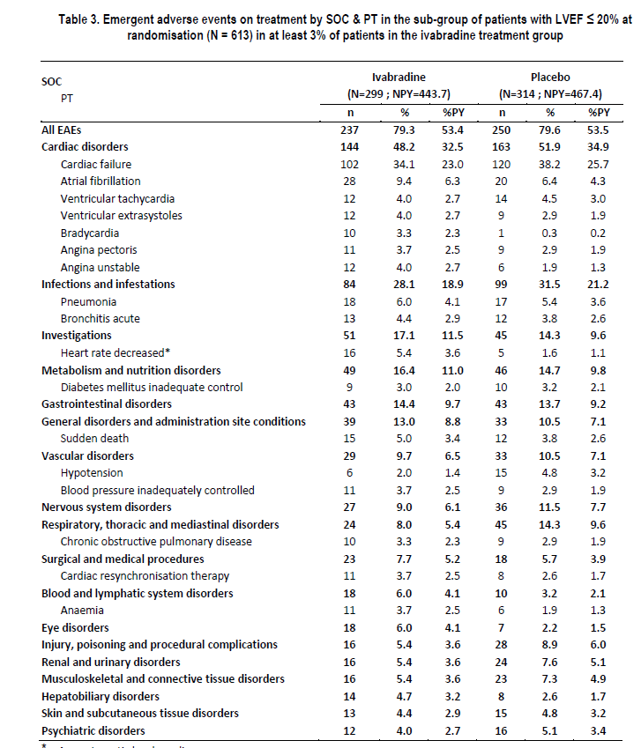

In its pre-ACPM response, the sponsor is requested to provide a short summary of the rates of the important TEAEs, including the 4 TEAEs mentioned above, in the patients aged 70 years or more in the RS BBdose compared with those in the patients aged less than 70 years in the RS BBdose population and also compared with the RS BBdose population itself.
In the Safety Set (SS) _{BBdose} population, patients aged ≥ 70 years at baseline (N=603) had a greater incidence of emergent adverse events on treatment (EAEs) (455 patients, 75.5%) compared to patients aged < 70 years (N = 2573; 1825 patients, 70.9%), and also compared to patients of the Safety Set (SS) BBdose population overall (N = 3176; 2280 patients, 71.8%).
The incidence of all EAEs was slightly higher in the ivabradine group compared to the placebo group in both age sub-groups ≥ 70 years (78.0% versus 72.6%) and < 70 years (72.3% versus 69.6%).
TEAEs reported more frequently with ivabradine than with placebo (ivabradine versus placebo) were:
- bradycardia asymptomatic: ≥ 70 years (6.9% versus 2.1%) and < 70 years (5.6% versus 1.4%),
- bradycardia symptomatic: ≥ 70 years (6.3% versus 2.5%) and < 70 years (4.5% versus 0.7%),
- atrial fibrillation: ≥ 70 years (10.7% versus 10.2%) and < 70 years (6.9% versus 5.6%),
- blood pressure inadequately controlled: ≥ 70 years (11.0% versus 6.7%).
EAEs reported less frequently with ivabradine than with placebo (ivabradine versus placebo) were related to:
- cardiac failure: ≥ 70 years (21.4% vs 26.3%) and < 70 years (18.9% versus 21.2%),
- blood pressure inadequately controlled:< 70 years (7.6% versus 8.1%).
See Table 35 below.

Table 35

The Delegate expressed concern that the sponsor’s response to the evaluator’s concern about the age make-up of the SHIFT population has too much of a focus on population means. The sponsor was asked a number of questions about other measures of comparison of the age make-up of the relevant study/audit populations.
In terms of population differences arising between clinical studies and real world practice, it is well documented that clinical studies in various therapeutic areas including cardiology and particularly in heart failure have recruited younger patients and excluded elderly patients (that is, upper age exclusions) either explicitly or implicitly (like exclusions for coexisting conditions common in older persons). A summary of the different CHF trials with mean age of patients is provided Table 36. The SHIFT trial population is consistent with other major CHF registration studies where the mean age of patients ranged from 60-65 years with the outlier being the SENIORS study (nebivolol) which specifically recruited an older population (inclusion criteria was ≥70 years and therefore the mean age was 76 years). In the European Society of Cardiology guidelines on diagnosis and treatment of heart failure, treatment recommendations are based on six main trials. The mean ages of participants in individual trials were 71 years (CONSENSUS), 61 years (SOLVD-T), 65 years (RALES), 67 years (CHARM-Alternative), 64 years (CHARM-Added) and 63 years (Val-HeFT). The weighted mean age in these trials was 63.8 years compared with the authors of the Guidelines’ estimated mean age of patients in the community with heart failure of 75 years. Notably, some of these same trials also form the basis for the Australian Heart Foundation Heart Failure guidelines. A systematic review of studies of older people and their representation in clinical trials concluded that people taking part in trials in hypertension, heart failure, Alzheimer’s disease, depression and colorectal cancer were generally younger than the people typically seen by doctors in hospitals or general practice. The available evidence on effectiveness and safety of treatments is based on younger people often because exclusion criteria in trials relate to comorbidities and concurrent treatments that are more prevalent in older people.
Table 36. Major morbidity/mortality trials in CHF (versus placebo).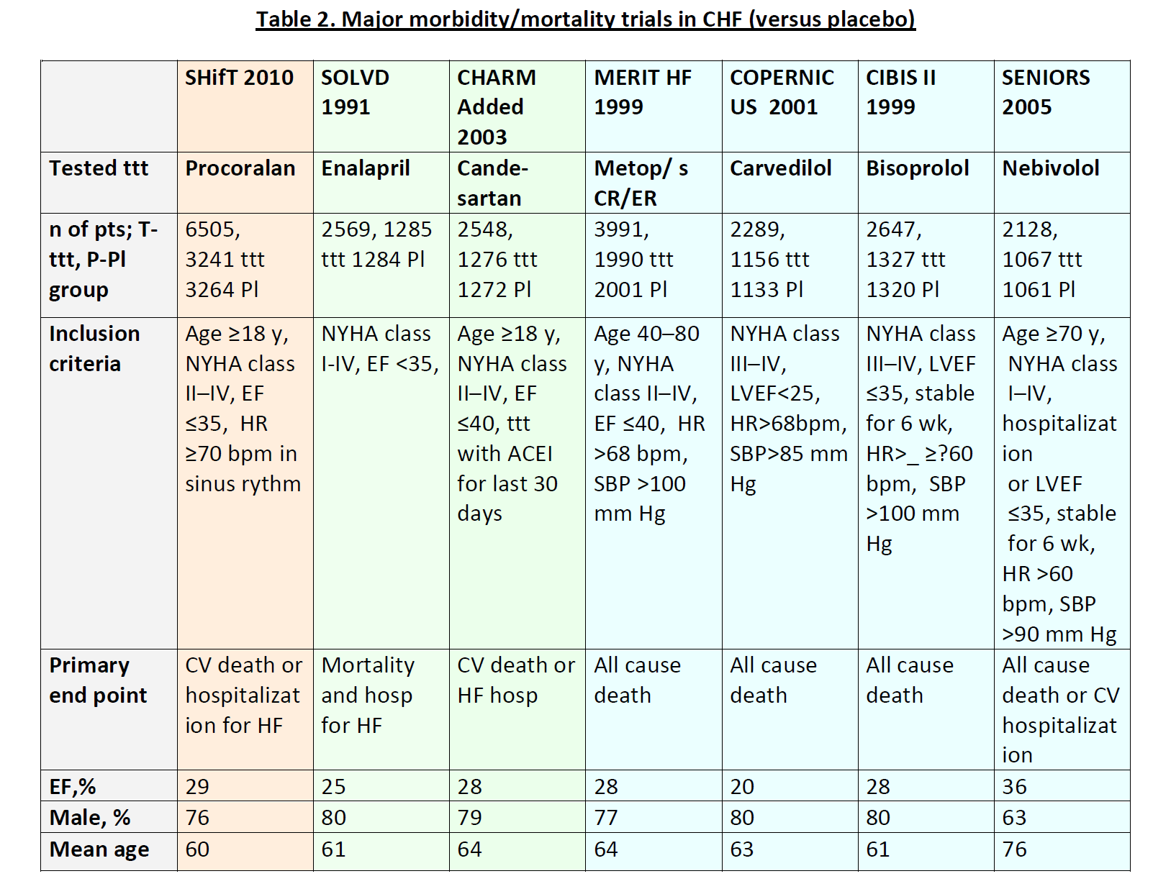
The SHIFT trial therefore is not unlike other trials, including major heart failure trials where most of the trial population is somewhat younger than the estimated mean age of patients in the community. The absolute number of patients ≥ 65 years in SHIFT is 2,474; this provides a reassuring amount of exposure in this age group.
In response to the Delegate’s question, the median age of patients in the BENCH audit was 72 years with an interquartile range (IQR) of 62.5-79 years. 68% of patients were aged ≥65 years. The median age for all heart failure patients in the WHICH audit was 74 years with an IQR of 64-81 years. Some 73% of patients were aged ≥65 years. The median age in the SHIFT study was 60 years with an IQR of 53-69 years. With 6,000 patients, SHIFT is one of the largest HF studies ever conducted in patients on optimal background treatment as recommended by Australian and International guidelines. Most studies fall in the range 2000 to 5000 patients. The 38% of patients in SHIFT aged ≥65 years represents 2,474 patients, this is a very large exposure in the elderly given the mean follow-up of 21.9 months.

The sponsor was asked to confirm that the various pre specified sub-group analyses of the primary composite endpoint in the RS population were all sufficiently statistically powered by the study enrolment and that the hazard ratio calculations were the result of a post hoc analysis.
No specific calculation of power was done for the pre specified sub-groups analyses of the primary composite endpoint in the RS population. The sponsor confirmed that the results provided were post hoc analyses.

The Delegate sought clarification of the process of arriving at the threshold HR 75 bpm. Did the sponsor for example start at the median heart rate of 77 bpm and then work backwards until non-significant interactions were achieved? So, did the sponsor first test the HR of 76 bpm? The sponsor was requested to detail precisely and in detail the process by which the value of 75 bpm for the HR threshold was actually chosen.
The EMA indicated in its evaluation of the SHIFT study that the baseline heart rate (HR) for patients with a positive benefit/risk balance may be higher than 75 bpm which could be considered as a relevant threshold in clinical practice. It is also the mean heart rate of the population included in the Euro Heart Survey conducted by the European Society of Cardiology. Servier considered the EMA’s advice and complementary analyses were subsequently performed to evaluate the efficacy and the safety of ivabradine treatment in this sub-group ≥75 bpm. Therefore, Servier did not follow any specific methodology in arriving at a threshold of > 75 bpm. This population was shown to derive a benefit from ivabradine treatment, including for mortality endpoints and was thus the population approved for the indication by EMA.

The sponsor was asked to respond to a number of questions about the analysis of efficacy in patients aged 65 years and over, particularly in comparison with those aged less than 65 years. The sponsor was requested to respond to all questions and all requests for clarification.
The following points address each of the Delegate’s questions:
- The analysis of patients aged <65 years/≥65 years and now includes the numerator/denominator equivalents of each percentage result in the second and third columns.
- Servier confirms that the test of interaction between two age strata (< 65 years and ≥65 years) in relation to the primary composite endpoint (PCE) was pre specified in the statistical analysis plan.
- The study was not powered for an analysis of interaction.
- The analyses of the PCE in the sub-groups <65 /≥ 65 years were pre specified and the interaction test was also pre specified.
- The analyses of the PCE in the sub-groups <70/≥70 years including the interaction test, were post-hoc and followed the same method as that for the pre-specified sub-group.

The sponsor was asked a number of questions about the timing of modification of antihypertensive treatment in those patients presenting with the AE ‘blood pressure inadequately controlled’. The Delegate requests answers to all questions.
The following points address each of the Delegate’s questions:
- The precise timing of anti-hypertensive treatment modification is recorded individually for each patient and this information is located in the individual patient data section of the submission dossier.
- Anti-hypertensive treatment modification was triggered by the physician at their discretion as occurs in usual clinical practice and may have occurred at any time during the trial. Not all patients who had their treatment modified necessarily reported the EAE ‘blood pressure inadequately controlled’. Modifications may not have just been related to blood pressure but may have been related to other clinical situations reported such as tolerance issues with these treatments or changes required by the management of heart failure since antihypertensive treatments are also used to treat heart failure. For example upward or downward titration of beta blocker (BB) dose or ACE inhibitors during hospitalisation for heart failure may affect blood pressure and therefore require adjustments in antihypertensive treatment. For patients who had their antihypertensive treatment modified and who presented with the EAE ‘blood pressure inadequately controlled’, antihypertensive treatment was modified between randomisation and the occurrence of the EAE. This EAE reflects the clinical practice dynamics of managing patients with symptomatic systolic heart failure.
- Twenty-five percent of the ivabradine treated patients who had this EAE were also taking diuretics at baseline.
- Since the event of blood pressure inadequately controlled has already been reported in the Overall Safety Assessment (1.2% ivabradine versus 0.4% placebo) and in Study CL3-057 (2.4% ivabradine versus 0.5% placebo), the event will be added to the RMP. This EAE was also reported in Study CL3- 056 where the incidence was similar between ivabradine treated and placebo patients (3.6% versus 3.5%) and is listed in the AE section of the current TGA-approved CORALAN PI.
- Study CL3-057 is titled ‘Evaluation of the anti-anginal efficacy and safety of oral administration of ivabradine compared to placebo on top of a background therapy with atenolol in patients with stable angina pectoris. A 4 month randomised double blind parallel group international multicentre study.’
This study was submitted to the TGA for evaluation in September 2008 to support the extension of the CORALAN ivabradine indication to allow the addition of ivabradine to beta blockers in the treatment of stable angina, and was consequently approved by the TGA on 3 September 2010.

The sponsor has been asked to clarify certain issues regarding the claim of a statistically significant improvement in NYHA class. There was no specific power calculation done for the NYHA Class Improvement at last recorded value. However the post hoc calculation for 3200 patients per treatment group shows a power of 90%. Therefore, the sponsor proposed to maintain this claim.
Servier has reviewed the Final Clinical Evaluation Report (FCER) and wishes to advise the TGA that it has noted errors of fact and material omissions. The location of the error and the correct information is provided. References to the correct information in the submission documentation are also included.
Servier notes that in some instances, material omissions have brought into question the appropriateness of the Second round assessment of benefits and Second round assessment of benefit-risk balance. It is not possible to ascertain from the FCER whether the clinical evaluator has considered and accepted the entire response or just portions of the response. The sponsor asks that if responses to the major reasons for rejection mentioned in the First Round Clinical Evaluation Report have not previously been considered, that the Delegate consider this prior to finalising the Overview.
The sponsor did not agree that “the additional efficacy data submitted [with the response to the first CER], did not change the efficacy profile.” Additional data particularly test for interaction submitted but not mentioned in the FCER does potentially change the efficacy profile and the sponsor asked that the appropriateness of this statement be reconsidered in light of these material omissions and the information provided hereafter.
Servier accepted the conclusion in the report that the safety profile has improved however they did not agree that a special precaution in patients aged ≥ 65 years is warranted given that additional data submitted with Servier’s response to the first CER shows:
- Age has been clearly shown not to be a modifier of treatment efficacy or safety
- Higher incidences of TEAEs in more elderly group might be reflecting generally higher incidences in more elderly subgroup compared to those younger.
- The risk of Serious AEs such as atrial fibrillation and Symptomatic bradycardia is not ‘higher’ in ≥ aged 65 years but in fact lower than in patients aged < 65 years
Since sections of the clinical evaluation reports may be reproduced in the AusPAR, Servier believes that these evaluation reports should accurately reflect the information provided to and evaluated by the TGA.

Advisory committee considerations
The Advisory Committee on Prescription Medicines (ACPM) (which has succeeded ADEC), having considered the evaluations and the Delegate’s overview, as well as the sponsor’s response to these documents, advised the following:
The application seeks to register an extension of indications for a currently registered product.
The ACPM taking into account the submitted evidence of efficacy, safety and quality considered this product to have an overall negative benefit-risk profile.
In making this recommendation the ACPM considered efficacy was not significantly demonstrated and presented an uncertain overall benefit-risk balance.
The ACPM further advised that the benefit was based on indirect assumptions and subgroup analysis and as a result was neither applicable in general or of significant clinical meaning to the broader, particularly older, population.
The ACPM expressed significant concerns regarding the conduct of the trial noting the incomplete blinding and other irregularities at two sites.

Outcome
Based on a review of quality, safety and efficacy, TGA approved the registration of Coralan containing ivabradine for the new indication:

Treatment of chronic heart failure
Treatment of symptomatic chronic heart failure of NYHA Classes II or III and with documented left ventricular ejection fraction (LVEF) ≤ 35% in adult patients in sinus rhythm and with heart rate at or above 77 bpm, in combination with optimal standard chronic heart failure treatment.
The full indications are now:

Treatment of coronary artery disease
Treatment of chronic stable angina due to atherosclerotic coronary artery disease in patients with normal sinus rhythm, who are unable to tolerate or have a contraindication to the use of beta blockers, OR in combination with atenolol 50mg once daily when heart rate is at or above 60 bpm and angina is inadequately controlled.

Treatment of chronic heart failure
Treatment of symptomatic chronic heart failure of NYHA Classes II or III and with documented left ventricular ejection fraction (LVEF) ≤ 35% in adult patients in sinus rhythm and with heart rate at or above 77 bpm, in combination with optimal standard chronic heart failure treatment.

Specific Conditions Applying to These Therapeutic Goods:
- The sponsor will implement in full the Risk Management Plan version number 2, final version dated 16 December 2011, and any updated versions as agreed with the Office of Product Review.

Attachment 1. Product Information
The following Product Information was approved at the time this AusPAR was published. For the current Product Information please refer to the TGA website at <http://www.tga.gov.au/hp/information-medicines-pi.htm>.

¹ American Heart Foundation, 2009 Focused Update Incorporated Into the ACC/AHA 2005 Guidelines for the Diagnosis and Management of Heart Failure in Adults, Circulation, 119:e391-e479, 2009.
Australian Institute of Health and Welfare (AIHW) and the National Heart Foundation of Australia (NHFA). Heart, stroke and vascular diseases - Australian facts 2004.
http://www.aihw.gov.au/publication-detail/?id=6442467598 (accessed 20 September 2011)
All aetiologies of CHF were included, except congenital heart disease, severe aortic or mitral stenosis, severe aortic regurgitation, or severe primary mitral regurgitation
New York Heart Association functional classification of heart failure. NYHA Class I: No symptoms and no limitation in ordinary physical activity. NYHA Class II: Mild symptoms (mild shortness of breath and/or angina) and slight limitation during ordinary activity. NYHA Class III: Marked limitation in activity due to symptoms, even during less-than-ordinary activity, e.g. walking short distances (20–100 m). Comfortable only at rest. NYHA Class IV: Severe limitations. Experiences symptoms even while at rest. Mostly bed-bound patients.
These were, history of stroke or cerebral transient ischaemic attack within the previous 4 weeks; severe aortic or mitral stenosis, or severe aortic regurgitation, or severe primary mitral regurgitation; scheduled surgery for valvular heart disease; active myocarditis; congenital heart diseases; previous cardiac transplantation or on list for cardiac transplantation; cardiac resynchronisation therapy started within the previous 6 months; pacemaker with atrial or ventricular pacing (except bi-ventricular pacing) > 40% of the time, or with a stimulation threshold at the atrial or ventricular level ≥ 60 bpm; permanent atrial fibrillation or flutter; sick sinus syndrome, sinoatrial block, 2nd and 3rd degree atrio-ventricular block, history of symptomatic or sustained (≥ 30 sec) ventricular arrhythmia unless a cardioverter defibrillator was implanted; any cardioverter defibrillator shock experienced within the previous 6 months; patients with familial history of or congenital long QT syndrome or treated with selected QT prolonging products; severe or uncontrolled hypertension (sitting systolic blood pressure > 180 mmHg or sitting diastolic blood pressure > 110 mmHg); sitting systolic blood pressure < 85 mmHg or current symptomatic hypotension.
TGA adopted EU guideline: Notes for guidance on clinical investigation of medicinal products for treatment of cardiac failure. (CPMP/EWP/235/95 Rev 1).
Australian Product Information, ivabradine.
The study protocol listed these as macrolide antibiotics known to be strong CYP3A4 inhibitors (such as clarithromycin, erythromycin, telithromycin, josamycin, etc), cyclosporin, antiretroviral drugs (such as ritonavir, nelfinavir, saquinavir, delavirdine, etc), azole antifungal agents administered by systemic route (such as ketoconazole, itraconazole, etc), and nefazodone.
QT interval: a measure of the time between the start of the Q wave and the end of the T wave in the heart's electrical cycle. A prolonged QT interval is a risk factor for ventricular tachyarrhythmias and sudden death.
Internal report NP15194. CL3-16257-017 Study. Evaluation of the anti-anginal efficacy and safety of oral chronic administration of ivabradine (5 mg b.i.d. then 7.5 mg b.i.d. or 10 mg b.i.d.) compared to atenolol (50 mg o.d. then 100 mg o.d.) in patients with stable effort angina pectoris. A 4-month international multicentre, parallel group, double-blind, randomised, controlled trial.
Australian Product Information, ivabradine.
These were defined as a dose equal to or higher than the following dose for each beta-blocker: Carvedilol 25 mg, Metoprolol succinate 95 mg, Bisoprolol 5 mg, Nebivolol 5 mg. These doses were derived from the European Society of Cardiology (ESC) guidelines (Swedberg K, et al. Guidelines for the diagnosis and treatment of chronic heart failure: executive summary (update 2005): the Task Force for the Diagnosis and Treatment of Chronic Heart Failure of the European Society of Cardiology. Eur Heart J 26:1115-1140, 2005). In addition, metoprolol tartrate was added to this list as it is indicated for the treatment of patients with heart failure in several countries participating in the study, with the target dose defined as 150 mg (i.e. “at least half of recommended target daily dose” defined as metoprolol tartrate 75 mg). This was based on a study by Waagstein et al, 1993 (Waagstein F, et al. Beneficial effects of metoprolol in idiopathic dilated cardiomyopathy. Lancet. 342:1441-6, 1993.)
Fox K, et al. Ivabradine for patients with stable coronary artery disease and left-ventricular systolic dysfunction (BEAUTIFUL): a randomised, double-blind, placebo-controlled trial. Lancet 372:807–816, 2008.
TGA-adopted ICH Topic E9: Note for Guidance on Statistical Principles for Clinical Trials. September 1998.
The sponsor stated that these prognostic factors were chosen in accordance with the European Society of Cardiology (ESC) guidelines for the diagnosis and treatment of acute and chronic heart failure, 2008.
The RS population was divided into pre-defined subgroups according to baseline values of: age (< 65 / ≥65 years), gender (male/female), beta-blocker intake at randomisation (yes/no), primary cause of HF (ischaemic cause/non ischaemic cause), NYHA class (II / III or IV), diabetes (yes/no), hypertension (yes/no), heart rate for patients in sinus rhythm (< 77 bpm / ≥ 77 bpm) (77 bpm was the median HR value for randomised patients).
Response to EMA queries question no. 14. Analysis which included the 46 patients showed a relative risk reduction in favour of ivabradine of 18% (hazard ratio 0.82, 95% CI [075-090], p<0.0001).
Sponsor comment: “The CSR did specify in sections 10.3 and 9.8.2.1 that exclusion occurred before unblinding.”
Global compliance (%) was calculated as (Σ number of tablets taken / (duration of treatment x 2)) x 100
Australian Institute of Health and Welfare (AIHW) and the National Heart Foundation of Australia (NHFA). Heart, stroke and vascular diseases - Australian facts 2004. Canberra: National Centre for monitoring cardiovascular disease; 2004.
Australian Institute of Health and Welfare (AIHW) and the National Heart Foundation of Australia (NHFA). Heart, stroke and vascular diseases - Australian facts 2004. Canberra: National Centre for monitoring cardiovascular disease; 2004.
Australian Institute of Health and Welfare (AIHW) and the National Heart Foundation of Australia (NHFA). Women and heart disease- Cardiovascular profile of women in Australia. June 2010
Sponsor comment: “95% confidence intervals were indeed presented demonstrating statistical significance for all subgroups except the sub-groups of patients ≥65 years and having HR<77 bpm at baseline.”
Sponsor comment: “95% confidence intervals were indeed presented demonstrating no statistical significance.”
Sponsor comment: “ The 95%confidence interval of [0.70;1.14] given showed that the reduction was not statistically significant.
Sponsor comment: “The 95%confidence intervals respectively of [0.51;1.00] and [0.68;1.23] are given, showing that the reductions are not significant.”
Sponsor comment: “Death from heart failure was statistically significant”.
Sponsor comment: “Except for death from heart failure.”
Sponsor comment: “As stated in the approved PI “In ivabradine-treated patients with a baseline heart rate ≥ 77 bpm, the primary composite endpoint was reduced by 25% (p<0.0001); cardiovascular death by 19% (p=0.0137) (absolute risk reduced by 3.0%); and hospitalisation for worsening heart failure by 31% (p=<0.0001) (absolute risk reduced by 6.6%) (refer to Table 3), compared to patients on placebo.””
NT-pro-BNP is a prognostic marker in patients with CHF
In the study, annual incidence was calculated as % patient-years (%PY). This was calculated as the ratio between the number of patients having experienced the events and the number of patient-years, expressed for 100 patient-years.
HR < 50 bpm
Paragraph corrected (underlined text added) as per typographical error noted in Second Round Benefit-Risk Assessment; Benefits: “While the results showed that there was no increased risk of the mortality endpoints with ivabradine compared to placebo, there was no statistically significant difference in favour of ivabradine over placebo in most of the mortality endpoints analysed in the study in the general study population (RS dataset), where only the endpoint of death from heart failure was statistically significant (RRR 26%; p=0.014). There was no statistically significant difference in favour of ivabradine over placebo in all the mortality endpoints analysed in the study in the sub-population of patients who were on at least 50% of the optimal beta blocker dose (RS_{BBdose} dataset). In fact, in the RS_{BBdose} dataset, there was no discernible difference between treatment groups in the endpoints of all-cause mortality and of cardiovascular death (relative risk reduction of 1% and 0%, respectively).”
Sponsor comment: The analysis for statistical significance in the subgroups of patients with baseline HR≥ 77BPM and <77 bpm against placebo were subsequently provided by the sponsor and are presented in the approved PI.
Sponsor comment: “The sponsor subsequently explained in its Pre ACPM response that the criterion of ≥75 bpm was chosen because the EMA indicated in its evaluation of the SHifT study that ‘the baseline heart rate (HR) for patients with a positive benefit/risk balance may be higher than 75 bpm which could be considered as a relevant threshold in clinical practice.’ It is also the mean heart rate of the population included in the Euro Heart Survey conducted by the European Society of Cardiology. The sponsor considered the EMA’s advice and complementary analyses were subsequently performed to evaluate the efficacy and the safety of ivabradine treatment in this sub-group, ≥ 75 bpm. Therefore, the sponsor did not follow any specific methodology in arriving at a threshold of > 75 bpm.“
Sponsor comment: “The sponsor provided this data in its response to the first clinical evaluation report and also in its review of the final clinical evaluation report.”
At Day 28, the mean (± SD) change in HR from baseline in the ivabradine group was -15.4 ± 10.7 bpm and -15.5 ± 10.7 bpm in the RS and RS_{BBdose} populations, respectively. At the last post-randomisation visit, the corresponding change was -12.0 ± 13.3 bpm and -12.0 ± 12.8 bpm, respectively.
Sponsor comment: “This analysis had been done and was provided in the responses to the questions raised by the EMA. The sponsor subsequently forwarded a copy of the EMA questions and responses with its response to the Consolidated Section 31 Request for Information.”
Australian Institute of Health and Welfare (AIHW) and the National Heart Foundation of Australia (NHFA). Heart, stroke and vascular diseases - Australian facts 2004.
Sponsor comment: “The sponsor provided this data in its response to the first clinical evaluation report and in its review of the final clinical evaluation report. The analysis provided enabled a comparison of the sub-group of patients aged ≥ 65 years with HR ≥ 75 bpm with patients from the Randomised Set (RS). The relevant table summarising the results of this analysis, which was included in the sponsor’s review, is shown below (Table 29).”
Sponsor comment: “The RMP reviewed by the OPR was eventually superseded by an updated version implemented at the time of TGA registration.”
PV=Pharmacovigilance
Sponsor comment: “Registration and ad hoc follow-up of spontaneous cases with reinforcement of the routine Pharmacovigilance procedures from prescription sources : - all excessive bradycardia (<40 bpm or symptomatic) reported to the Company will be considered as important medical events and will be reported to the local authority and for non-EU cases to the EMA. - all AF and other SVT reported to the Company will be considered as important medical events and will be reported to the local authority and for non-EU cases to the EMA. RMP version 10/11/2010”
Sponsor comment: “As requested by the Delegate, the Risk Management Plan version 2, final version dated 16 December 2011 was implemented at the time of TGA approval of this submission and was current at the time this AusPAR was written.”
The WHICH study (Stewart, Carrington et al. 2011a; 2011b) – a prospective comparison of HF patients attending a specialist CHF outpatient clinic vs. a nurse-led, home-based intervention;
The National Benchmarking and Evidence-Based National Clinical Guidelines for HF Management Programs (BENCH) study – a prospective comparison of HF programs; and
The Alfred HF Clinic (Porapakkham and Krum 2010) – a retrospective analysis of patients from the HF Clinic at the Alfred Hospital in Melbourne.
Swedburg, K et al, Ivabradine and outcomes in chronic heart failure (SHIFT): a randomised placebo-controlled study, Lancet 2010;376:875-85; published online August 29, 2010 D0I:10.1016/S0140-6736(10)61198-1; copy of paper provided by sponsor as attachment to the sponsor’s response.
Sponsor comment:” Corrections as per sponsor’s e-mail to the Delegate on the 10 February 2012: N=4150”
Swedburg, K et al, Ivabradine and outcomes in chronic heart failure (SHIFT): a randomised placebo-controlled study, Lancet 2010;376:875-85; published online August 29, 2010 D0I:10.1016/S0140-6736(10)61198-1; copy of paper provided by sponsor as attachment to s31 response; study limitations are discussed on page 883
Beswick et al. PREDICT Review: Increasing the participation of elderly in clinical trials Work Package 1. Literature review, Universities of Bristol and Oxford, Nov. 2008.
Guidelines for the prevention, detection and management of chronic heart failure in Australia. Updated October 2011.
Beswick et al. PREDICT Review: Increasing the participation of elderly in clinical trials Work Package 1. Literature review, Universities of Bristol and Oxford, Nov. 2008.
Cleland JG, Swedberg K, Follath F, Komajda M, Cohen-Solal A, Aguilar JC, Dietz R, Gavazzi A, Hobbs R, Korewicki J, Madeira HC, Moiseyev VS, Preda I, van Gilst WH, Widimsky J, Freemantle N, Eastaugh J, Mason J; Study Group on Diagnosis of the Working Group on Heart Failure of the European Society of Cardiology. The EuroHeart Failure survey programme . a survey on the quality of care among patients with heart failure in Europe. Part 1: patient characteristics and diagnosis. Eur Heart J 2003;214:442.463
In the sponsor’s Clinical Study Report.

