November 2020

Australian Public Assessment Report for Isatuximab
  - Proprietary Product Name: Sarclisa
  - Sponsor: Sanofi-Aventis Australia Pty Ltd

About the Therapeutic Goods Administration (TGA)
- The Therapeutic Goods Administration (TGA) is part of the Australian Government Department of Health and is responsible for regulating medicines and medical devices.
- The TGA administers the Therapeutic Goods Act 1989 (the Act), applying a risk management approach designed to ensure therapeutic goods supplied in Australia meet acceptable standards of quality, safety and efficacy (performance) when necessary.
- The work of the TGA is based on applying scientific and clinical expertise to decision-making, to ensure that the benefits to consumers outweigh any risks associated with the use of medicines and medical devices.
- The TGA relies on the public, healthcare professionals and industry to report problems with medicines or medical devices. TGA investigates reports received by it to determine any necessary regulatory action.
- To report a problem with a medicine or medical device, please see the information on the TGA website <https://www.tga.gov.au>.

About AusPARs
- An Australian Public Assessment Report (AusPAR) provides information about the evaluation of a prescription medicine and the considerations that led the TGA to approve or not approve a prescription medicine submission.
- AusPARs are prepared and published by the TGA.
- An AusPAR is prepared for submissions that relate to new chemical entities, generic medicines, major variations and extensions of indications.
- An AusPAR is a static document; it provides information that relates to a submission at a particular point in time.
- A new AusPAR will be developed to reflect changes to indications and/or major variations to a prescription medicine subject to evaluation by the TGA.

Copyright
© Commonwealth of Australia 2020
This work is copyright. You may reproduce the whole or part of this work in unaltered form for your own personal use or, if you are part of an organisation, for internal use within your organisation, but only if you or your organisation do not use the reproduction for any commercial purpose and retain this copyright notice and all disclaimer notices as part of that reproduction. Apart from rights to use as permitted by the Copyright Act 1968 or allowed by this copyright notice, all other rights are reserved and you are not allowed to reproduce the whole or any part of this work in any way (electronic or otherwise) without first being given specific written permission from the Commonwealth to do so. Requests and inquiries concerning reproduction and rights are to be sent to the TGA Copyright Officer, Therapeutic Goods Administration, PO Box 100, Woden ACT 2606 or emailed to <tga.copyright@tga.gov.au>.

Contents
Common abbreviations 4
I. Introduction to product submission 7
Submission details 7
Product background 8
Regulatory status 10
Product Information 10
II. Registration timeline 10
III. Submission overview and risk/benefit assessment 11
Quality 11
Nonclinical 11
Clinical 13
Risk management plan 23
Risk-benefit analysis 24
Outcome 36
Attachment 1. Product Information 37

Common abbreviations
Abbreviation | Meaning
ACM | Advisory Committee on Medicines
ADA | Anti-drug antibody
ADCC | Antibody dependent cell mediated cytotoxicity
ADCP | Antibody dependent cellular phagocytosis
AE | Adverse event
ARTG | Australian Register of Therapeutic Goods
ASA | Australian specific Annex
BOR | Best overall response
BPM | Beats per minute
CBR | Clinical benefit rate
CD38 | Cluster of differentiation 38
CDC | Complement dependent cytotoxicity
CHMP | Committee for Medicinal Products for Human Use (European Union)
CHO | Chinese hamster ovary
CL | Clearance
C_{max} | Maximum plasma concentration
CNS | Central nervous system
CR | Complete response
CV | Coefficient of variation
DLBCL | Diffuse large B cell lymphoma
DLP | Data lock point
DOR | Duration of response
DP | Drug product
ECG | Electrocardiogram
EMA | European Medicines Agency (European Union)
EU | European Union
Fc | Fragment crystalline
FDA | Food and Drug Administration (United States)
G-CSF | Granulocyte colony-stimulating factor
GLP | Good Laboratory Practice
HR | Heart rate
ICH | International Council for Harmonisation of Technical Requirements for Pharmaceuticals for Human Use
IgG | Immunoglobulin G
IgG1κ | Immunoglobulin G1 kappa
IR | Infusion reaction
IRC | Independent Review Committee
ISE | Integrated summary of efficacy
ISS | Integrated summary of safety
IV | Intravenous
MM | Multiple myeloma
MRD | Minimal residual disease
NK | Natural killer
ORR | Overall response rate
OS | Overall survival
PBMC | Peripheral blood mononuclear cell
PD | Pharmacodynamic(s)
PFS | Progression free survival
PI | Product Information (drug document)
PK | Pharmacokinetic(s)
PR | Partial response
Q2W | Every two weeks
Q4W | Every four weeks
QW | Once weekly
RMP | Risk management plan
RRMM | Relapsed or refractory multiple myeloma
SCC | Squamous cell carcinoma
sCR | Stringent complete response
SCS | Summary of clinical safety
SPM | Second primary malignancy
TEAE | Treatment emergent adverse event
TLS | Tumour lysis syndrome
Treg | Regulatory T cell
US | United States (of America)
USPI | United States Prescribing Information
V1 | Apparent volume
VGPR | Very good partial response

I. Introduction to product submission

Submission details
Type of submission: | New biological entity
Product name: | Sarclisa
Active ingredient: | Isatuximab
Decision: | Approved
Date of decision: | 29 April 2020
Date of entry onto ARTG: | 6 May 2020
ARTG numbers: | 319085, 319086
Black Triangle Scheme: | Yes  This product will remain in the scheme for 5 years, starting on the date the product is first supplied in Australia
Sponsor’s name and address: | Sanofi-Aventis Australia Pty Ltd  12-24 Talavera Road,  Macquarie Park, NSW 2113
Dose form: | Concentrated injection
Strengths: | 500 mg/25 mL and 100 mg/5 mL
Container: | Vial
Pack sizes: | 500 mg/25 mL: 1 vial pack  100 mg/5 mL: 1; or 3 vial packs
Approved therapeutic use: | Sarclisa is indicated in combination with pomalidomide and dexamethasone, for the treatment of patients with multiple myeloma (MM) who have received at least two prior therapies including lenalidomide and a proteasome inhibitor (PI).
Route of administration: | Intravenous
Dosage: | The recommended dose of Sarclisa is 10 mg/kg body weight administered as an intravenous infusion (IV) in combination with pomalidomide and dexamethasone.  For further information regarding dosage, refer to the Product Information.
Pregnancy category: | C  Drugs which, owing to their pharmacological effects, have caused or may be suspected of causing, harmful effects on the human fetus or neonate without causing malformations. These effects may be reversible. Accompanying texts should be consulted for further details.  The use of any medicine during pregnancy requires careful consideration of both risks and benefits by the treating health professional. This must not be used as the sole basis of decision making in the use of medicines during pregnancy. The TGA does not provide advice on the use of medicines in pregnancy for specific cases. More information is available from obstetric drug information services in your State or Territory.

Product background
This AusPAR describes the application by Sanofi-Aventis Australia Pty Ltd (the sponsor) to register Sarclisa (isatuximab) 500 mg/25 mL and 100 mg/5 mL concentrated injection for intravenous (IV) infusion for the following proposed indication:
Sarclisa is indicated in combination with pomalidomide and dexamethasone, for the treatment of patients with multiple myeloma (MM) who have received at least two prior therapies including lenalidomide and a proteasome inhibitor (PI).
Multiple myeloma (MM) is a malignant disorder of plasma cells characterised by uncontrolled and progressive proliferation of a plasma cell clone. The proliferation of myeloma cells causes displacement of normal bone marrow hematopoietic precursors and the overproduction of monoclonal antibodies. The disease most commonly presents with hypercalcaemia, renal failure, anaemia and bone lesions (CRAB features)., There is no cure for MM and the disease leads to progressive morbidity and death. Treatment of MM in patients who have not responded to treatment, including lenalidomide and proteasome inhibitors, is particularly challenging.
MM accounts for about 10% of all haematological malignancies. The annual incidence of myeloma in Australia is about 7 to 8 cases per 100,000 population for males and about 4 to 5 cases per 100,000 population for females. The 1 and 5 year relative survival rates at diagnosis for all patients in Australia for the period 2009 to 2013 were 81.9% and 48.5%, respectively.4 Based on Australian data for 2013 (incidence) and 2014 (mortality), the median age of patients at the time of diagnosis is 70.9 years and the median age at death is 76.0 years, with both incidence and mortality age data being similar for males and females.4
Until recently, the prognosis for relapsed patients and patients who are refractory to lenalidomide and bortezomib has been very poor. However, a number of new drugs have been introduced for the treatment of patients with relapsed or refractory multiple myeloma (RRMM), including daratumumab, carfilzomib and pomalidomide. These drugs have improved the outlook for patients with advanced disease.
Current treatment options for Australian patients who fail treatment with lenalidomide and proteasome inhibitors include daratumumab monotherapy and pomalidomide based therapies. Daratumumab; an immunoglobulin G1 kappa (IgG1κ) human monoclonal antibody against cluster of differentiation 38 (CD38) antigen, is approved in Australia as monotherapy for patients with MM who have received at least three prior lines of therapy including a proteasome inhibitor and an immunomodulatory agent or who are refractory to both a proteasome inhibitor and an immunomodulatory agent. Pomalidomide; is approved in Australia in combination with dexamethasone for the treatment of patients with relapsed and refractory multiple myeloma who have received at least two prior treatment regimens, including both lenalidomide and bortezomib, and have demonstrated disease progression on the last therapy.
Isatuximab binds selectively to CD38 membrane protein and leads to the death of CD38 expressing tumour cells by acting through immunoglobulin G (IgG) fragment crystalline (Fc)-dependent mechanisms including antibody dependent cell mediated cytotoxicity (ADCC), antibody dependent cellular phagocytosis (ADCP), and complement dependent cytotoxicity (CDC). Isatuximab can also trigger tumour cell death by induction of apoptosis via an Fc-independent mechanism. The sponsor comments that compared with the approved anti-CD38 agent daratumumab, isatuximab has a distinct mechanism of action, including different binding epitope and different sensitivity to the CD38 receptor density and structural Fc domain. MM is considered to be an appropriate target disease for an anti-CD38 agent because of the high and uniform expression of CD38 on malignant plasma cells.
The sponsor states that novel agents and combinations are constantly needed to improve disease control and delay progression, prevent or improve myeloma-related complications and ultimately improve survival. Genetic and molecular analyses have revealed the complexity and heterogeneity of MM, highlighting the need for therapeutic strategies that encompass multiple modes of action. Agents with alternative or improved target specificity and new combination approaches triggering multiple cytotoxic mechanisms are needed to overcome resistance to available therapies and further improve patient outcomes. Isatuximab belongs to a novel class of agents with a novel mechanism of action and thus offers an additional therapeutic option for the treatment of MM.
The application for the registration of Sarclisa (isatuximab) has been made under the ACSS (Australia, Canada, Singapore and Switzerland) Consortium work sharing program with Health Canada.

Regulatory status
This product is considered a new chemical entity medicine for Australian regulatory purposes. This is the first application for Australian registration of isatuximab.
At the time the TGA considered this application, applications have been made to the European Medicines Agency (EMA) of the European Union (EU) and United States (US) Food and Drug Administration (FDA) to register isatuximab, but no regulatory decisions had been issued worldwide.

Product Information
The Product Information (PI) approved with the submission which is described in this AusPAR can be found as Attachment 1. For the most recent PI, please refer to the TGA website at <https://www.tga.gov.au/product-information-pi>.

II. Registration timeline
The following table captures the key steps and dates for this application and which are detailed and discussed in this AusPAR.
Table 1: Timeline for Submission PM-2019-02568-1-6
Description | Date
Designation (Orphan); | 14 May 2019
Submission dossier accepted and first round evaluation commenced | 30 July 2019
First round evaluation completed | 20 November 2019
Sponsor provides responses on questions raised in first round evaluation | 23 December 2019
Second round evaluation completed | 28 February 2020
Delegate’s Overall benefit-risk assessment and request for Advisory Committee advice | 24 February 2020
Sponsor’s pre-Advisory Committee response | 16 March 2020
Advisory Committee meeting | 2 and 3 April 2020
Registration decision (Outcome) | 29 April 2020
Completion of administrative activities and registration on the ARTG | 6 May 2020
Number of working days from submission dossier acceptance to registration decision* | 166
*Statutory timeframe for standard applications is 255 working days

III. Submission overview and risk/benefit assessment
The submission was summarised in the following Delegate’s overview and recommendations.
This section is a TGA summary of wording used in TGA’s evaluation report, which discussed numerous aspects of overseas evaluation reports and included some information that was commercial-in-confidence.

Quality
Isatuximab is an IgG1-derived monoclonal antibody that binds to a specific extracellular epitope of CD38 receptor and triggers several mechanisms leading to the death of CD38 expressing tumor cells. It is produced from a mammalian cell line (Chinese hamster ovary, CHO) using a fed-batch production process. The isatuximab drug product (DP) is supplied as a sterile 20 mg/mL concentrate solution for infusion in two single-use vial presentations, 500 mg/25 mL and 100 mg/5 mL, and is administered by a healthcare professional. The Sarclisa DP must be diluted with 0.9% sodium chloride or dextrose 5% solution before an intravenous infusion in combination with pomalidomide and dexamethasone. Each treatment cycle consists of a 28 day period and is repeated until disease progression or unacceptable toxicity.
The drug substance is stored in a 20 L polycarbonate bottle with polypropylene screw closure at ≤ -30°C whereas the drug product is stored in either a colourless clear Type I glass vial of 30 mL or 6 mL at 5 ± 3°C, protected from light. The provided data support the proposed shelf life of 36 months for drug substance and drug product.
There are no objections on quality grounds to the approval of Sarclisa.

Nonclinical
The following points were summarised in the nonclinical evaluation:
- The nonclinical dossier was adequate in scope according to the relevant TGA-adopted guidelines;, but limited due to the species specificity of isatuximab. The submitted studies were of high quality, and the main toxicity study was Good Laboratory Practice (GLP) compliant.
- CD38 is a transmembrane glycoprotein with ectoenzymatic activity that is highly expressed on MM cells. In vitro studies established that isatuximab binds to human CD38 with subnanomolar affinity, potently inhibits CD38 enzymatic activity, and triggers cell death of human MM and other CD38-expressing tumour cell lines through multiple mechanisms: direct induction of apoptosis, ADCC, CDC and ADCP. Isatuximab was also shown to modulate immune cell activity, activating natural killer (NK) cells and enhancing their lytic activity, and inhibiting regulatory T cells (Tregs) in vitro.
- Anti-tumour activity was demonstrated for isatuximab in mice bearing human MM and diffuse large B cell lymphoma (DLBCL) tumour xenografts.
- In vitro cytotoxicity and in vivo anti-tumour activity by isatuximab were enhanced in combination with pomalidomide.
- Isatuximab and the existing anti-CD38 antibody, daratumumab (Darzalex), bind to human CD38 with comparable affinity but at distinct epitopes and show differences in functional activity.
- In secondary pharmacodynamic studies conducted in vitro, isatuximab did not cause significant cytokine release from normal human peripheral blood mononuclear cells (PBMCs), did not stimulate proliferation of PBMCs, and did not induce apoptosis of B cells, T cells or monocytes, but was found to increase the number of apoptotic NK cells.
- Isatuximab recognised chimpanzee CD38, but not the form of CD38 in standard laboratory species (including mouse, rat, guinea pig, rabbit, dog, cynomolgus monkey and rhesus monkey). Two antibodies against monkey CD38 were explored as potential surrogates for isatuximab for use in toxicity testing but lacked isatuximab’s ability to induce apoptosis.
- With ethical concerns over the use of chimpanzees and potential surrogate antibodies not suitable due to differences in functional activity, the sponsor investigated general safety in a study performed with isatuximab in cynomolgus monkeys, involving intravenous (IV) administration once weekly for 3 weeks. No adverse effects were observed up to the highest dose tested (100 mg/kg/week), including to endpoints relating to cardiovascular, respiratory and central nervous system (CNS) function. This study is of very limited predictive value given that the cynomolgus monkey is not a pharmacologically relevant species for isatuximab, and the short duration of the study and the small number of animals used hinders identification of potential off-target effects. ICH S6 (R1);10 discourages the conduct of toxicity studies in non-pharmacologically relevant species.
- Information on the tissue expression of CD38, the tissue staining pattern of isatuximab, and the phenotype of CD38-knockout animals offer insight into the potential toxicity of isatuximab in the absence of a useful repeat-dose toxicity study. While isatuximab is seen to target CD38 with high specificity, CD38 is expressed in various lymphoid and non-lymphoid tissues, including the prostate, pituitary, lung and brain where isatuximab staining was observed in immunohistochemistry experiments. No CNS toxicity by isatuximab would be expected, though, given the operation of the blood-brain barrier to prevent antibody penetration. Published literature on CD38-knockout mice suggest the potential for isatuximab to impair glucose tolerance and lower serum insulin levels; reduce bone mineral density; and impair the humoural immune response.
- Consistent with the relevant;9,10 TGA-adopted International Council for Harmonisation of Technical Requirements for Pharmaceuticals for Human Use (ICH) guidelines, no studies on genotoxicity, carcinogenicity, fertility and early embryonic development, and pre-/postnatal development were submitted. Effects on embryofetal development were not investigated due to the absence of appropriate animal models. CD38 is not seen to have a critical role in development based on the viability and gross normal appearance of CD38-knockout mice, but these animals do display neurological deficits and impairments to bone, pancreatic β-cell function and the immune system, suggesting the potential for pharmacologically mediated adverse effects with exposure to isatuximab in utero. Pregnancy Category C, as the sponsor proposes, is considered appropriate.
- Isatuximab was well tolerated locally by the IV route in rabbits and monkeys. Haemocompatibility was demonstrated in vitro using human blood/plasma.
There are no nonclinical objections to the registration of Sarclisa for the proposed indication.
The nonclinical evaluator has requested several amendments to the PI.
It is noted that isatuximab is not expected to have significant genotoxic potential.

Clinical
The clinical data submitted supporting the proposed indication and treatment regimen are summarised below:
- Two clinical efficacy and safety studies directly related to treatment with isatuximab in combination with pomalidomide and dexamethasone for the proposed indication:
  - Study EFC14335 (also known as the ICARIA trial); a Phase III study identified by the sponsor as the pivotal efficacy and safety study; and
  - Study TCD14079; a Phase Ib study identified by the sponsor as providing supportive data.
  - These two studies also provided pharmacokinetic (PK) and pharmacodynamic (PD) data.
- Two clinical studies providing isatuximab single-agent PK, PD, efficacy and safety data in patients with RRMM and CD38+ advanced haematological malignancies:
  - Study TED10893 (Phase I/II), the first in humans study with isatuximab; and
  - Study TED14154 (Phase I, Phase II Stages 1 and 2).
- Two clinical studies providing PK, PD, efficacy and safety data for isatuximab in combination with agents other than pomalidomide and dexamethasone for the treatment of MM:
  - Study TCD11863 (Phase Ib) isatuximab in combination with lenalidomide and dexamethasone for the treatment of RRMM; and
  - Study TCD13983 (Phase Ib) isatuximab in combination with bortezomib based regimens for the treatment of patients with newly diagnosed MM (NDMM) not eligible for transplant.
- Seven population PK reports:
  - ReportsPOH365; POH0458; POH0503; POH0461; BAY0057; POH0487; and POH0460.
  - The key population PK report is POH0503, which pools data from the two single agent studies, Study TED10893 (Phase I, Phase II Stage 1 and 2) and Study TED14154 (Part A), and from the two combination isatuximab, pomalidomide and dexamethasone studies, Studies TCD14079 and EFC14335.
- Three PK/PD reports relating to the development of a semi-mechanistic PK/PD model for serum M-protein kinetics: Reports POH0458; POH0488; and POH0480.
- Six PK/PD exposure-response reports: Reports POH0646 (efficacy); POH0651 (efficacy); POH0648 (efficacy and safety); POH0647 (efficacy); POH0645 (safety); Complementary Electrocardiogram (ECG) Report (safety - QTc).
- One population PK report (Report POH0738) evaluating the impact of immunogenicity on the PK of isatuximab from pooled monotherapy and combination studies.
- One immune biomarker report; one blood compatibility testing report; one integrated summary of safety (ISS); one integrated summary of efficacy (ISE).
- Ten reports for bioanalytical studies associated with clinical studies, and two reports for bioanalytical stability studies.
- Literature references.

Pharmacology

Pharmacokinetics
The PK of isatuximab are consistent with an IV administered antibody with significant tissue binding. It has a relatively low volume of distribution (8.75 L), and a long elimination half-life (28 days). Clearance reduces by 50% over the first 8 weeks of treatment to reach steady-state, but shows high variability between individuals (coefficient of variation (CV)% = 47.5%).
Body weight, β2- macroglobulin and myeloma type (IgG versus other) were significant factors affecting clearance. These did not involve in changes in exposure considered clinically significant, and myeloma type is investigated in a stratified analysis of clinical outcomes in the efficacy trials.
Post-hoc population kinetics in patients with renal impairment (mild to severe) and hepatic impairment (mild only) did not indicate a significant difference in exposure to isatuximab when compared to patients without these factors.
Comparison of fixed and body-weight dosing indicated that there was no significant difference in drug exposure between low, normal and high weight individuals with weight-based dosing. Conversely, fixed dosing produced a significant difference in exposure between high and low weight individuals (Figure 1).
Figure 1: Exposure to isatuximab in weight based (left) and fixed-dose regimens (right) in low (blue), standard (black) and high (yellow) weight individuals
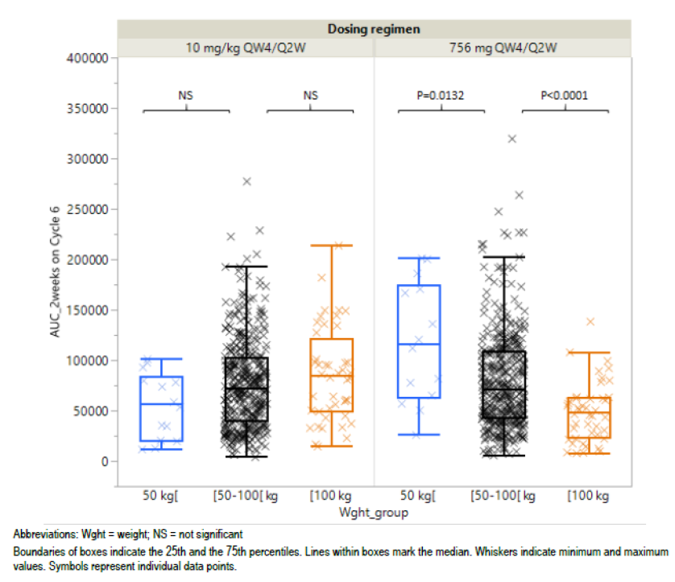
Abbreviations: Wght = weight; NS = not significant; Q4W = every 4 weeks; Q2W = every 2 weeks; AUC = area under the concentration-time curve.
Based on this the sponsor selected weight-based dosing for further development.
No specific drug interaction studies were performed. There was no significant effect of isatuximab on the pharmacokinetics of pomalidomide and vice versa based on population PK modelling.
An anti-drug antibody (ADA) assay was developed, but no patient in the Phase III trials developed ADA and therefore there the sponsor has reported no data on the incidence of ADA.

Pharmacodynamics
No specific PD trials were conducted. PD endpoints were collected in PK and efficacy trials.
CD38 receptor occupancy is high at the proposed dose; measured as 79.4% in 7 patients who received the dose proposed for registration at 4 weeks.
Reductions in M-protein were similar between 10 mg/kg once weekly (QW)/ every two weeks (Q2W) and 20 mg/kg QW/Q2W in patients who received isatuximab/pomalidomide combination therapy.
The probability of achieving overall response rate (ORR) and progression free survival (PFS) increased with 4 week isatuximab trough blood levels. An ORR > 60% was 82.6% for the 10 mg/kg QW/Q2W dose, and 96.7% for the 20 mg QW/Q2W dose for patients receiving isatuximab/pomalidomide combination therapy. The evaluator has noted that this strongly favours the dose higher than that proposed for registration.
There was no significant correlation between isatuximab exposure quartiles (for example, Q1 to Q4, low to high) and several exploratory adverse events.
Table 2: Mean (95% confidence interval) adverse event rate for predicted isatuximab exposure quartiles for area under the concentration-time curve over 1 week or 4 weeks
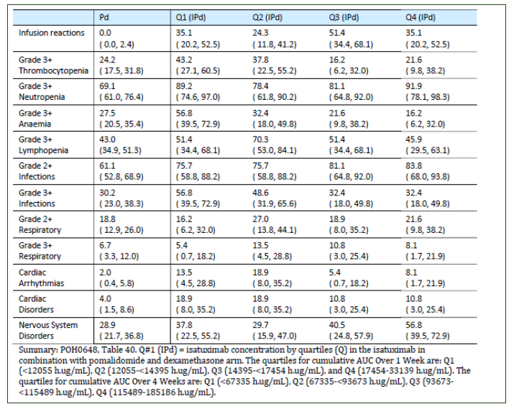AUC = area under the concentration time curve, IPd = isatuximab + pomalidomide, Pd = pomalidomide.
There was no significant association between isatuximab exposure (in single agent trials) and QTc prolongation; at doses between 0.3 and 20 mg/kg. PK/PD modelling indicated a small statistically significant relationship between heart rate (HR) and dose, amounting to an increase of 2.3 beats per minute (BPM) per 100 µg/mL increase in isatuximab plasma concentration.

Efficacy

Dose finding
In Study TCD11863, doses of isatuximab between 3 mg/kg and 20 mg/kg were assessed in combination with lenolidomide and dexamethasone.
Table 3: Study TCD11863 Overall response rate, clinical benefit rate and duration of response for patients treated with different doses of isatuximab with lenolidomide and dexamethasone
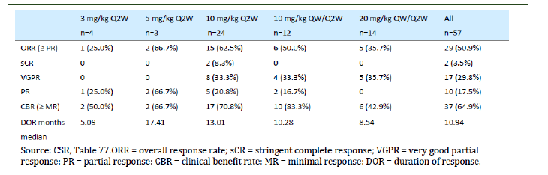
In Study TCD14079 doses of isatuximab between 5mg/kg and 20mg/kg were examined in combination with pomalidomide and dexamethasone.
Table 4: Study TCD14079 Overall response rate in patients treated with different doses of isatuximab with pomalidomide and dexamethasone
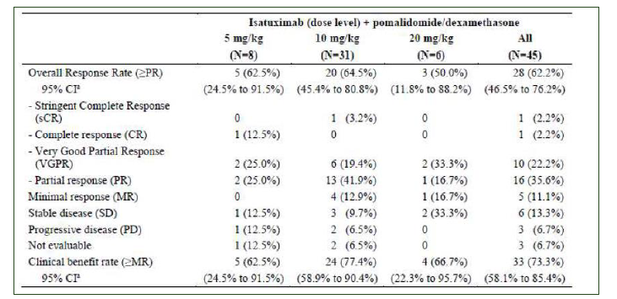
The sponsor also submitted a simulation of trial response based on 44 patients from Study TCD14079 in whom there was evaluable PK data in order predict the response rate to isatuximab treatment based on dose. This indicated that predicted ORR for 20 mg/kg QW/Q2W was higher, at 77.7%, than for 10 mg/kg QW/Q2W, at 66.9% albeit with overlapping 95% CI of the estimate of this effect.
The evaluator has noted that while this data supports the 10 mg/kg QW/Q2W dose being suitable for selection in the pivotal trials, there is significant evidence that the 20 mg/kg QW/Q2W dose may be the most effective dose.

Pivotal efficacy data
The pivotal Phase III efficacy study was Study EFC14335. This was a prospective, multicentre, multinational, randomised, open label, parallel group, 2 arm study evaluating the efficacy of isatuximab with pomalidomide compared with pomalidomide for the treatment of 307 patients with RRMM who had received at least 2 prior lines of therapy. Previous lines of therapy included lenalidomide and a proteasome inhibitor (bortezomib, carfilzomib, or ixazomib) alone or in combination. All patients had demonstrated disease progression on or within 60 days of completion of the last therapy. Patients were randomised 1:1 to receive pomalidomide (n = 153) or isatuximab with pomalidomide (n = 154) treatment.
Figure 2: Design of Study EFC14335
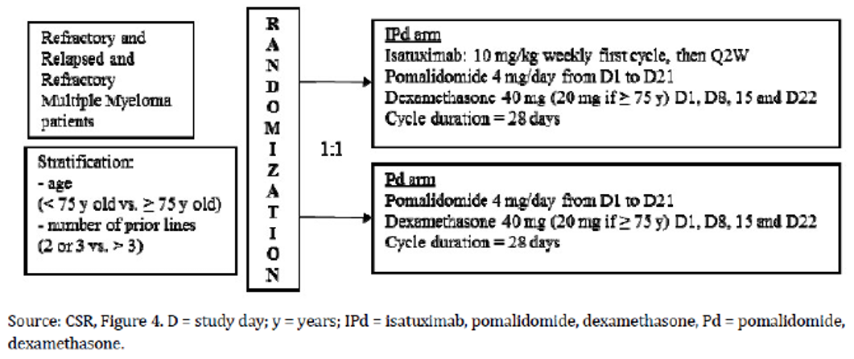
Isatuximab infusions were administered as follows (from section 8.4 of the trial report):
‘Isatuximab 10mg/kg IV was administered on Days 1,8,15 and 22 at Cycle 1, and then on Days 1 and 15 for subsequent cycles. The first infusion was initiated at 175 mg/hour and in the absence of infusion reactions (IRs) after 1 hour of infusion, the infusion rate was increased in 50mg/hour increments every 30 mins, to a maximum of 400 mg/hour. Subsequent infusions were initiated at 175 mg/hour and the absence of IAR; after 1 hour of infusion, the rate was increased by 100 mg/hour increments every 30 minutes, to a maximum of 400 mg/hour.
Dilution method for isatuximab
Isatuximab concentrate for solution for infusion was diluted in an infusion bag with 0.9% sodium chloride or 5% dextrose solution to archive the appropriate drug concentration for infusion. For infusion, an IV tubing administration set with a 0.20 -µm in-line filter was used or if unavailable, a 0.20 - µm filter unit was attached to the administration set before administration.’
The primary endpoint was PFS, which was defined as the time from the date of randomisation to the date of first documentation of progressive disease as determined by the Independent Review Committee (IRC), or the date of death from any cause, whichever occurred first. Patients without progressive disease or death before the analysis cut-off or the date of initiation of further anti-myeloma treatment were censored at the date of the last valid disease assessment not showing disease progression performed prior to initiation of further anti-myeloma treatment (if any) or the analysis cut-off date, whichever came first.
Key secondary endpoints included:
- ORR: defined as the proportion of patients with stringent complete response (sCR), complete response (CR), very good partial response (VGPR), or partial response (PR) as best overall response (BOR), assessed by the Independent Review Committee (IRC) using the International Myeloma Working Group (IMWG) criteria. For patients with non-measurable M-protein at Cycle 1 Day 1, the possible responses were CR, non-progressive disease or progressive disease. An additional analysis of ORR using investigator assessment of response was also performed.
- Overall survival (OS): defined as the time from the date of randomisation to the date of death from any cause. If death was not observed before the analysis data cut-off date, OS was censored at the last date that the patient was known to be alive or at the cut-off date, whichever was first.
Figure 3: Study EFC14335 Primary analysis (Kaplan-Meier estimate) of progression free survival based on Independent Review Committee assessment, by treatment group
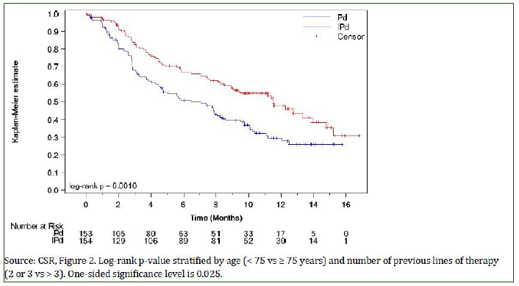
Pd = pomalidomide (and dexamethasone); IPd = isatuximab with pomalidomide (and dexamethasone)
Table 5: Study EFC14335 Primary analysis of progression free survival based on Independent Review Committee assessment, intent to treat population
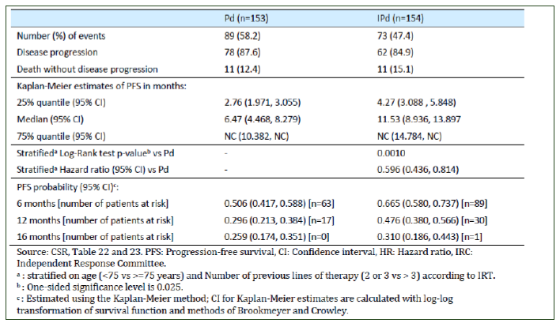
Pd = pomalidomide (and dexamethasone); IPd = isatuximab with pomalidomide (and dexamethasone)
Primary analysis of PFS, based on IRC, was undertaken when the planned number of events had occurred (162 events of death or disease progression, whichever occurred first). The cut-off date for the analysis was 11 October 2018. The overall median follow-up time at the time of the data cut-off was 11.60 months, with the median follow-up times being similar in both treatment arms (11.73 months, pomalidomide alone; 11.56 months, isatuximab plus pomalidomide).
Of the 140 events of disease progression contributing to the total number of PFS events, 120 (85.7%) were confirmed progression diagnosed on M-protein and 20 (14.3%) were radiological progression. In the pomalidomide arm, there were 69 (88.5%) confirmed disease progression events diagnosed on M-protein and 9 (11.5%) radiological progression events. In the isatuximab plus pomalidomide arm, there were 51 (83.3%) confirmed disease progression events diagnosed on M-protein and 11 (17.7%) radiological progression events.
Treatment with isatuximab plus pomalidomide produced significantly longer PFS compared to pomalidomide treatment (median 11.53 months versus 6.47 months, p < 0.001).
At the time of the interim survival analysis, the majority of patients in both treatment arms had been censored (63.4%, pomalidomide alone; 72.1%, isatuximab plus pomalidomide). Of the 97 patients censored in the pomalidomide arm, 90 (92.8%) were still alive at the cut-off date and 7 (7.2%) had been lost to follow-up. Of the 111 patients censored in the isatuximab plus pomalidomide arm, 106 (95.5%) were still alive at the cut-off data, 1 (0.9%) was alive at the last contact before cut-off date and 4 (3.6%) had been lost to follow-up.
The clinical evaluator has noted that there was a higher rate of clarithromycin use in the isatuximab plus pomalidomide arm (15.6%) than the pomalidomide (7.8%) arm. The sponsor has noted that the veracity of any anti-myeloma effect of clarithromycin is contested. In any case, the difference in PFS between the isatuximab plus pomalidomide and pomalidomide arms remains when patients are stratified for clarithromycin use, and the clinical evaluator has accepted this analysis.

Safety
The summary of clinical safety (SCS) reviewed the submitted safety data based on 576 patients treated with isatuximab from 6 completed or partially completed Sanofi (the sponsor) sponsored studies. The pool combining all patients exposed to isatuximab contained several treatment combinations in addition to the proposed isatuximab plus pomalidomide regimen.
Table 6: Patient description and disposition in the pooled safety population
IPd = isatuximab with pomalidomide (and dexamethasone); Isa(+/-Dex) = isatuximab alone with or without dexamethasone
The majority of the safety data at the dosing regimen proposed for registration comes from the 152 isatuximab plus pomalidomide treated patients in the pivotal efficacy study, Study EFC14335.

Treatment emergent adverse events
Virtually all patients treated with isatuximab plus pomalidomide, or pomalidomide suffered at least one treatment emergent adverse event (TEAE), which occurred in 99.3% and 98% of patients respectively.
The following TEAEs were of potential regulatory significance.

Neutropaenia
Neutropaenia was reported more frequently in the isatuximab plus pomalidomide than the pomalidomide arm of the pivotal trial, occurring in 46.7% versus 33.6% of patients respectively. This included febrile neutropaenia, which occurred in 11.8% of isatuximab plus pomalidomide patients and 2.0% of pomalidomide patients.
In response to additional questions by the Delegate, the sponsor has noted that a total of 53% of pomalidomide and 69% of isatuximab plus pomalidomide patients require granulocyte colony-stimulating factor (G-CSF) to manage neutropaenia, almost universally of Grade 3 and 4 in severity. The rate of prophylactic use was similar between isatuximab plus pomalidomide and pomalidomide arms (31.4% and 32.9% respectively), but curative use of G-CSF was higher in the isatuximab plus pomalidomide than the pomalidomide arms (93.3% versus 84.8% respectively).
There was a higher rate of neutropaenia infections in isatuximab plus pomalidomide treated patients, being 25% versus 19.5% in the isatuximab plus pomalidomide and pomalidomide arms. Respiratory tract infections (all Grades) were reported in 74.3% of patients in the isatuximab plus pomalidomide arm, and 53.0% of patients in the pomalidomide arm and Grade ≥ 3 events were reported in 36.2% and 24.2% of patients, respectively. However, the majority of episodes of neutropaenia resolved complete in both treatment arms; 71 out of 73 in the pomalidomide arm and 120 out of 122 in the isatuximab plus pomalidomide arm of the pivotal efficacy study respectively.
Table 7: Description of Grade 3 or 4 laboratory neutropaenia during the on-treatment period for patients not using concomitant medication with granulocyte-colony stimulating factor/ granulocyte-macrophage colony stimulating factor
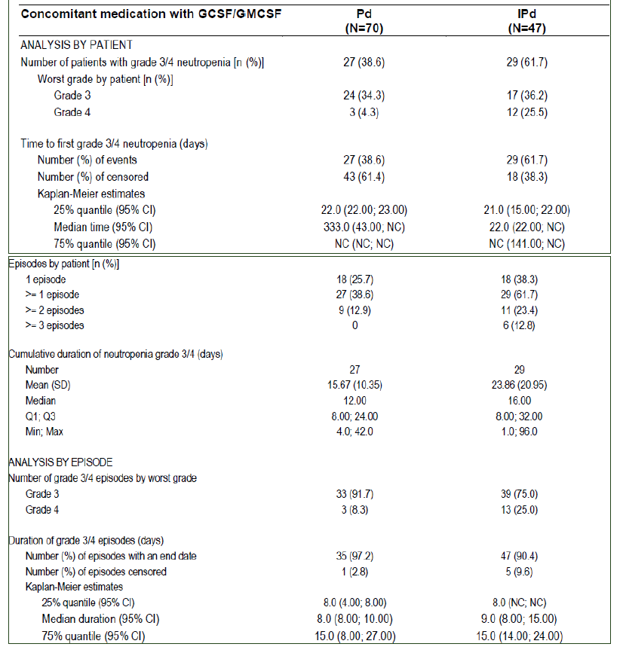
IPd = isatuximab plus pomalidomide (and dexamethasone); Pd = pomalidomide (plus dexamethasone); G-CSF = granulocyte-colony stimulating factor; GM-CSF = granulocyte-macrophage colony stimulating factor

Cardiac disorders
Cardiac disorder TEAEs were reported more frequently in the isatuximab plus pomalidomide arm than in the pomalidomide arm (14.5% versus 4.0%). This was mostly due to cardiac arrhythmias, of which the most frequently reported was atrial fibrillation (4.6% of isatuximab plus pomalidomide arm and 2% of pomalidomide arm).

Infusion reactions
Infusion reactions were reported more frequently in the 38.2% of patients in the isatuximab plus pomalidomide arm. These were Grade3 to 4 in only 2.6% patients and there were no fatal infusion reactions. The most common symptoms associated with infusion reactions were dyspnoea, cough, nausea and chills.
The evaluator has noted that the sponsor has proposed to administer isatuximab in a fix volume infusion rate for example, 25 mL/hr, while in the pivotal trial the drug was administered on a dose mass basis for example, 175 mg/hr. As noted, the sponsor has relied on data from Study TCD14079, a supportive efficacy trial in 54 patients who received isatuximab plus pomalidomide using a fixed-volume administration method. This indicated an infusion reaction rate of 40.4%, which the evaluator notes is similar to that observed in the pivotal trial.

Secondary malignancies
Secondary malignancies were reported in 1 pomalidomide and 6 isatuximab plus pomalidomide treated patients in the pivotal trial. The 1 case in the pomalidomide arm was skin squamous cell carcinoma (SCC), while those in the isatuximab + pomalidomide arm were SCC (n = 4), breast (n = 1) and myelodysplastic syndrome (n = 1). Overall, secondary primary malignancies were diagnoses in 3% of patients treated with isatuximab. The sponsor has noted that these are within the background cancer incidence for the MM population being treated, and that these patients had been exposed to multiple previous therapies such as alkylating agents. The sponsor has also noted that secondary primary malignancies were reported in 4.1% of daratumumab treated patients treated with daratumumab + bortezomib and dexamathasone.

On-treatment fatal treatment emergent adverse events
On-treatment fatal TEAEs in the context of disease progression were reported in 6 (3.9%) patients in the isatuximab plus pomalidomide arm and 5 (3.4%) patients in the pomalidomide arm. In the isatuximab plus pomalidomide arm, the 6 fatal adverse events (AEs) reported in the context of disease progression were 5 events of disease progression and 1 event of hepatic enzyme increased. In the pomalidomide arm, the 5 fatal AEs reported in the context of disease progression were 2 events of disease progression, and 1 event each for cauda equina syndrome, acute kidney injury, and renal failure. None of the fatal AEs reported in the context of disease progression in either treatment arm were considered to be related to treatment.

Risk management plan
The sponsor has submitted European Union (EU)-risk management plan (RMP) version 0.1 (12 April 2019; data lock point (DLP) 15 November 2018) and Australian specific Annex (ASA) version 1.0 (30 June 2019) in support of this application.
The summary of safety concerns and their associated risk monitoring and mitigation strategies are summarised in the table below.
Table 8: Summary of safety concerns
Summary of safety concerns |  | Pharmacovigilance |  | Risk minimisation
 |  | Routine | Additional | Routine | Additional
Important identified risks | Interference with indirect antiglobulin test (indirect Coombs test) and possible resulting adverse clinical consequences for the patient (bleeding due to transfusion delay, transfusion haemolysis) |  | * |  | †
Important potential risks | Tumour lysis syndrome (TLS) |  | – |  | –
Important potential risks | Second primary malignancies (SPMs) |  | – |  | –
Missing information | Use in pregnant and lactating women |  | – |  | –
Missing information | Effect on male and female fertility |  | – |  | –
Missing information | Use in patients with moderate/severe hepatic impairment |  | – |  | –
Missing information | Long-term use (> 2 years) |  | – |  | –
* PASS survey to assess effectiveness of brochure and patient alert card (survey conducted in the EU only). † HCPs and bloods banks brochure; patient alert card.
The RMP evaluator has raised no objections to registration.
The RMP evaluator has raised the issue of cardiac arrhythmias and requested that this be noted as an identified risk. The Delegate does not agree this is appropriate for the reasons set out (see the Delegate’s considerations, in the ‘Risk-benefit analysis’ section, below).
The Delegate notes that observation of rates of secondary malignancy has not been specified in the RMP plan.

Risk-benefit analysis

Delegate’s considerations
The pivotal efficacy study, Study EFC14335, provides robust evidence that there is a PFS benefit in adding isatuximab to the combination of pomalidomide and dexamethasone. This clearly comes with an additional burden of toxicity, particularly neutropenia and infections, but this is in the context of a disease with a very poor prognosis if treatment fails.
The main issue regarding efficacy is that the clinical trial excluded patients who had been treated with daratumumab. While this may have been reasonable given the limited availability of daratumumab when the isatuximab clinical trial program was commenced, it leaves the question of comparative efficacy unresolved. Patients in whom one CD38 inhibitor fails may have to consider treatment with the other and, since daratumumab is already registered, these patients may constitute the first Australian cohort exposed to isatuximab. There is, however, no way to resolve the appropriate ordering of these medications from the pre-market data available. The Delegate notes that while isatuximab recognises a different CD38 epitope to daratumumab, the mechanism of daratumumab resistance has not been elucidated and might include factors such as receptor down-regulation that would be equally significant to isatuximab.
The Delegate notes that the patients enrolled in the pivotal trial had RRMM, and that this is not specified in the proposed indication. The Delegate notes, however, that the indication requires failure of several prior lines of therapy and that, in the context of MM, this would imply relapsed or refractory disease. The Delegate is minded to accept the proposed indication, albeit without knowing the wording which may be approved by FDA or EMA.
The evaluator and expert advice has noted that the 20 mg/kg dose is potentially optimal for efficacy, and noted that it would have been useful to continue it into the Phase III trials. While the Delegate agrees there is some evidence to support better response rates in the higher dose, the safety information at that dose is insufficient to conclude that it would be tolerated by most patients. The Delegate does not, therefore, intend to suggest that this could be an appropriate dose for therapy until more data is available.
The Delegate notes that the sponsor has included both rates of minimal residual disease (MRD) and improved renal function (renal response) in the description of the pivotal trial in the draft PI. These were both exploratory post-hoc analyses performed on 14 and 43 of the 153 patients in the isatuximab plus pomalidomide arm, with no statistical control for multiplicity of testing or confounding. The Delegate intends to remove this data from the PI as, while it does numerically favour isatuximab plus pomalidomide therapy over pomalidomide, it should not be considered quantitatively or statistically robust.
The Delegate notes that the sponsor has included ORR in high and low-risk cytogenetic populations in the description of the pivotal trial in the draft PI. This was also an exploratory subgroup analysis (and so described in the body of the study report) performed in a subset of patients and while the results numerically favoured isatuximab plus pomalidomide over pomalidomide, this was not a statistically significant result.

Safety (general)
The toxicity profile evidenced in the trial is similar to daratumumab. Acknowledging the relatively small patient exposure, the clinical evaluator has not identified novel toxicity in isatuximab.
The Delegate requested additional information regarding cardiac arrhythmias as part of the collaborative international evaluation of this medication, and has concluded that there is no evidence of an increased rate of severe events in isatuximab plus pomalidomide therapy. This is supported by evaluated data indicating no significant effect on ECG parameters in isatuximab treated patients. CD38 is only expressed in cardiac tissue in trace amounts, and no cross-tissue reactivity was identified in a cross-reactivity study (Study IHX003) conducted in product development. The sponsor has indicated that there is no conclusive evidence of cardiac tissue binding by isatuximab.
The Delegate requested additional information regarding cardiac arrhythmias as part of the collaborative international evaluation of this medication, and has concluded that there is no evidence of an increased rate of severe events in isatuximab plus pomalidomide therapy. This is supported by evaluated data indicating no significant effect on ECG parameters in isatuximab treated patients. CD38 is only expressed in cardiac tissue in trace amounts, and no cross-tissue reactivity was identified in a cross-reactivity study (Study IHX003) conducted in product development. The sponsor has indicated that there is no conclusive evidence of cardiac tissue binding by isatuximab.
It should be noted that the rate of cardiac arrhythmias in other isatuximab trials is lower, and was only 4.9% in an Isatuximab monotherapy trial. As the sponsor has noted in response to the RMP evaluation:
‘In the pomalidomide registration study MM-002, TEAEs of cardiac disorders were reported in 18% of patients on pomalidomide regimens, and TEAEs of cardiac disorders occurred in 14.5% and 4.0% of isatuximab + pomalidomide and pomalidomide, respectively, in Study EFC14335. By comparison, 10.2% of patients in Data Pool 4 exposed to isatuximab reported TEAEs of cardiac disorders. Serious TEAEs of atrial fibrillation in the pomalidomide registration study MM-002 were reported in 3% of patients who received pomalidomide, and were reported in 2% and 0.7% of isatuximab + pomalidomide and pomalidomide patients respectively, in Study EFC14335. By comparison, 1.0% of patients in Data Pool 4 exposed to isatuximab had a serious TEAE of atrial fibrillation.’
The Delegate has reviewed the case narratives of the two deaths in which atrial fibrillation was reported with isatuximab plus pomalidomide treatment (as not associated with therapy), as well as those for other arrhythmias and agrees that there is little clinical evidence that arrhythmias could not be attributed to age or concomitant cardiovascular disease.
The Delegate notes the numerically higher rate of secondary malignancies in the isatuximab plus pomalidomide than the pomalidomide arms. While this does not provide a definite ‘signal’ regarding this risk, the Delegate feels that the sponsor should give specific attention to reporting rates of malignancy in isatuximab treated patients in analysis of post-marketing data reported to the TGA.
Rates of neutropaenia are higher in isatuximab plus pomalidomide than pomalidomide treated patients. This is not an unexpected adverse event with CD38 antibody therapy, and it resolved in the majority of cases. The Delegate notes that the safety and efficacy of medications for advanced multiple myeloma is dependent on expert clinical management in a specialised environment where therapy such as G-CSF and antibiotic cover is provided as needed.

Safety (infusion rate)
The Delegate is minded to register the fixed-volume infusion for most patients given it does not change the overall dose received. Isatuximab is 100% bioavailable and has a long half-life and, therefore, the dose rate is unlikely to influence efficacy. The Delegate considers the rate of administration to be significant for its potential to cause infusion reactions. These are similar between the fixed-dose and fixed-volume administration methods in a supplemental efficacy trial.
The Delegate notes, however, that the concentration of drug in a fixed-volume infusion may become considerably higher than was administered in the pivotal trial where patients are of high body-weight. There are too few patients in Study TCD14079 to address this specific issue. The Delegate is minded that, should the fixed dosage regimen be approved, it would be appropriate to advise that the original weight-based infusions should be used in patients with high body weight.
The sponsor should be aware that the Delegate will not consider advice that the number of high body weight individuals in the MM population is small as being determinative in this matter. The dosage instruction approved will be required to be safe for this population, and may be precautionary in the absence of sufficient safety data.

Proposed action
The Delegate intends to approve the application to register isatuximab for the indication:
Sarclisa is indicated in combination with pomalidomide and dexamethasone, for the treatment of patients with multiple myeloma (MM) who have received at least two prior therapies including lenalidomide and a proteasome inhibitor (PI).
With a PI document amended as follows from the draft submitted with the application:
- Amendments as proposed in the pre-clinical evaluation will be included.
- Table 5, detailing results of Study EFC14335, will be amended to remove VGPR, Duration of Response and MRD secondary endpoint data. The text descriptions of these endpoints will also be removed.
And with dosage advice worded as necessary to take into consideration the advice of the Advisory Committee on Medicines (ACM) and information provided by the sponsor.

Questions for sponsor
The Delegate requests that the sponsor specifically provide a response to the following.
- Present the concentration of isatuximab in a proposed fixed-dose infusion versus the concentration of isatuxumab in the pivotal trial dosage regimen for stratified weight bands for example, 70 kg, 80 kg, 90 kg et cetera up to high body weights.
Sponsor’s response
The sponsor proposed to register the dosage and administration regimen based on a fixed volume infusion following the positive results from Study TCD14079 Part B. Study TCD14079 Part B was conducted in a patient population similar to the pivotal Phase III study, Study EFC14335, and used the exact same dosing regimen (that is, isatuximab 10 mg/kg weekly during first cycle, followed by every 2 weeks administrations). The main objective of Study TCD14079 Part B was to demonstrate the feasibility of a simpler, one-step infusion process using a fixed volume infusion of 250 mL, with infusion rates expressed in mL/hour, which could minimise the risk of infusion rate errors and reduce the infusion duration starting with the second infusion. In Study EFC14335 (and other studies included in the application) isatuximab was administered with weight-based infusion volume and infusion rates expressed in mg/hour. The differences between the 2 methods are analysed in the following table. Of note, most patients in Study EFC14335 received their infusions with a volume of 250 mL, similar to the volume used in patients treated in Study TCD14079 Part B.
Table 9: Isatuximab infusion methods
 | Weight-based volume infusion expressed in mg/hour | Fixed volume infusion expressed in mL/hour
Clinical studies | Study EFC14335, and in other clinical studies throughout in the submission | Study TCD14079 Part B
Infusion volume | The appropriate volume of isatuximab (10 mg/kg) will be diluted in an infusion bag of 0.9% sodium chloride solution or 5% dextrose. The final infusion volume, based on patient weight, will be administered for a period of time that will depend on the dose administered and will be based on drug amount given per hour (mg/hour). | The appropriate volume of isatuximab (10 mg/kg) will be diluted in an infusion bag with 250 mL of 0.9% sodium chloride solution. The infusion will be administered at a mL/hour rate.
First infusion | First infusion: initiate infusion at 175 mg/hour. In the absence of infusion reactions (IRs) after 1 hour of infusion, increase infusion rate by 50 mg/hour increments every 30 minutes, to a maximum of 400 mg/hour.  Once a Grade 2 IR leading to interruption has improved to Grade ≤ 1, the infusion may be restarted at half (87.5 mg/hour) the initial infusion rate. If symptoms do not recur after 30 minutes, the infusion rate may be increased by 50 mg/hour increments every 30 minutes, to a maximum of 400 mg/hour. | First infusion: Initiate infusion at 25 mL/hour. In the absence of infusion reactions (IRs) after 1 hour of infusion, increase infusion rate by 25 mL/hour increments every 30 minutes, to a maximum of 150 mL/hour.  In case of a Grade 2 IR during first infusion, after interruption, infusion could be restarted at one half (12.5 mL/hour) of the initial infusion rate after the IR will have improved to Grade ≤1. If IR symptoms do not recur after 30 minutes, the infusion rate may be increased in 25 mL/hour increments every 30 minutes, until the total volume is infused.
Second infusion | See subsequent infusions below | Second infusion: Initiate infusion at 50 mL/hour regardless of whether Grade ≤ 2 IRs had occurred during first infusion. In the absence of Grade≥2 IRs after 30 minutes of infusion, increase rate by:  - 50 mL/hour for 30 minutes, then,  - 100 mL/hour every 30 minutes, up to 300 mL/hour, until the total volume is infused.  In case of Grade 2 IR during second infusion, infusion could be restarted at one half (25 mL/hour) of the initial infusion rate after the IR will have improved to Grade ≤ 1. If symptoms do not recur after 30 minutes, the infusion rate may be increased in 50 mL/hour increments every 30 minutes, until the total volume is infused.
Subsequent infusions | Subsequent infusions: initiate infusion at 175 mg/hour. In the absence of IRs after 1 hour of infusion, increase rate by 100 mg/hour increments every 30 minutes, to a maximum of 400 mg/hour. | Third and subsequent infusions: Initiate infusion at a fixed infusion rate of 200 mL/hour regardless of whether Grade ≤ 2 IRs had occurred during previous infusions, until the total volume is infused. In case of a Grade 2 IR during third infusion, after interruption, infusion could be restarted at one half (100 mL/hour) of the infusion rate after the IR will have improved to Grade ≤ 1. If IR symptoms do not recur after 30 minutes, the infusion rate may be increased in 50 mL/hour increments every 30 minutes, until the total volume is infused.
In Study TCD14079 Part B:
- For first infusion, the starting infusion rate was 25 mL/hour, which corresponds to a lower infusion rate (40 to 120 mg/hour for patients with weight ranging from 40 to 120 kg) than the initial infusion rate used in Study EFC14335 (175 mg/hour).
- For second infusion, the starting infusion rate was 50 mL/hour, which corresponds to a lower infusion rate (80 mg/hour for patients with weight of 40 kg), similar infusion rate (175 mg/hour for patients with a weight of 87.5 kg), or higher infusion rate (240 mg/hour for patients with a weight of 120 kg) than the initial infusion rate used in Study EFC14335 (175 mg/hour).
- For third and subsequent infusions, the fixed infusion rate of 200 mL/hour, corresponds to a higher infusion rate (320 to 960 mg/hour for patients with weight ranging from 40 to 120 kg) than the initial infusion rate used in Study EFC1335 (175 mg/hour).
Concentrations of isatuximab (mg/ml) within the first 90 minutes of first isatuximab infusion (that is, when infusion reactions generally occurred) were lower with volume based infusion than with the weight based infusion for all patients.
Results: In primary analysis results of Study TCD14079 Part B, IRs of any grade were reported in 19 patients (40.4%), and in 20 episodes in 871 infusions (2.3%). All the IRs were Grade 2 and all IR episodes occurred during the first infusion (see the following table below). Importantly, no IRs were reported after the first infusion.
Table 10: Study TCD14079 Part B Description of infusion reactions (all treated population)
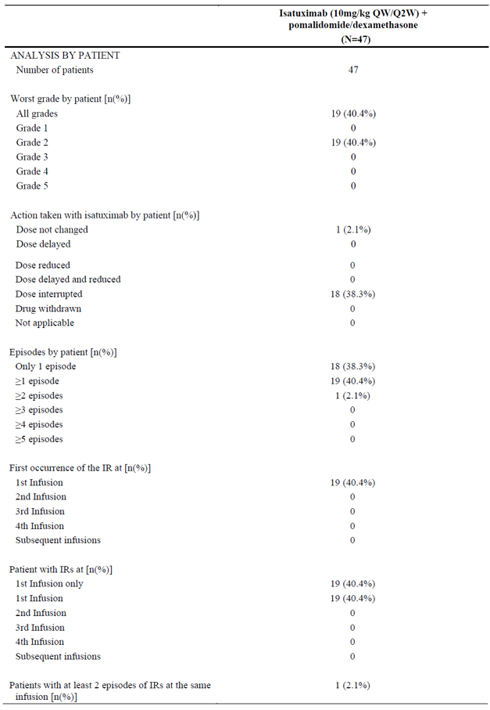
In the population PK analysis (Report POH0503) when isatuximab is administered with weight based volume, body weight was already identified as a significant covariate with a 26% increase in linear clearance (CL) at steady state and 19% increase in apparent volume (V1); for a body weight of 109.5 kg (95th percentile in the population PK dataset) and a 21% and 17% decrease in linear CL at steady state and V1 respectively, for a body weight of 51.3 kg (5th percentile) compared to 75.6 kg (median weight).
Simulations for a typical patient (5th percentile, median and 95th percentile of body weight) showed that patients with higher body weight (95th percentile) had a trend of higher exposure when isatuximab is given as body weight based dose (see figure below).
Figure 4: Report POH0503 Isatuximab concentration-time profile in a typical patient at 10 mg/kg once monthly then once every two weeks
‘Typical patient’ = male, Ig MM Type=IgG, not Asian, β2 microglobulin=3.9 mg/L.
In this context, to assess the impact of the different IV infusion durations on isatuximab PK, simulations using the previously developed population PK model were performed for a typical patient where all covariates were kept the same, except for body weight, using:
- the fixed volume infusion method implemented in Study TCD14079 Part B (with different mL/hour infusion rates), and
- an infusion method consisting of a weight-based volume (with different mg/hour infusion rates).
In other words, the infusion duration per administration (first, second, or subsequent) remains the same across patients with the fixed-volume infusion protocol, while the duration per administration increased with weight across patients for the variable volume (body weight based) infusion protocol. The infusion durations for a patient with low (5th percentile of population PK Report POH0503 dataset), median (50th percentile of POH0503 dataset), or high (95th percentile of POH0503 dataset) body weight for the two infusion protocols are summarised in Table 11. The effect of these two infusion protocols on isatuximab PK parameters is shown in Table 12.
As shown in Table 12, the shorter infusion duration implemented from the second administration with the fixed volume infusion method in StudyTCD14079 Part B has no impact on maximum plasma concentration (C_{max}) after repeat administration, although it occurred earlier as expected (that is, end of infusion).
To conclude, the change of the duration of infusion has minimal to no impact on isatuximab PK and the effect on body weight on isatuximab PK remains unchanged when isatuximab is administered with the fixed volume infusion method (that is, trend of higher plasma isatuximab concentration (that is, C_{max}) in higher body weight patients).
Table 11: Duration of infusion used for the pharmacokinetics simulations by infusion protocol and body weight per administration at 10 mg/kg once weekly/once every 2 weeks (comparison of the 2 infusion protocols)
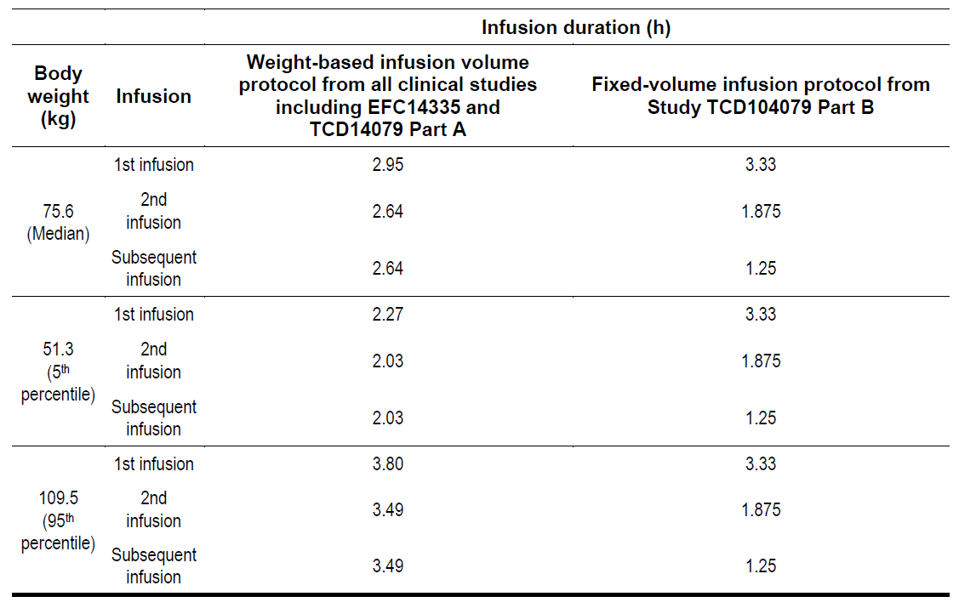
Table 12: Effect of the duration of infusion on the pharmacokinetics parameters of a typical patient after isatuximab at 10 mg/kg once weekly/once every 2 weeks (comparison of the 2 infusion protocols)
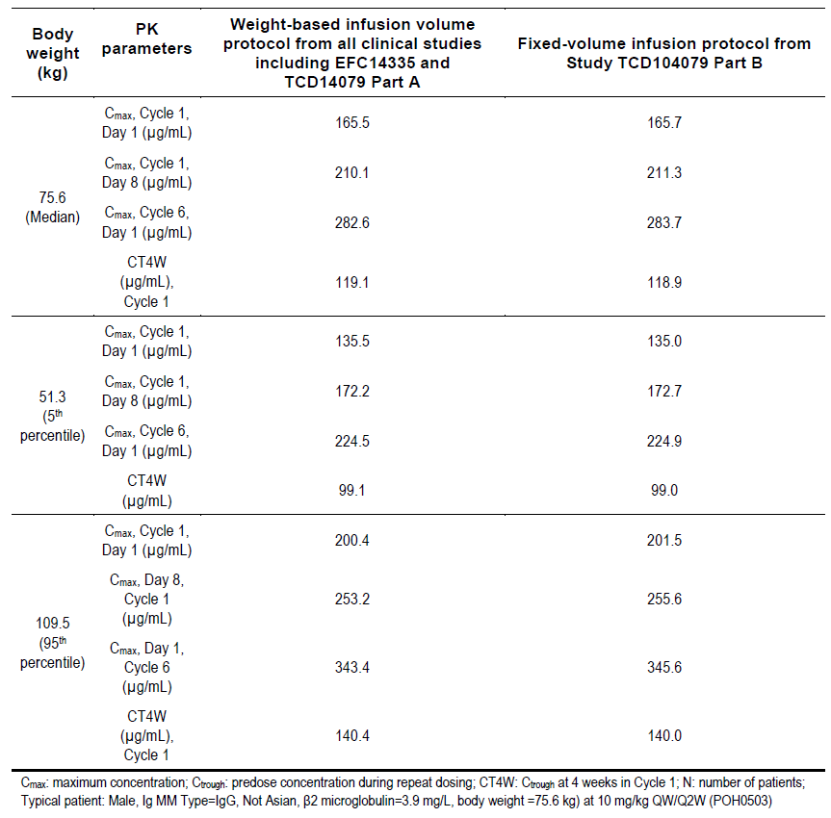
- Provide an analysis of the rate of infusion reactions in high-body weight individuals compared to those of standard and low body-weight, specifying the weight cut-offs for these strata.
Sponsor’s response
Rate of infusion reactions by body weight (< 50 kg, ≥ 50 to < 100 and ≥ 100 kg) for Study TCD14079 Part B and all isatuximab-treated patients (weight based infusion volume) presented by data pool (isatuximab plus pomalidomide, isatuximab with or without dexamethasone, other combinations and all isatuximab-treated patients) and overall are provided in Table 13. Overall, a trend toward more infusion reactions was observed in Study TCD14079 Part B for patients with high-body weight; however, similar results were observed for patients treated with weight based infusion volume.
Table 13: Rate of infusion reactions by body weight
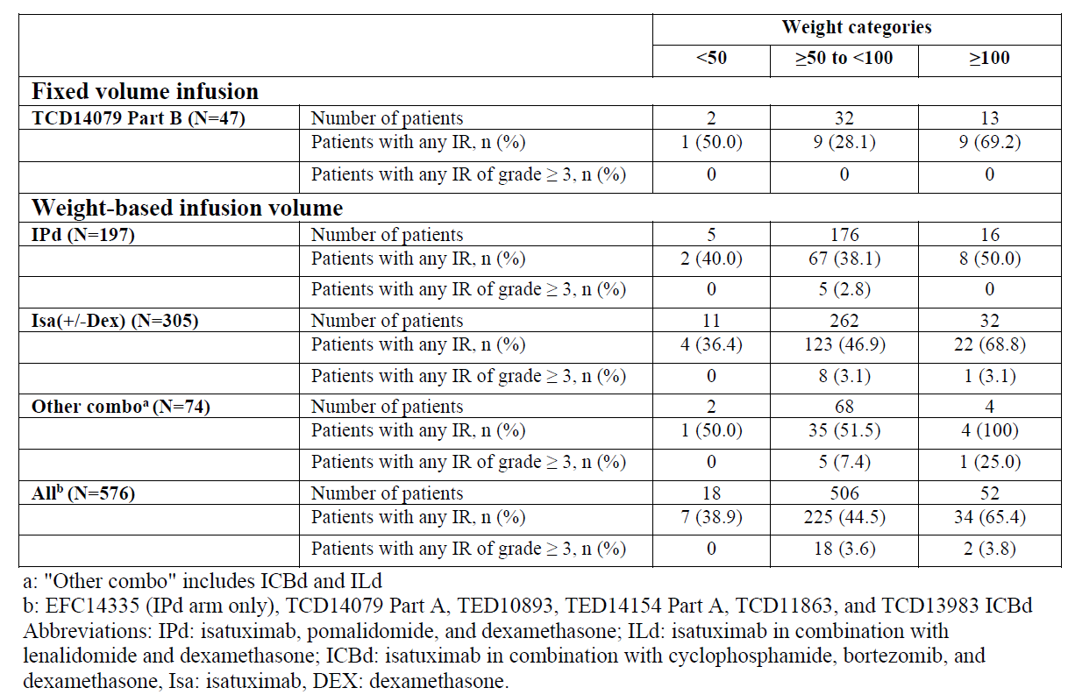
- Indicates and justifies the maximum isatuximab concentration (if any) which the sponsor considers safe for infusion in terms of infusion reactions or other infusion-related adverse events.
Sponsor’s response
The feasibility of isatuximab administration with fixed volume infusion of 250 mL and infusion rates expressed in mL/hour was demonstrated in Study TCD14079 Part B. In this study, the incidence of IRs was 40.4% which is consistent with the incidence of infusion reactions of 38% reported in the pivotal study, Study EFC14335. All the IRs were Grade 2 and all occurred during the first infusion. No infusion reaction occurred at infusion 2 or subsequent (that is, when infusion rate is similar or higher than in Study EFC14335). The change of the infusion duration has minimal to no impact on isatuximab PK and the effect on body weight on isatuximab PK remains unchanged when isatuximab is administered with the fixed volume method. A trend toward more infusion reactions was observed in Study TCD14079 Part B for patients with high-body weight; however, similar results were observed for patients treated with weight-based infusion volume. Therefore, the higher incidence of IRs in patients with high-body weight does not seem to be related to the infusion method.
In conclusion, based on these results and consistent with the United States Prescribing Information (USPI), the sponsor considers that the fixed volume infusion can be safely used for all patients. However, the sponsor will continue to monitor the safety of the patients treated with fixed volume infusion.

Independent expert advice
The Delegate sought and received independent expert clinical advice on the following questions.
- Please comment on the adverse event profile of isatuximab, particularly rates of neutropenia, with respect to the likely place of isatuximab in clinical therapy. In particular, the comparative toxicity with daratumumab.
In brief, the external experts agreed that the rate of neutropenia was within tolerable limits. This is a recognised side effect of a number of anti-cancer medications including other CD38 inhibitors and clinical teams are both aware of the need to monitor for it, and able to intervene to treat emerging cases early.
- Please comment on the appropriateness of excluding daratumumab treated patients from the pivotal trial, as well as any implications that may have for the place of isatuximab in clinical therapy.
The exclusion of daratumumab from the trials was noted, but not considered significant to the overall use of the medication.
- Please note any other concerns with the efficacy and safety of isatuximab you consider clinically relevant.
In general, the external experts supported isatuximab for registration.

Request for Advisory Committee on Medicines advice
- Advice is sought whether the ACM has any concerns with the approval of isatuximab for marketing in Australia.
- Advice is sought regarding the appropriate dosage advice, regarding fixed or weight/based dosing of isatuximab.

Advisory Committee considerations
The ACM considered this product to have an overall positive benefit-risk profile for the indication:
Sarclisa is indicated in combination with pomalidomide and dexamethasone, for the treatment of patients with multiple myeloma (MM) who have received at least two prior therapies including lenalidomide and a proteasome inhibitor (PI).

Specific advice
The ACM advised the following in response to the Delegate’s specific request for advice.
- Advice is sought whether the ACM has any concerns with the approval of isatuximab for marketing in Australia.
This ACM raised no concerns with approval of isatuximab.
- Advice is sought regarding the appropriate dosage advice, regarding fixed or weight/based dosing of isatuximab.
The trial evidence presented supports the dosage of 10 mg/kg as a weight based dosing regimen as it gives more even exposure than a fixed dose. The ACM noted that any infusion reactions caused by fixed volume administration and the higher concentration being administered to heavier patients can be managed in the clinic. Further, fixed volume administration would allow faster infusions which are also more practical in the real life clinical setting.
- Whether the evidence supports the indications.
The evidence supports the indications proposed by the sponsor.
The ACM proposed amendments to the PI document and strongly supported isatuximab patients carry a patient card, similar to that recommended for other drugs in this class, as cross matching will be a problem.
No other issues or concerns regarding the application data or the clinical use of agent were raised by the ACM.
The ACM advised that implementation by the sponsor of the recommendations outlined above to the satisfaction of the TGA, in addition to the evidence of efficacy and safety provided would support the safe and effective use of Sarclisa.

Outcome
Based on a review of quality, safety and efficacy, TGA approved the registration of Sarclisa (isatuximab) 500 mg/25 mL and 100 mg/5 mL concentrated injection, indicated for:
Sarclisa is indicated in combination with pomalidomide and dexamethasone, for the treatment of patients with multiple myeloma (MM) who have received at least two prior therapies including lenalidomide and a proteasome inhibitor (PI).

Specific conditions of registration applying to these goods
- Sarclisa (isatuximab) is to be included in the Black Triangle Scheme. The Product Information (PI) and Consumer Medicines Information (CMI) for Sarclisa must include the black triangle symbol and mandatory accompanying text for five years, which starts from the date that the sponsor notifies the TGA of supply of the product.
- The isatuximab (Sarclisa) EU-RMP (version 0.1, dated 12 April 2019, data lock point 15 November 2018), with Australian specific Annex (version 1.0, dated 30 June 2019), included with submission PM-2019-02568-1-6, and any subsequent revisions, as agreed with the TGA will be implemented in Australia.
An obligatory component of risk management plans is routine pharmacovigilance. Routine pharmacovigilance includes the submission of periodic safety update reports (PSURs).
Unless agreed separately between the supplier who is the recipient of the approval and the TGA, the first report must be submitted to TGA no later than 15 calendar months after the date of the approval letter. The subsequent reports must be submitted no less frequently than annually from the date of the first submitted report until the period covered by such reports is not less than three years from the date of the approval letter. The annual submission may be made up of two PSURs each covering six months. If the sponsor wishes, the six monthly reports may be submitted separately as they become available.
If the product is approved in the EU during the three years period, reports can be provided in line with the published list of EU reference dates no less frequently than annually from the date of the first submitted report until the period covered by such reports is not less than three years from the date of the approval letter.
The reports are to at least meet the requirements for PSURs as described in the European Medicines Agency’s Guideline on Good Pharmacovigilance Practices (GVP) Module VII-periodic safety update report (Rev 1), Part VII.B Structures and processes. Note that submission of a PSUR does not constitute an application to vary the registration. Each report must have been prepared within ninety calendar days of the data lock point for that report.
- It is a condition of registration that all batches of:
  - Sarclisa isatuximab 500 mg/25 mL concentrated injection vial
  - Sarclisa isatuximab 100 mg/5 mL concentrated injection vial
imported into/manufactured in Australia must comply with the product details and specifications approved during evaluation and detailed in the Certified Product Details (CPD).
- It is a condition of registration that up to 5 initial batches of:
  - Sarclisa isatuximab 500 mg/25 mL concentrated injection vial
  - Sarclisa isatuximab 100 mg/5 mL concentrated injection vial
imported into/manufactured in Australia is not released for sale until samples and/or the manufacturer’s release data have been assessed and endorsed for release by the TGA Laboratories Branch. Outcomes of laboratory testing are published biannually in the TGA Database of Laboratory Testing Results http://www.tga.gov.au/ws-labsindex.
- The sponsor should be prepared to provide product samples, reference materials and documentary evidence as defined by the TGA Laboratories branch. The sponsor must contact Biochemistry.Testing@health.gov.au for specific material requirements related to the batch release testing/assessment of the product. More information on TGA testing of biological medicines is available at https://www.tga.gov.au/publication/testingbiological- medicines.
This batch release condition will be reviewed and may be modified on the basis of actual batch quality and consistency. This condition remains in place until the sponsor is notified in writing of any variation.
- Certified Product Details
The Certified Product Details (CPD), as described in Guidance 7: Certified Product Details of the Australian Regulatory Guidelines for Prescription Medicines (ARGPM) [http://www.tga.gov.au/industry/pm-argpm-guidance-7.htm], in PDF format, for the above products should be provided upon registration of these therapeutic goods. In addition, an updated CPD should be provided when changes to finished product specifications and test methods are approved in a Category 3 application or notified through a self-assessable change.

Attachment 1. Product Information
The PI for Sarclisa approved with the submission which is described in this AusPAR is at Attachment 1. For the most recent PI, please refer to the TGA website at <https://www.tga.gov.au/product-information-pi>.

Therapeutic Goods Administration
PO Box 100 Woden ACT 2606 Australia
Email: info@tga.gov.au Phone: 1800 020 653 Fax: 02 6232 8605
https://www.tga.gov.au

The Black Triangle Scheme provides a simple means for practitioners and patients to identify certain types of new prescription medicines, including those being used in new ways and to encourage the reporting of adverse events associated with their use. The Black Triangle does not denote that there are known safety problems, just that the TGA is encouraging adverse event reporting to help us build up the full picture of a medicine's safety profile.
The acronym CRAB was originally defined in the 2003 classification criteria of multiple myeloma by the International Myeloma Working Group in 2003 to simplify the most typical clinical manifestations of multiple myeloma.
International Myeloma Working Group; Criteria for the classification of monoclonal gammopathies, multiple myeloma and related disorders: a report of the International Myeloma Working Group. British Journal of Haematology, 121 (2003): 749-757.
Australian Institute of Health and Welfare (AIHW) 2017. Cancer in Australia 2017. Cancer series no. 101. Cat. No. CAN 100. Canberra: AIHW.
Darzalex daratumumab 100 mg/5 mL concentrated solution for infusion vial (ARTG: 281842); 400 mg/20 mL concentrated solution for infusion vial (ARTG 281843); and 1800 mg/15 mL solution for injection vial (ARTG 322685). ARTG effective date 7 October 2020.
See AusPAR for Pomalyst pomalidomide Celgene Australia Pty Ltd PM-2013-02037-1-4. Published 20 November 2014 at https://www.tga.gov.au/auspar/auspar-pomalidomide
The ACSS Consortium is a collaborative initiative of like-minded, medium-sized regulatory authorities between Australia's Therapeutic Goods Administration (TGA), Health Canada (HC), Singapore's Health Sciences Authority (HSA) and the Swiss Agency for Therapeutic Products (Swissmedic). Regulatory authorities face very similar challenges, such as increasing workload and increasing complexities in the medicinal applications that are being regulated, thus contributing to increasing pressure on available resources. The purpose of the consortium is to build synergies and share knowledge amongst the regulatory authorities thereby enhancing efficiency of regulatory systems. The ACSS Consortium consists of various projects that aim to help meet the challenges faced by regulatory authorities, including timely access to safe therapeutic products within a limited resource capacity. The ACSS uses a network of bilateral confidentiality agreements and Memoranda of Understanding to conduct their work.
'Orphan drugs' are often developed to treat small and very specific patient populations who suffer from rare diseases and conditions. In order to facilitate orphan drug access to the Australian marketplace and help offset orphan drug development costs the TGA waives application and evaluation fees for prescription medicine registration applications if a related orphan designation is in force. A medicine may be eligible for orphan drug designation if all orphan criteria set by the TGA are met. The orphan designation application precedes the registration application and the designation is specific to the sponsor, orphan indication for which designation was granted and dosage form of the medicine.
European Medicines Agency (EMA), Committee for Medicinal Products for Human Use (CHMP), ICH guideline S9 on nonclinical evaluation for anticancer pharmaceuticals, EMA/CHMP/ICH/646107/2008. Adopted May 2010.
EMA, CHMP, ICH guideline S6 (R1) – preclinical safety evaluation of biotechnology-derived pharmaceuticals, EMA/CHMP/ICH/731268/1998. Adopted June 2011.
Good Laboratory Practice (GLP) is an international quality system of management controls for the experimental (non-clinical) research arena, research laboratories and organisations to ensure the uniformity, consistency, reliability, reproducibility, quality, and integrity of products in development for human or animal health (including pharmaceuticals) through nonclinical safety tests; from physiochemical properties through acute to chronic toxicity tests.
Kato, I et al.. CD38 disruption impairs glucose-induced increases in cyclic ADP-ribose, [Ca2+]i, and insulin secretion. J. Biol. Chem. 1999; 274: 1869–1872.
Sun L., et al. Disordered osteoclast formation and function in a CD38 (ADP-ribosyl cyclase)-deficient mouse establishes an essential role for CD38 in bone resorption. FASEB J. 2003; 17: 369–375.
Cockayne, D.A., et al. Mice deficient for the ecto-nicotinamide adenine dinucleotide glycohydrolase CD38 exhibit altered humoral immune responses. Blood. 1998; 92: 1324–1333.
Australian Pregnancy Category C: Drugs which, owing to their pharmacological effects, have caused or may be suspected of causing, harmful effects on the human fetus or neonate without causing malformations. These effects may be reversible. Accompanying texts should be consulted for further details.
Study EFC13225; title: ‘A Phase 3 Randomized, Open-label, Multicenter Study Comparing Isatuximab (SAR650984) in Combination with Pomalidomide and Low-dose Dexamethasone versus Pomalidomide and Low-dose Dexamethasone in Patients with Refractory or Relapsed and Refractory Multiple Myeloma’. EudraCT number: 2016-003097-41; WHO Universal Trial Reference Number (UTRN): U1111-1180-6262; NCT number: NCT02990338.
Study TCD14079; title: ‘SAR650984, Pomalidomide and Dexamethasone in Combination in RRMM Patients (PomdeSAR)’. WHO Universal Trial Reference Number (UTRN): U1111-1155-7484; NCT number: NCT02283775.
The QT interval is the time from the start of the QRS wave complex to the end of the corresponding T wave. It approximates to the time taken for ventricular depolarisation and repolarisation, that is to say, the period of ventricular systole from ventricular isovolumetric contraction to isovolumetric relaxation. The corrected QT interval (QTc) estimates the QT interval at a standard heart rate. This allows comparison of QT values over time at different heart rates and improves detection of patients at increased risk of arrhythmias.
IAR = Infusion associated reaction
Rajkumar, S.V. et al. International Myeloma Working Group updated criteria for the diagnosis of multiple myeloma, Lancet Oncol. 2014; 15(12): e538-548.
Routine risk minimisation activities may be limited to ensuring that suitable warnings are included in the product information or by careful use of labelling and packaging. Routine pharmacovigilance practices involve the following activities: - All suspected adverse reactions that are reported to the personnel of the company are collected and collated in an accessible manner; - Reporting to regulatory authorities; - Continuous monitoring of the safety profiles of approved products including signal detection and updating of labelling; - Submission of PSURs; - Meeting other local regulatory agency requirements.
V1 = Apparent volume of the central or plasma compartment in a two-compartment model.
The ACM provides independent medical and scientific advice to the Minister for Health and the Therapeutic Goods Administration (TGA) on issues relating to the safety, quality and efficacy of medicines supplied in Australia including issues relating to pre-market and post-market functions for medicines. The Committee is established under Regulation 35 of the Therapeutic Goods Regulations 1990. Members are appointed by the Minister. The ACM was established in January 2017 replacing Advisory Committee on Prescription Medicines (ACPM) which was formed in January 2010. ACM encompass pre and post-market advice for medicines, following the consolidation of the previous functions of the Advisory Committee on Prescription Medicines (ACPM), the Advisory Committee on the Safety of Medicines (ACSOM) and the Advisory Committee on Non-Prescription Medicines (ACNM). Membership comprises of professionals with specific scientific, medical or clinical expertise, as well as appropriate consumer health issues relating to medicines.

