AusPAR Attachment 2

Extract from the Clinical Evaluation Report for irinotecan (as sucrosofate)
  - Proprietary Product Name: Onivyde
  - Sponsor: Baxalta Australia Pty Ltd

First round report: February 2016
Second round report: July 2016

About the Therapeutic Goods Administration (TGA)
- The Therapeutic Goods Administration (TGA) is part of the Australian Government Department of Health, and is responsible for regulating medicines and medical devices.
- The TGA administers the Therapeutic Goods Act 1989 (the Act), applying a risk management approach designed to ensure therapeutic goods supplied in Australia meet acceptable standards of quality, safety and efficacy (performance), when necessary.
- The work of the TGA is based on applying scientific and clinical expertise to decision-making, to ensure that the benefits to consumers outweigh any risks associated with the use of medicines and medical devices.
- The TGA relies on the public, healthcare professionals and industry to report problems with medicines or medical devices. TGA investigates reports received by it to determine any necessary regulatory action.
- To report a problem with a medicine or medical device, please see the information on the TGA website <https://www.tga.gov.au>.
About the Extract from the Clinical Evaluation Report
- This document provides a more detailed evaluation of the clinical findings, extracted from the Clinical Evaluation Report (CER) prepared by the TGA. This extract does not include sections from the CER regarding product documentation or post market activities.
- The words [Information redacted], where they appear in this document, indicate that confidential information has been deleted.
- For the most recent Product Information (PI), please refer to the TGA website <https://www.tga.gov.au/product-information-pi>.
Copyright
© Commonwealth of Australia 2017
This work is copyright. You may reproduce the whole or part of this work in unaltered form for your own personal use or, if you are part of an organisation, for internal use within your organisation, but only if you or your organisation do not use the reproduction for any commercial purpose and retain this copyright notice and all disclaimer notices as part of that reproduction. Apart from rights to use as permitted by the Copyright Act 1968 or allowed by this copyright notice, all other rights are reserved and you are not allowed to reproduce the whole or any part of this work in any way (electronic or otherwise) without first being given specific written permission from the Commonwealth to do so. Requests and inquiries concerning reproduction and rights are to be sent to the TGA Copyright Officer, Therapeutic Goods Administration, PO Box 100, Woden ACT 2606 or emailed to <tga.copyright@tga.gov.au>.

Contents
List of abbreviations 5
1. Introduction 8
1.1. Drug class and therapeutic indication 8
1.2. Dosage forms and strengths 8
1.3. Dosage and administration 8
1.4. Other proposed changes to the PI 8
2. Clinical rationale 8
2.1. First line therapy 9
2.2. Second line therapy 10
3. Contents of the clinical dossier 11
3.1. Scope of the clinical dossier 11
3.2. Paediatric data 11
3.3. Good clinical practice 11
4. Pharmacokinetics 11
4.1. Studies providing pharmacokinetic data 11
4.2. Summary of pharmacokinetics 12
4.3. Evaluator’s overall conclusions on pharmacokinetics 14
5. Pharmacodynamics 14
6. Dosage selection for the pivotal studies 14
7. Clinical efficacy 15
7.1. Pivotal efficacy study: MM-398-07-03-1 (NAPOLI-1) 15
7.2. Other efficacy studies 26
7.3. Analyses performed across trials (pooled & meta analyses) 27
7.4. Evaluator’s conclusions on clinical efficacy for pancreatic cancer 27
8. Clinical safety 28
8.1. Studies providing evaluable safety data 28
8.2. Patient exposure 29
8.3. Adverse events 30
8.4. Laboratory tests 38
8.5. Phase I studies 40
8.6. Post-marketing experience 42
8.7. Safety issues with the potential for major regulatory impact 43
8.8. Safety in special populations 44
8.9. Evaluator’s overall conclusions on clinical safety 44
9. First round benefit-risk assessment 44
9.1. First round assessment of benefits 44
9.2. First round assessment of risks 45
9.3. First round assessment of benefit-risk balance 45
10. First round recommendation regarding authorisation 45
11. Clinical questions 45
12. Second round evaluation of clinical data 45
13. Second round benefit-risk assessment 45
13.1. Second round assessment of benefits 45
13.2. Second round assessment of risks 45
13.3. Second round assessment of benefit-risk balance 45
14. Second round recommendation regarding authorisation 46
15. References 46

List of abbreviations
Abbreviations | Meaning
5-FU | 5-fluorouracil
AE | Adverse Event
AEOSI | Adverse event of special importance
ALKP | Alkaline Phosphatase
ALT | Alanine Transaminase
ARTG | Australian Register of Therapeutic Goods
AST | Aspartate Transaminase
AUC | Area under the curve
CBR | Clinical benefit response
CI | Confidence interval
Cmax | Maximum concentration
CMI | Consumer Medicines Information
CL | Clearance
CPT-11 | Irinotecan
CR | Complete Response
CT | X-Ray Computed Tomography
CTCAE | Common terminology criteria for adverse events
CV | Coefficient of variation
DILI | Drug-induced liver injury
DLT | Dose limiting toxicity
DoR | Duration of Response
ECG | Electrocardiograph
EMA | European Medicines Agency
ESMO | European Society of Medical Oncology
EORTC | European Organisation for Research and Treatment of Cancer
FDA | US Food and Drug Administration
GCP | Good Clinical Practice
GIT | Gastrointestinal tract
ICH | International Conference on Harmonisation
ITT | Intention to Treat
IV | Intravenous
KPS | Karnofsky performance scale
LDH | Lactate Dehydrogenase
LFTs | Liver function tests
LV | Leucovorin (folinic acid)
MEDRA | Medical dictionary for regulatory activities
MRI | Magnetic Resonance Imaging
MTD | Maximum Tolerated Dose
NCI | National Cancer Institute
NCCN | National Comprehensive Cancer Network
ORR | Objective response rate
OS | Overall Survival
PD | Pharmacodynamics
PFS | Progression free survival
PI | Product Information
PK | Pharmacokinetics
PP | Per Protocol
PR | Partial Response
PRO | Patient reported outcome
QoL | Quality of Life
RMP | Risk management plan
SAE | Serious adverse event
TTF | Time to Treatment Failure
TMR | Tumour Marker Response
UGT1A1 | Uridine diphosphate-glucuronyl transferase 1A1

Introduction
This is a full submission to register a new formulation of irinotecan (liposomal encapsulated) for a new indication.

Drug class and therapeutic indication
Irinotecan is a campothecin analogue with cytotoxic and antineoplastic properties. It acts through inhibition of topoisomerase I, an enzyme that reduces torsional stress in supercoiled DNA to allow DNA to become untangled and commence replication. In the proposed new formulation the drug is presented as a sucrosofate salt and encapsulated in liposomes.
The proposed indication is:
Treatment of metastatic adenocarcinoma of the pancreas, in combination with 5-fluorouracil and leucovorin in patients who have been previously treated with gemcitabine.

Dosage forms and strengths
The submission proposes registration of one dosage form, a 10mL vial containing the equivalent of 50 mg of irinotecan hydrochloride, as a dispersion of liposomes.

Dosage and administration
The sponsor is proposing that Onivyde be used in combination with leucovorin and 5-fluorouracil. The three drugs are to be administered in sequence as follows:
- Onivyde 80 mg/m² IV over 90 minutes;
- Leucovorin 400 mg/m² IV over 30 minutes;
- 5-fluorouracil 2400 mg/m² IV over 46 hours.
This regimen is to be repeated every 2 weeks. Prior to infusion, each dose of Onivyde is to be diluted in 5% glucose or normal saline to a final volume of 500 mL.
Dosage reductions and delays are recommended in the event of serious toxicities.
A reduced starting dose of Onivyde of 60 mg/m² IV is recommended for subjects known to be homozygous for UGT1A1*28. The active metabolite of irinotecan, SN-38, is glucuronidated by UGT1A1. The variant UGT1A1*28 is associated with a decrease in this glucuronidation and an increased risk of toxicity (neutropaenia and diarrhoea).

Other proposed changes to the PI
Not applicable.

Clinical rationale
Adenocarcinoma of the pancreas is a malignant tumour arising from epithelium lining the pancreatic ducts. According to Cancer Australia, it was projected that 3030 new cases of pancreatic cancer would be diagnosed in Australia in 2015, with 2710 deaths. Incidence increases with increasing age, peaking during the seventh and eighth decades of life and is approximately equal in the sexes.
Early stage disease is usually clinically silent. With more advanced disease typical symptoms and signs include abdominal pain, nausea, asthenia, anorexia, weight loss, hyperglycaemia and obstructive jaundice. Less common manifestations include pancreatitis, venous thrombosis, gastric outlet obstruction, gastrointestinal bleeding, panniculitis and depression.
Progression of the disease is associated with local invasion of tissues surrounding the pancreas, spread to regional lymph nodes and distant metastases (usually to the liver, peritoneum and lung). The current staging system for pancreatic adenocarcinoma is summarised. Patients who present with early stage disease can be treated surgically. However, most patients present with late stage disease. The prognosis for patients diagnosed with pancreatic cancer is poor with a 5 year survival rate of only 5%. For subjects with metastatic disease typical median overall survival is the range of 6-11 months. Adverse prognostic factors in pancreatic cancer include lymph node metastases, high tumour grade, large tumour size, elevated levels of the serum biomarker CA 19-9 and positive resection margins following surgery.
The mainstay of treatment for metastatic disease is chemotherapy. Available chemotherapy regimens include the following.

First line therapy
- The FOLFIRONOX regimen. This regimen combines oxaliplatin, irinotecan and 5-fluorouracil/leucovorin. In a randomised controlled trial, this regimen was shown to produce a significant overall survival benefit when compared to the then standard therapy of gemcitabine monotherapy (median overall survival 11.1 versus 6.8 months). In Australia, neither oxaliplatin nor irinotecan is registered for the treatment of pancreatic cancer.
- Nanoparticle albumin-bound paclitaxel (Nab-paclitaxel) combined with gemcitabine. In a randomised controlled trial, this combination was also shown to produce a significant overall survival benefit when compared to gemcitabine monotherapy (median overall survival 8.5 versus 6.7 months). The combination is registered for the first-line treatment of pancreatic cancer in Australia.
- Erlotinib combined with gemcitabine. In another randomised controlled trial, this combination demonstrated a significant survival advantage compared to gemcitabine monotherapy (median overall survival 6.2 versus 5.9 months). This combination is also registered in Australia.
- Gemcitabine monotherapy. In a randomised controlled trial published in 1997, this regimen was shown to produce a significant overall survival benefit when compared to the then standard therapy of 5-fluorouracil monotherapy (median overall survival 5.7 versus 4.4 months). Gemcitabine monotherapy is approved for the treatment of pancreatic cancer in Australia.
There are two recently published clinical practice guidelines on the management of pancreatic cancer. These were produced by the NCCN and the ESMO. Both guidelines recommend FOLFIRONOX or Nab-paclitaxel/gemcitabine as the preferred regimens for first line treatment of patients with good performance status. Gemcitabine monotherapy is recommended for subjects with poor performance status.

Second line therapy
There is currently no standard of care for second-line treatment. A randomised controlled trial (CONKO-003) published in 2014 compared the combination of oxaliplatin and 5-fluorouracil/leucovorin (OFF regimen) with 5-FU/LV alone in subjects who had disease progression after gemcitabine monotherapy. The OFF regimen was associated with a significant improvement in overall survival (median overall survival 5.9 versus 3.3 months). However, another trial, the PANCREOX study, compared a similar regimen of oxaliplatin and 5-FU/LV (the mFOLFOX6 regimen) with 5-FU/LV alone and found a detrimental effect on overall survival (median overall survival 6.1 versus 9.9 months).
The NCCN guideline recommends the use of fluoropyrimidine based chemotherapy for subjects who have received prior gemcitabine based chemotherapy, and gemcitabine based chemotherapy for subjects who have received prior fluoropyrimidine-based treatment. The ESMO guidelines do not make any specific recommendations for second line therapy but suggest that Onivyde may become the best option in the future. Neither of these guidelines specifically recommends the OFF regimen for second line therapy. In Australia, the “eviQ” site of the Cancer Institute of NSW provides a protocol for the OFF regimen for subjects who have failed gemcitabine. However, it is not clear whether the results of the PANCREOX trial have been considered.
In Australia, 5-FU and mitomycin are grandfathered drugs that have a broad indication for pancreatic cancer that would not exclude use in the second line setting.
The rationale for the development of Onivyde was therefore to address an unmet clinical need for second line (or later) therapy in subjects who have already failed gemcitabine based chemotherapy.
According to the sponsor, the liposomal formulation of irinotecan was designed to combine the following characteristics:
- Prolong circulation in plasma and in tumour through the protection provided by the liposomal encapsulation;
- Increase delivery in tumours to take advantage of the compromised vasculature of tumours; and
- Increase conversion of irinotecan to SN-38 in tumours.
Liposomal encapsulation of cytotoxic agents is not a novel approach. Liposomal doxorubicin has been marketed in Australia for many years.

Contents of the clinical dossier

Scope of the clinical dossier
The submission contained the following clinical information:
- 4 phase 1 dose-escalation studies designed to examine maximum tolerated dose, dose-limiting toxicity and pharmacokinetics (PEP0201, PEP0202, PEP0203 and PIST-CRC);
- 1 other phase 1 study which generated pharmacokinetic data (MM-398-01-01-02);
- 1 population PK and exposure-response analysis;
- 1 pivotal efficacy/safety study (MM-398-07-03-01);
- 2 supportive phase 2 studies using Onivyde as monotherapy (PEP0206 and PEP0208);
- Literature references.

Paediatric data
The submission did not include paediatric data. As metastatic pancreatic cancer is a disease of adults the absence of paediatric data is acceptable.

Good clinical practice
The reports for the clinical studies in the submission included assurances that they were conducted in accordance with the ethical principles of Good Clinical Practice (GCP) as required by the major regulatory authorities, and in accordance with the Declaration of Helsinki.

Pharmacokinetics

Studies providing pharmacokinetic data
Table 1 shows the studies relating to each pharmacokinetic topic and the location of each study summary.

Table 1: Submitted pharmacokinetic studies.
PK topic | Subtopic | Study ID | *
PK in oncology subjects | General PK - Single dose | PEP0201 | *
PK in oncology subjects |  | PIST-CRC-01 | *
PK in oncology subjects |  | PEP0203 | *
PK in oncology subjects |  | MM-398-01-01-02 | *
PK in oncology subjects |  | PEP0206
PK in oncology subjects |  | MM-398-07-03-01 (NAPOLI-1)
Population PK analyses | Oncology subjects | - | *
* Indicates a primary aim of the study.
None of the pharmacokinetic studies had deficiencies that excluded their results from consideration.

Summary of pharmacokinetics
The information in the following summary is derived from conventional pharmacokinetic studies unless otherwise stated.

Pharmacokinetics in oncology subjects
Irinotecan is converted to its active metabolite SN-38 primarily by esterases in the liver. SN-38 is approximately 1,000 times more potent than irinotecan. SN-38 is converted to its inactive metabolite SN-38 glucuronide (SN-38G) by uridine diphosphate-glucuronyl transferase 1A1 (UGT1A1). In the submitted PK studies, the parameters generally measured were total irinotecan (total of encapsulated and non-encapsulated), SN-38 and SN-38G. All the PK data were obtained after single doses of Onivyde.

Absorption
Onivyde is administered intravenously and therefore has 100% absorption and bioavailability. In one study (PEP0201), plasma levels of both total irinotecan and encapsulated irinotecan were measured. The results indicated that most of the irinotecan in plasma remained in the encapsulated form.
Compared to conventional irinotecan solution, administration of Onivyde resulted in significantly greater dose-normalised C_{max} and AUC values for total irinotecan, and significantly greater dose-normalised AUC values for SN-38. However, dose-normalised C_{max} values for SN-38 were significantly reduced.

Dose proportionality
In a pooled analysis of PK data, AUC and C_{max} for total irinotecan were proportional to Onivyde dose over the 60-180 mg/m² dose range. C_{max} values for the active metabolite SN-38 were also dose-proportional. However, it could not be demonstrated that AUC values for SN-38 increase proportionally with increased Onivyde dose.

Distribution

Volume of distribution
After Onivyde administration, the volume of distribution for total irinotecan was small (typically 2-3 L/m²). In contrast, after conventional irinotecan hydrochloride solution, volume of distribution was estimated to be 98.5 L. These data indicate that liposome-encapsulated irinotecan is retained in the vascular space and not widely distributed.

Plasma protein binding
An in vitro study was reported as demonstrating that the level of liposome binding to plasma proteins is low (<0.44%).

Tissue distribution
Following Onivyde administration, concentrations of the active metabolite SN-38 were higher in tumour tissue than in plasma.
Comment: There were no clinical data to establish that tumour concentrations of SN-38 were higher after Onivyde administration than after administration of conventional irinotecan hydrochloride.

Metabolism
The submission did not contain any studies that examined the metabolism of irinotecan after administration of Onivyde. After release from the liposomes the irinotecan contained in Onivyde would be expected to be metabolised to SN-38 and then SN-38 glucuronide.

Total clearance
Values for total clearance of total irinotecan following administration of Onivyde were typically in the range of 59 – 200 mLs/hr/m². In contrast, after conventional irinotecan hydrochloride solution, mean clearance was estimated to be 12,886 mLs/hr/m².

Half-life
After administration of Onivyde, the half-life of total irinotecan in plasma was typically in the range of 15 – 24 hours. In comparison, after administration of conventional irinotecan the half-life of irinotecan was 7.7 hours.

Consequences of genetic polymorphism
SN-38 is converted to its inactive metabolite SN-38 glucuronide (SN-38G) by UGT1A1. With conventional irinotecan hydrochloride solution it is known that subjects who are homozygous for the UGT1A1*28 allele have a decreased capacity for this conversion, and may therefore experience increased toxicity due to SN-38 (neutropaenia and diarrhoea). A similar effect would be expected with Onivyde. However, in a population PK analysis, there was no association demonstrated between UGT1A1*28 homozygosity and plasma SN-38 concentrations.

Excretion
There were no clinical studies in the submission that examined the excretion of irinotecan or its metabolites after administration of Onivyde. After administration of conventional irinotecan, the drug and its metabolites are primarily excreted in the faeces.

Intra- and inter-individual variability of pharmacokinetics
The Summary of Clinical Pharmacology did not include a discussion of PK variability. Where reported, the coefficient of variation for PK parameters was typically in the range of 50-150%, suggesting moderate to high inter-individual variability. All PK data in the submission were after a single dose and therefore intra-patient variability was not assessed.

Pharmacokinetics in other special populations

Pharmacokinetics in subjects with impaired hepatic function
There were no dedicated studies on the PK of Onivyde in subjects with hepatic impairment. In the population PK analysis, higher baseline bilirubin was associated with higher SN-38 concentrations. However other markers of hepatic function (AST, ALT, presence or absence of liver metastases) were not associated with altered pharmacokinetics.

Pharmacokinetics in subjects with impaired renal function
There were no dedicated studies on the PK of Onivyde in subjects with hepatic impairment. In the population PK analysis, impaired creatinine clearance at baseline was not associated with altered pharmacokinetics.

Pharmacokinetics according to age
In the population PK analysis, increased age was not associated with altered PK of irinotecan or SN-38.

Pharmacokinetic interactions
In the population PK analysis, co-administration of Onivyde with 5-FU was not associated with any significant alteration in the PK parameters for irinotecan or SN-38.
In the pivotal study, sparse PK sampling did not suggest any effect of Onivyde on the PK of 5-FU.

Evaluator’s overall conclusions on pharmacokinetics
Overall the submitted studies are considered adequate for defining the pharmacokinetics of irinotecan and SN-38 after administration of Onivyde.
Compared with conventional irinotecan, Onivyde administration results in a prolonged irinotecan half-life with reduced clearance and volume of distribution. AUC and C_{max} values for irinotecan are increased. AUC values for the active metabolite SN-38 are also increased but C_{max} values are decreased. The clinical data do not provide any evidence that concentrations of irinotecan or SN-38 are increased in tumour tissue compared to conventional irinotecan.
Although the PK comparisons with conventional irinotecan are of interest, they are of limited clinical relevance, as conventional irinotecan is not used as a single agent in the treatment of pancreatic cancer.

Pharmacodynamics
There were no clinical pharmacodynamic studies in the submission.

Dosage selection for the pivotal studies
In the pivotal study two dosage regimens of Onivyde were tested:
- Monotherapy using a dose of 120 mg/m² every 21 days; and
- Combination with 5FU/LV using 80 mg/m² every 14 days.
120 mg/m² every 21 days was determined to be the maximum tolerated dose (MTD) for monotherapy in study PEP0201. This dose had also been used in a phase 2 study (PEP0208) in subjects with pancreatic cancer.
The dose of 80 mg/m² every 14 days in combination with 5FU/LV was based on the findings of an investigator-initiated phase 2 study in subjects with colorectal cancer (the PEPCOL study). The safety data from this study apparently indicated that the toxicity of this combination was similar to that of Onivyde monotherapy.

Clinical efficacy

Pivotal efficacy study: MM-398-07-03-1 (NAPOLI-1)

Study design, objectives, locations and dates
The study was a randomised open-label, phase 3 trial with three parallel groups.
The primary objective of the study was to compare overall survival following treatment with Onivyde, with or without 5-FU and leucovorin (5-FU/LV), versus 5-FU/LV, in patients with metastatic pancreatic cancer that had progressed on gemcitabine based therapy.
Secondary objectives were to:
- Compare the following between the experimental and control arms: Progression-free survival (PFS); Time to treatment failure (TTF); Objective Response Rate (ORR); Tumour marker response of CA 19-9; Clinical Benefit Response (CBR) rate; and Patient-reported outcomes (PROs) using the European Organization for Research and Treatment of Cancer (EORTC) quality-of-life core questionnaire (EORTC-QLQC30).
- Compare the safety and adverse event (AE) profile between the treatment arms;
- Determine the pharmacokinetic properties of Onivyde, as a single agent and in combination with 5-FU and leucovorin, in this population.
The study was conducted at 76 sites in 15 countries (Argentina, Australia, Brazil, Canada, Czech Republic, France, Germany, Hungary, Italy, South Africa, South Korea, Spain, Taiwan, UK and US).
The trial commenced in January 2012. The date of data cut-off for inclusion in the study report was 14 February 2014. The study report itself was dated 13 March 2015. The study has been published.

Inclusion and exclusion criteria
Inclusion and exclusion criteria for the study are listed below.

Inclusion criteria
- Histologically or cytologically confirmed adenocarcinoma of exocrine pancreas
- Documented metastatic disease; disease status was permitted to be measurable or non-measurable as defined by RECIST v 1.1 guidelines
- Documented disease progression after prior gemcitabine or gemcitabine containing therapy, in locally advanced or metastatic setting. Examples of permitted therapies included, but were not limited to:
  - Single agent gemcitabine
  - Any one gemcitabine based regimen, with or without maintenance gemcitabine
  - Single agent gemcitabine to which a platinum agent, a fluoropyrimidine, or erlotinib was subsequently added
  - Gemcitabine administered in the adjuvant setting, if disease recurrence occurred within 6 months of completing the adjuvant therapy
- Karnofsky Performance Status (KPS) ≥ 70
- Adequate bone marrow reserves as evidenced by
  - ANC > 1,500 cells/µL without the use of hematopoietic growth factors; and
  - Platelet count > 100,000 cells/µL; and
  - Haemoglobin > 9 g/dL (blood transfusions were permitted for patients with haemoglobin levels below 9 g /dL)
- Adequate hepatic function as evidenced by
  - Serum total bilirubin within normal range for the institution (biliary drainage was allowed for biliary obstruction)
  - Albumin levels ≥ 3.0 g/dL
  - Aspartate aminotransferase (AST) and alanine aminotransferase (ALT) ≤ 2.5 x ULN (≤ 5 x ULN was acceptable if liver metastases were present)
- Adequate renal function as evidenced by a serum creatinine ≤ 1.5 x ULN
- Normal ECG or ECG without any clinically significant findings
- Recovered from the effects of any prior surgery, radiotherapy or other anti-neoplastic therapy
- At least 18 years of age
- Able to understand and sign an informed consent (or have a legal representative who is able to do so)

Exclusion criteria
- Active CNS metastases (indicated by clinical symptoms, cerebral edema, steroid requirement, or progressive disease); patient should have been off steroids for at least 28 days prior to starting study therapy
- Clinically significant gastrointestinal disorder including hepatic disorders, bleeding, inflammation, occlusion, or diarrhoea > Grade 1
- History of any second malignancy in the last 5 years; subjects with prior history of in situ cancer or basal or squamous cell skin cancer were eligible. Subjects with other malignancies were eligible if they had been continuously disease free for at least 5 years.
- Severe arterial thromboembolic events (myocardial infarction, unstable angina pectoris, stroke) less than 6 months before inclusion
- NYHA Class III or IV congestive heart failure, ventricular arrhythmias or uncontrolled blood pressure
- Active infection or an unexplained fever > 38.5°C during Screening visits or on the first scheduled day of dosing (at the discretion of the investigator, patients with tumour fever were permitted to be enrolled), which in the investigator’s opinion might have compromised the patient’s participation in the trial or affected the study outcome
- Known hypersensitivity to any of the components of MM-398, other liposomal products, fluoropyrimidines, or leucovorin
- Investigational therapy administered within 4 weeks, or within a time interval less than at least 5 half-lives of the investigational agent, whichever was longer, prior to the first scheduled day of dosing in this study
- Any other medical or social condition deemed by the Investigator to be likely to interfere with a patient’s ability to sign informed consent, cooperate and participate in the study, or interfere with the interpretation of the results
- Pregnant or breast feeding; females of child-bearing potential were required to test negative for pregnancy at the time of enrolment based on a urine or serum pregnancy test. Both male and female patients of reproductive potential were required to agree to use a reliable method of birth control, during the study and for 3 months following the last dose of study drug.
Comment: Enrolment in the study was limited to subjects with good performance status (Karnofsky score [Table 2] ≥ 70). In practice, many patients with progressive disease after first-line chemotherapy are too sick to receive further treatment.

Table 2: Study MM-398-07-03-01 – Karnofsky performance status.
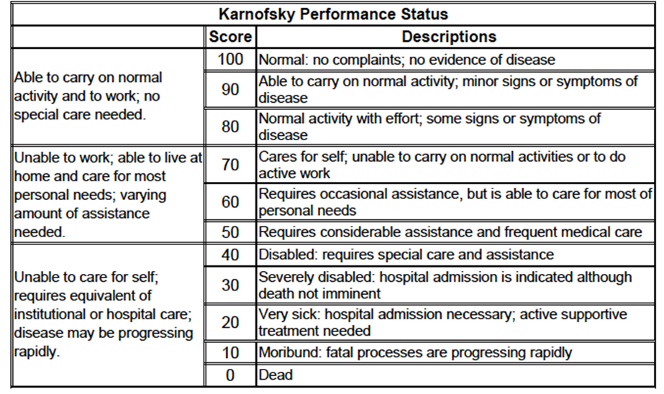

Study treatments
The trial was originally designed as a 2-arm study with subjects randomised 1:1 to receive either Onivyde monotherapy or 5FU/LV. After commencement of the study, a third arm (Onivyde in combination with 5FU/LV) was added with subsequent subjects randomised 1:1:1 to the three treatments. A total of 63 subjects had been randomised prior to the introduction of the third study arm.
The three study treatments were:
- Arm A: Onivyde 120 mg/m² IV over 90 minutes Day 1 of a 21 day cycle;
- Arm B: 5-FU 2000 mg/m² IV over 24 hours Days 1, 8, 15, 22 of a 42 day cycle;
LV 200 mg/m² IV over 30 minutes Days 1, 8, 15, 22 of a 42 day cycle;
- Arm C: Onivyde 80 mg/m² IV over 90 minutes Day 1 of a 14 day cycle;
5-FU 2400 mg/m² IV over 46 hours Day 1 of a 14 day cycle;
LV 400 mg/m² IV over 30 minutes Day 1 of a 14 day cycle.
Subjects who were homozygous for UGT1A1*28 received reduced initial doses of Onivyde. In arm A the initial dose was reduced to 80 mg/m² and in Arm C it was reduced to 60 mg/m². If the subject did not experience any drug-related toxicity the dose could be increased in subsequent cycles. In Arm C, Onivyde was administered prior to 5-FU/LV. In Arms B and C leucovorin was administered immediately before 5-FU. Prior to administration of Onivyde the dose was diluted in 5% dextrose to a final volume of 500 mLs.
Dose delays and dose reductions were specified for both Onivyde and 5-FU in the event of toxicities. All subjects were pre-medicated with anti-emetic agents according to local institutional practice for irinotecan and 5-FU administration. Use of G-CSF was permitted for the treatment of neutropaenia. Treatment with other anti-neoplastic therapy, curative radiotherapy or other investigational agents was prohibited.
Treatment was continued until disease progression, symptomatic deterioration, development of intolerable toxicity or a request from the patient (or the patient’s physician) to withdraw from the study.
Comment: The sponsor is not seeking approval for the use of Onivyde as monotherapy. Hence the comparison of interest from this study is Onivyde vs. 5FU/LV. There is currently no standard therapy for the second-line treatment of metastatic pancreatic cancer after failure of gemcitabine-based therapy. However, the choice of infusional 5-FU/LV as the comparator in this study is considered appropriate for the following reasons:
- According to the NCCN guidelines, fluoropyrimidine-based regimens are appropriate in this situation;
- 5-FU/LV has been used as the comparator arm in other recent phase 3 studies of 2nd line chemotherapy in pancreatic cancer;
- As discussed, trials of more intensive fluoropyrimidine-based regimens (e.g. 5FU with oxaliplatin) have given conflicting results;
- In Australia, 5-FU has a broad grandfathered indication for the treatment of pancreatic cancer that does not exclude use as a second-line agent.
- The 5-FU/LV schedules used in Arms B and C were different. The dose intensity of 5-FU was higher in Arm B (over a six week period a subject in Arm B would receive 8000 mg/m² of 5-FU whereas a subject in Arm C would receive 7,200 mg/m²).
- It is noted that the dose of Onivyde approved in the USA (based on this study) is 70/mg/m² rather than 80/mg/m². This appears to be due to the irinotecan content in Onivyde being based on free irinotecan base rather than irinotecan hydrochloride trihydrate as is proposed in the draft Australian PI.

Efficacy variables and outcomes
The main efficacy variables were:
- Survival
- Delay in disease progression;
- Reduction in tumour size;
- Improvement in symptoms;
- Quality of life.
The primary efficacy outcome was overall survival (OS) defined as the time from the date of randomisation to date of death or the date last known alive.
Secondary efficacy outcomes were:
- Progression-free survival (PFS), defined as the time from the date of randomisation to date of death or disease progression, whichever occurred earlier. Disease progression was defined according to the Response Evaluation Criteria In Solid Tumours (RECIST) version 1.1. Progression was assessed by the investigators;
- Time to treatment failure (TTF), defined as the time from the date of randomisation to date of death, disease progression or study discontinuation due to toxicity;
- Objective Response Rate (ORR), determined using RECIST v1.1 criteria and assessed by the investigators;
- Clinical Benefit Response (CBR) rate. This was a complex composite endpoint based on assessment of pain, performance status and weight.
- Tumour Marker Response (TMR) rate, defined as the proportion of those subjects with elevated serum levels of the tumour marker CA19-9 at baseline, who achieved a 50% reduction from baseline.
- Quality of life as assessed by the EORTC QLQ-C30 questionnaire. This is a validated cancer-specific 30-item questionnaire. It incorporates five functional scales (physical, role, cognitive, emotional and social) covered by 16 questions, three symptom scales (fatigue, pain and nausea/vomiting) covered by 6 questions, six single-question items (constipation, diarrhoea, sleep, dyspnoea, appetite and financial difficulties) and two questions addressing global health status. All scales and single-item measures range in score from 0 to 100. A high score on a functional scale represents a high level of functioning. A high score on global quality of life represents a high quality of life. A high score on the symptom scale or item represents a high level of symptomatic problems. A minimal clinically important difference is considered to be 5-10 points on the 100-point scale.
Tumour assessment (by CT or MRI) was performed at screening and every six weeks after randomisation. For subjects who discontinued treatment for reasons other than disease progression, scans were to be continued at six-weekly intervals until disease progression or commencement of other anti-cancer therapy. Data to assess CBR were collected at weekly intervals. Serum CA19-9 levels were assessed at screening and at every 6 weeks during treatment. The EORTC QLQ-C30 was administered at screening and at 6-weekly intervals thereafter. Patients who discontinued the study were followed up at monthly intervals for survival.
Comment: The choice of overall survival as the primary endpoint is appropriate. With the exception of CBR rate and TMR rate, the secondary endpoints are all standard for oncology studies. Disease progression and tumour response were assessed by the investigators, who were not blinded to treatment allocation. Therefore, interpretation of PFS and ORR may have been susceptible to bias.

Randomisation and blinding methods
Subjects were randomised 1:1:1 to the three study arms via an interactive web response system (IWRS). Randomisation was stratified based on the following prognostic factors:
- Baseline albumin levels (≥ 4.0 g/dL vs. < 4.0g/dL);
- KPS (70 and 80 vs. ≥ 90);
- Ethnicity (Caucasian vs. East Asian vs. All Others)
There was no blinding used in the study.

Analysis populations
The following analysis populations were defined:
- The Intent-to-Treat (ITT) population included all randomized patients. This population was the primary population for all efficacy parameters.
- The Safety population was a subset of the ITT population that received at least one dose of study medication. All safety analyses were performed on this population. All analyses using this population were based on the treatment actually received.
- The Per-Protocol (PP) population: This was a subset of the ITT population. It included patients who received treatment for at least 6 weeks, did not violate any inclusion/exclusion criteria and did not significantly deviate from the protocol through receipt of any prohibited therapies, not receiving treatment as randomized or significant deviations in study drug administration.
- The Evaluable Patient (EP) population for tumour response consisted of all randomized and treated patients, who met all inclusion/exclusion criteria, had measurable disease at baseline and were evaluable for response (i.e. patients with at least one tumour evaluation while on treatment and those with early [≤ 12 weeks] disease progression, including symptomatic deterioration and death).
- Tumour marker response-evaluable (TMRE) population: Patients who had elevated CA 19-9 level (> 30 U/mL) at baseline were defined as eligible for evaluation of tumour marker response.
- CBR-evaluable (CBRE) population: Patients who met at least one of the following criteria were defined as eligible for evaluation of CBR:
  - Baseline pain intensity ≥ 20 (out of 100);
  - Baseline morphine consumption ≥ 10 mg/day PO morphine equivalents;
  - Baseline KPS of 70 to 90 points.
- PRO population: All ITT patients that provided baseline and at least one subsequent assessment on EORTC-QLQ-C30 instrument.
- PK population: All treated patients with at least one PK assessment on treatment.

Sample size
Based on previous studies it was assumed that median overall survival would be 4.5 months for Arm A, and 3.0 months for Arm B. For Arm C, a median survival of 6.0 months was selected. These corresponded to hazard ratios (HR) of 0.67 and 0.5 in favour of Arm A and Arm C relative to Arm B, respectively. The sample size and power calculations also assumed that approximately 65 patients were randomised under the initial protocol (2 study arms) and that the remaining patients would be randomised under the revised protocol (3 study arms).
Two comparisons were intended – Arm A vs. Arm B and Arm C vs. Arm B – using two pairwise un-stratified log rank tests. A Bonferroni-Holm testing procedure was to be used to control the overall error rate at the two-sided 0.05 level. It was calculated that a total of 305 deaths would provide at least 85% power to detect the hypothesised advantage of Arm A over Arm B, and at least 99% power to detect the hypothesised advantage of Arm C over Arm B. In order to accrue a total of 305 deaths it was calculated that a total 405 subjects would need to be randomised.

Statistical methods
For the primary endpoint of overall survival (OS), Kaplan-Meier analyses were performed on each treatment group to obtain nonparametric estimates of the survival function and the median survival time. Corresponding 95% confidence intervals were computed using the log-log method. Unstratified Cox proportional hazards regression were used to estimate hazard ratios and their corresponding 95% confidence intervals. Pairwise comparisons were performed using the unstratified log rank test. The final analysis of OS was planned to occur after 305 deaths. No interim analyses were planned. Multiple sensitivity analyses of OS were undertaken using alternative statistical methods. Similar methods were used for analysing PFS and TTF.
Response rates (ORR, CBR and TMR) were compared between treatment arms using Fisher’s exact tests.
A sequential testing procedure was carried out to control the overall false positive rate at 0.05, for the primary and secondary endpoints. The order of the sequence was: OS, PFS, and ORR. A pairwise treatment comparison for a secondary endpoint was only carried out if the prior pairwise comparisons in the hierarchy were significant.

Participant flow
A total of 577 subjects were screened for enrolment in the study. Of these a total of 417 were randomised. The most common causes for screening failure were inadequate hepatic function (n=64), KPS < 70 (n=29) and other conditions deemed likely to interfere with study participation (n=22).

Major protocol violations/deviations
Deviations were more common in Arm C (Onivyde + 5-FU/LV) than in the other two arms. This was largely due to an increased incidence of ‘investigational product (IP)’ violations. The majority of these were instances of subjects receiving a reduced dose of leucovorin (200 mg/m² instead of 400 mg/m²).
Comment: The protocol violations are unlikely to affect the validity of the study conclusions.

Baseline data
Median age of subjects was 63.0 years. Males comprised 57% of the population and most subjects were white (61%) or Asian (33%).
The majority of patients had received at least two prior lines of treatment for their advanced/metastatic disease.
All subjects had received prior gemcitabine either as a single agent or in combination. Prior 5-FU-based treatment had been used in 43.9% of subjects and prior irinotecan-based treatment in 11.0%. Prior radiotherapy and surgical treatment is summarised in Table 20.
Comment: Arm B (5-FU/LV) and Arm C (Onivyde + 5-FU/LV) were generally well balanced with respect to baseline characteristics.

Results for the primary efficacy outcome
Results for overall survival are summarised in Table 3 and in Figure 1 (for the comparison of Arm C vs. Arm B). Treatment with the Onivyde + 5-FU/LV combination was associated with a statistically significant improvement in overall survival when compared to treatment with 5-FU/LV alone (hazard ratio = 0.67 [95% CI: 0.49 – 0.92]; p = 0.0122). Median survival was increased from 4.2 months to 6.1 months. The probability of being alive at 6 months was increased from 38% to 53% At 9 months it was increased from 24% to 35%. Treatment with Onivyde monotherapy did not result in improved survival compared to 5-FU/LV.

Table 3: Study MM-398-07-03-01 – Overall survival.
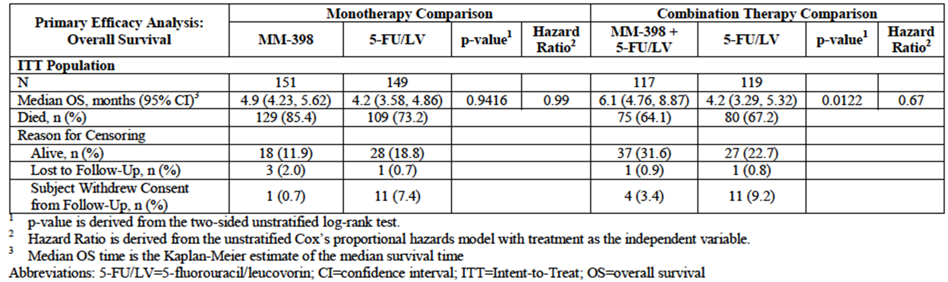
Figure 1: Study MM-398-07-03-01 – Overall survival.
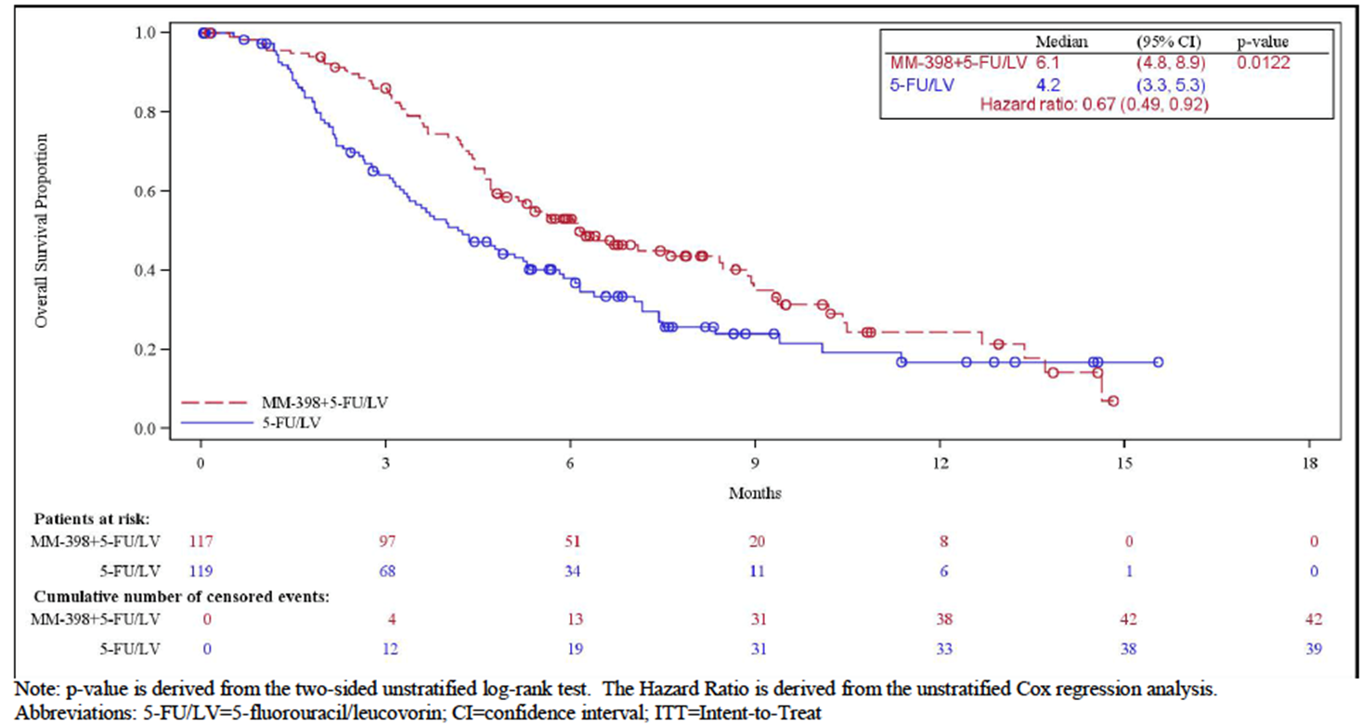
A number of sensitivity analyses were conducted and these are summarised in Table 4. These additional analyses were consistent with the findings of the primary analysis. A number of predefined subgroup analyses were also conducted. These are summarised in Figure 2.
Comment: The survival benefit obtained with Onivyde was generally consistent across subgroups in that hazard ratios were generally less than 1.0. It is noteworthy that a survival benefit was observed regardless of the number of prior lines of chemotherapy administered. It was also observed in subjects who had previously received 5-FU. Although the number of patients was small, the subgroup previously treated with irinotecan did not appear to experience a survival benefit.

Table 4: Study MM-398-07-03-01 – Overall survival (sensitivity analyses).
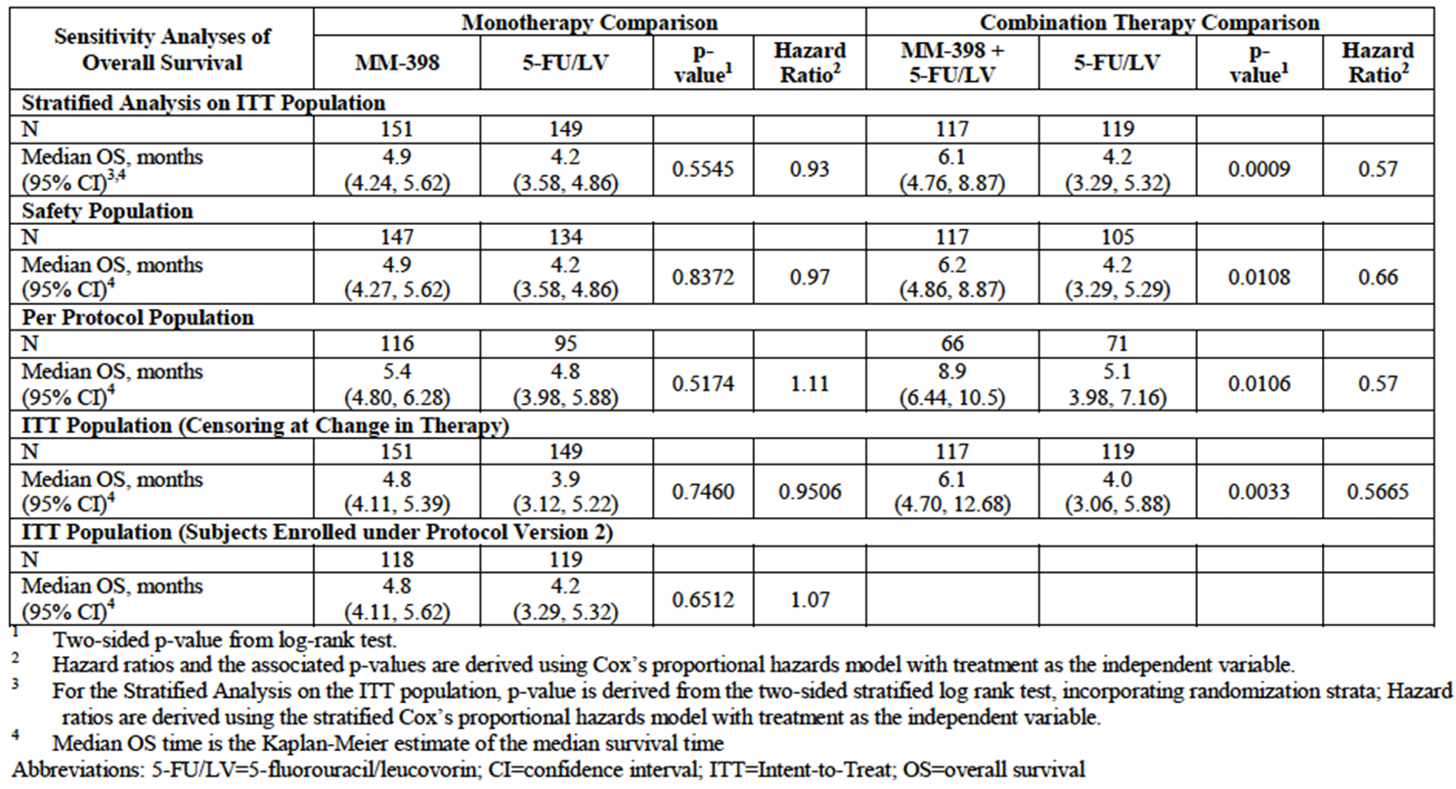
Figure 2: Study MM-398-07-03-01 – Overall survival.
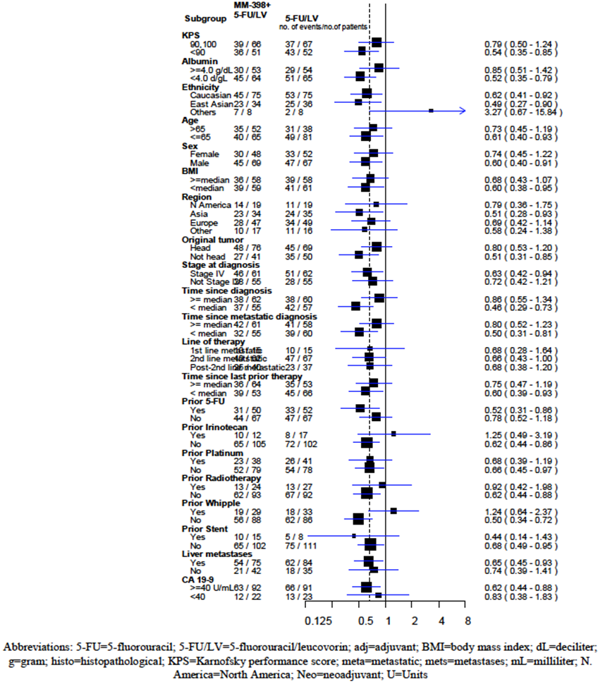

Results for other efficacy outcomes

Progression-free survival (PFS)
Results for PFS are summarised in Table 5 and in Figure 3 (for the comparison of Arm C vs. Arm B). Treatment with the Onivyde + 5-FU/LV combination was associated with a statistically significant improvement in PFS when compared to treatment with 5-FU/LV alone (hazard ratio = 0.56 [95% CI: 0.41 – 0.75]; p = 0.0001). Median PFS was increased from 1.5 months to 3.1 months. The probability of being alive and progression-free at 12 weeks was increased from 26% to 57%. Treatment with Onivyde monotherapy did not result in improved PFS compared to 5-FU/LV.

Table 5: Study MM-398-07-03-01 – Progression-free survival.
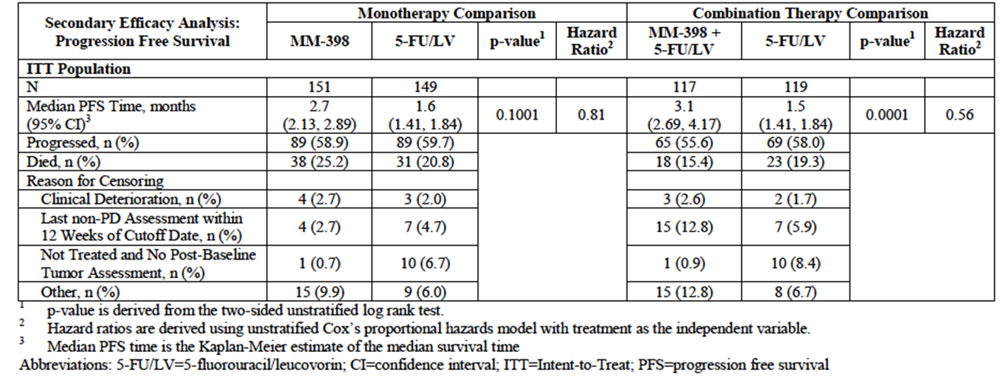
Figure 3: Study MM-398-07-03-01 – Progression-free survival.
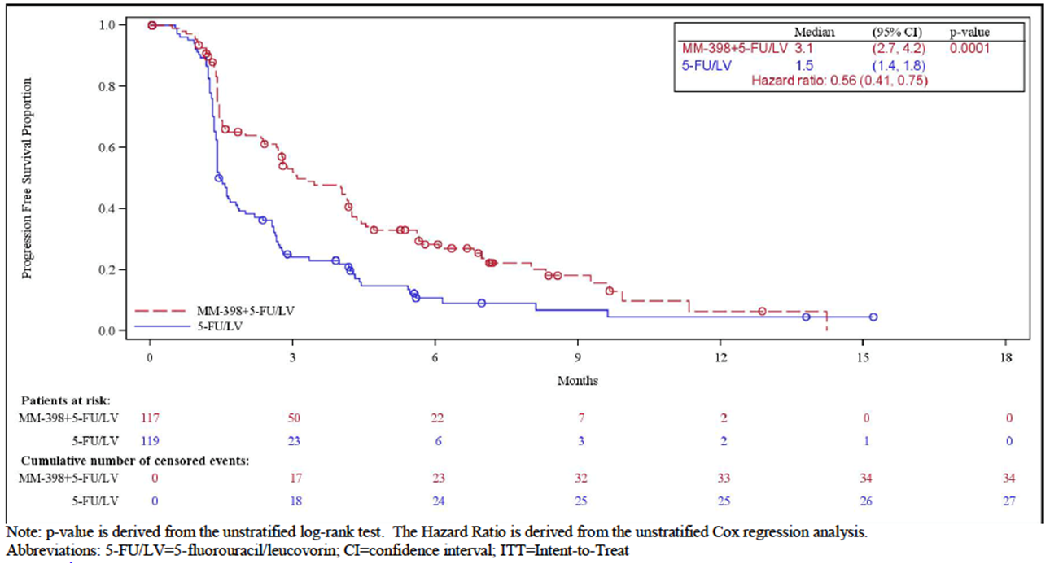
Several sensitivity analyses confirmed the findings of the primary PFS analysis. Subgroup analyses of PFS were not performed.

Time to Treatment Failure (TTF)
Results for TTF are summarised in Table 6. Treatment with the Onivyde + 5-FU/LV combination was associated with a statistically significant improvement in TTF when compared to treatment with 5-FU/LV alone (hazard ratio = 0.60 [95% CI: 0.45 – 0.78]; p = 0.0002). Median TTF was increased from 1.4 months to 2.3 months. Treatment with Onivyde monotherapy did not result in improved TTF compared to 5-FU/LV. Sensitivity analyses using the PP and EP populations confirmed the findings of the primary TTF analysis.

Table 6: Study MM-398-07-03-01 – Time to treatment failure.
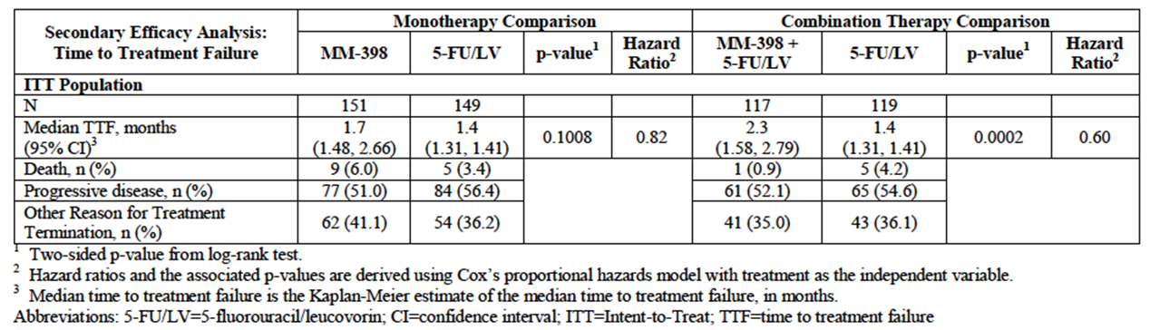

Objective response rate (ORR)
Results for ORR are summarised in Table 7. Tumour responses rates were low in all the three treatment groups. However, the confirmed response rate in the Onivyde + 5-FU/LV arm (7.69%) was significantly greater than that in the 5-FU/LV arm (0.84%) – p=0.0097. For unconfirmed responses the difference was numerically greater (16.24% vs. 0.84%; p<0.0001). All responses were partial responses.

Table 7: Study MM-398-07-03-01 – Objective response rate.
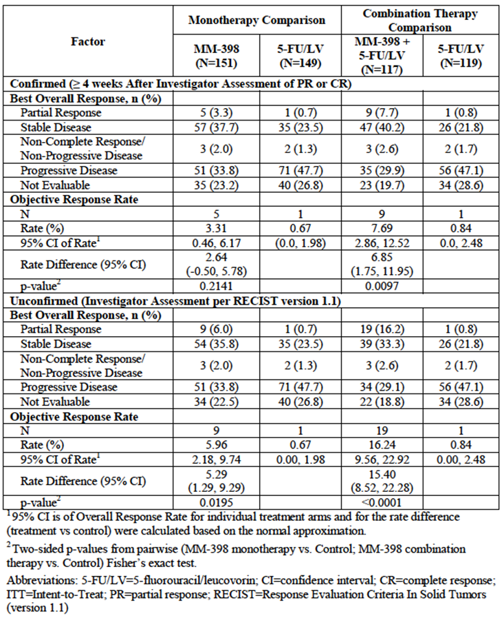

Clinical Benefit Response (CBR) rate
In the CBRE population, a CBR was achieved by 11 of 78 subjects (14.1%) in the Onivyde + 5-FU/LV arm compared to 7 of 60 subjects (11.7%) in the 5-FU/LV arm. The difference was not statistically significant (P=0.8007).

Tumour Marker Response (TMR) rate
In the TMRE population, a TMR was achieved by 28 of 97 subjects (28.9%) in the Onivyde + 5-FU/LV arm compared to 7 of 81 subjects (8.6%) in the 5-FU/LV arm. The difference was statistically significant (P=0.0006).

EORTC QLQ-C30 questionnaire
The study report presented tabulations of median scores at baseline, week 6 and week 12 in the three treatment arms for each of the following: - global health score, the five functional scale scores and the nine symptom scores. Median values at baseline were generally comparable between the three treatment arms. Median scores at week 6 and week 12 were generally unchanged or slightly changed from those at baseline, with no notable differences between treatment arms.
Median score for diarrhoea increased from 0 at baseline to 33.3 at week 6 in the two Onivyde-containing arms, indicating increased symptoms. In the 5-FU/LV arm the median score remained at 0.
Comment: The data suggest that there was minimal deterioration in QoL in any of the three treatment arms over the first 12 weeks of the study.

Other efficacy studies

Study PEP0208
Study PEP0208 was a single-arm, open-label phase 2 trial of Onivyde monotherapy in subjects with metastatic pancreatic cancer. It was conducted between 2009 and 2012 in three centres in Taiwan and the United States. The primary objective of the study was to assess the 3-month survival rate.
The study enrolled subjects with metastatic adenocarcinoma of the exocrine pancreas who had documented disease progression after gemcitabine-based therapy. Subjects were required to have a KPS ≥ 70.
Subjects were treated with Onivyde monotherapy 120 mg/m² IV on day 1 of a 21-day cycle. Subjects assessed as being at high risk of toxicity could receive a lower initial dose (100 mg/m²) at the discretion of the investigator. Treatment was continued until disease progression. The primary efficacy variable was the proportion of patients still alive 90 days after the first dose. Secondary endpoints included tumour response rate, serum CA19-9 levels, and clinical benefit response
A total of 40 subjects were enrolled and treated. Median age was 58.5 (range 39-82). 19 subjects were male and 12 were female.
At 90 days, 30 subjects (75.0%; 95% CI: 58.8 – 87.3) were alive. The objective response rate was 7.5% (95% CI: 1.6 – 20.4). All responses were partial responses. Median PFS (in the per protocol population) was 74.0 (95% CI: 41 - 133) days. Median OS (in the per protocol population) was 156.5 (95% CI: 112 - 237) days. Among subjects with an elevated serum CA19-9 level at baseline, 31.3% achieved a tumour marker response (≥ 50% decrease). 24% of subjects achieved a clinical benefit response.

Study PEP0201
This was the first-in-man study of Onivyde. The product was administered as monotherapy. Two of the 11 subjects had pancreatic cancer. One subject received 6 cycles of 180 mg/m² and achieved a partial response using RECIST criteria. The other subject received only 1 cycle of 180 mg/m² and developed progressive disease.

Study PEP0203
This was a phase 1, open dose-escalation study of Onivyde in combination with 5-fluorouracil and leucovorin in subjects with advanced solid tumours. Four of the 16 subjects enrolled had pancreatic cancer. In three of these subjects the best observed response was stable disease. The remaining patient developed progressive disease.

Analyses performed across trials (pooled & meta analyses)
There were no pooled analyses or meta-analyses of efficacy data included in the submission.

Evaluator’s conclusions on clinical efficacy for pancreatic cancer
The pivotal study in the submission was well designed and executed. The design generally complied with the requirements of the EMA guideline on anticancer agents.
Treatment with the combination of Onivyde + 5-FU/LV resulted in a statistically significant improvement in overall survival compared with 5-FU/LV alone. Median survival was improved by approximately 2 months. Given that the median survival with 5-FU/LV alone was only 4.2 months, an additional 2 months is considered clinically significant.
The finding of an overall survival benefit was supported by improvements in secondary endpoints such as PFS and TTF. There was also a small improvement in objective response rate and in the rate of response based on the biomarker CA19-9. The Onivyde + 5-FU/LV combination did not produce significant improvements in symptoms (as assessed by the CBR rate) or quality of life, compared to 5-FU/LV alone.
The submission to register Onivyde is based on a single pivotal study and the TGA has adopted an EMA guideline that deals with this situation. This guideline sets out certain ‘prerequisites’ that must be met for approval of such a submission. In the opinion of this reviewer, the design and results of the pivotal study allow the conclusion that these prerequisites have been met.
The Phase II monotherapy study in pancreatic cancer (PEP0208) provided some supportive evidence for efficacy in that a response rate of 7.5% was observed.
There are currently no established treatments for patients with metastatic pancreatic cancer who have failed gemcitabine based therapy. Given the demonstrated survival benefit and lack of alternative treatments, the evidence to support the efficacy of Onivyde in combination with 5-FU/LV is considered acceptable.

Clinical safety

Studies providing evaluable safety data
The submission did not include an analysis of pooled safety data. Hence safety data from each study are reviewed separately. The following studies provided evaluable safety data:

Pivotal efficacy study
In the pivotal efficacy study, the following safety data were collected:
- General adverse events (AEs). Information on AEs was collected at each study visit through open-ended questioning. AEs were graded (grades 1-5) according to the National Cancer Institute Common Toxicity Criteria for Adverse Events (NCI CTCAE) version 4.0. They were coded using the Medical Dictionary for Regulatory Activities (MedDRA) version 14.1.
- A number of AEs of special importance (AESI) were identified by the sponsor. These are listed in Table 8.

Table 8: Study MM-398-07-03-01 –AEs of special importance (AESI).
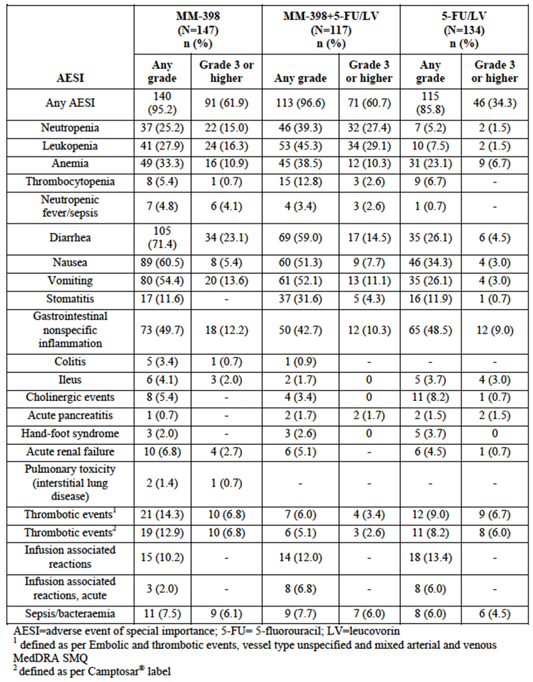
- Vital signs were recorded at most study visits. Physical examinations were performed regular intervals.
- Laboratory tests were performed at most study visits. Parameters tested were:
- Complete blood count (CBC), white blood count (WBC) and differential, haemoglobin, haematocrit and platelet count;
- Serum chemistry, electrolytes (sodium, potassium, chloride and bicarbonate), BUN, serum creatinine, glucose, direct and total bilirubin, AST, ALT, alkaline phosphatase, LDH, uric acid, total protein, albumin, calcium, magnesium, and phosphate
- ECGs were performed at screening and at the end of the study.

Phase 2 studies
There were two phase 2 studies
- Study PEP0208, which was a single-arm study of Onivyde as monotherapy in subjects with pancreatic cancer who had failed gemcitabine treatment.
- Study PEP0206, which compared Onivyde monotherapy with conventional irinotecan as monotherapy and docetaxel as monotherapy in subjects with gastric cancer. Safety data from this study are of interest as they enable a comparison of the toxicities of Onivyde and conventional irinotecan;
The safety data collected in these studies were comparable to those collected in the pivotal study.

Phase 1 studies
There were five phase 1 studies in the submission. Safety data from these studies are reviewed separately in this report.

Patient exposure
A total of 634 subjects were treated in the studies. Of these, 412 received Onivyde either as monotherapy or in combination with other chemotherapy agents.

Pivotal study
Overall exposure to study drugs in the pivotal study is summarised in Table 9.

Table 9: Study MM-398-07-03-01 – Overall exposure.
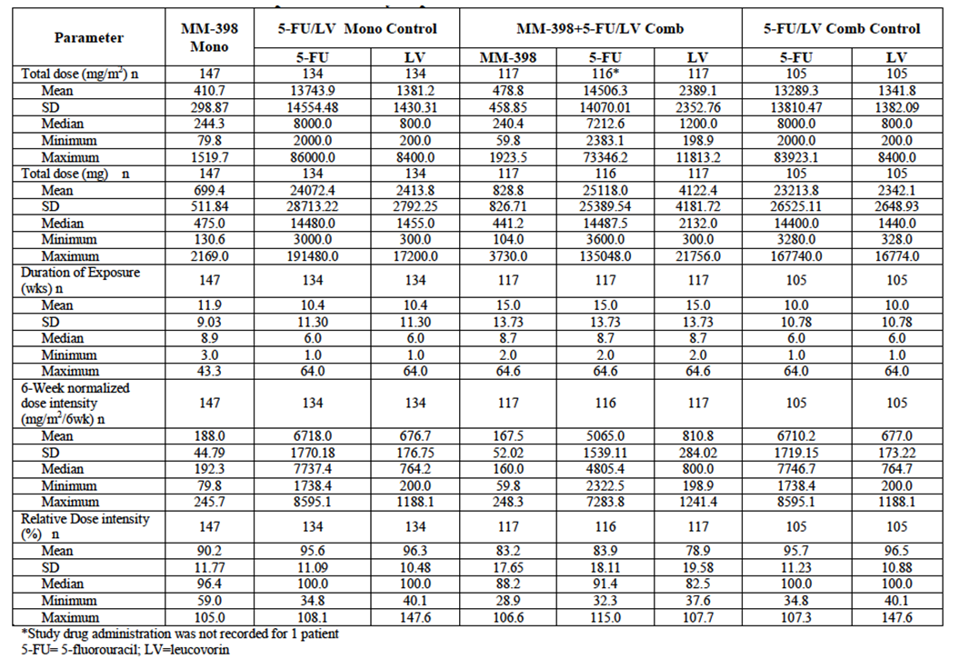
Comment: Duration of exposure was relatively short in all three treatment arms, but was longer in the Onivyde+5-FU/LV arm than in the 5-FU/LV control arm (mean duration 15.0 vs. 10.0 weeks). Although 5-FU dose intensity was higher in the control arm, the total amount of 5-FU delivered was slightly higher in the combination arm.

Other studies

PEP0208
The mean number of cycles received was 5.9 (21-day cycles of 120 mg/m²).

PEP0206 (vs. irinotecan)
The mean number of cycles received was 4.4 for Onivyde, 4.6 for irinotecan and 4.7 for docetaxel. Median dose intensity was 100% in all three arms.

Adverse events
An overall summary for the incidence of AEs, SAEs etc. is shown in Table 10 for the pivotal study, in Table 11 for study PEP0208 and in Table 12 for study PEP0206.

Table 10: Study MM-398-07-03-01 - Overall summary of AEs.
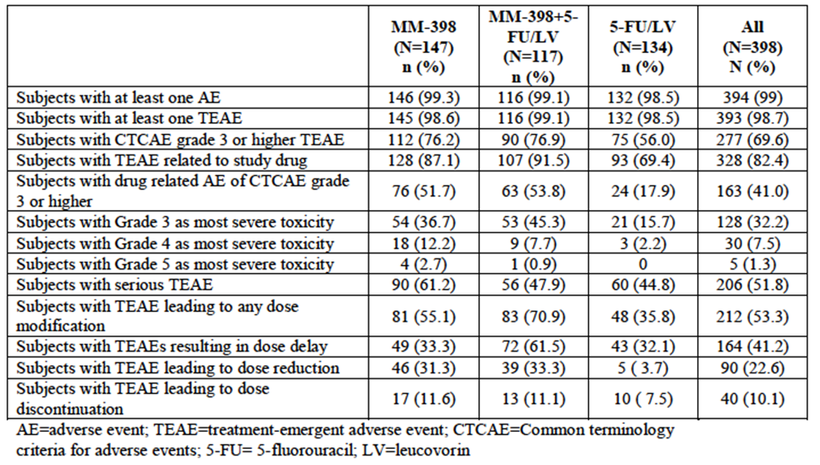

Table 11: Study PEP0208 - Overall summary of AEs.
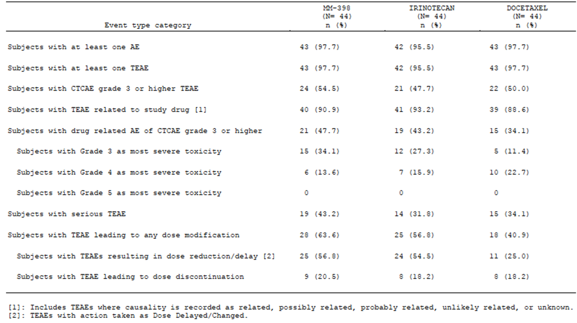

Table 12: Study MM-398-07-03-01 – Common AEs (incidence > 10% in any arm).
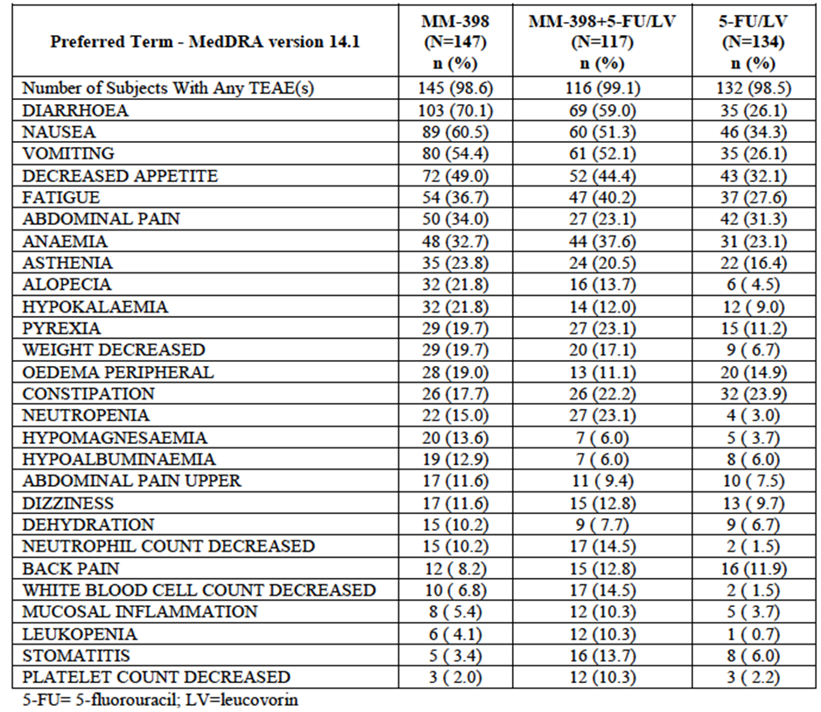

All adverse events (irrespective of relationship to study treatment)

Pivotal study
The incidence of treatment-emergent AEs was 99.1% in the combination arm and 98.5% in the 5-FU/LV comparator arm. Common AEs (those occurring in at least 10% of subjects in any arm) are shown in Table 12. Compared to the 5-FU/LV arm the combination arm was associated with notable increases the incidence of the following toxicities:
- Gastrointestinal toxicity – diarrhoea, nausea, vomiting, decreased appetite and stomatitis/mucosal inflammation;
- Myelotoxicity – anaemia, leukopaenia, neutropaenia and decreased platelet count;
- Constitutional symptoms – fatigue, pyrexia and decreased weight.
The incidence of diarrhoea was even higher in the Onivyde monotherapy arm, where a higher dose of Onivyde was used.
The incidence of grade ≥ 3 AEs was 76.9% in the combination arm and 56.0% in the 5-FU/LV comparator arm. Common grade ≥ 3 AEs (those occurring in at least 3% of subjects in any arm) are shown in Table 13. The pattern of extra toxicity in the combination arm was similar to that seen for all AEs.

Table 13: Study MM-398-07-03-01 – Common Grade ≥ 3 AEs (incidence > 3% in any arm).
System Organ Class/  Preferred Term - MedDRA version 14.1 | MM-398  (N=147)  n (%) |  | MM-398+5-  FU/LV  (N=117)  n (%) |  | 5-FU/LV  (N=134)  n (%)
Number of Subjects With Any Grade 3 or  Higher TEAE(s) | 112 (76.2) |  | 90 (76.9) |  | 75 (56.0)
BLOOD AND LYMPHATIC SYSTEM  DISORDERS | 29 (19.7) |  | 31 (26.5) |  | 10 ( 7.5)
ANAEMIA | 16 (10.9) |  | 11 ( 9.4) |  | 9 ( 6.7)
FEBRILE NEUTROPENIA | 6 ( 4.1) |  | 2 ( 1.7) |  | 0
NEUTROPENIA | 8 | (5.4) | 17 | (14.5) | 1 |  | (0.7)
GASTROINTESTINAL DISORDERS | 68 | (46.3) | 38 | (32.5) | 29 |  | (21.6)
ABDOMINAL PAIN | 12 | ( 8.2) | 8 | ( 6.8) | 8 |  | ( 6.0)
ASCITES | 5 | ( 3.4) | 2 | ( 1.7) | 2 |  | ( 1.5)
DIARRHOEA | 31 | (21.1) | 15 | (12.8) | 6 |  | ( 4.5)
NAUSEA | 8 | ( 5.4) | 9 | ( 7.7) | 4 |  | ( 3.0)
VOMITING | 20 | (13.6) | 13 | (11.1) | 4 |  | ( 3.0)
GENERAL DISORDERS AND  ADMINISTRATION  SITE CONDITIONS | 26 | (17.7) | 29 | (24.8) | 20 |  | (14.9)
ASTHENIA | 10 | ( 6.8) | 9 | ( 7.7) | 9 |  | ( 6.7)
FATIGUE | 9 | ( 6.1) | 16 | (13.7) | 5 |  | ( 3.7)
GENERAL PHYSICAL HEALTH  DETERIORATION | 5 | ( 3.4) |  | 0 |  |  | 0
INFECTIONS AND INFESTATIONS | 21 | (14.3) | 20 | (17.1) | 16 |  | (11.9)
SEPSIS | 3 | ( 2.0) | 4 | ( 3.4) | 1 | ( 0.7)
INVESTIGATIONS | 26 | (17.7) | 23 | (19.7) | 5 | ( 3.7)
NEUTROPHIL COUNT DECREASED | 12 | ( 8.2) | 12 | (10.3) | 1 | ( 0.7)
WHITE BLOOD CELL COUNT  DECREASED | 4 | ( 2.7) | 9 | ( 7.7) |  |  | 0
METABOLISM AND NUTRITION  DISORDERS | 53 | (36.1) | 22 | (18.8) | 16 |  | (11.9)
DECREASED APPETITE | 13 | ( 8.8) | 5 | ( 4.3) | 3 |  | ( 2.2)
DEHYDRATION | 5 | ( 3.4) | 5 | ( 4.3) | 2 |  | ( 1.5)
HYPERGLYCAEMIA | 8 | ( 5.4) | 1 | ( 0.9) | 3 |  | ( 2.2)
HYPOKALAEMIA | 17 | (11.6) | 4 | ( 3.4) | 3 |  | ( 2.2)
HYPONATRAEMIA | 9 | ( 6.1) | 3 | ( 2.6) | 2 |  | ( 1.5)

Other studies

PEP0208
AEs occurred in 100% of treated subjects. Gastrointestinal toxicity was the most frequent, especially diarrhoea (incidence = 75%), nausea (60.0%), decreased appetite and vomiting (57.5% each). Common non-GIT toxicities included fatigue (62.5%), alopecia (42.5%), neutropaenia (40.0%), leukopaenia (37.5%), decreased weight (37.5%) and anaemia (32.5%).
Grade ≥ 3 AEs occurred in 67.5% of subjects. The pattern of grade ≥ 3 toxicities was similar to that observed for all AEs.

PEP0206 (vs. irinotecan)
AEs occurred in 97.7% of subjects treated with Onivyde monotherapy compared with 95.5% of subjects treated with irinotecan. Common AEs are shown in Table 14. Gastrointestinal AEs were the most commonly reported events with Onivyde with diarrhoea being the most frequent (72.7%). Common non-GIT events were anorexia (54.5%), alopecia (38.6%) and neutropaenia (27.3%). The incidence of the common AEs was generally comparable in the Onivyde and irinotecan arms, although nausea (61.4% vs. 40.9%) and vomiting (45.5% vs. 34.1%) appeared more common with Onivyde.

Table 14: Study PEP0206 - Common AEs.
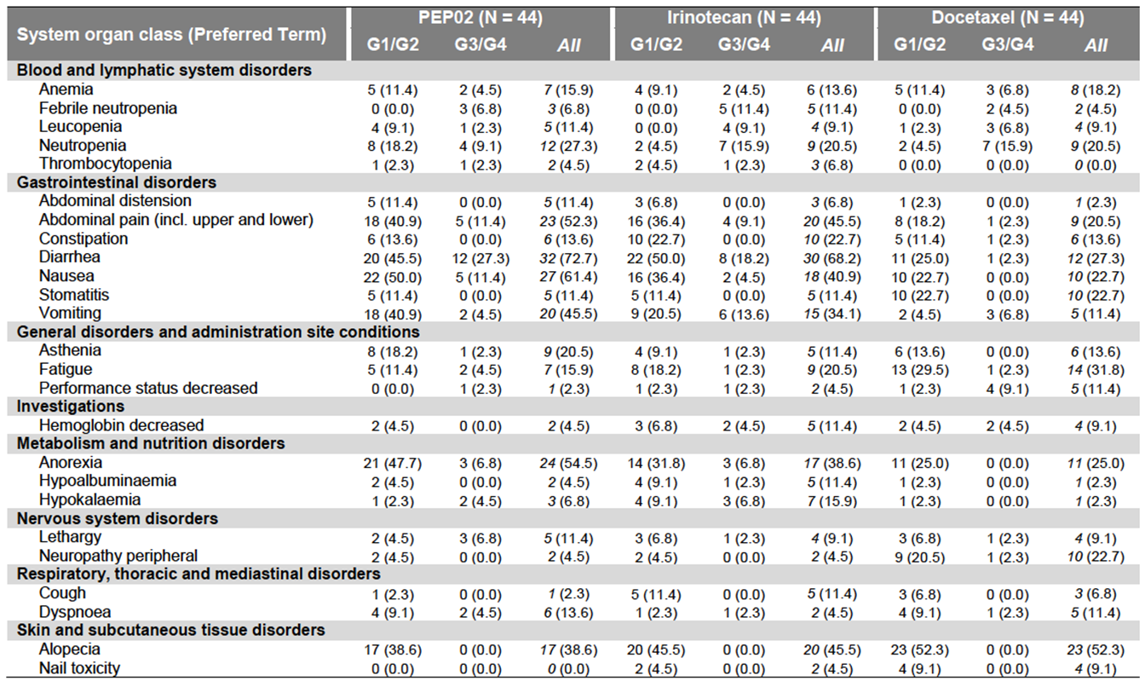
The incidence of grade 3 or 4 AEs was 54.5% with Onivyde and 47.7% with irinotecan. The pattern of events was consistent with that seen for all AEs.

Treatment-related adverse events (adverse drug reactions)

Pivotal study
The incidence of treatment-emergent AEs was 91.5% in the combination arm and 69.4% in the 5-FU/LV comparator arm. Common AEs (those occurring in at least 10% of subjects in any arm) are shown in Table 15. The pattern of extra toxicity in the combination arm was similar to that seen for all AEs.

Table 15: Study MM-398-07-03-01 – Common treatment-related AEs (incidence > 10%).
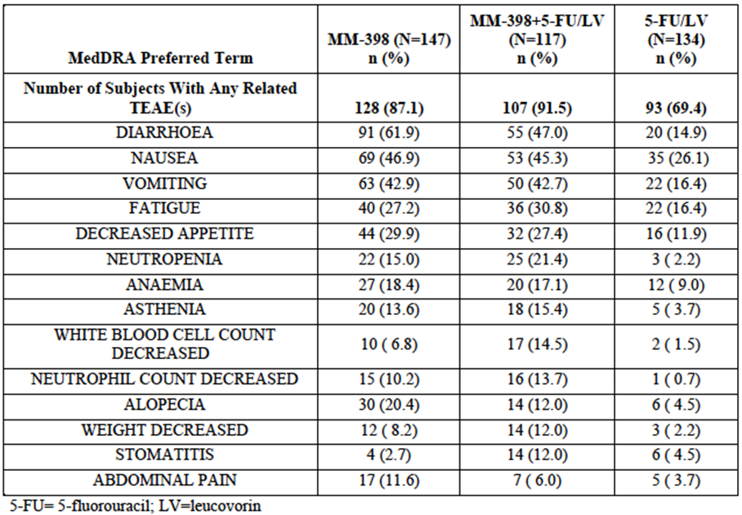

Other studies

PEP0208
The incidence of treatment-related AEs was 97.5%. The pattern of events was consistent with that seen for all AEs.

PEP0206 (vs. irinotecan)
The incidence of treatment-related AEs was 90.9% with Onivyde and 93.2% with irinotecan. The pattern of events was consistent with that seen for all AEs.

Deaths and other serious adverse events

Pivotal study

Deaths
The incidence of AEs (occurring while on treatment or within 30 days after cessation of treatment) and leading to death was:
- Onivyde monotherapy: 15/147 (10.2%);
- Onivyde+5-FU/LV: 2/117 (1.7%);
- 5-FU/LV: 10/134 (7.5%).
One of the deaths in the combination arm was assessed as being drug-related. This was a [information redacted] subject who received one dose only of the combination regimen. Four days later he developed fever, chills, vomiting and diarrhoea. He then developed severe neutropaenia followed by septic shock and multi-organ failure. The subject died 13 days after his first dose.
None of the 10 deaths in the 5-FU/LV arm were assessed as being related to treatment. Four of the deaths in the Onivyde monotherapy arm were assessed as being treatment-related (GIT toxicity, disseminated intravascular coagulation/pulmonary embolism, neutropaenia/septic shock and febrile neutropaenia/infectious colitis).

SAEs
The incidence of serious AEs was only slightly higher in the combination arm than in the 5-FU/LV comparator arm (47.9% vs. 44.8%). SAEs occurring in at least 1% of subjects in any arm are shown in Table 16. The combination arm was associated with higher incidences of serious cytopaenias, infections and some GIT disorders (diarrhoea, nausea, vomiting).

Table 16: Study MM-398-07-03-01 – Serious AEs (incidence > 1%).
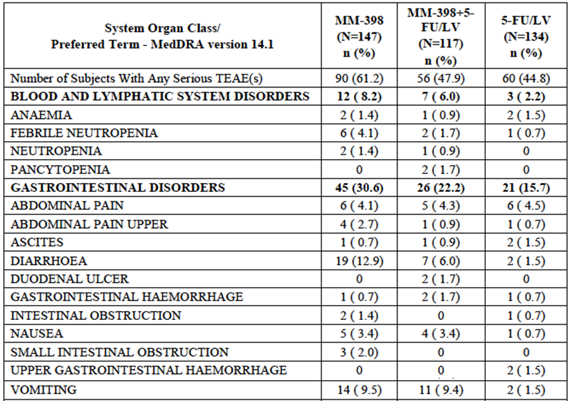
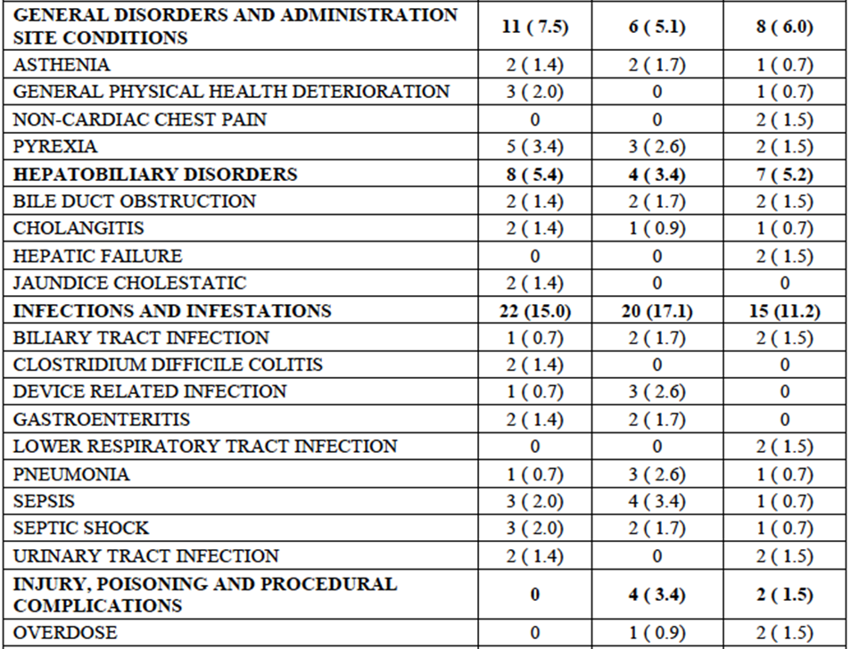

Table 16 (continued): Study MM-398-07-03-01 – Serious AEs (incidence > 1%).
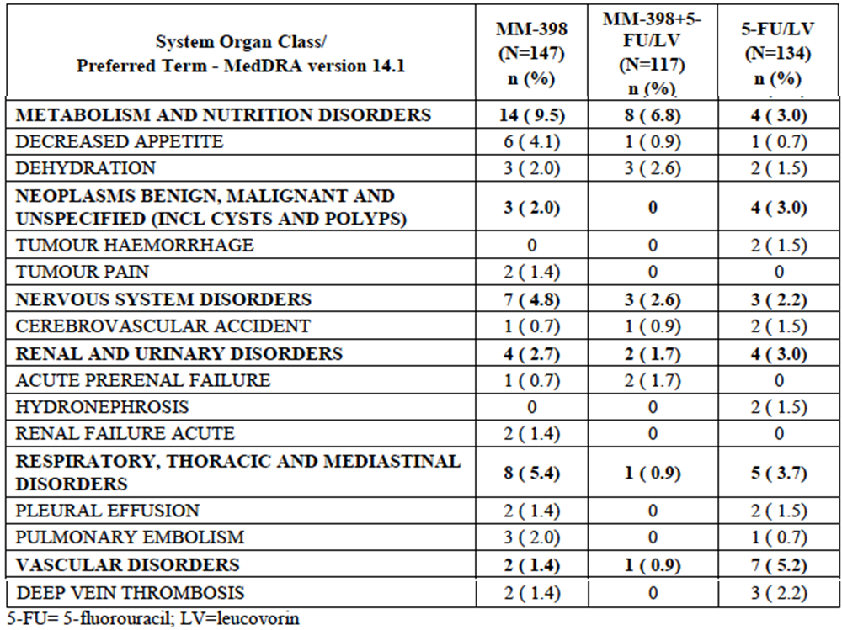

Other studies

PEP0208
Deaths
There were four subjects in the study who developed AEs that led to death. One was considered probably related to treatment. This was a [information redacted] subject who died from neutropaenic sepsis. Two other deaths were assessed as being unlikely to be related (aspiration pneumonia and abdominal pain/suspected tumour progression). The remaining death was due to respiratory failure and was assessed as not related.
SAEs
SAEs occurred in 45.0% of subjects. The pattern of events was consistent with that seen for all AEs.

PEP0206 (vs. irinotecan)
Deaths
There were 4 deaths in the study: 2 in the Onivyde arm, and 2 in the irinotecan arm. Only one of these deaths was assessed as being related to study drug. This was a [information redacted] subject treated with one cycle of Onivyde who developed febrile neutropaenia, a chest infection and septic shock. The subject recovered after ICU treatment but died at home at some time later presumably due to ongoing infection.
SAEs
SAEs were more common with Onivyde (43.2%) than with irinotecan (31.8%). Individual SAEs that were notably more common with Onivyde included:
- Diarrhoea (20.5% vs. 9.1%);
- Abdominal pain (9.1% vs. 2.3%);
- Dyspnoea (6.8% vs. 0%);
- Nausea (4.5% vs. 0%);
- Dehydration (4.5% vs. 0%).

Discontinuation due to adverse events

Pivotal study
AEs leading to treatment discontinuation were only slightly more frequent in the combination arm than in the 5-FU/LV comparator arm (11.1% vs. 7.5%). GIT disorders and infections leading to discontinuation were more common in the combination arm.

Other studies

PEP0208
The incidence of AEs leading to discontinuation was 15.0% (6/40 subjects). Neutropaenia was an issue in two of these subjects and diarrhoea in one. Otherwise there was no consistent pattern of AEs.

PEP0206 (vs. irinotecan)
The incidence of AEs leading to discontinuation was 20.5% with Onivyde and 18.2% with irinotecan. The only individual AE that led to discontinuation in more than one patient in the Onivyde arm was decreased appetite (3 subjects, 6.8%).

Adverse events of special importance
In the pivotal study a number of AEs were identified as AEs of special interest (AESI). The incidence of these events are summarised above.

Laboratory tests
An analysis of the incidence of abnormal laboratory values was not presented for study PEP0206.

Liver function

Pivotal study
Elevated ALT levels occurred more frequently in the combination arm than in the 5-FU/LV arm (50.5% vs. 36.9%). Grade 3 or 4 elevations were also more common (5.5% vs. 0.8%). However, incidences of other LFT abnormalities (AST, ALKP and bilirubin) were not notably higher with combination treatment.

Study PEP0208
Grade 3 or 4 elevations were observed in 34.3% of subjects for GGT and 16.2% of subjects for ALKP. For other LFTs the incidence was < 10%.
Comment: Abnormal LFTs are listed as an adverse reaction in the current PI for conventional irinotecan.

Kidney function

Pivotal study
Although elevations in serum creatinine occurred more frequently in the combination arm than in the 5-FU/LV arm, there were no grade 3 or 4 abnormalities.

Study PEP0208
There were no grade 3 or 4 elevations in serum creatinine.
Comment: Increase in serum creatinine and blood urea nitrogen is listed in the current PI for conventional irinotecan.

Other clinical chemistry

Pivotal study
Electrolyte abnormalities (decreases in sodium, potassium, calcium and magnesium) were more common in the combination arm. The abnormalities were predominantly grade 1 in severity. Such abnormalities may have been due to diarrhoea induced by Onivyde.

Study PEP0208
Grade 3 or 4 changes in sodium were observed in 23.1% of subjects. For other biochemistry parameters the incidence was < 10%.

Haematology

Pivotal study
Neutropaenia was more common in the combination arm than in the comparator arm (51.8% vs. 6.0%). Grade 3/4 neutropaenia was also more common (20.2% vs. 2.3%). Results for leukopaenia were similar. Decreases in haemoglobin and platelets also occurred more commonly in the combination arm, although grade 3/4 abnormalities were not notably increased.

Study PEP0208
25% of subjects developed grade 3 or 4 neutropaenia, and 22.5% of subjects developed grade 3 or 4 leukopaenia.

Electrocardiograph

Pivotal study
There were no clinically significant changes in ECGs.

Other studies
ECGs were not routinely monitored in the phase 2 studies.

Vital signs

Pivotal study
Significant weight loss (> 5%) occurred more frequently with combination treatment than with 5-FU/LV (52.6% vs. 25.0%). Other abnormalities occurred with comparable frequency.

Other studies

PEP0208
There were no clinically significant changes observed in mean values for vital signs.

PEP0206 (vs. irinotecan)
No consistent clinically significant changes were observed in blood pressure or pulse rate. Small decreases in mean body weight were observed for both the Onivyde and irinotecan groups over the course of the study.

Phase I studies

Study PEP0201
This study was the first-in-man trial of Onivyde. It was a phase 1, open, dose-escalation trial that examined the safety and PK of Onivyde as monotherapy in subjects with solid tumours. Three dose levels were tested – 80, 120 and 160 mg/m² – given IV on day 1 of a 21-day cycle.

DLT/MTD
DLTs were defined as:
- Grade 4 haematological toxicity lasting for longer than 3 days; or
- Febrile neutropaenia (ANC < 0.5 x 10⁹/L with temperature ≥ 38°C); or
- Grade ≥ 3 non-haematological toxicity (except grade 3 nausea and vomiting).
The maximum tolerated dose (MTD) was defined as the highest dose level at which ≤ 1 out of six patients experienced DLT.
A total of 11 subjects were enrolled. DLTs occurred in 2 of 4 subjects treated with 180 mg/m² and only 1 of 6 subjects treated with 120 mg/m². The MTD was therefore determined to be 120 mg/m² (when given as monotherapy at 21-day intervals).

Other safety data
A total of 40 cycles of treatment were administered to the 11 subjects (range 1-6 per subject). The incidence of AEs was 100%. The most events were diarrhoea (incidence 100%), vomiting (82%), nausea (82%), fatigue, (55%), alopecia (55%), leukopaenia (36%), neutropaenia (36%) and weight loss (36%). The incidence of drug-related AEs was also 100%, with a similar pattern of events. Seven subjects (64%) experienced SAEs (mostly gastrointestinal and haematological events). One patient died after developing febrile neutropaenia and GIT haemorrhage.

Study PIST-CRC-01
This was a phase 1 dose-escalation study of Onivyde as monotherapy in subjects with metastatic colorectal cancer. Three dose levels were tested – 80, 90 and 100 mg/m² – given IV on days 1 and 15 of a 28-day cycle. Escalation above 100 mg/m² was not permitted in the protocol.

DLT/MTD
DLTs were defined as:
- Grade 4 haematological toxicity lasting for longer than 3 days; or
- Grade 3 haematological toxicity associated with complications (e.g., febrile neutropaenia or bleeding); or
- Grade ≥ 3 non-haematological toxicity (except grade 3 nausea and vomiting);
- Dose delay of > 2 weeks due to drug-related toxicity.
The MTD was defined as the highest dose level at which no more than 1 out of six patients experienced DLT.
A total of 18 subjects were enrolled. One subject at each dose level developed a DLT. As dose escalation beyond 100 mg/m² was not permitted, this dose level was determined to be the MTD (when given as monotherapy at 14-day intervals).

Other safety data
A total of 109 cycles were administered to the 18 subjects (median 4 cycles/subject, range 2-18). AEs and treatment-related AEs occurred in 100% of subjects. Grade 3 or 4 AEs occurred in 72% of subjects and SAEs in 17%. There were no deaths due to AEs. The most common toxicities assessed as treatment-related were:
- Gastrointestinal - diarrhoea (incidence 77.8%), nausea (77.8%), anorexia (77.8%) and vomiting (66.7%);
- Haematological - anaemia (66.7%), leukopenia (61.1%), and neutropenia (55.6%);
- Alopecia (88.9%);
- Mucosal inflammation (61.1%);
- Fatigue (50.0%);

Study PEP0203
This was a phase 1, open dose-escalation trial that examined the safety of Onivyde in combination with 5-fluorouracil and leucovorin in subjects with advanced solid tumours. Four dose levels of Onivyde were tested – 60, 80, 100 and 120 mg/m² - given IV on day 1 of a 21-day cycle. All subjects also received 5-fluorouracil 2000 mg/m² IV and leucovorin 200 mg/ m² IV (both over 24 hours) on days 1 and 8 of the 21-day cycle.

DLT/MTD
DLTs were defined as a toxicity occurring during the first cycle consisting of:
- Grade 4 haematological toxicity lasting at least 3 days; or
- Grade 3 haematological toxicity associated with complications (e.g., febrile neutropaenia or bleeding); or
- Grade ≥ 3 non-haematological toxicity (except grade 3 nausea and vomiting);
- Dose delay of > 2 weeks due to drug-related toxicity.
The MTD was defined as the highest dose level at which no more than 1 out of six patients experienced DLT.
A total of 16 subjects were enrolled. No subjects in the 60 and 80 mg/m² cohorts experienced a DLT. 2/5 subjects in the 100 mg/m² cohort and 2/2 subjects in the 120 mg/m² cohort experienced DLTs. The MTD was therefore determined to be 80 mg/m² (when given in combination with 5FU/LV in a 21-day cycle).

Other safety data
The median number of cycles administered to the 16 subjects was 4.5 (range 1 to 6). AEs occurred in 100% of subjects and treatment-related AEs in 94%. Grade 3 or 4 AEs occurred in 44% of subjects and SAEs in 62.5%. There were no deaths due to treatment-related AEs. The most common toxicities assessed as treatment-related were:
- Gastrointestinal - nausea (incidence 81.3%), diarrhoea (75.0%), vomiting (75.0%) and abdominal pain (43.8%);
- Weight loss (50.0%);
- Hypokalaemia (50.0%)
- Fatigue (50.0%);
- Haematological - anaemia (43.8%), leukopenia (37.5%), and neutropenia (37.5%%);
- Mucosal inflammation (43.8%);
- Pyrexia (43.8%).

Study PEP0202
This was a phase 1, open dose-escalation trial that examined the safety of Onivyde in combination with cisplatin in subjects with advanced carcinoma of the cervix. Two dose levels of Onivyde were tested – 60 and 80 mg/m² - given IV on day 1 of a 21-day cycle. All subjects also received cisplatin 60 mg/m² IV on day 1 of the 21-day cycle. Further phase 1 dose escalation of Onivyde up to 120 mg/m², and a planned phase 2 portion of the trial did not proceed.

DLT/MTD
DLT was defined as drug-related toxicity occurring in the first cycle and consisting of at least one of the following:
- Grade 4 haematological toxicity lasting for longer than 3 days; or
- Grade 3 haematological toxicity associated with complications (e.g., febrile neutropaenia or bleeding)
- Grade ≥ 3 non-haematological toxicity (except for alopecia and nausea and vomiting that responded to treatment);
- Dose delay of > 2 weeks due to drug-related toxicity.
The maximum tolerated dose (MTD) was defined as the highest dose level at which ≤ 1 out of six patients experienced DLT.
Three subjects were treated at the 60 mg/m² dose level and none developed DLT (although one subject died due to multiple SAEs in the second cycle). Three subjects were then treated at the 80 mg/m² dose level and two of these developed DLTs, principally diarrhoea, febrile neutropenia, and grade 4 leukopaenia and neutropaenia. Both of these patients died. The study was suspended and then terminated. The stated reason for termination was that protocol violations (incorrect dosing) had occurred at 60 mg/m² such that the safety of this dose had not been adequately tested prior to escalation to the next dose level. The 80 mg/m² dose level clearly exceeded the MTD. However, an insufficient number of subjects had been enrolled in the 60 mg/m² dose level to define the MTD.

Other safety data
AEs and treatment-related AEs occurred in 100% of subjects. 3 subjects (50%) developed a total of 19 SAEs. 17 of these SAEs were considered to be treatment-related. All 3 of these subjects died with diarrhoea, neutropaenia and sepsis.

Study MM-398-01-01-02
This was a phase 1 pilot study that involved treating subjects with metastatic solid tumours with Onivyde monotherapy at a dose of 80 mg/m² every 2 weeks. A full study report was not provided. Limited safety data were provided in a six-page synopsis of the study.
13 patients were treated with Onivyde. The median number of cycles received was 2 (range 1-8). The incidence of treatment-related AEs was 100%. The incidence of SAEs was 30.8% and for grade 3 or 4 AEs it was 69.2%. There were no AEs that led to death.
The most common AEs assessed as related to Onivyde were diarrhea (76.9%), nausea (69.2%), vomiting (53.8%), anaemia (30.8%), hypokalaemia (30.8%), neutropaenia (30.8%), and fatigue (23.1%).

Post-marketing experience
There were no post-marketing data included in the submission.

Safety issues with the potential for major regulatory impact

Liver toxicity
The current PI for conventional irinotecan solution states that liver enzyme abnormalities have been reported with the drug, but usually in patients with known hepatic metastases. It also states that increases in AST and ALT in the absence of progressive liver metastasis have been reported rarely.
The submission did not provide a discussion of any patients that met ‘Hy’s law’ criteria for liver toxicity. However, in the pivotal study, approximately 70% of subjects had hepatic metastases at baseline. The incidence of grade 3/4 abnormalities of ALT was increased in the combination arm compared to the comparator arm. However, abnormalities of other LFTs were not notably increased. There were 2 reported cases of hepatic failure in the 5-FU/LV control arm and none in the two Onivyde arms.
Comment: Irinotecan does not appear to have been associated with severe irreversible drug-induced liver injury (DILI). The submitted data do not suggest this is a risk for Onivyde.

Haematological toxicity
Haematological toxicity is a known adverse reaction associated with irinotecan. In the pivotal study, Onivyde was associated with a significantly increased risk of grade 3/4 neutropaenia and leukopaenia. There were two cases of pancytopaenia reported in the Onivyde monotherapy arm.

Serious skin reactions
According to the current PI for conventional irinotecan solution, alopecia is a common adverse effect. Rashes have also been reported but these did not result in discontinuation of treatment.
In the pivotal study in this submission, the incidence of dermatological adverse events was 28.2% in the combination arm and 29.1% in the 5-FU/LV comparator arm. There were no serious dermatological reactions reported.
In Study PEP0202, in which Onivyde was administered in combination with cisplatin, there was 1 case of Stevens-Johnson syndrome that was assessed as being unrelated to Onivyde.

Cardiovascular safety
The current PI for conventional irinotecan solution lists vasodilation (due to irinotecan’s anti-cholinesterase activity) and thromboembolic events as potential cardiovascular toxicities.
Combination treatment was associated with an increased incidence of hypotension (6.0% versus 1.5%) compared to 5-FU/LV. Otherwise there was no suggestion of increased cardiovascular toxicity due to Onivyde. There was no increase in the incidence of serious cardiovascular AEs in the combination arm.

Unwanted immunological events
The current PI for conventional irinotecan solution indicates that hypersensitivity reactions including severe anaphylactic and anaphylactoid reactions have been observed with the drug.
In the pivotal study, infusion reactions (defined using a standardised MedDRA query for hypersensitivity type events) and acute infusion reactions (those occurring on the day of treatment) occurred with similar frequency in the two treatment arms. There were no reports of anaphylaxis in any of the submitted studies.

Safety in special populations

UGT1A1 genotype
Subjects enrolled in the pivotal study had UGT1A1 genotyping performed at baseline. The proportions of subjects who were homozygous for UGT1A1*28 were as follows:
- Onivyde monotherapy: 7/147 (4.8%);
- 5-FU/LV: 13/134 (9.7%);
- Onivyde+5-FU/LV: 7/117 (6.0%).
In the two Onivyde arms toxicity was comparable between those subjects who were homozygous for UGT1A1*28 and those who were not.

Race
In the combination arm of the pivotal study, Asians had a higher frequency of grade ≥ 3 AEs compared to Whites (87.9% vs. 69.9%). This was mainly due to an increased frequency of grade ≥ 3 neutropenia (24.2% in Asians vs. 12.3% in Whites) and neutrophil count decreased (33.3% in Asians vs. 1.4% in Whites).

Other populations
The Summary of Clinical Safety included analyses of safety in various other subpopulations in the pivotal study. There was no consistent evidence of increased toxicity associated with advancing age or female gender.

Evaluator’s overall conclusions on clinical safety
The addition of Onivyde to 5-FU/LV for the treatment of metastatic pancreatic cancer results in an increase in toxicity. The incidence of drug related AEs was notably increased (91.5% versus 69.4%), as was the incidence of grade ≥ 3 AEs (76.9% versus 56.0%). However, the incidence of serious AEs was only slightly increased (47.9% versus 44.8%). There was no apparent increase in the incidence of AEs leading to death, and in any event the drug has beneficial effect on overall survival.
The pattern of adverse events associated with the increased toxicity was consistent with the known safety profile of irinotecan: mainly GIT toxicity (diarrhoea, vomiting, nausea), myelotoxicity (mainly neutropaenia) and infections. No novel toxicities associated with Onivyde treatment were identified.
The toxicities appeared to be manageable with dose delays and dose reductions, as evidenced by the proportion of patients having to discontinue treatment due to AEs being only slightly higher in the combination arm than in the 5-FU/LV arm (11.1% versus 7.5%).
Metastatic pancreatic cancer is a life threatening condition and subjects who have already failed treatment with gemcitabine have a very poor prognosis. Although the proposed combination of Onivyde with 5-FU/LV has significant toxicity, it is considered acceptable given the proposed patient population.

First round benefit-risk assessment

First round assessment of benefits
The benefits of Onivyde in the proposed usage are:
- An increase in overall survival with a prolongation of median survival of approximately 2 months.
The drug was not associated with any improvement in symptoms or quality of life.

First round assessment of risks
The risks of Onivyde in the proposed usage are:
- A toxicity profile similar to that seen with conventional irinotecan solution (mainly gastrointestinal toxicity and myelotoxicity).

First round assessment of benefit-risk balance
The benefit-risk balance of Onivyde, given the proposed usage, is favourable. This assessment takes into consideration the very poor prognosis of the proposed patient group and the lack of established alternative therapies.

First round recommendation regarding authorisation
It is recommended that the application for registration be approved.

Clinical questions
There are no clinical questions.

Second round evaluation of clinical data
There were no clinical questions raised in the first round evaluation.

Second round benefit-risk assessment

Second round assessment of benefits
No new clinical information was submitted. Accordingly, the benefits of Onivyde are unchanged from those identified in the first round evaluation.

Second round assessment of risks
No new clinical information was submitted. Accordingly, the risks of Onivyde are unchanged from those identified in the first round evaluation.

Second round assessment of benefit-risk balance
The benefit-risk balance of Onivyde, given the proposed usage, is favourable.

Second round recommendation regarding authorisation
It is recommended that the application for registration be approved.

References
- Hidalgo M. Pancreatic cancer. N Engl J Med. 2010; 362(17): 1605-17.
- Cancer Australia. Pancreatic cancer statistics.
- National Comprehensive Cancer Network (NCCN). NCCN Clinical Practice Guidelines in Oncology – Pancreatic Adenocarcinoma. Version 2.2015.
- Vincent A, Herman J, Schulick R et al. Pancreatic cancer. Lancet. 2011; 378 (9791): 607-20.
- Ducreux M, Cuhna AS, Caramella C et al. Cancer of the pancreas: ESMO Clinical Practice Guidelines for diagnosis, treatment and follow-up. Ann Oncol. 2015; 26 Suppl 5: v56-68.
- Conroy T, Desseigne F, Ychou M et al. FOLFIRINOX versus gemcitabine for metastatic pancreatic cancer. N Engl J Med. 2011; 364 (19): 1817-25.
- Von Hoff DD, Ervin T, Arena FP et al. Increased survival in pancreatic cancer with nab-paclitaxel plus gemcitabine. N Engl J Med. 2013; 369 (18): 1691-703.
- Moore MJ, Goldstein D, Hamm J et al. Erlotinib plus gemcitabine compared with gemcitabine alone in patients with advanced pancreatic cancer: a phase III trial of the National Cancer Institute of Canada Clinical Trials Group. J Clin Oncol. 2007 May 20; 25 (15): 1960-6.
- Burris HA, Moore MJ, Andersen J et al. Improvements in survival and clinical benefit with gemcitabine as first-line therapy for patients with advanced pancreas cancer: a randomized trial. J Clin Oncol. 1997; 15 (6): 2403-13.
- Oettle H, Riess H, Stieler JM et al. Second-line oxaliplatin, folinic acid, and fluorouracil versus folinic acid and fluorouracil alone for gemcitabine-refractory pancreatic cancer: outcomes from the CONKO-003 trial. J Clin Oncol. 2014; 32 (23): 2423-9.
- Gill S, Ko YJ, Cripps C et al. PANCREOX: A randomized phase 3 study of 5FU/LV with or without oxaliplatin for second-line advanced pancreatic cancer in patients who have received gemcitabine-based chemotherapy. ASCO Meeting Abstracts. 2014; 32: 4022.
- Cancer Institute of NSW. EviQ – Protocols – Medical Oncology – Upper Gastrointestinal - Pancreas Metastatic FOLFOX6 (Modified) (Fluorouracil Leucovorin Oxaliplatin).
- European Medicines Agency. Guideline on the evaluation of anticancer medicinal products in man. EMA/CHMP/205/95/Rev.4; (2012).
- European Medicines Agency. Points to consider on application with 1. Meta-analyses; 2. One pivotal study; CPMP/EWP/2330/99 (2001).
- Therapeutic Goods Administration. Product Information for irinotecan hydrochloride (CAMPTOSAR).
- Mathijssen RH, van Alphen RJ, Verweij J et al. Clinical pharmacokinetics and metabolism of irinotecan (CPT-11). Clin Cancer Res. 2001; 7 (8): 2182-94.
- Wang-Gillam A, Li C-P, Bodoky G et al. Nanoliposomal irinotecan with fluorouracil and folinic acid in metastatic pancreatic cancer after previous gemcitabine-based therapy (NAPOLI-1): a global, randomised, open-label, phase 3 trial. Lancet. 2016, 387: 545 – 557.
- Eisenhauer EA et al. New response evaluation criteria in solid tumours: Revised RECIST guideline (version 1.1). Eur J Cancer. 2009, 45: 228-247.

Therapeutic Goods Administration
PO Box 100 Woden ACT 2606 Australia
Email: info@tga.gov.au Phone: 1800 020 653 Fax: 02 6232 8605
https://www.tga.gov.au

Hidalgo M. Pancreatic cancer. N Engl J Med. 362: 1605-1617 (2010).
Cancer Australia. Pancreatic cancer statistics. Accessed 13 January 2016.
National Comprehensive Cancer Network (NCCN). NCCN Clinical Practice Guidelines in Oncology – Pancreatic Adenocarcinoma. Version 2.2015. Accessed 11 January 2016.
Vincent A, et al. Pancreatic cancer. Lancet 378: 607-620 (2011).
Ducreux M, et al. Cancer of the pancreas: ESMO Clinical Practice Guidelines for diagnosis, treatment and follow-up. Ann Oncol. 26 Suppl 5: v56-68 (2015).
Hidalgo M. Pancreatic cancer. N Engl J Med. 362: 1605-1617 (2010).
Conroy T, et al. FOLFIRINOX versus gemcitabine for metastatic pancreatic cancer. N Engl J Med. 364: 1817-1825 (2011).
Von Hoff DD, et al. Increased survival in pancreatic cancer with nab-paclitaxel plus gemcitabine. N Engl J Med. 369: 1691-1703 (2013).
Moore MJ, et al. Erlotinib plus gemcitabine compared with gemcitabine alone in patients with advanced pancreatic cancer: a phase III trial of the National Cancer Institute of Canada Clinical Trials Group. J Clin Oncol. 25: 1960-1966 (2007).
Burris HA, et al. Improvements in survival and clinical benefit with gemcitabine as first-line therapy for patients with advanced pancreas cancer: a randomized trial. J Clin Oncol. 15: 2403-2413 (1997).
National Comprehensive Cancer Network (NCCN). NCCN Clinical Practice Guidelines in Oncology – Pancreatic Adenocarcinoma. Version 2.2015. Accessed 11 January 2016.
Ducreux M, et al. Cancer of the pancreas: ESMO Clinical Practice Guidelines for diagnosis, treatment and follow-up. Ann Oncol. 26 Suppl 5: v56-68 (2015).
Oettle H, et al. Second-line oxaliplatin, folinic acid, and fluorouracil versus folinic acid and fluorouracil alone for gemcitabine-refractory pancreatic cancer: outcomes from the CONKO-003 trial. J Clin Oncol. 32: 2423-2429 (2014).
Gill S, et al. PANCREOX: A randomized phase 3 study of 5FU/LV with or without oxaliplatin for second-line advanced pancreatic cancer in patients who have received gemcitabine-based chemotherapy. ASCO Meeting Abstracts 32: 4022 (2014).
Cancer Institute of NSW. EviQ – Protocols – Medical Oncology – Upper Gastrointestinal - Pancreas Metastatic FOLFOX6 (Modified) (Fluorouracil Leucovorin Oxaliplatin). Accessed 12 January 2016.
Mathijssen RH, et al. Clinical pharmacokinetics and metabolism of irinotecan (CPT-11). Clin Cancer Res. 7: 2182-94 (2001).
Wang-Gillam A, et al. Nanoliposomal irinotecan with fluorouracil and folinic acid in metastatic pancreatic cancer after previous gemcitabine-based therapy (NAPOLI-1): a global, randomised, open-label, phase 3 trial. Lancet 387: 545-557 (2016).
Hidalgo M. Pancreatic cancer. N Engl J Med. 362: 1605-17 (2010); Vincent A, et al. Pancreatic cancer. Lancet 378: 607-20 (2011).
National Comprehensive Cancer Network (NCCN). NCCN Clinical Practice Guidelines in Oncology – Pancreatic Adenocarcinoma. Version 2.2015.
Oettle H, et al. Second-line oxaliplatin, folinic acid, and fluorouracil versus folinic acid and fluorouracil alone for gemcitabine-refractory pancreatic cancer: outcomes from the CONKO-003 trial. J Clin Oncol. 32 : 2423-9 (2014); Gill S, et al. PANCREOX: A randomized phase 3 study of 5FU/LV with or without oxaliplatin for second-line advanced pancreatic cancer in patients who have received gemcitabine-based chemotherapy. ASCO Meeting Abstracts 32: 4022 (2014).
European Medicines Agency, “Guideline on the evaluation of anticancer medicinal products in man (EMA/CHMP/205/95/Rev.4)”, 13 December 2012.
European Medicines Agency, “Points to consider on application with 1. Meta-analyses; 2. One pivotal study; (CPMP/EWP/2330/99)”, 31 May 2001.
PI for irinotecan hydrochloride (CAMPTOSAR).

