First round evaluation June 2014
Second round evaluation December 2014

AusPAR Attachment 2

Extract from the Clinical Evaluation Report for Ipilimumab (rch)
  - Proprietary Product Name: Yervoy / Winglore
  - Sponsor: Bristol-Myers Squibb Australia Pty Ltd

About the Therapeutic Goods Administration (TGA)
- The Therapeutic Goods Administration (TGA) is part of the Australian Government Department of Health, and is responsible for regulating medicines and medical devices.
- The TGA administers the Therapeutic Goods Act 1989 (the Act), applying a risk management approach designed to ensure therapeutic goods supplied in Australia meet acceptable standards of quality, safety and efficacy (performance), when necessary.
- The work of the TGA is based on applying scientific and clinical expertise to Decemberision-making, to ensure that the benefits to consumers outweigh any risks associated with the use of medicines and medical devices.
- The TGA relies on the public, healthcare professionals and industry to report problems with medicines or medical devices. TGA investigates reports received by it to determine any necessary regulatory action.
- To report a problem with a medicine or medical device, please see the information on the TGA website <https://www.tga.gov.au>.
About the Extract from the Clinical Evaluation Report
- This document provides a more detailed evaluation of the clinical findings, extracted from the Clinical Evaluation Report (CER) prepared by the TGA. This extract does not include sections from the CER regarding product documentation or post market activities.
- The words (Information redacted), where they appear in this document, indicate that confidential information has been deleted.
- For the most recent Product Information (PI), please refer to the TGA website <https://www.tga.gov.au/product-information-pi>.
Copyright
© Commonwealth of Australia 2017
This work is copyright. You may reproduce the whole or part of this work in unaltered form for your own personal use or, if you are part of an organisation, for internal use within your organisation, but only if you or your organisation do not use the reproduction for any commercial purpose and retain this copyright notice and all disclaimer notices as part of that reproduction. Apart from rights to use as permitted by the Copyright Act 1968 or allowed by this copyright notice, all other rights are reserved and you are not allowed to reproduce the whole or any part of this work in any way (electronic or otherwise) without first being given specific written permission from the Commonwealth to do so. Requests and inquiries concerning reproduction and rights are to be sent to the TGA Copyright Officer, Therapeutic Goods Administration, PO Box 100, Woden ACT 2606 or emailed to <tga.copyright@tga.gov.au>.

Contents
List of abbreviations 5
1. Background 7
1.1. Submission type 7
1.2. Drug class and therapeutic indication 7
1.3. Dosage forms and strengths 7
1.4. Dosage and administration 7
2. Clinical rationale 7
3. Contents of the clinical dossier 8
3.1. Scope of the clinical dossier 8
3.2. Paediatric data 10
3.3. Good clinical practice 10
4. Pharmacokinetics 10
4.1. Studies providing pharmacokinetic data 10
4.2. Overall Summary of pharmacokinetics 12
4.3. Summary of pharmacokinetic studies 13
4.4. Pharmacokinetics in the target population 27
4.5. Evaluator’s overall conclusions on pharmacokinetics 33
5. Pharmacodynamics 34
5.1. Studies providing pharmacodynamic data 34
5.2. Summary of pharmacodynamics 34
5.3. Evaluator’s overall conclusions on pharmacodynamics 37
5.4. Population Pharmacokinetic report 37
6. Dosage selection for the pivotal studies 51
6.1. Comments regarding the dosage selection for the current application 52
7. Clinical efficacy 55
7.1. For overall survival benefit 55
7.2. Other supportive studies 69
7.3. Observational studies (interim reports) 74
7.4. Pooled analyses 79
7.5. For overall survival benefit in patients with BRAFV600E mutation positive tumours 92
8. Clinical safety 94
8.1. Studies providing evaluable safety data 94
8.2. Pivotal studies that assessed safety as a primary outcome 110
8.3. Patient exposure 110
8.4. Adverse events 112
8.5. Treatment-related adverse events (adverse drug reactions) 132
8.6. Deaths and other serious adverse event 132
8.7. Immune related adverse events 138
8.8. Laboratory tests 138
8.9. Post-marketing experience 138
8.10. Safety issues with the potential for major regulatory impact 139
8.11. Relevant new data not submitted by the sponsor 139
8.12. Evaluator’s overall conclusions on clinical safety 144
9. First round benefit-risk assessment 145
9.1. First round assessment of benefits 145
9.2. First round assessment of risks 145
9.3. First round assessment of benefit-risk balance 145
10. First round recommendation regarding authorisation 146
11. Clinical questions 146
11.1. Pharmacokinetics 146
11.2. Pharmacodynamics 147
11.3. Efficacy 147
11.4. Safety 147
12. Second round evaluation of clinical data submitted in response to questions 160
12.1. Overview of populations 161
12.2. Evaluation relevant to pharmacology 162
12.3. Evaluation relevant to efficacy 167
12.4. Evaluation relevant to safety 171
13. Second round benefit-risk assessment 177
13.1. Second round assessment of benefits 177
13.2. Second round assessment of risks 177
13.3. Second round assessment of benefit-risk balance 177
14. Second round recommendation regarding authorisation 178
15. References 178

List of abbreviations
Abbreviation | Meaning
AE | adverse event
ASCO | American Society of Clinical Oncology
BALB | Baseline serum albumin
BALT | Baseline alanine aminotransferase
BBSA | Baseline body surface area
BIBW | Baseline ideal body weight
BHT | Baseline height
BRAFmt | BRAF mutant
BRAFwt | BRAF wild-type (not mutated)
BUDEN | Concomitant budesonide.
CI | confidence interval
CSR | clinical study report
DTIC | dacarbazine
EMA | European Medicines Agency
ER | exposure-response
ER-OS | exposure-response overall survival
ER-irAE | exposure-response immune related adverse event
EU | European Union
GCP | good clinical practice
GI | gastrointestinal
GIT | gastrointestinal tract
HR | hazards ratio
hr | hour
IBE | Immune Breakthrough Events
irAE | immune related adverse event
IRC | independent review committee
irCA | immune related clinical activity
OS | overall survival
PD | pharmacodynamics
PFS | progression free survival
pg | page
PI | product information
PK | pharmacokinetics
PopPK | population pharmacokinetics
RACE | Race
SAE | serious adverse event
TA | tumour assessment
ULN | upper limit of normal
US | United States (of America)
versus | versus
wk | week

Background

Submission type
This application is for the extension of indication for ipilimumab 3 mg/kg monotherapy as second line therapy in previously treated patients with advanced melanoma, to the first line setting in previously untreated patients.

Drug class and therapeutic indication
The drug is a fully human anti-human IgG1-ϗ monoclonal antibody targeting cytotoxic T-lymphocyte antigen 4 (CTLA-4 or CD152). The proposed mechanism of action is through removal of inhibitory signals mediated through interaction between CTLA-4 on T-lymphocytes and B7 molecules (CD80 and CD86) on antigen presenting cells, with subsequent activation and potentiation of anti-tumour immune response.
The proposed indication is to include use as first line therapy for patients ‘who have not been previously treated with prior therapies’.

Dosage forms and strengths
No new dosage forms or strengths are proposed.
The following dosage forms and strengths are currently registered:
3 mg/kg for a maximum of 4 doses of Yervoy/Winglore (ipilimumab) in the form of 200 mg in 40 ml and 50 mg in 10 ml, intravenously. Winglore is not marketed in Australia.

Dosage and administration
The dosage and administration are unchanged to previous.

Clinical rationale
Metastatic melanoma is a disease that has previously lacked therapeutic options which provide meaningful survival benefit, with a median overall survival (OS) of 6 to 9 months without treatment. The global incidence and mortality of the disease is increasing. The standard of care for systemic therapy has included dacarbazine (DTIC), Fotemustine, or interleukin-2 (IL-2), none of which provide any survival advantage. Identification of defining BRAF mutant (BRAFmt) molecular subtype in approximately 50% of melanomas has permitted successful development of targeted therapeutic options.
Recently both targeted (BRAF/MEK inhibitors) and immunomodulatory (ipilimumab) therapies have been approved in the US and EU for the treatment of patients with advanced disease, on the basis of significantly improved overall survival benefit. In MDX010-20, ipilimumab improved OS by 32 to 34% (HRs 0.68 and 0.66) and median OS by approximately 4 months for the two ipilimumab containing groups compared with the gp100 control group. The long-term survival effect of ipilimumab was reflected in the estimated 1 year and 2 year survival rates, which were consistently higher for the ipilimumab-containing treatment groups relative to the gp100 group. The estimated 2 year survival rate was 24% among subjects in the 3 mg/kg ipilimumab group, compared with 14% in the control group. Furthermore, with respect to therapy targeting BRAFmt, the development of resistance is common. Currently in Australia, ipilimumab is approved for use as monotherapy at a 3 mg/kg dosing for a maximum of 4 doses for use in patients who have un-resectable stage III or IV melanoma.
The current application seeks to extend the indication for treatment of metastatic melanoma with ipilimumab from the second line setting (after prior therapy), to the first line setting (treatment naive patients), ‘for the treatment of advanced (un-resectable or metastatic) melanoma in adults’ at the 3 mg/kg posology.
The application has been made on the basis of the unmet need for effective therapeutic options for previously untreated patients with advanced melanoma. The rationale proposed by the sponsor in support of this application includes; the provision of durable survival advantage provided by the drug for untreated patients in one Phase III study using a 10 mg/kg dosing administered concurrently with dacarbazine (DTIC), the survival advantage provided for previously treated patients in one pivotal Phase III study using a 3 mg/kg posology (MDX010-20, previously evaluated), the survival benefit provided by the 3 mg/kg dosing schedule for previously treated and untreated patients from pooled analyses, the propensity for resistance development for targeted therapies, and the ongoing need for therapeutic options for patients with BRAF wild-type (BRAFwt, not mutated) tumours.
Comment: With respect to the sponsor’s rationale for the application described above, whilst the clinical need does exist for more effective therapeutic options for previously treated and untreated patients with advanced melanoma (irrespective of mutational status), the majority of submitted data reference in support of the rationale is not directly relevant to the proposed usage in the application. The referenced studies described above include those with a different posology (10 mg/kg), different treatment schedule (combination therapy), include maintenance treatment (compared to monotherapy) and evaluates a population that differs from that in the application. Thus, the submitted data does not meet the guidelines of good statistical principles of clinical trial conduct with limited external validity.
However, this inclusion of data is in line with the pre-submission meeting notes.

Contents of the clinical dossier

Scope of the clinical dossier
There were no studies included in the dossier that investigated the treatment schedule of the proposed usage in the appropriate population for the current application.
The clinical dossier focused on the provision of new and collated data supportive of the efficacy of the drug in the treated and untreated population, at both the 3 mg/kg and 10 mg/kg dosing, as combination therapy and as monotherapy, with other additional information in support of proposed changes to the PI.
The majority of the new data submitted is summarised in Table 1 according to relevance to pharmacokinetics, pharmacodynamics, efficacy, and safety.

Table 1: Summary of major individual data sources submitted for clinical evaluation
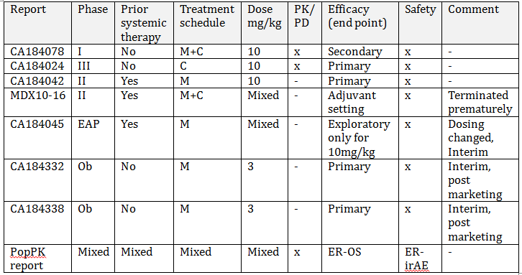
‘x’ indicates relevant data is present; ‘-’ no data is present. Combination (C) Extended Access Program (EAP) Monotherapy (M) Observational (Ob) Pharmacokinetics (PK) Pharmacodynamics (PD) Population PK (PopPK)
Three completed clinical study reports;
- Phase III CA184024 (Mod5351) for efficacy, safety and pharmacokinetic data for ipilimumab 10 mg/kg in combination with DTIC, with a maintenance phase.
- Phase II CA184042 (Mod 5352) for efficacy, and safety for ipilimumab 10 mg/kg monotherapy (with a maintenance phase) for patients with brain metastases with or without concurrent steroid use.
- Phase I CA184078 (Mod 5342) pharmacokinetic, pharmacodynamic, safety data and secondary efficacy data of ipilimumab 10 mg/kg monotherapy and as combination therapy (all with a maintenance phase).
Comment: The sponsor indicates that CA184024 and CA184078 are ‘pertinent’ to the claimed indication. However these studies utilise a different posology, combination therapy and a maintenance schedule in contrast to the current application. Furthermore, the latter study has small numbers (n = 59) and has a Phase I design. Thus, these studies provide limited relevant evidence.
Three abbreviated clinical study reports (synopses);
- MDX010-16 provides safety, and early efficacy data for use of ipilimumab in the adjuvant setting in a prematurely terminated study (Mod 5353). This study was terminated early following the sponsor’s acquisition of Medarex, where the clinical development program had evolved to use of a different ipilimumab treatment schedule and focused on monotherapy rather than concomitant administration with gp100.
- Retrospective observational studies in the first line setting CA184332 and CA184338 (Mod 536).
One interim summary
- CA184045 safety and efficacy of expanded access program (EAP) using ipilimumab 10 mg/kg (Mod 5352).
One Population PK (PopPK) report
- Population pharmacokinetic analysis of combined Studies (CA184004, CA184007, CA184008, CA184022, CA184024, CA184078), with investigation of exposure response (ER) in the untreated and treated patients (Mod 5335, report named as ‘930057648’).
Others reports with data
- Line listing of cumulative serious adverse events. The report indicates that the key (legend for abbreviations) is provided on the final page of the report but is not found there, or in the Clinical Overview documents.
- Supportive data for of immune-mediated adverse event analysis for US PI for previously evaluated Studies MDX010-20, CA184004, CA184022 (5353 supportive data).
Protocols included without clinical data
- CA184029 protocol (5351), CA184025 revised protocol (5352), CA184089 EU guidelines for the expanded access (Mod 5352).
The dossier also included a clinical overview, clinical summaries (clinical pharmacology, clinical efficacy, clinical safety), synopsis of individual studies and literature references.

Paediatric data
The submission did not include paediatric data.

Good clinical practice
Declaration of the study being performed in accordance to GCP with ethics approval is included in the report of CA184024, CA184042, CA184078, MDX10-16, CA184045 and for all studies referred to within this submission that were previously evaluated.
The two observational Studies CA184332 and CA184338 did not require patient consent for treatment. The reports included the following declaration of compliance with the ‘International Society for Pharmacoepidemiology (ISPE) Guidelines for Good Pharmacoepidemiology Practices (GPP) and applicable regulatory requirements’.
CA184089 EU expanded access program requires patient consent consistent with institutional requirements.

Pharmacokinetics

Studies providing pharmacokinetic data
Summaries of the new pharmacokinetic studies are presented in Section 4.3. The ER-OS data from the PopPK report which assessed patient data from CA184024 is also reproduced in Section 7.
Table 2 shows the studies relating to each pharmacokinetic topic and the location of each study summary. The summary of studies with data used in the PopPK analysis presented in Table 3.

Table2: Submitted pharmacokinetic studies
PK topic | Subtopic | Study ID
PK in healthy adults | General PK  - Single dose | NA
PK in healthy adults | - Multi-dose | NA
PK in healthy adults | Bioequivalence† - Single dose | NA
PK in healthy adults | Multi-dose | NA
PK in healthy adults | Food effect | NA
PK in special populations | Target population§  - Single dose
PK in special populations | - Multi-dose | CA184078  PopPK
PK in special populations | Hepatic impairment | CA184078 (mild)#  PopPK (mild)
PK in special populations | Renal impairment | CA184078 (mild)~  PopPK (mild to mod)
PK in special populations | Neonates/infants/children/adolescents | NA
PK in special populations | Elderly | NA
Genetic/gender-related PK | Males versus females | PopPK
PK interactions | Carboplatin/paclitaxel | CA184078
PK interactions | Dacarbazine | CA184078 PopPK
Population PK analyses | Healthy subjects | NA
Population PK analyses | Target population | CA184078 PopPK
Population PK analyses | Other | NA
* Indicates the primary aim of the study. † Bioequivalence of different formulations. § Subjects who would be eligible to receive the drug if approved for the proposed indication. # total bilirubin 1.0 to 1.5 times ULN or AST > ULN as defined using the National Cancer Institute criteria of hepatic dysfunction ~ GFR: mild (GFR < 90 and > 60 mL/min/1.73 m2; n = 349), moderate (GFR < 60 and > 30 mL/min/1.73 m²; n = 82)
None of the pharmacokinetic studies had deficiencies that excluded their results from consideration.

Overall Summary of pharmacokinetics
There were no studies included in the dossier that investigated the treatment schedule of the proposed usage in the appropriate population for the current application.
The PopPK analysis was performed by the sponsor to provide PK data for ipilimumab monotherapy at 3 mg/kg dose in untreated patients. There were no studies analysed or submitted in the dossier that included randomised data utilising the treatment schedule of the proposed usage in the relevant population for the current application. In contrast to the current application, studies analysed in the PopPK report included pre-treated patients, those administered 10 mg/kg and those treated with combination therapy. Furthermore, all studies included a maintenance phase (or ‘re-induction’ phase) in contrast to the proposed usage. The PopPK analysis collated data from the newly submitted studies and previously evaluated Studies (CA184004, CA184007, CA184008, CA184022, CA184024, and CA184078). The summary of studies utilised in the PopPK analysis are summarised in Table 3.
Table 3: Ipilimumab clinical studies contributing to PK data and PopPK modelling
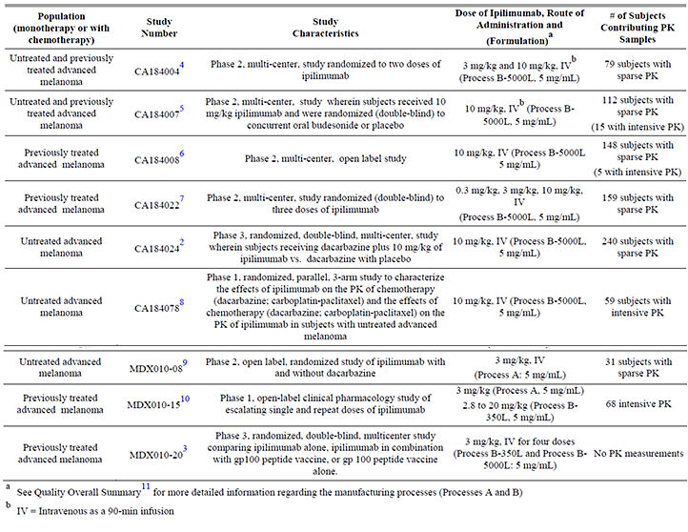
The new PK data incorporated into the submitted PopPK report was provided in this submission from Studies CA184078 and CA184024, of which both used a 10 mg/kg posology. Furthermore, CA184024 investigated ipilimumab administration in combination with DTIC. Total numbers investigated in CA184078 were small (n = 59) with only 20 out of 59 patients receiving ipilimumab monotherapy (10 mg/kg). Whilst individual data was presented in the CA184078 CSR, PK data for CA184024 (n = 240) was presented embedded within the PopPK analysis performed by the sponsor. Of particular note, approximately 50% of PK data from CA184078 was not used in the PopPK modelling (only n = 29 out of 59 included).
The previously submitted studies with PK data consisted of four Phase II studies: (CA184004: n = 79, CA184007: n = 112, CA184008: n = 148 and CA184022: n = 177). These were also evaluated in a previously submitted PopPK analysis.
Thus, the newly submitted PopPK analysis which derived data from these heterogeneous studies, acts as an extension of the previous analysis, with new data predominantly sourced from one Phase III study using ipilimumab 10 mg/kg in combination with DTIC. With reference to the current application, of a total of 785 patients analysed, 528 out of 785 (67%) received ipilimumab monotherapy (versus DTIC + ipilimumab), and 348 out of 785 (44%) were previously untreated. All studies included a maintenance phase in contrast to the proposed usage. With respect to posology, 58 patients were dosed at 0.3 mg/kg, 101 patients at 3 mg/kg, and 626 patients at 10 mg/kg. Only 14 previously untreated patients received ipilimumab 3 mg/kg monotherapy, pertinent to the application. Please see Table 9 for the contribution of numbers for previously untreated patients administered ipilimumab 3 mg/kg monotherapy, according to study. Note should be made that all studies included a maintenance phase. Only patients from CA184024 (10 mg/kg+DTIC) were included in the ER OS analysis. For the final Exposure-Safety irAE analysis, 58 patients were dosed at 0.3 mg/kg, 101 patients at 3 mg/kg, and 626 patients at 10 mg/kg.
Table 3 (above) outlines the different manufacturing processes (A or B), dosing schedules (0.3 mg/kg, 3 mg/kg, 10 mg/kg, or in combination with DTIC), and different number of PK samples (intensive versus sparse). Time points for PK sample collection times may differ between each study. For example, intensive sampling was obtained in one PK drug-drug interaction study (CA184078) and a subset of subjects with advanced melanoma who received multiple doses of ipilimumab (CA184007 and CA184008). Sparse PK samples were analysed from CA184004, CA184007, CA184008, CA184022 and CA184024, of which different dosing schedules were investigated. Note should be made that the populations investigated were not uniform between studies. Specifically, inclusion and exclusion criteria for studies were not the same.
Similar to the previous PopPK analysis, the sponsor considered that the comparison of predicted values with observed values provided external validation of the model. For the ER OS and the irAE analysis, no external validation of results was performed.
The external PopPK evaluator found that the assessment of the Methods, Results and Discussion of the sponsor’s report, which included a repeat of the PopPK models, confirmed the results presented. Specifically, methodology utilised for the analysis was confirmed to be appropriate and in accordance with the guidelines.
Comment: Please note that models for the ER-OS and ER-irAE were not repeated by the external PopPK evaluator as these were not provided by the sponsor.
The information in the following summary is derived from conventional pharmacokinetic studies unless otherwise stated.

Summary of pharmacokinetic studies

CA184078

Objectives
The primary objective was to estimate the effect of ipilimumab on the pharmacokinetics of paclitaxel/carboplatin and dacarbazine (DTIC), and to estimate the effect of paclitaxel/carboplatin and DTIC on the PK of ipilimumab in patients with untreated melanoma.

Methodology

Design
CA184078 was a 3 arm, parallel, randomised, open label Phase I study, with an induction and maintenance phase, performed over four centres, between 17-February-2009 and27-July-2010 (Week 48 database lock).

Entry criteria
Untreated adults with stage III or IV melanoma and ECOG < 1.

Treatments
- Arm A: Induction Phase; paclitaxel 175 mg/m² + carboplatin AUC 6 Day 1 plus ipilimumab 10 mg/kg Day 3. Further ipilimumab (Weeks 4, 7 and 10) and paclitaxel/carboplatin (Weeks 4, 7, 10, 13, 16, 19 and 22) every 3 weeks to a maximum of 8 chemotherapy doses.
- Arm B: Induction Phase; DTIC 850 mg/m² Day 1 plus ipilimumab 10 mg/kg Day 3. Further doses of ipilimumab (Weeks 4, 7 and 10) and DTIC (Weeks 4, 7, 10, 13, 16, 19 and 22) every 3 weeks to a maximum of 8 chemotherapy doses.
- Arm C: Induction Phase; ipilimumab 10 mg/kg every 3 weeks for up to 4 doses.
Then Maintenance Phase for all arms: ipilimumab 10 mg/kg ever 12 weeks until PD, toxicity, study closure or withdrawal.

PK sampling and analysis
- Arm A: PK sampling on Week 1 Day 1 (without ipilimumab); 3 blood samples during paclitaxel, 3 samples post paclitaxel, 24 hours, and at 48 hours. Sampling was performed also after the third dose at Week 7 (with ipilimumab), with the first PK sample starting at 1 hour post ipilimumab, and other samples taken at the time schedules as Week 1.
- Arm B: DTIC and its active metabolite, 5-aminoimidazole-4-carboxamide (AIC) were assessed. Blood samples were collected 24 hours after the first dose of DTIC (before ipilimumab) at 1 hour, 1.5 hours, 2.5 hours, 3.5 hours, 5.5hours, 9.5 hours, and Day 2. After the third dose at Week 7 (Day 43, with ipilimumab), the first PK sample was taken starting 1 hour post ipilimumab and according to the DTIC schedule.
- Arm C (and all arms in addition to above): Week 7, Day 43 blood samples were taken at 0 hours (pre dose), then 1.5 hours (infusion ends), then in comparison to when ipilimumab was given with combination therapy, the first PK sample was 2.5 hours later (4 hours post ipilimumab), then Day 44, Day 46, Day 50, Day 57 and Day 64.
Assays for measurement of ipilimumab levels were performed by an internally validated (BMS) ELISA assay. This assay was utilised in reports from the initial application. Paclitaxel, DTIC and AIC analysis were referenced to previous validated published methods.

Study participants
Of 72 enrolled patients, 59 were randomised to treatment and received ipilimumab + paclitaxel/carboplatin (Arm A, n = 20), ipilimumab + DTIC (Arm B, n = 19), or ipilimumab alone (Arm C, n = 20). 59 patients received one dose of ipilimumab, but the majority of 41 (70%) patients did not complete the induction phase due to PD (63%) or toxicity and/or death (34%). Of 18 who completed induction, 2 did not receive any maintenance, and only 15 patients completed maintenance. Patients were predominantly white males (64%), of excellent ECOG.

PK results
Table 4 summarises the ipilimumab PK results. Co-administration with chemotherapy slightly reduced exposure to ipilimumab. The geometric means for ipilimumab C_{max} and AUC (0 to 21 days) changed 0.982 and 0.917 fold, in the presence of DTIC. The 90% CIs for the geometric mean ratios were contained within 0.75 and 1.21. The geometric means for ipilimumab C_{max} and AUC (0 to 21 days) changed 0.934 and 0.868 fold, with paclitaxel/carboplatin. The 90% CIs for the geometric mean ratios were contained within 0.68 and 1.14.

Table 4: Summary of ipilimumab pharmacokinetics, for ipilimumab alone (Arm C) or with paclitaxel/carboplatin (Arm A) or with DTIC (Arm B)
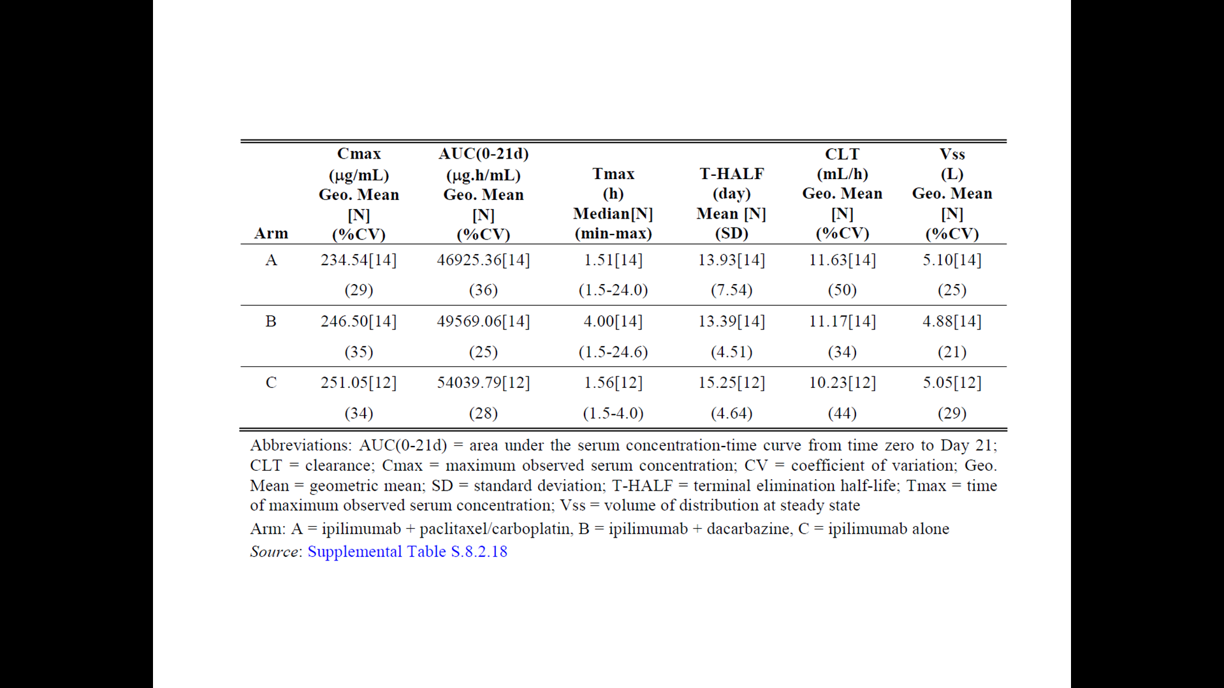
Table 5 summarises the paclitaxel PK data, with the geometric means for paclitaxel C_{max} and AUC_{(INF)} changed 0.963 and 1.068 fold, respectively, in the presence of ipilimumab. All 90% CIs for the geometric mean ratios were contained within 0.79 and 1.20. The PK data for DTIC and AIC are summarised in Table 6. Ipilimumab did not affect the pharmacokinetics of DTIC and its active metabolite, AIC. The geometric means for DTIC C_{max} and AUC_{(INF)} changed 1.027 and 0.912 fold, respectively, in the presence of ipilimumab. Parameters for AIC changed 1.058 and 0.970 fold, respectively. All 90% CIs for the geometric mean ratios were contained within 0.75 and 1.25.

Table 5: Summary statistics of Paclitaxel pharmacokinetic parameters
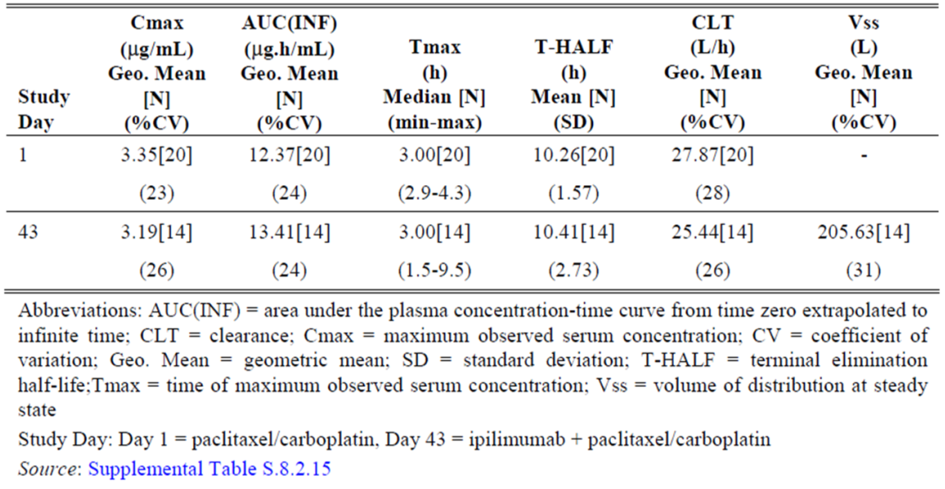

Table 6: Summary of DTIC and AIC pharmacokinetic parameters
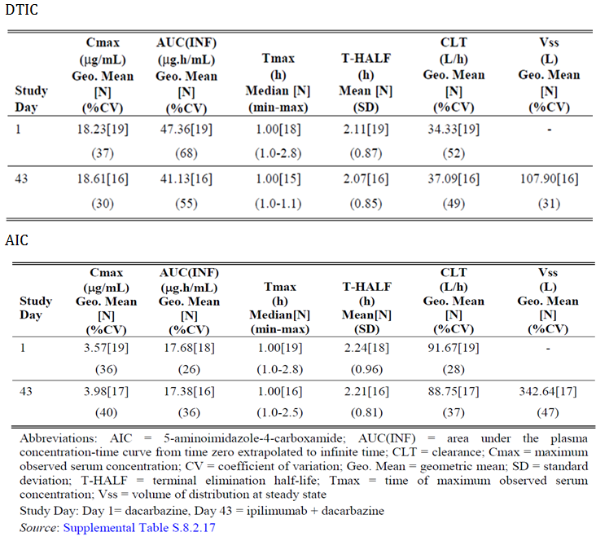
Comments: The study design, and conduct were satisfactory. However, with respect to the current application, no PK data is presented in this study that addresses the proposed usage.

CA184024
Within the CSR no PK information is provided beyond a listing of serum concentrations and the study analysis/data is embedded into the PopPK report.
Briefly, CA184024 was a randomised, double blind, multi-centre, Phase III study in untreated subjects with un-resectable Stage III or IV melanoma receiving DTIC plus placebo or DTIC plus 10 mg/kg of ipilimumab. Ipilimumab was administered as 4 single doses as 90 minute IV infusions at Weeks 1, 4, 7 and 10 (treatment period) in combination with DTIC treatment. Subjects who were eligible for extended doses in the maintenance period received the same doses of ipilimumab on Weeks 24, 36, 48 and every 12 weeks on study thereafter until unacceptable toxicity, tumour progression or withdrawal of consent. Sparse PK data from 240 subjects were obtained in this study; but non-compartmental analysis (NCA) PK parameters were not estimated in CA184024, as only 7 data points were collected across a 12 week interval over 4 treatment induction doses.
Note also that a number of protocol amendments with relevance to PK data that are not yet reported. In particular, amendment number 01 to the protocol refers to pharmacogenomics testing (for example, examination of CYP450 variants) and amendment number 04, refers to pharmacogenomics testing for SNPs, as well as autoimmune markers (for example, ASCA antibody and ANCA) to predict GI irAEs.
Please note with reference to ER-OS modelling, this study investigated previously untreated patients and thus is not informative for the effect of prior treatment status on the efficacy endpoint of OS.

Population Pharmacokinetic report
The PopPK analysis (an extension of the previous) was performed with 3,200 ipilimumab serum concentration values from 785 subjects with advanced melanoma, who were enrolled in the following clinical studies:
- one chemo combination Phase I study (CA184078, n = 29)
- four Phase II monotherapy clinical studies (CA184004, n = 79, CA184007 n = 112, CA184008 n = 148 and CA184022 n = 177) and
- one randomised Phase III study in combination with dacarbazine (CA184024, n =2 40).
No trials were submitted that directly addressed the proposed indication.
Of these, 528 subjects received ipilimumab alone, while 257 subjects received ipilimumab with DTIC. The exposure response (ER) analysis for OS was performed only with data from Study CA184024 (10 mg/kg). The ER analyses for irAEs were performed with data from all the studies (n = 1,036); 785 administered doses of 0.3, 3, or 10 mg/kg ipilimumab, and 251 subjects administered placebo.
With respect to the current application, it should be noted that only 14 untreated patients were included who received ipilimumab 3 mg/kg, versus 87 previously treated patients who received the same dose. It is unclear how many of these 14 previously untreated patients also received maintenance therapy.
Comment: The previous population pharmacokinetic analysis was conducted with 2089 ipilimumab serum concentration values from 498 subjects who were enrolled in the following 4 Phase II Studies: CA184004, CA184007, CA184008, and CA184022. The PopPK model was developed with 1761 observations from 419 subjects enrolled in 3 of the studies (CA184007, CA184008, and CA184022), and data from 79 subjects enrolled in the remaining Study (CA184004) was used for external model validation.
Thus, the new data consisted of 1,111 serum values from 287 extra patients. The majority of this new data was obtained from CA184024 which uses ipilimumab 10 mg/kg + DTIC dosing. 51% (30/59) patients from CA 184078 were excluded from the PopPK analysis (see the section on ‘Patient population’ below).
In most studies, PK samples were collected on Day 1 and Day 43 (3rd dose), pre infusion and after 90 minute infusion. Three additional samples were taken between Day 3 to 7 (post dose) after week 7 dose, Day 10 to 15 (post dose) after week 7 dose and the pre-dose sample on Day 64. In CA184078, , samples were collected on Day 1 and Day 43, pre infusion and 1.5, 3, 5, 9, 24, and 48 hours post start of infusion.

Methods

Population pharmacokinetic analysis
The PopPK model was developed in 3 stages;
- The Base model: was used as confirmation of the base PopPK model from the previous report. Covariate effects were not considered
- The Full model: A full covariate model was developed incorporating the effect of all pre-specified covariate parameter relationships
- The Final model: was developed by retaining covariates that improved the goodness of fit statistic (Bayesian Information Criterion (BIC)) and were of potential clinical relevance.
Baseline covariates examined were body weight, age, gender, estimated glomerular filtration (eGFR) rate, Eastern Oncology Group (ECOG) performance status, baseline lactate dehydrogenase (LDH), dacarbazine, and prior systemic anti-cancer therapy. In addition, the effect of immunogenicity on clearance was assessed as a time varying covariate to account for the possibility that anti-drug antibodies (ADA, also termed antihuman-antibodies or HAHA) are not present at all times in immunogenic subjects. Covariate models were developed for ipilimumab clearance and central volume of distribution. No covariates were modelled on the peripheral volume of distribution and inter compartmental clearance. Visual predictive check with and without bias correction was used to evaluate the prediction performance of the developed final PopPK model. The final PopPK model was used to predict steady state ipilimumab steady trough concentration (C_{minss}) for exposure response (ER) analyses.

Exposure-efficacy response analysis: OS (ER-OS)
The ER-OS relationship was characterised with a Cox proportional hazards (CPH) model relating C_{minss} to the hazard of death. Note should be made that this data set only included patients from CA184024 (10 mg/kg + DTIC). The CPH model was developed in 3 stages;
- A base model was developed to establish the existence and functional form of the ER relationship between OS and ipilimumab C_{minss}
- A full model was developed to assess the effect of all of the potential covariates of interest.
- A final model was developed by retaining potentially clinically relevant predictors, with appropriate functional forms of their relationships with OS
The CPH model was evaluated by comparing model predicted cumulative probability of OS versus time with that obtained with Kaplan-Meier (KM) analysis (observed data).

Exposure-safety response analyses (irAE)
An E_{max} based proportional odds model was developed to describe the probability of experiencing a worst irAE of Grade 2 or greater (Grade ≥ 2), and Grade 3 or greater (Grade ≥ 3). Four separate models were developed for gastrointestinal irAEs, hepatobiliary irAEs, skin irAEs, and ‘any organ’ irAEs (which incorporated all previous categories and other organs organ). Covariates of age, body weight, gender, ECOG, LDH, ALC, metastatic status, prior anti-cancer therapy, and in the case of hepatobiliary irAEs, the presence of liver metastases, were incorporated into the logit functions in a linear manner.
Comment: Please note comments on the safety data and questions to the sponsor.

Results

Assay performance and samples
The ELISA assay accuracy was within ± 9.40%, and the inter assay and intra assay coefficients of variation were within 6.82% and 5.21%, respectively.
Samples were excluded mainly due to being below the limit of quantification, if quantifiable concentrations were detected pre dose (not described further) or due to the mismatching of samples (not described further). Approximately one third of samples were excluded overall and similarly when only new studies with PK data are considered (Table 7). Most patients provided 7 PK samples, usually obtained between the first post dose time point up to Day 25 (600 hours) with very few samples beyond this, up to the 42 day (1000 hour) time point.

Table 7: Samples included in the PopPK analysis
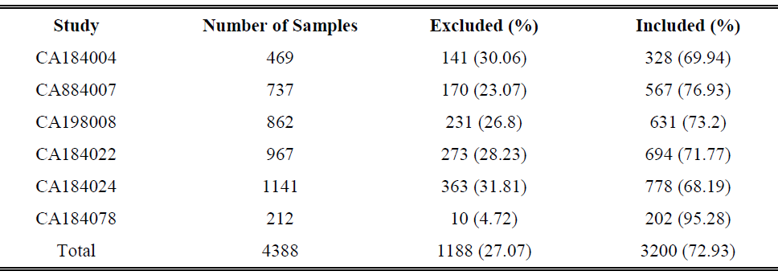
Comment: Refer to list of questions for the sponsor, for queries regarding excluded samples. The relative contribution of the new data from studies using a 10 mg/kg posology, using combination therapy and using a maintenance phase should be considered given the application for an alternate proposed usage.

Patient population
Of 785 patients analysed, 528 (67%) received ipilimumab monotherapy, and 348 (44%) were untreated. There were only 14 previously untreated patients versus 87 previously treated patients in the ipilimumab 3 mg/kg dosing schedule included. Only the 498 patients in CA184024 were included in the ER OS analysis. Of all 1,126 patients included in the Exposure Safety-irAE analysis, most (n = 1,036) were retained for the analysis, whilst note is made that 51% (30 out of 59) patients from CA 184078 were excluded from analysis due to no Week 7 sample collection due to disease progression or toxicity. For the final Exposure Safety irAE analysis 58 patients were dosed at 0.3 mg/kg, 101 patients at 3 mg/kg, and 626 patients at 10 mg/kg.
Comment: It is unclear why the ER-OS analysis only included patients PK data from CA184024, when the previous PopPK report included other studies (with the 3 mg/kg dosing). Refer to list of questions for the sponsor.
With respect to the current application seeking monotherapy with 3 mg/kg for previously untreated patients, it is important to examine how many patients’ data address this. Table 8 below summarises the number of patients included in the irAE analysis according to dose but not according to treatment status. Table 9, lists patients according to pre-treatment status and according to study. Note that for the 3 mg/kg dosing, only patients from CA184004 (previously treated and untreated patients) and CA184022 (previously treated patients) contribute data. Thus only data from CA184004 appears relevant for the current application. There were only 14 previously untreated patients versus 87 previously treated patients in the ipilimumab 3 mg/kg dosing schedule included. Inspection of information provided in the sponsor’s summary of clinical efficacy report indicates that the total pooled number of untreated patients for both CA184004/-022 was only 15 patients. Thus the number of previously untreated patients administered 3 mg/kg ipilimumab monotherapy providing PK data for the PopPK analysis is small. It is not clear whether these 14 patients also received maintenance therapy.

Table 8: Number of patients by ipilimumab dose, DTIC co-administration and study, included in the exposure-irAE dataset
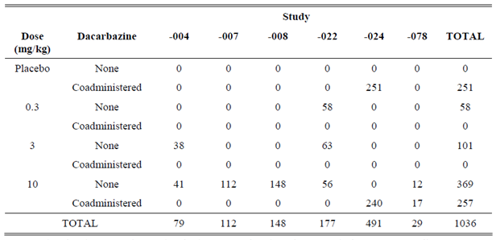

Table 9: Summary of the pooled efficacy analysis populations according to study and pre-treatment status
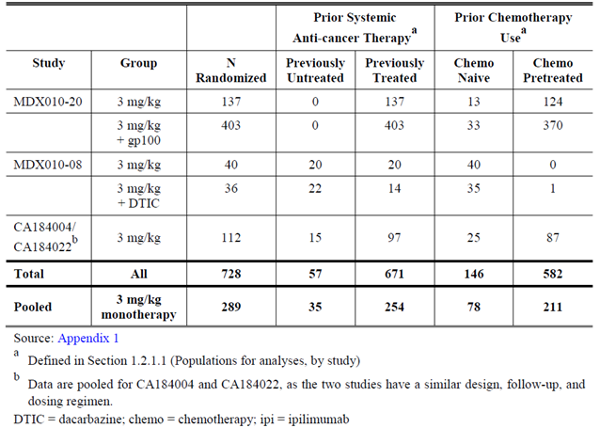

PopPK modelling
Ipilimumab PK was described with a linear, two compartment, zero order IV infusion model with first order elimination. PopPK modelling identified LDH and body weight as relevant covariates for CL, and the covariate of weight relevant for VC. Thus, support of the currently approved weight based dosing regimen was provided.
Ipilimumab CL increases with increased baseline LDH (Table 10). Patients with LDH higher than 3 x ULN were infrequent, thus conclusions as to the effect of elevated LDH above this are uncertain. Clearance was not impacted significantly by baseline LDH levels up to 3 x ULN. Of the patients examined, 42% (330 out of 785) patients had baseline LDH at the nominal ULN of 225 IU/L, 17% (134 out of 785) patient’s LDH was 2 x ULN, 8% (63 out of 785) patient’s LDH 3 x ULN, 4% (31 out of 785) patient’s LDH 4 x ULN, and 3% (24 out of 785) patients’ LDH of 5 x ULN. Ipilimumab clearance increases by 19.1% (18.6 mL/hr) in a subject with LDH value of 675 IU/L (3 x ULN) compared with a LDH value of 225 IU/L (ULN, 15.6 mL/hr). Thus, baseline LDH values > 675 IU/L (3 x ULN) are reported by the sponsor to be unlikely to have clinically meaningful impact on CL. Approximately 8% of subjects has LDH values > 675 IU/L (3 x ULN) and the increase in CL was 28% (19. 9 ml/hr) increased at LDH value of 5 x ULN.

Table 10: Effect of LDH on ipilimumab clearance
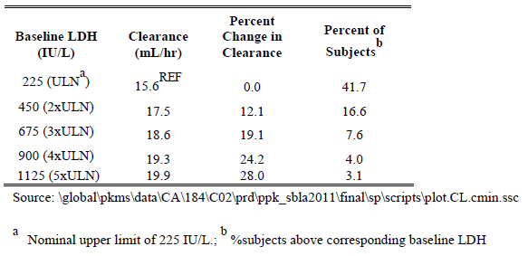
Comment: The sponsor’s conclusion that LDH levels greater than 3 x ULN are unlikely to have a clinically meaningful impact may be true, but has been insufficiently investigated due to the relatively small patient numbers who were examined in this group. Patients with higher LDH are usually those with very advanced disease and poor ECOG performance status and are not likely to be eligible for most trials.
Concomitant DTIC, prior systemic anti-cancer therapy, and immunogenicity status were not retained in the final model because they were found not to clinically relevant predictors of ipilimumab PK.
Comment: Note should be made that the analysed studies did not address the proposed usage or population of interest, and eligibility for studies were heterogeneous. Though modelling identified relevant covariates, the total number in each group according to treatment received should be considered, as well as patient pre-treatment status. Ultimately, only 14 previously untreated patients and 87 previously treated patients administered ipilimumab 3 mg/kg provide relevant data.
Target trough concentrations were set to block the B7 molecules (CD86 and CD80); C_{minss} of 3 µg/mL to block CD86 and 20 µg/mL to block CD86 and CD80. Distributions of predicted C_{minss} showed that the 3 mg/kg dose yielded C_{minss} values that were sufficient for maximal inhibition of CD86, but less than 50% exceeded the 20 µg/mL concentration. The 10 mg/kg yielded C_{minss} values sufficient for maximal inhibition of both CD80 and CD86.
With respect to the current application, prior treatment status was found in the full PopPK model little covariate effect on CL (1.01, 95% CI: 0.94 to 1.10), and was not retained as a relevant covariate in the final PopPK model. C_{minss} of ipilimumab by dosing for previously treated and untreated patients were similar. Median values of C_{minss} after the third dose for the 3 and 10 mg/kg previously untreated are 13.5 and 51.5 µg/mL, respectively. Median values of C_{minss} for the 0.3, 3, and 10 mg/kg previously treated are 1.52, 17.1, and 51.7 µg/mL. Again, note should be made of the small numbers in the 3 mg/kg previously untreated group (n = 14) used to generate this data.
The final PopPK modelling concentration time data for each dosing schedule were similar to previous and is summarised in Table 11.

Table 11: PK parameter estimates from the final PopPK model for ipilimumab 3 mg/kg and 10 mg/kg
Parameter | 3 mg/kg Ipilimumab N=101 | 10 mg/kg Ipilimumab N=626
AUC_{ss} (mg.h/ml)  Mean ± SD  Median (min-max) | 16.7 ± 8.3  16.0 (5.0-72.5) | 51.9 ± 19.9  50.2 (1.5-223)
C_{maxss} (µg/ml)  Mean ± SD  Median (min-max) | 76.9 (20.2)  73.3 (30.9-204) | 246 ± 53  240 (13-655)
C_{minss} (µg/ml)  Mean ± SD  Median (min-max) | 19.4 (14.5)  17.9 (1.9-121) | 58.1 ± 33.8  53.7 (0.7-373)
CL (ml/h)  Mean ± SD  Median (min-max) | 16.7 ± 7.1  15.9 (3.5-44.6) | 16.9 ± 6.3  15.7 (3.3-53.3)
V_{ss} (L)  Mean ± SD  Median (min-max) | 7.44 ± 0.77  7.37 (6.0-9.6) | 7.45 ± 0.75  7.45 (5.3-10.2)
T½ (days)  Mean ± SD  Median (min-max) | 16.0 ± 6.3  14.9 (6.1-53) | 15.2 ± 4.9  14.7 (5.7-54)
As per previous report, following IV infusion ipilimumab undergoes biphasic elimination. Due to its large molecular weight and high polarity, it is expected that ipilimumab first distributes into vascular space and subsequently into extracellular fluid space which is reflected in the steady-state volume of distribution (V_{ss}) of 7.63 L (using a reference subject 79 kg, LDH 204).
The effect of renal impairment on the clearance of ipilimumab was evaluated in patients with mild (GFR < 90 and > 60 mL/min/1.73 m²; n = 349), moderate (GFR < 60 and > 30 mL/min/1.73 m²; n = 82), or severe (GFR < 30 and > 15 mL/min/1.73m²; n = 4) renal impairment compared to patients with normal renal function (GFR > 90 mL/min/1.73m²; n = 350) in population pharmacokinetic analyses. Median CL of ipilimumab for subjects with normal renal function, mild, moderate, and severe renal impairment is 0.017, 0.015, 0.015, and 0.014 L/hr, respectively. The median values of CL for the normal (n = 708) and mild hepatic (n = 76) dysfunction categories are 0.015, and 0.018 L/hr, respectively. Thus, mild to moderate renal impairment and mild hepatic impairment demonstrated no effect on ipilimumab CL.

ER-OS modelling
The final ER-OS model (based on data from untreated patients at 10 mg/kg dosing with DTIC taken only from Study CA184024), used to characterise the relationship between ipilimumab steady state trough concentration (C_{minss}) and selected clinical endpoints, identified four significant covariates (metastatic status, ECOG, C_{minss}, LDH status). Their effects are summarised in Table 12 below. Improvement in survival with higher ipilimumab C_{minss} value is noted, with patients with median C_{minss} of 49.9 µg/mL having a relative OS hazard ratio of 0.73 compared to placebo (+DTIC). Higher M-category status, ECOG status = 1, and elevated LDH above the ULN carried a relatively higher risk of worse survival. Note is made that although gender was an important predictor of overall survival in the full model, it was not retained in the final model based on Bayesian criterion. The coefficient for gender varied between each model (for example > 55% difference). Thus, data supportive of the survival benefit of ipilimumab 10 mg/kg (with increasing C_{minss}) in an untreated patient population is provided utilising PopPK modelling.
Comment: The relevance of the ER-OS modelling should be considered here given the use of patient data from CA184024. This study investigated a different posology, utilised combination therapy and included a maintenance phase, in contrast to the proposed usage. It is unclear why other datasets were not included. This study examined only previously untreated patients and thus is not informative of the effect of previous treatment on OS.

Table 12: Parameter estimates of final CPH model for OS analysis
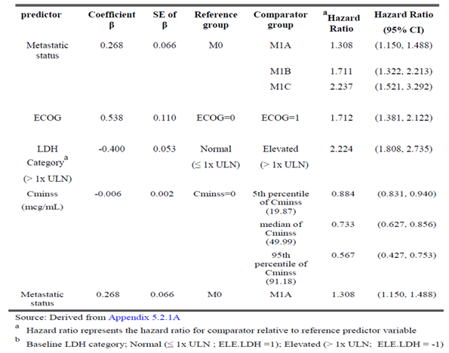

ER-irAE modelling
Regarding safety data, Section 8 of this report should be referred to, as well as the Questions to the sponsor. Reference to these Sections is important for the appropriate interpretation of the data from this modelling.
Immune related AEs (irAEs) were selected as the safety endpoint for the ER analysis because they are likely causally related to drug exposure and the mechanism of action of ipilimumab, and were the most frequently reported drug related AEs.
The final Exposure-Safety irAEs model identified that for gastrointestinal irAEs, a subject with a C_{minss} of 53.7 µg/mL (median C_{minss} in the 10 mg/kg group) is estimated to have approximately six times greater odds of a GIT irAE than a subject with no ipilimumab concentration. However, concomitant administration with DTIC was retained the only retained covariate, which decreased the odds of a gastrointestinal irAE by nearly 43% in subjects administered concomitant DTIC relative to those who are not.
For hepatobiliary irAEs the probability of an irAE increased with DTIC. However, prior anticancer therapy decreased the probability of hepatobiliary irAE. The odds ratio of a hepatobiliary irAE are 9.3 (95%CI 6.04, 15.5) times higher in subjects administered concomitant DTIC relative to those who are not. The worst grade hepatobiliary irAEs were noted to be Grade 3 or higher. The covariate effect of the presence of hepatic metastases was also investigated but not retained.
For skin related irAEs, no covariate was retained in the final mode.
For ‘any’ irAE, prior anticancer therapy was the only covariate retained although, the effects of DTIC co-administration may be lost due to opposite effects of this covariate on gastrointestinal and hepatobiliary irAEs causing a net neutral effect (‘any’ irAE group incorporated both gastrointestinal and hepatobiliary AEs). Previously treated patients had an improved odds ratio for ‘any’ irAE of 0.51 (95%CI 0.337, 0.677) compared with untreated patients, who were more likely to experience toxicity.
Comment: The end of the PopPK report has this statement: ‘The predicted probability of a Grade 2+ hepatobiliary irAE is 2.93% with concomitant dacarbazine and 0.324% in the absence of concomitant dacarbazine. For Grade 3+ irAEs, the probabilities are 2.18% and 0.239%, with and without concomitant dacarbazine. It is not clear where these values are from with reference to the hepatobiliary results from the final model. The values differ from those present here from the final model. Indeed, where these values are from is unclear.
Additionally, the conclusions of the PopPK report did not include a statement regarding the likelihood of an increased risk of toxicity for untreated patients compared to treated patients.
The summary of the median predicted probability of irAE by dose level is summarised in Table 13 below. These are taken from the PopPK report with results rounded up to two decimal points (with minor editing).

Table13: Median predicted probability of irAE by dose level
irAE type | Covariate Condition | Dose (mg/kg) | Grade 2+ |  | Grade 3+
irAE type | Covariate Condition | Dose (mg/kg) | Median Prediction | 2.5th, 97.5th Percentile | Median Prediction | 2.5th, 97.5th Percentile
Gastrointestinal | No DTIC | 3 | 0.17 | 0.13, 0.03 | 0.08 | 0.06, 0.11
Gastrointestinal | No DTIC | 10 | 0.26 | 0.23, 0.30 | 0.12 | 0.11, 0.15
Gastrointestinal | DTIC | 3 | NA | NA | NA | NA
Gastrointestinal | DTIC | 10 | 0.16 | 0.15, 0.20 | 0.07 | 0.06, 0.09
Hepatobiliary | No DTIC | 3 | 0.02 | 0.01, 0.05 | 0.01 | 0.01, 0.04
Hepatobiliary | No DTIC | 10 | 0.07 | 0.04, 0.15 | 0.05 | 0.03, 0.12
Hepatobiliary | DTIC | 3 | NA | NA | NA | NA
Hepatobiliary | DTIC | 10 | 0.37 | 0.28, 0.59 | 0.30 | 0.22, 0.52
Skin | NA | 3 | 0.11 | 0.07, 0.21 | 0.01 | 0.01, 0.029
Skin | NA | 10 | 0.22 | 0.19, 0.28 | 0.03 | 0.03, 0.04
Any | No DTIC | 3 | 0.36 | 0.31, 0.58 | 0.15 | 0.13, 0.31
Any | No DTIC | 10 | 0.65 | 0.59, 0.75 | 0.37 | 0.32, 0.49
Any | DTIC | 3 | 0.27 | 0.18, 0.46 | 0.11 | 0.07, 0.22
Any | DTIC | 10 | 0.48 | 0.41, 0.60 | 0.23 | 0.18, 0.33
Thus with respect to the current application, PopPK modelling for irAEs demonstrates that the probability of Grade 2 or Grade 3 irAEs is less with the lower dose of 3 mg/kg (n = 101) versus 10 mg/kg (n = 626), although previously untreated patients have a higher probability of ‘any’ irAEs. However, the small number of subjects pertinent to the current application (3 mg/kg and previously untreated, n = 14) limit the external validity of the modelling provided.
Comment: Reference should be made to the Safety Section of this report and questions to the sponsor regarding the safety data.

External population pharmacokinetic evaluator’s report
The TGA provided an external PopPK report whereby the evaluator repeated the key models and repeated the covariate analyses. The analysis performed found no deficiencies or inconsistencies, and the report was found to agree or largely agree with the EMA guidelines. Specifically, the external PopPK report assessed the sponsor’s report on all points from Analysis Plan to Discussion.
The evaluator summarises the key findings of the sponsor’s PopPK report with the following:
‘The results found in the PopPK study have been compared and agree with previously obtained information on the PK of ipilimumab. This comparison has been done based on presented data in the report and in Module 2.7.2. It found that ipilimumab clearance is related to the weight of a patient and doses should be based on patients’ weight. Again, this was a confirmation of previous results.
Differences between previously treated and untreated patients were not found in the PK of the drug, however showed to have a difference in the toxicity. The odds of any irAE occurring was found to be approximately half in subjects who have been previously treated with anticancer therapy relative to those who were previously untreated.’
Selected pertinent details from the report are summarised below.

Repeat of the PopPK models
The evaluator utilised software similar to the sponsor, in conjunction with other software. The base, full and final PopPK models were provided by the sponsor and repeated by the evaluator. However, the models of the ER-OS and ER-irAE were not available for assessment.
The PopPK modelling was confirmed by the evaluator where the parameter estimates were found to match the sponsor’s.
The covariate model building steps were also repeated. Model files were not provided but the external evaluator was able to replicate the sponsor’s methodology and could confirm the steps leading to the full model.
The external PopPK evaluator notes that the sponsor did not provide explanation for the omission of a number of covariates collected. This has been included as a question to the sponsor. Selected covariates not examined by the sponsor include the baseline BSA, ideal body weight, race, and albumen.

Analysis plan section
The sponsor’s analysis plan was assessed as sufficient by the external PopPK evaluator.
A minor note is made that ‘the handling of data below the limit of quantification (BLOQ) should have been more detailed and structured depending to percent of BLOQ data to be seen in the data set. The analysis plan presents method for handling BLOQ data that is only acceptable if small amounts of BLOQ data are to be expected. If the amount of BLOQ data, particular at certain times within a dosing interval is high. The method of choice in this report was omitting the BLOQ data, which can lead to bias in the estimation of the parameter estimates (2 to 4). No discussion about the choice of method was available in the analysis plan.’
In a further section the evaluator writes ‘It is difficult to assess from the report at which time points during the dosing interval the BLOQ samples occurred and consequences of data censoring cannot be judged fully.’
Comment: Please see Questions to the sponsor.

Discussion
The external PopPK evaluator could confirm the conclusions of the sponsor for each of the analyses.

For the PopPK modelling
- PK of ipilimumab is linear in the dose range tested
- The PK of ipilimumab is time invariant
- No difference in the PK of ipilimumab in untreated versus treated patients
- Ipilimumab should be dosed according to the total body weight of the patient, due to the significant impact of total body weight WT on ipilimumab CL found, effecting overall exposure to the drug
- Ipilimumab CL increases with increasing baseline LDH. However patients with sufficiently high LDH to cause clinical meaningful changes in CL have been found to be rare and are unlikely to have clinically meaningful impact of LDH on their ipilimumab C
- Renal function and mild hepatic impairment have no impact on ipilimumab CL
- Dacarbazine did not affect ipilimumab CL.
Comment: Note is also made of the external PopPK evaluator’s comment; ‘Ipilimumab CL increases with increasing baseline LDH. However patients with sufficiently high LDH to cause clinical meaningful changes in CL have been found to be rare and are unlikely to have clinically meaningful impact of LDH on their ipilimumab CL.’
As previously mentioned, though this statement may be true, the population in reference has not been sufficiently examined. Patients with elevated LDH are likely to have more advanced disease and associated poor ECOG performance status and are likely not to fit with trial eligibility criteria. Thus, the impact of elevated LDH > 3 x ULN on CL is uncertain.

For the ER-OS modelling
- The relationship between ipilimumab C_{minss} and OS hazard ratio was found to be significant. C_{minss} was selected as the summary measure of ipilimumab exposure for this analysis and was based on mechanistic rationale and previous report.
- LDH, ECOG status and metastatic status were identified as significant predictors of overall survival (OS).
The final ER-OS model showed a lower OS ratio in patients with higher C_{minss} values. It is appropriate to conclude that survival of previously untreated advanced melanoma patients increased with increasing ipilimumab C_{minss} over the range of exposures achieved with the 10 mg/kg dose, based on the final ER-OS model and the model evaluation and application reported here.
Comment: The relevance of the ER-OS modelling should be considered here given the use of patient data from CA184024. This study investigated a different posology, utilised combination therapy and included a maintenance phase, in contrast to the proposed usage. It is unclear why other datasets were not included. This study examined only previously untreated patients and thus is not informative of the effect of previous treatment on OS.

For the ER-irAE modelling
- Log-odds of immune related irAEs increase with increasing C_{minss} according to an E_{max} pharmacodynamic model
- Dacarbazine had a marked effect on irAEs, therefore it was included in the base model
- Ipilimumab potency for inducing irAE is generally similar for gastrointestinal and skin and any irAE and the probably of having these irAEs is near maximal for C_{minss} values greater than the median of the 10 mg/kg dose
- Prior anticancer therapy was an important covariate on the probability of irAE occurrences.
Comment: Please refer to the safety section and clinical questions section for important context regarding the safety data.

Pharmacokinetics in the target population
The PK of ipilimumab has been primarily studied in subjects with advanced melanoma.

Absorption, distribution, metabolism, excretion

Population pharmacokinetics (PopPK) report
There were no studies included within this analysis that directly addressed the proposed usage. This has been previously summarised within the complete presentation of this PopPK report.
As previously identified, ipilimumab PK was described with a linear, two compartment, zero order IV infusion model with first order elimination. Table 14 summarises the PK parameter estimates for the 3 mg/kg and 10 mg/kg dosing schedules, which are similar to previously reported values.
LDH and body weight are relevant covariates for CL, and the covariate of weight relevant for VC. Thus, support of the currently approved weight based dosing regimen was provided.
Ipilimumab CL increases with increased baseline LDH. Patients with LDH higher than 3 x ULN were infrequent, thus conclusions as to the effect of elevated LDH above this level are uncertain. Clearance was not impacted significantly by baseline LDH levels up to three times the ULN. Of the patients examined, 42% (330 out of 785) patients had baseline LDH at the nominal ULN of 225 IU/L, 17% (134 out of 785) patient’s LDH was 2 x ULN, 8% (63 out of 785) patient’s LDH 3 x ULN, 4% (31 out of 785) patients’ LDH 4 x ULN, and 3% (24 out of 785) patients’ LDH of 5 x ULN. Ipilimumab clearance increases by 19.1% (18.6 mL/hr) in a subject with LDH value of 675 IU/L (3 x ULN) compared with a LDH value of 225 IU/L (ULN, 15.6 ml/hr). Thus, baseline LDH values > 675 IU/L (3 x ULN) are reported by the sponsor to be unlikely to have clinically meaningful impact on CL. Approximately 8% of subjects has LDH values > 675 IU/L(3 x ULN), and the increase in CL was 28% (19.9 ml/hr) increased at LDH value of 5 x ULN.
Comment: The sponsor concluded that LDH levels greater than 3 x ULN was unlikely to have a clinically meaningful impact. However, there were insufficient patients with LDH > 3 x ULN investigated to demonstrate this. Thus, uncertainty remains. Raised LDH is associated with poor performance status and very advanced disease, and such patients would likely have an ECOG performance status > 2 and be excluded from the trials.
Concomitant DTIC, prior systemic anti-cancer therapy, and immunogenicity status were not found to be clinically relevant predictors of ipilimumab PK.

Table 14: PK parameter estimates from the final PopPK model for ipilimumab 3 mg/kg and 10 mg/kg
Parameter | 3 mg/kg ipilimumab N = 101 | 10 mg/kg ipilimumab N = 626
AUC_{ss} (mg.h/ml)  Mean ± SD  Median (min-max) | 16.7 ± 8.3  16.0 (5.0-72.5) | 51.9 ± 19.9  50.2 (1.5-223)
C_{max}s_{s} (µg/ml)  Mean ± SD  Median (min-max) | 76.9 (20.2)  73.3 (30.9-204) | 246 ± 53  240 (13-655)
C_{minss} (µg/ml)  Mean ± SD  Median (min-max) | 19.4 (14.5)  17.9 (1.9-121) | 58.1 ± 33.8  53.7 (0.7-373)
CL (ml/h)  Mean ± SD  Median (min-max) | 16.7 ± 7.1  15.9 (3.5-44.6) | 16.9 ± 6.3  15.7 (3.3-53.3)
V_{ss} (L)  Mean ± SD  Median (min-max) | 7.44 ± 0.77  7.37 (6.0-9.6) | 7.45 ± 0.75  7.45 (5.3-10.2)
T½ (days)  Mean ± SD  Median (min-max) | 16.0 ± 6.3  14.9 (6.1-53) | 15.2 ± 4.9  14.7 (5.7-54)
Target trough concentrations were set to block the B7 molecules (CD86 and CD80); C_{minss} of 3 µg/ ml to block CD86 and 20 µg/ml to block CD86 and CD80. Distributions of predicted C_{minss} showed that the 3 mg/kg dose yielded C_{minss} values that were sufficient for maximal inhibition of CD86, but less than 50% exceeded the 20µg/ ml concentration. The 10 mg/kg yielded C_{minss} values sufficient for maximal inhibition of both CD80 and CD86.
Comment: PK data included in the PopPK modelling that was relevant to the current application consisted of data from 14 previously untreated patients who received ipilimumab 3 mg/kg monotherapy. These may have included patients administered maintenance therapy.

CA184078
Data relevant to the current application is presented below in Table 15. This table summarises the ipilimumab PK according to study arm, of which one arm consisted of ipilimumab 10 mg/kg monotherapy (Arm C, n = 20) in contrast to the other arms which included concomitant chemotherapy administration.
Co-administration with chemotherapy slightly reduced exposure to ipilimumab in this Phase I study. The geometric means for ipilimumab C_{max} and AUC_{0 - 21d} changed 0.982 and 0.917 fold, in the presence of DTIC. The 90% CIs for the geometric mean ratios were contained within 0.75 and 1.21. The geometric means for ipilimumab C_{max} and AUC_{0 - 21d} changed 0.934 and 0.868 fold, with paclitaxel/carboplatin. The 90% CIs for the geometric mean ratios were contained within 0.68 and 1.14.

Table 15: Summary of ipilimumab pharmacokinetics, for ipilimumab alone (Arm C) or with paclitaxel/carboplatin (Arm A) or DTIC (Arm B)
Given that the proposed usage is for ipilimumab 3 mg/kg monotherapy, comprehensive details regarding paclitaxel and DTIC PK were provided in ‘Summary of pharmacokinetic studies CA184078’.

Pharmacokinetics in other special populations

Pharmacokinetics in subjects with impaired hepatic function

PopPK report
Clearance of ipilimumab in subjects with mild hepatic impairment was similar to that of subjects with normal hepatic function.
The effect of hepatic impairment on the clearance of ipilimumab was evaluated in patients with mild hepatic impairment (total bilirubin 1.0 to 1.5 times ULN or AST > ULN as defined using the National Cancer Institute criteria of hepatic dysfunction; n = 76) compared to patients with normal hepatic function (total bilirubin and AST ≤ ULN; n = 708) in the population pharmacokinetic analyses. No clinically important differences in the clearance of ipilimumab were found between patients with mild hepatic impairment and normal hepatic function.
Ipilimumab has not been studied in patients with moderate (total bilirubin > 1.5 to 3 x ULN and any AST) or severe hepatic impairment (total bilirubin > 3 x ULN and any AST).

Pharmacokinetics in subjects with impaired renal function

PopPK report
Clearance of ipilimumab in subjects with mild and moderate renal impairment was similar to that of subjects with normal renal function.
The effect of renal impairment on the clearance of ipilimumab was evaluated in patients with mild (GFR < 90 and > 60 mL/min/1.73 m²; n = 349), moderate (GFR < 60 and > 30 mL/min/1.73 m²; n = 82), or severe (GFR < 30 and > 15 mL/min/1.73m²; n = 4) renal impairment compared to patients with normal renal function (GFR > 90 mL/min/1.73m²; n = 350) in population pharmacokinetic analyses. No clinically important differences in the clearance of ipilimumab were found between patients with mild to moderate renal impairment and patients with normal renal function

Pharmacokinetics according to age

PopPK report
The sponsor reports that PK of ipilimumab was not affected by age as determined in the PopPK modelling, which did not retain age as a relevant covariate. The oldest patient included was 87 years old, with approximately 120 patients above age 70 years.

Pharmacokinetics according to treatment status

PopPK report
Reference again is made to the limited number of patients and studies relevant to the proposed usage (n = 14 for previously untreated patients who received 3 mg/kg monotherapy).
There were little differences found between the untreated and treated population for PK parameters. Prior treatment status was found in the full PopPK model to have little covariate effect on CL (1.01, 95% CI: 0.94 to 1.10) and was not retained as a relevant covariate in the final PopPK model. C_{minss} of ipilimumab for previously treated and untreated patients were similar. For example, median values of C_{minss} following the third dose, for the 3 and 10 mg/kg previously untreated were 13.5 and 51.5 µg/mL, respectively. Median values of C_{minss} for the 3 and 10 mg/kg previously treated were 17.1 and 51.7 µg/mL.
Comment: With respect to the ER-irAE included within the PopPK report, safety section and questions to the sponsor section within this evaluation report should be reviewed. The sponsor did not adequately demonstrate safety of the drug in CA184024 (and other studies), with regards to the capturing of AEs, grading of AEs and attribution of causality. ER-irAE modelling based on this data from the PopPK report is presented below.
The ER-irAE modelling did identify that the odds of ‘any’ irAE differed according to pre-treatment status. Specifically, the odds of ‘any’ irAE occurring was found to be approximately half in subjects who have been previously treated with anticancer therapy relative to those who were previously untreated. The ‘any’ grouping refers an irAE from all organs (including those also individually analysed).
The final Exposure-Safety irAEs model identified that for GIT irAEs, a subject with a C_{minss} of 53.7 µg/mL (median C_{minss} in the 10 mg/kg group) is estimated to have approximately six times greater odds of a GIT irAE than a subject with no ipilimumab concentration. However, concomitant administration with DTIC was the only retained covariate, which decreased the odds of a GIT irAE by nearly 43% in subjects administered concomitant DTIC relative to those who are not.
For hepatobiliary irAEs the probability of an irAE increased with DTIC. However, prior anticancer therapy decreased the probability of hepatobiliary irAE. The odds ratio of a hepatobiliary irAE are 9.3 (95%CI 6.04, 15.5) times higher in subjects administered concomitant DTIC relative to those who are not. The worst grade hepatobiliary irAEs were noted to be Grade 3 or higher. The covariate effect of the presence of hepatic metastases was also investigated but not retained.
For skin related irAEs, no covariate was retained in the final mode.
For ‘any’ irAE, prior anticancer therapy was the only covariate retained although, the effects of DTIC co-administration may be lost due to opposite effects of this covariate on gastrointestinal and hepatobiliary irAEs causing a net neutral effect (‘any’ irAE group incorporated both gastrointestinal and hepatobiliary AEs). Previously treated patients had an improved odds ratio for ‘any’ irAE of 0.51 (95%CI 0.337, 0.677) compared with untreated patients, who were more likely to experience toxicity. That is, patients who were previously treated had approximately half the odds of experiencing ‘any’ irAE.

Pharmacokinetics according to other categories

PopPK report
Final modelling found ipilimumab PK was independent of concomitant use of DTIC, and immunogenicity (ADA status).

Summary of clinical pharmacology
This report contained an analysis of immunogenicity, which did not appear to affect the safety or efficacy of ipilimumab.
ADA status was examined in 852 subjects, of whom 760 subjects (CA184004, CA184007, CA184008, CA184022, CA184024, and CA184078) had both pre and post baseline samples available for analysis. Some 17 (2.2%) developed immunogenicity post treatment. Pre-existing baseline cross reacting ADAs were observed in the remaining 22 subjects.
Thirty-nine subjects across CA184004 (n = 4), CA184007 (n = 2), CA184008 (n = 4), CA184022 (n = 16), CA184024 (n = 6), and CA184078 (n = 7) had at least one positive ADA at any time point. The majority of positive anti-ipilimumab reactions were of a low, borderline positive titre (that is, titre of 10) except for 3 subjects in CA184022 who had titres of 50, 1 subject in CA184024 who had a titre of 80 and 2 subjects in CA184078 who had titres > 10. Across all positive samples, reactions were detected to both the common and the Fab region of ipilimumab. No samples were positive in the neutralising assay. Furthermore, since the Fab region of ipilimumab is not a naturally occurring epitope, neutralising antibodies to this region of ipilimumab are not anticipated to have any physiologic significance aside from potential neutralisation of ipilimumab activity.
None of the 39 subjects had any infusion related or peri-infusional hypersensitivity or anaphylactic reactions. These subjects did experience AEs that were inflammatory in nature (irAEs), such as dermatitis, erythema, pruritus, hepatitis, fever and fatigue; however these AEs were predominantly Grade ≤ 2 and were not restricted to those exhibiting positive immunogenicity and were not peri-infusional or consistently coincident with the presence of anti-ipilimumab antibodies.
For the two Phase III studies, in CA184024, the ipilimumab plus DTIC group 6 out of 233 (2.6%) evaluated subjects were positive for anti-drug antibodies at any time point, and 2 out of 191 (1.0%) evaluated subjects were positive post baseline for anti-ipilimumab antibodies. No subjects developed anti-ipilimumab antibodies after ipilimumab treatment in MDX010-20. The majority of positive samples were of low, borderline positive titre. Review of the AEs in the subjects with positive immunogenicity did not reveal any clinically meaningful hypersensitivity reactions. The development of ADA did not impact significantly the CL of ipilimumab. Based on the few subjects who seroconverted and the lack of significant effect on PK, it appears unlikely that the presence of antibodies to ipilimumab could affect the efficacy or safety of ipilimumab.

Pharmacokinetic interactions

Pharmacokinetic interactions demonstrated in human studies

CA184078
There was no clinically meaningful PK drug-drug interaction observed between ipilimumab and either paclitaxel or DTIC and it metabolite, AIC. As therapeutic proteins are generally cleared through their interactions with specific receptors on the target T cell surfaces, as well as interactions with the FcγR1 receptors on the hepatic sinusoidal epithelial cells through proteolysis by proteases and peptidases in the Kupffer cells in the liver and macrophage activity in the spleen, these non-specific mechanisms of clearance are the presumed primary expected routes of elimination for ipilimumab. Thus, ipilimumab is not metabolised by cytochrome P450 enzymes (CYPs) or other drug metabolising enzymes. Ipilimumab did not have a significant effect on the pharmacokinetics of substrates of CYP1A2, and CYP2E1 (for (paclitaxel/carboplatin) or CYP2C8 and CYP3A4 (for DTIC/AIC) when co-administered with substrates of these CYP isozymes. In this study, untreated advanced melanoma subjects receiving 10 mg/kg of ipilimumab in combination with carboplatin (AUC = 6 mg/ml min) and paclitaxel; or ipilimumab in combination with DTIC, ipilimumab had no major effect on the PK of paclitaxel or DTIC (pro-drug) and it major metabolite, AIC, as the 90% confidence intervals (CI) for the geometric mean ratio were either entirely contained within the usual equivalence criteria of 0.80 to 1.25.
Comment: Carboplatin is mainly renally excreted and the large size of the ipilimumab protein makes it unlikely to be filtered through the glomerulus, thus no reference is made to PK interactions of this drug.

Evaluator’s overall conclusions on pharmacokinetics
There were no studies included in the dossier that investigated the treatment schedule of the proposed usage in the appropriate population for the current application.
For the provision of bridging data, an extension of the previous PopPK analysis was performed with 3,200 ipilimumab serum concentration values from 785 subjects with advanced melanoma, who were enrolled in the following heterogeneous clinical studies;
- one chemo-combination Phase I study (CA184078, n = 29)
- four Phase II monotherapy clinical studies (CA184004: n = 79, CA184007: n = 112, CA184008: n = 148 and CA184022: n = 177)
- one randomised Phase III study in combination with DTIC (CA184024, n = 240)
Of these, 528 subjects received ipilimumab monotherapy, while 257 subjects received ipilimumab with DTIC. The dose of ipilimumab varied between trials. All studies included a maintenance phase in contrast to the proposed usage.
With respect to the current application, it should be noted that only 14 patients were included in the PopPK analysis that were previously untreated and received ipilimumab 3 mg/kg monotherapy. Furthermore, only 87previously treated patients received monotherapy at the same dose.
Based on the collation of data from the heterogeneous populations described, the analysis demonstrated that ipilimumab exhibits linear and time invariant PK. The CL and VC of ipilimumab increased with body weight. Ipilimumab CL also increases with baseline LDH, with baseline LDH values less than 675 IU/L (3 x ULN) being unlikely to have clinically meaningful impact on ipilimumab CL. Age, gender, mild to moderate renal impairment, mild hepatic impairment, immunogenicity, previous cancer therapy and concomitant DTIC administration were not clinically relevant predictors of ipilimumab clearance. Target trough concentrations were set for blockade of B7 molecules; C_{minss} of 3 µg/mL to block CD86 and 20 µg/mL to block both CD86 and CD80. Distributions of predicted C_{minss} showed that the 3 mg/kg dose yielded C_{minss} values that were sufficient for maximal inhibition of CD86, but less than 50% exceeded the 20 µg/mL concentration.
With respect to the current application, the data collated from these heterogeneous studies demonstrated that ipilimumab PK appears similar between previously treated and untreated patients at all dose levels investigated. Importantly, C_{minss} of ipilimumab at the 3 mg/kg dosing was similar for previously treated and untreated patients. However, the small number of patients providing data for the relevant analysis is emphasised.
Overall, interpretation of PK modelling should include consideration of the small number of patients relevant to the current application (n = 14 for previously untreated patients dosed at 3 mg/kg).

Pharmacodynamics

Studies providing pharmacodynamic data
Table 16 shows the studies relating to each pharmacodynamic topic and the location of each study summary.

Table 16: Submitted pharmacodynamic studies
PD Topic | Subtopic | Study ID
Primary Pharmacology |  | No studies
Secondary Pharmacology | Effect on absolute lymphocyte count (ALC) | CA184078 CA184024
Gender other genetic and Age-Related Differences in PD Response | Effect of gender | No studies
 | Effect of age | No studies
PD Interactions |  | No studies
Population PD and PK-PD analyses | Healthy subjects | No studies
Population PD and PK-PD analyses | Target population | No studies
None of the pharmacodynamic studies had deficiencies that excluded their results from consideration.

Summary of pharmacodynamics
The information in the following summary is derived from conventional pharmacodynamic studies in humans unless otherwise stated.

CA184078
Please see previous PK section for summary of the study. Only PD relevant information will be summarised here.
The primary objective of this study was to estimate the effect of ipilimumab 10 mg/kg on the pharmacokinetics of paclitaxel/carboplatin and DTIC, and to estimate the effect of paclitaxel/carboplatin and DTIC on the PK of ipilimumab in patients with untreated melanoma. CA184078 was a 3 arm, parallel, randomised, open label Phase I study, with an induction and maintenance phase, over four centres.

Methodology

Data collection and analysis
ALC was measured with other haematology parameters prior to treatment (up to 28days), during induction (Week 1, 4, 7, 10, 12, 13, 16, 19, 22), Maintenance (Week 24, 36, 48 +), and at the end of the study. An extended linear model for longitudinal data was used to estimate mean ALC as a function of both time and treatment arm. Derived ALC measures included ALC at baseline (ALC1), and the rate of change in ALC from baseline to at or just prior to the third infusion (‘Slope3’ to assess first half of the induction period) or to the end of the Induction-Dosing Period (‘Slope5’). Slopes were calculated for each subject individually as the estimated slope parameter from simple linear Ordinary Least Squares (OLS) regression. Frequencies and absolute count of activate CD4+/CD8+ cells were assessed by flow cytometry and their relationship with immune response clinical activity was investigated. Mean gene expression for 14 genes (CD8A, FOXP3, TRA, MS4A1, GBP1, MX1, OAS2, RSAD2, KLRB1, TNFRSF2, IGKC, IGG, IGL, RRM2) was assessed by qRT-PCR was assessed for each time point, and the relationship with ipilimumab anti-tumour effect was examined. Based on previous findings, humoral response to NY-ESO-1 antigen was assessed, and the relationship between a positive baseline versus post baseline status and immune related clinical activity of ipilimumab was investigated. The mean change in ALC over time for each treatment arm and corresponding two sided 95% CIs were estimated using an extended (that is, mixed) linear model. Linear logistic regression was used to estimate and test dependence of immune related clinical activity (irCA) on each ALC measure, by treatment arm.

Study participants
All 59 treated subjects were included in the pharmacodynamic dataset, and of the 51 response evaluable subjects in this study, between 44 (86.3%) and 51 (100%) were included in the analyses of association between ALC and immune related clinical activity. All 59 treated subjects had at least 2 and up to 9 ALC evaluations during the induction dosing period, with a median of 6. The distribution of number of ALC evaluations per subject was similar among treatment arms.
With relevance to the contribution of this study to PD data, it is pertinent to review the number of patients in each arm. Some 59 were randomised to treatment and received ipilimumab + paclitaxel/carboplatin (Arm A, n = 20), ipilimumab + dacarbazine (Arm B, n = 19), or ipilimumab alone (Arm C, n = 20). Some 59 patients received one dose, but the majority of 41 (70%) patients did not complete induction due to PD (63%) or toxicity/death (34%). Thus, each conclusion below should be interpreted with caution due to small numbers per treatment arm. This study did not contribute any data directly relevant to the current application for use of 3 mg/kg dosing in a previously untreated population.

PD results
- Mean ALC increased over time after initiation of ipilimumab treatment similarly in the 3 treatment arms
- Positive associations between irCA and increases in ALC were not statistically significant when analysed as a dichotomous or continuous variable
- Mean relative frequencies and absolute counts of activated CD4+ and CD8+ T cells increased significantly over time after initiation of ipilimumab treatment similarly in the 3 treatment arms. No associations between irCA and T cell subset frequencies were apparent
- Expression of 12 of 14 immune related genes in peripheral blood changed significantly over time during ipilimumab induction dosing in at least one treatment arm. In the ipilimumab + paclitaxel/carboplatin arm, mean expression of several immune related genes either increased more slowly, or decreased more rapidly, than in the other arms. Statistically significant associations between irCA and baseline expression of 5 of the 14 genes were observed, predominantly for the ipilimumab + chemotherapy treatment arms. Interpretation of these results should be performed with caution due to small numbers, and in the context of the current application have limited relevance
- Concentrations of serum antibodies to NY-ESO-1 were stable over time in a large majority of subjects. No evidence of association between baseline or post baseline NY-ESO-1 antibody concentration and irCA was observed.

Safety
See the PK section for this study. No additional comments are made.
Comments: The study design, conduct and analysis were satisfactory. However, the sponsor notes that studies based on small numbers (approximately 20 patients per study Arm) should be interpreted with caution, and no PD data within this study addressed the current application for a 3 mg/kg posology.

CA184024
A comprehensive summary of this study is provided in the Clinical Efficacy section and Safety data is summarised in Section 8. Only information relevant to PD parameters is described here.

Objectives
Briefly, CA184024 is a randomised, double-blind, multicentre, Phase III study in untreated subjects with un resectable Stage III or IV melanoma receiving DTIC plus placebo or DTIC plus 10 mg/kg of ipilimumab. Ipilimumab was administered as 4 single doses as 90 minute IV infusions at Weeks 1, 4, 7 and 10 (treatment period) in combination with DTIC treatment. Subjects who were eligible for extended doses in the maintenance period received the same doses of ipilimumab on Weeks 24, 36, 48 and every 12 weeks on study thereafter until unacceptable toxicity, tumour progression or withdrawal of consent.

Methodology

PD Data collection and analysis
Absolute lymphocyte count (ALC), which was measured as part of the haematology panel, was analysed as a potential pharmacodynamic marker of ipilimumab biologic activity.
Derived ALC measures included ALC at baseline (ALC1), and the rate of change in ALC from baseline to at or just prior to the third infusion (‘Slope 3’ to assess first half of the induction period) or to the end of the Induction Dosing Period (‘Slope 5’). The slope of ALC versus weeks since first dose was estimated by simple linear regression for each subject separately. Haematology included were collected at baseline (up to 28 days prior to first study dosing), during Induction (Week1, 4, 7, 10, 12 and 24), during Maintenance (Week 36, 40) and at the study completion. Linear logistic regression was used to estimate and test dependence of clinical activity on each ALC measure (as a continuous valued predictor), treatment group, and treatment-by-measure interaction. Reported Odds Ratios were scaled to give the fold change in odds of clinical activity when increasing ALC1 by 1 unit, or Slope 3 or Slope 5 by 0.1 units. Slope 3 versus ALC1 and Slope 5 versus ALC1 were plotted, by treatment and CA group. Cox proportional hazards (PH) models were used to assess the dependence of OS on ALC measures.
The relationship between OS and baseline ALC and ALC1 as a continuous variable and dichotomous variable (threshold of 1 x 103 c/µL) was assessed with Cox proportional hazards modelling.

Study participants
Some 497 out of 498 of the treated subjects who had an unambiguous date of first ipilimumab dose and at least one ALC evaluation during the induction dosing period were included in the Pharmacodynamic dataset. Correlation between ALC and OS included only response evaluable subjects. For analyses described there were for Slope 3, 345 (69.3%) patients and for Slope 5, 286 (57.4%) subjects available. For analyses of associations between OS and ALC measures, between 328 (65.9%) and 482 (96.8%) treated subjects were available. All treated subjects had at least 1 and up to 22 ALC evaluations during the induction dosing period, with a median of 6. The distribution of number of ALC evaluations per subject was similar between treatment groups.

PD results
Mean ALC was similar at first dose between treatment groups, and then increased over time after initiation of treatment in the ipilimumab plus DTIC group, but not in the DTIC monotherapy group. Baseline ALC was not associated with clinical activity of ipilimumab. The estimated HR comparing the ALC1 ≥ 1 x 10³ c/µL and ALC1 < 1 x 10³ c/µL was 0.61 (95% CI: 0.40, 0.92) for the ipilimumab plus DTIC group and 0.79 (95% CI: 0.55, 1.12) for the DTIC monotherapy group, suggesting a greater ALC1 effect on OS in the former group. However, the ALC1 effect did not differ significantly between the 2 treatment groups (p = 0.370). The rate of change in ALC over time was not significantly associated with OS. Thus, a higher ALC at baseline may be an independent prognostic variable given that it was significantly associated with longer OS independent of treatment assignment. Thus, the results show that ALC is not a pharmacodynamic marker of ipilimumab activity.
Comment: The study design, conduct and analysis were satisfactory. With respect to the current application, the posology of this study differs. The data on ALC changes is similar to previous.
The correlative analyses with respect to PD are annotated here given the sponsor’s presentation of the data, but ultimately it has no relevance to ipilimumab PD as the measure of baseline ALC was independent of treatment.

Mechanism of action
No new studies have been submitted that are relevant.

Pharmacodynamic effects

Primary pharmacodynamic effects
No new studies have been submitted that are relevant.

Secondary pharmacodynamic effects
New PD data from both CA184078 (relatively sparse) and CA184024 addressed the effect of ipilimumab on absolute lymphocyte count (ALC). Taking note that these studies utilised a 10 mg/kg posology, CA184078 had three treatment arms including monotherapy with ipilimumab, and CA184024 utilised an investigational arm of combination therapy ipilimumab + DTIC versus DTIC + placebo.
As observed in previous studies, mean ALC increased over time with repeated dosing of ipilimumab, with no differences noted between treatment arms that contained ipilimumab (irrespective of concurrent chemotherapy). Increases in ALC were not seen in the DTIC + placebo arm. Other exploratory studies have been described in the previous section.

Evaluator’s overall conclusions on pharmacodynamics
New PD data using the 10 mg/kg posology confirms previous observations regarding increases in ALC with repeated ipilimumab doses over time. Overall, no new data addressing the current application for the 3 mg/kg posology is presented.

Population Pharmacokinetic report
A separate PopPK evaluation was prepared for this submission. This section contains an extract from that report.

Analysis of Study
Analysis of Study Ipilimumab PopPK and exposure – response analyses in previously treated or untreated subjects with advanced melanoma.

Study summary
A population pharmacokinetic (PopPK) analysis was used to describe the intensive and sparse pharmacokinetic (PK) data from 785 subjects with advanced melanoma who received 0.3 mg/kg, 3 mg/kg, or 10 mg/kg ipilimumab during the treatment period in one Phase I study (CA184078), four Phase II studies (CA184004, CA184007, CA184008, and CA184022) and one PhaseIII study (CA184024). PK data for intravenous administered ipilimumab are available from Phase I, II, and III clinical studies.
Non-compartmental analysis provided PK parameters derived from intensive PK data collected from subjects with advanced melanoma who received 3 or 10 mg/kg ipilimumab during the treatment period. No studies were performed in healthy subjects due to the safety profile of ipilimumab. In addition, a PopPK analysis was used to describe the intensive and sparse PK data from 785 subjects with advanced melanoma. Additionally, the exposure response (ER) relationship between trough concentration at steady-state (C_{minss}) and overall survival (OS) and immune-related adverse effects (irAE) were described.

Study objectives
The objectives of the study were:
- To describe the PK of ipilimumab in previously treated or untreated patients with advanced melanoma, and to quantify the sources and correlates of variability in ipilimumab exposure in this population
- To describe the relationship between ipilimumab exposure (cminss) and efficacy (OS) in previously untreated patients with advanced melanoma
- To describe the relationship between ipilimumab exposure and safety of irAEs in previously treated or untreated patients with advanced melanoma. This included any irAEs and irAEs occurring in skin, gastrointestinal, or liver specifically.

Critical Summary - Repeat of the key analysis of the PopPK study
The key models (base model, full model and final model) of the PopPK study provided were repeated using the software NONMEM version 7.2 and software PsN version 3.7.6. No deviations from the submitted results presented for the base PopPK model, for the full PopPK model or for the final PopPK model were found. The results submitted in the report can be confirmed according to the assessment performed.
Additionally to repeating the three main models submitted, the covariate analysis was repeated as well according to the methods described. Again, the results are comparable to the results presented.
The analysis performed for the purpose of this report has confirmed the results submitted in the report. No deficiencies or inconsistencies were found.

Critical summary – review the report of study using the Guideline
The sponsors report titled ‘Ipilimumab Population Pharmacokinetic and Exposure – Response Analyses in Previously Treated or Untreated Subjects with Advanced Melanoma’ has been reviewed using the Guideline.¹
The report has been assessed on all points from analysis plan to discussion of the guideline and has been found to agree or largely agree with the requirements outlined in the guidelines. A detailed critical summary, addressing each of the points, can be found below. Overall the particular points not in agreement with the guidelines are:
- No raw data plots provided, limiting the graphical evaluation of the available data for the analyses;
- No discussion on pre-defined covariate selection procedure included in the report;
- Analysis plan list insufficient details about handling data below the limit of quantification and provides no discussion on the consequences of their method selected;
- Several tables and figures are presented with limited/missing details, for example; missing units, to be appropriately evaluated.
Overall, the report was found to use appropriate data, method and evaluation standards for a PopPK analysis. Additionally, the analysis of the exposure-response relationship seems similarly appropriate. For all three presented models (PopPK, ER:OS, ER:irAEs) the base model and covariate selection are appropriate, however as listed above the discussion on the covariate selection within the report has been limited. The final models are based on rigorous model building and evaluations, which are appropriate to use and are according to the guideline recommendation and the standard current practice. The consequences and the impact of the final models have been discussed in detail and are relevant in regards to clinical decision making, particularly in regards to influential covariates.
The results found in the PopPK study have been compared and agree with previously obtained information on the PK of ipilimumab. This comparison has been done based on presented data in the report and in the clinical summary. It found that ipilimumab clearance is related to the weight of a patient and doses should be based on patient’s weight. Again, this was a confirmation of previous results.
Differences between previously treated and untreated patients were not found in the PK of the drug, however showed to have a difference in the toxicity. The odds of any irAE occurring was found to be approximately half in subjects who have been previously treated with anticancer therapy relative to those who were previously untreated.
The discussion section provides information on how the results of the analysis were used to support the extension to monotherapy of ipilimumab for treatment of patients with unresectable or metastatic melanoma and to support dosing based on total body weight. Conclusions drawn from the final models are valid and the results of the PopPK model could be replicated in this assessment and found appropriate.

Repeat of the key models of the PopPK Study

Models repeated
The models that were repeated for the assessment are listed in Table 17 below. Three models for the PopPK analysis were provided and the base, full and final model of the PopPK analysis was repeated. Models of the Exposure-Response analyses (ER: OS, ER:irAE) were not available for assessment.

Table 17: List of models repeated for the assessment
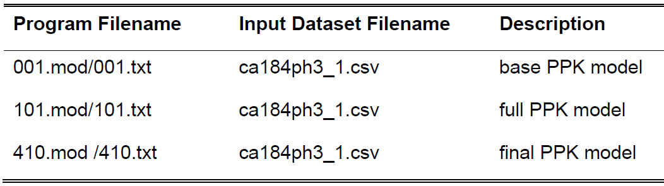

Software used for the evaluation
The runs were repeated using NONMEM version 7.2, in conjunction with an Intel FORTRAN compiler and PsN (Perl-speaks-NONMEM) version 3.7.6 on a Microsoft Windows Servers.

Results

Repeat of the key model
Key analysis models of the PopPK study were repeated in the assessment. Note the data set provided for the assessment was ‘ca184ph3-csv.txt’. However in the model files 001.txt, 101.txt and 410.txt the data set ‘ca184ph3_1.csv’ was specified in the code: “$DATA ca184ph3_1.csv IGNORE=C”. To be able to rerun the analysis using the same model files, the data set provided for the assessment was renamed to ‘ca184ph3_1.csv’. It was assumed in this assessment that the right data set was used and there was a transcription error at some stage. The data content in the data set and the order of the data items were exactly as described in the report.
Table 18 shows the list of the parameter estimates provided in the ‘930057648-poppk. pdf’ report in comparison to the results of the repeated models performed for this assessment. Table 18 shows the results from the repeat of the key analysis models of the PopPK study match exactly the results submitted in the report. No differences have been noted when comprehensively comparing the output files. In Table 18 the parameter estimates are listed. Further comparison of the output files in regards to the reported standard errors, the covariance matrix, the correlation matrix, the inverse covariance matrix and the eigenvalues of the correlation matrix were found to also match the sponsors report results. The results submitted by the sponsor can be confirmed according to the assessment performed.

Table 18: Comparison of parameter estimates for the PopPK analysis reported in the output files (.lst) of the study report and obtained in the output files (.lst) from the repeated models
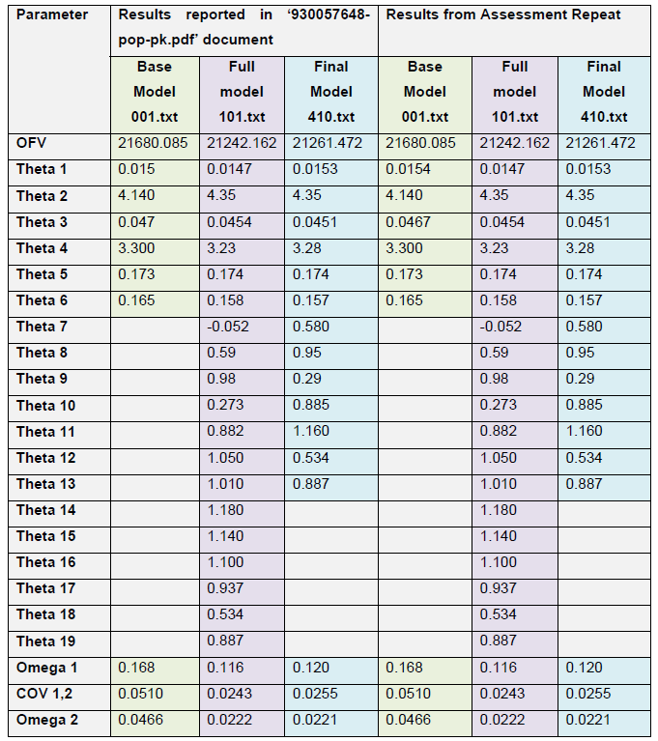

Evaluation of the covariate model building steps
Additionally, the covariate model building steps were repeated as well. Model files and result files for each of the covariate model building steps were not provided for evaluation. However, the provided base model was used together with the methods described in the report and the steps leading to the full model could be confirmed.
It should be noted that the report did not specify why only the listed covariate parameters relationships were tested. Several potentially influential covariates available in the data set such as: BBSA, BIBW, BHT, BALB, BALT, RACE, BUDEN were omitted by the sponsor according to the method section. No reason had been listed for omitting them from the covariate analysis in the report.
In the assessment of the covariate analysis steps these omitted covariates were not included and not tested either.

Review using the guideline
The following part includes a detailed description addressing each of the points in turn from analysis plan to discussion according to the EMEA guideline.¹ This guideline will be referred to as ‘EMEA guideline’.

Analysis plan
The analysis plan “Pharmacometric Analyses Plan: Ipilimumab (BMS-734016) Population pharmacokinetics and exposure-response in patients with previously untreated advanced melanoma” was submitted as a separate document to the main report.
The separately submitted analysis plan largely meets the requirements of the EMEA guideline, specific comments are listed below:
- The objective(s) of the analysis were stated clearly, the background information on the drug and the rational are described sufficiently.
- A description of the studies from which the data originate was presented in the analysis plan.
- The nature of the data to be analysed (how many subjects, sampling design) was clearly outlined in the plan.
- The data analyses method for three different analyses: PopPK, ER:OS and ER: irAE were described in detail, specifically:
  - The procedures for handling missing dose data and outlying data were described and seem appropriate and according to standard.
  - The handling of data below the limit of quantification (BLOQ) should have been more detailed and structured depending on the percent of BLOQ data to be seen in the data set. The analysis plan presents a method for handling BLOQ data that is only acceptable if small amounts of BLOQ data are to be expected. If the amount of BLOQ data, particular at certain times within a doing interval is high, then the method presented in the analysis plan (omitting the BLOQ data) can lead to bias parameter estimates. . No discussion about the choice of method was available in the analysis plan.
  - The general modelling aspects specifically in regards to software, estimation methods and diagnostics to be used were described and considered appropriate.
  - The overall modelling procedure/strategy was described and appears appropriate.
  - Structural and variability models to be tested for the PopPK model were based on a previous analysis according to the analysis plan. This is appropriate as some of the data used in the previous analysis was to be used for this analysis again.
  - The covariates and covariate models to be tested were listed for each of the models.
  - The algorithms/methods to be used for covariate model building and the criteria to be used for selection of models during model building and inclusion of covariates (for example, objective function value, level of statistical significance, goodness of fit plots, standard error, inter-individual variability, clinical relevance) were listed in the analysis plan.
  - The model evaluation/qualification procedures to be used were listed in the plan and are considered appropriate.
  - Model application procedures were listed in the analysis plan and were deemed appropriate.

Final report sub-sections

Summary
The synopsis in the sponsor’s report meets the criteria of the EMEA guidelines. It contains sufficient information on the context of the study, objectives, study design, data (number of subjects and samples), methods, results and the main findings and conclusions of the population PK analysis summaries and clearly presented in logical order.

Introduction
The introduction in the report provides background information about the drug ipilimumab and the rational for this analysis, which was to support the extension to first-line treatment for stage III or IV melanoma patients, provide insight into the relationship between ipilimumab C_{minss} and patient covariates that are associated with key efficacy overall survival (OS) and safety immune-related adverse events (irAEs) endpoints, in particular adverse events regarding skin, gastrointestinal tract and liver.
The report provides sufficient background information to place the analysis into context within the drug's clinical development. The introduction in the sponsor’s report meets the criteria of the EMEA guidelines.

Objectives
The objectives are clearly stated in the sponsors report. These analyses aimed to describe the PK of ipilimumab in previously treated or untreated patients with advanced melanoma, and to quantify the sources and correlates of variability in ipilimumab exposure in this population, the relationship between ipilimumab exposure and efficacy (OS) in previously untreated patients with advanced melanoma as well as the describe the relationship between ipilimumab exposure and safety (irAEs) in previously treated or untreated patients with advanced melanoma.
The objectives section meets the criteria of the EMEA guideline.

Data
The data that was included in the analysis and it’s originate were described in the report in great detail. Information regarding nominal number of samples per subject per visit and sampling times in each study were provided. A graphical display of the concentration versus time should have supported and illustrated the data available; however this was not included in the report.
The methods for calculating derived covariates were listed within the report and seem appropriate. Handling of missing data has been described at several points in detail. Identification and handling of outliners have been described in detail and appears appropriate for the analysis. Outliners were identified based on the conditional weighted residuals (CWRES) throughout the model building process and distributional checks suggested by Tukey. The report describes and justifies the procedures that were taken in handling outliers and are appropriate.
The handling of data below the limit of quantification (BLOQ) has been described in the report. All BLOQ were omitted in this analysis. From data provided a 5.7% rate of data omission due to this reason in relation to the total number of samples used in the PopPK analysis can be calculated. 5.7 % can be considered a small and negligible omission of data, however this was not stated in the report and possible consequences of this censoring were not discussed either. It is difficult to assess from the report at which time points during the dosing interval the BLOQ samples occurred and consequences of data censoring cannot be judged fully. All data used in the analysis compared to censored data are not graphically displayed for judgement of the possible consequences of the omission of the BLOQ data.
Electronic files of the analysis datasets as comma separated values and space delimited text files were provided for the PopPK analysis (‘ca184ph3-csv.txt’). Other data files such as preddata.csv and pkirAE.v1.csv used for the other two models in this report were not provided. Detailed specifications of the data were included in the report.
In conclusion the nature of the data and the studies from which the data originated from are comprehensively described in the report and the procedures for handling missing data and outlying data have been described in detail. The report largely meets the criteria of the EMEA guideline. Discussion on the omission of the BLOQ data was not available and no graphical display of the data used for the analysis was provided in the report. The data available and the study designs of the studies, as well as the merging of the data from several different studies were appropriate to be analysed using a PopPK approach.

Methods
The methods for the development and evaluation of the PopPK model and those relating to the exposure-response (ER) models (OS and irAEs) were described.

Bioanalytical methods
The bioanalytical methods used and the limit of quantification for ipilimumab and inter-assay and intra-assay coefficients of variation were specified according to the guidelines in the data section of the report.

Analysis plan
No deviations from the analysis plan during the analysis could be identified and none were discussed within the report.
Criteria to be used for selection of models during model building and inclusion of covariates and the model evaluation/qualification procedures to be used have been listed in the method section and are the same as listed in the separately provided analysis plan. Specific methods used have been referenced throughout the report, similarly to the ones referenced in the analysis plan. Models, covariates and covariate models that were tested are the same as predefined in the analysis plan.

PopPK ER analyses
The methods outlined for the PopPK and ER analysis largely meet the EMEA guidelines. Missing information in the report, required by the EMEA guideline:
- Rational for testing selected covariates in the data set.
The steps and components of the PopPK model and the ER models were stated and specified along with a list of the hardware and software used (NONMEM, Splus, PsN). The analysis methods and the choice of estimation method (for example, FOCE with interaction for PopPK, no methods listed for the Exposure-Safety Response analyses) were also stated. Justifications for these choices have been limited within the report. The assumptions made during the analysis were discussed only to a limited extent for some of the models.
The model selection criterion during model building and inclusion of covariates was specified as the Bayesian Information Criterion (BIC) (calculated based on the objective function value, number of observations and the number of parameters in the model). No level of statistical significance was defined. Model selection was guided by the magnitude of change in BIC values.
The following criteria were also considered during the covariate model process to arrive at the final model:
- Diagnostic goodness-of-fit plots (conditional weighted residuals versus time/population predictions)
- Plots of observed data versus population/individual predictions
- The extent to which the model could explain the variability in the data, as measured by inter-subject variability and residual-error parameters and bootstrap procedures.
All of the above can be considered appropriate.

Structural model
For each of the three models (PopPK and ER models) the report presents the a priori information available regarding the model structure or the assumptions that the structural model was based on.

Covariate model
The covariates tested for inclusion in the model were presented for the PopPK and the ER: irAEs model, however no rationale for testing these covariates and none of the other available covariates in the data set were given. The EMEA guidelines states that this should be discussed. A discussion was missing on why covariates such as body surface area and albumin were not considered in the PopPK analysis, for example. For the ER :OS model the selected covariates were not listed, however it was specified that the selection was based on extensive data visualisation (not presented in the report). The parameterisation of the covariate model for the PopPK analysis was specified in the report. This was not explicitly done for the ER models. The covariate model building procedures were described in agreement with the guidelines and extensive tables listing the steps were included.
In conclusion, only limited information on the specific criteria for covariate selection was presented for the three data analyses.

Variability models / stochastic models
Models applied to describe inter-individual and residual were described for the PopPK model. Inter-occasion variability was not investigated in the model. No rational for this was provided.

Model evaluation
Model evaluation procedures to support the objective to describe the data and evaluate potential covariate effects in this report meet the standards required by the EMEA guideline.
The model evaluation procedures were described and include both graphical evaluation and statistical procedures. Justification of the model evaluation procedures chosen was limited in the report, overall they were appropriate.
The following tools were used for the three models were: assessment of goodness of- fit plots, precision of parameter estimates, bootstrapping, visual predictive checks (VPC) and prediction corrected visual predictive checks (pcVPC).

Results
The results of the three analyses were presented in a sequential manner. The results of the PopPK analysis the results of the ER:OS analysis, and the ER: irAEs model results were all provided.

Data
Results on the data is not discussed or reported. Data used for the analyses is described. Additional details on the data set used for the PopPK analysis was presented in appendixes and information on the data sets used for the ER:OS and ER:irAEs analysis was also presented in appendixes.
Information on the total number of subjects, the total number of observed concentrations used in the analysis, the distribution of the used data presented in graphics and tables, presentations of the actual number of samples per subject, summary statistics and histograms of the continuous covariates and frequencies of categorical covariates, missing data (missing dosing and sample times, missing covariates), outliers specified with all relevant data available and lists of subjects removed from the analysis listed with relevant patient characteristics were found in the above mentioned data section not in the result section of the report.
The information presented in the report in the data section largely meets the criteria of the EMEA guideline for the result/data section.

Missing information
Missing information in the report, required by the EMEA guideline, are:
- Graphics of the raw data provided on linear scale and usually also on log-linear scale. The available data was not displayed in any raw format within the report.
- Information regarding drop-outs during the study were not found in the report.

Base model
For the PopPK model and the ER:OS model the major decisions taken during the base model development were not found in the report. No overview of the steps taken during model development (a run record) that, at a minimum, clearly describes important decisions taken during the building of the base population model was presented. Furthermore, no comparison to other structural models tested was presented.
Data set alterations, excluding outliners done during the PopPK base model development, were described in detail. For both these models an, a priori base model was suggested in the method sections based on previous analyses.
The models tested for the ER:irAE base model were listed for the separate irAEs and any irAEs. A run records listing the model selection criterion (BIC) for each of the models considered was displayed. The run record however did not include parameter estimates. It was specified that the model with the lowest BIC was selected as the base model.
All three base models are presented in the report in tables listing the parameter estimates, their standard errors and/or confidence intervals, inter-individual and residual variability models.
Goodness-of fit (GOF) plots were presented for the PopPK model, including information on shrinkage for the parameters. The following GOF plots were appropriately presented in the base model sections of the three models:
- Observed data versus predicted data and individual predicted data. An identity line and a trend line are included and the plot was provided in both linear and log scale
- Weighted residuals and/or conditional weighted residuals versus predicted data and versus time including a zero line and a trend line
- Absolute individual weighted residuals versus individual predicted data including a trend line.
The results describing the three base models from the analyses presented in the report largely meet the EMEA guidelines.

Covariate selection
The description of the covariate selection processes for the PopPK model in the report was limited. It was only stated that the covariate included into the model were informed by prior knowledge gained from an ipilimumab PopPK model developed with data from Phase II studies and other specific covariates of interest were tested and listed. No graphics generated to screen for potential covariate relationships were provided in this report. The covariate model building steps to illustrate covariates that are included in the final model and those that were tested but were not retained in the final model were presented in a separate run record. The criteria on which the decision was based (BIC) was outlined in the method section. The results for the final and full covariate model were presented in terms of parameter estimates in the report sufficiently. The values of the affected parameter at the 5th to 95th percentiles of the covariate range were presented. No simulations were performed.
The results and the steps of the covariate analysis clearly show that prior systemic cancer therapy age, as well as concomitant therapy with dacarbazine, hepatic impairment, and HAHA status as predictors of clearance (CL) could be excluded from the full model and showed no clinical significant effect on CL. For some covariates the influence of missing covariates in the data set was evaluated and tested further in regards to their potential clinical relevance.
The covariate selection processes for the ER:OS model was described in more detail. Graphics are presented that demonstrated the screening for potential covariate relationships. The covariate model building steps to illustrate covariate – parameter relationships that are included in the final model and those that were tested but were not retained in the final model were clearly presented in a separate run record. The criteria on which the decision was based (- 2LL, BIC) was outlined in the method section and the appendix. The results for the final and full covariate model were presented in terms of parameter estimates sufficiently. The values of the affected parameter at the 5th to 95th percentiles of the covariate range were presented in graphics. No simulations were performed.
The covariate selection processes for the ER:irAE model was described in detail. However, a discussion on the pre-specified covariate parameter relationships was not found in the report. The full model for each irAE type was subjected to a stepwise backward elimination procedure to achieve a parsimonious model. The change in BIC value from the model including the covariate to one excluding it governed the order of covariate removal at each step. No graphics are presented that demonstrated the screening for potential covariate relationships. The covariate model building steps to illustrate covariates that are included in the final model and those that were tested but were not retained in the final model were clearly presented in a separate run record. The criteria on which the decision was based (BIC) was outlined in the method section and the appendix. The results for the final and full covariate model were presented in terms of parameter estimates sufficiently. The values of the affected parameter at the 5th to 95th percentiles of the covariate range were presented in graphics. No simulations were performed to evaluate the impact of the covariates to illustrate the effect of various covariate combinations for a series of different ‘typical’ subjects.
The results describing the covariate selection process for all three models: the PopPK model, the ER:OS and ER:irAE, presented in the report largely meet the EMEA guidelines.

Final model
The final PopPK model was clearly described in the report. The parameter estimates for all parameters in the final model were presented, together with their confidence intervals. The final PopPK model contained baseline BW, LDH, ECOG status, sex, and eGFR as explanatory covariates for the variability on CL. Weight and sex were included on volume of distribution (Vd) in the final model. A discussion on the extent of decrease of inter-individual variability on CL and Vd by the inclusion of the covariates in the model was provided. The fundamental GOF plots were supplied for the final PopPK model. The NONMEM input and output files for the base and final models were provided.
The final ER:OS model was clearly described in the report and model parameter estimates were summarised together with their confidence intervals and with hazard ratios calculated for each retained covariate. Details of final model development were presented. The magnitude of covariate effects were assessed by the ratio of parameter estimates relative to typical parameter value for a reference subject and graphically displayed. The final ER:OS model included metastatic status, ECOG, and lactate dehydrogenase (LDH) status.
The NONMEM input and output files for the base and final models were provided.
The final ER:irAEs model was clearly described in the report and model parameter estimates were summarised. A table summarised the parameter estimates and 95% confidence intervals for the final gastrointestinal irAE model. Concomitant dacarbazine was the only covariate retained in the model and resulted in a lower probability of gastrointestinal irAEs. The parameter estimates and 95% confidence intervals for the final hepatobiliary irAE model were summarised. Concomitant dacarbazine was again the only covariate retained in the final gastrointestinal irAE model, but showed here that concomitant use of dacarbazine increased the probability of hepatobiliary irAEs. A Table provided the summarised parameter estimates and 95% confidence intervals for the final skin irAE model. No covariate was retained in the final model. The parameter estimates and 95% confidence intervals for the final model for any irAE were summarised in a table. Prior anticancer therapy was the only covariate retained in the final model for any irAE type. The odds of any irAE occurring was found to be approximately half in subjects who have been previously treated with anticancer therapy relative to those who were previously untreated. Details of the final model development were presented. The magnitude of covariate effects were assessed by the ratio of parameter estimates relative to typical parameter value for a reference subject and graphically displayed. The NONMEM input and output files for the base and final models were provided.
The results section describing the final models: the PopPK model, the ER:OS and ER: irAE, presented in the report largely meet the EMEA guidelines.

Model evaluation
All model evaluation procedure performed for each of the separate models meet the criteria listed on page10 of the EMEA guidelines.¹
Several different procedures have been used during the model building process and for the evaluation of the three final models. All model evaluation procedures are displayed in a manner appropriate to demonstrate that the final model is robust and sufficiently good in describing the data so that the objectives of the analysis were met.
Two slight deviations were found in the predictive performance of the final models, however can be considered of minor importance. They models seem to deviate from the observed data on the following two occasions:
- For the ER:OS model a deviation of the median trend after 10 months of time in the ipilimumab and ECOG = 1 group can be seen;
- For the ER:irAE model for gastrointestinal irAEs, a deviation from the observed incidence to the average predicted probability of gastrointestinal irAE can be seen. This shows that the model has limited capability to predict the grades for the irAEs with high concentrations.

Model application
The report has utilised the models and applied them to present the results and discuss the clinical implications of the model results for each of the models within a specific ‘Model application’ section. There are no explicit guidelines on which application tests are deemed appropriate by the EMEA.
However, after assessment of all of these sections, the conclusions drawn from them and the model application presented in this section can be considered appropriate. The results from the model application section have been used to a great extent to support the discussion and are evaluated there in more detail.

Assessment conclusion for the results section
No major breach of the reporting guidelines for the result section was found. Some information particular discussion on decision making was limited; however, all models, model building steps, criteria for model selection and evaluation steps are in agreement with the guidelines and appear reasonable. The final models presented in the report appear reasonable and based on appropriate model selection and evaluation criteria. Graphical plots supporting the decision making such as GOF plots are consistent with the EMEA Guideline. The models have been tested rigorously using relevant graphics, given the data and the assumptions made in the process, as well according to current evidenced based standards (for example, shrinkage was reported when required). The quality of the model evaluation procedures was of appropriate standard.
Points of concern noted above and summarised here for completion are:
- Covariate parameter selection was discussed minimally in this report. The guidelines recommend that these are discussed. It was difficult to assess the appropriateness of the covariates selected for the covariate model building steps, based on the content provided in the report. For example it is unclear: Why was total body weight tested on CL and Vd in the PopPK model and not BSA or lean body weight? Furthermore, why was albumin not a covariate selected for the covariate model building step? There might have been reasonable criteria for this, however it can’t be evaluated.
- It was noted that units for parameters and concentrations presented in the tables in the result sections were missing on several occasions throughout the report. This made it difficult to evaluate the appropriateness of some of the parameter values. The parameter values presented in the tables seem reasonable, based on the assumption that units of the values are appropriately.

Discussion
The discussion of the report addresses how well the final models describe the data and the clinical relevance of any covariate influences in detail. The results of the PopPK analysis have been related to previously obtained results and are in agreement with them. The discussion of the report meets the EMEA guidelines.
Explicit discussion points for the PopPK model have been:
- PK of ipilimumab is linear in the dose range tested.
- The PK of ipilimumab is time invariant.
- No difference in the PK of ipilimumab in previously untreated versus previously treated patients.
- Ipilimumab should be dosed according to the total body weight of the patient, due to the significant impact of total body weight WT on ipilimumab CL found, effecting overall exposure to the drug.
- Ipilimumab CL increases with increasing baseline LDH. However patients with sufficiently high LDH to cause clinical meaningful changes in CL have been found to be rare and are unlikely to have clinically meaningful impact of LDH on their ipilimumab CL.
- Renal function and mild hepatic impairment have no impact on ipilimumab CL.
- Dacarbazine did not affect ipilimumab CL.
All of the above claims have been supported by rigorous evaluation of the model and model outcomes. The claim of PK being time invariant and linear over the tested dose range is adequate and appropriate. The most clinical influential covariates found were total body weight on CL and Vd, both increase with increasing weight and the patient with the smallest weight and the largest weight in the study population had significantly smaller and larger CL, respectively, compared to the average weight patients in the study population. In particular, C_{minss} concentrations have been linked to efficacy and safety of ipilimumab. It has been shown that a fixed dose for all patients will underexpose heavier patients leading potentially to treatment failure. Vice versa, overexposure in lighter patients might lead to increased risk of adverse events. The conclusion dosing of ipilimumab based on patient’s body weight is appropriate.
The impact of LDH on ipilimumab CL has been discussed and it was concluded that baseline LDH values less than 675 IU/L are unlikely to have clinically meaningful impact on ipilimumab CL, and that the additional increase in CL in patients with LDH values as high as 5 x ULN is only approximately 10% relative to patients with LDH of 3 x ULN. It should also be noted that LDH is a key prognostic factor indicating worse outcomes; consequently this may lead to a higher ipilimumab CL, in higher risk patients and should be considered when these are being treated. It is however not discussed in further details if dose changes should be recommended in high risk patients.
Renal function and mild hepatic impairment showed to have no clinically relevant effect on ipilimumab CL. Estimated glomerular filtration rate (eGFR) was included in the final model however, the explorations of the effect magnitude showed that ipilimumab CL changed by less than 20% for the lowest and highest eGFR in comparison to the population median value. The effect of hepatic impairment on ipilimumab CL is based mainly on a comparison between patients with normal hepatic function and mild impairment. The effect of hepatic impairment should be revaluated again in future studies when more data from patients with moderate to severe impairment are available.
Additionally, the influence of concomitant therapy with Dacarbazine, immunogenicity (Human-anti-human antibody (HAHA) status) and patient’s age were discussed and found not to be clinically relevant predictors of ipilimumab CL. These are appropriate conclusions given the results of the PopPK analysis.
The PopPK model predicted that 3 and 10 mg/kg doses yield pharmacologically active ipilimumab C_{minss} values when the target trough concentrations of 3 and 20 µg/mL are considered. Again, the application of the final PopPK model is supporting this discussion.
In conclusion the discussion points regarding the PopPK model for ipilimumab in the advanced melanoma patient population are all supported by the models and by the model evaluations and application performed.
Explicit discussion points for the ER:OS model have been:
- The relationship between ipilimumab C_{minss} and OS hazard ratio was found to be significant. C_{minss} was selected as the summary measure of ipilimumab exposure for this analysis and was based on mechanistic rationale and previous report
- LDH, ECOG status and metastatic status were identified as significant predictors of overall survival (OS).
The final ER:OS model showed a lower OS hazard ratio in patients with higher C_{minss} values. It is appropriate to conclude that survival of previously untreated advanced melanoma patients increased with increasing ipilimumab C_{minss} over the range of exposures achieved with the 10 mg/kg dose, based on the final ER:OS model and the model evaluation and application reported here.
Additionally, elevated LDH, reduced ECOG status and more advanced metastatic status increased the risk of death in patients. Metastatic stage at study entry, abnormal LDH, and poor ECOG performance status are known prognostic factors for poorer survival from metastatic melanoma and could be confirmed here. The influence of gender on OS was inconclusive from this study.
The relationship between ipilimumab exposure and OS seems to be well characterised by the model in the advanced melanoma patient population studied and supported by model evaluations performed.
Explicit discussion points for the ER:iAR model have been:
- Log-odds of immune-related irAEs increase with increasing C_{minss} according to an E_{max} pharmacodynamic model.
- Dacarbazine had a marked effect on irAEs, therefore it was included in the base model.
- Ipilimumab potency for inducing irAE is generally similar for gastrointestinal and skin and any irAE and the probability of having these irAEs is near maximal for C_{minss} values greater than the median of the 10 mg/kg dose.
- Prior anticancer therapy was an important covariate on the probability of irAE occurrences.
The final ER:iAR model supported an E_{max} pharmacodynamic model to describe the relationship between increasing irAEs with increasing C_{minss} values. This is an extension to a previous pharmacometric analysis, supported by more data and a broader C_{minss} values in this study. The model was built according to standard practice and was evaluated extensively consequently this conclusion seems appropriate. Also the a priori inclusion of dacarbazine co-administration was appropriate. Co- administration of dacarbazine with ipilimumab increased the incidence of hepatobiliary irAEs but lowered the incidence of gastrointestinal irAEs. Model based estimates of the odds ratios were approximately 9 fold and 0.5 fold, respectively.
The probability of gastrointestinal and skin irAEs was near maximal for C_{minss} values greater than the median of the 10 mg/kg dose, whereas the probability of hepatobiliary irAEs increased over most of the C_{minss} value range produced by 10 mg/kg. The potency of ipilimumab to cause irAE differs by target organ, however the probability of having mild or more severe irAEs differs little. Prior anticancer therapy reduced the risk of any irAE, particularly gastrointestinal and hepatobiliary irAE, however the underlying physiological reasons seem still unknown. The results from the ER:irAE model show an increasing odds ratio for irAEs with increasing C_{minss}, which provides strong support for a role of ipilimumab in the frequency and severity of irAEs.
The relationship between ipilimumab exposure and irAEs seems to be well characterised by the models in the advanced melanoma patient population studied and supported by model evaluations performed.

Dosage selection for the pivotal studies
No pivotal studies have been submitted with this application. There are no newly submitted studies that address dosage selection.

Comments regarding the dosage selection for the current application
The sponsor writes in the ‘Summary of Clinical Efficacy’;
‘Ipilimumab monotherapy (3 mg/kg every 3 weeks for 4 doses) was approved in the US and several other countries for the treatment of metastatic melanoma regardless of prior therapy. In the EU, Australia, and other countries, ipilimumab was approved for the use in previously treated metastatic melanoma. These approvals were primarily based on the OS benefit observed in MDX010-20 (Phase III study of 3 mg/kg ipilimumab ± gp100 versus gp100 alone in pre-treated advanced melanoma), as well as key results from a second randomised Phase III trial demonstrating OS benefit with ipilimumab in previously untreated advanced melanoma (CA184024; 10 mg/kg ipilimumab + DTIC versus DTIC alone).
This submission presents evidence to support extension of the 3 mg/kg posology to include patients with untreated advanced melanoma based on:
- Pharmacologic data showing consistent baseline immune status and T cell response in untreated and previously treated subjects
- Consistency in PK data between untreated and previously treated subjects
- Consistency in efficacy of 3 mg/kg regardless of number or type of prior therapy in MDX010-20
- Exposure-response (ER) data corroborating that the efficacy of ipilimumab is independent of prior therapy
- Data from pooled Phase II studies of ipilimumab 3 mg/kg in untreated subjects that demonstrates consistency in safety and efficacy with that in previously treated subjects
- Results from the Phase III study of ipilimumab 10 mg/kg plus DTIC versus DTIC confirming clinically meaningful improvement in OS and long term benefit in untreated subjects treated with ipilimumab.
The durable survival and favourable risk/benefit ratio of ipilimumab in 2 Phase III trials support an update to the therapeutic indication in the ipilimumab Summary of Product Characteristics (SmPC) to include previously untreated, advanced melanoma. Both, 3 mg/kg ipilimumab and 10 mg/kg ipilimumab + DTIC provide positive risk/benefit with similar median and long term OS. BMS (the sponsor) recommends the posology of 3 mg/kg ipilimumab for previously untreated advanced melanoma based on a number of considerations outlined in the Clinical Overview.’
Firstly regarding these points listed;
- Randomised evidence in support of the standardisation of therapy has not been provided with the current application
- Data regarding baseline immune status being similar between untreated and previously treated patients is based on the Phase II Study CA184007 which uses the 10 mg/kg posology and maintenance phase. The external validity of this statement for the current application is limited
- Data regarding T cell response at the 3 mg/kg dose was studied in previously treated or untreated subjects in the Phase II CA184004 trial, which included maximally 14 previously untreated patients administered ipilimumab 3 mg/kg monotherapy and included maintenance phase. Whilst this statement is relevant for the current application, the numbers generating this data is small and it is unclear how many of the 14 patients received maintenance therapy
- The pharmacological data within the current application included small numbers of patients relevant to the proposed indication. There were only 14 previously untreated patients who administered ipilimumab 3 mg/kg monotherapy who were included within the analyses of reference. It is unclear how many of the 14 patients received maintenance therapy
- The third point can also be used as support for the use of ipilimumab in the second line setting (for previously treated patients)
- The ER-OS data referred to that was provided within the newly submitted PopPK analysis was based on previously untreated patients from CA184024 (10 mg/kg + DTIC), such that it was not informative for the covariate of previous treatment. If this statement is in reference to the previous ER-OS modelling performed for the previous evaluation, with reference to the data provided, there were maximally 35 patients included that are relevant to the current application
- Pooled data from Phase II studies, were again based on small numbers of patients relevant to the current application (n = 35)
- The external validity of a study using a 10 mg/kg posology, and its combination with DTIC, is limited for the current application.
Within the ‘Clinical Overview’, the sponsor writes;
‘Extension of the current ipilimumab indication to include patients with advanced melanoma, regardless of prior therapy, is warranted based on 2 randomised Phase III trials of ipilimumab in advanced melanoma demonstrating durable OS benefit. Of all the other therapies for previously untreated advanced melanoma, including vemurafenib, DTIC, and Fotemustine, only ipilimumab has demonstrated a durable OS benefit through at least 2 years. In 2012, the two most widely used oncology guidelines, ESMO and NCCN, recommended ipilimumab for advanced melanoma, regardless of line of therapy.
While ipilimumab provides a favourable benefit: risk for untreated patients with advanced melanoma both as a 3 mg/kg monotherapy regimen and at a dose of 10 mg/kg plus DTIC, BMS recommends a 3 mg/kg monotherapy based on the following considerations:
- The efficacy, PK, and PD effects as well as the safety and tolerability of 3 mg/kg ipilimumab are independent of prior therapy
- The safety and tolerability of 3 mg/kg ipilimumab monotherapy appears to compare favourably to 10 mg/kg ipilimumab + DTIC, allowing more subjects to receive, on average, the full 4 doses of initial treatment and avoid the additional toxicity from DTIC
- New real world OS and safety data from treatment naive patients who received 3 mg/kg
- Ipilimumab in the US as their first line of therapy provides confidence in this regimen for advanced melanoma.
- 3 mg/kg dose is already approved and widely used for previously treated melanoma.
Extension of 3 mg/kg monotherapy would standardise the ipilimumab safety profile and treatment regimen for advanced melanoma.’
Regarding these points listed by the sponsor;
- Randomised evidence in support of the standardisation of therapy has not been provided with the current application
- Ipilimumab is the only therapy currently for patients with advanced melanoma that provides a durable overall survival. However, the MDX010-20 study trial design included co-administration with gp100 and maintenance therapy and the subgroup analyses have not been prospectively validated. No randomised data has been presented in support of this statement
- Given that the benefits of ipilimumab 3 mg/kg are independent of prior therapy, this can also be interpreted as support for its use (efficacy) in the second line setting
- Direct head-to-head comparison of the benefits of 3 mg/kg versus 10 mg/kg ipilimumab has not been performed. Cross study comparisons of heterogeneous studies are a poor statistical method of comparing efficacy and have limited external validity for the current application
- Observational interim studies with ‘real world data’ do not provide high quality level evidence according to conventional grading criteria given the uncontrolled data collection. One of these interim CSRs did not capture safety events. However, data addressing the pre-submission meeting queries should be reviewed.
Overall, the external validity of the data provided is limited; the number of patients relevant to the current application is small, and in general, data does not directly address the proposed usage. There is a clear lack of randomised data.
To further demonstrate the limitations of cross study comparisons, within this current application the Summary of Clinical Safety refers to the CA184022 where the controlled comparison between the 3 mg/kg and 10 mg/kg dose has been made. Significantly, differences in BORR, OS and irAEs are observed between posology. This suggests that though numbers in cross study comparisons appear similar, when examined in a controlled setting, significant differences can be observed between different treatments.
‘Ipilimumab 10 mg/kg monotherapy was initially studied in Phase II studies. In the dose ranging Study CA184022, a statistically significant trend (p = 0.0015) for increased BORR with increased dose was observed, suggesting a dose effect for ipilimumab activity. A numerical improvement in median OS and 1 year survival rate at 10 mg/kg compared with 3 and 0.3 mg/kg was observed. In addition, a numerical increase in irAEs (any grade) with increasing ipilimumab dose was observed; 0.3 mg/kg (26.4%), 3 mg/kg (64.8%), and 10 mg/kg (70.4%). The overall irAE profile was similar between the 3 and 10 mg/kg treatment groups except for the incidence of Grade 3 to 4 irAEs, which was higher in the 10 mg/kg group than in the 3 mg/kg group (25.4% versus 7.0%).’
Similarly, when CA184024 was compared with ipilimumab 3 mg/kg monotherapy in previously treated melanoma patients (MDX010-20), differences between the frequency and type of AEs can be observed with the different posology and treatment combinations. Thus, though similarities between studies exist, significant anticipated differences also can also be observed within them.
‘In CA184024, ipilimumab 10 mg/kg + DTIC demonstrated a clinically and statistically significant increase in OS relative to the global standard of care, DTIC, in previously untreated, advanced melanoma. In this trial, the safety of ipilimumab + DTIC was comparable to that observed for ipilimumab 3 mg/kg monotherapy in previously treated melanoma except for
- the occurrence of common DTIC-associated toxicity (for example, nausea, vomiting and myelo-suppression) and
- a higher incidence and severity of hepatitis.
However, the higher incidence of hepatitis was likely due to the combination of DTIC with 10 mg/kg ipilimumab, since it was higher than expected from DTIC alone or 10 mg/kg ipilimumab monotherapy. In CA184024, there were no treatment-related deaths or GI perforations in the ipilimumab + DTIC group.’
These differences demonstrate the limitations of cross study comparisons. CA184022 illustrates that the efficacy and safety of different treatment schedules is likely to exist, thus studies utilising the 10 mg/kg dosing supply limited support for the current application. CA184024 demonstrates that combination therapy confers anticipated increased toxicity compared to monotherapy, thus studies that do not utilise ipilimumab monotherapy supply limited support for the current application.
In the previous evaluation, the sponsor did not perform an integrated (safety) analysis due to the heterogeneous nature of the studies and populations. The studies in reference overlap those presented in pooled analyses for the current submission. The following excerpt is taken from the previous TGA clinical evaluation report;
‘The safety evidence presented comprises
- Routine safety data from the clinical Studies MDXCTLA4-01, MDXCTLA4-02, MDX010-15, CA184004, CA184007, CA184008, CA184022, MDX010-20, MDX010-08
- Routine safety data from the ancillary studies (CA184042, MDX010-19, MDX010-13, MDX010-05, MDXCTLA4-04, MDX010-03, MDX010-07, MDX010-17, MDX010-21, MDX010-12, MDX010-11, MDX010-23 and MDX010-24). In general, for studies in this group, the sponsor states (Mod 2 section 2.7.4, page 22): ‘No analyses were performed on an integrated level for these studies as they represented various tumour types and Ipilimumab doses, schedules, and regimens, including in combination with other therapies.’
Thus, the bridging data presented needs to be regarded with caution.
In conclusion, with respect to the dosage selection of the sponsor, on the basis of limited data provided relevant to the population of interest (n = 15 to 35), limited external validity of the studies submitted, and the absence of randomised data, there is insufficient evidence to support this application.

Clinical efficacy

For overall survival benefit

Pivotal efficacy studies
There are no pivotal studies submitted that provide efficacy data for the proposed indication (3 mg/kg monotherapy in the previously untreated population).

Other efficacy studies
There were no studies included in the dossier that investigated the treatment schedule of the proposed usage in the appropriate population for the current application. The majority of efficacy data submitted by the sponsor is deficient with limited external validity due to;
- the use of the 10 mg/kg dosing schedule
- administration of ipilimumab concurrently with other therapy
- the use of a maintenance phase, and
- the investigation of a population of patients not relevant to the proposed usage.
Other efficacy data submitted is based on subgroup analyses which are exploratory and require confirmation in a randomised controlled trial. In addition, all studies including the previously submitted Study MDX010-20, for which the current approved indication is based, included a maintenance phase which limits the external validity of the efficacy data for the current application. In addition, MDX010-20 trial design involved co-administration of ipilimumab with gp100.
The main study contributing efficacy data is one single Phase III Study, CA184024, which uses ipilimumab 10 mg/kg administered concurrently with DTIC, and includes a maintenance phase. According to the statistical principles of clinical trials, CA184024 has limited external validity. The next subsection provides more data addressing the current application from pooled analyses.
Other studies reviewed within this section that have been submitted in support of the current application include one Phase II study interim report for CA184042 which uses a 10 mg/kg dosing, a Phase I study with a secondary endpoint of efficacy (CA184078), two interim reports for observational Studies (CA184332, CA184338), and a report for the extended access program (EAP) for which efficacy analyses were performed only on patients treated with the 10 mg/kg dosing (CA184045). Efficacy results were not reviewed for MDX010-16 as the study design was for the adjuvant setting and the median time to disease relapse results is immature since less than 50% of the subjects relapsed and the median value was not reached. In addition, this study was terminated early. These studies have been included due to their reference in the pre-submission meeting. These studies contribute limited supportive efficacy data due to the use of the 10 mg/kg dosing, concurrent administration with other drugs, phase I design, observational design, and an alternate primary endpoint to efficacy.
With reference to the current application, the OS obtained by patients treated by previous conventional systemic therapy for this setting should be noted. It also should be noted that there are some long term survivors observed in the standard (non ipilimumab) treatment arms. Trials in previously untreated advanced melanoma patients demonstrate a median OS of approximately 9 months and estimated 1 year OS rate of approximately 36% as historical benchmark for DTIC monotherapy. Fotemustine, the only other chemotherapy used as standard treatment, has a median OS of 7.2 months and estimated 1 year OS rate of approximately 30%. (Avril et. al 2004; Chapman et. al 1999; Middleton et al 2000, Patel et al, 2011).

Study CA184024

Study design, objectives, locations and dates
Study CA184024 was a Phase III, multi centre, randomised, double blind, 2 arm study in patients with previously untreated Stage IIIc, N3 (un-resectable) or Stage IV melanoma receiving DTIC plus 10 mg/kg ipilimumab versus DTIC with placebo.

Primary objective
The primary objective of this study was to compare overall survival (OS).

Secondary Objectives
- To compare progression free survival (PFS) between two arms
- To compare disease control rate (proportion with best overall response of complete response (CR) or partial response (PR) or stable disease (SD)) between two arms
- To compare best overall response rate (BORR) between two arms
- To estimate survival rates at 1 year, 18 months and 2 years for each treatment arm
- To estimate duration of response for each treatment arm
- To estimate time to response for each treatment arm
- To evaluate the safety profile for each treatment arm
- To evaluate health-related quality of life (HRQoL) for each treatment arm
- To obtain serum samples for population pharmacokinetics (PK).
Following database lock for the main analysis, the study was amended and continued in an Extension Phase, the objectives of which were:
- To estimate survival rates at 3, 4, and 5 years for ipilimumab
- To evaluate the safety profile of ipilimumab for subjects in the Extension Phase.
The first subject visit was on 08 August 2006, and the last subject visit for the primary endpoint was 07 February 2011. A total of 502 subjects were randomised at 111 sites in Africa, Australia, Europe, North America, and South America. Randomised patients were predominantly from Europe (351 out of 502), whilst only 15 patients were from Australia; 5 in the investigational arm and 10 in the standard (DTIC alone) arm.

Inclusion and exclusion criteria

Inclusion criteria
- Histologic diagnosis of malignant melanoma
- Untreated, measurable, and un-resectable Stage III or Stage IV melanoma
- At least 18 years of age
- Women met 1 of the following criteria:
  - post-menopausal for at least 1 year; surgically incapable of bearing children; or utilising a reliable form of contraception.
  - Women of childbearing potential had a negative serum β-human chorionic gonadotropin (HCG) hormone pregnancy test conducted during screening and a negative urine β-HCG pregnancy test conducted prior to study drug administration.
- Men who could have fathered a child agreed to the use of male contraception for the duration of their participation in the trial.
- Life expectancy ≥ 16 weeks
- ECOG performance status of 0 or 1
- Required values for initial laboratory tests:
  - White blood cell (WBC) count ≥ 2,500/µL
  - Absolute neutrophil count (ANC) ≥ 1,000/µL
  - Platelet count ≥ 75 x 10³/µL
  - Haemoglobin (Hb) ≥ 9 g/dL
  - Creatinine ≤ 2.5 x ULN
  - AST ≤ 3 x ULN for subjects without liver metastases; ≤ 5 x ULN with liver metastases
  - Total Bilirubin ≤ 3 x ULN, except subjects with Gilbert’s Syndrome, who must have had a total bilirubin < 3.0 mg/dL
- Negative screening tests for human immunodeficiency virus (HIV), Hepatitis B, and Hepatitis C. If positive results were not indicative of true active or chronic infection, the subject could have been admitted after discussion with an agreement by the Contract Research Organisation’s (CRO) Medical Monitor.

Exclusion criteria
- Any other prior malignancy from which the subject has been disease free for less than 5 years, with the exception of adequately treated and cured basal or squamous cell skin cancer, superficial bladder cancer, or adequately treated carcinoma in situ of the cervix
- Primary ocular or mucosal melanoma
- Prior treatment with a CD137 agonist or CTLA-4 inhibitor or agonist
- Prior treatment with any non-oncology vaccine therapy used for prevention of infectious diseases (up to 4 weeks prior to any dose of study therapy)
- Evidence of brain metastases
- Previous treatment with other investigational products within the last 4 weeks prior to randomisation
- Previous participation in another ipilimumab clinical trial
- Pregnant or nursing
- Any underlying medical or psychiatric condition, which in the opinion of the investigator, will make the administration of study drug hazardous or obscure the interpretation of AEs, such as a condition associated with frequent diarrhoea
- Prior or concomitant therapy with any anticancer agent, immunosuppressive agents, surgery, or radiotherapy other than defined in the protocol; other investigational anticancer therapies, or chronic use of systemic corticosteroids (prior adjuvant therapy was not exclusionary)
- Inability to provide adequate informed consent.
The exclusion of patients with ocular or mucosal melanoma, brain metastases, and prior adjuvant therapy differs from the proposed usage and other studies summarised within this Section.

Study treatments
Patients were randomised in a 1:1 ratio to receive DTIC plus ipilimumab or DTIC plus placebo.

Ipilimumab
Each patient received ipilimumab (10 mg/kg or placebo) as a single dose via a 90 minute intravenous (IV) infusion. In the induction phase, ipilimumab or placebo was administered at Weeks 1, 4, 7 and 10 for a total of 4 separate doses. Patients without progressive disease who continued to tolerate placebo or active ipilimumab continued ipilimumab dosing every 12 weeks (maintenance phase). Ipilimumab administration continued until disease progression, unacceptable toxicity or withdrawal of consent.

Dacarbazine (DTIC)
All patients in the induction phase received open label DTIC at 850 mg/m² IV over 30 to 60 minutes every 3 weeks up to Week 22, until PD on or after Week 12, unacceptable toxicity associated with DTIC or ipilimumab/placebo, discontinuation of ipilimumab or withdrawal from treatment or the study itself. Whenever applicable (Weeks 1, 4, 7 and 10), DTIC was to be administered following ipilimumab/placebo, on the same day.
With respect to the current application, this treatment schedule differs in terms of dose prescribed, its concomitant administration with DTIC, and the use of maintenance therapy. The efficacy data presented within this study of ipilimumab 10 mg/kg administered with DTIC is not relevant to the proposed indication. The effect of DTIC on efficacy cannot be separated from the efficacy of ipilimumab.

Efficacy variables and outcomes
A ranking of key efficacy variables addressing protocol objectives and reflecting their relative importance within the study (from greatest to least) is given below.
- OS
- PFS
- Disease control rate (DCR)
- Best overall response rate (BORR)
- Survival rates at one year, 18 months, and 2 years
- Duration of response
- Time to response
- PFS rate at Week 12
- Investigator assessed PFS, disease control rate, BORR, duration of response, time to response, PFS rate at Week 12
The primary efficacy variable was OS.
Other efficacy outcomes included:
- Duration of SD
- brain metastasis free status
- Exploratory analyses of immune related (ir-) endpoints of clinical benefit (irBORR, ir-duration of response, ir-duration of stable disease, late clinical activity)
- Exploratory analyses of health related quality of life (HRQoL) endpoints for each treatment arm (EORTC QLQ-C30)
OS was defined for each patient as the time between randomisation date and death. If a patient was still alive, the patient was censored at the last known alive date.
Progression free survival (PFS) was defined as the time between randomisation and the date of progression or death, which ever occurred first. A patient who died without reported prior progression was considered to have progressed on the date of death. For those who remained alive and did not progress, PFS was censored on the date of last evaluable tumour assessment (TA), but if they had no recorded post-baseline TA, they were censored at the day of randomisation. Progression prior to Week 12 did not constitute a PFS event if the patient showed a subsequent assessment of SD, PR or CR at week 12. However, if they experienced progression at a visit subsequent to week 12, this constituted PD. For patients who had surgical resection, only pre-surgical treatment assessments conducted on or prior to the date of surgery were considered in the determination of PFS. The primary assessment of PFS was based on review of lesion imaging data by the independent review committee (IRC).
DCR was defined as the number of subjects who’s BOR was PR, CR, or SD, divided by the total number of randomised subjects.
BORR was defined as the number of subjects who’s BOR was PR or CR, divided by the total number of randomised subjects.
Duration of response was defined in subjects whose BOR was CR or PR as the time between the first date of CR (subsequently confirmed) or PR (subsequently confirmed), and the date of PD or death (whichever occurred first).
Survival rates and tumour responses (CR, PR, SD or PD) were based on assessment according to modified WHO criteria (mWHO) and irResponse criteria evaluated by an IRC and investigators. The assessment of the IRC was considered primary over that of the investigators.

Randomisation and blinding methods
In order to evenly balance factors that may influence outcome, subjects enrolled into the study were stratified on the basis of baseline M stage (M0 versus M1a versus M1b versus M1c), Eastern Cooperative Oncology Group (ECOG) performance status (0 versus 1) as determined at randomisation, and study site. The randomisation to each treatment arm was 1:1.
The sponsor, subject, and site staff were blinded with respect to the subject’s treatment assignment. Local pharmacists and the CRO pharmacy monitors were un-blinded. An independent data monitoring committee had the possibility to access un-blinded data in order to enable review of emerging safety data. In the event of a medical emergency or pregnancy in an individual subject, the treating physician could be un-blinded if knowledge of the investigational product was critical to the subject’s management.

Analysis populations
Analyses of baseline characteristics and efficacy endpoints were based on all randomised subjects and were performed using the treatment group as randomised, that is, on an intent-to-treat (ITT) basis.
The safety population is all treated subjects, and includes all subjects who received at least 1 dose of their randomised ipilimumab or placebo and/or DTIC.
The response evaluable population consisted of all subjects who were treated with at least 1 dose of ipilimumab or placebo and/or DTIC as randomised and with:
- measurable disease at baseline as determined by the IRC
- histologic diagnosis of malignant melanoma; and
- at least 1 screening (that is, baseline) and at least 1 on-study tumour assessment.
Sensitivity analyses of BORR were based on response evaluable subjects.

Sample size
In the original study design, 416 events from a sample size of 500 subjects ensured 90% power to detect (using a log-rank test at the two sided 0.05 significance level) an improvement in PFS (the original primary endpoint) equivalent to a hazard ratio (HR) of 0.727. The study similarly had 90% power to detect (also using a log-rank test at the two-sided 0.05 significance level) an improvement in the main secondary endpoint, OS, equivalent to a HR of 0.727 (corresponding to an increase from 8 months to 11 months in median OS). In light of Phase II data that suggested that OS was the better endpoint to characterise efficacy, the primary endpoint of the study was changed from PFS to OS after a discussion and approval by the United States (US) Food and Drug Administration (FDA) in October 2008, prior to un-blinding the study. No changes to the statistical considerations were necessary as the study was already fully powered to assess OS. Since the PFS endpoint had 90% power based on 416 PFS events, it was planned to finalise the IRC database once a minimum of 416 events had been observe.

Statistical methods
Hierarchical tests were performed to compare the following secondary endpoints between treatment groups, with the order reflecting the hierarchy after the primary OS analysis: IRC-determined PFS, disease control rate, and BORR. A superiority claim could be made for a given endpoint only if all preceding endpoint comparisons in the hierarchy had been shown to be statistically significant (using a two sided alpha level of 0.05). The hierarchical method ensured an overall alpha level of 0.05 for the study. No multiplicity adjustment for other secondary analyses was made.
The primary analysis for OS was a log-rank test, stratified by baseline M-stage (M0 versus M1a versus M1b versus M1c) and ECOG performance status (0 versus 1) as defined at the time of randomisation, to compare OS between treatment groups. A two-sided alpha of 0.05 was used. The HR of DTIC plus 10 mg/kg ipilimumab to DTIC with placebo and the corresponding two sided 95% CI were estimated using a Cox proportional hazards model, stratified by baseline M-stage (M0 versus M1a versus M1b versus M1c) and ECOG performance status (0 versus 1) as defined at the time of randomisation, and with treatment as the single covariate. The survival rate at 1 year, at 18 months, and 2 years (each pre-specified) and at 3 years (post-hoc) was calculated for each treatment group using the Kaplan-Meier product limit method. Corresponding two sided 95% bootstrap CI were calculated.
PFS within treatment group was estimated using the Kaplan-Meier product limit method, and was plotted with a two sided 95% CI for the median calculated using the method of Brookmeyer and Crowley.
BORR and DCR were summarised by treatment group using descriptive statistics. An exact, 2 sided 95% CI within treatment group was constructed using the Clopper and Pearson method. For the comparisons of BORR and DCR between treatment groups, a Cochran-Mantel-Haenszel (CMH) test with an associated odds ratio estimate and exact 95% CI, stratified by baseline M-stage (M0 versus M1a versus M1b versus M1c) and ECOG performance status (0 versus 1) as defined at the time of randomisation, was used. For the duration of response, and duration of stable disease in subjects with a confirmed response of CR or PR (both IRC and investigator-determined), the median duration was estimated using the Kaplan-Meier product limit method, together with a two sided 95% CI for the median, calculated using the method of Brookmeyer and Crowley.
The proportion of subjects who were free of brain metastasis was calculated by treatment arm, together with the exact, two sided 95% CI (using the method of Clopper and Pearson). Exact, two sided 95% CI for irBORR within treatment group was calculated using the method of Clopper and Pearson. The median ir-duration of response in subjects whose irBOR was irCR or irPR, was estimated using the Kaplan-Meier product limit method, together with a two sided 95% CI for the median, calculated using the method of Brookmeyer and Crowley. Descriptive statistics were used for HRQoL score and the comparison of HRQoL between the treatment groups was assessed by means of a Wei-Lachin test on differences from baseline.

Participant flow
The participant flow is summarised in Figure 1.
Figure1: Summary of participant flow for Study CA184024
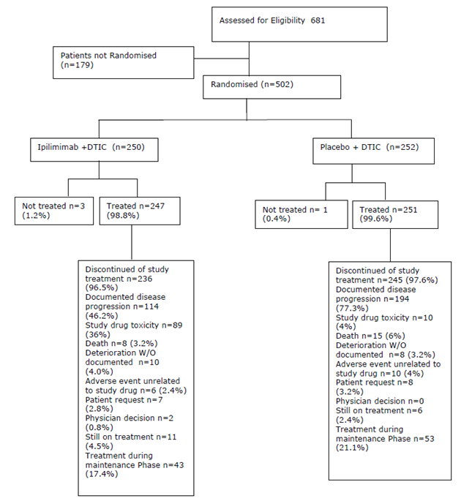

Major protocol violations/deviations
Significant eligibility deviations were reported for 13.2% and 15.1% of subjects in the ipilimumab plus DTIC and DTIC monotherapy groups. The most common eligibility deviation was laboratory test values not meeting eligibility criteria during the screening period (7.2% and 8.7% of subjects in the ipilimumab plus DTIC and DTIC monotherapy groups, respectively). Review of data provided demonstrated that the number of other deviations were relatively similar between treatment (for example ECOG > 0 or 1, or non-measureable disease).
On study ‘significant’ protocol deviations (those relating to inclusion/exclusion criteria, study conduct, subject management, or subject assessment that could have potentially affected the interpretability of study results) are separated according to programmable and non-programmable deviations. Non programmable protocol deviations were defined as other potentially clinically relevant study management issues reported by the sites, identified by the sponsor and counted manually. Significant programmable protocol deviations were reported for 23.5% and 21.5% of subjects in the ipilimumab plus DTIC and DTIC monotherapy groups, respectively; most of these were related to the timing of dose administration and the absence of required laboratory tests prior to dosing. Significant non programmable protocol eligibility deviations were reported for a total of 8 (3.2%) and 10 (4.0%) treated subjects in the DTIC monotherapy group and ipilimumab plus DTIC, respectively (the sponsor annotates the frequency for these deviations opposite to what is listed on Table 4.3B of the CSR).
Other reported protocol deviations that occurred that were unlikely to invalidate the use of data, included; a total of 17 (3.4%) patients were continued on treatment despite adverse events, 18 (3.6%) patients were continued on treatment despite progressive disease, 16 (3.2%) patients were continued on treatment despite dose skipping criteria (It is unclear how this differs from an adverse event or if these excluded those associated with adverse events), report of 26 (5.2%) patients’ SAEs were delayed (3 of which occurred in the same patient, and 2 of which occurred in another patient both in the same institution), and 3 subjects’ (1%) SAEs were not reported the IRB (2 occurred in the same patient), all of which were all generally more common in the investigational arm. In addition, a total of 19 consent violations occurred.

Baseline data
A total of 502 subjects were randomised (250 to ipilimumab plus DTIC and 252 to DTIC monotherapy); 498 subjects were treated (247 to ipilimumab plus DTIC and 251 to DTIC monotherapy). Two subjects in the DTIC monotherapy group each erroneously received 1 dose of active ipilimumab instead of ipilimumab placebo. Median follow up was 10.5 months (range 0.4 to 47.4 months) for the ipilimumab plus DTIC group and 8.9 months (range 0.1 to 47.6 months) for the DTIC monotherapy group.
Baseline demographics and disease characteristics were balanced between treatment groups. The median age was 58.0 years. Most subjects were male (60.0%), aged < 65 years (68.1%), and of white race (99.6%) (Table 19 below). The majority of subjects were M1c stage (56.2%), and 40.4% of subjects had an elevated LDH at baseline (> ULN). ECOG performance status was 0 or 1 for all subjects. The median time from initial pathological diagnosis of malignant melanoma to first dose of study therapy was 20.0 months. The frequency of prior systemic therapy reported as balanced between treatment groups (26.4% and 27.0% in the ipilimumab + DTIC group and DTIC monotherapy group, respectively). The most common adjuvant therapies were interferon containing regimens (114 out of 133 subjects). The most common reason for discontinuing prior therapy was disease progression (55 subjects), followed by treatment completion (37 subjects).
The CSR indicates that a listing of prior systemic therapy is provided which is a listing of all pre and post study systemic treatment. Prior treatment included previous chemotherapy for which it is not described how exclusion criteria were not violated, unless these agents were considered as (unconventional) ‘adjuvant therapy’ which was permitted in the study. For example, in CA184024-a subject [information redacted] on the investigational arm, received study treatment between August to September 2007 but had received 2 cycles of DTIC in March 2006 study arm. Similarly, in CA184024- a subject [information redacted] on the investigational arm was treated on study between June 2007 and 2009, but had received bleomycin, lomustine, and vincristine in 2006. In Study CA184024 a subject [information redacted] on the control arm was treated on study between August 2007 and January 2008, but had received 3 doses of vinblastine with interferon alpha and interleukin in 2006.
Most subjects had normal WBC, ANC, platelet and liver function results at baseline. Haemoglobin was normal in 77.9% of subjects. Absolute lymphocyte count was normal in 58.4% of subjects, with Grade 2 and 3 abnormalities reported in 4.6% and 0.4% of subjects, respectively, but was similar between treatment groups.

Table 19: Study CA184024 patient baseline characteristics
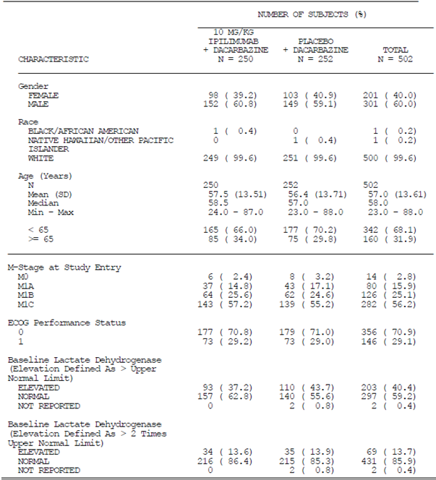
Prior to database lock, treatment was unblinded for 8 (1.6%) treated subjects (2 were unblinded to the site investigator and 6 were unblinded to BMS). Two of the subjects were in the ipilimumab plus DTIC group and 6 were in the DTIC monotherapy group. Of these 8 unblindings, 5 were accidentally unblinded, 2 were intentionally unblinded to aid in the assessment of expedited safety reports, and 1 was intentionally unblinded to support a clinical decision of the site investigator regarding subject safety.
Regarding concomitant therapy, systemic corticosteroids were reported for 59.1% of subjects in the ipilimumab plus DTIC group and 30.7% of subjects in the DTIC monotherapy group. However, it is not clear how many of these were adverse events requiring steroids or otherwise (in the referred Appendix 4.6 there were listings of corticosteroids that were for “other” rather than “adverse events”).

Results for the primary efficacy outcome
Survival was assessed for subjects known to be alive at last contact and was a median of 10.5 months (range 0.4 to 47.4 months) for the ipilimumab plus DTIC group and 8.9 months (range 0.1 to 47.6 months) for the DTIC monotherapy group. The study demonstrated clinically meaningful and statistically significant prolonged survival for the ipilimumab plus DTIC group relative to the DTIC monotherapy group. There was a risk reduction for death of 28% in the ipilimumab plus DTIC group (HR = 0.72, 95% CI 0.59 to 0.87, p = 0.0009) (Figure 2). The median survival was 11.2 (95% CI: 9.4, 13.6) months in the ipilimumab plus DTIC group and 9.1 (95% CI: 7.8, 10.5) months in the DTIC monotherapy group.
Figure 2: Kaplan Meier curve for overall survival of randomised subjects from CA184024
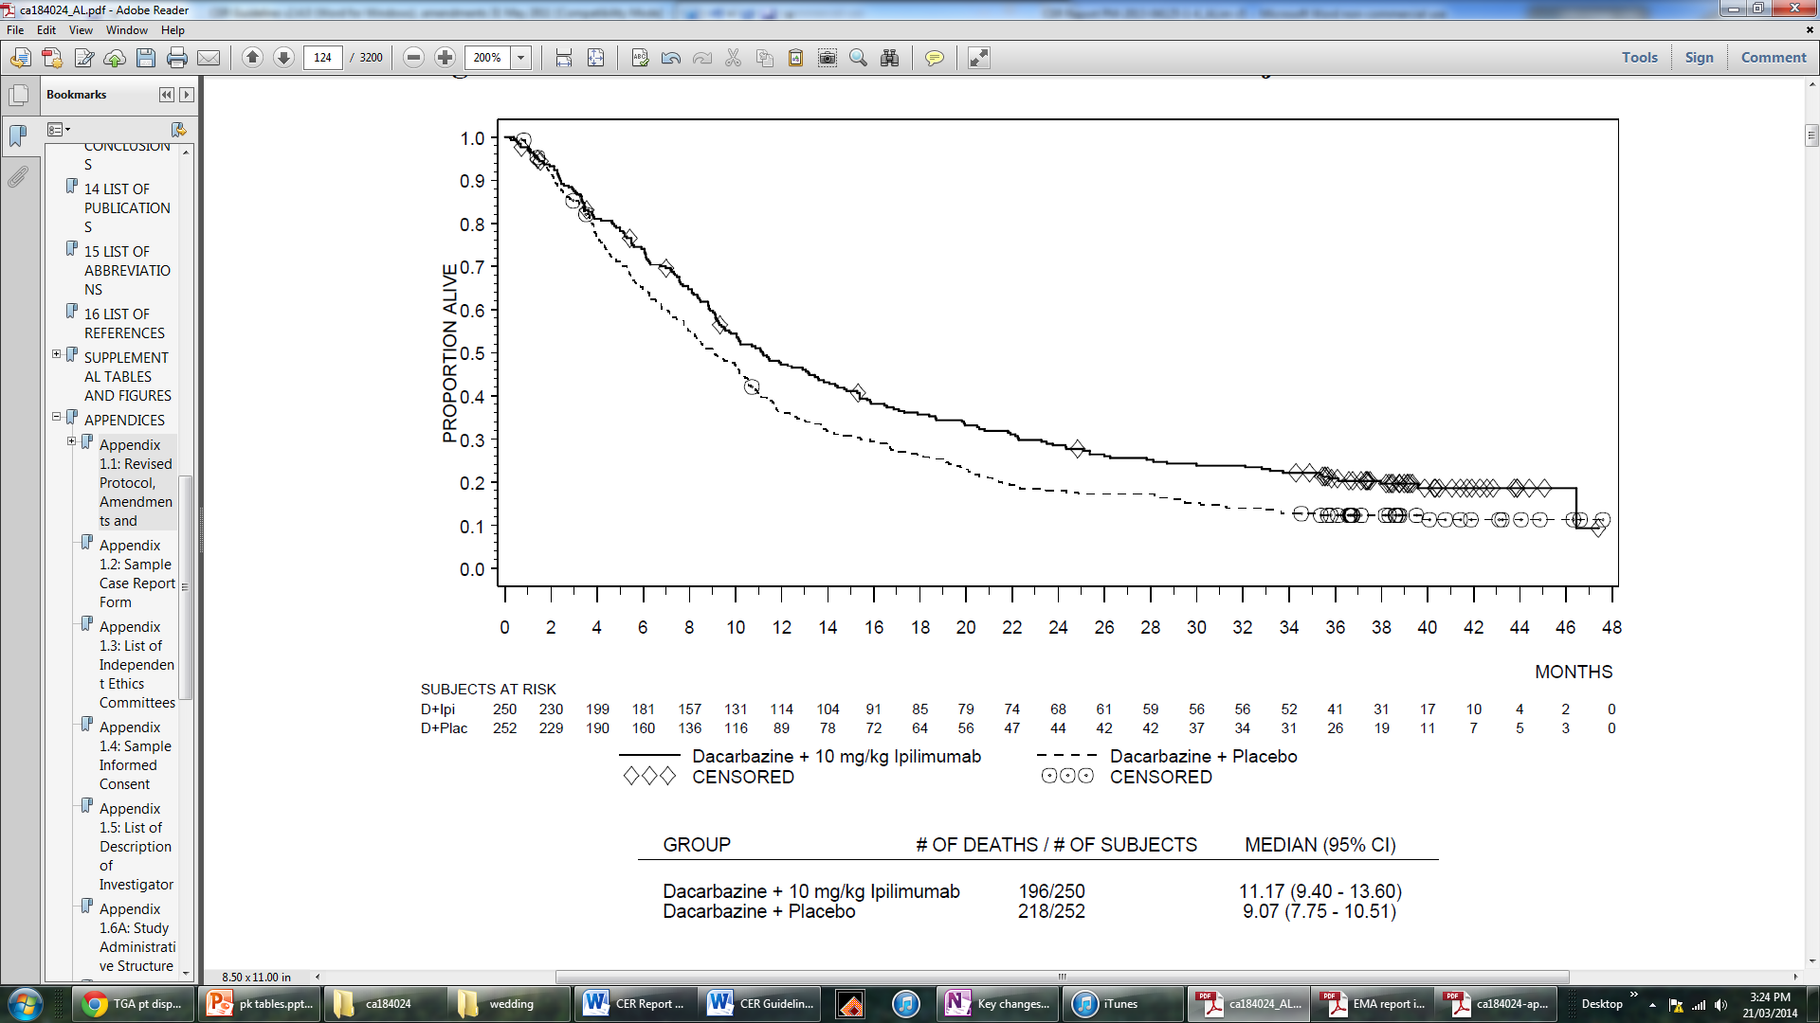
Prolonged survival for a proportion of subjects in the ipilimumab plus DTIC group was demonstrated, with a 2 year survival rate of 28.5% (versus 17.9% for DTIC monotherapy), and a 3 year survival rate of 20.8% (versus 12.2% for DTIC monotherapy, Table 20).
Comment: Note that the confidence intervals overlap for Table 20.

Table20: Overall survival by time points for randomised subjects from CA184024, (2 sided confidence interval calculated using the bootstrap method, based on Kaplan-Meier estimation)
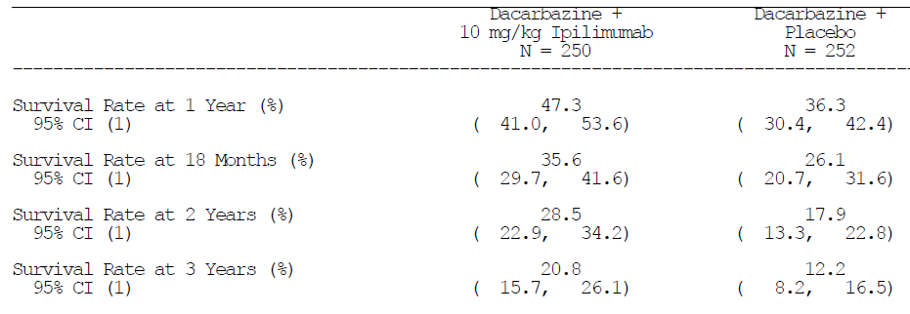
Among the 15.2% of subjects in the ipilimumab plus DTIC group achieving confirmed objective response, the median duration of response was 19.3 months versus 8.1 months for the 10.3% of subjects in the DTIC monotherapy group who achieved a response. The disease control rate (DCR), which is composed of CR, PR, and SD, was 33.2% and 30.2% for the ipilimumab plus DTIC and DTIC monotherapy groups, respectively. Overall survival for subjects with disease control (subjects with CR/PR/SD) was 28.7 months (95% CI: 23.8, ---) and 19.8 months (95% CI: 14.6, 28.2) in the ipilimumab plus DTIC and DTIC monotherapy groups, respectively.
In each treatment group, the median OS was longer for those subjects who received 4 induction doses of ipilimumab/placebo compared to those who received fewer doses, based on an analysis which excluded subjects who died (or who were censored) before the scheduled 4th induction dose (Figure 3 below). This explains the initial delay (up to Week 10) in the Kaplan-Meier plots before any deaths are observed. In the ipilimumab plus DTIC group the median OS for subjects who received 4 doses was 16.5 months (95% CI: 13.6, 22.1), compared to 9.3 months (95% CI: 8.5, 13.4) for those who received < 4 doses, and 10.2 months (95% CI: 8.4, 17.1) for those who received 3 doses.
In the DTIC monotherapy group, the median OS for subjects who received 4 induction doses was 11.8 months (95% CI: 10.5, 13.9), compared to 5.3 months (95% CI: 3.9, 6.3) for those who received < 4 doses, and 5.4 months (95% CI: 4.1, 8.3) for those who received 3 doses. The time dependent character of these analyses, which does not exclude other potentially confounding variables, prevents definitive conclusions regarding the impact of the number of doses of study treatment on survival.
The proportion of subjects receiving subsequent therapy, and the treatments were balanced across groups (ipilimumab plus DTIC: 54.7%, DTIC monotherapy: 59.0%). Survival analyses accounting for subsequent therapy was similar to the primary endpoint numerically with the CI including the null value, that is, crosses 1 (ipilimumab plus DTIC: 11.2 months; DTIC monotherapy: 9.1 months, HR 0.78, 95% CI: 0.58 - 1.05).
Figure 3: Overall survival by number of induction doses (4 versus < 4) according to treatment arm
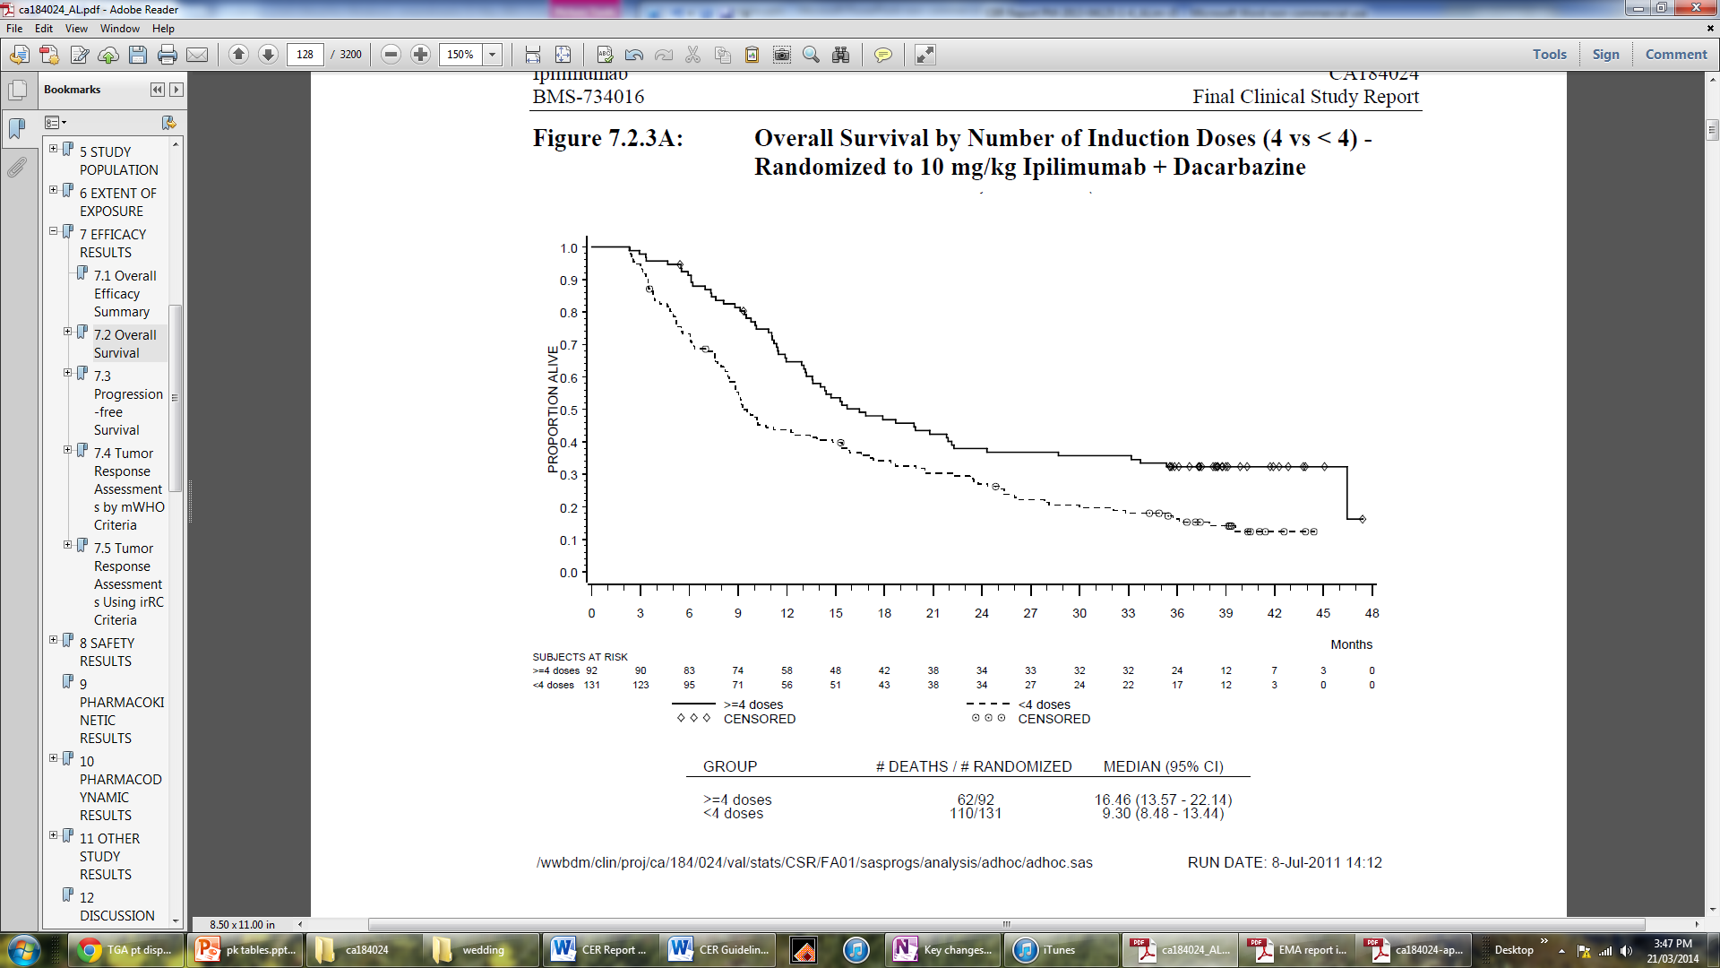
Comment: Thus with these survival rates, CA184024 demonstrates that ipilimumab 10 mg/kg dosing administered with DTIC and with the inclusion of maintenance therapy provides a survival benefit compared to standard treatment (DTIC monotherapy).

Results for other efficacy outcomes
For PFS analyses, a total of 203 (81.2%) subjects in the ipilimumab plus DTIC group and 223 (88.5%) subjects in the DTIC monotherapy group had progressed, or died. The assessment of progression is based on the IRC database which was finalised (after at least 416 subjects had progressed or died, as per the original sizing assumptions) 15 months prior to the main database lock. Hence, the proportion of censored subjects before 4 years in the PFS analysis is higher than in the OS analysis.
The results for PFS, DCR, BORR, and other efficacy outcomes are summarised in Table 21 below. The median PFS was similar in both groups (2.8 months and 2.6 months, respectively), with the HR for PFS between ipilimumab plus DTIC and DTIC monotherapy was 0.76 (95% CI: 0.63, 0.93). The DCR, which is composed of CR, PR, and SD, was 33.2% and 30.2% for the ipilimumab plus DTIC and DTIC monotherapy groups, respectively (p = 0.4067). Among response evaluable subjects, the DCR was 39.8% versus 33.2%, respectively. Based on the pre specified hierarchical testing procedure, the non-significant p value for DCR meant that statistical significance for BORR was not formally tested. The median time to response among randomised subjects was 2.6 months (95% CI: 2.6, 2.6) and 2.7 months (95% CI: 2.6, 3.6) for the investigation arm and standard arm. In the ipilimumab plus DTIC group, the median duration of response (CR/PR) using modified WHO criteria was 19.3 months, and the median duration of stable disease was 4.7 months, as determined by the IRC. In the DTIC monotherapy group, the median duration of response was 8.1 months and the median duration of stable disease was 4.6 months.
Using irResponse Criteria (irRC), results were similar. The irDCR was 35.2% for the investigational arm (8 irCR, 34 irPR, and 46 irSD) and 34.1% for control arm (7 irCR, 21 irPR, and 58 irSD). The irBORR was 16.8% and 11.1% in the ipilimumab plus DTIC and DTIC monotherapy groups, respectively. Using irRC, there were 42 responders in the ipilimumab plus DTIC group (versus 38 using mWHO) and 28 in the DTIC monotherapy group (versus 26 using mWHO). Using the irResponse criteria, the median duration of ir response was 21.1 months (95% CI: 16.5, 26.1) and 10.2 months (95% CI: 5.6, 24.0) in the ipilimumab plus DTIC and DTIC monotherapy groups, respectively. The median duration of irSD was 4.8 months (95% CI: 2.8, 7.7) and 3.4 months (95% CI: 2.5, 5.2), respectively.
Based on IRC evaluation of imaging of subjects with clinical symptoms, over 90% of subjects across groups were free of brain metastases (ipilimumab plus DTIC: 93.6%, 95% CI 89.8 - 96.3; DTIC monotherapy: 90.9%, 95% CI 86.6 - 94.1; 2-sided exact CI by Clopper and Pearson method).

Table21: Summary of other key efficacy end-points, following IRC review using mWHO criteria for randomised subjects
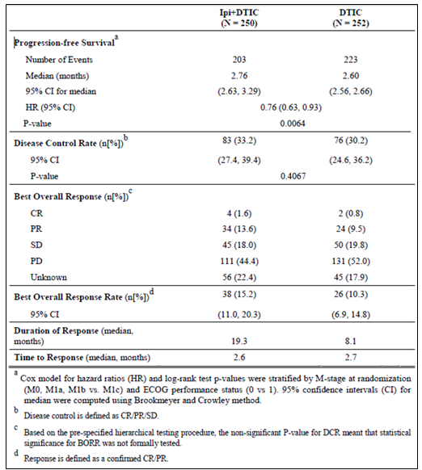
Results from pre-specified subgroup analyses demonstrate a consistent pattern with HRs favouring the investigational arm (see Table 22 below). Subgroup comparisons for OS were performed across the following pre-specified categories: M-stage, baseline LDH, age, female age, ECOG status, prior adjuvant treatment, race, and gender. M-stage and baseline LDH represent prognostic factors associated with poor clinical outcome in late stage melanoma. In addition, ECOG and M-stage were used as stratification factors for randomisation in this study. The data demonstrate that the observed OS benefit was consistent within most of the subgroups. However, for women above 50 years of age (HR 1.03), the data supporting an OS benefit of ipilimumab plus DTIC treatment were limited. The efficacy of ipilimumab plus DTIC for women above 50 years of age is therefore uncertain. As the subgroup analysis includes only a small number of subjects (ipilimumab plus DTIC: N = 68; DTIC monotherapy: N = 67), no definitive conclusions can be drawn from these data.

Table 22: Overall survival and 95% confidence intervals for subgroup analyses
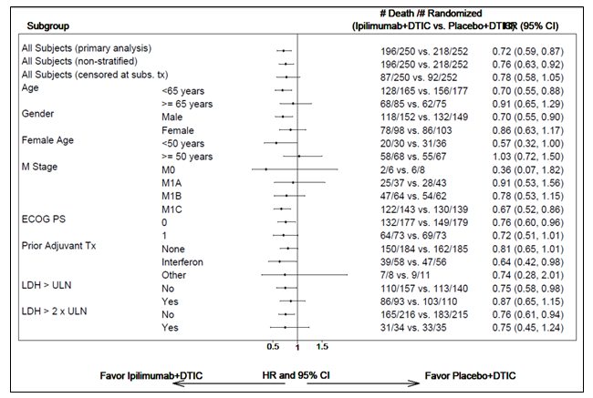
Thus, in summary, this Study CA184024 provides evidence for the primary efficacy variable of overall survival benefit obtained for previously untreated patients with advanced melanoma who are administered ipilimumab 10 mg/kg in combination with DTIC with a maintenance schedule.
In the context of the current application for 3 mg/kg dosing, extrapolation of efficacy from this study utilising a different posology and treatment schedule is limited (limited external validity).

Other supportive studies
The following Studies (CA184042, CA184078) are included within this subsection due to reference in the pre-submission meeting. As previously mentioned, with respect to the current application, due to the use of the 10 mg/kg posology, use in previously treated patients, use of maintenance phase, immaturity of data, generally small patient numbers and the study designs (for example non-randomised, Phase I, observational), the quality of the evidence is not considered high level according to the conventional grading systems.
Note that MDX010-16 is not considered here as the study design investigated use of ipilimumab in the adjuvant setting and efficacy data is immature. Safety data for this study is summarised in the safety section.

Study CA184042 (Phase II, interim report)

Study design, objectives, locations and dates
CA184042 is an ongoing two-stage modified Gehan designed Phase II trial to study the potential tumour response and safe use of ipilimumab 10 mg/kg monotherapy in subjects with Stage IV melanoma with brain metastases. The study commenced 11 July 2008 with the data cut-off 25 April 2011 with the anticipated last patient visit 1 April 2011. The ‘CSR’ report date 7 December 2011.
The primary objective of the study is to assess the global (brain + non CNS lesions) DCR determined after Week 12 using mWHO tumour assessment criteria. Secondary objectives of the study included; an estimation of the overall response rate (ORR) and DCR of non-central nervous system (CNS) lesions and global tumour burden using the mWHO and (IR) tumour assessment criteria in corticosteroid free subjects (Arm A); an estimation of the brain median PFS, non CNS PFS, and Global PFS in both study arms using mWHO and IR tumour assessment criteria; OS in both study arms; to evaluate the safety and tolerability of ipilimumab in both study arms; to determine the incidence of magnetic resonance imaging (MRI) defined brain oedema, haemorrhage, and other radiographic changes in the brain metastases and evaluate any association with the onset and/or duration of tumour response observed in the brain or non CNS lesions in both study arms; to determine if corticosteroid treatment interferes with tumour response by measuring clinical benefit (measured by ORR and/or the DCR determined after Week 12) of melanoma brain metastases in corticosteroid dependent subjects (Arm B) using the mWHO and IR tumour assessment criteria; and to evaluate the impact of prior therapy (systemic and/or prior therapy for brain metastases).

Inclusion and exclusion criteria
Previous treatment was permitted in this study in contrast to the proposed usage.
Inclusion criteria included; 16 years of age or older, ECOG performance status of 0 to 1, histologically documented malignant melanoma with brain metastases with radiologic evidence of at least 1 measurable index metastatic brain lesion, with its greatest dimension > 0.5 cm and no larger than 3 cm in diameter, that was not previously irradiated, and/or at least 2 measurable lesions > 0.3 cm visible on contrast enhanced MRI. In Stage 1 (Arm A), subjects had to be off corticosteroid therapy at least 10 days before starting ipilimumab therapy.
Exclusion criteria comprised of history of known carcinomatous meningitis, radiotherapy of any type within 14 days of first dose, any previous therapy within 28days, significant comorbidity including autoimmune disease and other common exclusion criteria.

Study treatments
During the induction phase, subjects received ipilimumab in 4 separate 10 mg/kg doses at 3 week intervals (Weeks 1, 4, 7, 10), followed by a study drug free period up to Week 24. If ipilimumab was tolerable and global tumour burden did not progress, patients were eligible to enter a maintenance phase, to receive ipilimumab (10 mg/kg) every 12 weeks (Weeks 24, 36, and 48+) until discontinuation due to confirmed irPD in their global tumour burden, development of unacceptable toxicity, clinical deterioration requiring a change in therapy, or withdrawal of consent.

Efficacy variables and outcomes
The primary efficacy outcome was DCR using mWHO criteria and irRC, ORR, and DCR of non CNS lesions and global tumour burden (brain +non CNS lesions).
Other efficacy outcomes included:
- Best overall response rate (BORR) by mWHO and irRC
- Overall survival (OS) and Progression-free survival (PFS) by mWHO and irRC
- Duration of response (DOR) and stable disease (SD) by mWHO and irRC
- Onset of response by mWHO and irRC

Analysis populations
Of the 99 subjects screened at 10 sites in the United States between July 2008 and June 2009, 27 (27.3%) were not treated because they did not meet screening criteria. A total of 72 subjects were treated and evaluated; 51 subjects (corticosteroid free) in Arm A and 21 subjects (corticosteroid dependent) in Arm B of the study.

Statistical methods and sample size
All analyses were performed by treatment arms. An exact, two sided 95% confidence interval (CI) for DCR and BORR within each treatment arm was calculated using the method of Clopper and Pearson. Time dependent variables (PFS, OS, duration of response for those with a confirmed response of CR or PR, duration of stable disease) were estimated using the Kaplan-Meier product limit method, the plot displaying the median, together with a two sided 95% CI for the median, calculated using the method of Brookmeyer and Crowley. The onset of response in subjects with a CR or PR was summarised by treatment arm using descriptive statistics (median, minimum, and maximum).
In Stage 1 accrual was to be continued in Arm A until 21 evaluable subjects were enrolled. If fewer than 2 objective (radiologically confirmed) responses, or no more than 7 instances of 12 week PFS (no more than 33%), were observed among the initial 21 subjects, this study arm was to be terminated early and declared negative. If 2 or more objective responses were observed in the first 21 subjects or 8 or more instances of 12 week PFS (more than 33%), an additional 20 subjects were to be accrued during Stage 2 of the study.
All enrolled patients were analysed if one dose of ipilimumab was received.

Baseline data
The participant flow is summarised in Figure 4 below.
Figure 4: Participant flow for CA184042
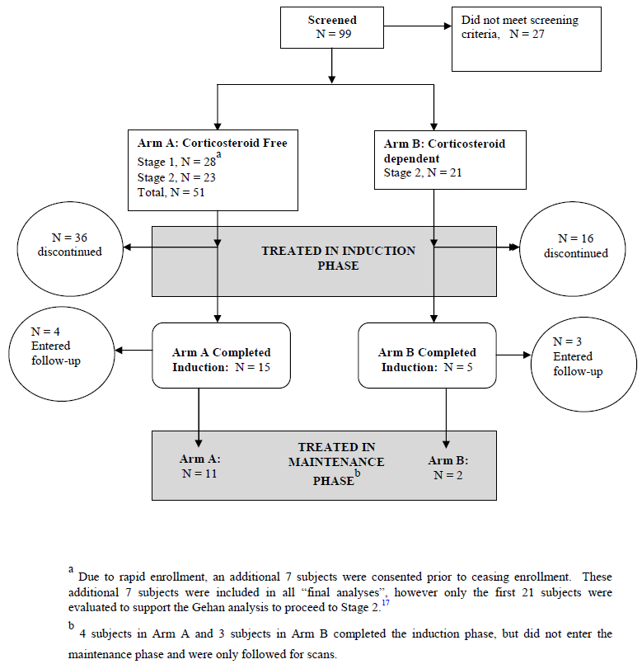
All 72 treated subjects were male Caucasians, generally < 65 years of age, with an ECOG status of 0 or 1. Only 1 patient in Arm B did not have at least one index CNS lesion. The location of other metastases for subjects differed in frequency. For Arm A; 22 (43.1%), 14 (27.5%) and 16 (31.4%) subjects also had visceral lesions in the lung, liver or other areas, respectively. Of the 20 subjects in Arm B; 12 (57.1%), 9 (42.9%), and 13 (61.9%) subjects also had visceral lesions in the lung, liver, or other areas, respectively. Prior systemic treatment differed between arms. Forty subjects (78.4%) in Arm A had prior systemic therapy; most commonly immunotherapy (24 subjects; 47.1%), with 5 subjects who received ≥ 3 regimens. Fifteen subjects (71.4%) in Arm B of had prior systemic therapy, which was most commonly chemotherapy (14 subjects; 66.7%). No subjects in Arm B received ≥ 3 regimens of systemic therapy. All 72 subjects had prior surgery for their cancer and most had prior radiotherapy to the brain.
With respect to eligibility protocol violations: both arms included one subject with a prohibited concomitant illness, and one subject in Arm B had a Grade 3 abnormal ALT while 2 subjects in Arm A had Grade 3 abnormal total bilirubin levels.
With respect to discontinuation of therapy, the majority occurred due to treatment failure, disease progression or death. There were 3 treatment discontinuations in Arm A and 2 discontinuations in Arm B for irAEs (non CNS). Two of the 11 subjects treated in the maintenance phase discontinued treatment; 1 due to disease progression and the other due to surgery. The 2 subjects in Arm B who were treated during the maintenance phase remain on treatment as of the cut-off date of 25 April 2011. Discontinuations annotated as ‘other’ by the sponsor were not described.
Although the subjects in Arm A were not on corticosteroids at study entry, 36 subjects (70.6%) in Arm A received corticosteroids during the study.
One patient was reported to have died from a study drug related AE.

Results for the primary efficacy outcome
Three objective (radiologically confirmed by investigator) responses were observed among the first 21 subjects enrolled in Stage 1 allowing the study to proceed to Stage 2.

Primary Efficacy
Global DCR (CR, PR, or SD) by mWHO criteria was 17.6% (95% CI: 8.4 to 30.9; 9 subjects free of disease progression out of 51 subjects) in Arm A and 4.8% (95% CI: 0.1 to 23.8; 1 subject free of disease progression out of 21 subjects) in Arm B after Week 12.

Secondary Efficacy
- Global BORR (CR or PR) by mWHO or irRC criteria was observed in 5 subjects (9.8%, 95% CI: 3.3 to 21.4)) in Arm A and 1 subject (4.8%, 95% CI 0.1 to 23.8) in Arm B. All objective responses were PR.
- There was no difference in the objective response rate by either mWHO or irRC criteria.
- Median global progression free survival by mWHO criteria was comparable between arms; Arm A was 1.4 months and Arm B was 1.2 months. Median brain PFS by mWHO criteria was similar.
- Median OS was 6.97 (95% CI: 4.14 to 10.81) and 3.75 (95% CI: 1.64 to 7.33) months, respectively. At the time of the database lock, 15 (29.4%) subjects were still alive in Arm A, and 2 in Arm B (9.5%). The 1 and 2 year survival rates were 31% and 26%, for Arm A and 19% and 10%, for Arm B.
- For the 5 responders (PR) in Arm A, median onset of response was 1.2 months, and median duration of response (DOR) was 10.4 months. Specifically, the duration of response was 10.4, 9.7, 18.2, 15.3, and 2.9 months; all responders in Arm A relapsed or died at the time of the 25 April 2011 database lock. The one subject with objective response (PR) in Arm B had an onset of response of 1.2 months, and was still in PR (20.7+ months) at the time of the 25 April 2011 database lock.
- Of the 9 subjects who achieved DCR in Arm A, 4 had SD (0 in Arm B). At the time of the database lock, none had SD. The median duration of SD was 3.7 months.
- Eight subjects in Arm A and 1 subject in Arm B achieved irSD. At the time of the database lock, none had SD. The median duration of irSD in Arm A was 3.7 months.
- Brain DCR by mWHO was achieved in 12 (23.5%) and 2 (9.5%) of subjects in Arm A and Arm B, respectively. Of these, objective response was achieved in 8 (15.7%) and 1 (4.8%) subjects, respectively.
- Non CNS DCR by mWHO was achieved in 14 (27.4%) and 1 (4.8%) of subjects in Arm A and Arm B, respectively. Of these, objective response was achieved in 7 (13.7%) and 1 (4.8%) subjects, respectively.
In conclusion, with respect to efficacy, this study provides supportive evidence for the global disease control rate and survival benefit with use of ipilimumab 10 mg/kg in patients with metastatic melanoma with brain lesions, of which patients without concomitant steroids have an improved outcome compared to patients on steroids. However, note should be made of the modest number of patients in each study arm. Given the examination of previously treated patients, the impact of previous treatments may contribute to the reported efficacy of the drug. The non-randomised design of the study does not account for the introduction of biases, in particular, selection bias. With respect to the current application, extrapolation of efficacy for another dosage has limited external validity.
Please note also that for comparison of this population with other trials, the inclusion criteria for CNS disease differs (external validity is limited).
Thus, this study does not provide supportive evidence for the proposed indication.

Study CA184078

Study design summary
For the description of Study CA184078 ‘Objectives’, ‘Design’, ‘Entry criteria’, Treatments’ see section 4.3.1 above.

Study participants
Of 72 enrolled patients, 59 were randomised to treatment and received ipilimumab + paclitaxel/carboplatin (Arm A, n = 20), ipilimumab + DTIC (Arm B, n = 19), or ipilimumab alone (Arm C, n = 20). Some 59 patients received one dose, but the majority of 41 (70%) patients did not complete induction due to PD (63%) or toxicity and /or death (34%). Of 18 who completed induction, 2 did not receive any maintenance, and 15 patients completed maintenance. Patients were predominantly white males (64%), of excellent ECOG (0 or 1). No significant differences were noted in baseline characteristics (numbers per arm were small). Protocol deviations were not reported within the study.

Efficacy variables and outcomes
The primary endpoint of this study was PK related. Other efficacy outcomes included: ORR based on mWHO and irRC, DCR based on mWHO and irRC, and PFS based on mWHO and irRC.

Statistical methods
Individual tumour measurements, tumour responses at each assessment, BOR, and PFS, as defined by mWHO criteria and irRC, were listed. BOR/irBOR, ORR/irORR, and DCR/irDCR were described by treatment for all randomised subjects and response evaluable subjects. For the purpose of these summaries in all randomised subjects, subjects with resected index lesions, or new lesions for irRC, were considered to have progressed. PFS was plotted by treatment as defined by mWHO criteria and irRC. For subjects with no recorded post baseline tumour assessment, PFS was censored at the day of randomisation. A subject who died without reported prior progression (PD/irPD) was considered to have progressed on the date of death. For those who remained alive and did not progress (PD/irPD), PFS was censored on the date of last evaluable tumour assessment.

Results for other efficacy outcomes
The sponsor writes ‘Efficacy measure estimates were imprecise because of the small size of this study, and differences among treatment arms were not tested.’
The following is a summary of efficacy results:
- The ORR expressed relative to the population of all randomised subjects was lower than that for the response evaluable population and the pattern was similar to that seen in the response evaluable subjects, with the response rate for Arm B (26.3%, n = 5) and Arm C (25.0%, n = 5) being higher than Arm A (10.0%, n = 2) based on mWHO criteria. Based on irRC, Arm B had a higher response rate (31.6%) than both Arms A and C, with Arm A having the same response rate as Arm C (both 25.0%).
- The DCR, based on mWHO criteria, expressed relative to the population of all randomised subjects was lower than that for the response evaluable population and the pattern was similar to that seen in the response evaluable subjects, which was highest in Arm B (52.6%, n = 10), followed by Arm C (45.0%, n = 9) and Arm A (40.0%, n = 8). Based on irRC, the DCR was highest in Arm C (55.0%), followed by Arm B (57.9%) and Arm A (50.0%).
- Both median PFS (mWHO) and median immune related progression free survival (irPFS) appeared similar among the treatment arms. Median PFS by mWHO criteria was for Arm A 2.8% (95% CI: 2.7 to 3.9), for Arm B 3.6% (95% CI: 2.9 to 5.9), and for Arm C 3.0% (95% CI: 2.7 to 6.8).
In the context of the current application, this study does not provide supportive efficacy data for the proposed usage due to the use of an alternate primary end point (efficacy was a secondary end point), the small patient numbers, the use of ipilimumab 10 mg/kg (with or without concomitant chemotherapy) and the use of a maintenance phase.

Observational studies (interim reports)
These studies are included due to their reference in the pre-submission meeting. Although post marketing experience provides important information, data is not considered high level quality evidence (according to conventional grading) given the uncontrolled, retrospective nature of the studies in a heterogeneous population of patients. Thus, the presence of introduced bias (such as selection bias) cannot be accounted for and should be considered in cross study comparisons. Furthermore, given both are interim reports, data is relatively immature with the anticipated submission of finalised data in approximately 2017.

Study CA184332
Study CA184332 is a retrospective, observational cohort study of patients in the United States (US) receiving 3 mg/kg ipilimumab as first line treatment of un-resectable or metastatic melanoma.

Objectives
The primary objectives of this observational study are:
- To describe the demographic and clinical characteristics.
- To describe the occurrence of all adverse events (AEs) during first line ipilimumab treatment as well as those observed during any subsequent lines of treatment. In the remaining 3 years of the study follow up, a description of the occurrence of AEs will also be provided.
- To describe patterns of care (dosing, number and dates of doses, treatment rationales, reasons for treatment termination, etcetera) during first line ipilimumab treatment and any subsequent lines of therapy.
- To describe the overall survival (OS) of patients (mean, median, and 1, 2, 3 and 4 year OS).
The purpose of the interim analysis is to summarise key baseline data and OS in patients for whom at least 1 year has elapsed since their initiation of treatment with ipilimumab.

Study Population
The study population was previously untreated Stage III or Stage IV melanoma patients who received ipilimumab (3 mg/kg) between 1 April 2011 (post marketing) and 30 September 2012. The interim analysis is limited to patients within the US Oncology iKnowMed database who began treatment by 31 December 2011, to ensure at least 1 year elapsed since treatment began.

Inclusion criteria
Inclusion or exclusion from this interim analysis was based solely on the time elapsed since the treatment start date and was without regard to patients’ vital status (alive or deceased). Inclusion was contingent on patients remaining in sites utilising the iKnowMed database for the entire study observation period. The patients were programmatically identified from a database, without input from the site or sponsor, and selection was based solely on the eligibility criteria and the initial date of treatment.
Key Inclusion Criteria: Diagnosis of un-resectable or metastatic melanoma, including patients with all types of primary tumours (cutaneous, mucosal, ocular, other, unknown primary); Age ≥ 18 years at the time of diagnosis; Initiated first line treatment with ipilimumab 3 mg/kg monotherapy.

Exclusion criteria
Key exclusion criteria: Prior systemic treatment for un-resectable or metastatic melanoma; current or pending participation in a clinical trial or expanded access program; current use of therapy to treat a cancer other than melanoma.

Statistical plan
Overall survival from ipilimumab initiation was defined as the time from first ipilimumab dose date to death or to the last known alive date from the most recent follow-up visit for patients who were alive. Median OS time and survival rates at 1 year and 1.5 years were estimated using the Kaplan-Meier method. The 95% confidence interval (CI) for median OS was estimated based on log transformation. The 95% CI of the OS rates was estimated based on log-log transformation. The Kaplan-Meier curve of OS from ipilimumab initiation was plotted. SAS v 9.2 was used for the statistical analyses.
Overall survival since advanced melanoma diagnosis is defined as the time from the date of advanced melanoma diagnosis to death or to the last known alive date from the most recent follow up for patients who were alive.
Exposure data were not collected. Subsequent therapies were not analysed for this interim report. Adverse event (AE) data were not collected for this interim analysis due to the time limitation for the database lock.
Comment: It is noted that the study period was identical to CA184338 which collected AEs and both interim reports are dated in May 2013. It is unclear as to why safety data was not collated for both studies.

Results
Of the 75 patients, 14 were eliminated from the analysis on the basis of the inclusion/exclusion criteria. The baseline demographics and disease characteristics for the 61 patients included in the interim analysis demonstrated that the majority of patients were diagnosed with cutaneous melanoma (95%), negative for the BRAF mutation status (51% please see evaluator’s comment below regarding reliability of this statement and testing was not necessarily pre-treatment), and had an ECOG performance status (PS) of 0 or 1 (90%).
Brain metastases were present in 33% of the patients, one patient had a baseline ECOG performance status (PS) of 3, two patients had a baseline ECOG PS of 2, two had an anorectal primary site and one patient had an ocular primary site. In addition to the brain, the most common sites of metastases at advanced melanoma diagnosis were the lung (53%), lymph nodes beyond the regional lymph nodes basin (38%), liver (38%), and subcutaneous tissues (18%).
Approximately 30% of patients were stage M1c at ipilimumab initiation. The median age was 68 years. There is uncertainty in the frequency of elevated lactate dehydrogenase (LDH) at baseline (26.2% missing) and frequency of BRAF and/or NRAS mutations (36.1% and 95.1% missing, respectively) as these tests are not performed consistently for all patients. The mean (median) times from initial melanoma diagnosis and from advanced melanoma diagnosis to first dose of ipilimumab were 25.2 (10.3) and 1.2 (0.7) months, respectively. The mean (median) time from initial melanoma diagnosis to advanced melanoma diagnosis was 23.9 (7.3) months.
Overall survival was defined as the time from initiation of ipilimumab until death from any cause. The median follow-up was 8.5 months and 50.8% of patients had died at the time of this interim analysis. Median OS was 11.5 months (95% CI: 6.6, -). The estimated 1 year survival rate was 49.3%. At the time of this interim analysis, the majority (67%) of the patients’ survival statuses were current, that is, the patient was known to have had died or to be alive within 3 months.

Study CA184338
Study CA184338 is another retrospective, observational cohort study of patients US receiving 3 mg/kg ipilimumab as first line treatment of un-resectable or metastatic melanoma. The Objectives and Methodology (headings ‘study population’ to ‘statistical plan’) were identical to CA184332, described above. However safety data was collected. Subjects with unknown or partial death dates were not included in safety analyses.

Results
The baseline demographics and disease characteristics for the 120 patients included in the interim analysis, demonstrated the most common primary site as cutaneous (87%), with 16 patients with non-cutaneous primary sites (5 ocular, 3 mucosal, 2 anorectal, 1 nasal sinus, 5 unknown). At the time of the advanced melanoma diagnosis, 55% were stage M1c and 8% had brain metastases. 37% had elevated lactate dehydrogenase (LDH) and 93% had an ECOG performance status of 0 or 1. The median age was 63.0 years. There is uncertainty in the frequency of BRAF and NRAS mutations (19% and 88% missing, respectively) as these tests were not performed consistently. Few patients received prior adjuvant or neo adjuvant therapy (13%), the most frequent of which was interferon alpha (12%). The currently approved induction dosing regimen in the US is 4 doses of 3 mg/kg ipilimumab monotherapy, which most patients (95 out of 120, 79%) received. Most patients completed the induction dosing without permanent discontinuation (92 out of 120, 77%). The most frequent reasons given for discontinuing induction dosing were disease progression (17 out of 120) and drug toxicity (6 out of 120). Other reasons included ‘going to hospice’ (2), hypotension (1), congestive heart failure (1), myocardial infarction (1), patient request (5), and non-drug related AE (1).
Overall survival was defined as the time from initiation of ipilimumab dosing until death from any cause. The median follow up was 12.0 months and 48% of patients had died by the time of this interim analysis. Median OS was 14.3 months (95% CI: 12.1 -). The estimated 1 year survival rate was 59.5% (95% CI: 50.1 to 67.8%). At the time of this interim analysis, the majority (88%) of the patients’ survival statuses were current, that is, the patient was known to have had died or to be alive within the last 3 months.

Extended access program (interim summary for CA184045)
The purpose of this interim summary for CA184045 was ‘to summarise safety and overall survival (OS) data from a cohort of subjects receiving 10 mg/kg ipilimumab (BMS-734016) in the Expanded Access Protocol (EAP) CA184045 to support a regulatory submission for 10 mg/kg ipilimumab for the treatment of patients with metastatic melanoma.’
The CA184045 EAP provided treatment with ipilimumab to subjects who have un-resectable Stage III or Stage IV melanoma, who have either failed previous treatment or could not tolerate previous treatment, and for whom no alternative drug or therapy is available; have had no treatment with ipilimumab through participation in a clinical study (the exceptions being rollover patients from MDX010-16 and MDX010-20); and whose physicians believe that it is appropriate to administer ipilimumab.

Methodology
Eligible subjects who were previously treated in ipilimumab Studies MDX010-16 or MDX010-20 could also roll over into this EAP. This is a multicentre, open label EAP that is being conducted in the United States (US), Canada, Brazil, and Argentina. The protocol design has been amended over time with respect to both treatment and data collection, as outlined below:
- Original EAP: Subjects were treated and were enrolled between August 2007 and October 2008 as follows; Induction: Week 1 to Week 24; 10 mg/kg ipilimumab administered intravenously every 3 weeks up to a maximum of 4 doses followed by Maintenance: from Week 24; 10 mg/kg ipilimumab administered intravenously every 12 weeks until the subject is no longer clinically benefiting from therapy, per the investigator, or until the occurrence of unacceptable or unmanageable toxicity. After enrolment stopped in October 2008, subjects already in the study could continue to receive 10 mg/kg ipilimumab. Data collection included limited safety data only (that is, SAEs; AEs related to study drug; and AEs that led to study drug discontinuation, to hospitalisation, or to study drug interruption).
- Amendment 2 (September 2009): Subsequent to this amendment, safety data collection was expanded to include all AEs (AEs that occurred prior to Amendment 2 were not collected retrospectively).
- Amendment 3 (March 2010): Subjects enrolled after this amendment, were treated with 3 mg/kg ipilimumab induction followed by re-induction (if eligible); maintenance dosing was not offered with the 3 mg/kg dose. Earlier subjects receiving 10 mg/kg ipilimumab were still eligible for maintenance dosing at 10 mg/kg and were also eligible for re-induction following the approval of this amendment.
- Amendment 6 (March 2011): For both 10 mg/kg and 3 mg/kg ipilimumab subjects who re consented: after subject discontinuation or treatment protocol closure in a given country, subjects are to be contacted every 24 weeks to evaluate their survival status. All efforts were made to collect the survival status of all subjects retrospectively. As of the CRF cut-off date of 31 October 2011, enrolment in the EAP is as follows:
  - United States: enrolment stopped in March 2011. The number of treated subjects is 906 at 10 mg/kg and 2,053 at 3 mg/kg.
  - Canada: enrolment is continuing until 12 weeks post Health Canada approval. The number of treated subjects is 136 at 3 mg/kg and none at 10 mg/kg.
  - Argentina, Brazil: enrolment is expected to last until regulatory approval of ipilimumab. The number of treated subjects is 181 at 3 mg/kg and none at 10 mg/kg.

Population for analysis
Analyses for this interim summary are defined on a population for which all of the following are true; Subjects were treated with 10 mg/kg ipilimumab, were not rollover subjects from MDX010-16 or MDX010-20, and were coming from sites where Amendment 6 (for OS) was approved by 31 October 2011. The reasons for these limitations are as follows; Rollover subjects were excluded as AEs prior to enrolment in this study would not be reflected, and sites where Amendment 6 was not approved were excluded to ensure consistency between the safety and efficacy populations. This provided a total of 906 subjects treated with 10 mg/kg ipilimumab (all of whom were enrolled at US sites). Of these, 830 were included in this interim analysis. 76 patients were excluded due to the aforementioned criteria.

Endpoints
There are no primary or secondary, efficacy or safety endpoints defined for this protocol. The exploratory and additional endpoints for the current analysis include safety and tolerability, SAEs (drug related SAEs including those with outcome of death and AEs leading to discontinuation of treatment), deaths, extent of exposure and efficacy (OS as an exploratory endpoint). OS was defined as the time from the first dose date until the date of death. For those subjects who have not died, OS was censored at the last date the subject was known to be alive. The survival rate at one year is defined as the probability that a subject is alive at one year following the first dose date, and was estimated via the Kaplan-Meier method. Analogous methods apply to estimating survival rates at 2 and 3 years. Analyses performed across trials (pooled analyses and meta-analyses) A Kaplan-Meier curve, including a summary table with the median OS together with a two sided 95% confidence interval for the median, calculated using the method of Brookmeyer and Crowley. Survival rates at 1, 2, and 3 years, with the corresponding two sided 95% log negative-log transformed confidence interval.

Results
Primary disease sites were unclear. Patient disease types were described as ‘brain metastases 27%, ocular 5%, and mucosal 4%’ melanoma. A review of the listing disease types included 550 patients with ‘other’. Beyond ocular and mucosal sites, no clear conventional primary sites were described. About half of the subjects (54%) received all 4 doses during the Induction Phase. 31% of patients received at least 5 doses during the entire study duration, and 14% received at least 10 doses. Of the 830 subjects, 72 (9%) were still on treatment at the time of the CRF cut-off date. 758 (91%) had discontinued, mainly during Induction (566 out of 758) due to disease progression (51%) and study drug toxicity (8%). Over the entire study, discontinuation occurred predominantly due to due to disease progression (66%) and study drug toxicity (11%).
Causes of death were not captured routinely prior to Amendment 3 (see Section 8 for safety data). Four hundred ninety four subjects (60%) died and therefore were considered to have a current follow-up. One hundred nine subjects (13%) had a last known alive date within 30 days of the CRF cut-off date. The remaining 227 subjects (27%) are subjects with unknown survival status. (Note that for 172 of these 227 subjects, the last known alive date is more than 2 years before the CRF cut-off date.) Furthermore, of the 227 subjects with unknown follow up, 194 were not re-consented for Amendment 6 and had already discontinued study drug, with the most common discontinuation reason being disease progression. The Kaplan-Meier curve shows a high proportion of censoring. The median OS was 10.1 months (95% CI: 8.7, 12.4). The median (min-max) extent of follow up was 5.9 months (0.1 to 48.8 months). The survival rates at 1, 2 and 3 years were 47%, 34%, and 30%, respectively.
In the context of the current application, the interim summary for CA184045 provides little relevant efficacy data as reported dataset focused on patients treated with the 10 mg/kg dosing. The study is uncontrolled and does not contribute high quality level evidence according to conventional grading systems. Approximately 30% of patients in this survival analysis had an unknown survival status.
It is not explained by the sponsor clearly why the population treated with the 3 mg/kg dosing schedule relevant to the current application were not reported.

Pooled analyses

Pooled analyses from the summary of clinical efficacy
There were no studies included in the dossier that investigated the efficacy of the treatment schedule of the proposed usage in the appropriate population for the current application Instead, the sponsor provided data that was pooled from a number of heterogeneous studies and heterogeneous patient populations to assess efficacy of the 3 mg/kg posology in the previously untreated population. Subgroup analyses of this pooled data were then performed, with limited power for these analyses and no prospective validation of observations.
Note should be made again that the current application is for use in ‘previously untreated’ patients, not ‘chemotherapy naive patients’.
A tabular overview of each of previously evaluated studies referred to within this analysis is provided in Table 23, from which the data is derived.

Table 23: Summary of studies included in the pooled analyses for efficacy of ipilimumab 3 mg/kg
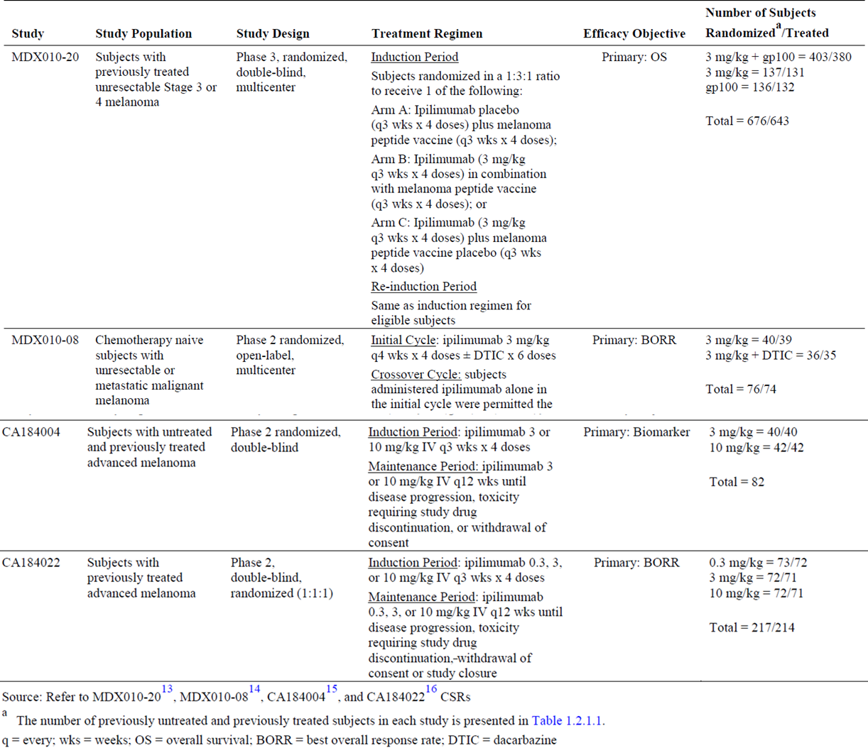

Populations for analyses:
No individual studies were presented, testing 3 mg/kg for efficacy in untreated patients. Instead, OS data on 3 mg/kg ipilimumab monotherapy were pooled from MDX010-20, MDX010-08, CA184004 and CA184022 of which the CSRs have all been previously evaluated. Study numbers, dosing schedules, dosing regimens post induction, randomisation ratios, length of survival follow-up and possible crossover were variable between trials. With respect to the treatment status of subjects according to study;
- CA184004 enrolled both untreated and previously treated patients
- CA184022 enrolled previously treated patients.
For these studies previously treated subjects were defined as subjects with prior systemic anti-cancer therapy received for advanced melanoma (excluding adjuvant therapy);
- MDX010-20 investigated previously treated subjects
- MDX010-08 investigated ‘chemotherapy naive subjects’.
Comment: Note should be made that Table 23 and the sponsor indicates within the text that patients from MDX010-08 are previously treated. Thus it is unclear as to how many of the patients included from this study are relevant to the proposed indication.
Chemotherapy pre-treated subjects were defined as subjects with prior chemotherapy received for advanced melanoma.
The total number of previously untreated patients who received monotherapy with 3 mg/kg ipilimumab consisted of maximally 35 patients. Note is made that data was pooled from CA184004 and CA184022, of which only CA184004 enrolled untreated patients. The total number of chemotherapy naïve patients treated with monotherapy was 78 patients. In comparison, the number of previously treated patients is large. Thus, conclusions made by the sponsor are derived from data comparing 35 previously untreated patients versus 254 previously treated patients. Additionally, it is unclear how many of these 35 patients were previously untreated (versus chemotherapy naïve as per Table 23) and how many also received maintenance therapy. Thus the total number of relevant patients examined is limited even within these pooled subgroup analyses.
The contribution of data according to treatment status by study is summarised in Table 24

Table 24: Summary of the pooled efficacy analysis populations according to study and pre-treatment status
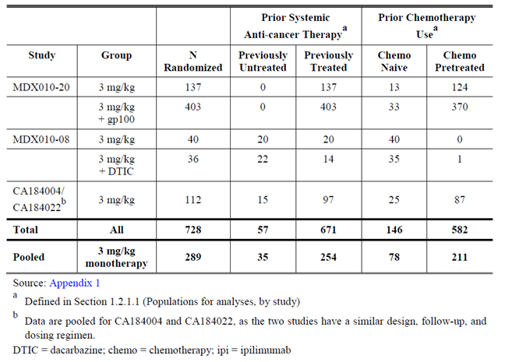
Comment: Can the sponsor please clarify of the indicated total 35 previously untreated patients, how many of the randomised patients received maintenance therapy and how many did not? Can the sponsor confirm that the patients investigated within MDX010-08 were previously untreated rather than chemotherapy naive? Thus, can the sponsor please indicate the total number of patients who have not previously received any prior therapy, who were randomised in the relevant study, and who received ipilimumab 3 mg/kg monotherapy without any maintenance therapy? The efficacy of the drug for this subgroup of patients is relevant for the proposed indication, such that further clarification is requested from the sponsor, regarding efficacy data for this subgroup only.
Baseline demographics are impossible to comment on due to the post hoc nature of the analysis, the aforementioned numerous differences between the trials, and the small number of patients (n = 35 previously untreated) relevant to the current application. For noted differences (or similarities), it is impossible to comment on the significance of these due to the imbalanced patient numbers between (relevant) groups.
The sponsor reports that baseline demographics and subject characteristics were generally similar between previously untreated and previously treated subjects. Although the total number of subjects within each study is limited, the baseline demographics and subject characteristics were generally similar between previously untreated and previously treated subjects. Note is made of the small numbers in MDX010-08, however, in the monotherapy group the proportion of women (55% versus 30%), women ≥ 50 years (40% versus 10%), and subjects ≥ 65 years (70% versus 30%) were numerically higher in previously untreated subjects compared to previously treated subjects, respectively. Also, the proportion of untreated subjects with age ≥ 65 years (14 out of 20; 70%) in MDX010-08 was highest among all subgroups evaluated. Higher proportions of men and older age are generally considered as poorer baseline characteristics. These analyses are conducted post hoc and prior treatment was not a stratification factor within each study.
Within each study, previously untreated and previously treated subjects each received a median of 4 doses, with the exception of previously treated subjects in MDX010-08 (median of 3 doses in the monotherapy group and 3.5 doses in the ipilimumab + DTIC group).

Efficacy results for OS – cross comparison between studies according to treatment status
OS by treatment status according to study is summarised in Table 25 (below).

Median OS
Within each study, median OS for previously untreated and treated subjects was similar. In the Phase II studies, median OS for previously treated subjects (9.33 to 11.6 months) was similar previously untreated subjects (10.1 to 16.6 months). These were similar to the median OS in MDX010-20 (10.1 months).

1 year survival rate
Within each study, estimated 1 year survival rates for previously untreated subjects were similar to previously treated subjects. For the Phase II studies, the 1 year survival rates for previously treated subjects (41% to 50%) were similar to previously untreated subjects (44% to 70%). These were similar to the 1 year survival rate in MDX010-20 (46%).

2 year survival rate
The estimated 2 year survival rate was 24% in the ipilimumab monotherapy group (n = 137) in MDX010-20. With some Phase II studies having only a few subjects still at risk for death beyond 18 months (for example, MDX010-08), the 2 year survival estimates for each study alone should be interpreted with caution. In MDX010-08 and CA184004/022, the estimated 2 year survival rates ranged from 14% to 33% for previously treated subjects and 11% to 40% for previously untreated subjects.
Thus data is presented that demonstrates similar OS obtained irrespective of treatment status for patients administered ipilimumab 3 mg/kg monotherapy. However, cross study comparisons should be interpreted with care, and small relevant study numbers are emphasised.

Table 25: Summary of OS by treatment status according to study using the 3 mg/kg posology
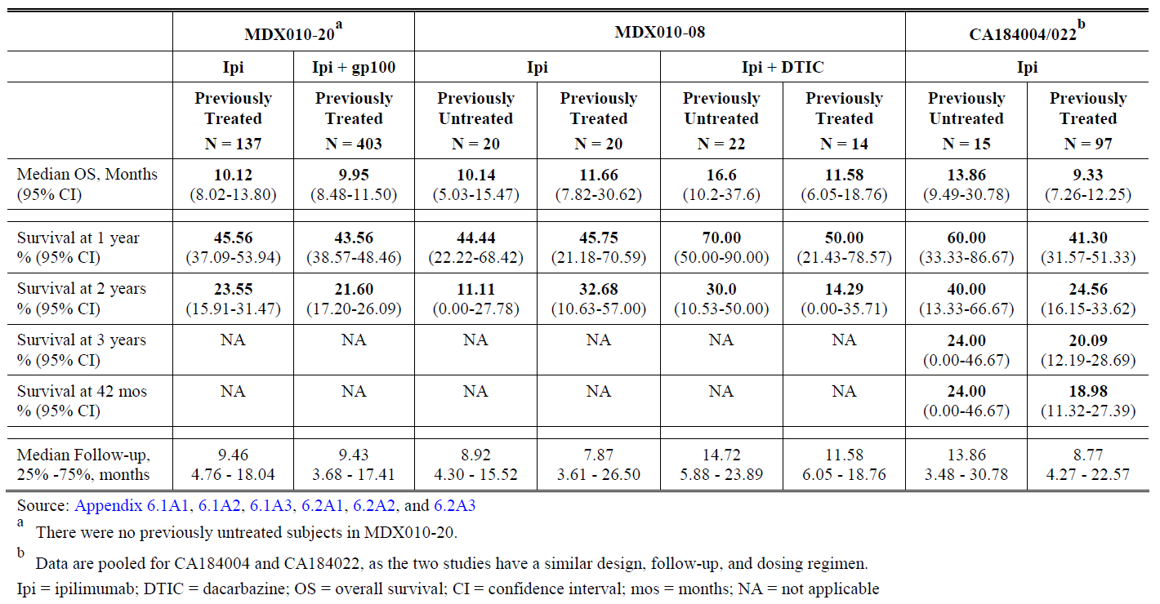
Comment: Cross study comparisons and pooled data across studies provides low quality ‘evidence’ compared to a study that directly examines the hypothesis. The table above is presented in lieu of the KM curves to emphasise again the small numbers in relevant groups. The heterogeneous drug therapies and heterogeneous populations investigated in these cross study comparisons are emphasised. There were no studies included that directly assessed the proposed usage.
The previous query is relevant here; can the sponsor confirm that the patients investigated within MDX010-08 were previously untreated rather than chemotherapy naive? Thus, can the sponsor please indicate the total number of patients who have not previously received any prior therapy, who were randomised in the relevant study, and who received ipilimumab 3 mg/kg monotherapy without any maintenance therapy? The efficacy of drug for these patients is relevant for the proposed indication, such that further clarification is requested from the sponsor, regarding efficacy data for this subgroup only.

Efficacy results for OS – pooled data
In an analysis of pooled data among subjects randomised to 3 mg/kg ipilimumab monotherapy (Phase II and III studies combined), observed OS (K-M estimates of median survival, survival rates at 1 and 2 years, as well as the K-M curves) was generally similar between previously untreated and previously treated subjects. The median OS in the pooled group is similar to previous (Table 25). For previously untreated pooled patients OS was 8.77 to 15.5 months versus 8.34 to 12.1 months for previously treated patients. The 1 year survival rate estimates were 52% for previously untreated subjects and 44% for previously treated subjects. The 2 year survival rate was 24% for previously untreated subjects and 25% for previously treated subjects. Among the 35 previously untreated subjects, 8 remained at risk for death at 2 years (6 out of 15 from CA184004/022 and 2 out of 20 from MDX010-08).
Comment: These results provide uncertain supportive value given that compared to the subgroup analysis of individual studies, only a small numerical increase in subject numbers is gained by pooling numbers from the previously untreated population (20 + 15 patients). The significance of the pooled efficacy data should be interpreted with caution.

Subgroup analyses for survival within MDX020
The sponsor writes that OS benefit was observed regardless of the number of or type of prior anti-cancer systemic treatment. OS benefit was observed for subjects without respect to pre-treatment with DTIC, prior immunotherapy or number of previous lines of therapy (1 versus or ≥ lines). The treatment effect in favour of the 3 mg/kg ipilimumab group was observed across all prior therapy subgroups: in all cases, the 95% CI of HR estimates in all subgroups included the HR estimate for the overall (intent-to-treat (ITT)) population (HR = 0.66; 95% CI: 0.51 to 0.87). These results demonstrate that the performance of ipilimumab within these subgroups is favourable. Similar results were observed favouring in the ipilimumab 3 mg/kg + gp100 group versus the control group, where the 95% CI of HR estimates in all subgroups included the HR estimate for the overall (ITT) population (HR = 0.68; 95% CI: 0.55 to 0.85).
This data can also be considered supportive for the use of ipilimumab in the second line setting.
In MDX010-20, note that pre-treated patients were enrolled. Numbers within the subgroup analyses comparing the HR for death between treatment arms according to previous exposure to systemic therapy were small, particularly with reference to those without exposure to a defined therapy. Taken from the clinical overview, the largest subgroup comparison was between 105 patients versus 103 patients who had no previous exposure to IL-2. The smallest subgroup comparison was according ‘no prior use of chemotherapy status’ which compared 13 patients versus 9 patients according to treatment arm, of which the confidence intervals included 1. The figure from which the conclusions above are derived is reproduced in Figure 5.
The subgroup analysis according to previous treatment status for this study did not appear to be a pre-specified endpoint. The study is underpowered for the subgroup analyses. Furthermore, the study also included a maintenance arm. Thus, the observations of this subgroup analysis require confirmation in a prospective randomised controlled trial and should be interpreted with caution.
Figure 5: Forest plot of OS by prior therapy subgroup analysis of MDX010-20 according to ipilimumab versus gp100
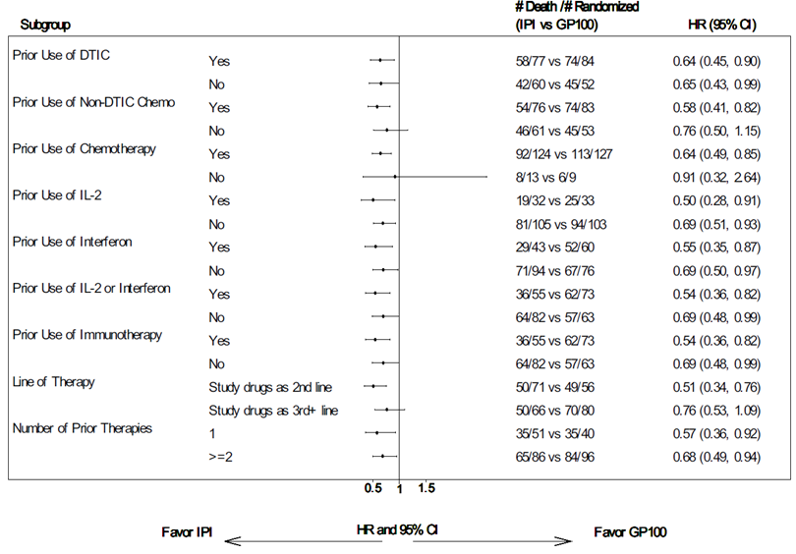

OS according to previous chemotherapy exposure status
OS according to previous chemotherapy exposure status was also investigated across studies and as a pooled analysis. Results were provided and given the context of the current application for use in the previously untreated population are not reproduced in this section.

Summary of Clinical efficacy conclusions for the pooled analysis
The report presented pooled OS analyses conducted for 728 subjects over four studies (CA184004, CA184022, MDX010-20, MDX010-08) in advanced melanoma randomised to 3 mg/kg ipilimumab (alone or in combination with another agent), which included;
- 35 out of 57 previously untreated patients, and
- 254 out of 671 previously treated patients who received ipilimumab monotherapy.
The analysis showed numerically similar OS rates between previously treated and previously untreated subjects, within and across studies. These data suggest that the clinical benefit in previously untreated subjects is of similar numerical magnitude and durability to that observed in previously treated subjects. These comparisons are summarised in Table 26 below.

Table 26: Comparison of survival results for previously untreated patients across studies
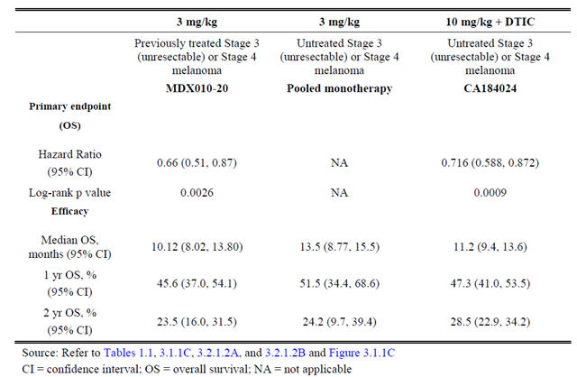
Comment: The previous query is relevant here; can the sponsor confirm that the patients investigated within MDX010-08 were previously untreated rather than chemotherapy naive? Thus, can the sponsor please indicate the total number of patients who have not previously received any prior therapy, who were randomised in the relevant study, and who received ipilimumab 3 mg/kg monotherapy without any maintenance therapy? The efficacy of the drug for these patients is relevant for the proposed indication, such that further clarification is requested from the sponsor, regarding efficacy data for this subgroup only.

Pooled OS analyses from clinical overview
A similar pooled OS analysis was performed for all studies using 3 mg/kg dosing of ipilimumab according to pre-treatment status. These include the observational studies, and studies previously discussed above (CA184004, CA184022, MDX010-20, MDX010-08) from which the pooled previously untreated (n = 35) and chemotherapy naïve (n = 78) data are derived. Overall survival rates were compared to rates from ‘standard arms’ from patients treated with DTIC monotherapy on CA184024 and ipilimumab 3 mg/kg monotherapy arm from MDX010-20.
Note should be made that the studies included within this pooled analysis are heterogeneous. Pooled data and cross study comparisons should be interpreted with consideration of the differing study designs, the different treatment schedules, and the heterogeneous populations investigated.
As per the previous subsection, the queries regarding the relevant population also apply to this analysis; can the sponsor confirm that the patients investigated within MDX010-08 were previously untreated rather than chemotherapy naive? Table 23 and the sponsor’s text indicate that patients from this study were previously treated. Thus, the sponsor is requested to clarify the total number of patients who have not previously received any prior therapy, who were randomised in the relevant study, and who received ipilimumab 3 mg/kg monotherapy without any maintenance therapy. The efficacy of the drug for this subgroup of patients is relevant for the proposed indication, such that further clarification is requested from the sponsor regarding efficacy data for this subgroup only.
Details for CA184004, CA184022, MDX010-20, and MDX010-08 have been previously described (see Table 23). Baseline characteristics between populations from the observational Studies, CA184024, and pooled chemotherapy naive patients were reported to be similar. The sponsor uses these similarities between populations as bridging data in support of the current application.
Table 27.summarises the OS rates between each of the studies for this pooled analyses.

Table 27: OS for subjects treated with 3mg/kg ipilimumab according to treatment status and study
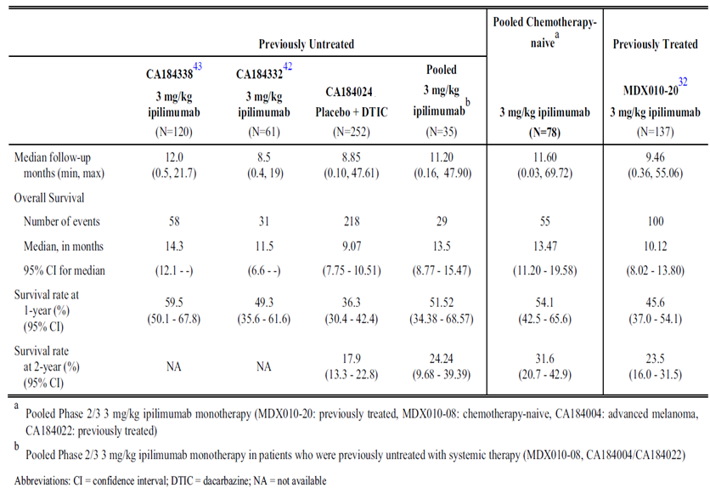
The estimated 1 year OS for previously untreated patients who received 3 mg/kg ipilimumab monotherapy in Studies CA184338, CA184332, or the pooled Phase II trials ranged from 49.3% to 59.5%; the chemotherapy naive 1 year OS rate was 54.1%. In all of these datasets, the estimated 1 year OS rates are mature with the majority of patient censoring occurring after this time point, are internally consistent, and compare favourably to the estimated 1 year OS rate for DTIC (36%). For comparison, the 1 year OS rate for previously treated subjects who received 3 mg/kg ipilimumab was 46%. Although not yet fully mature for CA184332 and CA184338, the 2 year estimated OS rate is mature for the pooled chemotherapy naive subjects, is numerically higher to those observed in the randomised Phase III trials of DTIC, and compares favourably to the 2 year OS rates for the DTIC arm in CA184024.
The median OS for CA184332 and CA184338 (11.5 and 14 months, respectively) the pooled subjects from the Phase II (13.5 months) and for the pooled chemotherapy naive group (13.5 months) are both internally consistent and numerically higher than that observed for DTIC monotherapy (range, 5.6 to 9.4 months). The follow up of subjects in all these data sets, except for CA184338, is sufficient to allow estimation of the median OS. For CA184338, censoring around the 14 month time point may limit accurate estimation of median OS. OS rates for 10 mg/kg ipilimumab + DTIC are provided as reference and appear to be similar to that of the 3 mg/kg ipilimumab populations.
Overall, it should also be noted that the OS benefit obtained for patients treated with ipilimumab, regardless of previous treatment status, is superior to than historical controls and other historical models. Again, trials in previously untreated, advanced melanoma demonstrate a median OS of approximately 9 months and estimated 1 year OS rate of approximately 36% as historical benchmark for DTIC monotherapy. For Fotemustine therapy, a median OS of 7.2 months and estimated 1 year OS rate of approximately 30% is obtained (Avril et. al 2004; Chapman et. al 1999; Middleton et al 2000, Patel et al, 2011).
Comment: Within the pooled previously untreated group there is a patient who was followed up for only 4.8 days, and in the pooled chemotherapy naïve group a patient followed up for 0.9 days. Can the sponsor please provide details of the patients’ performance status, the reason for the short duration of follow up and confirmation that these patients met the eligibility criteria of the relevant study? Can the sponsor please provide the interquartile ranges for the median follow up? The previous queries regarding the clarification of total number of patients relevant to the proposed indication is also pertinent here.
Despite comparisons demonstrating numerical similarities, with regard to adequacy of evidence provided in support of the current application, this data is considered of low quality. There is a significant likelihood of bias given the cross study comparisons and the pooling of data from heterogeneous studies that differ from the current application with regards to both the population being studied and the treatment schedules. Survival data from a study investigating 10 mg/kg dosing cannot prove the efficacy of another posology. Combination therapy (ipilimumab +DTIC) studies cannot provide evidence for efficacy of monotherapy. Studies that utilise maintenance therapy cannot provide evidence for the proposed usage. The efficacy data presented relevant to the population of interest for the current application is based on only 35 pooled patients. Cross comparison of OS rates between different studies and different populations should be interpreted and regarded with caution.
The sponsor has included overlying KM curves from these different studies to visually demonstrate what is presented in Table 27. The Kaplan-Meier curve presented actually omits the population of interest, however does demonstrate what the table shows, which is that the OS rates were similar between studies (the lowest line is DTIC alone, as shown in Figure 6).The overlaying of KM curves is a poor statistical method of cross study comparisons that is easily misinterpreted. For example, it is difficult to appreciate that previously untreated patients are excluded from the overlaid curves. The sponsor writes regarding the omission of this curve the following; ‘The Kaplan-Meier OS curve for 10 mg/kg ipilimumab + DTIC is provided as reference and appears to be similar to that of the 3 mg/kg ipilimumab populations. The Kaplan-Meier OS curve for the 35 previously untreated subjects from the Phase II program, the smallest of the data sets, are not included in this figure to avoid too many curves.’
Figure 6: Kaplan-Meier of overall survival up to 24 months
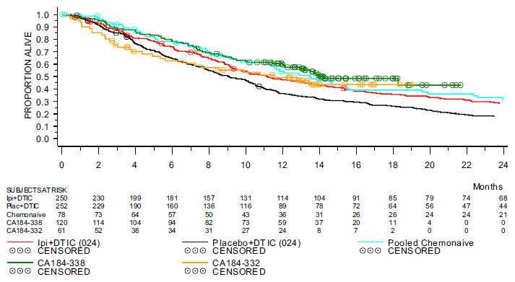

Population PK reports

ES-OR modelling from the newly submitted PopPK report
Please refer to section 4 for full details of the PopPK report.
Similar to the previous PopPK analysis, the sponsor considered that the comparison of predicted values with actually observed values provided external validation of the model. For the ER OS and the irAE analysis, no external validation of results was performed.
The final ER-OS model (based only on data from untreated patients at 10 mg/kg dosing with DTIC taken from study CA184024), was used to characterise the relationship between ipilimumab steady state trough concentration (C_{minss}) and selected clinical endpoints identified four significant covariates (metastatic status, ECOG, C_{minss}, LDH status), with their effects summarised in Table 12(above in Section 4). Improvement in survival with higher ipilimumab C_{minss} value is noted, with patients with median C_{minss} of 49.9 µg/mL having a relative OS hazard ratio of 0.73 compared to placebo (+DTIC). Higher M-category status, ECOG status = 1, and elevated LDH above the ULN carried a relatively higher risk of worse survival. Note is made that although gender was an important predictor of overall survival in the full model, it was not retained in the final model based on Bayesian criterion. The coefficient for gender varied between each model (for example > 55% difference). Thus, data supportive of the survival benefit of ipilimumab 10mg/kg (with increasing C_{minss}) in an untreated patient population is provided utilising PopPK modelling.
Given the examination of previously untreated patients, the use of ipilimumab 10 mg/kg administered concurrently with DTIC and a maintenance phase within the analysed study, there is limited external validity of this analysis for the current application. This patient population is not informative for the covariate of previous therapy.

ER-OS modelling from the previous PopPK report
The clinical overview contains reference to the ER-OS modelling from the previously evaluated report which demonstrated that efficacy was independent of prior treatment status. Note should be made that this modelling was performed on the four previously discussed Phase II studies which included 35 patients relevant to the current application. The previous queries regarding the clarification of the actual total number of patients relevant to the proposed usage are also pertinent here.
An exposure survival analysis using a Cox Proportional Hazard (CPH) model was conducted on 419 previously treated and 78 previously untreated, advanced melanoma subjects treated in Phase II ipilimumab Studies (CA184004, CA184007, CA184008, and CA184022) and demonstrated that ipilimumab’s efficacy was independent of line of therapy. The analysis was limited to subjects who received ipilimumab monotherapy to avoid potential bias of concomitant therapies. The analysis included subjects treated with 0.3 mg/kg (n = 47), 3 mg/kg (n = 98), and 10 mg/kg (n = 352) doses of ipilimumab since actual exposure (trough concentration) rather than nominal dose was used in the model. The magnitude of the effect of key covariates on OS was also assessed in this model.
Prior anti-cancer systemic treatment (yes versus no) was not a significant covariate for risk of death (HR 1.16; 95% confidence interval (CI): 0.805, 1.66). Similarly, use of prior immunotherapy (primarily interferon and IL-2) was not a significant covariate (HR 1.01; 95% CI: 0.76, 1.34). The only baseline covariates associated with significant effect on risk of death were increasing lactate dehydrogenase (LDH), trough concentration at steady state (C_{minss}), and Eastern Cooperative Oncology Group (ECOG) PS > 0; therefore, based on these Phase II data, the risk of death while receiving ipilimumab is independent of prior therapy.
Comment: The sponsor’s comment on the population analysed within this previous report should be noted, being ‘limited to subjects who received ipilimumab monotherapy to avoid potential bias of concomitant therapies.’

Evaluator’s conclusions on clinical efficacy for overall survival
There was no investigation of efficacy utilising ipilimumab 3 mg/kg monotherapy according to the proposed usage where efficacy was the primary endpoint. Current claim utilises the concept of non-inferiority but appropriate studies have not been carried out prospectively to test this.
A single Phase III Study (CA184024) demonstrates a statistically significant survival benefit obtained for previously untreated patients with advanced melanoma administered combination ipilimumab 10 mg/kg and DTIC versus DTIC monotherapy. The study design, study execution, quality of the efficacy data, and plausibility of hypothesis tested were robust.
However, this study has been submitted by the sponsor as part of the ‘bridging argument’ for the proposed usage. The current application seeks to use the 3 mg/kg dosing schedule and seeks use of ipilimumab as monotherapy. In comparison, this Phase III study utilises a different posology, utilises drug administration concurrently with DTIC and incorporated a maintenance phase of treatment. Thus, this study has limited external validity for the current application. It therefore provides limited relevant evidence for the proposed usage.
An interim report from one Phase II Study (CA184042) was submitted which used 10 mg/kg ipilimumab in previously untreated patients with brain metastases without (Arm A; n = 51) or with concomitant steroids (Arm B; n = 21). This study provides supportive evidence for the global disease control rate and survival benefit with use of ipilimumab 10 mg/kg in patients with metastatic melanoma with brain lesions, of which patients without concomitant steroids have an improved outcome compared to patients on steroids.
This study is submitted by the sponsor as part of the ‘bridging argument’ for the proposed usage. The external validity of this study is limited in the context of the current application. Limited supportive evidence is provided by this data as a ‘bridging argument’ given the use of the 10 mg/kg posology. The population examined in this study differs to MDX010-20 and other studies which utilise the 3 mg/kg posology, limiting the external validity of comparisons. The study was not randomised. It therefore provides limited relevant evidence for the proposed usage.
Pooled analyses using previously evaluated and newly submitted studies demonstrated numerically similar OS rates, despite use of 3 mg/kg dosing, 10 mg/kg dosing, and monotherapy or combination treatment schedules. The populations between studies appear similar. However, uncontrolled, post hoc exploratory, non-confirmatory cross study comparisons do not provide sufficient quality evidence for robust conclusions, and are only useful for hypothesis generation. There is limited external validity of the comparison of survival rates between different treatment schedules and patient populations. The inclusion of bias, in particular selection bias and the use of concomitant therapy, is not accounted for. The pooled analyses provided efficacy data for (maximally) 35 previously untreated patients who were administered 3 mg/kg ipilimumab monotherapy. The additional benefit of pooled data from two studies is limited, when the numbers in each study are small (n = 20 + n = 15). ER-OS modelling from the new PopPK report has limited external validity for the current application due to its use of patients’ data only from CA184024. PopPK modelling from the previous submission included a small number of patients relevant to the current application (maximally n = 35). Furthermore, all studies included a maintenance therapy phase.
Thus, with respect to the current application for use of ipilimumab 3 mg/kg monotherapy in previously untreated patients, the relevant data provided by the pooled analyses derived from heterogeneous studies is considered limited, and does not provide sufficient quality of evidence for regulatory purposes.
Other studies summarised within this section (CA184078, two interim reports from observational post-marketing studies, and one interim report summarising data from the EAP) were submitted by the sponsor as additional support for the proposed usage. These studies were shown to demonstrate similar numerical OS rates observed within the controlled studies. However, evidence provided by these studies is considered not to be of sufficient quality for robust conclusions. This is due to Phase I study having limited relevance to the proposed usage (study design, primary endpoint, numbers investigated, 10 mg/kg posology), and the low quality level of evidence contributed by uncontrolled data collection in the three observational studies. Data was also immature. Thus, the Phase I study provides limited quality evidence and limited relevant evidence for the proposed usage (limited external validity). The observational studies provide limited quality evidence for the current application.
Overall, limited data is presented that is relevant to the current application which seeks approval for the use of ipilimumab 3 mg/kg monotherapy in previously untreated patients. No randomised data addressing the proposed usage was provided.
Data derived pooled from maximally 35 patients across two Phase II studies provides insufficient evidence for robust conclusions on the efficacy of the drug for the proposed usage. It is impossible to derive an understanding of the efficacy of the drug for the proposed usage from studies that utilise a different dosing schedule (10 mg/kg) or treatment schedule (combination therapy and maintenance therapy). Though pooled data has been presented as a ‘bridging argument’ to indirectly address the efficacy of ipilimumab 3 mg/kg monotherapy in previously untreated patients, the limited numbers of relevant patients within pooled analyses and the use of cross study comparisons argues strongly that there is insufficient evidence available to support the current application. The ‘bridging argument’ has not been established on randomised data. The ‘bridging argument’ has been established on cross study comparisons and pooled data from heterogeneous studies. Thus the likelihood of bias (for example selection bias, concomitant use of other therapy), within these analyses needs to be considered as unaccounted for given the uncontrolled, non-randomised methodology utilised. The data presented in support of the current application does not meet the statistical principles of clinical trials guidelines.
Whilst note is made of the clinical need for effective therapy in this patient population, the likely biological plausibility for the efficacy of the proposed usage, the long term survival benefit provided for a subgroup of previously treated patients, the desire to avoid toxicity with higher dosing schedules, and the pre-submission meeting notes, on the presented data alone insufficient evidence has been provided that directly addresses or supports the current application.
Therefore, the efficacy of the proposed usage (or the optimal dose) in the untreated population has not been sufficiently proven due to the absence of randomised data and absence of data with sufficient quality or relevance.
Please also see Section 6 ‘Comments regarding the dosage selection for the current application’.

For overall survival benefit in patients with BRAFV600E mutation positive tumours
A retrospective analysis of the BRAF mutation status of patient tumours obtained in the Phase II Study CA184004 was performed. This previously evaluated study was a randomised, double blind, multicentre study of 82 pre-treated or untreated subjects with un-resectable Stage III or Stage IV melanoma. Subjects received ipilimumab 3 mg/kg (n = 40) or 10 mg/kg (n = 42) every 3 weeks for 4 doses followed by maintenance dosing in eligible subjects. The BRAFV600E mutation status was assessed in 80 tumour biopsies by two competitive allele specific polymerase chain reaction (PCR) based assays. Of these samples, data on disease control were available for 69 subjects.
Rates of objective responses (CR or PR) and SD in subjects with BRAFV600E mutation positive tumours (0% CR, 10% PR, and 20% SD) were comparable to those in subjects with the wild type BRAF (3.2%, CR, 9.7% PR, and 22.6% SD). Eleven subjects had durable disease control of which 6 (55%) had BRAFV600E mutation positive tumours and 5 (45%) did not. In the 48 subjects without durable disease control, the mutation frequency was 50%. Therefore, in this study of 80 tumours, the sponsor concludes that ipilimumab was shown to be equally active in BRAFV600E mutant and wild type melanoma.
No information was provided by the sponsor of the frequency of BRAFV600E status stratified according to previous treatment status, study treatment dose, response and survival (combined).
Comment: This information has not been requested because on the sample size, the limited analysis, the study design and the post hoc analysis, even with additional data this isolated study provides inadequate evidence supportive of the sponsor’s claim.
From the publication by Shahabi et al. (2012) regarding this study, 23 out of 40 (57.5%) BRAFmt were detected in the 3 mg/kg cohort, and 17 out of 40 (42.5%) were detected in the 10 mg/kg cohort. In addition, the numbers of patients contributing to the above summarised information is as summarised in Table 28, below.

Table 28: Best overall response according to BRAFV600E status, for patients studied on CA184004
Best overall response | Wild-type | BRAFV600E
CR (n = 1) | 1 | NA
PR (n = 6) | 3 | 3
SD (n = 13) | 7 | 6
PD (n = 41) | 20 | 21
Unknown (n = 8) | 4 | 4
Total | 35 | 34
CR complete response; PR partial response; SD stable disease; PD progressive disease; NA not applicable. This table is reproduced from the publication by Shahabi et al. (2012) with exchange of ‘NA’ instead of ‘0’ given that there were no patients in this group.
There is insufficient evidence supporting the sponsor’s conclusions that ‘Therefore, ipilimumab is equally active in BRAF mutant and wild type melanoma.’ This is predominantly on the basis of the small numbers examined, and the limited information according to study dosing combined with other relevant factors of interest. Presumably the commercially available castPCR kit referred to in the publication that was additionally utilised to confirm mutation status contained (control) probes for the V600K and V600D mutations. Regardless of this, the sample size of the cohort is unlikely to be sufficient to detect other mutations of lower frequency.
Comment: The table demonstrates that numbers were small in each group, there were only seven patients that responded to treatment, and there was only one patient who had CR.

Evaluator’s conclusions on use in patients according to BRAF mutation status
Limited evidence is provided regarding the efficacy of ipilimumab regardless of BRAFV600E mutation status, from a small retrospective study of 82 patients without specific details of treatment or survival provided.
Regardless of this, data from a single retrospective Phase II study of 82 patients is not considered sufficient evidence to support use of ipilimumab as first line therapy regardless of BRAFmt status for regulatory purposes. Other relevant BRAF mutations (for example BRAFV600K or BRAFV600D) were not detected in this single study, likely due to insufficient numbers to detect less frequent mutations (the power of the study was limited). Numbers examined were small overall, and of particular interest, the total number of patients with a tumour response to the drug was smaller. Comprehensive information was not provided by the sponsor with treatment and clinical outcome stratified according to mutation status. Thus, response to ipilimumab according to mutation status is insufficiently characterised. Therefore, there is insufficient evidence to support the conclusion written by the sponsor that ‘Therefore, ipilimumab is equally active in BRAF mutant and wild type melanoma.’
From a ‘real world’ oncological perspective, patients with mutation positive tumours are unlikely to receive non-targeted therapy (for example chemotherapy, immunotherapy) prior to targeted therapy in order to maximise the number of clinical treatment lines available. The setting whereby therapy is used as first line treatment is usually established by the appropriate randomised controlled trial demonstrating efficacy (superiority) in relevant populations of sufficient size.
The sponsor has proposed a change to the PI, to alter clinical trial information for the study description of MDX010-20 was updated to include the following statement: ‘Patients were enrolled regardless of their baseline BRAF mutation status.’ Whilst this statement is true with respect to the trial, this may be mistaken to imply that the efficacy of ipilimumab has been sufficiently examined and proven to be equal in BRAFmt positive and negative tumours. The efficacy of ipilimumab according to BRAF mutations status has been sufficiently investigated, and the proposed change to the PI is not supported with adequate data to justify this change. A trial to directly compare the efficacy of BRAF targeted therapy versus ipilimumab in the first line setting with BRAFmt status prospectively collected, would need to be performed to provide randomised evidence for the benefit of ipilimumab in the first line setting.

Clinical safety

Studies providing evaluable safety data

Pivotal efficacy studies
As commented previously, in the context of the current application for the 3 mg/kg posology, no submitted studies are considered pivotal. The sponsor states that the primary evidence of safety for the current application comes from data from previously evaluated studies that utilise the 3 mg/kg posology and a maintenance phase.

Pivotal studies that assessed safety as a primary outcome
There were no relevant studies submitted.

Dose-response and non-pivotal efficacy studies
No pivotal study was submitted in support of the proposed usage. The majority of studies within this application provided limited relevant evidence. Thus, the majority of the safety data from these studies also provide limited relevant data.
Review of the submitted studies has identified a number of uncertainties regarding the accuracy of the source safety data and subsequent analyses from these sources. Overall, the uncertainties regarding the safety data for all studies refer to;
- The appropriate documentation of AEs
- The grading of AEs
- The allocation of causality for AEs
- The summarised data is limited due to the two previous points and the text does not comprehensively summarise clinically meaningful information
- The presentation of data appears to minimise the frequency of clinically meaningful safety data, through the use of MedDRA preferred terms which are highly specific (in comparison to considering higher level terms, collapsing terms or summating the data in a meaningful way)
- Specific pertinent examples of deficiencies include the apparent incorrect documentation of Grade 5 events (representation on tables, reporting, and allocation of causality), GI perforations, GI toxicity in general, hepatotoxicity, and a case of G4 optic neuritis (CA184078).
Thus as the accuracy of source data is uncertain, the accuracy of subsequent analyses are also uncertain. Resultantly, the sponsor has not adequately presented safety data in a manner that facilitated the assessment of the drug’s safety.
However, questions to the sponsor within this section focus only on information that will inform the safety of the drug relevant for the proposed usage. Again, there are no randomised studies submitted that provide relevant safety information for the proposed usage.
The following studies submitted with this application that provide evaluable safety data are:
CA184024, CA184042, MDX010-16, CA184078, one observational study (one did not capture safety events), and one EAP study. A synopsis of MDX010-16 was provided due to its investigation of drug use in the adjuvant setting, whilst all other newly submitted studies have been comprehensively summarised above in Section 7.
As an important background, there are a number of key issues identified through the course of evaluation, which should be noted to permit the appropriate interpretation of safety events. These are described below.
- Note should be made that some Grade 2 events represent clinically serious AEs due to the necessity of dose skipping and the hospitalisation of patients for the management of events. For example, it is worth noting two amendments to the CA184024 protocol that were made post subject enrolment and were in response to SAEs on this study. Attention is brought to these SAEs as these amendments indicate dose skipping or discontinuation was required with Grade 2 events that may be overlooked as less serious AEs.
Amendment 9 of the protocol indicated that:
‘It may be necessary to skip study drug dosing for the following related adverse event(s):
- Any ≥ Grade 2 non-skin related adverse event (including IBEs), except for laboratory abnormalities
- Any ≥ Grade 3 laboratory abnormality
It is necessary to skip study drug dosing for the following adverse events:
- Any ≥ Grade 3 skin related adverse event regardless of causality.’
Amendment 7 of the protocol indicated that;
‘Permanent Discontinuation of study drug for related adverse events or other criteria:
- Any ≥ Grade 3 eye pain or reduction of visual acuity or any ≤ Grade 2 ocular toxicity that does not respond to topical therapy.’
See the next point for further elaboration of this point.
- Limitations of the (appropriately used) conventional CTCAE criteria to represent the severity of AEs should also be noted. The limitations are irrespective of the version utilised. Limitations of any toxicity grading criteria are an anticipated normality that requires clinical expertise for the assessment, summary and interpretation of the data in a clinically meaningful fashion.
For example, version 3.0 does not incorporate hospitalisation into the grading of the severity of vomiting. Thus, a number of patients were hospitalised for Grade 2 vomiting. Similarly, whilst hospitalisation for ‘diarrhoea’ is a Grade 3 event, for ‘colitis’ hospitalisation is not accounted for in the grading system and thus a number of patients were hospitalised for less than Grade 3 colitis. ‘Autoimmune colitis’ however, classes hospitalisation as a Grade 3 event. All these terms are often reported separately as MedDRA ‘preferred terms’ within the provided narratives and tables of the CSRs. Thus, if diarrhoea is captured only as ‘colitis’ an indication of whether hospitalisation resulted for the AE is not represented.
Furthermore, the requirement for systemic corticosteroids or other agents (for example infliximab) or TPN or surgical intervention is also not necessarily taken into account in the toxicity grading system. Thus, the clinical severity of the AE may not be accurately represented by the grade or the choice of clinical term used and its subsequent grading system.
- The statistical analysis plan should be noted for each report as these were not necessarily uniform. The statistical plan for the Summary of Clinical Safety was excellent and embedded within each relevant section of the report. In comparison, the statistical analysis plan for the safety analysis of CSRs often required cross referencing to the Appendix. It is unclear if each newly submitted study and analysis used different MedDRA terms, and conventions for dealing with multiple AEs within a time period. For example, in the pooled analyses for trials using the 3 mg/kg posology, MedDRA v14.1 was used. For multiple episodes of the same AE rates of the event were calculated;
‘All multiple event presentations during the induction period were performed for all treated subjects. The induction period started from the first date of study therapy dosing and ended 70 days after the last date of study therapy dosing in the induction period or at the day before the first maintenance/re-induction/cross over dose, whichever came first. Incidence rates per 100 person-years were calculated and summarised for all AEs during the induction period. The numerator is the number of unique events (that is, after duplicates were eliminated and overlapping and contiguous occurrences of the same event were collapsed) during the induction period. The denominator is the overall total exposure (person-years) during the induction period with total exposure (person-years) calculated as the sum over all subjects of (minimum (last date of study therapy dosing in induction + 70, maintenance/re-induction/cross-over first dose date - 1) - first date of study therapy dosing + 1)/365.25, regardless if the subject had events or not. The resulting incidence rate is multiplied by 100 to express the rate per 100 person-years.
Similarly, for all immune related AEs (irAEs), incidence rates per 100 person-years were summarised by time interval: 0 to 6 months, 6 to 12 months and annually thereafter. In addition, the number of subjects who experienced an irAE once or multiple times during the induction period is presented.’
In comparison, for CA184024, MedDRA v13.1 was used for the analysis. It appears that multiple AEs were categorised in different ways. Only the worst CTCAE grade was reported for some tables such as ‘Inflammatory events regardless of causality (worst CTC grade (Any grade, 3 to 4, 5) of any event and of events by system organ class)’ and for irAEs multiple events were collapsed ‘Any irAEs occurring within same dosing period in the induction phase (Week 1, Week 4, Week 7 and Week 10) should be considered as a single event.’ Numbers of episodes for irAEs were also counted according to grade and provided in one of the supplementary tables.
The convention for the reporting of multiple episodes of AEs for CA184042, and CA184078 were not located.
- The choice of specific MedDRA terms presented should also be noted, which affects the clinical relevance or clinical interpretation of a reported frequency for an AE. For example, if ‘preferred terms’ are reported, what will be reported is the frequency of one specific clinical term rather than the breadth of terms that are considered synonymous. Thus, use of a specific preferred term will underrepresent the frequency of an AE that may have multiple clinically relevant synonyms.
Overall the frequency of AEs was not presented adequately by the sponsor.
The presentation of analysed safety data according to the sponsor’s choice of MedDRA terminology made the clinical interpretation impossible. As an example, the frequency of all AEs was difficult to determine. This does arise due to the necessary use of comprehensive terminology (MedDRA terms) to capture relevant events, but how this information is meaningfully collated is crucial. For example, for GI irAEs it appears that ‘colitis’ ‘enterocolitis’ ‘proctitis’ and ‘procotocolitis’ are listed as separate terms (according to MedDRA preferred terms), and are accounted for differently according to numerous different summary tables. As a result, the true frequency of GI inflammation is unclear.
As an example, for CA184024 the most common irAEs for the study arm (≥ 20%) were ‘diarrhoea, ALT increased, AST increased, pruritus, and rash. The ‘Summary of On-Study Immune-Related Adverse Events’ lists all events according to MedDRA search terms. For any grade of AE, this Appendix shows that a total of 88 patients had a Gastrointestinal AEs, of which 81 had diarrhoea, 11 had colitis, 4 stomatitis, 1 GI haemorrhage, 1 aphthous stomatitis, 0 enteritis, 0 haematochezia, 0 mouth ulceration, 1 proctitis and other categories were listed. Thus, if a reader wished to determine how many patients had immune related diarrhoea or GI inflammation the answer is unclear, as diarrhoea is a symptom of inflammation of the GIT. The following relevant questions remain unanswered by the sponsor’s presentation of data;
- Did the cases of GIT inflammation (for example colitis) also have diarrhoea captured concurrently? How was colitis diagnosed without concurrent diarrhoea? If the investigator did not capture diarrhoea but captured colitis, how was it ensured that the data captured was comprehensive and clinically represented the true frequency of the AE? How many of the patients with diarrhoea also had colitis or GIT inflammation?
- How many patients experienced inflammation along the GIT? This would include the cases of colitis, stomatitis, aphthous stomatitis, and proctitis from above.
- How many patients overlapped?
- How were the differences between enteritis and colitis defined? How many events overlapped?
With the data presented in the current form, if a reader concluded that no patients on this study had ‘mouth ulceration’ this would in itself be true but four patients had stomatitis and one had aphthous stomatitis. Therefore, the frequency of events clinically synonymous with ‘mouth ulceration’ is under represented.
More examples of the apparent limitations of the sponsor’s presentation of safety data are given below according to study and are also summarised below.
- The definition of inflammation related AE (versus SAE) terms is described very clearly in CA184024. The definition of these is as follows;
An SAE was defined as an untoward (unfavourable) event which:
- was fatal or life threatening
- required or prolonged hospitalisation
- was significantly or permanently disabling or incapacitating
- constituted a congenital anomaly or a birth defect, or
- may have jeopardised the subject and may have required medical or surgical intervention to prevent one of the outcomes listed above.
Hospitalisations were not considered SAEs if they:
- were admission to a hospice for respite care
- were planned before entry into the clinical study
- were for elective treatment of a condition unrelated to the study indication or its treatment
- occurred on an emergency, outpatient basis and did not result in admission (unless fulfilling one or both of the criterion above)
- were part of the normal treatment or monitoring of the studied indication and not associated with any deterioration in condition.
Inflammatory events regardless of causality:
Inflammatory events regardless of causality (IERCs) represent all reported inflammatory AEs, regardless of whether the investigator considered the event to be drug related.
Immune-related adverse events:
Immune related adverse events (irAEs) represent the subset of IERCs that were considered by the investigator to be drug related.
For both analyses, formal exclusion of non-inflammatory aetiologies was not required. An exploratory, retrospective analysis based on sponsor physician data review to exclude non-inflammatory aetiologies and consider available evidence of inflammation to determine whether specific events of clinical interest (enterocolitis, hepatitis, dermatitis, neuropathies, endocrinopathies, and other AEs) were likely immune mediated and associated with ipilimumab treatment, regardless of the investigator’s assessment of causality.
Immune mediated adverse reactions
An exploratory, retrospective analysis defined immune mediated adverse reactions (imARs). The imARs were adjudicated in a blinded fashion based on sponsor physician data review to exclude non-inflammatory aetiologies such as infection or tumour progression, and to consider available evidence of inflammation such as tumour biopsies or responsiveness to steroids, in an effort to determine whether specific AEs or abnormal hepatic laboratory values were likely to be immune-mediated and associated with ipilimumab treatment. The imARs included specific events of clinical interest for example, enterocolitis, hepatitis, dermatitis, neuropathies, or endocrinopathies, including hypophysitis. The methodology for imAR analysis was developed between BMS and the US FDA for the first approval of 3 mg/kg ipilimumab monotherapy in the US.
On study AEs
On study AEs (with start date on or after the first date of dosing and no later than 70 days following last date of dosing) were included in the adjudication process. The following categories of imARs were included: enterocolitis, dermatitis, hepatitis, and endocrinopathies, with a particular focus on high-grade events due to their clinical relevance.
A list of preferred MedDRA terms that was the basis of the database search to define the imARs was provided. All AE records with an onset date on or after the first dosing date and meeting the identified preferred terms were selected and downloaded in a clinical review tool. Only AE records of subjects treated with study medication were included. In addition, ALT and AST laboratory abnormalities (from the laboratory data in the clinical database), with a CTC grade of 3 or more, that occurred after the first dosing date were selected. BMS physicians adjudicated whether an AE was an imAR using all available evidence. The analyses of imARs were based on these adjudicated data.
The imARs were adjudicated in a blinded fashion based on sponsor physician data review to exclude inflammatory aetiologies, such as infection or tumour progression and to consider available evidence of inflammation such as tumour biopsies or responsiveness to steroids, in an effort to determine whether specific AEs or abnormal hepatic laboratory values were likely to be immune mediated and associated with ipilimumab treatment. The imARs included specific events of clinical interest (enterocolitis, hepatitis, dermatitis, neuropathies, endocrinopathies, and other).
The list of MedDRA terms (preferred terms, and higher level terms) utilised to generate lists for the assessment of imARs was provided. However, apart from the listing of terms, further information of the definition of the terms, or whether and how the terms were clinically collated were not found. These were not found in the relevant section or in the appendices which were referenced within the reports.
Thus, these outlined issues should be considered regarding data presented within this section and impact (and can limit) the clinical interpretation of presented data.

Pooled data
A summary of safety issues derived from the pooled dataset of completed melanoma clinical trials is presented in the ‘clinical overview efficacy safety’ report. The sponsor reports that this analysis consisted of 1,924 patients exposed to ipilimumab at various dose/regimen from 17 clinical trials (CA184-004, -007, -008, -022, -024, - 042, -078, MDX-CTLA4-02, 03, 04, and MDX010-05, 08, 13, 15, 16, 19, 20). The Expanded Access Programs (EAP) (CA184-045 and Named Patient Program (CA184-089) of ipilimumab for advanced melanoma are ongoing and capture serious adverse events. The EAP had 9,334 patients (as of 24 March 2013) treated with ipilimumab and the EAP drug related serious adverse events (SAE) was also reviewed. In total, 11,258 patients with advanced melanoma were exposed to ipilimumab in BMS melanoma clinical trials including the EAP.
Similarly, in the Summary of Clinical Safety, pooled analyses for the 10 mg/kg studies were included (in addition to the pooled analyses for the 3 mg/kg studies which are presented below).
Given the focus on safety information relevant to the proposed usage and the aforementioned issues regarding the accuracy of the safety data sources for the submitted studies within this dossier, an assessment of this pooled safety data was not possible.

Pooled safety data for previously evaluated studies using the 3 mg/kg posology
Within the ‘Summary of Clinical Safety’, a pooled analysis was performed for MDX010-20, MDX010-08, CA184004 and CA184022. These studies have been discussed and study populations described above. However, the numbers analysed in each population were slightly different, whereby the number of previously untreated patients administered ipilimumab 3 mg/kg monotherapy was 34, and the chemotherapy naïve population consisted of 75 patients. The summary table defining the population analysed for this pooled safety is Table 29 below.

Table 29: The number of patients according study for the pooled safety analysis of 3 mg/kg trials
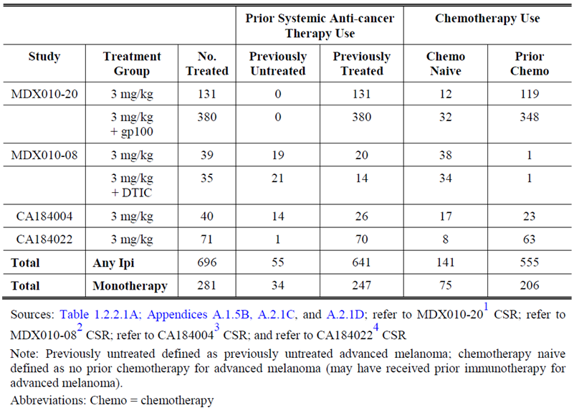
Again, clarification of the population relevant to the proposed usage as raised in the previous section is pertinent here. The sponsor referred to the population in MDX010-08 as previously treated (Table 23). It is therefore unclear how many of the indicated number of 34 ‘previously untreated’ patients were randomised to receive ipilimumab 3 mg/kg monotherapy and who did not receive maintenance therapy, pertinent to the proposed usage. Thus, the safety data relevant to the proposed usage throughout this entire report is unclear.
Note should also be made that the current application seeks use for ipilimumab 3 mg/kg in previously untreated patients, and not chemotherapy naïve patients.

Statistical analysis plan
The MedDRA version 14.1 and CTCAE v3 were used for this analysis. If an individual AE was reported more than once for a subject during treatment, the greatest severity was used for tabulation.
All multiple event presentations during the induction period were performed for all treated subjects. The induction period started from the first date of study therapy dosing and ended 70 days after the last date of study therapy dosing in the induction period or at the day before the first maintenance/re-induction/cross over dose, whichever came first. Incidence rates per 100 person-years were calculated and summarised for all AEs during the induction period. The numerator is the number of unique events (that is, after duplicates were eliminated and overlapping and contiguous occurrences of the same event were collapsed) during the induction period. The denominator is the overall total exposure (person-years) during the induction period with total exposure (person-years) calculated as the sum over all subjects of (minimum (last date of study therapy dosing in induction + 70, maintenance/re-induction/cross over first dose date - 1) - first date of study therapy dosing +1)/365.25, regardless if the subject had events or not. The resulting incidence rate is multiplied by 100 to express the rate per 100 person-years.
Similarly, for all immune-related AEs (irAEs), incidence rates per 100 person-years were summarised by time interval: 0 to 6 months, 6 to 12 months and annually thereafter. In addition, the number of subjects who experienced an irAE once or multiple times during the induction period is presented.

Population analysed

According to previous treatment status
A total of 697 subjects (55 previously untreated and 642 previously treated) were treated with study medication. These 642 previously treated subjects include 2 compassionate use subjects from MDX010-08 who were not randomised but were treated in the study with ipilimumab 3 mg/kg. One of the 642 subjects in the previously treated group received gp100 instead of ipilimumab + gp100 though. As a result, 641 subjects who were previously treated received ipilimumab 3 mg/kg.
Comment: It is not clear why non-randomised patients were included in MDX010-08. Could the sponsor please clarify how many randomised patients were previously untreated (not chemotherapy naïve) who received ipilimumab 3 mg/kg monotherapy and who did not receive maintenance therapy?

According to chemotherapy pre-treatment status
A total of 697 subjects (141 chemotherapy naive and 556 chemotherapy pre-treated) were treated with study medication. These include 2 compassionate use subjects from MDX010-08 who were not randomised but were treated in the study with ipilimumab 3 mg/kg (1 in each group). One of the 556 subjects in the chemotherapy pre-treated group received gp100 instead of ipilimumab + gp100 though. Hence 555 subjects who were chemotherapy pre-treated received ipilimumab 3 mg/kg.
Comment: It is not clear why non-randomised patients were included in MDX010-08.
In previously treated and previously untreated subjects receiving any ipilimumab 3 mg/kg containing regimen during the induction period, a median of 4 doses of ipilimumab were administered. The majority of subjects in both groups received 4 doses during induction (previously untreated 54.5%, previously treated 64.3%). In chemotherapy naive and chemotherapy pre-treated subjects receiving any ipilimumab 3 mg/kg containing regimen during the induction period, results were similar to that seen in the previously untreated/treated subjects receiving any ipilimumab 3 mg/kg regimen; the majority in both groups received 4 doses during induction (chemotherapy naïve 60.3% versus chemotherapy pre-treated 64.3%, respectively).

Demographics of previously untreated and previously treated
Demographics and subject characteristics in chemotherapy naive and chemotherapy pre-treated subjects were similar to those in the previously untreated and previously treated populations, except that a difference between groups was observed in age. Untreated patients were older (median age 66 years versus 57 years treated), with 50.9% of previously untreated subjects ≥ 65 years of age compared to 28.2% of previously treated subjects. Approximately 94% of both groups were white/Caucasian. Nearly all subjects had an Eastern Cooperative Oncology Group (ECOG) performance status (PS) of 0 or 1. Most subjects had M1c stage disease (distant metastases) (previously untreated 52.7% and previously treated 66.5%), and less than half of the subjects had elevated lactic dehydrogenase (LDH) level (> upper limit of normal (ULN)) at baseline (previously untreated 25.5% and previously treated 36.8%). As per definition, no subjects in the previously untreated population and all subjects in the previously treated population received prior systemic anticancer therapy for advanced melanoma. In the previously treated population, the most common previous systemic anticancer therapy was dacarbazine (54.3%). Four subjects (7.3%) in the previously untreated population were administered prior adjuvant immunotherapy consisting of interferon alfa 2B, interleukin 2, and investigational immunotherapy. A total of 321 subjects (50.1%) in the previously treated population were administered prior immunotherapy; interferon and interleukin 2 were most commonly administered.

Demographics of chemotherapy naive and chemotherapy pre-treated
Demography and subject characteristics in chemotherapy naive and chemotherapy pre-treated subjects were similar to those in the previously untreated and previously treated populations, except that median age (58 and 57 years, respectively) and the percentage of subjects ≥ 65 years of age (33.3% and 29.2%, respectively) were similar. A total of 63.1% of chemotherapy naive subjects and 99.5% of chemotherapy pre-treated subjects had received prior systemic anticancer therapy for advanced melanoma, respectively. In the chemotherapy naive population, the most common previous systemic anticancer therapy was interleukin 2 (41.8%) and in the chemotherapy pre-treated population, was DTIC (62.7%). A total of 83 subjects (58.9%) in the chemotherapy naive population received prior immunotherapy consisting most commonly of interleukin 2 and interferon. A total of 242 subjects (43.6%) in the chemotherapy pre-treated population received prior immunotherapy; interferon and interleukin 2 were the most commonly received.

Infusion interruptions
A total of 2 out of 55 subjects (3.6%) in the previously untreated group and 132 out of 641 subjects (20.6%) in the previously treated group required at least 1 infusion interruption. Interruptions were more common in chemotherapy pre-treated group, with a total of 18 out of 141 subjects (12.8%) in the chemotherapy naive group and 116 out of 555 subjects (20.9%) in the chemotherapy pre-treated group required at least 1 infusion interruption (the majority of these subjects had only 1 infusion interruption). The reason was described as ‘other’ and not specified.

Overall AEs
The majority of patients (approximately 85%) experienced an AE of any grade but this was similar between groups of patients split according to pre-treatment status and previous chemotherapy exposure. It is difficult to comment on whether AEs were more frequent according to treatment status due to the imbalance in numbers and relative proportion of events. The results according to pre-treatment status are summarised below in Table 30.

Table 30: Safety parameters according to pre-treatment status for patients treated with ipilimumab 3 mg/kg (not according to monotherapy)
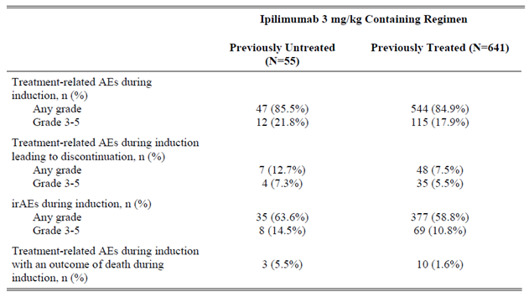
Comment: It is unclear from this table and summary how many patients are relevant to the proposed usage.

All adverse events during the induction period
Nearly all subjects reported at least one AE during induction regardless of relationship to study therapy (previously untreated 98.2%, previously treated 98.1%). A summary of all AEs reported in at least 5% of subjects in any group is presented in Table 31. Grade 3 to 4 AEs were similar (40.0% previously untreated, 41.7% previously treated), of which Grade 3 events were of similar incidence (32.7% previously untreated versus 34.8% previously treated). Grade 4 events were also similar between groups (7.3% and 6.9%, respectively).
Comment: There were numerical differences (and many similarities) observed between comparator groups. The differences were deemed by the sponsor as not ‘clinically relevant’. It is unclear how the sponsor justifies this, as the same conclusion could also be made for the similarities. It is difficult to make any conclusions on the comparison of the safety data provided given that the previously untreated group contained both patients administered monotherapy and combination therapy. It is also impossible to make conclusions based on comparisons comparing 55 previously untreated patients with 641 previously patients.

Table 31: Summary of adverse events (at least 5%) during induction by prior systemic anti-cancer therapy – treated subjects
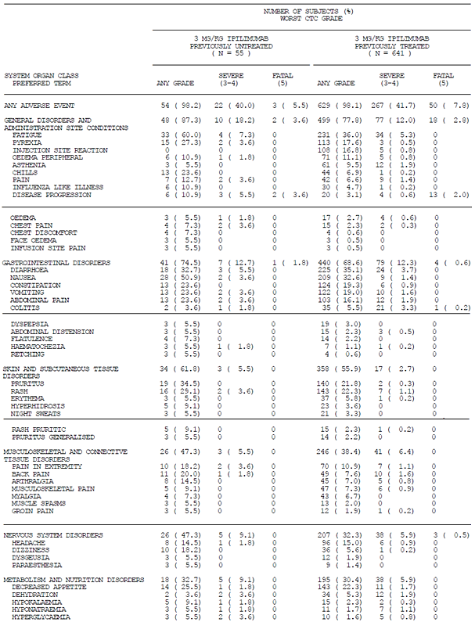

Table 31 (continued): Summary of adverse events (at least 5%) during induction by prior systemic anti-cancer therapy – treated subjects
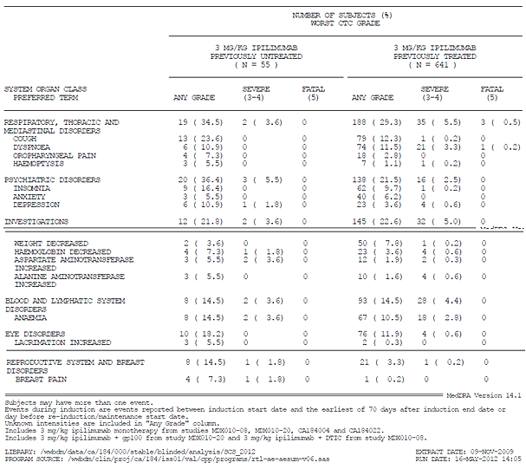
The most common Grade 3 to 4 events (reported in ≥ 5% of subjects in either population) were fatigue (7.3% previously untreated; 5.3% previously treated), disease progression (5.5% previously untreated; 0.6% previously treated), and diarrhoea (5.5% previously untreated; 3.7% previously treated). There were more injection site reactions of any grade reported in the previously treated group due to the use of gp100 in MDX010-206. The previously untreated group has more subjects with any grade: fatigue, pyrexia, chills, nausea, pruritus, back pain, dizziness, and cough.
Comment: The clinical interpretation of the previous paragraph is challenging without reference to source data. The reference to the Appendices A2.3A and A2.3B, demonstrate that these list MedDRA preferred terms, such that (as examples);
- diarrhoea, colitis, diarrhoea haemorrhagic, colitis microscopic, enteritis etcetera
- haematochezia, GI haemorrhage, rectal haemorrhage, gastric haemorrhage, haematemesis, intestinal haemorrhage, lower GI haemorrhage etcetera
- under general disorders: mucosal inflammation, inflammation
- under gastrointestinal disorders: aphthous stomatitis, mouth ulceration, oesophagitis, oral pain, stomatitis, tongue ulceration, gastritis, gastritis haemorrhagic, gingival pain, lip ulceration
- under respiratory disorders: oropharyngeal pain etc.
Are all Separate listings according to the preferred terms?
Thus, though the text reports the incidence of a single preferred term accurately, it is unclear how frequent events are if these were collated in a clinically relevant manner. It is also unclear what is being described in the text without reference to the Appendices.
The sponsor is requested to perform an analysis whereby the events (though described by different clinical preferred terms) are collated in a clinically meaningful way, are summarised, and represented in text and tables as an updated version of the data for the patient population relevant to the proposed usage.
Similar findings were demonstrated when populations were stratified according to previous chemotherapy exposure.

Analyses of exposure-adjusted AEs including multiple occurrences of unique events occurring during induction
The sponsor writes that the analyses of exposure adjusted irAEs, including multiple occurrences of unique events occurring during induction in treated subjects, do not reveal any clinically relevant safety differences.
The incidence rate of any AEs (event/100 person-years) was 3,709.2 events/100 person-years in the previously untreated group and 2,739.2 events/100 person-years in the previously treated group.
The incidence rate of any irAEs (event/100 person-years) was 471.1 events/100 person-years in the previously untreated group and 381.2 events/100 person-years in the previously treated group. The most common irAEs involved the skin (258.4 versus 189.7) and GI (162.1 versus 145.3) systems in previously untreated and previously treated subjects respectively. While there is a numerical difference in the incidence rate of irAEs in these systems, the differences are inconsistent among individual events (for example, rash: 91.2 versus 62.6; diarrhoea: 91.2 versus 114.5, previously untreated versus previously treated).
An analysis of the number of subjects who reported 1, 2 to 3, or ≥ 4 irAEs showed that most individual irAEs were uncommon and rarely occurred in the same subject more than once. Diarrhoea and rash were the only irAEs reported two or more times in the same subject for ≥ 5% of subjects in any group.
Comment: The clinical interpretation of the previous paragraph is not clear if preferred terms were used for this analysis. The previous comment applies to this situation. Can the sponsor please re do the analysis focusing on the patient population relevant to the proposed usage if preferred terms were not meaningfully collated?
Similar findings were demonstrated when populations were stratified according to previous chemotherapy exposure.

Treatment related adverse events during the induction period
The incidence of any grade treatment related diarrhoea was similar between previously untreated and previously treated groups; however, any grade treatment related rash and pruritus were numerically higher in the previously untreated subjects compared to previously treated subjects (rash: 25.5% versus 18.7%; pruritus: 30.9% versus 18.1%, respectively). However, the incidence of severe skin irAEs was low and similar in both groups. Other treatment related AEs of any grade reported more frequently in the previously untreated group were fatigue, pyrexia, chills, and nausea; however, these differences are not clinically meaningful. Any grade treatment related injection site reaction was numerically higher in the previously treated group, which is possibly due to gp100 exposure in this population. Grade 3 to 4 events were reported for 20.0% and 16.5% of previously untreated and previously treated subjects, respectively. In most cases, these events were Grade 3 in severity (12.7% and 15.0%, respectively), with few reports of Grade 4 events (7.3% and 1.6%, respectively).
Similar findings were demonstrated when populations were stratified according to previous chemotherapy exposure.

Deaths; induction period
A total of 5 out of 55 (9.1%) subjects in the previously untreated group and 132 out of 641 (20.6%) subjects in the previously treated group died during the induction period (all deaths reported between the induction start date and the earliest of 70 days after induction end date or the day before re-induction/maintenance/cross over start date), mostly due to disease progression/malignant disease. The difference in death rate between groups may be due to the small number of subjects who died in the previously untreated group, or possibly related to the natural history of previously untreated versus treated subjects consistent with the assumption that previously treated subjects have more advanced or aggressive disease. There were 9 (6.4%) and 128 (23.1%) deaths during induction in the chemotherapy naïve and chemotherapy pre-treated groups, respectively. Most of these deaths were due to disease progression/malignant disease.
This analysis identified 16 treatment related deaths among the 696 subjects who received ipilimumab 3 mg/kg in the four studies pooled for these analyses:
- 12 in MDX010-20 (8 in the ipilimumab + gp100 group and 4 in the ipilimumab monotherapy group)
- 1 in CA184004
- 1 in CA184022
- 2 in MDX010-08 (the 2 deaths in MDX010-08 were identified in the final MDX010-08 clinical study report
Of the 16 treatment related deaths, 3 (5.5%) were in previously untreated subjects and 13 (2.0%) were in previously treated subjects. The sponsor writes, that;
‘Although the number of treatment related deaths was numerically higher in the previously untreated group, the difference in frequency is not clinically relevant since:
- there was a comparable incidence of treatment related deaths in the larger analysis between chemotherapy naive and chemotherapy pre-treated subjects
- of the 3 deaths in previously untreated subjects, 1 was confounded by disease progression complicated by hypersensitivity/vascular collapse due to recent chemotherapy and a second by coincident sepsis/pulmonary embolus and
- there were no drug related deaths in 247previously untreated subjects who received a higher dose (10 mg/kg ipilimumab) in CA184024.’
Comment: The sponsor concludes that differences in the numbers are not ‘clinically relevant’ based on a small number of observations. It is unclear how the sponsor can justify this conclusion given the limited number of observations and the uncontrolled comparison of deaths from one posology to another.
Seven of the 16 treatment related deaths occurred in subjects who received 3 mg/kg ipilimumab monotherapy Overall, in the smaller subsets of subjects who received ipilimumab 3 mg/kg monotherapy, the rates of treatment related deaths ranged from 2.0% to 5.8% (2 out of 34 (5.8%) in previously untreated subjects, 5 out of 247 (2.0%) in previously treated subjects, 2 out of 75 (2.7%) in chemotherapy naive subjects, and 5 out of 206 (2.4%) in chemotherapy pre-treated subjects). Treatment related deaths are presented below in Table 32.

Table 32: Summary of treatment related deaths for pooled 3 mg/kg safety analysis according to pre-treatment status but not according to monotherapy
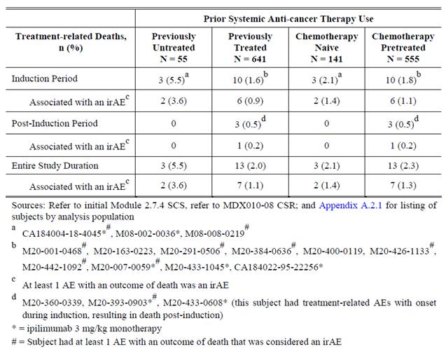
Comment: It is unclear how many patients within the previously untreated population are directly relevant to the proposed usage.

Adverse events during the induction period leading to discontinuation of study drug
The frequency of subjects with any grade treatment-related AEs during induction leading to discontinuation of study treatment was numerically higher in the previously untreated group compared to the previously treated (12.7% versus 7.5%, respectively) group. Grade 3 to 4 treatment related AEs leading to discontinuation were similar in the previously untreated versus the previously treated group (7.3% versus 5.0%, respectively).
Similar findings were demonstrated when populations were stratified according to previous chemotherapy exposure.

Immune-related adverse events (irAEs)
An irAE was defined as an AE that is;
- Consistent with an immune phenomenon; and
- Considered related (possibly, probably, or definitely) to study drug by the investigators or with unknown causality.
The irAEs were identified by a pre-defined list of MedDRA (version 14.1) preferred terms (PTs) of all possible ipilimumab related AEs based on clinical program wide experience. Immune related AEs are programmatically derived from treatment related AEs. The incidence and severity of irAEs are presented. Overall irAEs, as well as six irAE organ specific subcategories (GI, hepatic, endocrine, skin, neurological, and other) are presented.
The overall incidence of any irAEs reported during induction was 63.6% in the previously untreated and 58.8% in the previously treated groups. The incidence of Grade 3 to 4 irAEs was 12.7% (Grade 3, 9.1%; Grade 4, 3.6%) and 10.0% (Grade 3, 9.0%; Grade 4, 0.9%) in the previously untreated and previously treated groups, respectively. There was 1 (1.8%) previously untreated subject and 5 (0.8%) previously treated subjects with a Grade 5 (fatal) irAE.
For each analysis according to organ specific subcategories, the sponsor notes no clinically meaningful differences between groups according to treatment status.

Infusion reactions
Potential infusion reactions were identified based on a search of the clinical database for the pooled analysis for MedDRA high level terms and preferred terms. This analysis was previously performed for the initial submission without preferred terms of hypersensitivity and drug hypersensitivity. Each event was reviewed for its temporal association with study drug administration and for any contemporaneous additional AE or SAE information. Likely systemic infusion reactions were subsequently defined as any event from the listing that occurred within 48 hours after the subject received study treatment. The discussion in this summary will focus on likely systemic infusion reactions of ≥ Grade 2.
In the pooled analysis for this summary, a total of 12 subjects (MDX010-20: 8 subjects, MDX010-08: 2 subjects, CA184004: 1 subject, and CA184022: 1 subject) were identified with potential infusion reactions at the ipilimumab 3 mg/kg dose. Of these 12 subjects, and after clinical assessment of these events, a total of 5 subjects were identified as having a likely ≥ Grade 2 infusion reaction to an ipilimumab-containing study treatment (MDX010-20: 4, CA184004: 1).
In MDX010-20, 1 subject received ipilimumab 3 mg/kg monotherapy and 3 subjects received ipilimumab 3 mg/kg + gp100 (all 4 subjects were in the previously treated, prior chemotherapy populations). Only 1 (in the ipilimumab 3 mg/kg + gp100 group) of these 4 subjects had likely Grade 3 infusion reactions (1 occurrence each on Study Days 22 and 64). In CA184004, the 1 subject with a likely infusion reaction to ipilimumab study treatment received ipilimumab 3 mg/kg monotherapy (previously treated, prior chemotherapy). All of the likely infusion reactions, including the Grade 3 events, were transient and resolved on their own or after appropriate treatment; the rest of the likely infusion reactions were ≤ Grade 2.
Thus, in the studies in advanced melanoma assessed for potential infusion reactions for this summary, of the 696 subjects who were treated with ipilimumab 3 mg/kg monotherapy or in combination with gp100 or DTIC (MDX010-20 = 511, MDX010-08 = 74, CA184004 = 40, and CA184022 = 71) a total of 5 subjects (5 out of 696, 0.7%) (MDX010-20: 4 subjects, CA184004: 1 subject) had ≥ Grade 2 events likely to be infusion reactions.

Investigations
For haematology and serum chemistry parameters, the sponsor did not identify significant differences in frequency or grade of AEs between groups, according to treatment status. There were no potential DILI cases in subjects who received ipilimumab 3 mg/kg, as reported in the initial submission. No new data are available.

Subgroup analyses for MDX010-20
Subgroup analyses for safety (irAEs and Grade 3 to 5 irAEs; overall and by subcategory) during the induction period in MDX010-20 for all subjects treated with a ipilimumab containing regimen (either ipilimumab 3 mg/kg or ipilimumab 3 mg/kg + gp100) were performed for the following intrinsic factors: prior use of DTIC (yes/no), prior use of chemotherapy (yes/no), prior use of immunotherapy (yes/no), line of therapy (study drugs as second line, study drugs as third+ line), number of prior therapies (1, > 1).
‘For each of these factors, the safety profile of the pooled ipilimumab containing regimens was similar between subgroups, except for any grade skin irAEs. Subjects who received prior therapy seemed to have less skin irAEs than subjects without prior therapy. Some numerical differences were observed among subgroups; however, sometimes the small sample size and/or the small number of events limit the interpretability of some of these comparisons. These numerical differences are not clinically meaningful.’
Similar safety was observed in the subgroup analysis for prior immunotherapy, although the skin irAEs also showed somewhat higher frequency in the no prior immunotherapy category (36.3% in prior immunotherapy; 43.0% in no prior immunotherapy). For Grade 3 to 5 irAEs, similar safety was observed between subgroups.
Comment: The previous comments on the imbalanced numbers in each comparator group also apply to this subsection.

Post marketing experience
‘The estimated number of patients exposed during the period referenced above is 5,532 including previously untreated advanced melanoma (United States). The safety profile was similar to the profile established during clinical trials and no new major safety concerns were identified.’
Thus, in summary, the sponsor provided a pooled analysis of safety for studies utilising 3 mg/kg ipilimumab (monotherapy and in combination) and reported no clinically meaningful differences in safety between groups according to pre-treatment status. The small numbers of patients in the relevant group for the proposed indication, the imbalance of numbers between comparator groups, the different populations that were pooled, and the different treatments being investigated limit any conclusions that can be drawn about the safety of ipilimumab for the proposed usage.

Pivotal studies that assessed safety as a primary outcome
There were no relevant studies submitted.

Patient exposure
Note should be made of the proposed usage being for ipilimumab 3 mg/kg monotherapy and the external validity (relevance of the evidence) of the majority of listed studies in Table 33and Table 34.

Table 33: Exposure to ipilimumab and comparators by patient numbers in clinical studies
Study type/Indication | Controlled studies |  |  | Uncontrolled studies | Total Ipilimumab
Study type/Indication | Ipilimumab | Ipilimumab with Carboplatin/Paclitaxel | Ipilimumab with DTIC | Ipilimumab | Total Ipilimumab
Clinical pharmacology | 20 | 20 | 19 | - | 59
Ipilimumab 3mg/kg
Monotherapy  +peptide | -  25 | -  - | -  - | 120  - | 145  -
Subtotal Indication 1 | 25 |  |  | 120 | 145
Ipilimumab 10mg/kg
+DTIC  Monotherapy  Plus peptide  +steroids | -  26  25  72 |  | 247  -  -  - | -  830  -  - | 247  856  25  72
Subtotal Indication 2 | 123 |  | 247 | 830 | 1200
TOTAL | 168 | 20 | 266 | 950 | 1404

Table 34: Patient exposure to ipilimumab in clinical studies according to dose and duration
Note should be made that analysis was limited to the induction (3month) period only for some studies.
Study type/ indication | Induction | Maintenance
Study type/ indication | ≥ 3 mo. | ≥ 6 mo. | ≥ 12 mo. | Any duration
Clinical pharmacology | 59 | 0 | 0 | 59
Ipilimumab 3mg/kg
Monotherapy + peptide | 25 | 0 | - | 25
Active-controlled
Uncontrolled | 120 | - | - | 120
Subtotal Indication 1 | 145 | - | - | 145
Ipilimumab 10mg/kg
With DTIC | 247 | 43 | - | 247
Monotherapy vs. with steroids | 72 | 13 | - | 72
Monotherapy  With peptide  Uncontrolled | 26  25  830 | 6  6 | -  - | 26  25  830
Subtotal Indication 2 | 1200 | 68 | - | 1200
TOTAL | 1404 | 68 | - | 1404

Adverse events

All adverse events (irrespective of relationship to study treatment)
As previously detailed; ’no pivotal study was submitted in support of the proposed usage. The majority of studies within this application provided limited relevant evidence. Thus, the majority of the safety data from these studies also provide limited relevant data.’
Safety review of the submitted studies has identified a number of uncertainties regarding the accuracy of the source safety data and subsequent analyses from these sources. Overall, the uncertainties regarding the safety data for all studies refer to;
- The appropriate documentation of AEs
- The grading of AEs
- The allocation of causality for AEs
- The summarised data is limited due to the two previous points and the text does not comprehensively summarise clinically meaningful information
- The presentation of data appears to minimise the frequency of clinically meaningful safety data, through the use of MedDRA preferred terms which are highly specific (in comparison to considering higher level terms, collapsing terms or summating the data in a meaningful way)
- Specific pertinent examples of deficiencies include the apparent incorrect documentation of Grade 5 events (representation on tables, reporting, and allocation of causality), GI perforations, GI toxicity in general, hepatotoxicity, and a case of G4 optic neuritis (CA184078).
Thus as the accuracy of source data is uncertain, the accuracy of subsequent analyses are also uncertain. Resultantly, the sponsor has not adequately presented safety data in a manner that facilitated the assessment of the drug safety. Questions to the sponsor will focus on pertinent cases and those relevant to the proposed indication.’
The cases listed here do not represent an exhaustive collation of all noted discrepancies but serve to illustrate the issues discussed.

CA184024

AE classification on summary tables is unclear

Example 1. The frequency of liver related irAEs cannot be verified
On manual inspection of the SAE narratives, there seems to be at least 17 Gr3/4 events of hepatitis which differs to that captured in the ‘hepatobiliary disorders’ category (provided in Table 8.5.2.2) ‘Summary of On-study Liver irAEs; Treated Subjects’ which indicates only 15 Gr 3/4 events. Manual identification of AEs is not likely to comprehensively capture all events. Below lists the patient identifier (note the patient identifier has been redacted) for the G4 and G3 liver toxicity events manually identified from the narratives, with ‘yes’ indicating that the investigator attributed causality to the study treatment;
Grade 4 hepatitis:
- CA184024-[information redacted] yes
- CA184024-[information redacted] yes
- CA184024-[information redacted] yes
- CA184024-[information redacted] yes
- CA184024-[information redacted] yes
- CA184024-[information redacted] yes
- CA184024-[information redacted] investigator annotated ‘autoimmune event’ not liver related; yes
- CA184024-[information redacted] yes
- CA184024-[information redacted] yes
- CA184024-[information redacted] yes
- CA184024-[information redacted] yes
- CA184024-[information redacted] yes
Total G4 events = 11 episodes, +/- 1
G3 hepatitis:
- CA184024 - [information redacted] no comment re: causality but listed as irAE
- CA184024 - [information redacted] yes
- CA184024 - [information redacted] no comment but listed as irAE
- CA184024 - [information redacted] yes
- CA184024 - [information redacted] yes
- CA184024 - [information redacted] yes
Total G3 events = 6 cases.
The total is at least 17 G3/4 liver irAEs. This does not match up with the numbers in the Table 8.5.2.2 category ‘hepatobiliary disorders’ where hepatitis is captured that appears to indicate a total of 15 Gr3/4 events.

Example 2 – The frequency of GI toxicity is unclear and apparently discordant
- In Table S6.2 ‘Intensity of On-Study Adverse Events; 10 mg/kg + dacarbazine Treated Subjects’, has one Gr1 ‘GI haemorrhage’ event, but has separately listed two Gr1 ‘rectal haemorrhage’, one G4 ‘intestinal haemorrhage’ and one Gr3 ‘large intestinal haemorrhage’. Under vascular disorders there is one listing of one Gr2 ‘haemorrhage’ not otherwise specified.
- In the Table S.6.5 ‘Intensity of On-Study Serious Adverse Events; 10 mg/kg + dacarbazine Treated Subjects’ lists one Gr3 large intestinal haemorrhage under gastrointestinal disorders.
- However, inspection of Table S6.4.6 ‘Intensity of On-Study Serious Inflammatory Events regardless of causality; 10 mg/kg + dacarbazine Treated Subjects’ lists only one event of Gr 3 ‘large intestinal haemorrhage’.
- In Appendix 6.26 ‘Summary of On-Study Serious Inflammatory Events regardless of Causality; Treated Subjects’ lists one Gr3/4 large intestinal haemorrhage.
- Appendix 6.42 ‘Summary of On-Study Inflammatory Events regardless of Causality; Treated Subjects’ reports similar findings to Table S6.2.
Whilst it is noted that the first table lists ‘AEs’ and the latter two tables list ‘Serious’ AEs, each table captures all grades of AEs and the reason for differences is unclear.

Example 3 – the number of events of diarrhoea is unclear
The total number of Gr3/4 events of diarrhoea was reported for this study as 12. On manual inspection of the narratives (which will not comprehensively capture all events), the number of cases found is as follows;
G3/4 diarrhoea events listed (11 on manual inspection)
CA184024-[information redacted], CA184024-[information redacted], CA184024-[information redacted], CA184024-[information redacted], CA184024-[information redacted], CA184024-[information redacted], CA184024-[information redacted], CA184024-[information redacted], CA184024-[information redacted], CA184024-[information redacted], CA184024-[information redacted].
However, inspection of the narratives demonstrated the following questions that are listed below (with most being described in more details within this section from Case 10 onwards);
- CA184024-[information redacted]: was graded as Gr2 but was hospitalised for the diarrhoea. Is this grading correct?
- CA184024- [information redacted] This patient is reported within the narrative to have had diarrhoea up to 18 times per day but no event of diarrhoea is listed. Proctitis is listed, as an event but not as an imAR. This issue demonstrates the need for clarification of what is being consistently captured. (This case is discussed further below)
- CA184024-[information redacted] had G3 proctocolitis documented in the summary list, but the narrative also includes G3 diarrhoea which is not listed.
- CA184024-[information redacted] has both Gr 3 colitis and Gr3 diarrhoea described in the narrative but only Gr3 colitis is annotated. This patient is included above.
- CA184024-[information redacted] was hospitalised for diarrhoea but had the event only graded as Gr2 (described below)
- CA184024-[information redacted] was hospitalised for diarrhoea and colitis but grading does not reflect this
- CA184024-[information redacted] was hospitalised for a two month history of diarrhoea but is not reflected as Gr3.
Thus, how many G3/4 events of diarrhoea occurred is not clear.

The grading of AEs
In this section to assist the reader the evaluators comments within the text are tialicised.
The grading of AEs annotations of AEs and attribution of causality are unclear.
- Case 1: Causality of death is not reported as study drug related when it appears to be possible.
CA184024-[information redacted] died within days of the first dose and causality was not attributed to the study drug, although it appears it may be related. The narrative describes G3 liver AEs on Day 2 as the only event preceding hospitalisation which could account for the sudden deterioration of the patient, as no other cause is identified. Given the rapid deterioration in LFTs within 1 day of dosing, possibility of study drug related death here is highly suspicious. Can the sponsor please clarify this?
The renal dysfunction, altered mental state, hyperkalaemia and elevated ammonia were not captured as AEs. Can the sponsor please explain why? Were these events captured?
‘General Medical History: Accidental shot right leg 1967, alcohol moderate use, smokes 20 cigarettes per week, nil other hepatotoxic meds.
ECOG PS 1.
Event:
- Disease progression (Grade 5, not likely related, Day 7)
imAR:
- Hepatitis (Earliest onset any Grade: Day 2, Worst Grade: 3)
A baseline spiral CT, Day - 7, showed multiple liver lesions.
On Day 2 of the study laboratory results showed an adverse event of alanine aminotransferase (ALT) increased (Grade 3) and aspartate aminotransferase (AST) increased (Grade 3). On Day 7, 6 days post 1st dose of study therapy, the subject was hospitalised for constitutional symptoms or deteriorating general condition. He developed worsening of symptoms after hospitalisation with an ECOG score of 3 to 4 and increased liver enzymes. A microbiology test was performed on the same day was negative.
His general condition deteriorated while hospitalised but appeared to be stable after analgesic adjustments. A slight fever was also noted. An elevated CRP (C-reactive protein) to 400 mg/L (normal range 0 to 10 mg/L) was also seen with no growth in blood culture. A chest X-ray showed right side pleural fluid without any indications of definite pneumonia. Further, deterioration of kidney function (creatinine level of 365 µmol/L; baseline: 83 µmol/L), increased clouded mentality, hyperkalaemia (7.6 mmol/L; normal: 4.1 to 5 mmol/L, baseline: 4.6 mmol/L), and elevated ammonia (120 unit not available) were also reported. He expired on Day 11 due to disease progression leading to multi organ failure. The event of hepatitis was continuing at the time of death. An autopsy was not performed.
- Case 2 – Incomplete documentation of imAR events, unclear grading of AE, AEs in narrative not listed in a narrative containing clinically significant events.
CA184024-[information redacted]: imAR diarrhoea was documented as only Gr 2 despite repeated hospitalisation, repeated colonoscopy, recurrence of symptoms with weaning of corticosteroids, and requirement for TPN. Worst grade severity of diarrhoea has not been documented for a number of episodes correctly. Hypokalaemia was not captured. Can the sponsor please explain these discrepancies?
“Event:
- Diarrhoea (Grade 3, certainly related, Day 53)
- Escherichia infection (Grade 3, possibly related, Day 53)
- Colitis (Grade 2, certainly related, Day 55)
- Diarrhoea (Grade 2, certainly related, Day 67) but patient was hospitalised on Day 68 due to this and administered IV corticosteroids. Hospitalisation is G3.
- Diarrhoea (Grade 2, certainly related, Day 75) but patient was hospitalised, required a colonoscopy on Day 77
- Diarrhoea (Grade 3, certainly related, Day 85) due to tapering of the steroids diarrhoea reoccurred and the patient required IV corticosteroids (imAR incorrectly graded)
- Diarrhoea (Grade 1, certainly related, Day 100) again due to tapering of steroid, required hospitalisation and TPN, toxicity incorrectly graded.
  - Not documented - Day 110 (08-October-2007), she had an increase in diarrhoea to eight times per day during the admission for the previous dot point which constitutes G3 diarrhoea at least. This required an increase in corticosteroid dosing and treatment with Infliximab.
imAR:
- Diarrhoea (Grade 2, certainly related, Day 67); this is incorrectly graded.
- Dermatitis (Grade 2, certainly related, Day 49)
On Day 48, 5 days after the 3rd dose of study therapy, the subject experienced diarrhoea (Grade 1) consisting loose stool two to three time a day. She received unknown treatment for the event. On Day 49 the subject presented with grade 2 dermatitis (investigator reported term itching and rash). On the evening of Day 53, the subject had four episodes of diarrhoea and was diagnosed with Escherichia infection (Grade 3). The severity of diarrhoea increased to Grade 3 on Day 53. On Day 54, she was hospitalised due to diarrhoea and was treated with hydration and 125 mg of methylprednisolone. She was afebrile and there was no blood in her stools. On Day 55, the dermatitis was downgraded to grade 1 and she was diagnosed with colitis (Grade 2) by a colonoscopy procedure which revealed inflammatory colitis with marked colitis changes up to the 50 cm of descending colon. Stool cultures done on were positive for Clostridium difficile. She was diagnosed with Clostridium difficile infection (Grade 3) and treated with metronidazole. On Day 56, diarrhoea was still persisting, but her bowel sounds were good and she remained afebrile. She was also started on intravenous steroids, which subsequently switched over to oral steroids. On Day 58, the events of diarrhoea, Escherichia infection and Clostridium difficile infection were considered as resolved. The event of colitis and dermatitis both resolved on Day 62.
On Day 67, she had again five episodes of diarrhoea (Grade 2). On Day 68, she was hospitalised with no pyrexia, no blood in stool, and not dehydrated. Treatment included methylprednisolone 125 mg QD intravenously. On Day 70, she was discharged from the hospital with Grade 1 diarrhoea; the event was reported to be resolved with sequelae on the same day. She was discharged with 80 mg prednisolone BID.
On Day 75, she was readmitted with diarrhoea (Grade 2) of 4 to 5 episodes daily, which required treatment with solumedrol (continuation 80 mg prednisolone BID). The recurrence of diarrhoea (Grade 2) was described as sometimes watery/firm. There was no blood in the stool and her hydration status was good. Laboratory results on Day 76 showed potassium level 2.6 mmol/L (baseline 4.1; normal 3.5 to 5). A colonoscopy performed on Day 77 revealed that the intestinal mucosa was not friable and did not bleed on touch, hyperaemia proximally with a good improvement and colitis was getting better, which indicated a better improvement from the previous colonoscopy done on Day 55. She was discharged on Day 79, with prednisolone 80 mg BID tapering over a month. Upon tapering of steroids, diarrhoea reoccurred. On Day 85, the subject again experience diarrhoea (Grade 3) and her potassium level was 3.1 mmol/L. She received methyl prednisone 125 mg intravenously. Since Day 91, prednisolone therapy was reduced to 80 mg daily. On Day 92, she was discharged with Grade 1 diarrhoea. After being discharged from the hospital, she was tapering off of prednisolone therapy from 80 mg daily to 60 mg daily. Subsequently, the diarrhoea increased from once daily to three times daily. On Day 100, she was hospitalised again with Grade 1 diarrhoea. At that time, she was treated through total parenteral nutrition (TPN). After one week of TPN, her condition remained unchanged. On Day 110, she had an increase in diarrhoea to eight times. The prednisolone dose was increased to 80 mg/day on Day 111. A computed tomography (CT) and colonoscopy were performed on Day 113. The colonoscopy showed further improvement when compared to the last colonoscopy performed. Endoscopy description reported that there were slight changes over the entire colon, granulated mucosa but not haemorrhagic and no longer oedematous. There were no ulcerations and no fibrin. There was continued haustration and fine capillary bed under granulations. She was started on budesonide and loperamide and had one dose of infliximab 280 mg. She was discontinued from the study on Day 55 due to the events of diarrhoea, Escherichia infection and colitis. She was discharged from the hospital on Day 114 with diarrhoea (Grade 1). The event of diarrhoea resolved on Day 169.
The investigator considered that the events of diarrhoea and colitis were certainly related and the event of Escherichia infection as possibly related to ipilimumab and dacarbazine study therapy.”
- Case 3 - grading of imARs are unclear for Gr4 elevated GGT.
CA184024-[information redacted], grade 4 GGT documented but the worst imAR annotated is G3. The imAR lists were only generated with G3 AST/ALT results. The sponsor does not clearly indicate where the rationale for the omission of elevated GGT for imARs was defined.
‘Event:
- Aspartate aminotransferase increased (Grade 3, not likely related, Day 66)
- Alanine aminotransferase increased (Grade 2, not likely related, Day 66)
- Gamma-glutamyl transferase increased (Grade 3, not likely related, Day 66)
- Alanine aminotransferase increased (Grade 1, not likely related, Day 70)
- Aspartate aminotransferase increased (Grade 1, not likely related, Day 80)
- Gamma-glutamyl transferase increased (Grade 4, not likely related, Day 80)
imAR:
- Hepatitis (Earliest onset any Grade: Day 45, Worst Grade: 3) Day 70 and Day 80 respectively. (Values were not available)
On Day 80, GGT level worsened to Grade 4 with a value of 1,125 U/L. He was hospitalised for treatment with IV prednisolone (dose not available) and further workup. On Day 92, GGT was noted to be 1,039 U/L (NR < 55 U/L). Disease progression with new brain and lung metastases was noted’
- Case 4- Inadequate details from investigator; possible study related AE resulting in death.
CA184024--[information redacted] The subject developed renal failure and was hospitalised 13 days post study dose with no other causes identified for the development of renal failure and subsequent death. Was the renal failure potentially related to study treatment? How was the disease progression determined?
‘Event:
- renal failure (Grade 3, not related, Day 14)
- renal failure (Grade 5, not related, Day 18).
On Day 14, 13 days post 1st dose of study therapy, the subject developed renal failure (Grade 3) and was hospitalised. Laboratory tests performed on Day 15 showed urea 277.4 mg/dL (normal: 17 to 43 mg/dL, baseline: 7.5 mmol/L, normal: 2.1 to 7.6 mmol/L), uric acid 14.7 mg/dL (normal: 3.2 to 7.6 mg/dL, baseline: 5.3 mg/dL), creatinine 2.3 mg/dL (normal: 0.72 to 1.3 mg/dL, baseline: 1.19 mg/dL). He was treated with sodium chloride solution and 5% glucose solution, furosemide, allopurinol, bicarbonate, metoclopramide, morphine, and hydroxyzine. Laboratory tests on Day 18, showed the following results: urea 392.2 mg/dL, uric acid 13.1 mg/dL and creatinine 4.8 mg/dL. He died due to renal failure and disease progression on Day 18. Autopsy details were not available. The investigator considered that the event of renal failure was not related to ipilimumab and dacarbazine study therapy.’
- Case 5 - Grade 4 event listed by investigator incorrectly. Was this missed as a Gr4 endocrine irAE?
CA184024--[information redacted]: no immune related endocrine AE listed although possible. Note is made that the investigator did not attribute causality. The Gr4 hypoglycaemic seizure occurred without history of diabetes or oral hypoglycaemic medications. The patient recovered with corticosteroids (and thyroxine replacement), and was subsequently confirmed to have subclinical hypothyroidism (low TSH but normal T3/T4). This hypoglycaemic event is highly suspicious for a study drug related autoimmune AE for which corticosteroid replacement was administered. No cortisol results were given by the investigator. What did the sponsor allocate as the cause of the Gr4 hypoglycemic seizure? Can the sponsor explain why the hypoglycemic event was not captured as an imAR? Was this because the investigator did not attribute the causality to the study drugs?
‘Event:
- Cholelithiasis (Grade 2, not related, Day 64)
- Hypoglycemic seizure (Grade 4, not likely related, Day 335)
- Endocrine disorder (Grade 2, probably related, Day 353)
- Endocrine disorder (Grade 1, probably related, Day 434)
- Hypoglycemic event (Grade 4, not related, Day 789)
imAR:
- Hepatitis (Earliest onset any Grade: Day 63, Worst Grade: 3)
- Dermatitis (Grade 2, not related, Day 71)
On Day 335, 82 days post 9th dose of study therapy, the subject was admitted to the hospital with a hypoglycaemic seizure (Grade 4). He was in a coma, and laboratory tests showed very low sodium and blood glucose levels (lab values not available). Intravenous fluids, levothyroxine and hydrocortisone were given as treatment for the event and study therapy was interrupted. On Day 336, a magnetic resonance imaging of the brain showed evidence of prominent right maxillary sinusitis and right ethmoid sinusitis, no abnormal post contrast enhancement, no suspicious space occupying lesions, no areas of demyelination and normal ventricles. On Day 337, hypoglycaemic seizure resolved and he was discharged from the hospital. He had no relevant medical history of diabetes and was not on any diabetic medication. On Day 353, his random glucose level was low at 3.9 µmol/L (normal: 4.1 to 7.7 µmol/L). On that same day, 100 days post 9th dose of the study therapy, the subject was diagnosed with endocrine disorder (Grade 2).’
- Case 6 - The summary narrative does not list a Gr4 irAE. Does this indicate it was accounted for?
CA184024-[information redacted]: Was the colitis listed as an imAR? It is not listed below as such but the narrative indicates that the reason for narrative was for a serious irAE. The listing only reads as:
‘Event:
- Diarrhoea (Grade 1), probably related, Day 472)
- Colitis (Grade 4, probably related, Day 482)
- Diarrhoea (Grade 3, probably related, Day 482)’
(No imAR category listed.)
- Case 7 - The investigator incorrectly annotates a Gr 4 AE/imAR. The sponsor annotates imAR appropriately. Are both events captured as listed? What was captured in the summary of imARs – both an ‘autoimmune disorder’ and ‘hepatitis’?
CA184024-[information redacted]: The investigator requested a SAE to be documented as an ‘autoimmune disorder’ AE but is clearly ‘hepatitis’. There are no other endocrine events described to account for the ‘autoimmune disorder’ and the narrative states that hyperbilirubinemia and transaminitis are documented as the ‘endocrine’ AE at the investigator’s request.
‘Event:
- Hyperbilirubinemia (Grade 3, certainly related, Day 63)
- Autoimmune Disorder (Grade 4, certainly related, Day 63)
- Pain in extremity (Grade 4, Not related, Day 82)
- Autoimmune Disorder (Recurrent) (Grade 3, certainly related, Day 118)
- Alanine aminotransferase increased (Grade 4, certainly related, Day 126)
- Alanine aminotransferase increased (Grade 2, certainly related, Day 133)
- Alanine aminotransferase increased (Grade 1, certainly related, Day 140)
imAR:
- Hepatitis (Earliest onset any Grade: Day 63, Worst Grade: 4)
- Dermatitis (Grade 2, certainly related, Day 25)’
- Case 8 –Documentation of a potential GI perforation is unclear, as well as cause of GI haemorrhage that is captured on the same day as Gr4 enterocolitis.
CA184024-[information redacted] was treated on the study arm. It is unclear from the narrative whether a perforated viscous was considered as a potential event as described within the narrative. No GI perforations were described for this study within the CSR. The patient is noted to have both grade 4 enterocolitis and the intestinal haemorrhage described on the same study day, although the investigator’s conclusion is noted. Anaemia is not captured. Did the patient have a perforation?
‘Event:
- Abdominal pain (Grade 3, not likely related, Day 66)
- Malaise (Grade 1, not likely related, Day 66)
- Hepatitis (Grade 3, probably related, Day 66)
- Intestinal haemorrhage (Grade 4, not likely related, Day 74)
imAR:
- Hepatitis (Earliest onset any Grade: Day 46 , Worst Grade: 3)
- Enterocolitis (Grade 4, not likely related, Day 74)
He developed an autoimmune hepatitis that was controlled with corticosteroids. An ultrasound of the liver was performed and revealed no liver metastases. He was started on levocetirizine dihydrochloride from Day 60 to Day 74, methylprednisolone (dose not available) on Day 68, which was switched over to prednisolone (dose not available) on Day 73. Prednisolone was stopped on the same day. During the hospital admission, he developed acute abdominal symptoms which appeared to be based on bleeding in the peritoneal cavity, possibly as a result of a metastasis in combination with a perforation haemorrhage. The investigator stated that the abdominal bleeding could have been caused because of prolonged clotting times for which the subject was taking acenocoumarol.
On Day 74, 28 days after the 3rd dose of study therapy, he was diagnosed with intestinal haemorrhage (Grade 4). The activated partial thromboplastin time was 42 seconds (Normal Range 0 to 40 seconds) and prothrombin time was 76 seconds (normal and baseline values are not available). His treatment included potassium chloride from Day 68, hydrocortisone from Day 75 to Day 78, and flucloxacillin sodium from Day 77 to Day 81. He also received prothrombin on Day 74, gentamicin sodium on Day 74, metronidazole on Day 74, ceftriaxone sodium from Day 74 to Day 80, red blood cells from Day 74 to Day 75, meperidine on Day 74, plasma fresh frozen on Day 74, 10 mg prednisolone from Day 79 to Day 110, and phosphate on Day 81. On Day 75, explorative surgery took place find the extension and cause of the bleeding. During the explorative laparotomy, three liters of blood were removed and it appeared that the bleeding was successfully stopped. A biopsy of the haemorrhage showed no indication of metastasis. At the last computed tomography (CT) scan assessment; there was an indication of an increase in the metastases by 24%. The event of intestinal haemorrhage and pain abdomen resolved on Day 75. The study therapy was discontinued due the event of hepatitis. The event of malaise resolved on Day 82. On Day 186, his lab values continued to be normal (values not available) and further treatment was not required. The event of hepatitis resolved on Day 186.
The investigator considered that the event of hepatitis was probably related and events of abdominal pain, malaise and intestinal haemorrhage were not likely related to the ipilimumab and dacarbazine study therapy.’
- Case 9 – Gr3 proctocolitis requiring diversion colostomy suspicious for irAE with chronic inflammation on biopsy. Corticosteroids were not used although this AE was highly suspicious for an irAE.
CA184024-[information redacted]
In addition to above, diarrhoea and weight loss was not captured.
‘Event:
- Proctocolitis (Grade 3, Not likely related, Day 638)
- Pulmonary Embolism (Grade 5, Not related, Day 667)
imAR:
- Hepatitis (Earliest onset any Grade: Day 83, Worst Grade: 2)
On Day 562, the subject was diagnosed with diarrhoea (Grade 1). On Day 638, 56 days post 13th dose of study therapy, the subject experienced diarrhoea Grade 3 and developed severe rectal pain. He has had a weight loss of thirty to forty pounds (timeframe unknown). He also developed severe rectal fissures, worsening problems with hemorrhoids, and had severe rectal pain on an intermittent basis because of the unrelenting diarrhoea. The subject was hospitalised on the same day and was diagnosed with proctocolitis (Grade 3). Treatments of metronidazole and loperamide were unsuccessful. On Day 639, the subject underwent a loop diverting sigmoid colostomy with biopsy of the anorectal tissue to palliate his symptoms. The (biopsy) revealed benign anal mucosa with chronic inflammation and focal parakeratosis, anal polyp and no evidence for malignancy. The subject was discontinued from the study due to the event proctocolitis.’
- Case 10 –It is unclear if enterocolitis was captured as an AE. It is unclear if the patient required an admission to the hospital for the biopsy that confirmed this diagnosis (Gr 3). Given the sponsor’s definition, if hospitalisation was required for investigation and management of a drug related AE, then hospitalisation for the colonoscopy should be captured as an Gr 3 SAE.
CA184024-[information redacted] appears to not have colitis captured. This patient had a biopsy proven colitis. It is unclear if the event was only Gr1 to 2 as presumably the patient had to be hospitalised for the biopsy. Note is made however that no treatment was required nor alteration to the study drug.
‘Event:
- Supraventricular tachycardia (Grade 3, not related, Day 67)
- Pyrexia (Grade 2, not related, Day 67)
- Hypersensitivity (Grade 2, probably related, Day 130)
- Hernia pain (Grade 3, not related, Day 182)
- Anemia (Grade 1, not related, Day 193)
imAR:
- Diarrhoea (Grade 2, probably related, Day 96)
On Day 96, of the study the patient presented with Grade 2 enterocolitis (investigator reported term diarrhoea). No treatment was given and no action was taken on study drug as a result of the event. A biopsy was done on Day 100 revealed acute colitis. Grade 1 colitis was reported to have started on Day 100. No treatment was given for colitis and there was no action taken regarding study therapy. The investigator considered the events of diarrhoea and colitis as probably related to study therapy. Both events resolved on Day 105.’
- Case 11-Pancolitis is not listed as an AE or imAR.
CA184024-[information redacted] this patient had pancolitis but this is not listed as an event.
‘Event:
- Fracture (Grade 2, not related, Day 29)
- Diarrhoea (Grade 3, certainly related, Day 75)
imAR:
- Diarrhoea (Grade 3, certainly related, Day 75)
On Day 70, 5 days post 4th dose of study therapy, the subject experienced diarrhoea (Grade 2). Two days later, on Day 72, he also experienced nausea and vomiting. On Day 75, 10 days post 4th dose of study therapy, he was hospitalised for diarrhoea (Grade 3). He complained of 10 to 20 stools per day with a little amount of blood. His general condition was stable. He was started on intravenous fluids and steroids (prednisolone, dose unknown). On Day 76, a colonoscopy was performed which revealed no active bleeding and no metastases. However, it showed pancolitis. He was started on codeine. On Day 79, the therapy with prednisolone was switched over to methylprednisolone (dose not available). He was discontinued from the study due to the event. The event of diarrhoea was considered resolved with sequelae on Day 88 by the investigator. Grade 2 diarrhoea occurred from Day 88 to Day 89 and Grade 1 occurred from Day 89 and remained ongoing.
The investigator considered that the event of diarrhoea was certainly related to ipilimumab and dacarbazine study therapy.’
- Case 12; It is unclear if the patient was hospitalised for an investigation (this would be defined as a Gr3 SAE).
CA184024-[information redacted] It is unclear if this patient was admitted for the colonoscopy, thus the grading of colitis is uncertain.
‘Event:
- Colitis (Grade 2, certain related, Day 33)
- Colitis (Grade 1, certain related, Day 45)
- Alanine aminotransferase increased (Grade 3, probably related, Day 62)
- Aspartate aminotransferase increased (Grade 3, probably related, Day 62)
imAR:
- Hepatitis (Earliest onset any Grade: Day 43 , Worst Grade: 3)
- Colitis (Earliest onset any Grade: Day 33 , Worst Grade: 2)
On Day 33, 11 days post 2nd dose of study therapy, the subject experienced diffuse abdominal pain and was diagnosed with colitis (Grade 2). He also had one episode of diarrhoea with blood in his stool on Day 36 and a second bout occurred on Day 43. He was treated with oral 10 mg prednisolone twice daily from Day 44 to Day 51. A colonoscopy performed on Day 45 showed colon polyps, catarrhal colitis and internal haemorrhoids. The study therapy was interrupted due to the event. The Grade 2 colitis improved to Grade 1 intensity on Day 45. The event of colitis was considered resolved on Day 52.
The investigator considered that the event of colitis was certainly related to the ipilimumab and dacarbazine study therapy.’
- Case 13; The patient was hospitalised for diarrhoea for the first dosing period but the grading does not reflect this.
CA184024-[information redacted]
‘Event:
- Diarrhoea (Grade 2, probably related, Day 2)
- Diarrhoea (Grade 3, probably related, Day 24)
- Vomiting (Grade 3, possibly related, Day 24)
- Diarrhoea (Grade 3, certainly related, Day 38)
- Oedema peripheral (Grade 3, not related, Day 38)
- Malignant neoplasm (Grade 5, not related, Day 60)
imAR:
- Enterocolitis (Earliest onset any Grade: Day 24 , Worst Grade: 3)
On Day 2, one day post 1st dose of study therapy, the subject presented with diarrhoea (Grade 2) and was hospitalised on Day 6. His stool culture was negative. A colonoscopy was not indicated and no corticosteroid therapy was instituted. Treatment included administration of IV fluids and unspecified antibiotic therapy from Day 2 onwards. No action was taken with the study therapy. The event of diarrhoea resolved on Day 7.
The investigator considered that the event of diarrhoea was probably related to ipilimumab and dacarbazine study therapy.’
- Case 14 – Grade 3 diarrhoea related to study treatment is suspicious for contributing to patient’s death.
CA184024-[information redacted]: This patient was hospitalised within 10 days of a previous admission for recurrent Gr 3 diarrhoea due to colitis secondary to the study drug. He failed to be weaned off systemic corticosteroids, required mesalamine and infliximab. The Gr 3 diarrhoea did not resolve until the patient's death. The peripheral oedema and hypokalaemia that developed 8 days after re-admission was suggestive of the patient's Decompensation as a result of the diarrhoea. The patient died 18 days after the infliximab. Disease progression was noted in the liver on same day as re-hospitalisation but liver function tests were within the relatively normal range. Could this death not be considered second to the study drug or at least Gr4 colitis? The AE of hypokalaemia has not been annotated. Can the sponsor please provide more information and explanation for these?
‘Event:
- Diarrhoea (Grade 2, probably related, Day 2)
- Diarrhoea (Grade 3, probably related, Day 24)
- Vomiting (Grade 3, possibly related, Day 24)
- Diarrhoea (Grade 3, certainly related, Day 38)
- Oedema peripheral (Grade 3, not related, Day 38)
- Malignant neoplasm (Grade 5, not related, Day 60)
imAR:
- Enterocolitis (Earliest onset any Grade: Day 24 , Worst Grade: 3)
On Day 24, one day post 2nd dose of study therapy, he was again hospitalised due to diarrhoea (Grade 3) and vomiting (Grade 3). On the same day, his body temperature was 37.5° C, pulse was 90/min and oxygen saturation was 92% in room air. He was slightly dehydrated. His white blood cells (WBC) were within normal limits. He received intravenous fluids from Day 24 to Day 28, ondansetron from Day 24 to Day 29, loperamide from Day 24 to Day 31. A stool specimen collected on Day 25 showed no presence of Clostridium difficile toxins, Cryptosporidium, Oocysts, Salmonella, Shigella, Campylobacter or E. coli. No WBCs, RBCs, pathogenic ova, cysts or parasites were seen in the stool sample. A sigmoidoscopy was performed on Day 28 which indicated a diagnosis of indeterminate colitis. Treatment included intravenous (IV) 8 mg dexamethasone on Day 28 and then oral dexamethasone for two weeks. He was discontinued from the study on Day 24 due to diarrhoea. The event of vomiting resolved on Day 28 and diarrhoea resolved on Day 31, and he was discharged to home on the same day.
The investigator considered that the event of diarrhoea was probably related and the event of vomiting was possibly related to ipilimumab and dacarbazine study therapy.
On Day 38, 15 days post 2nd dose of study therapy, he was readmitted to the hospital with more symptoms of drug induced diarrhoea (Grade 3) and with bilateral lower extremity oedema (Grade 3). Blood test performed on Day 36, showed INR to be 1.3, haemoglobin to be 12.7 g/dL, alkaline phosphatase (ALP) 170 U/L, albumin 3.1 g/dL and urea was 6.8 µmol/L. A computed tomography (CT) scan on Day 38 showed evidence of disease progression in the liver. Additional treatment for diarrhoea included 100 mg hydrocortisone IV from Day 38. He also received loperamide and mesalamine for the second occurrence of diarrhoea from Day 39 onwards. Infliximab was begun on Day 42 thru Day 49. On Day 45 lab values included potassium of 2.7 µmol/L (baseline 4.2 µmol/L), WBC count of 15.3×10⁹ c/L (baseline on Day 1: 8.1x10⁹c/L), and neutrophil count of 12.7×10⁹ c/L (baseline on Day 1: 6.3x10⁹c/L). On Day 46, the bilateral leg oedema which is related to the underlying progressive disease was treated with intravenous furosemide followed by oral doses and compression stockings. On Day 60, he died due to malignant neoplasm progression. The events of diarrhoea and bilateral leg oedema were continuing at the time of death. Autopsy details were not available. Transaminase and bilirubin levels remained within normal limits throughout. Alk. Phos. levels elevated to 369 on Day 23 (3 x ULN), before decreasing to normal.
The investigator considered that the event of diarrhoea was certainly related and the events of oedema peripheral and malignant neoplasm were not related to the ipilimumab and dacarbazine study therapy.’
- Case 15 – Cause for hospitalisation unclear in the context of an accidental overdose of DTIC. Some AEs are not listed.
CA184024-[information redacted] It is unclear if this patient hospitalised due to the vomiting, diarrhoea or the accidental overdose of DTIC. The events of vomiting and diarrhoea are not listed.
Event:
- Lymphopenia (Grade 3, probably related, Day 506)
- Lymphopenia (Grade 4, probably related, Day 507)
imAR:
- Dermatitis (Grade 2, possibly related, Day 97)
On Day 505, 91 days post 11th dose of the study therapy, patient was dosed with 2,320 mg dacarbazine instead of ipilimumab due to pharmacy error. The subject developed diarrhoea and vomiting (both Grade 1) as a result of accidental overdose and was hospitalised. Metoclopramide was given for the event. The study therapy was interrupted due to the event. The events of diarrhoea and vomiting resolved on the same day. While hospitalised on Day 506, she was noted to have lymphopenia (Grade 3) and pyrexia (Grade 1). Filgrastim was given for the event. On Day 507, the event of lymphopenia worsened from Grade 3 to Grade 4.’
- Case 16 – patient was hospitalised for diarrhoea but the event is annotated as Gr 2.
CA184024-[information redacted]
‘Event:
- Tumor haemorrhage (Grade 3, not likely related, Day 4)
- Groin infection (Grade 3, not likely related, Day 5)
- Groin infection (Grade 3, not likely related, Day 17)
- Diarrhoea (Grade 2, probably related, Day 31)
- Neutropenia (Grade 4, possibly related, Day 74)
- Pleural effusion (Grade 3, not likely related, Day 87)
- Disease progression (Grade 5, not related, Day 115)
imAR:
- Enterocolitis (Grade 2, probably related, Day 26)
On Day 26, 1 day post 2nd dose of study therapy, the subject experienced diarrhoea (Grade 2), with 4 watery stools per day. On Day 31, the frequency increased to 6 bowel movements per day and she was hospitalised. The event was treated with acetorphan from Day 29 to Day 33, diosmectite from Day 32 to Day 37, and on Day 33, budesonide (dosage unavailable) was also introduced. No action was taken with regard to the study therapy. Diarrhoea resolved on Day 33 and she was discharged on the same day. The investigator considered that the event of diarrhoea was probably related to the ipilimumab and dacarbazine study therapy.’
- Case 17 – the patient was hospitalised for colitis and diarrhoea. Grading does not reflect this. Pancreatitis is not listed.
CA184024 - [information redacted]. Patient was hospitalised for colitis/diarrhoea. Neither of these events are graded as Gr 3 events. The elevated lipase (pancreatitis) was not listed.
“Event:
- Colitis (Grade 2, probably related, Day 64)
- Alanine aminotransferase increased (Grade 3, probably related, Day 64)
- Aspartate aminotransferase increased (Grade 2, probably related, Day 64)
imAR:
- Hepatitis (Earliest onset any Grade: Day 64 , Worst Grade: 3)
- Colitis (Grade 2, probably related, Day 64)
- Diarrhoea (Grade 2, probably related, Day 29)
On Day 64, 21 days post 3rd dose of study therapy, the subject was hospitalised due to colitis (Grade 2). On the day of hospitalization he reported with a history of five loose stools per day with abdominal pain onset Day 43. A computed tomography (CT) revealed increase in number and size of lower lobe pneumonitis pulmonary nodules, hepatic segment with lesion; splenic metastases. He had flexible sigmoidoscopy that documented colitis. Laboratory tests on the same day revealed alanine aminotransferase (ALT) increased (Grade 3) and aspartate aminotransferase (AST) increased (Grade 2). A baseline spiral CT, Day -14, revealed multiple liver lesions.
He was started on methylprednisolone sodium succinate (dose not available). On Day 64, elevated lipase was reported at 64 U/L (Grade 1) and considered as an inflammatory event. He also had increase lactate dehydrogenase (LDH) at 317 U/L (baseline: 170 U/L; normal: 135 to 225 U/L). The elevated lipase resolved on the same day. Laboratory value on Day 64 for total bilirubin was 1.1 mg/dL (baseline: 0.3 mg/dL; normal: 6.2 to 8.3 mg/dL). Smooth muscle antibody was negative. The next day, on Day 65, laboratory value for total bilirubin was reduced to 0.8 mg/dL. Stool cultures and hepatitis profile were negative. On Day 66, colitis resolved and increased AST improved from Grade 2 to Grade 1. The event elevated ALT improved to Grade 2 on Day 67 and he was discharged from the hospital on the same day. The methylprednisolone was replaced to 10 mg prednisone. On Day 71, the event ALT increased further improved to Grade 1. His LDH remained elevated at 202 U/L. The diarrhoea resolved on Day 81 and ALT increased resolved on Day 85. As a result of these events the dose 4 of study therapy was skipped.
The investigator considered that the events of colitis, alanine aminotransferase increased and aspartate aminotransferase increased were probably related to the ipilimumab and Dacarbazine study therapy.”
- Case 18. Patient had up to diarrhoea up to 18 times day but the event is not listed. The patient had Gr3 proctitis but the event is not listed as an imAR though listed as an event.
CA184024 [information redacted]
“Event:
- Pancreatitis (Grade 2, certainly related, Day 35)
- Hyponatremia (Grade 3, not related, Day 35)
- Proctitis (Grade 3, certainly related, Day 36)
imAR:
- Pancreatitis (Grade 2, certainly related, Day 35)
On the same day, during hospitalization he reported diarrhoea up to 18 times a day and he was also noted to have hyponatremia (Grade 3). The cause of the hyponatremia was indicated that it might be a secondary event of diarrhoea. On Day 36, he was diagnosed with proctitis (Grade 3). He was treated with insertion of a naso-gastric probe, pargeverine, NSAID, analgesics, and hydration. He received glucose and saline solution, potassium chloride, sulfate magnesium and omeprazole for the event of pancreatitis. During hospitalization he also received methylprednisolone (dose not available) from Day 44 to Day 50 and Saccharomyces boulardii. On Day 61 he was discontinued from the study due to pancreatitis, hyponatremia and proctitis.
On Day 37, the symptoms improved and he did not have any pain or hemodynamic changes. Other laboratory values on the same day were: aspartate aminotransferase (AST) 33 U/L (normal: 17 to 59 U/L), alanine aminotransferase (ALT) 35 U/L (normal: 9 to 52 U/L), gamma glutamyl transferase (GGT) 108 U/L (normal value not available), alkaline phosphatase (ALP) 147 U/L (normal: 38 to 126 U/L), white blood cell (WBC) count was 10 x 10³ c/µL (normal: 4.5 to 11 x 10³ c/µL), and 70% segmented neutrophils (normal: 44 to 72%). Fecal leukocytes were positive on Day 41. The diarrhoea was 6 to 8 times per day on Day 44, and reduced to 2 times per day on Day 46. His cortisol level was normal on Day 46 (7.39 µg/dL; Normal range 6 to 28 µg/dL). He took prednisone 50 mg daily from Day 49. A tapering dose of prednisone 25 mg was followed by 15 mg, then 10 mg and then 5 mg. The event of hyponatremia resolved on Day 49. The events of proctitis and pancreatitis were considered as resolved on Day 50 and he was discharged on the same day with a follow-up enzyme evaluations scheduled on the following week. The last dose of prednisone was on Day 91 (exact date for prednisone tapering not available).
The investigator considered that the event of hyponatremia was not related and pancreatitis and proctitis were certainly related to the ipilimumab and Dacarbazine study therapy.”
- Case 19 – the event of diarrhoea is not listed.
CA184024 [information redacted]
“Event:
- Pyrexia (Grade 2, possibly related, Day 7)
- Exfoliative Rash (Grade 2, not related, Day 7)
- Tumour pain (Grade 2, not related, Day 33)
- Disease progression (Grade 5, not related, Day 57)
imAR:
- Endocrinopathy (Grade 2, probably related, Day 24)
On Day 24 of the study the patient presented with Grade 2 diarrhoea. Treatment was given and no action was taken on study drug as a result of the event.”
- Case 20 – Cause for hospitalisation unclear and grading of event/s leading to hospitalisation (possible study related Gr4 event).
CA184024-[information redacted] Which event caused the patient's hospitalisation? Is the grading sufficient? For example, if it was secondary to the confusional state, this would be a grade 4 event.
“Event:
- Diarrhoea (Grade 1, probably related, Day 49)
- Nausea (Grade 2, probably related, Day 49)
- Fatigue (Grade 2, not likely related, Day 49)
- Pyrexia (Grade 2, possibly related, Day 49)
- Confusional State (Grade 2, probably related, Day 49)
- Back pain (Grade 3, not related, Day 139)
- Disease Progression (Grade 5, not related, Day 152)
imAR:
- Hepatitis (Earliest onset any Grade: Day 40, Worst Grade: 2)
On Day 49, 8 days post 3rd dose of study therapy, the subject was hospitalised due to increasing fatigue (Grade 2), diarrhoea (Grade 1), nausea (Grade 2), and pyrexia (Grade 2). He also presented with a decline in cognitive function which was reported as confusional state (Grade 2). On Day 49, he underwent brain magnetic resonance imaging (MRI) which was normal. Chest X-ray performed on the same day showed questionable decrease in the size of some of the masses in the right chest. He was treated with methylprednisolone sodium succinate 125 mg/2 ml injection from Day 50 until Day 51, ibuprofen, baclofen, omeprazole, dextrose, apap/hydcodone, lorazepam, potassium and cetylpyridinium/menthol lozenge for all the events. The 4th dose of study therapy was skipped due to the event of confusional state. The event of fatigue was considered by the investigator to be not related to study medication and resolved on Day 56. The events of diarrhoea, nausea, pyrexia, and confusional state resolved on Day 56 and he was discharged home in stable condition. The investigator considered that the events of diarrhoea, nausea, and confusional state were probably related and pyrexia was possibly related to ipilimumab and Dacarbazine study therapy.”
- Case 21 – Patient was hospitalised for diarrhoea but graded only as Gr2. Diarrhoea was study related and is suspicious for the cause of death. More information is requested.
CA184024 -[information redacted] This patient was hospitalised for a two month history of diarrhoea, 5 days post 4th dose of study therapy. The grading for diarrhoea should be 3. The patient was readmitted to another hospital following discharge after one day’s treatment for diarrhoea, and died 10 days after the initial presentation of this problem. Is more information available? Would this death be considered suspicious as being drug related given that diarrhoea was the precipitating event for hospitalisation? Weight loss is not captured as an AE. Can the sponsor please explain these?
“Event:
- Alanine aminotransferase increased (Grade 3, certainly related, Day 71)
- Presyncope (Grade 3, not likely related, Day 85)
- Dehydration (Grade 2, not likely related, Day 86)
- Diarrhoea (Grade 2, certainly related, Day 90)
- Respiratory Failure (Grade 5, not related, Day 101)
imAR:
- Hepatitis (Earliest onset any Grade: Day 43, Worst Grade: 3)
- Dermatitis (Earliest onset any Grade: Day 28, Worst Grade: 2)
- Enterocolitis (Earliest onset any Grade: Day 65, Worst Grade: 2)
On Day 90, 5 days post 4th dose of study therapy, the subject was hospitalised for diarrhoea (Grade 2) which had begun at Grade 1 on Day 65. He reported to have had diarrhoea for the last two months. He also experienced nausea, anorexia, and severe nocturia since his study therapy on Day 86. He was found to be positive for malnourishment and weight loss. Laboratory findings were normal for cardiac markers, complete blood count, and the basic metabolic panel tests. In addition, his stool was analysed for Clostridium difficile and other ova and parasites, and no abnormalities were seen. The electrocardiogram (date not available) reading showed no acute pathologic changes and sinus arrhythmia. A posterior to anterior chest X-ray (date not available) was performed which identified no acute pulmonary disease, no arteriosclerotic disease of the abdominal aorta, and no radiographic evidence of bowel obstruction. He was treated with steroids and intravenous fluids and was discharged from the hospital on the same day. He was discontinued from the study due to diarrhoea and was readmitted to another hospital. On Day 101, he died and the death certificate reported that the subject died due to respiratory failure and metastatic malignant melanoma.
The investigator considered that the events of ALT increased and diarrhoea were certainly related, whereas respiratory failure was not related to ipilimumab and Dacarbazine study therapy.”

Study CA184042
- Case 1 – No listing of Gr 3 colitis.
CA184042 [information redacted]
“Event:
Diarrhoea (Grade 2, not likely related, Day 108)
Clinical Summary:
On (Day 1), the subject received the first course intravenous ipilimumab. On Day 15, the subject had developed Grade 2 colitis, which lasted one week and was effectively treated with budesonide 9 mg/day. On Day 35, 13 days after the subject’s second dose of treatment, the subject developed Grade 3 colitis, which was treated with a single dose of methylprednisolone sodium succinate 80 mg, prednisone 80 mg/day, infliximab, and prochlorperazine edisylate. The subject did not receive Week 7 or Week 10 doses of ipilimumab, and the subject completed a steroid taper with resolution of symptoms on Day 64.”
- Case 2 No listing of Gr3 diarrhoea (hospitalisation).
CA184042 [information redacted]: Grade 3 diarrhoea is not listed. The cause of dehydration and renal failure were second to the diarrhoea which was treatment related.
“Events:
- Diarrhoea (Grade 2, probably related, Day 30)
- Dehydration (Grade 3, not likely related, Day 30)
- Dehydration (Grade 3, not likely related, Day 33)
- Renal failure (Grade 3, not related, Day 33)”
- Case 3 Gr 2 diarrhoea not listed.
CA184042 [information redacted]
“Events:
- Axillary pain (Grade 2, not related, Day 27)
- Diarrhoea (Grade 1, probably related, Day 44)
Clinical Summary:
On Day 5, the subject experienced Grade 2 diarrhoea. The subject was scheduled to receive the second dose of study medication on Day 23, which was interrupted in response to the event. Unspecified treatment was administered.”
- Case 4 Summary tables are unclear.
The top line of a category, such as “investigations” seems to summate the total number of patients with that event, with the subcategories listed below (same patient can have more than one AE)? If so, what about “Gastrointestinal disorders”? Thus, it is unclear what information is being summarised and if the information is correct.

Table 35: Adverse events leading to discontinuation of ipilimumab – treated subject’s
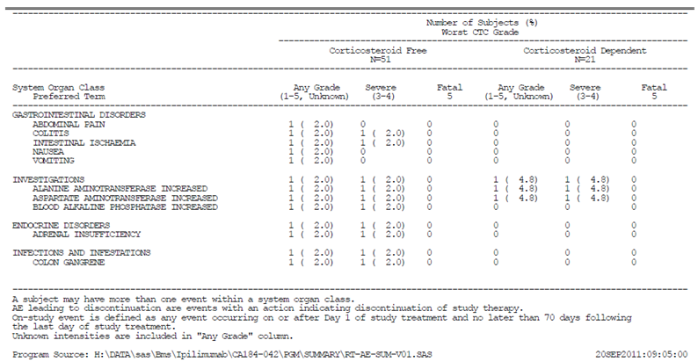
- Case 5 –Grade 5 events appear are not well represented on some summary tables.
The following table (Table 37) lists all the overall adverse events observed within the study. Note should be made that the table below separately lists Gr3/4 events but not Gr5 events (see section on Deaths and other SAEs). The grade 5 events are incorporated into AEs of any grade. It may be some of the grade 5 events were not listed here as they were not captured.

Table 36: Overall adverse events listed in Study CA184042
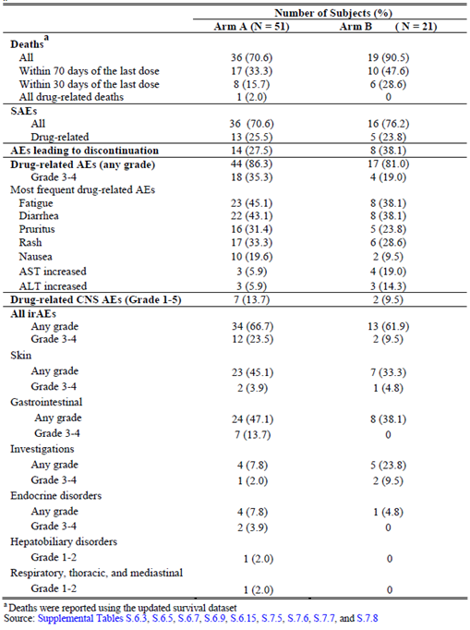

Study CA184078
- Case 1 – Gr 4 optic neuritis is not included in any of the summary tables or within the narrative of SAEs in the CSR.
Patient Identifier: CA184078 -[information redacted]
The optic neuritis was considered by the investigator as related to study therapy and therapy was discontinued as a result of the AE. As examples of where summary tables have not presented this AE, Table 8.2 (on-study treatment related serious adverse events – any CTC grade), and Table 8.4 (On-study adverse events leading to discontinuation – any CTC grade) do not list this event. This event is not listed in the PI/CMI or risk management plan. Can the sponsor explain these issues?
“Event:
- Hypopituitarism (Grade 3, Related, Day 43)
- Optic neuritis (Grade 4, Related, Day 162)
- Case 2 – numerous AEs appear not to be captured (bold text in narrative below).
Patient Identifier: CA184078 [information redacted]
“Event:
- Dyspnoea (Grade 3, Not related, Day 57)
- Pleural effusion (Grade 3, Not related, Day 57)
- Pleural effusion (Grade 3, Not related, Day 71)
- Dehydration (Grade 3, Related, Day 135)
- Febrile neutropenia (Grade 3, Related, Day 162)
Clinical Summary:
On Day 135, 71 days post 4th dose of study therapy (ipilimumab) and 8 days post 7th dose carboplatin/paclitaxel therapy, the subject presented to of nausea, vomiting, diarrhoea, fatigue and a fever of 100.2°F. He was hospitalised and was diagnosed with dehydration (Grade 3) and hypomagnesaemia. The subject did not experience abdominal pain, but felt weak and had not eaten or drunk anything in the last 24 hours. A chest X-ray performed on an unknown date showed no pneumonia. The subject was treated with magnesium sulphate, sodium chloride and vancomycin. No action was taken with regard to the study therapy. The event of dehydration resolved on Day 137. The investigator considered that the event of dehydration to be related to the study therapy.
On Day 162, 118 days post 3rd dose of ipilimumab and 55 days post 6th dose of carboplatin/paclitaxel the subject presented to the hospital with complaints of congestion, dry cough and some chills associated with fever of 100.6°F. On the same day, the subject’s had an absolute neutrophil count (ANC) of 0.23x10³ (Baseline: 3.85x10³) and platelets of 60x10⁹ (Baseline: 165x10⁹). On the same day, Day 162, the subject was diagnosed with febrile neutropenia (Grade 3). He was given IV piperacillin + tazobactam, normal saline 1L and acetaminophen. No action was taken with regards to study therapy. The event of febrile neutropenia resolved on Day 165.
The investigator considered that the event of febrile neutropenia to be related to the study therapy.”
- Case 3 – Nausea not graded or captured.
Patient Identifier: CA184078 [information redacted]
“Event:
- Mental status changes (Grade 3, related, Day 409)
- Pyrexia (Grade 3, related, Day 409)
- Hypotension (Grade 3, not related, Day 409)
- Hypokalaemia (Grade 3, not related, Day 409)
Clinical Summary:
On Day 409 of the study, 79 days post 7th dose of study therapy (ipilimumab) and338 days post 4th dose of study therapy (Dacarbazine), the subject was hospitalised with pyrexia (104°F) (Grade 3) associated with nausea, hypotension (Grade 3), hypokalaemia (Grade 3) and mental status changes (Grade 3).”
- Case 4 Anaemia not captured.
Patient Identifier: CA184078 [information redacted]
“Event:
- AST increased (Grade 3, Related, Day 28)
- ALT increased (Grade 3, Related, Day 28)
- Abdominal pain (Grade 2, Unrelated, Day 64)
- ALT increased (Grade 2, Not related, Day 64)
- AST increased (Grade 1, Not related, Day 64)
- Bacteremia (Grade 3, Not related, Day 94)
- Seroma (Grade 2, Not related, Day 94)
- Malignant Neoplasm Progression (Grade 5, Not related, Day 144)
Clinical Summary:
On Day 64, 43 days post 2nd dose of study, the events of Grade 2 elevated ALT, Grade 1 elevated AST and Grade 2 abdominal pain were reported. Methylprednisolone were initiated. On the same day, a computed tomography (CT) scan of the abdomen and pelvis revealed calcifications in the pelvis likely bone islands, however, metastatic disease was not excluded. She was found to have an increase in the size of the pancreatic mass and required several transfusions”

Treatment-related adverse events (adverse drug reactions)
A complete evaluation was not possible with the data provided by the sponsor. Please see questions to the sponsor regarding the safety data.

Deaths and other serious adverse event

CA184024

Deaths
A total of 193 (78.1%) subjects in the ipilimumab plus DTIC group and 217 (86.5%) subjects in the DTIC monotherapy group died. The majority of deaths were caused by disease progression, as noted on the death page of the CRF. The sponsor reports that there were no drug related AEs with an outcome of death in the ipilimumab plus DTIC group, and 1 (0.4%) in the DTIC group (CA184024 [information redacted], GI haemorrhage, cause of death is listed as study drug toxicity).
A number of the deaths are described here (paraphrased).

Ipilimumab + DTIC arm
CA184024 [information redacted]received 2 doses of ipilimumab and was documented as having two Grade 5 events; one possibly related to the study treatment being systemic inflammatory response syndrome (SIRs) which is an AE of interest given the study drug, and the other Grade 5 event being pneumonia which was deemed unrelated by the investigator.
Review of the SAE narrative demonstrated that the patient developed Gr 2 colitis on Day 35 of the drug, and within two days had reached Gr 3 toxicity. He was commenced on dexamethasone 16 mg daily from Day 43 and was continued on systemic corticosteroids until the time of death. Whilst he was taken off study due to colitis, the patient’s colitis was not reported as resolved to Gr1 until the date of his death. The patient developed pneumonia on Day 71 (still on corticosteroids and still with unresolved colitis) and was commenced on intravenous antibiotics, but was only admitted to hospital on Day 75 due to respiratory distress and deterioration. At this time he was diagnosed with SIRs. Cultures did not demonstrate an infective aetiology. The patient died on Day 77 (55 days post 2nd study drug dose) with septic shock, pneumonia, and metastatic melanoma indicated on the death certificate with systemic inflammatory response syndrome and dermatitis continuing at the time of death. This death was classified by the investigator as ‘other-pneumonia’.
Comment: This case may be possibly a death related to the study drug given the ongoing presence of irAEs (colitis, rash, SIRs) that required ongoing systemic corticosteroids until the time of death, the development of the reported pneumonia whilst other irAEs (including SIRs) were still requiring treatment, the absence of an infective aetiology being proven, the diagnosis of SIRs being given as the reason for hospitalisation, the potential for pneumonia to be similar in presentation to SIRs, and ultimately the event of SIRs was graded as 5. Pneumonia was also listed with as Grade 5.
As the event of SIRs was graded as a Gr 5 event, could the sponsor please explain why this event was not regarded as a treatment related death and presented in summary tables as such? Were deaths only presented according to how the investigator captured and annotated them? In addition, it would be helpful to know how the uniform collation of Gr 5 events (or SAEs) and allocation of causality were performed in the situation where there was disagreement between the investigator and sponsor.
Three cerebrovascular causes of death were listed, all more than 70 days post last study dose; two deaths from brain haemorrhage (CA184024 [information redacted] and CA184024 [information redacted], with the latter patient’s death being listed as ‘apoplexy’) and one ischemic cerebrovascular event (CA184024 [information redacted]). One death due to pulmonary embolism was listed.

DTIC alone arm
There was one ischaemic cerebrovascular event, 3 myocardial infarctions, one pulmonary embolus, and two cardiopulmonary arrests reported as unrelated to the study drugs.

Serious AEs
An evaluation of the safety of ipilimumab was not possible with the information provided by the sponsor, with questions previously outlined regarding the accuracy of the data sources utilised for the safety analyses. However, this study does not provide relevant evidence of safety for the proposed usage.

Other studies

CA184042
The sponsor writes:
‘A total of 55 subjects died; 36 out of 51 corticosteroid free subjects (70.6%) and 19 out of 21 corticosteroid-dependent subjects (90.5%). The majority died as a result of disease progression. One subject died due to drug toxicity (sepsis); one due to unknown cause (both in Arm A). As previously reported in the interim report, although the cause of death for Subject CA184042-[information redacted] was reported as PD by the investigator and is thus listed as PD in the clinical database, the internal BMS safety database shows the death as due to septic shock probably related to study drug’.
Review of the narratives suggests that the patient whose death is annotated as due to ‘septic shock’, died from possible/likely drug related colitis, gastrointestinal perforation /ischemia /gangrenous colon, likely precipitating the septic shock and subsequent patient death. These events were considered by the investigator probably related to study drug.
Note is made that there is no Grade 5 AE listed for any of the events; were deaths captured separately? Can the sponsor please explain this?
Is this death not more appropriately annotated as a result of possible/likely drug related colitis, gastrointestinal perforation/ischemia/gangrenous colon, likely precipitating the septic shock?
The colitis, diarrhoea, and gastrointestinal perforation are not listed as AEs though are described within the SAE narrative. Can the sponsor please explain why these were omitted?
The narrative is included below:
Patient Identifier: CA184042 [information redacted]
“Events:
- Atrial fibrillation (Grade 3, possibly related, Day 43)
- Intestinal ischemia (Grade 4, probably related, Day 43)
- Colon gangrene (Grade 4, probably related, Day 43)
- Septic shock (Grade 4, probably related, Day 43)
- Renal failure acute (Grade 4, not related, Day 43)
Clinical Summary:
On Day 43, 20 days after the last dose of ipilimumab, the subject presented acutely to the emergency room (ER) in fulminant septic shock (Grade 4) and renal failure acute (recorded as verbatim term acute renal failure) (Grade 4). Study drug was discontinued in response to septic shock. No action with study drug for acute renal failure. The subject received treatment for these events. For about 2 weeks prior to this hospitalization, the subject had been having severe non-bloody diarrhoea (a maximum of 4 episodes of diarrhoea per day) associated with crampy abdominal pain, but experienced no significant gastrointestinal type symptoms before that. On presentation to the ER, the subject was in septic shock and atrial fibrillation (Grade 3), which was successfully cardioverted. A computed tomography (CT) scan of the abdomen and pelvis suggested a perforated viscus with free air in the peritoneum. The subject became more acidotic in the morning and tachypneic. Lactic acid was 7.3 (units, baseline, and reference ranges not specified). A decision was made to take the subject to the operating room for exploratory laparotomy, where severe ischemic and gangrenous colon (Grade 4) and ischemia and gangrenous colon, the procedure was deferred, and the subject was transferred back to the intensive care unit and was intubated. The subject had evidence of multi organ system failure from septic shock, including hemodynamic instability requiring vasopressor support, acute renal insufficiency, pulmonary distress, and severe acidosis. The subject's prognosis was discussed with the subject’s immediate family and, as a result, the subject was withdrawn from the study, provided with comfort care, and taken off pressors. On Day 44, the subject died due to septic shock, extensive ischemic colitis, colon gangrene, and multi-organ system failure. At the time of death, ischemic and gangrenous colon and renal failure acute had not resolved. The investigator considered the fatal septic shock and ischemic/gangrenous colon probably related to study drug, atrial fibrillation possibly related to study drug, and renal failure acute not related to study drug.’
For the second death described in the text of the CSR as ‘cause unknown’, there is a possibility of a drug related AE, given the concurrent presence of G3 diarrhoea at the time of death. However, the narrative is not clear. It describes the diarrhoea as a single episode that was considered ‘resolved’ perhaps due to the patient’s death. Furthermore, ‘loss of consciousness’s used to describe the cause of death, is unconventional and difficult to interpret clinically.
What clinical event was thought to have caused the patient’s death? The events are additionally unclear given that the first event was considered ‘unresolved’ at the time of the second event (?) ten days later, where the patient was found unconscious in a pool of diarrhoea on the floor. Was the patient known to be unconscious at home for ten days? No grade 5 events are listed. Why is this? Could the sponsor please provide more commentary on the issues? The narrative is included below.
Patient Identifier: CA184042 [information redacted]
“Events:
- Loss of consciousness (Grade 3, not likely related, Day 104)
- Diarrhoea (Grade 3, possibly related, Day 114)
Clinical Summary:
On Day 104 of the study, the investigator reported a serious adverse event of loss of consciousness. The investigator judged the intensity to be Grade 3 and the relationship to study drug to be not likely related. The subject did not receive treatment for this event. The event of loss of consciousness did not resolve. No action was taken relating to study drug. On Day 114, the subject was found unconscious on the floor in a pool of diarrhoea. The investigator judged the intensity of these events to be Grade 3 and the relationship to study drug to be possibly related. The event of diarrhoea was a single episode and was resolved on Day 114. The subject did not receive treatment for this event. On Day 114, the subject died due to loss of consciousness. The event of black stool was removed and updated to diarrhoea.
The previous information was included in the NDA. The following new information was obtained at the time of the data cut-off for the 120 day safety update report.”

Serious AEs
An evaluation of the safety of ipilimumab was not possible as has been previously outlined, there are uncertainties about the accuracy of the data sources utilised for the safety analyses. However, this study does not provide direct relevant evidence of safety for the proposed usage.

Study CA184078
The sponsor writes:
“Twenty four treated subjects have died as of the Week 48 database lock: Twelve subjects (60%) in Arm A, 5 subjects (26%) in Arm B, and 7 subjects (35%) in Arm C. Twenty (20) subjects died due to disease progression, and 1 subject each died due to cardiac arrest (Subject CA184078 [information redacted], Arm A), liver failure (Subject CA184078 [information redacted], Arm C), renal failure (Subject CA184078 [information redacted], Arm B), and respiratory failure (Subject CA184078 [information redacted], Arm A). No subjects died within 70 days post-treatment due to reasons other than PD.”
Review of each of these deaths demonstrates the following;
- The first death described is listed as due to disease progression in the provided narrative and not due to cardiac arrest as stated above. However, in Appendix 6.9 ‘Listing of Deaths’ the subject is annotated as having a cardiac arrest two days post last study dose. There are also discrepancies between this Appendix and the narrative noted with some dates. Could the sponsor please provide an explanation for these discrepancies and clarify the events?
Patient Identifier: CA184078 [information redacted]
“Event:
- Hypersensitivity (Grade 3, Related, Day 22)
- Hypersensitivity (Grade 3, Related, Day 50)
- Atrial fibrillation (Grade 3, Not related, Day 59)
- Disease progression (Grade 5, Not related, Day 114)
On Day 114, 50 days post 4th dose of ipilimumab and 22 days post 5th dose of carboplatin and paclitaxel, the subject was noted with disease progression. The subject did not feel well and was unresponsive when the emergency medical technician (EMT) arrived. The subject was taken to a local hospital and was pronounced dead (Day 114) due to disease progression. The subject received the last dose of study therapy (ipilimumab) on Day 64, and the last doses of carboplatin and paclitaxel on 92.”
Appendix 6.9 lists ; for the same patient
“Subject: CA184078 [information redacted]
First date dosing: 14APR2009
Last date dosing: 04AUG2009
Death date: 05-AUG-2009
Number of days since last dose: 2
Primary cause of death: Other
Specify: ‘Cardiac Arrest’
- Subject CA184078 [information redacted], had one day on study treatment and did not continue due to ‘disease progression’ (after one day of treatment). The patient is listed to have died approximately 10 months after the study dose due to ‘liver failure’. An explanation of why this patient was taken off study after one day was not provided. A description of events was not found in the ‘cum-serious-line-listing’ report. Could more information please be provided to clarify this?
Comment: This case is not found in the ‘cum-serious-line-listing’ when the search terms were used as follows; [information redacted; three different annotations all associated with this one patient]. The value of cumulative line listings is limited when the patient identifiers are annotated differently to that in the study and split over two lines. For example, the patient identifier would be written as [information redacted] This presentation of the data by the sponsor in this manner limited adequate cross comparison of the safety data from this report and CSRs.
- Patient Identifier: CA184078 [information redacted]
This patient death is suspicious for being possibly related to the study drug. The subject developed grade 3 diarrhoea that recurred with weaning of corticosteroids, leading to hospitalisation with ongoing Grade 2 diarrhoea with Grade 3 dehydration to ‘rule out an ileus and perforation and to receive hydration’. The patient was eventually discharged to hospice care with anuric renal disease and ‘metastatic melanoma’ but received haemodialysis for Gr4 renal failure 17 days following her discharge to hospice care. She died 7 days after receiving haemodialysis. Diarrhoea and dehydration were ongoing until the time of death. Whilst disease progression was a likely contributor, ongoing diarrhoea attributed to study therapy appears to have precipitated the renal failure which appears to have contributed to the patient’s death.
What was the rationale for the patient receiving haemodialysis whilst in hospice care? Was it because the renal failure was thought to be reversible due to its relationship with the study drug? Was haemodialysis given due to the Physician’s opinion that the patient would not be terminal if the renal failure was reversible?
Patient Identifier: CA184078 [information redacted] (the same patient as described immediately above)
Event:
- Erythema nodosum (Grade 2, Related, Day 27)
- Erythema nodosum (Grade 1, Related, Day 43)
- Diarrhoea (Grade 3, Related, Day 87)
- Abdominal pain (Grade 3, Unrelated, Day 124)
- Dehydration (Grade 3, Unrelated, Day 124)
- Malignant neoplasm progression (Grade 5, Not related, Day 124)
- Renal failure (Grade 4, Not related, Day 159)
On Day 76, 10 days after the 4th dose of ipilimumab and Dacarbazine, the subject developed diarrhoea (Grade 1) which worsened to Grade 3. The subject was treated with loperamide, prednisone, atropine + diphenoxylate and levofloxacin and on Day 90, the event of diarrhoea improved to Grade 1, but on Day 106, the event of diarrhoea again worsened to Grade 2 and the subject continued with the treatment medication. On Day 108 the subject also began complaining of Grade 2 abdominal pain which worsened to Grade 3 on Day 113 but responded to toradol and improved to Grade 1 by the following day. On Day 124, the subject developed dehydration (Grade 3), abdominal (Grade 3) and malignant neoplasm progression (Grade 4). She was hospitalised to rule out ileus and perforation and to receive hydration. No action was taken with regard to the study medication.
On Day 131, a computed tomography (CT) scan of the chest, abdomen and pelvis showed bilateral pleural effusions, multiple bilateral lung metastases, extensive liver disease and peritoneal carcinomatosis. On Day 132, the subject’s laboratory test values showed white blood cell (WBC) of 27.7x10³ c/mL, blood urea nitrogen (BUN) of 73 mg/dL, creatinine of 1.87 mg/dL, total bilirubin of 13.2 mg/dL (11 X ULN), aspartate aminotransferase (AST) of 144 U/L (3.7 X ULN) alanine aminotransferase (ALT) of 140 U/L (2.5 x ULN). The subject’s situation was discussed with family members and the decision was made to take her home on hospice care. On the same day; the subject was discharged home on hospice care with progressive renal failure, anuric renal disease and metastatic melanoma to multiple sites. On Day 159, a serious adverse event of Grade 4 renal failure was reported. The subject received haemodialysis. On Day 166, 100 days post 4th dose of study therapy, the subject died due to malignant neoplasm progression. Death was reported as the outcome for dehydration and abdominal pain. The events of diarrhoea, abdominal pain and dehydration were ongoing at the time of death.
The investigator considered that the event of erythema nodosum, diarrhoea was related to the study therapy and the events of dehydration and abdominal pain, renal failure and malignant neoplasm progression were not related to the study therapy.
Subject CA184078 [information redacted], Arm A - was followed up until the 70 day period and thus completed the follow up period.

Serious AEs
An evaluation of the safety of ipilimumab was not possible and as has been previously outlined, there are uncertainties about the accuracy of the data sources utilised for the safety analyses. However, this study does not provide direct relevant evidence of safety for the proposed usage.

MDX010-16
No deaths were reported. (This study was for the use of the drug in the adjuvant setting).

Serious AEs
Narratives for SAEs within this CSR were not located, and assessment of safety for this study was not possible with the provided information. Furthermore, using the search term ‘MDX’ information within the ‘cum-serious-line-listing’ document was also not identified.

Discontinuation due to adverse events
An evaluation of the safety of ipilimumab was not possible with the information provided by the sponsor, with queries previously outlined regarding the accuracy of the data sources utilised for the safety analyses. However, submitted studies do not provide relevant evidence of safety for the proposed usage.

Immune related adverse events
An evaluation of the safety of ipilimumab was not possible with the information provided by the sponsor, with queries previously outlined regarding the accuracy of the data sources utilised for the safety analyses. However, submitted studies do not provide relevant evidence of safety for the proposed usage.

Laboratory tests
An evaluation of the safety of ipilimumab was not possible with the information provided by the sponsor, with queries previously outlined regarding the accuracy of the data sources utilised for the safety analyses. However, submitted studies do not provide relevant evidence of safety for the proposed usage.

Post-marketing experience

Study CA184338
It is important to note that for this observational study, subjects with unknown or partial death dates were not included in safety analyses.
Of 21 deaths reported during the Induction phase, all were reported as disease related except one case that was reported as secondary to cardiac issues. An additional 37 deaths were reported between completion of induction dosing and the most recent follow-up for survival. The majority of the deaths were disease related, with the exception of 3 accidental deaths, heart/renal failure (n = 1), and congestive heart failure/myocardial infarction (n=1).

Serious AEs
An evaluation of the safety of ipilimumab was not possible with the information provided by the sponsor, with queries previously outlined regarding the accuracy of the data sources utilised for the safety analyses. Narratives of SAEs were not found within the CSR or in the ‘cum-serious-line-listing’ report.

Study CA184045
Some 257 out of 830 subjects (31%) died within 70 days of the last dose date for the entire study duration. The majority of these subjects (180, 22%) had no death cause specified since they were recorded only on the SAE CRF page (where cause is not captured) but not on the death CRF page (where cause is captured), which was introduced by Amendment 3. Of the rest, the leading cause of death was disease progression (68 subjects, 8%), per the death CRF page. Some 239 of these deaths occurred within 70 days of the last dose date of the Induction phase (18 deaths during).
Two subjects had drug related SAEs with outcome of death: one had multi-organ failure (Subject CA184045 [information redacted]), and one had acute respiratory distress syndrome (ARDS; Subject CA184045 [information redacted]). Both deaths occurred within 70 days of the last dose date of the Induction phase. The subject with ARDS had extensive lung disease and evidence of melanoma infiltration in the alveolar space. In the source documents, terminal decline was likely due to progression of metastatic melanoma with functional compromise of the left lung coupled with diffuse alveolar damage. Neither of these deaths was captured on the death CRF page.
The sponsor writes in the discussion:
“Only 2, drug related SAEs with outcomes of death were noted (Subjects CA184045 [information redacted] and CA184045 [information redacted]). (In the 2010 Summary of Clinical Safety Summary, 4 drug-related SAEs with outcomes of death were reported for CA184045. However, for 2 of these subjects [CA184045 [information redacted] (sepsis) and CA184045 [information redacted] (infection)], the cause of death was subsequently changed to not related.)”
Narratives of these SAEs were not found within the CSR or in the ‘cum-serious-line-listing’ report.

Serious AEs
An evaluation of the safety of ipilimumab was not possible with the information provided by the sponsor, with queries previously outlined regarding the accuracy of the data sources utilised for the safety analyses. Narratives of SAEs were not found within the CSR or in the ‘cum-serious-line-listing’ report.

Safety issues with the potential for major regulatory impact
An evaluation of the safety of ipilimumab was not possible with the information provided by the sponsor.

Relevant new data not submitted by the sponsor

EORTC 18071/CA184029
At the recent annual American Society of Clinical Oncology meeting, 2014, Eggermont AM et al. presented initial safety data from a Phase III EORTC 18071 (CA184029) study which investigated the benefit of adjuvant ipilimumab 10mg/kg monotherapy with a maintenance phase versus placebo in previously untreated patients following complete resection of Stage III melanoma.
Of a total of 951 patients, 475 out of 951 were randomised to the study arm to receive ipilimumab 10mg/kg monotherapy, three weekly for a total of four doses, with the maintenance phase of 10mg/kg ipilimumab monotherapy administered every 12 weeks for a total of three years.
Baseline patient and tumour characteristics were balanced between treatment arms.

Total adverse events
Specifically regarding the safety data in this healthy, previously untreated population, 49% (230 out of 471) patients experienced any AE compared to 2% (8 out of 474) who received placebo.

Patient deaths
There were five patient (1.1%) drug related study deaths in the ipilimumab arm. Three patients died related to colitis, of which two patients had gastrointestinal perforations. One patient died from myocarditis and one died from Guillain-Barre syndrome.
The number of deaths in this study is larger than that reported in CA184024, although the limitations of uncontrolled cross study comparisons are noted.

Immune related adverse events
There were a significant number of immune related adverse events in the study arm. In general, the reported numbers of immune related AEs were in general greater than reported by the sponsor in CA184024 (10 mg/kg ipilimumab monotherapy with concomitant DTIC). The limitations of uncontrolled cross study comparisons are again noted.
Of patients on the study arm, the majority of patients (90.4%, 425 out of 471) experienced any grade of irAEs. Of these, 42% (198 out of 471) were Grade 3/4 events. Significantly 63.3% (298 out of 471)of patients experienced any grade of immune related dermatologic adverse event. Any grade of gastrointestinal immune related AEs occurred in 46.3% (218) patients, with 16% (75/out of 471) being a Gr 3/4 event. There were six drug related GI perforations on the study arm and 3 unrelated GI perforations on the placebo arm. Of particular note, a high proportion of patients (37.6%, 177 out of 471) experienced any grade of immune related endocrine events, with 18.3% (86 out of 471) of patients experiencing any grade of hypophysitis. Immune related hepatic AEs were noted in 25.1% (118 out of 471) of patients for any grade, immune related neurologic AEs in 4.5% (21 out of 471) patients for any grade, and 23.6% (111 out of 471) of patients experienced ‘other’ (any grade, unspecified) immune related AEs. These results are summarised in Table 37 below. As a reference, Table 38 from the CSR of CA184024 summarising the irAEs from this study as presented by the sponsor is provided below.
Of particular note, on the study arm although the majority of Gr 2 to 4 irAEs were reported to resolve, resolution of endocrine irAEs was not observed for 44% (59 out of 134) of patients with a Gr 2 to 4 endocrine irAE. The median number of weeks for resolution of Gr 2 to 4 irAE was 31.0 weeks (13.9 to 186.0) for endocrine irAEs. For the other G2 to 4 irAE subcategories, resolution of skin irAEs was not observed for 11% (14 out of 129) of patients, resolution of gastrointestinal irAEs was not observed for 6% (9 out of 144) of patients, and resolution of hepatic irAEs was not observed for 5% (4 out of 77) of patients.

Table 37: Summary of Immune related adverse events on EORTC 18071 (adjuvant use of 10 mg/kg ipilimumab monotherapy in previously untreated patients with a maintenance phase)
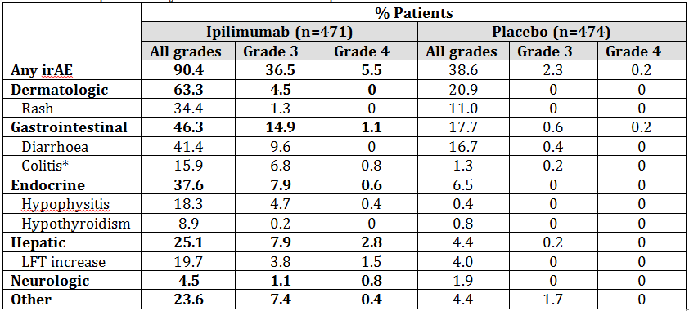
*Gastrointestinal perforations: ipilimumab, 6 related (1.3%); placebo, 3 unrelated (0.6%). LFT = liver function test. (This data is copied directly from Slide 12 of the oral presentation for the referenced abstract.)

Table 38: Summary of irAEs from CA184024 as presented by the sponsor
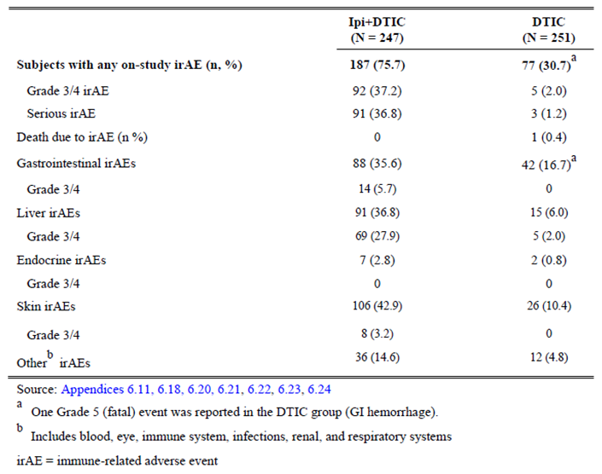
This recently reported study raises significant clinical concerns regarding the safety of ipilimumab monotherapy 10 mg/kg in a previously untreated and healthy population. Whilst the limitations of uncontrolled cross study comparisons are noted and the presentation of information as an oral abstract of the referenced study, in general the toxicity observed within this adjuvant study of healthy patients was numerically higher than that presented in CA184024. Significantly, there were five deaths within this healthy population and six treatment related GI perforations. In addition, the number of irAEs observed was numerically higher than reported in CA184024.
Thus, this study on the benefit for the adjuvant use of ipilimumab 10 mg/kg monotherapy in the previously untreated healthy population raises significant clinical concerns regarding the safety of the drug for the proposed usage.

CA184169
CA184169 is an ongoing randomised, double blinded, Phase III study of ipilimumab administered at 3 mg/kg versus 10 mg/kg in Subjects with Previously Treated or Untreated Unresectable or Metastatic Melanoma. The protocol for this study is found in the ‘literature references’ provided by the sponsor. Note is made of the research hypothesis for this study, that ‘The dose of 10 mg/kg ipilimumab will have superior efficacy for the primary endpoint of overall survival compared to the 3 mg/kg dose.’
Comment: Given the uncertainty of the differences in efficacy and safety issues between the 3 mg/kg and 10 mg/kg dosing schedule in previously untreated and previously treated patients, the Sponsor is requested to provide an interim summary of safety data for CA184169.
The synopsis of the study presented by the sponsor is copied below. It is unclear when patient enrolment commenced. The date of the first protocol is 26 September2011.
‘Investigational Product(s), Dose and Mode of Administration, Duration of Treatment with Investigational Product(s): ipilimumab 3 mg/kg or 10 mg/kg IV: Administered over 90 minutes every 3 weeks for up to four induction doses. Re-induction is allowed for subjects without intolerable toxicity and who respond or have stable disease for 3 months or more after induction, and subsequently progress.
Study Phase III

Research hypothesis
The dose of 10 mg/kg ipilimumab will have superior efficacy for the primary endpoint of overall survival compared to the 3 mg/kg dose.

Primary objective
To compare the overall survival of ipilimumab monotherapy at doses of 3 mg/kg versus 10 mg/kg in subjects with previously treated or untreated unresectable Stage III or Stage IV melanoma.

Study design
This is a randomised, multicentre, double blind Phase III study. Subjects aged > 18 years of age with untreated or previously treated unresectable Stage III or Stage IV (metastatic) melanoma who have not received a B-Raf inhibitor or prior immune checkpoint modulatory therapy (see eligibility criteria) will be randomly assigned to be treated with ipilimumab at a dose of either 3 mg/kg or 10 mg/kg by intravenous infusion every 3 weeks x 4 doses. After initial response (or stable disease for at least 3 months) followed by subsequent progression and in the absence of intolerable toxicity, subjects are eligible to receive re-induction therapy using the same dose and schedule as used for induction. Re-induction may be provided at the discretion of the investigator using the same criteria. When the analysis for the primary endpoint of overall survival has been conducted, all subjects, including subjects in the Re-induction phase, will no longer be treated on this study and will revert to commercial supplies of ipilimumab where available as per local labels. Subjects will continue to be followed for long term survival. The study will be double-blinded and subjects will be randomised in a 1:1 ratio between the two treatment arms.
Randomization will be stratified by:
- M sub-stage: M0+M1a+M1b versus M1c without brain metastases versus M1c with brain metastases
- Prior treatment for metastatic melanoma: yes versus no
- ECOG Performance Status: 0 versus 1

Study population
Men and women, > 18 years of age, with previously treated or untreated unresectable Stage III or IV histologically or cytologically confirmed melanoma, ECOG Performance Status 0 or 1, and who have not received a B-Raf inhibitor or prior CTLA-4 or PD-1antagonists, or PD-L1 or CD137 agonists are eligible. Subjects with brain metastases who are free of neurologic symptoms related to metastatic brain lesions and who do not require or receive systemic corticosteroid therapy in the 10 days prior to beginning ipilimumab therapy are eligible. Subjects with a history of or current active autoimmune diseases (see eligibility criteria) or current uncontrolled infectious disease will be excluded. Subjects must provide a baseline blood sample for biomarker testing.

Study assessments and primary endpoint
Safety assessments: All subjects who receive at least one dose of study treatment (ipilimumab) will be evaluated for safety parameters.
Primary endpoint: All randomised subjects will be evaluated for efficacy analyses. Overall survival (OS) will be defined as the time from the date of randomization until the date of death. For those subjects who have not died, OS will be censored on the last date the subject was known to be alive.

Statistical methods
Sample size determination: The assumptions used in the determination of sample size for the primary endpoint of survival are as follows: 540 deaths are required to detect an overall hazard ratio of 0.744 between the two randomised arms using a two sided, log rank test with an experiment wise type I error rate of 0.05 with at least 90% power. The sample size is based upon a simulation using piece wise hazard ratio survival estimates of 1.0 for less than or equal to 8 months and 0.56 for greater than 8 months for the 10 mg/kg versus 3 mg/kg treatment comparison. From this simulation the median survival time for the 10 mg/kg and 3 mg/kg groups are 15.2 and 12 months, respectively. The estimated 2 year survival rates obtained from this simulation are 38% and 25% for the 10 mg/kg and 3 mg/kg randomised groups, respectively. Based upon this simulation, the overall hazard ratio to be minimally statistically significant is 0.84. Assuming that the accrual for 700 subjects randomised (350 per treatment arm) will take at least 22 months, the study is expected to attain 540 deaths approximately 44 months after the first subject is randomised. However, the actual time of the study completion will be event driven.
The study conduct will be overseen by a data monitoring committee (DMC). The incidence of high grade immune mediated adverse reactions (imAR) at the 3 mg/kg dose as observed in the pivotal study MDX010-20 is 15%. Assuming that 95% of randomised subjects are treated, a sample size of at least 330 treated subjects per arm would provide a two sided exact 95% confidence interval (CI) of 11.5% to 19.5%, indicating a precision of at least +/- 4% to describe variations in this safety parameter. The maximum width of a two sided exact 95% CI is +/- 5.5%.

Populations for analyses
Intent-to-Treat Population: includes all subjects in the study who are randomised to either treatment group. This is the primary population for the efficacy analyses.
Safety Population: includes all subjects in the study who receive at least one dose of ipilimumab. This is the primary population for safety analyses.

Statistical approach/assumptions
A log rank test, stratified by:
- M0+ M1a+M1b versus M1c without brain metastases versus M1c with brain metastases
- prior treatment versus no prior treatment for metastatic melanoma
- ECOG PS 0 versus ECOG PS 1, will be used to compare OS between randomised arms at final analysis.
The hazard ratio and its corresponding 95% confidence interval will be calculated using a stratified Cox proportional hazard model. Kaplan-Meier curves will be presented along with the median and two-sided Brookmeyer-Crowley 95% confidence interval for median OS for each randomised arm. The 1 year and 2 year survival rates will be based on Kaplan-Meier estimates along with their corresponding log-log 95% confidence intervals.
Secondary efficacy endpoints include PFS, Best overall response rate (BORR) and disease control rate (DCR) using mWHO and irRC. Similar analyses as performed for OS will be performed for PFS (stratified log rank statistic, hazard ratio and its 95% CI, and Kaplan-Meier curves with median and 95% CI). Comparisons between treatment arms for BORR and DCR will be performed using Cochran Mantel Haenszel test statistics. A hierarchical testing procedure will be applied to efficacy endpoints outlined above so that an overall experimental type 1 error rate of 0.05 will be maintained.
- If OS is statistically significant in favour of 10 mg/kg then the comparison between treatment arms for PFS (by mWHO criteria) will be conducted at a 0.05 two sided significance level.
- If PFS is statistically significant in favour of 10 mg/kg then the comparison between treatment arms for BORR (by mWHO criteria) will be conducted at 0.05 two sided significance level.
- If BORR is statistically significant in favour of 10 mg/kg then the comparison between treatment arms for DCR (by mWHO criteria) will be conducted at a 0.05 two sided significance level.”

Evaluator’s overall conclusions on clinical safety
There were no pivotal trials submitted relevant to the proposed usage.
From data pooled from previously evaluated Phase II studies, maximally 35 patients investigated may provide relevant safety data. However, from the sponsor’s presentation of data, safety information relevant to the population indicated in the proposed usage was not clear. The sponsor was requested to address this.
Of the trials that are provided in the dossier, these provided limited relevant evidence for the proposed usage due to differences variously in the dose, regimen, or use in combination with chemotherapy, line of treatment as mentioned already. There are numerous issues regarding the source data and subsequent analyses.
Overall, there are uncertainties regarding the safety data for all these studies regarding:
- The appropriate documentation of AEs
- The grading of AEs
- The allocation of causality for AEs
- The summarised data is limited due to the two previous points and the text does not comprehensively summarise clinically meaningful information
- The presentation of data appears to minimise the frequency of clinically meaningful safety data, through the use of MedDRA preferred terms which are highly specific (in comparison to considering higher level terms, collapsing terms or summarising the data in a clinically meaningful way)
- Specific pertinent examples of deficiencies include the apparent incorrect documentation of Grade 5 events (representation on tables, reporting, and allocation of causality), GI perforations, GI toxicity in general, hepatotoxicity, and a case of G4 optic neuritis (CA184078).
As a result, evaluation of the safety of the drug within these trials was not possible.
Of pertinence, an EORTC Phase III trial recently presented at the annual American Society of Clinical Oncology investigating the benefit of adjuvant ipilimumab 10 mg/kg monotherapy in healthy patients with resected Stage III melanoma raises significant clinical concerns regarding the safety of the proposed usage. Of this healthy population investigated, within the study arm, five study-related deaths were observed, six study related GI perforations were observed and the rate of imARs were generally numerically higher than those presented in the reports submitted within the dossier.
In conclusion, due to the lack of randomised evidence relevant to the proposed usage and the uncertainties regarding the safety data of the submitted ‘bridging’ studies, the sponsor has not adequately demonstrated the safety of the drug for the application. A recent report raises significant clinical safety concerns for use of the drug in a healthy population.

First round benefit-risk assessment

First round assessment of benefits
The benefits of ipilimumab 3mg/kg monotherapy in untreated patients with advanced melanoma include:
- The evidence for efficacy for overall survival benefit at this dose in previously treated patients, as demonstrated in the previously evaluated study, MDX010-20. Some patients derive a durable long term survival benefit. However, with reference to the statistical principles of clinical trials guidelines, consideration should be made regarding the external validity of this study for the current application which seeks use in previously untreated patients and use as monotherapy without consideration of co-administration of gp100 or a maintenance phase.
- The unmet need remains for effective treatment options with durable efficacy for this patient group.

First round assessment of risks
The risks of the proposed usage could not be effectively evaluated due to:
The limited evidence provided addressing the proposed usage in the relevant population
- There is an absence of randomised data relevant to the population of interest for the current application
- The number of patients included within this submission that are relevant to the current application varies between n = 15 to n = 35.
The sponsor is requested to provide safety data for the previously untreated patients who were treated at the proposed dose for evaluation (see questions for sponsor). Please note that the safety analysis for Study CA184024, while not directly relevant in establishing safety for the proposed usage as monotherapy at 3 mg/kg dose, could not be completed with the data presented by the sponsor. The sponsor is requested to address the issues raised in the questions to the sponsor). Please also note the significant safety issues highlighted in Section 8.11 (relevant new data not submitted by sponsor).

First round assessment of benefit-risk balance
A benefit-risk balance is not currently able to be completed due to the aforementioned issues in the above.

First round recommendation regarding authorisation
No pivotal efficacy or safety data are suppled in support for the proposed indication. Of primary significance:
- Safety data provided for studies submitted with this application did not adequately demonstrate safety
- New data raises concern regarding the safety of the proposed usage.
Secondarily, the data provided relevant to the population of interest for the current application insufficiently addresses the statistical principles for clinical trials guidelines due to the following reasons:
- Post hoc pooled efficacy data from heterogeneous studies maximally incorporated maximally 35 patients investigated in Phase II studies that are relevant to the current application. Subgroup analyses were not planned and have not been prospectively validated. (insufficient ‘study’ size to address the proposed usage and limited external validity)
- Pooled pharmacological data from heterogeneous studies incorporated only 14 previously untreated patients administered ipilimumab 3mg/kg monotherapy relevant to the current application
- The external validity of data from trials utilising a different posology to the current application is limited
- The external validity of data from trials utilising combination therapy is limited in the context of the current application for monotherapy
- The external validity of data from trials utilising a maintenance phase is limited in the context of the current application for monotherapy
- The external validity of data from trials investigating patient populations that differ to the current application is limited
- There was no randomised data presented relevant to the population of interest or the treatment schedule of interest.
As a result, the safety and the efficacy of the proposed usage have not been adequately demonstrated by the sponsor. The clinical evaluator’s recommendation is that the application is not authorised.
The clinical evaluator also raised issues with regard to the PI and CMI but these are beyond the scope of the AusPAR.

Clinical questions

Pharmacokinetics
With reference to the PopPK analysis
- Could the sponsor please explain their rationale for only examining ER-OS response with the dataset from CA184024, when the previous report included other studies?
- Table 3.3.1.5B annotating samples included in the dataset, note is made that approximately one third of samples (1,188 out of 4,388) were excluded if below the limit of quantification, if quantifiable concentrations were detected pre-dose (not described further) or due to the mismatching of samples (not described further). Furthermore it is noted that this includes 11% samples were excluded due to ‘pre-dose samples’ separate to the listing of ‘Day 1 pre-dose samples’. Could the sponsor please clarify each category? For example, how many, and how high were the ipilimumab levels detected pre-dosing? Why was a level detected prior to dosing? Can the sponsor please explain and justify the exclusion of samples once dosing has commenced ‘Day 1 pre-dose samples’?
- For the covariate analysis, the number of covariates examined is smaller than those described. These omitted variables include baseline BSA, ideal body weight, albumen, and race. Can the sponsor please provide explanation for the omission of covariates?
- With the generation of the base PK model ‘There were some subjects who were had aberrant concentrations, and the inclusion of those concentrations’ prevented successful analysis (‘termination’?) of NONMEM and thus these samples were excluded. This is in addition to the 6 excluded samples described in the same paragraph. Could the sponsor please provide more information on the ‘aberrant’ samples; how many were there? Why were these considered aberrant (assay issue versus outliers)?

Pharmacodynamics
No questions.

Efficacy
- For the pooled efficacy analysis Table 23 and the sponsor’s text are unclear regarding the total number of patients relevant to the proposed indication from MDX010-08. The study summary in Table 23 and text refer to these patients as previously treated. However, these patients are included under the pooled total number of previously untreated patients.
Of the total 35 patients indicated:
  - Can the sponsor please clarify how many patients from MDX010-08 were previously untreated (versus chemotherapy naïve as indicated in the table and text)?
  - Can the sponsor clarify how many randomised patients received 3mg/kg ipilimumab monotherapy without any maintenance therapy?
Of this subsequent total of patients clarified by the previous questions, can the sponsor please provide the interquartile range of median follow up, and clarify the OS survival rates obtained for this group relevant to the proposed indication?
- For the pooled efficacy analysis, Table 26, indicates that within the pooled previously untreated group there is a patient who was followed up for only 4.8 days, and in the pooled chemotherapy naïve group a patient followed up for 0.9 days. Can the sponsor please provide details of the patients’ performance status, the reasons for the short duration of follow-up and confirmation that these patients met the eligibility criteria of the relevant study? Can the sponsor please provide the interquartile ranges for the median follow-up relevant to the table?
- Given the uncertainty of the differences in efficacy and safety issues between the 3mg/kg and 10mg/kg dosing schedule in previously untreated and previously treated patients, the sponsor is requested to provide an interim summary of efficacy data for CA184169.

Safety
Queries regarding safety data relevant to the proposed usage
There were maximally 35 patients from pooled Phase II studies previously submitted that provide safety data relevant for the proposed usage.
- For the pooled safety data, as outlined in the questions to the sponsor regarding efficacy (above), it is unclear how many patients presented within the pooled analyses are relevant to the proposed usage. Of the patients clarified by Efficacy question 1, can the sponsor provide the relevant safety data for these patients? The sponsor is requested to represent in text and table the summary of all information as presented within the pooled safety analyses (from the clinical overview and summary of clinical safety). In doing this, the following requests are made to permit evaluation:
- Source data should be checked to ensure AEs are captured, grading is appropriate and allocation of causality is accurate. To facilitate review by the evaluator, please provide amendments of previously submitted data in a tracked copy and cleaned/untracked copy.
- Safety data should be clearly presented and defined in a clinically meaningful way to avoid the underrepresentation of data as described in Section 8. Higher clinical terms should be collapsed in a meaningful way with each preferred term listed below. The method of analysis and collation of synonymous clinically relevant terms should be defined.
- In addition, the sponsor should summarise for these patients the number of episodes for all grades of AEs and imARs that required hospitalisation for investigation or management, the use of any systemic corticosteroid, infliximab use, other immunosuppressant use, surgical intervention, TPN or any other relevant medical intervention. Please summarise with sufficient detail included for each subcategory.
- Given the uncertainty of the differences in safety issues between the 3mg/kg and 10mg/kg dosing schedule in previously untreated and previously treated patients, the sponsor is requested to provide an interim summary of safety data for CA184169.
- General queries regarding source data from studies evaluated that provide limited evidence for the proposed usage
The sponsor has not provided safety data in a clinically meaningful manner that allowed the satisfactory assessment of the safety data for the studies submitted with this application. These issues have been discussed in Section 8.
- When narratives of SAEs within the dossier have been reviewed, it appears that AEs described within the narrative are not consistently captured in the listings of AEs and imARs found at the beginning of the narrative. This includes both the grading of AEs and the event itself.
- Can the sponsor please clarify if these lists for AEs and imARs should comprehensively include what is described within the narrative? Are these the data sources that are used to generate summary tables and analyses? The inconsistency between these summary lists and the narrative has been observed for all submitted trials with narratives available.
Examples are given in Section 8 according to study and are also summarised below. Please can the sponsor clarify if these lists at the beginning of each narrative are intended to capture and grade all events, and these lists are subsequently used for analyses?
- Can the sponsor please also indicate if Grade 5 events were captured on the SAE narrative, and if not, how were they collated/captured for all CSRs? Specifically, should the summary listing at the top of the narrative, capture a grade 5 event if the patient died? Can the sponsor explain how they ensured that deaths were uniformly and comprehensively captured?
- Can the sponsor please clarify for the allocation of SAEs versus AEs, who identified these events and how were these events defined (the criteria within the CSR does not explain this)? Was it according to investigator, sponsor, or CRF? Who judged if an event ‘may have jeopardised the subject’? What level of ‘medical’ intervention warranted a SAE?
- Can the sponsor please provide or indicate where the description of definitions, criteria and the background behind the allocation of imARs, as developed by the sponsor and the FDA can be found?
- Could the sponsor please clarify or indicate where the definition for a ‘severe’ versus ‘serious’ AE is found? For example, in CSR CA184024, Table 8.1 ‘Summary of Safety – treated subjects’, this table separately lists severe AEs as Gr 3/4 events, serious AEs, related AEs, AEs leading to drug discontinuation, and death.
- Can the sponsor please clarify if the document of cumulative line listings of serious events comprehensively captures the SAEs for the studies within the dossier? Does this include deaths? Cross referencing between a CSR and the cumulative line listing for AEs described within the body of the CSR was often not possible. Can the sponsor also indicate where the key for abbreviation in this document is located?
- Specific Questions regarding the data from studies evaluated that provide limited evidence for the proposed usage
Patient deaths identified by the sponsor
- Within Section 8, clarification regarding the following death is requested;
For CA184024, patient CA184024-115-24072 death appears to be possibly related to the study drug given the ongoing presence of irAEs (colitis, rash, SIRs) that required ongoing systemic corticosteroids until the time of death, the development of the reported pneumonia whilst other irAEs (including SIRs) were still requiring treatment, the absence of an infective aetiology being proven, the diagnosis of SIRs being given as the reason for hospitalisation, the potential for pneumonia to be similar in presentation to SIRs, and ultimately the event of SIRs was graded as 5. Pneumonia was also listed with as grade 5.
As the event of SIRs was graded as a Gr 5 event, could the sponsor please justify why this event was not regarded as a treatment related death and presented in summary tables as such?
Were deaths only presented according to how the investigator captured and annotated them? What if a grade 5 imAR was noted, as in this case?
- Within Section 8, clarification regarding the following death is requested.
Study CA184042: The sponsor writes “A total of 55 subjects died; 36 out of 51 corticosteroid free subjects (70.6%) and 19 out of 21 corticosteroid dependent subjects (90.5%). The majority died as a result of disease progression. One subject died due to drug toxicity (sepsis); one due to unknown cause (both in Arm A). As previously reported in the interim report, the cause of death for Subject CA184042-[information redacted] was reported as PD by the investigator and is thus listed as PD in the clinical database, but the internal BMS safety database shows the death as due to septic shock probably related to study drug.”
Review of the narratives suggests that the patient whose death is annotated as due to ‘septic shock’, died from possible/likely drug related colitis, gastrointestinal perforation/ischemia/gangrenous colon, likely precipitating the septic shock and subsequent patient death. These events were considered by the investigator probably related to study drug. Note is made that there is no Grade 5 AE listed for any of the events – were deaths captured separately and can the sponsor please explain this? Would it be more clinically accurate to indicate that this patient died due to possible/likely drug related colitis, gastrointestinal perforation/ ischemia/ gangrenous colon, likely precipitating the septic shock? The colitis, diarrhoea, and gastrointestinal perforation are not listed as AEs though are described within the SAE narrative. Could the sponsor provide more explanation for these omissions?
- Within Section 8, clarification regarding the following death is requested.
Study CA184042: For the second death described in the text of the CSR as ‘cause unknown’, there is a possibility of a drug related AE, given the concurrent presence of G3 diarrhoea at the time of death. However, the narrative is not clear. It describes the diarrhoea as a single episode that was considered ‘resolved’ perhaps due to the patient’s death. Furthermore, ‘Loss of consciousness’ used to describe the cause of death, is unconventional and difficult to interpret clinically.
What clinical event was thought to have caused the patient’s death? The events are additionally unclear given that the first event was considered ‘unresolved’ at the time of the second event (?) ten days later, where the patient was found unconscious in a pool of diarrhoea on the floor. Was the patient known to be unconscious at home for ten days? Why are no grade 5 events listed?
Could the sponsor please provide more information on the issues?
- Within Section 8, clarification regarding the following death is requested.
Study CA184078: The first death described is listed as due to disease progression in the provided narrative and not due to cardiac arrest as stated above. However, in Appendix 6.9 ‘Listing of Deaths’ the subject is annotated as having a cardiac arrest two days post last study dose. There are also discrepancies between this Appendix and the narrative noted with some dates. Could the sponsor please provide an explanation for these discrepancies and clarify the events?
‘Patient Identifier: [information redacted- patient X]
Event:
- Hypersensitivity (Grade 3, Related, Day 22)
- Hypersensitivity (Grade 3, Related, Day 50)
- Atrial fibrillation (Grade 3, Not related, Day 59)
- Disease progression (Grade 5, Not related, Day 114)
On Day 114, 50 days post 4th dose of ipilimumab and 22 days post 5th dose of carboplatin and paclitaxel, the subject was noted with disease progression. The subject did not feel well and was unresponsive when the emergency medical technician (EMT) arrived. The subject was taken to a local hospital and was pronounced dead (Day 114) due to disease progression. The subject received the last dose of study therapy (ipilimumab) on Day 64, and the last doses of carboplatin and paclitaxel on Day 92.’
Appendix 6.9 lists;
‘Subject: [information redacted- patient X]
First date dosing: 14 April 20xx
Last date dosing: 04 August 20xx
Death date: 05 August 20xx
Number of days since last dose: 2
Primary cause of death: Other Specify: cardiac arrest’
- Within Section 8, clarification regarding the following death is requested.
Study CA184078: Subject [information redacted] had one day on study treatment and did not continue due to ‘disease progression’ (after one day of treatment). The patient is listed to have died approximately 10 months after the study dose due to ‘liver failure’. An explanation of why this patient was taken off study after one day was not provided. A description of events was not found in the ‘cum-serious-line-listing’ report. Could more information please be provided to clarify why the patient was taken off study after one day of treatment?
- Within Section 8, clarification regarding the following death is requested.
Study CA184078: Patient Identifier: [information redacted]. This patient death is suspicious for being possibly related to the study drug. The subject developed grade 3 diarrhoea that recurred with weaning of corticosteroids, leading to hospitalisation with ongoing Grade 2 diarrhoea with Grade 3 dehydration to ‘rule out an ileus and perforation and to receive hydration’. The patient was eventually discharged to hospice care with anuric renal disease and ‘metastatic melanoma’ but received haemodialysis for Gr4 renal failure 17 days following her discharge to hospice care. She died 7 days after receiving haemodialysis. Diarrhoea and dehydration were ongoing until the time of death. Whilst disease progression was a likely contributor, ongoing diarrhoea attributed to study therapy appears to have precipitated the renal failure which appears to have contributed to the patient’s death.
What was the rationale for the patient receiving haemodialysis whilst in hospice care? Was it because the renal failure was thought to be reversible due to its relationship with the study drug? Was haemodialysis given due to the Physician’s opinion that the patient would not be terminal if the renal failure was reversible?
Selected pertinent safety queries raised through the process of evaluation
Study CA184024
  - Case 1; causality of death not reported as study drug related when it appears to be possible.
CA184024[information redacted] died within days of the first dose and causality was not attributed to the study drug, although it appears it may be related. The narrative describes G3 liver AEs on Day 2 as the only event preceding hospitalisation which could account for the sudden deterioration of the patient, as no other cause is identified. Given the rapid deterioration in LFTs within 1 day of dosing, possibility of study drug related death here is highly suspicious. Can the sponsor please clarify this?
The renal dysfunction, altered mental state, hyperkalaemia and elevated ammonia were not captured as AEs. Can the sponsor please explain why? Were these events captured?
‘General Medical History: Accidental shot right leg 1967, alcohol moderate use, smokes 20 cigarettes per week, nil other hepatotoxic meds.
ECOG PS 1.
Event: Disease progression (Grade 5, not likely related, Day 7)
imAR: Hepatitis (Earliest onset any Grade: Day 2, Worst Grade: 3)
A baseline spiral CT, Day -7, showed multiple liver lesions.
On Day 2 of the study, laboratory results showed an adverse event of alanine aminotransferase (ALT) increased (Grade 3) and aspartate aminotransferase (AST) increased (Grade 3). On Day 7, 6 days post 1st dose of study therapy, the subject was hospitalized for constitutional symptoms or deteriorating general condition. He developed worsening of symptoms after hospitalization with an ECOG score of 3-4 and increased liver enzymes. A microbiology test was performed on the same day was negative.
His general condition deteriorated while hospitalised but appeared to be stable after analgesic adjustments. A slight fever was also noted. An elevated CRP (C-reactive protein) to 400 mg/L (normal range 0 to 10 mg/L) was also seen with no growth in blood culture. A chest X-ray showed right side pleural fluid without any indications of definite pneumonia. Further, deterioration of kidney function (creatinine level of 365 µmol/L; baseline: 83 µmol/L), increased clouded mentality, hyperkalaemia (7.6 mmol/L; normal: 4.1 to 5 mmol/L, baseline: 4.6 mmol/L), and elevated ammonia (120 unit not available) were also reported. He expired on Day 11 due to disease progression leading to multi organ failure. The event of hepatitis was continuing at the time of death. An autopsy was not performed.’
- Case 2 – Incomplete documentation of imAR events, unclear grading of AE, AEs in narrative not listed for a narrative containing serious clinical events.
CA184024[information redacted]: imAR diarrhoea was documented as only Gr 2 despite repeated hospitalisation, repeated colonoscopy, recurrence of symptoms with weaning of corticosteroids, and requirement for TPN. Worst grade severity of diarrhoea has not been documented for a number of episodes correctly. Hypokalaemia was not captured. Can the sponsor please explain these discrepancies?
‘Event:
- Diarrhoea (Grade 3, certainly related, Day 53)
- Escherichia infection (Grade 3, possibly related, Day 53)
- Colitis (Grade 2, certainly related, Day 55)
- Diarrhoea (Grade 2, certainly related, Day 67) but patient was hospitalised on day 68 due to this and administered IV corticosteroids. Hospitalisation is G3.
- Diarrhoea (Grade 2, certainly related, Day 75) but patient was hospitalised, required a colonoscopy on Day 77
- Diarrhoea (Grade 3, certainly related, Day 85) due to tapering of the steroids diarrhoea reoccurred and the patient required IV corticosteroids (imAR incorrectly graded)
- Diarrhoea (Grade 1, certainly related, Day 100) again due to tapering of steroid, required hospitalisation and TPN, toxicity incorrectly graded.
Not documented; Day 110, she had an increase in diarrhoea to eight times per day during the admission for the previous dot point which constitutes G3 diarrhoea at least. This required an increase in corticosteroid dosing and treatment with Infliximab.
imAR:
- Diarrhoea (Grade 2, certainly related, Day 67) This is incorrectly graded.
- Dermatitis (Grade 2, certainly related, Day 49)
On Day 48, 5 days after the 3rd dose of study therapy, the subject experienced diarrhoea (Grade 1) consisting loose stool two to three time a day. She received unknown treatment for the event. On day 49 the subject presented with grade 2 dermatitis (investigator reported term itching and rash). On the evening of Day 53, the subject had four episodes of diarrhoea and was diagnosed with Escherichia infection (Grade 3). The severity of diarrhoea increased to Grade 3 on Day 53. On Day 54, she was hospitalised due to diarrhoea and was treated with hydration and 125 mg of methylprednisolone. She was afebrile and there was no blood in her stools. On Day 55, the dermatitis was downgraded to grade 1 and she was diagnosed with colitis (Grade 2) by a colonoscopy procedure which revealed inflammatory colitis with marked colitis changes up to the 50 cm of descending colon. Stool cultures done on [information redacted] (date not specified) were positive for Clostridium difficile. She was diagnosed with Clostridium difficile infection (Grade 3) and treated with metronidazole. On Day 56, diarrhoea was still persisting, but her bowel sounds were good and she remained afebrile. She was also started on intravenous steroids, which subsequently switched over to oral steroids. On Day 58, the events of diarrhoea, Escherichia infection and Clostridium difficile infection were considered as resolved. The event of colitis and dermatitis both resolved on Day 62.
On Day 67, she had again five episodes of diarrhoea (Grade 2). On Day 68, she was hospitalised with no pyrexia, no blood in stool, and not dehydrated. Treatment included methylprednisolone 125 mg QD intravenously. On Day 70, she was discharged from the hospital with Grade 1 diarrhoea; the event was reported to be resolved with sequelae on the same day. She was discharged with 80 mg prednisolone BID.
On Day 75, she was readmitted with diarrhoea (Grade 2) of 4 to 5 episodes daily, which required treatment with solumedrol (continuation 80 mg prednisolone BID). The recurrence of diarrhoea (Grade 2) was described as sometimes watery/firm. There was no blood in the stool and her hydration status was good. Laboratory results on Day 76 showed potassium level 2.6 mmol/L (baseline 4.1; normal 3.5 to 5). A colonoscopy performed on Day 77, revealed that the intestinal mucosa was not friable and did not bleed on touch, hyperaemia proximally with a good improvement and, colitis was getting better, which indicated a better improvement from the previous colonoscopy done on Day 55. She was discharged on Day 79, with prednisolone 80 mg BID tapering over a month. Upon tapering of steroids, diarrhoea reoccurred. On Day 85 the subject again experience diarrhoea (Grade 3) and her potassium level was 3.1 mmol/L. She received methylprednisone 125 mg intravenously. Since Day 91, prednisolone therapy was reduced to 80 mg daily. On Day 92, she was discharged with Grade 1 diarrhoea. After being discharged from the hospital, she was tapering off of prednisolone therapy from 80 mg daily to 60 mg daily. Subsequently, the diarrhoea increased from once daily to three times daily. On Day 100, she was hospitalised again with Grade 1 diarrhoea. At that time, she was treated through total parenteral nutrition (TPN). After one week of TPN, her condition remained unchanged. On Day 110, she had an increase in diarrhoea to eight times. The prednisolone dose was increased to 80 mg/day on Day 111. A computed tomography (CT) and colonoscopy were performed on Day 113. The colonoscopy showed further improvement when compared to the last colonoscopy performed. Endoscopy description reported that there were slight changes over the entire colon, granulated mucosa but not haemorrhagic and no longer oedematous. There were no ulcerations and no fibrin. There was continued haustration and fine capillary bed under granulations. She was started on budesonide and loperamide and had one dose of infliximab 280 mg. She was discontinued from the study on Day 55 due to the events of diarrhoea, Escherichia infection and colitis. She was discharged from the hospital on Day 114 with diarrhoea (Grade 1). The event of diarrhoea resolved on Day 169. The investigator considered that the events of diarrhoea and colitis were certainly related and the event of Escherichia infection as possibly related to ipilimumab and Dacarbazine study therapy.’
- Case 4; Inadequate details from investigator; possible study related AE resulting in death.
The subject developed renal failure and was hospitalised 13 days post study dose with no other causes identified for the development of renal failure and subsequent death. Was the renal failure potentially related to study treatment? How was the disease progression determined?
CA184024[information redacted]
‘Event:
- Renal failure (Grade 3, not related, Day 14)
- Renal failure (Grade 5, not related, Day 18)
Clinical Summary: On Day 14, 13 days post 1st dose of study therapy, the subject developed renal failure (Grade 3) and was hospitalised. Laboratory tests performed on Day 15 showed urea 277.4 mg/dL (normal: 17 to 43 mg/dL, baseline: 7.5 mmol/L, normal: 2.1 to 7.6 mmol/L), uric acid 14.7 mg/dL (normal: 3.2 to 7.6 mg/dL, baseline: 5.3 mg/dL), creatinine 2.3 mg/dL (normal: 0.72 to 1.3 mg/dL, baseline: 1.19 mg/dL). He was treated with sodium chloride solution and 5% glucose solution, furosemide, allopurinol, bicarbonate, metoclopramide, morphine, and hydroxyzine. Laboratory tests on Day 18, showed the following results: urea 392.2 mg/dL, uric acid 13.1 mg/dL and creatinine 4.8 mg/dL. He died due to renal failure and disease progression on Day 18. Autopsy details were not available. The investigator considered that the event of renal failure was not related to ipilimumab and Dacarbazine study therapy.’
- Case 5; Grade 4 event listed by investigator incorrectly. Was this missed as a Gr4 endocrine irAE?
Study CA184024[information redacted]: no immune related endocrine AE listed although possible. Note is made that the investigator did not attribute causality. The Gr4 hypoglycaemic seizure occurred without history of diabetes or oral hypoglycaemic medications. The patient recovered with corticosteroids (and thyroxine replacement), and was subsequently confirmed to have subclinical hypothyroidism (low TSH but normal T3/T4). This hypoglycaemic event is highly suspicious for a study drug related autoimmune AE for which corticosteroid replacement was administered. No cortisol results were given by the investigator. What did the sponsor allocate as the cause of the Gr4 hypoglycaemic seizure? Can the sponsor explain why the hypoglycaemic event was not captured as an imAR? Was this because the investigator did not attribute the causality to the study drugs?
‘Event:
- Cholelithiasis (Grade 2, not related, Day 64)
- Hypoglycaemic seizure (Grade 4, not likely related, Day 335)
- Endocrine disorder (Grade 2, probably related, Day 353)
- Endocrine disorder (Grade 1, probably related, Day 434)
- Hypoglycaemic event (Grade 4, not related, Day 789)
imAR:
- Hepatitis (Earliest onset any Grade: Day 63, Worst Grade: 3)
- Dermatitis (Grade 2, not related, Day 71)
On Day 335, 82 days post 9th dose of study therapy, the subject was admitted to the hospital with a hypoglycaemic seizure (Grade 4). He was in a coma, and laboratory tests showed very low sodium and blood glucose levels (lab values not available). Intravenous fluids, levothyroxine and hydrocortisone were given as treatment for the event and study therapy was interrupted. On Day 336, a magnetic resonance imaging of the brain showed evidence of prominent right maxillary sinusitis and right ethmoid sinusitis, no abnormal post contrast enhancement, no suspicious space occupying lesions, no areas of demyelination and normal ventricles. On Day 337, hypoglycaemic seizure resolved and he was discharged from the hospital. He had no relevant medical history of diabetes and was not on any diabetic medication. On Day 353, his random glucose level was low at 3.9 µmol/L (normal: 4.1-7.7 µmol/L). On that same day 100 days post 9th dose of the study therapy, the subject was diagnosed with endocrine disorder (Grade 2).’
- Case 6 - The summary narrative does not list a Gr4 irAE. Does this indicate it was accounted for?
CA184024 [information redacted]: Was the colitis listed as an imAR? It is not listed below as such but the narrative indicates that the reason for narrative was for a serious irAE. The listing only reads as:
‘Event:
- Diarrhoea (Grade 1), probably related, Day 472)
- Colitis (Grade 4, probably related, Day 482)
- Diarrhoea (Grade 3, probably related, Day 482)’
(No imAR category listed.)
- Case 7: The investigator incorrectly annotates a Gr 4 AE/imAR. The sponsor annotates imAR appropriately. Are both events captured as listed? What was captured in the summary of imARs; both an ‘autoimmune disorder’ and ‘hepatitis’?
CA184024 [information redacted]: The investigator requested a SAE to be documented as an ‘autoimmune disorder’ AE but is clearly ‘hepatitis’. There are no other endocrine events described to account for the ‘autoimmune disorder’ and the narrative states that hyperbilirubinemia and transaminitis are documented as the ‘endocrine’ AE at the investigator’s request.
‘Event:
Hyperbilirubinaemia (Grade 3, certainly related, Day 63)
Autoimmune Disorder (Grade 4, certainly related, Day 63)
Pain in extremity (Grade 4, Not related, Day 82)
Autoimmune Disorder (Recurrent) (Grade 3, certainly related, Day 118)
Alanine aminotransferase increased (Grade 4, certainly related, Day 126)
Alanine aminotransferase increased (Grade 2, certainly related, Day 133)
Alanine aminotransferase increased (Grade 1, certainly related, Day 140)
imAR:
Hepatitis (Earliest onset any Grade: Day 63, Worst Grade: 4)
Dermatitis (Grade 2, certainly related, Day 25)’
- Case 8; Documentation of a potential GI perforation is unclear, as well as cause of GI haemorrhage that is captured on the same day as Gr4 enterocolitis.
CA184024 [information redacted] was treated on the study arm. It is unclear from the narrative whether a perforated viscous was considered as a potential event as described within the narrative. No GI perforations were described for this study within the CSR. The patient is noted to have both grade 4 enterocolitis and the intestinal haemorrhage described on the same study day, although the investigator’s conclusion is noted. Anaemia is not captured. Did the patient have a perforation?
‘Event:
Abdominal pain (Grade 3, not likely related, Day 66)
Malaise (Grade 1, not likely related, Day 66)
Hepatitis (Grade 3, probably related, Day 66)
Intestinal haemorrhage (Grade 4, not likely related, Day 74)
imAR:
Hepatitis (Earliest onset any Grade: Day 46, Worst Grade: 3)
Enterocolitis (Grade 4, not likely related, Day 74)
He developed an autoimmune hepatitis that was controlled with corticosteroids. An ultrasound of the liver was performed and revealed no liver metastases. He was started on levocetirizine dihydrochloride from Day 60 to Day 74, methylprednisolone (dose not available) on Day 68, which was switched over to prednisolone (dose not available) on Day 73. Prednisolone was stopped on the same day. During the hospital admission, he developed acute abdominal symptoms which appeared to be based on bleeding in the peritoneal cavity, possibly as a result of a metastasis in combination with a perforation haemorrhage. The investigator stated that the abdominal bleeding could have been caused because of prolonged clotting times for which the subject was taking acenocoumarol.
On Day 74, 28 days after the 3rd dose of study therapy, he was diagnosed with intestinal haemorrhage (Grade 4). The activated partial thromboplastin time was 42 seconds (Normal Range 0-40 seconds) and prothrombin time was 76 seconds (normal and baseline values are not available). His treatment included potassium chloride from Day 68, hydrocortisone from Day 75 to Day 78, and flucloxacillin sodium from Day 77to Day 81. He also received prothrombin on Day 74, gentamicin sodium on Day 74, metronidazole on Day 74, ceftriaxone sodium from Day 74 to Day 80, red blood cells from Day 74 to Day 75, meperidine on Day 74, plasma fresh frozen on Day 74, 10 mg prednisolone from Day 79 to Day 110 and phosphate on Day 81. On Day 75, explorative surgery took place find the extension and cause of the bleeding. During the explorative laparotomy, three litres of blood were removed and it appeared that the bleeding was successfully stopped. A biopsy of the haemorrhage showed no indication of metastasis. At the last computed tomography (CT) scan assessment; there was an indication of an increase in the metastases by 24%. The intestinal haemorrhage and abdominal pain resolved on Day 75. The study therapy was discontinued due the event of hepatitis. The event of malaise resolved on Day 82. On Day 186, his lab values continued to be normal (values not available) and further treatment was not required. The event of hepatitis resolved on Day 186.
The investigator considered that the event of hepatitis was probably related and events of abdominal pain, malaise and intestinal haemorrhage were not likely related to the ipilimumab and Dacarbazine study therapy.’
- Case 14; Grade 3 diarrhoea related to study treatment is suspicious for contributing to patient’s death.
CA184024[information redacted]: This patient was hospitalised within 10 days of a previous admission for recurrent Gr 3 diarrhoea due to colitis secondary to the study drug. He failed to be weaned off systemic corticosteroids, required mesalamine and infliximab. The Gr 3 diarrhoea did not resolve until the patient's death. The peripheral oedema and hypokalaemia that developed 8 days after re-admission was suggestive of the patient's decompensation as a result of the diarrhoea. The patient died 18 days after the infliximab. Disease progression was noted in the liver on same day as re-hospitalisation but liver function tests were within the relatively normal range. Could this death not be considered second to the study drug or at least Gr4 colitis? The AE of hypokalaemia has not been annotated. Can the sponsor please provide more information and explanation for these?
‘Event:
- Diarrhoea (Grade 2, probably related, Day 2)
- Diarrhoea (Grade 3, probably related, Day 24)
- Vomiting (Grade 3, possibly related, Day 24)
- Diarrhoea (Grade 3, certainly related, Day 38)
- Oedema peripheral (Grade 3, not related, Day 38)
- Malignant neoplasm (Grade 5, not related, Day 60)
imAR:
- Enterocolitis (Earliest onset any Grade: Day 24, Worst Grade: 3)
On Day 24, one day post 2nd dose of study therapy, he was again hospitalised due to diarrhoea (Grade 3) and vomiting (Grade 3). On the same day, his body temperature was 37.5° C, pulse was 90/min and oxygen saturation was 92% in room air. He was slightly dehydrated. His white blood cells (WBC) were within normal limits. He received intravenous fluids from Day 24 to Day 28, ondansetron from Day 24 to Day 29, loperamide from Day 24 to Day 31. A stool specimen collected on Day 25 showed no presence of Clostridium difficile toxins, Cryptosporidium, Oocysts, Salmonella, Shigella, Campylobacter or E. coli. No WBCs, RBCs, pathogenic ova, cysts or parasites were seen in the stool sample. A sigmoidoscopy was performed on Day 28 which indicated a diagnosis of indeterminate colitis. Treatment included intravenous (IV) 8 mg dexamethasone on Day 28 and then oral dexamethasone for two weeks. He was discontinued from the study on Day 24 due to diarrhoea. The event of vomiting resolved on Day 28 and diarrhoea resolved on Day 31, and he was discharged to home on the same day.
The investigator considered that the event of diarrhoea was probably related and the event of vomiting was possibly related to ipilimumab and Dacarbazine study therapy.
On Day 38, 15 days post 2nd dose of study therapy, he was readmitted to the hospital with more symptoms of drug induced diarrhoea (Grade 3) and with bilateral lower extremity oedema (Grade 3). Blood test performed on Day 36, showed INR to be 1.3, haemoglobin to be 12.7 g/dL, alkaline phosphatase (ALP) 170 U/L, albumin 3.1 g/dL and urea was 6.8 µmol/L. A computed tomography (CT) scan on Day 38 showed evidence of disease progression in the liver. Additional treatment for diarrhoea included 100 mg hydrocortisone IV from Day 38. He also received loperamide and mesalamine for the second occurrence of diarrhoea from Day 39 onwards. Infliximab was begun on Day 42 thru Day 49. On Day 45 lab values included potassium of 2.7 µmol/L (baseline 4.2 µmol/L), WBC count of 15.3 x 10⁹ c/L (baseline on Day 1: 8.1 x 10⁹c/L), and neutrophil count of 12.7 x 10⁹ c/L (baseline on Day 1: 6.3 x 10⁹c/L). On Day 46, the bilateral leg oedema which is related to the underlying progressive disease was treated with intravenous furosemide followed by oral doses and compression stockings. On Day 60, he died due to malignant neoplasm progression. The events of diarrhoea and bilateral leg oedema were continuing at the time of death. Autopsy details were not available. Transaminase and bilirubin levels remained within normal limits throughout. Alk. Phos. Levels rose to 369 on Day 23 (3 x ULN) before decreasing to normal.
The investigator considered that the event of diarrhoea was certainly related and the events of oedema peripheral and malignant neoplasm were not related to the ipilimumab and Dacarbazine study therapy.’
- Case 20; Cause for hospitalisation unclear and grading of event/s leading to hospitalisation (likely treatment related Gr4 event).
CA184024 [information redacted] What event caused the patient's hospitalisation? Is the grading sufficient? For example, if it was secondary to the confusional state, this would be a grade 4 event.
‘Event:
Diarrhoea (Grade 1, probably related, Day 49)
Nausea (Grade 2, probably related, Day 49)
Fatigue (Grade 2, not likely related, Day 49)
Pyrexia (Grade 2, possibly related, Day 49)
Confusional State (Grade 2, probably related, Day 49)
Back pain (Grade 3, not related, Day 139)
Disease Progression (Grade 5, not related, Day 152)
imAR:
Hepatitis (Earliest onset any Grade: Day 40, Worst Grade: 2)
On Day 49, 8 days post 3rd dose of study therapy, the subject was hospitalised due to increasing fatigue (Grade 2), diarrhoea (Grade 1), nausea (Grade 2), and pyrexia (Grade 2). He also presented with a decline in cognitive function which was reported as confusional state (Grade 2). On Day 49, he underwent brain magnetic resonance imaging (MRI) which was normal. Chest X-ray performed on the same day showed questionable decrease in the size of some of the masses in the right chest. He was treated with methylprednisolone sodium succinate 125 mg/2 ml injection from Day 50 until Day 51, ibuprofen, baclofen, omeprazole, dextrose, apap/hydcodone, lorazepam, potassium and cetylpyridinium/menthol lozenge for all the events. The 4th dose of study therapy was skipped due to the event of confusional state. The event of fatigue was considered by the investigator to be not related to study medication and resolved on Day 56. The events of diarrhoea, nausea, pyrexia, and confusional state resolved on Day 56 and he was discharged home in stable condition. The investigator considered that the events of diarrhoea, nausea, and confusional state were probably related and pyrexia was possibly related to ipilimumab and Dacarbazine study therapy.’
- Case 21 – Patient was hospitalised (Gr 3) for diarrhoea but graded only as Gr2. Diarrhoea was study related and is suspicious for the cause of death. More information is requested.
CA184024 [information redacted] This patient was hospitalised for a two month history of diarrhoea, 5 days post 4th dose of study therapy. The grading for diarrhoea should be 3. The patient was readmitted to another hospital following discharge after one day’s treatment for diarrhoea, and died 10 days after the initial presentation of this problem. Is more information available? Would this death be considered suspicious as being drug related given that diarrhoea was the precipitating event for hospitalisation? Weight loss is not captured as an AE. Can the sponsor please explain these?
‘Event:
Alanine aminotransferase increased (Grade 3, certainly related, Day 71)
Presyncope (Grade 3, not likely related, Day 85)
Dehydration (Grade 2, not likely related, Day 86)
Diarrhoea (Grade 2, certainly related, Day 90)
Respiratory Failure (Grade 5, not related, Day 101)
imAR:
Hepatitis (Earliest onset any Grade: Day 43, Worst Grade: 3)
Dermatitis (Earliest onset any Grade: Day 28, Worst Grade: 2)
Enterocolitis (Earliest onset any Grade: Day 65, Worst Grade: 2)
On Day 90, 5 days post 4th dose of study therapy, the subject was hospitalised for diarrhoea (Grade 2) which had begun at Grade 1 on Day 65. He reported to have had diarrhoea for the last two months. He also experienced nausea, anorexia, and severe nocturia since his study therapy on Day 86. He was found to be positive for malnourishment and weight loss. Laboratory findings were normal for cardiac markers, complete blood count, and the basic metabolic panel tests. In addition, his stool was analysed for Clostridium difficile and other ova and parasites, and no abnormalities were seen. The electrocardiogram (date not available) reading showed no acute pathologic changes and sinus arrhythmia. A posterior to anterior chest X-ray (date not available) was performed which identified no acute pulmonary disease, no arteriosclerotic disease of the abdominal aorta, and no radiographic evidence of bowel obstruction. He was treated with steroids and intravenous fluids and was discharged from the hospital on the same day. He was discontinued from the study due to diarrhoea and was readmitted to another hospital. On Day 101, he died and the death certificate reported that the subject died due to respiratory failure and metastatic malignant melanoma.
The investigator considered that the events of ALT increased and diarrhoea were certainly related, whereas respiratory failure was not related to ipilimumab and Dacarbazine study therapy.’
Study CA184078
  - Case 1 – Gr 4 optic neuritis is not included in any of the summary tables or within the narrative of SAEs in the CSR.
The optic neuritis was considered by the investigator as related to study therapy and therapy was discontinued as a result of the AE. As examples of where summary tables have not presented this AE, Table 8.2 (on-study treatment related serious adverse events – any CTC grade), and Table 8.4 (On-study adverse events leading to discontinuation – any CTC grade) do not list this event. This event is not listed in the PI/CMI or risk management plan. Can the sponsor explain these issues?
‘Patient Identifier: CA184078 [information redacted]
Event:
- Hypopituitarism (Grade 3, Related, Day 43)
- Optic neuritis (Grade 4, Related, Day 162)’

Safety Specification in the draft RMP
- Can the sponsor clarify why the case of optic neuritis noted in CA184078 is not noted within this document?
- It is noted that there are differences in numbers from the ‘riskmgt-system’ report for the EMA regarding total investigated numbers in relevant populations. Table 24 in this evaluation report summarises the numbers of previously untreated patients given 3mg/kg monotherapy as 35 patients which differs to that included within this document. It reads as;
‘Safety data supporting 3 mg/kg ipilimumab monotherapy for both previously untreated and pre-treated advanced melanoma indication were from retrospective pooled analysis of studies in advanced melanoma treated with 3 mg/kg ipilimumab (Phase III MDX010-20; Phase II studies of MDX010-08, CA184004, and CA184022). This analysis included data from previously untreated (N = 55), previously treated (N = 641), chemotherapy-naive (N = 141), and prior chemotherapy treated (N = 555) subjects who received any 3 mg/kg ipilimumab-containing treatment.’
Can the sponsor please explain this and clarify the information?

Second round evaluation of clinical data submitted in response to questions
Overview of the response to questions raised.
The sponsor has submitted a response to TGA questions, with supporting documents. The following table (Table 39) summarises new or updated data and analyses in the response.

Table 39: Summary of updated data and analyses in sponsor’s response
Data type; study name | Nature of new data
CA184332 (observational study) | Additional patients (now n=157) and follow-up (new safety and OS data)
CA184338 (observational study) | Additional patients (now n=273) and follow-up (new safety and OS data)
Pooled analysis of MDX010-020, MDX010-08, CA184004 and CA184022 | Final efficacy and safety data.
CA184045 (EAP) | Interim CSR
Third exposure – response (ER) report | ER (OS) based on Phase II/III data.  ER (safety) based mainly on Phase II/III data.
No interim summary of efficacy or safety is available for CA184169.
For simplicity this second round evaluation report does not evaluate responses question by question. The approach is to synthesise new or updated data / scientific argument within the domains of pharmacology, efficacy and safety.

Overview of populations
Evidence provided or referred to by the sponsor in support of the application at the response to questions stage can be categorised according to study or analysis type, according to dose regimen and according to the patient population, as follows.
Information in Table 40 that is bold italicised is evidence has been provided in the response as new or updated data / analysis.

Table 40: An overview of evidence provided according to dose regimen and patient population
(Efficacy population unless specified) | 3 mg / kg monotherapy |  | 3 mg / kg combination |  | Other
Prior treatment of advanced disease? | Untreated | Treated | Untreated | Treated | Untreated
Randomised, controlled trial# | MDX010-08:  n=20 | MDX010-08:  n=20  MDX010-020:  n=137 | MDX010-08:  n=22 | MDX010-08:  n=14  MDX010-020:  n=403 | CA184024 10 mg/kg + DTIC  n=240
Uncontrolled trial | CA184004 CA184022  n=15 | CA184004 CA184022  n=97
Observational study | CA184338  n=273  CA184332  n=157 | nil
Other studies / analyses | Pooled Phase II/III*  n=35 (i.e. n=20+15 from above) | Pooled Phase II/III*  n=254 (i.e. n=20+137+97 from above) | Pooled Phase II/III*  n=22 | Pooled Phase II/III*  n=417
Other studies / analyses | The third ER analysis of OS used data from 756 subjects with advanced melanoma (many counted earlier in this table; see Section 13.2.1 for comments about patient heterogeneity).
*pooled phase II/III refers to studies MDX010-20, MDX010-08, CA184004, CA184022. Section 18.4.7 reveals that MDX010-20 contributed no previously untreated subjects. #randomisation was between monotherapy and combination arms
The sponsor distinguishes (in the pooled Phase II/III analysis) between patients previously untreated with any modality, and ‘chemo naive’ patients (previously untreated with chemotherapy, that is allowing previous treatment with modalities such as immunotherapy).
The sponsor devoted a section of the response document to defining populations and key clinical data. This is summarised in Table 41, this table includes a distinction between prior therapy for advanced disease and prior therapy in any setting (for example approximately 20% of those in observational studies had received neoadjuvant or adjuvant treatment). This appears to capture 3 mg/kg monotherapy data. More information about efficacy analysis populations was provided in tabulated form.

Table 41: Patient populations by prior treatment status
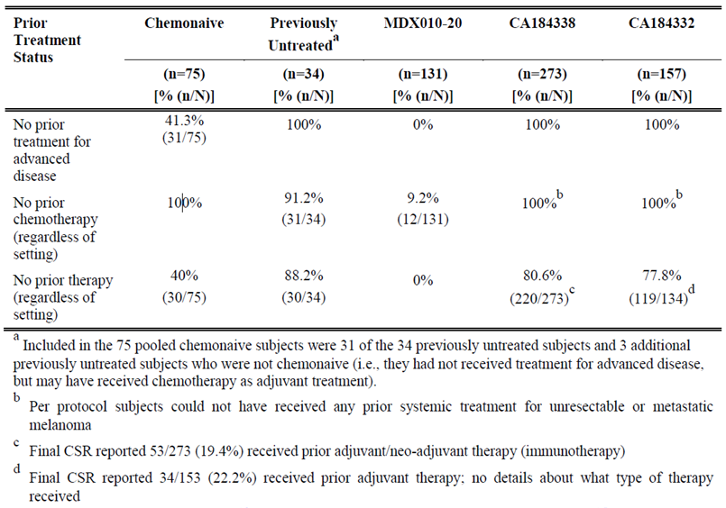
The sponsor refers, also, to safety analysis of patients who received 3 mg/kg ipilimumab monotherapy OR combination with other therapies (n=55 previously untreated; n=141 chemo-naive).

Evaluation relevant to pharmacology
The sponsor addressed various questions asked by the clinical evaluator concerning population pharmacokinetic (PopPK) data.

Choice of data for use in exposure-response (ER) analyses
With reference to clinical question 1 about the population PK analysis, the sponsor explained that CA184024 was the only study with a placebo arm for which OS was the primary endpoint.
The sponsor notes that a third ER analysis has been undertaken, considering OS data combined from CA184024 and the four Phase II studies (CA184004, CA184007, CA184008 and CA184022). One aim was to assess the relationship between C_{minss} and OS following 3 mg/kg and 10 mg/kg dosing. The 3rd ER-OS analysis is evaluated below.

Choice of covariates in PopPK analyses
With reference to Clinical Question 3 about the population PK analysis, the sponsor argues that body surface area and ideal body weight are highly correlated with total body weight; and also that dosing is according to total body weight.
The sponsor argues that inclusion of albumin as a covariate could have confounded the assessment of hepatic impairment. In the 3rd ER analysis, hepatic impairment was assessed for its effect on ipilimumab clearance (although only mild impairment and normal hepatic function were assessable, because only 1 subject had worse than mild impairment in the analysis). Given correlation between extent of hepatic impairment and albumin level, the evaluator accepted the sponsor’s argument in this regard.

Clinical relevance of impact of elevated LDH on ipilimumab exposure
With reference to a question in the CER, the sponsor argues that impact of LDH elevation > 3 x ULN on ipilimumab exposure is not meaningful. The sponsor notes elevated LDH is associated with a reduction in C_{minss} (that is trough ipilimumab level at steady state), implying no impact on safety profile. The sponsor also argues that impact on efficacy should be minimal, in that:
- exposure associated with an efficacious response (concentration range of 3 µg/mL to 20 µg/mL) was achieved in over 93% of subjects treated with ipilimumab 3 mg/kg; and
- the exposure-response analysis described in the PopPK-ER report (DCN 930082362) demonstrated a survival benefit even at the lowest 5th percentile of C_{minss} following 3 mg/kg dosing.
The clinical evaluator’s concern was more around the limited number of patients with elevations > 3 x ULN in LDH; but the evaluator accepts the sponsor’s view that the number of patients in this subgroup was not small.

Evaluation of third exposure-response analysis (DCN930082362)
This is the third PopPK/ER analysis provided by the sponsor. It is titled “ipilimumab Population Pharmacokinetic and Exposure - Response Analyses in Previously Treated or Untreated Subjects with Advanced Melanoma” (report date September 2014).
By way of background, there are two broad components to the ER analysis.
- First, a PopPK model is developed. The aim is to estimate ipilimumab exposure (for example C_{minss}) in individuals, by taking into account covariates found to explain exposure. Patients used in PopPK modelling (making up the PopPK analysis dataset) are drawn from a range of clinical studies.
- Second, a relationship between exposure and overall survival (ER: OS) is determined, taking into account covariates that might have an effect on OS. Likewise, a relationship between exposure and irAEs is examined (ER: irAEs). Outcomes (OS, irAEs) are from patients from specified clinical studies (making up exposure efficacy and exposure safety response analysis datasets).
Also by way of background, there have been two previous ER analyses:
- The first ER analysis used data from the four Phase II studies CA184004, CA184007, CA184008 and CA184022, but OS was not the primary endpoint.
- The second ER analysis used data from the Phase III study CA184024 and OS was the primary endpoint. This was evaluated in the first round 0f clinical evaluation.
The third ER analysis makes use of the same PopPK model that was used in the second PopPK/ER analysis (that is the PopPK analysis dataset is the same as described in the first round CER; and PK parameter estimates are the same).
The third ER analysis combines the above phase II and III studies and considers OS and irAEs (that is it has updated exposure response analysis datasets).
Methodology used for the third PopPK/ER analysis is not evaluated in detail here; refer to the separate Pop PK Evaluation Report and the first round CER, which considered the second PopPK/ER analysis.
The PopPK dataset included subjects with a range of doses (for example 3 mg/kg versus 10 mg/kg). The base PopPK model assumed linear PK. In the PSC Minutes for this application, it states:
There was enough information in the data to establish that the PK of the drug is linear within the tested dosing range. So exposure is proportion to dose…
With linear PK, parameters such as clearance and Vd should not vary with dose.
The PopPK model evaluation compares observed and model predicted concentrations stratified by dose (0.3, 3, 10 mg/kg). Predicted doses rise with dose group and broadly parallel observed doses, so the evaluator assumed that the base and full PopPK models capture ‘dose’ as an independent variable that helps explain exposure. Explicit description in the third PopPK/ER report of how this was achieved would have been useful.
In ER modelling for OS, the sponsor stratified C_{minss} impact on OS according to dose and the impact of C_{minss} in 10 mg/kg patients (with a C_{minss} range of 18.6 to 113 µg/mL) appears greater than the impact of C_{minss} in 3 mg/kg patients (with a C_{minss} range of 5.62 to 38.9 µg/mL). While this might be attributable to the lower exposure seen in the 3 mg/kg patients, there was also a difference between the 10 mg/kg and the 10 mg/kg + DTIC groups. Elsewhere, it was suggested that there was a loss of ipilimumab C_{minss} effect in the presence of DTIC. Alternatively, confounding by some unmeasured variable linked to OS might have contributed to modelled outcomes.
The same dose stratification approach was not evident in the ER (safety irAE) analysis.
Key information from the third PopPK/ER analysis is summarised in Figures 7 (for OS) and 8 (for irAEs).
Figure 7: Covariate effects on the hazard ratio for final CPH model
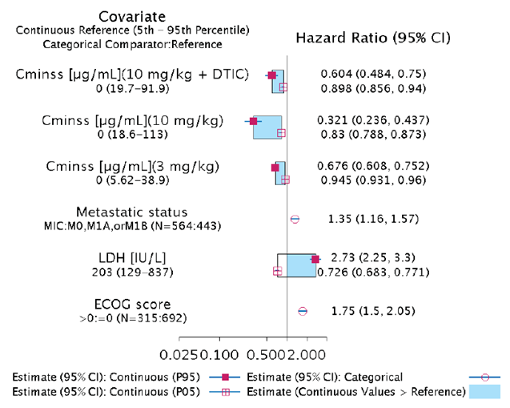
Figure 8: Full model odds ratios; any irAEs
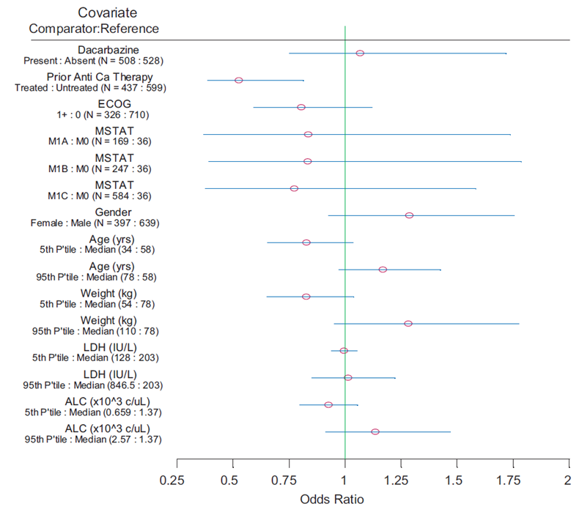
Table 12 on (parameter estimates for OS analysis, from the second ER analysis) can be compared with Table 42. The HR for C_{minss} is interpreted as indicating that per unit increase in C_{minss} (1 µg/mL) there is a reduction in risk of death by a factor of 0.987 (1.3%). As part of its efficacy argument, the sponsor noted exposure response modelling found no evidence that prior therapy influenced risk of death (implying that the OS benefit conferred by ipilimumab when used second line should be seen when it is used first line).

Table 42: Parameter estimates for full CPH model for OS analysis
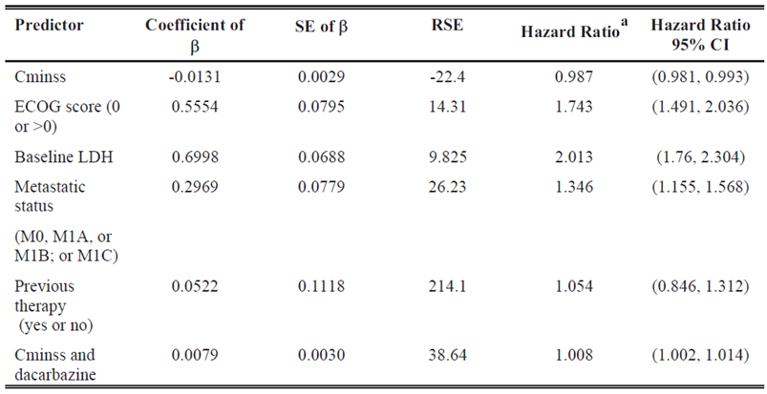
The evaluator did not consider that the updated PopPK/ER analyses substantially change understanding of the benefit-risk balance of ipilimumab 3 mg/kg in the target population. Given the various assumptions required in such modelling, and comments made above, the evaluator considered ER results exploratory.

Evaluation relevant to efficacy

Overview
The sponsor has not provided direct evidence of efficacy in the first-line population at the 3 mg/kg dose (in a suitable form such as a Phase III study), so relies on various indirect pieces of evidence. The sponsor summarises this evidence in its Clinical Overview in the response documents:
- Advanced melanoma represents a clinical continuum where prior chemotherapy has not been a significant prognostic factor for outcome
- Exposure response (ER) data corroborating that the efficacy of ipilimumab is independent of prior therapy
- Pharmacologic data showing consistent baseline immune status and T-cell response in untreated and previously treated subjects
- Consistency in pharmacokinetic (PK) data between untreated and previously treated subjects
- Consistency in efficacy of 3 mg/kg regardless of number or type of prior therapy in MDX010-20
- OS of previously untreated subjects who received ipilimumab 3 mg/kg in a real world setting (two retrospective observational studies) and pooled Phase II clinical trials in chemotherapy naïve subjects compare favourably to DTIC, the global standard for advanced melanoma, and was superior to historical Phase II OS in a risk adjusted model (Korn model)
- Results from the Phase III study of ipilimumab 10 mg/kg plus DTIC versus DTIC that provide proof of confidence that ipilimumab can prolong OS in untreated subjects treated with ipilimumab
The sponsor also writes in the response:
“For efficacy, benefit in first line was demonstrated primarily using the Korn model, which was designed to benchmark single arm trials to historical OS by adjusting for key prognostic factors. Validation of the Korn model by the sponsor was included in the initial submission and is provided again as part of this response…
In addition, first line use of ipilimumab is supported by a Phase III trial demonstrating superior OS with ipilimumab + DTIC, versus DTIC, albeit at a different dose.”

New data pertaining to efficacy

Final study report for pooled Phase II/III analysis
This report is identified as DCN930076433; the report date was 7 January 2014. To recapitulate key points about included subjects: the pooling was of 3 mg/kg chemo naive rather than treatment naïve patients; 78 such subjects were pooled across MDX010-08, MDX010-20, CA184004 and CA184022. Key exclusions varied by study but included ocular or mucosal melanoma and any brain metastases or untreated brain metastases. As noted earlier, only 35 out of 78 patients were previously untreated. The efficacy question 1 (Section 12 above) is also relevant; the sponsor’s response clarifies that 1 out of 35 of these subjects received 1 dose of maintenance treatment.
Across 78 chemo naive subjects, median OS was 13.5 months, and 1 year survival rate was 54.1% (2 year survival was 31.6%, and 3 year survival was 23.7%). The Kaplan-Meier curve of OS for these subjects is shown in Figure 9.
Figure 9: Kaplan-Meier of overall survival for chemotherapy naïve subjects
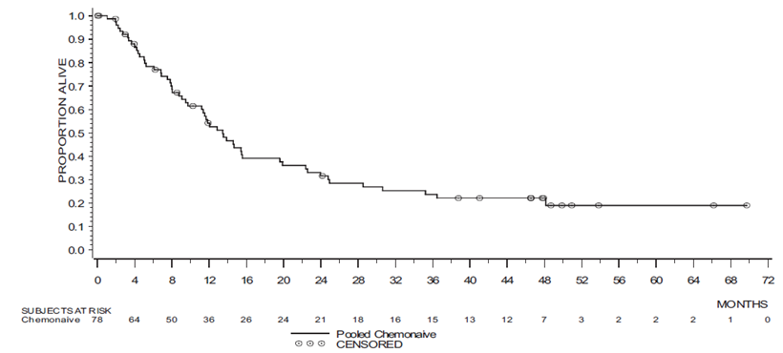
Across 35 previously untreated subjects, median OS was 13.5 months, and 1 year survival was 51.5% (2 year survival was 24.4%).

New data from CA184338
The final CSR for this study was provided, although it was described as a “final abbreviated summary” and it was noted that subsequent reports are planned to describe survival at 2, 3 and 4 year milestones. The report “summarises the analyses on 273 patients for whom at least 12 months had elapsed since initiation of ipilimumab 3 mg/kg monotherapy as first line treatment”.
Of the 257 patients, 65% were male, 95% were white, and mean age was 63 years at the start of ipilimumab monotherapy. The primary site was cutaneous in 88.3%. At the time of advanced disease diagnosis, 56% were M1c and 12.1% had brain metastases. 81% had an ECOG performance status of 0 or 1 (but in a further 10% ECOG status was unknown). Most patients were BRAF wild-type (66.3%; 15.4% were untested). Median time from initial melanoma diagnosis to advanced melanoma diagnosis was 18.3 months (mean time was 37 months).
212 out of 273 subjects (78%) received at least 4 induction doses. 7% of subjects discontinued due to toxicity.
Across 273 previously untreated subjects receiving 3 mg/kg, median OS was 14.5 months, and estimated 1 year survival rate was 59.2%. For patients without brain metastases, median OS was 17.5 months.

New data from CA184332
The final CSR for this study was provided, although it was described as a “final abbreviated summary” and it was noted that subsequent reports are planned to describe survival at 2, 3 and 4 year milestones. The report “summarises the analyses on 157 patients for whom at least 12 months had elapsed since initiation of ipilimumab 3 mg/kg monotherapy as first line treatment”.
Of the 157 patients, 68% were male, 68% were white, and median age was 66 years at the start of ipilimumab monotherapy. The primary site was cutaneous in 90.5%. At the time of advanced disease diagnosis, 54.1% were M1c and 22.1% had brain metastases. 81% had an ECOG performance status of 0 or 1 (but in a further 10% ECOG status was unknown). Most patients were BRAF wild-type (61.8%; 24.8% were untested). Interestingly, median time from initial melanoma diagnosis to advanced melanoma diagnosis was 8 months (but the mean time was 26 months, and the range was 0 to 352 months, with 24% having > 3 years between initial and advanced diagnoses).
92 out of 142 subjects (65%) received at least 4 induction doses. 18% of subjects discontinued due to toxicity.
Across 157 previously untreated subjects receiving 3 mg/kg, median OS was 11.5 months, and estimated 1 year survival rate was 46.7%. Median OS was 7 months in those with brain metastases, and 14.1 months in patients without metastases.

Korn model
This was included in the initial Dossier and re-submitted in the response.
The Korn model was “designed to benchmark single arm trials to historical OS by adjusting for key prognostic factors”. The factors were: ECOG PS; visceral disease; gender; and brain metastases.
The sponsor applied the model to untreated patients from CA184332 and CA184338 and pooled chemotherapy naïve 3 mg/kg patients, and claimed that observed OS was markedly superior to the Korn model-predicted OS of these patients.
Evidently this is an indirect approach to establishing efficacy. The indirect nature of this approach is offset to an extent by the large difference in favour of ipilimumab between the observed and Korn-predicted OS outcomes.

CA184045
The first round clinical evaluator asked for clinical data from CA184045, for those treated at 3 mg/kg. The sponsor has provided additional overall survival data from this expanded access programme, within the CSR for an interim report of safety and efficacy (document dated 20 May 2013). OS data was based on limited follow-up (median 6.1 months), and there was a high degree of drop out.
A change in protocol dropped the starting dose from 10 mg/kg to 3 mg/kg; and instead of maintenance, a re-induction regime was used. Interim analysis only considered subjects treated with 3 mg/kg. N = 2,276 subjects were treated at 3 mg/kg, and 2,155 of these were included in the interim analysis.
Median OS was 7.6 months. For the entire population, 1 year survival was 38%. For patients without brain metastases, mucosal melanoma or ocular melanoma (n = 1,240), median OS was 10.2 months and 1 year survival was 45%. The cohort included 33% with brain metastases, 8% with ECOG 2, 6% with ocular melanoma and 6% with mucosal melanoma.
The sponsor notes with regard to DTIC monotherapy in untreated advanced melanoma:
“Based on the 5 most recent trials in previously untreated, advanced melanoma, a median OS of approximately 9 months and estimated 1 year OS rate of approximately 36% represents an appropriate historical benchmark for DTIC monotherapy”
In three of those five DTIC studies, patients were excluded if brain metastases were present at baseline. In the one study (Avril et al) with a reasonable proportion of such subjects (that is 19.6% with brain metastases at baseline), median OS was 5.6 months.
The study was not designed to answer pre specified safety and efficacy questions, and these results are accordingly difficult to interpret as supportive of the current application.

New scientific argument regarding efficacy
In the response, in the context of discussion of the observational studies CA184332 and CA184338, the sponsor argues that the potential for bias in observational / single arm studies was minimised, citing the following measures:
- Both observational studies required that all patients who were sequentially treated at the sites during the indicated time period and who met the eligibility were enrolled.
- Both observational studies did not exclude patients on performance status, non-cutaneous primaries, life expectancy < 4 months, under presence of brain metastasis (all of which are associated with worse outcome).
- Both observational studies used > 25 sites, minimizing the risk for bias occurring at single sites based on unique treatment patterns or a unique patient population.
- Furthermore, sites enrolling patients into the two observational studies, as well as the clinical studies included in the pooled analysis, included a broad variety of settings, from academic centres to community practices, thus reflecting potential variations in local practices.
- The retrospective studies have sufficient follow up, comparable to median follow up for DTIC and have similar sample sizes to the ipilimumab monotherapy arm of MDX010-020 (N = 137).
Also in the response, the sponsor draws attention to analyses “performed to demonstrate that a significant bias in these studies is unlikely”.
- The baseline characteristics in the observational studies were generally comparable to those from the clinical trials; including the chemotherapy naive pooled dataset and CA184024 as acknowledged by the clinical evaluator in the evaluation report.
- The OS in each cohort was compared to the one predicted for this cohort by the Korn model, which takes into account known prognostic factors … the observed OS with ipilimumab was consistently above the OS predicted based on the Korn model for all analyses.
In the response, the sponsor advances further arguments supporting its application, namely:
- The similarity of first- and second-line patients in clinical practice (for example “…separated from each other often by only a few weeks of DTIC chemotherapy”).
- Prior treatment is not a prognostic factor for OS in metastatic melanoma (the sponsor refers to a meta-analysis of 42 Phase II studies from 1975 to 2005, allowing comparison of OS in previously untreated and previously treated melanoma patients; and to sub group analysis in MDX010-020, allowing comparison of OS in patients with 1 versus 2 + prior lines of therapy).

Efficacy conclusions
The sponsor argues that overall survival is ‘improved’ in previously untreated patients given 3 mg/kg ipilimumab, as follows:
- Median OS and 1 year OS rates in approximately 500 previously untreated patients (that is across the two observational studies and chemo naive or previously untreated patients pooled Phase II/III data) are numerically superior to outcomes in the DTIC arm of CA184024
- Median OS and 1 year OS rates in approximately 500 previously untreated patients (that is across the two observational studies and chemo naive or previously untreated patients pooled Phase II/III data) are superior to OS predicted for these cohorts based on historical Phase II OS using the Korn model.
The sponsor notes this improvement is despite 12 to 34% of patients in the observational studies having brain metastases at baseline (compared with < 2% in CA184024).
There is no direct comparison of ipilimumab 3 mg / kg with relevant comparators in the target population. The evidence presented relies on cross study comparison, or modelling.
The sponsor does not rely on data from the 10 mg/kg patient population to support claims for 3 mg/kg in an untreated population. The evaluator thinks this is an appropriate position, because the results of CA184024 cannot support the currently sought extension of indication. Evidence from that study is too indirect, because of (1) the 10 mg/kg dose used, and (2) combination with DTIC.
In the evaluator’s view, there is a sufficient accumulation of evidence to demonstrate that ipilimumab has efficacy in a first line setting, although it is unfortunate that there is no adequate direct demonstration of this effect.

Evaluation relevant to safety

Overview
The sponsor writes in the response document:
“Safety is supported mainly by analysis of previously untreated patients from pooled Phase II/III trials, and large observational studies in this setting.
In addition, first line use of ipilimumab is supported by a Phase III trial demonstrating superior OS with ipilimumab + DTIC, versus DTIC, albeit at a different dose.”

New data pertaining to safety

Exposure
The sponsor notes that “the majority” of patients (in the pooled Phase II/III cohort and in observational studies) received all 4 induction doses. Table 43 clarifies that 55 to 78% of these subjects received all 4 doses.

Table 43: Ipilimumab exposure
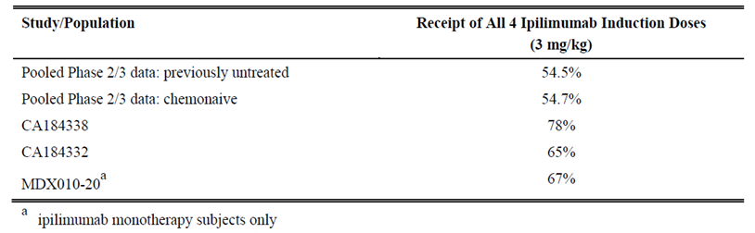

Observational studies
An updated overview of safety in the observational studies was provided (Table 44). In the updated safety analysis, the most frequently reported AEs were diarrhoea and rash / pruritus. With regard to immune related AEs (defined as AEs related to ipilimumab by the investigator and consistent with an inflammatory process), Table 45 shows the sponsor’s tabulation of irAEs in CA184338 (the other observational study did not delineate iRAEs from AEs). Of note, 7% of subjects had grade 3 gastrointestinal irAEs; two grade 4 GI irAEs were reported (colitis and enterocolitis) and one grade 4 report of myasthenia gravis was made. There were no fatal irAEs in CA184338.

Table 44: Overall Summary of safety (CA184332 and CA184338)
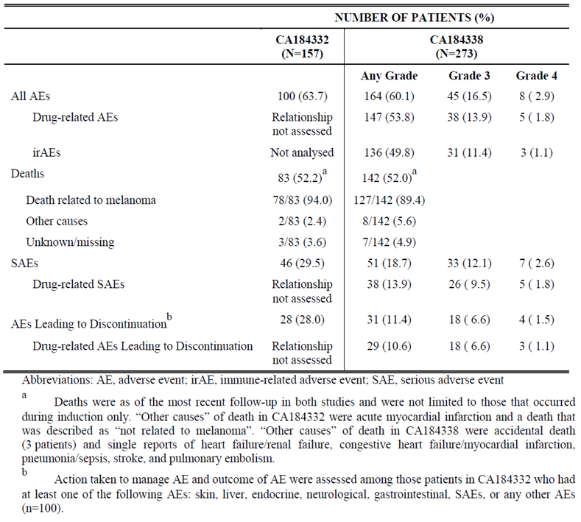

Table 45: Summary of immune-related adverse events during induction (CA184338)
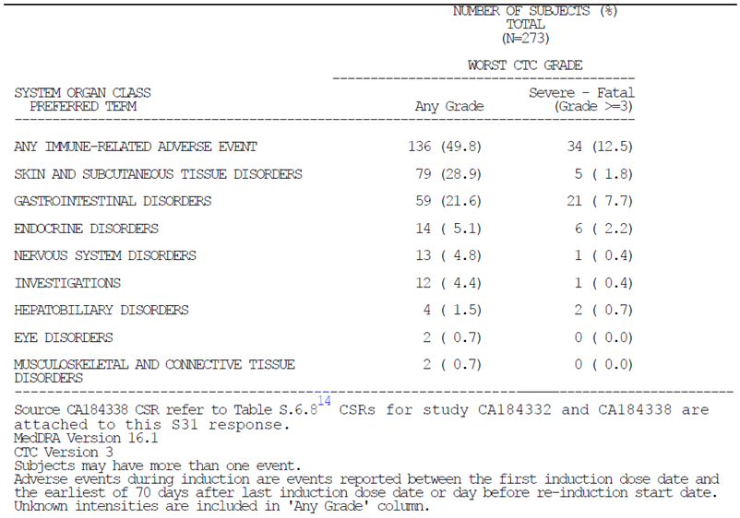
Summaries of safety outcomes from the two observational studies follow:

CA184338
Summary tables of AEs were limited to events occurring during the induction phase. It was notable that 60.1% of subjects (164 out of 273) reported AEs, and 136 out of 164 AEs were considered immune related. Most frequent events were diarrhoea (15%) and rash (15%); colitis was reported in 7% and enterocolitis in 4%; while subjects may have had more than one event, it seems likely no subject would have a report of colitis and a report of enterocolitis for the same event. Serious AEs plausibly linked to colitis were reported in up to 8% (that is 4.4% had an SAE of colitis, 2.6% had an SAE of diarrhoea and 1.8% had an SAE of enterocolitis; although subjects may have had > 1 event). Serious AEs were reported in 19% (detection of SAEs may not have been robust given the retrospective, chart review methodology used to find AEs). There were no deaths linked to drug toxicity.

CA184332
Summary tables of AEs were limited to events occurring during the induction phase. Most frequent events were diarrhoea (19.2%) and rash (18%). Colitis was reported in 5%. Serious AEs were reported in 29.5% (detection of SAEs may not have been robust given the retrospective, chart-review approach to data collection). There were no deaths linked to drug toxicity.

Pooled Phase II/III cohort
In analysis of the pooled Phase II/III cohort, the sponsor notes key safety parameters were similar for previously untreated (n = 55) and previously treated (n = 641) subjects.
Drug related deaths were seen in 3 out of 55 previously untreated subjects (5.5%), versus 13 out of 641 previously treated subjects (2.0%) (see Table 46). The sponsor notes in response: the number of untreated subjects is small; there was no disparity in the chemo naive versus chemo treated analysis; one death in a previously untreated subject was said to be confounded by disease progression; and there were no drug related deaths in 247 previously untreated subjects on 10 mg/kg in CA184024. Also, no deaths in the two observational studies were considered related to ipilimumab.

Table 46: Drug-related deaths; 3 mg/kg treated subjects
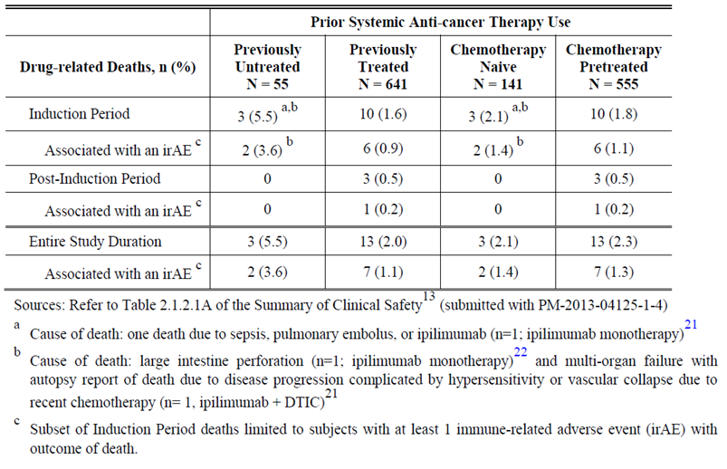
A top line summary of safety parameters in the final pooled analysis is shown in Table 48.

Table 47: Key safety parameters by prior treatment status (induction)
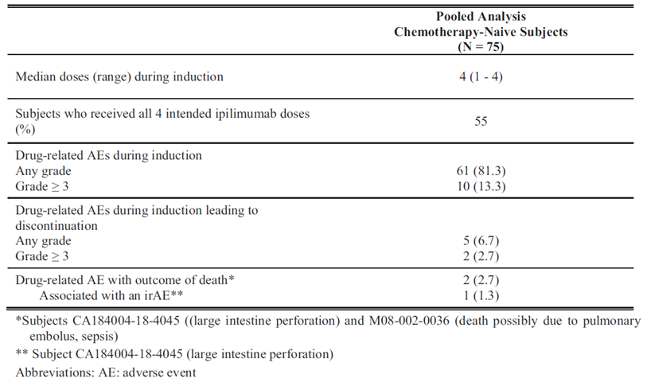

CA184045
Overall safety data for the EAP CA184045 are captured in Table 48. Serious AEs were common, as were immune-related AEs; however these data are difficult to interpret given the design of the study.

Table 48: Overall summary of safety data; entire study duration. Study CA184045
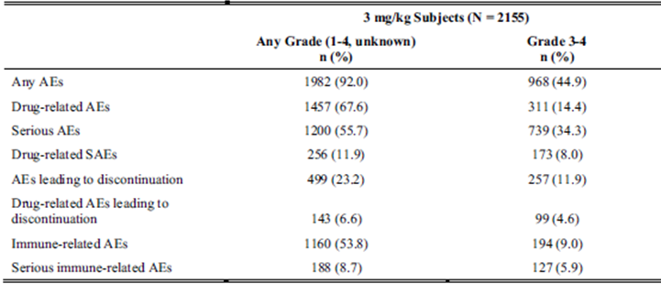

New scientific argument regarding safety

Methodology
In the response document, the sponsor considers safety methodology. Differences in safety data collection between observational studies and standard trials are noted.
The sponsor addresses the first round clinical evaluator’s specific question about exposure adjusted AEs. The focus of the response was irAEs. The same SOC > PT methods were used in these analyses, that is discrete preferred terms that may reflect the same toxicity were still treated separately, only being grouped at the SOC level. For example, pruritus, rash pruritic and pruritus generalised were separate preferred terms, and the SOC term was ‘skin and subcutaneous tissue disorders’ (which captures more than just pruritus, for example alopecia, vitiligo etcetera).
In the response the sponsor explains further aspects of safety methodology that were used in preparation of the initial dossier. No attempt was made to apply different methodologies, despite the request in “Additional Safety Question 1”.
Similar notes about methodology where the sponsor clarifies that AE summary tables and analyses are derived from the oracle clinical study database, which includes investigator-approved ‘cleaned’ data, but that narratives (for example for SAEs) are derived from that database but also the sponsor’s pharmacovigilance reporting system and other documents received from the investigator. It could be argued those data sources should be interrogated before compiling AE summaries, but a trade-off appears to have been made between feasibility and completeness of reporting.
Similar notes about methodology are made where the sponsor clarifies that AEs are not changed to grade 5 at the time of a subject’s death, and also that deaths outside the on study window (70 to 90 days depending on study) did not trigger narrative writing.
In the response, the sponsor defines immune mediated adverse reactions (imARs) which should be distinguished from immune related AEs (irAEs) and inflammatory events regardless of causality (IERCs).

Exposure response modelling
In the response there is discussion of the odds ratio of 0.51 for “any irAE” for previously treated (versus previously untreated) patients. The sponsor argues this finding may be confounded by prior treatment status and DTIC co-administration (a large proportion of previously untreated patients, 240 out of 348, were from CA184024 where DTIC was a concomitant treatment).

Fatalities
In the response the sponsor addresses concerns of the round 1 clinical evaluator about the role of ipilimumab in deaths of specific individuals. Two examples are discussed below, because of the apparently different approaches taken to ascribing cause.
- The sponsor addresses concerns held by the round 1 clinical evaluator about the role of ipilimumab in the death of a patient. A grade 5 SAE of systemic inflammatory response syndrome was considered possibly related while a grade 5 event of pneumonia was considered by the investigator unlikely to be related to ipilimumab. The primary cause of death was stated to be pneumonia, not SIRS. The sponsor’s approach was to accept the investigator’s judgement in this regard.
- The sponsor addresses concerns held by the round 1 clinical evaluator about the role of ipilimumab in the death of another patient. Notable was the sponsor’s decision to provide “disease progression” as the reason for death, ahead of the investigator’s decision to assign “cardiac arrest” as the reason. Also, it is not clear from the sponsor’s response why disease progression was assumed at day 114 (the day of the patient’s death). However, it seems difficult to ascribe cardiac arrest to ipilimumab, even indirectly, in this case.

Extrapolation from MDX010-020
In the response, the sponsor notes that in MDX010-020, irAEs were seen at similar frequencies in patients with 1 and > 1 prior therapies; implying that number of prior therapies has no impact on immune related safety. A further implication is that previously untreated patients would have a similar incidence of irAEs.

Extrapolation from CA184029
In the response the sponsor considers the relevance of EORTC 1807 / CA184029. This study considered 10 mg/kg in the adjuvant setting. The sponsor argues against relevance to the current application, because of the difference in patient populations (for example considerable disease burden in advanced melanoma versus no detectable disease after complete surgical resection in CA184029) and because of the different dose (given that toxicity is known to increase with dose). The sponsor further argues that the safety analysis of deaths (122 in the ipilimumab arm versus 160 in the placebo arm) suggests no detrimental effect.

Study CA184024
In the response, the sponsor addresses “selected pertinent safety questions raised through the process of evaluation CA184024”. The clinical evaluator only commented on key issues that they identified in reading the response.
In the response, the sponsor notes with regard to grading of diarrhoea AEs that TPN was sometimes used to ‘rest’ the GI tract when oral nutrition would still have been sufficient for the patient. In these cases it seems use of TPN did not qualify the event as grade 3. This approach is debatable; the alternative view is that if GI damage is enough to require the patient not to eat, it should be grade 3+.
In the response the sponsor addresses concerns of the round 1 clinical evaluator about lack of attribution of a grade 5 renal event to study drug. The clinical evaluator did not see any distinct trend in renal function (for example decline) prior to study drug use, and was concerned that there are insufficient grounds to exclude a link with the study drug.
In the response the sponsor addresses concerns of the round 1 clinical evaluator about lack of attribution of a grade 4 event of diarrhoea. The event was not considered immune mediated, apparently because a colon biopsy revealed ulcerative colitis and stool culture was positive for E. coli, while diarrhoea and colitis resolved with sulfasalazine and metronidazole. It seems an infectious process could not be excluded on this basis. This approach is debatable; in the evaluator’s view an immune related event is possible.

Safety conclusions
The sponsor argues that the safety profile of ipilimumab 3 mg/kg in observational studies and pooled Phase II/III studies in previously untreated patients is consistent with the profile in previously treated patients.
The round 1 clinical evaluator canvasses various imperfections in safety methodology, which make it more challenging to draw conclusions about the safety analyses presented. The clinical evaluator does accept the sponsor’s safety methodology as valid, without necessarily accepting every conclusion drawn by the sponsor, for example with regard to causality of some AEs.
No large, randomised, controlled study directly assesses safety of 3 mg/kg monotherapy in an untreated population, so evidence of safety in this group is again indirect. The clinical evaluator does not see any strong signal that ipilimumab in the first line setting has worse toxicity than is seen in the second line setting.

Second round benefit-risk assessment

Second round assessment of benefits
The main benefit of ipilimumab 3 mg/kg in the proposed usage is conferral of an overall survival benefit, relative to dacarbazine. There is a lack of direct evidence for this. There is also a lack of data comparing ipilimumab with more recently approved therapies, for example the BRAF and MEK inhibitors in BRAF V600 mutant disease. There is no information provided about concomitant use with such treatments.

Second round assessment of risks
The main risk of ipilimumab 3 mg/kg in the proposed use is that patients may experience the undoubted toxicities of treatment at an earlier stage of advanced disease.
There is no sign toxicities will be qualitatively different from those observed in second line treatment, but there is no direct and robust evidence to inform users about AE frequencies in the first line setting. A risk is that AE frequencies may be elevated in this setting, relative to experience with ipilimumab as a second line agent.
The key reassurance that toxicities of treatment are worth the risk is the indirect evidence of OS benefit. There is no information provided about impact on quality of life, and one risk is that quality of life may be degraded despite improved OS.

Second round assessment of benefit-risk balance
The benefit-risk balance of ipilimumab 3 mg/kg in patients previously untreated for their advanced melanoma is favourable. Given the indirect evidence for both efficacy and safety, there is considerable uncertainty attached to this assessment. However, the evaluator considers that in the circumstances (that is treatment of a life threatening condition, especially where patients may not have the opportunity to commence a second line agent) the degree of uncertainty is acceptable.

Second round recommendation regarding authorisation
The proposed change is to include use as first line therapy for patients, so that the formal indication for ipilimumab will read:
Yervoy/Winglore, as monotherapy, is indicated for the treatment of patients with unresectable or metastatic melanoma.
The evaluator recommends this change be authorised.
This wording does not refer to induction use or maintenance use, and in theory allows both uses. The PI’s Dosage and Administration section countenances induction and re-induction but not maintenance. The evaluator thinks this is a satisfactory approach.

References
Avril MF, Aamdal S, Grob JJ, et al. Fotemustine compared with Dacarbazine in patients with disseminated malignant melanoma: A Phase III study. J Clin Oncol. 2004; 22:1118-1125.
Chapman PB, et al. Phase III multicentre randomised trial of the Dartmouth Regimen versus Dacarbazine in patients with metastatic melanoma. J Clin Oncol. 1999; 17:2745-2751.
Eggermont AM, et al. Ipilimumab versus placebo after complete resection of Stage III melanoma: Initial efficacy and safety results from the EORTC 18071 Phase III trial. 2014 ASCO Annual Meeting Abstract No: LBA9008. (Please refer to the slides from the oral presentation for discussed information)
Middleton MR, et al. Randomised Phase III study of temozolomide versus Dacarbazine in the treatment of patients with advanced metastatic malignant melanoma. J Clin Oncol. 2000; 18:158-166.
Patel PM, et al. Extended schedule, escalated dose temozolomide versus Dacarbazine in Stage IV melanoma: final results of a randomised Phase III study (EORTC 18032). Eur J Cancer 2011; 47:1476–1483.
Shahabi V, et al. Assessment of association between BRAF-V600E mutation status in melanomas and clinical response to Ipilimumab. Cancer Immunol Immunother 2012; 61:733-737.

Therapeutic Goods Administration
PO Box 100 Woden ACT 2606 Australia
Email: info@tga.gov.au Phone: 1800 020 653 Fax: 02 6232 8605
https://www.tga.gov.au

CHMP/EWP/185990/06 Guideline on Reporting the Results of Population Pharmacokinetic Analyses
BBSA: Baseline body surface area; BIBW: Baseline ideal body weight; BHT: Baseline height; BALB: Baseline serum albumin; BALT: Baseline alanine aminotransferase; RACE: Race; BUDEN: Concomitant budesonide.
Bergstrand M, Karlsson MO. Handling data below the limit of quantification in mixed effect models. The AAPS journal. 2009;11:371-380.
Ahn JE, et al. Likelihood based approaches to handling data below the quantification limit using NONMEM VI. J Pharmacokinet Pharmacodyn. 2008;35:401-421.
Beal SL. Ways to fit a PK model with some data below the quantification limit. J Pharmacokinet Pharmacodyn. 2001;28:481-504.
Bristol-Myers Squibb Research and Development Document. Ipilimumab Population Pharmacokinetics and Exposure-Response Analyses in Subjects with Advanced Melanoma (CA184004, CA184007, CA184008, and CA184022). 2010.
Korn et al. Meta-analysis of Phase II co-operative group trials in metastatic Stage IV melanoma to determine progression-free and overall survival benchmarks for future Phase II trials. J Clin Oncol 2008; 26: 527-534

