December 2020

Australian Public Assessment Report for Iodised oil
  - Proprietary Product Name: Lipiodol Ultra Fluid
  - Sponsor: Guerbet Australia

About the Therapeutic Goods Administration (TGA)
- The Therapeutic Goods Administration (TGA) is part of the Australian Government Department of Health and is responsible for regulating medicines and medical devices.
- The TGA administers the Therapeutic Goods Act 1989 (the Act), applying a risk management approach designed to ensure therapeutic goods supplied in Australia meet acceptable standards of quality, safety and efficacy (performance) when necessary.
- The work of the TGA is based on applying scientific and clinical expertise to decision-making, to ensure that the benefits to consumers outweigh any risks associated with the use of medicines and medical devices.
- The TGA relies on the public, healthcare professionals and industry to report problems with medicines or medical devices. TGA investigates reports received by it to determine any necessary regulatory action.
- To report a problem with a medicine or medical device, please see the information on the TGA website <https://www.tga.gov.au>.

About AusPARs
- An Australian Public Assessment Report (AusPAR) provides information about the evaluation of a prescription medicine and the considerations that led the TGA to approve or not approve a prescription medicine submission.
- AusPARs are prepared and published by the TGA.
- An AusPAR is prepared for submissions that relate to new chemical entities, generic medicines, major variations and extensions of indications.
- An AusPAR is a static document; it provides information that relates to a submission at a particular point in time.
- A new AusPAR will be developed to reflect changes to indications and/or major variations to a prescription medicine subject to evaluation by the TGA.

Copyright
© Commonwealth of Australia 2020
This work is copyright. You may reproduce the whole or part of this work in unaltered form for your own personal use or, if you are part of an organisation, for internal use within your organisation, but only if you or your organisation do not use the reproduction for any commercial purpose and retain this copyright notice and all disclaimer notices as part of that reproduction. Apart from rights to use as permitted by the Copyright Act 1968 or allowed by this copyright notice, all other rights are reserved and you are not allowed to reproduce the whole or any part of this work in any way (electronic or otherwise) without first being given specific written permission from the Commonwealth to do so. Requests and inquiries concerning reproduction and rights are to be sent to the TGA Copyright Officer, Therapeutic Goods Administration, PO Box 100, Woden ACT 2606 or emailed to <tga.copyright@tga.gov.au>.

Contents
Common abbreviations 4
I. Introduction to product submission 5
Submission details 5
Product background 6
Regulatory status 7
Product Information 8
II. Registration timeline 8
III. Submission overview and risk/benefit assessment 9
Quality 9
Nonclinical 9
Clinical 10
Risk management plan 18
Risk-benefit analysis 19
Outcome 22
Attachment 1. Product Information 22

Common abbreviations
Abbreviation | Meaning
ACM | Advisory Committee on Medicines
AE | Adverse event
ARTG | Australian Register of Therapeutic Goods
BCLC B | Barcelona Clinic Liver Cancer stage B (intermediate)
CI | Confidence interval
CMI | Consumer Medicines Information
CT | Computed tomography
cTACE | Conventional trans-arterial chemoembolisation
DEB-TACE | Drug-eluting bead trans-arterial chemo-embolisation
HCC | Hepatocellular carcinoma
HR | Hazard ratio
ORR | Objective response rate
OS | Overall survival
PI | Product Information
RCT | Randomised controlled trial
RMP | Risk management plan
SI | Standard units
SUSMP | Standard for the Uniform Scheduling of Medicines and Poisons (the Poisons Standard)
TACE | Trans-arterial chemo-embolisation
US | United States

I. Introduction to product submission

Submission details
Type of submission: | Extension of indications
Product name: | Lipiodol Ultra Fluid
Active ingredient: | Iodised oil
Decision: | Approved
Date of decision: | 14 May 2020
Date of entry onto ARTG: | 18 May 2020
ARTG number: | 34371
Black Triangle Scheme: | No
Sponsor’s name and address: | Guerbet Australia Pty Ltd  166 Epping Road, Level 2 South,  Lane Cove West, NSW, 2066
Dose form: | Solution for injection
Strength: | 1 mg/mL
Container: | Ampoule
Pack size: | 1
Approved therapeutic use: | In interventional radiology:  As an imaging agent for visualisation and localisation during Trans-Arterial Chemo-Embolisation (TACE) of hepatocellular carcinoma (HCC) at intermediate stage in adults (see Section 4.3 Contraindications and Section 4.4 Special Warnings and Precautions for Use)
Routes of administration: | Intraarterial (in interventional radiology)
Dosage: | In interventional radiology: Trans-Arterial Chemo-Embolisation (TACE)  The dose of Lipiodol Ultra Fluid depends on the extent of the lesion but should usually not exceed a total dose of 15 mL in adults.  Procedures involving the use of Lipiodol Ultra Fluid in HCC patients should be conducted by interventional radiologists with prerequisite training and a thorough knowledge of the procedure to be performed.  The administration is by selective intra-arterial catheterisation of the hepatic artery. The procedure should be performed within a typical interventional radiology setting with the appropriate equipment.  Lipiodol Ultra Fluid for TACE can be mixed with anticancer medications for HCC in accordance with the applicable clinical guidelines.  For further information regarding dosage, refer to the Product Information.
Pregnancy category: | C  Drugs which, owing to their pharmacological effects, have caused or may be suspected of causing, harmful effects on the human fetus or neonate without causing malformations. These effects may be reversible. Accompanying texts should be consulted for further details.  The use of any medicine during pregnancy requires careful consideration of both risks and benefits by the treating health professional. This must not be used as the sole basis of decision making in the use of medicines during pregnancy. The TGA does not provide advice on the use of medicines in pregnancy for specific cases. More information is available from obstetric drug information services in your State or Territory.

Product background
This AusPAR describes the application by Guerbet Australia (the sponsor) to register Lipiodol Ultra Fluid (iodised oil) 10 mL injection solution ampoule for the following extension of indications:
In interventional radiology:
Visualisation and localisation during Trans-Arterial Chemo-Embolisation (TACE) of hepatocellular carcinoma (HCC) at intermediate stage in adults.
Iodised oil is an emulsion of active ethyl esters of iodised fatty acids of poppy seed oil (1 mg/mL) presented in 10mL glass ampoules, currently approved in Australia as a contrast agent for imaging such as lymphangiography and hysterosalpingography.
The submission described in this AusPAR was seeking approval of Lipiodol Ultra Fluid for its prevailing off-label use; in trans-arterial chemo-embolisation (TACE) of hepatocellular carcinoma (HCC), specifically at intermediate stage in adults. Intermediate HCC (BCLC-B) comprises heterogeneous group with unresectable HCC without vascular invasion or extrahepatic spread but with sufficiently preserved hepatic function. The proposed maximum dose in the TACE procedure is 15 mL.
TACE is performed by interventional radiologists. The hepatic artery is typically accessed via the femoral artery (under fluoroscopic guidance with water-soluble contrast) to administer Lipiodol Ultra Fluid-TACE for HCC.
In TACE, Lipiodol Ultra Fluid is given in combination with old generation cytotoxic agents such as doxorubicin, cisplatin, epirubicin and mitomycin. The procedure may be repeated every six to eight weeks according to the patient/disease progress. The intended registration of this agent is as an imaging agent, and not as a therapeutic agent.
The submission was literature-based, as agreed with the TGA.

Regulatory status
The product received initial registration on the Australian Register of Therapeutic Goods (ARTG) on 18 December 1991 for use in diagnostic radiology. Iodised oil has been a known contrast agent for over 70 years, and was grandfathered into the ARTG ‘as existing in clinical practice’.
At the time the TGA considered this application, similar applications had been approved in the United States (US), Canada, New Zealand, and a number of European nations, as outlined in Table 1 below.
In the US and Canada, as with Germany, indications focus on its imaging functions exclusively and disregard co-administration with cytotoxic agents in TACE for HCC.
The indication approved in New Zealand is the same indication proposed for Australia.
Table 1: International regulatory status
Region | Submission date | Status | Approved indications
United States | 4 June 2013 | Approved on 4 April 2014 | Selective hepatic intra-arterial use for imaging tumors in adults with known hepatocellular carcinoma (HCC)
Canada | 17 June 2016 | Approved on 13 July 2017 | Selective hepatic intra-arterial use for imaging tumors in adults with known hepatocellular carcinoma (HCC)
New Zealand | 4 August 2016 | Approved on 22 February 2018 | Visualisation, localisation during trans-arterial chemo-embolisation of hepatocellular carcinoma at intermediate stage, in adults
Germany | 20 March 2014 | Approved on 31 March 2017 | Visualisation and localisation of hepatocellular carcinoma at intermediate stage, in adults
France | 5 March 2014 | Approved on 7 August 2014 | Visualisation, localisation and vectorisation during trans-arterial chemo-embolisation of hepatocellular carcinoma at intermediate stage, in adults
Ireland | 14 April 2014 | Approved on 31 May 2018 | Visualisation, localisation and carrier of cytotoxic medicine during Trans-Arterial Chemo-Embolisation (TACE) of HCC at intermediate stage, in adults

Product Information
The Product Information (PI) approved with the submission which is described in this AusPAR can be found as Attachment 1. For the most recent PI, please refer to the TGA website at <https://www.tga.gov.au/product-information-pi>.

II. Registration timeline
The following table captures the key steps and dates for this application and which are detailed and discussed in this AusPAR.
Table 2: Timeline for Submission PM-2018-05773-1-2
Description | Date
Submission dossier accepted and first round evaluation commenced | 30 April 2019
First round evaluation completed | 22 October 2019
Sponsor provides responses on questions raised in first round evaluation | 23 December 2019
Second round evaluation completed | 18 February 2020
Delegate’s Overall benefit-risk assessment and request for Advisory Committee advice | 2 March 2020
Sponsor’s pre-Advisory Committee response | 16 March 2020
Advisory Committee meeting | 3 April 2020
Registration decision (Outcome) | 14 May 2020
Completion of administrative activities and registration on the ARTG | 18 May 2020
Number of working days from submission dossier acceptance to registration decision* | 208
*Statutory timeframe for standard applications is 255 working days

III. Submission overview and risk/benefit assessment
The submission was summarised in the following Delegate’s overview and recommendations.

Quality
There are no changes to the currently approved Lipiodol Ultra Fluid formulation, manufacturing, specifications or finished product details. The pharmaceutical dossier was mainly evaluated with respect to the preparation and administration directions to be added to the PI for use in TACE.
The quality area recommends approval but has notified as follows:
- Compatibility studies of Lipiodol Ultra Fluid were satisfactorily with respect to mixing with 3 of the 4 anticancer agents: doxorubicin, epirubicin and mitomycin. When combined with cisplatin, Lipiodol Ultra Fluid remained chemically stable, but total cisplatin impurities increased significantly from 0.3% to 3.5% after 3 hours.
- The sponsor was asked to confirm whether this complied with the British Pharmacopoeia Monograph. However, the sponsor was unable to confirm or identify these impurities and has proposed to delete reference to cisplatin in the PI. The nonclinical area was not able to qualify as these impurities are unknown (unidentified). Furthermore, only limited nonclinical data were available on TACE with cisplatin- Lipiodol Ultra Fluid in healthy pigs, and following intra-umbilical arterial administration, to anaesthetised rabbits. These studies do not provide any information relevant to the quality/safety concerns.
- The quality area has no objection to approval on chemistry grounds and advise consideration of clinical information. Alternatively, inclusion of a statement alerting health professionals to the observed cisplatin degradation with the advice that the mixture should be used as soon as feasible due to observed degradation of cisplatin or inclusion of a condition of registration for the sponsor to conduct additional studies examining cisplatin degradation is proposed.
- The proposed PI includes reference to devices that have been tested for administration of Lipiodol Ultra Fluid in TACE. No such device is currently available, although a separate device submission has been made to the relevant TGA area. The quality area has drawn the clinical delegate’s attention to the suitability of reference to any such device in the PI.
Otherwise, there are no outstanding quality-related matters.

Nonclinical
Following selective injection of Lipiodol Ultra Fluid into the hepatic artery, it is distributed throughout the liver. It is cleared by phagocytosis and via lymphatic drainage in 2 to 4 weeks. Iodised oil is distributed preferentially to HCC nodules likely due to hypervascularisation, and is retained there for several months to years partly due to the lack of lymphatic vessels draining the HCC nodules. The metabolism of iodised oil following selective intra-arterial injection for TACE has not been specifically studied.
The rationale behind the TACE procedure relies on the observation that approximately 95% of liver tumour blood supply is derived from the hepatic artery in contrast to the healthy liver parenchyma which receives 75% of its blood supply from the portal vein and 25% from the hepatic artery.
The clearance of Lipiodol Ultra Fluid from the liver was slow with approximately 20% of the administered radioactivity persisting 30 days post-dose. In tumour bearing animals, concentrations of radioactivity in the tumour were up to ten fold higher than that in healthy parenchyma 2 days post dose.
The main target organs for Lipiodol Ultra Fluid toxicity following selective intra-arterial administration, in a dog study using the clinical route, were lungs, central nervous system, liver and thyroid gland. Effects on pancreas and oil droplets in brain and kidneys were also observed. In liver, intrahepatic arterial administration occludes hepatic capillaries, resulting in a localised ischaemia, inhibition of hepatic metabolism and hepatic dysfunction and necrosis.
Testing indicated that Lipiodol Ultra Fluid is non-genotoxic. Carcinogenicity testing was not required. The nonclinical evaluators concluded that nonclinical data were generally supportive of the proposed use, but that clinical data were likely to provide more relevant information.
At present, no formal Pregnancy Category classification is applied to Lipiodol Ultra Fluid in the approved Australian PI. The nonclinical area recommends Pregnancy Category C, mainly due to of the risk of thyroid function disturbance in neonates from exposure to iodine (adult dose of 15 mL would deliver 7200 mg iodine). Note that iodised oil is an unscheduled substance (Poisons Standard No 27, 2020).

Clinical
The clinical evidence for Lipiodol Ultra Fluid in HCC is derived from 190 studies published between the early 1980s and 2017. Of these, 49 were prospective, 129 were retrospective, and the design was not defined in 12 studies. The majority (108) were conducted in Asia, 50 were in Europe and 23 were in the US. An additional 15 studies (6 prospective, 9 retrospective) were identified during a second literature search, of which 13 were in Asia, with one each in Germany and the US. The embolic agent was mainly gelatin sponge particles. Other embolic agents included polyvinyl alcohol and microspheres.
Please note that clinical outcomes, in place of indices of diagnostic test performance, were used to assess Lipiodol Ultra Fluid. However, the intention is not to establish a treatment effect of Lipiodol Ultra Fluid on HCC (co-administered with chemotherapy) or to differentiate clinical outcomes due to Lipiodol Ultra Fluid, but to demonstrate indirectly its diagnostic and prognostic ability/utility in the TACE for HCC procedure.
Multiple analyses of various combinations of studies were included.

Pharmacology
After selective trans-arterial injection of the hepatic artery in HCC patients, Lipiodol Ultra Fluid is distributed to the healthy liver parenchyma and the HCC nodules, with preferential accumulation in the HCC nodules likely due to hyper-vascularity in the tumour formations (see Table 3).
Table 3: Biodistribution of Lipiodol Ultra Fluid after administration into the hepatic artery
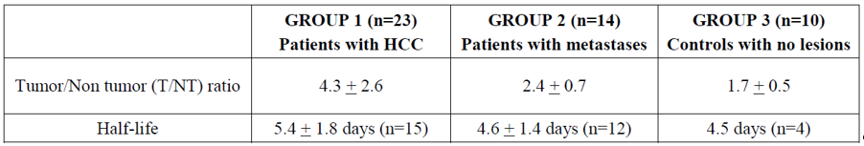
Following injection of 5 to 20 mL into the hepatic artery of HCC patients, Lipiodol Ultra Fluid was cleared from the liver parenchyma gradually over 3 to 7 days and selectively retained in the tumor nodules for up to 16 months. The confirmation of retention of Lipiodol Ultra Fluid within HCC nodules was obtained on reports indicating that the close-arterial injection into the hepatic artery allowed visualisation on computed tomography (CT) scans for up to 6 to 12 months after the procedure.

Efficacy
The primary outcome of interest was overall survival (OS), measuring the time from the first TACE procedure to death from any cause. The OS was analysed using meta-analysis methodology with random effects model, combining hazard ratios (HRs) of OS from the randomised controlled trials (RCTs). The HRs, corresponding variances and 95% confidence intervals (CIs) were taken directly from the published papers. Where HR was not available, it was derived from median survival times or survival rate at a timepoint. Bayesian sensitivity analyses were performed to assess robustness of the primary analysis of OS.
Published reports of 3 RCTs were available for comparison of cTACE; in HCC with conservative treatment (non-active treatment/best supportive/symptomatic treatment). The 3 trial populations and baseline disease classification were as follows in Table 4.
Table 4: Summary of study population included in the primary analysis of overall survival, cTACE versus conservative treatment (3 randomised controlled trials)
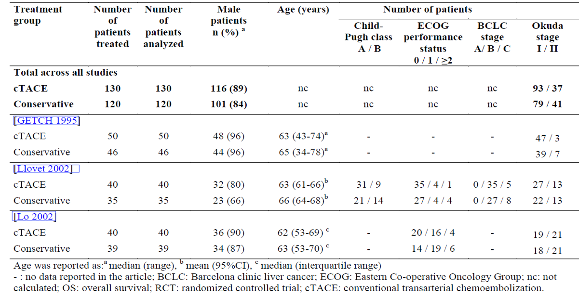
Papers referenced in this table: GETCH (1995), Llovet (2002), Lo (2002).
The results were indicative of overall benefit on OS gained with cTACE (HR 0.57; 95% CI 0.41, 0.8) compared to the conservative treatment. Among the 3 studies, Llovet et al. (2002);9 may be taken as a pivotal (it is more recent and has baseline BCLC available) and its individual results were consistent with the overall estimate (see Figure 1).
Figure 1: Overall survival in randomised controlled trials comparing cTACE to conservative treatment - hazard ratios for cTACE (n = 130) versus conservative treatment (n = 120) frequentist random-effects model - Forest-plot (3 randomised controlled trials)
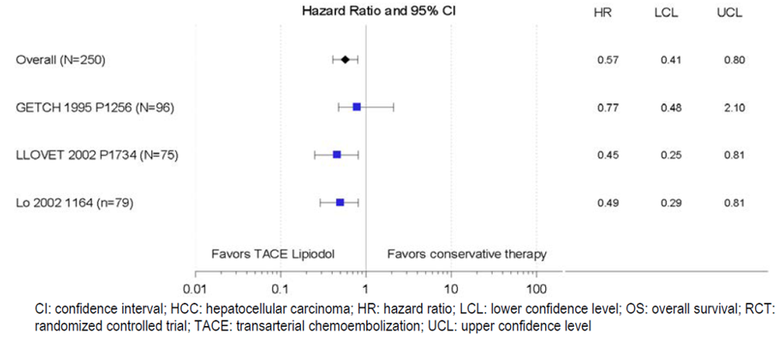
Papers referenced in this figure: GETCH (1995);8 Llovet et al., (2002);9 Lo et al., (2002).10
The overall objective response rate (ORR) was a secondary outcome. The results were as follows in Figure 2 (note relative risk instead of HR), supportive of the primary OS analysis.
Figure 2: Objective response rate relative risk for cTACE versus conservative treatment, frequentist random-effects model; forest plot (3 randomised controlled trials)
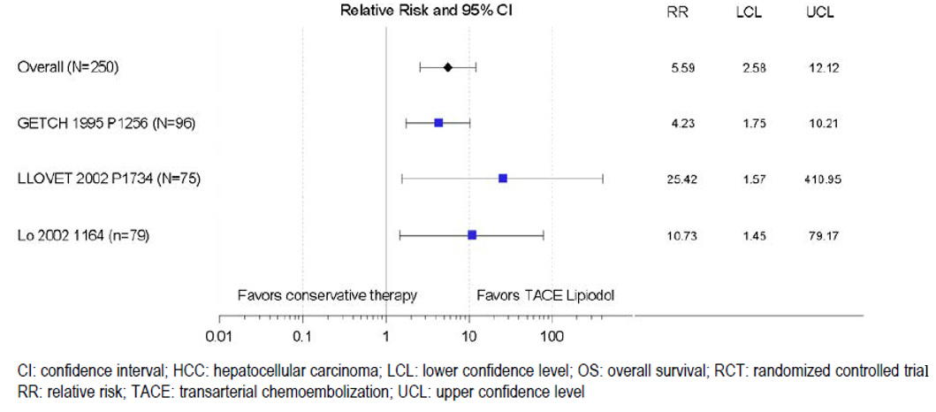
More recently, TACE using drug-eluting beads (DEB-TACE) which employ microbeads of biocompatible polymer with adsorbed cytotoxic agent given with Lipiodol Ultra Fluid has been developed. The results for OS, for cTACE versus DEB-TACE based on 2 RCTs indicated equivalence of both procedures as follows in Figure 3.
Figure 3: Overall survival hazard ratios for cTACE versus DEB-TACE treatment, frequentist random-effects model; forest plot (2 randomised controlled trials)
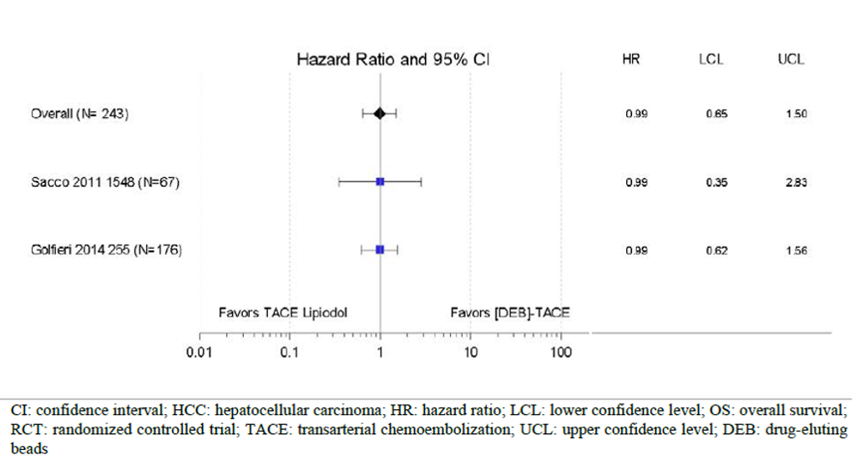
Papers referenced in this figure: Sacco et al., (2011); Golfieri et al., (2014).
Further qualitative (non-statistical) analysis of the dataset (34 study groups) was used to report survival rates for cTACE for HCC at intermediate stage as follows in Table 5.
Table 5: Median overall survival and overall survival rates during follow-up after cTACE treatment of hepatocellular carcinoma at intermediate stage, qualitative analysis
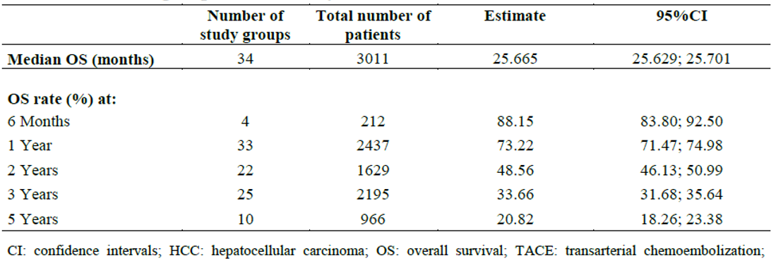
The survival rates for cTACE for HCC at any stage, based on 100 study groups, were as follows in Table 6.
Table 6: Median overall survival and overall survival rates during follow-up after cTACE treatment of hepatocellular carcinoma at any stage, qualitative analysis (subsets of 211 study groups)
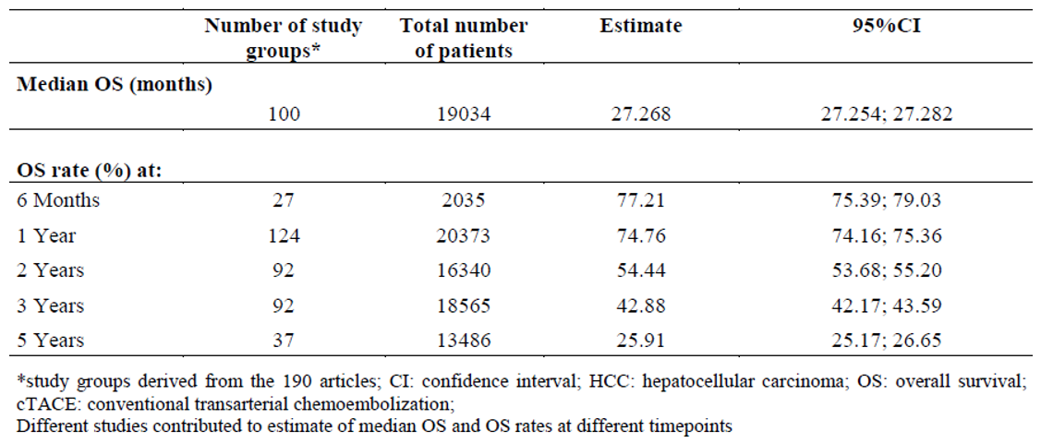
The survival rates for cTACE for HCC by Lipiodol Ultra Fluid dose were as follows in Table 7.
Table 7: Median overall survival after cTACE treatment of intermediate stage hepatocellular carcinoma and of hepatocellular carcinoma at any stage, subgroup analyses for different doses of Lipiodol Ultra Fluid
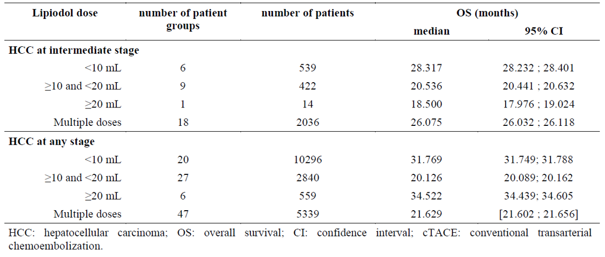
The survival rates for cTACE for HCC by single chemotherapeutic agent were as follows in Table 8.
Table 8: Median overall survival after cTACE with different single chemotherapeutic agents, qualitative analysis of hepatocellular carcinoma at intermediate stage and hepatocellular carcinoma at any stage
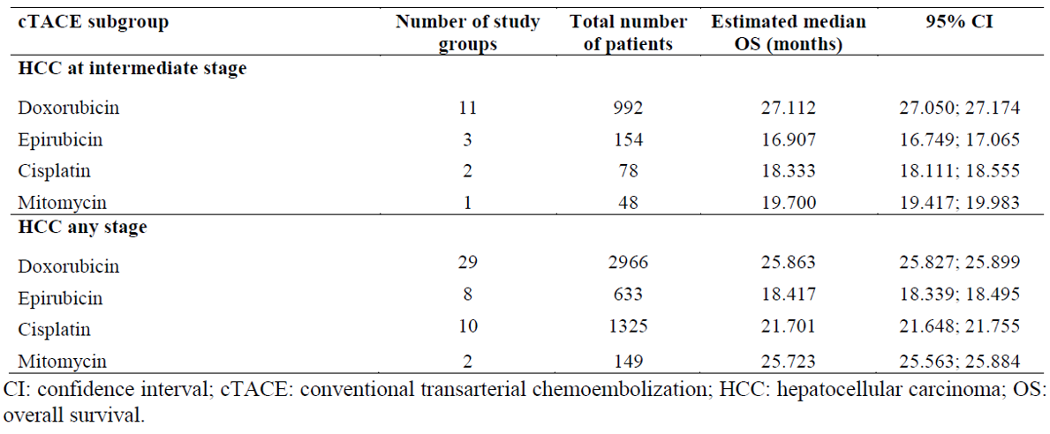
The additional studies identified during the most recent period (June 2017 to September 2018) were also consistent with the survival estimates in the above analyses.
In all datasets, only the Nakamura et al., (1994) study compared TACE with and without Lipiodol Ultra Fluid. This was a retrospective study in 443 participants in which 5 year cumulative survival rate with TACE was found to be 3.4% without Lipiodol Ultra Fluid and 12.9% after introduction of Lipiodol Ultra Fluid to TACE. Of the 29 patients who survived > 5 years, 23 had received Lipiodol Ultra Fluid during TACE, as shown in Figure 4.
Figure 4: Cumulative survival curves comparing the Lipiodol Ultra Fluid group with the non-Lipiodol Ultra Fluid group and relationship between the disease stage and the Lipiodol Ultra Fluid and non-Lipiodol Ultra Fluid groups
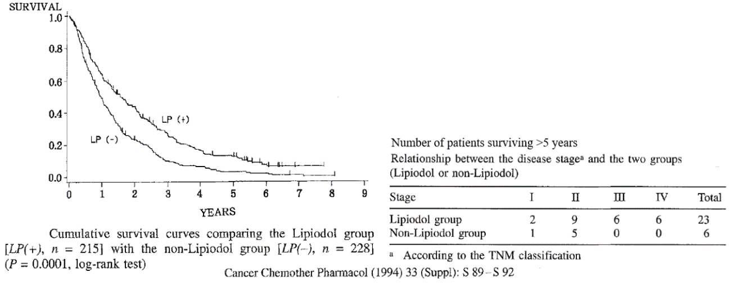
Diagnostic test performance indices (sensitivity, specificity, accuracy and such) for Lipiodol Ultra Fluid’s claim of visualisation and localisation HCC lesions during TACE treatment were not specifically evaluated in any study.

Safety
The safety dataset included 9637 patients from 108 studies (115 study groups) who received 1 to 7 sessions of cTACE for HCC at any stage, of which 2254 patients were HCC patients at intermediate stage in 28 studies (32 study groups). Overall, the most frequently reported adverse events (AEs) were as follows in Table 9.
Table 9: Most frequently reported adverse events in studies of cTACE treatment of hepatocellular carcinoma
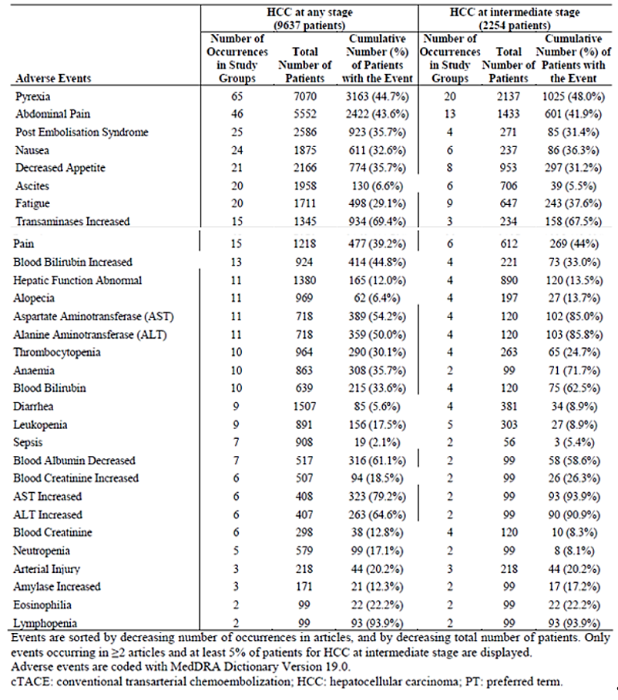
The most common AEs related to signs and symptoms of post-embolisation syndrome or the procedure itself, liver function test dysfunctions, haematological/bone marrow toxicity or symptoms of the existing condition.
Among the 108 studies analysed, there were 87 cTACE-related deaths reported in 78 studies (8646 patients). Of the 28 studies presenting safety outcomes in patients with HCC at intermediate stage, a total of 8 cTACE-related deaths were reported in 17 studies comprising 1982 patients.
As Lipiodol Ultra Fluid is coadministered with chemotherapeutic and embolic agents, attribution of causality to Lipiodol Ultra Fluid and/or distinction from confounding by indication is not straightforward.
In general, the safety concerns of cTACE are systemic toxicity (oily emboli in distant organs) and local (hepatic) toxicity (necrosis, inflammation et cetera).

Risk management plan
A previous risk management plant (RMP) has not been evaluated for this product. In support of the extended indications, the sponsor has submitted Global RMP version 1 (24 May 2018; data lock point 30 September 2017) and Australian specific annex version 1 (February 2019).
The summary of safety concerns and their associated risk monitoring and mitigation strategies are summarised in Table 10.
Table 10: Summary of safety concerns
Summary of safety concerns |  | Pharmacovigilance |  | Risk minimisation
 |  | Routine | Additional | Routine | Additional
Important identified risks | Thyroid disorders |  | – |  | –
Important identified risks | Embolic and thrombotic events |  | – |  | –
Important identified risks | Post embolization syndrome |  | – |  | –
Important identified risks | Hepatic failure |  | – |  | –
Important identified risks | Liver abscess |  | – |  | –
Important identified risks | Biloma |  | – |  | –
Important identified risks | Cholecystitis |  | – | – | –
Important identified risks | Granuloma |  | – |  | –
Important potential risks | Arrhythmia |  | – |  | –
Missing information | Use in pregnancy |  | – |  | –
The summary of safety concerns is acceptable from an RMP perspective. The sponsor has proposed routine pharmacovigilance for all safety concerns and this was also acceptable as was the risk minimisation plan.
There are no outstanding matters. Implementation of Lipiodol Ultra Fluid Global RMP (version 1, dated 24 May 2018, data lock point 30 September 2017), with Australian specific annex (version 1, dated February 2019) will be a condition of approval of the TACE indication in Australia.

Risk-benefit analysis

Delegate’s considerations
The proposed use of Lipiodol Ultra Fluid is not as an imaging agent but as an imaging agent in TACE, to be co-administered with cytotoxic agents for the treatment of HCC at intermediate stage.
According to the Sato et al., (1993) article, the role of Lipiodol Ultra Fluid as a contrast agent during TACE is:
‘to visualise in real time the hepatic arteries including branches feeding the tumour in order to adjust chemoembolization to the arterial flow, and image deposition of Lipiodol in tumour and its potential satellite nodules; To visualise in real time non-target liver embolization, arterial-portal shunts, and extra hepatic embolization; and to assess chemoembolization of entire tumour burden immediately post-procedure by imaging of Lipiodol deposition.’
This imaging ability of Lipiodol Ultra Fluid, during TACE, was not directly examined in any of the many published human clinical studies included in the sponsor’s dossier. Lipiodol Ultra Fluid is lipophilic and non-water soluble. Its opacifying properties and tropism for hepatic tumours continues for several months after the procedure.
Thus, the efficacy outcomes of TACE examined in the published studies related to clinical outcomes such as patient survival and response rates. The clinical dataset is extensive but of variable quality.
There was not much information on TACE with Lipiodol Ultra Fluid versus TACE without Lipiodol Ultra Fluid except the published Nakamura et al., (1994) paper.14
Although TACE has been extensively used over years worldwide, the procedure seems to vary among treatment centres with respect to concomitant cytotoxic drugs, embolic agents, doses and schedules.
Overall, a slightly revised indication is supported, such as:
In interventional radiology: As an imaging agent for visualisation and localisation during Trans- Arterial Chemo-Embolization (TACE) of hepatocellular carcinoma (HCC) at intermediate stage in adults (see Section 4.3 Contraindications and Section 4.4 Special Warnings and Precautions for Use).
This merely emphasises the imaging role without any intrinsic therapeutic effect rather than an oncology indication. In line with this thinking, the proposed PI does not include any clinical trial data. This is considered acceptable.
The dossier was not intended and did not include the relevant supporting data for proceeding to an exclusive imaging indication as in Canada and the US.
With respect to the cisplatin incompatibility issue, the Delegate is of the view that the available clinical data support the use of cisplatin in this context. A strengthened instruction to use Lipiodol Ultra Fluid-cisplatin/cytotoxic agent immediately after preparation may be added to the PI.
Please note that all 4 cytotoxic agents for which compatibility and clinical data were provided (doxorubicin, epirubicin, mitomycin and cisplatin) are registered in Australia, although the approved indications for epirubicin and cisplatin do not specifically include liver cancer.
With respect to the appropriateness of references in the PI to any special device to be used during TACE, the Delegate is of the view that if there are no known issues with using a standard glass syringe for this purpose, then a reference to any device is not required in the PI.

Proposed action
The Delegate has no reason to say, at this time, that the application for Lipiodol Ultra Fluid should not be approved for registration for the following indication:
In interventional radiology: As an imaging agent for visualisation and localisation during Trans- Arterial Chemo-Embolization (TACE) of hepatocellular carcinoma (HCC) at intermediate stage in adults (see Section 4.3 Contraindications and Section 4.4 Special Warnings and Precautions for Use).

Request for advisory committee on medicines advice
The Delegate requested Advisory Committee on Medicines (ACM) advice in response to the following questions:
- Is the use of Lipiodol Ultra Fluid, as part of TACE, consistent with the current Australian practice for HCC at BCLC intermediate stage? Does the ACM support the proposed extension of indication?
- Does the ACM recommend any further guidance, additional information or modification of information in the PI on patient selection, disease stage or directions for use?
- Does the Committee support the information on the use of the four identified cytotoxic agents (doxorubicin, epirubicin, mitomycin and cisplatin) in the PI including cisplatin?
- Does the Committee agree that a reference to any specific device to be used in the TACE is not required?
- The Committee is also requested to provide advice on any other issues that it thinks may be relevant to a decision on whether or not to approve this application

Advisory Committee considerations
The Advisory Committee on Medicines (ACM), having considered the evaluations and the Delegate’s overview, as well as the sponsor’s response to these documents, advised the following.

Specific advice
The ACM advised the following in response to the Delegate’s specific request for advice.
- Is the use of Lipiodol Ultra Fluid, as part of TACE, consistent with the current Australian practice for HCC at BCLC intermediate stage? Does the ACM support the proposed extension of indication?
The ACM was supportive of the proposed extension of indications. The ACM advised that this is consistent with standard Australian clinical practice, where Lipiodol Ultra Fluid is already part of the standard of care for intermediate HCC.
- Does the ACM recommend any further guidance, additional information or modification of information in the PI on patient selection, disease stage or directions for use?
The ACM advised that in Section 4.4 ‘Special Warnings and Precautions for Use’ the units for the liver function tests should be changed to Standard Units (SI), for consistency.
In regards to the same section of the PI, the ACM advised that current wording implies that thyroid function tests are not useful after treatment has been initiated; this should be reviewed and updated. Hyperthyroidism is currently listed as a potential adverse event, the ACM recommended that hypothyroidism also be listed. In regards to the Consumer Medicines Information (CMI), the ACM advised that wording should be added to the effect of ‘Tell your doctor if you have a large thyroid or goitre.’
- Does the Committee support the information on the use of the four identified cytotoxic agents (doxorubicin, epirubicin, mitomycin and cisplatin) in the PI including cisplatin?
The ACM noted that various agents are used in conjunction with Lipiodol Ultra Fluid, and was of the view that specifically naming agents in the PI was not necessary, particularly as the wording of the proposed indications specifies that Lipiodol Ultra Fluid is to be used as an imaging agent. This allows the use of Lipiodol Ultra Fluid to be more open and flexible to be adapted to clinical need.
- Does the Committee agree that a reference to any specific device to be used in the TACE is not required?
The ACM advised that there is variation in use and technique of administration for Lipiodol Ultra Fluid, therefore, it is not necessary to reference the use of a specific device for TACE. However, the ACM was of the view that standard wording around safety precautions for administration should be included.
- The Committee is also requested to provide advice on any other issues that it thinks may be relevant to a decision on whether or not to approve this application.
Nil further comments.

ACM conclusion
The ACM considered this product to have an overall positive benefit-risk profile for the indication:
In interventional radiology: As an imaging agent for visualisation and localisation during Trans- Arterial Chemo-Embolization (TACE) of hepatocellular carcinoma (HCC) at intermediate stage in adults (see Section 4.3 Contraindications and Section 4.4 Special Warnings and Precautions for Use).

Outcome
Based on a review of quality, safety and efficacy, the TGA approved the registration of Lipiodol Ultra Fluid (iodised oil) 10 mL injection solution ampoule for the following extension of indications:
In interventional radiology:
As an imaging agent for visualisation and localisation during Trans-Arterial Chemo-Embolisation (TACE) of hepatocellular carcinoma (HCC) at intermediate stage in adults (see Section 4.3 Contraindications and Section 4.4 Special Warnings and Precautions for Use)
As such, the full indications at this time were:
In diagnostic radiology:
Hysterosalpingography; lymphangiography; urethrography; radiography of the seminal vesicles, vas deferens and epididymis; nasal sinuses (for which purpose dilution to one-half or one-third strength with liquid paraffin or a suitable vegetable oil is generally advised); dacryocystography; sialography and the exploration of sinuses, fistulae, etc. It has also been used in the form of a 20% emulsion for the X-ray examination of empyema cavities.
In interventional radiology:
As an imaging agent for visualisation and localisation during Trans-Arterial Chemo-Embolisation (TACE) of hepatocellular carcinoma (HCC) at intermediate stage in adults (see Section 4.3 Contraindications and Section 4.4 Special Warnings and Precautions for Use)

Specific conditions of registration applying to these goods
- The Lipiodol Ultra Fluid Global RMP (version 1, dated 24 May 2018, data lock point 30 September 2017), with Australian specific annex (version 1, dated February 2019), included with submission PM-2018-05773-1-2, to be revised to the satisfaction of the TGA, will be implemented in Australia.
- For all injectable products the PI must be included with the product as a package insert.

Attachment 1. Product Information
The PI for Lipiodol Ultra Fluid approved with the submission which is described in this AusPAR is at Attachment 1. For the most recent PI, please refer to the TGA website at <https://www.tga.gov.au/product-information-pi>.

Therapeutic Goods Administration
PO Box 100 Woden ACT 2606 Australia
Email: info@tga.gov.au Phone: 1800 020 653 Fax: 02 6232 8605
https://www.tga.gov.au

The Black Triangle Scheme provides a simple means for practitioners and patients to identify certain types of new prescription medicines, including those being used in new ways and to encourage the reporting of adverse events associated with their use. The Black Triangle does not denote that there are known safety problems, just that the TGA is encouraging adverse event reporting to help us build up the full picture of a medicine's safety profile.
Barcelona Clinic Liver Cancer stage B (BCLC), or intermediate stage hepatocellular carcinoma according to the guidelines of the American Association for the Study of Liver Diseases.
Sahara, S. et al. Effects of hepatic artery chemoembolism using cisplatin-Lipiodol suspension with gelatin sponge particles on swine liver. Journal of Vascular Interventional Radiology, 2009; 20: 1359-1364.
LI J. et al. Tissue tolerance to pelvic intra-arterial chemoembolization with cisplatin-lipiodol suspension. Gynecol Oncol. 1993; 50(1): 10-14.
Australian Pregnancy Category C: Drugs which, owing to their pharmacological effects, have caused or may be suspected of causing, harmful effects on the human fetus or neonate without causing malformations. These effects may be reversible. Accompanying texts should be consulted for further details.
The Standard for the Uniform Scheduling of Medicines and Poisons (SUSMP): the SUSMP is a record of decisions regarding the classification of medicines and chemicals into Schedules for inclusion in relevant legislation of the states and territories; includes model provisions about containers and labels, and recommendations about other controls on medicines and chemicals; and is registered on the Federal Register of Legislation as the Poisons Standard.
cTACE = conventional trans-catheter arterial chemoembolisation with Lipiodol.
Groupe d'Etude et de Traitement du Carcinome Hepatocellulaire. A comparison of lipiodol chemoembolization and conservative treatment for unresectable hepatocellular carcinoma. New England Journal of Medicine, 1995; 332(19): 1256‐1261.
Llovet, J.M. et al. Arterial embolisation or chemoembolisation versus symptomatic treatment in patients with unresectable hepatocellular carcinoma: a randomised controlled trial. Lancet, 2002; 359(9319): 1734‐1739.
Lo, C.M. et al. Randomized controlled trial of transarterial lipiodol chemoembolization for unresectable hepatocellular carcinoma. Hepatology 2002; 35(5): 1164‐1171.
Percentage of patients with complete or partial response.
Sacco, R, et al. Conventional versus doxorubicin-eluting bead transarterial chemoembolization for hepatocellular carcinoma. J Vasc Interv Radiol. 2011; 22: 1545–1552.
Golfieri, R et al. Randomised controlled trial of doxorubicin-eluting beads vs conventional chemoembolisation for hepatocellular carcinoma. Br J Cancer, 2014; 111(2): 255-264.
Nakamura et al, 1994, Five-year survival after transcatheter chemoembolization for hepatocellular carcinoma, Cancer, Chemotherapy and Pharmacology, 33, 89-92
Routine risk minimisation activities may be limited to ensuring that suitable warnings are included in the product information or by careful use of labelling and packaging. Routine pharmacovigilance practices involve the following activities: - All suspected adverse reactions that are reported to the personnel of the company are collected and collated in an accessible manner; - Reporting to regulatory authorities; - Continuous monitoring of the safety profiles of approved products including signal detection and updating of labelling; - Submission of PSURs; - Meeting other local regulatory agency requirements.
Sato et al. Effects of hepatic artery embolization with Lipiodol and gelatin sponge particles on normal swine liver. Cardiovasc Intervent Radiol. 1993; 16(6): 348-354.
The ACM provides independent medical and scientific advice to the Minister for Health and the Therapeutic Goods Administration (TGA) on issues relating to the safety, quality and efficacy of medicines supplied in Australia including issues relating to pre-market and post-market functions for medicines. The Committee is established under Regulation 35 of the Therapeutic Goods Regulations 1990. Members are appointed by the Minister. The ACM was established in January 2017 replacing Advisory Committee on Prescription Medicines (ACPM) which was formed in January 2010. ACM encompass pre and post-market advice for medicines, following the consolidation of the previous functions of the Advisory Committee on Prescription Medicines (ACPM), the Advisory Committee on the Safety of Medicines (ACSOM) and the Advisory Committee on Non-Prescription Medicines (ACNM). Membership comprises of professionals with specific scientific, medical or clinical expertise, as well as appropriate consumer health issues relating to medicines.

