October 2013

Australian Public Assessment Report for interferon beta-1a
  - Proprietary Product Name: Rebif
  - Sponsor: Merck Serono Australia Pty Ltd
About the Therapeutic Goods Administration (TGA)
- The Therapeutic Goods Administration (TGA) is part of the Australian Government Department of Health, and is responsible for regulating medicines and medical devices.
- The TGA administers the Therapeutic Goods Act 1989 (the Act), applying a risk management approach designed to ensure therapeutic goods supplied in Australia meet acceptable standards of quality, safety and efficacy (performance), when necessary.
- The work of the TGA is based on applying scientific and clinical expertise to decision-making, to ensure that the benefits to consumers outweigh any risks associated with the use of medicines and medical devices.
- The TGA relies on the public, healthcare professionals and industry to report problems with medicines or medical devices. TGA investigates reports received by it to determine any necessary regulatory action.
- To report a problem with a medicine or medical device, please see the information on the TGA website <http://www.tga.gov.au>.
About AusPARs
- An Australian Public Assessment Record (AusPAR) provides information about the evaluation of a prescription medicine and the considerations that led the TGA to approve or not approve a prescription medicine submission.
- AusPARs are prepared and published by the TGA.
- An AusPAR is prepared for submissions that relate to new chemical entities, generic medicines, major variations, and extensions of indications.
- An AusPAR is a static document, in that it will provide information that relates to a submission at a particular point in time.
- A new AusPAR will be developed to reflect changes to indications and/or major variations to a prescription medicine subject to evaluation by the TGA.
Copyright
© Commonwealth of Australia 2013
This work is copyright. You may reproduce the whole or part of this work in unaltered form for your own personal use or, if you are part of an organisation, for internal use within your organisation, but only if you or your organisation do not use the reproduction for any commercial purpose and retain this copyright notice and all disclaimer notices as part of that reproduction. Apart from rights to use as permitted by the Copyright Act 1968 or allowed by this copyright notice, all other rights are reserved and you are not allowed to reproduce the whole or any part of this work in any way (electronic or otherwise) without first being given specific written permission from the Commonwealth to do so. Requests and inquiries concerning reproduction and rights are to be sent to the TGA Copyright Officer, Therapeutic Goods Administration, PO Box 100, Woden ACT 2606 or emailed to <tga.copyright@tga.gov.au>.

Contents
I. Introduction to product submission 4
Submission details 4
Product background 4
Regulatory status 5
Product Information 5
II. Quality findings 5
III. Nonclinical findings 5
IV. Clinical findings 5
Introduction 5
Pharmacokinetics 6
Pharmacodynamics 6
Efficacy 7
Safety 9
First round benefit-risk assessment 10
Second round evaluation of clinical data submitted in response to questions 12
Second round benefit-risk assessment 18
Second round recommendation regarding authorisation 18
V. Pharmacovigilance findings 19
Risk management plan 19
VI. Overall conclusion and risk/benefit assessment 25
Quality 25
Nonclinical 25
Clinical 26
Risk management plan 30
Risk-benefit analysis 31
Outcome 36
Attachment 1. Product Information 37
Attachment 2. Extract from the Clinical Evaluation Report 37

I. Introduction to product submission

Submission details
Type of submission: | Extension of indications
Decision: | Approved
Date of decision: | 15 May 2013

Active ingredient: | Interferon beta-1a
Product name: | Rebif
Sponsor’s name and address: | Merck Serono Australia Pty Ltd  Unit 3-4, 25 Frenchs Forest Road East  Frenchs Forest NSW 2086
Dose forms: | Solution for injection in pre-filled syringe  Solution for injection in cartridge  Solution for injection in pre-filled pen
Strengths: | Pre-filled syringe/pen: 22 µg/0.5 ml, 44 µg/0.5 ml;  Multi-dose cartridge: 66 µg/1.5 ml, 132 µg /1.5 ml
New approved therapeutic use: | Patients with a single demyelinating event in the central nervous system with an active inflammatory process, if alternative diagnoses have been excluded, and if they are determined to be at high risk of developing clinically definite multiple sclerosis. High risk can be inferred from cerebral MRI with 2 or more lesions suggestive of demyelination.
Route of administration: | Subcutaneous injection
Dosage: | 44 µg three times weekly (tiw)
ARTG numbers: | 133809, 133813, 165745, 165746, 174478, 174479

Product background
This AusPAR describes an application by the sponsor, Merck Serono Australia Pty Ltd, to extend the indications for interferon beta-1a (Rebif) to include patients with a single demyelinating event of the central nervous system (CNS): so called Clinically Isolated Syndrome (CIS).
Interferon beta-1a is a recombinant analogue of a naturally occurring human immune protein, beta interferon, which has complex regulatory actions on the immune system. Rebif is one of three commercial beta interferon preparations used to treat multiple sclerosis (MS) in Australia. One of these, Avonex, is also designated interferon beta-1a and is very similar to Rebif in its composition; both share the amino acid sequence of the native human protein. The third commercial beta interferon, Betaferon, is designated interferon beta-1b and has a couple of amino acid substitutions.
The currently approved indication for Rebif is
“the treatment of ambulatory patients with multiple sclerosis who have experienced two or more relapses within the last 2 years”
with the proviso that
“Rebif therapy should not be initiated in secondary progressive MS patients who no longer experience relapses.”
The proposed additional indication is the treatment of patients with a single, first clinical event suggestive of CNS demyelination, who are thought to be at risk of developing MS. The proposed Product Information (PI) describes this target group as
“patients with a single demyelinating event with an active inflammatory process, if alternative diagnoses have been excluded, and if they are determined to be at risk of developing relapsing multiple sclerosis.”

Regulatory status
At the time the TGA considered this application, Rebif for the proposed CIS indication had been approved in the European Union (January 2012), Canada (June 2012), Switzerland (October 2012) and in 5 additional countries.

Product Information
The approved PI current at the time this AusPAR was prepared can be found as Attachment 1.

II. Quality findings
There was no requirement for a quality evaluation in a submission of this type.

III. Nonclinical findings
There was no requirement for a nonclinical evaluation in a submission of this type.

IV. Clinical findings
A summary of the clinical findings is presented in this section. Further details of these clinical findings can be found in Attachment 2.

Introduction
This was a small submission, with a single pivotal study (IMP27025, published as the ‘REFLEX’ study) and one open label extension study (IMP28981).
The sponsor also submitted a number of relevant references relating to CIS and definitions of Clinically Definite Multiple Sclerosis (CDMS).

Pharmacokinetics
No pharmacokinetic studies were submitted. The pharmacokinetic properties of Rebif have been adequately explored in previous submissions but an assessment of that data is beyond the scope of this evaluation. The pharmacokinetic profile of Rebif is described in the approved PI as follows:
The pharmacokinetic and pharmacodynamic profiles of the Rebif HSA free formulation were investigated in Phase I Study 25827, a double blind, randomised, two period, crossover study in which 41 healthy subjects received single 44 µg doses of Rebif (containing Human Serum Albumin (HSA)) and the Rebif HSA free formulation. The geometric mean Cmax (17.1 IU/mL) and AUC (54.0 IU·h/mL) of the current formulation were approximately 70% higher than that of the previous formulation (10.2 IU/mL and 31.9 IU·h/mL, respectively). The median Tmax was 0.25 h (versus 0.33 h for the previous formulation). There was high inter patient variability in the pharmacokinetics of interferon beta-1a with both formulations. Bioequivalence was not demonstrated for PK parameters. However, in this study, both Rebif HSA and Rebif HSA free formulations were shown to be bioequivalent on the basis of two markers of biological activity, neopterin and beta-2 microglobulin.
The raw neopterin responses measured for Rebif HSA and Rebif HSA free formulations were similar. Median Tmax was 24 h after dosing for both formulations. Mean (± SD) Cmax was 42 ± 21 nmol/L for Rebif HSA free formulation, and 40 ± 19 nmol/L for Rebif HSA formulation. Mean AUC_{last} were 3882 ± 1804 nmol·h/L for Rebif HSA free formulation and 3581 ± 1475 nmol·h/L for the Rebif HSA formulation.
The beta-2 microglobulin responses of Rebif HSA and Rebif HSA free formulations were similar. For both formulations the median Tmax was 48 h after administration. Mean Cmax was 3017 ± 597ng/mL for Rebif HSA free formulation, and 2970 ± 646 ng/mL for Rebif HSA formulation. Mean AUC_{last} were 401 ± 67 μg·h/mL and 392 ± 70 μg·h/mL for the Rebif HSA free and Rebif HSA formulations, respectively.

Pharmacodynamics
No new pharmacodynamic studies were submitted. Given that MS plaques are relatively infrequent over the course of a year of treatment the pharmacodynamic effects of treatment on disease risk can only be inferred indirectly. As described above, endogenous immune compounds, such as neopterin and beta-2 microglobulin, have been used as surrogate markers of pharmacodynamic activity.
The pivotal efficacy study included two dose groups, a 44 µg three times weekly (tiw) dose group and a 44 µg once weekly (ow) dose group. Endogenous markers of the biological activity of beta interferon suggest that the main effects of interferon therapy persist for 3-4 days after treatment, so once weekly dosing may leave the patient under treated for part of each week. For instance, Durelli writes:
“Evidence from pharmacokinetic and pharmacodynamic studies have [sic] shown that a single dose of beta interferon results in an increase in beta interferon activity in the serum within several hours of injection, reaching a maximum level after 12-18 h, followed by a gradual decrease to baseline within 48 hours following injection. Increases in BRM [biological response marker] levels reach a maximum after 24-36 hours, and return to baseline levels a further 48-96 h later.”
This could partially account for the weaker therapeutic effect of Rebif ow versus Rebif tiw in the submitted pivotal study.

Efficacy

Studies providing efficacy data
Only one pivotal study (IMP27025, published as the ‘REFLEX’ study) was submitted for the new indication. Its open label extension (IMP28981) was also mentioned but this extension was ongoing at the time of submission and the results were unavailable. Thus, the submission rests on a single study.
The REFLEX study was a randomised, double-blind, placebo-controlled study carried out over two-years and involving 517 patients considered at risk of developing MS due to a recently experienced isolated demyelinating event (CIS) of the CNS consisting of optic neuritis, myelopathy or a brainstem syndrome.
Participants were randomised to receive Rebif 44 µg three times weekly (tiw), Rebif 44 µg once weekly (ow) or placebo as a subcutaneous injection for a period of two years (or up to the time when they experienced a second clinical attack leading to a diagnosis of CDMS or experienced progression defined by a sustained increase of at least 1·5 points in the Expanded Disability Status Scale (EDSS), at which time they qualified for open-label Rebif treatment).
The primary endpoint was the time to progression to MS, as defined by the McDonald 2005 criteria. In practice this meant the development of a second clinical episode, a new magnetic resonance imaging (MRI) lesion, or progression of disability.
The study recruited adult patients of either sex with a single, first clinical event suggestive of MS within 60 days prior to randomisation.
The exclusion of patients with <2 clinically silent MRI lesions and exclusions based on the McDonald 2005 criteria for diagnosing MS were particularly noted:
Requirement for ≥2 silent MRI lesions
The population of CIS subjects recruited to the pivotal study all had at least 2 cerebral MRI lesions. Subjects with only one MRI lesion or no lesion would be expected to have a lower risk of developing MS. It is unknown if Rebif is useful in subjects with ≤ 1 lesion, and the PI [Indication] should reflect this.
Changes in McDonald Criteria from 2005 to 2010
Subjects with a diagnosis of MS according to McDonald 2005 criteria were excluded from the study.
The McDonald criteria for diagnosing MS were first published in 2001; they have since been revised in 2005 and 2010 (McDonald et al., 2001, Polman et al., 2005, Polman et al., 2011). In the sponsor’s submission and in the clinical evaluation report, the term “McDonald MS” refers to the 2005 criteria unless the 2010 criteria are explicitly mentioned.
Some patients who would have been considered CIS patients according to old clinical criteria were (appropriately) excluded from the REFLEX study on the basis that they could already be diagnosed with MS by the newer MRI-based criteria. In particular, those with MS according to the McDonald 2005 criteria were explicitly excluded as these patients had already reached the primary endpoint (time to progression to MS, as defined by the McDonald 2005 criteria).
After the study was already underway, further revisions of the McDonald criteria were agreed upon in 2010 and published in 2011 (Polman et al., 2011⁴). Both sets of criteria (2005 and 2010) allow the results of MRI scans to be used for demonstrating dissemination in time (DIT) and dissemination in space (DIS), but the 2010 criteria are more inclusive, implying that some subjects in REFLEX are likely to have had MS (rather than true CIS) at baseline by the new criteria.
McDonald 2005 and 2010 criteria and the key differences between these are described in the CER (see Attachment 2 of this AusPAR).
The 2010 McDonald criteria were established after reviewing all of the literature on the 2005 criteria and discussion with MS experts around the world. They almost certainly represent an improvement over the early criteria. They are even more sensitive in making a diagnosis of MS, without apparent loss of specificity (Polman et al., 2011). Because of this increased sensitivity, however, some patients accepted into the REFLEX study according to the 2005 criteria would have been rejected by the 2010 criteria on the basis that they could already be diagnosed with MS at baseline. In fact, the sponsor has estimated that about 38% of the study cohort already had MS by the 2010 criteria at the time of randomisation. This does not reflect a fault in the study because the best available diagnostic criteria were used at the time, but it does mean that the target population studied in REFLEX no longer closely reflects the population to whom the new indication would apply (that is, patients with CIS) because clinicians will generally work from the new criteria. As stated in the Introduction, above, Rebif is already approved for the treatment of patients with MS.

Evaluator’s conclusions on clinical efficacy for Rebif in CIS
The submission rests on a single pivotal efficacy study. In the cohort studied, which included patients with a clinically isolated demyelinating syndrome and an MRI scan suggestive of MS, Rebif reduced the development of MS, including radiologically defined (McDonald) MS, which was the primary endpoint, and clinically defined MS (CDMS), which was the main secondary endpoint. There were also clear benefits on disease activity as measured with MRI. All of these treatment effects were statistically significant.
Over the course of the study, the total number of subjects diagnosed with McDonald MS was 106/171 (62.0%), 129/175 (73.7%), and 144/171 (84.2%) in the Rebif 44 µg tiw, 44 µg ow, and placebo groups, respectively. Using the stratified, adjusted model, the two year probability of conversion was similar to the raw conversion rates (62.5% and 85.8% for the proposed dose and placebo, respectively, which gives an absolute risk reduction of 23.3% and a relative risk reduction of 27.1%).
The model adjusted conversion rates to CDMS over two years were 21%, 22% and 38% in the 44 µg tiw group, 44 µg ow group and placebo group, respectively, giving an absolute risk reduction of 17% for the proposed tiw dose, and a relative risk reduction of 45%.
The mean number of active lesions per subject per MRI scan was reduced from 2.58 in the placebo group to 0.95 in the ow group and 0.50 in the tiw group.
In conclusion, Rebif shows worthwhile efficacy in this cohort of patients. The only caveat is that the cohort studied included many patients who would be diagnosed with MS (rather than true CIS) by more recent criteria and it did not include any subjects with <2 cerebral MRI lesions. The efficacy of Rebif in the setting of milder CIS cases is therefore unclear.

Safety
The only new study providing safety data was the pivotal efficacy study, ‘REFLEX’, in which the safety data were collected as follows:
- General adverse events (AEs) were assessed by blinded treating clinicians during regular scheduled visits, unscheduled visits and hospital presentations.
- AEs of particular interest, including those expected from the known tolerability profile of Rebif, were drawn from the main AE database.
- Laboratory tests, including routine haematological and biochemical monitoring (liver function tests and electrolytes), were performed at each visit.
- Serum samples for neutralising antibody surveillance (antibodies directed against beta interferon itself) were collected at baseline and at six monthly intervals; these were processed using standard methodology that distinguished between antibodies (Abs) that merely showed binding to beta interferon (Binding Abs, BAbs) and antibodies capable of neutralising the usual in vitro biological effects of beta interferon (Neutralising Abs, NAbs).

Post-marketing experience
Rebif has been used as a disease-modifying agent in MS for several years throughout the world since it was first launched in 1998 and its safety profile is therefore well established. Its use is associated with several tolerability issues but no major safety concerns.
With regard to the post-marketing data, the sponsor writes:
“Extensive post-marketing safety data is available for Rebif/RNF, regardless of its formulation, with a cumulative patient exposure in the post-marketing setting, since its first launch in 1998 up to end of October 2010, estimated to 839,084 patient-years. RNF was first launched in September 2007, and has now replaced the old formulation of Rebif in more than 70 countries. The cumulative exposure to RNF, estimated from its sales figures, approximates 155,000 patient-years, as of end of October 2010.
The cumulative safety data of Rebif are regularly reviewed and presented in 6-monthly Periodic Safety Reports (PSURs). The safety data presented in the latest PSUR (covering the review period from 04-May-2010 and 03-Nov-2010 (PSUR23)) indicated that the benefit-risk balance of Rebif remains positive.”

Evaluator’s overall conclusions on clinical safety
Rebif is already used by neurologists treating MS and its proposed use in CIS does not pose any new safety issues. The drug has some issues associated with tolerability which include an influenza-like syndrome, mood disturbances, fatigue, spasm, and injection site reactions but, in general, it is safe. Its use is associated with an increased incidence of abnormal liver function tests and thyroid abnormalities. Some patients may develop antibodies to the product but hypersensitivity reactions are relatively rare; it remains unclear whether these antibodies have a significant effect on efficacy.

First round benefit-risk assessment

First round assessment of benefits
The benefits of Rebif in the proposed CIS usage are:
- A reduced incidence of progression to radiologically defined MS (MS by McDonald 2005 criteria). The cumulative risk of conversion over the study was 62.0%, 73.7% and 84.2% in the Rebif 44 µg tiw, 44 µg ow, and placebo groups, respectively. (In the adjusted model, the risk of conversion was 62.5% with the proposed tiw dose and 85.8% with placebo. In the adjusted proportional hazards model, the instantaneous risk of progression was reduced by 51% for Rebif 44 µg tiw compared to placebo (HR [Hazard Ratio] = 0.49, 95% CI [0.38, 0.64]), and 31% for Rebif 44 µg ow compared to placebo (HR = 0.69, 95% CI [0.54, 0.87]). The absolute risk reduction over two years was 22.2% (84.2%-62.0%) based on raw numbers or 23.3% (85.8%-62.5%) in the adjusted model.
- A delay in progression to McDonald MS. The median time for conversion to McDonald MS was 97, 182, and 310 days in the placebo, Rebif 44 µg ow, and 44 µg tiw groups, respectively.
- A reduced incidence of conversion to Clinically Definite MS. The model-adjusted conversion rates to CDMS over two years were 21%, 22% and 38% in the 44 µg tiw group, 44 µg ow group and placebo group, respectively, giving an absolute risk reduction of 17% for the proposed tiw dose, compared to placebo, and a relative risk reduction of 45%.
- A reduced relapse rate. The annualised relapse rate (for qualifying relapses) was approximately halved by active treatment from 0.22 relapses/year in the placebo group to 0.12 relapses/year in both active groups, without any apparent difference between ow and tiw dosing (p≤ 0.001 for either dose group versus placebo).
- Reduced activity on MRI, with a lower number of unique active lesions. The mean number of active lesions per subject per scan was 2.58 in the placebo group, 0.95 in the ow group and 0.50 in the tiw group (p<0.001).
- Possible long term benefit. A small benefit was demonstrated in the Extended Disability Status Score (EDSS, p=0.011) over two years: this score attempts to capture cumulative disability but it is insensitive for small lesions and early disease. The brain and spinal cord have poor regenerative capacity and individual relapses may produce lasting deficits because axonal damage in the CNS is usually permanent. Eventually the cumulative effect of apparently silent lesions is likely to contribute to overall disability. Avoiding radiological and clinical activity from the earliest stage of the disease is therefore likely to preserve cerebral function that would otherwise be compromised, and is a sensible treatment goal, even if short term clinical studies do not easily confirm this effect.

First round assessment of risks
The risks of Rebif in the proposed usage are:
- Some subjects will experience influenza like illness, fatigue, spasm, mood changes and injection site reactions. Drug related Treatment Emergent Adverse Events (TEAEs) were observed in 77.8% of Rebif tiw recipients, compared to 43.3% of placebo recipients, an excess of 34.5%.
- Subjects with CIS who are not destined to progress to MS in the near future will be exposed to Rebif side effects without apparent gain. Whether this is considered a substantial problem depends partly on the definition used to assess MS. Over two years of treatment, this non progressing group would be expected to be only 16% of the initial cohort, using McDonald 2005 criteria (based on the observation that 84% of placebo recipients converted). The non progressing group would be much larger and would constitute the majority of the cohort if less current clinical criteria were used (62% of subjects in the placebo group did not progress to CDMS).
- Some subjects will progress to MS despite active treatment. Only 23% of subjects (85%-62%) treated over two years can expect to have McDonald MS prevented by active treatment and only 17% of subjects (38%-21%) treated over two years can expect to have CDMS prevented.
- The shifting definitions of MS, in particular, the changes from McDonald 2005 to McDonald 2010 criteria, mean that subjects fulfilling modern CIS criteria have milder disease than those treated in the pivotal CIS study, approximately 38% of whom already had McDonald 2010 MS at baseline. The chance that these milder CIS subjects would receive Rebif “unnecessarily” (in the sense that they would not have progressed to MS) is increased under the new diagnostic criteria. This increase has not been quantified by the sponsor.
- Discontinuation rates with injected treatments for MS are relatively high. The clinical benefit observed in the REFLEX study may not be achieved in practice where compliance is likely to be less than in the study population. Encouraging patients to start treatment very early might even mean that some abandon treatment before they get diagnosed with MS, so they are off treatment when their disease activity is greater.

First round assessment of benefit-risk balance
The benefit-risk balance of Rebif, given the proposed usage, appears favourable but there are uncertainties surrounding the group of CIS patients with milder disease.
The benefit of treatment in CIS subjects with <2 MRI lesions has not been assessed. This group was excluded from the pivotal study, is expected to have a relatively low chance of conversion to MS, and the risks and side effects of Rebif treatment do not appear justified. The PI (Indication) should explicitly exclude such low risk subjects.
More subtly, the benefit of treatment is still unclear in subjects with a single clinical demyelinating event who do not have McDonald 2010 MS. The CIS cohort in the pivotal study, defined using McDonald 2005 criteria, included approximately 38% of subjects who had McDonald 2010 MS and who would therefore not be diagnosed with CIS by modern criteria. The inclusion of these subjects is likely to have inflated the apparent benefit of active treatment. This was not a design fault, but merely reflects shifting definitions of MS that took place as the study was underway.
In the pivotal study, the proportion of subjects with McDonald 2010 MS (38%) is approximately double the proportion of patients who had progression to MS prevented by active treatment (22% by 2005 radiological criteria and 17% by clinical criteria). If it was these McDonald 2010 patients who benefited from treatment in the pivotal study, then the new CIS indication is not needed because such subjects could be treated under the [already approved] indication of “MS”.
A subgroup analysis of “true CIS” subjects without McDonald 2010 MS should be performed by the sponsor prior to finalising the PI and prior to final approval of the CIS indication. The primary and secondary endpoints of this proposed analysis should remain the same as in the original pivotal study. This analysis might prove to be underpowered, but it should at least show a quantitative benefit of treatment in “true CIS” subjects (defined using McDonald 2010 criteria) before the CIS indication is approved. Accurate assignment of subjects to the categories of “true CIS” or “McDonald 2010 MS” might be difficult in retrospect, but should be reasonably accurate in most cases. The assignment depends entirely on MRI analysis, so it could be done by blinded, independent radiologists without collecting or considering new clinical data. Statistical analysis should be performed with the same methods as in the original cohort.

First round recommendation regarding authorisation
Approval of the CIS indication for Rebif should be declined for now, pending clarification of efficacy in the CIS population as defined by modern criteria.
The sponsor should perform the subgroup analysis as proposed above, based on modern definitions of MS (McDonald 2010 criteria), and resubmit.

Second round evaluation of clinical data submitted in response to questions
The sponsor submitted data in response to the following two questions arising from the first round clinical evaluation:

Question 1
The CIS cohort in the pivotal study, defined using McDonald 2005 criteria, appeared to include 38% of subjects who actually had McDonald 2010 MS, and who would therefore not be diagnosed with CIS by modern criteria. This proportion of McDonald 2010 MS patients (38%) is approximately double the proportion of patients who had progression to MS prevented by active treatment (22% by 2005 radiological criteria, 17% by clinical criteria). It is not clear whether the McDonald 2010 patients are the patients who benefited from treatment in the pivotal study.
In view of the above, please perform a subgroup analysis of “true CIS” subjects without McDonald 2010 MS or provide justification for why this should not be required. The primary and secondary endpoints of the subgroup analysis should remain the same as in the original pivotal study. As the assignment of subjects to the categories of “true CIS” or “McDonald 2010 MS” depended entirely on MRI analysis, this could be done by blinded, independent radiologists without collecting or considering new clinical data. Statistical analysis should be performed with the same methods as in the original cohort.

Question 2
Please clarify when patients received a spinal cord MRI and how this contributed to eligibility at baseline and the occurrence of the McDonald MS endpoint.
The evaluator’s overview of the responses and assessment of the new data are below:

Sponsor’s response to question 1
The pivotal CIS study (REFLEX) was intended to exclude patients who had MS because it was already clear from prior studies that Rebif is useful in subjects with MS and Rebif is already registered for this indication. At the time of recruitment, MS was diagnosed using McDonald 2005 criteria. Because definitions of MS have changed in recent years, becoming more inclusive, about 38% of the original cohort recruited to the pivotal CIS study would now be considered to have had MS at the time of recruitment, using McDonald 2010 diagnostic criteria. That is, they would not have been considered to have CIS if the study had been designed at the time of the submission and evaluation, and would not be eligible; instead they would be considered to have MS already and would potentially receive Rebif according to existing indications.
The inclusion of these borderline MS subjects raises problems in interpreting the REFLEX study. If the benefit demonstrated in REFLEX was largely due to accidental inclusion of these borderline MS subjects (positive for M by 2010 criteria, but negative for MS by 2005 criteria), then this would leave open the possibility that Rebif has a substantially weaker benefit in “true CIS” subjects (negative for MS by both 2010 and 2005 criteria). In that case, the new CIS indication would not be appropriate.
In response to this concern, the sponsor has submitted a post-hoc subgroup analysis in which the original cohort of McDonald 2005-negative CIS subjects was divided into McDonald 2010-positive subjects who could, in retrospect, be diagnosed with MS, and McDonald 2010-negative subjects who would still be considered to have CIS by modern diagnostic criteria (“true CIS”). Although retrospective, this post-hoc subgroup assignment could be achieved by reassessing MRI data that was obtained prospectively, and it is likely to have been substantially accurate. (One imperfection in the data, impossible to correct in retrospect, was that spinal cord MRIs were only performed in case of spinal symptoms, for purposes of differential diagnosis at baseline. Lesions in the spinal cord can contribute to a diagnosis of McDonald 2010 MS, so a few cases of McDonald 2010-positive subjects could have been missed. This is very unlikely to have had a substantial impact on the analysis; see the discussion of Question 2).
The sponsor reassessed the primary endpoint (conversion to McDonald 2005 MS) and the main secondary endpoint (conversion to CDMS) in this subgroup analysis, using the same statistical methods as in the intent-to-treat (ITT) cohort. Because the analysis was post hoc, it was considered to be exploratory.
The results are shown in the tables below.
In the overall study population, 37.7% of subjects could be retrospectively diagnosed with McDonald 2010 MS at baseline. Dissemination of disease in space (as demonstrated by MRI or multifocal presentation) was present at baseline in 83.4% of subjects, and dissemination in time was suggested by contrasting-enhancing lesions in 41% of subjects, with the McDonald 2010-positive subgroup showing both types of dissemination. The incidence of McDonald 2010 positivity was broadly similar in the group receiving the the standard, proposed dose of Rebif 44 µg TIW (36.3%) as in the placebo group (39.2%) (Table 1).
Table 1: Baseline characteristics leading to retrospective McDonald 2010 MS diagnosis.
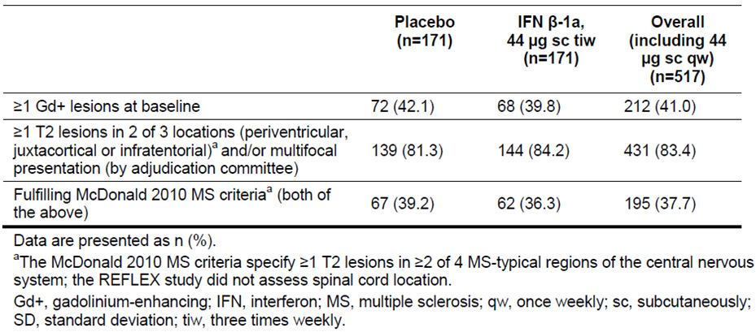
Baseline disease characteristics in the McDonald 2010-positive and McDonald 2010-negative subgroups are shown in Table 2. Not surprisingly, the two subgroups show substantial differences for those features leading to the McDonald 2010 diagnosis, such as multifocal disease and contrast enhancing lesions.
Table 2: Baseline demographic, disease and magnetic resonance imaging characteristics.
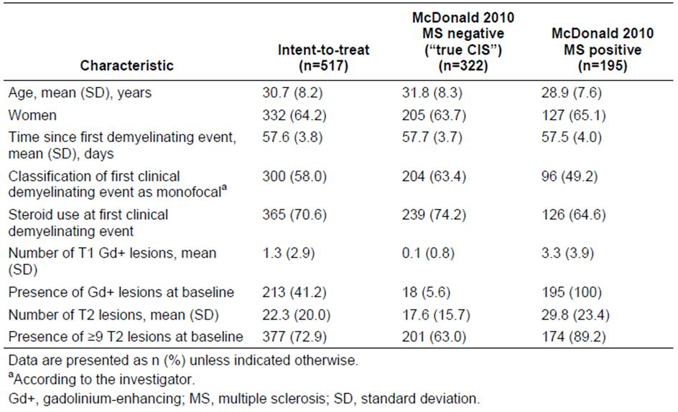
Results for the primary endpoint are in Table 3. Even in McDonald 2010-negative (“true CIS”) subjects, there was a substantial risk of converting to McDonald 2005 MS after two years, amounting to a 79% cumulative risk in the placebo treated subjects. Active treatment with the proposed 44 µg tiw dose reduced this risk significantly, to 53% over two years, consistent with a HR of 0.49 (95%CI 0.35; 0.69, p<0.001). This HR is the same as estimated in the original cohort of McDonald 2010-positive and McDonald 2010-negative patients, but with a slightly broader 95% Confidence Interval (CI).
Table 3: Analysis of the time to conversion to McDonald 2005 MS by McDonald 2010 MS status at baseline.ª
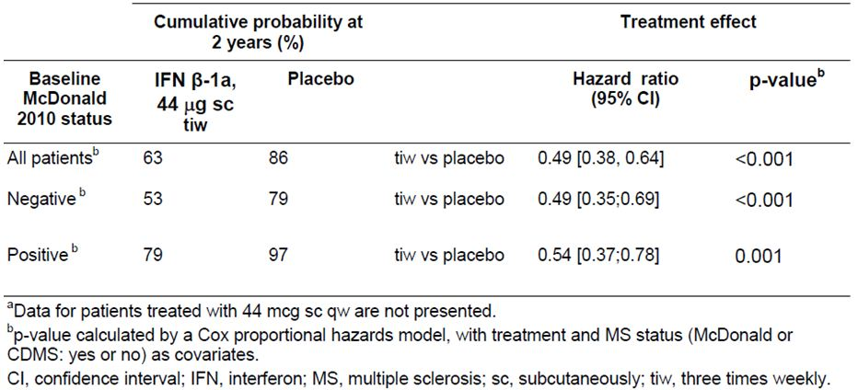
In subjects who already had McDonald 2010 MS at baseline, the risk of converting to McDonald 2005 MS over two years was very high: 97% in the placebo group, confirming the notion that the new McDonald 2010 criteria have high specificity for MS and merely enable earlier diagnosis. Active treatment of McDonald 2010-positive patients reduced conversion to McDonald 2005 MS over two years, but a clear majority of these patients (79%) converted anyway. From one perspective, it appears disappointing that only 18% of these subjects (97%-79%) managed to avoid McDonald 2005 MS through active treatment, but from another perspective they were “converting” to a disease that they already had, and were merely crossing a subtle diagnostic threshold from one set of diagnostic criteria to another. The HR in this subgroup was favourable, at 0.54, with clear statistical significance (95% CI 0.37; 0.78. p=0.001).
For the main secondary endpoint of CDMS, broadly similar results were obtained, though this endpoint was reached less commonly and the analysis had less statistical power (Table 4). The two year risk of CDMS in placebo recipients was 38% overall, with a somewhat lower risk (32%) in McDonald 2010-negative subjects and a higher risk (46%) in McDonald 2010-positive subjects. Active treatment with Rebif 44 µg TIW significantly reduced the risk of CDMS in both McDonald 2010-negative and McDonald 2010-positive subjects, even though the study was not originally powered for such an analysis. In the McDonald 2010-negative subgroup, conversion to CDMS was reduced to 19% with active treatment, consistent with an attributable reduction of 13% and a HR of 0.53 (95%CI 0.30; 0.93, p<0.028). In the higher risk McDonald 2010-positive subgroup, conversion was reduced to 24%, consistent with an attributable reduction of 22% and a HR of 0.44 (95% CI 0.23; 0.83, p=0.011).
Table 4: Analysis of the time to conversion to CDMS by McDonald 2010 MS status at baseline.ª
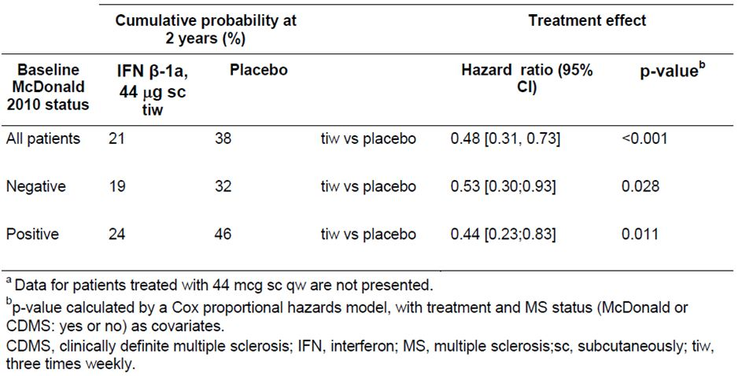
As part of the response to this question, the sponsor included a poster presented at the 5th Joint Triennial Congress of the European and Americas Committees for Treatment and Research in Multiple Sclerosis (ECTRIMS/ACTRIMS) in 2011; this poster presented essentially the same analysis requested in the first round evaluation, though the analysis was performed independently of the evaluation process. Figures 1-4 from that poster are reproduced below and illustrate that both McDonald 2010-negative and McDonald 2010-negative patients in the REFLEX study showed a significant benefit with active treatment, though the absolute risk of progression was higher, as expected, in McDonald 2010-positive patients.
Figure 1: Conversion to McDonald 2005 MS by McDonald 2010 MS criteria status at baseline.
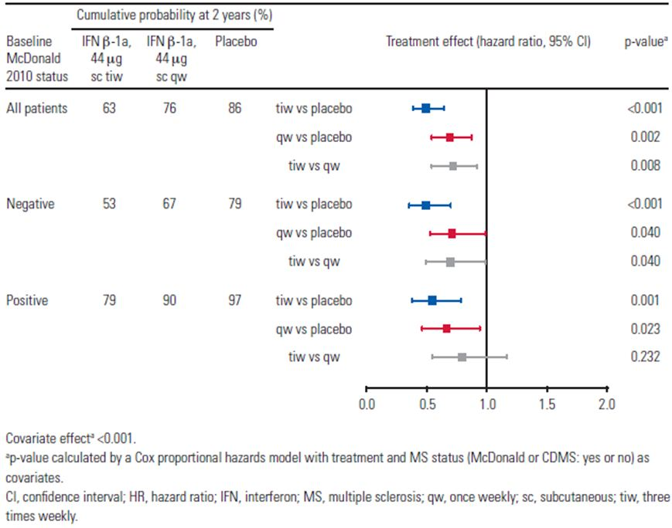
Figure 2: Time to McDonald 2005 MS by McDonald 2010 MS status at baseline: Kaplan-Meier cumulative incidence curves.ª
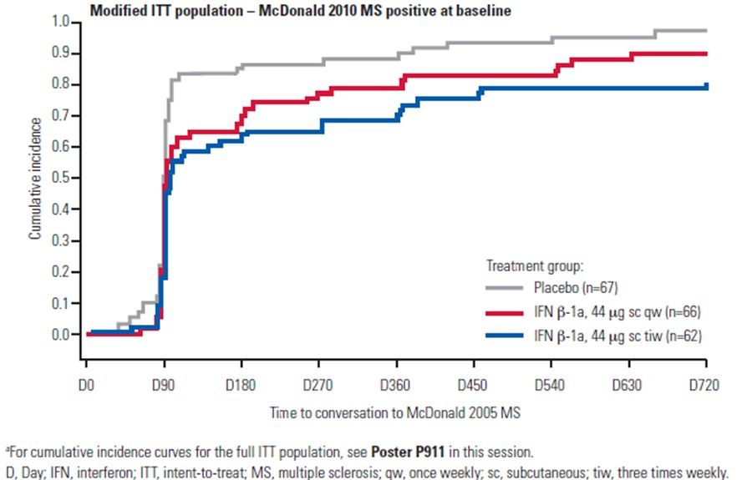
Figure 3: Conversion to CDMS by McDonald 2010 MS criteria status at baseline.
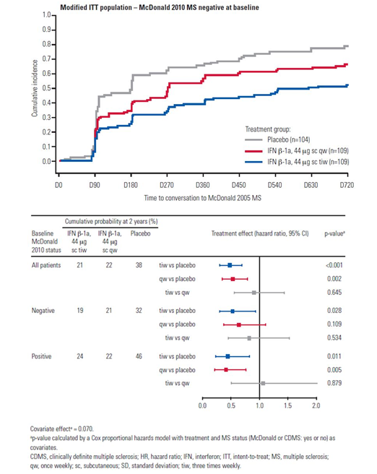
Figure 4: Time to CDMS by McDonald 2010 MS status at baseline: Kaplan-Meier cumulative incidence curves.ª
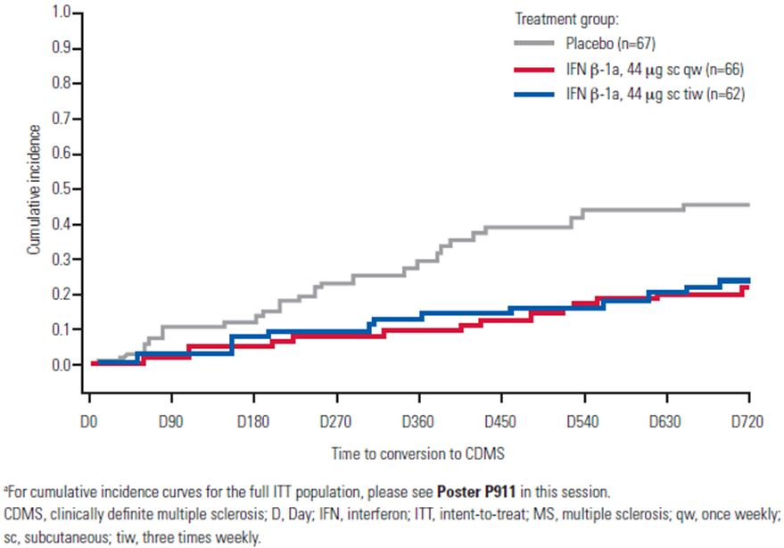
Overall, the sponsor’s post hoc analysis is reassuring. It confirms that the purported benefits in CIS patients can be achieved in subjects who are McDonald 2010-negative or McDonald 2010-positive, and that the proposed CIS indication identifies a group of subjects who can benefit from Rebif, regardless of which MS criteria are applied in defining CIS.
The results must be interpreted with one important caveat: subjects in the REFLEX study were required to have at least two cerebral MRI lesions at baseline and were therefore at higher risk than CIS subjects with a lighter MRI lesion load. The McDonald 2010-negative patients in the study were not, therefore, representative of the broader McDonald 2010-negative CIS population encountered in clinical practice, some of whom would be expected to have only one or no cerebral MRI lesions. There is still no evidence that these single lesion or zero lesion CIS subjects can obtain benefit from Rebif. Thus, Rebif is indicated for CIS subjects at high risk of conversion to MS, but not in subjects at low risk.
The first round clinical evaluation pointed out that the definition of high risk MS, in particular the requirement for at least two cerebral lesions, needs to be included in the PI. This new data does not change the need for such a definition.

Sponsor’s response to question 2
In the initial submission, it was somewhat unclear when spinal MRIs were performed. The sponsor has now indicated that spinal MRI scans were not performed routinely in all subjects at baseline, and not performed routinely in monitoring for conversion to McDonald 2005 MS. Instead, subjects with symptoms suggestive of spinal cord disease (that is, paraparesis, a transverse sensory level, or bladder dysfunction) received an MRI at baseline to exclude alternative diagnoses and subjects developing such symptoms during the study were scanned as needed.
This suggests that a small number of study patients may have had asymptomatic spinal cord lesions that were missed but this is very unlikely to have significantly modified the study’s results. Firstly, the spinal cord is a region in which plaques are highly likely to become symptomatic. Secondly, the same MRI approach was used in the active and placebo groups, with no likely source of bias. Thirdly, it is common clinical practice amongst neurologists to perform cerebral MRIs to monitor disease activity, and spinal MRIs only when prompted by symptoms, so the use of MRIs in the REFLEX study is fairly typical of the expected use of MRI in the target population of CIS subjects. This indicates that the results of the REFLEX study are likely to translate well into clinical practice.

Second round benefit-risk assessment
The second round benefit risk assessment is essentially unchanged compared to the first round assessment. The new data provides extra reassurance in that benefit has been demonstrated even in those subjects with “true CIS”, in whom a diagnosis of MS cannot be made with McDonald 2010 criteria. Hazard ratios in the McDonald 2010-positive and McDonald 2010-negative subgroups were broadly similar.

Second round recommendation regarding authorisation
Following the recommended revisions to the proposed PI, the sponsor’s application to register Rebif 44 µg tiw for treatment of subjects with CIS and at least two cerebral MRI lesions should be approved.
The evaluator recommended the Indication should be reworded to reflect the population actually studied in the pivotal trial, as follows (additions proposed by the evaluator underlined):
“Patients with a single demyelinating event in the central nervous system with an active inflammatory process, if alternative diagnoses have been excluded, and if they are determined to be at high risk of developing relapsing multiple sclerosis. High risk can be inferred from a cerebral MRI with 2 or more lesions suggestive of demyelination.”

V. Pharmacovigilance findings

Risk management plan
The sponsor submitted a Risk Management Plan (RMP) which was reviewed by the TGA’s Office of Product Review (OPR). Table 5 shows a summary of the Rebif RMP.
Table 5: Summary of Rebif RMP.
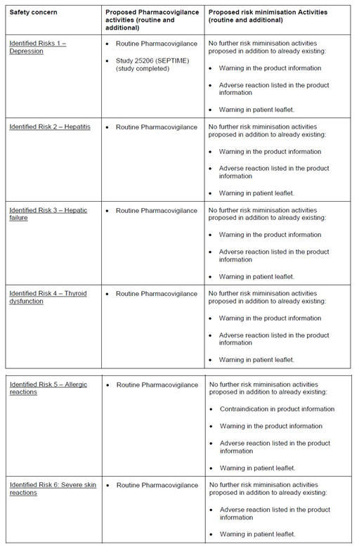
Table 5 (continued): Summary of Rebif RMP.
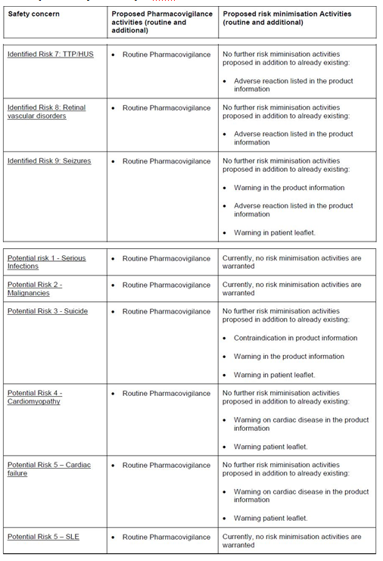
Table 5 (continued): Summary of Rebif RMP.
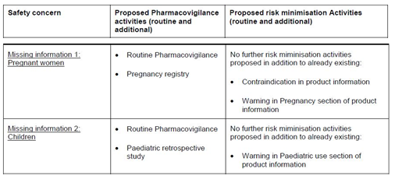
Table 6 summarises the TGA’s evaluation of the RMP and the sponsor’s responses to the issues raised by the OPR.
Table 6. Reconciliation of issues outlined in the RMP report
Recommendation in RMP evaluation report | Sponsor’s response | OPR evaluator’s comment
- Safety considerations may be raised by the clinical evaluator through the consolidated TGA request for information and/or the Nonclinical and Clinical Evaluation Reports respectively. It is important to ensure that the information provided in response to these includes consideration of the relevance for the Risk Management Plan, and any specific information needed to address this issue in the RMP. For any safety considerations so raised, please provide information that is relevant and necessary to address the issue in the RMP. | In case safety considerations will be raised, Merck Serono will address them in the next RMP update, due by June 2013. | This is acceptable.
- The sponsor should provide a justification for how information gathered from the European pregnancy registry will be applicable to Australian patients. The sponsor should also confirm the current status of the registry as planned or ongoing and a planned date for the submission of final data to the TGA. | The sponsor has confirmed that the registry is ongoing and has provided a justification for its applicability to Australia.  Pregnancies will be discussed within each Rebif PSUR. | This is acceptable.
- The sponsor should confirm whether the retrospective paediatric study is ongoing or completed and provide a planned date for the submission of final data to the TGA. | The retrospective paediatric study (REPLAY, EMR2000136-024) is complete.  It is planned to submit the final data to the TGA by Q1 2013, together with a recent cumulative safety review of Rebif in the paediatric population. | This is acceptable.
- The sponsor should include a precaution in the Australian PI that addresses the potential for hypersensitivity and allergic reactions similar to that found in the EU SmPC or provide a compelling justification for its omission. | As clarified with the assessor, the text referred to is not in the EU SmPC but in the Canadian and US PIs. The sponsor will add the requested wording to the Australian PI. | This is acceptable (NB following query by the sponsor, an amended RMP report was released to accurately reflect that this question should have related to the Canadian product monograph not the EU SmPC).
- It is recommended that the precaution in the proposed PI regarding Paediatric use is updated to be consistent with advice given in the EU SmPC. | The wording for paediatric use was discussed in a previous submission to the TGA (submitted 27/10/2010, approved 13/07/2011). Based on the outcome of above application the sponsor would like to retain the precaution in the proposed PI regarding paediatric use as is. | This is acceptable.

Summary of outstanding issues

Issues in relation to the RMP
There are no outstanding issues in relation to the RMP for this submission.

Advice from the Advisory Committee on the Safety of Medicines (ACSOM)
ACSOM advice was not sought for this submission.

Comments on the safety specification of the RMP

OMA Clinical Evaluation Report
The Safety Specification in the draft RMP is satisfactory. The sponsor is performing routine post marketing surveillance, flagging known safety issues including those related to hepatic dysfunction, thyroid dysfunction, depression and suicide. The sponsor has noted the relative lack of information in the paediatric age group and has proposed a retrospective paediatric cohort study, though details were lacking.

Key changes to the updated RMP
The sponsor has provided an updated version of the RMP (version 5.0). In this update, drug induced lupus erythematosus (DILE) (which was described together with the important potential risk ‘systemic lupus erythematosus (SLE)’ in version 4) was added as a separate important identified risk. Also in this version autoimmune hepatitis is discussed in more detail together with the important identified risk ‘liver injury/hepatitis’. The evaluator has no objection to these changes and recommends that version 5 is implemented as a condition of registration.

Evaluator’s comments and recommendations:
- RMP
It is recommended the Delegate implement Rebif RMP (version 5.0, dated 25 June 2012) and any future updates as a condition of registration.
- Periodic Safety Update Reports (PSURs)
The Delegate is advised that the next PSUR in the EU for this product is due mid 2015 on a 3 yearly cycle (as of 31 January 2013).

VI. Overall conclusion and risk/benefit assessment
The submission was summarised in the following Delegate’s overview and recommendations:

Quality
There was no requirement for a quality evaluation in a submission of this type.

Nonclinical
There was no requirement for a nonclinical evaluation in a submission of this type.

Clinical

Efficacy

Reflex study (IMP 27025): Pivotal
The REFLEX study was a randomised, double blind, placebo controlled study carried out over two years and involving 517 patients considered at risk of developing MS, due to a recently experienced isolated demyelinating event of the CNS, consisting of optic neuritis, myelopathy or a brainstem syndrome. The 517 subjects had a mean age of 30.7 years, a median EDSS score of 1.5, and 64.2% were females, in keeping with the known gender bias of CIS and MS. The mean time from onset of the first event to randomisation was 56.7 days. Further inclusion criteria are:
- Single, first clinical event suggestive of MS with an onset within 60 days prior to randomisation. The event had to be a new neurological abnormality present for at least 24 hours, either mono or poly symptomatic, other than paraesthesia, vegetative symptoms or cerebral dysfunction.
- At least two clinically silent lesions on T2 weighted MRI scan, with a size of at least 3 mm, at least one of which was ovoid or periventricular or infratentorial.
- EDSS 0-5.0 during the screening period
- Between 18 and 50 years old, inclusive
- Willing to follow study procedures
- If female, the patient had to be:
  - neither pregnant nor breast feeding nor attempting to conceive;
  - using a highly effective method of contraception
Participants were randomised to receive subcutaneously Rebif 44 µg three times weekly (tiw) (n = 171) or Rebif 44 µg once weekly (ow) (n=175) or placebo (n=171) on a 1:1:1 basis with stratification for four factors known to affect prognosis:
- Age (<30 years, ≥30 years)
- Classification of first clinical demyelinating event (monofocal, multifocal)
- Steroid use at first clinical demyelinating event (yes, no)
- Presence of at least 1 Gadolinium enhancing lesion at baseline (yes, no)
Of the 517 randomised subjects, 448 (86.7%) completed the study; the other 69 subjects (13.3%) withdrew prematurely (10.9% in the 44 µg ow group and 14.6% in both placebo and 44 µg tiw groups). This is a relatively high completion rate for a study of this duration. All subjects entered the ITT analysis, even if they withdrew. The treatment groups were reasonably well balanced at baseline.
Treatment was for a period of two years (or up to the time) when they experienced a second clinical attack leading to a diagnosis of CDMS or experienced progression defined by a sustained increase of at least 1.5 points in the EDSS, at which time they qualified for open label Rebif treatment at 44 µg tiw while keeping their initial treatment blinded. Appropriate placebo injections were employed in the placebo group and the once-weekly Rebif group in an attempt to maintain blinding.
In the active groups, patients received 20% of the full dose for 2 weeks, 50% for the next 2 weeks, and the full dose for the remainder of the study. This is a fairly standard approach aimed at improving tolerance.
Patients were also advised to take ibuprofen (400 mg) or paracetamol (1000 mg) prophylactically with each injection during the first 12 weeks of treatment, to minimise flu like symptoms.
Short courses of corticosteroid treatment for MS relapses were permitted at the discretion of the treating physician.
The primary efficacy variable was the time to diagnosis of MS by the McDonald 2005 criteria.
Additional major efficacy variables were:
The main secondary endpoint: Diagnosis of CDMS. This requires a second clinical event at a new CNS location, rather than accepting MRI lesions as evidence of disease activity.
The main MRI based secondary endpoint: Number of combined unique active lesions (CUA [combined unique active] lesions) on MRI. This is the combination of new or enhancing lesions on the MRI, per patient per scan, during double blind treatment.

Clinical evaluator’s comment:
As discussed above, the McDonald criteria require demonstration of dissemination in space and time using a mix of clinical and MRI criteria. If a patient developed MS by having a second clinical event, they could be diagnosed with MS by the McDonald 2005 criteria and they could also be diagnosed with CDMS, reaching two main study endpoints at once. If they developed MS by satisfying an MRI criterion but not a clinical one, they reached the primary study endpoint but not the secondary endpoint of CDMS.
The primary efficacy outcome was the time to McDonald MS for the high dose group versus placebo using a log-rank test in the ITT population. Given that there were three main efficacy variables (time to McDonald MS, time to CDMS and number of CUA lesions) and two active groups (high dose and low dose), a total of six major endpoints were examined in a hierarchical fashion: time to McDonald MS, time to CDMS, and number of CUA lesions for the high dose group versus placebo, and then the same three endpoints for the low dose group versus placebo. Lower ranked endpoints in the hierarchy were only considered positive if the previous endpoints had achieved significance. This approach corrects for the presence of multiple endpoints.
Other efficacy outcomes included:
- Other MRI based lesion counts and lesion volumes
- Annualised relapse rate
- Proportion of subjects relapse free
- Change in EDSS
- Change in MS Functional Composite (MSFC) and its components (Paced Auditory Serial Addition Test [PASAT], timed 25 foot walk, 9 hole peg test)
- Mean improvement from baseline in the EQ-5D quality of life assessments
Sample size requirements were based on observations of the BENEFIT study, in which a similar population of CIS subjects were treated with interferon beta-1b (Betaferon).
It was estimated that a total of 450 subjects (150 per treatment group) would produce approximately 165 events (McDonald conversions) for the comparison Rebif New Formulation (RNF, free from human serum albumin) 44 µg tiw versus placebo after approximately 21 months of recruitment. This number of events was sufficient to provide 90% power using a two sided log-rank test at a 0.05 alpha-error for detecting a HR of 0.6 in the primary efficacy endpoint for the main comparison RNF 44 µg tiw versus placebo. This HR corresponded to 15% subjects being free of conversion over 24 months in the placebo group and 32% in the RNF 44 µg tiw group, a clinically worthwhile difference.
Allowing for withdrawals, the proposed sample size was increased to 480 subjects equally allocated to each of the 3 treatment groups (160 subjects per group), and this target was exceeded.
The primary analysis population was the ITT population, which included all randomised subjects (n=517). The sponsor repeated all major analyses on the per protocol (PP) population, which consisted of all randomised subjects who did not have any major protocol deviations likely to interfere with assessment of the primary efficacy endpoint (conversion to McDonald MS) (n=458).
For the primary efficacy endpoint, the primary analysis was a pair wise comparison of the ITT treatment groups using a two sided stratified log-rank test at the 0.05 significance level: RNF 44 µg tiw versus placebo and RNF 44 µg ow versus placebo. (RNF 44 µg tiw versus RNF 44 µg ow was compared in an exploratory manner.) Stratification was performed using the same four prognostic factors that were used to stratify randomisation (age, unifocal versus multifocal disease, steroid use and gadolinium (Gd) contrast enhancing [Gd+] lesions).
The probability of subjects developing McDonald MS in each treatment group was estimated with survival curves using the non parametric Kaplan-Meier method.
The primary efficacy endpoint was also subjected to a secondary analysis to estimate the magnitude of the treatment effect in terms of the HR, using an adjusted Cox’s proportional hazards model. Adjustments were performed for the original four stratification factors.
The same analyses were also performed on the PP population, to confirm robustness of the primary analysis.
On the efficacy outcome of Rebif in CIS, the clinical evaluator concluded that:
- The submission rests on a single pivotal efficacy study. In the cohort studied, which included patients with a clinically isolated demyelinating syndrome and an MRI suggestive of MS, Rebif reduced the development of MS, including radiologically defined (McDonald) MS, which was the primary endpoint, and clinically defined MS (Clinically Definite MS, CDMS), which was the main secondary endpoint. There were also clear benefits on disease activity as measured with MRI. All of these treatment effects were statistically significant.
- Over the course of the study, the total number of subjects diagnosed with McDonald MS was 106/171 (62.0%), 129/175 (73.7%), and 144/171 (84.2%) in the Rebif 44 µg tiw, 44 µg ow, and placebo groups, respectively. Using the stratified, adjusted model, the two year probability of conversion was similar to the raw conversion rates (62.5% and 85.8% for the proposed dose and placebo, respectively, which gives an absolute risk reduction of 23.3% and a relative risk reduction of 27.1%).
- The model adjusted conversion rates to CDMS over two years were 21%, 22% and 38% in the 44 µg tiw group, 44 µg ow group and placebo group, respectively, giving an absolute risk reduction of 17% for the proposed tiw dose, and a relative risk reduction of 45%.
- The mean number of active lesions per subject per MRI scan was reduced from 2.58 in the placebo group to 0.95 in the ow group and 0.50 in the tiw group.
- Rebif shows worthwhile efficacy in this cohort of CIS patients. The only caveat is that the cohort studied included many patients who would be diagnosed with MS by more recent criteria, and it did not include any subjects with <2 cerebral MRI lesions. The efficacy of Rebif in the setting of milder CIS cases is therefore unclear.
Note: The clinical evaluator commented that in the sponsor’s submission and in the clinical evaluation report, the term “McDonald MS” refers to the 2005 criteria unless the 2010 criteria are explicitly mentioned. The clinical evaluator went on to state that some patients who would have been considered CIS patients according to old clinical criteria were (quite appropriately) excluded from the REFLEX study on the basis that they could already be diagnosed with MS by the newer MRI based criteria. In particular, those with MS according to the McDonald 2005 criteria were explicitly excluded: these patients had already reached the primary endpoint. From the CER (see Attachment 2 of this AusPAR):
After the study was already underway, further revisions of the McDonald criteria were agreed upon in 2010 and published in 2011. Both the 2005 criteria and 2010 criteria allow the results of MRI scans to be used for demonstrating dissemination in time (DIT) and dissemination in space (DIS). However, the 2010 criteria are much simpler and even more sensitive in making a diagnosis of MS, without apparent loss of specificity. Because of this increased sensitivity, some patients included in the REFLEX study according to the 2005 criteria would have been excluded by the 2010 criteria. According to the clinical evaluator, the sponsor has in fact estimated that about 38% of the study cohort already had MS by the 2010 criteria at the time of randomisation. This does not reflect a fault in the study, because the best available diagnostic criteria were used at the time, but it does mean that the target population studied in REFLEX no longer closely reflects the population to whom the new indication would apply, because clinicians will generally work from the new criteria.
The clinical evaluator stated that importantly, the same logic is likely to apply to the other interferons, which were registered for the CIS indication using old diagnostic criteria, so this is not a problem with Rebif in particular. Also, it confirms the notion that CIS and MS lie on a spectrum and that the distinction between them is somewhat arbitrary and prone to diagnostic shift – in which case, it is even more appropriate to treat CIS patients with medications known to be useful in MS.
However, from a purist perspective the recent changes in the diagnostic criteria for MS (and hence for CIS) weaken the sponsor’s submission. It is already accepted that Rebif is effective in MS; if 38% of the purported CIS population in the pivotal study actually had MS at baseline (by 2010 criteria), then the apparent finding of efficacy in CIS could have come, in part, from the inclusion of MS patients in the CIS study cohort. These patients would already be eligible for Rebif treatment under existing indications, and would not need the new CIS indication. The relevant question was whether the remaining 62% of patients also stand to benefit from Rebif. This question could be addressed by a suitable sub group analysis.
The submission made frequent reference to “MRI” without specifying what was scanned. In most cases, context made it clear that a cerebral MRI was performed but it remained unclear if a spinal MRI was also performed. The diagnosis of McDonald MS (by either 2005 criteria or 2010 criteria) can be made by including spinal cord lesions, so it seems likely that all subjects had a spinal cord MRI at baseline and at regular intervals afterwards, along with their cerebral MRI; the sponsor was asked to confirm this.

Risk management plan
The RMP evaluator stated that:
- The proposed extension of indications is for the treatment of “Patients with a single demyelinating event with an active inflammatory process, if alternative diagnoses have been excluded, and if they are determined to be at risk of developing relapsing multiple sclerosis”. A similar indication to that proposed was approved by the European Medicines Agency (EMA) in January 2012 and states
“Patients with a single demyelinating event with an active inflammatory process, if alternative diagnoses have been excluded, and if they are determined to be at high risk of developing clinically definite multiple sclerosis”.
- It is noted that the fundamental differences between the EMA indication and that proposed for Australia is the wording related to risk (that is, ‘at high risk of’ versus ‘at risk of’) and the use of ‘clinically definite multiple sclerosis’ versus ‘relapsing multiple sclerosis’.
- The Ongoing Safety Concerns are:
- Important identified risks
  - Depression
  - Hepatitis
  - Hepatic failure
  - Thyroid disorders
  - Allergic reactions
  - Severe skin reactions
  - TTP/HUS (thrombotic thrombocytopenic purpura/hemolytic uremic syndrome)
  - Retinal vascular disorders
  - Seizures
- Identified potential risks
  - Serious infections
  - Malignancies
  - Suicide
  - Cardiomyopathy
  - Cardiac failure
  - SLE (systemic lupus erythematosus)
- Important missing information
  - Pregnancy
  - Children
- The clinical aspects of the Safety Specification of the draft RMP is satisfactory as per the clinical evaluator and the RMP evaluator considered that the list of Ongoing Safety Concerns specified by the sponsor is acceptable.
- Routine pharmacovigilance is proposed by the sponsor to monitor all ongoing safety concerns. In its review of a similar application, the EMA concluded that no further pharmacovigilance activities other than those proposed in the EU RMP were necessary to monitor the ongoing risks.
- A pregnancy registry is proposed as additional pharmacovigilance for important missing information ’pregnancy’. The RMP specifies that the registry will be undertaken in designated European countries. The sponsor should also confirm the current status of the registry including the planned date for submission of final data to the TGA. The sponsor has confirmed that the registry is ongoing and has provided a justification for its applicability to Australia. The sponsor mentioned that pregnancies will be discussed within each Rebif PSUR.
- A retrospective paediatric study (REPLAY, EMR200136_024) has been completed by the sponsor as additional pharmacovigilance for important missing information ‘children’. It is planned to submit the final data to the TGA by Q1 2013, together with a recent cumulative safety review of Rebif in the paediatric population.
- Several observational post authorisation safety studies (PASS) have been initiated by the sponsor and are listed in the RMP. As these studies are ongoing their protocols have not been evaluated for the purposes of this report. It is expected that, when available, reports of these studies will be communicated to the TGA via PSURs.
- Routine risk minimisation (that is, product labelling) is considered sufficient by the sponsor to mitigate all ongoing safety concerns except for the important potential risks ‘serious infections’, ‘malignancies’ and ‘SLE’ for which no risk minimisation activities are proposed. This is consistent with activities in the EU and is acceptable. Rebif was first approved in Australia in November 2008 and the evaluator is not aware of any new safety signals that necessitate further risk minimisation activities at this time.
- In regard to the important identified risk ‘allergic reactions’ the Canadian product monograph provides the following statement in the ‘Warnings and Precautions’ section (a similar warning is also provided in the US product label):
Immune (including hypersensitivity, autoimmunity, immunogenicity)
Anaphylaxis has been reported as a rare complication of Rebif use. Other allergic reactions have included skin rash, angioedema, and urticaria, and have ranged from mild to severe without a clear relationship to dose or duration of exposure. Several allergic reactions, some severe, have occurred after prolonged use.

Risk-benefit analysis

Delegate considerations
The Delegate concurs with most of the clinical evaluator’s comments including the need to specifically quantify the risk factor in the sponsor’s proposed extension of indications. Also, while there is a risk of converting to relapsing form of MS (arguably the most common subtype), there are no predictive measures to determine the particular form of MS a patient may acquire (if at all) after a single demyelinating event. Reference to relapsing MS in the proposed extension of indications can therefore be deemed as presumptive and is somewhat beyond the scope of the data submitted. In contemporary clinical practice, a patient is not deemed to have MS until a second attack and progression with subsequent relapses, makes it a ‘relapsing MS’.
The RMP evaluator’s recommendations regarding RMP and PSUR implementation were noted.

Proposed action
The Delegate proposed to consider the approval of an extension of indications in line with the clinical evaluator’s recommendation and that approved by the EMA (January 2012):
“Patients with a single demyelinating event in the central nervous system with an active inflammatory process, if alternative diagnoses have been excluded, and if they are determined to be at high risk of developing clinically definite multiple sclerosis. High risk can be inferred from a cerebral MRI with 2 or more lesions suggestive of demyelination.”
This proposal is subject to resolving issues arising from deliberations of the Advisory Committee on Prescription Medicines (ACPM) and to the finalisation of matters pertaining to the PI and RMP to the satisfaction of the TGA.

Request for ACPM advice
The Delegate proposed to seek general advice on this application from the ACPM.

Response from sponsor
Merck Serono Australia Pty Ltd (the sponsor) has applied for an extension of the approved indication for Rebif (interferon beta-1a (rch)) to include CIS suggestive of MS. Following the review of the submitted data, the TGA Delegate is seeking advice from the ACPM for approval of the following indication:
Rebif is indicated for the treatment of:
Patients with a single demyelinating event in the central nervous system with and active inflammatory process, if alternative diagnoses have been excluded, and if they are determined to be at high risk of developing clinically definite multiple sclerosis. High risk can be inferred from cerebral MRI with 2 or more lesions suggestive of demyelination.
The sponsor concurs with the wording of the indication proposed by the Delegate, as it accurately reflects the population studied in the pivotal study, Study 27025 (REFLEX), and is consistent with recommendations of both the clinical evaluator and RMP evaluator, and with wording approved by the EMA in January 2012.
This pre ACPM response will address matters raised in the Delegate’s Overview regarding the presentation of the results of Study 27025 (REFLEX) in the Clinical Trials section of the PI document.

Study 27025 (REFLEX) efficacy results
Study 27025 (REFLEX) demonstrates that in patients with a clinically isolated demyelinating syndrome and an MRI suggestive of MS, Rebif reduced the time to the development of MS, including radiologically defined (McDonald) MS (the primary endpoint) and CDMS (the main secondary endpoint). There were also clear benefits on disease activity as measured with MRI. All treatment effects were statistically significant compared with placebo.
The clinical evaluator and Delegate have questioned use of the term ‘Risk reduction’ to report the complement of ‘HR’ in the tabulation of the results of Study 27025 (REFLEX) presented in the PI, raising concern over misinterpretation of this value as a cumulative risk reduction over the course of the two year study. The terms ‘Instantaneous hazard reduction’ and ‘Instantaneous risk reduction’ were used to describe this value in the Clinical Evaluation Report and Delegate’s Overview, respectively. Further, the Delegate recommends inclusion of values for ‘Absolute cumulative risk reduction’ and ‘Relative cumulative risk reduction’ instead of reporting values for ‘Instantaneous risk reduction’, while the clinical evaluator maintains that retention of values for ‘Instantaneous hazard reduction’ would be acceptable.
The sponsor agrees that different statistics can be used to summarise the results pertaining to ‘McDonald MS conversion’ and ‘CDMS conversion’. ‘Absolute risk reduction’ would be the appropriate statistic to report if the intention had been to compare the proportion of McDonald or CDMS conversion at 2 years between the two groups, Rebif 44 µg tiw and placebo. However, proportion of McDonald conversion at 2 years was not the primary endpoint of Study 27025 (REFLEX).
The primary endpoint of Study 27025 (REFLEX), as stated in the protocol, was time to McDonald conversion, that is, to answer the question, how treatment with Rebif would delay the occurrence of McDonald conversion compared to placebo. The relevant statistic to compare treatment effect between Rebif 44 µg tiw and placebo is ‘HR’. HR is a relative risk over time and is interpreted as a measurement of reduction or increase of the risk. Related to time to event, the primary endpoint and main secondary endpoint may be interpreted as follows:
- Over 2 years Rebif 44 µg tiw delayed McDonald MS, when compared with placebo (p <0.001 for tiw; adjusted log rank test). The instantaneous HR versus placebo for time to McDonald MS was 0.49, which corresponds to a risk reduction of 51%.
- Over 2 years, Rebif 44 µg tiw delayed CDMS, compared with placebo (p <0.001). The instantaneous HR for time to CDMS was 0.48, which corresponds to a risk reduction of 52%.
The table in the PI entitled ‘Efficacy results from Study 27025 (REFLEX)’ summarises results for two ‘time to event’ endpoints and all statistical measures reported in this table are statistics that summarise the time to event variables. The description of primary endpoints in the table has been revised to convey this more clearly. In addition, to take into account the comments of the clinical evaluator and Delegate regarding the possible misinterpretation of values previously reported in the table as ‘Risk reduction’, the sponsor proposes to remove these values from the table; the sponsor agrees that this value is the complement of the HR, and can be derived easily. The revised table, incorporating these changes, is shown as Table 7 in this AusPAR.
Table 7: Efficacy results from Study 27025 (REFLEX).
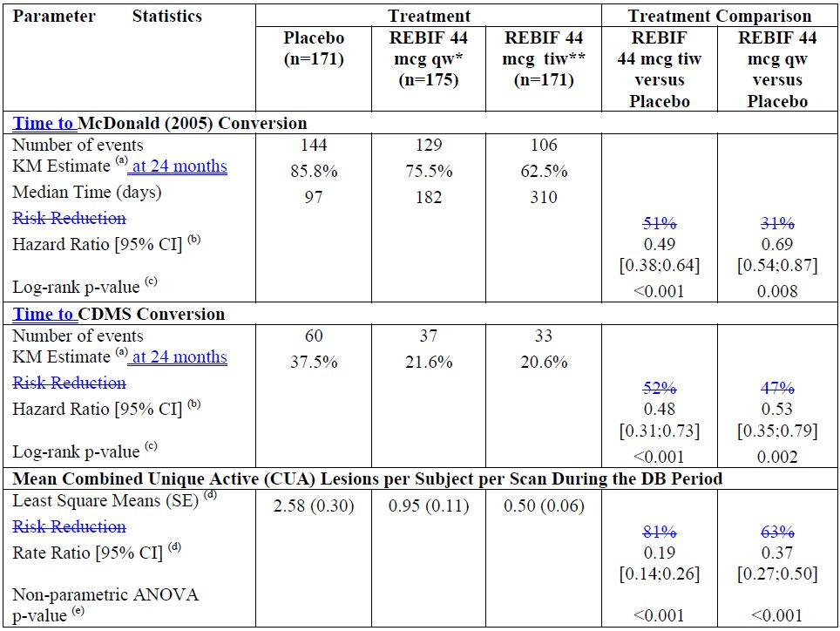
* qw – once a week
** tiw – three times per week
(a) Kaplan-Meier estimate of the cumulative probability of developing McDonald MS (or CDMS) over 2 years
(b) Multivariate Cox's proportional hazards model with treatment and randomisation stratification factors as covariates
(c) Stratified Chi-square log-rank test controlling for randomisation stratification factors
(d) Negative binomial model with treatment and randomisation stratification factors (f) as covariates and log number of scans as an offset variable
(e) 2-sided stratified non-parametric ANOVA model on ranked data with effects for treatment group and the randomisation stratification factors
(f) Randomisation stratification factors: age (<30 years, ≥30 years), classification of first clinical demyelinating event (monofocal, multifocal), steroid use at first clinical demyelinating event (yes, no), and presence of Gd Enhancing Lesions at baseline (yes, no).
However, it is important to note that both HR and risk reduction (shortened term for ‘instantaneous risk reduction’) for treatment of CIS are reported in the PIs for alternative therapeutic products, Avonex (interferon beta-1a (rch)) and Betaferon (interferon beta-1b (rbe)). The sponsor considers it necessary and appropriate to provide to clinicians comparable summary statistics for Rebif, and therefore proposes to include in the Rebif PI interpretation of the results of Study 27025 (REFLEX) for the proposed dose, as follows:
Treatment with Rebif 44 µg tiw resulted in a 51% relative reduction of risk of conversion to McDonald MS compared to placebo (HR = 0.49, 95% CI [0.38, 0.64], p-value < 0.001).

Study 27025 (REFLEX) subgroup analysis
McDonald criteria for the diagnosis of MS were revised four years after the commencement of Study 27025 (REFLEX). The changes to diagnostic criteria potentially allow earlier diagnosis of MS, such that, using a retrospective diagnosis of McDonald 2010 MS, over one third (37.7%) of patients randomised in Study 27025 (REFLEX) had McDonald 2010 MS at baseline and were at significantly greater risk of McDonald 2005 MS and slightly higher risk of CDMS. Post hoc subgroup analysis has established that, compared to placebo, Rebif 44 µg tiw significantly reduced the risk of McDonald 2005 MS and CDMS at 2 years, irrespective of McDonald 2010 status at baseline. Therefore, the main conclusions of the study would not have been affected if McDonald 2010 criteria had been available at the time of study design, that is, Rebif 44 µg can delay MS in patients with a first clinical demyelinating event.
The clinical evaluator notes that the post hoc analysis confirms that benefit has been demonstrated in subjects with “true CIS”, in whom a diagnosis of MS cannot be made with McDonald (2010) criteria, and recommends inclusion of these results in the PI. Therefore, the sponsor proposes inclusion of the following text in the PI:
Subgroup Analysis
Subsequent to the availability of revised McDonald (2010) criteria, a post hoc subgroup analysis was performed whereby subjects of Study 27025 (REFLEX) were re-categorised according to the new diagnostic criteria. Over one third of patients randomised had MS at baseline according to McDonald (2010) criteria. Compared with placebo, Rebif 44 µg given three times per week significantly reduced the risk of MS according to McDonald (2005) and of CDMS at 2 years, irrespective of the McDonald (2010) status at baseline.

Conclusion
The sponsor agrees with the Delegate’s recommended wording for the indication, and asked that the ACPM recommend approval of Rebif for the treatment of:
Patients with a single demyelinating event in the central nervous system with and active inflammatory process, if alternative diagnoses have been excluded, and if they are determined to be at high risk of developing clinically definite multiple sclerosis. High risk can be inferred from cerebral MRI with 2 or more lesions suggestive of demyelination.
All other recommendations, including the addition of the precautionary statement concerning immune reactions, have been implemented in the PI.

Advisory committee considerations
The ACPM, having considered the evaluations and the Delegate’s overview, as well as the sponsor’s response to these documents, advised the following:
The ACPM, taking into account the submitted evidence of efficacy, safety and quality, agreed with the Delegate and considered these products to have an overall positive benefit-risk profile for the Delegate’s proposed indication:
Patients with a single demyelinating event in the central nervous system with an active inflammatory process, if alternative diagnoses have been excluded, and if they are determined to be at high risk of developing clinically definite multiple sclerosis.
High risk can be inferred from a cerebral MRI with 2 or more lesions suggestive of demyelination.

Proposed PI/CMI amendments
The ACPM agreed with the Delegate to the proposed amendments to the PI and Consumer Medicine Information (CMI) and specifically advised on the inclusion of the following:
- a statement in the Clinical Trials section to more accurately reflect the cumulative 24 month reduction in risk of progression to a diagnosis of MS (McDonald or CDMS).
- a statement in the Clinical Trials section of the PI to reflect the details of the REFLEX subgroup analysis. There are close to 1,000,000 patient years experience, more than 155,000 years with the present serum free or “new” formulation (RNF).
- a statement in the Clinical Trials section of the PI to better present the information regarding the recruitment into REFLEX and to clearly state that patients with mild initial events were not included.

Proposed conditions of registration
The ACPM agreed with the Delegate on the proposed conditions of registration and specifically advised on the inclusion of the following:
- The sponsor should provide details of the retrospective paediatric cohort study which is planned. The results should also be provided to the TGA as soon as they are available.
- Prospective paediatric data collection should be encouraged.
- The sponsor should provide to the TGA information regarding European pregnancy data collection.
The ACPM advised that the implementation by the sponsor of the recommendations outlined above to the satisfaction of the TGA, in addition to the evidence of efficacy and safety provided would support the safe and effective use of these products.

Outcome
Based on a review of quality, safety and efficacy, TGA approved the registration of:
- Rebif 22 interferon beta-1a (rch) 22 µg/0.5 mL injection pre-filled syringe
- Rebif 44 interferon beta-1a (rch) 44 µg/0.5 mL injection pre-filled syringe
- Rebif 22 interferon beta-1a (rch) 66 µg/1.5 mL solution for injection multidose cartridge
- Rebif 44 interferon beta-1a (rch) 132 µg/1.5 mL solution for injection multidose cartridge
- Rebif 22 interferon beta-1a (rch) 22 µg/0.5 mL injection pre-filled syringe autoinjector
- Rebif 44 interferon beta-1a (rch) 44 µg/0.5 mL injection pre-filled syringe auto injector
for the new indication:
Patients with a single demyelinating event in the central nervous system with an active inflammatory process, if alternative diagnoses have been excluded, and if they are determined to be at high risk of developing clinically definite multiple sclerosis. High risk can be inferred from cerebral MRI with 2 or more lesions suggestive of demyelination.
The full indications are now:
Rebif is indicated for the treatment of:
    - Patients with a single demyelinating event in the central nervous system with an active inflammatory process, if alternative diagnoses have been excluded, and if they are determined to be at high risk of developing clinically definite multiple sclerosis. High risk can be inferred from cerebral MRI with 2 or more lesions suggestive of demyelination.
    - Ambulatory patients with multiple sclerosis who have experienced two or more relapses within the last 2 years.
Rebif therapy should not be initiated in secondary progressive multiple sclerosis patients who no longer experience relapses.

Specific conditions of registration applying to these therapeutic goods
The implementation in Australia of the Rebif RMP (version 5.0, dated 25 June 2012), included with submission PM-2012-00320-3-1, and any subsequent revisions, as agreed with the TGA and its OPR.

Attachment 1. Product Information
The Product Information approved at the time this AusPAR was published is at Attachment 1. For the most recent Product Information please refer to the TGA website at <http://www.tga.gov.au/hp/information-medicines-pi.htm>.

Attachment 2. Extract from the Clinical Evaluation Report

Durelli L. (2004). Is multiple sclerosis a disease that requires frequent beta interferon dosing? J Neurol. 251 Suppl 4: IV13-24.
McDonald WI, et al. (2001) Recommended diagnostic criteria for multiple sclerosis: guidelines from the International Panel on the diagnosis of multiple sclerosis. Ann Neurol. 50: 121-127.
Polman CH, Reingold SC, Edan G, Filippi M, Hartung H-P, Kappos L et al. (2005). Diagnostic criteria for multiple sclerosis. 2005 revisions to the "McDonald Criteria". Ann Neurol; 58:840-846.
Polman CH, Reingold SC, Banwell B, Clanet M, Cohen JA, Filippi M et al. (2011). Diagnostic criteria for multiple sclerosis: 2010 revisions to the "McDonald criteria". Ann Neurol 69: 292-302.
Rebif New Formulation, Human Serum Albumin free
Giovannoni G. (2012) The REFLEX study: a missed opportunity? Lancet Neurol. 11: 22-24.
Freedman MS, et al. Efficacy of subcutaneous interferon-beta-1a in patients with a first clinical demyelinating event: the REbif FLEXible dosing in early multiple sclerosis (REFLEX) study – outcomes in patients stratified by the 2010 McDonald criteria. 5th Joint triennial congress of the European and Americas Committees for Treatment and Research in Multiple Sclerosis, Amsterdam, The Netherlands, 19-22 October 2011.
Kappos L, et al. (2006) Treatment with interferon beta-1b delays conversion to clinically definite and McDonald MS in patients with clinically isolated syndromes. Neurology 67: 1242-1249.
Sponsor clarification: Patients recruited into the REFLEX study were not strictly/explicitly stratified by the degree of their clinical symptoms/manifestations, as assessed by the investigating clinician, into mild, moderate or severe; this statement has been included in the PI.

