August 2014

AusPAR Attachment 2

Extract from the Clinical Evaluation Report for insulin glargine (rbe)
  - Proprietary Product Name: Toujeo / Edomlus / Lambeto (U300)
  - Sponsor: Sanofi Aventis Australia Pty Ltd

About the Therapeutic Goods Administration (TGA)
- The Therapeutic Goods Administration (TGA) is part of the Australian Government Department of Health, and is responsible for regulating medicines and medical devices.
- The TGA administers the Therapeutic Goods Act 1989 (the Act), applying a risk management approach designed to ensure therapeutic goods supplied in Australia meet acceptable standards of quality, safety and efficacy (performance), when necessary.
- The work of the TGA is based on applying scientific and clinical expertise to decision making, to ensure that the benefits to consumers outweigh any risks associated with the use of medicines and medical devices.
- The TGA relies on the public, healthcare professionals and industry to report problems with medicines or medical devices. TGA investigates reports received by it to determine any necessary regulatory action.
- To report a problem with a medicine or medical device, please see the information on the TGA website <https://www.tga.gov.au>.
About the Extract from the Clinical Evaluation Report
- This document provides a more detailed evaluation of the clinical findings, extracted from the Clinical Evaluation Report (CER) prepared by the TGA. This extract does not include sections from the CER regarding product documentation or post market activities.
- The words [Information redacted], where they appear in this document, indicate that confidential information has been deleted.
- For the most recent Product Information (PI), please refer to the TGA website <https://www.tga.gov.au/product-information-pi>.
Copyright
© Commonwealth of Australia 2017
This work is copyright. You may reproduce the whole or part of this work in unaltered form for your own personal use or, if you are part of an organisation, for internal use within your organisation, but only if you or your organisation do not use the reproduction for any commercial purpose and retain this copyright notice and all disclaimer notices as part of that reproduction. Apart from rights to use as permitted by the Copyright Act 1968 or allowed by this copyright notice, all other rights are reserved and you are not allowed to reproduce the whole or any part of this work in any way (electronic or otherwise) without first being given specific written permission from the Commonwealth to do so. Requests and inquiries concerning reproduction and rights are to be sent to the TGA Copyright Officer, Therapeutic Goods Administration, PO Box 100, Woden ACT 2606 or emailed to <tga.copyright@tga.gov.au>.

Contents
List of abbreviations 4
1. Introduction 6
2. Clinical rationale 6
3. Contents of the clinical dossier 6
3.1. Scope of the clinical dossier 6
3.2. Paediatric data 7
3.3. Good clinical practice 7
4. Pharmacokinetics 7
4.1. Studies providing pharmacokinetic data 7
4.2. Evaluator’s overall conclusions on pharmacokinetics 14
5. Pharmacodynamics 14
5.1. Studies providing pharmacodynamic data 14
5.2. Summary of pharmacodynamics 14
5.3. Evaluator’s overall conclusions on pharmacodynamics 19
6. Dosage selection for the pivotal studies 20
7. Clinical efficacy 20
7.1. Treatment of diabetes mellitus in adults 20
8. Clinical safety 36
8.1. Studies providing evaluable safety data 37
8.2. Pivotal studies that assessed safety as a primary outcome 37
8.3. Patient exposure 37
8.4. Adverse events 38
8.5. Laboratory tests 39
8.6. Post marketing experience 41
8.7. Other safety issues 41
8.8. Evaluator’s overall conclusions on clinical safety 41
9. First round benefit risk assessment 41
9.1. First round assessment of benefits 41
9.2. First round assessment of risks 42
9.3. First round assessment of benefit risk balance 42
10. First round recommendation regarding authorisation 42
11. Clinical questions 42
12. References 44

List of abbreviations
Abbreviation | Meaning
AE | adverse event
ANCOVA | analysis of covariance
ATC | anatomic therapeutic chemical
AUC | area under curve
BMI | body mass index
CGM | continuous glucose monitoring
CI | confidence interval
CMI | consumer medicine information
CV | coefficient of variation
DKA | diabetic ketoacidosis
EU | European Union
FPG | fasting plasma glucose
GCP | good clinical practice
GIR | glucose infusion rate
HbA1c | haemoglobin A1c
HCl | hydrochloric acid
IGF | insulin like growth factor
IMP | investigational medical product
IVRS | interactive voice response system
LC-MS/MS | liquid chromatography coupled to tandem mass spectrometry
LLOQ | lower limit of quantification
MMRM | mixed model for repeated measurements
mITT | modified intention to treat
NPH | neutral protamine Hagedorn
PD | Pharmacodynamics
PI | product information
PK | Pharmacokinetic
RIA | Radioimmunoassay
RMP | risk management plan
T1DM | type 1 diabetes mellitus
T2DM | type 2 diabetes mellitus
SD | standard deviation
SMPG | Self-monitored plasma glucose
TGA | Therapeutic Goods Administration
USA | United States of America

Introduction
This is a submission to register an additional strength (300 U/mL) of insulin glargine.
Insulin glargine is classified as one of the drugs used in diabetes in the ATC system. It is included in ATC Code A10AE04 which is ‘insulin and analogues for injection, long acting’.
While the submission is to register an additional strength of insulin glargine, it also does propose a more restrictive indication for the new strength, excluding use in children. The existing, approved indication is:
Treatment of type 1 diabetes mellitus in adults and children and type 2 diabetes mellitus in adults who require insulin for the control of hyperglycaemia.
The proposed indication for the new U300 product is
Treatment of diabetes mellitus in adults.
The following dosage forms and strengths are currently registered: glargine insulin 100 U/mL, presented as 10 mL vials, 3 mL cartridges for use in pen injectors, and 3 mL prefilled pen injectors (device brand name Solostar); all these presentations are marketed under the trade name Lantus. The trade name Optisulin is also registered but not marketed in Australia.
The submission proposes registration of glargine insulin 300 U/mL, presented in a 1.5 mL Solostar prefilled injector with the trade names Toujeo, Edomlus and Lambeto.
Like most insulin preparations, the product is intended for subcutaneous injection, in this case once daily, usually by the patient. Time of day is not specified. As usual for insulin, the quantum of dosage is individualised. The PI states that injections can be given up to 3 hours before or after the usual administration time, this being a significant change from the existing recommendation for Lantus.

Clinical rationale
The use of injectable insulin is essential in the management of type 2 diabetes mellitus (T1DM) and is well established as a treatment option for type 2 diabetes mellitus (T2DM), particularly in those patients with secondary failure of oral hypoglycaemic therapy in whom there is usually evidence of loss of beta cell function. Despite the development of alternative therapeutic options such as incretin based therapies, there remains a population of T2DM patients for whom insulin is a safe and effective treatment either alone or in combination with other agents.
In both T1DM and T2DM applications, there is a place for a long acting insulin preparation suitable for once daily administration, either as the basal component of a basal/bolus regimen or, in the majority of T2DM patients requiring insulin, used alone. The existing approved formation of insulin glargine (Lantus) has been widely used in this role both in Australia and overseas, particularly since the earlier long acting formulations crystalline insulin zinc suspension (Ultralente) and protamine zinc insulin were withdrawn from the market.

Contents of the clinical dossier

Scope of the clinical dossier
The clinical dossier documents a development program of pharmacodynamic (PD)/pharmacokinetic (PK) studies and pivotal clinical/efficacy studies beyond what would be expected simply for the registration of a new strength, relating to the sponsor's claim of an improved benefit/risk ratio for the use of the product by comparison with the existing U100 strength, based on maintenance of equivalent efficacy (blood glucose and HbA1c reduction) and associated with improved safety in terms of a reduction in hypoglycaemic episodes, particularly at night. The submission places particular emphasis on the hypoglycaemic aspect of safety, relating improvements in this to alterations in the PK and PD properties of the product observed in the submitted clinical pharmacology studies. It draws a distinction between this and what it calls non hypoglycaemic safety, claiming, quite reasonably in the view of this evaluation, that evidence on this aspect can be extrapolated from the extensive documented use of the U100 Lantus product.
Comment: While hypoglycaemia is always a safety issue with regard to insulin administration, clinicians treating diabetes look upon the avoidance of hypoglycaemia as an efficacy issue: an effective insulin preparation is one which achieves good glycaemic control with the least possible incidence of hypoglycaemia.
The submission contained the following clinical information:
- 6 clinical pharmacology studies, all of which provide both PK and PD data.
- 4 pivotal efficacy/safety studies comparing the U300 product with U100 Lantus as comparator.
- An exploratory Phase II study (PDY12777) undertaking the same comparison utilising continuous glucose monitoring (CGM).
- 2 other studies (sub-studies of 2 of the pivotal studies) evaluating the efficacy and safety of varying the dosing interval by plus 3 hours.

Paediatric data
The submission did not include paediatric data, consistent with the proposed indication specifying adult use.

Good clinical practice
All submitted studies contained certifications regarding compliance with established codes of GCP and the protocols and other documentation examined by this evaluation appear consistent with these.

Pharmacokinetics

Studies providing pharmacokinetic data
Table 1 shows the studies relating to each PK topic and the location of each study summary.

Table 1: Submitted pharmacokinetic studies
PK Topic | Subtopic | Study ID
PK in healthy adults | Bioequivalence¹ – Single dose | PKD10086
PK in special populations | Target population² –  Single dose  Multi dose | PKD11627  PKD12270  PKD13560  PDY12335  TDR11626
¹ Bioequivalence of different formulations. ² Subjects who would be eligible to receive the drug if approved for the proposed indication.
None of the PK studies had deficiencies that excluded their results from consideration.

Pharmacokinetics in healthy subjects
Other than Study PKD10086, PK studies submitted with this application were conducted in a subset of the target population, patients with T1DM.

Absorption

Sites and mechanisms of absorption
No relevant studies are contained in the submission. The product is absorbed from its subcutaneous injection site following the formation of micro precipitates. It is presumed that this mechanism of absorption was fully described and evaluated in the Australian and international applications for original registration of insulin glargine (Lantus). The present submission describes the absorption process for the U300 products as being qualitatively similar to that for the existing product, but with different time dynamics resulting in delayed and prolonged absorption. These characteristics are described in the PK studies summarised and discussed below.

Bioequivalence to relevant registered products
Study PKD10086, which was conducted more than 3 years before the remainder of the clinical pharmacology program, demonstrated that the U300 product was not bioequivalent unit for unit with U100 Lantus, insulin glargine exposure over the period 0 to 24 hours following subcutaneous injection being reduced by almost 40%. The point estimate (90% CI) for test versus reference treatment was 0.615 (0.574 to 0.659).

Pharmacokinetics in the target population
All of the studies described in this section were performed on populations of patients with T1DM. Patients with T2DM also form part of the target population, but are difficult subjects for PK studies because of the presence of circulating insulin, which cross reacts in RIAs for glargine insulin.

Bioavailability

Absolute bioavailability
No absolute bioavailability study is included. Given that the drug substance in this new strength formulation is the same, that its absorption characteristics are the same except for the time course, and its metabolism is unchanged, this appears acceptable.

Bioequivalence of clinical trial and market formulations
Certification is provided, at least for Study PKD10086, that the U300 formulation used in the trial was identical with that to be marketed.

Bioequivalence of different dosage forms and strengths
The major thrust of the PK data presentation in this submission is to assess the bioequivalence (or in reality, the degree of lack thereof) of the U300 formulation with the existing registered U100 Lantus formulation. Accordingly that data is presented. Apart from this, there is 1 study (PKD 13560) which compares in T1DM patients the PK and PD of 2 U300 formulations, 1 (reference) identical with those used in the other PK studies in the submission, and the other (test) otherwise identical but containing 20 µg/mL polysorbate. This latter formulation is intended for development in a 5 mL vial presentation and is therefore not strictly relevant to this submission. The data shows close correspondence of the PK values for total exposure 0 to 24 hours with clear evidence of bioequivalence, the point estimate (90% CI) for test versus reference on this parameter being 1.00 (0.95 to 1.06). The similar time course of exposure is shown below (Figure 1).
Figure 1: Time course of exposure to insulin glargine
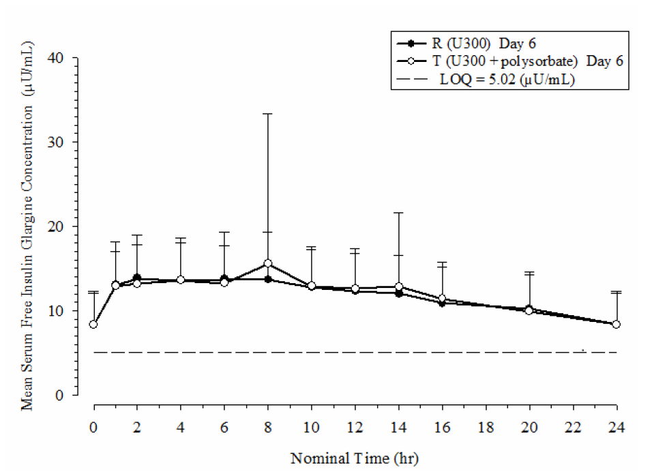
The median value at Time 0 for the entire study population, representing the steady state from previous dosing, was 8.27 μU/mL (range <LLOQ to 19.0).

Bioequivalence to relevant registered products
PK of U300 by comparison with U100 Lantus was assessed in 2 single dose crossover studies, PKD 11627 and PKD12270. In each, the reference U100 treatment was given in a dose of 0.4 U/kg. In PKD12270, U300 was given at 2 dose levels of 0.4 and 0.6 U/kg while in PKD11627, a third dose level of 0.9 U/kg was also used. A further study, TDR11626, assessed the PK of U300 0.4 and 0.6 U/kg versus U100 Lantus 0.4 U/kg at steady state after 8 days of administration. In all 3 of the studies, the PK assessment was a secondary objective to that of measuring the PD response using the euglycaemic clamp technique.
None of these studies was designed to demonstrate, nor do any of them show, bioequivalence between the test and reference products and the PK data comparing the two is regarded as observational only. What all 3 studies do show is a comparatively delayed onset and prolonged duration of drug exposure with the U300 formulation, which results in a markedly reduced total exposure to approximately 2 thirds of that for U100 over the 24 hours following administration particularly in the single dose studies, just as in healthy subject Study PKD10086. The concentration/time profiles for the 2 formulations show that there is considerable product still to be absorbed at the end of the initial 24 hour observation period and still at 36 hours, accounting for the difference in measured exposure.

Dose proportionality
No formal dose response study was undertaken, or was necessary in view of this evaluation, but evidence of dose proportionality is seen in Study PKD11627 in which 3 doses of 0.4, 0.6 and 0.9 U/kg of the U300 formulation were used. The concentration time profiles for these doses are shown below (Figure 2).
Figure 2: Mean (+SD) serum insulin glargine concentration time profiles (linear scale)
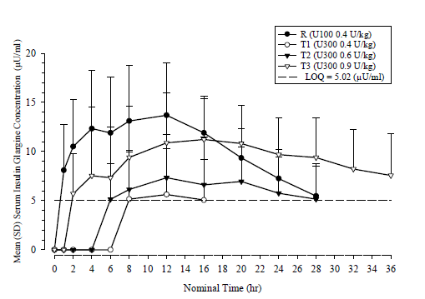
Mean drug exposure as assessed by INS-AUC _{0-36h} was 318 µU/hr/mL for U100 and 195, 206 and 327 µU/hr/mL for the 3 U300 doses respectively. Note that for the 0.4 U/kg dose, measured insulin glargine levels rarely exceeded the LLOQ of the assay, so the exposure figure for that dose is unreliable. The exposure values for the higher doses are in close proportion to the dose administered. Delayed onset of absorption, later peak and flatter concentration/time profile with the U300 formulation is also shown for all doses.

Bioavailability during multiple dosing
As might be expected from the prolonged absorption profile demonstrated for the U300 formulation in the single dose studies, exposure with equivalent doses of the 2 products was more comparable when measured at steady state in Study TDR11626, as shown in Table 2.

Table 2: PK exposure with U300 versus U100 glargine at two dose levels
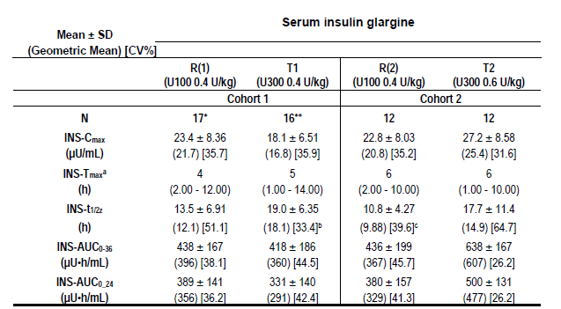
Note that in this study each treatment cohort (T1 and T2) had separate reference control groups, but with very similar data. At the 0.4 U/kg dose, mean exposure with U300 was 95% of control at 24 hours and 85% at 36 hours. With the 0.6 U/kg dose, these figures were 146% and 132% of the control U100 administration, respectively. The time distribution of exposure across the 36 hour period of observation is shown in the following figure, which also (due to the steady state administration) gives a more real world view of PK exposure with the U 300 formulation by comparison with the 100 Lantus (Figure 3).
Figure 3: Mean (+SD) insulin glargine concentration time profiles starting with dosing on Day 8 (linear scale)
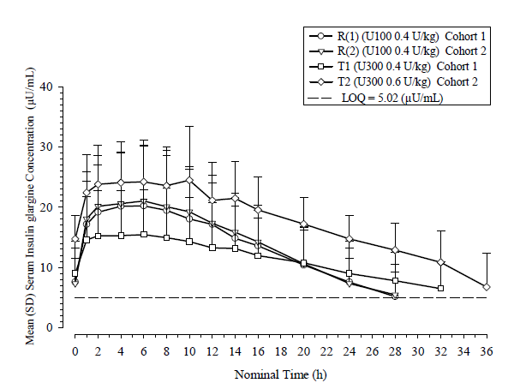
Given the degree of carryover of PK activity past 24 hours shown by the above data, it might be expected that significant accumulation would occur with daily administration. This aspect receives little emphasis in the documentation; beyond the comment in the clinical overview with regard to the measurement of metabolite M1 in Study TDR11626 that steady state was reached after 3 to 4 days of treatment with U300 compared with 1 to 2 days with U100 Lantus. Plasma M1 measurements, with descriptive summary statistics, are presented for all of the subjects at baseline on each of the 8 days of the study. The level of metabolite M1 is the relevant parameter as it is the major active circulating form. For both reference (R1 and R2) treatments as described above (Figure 3), the group data shows a plateau level being achieved by Day 3, that is, after 2 days administration. For T1, this appears by Day 4 and for T2, by Day 5. The mean (SD) trough M1 levels at Day 8 (ng/mL) were as follows:
- Treatment R1 (N = 18) 0.437 (0.168)
- Treatment T1 (N = 17) 0.579 (0.567)
- Treatment R2 (N = 12) 0.455 (0.448)
- Treatment T2 (N = 12) 0.686 (0.528).
The sample size is too small and the degree of variance too great to show significance, but the data is consistent with a minor and dose proportional degree of accumulation of glargine insulin which has reached a plateau within the first week.
Limited PK data at steady state were also obtained in Study PDY12335 in which patients were randomised to U300 or U100 Lantus and the dosage individually titrated to attain a similar level of glycaemic control as assessed by CGM. At the end of the treatment period, mean trough (steady state) glargine insulin level was 33.1 ± 21.7 µU/mL for U300 and 31.7 ± 27.0 µU/mL for U100 Lantus, although these data may have been affected by short acting insulin administration. Nevertheless, given that the treatment periods in this study were of 28 days, this is evidence against any significant accumulation.

Effect of administration timing
No specific study has been undertaken to assess any effect of time of day of administration on U300 insulin glargine PK. In the single dose studies in both healthy subjects and T1DM patients, the dose was given fasting in the morning. In all 3 multiple dose, steady state studies, it was given in the evening or at bedtime. Subjective perusal of the data does not suggest any difference attributable to these differences in timing.
The sub-studies of Studies EFC11628 and EFC11629 which assessed the effect of varying the time of administration by ± 3 hours do not include PK data.

Distribution
No specific information was provided in the submission. In view of the similar pattern of metabolism, it is assumed that distribution following subcutaneous injection is the same for the proposed product as for the existing U100 formulation.

Metabolism
The following information is extracted from the current approved PI for Lantus (1):
Following subcutaneous injection, insulin glargine is rapidly metabolised at the carboxyl terminus of the Beta chain with formation of 2 active metabolites M1 (21AGly-insulin) and M2 (21A-Gly-des-30B-Thr-insulin). In plasma, the principal circulating compound is the metabolite M1. The exposure to M1 increases with the administered dose of Lantus. The PK and PD findings indicate that the effect of the subcutaneous injection with Lantus is principally based on exposure to M1. Insulin glargine and the metabolite M2 were not detectable in the vast majority of subjects and, when they were detectable their concentration was independent of the administered dose of Lantus.

Pharmacokinetics of metabolites
Insulin glargine and the 2 metabolites M1 and M2 described in the previous section were measured by liquid chromatography coupled to tandem mass spectrometry (LC-MS/MS) in 2 studies. In Study PKD12270 the levels were too close to LLOQ, and the patient numbers insufficient, for meaningful conclusions. In Study TDR11626 metabolite M1 was identified as the principal circulating form, as described in the preceding section, with levels of parent insulin glargine and metabolite M2 were below LLOQ in most samples. Irrespective of whether the U300 or existing U100 Lantus formulation was administered, the concentration time profiles for metabolite M1 were similar to those for insulin glargine measured by RIA, which does not distinguish between the parent compound and metabolite M1.

Intra and inter individual variability of pharmacokinetics
In Study PKD13560, intra subject CV (90% CI) for total exposure (INS-AUC _{0-24h}) was 17.4 (14.5 to 21.1) %, and total CV 39.4 (34.1 to 47.4) %. These values are in the range of expectation following injection of insulin; despite attention to injection technique, absorption from the site can be influenced by a range of factors. Variance estimates in the other studies do not suggest any difference between the U300 and existing U100 formulations in this respect.
Comment: Variability of the glycaemic (PD) response to the U300 formulation, by comparison with that observed for the U100 Lantus formulation, is a significant issue in relation to the sponsor's claims for greater reliability of glycaemic control and in particular avoidance of hypoglycaemia. Variability of these responses was assessed in Study TDR11626 and is discussed below in the section on pharmacodynamics.

Evaluator’s overall conclusions on pharmacokinetics
The PK studies have been well conducted and present robust evidence that the proposed U300 formulation has a reliable absorption profile quantitatively similar to that of the existing Lantus product but with delayed onset of action, a lower and later peak level and more sustained maintenance of insulin levels over the later part of the 24 hour dosing interval. Although this does not result in significant accumulation with prolonged administration, steady state insulin levels do take 3 to 4 days to achieve by comparison with 1 to 2 days with the existing approved U100 Lantus formulation.

Pharmacodynamics

Studies providing pharmacodynamic data

Table 3: Studies relating to each PD topic
PD Topic | Subtopic | Study ID
Primary Pharmacology | Effect on insulin action as measured by glucose infusion rate (GIR) during euglycaemic clamp | PKD10086*  PKD11627  PKD12270  PKD13550  TDR11626
Primary Pharmacology | Effect on glycaemic profile measured by continuous glucose monitoring (CGM) | PDY12335
*Conducted on healthy subjects; remainder of studies conducted on subjects who would be eligible to receive the drug if approved for the proposed indication.
These studies containing PD data are the same set as those presented above in Section 4 on PK. None had deficiencies that excluded their results from consideration.

Summary of pharmacodynamics
The information in the following summary is derived from conventional PD studies in humans.

Mechanism of action
The actions of glargine insulin are identical to those of native insulin in the regulation of glucose metabolism and take place by means of binding to the membrane bound insulin receptor. These are well summarised in sections of the proposed PI which remain unchanged from the existing PI for insulin glargine (Lantus).

Pharmacodynamic effects

Primary pharmacodynamic effects
The blood glucose lowering action of the proposed new formulation of insulin glargine has been assessed in the series of studies listed above in Table 3, using the euglycaemic clamp technique. Following injection of the test or reference product, the resulting fall in blood glucose is prevented by intravenous glucose infusion regulated approximately every 5 minutes to maintain the plasma glucose close to a normal value of 5.5 mmol/L; the body weight adjusted GIR (mg/min/kg) is then the measure of the degree of insulin action. In all of the studies included with this application and described below, the U300 formulation has been compared with the existing registered U100 Lantus formulation. The methodology for these studies and presentation of the results is closely similar to that submitted with the original Lantus registration, as shown in its approved PI, in which the U100 formulation was the test product and NPH insulin the comparator.
Single dose Study PKD10086 was conducted in healthy volunteers. The validity of the clamp study in this situation was confirmed by observing suppression of C peptide levels. This is not an issue for the remaining PD studies which were all conducted in patients with T1DM. Bioequivalence in terms of insulin action was tested for in a crossover design but was not shown, activity of the test product in a dose of 0.4 U/kg body weight being a mean 61.5% that of the comparator.
Comment: The primary parameter for comparison was total exposure over 24 hours. Failure of bioequivalence by this criterion appears explained by prolongation of the exposure profile for the U300 formulation well beyond 24 hours. The same applies to the results of the other PD studies submitted. This aspect of the data is critical to the submission; also important is data on the variability of PD response.
The remainder of the studies were undertaken in T1DM patients. Study PKD11627 used the same 0.4 U/kg dosage of the comparator but this time tested against 0.4, 0.6 and 0.9 U/kg doses of the test product. Once again, and this time over 36 hours, markedly reduced activity of the test product was shown with point estimates for the ratio of test/reference being 0.63, 0.57 and 1.03 for the above 3 doses respectively. As discussed in the study summary the significance of these observations is limited because of instability of the blood glucose value during the clamp studies, the direction of which was such as to cause underestimation of the PD activity of the test product. A similar protocol was used in Study PDY12270, undertaken in Japanese patients, except for the omission of the 0.9 U/kg dosage. The results were similar, showing markedly reduced GIR-AUC _{0-36h} values for both doses of the test product compared with comparator U100, but once again there were marked variations in blood glucose values particularly during the early part of the clamp studies such as to at least partly explain the apparently reduced activity of the test product.
Conclusions in terms of comparing the PD activity of the U300 with that of the existing formulation are difficult to draw from the above studies because of the problems inherent in comparing their activities during a fixed time interval when the durations of action of the two products are so obviously different. These difficulties are to some extent overcome in the multiple dose double blind crossover Study TDR11626. Insulin action was assessed on the basis of both 24 and 36 hour GIR-AUC values taken on the last day of an 8 day dosing regimen in which 0.4 and 0.6 U/kg doses of U300 were compared with 0.4 U/kg of U100 Lantus. The point estimates with 90% CI for the test/reference treatment comparison ratios were, for the 0.4 U/kg dose, 0.73 (0.56 to 0.94) for AUC_{0-24h} and 0.85 (0.70 to 1.03) for AUC_{0-36h}; and for the 0.6 U/kg dose, 1.46 (0.96 to 2.21) for AUC_{0-24h} and 1.65 (1.11 to 2.46) for AUC_{0-36h}.
Comment: While the study was not designed to show bioequivalence, the ideal point estimates for which would be 1.0 and 1.5 for the 2 doses respectively, the results clearly show that the new formulation has PD activity consistent with its PK and, for the purpose of clinical use, equivalent in potency on close to a unit for unit basis.
The PD results from Study 13560, in which formulations with and without polysorbate were used, show close bioequivalence of the results as was the case for the PK data as described above.

Secondary pharmacodynamic effects
No relevant data is included.
Comment: A potential secondary PD action of insulin is that of stimulation of cellular proliferation by means of binding to and activation of the IGF-I receptor. Glargine insulin, although not its metabolites M1 and M2, is known to have an affinity for the IGF-I receptor greater than that of human insulin, although the plasma concentrations occurring during insulin therapy have been found to be insufficient to activate the potentially mitogenic IGF-I pathway. These aspects of the action of glargine insulin are documented in the existing PI for U100 Lantus and this information remains unchanged in the proposed PI for the current application. Given that the therapeutic levels of insulin glargine and its metabolites resulting from the use of the U300 product are, as shown in the included PK studies, of the same order as those found with U100 Lantus therapy, it can be concluded that no additional information regarding this secondary effect is necessary for the current application.

Time course of pharmacodynamic effects
Alteration of the time course of insulin action resulting from a single daily injection of glargine insulin is the single major finding of importance in the supporting PD data. In Figure 4 the time action profiles of U100 (left panel) and U300 (right panel) from single dose study PKD10086 are shown.
Figure 4: Time action profiles of U100 (left panel) and U300 (right panel) from single dose Study PKD10086
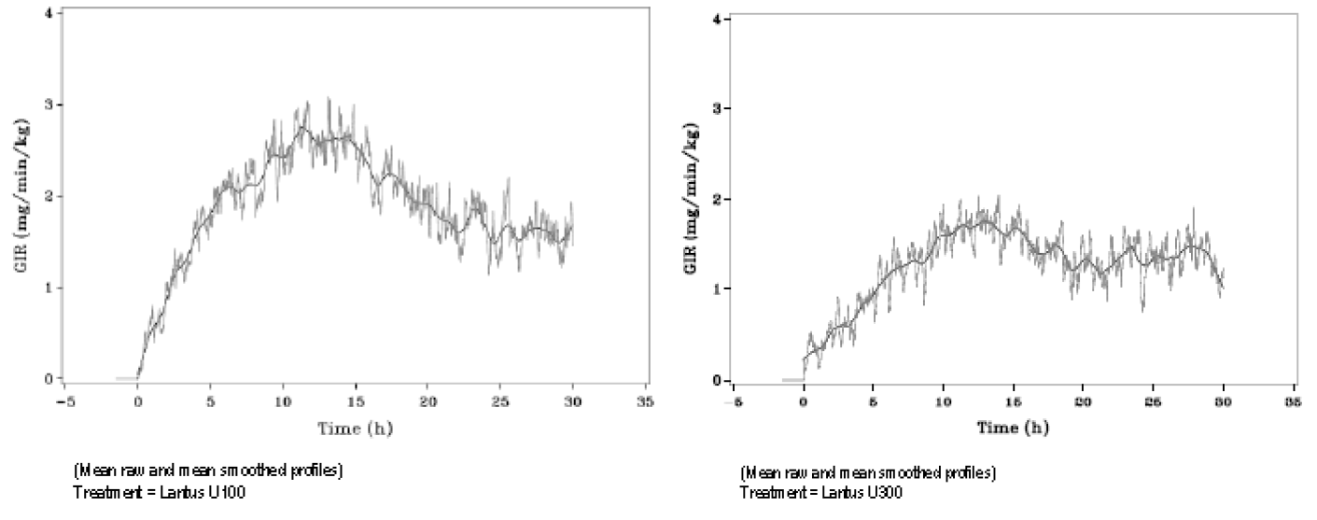
Similar observations were made in the studies conducted on T1DM patients, with the difference between the test and reference products best demonstrated in Study TDR11626, in which steady state conditions had been achieved and there were less technical difficulties in the conduct of the euglycaemic clamp studies. The GIR results are illustrated in Figure 5, with both reference treatment cohorts in the left panels and the U300 test treatment on the right.
Figure 5: The GIR results with both reference treatment cohorts in the left panels and the U300 test treatment on the right
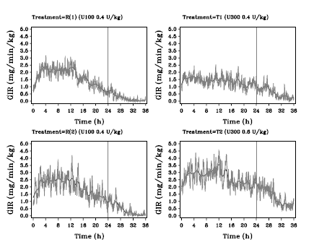
GIR = body weight standardised Glucose Infusion Rate R(1): denotes injection of 0.4U/kg Lantus U100 and T1 injection of insulin glargine U300 (0.4U/kg) in Cohort 1 R(2): denotes injection of 0.4U/kg Lantus U100 and T2 injection of insulin glargine U300 (0.6U/kg) in Cohort 2
Note particularly the more constant profile of insulin activity over 24 hours evident for the 0.4U/kg U300 dose (upper right) compared with the same dose of U100 (upper left). These PD data are consistent with the difference in the PK time course characteristics between the 2 products demonstrated particularly in this study as shown in Figure 3.
Comment: While the above PD data are supportive of the sponsor's claim that the new U300 formulation has a flatter time concentration curve and thus a more constant action over 24 hours than its existing U100 formulation used as the comparator in these studies, the time course of action of the U100 (Lantus) formulation shown in these studies is in marked contrast to that shown in studies using the same methodology when it was the test product and NPH insulin the reference product. A graphic illustration of this comparison is reproduced below, (Figure 6) taken from the current Lantus PI.
Figure 6: Time action profiles of insulin glargine and NPH insulin
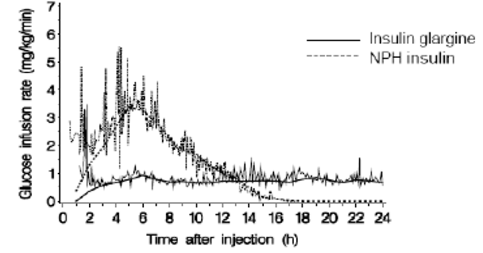
Whereas the GIR values for Lantus U100 as the reference treatment in studies in the current application fall by approximately 50% from a peak at 8 to 12 hours, as shown above in Figure 5, the profile in the above graph taken from a study which supported the original registration of Lantus showed values constant from 6 through to 24 hours, more resembling the data found for the U300 formulation in the current application.

Variability of pharmacodynamic effect
Variability of the PD response was examined in some detail in Study TDR11626. A parameter was derived relating to the GIR values in each treatment group which is the mean of all the variances of GIR above or below the smoothed curve of all results, irrespective of direction. The variance values are consistently lower in the treatment groups T1 and T2 (U300 0.4 and 0.6 U/kg dose respectively) by comparison with the comparator U100 Lantus groups, but the differences do not reach statistical significance.
Comment: As pointed out in the study summary, the values quoted are absolute variances and therefore proportional to the absolute exposure (AUC-GIR), so that comparison between the treatment groups would be more validly expressed as a proportion of the total exposure. The mean variances in the study report (mg/kg/min), expressed as a proportion of the AUC-GIR _{0-36h} recalculated as mg/kg/min, are shown below (evaluator calculation):
Group R1 (cohort 1, U100 0.4 U/kg) 69%
Group T1 (cohort 1, U300 0.4 U/kg) 50%
Group R2 (cohort 2, U100 0.4 U/kg) 63%
Group T2 (cohort 2, U300 0.6 U/kg) 37%
These data at least represent a valid comparison between the reference treatment groups and support the finding of the study that variability of GIR as a PD parameter was numerically less with the U300 formulation. Without supporting statistical analysis, however, the significance of the finding is uncertain.
Variability of PD response measured by CGM was presented in Study PDY12335, but this was not designed so much as a PD study as an efficacy study to examine specifically the parameter of glycaemic variability experienced with the new U300 glargine formulation by comparison with that seen with the existing formulation. No significant difference in parameters of glycaemic control was identified between the groups. Differences in the incidence of hypoglycaemia were demonstrated and these are discussed below in relation to safety.

Relationship between drug concentration and pharmacodynamic effects
Correlation of the PK exposure (INS-AUC) and PD response (GIR-AUC) was undertaken in Study TDR11626 for both the 0 to 24 hour and 0 to 36 hour periods, with a significant correlation coefficient being established in both instances and no differences observed between the treatment groups. The data for the 0 to 36 hour treatment period are illustrated graphically below (Figure 7).
Figure 7: Scatterplot of GIR-AUC_{0-36h} versus INS-AUC_{0-36h}
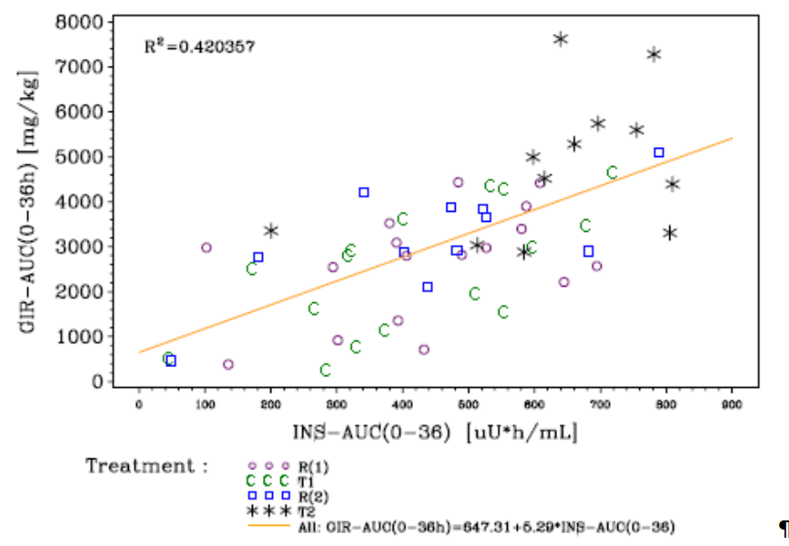GIR = body weight standardised Glucose Infusion Rate R(1): denotes injection of 0.4U/kg Lantus U100 and T1 injection of 0.4 U/kg insulin glargine U300 in Cohort 1. R(2): denotes injection of 0.4U/kg Lantus U100 and T2 injection of 0.6 U/kg insulin glargine U300 in Cohort 2.

Evaluator’s overall conclusions on pharmacodynamics
The PD properties of the new U300 glargine insulin formulation are qualitatively similar to those of the existing U100 formulation but with a delayed onset, prolonged duration of action and reduced variation during the dosing interval consistent with its altered PK properties. There is suggestive evidence, not confirmed by the statistical analysis, that intra individual variation in PD response during the dosing interval may be reduced with the new formulation.

Dosage selection for the pivotal studies
Dosage of insulin therapy is generally individualised along a continuous scale and usually, as in these studies, to a therapeutic target. The starting dose in this instance, for either the test product or the comparator (U100 Lantus), was defined as the subject’s existing insulin dose, or in the case of insulin naïve subjects (patients) in Study EFC 12347, 0.2 U/kg. In Studies EFC11628 and EFC11629, the administration device used necessitated a lower limit of 42 units for basal insulin dose at recruitment.

Clinical efficacy
Efficacy is supported by 4 pivotal Phase III studies. These were conducted using a common protocol and their results are therefore presented together below. Additionally there was a Phase II exploratory study (PDY12777), and 3 month sub-studies conducted during the main study period of 2 of the pivotal studies (EFC11628 and EFC11629). The general characteristics of all of these studies are summarised in the sponsor's tabulation reproduced at Table 4.

Treatment of diabetes mellitus in adults

Pivotal efficacy studies

Studies EFC12456, EFC11628, EFC11629, EFC12347

Table 4: Characteristics of Pivotal Studies EFC12456, PDY12777
Studies in T1DM | EFC12456  Phase III | PDY12777 Phase II; Exploratory CGM study
Population | T1DM on basal insulin in combination with mealtime insulin analogue | T1DM on basal insulin in combination with mealtime insulin analogue
Region | North America, South America, Europe, South Africa, Japan | USA
Comparator | Lantus | Lantus
Randomisation | 1:1:1:1  HOE901-U300 morning injection  HOE901-U300 evening injection  Lantus morning injection  Lantus evening injection | 1:1:1:1  HOE901-U300 injection sequence:  Period A morning – Period B evening  Period A evening – Period B morning  Lantus injection sequence  Period A morning – Period B evening  Period A evening – Period B morning
Main objectives | Efficacy and safety | Efficacy and safety
Route  Injection device | Once daily SC injection  HOE901-U300: modified Tactipen  Lantus: Solostar | Once daily SC injection  HOE901-U300 and Lantus:  Half unit syringe; whole unit syringe for Lantus doses > 30 units
Duration of treatment | 6 months (comparative main study period)  6 months comparative extension period* | 16 weeks (2 x 8 weeks)
Number of patients randomised | HOE901-U300; 274  Lantus; 275 | HOE901-U300; 30  Lantus; 29
*Extension period ongoing at the time of the cut off; results not included in the dossier OAD = oral anti hyperglycaemic drugs; T1DM = type 1 diabetes mellitus; T2DM = type 2 diabetes mellitus; CGM = continuous glucose monitoring; NA = not applicable

Table 5: Characteristics of Pivotal Studies EFC11628, EFC11629, EFC12347
Studies in T2DM | EFC11628 Phase III | EFC11629 Phase III | EFC12347  Phase III
Population | T2DM on basal insulin in combination with mealtime insulin analogue | T2DM on basal insulin in combination with OAD | T1DM on basal insulin in combination with mealtime insulin analogue
Region | North America, South America, Europe, South Africa | North America, South America, Europe, South Africa | North America, South America, Europe, Japan
Comparator | Lantus | Lantus | Lantus
Randomisation | 1:1 | 1:1 | 1:1
Main objectives | Efficacy and safety | Efficacy and safety | Efficacy and safety
Route  Injection device | Once daily SC injection  HOE901-U300: modified Solostar  Lantus: Solostar | Once daily SC injection  HOE901-U300: modified Solostar  Lantus: Solostar | Once daily SC injection  HOE901-U300: modified Tactipen  Lantus: Solostar
Duration of treatment | 6 months (main study period)  6 months comparative extension period* | 6 months (main study period)  6 months comparative extension period* | 6 months (main study period)  6 months comparative extension period*
Number of patients randomised | HOE901-U300 –404  Lantus; 402 | HOE901-U300 – 403  Lantus; 406 | HOE901-U300 – 435  Lantus; 438
3 month substudies |  |  | N/A
Patient population | Patients randomised and treated with HOE901-U300 during the main study period | Patients randomised and treated with HOE901-U300 during the main study period
Comparison | HOE901-U300 injection intervals  At fixed 24 hour intervals  At intervals of 24 ± 3 hours | HOE901-U300 injection intervals  At fixed 24 hour intervals  At intervals of 24 ± 3 hours
Randomisation | 1:1 | 1:1
Objective | Efficacy and safety | Efficacy and safety
Duration | 3 months (Month 6 – Month 9 extension period) | 3 months (Month 6 – Month 9 extension period)
Number of patients | Fixed intervals; 53  Adaptable intervals; 56 | Fixed intervals; 44  Adaptable intervals; 45
*Extension period ongoing at the time of the cut off; results not included in the dossier OAD = oral anti hyperglycaemic drugs; T1DM = type 1 diabetes mellitus; T2DM = type 2 diabetes mellitus; CGM = continuous glucose monitoring; NA = not applicable

Study design, objectives, locations and dates
All 4 pivotal studies were multicentre, multinational, open label, active controlled parallel group trials in which the use of U300 was compared with U100 Lantus over a 6 month treatment period followed by a 6 month safety extension. Study EFC12456 was carried out on T1DM patients and the remainder on T2DM patients in 3 different categories as described below, along with the regional distribution of the centres in which the studies carried out:
Study EFC12456, T1DM on basal in combination with mealtime insulin ≥ 1 year: 147 centres in 12 countries in North America, Europe and in Japan
Study EFC11628, T2DM on basal in combination with mealtime insulin ≥ 1 year: 180 centres in 13 countries in North America, Europe, South Africa and in Mexico
StudyEFC11629, T2DM on basal insulin in combination with OHA ≥ 6 months: 213 centres in 13 countries in North America, Europe, South Africa, and in Mexico and Chile
Study EFC12347, T2DM ≥ 1 year, insulin naïve and on OHA ≥ 6 months: 249 centres in 15 countries in North America, Europe, and in Japan
Collectively, the studies were performed during the period December 2011 to September 2013.
The primary objective was to compare efficacy of the test versus reference treatment in terms of change in HbA1c from baseline to end point at 6 months. The studies were designed to show non inferiority on the basis of this parameter, with a non-inferiority margin of 0.4% HbA1c. Subjects in Study EFC12456 were also, at randomisation, stratified to morning or evening injection and a secondary objective was to compare the change in HbA1c between the 2 products, as well as other parameters of glycaemic control, by time of injection. In the remaining studies, secondary objectives included comparison of the test versus reference treatments in terms of reaching target values of HbA1c and plasma glucose; parameters of treatment satisfaction; and safety and tolerability, including monitoring for anti-insulin antibodies.

Inclusion and exclusion criteria
Inclusion was open to adult patients at least 18 years of age with a screening HbA1c in the range of ≥ 7.0 to ≤ 10.0% for insulin pre-treated patients (EFC12456, EFC11628 and EFC11629) or ≥ 7.0 to ≤ 11.0% in insulin naïve patients (EFC12347).
The studies were designed to be as inclusive as possible, with exclusion criteria limited to serious or rapidly progressive ocular complications of diabetes, a history of hypoglycaemic unawareness or DKA, active malignancy or major systemic disease.

Study treatments
In all studies, the test treatment was U300 insulin glargine in the formulation as proposed for marketing, and the reference treatment U100 Lantus as already marketed in Australia. All treatments were given using pen injector devices. In Studies EFC11628 and EFC11629 the device used was the Solostar pen as marketed in Australia containing Lantus. This device permits setting of the dosage in steps of 1 U but for those patients randomised to the higher concentration U300 formulation, the minimum dose step was 3 U. In the other 2 studies, patients randomised to U300 used a modified form of a reusable device called Tactipen, which is not to the knowledge of this evaluator used in Australia. This injection device allowed dose setting in the range of 3 to 90 U with minimum increment steps of 1.5 U for the U300 strength.
In the T1DM Study EFC12456, doses were given once daily either in the morning or evening according to injection time stratification within each treatment group, and in all the T2DM studies once daily in the evening.
Comment: These injection times were rather loosely defined. "Morning" meant the time between pre breakfast and pre-lunch, and "evening" meant the time from immediately before dinner until bedtime. However, for each individual patient the precise injection time was to be agreed between patient and investigator and then adhered to within + 1 hour for the duration of the study.
Patients already on Lantus prior to the study switched over to the study medications in the existing dose or, if they had been on NPH or Detemir, 80% of that dose (this being the standard recommendation). For insulin naïve patients, the starting dose was 0.2 U/kg body weight.
Dosage titration to pre specified plasma glucose targets was carried out throughout the 6 month study period, with adjustments to be made at least once weekly if necessary, but not more than every 3 to 4 days. The titration protocol differed between the T1DM and T2DM studies. In the former, adjustments were made depending on the mean of all of the fasting pre-prandial SMPG readings in the previous 3 to 4 days, whereas in the latter (T2DM) the determining parameter was the fasting pre breakfast SMPG. T1DM patients were instructed to increase glargine doses by at least 10% but not exceeding 4.5 U for U300 or 4 U for U100 Lantus. For T2DM patients, the protocol required increases of 3 or 6 U depending on the SMPG level. In either case, reductions in dosage were to be made in the event of hypoglycaemia. The target range for median pre-prandial SMPG for the T1DM patients was 4.4 to 7.2 mmol/L, and the target for fasting pre breakfast SMPG in the T2DM studies 4.4 to 5.6 mmol/L. A titration monitoring team supervised this process.
Comment: What is described here is a typical self-performed insulin adjustment protocol as carried out in most modern ambulatory diabetes care centres. The dosage increments and target values advised for the 2 types of diabetes are appropriate, as is the finer adjustment available for the more insulin sensitive T1DM patients. Note that the study protocols specify similar increments for test and reference products, despite the difference in minimum possible increments or decrements achievable with the pen devices.

Efficacy variables and outcomes
The main efficacy variable was HbA1c. The primary efficacy outcome was the change from baseline to end point at Month 6 in HbA1c.
Other efficacy variables/outcomes included:
- (T2DM studies only): testing for superiority of U300, only if non inferiority first shown.
- % of patients experiencing 1 episode of nocturnal (between midnight and 6 AM) hypoglycaemia between Week 9 and end of study at 6 months.
- Pre injection plasma glucose (morning or evening, depending on individual study protocol).
- Fasting plasma glucose (FPG) measured in a central laboratory.
- Self-monitored plasma glucose (SMPG) profiles.
- Insulin dose data.

Randomisation and blinding methods
In all studies recruited and screened patients were randomised 1:1 to U300 or U100 Lantus by use of a centralised interactive voice response randomisation system (IVRS). In Study EFC12456 there was secondary randomisation 1:1 to morning or evening injection group within each treatment group. The choice of an open label design, with no blinding of either investigators or participants, was dictated by the need for dosage adjustment and the difference between the test and reference formulations in terms of concentration and volume of injection per unit of medication (insulin). Nevertheless both the central laboratory and investigator teams remained blinded to the treatment group allocation with regard to results of the primary efficacy parameter (HbA1c) until the database was locked at the end of each study.

Analysis populations
The primary efficacy population used was the mITT population, defined in the statistical analysis plan for each study as "all randomised patients who receive at least 1 dose of the open label IMP, and have both a baseline assessment and at least 1 post baseline assessment of any primary or secondary efficacy variables, irrespective of compliance with the study protocol and procedures". As illustrated in the flow diagram for Study EFC12456, this was further refined for the purpose of carrying out the primary efficacy analysis by excluding patients who had no post baseline value or whose post baseline value was not performed while on treatment or while in the defined time window for the visit. The population remaining was that required for the Mixed Model for product Repeated Measurements (MMRM) used for the statistical analysis as shown below (Table 6). The final population referred to as Pattern 3, is that with values at baseline and Month 6, essentially the per protocol population. The numbers in these various populations (test and reference combined, and as % of those randomised) for the 4 pivotal studies were as follows:

Table 6: Numbers in the various populations for the 4 pivotal studies
 | EFC12456 | EFC11628 | EFC11629 | EFC12347
Randomised | 549 | 807 | 811 | 878
mITT | 546 (99%) | 804 (99%) | 808 (99%) | 862 (98%)
MMRM | 499 (91%) | 777 (96%) | 761 (94%) | 796 (91%)
Pattern 3 | 454 (83%) | 735 (91%) | 682 (84%) | 715 (81%)
Comment: As can be seen from the above (evaluator calculation), the proportion of the randomised population eventually analysed (MMRM) is over 90% for each study. Importantly, the numbers of randomised patients excluded from the MMRM is very evenly distributed between test and reference populations in each of the studies which also shows that the patients retained in the MMRM but excluded from the final Pattern 3 population are those in whom the week 12 HbA1c, rather than Month 6, is the final measurement. This is appropriate and if anything would diminish the treatment effect found for both test and reference treatments, although the efficacy data in all of the studies they show that the majority of reduction in HbA1c had occurred during the first 12 weeks of the 6 month study period.

Sample size
Sample size calculations are described in each study report. As an example, the most complex calculation, that for Study EFC12456 due to its 2 level stratification is summarised as follows:
A sample size of 500 patients (125 for each of the 4 factor level combinations [HOE901-U300 or Lantus with morning or evening injection]) was considered sufficient to ensure that the upper confidence limit of the 2 sided 95% confidence interval (CI) for the mean difference (overall) between HOE901-U300 and Lantus would not exceed 0.4% HbA1c with > 99% power assuming that standard deviation (SD) is 1.0% (modified intention to treat [mITT] population n = 500), that the true difference between HOE901-U300 and Lantus is zero in HbA1c and assuming that all patients were evaluable.
Similar and satisfactory calculations are given in each of the other study reports, all employing the same values for non-inferiority limit (0.4% HbA1c), power (> 99%), and true difference (zero). In each study, the numbers of patients randomised comply with these calculations.

Statistical methods
The primary efficacy endpoint (outcome) as defined above was analysed using analysis of covariance (ANCOVA), with the difference between treatment groups expressed as the least squares (LS) mean difference in HbA1c change, with 2 sided 95% CI. The methodology is documented in a statistical analysis plan for each study, using common principles.

Participant flow
Flow diagrams for the individual pivotal studies are shown in the summary of clinical efficacy. That for Study EFC12456 is reproduced below as Figure 8; the others are essentially similar, except that the actual numbers of patients included/excluded at various stages.

Major protocol violations/deviations
Small numbers of protocol violations, mostly failure to have specified baseline or on treatment measurements, occurred and resulted in exclusion of subjects from the mITT as illustrated for Study EFC12456 in Figure 8, and similarly in other studies.
Figure: 8: Study EFC 12456: participant flow and analysis sets
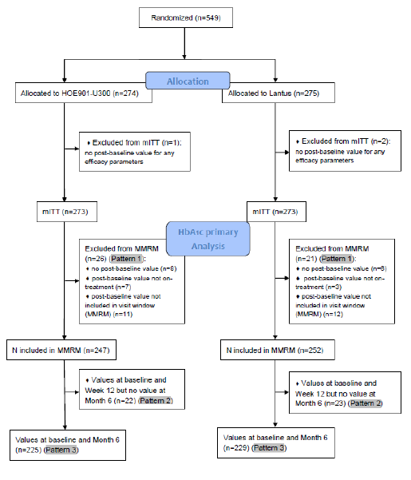
Comment: In all of the studies, protocol violations appear to have been managed appropriately with regard to data handling and were insufficient in numbers to interfere with the conclusions.

Baseline data
The population of patients randomised into the pivotal studies was substantial, totalling 549 for the T1DM study and 2496 for the pooled T2DM studies. They were spread across a wide range of age groups and geographical regions. At baseline, the T1DM patients had a mean HbA1c of 8.12%, ranging from 6.5 to 10.8%. Characteristics such as duration of diabetes, which ranged from 1 to 70 years overall, previous therapies and prevalence of diabetes complications were evenly distributed between the treatment groups in all of the pivotal studies. Patients in the T2DM studies were on average older, as would be expected, averaging from 57 to 60 years of age in the treatment groups of the 3 studies by comparison with the overall mean age of 47 years for the T1DM patients. Baseline glycaemic control as indicated HbA1c was, as specified by the recruitment criteria, similar to that for the T1DM study, averaging between 8.10 and 8.40% in the various treatment groups with an overall range of 6.5 to 12.6%.
Comment: Selection and documentation of the study populations were satisfactory, and for both the T1DM and T2DM categories the populations are well representative of the target population for this product in the Australian context.

Results for the primary efficacy outcome
The results for the change in HbA1c from baseline to 6 months, and the comparison between the U300 and U100 Lantus groups, are displayed in the following table:

Table 7: Primary efficacy analysis – Summary of mean change in HbA_{1c} (%) from baseline to endpoint (Month 6) in the Phase III studies and in meta-analysis of EFC11629 and EFC12347 (MMRM analysis) – mITT population
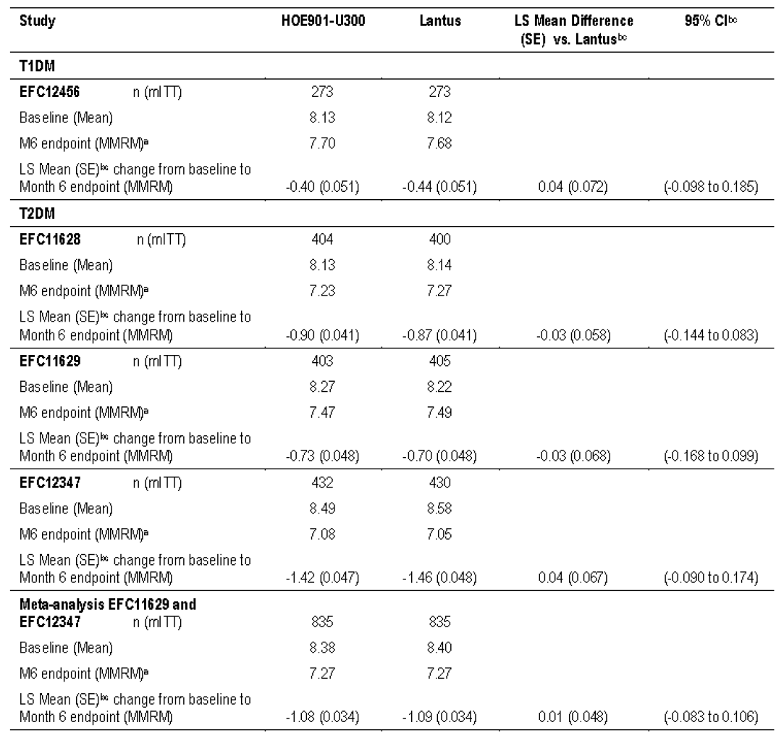MMRM = Mixed model for repeated measurements
A Month 6 endpoint (MMRM) value is either the observed value at Month 6 or the value retrieved (time windows in the SAP)
B MMRM with treatment (or randomised group for EFC12456), randomization strata of screening HbA1c, world region (or randomisation strata of geographical region for EFC12347 and EFC12456), visit and visit by treatment interaction as fixed categorical effects, baseline value and baseline by visit interaction as fixed continuous covariates
C For meta-analysis, same MMRM as above with addition of fixed effect study, study by visit interaction and deletion of world region or randomisation strata of geographical region
For each of the studies, and for the meta-analysis of the studies involving oral agents, non-inferiority of the test with respect to the reference formulation is clearly demonstrated, within very close limits. When performed as specified by the study protocol, further testing failed to show superiority of the U300 formulation.
Comment: Note that, irrespective of the formulation used, the greatest decreases in HbA1c occurred in the insulin naïve group (Study EFC12347), for whom the addition of insulin was therapeutically worthwhile. The smaller decreases which occurred uniformly in the other groups who were already on insulin are attributable to the more intensive insulin adjustment occurring under study conditions.
In the T1DM study, a secondary analysis was performed of HbA1c change from baseline to 6 months in the subgroups comparing morning and evening injections. The greatest reductions in HbA1c (LS mean 0.48% in each case) were seen for the morning U300 and evening U100 groups, but the differences from the other groups were small and not statistically significant, as shown in the following table:

Table 8: HbA1c change by time of injection in Study EFC12456
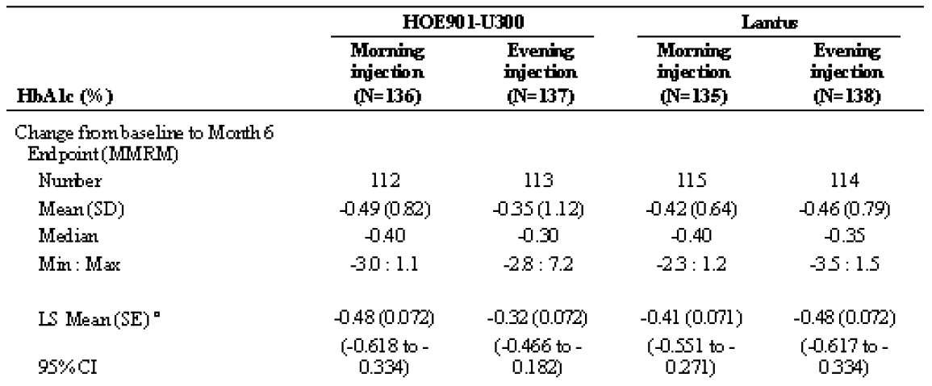

Results for other efficacy outcomes

Incidence of nocturnal hypoglycaemia
This was specified as the first main secondary efficacy endpoint. Data was collected on episodes of nocturnal hypoglycaemia, defined as occurring between midnight and 6 AM, which were either severe, that is, symptomatic and requiring correction, or confirmed by SMPG < 3.9 mmol/L. The incidence of such episodes in the pivotal study populations, together with comparative statistics between the test and reference treatment groups, is shown in the following table:

Table 9: Secondary efficacy analysis – Number (%) of patients with at least one severe and/or confirmed (SMPG ≤ 3.9 mmol/L [70 mg/dL]) nocturnal hypoglycaemia (00:00 to 05:59) occurring between start of Week 9 to Month 6, in pivotal Phase III studies and in meta-analysis of EFC11629 and EFC12347
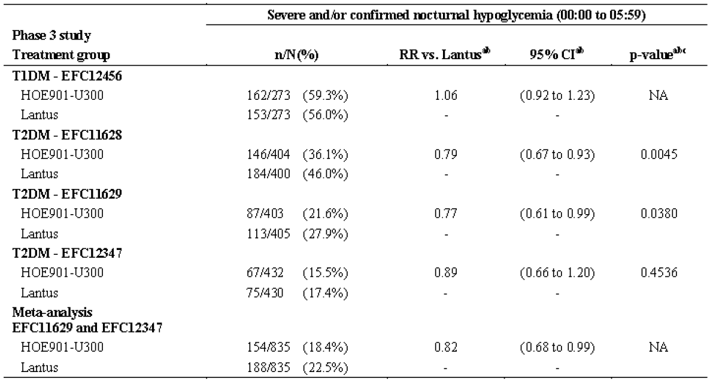
It is evident that nocturnal hypoglycaemia has occurred significantly less frequently with the U300 formulation both in Study EFC11628 (T2DM patients on basal plus mealtime insulin) and EFC 11629 (T2DM on basal insulin plus oral agent), but not in the T1DM study, and probably not to any significant extent in the study on insulin naïve patients whose overall incidence of hypoglycaemia was much less. In the T2DM studies, all insulin doses were given in the evening but in the T1DM study patients were sub stratified into morning and evening injection groups. The incidence of nocturnal hypoglycaemia (similarly defined) in this study by time of injection is shown below:

Table 10: Secondary efficacy endpoints - Number (%) of patients with at least one nocturnal hypoglycaemia (00:00 to 05:59 hours) occurring between start of Week 9 and Month 6, indicated as severe and/or confirmed by plasma glucose ≤ 3.9 mmol/L (70 mg/dL) by injection time (morning, evening) - mITT population
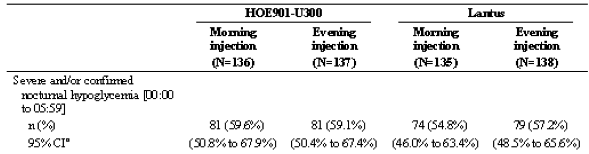
No significant reduction in nocturnal hypoglycaemia is observed with use of the U300 formulation in these T1DM patients, and with morning administration the incidence of such may even be greater with the U300 formulation (59.6 versus 54.8%).
Comment: The observation of a reduction in nocturnal hypoglycaemia with use of a longer acting therapeutic agent (whether insulin or oral), despite an equivalent level of glycaemic control, is surprising in terms of current thinking about the role of long versus short acting agents in diabetes care. A plausible explanation might be that when the U300 is given in the evening, as in the T2DM studies, its delayed onset of action as demonstrated in the PD studies would mitigate against causation of hypoglycaemia during the night. This might not apply to T1DM patients who are more insulin sensitive and have a higher overall incidence of hypoglycaemia for that reason and may also have deficient counter regulatory responses. The slight (if significant) increase in nocturnal hypoglycaemia observed (Table 10) with morning administration in the T1DM patients could equally be attributed to the more active late phase of the PD action of the U300 product which would be evident in the middle of the following night.

Change in pre injection SMPG from baseline to Month 6
In the Type 1 study, this parameter fell by a mean of 1.16 mmol/L in U300 patients compared with 0.82 mmol/L for U100 Lantus. The significance of this was not tested because of the hierarchical testing strategy. In Type 2 patients, the fall from baseline to 6 months was very similar in Studies EFC11628 and EFC12347. In Study EFC11629, the fall was greater for U300 (0.89 versus 0.64 mmol/L) but the difference was not significance (p = 0.218).

Change in FPG from baseline to Month 6
There are no differences between the 2 treatment groups of sufficient magnitude to be either statistically or clinically significant, but it is notable that the values for Month 6 FPG, and for the fall from baseline in 6 months, are numerically lower in the U100 than in the test U300 treatment groups in all 4 pivotal studies.
Comment: Higher FPG levels in the U300 patients would be consistent with the slower onset of overnight action with the product administered in the evening and associated reduced incidence of hypoglycaemia, as suggested in the previous comment.

Change in 8 point SMPG profiles
The profiles improved in terms of overall glycaemic control between baseline and 6 months, consistent with the improvement in HbA1c. The major qualitative difference between the treatment groups was a greater decrease between 3 AM and pre-lunch in the U100 Lantus group by comparison with U300 treated patients.
Comment: Again, this pattern of change is consistent with a greater overnight action of U100 Lantus, as predicted by its PD profile, when given in the evening.

Insulin dose data
Comparison of the basal insulin (study medication) doses between the pivotal studies is of interest to this evaluation and is shown in the following table compiled from these reports:

Table 11: Baseline and six month study medication doses, pivotal studies
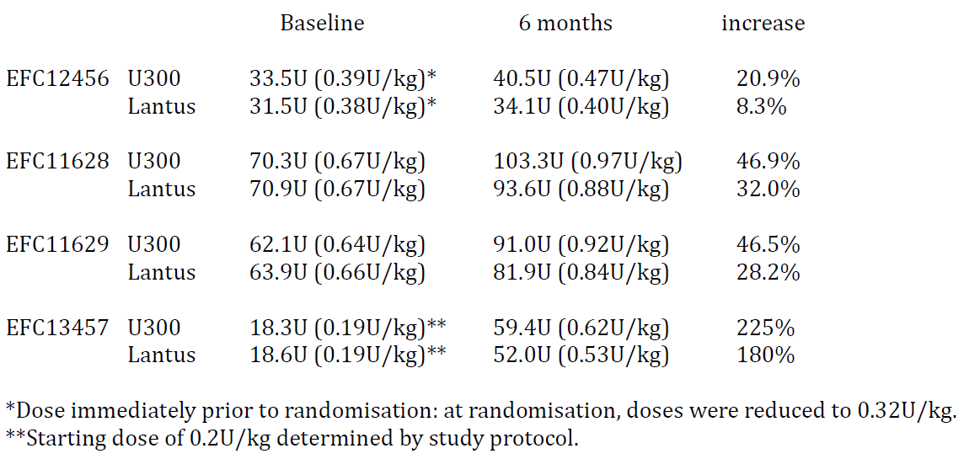
Comment: Note that, at the 6 month efficacy endpoint, total insulin dose, dose per kg body weight, and in particular the % increase in dose from baseline is greater for the U300 treatment group than for the reference group in each of the studies. Given that the increments in insulin dose during the treatment period are driven by the requirement to achieve pre-specified plasma glucose targets, this indicates that achievement of these targets required substantially greater increases in dose for the U300 formulation than with U100 Lantus; and that the overall improvement in glycaemic control achieved with U300 required more units of insulin per unit reduction in HbA1c than with U100 Lantus.

Other secondary endpoints
Data was collected in the pivotal studies on other secondary endpoints including change in the variability of SMPG from baseline to 6 months, responder analyses, and change in 24 hour average plasma glucose. None of these parameters indicated any significant differences between the test and reference treatment groups.

Study PDY12777 (5.3.5.1)

Study design, objectives, locations and dates
This was a 16 week, randomised, open label, controlled Phase II exploratory study to compare efficacy and safety of the U300 formulation with U100 Lantus, in patients with T1DM, using CGM as the principal measurement of efficacy. It was carried out in 3 USA centres, coordinated at Park Nicollet Health Services, Minneapolis, between August 2012 and April 2013. The study employed a 4 parallel group design in which eligible patients received either U300 or U100 as basal insulin in 2 treatment periods of 8 weeks during which the insulin was given in the morning or the evening, in random order.

Inclusion and exclusion criteria
The inclusion criterion required adult patients aged 18 to 70 inclusive with T1DM for at least 1 year. Exclusion criteria included HbA1c > 9% at screening, recent insulin dose exceeding 0.5 U/kg body weight, unstable insulin dose, use of premixed insulins or insulin pump therapy, end stage renal disease or uncontrolled hypertension, and a standard list of severe systemic diseases as used in the pivotal studies for this submission. Effectively, the list of excluded antidiabetic therapies meant that recruited patients had to be on a basal/bolus insulin regimen.

Study treatments
Patients were randomised to receive either U300 (test) or u100 Lantus (reference) as the basal insulin and were to continue using their bolus insulin in the same pattern as pre-study. The starting dose was determined by their existing basal insulin and adjusted so as to be divisible by 1.5, this being made necessary by the use throughout the study of standard half unit syringes designed for 100 U/mL insulin. During the first 6 weeks of each treatment period test or reference treatment doses were increased by increments of 1.5 to 4.5 units at intervals not more often than 3 to 4 days towards achieving a target pre-prandial plasma glucose between 4.4 to 7.2 mmol/L. At the same time the patient bolus insulin doses were adjusted to achieve post prandial levels below 8.9 mmol/L.

Efficacy variables and outcomes
The main efficacy variables were:
- % of time with CGM in the range 4.4 to 7.8 mmol/L during the last week of each treatment period (primary efficacy outcome).
- % of time above or below those limits.
- Measurements of diurnal glucose stability and variability, as specified in the protocol.
Other efficacy outcomes included:
- HbA1c and FPG measurements at specified intervals.
- Pre injection SMPG, and 7 point SMPG profiles.
- Insulin dose data.

Randomisation and blinding methods
Randomisation was carried out 1:1:1:1 by IVRS. The open label design was necessary because of the products used, as in the pivotal studies. HbA1c and FPG were performed centrally with the results blinded to the patient and investigators, and the CGM data was blinded to the patients.

Analysis populations
The efficacy population was the mITT population, defined as those randomised patients who received at least 1 dose of the open label test or reference insulin and had at least 1 post baseline assessment of any efficacy variable. The CGM population was defined as all of the above with evaluable post baseline CGM data, and the safety population as all randomised patients exposed to at least 1 dose of study medication.

Sample size
Sample size calculation was not performed. Enrolment of 56 patients (14 per study group) was planned, with a goal of achieving 48 evaluable patients.

Statistical methods
The primary endpoint was analysed using linear mixed model with treatment and period as fixed effects, and subject as random effect, and the relevant differences between test and reference treatments determined.

Participant flow
59 patients were randomised. There were 14 in the U100 Lantus evening then morning group and 15 in the other 3 groups. 1 U300 patient and 3 U100 patients discontinued for a variety of non-safety related reasons. The remaining 55 completed the study treatment periods.

Major protocol violations/deviations
Protocol violations described as important occurred in 10 patients, 5 in each study treatment group. Five of these related to the use of non-study anti diabetic medications and the remainder to the use of acetaminophen containing medications, which can interfere with the CGM device measurements. It is stated that none of these led to exclusion of patients from the mITT population for efficacy analysis. It is presumed this means that the investigators decided that the specific deviations would not have perturbed the data.

Baseline data
Mean age was 44.2 years (range 20 to 69). 32/59 of the patients were male and all were Caucasian/white. Mean BMI was 27.3, range 18 to 41. Baseline HbA1c was < 8% in 49/59 patients. Median duration of diabetes was 22.1 years, range 2 to 54.

Results for the primary efficacy outcome
The % time within the target glycaemic range showed no significant change between the test and reference treatment groups, the mean (SD) being 31.8 (9.3) for U300 and 31.0 (9.0) for U100.

Results for other efficacy outcomes
U300 patients spent less time in the high hyperglycaemia ranges of > 10.0 mmol/L and > 13.9 mmol/L than U100 Lantus patients, suggesting a trend for less hyperglycaemic excursions in the U300 group. The number of CGM measurements below glycaemic target was lower in the U300 morning injection group than in the U100 Lantus morning injection group, while results were comparable for the evening injection groups. The number of measurements above glycaemic target was not influenced by timing of injection. Consistent with these observations, the graphs below of average glucose based on CGM by hour of the day showed flatter profiles with smaller excursions within a more narrow range for U300 than for U100 Lantus, more so in patients randomised to morning injection.
Figure 9: Study PDY12777 - Average glucose (mmol/L) by hour of day (last 2 weeks in each treatment period)
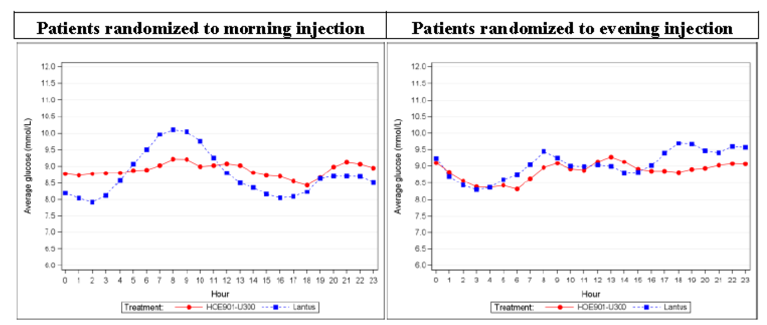
There was no significant difference between treatment groups in change in HbA1c from baseline to end of study, although the period of time involved was too short for this to be meaningful measurement. FPG results were variable. There was no significant trend in insulin dose between the study groups.
Comment: This study provides descriptive evidence of less variability of glycaemic control in T1DM patients. While this is not capable of statistical confirmation, it is supported by the observation of less hypoglycaemic episodes in the U300 group, particularly when the injections were given in the evening when the percentage of patients reporting at least 1 nocturnal event was 65.5% for U300 by comparison with 85.7% for U100 Lantus.

Other efficacy studies

Study EFC11628 administration sub-study
This 3 month study was carried out on a cohort of those patients randomised to the U300 formulation in the main study described above, for which the study population was patients with T2DM on basal together with mealtime bolus insulin. It was carried out immediately after the 6 month treatment assessment period of the main study. Its objective was to assess the effect on HbA1c and other parameters of glycaemic control, and on the incidence of hypoglycaemia, of varying the 24 hour dosing interval of the U300 formulation by plus 3 hours (adaptable dosing interval). The primary efficacy variable was change in HbA1c from baseline to 3 months, and secondary variables were as described for the main study. Safety was assessed by a number of parameters of the incidence of hypoglycaemia, again as in the main study.
109 patients were randomised, 56 to the adaptable dosing interval while 53 remained on the fixed interval. 106 were evaluable. Demographics were representative of the main study. Insulin dosage adjustment continued using the same protocol as in the main study.

Compliance
The protocol for the adaptable interval required that the maximum interval (3 hours earlier or later than usual) had to be used on at least 2 days of the week. Compliance with the requirements was well monitored. The result was that the mean percentage of injections administered within the usual recommended 23 to 25 hour interval by patients in the control group was 88%, whereas in the adaptable group it was 63%. The proportion administered at an interval of < 21.5 hours was 11%, compared with 1.6% for the controls; and for the interval of > 26.5 hours, 12% by comparison with 2.3%. In summary, there was a clinically significant level of deviation in injection time.

Results
From mean values of 7.21% and 7.17% respectively, HbA1c rose by a mean of 0.03% in the adaptable interval group and fell by a mean of 0.03% in the control group. FPG and pre injection SMPG showed no pattern of change corresponding with long or short injection intervals. There was a slight increase in basal but not mealtime insulin dose in both groups. Hypoglycaemia incidence remained similar in both groups; there were numerically more nocturnal events in the adaptable group although more events overall in the fixed interval group, but the differences do not appear significant.

Study EFC11629 administration sub-study
The protocol for this study was identical with that for the sub-study of EFC11628 described in the previous section. Patients in this study were on basal insulin in combination with OHA. 89 patients were randomised, 45 to the adaptable dosing interval while 44 remained on the fixed interval. 78 completed the study. Demographics were again representative of the main study.

Compliance
In this study, the mean percentage of injections administered within the usual recommended 23 to 25 hour interval by patients in the control group was 89%, whereas in the adaptable group it was 53%. The proportion administered at an interval of < 21.5 hours was 13%, compared with 1.3% for the controls; and for the interval of > 26.5 hours, 15% by comparison with 1.1%. The level of deviation in injection time was again significant.

Results
From mean values of 7.41% and 7.47% respectively, HbA1c rose by a mean of 0.06% in the adaptable interval group compared with 0.02% in the control group. FPG and pre injection SMPG showed no pattern of change corresponding with long or short injection intervals. There was a slight increase in insulin dose in both groups. Hypoglycaemia incidence showed a similar pattern of change to that seen in the EFC11628 Sub-study, but the degree of variance and short time of observation are such that it is difficult to regard this as significant.
Comment: These 2 studies show that for the U300 formulation a variance of up to 3 hours in the timing of the once daily injection is tolerated without any discernible effect on glycaemic control or incidence of hypoglycaemia. It is important to recognise, however, that this observation has been made in T2DM patients who are intrinsically more tolerant of such change because they have residual endogenous insulin secretion, and that the finding should not be generalised to apply to use of the product in T1DM patients. It also cannot be assumed that the finding would apply to morning injection of U300. Furthermore, as patients from the reference (U100 Lantus) arms of Studies EFC11628 and EFC11629 were not included in the sub-studies, it has not been shown that the lack of effect of variance in injection time is specific to the U300 formulation as opposed to insulin glargine generally.

Analyses performed across trials (pooled analyses and meta-analyses)
A meta-analysis was performed of the 2 pivotal studies carried out on patients using oral agents, EFC11629 and EFC12347. This confirmed non inferiority of the test versus reference product, (Table 7) which had already been demonstrated in the 2 studies individually, but did not add any further information with regard to hypoglycaemia incidence (Table 9).
This pooled analysis, as well as the individual reports of the pivotal studies, contained subgroup analyses which showed no difference in the treatment effect according to factors such as age, gender, race, ethnicity, baseline BMI, duration of diabetes, HbA1c level at screening, or geographical area.

Evaluator’s conclusions on clinical efficacy for treatment of diabetes mellitus in adults

Preamble
Parameters of hypoglycaemia incidence, particularly nocturnal hypoglycaemia, were included as efficacy variables in the pivotal studies and will therefore be taken into consideration in these conclusions. An effective insulin preparation is one which achieves good glycaemic control with the least possible incidence of hypoglycaemia.
The included studies clearly demonstrate non inferiority of the U300 formulation by comparison with U100 Lantus in terms of the principal efficacy parameter, change in HbA1c from baseline to 6 months, in the most relevant clinical setting of improving glycaemic control by stepwise insulin titration. The numerical comparison of efficacy by this criterion was very close between the 2 formulations, as was the comparison of the secondary glycaemic parameters FPG and pre injection SMPG. All of the above comparisons were successfully demonstrated in each pivotal study.
The first specified secondary efficacy parameter was the incidence of nocturnal hypoglycaemia. A reduced incidence of this was found in all 3 of the pivotal studies carried out on T2DM patients, but not in Study EFC 12456 carried out on T1DM patients. In 2 of the T2DM studies, EFC11628 and EFC11629, the risk reduction for nocturnal hypoglycaemia was statistically significant (Table 9).
Variation of the timing of daily insulin injection by up to 3 hours was shown, in sub-studies of EFC11628 and EFC11629 to have no effect on glycaemic control or hypoglycaemia incidence in T2DM patients using the U300 formulation.
A number of the studies show reduced glycaemic variability with the U300 formulation, particularly across the time course of its action (Figure 9). None of these findings achieve statistical significance, but the fact that the phenomenon has been observed more than once and is supported by similar PD data suggests that this is a real finding.
The above conclusions concur with those on which the sponsor bases claims for the use of the U300 formulation. This evaluation, however, finds a number of important caveats in relation to these conclusions, as follows:
- The finding of reduced hypoglycaemia incidence which, as the sponsor acknowledges, is restricted to use in T2DM, is also only supported for evening injection of U300. Not to have included a morning injection arm in the T2DM studies, as was done for the T1DM Study EFC12456, is a flaw in the design of the trials. There is every possibility that morning injection would not be associated with such reduced incidence of nocturnal hypoglycaemia, or might even result in an increase, as was observed in Study EFC12456 although not statistically confirmed. The possibility of such an outcome is also supported by the data from the PD studies, which were all performed with morning administration.
- The demonstration of non-inferior clinical efficacy of U300 with respect to U100 comes at the cost of increased dose of insulin; from baseline to 6 months, U300 dose increased 1.5 to 2.5 fold more than U100, resulting in final doses 10% higher for the T2DM patients and 17% higher for T1DM.
- The finding supporting flexibility of dosage timing by ± 3 hours is only supported for T2DM patients, in whom it was shown. It should not be assumed that this tolerance would extend to use in T1DM. It has also not been confirmed that this property is specific to the U300 formulation as the U100 Lantus patients in Studies EFC11628 and EFC11629 were not included in the sub-studies. Demonstration of a difference between the treatment arms would have added more weight to the finding.
Apart from the matter of increased insulin dosage, these restrictions on the relevance of the supporting data are not recognised or acknowledged in any of the summary documents in the submission.

Clinical safety
Throughout this submission, a distinction is quite reasonably drawn between safety relating to hypoglycaemia, and general safety. Hypoglycaemia is an inevitable safety issue with any form of insulin therapy, and its avoidance is a parameter of efficacy as already discussed above with particular relevance to the proposed new U300 formulation.
Other new safety issues seem unlikely to arise as the drug substance and excipient composition of the formulation are identical with the U100 Lantus formulation currently in use. Referring to the clinical development program for U300, the sponsor’s letter of application states: "The program has been built on the hypothesis that the efficacy and general, non-hypoglycaemia safety profile of U100 can be extended to insulin glargine in the U300 formulation". This evaluation supports that proposal. The general safety information collected in the clinical trials and summarised briefly below provides, as might be expected, no evidence of difference between the two formulations.

Studies providing evaluable safety data
All of the included studies, as listed in the exposure table below (Table 12), provided safety data.

Pivotal efficacy studies
In the pivotal efficacy studies, adverse events (AE) and severe adverse events (SAE) were documented at study visits using standard clinical trial procedures. These included AE of specific interest including injection site reactions, hypersensitivity reactions, and malignancies and cardiovascular events which have become matters of particular interest for diabetes medications.

Pivotal studies that assessed safety as a primary outcome
There were no pivotal studies that assessed safety as a primary outcome, but all assessed hypoglycaemia as a secondary efficacy outcome, as described in Section 8.2.

Dose response and non-pivotal efficacy studies
Non pivotal efficacy studies provided safety data, as follows:
- Study PDY12777 provided data on 59 patients.
No dose response studies are included.

Pivotal studies that assessed safety as a primary outcome
There were no pivotal studies assessing safety as a primary outcome, but all 4 pivotal studies as described above in Section 7, besides collecting routine safety information, included detailed information on hypoglycaemia incidence and severity and specified the incidence of nocturnal hypoglycaemia as the main secondary efficacy parameter. The relevant outcomes are described and commented upon above.

Patient exposure
Overall exposure to the test drug and comparator is shown in the following table.

Table 12: Exposure to U300 and comparator (U100 Lantus) in clinical studies
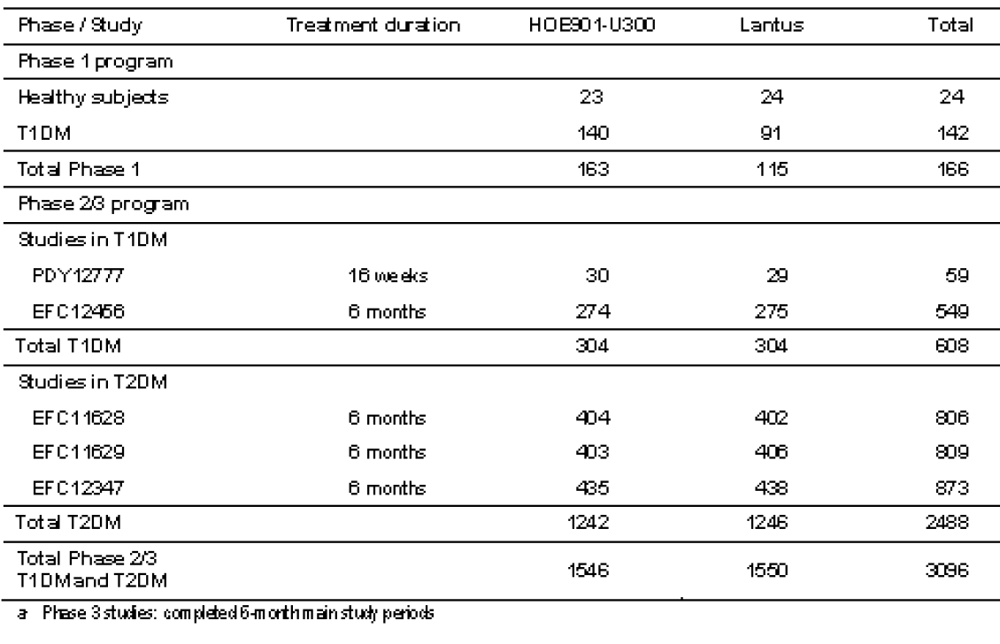

Adverse events

All adverse events (irrespective of relationship to study treatment)

Pivotal studies
The overall incidence of AE in T1DM patients was 62.8% for those treated with U300 and 58.9% for U100; and for T2DM patients, 57.3% and 53.7% respectively. Most were non-specific and not likely to be treatment related, for example, upper respiratory and other viral infections and gastrointestinal disorders. No pattern of difference between test and reference products was evident.
Comment: The slight difference in incidence between the groups is not likely to be significant, but if it were so this could be explained by the fact that these were open label studies which might contain a bias towards reporting AE on the new product.

Other studies
The remaining studies comprise a single 16 week Phase II exploratory study on 59 T1DM patients, PK/PD studies (mostly single dose) on 142 T1DM patients, and a single dose study on 24 healthy subjects. Although safety information was collected, it did not describe any unusual events and is insufficient in quantity to have any impact on the overall findings.

Treatment related adverse events (adverse drug reactions)

Pivotal studies
There was no pattern of treatment related AE except for the following which are routinely considered for insulin preparations:
- Injection site reactions: these were reported by 8 (2.6%) of T1DM patients using the U300 formulation, and 5 (1.6%) using U100 Lantus (again, the open label situation might confound any significance of such observations). For T2DM patients such reactions were reported by 2.4% and 3.1% of subjects in these two groups respectively.
- Hypersensitivity reactions: while some were reported (for example, asthma, urticaria) none were thought due to either the test or reference insulin therapy and none resulted in discontinuation.

Other studies
Although safety information was collected, it did not describe any unusual events and is insufficient in quantity to have any impact on the overall findings.

Deaths and other serious adverse events

Pivotal studies
Amongst T1DM patients, there was a single death in the U300 group while on treatment; and amongst T2DM patients, 4 in the U300 group and 3 in the U100 Lantus group. There were no SAE apparently attributable to study medication. The mortality rate is consistent with expectation.

Other studies
Although safety information was collected, it did not describe any unusual events and is insufficient in quantity to have any impact on the overall findings.

Discontinuation due to adverse events

Pivotal studies
Discontinuations were consistent between the test and reference groups: for T1DM, 1.3% for U300 and 1.0% for U 100; and for T2DM, 1.4% and 1.3% respectively.

Other studies
Although safety information was collected, it did not describe any unusual events and is insufficient in quantity to have any impact on the overall findings.

Laboratory tests

Liver function

Pivotal studies
No clinically relevant pattern of abnormality or seen in either test or reference group, and there was no related pattern of AE amongst the clinical data.

Other studies
Although safety information was collected, it did not describe any unusual events and is insufficient in quantity to have any impact on the overall findings.

Kidney function

Pivotal studies
Routine testing revealed no significant abnormalities.

Other studies
Although safety information was collected, it did not describe any unusual events and is insufficient in quantity to have any impact on the overall findings.

Other clinical chemistry

Pivotal studies
Apart from renal function tests and full liver function tests, the only other parameters routinely monitored were cholesterol and triglycerides. These showed no pattern of difference between the test and reference preparations.

Other studies
Although safety information was collected, it did not describe any unusual events and is insufficient in quantity to have any impact on the overall findings.

Haematology

Pivotal studies
Haemoglobin, haematocrit, red blood cells, platelets, and white blood cell parameters were routinely monitored with no pattern of abnormality emerging in either study group.

Other studies
Although safety information was collected, it did not describe any unusual events and is insufficient in quantity to have any impact on the overall findings.

Hypoglycaemia
Hypoglycaemia was the subject of very detailed evaluation in all the clinical studies. Multiple categories were defined, the most clinically important being those of severe hypoglycaemia (requiring second party assistance or associated with seizures, et cetera) and those documented by SMPG < 3.9 mmol/L. Analyses of hypoglycaemia incidence were also performed according to occurrence at any time of the day, occurrence between 00:00 and 05:59 (nocturnal hypoglycaemia), and occurrence during the daytime. The main findings in comparing these parameters between the U300 and comparator U100 populations were as follows:
- In T1DM patients, there was no overall difference (any time of day) in hypoglycaemia incidence between the groups, although there was a trend for less nocturnal and more daytime hypoglycaemia with U300.
- Overall hypoglycaemia incidence is most common in T1DM, followed by the group of T2DM on basal/bolus insulin and then those on basal insulin/OHA and was least in insulin naïve patients.
- With the use of U300 given as an evening injection for T2DM, there was a significant and clinically relevant reduction (mean 21 to 23%, depending on background treatment) reduction in nocturnal hypoglycaemia as defined by the severe/SMPG confirmed categories. This was the only finding which achieved statistical significance.
- There was a trend towards a reduction in daytime hypoglycaemia in the T2DM studies carried out on patients using basal insulin in combination with OHA.

Malignancy
These were searched for and 6 (0.4%) identified in the U300 group, with 10 (0.6%) in the U100 group.

Cardiovascular events
The incidence of cardiovascular death from any cause, non-fatal myocardial infarction and non-fatal stroke was low in both treatment groups, involving 1 patient on U300 and 2 on U100.

Post marketing experience
None is available as the product is not yet marketed in any jurisdiction.

Other safety issues

Safety in special populations
As for efficacy, the pooled pivotal study population was subjected to subgroup analyses which showed no differences in the safety data attributable to factors such as age, gender, race (limited, as most were Caucasian), ethnicity, baseline BMI, or geographical area.

Potential for dosing errors
Dosing error related to the availability of multiple strengths of insulin was a common problem prior to the worldwide adoption of 100 U/mL as a single standard strength in the 1980s. The proposal of this submission to now reintroduce an additional strength does raise this concern once again, although the specific presentation applied for does not constitute a risk as the insulin is contained in a prefilled injection device specifically designed to deliver the correct dose.

Use of injection device
No information provided. It is presumed that the safety and user friendliness of the 1.5 mL prefilled injection device is the subject of evaluation separate to this report.

Evaluator’s overall conclusions on clinical safety
The evidence that use of the U300 formulation by T2DM patients, by comparison with U100 Lantus, results in a clinically significant reduction in the risk of nocturnal hypoglycaemia, is accepted. As already noted in the conclusions on efficacy, this conclusion is subject to the product being used under the same conditions as in the supporting trials, specifically as an evening injection.
Safety data other than that relating to hypoglycaemia support the sponsor’s contention that the general safety profile of U100 Lantus can be extended to the new U300 formulation (Toujeo). A possible association of insulin glargine with malignancy incidence has been the subject of attention in the literature although concern has diminished, as reflected in a recent review. There is no evidence of such concerns in the data submitted with this application.

First round benefit risk assessment
The benefits and risks listed below are postulated as those which would apply to use of Toujeo (300 U/mL insulin glargine) in place of U100 Lantus, the product with which it was compared in the included clinical trials and which is also the product it would most likely replace in clinical use in Australia.

First round assessment of benefits
The benefits of Toujeo in the proposed usage are:
- Maintenance, for both T1DM and T2DM patients, of an equivalent level of blood sugar control.
- Reduction of the risk of hypoglycaemia occurring at night. On the evidence provided, this benefit is restricted to T2DM patients given Toujeo as an evening injection. However, the proposed usage as defined by the dosing instructions in the draft PI does not specify this, so unless that is changed this benefit is uncertain.
- Ability to vary the time of daily injection by up to 3 hours. This has only been shown for T2DM patients and it has not been clearly shown that the benefit only applies to U300.
- A reduced injection volume. This would be an advantage for patients on large doses but is partially offset by the need, according to the trial data, to increase the dose.

First round assessment of risks
The risks of Toujeo in the proposed usage are:
- Necessity to use a higher dose of insulin. There is a largely hypothetical risk, of minor degree, related to the suggestion that increased exposure to insulin, whether exogenous or endogenous, is associated with some health risks. An additional "disadvantage", as opposed to "risk", would be increased resource or economic costs associated with increased insulin usage.
- Potential for dosing error. As noted above, this is offset by presentation of the product in a dedicated, disposable injection device. However, approval of this application might open the way to availability of other presentations (for example, cartridge or vial) which would carry this risk if used with standard insulin syringes. Appropriate warnings do appear in the draft Consumer Medicine Information (CMI).

First round assessment of benefit risk balance
The benefit risk balance of Toujeo is unfavourable given the proposed usage, but would become favourable if the changes recommended in Section 10 are adopted. This comment relates entirely to the finding of this evaluation that the recommendations regarding timing of dose in the draft PI are not consistent with the supporting evidence and have the potential to put patients at risk, or at least be denied the potential benefits of the product, unless appropriately changed.

First round recommendation regarding authorisation
The evaluator stated that approval of the submission in its present form is not recommended. The sponsor should be asked to consider changes to the draft PI particularly those which would align the recommendations regarding dosage timing with the evidence in the pivotal trials. The evaluator emphasised that the evidence itself is not in question and that the submission was in other respects satisfactory.

Clinical questions
- Why is a separate PI needed, rather than editing the Lantus PI to include information on the 300U strength?
Sponsor’s response:
To avoid possibility of confusion by prescribers, the sponsor is proposing to provide a separate PI for 300U strength In recognition of the different PK/PD properties of U300 compared to Lantus the sponsor considers the information in the following sections should be separated to avoid potential confusion between the two products.
- Pharmacology
- Clinical trials
- Adverse effects
- Dosage and administration
The sponsor has therefore created a separate PI for U300 to reflect the differences between the two products.
It is important to note that the U300 PI contains all the Lantus safety prescribing information.
- Why was the reduction in hypos only seen in patients with T2D; and only when given in the evening?
Sponsor’s response:
For the assessment of the hypoglycaemia risk associated with basal insulin in clinical studies potential confounding factors such as meal time insulin, daytime physical activities and meal intake (preventing hypoglycaemia) have to be taken into consideration and should be excluded as much as possible. Studies, where basal insulin is given alone or in combination with anti-hyperglycaemic drugs, which do not increase the risk of hypoglycaemia, allow the comparison of the hypoglycaemia risk of two basal insulin products in less biased conditions as compared with studies, where basal insulin is given in combination with mealtime insulin. In addition, the night time period is less subject to confounding factors as compared to daytime with physical activities, real life stress and meal intake.
Taking into consideration these points, the risk of hypoglycaemia was assessed as pre-specified first main secondary efficacy endpoint in the protocols of the three Phase III studies in T2DM (EFC11628, EFC11629, EFC12347), defined as percentage of patients experiencing at least one nocturnal severe and/or confirmed hypoglycaemia from start of Week 9 to Month 6. The basal insulin was in both treatment groups to be administered in the evening in all three studies in T2DM. In the study in T1DM (EFC12456) the assessment of hypoglycaemia risk was not a prespecified main secondary efficacy endpoint in a hierarchical analysis. In this study, per randomisation injection of the basal insulin was in the morning or in the evening. Thorough hypoglycaemia analyses were done in all clinical studies as part of the safety analyses.
The conditions in the studies in T2DM, particularly Studies EFC11629 and EFC12347, where basal insulin was given in combination with OAD(s), provided more adequate conditions to verify the lower risk of hypoglycaemia associated with the PK/PD profile of HOE901-U300 as compared with the study in T1DM, where patients were on a multiple daily injection regimen using basal insulin in combination with mealtime insulin.
As in all studies in T2DM the basal insulin was administered in the evening, there are no data on the hypoglycaemia risk in T2DM when HOE901-U300 is given in the morning. Taking into account the PK/PD profile of HOE901-U300 with its even distribution of the glucose lowering activity of the 24 hour period one would assume that the lower risk of hypoglycaemia would be independent of the injection time. Indeed, there was no difference in the percentages of patients reporting hypoglycaemia and in the hypoglycaemia event rate per patient year exposure between the HOE901-U300 morning injection group and evening injection group in Study EFC12456 in T1DM.
- Why was there no reduction in hypos in patients with T1D?
Sponsor’s response:
In the Phase III Study EFC12456 in T1DM there was no obvious difference in the risk of hypoglycaemia between HOE901-U300 and Lantus, percentages of patients with severe/confirmed hypoglycaemia and event rates were comparable between treatment groups. There was also no difference in the risk of hypoglycaemia between treatment groups in the morning injection group and evening injection group which is furthermore supporting the similarity of morning and evening injection of HOE901-U300. In this multicentre, multinational Phase III study the influence of the multiple daily injections of mealtime insulin is a major confounding factor for the assessment of the hypoglycaemia risk associated with the PK/PD profile of a basal insulin product. The potential effects of the different PK/PD profiles of HOE901-U300 and Lantus were also reviewed in the exploratory CGM Study PDY12777 in patients with T1DM. The study was performed in a relatively small number of patients (n=60) with T1DM enrolled in 3 highly qualified centres providing weekly patient contacts to optimise the insulin doses taking into account the PK/PD profiles of HOE901-U300 and Lantus. Patients were relatively well controlled (HbA1c at baseline 7.4 to 7.5%; at Week 16, 7.0 to 7.1%) compared with Study EFC12456 (HbA1c at baseline 8.1%; at Month 6, 7.7%). Consistently with the lower HbA1c, the rate of severe and/or confirmed hypoglycaemia (SMPG < 54 mg/dL; 7.0 mmol/L) was higher in Study PDY12777 compared to Study EFC12456. It is consistent with the inverse relationship between HbA1c and the risk of hypoglycaemia in T1DM shown in the Diabetes Control and Complications Trial Research Group.
In Study PDY12777 all patients had at least one episode of hypoglycaemia, so that the analysis of event rates is more meaningful. The hypoglycaemia event rates for severe and/or confirmed hypoglycaemia were lower in the HOE901-U300 than Lantus group, for both, events at any time of the day and particularly for nocturnal hypoglycaemia. The conditions in the exploratory Study PDY12777 may have supported the optimisation of the insulin treatment including the adjustment of mealtime insulin dose via the PK/PD profile of HOE901-U300, so that the lower risk of hypoglycaemia associated with HOE901-U300 could be detected also in T1DM patients.
Analyses of the hypoglycaemia events during the first 8 weeks of study treatment, that is, the initial treatment period with a potentially increased risk of hypoglycaemia after changing to the new insulin regimen or initiation of insulin treatment in insulin naïve T2DM, showed a consistently lower risk of nocturnal hypoglycaemia in the HOE901-U300 group compared with the Lantus group in both, studies in T1DM and in T2DM, regardless the insulin regimen, that is, combination of HOE901-U300 with non-insulin AHA or with a mealtime insulin.
In summary, although the multiple daily injections of mealtime insulin is a major confounding factor for the assessment of the hypoglycaemia risk in the studies in T1DM, the lower risk of nocturnal hypoglycaemia during the initial treatment period in Study EFC12456 and the lower risk of hypoglycaemia seen in Study PDY12777 in relatively well controlled T1DM suggest that HOE901-U300 has a favourable benefit risk profile for patients with T1DM as it has for patients with T2DM.

References
- Home P: Insulin therapy and cancer. Diabetes Care 2013 Aug: 36 Suppl 2
- Diabetes Control and Complications Trial Research Group. The effect of intensive treatment of diabetes on the development and progression of long-term complications in insulin dependent diabetes mellitus. N Eng J Med. 1993; 329: 977-86

Therapeutic Goods Administration
PO Box 100 Woden ACT 2606 Australia
Email: info@tga.gov.au Phone: 1800 020 653 Fax: 02 6232 8605
https://www.tga.gov.au

Home P: Insulin therapy and cancer. Diabetes Care 2013 Aug: 36 Suppl 2
Diabetes Control and Complications Trial Research Group. The effect of intensive treatment of diabetes on the development and progression of long-term complications in insulin dependent diabetes mellitus. N Eng J Med. 1993; 329: 977-86

