30 January 2014

AusPAR Attachment 2

Extract from the Clinical Evaluation Report for Insulin glargine
  - Proprietary Product Name: Abasria/Abasria KwikPen
  - Sponsor: Eli Lilly Australia Pty Ltd

About the Therapeutic Goods Administration (TGA)
- The Therapeutic Goods Administration (TGA) is part of the Australian Government Department of Health, and is responsible for regulating medicines and medical devices.
- The TGA administers the Therapeutic Goods Act 1989 (the Act), applying a risk management approach designed to ensure therapeutic goods supplied in Australia meet acceptable standards of quality, safety and efficacy (performance), when necessary.
- The work of the TGA is based on applying scientific and clinical expertise to decision-making, to ensure that the benefits to consumers outweigh any risks associated with the use of medicines and medical devices.
- The TGA relies on the public, healthcare professionals and industry to report problems with medicines or medical devices. TGA investigates reports received by it to determine any necessary regulatory action.
- To report a problem with a medicine or medical device, please see the information on the TGA website <https://www.tga.gov.au>.
About the Extract from the Clinical Evaluation Report
- This document provides a more detailed evaluation of the clinical findings, extracted from the Clinical Evaluation Report (CER) prepared by the TGA. This extract does not include sections from the CER regarding product documentation or post market activities.
- The words [Information redacted], where they appear in this document, indicate that confidential information has been deleted.
- For the most recent Product Information (PI), please refer to the TGA website <https://www.tga.gov.au/product-information-pi>.
Copyright
© Commonwealth of Australia 2015
This work is copyright. You may reproduce the whole or part of this work in unaltered form for your own personal use or, if you are part of an organisation, for internal use within your organisation, but only if you or your organisation do not use the reproduction for any commercial purpose and retain this copyright notice and all disclaimer notices as part of that reproduction. Apart from rights to use as permitted by the Copyright Act 1968 or allowed by this copyright notice, all other rights are reserved and you are not allowed to reproduce the whole or any part of this work in any way (electronic or otherwise) without first being given specific written permission from the Commonwealth to do so. Requests and inquiries concerning reproduction and rights are to be sent to the TGA Copyright Officer, Therapeutic Goods Administration, PO Box 100, Woden ACT 2606 or emailed to <tga.copyright@tga.gov.au>.

Contents
List of the most common abbreviations used in this AusPAR 5
1. Clinical rationale 7
2. Contents of the clinical dossier 7
2.1. Scope of the clinical dossier 7
2.2. Paediatric data 8
2.3. Good clinical practice 8
3. Pharmacokinetics 8
3.1. Studies providing pharmacokinetic data 8
3.2. Summary of pharmacokinetics 10
3.3. Evaluator’s overall conclusions on pharmacokinetics 18
4. Pharmacodynamics 20
4.1. Studies providing pharmacodynamic data 20
4.2. Summary of pharmacodynamics 21
4.3. Evaluator’s overall conclusions on pharmacodynamics 26
5. Dosage selection for the pivotal studies 27
6. Clinical efficacy 27
6.1. Treatment of T2DM in Adults 28
6.2. Evaluator’s conclusions on clinical efficacy 35
6.3. Treatment of T1DM 36
6.4. Evaluator’s conclusions on clinical efficacy 42
7. Clinical safety 43
7.1. Studies providing evaluable safety data 43
7.2. Patient exposure in Phase Three studies 44
7.3. Adverse events 45
7.4. Laboratory tests 50
7.5. Electrocardiograph 50
7.6. Vital signs 51
7.7. Post-marketing experience 54
7.8. Safety issues with the potential for major regulatory impact 54
7.9. Evaluator’s overall conclusions on clinical safety 55
8. First round benefit-risk assessment 55
8.1. First round assessment of benefits 55
8.2. First round assessment of risks 55
8.3. First round assessment of benefit-risk balance 55
9. First round recommendation regarding authorisation 55
10. Clinical questions 56
10.1. Pharmacokinetics 56
10.2. Pharmacodynamics 56
10.3. Efficacy 56
10.4. Safety 56
11. Second round evaluation of clinical data submitted in response to questions 56
12. References 56

List of the most common abbreviations used in this AusPAR
Abbreviation | Meaning
ACE | Angiotensin converting enzyme
ALAT | Alanine aminotransferase
ASR | Annual Safety Report
CCDS | Company Core Data Sheet
CHMP | Committee for Medicinal Products for Human Use
DCCT | Diabetes Control and Complications Trial
DSUR | Development Safety Update Report
EEA | European economic area
EMA | European medicines agency
EU | European union
FDA | Food and Drug Administration
GLP-1 | Glucagon-like peptide-1
GPRD | General Practice Research Database
GW | Gestational week
HMEC | Human Mammary Epithelial Cells
HIV | Human Immunodeficiency Virus
IBD | International Birth Date
ICH | International Conference on Harmonisation
L6-hIR | L6 myoblasts from ATTC transfected with human insulin receptors
MAH | Market Authorisation Holder
MAOI | Monoamine oxidase inhibitors
MedDRA | Medical Dictionary for Regulatory Activities
NPH | Neutral protamine Hagedorn
NYHA | New York Heart Association
PD | Pharmacodynamics
PK | Pharmacokinetics
PSUR | Periodic Safety Update Report
PT | Preferred term
PYE | Patient years of exposure
RR | Reporting rate
RMP | Risk Management Plan
RSI | Request for Supplementary Information
SmPC | Summary of Product Characteristics
SMQ | Standardised MedDRA Query
TZD | Thiazolidinedione
WHO | World Health Organization

Clinical rationale
Abasria has been developed as a medicine that is similar to Lanus brand of insulin glargine, marketed by Sanofi-Aventis Australia Pty Ltd.
The rationale for the drug development programme is also stated as:
‘The development plan for Abasria, informed by the scientific principles set forth in the Committee for Medicinal Products (CHMP) guidances on biosimilars and adopted by the TGA, reflects a stepwise approach to demonstrating the similarity of Abasria to the reference medicinal product (Lantus). The aim of the Abasria development program was to demonstrate that Abasria has a highly similar profile to Lantus in terms of quality, nonclinical, pharmacokinetics and pharmacodynamics, and clinical safety and efficacy aspects, allowing Abasria to adopt the data generated with Lantus and thus the Australian Product Information (AUPI) for Lantus.’
The drug development programme is described in these terms:
‘The totality of data presented in this application, specifically the clinical data summarised in Module 2, support a sufficient demonstration of similarity of Abasria to Lantus:
- The primary goal of the development program was achieved: Comparative PK and PD studies demonstrated highly similar PK and PD of Abasria to Lantus (Study ABEA) and of EU-approved Lantus to US-approved Lantus (Study ABEN) within predefined bioequivalence acceptance limits.
- Study ABEN established a scientific bridge that justified presenting the analyses of clinical efficacy and safety with a comparator group comprising EU- and US approved Lantus in the multinational Phase III clinical studies (ABEB and ABEC). The scientific bridge was supported by subgroup analyses in the Phase III studies comparing the treatment effect of Abasria to either EU- or US-approved Lantus for selected efficacy and safety parameters, which showed no clinically meaningful differential treatment effects between Abasria and Lantus (irrespective of source).
- Clinical data from Studies ABEB (T1DM) and ABEC (T2DM) provide evidence that Abasria and Lantus have equivalent efficacy by meeting the primary test of the non-inferiority of Abasria to Lantus as well as the secondary, complementary test of the non-inferiority of Lantus to Abasria with respect to change in HbA1c, and with no statistically significant difference between treatment groups for key secondary measures of efficacy.
- Clinical safety data from the Phase III studies demonstrate a highly similar safety profile (including immunogenicity, allergic reactions, and hypoglycemia) of Abasria to Lantus. Importantly, the development of anti-insulin glargine antibodies (as measured by TEAR) was not associated with any detrimental effect on efficacy and safety outcomes in patients with 11DM or T2DM.’
Comment: As is evident from the content of Modules 2 and 5, the drug development programme was informed by discussions with the FDA and with the EMA.

Contents of the clinical dossier

Scope of the clinical dossier
- Five clinical pharmacology studies, all of which generated pharmacokinetic data and also pharmacodynamic data.
- No population pharmacokinetic analyses.
- One pivotal efficacy/safety study (ABEC).
- No dose-finding studies.
- One other efficacy/safety study (ABEB).
- Literature references.

Paediatric data
The submission did not include paediatric data.

Good clinical practice
As appended to the letter of application:
‘I certify that Eli Lilly Australia Pty. Limited is in possession of documentation to demonstrate that the clinical studies accompanying the letter of 01 October 2013 were carried out in accordance with the principles of the Declaration of Helsinki and, if conducted in Australia, in accordance with the NH&MRC ‘Statement on Human Experimentation’.
I further certify that such documentation will be provided to the Department of Human Services and Health within three months of any request.
I understand that the documentation referred to includes Ethics Review Committee approval letters, signed subject consent forms and the patient information sheet if there is one.’
The evaluator mentions in the discussion of each study any relevant matters in regard to GCP, ethical certification and auditing. In brief, no major concerns were noted but some clarifications from the applicant might be needed. These are mentioned in the discussion of each study.

Pharmacokinetics

Studies providing pharmacokinetic data
Table 1 shows the studies relating to each pharmacokinetic topic and the location of each study summary.

Table 1. Submitted pharmacokinetic studies.
PK topic | Subtopic | Study ID | *
PK in healthy adults | General PK - Single dose | ABEA  ABEM  ABEI | PK & PD  PK & PD  PK & PD
PK in healthy adults | - Multi-dose
PK in healthy adults | Bioequivalence† - Single dose | ABEN  ABEA  ABEM  ABEI | PK & PD of Lantus US v. Lantus EU  PK comparisons  PK comparisons  PK comparisons
PK in healthy adults | - Multi-dose | Not submitted.
PK in healthy adults | Food effect | Not applicable.
PK in special populations | Target population §- Single dose | ABEE | PK & PD
PK in special populations | - Multi-dose | Not submitted.
PK in special populations | Hepatic impairment | Not submitted.
PK in special populations | Renal impairment | Not submitted.
PK in special populations | Neonates/infants/children/  adolescents | Not submitted.
PK in special populations | Elderly | Not submitted.
Genetic/gender-related PK | Males vs. females | Not submitted
Genetic/gender-related PK | Other genetic variable} | Not submitted
PK interactions | Not applicable.
Population PK analyses | Healthy subjects | Not submitted.
Population PK analyses | Target population | Not submitted.
Population PK analyses | Other | Not applicable.
* Indicates the primary aim of the study. † Bioequivalence of different formulations. § Subjects with T1DM.
None of the pharmacokinetic studies in healthy volunteers had deficiencies that excluded their results from consideration. However, some studies are considered to be less relevant than others for the reasons briefly stated in Table 2.
Table 2 lists pharmacokinetic results that are considered to be less relevant due to study deficiencies.

Table 2. Pharmacokinetic results excluded from consideration.
Study ID | Subtopic(s) | PK results excluded
ABEE | Pharmacodynamics of Abasria Compared to Lantus® in Subjects with Type 1 Diabetes Mellitus | All results – assay insensitivity led to incomplete characterisation of the PK attributes of Abasria in this study.
The design of ABEE is briefly described in the tabulation below, taken from the Module 5 clinical data. The study did generate useful pharmacodynamic data.

Table 3: Design of Study ABEE
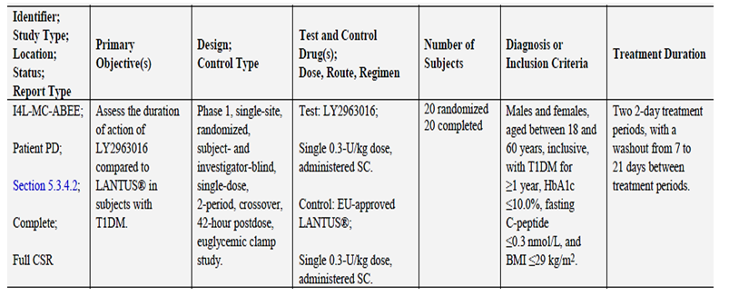

Summary of pharmacokinetics
The information in the following summary is derived from conventional pharmacokinetic studies unless otherwise stated.

Pharmacokinetics in healthy subjects
At the outset, it is necessary to state that the PK data depended upon a non-specific RIA method. The method included a correction for endogenous insulin by adjusting for C-peptide levels. The assessment of the validity of this approach is for the TGA Quality evaluator.
There are three studies that contribute materially relevant information on the pharmacokinetics, in healthy subjects, of Abasria and of Lantus EU. The studies are ABEA, ABEM and ABEI. These studies also generated pharmacodynamic data.
Of these three studies, ABEI is the least important owing to its small size and non-replicate design (randomized, open-label, 2-treatment, 2-period crossover study was conducted in 16 healthy subjects [13 males and 3 females, 21 to 45 years of age] to evaluate the relative bioavailability and PD response of LY2963016 (Test) compared to EU-approved Lantus®). However, it was useful as an informative pilot study and its PK results were similar to those of the larger, replicated studies ABEA and ABEN.
The design of each study is briefly presented below, extracted from the Module 5 tabulations:

Table 4: Design of studies submitted
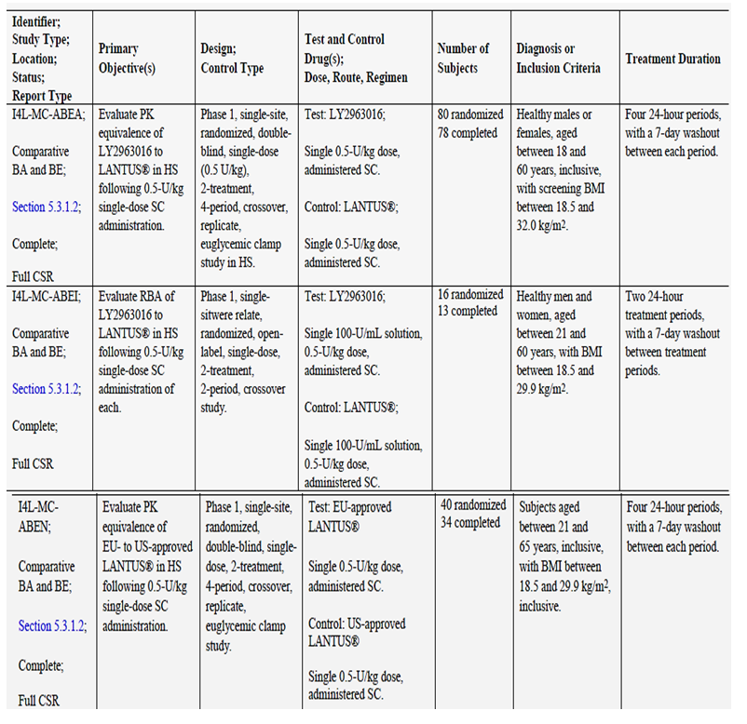
HS = healthy subjects.

Pharmacokinetic comparisons
The results from the three studies that included comparisons of Abasria with Lantus EU are summarised in the tables below. The tables are sourced from Module 2 but reflect the study reports in Module 5. Also included is the Lantus US vs. Lantus EU comparative study, ABEN.
The consistency of the results for the given doses is notable in ABEA, ABEM and ABEI.

Table 5: Least-squares mean geometric mean ratios, 90% confidnce intervals (Primary PK and PD parameters), and 95% confidence intervals (Primary PD parameters only) across Studies ABEA and ABEN
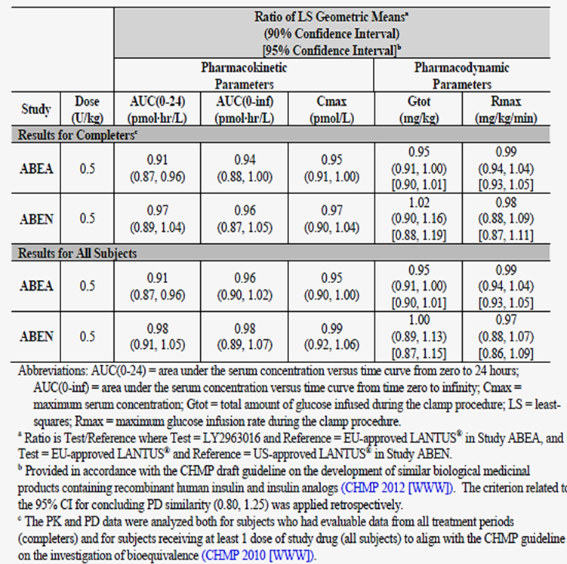

Table 6: Pharmacokinetic and pharmacodynamic comparisons between LY2963016 and EU approved Lantus. Study ABEI
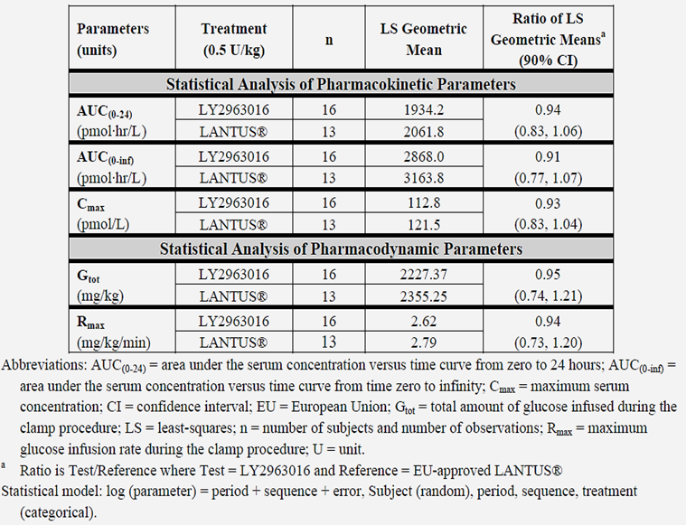

Table 7: Pharmacokinetic and pharmacodynamic comparisons between LY2963016 and EU approved Lantus at two dose levels-Study ABEM
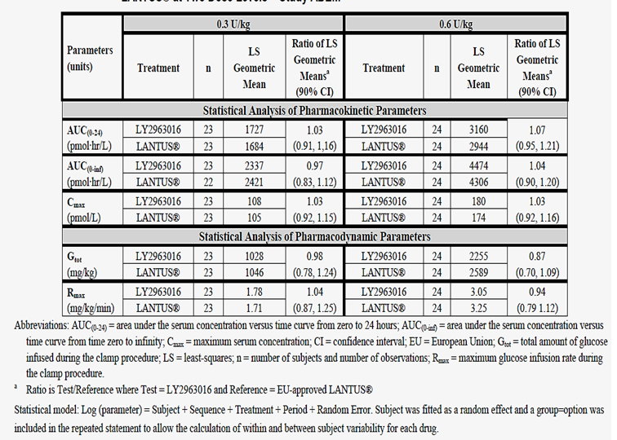
Of further note, the assay method was able to detect a dose response in Study ABEM, a study of Lantus EU vs. Abasria.

Absorption

Sites and mechanisms of absorption
All of the Phase I studies used the abdomen as the site of injection. Therefore no exploration of site effects occurred. The site of injection in the Phase III studies was as per the Lantus PI in each country but no PK data were gathered.

Bioavailability

Absolute bioavailability
Such a study was not done. Insulin glargine is not suitable for intravenous administration as it is intended to bind to the site of local injection from which it is slowly released, including as its metabolite M1.
Several studies were done that compared the PK of subcutaneously administered Abasria with Lantus (EU) and a study [ABEO] is in progress (not submitted) that compares the PK of subcutaneously administered Abasria with Lantus (US).

Bioavailability relative to an oral solution or micronised suspension
Not applicable. Abasria is an injection for SC injection.

Bioequivalence of clinical trial and market formulations
Not applicable. The Abasria trial programme used the same formulation.

Bioequivalence of different dosage forms and strengths
Only one formulation of Abasria is proposed, presented in cartridges.

Bioequivalence to relevant registered products
According to the letter of application, no specific bioequivalence data were generated for this submission. The reasoning is reproduced in full below:
‘The totality of data presented in this application, specifically the clinical data summarised in Module 2, support a sufficient demonstration of similarity of Abasria to Lantus:
  - The primary goal of the development program was achieved: Comparative PK and PD studies demonstrated highly similar PK and PD of Abasria to Lantus (Study ABEA) and of EU-approved Lantus to US-approved Lantus (Study ABEN) within predefined bioequivalence acceptance limits.
  - Study ABEN established a scientific bridge that justified presenting the analyses of clinical efficacy and safety with a comparator group comprising EU- and US approved Lantus in the multinational Phase III clinical studies (ABEB and ABEC). The scientific bridge was supported by subgroup analyses in the Phase III studies comparing the treatment effect of Abasria to either EU- or US-approved Lantus for selected efficacy and safety parameters, which showed no clinically meaningful differential treatment effects between Abasria and Lantus (irrespective of source).
  - Clinical data from Studies ABEB (T1DM) and ABEC (T2DM) provide evidence that Abasria and Lantus have equivalent efficacy by meeting the primary test of the non-inferiority of Abasria to Lantus as well as the secondary, complementary test of the non-inferiority of Lantus to Abasria with respect to change in HbA1c, and with no statistically significant difference between treatment groups for key secondary measures of efficacy.
Clinical safety data from the Phase III studies demonstrate a highly similar safety profile (including immunogenicity, allergic reactions, and hypoglycemia) of Abasria to Lantus. Importantly, the development of anti-insulin glargine antibodies (as measured by TEAR) was not associated with any detrimental effect on efficacy and safety outcomes in patients with 11DM or T2DM.‘
The letter does not refer to the formulation (quantitative and qualitative) of Lantus in the EU, US and Australia. It is worth mentioning at this point that Study ABEN compared the PK and PD Lantus (US) with Lantus (EU) and did not include Abasria in the comparison. The reference to ABEN by the applicant in the highlighted text above is therefore unclear. Perhaps the author had intended to invite cross-study comparisons. This would also be problematical not least because Study ABEO (Lantus US vs. Abasria) has not been completed or submitted. Study ABEN is briefly described in this tabulation, taken from the Module 5 documents:

Table 8: Design of Study ABEN
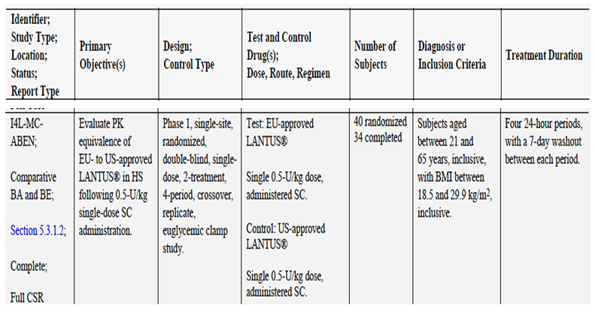
It can be said that three Phase I Studies included comparisons of Abasria with Lantus EU.
The tabulated results from the Phase I studies, as presented above, support equivalent pharmacokinetics at given doses and therefore one can infer bioequivalence of Abasria with Lantus EU, subject to no objections, from the chemistry evaluator, to the assay method.
However this conclusion is a long way from the intent of the letter of application. It appears to be the case that Abasria injection is qualitatively different from Lantus injection solution. The applicant remarks, ‘…no bridging study is considered necessary as Lantus available in Australia is manufactured in Germany’ as though claimed provenance equals identity. In the same sentence it is remarked that Lantus EU and Lantus US share the same provenance but Phase I studies to demonstrate their comparability with Abasria and with each other have been done and one is in progress.
The evaluator is not able to say that the Phase I studies or that the limited arguments in the Letter of Application are sufficient to demonstrate that Abasria is clinically equivalent to Lantus as sold in Australia. The evaluator was not able to find in Module 2.3 a suggestion of a quantitative comparability exercise for Lantus US, Lantus EU and Lantus Australia but this is not to say that such data were not submitted.

Influence of food
Not applicable. Insulin glargine is administered by subcutaneous injection.

Dose proportionality
One study was submitted that addresses this matter.

Bioavailability during multiple-dosing
No multidose (in the sense of steady state) PK studies were submitted.

Effect of administration timing
No PK studies were submitted that address this matter.

Distribution

Volume of distribution
The three evaluable PK studies generated data in regard to the apparent volume of distribution during the terminal phase after extravenous administration (Vz/F), given that there was no absolute bioavailability study. In Studies ABEA and ABEI, in which the 0.5U/kg BW dose was given SC, the Vz/F was 1130 and 1100L, similar to the reference product, Lantus EU. In Study ABEM, after doses of 0.3 or 0.6U/g BW given SC, the Vz/F was 553 or 713L.

Plasma protein binding
No new data were submitted in this application.

Erythrocyte distribution
No new data were submitted in this application.

Tissue distribution
No new data were submitted in this application.

Metabolism

Interconversion between enantiomers
Not applicable.

Sites of metabolism and mechanisms / enzyme systems involved
No new data were submitted in this application.

Non-renal clearance
No new data were submitted in this application.

Metabolites identified in humans

Active metabolites
No new data were submitted in this application.

Other metabolites
No new data were submitted in this application. Insulin glargine is known to have two active metabolites (Lantus PI).

Pharmacokinetics of metabolites
No new data were submitted in this application.

Consequences of genetic polymorphism
No new data were submitted in this application. However, subgroup analyses in regard to efficacy were conducted on the Phase III study population.

Excretion

Routes and mechanisms of excretion
No new data were submitted in this application.

Mass balance studies
Not applicable.

Renal clearance
No new data were submitted in this application.

Intra- and inter-individual variability of pharmacokinetics
No formal analysis of this was provided across the Phase I studies. The replicate studies ABEN and ABEA do show variation of each replicate of the same drug (test or reference) some of which were attributed to possible errors in administration e.g. proximity to a vessel. The data overall, however, support conventional equivalence of Lantus EU and Abasria in terms of C_{max}, AUC _{0-t} and T_{max}.

Pharmacokinetics in the target population
Study ABEE was conducted in adults with T1DM. See above for the description of the study.
The study did not generate useful PK data due to the low dose of insulin glargine used (0.3 U/kg BW) and the limits to assay sensitivity (multiple concentrations were below the limit of quantification (<50 pM)). Nine of 20 subjects had quantifiable samples for both periods. Three had had quantifiable samples for neither period. There was no sample size calculation, ‘No sample size calculations took place in advance of the study’. As stated in Section 7.3 of the study protocol, ‘Up to 20 subjects may be enrolled in order that at least 16 subjects complete the study. The sample size is customary for Phase I studies evaluating safety, PK, and/or GD parameters. The duration of action of LY2963016 relative to that of Lantus will be estimated but will not be required to meet a statistical criterion.’ The study is therefore considered to be exploratory and primarily a PD study.
As insulin lispro was used in the run-in period of the study, the applicant provided modified PK data but no calculations. The applicant therefore provided an adjusted result, as depicted in the figure below, modified by subtracting values attributable to the initial insulin lispro infusion:
Figure 1: Mean (± standard deviation) lispro-corrected insulin concentration versus time profiles following subcutaneous administration of a single dose of LY2963016 0.3 U/kg BW) or Lantus 0.3 U/kg BW). Tope Linear and Bottom semi-logarithmic.
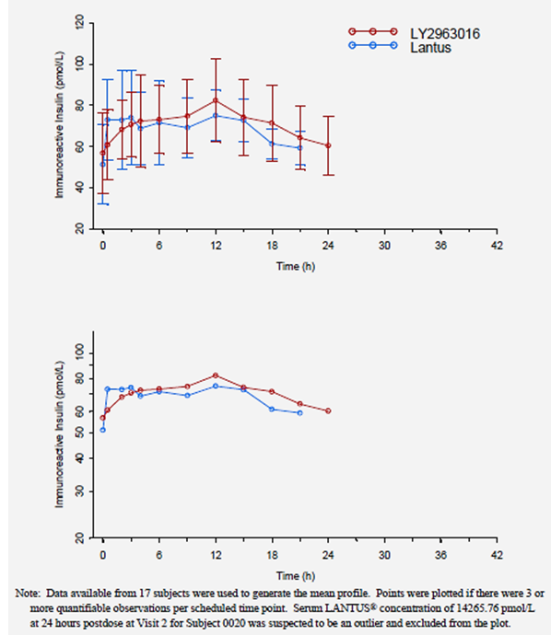
The evaluator is of the view that the information is not interpretable.

Pharmacokinetics in other special populations

Pharmacokinetics in subjects with impaired hepatic function
No new data were submitted in this application.

Pharmacokinetics in subjects with impaired renal function
Subjects with severe renal impairment were excluded from the study programme. Most pharmacokinetic data were generated in healthy volunteers. There was no information submitted to address this matter.

Pharmacokinetics according to age
According to M1.12, no studies in paediatric populations are required or planned. The Phase I studies enrolled adults but none of them was elderly.

Pharmacokinetics related to genetic factors
No new data were submitted in this application.

Pharmacokinetics
Other useful and conventional PK parameters (apparent clearance, median _{Tmax} with ranges, t _{½}), derived from the three best Phase I studies, are found in Table 9 below.

Pharmacokinetic interactions

Pharmacokinetic interactions demonstrated in human studies
No new data were submitted in this application.

Clinical implications of in vitro findings
Not applicable.

Evaluator’s overall conclusions on pharmacokinetics
An important assumption that this evaluator makes is that the analytical method will be found to be satisfactory by the Quality evaluator.
The Phase I studies marginally address the requirements of the adopted EU guideline EMEA/CHMP/BMWP/32775/2005 Annex To Guideline On Similar Biological Medicinal Products Containing Biotechnology-Derived Proteins As Active Substance: Non-Clinical And Clinical Issues - Guidance On Similar Medicinal Products Containing Recombinant Human Soluble Insulin,
‘The relative pharmacokinetic properties of the similar biological medicinal product and the reference medicinal product should be determined in a single dose crossover study using subcutaneous administration. Comprehensive comparative data should be provided on the time-concentration profile (AUC as the primary endpoint and Cmax, Tmax, and T1/2 as secondary endpoints). Studies should be performed preferably in patients with type1 diabetes. Factors contributing to PK variability e.g. insulin dose and site of injection / thickness of subcutaneous fat should be taken into account.’
The Phase I studies used consistent methods and appear to have been conducted diligently. The one study in subjects with T1DM (Study ABEE) yielded uninterpretable PK results. Hence the useful data came from studies in healthy volunteers – the analytical method required C-peptide correction; the assay method was not specific to insulin glargine and its principal metabolite.
C-peptide correction is essential in studies involving healthy volunteers and it is accord with the need to have some form of baseline correction as articulated in the adopted guideline CPMP/EWP/QWP/1401/98 Rev. 1/ Corr ** Guideline On The Investigation Of Bioequivalence
Sampling times
‘A sufficient number of samples to adequately describe the plasma concentration-time profile should be collected. The sampling schedule should include frequent sampling around predicted tmax to provide a reliable estimate of peak exposure. In particular, the sampling schedule should be planned to avoid Cmax being the first point of a concentration time curve. The sampling schedule should also cover the plasma concentration time curve long enough to provide a reliable estimate of the extent of exposure which is achieved if AUC(0-t) covers at least 80% of AUC(0-∞). At least three to four samples are needed during the terminal log-linear phase in order to reliably estimate the terminal rate constant (which is needed for a reliable estimate of AUC(0-∞))…’
‘For endogenous substances, the sampling schedule should allow characterisation of the endogenous baseline profile for each subject in each period. Often, a baseline is determined from 2-3 samples taken before the drug products are administered…’
It is noted that the studies did not always achieve enough duration of sampling to achieve 80% of AUC_{(0-∞)}. The extrapolation of AUC exceeded 20% in ABEA, ABEI, ABEM & ABEN.
‘Endogenous substances
If the substance being studied is endogenous, the calculation of pharmacokinetic parameters should be performed using baseline correction so that the calculated pharmacokinetic parameters refer to the additional concentrations provided by the treatment. Administration of supra-therapeutic doses can be considered in bioequivalence studies of endogenous drugs, provided that the dose is well tolerated, so that the additional concentrations over baseline provided by the treatment may be reliably determined.
If a separation in exposure following administration of different doses of a particular endogenous substance has not been previously established this should be demonstrated, either in a pilot study or as part of the pivotal bioequivalence study using different doses of the reference formulation, in order to ensure that the dose used for the bioequivalence comparison is sensitive to detect potential differences between formulations.
The exact method for baseline correction should be pre-specified and justified in the study protocol. In general, the standard subtractive baseline correction method, meaning either subtraction of the mean of individual endogenous pre-dose concentrations or subtraction of the individual endogenous predose AUC, is preferred. In rare cases where substantial increases over baseline endogenous levels are seen, baseline correction may not be needed.
In bioequivalence studies with endogenous substances, it cannot be directly assessed whether carryover has occurred, so extra care should be taken to ensure that the washout period is of an adequate duration.’
The use of C-peptide correction is in principle reasonable owing to the lack of a specific assay.

Overview and Relevance of Pharmacokinetic Data
Table 9 below, taken from the appendices to Module 2.7 includes PK data from all of the Phase I studies:

Table 9: Pharmacokinetic parameter estimates for the completed relative bioavailability and comparative PK and PD studies in Healthy subjects. Studies ABEI, ABEM, ABEA and ABEN.
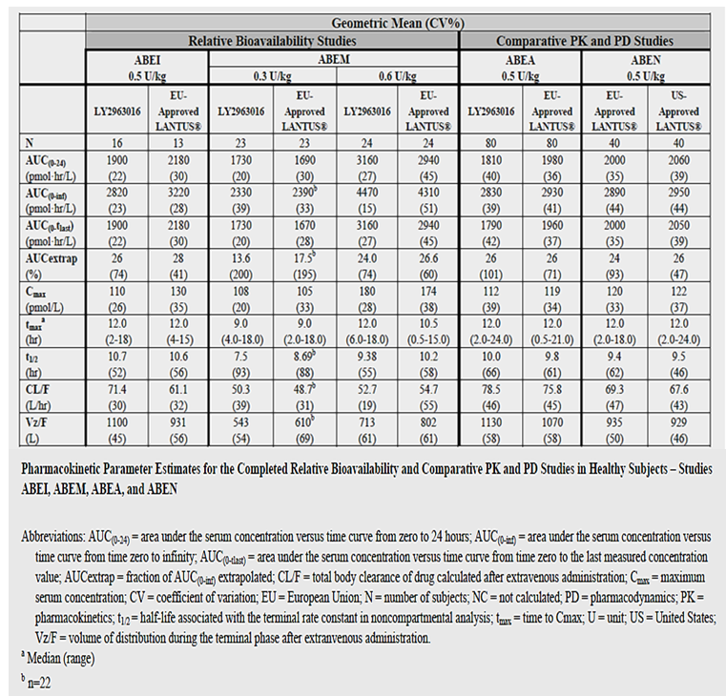
It is notable how comparable the results are across studies at the same dose of 0.5U/kg BW but ABEM’s results seem to overestimate the Cmax and AUCs.
Does Abasria have a PK profile equivalent to Lantus?
Within the abovementioned limits, Lantus EU and Abasria exhibited similar PK parameters in two adequate studies against Lantus EU.
Moreover, Study ABEM used two different doses and produced reasonably dose linear PK results. There is therefore a reasonable degree of confidence that Abasria and Lantus EU are equivalent in terms of PK and that Lantus USA and Lantus EU are also equivalent to each other in terms of PK.
Lantus EU exhibited similar PK to Lantus US in one adequate study. The data from study ABEO are not yet available but this submission was intended for the EMA, not the USA. This submission has no specific Australian content in Module 5.

Pharmacodynamics

Studies providing pharmacodynamic data
Table 10 shows the studies relating to each pharmacodynamic topic. The studies are the same Phase I studies that have been considered in regard to pharmacodynamics. The used the same euglycaemic clamp method with the same sampling times and data management, excepting that those studies in healthy volunteers ran for only 24 hours. The results across studies ought therefore to be both consistent and comparable. They were.

Table 10: Submitted pharmacodynamic studies.
PD Topic | Subtopic | Study ID | *Aim of Study
Primary Pharmacology | Effect on glucodynamics in a euglycaemic clamp study | ABEA  ABEM  ABEI  ABEE | PK & PD  PK & PD  PK & PD  PK & PD
Secondary Pharmacology | Effect on C-peptide levels in healthy volunteers# | ABEA  ABEM  ABEI | PK  PK  PK
Gender other genetic and Age-Related Differences in PD Response | Effect of gender | Not done
 | Effect of age | Not done
Comparison of Lantus EU vs. Lantus US | ‘Scientific Bridge’ to support Phase III studies use of both sources of Lantus | ABEN | PK & PD
Population PD and PK-PD analyses | Healthy subjects | Not done
Population PD and PK-PD analyses | Target population | Not done
* Indicates the primary aim of the study where applicable. § Subjects who would be eligible to receive the drug if approved for the proposed indication. # C-peptide levels are presented graphically as Figures only.
None of the pharmacodynamic studies had deficiencies that excluded their results from consideration.

Summary of pharmacodynamics
The information in the following summary is derived from conventional pharmacodynamic studies in humans.

Mechanism of action
As stated in the approved PI of Lantus, ‘Insulin and its analogues lower blood glucose levels by stimulating peripheral glucose uptake, especially by skeletal muscle and fat, and by inhibiting hepatic glucose production. Insulin inhibits lipolysis in the adipocyte, inhibits proteolysis and enhances protein synthesis.’ ‘In clinical studies, intravenous insulin glargine and human insulin have been shown to be equipotent when given at the same doses.’
Abasria contains insulin glargine. It should therefore exhibit a long duration of action. However, the only mechanistic studies were those described above in Table 10 i.e. glucodynamic studies.

Pharmacodynamic effects

Primary pharmacodynamic effects
Insulin glargine’s primary pharmacodynamic action is glucodynamic and for this reason a euglycaemic clamp method – the standard for testing insulins – was used in the PD studies.
Studies ABEA, ABEM and ABEE are most relevant. All of them compared Abasria with Lantus EU. Study ABEN was the ‘scientific bridging study’ that related Lantus EU to Lantus US.
Table 11 below, taken from the appendices to Module 2.7 includes PD data from all of the Phase I studies in healthy volunteers, including the early, small, non-replicate study, Study ABEI:

Table 11: Pharmacodynamic parameter estimates for the completed relative bioavailability and comparative PK and PD studies in Healthy subjects-Studies ABEI, ABEM, ABEA and ABEN
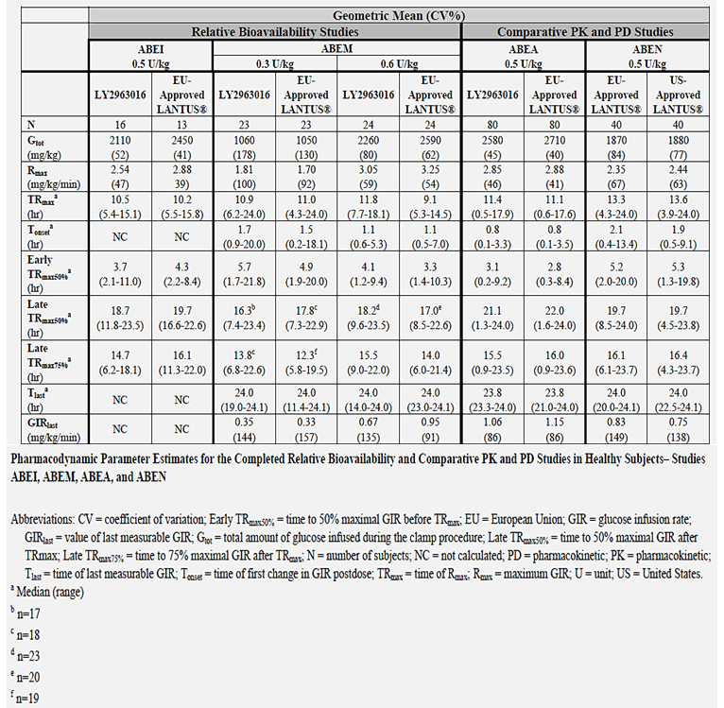
The PD results were not statistically different for Lantus EU vs. Abasria and for Lantus EU vs. Lantus US.
In Study ABEE, 35% of clamps were terminated at 42 hours. However, this small study provides the best estimates of duration of action and less need for extrapolation of data. Table 12 is taken from the Module 5 Study report:

Table 12: Geometric mean pharmacodynamic parameter estimates for LY2963016 and Lantus after a single subcutaneous dose of 0.3 U/kg
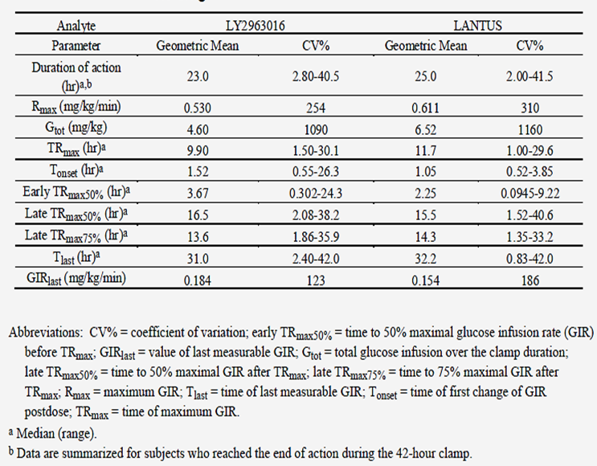

Secondary pharmacodynamic effects
If it is reasonable to consider the negative feedback of insulin upon the pancreatic beta islet cells as a secondary effect, then the collection of C-peptide levels in the studies that enrolled healthy volunteers can be included as a secondary endpoint. The data were not submitted in tabular form.
As an example, the two largest studies’ results are shown below:
Figure 2 is taken from the Module 5 study report of Study ABEA. It shows a slow onset of suppression to about 12 hours post-dose, the suppression of C-peptide levels continued until 24 hours post-dose (when the study was terminated).
Figure 2: Mean (± standard deviation) of serum C-peptide concentration following subcutaneous administration of a single dose of LY2963016 (0.5 U/kg BW) and Lantus (0.5 U/kg BW).
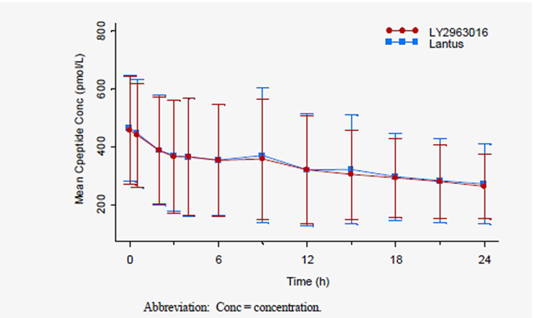
Figure 3 is taken from the Module 5 study report of Study ABEM. Although the data again show depression of C-peptide levels to 24 hours post-dose (when the study was terminated), there is only a suggestion of a dose related effect for Abasria and Lantus.
Figure 3: Mean (± standard deviation) of serum C-peptide concentration following subcutaneous administration of a single dose of LY2963016 (0.3 and 0.6 U/kg BW) and Lantus (0.3 and 0.6 U/kg BW).
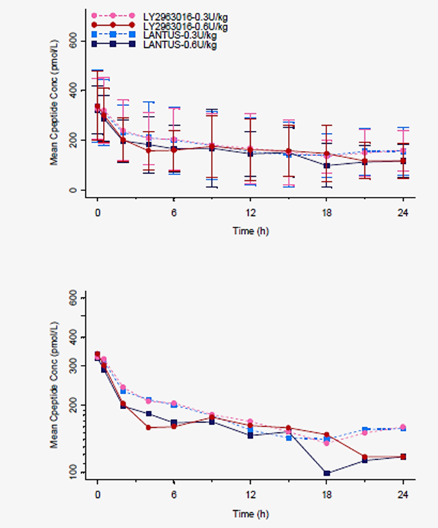
Other effects: Insulin glargine has some agonistic affinity for IGF-1 receptors. No clinical data were submitted on this aspect.

Time course of pharmacodynamic effects
This was not adequately explored in the Phase I studies that enrolled only healthy volunteers because the euglycaemic clamp only ran for 24 hours post-dose of test and reference insulin glargine. However, Study ABEE -the study in persons with T1DM - although rather small, ran for 42 hours and the end point of action was detected in the majority of subjects.
The Australian PI of Lantus includes this figure:
Figure 4: Time-action profiles of insulin glargine and NPH
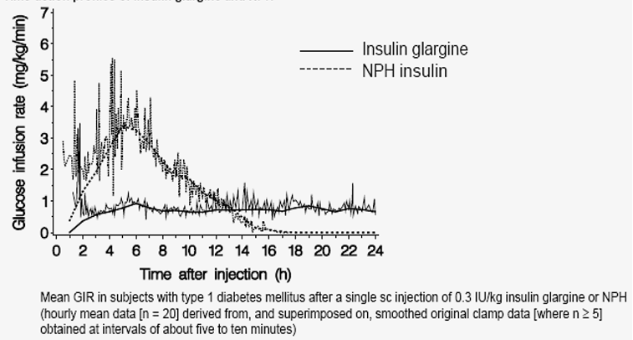
Figure 5 is taken from the Module 5 Study report. It shows a similarly prolonged duration of effect for Lantus EU and Abasria:
Figure 5: Mean (and 90% confidence interval) glucose infusion rate versus time profiles (upper), the corresponding Biostator glucose levels (middle) and Super GL glucose levels (lower) following a single subcutaneous administration of LY2963016 (0.3 U/kg) or Lantus (0.3 U/kg).
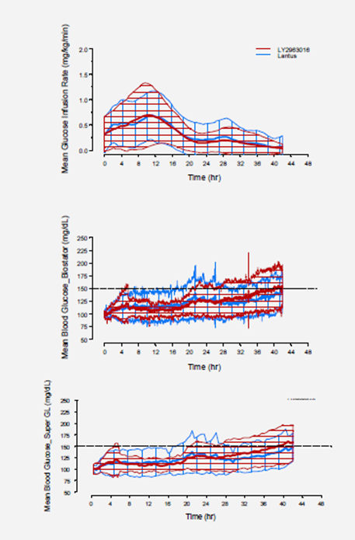
More useful is this table (Table 13) of individual end of action data from the Appendices to Module 2.7 and Figure 6, a survival plot analysis, from the Module 5 study report:

Table 13: Individual estimates for end of action (hours)-Study ABEE
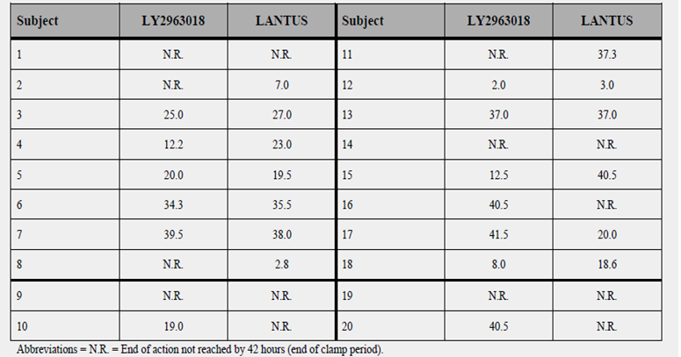
Figure 6: Time-to-event (survival) plot of duration of action (hours), all subjects
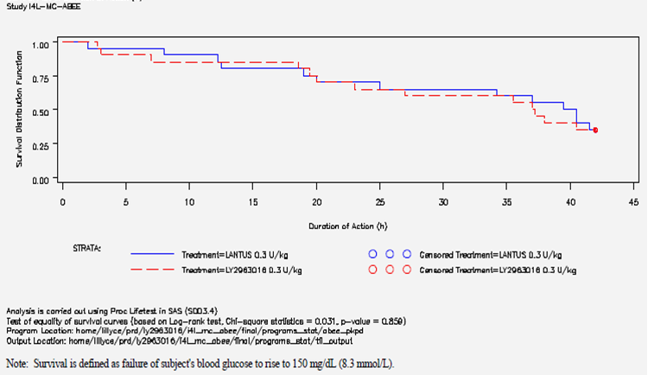
There was no formal sample size calculation in study ABEE; it was of a 2 period, non-replicate design. Five subjects did not reach end of action by 42 hours for both test and reference insulin glargine doses, a further 6 did not reach end of action by 42 hours for one of the test or reference insulin glargine doses but the applicant reported no statistically significant difference between test and reference medicinal products. The evaluator is of the opinion that no clinically significant difference was seen. Nonetheless, the matter of the duration of action of Abasria cannot be said to have been exhaustively studied.

Relationship between drug concentration and pharmacodynamic effects
Not studied, however dose comparability of effect by comparison with the reference insulin (Lantus EU) was the intended purpose of the Phase I studies. One study, Study ABEM, studied comparability of Abasria against Lantus EU at two dose levels.

Genetic-, gender- and age-related differences in pharmacodynamic response
Not studied. Different Phase I studies had a variable ethnic mix, most subjects were male and Caucasian or Asian (presumed, Chinese) adults under 50 years of age. Too few data were collected for any comparisons to be made.

Pharmacodynamic interactions
Not studied.

Evaluator’s overall conclusions on pharmacodynamics
The Phase I studies were more successful as PD studies than as PK studies notwithstanding the duration of most studies (24 hours).
The Phase I studies adequately address the requirements of the adopted EU guideline EMEA/CHMP/BMWP/32775/2005 Annex To Guideline On Similar Biological Medicinal Products Containing Biotechnology-Derived Proteins As Active Substance:
Non-Clinical And Clinical Issues - Guidance On Similar Medicinal Products Containing Recombinant Human Soluble Insulin, noting that the short duration of studies in healthy volunteers could not capture the full duration of action of insulin glargine and that the study in patients with T1DM did not capture the full duration of action of insulin glargine in a minority of subjects in each and/or both periods:
‘The clinical activity of an insulin preparation is determined by its time-effect profile of hypoglycaemic response, which incorporates components of pharmacodynamics and pharmacokinetics. Pharmacodynamic data are of primary importance to demonstrate comparability of a similar rh-insulin. The double-blind, crossover hyperinsulinaemic euglycaemic clamp study is suitable for this characterisation. Data on comparability regarding glucose infusion rate and serum insulin concentrations should be made available. The choice of study population and study duration should be justified. Plasma glucose levels should be obtained as part of the PK study following subcutaneous administration.‘
Does Abasria have PD profiles equivalent to Lantus?
Yes, this is shown directly by glucodynamic parameters and by the influence on C-peptide levels in healthy volunteers. The Lantus used was Lantus EU.

Dosage selection for the pivotal studies
Abasria is modelled as a biosimilar version of Lantus, and the nonclinical (preclinical) data supported comparability of Lantus and Abasria. Therefore, the Phase III Studies treated the enrolled patients according to the locally approved PI of Lantus and according to a reasonable treatment algorithm (Study ABEC) or reasonable principles (Study ABEB).

Clinical efficacy
Lantus is registered with the following composite indication, as represented in the PI:
‘Insulin glargine is an insulin analogue indicated for once-daily subcutaneous administration in the treatment of type 1 diabetes mellitus in adults and children and type 2 diabetes mellitus in adults who require insulin for the control of hyperglycaemia.’
The first indication is subdivided in to adults and children; the second is limited to adults.
There are two Phase III studies in this submission, Study ABEC and Study ABEB.
The following table, from Module 2.7 of the submission, includes a brief description of the studies:

Table 14: Brief description of the phase III studies efficacy and safety studies supporting the use of LY2963016 in patients with T1DM and T2DM
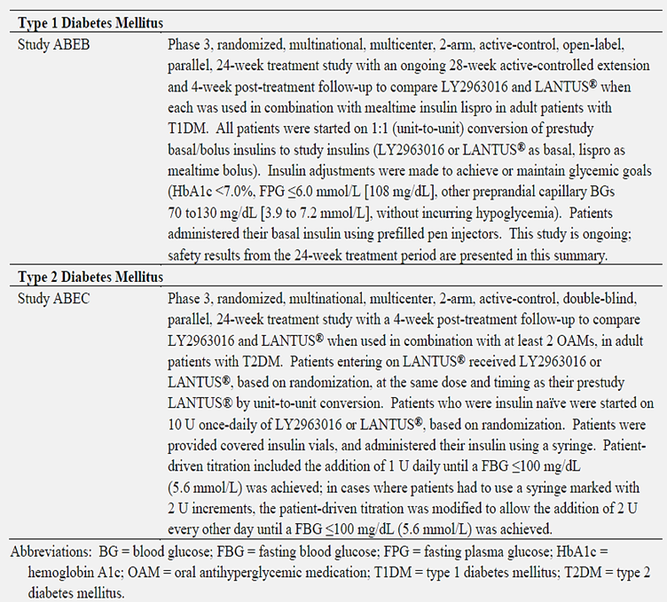

Treatment of T2DM in Adults

Pivotal efficacy studies

Study ABEC [Study 14L-MC-ABEC]
This study is regarded by the evaluator as the pivotal study of the submission.

Study design, objectives, locations and dates
From Protocol Summary – ‘Study Design: A randomized, multicenter, 2-arm, active-control, double-blind, parallel, 24-week treatment and 4-week post-treatment follow-up study in adult patients with type 2 diabetes mellitus (T2DM). The study patients should be on 2 or more OAMs and may be insulin naïve with inadequate glycemic control or on Lantus with adequate or inadequate glycemic control’;
‘Lead-in period: None;
Treatment period: 24 weeks;
Washout period: None;
[Post-trial] Observation period: 4 weeks’.
Comment: As in ABEB, this means that the first 12 weeks involved dose titration of the insulin regimen. There was as four week observation period after week 24.
Objectives: According to the final version of the protocol, they were –
‘The primary objective of this study is to test the hypothesis that LY2963016 administered once daily (QD) is non-inferior to Lantus (QD), as measured by change in hemoglobin A1c (HbA1c) from baseline to 24 weeks, when used in combination with oral antihyperglycemic medications (OAMs).
The secondary objectives of the study are:
- To compare safety of LY2963016 relative to Lantus (eg, incidence of anti-insulin antibodies, hypoglycemia, adverse events [AEs]) when used in combination with OAMs.
- To compare LY2963016 relative to Lantus for other efficacy variables (eg, change in HbA1c at 4, 8, 12, 16, and 20 weeks, 7-point self-monitored blood glucose [SMBG] profiles [as plasma equivalent values], percentage of patients with HbA1c <7%, the percentage of patients with HbA1c ≤6.5%).
- To compare LY2963016 relative to Lantus with regard to intrapatient blood glucose (BG) variability, basal insulin dose, and weight, when used in combination with OAMs.
- To test the hypothesis that Lantus is non-inferior to LY2963016 (QD), as measured by change in HbA1c from baseline to 24 weeks, when used in combination with OAMs.
- To compare LY2963016 relative to Lantus for patient-reported outcomes (PRO) as measured by responses to the Adult Low Blood Sugar Survey (ALBSS) and the Insulin Treatment Satisfaction Questionnaire (ITSQ).’
Locations: The study was multinational – it was conducted in the following countries and the investigators were usually endocrinologists or subspecialised diabetologists:
(from Module 5 Study report appendix): Czech Republic (36 patients, 6 sites, 6 investigators), France (16 patients, 4 sites, 4 investigators), Germany (28 patients, 10 sites, 10 investigators), Greece (22 patients, 4 sites, 4 investigators), Hungary (62 patients, 7 sites, 7 investigators), Italy (11 patients, 6 sites, 6 investigators), Korea, South (32 patients, 5 sites, 5 investigators), Mexico (58 patients, 4 sites, 4 investigators); Poland (23 patients, 6 sites, 6 investigators), Spain (22 patients, 4 sites, 4 investigators), Taiwan (21 patients, 8 sites, 8 investigators) and the United States (423 patients, 38 sites, 38 investigators).
Study Dates: The study has been completed; there is no ongoing extension phase. According to the M5.3 report p.1/2431: ‘First patient enrolled (assigned to therapy): 06 September 2011; Last patient completed: 17 September 2012’.

Inclusion and exclusion criteria
Inclusion Criteria: In brief, eligible patients were adults, who had a diagnosis of T2DM as determined by the World Health Organization (WHO) diagnostic criteria, all of whom had been receiving 2 or more OAMs at stable doses for the 12 weeks prior to screening, with or without Lantus. Patients enrolled could have been insulin naïve or receiving a basal insulin. To qualify, the subject should have had an HbA1c ≥7.0% and ≤11.0% if insulin naïve; or HbA1c ≤11.0% if previously on Lantus®.
Their body mass index (BMI) was to be ≤45 kg/m².
Exclusion Criteria: These were numerous but the most important from the aspect of validity of study’s design are:
- Had used any other insulin except Lantus® within the previous 30 days
- Had been exposed to a biosimilar insulin glargine within the previous 90 days
- Had a history of taking basal bolus therapy or, in the investigator’s opinion, required mealtime insulin to achieve target control
- Had used short-acting glucagon-like peptide 1 (GLP-1) agonist (eg, exenatide) or long acting GLP-1 agonist (e.g. liraglutide) within the previous 90 days
- Had used pramlintide (eg, Symlin®) within the previous 30 days*
- Had excessive insulin resistance at study entry (total insulin dose ≥1.5 U/kg)
- Had more than 1 episode of severe hypoglycaemia within 6 months prior to study entry
- Had a known hypersensitivity or allergy to Lantus® or its excipients
*Pramlintide is an analogue of amylin that is marketed in the USA.
The other exclusion criteria were safety-related in the interests of the safety of the subjects enrolled.
Comment: These criteria resulted in the recruitment of a study population that required the basal insulin to be added to OAMs. That is, their T2DM was suboptimally controlled, even if already receiving Lantus. This suboptimal baseline control, coupled with the lack of a lead-in period, led to predictable effects on the study’s outcomes. That is, the study was not a maintenance of efficacy study.

Study treatments
Insulin glargine: The use of insulin was aligned with the approved product information of Lantus
Patients on pre-study Lantus: Starting dose of Abasria or Lantus QD at the same dose as pre-study Lantus.
Insulin naïve patients: Starting dose of 10 U Abasria or Lantus QD. All patients will then follow a patient-driven dosing algorithm while being supervised by investigators through the course of the study to maintain the fasting blood glucose (FBG) (5.6 mmol/L) while avoiding hypoglycaemia.
Oral Antidiabetic Medications: In general, patients with DM 2 were expected to continue pre-study OAMs at the same dose during the study. However, special rules applied to SUs and to DPP-IV inhibitors. The investigator may have decreased the dose or discontinued the SU only after consultation and approval by Eli Lilly’s representative (excluding other obvious causes of hypoglycaemia) and this was to be documented.
Sitagliptin was the only dipeptidyl peptidase-IV (DPP-IV) inhibitor approved for use with insulin at the start of the study; patients were initially not allowed to continue taking any other DPP-IV inhibitor during the study. Saxagliptin received approval for use with insulin during the trial and was allowed as concomitant therapy, once approved, for patients entering the study. (Patients who were previously enrolled in the study and were using saxagliptin, prior to its regulatory approval for use with insulin, were allowed to remain in the study if they stopped using saxagliptin).
Of note, 83.3% of patients overall took SUs at entry to the study; 82.1% were receiving 2 OAMs of which metformin and SU was the most common combination (62.4% of all patients); 15.9% of patients were on 3 OAMs, 1.7% were on 4 OAMs, and 0.3% were on 5 OAMs prior to randomization.

Efficacy variables and outcomes
The main efficacy variables were:
- HbA1c
- BG levels at different times of the day and night
The primary objective of this study was to test the hypothesis that Abasria administered once was non-inferior to Lantus® administered QD, as measured by change in hemoglobin A1c (HbA1c) from baseline to 24 weeks, when used in combination with OAMs.
Other efficacy outcomes included:
- To compare LY2963016 relative to Lantus® for other efficacy variables (eg, change in HbA1c at 4, 8, 12, 16, and 20 weeks; 7-point self-monitored blood glucose [SMBG] profiles [as plasma equivalent values]; percentage of patients with HbA1c <7%, percentage of patients with HbA1c ≤6.5%).
- To compare Abasria relative to Lantus® with regard to intrapatient blood glucose (BG) variability, basal insulin dose, and weight, when used in combination with OAMs.
- To test the hypothesis that Lantus® was non-inferior to Abasria (QD), as measured by change in HbA1c from baseline to 24 weeks, when used in combination with OAMs.
- To compare LY2963016 relative to Lantus® for patient-reported outcomes as measured by responses to the Adult Low Blood Sugar Survey (ALBSS) and the Insulin Treatment Satisfaction Questionnaire (ITSQ).
There were safety outcomes as well: To compare the safety of Abasria relative to Lantus® (e.g. incidence of anti-insulin antibodies, hypoglycaemia, adverse events [AEs]) when used in combination with OAMs.
The outcomes were thus numerous.

Randomisation and blinding methods
Randomisation: From Protocol - ‘Eligible patients will be randomized to 1 of the 2 treatment groups in a double-blind fashion by a telephone directed random assignment [using the interactive voice response system (IVRS)] that is stratified by country, HbA1c levels (<8.5% versus ≥8.5%), sulfonylurea (SU) use (yes or no), and time of basal insulin injection (daytime, evening/bedtime).’
Randomisation codes were provided in the submission.
Blinding: Patients on Abasria or Lantus were provided with covered vials (for blinding purposes) and syringes during the study. A vial cover was developed that concealed the differences between the vials of Abasria and those of Lantus®, while allowing visual inspection of the insulin solutions in the vial. According to the Module 5 study report, ‘Patients, investigators, and all other site, sponsor, and contracted personnel involved in the conduct of the study were blinded to individual treatment assignments for the duration of the study. Unblinding did not occur until the reporting database was validated and locked for final statistical analysis. Unblinding occurred on 16 January 2013.’

Analysis populations
The definitions apply to Study ABEB as well and they are conventional.
From the Module 5 Study report:
‘The patient populations used in the study are described below:
- All Patients Entered - all patients who entered this study and completed Visit 1
- All Randomized - all patients who were randomized to a treatment arm
- Full Analysis Set (FAS) - based on the ITT principle, all patients who were randomized and who have taken at least one dose of study medication. Patients are assigned to the treatment arm to which they were randomized.
- Per-protocol (PP) - patients in the FAS/ITT population who also meet the following criteria:
- have no violations of Inclusion/Exclusion Criteria
- have not discontinued from the study prior to 24 weeks
- have not been off study medication for more than 14 consecutive days during the treatment period
- have not received chronic (lasting longer than 14 consecutive days) systemic glucocorticoid therapy (excluding topical, intra-articular, intraocular, and inhaled preparations).
Unless otherwise specified, listings will be prepared using all randomized patients. Efficacy and safety analyses will be conducted using the FAS population. Selected analyses will be conducted using the all randomized patients population and the PP population.’
The analytical plan was not submitted.

Sample size
From Module 5:
[Protocol Summary] ‘Sample Size: Based on the primary objective to show non-inferiority of LY2963016 to Lantus at the 0.40% non-inferiority margin (NIM), 284 (568 total) completers per arm are needed at 24 weeks. This calculation assumes no treatment difference in HbA1c between the LY2963016 and Lantus, common SD of 1.1% for change from baseline in HbA1c, 0.05 two-sided significance level, and over 99% power. Assuming a 15% dropout rate at 24 weeks, the required number of randomized patients is 334 per arm (668 total). The same sample size is needed to show non-inferiority of LY2963016 to Lantus at the 0.30% NIM with 90% power. Blinded sample-size re-estimation will be performed before the last patient has been enrolled in the study.’
[From Protocol, 12.1] ‘Based on the primary objective, to show non-inferiority of LY2963016 to Lantus at the 0.40% non-inferiority margin (NIM), 284 (568 total) completers per arm are needed at 24 weeks. This calculation assumes no treatment difference in HbA1c between LY2963016 and Lantus, common SD of 1.1% for change from baseline in HbA1c, 0.05 two-sided significance level, and over 99% power. Assuming a 15% dropout rate at 24 weeks, the required number of randomized patients is 334 per arm (668 total). The same sample size is needed to show non-inferiority of LY2963016 to Lantus at the 0.30% NIM with 90% power. Blinded sample-size re-estimation will be performed before the last patient has been enrolled in the study. This re-estimation will use a statistical model to estimate the variability in the change in HbA1c from baseline to 24-week endpoint using all available patient HbA1c values at the time of data cutoff. The estimate of variability will then be used to recalculate the sample size that would be needed to have 90% conditional power for a NIM of 0.3%, assuming no difference between treatments. The sample size from the study is constrained between a predefined minimum sample size of 606 patients, and a predefined maximum sample size of 792 patients. If the recalculated sample size is smaller than the minimum sample size planned, the study will enrol to the minimum sample size. If the recalculated sample size is larger than planned minimum sample size, the team will make a decision whether to increase sample size, up to a predefined maximum, or accept the consequent reduction in power.’
Evaluator’s Comment: Six hundred and sixty-two patients were evaluable at 24 weeks. This is clearly above the 568 total that was pre-specified.

Statistical methods
The full analytical plan was not supplied – ‘A Statistical Analysis Plan is available upon request.’ [Appendices to Study Report, M5.3]. The statistical methods were described in the study report and in Module 2.7. The evaluator has examined what was submitted.
The statistical methods appear to have been conventional in terms of adopted guidelines.
‘The primary efficacy analysis of change in HbA1c from baseline to 24 weeks was completed for the FAS population using an analysis of covariance (ANCOVA) model.’
‘As a robustness check on the primary analysis, the secondary analysis model was conducted using the ANCOVA model described above for the PP population. A non-inferiority trial is often analysed using both FAS/ITT and PP approaches. Per the CHMP Points to Consider on Switching between Superiority and Non-inferiority Trials (CHMP 2000), the FAS and PP have equal importance and their use should lead to similar conclusions. If both approaches support non-inferiority, confidence in the results is increased.’ ‘Missing data were imputed using last-observation-carried-forward (LOCF) methodology. If a patient’s baseline value was missing, or a patient only had a baseline value with no follow-up values, the patient was not included in the analysis.’
[M2.7.3 p.15] ‘Unless otherwise noted, all tests of treatment effects were conducted at a 2-sided alpha level of 0.05 and confidence intervals (CI) were calculated as 2-sided 95% CIs. All tests of interactions between treatment groups and other factors were conducted at a 2-sided alpha level of 0.05 and no adjustments for multiplicity were performed.’ ‘For Study ABEC, the model included country, sulfonylurea use (yes, no), time of basal insulin injection (daytime, evening/bedtime), and treatment as fixed effects and baseline HbA1c as a covariate.’
Comment: It is reasonable in an equivalence study to report FAS and PP results. Overall improvement of glycaemic control occurred in a time dependent manner in both studies and this was statistically and clinically significant versus baseline in both treatment groups. The number of dropouts in both studies was reasonably small: most patients completed to week 24 in both studies - ABEB (95.1%) - and ABEC (87.6%), so one would expect both analyses to produce similar outcomes.
[M2.7.3 p.15] ‘Unless otherwise noted, all tests of treatment effects were conducted at a 2-sided alpha level of 0.05 and confidence intervals (CI) were calculated as 2-sided 95% CIs. All tests of interactions between treatment groups and other factors were conducted at a 2-sided alpha level of 0.05 and no adjustments for multiplicities were performed.’
Comment: Numerous secondary/supportive endpoints and subgroup analyses were reported. It is not surprising that a few statistically significant results were reported.
From Module 5 ’The primary efficacy endpoint is the change in HbA1c from baseline to 24 weeks. If the 24-week HbA1c value is missing, the last post-baseline value will be carried forward and used in the analysis. This creates the HbA1c endpoint value using the LOCF methodology. If there are no HbA1c data after the date of randomization, the endpoint will be considered missing.
The primary analysis model will be an analysis of covariance (ANCOVA) for the change in HbA1c from baseline to endpoint with pooled country, sulfonylurea use (yes, no), time of basal insulin injection (daytime, evening/bedtime), and treatment as fixed effects and baseline HbA1c as a covariate. This analysis will be conducted using the full analysis set (FAS) population, which is defined using the intent-to-treat (ITT) principle. As a robustness check on the primary analysis, the secondary analysis model will use the ANCOVA model above for the per-protocol patient population. The analysis of the continuous secondary efficacy and safety measurements will use the ANCOVA model with the FAS patient population. For categorical measures, Fisher’s Exact test or Pearson’s Chi square test will be utilized.’
From Study report [evidently in reference to the primary efficacy endpoint] ‘Multiple Comparisons/Multiplicity: No adjustments for multiplicity were performed. It was not necessary to adjust for multiplicity due to the gate-keeping procedure for non-inferiority. In addition, claiming equivalent efficacy was only to be considered if LY2963016 was declared non-inferior to Lantus® in the primary treatment comparison, and Lantus® was declared non-inferior to LY2963016 in the secondary treatment comparison.’ ‘The primary treatment comparison was to compare LY2963016 with Lantus® at the non-inferiority margin of 0.4%. Non-inferiority of LY2963016 to Lantus® was declared if the upper limit of the 95% CI for the treatment difference in change in HbA1c from baseline to the 24-week endpoint was less than 0.4%. If the 0.4% non-inferiority margin was met, then the upper limit of the 95% CI was compared to the 0.3% non-inferiority margin. This gate-keeping procedure controlled the family-wise type 1 error rate at a 1-sided 0.025 level. A key secondary treatment comparison was to compare Lantus® versus LY2963016 at the non-inferiority margin of -0.4%. Non-inferiority of Lantus® to LY2963016 was declared if the lower limit of the 95% CI for the treatment difference in change in HbA1c from baseline to the 24-week endpoint was greater than -0.4%. If LY2963016 was declared non-inferior to Lantus® in the primary treatment comparison, and Lantus® was declared non-inferior to LY2963016 in the secondary treatment comparison, then LY2963016 was considered to have equivalent efficacy as Lantus®.’
Comment: This plan is consistent with that used in Study ABEB

Participant flow
The applicant refers to this as ‘patient disposition’.
The dropout rate was reasonable. As stated in the Module 5 study report, ‘… the incidence of discontinuations in the LY2963016 group (42 patients [11.2%]) was similar to the Lantus® group (52 patients [13.7%]), p=.322. The most common reason for study discontinuation in both groups was subject decision (LY2963016: 11 patients [2.9%]; Lantus®: 16 patients [4.2%]).’ ‘The mean exposure to study drug was 22.38 weeks for the LY2963016 group and 22.13 weeks for the Lantus® group. Approximately 89% of all patients were exposed to study drug for at least 18 weeks. The exposure in total patient-years was 161.28 patient-years and 161.16 patient-years for the LY2963016 and Lantus® treatment groups, respectively.’

Major protocol violations/deviations
In brief, according to document in the appendices to the study report, I4L-MC-ABEC CSR Appendix Protocol Deviations, there were significant protocol violations involving most investigators and 150 patients. The majority of violations related to discontinuation from the study prior to 24 weeks or the use of OAMs with insulin not used in accordance with product label or dose adjustment of sulfonylureas without consultation or approval by Lilly/use of OAMs with insulin not used in accordance with product label or non-compliance with the requirements of the protocol. A few did not comply with the entry criteria and there were numerous other reasons, including dispensing errors and use of medication that was not fit for use. Of note in regard to protocol violations, the dose of sulfonylureas was regulated by Eli Lilly.
Comment: In the evaluator’s opinion, these protocol violations are insufficient to vitiate the study.

Baseline data
The two treatment groups were adequately matched.
[From Module 2.7.3] ‘The study population included adult (≥18 years) patients who had a confirmed diagnosis of T2DM (in Study ABEC), based on the World Health Organization (WHO) disease diagnostic criteria … In Study ABEC, eligible patients were either insulin-naïve or prior Lantus® users and had to be taking 2 or more oral antihyperglycemic medications (OAMs) at stable doses’.
‘Patients in Study ABEC were already administering Lantus®, or were insulin naïve at screening. A total of 299 patients (39.6%) were on pre-study Lantus®, and 457 (60.4%) were insulin naïve, and the proportion of patients on pre-study Lantus® or that were insulin naïve was comparable between treatment groups.’ The patients ‘… may have been insulin naïve with inadequate glycemic control or on Lantus® with adequate or inadequate glycemic control.’
Where a basal insulin had been used, there was an equal split of evening or morning injection times. A slight majority of patients had received Lantus US rather than Lantus US, most had normal renal function, 5.8% had moderate renal impairment and none had severe renal impairment. The mean duration of T2DM was 11.45 years, the mean BMI was 31.9kg/m² and the mean baseline HdA1c was 8.32%.

Results for the primary efficacy outcome
The end point results satisfied the predetermined tests of non-inferiority.
As stated in the Module 5 study report, ‘The LS mean change in HbA1c from baseline to 24-week endpoint (LOCF) was -1.286% and -1.338% for the LY2963016 and Lantus® groups, respectively.
Non-inferiority of LY2963016 to Lantus® was to be concluded if the upper limit of the 95% CI for the treatment comparison was <0.4%. If the 0.4% non-inferiority margin was met, the upper limit of the 95% CI was compared with the 0.3% non-inferiority margin. As a key secondary treatment comparison, non-inferiority of Lantus® to LY2963016 was to be concluded if the lower limit of the 95% CI was >-0.4%; if each was declared non-inferior, then LY2963016 was considered to have equivalent efficacy to Lantus®. The LS mean difference between treatments (LY2963016 – Lantus®) in change from baseline at endpoint (LOCF) was 0.052% (95% CI: [-0.070%, 0.175%]). Non-inferiority of LY2963016 to Lantus® was demonstrated at the 0.4% and 0.3% non-inferiority margins; non-inferiority of Lantus® to LY2963016 was demonstrated in the secondary treatment comparison. LY2963016 and Lantus® were considered to have equivalent efficacy.’
It is notable that continuous improvement occurred in group mean values to week 24. Perhaps this steady improvement is not surprising because HbA1c is a lagging indicator of overall glycaemic control. The mean results obtained from Lantus and Abasria are practically identical at each time point.
Further, the results for the per protocol population were very similar. The per protocol analysis of the primary endpoint also satisfied the three sequential non-inferiority, also suggesting equivalent efficacy.

Results for other efficacy outcomes
As noted above, there were many other efficacy endpoints, most of them appear to be exploratory.
Secondary endpoints related to HbA1c Change in HbA1c from Baseline to Weeks 4, 8, 12, 16, 20, and 24 and Patients Achieving HbA1c Target Values at Endpoint were both clinically and statistically non-significantly different, both showing time-dependent improvement from baseline.
The majority of these secondary/supportive endpoints showed no statistically significant differences between the Abasria and Lantus groups. Predictably, however, a few significant results were noted at some time points. In the opinion of the evaluator, these differences are of no clinical significance.
Also reported were the outcomes of the Health Outcomes/Quality-of-Life Evaluation (ALBSS, ITSQ). No differences were seen between treatment groups with either instrument that was used.

Evaluator’s conclusions on clinical efficacy
For the treatment of type 2 diabetes mellitus in adults who require insulin for the control of hyperglycaemia
The applicant concluded, in regard to the primary endpoint,
‘The primary objective of demonstrating non-inferiority of LY2963016 to Lantus®, as measured by change in HbA1c from baseline to Week 24 endpoint (LOCF) when used in combination with OAMs, was met. In addition, non-inferiority of Lantus® to LY2963016 was demonstrated; thus, LY2963016 and Lantus® were considered to have equivalent efficacy. Both treatment groups had statistically significant (p<.001) reductions in HbA1c from baseline to endpoint (LOCF).’ [M5.2 p.193/2431]
The evaluator accepts this conclusion, based on a study that exceeded the predetermined sample size and that had a modest dropout rate. The results of the study show comparable efficacy–comparable improvement from baseline in both treatment groups that is comparable also in terms of subgroups of previous Lantus use or insulin-naïve patients. The patient population was reasonably representative of patients with T2DM who require a basal insulin, matching Lantus’ registered indication. It is clear that a large majority of subjects was not tightly controlled at study entry.
The study was not ideal in design and it is the sole study in the population, patients with T2DM. However, efficacy was shown and a second supportive study – Study ABEB – in T1DM is available to support comparable efficacy against Lantus.

Treatment of T1DM
There was one study submitted in this indication, Study ABEB. Many of the design and study conduct principles were closely similar to that of Study ABEC. The major difference is that Study ABEB was of open label design and, which was of less importance, Study ABEB was ongoing at the time of submission. It is intended to run for one year (a 28 week extension period) but the 24 week data (as intended) have been submitted with this application.
The open label design is considered to be highly problematical in an equivalence study because bias might occur e.g. both patients and investigators may attend differently to safety signals and diabetic control algorithms. The evaluator therefore regards this study as supportive of efficacy but not as a pivotal study.

Supportive efficacy studies

Study ABEB [Study I4L-MC-ABEB ]

Study design, objectives, locations and dates
As stated in the study’s protocol, ABEB is a …
‘a prospective, multinational, randomized, multicenter, 2-arm, active-control, open-label, parallel, 24-week treatment study in patients with T1DM with a 28-week extension and 4-week post-treatment follow up. The study is designed to determine non-inferiority of LY2963016 to Lantus in change in HbA1c from baseline in patients with T1DM. Patients will be screened at Visit 1, and eligible patients will be randomized to LY2963016 or Lantus at Visit 2 to be treated for a total period of 52 weeks.’
‘A total of 400-550 patients are planned to be enrolled in the study, with a target to have 368 patients completing the study.’
‘The study design includes Screening, Randomization, Treatment (24 weeks until primary endpoint assessment, followed by a 28-week extension) and Post-treatment Follow-up periods. The Treatment Period is composed of a Titration Period and a Maintenance Period. It is expected that most of the basal and bolus insulin dose adjustments should occur during the initial titration period (Weeks 0 through 6); however, titration could extend up to Week 12 for patients who need more intensification to achieve glycemic targets. It is expected that insulin dose adjustments during the Maintenance Period would be for safety such as hypoglycemia or unacceptable hyperglycemia.’
Locations: The study was international and multicentric - it was conducted at 59 study centres in 9 countries. All investigators were specialist physicians, usually diabetologists. Ethics review boards were identified for each investigator (in Module 5 I4L-MC-ABEB Interim CSR Appendix ERB ICD).
Dates: The first patient enrolled (assigned to therapy): 08 September 2011 and the last patient completed the 24th week visit: 13 August 2012.

Inclusion and exclusion criteria
Inclusion criteria:
Patients with T1DM for ≥1 year, aged ≥18, with a body mass index ≤35 kg/m² will be included in the study. Patients should have an HbA1c ≤11%; on basal-bolus insulin therapy for at least 1 year. Basal insulin must be QD injection of human insulin isophane suspension (NPH), Lantus, or detemir for at least 3 months (90 days) prior to Visit 1 and combined with mealtime injections of human regular insulin, or insulin analog lispro, aspart, or glulisine. [from protocol summary]
Eligible patients had a diagnosis of T1DM as determined by the World Health Organization (WHO) diagnostic criteria [study summary, page 38/4817]
As determined by the investigator, are capable and willing to do the following:
- perform SMBG
- complete patient diaries as instructed for this protocol
- use the insulin injection device(s) according to the instructions provided
- are receptive to diabetes education
- comply with the required study insulins and study visits;
… and, have given written informed consent to participate in this study in accordance with local regulations. [from protocol section 8.1]
Exclusion criteria:
Patients with known hypersensitivity or allergy to the study insulins (insulin glargine or insulin lispro) or their excipients, or with significant renal, cardiac, gastrointestinal, or liver disease, will be excluded. Patients with active cancer or cancer within the past 5 years will be excluded. Patients who are using twice daily insulin glargine within 6 months (180 days) prior to Visit 1 will be excluded.
[abstracted from protocol summary]
[9] Exposure to a biosimilar insulin glargine.
[10] Excessive insulin resistance at entry into the study (total daily insulin dose [TDID] ≥1.5 U/kg).
[11] Have had more than one episode of severe hypoglycemia, as defined in Section 9.9 of the protocol, within 6 months prior to entry into the study.
[12] Have had more than one episode of diabetic ketoacidosis or emergency room visits for uncontrolled diabetes leading to hospitalization within 6 months prior to entry into the study.
[14] Are pregnant or intend to become pregnant during the course of the study, or are sexually active women of childbearing potential not actively practicing birth control by a method determined by the investigator to be medically acceptable.
[15] Women who are breastfeeding.
[16] Have taken any oral antihyperglycemic medications (OAMs) within 3 months prior to Visit 1.
[17] Have received treatment within the last 30 days with a drug that has not received regulatory approval for any indication at the time of study entry.
[18] Have received treatment with pramlintide or with continuous subcutaneous insulin infusion within 3-months prior to Visit 1.
[26] Have an irregular sleep/wake cycle (eg, patients who sleep during the day and work during the night).
[27] Have any other condition (including known drug or alcohol abuse or psychiatric disorder) that precludes the patient from following and completing the protocol.
[28] Are investigator-site personnel directly affiliated with this study and/or their immediate families. Immediate family is defined as a spouse, parent, child, or sibling, whether biological or legally adopted.
[29] Are Lilly employees.
[from protocol section 8.2]
4L-MC-ABEB(2) Clinical Protocol Addendum
Protocol Addendum (2) Approval Date: 22-Aug-2011 GMT at the request of the Japanese regulatory agency.
The following text is an addendum to Section 8.2 (Exclusion Criteria) of the protocol.
[19] Have congestive heart failure Class III and Class IV (Attachment 1).
[32] Have undergone a major surgical operation within 3 months prior to Visit 1, or plan to undergo a major surgical operation during the course of the clinical trial.
[33] Have pre-proliferative and proliferative retinopathy, maculopathy requiring treatment or not clinically stable in the last 6 months, or patients with active changes in subjective eye symptoms as determined by the investigator if an eye exam has not been performed in the last 6 months.
Note: Patients with a history of pre-proliferative retinopathy, proliferative retinopathy, or maculopathy that remains stable at least 6 months after photocoagulation, and who are enrolled based on principal investigator or sub-investigator judgment, should continue to attend appropriate periodical eye examinations with an ophthalmologist.
Discontinuation criteria:
These resembled the exclusion criteria. In addition, ‘Patients who were off study medication for more than 10 consecutive days were to be discontinued from the study. Patients who received excluded concomitant therapy were to be discontinued from the study.’ ‘If a patient experienced elevated liver enzymes (≥3 times the upper limit of normal [ULN]) or elevated total bilirubin (≥2 times the ULN), clinical and laboratory investigation was highly recommended for diagnosis and monitoring based on consultation with the Lilly CRP, and the patient’s continued participation in the study (with or without study drug) was decided based on the final diagnosis and the investigator’s clinical judgment.’
Comment: The study enrolled reasonably healthy, prospectively compliant persons with T1DM. It is of note that the inclusion criteria effectively excluded patients taking NPH insulin b.d.

Study treatments
As in Study ABEC, the use of insulin glargine was aligned with the approved product information of Lantus. Patients were instructed to rotate the site of injection following good practices for insulin administration.
The initial dose of basal insulin in each study (Abasria or Lantus®) was equivalent to the dose of the individual patient’s pre-study QD basal insulin that was discontinued (i.e., unit-for-unit conversion).
As in Study ABEC, there was no run-in period, so half the study time was expected to be spent in dose titration. ‘The Treatment Period was composed of a Titration Period and a Maintenance Period. It was expected that most of the basal and bolus insulin dose adjustments would occur during the initial titration period (Weeks 0 through 6); however, titration could have been extended up to Week 12 for patients who needed more intensification to achieve glycemic targets’ [Study summary p. 38/4817].
As per the Protocol’s description, ‘For patients whose glycemic control is within desired levels on prestudy insulins, and once they are switched from their prestudy insulins to LY2963016 or Lantus and insulin lispro on a unit-to-unit conversion, the investigators and patients should continue managing the patient’s insulin therapy in the manner that effectively maintains glycemic goals (HbA1c <7%, FPG ≤6.0 mmol/L [≤108 mg/dL], other preprandial capillary BGs 70-130 mg/dL [3.9-7.2 mmol/L], without incurring hypoglycemia). However, for patients with inadequate glycemic control, further insulin titration should be done (in conjunction with patient education, if needed) to improve glycemic control, as guided by general principles of intensive/flexible insulin therapy described below and/or in Attachment 4’.

Efficacy variables and outcomes
The main efficacy variables were:
- Haemoglobin A1c (HbA1c)
- Blood glucose variability
The primary efficacy outcome was, as stated in the Module 5 study report, ‘… to test the hypothesis that LY2963016 (QD) was non-inferior to Lantus® (QD), as measured by change in hemoglobin A1c (HbA1c), from baseline to 24 weeks, when used in combination with pre-meal insulin lispro administered thrice a day (TID)’.
Other efficacy outcomes were:
‘The secondary objectives of the study were as follows:
- To compare the safety of LY2963016 relative to Lantus® (eg, incidence of anti-insulin antibodies, hypoglycemia, adverse events [AEs]) when used in combination with pre-meal insulin lispro.
- To compare LY2963016 relative to Lantus® for other efficacy variables (eg, change in HbA1c at 6 weeks, 12 weeks, 36 weeks, and 52 weeks; 7-point self-monitored blood glucose [SMBG] profiles; percentage of patients with HbA1c <7%, percentage of patients with HbA1c ≤6.5%).
- To compare LY2963016 relative to Lantus® with regard to intrapatient blood-glucose (BG) variability; basal and prandial (separately and as total daily) insulin dose; and weight when used in combination with pre-meal insulin lispro.
- To test the hypothesis that Lantus® was non-inferior to LY2963016, as measured by change in HbA1c from baseline to 24 weeks, when used in combination with pre-meal insulin lispro (TID).
- To compare patient-reported outcomes (PROs) as measured by responses to the Adult Low Blood Sugar Survey (ALBSS) and the Insulin Treatment Satisfaction Questionnaire (ITSQ) between LY2963016 and Lantus®.’

Randomisation and blinding methods
Randomisation:
The randomisation method appears to have been quite similar to that of Study ABEC. As per the Protocol’s description, ‘At Visit 1, patients will be assigned a patient number, and at Visit 2, those who are eligible to participate in the study will be assigned to 1 of the 2 treatment arms by stratified randomization via telephone-directed random assignment using the interactive voice response system. To achieve between-treatment group comparability, patients will be stratified by country, Visit 1 HbA1c value (<8.5%, ≥8.5%), and time of basal insulin injection (daytime, evening/bedtime).’
The randomisation scheme and codes were submitted.
Blinding:
The applicant stated,
‘The blinding of pens for this trial was not possible due to the proprietary considerations and distinctiveness of the container-closure systems and the pens. Furthermore, the majority of insulin users worldwide use pen devices (Perfetti 2010)’ [Study report pp. 37-38/4817].
Comment: The applicant did not say why vials and syringes could not be used, as in Study ABEC which included many insulin naïve subjects. The rationale about frequent use of pens would have been more appropriate to a consumer acceptance testing programme than to a Phase III efficacy and safety study.

Analysis populations
The analytical plan was not submitted. The definitions used were apparently aligned with those of Study ABEC, so they will not be repeated here.
The analysis populations included FAS and PP, similar to Study ABEC and both were subject to statistical analyses.

Sample size
As stated in the Module 5 Study Report, the study exceeded the a priori sample size calculations, ‘Based on the primary objective, to show non-inferiority of LY2963016 to Lantus® at the 0.4% non-inferiority margin, 184 (368 total) completers per arm were needed at 24 weeks. This calculation assumed no treatment difference in HbA1c between LY2963016 and Lantus®, common SD of 0.884% for change from baseline in HbA1c, 0.05 two-sided significance level, and over 99% power. Assuming a 15% drop-out rate at 24 weeks, the required number of randomized patients was 216 per arm (432 total). The same sample size was needed to show non-inferiority of LY2963016 to Lantus® at the 0.3% non-inferiority margin with 90% power.’
Comment: As is shown below in Patient Flow/Disposition, the completion rate to 24 weeks was a remarkable 95%. The study was therefore adequately powered in terms of the original sample size calculations. There could have been no significant difference between the PP and FAS analyses in this circumstance.

Statistical methods
The statistical analysis plan was not submitted.
However, the statistical analyses were similar to those used in Study ABEC. In regard to the primary endpoint, ‘The primary treatment comparison was to compare LY2963016 versus Lantus® at the non-inferiority margin of 0.4%. Non-inferiority of LY2963016 to Lantus® was declared if the upper limit of the 95% CI for the treatment difference in change in HbA1c from baseline to the 24-week endpoint was less than 0.4%. If the 0.4% non-inferiority margin was met, then the upper limit of the 95% CI was compared to the 0.3% non-inferiority margin. This gate-keeping procedure controlled the family-wise type 1 error rate at a 1-sided 0.025 level. A key secondary treatment comparison was to compare Lantus® versus LY2963016 at the non-inferiority margin of -0.4%. Non-inferiority of Lantus® to LY2963016 was declared if the lower limit of the 95% CI for the treatment difference in change in HbA1c from baseline to the 24-week endpoint was greater than -0.4%. If LY2963016 was declared non-inferior to Lantus® in the primary treatment comparison, and Lantus® was declared non-inferior to LY2963016 in the secondary treatment comparison, then LY2963016 was considered to have equivalent efficacy as Lantus®.’
Comment: the statistical analyses for the primary endpoint were in accord with the guidelines and advice of the EMA and the FDA. Full details and the rationale were not submitted. There were numerous secondary endpoints and subgroup analyses for which multiplicity was not controlled.

Participant flow
As stated in the Module 5 Study report, page 107/4817, ‘A total of 535 patients (LY2963016: 268; Lantus®: 267) were randomized and received at least 1 dose of study drug (FAS population).’
The study had a remarkable completion rate to 24 weeks – 95%.

Major protocol violations/deviations
The evaluator is not of the view that ‘major’ protocol violations occurred. In the appendix to the main study report, protocol violations were listed. They principally comprised study dropouts (26 of 29 violations), one individual with a BMI > 35kg/m² and also one case of pregnancy while on study, and individuals with missing data values.

Baseline data
Demographics:
Overall, patient characteristics were similar between treatment groups. As stated in the Module5 Study report, page 107/4817,
‘The mean age of patients was 41.16 years, and the mean duration of diabetes was 16.44 years. The majority of patients were White (74.5%), and more than half of the patients were male (57.9%). The mean baseline BMI was 25.53 kg/m², and the mean HbA1c was 7.77% (LY2963016: 7.75%; Lantus®: 7.78%). Similar proportions of patients in each treatment group entered the study with HbA1c <8.5% or ≥8.5%, however, significantly more patients entered the study with HbA1c levels <7.0% in the LY2963016 group compared with the Lantus® group (p=.022). More than 80% of patients in both treatment groups were using Lantus® prior to randomization.’
Comment: Matching of the two groups was adequate.

Results for the primary efficacy outcome
The inclusion criteria did not require that study participants have well-controlled T1DM. In Study ABEB the Abasria and Lantus® treatment groups had within-group clinically and statistically significant (p<.001) decreases in LS mean HbA1c values from baseline to endpoint.
As stated concisely in the Module 5 Study Report,
‘The primary objective of testing the hypothesis that LY2963016 (QD) is non-inferior to Lantus® (QD) based on change in HbA1c from baseline to the 24-week endpoint (LOCF) demonstrated that LY2963016 was non-inferior to Lantus® in the primary treatment comparison that tested for non-inferiority with 0.4% and 0.3% non-inferiority margins in a gated approach (LS mean difference: 0.106%; 95% CI: -0.005% to 0.217%; FAS patients).
Lantus® was non-inferior to LY2963016 in the secondary treatment comparison, and therefore LY2963016 and Lantus® were considered to have equivalent efficacy. Both treatment groups had statistically significant reductions in HbA1c from baseline to endpoint (LOCF) (LS mean change: LY2963016, -0.350%, p<.001; Lantus®, -0.456%, p<.001). The analyses performed on the PP population provided similar results and supported the results based on the FAS population.’
Therefore, in terms of the objectives of the study and of the statistical plan the study might be said to have satisfied the criteria for non-inferiority. It is certainly true that both groups improved steadily from baseline:
The trend of mean HbA1c by treatment group results is seen in figure ABEB 11.1, taken from the Module 5 study report:
Figure 7: ABEB11.1 Study ABEB - HbA1c from baseline by visit to endpoint (LOCF) for the FAS Population
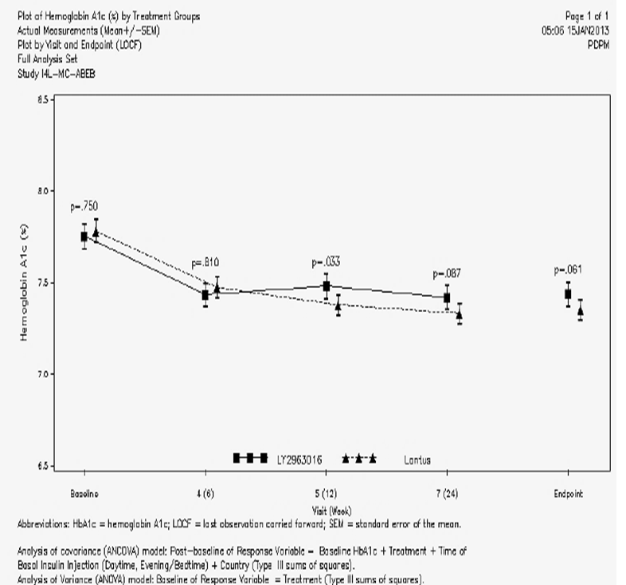

Results for other efficacy outcomes
The outcomes Change from Baseline in HbA1c at Week 6, Week 12, and Week 24 and the Patients Achieving HbA1c Target Values At Endpoint were in line with the primary endpoint – significant declines from baseline values and no difference between treatment groups.
There were numerous (12) other supportive efficacy outcomes and analyses that were included. These numerous supportive efficacy endpoints are of less scientific interest than the primary endpoint. A few sporadic statistically significant between group differences were noted at some time points. The evaluator is of the view that these are chance observations and that no clinically important efficacy differences were detected between the treatment groups.
There were also some ‘Other’ outcomes, comprising the ITSQ and the ALBSS. No between group differences were seen in the ITSQ and in the ALBSS.

Evaluator’s conclusions on clinical efficacy
For Insulin glargine is an insulin analogue indicated for once-daily subcutaneous administration in the treatment of type 1 diabetes mellitus in adults and children and type 2 diabetes mellitus in adults who require insulin for the control of hyperglycaemia.
The first indication is subdivided in to adults and children; the second is limited to adults.
In regard to T1DM, Study ABEB satisfied the requirements of its a priori sample size calculations and analytical plan. It was conducted in the light of advice received from the FDA and from the EMA. The study groups were well-matched. However, Study ABEB was of open label design and it is uncertain as to how much this might have affected the behaviour of investigators in order to achieve similar improvements in both groups against baseline HbA1c readings. Within this major limitation, Study ABEB supports equi-efficaciousness of Abasria and Lantus as the basal insulin component in the treatment regimen of patients with T1DM. The supportive efficacy outcomes in Study ABEB are of doubtful clinical value.
In regard to T2DM, The evaluator accepts that comparable efficacy to Lantus EU and Lantus US was shown in study ABEC, a study that exceeded the predetermined sample size and that had a modest dropout rate. The results of the study show comparable efficacy – including comparable improvement from baseline in both treatment groups that is comparable also in terms of subgroups of previous Lantus use or insulin-naïve patients. The patient population was reasonably representative of patients with T2DM who require a basal insulin, matching Lantus’ registered indication. It is clear that a large majority of subjects was not tightly controlled at study entry.

Clinical safety

Studies providing evaluable safety data
The following types of studies provided evaluable safety data:
- Phase I Studies
- Phase III Studies
The Phase I Studies were numerically dominated by the use of healthy volunteers, so most adverse events were procedure related (invasive procedures, intercurrent illnesses, hypoglycaemia). No new safety concerns arose from these Phase I studies.
The erratic absorption of insulin, in some individuals in at least one period of the replicate studies, suggests limits to the reliability of insulin glargine (whether as Abasria or Lantus) as a slow release pharmaceutical.
The Phase III Studies are of uneven quality (ABEC was blinded; ABEB was open) but both were large enough to define common adverse events and both included a blinded centralised review of possible immunological adverse events as well as binding activity of insulin antibodies.
I have referred to ABEB and ABEC as ‘Phase III Studies’ rather than ‘pivotal’ studies in this section because I do not agree that ABEB is a pivotal study.

Phase III efficacy studies
In the Phase III efficacy studies, the safety data were collected according to this tabulation extracted (and excerpted) from Table 15, Module 5 Study report:

Table 15: Study schedule Protocol I4L-MC-ABEC
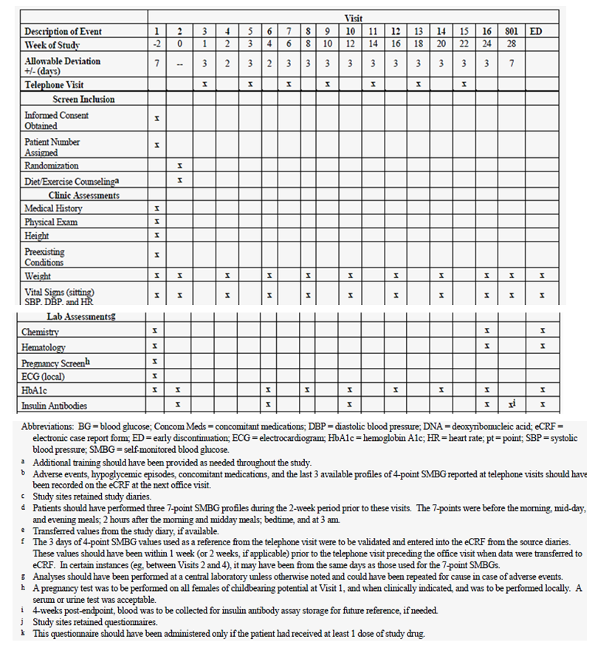

Phase III studies that assessed safety as a primary outcome
Neither Study ABEC nor Study ABEB had specific safety objectives as primary outcomes. It is noted that both had one secondary outcome that is arguably safety-related, ‘To compare LY2963016 relative to Lantus® with regard to intrapatient blood-glucose (BG) variability; basal and prandial (separately and as total daily) insulin dose; and weight when used in combination with pre-meal insulin lispro.’ This outcome has been presented in the efficacy discussion of each study. Study ABEC had also this secondary outcome: ‘To compare the safety of LY2963016 relative to Lantus® (eg, incidence of anti-insulin antibodies, hypoglycemia, adverse events [AEs]) when used in combination with OAMs’.

Dose-response and non-pivotal efficacy studies
Not applicable.

Other studies evaluable for safety only
Not applicable.

Phase three studies that assessed safety as a primary outcome
Not applicable.

Patient exposure in Phase Three studies
As noted in the Module 2.7 safety summary, a total of 536 patients with T1DM and 759 patients with T2DM were randomly assigned to treatment in Studies ABEB and ABEC, respectively. Of these patients, a total of 535 patients with T1DM and 756 patients with T2DM received at least 1 dose of randomly assigned study drug, comprising the Full Analysis Sets (FAS), and serving as the populations of interest for analyses in the applicant’s safety analyses. The mean duration of exposure for patients in Study ABEB was 23.32 weeks and 23.66 weeks for the Abasria and Lantus® groups, respectively; mean duration of exposure in Study ABEC was 22.38 and 22.13 weeks, respectively. The dose of insulin glargine was according to the same treatment paradigm in each study; the locally approved PI informed the use of insulin glargine.
The following comparative table is from the Module 2.7 safety summary; it matches the patient numbers in the Module 5 study reports.

Table 16. Exposure (by duration) to Abasria and Lantus in Phase III clinical studies.
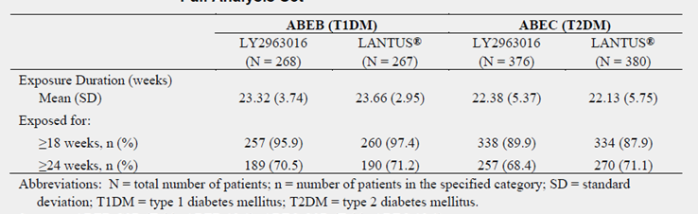
There is no experience beyond the cut-off point of Studies ABEB and ABEC i.e. 24 weeks on treatment.

Adverse events

All adverse events (irrespective of relationship to study treatment)

Phase III studies
Table 17 below contains an overall summary of adverse events in both phase three studies.

Table 17: Overall summary of adverse events in both phase three studies. Studies ABEB and ABEC. Full analysis set
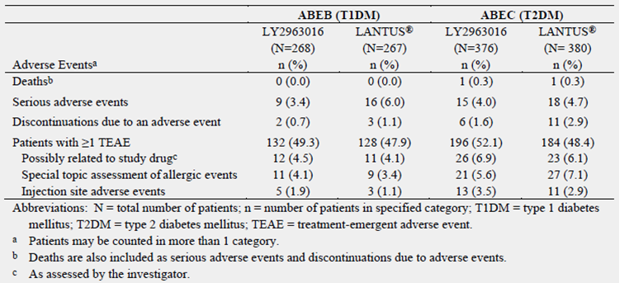

Common and Very Common Adverse Events:
The two phase three studies were based on different populations, so it is not reasonable to pool the safety data. However, in addition to the separate presentation of common adverse events, it is convenient to examine the data concisely in the tabulation of common adverse events that was provided by the applicant.
Table 18 below includes all common treatment emergent adverse events reported in the phase three studies. It has been taken from the Module 2.7 safety summary. It can be said that very common and common adverse events were reasonably balanced across treatment groups in both studies.

Table 18: Phase III studies. Common treatment emergent adverse events in ≥1% of patients in any treatment group Study ABEB and Study ABEC. Full analysis set.
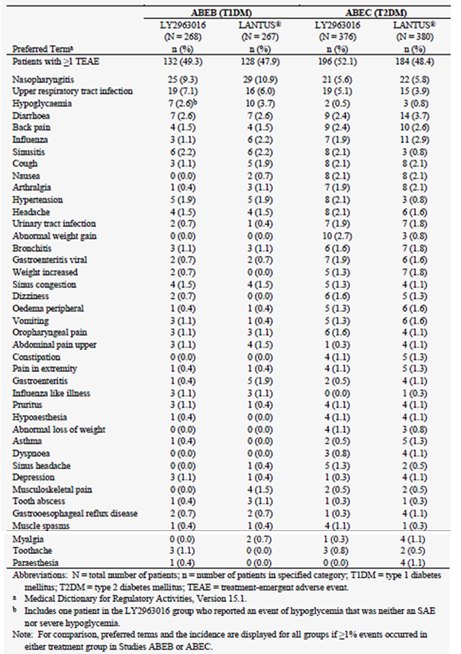

Treatment-related adverse events (adverse drug reactions)

Phase III studies
The applicant did not ascribe causality to non-serious adverse events; investigators were able to do so. See Table 19 below taken from Module 2.7, for the proportion of AEs that were considered to be treatment-related. The numbers of affected patients is close to equal in each treatment group but looks low (up to 4.5% in ABEB, up to 6.9% in ABEC).
It is obvious that local injection reactions and hypoglycaemia are treatment related. Hypoglycaemic adverse events are described below because severe episodes were considered to be serious adverse events.

Table 19: Overall summary of adverse events in Studies ABEB and ABEC Full analysis set
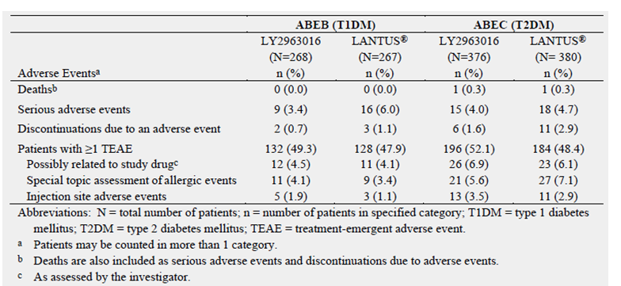

Local injection site reactions:
Injection site AEs were a topic of interest, so both protocols provided for an evaluation of pain, pruritus, and rash associated with the injection, as well as the characteristics of the injection site (abscess, nodule, lipoatrophy, lipohypertrophy, or induration). For reasons unknown, injection site reactions were not mentioned in Table 18 above. As shown in Table 19, injection site reactions were more frequently seen with Abasria in both studies. Study ABEC was blinded and it is of note that injection site reactions were more frequently reported and more equally distributed than in Study ABEB. A little more detail is provided in Table 20 below. Some injection site reactions involved reports of pain:
- In Study ABEC, injection site pain - Abasria: 3 patients [0.8%], Lantus®: 3 patients [0.8%];
- In Study ABEB, five patients (1.9%) in the Abasria group and 3 patients (1.1%) in the Lantus® group reported injection site AEs. Most patients reporting injection site AEs reported having mild or moderate pain associated with the injection (Abasria: 5 patients [1.9%]; Lantus®: 2 patients [0.7%])
If Abasria is in fact less well tolerated locally than Lantus, this will become clearer from post-marketing data, including consumers’ complaints.

Other studies
Not applicable.

Deaths and other serious adverse events

Phase III studies

Deaths:
Two deaths were reported in Study ABEC, one in each treatment group. No deaths occurred in Study ABEB.
[information redacted] (Lantus®), a [information redacted] male using Lantus® prior to study entry, had a medical history that included arrhythmia, hypertension, hyperlipoproteinaemia, and diabetes mellitus. The patient experienced an SAE of myocardial infarction with a fatal outcome approximately 1 month after initiating study drug.
[information redacted] (Abasria), [information redacted] female, insulin-naïve patient with a medical history that included hypertonia, hyperlipoproteinaemia, and diabetes mellitus, experienced an SAE of lung adenocarcinoma with a fatal outcome approximately 7 months after initiating study drug (duration of treatment with study drug was approximately 5 months). The respective investigators assessed the deaths as not related to study drug or study procedure.
The case narratives were provided. The evaluator finds the deaths are unlikely to be related to the study drugs.

Serious adverse events:
Serious adverse events have been presented for the individual studies of this report. As shown above, serious adverse events were slightly more frequent in the Lantus groups than in the Abasria groups in the phase three studies.
See Table 20, taken from the applicant’s Table 2.7.4.8 for a comparison of serious adverse events in both studies.

Table 20:- Comparison of serious adverse events in both studies. Studies ABEB and ABEC. Full analysis set.

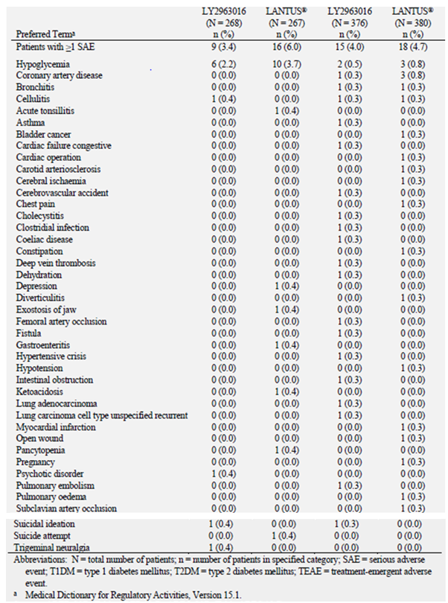

Neoplasms:
Also of note are neoplasms that were reported on study. Insulin glargine is agonistic at IGF-1 receptors, to a greater degree than native human insulin. As the exposure was up to 24 weeks, causation is difficult to attribute to insulin glargine. The following table was taken from the Module 2.7 safety summary. Patient [information redacted] is discussed under Deaths.

Table 21: Listing of Neoplasms Studies ABEB and ABEC. Full analysis set
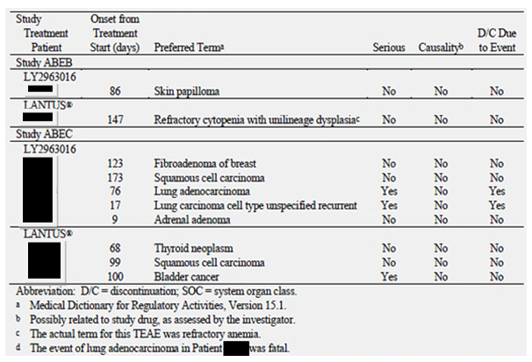

Hypoglycaemia:
Severe hypoglycaemia was considered to be a serious adverse event. Both phase three studies included provisions for data gathering in case of suspected hypoglycaemia. Patients were instructed to check their blood glucose level, whenever possible, if they had symptoms suggestive of hypoglycaemia. For each hypoglycemic event, patients were to record their blood glucose level, associated symptoms, and treatment in their study diaries.
Module 2.7 states that,
‘A hypoglycaemic event was defined as follows:
- Any time a patient felt that he/she was experiencing a sign or symptom that was associated with hypoglycaemia; OR
- A blood glucose level ≤3.9 mmol/L, even if it was not associated with signs, symptoms, or treatment consistent with current guidelines (ADA 2005).’
However, the study protocols included descriptors for several subtypes:
- ‘Severe hypoglycemia was defined as a hypoglycemic event that required assistance of another person to actively administer carbohydrate, glucagons, or other resuscitative actions. These episodes may have been associated with sufficient neuroglycopenia to induce seizure or coma. Blood glucose measurements may not have been available during such an event, but neurological recovery attributable to the restoration of BG to normal was considered sufficient evidence that the event was induced by low plasma glucose. Episodes of severe hypoglycemia were also to be recorded as SAEs.
- Nocturnal hypoglycemia was defined as any hypoglycemic event that occurred between bedtime and waking. Non-nocturnal hypoglycemia was defined as any hypoglycemic event that occurred between waking and bedtime.
As well as these, other types of hypoglycaemia were included in the individual study tabulations.
See Table 18 above for the comparisons within each study regarding severe hypoglycaemia; Table 17 contains the corresponding information for all types of hypoglycaemia.
In practice, there was no imbalance between the two treatment groups in both phase three studies in regard to hypoglycaemia.

Discontinuation due to adverse events

Phase III studies
As shown in Table 20 above, serious adverse events were slightly more frequent in the Lantus groups than in the Abasria groups in the phase three studies. Five patients (Abasria: 2; Lantus®: 3) in Study ABEB and 17 patients (Abasria: 6; Lantus®: 11) in Study ABEC discontinued due to an adverse event.
Discontinuations for events that were considered to be causally related to the study drug were few: in ABEC there were fewer discontinuations in the Abasria group (one case of injection site pain) than in the Lantus group (one each of oral paraesthesia, injection site mass and fatigue); in ABEB there was one such discontinuation only, in the Lantus group for hypoglycaemia.

Laboratory tests
In ABEC and ABEB, there was a centralised process for logging laboratory test results and recording them in SI units, also generating comparisons with standard reference ranges. This does not appear to refer to standardisation or to Quality Assurance of laboratory results across many centres.

Study ABEC
The applicant presented group mean data at several time points for Study ABEC. No clinically significant changes occurred with respect to haematological (erythrocyte count, haematocrit, haemoglobin, leucocyte count, platelet count) or of chemistry variables (ALT, AST, bilirubin, alkaline phosphatase, albumin, urea, potassium, sodium, creatinine). Individual data listings were provided for abnormal laboratory results. The evaluator concludes that no pattern related to either study drug was present, as might have been expected.

Study ABEB
The study summary included listings in table ABEB 14.8 of all patients with abnormal laboratory results during the conduct of the study. [From Study ABEB Module 5 Study report, page 174/4817]
‘Small, but statistically significant treatment differences were observed for LS mean change from baseline to endpoint (LOCF) for creatinine (LY2963016: 0.50 micromole/L; Lantus®: 2.42 micromole/L; LS mean difference [SE]: -1.92 mmol/L [0.85]; p=.025) and hemoglobin (LY2963016: -0.09 mmol/L; Lantus®: -0.01 mmol/L; LS mean difference [SE]: -0.09 mmol/L [0.04]; p=.028).’
The clinical chemistry listings reflected a population with prevalent renal impairment and some hepatic disease. The blood count results that were abnormal were in general only marginally outside the reference ranges.

Electrocardiograph

Pivotal studies

ABEC and ABEB:
An ECG was collected at screening to determine eligibility of the patient for entry into the study. The ECG was interpreted by a qualified physician (the investigator or qualified designee) at the site as soon after the time of ECG collection as possible, for immediate patient management and to determine whether the patient met entry criteria. If the ECG results were considered abnormal and clinically significant, they were entered as an AE. ECGs could have been repeated for ascertainment of cause in case of adverse events. That is, ECGs were not routinely repeated.

Vital signs

Phase III studies
As reported in the Module 5 study report of Study ABEB,
‘Patient vital signs (DBP, SBP, and HR) were taken at specified times throughout the study.’ ‘For DBP, SBP, and HR, there were no statistically significant differences between treatment groups for actual values or change from baseline at any visit or endpoint (LOCF). From baseline to endpoint (LOCF), DBP decreased by an LS mean value of 0.95 mm Hg and 1.01 mm Hg for the LY2963016 group and Lantus® group, respectively; SBP decreased by an LS mean value of 2.69 mm Hg and 0.83mm Hg, respectively; and HR changed by an LS mean of -0.96 bpm and 0.17 bpm, respectively.’
As reported in the Module 5 study report of Study ABEC,
‘From baseline to endpoint (LOCF), DBP decreased by LS mean values of 2.26 mm Hg and 1.23 mm Hg in the LY2963016 and Lantus® groups, respectively. There was a statistically significant treatment difference in the change from baseline to Visit 12 (Week 16); DBP decreased by an LS mean value of 2.97 mm Hg in the LY2963016 group and by 1.02 mm Hg in the Lantus® group (LS mean difference: -1.95 mm Hg; p=.014). There were no statistically significant differences in actual measurements or change from baseline at any other visit or endpoint (LOCF) for DBP.’ ‘Systolic blood pressure decreased from baseline to endpoint (LOCF) by LS mean values of 2.64 mm Hg and 0.63 mm Hg in the LY2963016 and Lantus® groups, respectively. There were no statistically significant treatment differences in actual measurements or change from baseline at any visit or endpoint (LOCF).’
Heart rate varied slightly in ABEC,
‘From baseline to endpoint (LOCF), HR decreased by an LS mean value of 0.37 bpm in the LY2963016 group and increased by 0.13 bpm in the Lantus® group.’
This was not significant. There were minor differences at some visits that were significant (a group means difference of <2 beats per minute on two occasions, and 2.03 beats per minute or less versus baseline on three occasions within each group.
In summary, no important changes in vital signs were noted over the course of both studies.

Insulin antibodies and immunological adverse events

Insulin antibodies
Taking both Phase III studies together, for conciseness of presentation:
- There was a centralised testing method at one laboratory.
- In both studies, the ‘… number and percentage of patients who had a treatment-emergent antibody response (TEAR) was summarized by treatment group at each postbaseline visit and endpoint (LOCF), and analyzed using Fisher’s Exact test or Pearson’s Chi-square test. Treatment-emergent antibody response (TEAR) was defined as an absolute increase of at least 1% in insulin antibody levels (measured in % binding) AND at least a 30% relative increase from baseline for patients who were insulin-antibody positive at baseline, or changed from insulin-antibody negative status at baseline to antibody positive during the course of the study following treatment with study drug.’ [ABEB Study report, page 64/4817].
- The following table is drawn from Module 2.7:

Table 22: Proportion of patients with detectable antibodies. Summary at baseline, end point (LOCF), and overall. full analysis set.
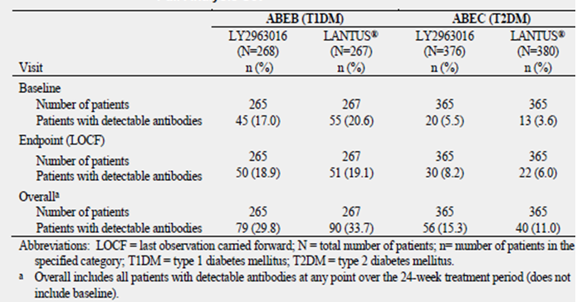
However, these two populations are unalike in immunological terms and in regard to the duration of previous exposure to insulin injections (many patients in ABEC were insulin naïve; thus 6% of the Abasria group vs. 5.8% of the Lantus group showed a treatment emergent antibody response). From these baseline-to-endpoint comparisons, it can be said that no between-group differences emerged in studies ABEB and ABEC but the proportion of patients with detectable antibodies rose over time. In Study ABEB, insulin antibodies were both very common (31% overall) but manifested at about 18-22% at each visit. This rising frequency of antibodies was not noted to have safety or efficacy correlates but 12 month data will shortly be available from Study ABEB.
Table 23, from the Module 2.7 Safety Summary, contains subgroup analyses on the relationship between overall TEAR status and clinical outcomes.

Table 23: Subgroup analyses: Relationship between TEAR status at endpoint (LOCF) and clinical outcomes. Summary analysis of change from baseline to 24 week end point using ANCOVA. Studies ABEB and ABEC.
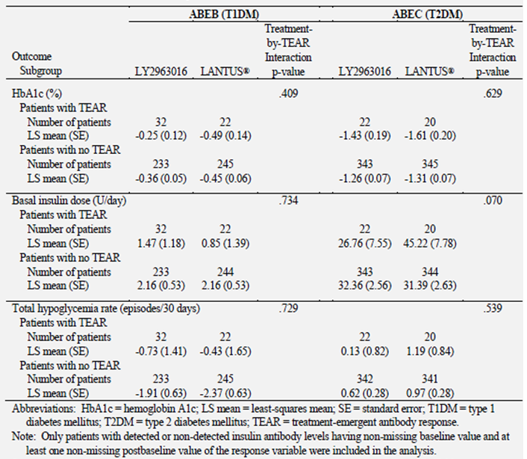
In regard to TEAR, the prevalence was high in both treatment arms.
‘For patients who were negative for insulin antibodies at baseline, TEAR was defined as changing from insulin-antibody negative to insulin antibody positive during the course of the study following treatment with study drug. For patients who were positive for detectable insulin antibodies at baseline, TEAR was defined as an absolute increase of at least 1% in insulin antibody levels (measured in % binding) AND at least a 30% relative increase in insulin antibody levels from baseline. Over the entire 24-week treatment period, 108 patients (20.3%) developed TEAR (LY2963016: 56 patients [21.1%]; Lantus®: 52 patients [19.5%]; p=.667). There were no statistically significant differences between treatment groups for the number of patients with TEAR at any visit, endpoint (LOCF), or overall.’[Module 5 Study report, p. 160/4817]
The applicant postulates optimistically,
‘Since the assay for antibodies to LY2963016 also detects antibodies that cross-react to insulin and insulin analogs, it is likely that antibodies present at baseline represent antibodies to insulin or insulin analogs that the patient may have been on prior to enrolling in Study ABEB. Similarly, the characteristics of the antibody assay do not allow for differentiation of a TEAR event deriving from reactivation of quiescent B cells to insulin or an insulin analog the patient may have taken previously, or new antibody formation to LY2963016.’ [Module 5 Study Report, p. 160/4817]
Comment: Perhaps but there is a problem with not having a specific assay. In regard to the first speculative sentence, absence of evidence of cross-reactive antibodies to other insulins is not evidence of absence of emergent antibodies to insulin glargine. In regard to the second, the same comment applies - it is not possible to whittle down the frequency of TEARs in this way.

Immunological/Allergic AEs
In both Phase III studies, the assessment of allergic events was performed by an initial blinded reviewer, a physician employed by Eli Lilly, using preferred terms by SOC in order to identify all possible cases of allergic events.
As shown in Table 24 below, Abasria was slightly less associated with adverse events that are potentially mediated immunologically; no important differences occurred between groups in either study.

Table 24: Phase III Studies - Possible Allergic Events. Studies ABEB and ABEC. Full analysis set.
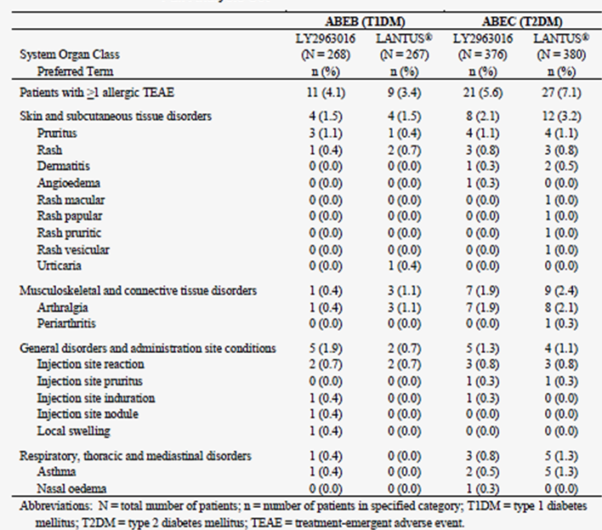

Post-marketing experience
Marketing has not yet occurred in any country.

Safety issues with the potential for major regulatory impact

Neoplasms
As mentioned above, a few neoplasms were reported in both studies. The matter deserves long term targeted surveillance because:
- Insulin glargine is agonistic at the IGF-1 receptor
- The approved PI of Lantus states,
‘IGF-1 receptor binding: The affinity of insulin glargine for the human IGF-1 receptor is approximately 5 to 8-fold greater than that of human insulin (but approximately 70 to 80-fold lower than the one of IGF-1), whereas M1 and M2 bind the IGF-1 receptor with slightly lower affinity compared to human insulin. The total therapeutic insulin concentrations (insulin glargine and its metabolites) found in type 1 diabetic patients was markedly lower than what would be required for a half maximal occupation of the IGF-1 receptor and the subsequent activation of the mitogenic-proliferative pathway initiated by the IGF-1 receptor. Physiological concentrations of endogenous IGF-1 may activate the mitogenic proliferative pathway; however, the therapeutic concentrations found in insulin therapy, including in Lantus therapy, are considerably lower than the pharmacological concentrations required to activate the IGF-1 pathway.’
- The above might not always apply e.g. when early release of insulin glargine occurs from the site of injection, as happened in the Phase I studies. A non-selective assay was used but it is likely that insulin glargine, not M1 was released. Consequently, intermittent release of insulin glargine from the site of injection, in a setting of long term use, has not been excluded.
- The matter has been discussed in the literature since the publication of a retrospective cohort study of German health insurance fund records. A dose-dependent increase in cancer risk was found for treatment with insulin glargine compared with human insulin. The matter has been kept under review by the EMA. The most recent statement was published on 31 May 2013 (EMA/329790/2013 EMEA/H/C/000309). The statement commenced with,
‘On 30 May 2013, the European Medicines Agency completed a review of new data on the cancer risk with insulin glargine-containing medicines. The Agency’s Committee for Medicinal Products for Human Use (CHMP) concluded that the data do not show an increased risk of cancer and that the balance of the medicine’s benefits and risks remains unchanged.’
New information was derived from two further cohort studies and from a case-control study.
‘Based on the assessment of the population-based studies, the CHMP concluded that overall the data did not indicate an increased risk of cancer with insulin glargine, noting that there is no known mechanism by which the insulin glargine would cause cancer and that a cancer risk has not been seen in laboratory studies. As for all medicines, the Agency will continue to assess any new data that become available in this area, as part of the routine monitoring of the medicine.’
- The evaluator does not wish to split hairs but there is difference between ‘no known mechanism by which the insulin glargine would cause cancer’ (there is no suggestion that insulin glargine is for example genotoxic) and a potential to promote tumours by an agonistic effect at IGF-1 receptors. Consequently, postmarketing surveillance will possibly be contributory but the studies would need to be long term and be capable of dealing with confounders such as HMG CoA reductase inhibitors and low dose aspirin, both of which are commonly prescribed to diabetic patients.
- Nonetheless, there is no basis for suggesting that Abasria presents a different degree of risk from Lantus, so registration of Abasria cannot be opposed on the grounds of potential neoplasia.

Evaluator’s overall conclusions on clinical safety
The Phase III studies are of sufficient size and duration to establish in terms of common adverse events. They enrolled reasonably representative populations of Type 1 and Type 2 diabetics that were using treatment regimens relevant to recommended clinical practice in this country. The study in Type 1 diabetics has an ongoing extension phase that should be submitted as a post-registration commitment. Its open design admits the possibility of bias.
No new safety signals emerged and Abasria was not worse than Lantus in terms of the frequency of serious adverse events. Abasria appears to be registrable on clinical safety grounds. The 12 month data on Study ABEB should be submitted for evaluation when they become available.

First round benefit-risk assessment

First round assessment of benefits
The benefits of Abasria in the proposed usage are:
- Not different from those of Lantus EU and Lantus US, based on two way non-inferiority in two Phase III studies.

First round assessment of risks
The risks of Abasria in the proposed usage are:
- Not different from those of Lantus EU and Lantus US, based on two the experience in two Phase III studies.
- The evaluator also listed unresolved potential problems regarding the safety the cartridge and clinical data to support the KwikPen device.

First round assessment of benefit-risk balance
The benefit-risk balance of Abasria cartridges is unfavourable given the proposed usage, but would become favourable if the uncertainty raised should be resolved.

First round recommendation regarding authorisation
Registration should not proceed at present, pending resolution of the matters raised above.
Submission of the completed (52 weeks of data) Study ABEB should be a condition of registration.

Clinical questions

Pharmacokinetics
- In study ABEN, the source of the US Lantus in unclear – as mentioned in table APP.2.7.1.4.24, the US Lantus was bought in Germany. The applicant should confirm and clarify how this can be correct.
- The applicant should clarify if [information redacted] were the investigator and whose signature appears on I4L-MC-ABEI CSR Appendix Signature. The applicant should also confirm that Lantus EU was used in Study ABEI.

Pharmacodynamics
Nil.

Efficacy
Nil.

Safety
Nil.

Second round evaluation of clinical data submitted in response to questions
The sponsor responded to the issues raised about the KwikPen as follows:
‘There is no basis for the assumption that medication error is more likely to occur with Abasria compared to other insulins currently available, including the reference product in this application, without a dedicated pen and should therefore be removed from the evaluation report. The evaluator also states no information is available on the KwikPen device with respect to dose accuracy. This statement is incorrect as Module 3.2R.3 includes the required device testing information.’

References
- Module 1.13.1 Australian Annex to the RMP, page 6 of 7.
- From Table 2.3.P.1-1, modified to use Australian Approved Names.
- Hemkens LG, Grouven U, Bender R, Günster C, Gutschmidt S, Selke GW, Sawicki PT. Risk of malignancies in patients with diabetes treated with human insulin or insulin analogues: a cohort study. Diabetologia. 009;52:1732–1744.
Therapeutic Goods Administration
PO Box 100 Woden ACT 2606 Australia
Email: info@tga.gov.au Phone: 1800 020 653 Fax: 02 6232 8605
https://www.tga.gov.au

With a subsequent application, which followed the TGA’s evaluation and approval of this application, the registered names were amended on the ARTG to: ARTG 2155552 Basaglar KwikPen insulin glargine (rbe) 100 IU/mL solution for injection cartridge and ARTG 215551 Basaglar insulin glargine (rbe) 100 IU/mL solution for injection cartridge
This is by reference to Lantus as a composite of two different provenances (EU and USA).
The 28 week extension was not available for submission.

