August 2020

Australian Public Assessment Report for Insulin aspart (rys)
  - Proprietary Product Name: Fiasp, Fiasp Penfill, and Fiasp FlexTouch
  - Sponsor: Novo Nordisk Pharmaceuticals Pty Ltd

About the Therapeutic Goods Administration (TGA)
- The Therapeutic Goods Administration (TGA) is part of the Australian Government Department of Health and is responsible for regulating medicines and medical devices.
- The TGA administers the Therapeutic Goods Act 1989 (the Act), applying a risk management approach designed to ensure therapeutic goods supplied in Australia meet acceptable standards of quality, safety and efficacy (performance) when necessary.
- The work of the TGA is based on applying scientific and clinical expertise to decision-making, to ensure that the benefits to consumers outweigh any risks associated with the use of medicines and medical devices.
- The TGA relies on the public, healthcare professionals and industry to report problems with medicines or medical devices. TGA investigates reports received by it to determine any necessary regulatory action.
- To report a problem with a medicine or medical device, please see the information on the TGA website <https://www.tga.gov.au>.

About AusPARs
- An Australian Public Assessment Report (AusPAR) provides information about the evaluation of a prescription medicine and the considerations that led the TGA to approve or not approve a prescription medicine submission.
- AusPARs are prepared and published by the TGA.
- An AusPAR is prepared for submissions that relate to new chemical entities, generic medicines, major variations and extensions of indications.
- An AusPAR is a static document; it provides information that relates to a submission at a particular point in time.
- A new AusPAR will be developed to reflect changes to indications and/or major variations to a prescription medicine subject to evaluation by the TGA.

Copyright
© Commonwealth of Australia 2020
This work is copyright. You may reproduce the whole or part of this work in unaltered form for your own personal use or, if you are part of an organisation, for internal use within your organisation, but only if you or your organisation do not use the reproduction for any commercial purpose and retain this copyright notice and all disclaimer notices as part of that reproduction. Apart from rights to use as permitted by the Copyright Act 1968 or allowed by this copyright notice, all other rights are reserved and you are not allowed to reproduce the whole or any part of this work in any way (electronic or otherwise) without first being given specific written permission from the Commonwealth to do so. Requests and inquiries concerning reproduction and rights are to be sent to the TGA Copyright Officer, Therapeutic Goods Administration, PO Box 100, Woden ACT 2606 or emailed to <tga.copyright@tga.gov.au>.

Contents
Common abbreviations 4
I. Introduction to product submission 6
Submission details 6
Product background 7
Regulatory status 8
Product Information 9
II. Registration timeline 9
III. Submission overview and risk/benefit assessment 9
Quality 9
Nonclinical 10
Clinical 10
Risk management plan 18
Risk-benefit analysis 19
Outcome 19
Attachment 1. Product Information 20

Common abbreviations
Abbreviation | Meaning
ACM | Advisory Committee on Medicines
ARTG | Australian Register of Therapeutic Goods
ASA | Australian specific Annex
AUC | Area under the concentration-time curve
AUC_{IAsp} | Area under the insulin aspart concentration time curve
B/T | Bound/total radiolabelled insulin aspart co-precipitated with immunoglobulin
CGM | Continuous glucose monitoring
CGMS | Continuous glucose monitoring subgroup
CI | Confidence interval
CMI | Consumer Medicines Information
CSII | Continuous subcutaneous insulin infusion
EMA | European Medicines Agency (European Union)
EU | European Union
FAS | Full analysis set
FPG | Fasting plasma glucose
GVP | Good Pharmacovigilance Practices
HbA1c | Glycated haemoglobin A1c
ISPAD | International Society for Pediatric and Adolescent Diabetes (Berlin, Germany)
IV | Intravenous
LLOQ | Lower limit of quantification
LSMeans | Least-squares means
PD | Pharmacodynamic(s)
PG | Plasma glucose
PI | Product Information
PK | Pharmacokinetic(s)
PSUR | Periodic safety update report
RMP | Risk management plan
SC | Subcutaneous
T_{½} | Half-life
T1DM | Type 1 diabetes mellitus
T2DM | Type 2 diabetes mellitus
T_{max} | Time to maximum observed concentration
U | Units
USA | United States of America

I. Introduction to product submission

Submission details
Type of submission: | Extension of indications
Decision: | Approved
Date of decision: | 11 March 2020
Date of entry onto ARTG: | 13 March 2020
ARTG numbers: | 275375, 275393, 275394
Black Triangle Scheme | Yes  This product will remain in the scheme for 5 years, starting on the date the new indication was approved
Active ingredients: | Insulin aspart (rys)
Product names: | Fiasp; Fiasp Penfill; and Fiasp FlexTouch
Sponsor’s name and address: | Novo Nordisk Pharmaceuticals Pty Ltd  Level 3, 21 Solent Circuit, Baulkham Hills, NSW 2153
Dose form: | Solution for injection
Strength: | 100 units (U)/mL
Containers: | Cartridge, vial, prefilled pen
Pack sizes: | Fiasp FlexTouch: 1 x 3 mL and 5 x 3 mL prefilled pen(s)  Fiasp vial: 1 x 10 mL vial  Fiasp Penfill: 5 x 3 mL cartridges
Approved therapeutic use: | Treatment of diabetes mellitus in adolescents and children aged 1 year and above
Routes of administration: | Subcutaneous (SC), intravenous (IV)
Dosage: | Fiasp should be administered 0 to 2 minutes prior to starting a meal. Administration of Fiasp up to 20 minutes after starting a meal in adults was as efficacious as NovoRapid; given before a meal.  Fiasp can be used for continuous subcutaneous insulin infusion (CSII) in pumps or be administrated intravenously by healthcare professionals.  Dosing with Fiasp is individual and determined in accordance with the needs of the patient, in particular the estimated carbohydrate consumption and glycaemic load of the meal.  See the Product Information for further details.

Product background
This AusPAR describes the application by Novo Nordisk Pharmaceuticals Pty Ltd (the sponsor) to register Fiasp, Fiasp Penfill and Fiasp FlexTouch containing insulin aspart (rys) 100 units/mL solution for injection for the following proposed extension of indications:
Treatment of diabetes mellitus in adults, adolescents and children aged 1 year and above.
Type 1 diabetes mellitus (T1DM) is an auto-immune condition in which the immune system is activated to destroy the beta cells in the pancreas that produce insulin. The exact cause of this auto-immune reaction is not known. Family history of T1DM has a strong link to the development of this condition. T1DM is not linked to modifiable lifestyle factors. No cure has been found so far and this condition cannot be prevented.
T1DM occurs when pancreas does not produce insulin. In Australia, T1DM accounts for around 10% of all cases of diabetes. It is one of the most common chronic childhood conditions. Onset is usually abrupt and the symptoms include excessive thirst and urination, unexplained weight loss, weakness and fatigue and blurred vision.
In Australia, there were 2,600 new cases of T1DM diagnosed in 2016 that corresponds to an estimate of 12 cases per 100,000 population. The incidence rate for 0 to14 year olds remained on average 1.5 times as high as for those aged 15 to 24 years and 4 times as high as for those aged 25 years and over (Figure 1).
Figure 1: Trends of incidence of type 1 diabetes mellitus by age (Australian Institute of Health and Welfare)
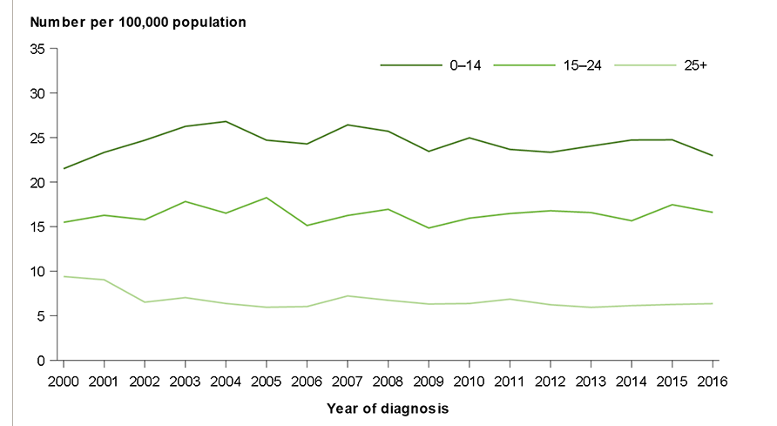
There are unique challenges in the management of children and adolescents with diabetes. These include the obvious differences in the size of the patients, developmental issues such as the unpredictability of a toddler's dietary intake, activity level and inability to communicate symptoms of hypoglycaemia. Medical issues such as hypoglycaemia and diabetic ketoacidosis have an increased risk of incidence in children, compared to adults.
Insulin therapy is the mainstay of treatment for T1DM in children.
Table 1: List of the TGA approved fast-acting insulins available for children and adolescents
Trade name | Active ingredient | Indication
Humalog | insulin lispro | For the treatment of patients with type 1 (insulin-dependent diabetes mellitus) and type 2 (non-insulin-dependent diabetes mellitus) diabetes mellitus who require insulin for the maintenance of normal glucose homeostasis
NovoRapid | insulin aspart | Treatment of diabetes mellitus
Apidra | insulin glulisine | Apidra is indicated for the treatment of type 1 and type 2 diabetes mellitus in adults and children of 4 years or above who require insulin for the control of hyperglycaemia.
Fiasp is a fast-acting insulin aspart formulation currently registered for treatment of diabetes mellitus in adults. The primary activity of insulin, including insulin aspart, is the regulation of glucose metabolism. Insulin and its analogues exert their specific action through binding to insulin receptors. Receptor-bound insulin lowers blood glucose by facilitating cellular uptake of glucose into skeletal muscle and adipose tissue and by inhibiting the output of glucose from the liver. Insulin inhibits lipolysis in the adipocyte, inhibits proteolysis, and enhances protein synthesis.

Regulatory status
The product received initial registration on the Australian Register of Therapeutic Goods (ARTG) on 27 July 2017 for the indications described above.
Fiasp was first registered in the European Union (EU) on 9 January 2017 for the treatment of diabetes mellitus in adults. The indications were extended to include treatment of children and adolescents aged 1 year and above in July 2019. The EU indications for Fiasp are at present:
Treatment of diabetes mellitus in adults, adolescents and children aged 1 year and above.
Fiasp was first registered in the United States of America (USA) on 29 September 2017 to improve glycemic control in adults with diabetes mellitus. The indications were extended to include paediatric patients in December 2019. The US indications for Fiasp are at present:
Fiasp is a rapid-acting human insulin analog indicated to improve glycemic control in adult and pediatric patients with diabetes mellitus

Product Information
The Product Information (PI) approved with the submission which is described in this AusPAR can be found as Attachment 1. For the most recent PI, please refer to the TGA website at <https://www.tga.gov.au/product-information-pi>.

II. Registration timeline
The following table captures the key steps and dates for this application and which are detailed and discussed in this AusPAR.
Table 2: Timeline for Submission PM-2018-05745-1-5
Description | Date
Submission dossier accepted and first round evaluation commenced | 1 April 2019
First round evaluation completed | 3 September 2019
Sponsor provides responses on questions raised in first round evaluation | 4 November 2019
Second round evaluation completed | 11 December 2020
Delegate’s Overall benefit-risk assessment | 15 January 2020
Sponsor’s pre-Advisory Committee response | Not applicable
Advisory Committee meeting | Not applicable
Registration decision (Outcome) | 11 March 2020
Completion of administrative activities and registration on ARTG | 13 March 2020
Number of working days from submission dossier acceptance to registration decision* | 190
*Statutory timeframe for standard applications is 255 working days

III. Submission overview and risk/benefit assessment
The submission was summarised in the following Delegate’s overview and recommendations.

Quality
There was no requirement for a quality evaluation in a submission of this type.

Nonclinical
There was no requirement for a nonclinical evaluation in a submission of this type.

Clinical
The clinical dossier included one new pharmacokinetics (PK)/pharmacodynamics (PD) study (Study NN1218-4371), another PK/PD study (Study NN1218-3888), and one new efficacy and safety study (Study NN1218-4101).

Pharmacology

Study NN1218-4371
Study NN1218-4371 compared the PK properties of NovoRapid and Fiasp between children, adolescents and adults with T1DM.
The design was a double blind, two period cross over randomised controlled trial. The trial consisted of a screening visit (Visit 1), two dosing visits (Visit 2 to 3, each 2 days), and a follow-up visit (Visit 4). The first dosing visit (Day 1) was 3 to 22 days after the screening visit. The follow-up visit was 7 to 22 days after Visit 3 (Day 2). At the dosing visits, the subjects attended the site the evening before dosing. Overnight infusion of Actrapid; and/or glucose were administered to achieve stable plasma glucose concentrations. Infusions were stopped in the morning prior to dosing. A dose of 0.2 U/kg of either Fiasp or NovoRapid was administered. The test substance was administered within 2 minutes of a standard meal (‘Ensure’, amount adjusted to the patient’s weight).
Thirteen children, 16 adolescents and 17 adults participated in the study. At Baseline, the mean level of anti-insulin aspart antibodies was highest in children at 30.3% bound/total radiolabelled insulin aspart co-precipitated with immunoglobulin (B/T), followed by 36.0% in adolescents and 18.9% in adults.
The primary endpoint was area under the serum insulin aspart concentration-time curve from 0 to 12 hours (AUC_{IAsp,0–12h}).
Free and total insulin aspart were measured by a validated insulin aspart-specific enzyme-linked immunosorbent assay (ELISA).

Pharmacokinetics
Total exposure (AUC_{IAsp,free,0-12h}) of Fiasp was 493 pmol*h/L in children, 604 pmol*h/L in adolescents and 693 pmol*h/L in adults. Total exposure was 29% lower in children (age group ratio: 0.71 (0.61; 0.83) 95% confidence interval (CI)) and 13% lower in adolescents (age group ratio: 0.87 (0.78; 0.98) 95% CI) compared to adults. Both these differences were statistically significant.
Based on systemic total insulin concentration estimation, a greater total exposure (AUC_{IAsp,total,0-12h}) was noted in children and adolescents, compared to adults (Figure 2).
Figure 2: Study NN1218-4371 Mean serum Fiasp (insulin aspart) concentration 0 to 8 hours (full analysis set)
IAsp serum conc = total serum insulin aspart serum concentration.
Horizontal grey line at 10 pmol/L indicates the lower limit of quantification (LLOQ).
The antibody adjusted time to maximal concentration (T_{max}) was shorter in children (47.5 minutes) compared to adolescents (62.8 minutes) and adults (64.0 minutes).
In children, the onset of appearance for free insulin aspart was 5 minutes earlier for Fiasp compared to NovoRapid.
The mean duration of exposure of Fiasp was 10 minutes shorter in children, compared to adults.

Pharmacodynamics: plasma glucose
The plasma glucose concentration was measured over a period of 12 hours following a single dose of Fiasp insulin given just prior to a standardised meal.
Three children and four adults developed hypoglycaemia between 2 to 6 hours of treatment period in Fiasp. They were administered with carbohydrate meal intervention. Hence, these events had an effect on PD parameters that were secondary endpoints (mean change in plasma glucose levels) and assessed between 0 to 6 hours post single dose of Fiasp and standardised meal.
One hour plasma glucose lowering effect from Baseline with Fiasp was comparable across age groups. The two hour plasma glucose lowering effect from Baseline was not significantly different between children and adults; but significantly lower in adolescents compared to adults (see Table 3).
Table 3: Study NN1218-4371 Mean change in plasma glucose, age group comparisons for Fiasp insulin aspart
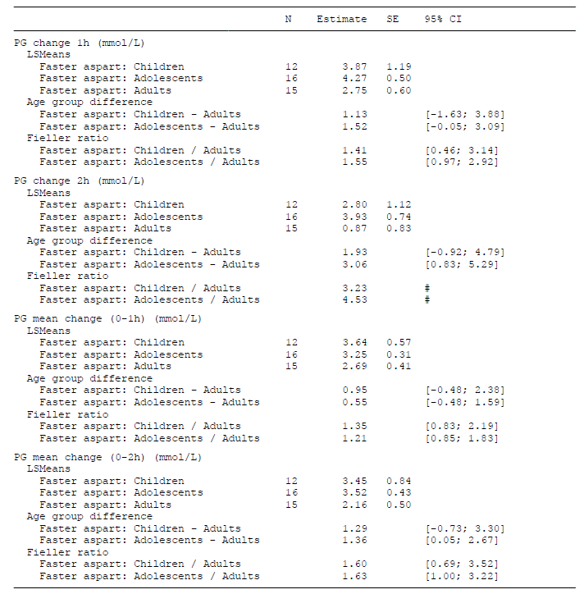
N = number of subjects; SE = standard error; CI = confidence interval; PG = plasma glucose; LSMeans = least-squares means
The maximum plasma glucose excursions from 0 to 2 hours were comparable between children, adolescents and adults.
Fiasp achieved a greater 1 hour and 2 hour glucose lowering effect, compared to NovoRapid in children, adolescents and adults. The treatment difference was statistically significant in adolescents and adults, but not in children.

Study NN1218-3888
Study NN1218-3888 compared the PK properties of NovoRapid and Fiasp in children, adolescents and adults with T1DM.
The design was a single centre, single dose, two period cross over randomised controlled trial. The trial design was similar to Study NN1218-4371. When the subjects had attained a stable plasma glucose concentration, a dose of 0.2 U/kg of either Fiasp or Novorapid was administered. A standard liquid meal (‘Boost’, amount adjusted to the patient’s weight) was given to the subjects within 2 minutes of administering the test substance.
Thirteen children, 13 adolescents and 15 adults participated in the study. At Baseline, the mean level of anti-insulin aspart antibodies was highest in children at 33.2% (B/T), followed by 23.7% in adolescents and 18.7% in adults.
The primary endpoint was area under the serum insulin aspart concentration-time curve from 0 to 12 hours (AUC_{IAsp,0–12h}).
Free insulin aspart were measured by a validated insulin aspart-specific ELISA.

Pharmacokinetics
Total exposure to Fiasp was 397.64 pmol*h/L in children, 524.32 pmol*h/L in adolescents and 671.83 pmol*h/L in adults. The maximum serum Fiasp concentration levels were comparable across age groups (Figure 3).
The time to maximum observed concentration (T_{max}) was shorter in children at 48.5 minutes, compared to adolescents (53.38 minutes) and adults (59.2 minutes).
The mean duration of exposure was shorter for children (280.46 minutes), compared to adolescents (318.04 minutes) and adults (401.52 minutes).
Figure 3: Study NN1218-3888 Mean serum Fiasp insulin aspart concentration 0 to 8 hours
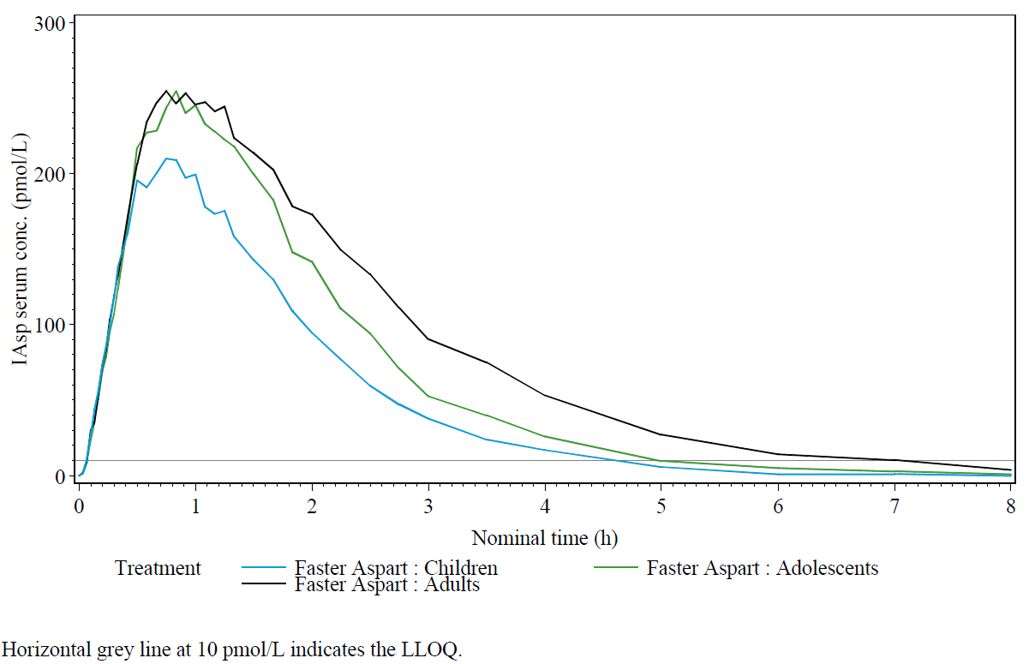
LLOQ = lower limit of quantification
The difference between children, adolescents and adults in the time profile of exposure to Fiasp was very similar to that seen with NovoRapid. The onset of insulin exposure was approximately 5 minutes faster for Fiasp than NovoRapid in all age groups, and the half-life (T_{½}) 25 minutes in all age groups.
Overall, the data submitted show a very similar time profile for Fiasp in children and adolescents compared to adults.

Pharmacodynamics: plasma glucose
The plasma glucose concentration was measured over a period of 12 hours following a single dose of Fiasp insulin given just prior to a standardised meal.
Three children and four adults developed hypoglycaemia between 2 to 6 hours of treatment period in Fiasp. Four children, 1 adolescent and 4 adults developed hypoglycaemia in the same time period with NovoRapid.
Similar changes in plasma glucose at 1 and 2 hours were seen in all age groups (see Table 4). Fiasp achieved less rise in blood glucose within the first 2 hours in all age groups. This was achieved slightly earlier than NovoRapid for children and adolescents.
The maximum plasma glucose excursion during 6 hours post dose of Fiasp was comparable between children (5.77 mmol/L) and adults (5.13 mmol/L). Mean plasma glucose excursion was significantly greater for adolescents (7.25 mmol/L), when compared to adults, consistent with the effects of insulin resistance of puberty.
The glucose lowering effect at 1 hour and 2 hours post dose for Fiasp was comparable across age groups.
At 1 hour post meal, the mean plasma glucose value achieved with Fiasp was 15% lower than NovoRapid. At 2 hours, this difference in mean plasma glucose level was 12%.
Table 4: Study NN1218-3888 Mean change in plasma glucose, age group comparisons for Fiasp insulin aspart
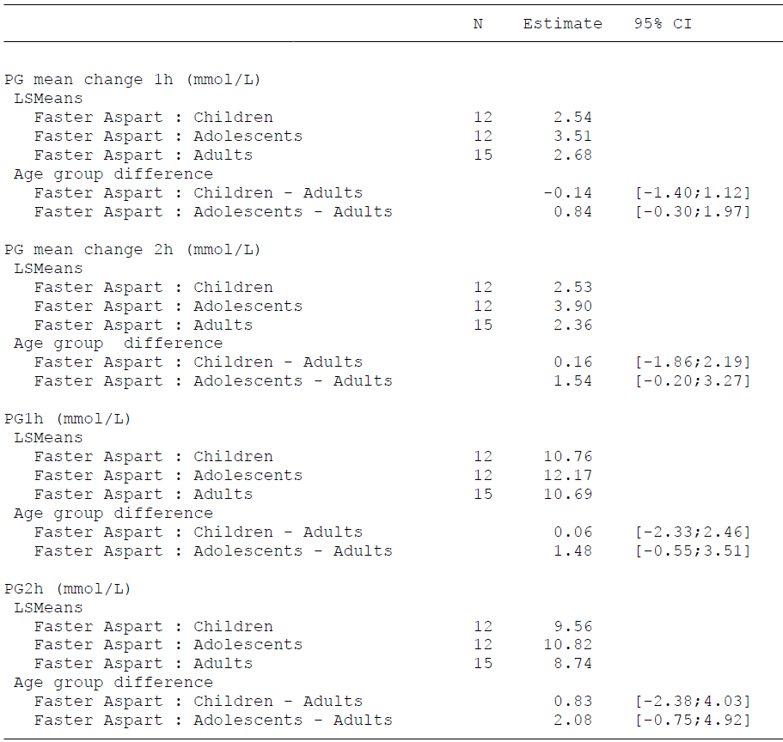
N = number of subjects; CI = confidence interval; PG = plasma glucose; LSMeans = least-squares means

Clinical efficacy and safety

Study NN1218-4101

Primary objective
To demonstrate non-inferiority of meal-time Fiasp to meal-time NovoRapid when used in conjunction with insulin degludec; in children and adolescents with type 1diabetes in terms of glycaemic control.

Secondary objectives
- To demonstrate non-inferiority in terms of glycaemic control of post-meal Fiasp to meal-time NovoRapid.
- To demonstrate superiority in terms of glycaemic control of meal-time Fiasp to NovoRapid.
- To compare efficacy and safety of treatment with meal-time Fiasp versus meal-time NovoRapid.

Methods
Study NN1218-4101 is a 26 week, active controlled, treat-to-target, 3 armed, parallel group randomised controlled trial (study design shown in Figure 4).
Meal time dosing was defined as bolus insulin injected 0 to 2 minutes before the meal and post meal time dosing was defined as bolus insulin injected 20 minutes after the start of the meal. Bolus insulin was administered for each of 3 main meals that is breakfast, lunch and dinner. Additional doses were allowed at the discretion of investigator.
The bolus insulin was titrated to the pre-meal glycaemic target of 4.0 to 8.0 mmol/L and bedtime glycaemic target of 6.7 to 10.0 mmol/L in a treat-to-target approach.
A subset of 150 patients had continuous glucose monitoring subgroup (CGMS). The primary efficacy endpoint was glycated haemoglobin A1c (HbA1c). Secondary efficacy endpoints included 8 point self-measured plasma glucose, insulin dose and fasting plasma glucose (FPG).
Figure 4: Study NN1218-4101 schema and design
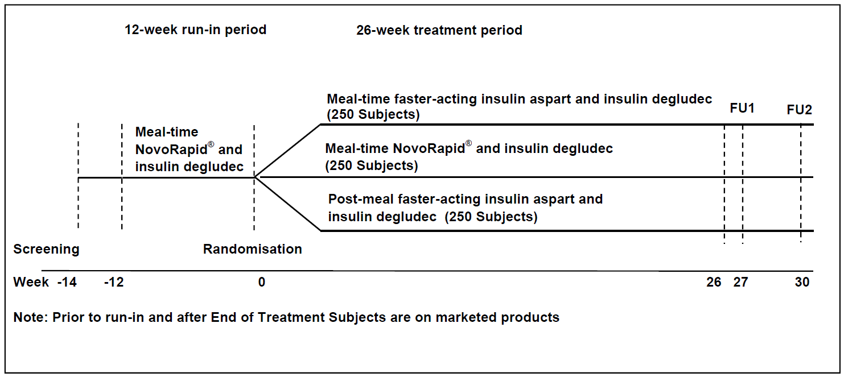
FU1 = follow-up 1; FU2 = follow-up 2

Results
There were 777 patients randomised. Of these, 756 completed the treatment period and 760 completed the trial period. Forty six subjects were aged 1 to 6 years, 301 were aged 6 to 12 years and 430 were aged 12 to 18 years. Weight ranged from 12.3 kg to 103.4 kg.
At Week 26, patients in meal time Fiasp group achieved a 0.06% points change in mean HbA1c from Baseline. In NovoRapid and post meal time Fiasp groups, the mean change in HbA1c were 0.22% and 0.35%, respectively (see Table 5).
Table 5: Study NN1218-4101 Change in HbA1c and treatment difference at Week 26
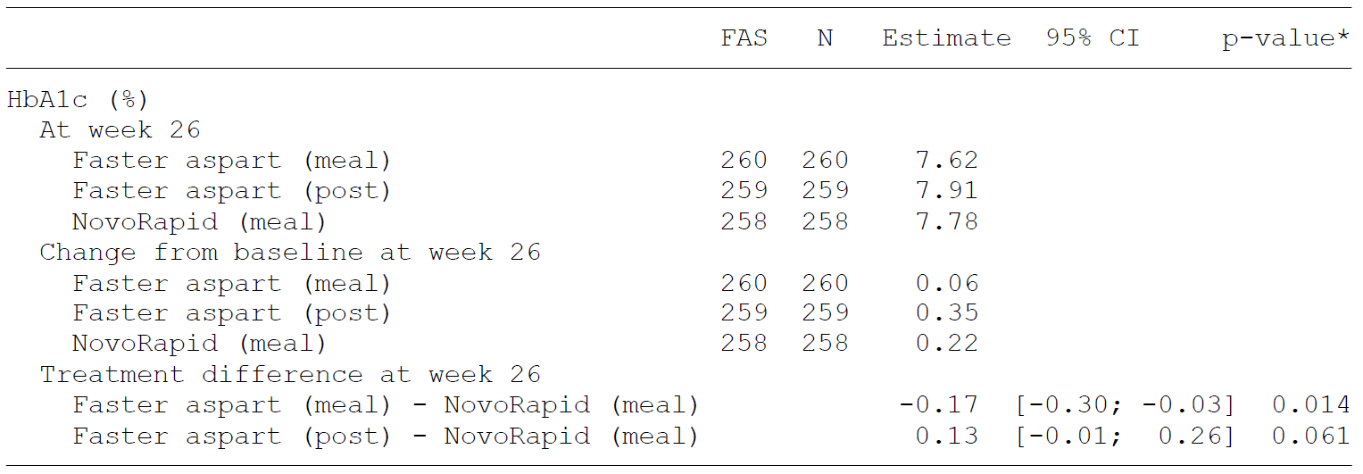
FAS = Full analysis set; N = number of subjects; CI = confidence interval
The observed mean change from Baseline to Week 26 for the mean of the 8-point profile was highest for meal time Fiasp at -0.27 mmol/L, followed by -0.05 mmol/L with NovoRapid and 0.17 mmol/L with post meal Fiasp.
Change in mean 1 hour post prandial glucose was -0.94 mmol/L for Fiasp and -0.21 mmol/L for NovoRapid, and 0.36 mmol/L for post meal Fiasp.
A numerically greater proportion of patients in mealtime Fiasp group achieved HbA1c of < 7.5% in total and also without hypoglycaemic episodes (see Table 6).
Table 6: Study NN1218-4101 Percentage of patients achieving HbA1c target at Week 26
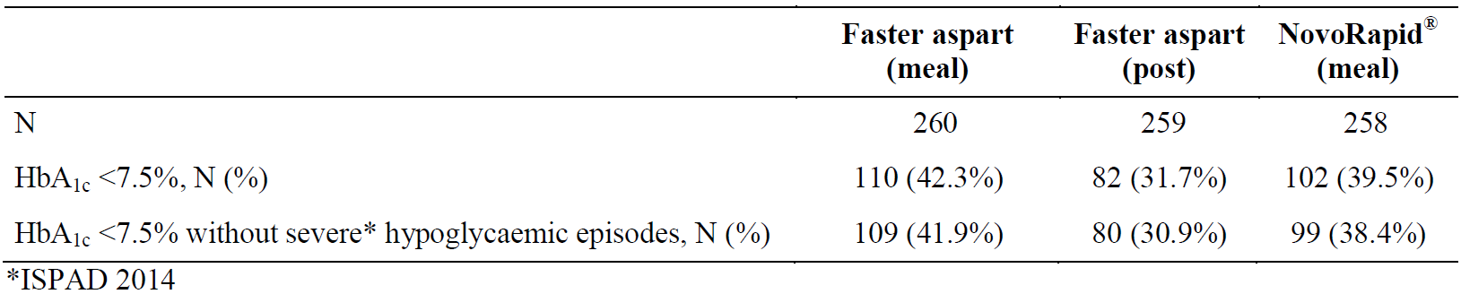
N = number of subjects; ISPAD = International Society for Pediatric and Adolescent Diabetes
In the subset of patients who had continuous glucose monitoring (CGM) performed, the time spent with an interstitial glucose of < 3.5 mmol/L was 4.02% with pre meal Fiasp, 4.57% with post meal Fiasp and 4.13% for pre-meal NovoRapid. For time spent with an interstitial glucose of > 12 mmol/L, pre-meal Fiasp 26.09%, post meal Fiasp 25.67%, pre meal NovoRapid 28.6%. For time spent with an interstitial glucose in the target range 4.0 to 7.8 mmol/L, for pre-meal Fiasp this was 33.66%, post meal Fiasp 32.27%, and pre-meal NovoRapid 31.17%.
The evaluator noted a number of limitations in this study. These included:
- Factors that affect the ability to translate the results in the real world. Most importantly, premeal NovoRapid was not given according to the recommended dosing period in the current PI, thus was not a valid real world comparator. Dosing NovoRapid as it was done in the clinical study may have led to poorer glycaemic control than would be expected from the use of NovoRapid as stated in the PI.
- HbA1c is a widely accepted but blunt measure of glycaemic control. It is probably not ideal for a non-inferiority study. Changes in post prandial blood glucose level or CGMS are more sensitive and specific for this purpose.
- 0.4% is a wide non-inferiority margin, especially in the context of a group of children with good glycaemic control at the start of the study. For this patient population a much lower non inferiority margin would be more appropriate.
In relation to safety, there were 5 out of 261 patients with serious AE in the pre-meal Fiasp group, 13 out of 258 in the post meal Fiasp group and 9 out of 258 in the NovoRapid group.
No major differences were noted in incidence of hypoglycaemia across age groups.
In children 1 to 6 years of age, there were no severe hypoglycaemic episodes. In children 6 to < 12 years of age, a total of 3 severe hypoglycaemic episodes were reported. The post meal Fiasp group had a higher event rate, compared to meal-time insulin aspart. No severe hypoglycaemic events were reported in NovoRapid group. In children 12 to < 18 years of age, 13 severe events of hypoglycaemia were reported. There was no major difference in the incidence of these events across treatment groups.
Majority of symptomatic severe hypoglycaemic events occurred in daytime. The post meal-time Fiasp group reported a higher event rate for nocturnal events, compared to other two treatment groups.
In the post second round response, the sponsor noted a number of corrections to the clinical evaluation report.
In addition, the sponsor proposed use in type 2 diabetes mellitus (T2DM) based on an extrapolation of data from adults with T2DM and children and adolescents with T1DM. However, the Delegate was unable to locate any documents explaining or proposing that extrapolation except for the following statement in the clinical overview:
‘The clinical trials were conducted in children and adolescents with T1DM. Insulin treatment may be required to achieve good glycaemic control in children and adolescents with type 2 diabetes (T2DM) and insulin is, together with metformin, the only approved drugs for the treatment of diabetes in this population. According to the European Medicines Agency (EMA) diabetes guideline, additional data in paediatric patients with T2DM may not be needed if efficacy and safety of a novel insulin is demonstrated in adults with T2DM and in children with T1DM. As part of the clinical development programme for faster aspart, 2 therapeutic confirmatory trials in adult subjects with T2DM were conducted: trial 3853 in which 689 bolus insulin-naïve subjects were treated for 26 weeks with faster aspart versus NovoRapid/NovoLog in a basal-bolus regimen with a trial design comparable to that of trial 4101, and trial 4049 in which 236 bolus insulin-naïve subjects were treated with faster aspart + basal versus basal only treatment. Both trials demonstrated that faster aspart was efficacious and safe in adult subjects with T2DM’.

Risk management plan
The most recently evaluated European Union-risk management plan (EU-RMP) was version 1.0 (23 November 2015; data lock point (DLP) 10 March 2015) and Australian specific Annex (ASA) version 0.2 (dated 21 November 2016). In support of the extended indications, the sponsor has submitted EU-RMP version 3.0 (date 24 April 2018; DLP 30 Sep 2018) and ASA version 1.1 (date 30 Jan 2019). At the second round of evaluation, the EU-RMP was updated to version 3.1 (dated 2 July 2019; DLP 30 Sep 2018) and the ASA was updated to version 1.3 (dated 15 October 2019).
The proposed summary of safety concerns and their associated risk monitoring and mitigation strategies are summarised in Table 7.
Table 7: Summary of safety concerns
Summary of safety concerns |  | Pharmacovigilance |  | Risk minimisation
 |  | Routine | Additional | Routine | Additional
Important identified risks | Medication errors | ¹ | – |  | ²
Important potential risks | None | – | – | – | –
Missing Information | None | – | – | – | –
¹ RMP evaluator has recommended that a specific adverse drug reaction follow-up form be implemented.² ‘Dear health care professional’ letter previously completed activity at launch.
The Delegate notes that a number of risks have been removed from the EU-RMP and ASA including risk of hypoglycaemia, systemic allergic effects and development of antibodies. The Delegate agrees that these are known risks, and that there are sufficient risk mitigation activities in relation to them. However, the Delegate would prefer that these events continue to be described in the periodic safety update report (PSUR). Hypoglycaemia may be a manifestation of medication errors and if this occurs closer scrutiny as to the reason for this with extra risk mitigation activities may be needed. Changes in the rates of allergic effects or antibodies may provide a signal that there has been a drift in the formulation that requires evaluation.

Risk-benefit analysis

Delegate’s considerations
Overall, the Delegate approves the use of Fiasp in children and adolescents with diabetes over the age of 1 year.
The Delegate accepts an extrapolation of efficacy and safety data from adults with T2DM, children and adolescents with T1DM, and PK profile in children and adolescents to children and adolescents with T2DM. This is based on similarity of the disease in adolescents and adults, and similar PK profile in children and adolescents with T2DM. However, for future submissions the sponsor is requested to submit a more detailed extrapolation plan and justification for this based on the similarity of disease in the two populations, and description of the PK profile of drug in two populations and relevant bridging studies.
The Delegate accepts the extrapolation of data from adults in pumps for children with pumps.
The Delegate agrees with the clinical evaluator that the data for both adults and children suggests that the efficacy and safety for post meal Fiasp is not as good as pre-meal Fiasp. For most medicines, the dose selected is the optimal dose from the clinical studies. The Delegate would prefer this be the case for Fiasp. The Delegate accepts that the data suggests that there was non-inferiority for HbA1c for post meal Fiasp compared to NovoRapid, however, the direction of change, secondary endpoints and safety all support pre-meal Fiasp being the better dosing algorithm. The Delegate accepts the use of post meal aspart being included in the clinical studies, however, would recommend the dosing and administration section focus on the optimal method of administration which is 0 to 2 minutes before meals.

Advisory Committee considerations
The Delegate did not refer this application to the Advisory Committee on Medicines (ACM) for advice.

Outcome
Based on a review of quality, safety and efficacy, the TGA approved the registration of Fiasp, Fiasp penfill and Fiasp flextouch containing insulin aspart (rys) 100 units/mL solution for injection, for the following extension of indications:
Treatment of diabetes mellitus in adolescents and children aged 1 year and above.
As such, the full indications at this time were:
Treatment of diabetes mellitus in adults, adolescents and children aged 1 year and above.

Specific conditions of registration applying to these goods
- Fiasp / Fiasp Penfill / Fiasp FlexTouch (insulin aspart (rys)) are to be included in the Black Triangle Scheme. The PI and Consumer Medicines Information (CMI) documents for Fiasp / Fiasp Penfill / Fiasp Flextouch must include the black triangle symbol and mandatory accompanying text for five years, which starts from the date the new indication is registered.
- Any changes to which the sponsor has agreed should be included in a revised RMP and ASA. However, irrespective of whether or not they are included in the currently available version of the RMP document, the agreed changes become part of the risk management system.
The Fiasp (insulin aspart (rys)) EU-RMP, version 3.1, dated 2 July 2019 (data lock point 30 September 2018), with ASA, version 1.3, dated 15 October 2019, included with submission PM-2018-05745-1-5, and any subsequent revisions, as agreed with the TGA will be implemented in Australia.
Reports are to be provided in line with the current published list of EU reference dates and frequency of submission of PSURs until the period covered by such reports is not less than three years from the date of this approval letter.
The reports are to at least meet the requirements for PSURs as described in the EMA’s Guideline on Good Pharmacovigilance Practices (GVP) Module VII-periodic safety update report (Rev 1), Part VII.B Structures and processes. Note that submission of a PSUR does not constitute an application to vary the registration.
- The CMI documents must be included with the products as a package insert. The CMI documents should have a link to the full version of the PI on the TGA website.

Attachment 1. Product Information
The PI for Fiasp, Fiasp Penfill and Fiasp FlexTouch approved with the submission which is described in this AusPAR is at Attachment 1. For the most recent PI, please refer to the TGA website at <https://www.tga.gov.au/product-information-pi>.

Therapeutic Goods Administration
PO Box 100 Woden ACT 2606 Australia
Email: info@tga.gov.au Phone: 1800 020 653 Fax: 02 6232 8605
https://www.tga.gov.au

NovoRapid insulin aspart is a rapid acting insulin used to treat diabetes mellitus, registered on the Australian Register of Therapeutic Goods (ARTG) under the following ARTG entries: NovoRapid Innolet insulin aspart (rys) 100 U/mL injection multi-dose cartridge (ARTG R 133446) NovoRapid Flexpen insulin aspart (rys) 300 U/3 mL injection multidose cartridge (ARTG R 133445) NovoRapid Penfill insulin aspart (rys) 300 U/3 mL injection cartridge (ARTG R 133444) and NovoRapid insulin aspart (rys) 100 U/mL injection multidose vial (ARTG R 133443).
Australian Government Australian Institute of Health and Welfare. Diabetes snapshot. Updated 24th July 2018. https://www.aihw.gov.au/reports/diabetes/diabetes-snapshot/contents/how-many-australians-have-diabetes.
Actrapid is a human insulin is produced in Saccharomyces cerevisiae by recombinant DNA technology.
Insulin degludec is an ultralong-acting basal insulin analogue with a duration of action > 24 hours up to 42 hours.
HbA1c, or glycated haemoglobin, is a form of haemoglobin chemically linked to a sugar via glycation. HbA1c is measured primarily to determine the three month average blood sugar level and is the most accepted method of measuring chronic glycaemia. Measurement can be used as a diagnostic test for diabetes mellitus and as an assessment test for glycaemic control in people with diabetes. An HbA1c of 48 mmol/mol (6.5%) or greater has now been recommended in Australia for diagnosis of type 2 diabetes. https://www.nps.org.au/australian-prescriber/articles/glycated-haemoglobin-for-the-diagnosis-of-diabetes
EMA, Committee for Medicinal Products for Human Use (CHMP), Guideline on clinical investigation of medicinal products in the treatment or prevention of diabetes mellitus, CPMP/EWP/1080/00 Rev. 1, 14 May 2012.
The ACM provides independent medical and scientific advice to the Minister for Health and the Therapeutic Goods Administration (TGA) on issues relating to the safety, quality and efficacy of medicines supplied in Australia including issues relating to pre-market and post-market functions for medicines. The Committee is established under Regulation 35 of the Therapeutic Goods Regulations 1990. Members are appointed by the Minister. The ACM was established in January 2017 replacing Advisory Committee on Prescription Medicines (ACPM) which was formed in January 2010. ACM encompass pre and post-market advice for medicines, following the consolidation of the previous functions of the Advisory Committee on Prescription Medicines (ACPM), the Advisory Committee on the Safety of Medicines (ACSOM) and the Advisory Committee on Non-Prescription Medicines (ACNM). Membership comprises of professionals with specific scientific, medical or clinical expertise, as well as appropriate consumer health issues relating to medicines.

