March 2021

Australian Public Assessment Report for Insulin aspart
  - Proprietary Product Name: Truvelog
  - Sponsor: Sanofi-Aventis Australia Pty Ltd

About the Therapeutic Goods Administration (TGA)
- The Therapeutic Goods Administration (TGA) is part of the Australian Government Department of Health and is responsible for regulating medicines and medical devices.
- The TGA administers the Therapeutic Goods Act 1989 (the Act), applying a risk management approach designed to ensure therapeutic goods supplied in Australia meet acceptable standards of quality, safety and efficacy (performance) when necessary.
- The work of the TGA is based on applying scientific and clinical expertise to decision-making, to ensure that the benefits to consumers outweigh any risks associated with the use of medicines and medical devices.
- The TGA relies on the public, healthcare professionals and industry to report problems with medicines or medical devices. TGA investigates reports received by it to determine any necessary regulatory action.
- To report a problem with a medicine or medical device, please see the information on the TGA website <https://www.tga.gov.au>.

About AusPARs
- An Australian Public Assessment Report (AusPAR) provides information about the evaluation of a prescription medicine and the considerations that led the TGA to approve or not approve a prescription medicine submission.
- AusPARs are prepared and published by the TGA.
- An AusPAR is prepared for submissions that relate to new chemical entities, generic medicines, major variations and extensions of indications.
- An AusPAR is a static document; it provides information that relates to a submission at a particular point in time.
- A new AusPAR will be developed to reflect changes to indications and/or major variations to a prescription medicine subject to evaluation by the TGA.

Copyright
© Commonwealth of Australia 2021
This work is copyright. You may reproduce the whole or part of this work in unaltered form for your own personal use or, if you are part of an organisation, for internal use within your organisation, but only if you or your organisation do not use the reproduction for any commercial purpose and retain this copyright notice and all disclaimer notices as part of that reproduction. Apart from rights to use as permitted by the Copyright Act 1968 or allowed by this copyright notice, all other rights are reserved and you are not allowed to reproduce the whole or any part of this work in any way (electronic or otherwise) without first being given specific written permission from the Commonwealth to do so. Requests and inquiries concerning reproduction and rights are to be sent to the TGA Copyright Officer, Therapeutic Goods Administration, PO Box 100, Woden ACT 2606 or emailed to <tga.copyright@tga.gov.au>.

Contents
List of abbreviations 4
I. Introduction to product submission 6
Submission details 6
Product background 7
Regulatory status 8
Product Information 9
II. Registration timeline 9
III. Submission overview and risk/benefit assessment 10
Quality 10
Nonclinical 11
Clinical 11
Risk management plan 16
Risk-benefit analysis 16
Outcome 17
Attachment 1. Product Information 18

List of abbreviations
Abbreviation | Meaning
ACM | Advisory Committee on Medicines
AIA | Anti-insulin aspart antibodies
ARTG | Australian Register of Therapeutic Goods
ASA | Australian specific annex
AU | Australia
AUC | Area under the plasma concentration-time curve
AUC₀₋₂ | Area under the plasma concentration-time curve, from time zero to 2 hours
AUC_{4-tlast} | Area under the plasma concentration-time curve, from 4 hours to the real time t_{last}/time corresponding to the last concentration above the limit of quantification
AUC_{last} | Area under the plasma concentration-time curve from time zero to time of last measurable concentration
CI | Confidence interval
C_{max} | Maximum plasma concentration
CMI | Consumer Medicines Information
CSII | Continuous subcutaneous insulin infusion
EMA | European Medicines Agency (European Union)
EU | European Union
GIR | Glucose infusion rate
GIR-AUC₀₋₁₂ | Area under the body weight standardised glucose infusion rate time curve from 0 to 12 hours
GLUT4 | Glucose transporter type 4
HbA1c | Haemoglobin A1C
IGF-1 | Insulin-like growth factor 1
IGF1-R | Insulin-like growth factor 1 receptor
INS | Insulin aspart
IR-A | Insulin receptor isoform A
IR-B | Insulin receptor isoform B
NZ | New Zealand
PD | Pharmacodynamic/s
pg/ml | Picograms per millilitre
pg*hr/ml | Picograms times hours per millilitre
PI | Product Information
PK | Pharmacokinetic/s
PSUR | Periodic safety update report
RMP | Risk management plan
SAR341402 | Compound development code for Truvelog
SC | Subcutaneous
SD | Standard deviation
SE | Standard error
t_{1/2z} | Terminal half life associated with the terminal slope
TGA | Therapeutic Goods Administration
t_{last} | Time corresponding to the last concentration above the limit of quantification
t_{max} | Time required to reach the maximum or peak recorded plasma concentration
US | United States (of America)

I. Introduction to product submission

Submission details
Type of submission: | New biosimilar medicine
Product name: | Truvelog
Active ingredient: | Insulin aspart
Decision: | Approved
Date of decision: | 14 October 2020
Date of entry onto ARTG: | 15 October 2020
ARTG numbers: | 325474, 325475
Black Triangle Scheme: | No
Sponsor’s name and address: | Sanofi-Aventis Australia Pty Ltd  12-24 Talavera Road  Macquarie Park, NSW 2113
Dose form: | Solution for injection
Strength: | 100 units (equivalent to 3.5 mg)/ mL
Containers: | Cartridge and pre-filled pen
Pack sizes: | 1, 5 or 10 pre-filled pens  5 or 10 cartridges
Approved therapeutic use: | Treatment of diabetes mellitus.
Route of administration: | Subcutaneous injection
Dosage: | Insulin aspart has a faster onset and a shorter duration of action than soluble human insulin. Due to the faster onset of action, insulin aspart should generally be given immediately before a meal or when necessary, soon after the start of a meal.  The dosage of insulin aspart is determined by the physician according to the patient’s individual needs. The individual insulin requirement is usually between 0.5 and 1.0 units/kg/day in adults and children. In a meal related treatment 50 to 70% of this requirement may be provided by Truvelog (insulin aspart) and the remainder provided by an intermediate-acting or long-acting insulin given at least once a day.  For further information regarding dosage, refer to the Product Information.
Pregnancy category: | A  Drugs which have been taken by a large number of pregnant women and women of childbearing age without any proven increase in the frequency of malformations or other direct or indirect harmful effects on the fetus having been observed.  The use of any medicine during pregnancy requires careful consideration of both risks and benefits by the treating health professional. This must not be used as the sole basis of decision making in the use of medicines during pregnancy. The TGA does not provide advice on the use of medicines in pregnancy for specific cases. More information is available from obstetric drug information services in your State or Territory.

Product background
This AusPAR describes the application by Sanofi-Aventis Australia Pty Ltd (the sponsor) to register Truvelog (insulin aspart) 100 units/mL solution for injection cartridge and pre-filled pen, for the following proposed indication:
Treatment of diabetes mellitus
Insulin lowers blood glucose levels by binding to insulin receptors to increase glucose uptake and inhibit hepatic glucose output. Insulin replacement therapy is essential for people with type 1 diabetes mellitus. Insulin may also be required for people with type 2 diabetes mellitus or gestational diabetes. There are many types of insulins available in the market differing in origin, type of delivery system, and onset of action.
The Product Information (PI) for Truvelog (insulin aspart) contains the following information regarding the mechanism of action of insulin aspart:
‘Insulin aspart produces a more rapid and pronounced blood glucose lowering effect than soluble human insulin, due to the faster onset of action. Insulin aspart is equipotent to soluble human insulin on a molar basis.
Insulin aspart has a shorter duration of action compared to soluble human insulin after subcutaneous injection (see Figure 1).
When administered immediately before a meal, the effect of insulin aspart more closely mimics normal physiological postprandial insulin release than soluble human insulin.
The onset of action of insulin aspart occurs within 10 to 20 minutes of subcutaneous (SC) injection. The maximum effect is exerted between 1 and 3 hours after injection. The duration of action is 3 to 5 hours. Insulin aspart has a more predictable time to peak effect within subjects than soluble human insulin.
As with all insulins in clinical practice, the duration of action of insulin aspart will vary according to the dose, injection site, blood flow, temperature and level of physical activity.’
Figure 1: Blood glucose concentrations (mean ± 2 estimated population mean) following a single pre-meal dose (0.15 units/kg) of insulin aspart injected immediately before a meal (solid curve), or soluble human insulin administrated 30 minutes before a meal (dashed curve) in patient with type 1 diabetes mellitus
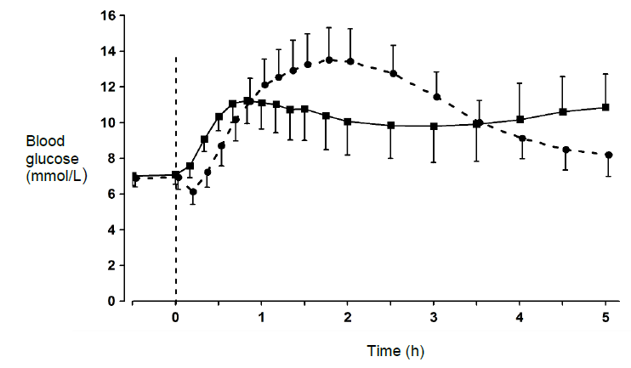
Source: PI for Truvelog.³
This is an application to register a biosimilar to insulin aspart (NovoRapid branded, the innovator product) manufactured by Novo Nordisk Pharmaceuticals Pty Ltd. NovoRapid was first registered in 2006. It is widely used for the treatment of diabetes.
The sponsor has proposed the same indication as NovoRapid. It will be available in the same dose forms (cartridges and single use pens).
The pen injector proposed by the sponsor is known as Solostar, this is the same injector as used for another widely used insulin analogue called Lantus.
The PI is derived from the current PI for NovoRapid; however the sections relevant to Novomix, insulin pumps and use of insulin aspart intravenously have been deleted.

Regulatory status
This product is considered a new biosimilar medicine for Australian regulatory purposes.
At the time the TGA considered this application, a similar application had been approved in the European Union (EU; June 2020).
Table 1: International regulatory status
Region | Submission date | Status | Approved indications
European Union | 29 May 2019 | Approved on 25 June 2020 (as ‘Insulin aspart Sanofi’) | Treatment of diabetes mellitus in adults, adolescents and children aged 1 year and above

Product Information
The Product Information (PI) approved with the submission which is described in this AusPAR can be found as Attachment 1. For the most recent PI, please refer to the TGA website at <https://www.tga.gov.au/product-information-pi>.

II. Registration timeline
The following table captures the key steps and dates for this application and which are detailed and discussed in this AusPAR.
Table 2: Timeline for Submission PM-2019-04815-1-5
Description | Date
Submission dossier accepted and first round evaluation commenced | 2 December 2019
First round evaluation completed | 30 April 2020
Sponsor provides responses on questions raised in first round evaluation | 26 June 2020
Second round evaluation completed | 5 August 2020
Delegate’s Overall benefit-risk assessment | 9 September 2020
Sponsor’s pre-Advisory Committee response | Not applicable
Advisory Committee meeting | Not applicable
Registration decision (Outcome) | 14 October 2020
Completion of administrative activities and registration on the ARTG | 15 October 2020
Number of working days from submission dossier acceptance to registration decision* | 170
*Statutory timeframe for standard applications is 255 working days

III. Submission overview and risk/benefit assessment
The submission was summarised in the following Delegate’s overview and recommendations.

Quality
There were no objections by the quality evaluator in relation to the registration of Truvelog insulin aspart.
Extensive characterisation studies involving comparison of primary, secondary and tertiary structures, physicochemical properties and biological activities showed that Truvelog insulin aspart and NovoRapid (EU-sourced) (known as NovoLog in the United States (US)) are generally similar. The main differences between Truvelog and the innovator product are the absence of glycerol (as tonicity agent) and disodium phosphate dihydrate (as buffering agent) and the addition of polysorbate 20. These differences were considered to be minor and not of concern with respect to product biosimilarity. Insulin aspart is a two chain peptide consisting of 51 amino acids. The A chain is composed of 21 amino acids and the B chain is composed of 30 amino acids. It is identical in primary structure to human insulin, only differing in amino acid sequence at position 28 of the B chain. Human insulin is 28B-L-proline-, whereas insulin aspart is 28B-L-aspartic acid-. As with human insulin, insulin aspart contains two interchain disulfide bonds and one intrachain disulfide bond (see Figure 2, below).
Figure 2: Insulin aspart chemical structure
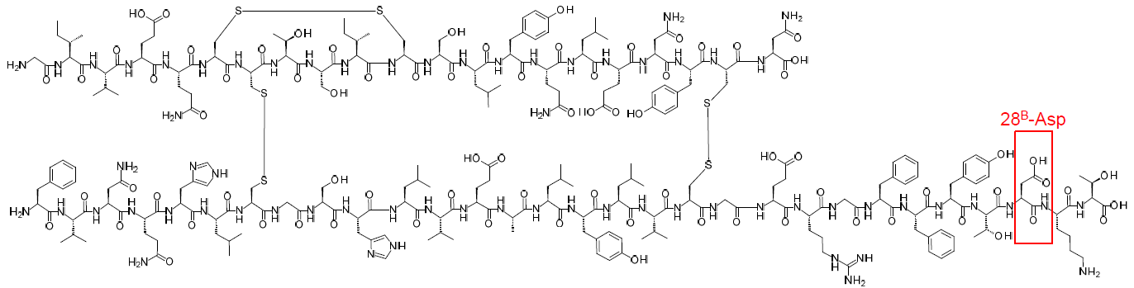
The data supplied in relation to the physical and chemical properties of insulin aspart were satisfactory.
All manufacturing steps and analytical procedures were validated.
There were no issues in relation to the manufacture or manufacturer.
There were no issues relating to the specifications.
The real time data submitted for the drug substance support a shelf life of 24 months when stored at ≤ -20°C ± 5°C.
The real time data submitted for the drug product support a shelf life of 12 months when stored at 5°C.
The proposed shelf life and storage conditions for the opened product are 28 days when stored at room temperature (≤ 30°C).
The manufacturer of the EU/US sourced innovator drug product is the same as the manufacturer of the Australia (AU)/New Zealand (NZ) innovator drug product. Thus, bridging studies between Australian NovoRapid and EU/US-sourced NovoRapid /NovoLog were not considered necessary.
In addition, the final drug product for EU NovoRapid and US NovoLog are the same, thus are reasonably considered to be the same products with different packaging.

Nonclinical
The nonclinical dossier contained comparative studies on pharmacology and repeated dose toxicity (including toxicokinetics). The scope of the nonclinical program was adequate under the relevant TGA adopted EU guideline. The studies were conducted using EU-sourced NovoRapid and US-sourced NovoLog as the reference products.
A high degree of comparability was demonstrated between the form of insulin aspart in Truvelog and that in NovoRapid / NovoLog in in vitro assays examining:
- binding affinity for recombinant human insulin receptors: insulin receptor isoform A (IR-A) and insulin receptor isoform B (IR-B)
- binding kinetics at IR-A and IR-B and the human insulin-like growth factor 1 (IGF-1) receptor (IGF1-R)
- receptor autophosphorylation (IR-A, IR-B and IGF1-R)
- metabolic activity, assessed as inhibition of lipolysis in cultured human adipocytes; stimulation of glucose uptake by L6 rat myoblast cells overexpressing the human glucose transporter type 4 (GLUT4) transporter; and attenuation of gluconeogenesis-related gene expression (glucuose-6-phosphatase gene expression in human primary hepatocytes)
- mitogenic potency (assessed in human breast adenocarcinoma cell lines).
Four batches of Truvelog and three batches of NovoRapid were used.
No specialised in vivo pharmacology assay was conducted (consistent with the applicable guideline), but relevant information was obtained as part of the toxicity studies conducted in rats, with the Truvelog, NovoRapid and NovoLog forms of insulin aspart shown to display similar glucodynamic profiles following subcutaneous (SC) administration.
Comparable plasma kinetic profiles after SC administration from toxicokinetic data obtained in rats were evident for Truvelog compared to NovoRapid and NovoLog.
Truvelog, like NovoRapid, was shown to be well tolerated locally following SC administration in rats and rabbits. Intramuscular administration was similarly well tolerated, and intravenous and paravenous administration resulted in only slight local irritation in rabbits.

Clinical
The clinical dossier consists of:
- Two clinical pharmacology studies providing pharmacokinetic (PK) and pharmacodynamic (PD) data, conducted in Caucasian (Study PDY12695) and Japanese adults (Study PDY15287), respectively (note that for the Japanese study, only the protocol was provided, no results).
- One pivotal efficacy/safety and efficacy study (Study EFC15081).
- A safety assessment of the product used in continuous subcutaneous insulin infusion (CSII), Study PDY15083
- literature references.
The studies in the clinical development program were consistent with the requirements of the EMA guideline on non-clinical and clinical development of similar biological medicinal products containing recombinant human insulin and insulin analogue.⁷

Pharmacokinetics Study 12695 (also known as Study PDY12695)
This was a three way comparison of Truvelog, NovoRapid and NovoLog. A single dose of 0.3 units / kg of each formulation was administered to 30 patients with Type 1 diabetes mellitus.
Table 3 shows the relative bioavailability between Truvelog, NovoRapid and NovoLog. It shows that the bioavailability is almost identical between the three treatments.
Table 4 shows the PK data between Truvelog, NovoRapid and NovoLog. All three treatments shows near identical results.
Table 3: Study 12695 - relative bioavailability analysis of Truvelog (SAR341402), NovoRapid and NovoLog
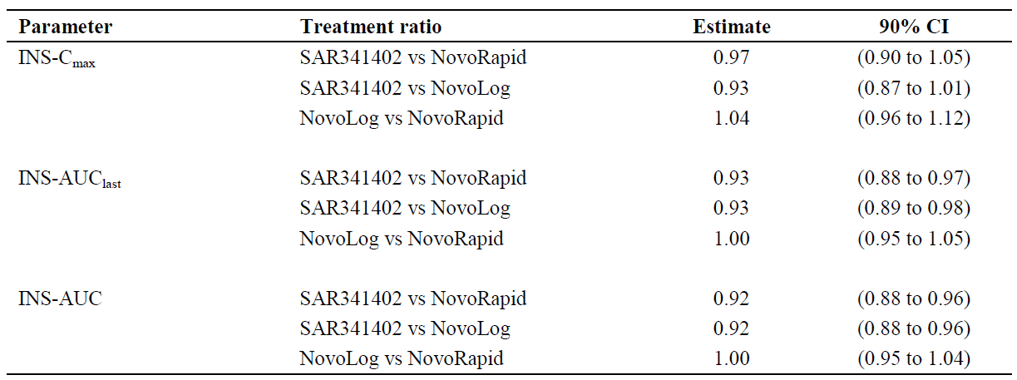
AUC = area under the plasma concentration-time curve, AUC_{last} = Area under the plasma concentration-time curve calculated using the trapezoidal method from time zero to the real time t_{last}/time corresponding to the last concentration above the limit of quantification, C_{max} = maximum plasma concentration, INS = insulin aspart, SAR341402 = compound development code for Truvelog.
Table 4: Study 12695 - pharmacokinetic data for Truvelog (SAR341402), NovoRapid and NovoLog
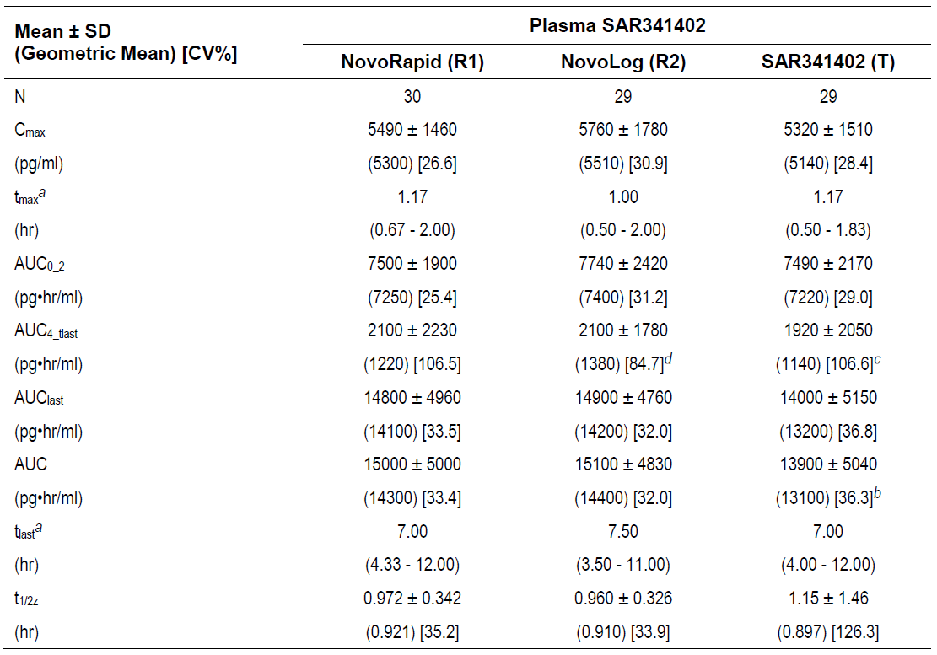
a: median (min – max). b: n = 28, Subject[ID redacted]; AUC not included in calculation of summary statistics (values with a percentage of extrapolation > 20%). c: n = 27, Subject [ID redacted] and [ID redacted]; AUC_{4-tlast} could not be calculated (t_{last} at T4H). d: n = 28, Subject [ID redacted] AUC_{4-tlast} could not be calculated (t_{last} at T4H).
SD: standard deviation. CI: confidence interval. N: number of subjects. T4H: the fourth hour of sampling. C_{max}: Maximum plasma concentration. pg/mL: picograms per millilitre. t_{max}: Time required to reach the maximum or peak recorded serum concentration. hr: hour. AUC₀₋₂: Area under the plasma concentration-time curve, from time zero to 2 hours. pg*hr/mL: picograms times hours per millilitre. AUC_{4-tlast}: Area under the plasma concentration-time curve, from 4 hours to the real time t_{last}/time corresponding to the last concentration above the limit of quantification. AUC_{last}: Area under the plasma concentration-time curve calculated using the trapezoidal method from time zero to the real time t_{last}/time corresponding to the last concentration above the limit of quantification. AUC: Area under the plasma concentration-time curve. t_{last}: Time corresponding to the last concentration above the limit of quantification. t_{1/2z}: Terminal half life.
Bioequivalence between Truvelog and the two comparators were demonstrated, in Table 5 below.
Table 5: Statistical analyses of primary pharmacodynamics variable (GIR-AUC₀₋₁₂) between Truvelog (SAR341402), NovoRapid and NovoLog
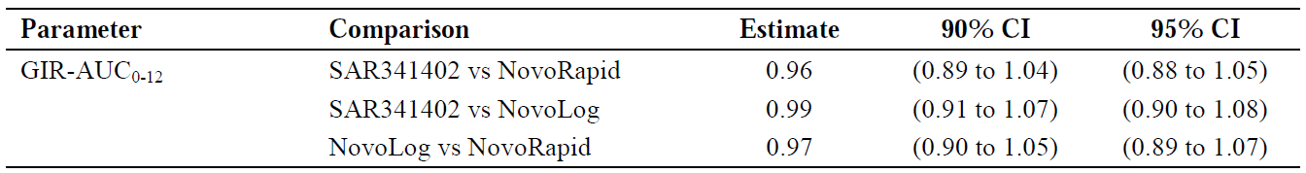
GIR-AUC₀₋₁₂: area under the body weight standardized glucose infusion rate time curve from 0 to 12 hours.
Truvelog also had very similar pharmacodynamics (insulin mediated glucose uptake as measured by an euglycaemic hyperinsulinaemic clamp, as demonstrated in Figure 3.
Figure 3: Study 12695 - mean smoothed glucose infusion rate profiles over time in hours
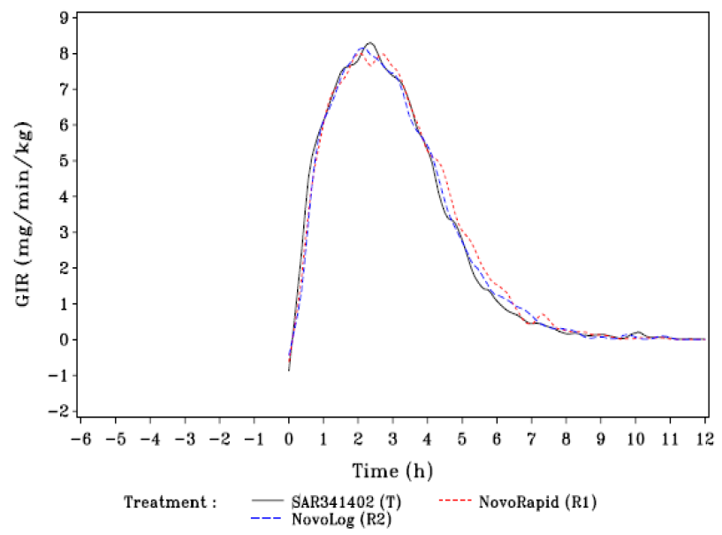
GIR: glucose infusion rate.

Study EFC15081
This was an international multicentre study of 597 patients with type 1 diabetes mellitus (and type 2 diabetes mellitus on multiple daily doses of insulin) conducted between August 2017 and July 2018. It was an open label study as the injection pens used to deliver the two insulins were different.
The primary objective was to demonstrate non-inferiority, with regard to glycaemic control estimated by measurement of haemoglobin A1C (HbA1c) levels of Truvelog to NovoRapid /NovoLog. Secondary objectives were to assess immunogenicity of the test and reference substances using anti-insulin aspart antibodies (AIA) and to assess the relationship of AIA in regards to efficacy and safety.
The basal insulins used were insulin glargine or insulin detemir. Patients’ previous short acting insulin were changed to Truvelog or NovoRapid. The treatment period was 26 weeks. Patients were followed up for a further 26 weeks in the safety component (but this was not included in the dossier). At study visits insulin dosage was adjusted according to post prandial blood sugar monitoring measurements. The aim was to achieve 2 hour post-prandial plasma glucose of < 10 mmol / L while avoiding hypoglycaemia. Patients were seen eight times over the first 6 months then once in the next 6 months. Approximately 93% of patients completed the 6 month follow up.
At Baseline, median age of subjects was 49 years (range 19 to 86), and 60% were male. Most (82.6%) were white Caucasian with a spread of other ethnic groups. 56% were from the United States and 25% from Eastern Europe. Median body mass index was 26.5 (range 15.4 to 39.7). 83.2% had Type 1 diabetes mellitus. Median duration of diabetes was 17 years (range 1 to 61). Baseline mean HbA1c was 7.9% and fasting plasma glucose test result of 9.9 mmol / L. The data were well balanced between the test and control groups. The point estimate and 95% CI were well within the non-inferiority margin of 0.3%. This is shown in Table 6.
Table 6: Summary of change in HbA1c (%) from Baseline to Week 26 using analysis of covariance analysis - intention to treat population
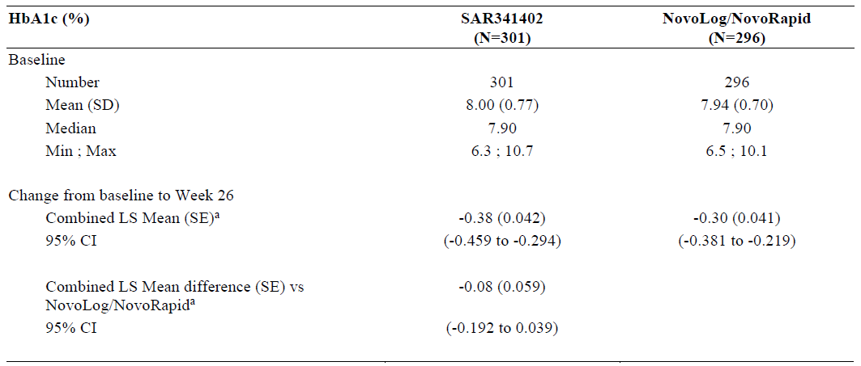
ANCOVA = analysis of covariance. SAR341402 = Truvelog. N = number of subjects. LS = Least Squares. SE = standard error.
a = Retrieved dropout multiple imputations of missing changes at Week 26 (10 000 imputations using separate models for patients who prematurely discontinued or completed the main 6 month treatment period) followed by ANCOVA with treatment group (SAR341402, NovoLog/NovoRapid), the randomisation strata of geographical region and type of diabetes (Europe Type 1, US Type 1, US Type 2, Japan Type 1) and prior use of NovoLog/NovoRapid (Yes, No) as fixed categorical effects, as well as the continuous fixed covariate of Baseline HbA1c value. Results were combined using Rubin's formulae.

Study PDY15083
This study was included as a supportive study to evaluate the use of Truvelog in insulin pumps, however the sponsor is not proposing to register a vial dose form. Its primary objective was to assess the safety of Truvelog and NovoLog when used in external insulin pumps in terms of the number of patients with infusion set occlusions. Infusion set occlusions were defined as ‘infusion set change due to failure to correct hyperglycemia (plasma glucose ≥ 13.9 mmol / L) by insulin bolus via the insulin pump’.
Subjects underwent two treatment periods, each of 4 weeks in one of two randomised sequences (Truvelog or NovoLog). The study was conducted in an open label fashion because the containers of the test and reference products differ in size, shape and cap colour. More patients had at least one infusion set occlusion with Truvelog (14 out of 43) than with NovoLog (12 out of 43), a risk difference of 4.1%. However the number of patients experiencing severe hyperglycaemia or severe hypoglycaemia were similar. The clinical evaluator considered that the difference in infusion set occlusions was clinically significant.

Safety
The overall exposure to Truvelog in the clinical studies was 290 patient years.
In Study EFC15081, the proportion of patients with at least one hypoglycaemic event and the event rates of hypoglycaemia per patient-year of exposure were similar in the two treatment groups across all American Diabetes Association-defined categories of hypoglycaemia. Severe hypoglycaemia was reported by 4.0% of Truvelog patients by comparison with 3.4% of NovoLog /NovoRapid patients.
In Study EFC15081, the emergence of AIAs were specifically examined. A similar percentage of patients in both Truvelog and comparator treatment groups had positive AIA titres at Baseline. The proportion of the study population found to have seroconverted or experienced a rise in titre of pre-existing AIA between Baseline and 26 weeks (treatment emergent AIAs) was similar with Truvelog and NovoLog /NovoRapid, with a risk difference between the two treatment groups of - 3.5% (90% CI: - 8.75% to 1.73%). AIA titres were comparable between treatment groups with a maximum titre of 1 in 1024 in one patient with Type 1 diabetes mellitus in the NovoLog/NovoRapid group. AIAs were cross-reactive to human insulin in the vast majority of the patients in both treatment groups.

Risk management plan
The sponsor submitted version 1 of the EU risk management plan (RMP; data lock point 21 February 2019); and version 1.0 of the Australian specific annex (ASA).
The summary of safety concerns and their associated risk monitoring and mitigation strategies are summarised as follows:
- Important identified risk: hypoglycaemia
- Important potential risk: medication errors due to insulin mix up and potential misuse of pen
- Missing information: children less than 1 year
The summary of safety concerns is based upon the EU RMP for NovoRapid, however the following items were not included:
- Important identified risk: hypoglycaemia- as this is a known adverse effect and already included in the PI
- Important potential risks: misuse of NovoRapid pump cart and injection/infusion site reactions in connection with pump use- as there is no presentation of Truvelog designed to be used in insulin pumps
The sponsor proposes to submit periodic safety update reports (PSURs) for insulin aspart to the TGA annually for a total of three years post registration of Truvelog. The timing of the first submission will be aligned with the EU PSUR reporting requirements.
There was no requirement for a risk management plan evaluation for a submission of this type, because it is a biosimilar for an innovator product that does not have any additional risk minimisation activities.

Risk-benefit analysis

Delegate’s considerations
The data provided is adequate to support the registration of Truvelog as a biosimilar to insulin aspart (NovoRapid). The disposable pens are also sufficiently similar for patients to know how to use the device without the need for re-education.
The Delegate notes that there was a numerically greater number of patients with pump occlusions who were using Truvelog compared to NovoRapid. The small difference in excipients between the two products is unlikely to cause this. In addition, occlusions or malfunction with insulin pumps are far more likely to be due to the pump mechanical issues or problems with the pump cannula or tubing than the insulin solution. The Delegate believes this difference is due to chance, or increased reporting in the Truvelog group.
The sponsor has omitted the potential risks associated use of Truvelog in pumps from the RMP as there is no vial presentation for this use. The Delegate disagrees with this rationale, because in clinical practice patients frequently use cartridges of insulin to withdraw insulin from and use in pumps. The sponsor is requested to:
- Include occlusion of insulin pumps as a potential risk in the ASA
- Include a discussion of adverse effects of Truvelog in insulin pumps in PSURs. This may be under the subheading ‘off label use’ or alternative subheadings thought to be appropriate by the sponsor.
The sponsor is otherwise proposing routine pharmacovigilance and risk mitigation activities. This is acceptable.
The sponsor has requested to include the CMI and instructions for use in the pack, but not the PI. This is acceptable as this product is used by patients for self administration.
In relation to the PI, the sponsor has included information from the clinical studies comparing Truvelog to NovoRapid/NovoLog. This is not required by the TGA. As Truvelog is considered a biosimilar to NovoRapid, and the exposure in the clinical development program for this is considerably less than the innovator, data from the innovator is considered sufficient.

Outcome
Based on a review of quality, safety and efficacy, TGA approved the registration of Truvelog insulin aspart 100 units / mL solution for injection cartridge and pre-filled pen, for subcutaneous injection, for the following indication:
Treatment of diabetes mellitus

Specific conditions of registration applying to these goods
- This approval does not impose any requirement for the submission of PSURs. You [the sponsor] should note that it is a requirement that all existing requirements for the submission of PSURs as a consequence of the initial registration or subsequent changes must be completed.
- The Consumer Medicines Information (CMI) and Instructions for Use (IFU) leaflet must be included with the products as package insert. The CMI should have a link to the full version of the PI on the TGA website.
- Laboratory testing and compliance with Certified Product Details (CPD)
  - All batches of Truvelog supplied in Australia must comply with the product details and specifications approved during evaluation and detailed in the CPD.
  - When requested by the TGA, the sponsor should be prepared to provide product samples, specified reference materials and documentary evidence to enable the TGA to conduct laboratory testing on the Products. Outcomes of laboratory testing are published biannually in the TGA Database of Laboratory Testing Results (http://www.tga.gov.au/ws-labs-index and periodically in testing reports) on the TGA website.

Attachment 1. Product Information
The PI for Truvelog approved with the submission which is described in this AusPAR is at Attachment 1. For the most recent PI, please refer to the TGA website at <https://www.tga.gov.au/product-information-pi>.

Therapeutic Goods Administration
PO Box 100 Woden ACT 2606 Australia
Email: info@tga.gov.au Phone: 1800 020 653 Fax: 02 6232 8605
https://www.tga.gov.au

The Black Triangle Scheme provides a simple means for practitioners and patients to identify certain types of new prescription medicines, including those being used in new ways and to encourage the reporting of adverse events associated with their use. The Black Triangle does not denote that there are known safety problems, just that the TGA is encouraging adverse event reporting to help us build up the full picture of a medicine's safety profile.
Diabetes Australia, ‘Living with Diabetes – Medicine’, available from the Diabetes Australia website, accessed January 2021.
PI for Truvelog (insulin aspart (rbe) solution for injection) AUST R 325474, 325475 (ARTG start date 15 October 2020).
The innovator products for Truvelog are: NovoRapid Penfill insulin aspart (rys) 300 U/3 mL injection cartridge AUST R 133444 (ARTG start date 21 December 2006) and NovoRapid Flexpen insulin aspart (rys) 300 U/3 mL injection multidose cartridge AUST R 133445 (ARTG start date 21 December 2006). Sponsor: Novo Nordisk Pharmaceuticals Pty Ltd.
Lantus Solostar 100 IU/mL insulin glargine (rbe) 3 mL solution for injection injector pen (ARTG start date 22 June 2006). Sponsor: Sanofi-Aventis Australia Pty Ltd.
Sponsor clarification: the sponsor provided various pieces of evidence in the justification for not providing biopharmaceutic studies. This included the drug substance manufacturers of the EU/US sources of the innovator drug product being the same as the Australian/New Zealand innovator drug product.
European Medicines Agency (EMA), Committee for Medicinal Products for Human Use (CHMP), Non-clinical and clinical development of similar biological medicinal products containing recombinant human insulin and insulin analogues, EMEA/CHMP/BMWP/32775/2005 Rev. 1, 26 February 2015.
The sponsor must still comply with routine product vigilance and risk minimisation requirements.

