November 2016

AusPAR Attachment 2

Extract from the Clinical Evaluation Report for influenza virus haemagglutinin (vaccine)
  - Proprietary Product Name: Influvac Tetra
  - Sponsor: Mylan Pharma Pty Ltd

About the Therapeutic Goods Administration (TGA)
- The Therapeutic Goods Administration (TGA) is part of the Australian Government Department of Health, and is responsible for regulating medicines and medical devices.
- The TGA administers the Therapeutic Goods Act 1989 (the Act), applying a risk management approach designed to ensure therapeutic goods supplied in Australia meet acceptable standards of quality, safety and efficacy (performance), when necessary.
- The work of the TGA is based on applying scientific and clinical expertise to decision-making, to ensure that the benefits to consumers outweigh any risks associated with the use of medicines and medical devices.
- The TGA relies on the public, healthcare professionals and industry to report problems with medicines or medical devices. TGA investigates reports received by it to determine any necessary regulatory action.
- To report a problem with a medicine or medical device, please see the information on the TGA website <https://www.tga.gov.au >.
About the Extract from the Clinical Evaluation Report
- This document provides a more detailed evaluation of the clinical findings, extracted from the Clinical Evaluation Report (CER) prepared by the TGA. This extract does not include sections from the CER regarding product documentation or post market activities.
- The words (Information redacted), where they appear in this document, indicate that confidential information has been deleted.
- For the most recent Product Information (PI), please refer to the TGA website <https://www.tga.gov.au/product-information-pi>.
Copyright
© Commonwealth of Australia 2018
This work is copyright. You may reproduce the whole or part of this work in unaltered form for your own personal use or, if you are part of an organisation, for internal use within your organisation, but only if you or your organisation do not use the reproduction for any commercial purpose and retain this copyright notice and all disclaimer notices as part of that reproduction. Apart from rights to use as permitted by the Copyright Act 1968 or allowed by this copyright notice, all other rights are reserved and you are not allowed to reproduce the whole or any part of this work in any way (electronic or otherwise) without first being given specific written permission from the Commonwealth to do so. Requests and inquiries concerning reproduction and rights are to be sent to the TGA Copyright Officer, Therapeutic Goods Administration, PO Box 100, Woden ACT 2606 or emailed to <tga.copyright@tga.gov.au>.

Contents
List of common abbreviations 5
1. Introduction 8
1.1. Drug class and therapeutic indication 8
1.2. Dosage forms and strengths 9
1.3. Dosage and administration 9
2. Clinical rationale 9
2.1. Background 9
2.2. Clinical rationale 10
2.3. Evaluator’s commentary on the background information 11
3. Contents of the clinical dossier 11
3.1. Scope of the clinical dossier 11
3.2. Paediatric data 11
3.3. Good clinical practice 11
3.4. Evaluator’s commentary on the clinical dossier 11
4. Pharmacokinetics 12
5. Immunogenicity 12
5.1. Evaluator’s overall conclusions on immunogenicity from the supportive studies 12
6. Dosage selection for the pivotal studies 12
7. Clinical efficacy (immunogenicity) 12
7.1. Studies providing evaluable efficacy data 13
7.2. Pivotal or main efficacy studies 13
7.3. Analyses performed across trials: pooled and meta analyses 25
7.4. Evaluator’s conclusions on clinical efficacy 26
8. Clinical safety 27
8.1. Studies providing evaluable safety data 28
8.2. Patient exposure 28
8.3. Adverse events 28
8.4. Evaluation of issues in Study INFQ3001 with possible regulatory impact 33
8.5. Other safety issues 34
8.6. Post marketing experience 34
8.7. Evaluator’s overall conclusions on clinical safety 34
9. First round benefit-risk assessment 35
9.1. First round assessment of benefits 35
9.2. First round assessment of risks 35
9.3. First round assessment of benefit-risk balance 36
10. First round recommendation regarding authorisation 36
11. Clinical questions 36
12. Second round benefit-risk assessment 36
13. References 36

List of common abbreviations
Abbreviation | Meaning
AE | Adverse event
AESI | Adverse event of special interest
ASA | Australian-specific annex
CDC | Centers of Disease Control and Prevention
CHMP (CPMP) | Committee for Medicinal Products for Human Use
CI | Confidence Interval
eCRF | Electronic Case Report Form
EU | European Union
FAS | Full analysis sample
FDA | Food and Drug Administration
GBS | Guillain Barré syndrome
GCP | Good Clinical Practice
GMFIs | Geometric Mean Fold Increases
GMR | Geometric mean ratio
GMTs | Geometric Mean Titres
Gp | Group
HA | Haemagglutinin
HAI or HI | Haemagglutination Inhibition
IB | Investigator Brochure
ICH | International Conference on Harmonization
ILI | Influenza like Infection
IM | Intramuscular
IRI | Intercurrent respiratory infection
ITT | Intention to treat
IVV | influenza virus vaccine
MAA | Marketing Authorisation Application
MedDRA | Medical Dictionary for Regulatory Activities
mL | Millilitre
NA | Neuraminidase
NCIs | New Chronic Illnesses
NH | Northern Hemisphere
NOCI | new onset of chronic illness
PI | Prescribing Information
Pop’n | Population
PP | Per protocol
PT | Preferred Term
QIV | Quadrivalent inactivated Influenza Vaccine
RMP | Risk Management Plan
SAE | Serious Adverse Event
SCR | Seroconversion Rate
SCF | Seroconversion Factor
SH | Southern Hemisphere
SOC | System Organ Class
SPR | Seroprotection Rate
SRH | Single radial haemolysis
TEAE | Treatment emergent adverse event
TESAE | Treatment emergent serious adverse event
TGA | Therapeutic Goods Administration
TIV | Trivalent Inactivated Influenza Vaccine
TRAE | Treatment related adverse event
US | United States
VE | Vaccine efficacy
VN | Virus neutralisation
WHO | World Health Organization
Yrs | Years

Introduction
This is a submission by the sponsor to register Influvac Tetra for the prevention of influenza A and B in adults aged ≥ 18 years. The suspension for injection includes 4 inactivated, split influenza virus strains (15/15/15/15 µg (total 60 µg) per 0.5 mL), 2 type A strain subtypes and 2 type B strains from separate lineages as recommended by the Australian Influenza Vaccine Committee for that season. The submission includes 1 completed Phase III clinical study (Study INFQ3001) in adults in support of this application. The proposed indication is supported by and relies on the large trial database and post approval pharmacovigilance data of the trivalent vaccine Influvac trivalent vaccine which contains 3 viral strains (1 influenza A/H1N1 strain, 1 influenza A/H3N2 strain, and 1 influenza B strain). The latter was first registered in Australia in January 2002 for adult use; Influvac Junior was registered in July 2006. Since 2005 the vaccine is thiomersal free (preservative). In summary, the clinical development plan consists of 3 studies, with a planned number of 2940 subjects to be exposed to the quadrivalent influenza vaccine, of whom approximately 1540 will be adults and approximately 1400 will be children and adolescents. The paediatric development plan accounts for potential age related differences in immune response with respect to previous exposure to influenza (priming status) and therefore distinguishes between the age groups of 6 to 35 months (= non-primed, or naïve), 3 to 8 years (= primed and naïve children) and 9 to 17 years (considered primed/non-naïve); a staggered approach over sequential seasons will be followed.
Study INFQ3002 will include 1200 children in stable health in the age range 3 to 17 years with a randomisation ratio 2:1 for 3 to 8 years and 9 to 17 years, respectively. The treatment groups will be quadrivalent influenza vaccine, trivalent influenza vaccine Influvac with the marketed lineage B strain and trivalent influenza vaccine with the alternative lineage B strain to investigate the comparability of the immunogenicity with respect to the common strains contained in the quadrivalent and trivalent vaccines and assess overall safety. Approximately 400 children will be exposed to quadrivalent influenza vaccine, of which approximately 270 will be aged 3 to 8 years. The study is planned to start in the 2016/2017 Northern Hemisphere (NH) season.
Study INFQ3003 will include approximately 2000 non-primed children in the age group of 6 to 35 months to investigate the protective efficacy of quadrivalent influenza vaccine versus a non-influenza vaccine. Equal stratification is planned for 4 age ranges (6 to 11 months; 12 to 18 months; 19 to 24 months and 25 to 35 months). Half of the 1000 children will be exposed to quadrivalent influenza vaccine. The study is planned to start in the subsequent next northern hemisphere season, but may comprise 1 or 2 seasons, depending on the outcome of an interim analysis at the end of the first season, with a planned enrolment of approximately 1000 subjects in each season.
Post-authorisation, a dedicated clinical trial is foreseen to assess the immunogenicity of quadrivalent influenza vaccine in children suffering from mild to severe immune deficiency with different severity levels of immune suppression.

Drug class and therapeutic indication
This is an inactivated quadrivalent influenza vaccine containing influenza haemagglutinin antigens: Type A (H1N1) like virus; Type A (H3N2) like virus; Type B (Victoria lineage) and Type B (Yamagata lineage). The potency of the vaccine is expressed as the concentration of HA antigen, although neuraminidase antigen is also present. The target concentration is 15 µg HA per strain.

Dosage forms and strengths
Influvac Tetra is a quadrivalent influenza vaccine (surface antigen, inactivated) consisting of a clear, aqueous suspension packed in pre-filled syringes each containing 0.5 mL. The vaccine contains predominantly HA of 4 strains (2 x ‘A’; 2 x ‘B’) of influenza virus in phosphate buffered saline, calcium and magnesium chloride buffers.

Dosage and administration
A single 0.5 mL dose annually intramuscularly (IM), for the prevention of influenza caused by Influenza Virus, Types A and B in persons aged ≥ 18 years.

Clinical rationale

Background

Information on the condition being treated
Influenza, a respiratory orthomyxovirus, is a seasonal infectious disease that occurs in epidemics throughout the northern and southern hemisphere winter months, and leads to considerable morbidity and mortality globally in all age groups. In general, influenza resolves within 2 to 7 days, although symptoms of cough and malaise may be prolonged. However, for some population groups, notably the elderly and those with chronic diseases influenza can exacerbate underlying medical conditions and/or lead to secondary viral or bacterial pneumonia (Fiore; Rothberg). During influenza epidemics, there is an increased mortality risk among older adults (age > 65 years), people with chronic diseases, and very young children (age 0 to 12 months), as well as an increase in morbidity and hospitalisation because of influenza-associated complications (Fiore; Monto).
Influenza A and B cause most of human disease. Influenza A viruses are divided into subtypes based on 2 viral external proteins, the haemagglutinin (HA) and the neuraminidase (NA).
Of the influenza type A virus subtypes, the A/H3N2 and A/H1N1 subtypes are clinically the most important. Influenza type B viruses show extensive variation in antigenicity. Influenza B viruses are separated into 2 distinct genetic lineages, Yamagata and Victoria. In terms of infection, influenza type A viruses have been isolated from several non-human species, including birds, horses, and swine, whereas influenza type B viruses almost exclusively affect humans.
The influenza A or B surface glycoprotein HA is the key antigen involved in attachment of the virus to receptors on respiratory epithelial cells, whereas the NA glycoprotein is involved in release of the virus from the cell surface. During infection, the virus stimulates production of antibodies in the serum (immunoglobulin G) and nasal secretions (immunoglobulin A) to these surface glycoproteins. High levels of virus type-specific antibodies are associated with protection from disease due to infections with homologous and closely related influenza virus trains (Hay; Fiore). Novel influenza strains arise from antigenic drift due to point mutation and recombination events that occur during viral replication. These events result in the emergence of new strains of the influenza virus capable of causing epidemics, as pre-existing antibodies resulting from previous virus exposure or vaccination are generally not cross-protective (Hay).
Influenza type A is capable of major antigenic shifts when a novel HA emerges from re-assortment with an animal influenza virus. Influenza B undergoes less rapid antigenic drift, that is, generally more stable, than influenza A. When a new subtype of influenza virus emerges, all individuals are susceptible to infection except those who have lived through earlier epidemics with a related virus subtype. Infection produces immunity to the specific virus; however, the length and extent of immunity is dependent on the degree of antigenic shift, the number of previous infections, and the immune status of the individual (Beyer).
Influenza epidemics have been associated with the circulation of type A/H3N2, type A/H1N1, and type B viruses, either individually or together. 2 genetically distinct lineages of influenza B viruses have co-circulated since 1985 (Rota). The burden of infection is largely on school age children, young adults, and the elderly (Belshe). In the US, B viruses account for 24% of positive specimens and 34% of reported paediatric influenza deaths (Ambrose), however the incidence can vary dramatically between influenza seasons (range 1% to 60%) (www.euroflu.org). The burden of influenza B appears to be the highest for children and young adults with a relative high incidence as compared to the type A strains (Grant; Olson). Influenza B causes morbidity and mortality in all age groups, however in children it appears to be a disproportionate cause of influenza related hospitalizations and deaths compared to the type A strains (Thompson).
Currently, based on viral surveillance data, an influenza B virus representing one of these 2 lineages is selected each year to be included in the annual vaccine. The cross protection against infection with one B lineage provided by immunisation with a vaccine derived from the other B lineage is uncertain, but expected to be low (Belshe). Predicting which lineage will predominate has been challenging, and in some seasons, there has been a mismatch between the lineage chosen for the vaccine and the predominant circulating influenza B virus lineage. In Europe from 2003 to 2004 through 2010, the predominant lineage of a given season differed from that contained in the vaccine in 4 out of 8 seasons and overall an estimated 58% of lab confirmed influenza B samples were of the lineage not included in the vaccine (Ambrose). Based on the demonstrated burden of influenza B, the limited cross-protection between the 2 influenza B lineages, and the inability to accurately predict which influenza B lineage will circulate, it may be expected that seasonal influenza vaccines will be improved by the inclusion of influenza B strains from both lineages. While a good antigenic match would still not be assured, this step would eliminate a mismatch in lineage between the vaccine strain and circulating strains.

Current treatment options
According to the WHO vaccination is the most effective way to prevent influenza and its complications and is the key public health approach in most countries around the world, including Australia. Prevention of influenza illness is achieved by annual prophylactic immunisation, the exact composition of which changes according to what are predicted to be the predominant A and B strain(s) circulating in either the Northern or Southern Hemispheres for that influenza season.

Clinical rationale
Each year in Australia, influenza infection affects somewhere between 5 to 10% of the general population and this can be up to 20% in some years. Among Australian patients aged ≥ 50 years, influenza is annually associated with > 3,000 deaths and > 13,500 hospitalisations (data from the immunise.health.gov.au website). According to the WHO, vaccination is the most effective way to prevent influenza and its complications.

Switch from trivalent to quadrivalent vaccine
The planned change from the trivalent to quadrivalent influenza vaccine is not associated with major changes in the general production process, and therefore no change in the safety profile is expected. Extensive clinical experience gained with Influvac (trivalent) for over ≥ 30 years is considered relevant for the development of the quadrivalent vaccine as the antigens of the influenza strains in both formulations are similar. In fact, both the Victoria and Yamagata B strain lineages, either one or the other, have been present in former Influvac formulations and the immunogenicity and safety has been extensively studied in clinical studies. For the currently used thiomersal free trivalent formulation, the Yamagata lineage has been contained in the vaccine for 5 out of 10 seasons versus 5 seasons for the Victoria-lineage. The immunogenicity, safety and reactogenicity profiles were similar, therefore it is not expected that the combination of the 2 B strain lineages in the quadrivalent vaccine will result in a different immunogenicity and safety profile compared to trivalent Influvac. This view is strengthened by recent publications comparing the quadrivalent and trivalent formulations of other influenza vaccines (Greenburg 2013, 2014; Jain; Domachowske; Pepin; Langley). In these studies, reactogenicity and safety of the quadrivalent formulations was consistent with the established profiles of the corresponding trivalent formulations. In addition, the second B strain in the quadrivalent formulations did not impact immune responses elicited by the 3 strains contained in the trivalent formulations.

Evaluator’s commentary on the background information
This background information provides the rationale for this product and aligns with other submissions for approved (in Australia) quadrivalent influenza vaccines; FluQuadri and Fluarix Tetra.

Contents of the clinical dossier

Scope of the clinical dossier
The submission contained the following clinical information:
- A Clinical Overview, Summary of Clinical Efficacy, Summary of Clinical Safety;
- A pivotal Phase III randomised, multicentre, double blinded study to evaluate the quadrivalent vaccine versus 2 TIVs each containing one of the ‘B’ strains contained in the QIV.

Paediatric data
The submission does not include paediatric efficacy/safety data, although paediatric studies are ongoing and/or planned. See Section 1 (above) for ongoing/planned studies.

Good clinical practice
Approvals to undertake the clinical studies were obtained from appropriately constituted institutional ethics committees/independent research boards, in accordance with the relevant national guidelines and regulations applicable. The studies presented in this submission were conducted in accordance with GCP.

Evaluator’s commentary on the clinical dossier
The main objectives of the quadrivalent clinical development program were to demonstrate that the candidate quadrivalent vaccine provides superior immunogenicity compared to the marketed trivalent Influvac for the added B strain without affecting antibody responses to the other strains and without compromising the safety profile.

Pharmacokinetics
With respect to the nature of the product, clinical pharmacology data have not been assessed. The subunit influenza vaccine, as all vaccines, induces antibodies, which consecutively are responsible for the desired effect of the intervention, that is, protection against an infectious disease (principle of active vaccination). The constituents of the vaccine itself are phagocytosed at the site of injection. Therefore, specific interaction or pharmacokinetic studies have not been carried out in man.

Immunogenicity
Efficacy and safety data arising from the pivotal study (Study INFQ3001) is summarised in Sections 7 and 8 respectively of this document. A number of supportive immunogenicity studies have previously been reviewed by the TGA, and can be considered supportive of this submission.

Evaluator’s overall conclusions on immunogenicity from the supportive studies
None of the supportive immunogenicity studies provide any data for a quadrivalent vaccine. All pertain to the immunogenicity and safety of trivalent vaccines containing 2 ‘A’ strains of influenza and 1 ‘B’ strain of influenza. Each vaccine contains 15 µg of HA per strain. These data are included because they show that the ‘B’ strain as a component of these trivalent vaccines were safe and immunogenic.

Dosage selection for the pivotal studies
The dosage selection for the addition B strain immunogen in Influvac Tetra was based upon the standard used in the TIV, that is, 15 µg of HA per strain.

Clinical efficacy (immunogenicity)
The pivotal Study INFQ3001is not an ‘efficacy’ study, instead the immunogenicity data derived is used as a surrogate for clinical efficacy. This is a standard approach in influenza vaccine studies. The study was designed according to the Guideline on Clinical Evaluation of New Vaccines (EMEA/CHMP/VWP/164653/2005) and the scientific advice from an EU national competent authority for registration of QIV in the adult/elderly population. Anti-haemagglutinin (HA) antibody response is an established correlate of protection against influenza in adults; therefore, HI titre was the primary outcome measure in this study. The study aimed to demonstrate the comparability of the immunogenicity of the shared strains contained in both the QIV and TIV formulations. Therefore, the primary objective was to demonstrate that the post-vaccination HI antibody responses with QIV for each of the shared strains were non-inferior to those with the TIVs. The non-inferiority margin was set at 1.5, which was in agreement with the scientific advice obtained from an EU national competent authority and was also in accordance with the margin recommended by FDA guidelines. As a secondary efficacy objective, the study aimed to demonstrate that the added B strain in QIV provided an antibody response superior to that with the TIV for the alternate B strain lineage. In addition, the immunogenicity of each of the strains in QIV and TIVs was further characterised by describing the derived serology parameters of seroconversion, and mean fold increase with respect to HI and VN antibody titres and by performing analyses in study population subsets according to age and pre-existing antibody status. Furthermore, CMI values were described for a subset of subjects.
Central Lab performing the HI assays, in accordance with the guidelines indicated by EMA:
- Any HI result < 10 (= undetectable) was expressed as 5;
- Sera which have a titre ≥ 10 but < 40 are considered positive but not protective;
- Sera with a titre ≥ 40 are considered positive and protective.

Studies providing evaluable efficacy data
See above, the pivotal Study INFQ3001 provide indirect evidence of ‘efficacy’ through serological responses to the vaccine which have been determined, over time, and from multiple sources to have clinical efficacy either in protecting against influenza acquisition or attenuating the course of the infection if infection is not completely prevented through vaccination.

Pivotal or main efficacy studies

Study INFQ3001
This was ‘A Phase III, randomised, double blind, active controlled study in adults to assess the safety and immunogenicity of the candidate quadrivalent influenza vaccine and its non-inferiority to trivalent influenza vaccine’.

Study design, objectives, locations and dates

Study design
A Phase III, randomised, double blind, active controlled study in adults to assess the safety and immunogenicity of the candidate quadrivalent influenza vaccine (distributed by the sponsor trading under a preferred business name) and its non-inferiority to trivalent influenza vaccine.

Primary objective
To demonstrate in subjects ≥ 18 years of age the non-inferiority of QIV with respect to post-vaccination geometric mean haemagglutinin inhibition (HI) antibody titres against the shared strains compared with the trivalent influenza vaccines (TIV) with either the B strain of the Victoria (TIV(Vic)) or the B strain of the Yamagata lineage (TIV(Yam)).

Secondary objectives
- To demonstrate in subjects ≥ 18 of age the superiority of QIV to TIV(Vic) and TIV(Yam) with respect to post-vaccination geometric mean HI antibody titres against the alternate lineage B strain;
- To describe the immunogenicity for HI and virus neutralisation (VN) antibody titres using the derived serology parameters seroconversion and geometric mean fold increase for each of the strains in QIV and TIV, in adults (≥ 18 to ≤ 60 years of age) and elderly (≥ 61 years of age);
- To describe the immunogenicity for HI and VN antibody titres in study population subsets according to age and pre-existing antibody status for each of the strains in QIV and TIV.
- To describe cell mediated immunity (CMI) values for a subset of subjects.

Safety objectives
To compare the reactogenicity and the safety of QIV with that of the TIV treatment arms in adults and elderly.

Locations
n = 20 sites (in Belgium, Germany, Hungary, Latvia and Lithuania)

Dates
First subject, first visit: 28 May 2015; last subject last visit: 6 January 2016.

Protocols
Version 1 dated 11 November 2014; Amendment 1: 28 April 2015, key changes:
- Change 1: Russia excluded from participation. The study will be conducted solely in countries within Europe. Rationale: due to additional data requirements in Russia it was not feasible to obtain timely study approvals for conducting the study including Russian sites;
- Change 2: Subjects who have been placed in an institution by regulatory or legal ordinance are to be excluded from study participation. Rationale: it was requested by a Central Ethics Committee to exclude subjects that are in an institution by regulatory or legal ordinance;
- Change 3: acceptable methods of birth control should be in accordance with local regulations and that more stringent criteria may apply. Rationale: acceptable methods of birth control have been defined in the protocol under exclusion criteria;
- Change 4: Upon Competent Authority (CA) request the period of pregnancy reporting is extended beyond the immunisation phase. All pregnancy cases will be reported if they occur during the study, including the entire safety follow-up period. Rationale: Pregnancy is excluded per protocol during the first 3 weeks of the study to avoid any potential safety concern related to the vaccination. Any pregnancy occurring during the entire study duration including the safety follow-up period will be reported and followed on pregnancy evolution and outcome, that is, the health status of the newborn;
- Change 5: Specific reference is made to the safety reference information described in the Investigators’ Brochure (IB);
- Change 6: Definition of seroconversion added to the statistical section of the protocol. Rationale: requested by a CA to add the definition of seroconversion to the protocol. That is, the following summary statistics will be presented, for each of the 4 strains and each of the 3 formulations: the pre and post vaccination geometric mean titres (GMTs) and the geometric mean fold increases for HI and VN; reverse cumulative distribution curves supplemented by tables presenting % of vaccinees with titres above cut-off on a logarithmic scale for HI and VN; seroconversion rates for HI and VN defined as becoming seropositive if seronegative at enrolment, or (at least) a 4 fold rise in titre if seropositive at enrolment.

Inclusion and exclusion criteria

Inclusion criteria
- Gives informed consent and able to adhere to all study procedures;
- Men and women aged ≥ 18 years of age at the day of study vaccination;
- Being in good health as judged by medical history, physical examination and clinical judgment of the investigator.

Exclusion criteria
- History of allergy to egg, chicken proteins, or other vaccine components;
- History of serious adverse reaction to any influenza vaccine;
- History of Guillain-Barré syndrome;
- Confirmed influenza infection or vaccination against influenza in the 6 months preceding enrolment;
- Receipt of any vaccine within the preceding 4 weeks prior to study vaccination or planned vaccination during the study between Visit 1 (Day 1) and Visit 2 (Day 22);
- Having fever (oral temperature of ≥ 38.0 ºC ) and/or presenting with an acute disease or infection on the day of study vaccination;
- Any known immunocompromising condition or immunosuppressive therapy within 6 months preceding study vaccination;
- Using or having used immunomodulating agents during the 4 weeks prior to the study or planned use during the study;
- Receipt of blood or blood products within the 3 months preceding enrolment;
- Participation in a placebo-controlled influenza vaccine clinical trial any time prior to entering this study if the treatment arm is not known;
- Any condition that in the opinion of the investigator would pose a health risk to the subject if enrolled or could interfere with the evaluation of the study vaccine including (but not limited to) bleeding disorder, known immunodeficiency, seizure disorder, acute, severe or progressive hepatic, renal, neurological or neuromuscular disease;
- Being a solid organ or bone marrow/stem cell transplant recipient;
- Use of cytotoxic drugs, anticancer chemotherapy or radiation therapy within 36 months before the day of study vaccination;
- Receipt of another investigational agent within 30 days prior to study vaccination, or planned use during the entire study period;
- Known drug or alcohol abuse;
- Planned surgery requiring a general anaesthetic, or surgery requiring inpatient hospitalisation for at least 24 hours during the entire study period;
- Being an employee of the sponsor/contract research organisation conducting this study or personnel of the study site;
- Any other reason that, in the investigator’s opinion, prohibits the inclusion of the subject into the study;
- Exclusion criteria only for female subjects aged ≥ 18 and ≤60 years and of childbearing potential: Being pregnant, breastfeeding or intending to become pregnant during the study period up to Visit 2 (Day 22);
- Not using an acceptable method (as listed in the protocol) of birth control up to Visit 2 (Day 22).

Study treatments

Test product, dose and mode of administration
A single 0.5 mL dose of quadrivalent influenza subunit vaccine (with the strains recommended for the past influenza season NH2014/2015) was given. The HA content of the QIV batch as follows:
- A/California/7/2009 (H1N1) pdm09 like strain (A/California/7/2009, X-181) (16.9 µg HA/dose)
- A/Texas/50/2012 (H3N2) like strain (A/Texas/50/2012, X-223A) (17.0 µg HA/dose)
- B/Massachusetts/2/2012 like strain (B/Massachusetts/2/2012, BX-51B) (15.3 µg HA/dose)
- B/Brisbane/60/2008 (wild type) (17.3 µg HA/dose)

Reference therapy, dose and mode of administration
A single 0.5 mL dose of licensed Influvac containing approximately 15 µg of HA antigen per virus strain, or a single 0.5 mL dose of TIV containing the alternate B strain (both vaccines with the strains recommended for the past influenza season NH2014/2015), administered by intramuscular injection in the deltoid muscle of the upper arm.
The HA content of the TIV_{(Vic)} batch was as follows:
- A/California/7/2009 (H1N1) pdm09 like strain (A/California/7/2009, X-181) (16.7 µg HA/dose)
- A/Texas/50/2012 (H3N2) like strain (A/Texas/50/2012, X-223A) (16.5 µg HA/dose)
- B/Brisbane/60/2008 (wild type) (18.4 µg HA/dose)
The HA content of the TIV_{(Yam)(} Influvac) batch was as follows:
- A/California/7/2009 (H1N1) pdm09 like strain (A/California/7/2009, X-181) (17.1 µg HA/dose)
- A/Texas/50/2012 (H3N2) like strain (A/Texas/50/2012, X-223A) (16.6 µg HA/dose)
- B/Massachusetts/2/2012 like strain (B/Massachusetts/2/2012, BX-51B) (14.9 µg HA/dose)
Above mentioned HA doses are according to the respective certificates of analysis.

Efficacy variables and outcomes
Randomised, double blind, active controlled immunogenicity study in 2 age groups: adults and elderly. In both age groups, eligible participants will be randomly assigned to vaccination with QIV, TIV_{(Vic)} or TIV_{(Yam)}, in a 7:1:1 ratio, respectively.
Screening performed at Visit 1, or alternatively maximally 2 weeks before: informed consent and review of medical history, inclusion and exclusion criteria, demographic data, concomitant medication, influenza and influenza vaccination history; physical examination.
Visit 1 (Day 1): pregnancy test for females of childbearing potential; assessment of AEs and concomitant medications; blood sampling for baseline immunogenicity assessment. Subjects were vaccinated with the study vaccine IM in the deltoid muscle of the arm. Subjects observed for ≥ 30 minutes to monitor for any immediate adverse reactions, and a daily diary, thermometer, and ruler provided for daily reporting of solicited local and systemic reactions and overall inconvenience occurring during the first 7 days after vaccination.
Subjects were instructed to report intercurrent respiratory infections immediately (that is, occurrence of symptoms or signs likely to predict influenza infection) in the period following vaccination until Visit 2 (Day 22) by phone contact, at which an extra visit was to be scheduled, preferably within 24 hours, but no later than 72 hours after the onset of symptoms. At these extra visits, a nasal and/or pharyngeal swab was to be collected for the diagnosis of influenza infection.
A telephone call occurred approximately 3 days after vaccination (Phone contact 1, Day 4) to ensure correct completion of the daily diary, to assess unsolicited AEs, use of concomitant medication and remind the subject to report potential intercurrent respiratory infections.
Visit 2 (Day 22) occurred 3 weeks after vaccination and included collection of the daily diary, assessment of AEs, concomitant medication, a symptom-directed physical examination if AEs are present, pregnancy test for females of childbearing potential and blood collection for immunogenicity assessments.
A final telephone call occurred approximately 6 months after vaccination (Phone contact 2, Day 183) for recording any new SAEs and New Chronic Illnesses (NCIs) and any vaccinations received since Visit 2 (Day 22).

Primary endpoint(s)
Post-vaccination geometric mean HI antibody titres against the 2 A and the 2 B strains

Secondary endpoint(s)
Pre-vaccination geometric mean HI titres against the 2 A and the 2 B strains; pre- and post-vaccination geometric mean VN titres for a subset of subjects; seroconversion rates and geometric mean fold increases for HI and VN. Pre- and post-vaccination cell-mediated immunity (CMI) values for a subset of subjects.

Safety information captured
- Unsolicited (that is, spontaneously reported) AEs and SAEs following vaccination between Visit 1 (Day 1) and Visit 2 (Day 22). New SAEs and NCIs between Visit 2 (Day 22) and Phone contact 2 (Day 183).
- Solicited injection site reactions (that is erythema, swelling, induration, vaccination site pain, ecchymosis) and systemic reactions (that is fever, headache, malaise, myalgia, arthralgia, fatigue, sweating, shivering), within 7 days following vaccination.
- Overall inconvenience after the vaccination assessed.

Randomisation and blinding methods

Randomisation
Subjects assigned to a treatment group by means of randomisation using a centralised electronic system (interactive voice/web response system; IXRS). Randomisation was stratified by centre and age group. The IXRS assigned a 5 digit randomisation number to each subject according to a randomisation scheme. The medication was identified using 6 digit kit randomisation number. Randomisation scheme was provided by the sponsor’s clinical supply management (drug product development department).

Blinding
Packaging and labelling was controlled by the sponsor’s clinical supply chain management (product development and support). A sponsor-designated qualified person released all clinical supplies prior to shipment to investigational sites. A certificate of compliance was issued stating the expiry date of the clinical supplies. Distribution of study vaccine was done by a separate company. Blinded and packaged medication was provided to the investigational site and dispensed to the subjects. All syringes were identical in appearance, and packaged in the proper proportion to assure desired dosages and maintenance of blinding.

Analysis populations
All subjects consented sample = all subjects who gave their informed consent.
All subjects vaccinated sample = all subjects consented sample; and were vaccinated.
Safety sample = the all subjects vaccinated sample; and ≥ 1 post-vaccination safety observation.
Full analysis sample (FAS) = all subjects in the safety sample; and ≥ 1 post-vaccination efficacy observation.
Per-protocol sample defined through blind data review, and consists of all subjects who: are included in the FAS; and did not present any major protocol violation.

Sample size
Randomised, double blind, active controlled immunogenicity study in adults, stratified 1:1 for age in a non-elderly (≥ 18 to ≤60years) and an elderly (≥ 61 years) group. In both age groups, eligible participants randomly assigned to vaccination with QIV, TIV_{(Vic)} or TIV_{(Yam)}, in a 7:1:1 ratio, respectively. The number of subjects to be allocated to treatment totals 1,980: 1,540 QIV: 220 TIV_{(Vic)}:220 TIV_{(Yam)}. Numbers of subjects to be screened was approximately 2,080 allowing for an approximate 5% screen failure rate. The proposed sample size was based on the scientific advice obtained from an EU National Competent Authority to collect safety data for an adequate number of subjects vaccinated with QIV. Given this, a sample size of 1,540 subjects vaccinated with QIV and 2 x 220 subjects vaccinated with TIV secures an overall statistical power of > 95% to demonstrate the non-inferiority of QIV to TIV with respect to the immunogenicity against the shared strains. The sample size provides further an overall statistical power of > 95% to demonstrate the superiority of QIV to TIV with respect to the induced immunogenicity against the alternate lineage B strain.

Table 1: Sample size calculations in Study INFQ3001

Statistical methods

Efficacy
Analysed for the FAS and the PP samples.

Primary efficacy
Non-inferiority of QIV to TIV with respect to the induced immunogenicity against the shared strains will be tested by comparing the Day 22 geometric means of the HI titres against these strains between the QIV and ITVs. For the A (H1N1) and the A (H3N2) strains the HI antibody titre data of the subjects vaccinated with a TIV will be pooled. Non-inferiority will be inspected by calculating for each of the 2 A strains and each of the 2 B strains a 2 sided 95% CI for geometric mean ratios (GMRs) for the contrast TIV versus QIV, using an analysis of variance model for the log-transformed titres, with age group and centre as factors in the model. The non-inferiority margin has been set to 1.5 in agreement with scientific advice obtained from an EU National Competent Authority. Non-inferiority of QIV to TIV will be concluded if for all 4 strains the upper limit of the 95% CI falls below 1.5. For this analysis the PP set will be the primary one.

Secondary efficacy
The superiority of QIV to TIV with respect to the induced immunogenicity against the alternate-lineage B strains will be tested by comparing the Day 22 geometric means of the HI titres against the alternate-lineage B strains between the QIV and the 2 TIVs. Both comparisons will be done at the 2-sided significance level 0.05. Summary statistics presented, for each of the 4 strains and each of the 3 formulations: the pre and post vaccination GMTs and the geometric mean fold increases for HI and VN; reverse cumulative distribution curves supplemented by tables presenting % of vaccinees with titres above cut-off on a log scale for HI and VN; seroconversion rates for HI and VN. In addition, analyses in subsets according to age and pre-existing antibody status presented. CMI values summarised.

Safety
Safety data analysed for the safety set, constituted by all vaccinated subjects. Safety data of the subjects vaccinated with a trivalent formulation was pooled. All safety analyses were done by age group. Reporting rates of local and systemic reactions compared between the QIV and the TIV formulations by calculating 2 sided 95% CI for the relative risks (quadrivalent versus trivalent). The same analysis repeated on the numbers of subjects with ≥ 1 treatment emergent adverse event (TEAE), overall, and by MedDRA System Organ Class (SOC).

Participant flow
Figure 1: Flowchart of subject disposition in Study INFQ3001
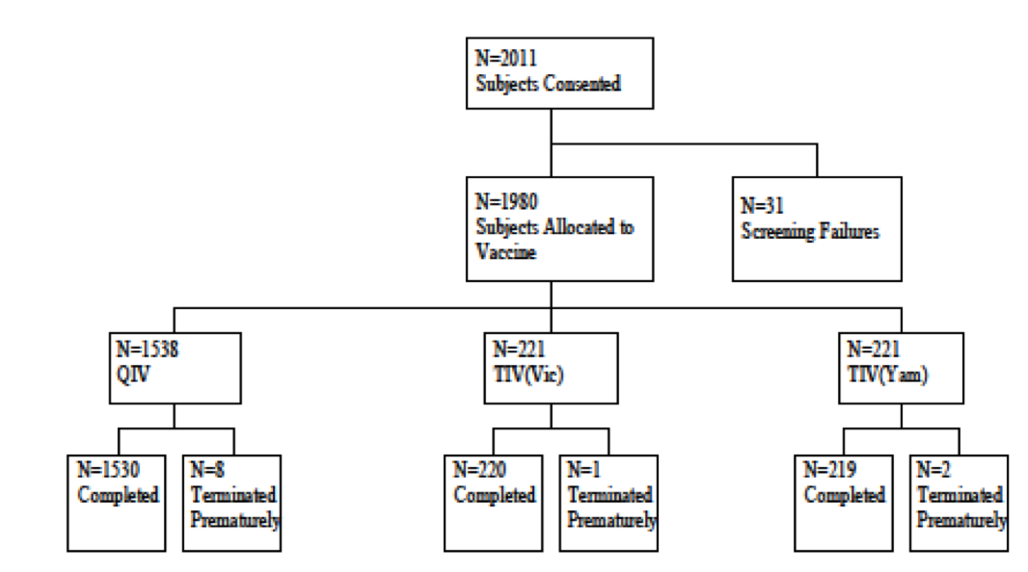
Figure 2: Flowchart of subject analysis populations in Study INFQ3001
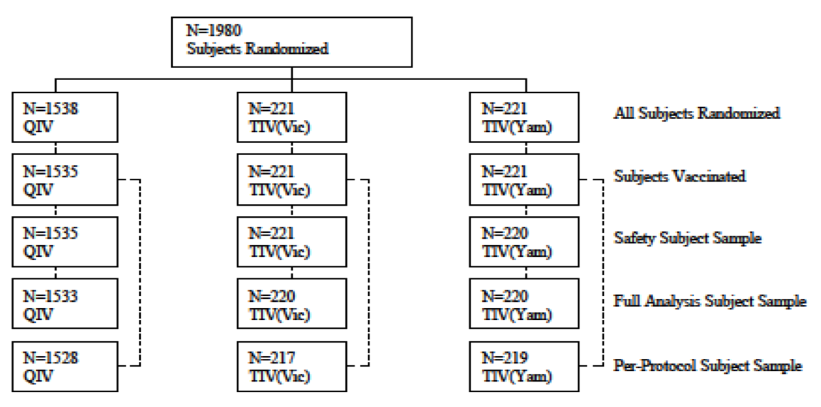

Major protocol violations/deviations

Table 2: Subjects with critical or major protocol deviations in Study INFQ3001
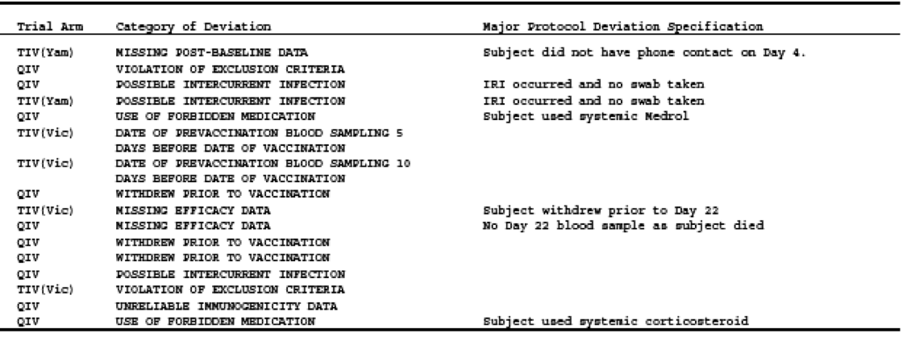
The highest proportion of subjects with major protocol deviations was observed in the categories of possible intercurrent infection and withdrawal prior to vaccination (3 subjects each, 0.2%)

Baseline data

Table 3: Demographics; All subjects randomised sample in Study INFQ3001
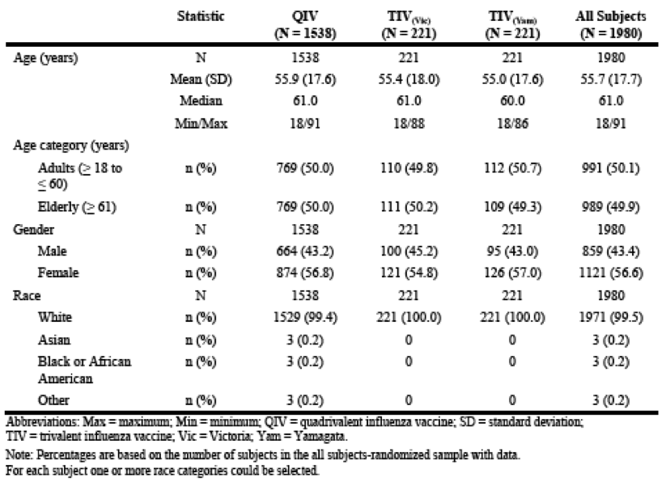
As shown in Table 3 above, the majority of subjects were White (99.5%); 43.4% were male and 56.6% female. The mean (SD) age at screening was 55.7 (17.7) years. Adults had a mean age of 39 (SD = 12.6) years and a median age of 39 years (range: 18 to 60 years). About half of the adults were male. Elderly adults had a mean age of 69 (SD = 6.3) years and a median age of 68 years (range: 60 to 92 years). The proportion of adult and elderly subjects was similar in each vaccination group. In general, subject demographics were similar in all vaccination groups. The majority of subjects across vaccination groups had not previously received a vaccine against seasonal influenza (51.2% in the QIV group, 54.3% in the TIV_{(Vic)} group, and 52.9% in the TIV_{(Yam)} group) and had not experienced an ILI since the start of the last season (99.2% in the QIV group, 99.5% in the TIV_{(Vic)} group, 99.1% in the TIV_{(Yam)} group). The proportion of subjects who had previously received a seasonal influenza vaccine was higher in elderly subjects (61.2% in the QIV group, 59.5% in the TIV_{(Vic)} group, and 57.8% in the TIV_{(Yam)} group) than in adult subjects (36.4% in the QIV group, 31.8% in the TIV_{(Vic)} group, and 36.6% in the TIV_{(Yam)} group).

Results for the primary efficacy outcome
For all 4 strains the upper limit of the 95% CI for the HI geometric mean ratio (GMR; TIV versus QIV) fell below the predefined non-inferiority margin of 1.5, meaning that the non-inferiority of QIV to TIV was demonstrated as shown in Table 4, below.

Table 4: Non-inferiority of QIV versus TIV against shared strains based on post-vaccination geometric mean HI titres; PP sample
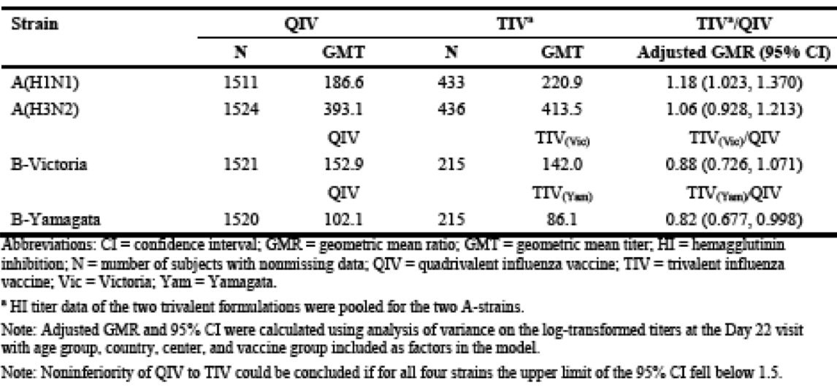
The primary efficacy analysis was repeated for the FAS and results were similar to the PP subject sample. The pre- and post-vaccination GMTs for HI were analysed in the 2 age groups and results demonstrated the comparability of GMTs between QIV and TIV per age group (Table 5).

Table 5: Geometric mean HI titres by strain; FAS

Results for other efficacy outcomes
For both B strain lineages, the HI GMT of the TIV group was less than half of the GMT in the QIV group: 64.1 versus 153.1 (B Victoria lineage) and 47.2 versus 101.9 (B Yamagata lineage) (Table 6). Both differences were statistically significant (P < 0.0001, both comparisons). Thus, the HI antibody responses elicited by the B strain antigens were superior to the antibody responses elicited by cross reactivity antigens of the alternate B strain lineages. The secondary efficacy analysis was repeated for the PP subject sample and was similar to the FAS.

Table 6: Superiority of QIV versus TIV against the alternate lineage B strains based on the post-vaccination geometric mean HI titres; FAS
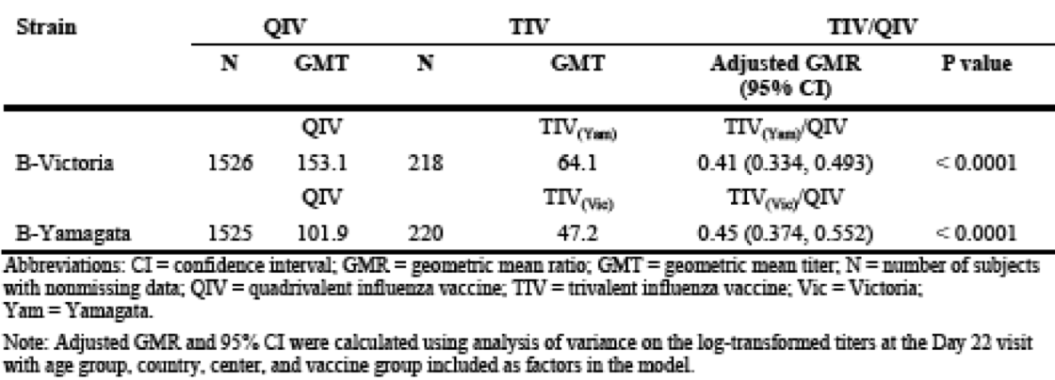

GMTs by strain, centre, country, and fold increase
In all vaccination groups, the HI antibody responses declined with increasing age for all 4 strains. In both adult subjects and elderly subjects, GMTs increased in all vaccination groups for the FAS from Day 1 (pre-vaccination) to the Day 22 visit after vaccination for all 4 strains. Both B strain lineages induced limited cross-reactivity. In the TIV_{(Yam)} group, the GMTs for HI against the B Victoria lineage increased from 17.7 to 85.1 in the adult subjects and from 21.4 to 48.0 in the elderly subjects whereas the GMTS for the B-Yamagata lineage increased from 15.8 to 184.7 in the adult subjects and from 17.0 to 106.6 in the elderly subjects. Similarly, in the TIV_{(Vic)} group, the GMTs for HI against the B-Yamagata lineage increased from 26.3 to 81.7 in the adult subjects and from 13.3 to 27.3 in the elderly subjects whereas the GMTS for the B-Victoria lineage increased from 20.2 to 128.7 in the adult subjects and from 16.4 to 57.4 in the elderly subjects. In both adult subjects and elderly subjects, the GMFIs in HI titres were similar across vaccination groups for all 4 strains. In the adult subjects (see Table 7, below), the Geometric Mean Fold Increases (GMFIs) varied between 6.3 and 11.4 in the QIV group and between 6.2 and 11.7 in the TIV groups (excluding alternate lineages). In the elderly subjects (see Table 8, below) the GMFIs varied between 4.2 and 5.5 in the QIV group and between 2.1 and 6.9 in the TIV groups (excluding alternate lineages). The GMFI in HI titres was repeated for the PP subject sample and were similar to the FAS.

Table 7: GMFIs in HI Titres; FAS (Adults)
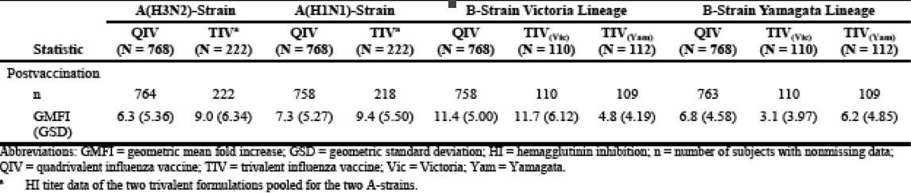

Table 8: Geometric mean fold increases in HI titres; FAS (Elderly)
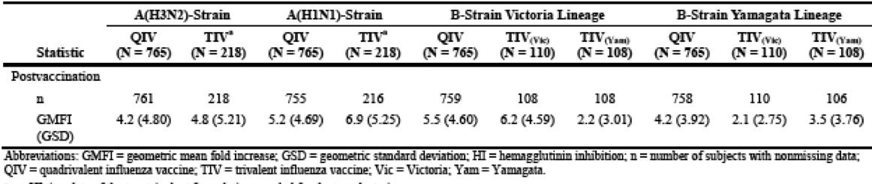

Seroconversion rate based on HI Titres
Seroconversion (defined as becoming seropositive if seronegative at enrolment or at least a 4 fold increase in titres if seropositive at enrolment) rate is presented in Tables 9 and 10, below.
Adults:
- For the A(H3N2) strain and A(H1N1) strain, seroconversion rates were comparable between vaccination groups (A(H3N2) strain: QIV (51.3%); pooled TIV (58.6%); A(H1N1) strain: QIV (59.4%); pooled TIV (65.1%);
- For the B strain Victoria lineage, the seroconversion rates were comparable between QIV (70.2%) and TIV_{(Vic)} (66.4%) groups. The seroconversion rate was lower in the TIV_{(Yam)} group (51.4%) due to the limited cross-reactivity;
- For B strain Yamagata lineage, the seroconversion rates were comparable between QIV (59.2%) and TIV_{(Yam)} (58.7%) groups. The seroconversion rate was lower in the TIV_{(Vic)} group (40.9%) due to the limited cross-reactivity.
Elderly:
- For the A(H3N2) strain and A(H1N1) strain, the seroconversion rates were comparable between vaccination groups (A(H3N2) strain: QIV (39.3%); pooled TIV (44.0%); A(H1N1) strain: QIV, (50.3%); pooled TIV (57.4%);
- For the B strain Victoria lineage, the seroconversion rates were comparable between QIV (53.6%) and TIV_{(Vic)} (55.6%) groups. The seroconversion rate was lower in the TIV_{(Yam)} group 25.0% due to the limited cross-reactivity;
- For the B strain Yamagata lineage, the seroconversion rates were comparable between QIV (49.9%) and TIV_{(Yam)} (46.2%) groups. The seroconversion rate was lower in the TIV_{(Vic)} group (30.0%) due to the limited cross-reactivity.

Table 9: Seroconversion rates based on HI titres; FAS (Adults)
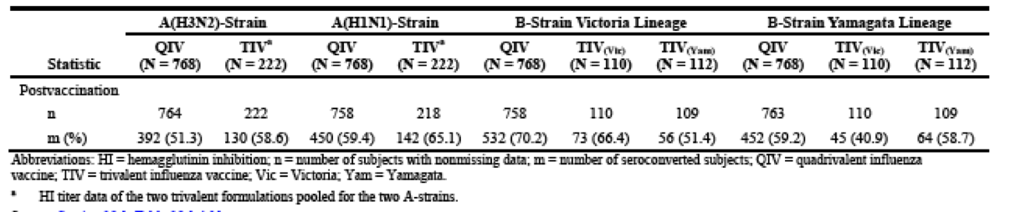

Table 10: Seroconversion rates based on HI titres; FAS (Elderly)
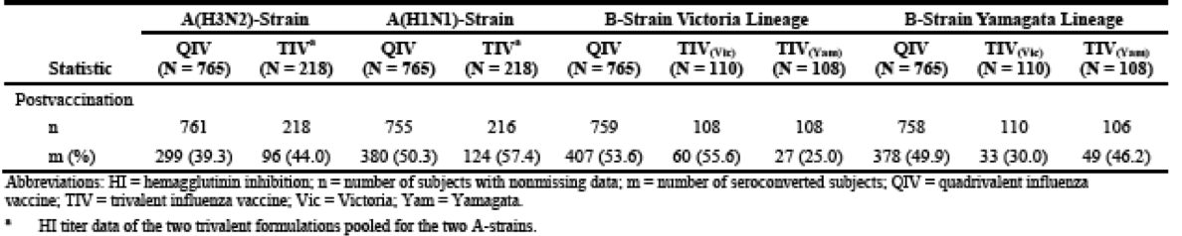

Geometric mean virus neutralisation titres
In both adult subjects and elderly subjects, the GMTs for VN increased in all vaccination groups from Day 1 (pre-vaccination) to the Day 22 visit (post-vaccination) for all 4 strains. The results for the PP subject sample were similar to the FAS.

Geometric mean virus neutralisation titres by fold increase
In both adult subjects and elderly subjects, the GMFI results for VN titres were in line with the HI titres, although the differences were less pronounced. The results for the PP subject sample were similar to the FA subject sample.

Seroconversion rate based on virus neutralisation titres
In both adult subjects and elderly subjects, the seroconversion rates based on VN titres were in line with the HI titres, although the differences were less pronounced. The seroconversion rate based on VN titres was repeated for the PP subject sample and results for the PP subject sample were similar to the FAS. The proportion of subjects with post-vaccination HI titres ≥ 40 for all 4 strains across all vaccination groups in adult subjects and elderly subjects, respectively are presented in Tables 11 and 12 (shown below). The proportion of subjects with post-vaccination HI titres ≥ 40 increased from Day 1 (pre-vaccination) to Day 22 (post-vaccination) for all 4 strains in both adult subjects and elderly subjects in all vaccination groups.
For the A (H3N2) strain in adult subjects, the post-vaccination HI titres ≥ 40 were reported in 97.8% in the QIV group compared to 95.9% in the pooled TIV group. In elderly subjects, the post-vaccination HI titres ≥ 40 were reported in 95.7% in the QIV group compared to 96.3% in the pooled TIV group.
For the A (H1N1) strain in adult subjects, the post-vaccination HI titres ≥ 40 were reported in 94.6% in the QIV group compared to 93.6% in the TIV group. In elderly subjects, the post-vaccination HI titres ≥ 40 were reported in 85.3% in the QIV group compared to 88.9% in the pooled TIV group.
For the B strain Victoria lineage in adult subjects, post-vaccination HI titres ≥ 40 were reported in 92.8% in the QIV group compared to 89.1% in the TIV_{(Vic)} group and 79.1% in the TIV_{(Yam)} group. In elderly subjects, the post-vaccination HI titres ≥ 40 were reported in 80.8% in the QIV group compared to 81.5% in the TIV_{(Vic)} group and 63.0% in the TIV_{(Yam)} group
For the B strain Yamagata lineage in adult subjects, post-vaccination HI titres ≥ 40 were reported in 91.6% in the QIV group compared to 78.2% in the TIV_{(Vic)} group and 90.0% in the TIV_{(Yam)} group. In elderly subjects, the post-vaccination HI titres ≥ 40 were reported in 73.3% in the QIV group compared to 51.8% in the TIV_{(Vic)} group and 73.6% in the TIV_{(Yam)} group.

Table 11: Proportion of subjects with post-vaccination HI titres ≥ 40; FAS (adults)
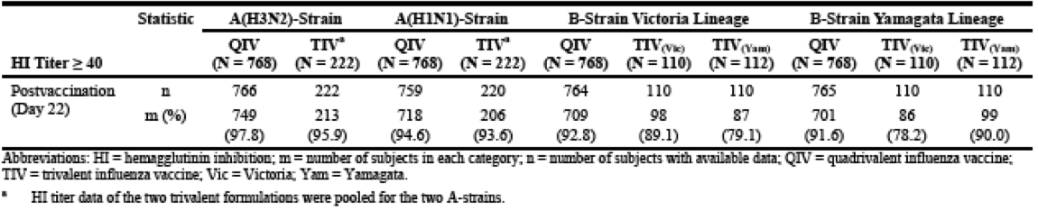

Table 12: Proportion of subjects with post-vaccination HI titres ≥ 40; FAS (elderly)
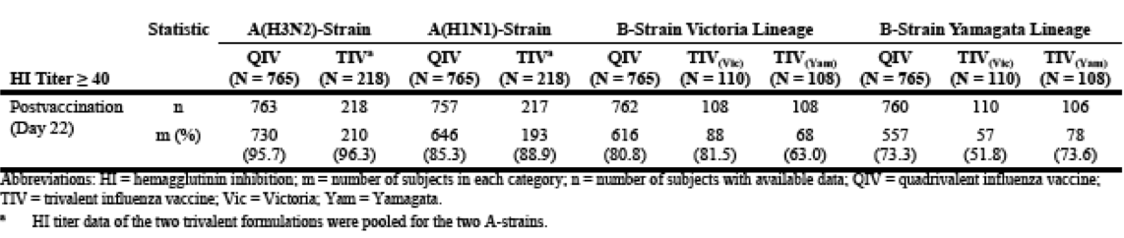

Evaluator commentary
The study design was appropriate with adequate power for the primary and key secondary endpoints. Several endpoints exploring T cell immune responses in a subset are exploratory and not discussed above. The study demonstrated in all age groups studied (adults and the elderly) first that the post-vaccination geometric mean HI titres of all influenza strains in QIV were non-inferior to the shared strains contained in the TIV formulations and second, there were superior immune responses (as measured by post-vaccination geometric mean HI antibody titres) for each of the B strain lineages in the QIV when compared to the TIVs with the alternate B strain lineage. Geometric mean fold increases based on HI titres was > 6.3 in adult subjects and > 4.2 in elderly subjects in the QIV group for all 4 strains. Seroconversion based on HI titres was found in > 51.0% of the adult subjects and > 39.0% of the elderly subjects in the QIV group for all 4 strains. More than 91.0% of the adult subjects and > 73.0% of the elderly subjects in the QIV group had post-vaccination HI titres ≥ 40 for all 4 strains.

Analyses performed across trials: pooled and meta analyses
Post-vaccination GMTs found in the QIV and TIV formulations in Study INFQ3001 against the TIV formulation in the 16 supportive studies of Influvac, boxplots of the post-vaccination geometric mean HI titres per strain are displayed in Figures 3 and 4 (shown below) for the adults and elderly adults, respectively. In summary, the post-vaccination GMTs of the QIV and TIV formulations used in Study INFQ3001 are within the expected range of the pooled post-vaccination GMTs of the 16 TIV studies in the clinical study database of Influvac.

Adults

Comparison of QIV in INFQ3001 against TIV supportive studies
For the H3N2 strain, the post-vaccination GMT for QIV in Study INFQ3001 was 442.4, which is within the interquartile range of the pooled TIV studies (300.9 to 545.0). For the H1N1 strain, the post-vaccination GMT for QIV was 272.2, which also fell within the interquartile range of the pooled TIV studies (170.4 to 538.2).
For the B strain Victoria lineage and Yamagata lineage, the post-vaccination GMT for QIV was 214.0 and 162.5, respectively, which is within the interquartile range of the pooled TIV studies (108.8 to 246.9).

Comparison TIV in INFQ3001 against TIV supportive studies
For the H3N2 strain, the post-vaccination GMT for TIV in Study INFQ3001 was 473.5, which is within the interquartile range of the pooled TIV studies (300.9 to 545.0). For the H1N1 strain, the post-vaccination GMT for TIV was 310.1, which also fell within the interquartile range of the pooled TIV studies (170.4 to 538.2). For the B strain Victoria lineage and Yamagata lineage, the GMT for TIV was 184.7 and 128.7, respectively, which is within the interquartile range of the pooled TIV studies (108.8 to 246.9).
Figure 3: Geometric mean HI titres; Adults, Clinical Study Database for Influvac

Elderly adults

Comparison QIV in INFQ3001 against TIV supportive studies
For the H3N2 strain, the post-vaccination GMT for QIV in Study INFQ3001 was 348.5, which is within the interquartile range of the pooled TIV studies (231.5 to 402.5). For the H1N1 strain, the post-vaccination GMT for QIV was 127.2, which also fell within the interquartile range of the pooled TIV studies (80.0 to 233.6). For the B strain Victoria lineage and Yamagata lineage, the post-vaccination GMT for QIV was 109.4 and 63.7, respectively, which is within the interquartile range of the pooled TIV studies (42.6 to 182.9).

Comparison TIV in INFQ3001 against TIV supportive studies
For the H3N2 strain, the post-vaccination GMT for TIV in Study INFQ3001 was 357.4, which is within the interquartile range of the pooled TIV studies (231.5 to 402.5). For the H1N1 strain, the post-vaccination GMT for TIV was 157.7, which also fell within the interquartile range of the pooled TIV studies (80.0 to 233.6). For the B strain Victoria lineage and Yamagata lineage, the post-vaccination GMT for TIV was 106.6 and 57.4, respectively, which is within the interquartile range of the pooled TIV studies (42.6 to 182.9).
Figure 4: Geometric mean HI titres; Elderly adults, Clinical Study Database for Influvac

Evaluator’s conclusions on clinical efficacy
Study INFQ3001 conducted entirely within the European Union, demonstrates the immunogenicity of Influvac Tetra in adults aged 18 to 60 years and the elderly aged ≥ 61 years against all 4 strains of influenza virus contained within the vaccine. Standard methodology to demonstrate immunogenicity was utilised. Importantly, the added B strain provides superior immunogenicity without affecting the antibody response to the other strains and there is no safety cost (discussed in Section 8, below). Seroprotection rates for all 4 strains in the QIV were higher in adults compared to the elderly, but nevertheless high in both groups. Lower seroprotection in the elderly is a universal finding in immunogenicity studies for influenza vaccines (that is, not a unique finding for this vaccine) and the reviewer has no concerns about this finding in the pivotal study and the pooled analyses.

Clinical safety
There is one key study, Study INFQ3001, described in Section 7 (above) that provided evaluable safety data for the QIV. The study aimed to demonstrate that the safety and reactogenicity of QIV is comparable to those of TIVs. The extensive safety data collected for Influvac is considered supportive of QIV development, as the antigens of the influenza strains in QIV are similar to those from TIV formulations over the years (apart from the fact that QIV now combines 2 B strain lineages in one formulation). Influvac has shown a favourable safety profile in both healthy and at-risk populations, and no unexpected safety signals that would warrant specific additional risk minimisation activities have been observed to date. Therefore, standard safety outcome parameters for influenza vaccine studies were used, that is, solicited local and systemic reactions (reactogenicity), overall inconvenience, and other unsolicited AEs. For the 6 month safety follow up, only new SAEs and NCIs were reported.
Safety reporting parameters are defined as follows:
- AE: An AE is any untoward medical occurrence in a patient or clinical investigation subject administered a pharmaceutical product and which does not necessarily have a causal relationship with this treatment. An AE can, therefore, be any unfavourable and unintended sign (including an abnormal, clinically significant laboratory finding), symptom, or disease temporally associated with the use of an investigational product, whether or not considered related to the product. The post therapy AE collection period is defined as the period up to Visit 2 (until Day 22 after study vaccination).
- Solicited AEs and Unsolicited AEs (as defined in Section 7) graded for severity as follows:
  - Mild: Symptoms are easily tolerated and do not interfere with normal, everyday activities;
  - Moderate: Discomfort enough to cause some interference with normal, everyday activities;
  - Severe: Symptoms that prevent normal, everyday activities.
- New Chronic illnesses (NCI): Collected from informed consent to study end, that is, Phone Contact 2 (Day 183).
- SAE: Untoward medical occurrence that results in death; is life-threatening; requires in patient hospitalisation or prolongation of existing hospitalisation; results in persistent or significant disability or incapacity; is a congenital anomaly or birth defect; is an important medical event; is the suspected transmission of an infectious agent via a medicinal product. Collected from signing informed consent to study end, that is, Phone contact 2 (Day 183).
- Severity Of AEs: Assessed by the investigator as follows:
  - Mild: Usually transient and do not interfere with the subject’s daily activities;
  - Moderate: Low level of inconvenience or concern to the subject and may interfere with daily activities;
  - Severe: Interrupt the subject’s usual daily activity.
- Causality of AEs: Assessed by investigator as unrelated, unlikely, possible or probable.

Studies providing evaluable safety data
Study INFQ3001, described in Section 7 (above) collected safety data as a secondary outcome.

Pivotal studies that assessed safety as the sole primary outcome
No studies.

Evaluator commentary
Study INFQ3001 was deemed a large enough study to assess the safety of the QIV compared to the TIVs in the study. The reason why this relatively small study is adequate is that QIV is not considered a completely new vaccine which would necessitate higher number of vaccines in order to characterise safety. The extensive safety data collected with the TIV, Influvac, is considered supportive for the QIV development, since the production process for QIV and Influvac are identical and importantly both B strain lineages have been alternatingly present in the TIV formulation over many years, without safety concerns.

Patient exposure
1535 adults received a single dose of the QIV (See Section 7, above). Of the 990 vaccinated adult subjects, 768 received a single vaccination of QIV, and 222 subjects received a single vaccination of TIV on Day 1. Of the 986 vaccinated elderly adults, 767 received a single vaccination of QIV, and 219 subjects received a single vaccination of TIV on Day 1.

Adverse events
Integrated analyses performed on the safety data of the current thiomersal free formulation of the TIV, Influvac, was restricted to healthy adults (18 to 60 years of age) and elderly adults (≥ 61 years of age) who received a single vaccination of the standard trivalent dose, that is, 15 µg of an A (H1N1) strain, 15 µg of an A (H3N2) strain and 15 µg of a B strain, and for whom safety data are available. The list of solicited local and systemic reactions differs between studies. Some reactions were solicited in almost all studies; others were solicited in only few studies. In most of the studies, 9 local reactions (redness, swelling, itching, warmth, pain, tenderness, impairment of arm movement, induration and ecchymosis) and 6 systemic reactions (fever, increased sweating, headache, malaise, insomnia or fatigue, and shivering) were recorded daily by the subjects participating in the studies. Insomnia was included for all studies until 2007 and was replaced by fatigue from 2008 onwards. In the study performed in China (Study S201.3.121) rash was added to the local reactions and allergic reactions, cough, myalgia, malaise/fatigue, nausea/vomiting and diarrhoea were added to the systemic reactions as per Chinese regulatory requirements. In the 2 studies (Studies S203.2.009 and S203.3.013) where Influvac was used as a comparator, myalgia and arthralgia were added to the systemic reactions.

All adverse events (irrespective of relationship to study treatment)

Integrated safety analyses (Clinical Study Database Influvac)
AEs were evaluated in 1473 adults and 1744 elderly adults up to Day 22 post-vaccination. During the first 3 weeks after vaccination, TEAEs were reported in 9.8% of the adults and 7.5% of the elderly adults. None of the subjects died up to Day 22 of the supportive TIV studies. The % of subjects with ≥ 1 TEAE considered to have a reasonable possibility for a causal relationship with the study vaccine was 1.9% and 1.3%, respectively. TEAEs were reported most commonly in the ‘Infections and infestations’, 3.1% of the adult subjects 1.4% of the elderly subjects. Most frequently reported TEAEs were headache (1.4% of the adults and 0.3% of the elderly) and oropharyngeal pain (1.4% and 0.4%, respectively), followed by nasal congestion (1.0% and 0.1%, respectively), nasopharyngitis and URTI (both 0.7% and 0.2%, respectively). All other TEAEs reported by 0.5% of the subjects or less. TESAEs were reported by 3 adults (0.2%; 3 events) and 7 (0.4%; 7 events) elderly adults.

Pivotal and/or main efficacy studies (Study INFQ3001)

Adults
4.5% of subjects reported ≥ 1 TEAE up to the Day 22 visit; 4.8% subjects in the QIV group and 3.6% subjects in the TIV group. No subject died or discontinued the study up to the Day 22 visit due to TEAEs. A total of 0.5% and 0.9% of the subjects in the QIV and TIV groups, respectively, had ≥ 1 TEAE considered to have a reasonable possibility for a causal relationship with the study vaccine. 3 subjects (0.3%) in the QIV group reported TEAEs that were severe. However, the proportion of subjects with TEAEs was similar across vaccination groups. TEAEs were reported most frequently in the SOC of ‘Infections and infestations’ (14 adult subjects (1.8%) in the QIV group and 2 adult subjects (0.9%) in the TIV group). No TEAE was reported in > 2 adult subjects for any PT in either vaccination group. No flagging occurred (= 1.0 not included in the CI for the rate ratio between the QIV and the TIV group). 2 adult subjects from the QIV group experienced one TESAE each (cartilage injury and hand fracture) up to the Day 22 visit.
Of the TEAEs, the majority were mild.
QIV group: TEAEs assessed as moderate in severity: animal bite, arthropod bite, wound, gastritis, intervertebral disc protrusion, arthralgia, myalgia, dizziness, and allergic conjunctivitis (reported in 1 subject (0.1%) each). Arthralgia and myalgia were systemic reactions that occurred after Day 7 and hence were reported as TEAEs. TEAEs assessed as severe: hand fracture, cartilage injury, and gastritis (reported in 1 subject (0.1%) each).
TIV group: TEAEs assessed as moderate in severity: cluster headache and ILI (reported in 1 subject (0.5%) each). None of TEAEs assessed as severe by the Investigator in the TIV group.

Elderly adults
Overall, 3.5% of subjects reported ≥ 1 TEAE up to the Day 22 visit; 3.8% subjects in the QIV group and 2.7% subjects in the TIV group. No subject died or discontinued up to the Day 22 visit due to TEAEs. 5 subjects (0.5%) reported 6 TESAEs. A total of 0.8% and 0.9% of subjects in the QIV and TIV groups, respectively, had ≥ one TEAE that was considered to have a reasonable possibility for a causal relationship with the study vaccine. Overall, 4 subjects (0.4%) reported 4 TEAEs that were severe in severity. However, the proportion of subjects with TEAEs was similar across vaccination groups. TEAEs were reported most commonly in the ‘Infections and infestations’ SOC (11 subjects (1.4%) in the QIV group and 2 elderly adults (0.9%) in the TIV group). No TEAE was reported in > 2 elderly adults for any PT in either vaccination group. No flagging occurred in this age group.
5 elderly adults experienced a total of 6 TESAEs up to the Day 22 visit. Of these, 4 TESAEs (abdominal wall abscess, atrial fibrillation, foot fracture, and rotator cuff syndrome) were reported in 1 elderly adult each from the QIV group and 2 TESAEs (sub-acute endocarditis and arterial embolism) were reported in 1 elderly adult from the TIV group. Of the TEAEs that were reported in elderly adults, the majority were mild in severity.

Moderate TEAEs
- QIV group: URTI, cystitis, bronchitis, back pain, dyspnoea, chronic pancreatitis, somnolence, atrial fibrillation, contusion, and hepatic cirrhosis (reported in 1 subject (0.1%) each).
- TIV group: sub-acute endocarditis, spinal osteoarthritis, and aortic valve incompetence (reported in 1 subject (0.5%) each).

Severe TEAEs
- QIV group: abdominal wall abscess, rotator cuff syndrome, and foot fracture (reported in 1 subject (0.1%) each).
- TIV group: arterial embolism (reported in 1 subject (0.5%)).

Treatment related adverse events (adverse drug reactions)

Integrated safety analyses (Clinical Study Database Influvac)
Treatment-related TESAEs were reported by 1.9% adults and 1.3% elderly adults. The most frequently reported TRAEs are nasal congestion (0.7% of the adults and 0.1% of the elderly) and oropharyngeal pain (0.6% and 0.1%, respectively), followed by cough (0.3% and 0.2%, respectively), nasopharyngitis (0.3% and 0.1%, respectively), pain and headache (both 0.2% in adults only). All other TRAEs were reported by 0.1% of the subjects.

Pivotal and/or main efficacy studies (Study INFQ3001)
Adults: Proportion with vaccine-related TEAEs was 0.6% across vaccination groups; 4 subjects (0.5%) in the QIV group and 2 subjects (0.9%) in the TIV group. The PT asthenia was the only TEAE reported in > 1 subject (2 subjects (0.3%) in the QIV group.
Elderly adults: Proportion with vaccine-related TEAEs was 0.8% across the vaccination groups; 6 subjects (0.8%) in the QIV group and 2 subjects (0.9%) in the TIV group. None of the vaccine-related TEAEs were reported in > 1 subject for any PT in either vaccination group.

Reactogenicity within 7 Days after vaccination: Local reactions
Adults: Rates were generally low (< 10%) except vaccination site pain in 24.9% in the QIV group and 18.5% in the TIV group. One subject each in the QIV group had severe swelling and vaccination site pain. Except for vaccination site pain, reporting rates of all other local reactions were slightly lower in the QIV group than in the TIV group. None of the differences reached statistical significance and were not flagged as a potential safety issue.
Elderly: The percentage of elderly adults with local reactions within 7 days after vaccination was low (< 5%) except for vaccination site pain that occurred in 7.6% in the QIV group and 5.9% in the TIV group. One subject in the QIV group had severe induration, 2 subjects in the TIV group had severe swelling, and 1 subject in the TIV group had severe induration. Although reporting rates were slightly higher in the QIV group in elderly adults, none of the differences reached statistical significance and were not flagged as a potential safety issue.
For both adult and elderly adults, most of the local reactions were mild or moderate in severity. Overall, all local reaction symptoms lasted for 1 to 3 days for the majority of subjects in both vaccination groups.

Reactogenicity within 7 days after vaccination: Systemic reactions
Adults: Headache and fatigue/tiredness were the most frequent systemic reactions within 7 days after vaccination in both vaccination groups. Headache reported by 12.4% of subjects in the QIV group and 13.1% in the TIV group. Fatigue/tiredness reported by 11.9% and 12.6% of subjects in the QIV and TIV groups, respectively. Most systemic reactions were mild or moderate. Severe reactions reported in ≤0.3% in the QIV group and ≤0.9% in the TIV group. Duration was 1-3 days for the majority of subjects in both vaccination groups. Reporting rates and relative risks of systemic reactions were comparable between the QIV group and the TIV group.
Elderly: Headache and fatigue/tiredness were the most frequent systemic reactions within 7 days after vaccination in both vaccination groups. Headache reported by 8.1% in the QIV group and 7.3% in the TIV group. Fatigue/tiredness reported by 10.6% and 6.8% of subjects in the QIV and TIV groups, respectively. Most systemic reactions were mild or moderate. Severe reactions reported in ≤ 0.7% in the QIV group and ≤ 0.5% in the TIV group. Duration was 1 to 3 days for the majority of subjects in both vaccination groups. Differences in rates between QIV and TIV were relatively small, although only one reaction (arthralgia/joint pain, 5.8% (QIV) versus 2.3% (TIV)) reached statistical significance (see Table 13, below), thus was flagged as having a potentially higher reporting rate for elderly subjects in the QIV group.

Table 13: Study INFQ3001 systemic reactions, reporting rates and relative risks; safety subject sample, elderly population
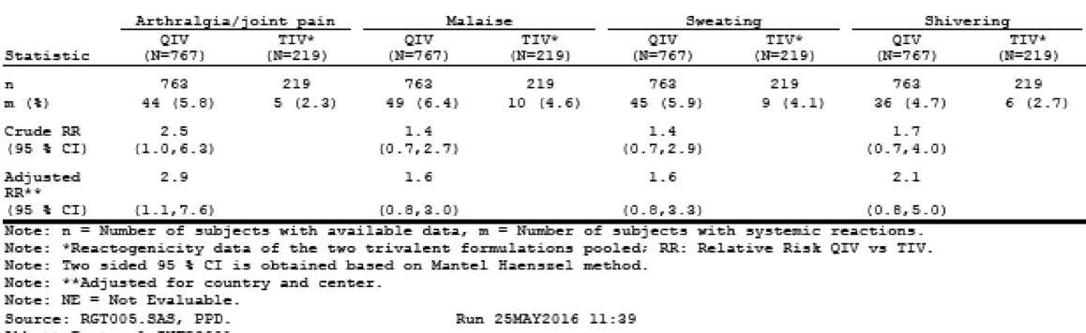

Clinical study database influvac
Local Reactions: Most frequently reported reaction was vaccination site pain (13.4% of the adults and 3.8% of the elderly). All other local reactions were reported by 3.2 to 6.1% of the adults and by 1.7-3.0% of the elderly adults. Most local reactions were mild, resolving within 3 days. Elderly adults reported fewer local reactions than the adults.
Systemic Reactions: Most frequently reported systemic reactions were fatigue (14.4% of the adults and 9.1% of the elderly), and headache (12.0% and 7.4%, respectively). All other systemic reactions reported by 0.5-8.9% of the adults and by 0.5% to 4.8% of the elderly. Most systemic reactions were mild, resolving within 3 days. Elderly adults reported fewer systemic reactions than the adults.

Deaths and other serious adverse events

Deaths
No deaths reported up to Day 22 post-vaccination in Study INFQ3001 or in the 16 supportive clinical studies for TIV.

Deaths post day 22 (Study INFQ3001)
Of the reported TESAEs (severe cardiac disorder), outcome was fatal (unrelated to study vaccine) for 1 adult subject in the QIV group. Of the reported TESAEs, outcome was fatal for 4 elderly adults in the QIV group: oesophageal carcinoma, pancreatic carcinoma, hepatic failure, and congestive cardiac failure. None of the TESAEs were considered related to study vaccine.

SAEs (Study INFQ3001)
No pregnancies up to the Day 22 visit; 5 pregnancies between Day 22 to Month-6 post-vaccination. 2 subjects had spontaneous abortions; one subject had an elective termination; 2 subjects had full term pregnancies with normal outcomes. These events judged as unrelated to study vaccination.

SAEs up to the day 22 visit
Adults: 2 in the QIV group experienced one TESAE each (cartilage injury and hand fracture) up to the Day 22 visit.
Elderly: 5 experienced a total of 6 TESAEs up to the Day 22 visit. Of these, 4 TESAEs, that is, abdominal wall abscess, atrial fibrillation, foot fracture, and rotator cuff syndrome, were reported in 1 subject each from the QIV group and 2 TESAE (sub-acute endocarditis and arterial embolism) were reported in 1 subject from the TIV group. Atrial fibrillation and subacute endocarditis were of moderate intensity, all others were severe. None considered study vaccine related.

SAE from the day 22 visit to study end
Adults: Similar across the vaccination groups (1.3% and 1.8% in the QIV and TIV groups, respectively). No TESAEs reported in > 1 subject for any PT in either vaccination group, except hypertension that was reported in 2 subjects (0.3%) in the QIV group. All TESAEs considered not related or unlikely related to the study vaccine.
Elderly: Similar across the vaccination groups (3.9% and 4.1% in the QIV and TIV groups, respectively). No TESAEs reported in > 1 subject for any PT in either vaccination group, except cerebrovascular accident reported in 2 subjects (0.3%) in the QIV group. All TESAEs considered not related to the study vaccine.

NCI (collected day 22 visit up to the Month-6 telephone call).
Adults: Similar across the groups (1.3% and 1.4% in the QIV and TIV groups, respectively). No NCIs reported in > 1 subject for any PT in either vaccination group, except spinal osteoarthritis reported in 2 subjects (0.3%) in the QIV group.
Elderly: Similar across the groups (4.0% and 2.3% in the QIV and TIV groups, respectively). No NCIs reported in > 1 subject for any PT in either vaccination group, except for the following illnesses in the QIV group: cataract reported in 5 subjects (0.7%); osteoarthritis reported in 3 subjects (0.4%); and gastroenteritis, atrial fibrillation, and hypothyroidism each reported in 2 subjects (0.3%). None of the NCIs considered related to the study vaccine.

Clinical study database influvac
Pregnancy: 2 subjects became pregnant during the study: normal pregnancy outcome with live births. One subject vaccinated in the supportive TIV study S203.3.013 (conducted in Australia) became pregnant between the Day 22 visit and Month 6 post-vaccination. She had a full term pregnancy with normal outcome.
Unsolicited AEs: in those in whom these could be evaluated, 3 adults and 7 elderly adults reported 10 TESAEs in total in the study period up to 3 weeks after vaccination. All the reported TESAEs were considered not related to study vaccine.
Adults: 3 subjects experienced one TESAE each, that is, type I diabetes mellitus, shoulder surgery, acute appendicitis, considered to be of mild, moderate and severe intensity, respectively.
Elderly: 7 experienced the following TESAEs, that is, pancreatic neoplasm, coronary artery disease, transient ischemic attack, adenocarcinoma of the prostate and urinary retention secondary to benign prostatic hyperplasia, radiculitis secondary to osteoarthritis, chest pain and confusion. Radiculitis and chest pain were considered to be moderate, all other TESAEs were severe.

Extended safety (SAE and NCI) follow-up (Day 22 up to 6 months post-vaccination)
This was performed in 2 studies (Studies S203.2.009 and S203.3.013).
Deaths: Outcome fatal (congestive cardiac failure in 1 subject and metastatic pancreatic carcinoma and peritonitis in 1 subject) for 2 elderly adults during the period from Day 22 up to 6 months post-vaccination. None considered vaccine-related.
Other SAEs:
- Study S203.2009 (first year): The proportion of elderly adults reported with ≥ 1 TESAE was 3.9%. The most commonly reported TESAE was angina pectoris (2 subjects). No other TESAEs were reported in more than one subject. None considered vaccine-related.
- Study S203.2009 (second year): The proportion of subjects reported with at least one TESAE from the Year 2 Day 22 Visit up to the Year 2 Month 6-telephone call of the study was 3.5%. No TESAEs were reported in more than one subject. None considered vaccine related.
NCI:
- Study S203.2009 (first year): 9.2% subjects with at least one NCI reported. No NCI reported in ≥ 5%. The most common NCI was osteoarthritis (5 (2.4%) subjects). None considered vaccine-related.
- Study S203.2009 (second year): 7.0% subjects with ≥ 1 NCI reported. No NCI reported in ≥ 2%. Most common NCI was osteoarthritis (2 (1.4%) subjects). None considered vaccine-related.

Discontinuations due to adverse events

Integrated safety analyses
Overall, 0.7% prematurely withdrew from the studies, 10 (0.7%) adults and 13 (0.7%) elderly adults. Reasons reported: lost to follow-up (7 adults and 6 elderly adults), and AE (6 elderly adults with SAEs), withdrawal of consent (1 adult and 1 elderly adult), and lack of time (due to personal reasons, 2 adult subjects).

Pivotal and/or main efficacy studies (Study INFQ3001)
Overall, 11 subjects (0.6%) prematurely withdrew from the study. The number of premature withdrawals was 8 subjects (0.5%) assigned to QIV, 1 subject (0.5%) to TIV_{(Vic)} and 2 subjects (0.9%) to TIV_{(Yam)}. Reasons reported: withdrawal of consent (4 subjects), AE (3 subjects with fatal TEAEs, lost to follow-up (3 subjects) and administrative (1 subject). No subject reported a TEAE up to the Day 22 visit leading to study termination.

Evaluation of issues in Study INFQ3001 with possible regulatory impact

Liver function and liver toxicity
Not assessed.

Renal function and renal toxicity
Not assessed.

Other clinical chemistry
Not assessed.

Haematology and haematological toxicity
Not assessed.

Electrocardiograph findings and cardiovascular safety
Not applicable, not assessed.

Vital signs and clinical examination findings
None revealed.

Immunogenicity and immunological events
None revealed in Study INFQ3001. According to the current EU RMP; Version 3.0, DLP 29 February 2016, hypersensitivity is characterised as the only important identified risk for the seasonal influenza vaccine Influvac.

Serious skin reactions
None seen.

Other safety issues

Safety in special populations
Not assessed.

Safety related to drug-drug interactions and other interactions
Not assessed.

Post marketing experience
Not applicable, this is a new drug application. However, PSURs numbers 17 (1 May 2011 to 30 April 2012) to number 24 (1 September 2015 to 15 March 2016) inclusive for the TIV were submitted with this application. The quadrivalent influenza vaccine described in the sponsor’s Summary of Clinical Safety is currently not marketed, therefore only post-marketing safety data from the marketed thiomersal-free TIV was presented and is summarised as part of the integrated safety analysis data. Based on market data, > 350 million doses of the current thiomersal free formulation of the subunit influenza vaccine have been administered between 2004 and 30 April 2016. Considering the large number of patients vaccinated with influenza vaccine and the low number of AEs reported, the vaccine is regarded as safe and well tolerated.

Evaluator’s overall conclusions on clinical safety
In line with the scientific advice obtained from a EU national authority, the exposure of around 1,500 adult subjects to QIV is deemed sufficient to demonstrate the safety of QIV. This exposure is lower than specified in the Note for Guidance on the ‘Clinical Evaluation of New Vaccines’ (EMEA/CHMP/VWP/164653/2005), which recommends at least 3,000 subjects. However, QIV is not considered a completely new vaccine which would necessitate higher number of vaccinees in order to characterise safety. The extensive safety data collected with the related TIV, Influvac, is considered supportive for the QIV development, since the production process for QIV and Influvac are identical (aside from QIV containing both B strain lineages). Moreover, both B strain lineages have been alternatingly present in the TIV formulation over the years.
In Study INFQ3001, the safety profile of QIV in adults and elderly adults is generally similar to that observed for the comparator TIV vaccines within the study and similar to the integrated safety analyses derived from the 16 supporting immunogenicity studies. There was no concerning safety signal revealed with respect to solicited local and systemic reactogenicity, TRAEs or SAEs in either the adult or elderly populations studied. The reviewer notes the slightly increased recorded incidence of arthralgia/joint pain post vaccination in the elderly population receiving the QIV vaccine, but despite this, the rates were still low. Overall, the clinical evaluator thinks that QIV has a clinically acceptable safety and tolerability profile in adults aged ≥ 18 years at least in the relatively small number of patients enrolled in this study exposed to single dose QIV. As Influvac has been marketed for several decades, no additional risks, which might be based on known class effects or known pharmacologic properties, are expected to occur.

First round benefit-risk assessment

First round assessment of benefits

Table 14: First round assessment of benefits
Indication
Benefits | Strengths and Uncertainties
- Influvac Tetra in the proposed usage provides better coverage of the influenza B strains than the TIV;  - QIV was immunogenic against all 4 strains it contains in both the adult and elderly populations;  - the safety profile of this QIV is similar to trivalent inactivated influenza vaccines in general, and to the specific TIV comparators used in the pivotal efficacy study;  - the inclusion of both B strains will overcome the problem of poor predictions of which B strain is likely to circulate, this has been problematic over the last few years and has led to misalignment of the B strain in the recommended TIV with the circulating B strain. | - Paucity of data for the QIV in younger adults;  - paucity of data for the QIV in adults and the elderly of Black or Asian ethnicity;  - no data on immunogenicity or safety of repeat dosing with the QIV;  - no data on immunogenicity or safety of repeat dosing with a QIV manufactured by a different company;  - other QIV flu vaccines are available, so this QIV will not fill a ‘gap in the market’.

First round assessment of risks
The risks of Influvac Tetra in the proposed usage are shown in Table 15, below.

Table 15: First round assessment of risks
Risks | Strengths and Uncertainties
- There is no data on the immunogenicity and safety profile in immunocompromised patients as such patients were specifically excluded from participation;  - Hardly any data for the QIV in subjects of Asian ethnicity;  - nil data for the QIV in Australian indigenous ethnicity; this is relevant to the Australian population;  - no data presented for the safety of QIV in lactating women, yet the product information states Influvac Tetra can be used during lactation. | - (Related to first bullet point, left) Flagged in the PI; as detailed in the RMP,  ‘Other routine measures including monitoring and reporting of post-marketing safety data and signal detection in the immunocompromised’.  - (Related to bullet points 2 to 4 left), no indication from the TIV data that immunogenicity and safety of the QIV will be any different in these different ethnicities or in lactating women. Although there is no data on immunogenicity and safety of this QIV in pregnancy or lactation, use in pregnant and breast-feeding women is not an identified Safety Concern in the EU-RMP. There is a clear plan for the collection of safety data in pregnancy and lactation, which will be reported as a summary data in the PSURs.

First round assessment of benefit-risk balance
The first round assessment of benefit-risk balance is favourable.

First round recommendation regarding authorisation
The clinical evaluator recommends authorisation.

Clinical questions
The clinical evaluator had no questions for the sponsor.

Second round benefit-risk assessment
Following the satisfactory assessment of the Influvac Tetra in the first round, the submission proceeded to Delegate’s overview. See the associated AusPAR for further details.

References
Ambrose C, Levin M. The rationale for quadrivalent influenza vaccines. Hum Vaccin Immunother 2012 Jan; 8(1):81-8.
Belshe, R. The need for quadrivalent vaccine against seasonal influenza. Vaccine 2010 Sep 7; 28 Suppl 4: D45-53.
Beyer W, et al. Protection against influenza after annually repeated vaccination: a meta-analysis of serologic and field studies. Arch Intern Med. 1999;159(2):182-8.
Domachowske J, et al. A Randomized Trial of Candidate Inactivated Quadrivalent Influenza Vaccine versus Trivalent Influenza Vaccines in Children Aged 3-17 Years. J Infect Dis 2013;207(12):1878-87.
Fiore A, et al. Prevention and control of seasonal influenza with vaccines: recommendations of the Advisory Committee on Immunization Practices (ACIP), 2009. MMWR Recomm Rep 2009 Jul 31;58(RR-8):1-52.
Greenberg D, et al. Safety and immunogenicity of a quadrivalent inactivated influenza vaccine compared to licensed trivalent inactivated influenza vaccines in adults. Vaccine 2013;31(5):770-6.
Greenberg D, et al. Safety and Immunogenicity of an Inactivated Quadrivalent Influenza Vaccine in Children 6 Months through 8 Years of Age. Pediatr Infect Dis J. 2014 Jan 17.
Grant K, et al. High proportion of influenza B characterises the 2008 influenza season in Victoria. Commun Dis Intell Q Rep 2009;33(3):328-36.
Hay A, et al. Influenza viruses. In: Belshe RB, ed. Textbook of Human Virology. St. Louis, Missouri: Mosby Year Book, Inc, 1991;307−341.
Jain V et al. Vaccine for prevention of mild and moderate-to-severe influenza in children. N Engl J Med. 2013; 369(26):2481-91
Langley J, et al. Immunogenicity and safety of an inactivated quadrivalent influenza vaccine candidate: a Phase III randomized controlled trial in children. J Infect Dis. 2013; 208(4):544-53.
Monto A. Epidemiology of influenza. Vaccine. 2008 Sep 12; 26 Suppl 4:D45-8.
Olson D, et al. Monitoring the impact of influenza by age: emergency department fever and respiratory complaint surveillance in New York City. PLoS Med 2007;4(8):e247.
Pépin S, et al. Safety and immunogenicity of a quadrivalent inactivated influenza vaccine in adults. Vaccine. 2013; 31(47):5572-8.
Rota P, et al. Cocirculation of 2 distinct evolutionary lineages of influenza type B virus since 1983. Virology 1990 Mar; 175(1):59-68.
Rothberg M, et al.. Complications of viral influenza. Am J Med 2008 Apr;121(4):258-64
Thompson W, et al. Mortality associated with influenza and respiratory syncytial virus in the United States. JAMA 2003;8;289(2):179-86.

Therapeutic Goods Administration
PO Box 100 Woden ACT 2606 Australia
Email: info@tga.gov.au Phone: 1800 020 653 Fax: 02 6232 8605
https://www.tga.gov.au

