July 2021

Australian Public Assessment Report for Influenza Haemagglutinin Recombinant
  - Proprietary Product Name: Flublok Quadrivalent
  - Sponsor: Sanofi-Aventis Australia Pty Ltd

About the Therapeutic Goods Administration (TGA)
- The Therapeutic Goods Administration (TGA) is part of the Australian Government Department of Health and is responsible for regulating medicines and medical devices.
- The TGA administers the Therapeutic Goods Act 1989 (the Act), applying a risk management approach designed to ensure therapeutic goods supplied in Australia meet acceptable standards of quality, safety and efficacy (performance) when necessary.
- The work of the TGA is based on applying scientific and clinical expertise to decision-making, to ensure that the benefits to consumers outweigh any risks associated with the use of medicines and medical devices.
- The TGA relies on the public, healthcare professionals and industry to report problems with medicines or medical devices. TGA investigates reports received by it to determine any necessary regulatory action.
- To report a problem with a medicine or medical device, please see the information on the TGA website <https://www.tga.gov.au>.

About AusPARs
- An Australian Public Assessment Report (AusPAR) provides information about the evaluation of a prescription medicine and the considerations that led the TGA to approve or not approve a prescription medicine submission.
- AusPARs are prepared and published by the TGA.
- An AusPAR is prepared for submissions that relate to new chemical entities, generic medicines, major variations and extensions of indications.
- An AusPAR is a static document; it provides information that relates to a submission at a particular point in time.
- A new AusPAR will be developed to reflect changes to indications and/or major variations to a prescription medicine subject to evaluation by the TGA.

Copyright
© Commonwealth of Australia 2021
This work is copyright. You may reproduce the whole or part of this work in unaltered form for your own personal use or, if you are part of an organisation, for internal use within your organisation, but only if you or your organisation do not use the reproduction for any commercial purpose and retain this copyright notice and all disclaimer notices as part of that reproduction. Apart from rights to use as permitted by the Copyright Act 1968 or allowed by this copyright notice, all other rights are reserved and you are not allowed to reproduce the whole or any part of this work in any way (electronic or otherwise) without first being given specific written permission from the Commonwealth to do so. Requests and inquiries concerning reproduction and rights are to be sent to the TGA Copyright Officer, Therapeutic Goods Administration, PO Box 100, Woden ACT 2606 or emailed to <tga.copyright@tga.gov.au>.

Contents
List of abbreviations 4
I. Introduction to product submission 6
Submission details 6
Product background 7
Regulatory status 8
Product Information 9
II. Registration timeline 9
III. Submission overview and risk/benefit assessment 10
Quality 10
Nonclinical 11
Clinical 11
Risk management plan 24
Risk-benefit analysis 25
Outcome 28
Attachment 1. Product Information 29

List of abbreviations
Abbreviation | Meaning
ACV | Advisory Committee on Vaccine
AE | Adverse event
ARTG | Australian Register of Therapeutic Goods
ASA | Australia specific annex
ATAGI | Australian Technical Advisory Group on Immunisation
CBER | Center for Biologics Evaluation and Research (United States of America)
CDC | Centers for Disease Control (United States of America)
CMI | Consumer Medicines Information
CHMP | Committee for Medicinal Products for Human Use (European Union)
CI | Confidence interval
CPD | Certified Product Details
DLP | Data lock point
EMA | European Medicines Agency (European Union)
EMEA | European Medicines Evaluation Agency (European Union)
EP | European Pharmacopoeia
EU | European Union
FDA | Food and Drug Administration (United States of America)
GMT | Geometric mean titre
HI | Haemagglutination inhibition
IIV4 | Quadrivalent inactivated influenza vaccine (Fluarix Tetra)
ILI | Influenza like illness
JP | Japanese Pharmacopoeia
PI | Product Information
PSUR | Periodic safety update report
rDNA | Recombinant deoxyribonucleic acid
rHA | Recombinant haemagglutinin
RIV3 | Flublok Trivalent, trivalent recombinant influenza vaccine (sponsor development code name)
RIV4 | Flublok Quadrivalent, quadrivalent recombinant influenza vaccine (sponsor development code name)
RMP | Risk management plan
RT-PCR | Reverse transcriptase polymerase chain reaction
rVE | Relative vaccine efficacy
SAE | Serious adverse event
SCR | Seroconversion rate
USA | United States of America
USP | United States Pharmacopeia
WHO | World Health Organization

I. Introduction to product submission

Submission details
Type of submission: | New biological entity
Product name: | Flublok Quadrivalent
Active ingredient: | Influenza haemagglutinin recombinant
Decision: | Approved
Date of decision: | 12 May 2021
Date of entry onto ARTG: | 13 May 2021
ARTG number: | 325683
Black Triangle Scheme: | No
Sponsor’s name and address: | Sanofi-Aventis Australia Pty Ltd  12-24 Talavera Road  Macquarie Park, NSW, 2113
Dose form: | Solution for injection
Strength: | 180 µg total haemagglutinin/0.5 mL (45 µg haemagglutinin antigen from each of four strains)
Container: | Syringe
Pack sizes: | 1 or 10
Approved therapeutic use: | Flublok Quadrivalent is indicated for active immunisation for the prevention of influenza disease caused by influenza virus types A and B contained in the vaccine. Flublok Quadrivalent is approved for use in persons 18 years of age and older.
Route of administration: | Intramuscular injection
Dosage: | Given the variation of the influenza viruses and the duration of immunity provided by the vaccine, it is recommended to vaccinate against influenza every year.  Individuals 18 years of age and older receive a 0.5 mL single dose annually.  For further information regarding dosage, refer to the Product Information.
Pregnancy category: | B1  Drugs which have been taken by only a limited number of pregnant women and women of childbearing age, without an increase in the frequency of malformation or other direct or indirect harmful effects on the human fetus having been observed.  Studies in animals have not shown evidence of an increased occurrence of fetal damage.  The use of any medicine during pregnancy requires careful consideration of both risks and benefits by the treating health professional. This must not be used as the sole basis of decision making in the use of medicines during pregnancy. The TGA does not provide advice on the use of medicines in pregnancy for specific cases. More information is available from obstetric drug information services in your State or Territory.

Product background
This AusPAR describes the application by Sanofi-Aventis Australia Pty Ltd (the sponsor) to register Flublok Quadrivalent (influenza haemagglutinin recombinant) 180 µg/0.5 mL, solution for injection for the following proposed indication:
Flublok Quadrivalent is indicated for active immunisation for the prevention of influenza disease caused by influenza. Flublok Quadrivalent is approved for use in persons 18 years of age and older.
Influenza is an acute respiratory illness caused by influenza viruses (specifically influenza viruses A, B, or C) which occurs mainly during winter seasons and lead to outbreaks. Immunisation is the most effective prevention method. Even though influenza can be self-limiting in otherwise healthy individuals, severe morbidity and mortality may occur, in particular in at risk populations.
The treatment options differ between children and adults. This application is only concerned with adults (18 years and over).
Influenza viruses are associated with high mutation rates. Consequently, this evolution may prevents immunity to different viral variants. Each year, a decision on the strain composition is made to provide a circulating strain and vaccine match.
Multiple influenza vaccines are available, including inactivated vaccines (for intramuscular injection or intradermal administration), and a live attenuated vaccine (for intranasal administration). Recent influenza vaccines have been trivalent or quadrivalent. For the 2020 season, only quadrivalent vaccines will be supplied for the Australian market.
Antiviral drugs are available to treat influenza, but influenza vaccination is the preferred option. Adjunctive use is possible in particular vaccinated target groups (for examples, potentially in the elderly in institutional care, in outbreak settings, or as post-exposure prophylaxis), but the potential for antiviral drug resistance exists. The most important class of antiviral drugs against influenza consists of the neuraminidase inhibitors (oseltamivir or zanamivir).
Influenza vaccination options for individuals with an egg allergy are limited, and they may require antivirals, if any vaccine is contraindicated.
Most influenza vaccines contain ovalbumin, and would be contraindicated (depending on the type of hypersensitivity, and also whether desensitisation or other therapies had proven successful for them).
Some cell based flu vaccines (Flucelvax; not currently on the Australian Register of Therapeutic Goods (ARTG), but under TGA evaluation) have a smaller amount of egg protein compared to other vaccines, and may be used under expert guidance. Preflucel (an inactivated, purified antigen influenza vaccine) also claims to be egg protein free, but is no longer registered on the ARTG. The vaccine in this application, a quadrivalent recombinant influenza vaccine (Flublok Quadrivalent, also known by the sponsor’s vaccine development code of RIV4) claims to be completely egg free.
Flublok Quadrivalent (originally a trivalent version (known as Flublok Trivalent), and transitioned to the quadrivalent version in 2016) has been registered in the United States of America (USA) and is an egg free alternative there but not available in Australia as it is currently not registered.
The clinical benefits and needs for influenza vaccination are undisputed. There are already many influenza vaccine products on the market that comparable with regard to their efficacy, effectiveness, and safety profile. This application concerns the first recombinant influenza vaccine, and the first egg free influenza vaccine for registration in Australia.
Flublok Quadrivalent, if registered on the ARTG, would provide Australian patients with egg hypersensitivity an alternative, egg free influenza vaccine. Many of those individuals did not have the opportunity to be vaccinated against influenza previously.
Flublok Quadrivalent contains 45 μg per hemagglutinin antigen (for each of four influenza virus strains) compared to 15 μg per antigen in all other registered influenza vaccines. The sponsor also claims that higher doses of hemagglutinin may have important clinical and public health benefits, that is, the improved protective efficacy associated with a high dose inactivated vaccine in older adults.

Regulatory status
This product is considered a new biological entity for Australian regulatory purposes.
At the time the TGA considered this application, a similar application had been approved in the USA (on 3 October 2016). A similar application was under consideration in the European Union (EU) (submitted on 4 October 2019).
Table 1, shown below, summarises these applications and provides the indications where approved.
Table 1: International regulatory status
Region | Submission date | Status | Approved indications
United States of America | 4 December 2015 | Approved on 3 October 2016 | Flublok Quadrivalent is a vaccine indicated for active immunization against disease caused by influenza A subtype viruses and influenza type B viruses contained in the vaccine.  Flublok Quadrivalent is indicated for use in persons 18 years of age and older.
European Union | 4 October 2019 | Under consideration | Under consideration

Product Information
The Product Information (PI) approved with the submission which is described in this AusPAR can be found as Attachment 1. For the most recent PI, please refer to the TGA website at <https://www.tga.gov.au/product-information-pi>.

II. Registration timeline
The following table captures the key steps and dates for this application and which are detailed and discussed in this AusPAR.
Table 2: Timeline for Submission PM-2019-04824-1-2
Description | Date
Submission dossier accepted and first round evaluation commenced | 2 December 2019
First round evaluation completed | 30 April 2020
Sponsor provides responses on questions raised in first round evaluation | 30 June 2020
Second round evaluation completed | 12 August 2020
Delegate’s Overall benefit-risk assessment and request for Advisory Committee advice | 3 September 2020
Sponsor’s pre-Advisory Committee response | 14 September 2020
Advisory Committee meeting | 30 September 2020
Registration decision (Outcome) | 12 May 2021
Completion of administrative activities and registration on the ARTG | 13 May 2021
Number of working days from submission dossier acceptance to registration decision* | 199
*Statutory timeframe for standard applications is 255 working days

III. Submission overview and risk/benefit assessment
The submission was summarised in the following Delegate’s overview and recommendations.
TGA guidance at pre-submission meetings is nonbinding and without prejudice.
Relevant guidelines or guidance documents referred to by the Delegate are shown below:
- European Medicines Agency (EMA), Committee for Medicinal Products for Human Use (CHMP), 21 July 2016. Guideline on Influenza Vaccines, Non-clinical and Clinical Module (EMA/CHMP/VWP/457259/2014).
- European Medicines Evaluation Agency (EMEA), Committee for Medicinal Products for Human Use (CHMP), 18 October 2006. Guideline on Clinical Evaluation of New Vaccines (EMEA/CHMP/VWP/164653/2005).

Quality
Flublok Quadrivalent is manufactured using recombinant deoxyribonucleic acid (rDNA) technology and uses an insect baculovirus expression vector system that does not require the use of live influenza virus or biocontainment procedures, and utilises the expresSF⁺ cell line derived from Sf9 cells of the fall armyworm, Spodoptera frugiperda. Each of the four haemagglutinins is expressed in this cell line using a baculovirus vector, extracted from the cells and further purified. The recombinant haemagglutinin (rHA) protein produced is an exact genetic match for the full length haemagglutinin of the selected strain and undergoes the post translational glycosylation and folding required to yield a protein comparable to that produced by the wild type virus.
Flublok Quadrivalent is formulated in phosphate buffered saline without egg proteins, antibiotics, preservatives, gelatine or adjuvants.
The Flublok Quadrivalent drug product is supplied as a sterile liquid with no diluents required for reconstitution and packaged as a single dose (1 mL) as according to the United States Pharmacopeia (USP), European Pharmacopoeia (EP), and Japanese Pharmacopoeia (JP); all in Type I glass syringes with a latex free elastomer stopper containing one 0.5 mL dose for intramuscular injection.
The drug substance contained in the final drug product consists of four separately manufactured rHA proteins derived from:
- influenza A virus subtype H1N1, and named rHA H1;
- influenza A virus subtype H3N2, and named rHA H3;
- influenza B virus Victoria lineage, and named rHA B-V;
- influenza B virus Yamagata lineage, and named rHA B-Y.
Each of the four hemagglutinin genes are cloned from the World Health Organization (WHO) recommended influenza viruses on an annual basis.
The quality evaluator was satisfied that the sponsor had addressed questions raised by TGA. Minor outstanding issues are expected to be resolved prior to registration. There were no objections to the registration of Flublok Quadrivalent – recombinant influenza vaccine in relation to manufacturing quality.
The Delegate mentioned that the proposed tradename has not yet been resolved and will be discussed with the sponsor and the Advisory Committee on Vaccines (ACV).¹⁴

Nonclinical
The nonclinical evaluator commented that the nonclinical dossier was on the related Flublok Trivalent influenza vaccine, which is produced by similar manufacturing process with no significant differences between the formulations (no additional excipients), only an increase in rHA content from 135 to 180 μg/dose. This was deemed acceptable based on the TGA adopted guidance., The safety and efficacy of Flublok Quadrivalent would therefore largely rely on the clinical data.
Nonclinical studies with Flublok Trivalent were Good Laboratory Practice compliant: safety pharmacology studies (respiratory function and central nervous system in rats and the cardiovascular system in dogs); acute (rats and dogs); and repeat dose toxicity studies (rats); a developmental and reproductive toxicity study (rats) and local tolerance studies (rabbits). The nonclinical submission was generally in accordance with the WHO guidelines; however, some data and study deficiencies were noted.
There were no nonclinical objections to the registration of Flublok Quadrivalent provided the clinical evaluation of efficacy, safety and local tolerability of Flublok Quadrivalent was determined to be adequate by the clinical evaluator.
Following completion of all second round assessment reports, the nonclinical evaluator was satisfied that the sponsor had accepted all nonclinical recommendations regarding the PI.

Clinical
The clinical module contained study reports and integrated analyses and the United States (US) Food and Drug Administration (FDA) requested recalculations using data from Studies PSC12 and PSC16 only (not Study PSC04). The data relevant to this application were as follows:
- two pivotal Phase III studies: Study PSC12 and Study PSC16; and
- one other efficacy study: Study PSC04 (Flublok Trivalent).
- Other items included:
  - complementary analyses for immunogenicity on haemagglutination inhibition (HI) for Studies PSC12 and PSC16;
  - Study PSC12: recalculation for efficacy and immunogenicity following US FDA requests;
  - Study PSC16: recalculation for immunogenicity following US FDA requests;
  - complementary listings of clinical study reports for Studies PSC12 and PSC16;
  - reports of bioanalytical and analytical methods for human studies;
  - case report forms and individual patient listings; and
  - literature references.

Efficacy
Three studies were relevant to the efficacy analysis: Study PSC12, Study PSC16, and Study PSC04.
Study PSC12 was a Phase III, multicentre, randomised, double blind and active controlled, parallel group, two arm study in 9003 adults aged ≥ 50 years to compare the relative vaccine efficacy (rVE), immunogenicity, reactogenicity and safety of Flublok Quadrivalent with Fluarix Tetra, a US-licensed quadrivalent inactivated influenza vaccine (IIV4).
Study PSC16 was a Phase III, multicentre, randomised, double blind and active controlled, parallel group, two arm study in 1350 adults aged 18 to 49 years to compare immunogenicity, reactogenicity and safety of Flublok Quadrivalent with Fluarix Tetra (a IIV4, as described above).
Both Studies PSC12 and PSC16 were considered the pivotal trials with nearly identical study design (including the same strains used in the 2014 to 2015 season, and the same comparator vaccine) with two main differences:
- Study PSC12 had a relative efficacy endpoint (rVE compared to IIV4), Study PSC16 only had immunogenicity endpoints;
- Study PSC12 investigated adults aged ≥ 50 years, Study PSC16 investigated adults aged 18 to 49 years.
Study PSC04 used Flublok Trivalent, this study is to provide support for Study PSC016 through true efficacy endpoints (vaccine efficacy compared to placebo) in the 18 to 49 year age group.

Study PSC12
The primary objective of Study PSC12 was to compare the clinical efficacy of Flublok Quadrivalent to that of an IIV4, with respect to the ratio of attack rates of reverse transcriptase polymerase chain reaction (RT-PCR) confirmed protocol defined influenza like illnesses (ILI) that began at least 14 days after vaccination caused by any influenza viral types or subtypes.
The primary statistical hypothesis stated that ‘if non-inferiority is demonstrated, the efficacy of RIV4 [Flublok Quadrivalent] will be tested as an exploratory analysis for superiority over IIV4, based on the incidence of RT-PCR confirmed protocol defined ILI’.
Secondary objectives included the following:
- to compare the protective efficacy in prevention of respiratory illness and influenza infection beginning at least 14 days after vaccination among Flublok Quadrivalent subjects versus IIV4 subjects using several alternative case definitions;
- to compare immunogenicity of Flublok Quadrivalent versus IIV4 in a preselected subset of subjects adequate to compare post vaccination HI geometric mean titre (GMT) and seroconversion rate (SCR) for all four antigens in each study vaccine;
- to compare the safety and reactogenicity of Flublok Quadrivalent versus IIV4.
Efficacy and safety or reactogenicity were assessed by subgroups defined by age category, gender and race or ethnicity as exploratory analyses.
Subjects were randomised 1:1 to the two vaccine groups. The primary efficacy endpoint was RT-PCR confirmed, protocol defined ILI caused by any influenza strain that begins at least 14 days post vaccination. rVE was calculated as:
$rVE=1-(\frac{attack rate FlublockQuadrivalent}{attack rate IIV4}$)
The primary analysis was a test of the non-inferior efficacy of Flublok Quadrivalent relative to IIV4 in the prevention of RT-PCR confirmed, protocol defined ILI caused by any influenza strain. The pre-specified criterion for non-inferiority, for which the study was powered, was a lower bound of the 95% confidence interval (CI) for rVE of -20%. Non-inferiority can be established if the lower bound of the two sided 95% CI for rVE was greater than -0.20.
The primary efficacy analysis was based on the numbers of protocol defined ILI with RT-PCR positive nasopharyngeal swabs detecting influenza virus of any strain.
The results of primary efficacy analysis showed a positive rVE of + 31% (95% CI:10%, 47%).
Table 3: Study PSC12 Relative vaccine efficacy for reverse transcriptase polymerase chain reaction confirmed protocol defined influenza like illness* (efficacy population; primary analysis (per-protocol analysis))
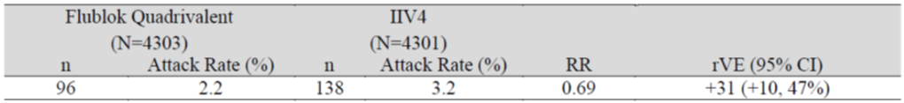
IIV4 = quadrivalent inactivated influenza vaccine (Fluarix Tetra); N = (tota) population size; n = sample size, RR = partial response; rVE = relative vaccine efficacy; CI = confidence interval.
* Meets case definition of protocol defined influenza like illness: at least one of the following respiratory symptoms (sore throat, cough, sputum production, wheezing or difficulty breathing) accompanied by at least one of the following systemic symptoms (temperature of > 37.2ºC), chills, fatigue, headache or myalgia).
With a lower bound of the 95% CI of +10%, Flublok Quadrivalent has met the criterion for non-inferiority and therefore the pre-specified exploratory analysis for superiority was performed. The exploratory analysis of superiority for the efficacy results (defined as the lower bound of the 95% CI > +9%) was fulfilled in this case.
The time to RT-PCR confirmed, protocol defined ILI confirmed a consistently reduced attack rate among Flublok Quadrivalent recipients as compared with IIV4 recipients that became apparent within two to four weeks of vaccination and persisted throughout the influenza season.
The B lineages on their own showed a much lower performance. Whereas the post hoc analysis of the separate strains showed all RT-PCR positive influenza A viruses to fulfil the non-inferiority criterion on its own (rVE = 36%, 95% CI: 14%, 53%), this was not the case for RT-PCR positive influenza B viruses (rVE = 4%, 95% CI: -72%, 46%). This may have been due to potential mismatch and potential underpowering. Influenza B viruses were not dominant during the 2014 to 2015 influenza season.
Table 4: Study PSC12 Relative vaccine efficacy of Flublok Quadrivalent versus quadrivalent inactivated influenza vaccine (primary and selected secondary analyses)
 | Flublok Quadrivalent  (N = 4303) |  | IIV4  (N = 4301) |  | RR | rVE %  (95% CI)
 | n | Attack rate % (n/N) | n | Attack rate % (n/N) | RR | rVE %  (95% CI)
All RT-PCR positive Influenza* | 96 | 2.2 | 138 | 3.2 | 0.70 | 30 (10, 47)
All RT-PCR positive Influenza A† | 73 | 1.7 | 114 | 2.7 | 0.64 | 36 (14, 53)
All RT-PCR positive Influenza B † | 23 | 0.5 | 24 | 0.6 | 0.96 | 4 (-72, 46)
All Culture confirmed Protocol defined ILI†‡ | 58 | 1.3 | 101 | 2.3 | 0.57 | 43 (21, 59)
IIV4 = quadrivalent inactivated influenza vaccine (Fluarix Tetra); RR = partial response; rVE = relative vaccine efficacy; n = sample size; N = population size; RT-PCR = reverse transcriptase polymerase chain reaction; ILI = influenza like illness.
*Primary analysis. All cases of RT-PCR confirmed influenza are included.
†Post hoc analyses. All cases of influenza A were A/H3N2. Cases of influenza B were not distinguished by lineage.
‡Culture of RT-PCR positive samples was performed in Madin-Darby canine kidney cells.
The secondary efficacy outcomes were mostly supportive of the primary outcome, with the exception of the influenza B virus lineage results.
Table 5: Study PSC12 Summary of results for other efficacy outcomes
Variables used for the rVE secondary analyses | Non-inferiority criterion | Superiority criterion
RT-PCR confirmed protocol defined ILI (stratified into influenza A and B viruses) | Fulfilled for A  Not fulfilled for B | Fulfilled for A  Not fulfilled for B
Culture confirmed protocol defined ILI | Fulfilled | Fulfilled
RT-PCR confirmed CDC-ILI | Fulfilled | Not fulfilled
Culture confirmed CDC-ILI | Fulfilled | Fulfilled
Culture confirmed protocol defined ILI | Fulfilled for A+B  Fulfilled for A  Not fulfilled for B | Fulfilled for A+B  Fulfilled for A  Not fulfilled for B
rVE = relative vaccine efficacy; RT-PCR = reverse transcriptase polymerase chain reaction; ILI = influenza like illness; CDC = Centers for Disease Control.

Immunogenicity outcomes

Seroconversion
Seroconversion proportion comparisons are shown below (Table 6).The non-inferiority criterion was: two sided 95% CI percentage difference upper bound of < 10%.
Seroconversion proportions (%) in Flublok Quadrivalent recipients demonstrated non-inferiority compared to those in IIV4 recipients for:
- influenza A/Texas, and
- influenza B/Massachusetts.
They did not demonstrate non-inferiority for:
- influenza B/Brisbane, and
- influenza A/California (the sponsor claims that the response was similar, and that the non-fulfilment of non-inferiority is sample size related).
Table 6: Study PSC12 Comparison of haemagglutination inhibition seroconversion rates (not stratified; immunogenicity population)
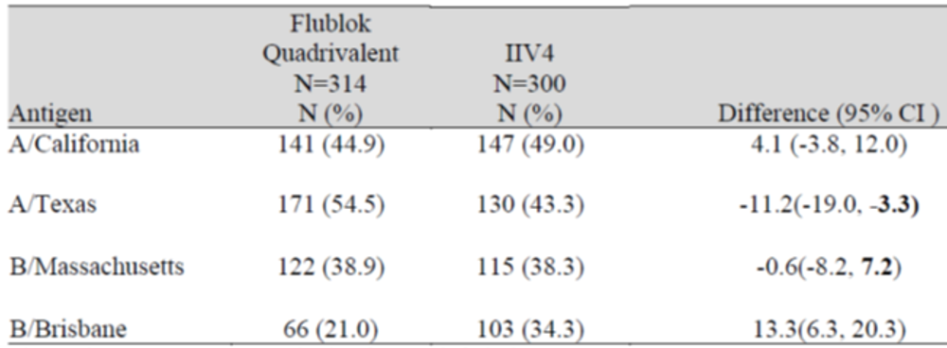
IIV4 = quadrivalent inactivated influenza vaccine (Fluarix Tetra); N = population size, CI = confidence interval.
Figures in bold meet Center for Biologics Evaluation and Research criterion for non-inferiority.
The non-inferiority criterion for the 50 to 64 year age group was: lower bound of two sided 95% CI ≥ 40%. The US Centers for Biologics Evaluation and Research (CBER) non-inferiority criterion for the 65 year and over age group was: lower bound of two sided 95% CI ≥ 30%.
For Flublok Quadrivalent, the non-inferiority criterion was only met for influenza A/California and influenza A/Texas in the 50 to 64 year age subset, and influenza A/H3N2/Texas for age ≥ 65 years.

Study PSC16
Study PSC16 was a Phase III, observer blind, randomised, comparator controlled, multicentre trial designed to evaluate the safety, reactogenicity, and immunogenicity of Flublok Quadrivalent as compared to IIV4 in ambulatory, medically stable adults between 18 to 49 years of age.

Primary objectives
To demonstrate non-inferior immunogenicity of the four antigens in Flublok Quadrivalent to the corresponding antigens in IIV4.
To compare the safety profiles of Flublok Quadrivalent and IIV4.

Secondary objectives
To evaluate the HI SCRs and proportion of subjects with a post vaccination HI titre ≥ 40 (% ≥ 40) for the four rHA antigens contained in the quadrivalent formulation with respect to CBER criteria for licensure under accelerated approval regulations.
To evaluate the safety and reactogenicity of RIV4 in adults 18 to 49 years of age.
A total of 1350 subjects were randomised 3:1 to receive either Flublok Quadrivalent or IIV4. To show the non-inferior immunogenicity of the four antigens in the Flublok Quadrivalent to the corresponding antigens in IIV4, this was through the evaluation of:
- the ratio of post vaccination HI GMTs for each of the four antigens, and the difference in HI SCRs to each of the four antigens.
- there were eight co-primary immunogenicity endpoints:
- HI GMT at post vaccination Day 28 for each of the four antigens in each treatment group
- SCRs at post vaccination Day 28 for each of the four antigens in each treatment group
- the pre-specified success criteria for establishing the non-inferior immunogenicity of Flublok Quadrivalent as compared to IIV4 were as follows for all four antigens:
- upper bound of the two sided 95% CI for the GMT (IIV4) / GMT (Flublok Quadrivalent) ≤ 1.5, and upper bound of the two sided 95% CI for the SCR (Flublok Quadrivalent) – SCR (Flublok Quadrivalent)≤ 10%.

Results
Table 7 presents the co-primary endpoint results of baseline HI GMTs, Day 28 post-vaccination GMTs and GMT ratios of IIV4 relative to Flublok Quadrivalent for each vaccine antigen (immunogenicity population). The co-primary endpoint of non-inferior post vaccination HI GMTs demonstrated satisfactory rises in GMT among Flublok Quadrivalent recipients for influenza A/H1/California, influenza A/H3/Texas and influenza B/Massachusetts lineage, but not for influenza B/Brisbane lineage.
The post vaccination GMTs for the first three antigens met the non-inferiority criterion.
While the Flublok Quadrivalent group did not meet the criterion for non-inferiority for influenza B/Brisbane lineage, the response to influenza B/Brisbane lineage was relatively weak in both vaccine groups. The post vaccination HI GMTs for the influenza B/Brisbane lineage were very low in both treatment groups (43 versus 64), and were within the two fold dilution validated for the HI assay (see Table 7 below).
Table 7: Study PSC16 Co-primary analysis: pre and post vaccination haemagglutination inhibition geometric mean titres (immunogenicity population)
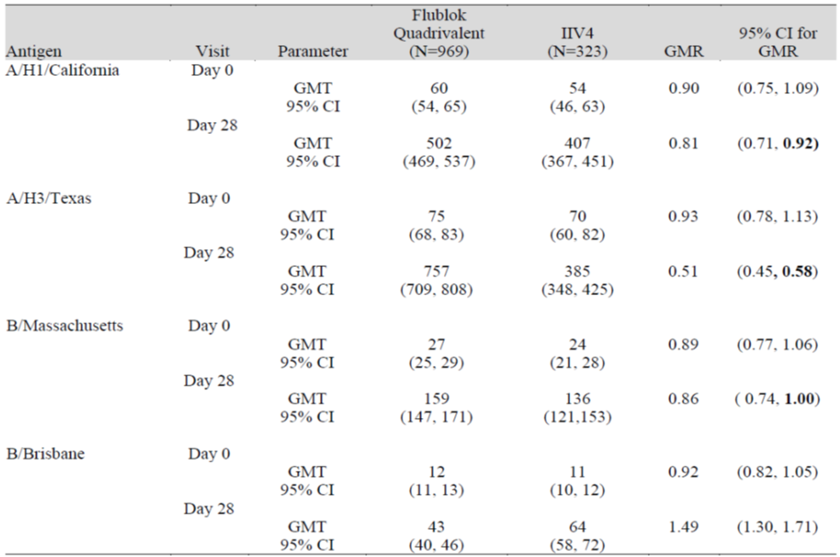
IIV = quadrivalent inactivated influenza vaccine (Fluarix Tetra); N= population size, GMR = geometric mean titre ratio; CI = confidence interval; GMT = geometric mean titre.
Figures in bold meet Center for Biologics Evaluation and Research (CBER) criterion for non-inferiority.
The results of post vaccination SCR difference for each of the four antigens in each treatment group is shown below. The Flublok Quadrivalent group did not meet the criterion for non-inferiority for B/Brisbane for SCR (upper bound of 95% CI was 23.9).
Table 8: Study PSC16. Primary analysis: haemagglutination inhibition seroconversion rate differences at Day 28 (immunogenicity population)
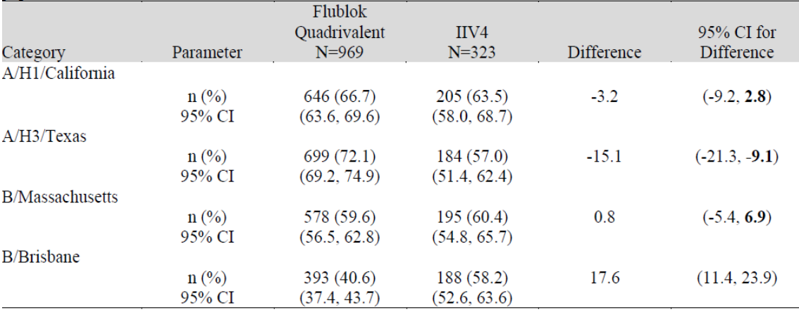
IIV = quadrivalent inactivated influenza vaccine (Fluarix Tetra); N= population size, CI = confidence interval; n = sample size.
Figures in bold meet Center for Biologics Evaluation and Research (CBER) criterion for non-inferiority.
Secondary objectives were to evaluate the SCRs and proportion of subjects with post vaccination HI titres ≥ 1:40 (% HI ≥ 1:40) for each of the four antigens contained in Flublok Quadrivalent and to evaluate the safety and reactogenicity of Flublok Quadrivalent in adults 18 to 49 years of age.

Seroconversion rates
The criterion for an acceptable magnitude of seroconversion (lower bound of the 95% confidence interval ≥ 40%) was met in the Flublok Quadrivalent group for influenza A/H1/California, influenza A/H3/Texas and influenza B/Massachusetts. The criterion was not met for influenza B/Brisbane.

Proportion of subjects with post vaccination haemagglutination inhibition titre ≥ 40
Non-inferiority was defined as the 95% CI lower bound for the proportion of subjects with post vaccination HI titre ≥ 40 being ≥ 70%.
The criterion was met for: the A/H1/California, A/H3/Texas and B/Massachusetts influenza viruses. The criterion was not met for: the influenza B/Brisbane lineage (lower bound: 61.2%). The evaluator noted that even the upper bound for the result for Flublok Quadrivalent for the influenza virus B/Brisbane lineage did not reach 70, but only 67.3%, whereas the comparator comfortably met the criterion (74.8%, 83.3%).
Table 9: Study PSC16 Secondary analysis: proportion of subjects with post vaccination haemagglutination inhibition titre ≥ 40 at Day 28
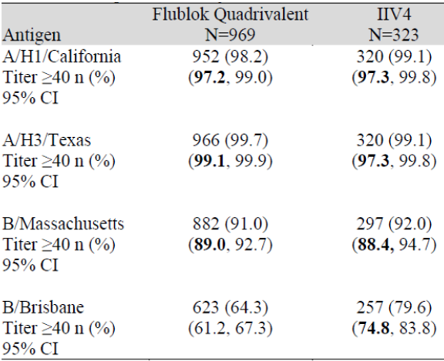
N = population size; IIV = quadrivalent inactivated influenza vaccine (Fluarix Tetra); CI = confidence interval; n = sample size.
Figures in bold meet Centers for Biologics Evaluation and Research (CBER) criterion for licensure under accelerated approval regulations.

Study PSC04
This study was included in the dossier, as absolute efficacy was not evaluated in Study PSC16.
Study PSC04 was a Phase III, multicentre, randomised, double blind and placebo controlled, parallel group, two arm study in 4648 adults aged 18 to 49 years to compare the vaccine efficacy, immunogenicity, reactogenicity and safety of Flublok Trivalent with placebo.

Efficacy endpoints

Primary efficacy endpoint
The proportion of subjects in the Flublok Trivalent group, relative to placebo, who experienced cell culture confirmed Centers for Disease Control (CDC)-ILI associated with isolation of an influenza virus antigenically resembling the vaccine.

Secondary efficacy endpoint
The proportion of subjects in the Flublok Trivalent treatment group, relative to placebo, who experienced cell culture confirmed respiratory illness (regardless of CDC-ILI) associated with isolation of an influenza virus antigenically resembling the vaccine strain from a nasal swab or throat swab collected during the acute illness.

Immunogenicity endpoints

Primary immunogenicity endpoint
Lot consistency: the two sided 95% CI for each strain contained within RIV3 for the ratio of post vaccination GMTs for Lot A versus B, Lot A versus C and Lot B versus C should entirely be within 0.67 to 1.5.

Secondary immunogenicity endpoints
For each strain contained within Flublok Trivalent, by Day 28:
SCR (proportion): a post vaccination HI antibody titre of ≥ 1:40 in subjects with undetectable baseline antibody or a ≥ four fold rise in antibody in subjects with a baseline titre of ≥ 1:10, with the achievement of post vaccination titre of ≥ 1:40.
Seroprotection rate (proportion): post vaccination HI antibody titre of > 1:40 (seroprotection level).

Safety endpoints
The rate and severity of solicited adverse events (AE) reported within seven days of vaccination, all AEs reported within 28 days of vaccination and all serious adverse events (SAE) reported for the duration of the study.

Results

Efficacy endpoints
Five subjects (one receiving Flublok Trivalent, and four receiving placebo) experienced culture confirmed CDC-ILI with a strain antigenically resembling the vaccine strain. In all cases, the strain was influenza A/Wisconsin/67/2005 (H3N2). The protective efficacy of Flublok Trivalent, relative to placebo, was 75.4% (95% CI: -148, 99.5).
Two of the 64 influenza isolates from Flublok Trivalent recipients and 6 of the 115 isolates from placebo recipients were represented in the vaccine, resulting in a point estimate of efficacy of 67.2 (95% CI: -83.2, 96.8%).
Table 10: Study PSC04 Primary and secondary efficacy results (safety population)
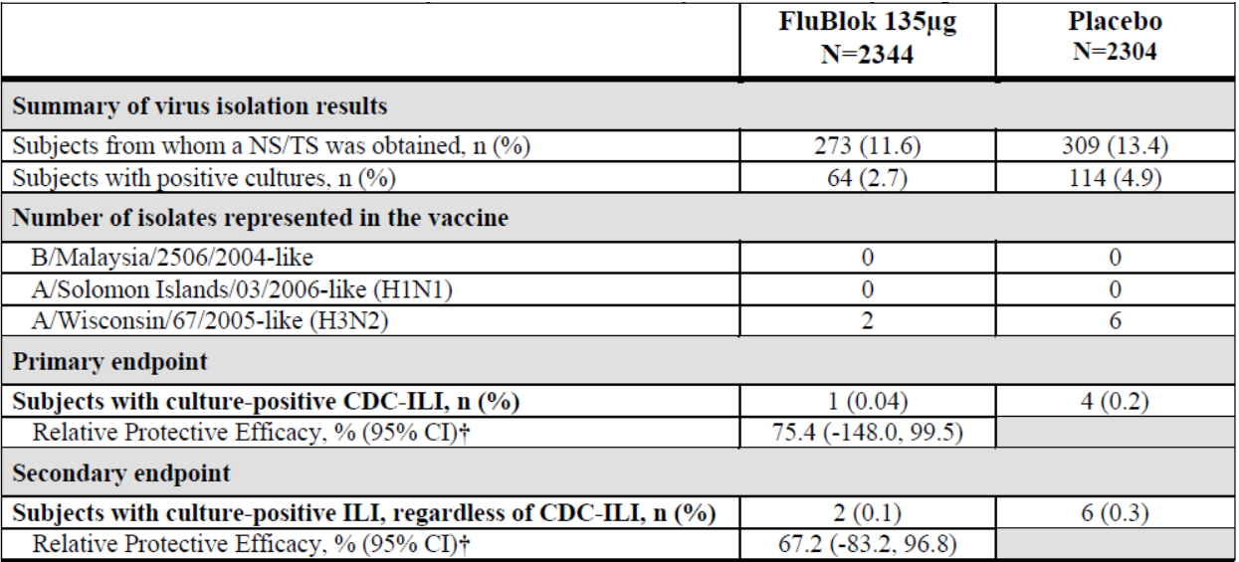
N = population size; n = sample size; CDC = Centers for Disease Control; ILI = influenza like illness; CI = confidence interval.
† Determined under the assumption of Poisson event rates, according to Breslow and Day, (1987).
Table 11: Study PSC04 Pre-specified exploratory efficacy results (safety population)
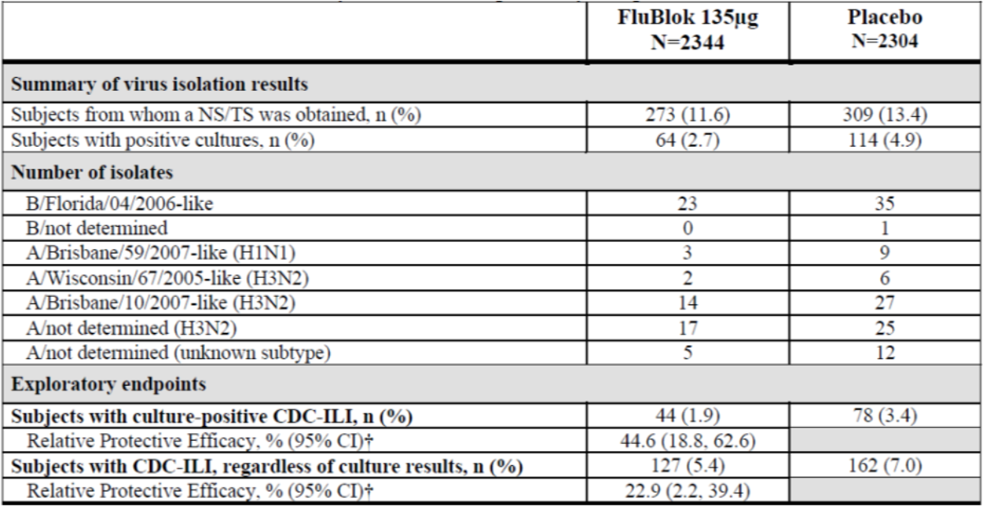
N = population size; n = sample size; CDC = Centers for Disease Control; ILI = influenza like illness; CI = confidence interval.
† Determined under the assumption of Poisson event rates, according to Breslow and Day (1987).⁹
Table 12: Study PSC04 Rates of study endpoints and percent protective efficacy in Flublok Trivalent and placebo recipients⁴
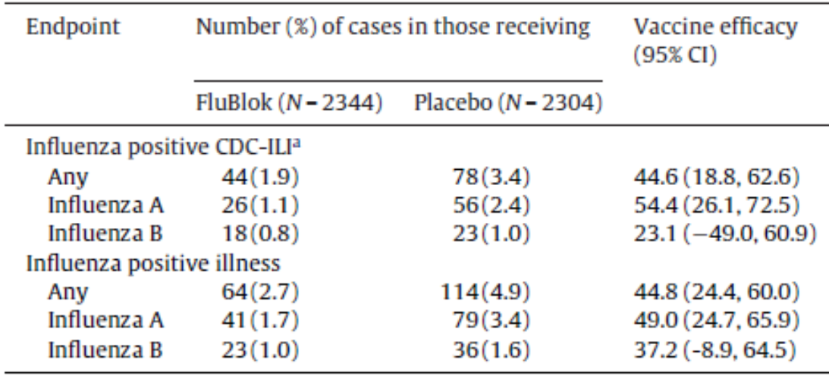
Note Flublok, refers to Flublok Trivalent in Study PSC04.
N = population size; CI = confidence interval; CDC = Centers for Disease Control, ILI = influenza like illness.
a CDC-ILI was defined as fever > 100ºF (that is, 37.8°C) with either cough or sore throat on the same or consecutive days.

Immunogenicity endpoints
Lot consistency:
Immunogenicity was assessed on samples from 391 subjects at five study sites. The two sided 95% CI for each strain contained within Flublok Trivalent for the ratio of post vaccination GMTs for Lot A versus B, Lot A versus C and Lot B versus C should entirely be within 0.67 to 1.5.
Results (confidence interval ranges):
- 0.67 to 1.31 for influenza A/Solomon Islands (within range)
- 0.64 to 1.25 for influenza B/Malaysia (not within range). The clinical evaluator noted that the sponsor claimed that the three lots can still be considered equivalent based on the methodology proposed by Lachenbruch et al. (2004).
- 0.56 to 2.91 for influenza A/Wisconsin (not within range).
The Delegate commented that the Australian Technical Advisory Group on Immunisation (ATAGI) pre-submission advice (June 2020) and published study report highlighted a suboptimal match between the vaccine and circulating strains in 2007 and 2008. Only eight isolates in the study (< 5% of the total) were antigenically identical to the strains contained in the vaccine. ‘Fifty-eight of the 59 influenza B viruses (98%) were antigenically similar to B/Florida/04/2006, representing a different clade from the vaccine strain’.³

Studies PSC12 and PSC16 immunogenicity
In both studies of Flublok Quadrivalent, HI antibody titres to each virus strain represented in the vaccines Flublok Quadrivalent and IIV4 were measured in sera obtained approximately 28 days after vaccination. Post vaccination HI GMT, SCRs and proportion of subjects with post vaccination HI titres ≥ 40 were provided.
Serum HI antibody responses to Flublok Quadrivalent usually met the pre-specified criteria for non-inferiority for three of the four strains represented in the study vaccines (except for influenza A/California using SCRs in Study PSC12) (see Table 13 below).
The HI responses to influenza B/Brisbane (Victoria lineage) were very low in both Flublok Quadrivalent and IIV4 vaccine groups. Flublok Quadrivalent did not meet the non-inferiority criterion for either SCRs or for GMT ratios for this strain in either study. In contrast, Flublok Quadrivalent demonstrated robust HI responses to influenza A/H1N1 and A/H3N2 subtypes.
In a subgroup analysis of Study PSC12, the non-inferiority criterion was only met for influenza A/California and influenza A/Texas in the 50 to 64 year age subset, and influenza A/H3N2/Texas for age ≥ 65 years, but none of the others. As expected, responses appear to decline with advancing age.
Table 13: Studies PSC12 and PSC16 Summary of demonstrated non-inferiority for immunogenicity analyses
Test | Influenza virus | Study PSC12  (age ≥ 50 years)  Non-inferiority | Study PSC16  (age 18 to 49 years)  Non-inferiority
Seroconversion rates | A/Texas | Yes | Yes
Seroconversion rates | A/California | No | Yes
Seroconversion rates | B/Massachusetts | Yes | Yes
Seroconversion rates | B/Brisbane | No | No
HI GMT Responses | A/Texas | Yes | Yes
HI GMT Responses | A/California | Yes | Yes
HI GMT Responses | B/Massachusetts | Yes | Yes
HI GMT Responses | B/Brisbane | No | No
HI = haemagglutination inhibition; GMT = geometric mean titre.

Safety
10,353 adults (aged ≥ 18 years) were exposed to Flublok Quadrivalent (with the majority being ≥ 50 years old), and 4648 adults aged 18 to 49 years were exposed to Flublok Trivalent.
5326 subjects received one dose of Flublok Quadrivalent in Study PSC12 or Study PSC16 and provided safety data. All received a single dose of Flublok Quadrivalent.

Solicited adverse events
The most common injection site reactions were local tenderness and local pain. The most common systemic reactions were headache, fatigue, muscle pain and joint pain.

Unsolicited adverse events
In Study PSC12, 1345/4328 (31.1%) Flublok Quadrivalent subjects reported one or more unsolicited AE terms during follow-up after vaccine administration, and 1355/4344 (31.2%) IIV4 subjects reported an unsolicited AE term. In Study PSC16, unsolicited AE terms were reported by 143/998 (14.3%) and 47/332 (14.2%) subjects in the RIV4 and active control groups, respectively.
The most common unsolicited AE terms reported from both studies (≥ 1% of subjects in either vaccine group in Study PSC16 and ≥ 2% of subjects in either vaccine group in Study PSC12) were common respiratory symptoms and headache. Overall, the safety profile was similar in the two groups.

Deaths
In PSC12, there were 20 deaths. None of the deaths were considered related to study vaccine by the sponsor. There were no deaths in Study PSC16.

Serious adverse events
In Study PSC12, SAEs were reported from 277 subjects, including 145 (3.4%) in the Flublok Quadrivalent group and 132 (3.0%) in the IIV4 group, 20 of which events resulted in death (eight among Flublok Quadrivalent and 12 among IIV4 subjects, respectively).
In Study PSC16, 15 SAEs were reported from 12 subjects, including ten (1.0%) in the Flublok Quadrivalent group and two (0.6%) in the IIV4 group.
In Study PSC12 or Study PSC16, no SAEs were considered related to study vaccine by the sponsor.

Discontinuations
All studies only provided a single dose of vaccine or placebo. In Study PSC12, 0.2% of subjects in each vaccine group discontinued due to an AE. There were no immediate AEs that led to study discontinuation for any subject in Study PSC16.

Safety in special populations
In Study PSC12 (with adults ≥ 50 years of age), most spontaneous AEs were also from mild to moderate severity (Grade 1 to 2); and no events were considered Grade 4 (life threatening). Overall, there were no significant differences in the most common unsolicited AEs by age category (comparing 50 to 64 years with ≥ 65 years).
However when comparing AEs of Study PSC12 (adults ≥ 50 years), and Study PSC16 (adults aged 18 to 49 years) solicited AEs occurred at greater frequency in Study PSC12 compared to Study PSC16 (that is, older subjects reporting more), and vice versa for unsolicited AEs (that is, younger subjects reporting more). However, there were no significant differences between Flublok Quadrivalent and IIV4 for each age group.
No data for pregnant women were available from clinical trials.

Post-market data
The evaluator commented that given that Flublok Quadrivalent has been on the market since 2016, considerable post-market data should be available. Following the a TGA request for information, the latest Periodic Benefit-Risk Evaluation Report covering the period 16 January 2019 to 15 January 2020 was provided, as well as a brief summary of safety from post-market data.

Clinical evaluator’s recommendation
The clinical evaluator was generally satisfied with the conduct of Study PSC12, but drew attention to several points, including the following:
• while both study treatments contained four strains, the haemagglutinin dose in Group A (Flublok Quadrivalent) was three times the dose in Group B (Fluarix Quadrivalent, or the IIV4).
• the primary variable and endpoint were acceptable. The non-inferiority margin was rather large, but justified by the sponsor.
• the secondary efficacy outcomes were mostly supportive of the primary outcome, except for the B strain results.
• the results for the B strains were difficult to interpret due to potential mismatch and potential underpowering. Influenza B strains were not dominant during the 2014 to 2015 season.
For Study PSC16 the clinical evaluator drew attention to a number of points, including the following:
The sponsor’s rationale for not testing for rVE, but only immunogenicity (against IIV4) was that the Flublok Trivalent formulation had been demonstrated to be effective and to have an acceptable safety profile in adults 18 to 49 years of age.
Multiplicity issues were not addressed in the statistical plan.
The sponsor’s overall criterion for establishing non-inferiority has not been met.
- The criterion was met for: influenza A/H1/California, influenza A/H3/Texas and influenza B/Massachusetts.
- The criterion was not met for: influenza B/Brisbane.
As for the primary analysis, the secondary analysis criteria for establishing non-inferiority have not been met overall.
- The criterion was met for: influenza A/H1/California, influenza A/H3/Texas and influenza B/Massachusetts.
- The criterion was not met for: influenza B/Brisbane.
For Study PSC04 the clinical evaluator highlighted that the sponsor’s efficacy primary objective was met, but the immunogenicity objective was not met for two of the three strains. The setup of the co-primary endpoints without multiplicity analysis arrangements, and the post hoc analyses to reach a positive outcome are not ideal. However, individually, all lots appeared to fulfil CBER criteria for seroconversion and seroprotection.
The clinical evaluator concluded that the safety profile of Flublok Quadrivalent has been adequately characterised in adults. The exposure was adequate and there appears to be sufficient post-market experience. The limitations and potential issues in the profile include the following:
- no paediatric data;
- limited data in the Asian population (may be addressed by providing post-market data);
- limited or no data for the indigenous Australian population.

Risk management plan
The sponsor has submitted draft EU-risk management plan (RMP) version 0.1 (dated 12 September 2019; data lock point (DLP) 15 January 2019) and Australia Specific Annex (ASA) version 1.0 (dated 28 October 2019) in support of this application. At the fourth round of evaluation and following European approval, updated EU-RMP version 1.0 (dated 12 October 2020; DLP 15 January 2019) and ASA version 1.1 (dated December 2020) were submitted.
The proposed summary of safety concerns contained nil risks in the draft EU-RMP and ASA at the first and second round of evaluations. The sponsor subsequently amended the summary of safety concerns in the ASA, as below, while the EU-RMP remains with nil safety concerns.
The summary of safety concerns and their associated risk monitoring and mitigation strategies are summarised in Table 14.
Table 14: Summary of safety concerns
Summary of safety concerns |  | Pharmacovigilance |  | Risk Minimisation
 |  | Routine | Additional | Routine | Additional
Important identified risks | Anaphylaxis (Australia specific concern) |  | – |  | –
Important potential risks | Nil
Missing information | Use in pregnancy (Australia specific concern) | * | – |  | –
* Observational study in progress in the United States of America
- The sponsor has nominated routine pharmacovigilance activities. The sponsor is confident of inclusion of the vaccine in the AusVaxSafety program, which serves as enhanced safety surveillance.
- The sponsor has nominated only routine risk minimisation activities, such as the PI and Consumer Medicines Information (CMI) and labelling. This approach is acceptable.

Risk-benefit analysis

Delegate’s considerations
Efficacy and safety data presented are sufficient to recommend registration. There is considerable post-market experience with Flublok Quadrivalent, given the overseas registration.
The evaluator was of the opinion that the study design of the two pivotal clinical trials was acceptable overall and generally complied with TGA adopted guidance documents.^{3,4} The populations studied were relevant for the claimed indication. The inclusion and exclusion criteria that were used in the pivotal studies provided a reasonable balance between internal and external validity. The results were generalisable to the Australian population with the exception of Asian and indigenous Australian populations.
For some strains (most notably the B/Brisbane strain), the non-inferiority criterion was not met for most analyses, potentially due to mismatch and underpowering. Studies PSC12 and PSC16 data were derived from a single influenza season (New Hampshire 2014 to 2015) dominated by the influenza A/H3N2 subtype. Data from additional seasons with different dominating strains would have been useful.
Discussion of the tradename is warranted prior to registration.

Proposed action
The Delegate has no reason to say, at this time, that the application for Flublok Quadrivalent should not be approved for registration.

Advisory Committee considerations
The Advisory Committee on Vaccine (ACV), having considered the evaluations and the Delegate’s overview, as well as the sponsor’s response to these documents, advised the following.

Specific advice to the Delegate
- Please comment on the suitability of the proposed trade name Flublok Quadrivalent. Concern has been raised regarding the promotional nature of the ‘blok’ component of the trade name by the TGA Trade Name Committee. The tradename Supemtek has been proposed for the EU and Canada and would allay these concerns if adopted for Australia. What are the views of the ACV regarding the tradename Supemtek for Australia?
The ACV noted advantages and disadvantages of both possible tradenames. Flublok contained the ‘flu’ element commonly used across influenza vaccines, while ‘blok’ may mislead consumers to expect 100% protection against influenza that season. Supemtek was not obviously the name of a quadrivalent influenza vaccine and also hinted at superior performance, while recognising the use of a new technology for influenza vaccines (‘tek’).
The ACV noted that the sponsor had not provided the rationale for different tradenames in the key US and EU markets.
On balance, of the two proposed tradenames, Flublok Quadrivalent was preferred.
- The recommendations for the Product Information following the second round of clinical evaluation have been mostly adopted by the sponsor. Please comment on the two outstanding recommendations discussed in the Review of Product Information in regards to:
a. the therapeutic indication
The ACV advised the indication should refer to active immunisation for the prevention of influenza disease caused by influenza virus types A and B contained in the vaccine. This is consistent with other seasonal influenza vaccines.
b. the superiority claim for efficacy in PCS12
The ACV advised that the current proposed wording in support of the claim for superior efficacy (page 12 of 16 in the annotated PI) was not suitable.
Superiority was not convincingly shown for the vaccine’s performance as a quadrivalent vaccine. The ACV advised a preference to exclude superiority claims, as these were:
- based on an exploratory analysis
- related to a single season only with predominant mismatched influenza A: H3N2 subtype circulating
- failed to demonstrate superiority (or even non- inferiority) for any B strain analysed separately to the influenza A strains
- failed to demonstrate superiority in the RT-PCR-confirmed CDC-ILI analysis (as opposed to the RT-PCR-confirmed protocol-defined ILI analysis).
Reference to ‘barely missed’ endpoints appeared promotional, rather than neutral information from the available evidence.
It was noted that the FDA expressed similar concerns during their review and have not included claims of superiority in the US prescribing information.
The ACV advised the following wording, proposed by the clinical evaluator, with minor modification:
‘In PSC12 (conducted in the 2014 - 2015 influenza season in adults aged 50 years and above), the relative vaccine efficacy for RT-PCR-confirmed protocol- defined ILI due to any influenza strain, was +31% (95% CI: 10% – 47%) meeting the pre-specified non- inferiority criterion (defined as the 95% CI lower bound > -20%) (Table 7). However, the non-inferiority criterion was not met when B strains were analysed separately to A strains. There are no clinical trial data with true efficacy endpoints from other seasons available for Flublok Quadrivalent.’
Any reference to superiority should be qualified as applying only to influenza A strains.
- Other advice
The ACV advised that the Product Information and Consumer Medicine Information should include qualitative and quantitative information on manufacturing residues present in the injected formulation. As Flublok Quadrivalent is produced by a new manufacturing method, disclosure of manufacturing residues is part of appropriate transparency relating to this technology. The ACV noted that information on manufacturing residues is included in approved product labelling in the USA and proposed labelling for the European market.
The presence or absence of latex is information that contributes to the safe administration of any injected product. (Section 6.5 of the PI states that the single dose, pre-filled syringes contain no natural rubber latex.)

Conclusion
The ACV considered this vaccine to have an overall positive benefit-risk profile for the indication:
Flublok Quadrivalent is indicated for active immunisation for the prevention of influenza disease caused by influenza virus types A and B contained in the vaccine. Flublok Quadrivalent is approved for use in persons 18 years of age and older.

Outcome
Based on a review of quality, safety and efficacy, the TGA approved the registration of Flublok Quadrivalent (influenza haemagglutinin recombinant) 180 µg/0.5 mL, solution for injection, syringe, indicated for:
Flublok Quadrivalent is indicated for active immunisation for the prevention of influenza disease caused by influenza virus types A and B contained in the vaccine. Flublok Quadrivalent is approved for use in persons 18 years of age and older.

Specific conditions of registration applying to these goods
- The Flublok Quadrivalent EU-RMP (version 1.0, dated 12 October 2020, data lock point 15 January 2019), with ASA (version 1.1, dated December 2020), included with submission PM-2019-04824-1-2, will be implemented in Australia.
An obligatory component of risk management plans is routine pharmacovigilance. Routine pharmacovigilance includes the submission of periodic safety update reports (PSURs).
Unless agreed separately between the supplier who is the recipient of the approval and the TGA, the first report must be submitted to TGA no later than 15 calendar months after the date of the approval letter. The subsequent reports must be submitted no less frequently than annually from the date of the first submitted report until the period covered by such reports is not less than three years from the date of the approval letter. The annual submission may be made up of two PSURs each covering six months. If the sponsor wishes, the six monthly reports may be submitted separately as they become available.
If the product is approved in the EU during the three years period, reports can be provided in line with the published list of EU reference dates no less frequently than annually from the date of the first submitted report until the period covered by such reports is not less than three years from the date of the approval letter.
The reports are to at least meet the requirements for PSURs as described in the European Medicines Agency’s Guideline on Good Pharmacovigilance Practices (GVP) Module VII-periodic safety update report (Rev 1), Part VII.B structures and processes. Note that submission of a PSUR does not constitute an application to vary the registration. Each report must have been prepared within ninety calendar days of the data lock point for that report.
- The additional requested quality data should be provided to the TGA.
- Batch release testing and compliance
It is a condition of registration that all independent batches of Flublok Quadrivalent imported into Australia are not released for sale until samples and the manufacturer’s release data have been assessed and the sponsor has received notification acknowledging release from the Laboratories Branch, TGA.
For each independent batch of the product imported into Australia, the sponsor must supply the following:
  - a completed Request for Release Form, available from vaccines@health.gov.au;
  - complete summary protocols for manufacture and quality control, including all steps in production;
  - at least twenty doses of the first consignment of each batch of Flublok Quadrivalent with the Australian approved labels, PI and packaging;
  - at least ten doses of any further consignment of each batch of Flublok Quadrivalent with the Australian approved labels, PI and packaging and at least twenty doses of any further consignment of each batch of Flublok Quadrivalent with the Australian approved labels, PI and packaging;
  - certificate of release from a regulatory agency acting for the country of origin such as an Official Medicines Control Laboratories (if available);
  - any reagents, reference material and standards required to undertake testing, as requested by Laboratories Branch, TGA.
Distribution of each shipment of each batch of vaccine is conditional upon fulfilment of these conditions and receipt of a letter from the Laboratories Branch acknowledging release.
- Certified Product Details
An electronic copy of the Certified Product Details (CPD) as described in Guidance 7: Certified product details of the Australian Regulatory Guidelines for Prescription Medicines https://www.tga.gov.au/guidance-7-certified-product-details should be provided upon registration of the therapeutic good. In addition, an updated CPD, for the above products incorporating the approved changes is to be provided within one month of the date of approval letter. A template for preparation of CPD for biological prescription medicines and Vaccines can be obtained from the TGA website https://www.tga.gov.au/form/certified-product-details-cpd-biological-prescription medicines]. The CPD should be sent as a single bookmarked PDF document to Vaccines@health.gov.au as soon as possible after registration/approval of the product or any subsequent changes.
- The sponsor must conduct an enhanced safety surveillance study in Australia, if requested by TGA. A protocol for the proposed study will be required to be submitted with the annual strain update variation, if there is inadequate post-market safety data to demonstrate that the reactogenicity of that season's vaccine has been adequately characterised and the vaccine is not supplied on the National Immunisation Program in that season.
- For all injectable products the PI must be included with the product as a package insert.

Attachment 1. Product Information
The PI for Flublok Quadrivalent approved with the submission which is described in this AusPAR is at Attachment 1. For the most recent PI, please refer to the TGA website at <https://www.tga.gov.au/product-information-pi>.

Therapeutic Goods Administration
PO Box 100 Woden ACT 2606 Australia
Email: info@tga.gov.au Phone: 1800 020 653 Fax: 02 6232 8605
https://www.tga.gov.au

The Black Triangle Scheme provides a simple means for practitioners and patients to identify certain types of new prescription medicines, including those being used in new ways and to encourage the reporting of adverse events associated with their use. The Black Triangle does not denote that there are known safety problems, just that the TGA is encouraging adverse event reporting to help us build up the full picture of a medicine's safety profile.
Therapeutic goods must be entered in the Australian Register of Therapeutic Goods (ARTG) before they can be lawfully supplied in or exported from Australia, unless exempt from being entered in the ARTG, or otherwise authorised by the TGA. For further information visit: https://www.tga.gov.au/australian-register-therapeutic-goods.
European Medicines Evaluation Agency (EMEA), Committee for Medicinal Products for Human Use (CHMP), 18 October 2006. Guideline on Clinical Evaluation of New Vaccines (EMEA/CHMP/VWP/164653/2005).
European Medicines Agency (EMA), Committee for Medicinal Products for Human Use (CHMP), 21 July 2016. Guideline on Influenza Vaccines. Non-clinical and Clinical Module (EMA/CHMP/VWP/457259/2014).
World Health Organisation (WHO) Guidelines on Nonclinical Evaluation of Vaccines. WHO Technical Report Series Report No. 927: Annex 1, 2005: 31-63.
Dunkle, L. M. et al. Efficacy of Recombinant Influenza Vaccine in Adults 50 Years of Age or Older, N Engl J Med, 2017; 376: 2427-2436.
Dunkle L, M. et al. Randomized Comparison of Immunogenicity and Safety of Quadrivalent Recombinant Versus Inactivated Influenza Vaccine in Healthy Adults 18-49 Years of Age, J Infect Dis, 2017; 216: 1219–1226.
Treanor J. J. et al. Protective efficacy of a trivalent recombinant hemagglutinin protein vaccine (FluBlok) against influenza in healthy adults: a randomized, placebo-controlled trial, Vaccine, 2011; 29(44): 7733-7739.
Breslow, N. E. and Day, N. E. Statistical Methods in Cancer Research. Volume II-the Design and Analysis of Cohort Studies, IARC Sci Publ, 1987; (82): 1-406.
Lachenbruch, P.A. et al. Lot Consistency as an Equivalence Problem, J Biopharm Stat, 2003; 14: 275-290.
The sponsor claims that the response was similar, and that the non-fulfilment of non-inferiority is sample-size related.
The sponsor states that while Flublok Quadrivalent did not meet the geometric mean titre (GMT) ratio criterion for non-inferiority for B/Brisbane, the absolute values for GMT in each treatment group were within the limits of sensitivity for which this assay is validated (two fold dilution) and suggested a possible overall reduced immunogenicity of this influenza strain.
Routine risk minimisation activities may be limited to ensuring that suitable warnings are included in the Product Information or by careful use of labelling and packaging. Routine pharmacovigilance practices involve the following activities: - All suspected adverse reactions that are reported to the personnel of the company are collected and collated in an accessible manner; - Reporting to regulatory authorities; - Continuous monitoring of the safety profiles of approved products including signal detection and updating of labelling; - Submission of PSURs; - Meeting other local regulatory agency requirements.
The Advisory Committee on Vaccines (ACV) provides independent medical and scientific advice to the Minister for Health and the Therapeutic Goods Administration (TGA) on issues relating to the safety, quality and efficacy of vaccines supplied in Australia including issues relating to pre-market assessment, post-market monitoring and safe use in national immunisation programs. The Committee is established under Regulation 39F of the Therapeutic Goods Regulations 1990 and the members are appointed by the Minister for Health. The ACV was established in January 2017, following consolidation of previous functions of the Advisory Committee on the Safety of Vaccines (ACSOV) and the pre-market functions for vaccines of the Advisory Committee on Prescription Medicines (ACPM). Membership comprises professionals with expertise in specific scientific, medical or clinical fields, or consumer health issues.
PCS12 is the shortened form of Study PCS12.

