First round CER: February 2016
Second round CER: June 2016

AusPAR Attachment 2

Extract from the Clinical Evaluation Report for infliximab
  - Proprietary Product Name: Renflexis
  - Sponsor: Samsung Bioepis AU Pty Ltd

About the Therapeutic Goods Administration (TGA)
- The Therapeutic Goods Administration (TGA) is part of the Australian Government Department of Health, and is responsible for regulating medicines and medical devices.
- The TGA administers the Therapeutic Goods Act 1989 (the Act), applying a risk management approach designed to ensure therapeutic goods supplied in Australia meet acceptable standards of quality, safety and efficacy (performance), when necessary.
- The work of the TGA is based on applying scientific and clinical expertise to decision-making, to ensure that the benefits to consumers outweigh any risks associated with the use of medicines and medical devices.
- The TGA relies on the public, healthcare professionals and industry to report problems with medicines or medical devices. TGA investigates reports received by it to determine any necessary regulatory action.
- To report a problem with a medicine or medical device, please see the information on the TGA website <https://www.tga.gov.au>.
About the Extract from the Clinical Evaluation Report
- This document provides a more detailed evaluation of the clinical findings, extracted from the Clinical Evaluation Report (CER) prepared by the TGA. This extract does not include sections from the CER regarding product documentation or post market activities.
- The words [Information redacted], where they appear in this document, indicate that confidential information has been deleted.
- For the most recent Product Information (PI), please refer to the TGA website <https://www.tga.gov.au/product-information-pi>.
Copyright
© Commonwealth of Australia 2016
This work is copyright. You may reproduce the whole or part of this work in unaltered form for your own personal use or, if you are part of an organisation, for internal use within your organisation, but only if you or your organisation do not use the reproduction for any commercial purpose and retain this copyright notice and all disclaimer notices as part of that reproduction. Apart from rights to use as permitted by the Copyright Act 1968 or allowed by this copyright notice, all other rights are reserved and you are not allowed to reproduce the whole or any part of this work in any way (electronic or otherwise) without first being given specific written permission from the Commonwealth to do so. Requests and inquiries concerning reproduction and rights are to be sent to the TGA Copyright Officer, Therapeutic Goods Administration, PO Box 100, Woden ACT 2606 or emailed to <tga.copyright@tga.gov.au>.

Contents
List of abbreviations 5
1. Introduction 9
1.1. Drug class and therapeutic indication 9
1.2. Dosage forms and strengths 10
1.3. Dosage and administration 10
2. Clinical rationale 10
2.1. Guidance 11
3. Contents of the clinical dossier 12
3.1. Scope of the clinical dossier 12
3.2. Paediatric data 13
3.3. Good clinical practice 13
4. Pharmacokinetics 13
4.1. Studies providing pharmacokinetic data 13
4.2. Summary of pharmacokinetics 13
4.3. Evaluator’s overall conclusions on pharmacokinetics 15
5. Pharmacodynamics 16
5.1. Studies providing pharmacodynamic data 16
6. Dosage selection for the pivotal studies 16
7. Clinical efficacy 16
7.1. Pivotal efficacy studies 16
7.2. Evaluator’s conclusions on clinical efficacy for rheumatoid arthritis in adults 26
8. Clinical safety 30
8.1. Studies providing evaluable safety data 30
8.2. Pivotal studies that assessed safety as a primary outcome 30
8.3. Patient exposure 30
8.4. Adverse events 31
8.5. Laboratory tests 33
8.6. Post-marketing experience 37
8.7. Safety issues with the potential for major regulatory impact 38
8.8. Evaluator’s overall conclusions on clinical safety 38
9. First round benefit-risk assessment 39
9.1. First round assessment of benefits 39
9.2. First round assessment of risks 39
9.3. First round assessment of benefit-risk balance 39
10. First round recommendation regarding authorisation 40
11. Clinical questions 41
11.1. Additional expert input 41
11.2. Clinical questions 41
12. Second round evaluation of clinical data submitted in response to questions 42
12.1. Pharmacokinetics 42
12.2. Pharmacodynamics 42
12.3. Efficacy 42
13. Second round benefit-risk assessment 47
13.1. Second round assessment of benefits 47
13.2. Second round assessment of risks 47
13.3. Second round assessment of benefit-risk balance 47
14. Second round recommendation regarding authorisation 47
15. References 48

List of abbreviations
Abbreviation | Meaning
ACR | American College of Rheumatology
ACR20 | American College of Rheumatology 20% response criteria
ACR50 | American College of Rheumatology 50% response criteria
ACR70 | American College of Rheumatology 70% response criteria
ACR-N | numeric index of the ACR response
ADA | anti-drug antibody
ADCC | antibody-dependent cell-mediated cytotoxicity
AE | adverse event
AESI | adverse event of special interest
ALT | alanine aminotransferase
ANA | anti-nuclear antibodies
ANCOVA | analysis of covariance
ANOVA | analysis of variance
AS | ankylosing spondylitis
AUC | area under the curve
BLQ | below the limit of quantitation
CD | Crohn’s disease
CDC | complement-dependent cytotoxicity
CHF | congestive heart failure
CHO | Chinese hamster ovary
CI | confidence interval
CV% | coefficient variation
CRP | C-reactive protein
C_{trough} | trough concentration
DAS28 | disease activity score based on a 28 joint count
DMARD | disease modifying anti-rheumatic drug
DNA | deoxyribonucleic acid
DP | drug product
DS | drug substance
DSMB | Data Safety Monitoring Committee
ECCO | European Crohn’s and Colitis Organisation
ECG | electrocardiogram
ELISA | enzyme-linked immunosorbent assay
EMA | European Medicines Agency
ENR | enrolled set
ESR | erythrocyte sedimentation rate
EU | European Union
EULAR | European League Against Rheumatism
FAS | full analysis set
FDA | Food and Drug Administration (US)
GCP | Good Clinical Practice
h | hour
HAQ-DI | Health Assessment Questionnaire Disability Index
HBV | hepatitis B
HCV | hepatitis C
HSTCL | hepatosplenic T-cell lymphoma
IBD | inflammatory bowel disease
ICH | International Conference on Harmonisation
IEC | Independent Ethics Committee
IgG | immunoglobulin G
IP | investigational product
IRB | Institutional Review Board
IV | intravenous
IVRS | interactive voice response system
IWRS | interactive web response system
JSN | joint space narrowing
LLN | lower limit of normal
mAb | monoclonal antibody
MCB | master cell batch
mTSS | modified Total Sharp Score
MedDRA | Medical Dictionary for Regulatory Activities
MTX | methotrexate
MW | molecular weight
NAb | neutralising antibodies
NSAID | non-steroidal anti-inflammatory drug
NYHA | New York Heart Association
PCS | potentially clinically significant
PD | pharmacodynamic
PI | Product Information
PK | pharmacokinetic
PPS | per protocol set
PsA | psoriatic arthritis
PT | preferred term
PV | pharmacovigilance
QFG | QuantiFERON® Gold Test
RA | rheumatoid arthritis
RAN | randomised set
RF | rheumatoid factor
SAE | serious adverse event
SAF | safety set
SAP | statistical analysis plan
SD | standard deviation
SE | standard error
SmPC | Summary of Product Characteristics
SOC | system organ class
TB | tuberculosis
TEAE | treatment-emergent adverse event
TNFα | tumour necrosis factor alpha
UC | ulcerative colitis
ULN | upper limit of normal
US | United States
VAS | visual analogue scale
WCB | working cell batch

Introduction
This is a submission to register a new biosimilar medication containing the drug substance infliximab.

Drug class and therapeutic indication
Infliximab is a monoclonal antibody with activity against circulating and membrane bound TNFα in several therapeutic areas.
The proposed indications are the same as those currently approved in Australia for the reference product Remicade and for the biosimilar Remsima, described as follows:
‘Rheumatoid Arthritis in Adults
Renflexis, in combination with methotrexate, is indicated for the reduction of signs and symptoms and prevention of structural joint damage (erosions and joint space narrowing) in:
- patients with active disease despite treatment with methotrexate
- patients with active disease who have not previously received methotrexate
Renflexis should be given in combination with methotrexate. Efficacy and safety in rheumatoid arthritis have been demonstrated only in combination with methotrexate.
Ankylosing Spondylitis
Renflexis is indicated for the reduction of signs and symptoms and improvement in physical function in patients with active disease.
Psoriatic arthritis
Renflexis is indicated for the treatment of the signs and symptoms, as well as for the improvement in physical function in adult patients with active and progressive psoriatic arthritis who have previously responded inadequately to disease-modifying anti-rheumatic drug (DMARD) therapy.
Renflexis may be administered in combination with methotrexate.
Psoriasis
Renflexis is indicated for the treatment of adult patients with moderate to severe plaque psoriasis for whom phototherapy or conventional systemic treatments have been inadequate or are inappropriate. Safety and efficacy beyond 12 months have not been established.
Crohn’s Disease in Adults and in Children and adolescents (6 to 17 years)
Renflexis is indicated for the treatment of moderate to severe Crohn’s disease, to reduce the signs and symptoms and to induce and maintain clinical remission in patients who have an inadequate response to conventional therapies.
Refractory Fistulising Crohn’s Disease
Renflexis is indicated for reducing the number of draining enterocutaneous and rectovaginal fistulas and maintain fistula closure in adult patients.
Ulcerative colitis in adults and in children and adolescents (6 to 17 years)
Renflexis is indicated for the treatment of moderately severe to severe active ulcerative colitis in patients who have had an inadequate response to conventional therapy.’

Dosage forms and strengths
The submission proposes registration of the following dosage forms and strengths: Vials containing infliximab 100 mg as lyophilised powder for reconstitution.
The dosage form and strength are identical to that of the reference product Remicade.

Dosage and administration
Dosage and administration for the multiple indications are identical to those of the reference product Remicade.

Clinical rationale
Rheumatoid arthritis is a chronic disorder associated with synovial inflammation, fatigue, malaise, morning stiffness, reduced physical functioning and reduced quality of life. More severe disease may be associated with joint destruction, rheumatoid nodules, lung disease and cardiovascular complications. The prevalence of RA is approximately 0.5% to 1% and it occurs more commonly in women. Without treatment, it may progress to cause severe joint deformities with loss of mobility and the ability to perform simple activities of daily living. Pain relief is provided most commonly but NSAIDs which are effective but do not modify the underlying disease process. Disease-modifying anti-rheumatic drugs (DMARDs) reduce disease progression and joint damage. The most commonly used DMARD is methotrexate (MTX), but other agents such as leflunomide, injectable gold, sulfasalazine and hydrochloroquine have proved effective. However, the benefits of DMARDs are often delayed in onset and their use is limited by side-effects.
In the last 20 years, biological therapies such as monoclonal antibodies to several targets in the inflammatory chain have been developed and are now in widespread use. Infliximab (Remicade), adalimumab, certolizumab and golimumab belong to a class of TNFα inhibitors approved for use in RA and other inflammatory conditions such as psoriasis, psoriatic arthritis ankylosing spondylitis and inflammatory bowel disease. They have proved effective although their use is limited by immunogenicity and loss of effectiveness in a significant proportion of patients with long-term use. They are generally well tolerated but there is a significant risk of hypersensitivity reactions and serious infections, including opportunistic infections and reactivation of latent TB.
TNFα is produced mainly by macrophages and is known to trigger the release of multiple pro-inflammatory factors. Elevated TNFα levels are found in synovial tissues and fluid and in interstitial inflammatory cells around joints in patients with RA. It exists in soluble and transmembrane forms which activate cell-bound TNF receptors, TNFR1 found in most tissues and TNFR2 found only on inflammatory cells. Neutralisation of soluble TNFα is thought to play an important role in reducing inflammation in RA, PsA, and psoriasis. In IBD, inhibition of transmembrane TNFα and Fcγ receptor-mediated functions may also be important. These potential differences in mechanism of action must be considered when comparing the safety and efficacy of TNFα inhibitors in patients with rheumatological and IBD indications. Infliximab is a chimeric human-mouse monoclonal antibody which binds with high affinity to both soluble and transmembrane forms of TNFα. It reduces the levels of TNFα and other markers of inflammation including IL-6 and CRP.
The TNF-α inhibitor Remicade was first approved for RA in the US in 1998, in the EU in 1999 and in Australia in 2000. Three large, placebo-controlled, pivotal studies of Remicade have been conducted in patients with RA (the Studies ATTRACT, ASPIRE and START) and these are summarised in the Remicade PI. In each study, the combination of infliximab + MTX was significantly superior to placebo + MTX for response criteria including ACR20, ACR50 and ACR70. In START study, the primary endpoint was safety and there was a statistically significant increase in serious infections in the infliximab + MTX group. Efficacy in other rheumatologic indications and in IBD has also been demonstrated in a series of clinical studies also summarised in the Remicade PI.
The first infliximab biosimilar CT-P13 (Remsima/Flixceli/Inflectra) was approved by the EMA in September 2013 for all indications for which Remicade is approved, using the same dosage and administration. Similar approval was given by the TGA for RA and all indications in August 2015 and it is currently under review by the FDA. CT-P13 has an equivalent PK profile to Remicade in patients with ankylosing spondylitis and equivalent efficacy in patients with rheumatoid arthritis. A summary of the CT-P13 clinical development program is reviewed in detail by McKeague, 2014. In the pivotal study, the CI for the treatment difference for ACR20 responses at Week 30 fell within the pre-defined ± 15% to limits in patients with rheumatoid arthritis also receiving MTX. CT-P13 had comparable tolerability to Remicade. The immunological response was also similar with ADAs detected in 52.3% of the CT-P13 group and 49.5% of the Remicade group at Week 54.
Renflexis (SB2) has been developed by the sponsor as a similar biological product to Remicade. It is expected to have a similar profile to Remicade for efficacy, safety, PK and immunogenicity in patients with RA and other inflammatory diseases.

Guidance
Regulatory guidance was sought from the EMA and US FDA regarding the structure of the proposed submission.
- Advice was given by the US FDA at the pre-IND meeting in February 2012 (PIND113461) and at intervals thereafter.
Scientific advice from the EMA was also sought at various points during the development program:
- EMA/CHMP/SAWP/70331/2012
- EMA/221989/2012
- EMA/CHMP/SAWP/451470/2012
The sponsor’s clinical development plan was designed in accordance with the following EU and TGA guidelines extant at the time.
Evaluation of biosimilars (TGA):
- CHMP/437/04 Rev1: Guideline on similar biological medicinal products
- EMA/CHMP/BWP/49348/2005: Guideline on similar biological medicinal products containing biotechnology-derived proteins as active substance: quality issues (Rev1)
- EMEA/CHMP/BMWP/42832/2005: Guideline on similar biological medicinal products containing monoclonal antibodies: non-clinical and clinical issues
- EMEA/CHMP/BMWP/42832/2005 Rev1: Guideline on similar biological medicinal products containing monoclonal antibodies: non-clinical and clinical issues. Note: This includes extrapolation of efficacy and safety from one therapeutic indication to another.
- CHMP/EWP/89249/2004: Guideline on the clinical investigation of the pharmacokinetics of therapeutic proteins
- EMEA/CHMP/BMWP/14327/2006: Guideline on immunogenicity assessment of biotechnology-derived therapeutic proteins
The TGA has recently updated its guidance on Regulation of Biosimilar Medications (V 2.0 dated 17/12/2015 (available from the TGA website). These incorporate the relevant EU guidelines listed below:
- Quality guidelines:
  - CHMP/437/04 Rev1: Guideline on similar biological medicinal products
  - EMA/CHMP/BWP/247713/2012: Guideline on similar biological medicinal products containing biotechnology-derived proteins as active substance: quality issues (Rev1)
- Comparability guidelines
  - CPMP/ICH/5721/03 ICH Topic Q 5 E: Comparability of biotechnology/biological products. Note for guidance on biotechnological/biological products subject to changes in their manufacturing process
- Clinical and nonclinical data guidelines
  - EMEA/CHMP/BMWP/42832/2005 Rev1: Guideline on similar biological medicinal products containing biotechnology-derived proteins as active substances: non-clinical and clinical issues
  - CHMP/BMWP/101695/2006: Guideline on comparability of biotechnology-derived medicinal products after a change in the manufacturing process – non-clinical and clinical issues
  - EMEA/CHMP/BMWP/14327/2006: Guideline on immunogenicity assessment of biotechnology-derived therapeutic proteins
In addition, guidance on the reference medicine is given. The use of Remicade complies with this guidance as it has been approved for use by the EMA and US FDA, and marketed in Australia for many years. Guidelines relating to non-rheumatological indications were not applicable as it was proposed to seek approval by extrapolation. A pre-submission meeting with the TGA was held on 10 June 2015. Key outcomes included:
- The TGA agreed that extrapolation of RA data to other authorisations is appropriate with appropriate justification. The justification would depend on issues including:
  - Dosage regimen differences between RA and other indications
  - Potential immunodeficiency differences due to concomitant MTX therapy
  - Endpoint sensitivity
  - Adequacy of one year data to assess radiological response
  - Literature support for the justification.
- The TGA agreed that the Renflexis PI should match the Remicade PI with additional efficacy and safety data from the comparator studies.
- The TGA accepted that EU sourced Remicade could be used as the reference product in the clinical program if comparability to Remicade sourced in Australia is shown on bridging batch testing.

Contents of the clinical dossier

Scope of the clinical dossier
The Renflexis submission contains the following clinical information:
- 1 clinical pharmacology study provided bioequivalence pharmacokinetic data. No pharmacodynamic data were submitted.
- 1 population pharmacokinetic analysis was included in the pivotal efficacy study.
- 1 pivotal efficacy/safety study.
- A Clinical Overview, Summary of Clinical Efficacy, Summary of Clinical Safety and literature references.
No dose-finding studies were submitted. No other efficacy/safety studies were submitted. No pooled analyses were submitted.

Paediatric data
The submission did not include paediatric data. The sponsor does not have a paediatric development plan but proposes to include paediatric indications as per the reference product.

Good clinical practice
Both studies were conducted according to the principles of ICH GCP.

Pharmacokinetics

Studies providing pharmacokinetic data
A single pharmacokinetic study, Study SB2-G11-NHV was submitted and summarised. It was a conventional, single dose, equivalence study comparing SB2 with EU and US sourced Remicade in normal healthy subjects. A limited population PK study in the pivotal efficacy Study SB2-G31-RA was performed in a 50% sample of enrolled patients.

Summary of pharmacokinetics

Physicochemical characteristics of the active substance
The following information is derived from the sponsor’s summaries.
SB2 active substance was characterised using orthogonal structural, physicochemical, bio-analytical, biophysical and in vitro methods in keeping with EMA and FDA requirements. It is a chimeric human/mouse monoclonal antibody with a large glycoprotein consisting of four polypeptide chains, two identical heavy chains and two identical light chains, with a total of 1328 amino acids. Each single heavy chain contains 450 residues and each single light chain contains 214 residues. The four chains are cross-linked by disulphide bonds and the overall molecular weight is approximately 149 kDa. The schematic structure is shown in Figure 1 below. The DS is a clear opalescent and colourless to slightly yellow solution which is free of visible particles with pH 6 ± 0.5.
Figure 1. Schematic structure of infliximab

Pharmacokinetics in healthy subjects

Bioequivalence to relevant registered products

Study SB2-G11-NHV
This was a randomised, single blind, single dose, parallel group, 3-arm PK study in healthy subjects to demonstrate equivalence between SB2, EU-sourced Remicade (EU-R) and US-sourced Remicade (US-R). The study was designed to meet the different regulatory requirements of the EMA and FDA. The use of the single 5 mg/kg dose in the target population of healthy subjects was agreed by the EMA and by the FDA.
A conventional cross-over design was not possible because of the long half-life of infliximab and the risks of immunogenicity in healthy subjects. Healthy subjects were selected to negate the potential confounding effects of comorbidity and concomitant medications and to negate target-mediated clearance in RA patients. Equivalence between SB2, EU-R and US-R was confirmed for the primary endpoints of AUC_{inf}, AUC_{last} and C_{max}. The 90% CIs of the LS mean ratios all fell comfortably within the pre-specified 80 to 125% limits for equivalence for each comparison (SB2 versus EU-R, SB2 versus US-R and EU-R versus US-R). Other PK parameters, including T_{max}, V_{z}, t_{1/2}, CL and %AUC_{extrap}, were also comparable for each of the three products.

Population pharmacokinetics

Study SB2-G31-RA
A limited population PK sub study was incorporated within SB2-G31-RA. A 50% sample of enrolled patients was planned and 325 patients were studied (165 SB2, 160 Remicade). Samples for measurement of trough infliximab concentrations were taken at each study visit from Week 0 to Week 30.
Mean trough (pre-dose) study drug concentrations by visit are shown below in Table 1. Mean trough infliximab concentrations were comparable at each time point in the SB2 and Remicade groups. Steady state concentrations were achieved between Week 14 and Week 22. Mean trough concentrations were comparable between treatment groups in ADA- and ADA+ patients at Week 30. Relationships between drug dose, drug concentration and clinical response were not analysed.

Table 1. Study SB2-G31-RA Serum drug trough concentrations (µg/mL, PK population)

Evaluator’s overall conclusions on pharmacokinetics
The PK profiles of SB2 and the reference product may be considered comparable for all parameters tested.
PK equivalence has been demonstrated between SB2 and Remicade sourced from the EU or US. As shown above (see Section 4.2.2.1: Study SB2-G11-NHV) the AUC and C_{max} 90% CIs fell comfortably within the accepted 80% to 125% limits for PK equivalence. The TGA could accept batch testing to show equivalence between EU-sourced Remicade and the registered Australian product but this is yet to be determined. No repeat dose data were obtained in healthy subjects. However, a limited PK population study was performed as part of the pivotal Phase III study in RA patients. Steady state was achieved between Weeks 14 and 22 and there were no differences in trough serum infliximab concentrations between the SB2 and EU-R groups at any time during the first 30 weeks of treatment.
The infliximab 5 mg/kg single dose study in healthy subjects was adopted following consultation with the EMA and FDA. The 5 mg/kg dose was selected as it represents the maximum usual therapeutic dose of Remicade for most indications (with the exception of inflammatory bowel disease for which 10 mg/kg may be used). A 5 mg/kg single-dose study can be considered acceptable and there are no concerns about potentially greater differences at higher doses. The PK profile of infliximab has been extensively characterised in previous studies. Kavanaugh (2000) showed proportional increases in C_{max} and AUC for single infusions of infliximab at doses of 5, 10, or 20 mg/kg in a 40 week study in RA patients. The AUC/dose, clearance, volume of distribution, mean residence time and terminal half-life were comparable for the three doses. There was no accumulation with repeated infusions with comparable median serum infliximab concentrations at Weeks 20, 28 and 36. The Remicade PI documents equivalent linear exposure in patients with RA given 5 mg/kg and 10 mg and 5 mg/kg in patients with Crohn’s disease. A review by Nesterov (2005) has identified published PK data for infliximab in patients with Crohn’s disease, psoriasis and RA. Although most of the data are published as abstracts, there is no evidence for meaningful differences in infliximab PK in other indications. Although PK testing has not been performed in patients with Crohn’s disease at a dose of 10 mg/kg, the available evidence suggests that exposure will be linear and comparable to patients with RA. Potential differences related to soluble and transmembrane inhibition are unlikely to affect this assumption. No additional PK studies were performed as they are not required for a biosimilar (EMA/CHMP/BMWP/403543/2010). Previous Remicade studies have not shown meaningful differences in infliximab PK related to age, race or gender.

Pharmacodynamics

Studies providing pharmacodynamic data
No studies were submitted.

Dosage selection for the pivotal studies
Infliximab dosages were based on the Remicade SmPC.

Clinical efficacy

Pivotal efficacy studies

Study SB2-G31-RA

Study design, objectives, locations and dates
This was a randomised, double blind, parallel group, multicentre, Phase III study to evaluate the efficacy and safety of SB2 compared to Remicade in patients with moderate to severe rheumatoid arthritis despite methotrexate therapy. It was conducted at 73 centres in Bosnia and Herzegovina, Bulgaria, Czech Republic, Korea, Latvia, Lithuania, Philippines, Poland, Romania, Ukraine and the UK. It was started in August 2013 and completed in August 2015. The cut-off date for the 54 week primary analysis was March 2015.
The study was designed to provide clinical evidence of comparable efficacy, safety, immunogenicity and PK between SB2 and the reference product in keeping with the EU Guidelines for similar biological products (EMEA/CHMP/BMWP/42832/2005) and similar biological products containing monoclonal antibodies (EMA/CHMP/BMWP/403543/2010). The RA study indication was selected after consultation with the EMA and the US FDA. Remicade was sourced from the EU and the dose selected was based on the Remicade SmPC. The study was conducted in accordance with ICH GCP and oversight was provided by an independent DSMB.
The study schematic is shown below in Figure 2. The primary objective was to demonstrate the equivalence of SB2 and Remicade after treatment for 30 weeks and the primary endpoint was the ACR20 response at Week 30. A total of 584 patients with moderate to severe RA despite MTX therapy were planned. During a screening period of up to 6 weeks, routine clinical testing was performed including evaluations to exclude TB infection. At the baseline visit, patients were randomised 1:1 to receive either SB2 3 mg/kg or Remicade 3 mg/kg. Dosing occurred at Weeks 0, 2 and 6 and then every 8 weeks until the last dose was given at Week 46. Patients who had a sub-optimal response to therapy at Week 30 had the option to increase the dose of study drug by 1.5 mg/kg increments to a maximum dose of 7.5 mg/kg.
At Week 0, efficacy assessments were performed including pain assessment VAS, patient global assessment VAS, physician global assessment VAS, the health assessment questionnaire disability index (HAQ-DI), CRP and swollen and tender joint counts performed by two independent blinded assessors. The assessments were repeated during the randomised treatment period at Weeks 2, 6, 14, 22, 30, 38, 46 and 54. In addition to ACR20, efficacy response rates were evaluated based on ACR50, ACR70, DAS28, major clinical response and the EULAR response.
Permitted concomitant medications included paracetamol up to 4 g/day, stable doses of glucocorticoids at doses equivalent to ≤ 10 mg prednisolone daily, ibuprofen at stable doses up to 1200 mg/day and other NSAIDs at stable doses according to the local PI. Prohibited medications included glucocorticoids at doses equivalent to > 10 mg daily, DMARDs and systemic immunosuppressive agents excluding MTX, leflunomide, corticosteroid injection, alkylating agents and other investigational products.
A PK analysis was planned for the first 50% of the enrolled patients (approximately 292 patients).
An additional randomised, double blind transition-extension period was conducted from Week 54 to Week 78 (not yet reported). The study schematic including the transition-extension period is shown below in Figure 3, below. This transition-extension period was designed to investigate safety, tolerability, immunogenicity and efficacy in SB2 patients who transitioned from the Remicade group to the SB2 treatment group, compared with patients who maintained Remicade treatment after Week 54.
Figure 2. SB2-G31-RA study schematic to Week 54
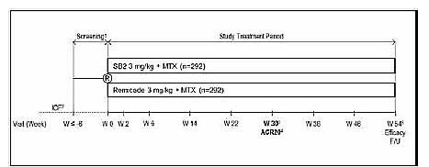
Figure 3. SB2-G31-RA study schematic including transition-extension period to Week 78
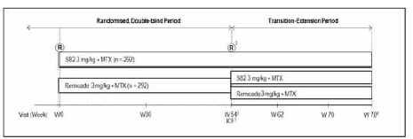

Inclusion and exclusion criteria
The key inclusion criteria were: male and female patients aged 18 to 75 years; RA based on ACR criteria for at least 6 months; moderate to severe RA disease despite MTX therapy (based on protocol defined joint count, ESR and CRP criteria); MTX treatment for at least 6 months; a stable dose of MTX 10 to 25 mg/week for at least 4 weeks before screening.
The key exclusion criteria were: previous treatment with any biologic agent including TNF inhibitors; known hypersensitivity to human immunological proteins or other components of SB2 or Remicade; abnormal renal or hepatic function using pre-defined protocol criteria; past or present HBV, HCV or HIV infection; current active TB; serious infections; infections requiring IV antibiotics within 8 weeks or oral antibiotics within 2 weeks of randomisation; a history of an infected joint prosthesis which had not been removed or replaced; concomitant significant other conditions including inflammatory or rheumatic diseases, malignancies in the previous 5 years, lymphoproliferative diseases including lymphoma, a history of congestive cardiac failure NYHA III/IV or unstable angina, physical incapacitation; demyelinating diseases including multiple sclerosis and Guillain-Barre syndrome; pregnancy and lactation; and protocol defined prohibited medications including glucocorticoids equivalent to > 10 mg prednisolone daily.

Study treatments
SB2 and Remicade were presented in matching vials containing infliximab 100 mg lyophilised powder for injection. Four batches of SB2 were manufactured and six batches of Remicade were sourced from the EU.
The dilution procedures and infusion rates were conducted according to the Remicade PI. The study drugs were reconstituted no more than 3 hours before administration using sterile water for injection and diluted with 0.9% saline for infusion over 2 hours. Infusion sets with in-line, sterile, non-pyrogenic, low protein-binding filters were provided.
The dosing regimen was 3 mg/kg on Weeks 0, 2 and 6 and then every 8 weeks until the final dose at Week 46. In patients with a sub-optimal clinical response at Week 30, the dose could be increased by 1.5 mg/kg increments to a maximum dose of 7.5 mg/kg.
Non-investigational oral or parenteral MTX 10 to 25 mg/week and oral folic acid 5 to 10 mg/week were given.

Efficacy variables and outcomes
The main efficacy variable was change in ACR20 response rates.
The primary efficacy outcome was to demonstrate the equivalence of SB2 to Remicade at Week 30 assessed by ACR20 response rates.
Other efficacy outcomes included:
- ACR20 response rates at Week 54
- ACR50 and ACR70 response rates at Week 30 and Week 54.
- The numeric index of the ACR response (ACR-N) at Week 30 and Week 54
- The AUC of ACR-N up to Week 30
- DAS28 score at Week 30 and Week 54
- EULAR response at Week 30 and Week 54
- AUC for change in DAS28 from Baseline to Week 30
- Major clinical response (ACR70 response for 6 consecutive months) at Week 54
- Changes in mTSS at Week 54
- Study drug C_{trough} at intervals during the randomised treatment period up to Week 30
- The incidence of ADAs and NAb
        - Randomisation and blinding methods
Randomisation was conducted 1:1 via IVRS or IWRS using a computer-generated schedule which randomised patients at a centre level. The patients, investigators, joint assessors and study personnel remained blind throughout the entire treatment period. Emergency unblinding was permitted for safety concerns only in individual patients. A limited number of sponsor and CRO personnel were prospectively unblinded for reporting of efficacy, PK, safety and immunogenicity endpoints.
        - Analysis populations
The enrolled set (ENR) comprised all screened patients who were planned to be randomised. The full analysis set (FAS) included all randomised patients (RAN). Patients who were inadvertently randomised but did not receive a dose of study drug were excluded from the FAS. The per protocol set (PPS1) included all patients in the FAS who completed the Week 30 visit and who recorded 80 to 120% compliance with the expected number of IP administrations and who did not have pre-defined major protocol deviations. The PPS2 included all patients who completed the Week 54 visit with the same caveats. The safety set (SAF) included all randomised patients who received at least one dose of study medication. A total of 584 patients were included in the RAN and 99.8% of patients were included in the FAS and SAF. Totals of 81.8% and 70.2% of patients were included in PPS1 and PPS2. A total of 325 patients were included in the PK population (SB2 56.7%, Remicade 54.6%). Full details are shown below in Table 2.

Table 2. Data sets analysed (randomised set)

Sample size
The sample size was calculated based on a meta-analysis of ACR20 response rates from selected published infliximab studies. Compared with placebo, a risk difference of 0.33 (90% CI: 0.28, 0.38) was estimated with approximately 50% of the lower limit preserved on or over placebo to obtain the equivalence margin. An equivalence limit of ± 15% was set. Based on this limit, 233 patients in each treatment group were required for 82% power to expect the 2-sided 95% CI to lie between ± 15%. An overall sample size of 292 patients per treatment group was calculated to allow for a 20% withdrawal rate.

Statistical methods
The primary efficacy analysis compared ACR20 response rates in the treatment groups by comparing the 95% CI of the difference of two proportions using the equivalence margin of ± 15%. The primary analysis was performed on PPS1 by non-parametric method using NParCov with baseline CRP as a covariate, and stratified by region. No missing data were imputed for the PPS1. A sensitivity analysis was performed using the FAS and missing data were imputed. The data imputation methods for managing missing data were (a) available data analysis (subjects with missing data at Week 30 or Week 54 were excluded from the analysis); (b) non-responder analysis (patients with missing ACR20 responses at Week 30 or Week 54 were considered as ACR20 non-responders); and (c) pattern mixture analysis using multiple imputations for patients who withdrew from the study for lack of efficacy or an AE. Similar analyses were performed for ACR50 and ACR70 responses for the PPS1 and PPS2. ACR-N, DAS28 and mTSS endpoints were also analysed using ANCOVA models. For the secondary endpoints, differences between the treatment groups were assessed by comparing the 95% CI of the difference with the equivalence margin of ± 15%.

Participant flow
A total of 805 patients were screened and 584 were randomised as planned. The most common reason for screening failure was not meeting the inclusion/exclusion criteria. Totals of 291 and 293 patients were randomised to the SB2 and Remicade treatment groups, respectively. In the RAN, 505 (86.5%) patients completed 30 weeks of the study and 452 (77.4%) patients completed 54 weeks. At Week 30, 13.5% of patients (15.5% SB2, 11.6% Remicade) had withdrawn from the study, most commonly due to AEs (7.2% SB2, 3.4% Remicade) and withdrawal of consent (5.8% SB2, 4.1% Remicade). At Week 54, 21.2% of patients (20.6% SB2, 21.8% Remicade) had withdrawn from the study, most commonly due to withdrawal of consent (7.9% versus 8.9%) and AEs (9.3% versus 7.2%). Additional details are shown below in Table 3.

Table 3. Disposition of patients

Major protocol violations/deviations
At least one major protocol deviation was reported in 20.4% of patients in the randomised set (SB2 20.6%, Remicade 20.1%) and 7% of patients were excluded from the PPS1 based on pre-defined criteria. The most common deviations were concomitant medication errors (SB2 3.4%, Remicade 2.7%) and failure to meet eligibility criteria (SB2 2.1%, Remicade 3.1%). A total of 10.3% of patients were excluded from the PPS2, most commonly due to study procedure criteria (SB2 4.5%, 3.4% Remicade) and concomitant medication errors (SB2 4.1%, Remicade 2.7%).

Baseline data
The baseline demographics in the RAN were comparable in each treatment group as shown below in Table 4. Most patients were female (80.1%) with a mean age of 52.1 years. Mean body weight was 72.1 kg and mean BMI was 26.56 kg/m². Most patients were White (86.6%) or Asian (13.0%). Baseline disease characteristics in the RAN were well balanced as shown below in Table 5. The mean disease duration was 6.4 years, the mean duration of MTX use was 50.7 months and the mean weekly dose of MTX at baseline was 14.7 mg. Baseline characteristics of rheumatoid disease activity were also balanced between treatment groups as detailed below in Table 6. The overall mean swollen joint count was 14.8, the mean tender joint count was 23.8 and the mean serum CRP was 13.0 mg/L.
Comment: The baseline demographics were comparable to those reported in the ATTRACT study (Lipsky, 2003). Baseline disease characteristics were also similar although the numbers of swollen joints (approximately 22 versus 15) and tender joints (approximately 32 versus 24) were higher in ATTRACT. The mean serum CRP was lower in ATTRACT (approximately 4 mg/L versus 13 mg/L) but the mean weekly dose of methotrexate was similar (approximately 16 mg versus 15 mg).

Table 4. Baseline demographic characteristics (randomised set)
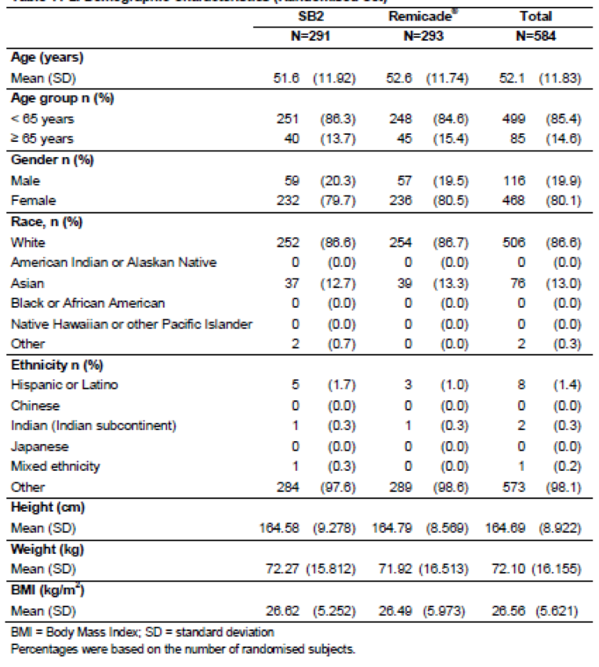

Table 5. Baseline disease characteristics (randomised set)
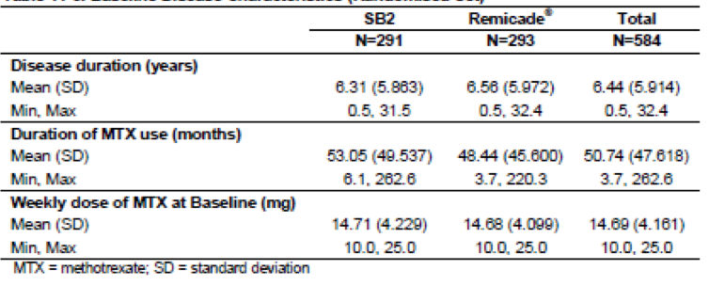

Table 6. Baseline characteristics for rheumatoid disease activity (Full analysis set/Randomised set)
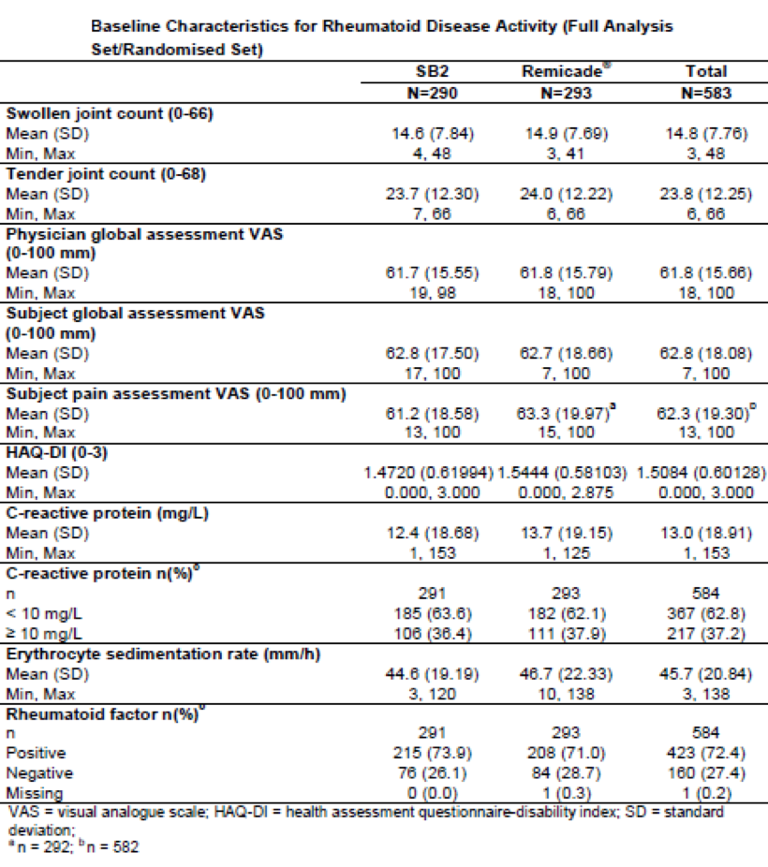

Results for the primary efficacy outcome
The primary endpoint was achieved with equivalent ACR20 response rates at Week 30 in the SB2 and Remicade treatment groups of the PPS1 (see Table 7, below). The proportions of patients achieving an ACR20 response at Week 30 were 64.1% in the SB2 group and 66.0% in the Remicade group. The mean adjusted difference for the ACR20 response was -1.88% (95% CI: -10.26, 6.51) which fell entirely within the pre-defined equivalence margin of +/-15%. A range of sensitivity analyses were performed including the FAS (shown in Table 8, below), a time-response curve (see Figure 4, below) and ANCOVA adjusting for baseline CRP (see Table 9, below). These were performed with and without imputation and each analysis supported the conclusions of the primary analysis.

Table 7. Primary analysis of ACR20 response rate at Week 30 (Per protocol set-1)
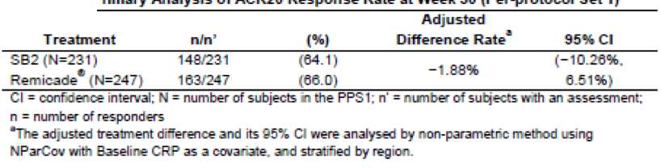

Table 8. Analysis of ACR20 response rate at Week 30; non-responder analysis (Full analysis set)
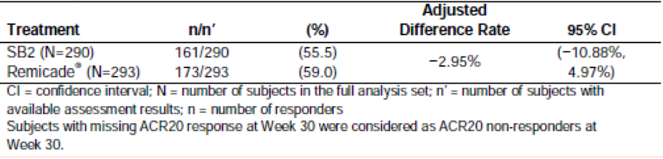
Figure 4. Time response model for ACR20 response up to Week 30 (Per protocol set-1)

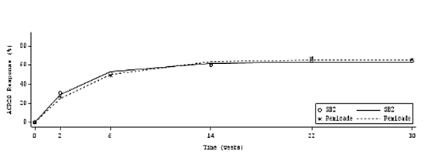

Table 9. Analysis of Covariance (ANCOVA) for ACR20 response at Week 30 with treatment by Baseline CRP level interaction (Per protocol set-1)
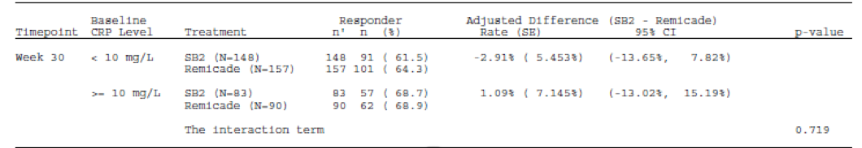

Results for other efficacy outcomes
At Week 54, the ACR20 response rate was 65.3% for the SB2 group and 69.2% for the Remicade group in the PPS2 (see Table 10, below) and 50.7% and 52.6% (see Table 11, below), respectively, in the FAS.

Table 10. Analysis of ACR20 response rate at Week 54 (Per protocol set 2)

Table 11. Analysis of ACR20 response rate at Week 54, non-responder analysis (Full analysis set)
ACR50 and ACR70 response rates at Week 30 for PPS1 and at Week 54 for PPS2 are shown below in Table 12 and Table 13 respectively. In the PPS1 at Week 30, ACR50 was achieved by 35.5% and 38.1% of the SB2 and Remicade groups, respectively, with an adjusted difference rate of -2.13% (95% CI: -10.69, 6.43). ACR70 was achieved by 18.2% and 19.0% of the respective groups with an adjusted difference rate of -0.25% (95% CI: -7.26, 6.75). In the PPS2 at Week 54, ACR50 was achieved by 41.6% and 38.9% of the SB2 and Remicade groups, respectively, with a mean adjusted difference rate of 3.43% (95% CI: -5.74, 12.60). ACR70 was achieved by 22.3% and 24.0% of the groups respectively with a mean adjusted difference rate of -1.07% (95% CI: -9.12, 6.98). At Week 54, the proportion of patients achieving a major clinical response (ACR70 response for 6 consecutive months) was 7.9% in the SB2 group and 6.5% in the Remicade group.

Table 12. Analysis of ACR50 and ACR 50 response rates at Week 30 (Per protocol set 1)

Table 13. Analysis of ACR50 and ACR70 response rate at Week 54 (Per protocol set 2)
The mean ACR-N values at Week 30 (36.63% versus 37.81%) and Week 54 (38.82% versus 39.77%) were similar in the respective treatment groups. The mean AUC of ACR-N at Week 30 was similar in both groups (6,072 (SD 4,477) versus 6,210 (SD 4,471)).
Changes in DAS28 score at Week 30 and Week 54 in the FAS are shown below in Table 14. At Week 30, the LSMean scores were 2.411 and 2.367 in the SB2 and Remicade groups, respectively, with a mean difference of 0.044 (95% CI: -0.186, 0.274). At Week 54, the LSMean scores were 2.469 and 2.472, respectively, with a mean difference of -0.004 (95% CI: -0.246, 0.239). The mean AUC of the change from baseline in DAS28 score up to Week 30 was 387.9 (SD 207.9) in the SB2 group and 401.3 (SD 223.3) in the Remicade group.

Table 14. ANCOVA for change in DAS28 score at Week 30 and Week 54 (Full analysis set)
The EULAR response (good, moderate, no response) was comparable in the two treatment groups at Week 30 and Week 54. At Week 30, 25.7% and 25.7% of the SB2 and Remicade groups, respectively had a good EULAR response; moderate EULAR responses were reported in 58.1% and 54.7% of the respective groups; and no EULAR response was reported in 16.2% and 19.6% of the respective groups. At Week 54, 31.7% and 27.9% of the SB2 and Remicade groups, respectively, had a good EULAR response; moderate EULAR responses were reported in 48.5% and 55.4% of each respective group; and no EULAR response was reported in 19.8% and 16.7% of the respective groups.
Changes in structural joint damage at Week 54 in the FAS are shown in Table 15. The mean (SD) change in mTSS from baseline was 0.38 (2.15) in the SB2 group and 0.37 (3.39) in the Remicade group. The changes in joint erosion score were 0.14 (1.16) and -0.03 (1.25) in the respective groups and the changes in joint space narrowing were 0.24 (1.39) and 0.40 (2.56) in the respective groups.

Table 15. Summary of structural joint damage at Week 54 (Full analysis set)
Changes in CRP by visit and treatment group and mean changes in HAQ-DI up to Week 54 are not recorded in the body of the CSR (see Clinical Questions).
A subgroup analysis of ACR20 response rates by ADA status at Week 30 in the PPS1 is shown below in Table 16. The ACR20 response rate was lower in the ADA+ subgroup than in the ADA-subgroup. However, the response rates were comparable in the SB2 and Remicade groups irrespective of the ADA status. In ADA- patients up to Week 30, the ACR20 response was 73.1% in the SB2 group and 73.6% in the Remicade group. The mean adjusted difference was -1.57% (95% CI: -13.23, 10.08) with the limits contained within the ± 15.0% equivalence margin. In ADA+ patients up to Week 30, the ACR20 response was 56.7% in the SB2 group and 58.7% in the Remicade group. The adjusted mean difference rate was -0.88% (95% CI: -12.63, 10.87) with the limits also contained within the ± 15.0% equivalence margin. There was no significant interaction between treatment and overall ADA status (p = 0.989). At Week 30 and Week 54 there were no significant differences between treatment groups for ACR50 and ACR70 response rates in ADA- and ADA+ subgroups (data not shown).

Table 16. ANCOVA for ACR20 response at Week 30 by 30-week ADA result and treatment (Per protocol set 1)
A subgroup analysis of ACR20 response rates by baseline CRP level at Week 30 in the PPS1 showed no significant differences between the SB2 and Remicade groups, with similar ACR20 response rates irrespective of baseline CRP (< 10 mg/L and ≥ 10 mg/L). In patients with baseline CRP < 10 mg/L, the ACR20 response was 61.5% in the SB2 group and 64.3% in the Remicade group at Week 30. The adjusted mean difference rate was -2.91% (95% CI: -13.65, 7.82) with the limits contained within the ± 15.0% equivalence margin. In patients with baseline CRP ≥ 10 mg/L, the ACR20 response was 68.7% in the SB2 group and 68.9% in the Remicade group. The adjusted mean difference rate was 1.09% (95% CI: -13.02, 15.19). There was no significant interaction between treatment and baseline CRP level (p = 0.719). Analyses of Week 30 and Week 54 ACR50 and ACR70 response rates by baseline CRP were not performed.
Subgroups analyses for ACR20 response rate at Week 30 were performed based on region (EU versus non-EU), age (< 65 years versus ≥ 65 years) and gender. No statistically significant interactions were observed in either treatment group.

Other efficacy studies
No other efficacy studies were submitted.

Analyses performed across trials (pooled analyses and meta-analyses)
None submitted.

Evaluator’s conclusions on clinical efficacy for rheumatoid arthritis in adults
Study SB2-G31-RA convincingly demonstrates equivalence between SB2 and Remicade based on achieving the primary endpoint of ACR20 responses and multiple secondary endpoints including ACR50, ACR70, EULAR and DAS28 scores.
The study was designed according to EMA guidelines and adopted after consultation with the EMA and FDA. The study population was representative of patients with moderate to severe RA who were unresponsive to MTX. Most patients were female (80.1%) with a mean age of 52.1 years and the mean duration of RA was approximately 6 years. Observer bias was minimised by the randomised and double-blind design. Compliance rates were high and overall 86.5% of patients completed the 30-week treatment period for the primary analysis.
The study achieved the primary objective of equivalence of SB2 and Remicade. At Week 30 in the PPS1, the mean difference in ACR20 response rates was -1.88% (95% CI: -10.26, 6.51) which fell entirely within the pre-defined equivalence margin of ± 15%. A range of sensitivity analyses at Weeks 30 and 54 confirmed the primary analysis. In addition, there were comparable outcomes at Weeks 30 and 54 for secondary endpoints including ACR50, ACR70, DAS28 and EULAR scores. Progression of radiographic structural damage was also comparable in the two treatment groups. Response rates were significantly higher in patients who did not develop ADAs during the treatment period, compared with those who did develop ADAs. However, subgroup analyses showed no interactions based on age, gender, baseline CRP, or geographical region. Mean serum trough infliximab concentrations of both study drugs were comparable.
The equivalence margins of ± 15% for the 95% CI for the primary endpoint are clinically appropriate and have been accepted by the EU and FDA. The secondary endpoints confirmed the primary analysis and there was no suggestion of lack of equivalence for any individual parameter. The study endpoints for RA have been universally adopted by professional bodies, including the American College of Rheumatology and regulatory authorities including the EMA and FDA. In particular, ACR20 response rates are generally accepted as a valid primary endpoint for trials in RA patients. 2-year data are preferred to detect changes in progressive radiological joint damage. Only one year data are available in Study SB2-G31-RA but there are no obvious trends to suggest different treatment effects. In the ATTRACT study, only 8% of patients developed ADAs but approximately half of RA patients can be expected to develop ADAs after one year based on other studies. In Study SB2-G31-RA at Week 54, the proportions of patients with positive ADA results in the SB2 and Remicade groups were 62.4% and 57.5%, respectively (p = 0.27). The presence of ADAs reduced efficacy in both groups but the differences between treatments were not statistically significant.
The study design, baseline demographics and disease characteristics were comparable to the ATTRACT study, and also to the PLANETRA study which compared the efficacy, safety and immunogenicity of Remsima and Remicade in a total of 606 patients (Yoo, 2013). The study duration and endpoints were comparable and the same equivalence limits of ± 15% for the 95% CI for ACR20 response were applied. In the PP population, ACR20 responses in the Remsima and Remicade groups were 73.4% and 69.7%, respectively, comparable to response rates achieved by both treatment groups in Study SB2-G31-RA. Key secondary efficacy endpoints were also comparable and no significant differences were observed for any parameter. In the PLANETRA study at Week 30, ADAs were detected in 48.4% and 48.2% of the Remsima and Remicade groups, respectively.
RA is generally accepted as a valid clinical model for assessing TNFα inhibitors by regulatory authorities. The choice of RA as opposed to other inflammatory diseases has been criticised because RA lacks sufficiently sensitive and measurable markers of response. However, markers used in RA have proved sufficiently sensitive to detect statistically and clinically significant treatment differences compared with placebo in multiple studies. RA is the most common relevant indication and there is a wide body of literature to support its use, particularly in Remicade efficacy studies.
If approval for SB2 is given, a significant proportion of RA and other patients in Australia can be expected to switch from Remicade to SB2. It should be made a condition of approval that the switch data from the transition-extension period to Week 78 of SB2-G31-RA be reviewed for both efficacy and safety (see Clinical Questions, below). The converse switch from SB2 to Remicade is unlikely. However, this is not addressed in the transition-extension study and the sponsor should provide a justification for not doing so (see Clinical Questions, below). The proposed PI addresses the question of switching under ‘Precautions’. Prescribers are cautioned that SB2 is not a generic Remicade and that switching should occur only under the supervision of an appropriate specialist. This statement is adequate but switch data should be added from the transition-extension study as they are presumably now available. With this exception, no further clinical studies or data are required.

Extrapolation of Indications
Two important EU guidelines on similar biological medicinal products (EMEA/CHMP/BMWP/42832/2005 Rev1; and EMA/CHMP/BMWP/403543/2010) address nonclinical and clinical issues when considering bioequivalence. Nonclinical issues include in vitro studies such as receptor binding studies, cell based assays, binding to Fc gamma receptors, and Fab and Fc-associated functions relevant to mechanisms of action. In vivo studies include relevant PK/PD effects and non-clinical toxicity. Clinical studies should include comparative PK studies of the reference and similar products; and at least one efficacy and safety study. PD markers should be relevant to the therapeutic effects of the product, and comparative PK/PD studies may also be required. The clinical studies should fully explore immunogenicity. If comparability is established, extrapolation to other indications may be justified based on the overall quality of the data.
A review by Weise (2014) notes that extrapolation of data is an established scientific and regulatory principle which has been exercised for many years for more than twenty biosimilar products. Clinical data are typically generated using appropriate comparability studies in one indication and extrapolated to the other indications. In only one case has a regulatory authority required additional clinical studies in other approved indications (a recent exception by Health Canada for an IBD indication). Acceptable data include comparable efficacy, safety and immunogenicity in a selected indication. To merit extrapolation, the mechanism of action should be carefully assessed, particularly if it involves multiple receptors or binding sites. If structure and functions, PK/PD effects and efficacy can be shown to be comparable for the biosimilar and the reference product, adverse drug reactions can also be expected at similar frequencies. However, similar immunogenicity cannot be assumed and comparability requires additional clinical confirmation.
Weise (2014) provided scientific advice to the EMA for the approval of the first biosimilar infliximab (Remsima) for which Remicade was the reference product. As noted in her review, the mechanism of infliximab is similar in rheumatological indications and in psoriasis, with binding to both soluble and membrane-bound TNFα. However, the Fc-region of infliximab is thought to contribute to the potential mechanisms associated with IBD (antibody-dependent cell-mediated cytotoxicity or complement-dependent cytotoxicity). Nonetheless, extrapolation was granted by the EMA based on the following arguments:
- Extensive analytical testing showed similar physicochemical and structural characteristics for Remsima compared with Remicade with only small differences in the proportion of isoforms.
- Despite the potential role of ADCC and CDC in IBD, the main mode of action in all therapeutic indications is binding to the soluble and/or membrane-bound TNFα.
- There was similar inhibition of the direct effects of TNF-α on epithelial cells which play an important role in CD.
- Induction of regulatory macrophages is a putative mode of action of infliximab in IBD. The biosimilar and reference products showed similar induction.
- A large PK study in AS patients displayed bioequivalence between the test and reference products.
- Equivalent efficacy and comparable safety and immunogenicity were demonstrated in a large, randomised study of patients in RA.
These views in relation to IBD have been challenged by bodies such as ECCO (Danese, 2013). In its position paper on biosimilars, ECCO proposes caution based on concerns including:
- Subtle differences in molecular structure may cause profound differences in clinical efficacy or immunogenicity.
- Rules applied to the production of generic chemical medicines cannot be transferred to biosimilars.
- Different biological and biosimilar medicines targeting the same molecule are neither identical in efficacy nor toxicity, even in the same clinical entity.
- A biosimilar proven effective and safe for one indication may not necessarily be effective and safe for a second indication for which the reference biological has been shown to be safe and effective.
- Specific evidence obtained in patients with IBD should be required to establish efficacy and safety for this specific indication, because experience with currently licensed biological medicines has already shown that clinical efficacy in IBD cannot be predicted by effectiveness in other indications, such as rheumatoid arthritis (an unreferenced statement).
- Post-marketing collection of data is necessary to confirm safety and identifying any increase in frequency of predictable adverse events.
- Switching products should only be made with the knowledge and approval of the patient and prescriber.
No comparator studies of a biosimilar infliximab have been performed in indications other than RA and there is no direct clinical evidence to support the arguments of regulators or sceptics. Bodies such as ECCO recommend comparative clinical trials in IBD patients in the interest of caution. On the other hand, regulatory authorities will accept extrapolation based on a balance of probabilities that efficacy and safety will be comparable. The TGA has recently approved Remsima infliximab for all indications (ARTG date 27 November 2015). Health Canada is a notable exception as it has recently approved Remsima for rheumatological indications but rejected extrapolation to IBD.
The sponsor has submitted a justification for extrapolation based on the following arguments:
- The mechanism of action of infliximab requires high affinity binding to both soluble and transmembrane TNFα (Wong, 2008), which occur in varying elevated concentrations in tissues and fluids of patients with RA, CD, AS, PsA, UC and psoriasis (Lin, 2008). This high affinity binding has been demonstrated for SB2.
- According to the Scientific Advice (EMA/CHMP/SAWP/70331/2012), soluble TNFα is important in the pathogenesis of AS, PsA and plaque psoriasis); and membrane bound TNFα is important in paediatric and adult CD and UC as discussed above.
- Non-clinical characterisation studies have shown similar structural, physicochemical and biological properties to Remicade. Multiple in vitro assays have explored the effects of SB2 and Remicade. These included: tmTNF-α binding assays, Fc receptor binding assays, CDC assays, ADCC assays and apoptosis assays (including IBD models). Overall, the results for SB2 were comparable to Remicade.
- Although the SB2 PK profile has not been tested in doses > 5 mg/kg, infliximab has been tested in doses up to 20 mg/kg. Exposure is linear with no accumulation after multiple administrations. Although doses of up to 10 mg/kg may be required in CD patients, the frequency of administration is the same. No significant PK differences have been reported in patients with RA, AS, psoriasis and adult and paediatric CD (Nesterov, 2005, Klotz, 2007).
In the evaluators’ opinion, sufficient justification has been provided to recommend extrapolation of efficacy endpoints to all other indications including IBD. The PK study, Study SB2-G11-NHV, showed comparability between SB2 and Remicade for all key parameters within the accepted 80 to 125% limits for the 90% CI. In the pivotal Study SB2-G31-RA in RA patients, the primary endpoint for bioequivalence was met based on ACR20 responses at Week 30. The treatment difference of -1.88% (95% CI: -10.26, 6.51) was comfortably within the pre-defined ± 15% equivalence limits. Immunogenicity incidences at Week 54 were higher than those observed in similar studies; however, immunogenicity was comparable in SB2 and Remicade patients.
Based on the overall data, SB2 and Remicade are comparable and extrapolation to all indications is justified if appropriate post-marketing surveillance is ensured. However, this opinion is dependent on a positive evaluation of the in vitro data supporting comparability.

Clinical safety

Studies providing evaluable safety data
The following studies provided evaluable safety data:

Pivotal efficacy study
In the single, pivotal efficacy study, Study SB2-G31-RA, the following safety data were collected:
- General adverse events (AEs) were coded using MedDRA Version 16.0 and assigned by PT and SOC.
- AEs of particular interest included serious infections, TB, malignancy, congestive heart failure and infusion reactions were reported separately.
- Laboratory tests, including routine biochemistry, haematology and CRP, were performed at two central laboratories [names removed].
- PK and immunogenicity analyses were performed by [name removed].

Other studies

Pivotal studies that assessed safety as a primary outcome
No studies were performed.

Dose-response and non-pivotal efficacy studies
No studies were performed.

Other studies evaluable for safety only
No studies were performed.

Clinical pharmacology study
A single study was performed (Study SB2-G11-NHV).

Pivotal studies that assessed safety as a primary outcome
No studies were performed.

Patient exposure
In Study SB2-G31-RA, mean (SD) exposure to study drug was 282.2 (91.02) days in the SB2 group and 287.8 (81.68) days in the Remicade group. At Week 30, 65.2% and 65.5% of the respective groups were receiving a dose of 3 mg/kg, 19.7% and 22.9% respectively were receiving 4.5 mg/kg. In the SB2 group at Week 46, 50.7%, 17.2% and 10.7% were respectively receiving 3.0 mg/kg, 4.5 mg/kg and 6.0 mg/kg. In the Remicade group at Week 46, 50.2%, 21.2%, 5.8% and 1.7% were respectively receiving 3.0 mg/kg, 4.5 mg/kg, 6.0 mg/kg and 7.5 mg/kg. Exposure ≥ 323 days occurred in 180 and 181 patients in the SB2 and Remicade groups, respectively.
Comment: Exposure was sufficient to show comparability with the known overall safety profile of infliximab. However, the number of patients was not sufficient to detect statistically significant or clinically important differences between the biosimilar and reference products.

Adverse events

All adverse events (irrespective of relationship to study treatment)

Pivotal Study SB2-G31-RA
AEs were reported by 61.7% and 65.2% of patients in the SB2 and Remicade groups, respectively. The majority of AEs were of mild to moderate severity and overall only 7.7% of patients reported severe events (SB2 8.6%, Remicade 6.8%). Most events were considered unrelated to study treatment. Overall, AEs of special interest were reported by 2.7% of patients (SB2 3.1%, Remicade 2.4%) and AEs leading to IP discontinuation were reported by 9.3% of patients (SB2 10.3%, Remicade 8.2%) as shown in Table 17, below.

Table 17. Summary of all treatment emergent adverse events (Safety set)
The number of AEs and categorisation by PT and SOC were comparable in the treatment groups. AEs reported by PT occurring in ≥ 2% of patients in the SAF are shown in Table 18, below. In the SB2 and Remicade groups, respectively, the most common events were latent TB (6.6% versus 7.2%), nasopharyngitis (6.2% versus 6.8%), ALT increased (7.9% versus 3.1%), rheumatoid arthritis (6.9% versus 3.8%), headache (5.5% versus 4.4%), upper respiratory tract infection (4.1% versus 3.8%), AST increased (4.1% versus 3.4%), bronchitis (3.1% versus 4.4%) and back pain (2.4% versus 3.8%). AEs reported most commonly by SOC were infections and infestations (29.3% versus 37.5%), musculoskeletal and connective tissue disorders (13.1% versus 13.3%), investigations (14.8% versus 10.6%), gastrointestinal disorders (9.7% versus 10.9%), skin and subcutaneous tissue disorders (9.7% versus 10.6%) and nervous system disorders (9.0% versus 10.2%).
Comment: Slightly higher rates of AEs related to increased ALT and RA were observed in the SB2 group. However, no meaningful treatment-emergent trends in ALT or differences between groups were observed (see Section 8.5.1.1). The higher rate of AEs related to RA suggests less efficacy in the SB2 group but this was not apparent in the efficacy analysis.

Table 18. Number (%) of subjects with TEAEs and number of events by PT that occurred in ≥ 2% of any subjects in any treatment group (Safety set)

Other studies
The PK study, Study SB2-G11-NHV was conducted in healthy subjects and the safety outcomes are summarised [not included in this document]. AEs were reported in 50.9% of the SB2 group, compared with 39.6 to 43.4% in the Remicade groups. All events were of mild or moderate severity, most were mild and no subjects discontinued the study because of AEs. The pattern of events was that expected in a healthy subject study and there were no notable differences between the treatment groups. The most common AEs by PT were nasopharyngitis (SB2 11.3%, Remicade 5.7% to 7.5%), and headache (SB2 9.4%, Remicade 11.3% to 13.2%).

Treatment-related adverse events (adverse drug reactions)

Pivotal Study SB2-G31-RA
Treatment-related AEs were reported in 24.1% and 23.5% of the SB2 and Remicade groups, respectively. The most commonly reported events by PT were ALT increased (4.5% versus 0.7%), AST increased (3.1% versus 0.7%) and latent TB (1.4% versus 2.4%). The most commonly reported events by SOC were infections and infestations (6.6% versus 9.2%), skin and subcutaneous tissue disorders (4.8% versus 5.8%) and investigations (7.2% versus 1.7%) (mostly related to ALT/AST elevations summarised in Section 8.5.1. (Laboratory tests: Liver function).

Deaths and other serious adverse events

Pivotal Study SB2-G31-RA
One death was reported during the study. A 71 year old female in the Remicade group died of left ventricular failure on Day 68, 25 days after the last dose of IP. It was not considered drug related.
Other SAEs were reported in 10.0% of the SB2 group and 10.6% of the Remicade group. The most commonly reported SAEs by PT were RA (1% versus 1%) and pneumonia (1% versus 0.7%). Other SAEs were reported in ≤ 2 patients in either group. The most commonly reported SAEs by SOC were infections and infestations (4.1% versus 2.4%) and musculoskeletal and connective tissue disorders (1.0% versus 2.0%). In the SB2 group, there were four SAEs due to pneumonia, and one due to TB. In the Remicade group, there were two cases of pneumonia and no cases of TB. All SAEs resolved with the exception of one patient in each group (prostate cancer, SB2; and pneumonia/ventricular failure, Remicade). SAES considered related to IP were reported in 10 patients In the SB2 group and 7 patients in the Remicade group.

Discontinuation due to adverse events

Pivotal Study SB2-G31-RA
AEs leading to discontinuation of IP were experienced by 10.3% of the SB2 group and 8.2% of Remicade group. The most common AEs leading to discontinuation in the respective groups were latent TB (0.7% versus 1.4%), pneumonia (1% versus 0.3%), rheumatoid arthritis (1.4% versus 0%) and hypersensitivity (1% versus 0%).

Laboratory tests

Liver function

Pivotal Study SB2-G31-RA
There were no meaningful treatment-emergent differences in mean or median values for serum ALT, AST, ALP, total bilirubin, gamma-GT, or serum albumin between the SB2 and Remicade groups. Changes from normal ALT at baseline to elevated levels at Week 54 were reported in 11.9% of the SB2 group and 9.4% of the Remicade group. Changes from normal AST at baseline to elevated levels at Week 54 were reported in 12.4% and 9.0% of the respective groups. By Week 54, PCS ALT abnormalities were reported in 5.2% of the SB2 group and 2.4% of the Remicade group, and PCS AST abnormalities were reported in 1.7% and 0.7% of the respective groups (as shown in Table 19, below). No possible cases meeting Hy’s law criteria were identified.

Table 19. Number (%) of subjects with at least 1 post-dose significant abnormality in biochemistry parameters by Week 54 (Safety set)

Kidney function

Pivotal Study SB2-G31-RA
There were no meaningful treatment-emergent differences in mean or median serum creatinine between the treatment groups. Changes from normal creatinine at baseline to elevated levels at Week 54 were reported in 2.2% of the SB2 group and 5.4% of the Remicade group. There were no meaningful treatment-emergent differences in urinary parameters between groups.
    - Other clinical chemistry

Pivotal Study SB2-G31-RA
There were no meaningful treatment-emergent differences between treatment groups in mean or median biochemistry parameters including serum sodium, potassium, phosphorus and glucose. The number of patients with at least one treatment-emergent significant biochemistry abnormality is shown in Table 19 (above). There were no clinically meaningful differences between the groups.

Haematology

Pivotal Study SB2-G31-RA
There were no meaningful treatment-emergent differences in mean or median haematology parameters between the treatment groups. The most common abnormal haematology parameter was increased neutrophils occurring in 2.8% and 1.4% of the SB2 and Remicade groups, respectively. Treatment-emergent low lymphocyte levels were reported in 2.1% and 1.0% of the respective groups. The number of patients with clinically significant changes in any haematology parameter was comparable in each group.

CRP

Pivotal study SB2-G31-RA
Comparable treatment-emergent decreases in CRP were observed in both groups (see Clinical Questions).

Electrocardiograph

Pivotal study
ECG abnormalities were reported in 74 and 66 patients in the SB2 and Remicade groups at screening. However, clinically significant abnormalities were observed in only one patient in the SB2 group. ECGs were performed only for cause during the randomised treatment period and clinically significant abnormalities were reported as AEs.

Vital signs

Pivotal study SB2-G31-RA
There were no meaningful changes from baseline to Week 54 in mean systolic or diastolic blood pressure, heart rate or body temperature in either treatment group. The incidence of clinically significant vital sign abnormalities was comparable between groups.

QuantiFERON Gold Test (QFG)

Pivotal Study SB2-G31-RA
At screening, positive QFG tests were reported in 6.2% and 8.5% of the SB2 and Remicade groups, respectively (see Table 20). These patients were started on treatment for latent TB. At screening, 93.4% of the SB2 group and 91.1% of the Remicade group had negative QFG tests. Overall, 12.5% and 14.2% of the respective groups had a post-screening positive QFG test at some point in the treatment period. In the SB2 and Remicade treatment groups, 7.5% and 7.8% of patients, respectively, had a shift in QFG test from negative at baseline to positive by Week 54.
Comment: New TB infections are listed as uncommon (< 10%) in the Remicade PI and the results in Study SB2-G31-RA are also < 10%. However, comparisons of clinical studies are not always meaningful as the incidence of new infections depends on the prevalence of TB in the populations studied, the screening methods employed, concomitant medications including corticosteroids, and other variables.

Table 20. Shift table from Baseline for the QuantiFERON gold test (Safety Set)

Anti-drug antibodies

Pivotal Study SB2-G31-RA
The incidence of ADA and NAb responses in the SAF are shown in Table 21, below. At Week 54, the proportions of patients with positive ADA results in the SB2 and Remicade groups were 62.4% and 57.5%, respectively (p = 0.27). NAbs were detected in 92.7% and 87.5% of the respective groups. The differences between treatments were not statistically significant.

Table 21. Incidence of ADAs and NAbs to infliximab (Safety set)

Adverse events of special interest

Pivotal study SB2-G31-RA
AEs of special interest were reported with similar frequency in the SB2 and Remicade treatment groups.

Infections
AEs were reported in 3.1% and 2.4% of the SB2 and Remicade groups, respectively. Active TB was reported in one case (0.3%) in the SB2 group (tuberculous pleurisy) and in one case (0.3%) of the Remicade group (pulmonary TB). None of the patients with latent TB (that is, QFG+) at screening developed active TB during the study following TB prophylaxis treatment. Pneumonia SAEs were reported in 1.0% and 0.7% of the respective groups.

Malignancies
One case each of breast and prostate cancer were reported in the SB2 group.

Congestive cardiac failure
One case of congestive cardiac failure was reported in the Remicade group

Infusion-related reactions
AEs associated with infusion-related reactions are shown by SOC and PT in Table 22, below. Acute infusion reactions occurred in 5.9% of patients in the SB2 group and 5.1% of the Remicade group. Most reactions were mild or moderate and all patients recovered. There were five SAEs related to infusion reactions. In the SB2 group, there were two events of hypersensitivity and one anaphylactic reaction. In the Remicade group, there was one event of urticaria and one event of anaphylactic shock. All of the serious infusion-related reactions occurred in ADA+ patients. No events of serum sickness or delayed hypersensitivity were reported.

Table 22. TEAEs associated with infusion related reactions by SOC and PT (Safety set)
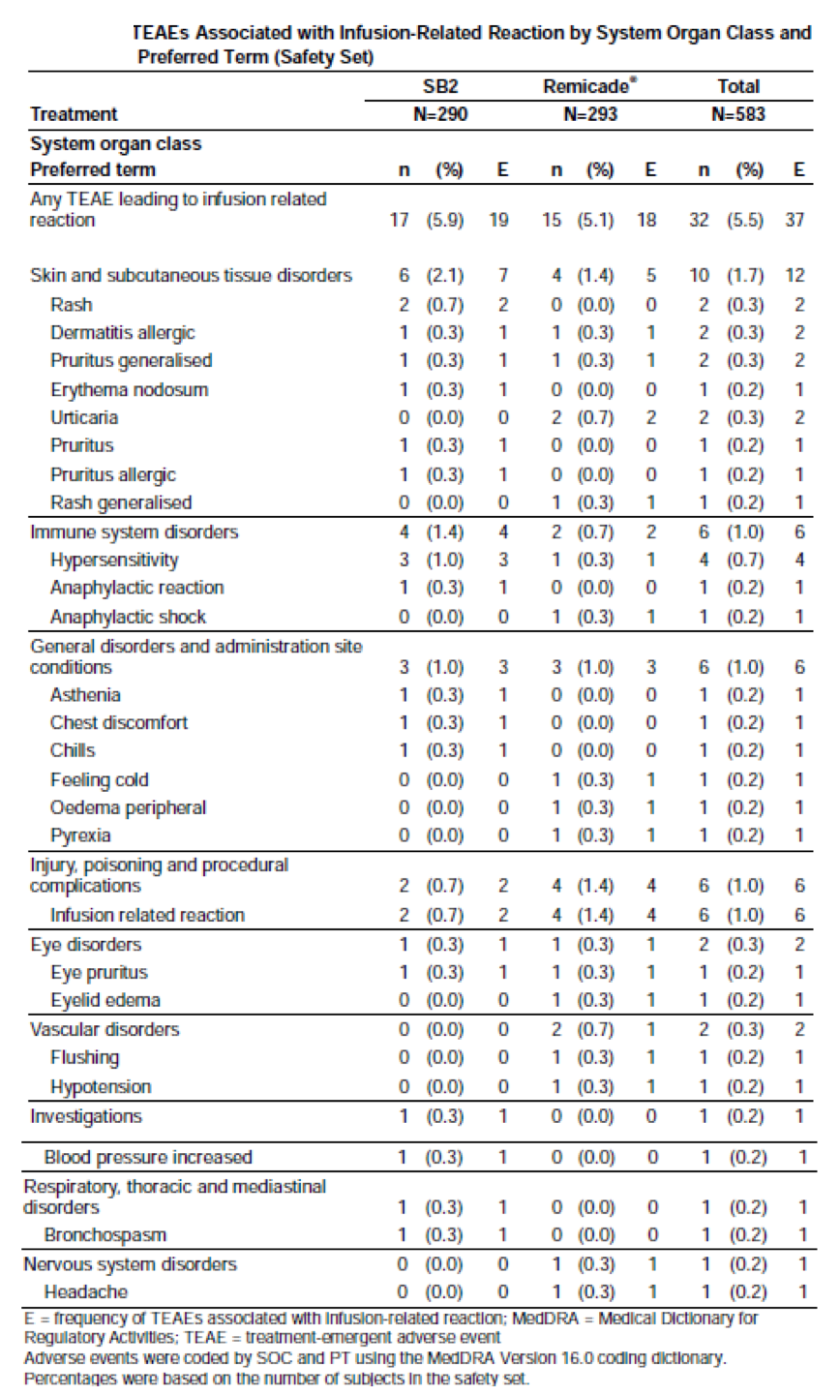

Post-marketing experience
Not applicable.

Safety issues with the potential for major regulatory impact

Liver toxicity
No safety signals were detected.

Haematological toxicity
No safety signals were detected.

Serious skin reactions
No safety signals were detected. No serious skin reactions were reported with the exception of two SAEs of urticarial in the Remicade group.

Cardiovascular safety
No safety signals were detected.

Unwanted immunological events
The incidences of ADAs, NAbs and infusion-related reactions are evaluated in Sections 8.5.9. and 8.5.10. (see above). The incidence of ADAs was comparable in each treatment group.

Other safety issues

Safety in special populations
No studies in special populations were conducted. However, subgroup analyses were performed based on ADA status, age and gender.

ADA status
In ADA- patients up to Week 54, AEs were reported in 60.2% and 72.6% of the SB2 and Remicade groups, respectively. The most commonly reported AEs by SOC were infections and infestations (SB2 32.4%, Remicade 40.3%). In ADA+ patients up to Week 54, AEs were reported in 62.6% and 60.1% of the respective groups. The most commonly reported AEs by SOC were infections and infestations (SB2 26.8%, Remicade 35.7%).

Age
In patients aged < 65 years, the incidence of AEs was 62.9% in the SB2 group and 67.3% in the Remicade group. In patients aged ≥ 65 years, the incidence of AEs was 53.8% and 53.3% in the respective groups.

Gender
In male patients, the incidence of AEs was 62.7% in the SB2 group and 63.2% in the Remicade group. In female patients, the incidence of AEs was 61.5% and 65.7% in the respective groups.

Safety related to drug-drug interactions and other interactions
No interaction studies have been performed.

Evaluator’s overall conclusions on clinical safety
The assessment of clinical safety is based on Study SB2-G31-RA which included 583 patients (290 SB2, 293 Remicade). The mean duration of exposure was 282.2 days and 287.8 days in the respective groups. The incidences of AEs up to Week 54 were comparable in the SB2 (61.7%) and Remicade (65.2%) groups and most events were of mild or moderate severity. Severe AEs were reported in 8.6% and 6.8% of the respective groups and SAEs were reported in 10.0% of the SB2 group and 10.6% of the Remicade group. The most commonly reported SAEs by PT were RA (1% versus 1%) and pneumonia (1% versus 0.7%). Only one death was recorded (left ventricular failure) and this was not considered drug related. Discontinuations because of adverse events were reported in approximately 10% of each treatment group. Overall, the most commonly reported AEs by PT were latent TB (6.9%), nasopharyngitis (6.5%), ALT increased (5.5%), rheumatoid arthritis (5.3%), headache (5.0%), upper respiratory tract infections (3.9%), AST increased (3.8%), bronchitis (3.8%), back pain (3.1%), arthralgia (2.7%) and pneumonia (2.6%). The incidence of AEs was comparable in subgroups defined by ADA status, age and gender. AEs of special interest (serious infections, TB, malignancies, congestive cardiac failure and infusion-related reactions) were also comparable in each treatment group. Infusion-related reactions were reported in 5.9% and 5.1% of the SB2 and Remicade groups, respectively. QuantiFERON Gold seroconversions from negative to positive occurred in 7 to 8% of the treatment groups. Treatment emergent ADAs (nearly all neutralising) were detected in approximately 60% of patients, with no significant differences between treatment groups.
The pattern and severity of adverse events in SB2-G31-RA were comparable to the PLANETRA study (Yoo, 2013). In PLANETRA at Week 30, AEs had been reported in 60.1% and 60.8% of patients in the Remsima and Remicade groups, respectively. Most events were mild to moderate and SAEs were reported in 10.0% and 7.0% of the respective groups. The most commonly reported events considered drug related were latent TB and increased hepatic transaminases. Infusion reactions were reported in 6.6% and 8.3% of patients, respectively. In ADA+ patients, 6.7% and 13.3% of patients, respectively, reported infusion reactions, compared with 4.2% and 2.8%, respectively in ADA- patients.
The safety profiles of SB2 and Remicade were comparable with no notable differences between treatment groups. The pattern of adverse events is consistent with that demonstrated in the comparative study of Remsima versus Remicade. It is also consistent with the Remicade PI and other published studies. No new safety signals related to SB2 infliximab have been identified.

First round benefit-risk assessment

First round assessment of benefits
The benefits of Renflexis (SB2) in the proposed usage are:
- Equivalent PK to Remicade in single dose studies in healthy subjects.
- Equivalent to Remicade for efficacy, safety and immunogenicity in patients with RA.
- Extrapolation to other rheumatological indications including IBD.

First round assessment of risks
The risks of Renflexis (SB2) in the proposed usage are:
- No unique risks have been identified compared with Remicade.
- Risks related to loss of efficacy, new safety signals and immunogenicity may emerge with long-term use in larger patient numbers.
- Dangers related to switching between SB2, Remicade and other infliximab biosimilars have not yet been quantified.
- Some authorities and professional bodies do not accept extrapolation to patients with IBD.

First round assessment of benefit-risk balance
The benefit-risk balance of Renflexis given the proposed usage, is favourable. Acceptable equivalence to the reference product in patients with RA has been demonstrated based on criteria outlined in the relevant guidelines published by the EMA and TGA. Extrapolation to other rheumatological indications and to IBD are permitted within the regulatory framework if the balance of probabilities is favourable based on equivalent PK, PD, efficacy, safety and immunogenicity. In the view of the EMA, equivalence was demonstrated, and the balance of probabilities was considered favourable for the first infliximab biosimilar Remsima, and more recently for Renflexis. Based on the same criteria, the TGA has also recently approved Remsima for all indications including IBD.
As discussed above in Section 7.2 (Clinical evaluator’s conclusions on efficacy), TNFα is elevated in RA, psoriasis, PsA, AS, CD and UC. Inhibition of soluble TNFα receptors is important in the rheumatological indications, but transmembrane receptor inhibition is also important in IBD patients. Other mediating processes such as reverse signalling, apoptosis, ADCC, and CDC may also be important. Differing mechanisms of action related to TNFα inhibition may distinguish the rheumatological and IBD indications. However, a series of nonclinical studies have shown comparable effects for SB2 and Remicade. Moreover, although CD patients may require higher doses of infliximab, PK studies of up to 20 mg/kg have shown linear kinetics with no evidence of accumulation. Studies of SB2 doses > 5 mg/kg have not been pre-formed with SB2 but there is no reason to expect PK differences at higher doses in CD patients.
Renflexis has comparable effects to Remicade in in vitro and in vivo assays, comparable PK in healthy subjects, comparable efficacy and safety in RA patients, and similar immunogenicity. On the balance of probabilities, the overall evidence supports equivalence, and extrapolation to other rheumatological conditions and IBD is appropriate.
The risks associated with switching between Renflexis, Remicade and other biosimilars are largely unknown. They should be assessed with analysis of transition-extension data in Study SB2-G31-RA and by appropriate post-marketing pharmacovigilance, particularly in patients with IBD. Switching should be undertaken only by specialists in the appropriate therapeutic areas.

First round recommendation regarding authorisation
Approval is recommended for the following indications (conditional to satisfactory responses to clinical questions and a positive evaluation of the quality data):
‘Rheumatoid arthritis in adults
Renflexis, in combination with methotrexate, is indicated for the reduction of signs and symptoms and prevention of structural joint damage (erosions and joint space narrowing) in:
- patients with active disease despite treatment with methotrexate
- patients with active disease who have not previously received methotrexate
Renflexis should be given in combination with methotrexate. Efficacy and safety in rheumatoid arthritis have been demonstrated only in combination with methotrexate.
Ankylosing spondylitis
Renflexis is indicated for the reduction of signs and symptoms and improvement in physical function in patients with active disease.
Psoriatic arthritis
Renflexis is indicated for the treatment of the signs and symptoms, as well as for the improvement in physical function in adult patients with active and progressive psoriatic arthritis who have previously responded inadequately to disease-modifying anti-rheumatic drug (DMARD) therapy.
Renflexis may be administered in combination with methotrexate.
Psoriasis
Renflexis is indicated for the treatment of adult patients with moderate to severe plaque psoriasis for whom phototherapy or conventional systemic treatments have been inadequate or are inappropriate. Safety and efficacy beyond 12 months have not been established.
Crohn’s disease in adults and in children and adolescents (6 to 17 years)
Renflexis is indicated for the treatment of moderate to severe Crohn’s disease, to reduce the signs and symptoms and to induce and maintain clinical remission in patients who have an inadequate response to conventional therapies.
Refractory fistulising Crohn’s disease
Renflexis is indicated for reducing the number of draining enterocutaneous and rectovaginal fistulas and maintain fistula closure in adult patients.
Ulcerative colitis in adults and in children and adolescents (6 to 17 years)
Renflexis is indicated for the treatment of moderately severe to severe active ulcerative colitis in patients who have had an inadequate response to conventional therapy.’

Clinical questions

Additional expert input
Not required.

Clinical questions

Pharmacokinetics
Q1. In 2 tables [not included in this document] the concentration curves refer to the SAF but two subjects were excluded from the SAF for PK analysis. Is there a reason for this discrepancy?

Pharmacodynamics
No questions.

Efficacy
Q2. Please provide a study report including synopsis efficacy, safety and immunogenicity endpoints for the transition-extension period of SB2-G31-RA to Week 78. Are there any other data to support the radiographic claims?
Q3. In the transition-extension period of SB2-G31-RA, the protocol design does not include a subset of patients switching from SB2 to Remicade. This scenario may be unlikely but is there any other justification for this omission?
Q4. The evaluators are unable to locate absolute mean changes in CRP by visit and treatment group, up to Week 54 (only categorical data are provided, that is < 10 and ≥ 10 mg/L). Please provide these data or provide a link if they in the CSR.
Q5. The evaluators are unable to locate mean changes in HAQ-DI by visit and treatment group up to Week 54. Please provide these data or provide a link if they in the CSR.

Safety
No questions.

Second round evaluation of clinical data submitted in response to questions

Pharmacokinetics

Question 1
In 2 tables [not included in this document], the concentration curves refer to the SAF but two subjects were excluded from the SAF for PK analysis. Is there a reason for this discrepancy?

Evaluator’s comment on sponsor’s response
The sponsor has explained the apparent discrepancy. Two patients were excluded from the analysis because they were admitted to hospital and were receiving concomitant medications. However, the population analysed was still the SAF.
The sponsor’s response is satisfactory and the data are correct.

Pharmacodynamics
No questions.

Efficacy

Question 2
Please provide a study report including synopsis efficacy, safety and immunogenicity endpoints for the transition-extension period of SB2-G31-RA to Week 78. Are there any other data to support the radiographic claims?

Evaluator’s comment on sponsor’s response
The sponsor has provided a supplementary CSR to the primary analysis of Study SB2-G31-RA, including data from all patients treated in the transition-extension period from Week 54 to Week 78. The last patient/last visit was conducted on 25 August 2015.
Study design: At Week 54, patients receiving Remicade during the randomised, double blind study period were re-randomised 1:1 to continue on Remicade, or transition to SB2 up to the last treatment at Week 70. The treatments continued to be administered double blind. Measurements of response criteria, safety, and immunogenicity were continued from the primary study, although no further radiographic assessments measured by mTSS were conducted. A total of 396 patients were re-randomised at Week 54 and 370 patients (93.4%) completed Week 78. A total of 201 patients continued SB2, and 195 patients receiving Remicade were re-randomised (SB2 n = 94; Remicade n = 101).
Results: Efficacy measured by ACR20, ACR50, and ACR70 response rates was sustained in all treatment groups during the 24 week transition period (see Table 23, below). Overall, the response rates were slightly lower in patients who were switched from Remicade to Renflexis than in patients who remained on Remicade. However, the changes in response rates were minor and confounded by relatively low patient numbers in each group. There were no obvious clinically meaningful differences in efficacy between treatment groups.

Table 23. ACR response rates by visit from Week 54 to Week 78
Changes and treatment differences in secondary efficacy measures were also minor and not clinically meaningful. The mean ACR-N in the SB2/SB2 group was 40.05% at Week 54 and 41.67% at Week 78, compared with 42.8% and 39.05%, respectively, in the Remicade/SB2 group. The mean DAS28 scores in the SB2/SB2 group were 3.97 at Week 54 and 3.80 at Week 78, compared with 3.88 and 4.01, respectively, in the Remicade/SB2 group. The proportion of patients with a good EULAR response in the SB2/SB2 group was 33.8% at Week 54 and 35.6% at Week 78, compared with 29.3% and 32.9%, respectively, in the Remicade/SB2 group.
An overall summary of adverse events reported during the transition period is shown below in Table 24. There were no deaths in any treatment group. During the transition period, SAEs were reported more frequently in patients receiving SB2 (6.4%) than in those continuing to receive Remicade (3.0%). Infusion related reactions were also more common in the SB2 group (3.2%) than in the Remicade group (2.0%).
As shown in Table 25 there were numerical differences in AEs reported by PT although the pattern of events in each group were comparable. During the transition period, increased LFTs were reported more frequently in the Remicade/Renflexis group (4.3%) than in patients who continued Remicade (1.0%). Latent TB was also reported more commonly in the switch group (7.4% versus 4.0%). However, interpretation is confounded by low event numbers in each group, and reassuringly, the frequencies of these AEs were almost identical in each group after treatment for one year. At Week 54, increased LFTs were reported in 2.5% of the SB2 group compared with 2.6% in the Remicade group, while latent TB was reported in 5.5% and 5.6% of the respective groups. Changes in ADAs and NAbs during the transition period are shown in Table 26. At Week 78, ADAs were detected in 45.7% of the SB2 group compared with 50.5% of the Remicade group, and the majority of these antibodies were neutralising (88.4% and 88.2%, respectively).

Table 24. Summary of all TEAEs during transition-extension period (Extended safety set)
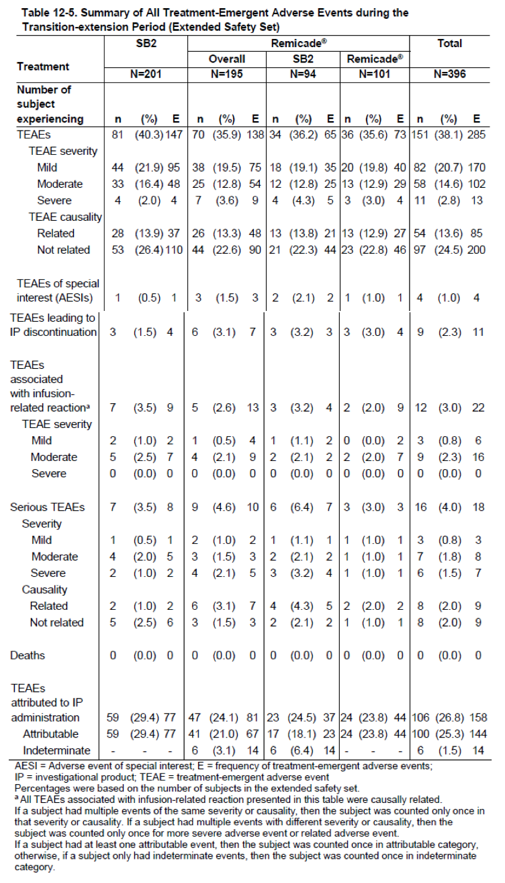

Table 25. AEs by PT reported in the transition period

Table 26. Incidence of ADAs and NAbs during the transition period
Comment: In this 24 week transition extension study, efficacy was sustained in patients who switched from Remicade to SB2. This was confirmed for all efficacy measures including ACR20, ACR50, ACR70, ACR-N, DAS28, and EULAR scores. During the transition period, there were no meaningful differences in the pattern of AEs reported in patients switched from Remicade to SB2. Immunogenicity was comparable in each group, and there was no increase in ADAs in switched patients. Overall, as in the primary analysis, there was no evidence suggesting a difference in clinical responses between SB2 and the reference product with continued treatment.
Structural damage measured by mTSS was assessed at Week 54 but no additional radiographic assessments were made at Week 78. The sponsor points out that radiographic changes occur slowly and that they are conventionally examined at annual intervals. As such, Week 78 assessments would be unlikely to detect meaningful differences. This argument is reasonable. It would have been preferable to have 2-year data. However, the sponsor argues that this assessment is not critical as all the clinical data (including mTSS at Week 54) point to equivalence between SB2 and the reference product. The sponsor also highlights the fact that published improvements in mTSS with Remicade over one and two years are comparable, and that structural joint damage is not a required endpoint for assessment of clinical equivalence. These arguments are also reasonable.
Overall, the sponsor’s response is satisfactory.

Question 3
In the transition-extension period of Study SB2-G31-RA, the protocol design does not include a subset of patients switching from SB2 to Remicade. This scenario may be unlikely but is there any other justification for this omission?

Evaluator’s comment on sponsor’s response
The sponsor states that the protocol was designed in consultation with regulatory authorities and that a SB2/Remicade switch arm was not considered necessary. The sponsor agrees that there is little likelihood of this switch occurring.
The response is satisfactory.

Question 4
The evaluators are unable to locate absolute mean changes in CRP by visit and treatment group, up to Week 54 (only categorical data are provided, that is, < 10 and ≥10 mg/L). Please provide these data or provide a link if they in the CSR.

Evaluator’s comment on sponsor’s response
The sponsor has provided a link to the CRP tables which show no meaningful differences between treatment groups. In the SB2 group, mean CRP was 11.7 mg/L at baseline and 8.8 mg/L at Week 54. In the Remicade group, mean CRP was 12.9 mg/L at baseline and 8.3 mg/L at Week 54.
The response is satisfactory.

Question 5
The evaluators are unable to locate mean changes in HAQ-DI by visit and treatment group up to Week 54. Please provide these data or provide a link if they in the CSR.

Evaluator’s comment on sponsor’s response
The sponsor has provided a link to the HAQ-DI tables which show no meaningful differences between treatment groups. In the SB2 group, mean HAQ-DI was 1.46 at baseline and 0.99 at Week 54. In the Remicade group, mean HAQ-DI was 1.51 at baseline and 0.98 at Week 54.
The response is satisfactory.

Second round benefit-risk assessment

Second round assessment of benefits
No change to the first round assessment.

Second round assessment of risks
No change to the first round assessment.

Second round assessment of benefit-risk balance
No change to the first round assessment. The benefit-risk balance remains positive.

Second round recommendation regarding authorisation
Approval is recommended for the following indications:
Rheumatoid arthritis in adults
Renflexis is given 3 mg/kg by IV infusion over 2 hours with repeat doses at 2 and 6 weeks, then every 8 weeks thereafter. Incremental doses of 1.5 mg/kg up to a maximum of 7.5 mg/kg may be considered if the initial response is inadequate.
Ankylosing spondylitis
Renflexis given 5 mg/kg by IV infusion over 2 hours with repeat doses at 2 and 6 weeks, then every 8 weeks thereafter.
Psoriatic arthritisRenflexis given 5 mg/kg by IV infusion over 2 hours with repeat doses at 2 and 6 weeks, then every 8 weeks thereafter.
Psoriasis
Renflexis given 5 mg/kg by IV infusion over 2 hours with repeat doses at 2 and 6 weeks, then every 8 weeks thereafter.
Crohn’s disease in adults and in children and adolescents (6 to 17 years)
Renflexis given 5 mg/kg by IV infusion over 2 hours with repeat doses at 2 and 6 weeks, then every 8 weeks thereafter. Maintenance doses of 10 mg/kg may be considered if the initial response is inadequate.
Refractory fistulising Crohn’s disease
Renflexis given 5 mg/kg by IV infusion over 2 hours with repeat doses at 2 and 6 weeks, then every 8 weeks thereafter. Maintenance doses of 10 mg/kg may be considered if the initial response is adequate but subsequently lost.
Ulcerative colitis in adults and in children and adolescents (6 to 17 years)
Renflexis given 5 mg/kg by IV infusion over 2 hours with repeat doses at 2 and 6 weeks, then every 8 weeks thereafter.

References
Danese S, et al. Governing Board and Operational Board of ECCO. ECCO position statement: the use of biosimilar medicines in the treatment of inflammatory bowel disease (IBD). J Crohn’s Colitis 2013; 7(7):586-589
Kavanaugh A, et al. Chimeric Anti-tumor Necrosis Factor-α monoclonal antibody treatment of patients with rheumatoid arthritis receiving methotrexate therapy. J Rheumatol 2000; 27:841-50
Klotz U, et al. Clinical pharmacokinetics and use of infliximab. Clin Pharmacokinet 2007; 46(8):645-660
Krintel S, et al. The frequency of anti-infliximab antibodies in patients with rheumatoid arthritis treated in routine care and the associations with adverse drug reactions and treatment failure. Rheumatology (Oxford) 2013; 52(7):1245-1253
Lin J, et al. TNFα blockade in human diseases: an overview of efficacy and safety. Clin Immunol 2008; 126(1):13-30
Lipsky P, et al. Infliximab and methotrexate in the treatment of rheumatoid arthritis: Anti-Tumour Necrosis Factor Trial in Rheumatoid Arthritis with Concomitant Therapy Study Group. N Eng J Med 2000; 343(22):1594-1602
McKeague K. A review of CT-P13: an infliximab biosimilar. BioDrugs 2014; 28(3):313-321
Nesterov I. Clinical pharmacokinetics of TNF antagonists: how do they differ? Semin Arthritis Rheum 2005; 34(5 Supp11):12-18
Van der Heijde D. How to read radiographs according to the Sharp/van der Heijde method. J Rheumatol 1999; 26:743-745
Weise M, et al. Biosimilars: the science of extrapolation. Blood 2014; 124(22):3191-3196
Wong M, et al. TNFα blockade in human diseases: mechanisms and future directions. Clin Immunol 2008; 126:121-136
Yoo D, et al. A randomised, double-blind, parallel-group study to demonstrate equivalence in efficacy and safety of CT-P13 compared with innovator infliximab when coadministered with methotrexate in patients with active rheumatoid arthritis: the PLANETRA study. Ann Rheum Dis 2013; 72:1613-1620

Therapeutic Goods Administration
PO Box 100 Woden ACT 2606 Australia
Email: info@tga.gov.au Phone: 1800 020 653 Fax: 02 6232 8605
https://www.tga.gov.au

6 weeks in approved Renflexis PI.

