March 2022

Australian Public Assessment Report for Inclisiran
  - Proprietary Product Name: Leqvio
  - Sponsor: Novartis Pharmaceuticals Australia Pty Limited

About the Therapeutic Goods Administration (TGA)
- The Therapeutic Goods Administration (TGA) is part of the Australian Government Department of Health and is responsible for regulating medicines and medical devices.
- The TGA administers the Therapeutic Goods Act 1989 (the Act), applying a risk management approach designed to ensure therapeutic goods supplied in Australia meet acceptable standards of quality, safety and efficacy (performance) when necessary.
- The work of the TGA is based on applying scientific and clinical expertise to decision-making, to ensure that the benefits to consumers outweigh any risks associated with the use of medicines and medical devices.
- The TGA relies on the public, healthcare professionals and industry to report problems with medicines or medical devices. TGA investigates reports received by it to determine any necessary regulatory action.
- To report a problem with a medicine or medical device, please see the information on the TGA website <https://www.tga.gov.au>.

About AusPARs
- An Australian Public Assessment Report (AusPAR) provides information about the evaluation of a prescription medicine and the considerations that led the TGA to approve or not approve a prescription medicine submission.
- AusPARs are prepared and published by the TGA.
- An AusPAR is prepared for submissions that relate to new chemical entities, generic medicines, major variations and extensions of indications.
- An AusPAR is a static document; it provides information that relates to a submission at a particular point in time.
- A new AusPAR will be developed to reflect changes to indications and/or major variations to a prescription medicine subject to evaluation by the TGA.

Copyright
© Commonwealth of Australia 2022
This work is copyright. You may reproduce the whole or part of this work in unaltered form for your own personal use or, if you are part of an organisation, for internal use within your organisation, but only if you or your organisation do not use the reproduction for any commercial purpose and retain this copyright notice and all disclaimer notices as part of that reproduction. Apart from rights to use as permitted by the Copyright Act 1968 or allowed by this copyright notice, all other rights are reserved and you are not allowed to reproduce the whole or any part of this work in any way (electronic or otherwise) without first being given specific written permission from the Commonwealth to do so. Requests and inquiries concerning reproduction and rights are to be sent to the TGA Copyright Officer, Therapeutic Goods Administration, PO Box 100, Woden ACT 2606 or emailed to <tga.copyright@tga.gov.au>.

Contents
List of abbreviations 4
I. Introduction to product submission 7
Submission details 7
Product background 8
Regulatory status 9
Product Information 10
II. Registration timeline 10
III. Submission overview and risk/benefit assessment 11
Quality 11
Nonclinical 12
Clinical 14
Risk management plan 44
Risk-benefit analysis 47
Outcome 54
Attachment 1. Product Information 55

List of abbreviations
Abbreviation | Meaning
ACM | Advisory Committee on Medicines
ACSS | Australia-Canada-Singapore-Switzerland Consortium
ADA | Anti-drug antibody
ADME | Absorption, distribution, metabolism and excretion
ALT | Alanine aminotransferase
Apo-A1 | Apolipoprotein A1
Apo-B | Apolipoprotein B
ARTG | Australian Register of Therapeutic Goods
ASA | Australian specific annex
ASCVD | Atherosclerotic cardiovascular disease
AST | Aspartate transaminase
AUC | Area under concentration time curve
AUC₀₋₄₈ | Area under the concentration time curve from time zero to 48 hours
AUC_{0-inf} | Area under the concentration time curve from time zero to infinity
AUC_{0-t} | Area under the concentration time curve from time zero to last measurable concentration
CHD | Coronary heart disease
CHMP | Committee for Medicinal Products for Human Use, European Medicines Agency
CI | Confidence interval
CLEC10A | C-type lectin domain family 10 member A
C_{max} | Maximum concentration
CMI | Consumer Medicine Information
CV | Cardiovascular
CVD | Cardiovascular disease
ddQTcF | Time matched placebo and baseline adjusted QT interval corrected for heart rate using the Fridericia correction
DLP | Data lock point
EMA | European Medicines Agency
ESRD | End stage renal disease
EU | European Union
FH | Familial hypercholesterolaemia
GalNAc | Triantennary N-acetyl galactosamine
GMP | Good Manufacturing Practices
GVP | Good Pharmacovigilance Practices
HDL-C | High density lipoprotein cholesterol
HeFH | Heterozygous familial hypercholesterolaemia
HoFH | Homozygous familial hypercholesterolaemia
ITT | Intent to treat
LDL-C | Low density lipoprotein cholesterol
LDLR | Low density lipoprotein receptor
LMT | Lipid modifying therapy
MACE | Major cardiovascular event
MI | Myocardial infraction
mITT | Modified intent to treat
PAD | Peripheral arterial disease
PCSK9 | Proprotein convertase subtilisin/kexin type 9
PD | Pharmacodynamic(s)
PI | Product Information
PK | Pharmacokinetic(s)
PSUR | Periodic safety update report
PT | Preferred Term
qPCR | Quantitative polymerase chain reaction
RISC | RNA induced silencing complex
RMP | Risk management plan
siRNA | Small interfering ribonucleic acid
TEAE | Treatment-emergent adverse event
TESAE | Treatment-emergent serious adverse event
T_{max} | Time of maximum concentration
ULN | Upper limit of normal
USA | United States of America
VLDL | Very low density lipoprotein

I. Introduction to product submission

Submission details
Type of submission: | New chemical entity
Product name: | Leqvio
Active ingredient: | Inclisiran
Decision: | Approved
Date of decision: | 14 September 2021
Date of entry onto ARTG: | 14 September 2021
ARTG number: | 342250
Black Triangle Scheme: | Yes  This product will remain in the scheme for 5 years, starting on the date the product is first supplied in Australia.
Sponsor’s name and address: | Novartis Pharmaceuticals Australia Pty Limited  54 Waterloo Road  Macquarie Park, NSW 2113
Dose form: | Solution for injection
Strength: | 284 mg/1.5 mL (equivalent to 300 mg inclisiran sodium)
Container: | Pre-filled syringe
Pack size: | One
Approved therapeutic use: | Leqvio is indicated as an adjunct to diet and exercise to reduce low-density lipoprotein cholesterol (LDL-C) in adults with heterozygous familial hypercholesterolaemia, atherosclerotic cardiovascular disease, or at high risk of a cardiovascular event:  - in combination with a statin or statin with other lipid‐lowering therapies in patients unable to reach LDL‐C goals with the maximum tolerated dose of a statin or,  - alone or in combination with other lipid‐lowering therapies in patients who are statin-intolerant
Route of administration: | Subcutaneous injection
Dosage: | The recommended dose of Leqvio is 284 mg administered as a single subcutaneous injection: initially, again at three months, followed by every six months.  For further information regarding dosage, refer to the Product Information.
Pregnancy category: | B1  Drugs which have been taken by only a limited number of pregnant women and women of childbearing age, without an increase in the frequency of malformation or other direct or indirect harmful effects on the human fetus having been observed.  Studies in animals have not shown evidence of an increased occurrence of fetal damage.  The use of any medicine during pregnancy requires careful consideration of both risks and benefits by the treating health professional. This must not be used as the sole basis of decision making in the use of medicines during pregnancy. The TGA does not provide advice on the use of medicines in pregnancy for specific cases. More information is available from obstetric drug information services in your State or Territory.

Product background
This AusPAR describes the application by Novartis Pharmaceuticals Australia Pty Ltd (the sponsor) to register Leqvio (inclisiran) 284 mg/1.5 mL, solution for injection for the following proposed indication:
For adults with primary hypercholesterolaemia (heterozygous familial and non- familial) or mixed dyslipidaemia, as an adjunct to diet in combination with a statin or statin with other lipidlowering therapies in patients unable to reach LDL-C goals with the maximum tolerated dose of a statin or, alone or in combination with other lipid-lowering therapies in patients who are statin- intolerant, or for whom a statin is contraindicated.
Primary hypercholesterolaemia is a disorder of lipid metabolism characterised by elevated serum cholesterol not caused by any other medical condition or medication. Primary hypercholesterolaemia can be characterised as familial or non-familial. Familial hypercholesterolaemia (FH) is an autosomal dominant disorder characterised by lifelong increases in the plasma concentration of low density lipoprotein cholesterol (LDL-C). Heterozygous familial hypercholesterolaemia (HeFH) occurs in 1:200 to 1:500 of the population, while homozygous familial hypercholesterolaemia (HoFH) is rare (about one per million population). Non-familial hypercholesterolaemia is influenced by diet, lifestyle and polygenetic factors, rather than being caused by a specific genetic disorder. Mixed dyslipidaemia is a disorder of lipid metabolism characterised by elevated levels of LDL-C and triglycerides, often associated with a low level of high density lipoprotein cholesterol (HDL-C).
Elevated LDL-C is strongly correlated with atherosclerotic cardiovascular disease (ASCVD). In patients with HeFH, coronary heart disease (CHD) occurs in about 50% of untreated men by age 50 years and 30% of untreated women by age 60 years. The risk of developing CHD is about 20 times higher in untreated HeFH patients compared with unaffected individuals. Target levels for LDL-C for low, intermediate and high risk FH are < 4, < 3 and < 2 mmol/L, respectively. Australian guidelines recommend a target LDL-C level of < 1.8 mmol/L for patients with CHD.2
In addition to diet and exercise, statins are the mainstay of treatment of hypercholesterolaemia. Statin therapy may be supplemented by a cholesterol absorption inhibitor (for example, ezetimibe) or bile acid sequestrants. Many patients can achieve target LDL-C levels with these therapies, but for patients intolerant of statins or who require additional lowering of LDL-C, monoclonal antibodies directed against proprotein convertase subtilisin/kexin type 9 (PCSK9) can provide further lowering of LDL-C. PCSK9 is involved in the degradation of low density lipoprotein receptors (LDLR) in the liver. A decrease in hepatic PCSK9 leads to increased LDLR expression on the surface of hepatocytes, resulting in increased LDL-C uptake and lowering of serum LDL-C levels.
Two PCSK9 inhibitors are registered in Australia: Repatha (evolocumab); was first registered in December 2015; and Praluent (alirocumab) was first registered in May 2016. Repatha has indications for prevention of cardiovascular events, primary hypercholesterolaemia, and homozygous familial hypercholesterolaemia. Praluent has indications for primary hypercholesterolaemia and prevention of cardiovascular events. Anti-PCSK9 antibodies are administered fortnightly or monthly by subcutaneous injection.
Inclisiran is a double stranded small interfering RNA (siRNA) which inhibits PCSK9 expression. The sense strand of inclisiran is conjugated with triantennary N-acetyl galactosamine (GalNAc) to facilitate uptake by hepatocytes. In hepatocytes, the antisense strand is incorporated in the RNA induced silencing complex (RISC), facilitating catalytic breakdown of messenger RNA for PCSK9, thereby inhibiting translation of PCSK9.
This application was evaluated as part of the Australia-Canada-Singapore-Switzerland (ACSS) Consortium, with work-sharing between the TGA, Health Science Authority Singapore, Health Canada. Each regulator made independent decisions regarding approval (market authorisation) of the new medicine.

Regulatory status
This product is considered a new chemical entity for Australian regulatory purposes.
At the time the TGA considered this application, a similar application had been approved in European Union (EU) on the 9 December 2020 and was under consideration in United States of America (USA), Canada, Switzerland and Singapore.
Table 1: International regulatory status
Region | Status | Approved indications
European Union | Approved on 9 December 2020 | Leqvio is indicated in adults with primary hypercholesterolaemia (heterozygous familial and nonfamilial) or mixed dyslipidaemia, as an adjunct to diet:  - in combination with a statin or statin with other lipid lowering therapies in patients unable to reach LDL-C goals with the maximum tolerated dose of a statin, or,  - alone or in combination with other lipid-lowering therapies in patients who are statin-intolerant, or for whom a statin is contraindicated.
United States of America | Under consideration | Under consideration
Canada | Under consideration | Under consideration
Switzerland | Under consideration | Under consideration
Singapore | Under consideration | Under consideration

Product Information
The Product Information (PI) approved with the submission which is described in this AusPAR can be found as Attachment 1. For the most recent PI, please refer to the TGA website at <https://www.tga.gov.au/product-information-pi>.

II. Registration timeline
The following table captures the key steps and dates for this application, and which are detailed and discussed in this AusPAR.
Table 2: Timeline for Submission PM-2020-04160-1-3
Description | Date
Submission dossier accepted and first round evaluation commenced | 30 September 2020
First round evaluation completed | 21 April 2021
Sponsor provides responses on questions raised in first round evaluation | 21 April 2021
Second round evaluation completed | 17 June 2021
Delegate’s Overall benefit-risk assessment and request for Advisory Committee advice | 30 June 2021
Sponsor’s pre-Advisory Committee response | 13 July 2021
Advisory Committee meeting | 5 and 6 August 2021
Registration decision (Outcome) | 14 September 2021
Completion of administrative activities and registration on the ARTG | 14 September 2021
Number of working days from submission dossier acceptance to registration decision* | 236
*Statutory timeframe for standard applications is 255 working days

III. Submission overview and risk/benefit assessment
This section is a TGA summary of wording used in TGA’s evaluation report, which discussed numerous aspects of overseas evaluation reports and included some information that was commercial-in-confidence.

Quality
Inclisiran is a synthetic, double-stranded, siRNA conjugated on the sense strand with triantennary N-acetyl galactosamine (GalNAc) to facilitate uptake by hepatocytes (Figure 1).
Figure 1: Schematic diagram of inclisiran structure
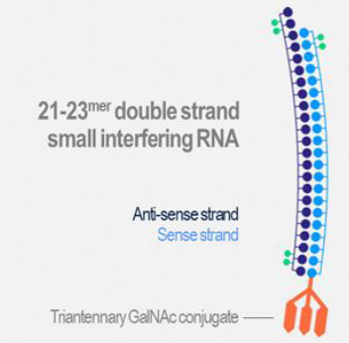
The drug substance is produced by chemical synthesis. The oligonucleotide strands are assembled one nucleotide at a time. The sense strand contains 21 nucleotides and antisense strand 23 nucleotides. An annealing step assembles the sense and antisense single strands into the duplex.
The manufacturing process and in-process controls are acceptable. The imposed drug substance specifications are sufficient to ensure the drug substance quality and consistency.
The product is presented in a pre-filled syringe containing inclisiran 284 mg in 1.5 mL of solution (as inclisiran sodium 300 mg), packaged in a carton with pack size of one. The finished product specifications are sufficient to ensure the quality of the finished product at release and throughout the shelf-life. The long term stability data support a shelf life of 24 months when stored below 25°C.
The Product Information (PI) and labels are acceptable from a pharmaceutical chemistry perspective. Good Manufacturing Practice (GMP) clearance is valid at all manufacturing sites.
There is no objection to approval from a pharmaceutical chemistry perspective.

Nonclinical
The pharmacology, pharmacokinetics (PK), safety pharmacology, and toxicology of inclisiran were evaluated in in vitro and in vivo nonclinical studies, consistent with regulatory guidance.
Absolute bioavailability of subcutaneous inclisiran in rats and monkeys was 48.9% and 29.3%, respectively. Inclisiran maximum concentration (C_{max}) and area under the concentration time curve from time zero to last measurable concentration (AUC_{0-t}) increased in an approximately dose proportional manner in both species after subcutaneous dosing. The time of maximum concentration in serum (T_{max}) in rats and monkeys was approximately one hour and two hours, respectively, and the elimination half-life ranged from 0.9 hours to 1.7 hours in rats and from 1.9 hours to 4.3 hours in monkeys. At 0.5 μg/mL (approximate human C_{max}), plasma protein binding was similar between species, ranging from 87.4% for human plasma to 93.1% for rat plasma. There were no gender differences in PK parameters.
Inclisiran has a GalNAc linker to target uptake by hepatocytes. In tissue distribution studies in rats and monkeys, the highest levels of radioactivity were generally associated with the liver, the target organ of efficacy, and kidney, the primary route of elimination from plasma.
Inclisiran exhibited potent and dose dependent pharmacologic activity when administered subcutaneously, resulting in reduction in circulating PCSK9 protein and serum LDL-C in monkeys. Following administration of a single maximal effective dose of inclisiran to monkeys, there was a sustained reduction in PCSK9 protein and LDL-C levels for up to 100 days post dose, even though inclisiran plasma levels were undetectable within approximately 24 hours of administration. Steady state PCSK9 and LDL-C reduction were demonstrated following several different repeat dose regimens with no evidence of tachyphylaxis. The combination of inclisiran and atorvastatin had an additive effect on lipid parameters in monkeys.
Inclisiran was not extensively metabolised in rats and monkeys. Renal excretion was the primary route of elimination from plasma with approximately 29% and 32% of the administered dose of inclisiran recovered in the urine of rats and monkeys, respectively, over a seven day period.
No clinically relevant organ system hazards were identified in the safety pharmacology studies. In a safety pharmacology study conducted in monkeys, inclisiran had no immediate or delayed effects on electrocardiogram parameters, haemodynamic parameters, respiration rate, or body temperature. No inclisiran related neurobehavioural observations were reported in repeat dose toxicity studies (4 week, 15 week and 40 week) in cynomolgus monkeys.
Inclisiran was well tolerated in all toxicity studies and there were no dose limiting toxicities. The exposure safety margins are high and adequate based on C_{max} and area under time concentration curve (AUC) in rats and monkeys, in the context of the proposed dose in humans. The most common findings were related to the pharmacologic effects of inclisiran on lipid profiles. Inclisiran was well tolerated at injection sites with mild occurrences of erythema and/or oedema that resolved during the recovery periods.
Inclisiran did not exhibit any appreciable activity against cytochrome c isozymes or efflux and uptake transporters, so drug interaction potential is considered negligible.
With regard to potential off-target activity, an analysis was performed to identify a set of transcripts that may potentially be inhibited by the antisense strand of inclisiran. Twenty genes were identified whose expression may be impacted by inclisiran. Of these 20 genes, two are not expressed in the liver. To measure off target inhibition, the response of endogenously expressed transcripts to inclisiran was determined by quantitative polymerase chain reaction (qPCR) in a dose response study in Hep3B; cells. The results indicated a ≥ 45 fold difference between the ‘on-target’ inhibition of PCSK9 and the inhibition of any of the predicted off-target transcripts, confirming the specificity of inclisiran for PCSK9. Potential off-target interactions due to the GalNAc linker have not been comprehensively investigated. Off-target activity of GalNAc to another receptor, C-type lectin domain family 10 member A (CLEC10A), may have contributed to effects on macrophages seen in toxicity studies.
Inclisiran did not show positive signals for selective reproductive toxicity in fertility and early embryonic development studies conducted in rats, embryo-fetal development studies conducted in rats and rabbits, and a pre- and post-natal development study conducted in rats. The proposed pregnancy category (B1) is acceptable. Milk transfer was demonstrated in rats, but due to the poor oral absorption of oligonucleotides, plasma levels of inclisiran in pups were below the level of detection.
Inclisiran did not induce gene mutations or chromosomal damage in genotoxicity studies and is not considered genotoxic. Inclisiran was non-carcinogenic in a six month study conducted in mice and a two year study conducted in rats.
There is no objection to approval from a nonclinical perspective.

Clinical
The clinical development program was conducted in accordance with the TGA adopted CHMP Guideline on clinical investigation of medicinal products in the treatment of lipid disorders.
The clinical dossier consisted of four Phase I studies, three Phase II studies, and three confirmatory Phase III studies (Table 2).
Table 2: Summary of clinical studies
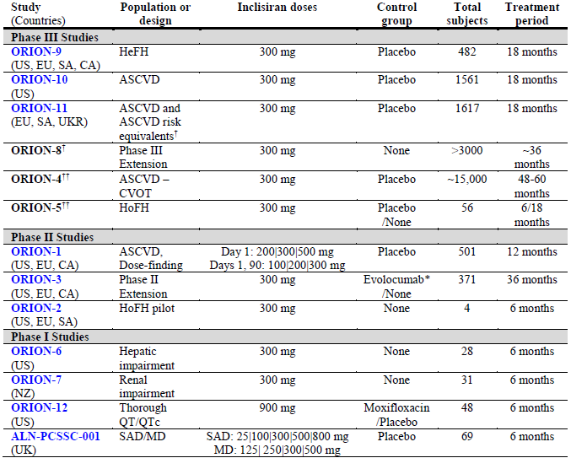
†† Study is ongoing at this time and not included in the application
* Subjects on placebo from ORION-1 trial were given evolovumab for the first year in ORION-3 trial
Abbreviations: ASCVD = atherosclerotic cardiovascular disease; CS = Canada; CVOT = cardiovascular outcomes trial; EU = European Union; HeFH = heterozygous familial hypercholesterolemia; HoFH = homozygous familial hypercholesterolemia; MAD = multiple ascending dose; NZ = New Zealand; QTc = corrected QT; SA = South Africa; SAD = single ascending dose; UKR = Ukraine; US = United States.
There are also three ongoing Phase III studies which were not presented in this application:
- The ORION-8 trial is an ongoing long term extension study for subjects enrolled in the Phase III studies, ORION-9 trial, ORION-10 trial and ORION-11 trial. ORION-8 trial commenced in April 2019 and the estimated completion date is December 2023.
- The ORION-4 trial is an ongoing Phase III randomised, placebo controlled, cardiovascular outcomes trial of inclisiran versus placebo in 15000 patients with ASCVD, which will inform cardiovascular and overall mortality. This study commenced in October 2018 and the estimated primary completion date is December 2024.
- The ORION-5 trial is an ongoing Phase III, randomised, two-part trial of inclisiran versus placebo in 56 subjects with HoFH. This study commenced in February 2019 and the estimated completion date is September 2021.

Pharmacology
The clinical pharmacology program evaluated the safety, tolerability, PK, and pharmacodynamics (PD) of inclisiran in healthy subjects with elevated LDL-C, subjects with ASCVD or ASCVD risk equivalents, and subjects with renal and hepatic impairment. The studies that contributed to inclisiran clinical pharmacology are:
- Phase I: Study ALN-PCSSC-001 (first-in-human), ORION-6 trial (hepatic), ORION-7 trial (renal) and ORION-12 trial (cardiac safety)
- Phase II: ORION-1 trial (patient population)
- Phase III: ORION-10 trial (patient population, statin PK).

Pharmacokinetics
Nonclinical findings and clinical data contributed to the understanding of the absorption, distribution, metabolism and excretion (ADME) properties of inclisiran. ADME studies were not performed because the use of radiolabelled compounds was not considered appropriate given the long tissue half-life observed in nonclinical studies and the long PD effect observed in Phase I studies. Absolute bioavailability was not assessed in humans.
In the Study ALN-PCSSC-001, healthy subjects with elevated LCL-C, inclisiran exposure increased proportionally over the studied dose range of 25 mg to 800 mg inclisiran sodium subcutaneous. C_{max} was observed between one and 8 hours after dosing. Median T_{max} at the 300 mg inclisiran sodium dose was four hours. Inclisiran did not accumulate with multiple dosing. The plasma half-life of inclisiran was 3.6 to 13.2 hours across the dose levels. Plasma concentrations generally reached undetectable levels after 12 hours for the 25 mg dose, after 24 hours for doses of 100 mg to 500 mg, and after 48 hours for the 800 mg dose. No dose limiting safety events were observed up to the highest dose tested.
The PK of a single 300 mg subcutaneous dose was evaluated in a combined analysis of healthy subjects in ORION-6 and ORION-7 trials. Median T_{max} was 4 hours in ORION-6 trial and 8 hours in ORION-7 trial (range 0.5 to 12 hours across the two studies). The volume of distribution of inclisiran was estimated to be 508 L. Inclisiran was rapidly cleared from the plasma with a mean half-life of 9.6 hours. Inclisiran was detectable in plasma up to 48 hours post dose. The majority of plasma elimination is attributed to hepatic uptake (informed by nonclinical data). Approximately 16% of inclisiran was excreted unchanged in urine.
Dedicated drug-drug interaction clinical studies were not performed. In vitro drug-drug interaction studies indicated very low risk for cytochrome p450; or transporter related clinical PK interactions. The potential risk of a drug-drug interaction with statin co-administration was investigated in the Study ALN-PCSSC-001 (effect of statin on inclisiran PK) and the ORION-10 trial (effect of inclisiran on statin PK). In Study ALN-PCSSC-001, the effect of statins on the PK of inclisiran was minor. Quantitative analysis of PK data from ORION-10 trial and population PD simulation indicated that there is no considerable effect of inclisiran on the PK of atorvastatin and rosuvastatin.

Hepatic impairment
The ORION-6 trial was a Phase I, single dose, open label study to evaluate the PK, PD, and safety of inclisiran sodium 300 mg subcutaneous in adult subjects with mild (Child-Pugh class A); and moderate (Child-Pugh class B);11 hepatic impairment compared to subjects with normal hepatic function. Inclisiran C_{max} was increased 1.1 and 2.1-fold, and the area under the concentration time curve from time zero to infinity (AUC_{0-inf}) was increased 1.3 and 2-fold, respectively, in patients with mild and moderate hepatic impairment compared to patients with normal hepatic function. The reduction in LDL-C was similar for patients with mild hepatic impairment and normal hepatic function. In patients with moderate hepatic impairment, baseline PCSK9 levels were lower and the reduction in LDL-C was less than that observed in patients with normal hepatic function or mild hepatic impairment (Figure 2).
No dose adjustment is proposed in patients with mild and moderate hepatic impairment (Child-Pugh class A and B).11 Inclisiran has not been studied in patients with severe hepatic impairment (Child-Pugh class C).11
Figure 2: ORION-6 trial Mean percent change in LDL-C from Baseline plus/minus standard deviation by hepatic function group over time (pharmacodynamic population)
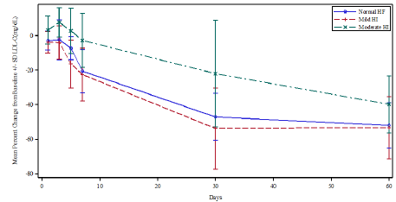
Abbreviations: HF = hepatic function; HI = hepatic impairment; PD = pharmacodynamics; SD = standard deviation.

Renal impairment
The ORION-7 trial was a Phase I, single dose, open label study to evaluate the PK, PD, and safety of inclisiran sodium 300 mg subcutaneous in adult subjects with mild, moderate and severe renal impairment compared to subjects with normal renal function. Renal impairment was defined based on estimated creatinine clearance (normal renal function ≥ 90 mL/min, mild renal impairment 60 to 89 mL/min, moderate renal impairment 30 to 59 mL/min, and severe renal impairment 15 to 29 mL/min). 31 subjects were enrolled, eight in each of the normal, mild and moderate renal impairment groups, and seven in the severe renal impairment group. Inclisiran C_{max} was increased by 2.3, 2.0 and 3.3-fold (Figure 3) and area under the concentration time curve from time zero to 48 hours post-dose (AUC_{0-48h}) was increased by 1.6, 1.8 and 2.3-fold in patients with mild, moderate and severe renal impairment, respectively, compared to patients with normal renal function. Inclisiran had a short plasma half-life (5 to 10 hours) regardless of renal impairment. Inclisiran was not detectable in plasma in any of the groups beyond 48 hours. Despite the higher plasma exposures over 48 hours, reductions in LDL-C were similar for healthy subjects and subjects with renal impairment (Figure 4).
Figure 3: ORION-7 trial Mean plasma concentration of Inclisiran following a single subcutaneous injection of 300 mg inclisiran sodium to healthy subjects or subjects with renal impairment
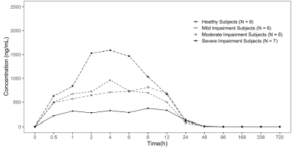
Figure 4: ORION-7 trial Mean percent change from Baseline LDL-C by renal function group over time
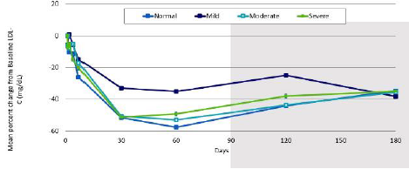
No dose adjustment is proposed for patients with mild, moderate, or severe renal impairment, or end-stage renal disease (ESRD). The sponsor proposes that haemodialysis should not be performed for at least 72 hours after Leqvio dosing.
The sponsor responded to an evaluation question regarding consideration of a lower dose in patients with renal impairment by commenting that although inclisiran plasma exposures were higher in subjects with renal impairment, the duration of detectable plasma concentrations was similar to subjects with normal renal function and the PD response (LDL-C reduction) was also similar. The sponsor commented on the temporal disconnect between PK and PD (inclisiran is undetectable in the systemic circulation by 24 to 48 hours but LDL-C lowering persists for months), concluding that inclisiran exposure is not predictive of its effect on LDL-C. Additionally, the sponsor commented that there are large safety margins relative to the toxicology studies and renal impairment is not expected to lead to off target effects, irrespective of a transient increase in plasma exposure.

Pharmacodynamics
A dissociation between inclisiran PK parameters and PD effects was observed in the clinical pharmacology studies, with effects on LDL-C persisting for months despite inclisiran plasma concentrations being undetectable 24 to 48 hours post-dosing.
In the Phase I study, Study ALN-PCSSC-001, a dose response relationship was observed up to 300 mg, with no additional benefit with higher doses up to 800 mg.
The ORION-1 trial was a Phase II, randomised, double blind, placebo controlled dose response study to assess the PK, PD, efficacy, and safety of single and multiple doses of subcutaneous inclisiran sodium in subjects with ASCVD or ASCVD risk equivalents and elevated LDL-C despite maximally tolerated lipid modifying therapy. The study evaluated single doses of 200 mg, 300 mg and 500 mg of inclisiran, and multiple doses (Day 1, Day 90) of 100 mg, 200 mg and 300 mg of inclisiran. The primary efficacy endpoint was the percentage change in LDL-C from Baseline to Day 180. Secondary efficacy outcomes included the change from Baseline LDL-C, change from Baseline in lipids and lipoproteins including total cholesterol, triglycerides, LDL-C, HDL-C, non-HDL-C, very low density lipoprotein (VLDL), apolipoprotein A1 (Apo-A1), apolipoprotein B (Apo-B), lipoprotein (a), C-reactive protein, and PCSK9.
The primary endpoint in the single dose groups showed a mean reduction in LDL-C from Baseline to Day 180 of 27.9%, 38.4%, and 41.9% for 200 mg, 300 mg, and 500 mg, respectively, compared to a 2.1% increase in the placebo group for the modified intent to treat (mITT) population (p < 0.0001, Figure 5). The primary endpoint in the multiple dose groups showed a mean reduction in LDL-C of 35.5%, 44.9%, and 52.6% following two doses of 100 mg, 200 mg, and 300 mg, respectively, compared to a 1.8% increase in the placebo group for the mITT population (p < 0.0001, Figure 6). LDL-C levels returned towards baseline from maximum effect at a linear rate of 2 to 3% per month.
Figure 5: ORION-1 trial Percent change from Baseline LDL-C by single dose group over time (modified intent to treat population)
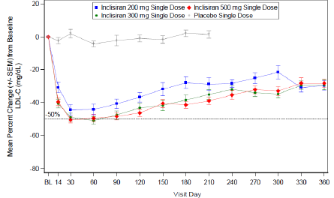
Note: Data for placebo treated subjects are not presented beyond Day 210 since the majority of placebo treated subjects did not have data collected beyond this timepoint. Data for the few placebo treated subject with beta quantification LDL-C values collected beyond Day 210 maybe be found in sponsor submitted dossier, which includes the beta quantification LDL-C values along with number of evaluable placebo-treated subjects.
Abbreviations: LDL-C = low density lipoprotein cholesterol, mITT = modified intent to treat; SEM = standard error of the mean.
Figure 6: ORION-1 trial Percent change from Baseline LDL-C by multiple dose group over time (modified intent to treat population)
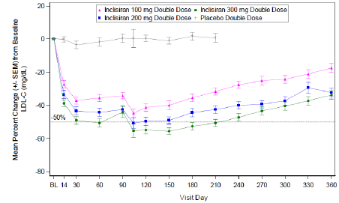
Note: Data for placebo treated subjects are not presented beyond Day 210 since the majority of placebo treated subjects did not have data collected beyond this timepoint. Data for the few placebo treated subject with beta quantification LDL-C values collected beyond Day 210 maybe be found in sponsor submitted dossier, which includes the beta quantification LDL-C values along with number of evaluable placebo-treated subjects.
Abbreviations: LDL-C = low density lipoprotein cholesterol, mITT = modified intent to treat; SEM = standard error of the mean.

Population pharmacodynamic modelling
The initial population PD model from the ORION-1 trial was developed to characterise the dose response relationship of inclisiran in subjects with ASCVD or ASCVD risk equivalents, and to inform dose selection for the Phase III studies. The pharmacometric evaluation concluded that the model is adequate for the performed simulations and can provide reliable information for dose selection. Based on the simulation results and estimated clinical impact (cardiovascular risk reduction), a dosing regimen of 300 mg inclisiran sodium given subcutaneously on Day 0, Day 90, and then every six months was selected for evaluation in the Phase III studies.
The final population PD model was developed with data from nine inclisiran clinical studies (Study ALN-PCSSC-001, and the ORION-1, ORION-3, ORION-6, ORION-7, ORION-9, ORION-10, ORION-11, and ORION-12 trials). The modelling was used to identify covariate effects (including age, body weight, gender, race, diabetes status, renal function, hepatic function, disease state, statin co-medication) to inform dosing recommendations in specific populations and to assess the impact of delayed or missed doses. The simulations were stratified by patient population to account for differences in baseline PCSK9 and LDL-C levels in patients with ASCVD and HeFH. No clinically meaningful differences in inclisiran PD were observed based on difference of age, body weight, gender, race and creatinine clearance. The covariate analysis did not identify any patient populations or subpopulations requiring a dose adjustment.
Simulations of the impact of missed or delayed doses on response indicated that delaying a planned dose by 1 to 3 months had a small impact on LDL-C levels, with rapid return to optimal LDL levels once the delayed dose was administered. The modelling suggested that LDL-C is expected to return to > 80% of baseline levels by one year after discontinuation of inclisiran.

Dose selection
Given the dissociation between PK parameters and PD effects, dose selection for the pivotal studies focussed on PD and safety. Based on dose-response relationships in ALN-PCSSC-001, ORION-1, and population PD modelling, the proposed dosing regimen (300 mg inclisiran sodium subcutaneous on Day 1, Day 90, and then every 6 months) was selected for evaluation in the pivotal studies. Patient focused aspects, including adherence to treatment and timing of clinical reviews, were also taken into consideration with the proposed dosing regimen.

Effect on QT interval
The ORION-12 trial was a thorough QT study; assessing the effect of a supratherapeutic dose of inclisiran sodium (900 mg subcutaneous) on cardiac repolarisation as assessed by QTcF; in healthy subjects. The predicted time matched placebo and baseline adjusted QT interval corrected for heart rate using the Fridericia correction (ddQTcF) at 4 hours after administration was 2.5 ms (90% CI 0.6, 4.5) for inclisiran and 11.4 ms (90% CI 9.5, 13.4) for moxifloxacin (Table 3). The 90% confidence interval (CI) for ddQTcF included zero at all other timepoints for inclisiran sodium 900 mg. At the maximum individual C_{max} achieved after a 900 mg subcutaneous dose of inclisiran, the model predicted effect on QTcF was 5.7 ms (90% CI: 1.14 to 10.27). No clinically significant effects on HR, PR interval and QRS interval were observed.
Table 3: Least-squares means and 90% confidence interval of model-predicted ddQTcF by time point and treatment (electrocardiogram population)
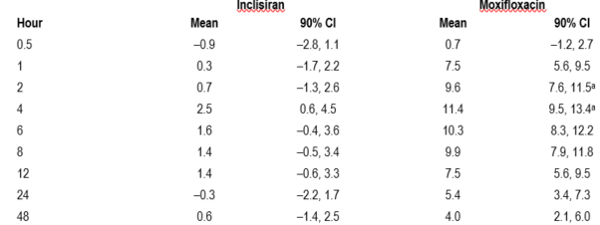
a Assay sensitivity was established if at least 1 lower bound of the CI for the QT interval corrected by Fridericia’s formula was greater than 5 milli sec at either the 2 or 4 hours postdose time point
Abbreviations: CI = confidence interval; ddQTcF = time matched placebo and baseline adjusted QT interval corrected for heart rate using the Fridericia correction; ECG = electrocardiogram

Immunogenicity
Testing for anti-drug antibodies (ADA) in the pivotal studies was performed at Baseline, Day 30, Day 150, Day 330, and Day 510 visits. Confirmed ADA positivity was detected in 1.8% of subjects prior to dosing (at Baseline) and in 4.9% (90/1830) during the 18 months of treatment with inclisiran (Table 4). There was no clear association between ADA positivity and loss of efficacy (Figure 7) or treatment emergent adverse events (TEAE).
Table 4: Frequency (percentage) of subjects with confirmed positive anti-drug antibodies by visit in Phase III studies
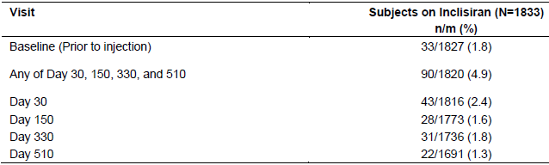
n: number of subjects with confirmed ADA responses
m: number of subjects with sample data collected at each visit (used as the denominator)
Figure 7: Mean actual values of low-density lipoprotein-cholesterol (mg/dL) by visit and maximum post-baseline titre (inclisiran subjects with low-density lipoprotein-cholesterol and anti-drug antibodies data in the Phase III studies)
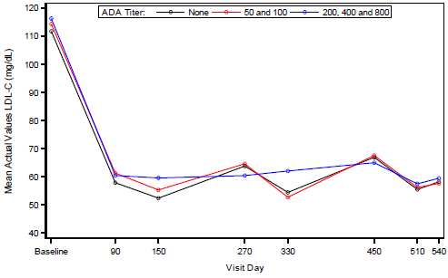

Efficacy
Three Phase III trials were submitted in support of the proposed indication:
- ORION-9 trial: 482 subjects with HeFH and elevated LDL-C despite maximally tolerated statin therapy.
- ORION-10 trial: 1561 subjects with ASCVD and elevated LDL-C despite maximally tolerated statin therapy.
- ORION-11 trial: 1617 subjects with ASCVD or ASCVD-risk equivalents (type 2 diabetes, FH, or 10 year cardiovascular (CV) event risk ≥ 20%) and elevated LDL-C despite maximally tolerated statin.
The three studies shared similar design: randomised, placebo controlled, double blind trials of 18 months duration evaluating the efficacy and safety of 300 mg inclisiran sodium (284 mg inclisiran) administered on Day 1, Day 90, Day 270 and Day 450 (Figure 8).
Figure 8: Schematic diagram of study design of the Phase III studies
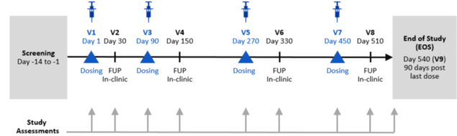
Abbreviations: EOS = End of study; FUP = follow up; V = visit
The studies included adult subjects who were unable to achieve target LDL-C despite receiving maximally tolerated statin therapy with or without other LDL-C lowering agents. Statin intolerant subjects were required to be intolerant to all doses of at least two different statins. Enrolment of statin intolerant subjects was capped at 15% of total study enrolment. All subjects were required to have fasting triglycerides < 4.52 mmol/L at screening.
Inclusion criteria unique to each of the studies are shown in Table 5. Exclusion criteria were identical across the three studies. Patients previously or currently treated with anti-PCSK9 monoclonal antibodies were excluded.
The primary and secondary efficacy endpoints were the same across the three studies (Table 6). All of the major efficacy endpoints were laboratory parameters. CV outcomes, including CV death, resuscitated cardiac arrest, non-fatal myocardial infarction, and non-fatal stroke (ischaemic and haemorrhagic), were exploratory.
Table 5: ORION-9, ORION-10 and ORION-11 trials, Unique inclusion criteria
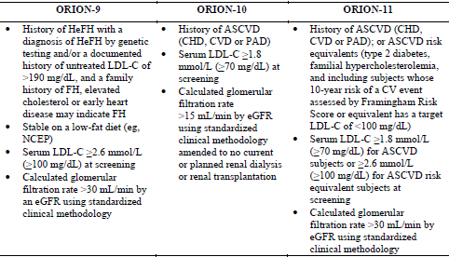
Abbreviations: ASCVD = atherosclerotic cardiovascular disease; CHD = coronary heart disease; CV = cardiovascular; CVD = cardiovascular disease; FH = familial hypercholesterolemia; eGFR = estimated glomerular filtration rate; HeFH = heterozygous familial hypercholesterolemia; LDL-C = low density lipoprotein cholesterol; NCEP = National Cholesterol Education Program; PAD = peripheral artery disease.
Table 6: ORION-9, ORION-10 and ORION-11 trials, Primary and secondary efficacy endpoints
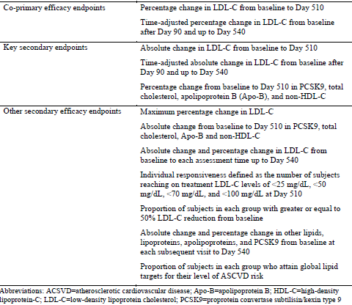
Abbreviations: ACSVD = atherosclerotic cardiovascular disease; Apo-B = apolipoprotein B; HDL-C = high density lipoprotein- C; LDL-C = low density lipoprotein cholesterol; PCSK9 = proprotein convertase subtilisin/kexin type 9.

ORION-9 trial
The ORION-9 trial was a Phase III study of adults with HeFH (confirmed by genotyping or clinical criteria) and LDL-C ≥ 2.6 mmol/L despite maximally tolerated statin therapy with or without other LDL-C lowering agents. It was conducted in 47 centres in eight countries: Canada, Czech Republic, Denmark, Netherlands, South Africa, Spain, Sweden, and USA. The inclusion criteria specific to this study are shown in Table 5. The genetic profile of subjects in the ORION-9 trial is shown in Table 7.
Table 7: ORION-9 trial, Genetic profile of subjects
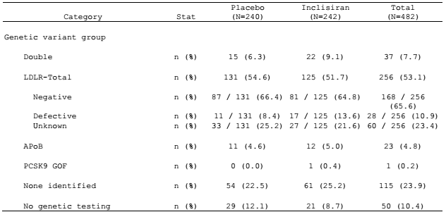
Abbreviations: APoB = apolipoprotein B; GOF = gain of function; LDL-R = low density lipoprotein receptor; PCSK9 = proprotein convertase subtilisin/kexin type 9.
For this trial, 617 subjects were screened and 482 were randomised and included in the intent to treat (ITT) population. Of the 482 subjects randomised, 481 subjects were treated (240 with placebo and 241 with inclisiran) and included in the safety population. 96.7% of subjects completed the trial and 95.4% of subjects in the inclisiran group received all four doses.
Demographic and baseline characteristics were balanced across the treatment groups. 47.1% of subjects were male, mean age was 54.7 years, and 94% of subjects were White, 2.5% were Asian and 3.1% were Black or African American. 72.6% of subjects had ASCVD risk equivalents and 27.4% had ASCVD. 10% of all subjects had diabetes, 38.6% were current or former smokers, and 42.1% had hypertension. 63.5% had mild or moderate renal impairment. Patients with severe renal impairment were not included in this study. The mean LDL-C at Baseline was 3.9 mmol/L.
94.4% of subjects were receiving statins or other lipid modifying therapies (LMT) at Baseline. 90.5% of subjects were on statin therapy (73.9% high intensity, 14.5% moderate intensity, 1.9% low intensity), and 9.5% were not on statin therapy (5.6% were on no LMT, 3.9% were on other LMT). 52.3% of subjects were receiving ezetimibe.
Outcomes for the co-primary efficacy endpoints were:
- The placebo adjusted percentage change in LDL-C from Baseline to Day 510 using observed values was - 49.5% (p < 0.0001). The primary analysis used a pre-specified washout model to account for missing data. The placebo adjusted percentage change in LDL-C from Baseline to Day 510 using imputed values was - 47.9% (p < 0.0001).
- Compared to placebo the time adjusted percentage change in LDL-C from Baseline after Day 90 and up to Day 540 was - 44.3% (p < 0.0001).
Key secondary outcomes (Table 8) were supportive of the co-primary endpoints. The maximal effect of inclisiran on LDL-C was observed at Day 150 (Figure 9). LDL-C lowering was maintained through to the end of study (Day 540), with fluctuations corresponding to the maintenance dosing schedule.
Subgroup analyses showed consistent outcomes across subgroups for the percentage change from Baseline in LDL-C at Day 510 (Figure 10) and the time adjusted percentage change in LDL-C after Day 90 and up to Day 540. Similar outcomes were seen in subjects with ASCVD and those who were ASCVD risk equivalent. Outcomes in subgroups based on lipid management treatment were also similar. There was a trend towards a higher placebo adjusted percentage reduction in LDL-C in subgroups with lower baseline LDL-C levels.
Table 8: ORION-9 trial, Key secondary efficacy endpoints
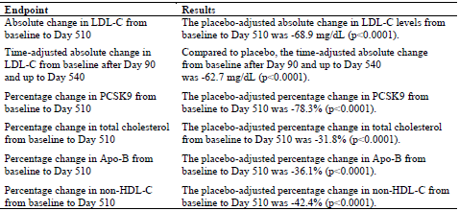
Figure 9: ORION-9 trial, Mean percentage change from Baseline of low-density lipoprotein-cholesterol by visit
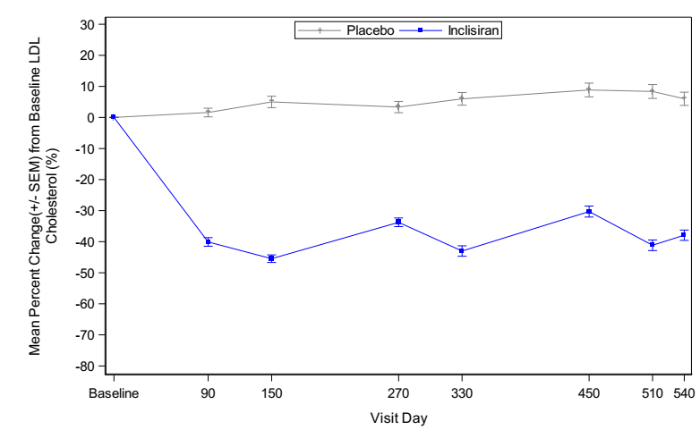
Figure 10: ORION-9 trial, Forest plot of treatment differences in percentage change from Baseline in low-density lipoprotein-cholesterol at Day 510 (intent to treat population)
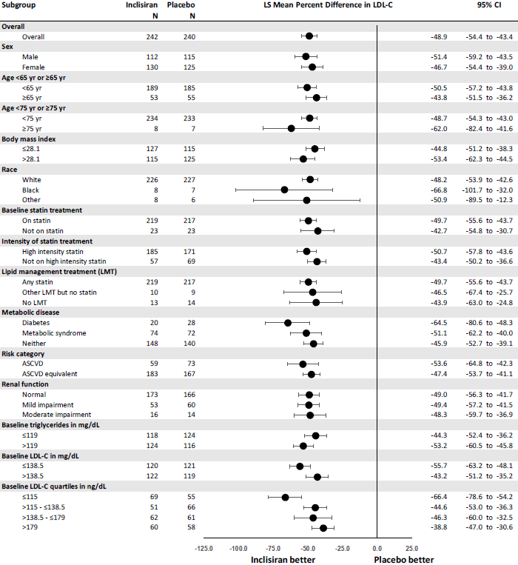
Cardiovascular outcomes in the ORION-9 trial were exploratory. Major cardiovascular event (MACE) events; were balanced across the treatment groups (Table 9).
Table 9: ORION-9 trial, Incidence of major cardiovascular events (safety population)
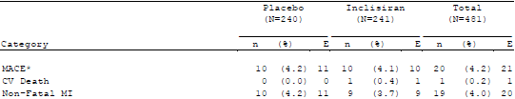
Abbreviation: CV = cardiovascular; MI = myocardial infraction

ORION-10 trial
The ORION-10 trial was a Phase III study of adults with ASCVD (CHD, cardiovascular diseases (CVD), or peripheral arterial disease (PAD)) and LDL-C ≥ 1.8 mmol/L despite maximally tolerated statin therapy with or without other LDL-C lowering agents. CHD was defined as prior myocardial infraction (MI), prior coronary revascularisation (percutaneous coronary intervention or coronary artery bypass graft surgery), or angiographic or computerised tomography imaging evidence of coronary atherosclerosis (> 70% stenosis in at least one major epicardial coronary artery). CVD was defined as prior ischemic stroke confirmed by imaging (not related to atrial fibrillation, valvular heart disease or mural thrombus), carotid artery stenosis > 70% on prior angiography or ultrasound, or history of carotid artery revascularisation. PAD was defined as prior documentation of resting ankle brachial index ≤ 0.85, history of revascularisation of an iliac, femoral or popliteal artery, or prior non-traumatic amputation of lower extremity due to PAD.
The study was conducted at 145 sites in the USA. Of the 2329 subjects were screened and 1561 were randomised and included in the ITT population. Of the 1561 randomised subjects, 1559 subjects were treated (778 with placebo and 781 with inclisiran) and included in the safety population. 90.6% of subjects completed the study and 89.1% of subjects in the inclisiran group received all four doses.
Demographic and baseline characteristics were balanced across the two treatment groups. 69.4% of subjects were male, mean age was 66 years old, and 85.7% of subjects were White, 0.6% were Asian and 12.6% were Black or African American. 45% of all subjects had diabetes, 38.6% (186 out of 482) were current or former smokers, and 90.6% had hypertension. 76.4% of subjects had renal impairment (mild, moderate, or severe). The mean LDL-C at Baseline was 2.7 mmol/L.
All subjects had ASCVD (91.1% had CHD, 16.7% had CVD, and 11.1% had PAD). 1,554 (99.6%) subjects had hyperlipidaemia, with 137 (8.8%) having familial hypercholesterolemia (20 with HeFH, 3 with HoFH and 114 unknown). 94.7% of subjects were receiving statins or other LMT at Baseline. 89.2% of subjects were on statin therapy at Baseline (69.4% on high intensity statin, 18.7% on medium intensity statin, 0.8% on low intensity statin), and 10.8% were not on statin therapy (5.3% were on no LMT, 5.4% were on other LMT).
Outcomes for the co-primary efficacy endpoints were:
- The placebo adjusted percentage change in LDL-C from Baseline to Day 510 using observed values was - 57.6% (p < 0.0001). The primary analysis used a pre-specified washout model to account for missing data. The placebo adjusted percentage change in LDL-C from Baseline to Day 510 using imputed values was - 52.2% (p < 0.0001).
- Compared to placebo the time adjusted percentage change in LDL-C from Baseline after Day 90 and up to Day 540 was - 53.8% (p < 0.0001).
Outcomes for the key secondary efficacy endpoints (Table 10) were supportive of the co-primary endpoints. The maximal effect of inclisiran on LDL-C was observed at Day 150 (Figure 11). LDL-C lowering was maintained through to the end of study (Day 540), with fluctuations corresponding to the maintenance dosing schedule.
Subgroup analyses showed consistent outcomes across subgroups (Figure 12). Similar outcomes were observed in subjects receiving a statin at Baseline and those not receiving a statin, and for subgroups based on lipid management treatment. There was a trend of a higher placebo adjusted percentage reduction in LDL-C for subgroups with lower baseline LDL-C levels.
Table 10: ORION-10 trial, Key secondary efficacy endpoints
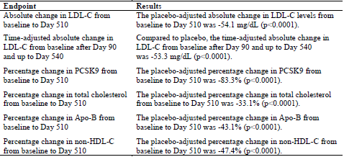
Figure 11: ORION-10 trial, Mean percentage change from Baseline of LDL-C by visit (intent to treat population)
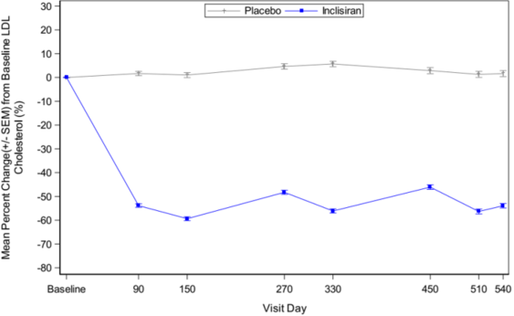
Figure 12: ORION-10 trial, Forest plot of treatment differences in percentage change from Baseline in low-density lipoprotein-cholesterol at Day 510 (subgroup analyses)
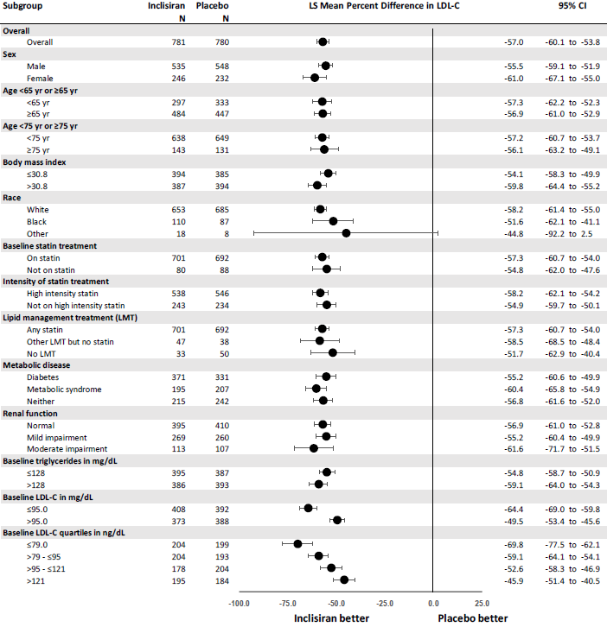
Cardiovascular outcomes in the ORION-10 trial were exploratory. There were fewer MACE events in the inclisiran group, with the difference driven by non-fatal MI (Table 11).
Table 11: ORION-10 trial, Incidence of major cardiovascular event (safety population)
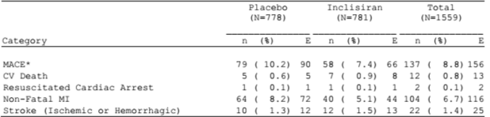
*MACE (major cardiovascular event) is defined as the composite of cardiovascular death, resuscitated cardiac arrest, non-fatal myocadiac infraction and stroke (ischemic or haemorrhagic).
Abbreviation: CV = cardiovascular; MACE = major cardiovascular event; MI = myocardial infarction

ORION-11 trial
The ORION-11 trial was a Phase III study of adults with ASCVD (CHD, CVD, or PAD) or ASCVD risk equivalents and with LDL-C ≥ 1.8 mmol/L (ASCVD subjects) or ≥ 2.6 mmol/L (ASCVD risk equivalents) despite maximally tolerated statin therapy with or without other LDL-C lowering agents. ASCVD risk equivalent was defined as subjects with type two diabetes, FH, or 10 year risk of a CV event ≥ 20% (that is target LDL-C < 2.6 mmol/L).
The study was conducted in 71 centres in seven countries: Czech Republic, Germany, Hungary, Netherlands, Poland, South Africa, Ukraine, and United Kingdom. Of the 2381 subjects were screened, 1617 were randomised. Of the 1617 randomised subjects, 1615 were treated (805 with placebo and 810 with inclisiran) and included in the safety population. 95.4% of subjects completed the trial and 92.1% of subjects in the inclisiran group received all four doses.
Demographic and baseline characteristics were well balanced across the two treatment groups. 71.7% of subjects were male, mean age was 64.8 years old, and 98.1% of subjects were White, 0.5% were Asian and 1.2% were Black or African American. 45% of all subjects had diabetes, 38.6% were current or former smokers, and 90.6% had hypertension. 70.9% of subjects had mild or moderate renal impairment. Patients with severe renal impairment were not included in this study.
One thousand four hundred and fourteen subjects (87.4%) had ASCVD and 203 (12.6%) were ASCVD risk equivalent. Of the subjects with ASCVD, 87.5% had CHD, 16.5% had CVD, and 10.4% had PAD. Of the subjects who were ASCVD risk equivalent, 65% (132 out of 203) had diabetes, 56.2% (114 out of 203) had 10 year risk of a CV event ≥ 20%, and 5.4% (11 out of 203) had HeFH. Overall, 35.1% of subjects had diabetes and 80.5% had hypertension. The mean LDL-C at Baseline was 2.7 mmol/L.
96.8% of subjects were receiving statins or other lipid-modifying therapies at Baseline. 94.7% were on statin therapy at Baseline (78% on high intensity statin, 15.5% on moderate intensity statin, 0.4% on low intensity statin), and 5.3% were not on statin therapy (3.2% were on no LMT, 2% were on other LMT).
Outcomes for the co-primary efficacy endpoints were:
- The placebo adjusted percentage change in LDL-C from Baseline to Day 510 using observed values was -53.5% (p < 0.0001). The primary analysis used a pre-specified washout model to account for missing data. The placebo adjusted percentage change in LDL-C from Baseline to Day 510 was - 47.8% (p < 0.0001).
- Compared to placebo the time adjusted percentage change in LDL-C from Baseline after Day 90 and up to Day 540 was - 49.2% (p < 0.0001).
Outcomes for the key secondary efficacy endpoints (Table 12) were supportive of the co-primary endpoints. The maximal effect of inclisiran on LDL-C was observed at Day 150 (Figure 13). LDL-C lowering was maintained through to the end of study (Day 540), with fluctuations corresponding to the maintenance dosing schedule.
Subgroup analyses showed consistent outcomes across subgroups (Figure 14). Reduction in LDL-C was similar for subjects with ASCVD and ASCVD-risk equivalents. Outcomes were also similar for subgroups based on lipid management treatment. There was a trend of a higher placebo adjusted percentage reduction in LDL-C for subgroups with lower baseline LDL-C.
Table 12: ORION-11 trial, Key secondary efficacy endpoint
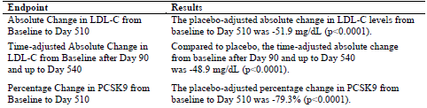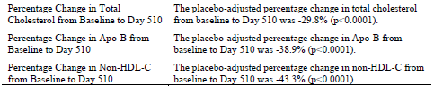
Figure 13: ORION-11 trial, Mean percentage change from Baseline of low-density lipoprotein-cholesterol by visit (intent to treat population)
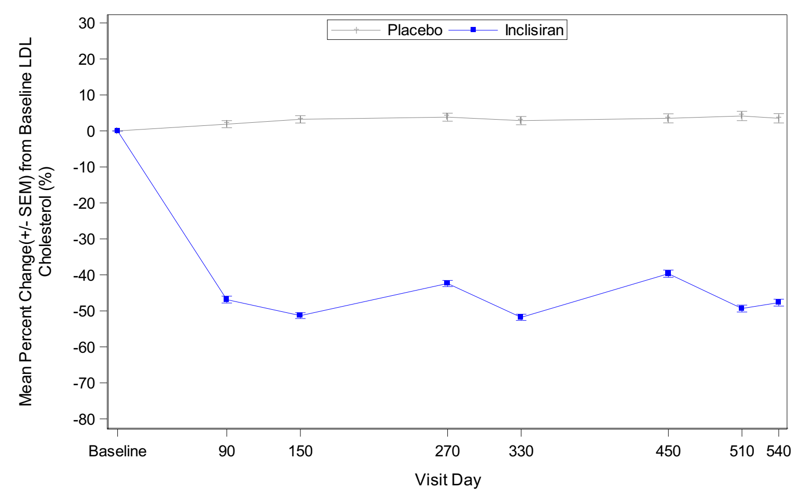
Figure 14: ORION-11 trial, Forest plot of treatment differences in percentage change from Baseline in low-density lipoprotein-cholesterol at Day 510 (intent to treat population)
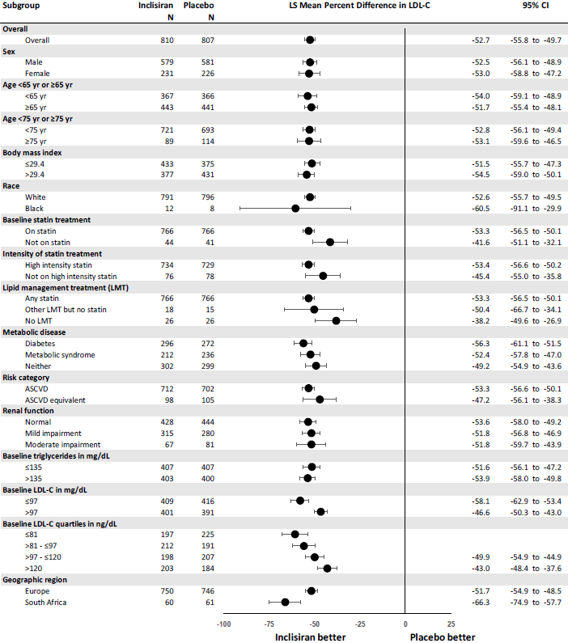
Cardiovascular outcomes in the ORION-11 trial were exploratory. MACE events were lower in the inclisiran arm, with the difference driven primarily by non-fatal MI (Table 13).
Table 13: ORION-11 trial, Incidence of major cardiovascular event (safety population)
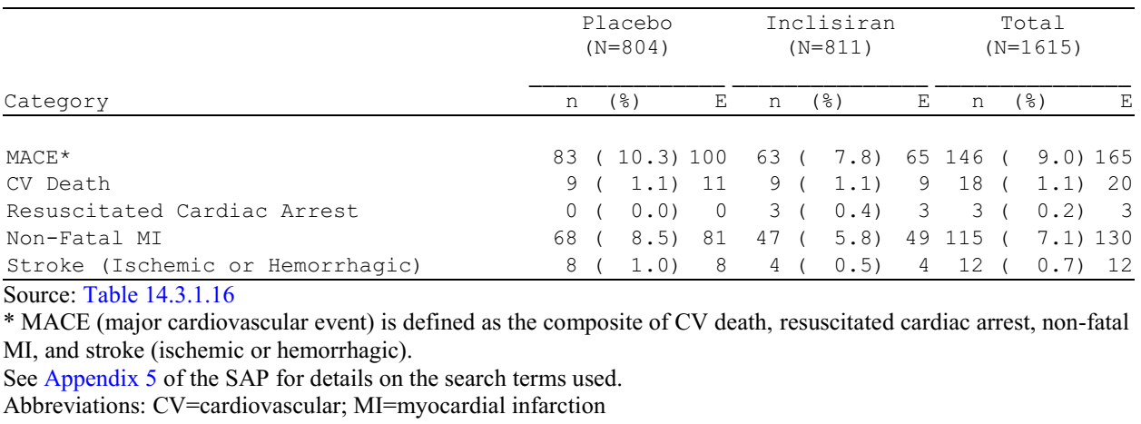
MACE (major cardiovascular event) is defined as the composite of cardiovascular death, resuscitated cardiac arrest, non-fatal myocadiac infraction and stroke (ischemic or haemorrhagic).
Abbreviation: CV = cardiovascular; MACE = major cardiovascular event; MI = myocardial infarction

Pooled analyses of efficacy
The primary analyses of efficacy are based on data from the individual Phase III studies, but the similarities in the study designs allowed analyses of pooled data:
- Efficacy pool 1: ORION-9, ORION-10, and ORION-11 trials
- Efficacy pool 2: ORION-10 and ORION-11 trials (Table 14)
The three studies shared the same efficacy endpoints and dosing regimen, but there were differences in the study populations. The ORION-9 trial evaluated subjects with HeFH, who were generally younger than subjects in the ORION-10 trial (ASCVD) and the ORION-11 trial (ASCVD or ASCVD-risk equivalent) and had higher baseline LDL-C and a lower baseline prevalence of ASCVD, diabetes and hypertension.
Table 14: Pools of data for integrated analyses of efficacy
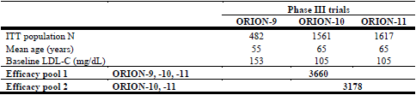
Abbreviations: ITT = intent to treat, LDL-C = low density lipoprotein cholesterol
In efficacy pool 1, 85% of subjects had ASCVD and 15% had ASCVD risk equivalents. In efficacy pool 2, 94% of subjects had ASCVD and 6% had ASCVD risk equivalents. 94% of subjects in each efficacy pool were receiving a statin at study entry (74% were receiving high intensity statin). Despite maximally tolerated statin therapy, mean baseline LDL-C was 3.9 mmol/L in the ORION-9 trial and 2.7 mmol/L in the ORION-10 and the ORION-11 trials. Of the 1833 subjects, 515 (28%) subjects treated with inclisiran in efficacy pool 1 had normal renal function at Baseline, 1012 (55%) had mild renal impairment at Baseline, 295 (16%) had moderate renal impairment at Baseline, and 11 (0.6%) had severe renal impairment at Baseline.
Outcomes for the co-primary efficacy endpoints in the pooled analysis were:
- The placebo adjusted percentage change in LDL-C from Baseline to Day 510 using observed values was - 54.7% (p < 0.0001) in efficacy pool 1 and - 55.6% (p < 0.0001) in efficacy pool 2. The primary analysis used a pre-specified washout model to account for missing data. The placebo adjusted percentage change in LDL-C from Baseline to Day 510 was - 50.7% (p < 0.0001) in efficacy pool 1 and - 51% (p < 0.0001) in efficacy pool 2.
- Compared to placebo the time adjusted percentage change in LDL-C from Baseline after Day 90 and up to Day 540 was - 50.5% (p < 0.0001) in efficacy pool 1 and - 51.4% (p < 0.0001) in efficacy pool 2.
In efficacy pool 1, the placebo adjusted absolute change in LDL-C levels from Baseline to Day 510 was - 55.1 mg/dL (p < 0.0001), equivalent to - 1.4 mmol/L. In efficacy pool 2, the placebo adjusted absolute change in LDL-C levels from Baseline to Day 510 was - 52.9 mg/dL (p < 0.0001), equivalent to - 1.4 mmol/L.
The proportion of subjects who attained global lipid targets at Day 510 for their level of ASCVD risk (that is ˂ 1.8 mmol/L for ASCVD, ˂ 2.6 mmol/L for ASCVD risk equivalent) was 82% for inclisiran and 16% for placebo in ASCVD subjects, and 70% for inclisiran and 17% for placebo in ASCVD risk equivalent subjects.
Table 15: Percentage change from Baseline low density lipoprotein cholesterol by visit in efficacy pool 1 and pool 2 (intent to treat population)
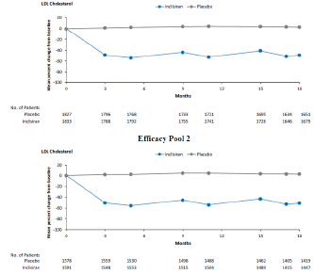
Ten subjects (0.6%) in the pivotal trials were identified as non-responders to inclisiran (defined as subjects with no reduction in LDL-C from Baseline at any point in the study). Nine of these subjects had a decrease in PCSK9 post-baseline, indicating that inclisiran was successful in reaching its target in the liver. One subject had only one PCSK9 measurement taken before withdrawing consent. Nine (0.5%), 22 (1.3%), and 38 (2.3%) inclisiran treated subjects in the pivotal studies did not experience a reduction in LDL-C from Baseline to end of study after administration of the second, third, and fourth dose, respectively. The sponsor’s hypothesis (supported by an exploratory analysis of statin plasma concentrations in the ORION-10 trial) is that non-compliance with background lipid lowering therapy contributed to the non-responder rates.
Approximately 30% of subjects in the Phase III studies had LDL-C < 25 mg/dL on at least one occasion, and 14% of subjects had LDL-C < 25 mg/dL on at two consecutive occasions. Diabetes mellitus, ASCVD, and baseline LDL-C ≤ 81 mg/dL were identified as associated factors in subjects who achieved LDL-C < 25 mg/dL with inclisiran treatment.

ORION-3 trial
The ORION-3 trial is an ongoing, Phase II, open label, active comparator, long term (4 year) extension study to assess the effect of long term dosing of inclisiran and evolocumab in subjects with high CV risk and elevated LDL-C. The ORION-3 trial enrolled subjects who completed the ORION-1 trial.
The primary objective is to evaluate the effect of inclisiran treatment on LDL-C levels at Day 210 compared to baseline of ORION-1 trial in the inclisiran only arm. Secondary objectives (inclisiran only arm) include evaluation of the change in LDL-C over time, change in PCSK9 over time, change in other lipids, lipoproteins and apolipoproteins over time, proportion of subjects achieving target levels pre-specified in global lipid guidelines, proportion of subjects achieving at least 50% LDL-C reduction from Baseline of the ORION-1 trial over time, individual responsiveness to inclisiran, duration of lipid lowering effect), and the safety and tolerability of inclisiran. Exploratory objectives include the evaluation of the efficacy and safety of concurrent administration of evolocumab and inclisiran and transitioning from evolocumab to inclisiran.
The ORION-3 trial enrolled subjects who completed ORION-1 trial to at least Day 210 and whose LDL-C had returned to within 20% of the baseline value or who reached Day 360 of the ORION-1 trial with no contraindication to receiving inclisiran or evolocumab. Subjects had ASCVD or ASCVD risk equivalent (for example, diabetes or FH) and elevated LDL-C despite maximum tolerated dose of LDL-C lowering therapies.
Subjects were allocated to treatment in the ORION-3 trial based on the treatment received in the ORION-1 trial. Subjects who received inclisiran in the ORION-1 trial continued to receive inclisiran in the ORION-3 trial (Group 1; inclisiran only arm). Subjects who received placebo in the ORION-1 trial received evolocumab 140 mg subcutaneous once every two weeks in the ORION-3 trial until Day 336 before transitioning to inclisiran for the remainder of the study (Group 2; switching arm).
Subjects in Group 1 received inclisiran sodium 300 mg subcutaneous on Day 1 and then on Day 180, Day 360, Day 540, Day 720, Day 810, Day 990, Day 1170, and Day 1350. Subjects in Group 2 received their first dose of evolocumab 140 mg subcutaneous on Day 1 administered by the investigator, and then self-administered evolocumab 140 mg subcutaneous once every two weeks until Day 336. Two different transitions from evolocumab to inclisiran were evaluated. The staged transition group (Transition 1) received only inclisiran on Day 360, whereas the concurrent transition group (Transition 2) received both evolocumab and inclisiran on Day 360. Inclisiran was subsequently administered on Day 450 and then every six months (Days 630, 810, 990, 1170, and 1350). The end of study visit was Day at 1440 (4 years).
Of the 382 subjects who consented to participate in the ORION-3 trial:
- 290 had received inclisiran in the ORION-1 trial, so received only inclisiran in the ORION-3 trial (Group 1)
- 92 had received placebo in the ORION-1 trial, so received evolocumab followed by inclisiran in the ORION-3 trial (Group 2).
In Group 1, 65.3% of subjects were male and the mean age was 63.2 years. 73.4% of subjects had mild or moderate renal impairment, 23.3% had diabetes mellitus, and 65.9% had hypertension. In Group 2, 63.1% of subjects were male and the mean age was 62.1 years. 71.4% of subjects had mild or moderate renal impairment, 20.5% had diabetes mellitus, and 70.2% had hypertension.
This application presented data up to the 8 May 2019 data cut-off date, when the last subject completed the Day 450 visit. Efficacy data are presented up to Day 630. The majority of subjects (85.6%) in the inclisiran only arm had received four administrations of inclisiran in the ORION-3 trial. The mean duration on study was 584 days.
The primary efficacy endpoint (percentage change in LDL-C from Baseline in the ORION-1 trial to Day 210 in the ORION-3 trial; inclisiran only arm) was - 50.6% (p < 0.0001). The response in LDL-C to six monthly inclisiran was maintained out to Day 630 (Figure 15). Reductions in PCSK9, ApoB, non-HDL-C, and TC were also maintained. 79% of subjects in Group 1 had ≥ 50% reduction in LDL-C from Baseline of ORION-1 trial at any time point during the study. 90.8% of subjects achieved an LDL-C level of < 100 mg/dL (< 2.6 mmol/L) at any time point during the study, and 77.1% achieved an LDL-C level of less than 70 mg/dL (< 1.8 mmol/L) at any time point during the study. 57.7% of subjects achieved an LDL-C level of < 50 mg/dL (< 1.3 mmol/L), and 26.8% of subjects achieved an LDL-C level of < 25 mg/dL (< 0.6 mmol/L) at any time point in the study.
All efficacy analyses in Group 2 (switching arm) are exploratory. Subjects who transitioned from evolocumab to inclisiran concurrently (Transition 2) experienced a greater percentage reduction in LDL-C at 30 days after switching compared to those who had a staged transition (Transition 1), but no meaningful difference between the two transition strategies was seen at Day 450 (90 days after switching) and beyond (Table 16). After doses of inclisiran at Days 360 and 450, the percentage change in PCSK9 levels at Day 510 was - 73.2% for Transition 1 and - 75.2% for Transition 2.
During the evolocumab treatment phase in Group 2, 89% of subjects had a ≥ 50% reduction in LDL-C from Baseline of ORION-3 trial at any time point. At Day 360, 53.7% of subjects had ≥ 50% reduction in LDL-C from Baseline. After switching to inclisiran treatment, 79.7% of subjects for Transition 1 and 88.9% of subjects for Transition 2 had a ≥ 50% reduction in LDL-C from Baseline of the ORION-3 trial at any time point. Inclisiran was administered on Day 360 and Day 450, so outcomes for six monthly maintenance treatment with inclisiran in Group 2 were not available in this interim dataset.
Figure 15: ORION-3 trial, Percent change from Baseline low density lipoprotein cholesterol (calculated) by visit to Day 630, Group 1 (inclisiran-only arm) (modified intent to treat population)
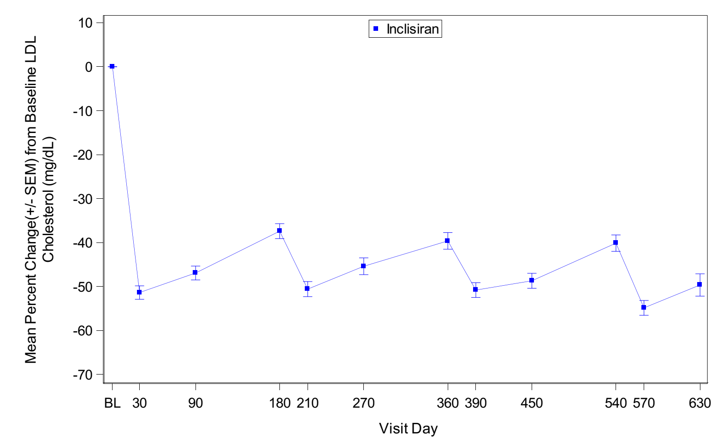
Table 16: ORION-3 trial, Percentage change in low density lipoprotein cholesterol at Day 360 (evolocumab) and after transition to treatment with inclisiran, Group 2 (switching arm)
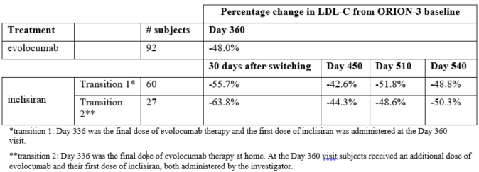
* Transition 1: Day 336 was the final dose of evolocumab therapy and the first dose of inclisiran was administered at the Day 360 visit
** Transition 2: Day 336 was the final dose of evolocumab therapy at home. At the Day 360 visit subject received an additional dose of evolocumab and their first dose of inclisiran, both administer by the investigator

Safety
Overall, the clinical dossier provides safety data from 4332 subjects, including 2452 on inclisiran at any dose and 2118 on inclisiran at the proposed dose. The primary analysis of safety was based on pooled data from the safety population of the three Phase III studies (the safety pool), which assessed the safety of inclisiran compared to placebo in subjects with HeFH, ASCVD, and/or ASCVD risk equivalents over a duration of 18 months. The safety of inclisiran beyond 18 months of treatment is being assessed in three ongoing trials: the ORION-3 (interim data presented in this submission), ORION-8, and ORION-4 trials.
The safety pool included 3655 subjects, 1833 treated with inclisiran and 1822 on placebo. 90.6% of placebo subjects and 90.9% of inclisiran treated subjects received all four doses of study drug. Mean duration of follow up was 523 days for placebo and 526 days for inclisiran. The safety profile of inclisiran in all three pivotal trials was similar.
The overall incidence of treatment-emergent adverse events (TEAEs), treatment-emergent serious adverse events (TESAE), TEAEs leading to discontinuation, and deaths were similar for inclisiran and placebo (Table 17). The majority of TEAEs were of mild or moderate severity, with severe TEAEs reported in 15.3% of placebo treated subjects and 13% of inclisiran treated subjects.
Table 17: Overall summary of treatment-emergent adverse events for the safety pool (safety population)
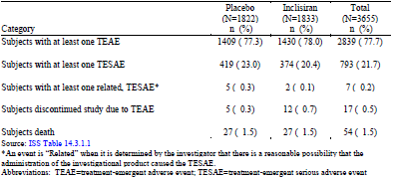
* An event is ‘related’ when it is determined by the investigator that there is a reasonable possibility that the administration of the investigational product caused the TESAE.
Abbreviations: TEAE = treatment emergent adverse event; TESAE = treatment emergent serious adverse event
Treatment emergent adverse events by Preferred Term (PT) (≥ 3% in either group) are shown in Table 18. The most common TEAEs with a higher incidence with inclisiran than placebo were diabetes mellitus, nasopharyngitis, arthralgia, back pain, urinary tract infection, diarrhoea, bronchitis, and cough. The largest observed difference was for injection site reactions (3.1% inclisiran versus 0.1% placebo). The incidence of dizziness in the inclisiran group was similar to placebo.
Treatment emergent adverse events at the injection site occurred more frequently with inclisiran (8.2%) than placebo (1.8%). TEAEs at the injection site were localised, mostly mild (occasionally moderate), and generally transient. There were no severe TEAEs at the injection site, and no TESAEs at the injection site. Four inclisiran treated subjects withdrew from study drug due to TEAEs at the injection site.
A higher incidence of lower respiratory tract and lung infections was observed in the inclisiran group (8.1%) than the placebo group (6%). Conditions contributing to this difference included bronchitis (4.3% versus 2.7%), lower respiratory tract infection (1.9% versus 1.5%), and pneumonia (2.5% versus 2%). The relative risk for bronchitis was 1.6 (95% CI 1.1, 2.2). The sponsor commented that there are no nonclinical or mechanistic data that support the potential for adverse respiratory system effects or effects on immunity. The nonclinical evaluation commented that the CLEC10A membrane receptor has binding affinity for GalNAc and is expressed in the lungs. The clinical evaluation concluded that a causal relationship between inclisiran treatment and the reported events of lower respiratory tract and lung infections cannot be excluded.
Osteoporosis/osteopenia events were numerically higher with inclisiran (12 subjects, 0.7%) than placebo (7 subjects, 0.4%). All these events were of mild to moderate intensity, and none were serious. Spinal fractures/dislocations and pelvic fractures/dislocations were reported at a low incidence overall but were numerically higher in the inclisiran group than placebo (spinal fractures/dislocations were reported in 10 subjects (0.5%) in the inclisiran group and 3 subjects (0.2%) in the placebo group; pelvic fractures/dislocations were reported in 3 subjects (0.2%) in the inclisiran group and none in the placebo group). The sponsor commented that these observations are not supported by nonclinical findings or mechanistic data, and that the small observed differences are in line with the variability of the data and are due to chance. The clinical evaluation concluded that a causal relationship cannot be excluded.
Events of joint disorders were numerically higher with inclisiran (10.6%) than with placebo (9.4%). The evaluation noted that conditions contributing to this difference included arthritis, arthropathy, rotator cuff syndrome, and arthralgia. The sponsor commented that an association between inclisiran and musculoskeletal/connective tissue disorders could not be established based on the available clinical data, mechanistic data and non-clinical data. The clinical evaluation concluded that a causal relationship cannot be ruled out.
Table 18: Treatment emergent adverse events by Preferred Term (≥ 3% in either group) in the safety pool (safety population)
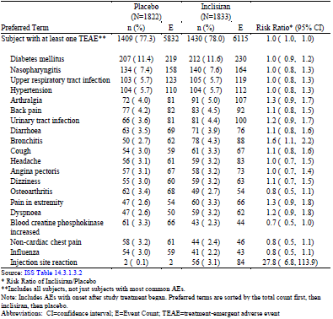
* Risk ratio of inclisiran/placebo
** Includes all subjects, not just subjects with most common adverse event
Note: Includes adverse events with onset after study treatment began. Preferred terms are sorted by the total count first, then inclisiran, then placebo.
Abbreviations: CI = confidence interval; E = event count; TEAE = treatment emergent adverse event
Treatment emergent serious adverse events were reported in 20.4% of subjects in the inclisiran group and 23% in the placebo group (Table 19). The majority of TESAEs were CV events. In the safety pool, the incidence of MACE (a composite of CV death, resuscitated cardiac arrest, non-fatal MI, and stroke) was 7.1% in the inclisiran group compared to 9.4% in the placebo group (Table 20). Non-fatal MI was the major driver of the MACE outcome. CV death was reported in 17 subjects (0.9%) in the inclisiran group and 14 subjects (0.8%) in the placebo group. All cause mortality was comparable in both arms (1.5%).
No systemic allergic reactions were reported with inclisiran. With the exception of injection site events, TEAEs related to hypersensitivity were similar for inclisiran and placebo. There was no meaningful difference in neurological events or neurocognitive disorders between inclisiran and placebo. TESAEs for neoplasms were similar between the groups (2.7% for placebo, 2.4% for inclisiran).
Table 19: Treatment-emergent serious adverse events (≥ 0.5% in either treatment group) in the safety pool (safety population)
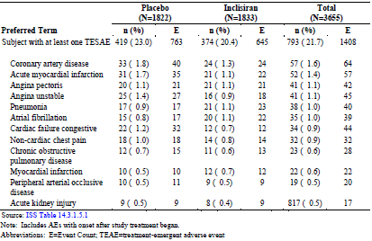
Note: Includes adverse events with onset after study treatment began
Abbreviations: E = event count; TEAE = treatment emergent adverse event
Table 20: Treatment-emergent cardiac adverse events in safety pool (safety population)
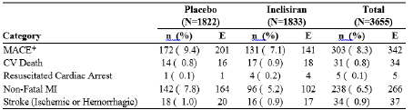
*MACE (major cardiovascular event) is defined as the composite of cardiovascular death, resuscitated cardiac arrest, non-fatal myocardial infarction, and stroke (ischemic or haemorrhagic)
Abbreviation: CV = cardiovascular; E = event count; ISAP = integrated statistical analysis plan; MI = myocardial infarction.

Hepatic safety
TEAEs related to hepatic events were balanced across the inclisiran and placebo treatment groups.
Evaluation of laboratory parameters for liver function showed that clinically significant elevations in alanine aminotransferase (ALT) and aspartate transaminase (AST) > 3 times of the upper limit of normal (ULN) were comparable in the inclisiran treated and placebo treated groups in the safety pool. Elevations in ALT and AST > 1 times the ULN and ≤ 3 times ULN were observed more frequently with inclisiran (19.7% for ALT, 17.2% for AST) than placebo (13.6% for ALT, 11.1% for AST). The effect on liver enzymes was transient in most cases, although some subjects in the inclisiran group showed a more sustained effect (that is for at least two consecutive visits). Subjects across the entire clinical trial program were assessed against two definitions of Hy’s law described in the Health Canada guidance document Pre-Market Evaluation of Hepatotoxicity in Health Products, and there were no cases which met either definition of Hy’s law.
Adverse events by hepatic function were assessed in the hepatic impairment study and in post-hoc analyses in the safety pool. The safety of inclisiran has not been assessed in patients with severe hepatic impairment. Subjects with active liver disease or unexplained elevations in ALT, AST, > 3 times the ULN, or total bilirubin > 2 times the ULN, were excluded from the pivotal trials.

Renal safety
There were no clinically meaningful differences between the treatment groups with regard to changes in renal function (serum creatinine, blood urea nitrogen, and eGFR), creatine kinase, and haematology and coagulation parameters.
Subjects with mild and moderate renal impairment represented 55% and 16% of the pivotal trials’ populations, respectively. Safety findings in these populations were similar to subjects with normal renal function. Subjects with severe renal impairment represented 0.6% of the pivotal trials’ populations, so safety conclusions in this population are limited. Patients with ESRD were not studied.

Other laboratory parameters
There were no clinically meaningful differences between the treatment groups with regard to changes in creatine kinase, and haematology and coagulation parameters.

Diabetes and glycaemic control
Safety analyses relating to diabetes included change in glucose related laboratory values over time, shifts from Baseline in glucose control category, incidence of post-baseline new onset of diabetes, and TEAEs related to development or worsening of diabetes mellitus.
No difference was seen in the shift from Baseline to maximum change upon treatment for plasma glucose, but a small difference was observed for subjects with haemoglobin A1c ≥ 6.5% (26.5% at Baseline and 29.4% post-baseline for inclisiran, compared to 25.6% at Baseline and 26.3% post-baseline for placebo).
Analyses of shifts from Baseline in glucose control category based on fasting glucose and haemoglobin A1c showed a small difference (inclisiran 25.2% versus placebo 21.7%) in the proportion of patients who shifted to a worse category (that is normal to impaired, normal to diabetes, or impaired to diabetes). This observation was seen across subgroups defined by baseline metabolic status (subjects with diabetes, metabolic syndrome without diabetes, or neither).
In subjects without diabetes at Baseline, new onset of diabetes (defined as one or more of the diabetes components listed in Table 21) was reported in 4.3% on inclisiran and 4.7% on placebo, and in subjects with baseline fasting glucose ≥ 100 and < 126 mg/dL, new onset diabetes was reported in 14.6% on inclisiran and 13.8% on placebo (Table 21). In further analyses conducted by the evaluator, a higher incidence of post-baseline new onset of diabetes in the inclisiran group compared to the placebo group was observed only in subjects with metabolic syndrome with no diabetes at Baseline and with baseline fasting glucose ≥ 100 and < 126 mg/dL (Table 22).
Table 21: Incidence of post-baseline new onset of diabetes in the safety pool (safety population)
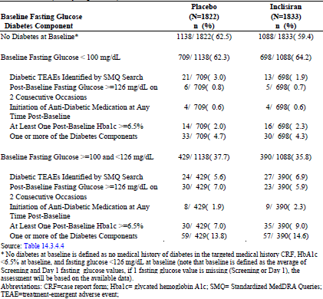
* No diabetes at Baseline is defined as no medical history of diabetes in the targeted medical history CRF, HbA1c < 6.5% at Baseline, and fasting glucose < 126 mg/dL at Baseline (note that baseline is defined as the average of Screening and Day 1 fasting glucose values, if 1 fasting glucose value is missing (Screening or Day 1), the assessment will be based on the available data).
Abbreviations: CRF = case report form; Hba1c = glycated hemoglobin A1c; SMQ = standardised MedDRA Queries; TEAE = treatment emergent adverse event.
Table 22: Incidence of post-baseline new-onset of diabetes by metabolic status and baseline fasting glucose - controlled Phase III safety pool (safety population)
Baseline metabolic status | Baseline fasting glucose | Incidence of one or more of the diabetes components
Baseline metabolic status | Baseline fasting glucose | Placebo | Inclisiran
Metabolic syndrome with no diabetes | All | 57/484 (11.8%) | 59/454 (13%)
Metabolic syndrome with no diabetes | < 100 mg/dL | 16/208 (7.7%) | 12/207 (5.8%)
Metabolic syndrome with no diabetes | ≥100 and <126 mg/dL | 41/276 (14.9%) | 47/247 (19%)
Neither diabetes nor metabolic syndrome | All | 35/654 (5.4%) | 28/634 (4.4%)
Neither diabetes nor metabolic syndrome | < 100 mg/dL | 17/501 (3.4%) | 18/491 (3.7%)
Neither diabetes nor metabolic syndrome | ≥100 and <126 mg/dL | 18/153 (11.8%) | 10/143 (7%)
In the safety pool, TEAEs related to development or worsening of diabetes mellitus were similar overall (Table 23). Slightly more TEAEs were reported with inclisiran for glycosylated haemoglobin increased (0.5% inclisiran, 0.2% placebo) and hyperglycaemia (1.4% inclisiran, 0.8% placebo), but slightly fewer for glucose tolerance impaired (0.4% inclisiran, 0.7% placebo). In subjects without diabetes at Baseline, TEAEs related to development of diabetes were reported in 4.4% in the inclisiran group and 4.7% in the placebo group. For subjects with diabetes at Baseline, the incidence of TEAEs related to worsening of diabetes was similar in both groups (placebo 34% versus inclisiran 33.2%). There are inconsistencies in findings for TEAEs related to development or worsening of diabetes across the individual Phase III studies (Table 24).
Table 23: Treatment emergent adverse events related to development or worsening of diabetes mellitus in the safety pool (Safety population)
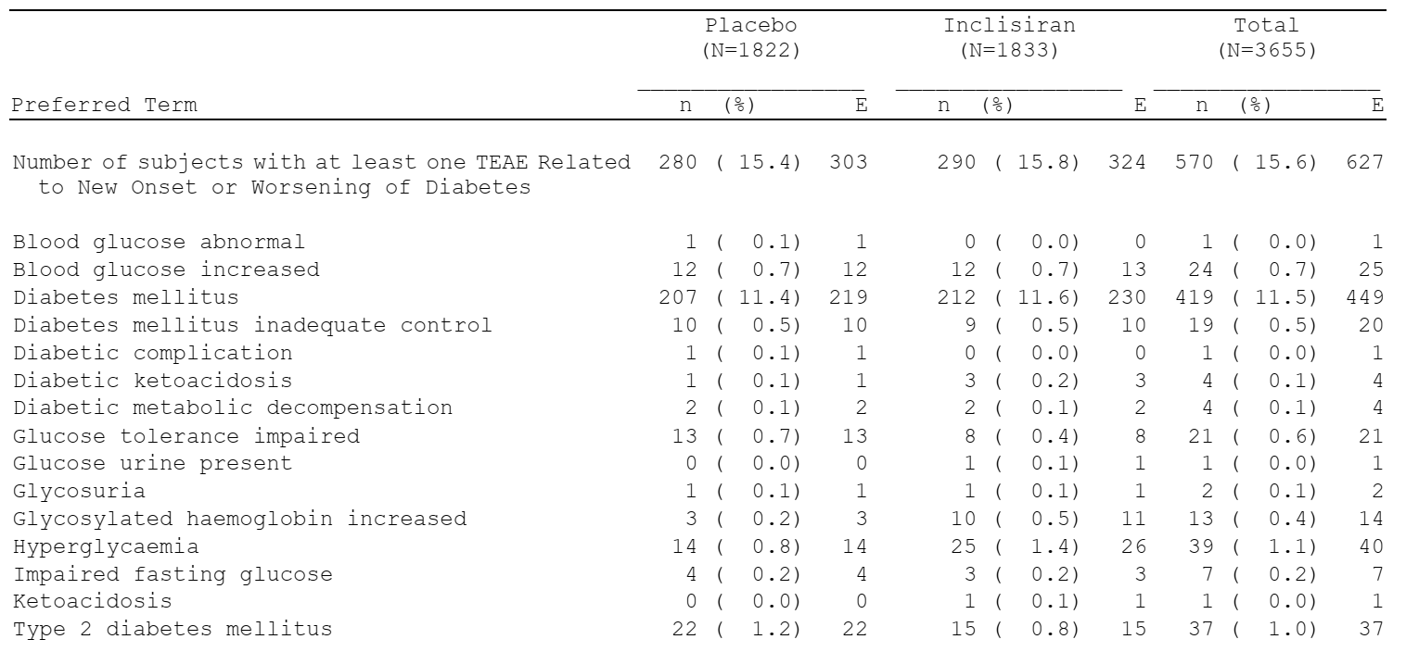
Table 24: ORION-9, ORION-10, ORION-11 trials, Treatment emergent adverse events related to development or worsening of diabetes mellitus
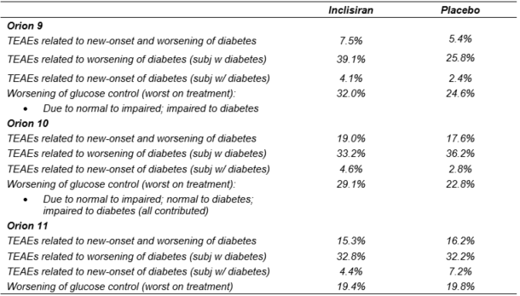
The sponsor provided an analysis of adverse events of special interest for patients who sustained LDL-C < 25 mg/dL and < 50 mg/dL (Table 25). There was a higher incidence of TEAEs related to new onset/worsening diabetes and hypersensitivity in patients with LDL-C < 25 mg/dL, but there were differences in baseline characteristics between the groups, particularly with regard to diabetes events.
Table 25: Number (%) of patients with treatment emergent adverse events of special interest by post-baseline LDL-C level less than 25 mg/dL in safety pool (safety population)
n = number of subjects with event(s) percentage is calculated by n/N*100
TEAE/TESAE = treatment emergent adverse event / treatment emergent serious adverse event

Safety in pregnancy and lactation
There are no clinical data on the use of inclisiran during pregnancy or lactation.

Long-term safety
Interim data from the ongoing long term extension study ORION-3 trial contribute to long term safety data for inclisiran. As at the 8 May 2019 data cutoff, 243 out of 284 (85.6%) subjects in Group 1 (inclisiran only arm) had received four doses of inclisiran in the ORION-3 trial and the mean duration on study was 583.9 days. 87 subjects received inclisiran in Group 2 (switching arm), 60 in Transition 1 (staged transition) and 27 in Transition 2 (concurrent evolocumab and inclisiran on Day 360). 64.4% of subjects in Group 2 had received two doses of inclisiran (Day 360 and Day 450) and the mean duration on study was 588.3 days.
In Group 1, 89.1% of subjects experienced at least one TEAE. The most common TEAEs were nasopharyngitis (14.8%), influenza (8.5%), urinary tract infection (7.7%), and hypertension (7%). The majority of treatment related TEAEs were TEAEs at the injection site. 21.1% experienced at least one TESAE.
In Group 2, 40 of 60 subjects (66.7%) in Transition 1 reported at least one TEAE and 22 of 27 subjects (81.5%) in Transition 2 reported at least one TEAE. TESAEs were balanced (11.7% in Transition 1, 11.1% in Transition 2). The most common TEAEs reported between Day 360 and the data cut-off date were hypertension (6.9%), nasopharyngitis (6.9%), arthralgia (4.6%), influenza (4.6%), and injection site pain (4.6%).

Risk management plan
The sponsor has submitted an EU approved EU-risk management plan (RMP) version 1.0 (dated 12 October 2020; data lock point (DLP) 17 September 2019) and Australian specific annex (ASA) version 1.1 (12 February 2021) in support of this application. On TGA request, sponsor has supplied updated ASA version 1.2 (5 August 2021) to accompany EU-RMP version 1.0 and support the decision on product registration.
The summary of safety concerns and their associated risk monitoring and mitigation strategies are summarised in Table 26.
Table 26: Summary of safety concerns
Summary of safety concerns |  | Pharmacovigilance |  | Risk Minimisation
 |  | Routine | Additional | Routine | Additional
Important identified risks | None | – | – | – | –
Important potential risks | None | – | – | – | –
Missing information | Long-term safety | ü¹ | ü² | ü | –
Missing information | Use in pregnancy and breast-feeding | ü | ü³ | ü | –
Missing information | Use in patients with severe hepatic impairment | ü | – | ü | –
1 Includes, but not limited to, analysis of following safety topics in PSUR submissions to the TGA: hepatotoxicity; long-term immunogenicity; new onset Diabetes Mellitus and worsening of pre-existing Diabetes Mellitus.
2 Ongoing clinical studies ORION-3 and ORION-8. Reports to be submitted to TGA for review on completion.
3 Post-authorisation Safety Study (PASS) - Inclisiran Pregnancy outcomes Intensive Monitoring (PRIM) Study
At the third round of RMP evaluation, the safety specification including the summary of safety concerns above is considered acceptable from an RMP perspective. RMP safety concerns in EU-RMP and ASA are the same. There are no Australia specific safety concerns.
Routine and additional pharmacovigilance activities have been proposed for all safety concerns. There are two ongoing clinical studies being conducted overseas which will provide relevant information on the long term safety of Leqvio beyond the 18 months of Phase III data submitted in support of product registration. There is no Australian patient involvement in these, but the study outcomes are considered relevant to Australian patients and use. There is a planned multinational post-authorisation safety study which will continue until 10 years from the first launch or until 500 prospectively reported live births with required details on status is achieved. The activity was accepted by EU’s European Medicines Agency (EMA) but is further subject to EMA’s final protocol approval. Data collection has commenced following product’s launch in other international jurisdictions with findings anticipated in future PSUR submissions to TGA. As outlined in ASA version 1.2, sponsor agrees to include safety topics listed in table description of the Table 26 above as part of ‘long-term’ safety monitoring of Leqvio use and report on these in PSURs. It is also agreed in the ASA that ‘use in patients with severe renal impairment’ will be analysed as a safety topic in the PSUR. This is in line with EU requirement. At fourth round of RMP evaluation, the proposed pharmacovigilance plan is considered acceptable.
As this product will be administered by health care professionals in health care setting and, in consideration of the current summary of safety concerns, the associated risks can be expected to be addressed with routine risk minimisation measures. Risks associated with other siRNA medicines are also managed in the same way internationally. Sponsor advises the subcutaneous route of administration is expected to form standard clinical practice and does not require additional training to health care providers. There are no Instructions for Use intended to be provided within the product’s packaging, to accompany the PI and Consumer Medicine Information (CMI) particulars. This would be considered acceptable given product’s presentation as a standard 1.5 mL pre-filled syringe with administration not requiring any special technique or instructions beyond standard clinical practice and PI. There are no plans for patient self-administration. The proposed risk minimisation plan is considered acceptable.
The RMP is considered acceptable.

Suggested wording for conditions of registration
Any changes to which the sponsor has agreed should be included in a revised RMP and ASA. However, irrespective of whether or not they are included in the currently available version of the RMP document, the agreed changes become part of the risk management system.
The suggested wording is:
The Inclisiran EU-Risk Management Plan (RMP) (version 1.0, dated 12 October 2020, data lock point 17 September 2019), with Australian Specific Annex (version 1.2, dated 5 August 2021), included with submission PM-2020-04160-1-3, to be revised to the satisfaction of the TGA, will be implemented in Australia.
The following wording is recommended for the PSUR requirement:
An obligatory component of risk management plans is routine pharmacovigilance. Routine pharmacovigilance includes the submission of periodic safety update reports (PSURs).
Reports are to be provided in line with the current published list of EU reference dates and frequency of submission of PSURs until the period covered by such reports is not less than three years from the date of this approval letter.
The reports are to at least meet the requirements for PSURs as described in the European Medicines Agency’s Guideline on good pharmacovigilance practices (GVP) Module VII-periodic safety update report (Rev 1), Part VII.B Structures and processes. Note that submission of a PSUR does not constitute an application to vary the registration.
Analysis of the following inclisiran use safety topics is to be included in PSUR submissions to the TGA: hepatotoxicity; long-term immunogenicity; new onset Diabetes Mellitus and worsening of pre-existing Diabetes Mellitus; and use in patients with severe renal impairment.
As Leqvio is a new chemical entity it should be included in the Black Triangle Scheme as a condition of registration. The following wording is recommended for the condition of registration:
Leqvio (inclisiran) is to be included in the Black Triangle Scheme. The PI and CMI for Leqvio must include the black triangle symbol and mandatory accompanying text for five years, which starts from the date that the sponsor notifies the TGA of supply of the product.
The following is recommended as a specific condition of registration:
Final study reports for ORION-3 and ORION-8 must be submitted to the TGA for review on completion.

Risk-benefit analysis

Delegate’s considerations

Pharmacology
There is a temporal disconnect between the PK and PD of inclisiran, with effects on LDL-C persisting for months despite inclisiran being undetectable in plasma within 48 hours of dosing. Given the dissociation between PK parameters and PD effects, dose selection for the pivotal studies focussed on PD and safety. Based on dose response relationships in Study ALN-PCSSC-001, the ORION-1 trial, and population PD modelling, the dosing regimen selected for the pivotal studies was 284 mg inclisiran (300 mg inclisiran sodium) subcutaneously on Day 1, Day 90, and then every six months. Population PD modelling did not identify any patient populations or subpopulations requiring a dose adjustment.
In the hepatic impairment study ORION-6 trial, inclisiran C_{max} was increased 1.1 and 2.1 fold and AUC_{0-inf} was increased 1.3 and 2 fold in patients with mild and moderate hepatic impairment, respectively, compared to patients with normal hepatic function. Reduction in LDL-C was similar for patients with mild hepatic impairment and normal hepatic function. For patients with moderate hepatic impairment, baseline PCSK9 levels were lower and the reduction in LDL-C was less than that observed in patients with normal hepatic function or mild hepatic impairment. No dose adjustment is proposed in patients with mild and moderate hepatic impairment (Child-Pugh class A and B).11 Inclisiran has not been studied in patients with severe hepatic impairment (Child-Pugh class C).11
In the renal impairment study, the ORION-7 trial, inclisiran C_{max} was increased by 2.3, 2.0 and 3.3 fold and AUC₀₋₄₈ was increased by 1.6, 1.8 and 2.3 fold in patients with mild, moderate and severe renal impairment, respectively, compared to subjects with normal renal function. Despite the increase in plasma exposure in subjects with renal impairment, reduction in LDL-C was similar for subjects with renal impairment and healthy subjects. No dose adjustment is proposed for patients with mild, moderate or severe renal impairment, or ESRD. Efficacy and safety data are limited for patients with severe renal impairment. Inclisiran has not been studied in patients with ESRD. The proposed dosing guidance for patients with ESRD is based on the totality of data, including PK, PD, clinical, and non-clinical data.
In the dedicated QT study, the ORION-12 trial, the predicted ddQTcF at 4 hours after administration of a supratherapeutic dose (900 mg inclisiran sodium) was 2.5 ms (90% CI 0.6, 4.5). At all other timepoints, the ddQTcF 90% CI included zero. At the maximum individual C_{max} achieved after a 900 mg inclisiran sodium, the model predicted effect on QTcF was 5.7 ms (90% CI: 1.14 to 10.27). A clinically significant effect of inclisiran on QTcF is not expected based on the findings from this study.

Efficacy
Pivotal efficacy data for the proposed treatment population were derived from three Phase III studies: the ORION-9 trial in subjects with HeFH, the ORION-10 trial in subjects with ASCVD, and the ORION-11 trial in subjects with ASCVD or ASCVD risk equivalents. All subjects were unable to achieve target LDL-C despite maximally tolerated statin therapy with or without other LMT. Serum LDL-C was ≥ 1.8 mmol/L at screening in subjects with ASCVD (ORION-10 and ORION-11 trials), and ≥ 2.6 mmol/L in subjects with HeFH (ORION-9 trial) or ASCVD risk equivalents (ORION-11 trial). The majority of subjects in each of the three studies were receiving a high intensity statin.
The pivotal studies compared the efficacy of inclisiran to placebo over 18 months. The primary and secondary efficacy endpoints were all laboratory parameters. The co-primary efficacy endpoints were the placebo adjusted percentage change in LDL-C from Baseline to Day 510, and the time adjusted percentage change in LDL-C from Baseline after Day 90 and up to Day 540. These endpoints are acceptable to support a therapeutic claim relating to lowering LDL-C. Cardiovascular morbidity and mortality were assessed as exploratory outcomes. The effect of inclisiran on cardiovascular outcomes is being assessed in the ongoing ORION-4 trial.
Outcomes for the co-primary efficacy endpoints in the pivotal studies are summarised in Table 27. The effect of inclisiran on lowering LDL-C was consistent across the three studies. Sensitivity analyses using imputation for missing data were consistent with the primary analyses. The magnitude of the reduction in LDL-C with inclisiran compared to placebo is clinically meaningful, particularly in the context of patients with HeFH, ASCVD, or ASCVD-risk equivalents who were unable to achieve target LDL-C despite receiving maximally tolerated statin therapy.
Table 27: Summary of the Co-Primary Efficacy Outcomes from the Phase III Studies
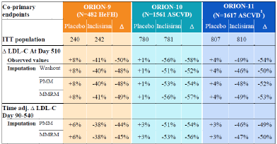
Abbreviations: ASCVD = atherosclerotic cardiovascular disease; MMRM = mixed effects model repeated measures; PMM = predictive mean matching; Washout = include the ‘Modified’ washout for the ORION-11 trials.
Secondary efficacy endpoints, including reductions in PCSK9, TC, Apo-B, and non-HDL-C, were supportive of the co-primary endpoints. Slight increases in HDL-C and small decreases in triglycerides were also observed across the studies. The proportion of subjects who attained global lipid targets at Day 510 (that is ˂ 1.8 mmol/L for ASCVD and ˂ 2.6 mmol/L for ASCVD-risk equivalent) was 82% for inclisiran and 16% for placebo in ASCVD subjects, and 70% for inclisiran and 17% for placebo in ASCVD risk equivalent subjects.
Subgroup analyses showed consistent effects on LDL-C across subgroups. The effect of inclisiran on LDL-C was similar for subjects with ASCVD and those who were ASCVD risk equivalent. Of the 482 randomised subjects with HeFH in the ORION-9 trial, 27% had ASCVD and 73% were ASCVD risk equivalent. Of the 1617 randomised subjects in the ORION-11 trial, 87% had ASCVD and 13% were ASCVD risk equivalent.
The effect of inclisiran on LDL-C was similar in subjects receiving a statin and in subjects not receiving a statin. Subgroup outcomes for those receiving a statin, those receiving other lipid management treatment without a statin, and those receiving no other lipid management treatment were also similar. The number of statin intolerant subjects in the pivotal studies was limited by the pre-specified cap of 15% of total study enrolment.
There appeared to be a trend of a greater percentage reduction in LDL-C with inclisiran in subgroups with lower baseline LDL-C; however, further analyses suggested that the subgroup differences based on baseline LDL-C were driven by changes in LDL-C levels in the placebo group rather than the inclisiran group, and that the percentage reduction in LDL-C associated with inclisiran was similar regardless of baseline LDL-C level.
The pivotal studies assessed the efficacy of inclisiran over 18 months of treatment, including two 6 monthly maintenance doses at Day 270 and Day 450. The ongoing long term extension trials, the ORION-8 and ORION-3 trials, will inform efficacy and safety of inclisiran for a duration up to 3 and 4 years respectively. Interim data from the ORION-3 trial show maintenance of efficacy out to Day 630. In the switching arm of the ORION-3 trial, the reduction in LDL-C was maintained after switching from evolocumab to inclisiran.
The efficacy of inclisiran has not been directly compared to PCSK9 inhibitors, but the magnitude of LDL-C lowering with inclisiran is broadly similar to that reported with PCSK9 inhibitors.

Safety
The safety dataset for inclisiran comprises 2452 subjects who received inclisiran at any dose. The safety pool from the Phase III studies included 3655 subjects, 1833 treated with inclisiran and 1822 on placebo, with mean duration of follow up of 526 days for and inclisiran 523 days for placebo. The safety of inclisiran beyond 18 months of treatment is being assessed in three ongoing studies: the ORION-3 (interim data presented in this submission), ORION-8, and ORION-4 trials.
The safety profile of inclisiran was similar across the three pivotal studies. In the safety pool, 78% of inclisiran-treated subjects experienced at least one TEAE as compared to 77.3% of placebo treated subjects. Most of the TEAEs were of mild to moderate intensity. The incidence of TESAEs, TEAEs leading to discontinuation and fatal events was comparable in both treatment arms.
The most notable difference in TEAEs in the safety pool was a higher incidence of TEAEs at the injection site in the inclisiran group (8.2%) compared to placebo (1.8%). None of the TEAEs at the injection site were severe or serious.
Clinically significant elevations (> 3 times ULN) of biochemical markers of hepatic function were comparable to placebo, although elevations of ALT and AST > 1 times ULN and ≤ 3 times ULN were observed more frequently with inclisiran. There were no cases meeting the definition of Hy’s Law. TEAEs related to hepatic events were balanced across the inclisiran and placebo treatment groups. Hepatic safety will continue to be monitored in the ongoing clinical studies as part of the evaluation of long-term safety.
The clinical evaluation identified TEAEs, including lower respiratory tract and lung infections (including bronchitis), osteoporosis, and joint disorders, which were observed more frequently with inclisiran than placebo and for which causality could not be excluded. The RMP evaluator proposes that these issues will be assessed as part of long-term safety monitoring.
The clinical evaluation identified a higher incidence of new onset of diabetes in subjects with metabolic syndrome and baseline fasting glucose ≥ 100 and < 126 mg/dL. There was no difference in new onset of diabetes in subjects who were non-diabetic at Baseline, and no difference in TEAEs relating to worsening of diabetes in subjects with diabetes at Baseline. The clinical significance of these findings remains uncertain as a difference in new onset diabetes was observed only in a subgroup of the safety population, and there were inconsistencies in the safety findings relating to diabetes across the individual Phase III studies and in the safety pool overall. Development or worsening of diabetes will be assessed in the ongoing clinical trials evaluating long-term safety and will also be presented as a safety topic in periodic safety update reports (PSUR).
Interim safety data from the ongoing extension study, the ORION-3 trial, were consistent with the safety profile from the Phase III studies.

Uncertainties and limitations of the data
The efficacy of inclisiran has been demonstrated in terms of its effect on LDL-C and associated laboratory parameters, but a cardiovascular benefit has not been demonstrated. The ongoing Phase III study, the ORION-4 trial, is evaluating the effect of inclisiran on cardiovascular outcomes. The studies presented in this submission support an indication based on lipid lowering effect, as per the Guideline on clinical investigation of medicinal products in the treatment of lipid disorders.⁸
The pivotal studies evaluated efficacy and safety up to 18 months. The efficacy and safety of inclisiran beyond 18 months of treatment is being assessed in the ongoing, extension studies, the ORION-3 trial (interim data presented in this submission) and the ORION-8 trial, and the ongoing CV outcomes study, the ORION-4 trial.
Inclisiran has not been studied in patients with severe hepatic impairment. In patients with moderate hepatic impairment in the ORION-6 trial, baseline PCSK9 levels were lower and the reduction in LDL-C was less than in patients with normal hepatic function or mild hepatic impairment. Use of inclisiran in patients with severe hepatic impairment is listed as missing information in the RMP.
Inclisiran has not been studied in patients with ESRD, and efficacy and safety data are limited for patients with severe renal impairment.
The efficacy and safety of inclisiran have not been assessed in children or adolescents. This limitation is addressed in the proposed indication restricting use to adults.
There are no clinical data on the use of inclisiran during pregnancy or lactation. This is listed as missing information in the RMP.

Proposed Indication
The sponsor’s proposed indication is:
Leqvio is indicated in adults with primary hypercholesterolaemia (heterozygous familial and nonfamilial) or mixed dyslipidaemia, as an adjunct to diet:
- in combination with a statin or statin with other lipid‐lowering therapies in patients unable to reach LDL‐C goals with the maximum tolerated dose of a statin or,
- alone or in combination with other lipid‐lowering therapies in patients who are statin intolerant, or for whom a statin is contraindicated.
The pivotal studies assessed the efficacy and safety of inclisiran in subjects with HeFH, ASCVD, and ASCVD risk equivalents, who were unable to achieve their target LDL-C despite maximally tolerated statin therapy. The ORION-9 trial assessed 482 subjects with HeFH, ORION-10 trial assessed 1561 subjects with ASCVD, and ORION-11 trial assessed 1617 subjects, of whom 87% had ASCVD and 13% had ASCVD risk equivalents.
The proposed indication includes adults with non-familial hypercholesterolaemia without regard to ASCVD or CV risk, whereas the majority of subjects with non-familial hypercholesterolaemia in the pivotal studies had ASCVD, and a minority were ASCVD risk equivalent. Therefore, the Delegate is inclined to the view that the indication for adults with non-familial hypercholesterolaemia should be restricted to those with ASCVD, but the Delegate would like to consider the advice of ACM before finalising Delegate’s position.
The proposed indication includes adults with mixed dyslipidaemia. The inclusion criteria of the pivotal studies did not refer specifically to mixed dyslipidaemia. The lipid parameters specified in the inclusion criteria of the pivotal studies were:
- LDL-C ≥ 2.6 mmol/L at screening for subjects in the ORION-9 trial and subjects in the ORION-11 trial with ASCVD risk equivalents; and LDL-C ≥ 1.8 mmol/L at screening for subjects in the ORION-10 and ORION-11 trials with ASCVD.
- fasting triglycerides < 4.52 mmol/L at screening.
The requirement for subjects to have fasting triglycerides < 4.52 mmol/L at screening limited enrolment of patients with mixed dyslipidaemia. 67.4% of screen failures in the ORION 9 trial were due to failure to meet the inclusion criterion for fasting triglycerides. Although subgroup analyses based on baseline triglyceride level showed no significant difference in placebo adjusted percentage change in LDL-C from Baseline to Day 510, the indication should not refer specifically to patients with mixed dyslipidaemia because this was only a subpopulation of the pivotal studies and patients with fasting triglycerides ≥ 4.52 mmol/L were not included.
The efficacy of inclisiran has been demonstrated with regard to lowering LDL-C, but a benefit on cardiovascular morbidity or mortality has not been demonstrated, so the indication should refer specifically to reducing LDL-C.
Subjects not receiving a statin could receive inclisiran alone or in combination with other LMT. Subjects not receiving a statin were required to have documented evidence of intolerance to all doses of at least two different statins. Enrolment of statin intolerant subjects was capped at 15% of total study enrolment. 9.5% of subjects in the ORION-9 trial, 10.8% in the ORION-10 trial, and 5.3% in the ORION-11 trial were not receiving statin therapy. The effect of inclisiran on LDL-C was similar in subgroup analyses of subjects on statin therapy and subjects not on statin therapy. The effect of inclisiran on LDL-C was also similar in subgroup analyses based on lipid management treatment (any statin, other LMT but no statin, or no other LMT).
The pivotal studies did not include subjects for whom a statin is contraindicated. The pivotal studies excluded patients with active liver disease (as defined in the exclusion criteria) and women who were pregnant or breastfeeding. Consequently, there remains uncertainty regarding the efficacy and safety of inclisiran in patients for whom a statin is contraindicated.
Subject to advice from ACM, Delegate’s suggested indication is:
Leqvio is indicated as an adjunct to diet and exercise to reduce low-density lipoprotein cholesterol (LDL-C) in adults with heterozygous familial hypercholesterolaemia or atherosclerotic cardiovascular disease:
- in combination with a statin or statin with other lipid‐lowering therapies in patients unable to reach LDL‐C goals with the maximum tolerated dose of a statin or,
- alone or in combination with other lipid‐lowering therapies in patients who are statin-intolerant.

Proposed conditions of registration
- The Inclisiran EU- RMP (version 1.0, dated 12 October 2020, DLP 17 September 2019), with ASA (version 1.1, dated 12 February 2021), included with submission PM-2020-04160-1-3, to be revised to the satisfaction of the TGA, will be implemented in Australia.
- An obligatory component of risk management plans is routine pharmacovigilance. Routine pharmacovigilance includes the submission of periodic safety update reports (PSURs).
Reports are to be provided in line with the current published list of EU reference dates and frequency of submission of PSURs until the period covered by such reports is not less than three years from the date of the approval letter.
The reports are to at least meet the requirements for PSURs as described in the European Medicines Agency’s Guideline on Good Pharmacovigilance Practices (GVP) Module VII-periodic safety update report (Rev 1), Part VII.B Structures and processes. Note that submission of a PSUR does not constitute an application to vary the registration.
Safety analysis of each of the following targeted safety measures requiring ‘long-term’ safety monitoring of Leqvio use is required in PSUR submissions to the TGA: respiratory tract infections (mainly bronchitis); osteoporosis and risk of spinal/pelvic fractures; hepatotoxicity; potential off-target effects in patients with severe renal impairment (end-stage renal disease); long-term immunogenicity; and worsening glycaemic control (new onset of diabetes, particularly in subjects with metabolic syndrome and in a prediabetic stage (fasting glucose 100 and < 126 mg/dL))
- Leqvio (inclisiran) is to be included in the Black Triangle Scheme. The PI and CMI for Leqvio must include the black triangle symbol and mandatory accompanying text for five years, which starts from the date that the sponsor notifies the TGA of supply of the product.
- Final study reports for ORION-3 and ORION-8 must be submitted to the TGA for review on completion.

Proposed action
The manufacturing quality of Leqvio is acceptable and there are no outstanding issues from a pharmaceutical chemistry perspective. The efficacy of inclisiran in lowering LDL-C has been demonstrated in three Phase III studies involving patients with HeFH, ASCVD, and ASCVD risk equivalents who were unable to achieve target LDL-C despite maximally tolerated statin therapy. The majority of the data in adults with non-familial hypercholesterolaemia is in patients with ASCVD. The safety profile of inclisiran is acceptable. Injection site reactions were observed more frequently with inclisiran compared to placebo. Long-term efficacy and safety are being assessed in ongoing long term studies.

Advisory Committee considerations
The Advisory Committee on Medicines (ACM), having considered the evaluations and the Delegate’s overview, as well as the sponsor’s response to these documents, advised the following.

Specific advice to the Delegate
- What is ACM’s advice regarding the Product Information guidance relating to end-stage renal disease and haemodialysis?
The ACM was of the view that inclisiran should not be recommended for use in patients with stage 5 chronic kidney disease and/or on haemodialysis due to the lack of safety evidence.
- What is ACM’s advice regarding use of inclisiran in patients with severe hepatic impairment?
The ACM noted that the LDL-C levels in patients with severe hepatic impairment have been reported to be low in general, therefore, the probability of using inclisiran therapy for LDL-C lowering in this patient population is extremely low. The ACM was of the view that inclisiran should not be recommended for use in patients with severe hepatic impairment.
- What is ACM’s advice regarding the study findings relating to glycaemic control and new onset diabetes, and the proposed risk management strategy?
The ACM noted that there was no difference in new onset of diabetes in subjects who were non-diabetic at Baseline, and no difference in treatment emergent adverse events relating to worsening of diabetes in subjects with diabetes at Baseline. However, the ACM agreed that the clinical significance of these findings remains uncertain as a difference in new onset diabetes was observed only in a subgroup of the safety population, and there were inconsistencies in the safety findings relating to diabetes across the individual Phase III studies and in the safety pool overall.
The ACM recommended that the risk of development or worsening of diabetes should be assessed as part of long-term safety monitoring in the ongoing clinical trials, and be included as part of the risk management plan.
- What is ACM’s advice on the guidance in section 5.1 of the Product Information regarding effects on the QTc interval?
The ACM agreed that the ORION-12 trial was a thorough QT study assessing the effects of a supratherapeutic dose of inclisiran sodium (900 mg subcutaneously) on cardiac repolarisation as assessed by QTcF in healthy subjects. There were no clinically significant effects on heart rate, PR and QRS intervals observed in the ORION-12 trial. The ACM agreed with the Delegate's proposed wording on the guidance in section 5.1 of the Product Information regarding effects on the QTc interval: 'No clinically significant increase in QTc or any other ECG parameter was observed with the supratherapeutic dose of inclisiran'.
- What is ACM’s advice regarding the proposed dosing guidance for patients transitioning from a PCSK9 inhibitor (monoclonal antibody) to inclisiran?
The ACM advised that there is no clinical need for concurrent transition (that is, evolocumab and inclisiran on the same day).
- What is ACM’s advice regarding the proposed indication?
The ACM agreed with Delegate's proposal to include the surrogate endpoint ‘reduction in LDL-C’ in the indication.
- Should the indication for patients with non-familial hypercholesterolaemia be restricted to those with ASCVD, or those at high risk of a CV event?
The ACM advised that the indication should not be restricted to those that have established ASCVD but should also be available to those at high risk of a cardiovascular event.

Conclusion
The ACM considered this product to have an overall positive benefit-risk profile for the indication:
Leqvio is indicated as an adjunct to diet and exercise to reduce low-density lipoprotein cholesterol (LDL-C) in adults with heterozygous familial hypercholesterolaemia, atherosclerotic cardiovascular disease, or at high risk of a cardiovascular event:
- in combination with a statin or statin with other lipid‐lowering therapies in patients unable to reach LDL‐C goals with the maximum tolerated dose of a statin or,
- alone or in combination with other lipid‐lowering therapies in patients who are statin-intolerant.

Outcome
Based on a review of quality, safety and efficacy, the TGA approved the registration of Leqvio (inclisiran) 284 mg/1.5 mL, solution for injection, vial indicated for:
Leqvio is indicated as an adjunct to diet and exercise to reduce low-density lipoprotein cholesterol (LDL-C) in adults with heterozygous familial hypercholesterolaemia, atherosclerotic cardiovascular disease, or at high risk of a cardiovascular event:
- in combination with a statin or statin with other lipid‐lowering therapies in patients unable to reach LDL‐C goals with the maximum tolerated dose of a statin or,
- alone or in combination with other lipid‐lowering therapies in patients who are statin-intolerant.

Specific conditions of registration applying to these goods
- Leqvio (inclisiran) is to be included in the Black Triangle Scheme. The PI and CMI for Leqvio must include the black triangle symbol and mandatory accompanying text for five years, which starts from the date that the sponsor notifies the TGA of supply of the product.
- The Inclisiran EU- RMP (version 1.0, dated 12 October 2020, data lock point 17 September 2019), with ASA (version 1.2, dated 5 August 2021), included with submission PM-2020-04160-1-3, to be revised to the satisfaction of the TGA, will be implemented in Australia.
An obligatory component of risk management plans is routine pharmacovigilance. Routine pharmacovigilance includes the submission of PSURs.
Reports are to be provided in line with the current published list of EU reference dates and frequency of submission of PSURs until the period covered by such reports is not less than three years from the date of the approval letter.
The reports are to at least meet the requirements for PSURs as described in the European Medicines Agency’s Guideline on GVP Module VII-periodic safety update report (Rev 1), Part VII.B Structures and processes. Note that submission of a PSUR does not constitute an application to vary the registration.
Analysis of the following inclisiran use safety topics is to be included in PSUR submissions to the TGA: hepatotoxicity; long-term immunogenicity; new onset Diabetes Mellitus and worsening of pre-existing Diabetes Mellitus; and use in patients with severe renal impairment.
- Final study reports for ORION-3 and ORION-8 must be submitted to the TGA for review on completion.

Attachment 1. Product Information
The PI for Leqvio approved with the submission which is described in this AusPAR is at Attachment 1. For the most recent PI, please refer to the TGA website at <https://www.tga.gov.au/product-information-pi>.

Therapeutic Goods Administration
PO Box 100 Woden ACT 2606 Australia
Email: info@tga.gov.au Phone: 1800 020 653 Fax: 02 6232 8605
https://www.tga.gov.au

The Black Triangle Scheme provides a simple means for practitioners and patients to identify certain types of new prescription medicines, including those being used in new ways and to encourage the reporting of adverse events associated with their use. The Black Triangle does not denote that there are known safety problems, just that the TGA is encouraging adverse event reporting to help us build up the full picture of a medicine's safety profile.
Diagnosis and Management of Familial Hypercholesterolaemia – Position Statement, Cardiac Society of Australia and New Zealand 2016
Repatha (evolocumab) was first registered in Australia on 9 December 2015. ARTG number: 231151.
Praluent (alirocumab) was first registered in Australia on 17 May 2016. ARTG number: 238285.
The ACSS Consortium (now the Access Consortium) was a medium-sized coalition of regulatory authorities that work together to promote greater regulatory collaboration and alignment of regulatory requirements. formed in 2007 and comprised the national regulatory authorities of Australia, Canada, Singapore and Switzerland. In October 2020, the United Kingdom’s Ministry of Healthcare products Regulatory Authority (MHRA) joined and the group's current name was changed to the 'Access Consortium'. Further information is available on the TGA website at: https://www.tga.gov.au/australia-canada-singapore-switzerland-united-kingdom-access-consortium
Cell line exhibiting epithelial morphology that was isolated from liver tissue derived from an 8 year old, Black youth with liver cancer. This cell line contains an integrated hepatitis B virus genome.
Drugs which have been taken by only a limited number of pregnant women and women of childbearing age, without an increase in the frequency of malformation or other direct or indirect harmful effects on the human fetus having been observed. Studies in animals have not shown evidence of an increased occurrence of fetal damage
European Medicines Agency (EMA), Committee for Medicinal Products for Human Use (CHMP), Guideline on clinical investigation of medicinal products in the treatment of lipid disorders. EMA/CHMP/748108/2013, Rev. 3.
Sponsor’s clarification: The most recent update to the estimated primary completion date of ORION-4 trial is July 2026.
Cytochrome P450 (CYP) enzymes: CYPs are the major enzymes involved in drug metabolism, accounting for large part of the total metabolism. Most drugs undergo deactivation by CYPs, either directly or by facilitated excretion from the body. Also, many substances are bioactivated by CYPs to form their active compounds. Many drugs may increase or decrease the activity of various CYP isozymes either by inducing the biosynthesis of an isozyme (enzyme induction) or by directly inhibiting the activity of the CYP (enzyme inhibition). This is a major source of adverse drug interactions, since changes in CYP enzyme activity may affect the metabolism and clearance of various drugs. Such drug interactions are especially important to take into account when using drugs of vital importance to the patient, drugs with important side-effects and drugs with small therapeutic windows, but any drug may be subject to an altered plasma concentration due to altered drug metabolism.
Modified Child-Pugh classification of the severity of liver disease according to the degree of ascites, the serum concentrations of bilirubin and albumin, the prothrombin time, and the degree of encephalopathy. A total Child-Turcotte-Pugh score of 5 to 6 is considered Child-Pugh class A (well-compensated disease), 7 to 9 is class B (significant functional compromise), and 10 to 15 is class C (decompensated disease). These classes correlate with one- and two-year patient survival: class A: 100 and 85%; class B: 80 and 60%; and class C: 45 and 35%.
The QT interval is the time from the start of the QRS wave complex to the end of the corresponding T wave. It approximates to the time taken for ventricular depolarisation and repolarisation, that is to say, the period of ventricular systole from ventricular isovolumetric contraction to isovolumetric relaxation.
The corrected QT interval (QTc) estimates the QT interval at a standard heart rate. This allows comparison of QT values over time at different heart rates and improves detection of patients at increased risk of arrhythmias. The QTcF is the QT interval corrected for heart rate according to Fridericia’s formula.
MACE (major cardiovascular event) is defined as the composite of cardiovascular (CV) death, resuscitated cardiac arrest, non-fatal myocardial infarction (MI), and stroke (ischemic or hemorrhagic)
Day 810 dose added to assess the effect of giving 2 doses 90 days apart
Health Canada, Guidance on Pre-market Evaluation of Hepatotoxicity in Health Products, 2012. Available from https://www.canada.ca
Routine risk minimisation activities may be limited to ensuring that suitable warnings are included in the product information or by careful use of labelling and packaging. Routine pharmacovigilance practices involve the following activities: - All suspected adverse reactions that are reported to the personnel of the company are collected and collated in an accessible manner; - Reporting to regulatory authorities; - Continuous monitoring of the safety profiles of approved products including signal detection and updating of labelling; - Submission of PSURs; - Meeting other local regulatory agency requirements.
The ACM provides independent medical and scientific advice to the Minister for Health and the TGA on issues relating to the safety, quality and efficacy of medicines supplied in Australia including issues relating to pre market and post-market functions for medicines. Further information can be found here: https://www.tga.gov.au/committee/advisory-committee-medicines-acm.

