December 2019

Australian Public Assessment Report for Inactivated quadrivalent influenza vaccine (split virion)
  - Proprietary Product Name: Vaxigrip Tetra
  - Sponsor: Sanofi-Aventis Australia Pty Ltd

About the Therapeutic Goods Administration (TGA)
- The Therapeutic Goods Administration (TGA) is part of the Australian Government Department of Health and is responsible for regulating medicines and medical devices.
- The TGA administers the Therapeutic Goods Act 1989 (the Act), applying a risk management approach designed to ensure therapeutic goods supplied in Australia meet acceptable standards of quality, safety and efficacy (performance) when necessary.
- The work of the TGA is based on applying scientific and clinical expertise to decision-making, to ensure that the benefits to consumers outweigh any risks associated with the use of medicines and medical devices.
- The TGA relies on the public, healthcare professionals and industry to report problems with medicines or medical devices. TGA investigates reports received by it to determine any necessary regulatory action.
- To report a problem with a medicine or medical device, please see the information on the TGA website <https://www.tga.gov.au>.

About AusPARs
- An Australian Public Assessment Report (AusPAR) provides information about the evaluation of a prescription medicine and the considerations that led the TGA to approve or not approve a prescription medicine submission.
- AusPARs are prepared and published by the TGA.
- An AusPAR is prepared for submissions that relate to new chemical entities, generic medicines, major variations and extensions of indications.
- An AusPAR is a static document; it provides information that relates to a submission at a particular point in time.
- A new AusPAR will be developed to reflect changes to indications and/or major variations to a prescription medicine subject to evaluation by the TGA.

Copyright
© Commonwealth of Australia 2019
This work is copyright. You may reproduce the whole or part of this work in unaltered form for your own personal use or, if you are part of an organisation, for internal use within your organisation, but only if you or your organisation do not use the reproduction for any commercial purpose and retain this copyright notice and all disclaimer notices as part of that reproduction. Apart from rights to use as permitted by the Copyright Act 1968 or allowed by this copyright notice, all other rights are reserved and you are not allowed to reproduce the whole or any part of this work in any way (electronic or otherwise) without first being given specific written permission from the Commonwealth to do so. Requests and inquiries concerning reproduction and rights are to be sent to the TGA Copyright Officer, Therapeutic Goods Administration, PO Box 100, Woden ACT 2606 or emailed to <tga.copyright@tga.gov.au>.

Contents
Common abbreviations 4
I. Introduction to product submission 6
Submission details 6
Product background 7
Regulatory status 8
Product Information 8
II. Registration timeline 8
III. Submission overview and risk/benefit assessment 9
Quality 9
Nonclinical 12
Clinical 13
Risk management plan 22
Risk-benefit analysis 23
Outcome 26
Attachment 1. Product Information 29

Common abbreviations
Abbreviation | Meaning
ACIP | Advisory Committee on Immunization Practices (USA)
AE | Adverse event(s)
AR | Adverse reaction
ASA | Australian specific annex
CHMP | Committee for Medicinal Products for Human Use (EU)
CPMP | Committee for Proprietary Medicinal Products (EU)
CI | Confidence interval
CMI | Consumer Medicines Information
DLP | Data lock point
DP | Drug product
DS | Drug substance
EMA | European Medicines Agency (EU)
EU | European Union
EU-RMP | European Union Risk Management Plan
FAS | Full analysis set
FASE | Full analysis set for efficacy
FASI | Full analysis set for immunogenicity
FDA | Food and Drug Administration (USA)
GBS | Guillain Barré syndrome
GMT | Geometric mean titres
GMTR | Geometric mean titre ratio
GPE | Global pharmacovigilance and epidemiology
HA | Haemagglutinin
HAI | Haemagglutination inhibition
IM | Intramuscular
LL | Lower limit
mL | Millilitre(s)
NA | Neuraminidase
NH | Northern Hemisphere
PD | Pharmacodynamic(s)
Ph. Eur | European Pharmacopoeia
PP | Per protocol
PPAS | Per-protocol analysis set
PPE | Per-protocol analysis set for efficacy
PPI | Per-protocol analysis set for immunogenicity
QIV | Quadrivalent inactivated influenza vaccine
RMP | Risk management plan
SafAS | Safety analysis population
SC | Subcutaneous
SCR | Seroconversion rate
SH | Southern Hemisphere
TGA | Therapeutic Goods Administration
TIV | Trivalent inactivated influenza vaccine
US(A) | United States (of America)
VE | Vaccine efficacy
WHO | World Health Organization

I. Introduction to product submission

Submission details
Type of submission: | New biological entity
Decision: | Approved
Date of decision: | 15 May 2019
Date of entry onto ARTG: | 20 May 2019
ARTG numbers: | 299922, 315082
Black Triangle Scheme | No

Active ingredient: | Inactivated quadrivalent influenza vaccine (split virion) influenza virus haemagglutinin
Product name: | Vaxigrip Tetra
Sponsor’s name and address: | Sanofi-Aventis Australia Pty Ltd  12-24 Talavera Road  Macquarie Park NSW 2113
Dose form: | Suspension for injection
Strength: | 60 µg/0.5 mL
Containers: | Prefilled syringe needle free and prefilled syringe with attached needle
Pack sizes: | 1 or 10
Approved therapeutic use: | Vaxigrip Tetra is indicated for active immunisation of adults and children from 6 months of age and older for the prevention of influenza disease caused by the two influenza A virus subtypes and the two influenza B virus types contained in the vaccine.
Routes of administration: | Intramuscular or deep subcutaneous injection
Dosage: | Vaxigrip Tetra should be given in accordance with the national recommendation as per the current Immunisation Handbook.  Given the antigenic variation in circulating influenza viruses and the duration of immunity provided by the vaccine, it is recommended to perform vaccination against influenza every year at the beginning of the risk period.  Individuals from 9 years of age: one injection of 0.5 mL dose.  Children from 6 months to 8 years of age:  - If the child has not previously been vaccinated: two 0.5 mL injections at least one month apart.  - If the child has been previously vaccinated: a single 0.5 mL injection.  For further information refer to the Product Information.

Product background
This AusPAR describes the application by Sanofi-Aventis Australia Pty Ltd (the sponsor) to register Vaxigrip Tetra (inactivated quadrivalent influenza vaccine (split virion) influenza virus haemagglutinin) for the following indication:
[…] active immunisation of adults and children from 6 months of age and older for the prevention of influenza disease.
Influenza is a seasonal infectious disease caused by an orthomyxovirus that can lead to considerable morbidity and mortality. Influenza is a highly infectious disease that occurs in epidemics throughout the Northern Hemisphere (NH) and Southern Hemisphere (SH) winter months. Minor or major epidemics of influenza occur in most years, usually during the winter months in temperate regions. In general, influenza resolves within two to seven days, although symptoms of cough and malaise may be prolonged. However, for some population groups, notably the elderly and those with chronic diseases influenza can exacerbate underlying medical conditions and/or lead to secondary viral or bacterial pneumonia., During influenza epidemics, there is an increased mortality risk among older adults (age > 65 years), people with chronic diseases, and very young children (age 0 to 12 months), as well as an increase in morbidity and hospitalisation because of influenza-associated complications.^{1,} The impact of influenza is often substantially underestimated.
Influenza types A and B cause most human disease. Influenza A viruses are divided into subtypes based on two viral external proteins, the haemagglutinin (HA) and the neuraminidase (NA) proteins. Of the influenza type A virus subtypes, the influenza A/H3N2 and A/H1N1 subtypes are clinically the most important. Influenza type B viruses show extensive variation in antigenicity. Influenza B viruses are separated into two distinct genetic lineages, Yamagata and Victoria. In terms of infection, influenza type A viruses have been isolated from several non-human species, including birds, horses, and swine, whereas influenza type B viruses almost exclusively affect humans. The influenza A or B surface glycoprotein HA is the key antigen involved in attachment of the virus to receptors on respiratory epithelial cells, whereas the NA glycoprotein is involved in release of the virus from the cell surface. During infection, the virus stimulates production of antibodies in the serum (immunoglobulin G) and nasal secretions (immunoglobulin A) to these surface glycoproteins. High levels of virus type-specific antibodies are associated with protection from disease due to infections with homologous and closely related influenza virus strains.1, Novel influenza strains arise from antigenic drift due to point mutation and recombination events that occur during viral replication. These events result in the emergence of new strains of the influenza virus capable of causing epidemics, as pre-existing antibodies resulting from previous virus exposure or vaccination are generally not cross-protective.4
Prevention of influenza illness is achieved by annual prophylactic immunisation, the exact composition of which changes according to what are predicted to be the predominant A and B strain(s) circulating in either the NH or SH for that influenza season. The awareness and analysis of the potential for B strain mismatch between circulating strains and vaccine included strains has led to new strategies for improved vaccine protection. Specifically, a number of quadrivalent vaccines with representative strains of both major B strain lineages have been developed.
In Australia, annual influenza vaccination is currently recommended for any person ≥ 6 months of age who wishes to reduce the likelihood of becoming ill with influenza, as well as a range of co-morbid conditions that place persons at risk of complications from influenza infection.

Regulatory status
Vaxigrip Tetra (inactivated quadrivalent influenza vaccine (split virion) influenza virus haemagglutinin) is considered a new biological entity for Australian regulatory purposes.
The initial application for Vaxigrip Tetra for individuals aged ≥ 3 years was submitted in 2015 under the decentralised procedure in the European Union (EU). Following the approval, a variation application to lower the age indication to ≥ 6 months of age was submitted in July 2017, and approved in some countries. The reference member state is Germany for both applications. At the time this submission was under consideration, the ≥ 6 months of age indication was approved in over 40 countries worldwide, and was under consideration in Italy, Slovakia, Brunei Darussalam and Costa Rica.

Product Information
The Product Information (PI) approved with the submission which is described in this AusPAR can be found as Attachment 1. For the most recent PI, please refer to the TGA website at <https://www.tga.gov.au/product-information-pi>.

II. Registration timeline
Table 1 captures the key steps and dates for this application and which are detailed and discussed in this AusPAR.
Table 1: Timeline for Submission PM-2018-00583-1-2
Description | Date
Submission dossier accepted and first round evaluation commenced | 29 March 2018
First round evaluation completed | 4 September 2018
Sponsor provides responses on questions raised in first round evaluation | 31 October 2018
Second round evaluation completed | 30 November 2018
Delegate’s Overall benefit-risk assessment and request for Advisory Committee advice | 5 March 2019
Sponsor’s pre-Advisory Committee response | 19 March 2019
Advisory Committee meeting | 3 April 2019
Registration decision (Outcome) | 15 May 2019
Completion of administrative activities and registration on the ARTG | 20 May 2019
Number of working days from submission dossier acceptance to registration decision* | 168
*Statutory timeframe for standard applications is 255 working days

III. Submission overview and risk/benefit assessment
The submission was summarised in the following Delegate’s overview and recommendations.

Quality
The submission is for registration of Vaxigrip Tetra, an inactivated (split virion) quadrivalent, influenza vaccine. The drug product is presented in 1 mL clear glass syringes with each syringe containing 0.5 mL of vaccine which nominally contains 60 µg HA antigen. The 60 µg HA comprises 15 µg of each of four strains of virus (influenza A/H1N1, A/H3N2, B (Yamagata lineage) and B (Victoria lineage)). This product is similar to the currently registered and previously supplied inactivated trivalent influenza virus vaccine, Vaxigrip (which contains a nominal 45 µg of HA; 15 µg of each of three strains (influenza A/H1N1, A/H3N2, and a B strain of either Yamagata or Victoria lineage)).
The quality evaluator advises that on the basis of the quality assessment, there are no identified quality issues that would preclude the registration of the product, however, there are some issues that need to be fully resolved before it is possible to provide assurances that the product is able to meet all of the requirements of the Therapeutics Goods Act 1989 and its associated instruments.
The quality evaluator has proposed a list of quality ‘conditions of registration’ to ensure the product is fully compliant with all of the previously mentioned instruments before release of the product into the market in Australia (see ‘Proposed quality conditions of registration’, below).
The quality evaluator has summarised the identified quality issues, and has also advised the clinical Delegate that some of the issues could be managed through the evaluation of future requests for seasonal variations while other issues have to be addressed through the proposed quality conditions of registration.
The quality evaluator also raises the issue with the label name currently proposed by the sponsor:
Vaxigrip Tetra Inactivated Quadrivalent Influenza Vaccine (Split Virion), Influenza Virus Haemagglutinin 60 mcg, 0.5 mL, Suspension For Injection In Pre-Filled Syringe Influenza virus haemagglutinin.
For clarity and to align better with other products in the marketplace, the quality evaluator recommends that the label name be amended to:
Vaxigrip Tetra Inactivated Quadrivalent Influenza Vaccine (Split Virion), Influenza Virus Haemagglutinin 60 mcg, 0.5 mL, Suspension For Injection, Pre-Filled Syringe, needle-free.
Consequent changes that are not covered elsewhere also need to be made to the PI, the Consumer Medicines Information (CMI) and the packaging as a result of the name change.

Proposed quality conditions of registration
Before it is possible to provide assurances that the product is of suitable quality within the framework of the Therapeutics Goods Act 1989 and its associated instruments, the following conditions of registration will need to be met:
- Quality; including compliance with European Pharmacopoeia (Ph. Eur) 2.6.16 (infectious disease safety)
It is a condition of registration that:
- At least 45 working days before the submission of the first request under s9D(3) of the Therapeutic Goods Act 1989 for a change to the strain composition of the vaccine, and not later than 31 October 2019, the following be provided to the TGA for approval under s9D(3) of the Act:
- Revised syringe labels that clearly show the age indication for the product and, amended packaging that meets the requirement of TGO91.
- Summaries of historical inactivation data and stability data is to be provided in a suitable format in a clearly identified section of the dossier.
- Evidence demonstrating that the factors responsible for the presence of particles/filaments in samples of monovalent bulk (drug substance) used for the Appearance Test (conducted under Q_0001593) have been adequately addressed to significantly reduce the risk of contamination of test samples with extraneous particles.
- Demonstration that the product:
- Conforms to the tests which are invoked by the European Pharmacopoeia (Ph. Eur.) General Monograph 07/2018:0153 Vaccines for human use that control for non-specific extraneous agents including non-enveloped viruses. These tests are specified in Ph. Eur. Methods of Analysis 2.6.16 Tests for extraneous agents in viral vaccines for human use; or
- has alternative measures applied that are effective at managing the risk of contamination with known, emerging, and unknown non-enveloped viruses, to an equivalent or greater level than the measures prescribed by Ph. Eur. 2.6.16.
- An updated risk assessment and risk management procedure which:
- provides specific coverage on how the sponsor addresses product contamination risks posed due to entry of known, emerging, and unknown viruses in candidate virus vaccine or egg substrates; and
- summarises the risk management strategies for ensuring ongoing freedom from extraneous agents in final product.
Any extension beyond the time frame and dates indicated above would be would be subject to written agreement with the TGA.
- The shelf-life of the drug substance (DS) will be 24 months with the condition that any DS to be used for formulation of drug product will be retested if it is to be used in the manufacture of drug product (DP) more than three (3) months after its date of manufacture. The DS must meet the specification of having an HA content of not less that 70% of the content estimated in the first test after manufacture before it can be used for the manufacture of DP. Summary protocols of manufacture must provide the results for both tests on the DS.
- Batch release testing and compliance with the Certified Product Details
It is a condition of registration that all independent batches of Vaxigrip Tetra and Vaxigrip Tetra Junior imported into Australia are not released for sale until samples and the manufacturer’s release data have been assessed and you have received notification acknowledging release from the Laboratories Branch, TGA.
For each independent batch of the product imported into Australia, the sponsor must supply the following:
  - A completed Request for Release Form, available from vaccines@health.gov.au.
  - Complete summary protocols for manufacture and QC, including all steps in production.
  - At least 20 (twenty) doses of the first consignment of each batch of Vaxigrip Tetra with the Australian approved labels, PI and packaging and 40 (forty) doses of the first consignment of each batch of Vaxigrip Tetra Junior with the Australian approved labels, PI and packaging
  - At least 10 (ten) doses of any further consignment of each batch of Vaxigrip Tetra with the Australian approved labels, PI and packaging and at least 20 (twenty) doses of any further consignment of each batch of Vaxigrip Tetra Junior with the Australian approved labels, PI and packaging.
  - Certificate of Release from regulatory agency acting for the country of origin such as an OMCL (if available).
  - Any reagents, reference material and standards required to undertake testing, as requested by Laboratories Branch, TGA.
Distribution of each shipment of each batch of vaccine is conditional upon fulfilment of these conditions and receipt of a letter from the Laboratories Branch acknowledging release.
Samples and data should be forwarded to the Immunobiology Section, Laboratories Branch before release of each batch and with sufficient lead time to allow for Laboratories Branch testing.
All shipments (including reagents) must be sent to TGA from the Australian sponsor/agent who will be required to facilitate the import and customs clearance process.
  - Certified Product Details
An electronic copy of the Certified Product Details (CPD) as described in Guidance 7: Certified Product Details of the Australian Regulatory Guidelines for Prescription Medicines (ARGPM) https://www.tga.gov.au/guidance-7-certified-product-details should be provided upon registration of the therapeutic good. In addition, an updated CPD, for the above products incorporating the approved changes is to be provided within one month of the date of approval letter. A template for preparation of CPD for biological prescription medicines and vaccines can be obtained from the TGA website https://www.tga.gov.au/form/certified-product-details-cpd-biological-prescription-medicines. The CPD should be sent as a single bookmarked PDF document to vaccines@health.gov.au as soon as possible after registration/approval of the product or any subsequent changes as indicated above.

Nonclinical
Vaxigrip Tetra is proposed for the active immunisation of adults and children from 6 months of age and older for the prevention of influenza disease caused by the two influenza A virus subtypes and the two influenza B virus types contained in the vaccine, which will be administered via intramuscular (IM) or deep subcutaneous (SC) injection.
The number of new nonclinical studies conducted with Vaxigrip Tetra is in accordance with European Medicines Agency (EMA) guidance; for a new influenza vaccine based on an existing manufacturing process by the sponsor. The nonclinical dossier comprised of four new nonclinical studies:
- Primary pharmacology (Study F.RE.QIV002.Ms; in mice); this study evaluated the immunogenicity induced by 3 quadrivalent inactivated influenza vaccine (QIV) batches and 2 trivalent inactivated influenza vaccines (TIV) and found that the functional haemagglutination inhibition (HAI) responses measured with the three QIV batches were similar to those induced by the two TIV batches in regards to the A and B strains. The QIV vaccines, having broader coverage than the TIV vaccines, induced HAI responses for all four strains, whereas the TIV vaccines only induced responses for the B strain included in their respective composition.
- Repeat-dose toxicity (Study SP0171 RD1403; in rabbits); this study determined the local tolerance and systemic toxicity of the QIV, following three IM injections to rabbits, which were 2 weeks apart. Furthermore, the study assessed any delayed onset of toxicity and/or the reversibility of toxicity during a 2 week treatment free period. The study found that the vaccine was well tolerated in rabbits. No treatment related changes in clinical pathology, evidence of systemic toxicity or poor local tolerance was observed throughout the study. Treatment related findings were limited to minimal and transient local inflammation at the injected muscle which showed evidence of recovery at the end of the 14 day observation period.
- Reproductive and developmental toxicity (Study SP0171 DV1207; in rabbits); this study evaluated the effects of the QIV on embryofetal development and early post-natal development of the rabbit, following IM administration at 24 and 10 days before the start of mating, as well as on gestation Days 6, 12 and 27. The study found no signs of systemic maternal toxicity, no evidence of any induced adverse maternal findings, effects on embryofetal development or early post-natal development in the rabbit.
- Toxicity study investigating cardiovascular function (Study SP0171 PS1404; in rabbits); this study assessed the potential effect of the QIV on cardiovascular and respiratory functions, as well as body temperature in conscious telemetered male rabbits over a 24 period following 1 to 3 IM injections (2 weeks apart). The study found that the QIV vaccine did not show any significant effects on the parameters measured.

Paediatric use
Vaxigrip Tetra is proposed for paediatric use. However, no specific nonclinical studies in juvenile animals have been submitted.

Recommendations from the nonclinical evaluation
Although the number of submitted animal studies with the QIV is limited, the evaluated data raises no nonclinical objections to registration of Vaxigrip Tetra vaccine. However, evaluation of the efficacy and safety will largely rely on the clinical data.
The draft PI should be amended as indicated in the nonclinical evaluation report.

Delegate’s summary of the nonclinical evaluation
The number of new nonclinical studies conducted with Vaxigrip Tetra is in accordance with EMA guidance for a new influenza vaccine;5 based on an existing manufacturing process by the sponsor. The nonclinical dossier comprised of four new nonclinical studies. Although the number of submitted animal studies with the QIV is limited, the evaluated data raises no nonclinical objections to registration of this QIV. However, the non-clinical evaluator pointed out that the evaluation of the efficacy and safety will largely rely on the clinical data.

Clinical
The efficacy of the QIV is inferred from its immunogenicity based on comparative immunogenicity evaluation with the sponsor’s TIV which has been licensed in the EU since 1998. In accordance with EMA Guideline on Clinical Evaluation of New Vaccines;5 the mechanism of action of influenza vaccines consists of the induction of immune responses against the antigens contained in the vaccine. Therefore, the pharmacodynamics (PD) profile of the QIV is defined by its immunogenicity profile.
In addition, the immunogenicity recommendations for influenza vaccines are to meet at least one of the three EMA criteria per age as defined in the relevant guidance document..
The following 5 Phase III studies provided immunogenicity data for the candidate QIV in adults (18 to 60 years old), the elderly (> 60 years old), and in subjects from 3 to 17 years of age. An additional efficacy study (Study GQM05) is provided to support the QIV in subjects from 6 to 35 months of age. The clinical dossier contains the study reports for these 6 studies, integrated safety analyses, and post marketing data for the TIV in pregnancy, and so on.
Studies included in the clinical dossier:
- Study GQM11 (18 to 60; and > 60 years old);
- Study GQM01 (18 to 60; and > 60 years old);
- Study GQM04 (9 to 17 years; and 18 to 60 years old);
- Study GQM09 (9 to 17 years old);
- Study GQM02 (3 to 8 years old).
The summary of the five Phase III studies is presented in Table 2, below.
Table 2: Summary of the five Phase III clinical studies
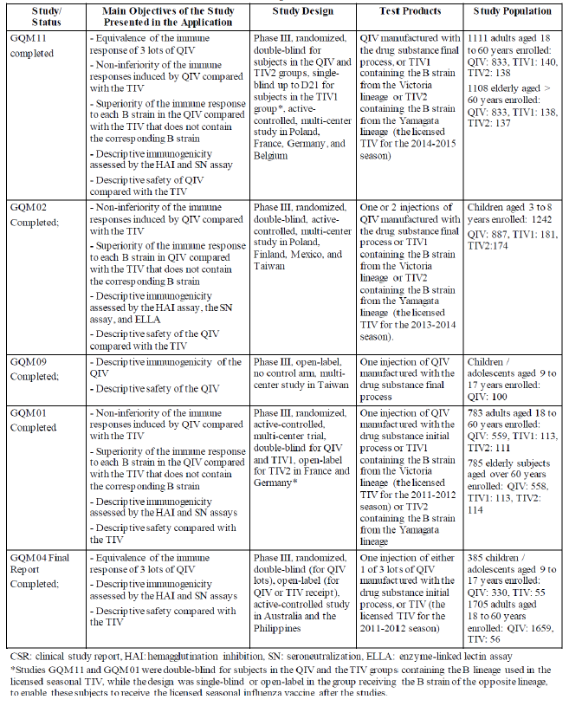

Immunogenicity and efficacy

Study GQM11 (adults and elderly)
Study GQM11 was a randomised, double blind study for subjects in the QIV and TIV2 groups; single blind up to Day 21 for subjects in the TIV1 group; active controlled, multi-centre trial in approximately 1112 adult (aged 18 to 60 years old) and 1112 elderly (aged > 60 years old) subjects in Europe.
The primary objective was lot-to-lot consistency. Lot-to-lot consistency of 3 lots of the QIV was demonstrated, as the equivalence criteria were met. Lot-to-lot consistency was confirmed after adjustment on baseline anti-HAI antibody titres. It was observed that one of the vaccine lot comparisons did not include 1 in the 95% confidence interval (CI): lot S4456 versus lot S4458 for the H3N2 strain, with a geometric mean titre ratio (GMTR) of 1.14 (95% CI 1.02; 1.27). Although this indicates a statistically significant difference between the geometric mean titres (GMT) of these 2 lots (after baseline correction), the difference is not considered as clinically relevant, because the 95% CI limits of the difference are still within the pre-specified range of 0.667 to 1.5. Moreover, the study was not designed to control the alpha risk to detect at least 1 difference based on these 95% CIs, and due to the resulting multiplicity issue, the risk to detect at least 1 difference, which does not exist, is inflated. Results were similar in the per-protocol analysis set (PPAS) and the full analysis set (FAS).
The non-inferiority and superiority analyses were performed on the pool of QIV lots.
Non-inferiority of the immune response to the QIV compared to the response to the TIV was demonstrated as the lower limit of the 2-sided 95% CI of GMT-QIV/GMT-TIV > 0.667 for each of the strains. The GMTs at Baseline against each of the 4 strains were similar across vaccine groups in both adults aged 18 to 60 years and the elderly aged > 60 years. The analysis of non-inferiority of the QIV to the TIV in all subjects in the PPAS is presented in Table 3, shown below. Non-inferiority of the QIV compared to the TIV was confirmed after adjustment on pre-vaccination titres, as well as in the FAS.
Table 3: Immunogenicity primary objective: non-inferiority in all subjects-age stratified geometric mean titre ratio 21 days post vaccination, Per-protocol analysis set (Study GQM11)
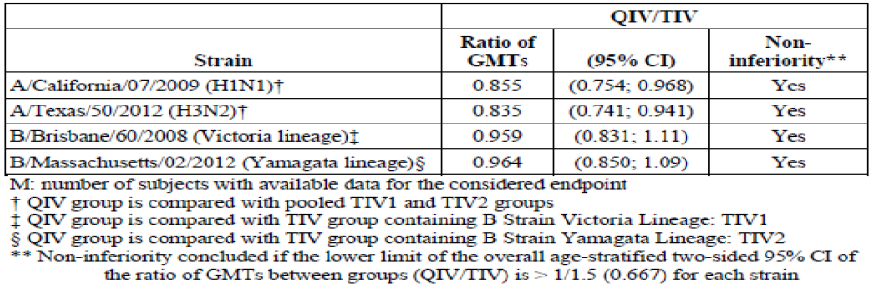
Analysis of superiority was secondary objective of the study. In each age group, the QIV demonstrated superior immunogenicity compared to the TIV for the additional B strains in the FAS.
Overall, the study demonstrated that the 3 QIV lots were shown to be as immunogenic as the licensed TIV in adult and elderly subjects. In addition, the 3 QIV lots provided superior immunogenicity against influenza B strains of both lineages simultaneously compared to TIV. QIV induced an immune response that lasted for 12 months; however, relatively few participants (only 18% in each age strata) had a Month 12 visit, so these persistence data are derived from a minority.

Study GQM01 (adults and elderly subjects)
Study GQM01 was a Phase III, randomised, double blind (except for subjects included in the TIV2 group), active controlled multicentre trial in 1568 adult (18 to 60 years of age) and elderly (> 60 years of age) subjects in Europe.
Non-inferiority of the QIV versus the TIVs was assessed on the per-protocol (PP) analysis set. Before vaccination, GMTs were similar between groups for each age group. No major differences were found between immune responses to TIV1; and TIV2 for the A strains, and analysis of their pooled response was considered. Non-inferiority for all the 4 strains was concluded, as the lower limit (LL) of the age-stratified two-sided 95% CI of the ratio of GMTs between groups was > 1/1.5 (0.667) for each strain. Hence the immune response induced by the QIV is non-inferior to the one induced by a TIV, as measured with the HAI method. The same trend is observed in each age group with ratios of GMTs within age group ranging from 0.778 to 1.21 (in adults) and 0.931 to 1.10 (in elderly subjects) for the 4 strains. Similar results obtained for the FAS.
Superiority of the B strain response of the QIV versus TIVs was assessed on the FAS. Before vaccination, GMTs were similar between groups for each age group. While the immune response increased against the B strain not contained in the TIV after TIV vaccination, this immune response was greater with the QIV: the two sided 95% CI of the ratio of GMTs between groups was > 1 for the 2 B strains in each age group. Therefore, for each B strain, the QIV induced immune response was superior to the immune response induced by a TIV not containing that B strain. Similar results were obtained for the PP analysis set.

Study GQM09 (9 to 17 years)
Study GQM09 was an open label, uncontrolled, multi-centre Phase III study conducted in Taiwan. The study included 100 subjects aged 9 to 17 years. This study was conducted as a Taiwan Food and Drug Administration requirement to register the vaccine in Taiwan in those aged ≥ 9 years.
A descriptive analysis of the anti-HA antibody response showed that the QIV elicited an immune response against all 4 strains. As Study GQM09 was designed without control arm, no comparative data of the immune response to the QIV versus the TIV are available for this age group.
No non-inferiority analysis was performed. However, the level of post-vaccination titres to the QIV in adolescents appears similar to that observed in adults in Study GQM11, this was also observed in Study GQM04. In addition, as non-inferiority of the QIV compared to the TIV was demonstrated in adults (aged 18 years and above) and in children aged 3 to 8 years, non-inferiority is also expected in children and adolescents aged 9 to 17 years. This extrapolation was supported by the observation that the ratios of GMTs between the QIV and TIV groups were comparable whatever the age group (that is, 3 to 8 years, 18 to 60 years and > 60 years) and may therefore be expected to be similar in subjects aged 9 to 17 years.

Study GQM04 (subjects aged 9 to 17 years; and 18 to 60 years)
Study GQM04 was a Phase III, randomised, double blind (for QIV lots), open (for QIV or TIV receipt), controlled, multicentre trial in 385 children/adolescent (9 to 17 years of age) and 1705 adults (18 to 60 years of age) subjects in the Asia-Pacific region.
The primary objective is the assessment of safety.
The secondary objectives include:
- Lot consistency: to demonstrate that the 3 different industrial lots of QIV induce an equivalent immune response at 21 days post-vaccination in both age groups;
- Immunogenicity: to describe the compliance of the immunogenicity of QIV to the EMA criteria;6 in each age group.
Lot consistency: in the analysis with results stratified by age and according to an adjustment on baseline titres, lot consistency was confirmed for each pair of lots and for each strain as the two sided 95% CI was between 1/1.5 and 1.5 for each pair of lots and for each strain and equivalence for all the 4 strains was concluded. The ratio of GMTs ranged from 0.848 to 1.02 for the 4 strains; that is, close to 1.
Immunogenicity: for adults, the three EMA criteria are met (all 95% CI inclusive) for each strain. The results for the subjects of 9 to 17 years old were comparable to the adult group; GMTRs were higher than those of adults.

Study GQM02 (children 3 to 8 years)
Study GQM02 was a Phase III, randomised, double blind, active control multicentre study. The subjects in this study received either 1 or 2 injections of the QIV or the TIV, based on their previous vaccination history. Subject received 1 injection if they had received a full schedule of influenza vaccines (that is, 2 injections in the same year) in any of the years preceding the study, and were defined as ‘primed’ subjects. If they had not received a full schedule of 2 injections in any year before the study, they received 2 injections, with an interval of 28 days, and were defined as ‘unprimed’ subjects. The proportion of primed and unprimed subjects in the QIV and TIV groups was similar. The GMTs at Baseline against each of the 4 strains were similar across vaccine groups in both primed and unprimed subjects.
The primary objective is the analysis of non-inferiority of the immune response of the QIV versus the TIV in all subjects. This analysis in the PPAS is presented in Table 4, below.
Table 4: Immunogenicity primary objective: non-inferiority to the trivalent inactivated influenza vaccine; geometric mean titre ratio 28 days post the last vaccination, Per-protocol analysis set (Study GQM02)
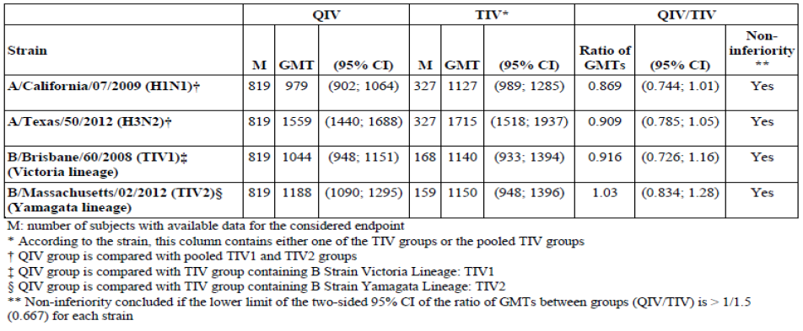
Non-inferiority of the immune response to the QIV compared to the TIV was demonstrated as the lower limit of the 2 sided 95% CI of GMT-QIV/GMT-TIV > 0.667 for each of the strains. Non-inferiority was tested for the entire population, and not separately in primed and unprimed subjects, as the number of subjects with primed and unprimed status could not be confirmed in advance. Nonetheless, the trend was the same in primed and unprimed subjects as that observed in the overall population, although no statistical comparison was performed. Non-inferiority was also confirmed after adjustment on baseline anti-HAI antibody titres and after stratification on history of previous influenza vaccination. Results were similar in the PPAS and the FAS.
The QIV also demonstrated superior immunogenicity compared to the TIV for the additional B strains. The GMT ratios were 6.17 (95% CI: 4.80; 7.94) for the influenza B Victoria strain and 5.38 (95% CI: 4.34; 6.68) for the influenza B Yamagata strain. Superiority of the immune response to the QIV compared to the TIV that does not contain the B lineage tested was demonstrated as the lower limit of the 2-sided 95% CI of GMT-QIV/GMT-TIV was > 1.

Study GQM05 (children 6 to 35 months)
Study GMQ05 was a Phase III, randomised, observer blind (except TIV groups which were open label), placebo controlled, multicentre trial in 4 regions involving approximately 9000 healthy children aged 6 to 35 months who were influenza vaccine naive. In Cohorts 1, 3, and 4, approximately 7608 to be randomised in a 1:1 ratio to receive a 2 dose schedule 28 days apart of either QIV or placebo. In Cohort 2, approximately 1392 subjects to be randomised in a 2:2:1:1 ratio to receive a 2 dose schedule 28 days apart of QIV, or placebo, or TIV containing either the B strain from the Victoria lineage (TIV1) or the B strain from the Yamagata lineage (TIV2) as recommended by the World Health Organization (WHO).
Although administration of ‘half dose’ (0.25 mL) of influenza vaccine in children aged 6 to 35 months is recommended by WHO for influenza vaccination, the ‘full dose’ (0.5 mL) of QIV was used in Study GQM05. The rationale for this was based on published data showing that administration of two ‘full doses’ (2 x 0.5 mL) of TIV in infants/toddlers improves immunogenicity without increasing reactogenicity. In addition, the use of 0.5 mL dose in children < 3 years of age is already implemented in routine practice in parts of Europe. In a Finnish study, the effectiveness of the licensed seasonal TIV manufactured by the sponsor in France against matched strains was found to reach 66% in children aged 9 months to 3 years who received two 0.5 mL vaccine doses 28 days apart. As recommended by WHO and Europe in children not previously been vaccinated, a second dose should be given after an interval of at least 4 weeks, this approach was used in Study GQM05.
There were 6 main analysis sets in this study: the per-protocol analysis set for efficacy (PPE); full analysis set for efficacy (FASE); per-protocol analysis set for immunogenicity (PPI); full analysis set for immunogenicity (FASI); the other immunogenicity analysis set; and the safety analysis population (SafAS).

Primary objective: vaccine efficacy
A total of 365 subjects in the PPE experienced laboratory-confirmed influenza illness, 120 subjects (4.82%) in the QIV group and 245 subjects (9.84%) in the placebo group. Among these, 24 subjects (0.96%) in the QIV group and 76 subjects (3.05%) in the placebo group had influenza illness due to virus strains similar to those in the vaccine. Efficacy of QIV for the prevention of laboratory-confirmed influenza illness caused by any influenza A or B strains is presented in Table 5. The vaccine efficacy of 2 QIV doses in previously unvaccinated children for the prevention of laboratory-confirmed influenza illness was demonstrated for both primary endpoints as the lower bound of the 97% CIs for the corresponding vaccine efficacy (VE) were above the predefined margin of 20%. Results were similar in the Full analysis set for efficacy (FASE).
Table 5: Primary objective, vaccine efficacy against laboratory confirmed influenza illness in per-protocol analysis set for efficacy population (Study GQM05)
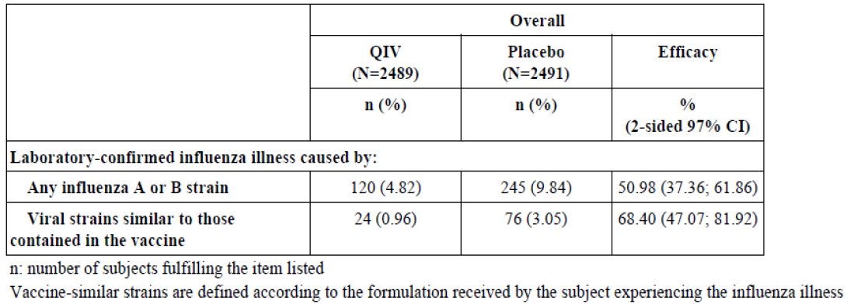
The 95% CIs of VEs (PPE and FASE) are also provided for descriptive purpose. Overall, in the FASE population, QIV prevents 52.03% (95% CI: 40.24; 61.66) of laboratory confirmed influenza illness caused by any circulating strains and 69.33% (95% CI: 51.93; 81.03) of laboratory confirmed influenza illness caused by vaccine similar strains. The potential benefit of QIV in this population is further highlighted by the substantial attack rate of influenza illness during the study, close to 10% in the Placebo group.

Immunogenicity
There were no primary immunogenicity objectives. The analyses of non-inferiority and superiority were performed as secondary objectives in a subset of subjects. The GMTs at baseline against each of the 4 strains were similar across vaccine groups. The analysis of non-inferiority of the QIV to the TIV in a subset of subjects was a secondary objective and this analysis in the PPAS is presented in Table 6.
Table 6: Non-inferiority between quadrivalent inactivated influenza vaccine and tetravalent inactivated influenza vaccine in a subset of subjects, ratios of anti-haemagglutinin geometric mean titres 28 days after second vaccination, per-protocol analysis set (Study GQM05)
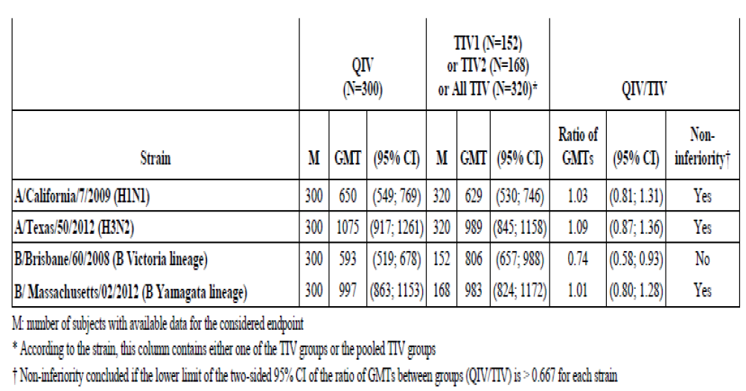
Non-inferiority on immune response was demonstrated in the PPI for 3 of the vaccine strains as the lower limit of the two-sided 95% CI of the ratio of GMTs between groups (QIV/TIV) was > 0.667 for each of the 3 strains. For the influenza B/Brisbane/60/2008 strain (B Victoria lineage), non-inferiority was not met and an average decrease of 26% of GMT was observed compared with the TIV.
However, the non-inferiority of the immune response to the influenza B/Brisbane/60/2008 strain had been demonstrated in subjects aged 3 to 8 years (Study GQM02) with the same vaccine strains and in adults and elderly (Study GQM11) with the same clinical lot used in Study GQM05 (both for QIV and TIV1). The reason for not demonstrating non-inferiority for the influenza B/Brisbane/60/2008 strain in Study GQM05 was investigated, in the data as well as with regards to the HA content and the laboratory testing for this strain. No confounding factor or cause that might have explained this observed lower GMT was identified based on this investigation.
In light of the overall good immunogenicity profile induced by QIV in children aged 6 to 35 months and considering that the non-inferiority had already been demonstrated for the same 4 strains in adults aged 18 years and older and in children aged 3 to 8 years, the delegate agrees with the clinical evaluator that the clinical relevance of the missed non-inferiority endpoint for the influenza B/Brisbane/60/2008 strain in the 6 to 35 months age group is questionable.

Clinical safety
The cumulative subjects’ exposure to the QIV from the clinical trials by age and sex is presented in Table 7, below.
Table 7: Cumulative subject exposure to the quadrivalent inactivated influenza vaccine
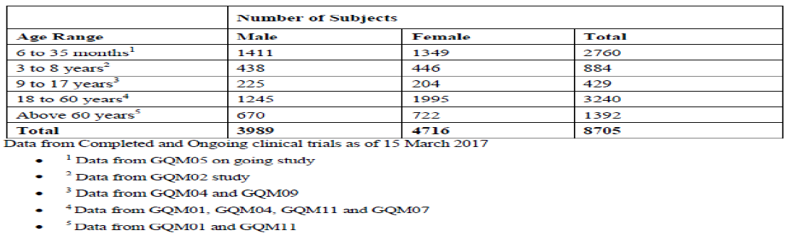

Safety in general population
A total of 8705 subjects (that is, 3240 adults, 1392 elderly, 429 children and adolescents aged 9 to 17 years, 884 children aged 3 to 8 years, and 2760 children aged 6 to 35 months (Table 8, below) received 1 or 2 injections of the QIV (including 491 children aged 3 to 8 years and 209 children aged 6 to 35 months who received 2 or 4 QIV doses, respectively). A total of 1835 subjects (that is, 557 adults, 502 elderly, 55 children and adolescents aged 9 to 17 years, 354 children aged 3 to 8 years, and 367 children aged 6 to 35 months) received at least one injection of the TIV, which was used as control product in Studies GQM01, GQM11, GQM04, GQM02, and GQM05. In addition, a total of 2711 children aged 6 to 35 months in Study GQM05 received at least one injection of placebo. The size of the safety database was sufficient to detect adverse events (AE) occurring with the incidences of uncommon to rare, in accordance with the recommendations from the EMA.
In these studies, the QIV was administered as one intramuscular or subcutaneous injection to subjects aged 9 years and above. One or 2 doses of QIV were administered to children aged 3 to 8 years, depending on their history of influenza vaccination at enrolment. This schedule reflects official recommendations and experience with the sponsor’s TIV and other inactivated influenza vaccines. The TIV manufactured by the sponsor in France was used as a comparator to evaluate the safety of the QIV in most of the studies and the safety profile of the QIV was compared with Placebo in Study GQM05.
Table 8: Subjects who received at least 1 injection of the quadrivalent inactivated influenza vaccine
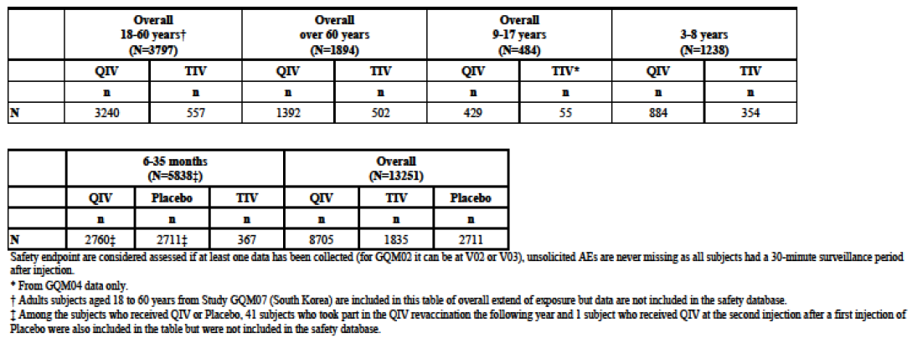
The results of the safety analysis for the QIV (0.5 mL, 1 or 2 doses) indicates that the QIV is well tolerated and has a safety profile similar to that of the sponsor’s licensed TIV. In addition, in the youngest age group (aged 6 to 35 months) who received 2 QIV doses, each of 0.5 mL (= full dose), the QIV was very well tolerated with a safety profile comparable to TIV and Placebo, aside from marginally higher rates for injection site reactions. The most frequently reported adverse reaction (AR) after QIV, in all populations including children from 6 to 35 months of age, was injection site pain. In the subpopulation of children less than 24 months of age, the most frequently reported AR was irritability and in the subpopulation of children from 24 to 35 months of age it was malaise. Most reactions usually occurred within the first 3 days following vaccination and resolved spontaneously within 1 to 3 days after onset. Rates of unsolicited AE were comparable for the QIV and TIV in all age groups. No safety signal of concern was observed following QIV. In children aged 3 to 8 years, the safety profile of the QIV was similar after the first and the second injections (separated by at least 4 weeks) in those given 2 vaccinations (as recommended by WHO in influenza vaccine naive children). Importantly too, in the youngest children (aged 6 to 35 months), the safety profile of the QIV was similar after the first and the second injections, and if anything there were fewer adverse reactions after the second injection than after the first injection. This large portfolio of Phase III studies, including Study GCQM04, which had a safety primary endpoint, demonstrates that this QIV dosed at 1 to 2 doses of 0.5 mL IM (or deep SC) appears safe and well tolerated across the age spectrum, from age 6 months onwards.

Safety in pregnant women (post-market data)

Data from global pharmacovigilance and epidemiology database
Over the years, the sponsor has manufactured 3 different formulations of IM TIV/Vaxigrip depending on thiomersal content. From 1 January 1993 up to 31 March 2017, a total of 1.88 billion doses of IM TIV/Vaxigrip (all formulations considered) were distributed worldwide. A search was conducted in the sponsor’s Pharmacovigilance and Epidemiology (GPE) safety database to retrieve all cases of exposure to the sponsor’s IM TIV/Vaxigrip all formulations considered, that is, influenza split triton vaccine thiomersal free, influenza split triton vaccine thiomersal lower content, and thiomersal containing influenza split triton vaccine. This search included all pregnancy case reports involving IM TIV/Vaxigrip received from 1 January 1993 to 15 March 2017. During this 24 years period, only 249 cases of exposure during pregnancy were reported (clinical trials and post-marketing) for IM TIV/Vaxigrip. Out of the 249 cases, 165 were prospective reports referring mainly to pregnancy reports without adverse event (60%, 99 out of 165) and 84 were retrospective with a majority of reports with adverse events (96%, 81 out of 84). Among pregnancy cases in which AEs were reported, 72 were referred to as non-obstetrical AEs and 88 involved a pregnancy complication. A role of the vaccine could not be established in any of the 88 cases with pregnancy complication.

Data from clinical trials
The sponsor provided the supportive review information relating to the use of Vaxigrip (TIV) in pregnant women. The review mentioned published data relating to three randomised, double blind, placebo controlled trials in pregnant women. Data from these clinical trials conducted with Vaxigrip in pregnant women during the second and third trimester do not indicate any adverse fetal, newborn, infant or maternal outcomes attributable to the vaccine. On the basis of the data available, no safety concern is to be underlined when administrating IM TIV/Vaxigrip to pregnant women. Inactivated influenza vaccines are generally considered safe for the pregnant woman, the fetus, and the young infant.

Risk management plan
- The sponsor has submitted European Union Risk Management Plan (EU-RMP) version 5.0 (dated 13 July 2017; data lock point (DLP) 25 April 2017) and Australian specific annex (ASA) version 1.0 (dated February 2018) in support of this application.
- The proposed summary of safety concerns and their associated risk monitoring and mitigation strategies are summarised in Table 9.
Table 9: Summary of safety concerns
Summary of safety concerns |  | Pharmacovigilance |  | Risk Minimisation
 |  | Routine | Additional | Routine | Additional
Important identified risks | None | – | – | – | –
Important potential risks | Anaphylactic reaction |  | – |  | –
Important potential risks | Convulsions (including febrile) |  | – |  | –
Important potential risks | Guillain-Barré Syndrome |  | – |  | –
Important potential risks | Encephalitis/myelitis |  | – |  | –
Important potential risks | Neuritis (including Bell’s palsy) |  | – |  | –
Important potential risks | Vasculitis |  | – |  | –
Important potential risks | Thrombocytopenia |  | – |  | –
Missing information | Very rare unanticipated AEs that could not be identified during the clinical development |  | – |  | –
Missing information | Use in pregnant or lactating women | ¹ | ² |  | –
Missing information | Use in immune-compromised patients | ¹ | – |  | –
Missing information | Vaccine effectiveness |  | ³ |  | –
1: Specific adverse reaction follow-up questionnaire. 2: Phase IV clinical trial. 3: Research network project.
- Routine pharmacovigilance has been proposed to monitor all the safety concerns. Additional monitoring through a Phase IV clinical trial and a research network project in the EU have been proposed to monitor missing information ‘use in pregnant or lactating women’ and ‘vaccine effectiveness’. The sponsor is committed to conducting an enhanced surveillance program when being required.
- Routine risk minimisation has been proposed to mitigate all the safety concerns. This approach is consistent with other inactivated influenza vaccines.

Risk-benefit analysis

Delegate’s considerations
The Delegate agrees with the clinical evaluator and is of view that Vaxigrip Tetra induces a satisfactory post-vaccination immune response in terms of GMTs, GMTRs, and seroconversion rates (SCRs) in all age groups, and in the youngest age group (6 to 35 months), clinical efficacy was demonstrated. Vaxigrip Tetra will be one of the QIV recommended at the same dose across the age spectrum, that is, 6 months of age and older. The safety profile of the QIV is comparable to that of the TIV. The vaccine given as a single or two dose schedule in vaccine naïve children was well tolerated. No safety signal of concern was revealed in any age group given this QIV.
The quality evaluator advises that on the basis of quality assessment, there are no identified quality issues that would preclude the registration of the product, however, there are some issues that need to be fully resolved before it is possible to provide assurances that the product is able to meet all of the requirements of the Therapeutics Goods Act 1989 and its associated instruments. The quality evaluator has proposed a list of quality ‘conditions of registration’ to ensure the product is fully compliant with all of the previously mentioned instruments before release of the product into the market in Australia (outlined above in ‘Proposed quality conditions of registration’).
The Delegate considers that there is a positive benefit-risk balance and recommends the approval of this QIV for the proposed indication below:
Vaxigrip Tetra is indicated for active immunisation of adults and children from 6 months of age and older for the prevention of influenza disease caused by the two influenza A virus subtypes and the two influenza B virus types contained in the vaccine.
The finalisation of this submission is subjected to the satisfactory resolution of the PI revision and agreement on the conditions of registration.

Proposed action
The Delegate has no reason to say, at this time, that the application for Vaxigrip Tetra should not be approved for registration.
The finalisation of this submission is subjected to the satisfactory resolution of the PI revision and the agreement on the conditions of registration.

Request for Advisory Committee on Vaccines advice
The committee is requested to provide advice on the following specific issues:
- Does the Advisory Committee on Vaccines (ACV) support the registration of Vaxigrip Tetra for individuals from 6 months of age based on the data submitted?
- The advice of the ACV is requested on the proposed PI statements relating to individuals with history of Guillain-Barré syndrome and individuals who have a known allergy to egg protein.
- Does ACV have any other comments on the draft PI dated 30 January 2019?
- Can the ACV comment about the lower immune response and the vaccine effectiveness result against the influenza B Victoria lineage in children 6 to 35 months, and are there any concerns about this result?
The committee is (also) requested to provide advice on any other issues that it thinks may be relevant to a decision on whether or not to approve the application.

Advisory committee considerations
The Advisory Committee on Vaccines (ACV), having considered the evaluations and the Delegate’s overview, as well as the sponsor’s response to these documents, advised the following.
The ACV, taking into account the submitted evidence of efficacy, safety and quality, considered the vaccine Vaxigrip Tetra inactivated quadrivalent influenza vaccine (split virion), containing 60 microgram of influenza virus haemagglutinin in each 0.5 mL dose (15 micrograms of influenza virus haemagglutinin from each of four strains) to have an overall positive benefit-risk profile for the indication:
Vaxigrip Tetra is indicated for active immunisation of adults and children from 6 months of age and older for the prevention of influenza disease caused by the two influenza A virus subtypes and the two influenza B virus types contained in the vaccine.
In providing this advice the ACV:
- was of the view that the immunogenicity data were adequate, based on five Phase III studies in adults, the elderly, and in subjects from 3 to 17 years of age;
- was of the view that the primary objectives of efficacy in subjects from 6 to 35 months of age were met, including efficacy of two QIV doses in previously unvaccinated children for the prevention of laboratory-confirmed influenza illness;
- was of the view that the safety data were adequate for the use of the same 0.5 mL dose in adults and also in children from 6 months of age and older;
- supported the approach of the 2018 edition of the Australian Immunisation Handbook on vaccination of egg-allergic individuals.

Proposed product information/consumer medicine information amendments
The committee provided comments on the PI, as discussed in Question 3 below.
The committee supported the Category A classification for use in pregnancy; noting the clinical trials and population experience with the use of Vaxigrip (TIV) in pregnant women and women of child-bearing age.

Specific advice
The ACV advised the following in response to the Delegate’s specific questions on the submission.
- Does the ACV support the registration of Vaxigrip Tetra for individuals from 6 months of age based on the data submitted?
The ACV advised that the supporting data shows that the proposed QIV is well tolerated and has a safety profile similar to that of the licensed Sanofi Pasteur TIV.
The proposed vaccine showed marginally higher rates for injection site reactions, mainly of injection site pain. In infants 6 to less than 24 months of age, irritability occurred at a higher rate than from the TIV. For infants aged 24 to 35 months, malaise occurred at a higher rate than from the TIV.
The committee noted the trend in Europe towards the use of the 0.5 mL dose at all ages, and published literature supporting the administration of two ‘adult’ doses (2 x 0.5 mL) of TIV in influenza vaccine-naïve infants and toddlers.
- Does the ACV support the proposed PI statements relating to individuals with history of Guillain-Barré syndrome and individuals who have a known allergy to egg protein?
The committee advised that the PI should include a precaution such as:
‘Patients with a history of Guillain-Barré syndrome (GBS) with an onset related in time to influenza vaccination may be at increased risk of again developing GBS, but whether vaccination specifically might increase the risk for recurrence is unknown. Because patients with a history of GBS have an increased likelihood of again developing the syndrome, the chance of them coincidentally developing the syndrome following influenza vaccination may be higher than in individuals with no history of GBS. If GBS has occurred within 6 weeks following previous influenza vaccination, the decision to give Vaxigrip Tetra should be based on careful consideration of the potential benefits and risks.’
The committee noted that a similar precaution was included in the PI of the related TIV and the above text aligns with the Australian Immunisation Handbook recommendation.
While noting the sponsor’s pre-ACV response, the committee advised that ‘egg allergy’ is not a contraindication and instead should be treated as a special warning and precaution in the PI.
The committee advised that, even as a precaution, ‘egg products’ is ill-defined and can be misleading as it is unnecessarily restrictive.
The committee noted the Australian Immunisation Handbook advises that persons with egg allergy, including a history of egg allergy anaphylaxis, can be safety vaccinated with influenza vaccine noting that current inactivated influenza vaccines in Australia contain less than 1 µg (1000 ng) ovalbumin per dose; Vaxigrip Tetra may contain traces of ovalbumin, at not more than 0.05 µg (50 ng) per dose.
- Can the ACV comment on the draft PI dated 30 January 2019?
The ACV advised that it supported the inclusion in the PI of the proposed statements regarding of Guillain-Barré syndrome and individuals who have a known allergy to egg protein (see Question 2).
The ACV advised that the use of the 0.5 mL dose in all age groups is safe and effective.
- Can the ACV comment about the lower immune response and the vaccine effectiveness result against influenza B Victoria lineage in children 6 to 35 months, and are there any concerns about this result?
Study GQM05 was a Phase III, randomised, observer blind (except TIV groups which were open label), placebo controlled, multicentre trial in 4 regions involving approximately 9000 healthy children aged 6 to 35 months of age who were influenza vaccine naive. Overall in the FASE population, the QIV prevented 52% (95% CI: 40.24; 61.66) of laboratory-confirmed influenza illness caused by any circulating strains and 69% (95% CI: 51.93; 81.03) of laboratory confirmed influenza illness caused by vaccine similar strains.
However, a secondary objective of Study GQM05 was non-inferiority of the influenza B/Brisbane/60/2008 strain (B Victoria lineage) compared to placebo, which was not demonstrated (efficacy of 40% (CI:-28.98, 73.24)). Also, non-inferiority was not demonstrated between Vaxigrip Tetra compared to the TIV (on average a 26% lower GMT).
The reasons offered for not demonstrating non-inferiority for the influenza B/Brisbane strain included: the study was not designed or powered to demonstrate QIV efficacy against individual influenza strain types and sub-types; small absolute number of cases (12 cases in the QIV group and 20 cases in the placebo group) leading to wide confidence interval; that the study had been terminated early due to the achievement of a sufficient number of evaluable influenza cases. No confounding factors or laboratory cause was identified.
The ACV advised that the demonstration of immunogenicity induced by the QIV against all four strains in children aged 6 to 35 months and the demonstration of non-inferiority for the same four strains in adults aged 18 years and older and in children aged 3 to 8 years balance against the missed non-inferiority endpoint for the influenza B/Brisbane strain in the 6 to 35 months age group. While the benefit of the influenza B/Brisbane strain in the 6 to 35 months age group was not shown, it is not associated with additional risk.
While the purpose of any QIV compared to any TIV is to protect against the additional influenza B lineage strain, and this was not demonstrated in Study GQM05, the point estimate showed protection.
The committee noted that an influenza B/Brisbane-like strain is not included in the 2019 influenza vaccines, and may or may not be included in future seasonal influenza vaccines.

Outcome
Based on a review of quality, safety and efficacy, the TGA approved the registration of Vaxigrip Tetra (Inactivated quadrivalent influenza vaccine (split virion) influenza virus haemagglutinin), indicated for:
Vaxigrip Tetra is indicated for active immunisation of adults and children from 6 months of age and older for the prevention of influenza disease caused by the two influenza A virus subtypes and the two influenza B virus types contained in the vaccine.

Specific conditions of registration applying to these goods
- The Vaxigrip Tetra EU-Risk Management Plan (RMP) (version 5.0, dated 13 July 2017, data lock point 25 April 2017), with Australian Specific Annex (version 1.0, dated February 2018), included with submission PM-2018-00583-1-2, to be revised to the satisfaction of the TGA, will be implemented in Australia.
An obligatory component of risk management plans is routine pharmacovigilance. Routine pharmacovigilance includes the submission of periodic safety update reports (PSURs).
Reports are to be provided in line with the current published list of EU reference dates and frequency of submission of PSURs until the period covered by such reports is not less than three years from the date of this approval letter.
The reports are to at least meet the requirements for PSURs as described in the European Medicines Agency’s Guideline on Good Pharmacovigilance Practices (GVP) Module VII-periodic safety update report (Rev 1), Part VII.B Structures and processes. Note that submission of a PSUR does not constitute an application to vary the registration.
- For all injectable products the Product Information must be included with the product as a package insert.
Quality – including compliance with Ph. Eur 2.6.16 (Infectious Disease Safety)
It is a condition of registration that:
- At least 45 working days before the submission of the first request under s9D(3) of the Therapeutic Goods Act 1989 for a change to the strain composition of the vaccine, and not later than 31 October 2019, the following be provided to the TGA for approval under s9D(3) of the Act:
- Revised syringe labels that clearly show the age indication for the product and, amended packaging that meets the requirement of TGO91.
- Summaries of historical inactivation data and stability data is to be provided in a suitable format in a clearly identified section of the dossier.
- Evidence demonstrating that the factors responsible for the presence of particles/filaments in samples of monovalent bulk (drug substance) used for the Appearance Test (conducted under Q_0001593) have been adequately addressed to significantly reduce the risk of contamination of test samples with extraneous particles.
- Demonstration that the product:
- Conforms to the tests which are invoked by the European Pharmacopoeia (Ph. Eur.) General Monograph 07/2018:0153 Vaccines for human use that control for nonspecific extraneous agents including non-enveloped viruses. These tests are specified in Ph. Eur. Methods of Analysis 2.6.16 Tests for extraneous agents in viral vaccines for human use; or
- Has alternative measures applied that are effective at managing the risk of contamination with known, emerging, and unknown non-enveloped viruses, to an equivalent or greater level than the measures prescribed by Ph. Eur. 2.6.16.
- An updated risk assessment and risk management procedure which:
- Provides specific coverage on how Sanofi-Aventis addresses product contamination risks posed due to entry of known, emerging, and unknown viruses in candidate virus vaccine or egg substrates; and
- Summarises the risk management strategies for ensuring ongoing freedom from extraneous agents in final product.
Any extension beyond the time frame and dates indicated above would be would be subject to written agreement with the TGA.
- The shelf-life of the drug substance (DS) will be 24 months with the condition that any DS to be used for formulation of drug product will be retested if it is to be used in the manufacture of Drug Product (DP) more than three (3) months after its date of manufacture. The DS must meet the specification of having an HA content of not less that 70% of the content estimated in the first test after manufacture before it can be used for the manufacture of DP. Summary protocols of manufacture must provide the results for both tests on the DS.
Batch release testing and compliance with the Certified Product Details
It is a condition of registration that all independent batches of Vaxigrip Tetra and Vaxigrip Tetra Junior imported into Australia are not released for sale until samples and the manufacturer’s release data have been assessed and you have received notification acknowledging release from the Laboratories Branch, TGA.
For each independent batch of the product imported into Australia, the sponsor must supply the following:
- A completed Request for Release Form, available from vaccines@health.gov.au.
- Complete summary protocols for manufacture and QC, including all steps in production.
- At least 20 (twenty) doses of the first consignment of each batch of Vaxigrip Tetra with the Australian approved labels, PI and packaging and 40 (forty) doses of the first consignment of each batch of Vaxigrip Tetra Junior with the Australian approved labels, PI and packaging.
- At least 10 (ten) doses of any further consignment of each batch of Vaxigrip Tetra with the Australian approved labels, PI and packaging and at least 20 (twenty) doses of any further consignment of each batch of Vaxigrip Tetra Junior with the Australian approved labels, PI and packaging.
- Certificate of Release from regulatory agency acting for the country of origin such as an OMCL (if available).
- Any reagents, reference material and standards required to undertake testing, as requested by Laboratories Branch, TGA.
Distribution of each shipment of each batch of vaccine is conditional upon fulfilment of these conditions and receipt of a letter from the Laboratories Branch acknowledging release.
Samples and data should be forwarded to the Immunobiology Section, Laboratories Branch before release of each batch and with sufficient lead time to allow for Laboratories Branch testing.
All shipments (including reagents) must be sent to TGA from the Australian sponsor/agent who will be required to facilitate the import and customs clearance process.
Certified Product Details
An electronic copy of the Certified Product Details (CPD) as described in Guidance 7: Certified Product Details of the Australian Regulatory Guidelines for Prescription Medicines (ARGPM) https://www.tga.gov.au/guidance-7-certified-product-details should be provided upon registration of the therapeutic good. In addition, an updated CPD, for the above products incorporating the approved changes is to be provided within one month of the date of approval letter. A template for preparation of CPD for biological prescription medicines and Vaccines can be obtained from the TGA website https://www.tga.gov.au/form/certified-product-details-cpd-biological-prescriptionmedicines]. The CPD should be sent as a single bookmarked PDF document to Vaccines@health.gov.au as soon as possible after registration/approval of the product or any subsequent changes as indicated above.

Attachment 1. Product Information
The PI for Vaxigrip Tetra approved with the submission which is described in this AusPAR is at Attachment 1. For the most recent PI, please refer to the TGA website at <https://www.tga.gov.au/product-information-pi>.

Therapeutic Goods Administration
PO Box 100 Woden ACT 2606 Australia
Email: info@tga.gov.au Phone: 1800 020 653 Fax: 02 6232 8605
https://www.tga.gov.au

Fiore, A.E. et al. (2009). Prevention and control of seasonal influenza with vaccines: recommendations of the Advisory Committee on Immunization Practices (ACIP), MMWR Recomm Rep, 2009; 58: 1-52.
Rothberg, M.B. et al. (2008). Complications of viral influenza. Am J Med, 2008 ;121: 258-264.
Monto, A.S. (2008). Epidemiology of influenza. Vaccine. 2008; 26: D45-48.
Hay, A.J. et al. (1991). Influenza viruses. In: Belshe RB, ed. Textbook of Human Virology. St. Louis, Missouri: Mosby Year Book, Inc, 1991; 307−341.
European Medicines Agency (EMA) Committee for Medicinal Products for Human Use (CHMP). Guideline on influenza vaccines. Nonclinical and clinical module. 21 July 2016, EMA/CHMP/VWP/457259/2014.
European Medicines Agency (EMA), Committee for Proprietary Medicinal Products (CPMP), Guideline on Harmonisation of requirements for influenza vaccines, 12 March 1997, CPMP/BWP/214/96.
TIV2 group, trivalent inactivated influenza vaccine containing a single B strain from the Yamagata lineage.
TIV1 group, trivalent inactivated influenza vaccine containing a single B strain from the Victoria lineage.
Routine risk minimisation activities may be limited to ensuring that suitable warnings are included in the product information or by careful use of labelling and packaging. Routine pharmacovigilance practices involve the following activities: - All suspected adverse reactions that are reported to the personnel of the company are collected and collated in an accessible manner; - Reporting to regulatory authorities; - Continuous monitoring of the safety profiles of approved products including signal detection and updating of labelling; - Submission of PSURs; - Meeting other local regulatory agency requirements.
Australian Pregnancy Category A: Drugs which have been taken by a large number of pregnant women and women of childbearing age without any proven increase in the frequency of malformations or other direct or indirect harmful effects on the fetus having been observed.

