August 2015

Australian Public Assessment Report for inactivated influenza virus vaccine (containing 15 µg haemagglutinin of virus Types A H1N1+ A H3N2 + B)
  - Proprietary Product Name: Optaflu
  - Sponsor: Novartis Vaccines & Diagnostics Pty Ltd

About the Therapeutic Goods Administration (TGA)
- The Therapeutic Goods Administration (TGA) is part of the Australian Government Department of Health and is responsible for regulating medicines and medical devices.
- The TGA administers the Therapeutic Goods Act 1989 (the Act), applying a risk management approach designed to ensure therapeutic goods supplied in Australia meet acceptable standards of quality, safety and efficacy (performance), when necessary.
- The work of the TGA is based on applying scientific and clinical expertise to decision-making, to ensure that the benefits to consumers outweigh any risks associated with the use of medicines and medical devices.
- The TGA relies on the public, healthcare professionals and industry to report problems with medicines or medical devices. TGA investigates reports received by it to determine any necessary regulatory action.
- To report a problem with a medicine or medical device, please see the information on the TGA website <www.tga.gov.au>.
About AusPARs
- An Australian Public Assessment Report (AusPAR) provides information about the evaluation of a prescription medicine and the considerations that led the TGA to approve or not approve a prescription medicine submission.
- AusPARs are prepared and published by the TGA.
- An AusPAR is prepared for submissions that relate to new chemical entities, generic medicines, major variations, and extensions of indications.
- An AusPAR is a static document, in that it will provide information that relates to a submission at a particular point in time.
- A new AusPAR will be developed to reflect changes to indications and/or major variations to a prescription medicine subject to evaluation by the TGA.
Copyright
© Commonwealth of Australia 2015
This work is copyright. You may reproduce the whole or part of this work in unaltered form for your own personal use or, if you are part of an organisation, for internal use within your organisation, but only if you or your organisation do not use the reproduction for any commercial purpose and retain this copyright notice and all disclaimer notices as part of that reproduction. Apart from rights to use as permitted by the Copyright Act 1968 or allowed by this copyright notice, all other rights are reserved and you are not allowed to reproduce the whole or any part of this work in any way (electronic or otherwise) without first being given specific written permission from the Commonwealth to do so. Requests and inquiries concerning reproduction and rights are to be sent to the TGA Copyright Officer, Therapeutic Goods Administration, PO Box 100, Woden ACT 2606 or emailed to <tga.copyright@tga.gov.au>.

Contents
List of abbreviations 5
I. Introduction to product submission 7
Submission details 7
Product background 8
Regulatory status 8
Product Information 9
II. Quality findings 9
Drug substance (active ingredient) 9
Drug product 10
Biopharmaceutics 10
Quality summary and conclusions 10
III. Nonclinical findings 11
Introduction 11
Pharmacology 12
Pharmacokinetics 13
Toxicology 13
Nonclinical summary and conclusions 19
IV. Clinical findings 21
Introduction 21
Pharmacokinetics 22
Pharmacodynamics 22
Dosage selection for the pivotal studies 22
Efficacy 22
Safety 23
First round benefit-risk assessment 26
Clinical questions 26
Second round evaluation 28
Second round benefit-risk assessment 28
V. Pharmacovigilance findings 28
Risk management plan 28
VI. Overall conclusion and risk/benefit assessment 36
Quality 36
Nonclinical 36
Clinical 37
RMP evaluation 45
Risk-benefit analysis 45
Outcome 51
Attachment 1. Product Information 52
Attachment 2. Extract from the Clinical Evaluation Report 52

List of abbreviations
Abbreviation | Meaning
ACPM | Advisory Committee on Prescription Medicines
ACSOV | Advisory Committee on the Safety of Vaccines
AE | adverse event
ARTG | Australian Register of Therapeutic Goods
ASA | Australian Specific Annex
BSA | bovine serum albumin
CBER | Center for Biologics Evaluation and Research
CMI | Consumer Medicines Information
CPMP | Committee for Proprietary Medicinal Products
CTAB | cetyltrimethylammonium bromide
cTIV | cell culture derived influenza vaccine
EMA | European Medicines Agency
eTIV | egg derived influenza vaccine
eTIVa | Agrippal
eTIVf | Fluvirin
FDA | US Food and Drug Administration
GLP | Good Laboratory Practice
GMP | Good Manufacturing Practice
HA | haemagglutinin
HI | haemagglutinin inhibiting
ILI | influenza like illness
MDCK | Madin Darby Canine Kidney
NA | neuraminidase
PI | Product Information
RMP | Risk Management Plan
SAE | serious adverse event
SmPC | Summary of Product Characteristics

I. Introduction to product submission

Submission details
Type of submission: | New chemical entity
Decision: | Approved
Date of decision: | 3 March 2015

Active ingredients: | Inactivated influenza virus vaccine (containing 15 µg haemagglutinin of each of the recommended strains of influenza virus Types A H1N1+ A H3N2 + B)
Product name: | Optaflu
Sponsor’s name and address: | Novartis Vaccines & Diagnostics Pty Ltd  54 Waterloo Road  North Ryde NSW 2113
Dose form: | Suspension for injection
Strength: | 45 µg haemagglutinin/dose
Container: | Injection prefilled syringe
Pack sizes: | 1 x 0.5 mL prefilled syringe with needle  1 x 0.5 mL prefilled syringe without needle  10 x 0.5 mL prefilled syringe without needle
Approved therapeutic use: | For the prevention of influenza caused by Influenza Virus, Types A and B in adults over 18 years of age.  For full details regarding the recommendations for influenza vaccination refer to the current Australian Immunisation Handbook.
Route of administration: | Intramuscular
Dosage: | Adults 18 years of age and older: a single 0.5 mL dose
ARTG numbers: | 220736 (prefilled syringe without needle)  220737 (prefilled syringe with needle)

Product background
This AusPAR describes the application by Novartis Vaccines & Diagnostics Pty Ltd to register a new chemical entity Optaflu inactivated influenza virus vaccine (surface antigens), prepared in cell cultures for the prevention of influenza caused by Influenza Virus, types A and B in adults over 18 years of age.
Novartis Vaccines & Diagnostics Pty Ltd has developed a new technology to produce influenza vaccines in mammalian cell cultures. To date, all influenza vaccines currently registered by the TGA are cultivated in embryonated hens’ eggs. The sponsor states in their letter of application that the efficiency of developing vaccines in embryonated hens’ eggs is often low. The cell based process removes the dependence on eggs and the egg supply in the production process, potentially making it easier to scale up production and reduce production timelines.
With regards to approval in children, a paediatric indication was not sought by the sponsor following TGA pre submission advice that clinical efficacy data were preferred over immunogenicity data in this population. The paediatric Study V58P12 addressing safety and immunogenicity – a Combined Phase II/III, Observer Blind, Randomised, Multi Centre Study in Healthy Children and Adolescents Aged 3 to 17 Years – was made available to the TGA upon request.

Regulatory status
At the time of submission to TGA, Optaflu is registered by the US Food and Drug Administration (FDA), European Medicines Agency (EMA), and Swissmedic. Data from five immunogenicity and safety studies (V58P1, V58P2, V58P4, V58P4E1 and V58P9) and one supportive study V58P5 led to the approval in 2007 in the EU. An additional study V58P13 (which included efficacy data) was included in the submission that led to the approval as Flucelvax in the US in 2012.
A summary of this information is shown in Table 1.
Table 1: International regulatory status for Optaflu.
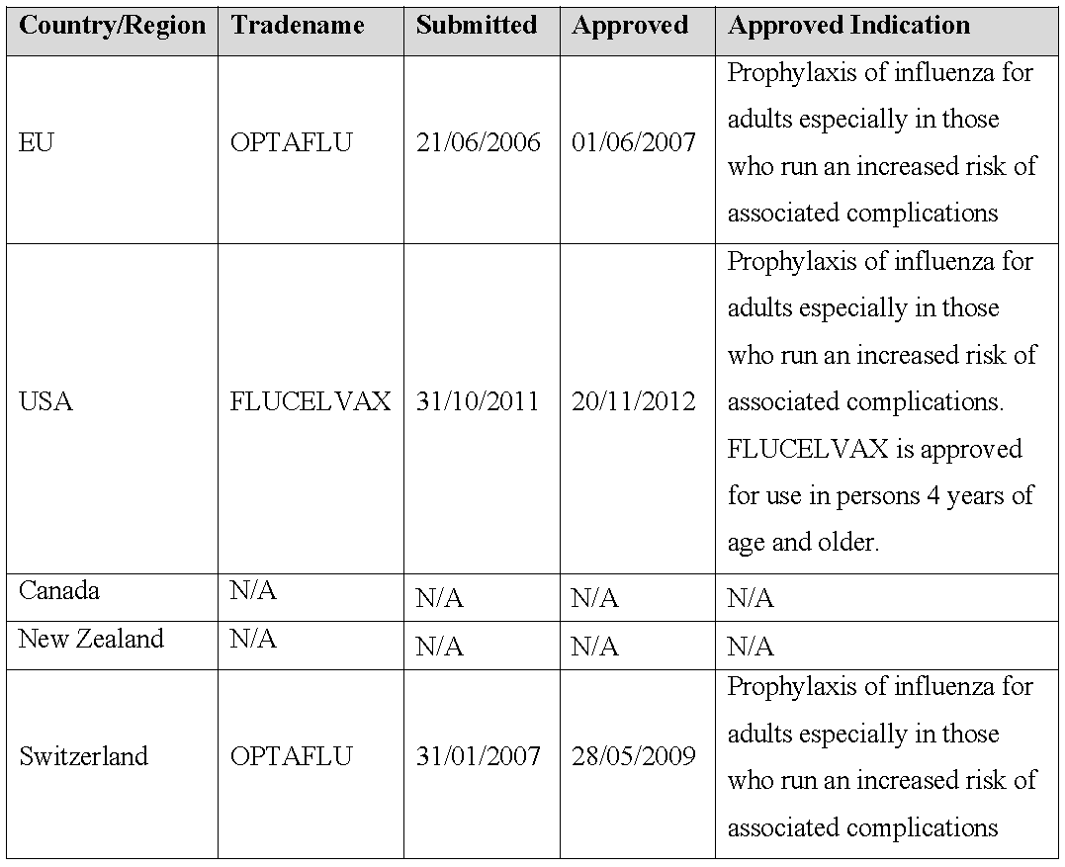

Product Information
The approved Product Information (PI) current at the time this AusPAR was prepared can be found as Attachment 1. For the most recent PI, please refer to the TGA website at <www.tga.gov.au/product-information-pi>.

II. Quality findings

Drug substance (active ingredient)
The drug substance is prepared by working seed inoculation of suspension cells then expansion using serum free media. Following expansion, the virus is centrifuged and filtered to remove cells and debris. The downstream purification process commences with ultra diafiltration to remove media components and concentrate pool. The virus is isolated with affinity chromatography then further concentration and buffer exchange follows. Virus inactivation uses b-propriolactone followed by splitting with cetyltrimethylammonium bromide (CTAB). Amberite is used to remove the CTAB. Virus core proteins are removed and the surface proteins purified by ultracentrifugation and anion exchange chromatography. Diafiltration is used to concentrate the antigen.
All viral/prion safety issues including use of animal derived excipients, in the cell expansion phase, the cell substrate and the ability of the production process to clear virus have been addressed. DNA testing is undertaken as a release test for the monovalent bulk.
The drug substance consists of monovalent bulks from H1N1, H3N2, and B strains. The active component is influenza virus haemagglutinin (HA) and neuraminidase (NA) (surface antigens). The routine assessment of the purity is by SDS-PAGE. The presence of NA is confirmed by Fetuin-NANA assays on the first three monovalent bulks from each working seed.
The drug substance complies with European Pharmacopoeia monograph 2149 for influenza vaccines produced using cell culture. Total DNA content for the monovalent bulk is ≤0.20 ng/µg HA.
Appropriate validation data have been submitted in support of the test procedures.
Shelf life specifications are in line with those provided for the monovalent bulk, the purity is assessed in terms of HA degradation from time zero. Original stability studies on consistency batches were conducted in full on three strains at 2-8˚C for at least 12 months and up to 18 months. Accelerated temperatures stability studies for 4 weeks at 37˚C or 6 months at 23-27˚C were also conducted. All lots were within specifications for real time studies up to 18 months. For accelerated stability lots at 23-27˚C were also within specifications. The proposed shelf life of 12 months at 2-8˚C is satisfactory.

Drug product
The vaccine is a clear to slightly opalescent liquid suspension 0.5 mL for injection presented in 1 mL type 1 glass prefilled syringes. The vaccine is presented as a single or 10 dose packs without needle and a single dose pack with needle.
The finished product consists of purified surface antigens from H1N1 H3N2 and B strains (15 µg /strain) formulated with phosphate buffered saline (PBS). The trivalent bulk is sterile filtered 0.22 µm and filled.
The specifications for the trivalent bulk and final lot comply with EP specifications. The test for residual infectious virus is undertaken on the monovalent bulk. No formaldehyde or bovine serum albumin (BSA) is present in the product. Protein specification is a maximum of 40 µg other than HA per virus. The maximum limit was calculated by the sum of the protein and HA (40 + 15) x 3 = 165 µg/dose or ≤330 µg/mL.
Stability data have been generated under stressed and real time conditions to characterise the stability profile of the product. The proposed shelf life is 12 months when stored at 2-8°C. Although 18 month stability data has been evaluated as acceptable, the sponsor has requested that the shelf like be 12 months in order to prevent concurrent vaccine supply.
Post commitment stability data is to be generated in support of temperature excursions (25˚C for 5 days). The vaccine should be protected from light.

Biopharmaceutics
Biopharmaceutic data are not required for this product because it is a biological vaccine product.

Quality summary and conclusions
The administrative, product usage, chemical, pharmaceutical, microbiological data submitted in support of this application have been evaluated in accordance with the Australian legislation, pharmacopoeial standards and relevant technical guidelines adopted by the TGA.
The following issues are still being addressed as will require resolution prior to supply:
- PI and Consumer Medicines Information (CMI) statement regarding the presence of egg protein;
- Good Manufacturing Practice (GMP) clearance submitted outstanding sites needs confirmation by the Office of Manufacturing Quality (OMQ); and
- S14 for labelling exemption from TGA 69 will be submitted in the future.
The evaluator recommends that Optaflu inactivated influenza virus vaccine (surface antigens) prepared in cell cultures injection prefilled syringe (with needle and without needle) should be approved.

III. Nonclinical findings

Introduction
Vaccination remains the most important method for reducing influenza virus infection and its complications. This assessment evaluates the preclinical safety properties in the Category 1 Application (Type A) to register Optaflu inactivated influenza virus vaccine (surface antigen) prepared in cell cultures for the prevention of influenza caused by influenza virus Types A and B in adults over 18 years of age.
Although other trivalent seasonal influenza vaccines are registered in Australia (for example, Fluvax [CSL Limited], Agrippal [Novartis], Fluarix [GSK]), the Optaflu trivalent, surface antigen, inactivated, influenza vaccine, represents the first cell culture derived, pre-pandemic seasonal influenza vaccine to be considered for registration. The use of cell culture, rather than eggs to cultivate virus offers several advantages, namely reduced production times; the ability to safely use whole, wild type virus (without reassortment); and the avoidance of potential problems with egg supply.
Overall, Optaflu displays acceptable safety properties including acceptable local intramuscular tolerance, acceptable repeated dose safety properties (2 intramuscular doses in rabbits), acceptable prenatal and postnatal reproductive safety properties in a single species (rabbits; effects on male reproduction were not evaluated).
The pivotal data submitted in support of the application were mostly adequate. However, a number of non pivotal immunogenicity and/or efficacy studies in ferrets and mice were evaluated but not summarised in this report because they were inconclusive.
Notably, influenza virus clearance requires both cellular and antibody responses, and priming with a heterologous virus might stimulate T cells cross reactive to internal viral proteins, which have more conserved epitopes than the highly variable surface glycoproteins. The priming model would more closely resemble the situation in humans where only infants are influenza naïve. In general, at least 2 exposures to influenza virus vaccines are recommended in influenza naïve individuals. However, Optaflu is being registered for use in adults (18 years of age or older). Thus, the use of Optaflu in influenza naïve individuals is unlikely given its proposed pattern of use.
The pivotal studies for detection of the neoplastic potential of the sponsor’s Madin Darby Canine Kidney cell line (MDCK cells; the neoplastic cell virus substrate used in the manufacture of Optaflu), virus substrate, MDCK cell free lysate, beta propiolactone treated MDCK cell free lysate, and MDCK cell DNA in T lymphocyte deficient rodent models suffered because of Quality Assurance/Quality Control (QA/QC) issues (which were acknowledged and corrected) pertaining to the tissue sample handling in the histopathology components of the studies. These studies were not conducted according to principles of Good Laboratory Practice (GLP). However, it is important to note that despite the QA/QC issues (which were corrected) and lack of GLP status, the overall outcome of these studies is acceptable for registration purposes.
This evaluation utilised the relevant EMA guideline and World Health Organisation recommendations for the evaluation of animal cell cultures as substrates for the manufacture of biological medicinal products and for the characterisation of cell banks.

Pharmacology

Primary pharmacology
Overall, Optaflu performed approximately the same as the positive control article (Agrippal S1, an egg allantoic cavity derived split influenza virus surface antigen vaccine containing influenza virus Type A H1N1 New Caledonia/20/99 15µg of HA per 0.5 mL dose, influenza virus type A H3N2 Moscow/10/99 15µg of HA per 0.5 mL dose, and influenza virus type B Hong Kong/330/2001 15µg of HA per 0.5 mL dose) in terms of stimulating HA inhibiting (HI) antibodies in the heterologous influenza virus primed 6 month old male ferret animal model of influenza virus infection. However, for some measured, influenza disease associated, endpoints (for example, mean maximum nasal virus titre, nasal flush mean maximum leukocyte count), there was a trend (not statistically significant p > 0.05) towards lower performance of the test article compared with the positive control article (Agrippal S1).
The nonclinical study package was essentially consistent with recently published EMA guidelines (note: this draft guideline has not been adopted by TGA). However, there were significant limitations in the immunogenicity subcomponent of the pivotal efficacy/immunogenicity study in primed ferrets:
- Insufficient data on the immunoassays used in the study were provided. HAI assay qualification data was only provided for the H1N1 influenza A strain. Suitable qualification data for the other influenza strains was not provided. Notably, no data on the optimisation of these assay techniques were provided. Thus, the sensitivity, specificity, precision, negative predictive value and accuracy of the HI assay systems for the influenza Type A H2N3 and Type B used could not be evaluated;
- Notably, the antigenic cross reactivity of all the HI assays could not be assessed;
- The immunogenicity components of the study did not evaluate mechanistically important aspects of the anamnestic response. However, such studies are not currently required by relevant nonclinical guidelines.
Optaflu was capable of inducing HI antibodies in pregnant rabbits. HI antibodies, at titres that were comparable to maternal levels, were present in rabbit foetuses (gestational age 29 days) and in 29 day old rabbit pups. Optaflu was able to induce prenatal and/or postnatal transfer of maternal immunity and/or de novo foetal and postnatal antibody production.

Secondary pharmacodynamics
There were no secondary pharmacodynamic studies submitted by the sponsor. This is in accordance with published guidelines.

Safety pharmacology
There were no submitted studies due to the nature of the product and the known nonclinical and clinical safety and tolerability profile of the vaccine. This is acceptable.
The nonclinical overview stated that each clinical lot of Optaflu undergoes general safety testing in mice and guinea pigs as part of the quality program. However, what this general safety testing entails is not stated. Notably, abnormal toxicity or inocuity batch testing is no longer required for influenza vaccines.

Pharmacokinetics
No studies investigating absorption, distribution, metabolism, and excretion were performed, which is in accordance with applicable guidelines.

Toxicology

Acute toxicity
No single dose toxicity studies were performed with Optaflu.

Repeat dose toxicity
A repeat dose toxicity study was conducted in which rabbits were administered 2 intramuscular clinical doses (45 µg HA total by the clinical route of exposure, using a formulation comparable to the clinical formulation) of either Optaflu or an allantoic cavity derived comparator vaccine (Agrippal S1), 7 days apart. The two doses administered to rabbits exceeded the intended number of injections (one) used in the proposed clinical regimen.
There was no evidence of systemic toxicity. Injection site reactions were of normal severity and partially or fully resolved over several weeks of recovery. The HA dose of 45 µg (15 µg/kg in a 3 kg rabbit or 165 µg/m²; BSA conversion factor of 11) is ~5.5x the human dose in mg/m² (based on a 50 kg individual; that is, 0.9 µg/kg or 30 µg/m²; BSA conversion factor of 33).
However, the pivotal two exposure rabbit repeat dose toxicity study has a number of important limitations:
- Notably, positive titres for influenza Type A H2N3 were present in all the control article treated animal samples collected on study Days 1-23. No explanation is provided for these unexpected data. It is highly likely that these positive results in the negative control experimental cohorts are spurious and brings into question the reliability of the sponsor’s immunoassays in this particular study (that is, this result is a false positive result) or control article preparation (cross contamination), or sample collection (cross contamination). Currently, there is no evidence that influenza Type A H2N3 infects rabbits under normal conditions. Furthermore, there is currently no evidence of naturally occurring antibodies in specific pathogen free rabbits that cross react with influenza Type A H2N3. Thus, pre existing titres to this virus strain in unexposed negative control animals are unexpected. Furthermore, the reported H2N3 titres (probably false positives) in the control group (median 40-80) are not insignificant in terms of these types of assays: “serum HI antibody titres of 40 are associated with at least a 50% reduction in risk for influenza infection”;
- Insufficient data on the immunoassays used in the study were provided. HAI assay qualification data was only provided for the H1N1 influenza A strain. Suitable qualification data for the other influenza strains was not provided. Notably, no data on the optimisation of these assay technique were provided. The sensitivity, specificity, precision, negative predictive value and accuracy of the HI assay systems for the influenza Type A H2N3 and Type B used could not be evaluated. The sensitivity, specificity, accuracy, precision and negative predictive value of the influenza Type A H2N3 and Type B HI assays could not be assessed;
- Notably, the antigenic cross reactivity of all the HI assays could not be assessed;
- The immunogenicity components of the study did not evaluate mechanistically important aspects of the anamnestic response. However such studies are not currently required by relevant nonclinical guidelines;
- No statistical analyses (not even basic summary statistics) of the immunogenicity data was presented in any of the submitted studies were performed. While historically only the geometric mean titre has been provided with serum/antibody titre data, it is important to note that statistical analyses of these types of immune haematological data is good, basic scientific practice. This is regarded as an overarching limitation of many of the sponsors submitted study reports.
Notably, no adverse reactions to vaccination with the clinical dose of Optaflu were observed in the pivotal ferret immunogenicity/efficacy study.
Note: the local tolerance of the Optaflu was determined in this study in rabbits. Two intramuscular injections were given 7 days apart into alternate hind limbs (that is, left-right hind limbs). Consequently, each limb received an acute or single dose of Optaflu. Histological evidence of mild injection site reactions (focal necrosis, associated inflammatory cellular infiltrates and haemorrhage) were present in all experimental groups (including the control article treated animals) and were partially resolved in some animals by study Day 23 (15 days following last dose; recovery necropsy evaluation). These changes can generally be regarded as adaptive given the circumstances of dosing. The reactions were not excessive. However, some degree of pain and limited local injection reaction can be expected in humans inoculated with Optaflu. Overall, the histological assessment of the injection site indicated that the vaccine was well tolerated.

Genotoxicity
No genotoxicity studies were conducted. This is in line with relevant guidelines.

Carcinogenicity
No carcinogenicity studies on the final vaccine product were submitted. This is acceptable based on its duration of use and the applicable guidelines.
The neoplastic potential of the virus growth medium and vaccine relevant extracts was assessed in rodents. The reliability of the relevant studies submitted by the sponsor is reduced due to the presence of data discrepancies (acknowledged and corrected to the best of the ability of the study director) in the necropsy and histology components of the relevant studies. Accordingly, all of the relevant submitted studies are non GLP. The impact of these discrepancies is perhaps lessened in the case of fully negative studies since all of the samples were negative irrespective of their experimental group of origin. As a result, the acknowledged data inconsistencies would not have affected the overall outcome of these studies.
The overall conclusions regarding the package of relevant studies submitted are:
- The sponsor’s MDCK cells (used as an influenza virus growth substrate) are both notably neoplastic and fully capable of metastasis (that is, malignant) in vivo in T cell deficient/depleted mice and rats (both neonatal and adult). The MDCK cell line used cannot, in any way, be described as “weakly tumorigenic”, at least in immune deficient rodent models;
- The sponsor’s MDCK cell lysates (produced by the freeze/thaw technique) are not neoplastic in vivo in relevant rodent models;
- DNA extracts from the sponsor’s MDCK cells and influenza infected MDCK cells are not neoplastic in vivo in relevant rodent models.
Based on the currently available data, the overall risk of de novo neoplastic disease due to the use of Optaflu is considered to be very low due to the complete lack of viable cells in the final product and lack of carcinogenicity/neoplastic potential of the MDCK cell free lysate, lack of carcinogenicity/neoplastic potential of the beta propiolactone treated MDCK cell free lysate, and lack of carcinogenicity/neoplastic potential of the MDCK cell DNA. The levels of residual non influenza virus protein and the level of residual DNA in the finished product conform to relevant international standards. The lowest dose of DNA administered to rodents was 28 μg per neonatal mouse (Study 48333). This is based on a 0.1 mL inoculation of neonatal mice with the beta propiolactone treated flu infected DNA preparation that contained 55 μg per 0.2 mL. Neonatal rats received a 0.2 mL inoculation but mice are used as the most conservative estimation. The dose of 28 μg (or 28000 ng) was a no observed effect level (NOEL). When compared to the WHO 10 ng acceptable DNA limit, this provides a safety factor of 2.8 x 10³.

Reproductive toxicity
Seasonal trivalent influenza vaccines are recommended for use in pregnancy. Published clinical data are limited, but indicate safety with seasonal influenza vaccines in pregnant women. Optaflu is still potentially capable of inducing fever, an effect known to result in adverse pregnancy outcomes.
A single, GLP compliant, reliable intramuscular rabbit reproductive and developmental toxicity study that included both prenatal and postnatal developmental cohorts of Optaflu and its elicited antibodies was submitted. Examination in a second species was not performed.
Maternal animals received the full human clinical dose (15 µg of HA from each strain) and volume (0.5 mL) of Optaflu with each injection (~5.5x the human dose in mg/m², based on 50 kg individual; that is, 0.9 µg/kg or 30 µg/m²; BSA conversion factor of 33).
The study design employed vaccine inoculation in does before cohabitation, through mating, gestation and lactation, that is, evaluation of potential effects on the maternal F0 generation as well as prenatal (stages A-D) and postnatal developmental F1 generation cohorts (in accordance with relevant FDA and EMA guidelines).

Core findings for the F0 generation
Intramuscular injection of Optaflu did not induce maternal death, abortion or total litter loss. The incidence of these events in this study was slightly higher than historical ranges. However, differences did not reach statistical significance between the Optaflu and control article treated groups. The cumulative perinatal mortality was 14.3% (6/42) for control rabbits and 15.6% (7/45) for rabbits receiving Optaflu. Total litter losses occurred in 2 does exposed to Optaflu. However, necropsy observations did not indicate any relevant findings that could be attributed to the test article. Mating and fertility indices were not affected by exposure to Optaflu. Injection site histological changes were not directly related to Optaflu and are consistent with normal adaptive/reparative changes given the method of dosing.

Core findings for the F1 generation
All clinical and necropsy observations for the pups (birth to lactation day 29) were considered unrelated to treatment of the does with Optaflu. No adverse effects on reflex and physical development were noted in the F1 generation pups due to the presence of anti influenza virus antibodies or exposure to maternal Optaflu inoculation on gestational Days 7 and 20.

Core immunogenicity findings
HI titres were measurable beginning on study Day 15 (after one injection of Optaflu) in three of the eight rabbits that were assayed. On study Day 29, HI titres were measurable in all rabbits that were assayed. Titres increased and/or remained elevated over the duration of the study demonstrating continued immune response to the vaccine. At the time of Caesarean sectioning, anti influenza antibodies were detected in all foetal pooled samples from the prenatal development cohort pups at levels comparable to those of the respective maternal sample. At the time of euthanasia, 29 days after birth, antibodies remained elevated in all postnatal development cohort pups that were surveyed, although titres were lower than those found in the prenatal development cohort pups. Overall, the results of the study demonstrate prenatal and/or postnatal transfer of maternal immunity and/or de novo foetal and postnatal antibody production.
However, a number of deficiencies in the immunogenicity component of the study were noted:
- Insufficient data on the immunoassays used in the study were provided. HI assay qualification data was only provided for the H1N1 influenza A strain. Suitable qualification data for the other influenza strains was not provided. Notably, no data on the optimisation of these assay technique were provided. The sensitivity, specificity, precision, negative predictive value and accuracy of the HAI assay systems for the influenza Type A H2N3 and Type B used could not be evaluated. The sensitivity, specificity, accuracy, precision and negative predictive value of the influenza Type A H2N3 and Type B HAI assays could not be assessed;
- Notably, the antigenic cross reactivity of all the HI assays could not be assessed;
- No statistical analyses of the immunogenicity data presented in any of the submitted studies were performed. While historically only the geometric mean titre has been provided with serum/antibody titre data, it is important to note that statistical analyses of these types of immune haematological data is not the currently accepted scientific norm and is good basic scientific practice. This is regarded as an overarching limitation of many of the sponsors submitted study reports.
Although embryofoetal development studies for drugs are usually required to be carried in two species, in this instance a single species is considered sufficient according to the relevant vaccine guideline.
In conclusion, a generally acceptable (although significant deficits are present in the immunogenicity component of the study) rabbit prenatal and postnatal development study did not demonstrate reproductive effects in females or prenatal and postnatal (to weaning) developmental effects. Detailed developmental neurotoxicity evaluations were not performed (not required) and the effects on male fertility were not examined.

Pregnancy classification
The sponsor has proposed Category B1 in the PI. Category B1 classification is supported by:
- Lack of evidence of prenatal or postnatal effects in single species (rabbit) reproduction and developmental toxicity study (potential effects in males [or lack thereof] were not evaluated).

Local tolerance
No specific local tolerance studies were performed with Optaflu. However, histological assessment of the injection sites was performed in the rabbit repeat dose toxicity study. No specific test article related effects were noted. Evidence of muscle necrosis, haemorrhage and inflammatory cell infiltrates were observed. These changes persisted in some animals until the end of the study recovery phase (15 days following last dose). However, these changes are consistent with the method of delivery of the test and control articles and can be interpreted as relatively normal adaptive/repair processes that are associated with tissue injuries associated with intramuscular injections. Local tolerance was acceptable.

Other toxicity studies
The pivotal studies for detection of the neoplastic potential of the sponsor’s MDCK cell line; the neoplastic cell virus substrate used in the manufacture of Optaflu), virus substrate, MDCK cell free lysate, beta propiolactone treated MDCK cell free lysate, and MDCK cell DNA in T lymphocyte deficient rodent models suffered because of QA/QC issues (which were acknowledged and corrected) pertaining to the tissue sample handling in the histopathology components of the studies. These studies were not conducted according to GLP. However, it is important to note that despite the QA/QC issues (which were corrected) and lack of GLP status, the overall outcome of these studies is generally acceptable for registration purposes.
Critically it should be clearly noted that the MDCK cell line used by the sponsor cannot be described as minimally tumorigenic in vivo, in relevant (that is, T cell depleted) animal models. However based on the currently available data, the overall risk of de novo neoplastic disease due to the use of Optaflu is considered to be extremely low due to the lack of viable cells in the final product and lack of carcinogenicity/neoplastic potential of MDCK cell free lysate, of beta propiolactone treated MDCK cell free lysate, and of MDCK cell DNA. The levels of residual non influenza virus protein and the level of residual DNA in the finished product conform to relevant international standards.

Impurities
The non active ingredients present in the described Optaflu formulation (endotoxin, total DNA content, total protein, polysorbate 80, CTAB, β-propiolactone, recombinant human insulin, residual infectious influenza virus, residual recombinant trypsin) are levels that are unlikely to adversely affect the safety properties of the product. These impurities are present in other Australian registered vaccines at similar or higher specified levels. It is also notable that polysorbate 80 is present in other Australian Register of Therapeutic Goods (ARTG) registered products indicated for intramuscular administration at levels similar or greater than the proposed vaccine formulation. Furthermore, the safety and tolerability of any intentional/unintentional manufacturing residuals was also investigated in a GLP (repeat dose) toxicology study in which rabbits received two clinical doses by the clinical route (intramuscular) within one week (Days 1 and 8). The level of exposure to polysorbate 80 and CTAB in this study was 1552 and 51.5 µg/0.5 mL dose respectively, that is, 517.3 mg/kg body weight (assuming a 3 kg rabbit; 5690.7 mg/m² based on BSA conversion factor of 11) and 17.2 (188.83 mg/m²). These exposures are approximately 8x and 5.5x higher, respectively, than adult human exposures on a mg/m² basis (based on a 50 kg individual and BSA conversion factor of 33). In this study, Optaflu was well tolerated, both systemically and locally at the injection sites. The clinical dose of 45 µg of HA dose of (15 µg/kg in a 3 kg rabbit or 165 µg/m²; BSA conversion factor of 11) is approximately 5.5x the adult human dose in mg/m² (based on 50 kg individual; that is, 0.9 µg/kg or 30 µg/m²; BSA conversion factor of 33) and ~1.8x the dose potentially administered to a child in mg/m² (based on a 10 kg child; that is, 4.5 µg/kg or 90 µg/m²; BSA conversion factor of 20).
It should be clearly noted that Optaflu has not been evaluated for prion disease potential or for the presence of modified proline rich proteins. However, the current international regulatory consensus is that vaccines such as Optaflu are very unlikely to cause transmissible spongiform encephalopathies in humans.

Paediatric use
Optaflu is being registered for use in adults (18 years of age or older). Accordingly, the safety properties of Optaflu pertaining to paediatric inoculation have not been specifically assessed.
It should be noted that that none of the sponsor’s submitted studies were performed in pre weaning animals. The age of the male ferrets used in the pivotal efficacy/immunogenicity study was > 6 months at the start of the study, that is, within the age range (4-8 months) for sexual maturity in this species. Thus, this study primarily addresses the adolescent/early adult life stage.
Similarly the age of the rabbits used in the pivotal repeat dose toxicology study was 13 weeks at the start of the study, that is, within the age range (4-6 months) for sexual maturity in this species. Thus this study primarily addresses the adolescent/early adult life stage.
Thus, based on the rabbit reproduction and development study (with prenatal and postnatal cohorts) the safety properties of direct Optaflu inoculation have not been evaluated over the neonatal to puberty life stages. However, it should be noted that the presence of Optaflu induced HI antibodies in both prenatal F1 generation (to gestational day 29) and postnatal F1 generation (to lactational day 29) rabbits was not associated with adverse effects.

Nonclinical summary and conclusions

Summary
- Although other trivalent seasonal influenza vaccines are registered in Australia (for example, Fluvax [CSL Limited], Agrippal [Novartis], Fluarix [GSK]), the Optaflu trivalent, surface antigen, inactivated, influenza vaccine, represents the first cell culture derived, pre pandemic seasonal influenza vaccine to be considered for registration. The use of cell culture, rather than eggs to cultivate virus offers several advantages, namely reduced production times, the ability to safely use whole, wild type virus (without reassortment) and avoidance of potential problems with egg supply.
- Overall, Optaflu displays acceptable safety properties including acceptable local intramuscular tolerance, acceptable repeated dose safety properties (2 intramuscular doses in rabbits), acceptable prenatal and postnatal reproductive safety properties in a single species (rabbits; effects on male reproduction were not evaluated).
- The pivotal data submitted in support of the application were mostly adequate. However, a number of non pivotal immunogenicity and/or efficacy studies in ferrets and mice were evaluated but not summarised in this report because they were inconclusive.
- Overall, Optaflu performed approximately the same as the positive control article (Agrippal S1, an egg allantoic cavity derived split influenza virus surface antigen vaccine containing influenza virus Type A H1N1 New Caledonia/20/99 15 µg of HA per 0.5 mL dose, influenza virus type A H3N2 Moscow/10/99 15 µg of HA per 0.5 mL dose, and influenza virus type B Hong Kong/330/2001 15 µg of HA per 0.5 mL dose) in terms of stimulating HI antibodies in the heterologous influenza virus primed 6 month old male ferret animal model of influenza virus infection. However, for some measured, influenza disease associated, endpoints (for example, mean maximum nasal virus titre, nasal flush mean maximum leukocyte count), there was a trend (not statistically significant p > 0.05) towards lower performance of the test article compared with the positive control article (Agrippal S1).
- A repeat dose toxicity study was conducted in which rabbits were administered 2 intramuscular clinical doses (45 µg HA total by the clinical route of exposure, using a formulation comparable to the clinical formulation) of either Optaflu or an allantoic cavity derived comparator vaccine (Agrippal TM S1), 7 days apart. The two doses administered to rabbits exceeded the intended number of injections (one) used in the proposed clinical regimen.
- There was no evidence of systemic toxicity. Injection site reactions were of normal severity and partially or fully resolved over several weeks of recovery. The HA dose of 45 µg (15 µg/kg in a 3 kg rabbit or 165 µg/m²; BSA conversion factor of 11) is ~5.5x the human dose in mg/m² (based on 50 kg individual; that is, 0.9 µg/kg or 30 µg/m²; BSA conversion factor of 33).
- The local tolerance of the Optaflu was determined in rabbits. Two intramuscular injections were given 7 days apart into alternate hind limbs (that is, left-right hind limbs). Consequently, each limb received an acute or single dose of Optaflu. Histological evidence of mild injection site reactions (focal necrosis, associated inflammatory cellular infiltrates and haemorrhage) were present in all experimental groups (including the control article treated animals) and were partially resolved in some animals by study Day 23 (15 days following last dose; recovery necropsy evaluation). These changes can generally be regarded as adaptive given the circumstances of dosing. The reactions were not excessive. However, some degree of pain and limited local injection reaction can be expected in humans inoculated with Optaflu. Overall, the histological assessment of the injection site indicated that the vaccine was well tolerated.
- The sponsor’s MDCK cells (used as an influenza virus growth substrate) are both notably neoplastic and fully capable of metastasis (that is, malignant) in vivo in T-cell deficient/depleted mice and rats (both neonatal and adult). The MDCK cell line used cannot, in any way, be described as “weakly tumorigenic”, at least in immune deficient rodent models.
- The sponsor’s MDCK cell lysates (produced by the freeze/thaw technique) are not neoplastic in vivo in relevant rodent models.
- DNA extracts from the sponsor’s MDCK cells and influenza infected MDCK cells are not neoplastic in vivo in relevant rodent models.
- Based on the currently available data, the overall risk of de novo neoplastic disease due to the use of Optaflu is considered to be very low due to the complete lack of viable cells in the final product and lack of carcinogenicity/neoplastic potential of the MDCK cell free lysate, lack of carcinogenicity/neoplastic potential of the beta-propiolactone treated MDCK cell free lysate, and lack of carcinogenicity/neoplastic potential of the MDCK cell DNA. The levels of residual non influenza virus protein and the level of residual DNA in the finished product conform to relevant international standards. The lowest dose of DNA administered to rodents was 28 μg per neonatal mouse (Study No. 48333). This is based on a 0.1 mL inoculation of neonatal mice with the beta propiolactone treated flu infected DNA preparation that contained 55 μg per 0.2 mL. Neonatal rats received a 0.2 mL inoculation, but mice are used as the most conservative estimation. The dose of 28 µg (or 28000 ng) was a no observed effect level (NOEL). When compared to the WHO 10 ng acceptable DNA limit, this provides a safety factor of 2.8 x 10³.
- Optaflu did not affect reproduction, growth or development over 2 generations in rabbits.
- The sponsor has proposed Category B1 in the PI. Category B1 classification is supported by lack of evidence of prenatal or postnatal effects in single species (rabbit) reproduction and developmental toxicity study (potential effects in males [or lack thereof] were not evaluated).
- It should be clearly noted that Optaflu has not been evaluated for prion disease potential or for the presence of modified proline rich proteins. However the current international regulatory consensus is that vaccines such as Optaflu are very unlikely to cause transmissible spongiform encephalopathies in humans.

Conclusions and recommendation
There are no nonclinical objections to registration of the inactivated, trivalent influenza vaccine, Optaflu, at a dose of 15 µg/strain, in adults.
The nonclinical PI should be amended as indicated.

IV. Clinical findings

Introduction
Influenza vaccines are currently the mainstay of influenza prophylaxis and control. Given the inherent uncertainties in influenza, and the complexities of manufacturing and logistics surrounding egg based vaccine production, the development of technologies not reliant on eggs for production has been considered a high priority by the WHO. Production methods using mammalian cell lines limit reliance on the supply of embryonated eggs. Cell culture derived influenza vaccines can, in principle, have greater flexibility in responding to the threat of an emerging pandemic.
Novartis Vaccines has manufactured an influenza vaccine produced in a cell line cloned from MDCK tissue. The drug substance is a sterile, cell free, monovalent bulk containing purified virus surface antigens from a single influenza strain. Monovalent bulk preparations from three distinct influenza virus strains are blended and formulated in PBS to produce a trivalent bulk harvest. The monovalent bulk antigen preparations are clear to slightly opalescent and contain mainly NA and HA antigens.
The formulation of the drug product was based on the experience of the company’s egg based influenza vaccine and has not changed during development other than to vary in accordance with the annual strain recommendations in compliance with the annual WHO and the Committee for Medicinal Products for Human Use.
Data from five immunogenicity and safety studies (V58P1, V58P2, V58P4, V58P4E1 and V58P9) led to the approval in 2007 of the MDCK cell derived trivalent influenza vaccine (cTIV) in the EU under the brand name Optaflu. In addition to these studies, data from Study V58P13 was included in the filing that led to the approval as Flucelvax in the US in 2012.

Contents of the clinical dossier
Seven studies were included:
- V58P1 phase I/II conducted in the EU
- V58P2 phase II conducted in New Zealand
- V58P4 phase III conducted in the US and EU
- V58P4E1 phase III extension of V58P4
- V58P5 phase II conducted in the US
- V58P9 phase III conducted in Europe
- V58P13 phase III conducted in the US and EU

Paediatric data
N/A

Good clinical practice
Novartis provided the following assurance which was essentially the same for each study. The investigator provided the ethics committees with all appropriate material including the protocol, the informed consent document, and other written information provided to the participants. The trial was not to be initiated until appropriate ethics committee approval of the protocol and the informed consent document and all recruiting materials were obtained in writing by the investigator and copies were received by the sponsor. Reports on the progress of the study were to be made to the ethics committee and the sponsor by the investigator in accordance with applicable governmental regulations and in agreement with policy established by the sponsor.
The studies were conducted in accordance with the Declaration of Helsinki and Good Clinical Practice (GCP) according to International Conference on Harmonisation (ICH) guidelines. The studies were based on adequately performed laboratory and animal experimentation and conducted under a protocol reviewed and approved by an ethics committee. The studies were conducted by scientifically and medically qualified persons. The benefits of the study were in proportion to the risks.
A properly executed, written, informed consent, in compliance with the Declaration of Helsinki, ICH GCP, and local regulations, was obtained from each participant prior to entering the participant into the trial. The investigator was to provide a copy of the signed informed consent to each participant and was to maintain a copy in the participant’s record file.

Pharmacokinetics
N/A

Pharmacodynamics
N/A

Dosage selection for the pivotal studies
The selection of dose, dose schedule and formulation were based in the Committee for Proprietary Medicinal Products (CHMP) Note for Guidance on the Harmonisation of Requirements for Influenza vaccines (CPMP/BWP/214/96) recommendations for adult use.

Efficacy

Studies providing efficacy data
All trials evaluated the safety, reactogenicity and immune responses to cTIV compared to eTIV. Agrippal (eTIVa) was used as the control vaccine in five studies and as a second investigational vaccine in the placebo controlled Study V58P13. The noninferiority study V58P5 used the control vaccine Fluvirin (eTIVf).

Evaluator’s conclusions on efficacy
Study V58P13 included sufficient numbers of participants to demonstrate efficacy against placebo.
Overall, the studies provided a database that was sufficient to demonstrate immunogenicity of cTIV in comparison to vaccines produced in embryonated hens eggs, Agrippal and Fluvirin, both registered in Australian. The criteria for assessing immunogenicity for all studies except Study V58P13, accorded with the CPMP/BWP214/96 guideline which has been adopted in Australia. Center for Biologics Evaluation and Research (CBER) criteria, which are more stringent, were assessed in V58P13. In addition, lot consistency and antibody persistence were demonstrated.
The dossier contains results that have undergone a significant amount of recalculation. All studies except V58P13, had immunogenicity results that were affected by a pipetting problem. The results of Studies V58P1, V58P2, V58P4, V58P4E1, V58P5 and V58P8 were submitted in version 2 of the Clinical Study Reports (CSRs). The non inferiority results of Study V58P5 were recalculated post hoc when the planned analysis failed to show non inferiority using HI egg derived assay for one strain. All results were then recalculated for presentation and these results were proposed for presentation in the PI.
The sponsor hypothesised that cell derived antigen may be the most appropriate source for HI testing of this cell derived vaccine, a hypothesis that was not specifically tested. In a number of studies, HI results using cell derived antigen were presented in addition to results using egg derived antigen. In Study C58P1, single radial haemolysis (SRH) results were also presented using both egg derived and cell derived antigen. The results against CPMP and CBER criteria were at times met by one method but not the other leading to the conundrum of how to avoid selective reporting in the clinical evaluation report.

Safety

Studies providing safety data
Safety endpoints for all studies included record of solicited adverse events (AEs), local and systemic reactions and other indicators of reactogenicity from Day 1 to Day 7. Unsolicited AEs were recorded for the duration of study. The solicited AEs listed in Table 2 were recorded by the participants on a standardised diary card which was returned to the investigator at the post vaccination visits. Participants were also contacted by telephone in the first week.
Table 2: Reactogenicity variables: solicited AEs.
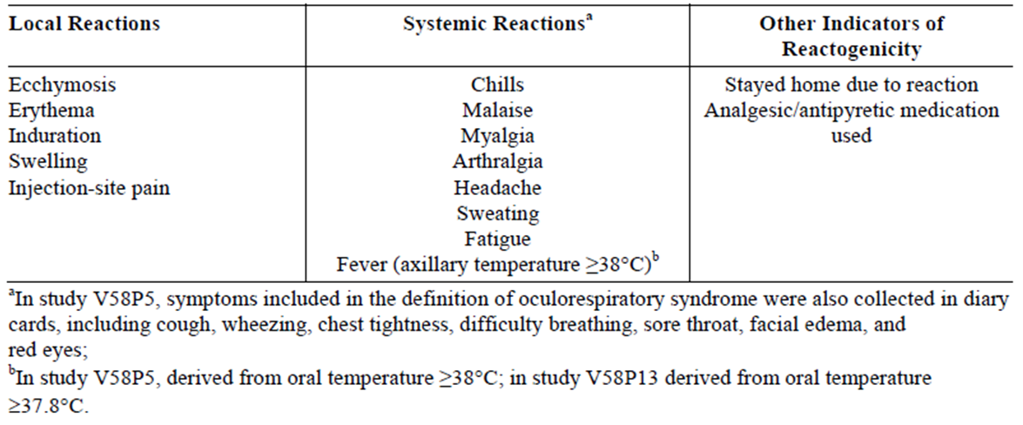
In all studies excluding Study V58P13, local reactions with the exception of pain at the injection site were graded similarly. For the purposes of this application, data were re-analysed to align with the scale used in Study V58P13: none (no reaction), mild to moderate (categories > 0 to 10 mm, > 10 to 25 mm, > 25 to 50 mm, > 50 to 100 mm in diameter) and severe (> 100 mm in diameter). Pain at injection site and all systemic reactions (with the exception of fever) and all unsolicited AEs were graded by the investigator as mild, moderate, or severe as follows:
- Mild no limitation of normal daily activities
- Moderate some limitation of normal daily activities
- Severe unable to perform normal daily activities
Measurement of body temperature was axillary in all studies except V58P5 and V58P13, in which oral temperature was collected. Axillary or oral temperature ≥ 38°C was classified as fever and body temperature was further graded as < 38°C, 38°C to 38.9°C, 39°C to 39.9°C, and ≥ 40°C.
All unsolicited AEs were collected during the follow up visits and during phone calls. The monitoring period for all unsolicited AEs continued for 21 days after vaccination for all studies with the exception of V58P5 and V58P13, in which they were collected only up to Day 7. In all studies, serious adverse events (SAEs) and AEs leading to withdrawal were collected for the entire study period, that is, approximately 6 months for participants in Studies V58P4, V58P4E1, V58P5, V58P9, and V58P13. In Studies V58P4E1, V58P9 AEs requiring a physician visit were also collected for the 6 months following vaccination, while in study V58P13 the onset of chronic diseases was collected for the 6 months.
Unsolicited AEs and SAEs were encoded using the Medicinal Dictionary for Regulatory Activities (MedDRA). All unsolicited AEs were graded mild, moderate, or severe by the investigator. Assessments of causal relationships were made as follows:
- Not related if the occurrence is not reasonably related in time, or there are no facts or arguments to suggest a causal relationship;
- Possibly related if reasonably related in time and the AE could be explained by causes other than exposure to the investigational product;
- Probably related if reasonably related in time and the investigational product is more likely than other causes to be responsible for the AE, or is the most likely cause of the AE.
Laboratory Safety Tests were only undertaken in V58P1 and for a subset of Study V58P5. Blood and urine samples were taken on Day 1 and Day 22 in study V58P1. Blood samples were collected on Day 1 and Day 8 in Study V58P5. Values deviating from the normal range were recorded. In both studies, tests on blood samples included creatinine, sodium, potassium, chloride, total protein, alkaline phosphatase, aspartate aminotransferase (AST), alanine aminotransferase (ALT), total bilirubin and blood urea nitrogen (BUN), haematocrit, haemoglobin, platelets, and white blood cells (total and differential). Urine tests in V58P1 were performed with a dipstick.
Occurrence of influenza like illness (ILI) in Study V58P9 was monitored from Day 23 till the end of Month 6 in a subset of participants and in all participants enrolled in study V58P5 for the entire study duration. Monitoring of ILI in Study V58P9 was conducted by means of active surveillance. Participants were asked to contact the study sites if they developed influenza like symptoms, and to provide nasopharyngeal specimens for laboratory confirmation of influenza virus.
In Study V58P9, ILI definition included: sudden onset of fever (axillary temperature ≥38°C), plus at least one systemic symptom such as myalgia, arthralgia, osteoalgia, tiredness, weakness, headache, ear ache, eye complaints, or chills, and at least one respiratory symptom such as sore throat, cough, hoarseness, wheezing, runny nose or nasal congestion. In Study V58P5, ILI cases were defined as: fever of 38.3°C (101.0°F) or greater, with cough or sore throat and with myalgia or chills. In both Studies V58P9 and V58P5, ILI cases of confirmed influenza were considered vaccine failures and reported as SAEs. In Study V58P13, vaccine efficacy was the primary outcome.

Patient exposure
N/A

Safety issues with the potential for major regulatory impact
N/A

Postmarketing data
This vaccine has been registered and it is likely that postmarketing information is now available although none has been submitted.

Evaluator’s conclusions on safety
In the pooled safety analysis in the age range 18-64, the risk ratios for injection site pain with RR 1.19 (95% CI 1.12, 1.26) favouring eTIV. There was no accounting for multiplicity in determining the required confidence interval. However, higher frequency of pain following cTIV vaccination was a consistent finding noted in all studies in which eTIVa was the comparator; however, in Study V58P5 in which eTIVf was the compactor, the incidence of pain recorded was greater for eTIVf.
Based on the submitted data, the sponsor’s conclusion on safety is agreed; this is reproduced below:
The cTIV vaccine was as safe as the control vaccine. The reactogenicity of both cTIV and control vaccines was similar within each age group. Only pain, of which over 99% was mild or moderate, was more frequently experienced by recipients of the cTIV than the control vaccine (adults 22% versus 17%: elderly 9% versus 5%, respectively). However, the difference in incidence rate was confined to a maximum of 2 days after injection and was not clinically relevant. Most other AEs reported by this study population were unrelated to the vaccines administered in this study. Those judged to be possibly or probably related to vaccination were experienced infrequently and were either ongoing local/systemic reactions (that is, past Day 7) or other common side effects of vaccination. The 3 serious AEs leading to death and 58 other serious AEs reported during this study predominantly occurred in the elderly population: all were unrelated to the study vaccines. The incident rate of serious AEs was as expected for this elderly population, where co-morbidities were very common.

First round benefit-risk assessment

First round assessment of benefits
- Influenza vaccination remains the mainstay of prevention of influenza
- Reduced reliance on the supply of embryonated hen eggs
- Possibility of increased vaccine availability in case of a pandemic
- Similar safety, efficacy and immunogenicity profile to egg derived vaccines, including Agrippal.

First round assessment of risks
- The risk profile in terms of adverse events is considered not materially different from that of the egg derived vaccines Agrippal and Fluvirin.

First round assessment of benefit-risk balance
The balance is considered to lie on the side of benefit.
It is recommended that the results of the planned postmarket studies are submitted to the TGA on completion.

Clinical questions
Below are the questions from the clinical evaluator. For details of the sponsor’s responses and the evaluator’s comments on the sponsor’s responses, see Attachment 2 of this AusPAR.

Question 1
The Overview of Clinical Pharmacology states that all studies except Study V58P13 were complicated by pipettor problems requiring reanalysis and presentation of only egg derived antigen assessments. The CSR for Study V58P1 includes results for egg and cell derived antigen HI testing, but it does not mention the pipette problem and the CSR is not specified as being Version 2, as was the case for other study reports of affected studies. Was there a pipette problem in Study V58P1?

Question 2
There was a marked difference in performance of the HI and SRH assays for the B strain in Study V58P2. The explanation provided was that this is consistent with previous literature reports (Monto et al.). No article with Monto as lead contributor was found in the reference list. The only Monto article located in the dossier did not discuss SRH assays. The sponsor is requested to supply a more detailed explanation for the discrepancies.

Question 3
It was stated in the Investigational Plan of Study V58P5 CSR that ILI would be assessed in Study V58P5. There was no discussion of ILI results found in the text of the CSR. The sponsor is asked to comment on ILI assessment and findings in this study.

Question 4
The US PI states:
“The tip caps of the pre-filled syringes may contain natural rubber latex which may cause allergic reactions in latex-sensitive individuals.”
The Australian PI states in the ‘Precautions’ section:
“Although no natural rubber latex is detected in the syringe tip cap, the safe use of Optaflu in latex-sensitive individuals has not been established.”
Which PI contains the most accurate information?

Question 5
Regarding presentation of immunogenicity results in the PI:
In all studies except Study V58P13, immunogenicity results were assessed against CPMP/BWP214/96 which has been formally adopted by the TGA. The clinical study reports include results in age categories 18 to 60 and > 60 years. The only exception, Study V58P13 included participants aged 18 to 49 years and had pre planned assessment against CBER criteria.
Participants in the studies assessed against CPMP criteria were re-categorised into age groups 18-64 and > 64 years and re-assessed against CBER criteria, which admittedly are more stringent than the CPMP criteria. These post hoc results are the results proposed for inclusion in the PI. As no hypotheses were tested in these instances and as the imposed criteria are more stringent, there is no objection to inclusion of results based on descriptive statistics although reporting according to protocol definitions would be preferred.
With respect to the non inferiority, hypothesis based, secondary objective of Study V58P4, upon which the study sample size was calculated, the results have also been recalculated for revised age groups for presentation in the PI. Table 4 of the proposed PI includes two sub analyses by revised age categories, neither of which was pre specified. It is not recommended that these results are included in the PI. It is recommended that the results of the non inferiority, analysis of Study V58P4 are presented in accordance with specification in the protocol, that is, in age groups 18 to 60 years and > 60 years. With respect to hypothesis driven results it is considered more important to accurately report the study than to manipulate results in order to present consistency of age groups.
With respect to Study V58P5, the results of this study do not fit neatly into the proposed short paragraph that follows Table 4 and the proposed text is not recommended. Assessment of non inferiority was the primary objective of this study and results of primary objectives are most suitable for the PI. The objective was not met using the pre specified ANOVA approach for A/H3N3 using the egg derived assay; it was met by a margin of 0.00329 using the cell derived antigen assay. Results were then re-analysed post hoc, controlling for centre, baseline results and vaccine group using ANCOVA, with results that met non inferiority criteria.
It is recommended that the results of assessments using the egg derived antigen are reported for Study V58P5 as for the other studies, or else qualify the HI antigen derivation for each of the studies. There is no objection to also including the ANCOVA results in addition providing the reader is informed that the analysis was post hoc and undertaken to control for difference in centres, pre vaccination.

Question 6
The Agrippal PI states the following. Is this correct?
“Elderly patients on long term warfarin therapy may experience an increase of International Normalised Ratio (INR) after influenza vaccination. Therefore, more frequent monitoring for six weeks after receiving influenza vaccine may be advisable.”

Second round evaluation
There is no change to the assessments stated in the first round.

Second round benefit-risk assessment
Based on the clinical efficacy, immunogenicity and safety data supplied in the clinical dossier, registration of Novartis Inactivated influenza virus vaccine (surface antigen) prepared in cell cultures Optaflu is recommended.

V. Pharmacovigilance findings

Risk management plan
The sponsor submitted a Risk Management Plan (EU-RMP) version 3.1 release date 15 November 2013 (data lock point 30 April 2013) and Australian Specific Annex (ASA) (version 1.0 release date 5 March 2014, which was reviewed by the TGA’s Office of Product Review (OPR).

Safety specification
The sponsor provided a summary of ongoing safety concerns which are shown at Table 3.
Table 3: Ongoing safety concerns.
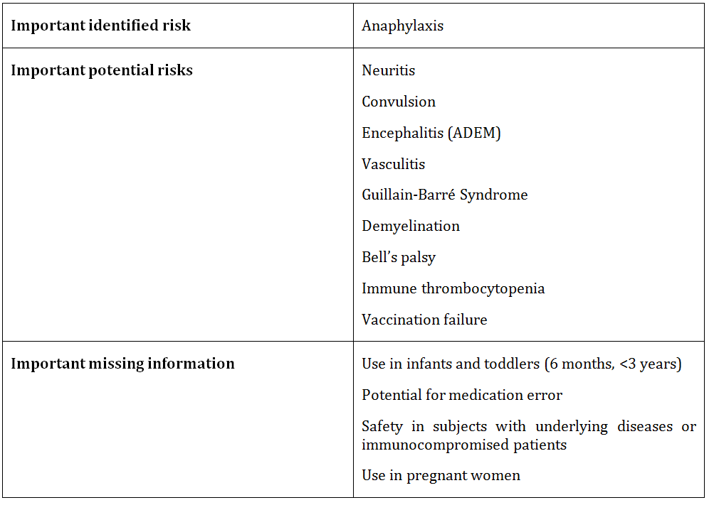

Pharmacovigilance plan
Routine pharmacovigilance is proposed to monitor the ongoing safety concerns. The sponsor has provided an assurance in the ASA that AE reports will be handled in line with “Australian requirements and recommendations for pharmacovigilance responsibilities of sponsors of medicines version 1.2, August 2013”. The sponsor is advised that this document has been recently updated (version 1.3, June 2014) and the reference in the ASA should be amended accordingly.
Additional pharmacovigilance activities are proposed as outlined in Table 4.
Table 4: Additional pharmacovigilance activities.
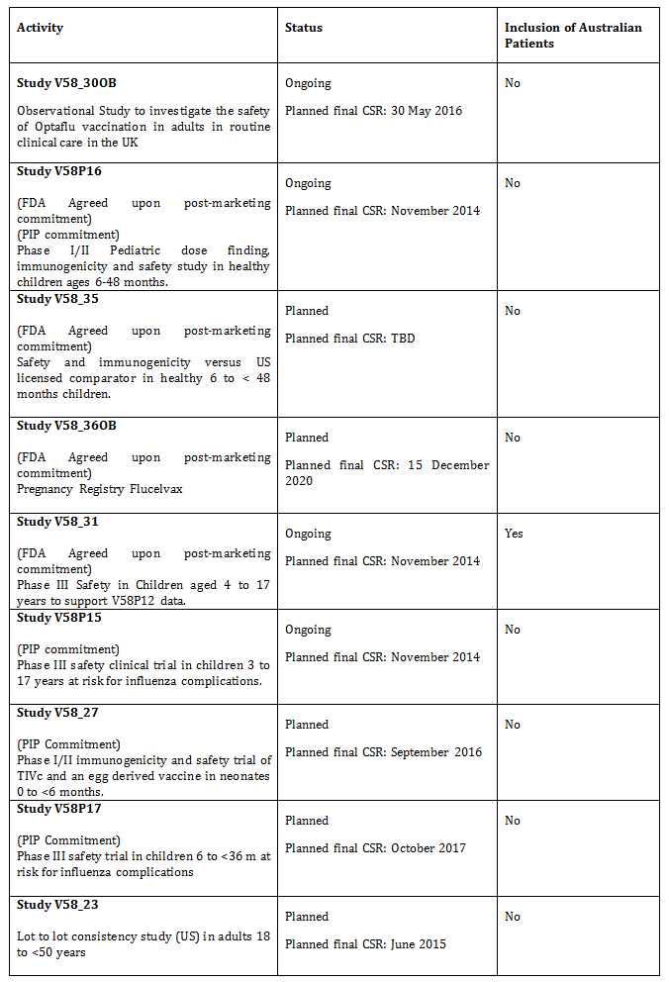

Risk minimisation activities
The sponsor has concluded that routine risk minimisation (that is, product labelling) only is sufficient to mitigate the risks associated with Optaflu. No additional risk minimisation activities are proposed.

Reconciliation of issues outlined in the RMP report
Reconciliation of issues outlined in the RMP report is as follows.

Recommendation #1 in RMP evaluation report
Safety considerations may be raised by the nonclinical and clinical evaluators through the consolidated Section 31 request and/or the nonclinical and clinical evaluation reports, respectively. It is important to ensure that the information provided in response to these includes consideration of the relevance for the RMP, and any specific information needed to address this issue in the RMP. For any safety considerations so raised, the sponsor should provide information that is relevant and necessary to address the issue in the RMP.

Sponsor response
No safety concerns warranting Novartis to provide additional information were raised by the clinical and nonclinical evaluators.

OPR evaluator’s comment
It is noted that the nonclinical evaluation report states that there were study quality issues and deficiencies. The sponsor should ensure that any impact of these upon the RMP is appropriately addressed.

Recommendation #2 in RMP evaluation report
The sponsor is requested to provide justification as to why tumorigenicity, infectivity and oncogenic potential are not considered as potential safety concerns in the RMP.

Sponsor response
Theoretical and potential safety issues regarding the use of immortalised tumorigenic cell lines, like MDCK cells, were considered during the early stages of development of Optaflu. Consistent with current global expectations for the qualification of a new cell line as a platform for vaccine production, Novartis has performed studies with intact MDCK cells, lysates of MDCK cells, and purified DNA obtained from MDCK cells. Tumorigenicity (intact MDCK cells) or oncogenicity (cell lysates and purified DNA) testing in rodents demonstrated that only intact MDCK cells (adapted to protein free growth in suspension) were tumorigenic in immunocompromised (nude) adult mice. Cell lysates and purified MDCK cell DNA were not oncogenic in the three infant rodent species tested.
MDCK cell removal throughout the manufacturing process has been formally demonstrated through a series of process evaluation and validation studies. In addition, the comprehensive adventitious agent management program for Optaflu reflects the ICH recommended complementary approach to control potential viral contamination of biotechnology products. The MDCK cell line, seed virus and other raw materials, including media components, have been selected and tested for the absence of undesirable viruses which may be infectious or pathogenic to humans. The manufacturing process has been assessed for its capacity to clear infectious viruses. Product intermediates and the final container are tested at appropriate intervals to assure absence of contaminating infectious viruses.
Because whole MDCK cells are reliably excluded from the vaccine during multiple steps of the manufacturing process, and MDCK cell lysates and DNA demonstrated no oncogenicity in sensitive animal models, and because a comprehensive adventitious agent management program is in place, Novartis concludes that the theoretical safety risks of tumorigenicity, oncogenic potential, and infectivity to a vaccinee receiving an annual dose of Optaflu are exceedingly low, and are therefore not addressed in the RMP.

OPR evaluator’s comment
The evaluator accepts that the risks of tumorigenicity, infectivity and oncogenic potential are very low but not absolutely absent. This is in accordance with comments on carcinogenicity in the nonclinical evaluation report.
The Advisory Committee on the Safety of Vaccines (ACSOV) stated that “with vaccines manufactured in CCL there is the potential for tumorigenicity” and concluded that the current evidence neither supports nor refutes the addition of these safety concerns to the RMP.
On balance, the evaluator considers that the inclusion of these safety concerns as important potential risks is not warranted at this time.
However it is recommended to the Delegate that the risks of ‘tumorigenicity’, ‘infectivity’ and ‘oncogenic potential’ are added as missing information to the RMP and/or ASA. This would be assumed to include the unknown effects of repeat dosing on this missing information.
In noting the challenges of monitoring these risks, ACSOV queried the feasibility of a study to monitor them given the time delay to onset and likely confounding factors. Routine pharmacovigilance would therefore be considered adequate.
ACSOV advised that to further quantify the risk in relation to these safety issues more information was required including available Periodic Safety Update Reports (PSURs).

Recommendation #3 in RMP evaluation report
At the time of approval in the EU, the European Public Assessment Report (EPAR; available online) lists two additional identified risks: “Severe systemic reactions associated with repeated dosing” and “Increased frequency of injection site pain compared to egg based vaccines”. These risks no longer appear in the most recent version of the EU-RMP provided to the TGA. The sponsor is requested to provide the justification for the removal of these risks in their Section 31 response.

Sponsor response
The sponsor has provided the requested justification in their Section 31 response.

OPR evaluator’s comment
The sponsor’s justification is acceptable.

Recommendation #4 in RMP evaluation report
The sponsor has provided an assurance in the ASA that AE reports will be handled in line with “Australian requirements and recommendations for pharmacovigilance responsibilities of sponsors of medicines version 1.2, August 2013”. The sponsor is advised that this document has been recently updated (version 1.3, June 2014) and the reference in the ASA should be amended accordingly.

Sponsor response
Novartis acknowledges this request. The reference in the ASA for “Australian requirements and recommendations for pharmacovigilance responsibilities of sponsors of medicines” has been updated to current version 1.3, June 2014. Please find updated ASA.

OPR evaluator’s comment
This is acceptable.

Recommendation #5 in RMP evaluation report
The ongoing pharmacovigilance studies will either generate safety data that will simply support the known safety profile of the medicine or generate data that will provoke applications to amend the Australian registration details. It is recommended that all interim reports and final reports for each activity are provided to the TGA accordingly.

Sponsor response
There is no planned submission of interim and final reports to the TGA, but they are available upon request. Novartis confirms that any change to the risk/benefit profile (that is, new safety information) that would become available from these studies would be added to the PSUR. They may also be submitted to the TGA via safety related notifications.

OPR evaluator’s comment
The sponsor’s response is noted. Results of any study, performed as part of the pharmacovigilance plan, are expected to be summarised in the PSUR.

Recommendation #6 in RMP evaluation report
The sponsor has concluded that no risk minimisation activities are required for the important potential risks ‘Neuritis’, ‘Encephalitis’ and ‘Immune thrombocytopaenia’. However encephalomyelitis, neuritis, vasculitis and thrombocytopaenia all appear in the summary of adverse reactions table in the EU Summary of Product Characteristics (SmPC). The sponsor is requested to clarify the reason for the inclusion of these risks in the EU document on the basis that the justification for not including them in the Australian labelling is that there were no corresponding adverse reactions from clinical studies or postmarketing studies.

Sponsor response
The potential risks encephalomyelitis, neuritis, vasculitis and thrombocytopaenia are included in the EU SmPC because they have been reported in association with egg-based influenza vaccines. We did not include them in the proposed Australian label because, based on the current clinical trial and postmarket adverse effects data, there is insufficient evidence to conclude a causal relationship between these events and Optaflu.

OPR evaluator’s comment
The evaluator does not consider that these risks are presented in the EU SmPC as pertaining to egg based vaccines. ‘Encephalomyelitis’, ‘neuritis’ and ‘thrombocytopaenia’ appear the EU SmPC which relates to adverse events seen with Optaflu. Preceding this table there is no mention of the association with egg based vaccines.
Insufficient evidence to conclude a causal relationship does not necessarily erase the need for inclusion of a particular risk in the PI, particularly when that risk is clinically important and has been reported. Such risks, appropriately qualified, could be listed in the post-marketing adverse events section for example.
Nevertheless, inclusion of these risks in the PI is subject to decision by the Delegate.

Recommendation #7 in RMP evaluation report
Optaflu has the advantage of being available for use in egg allergic individuals. Logically there is a potential for susceptible individuals to be at an increased risk of hypersensitivity due to the possible presence of dog allergens in Optaflu. The sponsor is requested to respond to this in the context that this fact is not sufficiently addressed in the product labelling.

Sponsor response
Optaflu is an inactivated subunit trivalent influenza virus vaccine prepared from virus propagated in MDCK (EU SmPC). MDCK cells do not express known major canine allergens associated with hypersensitivity reactions; however, minor canine allergens may be present posing a hypothetical concern with hypersensitivity reactions. A post hoc review was performed using the Optaflu clinical trials database. There were a total of 10065 Optaflu recipients, of which, ten individuals who reported a dog allergy did not report any hypersensitivity reactions. Limitations of this review include: the nature of the specific dog allergy was not well defined, the prevalence of dog allergy observed in Optaflu clinical trials was lower than expected in the general population and the number of subjects who had dog allergy was too small to be statistically significant or to see a definitive trend. In an in vitro study, rat basophil leukemia (RBL) cells expressing the human IgE receptor-1 were sensitised by exposure to sera from 30 confirmed dog allergic individuals to evaluate allergenicity of Optaflu using a mediator release assay. This type of assay can detect low levels of allergens. Participants selected all had convincing symptoms of immediate hypersensitivity on exposure to dogs, such as rhinorrhea, nasal congestion, nasal pruritus, ocular pruritus, ocular discharge, ocular injection, cough, wheezing, shortness of breath or cutaneous symptoms and both a positive skin prick test and defined serum IgE antibody level to dog dander and epithelium. None of the 30 dog allergic patients’ sera produced rat basophil degranulation when exposed to vaccine. The results of the bioassay performed in individuals documented to have dog protein allergy were all negative.

OPR evaluator’s comment
The sponsor’s response is noted. The final decision as to whether there should be guidance in the PI regarding use of Optaflu in dog allergic patients is referred to the Delegate.

Summary of recommendations

Outstanding issues

Issues in relation to the RMP
It is recommended to the Delegate that ‘tumorigenicity’, ‘infectivity’ and ‘oncogenic potential’ are added as missing information to the RMP and/or ASA.
The following outstanding issues regarding routine risk minimisation are referred to the Delegate for final consideration:
- Inclusion of important potential risks ‘neuritis’, ‘encephalitis’ and ‘immune thrombocytopaenia’ as adverse effects in the draft PI.
- Inclusion of information in the PI regarding use of Optaflu in dog-allergic individuals.
- Inclusion of ‘abdominal pain’, ‘diarrhoea’ and ‘dyspepsia’ as adverse effects in the draft PI.
- Inclusion of consumer-appropriate information in the CMI on how the vaccine is manufactured given it differs from comparator vaccines.

Advice from the Advisory Committee on the Safety of Vaccines (ACSOV)
Advice was obtained from ACSOV regarding the Optaflu RMP. This advice is incorporated into this report, where appropriate.
ACSOV advised that to further quantify the risk in relation to tumorigenicity, infectivity and oncogenic potential they required more information including available PSURs (see attachment 1).

Comments on the safety specification of the RMP

Clinical evaluation report
The clinical evaluation report includes the following comments regarding the safety specification in the RMP:
Identified Risk
Risks in terms of safety are considered similar to those of Agrippal and Fluvirin, both registered in Australia and considered an appropriated comparator for Australian purposes. It is possible that cTIV vaccination may result in a higher incidence of pain (pooled safety population RR 1.19 [95% CI 1.12, 1.26] favouring eTIV).
Limitation of the Research
The research presented fulfils requirements of the Therapeutic Goods Administration.
Areas of Uncertainly
    - Use in pregnancy and lactation, chronic illness, immunodeficiency states, and in ethnic groups either not represented or represented in small numbers such as Asians and Australian Indigenous groups.
    - Rare, as yet unidentified adverse events may require greater numbers to be vaccinated.
Pharmacovigilance
Spontaneous reporting is proposed in line with global and local Novartis procedures and with the “Australian requirements and recommendations for pharmacovigilance responsibilities of sponsors of medicines version 1.2, August 2013”.
Planned Post Market Research
Novartis Vaccines and Diagnostics presented the following protocols for post-market trials
Study V58P23 a phase III, multicentre, randomized double-blind, controlled study to evaluate the safety and immunogenicity of cTIV and eTIVf in healthy adults. This study is a post marketing commitment requested by CBER and is designed to demonstrate the immunologic equivalence, immunogenicity safety and tolerability between three consecutive lots of TIVc according to CBER criteria.
Study V58P30 Post-licensure observational safety study after Optaflu vaccination among adults in The Health Improvement Network (THIN) database of routine UK primary care records
Registry V5836OB: The objective of the Flucelvax (cTIV registered name in the US) Pregnancy Registry is to evaluate pregnancy outcomes among women immunized with the Flucelvax vaccine during pregnancy. The primary outcomes of interest include major congenital malformation, preterm birth, and low birth weight.

OPR evaluator’s comments
‘Use in pregnant women’ and ‘safety in subjects with underlying diseases or immunocompromised patients’ are included as missing information in the RMP. ‘Use in ethnic groups not studied’ is not currently included, however routine pharmacovigilance for this risk would be considered appropriate.

Nonclinical evaluation report
The nonclinical evaluation report includes the following comments regarding the safety specification in the RMP:
The overall results and conclusions drawn from in this section of the risk management plan are in general concordance with those of the nonclinical evaluator except for the study quality issues and deficiencies described above.
Regarding neoplastic potential, the nonclinical evaluation report contains the following comment:
Critically it should be clearly noted that the MDCK cell line used by the sponsor cannot be described as minimally tumorigenic in vivo, in relevant (i.e. T-cell depleted) animal models. However based on the currently available data, the overall risk of de novo neoplastic disease due to the use of Optaflu is considered to be extremely low due to the lack of viable cells in the final product and lack of carcinogenicity/neoplastic potential of MDCK cell-free lysate, of beta-propiolactone treated MDCK cell-free lysate, and of MDCK cell DNA.
The nonclinical evaluator has also recommended adding statements to the PI that Optaflu has not been evaluated for genotoxicity and carcinogenicity.

Key changes to the updated ASA
In the Section 31 response, the sponsor provided an updated ASA (version 2.0, release date 29 October 2014) which contained the following amendments as shown in Table 5.
Table 5: Amendments in the updated ASA.
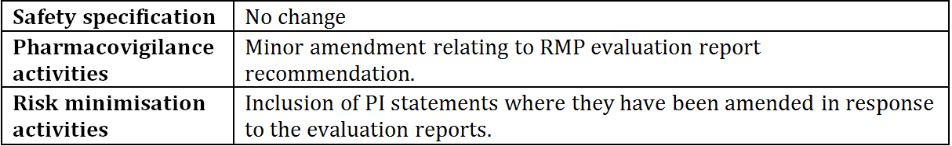
OPR evaluator’s comments: The evaluator has no objection to the above changes and recommends to the Delegate that the updated version is implemented (see below).

Suggested wording for conditions of registration

RMP
Implement EU-RMP (version 3.1 release date 15 November 2013, data lock point 30 April 2013) with Australian Specific Annex (version 2.0, release date 29 October 2014) revised to the agreement of the TGA (with respect to the outstanding issues listed).

VI. Overall conclusion and risk/benefit assessment
The submission was summarised in the following Delegate’s overview and recommendations:

Quality
The evaluator recommended that Optaflu inactivated influenza virus vaccine (surface antigens), prepared in cell cultures injection prefilled syringe (with needle and without needle) should be approved.
The administrative, product usage, chemical, pharmaceutical, microbiological data submitted were evaluated in accordance with the Australian legislation, pharmacopoeial standards and relevant technical guidelines adopted by the TGA. A few minor issues are still being addressed and will require resolution prior to supply.

Nonclinical
There were no nonclinical objections to registration of the inactivated, trivalent influenza vaccine, Optaflu, at a dose of 15 µg/strain in adults.
There were no nonclinical Section 31 questions. The sponsor reworded several of the nonclinical PI statements recommended. These were accepted by the TGA.
The sponsor has proposed Category B1 in the PI. This classification is supported by a lack of evidence of prenatal or postnatal effects in a single species (rabbit) reproductive and developmental toxicity study. Potential effects in males were not evaluated.
The nonclinical evaluator commented that Optaflu has not been evaluated for prion disease potential or for the presence of modified prion proteins; however, the current international regulatory consensus is that vaccines such as Optaflu are very unlikely to cause transmissible spongiform encephalopathies in humans.

Clinical
Table 6 shows an overview of clinical studies.
Table 6: Overview of clinical studies.
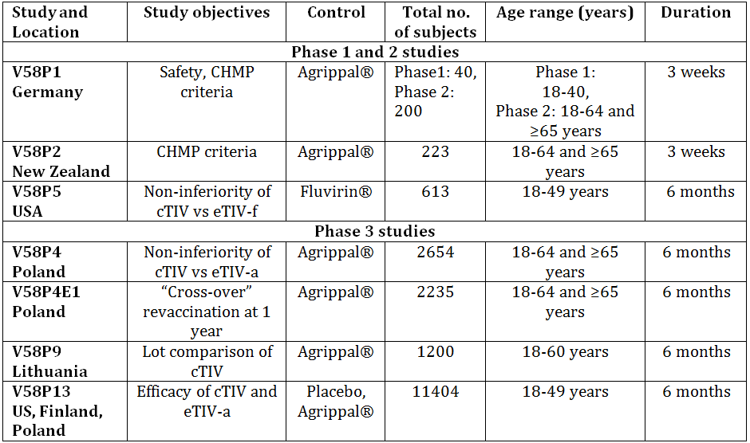
CHMP: Committee for Medicinal products for Human Use
cTIV: cell culture-derived influenza vaccine
eTIV-f: egg-derived influenza vaccine. Fluvirin
eTIV-a: egg-derived influenza vaccine. Agriflu/Agrippal
All studies included with the submission were completed.
Agrippal (eTIVa) was used as the control vaccine in five studies and as a second investigational vaccine in the placebo controlled efficacy study, V58P13. It is available in Australia. Fluvirin was used as the control vaccine for the noninferiority study, V58P5. It is currently marketed in 15 countries, but not in Australia.
For the studies submitted for registration in the EU, assessment of immunogenicity adhered to CPMP/BWP/214/96 requirements as shown in Figure 1.
Figure 1: CPMP/BWP/214/96 Immunogenicity criteria for evaluation of influenza vaccines.
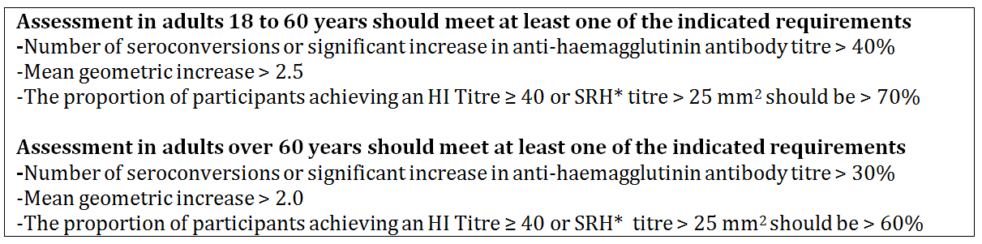
SRH: single radial haemolysis, HI: haemagglutinin inhibition.
* In most SRH test systems, a zone area of 25mm² is approximately equivalent to an HI titre of 1:40. However, this relationship can be affected by experimental conditions and should be re-examined in each laboratory so as to calibrate the test system adequately.
Studies V58P5 and V58P13 also adhered to the FDA CBER criteria, which specify the lower limit of the two sided 95% confidence interval (CI) for the percentage of subjects achieving seroconversion for HI antibody and for achieving an HI titre ≥ 1:40 as outlined in Figures 2 and 3.
Figure 2: FDA CBER immunogenicity criteria for evaluation of influenza vaccines.
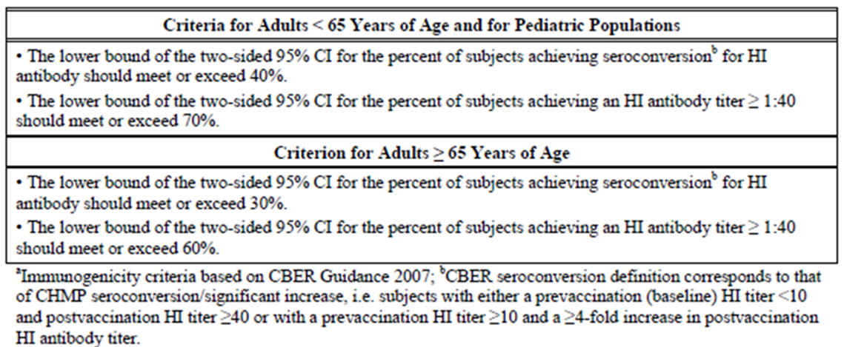
Figure 3: FDA CBER immunogenicity criteria for non inferiority and lot consistency.
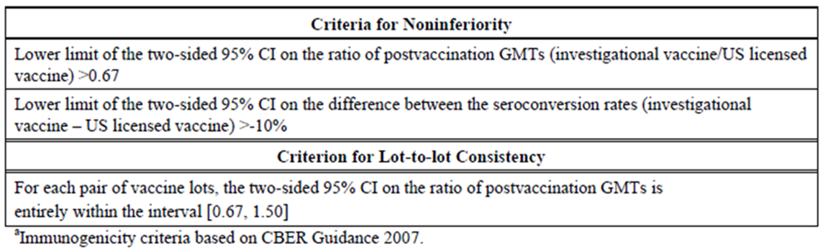

Efficacy

V58P13, FDA review
V58P13 was a Phase III, randomised, observer blind, placebo controlled, multicentre study of efficacy, immunogenicity, safety and tolerability of cTIV compared to eTIVa in healthy adults aged 18-49 years. It was completed in July 2008.
The primary objective was to demonstrate protection of cTIV and eTIV versus placebo against illness caused by virus-confirmed community acquired influenza wild type strains antigenically similar to those in the vaccines. The two influenza vaccines were evaluated separately; both were compared to placebo and not to each other.
Secondary efficacy objectives evaluated cTIV and eTIVa separately, each compared to placebo. Secondary immunogenicity objectives evaluated percentages with seroprotection and seroconversion or significant increase in titre in a subset of participants according to the FDA CBER criteria.
Subjects were randomised in a 1:1:1 ratio to receive cTIV, eTIVa (Aggripal), or PBS placebo. Active and passive surveillance for influenza-like illnesses was conducted throughout the 2007-2008 influenza season.
A subset of subjects enrolled at US study sites were enrolled in an immunogenicity subset to support the Agriflu/Aggripal (eTIVa) Biologics License Application: the first 240 subjects who received cTIV, the first 750 subjects who received eTIVa , and the first 60 who received placebo. The FDA reviewer commented that there was an imbalance in the size of the immunogenicity subsets, because the sponsor used the results of the study to support the size of the database supporting eTIVa immunogenicity, while there were several previously completed studies to support the immunogenicity of cTIV.
In total, 11404 participants were enrolled and randomised into three groups, 3828 received the cTIV vaccine, 3676 received the eTIVa and 3900 received placebo. Overall, 10844 completed the study. The mean age in the three groups was 32.7 - 33 years, with the majority of participants in all groups Caucasian (84% - 85%).
Table 7: V58P13 participant numbers planned and enrolled.
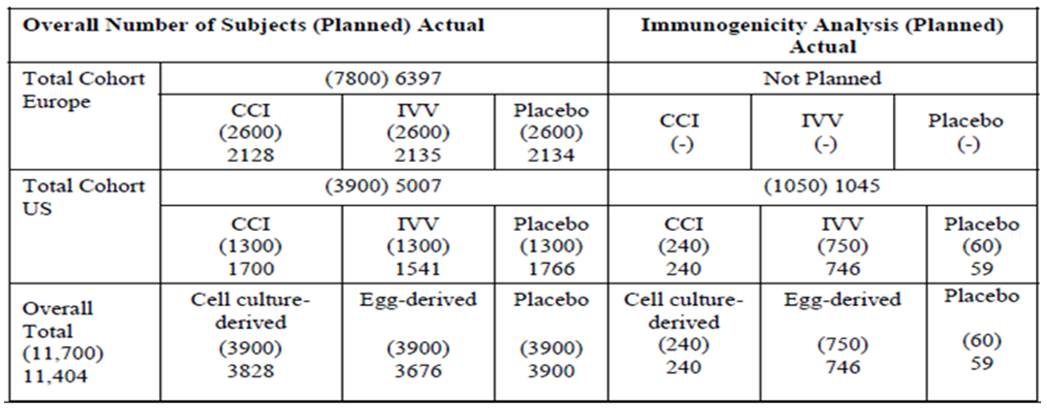
The primary objective was met for both vaccines, as described below.

cTIV vaccine
The rates of culture confirmed influenza caused by vaccine like strains in the per protocol efficacy population were 0.0019 (7/3776) for cTIV and 0.0114 (44/3843) for placebo. Overall vaccine efficacy (LL 97.5% CI) was 83.8% (61%); p = 0.0005.

eTIVa vaccine
The rates of culture confirmed influenza caused by vaccine like strains in the per protocol efficacy population were 0.0025 (9/3638) for eTIVa and 0.0114 (44/3843) for placebo. Overall vaccine efficacy (LL 97.5% CI) was 78.4% (52.1%); p = 0.0035.
It was concluded that the primary objective was met for both vaccines.
For vaccine efficacy against non vaccine strains for both vaccine groups, results were not statistically compliant with CBER criteria for assessing vaccine efficacy against placebo.
The CBER criteria for seroconversion and seroprotection were all met for each of the three strains for both cTIV and eTIV but not for placebo. The EU CPMP criteria were also met for all strains for the active vaccine groups.

Immunogenicity

V58P4
V58P4 was a Phase III, observer blind, randomised, multi centre study evaluating safety, tolerability and immunogenicity cTIV compared to eTIVa in healthy adults aged 18-60 years and > 60 years, conducted in five centres in Poland. It was completed in May 2005.
The primary objective was to evaluate immunogenicity of cTIV versus eTIVa according to the EU CPMP criteria (outlined previously).
The secondary objective was to demonstrate non inferiority of the correlates of protection (seroprotection, seroconversion and sufficient increase in geometric mean titre) of a single dose of cTIV compared to eTIVa.
A total of 2654 participants were enrolled, randomised, and vaccinated: 1330 in the cTIV arm and 1324 in the eTIVa arm. Of these, 1300 were aged 18 to 60 years and 1354 aged >60 years. More than 97% of subjects in each study arm completed the study.
In the age group 18-60 years, the average ages in the cTIV and eTIVa groups were 38.7 years and 38.3 years, respectively. In the age group >60 years, the average ages in the cTIV and eTIVa groups were 69.1 years and 68.8 years respectively. For both age groups, all participants were Caucasian.

Results
Primary objective: cTIV and eTIV met all three CPMP criteria against the three strains in both age groups (Table 8).
Table 8: Study V58P4 – results (point estimates) for seroconversion rate, percentage of subjects with HI titers ≥ 1:40, and geometric mean ratio (Per Protocol population).
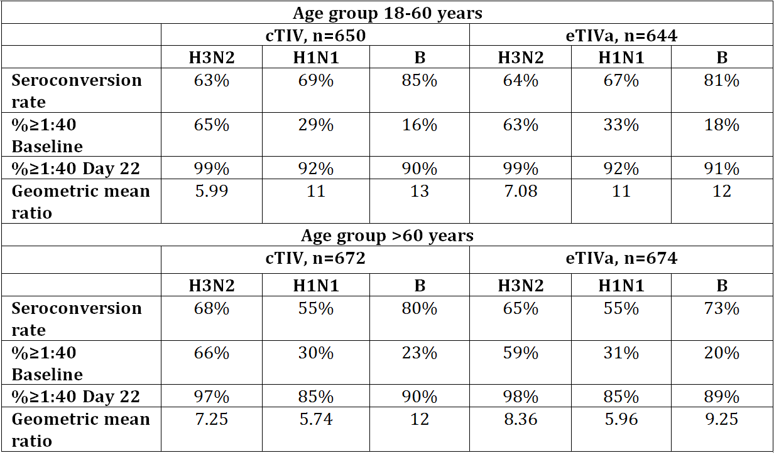
* Secondary objectives: the non-inferiority objective was met for both the 18 to 60 years and the >60 years age groups and summarised on pp 27-28 of the CER.
Secondary objective: The non inferiority criteria were met for all three strains for both age groups.

V58P4E1: Revaccination at one year
This was a 6 month extension study of V58P4, evaluating safety, tolerability and immunogenicity in a subset, of a repeat dose of cTIV or eTIVa one year after vaccination.
Participants were randomised 1:1 and stratified by the age at enrolment and the vaccine received in Study V58P4. Those who had previously received cTIV or eTIVa were randomly allocated to receive either cTIV or eTIVa, resulting in a total of 8 vaccination groups as shown below:
- Age 18-60 years: cTIV/cTIV, cTIV/control, control/control, and control/cTIV.
- Age > 60 years: cTIV/cTIV, cTIV/control, control/control, and control/cTIV.
Antibody titres were obtained in a subgroup of 480 subjects, 240 in each age subgroup. The immunogenicity subset was defined as the first 120 subjects who enrolled in each age subgroup at two of the study centres (01 and 05) and the sample size for the immunogenicity subgroups of each group (n = 54) complied with CPMP/BWP/214/96 criteria.
The study design was almost identical to Study V58P4E1, with the following exceptions:
- The influenza strains included in the study vaccines in V58P4E1 were those recommended for the 2005-2006 influenza season in the Northern Hemisphere, with the H1N1 and B strains identical to those in Study V58P4, but the H3N2 strain was changed to A/California/7/2004; and
- Immunogenicity was only performed in a subset of participants.
Of those enrolled in Study V58P4, 82% of those aged 18 to 60 years and 86% of those > 60 years entered the extension study. A total of 2235 participants, 1067 aged 18 to 60 years and 1168 aged > 60 years, were enrolled, 1105 were vaccinated with cTIV and 1130 with eTIVa.
For the 18-60 year age group, cTIV and eTIVa groups met all CPMP criteria against A/H3N2. CPMP seroprotection criteria were met for A/H1N1 and B vaccines but not seroconversion rates or geometric titres, given these subjects had previously received the same H1N1 and B strains in study V58P4.
For the >60 year age group, the CHMP criteria were met for all 3 strains for both vaccines.

V58P9: Supportive study, safety, lot consistency
V58P9 was a Phase III, randomised, controlled, observer blind, multicentre study in healthy adults aged 18 to 60 years, conducted in two centres in Lithuania, comparing three lots of cTIV with eTIVa. It was completed in 2006.
The primary objective was to evaluate immunogenicity of the two vaccines and of each cell derived vaccine lot, three weeks after a single dose of vaccine, according to CPMP/BWP/2014/96 criteria.

Efficacy
A subset including approximately 520 participants was to be included in an influenza-like illness surveillance program.
The FDA reviewer expressed concern that the clinical study report stated that the study was designed primarily as a descriptive assessment of safety. Criteria for assessment of lot consistency were not included in the protocol, but defined post hoc after immunogenicity results were known. One of the sites in Lithuania was audited by Lithuanian regulatory authorities in 2007 due to concerns with the conduct of a separate Novartis study (V87P4).
Given the above concerns, the TGA clinical evaluator commented that follow-up analysis of this site’s data did not indicate grounds for concluding that data from that site should be excluded from consideration in the study analyses. In addition, safety, tolerability and immunogenicity analyses were retrospectively performed without site 2 and compared in the addendum to the results of the overall population (site 1 and 2). Differences were reported to be small and did not change the overall assessment of cTIV compared to eTIV.
A total of 1199 subjects were vaccinated: 342 Lot A, 344 Lot B, and 343 Lot C (1029 total in cTIV group) and 171 eTIVa. A total of 1166 participants completed the study (998 in the pooled cTIV groups and 168 in the comparator groups). Baseline characteristics were similar for the pooled cTIV group and control group, all participants were Caucasian, for the four groups, mean age ranged from 32. 4 to 32.6 years.

Results

Immunogenicity
Each of the three cTIV lot groups, the total cTIV group and the control vaccine groups met all CPMP/BWP/214/96 criteria for all three antigen strains.

Lot consistency
Lot consistence in terms of geometric mean titres was shown in accordance with the chosen limits of 0.5 to 2 and also fell between the FDA guidance limits of 0.67 and 1.5 for each strain tested.

ILI
A subset of 494 participants was included in the ILI surveillance program. Five subjects in the cTIV group and two subjects in the control group had laboratory confirmed influenza, all of which were caused by the type B viral strain.
Table 9: V58P9 immune responses against the B strain in participants with vaccine failure.
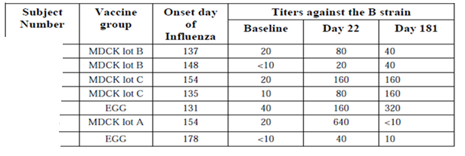
After Day 22, only three participants demonstrated further rises in titres, suggesting these participants might have been exposed subsequently to B/Shanghai/361/2002 or to an antigenically similar strain.
The sponsor commented that laboratory identification of influenza viruses was targeted to detect the different influenza type strains (A and B), but it was not able to further investigate the antigenic or genetic characteristics. Although more than 90% of all the isolated strains in Lithuania were of type B, no further information on the antigenic strain characterisation was available.
Results for antibody persistence and lot consistency at 6 months are summarised in the CER.

V58P5 (Phase II, non inferiority study)
This was a Phase II, observer blinded, randomised, multicentre non inferiority study in adults. It was conducted in the US and was the only study to use the egg derived influenza vaccine, Fluvirin, as the control vaccine. The study was completed in 2006.
The study compared the immunogenicity of a single dose of cTIV with eTIVf. Assessment of non inferiority was the only stated immunogenicity objective of this study.
Non inferiority was concluded for A/H1N1 and the B strain. Non inferiority was not met for A/H3N3 using the pre specified ANOVA approach using the egg derived assay; it was met by a margin of 0.00329 using the cell derived antigen assay. Results were then re-analysed post hoc, controlling for centre, baseline results and vaccine group using ANCOVA, with results that met non inferiority criteria. Seroprotection and seroconversion results using both antigen assays met CBER and CPMP criteria.
The concerns expressed by the clinical evaluator with respect to these analyses were adequately addressed with the Section 31 response, with the PI updated accordingly.

V58P2 (Phase II, exploratory study)
V58P2 was a Phase II, observer blind, randomised, single centre study of immunogenicity in terms of CPMP criteria, safety and reactogenicity of cTIV compared to eTIVa. It was conducted in New Zealand and completed in 2003.
Healthy adults age 18 to 60 (n =113) and > 60 years (n =110) were enrolled, the majority were Caucasian. Previous vaccination had been recorded for 82% of cTIV and 72% of eTIVa groups aged 18 to 60 and 94 to 96% of those aged > 60 years.
Results were similar for each vaccine and met at least one CPMP criterion. The FDA reviewer commented that the low seroconversion rates observed after vaccination with the influenza A antigens were most likely related to the high antibody titres present at baseline, given the majority of adult subjects (82% in the cTIV arm and 72% in the eTIVa arm) had previously received an influenza vaccine.
The seroconversion rates and percentage of subjects with post vaccination HAI titres of 1:40 or higher at baseline and at Day 22 were all lower to the influenza B strain. However, the antibody response to influenza B did meet the CPMP criteria demonstration of immunogenicity due to geometric mean ratios greater than 2.5 in both the cTIV and eTIVa arm.

V58P1 (Phase I/II)
V58P1 was a Phase I/II, observer blind, randomised 1:1, single centre, sequential cohort study conducted in Germany, comparing safety, tolerability and immunogenicity of cTIV compared and eTIVa in healthy adults. It was completed in 2002.
Phase I was a preliminary safety study of 4 weeks, including 40 participants aged 18 to 40 years and Phase II included 200 participants in age cohorts 18-60 and ≥ 61 years. Immunogenicity was assessed in compliance with CPMP/BWP/214/96.
The study was affected by a malfunctioning handheld electronic pipette leading to a systematic under-measurement of the volume of serum, resulting in underestimation of antibody titres. The data were not retested for this study.
For age 18 to 40 years, results for cTIV met CPMP criteria for each strain.
For pooled Phase I and II ages 18 to 60 years, results for cTIV met CPMP criteria for each strain. For age > 60 years, results for cTIV met CPMP criteria for each strain.

Overall conclusion regarding efficacy and immunogenicity
The clinical evaluator highlighted the following issues. Overall, the studies provided a database that was sufficient to demonstrate immunogenicity of cTIV in comparison to vaccines produced in embryonated hens’ eggs, Agrippal and Fluvirin. In addition, lot consistency and antibody persistence were demonstrated.
The evaluator expressed concern that results in the dossier had undergone a significant amount of recalculation, with all studies except V58P13 including immunogenicity results affected by a pipetting problem.
There was a marked difference in performance of the HI and SRH assays for the B strain in Study V58P2. The explanation provided by the sponsor with the Section 31 response cited several published reports describing this issue and concluded that the SRH test for post vaccination studies with influenza B viruses appears to be more sensitive than the HI test.

Safety
A pooled safety analysis performed across studies included 6710 cTIV participants (6138 aged 18 to 64 years and 572 ≥ 65 years), but excluded participants in the extension study V58P4E and those in the placebo arm of Study V58P13. Safety results for Study V58P4E were reported.
The clinical evaluator commented that age categories for the pooled analysis were not those included in the individual study analyses and therefore re-analysis of study results was required.
Safety endpoints for all studies included record of solicited AEs, local and systemic reactions and other indicators of reactogenicity from Day 1 to Day 7. Unsolicited AEs were recorded for the duration of study.

Participants aged 18 to 64 years
With regards to solicited adverse events, in the pooled safety analysis for the age range 18-64 years, injection site pain and erythema were the most commonly reported solicited local AEs. Headache, malaise, fatigue and myalgia were the most common solicited systemic AEs. The risk ratios for each solicited AEs included 1, except for injection site pain with RR 1.19 (95% CI 1.12, 1.26) favouring eTIV. A higher frequency of pain following cTIV vaccination was a consistent finding noted in all studies in which eTIVa(Aggripal) was the comparator; however, in Study V58P5 in which eTIVf (Fluvirin) was the comparator, the incidence of pain recorded was greater for eTIVf.

Participants aged ≥ 65 years
For adults ≥ 65 years, erythema and injection site pain were the most commonly reported solicited local AEs. Headache and fatigue were the most commonly reported solicited systemic AEs. All risk ratios included 1. Local AEs were reported less often by those age ≥ 65 years. Headache and myalgia were reported less often than in the younger age group but the difference otherwise in systemic AEs was not obviously remarkable.
With respect to unsolicited AEs and possibly/probably related AEs, these were noted to occur at a similar frequency for cTIV and control vaccines.

Deaths and serious AEs
In the pooled studies, a total of 13 deaths occurred, six in the 18 to 64 year age group (4 cTIV recipients, 1 eTIV-a recipients and 1 in the placebo group of study V58P13) and seven in the ≥ 65 year age group (3 for cTIV and 4 for eTIV-a). All deaths were considered unrelated to vaccination.
In total, 221 participants experienced a total of 270 SAEs within the 3 week reporting period for studies V58P1 and V58P2 or at any time during studies with 6 month follow up periods (V58P4, V58P4E1, V58P5, V58P9 and V58P13). (Note: this total includes participants in both age groups who received active treatment. In addition, 42 SAEs were reported for 37 participants (1%) 18 to 64 years of age who received placebo in study V58P13.)
Most SAEs were experienced by adults 18 to 64 years (166 SAEs in 141 participants, 1% [85] of cTIV recipients and 1% [56] of eTIV-a/f recipients).
There were 104 SAEs reported for 80 adults ≥ 65 years of age (4% [36] of cTIV recipients and 4% [44] of eTIV-a recipients).
No SAE was considered related to the vaccines.
There were 10 SAEs that resulted from influenza infection. Of these, eight cases (all seven in Study V58P9 and one in study V58P5) were identified as influenza B (five cTIV ; three control ) and two cases (both in V58P5) were identified as A/H3N2 influenza (one cTIV, one control).
There were 17 SAEs, including the 13 deaths, that led to withdrawal from the study.

RMP evaluation
The application was considered by ACSOV in September 2014. With regards to the potential for tumorigenicity, ACSOV concluded that the current evidence neither supported nor refuted the addition of these safety concerns to the RMP. Following the sponsor’s response, the RMP evaluator considered that the inclusion of these safety concerns as important potential risks was not warranted at this time. However, it was recommended that the risks of ‘tumorigenicity’, ‘infectivity’ and ‘oncogenic potential’ be added as missing information to the RMP and/or ASA.
The following outstanding issues regarding routine risk minimisation were also highlighted by the RMP evaluator:
- Inclusion of important potential risks ‘neuritis’, ‘encephalitis’ and ‘immune thrombocytopenia’ as adverse effects in the PI
- Information in the PI regarding use of Optaflu in dog allergic individuals
- Inclusion of ‘abdominal pain’, ‘diarrhoea’ and ‘dyspepsia’ as adverse effects in the PI
- Inclusion of consumer-appropriate information in the CMI on how the vaccine is manufactured, given it differs from comparator vaccines.
The Delegate is inclined to accept the sponsor’s response with regards to the use of Optaflu in dog allergic individuals and that this is a remote and non specific risk.

Risk-benefit analysis

Delegate’s considerations
This application seeks to register Optaflu inactivated influenza virus vaccine (surface antigen), prepared in cell cultures for the prevention of influenza caused by Influenza Virus, types A and B in adults over 18 years of age. Clinical data are compliant with EU CHMP and FDA CBER guidelines and include one efficacy study, five immunogenicity and safety studies, and one supportive study. Evaluators from biological, nonclinical and clinical areas of the TGA have no objections to registration.

Proposed action
The Delegate has no reason to say, at this time, that the application for Optaflu should not be approved for registration.
Approval is subject to implementation of the EU-RMP (version 3.1 release date 15 November 2013, data lock point 30 April 2013) with ASA (version 2.0, release date 29 October 2014) revised to the agreement of the TGA.

Request for Advisory Committee on Prescription Medicines (ACPM) advice
The committee is requested to provide advice on the following specific issues, with reference to the RMP evaluation:
- Inclusion of tumorigenicity’, ‘infectivity’ and ‘oncogenic potential’ as missing information to the RMP and/or ASA.
- Whether certain risks reported in relation to egg based influenza vaccines are relevant for cell based vaccines, given the difference in manufacturing processes.
- Use of Optaflu in dog allergic individuals and the need for inclusion of this information in the PI.
The committee is (also) requested to provide advice on any other issues that it thinks may be relevant to a decision on whether or not to approve this application.

Response from sponsor
Where appropriate, our comments have been cross referenced to the Delegate’s overview (DO), nonclinical evaluation report (NER), risk management plan evaluation report (RER), or to our submission for marketing authorisation (MA).

Introduction
Evaluators from biological, nonclinical and clinical areas of the TGA have no objections to registration. Consistent with this, the TGA Delegate proposes to register Optaflu Inactivated influenza virus vaccine (surface antigens) prepared in cell culture for the prevention of influenza caused by Influenza Virus, Types A and B in adults over 18 years of age (DO). The Delegate has sought advice of the ACPM on a number of issues (DO). For ease of reference, the Delegate’s comments are transcribed in italics.

Response to issues raised in the Delegate’s overview

Inclusion of missing information in the to the RMP and/or ASA
- “The committee is requested to provide advice on the inclusion of ‘tumorigenicity’, ‘infectivity’ and ‘oncogenic potential’ as missing information to the RMP and/or ASA.”
During the first round evaluation, the TGA requested a justification as to why tumorigenicity, infectivity, and oncogenic potential were not considered as potential safety concerns (TGA Recommendation, RER). As previously stated in our response to Section 31 request, Novartis does not believe that information on tumorigenicity, infectivity, and oncogenic potential should be listed as missing information given that an extensive set of ‘state of the art’ nonclinical in vivo and in vitro studies was performed to mitigate these theoretical safety concerns. In addition, these concerns have been appropriately monitored in clinical trials and post marketing settings to date. It is brought to the attention of the committee that the EMA concluded at the time of registration that the provided data sufficiently addressed the issues of oncogenicity/tumorigenicity of the MDCK cell substrate and adventitious agents. These aspects were therefore not listed as missing information in the European RMP.
Tumorigenicity/Oncogenicity
Not unexpectedly, in vivo studies demonstrated that intact MDCK cells (adapted to protein free growth in suspension) induced tumours in immunocompromised adult nude mice. However, several orthogonal manufacturing steps ensure that MDCK cells are completely removed during the Optaflu manufacturing process. This has been formally demonstrated through a series of process evaluation and validation studies. Detailed results on host cell protein removal were provided in technical report 232262 (MA). Additionally, the results of the filter manufacturers’ cell removal validation studies were presented in technical report 228843 (MA).
The nonclinical evaluator noted that based on the currently available data, the overall risk of de novo neoplastic disease due to the use of Optaflu is considered to be extremely low due to the lack of viable cells in the final product and lack of carcinogenicity/neoplastic potential of MDCK cell free lysate, of beta propiolactone treated MDCK cell free lysate, and of MDCK cell DNA (NER). The nonclinical evaluator also concluded that Novartis studies demonstrated that untreated and beta propiolactone treated cell lysates, as well as purified MDCK cell DNA, were not oncogenic in three well accepted infant rodent animal models (NER). The lack of oncogenicity of DNA demonstrated in vivo is reinforced by detailed in vitro studies. The risk associated with host cell DNA is considered negligible because:
- DNA removal steps lead to a consistent DNA content of < 10 ng/dose in the final product;
- Process related fragmentation of DNA and chemical inactivation by BPL results in DNA that has decreased integrity and ability to serve as a template for amplification, as demonstrated by PCR; and
- Residual DNA is unable to transfer transcriptionally active DNA into eukaryotic cells, as demonstrated by transfection studies (MA).
Taken together, the comprehensive in vivo and in vitro studies convincingly address the theoretical risk of oncogenicity and tumorigenicity. It should therefore be considered that these potential risks are adequately mitigated.
Infectivity
The presence of adventitious agents is a common safety concern in the use of any cell substrate, and throughout the manufacture of any biological product. To obliviate this safety concern, Novartis has implemented a comprehensive adventitious agent management program for Optaflu (MA) which reflects the ICH recommended complementary approach to control potential viral contamination of biotechnology products. Specifically:
- the MDCK cell line, seed virus, and other raw materials, including media components, have been selected and tested for the absence of undesirable viruses that may be infectious or pathogenic to humans;
- the manufacturing process has been assessed for its capacity to clear infectious viruses; and
- product intermediates, and the final container, are tested at appropriate intervals to assure absence of contaminating infectious viruses.
Pharmacovigilance activities
Adequate pharmacovigilance procedures are in place, monitoring all AEs reported during the use of Optaflu. In PSURs, cumulative clinical and postmarketing data of over 4.5 million patients are presented, respectively. In the Optaflu clinical development program, neoplasms were both infrequent and balanced between the egg and cell based trivalent influenza vaccine groups. Moreover, the MedDRA System Organ Classes that represent potential infectious complications (“infections and infestations” (both vaccines 4%) and “general disorders and administration site conditions” (cell based vaccine 2%, egg based vaccine 3%)) demonstrated that there were no signs of increased infectivity in subjects vaccinated with Optaflu in clinical trials. From first registration worldwide up until 31 December 2014, no confirmed cases of neoplasia or cases suggestive of infection related to an adventitious agent were reported in the postmarketing setting. These data show that there is no increased risk of neoplasms or infectivity with the use of Optaflu. Any future reports will be thoroughly evaluated during routine pharmacovigilance and presented in subsequent PSURs in similar appendices.
In conclusion, Novartis does not believe that the listing of tumorigenicity, infectivity, and oncogenic potential as missing information in the RMP and/or ASA is warranted.

Egg based specific risks
- “The committee is requested to provide advice on whether certain risks reported in relation to egg based influenza vaccines are relevant for cell based vaccines, given the difference in manufacturing processes.”
Novartis acknowledges that the following AEs in relation to egg-based influenza vaccines included in the European SmPC are not proposed for inclusion in the Australian PI:
- Neurological disorders, such as Guillain-Barré syndrome, encephalomyelitis and neuritis;
- Vasculitis, possibly associated with transient renal involvement;
- Thrombocytopaenia;
- Allergic reactions, in very rare cases leading to shock; and
- Gastrointestinal (GI) disorders such as abdominal pain, diarrhoea or dyspepsia.
It should be noted that at the time of the Optaflu registration in Europe, the number of patients exposed to Optaflu was limited to approximately 3,500. Therefore, both the AEs observed with Optaflu during clinical trials and, as required by the European Core SmPC/Patient Leaflet for trivalent influenza vaccines, the AEs reported with egg based trivalent influenza vaccines were included in the SmPC. It is important to note that this guidance only includes AEs reported with egg based influenza vaccines, since at the time this guidance was published, no cell based influenza vaccine was approved. It is acknowledged that in the current version of the SmPC there is no differentiation between egg and cell based AEs from clinical trials.
It is also recognised that neuralgia, paraesthesia, convulsion and febrile convulsion are listed separately in the SmPC as AEs reported from postmarketing surveillance with egg based seasonal trivalent vaccines. These are therefore not proposed for inclusion in the Australian PI.
Currently, more than 15750 subjects have been exposed to Optaflu in clinical trials, and more than 4.5 million patients have received this vaccine in the postmarketing setting. As of 31 December 2014, no Optaflu confirmed reports of encephalitis, Guillain-Barré syndrome, neuritis, vasculitis, thrombocytopenia, or allergic reactions leading to shock were received.
In clinical trials, 7 serious gastrointestinal AEs such as abdominal pain, diarrhea, and dyspepsia were reported but none were assessed as related to Optaflu (MA). In the postmarketing setting, 6 spontaneous cases were received (see Table 10).
Table 10: Post-marketing GI cases spontaneously reported.
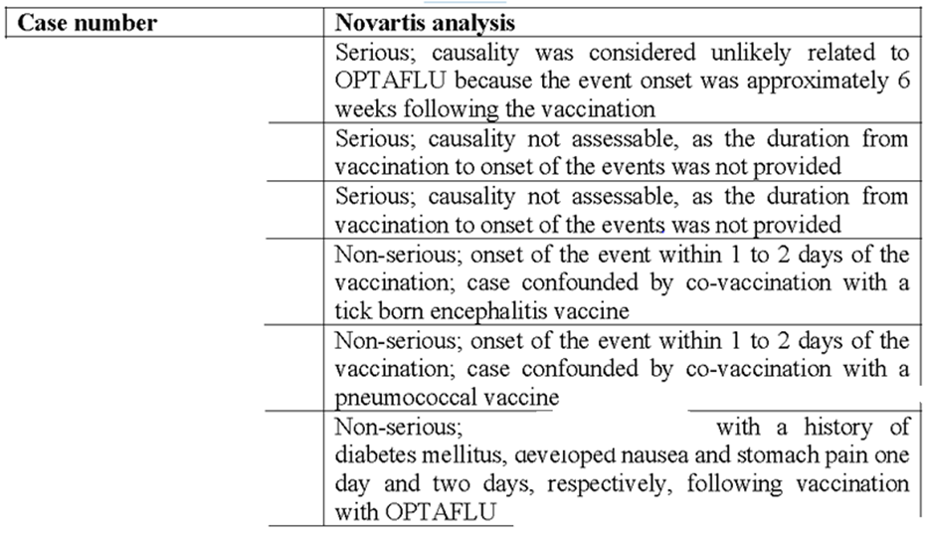
Thus, Novartis has concluded that there is insufficient evidence for a causal relationship between these events and Optaflu. Therefore, the AEs reported in relation to egg based influenza vaccines have not been included in the company core data sheet (CCDS), nor in the proposed Australian PI, nor in the current US prescribing information (appendices C1 and C2a, respectively). In November 2012, the US prescribing information text was approved by the FDA without the AEs reported in relation to egg based influenza vaccines. The FDA did not consider these events to be related to cell based influenza vaccines and, therefore, the FDA recommended removing them during labelling negotiations.
In any case, adequate pharmacovigilance procedures are in place, monitoring all AEs reported. Special attention is paid to the identified (anaphylaxis) and potential risks (neuritis, convulsions, encephalitis, vasculitis, Guillain-Barré Syndrome, demyelination, Bell’s palsy and immune thrombocytopenia) described in the RMP. Novartis hereby provides reassurance that safety signals arising from routine pharmacovigilance will be scrutinised, and if any of the potential risks described above are reported with Optaflu, necessity of inclusion of in the Australian PI will be reassessed.

Use of Optaflu in dog allergic individuals
- “The committee is requested to provide advice on the use of Optaflu in dog allergic individuals and the need for inclusion of this information in the PI.”
Novartis welcomes the Delegate’s inclination to accept that the hypersensitivity risk associated with the use in dog allergic individuals is remote and non specific (DO).
Even though Optaflu is prepared from virus propagated in MDCK cell lines, it is well known that these cells do not express known major canine allergens associated with hypersensitivity reactions. In theory, minor canine allergens may still be present at the end of manufacturing process posing a hypothetical concern with hypersensitivity reactions.
A post hoc review was performed using the Optaflu clinical trials database. There were a total of 10065 Optaflu recipients, of which ten individuals with a history of dog allergy did not report any hypersensitivity reactions after vaccine administration. In an in vitro study, sera from 30 confirmed dog-allergic individuals who expressed convincing symptoms was used to evaluate allergenicity of the vaccine using a bioassay able to detect low levels of allergens (MA, Novartis response to Section 31 request). None of the sera from dog-allergic individuals’ bioassay results showed evidence of dog protein allergy following exposure to Optaflu.
Based on the above, Novartis concludes that the safety risk of hypersensitivity reactions in individuals with dog allergy receiving annual doses of Optaflu is minimal. Novartis strongly believes that adequate pharmacovigilance procedures are currently in place, monitoring all AEs reported with special attention paid to hypersensitivity reactions. Any safety signals for hypersensitivity in dog allergic individuals arising from routine pharmacovigilance will be evaluated.

Overseas regulatory status update
An overseas regulatory status update for Optaflu is provided.

Relevant postmarketing data
PSURs covering period from first worldwide registration to 31 August 2014 is provided. An update on postmarketing reactions up until 31 December 2014 is also provided.

Update on studies in children in the US and in Europe
To date, Novartis has completed 3 clinical trials in the paediatric population:
- Study V58_31: a safety study in children aged 4 to 18 year olds
- Study V58P12: an immunogenicity and safety study in children aged 3 to 18 year olds (MA)
- Study V58P15: a safety study in children aged 3 to 17 year-old at risk of influenza associated complications.
In the US, an application including the Clinical Study Reports (CSRs) of Studies V58P12 and V58_31 was filed to the FDA in November 2014 as an efficacy supplement to support licensure in children over 4 year olds.
In Europe, the CSRs have also been submitted. The results of study V58P15 were submitted to the EMA in January 2014, while the CSRs of studies V58_31 and V58P12 were submitted to the EMA in December 2014.
Nevertheless, there are no immediate intentions to apply for a paediatric indication in Europe or Australia.

PI and CMI
The TGA recommended amendments to the Australian PI and CMI were implemented by Novartis. An annotated and clean copy of the PI and CMI are provided.

Concluding remarks
Novartis welcomes the Delegate’s recommendation to approve Optaflu inactivated influenza virus vaccine (surface antigens) prepared in cell cultures for the prevention of influenza caused by Influenza Virus, Types A and B in adults over 18 years of age.

Advisory committee considerations
The ACPM resolved to recommend to the TGA Delegate of the Minister and Secretary that taking into account the submitted evidence of efficacy, safety and quality, the ACPM agreed with the Delegate and considered Optaflu, solution for injection 0.5 mL prefilled syringe, containing the following inactivated influenza virus vaccine (surface antigens) to have an overall positive benefit-risk profile
- A/<Official strain> (H1N1) 15 μg haemagglutinin
- A/<Official strain> (H3N2) 15 μg haemagglutinin
- B/<Official strain> 15 μg haemagglutinin
for the modified indication:
For the prevention of influenza caused by Influenza Virus, Types A and B in adults over 18 years of age.
For full details regarding the recommendations for influenza vaccination refer to the current Australian Immunisation Handbook.
In making this recommendation, the ACPM expressed some concern that no data in immunocompromised or paediatric patients were presented but noted that paediatric data were available for evaluation and was of the view that such data should be requested of the sponsor.

Proposed conditions of registration
The ACPM agreed with the Delegate on the proposed conditions of registration.

Proposed Product Information (PI)/Consumer Medicine Information (CMI) amendments
The ACPM agreed with the Delegate to the proposed amendments to the PI and CMI and specifically advised on the inclusion of the following:
- A statement in the relevant section of the PI to reflect the growing observational post marketing data on AEs, such as:
some specific complications have occurred after influenza vaccination at low rates but their relationship to the method of production (that is, egg or cell based processes) is unclear, and no such complications have been reported in >4.5 million doses at the time of Australian registration.

Specific advice
The ACPM advised the following in response to the Delegate’s specific questions on this submission:
(Q1) Inclusion of ‘tumorigenicity’, ‘infectivity’ and ‘oncogenic potential’ as missing information to the RMP and/or Australian Specific Annex (ASA).
The ACPM considered the theoretical concerns of ‘tumorigenicity’, ‘infectivity’ and ‘oncogenic potential’ have been substantially addressed by the nonclinical data provided as argued in the pre ACPM response so the ACPM agreed that this cannot be classified as missing data.
(Q2) Whether certain risks reported in relation to egg based influenza vaccines are relevant for cell based vaccines, given the difference in manufacturing processes.
The ACPM agreed that vaccines that are egg based risk reactions which have been clearly documented. The allergic reactions due to the egg component would not be a concern with cell based manufacture. (Egg reactions are not common and control of these is generally well managed currently.)
It is not clear whether the antigens that incite post vaccination autoimmune disease are due to residual antigens present in eggs or influenza virus components. The sponsor reports that 4.5 million patients have received vaccine with no reports immune reactions such as neuritis, encephalitis, vasculitis, thrombocytopenia and Guillain-Barré syndrome. Although this is reassuring, the incidence of these AEs with influenza vaccine remain relevant risks for cell based vaccines until conclusively demonstrated otherwise.
However, the ACPM noted substantial postmarketing data (presented in PSUR) and was of the view that the PI could be suitably modified to reflect the growing observational evidence.
(Q3) Use of Optaflu in dog allergic individuals and the need for inclusion of this information in the PI.
Dog allergy is not common and is usually characterised by rhinitis or asthma and presumably related to dander rather than canine kidney antigens. The ACPM advised a warning is not considered necessary.
The ACPM advised that implementation by the sponsor of the recommendations outlined above to the satisfaction of the TGA, in addition to the evidence of efficacy and safety provided would support the safe and effective use of this product.

Outcome
Based on a review of quality, safety and efficacy, TGA approved the registration of Optaflu inactivated influenza virus vaccine (containing 15 µg haemagglutinin of each of the recommended strains of influenza virus Types A H1N1+ A H3N2 + B) 0.5 mL injection prefilled syringe (with needle and without needle) with the following indication:
For the prevention of influenza caused by Influenza Virus, Types A and B in adults over 18 years of age.
For full details regarding the recommendations for influenza vaccination refer to the current Australian Immunisation Handbook.

Specific conditions of registration applying to these goods
1. Implement EU-RMP (version 3.1 release date 15 November 2013, data lock point 30 April 2013) with Australian Specific Annex (version 2.0, release date 29 October 2014) revised to the agreement of the TGA (with respect to the outstanding issues listed).
2. Batch release testing by OLSS
It is a condition of registration that all independent batches of Optaflu inactivated influenza virus vaccine (surface antigens) imported into Australia are not released for sale until samples and/or the manufacturer’s release data have been assessed and endorsed for release by the TGA Office of Laboratories and Scientific Services (OLSS).
For each batch of vaccine imported into Australia, the sponsor should supply the following:
- Complete summary protocols for manufacture and quality control, including all steps in production;
- Number of doses to be released in Australia from each shipment;
- Evidence of maintenance of satisfactory transport conditions between the manufacturer and Australia such as graphs of temperature recordings and a statement that the approved storage conditions have been met;
- At least 20 doses of each first consignment of product lot with the Australian approved labels, PI and packaging, along with 3 doses of any further consignment of already released product (including diluents) with the Australian approved labels, PI and packaging;
- Certificate of Release from the regulatory agency acting for the country of origin (OMCL); and
- Any reagents, reference material, and standard required to undertake testing as requested by OLSS at least 12 months prior to supply of the vaccine in Australia.

Attachment 1. Product Information
The PI approved for Optaflu at the time this AusPAR was published is at Attachment 1. For the most recent PI, please refer to the TGA website at <www.tga.gov.au/product-information-pi>.

Attachment 2. Extract from the Clinical Evaluation Report

Therapeutic Goods Administration
PO Box 100 Woden ACT 2606 Australia
Email: info@tga.gov.au Phone: 1800 020 653 Fax: 02 6232 8605
https://www.tga.gov.au

Australian Government, Department of Health. The Australian Immunisation Handbook 10th Edition, Canberra 2013 (updated January 2014).
US Food and Drug Administration, Original application, STN 125408/0, Flucelvax, November 22, 2011.
Celvapan (Baxter, 2008) was the first whole virion, inactivated cell culture-derived (Vero cell derived) H5N1 ‘pandemic’ influenza vaccine to be considered for registration.
European Medicines Agency, “Note for Guidance on Preclinical Pharmacological and Toxicological testing of vaccines (CPMP/SWP/465/95)”, 17 December 1997.
World Health Organisation, “Annex 3: Recommendations for the evaluation of animal cell cultures as substrates for the manufacture of biological medicinal products and for the characterization of cell banks (Replacement of Annex 1 of WHO Technical Report Series, No. 878)”, 2010.
European Medicines Agency, “Guideline on influenza vaccines (EMA/CHMP/VWP/457259/2014)”, 25 July 2014.
European Medicines Agency, “Note for Guidance on Preclinical Pharmacological and Toxicological testing of vaccines (CPMP/SWP/465/95)”, 17 December 1997; European Medicines Agency, “Guideline on Adjuvants in Vaccines for Human Use (EMEA/CHMP/VEG/134716/2004)”, 20 January 2005.
European Medicines Agency, “Note for Guidance on Preclinical Pharmacological and Toxicological testing of vaccines (CPMP/SWP/465/95)”, 17 December 1997.
Potter CW, Oxford JS. (1979) Determinants of immunity to influenza infection in man. Br Med Bull. 35: 69-75.
Reverberi R. (2008) The statistical analysis of immunohaematological data. Blood Transfus. 6: 37-45.
European Medicines Agency, “Note for Guidance on Preclinical Pharmacological and Toxicological testing of vaccines (CPMP/SWP/465/95)”, 17 December 1997; European Medicines Agency, “Guideline on Adjuvants in Vaccines for Human Use (EMEA/CHMP/VEG/134716/2004)”, 20 January 2005.
Munoz FM, et al. (2005) Safety of influenza vaccination during pregnancy. American Journal of Obstetrics and Gynecology 192: 1098-1106; Naleway AL, et al. (2006) Delivering influenza vaccine to pregnant women. Epidemiological Reviews 28: 47-53.
Dreier JW, et al. (2014) Systematic review and meta-analyses: fever in pregnancy and health impacts in the offspring. Pediatrics 133: e674-e688.
US Food and Drug Administration FDA (CBER) Guidance (2006): Considerations for Developmental Toxicity Studies for Preventative Therapeutic Vaccines for Infectious Disease Indications.
European Medicines Agency, “ICH Topic S 5 (R2) Detection of Toxicity to Reproduction for Medicinal Products & Toxicity to Male Fertility (CPMP/ICH/386/95)”, March 1994.
Reverberi R. (2008) The statistical analysis of immunohaematological data. Blood Transfus. 6: 37-45.
Category B1: “Drugs which have been taken by only a limited number of pregnant women and women of childbearing age, without an increase in the frequency of malformation or other direct or indirect harmful effects on the human foetus having been observed. Studies in animals have not shown evidence of an increased occurrence of foetal damage.”
Celvapan (Baxter, 2008) was the first whole virion, inactivated cell culture-derived (Vero cell derived) H5N1 ‘pandemic’ influenza vaccine to be considered for registration.
European Medicines Agency, “Committee for Proprietary Medicinal Products (CHMP): Note for Guidance on the Harmonisation of Requirements for Influenza vaccines (CPMP/BWP/214/96)”, 12 March 1997.
European Medicines Agency, “Committee for Proprietary Medicinal Products (CHMP): Note for Guidance on the Harmonisation of Requirements for Influenza vaccines (CPMP/BWP/214/96)”, 12 March 1997.
Monto AS, Maassab HF. (1981) Ether Treatment of Type b Influenza Virus Antigen for the Hemagglutination Inhibition Test. J Clin Microb. 13: 54-57.
Wanich N, et al. (2010) In vitro assessment of the allergenicity of a novel influenza vaccine produced in dog kidney cells in individuals with dog allergy. Ann Allergy Asthma Immunol. 104: 426-433.
US Food and Drug Administration, “Guidance for Industry: Clinical Data Needed to Support the Licensure of Seasonal Inactivated Influenza Vaccines”, May 2007.
This table has been redacted of personal patient information.
This table has been redacted of personal patient information.
Wanich N, et al. (2010) In vitro assessment of the allergenicity of a novel influenza vaccine produced in dog kidney cells in individuals with dog allergy. Ann Allergy Asthma Immunol. 104: 426-433.

