Date of CER: 1 November 2014

AusPAR Attachment 2

Extract from the CER for inactivated influenza virus vaccine (containing 15 µg haemagglutinin of virus Types A H1N1+ A H3N2 + B)
  - Proprietary Product Name: Optaflu
  - Sponsor: Novartis Vaccines & Diagnostics Pty Ltd

About the Therapeutic Goods Administration (TGA)
- The Therapeutic Goods Administration (TGA) is part of the Australian Government Department of Health, and is responsible for regulating medicines and medical devices.
- The TGA administers the Therapeutic Goods Act 1989 (the Act), applying a risk management approach designed to ensure therapeutic goods supplied in Australia meet acceptable standards of quality, safety and efficacy (performance), when necessary.
- The work of the TGA is based on applying scientific and clinical expertise to decision-making, to ensure that the benefits to consumers outweigh any risks associated with the use of medicines and medical devices.
- The TGA relies on the public, healthcare professionals and industry to report problems with medicines or medical devices. The TGA investigates reports received by it to determine any necessary regulatory action.
- To report a problem with a medicine or medical device, please see the information on the TGA website <www.tga.gov.au>.
About the Extract from the Clinical Evaluation Report
- This document provides a more detailed evaluation of the clinical findings, extracted from the Clinical Evaluation Report (CER) prepared by the TGA. This extract does not include sections from the CER regarding product documentation or post market activities.
- The words [information redacted], where they appear in this document, indicate that confidential information has been deleted.
- For the most recent Product Information (PI), please refer to the TGA website <www.tga.gov.au/product-information-pi>.
Copyright
© Commonwealth of Australia 2015
This work is copyright. You may reproduce the whole or part of this work in unaltered form for your own personal use or, if you are part of an organisation, for internal use within your organisation, but only if you or your organisation do not use the reproduction for any commercial purpose and retain this copyright notice and all disclaimer notices as part of that reproduction. Apart from rights to use as permitted by the Copyright Act 1968 or allowed by this copyright notice, all other rights are reserved and you are not allowed to reproduce the whole or any part of this work in any way (electronic or otherwise) without first being given specific written permission from the Commonwealth to do so. Requests and inquiries concerning reproduction and rights are to be sent to the TGA Copyright Officer, Therapeutic Goods Administration, PO Box 100, Woden ACT 2606 or emailed to <tga.copyright@tga.gov.au>.

Contents
List of abbreviations 5
1. Clinical rationale 7
2. Contents of the clinical dossier 7
2.1. Scope of the clinical dossier 7
2.2. Paediatric data 7
2.3. Good clinical practice 8
3. Pharmacokinetics 8
4. Pharmacodynamics 8
5. Dosage selection for the pivotal studies 8
6. Clinical efficacy 8
6.1. Background 8
6.2. Pivotal efficacy study V58P13 13
6.3. Study V58P4 – Pivotal 24
6.4. Supportive study V58P4E 29
6.5. Study V58P9 – Supportive 33
6.6. Study V58P1 – Supportive 40
6.7. Study V58P2 – Supportive 48
6.8. Study V58P5 52
6.9. Immunogenicity according to CBER criteria 57
6.10. Efficacy and immunogenicity summary and discussion 57
7. Clinical safety 62
7.1. Pooled safety analysis 64
7.2. Extent of exposure, disposition and baseline characteristics 65
7.3. Solicited adverse events 67
7.4. Unsolicited adverse events 68
7.5. Serious adverse events 72
7.6. Individual study safety 72
7.7. Safety conclusions 83
8. First round benefit-risk assessment 84
8.1. Comment on the safety specification in risk management plan 84
8.2. Benefit assessment 84
8.3. Risk assessment 85
8.4. Benefit-risk balance 85
9. Clinical questions and second round evaluation 85
9.1. Question 1 85
9.2. Question 2 85
9.3. Question 3 86
9.4. Question 4 87
9.5. Question 5 87
9.6. Question 6 88
10. Second round benefit-risk assessment 89
11. Second round recommendation regarding authorisation 89

List of abbreviations
Abbreviation | Meaning
AE | Adverse event
ALT | Alanine aminotransferase
ANOVA | Analysis of variance
AP | Analysis plan
AST | Aspartate aminotransferase
B&SR | Biostatistics and Statistical Reporting
BMI | Body mass index
BUN | Blood urea nitrogen
CHMP | Committee for Medicinal Products for Human Use
CER | Clinical evaluation report
CI | Confidence interval
CRF | Case report form
CSR | Clinical study report
cTIV | Cell culture-derived influenza vaccine
EC | Ethics committee
EMEA | European Agency for the Evaluation of Medicinal Products
eTIV | Egg-derived influenza vaccine; eTIVa = Agrippal; eTIVf = Fluvirin
EU | European Union
FAS | Full analysis set
FCC | Flu cell culture
FDA | Food and Drug Administration
GCP | Good Clinical Practice
GMT | Geometric mean titre
HA | Haemagglutination
HI | Haemagglutination inhibition
ICD-9 | International Classification of Diseases 9th Edit
ICF | Informed consent form
ICH | International Conference on Harmonization
ILI | Influenza-like illness
IRB | Institutional Review Board
LSLV | Last subject last visit
MedDRA | Medical Dictionary for Regulatory Activities
MITT | Modified intention-to-treat
NA | neuraminidase
PBS | Phosphate buffered saline
PCR | Polymerase chain reaction
PP | Per protocol
SAE | Serious adverse events
SOC | System organ class
SOP | Standard operating procedure
UK | United Kingdom
US | United States
VE | Vaccine efficacy
vs. | Versus
WHO | World Health Organization

Clinical rationale
Influenza vaccines are currently the mainstay of influenza prophylaxis and control. Given the inherent uncertainties in influenza, and the complexities of manufacturing and logistics surrounding egg-based vaccine production, the development of technologies not reliant on eggs for production has been considered a high priority by the World Health Organisation (WHO 1995). Production methods using mammalian cell lines limit reliance on the supply of embryonated eggs. Cell culture derived influenza vaccines can, in principle, have greater flexibility in responding to the threat of an emerging pandemic.
Novartis Vaccines has manufactured an influenza vaccine produced in a cell line cloned from Madin Darby Canine Kidney (MDCK) tissue. The drug substance is a sterile, cell free, monovalent bulk containing purified virus surface antigens from a single influenza strain. Monovalent bulk preparations from three distinct influenza virus strains are blended and formulated in phosphate buffered saline (PBS) to produce a trivalent bulk harvest. The monovalent bulk antigen preparations are clear to slightly opalescent and contain mainly neuraminidase (NA) and haemagglutinin (HA) antigens.
The formulation of the drug product was based on the experience of the company’s egg-based influenza vaccine and has not changed during development other than to vary in accordance with the annual strain recommendations incompliance with the annual WHO and the Committee for Medicinal Products for Human Use.
Data from five immunogenicity and safety studies (V58P1, V58P2, V58P4, V58P4E1 and V58P9) led to the approval in 2007 of the MDCK cell-derived trivalent influenza vaccine (cTIV) in the European Union (EU) under the brand name Optaflu. In addition to these studies, data from study V58P13 was included in the filing that led to the approval as Flucelvax in the United States (US) in 2012.

Contents of the clinical dossier

Scope of the clinical dossier
The dossier submitted in hard copy included the following seven studies:
- V58P1, phase I/II conducted in the EU
- V58P2 phase II conducted in New Zealand
- V58P4 phase III conducted in the US and EU
- V58P4E1 phase III extension of V58P4
- V58P5 phase II conducted in the US
- V58P9 phase III conducted in Europe
- V58P13 phase III conducted in the US and EU

Paediatric data
N/A

Good clinical practice
Novartis provided the following assurance which was essentially the same for each study. The Investigator provided the Ethics Committees with all appropriate material, including the protocol, the informed consent document, and other written information provided to the participants. The trial was not to be initiated until appropriate Ethics Committee approval of the protocol and the informed consent document and all recruiting materials were obtained in writing by the Investigator and copies were received by the Sponsor. Reports on the progress of the study were to be made to the Ethics Committees and the Sponsor by the Investigator in accordance with applicable governmental regulations and in agreement with policy established by the Sponsor.
The studies were conducted in accordance with the Declaration of Helsinki and Good Clinical Practice (GCP) according to International Conference on Harmonisation (ICH) guidelines. The studies were based on adequately performed laboratory and animal experimentation and conducted under a protocol reviewed and approved by an Ethics Committee. The studies were conducted by scientifically and medically qualified persons. The benefits of the study were in proportion to the risks.
A properly executed, written, informed consent, in compliance with the Declaration of Helsinki, ICH GCP, and local regulations, was obtained from each participant prior to entering the participant into the trial. The investigator was to provide a copy of the signed informed consent to each participant and was to maintain a copy in the participant’s record file.

Pharmacokinetics
N/A

Pharmacodynamics
N/A

Dosage selection for the pivotal studies
The selection of dose, dose schedule and formulation were based in the Committee for Proprietary Medicinal Products (CHMP) Note for Guidance on the Harmonisation of Requirements for Influenza vaccines (CPMP/BWP/214/96) recommendations for adult use.

Clinical efficacy

Background
All trials evaluated the safety, reactogenicity and immune responses to cTIV compared to eTIV. Agrippal (eTIVa) was used as the control vaccine in five studies and as a second investigational vaccine in the placebo controlled study V58P13. The noninferiority study V58P5 used the control vaccine Fluvirin™ (eTIVf).

Treatments
On Day 1, all participants received a dose of 0.5 mL of assigned vaccine, by injection into the deltoid muscle preferably of the non-dominant arm.

Test product
0.5 mL dose of cTIV cell-culture-derived influenza subunit vaccine contained purified viral envelope-glycoproteins haemagglutinin 15 μg each of the strains of A/H1N1, A/H3N2 and type B, as well as neuraminidase recommended by the World Health Organization (WHO) and other health authorities to match the three most common and disease-causing influenza strains in circulation as recorded annually for the Northern and/or Southern Hemispheres for the relevant influenza season.

Reference product
0.5 mL dose of influenza subunit vaccine, derived from viruses propagated in embryonated hen eggs, contained purified viral envelope-glycoproteins haemagglutinin (15 μg each A/H1N1, A/H3N2 and type B, as well as neuraminidase recommended for the relevant influenza season.

Inclusion and exclusion criteria
Inclusion and exclusion criteria for each study were similar. All participants were adult aged at least 18 years, Age ranges differed in some instances and age groups are specified in relation to evaluation of each individual study as are any deviations from the list below.

Inclusion criteria
- Age ≥ 18 years (upper limits varied)
- Mentally competent to understand the nature, scope, and consequences of the study;
- Able and willing to give written informed consent prior to study entry;
- Available for all the visits scheduled in the study and resident in the study area;
- In good health as determined by medical history, physical examination and clinical judgment of the Investigator.

Exclusion criteria
- Unwilling or unable to give written informed consent to participate in the study;
- Participation in another trial of an investigational agent within 90 days of planned enrolment;
- Suffering from an acute infectious disease;
- Presence of any serious disease such as
  - cancer (except for benign or localized skin cancer and non-metastatic prostate cancer not currently treated with chemotherapy),
  - autoimmune disease (including rheumatoid arthritis),
  - advanced arteriosclerotic disease or complicated diabetes mellitus,
  - chronic obstructive pulmonary disease requiring oxygen therapy,
  - acute or progressive hepatic disease,
  - acute or progressive renal disease,
  - congestive heart failure;
    - Surgery planned during the study period;
    - bleeding diathesis;
    - History of hypersensitivity to any component of the study medication or chemically related substances;
    - History of any anaphylaxis, serious vaccine reactions, or allergy to eggs, egg products, mercury-containing compounds (such as sodium-ethylmercuricthiosalicylate), or any other vaccine component;
- Impairment/alteration of immune function resulting from
  - receipt of immunosuppressive therapy (any corticosteroid or cancer chemotherapy),
  - receipt of immunostimulants,
  - receipt of parenteral immunoglobulin preparation, blood products, and/or plasma derivatives within 3 months prior to planned enrolment and during the full length of the study,
  - high risk for developing an immunocompromising disease within 6 months prior to planned enrolment;
- History of drug or alcohol abuse;
- Laboratory-confirmed influenza disease in 6 months prior to enrolment;
- Receipt of influenza vaccine within 6 months prior to planned enrolment;
- receipt of another vaccine or any investigational agent within 60 days prior to planned enrolment, or planned vaccination within 3 weeks following the study vaccination;
- Presence of any acute respiratory disease, infections requiring systemic antibiotic or antiviral therapy (chronic antibiotic therapy for urinary tract prophylaxis was acceptable), or fever of 38°C or higher within 3 days prior to planned enrolment;
- Pregnant/breast feeding women or women who refused to use a reliable contraceptive method throughout the study (22 days);
- Any condition that, in the opinion of the investigator, might have interfered with the evaluation of the study objectives.

Removal from therapy or assessment
The participant could withdraw consent at any time. The investigator could withdraw a participant if, based on clinical judgment, it was in the best interest of the individual or because of non-compliance with the protocol. The sponsor could also request the removal of a participant. The protocol required that an individual was to be withdrawn from the study for the following:
- Febrile convulsions and neurological disturbances after vaccination,
- Hypersensitivity to the investigational vaccine, or
- Other suspected side effects that could compromise the participant’s wellbeing.

Use of antipyretic medication
Antipyretic medication was not to be used for the prevention of fever.

Randomisation, blinding and treatment allocation
Randomization lists were provided to the investigator by Chiron Vaccines (later Novartis Vaccines) and were used only by the unblinded study personnel. Each study participant was assigned a 5 - 6-digit number identifying the study site and participant.
A designated vaccination nurse was responsible for administering each dose of study vaccine and was instructed not to reveal the identity of the study vaccines to either the participant or the investigative site personnel involved in the monitoring or conduct of the trial, except in an emergency. The designated individual was to have no contact with the participants after the administration of the study vaccine.

Methods of assessment
In all studies, serology was assessed before and 3 weeks after vaccination. All sera were tested against prototype strains by haemagglutinin inhibition (HI), using a validated assay performed at Novartis Vaccines and Diagnostics GmbH Clinical Serology Laboratory, Marburg, Germany.
All studies except V58P13 were affected by a malfunctioning handheld electronic pipette leading to a systematic under-measurement of the volume of serum, resulting in underestimation of antibody titres and the requirement for retesting. Data presented in the dossier are those derived from retested samples after correction of the pipetting procedure, except for V58P1.
Historically, the HI assay uses an egg-derived test antigen. Both cell culture- and egg-based vaccines are derived from virus seeds originally grown in eggs but the impact of further propagation in cell culture versus eggs on amino acid sequences important in HI responses is unknown. Novartis considers it likely that cell culture derived antigen for the HI assay would be the most appropriate.
Four studies (V58P1, V58P2, V58P4, and V58P5) originally assessed the antibody responses by HI assay using both egg- and cell culture-derived test antigens. After correction of the pipetting procedure, studies V58P2, V58P4, and V58P4E1 were retested by HI assay using the egg-derived test antigen since this was felt to represent the most conservative assessment of immunogenicity. The V58P5 study was retested with both assays in order to compare the responses assessed by the egg- and cell culture-derived test antigens. Since HI assay results with egg-derived test antigens were available for all studies, they were used to support vaccine immunogenicity in this submission.
To obtain marketing authorization in Europe, assessment of immunogenicity in all studies except V58P5 and V58P13 was performed according to the CHMP requirements (CPMP/BWP/214/96 and CPMP/BWP/2490/00) (Table 1). For registration in the United States, assessment required use of Center for Biologics Evaluation and Research (CBER) Guidance “Clinical Data Needed to Support the Licensure of Seasonal Inactivated Influenza Vaccines” (May 2007) (Tables 2 and 3).

Table 1. CPMP/BWP/214/96 Immunogenicity Criteria for Evaluation of Influenza Vaccines
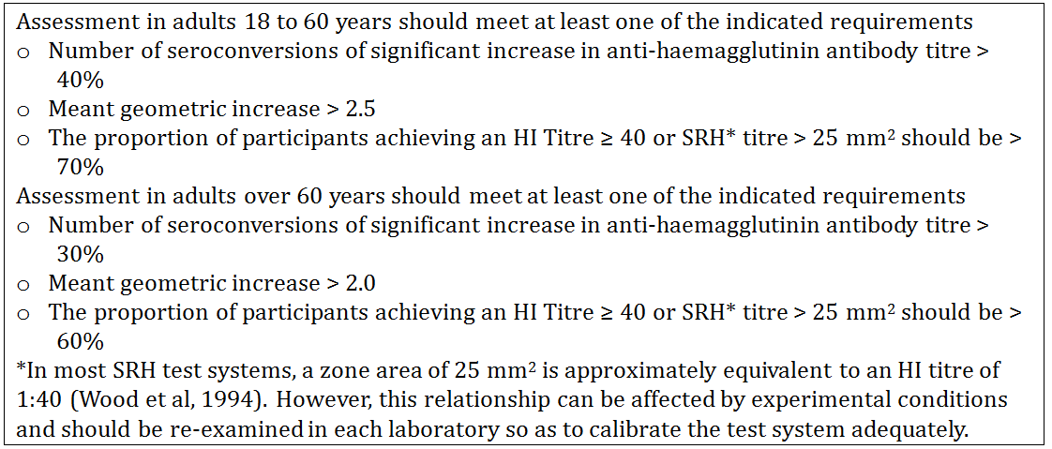

Table 2. CBER Immunogenicity Criteria for Evaluation of Influenza Vaccines
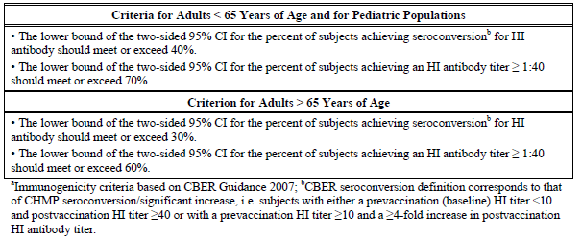

Table 3. CBER Immunogenicity Criteria for Noninferiority and Lot Consistency
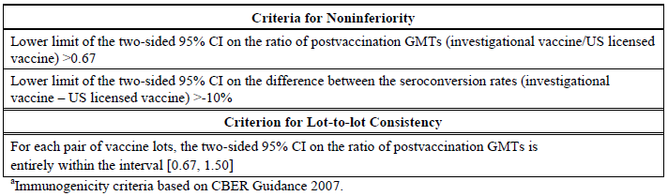

Definition of terms
- Influenza like Illness: Centers for Disease Control and Prevention (CDC) case definition of influenza like illness (ILI) was a fever of ≥ 37.8°C and cough or sore throat. Definitive diagnosis of influenza “illness” required laboratory confirmation of influenza virus.
- Seroprotection: HI titre ≥ 40.
- Seroconversion: For individuals with baseline HI titre < 10 a post vaccination titre ≥ 40; for those with baseline HI titre ≥ 10 seroconversion/significant increase was defined as a ≥ 4-fold increase in post vaccination HI antibody titre.

Analysis populations
The all randomised population provided demographic data and were the basis of data listing.
The safety population included all vaccinated participants who provided follow-up safety data.
The intention-to treat population (ITT) included all participants with evaluable serums samples before and after vaccination.
The per-protocol population (PP) included all vaccinated participants with no major protocol violations. The main population for the efficacy and immunogenicity analysis was the per protocol population unless there was a large drop-out in numbers.

Pivotal efficacy study V58P13

Study design
V58P13 was a phase III, randomized, observer-blind, placebo-controlled, multicentre study of efficacy, immunogenicity, safety and tolerability of cTIV compared to eTIVa in healthy adults. The study was conducted in the US, Finland and Poland between 09 October 2007 and 08 July 2008.

Primary objective
To demonstrate protection of cTIV and eTIV vs. placebo against illness caused by virus-confirmed community-acquired influenza wild type strains antigenically similar to those in the vaccines

Secondary objectives
Secondary objectives evaluated cTIV and eTIVa separately, each compared to placebo:

Efficacy
- To evaluate protection against illness caused by all virus-confirmed community acquired influenza wild type strains regardless of antigenic match to those contained in the vaccines
- To evaluate protection against illness caused by virus-confirmed influenza wild type strains dissimilar to those contained in the vaccines
- To evaluate protection against illness that does not match the CDC case definition caused by all virus-confirmed community-acquired influenza wild type strains that are either antigenically similar, dissimilar or regardless of antigenic match to those contained in the vaccines
- To evaluate the number of days in bed associated with cases of virus confirmed influenza i
- To evaluate the number of inpatient and outpatient medical visits due to influenza illness or symptoms of influenza
- To evaluate the number of days of usual activity lost due to influenza disease

Immunogenicity
To evaluate percentages with seroprotection and seroconversion or significant increase in titre in a subset of participants according to CBER criteria (Table 2).

Inclusion and exclusion criteria
In addition to criteria for all studies, participants were required to be available and willing to be actively followed throughout influenza season with weekly telephone calls and to comply with the need for prompt collection of nasal and throat specimens in the event of influenza-like illness. Exclusion criteria were similar but not identical to other studies and are summarised.

Study treatments
Participants were randomly assigned at a 1:1:1 ratio to receive one of the following:
- cTIV containing the purified viral envelope-glycoproteins, neuraminidase (NA) and haemagglutinin (HA) [including 15μg of HA for each strain (A/Solomon Islands/3/2006 (H1N1)-like, A/Wisconsin/67/2005 (H3N2)-like, and B/Malaysia/ 2506/2004-like)] recommended for the 2007-2008 influenza season in the Northern Hemisphere.
- eTIVa containing the purified viral envelope-glycoproteins neuraminidase and haemagglutinin [including 15μg of HA for each strain (A/Solomon Islands/3/2006 (H1N1)-like, A/Wisconsin/67/2005 (H3N2)-like, and B/Malaysia/ 2506/2004-like)] recommended for the 2007-2008 influenza season in the Northern Hemisphere.
- One 0.5 mL IM dose of phosphate buffered solution (PBS).

Variables and outcomes
The measures of vaccine efficacy (VE) were:
- The estimate of VE relative to placebo of each influenza vaccine for preventing virus-confirmed symptomatic influenza A or B illness, defined as influenza wild type strains antigenically similar to those contained in the vaccines.
- The estimate of VE relative to placebo of each influenza vaccine for preventing virus-confirmed influenza A or B illness where the illness was caused by wild type strains regardless of antigenic match to those contained in the vaccines.
- The estimate of VE relative to placebo of each influenza vaccine for preventing virus-confirmed influenza A or B illness where the illness was caused by wild type strains antigenically dissimilar to those contained in the vaccines.
- Mean and median number of days in bed associated with cases of virus-confirmed influenza.
- Mean and median number of inpatient and outpatient medical visits due to influenza illness or symptoms of influenza.
- Mean and median number of days of usual activity lost due to influenza disease.
Nasal and throat specimens were obtained from participants who met the influenza illness symptoms defined as fever of ≥ 100.0°F / ≥ 37.8°C and cough or sore throat. Specimens were shipped to a central laboratory that performed tissue culture and PCR testing for influenza virus. Positive isolates were also evaluated for antigenic characterization in a central laboratory.
For the immunogenicity subset, the percentages of participants found to be seroprotected or achieving seroconversion were assessed against the May 2007 CBER Guidance for Industry criteria (Table 2).

Randomisation and blinding methods
Participants were randomized using an IVRS. Instructions on the randomization process and related procedures were provided to the study sites for use only by the identified unblinded personnel at each study site. To support the eTIVa Biologics License Application, the first 1045 individuals randomized at the US sites were included in the immunogenicity subset according to an unbalanced randomization ratio of 8:25:2 to receive the cTIV (240), eTIVa (746), and placebo (59).

Sample size
This study was powered to demonstrate VE of each vaccine individually (i.e., cTIV vs. placebo; eTIVa vs. placebo) Assuming a VE of 70% (where VE = 1 – relative risk) for both the cell culture-derived and egg-derived influenza vaccines and an influenza virus attack rate of 3%, the sample size of 3500 evaluable participants per vaccine group had 92% power to ensure that each of the lower limits of the one-sided 97.5% CIs for VE was greater than 40% (Poisson approximation).
A total enrolment of 11,700 participants was planned to allow an approximate 10% drop out rate and provide at least 10,530 evaluable participants. Power estimates based on attack rates and vaccine efficacy are summarised in Table 4.

Table 4. V58P13 Power estimates
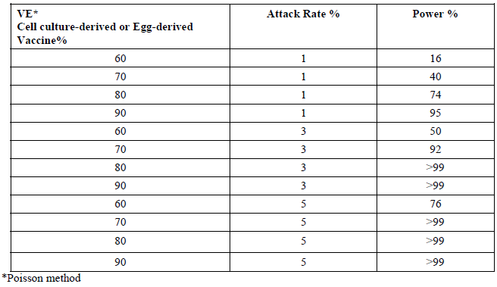
With respect to immunogenicity, with 240 evaluable participants in cTIV group, the lower limits of the two-sided 95% CIs around the estimated percentage of participants seroprotected or achieving seroconversion for HI antibody at day 22 would meet or exceed the threshold levels of 70% and 40%, respectively, if seroprotection was at least 76% (95% CI, 70%, 83%) and the percentage of participants with seroconversion in HI titre was at least 46.5% (95% CI, 40%, 54%). With 750 evaluable participants in the eTIVa group, the lower limits of the two-sided 95% CIs around the estimated percentage of participants seroprotected or achieving seroconversion for HI antibody titre at day 22 would meet or exceed the threshold levels of 70% and 40%, respectively, if seroprotection was at least 74% (95% CI, 70.7% to 77.1%), and the percentage of participants achieving seroconversion for HI antibody was at least 44% (95% CI, 40.4% to 47.6%).

Statistical methods
Each vaccine was to be considered statistically compliant with the May 2007 CBER Guidance for Industry criteria for estimating VE against placebo if the lower limit of the one-sided simultaneous 97.5% Confidence Interval (CI) for the estimate of VE relative to placebo was greater than 40%.
The efficacy of the two vaccines relative to placebo against wild type strains antigenically similar to the vaccine strains was assessed using simultaneous 100(1-α)% Sidak-corrected one-sided score CIs for the two relative risks, where α=0.025. The two simultaneous CIs were constructed by inverting the score test for the following hypotheses comparing each influenza vaccine to placebo.
Secondary measures of efficacy included estimates with one-sided 97.5% CIs for the VE of cTIV compared with placebo and eTIVa compared with placebo for the prevention of virus-confirmed symptomatic influenza A or B illness regardless of antigenic match to those contained in the vaccine, and dissimilar to those contained in the vaccine.
Secondary immunogenicity objectives, other efficacy objectives and safety objectives were evaluated descriptively; missing data were not imputed, there was no accounting for multiplicity.
For each antigen and each vaccine group, the geometric mean titre (GMT), associated 95% CI and median, minimal, and maximal titre value was determined for days 1 and 22. The 95% CIs for the GMTs were calculated using the mean square error from an ANOVA with a single factor for vaccine group. Analyses were performed on the logarithmically (base 10) transformed titre values.
For each antigen and vaccine group, the geometric mean ratio (GMR) of the day 22 post-vaccination titre value/the pre-vaccination titre value and associated 95% CI and the median, minimal, and maximal n-fold increase were calculated. Statistical methods used to analyse GMR data were identical to those described for GMT for the primary immunogenicity objective.

Change in conduct of the study
Amendment 2 (4-Feb-2008) 5 months after the first enrolment allowed for extension of the window for the collection of nasal and throat specimens after the start of influenza like illness (ILI) from 72 to 120 hours. The change was supported by evidence that influenza virus shedding can be detected by PCR up to 7 days after the onset of influenza symptoms. Version 2 of the Analysis Plan was issued on 10-Sep-2008, 12 months after the last participant completed the study.

Participant flow
The numbers planned, enrolled and completing are summarised in Tables 5 and 6. Disposition is illustrated in Figure 1. The numbers included in populations for analysis are shown in Table 7. In total, 11404 participants were enrolled and randomized into three groups, 3828 received the cTIV vaccine, 3676 received the eTIVa and 3900 received placebo. Overall 10844 completed the study; nine were administered the wrong vaccine: four in eTIVa, four in placebo, one in cTIV group.

Table 5. V58P13 Participant numbers planned and enrolled
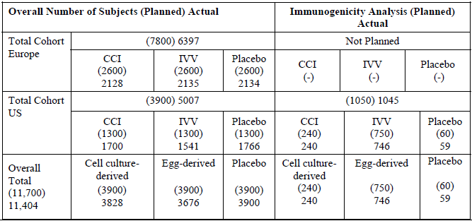

Table 6. V58P13 Summary of Study Terminations
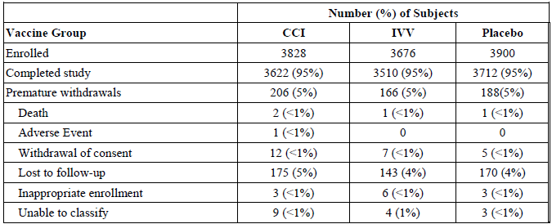

Table 7. V58P13 Overview of Participant Populations
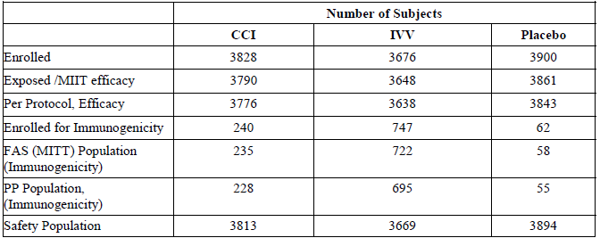

Figure 1. V58P13 Participant Disposition Flowchart
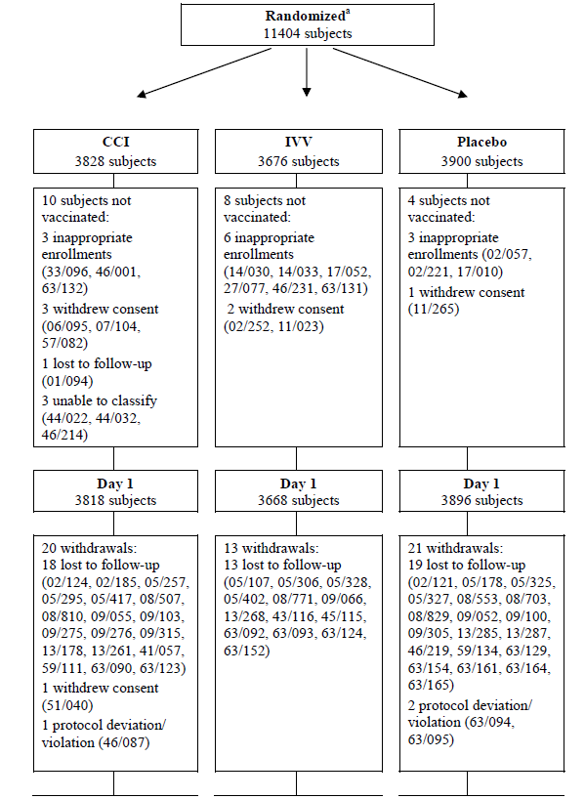
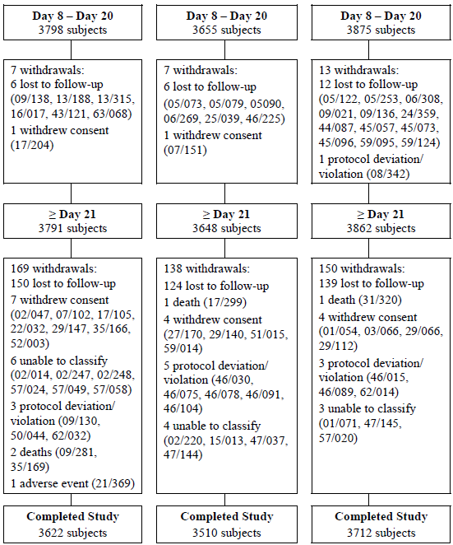
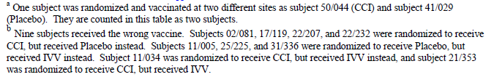
In the cTIV group, 3622 of the 3828 participants completed the study: Of the 206 withdrawing prematurely, 12 withdrew consent, 175 were lost to follow-up, 3 were withdrawn due to inappropriate enrolment, 4 had protocol deviations, 2 died, 1 had AE, and 9 could not be classified.
In the eTIVa group, 3510 of the 3676 participants completed the study. Of the 166 who withdrew prematurely, 7 withdrew consent, 143 were lost to follow-up, 6 were withdrawn due to inappropriate enrolment, 4 were unable to classify, 1 died, and 5 reported protocol deviations.
In the placebo group, 3712 of the 3900 participants completed the study. Of the 188 withdrawing 5 withdrew consent, 170 were lost to follow-up, 3 were withdrawn due to inappropriate enrolment, 3 were unable to classify, 1 died, and 6 participants recorded protocol deviations.
The main immunogenicity and efficacy analysis presented were for the PP population; the MITT and PP populations differed by less than 10%. The MITT population for the efficacy analyses included 3790, 3648 and 3861 participants in the cTIV, eTIVa and placebo groups, respectively. The PP population included 3776, 3638 and 3843 participants respectively.
The full analysis set of the immunogenicity population included 1015 participants (235 cTIV, 722 eTIVa; 58 placebo). The immunogenicity PP population included 228, 695 and 55 participants in the cTIV vaccine, eTIVa and placebo groups respectively.

Major protocol violations/deviations
There were 562 protocol deviations in the cTIV group, 503 in the eTIVa group and 555 in the placebo group. In total, 54 participants were excluded from the per-protocol population in the eTIVa group, 11 in the cTIV vaccine group and 6 in the Placebo groups. Major reasons were: blood samples drawn outside the window (54.5% in cTIV vaccine and 46.3% in eTIVa); serum samples not provided (45.4% in cTIV vaccine and 38.9% in eTIVa), and lack of post-baseline immunogenicity results (45.4% in cTIV and 38.9% in eTIVa) (Table 8).

Table 8. V58P13 Summary of Reasons for Exclusion from the PP Population
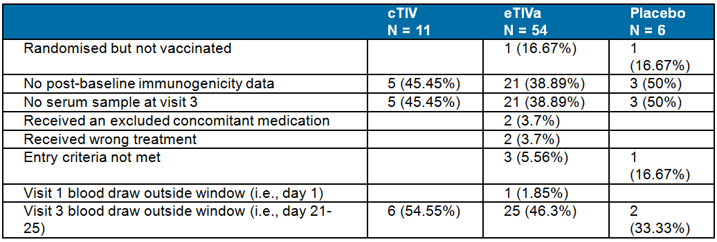

Baseline data
The mean age in the three groups was between 32.7 - 33 years. The males/females ratios in the three groups were similar (44%/56%). The majority of participants in all the groups were Caucasian (84% - 85%) followed by Hispanic (7% - 8%) and Black (7%). Mean weight and height across the groups were comparable (range, 76.736 Kg - 76.964 Kg and 170.9 cm - 171.08 cm). The percentages with previous vaccination ranged between 13% - 15%.
The demographic and other baseline characteristics of the immunogenicity sub-groups had mean age ranging from 32.6 - 33.8 years. . The proportion of males ranged from 42% - 43%. The majority were Caucasian (66% - 70%) Hispanic (20% - 24%) and Black (6% - 12%). Mean weight and height ranged 80.23 Kg - 81.16 Kg and 169 cm - 169.72 cm. The percentages with previous vaccination ranged from 20% - 25%.

Primary efficacy results

cTIV vaccine
The rates of culture-confirmed influenza caused by vaccine-like strains in the PP efficacy population were 0.0019 (7/3776) for cTIV and 0.0114 (44/3843) for placebo. Overall VE (LL 97.5% CI) was 83.8% (61%); p = 0.0005. The primary objective was met (Table 9).

Table 9. V58P13 Vaccine Efficacy Against Culture-Confirmed Influenza Caused by Vaccine-like Strains: Per Protocol Population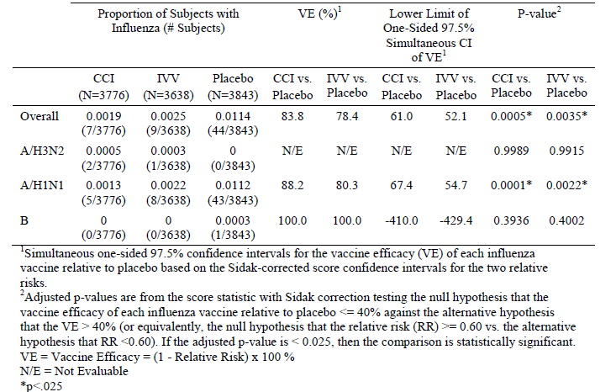
The reported incidences of A/H3N2 and B strain infections were very low in all groups including the placebo group. The incidence of A/H1N1 infection was higher in the placebo group than the vaccinated group with vaccine efficacy (LL 97.5% CI) for that strain of 88.2% (67.4%).

eTIVa
The rates of culture-confirmed influenza caused by vaccine-like strains in the per protocol efficacy population were 0.0025 (9/3638) for eTIVa and 0.0114 (44/3843) for placebo. Overall VE (LL 97.5% CI) was 78.4% (52.1%); p = 0.0035. The primary objective was met (Table 9).
The reported incidences of A/H3N2 and B strain infections were low in all groups including the placebo group. The incidence of A/H1N1 infection was higher in the placebo group than the vaccinated group with vaccine efficacy (LL 97.5% CI) for that strain of 80.3% (54.7%).

Secondary efficacy results

VE against non-vaccine strains

cTIV group
The rates of non-vaccine-like culture-confirmed influenza in the PP efficacy population were 0.0079 (30/3776) in the cTIV group and 0.0193 (74/3843) in the placebo group. VE (LL 97.5% CI) was 58.7% (33.5%); p = 0.078. The cTIV vaccine was not statistically compliant with the CBER guidance criteria for estimating VE against placebo. The objective was not met (Table 10).

Table 10. V58P13 VE Against Non-Vaccine like Strain Culture-Confirmed Influenza Caused – PP Population
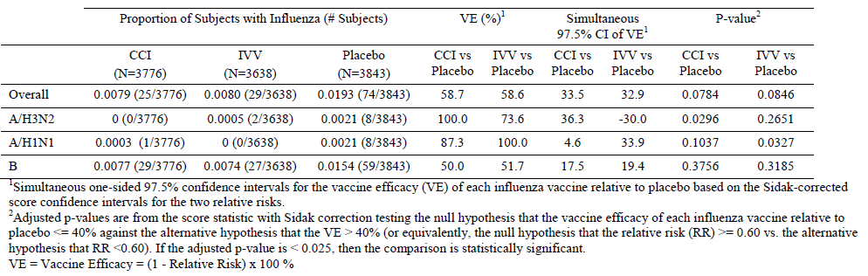
Evaluator comment: Based on Tables 9 and 10, it appears that all but one case of culture-confirmed influenza B was not due to the strain included in the vaccine. For the strain included in the vaccine, both cTIV and the eTIVa vaccinated per-protocol group had no culture-confirmed case and the placebo group reported one case. The cTIV per-protocol group recorded 29 cases of culture-confirmed non-vaccine strain influenza B, the eTIVa group recorded 27 cases and the placebo group recorded 59 cases.

eTIVa group
The rates of non-vaccine like culture-confirmed influenza in the PP efficacy population were 0.0080 (29/3638) in the eTIVa group and 0.0193 (74/3843) in the placebo group. VE (LL 97.5% CI) was 58.6% (32.9%): p = 0.085. The eTIVa group was not statistically compliant with the CBER criterion. The secondary efficacy objective was not met (Table 10).

VE against vaccine and non-vaccine strains

cTIV group
Rates of culture-confirmed influenza caused by vaccine- and non-vaccine-like strains in the PP efficacy population were 0.0111 (42/3776) for cTIV and 0.0364 (140/3843) for placebo. VE (LL 97.5% CI) was 69.5% (55.0%). The CBER criterion was met (Table 11).

Table 11. V58P13 VE Culture-Confirmed Influenza due to Vaccine and Non-vaccine-like Strains – PP Population
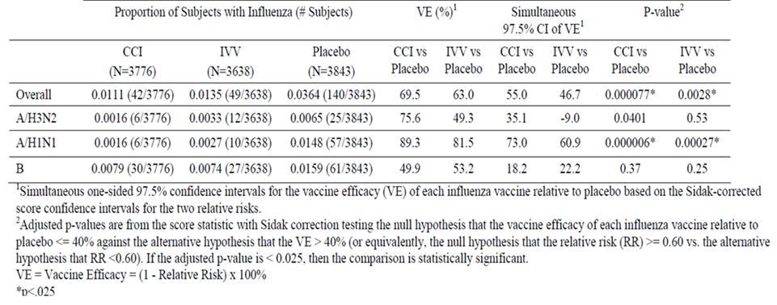

eTIVa group
Rates of culture-confirmed influenza caused by vaccine- and non-vaccine-like strains in the PP efficacy population were 0.0080 (29/3638) for eTIVa and 0.0193 (74/3843) for placebo. VE (LL 97.5% CI) was 58.6% (32.9%). The CBER guidance criterion was not met (Table 11).

Days in bed; medical visits; days of usual activity
Among the subset of participants in the per protocol efficacy population who had culture confirmed influenza and non-missing ILI follow-up data, there was no significant difference between the influenza vaccine groups and placebo in the mean number of days in bed, mean number of inpatients or outpatient visits due to influenza illness, or the mean number of days of usual activity lost due to influenza (Table 12).

Table 12. V58P13 Days in Bed, Medical Visits Usual Activity Lost due to virus confirmed flu, PP Population
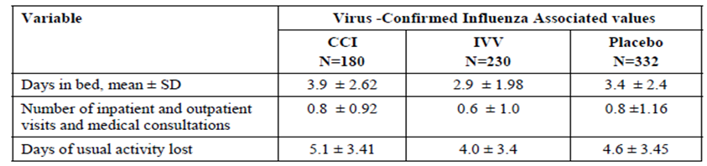

Vaccine efficacy by subgroup
The subgroup analysis suggested differences in VE for both cTIV and eTIVa in participants from the USA, compared to the EU. The Clinical Study Report (CSR) conclusion was that this may have been due to regional differences in circulating influenza strains. According to the EISS bulletin for 2008(23), influenza activity in the EU was predominantly caused by A(H1N1) strains – mainly vaccine-like - for most of the season, and mostly non-vaccine-like influenza B had been dominant in Europe from week 9 of 2008 onwards. There was also a low circulation of mainly non-vaccine-like A/(H3N2) strains. In contrast, A/(H3N2) strains were predominant in the USA for this season according to the CDC 2007-8 influenza season summary, and many did not match the vaccine strain. In addition, the predominant circulating B strains in the US were in most cases dissimilar to the vaccine strain.
The subgroup analysis also suggested that vaccine efficacy was reduced for individuals who had received an influenza vaccination in the preceding year. The CSR conclusion was that this may have been due to the previous year’s vaccination having conferred partial protection to the participants who received placebo in this study, thus reducing the number of cases of influenza in the placebo group and diluting the detection of differences in efficacy. The CSR stated that interpretation of subgroup analyses was limited by low event rates and for some analyses, small sample sizes.

Immunogenicity results

A/H1N1

cTIV test vaccine
- Pre-vaccination seroprotection: 48% (42, 55)
- Post-vaccination seroprotection 99% (97, 100)
- GMR 17 (13, 21)
- Seroconversion/significant increase 78% (72, 83)

eTIVa test vaccine
- Pre-vaccination seroprotection 53% (49, 57)
- Post-vaccination seroprotection 98% (97, 99)
- GMR 14 (12, 16)
- Seroconversion/significant increase 75% (71, 78)

Placebo control
- Pre-vaccination seroprotection 60% (46, 73)
- Post-vaccination seroprotection 60% (46, 73)
- GMR 0.99 (0.62, 1.56)
- Seroconversion/significant increase 0% (0, 6)

A/H3N2

cTIV test vaccine
- Pre-vaccination seroprotection 48% (39, 58)
- Post-vaccination seroprotection 99% (98, 100)
- GMR 6.94 (5.68, 8.46)
- Seroconversion/significant increase 59% (53, 66)

eTIVa test vaccine
- Pre-vaccination seroprotection 58% (54, 61)
- Post-vaccination seroprotection 99% (98, 100)
- GMR 8.68 (7.74, 9.73)
- Seroconversion/significant increase 68% (64, 71)

Placebo control
- Pre-vaccination seroprotection 71% (57, 82)
- Post-vaccination seroprotection 65% (51, 78)
- GMR 0.96 (0.64, 1.44)
- Seroconversion/significant increase 0% (0, 6)

B strain

cTIV test vaccine
- Pre-vaccination seroprotection 25% (20, 31)
- Post-vaccination seroprotection 78% (72, 83)
- GMR 5.2 (4.31, 6.28)
- Seroconversion/significant increase 51% (45, 58)

eTIVa test vaccine
- Pre-vaccination seroprotection23% (20, 27)
- Post-vaccination seroprotection 92% (90, 94)
- GMR 9.41 (8.45, 10)
- Seroconversion/significant increase 68% (65, 72)

Placebo control
- Pre-vaccination seroprotection 22% (12, 35)
- Post-vaccination seroprotection 22% (12, 35)
- GMR 0.99 (.68, 1.46)
- Seroconversion/significant increase 0% (0, 6)
The CBER criteria for seroconversion and seroprotection were all met for each of the three strains for both cTIV and eTIV but not for placebo. The CPMP criteria were also met for all strains for the active vaccine groups.

Study V58P4 – Pivotal

Study design, objective, location dates
V58P4 was a phase III, observer-blind, randomized, multi-centre study evaluating safety, tolerability and immunogenicity cTIV compared to eTIVa in healthy adults aged 18 – 60 years and > 60 years, conducted in 5 centres in Poland between 14th September 2004 and 16th May 2005.

Objectives
Primary: to evaluate immunogenicity of cTIV vs. eTIVa according to CPMP criteria.
Secondary: To demonstrate non-inferiority of the correlates of protection (seroprotection, seroconversion and sufficient increase in GMT) of a single dose of cTIV compared to eTIVa.

Study treatments

Test vaccine
cTIV cell contained purified viral envelope-glycoproteins haemagglutinin [15 μg each of the strains A/New Caledonia/20/99-like type A/H1N1, A/Fujian/411/2002-like type A/H3N2 and B/Shanghai/361/2002-like type B, as well as neuraminidase recommended for the influenza season 2004/05 in the Northern Hemisphere].

Reference vaccine
eTIVa contained purified viral envelope-glycoproteins haemagglutinin [15 μg each of the strains A/New Caledonia/20/99-like type A/H1N1, A/Fujian/411/2002-like type A/H3N2 and B/Shanghai/361/2002-like type B, as well as neuraminidase recommended for the influenza season 2004/05 in the Northern Hemisphere].

Sample size
The sample size calculation was based on the non-inferiority objective. In total 583 per group aged 18 – 60 years and 605 per group aged > 60 years were required to test the null hypothesis. Considering 10% of drop-outs, 1300 participants 18 - 60 years (650 in each vaccine group) and 1350 participants > 60 years (675 in each vaccine group) were planned for enrolment. The study power to demonstrate non-inferiority by age groups was planned to be not less than 80%.

Statistical methods
The primary immunogenicity objective and the safety data were analysed descriptively with assessment against CPMP criteria.
Secondary immunogenicity: The following serological assessments were considered for each strain for all participants in each age category according to the European recommendations for the non-inferiority criteria (CPMP/EWP/463/97):
- For seroprotection and seroconversion, non-inferiority would be concluded, if for all 3 antigens, the lower limit of the two-sided 95% confidence interval of the difference in the percentages between test and control was greater than - 10%.
- For the GMR non-inferiority would be concluded if, for all 3 strains, the lower confidence limit of the two-sided 95% CI for ratio of GMRs at day 22 was greater than 0.5.
All descriptive analyses were to be repeated for the subset of participants with baseline HI titre < 40.

Participant flow
A total of 2654 participants (1300 aged 18 to 60 years and 1354 aged > 60 years) were enrolled and vaccinated in accordance with the randomization scheme. Forty five participants prematurely withdrew: 18 – 60 years: 10 (2%) in the test group and 14 (2%) in the control group; > 60 years: 11 (2%) in the test group and 10 (1%) in the control group (Figure 2).
All premature withdrawals aged 18 - 60 and most > 60 years were due to lost to follow up or withdrawal of consent. For those aged > 60, the additional withdrawals were due to death (1 [< 1%] test, 2 [< 1%] control), and inappropriate enrolment (hepatic cirrhosis and hepatitis B) (1 [< 1%].
Figure 2. V58P4 Participant Completion Flowchart
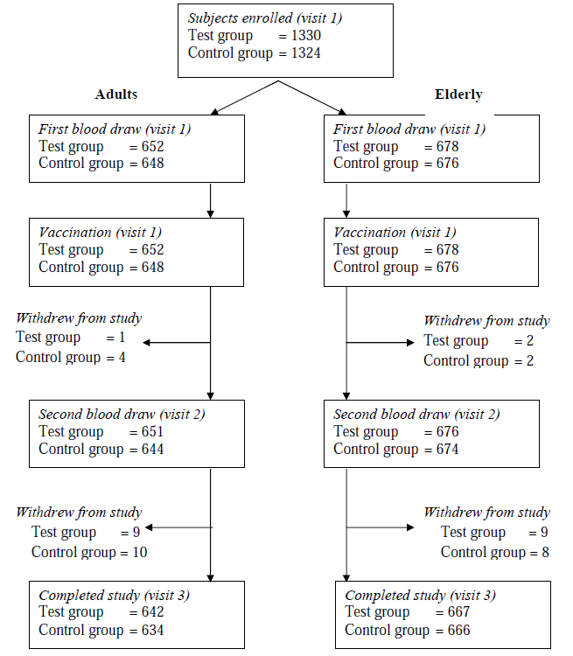

Major protocol violations/deviations
There were 6 major protocol deviations leading to exclusion from the PP population aged 18 to 60 years. Of these, one participant (cTIV) had the second blood draw ≥ 8 days outside the protocol-specified time window and 5 (1 cTIV, 4 eTIVa) withdrew before the second blood draw.
There were 8 major protocol deviations leading to exclusion from the PP population aged > 60 years: 3 (cTIV) had the second blood draw ≥ 8 days outside the specified time window, one (cTIV) did not meet the entry criteria, and 4 (2 cTOV, 2 eTIVa) withdrew before the second blood draw.

Baseline data
In the age group 18 to 60 years, the average ages in the cTIV and eTIVa groups were 38.7 years and 38.3 years respectively. The ratio of male to female was 42%:58% cTIV; 43%:57% control. All participants were Caucasian. Mean adult weight on enrolment was 71.34 kg for the cTIV group and 71.01 kg for the eTIVa group. Mean height was 168.1 cm for the cTIV group and 167.9 cm for the control group. A total of 38% and 42% of cTIV and control groups, respectively, had had at least one previous influenza vaccination.
In the age group > 60 years, the average ages in the cTIV and control groups were 69.1 years and 68.8 years respectively. The ratio of male to female was 43%:57% cTIV; 45%:55% control. All participants were Caucasian. The mean weight was 74.44 kg (cTIV) and 74.42 kg (control). Mean height was 164.0 cm for the cTIV group and 164.1 cm for the control. A total 59% of both groups had had at least one previous influenza vaccination.

Primary objective results

Age group 18 to 60 years
- The PP population included 1294 of the 1300 participants aged 18 to 60 years.
- Results for A/H1N1 are summarised.
- Results for A/H3N2 are summarised.
- Results for B strain are summarised.

A/New Caledonia/20/99 (A/H1N1)
- Pre-vaccination seroprotection: 29% cTIV, 33% eTIVa.
- Post-vaccination seroprotection: 92% for both vaccine groups.
- GMRs: 11 for both vaccine groups.
- Seroconversion/significant increases: 69% cTIV, 67% eTIVa.
- cTIV and eTIVa groups met all CPMP criteria for all 3 strains.

A/Fujian/411/2002 (A/H3N2)
- Pre-vaccination seroprotection: 65%cTIV, 63% eTIVa.
- Post-vaccination seroprotection: 99% for both groups.
- GMRs: 5.99-and 7.08 respectively.
- Seroconversion/significant increases: 63% cTIV, 64% of eTIVa.
- cTIV and eTIVa groups met all CPMP criteria for all 3 strains.

B/Shanghai/361/2002 (B)
- Pre-vaccination seroprotection: 16% cTIV, 18% eTIVa.
- Post-vaccination seroprotection: 90% and 91% respectively.
- GMrs: 13 and 12 respectively.
- Seroconversion/significant increase: 85% cTIV, 81% of controls.
- cTIV and eTIVa groups met all CPMP criteria for all 3 strains.

Age group > 60 years
- The PP population included a total of 1346 of the 1354 participants aged ≥ 61 years.
- Results for A/H1N1 are summarised.
- Results for A/H3N2 are summarised.
- Results for B strain are summarised.

A/New Caledonia/20/99 (A/H1N1)
- Pre-vaccination seroprotection: 30% cTIV, 31% eTIVa.
- Post-vaccination seroprotection: 85% for both vaccine groups.
- GMRs: 5.74 and 5.96 respectively.
- Seroconversion/significant increases: 55% of both groups.
- cTIV and eTIVa groups met all CPMP criteria for all 3 strains.

A/Fujian/411/2002 (A/H3N2)
- Pre-vaccination seroprotection: 66% cTIV, 59% of eTIVa.
- Post-vaccination seroprotection: 97% and 98% respectively.
- GMRs: 7.25 and 8.36 respectively.
- Seroconversion/significant increases: 68% cTIV, 65% eTIVa.
- cTIV and eTIVa groups met all CPMP criteria for all 3 strains.

B/Shanghai/361/2002 (B)
- Pre-vaccination seroprotection: 23% cTIV, 20% eTIVa.
- Post-vaccination seroprotection: 90% and 89% respectively.
- GMRs: 12 and 9.29 respectively.
- Seroconversion/significant increases: 80% cTIV, 73% eTIVa.
- cTIV and eTIVa groups met all CPMP criteria for all 3 strains.

Secondary objective results

Age group 18 to 60 years
The non-inferiority objective was met for the age group 18 to 60 years (Table 13).

Table 13. V58P4 Non-inferiority of Test to Control Vaccine
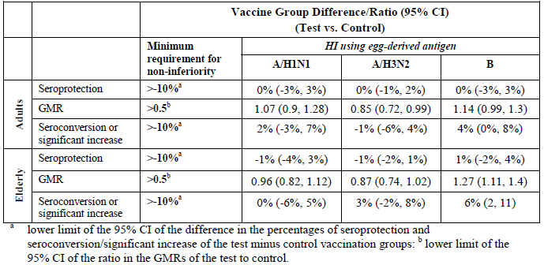

A/New Caledonia/20/99 (A/H1N1)
The lower limit of the 95% CI of the difference in the percentages of both seroprotection and of seroconversion/significant increase for the cTIV minus control groups was -3%. The LL of the 95% CI of the ratio in the GMRs of the cTIV to control groups was 0.9.

A/Fujian/411/2002 (A/H3N2)
The LLs of the 95% CI of the difference in the percentages of seroprotection and seroconversion/significant increase of the cTIV minus control groups were - 1% and - 6%, respectively. The 95% LL of CI of the ratio in the GMRs of the cTIV to control groups was 0.72.

B/Shanghai/361/2002 (B)
The LLs of the 95% CI of the difference in the percentages of seroprotection and seroconversion/significant increase of the cTIV minus control groups were -3% and 0%, respectively. The 95% LL of CI of the ratio in the GMRs of the cTIV to control groups was 0.99.

Age group ≥ 61 years
The non-inferiority objective was met for participants aged 61 years and over (Table 13).

A/New Caledonia/20/99 (A/H1N1)
The LLs of the 95% CI of the difference in the percentages of seroprotection and seroconversion/significant increase of the cTIV - control groups were –4% and -6%, respectively. The 95% CI LL of the ratio in the GMRs of the cTIV/control groups was 0.82.

A/Fujian/411/2002 (A/H3N2)
The LLs of the 95% CI of the difference in the percentages for both seroprotection and seroconversion/significant increase for the cTIV minus control groups was – 2%. The lower limit of the 95% CI of the ratio in the GMRs of the cTIV/control groups was 0.74.

B/Shanghai/361/2002 (B)
The LLs of the 95% CI of the difference in the percentages of seroprotection and seroconversion/significant increase of the cTIV minus eTIV groups were -2% and 2%, respectively. The lower limit of the 95% CI of the ratio in the GMRs of the cTIV/control groups was 1.11.

Sub-analysis
- For participants not seroprotected pre-vaccination, the cTIV and control vaccine groups met all (CPMP/BWP/214/96) criteria for all 3 strains for both age populations.
- Each centre met the CPMP criteria stipulated in the primary objective.
- Both male and female participants separately met CPMP criteria.
- Participants aged 18 – 60, of both vaccination groups who had been previously vaccinated failed to attain the seroconversion/significant increases for the A/H1N1 strain.
- The previously unvaccinated participants in both age group categories and both vaccinated and unvaccinated populations in the age group > 60 years attained the CPMP criteria.
- Participants with at least two previous diseases classified according to any of the following summary terms (a) circulatory system (b) endocrine, nutritional, metabolic and immunity (c) respiratory system (d) digestive system (e) genitourinary system (f) infectious and parasitic (since 2000) diseases, met the CPMP criteria. For ages 18 – 60, rates of co-morbidity were low.

Supportive study V58P4E

Study design, objective, location dates
V58P4E was a phase III, observer-blind, randomized, multi-centre, 6- month extension of study V58P4, conducted in 5 centres in Poland between September 2005 and April 2006, evaluating safety, tolerability and immunogenicity in a subset, of a repeat dose of cTIV or eTIVa one year after vaccination.
Participants were randomised 1:1 and stratified by the age at enrolment and the vaccine received in study V58P4. Those who had previously received cTIV or eTIVa were randomly allocated to receive either cTIV or eTIVa, resulting in a total of 8 vaccination groups as shown below:
- Age 18 – 60 years: cTIV/cTIV, cTIV/control, control/control, and control/cTIV.
- Age > 60 years: cTIV/cTIV, cTIV/control, control/control, and control/cTIV.
The first 120 participants enrolled in each age group (240 in total) at 2 of the study centres were included in the immunogenicity subset. Study design is illustrated in Figure 3.
Figure 3. V58P4E Study design
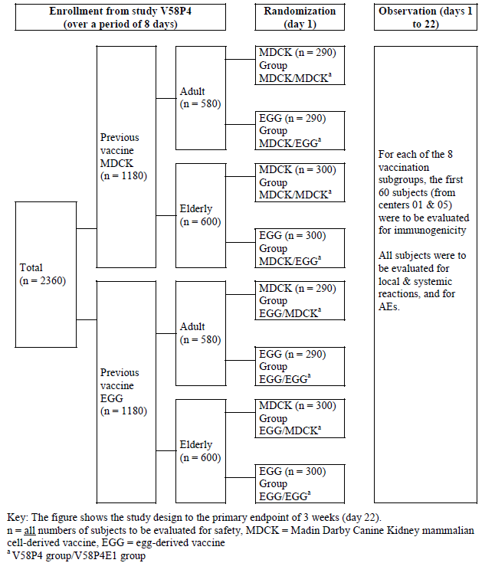

Immunogenicity objective
To evaluate immunogenicity 3 weeks after vaccination with either cTIV or eTIVa administered approximately 12 months after the first vaccination. Results were analysed based on the vaccine group to which participants were randomized in the extension study.

Study treatments

Test product
The cTIV vaccine 0.5 mL dose (Lot 008012A) contained A/New Caledonia/20/99-like (A/H1N1) strain and the B/Shanghai/361/2002-like strain, both included in the cTIV vaccine for V58P4, and new strain A/California/7/2004 (A/H3N2).

Reference product
eTIVa (Lot 057423) contained A/New Caledonia/20/99-like (A/H1N1) strain and the B/Shanghai/361/2002-like strain, both included in the cTIV vaccine for V58P4, and new strain A/California/7/2004 (A/H3N2).

Sample size
The sample size for the immunogenicity subsets of each vaccine group (n = 54) was planned in compliance with requirements of CPMP/BWP/214/96.

Change in the conduct of the study or planned analysis
There was one amendment dated 12 October 2005 and implemented after recruitment to the extension study had begun. Assignment of participants to vaccine and the use of hidden entry envelopes were described in more detail. Specifications of the preliminary safety analyses and the final immunogenicity and tolerability analyses were added.

Participant flow
Of those enrolled in V58P4, 82% of those aged 18 to 60 years and 86% of those > 60 years entered the extension study. A total of 2235 participants, 1067 aged 18 to 60 years and 1168 aged > 60 years, were enrolled, 1105 were vaccinated with cTIV and 1130 with eTIVa. One individual received the wrong vaccine, control instead of cTIV.
- Age 18 to 60 years: In total 533 vaccinated with cTIV: (cTIV/cTIV: 272; control/cTIV: 261). In total 534 participants received the control vaccine (cTIV/control: 274; control/control: 260)
- Age > 60 years: A total of 572 were vaccinated with cTIV (cTIV/cTIV: 291 control/cTIV: 281). A total of 597 received the control vaccine (cTIV/control: 297; control/control: 300)
Seven participants withdrew between Day 1 and 3 weeks
- 18 – 60 years: cTIV/cTIV: 2; control/cTIV: 1 and control/control: 1
- > 60 years: control/cTIV: 1 and control/control: 2
Premature withdrawals were due to lost to follow up (3 [<1%]), AEs (2 [<1%]), or withdrawal of consent (2 [<1%]). A total of 2228 participants completed to 3 weeks: 1101 in the cTIV total group (cTIV/cTIV: 561; control/ cTIV: 540); 1127 in the eTIV total group (cTIV/control: 570; control/control: 557).
Ninety-nine percent (99%) completed the 6 month follow up. Between 3 weeks and 6 months 7/1101 prematurely withdrew from the cTIV group and 10/1127 from the control group. No withdrawal resulted from an AE considered vaccine related.
A total of 247 participants in the cTIV group (cTIV/cTIV: 122; control/cTIV: 125) and 241 in the control group (cTIV/control: 121; control/control: 120) were included in the immunogenicity subset.
The age group 18 to 60 years immunogenicity subset included 121 participants in the cTIV group (cTIV/cTIV: 60; control /cTIV: 61) and 119 in the control group (cTIV/control: 60; control/control: 59). The age group > 60 years immunogenicity subset included 126 in the cTIV group (cTIV/cTIV: 62; control /cTIV: 64) and 122 in the control group (cTIV/control: 61; control /control: 61).
The immunogenicity ITT population included 243 of the 247 in the cTIV group and all 241 participants randomized to the control group. The immunogenicity PP population consisted of 242 in the cTIV total group (cTIV/cTIV: 121; control/cTIV: 121) and 241 in the control group (cTIV/control: 121; control/control: 120).

Protocol violations/deviations
In the age group 18 to 60 years, there were 23 and 14 protocol deviations in the cTIV and control group respectively. The most common were; visit 2 attended outside permitted window (cTIV: 9, control: 4), use of excluded concomitant medication (cTIV: 8, control: 3) and withdrawal from study due to lost to follow up (cTIV: 3, control: 4).
For age group > 60 years, there were 20 and 15 protocol deviations in the cTIV and control group respectively. The most common were; visit 2 attended outside permitted window (cTIV 5, control 7) and use of excluded concomitant medication (cTIV 6, control 2).

Baseline data
For the group aged 18 to 60 years, all were Caucasian, the average age was 39.8 years for cTIV and 39.0 years for the controls. The ratio of males to females was 42%/58% for both groups. Within subgroups there was some discrepancy amongst numbers of males and females. For medical history, the most commonly affected "body systems" were similar between groups.
All those > 60 years were Caucasian. Average age was 69.2 years cTIV and 69.9 for the controls, the male/female ratio was 46%/54% for cTIV and 41%/59% for controls. For medical history, the most commonly affected "body systems" were similar between groups.

Immunogenicity results

Age group 18 to 60 years
- Results for A/H1N1 are summarised.
- Results for A/H3N2 are summarised.
- Results for B strain are summarised.
- Results below are presented in order cTIV and eTIVa respectively and are for total vaccine groups.

A/New Caledonia/20/99 (A/H1N1)
- Pre-vaccination seroprotection: 57% cTIV group: 51% eTIVa
- Post-vaccination seroprotection: 88% and 80% respectively
- GMRs: 2.5 and 2.23 respectively
- Seroconversion/significant increases: 26% and 28%
- cTIV and eTIVa met the CPMP criterion for seroprotection against A/H1N1. Neither vaccine met the GMT or seroconversion/significant increase criteria.

A/California/7/2004 (H3N2)
- Pre-vaccination seroprotection: 29% of each group
- Post-vaccination seroprotection: 92% cTIV; 91% eTIVa
- GMRs: 9.32 and 5.03 respectively
- Seroconversion/significant increases: 81% and 73% respectively
- cTIV and eTIVa groups met all CPMP criteria against A/H3N2

B/Shanghai/361/2002 (B)
- Pre-vaccination seroprotection: 54% cTIV; 52% eTIVa
- Post-vaccination seroprotection: 83% and 87% respectively
- GMRs: 2.76 and 2.21 respectively
- Seroconversion/significant increases: 34% and 30% repectively
- cTIV and eTIVa met the CPMP seroprotection criterion against the B strain, cTIV, met the GMT criterion but eTIVa did not, Seroconversion/significant increase was not met by either vaccine.

Age group > 60 years
- Results for A/H1N1 are summarised.
- Results for A/H3N2 are summarised.
- Results for B strain are summarised.
- Results are presented in order, cTIV then eTIVa and are for total vaccine groups.

A/New Caledonia/20/99 (A/H1N1)
- Pre-vaccination seroprotection: 48% cTIV, 36% eTIVa
- Post-vaccinations seroprotection: 80% and 71%
- GMRs: 2.62 and 2.75
- Seroconversion/significant increases: 36% and 32%
- cTIV and eTIVa met all CPMP criteria against A/H1N1.

A/California/7/2004 (H3N2)
- Pre-vaccination seroprotection: 32% cTIV, 33% eTIVa
- Post-vaccination seroprotection: 94%, 91% respectively
- GMRS 12 and 7.1
- Seroconversion/significant increases: 83% and 79%
- cTIV and eTIVa met all CPMP criteria against A/H3N2

B/Shanghai/361/2002 (B)
- Pre-vaccination seroprotection: 61% cTIV, 52% eTIVa
- Post-vaccination seroprotection: 87% and 88%
- GMRs 2.75 and 2.66
- Seroconversion/significant increases:34% for cTIV and 33% for the control group
- cTIV and eTIVa met all CPMP criteria against the B strain.

Sub-analyses
There was a centre effect detected for seroprotection pre-vaccination but not post-vaccinations for those aged 18 to 60. There was a centre effect noted for B/Shanghai/361/2002 for those aged > 60 years. Adjusting for centre the GMRs, rates of seroprotection and seroconversion/significant increases were stated to remain similar to the non-adjusted results. Overall, results against CPMP criteria were similar for males and females.

Sponsor’s conclusion
The cell- and egg-derived vaccines, in both adult and elderly subjects, met at least one CHMP criteria for each strain. All 3 CHMP criteria for the evaluation of influenza vaccines (CPMP/BWP/214/96) were met only against the influenza virus strain to which they had not been previously exposed (i.e., California/7/2004-like [A/H3N2]) by both age groups.
Both adults and elderly subjects attained the CHMP seroprotection criteria (i.e., > 70% and > 60%, respectively) for all 3 virus strains, probably due to high baseline titres. In addition, all 3 CHMP criteria were attained for all virus strains for both vaccines in the elderly but not adult population.
As expected from previous studies, seroconversion/significant increase criterion (> 40% [adults], >30% [elderly]) and GMR criterion (>2.5 [adults] and >2.0 [elderly]) were not achieved in the adult population against the strains to which the population had been previously exposed, with the exception of the GMR criterion for the B strain which was met by the MDCK group.

Study V58P9 – Supportive
V58P9 was a phase III, randomized, controlled, observer-blind, multi-centre study in healthy adults aged 18 to 60 years, conducted between 19 September 2005 and 18 April 2006 in two centres in Lithuania, comparing three lots of a TIV with eTIVa.
A for-cause audit conducted in March 2007, and subsequent follow-up analysis of site 2 data did not indicate grounds for concluding that data from that site should be excluded from consideration in the study analyses. In addition safety, tolerability and immunogenicity analyses were retrospectively performed without site 2 and compared in the addendum to the results of the overall population (site 1 and 2). Differences with and without site 2 were reported to be small and did not change the assessment of cTIV compared to eTIV-a regarding immunogenicity, safety and tolerability.

Objectives
Immunogenicity: To evaluate immunogenicity of the 2 vaccines and of each cell-derived vaccine lot, 3 weeks after a single 0.5 mL intramuscular injection according to CPMP/BWP/214/96 criteria.
Efficacy: A subset including approximately 520 participants was to be included in an influenza-like illness (ILI) surveillance program.

Study treatments

Test vaccines
cTIV Lot A, Lot B and Lot C of the cTIV contained purified viral envelope glycoproteins, neuraminidase and haemagglutinin [including 15 μg for each of the HA strains A/New Caledonia/20/99 (H1N1)-like, A/California/7/2004 (H3N2)-like, B/Shanghai/361/2002-like] recommended for 2005-2006 in the Northern Hemisphere.

Reference vaccine
eTIVa contained purified viral envelope glycoproteins, NA and HA [including 15 μg for each of the HA strains A/New Caledonia/20/99 (H1N1)-like, A/California/7/2004 (H3N2)-like, B/Shanghai/361/2002-like].

Sample size
This study was primarily designed to assess safety. The sample size was determined following advice from EMEA regarding the size of safety database. Approximately 1000 participants were planned for enrolment in the cTIV group. The sample size was calculated to be adequate to demonstrate that the ratios of post-vaccination (day 22) GMT ratios between the 3 lots were equal to 1.0 with 95% confidence interval in the range of 0.5-2.0.

Participant flow
A total of 1199 were vaccinated: 342 Lot A, 344 Lot B, and 343 Lot C (1029 total in cTIV group) and 171 eTIVa.
Two participants received the wrong vaccine: one received cTIV instead of comparator and one received the comparator instead of cTIV. A total of 1166 participants completed the study: 332 Lot A, 332 Lot B and 334 Lot C (998 of the pooled cTIV groups) and 168 participants in the comparator group.
Overall, 31 cTIV participants (10 from Lot A, 12 from Lot B, 9 from Lot C) and 3 from the comparator groups withdrew from study. Of these 5 cTIV (1 from Lot A, 3 from Lot B, 1 from Lot C) and none from the comparator group withdrew between Visit 1 and Visit 2. The five participants were excluded from the ITT populations for early withdrawal and failure to provide post-vaccination samples. An additional 26 cTIV participants (9 Lot A, 9 Lot B, 8 Lot C) and 3 from the comparator group withdrew between Visit 2 and Visit 3. Reasons for discontinuation were: withdrawal of consent (2 cTIV), death (1 cTIV) and lost to follow-up (23 cTIV and 3 control).
The ITT population consisted of: 341 Lot A, 341 Lot B and 342 Lot C, (cTIV total 1024) and 171 in the control group. Numbers included in the PP population were: 339 vaccinated with Lot A, 337 with Lot B and 341 with Lot C (cTIV total 1017) and 168 in the control group (Figure 4).
Figure 4. V58P9 Participant Flowchart
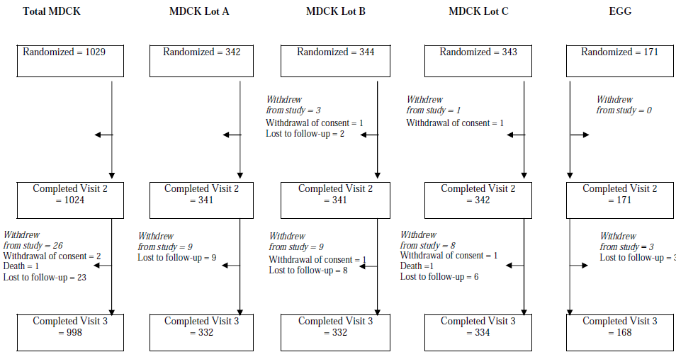

Major protocol violations/deviations
A total of 105 participants recorded protocol deviations. For 13, protocol deviations were considered major. Eight participants (1 Lot A, 4 Lot B, 1 Lot C, 2 control group) who did not satisfy the entry criteria were enrolled in the study. All were found to be suffering from active pulmonary tuberculosis and were taking excluded anti-infective medications. Overall, 53 participants (19 Lot A, 19 Lot B, 9 Lot C and 6 control group) received an excluded concomitant medication (Table 14).

Table 14. V58P9 Protocol Deviations
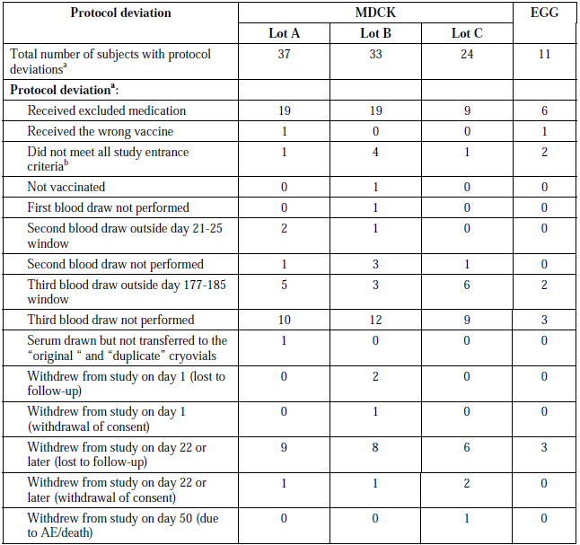

Baseline data
The demographic and baseline characteristics of the pooled cTIV group and the control group were very similar. All participants were Caucasian. For the four groups, mean age ranged from 32. 4 to 32.6 years; the proportion of males ranged from 36% to 41% and previous influenza vaccination was reported by between 21% and 26%.

Immunogenicity results
- Results for A/H1N1 are summarised.
- Results for A/H3N2 are summarised.
- Results for B strain are summarised.
- Each of the 3 cTIV lot groups, the total cTIV group and the control vaccine groups met all (CPMP/BWP/214/96) criteria for all 3 antigen strains. In the following description of results, cTIV results are followed by the eTIVa results.

A/New Caledonia/20/99 (H1N1)
- Pooled cTIV group and eTIVa
- Pre-vaccination seroprotection: 29% cTIV, 30% eTIVa
- Post-vaccination seroprotection: 94% and 95%
- GMRs: 18 and 16
- Seroconversion/significant: 81% and 77%
- cTIV lots and eTIva
- Pre-vaccination seroprotection: 27% (Lot C) to 31% (Lot B)
- Post-vaccination seroprotection: 93% (Lot B) to 95% (Lot A and eTIVa).
- GMRs: 16 (Lot B and control) to 20-fold (Lot C).
- Seroconversion/significant increases: 77% (control) to 85% (Lot C)

A/California/7/2004 (H3N2)
- Pooled cTIV group and eTIVa
- Pre-vaccination seroprotection: 24% cTIV, 27% eTIVa
- Post-vaccination seroprotection: 93% and 96%
- GMRs 14 and 17
- Seroprotection/significant increases: 83% and 88%
- cTIV lots and eTIVa
- Pre-vaccination seroprotection: 19% (Lot A) to 28% (Lot C)
- Post-vaccination seroprotection: 93% (Lots B and C) to 96% (eTIVa).
- GMRs 12 (Lot C) and 17 (eTIVa)
- Seroconversion/significant increases: 81% (Lot C) to 88% (eTIVa)

B/Shanghai/361/2002
- Pooled cTIV group and eTIVa
- Pre-vaccination seroprotection: 23% cTIV, 21% eTIVa
- Post-vaccination seroprotection: 91% and 88%
- GMRs 9.76 and 8.29
- Seroconversion/significant increases: 78% and 70%
- cTIV lots and eTIVa
- Pre-vaccination seroprotection: 21% (Lot A and control) to 27% (Lot B)
- Post-vaccination seroprotection: 88% (control) to 91% (Lots B and C).
- GMRs 8.29 (eTIVa) to 9.88 (Lot A)
- Seroconversion/significant increases: 70% (eTIVa) and 78% (Lots A and B)

Lot consistency
Lot consistence in terms of GMTs was shown in accordance with the chosen limits of 0.5 to 2 and also fell between the FDA Guidance for Industry: Clinical Data Needed to Support the Licensure of Seasonal Inactivated Influenza Vaccines MAY 2007 limits of 0.67 and 1.5 for each strain tested.
A/New Caledonia/20/99 (H1N1): The ratios of day 22 GMTs between lots were Lot A/Lot B: 1.02, Lot A/Lot C: 0.84 and Lot B/Lot C: 0.83. The 95% CIs around the ratios of the day 22 GMTs were in the range 0.67-1.26.
A/California/7/2004 (H3N2): The ratio of day 22 GMTs between lots were Lot A/Lot B: 0.97, Lot A/Lot C: 1.1 and Lot B/Lot C: 1.13. The lower 95% CIs around the ratios of the day 22 GMTs were in the range 0.81-1.36.
B/Shanghai/361/2002: The ratio of day 22 GMTs between lots were Lot A/Lot B: 0.82, Lot A/Lot C: 0.93 and Lot B/Lot C: 1.13. The 95% CIs around the ratios of the day 22 GMTs were in the range 0.70-1.33.

Antibody persistence to 6 months

A/New Caledonia/20/99 (H1N1)
Six months post-vaccination between 78% and 81% of participants across the three cTIV lot groups and 82% of participants in the control vaccine group were seroprotected and GMTs, although decreased compared to day 22, remained higher than baseline titres. Across the three cTIV lot groups GMTs were between 6.79 - to 8.61-fold higher than at baseline. For the control vaccine group GMTs were 5.23-fold higher than baseline (Table 15).

Table 15. V58P9 A/New Caledonia/20/99 (H1N1) 6 Month Immunogenicity Results – PP population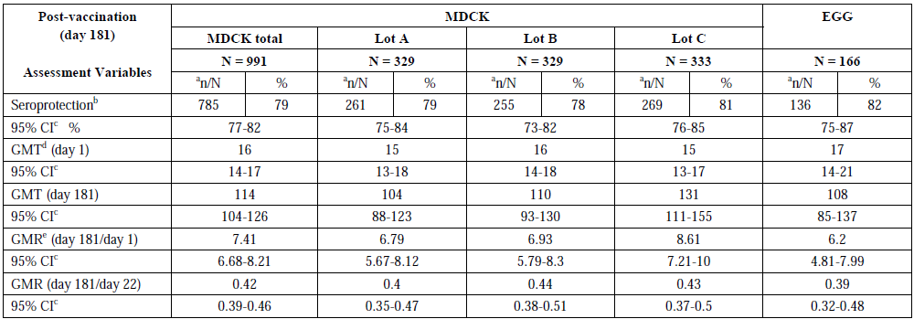

A/California/7/2004 (H3N2)
Six months post-vaccination between 75% and 84% of participants across the three cTIV lot groups and 86% of participants in the control vaccine group were seroprotected against the H3N2 strain. At 6 months GMTs were between 5.22- and 8.3-fold higher than at baseline. For the control vaccine group GMTs were still 7.51-fold higher than baseline (Table 16).

Table 16. V58P9 A/California/7/2004 (H3N2) 6 Month Immunogenicity Results – (PP) Population
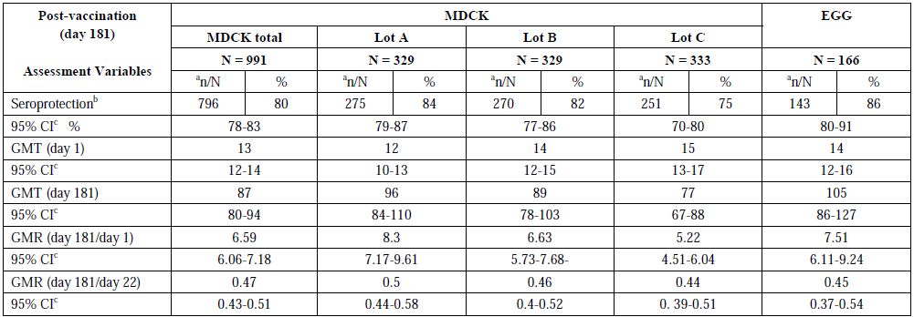

B/Shanghai/361/2002
Six months after vaccination between 64% and 70% of participants across the three cTIV lot groups and 64% of participants in the control vaccine group were seroprotected against the B strain. At 6 months GMTs were between 3.68- and 4.05-fold higher than at baseline. For the control vaccine group GMTs were still 3.53-fold higher than baseline (Table 17).

Table 17. V58P9 B/Shanghai/361/2002 6 Month Immunogenicity Results – PP population
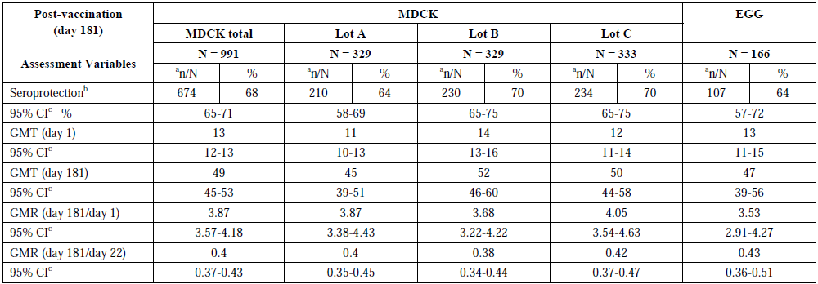

Lot consistency at 6 months
The 95% CIs for the ratios of day 181 GMTs between the three cTIV vaccine lots ranged between 0.63 - 0.96 and 1.01-1.52, respectively and therefore was within the range 0.5 and 2.0 demonstrating lot to lot consistency at 6 months after vaccination, although CBER lot criterion was not met for 3 of the 9 lots comparisons (Table 18).

Table 18. V58P9 cTIV Vaccine Lot Consistency at 6 Months
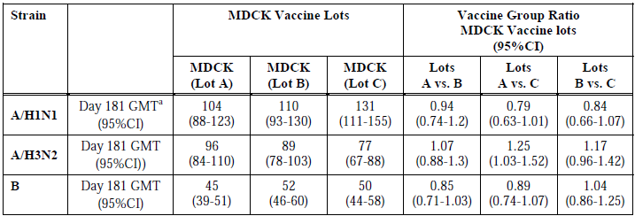
The seroprotection rates against the A strains remained above the CHMP cut off of 70% (range, 75%-86%) and also above LL 95% CI CBER cut off of 70% (range, 70%-80%).
Against the B strain, no group maintained a seroprotection rate of 70% and the lower limit of the 95% CI for the seroprotection rate was below 70% (range: 57%-65%). This could not be accounted for by the difference in baseline seroprotection rates against the B and A strains.
In all groups and against all three strains GMTs remained higher than 2.5-fold above the baseline value. Consistency between the three cTIV vaccine lots was confirmed at 6 months after vaccination as the lower and upper limits of the two-sided 95% CI on the day 181 GMT ratio between the three vaccine lots were within the range 0.5 – 2.0.

Efficacy result
A subset of 494 participants (randomised in ratio 2:2:2:3) was included in the ILI surveillance program: 327 in the pooled cTIV vaccine group and 167 participants in the eTIVa group. Nasal swabs were taken from the 21 symptomatic individuals in the cTIV group and the 10 in the control group. Of these, 5 in the cTIV group and 2 in the control group had laboratory confirmed influenza, all of which were caused by the type B viral strain.
Table 19 summarises the baseline and post-vaccination titres against B/Shanghai/361/2002 for participants with vaccine failure. After day 22, only three participants demonstrated further rises in titres (a further 2-fold increase at day 181 for all three participants: 01/0324 cTIV lot B, 01/0414 cTIV lot C, and 01/0652 control group) suggesting these participants might have been exposed subsequently to B/Shanghai/361/2002 or to an antigenically similar strain.

Table 19. V58P9 Immune Responses against the B Strain in Participants with Vaccine Failure
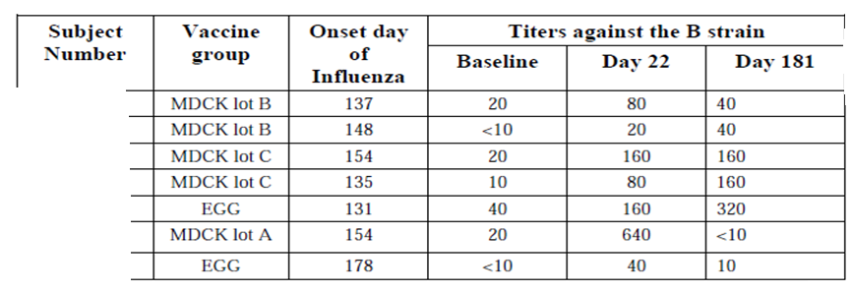

Sponsor comments
Laboratory identification of influenza viruses was targeted to detect the different influenza type strains (A and B), but it was not able to further investigate the antigenic or genetic characteristics. Although more than 90% of all the isolated strains in Lithuania were of type B, no further information on the antigenic strain characterization is available.
There is no reason to suspect that the epidemiology was different to that for Europe in general, where B/Malaysia/2506/2004-like was the predominantly circulating strain, whereas B/Shanghai/361/2002-like was the recommended vaccine strain. Therefore, it is unlikely that most of these cases were caused by vaccine failure and the information on ILI does not give a reliable indication of vaccine effectiveness.

Evaluator comment
The conclusion above is plausible but hypothetical.

Study V58P1 – Supportive

Design
V58P1 was a phase I/II, observer-blind, randomised 1:1, single-centre, sequential cohort study conducted in Germany between 24th September and 15th November 2002, comparing safety, tolerability and immunogenicity of cTIV compared and eTIVa in healthy adults.
- Phase I was a preliminary safety study of 4 weeks, including 40 participants aged 18 to 40 years.
- Phase II included 200 participants in age cohorts 18 – 60 and ≥ 61 years. Immunogenicity was assessed in compliance with CPMP/BWP/214/96.

Study treatments

Test product
cTIV contained 15 μg each of the strains A/New Caledonia/20/99-like type A/H1N1 [A/New Caledonia/20/99 IVR-116], A/Moscow/10/99-like type A/H3N2 [A/Panama/2007/99 RESVIR 17] and B/Sichuan/379/99-like type B [B/Guangdong/120/2000], as well as neuraminidase recommended for 2001/2002.

Reference product
eTIVa contained 15 μg each of the strains A/New Caledonia/20/99-like type A/H1N1 [A/New Caledonia/20/99 IVR-116], A/Moscow/10/99-like type A/H3N2 [A/Panama/2007/99 RESVIR 17] and B/Sichuan/379/99-like type B [B/Guangdong/120/2000], and neuraminidase recommended for 2001/2002. Thiomersal residues were present in the final product.

Immunogenicity variables and outcomes
In addition to HI testing, single radial haemolysis (SRH) test was assessed. The SRH testing was performed at the Institute of Hygiene, University of Siena, Italy. HI and SRH tests were performed using cTIV cell-derived antigen and egg-derived antigen.
- The lower limit of detection for the HI test was at a dilution of 1:10, i.e., a titre of 10. All titres below the lower limit of detection were set to half that limit for the immunogenicity analysis.
- The lower detection limit of the SRH test was at an area of 4 mm2. All areas below the lower limit of detection were set to 4 for the immunogenicity analysis.
The study was affected by a malfunctioning handheld electronic pipette leading to a systematic under-measurement of the volume of serum, resulting in underestimation of antibody titres. The data were not retested for this study.

Sample size
The sample size of at least 240 exceeded the requirements of CPMP\BWP\214\96 for seasonal influenza vaccines.

Statistical methods
All analyses were descriptive. The number and percent of seroconversion/significant increases from day 1 to day 22 were determined by vaccine group within each age group. The Clopper-Pearson 95% CIs for the percentages were computed.
The HI GMT and the SRH GMA pre-and post-vaccination were calculated for each participant by exponentiating the least-squares means of the log (base 10) transformed titre or area obtained from a one-way analysis of variance (ANOVA) with a factor for vaccine group. GMT and GMA median, minimum, maximum, and 95% CI values were obtained from the same ANOVA. Post-vaccination GMRs and 95% CIs were calculated as for GMTs and GMAs.

Participant flow
Two hundred and forty participants were enrolled, vaccinated, and analysed for safety. Two hundred and thirty nine were included in at least one immunogenicity analysis. One person in the cTIV group withdrew before the second blood draw due to an SAE considered unrelated to vaccination.
- Phase I, 40 participants were vaccinated with either cTIV or eTIVa, (20 per group
- Phase II,
  - 18 to 60 years: 82 received cTIV (40) or eTIVa (42 per group)
  - > 60 years: 118 received cTIV (60) or eTIVA (58 per group) (Table 20).

Table 20. V58P1 Number enrolled into each cohort
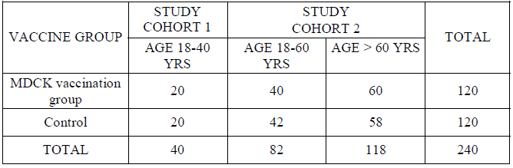

Major protocol violations/deviations
One major deviation was reported: withdrawal before the post-vaccination blood draw.
No blood draw was more than 3 days beyond the limits of this window. Two in the control group aged 60 years were one year below the lower age limit for inclusion into the > 60 year age group.

Baseline data
The average age was 51.2 years for the cTIV group and 49.1 years for eTIVa. Male/female ratio was 60%/40% for the cTIV group and 65%/35% for the eTIVa group. All participants were Caucasian. For the cTIV and eTIVa groups the respective mean weights were 76.69 kg and 75.86 kg: mean heights were 173.1 cm and 172.2 cm.

Immunogenicity results

Phase 1 – Adults aged 18 to 40 years
- Results for A/H1N1 are summarised.
- Results for A/H3N2 are summarised.
- Results for B Strain are summarised.
- Results are reported in the following order, HI followed by SRH results using egg-derived and cell-derived antigen testing.

A/New Caledonia/20/99-like (A/H1N1)

cTIV test vaccine
- Pre-vaccination seroprotection: 15% and 25% of participants had HI titres of ≥ 40; 5% and 5% had SRH areas ≥ 25 mm2 for egg-derived and cell-derived antigen assays respectively
- Post-vaccination seroprotection: HI 100% and 100%, SRH 90%, and 95%,
- GMRs: HI 30 and 43; SRH 12 and 13
- Seroconversion/significant increases: HI 95% and 95%; SRH 85%, and 95%
- cTIV met all CPMP criteria against the A/H1N1 strain.

eTIVa control vaccine
- Pre-vaccination seroprotection: 15% and 30% of participants had HI titres ≥ 40; 15% and 15% had SRH areas ≥ 25 mm2 for egg and cell-derived antigen assays respectively
- Post-vaccination seroprotection: HI 100% and 100%, SRH 95%, and 90%
- GMRs: HI 17 and 26; SRH 11, and 8.5
- Seroconversion/significant increases: HI 85% and 90%; SRH 85%, and 85%
- eTIVA met all CPMP criteria against the A/H1N1 strain

A/Moscow/10/99-like (A/H3N2

cTIV test vaccine
- Pre-vaccination seroprotection: 50% and 55% of participants had HI titres ≥ 40; 60% and 65% had SRH areas ≥ 25 mm2 for egg and cell-derived antigen assays respectively
- Post-vaccination seroprotection: HI 95% and 100%, SRH 90%, and 100%
- GMRs: HI 6.73 and 8.29, SRH 1.81, and 2.7
- Seroconversion/significant increases: HI 60% and 60%, SRH 35%, and 55%
- cTIV met CPMP seroprotection criterion against the A/H3N2 strain for each of the four assays. The GMR criterion was met for HI egg and cell-derived antigen and for SRH cell-derived antigen but not the SRH egg-derived antigen assay. Seroconversion/significant increase criterion was met for HI egg, HI cell and SRH cell assays, but not for the SRH egg-derived assay.

eTIVa control vaccine
- Pre-vaccination seroprotection: 50% and 60% of participants had HI titres ≥ 40; 60% and 65% had SRH areas ≥ 25 mm2 for egg and cell derived antigen assays respectively
- Post-vaccination seroprotection: HI 90% and 90%; SRH 75%, and 100%
- GMRs: HI 5.86 and 5.23; SRH 1.36, and 2.1
- Seroconversion/significant increases: HI 55% and 45%; SRH 25%, and 55%
- eTIVa met the CPMP seroprotection criterion against the A/H3N2 strain in each of the four assays. The control vaccine did not meet the GMR criterion for the SRH egg and cell assays and did not meet the seroconversion criterion for the SRH egg assay.

B/Sichuan/379/99-like (B)

cTIV test vaccine
- Pre-vaccination seroprotection: 5% and 20% of participant had HI titres ≥ 40; 10% and 15% had SRH areas ≥ 25 mm2 for egg and cell-derived antigen assays respectively
- Post-vaccination seroprotection: 100% and 95%, 90%, and 95%
- GMRs: HI 13 and 23; SRH 9.18, and 7.9
- Seroconversion/significant increases: HI 95% and 95%; SRH 85%, and 90%
- cTIV met the CPMP seroprotection, GMR and seroconversion criteria against the B strain.

eTIVa control vaccine
- Pre-vaccination seroprotection: 10% and 30% of participants had HI titres ≥ 40; 10% and 45% had SRH areas ≥ 25 mm2 for egg and cell-derived antigen assays respectively
- Post-vaccination seroprotection: HI 80% and 100%, SRH 70%, and 95%,
- GMRs: HI 9.3 and 16; SRH 5.96, and 4.73
- Seroconversion/significant increases: HI 75% and 80%, SRH 70%, and 75%
- eTIVa met CPMP seroprotection, GMR and seroconversion criteria against the B strain.

Phase II cohort 2 age 18 to 60 years
- Results for A/H1N1 are summarised.
- Results for A/H3N2 are summarised.
- Results for B Strains are summarised.

A/New Caledonia/20/99-like (A/H1N1)

cTIV test vaccine
- Pre-vaccination seroprotection: 15% and 15% of participants had HI titres of ≥ 40; 5% and 20% had SRH areas of ≥ 25 mm2 for egg and cell-derived antigen assays respectively
- Post-vaccination seroprotection: HI 95% and 98%; SRH 85%, and 95%
- GMRs: HI 25 and 17; SRH 9.71, and 9.43
- Seroconversion/ significant increases: HI 88%, 85%; SRH 83%, and 90%
- cTIV met the CPMP criteria against A/H1N1

eTIVa control vaccine
- Pre-vaccination seroprotection: 10% and 10% of participants had HI titres ≥ 40; 2% and 10% had SRH areas ≥ 25 mm2 for egg and cell-derived antigen assays respectively.
- Post-vaccination seroprotection: 90% and 93%, 86%, and 90%
- GMRs: HI 22 and 16; SRH 10, and 10
- Seroconversion/significant increases: HI 88% and 88%; SRH 86%, and 88%
- eTIVa met all CPMP criteria against the A/H1N1 strain for each of the four assays.

A/Moscow/10/99-like (A/H3N2)

cTIV test vaccine
- Pre-vaccination seroprotection: 23% and 50% of participants had HI titres ≥ 40; 0% and 30% had SRH areas ≥ 25 mm2 for egg- and cell-derived antigen assays respectively.
- Post-vaccination seroprotection: HI 88% and 98%; SRH 75%, and 98%
- GMRs: HI 14 and 11; SRH 7.19, and 5.93
- Seroconversion/ significant increases: HI 83% and 85%; SRH 75%, and 95%
- cTIV met all CPMP criteria against the A/H3N2 strain for each of the four assays.

eTIVa control vaccine
- Pre-vaccination seroprotection: 24% and 52% of participants had HI titres ≥ 40; 0% and 38% had SRH areas ≥ 25 mm2 for egg- and cell derived antigen assays respectively.
- Post-vaccination seroprotection: HI 86% and 93%; SRH 60%, and 100%
- GMRs: HI 10 and 6.12; SRH 7.01, and 5.19
- Seroconversion/significant increases: HI 81% and 57%; SRH 60%, and 95%
- eTIVa met the CPMP criteria against A/H3N2 GMR and seroconversion criteria for all four assays and the seroprotection criterion for the HI egg and cell-derived and SRH cell-derived assays, but not for the SRH egg-derived assay.

B/Sichuan/379/99-like (B)

cTIV test vaccine
- Pre-vaccination seroprotection: 15% and 18% of participants had HI titres ≥ 40; 13% and 30% had SRH areas ≥ 25 mm2 for egg and cell-derived antigen testing respectively.
- Post-vaccination seroprotection: HI 70% and 95%; SRH 88%, and 70%
- GMRs: HI 5.31 and 9.71; SRH 9.3, and 7.61
- Seroconversion/significant increases: HI 55% and 83%; SRH 83%, and 90%
- cTIV met all CPMP criteria against the B strain for all four assays.

eTIVa control vaccine
- Pre-vaccination seroprotection: 10% and 21% of participants had HI titres ≥ 40; 17% and 29% had SRH areas ≥ 25 mm2 for egg- and cell-derived antigen assays respectively.
- Post-vaccination seroprotection: HI 69% and 79%; SRH 79%, and 69%
- GMRs: HI 5.44 and 7.55; SRH 6.87, and 6.86
- Seroconversion/significant increases: HI 62% and 67%; SRH 69%, and 79%
- eTIVa met the GMR and seroconversion criteria against the B strain for all four assays and seroprotection criterion for HI cell and SRH egg assays, but not meet for HI egg or SRH cell assays.

Pooled Phase 1and Phase II cohorts aged 18 - 60 years
In total 122 adults aged from 18 to 60 years provided pre and post-vaccination blood samples.

A/New Caledonia/20/99-like (A/H1N1)

cTIV test vaccine
- Pre-vaccination seroprotection: 15% and 18% of participant had HI titres ≥ 40; 5% and 15% had SRH areas ≥ 25 mm2 for egg-derived and cell-derived antigen assays respectively.
- Post-vaccination seroprotection: HI 97% and 98%: SRH 87%, and 95%
- GMRs: HI 27 and 24; SRH 10, and 10
- Seroconversion/significant increases: HI 90% and 88%; SRH 83%, and 92%
- cTIV met all CPMP against the A/H1N1 strain for all four assays.

eTIVa control vaccine
- Pre-vaccination seroprotection: 11% and 16% of participants had HI titres ≥ 40; 6% and 11% had SRH areas ≥ 25 mm2 for egg- and cell derived antigen assays respectively.
- Post-vaccination seroprotection: HI 94% and 95%; SRH 89%, and 90%
- GMRs: HI 20 and 18; SRH 11, and 9.59
- Seroconversion/significant increases: HI 87% and 89%; SRH 85%, and 87%
- eTIVA met all CPMP criteria against the A/H1N1 strain in for each of the four assays.

A/Moscow/10/99-like (A/H3N2)

cTIV test vaccine
- Pre-vaccination seroprotection: 32% and 52% of participants had HI titres ≥ 40; 20 and 42% had SRH areas ≥ 25 mm2 for egg- and cell-derived antigen assays respectively.
- Post-vaccination seroprotection: HI 90% and 98%; SRH 80%, and 98%
- GMRs: HI 11 and 10; SRH 4.54 and 4.56
- Seroconversion/significant increases: HI 75% and 77%; SRH 62%, and 82%
- cTIV met all CPMP criteria against the A/H3N2 strain for each of the four assays.

eTIVa control vaccine
- Pre-vaccination seroprotection: 32% and 55% of participants had HI titres ≥ 40; 19% and 47% had SRH areas ≥ 25 mm2 for egg- and cell-derived antigen assays respectively.
- Post-vaccination seroprotection: HI 87% and 92%; SRH 65%, and 100%
- GMRs: HI 8.59 and 5.82; SRH 4.13 and 3.9
- Seroconversion/significant increases: HI 73% and 53%; SRH 48%, and 82%
- eTIVa met the GMR and seroconversion criteria against A/H3N2 for each assays and the seroprotection criterions for the HI egg and cell and SRH cell assays but not for the SRH egg assay.

B/Sichuan/379/99-like (B)

cTIV test vaccine
- Pre-vaccination seroprotection: 12% and 18% of participants had HI titres ≥ 40; 12% and 25% had SRH areas ≥ 25 mm2 for egg and cell-derived assays respectively.
- Post-vaccination seroprotection: HI 80% and 95%; SRH 88%, and 97%
- GMRs: HI 7.16 and 13; SRH 9.26, and 7.71
- Seroconversion/significant increases: HI 68% and 87%: SRH 83%, and 90%
- cTIV met all CPMP criteria against the B strain for all four assays.

eTIVa control vaccine
- Pre-vaccination seroprotection: 10% and 24% of participants had HI titres ≥ 40; 15% and 34% had SRH areas ≥ 25 mm2 for egg- and cell-derived antigen assays respectively.
- Post-vaccination seroprotection: HI 73% and 85%; SRH 76%, and 90%
- GMRs: HI 6.46 and 9.58; SRH 6.56, and 6.08
- Seroconversion/significant increases: HI 66% and 71%; SRH 69%, and 77%
- eTIVa met all CPMP criteria against the B strain for all four assays.

Phase II, cohort 2 Age > 60 years
- Of the 118 participants aged > 60, 117 provided evaluable pre- and post-vaccination blood samples.
- Results for A/H1N1 are summarised.
- Results for A/H3N2 are summarised.
- Results for B strain are summarised.

A/New Caledonia/20/99-like (A/H1N1)

cTIV test vaccine
- Pre-vaccination seroprotection: 15% and 17% of participants had HI titres ≥ 40; 7% and 24% had SRH areas of ≥ 25 mm2 for egg-derived and cell-derived antigen assays respectively.
- Post-vaccination seroprotection: HI 73% and 83%: SRH 69% and 93%
- GMRs: HI 7.85 and 8.15: SRH 5.6, and 4.04
- Seroconversion/significant increases: HI 58% and 68%: SRH 66%, and 81%
- cTIV met all CMPM criteria against the A/H1N1 strain for all four assays

eTIVa control vaccine
- Pre-vaccination seroprotection: 28% and 36% of participants had HI titres ≥ 40; 14% and 38% had SRH areas ≥ 25 mm2 for egg- and cell-derived antigen assays respectively.
- Post-vaccinations seroprotection: HI 83% and 84%; SRH 78%, and 90%
- GMRs: HI 6.37 and 5.78; SRH 4.92 and 2.97
- Seroconversion/significant increases: HI 52% and 53%; SRH 69%, and 66%
- eTIVa met all CPMP criteria against the A/H1N1 strain for each of the four assays.

A/Moscow/10/99-like (A/H3N2)

cTIV test vaccine
- Pre-vaccination seroprotection: 34% and 44% of participants had HI titres ≥ 40; 3% and 44% had SRH areas ≥ 25 mm2 for egg- and cell-derived antigen assays respectively.
- Post-vaccination seroprotection: HI 80% and 90%: SRH 64%, and 95%
- GMRs: HI 8.02 and 11; SRH 5.14 and 3.96
- Seroconversion/ significant increases: HI 68% and 75%; SRH 63%, and 80%
- cTIV met all CMPM criteria against the A/H3N2 strain for each of the four assays.

eTIVa control vaccine
- Pre-vaccination seroprotection: 40% and 62% of participants had HI titres ≥ 40; 5% and 50% had SRH areas ≥ 25 mm2 for egg- and cell derived antigen assays respectively.
- Post-vaccination seroprotection: HI 88% and 95%; SRH 67%, and 97%
- GMRS: HI 5.24 and 4.95; SRH 4.31 and 2.77
- Seroconversion/significant increases: HI 52% and 48%; SRH 62%, and 67%
- eTIVa met all CMPM criteria against the A/H3N2 strain for each of the four assays.

B/Sichuan/379/99-like (B)

cTIV-derived test vaccine
- Pre-vaccination seroprotection: 12% and 20% of participants had HI titres ≥ 40; 14% and 39% had SRH areas ≥ 25 mm2 for egg and cell-derived antigen assays respectively.
- Post-vaccinations seroprotection: HI 63% and 85%; SRH 76%, and 93%
- GMRs: HI 4.75 and 6.03; SRH 5.4, and 4.53
- Seroconversion/significant increases: HI 46% and 63%; SRH 66%, and 75%
- cTIV met all CMPM criteria against the B strain for each of the four assays.

eTIVa control vaccine
- Pre-vaccination seroprotection: 22% and 33% of participants had HI titres ≥ 40; 22% and 48% had SRH areas ≥ 25 mm2 for egg- and cell-derived antigen assays respectively.
- Post-vaccination seroprotection: HI 79% and 90%; SRH 84%, and 91%
- GMRs: HI 4.94 and 5.48; SRH 6.12, and 3.83
- Seroconversion/significant increases: HI 53% and 55%; SRH 69%, and 64%
- eTIVa met all CMPM criteria against the B strain for each of the four assays.

Study V58P2 – Supportive

Study design, objective, location dates
V58P2 was a phase II, observer-blind, randomised; single-centre study conducted in New Zealand from 11th March to 23rd April 2003, comparing immunogenicity of cTIV compared with eTIVa, in healthy adults aged 18 to 60 and ≥ 61 years, in terms of CPMP criteria.

Study treatments

Test product – Group A
cTIV contained15 μg each of the strains A/New Caledonia/20/99-like type A/H1N1 [A/New Caledonia/20/99 IVR-116], A/Moscow/10/99-like type A/H3N2 [A/Panama/2007/99 RESVIR 17] and B/Hong Kong/330/2001-like type B [B/Shangdong/7/97]), as well as neuraminidase recommended for the influenza season 2003 in the Southern Hemisphere.

Reference product – Group B
eTIVa contained 15 μg each of the strains A/New Caledonia/20/99-like type A/H1N1 [A/New Caledonia/20/99 IVR-116], A/Moscow/10/99-like type A/H3N2 [A/Panama/2007/99 RESVIR 17] and B/Hong Kong/330/2001-like type B [B/Shangdong/7/97]), as well as neuraminidase recommended for the influenza season 2003 in the Southern Hemisphere.

Sample size
The planned sample size of 223 met CPMP/BWP/214/96 criteria allowing for a drop-out of approximately 10%.

Statistical methods
Methods were descriptive. In addition to the group analyses, subgroup analyses were conducted.
- Non-seroprotected – day 1 HI titre less than 40 or SRH area less than 25 mm2;
- Seroprotected – day 1 HI titre of 40 or more or SRH area of 25 mm2 or more.
Statistical analyses for the subsets were as for the full sets.
Unplanned analyses were also performed on a further two subsets.
- Previously vaccinated against influenza
- Previously unvaccinated

Participant flow
A total of 223 participants enrolled, were vaccinated and completed the study: 113 aged 18 to 60 years, and 110 aged > 60 years.

Major protocol violations/deviations
There were no major protocol violations.

Baseline data
Amongst those aged 18 to 60 years, the mean ages (SD) were 47.2 (11.5) years and 46.7 (10.6) years for cTIV and control vaccine groups respectively. The ratio of male/female participants was 48%/52% for the cTIV group and 42%/58% for the control group. The majority of both groups were Caucasian: 98% cTIV and 96% controls. Mean weights were 81.43 (16.84) kg for the cTIV group and 82.34 (18.34) kg for the control group. Previous vaccination was recorded for 82% of the cTIV group and 72% of the control group.
Among the participants aged ≥ 61 years, the mean ages (SD) were 68.8 (5.4) years and 70.5 (5.6) years for cTIV and control groups, respectively. The ratio of male/female was 52%/48% for cTIV and 50%/50% for the controls. All participants were Caucasian. Mean weights (SD) were 77.51 (15.25) kg for cTIV and 78.16 (14.98) kg for the controls. Ninety-four percent of the cTIV group and 96% of controls had received at least one previous influenza vaccination.

Results

Age group 18 to 60 years
- Results for A/H1N1 are summarised.
- Results for A/H3N2 are summarised.
- Results for B strain are summarised.

A/New Caledonia/20/99-like (A/H1N1)

Test vaccine cTIV
- Pre-vaccination seroprotection: 52% had an HI titre (egg-derived antigen) ≥ 40; 46% and 79% had SRH areas (egg-derived and cell-derived antigen, respectively) ≥ 25 mm2.
- Post-vaccination seroprotection: HI 77%, SRH 66%, and 93%
- GMRs: 2.39, 1.76, and 1.66,
- Seroconversion/significant titre increases: HI 25%, SRH 34%, and 32%
- cTIV met the seroprotection criterion for egg-derived HI and cell-derived SRH testing but not by the egg-derived SRH test. GMR and seroconversion/significant increase criteria were not met.
- NB: The CSR states that subset analyses showed the result was due to participants not seroprotected on day 1 and participants who were previously vaccinated.

Control vaccine eTIVa
- Pre-vaccination seroprotection: 40% had HI titres ≥40 (egg-derived antigen); 35% and 61% had SRH areas ≥ 25 mm2 (egg- and cell-derived antigens, respectively).
- Post-vaccination seroprotection: HI 79%; SRH 79%, and 91%
- GMRs: HI 4.41; SRH 3.61, and 2.34
- Seroconversion/significant increases: HI 37%; SRH 53%, and 47%
- eTIVa met all CPMP criteria against the A/H1N1 except for the seroconversion/ significant increase using egg-derived HI testing.

A/Moscow/10/99-like (A/H3N2)

Test vaccine cTIV
- Pre-vaccination seroprotection: 71% had an HI titre ≥40 (egg-derived antigen); 54% and 84% had SRH areas ≥ 25 mm2 (egg- and cell-derived antigens).
- Post-vaccination seroprotection: HI 95%; SRH 88%, and 98%
- GMRs: 3.38, 1.8, and 1.67
- Seroconversion/significant increases: HI 39%; SRH 41%, and 39%
- cTIV met CPMP seroprotection criteria for A/H3N2 in each assay, and GMR and seroconversion criteria using respectively egg-derived HI and egg-derived SRH analyses. GMRs did not meet criteria using egg- and cell-derived SRH testing. Seroconversion or significant increases did not reach the criterion using egg-derived HI and cell-derived SRH testing.

Control vaccine eTIVa
- Pre-vaccination seroprotection: 81% had an HI titre ≥40 (egg-derived antigen); 75% and 93% had SRH areas ≥ 25 mm2 (egg- and cell-derived).
- Post-vaccination seroprotection: HI 96%; SRH 93%, and 98%
- GMRs: HI 2.5, SRH 1.52, and 1.33
- Seroconversion/significant increases: HI 30%; SRH 28%, and 32%
- eTIVa met the seroprotection criterion for each assays but not the GMR or the seroconversion for any assays. The results were comparable for cTIV and eTIVa and met at least one CMPM criterion.

B/Hong Kong/330/2001-like (B)

Test vaccine cTIV
- Pre-vaccination seroprotection: 5% had an HI titre ≥40 (egg-derived antigens); 88% and 64% had SRH areas ≥25 mm2 (egg- and cell-derived).
- Post-vaccination seroprotection: HI 46%; SRH 100%, and 98%
- GMRs: HI 3.01; SRH 1.59, and 2.92
- Seroconversion/significant increases: HI 38%; SRH 41%, and 68%
- cTIV met seroprotection criterion against the B strain for SRH egg- and cell-derived assays, HI egg-derived assay. The GMR criterion was met for HI egg and SRH cell assays, not for the SRH egg assay and seroconversion was met for SRH egg and cell assays, not for the HI egg assay.

Egg-derived (Control) vaccine
- Pre-vaccination seroprotection, 2% of adult control participants had an HI titre ≥40 (egg-derived antigen); 89% and 54% had SRH areas ≥ 25 mm2 (egg- and cell-derived).
- Post-vaccination seroprotection: HI 39%; SRH100%, and 91%
- GMRs: HI 2.92; SRH 1.52, and 2.96
- Seroconversion/significant increases: HI 28%; SRH 44%, and 60%
- eTIVa met seroprotection criteria for the B strain for SRH egg and cell-derived antigen assays but not for the HI egg assay. GMR criterion was met for HI egg and SRH cell assays, not for the SRH egg assay. Seroconversion was met for SRH egg and cell assays, not for the HI egg assay. The results were comparable for cTIV and control vaccines and met at least one CPMP criterion.

Age group ≥ 61 years
- Results for A/H1N1 are summarised.
- Results for A/H3N3 are summarised.
- Results for B strain are summarised.

A/New Caledonia/20/99-like (A/H1N1)

Test vaccine cTIV
- Pre-vaccination seroprotection: 69% had an HI titre ≥40 (egg-derived antigen); 43% and 72% had SRH areas ≥ 25 mm2 (egg- and cell-derived antigens).
- Post-vaccination seroprotection: HI 81%; SRH 67%, and 91%
- GMRs: HI 1.59; SRH 1.73, and 1.61
- Seroconversion/significant increases: HI 9%; SRH 41%, and 52%
- cTIV met seroprotection criteria against A/H1N1 for each assay. The GMR criterion was not met by any assay. Seroconversion/significant increase criterion was met using SRH egg and cell- derived antigen assays, but not for the HI egg assay.

Control vaccine eTIVa
- Pre-vaccination seroprotection: 57% had HI titres ≥40 (egg-derived antigen); 48% and 70% had SRH areas ≥25 mm2 (egg- and cell-derived antigens).
- Post-vaccination seroprotection: HI 75%; SRH 64%, and 88%
- GMRs: HI 1.69; SRH 1.54, and 1.5
- Seroconversion/significant increases: HI 13%; SRH 34%, and 38%
- eTIVa met seroprotection criteria for each of the 3 assays but did not meet the GMR criterion for any of the 3 assays. The seroconversion criterion was met using SRH egg and cell-derived assays, but not the HI egg assay. The cTIV and control vaccine results were similar and each passed at least on CPMP criterion.

A/Moscow/10/99-like (A/H3N2)

Test vaccine cTIV
- Pre-vaccination seroprotection: 76% had an HI titre ≥40 (egg-derived antigen); 56% and 87% had SRH areas ≥25 mm2 (egg- and cell-derived antigens).
- Post-vaccination seroprotection: HI 94%; SRH 81%, and 94
- GMRs: HI 2.62; SRH 1.58, and 1.5
- Seroconversion/significant increases: HI 30%; SRH 33%, and 31%
- cTIV met seroprotection criteria against A/H3N2 using each assay. The GMR criterion was met using the HI egg assay, but not SRH egg or cell-derived antigen assays. The seroconversion criterion was met using the SRH egg and cell assays but not for HI egg assay.

Control vaccine eTIVa
- Pre-vaccination seroprotection: 82% had an HI titre ≥40 (egg-derived antigen); 41% and 80% had SRH areas ≥25 mm2 (egg- and cell-derived antigens).
- Post-vaccination seroprotection: HI 93%; SRH 68%, and 95%
- GMRs: HI 1.66; SRH 1.61, and 1.4
- Seroconversion/significant increases: HI 13%; SRH 29%, and 23%
- eTIVa seroprotection criteria for each of the 3 assays but did not meet the GMR or seroconversion criteria for any of the 3 assays. For this antigen, cTIV appeared to do better than the control. Each vaccine met at least one CPMP criterion.

B/Hong Kong/330/2001-like (B)

cTIV-derived (Test) vaccine
- Pre-vaccination seroprotection: 4% had an HI titre ≥40 (egg-derived antigen); 70% and 76% had SRH areas ≥25 mm2 (egg- and cell-derived antigens).
- Post-vaccination seroprotection: HI 43%; SRH 93%, and 94%
- GMRs: HI 2.96; SRH 1.82, and 1.86
- Seroconversion/significant increases: HI 37%; SRH 44%, and 43%
- cTIV met seroprotection criterion against the B strain for SRH egg and cell-derived antigen test, but not for the HI egg assay. The GMR criteria were met for HI egg assay, but not SRH egg or cell assays. The seroconversion/significant increase criterion was met for each of the 3 assays.

Control vaccine eTIVa
- Pre-vaccination seroprotection: 4% had an HI titre ≥40 (egg-derived antigen); 59% and 75% had SRH areas ≥25 mm² (egg- and cell-derived antigens, respectively).
- Post vaccination, seroprotection: HI 38%; SRH 95%, and 98%
- GMRs: HI 2.76; SRH 2.32, and 2.29
- Seroconversion/significant increases: HI 30%; SRH 43%, and 46%
- eTIVa met the seroprotection criterion against the B strain criterion using SRH egg and cell, but not for the HI egg assay. The GMR criterion was met for all 3 assays. Seroconversion/significant increase was met using SRH egg and cell assays, but not for the HI egg assay. Test and control results were similar and at least one CPMP criterion was met.
Sponsor’s comment: The difference in performance on a B strain between HI and SRH assays is consistent with previous literature reports [Monto].
Evaluator comment: The difference in seroprotection rates against the B strain, using the HI egg-derived antigen test and the SRH testing with both egg- and cell-derived antigen for both study groups is remarkable. The reference could not be located in the dossier. (See S31 Response to Questions).

Study V58P5

Study design, objective, location dates
V58P5 was a phase 2, observer-blinded, randomized, multicentre non-inferiority study in adults conducted in the United States between 24th October 2005 and 9th May 2006, comparing immunogenicity of cTIV with eTIVf.

Study treatments

Test product
cTIV (test vaccine) containing at least 15 μg each of the three influenza antigens (A/New Caledonia/20/99-like type [A/H1N1], A/Moscow/10/99-like type [A/H3N2], and B/Sichuan/379/99-like type B [B/Guangdong/120/2000] per 0.5 mL dose. Lot No. 002011.

Reference product
eTIVf (control) containing at least 15 μg each of the three influenza antigens (A/New Caledonia/20/99-like type [A/H1N1], A/Moscow/10/99-like type [A/H3N2], and B/Sichuan/379/99-like type B [B/Guangdong/120/2000]) per 0.5 mL dose. Lot No. 0703.

Variables and outcomes
Sera were analysed by HI using egg-derived and cell culture-derived antigen against the 3 strains.

Randomisation and blinding methods
Participants were stratified into three age groups (18 to ≤ 30, 31 to ≤ 40, and 41 to < 50). For each age group, enrolled participants were randomized to either the cTIV group or the egg-derived (eTIVf) group on the basis of their order of entry at each study site. Randomization lists were prepared by the Chiron BCDM department or a designee and were provided to the investigator for use only by the unblinded study personnel.

Sample size
The sample size calculation was based on the immunogenicity objective of noninferiority. A significance level of 5.0% two-sided, and a power of 92.8% for each of the three individual tests were specified.
Assuming a standard deviation of 0.82, based on the upper limit of the 99% CI in a previous study using this cTIV (V58P2) for both vaccines, and a negligible effect of age, 210 participants per group would have been necessary to test the null hypothesis with a study power of 80%. In anticipation of about 30% non-evaluable participants, approximately 600 participants were enrolled, with approximately 300 in each vaccine group. Since the standard deviation used to calculate the sample size in this study was based on study V58P2, the immune response variability in this multicentre study should have been higher than the immune response variability of the single-centre study. The upper limit of 99% CI was used to estimate the assumed standard deviation of this study.

Statistical methods
Non-inferiority was demonstrated if the lower limit of the 95% confidence interval or the ratio of the post-vaccination GMTs was > 0.5. For each antigen and each vaccine group, least squares GMTs and associated 95% CIs and median, minimum, and maximum titre values were determined for day 1 (visit 1) and day 22 (visit 3). Vaccine group differences were assessed using one-way analysis of variance (ANOVA) with factor for vaccine group. Additional statistical analyses on least squares GMTs were performed considering study site as an additional factor of adjustment and baseline titre as a covariate in the model. All statistical analyses were performed on the logarithmically (base 10) transformed titre values.

Participant flow
A total of 613 participants (225 aged 18 to ≤ 30, 205 aged 31 to ≤ 40, and 183 aged 41 to < 50) were enrolled and vaccinated. Two participants in each vaccine group were lost to follow-up. The immunogenicity ITT population included 611 participants; 307 (50.3%) in the cTIV group and 304 (49.8%) in the eTIVf group. The immunogenicity PP population included 610 participants; 307 in the cTIV group and 303 in the eTIVf group.

Protocol violations/deviations
Three participants were excluded from the immunogenicity analyses for protocol deviations: 2 (1 in each group) did not have the second blood draw and 1 received the wrong vaccine.

Baseline data
The average ages in cTIV and eTIVf groups were 33.8 years and 34.2 years, respectively. The ratio of males to females was 36%/64% cTIV and 33%/67% eTIVf. The majority were Caucasian: 96% cTIV; 95% cTIVf. Mean weight was 76.13 kg cTIV group and 74.42 kg eTIVf. Mean height was 169.80 cm cTIV group and 170.08 cm eTIVf. Prior influenza vaccination was reported by 19% of participants in each vaccine group. The baseline characteristics of the PP population were similar to those of the all-enrolled population.
Among participants with reported medical histories, respiratory diseases (35% cTIV and 40% eTIVf) and factors influencing health status and contact with health services (31% and 38%, respectively) were reported most frequently (Table 21).

Table 21. V58P5 Summary of Medical History - Enrolled Population
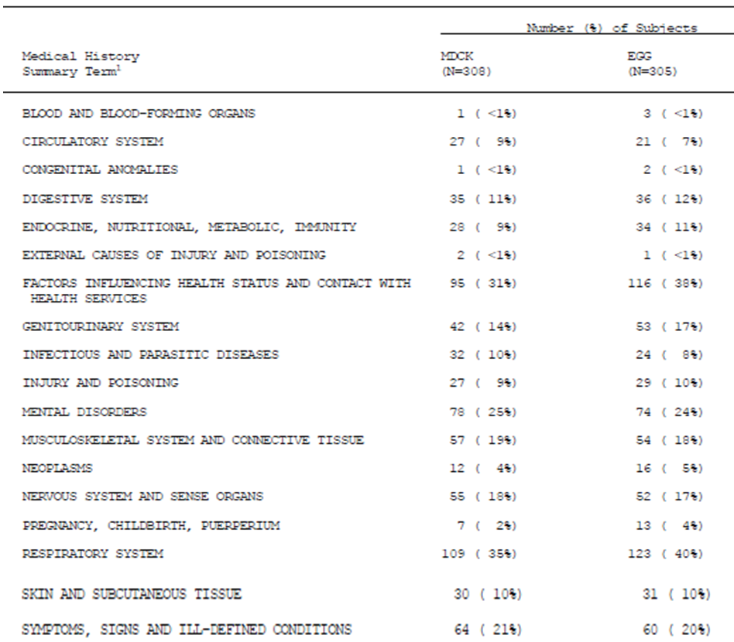

Immunogenicity results

Primary objective
The protocol-specified ANOVA results (95% CI) were as follows:

HI egg-derived antigen assay
- A/H1N1 0.85 (0.70, 1.04) consistent with non-inferiority
- A/H3N20.57 (0.46, 0.70) not consistent with non-inferiority
- B strain 1.14 (0.95, 1.36) consistent with non-inferiority

HI cell-derived antigen assay
- A/H1N1 0.92 (1.76, 1.12) consistent with non-inferiority
- A/H3N2 0.61 (0.5 [0.50329], 0.75) Considered by the sponsor to be consistent with non-inferiority
- B strain 1.31 (1.09, 0.75) consistent with non-inferiority
The distribution of pre-vaccination HI titres was considered unbalanced. Thus, a post-hoc analysis of covariance (ANCOVA) was also performed using the log10-transformed post-vaccination titres as the outcome variable in a model that included log10-transformed baseline titres as a covariate, and vaccine group and centre as factors. The ANCOVA results for GMR (95% CI) were as follows:

HI egg derived antigen assay
- A/H1N1 0.85 (0.70, 1.03)
- A/H3N2 0.63 (0.52, 0.76)
- B strain 1.16 (0.98, 1.38)

HI cell-derived antigen assay
- A/H1N1 0.92 (0.76, 1.12)
- A/H3N2 0.69 (0.57, 0.83)
- B strain 1.33 (1.13, 1.58)
The ANCOVA analyses results met the non-inferiority criterion specified for the ANOVA analyses.

Other immunogenicity results
Secondary objectives were not specified in the protocol or in the CSR Section 8.0. Seroprotection and seroconversion results using both antigen assays met CBER criteria.

A/H1N1

Pre-vaccination seroprotection
- Egg-derived antigen: 50% (44, 56) cTIV and 48% (42, 53) eTIVf
- Cell- derived antigen): 61% (55, 66) cTIV and 60% (54, 65) eTIVf

Post-vaccination seroprotection
- Egg-derived antigen; 96% (94, 98) cTIV and 98% (96, 99) eTIVf
- Cell-derived antigen: 99% (98, 100) cTIV and 99% (97, 100) eTIVf

GMRs
- Egg-derived antigen): 8.06 (6.64, 9.8) cTIV and 9.65 (7.93, 12) eTIVf
- Cell-derived antigen: 9.21 (7.48, 11) cTIV10 (8.19, 12) cTIVf

Seroconversion/significant increase
- Egg-derived antigen: 62% (57, 68) cTIV and 65% (59, 70) eTIVf
- Cell-derived antigen: 62% (56, 67) cTIV

A/H3N2

Pre-vaccination seroprotection
- Egg-derived antigen: 14% (11, 19) cTIV and 22% (18, 28) eTIVf
- Cell-derived antigen: 30% (25, 35) cTIV and 37% (32, 43)

Post-vaccination seroprotection
- Egg-derived antigen: 91% (87, 94) cTIV and 96% (93, 98)
- Cell-derived antigen: 98% (95, 99) cTIV and 99% (97, 100)

GMRs
- Egg-derived antigen: 18 (15, 20) cTIV and 25 (21, 29) eTIVf
- Cell-derived antigen18 (15, 21) for cTIV and 22 (18, 26) eTIVf

Seroconversion/significant increase
- Egg-derived antigen; 85% (81, 89) cTIV and 92% (88, 95) eTIVf
- Cell-derived antigen; 89% (85, 92) cTIV and 90% (87, 93) eTIVf

B strain

Pre-vaccination seroprotection
- Egg-derived antigen: 34% (28, 39) cTIV and 32% (27, 38)
- Cell-derived antigen 33% (27, 38) cTIV and 35% (29, 40) eTIVf

Post-vaccination seroprotection
- Egg-derived antigen: 94% (91, 96) cTIV and 93% (89, 95) eTIVf
- Cell-derived antigen: 97% (94, 98) cTIV and 91% (88, 94) eTIVf

GMRs
- Egg-derived antigen: 11 (9.49, 13) cTIV and 9.15 (7.83, 11) for eTIVf
- Cell-derived antigen 10 (8.92, 12) cTIV and 7.6 (6.54, 8.83) eTIVf

Seroconversion/significant increase
- Egg-derived antigen: 77% (72, 81) cTIV and 76% (70, 80) eTIVf
- Cell-derived antigen: 78% (73, 83) cTIV and 72 (66, 77) eTIVf
GMTs and GMRs at baseline and Day 22 are summarised.
Seroprotection results and seroconversion or significant increase in titre are summarised.

Efficacy results
It was stated that influenza-like illness would be assessed. There were no ILI results found in the text of the CSR. The following two tables were located. It appears that 5 in the cTIV group and 7 in the egg-derived vaccine group had evidence of ILI. Of these 4/5 in the cTIV group and 5/7 in the egg-derived vaccine group had negative cultures; 1 in each group had H3N2 isolated, and 1 in the egg-derived vaccine group had B strain isolated (Tables 22 and 23).

Table 22. V58P5 Summary of Influenza Symptoms
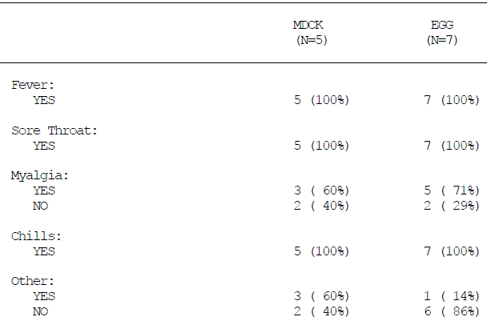

Table 23. V58P5 Summary of Culture Results
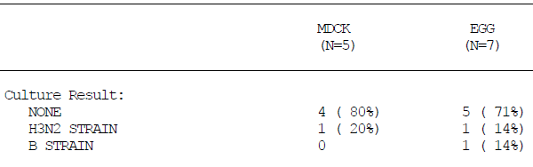

Evaluator comment
It is not understood why V58P5 is considered a Phase II study. A non-inferiority study including over 600 participants should surely be considered a Phase III study.
The study population was relatively young and inclusion criteria specified good health; however, the medical history suggests a population with significant health problems, including the enigmatic “factors influencing health status and contact with health services” affecting approximately a third. A quarter of participants had mental disorders and 17% had nervous system and sense organ disorders. A fifth had “ill-defined conditions”, and 38% had respiratory system disorders. Endocrine, nutritional, metabolic and immunity disorders affected approximately 10%. It also appears that the study participants were not particularly compliant. The population described gives rise to speculation.
Assessment of non-inferiority was the only stated immunogenicity objective of this study. Non-inferiority was not met for A/H3N3 using the pre-specified ANOVA approach using the egg-derived assay; it was met by a margin of 0.00329 using the cell-derived antigen assay. Results were then re-analysed post-hoc, controlling for centre, baseline results and vaccine group using ANCOVA, with results that met non-inferiority criteria. Seroprotection and seroconversion results using both antigen assays met CBER and CPMP criteria.
See also S31 Response to Questions.

Immunogenicity according to CBER criteria
The results were re-calculated according to CBER criteria and age group were changed from 18 to 60 and > 60 years, to 18 to 64 years and ≥ 65 years. Immunogenicity results in these terms are summarised. This information is included here, as the Sponsor proposes to include these results in the Product Information.
Evaluator Comment: While it may be acceptable to present in the Product Information, re-calculated results of descriptive analyses with no underlying hypothesis and more stringent evaluation criteria, it is not considered acceptable to re-calculate results of hypothesis driven analyses upon which samples sizes have been calculated, and to propose including the results in the Product Information.

Efficacy and immunogenicity summary and discussion
For this summarisation, results are reported for HI assay using egg-derived antigen as this assay was used for all studies. All studies used the same observer blinded design, and the same methods for patient selection and randomisation.

Study V25P13
V58P13 conducted in US, Finland and Poland, was a phase III, randomised (1:1:1), placebo-controlled multicentre study including adults aged 18 to 49 years. The study assessed efficacy, immunogenicity, safety and reactogenicity of a single dose of cTIV and eTIVa containing A/H1N1, A/H3N2 and B strains recommended for the season, compared to placebo.
The primary objectives was to demonstrate vaccine efficacy of cTIV and eTIVa against virus confirmed influenza wild type strains similar to those in the vaccines compared to placebo. Each vaccine was considered statistically compliant with the May 2007 CBER Guidance for Industry criteria if the lower limit of the one-sided simultaneous 97.5 CI for the estimate of VE relative to placebo was greater than 40%.
Immunogenicity was assessed in a subgroup randomised 8:25:2 for cTIV:eTIVa:placebo. Assessment of immunogenicity in terms of CBER criteria was a secondary objective.

Population results
Participants in the total population (immunogenicity subset) were predominantly Caucasian ~ 85% (66 – 70%), Hispanic ~ 7% (20 – 24%) and black 7% (6 – 12%) and for both cohorts mean age ~ 33 years, and proportion male/females ~ 44/56.
Numbers in the PP efficacy populations were 3776 for cTIV, 3638 for eTIVa and 3843 for placebo. Numbers included in the PP immunogenicity population were228, 695 and 55 respectively. Numbers in the safety population were 3813, 3669 and 3894 respectively.

Efficacy result
The primary efficacy objective was met for cTIV. Overall VE point estimate (LL 97.5% CI) was 83.8% (61%).

Immunogenicity results
The immunogenicity results met the CBER criteria for seroconversion and seroprotection for each of the three strains for both cTIV and eTIVa but not for the placebo. The CPMP criteria were also met by the active vaccines for all strains.

Evaluator comment
Study objectives were met according to TGA accepted criteria.

Study V58P4
V58P4 conducted in Poland, was a phase III, randomised, multi-centre study evaluating immunogenicity, safety, tolerability and immunogenicity of cTIV compared to eTIVa in healthy adults 18 to 60 years and > 60 years.
The primary objective was to assess immunogenicity against CPMP criteria, the secondary objective, for which sample size was calculated, was to demonstrate non-inferiority of cTIV vs. eTIVa in terms of seroprotection, seroconversion and significant increase in GMT.
For seroprotection and seroconversion, non-inferiority was concluded if, for all 3 antigens, the lower limit of the two-sided 95% CI for the difference in percentages was > -10%.
For the GMR, non-inferiority was concluded if, for all 3 stains, the lower limit of the two-sided 95% CI for the ratio was > 0.5.

Population results
- Numbers in the PP population aged 18 to 60 were 1294 (cTIV0) and 1300 (eTIVa)
- Numbers in the PP population aged > 60 were 1346 (cTIV) and 1354 (eTIVa)
All participants were Caucasian. In the age group 18 to 60 years, the average ages in the cTIV and eTIVa groups were 38.7 years and 38.3 years respectively. The ratio of male to female was 42%:58% cTIV; 43%:57% control. In the age group > 60 years, the respective average ages in the cTIV and control groups were 69.1 years and 68.8 years. The ratio of male to female was 43%:57% cTIV; 45%:55% control.

Immunogenicity results
Primary objective: cTIV and eTIV met all 3 CPMP criteria against the 3 strains in both age groups.
Secondary objective: The non-inferiority criteria were met for all three strains for both age groups.

Evaluator comment
Study objectives were met according to TGA accepted criteria

Study V58P4E1
V58P4E1 conducted in Poland, was a phase III, randomised (1:1), multi-centre 6-month extension of study V58P4. Participants who had previously received cTIV were randomised to either cTIV or eTIVa and those previously vaccinated were randomised to either cTIV or eTIVa resulting in 8 groups revaccinated at 12 months post first study vaccination. The first 120 participants in each age group (continued from V58P4) were included in the immunogenicity sub-set.
The objective was to evaluate immunogenicity 3 weeks after vaccination with either cTIV or eTIVa administered approximately 12 months after the first vaccination. Results were analysed based on the vaccine group to which participants were randomized in the extension study.
The vaccine administered included the same A/H1N1 and B strains as the previous vaccination; a new A/H3N2 strain was added.

Population results
A total of 247 participants in the cTIV group (cTIV/cTIV: 122; control/cTIV: 125) and 241 in the control group (cTIV/control: 121; control/control: 120) were included in the immunogenicity subset.
The age group 18 to 60 years immunogenicity subset included 121 participants in the cTIV group (cTIV/cTIV: 60; control /cTIV: 61) and 119 in the control group (cTIV/control: 60; control/control: 59). The age group > 60 years immunogenicity subset included 126 in the cTIV group (cTIV/cTIV: 62; control /cTIV: 64) and 122 in the control group (cTIV/control: 61; control /control: 61).
The immunogenicity PP population consisted of 242 in the cTIV total group (cTIV/cTIV: 121; control/cTIV: 121) and 241 in the control group (cTIV/control: 121; control/control: 120).
All participants were Caucasian. For the group aged 18 to 60 years, the average age was 39.8 years for cTIV and 39.0 years for the controls. The ratio of males to females was 42%/58% for both groups. For those > 60 years average age was 69.2 years cTIV and 69.9 for the controls, the male/female ratio was 46%/54% for cTIV and 41%/59% for controls.

Immunogenicity results

For ages 18 to 60 years
Both vaccines met CPMP criterion for seroprotection against A/H1N1 and neither met GMR or seroconversion/significant increase criteria.
Both vaccines met all criteria against A/H3N2.
Both vaccines met the seroprotection criterion against the B strain, the GMT criterion was met by cTIV but not eTIVa and neither met the seroconversion/significant increase criterion.
For age > 60 years, both vaccines met all criteria against A/H1N1, A/H3N2 and the B strain.
There was a centre effect detected for seroprotection pre-vaccination but not post-vaccinations for those aged 18 to 60. There was a centre effect noted for B/Shanghai/361/2002 for those aged > 60 years. Adjusting for centre the GMRs, rates of seroprotection and seroconversion/significant increases were stated to remain similar to the non-adjusted results. Overall, results against CPMP criteria were similar for males and females.

Evaluator comment
The results met TGA accepted criteria for registration of a seasonal vaccine. Seroprotection at day 1 for the two components included in the previous vaccine was noted in the range 44%-66%.

Study V58P9
V58P9 conducted in Lithuania, was a phase III, randomised, controlled, multi-centre study assessing immunogenicity against CPMP criteria, efficacy in a subgroup, safety and reactogenicity of three lots of cTIV compared to eTIVa.
Immunogenicity was assessed 3 weeks post-vaccination against CPMP criteria. Lot consistency was concluded if the 95% CIs lay between 0.5 and 2 (CPMP), or between 0.67 and 1.5 (FDA Guidance of Industry). A similar assessment was done at 6 months.
A for-cause audit conducted in March 2007, and subsequent follow-up analysis of site 2 data did not indicate grounds for concluding that data from that site should be excluded from consideration in the study analyses. In addition safety, tolerability and immunogenicity analyses were retrospectively performed without site 2 and compared in the addendum to the results of the overall population (site 1 and 2). Differences with and without site 2 were reported to be small and did not change the assessment of cTIV compared to eTIV-a regarding immunogenicity, safety and tolerability.

Population results
Numbers in the PP Population: At 3 weeks: 339 Lot A, 3Lo337 Lot B, 341 Lot C and 168 eTIVa. ; At 6 months: 329 Lot A, 329 Lot B, 333 Lot C and 166 eTIVa.
All participants were Caucasian. For the four groups, mean age ranged from 32. 4 to 32.6 years; the proportion of males ranged from 36% to 41% and previous influenza vaccination was reported by between 21% and 26%.

Immunogenicity results
cTIV and eTIV met all CPMP criteria against the three strains overall and for each lot. GMTs fell between the EMA and FDA limits for each vaccine strain.
Antibody persistence to 6 months was similarly assessed.
Against A/H1N1 and A/H3N3, seroprotection and GMRs were still above CPMP criteria overall and for each lot. Against the B strain GMRs overall and for each lot were still above the CPMP criterion but seroprotection had fallen below the criterion.
Lot consistency assessment at 6 months met the EMA but not the FDA criteria.

Evaluator comment
Study objectives assessed 3 weeks following vaccination were met overall and for each lot according to TGA accepted criteria. For each strain at least one criterion was met at 6 months.

Study V58P1
V58P1 conducted in Germany, was a phase I/II, randomised (1:1), single-centre, sequential cohort study of safety, reactogenicity and immunogenicity of cTIV compared to eTIVa. Immunogenicity was assessed in against with CPMP/BWP/214/96 using HI and SRH assays.
The study was affected by a malfunctioning handheld electronic pipette leading to a systematic under-measurement of the volume of serum, resulting in underestimation of antibody titres. The data were not retested for this study.

Population results
Phase I included 40 participants aged 18 to 40 years; Phase II included 200 participants in age cohorts 18 to 60, and > 60 years.
Participants were Caucasian, with average age approximately 50 years, male/female ratio approximately 60/40.

Immunogenicity results
For age 18 to 40 years, results for cTIV met CPMP criteria for each strain.
For pooled Phase I and II ages 18 to 60 years, results for cTIV met CPMP criteria each strain.
For age > 60 years results for cTIV met CPMP criteria for each strain.

Evaluator comment
Study objectives were met according to TGA accepted criteria.

Study V58P2
V58P2 conducted in New Zealand, was a phase II, observer-blind, randomised, single centre study of immunogenicity in terms of CPMP criteria, safety and reactogenicity of cTIV compared to eTIVa.

Population results
Healthy adults 18 to 60 (n – 113) and > 60 years (n = 110) were enrolled, the majority were Caucasian. Previous vaccination had been recorded for 82% of cTIV and 72% of eTIVa groups aged 18 to 60 and 94 to 96% of those aged > 60 years.

Immunogenicity results
Results were similar for each vaccine and met at least one CPMP criterion.

Evaluator comment
The results, although less convincing than for other studies, met TGA accepted registration criteria for seasonal vaccine.

Study V58P5
V58P5 conducted in the United States, was a phase II, randomised, multicentre study to demonstrate non-inferiority of antibody response of cTIV vs. eTIVf. Non-inferiority was concluded if the lower limit of the 95% CI of post-vaccination GMTs was > 0.5 using ANOVA analysis.

Population results
The immunogenicity PP population included 307 cTIv participants and 303 in the eTIVf group. Ages ranged from 18 to 40 years, the majority were Caucasian (95 to 96%), males/females approximately 33/67, with average age ~ 34 years and ~ 19% had prior influenza vaccination.

Immunogenicity results
Non-inferiority was concluded for A/H1N1 and the B strain but not for A/H3N2. Non-inferiority criteria were met when the analyses were repeated post-hoc using ANCOVA with covariates baseline titres, vaccine grouped centre.

Evaluator comment
It is not understood why this was considered a Phase II study.
Although the study population was relatively young, a substantial proportion had underlying health problems, leading to concern about external validity of results for this population.
The non-inferiority result required post-hoc manipulation to meet the hoped for objective for A/H3N2.

Sponsor’s overall efficacy and immunogenicity conclusion
Both the primary and secondary immunogenicity objectives were met as assessed by the HI assay using egg-derived viral antigens. The cTIV cell culture-derived (cTIV) vaccine was at least as immunogenic as the egg-derived (control) vaccine in both adult and elderly populations. All 3 influenza strains contained within the cTIV and control vaccines induced responses that met all the criteria stipulated in the Note for Guidance for harmonization of requirements of influenza vaccines (CPMP/BWP/214/96).
The attainment of CPMP criteria in both adult and elderly populations were unaffected by sex or centre. Subsets of unvaccinated individuals and participants not seroprotected at baseline also met all the criteria. Adult but not elderly participants who had previously received an influenza vaccination failed to attain seroconversion or significant increase for the A/H1N1 strain due to already high baseline titres. Previously exposed adults had higher baseline titres than previously exposed elderly participants. The immune responses against all strains in both adult and elderly participants induced by the cTIV vaccine were not inferior to those induced by the control vaccine.

Evaluator’s overall efficacy and immunogenicity conclusion
Study V58P13 included sufficient numbers of participants to demonstrate efficacy against placebo.
Overall, the studies provided a database that was sufficient to demonstrate immunogenicity of cTIV in comparison to vaccines produced in embryonated hens eggs, Agrippal and Fluvirin, both registered in Australian. The criteria for assessing immunogenicity for all studies except V58P13, accorded with the CPMP/BWP214/96 guideline which has been adopted in Australia. CBER criteria, which are more stringent, were assessed in V58P13. In addition, lot consistency and antibody persistence were demonstrated.
The dossier contains results that have undergone a significant amount of recalculation. All studies except V58P13, had immunogenicity results that were affected by a pipetting problem. The results of studies V58P1, V58P2, V58P4, V58P4E1, V58P5 and V58P8 were submitted in version 2 of the Clinical Study Reports (CSRs). The non-inferiority results of study V58P5 were recalculated post-hoc when the planned analysis failed to show non-inferiority using HI egg-derived assay for one strain. All results were then recalculated for presentation in Module 2 and these results were proposed for presentation in the Product Information.
Novartis Vaccines hypothesised that cell-derived antigen may be the most appropriate source for HI testing of this cell-derived vaccine, an hypothesis that was not specifically tested. In a number of studies, HI results using cell-derived antigen were presented in addition to results using egg-derived antigen. In study C58P1, SRH results were also presented using both egg-derived and cell-derived antigen. The results against CPMP and CBER criteria were at times met by one method but not the other leading to the conundrum of how to avoid selective reporting in the clinical evaluation report.

Clinical safety
Safety endpoints for all studies included record of solicited adverse events (AEs), local and systemic reactions and other indicators of reactogenicity from day 1 to day 7. Unsolicited AEs were recorded for the duration of study. The solicited adverse events listed in Table 24 and were recorded by the participants on a standardized diary card which was returned to the investigator at the post-vaccination visits. Participants were also contacted by telephone in the first week.

Table 24. Reactogenicity Variables: Solicited Adverse Events
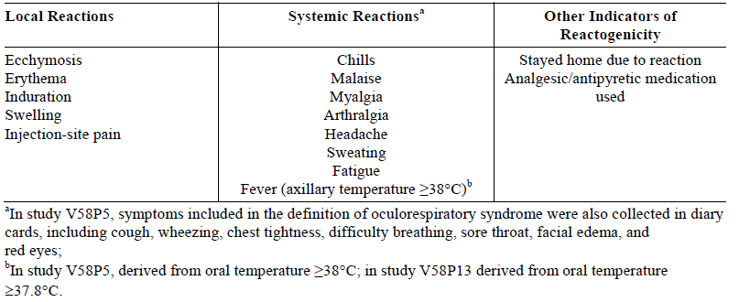
In all studies excluding V58P13, local reactions with the exception of pain at the injection site were graded similarly. For the purposes of this application, data were re-analysed to align with the scale used in V58P13: none (no reaction), mild to moderate (categories > 0 to 10 mm, > 10 to 25 mm, > 25 to 50 mm, > 50 to 100 mm in diameter) and severe (> 100 mm in diameter). Pain at injection site and all systemic reactions (with the exception of fever) and all unsolicited AEs were graded by the investigator as mild, moderate, or severe as follows:
- Mild no limitation of normal daily activities
- Moderate some limitation of normal daily activities
- Severe unable to perform normal daily activities
Measurement of body temperature was axillary in all studies except V58P5 and V58P13, in which oral temperature was collected. Axillary or oral temperature ≥ 38°C was classified as fever and body temperature was further graded as < 38°C, 38°C to 38.9°C, 39°C to 39.9°C, and ≥ 40°C.
All unsolicited AEs were collected during the follow-up visits and during phone calls. The monitoring period for all unsolicited AEs continued for 21 days after vaccination for all studies with the exception of V58P5 and V58P13, in which they were collected only up to day 7. In all studies, serious adverse events (SAEs) and AEs leading to withdrawal were collected for the entire study period, i.e., approximately 6 months for participants in studies V58P4, V58P4E1, V58P5, V58P9, and V58P13. In studies V58P4E1, V58P9 AEs requiring a physician visit were also collected for the 6 months following vaccination, while in study V58P13 the onset of chronic diseases was collected for the 6 months.
Unsolicited AEs and SAEs were encoded using the Medicinal Dictionary for Regulatory.
Activities (MedDRA). All unsolicited AEs were graded mild, moderate, or severe by the investigator. Assessments of causal relationships were made as follows:
- Not related if the occurrence is not reasonably related in time, or there are no facts or arguments to suggest a causal relationship.
- Possibly related if reasonably related in time and the AE could be explained by causes other than exposure to the investigational product.
- Probably related if reasonably related in time and the investigational product is more likely than other causes to be responsible for the AE, or is the most likely cause of the AE.
Laboratory Safety Tests were only undertaken in V58P1 and for a subset of study V58P5. Blood and urine samples were taken on day 1 and day 22 in study V58P1. Blood samples were collected on day 1 and day 8 in study V58P5. Values deviating from the normal range were recorded. In both studies, tests on blood samples included creatinine, sodium, potassium, chloride, total protein, alkaline phosphatase, aspartate aminotransferase (AST), alanine aminotransferase (ALT), total bilirubin and blood urea nitrogen (BUN), haematocrit, haemoglobin, platelets, and white blood cells (total and differential). Urine tests in V58P1 were performed with a dipstick.
Occurrence of influenza-like-illness in study V58P9 was monitored from Day 23 till the end of Month 6 in a subset of participants and in all participants enrolled in study V58P5 for the entire study duration. Monitoring of ILI in study V58P9 was conducted by means of active surveillance. Participants were asked to contact the study sites if they developed influenza-like symptoms, and to provide nasopharyngeal specimens for laboratory confirmation of influenza virus.
In study V58P9, ILI definition included: sudden onset of fever (axillary temperature ≥38°C), plus at least one systemic symptom such as myalgia, arthralgia, osteoalgia, tiredness, weakness, headache, ear ache, eye complaints, or chills, and at least one respiratory symptom such as sore throat, cough, hoarseness, wheezing, runny nose or nasal congestion. In study V58P5 ILI cases were defined as: fever of 38.3°C (101.0°F) or greater, with cough or sore throat and with myalgia or chills. In both studies V58P9 and V58P5 ILI cases of confirmed influenza were considered vaccine failures and reported as SAEs. In study V58P13 vaccine efficacy was the primary outcome.

Pooled safety analysis
A pooled safety analysis, performed across studies was reported in Module 2. The pooled safety database included 6710 cTIV participants (6138 aged 18 to 64 years and 572 ≥ 65 years), but excluded participants in the extension study V58P4E and those in the placebo arm of study V58P13.
The randomization scheme in study V58P9 led to an imbalance in the number of adults 18 to 64 years of age. Therefore, a weighted risk ratio analysis was performed to adjust for sample size factors. The individual studies are summarised. In addition to analysis stratified by age, analyses were performed by gender and ethnic origin and on a subset of participants with a history of circulatory system, diabetes, and/or chronic respiratory conditions.
Age categories for the pooled analysis were not those included in the individual study analyses and therefore re-analysis of study results was required. Brief summarise of each study follow. Each study is individually evaluated.

Study V58P1
V58P1was a phase I/II, observer-blind, randomised 1:1, single-centre, sequential cohort study conducted in Germany in 2002 in two phases compared cTIV and eTIVa. Baseline characteristics are summarised.
- Phase I included 40 participants aged 18-40 years randomised 1:1 to receive cTIV or eTIVa.
- Phase II included 200 healthy participants randomised 1:1 to receive either cTIV or eTIVa Participants phase II were grouped by age, 18 to 60 and ≥ 61 years.

Study V58P2
V58P2 was a Phase II, observer-blind, randomised, single-centre study conducted in New Zealand in 2003 compared cTIV to eTIVa. A total of 223 participants were enrolled: 113 aged 18 to 60 years, and 110 aged ≥ 61 years. Baseline characteristics are summarised.

Study V58P4
V58P4 was a phase III, observer-blind, randomized, study done in 5 centres in Poland between September 2004 and May 2005 to evaluate safety, tolerability and immunogenicity of cTIV or eTIVa. A total of 2654 healthy participants (1300 aged 18 to 60 years and 1354 aged > 60 years) were enrolled and vaccinated. Demographics are summarised.

Study V58P5
V58P5 was a phase II, observer-blind, randomized, multicentre study done in the US between October 2005 and May 2006, compared cTIV with eTIVf. A total of 613 participants aged 18 to < 50 years were enrolled and vaccinated. Baseline characteristics are summarised.

Study V58P9
V58P9 was a phase III, randomized, controlled, observer-blind, study conducted between September 2005 and April 2006 in two centres in Lithuania. The primary safety objective was to compare safety and tolerability of the 3 lots of cTIV compared to eTIVa. A total of 1199 participants aged 18 to < 61 years were vaccinated: 342 Lot A, 344 Lot B, and 343 Lot C (1029 in the cTIV groups) and 171 in the eTIVa group. Demographics are summarised.

Study V58P13
V58P13 was a phase III, randomized, observer-blind, placebo-controlled, multicentre study comparing cTIV and eTIVa in healthy adults aged 18 to 49 years undertaken in the 2007-2008 influenza season in the US, Finland and Poland. A total of 11404 participants were randomized: 3828 received cTIV, 3676 received eTIVa and 3900 received placebo. Baseline characteristics are summarised.

Extent of exposure, disposition and baseline characteristics
The pooled safety population for age group 18 to 64 years included 6138 for cTIV, 5154 for eTIV and for those aged ≥ 65, 572 in the cTIV group and 574 in the eTIV group. All but 29 enrolled participants received at least one vaccination and provided some post vaccination safety data. The 29 included 1 in study V58P9 randomized to cTIV vaccine Lot B, and 28 in study V58P13 (11 in the cTIV vaccine group, 10 participants in the eTIV-a group and 7 participants in the placebo group) (Tables 25 and 26).

Table 25. Pooled Numbers of Participants and Doses (Safety Population)
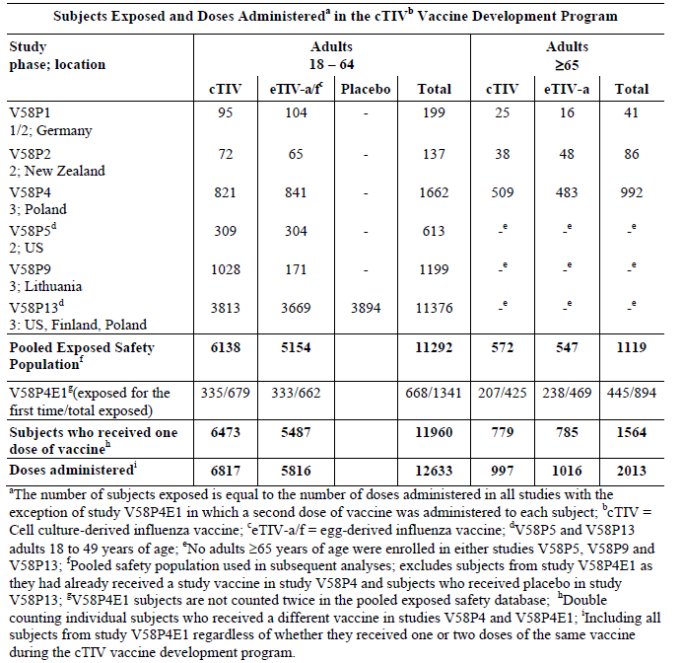

Table 26. Participant Disposition – Pooled Exposed Safety Population*
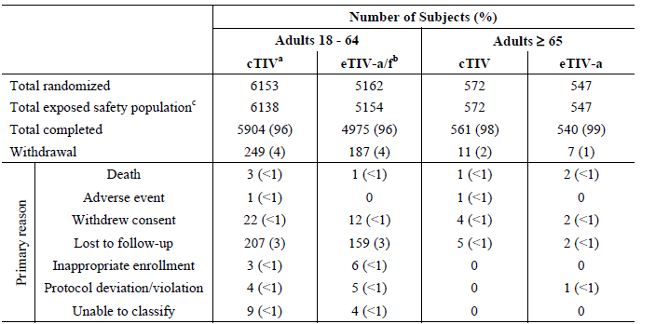
*excluding study V58P4E1 and the placebo group of study V58P13; ªcTIV = Cell culture-derived influenza vaccine; ^{b}eTIV-a/f = Egg-derived influenza vaccine; ^{c}participants were included in the safety population when they received study vaccination and provided post-dose safety data; Note: Two additional participants, study V58P4E1, were withdrawn in the 6 month follow up period, both for unrelated SAEs . In study V58P4E1 one participant was randomized to receive the cTIV vaccine but received the eTIV-a vaccine instead, and was analysed for safety as treated.
Between 89 - 100% of participants was Caucasian, Males accounted for 44 to 46% of populations. Other characteristics were well balanced (Table 27).

Table 27. Demography and Other Baseline Characteristics – Pooled Exposed Safety Population*
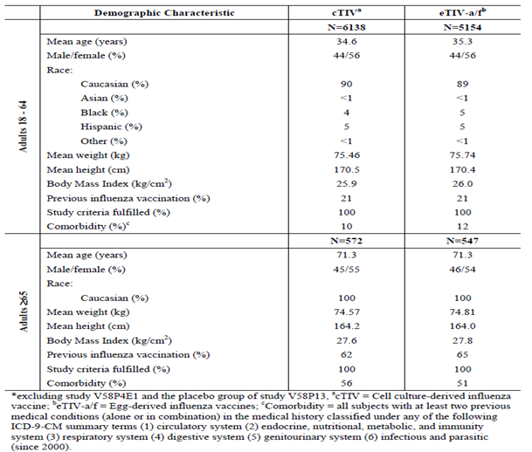

Solicited adverse events
In the pooled age range 18 – 64, injection site pain and erythema were the most commonly reported solicited local AEs and headache, malaise, fatigue and myalgia were the most common solicited systemic AEs. The risk ratios for each solicited AEs included 1 except for injection site pain with RR 1.19 (95% CI 1.12, 1.26) favouring eTIV (Table 28).
For adults ≥ 65 years, erythema and injection site pain were the most commonly reported solicited local AEs and headache and fatigue were the most commonly reported solicited systemic AEs. All RRs included 1. Local AEs were reported less often by those age ≥ 65 years. Headache and myalgia were reported less often than in the younger age group but the difference otherwise in systemic AEs was not obviously remarkable (Table 28).

Table 28. Solicited AEs in the Pooled Adult Safety Population (days 1–7)
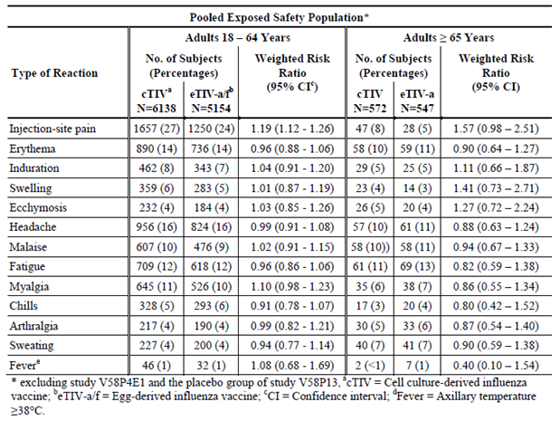

Unsolicited adverse events

Adults 18 to 64 years
The pooled percentages of participants 18 – 64 experiencing at least one unsolicited AE within the first week ranged between 5% and 17% for cTIV, and 3% to 23% for eTIV. Percentages experiencing AEs were similar in the cTIV 9% and eTIV 10%). Most AEs were either symptoms of common illnesses expected in the population of adults 18 to 64 years of age or known vaccine reactions. No AE occurred in more than 2% of the pooled population in the first week post-vaccination.
In the pooled population in the week following vaccination, unsolicited AEs considered at least possibly related to the vaccine were reported by 6% for each group. Most possibly or probably related AEs were mild. No more than 1% and 2% of participants in both groups experienced severe AEs. Each AE was reported by ≤ 1% of the pooled exposed safety population.
Within 3 weeks of vaccination 12% in the pooled cTIV and 14% in the eTIV-a/f group reported an unsolicited AE. Oropharyngeal pain was the most frequently reported AE (2% in both vaccine groups); all other AEs were observed in ≤ 1% of the pooled safety population.
The percentages reporting possibly/probably related AEs within 3 weeks post-vaccination were the same as within the first week following vaccination, with the exception of the Phase 1/II study V58P1 and efficacy study V58P13 in which selected AEs were documented between days 8 - 22.
During the period from day 23 to 6 months, unsolicited AEs were reported across studies by 1% - 12% and 1% - 8% of the cTIV and eTIV groups, respectively. All AE occurred < 1% and no AE was considered possibly/probably related to the vaccination in the period from day 23 to 6 months.

Adults > 65 years
In the first week post-vaccination, the percentages across individual studies experiencing at least one unsolicited AE were cTIV 4% - 11%, eTIVa 3% - 13%. In the pooled population the incidences were similar in the cTIV and eTIV-a group (cTIV 8%, eTIV-a 7%) (Table 33). Most AEs were either symptoms of common illnesses expected for age ≥ 65 years, or known vaccine reactions. No single unsolicited AE occurred in more than 1% of the pooled exposed safety population in the first week following vaccination (Table 34).
Within 3 weeks of vaccination, the percentages of participants reporting unsolicited AEs were cTIV 8% - 21%, eTIV 6% - 25%. The various unsolicited AEs monitored during the 6-month follow up period were reported across individual studies by 3% - 21% for cTIV and 3% - 17% for eTIV groups, respectively and for the pooled population by 3% of participants in both vaccine groups.
Within each study, the percentages experiencing unsolicited AEs at least possibly related to the vaccine within the first week were cTIV 1% to 4%, eTIVa 1% to 6%. In the pooled exposed safety population the percentages were 2% in both the cTIV and the eTIVa group.
There were no major differences in severity profiles between vaccine groups for possibly/probably related AEs reported in the first week post-vaccination when compared by study or between the pooled vaccine groups. Most possibly/probably related AEs were mild and no participant reported a severe AE (Table 35).
Possibly/probably related AEs reported in the week following vaccination were infrequent, balanced between the vaccine groups, and resulted from either known reactions to influenza vaccines or solicited AEs continuing past the 7-day observation window. In the first week, each possibly or probably related unsolicited AE was reported by no more than 1% of the pooled exposed safety population (Table 36). In all studies the percentages reporting possibly or probably related AEs within 3 weeks of vaccination were the same as those reported within the first week following vaccination, with the exception of studies V58P1 and V58P2. No AE was considered possibly or probably related to the vaccination in the period from day 23 to 6 months.

Table 29. Overview of Unsolicited AEs in the Pooled Exposed Safety Population - Adults 18 - 64 Years
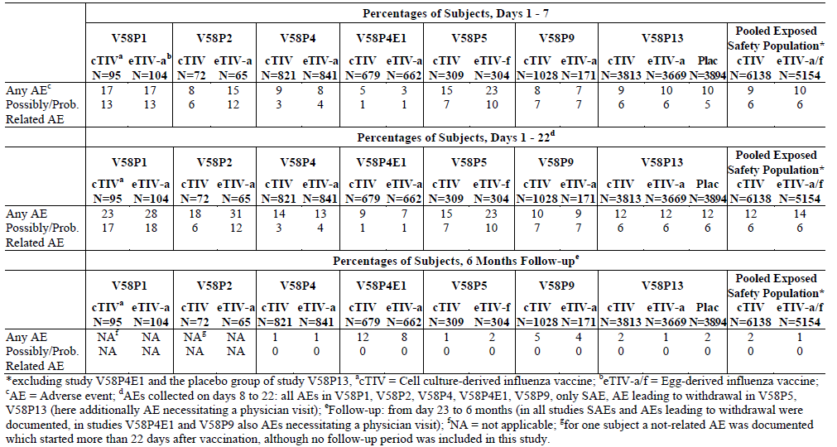

Table 30. All Unsolicited AEs Reported in ≥ 1% of the Pooled Exposed Safety Population (Days 1 - 7) - Adults 18 – 64 Years
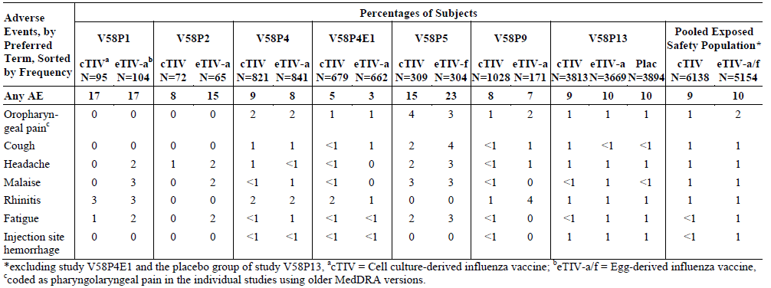

Table 31. Pooled Results of Possibly/Probably Related Unsolicited AEs by Severity (Days 1 - 7) - Adults 18 – 64 Years
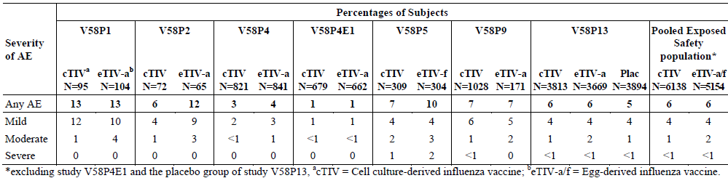

Table 32. Possibly/Probably Related Unsolicited AEs Reported in ≥ 1% of the Pooled Exposed Safety Population (Days 1 - 7) - Adults 18 - 64 Years
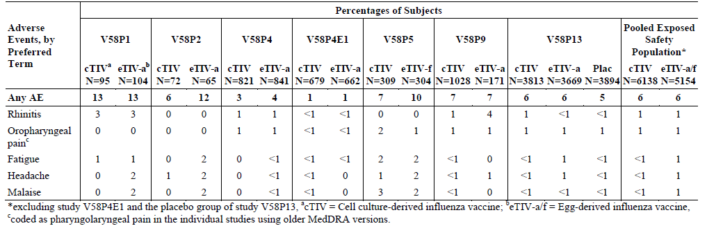

Table 33. Pooled Overview of Unsolicited AEs by Study and in the Pooled Exposed Safety Population - Adults ≥ 65 Years
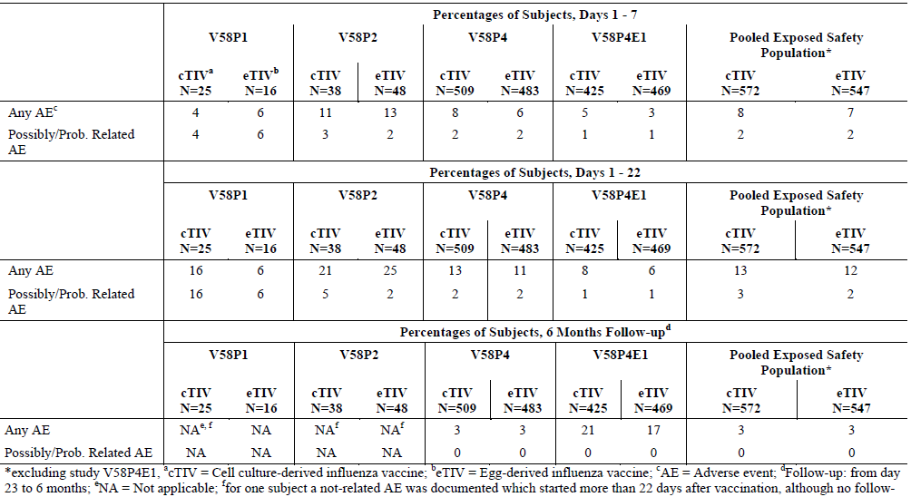

Table 34. All Unsolicited AEs Reported in ≥ 1% of the Pooled Exposed Safety Population (Days 1 - 7) - Adults ≥ 65 Years
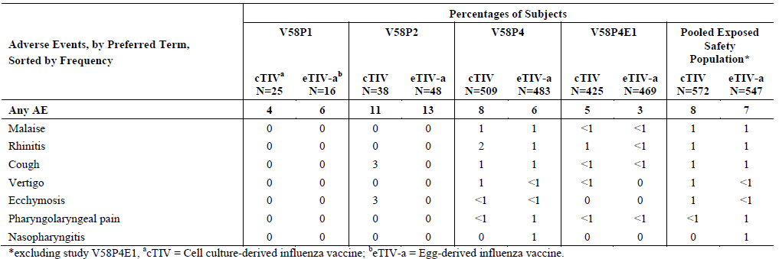

Table 35. Pooled Results for Possibly/Probably Related Unsolicited AEs by Severity (Days 1 - 7) - Adults ≥ 65 Years
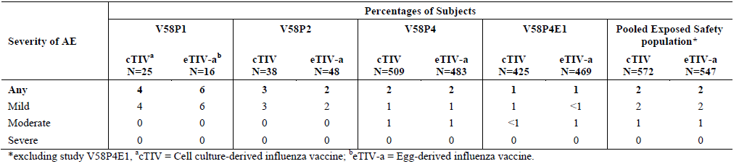

Table 36. Possibly/Probably Related Unsolicited AEs ≥1% of the Pooled Exposed Safety Population (Days 1 - 7) - Adults ≥ 65 Years
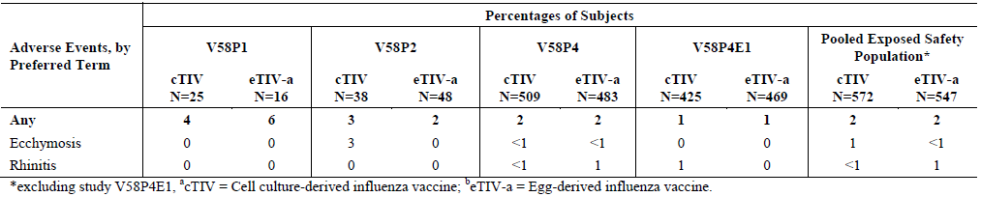

Serious adverse events
In the pooled studies, in total, 13 deaths occurred, six in the 18 to 64 year age group (4 cTIV recipients, 1 eTIV-a recipients and 1 in the placebo group of study V58P13) and 7 in the ≥ 65 year age group (3 for cTIV and 4 for eTIV-a). All deaths were considered unrelated to vaccination (more detail to follow in relation to individual studies).
In total, 221 participants experienced a total of 270 SAEs within the 3-week reporting period for studies V58P1 and V58P2 or at any time during studies with 6-month follow-up periods (V58P4, V58P4E1, V58P5, V58P9 and V58P13). Most SAEs were experienced by adults 18 to 64 years (166 SAEs in 141 participants, 1% [85] of cTIV recipients and 1% [56] of eTIV-a/f recipients). In addition 42 SAEs were reported for 37 participants (1%) 18 to 64 years of age who received placebo in study V58P13. Overall 104 SAEs were reported for 80 adults ≥ 65 years of age (4% [36] of cTIV recipients and 4% [44] of eTIV-a recipients. No SAE was considered related to the vaccines.
Since no SAE considered related to vaccine administration was detected in the pooled cTIV exposed safety database of 6138 participants, the Sponsor considered that it had been determined with 95% certainty that true vaccine related serious adverse event rate is < 0.0005 or < 1 in 2000.
Ten SAEs resulted from influenza infection. Of these, 8 cases (all 7 in study V58P9 and 1 in study V58P5) were identified as influenza B (cTIV 5; control 3) and two cases (both in V58P5) were identified as A/H3N2 influenza (1 cTIV, 1 control).
Seventeen SAEs, including the 13 deaths led to withdrawal from the study.

Individual study safety

Pivotal study V58P13
V58P13 was a Phase III, placebo-controlled study in the US, Finland and Poland.

Participant exposure
A total of 11376 of the 11404 participants enrolled were included in safety population (3813 participants-cTIV vaccine, 3669 participants-eTIVa and 3894 participants-placebo).

Solicited adverse reactions
The percentages reporting solicited reactions for the cTIV, eTIVa and placebo groups respectively were 53%, 49% and 38%.
The most commonly reported local reaction in all three groups was pain reported by 30% cTIV vs 24% eTIVa vs. 10% placebo. Most reactions were mild or moderate. Severe reactions were reported in < 1% of participants. After day 7, < 1% reported solicited reactions.
The most common systemic reactions reported within 7 days of vaccination were headache, fatigue, myalgia and malaise with similar frequency across both the vaccine and the placebo groups. No more than 1% of the participants reported severe systemic reactions (arthralgia, sweating, and chills). Less than < 1% of participants reported solicited reactions after day 7. For each vaccine group, the most frequently reported systemic reactions peaked between day 1 and day 2 with onset generally 30 minutes to 6 hours after vaccination.
The percentages staying at home due to a reaction were 1% cTIV group, 2% eTIVa group and 1% placebo. Percentages using analgesics were respectively 10%, 11% and 10%.

Unsolicited adverse events regardless of relatedness
Overall percentages of AEs reported during the study regardless of relatedness were:
- Days 1 – 7: between 9% - 10% in each of the groups
- Days 8 – 22: 3% of each group
- Days 23 – 181 between 1%-2%
From Day 1 – 7 the most common AEs by SOC were “Infections and Infestations” (cTIV 3%, eTIVa and placebo 2%), “Respiratory, Thoracic and Mediastinal Disorders” (2% each group), “Gastrointestinal Disorders” (1% each), and “General Disorders and Administration Site Conditions” (cTIV 2%; eTIVa 3%, placebo 2%), “Musculoskeletal, Connective Tissue and Bone Disorders” (1% of each), “Nervous System Disorders” (1% each ), “Skin and Subcutaneous Tissue Disorders” (cTIV and eTIVa 1%; placebo < 1%). No single AE was reported by ≥ 2%. Event of severe intensity were reporte for 1% in each group.
For days 8 - 22 the most commonly reported AEs by SOC were “Infections and Infestations” (cTIV and eTIVa 1%, placebo 2%). For other SOC incidences were < 1%. The AEs were of mild intensity in 1% in each group and of severe intensity in < 1% of each group.
Between days 23 and 181, the most commonly reported AEs by SOC were all reported by < 1% of participants and were in the same SOCs for each group except for endocrine and eye disorders which occurred in the cTIV and placebo groups but not the eTIVa group, and hepatobiliary and immune system disorders which occurred in the cTIV group but not in either of the other 2 groups. In each group, AEs of severe intensity were reported for 1% of participants.

Treatment related adverse events
From Day 1 to 7, AEs that were at least possibly related to vaccination were reported by 5% - 6% of each group. Between Days 8 - 22, the incidence was < 1% of each group. Between Days 23 - 181 there were no events reported. For days 1 - 7, possibly related AES were of mild intensity in 4% of each group and of severe intensity in < 1% in each group. Between days 8 - 22, intensity was mild ≤ 1%, and severe (< 1%).

Deaths and other serious adverse events
From Day 1 – 7, SAEs were reported by 1 cTIV (< 1%), 2 eTIVa (< 1%) and 2 placebo participants, (< 1%). From Days 8 - 22 SAEs occurred in 5 cTIV (< 1%), 9 eTIVa (< 1%) and 3 placebo participants (< 1%). Between Days 23 - 181 SAEs were reported by 38 cTIV (< 1%), 26 eTIVa (1%) and 32 placebo participants (1%). All SAEs were considered unrelated to vaccine administration.
Four deaths were reported (2 in the cTIV vaccine group, 1 in the eTIVa group and 1 in placebo). One died on Day 153 due to obesity and dyspnoea, one on day 75 from unknown cause, one on day 99 a homicide, and one on day 33 from a cerebral haemorrhaged diagnosed at day 26.

Discontinuation due to adverse events
Between Days 1 and 22, there were no withdrawals due to an AE. Between days 23 and 181 five participants discontinued from the study due to AEs: 3 cTIV, 2 due to death and one with of skull fracture and intracranial haemorrhage. Discontinuations the eTIVa and placebo groups (1 each) were due to death. No discontinuation was considered related to the study treatment.

Study V58P4
V58P4 was a phase III, observer-blind, randomized, study done in 5 centres in Poland.

Participant exposure
In total 1330 participants (652 aged 18 - 60 and 678 aged ≥ 61 years) were vaccinated with cTIV and 1324 (648 aged 18 to 60 and 676 age ≥ 61 years) received eTIVa.

Solicited adverse events 18 – 60 years
The percentages reporting any local reaction in the cTIV vaccine and control vaccine groups were cTIV 32% and eTIVa 31%. In both groups, pain at the injection site was most commonly reported: 22% cTIV and 17% eTIVa. Erythema was reported by 14% cTIV and 16% eTIVa. Other solicited AEs occurred in < 10% of participants. Most local reactions were either mild or moderate in severity.
The percentages reporting any systemic reactions were 22% cTIV and 23% eTIVa. Headache, fatigue, and malaise were the most common, reported by 12%, 11%, and 11%, respectively. Most reactions were generally transient and were of mild or moderate severity. Fever was reported by 2 participants (< 1%) cTIV and 5 (1%) eTIVa. In both groups 2% stayed at home because of a reaction during the Days 1 - 7 days due to a reaction. In the cTIV and eTIVa groups, 7% and 6% reported taking analgesic/antipyretic medication during this time.

Solicited adverse events > 60 years
The percentages of participants aged > 60 years reporting any local reaction in the cTIV and control vaccine groups were 22% and 18% respectively, a lower incidence rate than in those aged 18 to 60 years. In both groups, pain was the most commonly experienced local reaction, reported for 9% and 5%, respectively. Most local reactions were either mild or moderate in severity and there was no difference in the severity profiles of pain between the vaccination groups.
Systemic reactions were reported by 22% of both groups. Headache, fatigue, and malaise were the most common systemic reactions reported by between 10% and 12% of participants. Most systemic reactions were mild or moderate in severity and transient. Axillary temperature ≥ 38°C was reported by 1% in both groups. In the cTIV and control groups 3% and 2% respectively stayed at home during the first 7 days due to a reaction to a study vaccine while 5% and 4% respectively reported taking analgesic/antipyretic medication.

Unsolicited adverse events regardless of relatedness
For adults aged 18-60 years at least one AE was reported by 14% cTIV and 15% cTIVa. Most were due to common illnesses expected within this population. Frequency of AEs was balanced between the groups. Most AEs were classified mild or moderate. AEs of severe grade were experienced by 2 cTIV vaccinated (diarrhoea and laryngitis) and 3 eTIVa (toothache, otitis media, and headache): all were assessed as unrelated to the study vaccines.
For participants > 60 years, 15% cTIV and 13% eTIVa experienced at least one other AE. Most were due to common illnesses expected within this population. Most AEs were classified mild or moderate. AEs of severe grade were experienced by 7 (1%) cTIV (acute myocardial infarction, coronary artery disease, retinal detachment, carbon monoxide poisoning, procedural complication, benign oesophageal neoplasm, lung squamous cell carcinoma stage unspecified) and 6 eTIVa, 12 events in total: angina unstable, atrial fibrillation, vertigo, vomiting, rhinitis, gallbladder cancer, lung adenocarcinoma, cerebrovascular accident, headache, cough, pharyngolaryngeal pain, hypertensive crisis). All were considered unrelated to the study vaccines.

Treatment related adverse events
In the age group 18 to 60 years, AEs considered to be possibly/probably related to the study vaccine were reported by 2% of the cTIV group and 4% of controls. The most frequently reported AE was rhinitis (31 [5%] cTIV and 5 [1%] controls). For those aged > 60 years, incidences were 2% in both groups. Rhinitis and ecchymosis were the most common, each experienced by 3 participants per group.

Deaths and other serious adverse events
No deaths were reported in the age group 18 to 60 years. Seven serious AEs were reported in the cTIV group and 5 in the control group. None were judged possibly/probably related to the study vaccine. Within the population aged > 60 years, 3 deaths occurred, one in the cTIV group and 2 in the control group: carbon monoxide poisoning, cerebrovascular accident, and lung adenocarcinoma respectively, none of which were related to the study vaccines. Other serious AEs were reported by 18 participants in the cTIV group and 16 participants in the control group and these were also unrelated to the study vaccines.

Discontinuation due to adverse events
No AE resulted in premature discontinuation of a participant with the exception of the 3 cases of death in the age group > 60 years.

Study V58P4E
V58P4E was the 6-month extension of study V58P4. Results of this study, following second vaccination 12 months after vaccination in V58P4 were not included in the pooled safety analysis.
Participants were randomized to receive a second dose of cTIV or eTIVa. Those who had previously received cTIV were randomly allocated in a 1:1 ratio to receive either cTIV or eTIVa, and those who had previously received control vaccine were randomly allocated in a 1:1 ratio to receive either cTIV or eTIVa, resulting in a total of 8 vaccination groups stratified by age and according to the vaccine previously received in study V58P4 and the one received in the current study.
Safety Objectives were to evaluate safety and tolerability up to 3 weeks after vaccination with cTIV or eTIVa approximately 12 months after vaccination in Study V58P4 (primary), and to collect safety data for 6 months after immunization, including serious adverse events, adverse events necessitating a physician’s visit and/or resulting in premature withdrawal from study (secondary).

Participant exposure
Between 82% aged 18 – 60 years, and 86% aged > 60 years entered the extension study. Baseline characteristics are summarised.
In total 1104 participants (533 aged 18 – 60; 571 aged > 60 years) received cTIV vaccine and 1131 (534 aged 18 - 60 and 597 aged > 60 years) were vaccinated with eTIVa.
Of the 1104 participants vaccinated with cTIV-derived vaccine, 562 (272 aged 18 – 60 and 290 > 60 years) received cTIV vaccine in study V58P4 while 542 (261 aged 18 – 60 and 281 > 60 years) were previously vaccinated with the control.
Of the 1131 participants vaccinated with egg-derived vaccine, 571 (274 age 18 – 60 and 297 > 60 years) had received cTIV vaccine in study V58P4 while 560 (260 aged 18 – 60 and 300 > 60 years) had received control vaccines in study V58P4.

Solicited adverse events 18 – 60 years
The percentages reporting any local reaction in the total cTIV and eTIVa groups were: 30% cTIV total [cTIV/cTIV: 29%; control/cTIV: 32%] versus 28% eTIVa [cTIV/control: 27%; control/control: 29%].
In both the cTIV and eTIVa total groups, pain at the injection site was the most commonly experienced local reaction, reported for a slightly higher percentage in the cTIV total group (22% [cTIV/cTIV: 19%; control/cTIV: 24%]) than in the control total group (17% [cTIV/control: 16%; control/control: 18%]). Most local reactions were mild to moderate in severity.
The percentages reporting any systemic reaction were the same overall in both vaccine groups (16%) and were also comparable between the prior vaccination groups (cTIV/cTIV: 15%; control/cTIV: 18%; cTIV/control: 17%; control/control:16%).
Headache, fatigue, malaise, and myalgia were the most frequently experienced systemic reactions. Headache: 10% [cTIV total] vs 8% [control total], fatigue: 8% [cTIV and control total], malaise: 9% [cTIV total] vs 7% [control total], myalgia: 7% [cTIV total] vs 8% [control total]). Most systemic reactions were mild or moderate in severity. The onsets of systemic reactions generally peaked at 6 hours or day 2 after vaccination and the reactions were generally transient. Events ongoing at day 7 were reported by ≤ 2% in the cTIV total group and ≤1% in the control total group).
Fever was reported by 2 participants (< 1%) in the cTIV total group and by 5 (1%) in the control total group. In the cTIV and control total groups respectively, 1% and 2% stayed at home during the first 7 days due to a reaction, while 5% and 4% reported taking analgesic/antipyretic medication.

Solicited adverse events > 60 years
The percentages of participants age > 60 years reporting any local reaction in the cTIV total and control total groups were: 18% cTIV total [cTIV/cTIV: 16%; control/cTIV: 20%] vs. 16% control total [cTIV/control: 17%; control/control: 16%.
Local reactions were reported with lower frequency than in participants 18 – 60 years. In both the cTIV and control total groups, pain and erythema were the most commonly experienced local reactions (pain: 8% [cTIV total] vs 7% [control total]; erythema: 8% [cTIV total] vs 6% [control total]). No differences in the incidence of pain and erythema were noted among the vaccination subgroups (pain: cTIV/cTIV: 8%; control/cTIV: 9%; cTIV/control: 7%; control/control: 6%; erythema: cTIV/cTIV: 8%; control/cTIV: 9%; cTIV/control: 6%; control/control: 5%). Most local reactions were mild to moderate in severity.
The percentages reporting any systemic reaction were similar in both total groups: cTIV : 15%; control: 15%; cTIV/cTIV: 13%; control/cTIV: 17%; cTIV/control: 13%; control/control: 12%. Fatigue, malaise, and headache were the most frequently experienced systemic reactions: fatigue: 8% [cTIV total] vs. 7% [control total], malaise: 8% [cTIV total] vs. 7% [control total], headache: 6% [cTIV and control total]). Most were either mild or moderate in severity. Reactions ongoing at day 7 were reported by 2% in the cTIV and eTIVa total groups. In both total groups, fever was reported by < 1%, 1% stayed at home during the first 7 days due to a reaction while 3% reported taking analgesic/antipyretic medication.

Other adverse events regardless of relatedness 18 – 60 years
In total, 9% of adults in the cTIV total group (cTIV/cTIV: 10%; control/cTIV: 9%) and 7% in the control total group (cTIV/control: 7%; control/control: 8%) experienced at least one other AE during the course of this study. All AEs were classified as mild or moderate.
Unsolicited AEs between week 3 and 6 months were most common in the SOC “infections and infestations”: 6% of the cTIV and 5% of the control group. AEs in SOC “gastrointestinal disorders” were experienced by 2% of the cTIV group. All AEs in other SOCs were reported by < 1% of either group. Most were classified mild or moderate.

Other adverse events regardless of relatedness > 60 years
Adverse events to Week 3 and to 6 months are summarised. In total, 8% in the cTIV total group (cTIV/cTIV: 7%; control /cTIV: 9%) and 6% in the control total group (cTIV/control: 5%; control /control: 6%) experienced at least one other AE. Most were due to common illnesses expected within this population, the most common being “infections and infestations”: 20 (4%) of the cTIV total group (cTIV/cTIV: 2%; control /cTIV: 5%) and 11 (2%) of the control total group (cTIV/control: 2%; control /control: 2%). Rhinitis was the most common event (cTIV 13 participants [2%]; control: 7 participants [1%]; cTIV/cTIV: 4 participants [1%]; control /cTIV: 9 participants [3%]; cTIV/control: 3 participants [1%]; control /control: 4 participants [1%]). Other system organ classes affected by 2% of the population aged > 60 years in either of the total groups were:
- General disorders & administrative site conditions: cTIV: 13 participants (2%), control 8 participants (1%); cTIV/cTIV: 5 participants (2%), control /cTIV: 8 participants (3%), cTIV/control: 6 participants (2%), control /control: 2 participants (1%).
- Musculoskeletal, connective tissue & bone disorders: cTIV: 9 participants (2%), control: 8 participants (1%); cTIV/cTIV: 4 participants (1%), control /cTIV: 5 participants (2%), cTIV/control : 3 participants (1%), control /control : 5 participants (2%).
Most AEs were classified mild or moderate. Severe AEs were experienced by 3 (1%) in the cTIV total group (acute myocardial infarction in 2 participants, nasal congestion in 1 participant) and 3 participants (1%) in the control total group (acute myocardial infarction, forearm fracture, and blood pressure increased in 1 participant each). No severe AE was assessed as related to the study vaccines.
Between 3 weeks and to 6 months 10% of the cTIV and 8% or eTIVa had AEs classified under the SOC “infections and infestations.” AEs in other SOCs were reported ≤ 3%. Most AEs were classified as mild or moderate and considered unrelated to study vaccination.

Treatment related adverse events
In those aged 18 to 60 years, the majority of AEs were reported between day 4 and 22 (cTIV: 6%; control 5% overall. AEs judged possibly/probably related to the study vaccine were reported by 1% in both total groups and were accounted for by known local and systemic side effects of influenza vaccination. Injection site haemorrhage was the most common, experienced by 3 (1%) in both the cTIV total (cTIV/cTIV: 2 [1%]; control/cTIV: 1 [< 1%]) and the control total groups (cTIV/control: 1 [< 1%]; control/control: 2 [1%]).
For participants > 60 years, the most common possibly/probably related AE was rhinitis in the cTIV total group (cTIV total: 3 participants [1%]; control total: none) and injection site haemorrhage in the control total group (control total: 3 participants [1%]; cTIV total: 1 participant [<1%]), in the system organ class “general disorders & administration site conditions”. Related AEs generally had an onset between days 1 and 3. All were either mild or moderate in severity.

Deaths and other serious adverse events 18 – 60 years
No deaths occurred between day 1 and 3 weeks after vaccination. One individual in the cTIV group committed suicide in the period between 3 weeks and 6 months. One cTIV vaccinated participant reported the SAE of chest pain between Day 1 and Week 3, considered unrelated to the study vaccine. One participant developed joint contracture following fracture. These two participants both subsequently experienced additional SAEs later in the study.
Evaluator Comment: Unravelling the details was complicated by lack detail in the text and by lack of active links to the source documents. It appears that each AE by SOC was reported once and no pattern was discernible.

Deaths and other serious adverse events > 60 years
In the group aged > 60 years, no deaths occurred between day 1 and 3 weeks after vaccination. Six participants reported 6 SAEs, 3 in the cTIV total group (cTIV/cTIV: 2; control/cTIV: 1) and 3 in the control total group (cTIV/control: 1; control/control: 2); none were considered related to study vaccine: The events were: cTIV 2 acute myocardial infarctions, and one chest pain: control, one each of myocardial infarction, atrial fibrillation and forearm fracture.
Four deaths in participants aged > 60 years occurred between 3 week to 6 months, all vaccinated with eTIVa: acute myocardial infarction, sudden cardiac death, acute pancreatitis with diffuse peritonitis and cerebral haemorrhage. None were considered related to vaccine.
There were 62 SAEs reported by 49 participants (21 cTIV, and 28 controls) in the 3 week to 6 month follow up period and incidence rates were balanced between the vaccine groups. All SAEs were reportedly unrelated to the study vaccine. Two participants who experienced SAEs in the first 3 weeks also experienced SAEs thereafter and have only been counted once in the overall 6 month total. All but two aged > 60 were hospitalized: one in the cTIV group had an acute myocardial infarction resulting in death and one in the cTIV group suffered sudden cardiac death). For the entire study, 69 SAEs reported by 53 participants (23 cTIV, and 30 control) occurred in the 6 month follow up period.

Discontinuation due to adverse events
Between 3 weeks and 6 months no AE resulted in premature discontinuation of a participant aged 18 – 60 years. The death by suicide was the only event to lead to discontinuation outside that period. For those aged > 60 years, throughout the entire study period 5 AEs (including the 3 deaths) led to premature discontinuation of participants aged > 60 years. One participant was withdrawn for an SAE but later died, and was included on the premature withdrawal listing as an AE instead of a death. None of these events were considered related to the study vaccines.

Other safety parameters
Three pregnancies were reported. Two women delivered full term, healthy babies with no congenital abnormalities. The third participant was lost to follow-up.

Study V58P9
V58P9 was a phase III, randomized, controlled, observer-blind, Lithuanian multicentre, study.

Participant exposure
A total of 1199 participants were exposed to study vaccines. In total, 1028 participants received a single dose of 1 of the 3 cTIV lots) and 171 participants received eTIVa.

Solicited adverse events
The percentages reporting local reactions for the 3 lots of cTIV were 27-31% and eTIV 25%. The most common local reactions were erythema (17-23% of cTIV lots vs. 18% eTIV), and pain (10- 13% cTIV lots vs. 8% eTIVa).
A total of 24-26% of cTIV and 23% of eTIV groups reported systemic reactions, and the most common systemic reactions were fatigue, headache, and malaise (11-14% of cTIV lot groups compared to 11-12% of control group).

Other adverse events regardless of relatedness
In the 3 weeks following vaccination, 10% of pooled cTIV group and 9% of the eTIV group reported at least 1 unsolicited AE. Most were due to common illnesses expected within the study population, the most common AEs being: rhinitis (2% cTIV and 4% control), pharyngolaryngeal pain (2% cTIV and 2% control), and erythema (2% cTIV and 1% control). All other AEs were reported by 1% or less of the pooled cTIV group and control group. Most were classified mild or moderate. Between 3 weeks and 6 months a total 6% of the pooled cTIV group and 4% of control group reported at least one other AE.
Most AEs were classified as mild or moderate. Severe AEs were experienced by 6 (1%) cTIV participants: diarrhoea, fatigue, pyrexia, upper respiratory tract infection, arthralgia, myalgia, headache and tooth extraction. One control participant experienced severe menorrhagia. The severe AEs considered by the investigator to be possibly or probably treatment-related were fatigue, arthralgia, myalgia and 1 case of headache in the cTIV participants.
All AEs reported between 3 weeks to 6 months were unrelated to the study vaccine and due to common illnesses expected within the study population, with the most common AEs being: tonsillitis (1% cTIV, 1% control), influenza (1% cTIV, 1% control), and upper respiratory tract infection (1% cTIV, 0% control). All other AEs were reported by 1% or less of the pooled cTIV group or control group.

Treatment related adverse events
Adverse events considered possibly/probably related to study vaccine were reported by 7% of both the pooled cTIV group and control group. Most of these were accounted for by known effects of influenza vaccination and were reported between days 1 and 3 after vaccination (6% in both groups) compared to 1% in both groups between days 4 and 22 after vaccination. After 3 weeks, there were no new reports of vaccine related AEs.

Deaths and other serious adverse events
Within the first 3 weeks, 2 SAEs were reported for cTIV: 1. acute diarrhoea with onset 7 days after vaccination, and; 2. a hospitalization for essential hypertension 8 days after vaccination. No deaths, no discontinuations due to AEs and no other significant AEs were reported to day 22.
Between 3 weeks and 6 months there was one death in the cTIV group (injury/asphyxiation) and 18 other SAEs (15 cTIV, 3 control). Of these, 10 (9 cTIV, 1 control) experienced non-related SAEs and were hospitalized, and 7 others (5 cTIV, 2 control) had laboratory confirmed B strain influenza, which, by definition are considered vaccine failure although they were not considered as SAE.

Discontinuation due to adverse events
There were no discontinuations from the study due to AEs.

Other safety parameters
There were 2 pregnancies (cTIV Lot B and Lot C). For both the outcome was a healthy full-term baby with no congenital abnormalities.

Study V58P1
V58P1 was a Phase I/II, observer-blind, randomised, single-centre, sequential cohort study done in Germany.

Participant exposure
All 240 participants were included in the safety population, 120 participants per vaccination group.

Solicited local symptoms
With the exception of erythema for both cTIV and eTIVa, and swelling for eTIV, local solicited symptoms were more commen in the age range 18 to 60 years than in the older group.
Respectively for pooled 18 – 60 years vs. age > 60 the frequencies were:
Pain: Pooled 18 – 60 years: cTIV 38%, eTIVa 26%. Age > 60 cTIV 10%, eTIVa 16%
Erythema: Pooled 18 – 60 years cTIV 15% eTIVa 11%. Age > 60 cTIV 22% eTIVa 31%
Ecchymosis ≤ 5 % overall
Swelling: Pooled 18 – 60 years cTIV 15%, eTIV 15%. Age > 60 cTIV 13%, eTIV 29%
Induration: Pooled 18 0 60 years cTIV 23%, eTIV 31% Age > 60 cTIV 13%, eTIVa 22%

Solicited systemic symptoms
The most commonly reported solicited systemic symptoms were headache reported more frequently by those vaccinated with cTIV and malaise reported more frequently by those vaccinated with eTIVa. Headache and malaise were reported more frequently in the cohort aged 18 – 60 thant in those aged > 60 years. Solicited symptoms were more common in the age range 18 to 60 years with the exception of chills, reported in similar frequencies for both age groups, and sweating reported more frequently in both cTIV and control in the group aged > 60 years (Table 37).

Table 37. V58P1 Local and systemic reactions - by age, phase and overall total
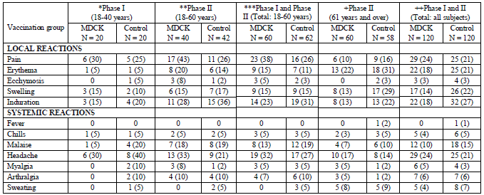

Other adverse events
A total of 57 participants experienced 92 AEs: 23% (27/120) of the cTIV group and 25% (30/20) of the cTIVa group reported at least one AE. Most frequently reported for both groups were nasopharyngitis (6% cTIV, 4% eTIVa) and rhinitis (3% for both groups). AEs were mostly mild or moderate and transient.

Treatment related adverse events
AEs judged to be possibly or probably related to the study vaccine were experienced by 17% cTIV and 17% eTIVa. Nasopharyngitis was the most commonly reported: maximum frequency 5 (8%) in the cTIV cohort aged > 60 years.

Deaths and other serious adverse events
There were no deaths. One SAE, syncope, 16 days post-vaccination was considered unrelated.

Discontinuation due to adverse events
There was only 1 withdrawal due to AE, the SAE of syncope.

Laboratory tests
There were no clinically significant changes in liver and renal function and full blood count.

Study V58P2
V58P2 was a phase II, observer-blind, randomised, single-centre study conducted in New Zealand.

Participant exposure
In total 223 participants were vaccinated.

Solicited adverse events
Among participants 18 to 60 years, the most frequent local reactions for cTIV and control respectively were injection site pain (52% and 44%), erythema (25% and 30%), and induration (23% and 28%). For systemic reactions: the most frequent systemic reactions for cTIV and control respectively were headache (25% and 23%), fatigue (14% and 16%), and malaise (5% and 18%).
Among participants ≥ 61 years, the most frequent local reactions were pain (17% and 16%), ecchymosis (11% and 4%), and induration (7% and 7%). The most frequent systemic reactions were headache (11% and 11%) and malaise (11% and 9%).
Most systemic reactions for both vaccine groups were observed within 3 days following vaccine administration. Injection site pain was mild or moderate in severity; there were no reports of severe local reactions. With one exception, all systemic reactions were mild to moderate in severity; one participants cTIV vaccine participant reported a severe headache on day 5 which resolved by day 7.

Other adverse events
For ages 18-60 years, AE were reported by 14/56 (25%) and 16/57 (28%) for cTIV and eTIVa respectively. The most common following cTIV were headache (5%); and upper respiratory infection, nasal congestion, and myalgia (4% each); following eTIV the most common were upper respiratory infection NOS (7%), pharyngitis (5%), and headache (4%). For age > 60 years, 8/54 (15%) and 17/56 (30%) cTIV and eTIVa,, reported AEs. The only AE reported by > 1 person was upper respiratory tract infection 2/56 control participants.

Deaths and other serious adverse events
There were no deaths or serious adverse events reported.

Discontinuation due to adverse events
There were no discontinuations due to adverse events.

Study V58P5
V58P5 was a phase II, observer-blind, randomized, multicentre study done in the United States.
In addition to safety reported for other studies, symptoms of oculorespiratory syndrome were solicited (e.g., cough, wheezing, chest tightness, other difficulty breathing, sore throat, facial oedema, and red eyes) were solicited. Influenza-like illness was also documented. Clinical specimens were sent to a central laboratory for viral cultures (Viral and Rickettsial Disease Laboratories [VRDL], Richmond, CA).

Participant exposure
The safety population included 613 participants: 309 cTIV and 304 eTIVf.

Solicited local adverse events
At least one local reaction was reported within 7 days by 54% cTIV and 61% eTIVf. Systemic reactions within 7 days post vaccination were reported by 58% of both groups. Other indicators of reactions (use of analgesics/antipyretics and stayed home due to a reaction) were reported by 33% in the cell-derived vaccine group and 37% in the Fluvirin group.
In both groups, pain at the injection site was the most common local reaction reported by 50% of participants in the cTIV group and 56% in the eTIVf group. Erythema was reported by 11% cTIV and 16% eTIVf. Induration was reported by ≤ 9% of both groups, swelling by ≤ 5% in either group. Most local reactions occurred within the first three days, were either mild or moderate; ≤ 1% of either group reported a local reaction graded severe.

Solicited systemic reactions
The most common systemic reaction was headache, reported by 35% of cTIV and 40% of the eTIVf group. Malaise, myalgia, fatigue, nausea, cough, and sore throat were reported with similar frequency in both vaccine groups (8% to 25% cTIV, 12% to 24% eTIVf). Other systemic reactions were reported by ≤ 12% of participants in each vaccine group. Chills were reported by 5% cTIV and 9% eTIV; headache by 22% cTIV group and 30% eTIVf during days 1 to 3.
Most systemic reactions were either mild or moderate; ≤ 1% of participants in either group reported any severe systemic reaction other than for headache (3% cTIV and 2% eTIV) and malaise (1% and 2%, respectively). Analgesic medication was used by 33% cTIv and 36% eTIVf. At most 3% of both groups stayed home after the vaccination.

Unsolicited adverse events regardless of relatedness
At least one unsolicited AE, regardless relatedness, was reported by 16% cTIV and 25% eTIVf. The most frequently reported were in SOC for “respiratory, thoracic, and mediastinal disorders” (6% cTIV and 8% eTIVf) and “general disorders and administrative site conditions” (5% cTIV and 7% eTIVf). Pharyngolaryngeal pain was reported by11 [4%] cTIV and 9 [3%] eTIVf. Severe AEs were reported by 8 participants (3%) in the cTIV group and15 (5%) in the Fluvirin group.

Treatment related adverse events
Adverse events considered possibly/probably related to the vaccine were reported by 7% cTIV and 10% eTIVf and generally had onset within days 1 through 7 days post-vaccination “General disorders and administrative site conditions” were most commonly reported: 4% cTIV and 5% eTIVf. Adverse events were reported by ≤ 3% in any other class. In both groups, malaise, fatigue, headache, and pharyngolaryngeal pain, cough, and injection site bruising were the only possibly/probably related AEs reported by ≥ 1% in either group.

Deaths and other serious adverse events
No deaths were reported. Eight SAEs were documented, 3 cTIv and 5 eTIVf, and none were judged possibly or probably related to the study vaccine.

Discontinuation due to adverse events
No AE resulted in the discontinuation of any participant.

Laboratory tests
A total of 62/120 who had laboratory tests, had 80 abnormal haematology or chemistry laboratory values on day 8 following vaccination, all of which had been normal at baseline. Twelve of the 62 participants had more than one abnormal laboratory value. Approximately two thirds (66%) of the abnormal values were accounted for by out-of-range eosinophils, monocytes, and glucose values. No change in laboratory value from day 1 to day 8 was considered related to vaccine or clinically meaningful.

Other safety parameter
Pregnancy was reported by 4 women during the study. Three participants gave birth to healthy infants; there was no information on the other outcome.

Post-marketing experience
There was no post-marketing data located in the clinical dossier.

Safety conclusions

Sponsor
The cTIV vaccine was as safe as the control vaccine. The reactogenicity of both cTIV and control vaccines was similar within each age group. Only pain, of which over 99% was mild or moderate, was more frequently experienced by recipients of the cTIV than the control vaccine (adults 22% versus 17%: elderly 9% versus 5%, respectively). However the difference in incidence rate was confined to a maximum of 2 days after injection and was not clinically relevant. Most other AEs reported by this study population were unrelated to the vaccines administered in this study. Those judged to be possibly or probably related to vaccination were experienced infrequently and were either ongoing local/systemic reactions (i.e., past day 7) or other common side-effects of vaccination. The 3 serious AEs leading to death and 58 other serious AEs reported during this study predominantly occurred in the elderly population: all were unrelated to the study vaccines. The incident rate of serious AEs was as expected for this elderly population, where co-morbidities were very common.

Evaluator
In the pooled safety analysis in the age range 18 – 64, the risk ratios for injection site pain with RR 1.19 (95% CI 1.12, 1.26) favouring eTIV. There was no accounting for multiplicity in determining the required confidence interval. However, higher frequency of pain following cTIV vaccination was a consistent finding noted in all studies in which eTIVa was the comparotor; however, in V58P5 in which eTIVf was the compactor, the incidence of pain recorded was greater for eTIVf.
Based on the submitted data, the Sponsor’s conclusion is agreed.

Post-marketing experience
This vaccine has been registered and it is likely that post-marketing information is now available although none has been submitted.

First round benefit-risk assessment

Comment on the safety specification in risk management plan

Safety specification

Identified risk
Risks in terms of safety are considered similar to those of Agrippal and Fluvirin, both registered in Australia and considered an appropriated comparator for Australian purposes. It is possible that cTIV vaccination may result in a higher incidence of pain (pooled safety population RR 1.19 (95% CI 1.12, 1.26) favouring eTIV).

Limitation of the research
The research presented fulfils requirements of the Therapeutic Goods Administration.

Areas of uncertainly
- Use in pregnancy and lactation, chronic illness, immunodeficiency states, and in ethnic groups either not represented or represented in small numbers such as Asians and Australian Indigenous groups.
- Rare, as yet unidentified adverse events may require greater numbers to be vaccinated.

Pharmacovigilance
Spontaneous reporting is proposed in line with global and local Novartis procedures and with the “Australian requirements and recommendations for pharmacovigilance responsibilities of sponsors of medicines” version 1.2, August 2013”.

Planned post market research
Novartis Vaccines and Diagnostics presented the following protocols for post-market trials.
Study V58P23 a phase III, multicentre, randomized double-blind, controlled study to evaluate the safety and immunogenicity of cTIV and eTIVf in healthy adults. This study is a post marketing commitment requested by CBER and is designed to demonstrate the immunologic equivalence, immunogenicity safety and tolerability between three consecutive lots of TIVc according to CBER criteria.
Study V58P30 Post-licensure observational safety study after Optaflu vaccination among adults in The Health Improvement Network (THIN) database of routine UK primary care records.
Registry V5836OB: The objective of the Flucelvax (cTIV registered name in the US) Pregnancy Registry is to evaluate pregnancy outcomes among women immunized with the Flucelvax vaccine during pregnancy. The primary outcomes of interest include major congenital malformation, preterm birth, and low birth weight.

Benefit assessment
- Influenza vaccination remains the mainstay of prevention of influenza
- Reduced reliance on the supply of embryonated hen eggs
- Possibility of increased vaccine availability in case of a pandemic
- Similar safety, efficacy and immunogenicity profile to egg-derived vaccines, including Agrippal.

Risk assessment
The risk profile in terms of adverse events is considered not materially different from that of the egg-derived vaccines Agrippal and Fluvirin.

Benefit-risk balance
The balance is considered to lie on the side of benefit.
It is recommended that the results of the planned post-market studies are submitted to the Therapeutic Goods Administration on completion.

Clinical questions and second round evaluation

Question 1
Module 2.5, Section 2.5.3 Overview of Clinical Pharmacology page 11 states that all studies except V58P13 were complicated by pipettor problems requiring reanalysis and presentation of only egg-derived antigen assessments. The CSR for V58P1 includes results for egg-and cell-derived antigen HI testing, it does not mention the pipette problem and the CSR is not specified as being Version 2, as was the case for other study reports of affected studies. Was there a pipette problem in V58P1?

Novartis response
Although serology testing for study V58P1 was impacted by the pipettor problem no retesting of serology samples from study V58P1 was performed based on the fact that this was the smallest sample size study of the program and not included in the immunogenicity populations summarised in Module 2.7.3. As a result, no CSR Version 2 was generated. This information has also been provided within the application, in Module 2.7.2.1:
“The older sequential phase 1 and 2 study V58P1 was not retested as the sample size was small (N = 240 participants) and the study was mainly designed to focus on safety. Only the data obtained following retesting are submitted in the current application.”

Evaluator comment
Response accepted.

Question 2
There was a marked difference in performance of the HI and SRH assays for the B strain in Study V58P2. The explanation provided was that this is consistent with previous literature reports (Monto et al.). No article with Monto as lead contributor was found in the reference list. The only Monto article located in the dossier did not discuss SRH assays. Monto AS, Maassab HF. Ether Treatment of Type b Influenza Virus Antigen for the Hemagglutination Inhibition Test. J Clin Microb Jan 1981; 13 (1): 54 – 57. The sponsor is requested to supply a more detailed explanation for the discrepancies.

Novartis response
Novartis acknowledges that the Monto citation does not specifically discuss the SRH assay’s performance and instead focuses on historical underperformance of the HI assay in the detection of influenza B antibody responses which the authors have attempted to address with adjustments to the HI assay. A direct comparison of the HI and SRH assay performance for B strains is presented in the article by Chakraverty (Chakraverty P. Comparison of Haemagglutination-Inhibition and Single-Radial-Haemolysis techniques for detection of antibodies to Influenza B virus. Arch of Virology 1980; 63:285-289). The author concludes that the SRH assay is more sensitive for some B strains than the HI assay and that unlike influenza A, influenza B infection often produces poor antibody responses when tested by HI assay. The additional references listed below better illustrate a consistent theme observed between the HI and SRH assays and influenza B responses.
HI assay underperformance relative to SRH in detection of influenza B has been shown in additional publications including:
- Mancini et al: Comparison of haemagglutination-inhibition and single radial haemolysis techniques for detecting antibodies to influenza A and B viruses J Hyg (Lond). 1983 Aug;91(1):157-62.
- Goodeve AC et al. The use of the single radial haemolysis test for assessing antibody response and protective antibody levels in an influenza B vaccine study. J Biol Stand. 1983 Oct;11(4):289-96.
- Oxford JS et al. Quantitation and analysis of the specificity of post-immunization antibodies to influenza B viruses using single radial haemolysis. J Hyg (Lond). 1982 Apr;88(2):325-33.

Evaluator comment
Response accepted. The Mancini et al and the Oxford et al articles supported the proposition that single radial haemolysis (SRH) test for post-vaccination studies with influenza B viruses appeared to be more sensitive than the HI test.

Question 3
It was stated in the Investigational Plan, Section 9.1 of the V58P5 CSR that influenza-like illness would be assessed in Study V58P5. There was no discussion of ILI results found in the text of the CSR. The Sponsor is asked to comment on influenza-like illness assessment and findings in this study.

Novartis response
A list of participants who were assessed for influenza-like illness (ILI) is provided in CSR V58P5 Version 2, Appendix 16.2.7.2.1. Further assessment of these cases is provided in the below paragraph. 12 participants were evaluated with ILI swabs. Of these 12 participants, 3 were determined to have influenza as evaluated by quick test followed by culture: 1 participant in the cTIV group (A/H3N2 detected) and 2 participants in the eTIV groups (A/H3N2 and B for eTIV-f and eTIV-fb, respectively) (Table 38). A fourth participant assigned to eTIV was noted to have undergone evaluation past the recommended interval after onset of symptoms.
Based on the exploratory nature of this objective and the limited number of observations, no implications relating to the efficacy of either influenza vaccine can be assumed.

Table 38. Listing of Laboratory-confirmed Influenza Cases in Study V58P5
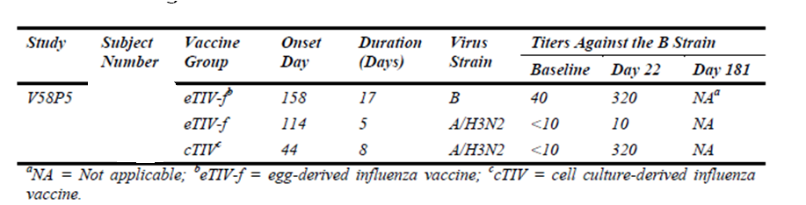
In addition to the information provided above, there is a discussion on the topic of influenza-like illness cases detected across several studies (including studies V58P5, V58P9, V58P13) included.

Evaluator comment
Response accepted.

Question 4
The US Product Information states: The tip caps of the pre-filled syringes may contain natural rubber latex which may cause allergic reactions in latex-sensitive individuals.
The Australian Product Information states in the Precautions Section: Although no natural rubber latex is detected in the syringe tip cap, the safe use of Optaflu in latex-sensitive individuals has not been established.
Which Product Information contains the most accurate information?

Novartis response
FDA requires the use of specific language in the US Product Informations of all U.S. licensed products using pre-filled syringes with the FM27 tip cap. Novartis Vaccines accepts this language in the US Product Information to comply with the FDA requirement, however, prefers to maintain the currently proposed text in the Australian Product Information as it provides the most accurate information and reflects the company core data sheet. Novartis considers the proposed statement in the Australian Product Information, “Although no natural rubber latex is detected in the syringe tip cap, the safe use of Optaflu in latex-sensitive individuals has not been established,” to be the most factually accurate given that no latex is detectable in the tip cap and that no studies in latex-sensitive individuals were performed.

Evaluator comment
Response accepted.

Question 5
Regarding presentation of immunogenicity results in the Product Information
In all studies except V58P13, immunogenicity results were assessed against CPMP/BWP214/96 which has been formally adopted by the Therapeutic Goods Administration. The clinical study reports include results in age categories 18 to 60 and > 60 years. The only exception, study V58P13, included participants aged 18 to 49 years and had pre-planned assessment against CBER criteria.
Participants in the studies assessed against CPMP criteria were re-categorised into age groups 18 – 64 and > 64 years and re-assessed against CBER criteria, which admittedly are more stringent than the CPMP criteria. These post-hoc results are the results proposed for inclusion in the Product Information. As no hypotheses were tested in these instances and as the imposed criteria are more stringent, there is no objection to inclusion of results based on descriptive statistics although reporting according to protocol definitions would be preferred.
With respect to the non-inferiority, hypothesis based, secondary objective of study V58P4, upon which the study sample size was calculated, the results have also been recalculated for revised age groups for presentation in the Product Information. Table 4 of the proposed Product Information includes two sub-analyses by revised age categories, neither of which was pre-specified. It is not recommended that these results are included in the Product Information. It is recommended that the results of the non-inferiority, analysis of V58P4 are presented in accordance with specification in the protocol i.e., in age groups 18 to 60 years and > 60 years. With respect to hypothesis driven results it is considered more important to accurately report the study than to manipulate results in order to present consistency of age groups.
With respect to Study V58P5, the results of this study do not fit neatly into the proposed short paragraph that follows Table 4 and the proposed text is not recommended. Assessment of non-inferiority was the primary objective of this study and results of primary objectives are most suitable for the Product Information. The objective was not met using the pre-specified ANOVA approach for A/H3N3 using the egg-derived assay; it was met by a margin of 0.00329 using the cell-derived antigen assay. Results were then re-analysed post-hoc, controlling for centre, baseline results and vaccine group using ANCOVA, with results that met non-inferiority criteria.
It is recommended that the results of assessments using the egg-derived antigen are reported for V58P5 as for the other studies, or else qualify the HI antigen derivation for each of the studies. There is no objection to also including the ANCOVA results in addition providing the reader is informed that the analysis was post-hoc and undertaken to control for difference in centres, pre-vaccination.

Novartis response
We acknowledge and agree to the proposed changes relating to the presentation of the non-inferiority data for study V58P4 (i.e., that the tables in the Product Information will be revised to show the original study results according to the original age groups analysed). The points relating to V58P5, the use of egg-derived antigen results are acknowledged and the table summarising the non-inferiority data has been deleted. The substituted text will reflect that non-inferiority was demonstrated for all three influenza strains. However, the caveat that this was observed after post-hoc adjustment for baseline imbalances by centres and baseline titer has been added. Please note that only the egg-derived assay results are shown in the Product Information and that the order of the tables summarising the immunogenicity data is now reorganised for clarity in presentation.
An updated draft Product Information is provided.

Evaluator comment
Response accepted.

Question 6
The Agrippal Product Information states the following. Is this correct?
“Elderly patients on long-term warfarin therapy may experience an increase of International Normalised Ratio (INR) after influenza vaccination. Therefore more frequent monitoring for six weeks after receiving influenza vaccine may be advisable.”

Novartis response
There are no data that directly inform on the prolongation of the prothrombin time following administration of Optaflu.
Regarding the Agrippal Product Information, the company would like to clarify that a different sentence was present in the Product Information until 2011: “Influenza vaccine can impair the metabolism of warfarin, theophylline, phenytoin, phenobarbitone and carbamazepine by the hepatic P450 system. Results from studies have been variable in degree of interaction and time after vaccination for the interaction to take effect. The interaction may be idiosyncratic. Patients taking warfarin, theophylline, phenytoin, phenobarbitone or carbamazepine should be advised of the possibility of an interaction and told to look out for signs of elevated levels of medication.”
In May 2012 Novartis submitted a Category 1 application with the aim to totally remove this sentence and provided a literature summarising the clinical evidence on this matter and supported a position that the data are mixed as to whether or not there is a risk of prothrombin time prolongation following influenza vaccine administration.
In response to that variation, TGA agreed to remove the above sentence but indeed insisted on keeping in the Product Information a sentence regarding interactions of warfarin with influenza vaccine. This is the sentence as proposed by TGA:
“Elderly patients on long-term warfarin therapy may experience an increase of International Normalised Ratio (INR) after influenza vaccination. Therefore there is a need for earlier INR monitoring after vaccination in this patient population.”
Novartis proposed a slightly different sentence in order to be more specific on the timing for INR monitoring. The sentence proposed by the company was accepted by TGA and is the one reported on the approved Agrippal Product Information.
A repeated literature search on this topic demonstrated no further publications on the topic since 2012. Nevertheless, Novartis intends to be consistent with local labelling practices on this topic and would therefore agree to the use of this language in labelling.

Evaluator comment
Response accepted.

Second round benefit-risk assessment
There is no change to the assessments stated in the first round.

Second round recommendation regarding authorisation
Based on the clinical efficacy, immunogenicity and safety data supplied in the clinical dossier, registration of Novartis Inactivated influenza virus vaccine (surface antigen) prepared in cell cultures Optaflu is recommended.

Therapeutic Goods Administration
PO Box 100 Woden ACT 2606 Australia
Email: info@tga.gov.au Phone: 1800 020 653 Fax: 02 6232 8605
https://www.tga.gov.au

European Influenza Surveillance Scheme.
eTIVf = Fluvirin

