Date of CER: January 2013

AusPAR Attachment 2

Extract from the Clinical Evaluation Report for imatinib mesylate
  - Proprietary Product Name: Glivec
  - Sponsor: Novartis Pharmaceuticals Australia Pty Ltd

About the Therapeutic Goods Administration (TGA)
- The Therapeutic Goods Administration (TGA) is part of the Australian Government Department of Health, and is responsible for regulating medicines and medical devices.
- The TGA administers the Therapeutic Goods Act 1989 (the Act), applying a risk management approach designed to ensure therapeutic goods supplied in Australia meet acceptable standards of quality, safety and efficacy (performance), when necessary.
- The work of the TGA is based on applying scientific and clinical expertise to decision-making, to ensure that the benefits to consumers outweigh any risks associated with the use of medicines and medical devices.
- The TGA relies on the public, healthcare professionals and industry to report problems with medicines or medical devices. TGA investigates reports received by it to determine any necessary regulatory action.
- To report a problem with a medicine or medical device, please see the information on the TGA website <http://www.tga.gov.au>.
About the Extract from the Clinical Evaluation Report
- This document provides a more detailed evaluation of the clinical findings, extracted from the Clinical Evaluation Report (CER) prepared by the TGA. This extract does not include sections from the CER regarding product documentation or post market activities. Text in this extract has been amended from the original text to correct errors contained in the original CER.
- The words [Information redacted], where they appear in this document, indicate that confidential information has been deleted.
- For the most recent Product Information (PI), please refer to the TGA website <http://www.tga.gov.au/hp/information-medicines-pi.htm>.
Copyright
© Commonwealth of Australia 2013
This work is copyright. You may reproduce the whole or part of this work in unaltered form for your own personal use or, if you are part of an organisation, for internal use within your organisation, but only if you or your organisation do not use the reproduction for any commercial purpose and retain this copyright notice and all disclaimer notices as part of that reproduction. Apart from rights to use as permitted by the Copyright Act 1968 or allowed by this copyright notice, all other rights are reserved and you are not allowed to reproduce the whole or any part of this work in any way (electronic or otherwise) without first being given specific written permission from the Commonwealth to do so. Requests and inquiries concerning reproduction and rights are to be sent to the TGA Copyright Officer, Therapeutic Goods Administration, PO Box 100, Woden ACT 2606 or emailed to <tga.copyright@tga.gov.au>.

Contents
List of abbreviations 4
1. Introduction 6
2. Clinical rationale 6
3. Contents of the clinical dossier 7
3.1. Scope of the clinical dossier 7
3.2. Paediatric data 7
3.3. Good clinical practice 7
4. Pharmacokinetics 8
4.1. Studies providing pharmacokinetic data 8
4.2. Pooled population pharmacokinetic modelling report: 8
4.3. Physiology–based PK (PBPK) modeling 12
4.4. Study A2110: 13
5. Pharmacodynamics 13
5.1. Studies providing pharmacodynamic data 13
6. Dosage selection for the pivotal studies 13
7. Clinical efficacy 14
7.1. Studies providing efficacy data 14
7.2. Pivotal efficacy study STI571I2301 14
7.3. Evaluator’s conclusions on pivotal efficacy study STI571I2301 26
7.4. Supportive study STI571AIT07 26
7.5. Evaluator’s conclusions on supportive study STI571AIT07 27
8. Clinical safety 27
8.1. Studies providing evaluable safety data 27
8.2. Exposure 30
8.3. Adverse events 34
8.4. Clinical laboratory evaluations 43
8.5. Safety in special groups and situations 43
8.6. Post-marketing data 44
8.7. Evaluator’s conclusions on safety 45
9. First round benefit-risk assessment 45
9.1. First round assessment of benefits 45
9.2. First round assessment of risk 45
9.3. First round assessment of benefit/risk balance 46
10. First round recommendation regarding authorisation 46
11. Clinical questions 46
12. Second round evaluation of clinical data submitted in response to questions 47

List of abbreviations
Abbreviation | Meaning
ALL | Acute lymphoblastic leukaemia
Apo | Apolipoprotein
AST | Aspartate aminotransferase
ATP | Adult treatment panel
AUC | Area under the concentration-time curve
BMI | Body mass index
BP | Blood pressure
BSA | Body surface area
BUN | Blood urea nitrogen
CHD | Coronary Heart Disease
CI | Confidence interval
CK | Creatine phosphokinase
Cmax | Maximum concentration
CML | Chronic myelogenous leukaemia
CNS | Central nervous system
COG | Central oncology group
CRF | Case Report Form
CSR | Clinical study report
CV | Coefficient of variation
DDI | Drug drug interaction
DFS | Disease free survival
EFS | Event free survival
FDC | Fixed dose combination
FMI | Final marketing image
GMR | Geometric mean ratio
HR | Heart rate
HSCT | Haemopoetic stem cell transplant
IV | Intravenous
IVRS | Interactive Voice Response System
LDL-C | Low-density lipoprotein cholesterol
LS mean | Least-squares mean
NDA | New drug application
PBPK | Physiological based pharmacokinetics
PD | Pharmacodynamic(s)
Ph | Philadelphia
PK | Pharmacokinetic(s)
PopPK | Populations pharmacokinetics
QD | once daily
RBC | Red blood (cell) count
SD | Standard deviation
SEM | Standard error of the mean
SOC | System Organ Class
SPC | Summary of product characteristics
SS | Steady state
ULN | Upper limit of normal
VLDL-C | Very low-density lipoprotein cholesterol.

Introduction
This is a submission to amend the currently approved indication for Philadelphia chromosome positive acute lymphoblastic leukaemia (PH+ALL) to “Imatinib, integrated with chemotherapy, is indicated for the treatment of newly diagnosed paediatric patients with Philadelphia chromosome positive acute lymphoblastic leukaemia”.
Imatinib is a small molecule protein tyrosine kinase inhibitor. It inhibits the activity of several tyrosine kinases i.e.: c-Kit, the receptor for stem cell factor coded by the c-Kit proto-oncogene, the platelet derived growth factor receptors alpha and beta (PDGFR alpha and PDGFR beta), the ABL family of non-receptor tyrosine kinases consisting of ABL1 and ABL2, the discoidin domain receptors DDR1 and DDR2 which are receptors for collagen, and c-Fms the receptor for macrophage stimulating factor.
Imatinib was first registered on 13 August 2001 and has been approved in Australia for the treatment of a number of solid tumour and haematological conditions where tyrosine kinases play a role in the disease. This includes acute lymphoblastic leukaemia (ALL) the most common disease in the paediatric population. Imatinib was approved for the treatment of adult patients with Philadelphia positive ALL on 10 May 2007.
The proposed additional indication is to include paediatric patients thereby the indication to read for treatment of adult and paediatric patients with newly diagnosed Philadelphia chromosome positive acute lymphoblastic leukaemia integrated with chemotherapy.
Imatinib is presently marketed as hard gelatine capsules containing 50mg or 100mg of imatinib and a film coated tablet containing 100mg or 400mg of imatinib.
Proposed dosage and administration: For the treatment of PH positive ALL in children should be based on body surface area (mg per meter squared (/m²). A dose of 340mg/m² daily is recommended for children with Philadelphia positive ALL not to exceed a total dose of 600mg per day. Treatment can be given as a once daily dose.
Imatinib has been given orphan drug designation for Ph positive ALL from May 2006.

Clinical rationale
Imatinib is currently approved in over 110 countries for the treatment of both haematological or malignancies in solid tumours. Imatinib is already approved in a paediatric indication namely Philadelphia chromosome positive chronic myelogenous leukaemia (CML) in blast crisis, accelerated phase or chronic phase after failure of Interferon – alpha therapy. The recommended dose is 340mg/m² daily. Imatinib is also currently approved in the European Union (EU) for the treatment of adult patients with newly diagnosed Philadelphia positive acute lymphoblastic leukaemia (ALL) integrated with chemotherapy at a recommend dose of 600mg per day. Imatinib is also approved in the EU and the US for the treatment of adult patients with relapsed or refractory Ph positive ALL.
Accordingly, the current pivotal study ST1571I2301 (to be known as 2301) is presented as a pivotal study supporting efficacy and safety in the treatment of newly diagnosed ALL very high risk paediatric patients. Also presented as a supportive study, study A1T07 was undertaken with newly diagnosed Philadelphia positive ALL patients who were both good and poor risk. However because of problems with randomisation and patient accrual the study has been determined as appropriate for assessment for safety only in the present submission.

Contents of the clinical dossier

Scope of the clinical dossier
The submission contained the following clinical information:
Module 5 includes a pooled population PK analysis from four studies involving patients with Philadelphia positive CML, Philadelphia positive ALL and other haematological disorders as indicated in Table 1. Also provided is a physiologically based PK (PBPK) model involving paediatric patients from the ages of 1 to 18 years.
Table 1: Summary of clinical and PK studies and PBPK analyses included in the submission
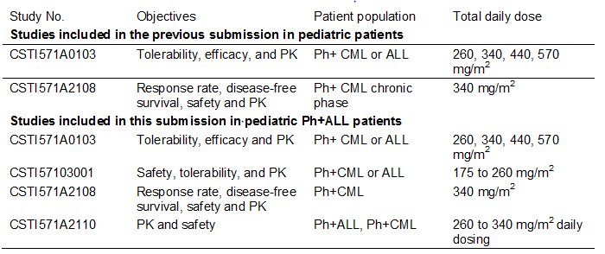
The pivotal study for evaluation of efficacy and safety was study 2301 in newly diagnosed ALL very high risk patients. Also provided is a supportive study A1T07 which again was in newly diagnosed Philadelphia positive ALL patients of both good and poor risk. As will be discussed within this submission the data provided in relation to efficacy for the supportive study is extremely limited and therefore not considered to be satisfactory for evaluation. The safety data is considered pertinent.
Module 1 contains the relevant application letter and forms, draft Australian PI and European summary of product characteristics.
Module 2 also contains relevant clinical over views, summary of clinical pharmacology, clinical efficacy, clinical safety and literature references.

Paediatric data
All the data presented in this submission are in relation to paediatric patients. This includes all pharmacological analyses together with the data from the pivotal study 2301 and various supportive studies.

Good clinical practice
All aspects of good clinical practice have been observed in the pivotal study and supportive studies.

Pharmacokinetics

Studies providing pharmacokinetic data
The clinical pharmacology of imatinib has previously been extensively described in the imatinib original application for newly diagnosed CML in adult and paediatric patients and patients with gastrointestinal stromal tumours. This evaluation provides an overview of the studies which support the clinical pharmacology summary of imatinib in the paediatric Philadelphia (Ph) positive ALL indication, as indicated in Table 2.
Table 2: Summary of clinical studies included in the previous submission and this submission
This paediatric PK data in the submission comprises two modelling study reports namely the pooled population pharmacokinetic modelling report update (IP PBPK) and the study report A2110. The pooled population pharmacokinetic analysis was conducted in paediatric patients aged 2 to 18 years with haematological disorders including CML, PH positive ALL or other indicated haematological disorders in four clinical studies A0103, 3001, 2108 and A2110. Since the 100 and 400mg tablet formulations were bioequivalent with the 100mg hard gelatine capsule there was no reason not to pool this PK data from the above studies.
The PBPK modelling report did not use any clinical data and was based on a physiological simulation. The PBPK model assessed the effect of the developmental pharmacology on systemic exposure to imatinib in paediatric patients. The objectives of the PBPK modelling report were:
- to predict paediatric PK using the PBPK approach based on the imatinib clearance in adult population then compare the results to the experimentally observed values
- to predict Imatinib plasma concentration – time profiles in plasma and tissue in paediatric subjects and to assess the effect of paediatric growth process using the PBPK model developed and
- to evaluate factors influencing the Imatinib exposure in paediatric patients with particular attention to children in the age range of 1 to 2 years.

Pooled population pharmacokinetic modelling report:
A population PK analysis was undertaken from four clinical studies A2110, A2108, 3001 and 0103. The study designs for these four trials are given in Table 3. Objectives of the analysis were to:
- characterise the pharmacokinetic profile of imatinib in paediatric patients
- confirm pharmacokinetics in children from 2 years of age on and
- establish adequate dosing schedule schemes for paediatric patients by model – based simulation using the final Pop PK model.
Table 3: Study designs and pharmacokinetic sampling times for studies contributing to the PopPK analysis (N=67)
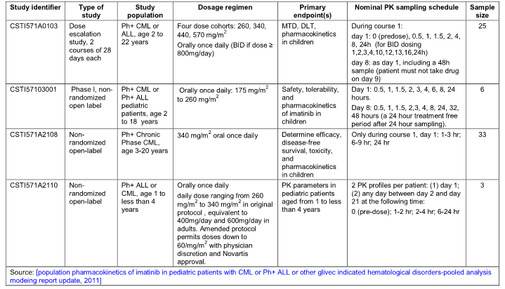
Data from subjects between 2 and 18 years of age were pooled from the four studies and plasma concentrations were measured for imatinib and the major pharmacologically active metabolite CPG74588. Non-linear mixed effects models for the Pop PK imatinib and the metabolite were developed using Nonmem version V1 level 2 with 1 interaction. The final model was used to assess clearance across body surface area, body weight and age. The clearance relationship with body weight from the final model was compared to the previously reported adult model. The final model was then used to simulate PK parameters and related PK exposure measures including AUC, Cmax, Cmin for the proposed paediatric dose of 260 and 340mg/m²as well as for various alternative dosing schemes including those designed to match the AUC for children with adults as indicated in Table 4.
Table 4: Dosing strategies evaluated by simulation in terms of their impact on AUC, Cmax, and Cmin
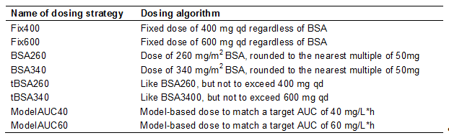
The results of the analysis revealed the Pop PK imatinib were characterised by a one compartmental model with zero order absorption and first order elimination. The model was parameterised in terms of apparent clearance (CL/F), apparent volume of distribution (V/F), and duration of zero–order input (D1). Inter-individual variability in CL/F and V/F were characterised by log normal distributions and the residual error by a combined error model. Analysis revealed that CL/F and V/F increased with body surface area. After correcting for the body surface area (BSA) effect the following covariates were not found to have clinically significant effects on the exposure of imatinib: age, gender, race, white blood count, haemoglobin, body weight, body mass index (BMI) and disease type. The clearance for a subject whose BSA was equal to 1.73/m²was 9.06 litres per hour which corresponds with estimates from previous work in the adult population.
There was no statistically significant difference in imatinib clearance among disease types as indicated in Figure 1 Patients with Ph positive ALL were estimated to have an imatinib clearance of 9.7% (SE 15.9%) less than that for Ph positive CML.
Figure 1: Imatinib clearance normalized to BSA=1.73m² by disease type (N=67)
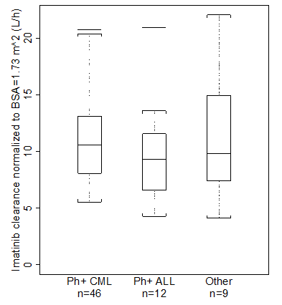
Comparison of the relationship between clearance and body weight in the final model with a previously developed adult model shows that the models are consistent with each other for body weights of 60 kilograms and higher. Refitting the final model without subjects younger than 4 years led to similar parameter estimates. Prediction of concentration–time profiles for the excluded subjects show that the observed concentrations were generally within the predicted 90 percent variability band. Pop PK model was used to assess AUC for 1 year old children. The uncertainty was greater for 1 year olds than 2 year olds. Slightly lower exposure was observed for 1 year olds as compared to 2 years and above.
The pop PK of CGP74588 was characterised by a two compartment model parameterised in terms of apparent clearance (CML/F), apparent volumes of the central compartment (VCM/F) and peripheral compartment (VPM/F) and the apparent intercompartmental clearance (QM/F). The fraction of imatinib and metabolised to CGP74588 in parent- metabolite modelling was fixed to 0.13 or 13 percent. The final pop PK model for the metabolite includes BSA as a covariate with clearances and volumes increased with BSA.
The exposure of 18 year old subjects (dosing scheme of 340mg/m² and not to exceed 600mg) was simulated using the adult model, as indicated in Figure 2. The exposure of children in different age groups for 340mg/m² corresponds closely to the exposure of adults simulated using the same model.
Figure2: Simulated AUC by age group for 304 mg/m² not to exceed at 600 mg dose, compared against adults simulated with the adult model receiving 600 mg fixed dose.
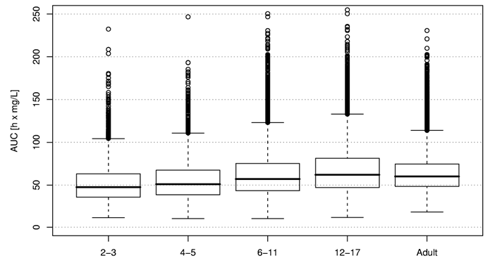
Model based simulation of various dosing schemes showed the dose of 260mg/m² not to exceed 400mg or 340mg/m² not to exceed 600mg lead to relatively constant exposures for AUC, Cmax and Cmin across the range of observed body surface area and ages. The AUC is achieved by these doses are similar to adult AUC as indicated in Figure 3.
Figure 3: AUC versus age in the different dosing strategies
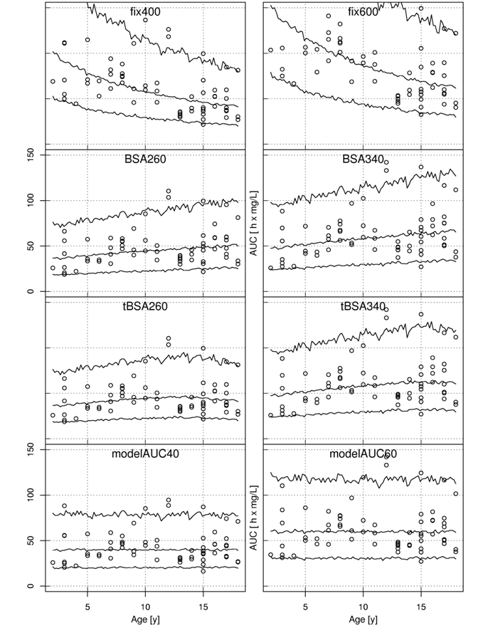

Comment:
Clearance of imatinib was found to increase with increasing BSA supporting a BSA based dosing scheme for imatinib in paediatric patients. The various cohorts analysed did not have clinically significant effects after correcting for BSA effects. This model corresponds well with the observed data when compared to an adult model and shows that the final model is able to successfully extrapolate to younger children between the ages of 2 and 4 years as well as adults. It is therefore reasonable to conclude that the current dosing schemes of 260mg/m² or 340mg/m², not to exceed 400mg or 600mg, respectively, are applicable for patients aged 1 year or older.

Physiology–based PK (PBPK) modeling
The objectives of this modeling were:
- to predict paediatric AUC steady state using PBPK approach based on imatinib clearance in the adult population and compare the results with the experimentally observed AUC values with specific focus on children aged 1 year and older.
- to predict imatinib plasma concentration-time profiles in plasma and tissue for paediatric subjects to assess the effect of paediatric growth processes using PBPK model and
- to evaluate factors influencing imatinib exposure in paediatric patients.
The paediatric growth database, such as organ size, blood flow, enzyme and plasma protein duration, was obtained from the literature. No clinical data was used for the model-based simulation. Clinical data from pooled studies were used as references to compare with model predictions.
A PBPK model previously developed for imatinib was used and the model parameters were modified using growth and maturation database obtained from the literature. Clearance range observed in a phase 3 trial in the adult population was used as reference for paediatric scaling. Two separate approaches were employed:
- the steady state (SS-model) approach scaling only clearance to steady state AUC and
- the dynamic (DYN-model) PK simulation to assess the imatinib concentration – time profile within dosing intervals.
The effects of body size and blood perfusion on the PK profiles were evaluated in addition to maturation and clearance. The model evaluations were conducted by comparing the predicted steady state AUC and predicted imatinib concentration-time profile with non-compartmental AUC computed by the trapezoidal rule and observed data from the pooled clinical studies respectively.
The results determined that the SS model simulations showed that the majority of actual steady state AUC values (95% or 29 of 31) normalized for 340mg/m2 in paediatric patients fell within 0.5 and 99.5 percentiles of model projected range scaled from adult measurements. Based on the DYN-model the predicted plasma concentration-time profiles were generally in good agreement for most paediatric patients except for younger patients under the age of 2 years for which the exposure appeared to be over-predicted. The predicted deviation from adult was higher for their first dose then at steady state (day 28). The largest deviation was observed for Cmax. The predicted age effect on AUC and Cmin were less than that on Cmax. The differences in predictions of children and adults seemed to be the mixed results of changing distribution volume and blood circulating turnover, in addition to clearance maturation with age. Even taking a conservative approach for the model assumptions the prediction was only 1.5 fold of the adult value at 1 year age suggesting a safe application of PBPK approach in scaling imatinib clearance down to children of 1 year of age.

Comment:
The projection of paediatric exposure to imatinib using a PBPK model was generally in good agreement with the actual measured PK exposure values in a limited number of paediatric patients ranging from age 2 to 18 years. Incorporation of the PK parameters and maturation processes within the model gave reasonable description of imatinib PK in paediatrics from 2 to 18 years. The exposure for a 1 year subject is likely to be over predicted using the PBPK model based on some bias seen in predictions for age 2 and 3 years. No major exposure – related safety concerns would be expected in dosing if dosed according to BSA.

Study A2110:
The primary objective of this study was to characterise the PK of imatinib in paediatric patients aged 1 to less than 4 years via a properly integrated physiologically based PK (PBPK) or population PK approaches. The primary end points were CL/F, V/F, Tmax, PBPK parameters, Cmax and AUC.
Due to insufficient patient enrolment (three out of ten patients) and scarcity of PK data, limited PK data was available and a non-compartmental analysis was not conducted.
This was a non-randomised open label study in which patients diagnosed with CML or PH positive ALL between the ages of 1 to 4 years were treated with imatinib administered as a daily dose ranging from 260mg/m² to 340mg/m². The maximum planned duration of treatment in this study was 21 days during which two sets of PK profiles were collected from each patient.
Only three patients were ultimately involved in this study which limited assessment of data. The PK results did show that there were no major differences in imatinib exposure between the two different visits. The PK profiles for imatinib and CGP74588 showed a large inter-patient variability. However the dose normalized Cmax and Cmin values were similar to adult patients. The observed Cmin for the three patients were consistent with those simulated at a corresponding dose from the final population PK model. Previous results had shown in adult patients imatinib is highly bound to plasma protein ranging from 94 to 97% over clinical relevant concentration ranges. The current study showed that imatinib is highly bound to plasma protein in paediatric patients. The degree of plasma protein binding was comparable to that observed in adult patients.

Comment:
The Cmin values from this study in the three paediatric patients were consistent with simulated values from the population PK model.

Pharmacodynamics

Studies providing pharmacodynamic data
No new pharmacodynamic data in relation to paediatric patients was undertaken or determined in this evaluation.

Dosage selection for the pivotal studies
No specific dose finding data was performed in the Ph positive ALL setting. The choice of once daily dosing with imatinib 340mg/m² for the pivotal study was based on the results of a COG paediatric phase 1 study in PH positive leukaemia which included 14 chronic phase CML patients, seven AML patients and 10 ALL patients. Among the 10 ALL patients 7 achieved an M1 marrow response and one achieved an M2 marrow response with the recommended dose. Pharmacokinetic analyses showed that the doses of 260mg and 340mg/m² had exposures similar to those observed in adults treated daily at 400mg and 600mg. The study also showed that daily oral imatinib was well tolerated in children at doses ranging from 260 to 570mg/m². An intermediate dose of 340mg/m² was therefore adopted for the pivotal study [ST1571I2301].
It was also noted that from the population PK modelling the model based simulation of various dosing schemes confirmed that the exposure of imatinib in paediatric patients receiving 260mg/m² not exceeding 400mg once daily or 340mg/m² once daily not exceeding 600mg once daily are comparable to those in adult patients receiving 400mg or 600mg once daily respectively.
It is also appropriate to note that there are two dosage forms of imatinib available, namely hard gelatine capsules and film coated tablets. For paediatric patients who are unable to swallow capsules they may be opened and the contents should be dissolved either in water or apple juice. In vitro data has demonstrated dispersed imatinib remains stable in water or apple juice.

Clinical efficacy

Studies providing efficacy data
This submission is based on efficacy and safety data from the pivotal phase 3 study 2301. It is appropriate to note that a further study AIT07 (a phase 2/ phase 3 trial) which was a multi-centre study initially designed as an open label randomised study to determine whether the addition of imatinib to standard chemotherapy extended disease free survival (DFS) in paediatric patients with Philadelphia positive ALL. However after the publication of the results from study 2301 demonstrating a significant benefit of adding imatinib to chemotherapy for paediatric patients of all risk for Philadelphia positive ALL, the participating groups considered it unacceptable to randomise patients into chemotherapy only arms. The protocol was therefore amended so that patients received imatinib regardless of risk category. This meant the sample size is inadequate to properly test for the primary efficacy analysis. Accordingly sponsors have not included this study in the efficacy evaluation. This evaluator will include the efficacy data available although accepts the fact that it represents very limited value in terms of determining the role of imatinib in the treatment of paediatric patients with Ph positive ALL.

Pivotal efficacy study STI571I2301

Methods
The pivotal study 2301 was sponsored, designed and conducted by the cooperative group COG. The primary objective of this study was to determine the feasibility of patient equivalent toxicity of an intensified chemotherapy regimen and incorporating novel agents for the treatment of children and young adults with very high risk ALL including Ph positive ALL. The study consisted of five cohorts each receiving the same intensive chemotherapy regimen back bone post-induction therapy that varied in the integration of imatinib treatment by increasing exposure in five sequential cohorts and is indicated in Table 5.
Table 5: Integration of imatinib into successive blocks of therapy (STI571I2301)
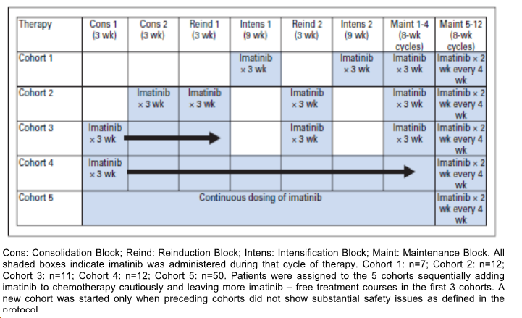
Positive interim results showed acceptable tolerability and superior efficacy for patients in cohort 5 which led to an amendment increasing the sample size in the group of Ph positive ALL patients receiving continuous imatinib treatment. A subsequent interim analysis demonstrated that earlier administration and higher cumulative doses of Imatinib were associated with improved 1 year event free survival (EFS) in all cohorts with the best results being observed in patients treated with continuous dosing in cohort 5 (95.3%, n = 50) which was higher than the historical controls of 65.7% (n = 56). At a later date COG performed another analysis at the cut off date of 31 October 2008 with a primary end point of 3 years EFS in Ph positive ALL patients. This demonstrated three year EFS results for cohort 5 at 80% with observed EFS rate more than twice that of historical controls at 35% (n = 120).
Accordingly a statistical analysis plan in December 2009 performed additional analyses in cohort 5 with a cut off date of 5 September 2009 with a primary end point of EFS and this was assessed in the context of data from historical controls.
EFS is defined as relapse at any site, secondary malignancy, and death from any cause after study entry.

Endpoints
The pivotal study 2301 was a multi-centre phase 3 open label sequential cohort non-randomised study which involved paediatric and young adult patients of less than 22 years with very high risk ALL defined as five year event free survival of less than 45% the large majority of whom had the Ph positive subtypes. A summary of study end points is indicated in Table 6.
Table 6: Summary of endpoints for Study STI571I2301
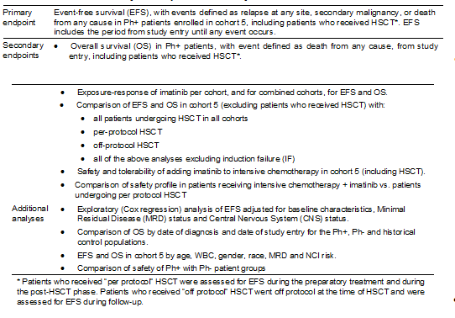

Study design
The study design is indicated in Figure 4:
Figure 4: Study design STI571I2301
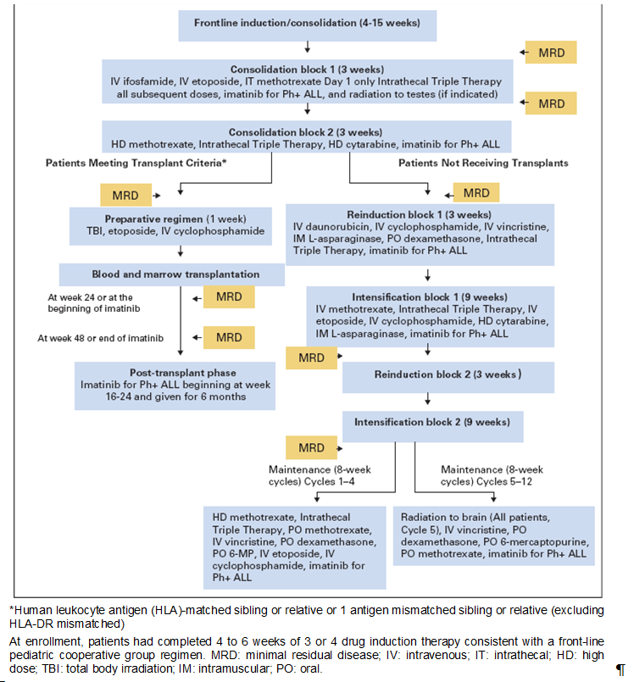

Patient characteristics and treatments
All patients in this study received an initial intensive chemotherapy regimen. The Ph positive patients received imatinib integrated with intensive chemotherapy in successive blocks of increasing imatinib exposure depending on the cohort as indicated in Table 5. In cohorts 1 to 4 imatinib was given at 340mg/m² in three week blocks while in cohort 5 imatinib was given at 340mg/m² per day continuously except during maintenance blocks 5 through 12 which consisted of two week imatinib blocks every four weeks.
It is noted that patients with HLA matched related donors or one antigen mismatch were rated donors eligible for stem cell transplant after consolidation block 2. At 16 to 24 weeks after per-protocol HSCT treatment with imatinib was resumed initially at a lower dose of 230mg/m² per day increased to 340mg/m² per day when no toxicity of at least grade 3 were observed after four weeks of post-HSCT imatinib.

Analysis populations
Breakdown of the population analysis for the 160 patients initially entered on to trial is indicated in Figure 5:
Figure 5: Patient Population in Study STI571I2301
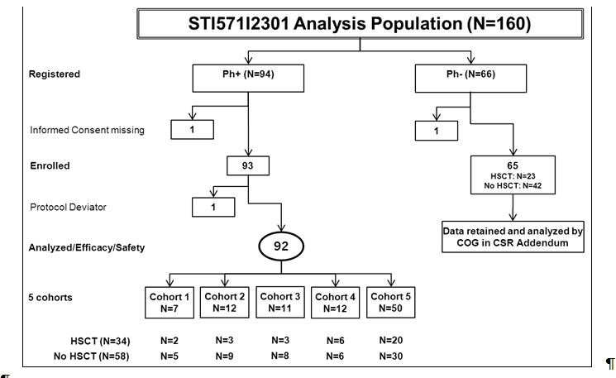
The historical control data set for the analyses presented in this submission included 120 Ph ALL patients previously enrolled in five clinical trials performed by the COG.
Reviewing the results of the pivotal study patients and sequential cohorts with increasing duration of imatinib had intermittent chemotherapy cohort 1 through to cohort 5. Analyses are presented by cohort or combined cohort groups compared to cohort 5 which included patients who received imatinib for the longest duration. Both efficacy and safety analyses included the same number of patients and no patients were excluded. Twenty of the 50 patients in the main analysis group of cohort 5 underwent HSCT. Thirty patients were treated only with chemotherapy plus imatinib. Six patients in cohort 5 failed induction treatment as indicated in Table 7:
Table 7: Analysis set and subgroups (STI571I2301)
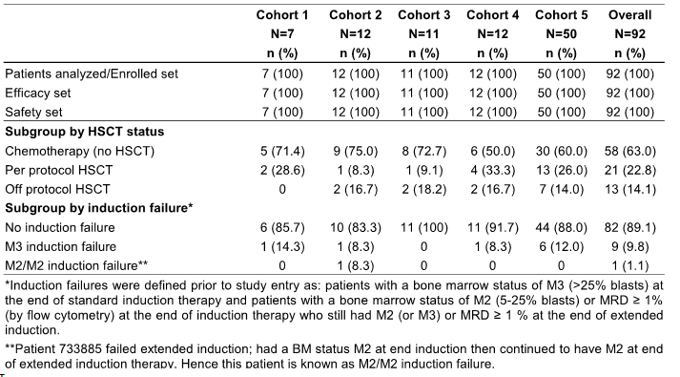

Patient disposition
A total of 160 paediatric patients were enrolled in this study between 14 October 2002 and 20 October 2006. Ninety three were Ph positive patients and received imatinib plus chemotherapy. One patient who was considered not evaluable was excluded from analysis. Approximately half of the Ph positive patients, that is, n=45 or 48.9%, completed protocol treatment and the remaining 47 patients discontinued before completing protocol treatment. The proportion of patients who discontinued protocol was highest in cohort 1 at 71.4% and lowest in patients receiving imatinib continuously in cohort 5 at 46%. Overall the three most frequent reasons for discontinuation were patient decision 10.9%, or relapse at any site 10.9% and off protocol HSCT 9.8%. As of the cut off date 5 September 2009 follow up was ongoing for 57 patients, follow up was discontinued for 30 patients (32.6%) and 5 patients (5.4%) had no follow date available. The overall patient disposition for the various cohorts is summarized in Tables 8 and 9:
Table 8: Overall patient disposition Ph+ cohorts (Enrolled set – STI571I2301)
Table 9: Patient disposition for end of protocol treatment, by cohort (Enrolled set – STI571I2301)
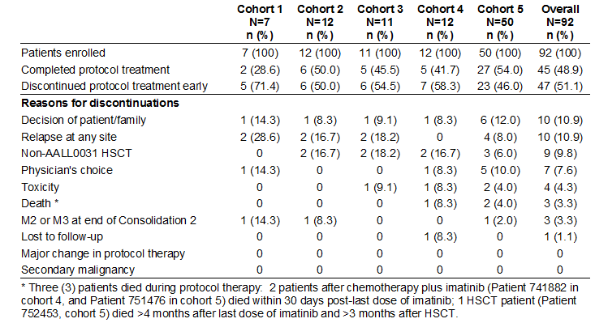

Demographic and other baseline characteristics
Demographic and baseline characteristics for the patients including the Ph positive patients, the Ph negative patients and the historical control group is indicated in Table 10.
Table 10: Demographics at baseline for Ph+ ALL cohorts, Ph-ALL group and historical control group (STI571I2301)
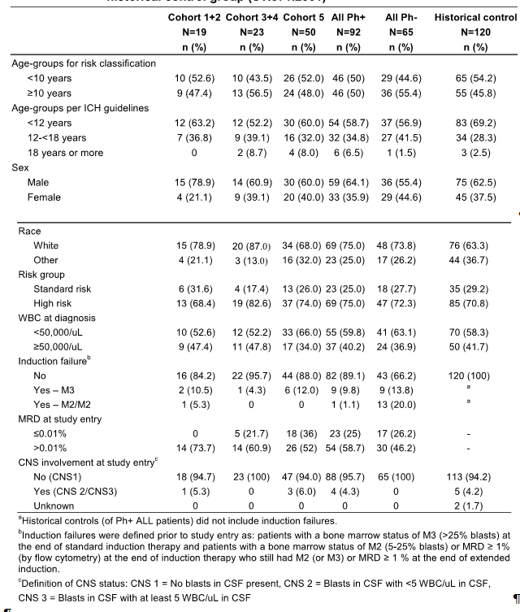Demographic and baseline characteristics were comparable across the cohorts. It is noted that of the Ph positive ALL patients 50% were less than 10 years of age and two patients were less than two years of age both from cohort 5. Comparisons of minimal residual disease status (MRD) at study entry showed more patients in cohort 3, 4 and 5 with MRD equal to or less than 0.01% included 25% in cohort 4 and 36% in cohort 5. It is also noted that the distribution of baseline characteristics are similar in cohort 5 to the historical control group. It is noted that the Ph negative group included a higher percentage of induction failures than the Ph positive ALL cohorts at 33.8% versus 10.9% respectively. It is also noted 34 of the Ph positive ALL patients or 37% of patients in the pivotal study underwent HSCT an unknown number had HSCT in the historical control groups. No clinically significant differences in baseline characteristics were observed from patients who received HSCT compared to those that received chemotherapy plus imatinib only.

Primary efficacy endpoint - Event free survival in Study STI571I2301 and historical control group
The primary efficacy end point of the study was EFS from study entry in Ph positive ALL patients and in cohort 5 including the option of HSCT. Imatinib had its highest impact on EFS in patients with Ph positive ALL when administered early on in the course of treatment and for a longer duration, with the best results noted in cohort 5 (n=50): the 48 month EFS rate for cohort 5 was 69.6% which was more than twice that of the historical controls with 31.6% and an HR 0.28% log rank P < 0.0001 as indicated in Table 11. Fourteen patients in cohort 5 showed an EFS event with nine patients relapsing at any site and five patients who died without relapse prior to death. Of the five patients who died, four had undergone HSCT and one patient received only chemotherapy plus imatinib.
Table 11: Event-free survival in cohort 5 (Efficacy set – STI571I2301) and in historical control
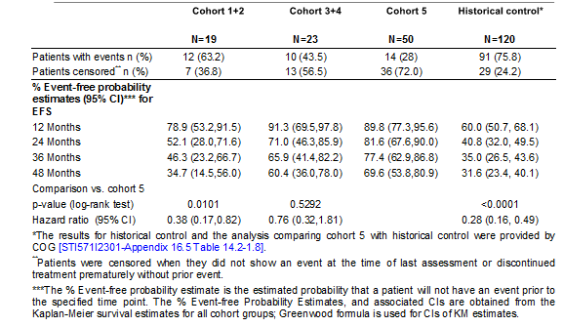
The estimated rate of EFS at 48 months was 34.7% in cohort 1+2 and was 60.4% in cohort 3+4. Comparison between cohort 5 and cohort 1+2 yielded a HR of 0.38 with a p-value of 0.0101 (log-rank). Comparison between cohort 5 and cohort 3+4 yielded a HR of 0.76 with a p-value of 0.5292 (log-rank) Figure 6 represents the Kaplan-Meier estimates of cohort 5 compared to the historical control group obtained from COG.
Figure 6: Kaplan Meier curve of event-free survival comparing cohort 5 (Efficacy set – STI571I2301) and historical control
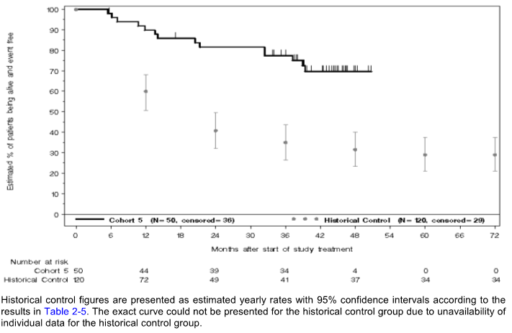

EFS in cohort 5 and historical control by baseline characteristics
Event free survival is analysed for cohort 5 and the historical control population considering various baseline characteristics including age at study start, gender, white blood count at diagnosis and CNS involvement and results are summarised in Table 12:
Table 12: Kaplan-Meier analysis of EFS in cohort 5 and historical control patients by baseline characteristics (Efficacy set – STI571I2301)
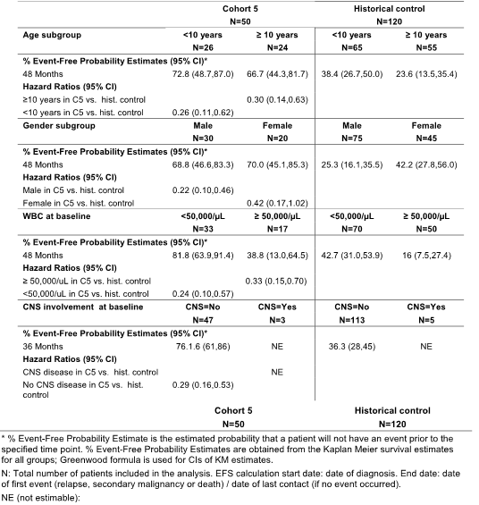
For all characteristics assessed there was an advantage in terms of event free survival for the patients in cohort 5 compared to the historical controls. This was further analysed utilizing a Cox regression analysis for selected baseline characteristics including age, gender and white blood count as the others had insufficient numbers available or not available for the historical controls namely minimal residual disease status. Again advantages were noted for the cohort 5 patients compared to the historical controls with HR 0.28 log rank P < 0.0001 as indicated in Table 13:
Table 13: Univariate and Multivariate Cox proportional hazards model (Efficacy set – STI571I2301)
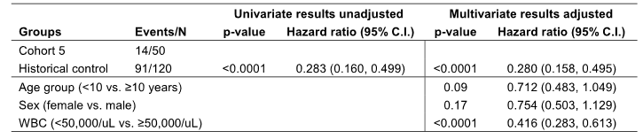

Overall survival
Comparison of overall survival for the various cohorts compared to the historical controls is summarised in Table 14. The estimated overall 48 month survival rate in cohort 5 was 83.6% compared to a rate of 44.8% for the historical controls with an HR 0.23 log rank P < 0.0001. This compared to an overall survival at 48 months of 49.2% for cohorts 1 + 2 and 74.7% for cohorts 3 + 4. Comparison between cohort 5 and cohort 1+2 yielded a HR of 0.30 (log-rank p=0.0091). Comparison between cohort 5 and cohort 3+4 yielded a HR of 0.74 (log-rank p=0.5949). This is indicated in Table 14 and Figure 7:
Table 14: Overall survival in Ph+ cohorts (Efficacy set – STI571I2301) and historical control
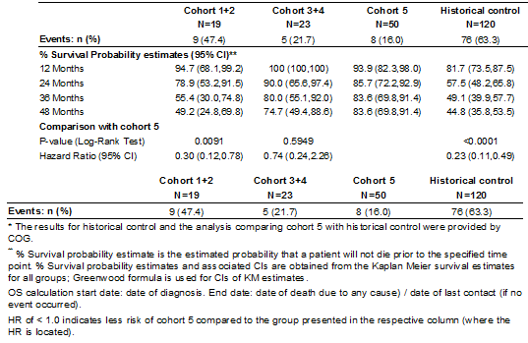
Figure 7: Overall survival by cohort groups (Efficacy set – STI571I2301)
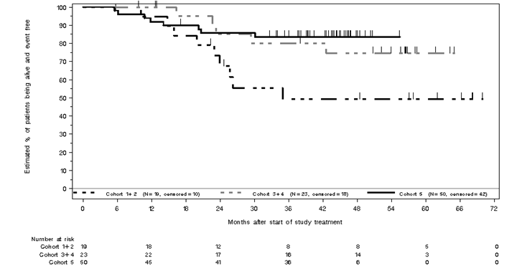

Effect of imatinib exposure on EFS
The effect of scheduled exposure to imatinib on event free survival using the cohort with increasing exposure from 1 to 5 was examined using the Cox proportional hazards model. This revealed that with increasing exposure to Imatinib from cohorts 1 to 5 the respectively estimated event free survival showed a P value of 0.080. It was estimated that each level increase in cohort number reduced the risk of an event by an estimated average of 23%.

Effect of HSCT
Recognising the potential influence of HSCT on outcomes and involvement of this procedure in many of the patients in the study additional analysis was undertaken excluding all patients who underwent HSCT from cohort 5 and comparing this group with all patients who received per protocol HSCT (n=21) and all patients who received off protocol HSCT (n=13). The analysis of EFS is indicated in Table 15 and Figure 8. A positive trend was noted for EFS favouring per protocol HSCT over off protocol HSCT and cohort 5 chemotherapy plus imatinib over per protocol HSCT. These figures were however not statistically significant.
Table 15: Effect of HSCT on EFS and OS (Efficacy set – STI571I2301)
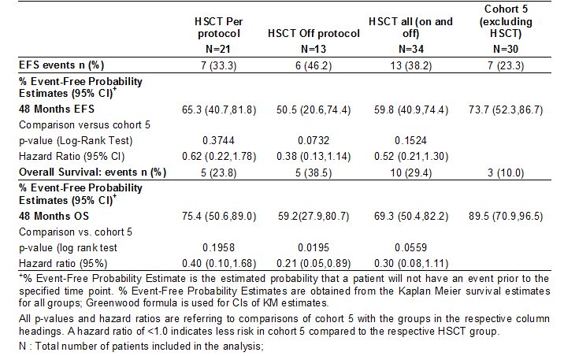
Figure 8: Kaplan-Meier curve of EFS comparing cohort 5 chemotherapy + imatinib and HSCT (Efficacy set – STI571I12301)
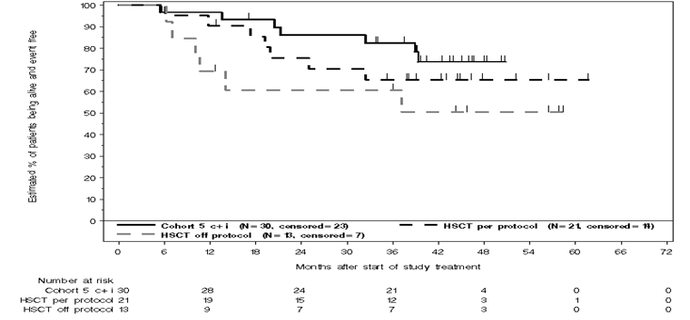
Overall survival for cohort 5 for patients who underwent HSCT both per protocol and off protocol is indicated in Figure 9. At 4 years the estimated overall survival rate of cohort 5 (chemotherapy plus Imatinib only, excluding HSCT n=30) was 89.5% versus 75.4% in the per protocol HSCT and 59.2% in the off protocol HSCT. Cox regression analysis adjusting for various baseline factors failed to show any differences in these data.
Figure 9: Kaplan-Meier curve of OS (months) comparing cohort 5 chemotherapy + imatinib vs. HSCT (Efficacy set – STI571I12301)
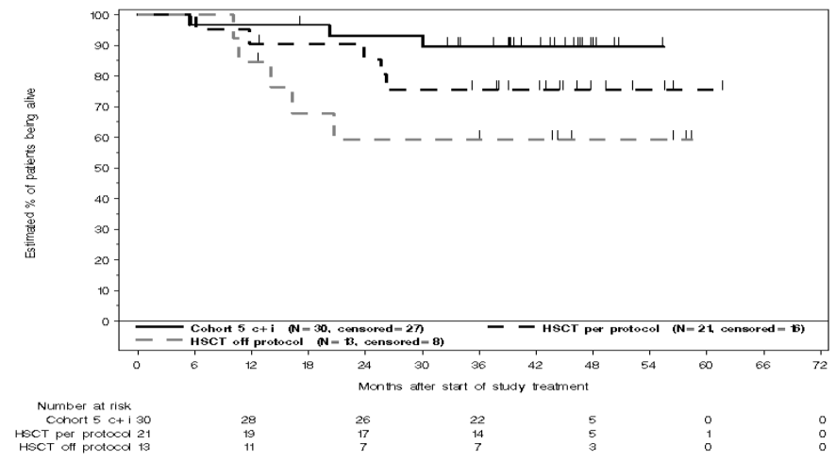

Evaluator’s conclusions on pivotal efficacy study STI571I2301
This data has clearly shown that for patients in cohort 5 of the pivotal study there was a highly significant benefit for the use of imatinib plus chemotherapy compared to the historical controls in relation to both event free survival and overall survival. Sub-group analyses confirmed this data. There was also a lesser but again significant benefit between cohort 5 and cohorts 1 + 2 who only had limited exposure to imatinib. The reviewer recognises the fact that as this is a relatively uncommon disease and that an appropriately randomised study would have been very difficult to conduct. The choice of historical controls however does raise some concerns particularly in the context that these came from various COG studies involving earlier chemotherapy protocols. The chemotherapy involved in induction for patients on study 2301 was extremely intensive involving quite a large number of agents which raises the question whether the intensity of induction therapy may not have been a significant factor in determining event free survival and overall survival irrespective of the role of imatinib. This would benefit from further evaluation.

Supportive study STI571AIT07

Methods
A further study AIT07 was an open labelled randomised phase 2/3 study assessing safety and efficacy of imatinib with chemotherapy in paediatric patients with Philadelphia positive acute lymphoblastic leukaemia and was performed between January 2004 and November 2010 involving 10 paediatric leukaemia study groups. The primary objective of this study was to evaluate the disease free survival in the good risk group of patients treated either with or without imatinib in correlation with intensive chemotherapy including the option of HSCT. The randomisation component involved chemotherapy plus imatinib or chemotherapy alone for the good risk patients. A total of 229 patients who were randomised were registered for the study and among the 213 eligible patients 35 were not entered onto the study. Of the 178 eligible patients 108 were good risk patients. Of these 108 patients 18 were not randomised due to clinical decision and patient refusal and only 90 patients were randomised to imatinib plus chemotherapy or chemotherapy alone.

Results
This study was terminated early because of recognition of the results from the pivotal study 2301 and a decision that no further randomisation was appropriate. This resulted in an insufficient sample size to properly test for the primary efficacy analysis. Nevertheless in relation to the primary end point of disease free survival, 6 out of 44 or 14% of chemotherapy alone patients and 4 out of 46 or 9% of chemotherapy plus imatinib patients had a disease free survival event. This was not statistically significantly different, with a hazard ratio of 0.978 and a log rank test of 0.9733. The estimated DFS rates at 24 months were comparable in the Good risk-no imatinib arm (65%) and Good risk-imatinib arm (81%), with very similar and wide confidence intervals of the estimated rates in both groups.
It is noted that over 80% of patients had undergone HSCT significantly influencing the results, but when disease free survival was assessed not censoring for HSCT 16 of 44 or 36% of the good risk patients receiving chemotherapy alone and 12 of 46 or 26% receiving chemotherapy plus imatinib had a DFS event., with the hazard ratio of 0.635 and P value of 0.2424. At the end of 24 months the estimated DFS rate was 68% in non-imatinib arm and 79% in the Imatinib arm.
In relation to overall survival at 48 months, in the good risk Imatinib patients it was 85% which was slightly higher than the non-imatinib patients at 73%, with a hazard ratio of 0.644.

Evaluator’s conclusions on supportive study STI571AIT07
These data certainly did not provide any further evidence supporting the role of imatinib in the maintenance phase of patients having undergone intensive chemotherapy induction for Ph positive ALL. Nevertheless as determined by the sponsors and investigators the data really is difficult to interpret and thereby provides little to add to the significance of the results from the pivotal trial 2301.

Clinical safety

Studies providing evaluable safety data
This submission presents safety data from 220 Ph positive ALL paediatric patients treated with imatinib from two studies i.e. the pivotal study 2301 involving 92 imatinib treated patients and a supportive study AIT07 involving 128 Imatinib treated patients. As there was substantial differences in design for the two studies data regarding safety are presented separately. The safety population was defined as patients who received at least one dose of study drug. The safety population was 92 patients for study 2301 and 128 for AIT07. The study design and population for the pivotal study has been presented and for the supportive study AI07 these are indicated in Table 16 and Figures 10, 11 and 12:
Table 16: Summary of study STI571AI07
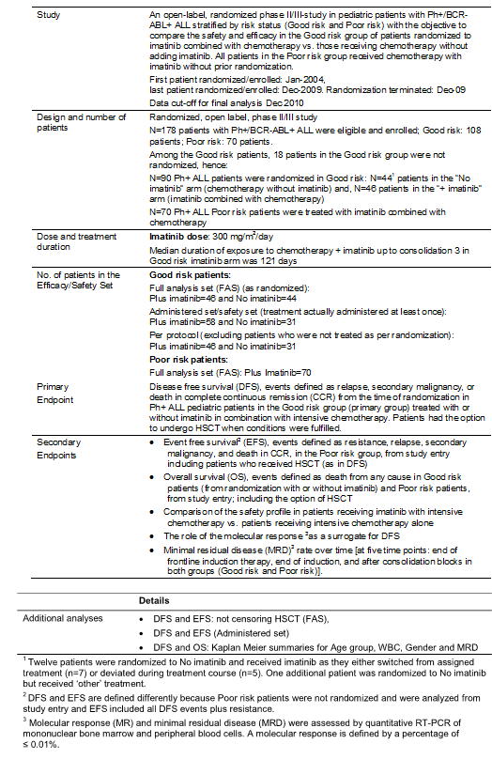
Figure 10: Patient population in Study STI571AIT07
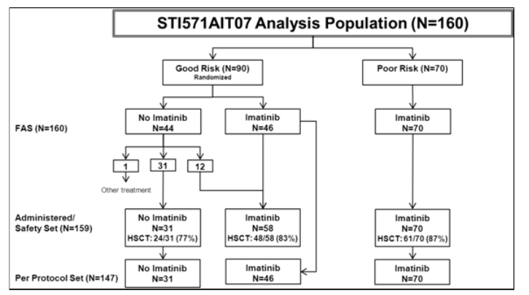
Figure 11: Treatment of Good risk Ph+ ALL with or without imatinib
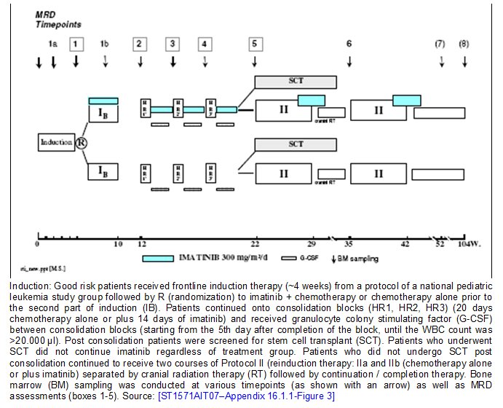
Figure 12: Treatment of Poor risk Ph+ ALL with or without imatinib

Exposure
In relation to exposure in the pivotal study median exposure to Imatinib for cohorts 1 to cohort 5 among patients who did not undergo HSCT range from 176 days for cohort 1 to 708 days for cohort 5. In the non HSCT Philadelphia negative patients the median exposure to chemotherapy was 783 days and this is illustrated in Table 17.
Table 17: Overall exposure to imatinib/chemotherapy (Safety set excluding HSCT patients – STI571I2301)
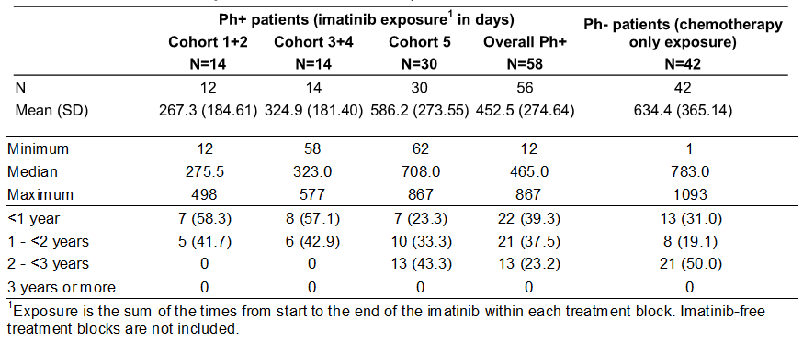
Among the PH positive ALL patients receiving per protocol HSCT the overall median intermittent exposure prior to HSCT was 42 days and with a range of 21 to 77 days and median exposure to Imatinib following HSCT was 169 days with a range of 14 to 192 days. Among the Ph positive patients the overall median Imatinib exposure prior to patients receiving off protocol HSCT was 53 days with a range of 28 to 165 days.
Duration of follow up from start of consultation 1 to the end of study including follow up after discontinuation of treatment is indicated in Table 18. As indicated in Table 19 65% of all patients had at least one treatment block delayed for more than 14 days. The most frequent reason for this being delayed neutrophil count recovery.
Table 18: Duration of follow-up (Safety set - STI571I2301
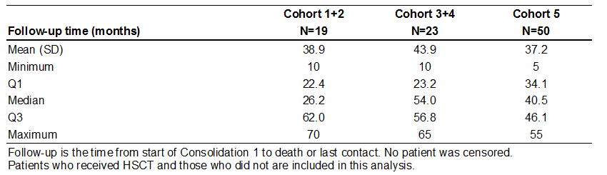
Table 19: Delayed start of next treatment block (Safety set - STI571I2301)
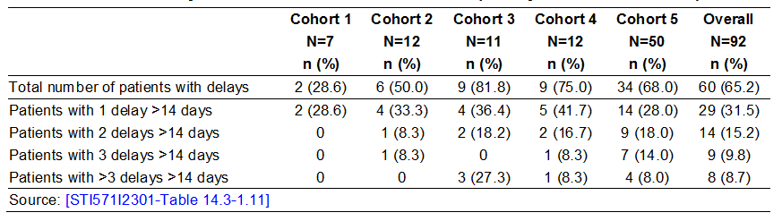
In relation to study AIT07 overall treatment exposure for Imatinib plus chemotherapy or chemotherapy alone is summarised in Table 20. Median duration of treatment was similar for all patient groups.
Table 20: Overall treatment exposure* (Safety set STI571I2301)
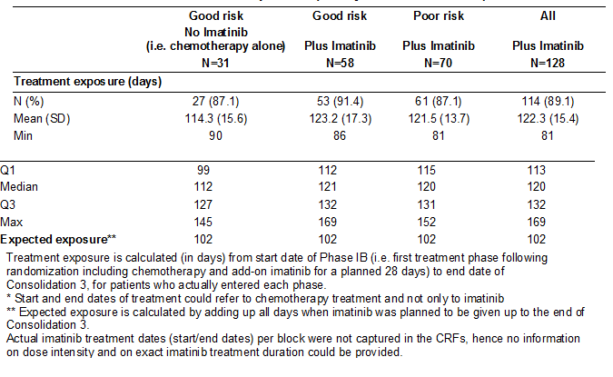
Overall 24 or 77.4% of the good risk patients who received chemotherapy alone, 48 or 82.8% of the good risk patients received Imatinib plus chemotherapy and 61 or 87.1% of the poor risk patients who received Imatinib plus chemotherapy underwent HSCT. In total 109 or 85.2% of patients who received Imatinib plus chemotherapy in both good and poor risk patients underwent HSCT in this study. Patients undergoing HSCT did not receive Imatinib post HSCT.
The median duration of follow up was similar for good risk patients receiving chemotherapy alone at 38 months with a range 2 to 72 and patients receiving Imatinib plus chemotherapy at 35 months with a range of 2 to 79. As expected follow time was poor for the poor risk patients at 23 months with a range of 4 to 79 months. Patients who received Imatinib from start of study treatment were followed up to a maximum of 79 months with a median of 30 months.
The incidence of treatment delay of at least one week was similar among good risk and poor risk patients who received Imatinib at 25 patients or 43% and 25 patients or 36% respectively. This is illustrated in Table 21.
Table 21: Treatment delays or dose modifications from start of study to Consolidation 3 (Safety set – STI571AIT07)
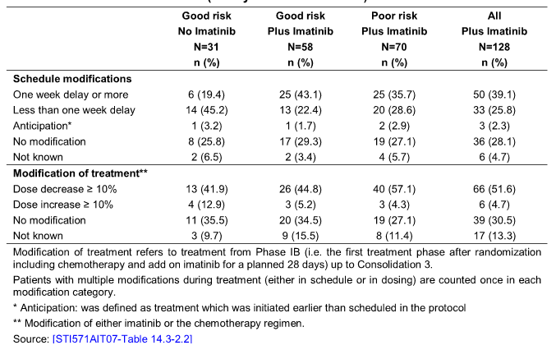
Baseline demographic characteristics for the pivotal study 2301 have been presented and are indicated in Table 22 for study AIT07.
Table 22: Demographics at baseline (Safety set - STI571AIT07)
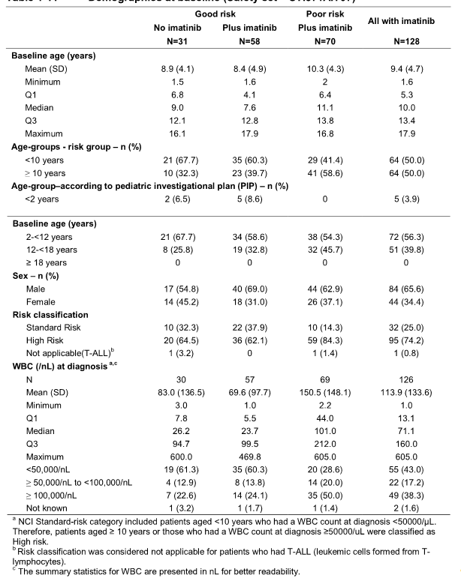
In relation to patient disposition in the pivotal study 2301 approximately half the patients in each group completed patient protocol treatment and the proportion of patients that discontinued protocol treatment prior to completing therapy was similar for both the Ph positive and Ph negative patients as indicated in Table 23.
Table 23: Overall patient disposition (Safety set - STI571I2301)
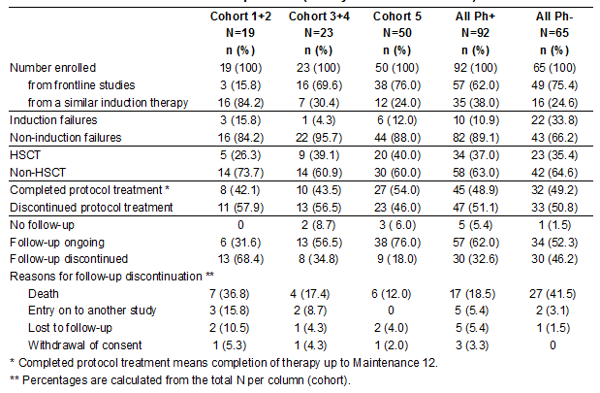
Patient disposition for study AIT07, of the total of 229 patients 178 were enrolled and assigned to either good risk i.e. 108 or poor risk i.e. 70. The remaining patients were outside of this protocol. All 70 patients assigned to the poor risk group received Imatinib plus chemotherapy and of the 108 good risk patients 90 were randomised to Imatinib plus chemotherapy i.e. 46 and chemotherapy alone i.e. 44. As indicated in Table 24.
Table 24: Patient disposition and primary reasons for discontinuation (FAS –STI571AIT07)

Adverse events
Adverse event reporting was as per NCI common terminology criteria including relevant grading.
Reviewing the overall incidence of adverse effects in Study 2301 the incidence of non-targeted AE at least grade 3 by system organ class and preferred term in Ph positive patients treated with chemotherapy plus Imatinib as well as the Ph negative patients who received chemotherapy alone is indicated in Table 25.
Table 25: Frequent (at least 5 patients in any group) non-targeted adverse events (grade 3, 4, 5) regardless of causality by system organ class and preferred term in Ph+ and Ph- patients (Safety set –STI571I2301)
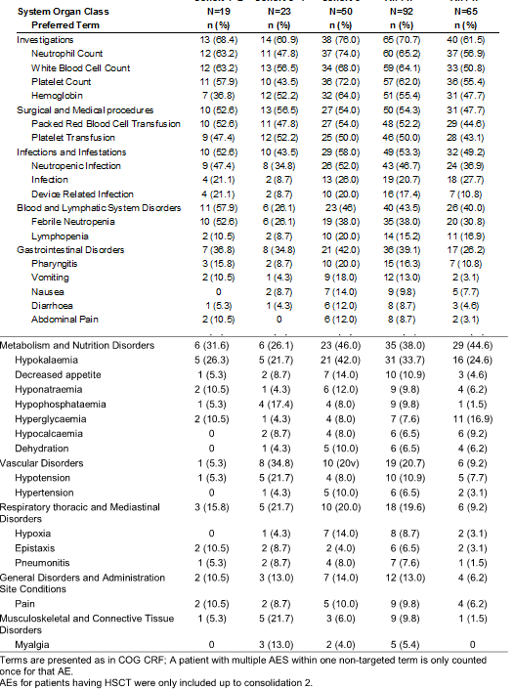
The proportion of patients experiencing adverse events were generally higher in those receiving chemotherapy plus Imatinib although as noted except for the Ph negative patients who did not receive Imatinib the incidence of lymphopenia, infection, hyperglycemia and hypocalcaemia was higher.
A selection of toxicities that were considered by the sponsor to be targeted toxicities and the incidence of these of at least grade 3 for patients who received chemotherapy plus Imatinib as well as the Ph negative patients who did not receive Imatinib is indicated in Table 26.
Table 26: Targeted toxicities (grade 3, 4 or 5) by preferred term in Ph+ and Ph- patients (Safety set – STI571I2301)
The most regular of these were increased ALT, AST and haemorrhage. Because of this increased incidence of elevated liver enzymes the duration of Imatinib was adjusted from 21 days per cycle to 14 days per cycle for maintenance cycles 5 to 12. Comparison of the enzyme elevations before and after the adjustment is indicated in Table 27 which indicates a decreased incidence of grade 3 and 4 ALT elevation, AST elevation and bilirubin elevation.
Table 27: Hepatic toxicities in maintenance cycle 5 pre- and post-Amendment 5B (Safety set – STI571I2301)
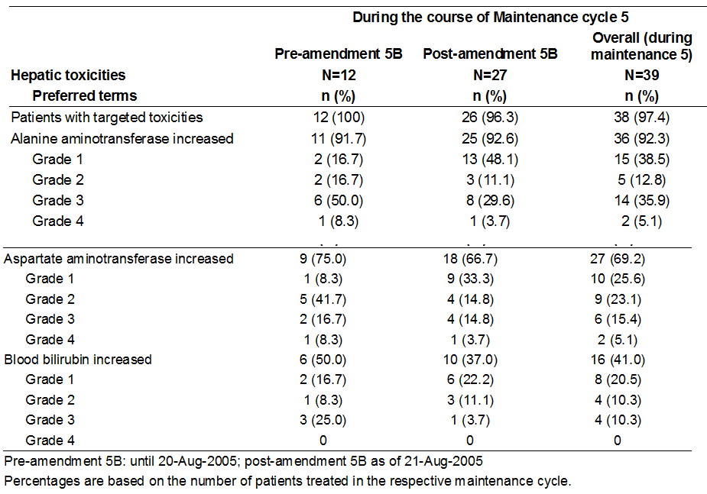

Analysis of adverse events within the Ph+ treatment blocks
As illustrated in Table 28 a number of PH positive ALL patients with grade 3, 4 or 5 adverse events by cohort and treatment block is indicated at the shaded cells which correspond to Imatinib integrated with chemotherapy. There is a high incidence of adverse events overall in each treatment block as expected due to the intensive chemotherapy regimen.
Table 28: Adverse events (grade 3, 4, 5) by treatment block in Ph+ patients treated with chemotherapy + imatinib (Safety set – STI571I2301)
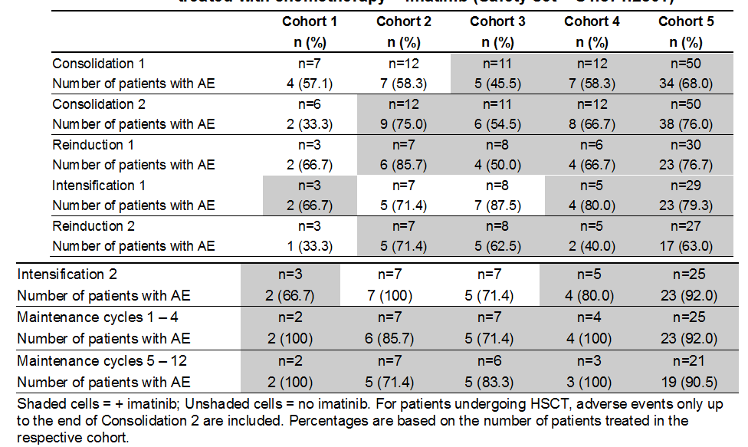

Common adverse events in study STI571AIT07
Reviewing adverse events for study AIT07 most patients experienced at least one adverse event during the study and these are consistent with the established safety profile of Imatinib. Again the most frequent were decreased white blood count, haemoglobin, platelet count and neutrophil count as well as infections as indicated in Table 29. For those good risk patients who received Imatinib compared to those who did not there was an increased incidence of neutropenia, infection, increased hepatic enzymes, decreased anti-thrombin 3, gastritis, proteinuria and euphoric mood.
Table 29: Adverse events regardless of study drug relationship by preferred term (Safety set – STI571AIT07)
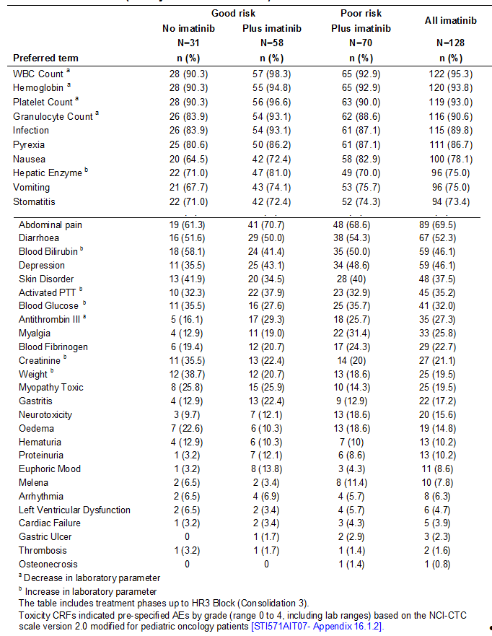

Adverse events suspected to be drug-related
Reviewing adverse events suspected to be drug related for study 2301, Table 30 indicates the most frequent adverse events for those who were at least grade 3 suspected to be related to Imatinib as assessed by the investigator. The suspected adverse events of myelosuppression and hepatotoxicity were consistent with the established safety profile of Imatinib. There were no consistent trends observed of increased or decreased frequency of suspected adverse events according to cohorts and treatment block.
Table 30: Frequent (at least 5 patients in any group) adverse events (grade 3, 4, 5) suspected to be related to imatinib by preferred term and treatment block (Safety set – STI571I2301)
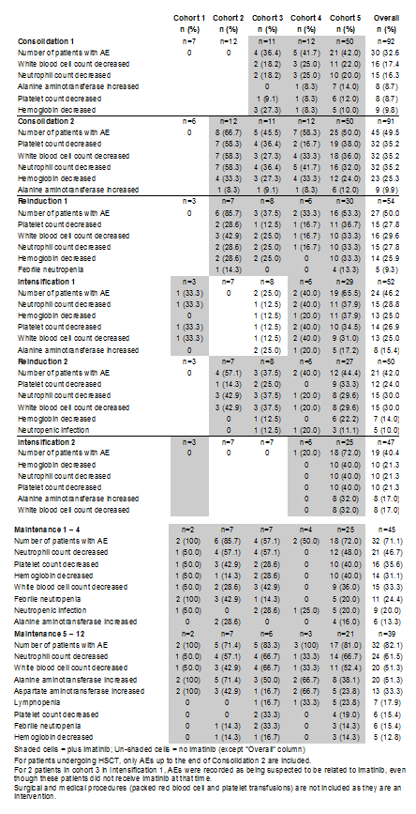
Information related to events suspected to be drug related was not collected for study STAIT07.

Deaths
In relation to deaths, in study 2301 the deaths and reasons for these are indicated in Tables 31 and 32.
Table 31: Deaths (Safety set – STI571I2301)
Table 32: Primary cause of death (Safety set - STI571I2301)
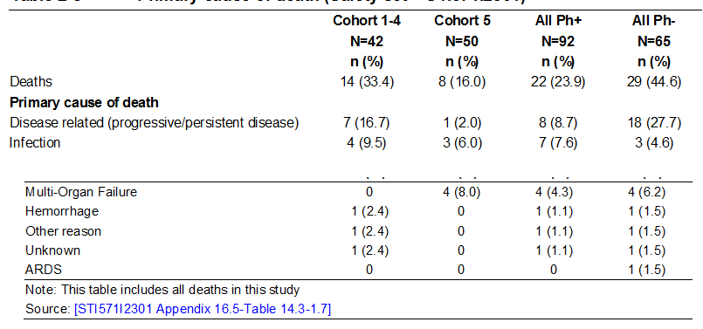
It is noted that four occurred on therapy or within 30 days of the last treatment. Of these, two were in patients who were receiving chemotherapy and Imatinib and both were related to infection. A further death was related to infection together with respiratory haemorrhage and failure. The final death was also associated with neutropenic infection.
It is noted the most common cause of death was progression of malignancy and in particular this was three times more common in the Philadelphia negative patients. It is also noted that patients in cohort 5 with the longest duration of Imatinib exposure experienced a lower incidence of deaths than patients in the other 4 cohorts including those deaths related to progressive disease, infection, haemorrhage and unknown.
In relation to study AIT07 as indicated in Table 33 a total of 41 deaths occurred during the study with a higher frequency in the poor risk patients (34.3%) compared to the good risk with no Imatinib (25.8%) or in good risk with Imatinib (15.5%). The reasons for the deaths were generally similar across treatment groups. Again the most common was progressive malignant disease.
Table 33: Deaths and cause of death by Risk and treatment group (Safety Set – STI571AIT07)
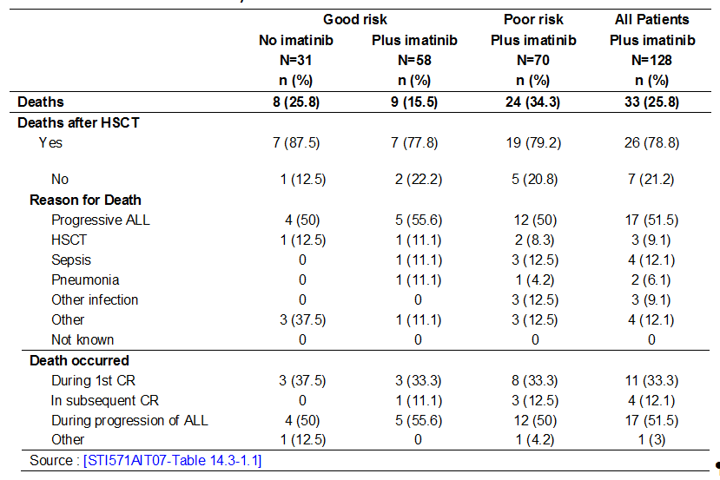

Serious adverse events
In relation to serious adverse events the frequency of these by system organ class for the pivotal study 2301 was higher for cohort 5 patients excluding HSCT at 50% and for all cohort patients who received per protocol HSCT at 33.3% and indicated in Table 34 (AdEERS: Adverse Event Expedited Reporting System).
Table 34: AdEERS by system organ class in cohort 5 excluding HSCT vs. all cohorts per protocol HSCT (Safety Set – STI571I2301)
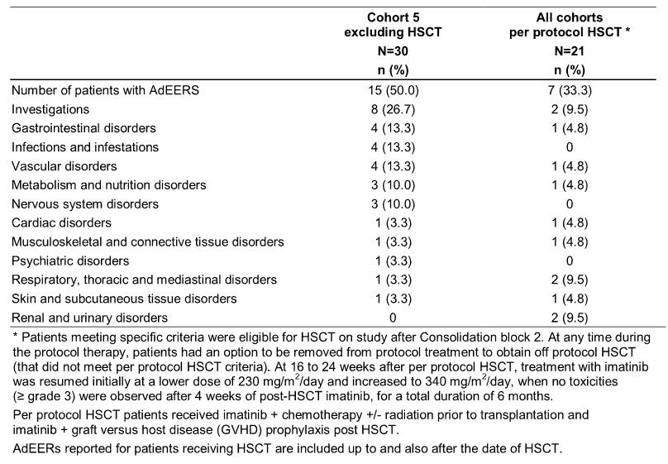
In relation to serious adverse events for study AIT07 the proportion of patients who experienced serious adverse events were similar for patients who received Imatinib at 31.3% versus 32.3% for patients not treated with Imatinib. The proportion of patients experiencing serious adverse events was lower in the good risk Imatinib group at 27.6% than in the good risk no Imatinib group at 32.3%. This latter figure was similar to that for the poor risk group at 34.3% all who had received Imatinib. This is illustrated in Table 35. Infections were the most commonly reported serious adverse events in both risk groups.
Table 35: Serious adverse events regardless of study drug relationship by system organ class and preferred term (Safety set –STI571AIT07)
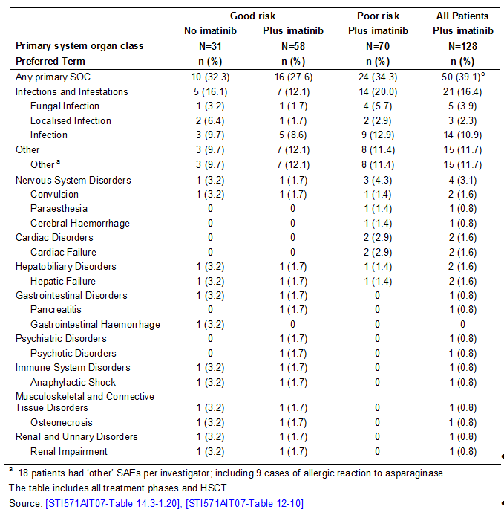

Discontinuations due to adverse events
In relation to discontinuations due to adverse events for study 2301 the percentage of discontinuations was low when Imatinib was added to the chemotherapy regimen. Four patients (4.3%) in the Ph+ group (two patients in cohorts 3 + 4 and 2 patients in cohort 5) and one patient in the Ph- group were discontinued prematurely from the study due to toxicity.
In relation to study AIT07 only one patient discontinued due to toxicity which is considered to be related to one of the chemotherapy agents i.e. Asparaginase and not causally related to Imatinib.

Clinical laboratory evaluations
In relation to clinical laboratory evaluations for the two studies only limited documentation of abnormalities was provided for the two studies.
In relation to study 2301 assessment of the neutrophil counts revealed that most Ph positive ALL patients had a drop in absolute neutrophil count to less than 750 per microlitre at some time regardless of Imatinib administration. For Consolidation 1 this was 85.7% (cohort 1), 58.3% (cohort 2), 54.5% (cohort 3), 72.7% (cohort 4) and 82% for cohort 5. Recovery time from neutropenia was similar across cohorts ranging from 3 to 35 days. These recoveries tended to be longer with more prolonged chemotherapy. There was no apparent difference in the incidence of neutropenia or time to recovery related to the incorporation of Imatinib into each treatment course.
In respect of thrombocytopenia patients with platelets less than 75,000 per microlitre at any time varied in all cohorts via treatment block being highest in Consolidation 2 and Intensifications 1 and 2 and lowest in Maintenance 5 to 12. The overall median time to recovery range was 5.5 to 17 days and was similar in cohort 5. In general there is no difference between treatment blocks.
Assessment of haematological values for study AIT07 showed decreased white blood count, haemoglobin and platelet count observed in over 90% of the patients in both groups with or without Imatinib. There were no significant differences observed across the treatment groups.

Safety in special groups and situations

Subgroup evaluation of adverse events-Study STI571I2301
Review of adverse events for study 2301 in relation to age noted there were 15 patients aged less than 4 years including 3 who were 1 to 2 years old. Analysis of adverse events for those who were less than 4 versus those that were aged higher than 4 years of age is summarised in Table 36.
Table 36: Deaths, AdEERs and other significant AEs by age group (Safety set – STI571I2301)
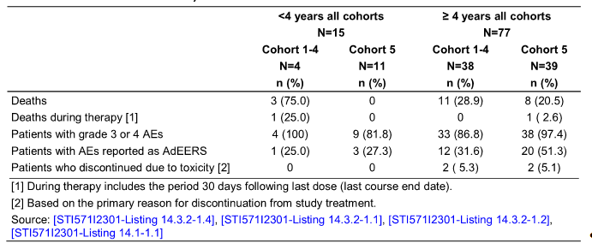
In the group of patients less than 4 years in cohort 5 involving 11 patients there were no deaths during or within 30 days of discontinuing Imatinib therapy. There were no discontinuations due to toxicity whereas in the age group greater than 4 years involving 39 patients there were 8 patient deaths (20.5%) and 2 (5.1%) who discontinued due to toxicity. The frequency of adverse events and grade 3 or 4 adverse events were similar for the younger and older age groups.
The most regular adverse events in all age groups were related to investigations followed by infections and infestations for those patients less than 12 years and gastrointestinal disorders for those 12 to 18 years. It is also noted in patients less than 12 years of age in cohort 5 the most frequent adverse events were decreased neutrophil count, decreased platelet count, decreased haemoglobin and increased ALT. No clinically relevant differences were observed concerning the frequency of adverse events in different age groups.

Subgroup evaluation of adverse events in study STI571AIT07
In relation to study AIT07 adverse events regardless of investigator causality assessment is summarised by age at diagnosis in Table 37. The overall incidence of adverse events was similar in the less than 4 years to the greater than 4 year age groups.
Table 37: Adverse events regardless of study drug relationship by preferred term and age at diagnosis (Safety set –STI571AIT07)
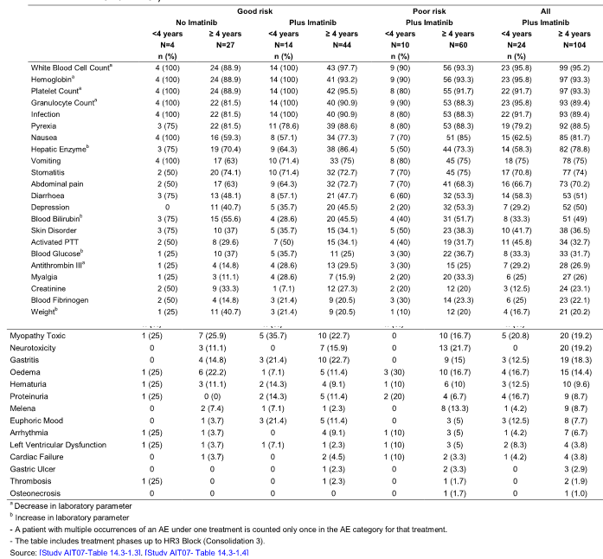

Post-marketing data
In relation to post-marketing data a worldwide literature search was performed to capture any investigator reports on safety aspects which were not included in study reports. This did not provide any evidence of unexpected or unknown events that would be attributable to treatment with Imatinib, confirming the established safety and tolerability profile of Imatinib.

Evaluator’s conclusions on safety
These two studies have essentially shown that the principal impact of adverse events relates to the intensive chemotherapy received by the patient. The addition of Imatinib resulted in a small increase in potential for selected toxicities in the pivotal study 2301 but not noted in study AIT07. Overall the safety profile of Imatinib when used in combination with chemotherapy appears to be consistent with the known safety profile of Imatinib and consistent with that previously determined for those adult patients with Ph positive ALL receiving Imatinib in conjunction with chemotherapy. There was no evidence that younger patients less than 4 years experienced a greater potential for adverse events in relation to the use of Imatinib.

First round benefit-risk assessment

First round assessment of benefits
The pivotal study 2301 certainly demonstrated evidence that the addition of Imatinib to chemotherapy following initial induction was associated with a prolongation in event free survival as the primary end point of this trial. Greater efficacy was apparent for the longer duration of administration of Imatinib as determined within cohort 5 and the estimated 48 month event free survival for this cohort was more than twice i.e. 69.6% that of historical controls i.e. 31.6% with an HR 0.28 and log rank P < 0.0001. There was also evidence of prolongation of overall survival at 48 months in relation to cohort 5 compared to historical controls i.e. 83.6% versus 44.8% with an HR of 0.23 and log rank P < 0.0001. There is also evidence of significant benefit for patients receiving the longest duration of Imatinib as in cohort 5 when compared with the shorter durations as in cohorts 1 and 2 with values being 0.0101 and also similarly for overall survival with a P value at 0.0091. It is of interest that there was a difference for overall survival in favour of cohort 5 excluding HSCT versus HSCT overall at the cohorts both off protocol HSCT and all HSCT showing that the therapeutic benefits in cohort 5 did not result from a therapeutic effect of HSCT and patients undergoing HSCT did not have better outcomes than patients receiving Imatinib in addition to chemotherapy alone in cohort 5.
These data for patients with Ph positive ALL following on earlier studies demonstrating benefit for the addition of Imatinib in Ph positive CML in the paediatric population. Nevertheless this evaluator still has concerns regarding the evidence of benefit for Imatinib in the pivotal study taking into account that the comparison is with historical controls which were conducted by the COG various years earlier and information regarding the nature and intensity of induction therapies for these studies is not provided. This raises the question as to whether the historical controls represent a comparable group to the study population.

First round assessment of risk
The safety profile of Imatinib observed in the studies 2301 and AIT07 were consistent with the known safety profile for this agent. The adverse events observed also confirmed that the Imatinib dosing regimen were therapeutically appropriate for the paediatric patient population and did not adversely impact known drug adverse event characteristics.
In study 2301 the overall incidence of preselected targeted toxicities and non-targeted adverse events were higher in the Ph positive ALL patients receiving chemotherapy plus Imatinib compared with Ph negative patients receiving chemotherapy alone. There was however an overall lower frequency of death i.e. 23.9% for patients who received Imatinib in contrast with the control group that did not receive Imatinib at 44.6%. There were no clinically relevant differences in the development of targeted toxicities and non-targeted adverse events between Ph positive and Ph negative ALL patients.
In study AIT07 the overall frequency of adverse events including those serious and non-serious were again similar between those patients receiving chemotherapy alone versus those who received chemotherapy plus Imatinib. There were no clinically relevant differences observed in the nature of adverse events across patient groups. There was a small increase in the frequency of adverse events between 5 to 10% when comparing the patients treated with Imatinib plus chemotherapy to those patients who received chemotherapy alone however the proportion of good risk patients experiencing serious adverse events was 27.6% and deaths 15.5% which was lower (in the population with Imatinib) then the population with chemotherapy alone at 32% and 25% respectively.
It is worth commenting that the four year evaluation data from the pivotal study has not shown any evidence of development of longer term adverse effects for this paediatric population. Nevertheless ongoing review of these patients remains appropriate.
It is also noted that the optimum long term duration of administration of Imatinib still remains somewhat uncertain both in terms of its potential use in induction as well as longer maintenance therapies for patients with Ph positive ALL.

First round assessment of benefit/risk balance
The efficacy results from the pivotal study 2301 has certainly shown benefit for the addition of Imatinib in improving both EFS and overall survival when compared to historical control. This was most apparent in those who received Imatinib for the longest duration of time. These favourable data are in line with that previously observed for paediatric patients with Ph positive CML and adult patients with Ph positive ALL. Nevertheless this evaluator has some reservation in relation to study 2301 in regards to the precise comparability of the historical control group to the study group.
Evaluation of adverse events from both the pivotal study 2301 and the supportive study AIT07 have shown no evidence of an increase potential for adverse events in the paediatric population receiving Imatinib compared to the known toxicity profile for Imatinib in both other paediatric populations and adult populations receiving this agent. There is if anything some evidence that both serious adverse events and deaths are perhaps reduced by the influence of Imatinib in combination with chemotherapy for this paediatric patient population.

First round recommendation regarding authorisation
On balance this evaluator considers it appropriate to approve Imatinib for the proposed new indication for the treatment of adult and paediatric patients with newly diagnosed Philadelphia chromosome positive acute lymphoblastic leukaemia integrated with chemotherapy. This recommendation is made on the basis of the efficacy results and their comparability with adult patients with Ph positive ALL with the addition of Imatinib and the paediatric population with Ph positive CML with the addition of Imatinib. Nevertheless the reservations as stated above in relation to the historical control group remain. Certainly there is no evidence from evaluation of adverse events from the two studies assessed to raise extra concerns regarding the role of Imatinib for the Ph positive ALL paediatric population.

Clinical questions
This evaluator would seek additional information regarding the nature of induction chemotherapy for the various COG studies utilized as historical controls for the pivotal trial 2301.
Further information on the longer term influence of Imatinib administration both as part of induction therapy and maintenance therapy for Ph positive ALL would be of interest.

Second round evaluation of clinical data submitted in response to questions
[Note: The sponsor’s response to the clinical questions were evaluated by the Delegate in the Overview for this application (see section on Risk-Benefit Analysis in the AusPAR for this application)]

