CER date: July 2012

AusPAR Attachment 2

Extract from the Clinical Evaluation Report for imatinib (as mesylate)
  - Proprietary Product Name: Glivec
  - Sponsor: Novartis Pharmaceuticals Australia Pty Ltd
About the Therapeutic Goods Administration (TGA)
- The Therapeutic Goods Administration (TGA) is part of the Australian Government Department of Health and Ageing, and is responsible for regulating medicines and medical devices.
- The TGA administers the Therapeutic Goods Act 1989 (the Act), applying a risk management approach designed to ensure therapeutic goods supplied in Australia meet acceptable standards of quality, safety and efficacy (performance), when necessary.
- The work of the TGA is based on applying scientific and clinical expertise to decision-making, to ensure that the benefits to consumers outweigh any risks associated with the use of medicines and medical devices.
- The TGA relies on the public, healthcare professionals and industry to report problems with medicines or medical devices. TGA investigates reports received by it to determine any necessary regulatory action.
- To report a problem with a medicine or medical device, please see the information on the TGA website <http://www.tga.gov.au>.
About the Extract from the Clinical Evaluation Report
- This document provides a more detailed evaluation of the clinical findings, extracted from the Clinical Evaluation Report (CER) prepared by the TGA. This extract does not include sections from the CER regarding product documentation or post market activities.
- The words [Information redacted], where they appear in this document, indicate that confidential information has been deleted.
- For the most recent Product Information (PI), please refer to the TGA website <http://www.tga.gov.au/hp/information-medicines-pi.htm>.
Copyright
© Commonwealth of Australia 2013
This work is copyright. You may reproduce the whole or part of this work in unaltered form for your own personal use or, if you are part of an organisation, for internal use within your organisation, but only if you or your organisation do not use the reproduction for any commercial purpose and retain this copyright notice and all disclaimer notices as part of that reproduction. Apart from rights to use as permitted by the Copyright Act 1968 or allowed by this copyright notice, all other rights are reserved and you are not allowed to reproduce the whole or any part of this work in any way (electronic or otherwise) without first being given specific written permission from the Commonwealth to do so. Requests and inquiries concerning reproduction and rights are to be sent to the TGA Copyright Officer, Therapeutic Goods Administration, PO Box 100, Woden ACT 2606 or emailed to <tga.copyright@tga.gov.au>.

Contents
List of abbreviations 5
1. Clinical rationale 9
2. Contents of the clinical dossier 10
2.1. Scope of the clinical dossier 10
2.2. Paediatric data 10
2.3. Good clinical practice 10
3. Pharmacokinetics 11
3.1. Studies providing pharmacokinetic data 11
3.2. Summary of pharmacokinetics 11
3.3. Evaluator’s overall conclusions on pharmacokinetics 13
4. Pharmacodynamics 14
5. Dosage selection for the pivotal studies 14
6. Clinical efficacy 14
6.1. Pivotal efficacy study: Study CST1571-K2301 14
6.2. Other efficacy studies 29
6.3. Analyses performed across trials 29
6.4. Evaluator’s conclusions on clinical efficacy 30
7. Clinical safety 31
7.1. Studies providing evaluable safety data 31
7.2. Pivotal studies that assessed safety as a primary outcome 33
7.3. Patient exposure in the pivotal trial 33
7.4. Adverse events 34
7.5. Laboratory tests 43
7.6. Post-marketing experience 46
7.7. Safety issues with the potential for major regulatory impact 47
7.8. Other safety issues 47
7.9. Evaluator’s overall conclusions on clinical safety 48
8. First round benefit-risk assessment 49
8.1. First round assessment of benefits 49
8.2. First round assessment of risks 50
8.3. First round assessment of benefit-risk balance 50
9. First round recommendation regarding authorisation 51
10. Clinical questions 51
10.1. Pharmacokinetics 51
10.2. Pharmacodynamics 51
10.3. Efficacy 51
10.4. Safety 51
11. Second round evaluation of clinical data submitted in response to questions 51
12. Second round benefit-risk assessment 52
13. Second round recommendation regarding authorisation 52
14. References 52

List of abbreviations
Abbreviation | Meaning
ABL1 | V-abl Abelson murine leukemia viral oncogene homolog
ABL2 | Abelson-related gene protein
AE(s) | adverse event(s)
AIO | Sarcoma Group of the Arbeitsgemeinschaft Internistische Onkologie
ALL | acute lymphatic leukemia
ALT | alanine aminotransferase/glutamic pyruvic transaminase/ GPT/SGPT
ANC | absolute neutrophil count
ARGUS | Novartis safety database
AST | aspartate aminotransferase/glutamic pyruvic transaminase/ GOT/SGOT
ATC | Anatomical Therapeutic Chemical
AUC | area under the concentration-time curve
AUC(0-inf) | area under the concentration-time curve from time zero to infinity
AUC(0-24h) | area under the concentration-time curve from time zero to 24h, the last sampling time point
BMI | body mass index
CI | confidence interval
CL/F | total body oral clearance of drug from the plasma
CLr | renal clearance of drug or metabolite
Cmax | maximum (peak) observed plasma drug concentration after dose administration
Cmin | trough (24h) plasma drug concentration
CML | chronic myeloid leukemia
CML-CP | chronic myeloid leukemia – chronic phase
CR | complete response
CRF | case report form
CRO | contract research organization
CSF-1R | colony stimulating factor 1 receptor/macrophage colony-stimulating factor receptor
CS&E | Novartis Clinical Safety and Epidemiology
CT | computerized tomography
CTC | Common Toxicology Criteria
CYP450 | cytochrome P450
DDR1, DDR2 | discoidin domain receptors 1 and 2
ECG | electrocardiogram
ECOG | Eastern Cooperative Oncology Group
FAS | Full Analysis Set
Fren | fraction of dose excreted in the urine
GI | gastrointestinal
GIST | gastrointestinal stromal tumors
G-CSF | granulocyte colony stimulating factor
GM-CSF | granulocyte macrophage colony stimulating factor
HIV | human immunodeficiency virus
HPF | high power field
HR | hazard ratio
IEC | Independent Ethics Committee
IRB | Institutional Review Board
ITT | intent-to-treat
KIT/KIT | stem cell factor receptor tyrosine kinase gene/gene protein product
LC/MS/MS | liquid chromatography/tandem mass spectrometry
LDH | lactate dehydrogenase
LLOQ | lower limit of quantification
LVEF | left ventricular ejection fraction
MedDRA | Medical Dictionary for Regulatory Activities
MDR | multi-drug resistance
MRI | magnetic resonance imaging
ms | millisecond
NCI/NIH | National Cancer Institute at the National Institutes of Health
OS | overall survival
PDGFR | platelet-derived growth factor receptor
PD | progression of disease
PFS | progression-free survival
PFS-Met | progression-free survival-metastatic
po | per os (oral)
Ph+ | Philadelphia chromosome positive
PK | pharmacokinetics
PR | partial response
PS | performance status
QC | quality control
RAP | reporting and analysis plan
RECIST | Response Evaluation Criteria In Solid Tumors
RFS | recurrence-free survival
SAE | serious adverse event
SCF | stem cell factor
SD | stable disease SD standard deviation
SI Units | International System of Units
SOC | system organ class
SmPC | Summary of Product Characteristics
SSG | Scandinavian Sarcoma Group
SULT | sulfotransferase
TK | tyrosine kinase
Tmax | time to reach the maximum (peak) plasma drug concentration after dose administration
t1/2 | elimination half-time associated with the terminal slope (λz) of a semi-logarithmic concentration-time curve
TMA | tumor tissue microarray
TTP | time to progression
TTP-Met | time to progression-metastatic
UGT | UDP-glucuronosyltransferase
ULN | upper limit of normal
Vz/F | the apparent volume of distribution during terminal phase (associated with λz)
WBC | white blood cell
WHO | World Health Organisation

Clinical rationale
Gastrointestinal stromal tumors (GISTs) are the most common mesenchymal tumors of the gastrointestinal (GI) tract and are thought to originate from the interstitial cells of Cajal. GISTs are malignant tumors most commonly resulting from activating mutations in the receptor tyrosine kinase KIT (CD117) or the platelet-derived growth factor receptors α (PDGFRα).
Imatinib was approved in a number of countries for the treatment of adult patients with KIT(CD117)+ unresectable and/or metastatic GIST, prolonging overall and the progression-free survival and increasing the 5-year survival rate. Subsequent studies showed that imitinab significantly prolonged recurrence-free survival (RFS) when used after apparent complete resection of GISTs at a dose of 400 mg/day for 12 months. The results of the analysis of RFS according to time period indicated that the greatest effect of imatinib was seen while on treatment, up to one year following randomisation. The difference between the groups decreased after study drug was stopped, suggesting that treatment with imatinib should be continued beyond one year. To investigate this hypothesis, a Phase III trial was conducted, comparing the efficacy and safety of 3 years of adjuvant treatment to 1 year’s treatment.
Concerns about acetaminophen interaction with imatinib: With an overdose of acetaminophen, the sulfation pathway becomes saturated and an increased amount of the drug is oxidized by cytochrome P450-2E1 (CYP2E1) to a highly reactive and hepatotoxic metabolite, N-acetyl-p-benzoquinone imine (NAPQI) (Figure 1). Small amounts of this imine are detoxified by conjugation with glutathione and further metabolised to acetaminophen mercapturate and cysteinate. Increased production of NAPQI leads to glutathione depletion and eventually to hepatocyte necrosis. Metabolism can shift from one to another pathway after, for example, saturation of sulfation by an acetaminophen overdose or by inhibition of a particular pathway by co-medications.
Figure 1: Metabolism of acetaminophen.
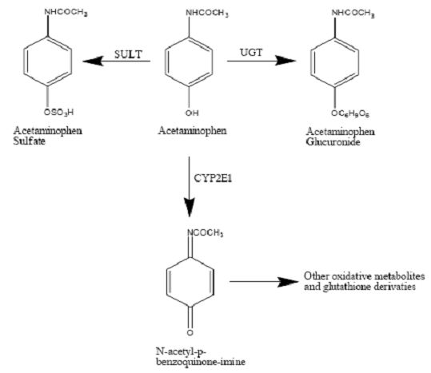
Studies conducted in vitro using pooled human microsomes showed that imatinib is a potent inhibitor of acetaminophen-O-glucuronidation but has no effect on the formation of the intermediate hepatoxic metabolite, NAPQI (Figure 1). However, because the glucuronidation pathway represents ~60% of acetaminophen metabolism, the inhibition of acetaminophen glucuronidation by imatinib may result in shunting acetaminophen metabolism to other pathways and more NAPQI may be formed in the body as a consequence of this inhibition. Therefore, the Food and Drug Administration requested the sponsor to conduct a drug-drug interaction study in cancer patients to examine the effect of imatinib on the pharmacokinetics of acetaminophen in order to properly adjust acetaminophen dose when it is concomitantly administered with imatinib.
Comment: The clinical rationale given is acceptable.

Contents of the clinical dossier

Scope of the clinical dossier
The clinical dossier was confined to a pharmacological study of imitanib and paracetamol (Study CST1571-A2107), a comparative Phase III trial of two different durations of treatment (12 months compared with 36 months) of adjuvant treatment of GIST with Glivec (CST1571-BFI03), and various data supporting changes to the PI, many of which are safety-related.
The submission contained the following clinical information:
- A clinical pharmacology study (CST1571-A2107) provided pharmacokinetic data on the effects of Glivec on the pharmacokinetics of paracetamol in patients with newly diagnosed, previously untreated chronic myeloid leukemia in chronic phase (CML-CP)
- Population pharmacokinetic analyses were not part of the submission.
- The pivotal efficacy/safety study (CST1571-BFI03) primarily compared recurrence-free survival (RFS) in GIST patients who were assessed as being at a high (> 50%) risk of disease recurrence within the first 5 years following surgery, treated with adjuvant imatinib mesylate for either 12 or 36 months
- No dose-finding studies were included in the submission.
- The previous study CST1571-BUS89 of the adjuvant treatment of GIST with Glivec for 12 months was supplied for reference only as it had been evaluated previously.
- A Phase III study, CST1571-K2301, was submitted to support the inclusion of information on hypophosphatemia in the PI. The randomised open-label study of 400 mg versus 800 mg of Glivec (imatinib mesylate) was conducted in patients with newly diagnosed, previously untreated chronic myeloid leukemia in chronic phase (CML-CP).
- An epidemiology report evaluating the frequency of second primary malignancies in Glivec treated patients in Novartis sponsored clinical trials.

Paediatric data
The submission included proposed changes to parts of the paediatric information in the PI with supporting arguments. No new studies in children were presented.

Good clinical practice
All studies and any amendments were reviewed by the Independent Ethics Committee or Institutional Review Board for each centre. The studies were conducted according to the ethical principles of the Declaration of Helsinki. Informed consent was obtained from each patient in writing during the screening visit and prior to his or her enrollment in the studies. The studies were described to the patients by the investigator, who answered any questions; patients were also provided with written information. Samples of the written information and the consent form were provided in the application.

Pharmacokinetics

Studies providing pharmacokinetic data
There was one pharmacokinetic study CST1571-A2107 presented on the interaction of imatinib and paracetamol. This had no deficiencies that excluded the results from consideration, but the conclusions of the evaluator differed from those of the sponsor.

Summary of pharmacokinetics
The pharmacokinetics of Glivec are presented in the current Product Information.
In this section, only data from the one PK study submitted on the interaction of imatinib and paracetamol are presented.

Pharmacokinetic interactions demonstrated in human studies
A summary of the data from the PK study of possible acetaminophen/paracetamol and imatinib interaction is shown in Tables 1-3 and Figures 2-3.
Table 1: Results for acetaminophen and its glucuronide.
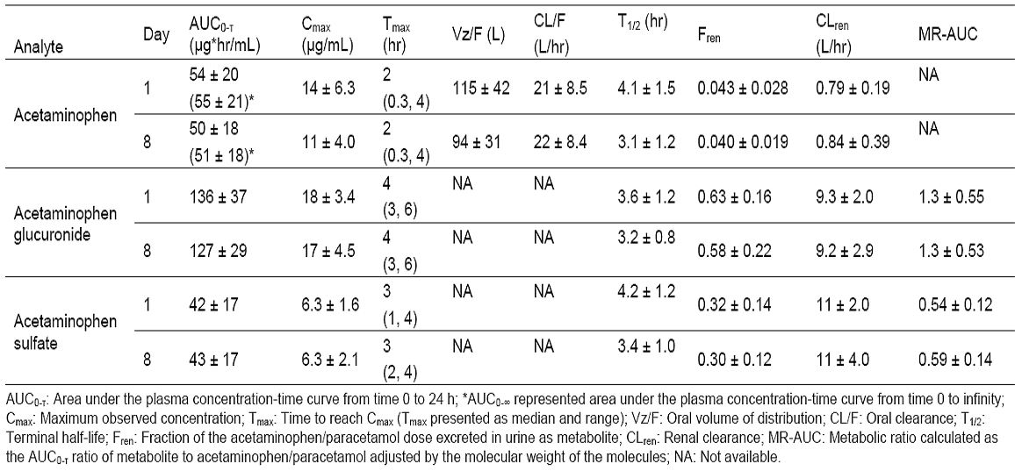
Table 2: Statistical analysis of PK results.
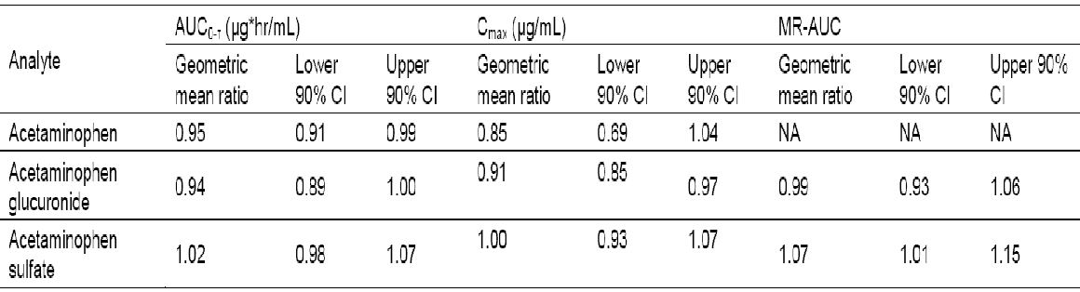
Figure 2: Arithmetic mean (SD) concentration-time profiles for plasma acetaminophen: 0-24 hours post-dose (linear view) (pharmacokinetic set).
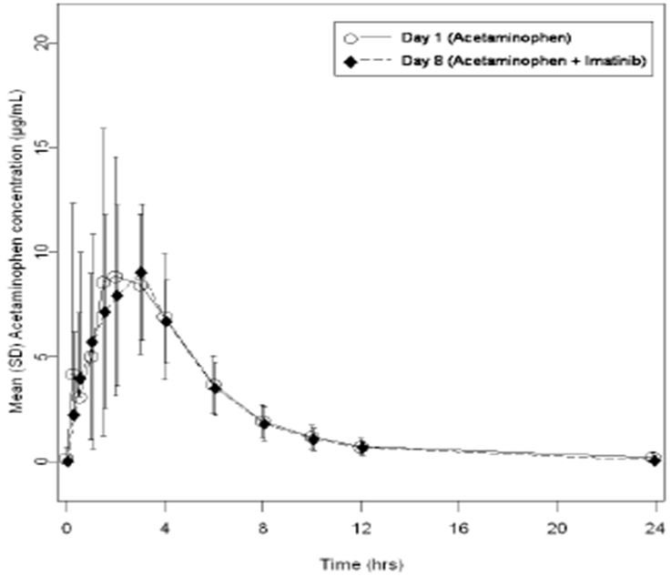
Figure 3: Mean acetaminophen/paracetamol glucuronide (AG) and acetaminophen/ paracetamol sulfate (AS) plasma concentration-time profiles on Day 1 (control; -SD) and Day 8 (treatment with imatinib; +SD) in CML patients (n =12).
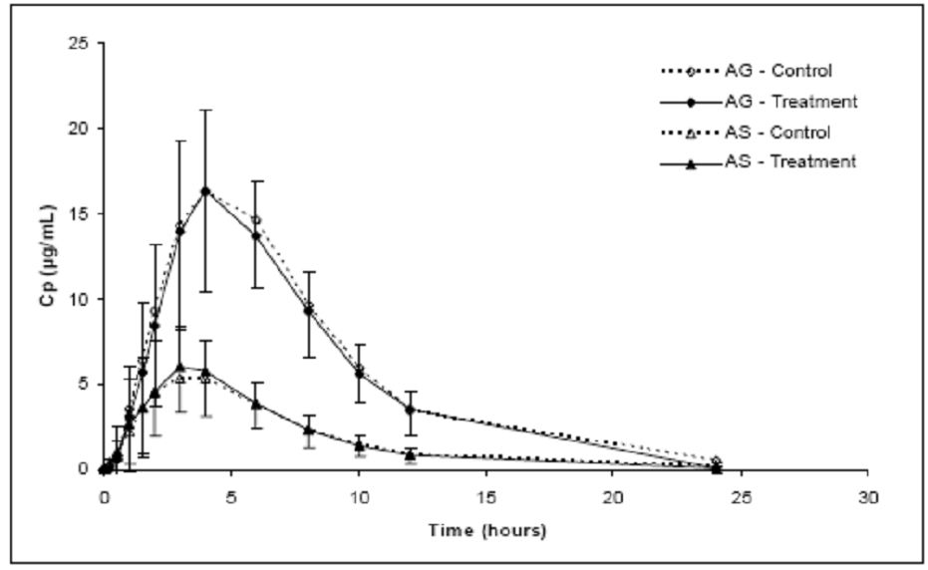
Table 3: Pharmacokinetic parameters (mean ± SD) of imatinib and its metabolite obtained for the 400 mg qd dose on Day 8 in CML patients (n=12).
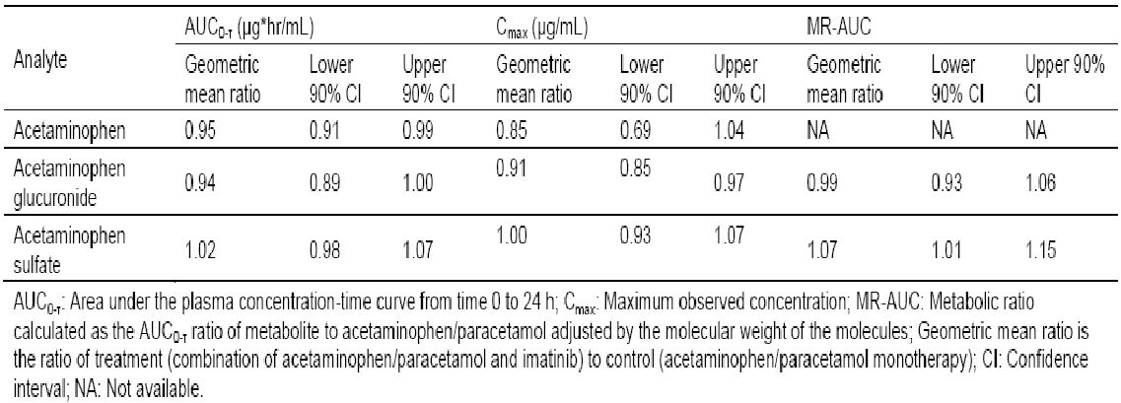

Clinical implications of in vitro findings
As described in the Clinical rationale, the in vitro demonstration that imatinib inhibited glucuronide formation from acetaminophen raised concerns that more of the hepatotoxic metabolite of acetaminophen (NAPQ1) may be formed when imatinib was coadministered. This issue has been addressed by performing the submitted PK study, as requested by the FDA.

Evaluator’s overall conclusions on pharmacokinetics
From the PK study of a single dose of acetaminophen/paracetamol coadministered with multiple doses of imatinib at steady-state, a similar ratio of plasma and urinary acetaminophen glucuronide to acetaminophen was observed in the absence and presence of imatinib, and a similar ratio of plasma urinary acetaminophen sulfate to acetaminophen was also observed in the absence and presence of imatinib. The evaluator concludes that imatinib (400 mg qd) did not significantly affect the pathways of metabolism of acetaminophen to its sulfate and glucuronide in the Korean patients studied. The method used was an acceptable surrogate for measuring the hepatotoxic metabolite NAPQ1 itself, which cannot be measured in vivo in humans. From these data, we can conclude that imatinib did not cause significant inhibition of glucuronidation and diversion of acetaminophen towards the toxic metabolite in the population studied.
However a number of problems with the study are of concern as follows.
- Ethnicity of the subjects: In the Evaluator’s Comments, it is pointed out that significant differences have been reported in the PKs of acetaminophen in some Asian populations compared to some Caucasian populations. These clear differences show that acetaminophen is metabolised at different rates in different ethnic groups. Although a difference has not been shown between Korean subjects and Australian Caucasians, the values for the PK parameters in this application for Koreans differ significantly from those of Australian Caucasians, as shown in the Comments referred to. Therefore, the results in the present study cannot be extrapolated to an Australian Caucasian population. This will be the main factor in my recommendation to reject the request to change the reference in the PI about this matter.
- Plasma concentration (Cmax) of acetaminophen: The Cmax value for the plasma concentrations of acetaminophen with and without imatinib did not show equivalence. The ratio of results for the Cmax of acetaminophen in the presence of imatinib to the Cmax in its absence had a 95% CI of 0.69-1.04. This was outside the required equivalence range of 0.8 to 1.25. Measurements showed a high between-patient variability, with CVs ranging from 34.4% to 43.4% for Cmax acetaminophen, and similar CV values for AUC parameters. This variability may account for the lack of equivalence. From a safety perspective, a lower value of Cmax of acetaminophen with coadministration of imatinib is not a safety concern, unless the plasma level was low because of accelerated metabolism of acetaminophen in the presence of imatinib. However other results excluded this possibility. Although none of the 12 patients showed evidence of abnormal hepatic function or renal function during the coadministration of the two drugs, the numbers in the study (n=12) were too low to detect relatively rare events such as acute renal failure and hepatic necrosis, even if the coadministration increased their frequency significantly.
- Co-medications in real life: Cytochromes metabolise acetaminophen and are inhibited by imatinib. They also have a role in producing the hepatotoxic metabolite of acetaminophen, NAPQ1. The study correctly prohibited those drugs that inhibited, were substrates for, or were inducers of cytochromes (except for allopurinol). While this was possible in a supervised study of this type, in medical practice, this would be unlikely, especially in diseases for which imatinib is used, often with acetaminophen. When other drugs that affect cytochromes are introduced, the effect on the metabolism of acetamophen would be unpredictable, and possibly result in the production of greater amounts of NAPQ1.
Conclusion: From a consideration of the above three problems, I find the request to delete the statement “Glivec inhibits paracetamol O-glucuronidation in vitro (Ki value of 58.5 micromol/L) and may inhibit paracetamol metabolism at therapeutic levels (see ‘PRECAUTIONS’)” from the PI cannot be supported. Reference to ethnic differences in the metabolism of acetaminophen could be considered as an addition.

Pharmacodynamics
No new pharmacodynamic data were presented in this application.

Dosage selection for the pivotal studies
As imatinib at a dose of 400 mg/day is already approved for the adjuvant treatment of adult patients following resection of GIST, this dose was chosen for the present study. Study treatment was to be stopped after 12 or 36 months. However, the patients who were rendered free from overt metastases by surgery were an exception and were allowed to continue adjuvant imatinib treatment beyond 12/36 months. The proportion of patients continuing imatinib treatment beyond 12/36 months was tabulated. The median duration and range (Min, Max) of the use of out-of-study adjuvant imatinib was recorded. Out-of-study adjuvant imatinib use was not included in duration of exposure of study drug.
Treatment of patients with recurrence of GIST during the study period was not specified, but in most cases was with further imatinib therapy, as this has been shown in other studies to be effective in a percentage of patients. Other treatments included other systemic therapy as first or second or third line treatment, imatinib as second or third line treatment, surgery for GIST recurrence, and radiotherapy for GIST recurrence.

Clinical efficacy

Pivotal efficacy study: Study CST1571-K2301
Short (12 months) versus long (36 months) duration of adjuvant treatment with the tyrosine kinase inhibitor imatinib mesylate of operable GIST with a high risk of recurrence: A randomised Phase III study.

Study design, objectives, locations and dates
Study Design: The study was a Phase III multicentre, open-label, randomised study to assess the efficacy and safety of imatinib therapy over 12 or 36 months in adult patients with operable KIT+ GIST who had all tumor tissue removed macroscopically at surgery, and who were estimated to be at high risk of disease recurrence (> 50% risk of recurrence within the first 5 years following the surgery). Once all macroscopic GIST had been surgically removed, patients were considered to be at high risk of GIST recurrence if one or more of the following criteria were met:
- tumour diameter >5.0 cm and mitotic count >5/50 high power fields (HPFs)
- tumour diameter >10.0 cm with any mitotic count
Comment: This criterion was in the original protocol (2003). Subsequent studies showed that if these large tumours had ≤5 mitotic figures/HPF, their risk of recurrence was intermediate and not high. The protocol was amended in May 2007 to increase the sample size, because it was anticipated that there would be fewer events (recurrence) than predicted because of this finding. However, their inclusion continued. In total, 78 patients of 199 (39.2%) in the 12 month arm had tumours >10 cm, and 98 of 198 (49.5%) in the 36 month arm but the numbers with ≤5 mitotic figures/HPF (not at high-risk) was not stated. The number of patients in total that were not high risk in the 12 month and 36 month arms were 41 (20.6%) and 32 (16.2%) respectively, based on the risk classification scheme used.
- tumours of any size, where the mitotic count is >10/50 HPFs
- tumour spillage into the abdominal cavity at surgery (tumour rupture could have occurred either before surgery or taken place during surgery)
Patients who had operable intra-abdominal GIST metastases and who had complete removal of macroscopic tumour at surgery were allowed to enter the study until October 2006, when the study protocol was amended to exclude them. Patients at baseline who had metastases removed at surgery were considered as having high risk of recurrence.
Patients were enrolled between 4 February 2004 and 29 September 2008 at 24 study centres in 4 countries. Patients were randomised (1:1) to receive imatinib 400 mg/day, to be started within 12 weeks of surgery, for either 12 months (n=199) or 36 months (n=198). Randomisation was performed centrally based on computer generated random numbers at the randomisation centre located at the Swedish Sacrcoma Group (SSG) secretariat. At randomisation, the patients were stratified as follows:
- local disease (1 tumour);
- intra-abdominal disease (intra-abdominal tumour spillage or microscopic disease left behind at surgical resection of GIST).
All patients were treated with imatinib 400 mg once daily. Patients had histological documentation of GIST that was resectable and removed at open surgery as well as immunohistochemical documentation of KIT/CD117 expression.
Comment: 1. Was the Patient Population at High Risk or not? : The intention of the study in the first protocol was to study patients at high risk of recurrence after surgical resection of their tumours. The design was confounded because all tumours >10 cm were originally considered to be at high risk of recurrence irrespective of mitotic figure count. However later studies showed that those with ≤5 mitotic figures/HPF were of intermediate, not high risk. Such patients who were already enrolled continued in the trial, which would not be a protocol violation. However other patients were included who were also not at high risk, and constituted the most frequent violation of the inclusion criteria. The final patient population, as stated above, included 20.6% of patients in the 12-month arm and 16.2% in the 36-month arm who were not at high risk. The patient population was therefore a mixture of high and not high risk, and so has consequences for the patient populations analysed. The presently approved indication for adjuvant treatment with Glivec in both Australia and the USA does not specify the risk category of the patient population to be treated. The population in the pivotal study in the present application is therefore different, as it excludes some patients not at high risk of recurrence. As there was an equal distribution in each arm of patients at high risk of recurrence, and those not at high risk as defined in the Inclusion Criteria (see below), no bias was introduced in the analysis of the trial results.
2. Definition of “High Risk”: The classification of risk chosen for the present study was a modified Fletcher classification, summarised in the Study Design above.
The classification of risk of recurrence for GIST tumours has changed with time as more information became available. The risk has been measured in different ways and has been extensively reviewed - the most concise and helpful being that of Joensuu (1). The modified Fletcher classification referred to above is based on a tumour’s size and mitotic index. The modification referred to appears to be the inclusion of patients with tumour spillage at surgery, and those who have microscopic tumour infiltration of the excision margins (added after the Amendment of October 2006) as being of high risk.
Since the Fletcher publication in 2002 (2), other classifications have included the site of the tumour as a risk factor, because GISTs arising in the small intestine have been confirmed as having a higher risk of recurrence than those arising in the stomach (Joensuu 1). A second classification was therefore used in the present study for comparison, that of Miettinen (3), which included as risk factor the tumour origin in addition to size and mitotic index.
Based on these two classifications, patients were assigned to one of two groups: “high-risk” or “non-high risk”. The two classifications also define “intermediate”, “low”, and “very low” risk groups, and in the study analysis the efficacy results for the intermediate risk groups were compared with those of the high risk groups in an exploratory analysis.
In the approved (and unchanged) indication, risk classification criteria were not used to define the patient population, so patients at all levels of risk are treated at present. The difference in these patient populations may have affected the wording to be used in the Product Information, but the efficacy results to be discussed later showed that efficacy was not significantly different in the ITT (total population), the high risk and the non-risk populations.
Objectives: The primary objective was to compare the relapse free survival (RFS) in GIST patients with a high (>50%) risk of disease recurrence within the first 5 years following surgery and treated with adjuvant imatinib for either 12 or 36 months.
The secondary objective was to compare the feasibility of adjuvant imatinib therapy, overall survival (OS), and GIST-specific survival in GIST patients estimated to have a high risk of disease recurrence and treated with adjuvant imatinib either for 12 or 36 months following radical surgery.
Protocol Amendments: The original protocol was finalised in 2003. Amendments were included in different protocol versions and 3 amendments. Many of the changes relate to alterations in the planned sample size. Initially the sample size was 80 patients, but this number was amended in October 2004, October 2006, May 2007, and February 2008 to arrive at the final figure of 400 patients.
Duration of follow-up: All patients were followed up until the date of the final analysis and for a time period of ~5 years following the final analysis. A final analysis was to be carried out when all randomised patients completed their first visit following 1 year of adjuvant treatment and at least 110 events had been recorded in the Efficacy population. Clinical follow-up visits were performed at the same time intervals in both treatment arms: every 3 months for the first three years, every 6 months up to 7 years following study entry and then every year for a minimum 10 years following study entry. Treatment after disease recurrence was at the discretion of the investigator, but data on treatment type, duration and response to treatment were to be captured on the case report forms (CRF).

Inclusion and exclusion criteria
The main inclusion criteria were that patients’ tumours were to be histologically diagnosed as GISTs, and were to be resectable at open surgery. Expert pathology was required to define those properties of the tumour that put the patient at high risk of recurrence. The inclusion and exclusion criteria are:

Inclusion criteria:
- Patients > 18 years of age.
- Histologically documented diagnosis of GIST, which was resectable.
- GIST removed at open surgery (laparoscopic and endoscopic surgery as the sole surgical procedures were not accepted).
- Immunohistochemical documentation of KIT (immunostaining for KIT/CD117) must have been positive on a tumour sample taken within 12 weeks of the study entry. Mutation analysis of the KIT gene was not required for study entry.
- High risk of tumour recurrence was defined as one or more of the following:
  - the largest tumour diameter greater than 10.0 cm (with any mitotic count). The tumour size needed to be 10.0 cm or greater in the resected tissue specimen when measured by a pathologist. (Please note that this inclusion criterion (No. 5, bullet 1) is contradictory in the protocol regarding whether a tumour diameter of exactly 10.0 cm would constitute a criterion of high risk, regardless of other criteria).
  - mitotic count > 10 mitoses per 50 high power fields (HPFs) (of any tumour size) the largest tumour diameter > 5.0 cm (measured by a pathologist) and the mitotic count > 5/50 HPFs tumour spillage into the abdominal cavity at surgery (tumour rupture could have occurred either before surgery or taken place during surgery)
  - patients who had microscopically infiltrated margins (or suspected microscopical infiltration, R1) were allowed to enter the study.
- Performance status 0, 1 or 2 (Eastern Cooperative Oncology Group; ECOG)
- Adequate end organ function, defined as the following: total bilirubin < 1.5 × ULN (upper limit of normal), serum aspartate aminotransferase (AST/SGOT) and alanine aminotransferase (ALT/SGPT) < 2.5 × UNL, creatinine < 1.5 × ULN, absolute neutrophil count (ANC) > 1.5 × 109/L, platelets > 100 × 109/L.
- Female patients of childbearing potential must have had a negative pregnancy test within 7 days before initiation of study drug dosing. Postmenopausal women had to be amenorrheic for at least 12 months to be considered of non-childbearing potential. Male and female patients of reproductive potential agreed to employ an effective barrier method of birth control throughout the study and for up to 3 months following discontinuation of study drug.
- Written, voluntary informed consent.

Exclusion criteria:
- Inoperable GIST.
- Metastatic disease (within or outside the abdomen).
- Less than 1 week or more than 12 weeks had elapsed from surgery. This time interval is counted from the date of the definite surgery aimed for cure, and cases where diagnostic or emergency surgery was carried out > 12 weeks prior to the study entry were allowed to be entered.
- Recurrent GIST.
- Patient has received any investigational agents within 28 days as calculated from the first day of the study drug dosing.
- Patient was less than 5 years free of another primary malignancy, except: if the other primary malignancy was not currently clinically significant or requiring active intervention, or if the other primary malignancy was a basal cell skin cancer or a cervical carcinoma in situ. Existence of any other malignant disease was not allowed.
- Patients with grade III/IV cardiac problems as defined by the New York Heart Association Criteria (i.e., congestive heart failure, myocardial infarction within 6 months of study).
- Female patients who were pregnant or breast-feeding.
- Patient had a severe and/or uncontrolled medical disease (i.e., uncontrolled diabetes, severe chronic renal disease, or active uncontrolled infection). The concurrent use of warfarin or acetaminophen was not allowed with imatinib, and needed to be replaced by other medications (e.g. by low molecular weight heparins in case of warfarin).
- Patient had known chronic liver disease (i.e., chronic active hepatitis and cirrhosis).
- Patient had a known diagnosis of human immunodeficiency virus (HIV) infection.
- Patient had received chemotherapy for GIST.
- Patient had received neoadjuvant imatinib therapy prior to randomization.
- Patient had received radiotherapy to > 25% of the bone marrow.
- Patient with any significant history of non-compliance to medical regimens or with inability to grant reliable informed consent.
Comment: The study began on 4 February 2004. At this time patients with resected metastatic disease were eligible and were enrolled. The trial was amended on 11 October 2006 to exclude such patients, but those already entered were allowed to continue.

Study treatments
Treatment with imatinib: All patients were treated with imatinib 400 mg once daily and were randomly assigned to treatment for either 12 months or 36 months. Dose adjustments were made for non-hematological and hematological toxicity.
Concomitant medication: In general, concomitant medications and therapies deemed necessary for the supportive care and safety of the patient were allowed provided their use was documented in the patient records. The administration of any other anticancer agents including chemotherapy and biologic agents was not permitted. Similarly, the use of other concurrent investigational drugs was not allowed. Post-operative radiation therapy should not have been given or re-excision done in case of suspicion of microscopic residual disease (R1 surgery). Because of the inherent risk of either reduced activity or enhanced toxicity of the concomitant medication and/or imatinib, drugs known to interact with the same cytochrome P450 (CYP450) isoenzymes (2D6 and 3A4) as imatinib were to be used with caution. Patients using concomitant medications known to be metabolized by these CYP450 enzymes were not excluded from the study. However, the patients must have been carefully monitored for any toxicity due to individual concomitant medication. Consideration should have been given to using alternative agents with less potential for interaction with imatinib.
Special care had to be given to the concomitant use of acetaminophen (paracetamol) (e.g. Panadol) with imatinib. Since warfarin is metabolized through the CYP450 system, no therapeutic anticoagulation with warfarin (e.g. Coumadin,) was permitted in patients participating in this study. As an alternative, therapeutic anticoagulation was accomplished using low molecular weight heparin (e.g. Fragmin) or heparin. In general, the use of Coumadin was discouraged in this study. The routine use of systemic corticosteroid therapy was not permitted. Corticosteroid therapy may only have been administered after consultation with the principal investigator. Prophylactic anti-emetics should have been withheld until the patient had experienced grade 1 nausea or vomiting. Use of erythropoietin or darbepoietin was allowed at the discretion of the treating physician to treat anemia (B-hemoglobin < 11 g/L). The use of granulocyte growth factors (granulocyte colony stimulating factor, G-CSF, or granulocyte macrophage colony stimulating factor GMCSF) was not allowed to support the granulocyte counts.

Efficacy variables and outcomes
The primary efficacy endpoint was RFS. Time to event was calculated from date of randomisation to the earliest date of recurrence or death from any cause. The recurrence date was defined as the date when the physician first suspected recurrence in the sequence of events that lead to the diagnosis of recurred GIST.
Key supportive and other sensitivity analyses of RFS: To assess the robustness of the analyses performed on the RFS endpoint, key supportive and sensitivity analyses were conducted with a variety of statistical methods, endpoint definitions and populations.
Exploratory analyses of RFS included estimation of HR within specific time periods, and several subgroup analyses (including recurrence risk according to modified Fletcher and Miettinen risk classification systems, demographic factors, and various disease characteristics).
Secondary efficacy endpoints were OS (measured from the date of randomization to the date of death resulting from any cause) and GIST-specific survival (measured from the date of randomization to the date of death considered to be caused by GIST).
Definition of RFS: Time to recurrence was calculated from date of randomization to the earliest date of recurrence or death from any cause. The recurrence date was defined as the date when the physician first suspected GIST recurrence in a sequence of events that lead to the diagnosis of recurred GIST. This date was documented on the CRF by the investigator and was used as such in the analysis after 100% source data verification. Following an intention-to-treat approach, centrally-reviewed non-GIST patients, as well as patients with metastases at baseline removed at surgery, were considered as having a recurrence at the recurrence date entered on the CRFs. Later cancer diseases (other than GIST) before recurrence or death were not considered as RFS events. All initial calculations were performed using time measured as days. For data presentation purposes, time was shown as years and/or months in the tables and figures. For this purpose, the following conversions were done:
- Time (years) = time (days) / 365.25
- Time (months) = time (years) x 12

Randomisation and blinding methods
Each patient was assigned a unique patient number, which was identical to the randomisation number. Once assigned, numbers for any non-evaluable or discontinued patients were not reused. Randomisation was performed centrally based on computer generated random numbers at the randomisation centre located at the SSG secretariat. At randomisation, the patients were stratified into 2 strata by type of disease:
- local disease (single tumour);
- intra-abdominal disease (intra-abdominal tumour spillage or microscopic disease left behind at surgery; R1 resection).
Patients who met the inclusion criteria for study treatment were registered and given a randomisation number at the SSG secretariat. Data collected on CRF during the trial were identified by the randomisation numbers.

Analysis populations
The main analysis populations were the Intention-to-Treat (ITT), the Efficacy and the Safety populations. As well, the following analyses of sub-populations were derived from the ITT and/or efficacy analysis populations for supportive or exploratory analyses purposes.
Modified Fletcher high risk population: All patients who were at high risk for disease recurrence according to modified Fletcher risk classification system using central pathology review data.
Modified Miettinen high risk population: All patients who were at high risk for disease recurrence according to modified Miettinen risk classification system using central pathology review data.
One year completer population: All patients who were event-free and on imatinib treatment at the month 12 visit (i.e. during the period when both treatment groups received identical treatment).
Comment: The study design, good statistical practice, and regulatory guidelines require the primary analysis to be done on the ITT population. This was done in this study, although the population so analysed was not that originally intended, that is a high risk population, The analysis of that population was done as a supportive analysis. As will be seen later, the results of the analysis of the ITT and the high risk populations were very similar.

Sample size
The sample size calculation was based on the analysis of the primary objective, i.e. comparison of the RFS from time of randomisation in patients with adjuvant imatinib either for 12 or 36 months. The patients were allocated to the treatment groups using an even allocation (1:1).
The sample size was re-estimated assuming the following event (GIST recurrence or death) rates:
- In the 12 months group, the yearly event rate was to be 7% for 18 months, 16% between 18 and 24 months, and 25% after 24 months
- In the 36 months group, the yearly event rate was to be 7% until 42 months, 16% between 42 and 48 months, and 25% after 48 months
The sample size was calculated by simulating log-rank tests using the above assumptions. A power of at least 80% was achieved with 160 patients per group. Under these assumptions, the overall HR was expected to be about 0.44 in favour of 36 months treatment group. At least 110 events were required for the final analysis to achieve a power of at least 80% with 160 patients. Assuming a drop-out rate of 20%, altogether 400 patients were randomised (200 patients per treatment group). A two-sided significance level of 0.05 was used.
The final analysis comparing the treatment groups was performed after all randomized patients had completed the visit that took place after one year of adjuvant therapy (study month 15 visit) and at least 110 events had been recorded. To prepare for the time of the final analysis, the number of events was monitored closely by the study statistician after all patients had been treated for 1 year.
Comment: The sample size was changed several times because of protocol amendments, the final figure being that stated above.

Statistical methods

Statistical hypothesis, model, and method of analysis
The primary objective of the study was to compare RFS in GIST patients with a high (> 50%) risk of disease recurrence within the first 5 years following the diagnosis and treated with adjuvant imatinib mesylate either for 12 or 36 months. The 36-month arm was hypothesised to be superior compared to the 12-month arm. This primary objective was phrased in terms of the null-hypothesis that there is no difference in RFS distributions between the two groups. The two-sided alternative hypothesis was that RFS was different between the groups. The type I error rate was a two-sided level of α = 0.05. Between-treatment difference was evaluated using a log-rank test to compare the RFS functions between the two treatment groups. The Kaplan-Meier estimates of the RFS functions for each treatment group were plotted. The quartile estimates (25% quartile, median, 75% quartile) of the time to the RFS events were provided along with 95% confidence intervals (CIs). The hazard ratio (HR) for RFS and its corresponding 95% CI was computed using a Cox proportional hazards regression model with the treatment group only as a factor in the model. In addition, patient status (alive and recurrence-free, recurrence or death) and timing of the event (on treatment/following withdrawal from treatment/following early discontinuation of the treatment/following early discontinuation of the treatment due to AE) was tabulated. For the event date all definitions take date of death from any cause as an event date if there was no prior recurrence. The primary analysis was an unstratified test as specified in the protocol. However, as the randomisation was stratified by the type of disease (local or non-local disease), statistical tests stratified by this factor were preferred. The supportive analyses were mainly performed as stratified, if the number of observations allowed it.

Supportive analyses of RFS
To assess the robustness of the analyses performed on the RFS endpoint, supportive analyses were conducted with a variety of statistical methods, endpoint definitions and populations.
One important issue was that the times of assessment for recurrence after treatment had been stopped differed in each arm. In the 12 months arm, after completion of treatment, assessments were done every 3 months from 12 to 36 months; in the 36-month arm, after completion of treatment, assessments were done every 6 months. To assess a possible effect of this difference on RFS, an analysis was performed using adjusted dates of recurrence. If a recurrence had been recorded at months 15, 21, 27 or 33 during the 3 monthly visits, the dates of recurrence were moved forward by 3 months to 18, 24, 30 or 36, thus making the 3 monthly visits equivalent to 6 monthly visits for comparison.

Participant flow
Patients were randomised to the study between 4 February 2004 and 29 September 2008. The median duration of follow-up (defined as the median time from randomisation to data cut-off, 31 December 2010) was 54 months.
A higher proportion of patients had completed their assigned treatment in the 12-month arm (83.4%) than in the 36-month arm (58.1%). No patients were still on treatment in the 12-month arm, whereas in the 36-month arm 9.6% of patients were still on treatment. Withdrawal due to disease recurrence during treatment was reported for 2.0% of patients in the 12-month arm and 6.1% of patients in the 36-month arm.
Comment: The higher figure in the 36-month arm reflects the longer duration of treatment that is 36 months in this arm.
In total, 16 patients (4.0%) discontinued treatment early for the reason assessed as ‘other’. The reasons were as follows: unconfirmed GIST according to the central pathology review (5 patients), other (second) malignancy (4 patients), protocol deviations (4 patients), screening failure (1 patient), and lost to follow up (1 patient). For one patient no further information in addition to ‘other reason’ was available.
In the 12-month arm, 154 (77.4%) patients were in follow-up, and in the 36-month arm 152 (76.8%) patients were in follow-up. At time of cut-off, 25 (12.6%) patients in the 12-month arm and 12 (6.1%) patients in the 36-month arm had died. GIST was the cause of death in 14 (7.0%) patients in the 12-month arm compared to 7 (3.5%) patients in the 36-month arm.
Comment: The number of patients lost to follow-up in the study was small (about 5%). However the number whose survival status was unknown at the cut-off date was high, 20 (10.1%) in the 12-month and 15 (7.6%) in the 36-month arm. These numbers were approximately balanced in the two arms, and would not compromise the comparison of overall survival in the two arms, unless the number of deaths in one arm was extremely different from that in the other arm, an unlikely possibility.

Major protocol violations/deviations
Overall, 157 (43.3%) patients had at least one protocol deviation; 76 (38.2%) patients in the 12-month arm and 81(40.9%) patients in the 36-month arm.
Of the deviations related to inclusion criteria (14.9%), the most common was the patient not being at a high risk of tumour recurrence based on local data (7.5% in the 12-month arm and 6.1% in the 36-month arm). However, after central review, the numbers of non-risk patients in each arm were 41 (20.6%) patients and 32 (16.2%) patients, respectively. The difference was mainly due to different results for the mitotic index (sponsor’s response).
For 5.0% of patients in the 12-month arm and 6.1% of patients in the 36-month arm, protocol specific procedures had been performed prior to signing informed consent. Deviations of the timing of visits were reported for 84 (21.2%) patients overall and were balanced between treatment arms.
Comment: The violations and deviations were reasonably balanced between the two arms, including the important violation of wrongly classifying patients as high risk, so there would be no significant bias in a comparison of the two arms. However this incidence (21% and 16%) was high. A sensitivity analysis was performed on the high risk and the non-high risk groups separately, and found the same hazard ratio (0.46) for the high risk group as for the total ITT population, suggesting that risk categories may not be significant in determining the efficacy outcome of adjuvant treatment based on RFS.

Baseline data
Comment: Apart from a minor imbalance in the ≤ 65 and ≥65 year old patient groups (60.8% cf 68.2%), the characteristics were evenly distributed.

Results for the primary efficacy outcome
The results of the primary efficacy analysis of RFS are summarised in Table 4 and graphically displayed in Figure 4. The overall difference in RFS was highly significant in favour of the 36-month arm (p-value < 0.0001, HR of 0.46 (95% CI 0.32-0.65)). The Kaplan-Meier estimates of RFS at 12 months were 93.7% in the 12-month arm and 95.9% in the 36-month arm. Following the first year of treatment, the difference in RFS estimates between arms increased over time: 75.4% vs. 90.7% at 24 months and 60.1% vs. 86.6% at 36 months, for the 12-month and 36-month groups, respectively. Importantly, after 48 months the differences in RFS between the arms start to diminish over time, although the later RFS estimates should be interpreted with caution due to the reduced number of patients at risk.
Table 4: Comparison for primary recurrence-free survival endpoint (ITT population).
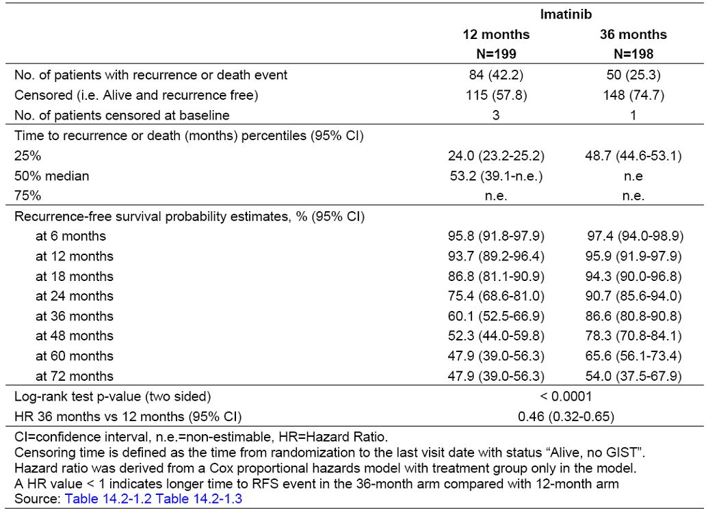
Figure 4: Kaplan-Meier estimate of primary recurrence-free survival in study CST157 1BF103 (ITT population).
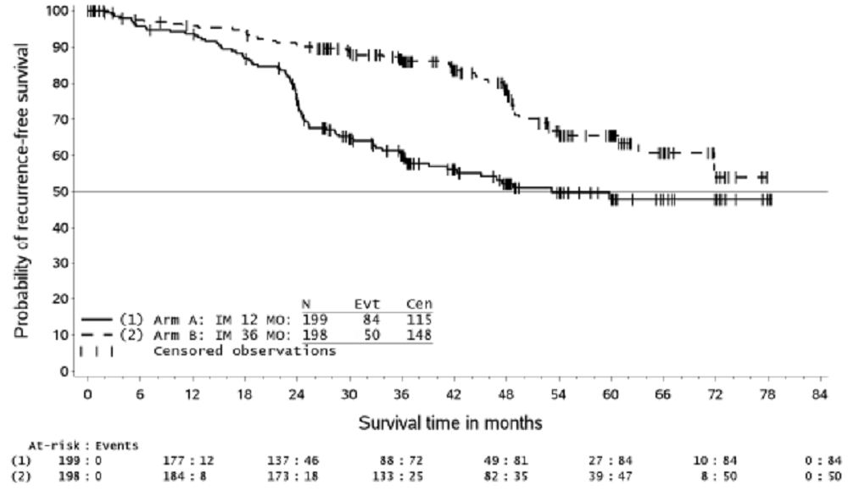
Table 5 summarises the patient status for RFS for the ITT population. Recurrence or death was reported for 84 (42.2%) patients in the 12-month arm and 50 (25.3%) patients in the 36-month arm. Of those patients who died, recurrence was reported for 20 (10.1%) patients in the 12-month arm and 10 (5.1%) patients in the 36-month arm prior to death. Recurrence on treatment (or within 30 days of last dose) was higher in the 36-month arm (17 patients; 8.6%) compared to the 12-month arm (8 patients; 4.0%), reflecting a longer treatment duration. Death was reported for approximately twice as many patients in the 12-month arm (25 patients; 12.6%) compared to the 36-month arm (12 patients; 6.1%); 14 (7.0%) patients in the 12-month arm and 7 (3.5%) patients in the 36-month arm had prior recurrence before GIST-related death.
Table 5: Patient status for recurrence-free survival analysis (ITT population).
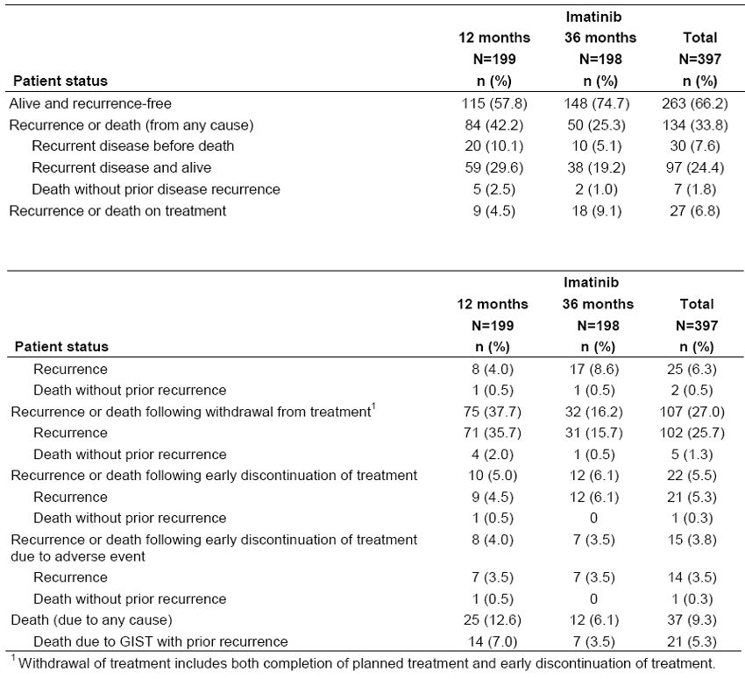
Key Analyses Supporting the Primary Endpoint, RFS: Table 6 summarises the primary and key supportive analyses for the ITT and Efficacy populations. Supportive analyses on RFS were all in favor of the 36-month compared to the 12-month treatment arm for both the ITT and Efficacy populations with a p≤ 0.0001, consistent with the primary analysis.
Table 6: Primary and supportive analyses of recurrence free survival (ITT and Efficacy populations).
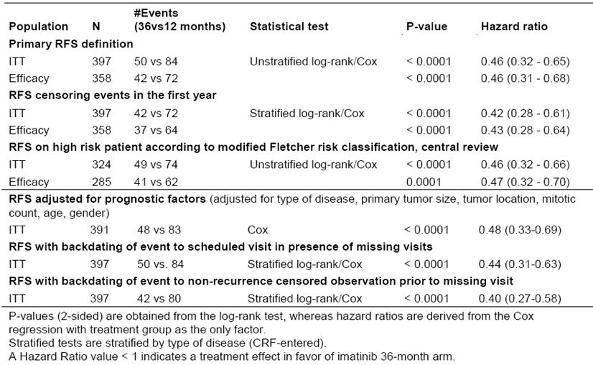
An analysis of treatment effect beyond 12 months was planned to characterise the potential benefit of an extension of imatinib therapy by two years by censoring any patient who had an RFS event or permanently discontinued treatment prior to 12 months. Results were highly significant in favor of the 36-month arm compared to the 12-month arm with a p< 0.0001 and a HR of 0.42 for the ITT population and 0.43 for the Efficacy population (Table 6). Similar treatment effect in favor of the 36-month arm (p≤ 0.0001) was reported for the further supportive analyses presented in the same table.
The impact of missing assessments prior to recurrence was assessed by two separate sensitivity analyses (Table 6). Both analyses showed a similarly highly significant result and treatment effect estimate in favor of the 36-month arm. In addition the percentage of patients with incomplete recurrence follow-up (based on the gap between the last non-recurrence assessment and data cut-off for non-recurrent patients) was relatively low at 10.1%, with approximate balance between the treatment groups (11.6% in the 12-month arm and 8.6% in the 36-month arm). There are only 4.3% of patients with incomplete RFS follow-up who are still on study (5.0% in the 12-month arm and 3.5% in the 36-month arm).
Other Sensitivity Analyses: In addition to the sensitivity analyses above, the following sensitivity analyses were performed, all of which showed consistency of the treatment effect in favor of the 36 month arm and thus showed the robustness of the primary RFS analysis result - RFS on high risk patients according to modified Miettinen risk classification, central review; RFS censoring patients using out-of-study adjuvant imatinib; RFS beyond one year treatment; RFS by investigator visit; RFS by investigator visit, adjusting for differing visit schedule; RFS using log-rank test stratified by the randomisation stratification factor; and RFS considering later cancer diseases (other than GIST).
Analyses of RFS in subgroups according to the modified Fletcher and the modified Miettinen classifications using data from the central pathology review: An important comparison was made of these subgroups, because the classifications differed. The groups at risk of recurrence and assessed were the high-risk group compared to non-high risk group for the ITT and Efficacy population and the high-risk group compared to the intermediate-risk group for the ITT population.
Modified Fletcher Classification: According to the modified Fletcher criteria, 63 (15.9%) patients were classed as intermediate risk and 10 (2.5%) patients were classed as low risk The RFS endpoint for the ITT population by recurrence risk group according to the modified Fletcher risk classification system gave a HR of 0.46 (95% CI 0.32-0.66) for the high risk group compared to a HR of 0.11 (95% CI 0.01-0.86) for the non-high risk group; within the non-high risk group 10 patients in the 12-month arm and 1 patient in the 36-month arm reported an RFS event (Table 7). Similar results were obtained for the Efficacy population: HR 0.47 (95% CI 0.32-0.70) for the high-risk group, and 0.11 (95% CI 0.01-0.86) for the non-high risk group. For the intermediate risk group, HR was 0.12 (95% CI 0.02-0.94); within this sub-population, 9 patients in the 12-month arm and 1 patient in the 36-month arm reported an RFS event (Table 7).
Table 7: Comparison for primary recurrence-free survival endpoint (ITT population).
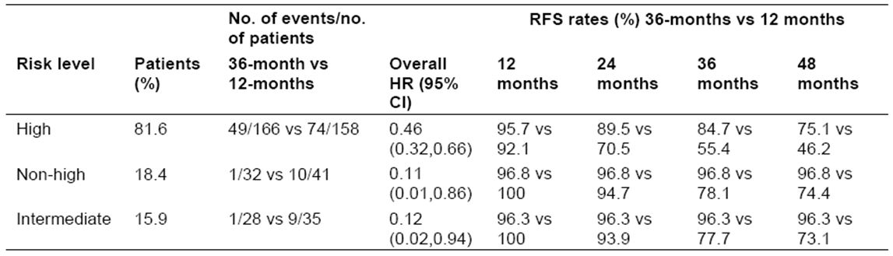
Modified Miettinen classification: NOTE: After the finalisation of the Clinical Study Report (CSR), it was detected that the subgroups within the non-high risk according to the Modified Miettinen risk classification were miscalculated. For the Modified Miettinen risk classification, patients were first classified into high and non-high risk groups, and there was no mistake at this stage. Then within the non-high risk group (n=116), patients were further classified into intermediate, low or very low risk groups. Due to a miscalculation, 14 patients in this non-high risk group were wrongly assigned to the intermediate, low, or very low risk groups. They were subsequently all assigned to a higher risk category, and the values below are the recalculated values, which differed little from the original values and which did not alter any of the conclusions from the original data analyses.
RFS endpoint analysed by recurrence risk according to Miettinen risk classification system had a HR for the treatment effect of 0.43 (95% CI 0.30-0.62) for the high-risk group and 0.44 (95% CI 0.15-1.30) for the non-high risk group and a HR of 0.39 (95% CI 0.11-1.34) for the intermediate risk group. Again, the high/non-high analyses performed for the Efficacy population gave similar results. Based on these observations, the superior effect of longer duration of therapy was consistent regardless of risk category, although the non-risk group experienced many less frequent recurrences.
Comment: From Table 7, the Fletcher classification placed a total of 324 patients (82%) in the high risk category and from Table 14.2-4.4 (contained in the Clinical Safety Report), a total of 73 in the non-risk category. The Miettinen classification placed 261 patients (66%) at high risk and 116 in the non-risk category. The conclusion is that when the origin of the tumour is taken into account, the number of patients at high risk is significantly reduced. Using the Miettinen classification could save a number of patients unnecessary treatment.
The hazard ratios (HRs) show convincingly the benefit of adjuvant Glivec in high risk patients, identified by either scheme. A benefit is also apparent for treatment of the non-high risk patients, but the actual values found for the HRs of these patients differ and need to be treated with caution because of the low number of events. In this group (by both classifications) there were 10 recurrences in the 12-month arm and one in the 36-month arm. The values of overall HRs [0.11 (Fletcher) and 0.44 (Miettinen), with very wide CIs, from 0.01 to 0.86 (Fletcher) and 0.15 to 1.30 (Miettinen)] were very different from the 0.46 value for the ITT population.
In the 36-month group, high-risk patients had 49/166 [30%] recurrence, and for non-high risk patients 1/32 [3%]; and in the 12-month arm, 74/158[47%] and 10/41[24%] (Table 12, above). These results are unexpected and indicate that although both higher risk groups have a higher rate of recurrence as expected, the 10-fold difference in the 36-month arm between high and non-high risk patients compared to the 2-fold difference in the 12-month arm is unexplained.
The conclusion is acceptable that treatment of both high and non-high risk patients confers a benefit in delaying tumour recurrence. The actual value for the HR for high risk patients is sound, but that for non-risk patients is less reliable, as the number of events (recurrences) was small. Further, the benefit of treating non-high risk patients is less because of the lower overall recurrence rate.

Results for other efficacy outcomes
Subgroup Analyses: RFS analyses by subgroup are illustrated in Figure 5, which shows HRs for the key subgroups along with 95% CIs. The study was not specifically powered to detect significant differences across subgroups, but the treatment effect is consistent across a range of patient characteristics identified at baseline, with the HRs consistently in favour of the 36-month arm for all subgroups presented.
Figure 5: Recurrence-free survival, forest plot of hazards ratios between treatments for each subgroup level (ITT population).
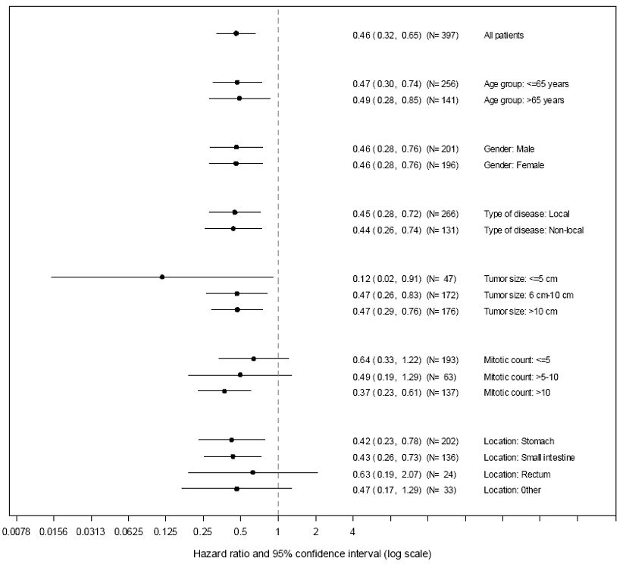
Analysis of recurrence-free survival according to time period: An additional analysis was performed, to estimate the treatment effect for defined study periods, and the results are presented in Table 8 along with the overall HR for comparison. These results indicate that the difference between the treatment groups increases over time up to 3 years. The treatment effect in the 0 to 12 month period was a HR of 0.64 (95% CI 0.26-1.57). The upper limit of the CI was above 1, as expected from the same treatment regime in both groups. The treatment effect in the period between 12 and 36 months, however, was highly in favour of the 36-month arm with a HR of 0.22 (95% CI 0.13-0.37). These results show that there was a very large treatment effect in the 12 to 36 month period, i.e. when patients in the 12-month arm were no longer receiving treatment, and patients in the 36-month arm continued to receive treatment. For the post 36-month time point, the point estimate is in favour of the 12-month arm (HR 1.31; 95% CI 0.65-2.63; note that the CI for the treatment effect is large with a range below and above 1). This result is as expected as the majority of the RFS events in the 12-month arm occurred in the 12-36 months period, immediately following withdrawal of therapy. A large proportion of the events in the 36 month arm occurred following withdrawal of therapy after 36 months when patients were no longer receiving benefit of imatinib therapy. These results indicate that the risk of recurrence in the 36-month arm increased markedly following treatment withdrawal at 36 months. However, this estimate needs to be interpreted with caution because of the reduced number of patients at risk at later time points which is reflected in the wide 95% CI.
Table 8: Recurrence-free survival, hazard ratio estimates according to study period in pivotal study (ITT population).
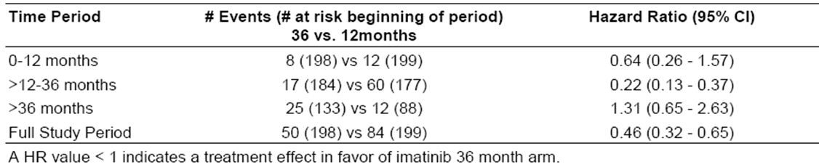
Overall Survival (OS): Overall survival was measured from the date of randomisation to the date of death resulting from any cause + 1 day. Patients alive were censored at the time of last follow-up. Overall survival between treatment groups for the ITT population is presented in Table 9 and Figure 6. In total, 37 deaths occurred on study with 25 deaths in the 12-month arm and 12 deaths in the 36-month arm after 74 months follow-up. Estimates of OS demonstrated the lower risk of death on the 36-month arm compared to the 12-month arm with a HR of 0.45 (95% CI 0.22-0.89), p=0.0187 (two-sided log rank test). Estimated OS at 36 months was 94.0% and 96.3% for the 12-month and 36-month arms, respectively. The difference between the arms continued to increase so that by 60 months the estimates were 81.7% and 92.0%, respectively.
Table 9: Comparison of Overall Survival in Pivotal Study (ITT population).
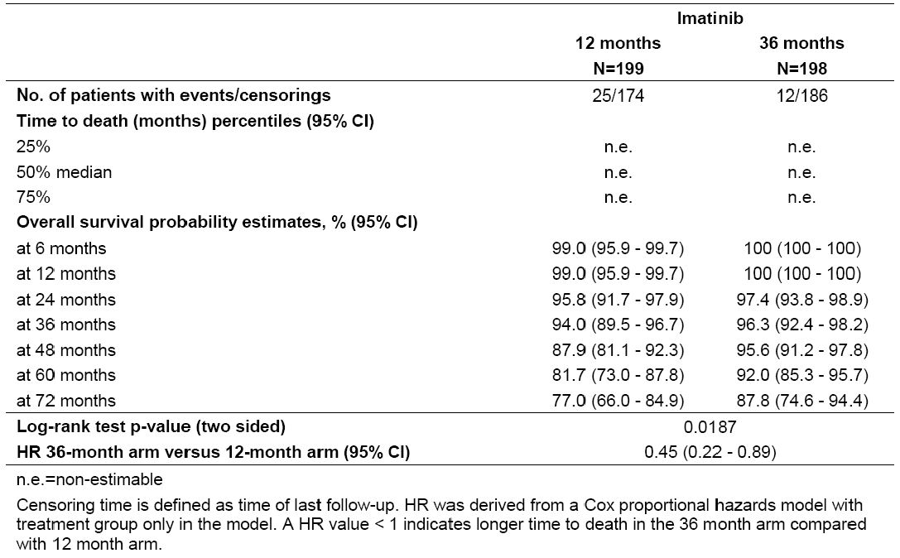
Figure 6: Kaplan-Meier estimates for overall survival in the pivotal study (ITT population).
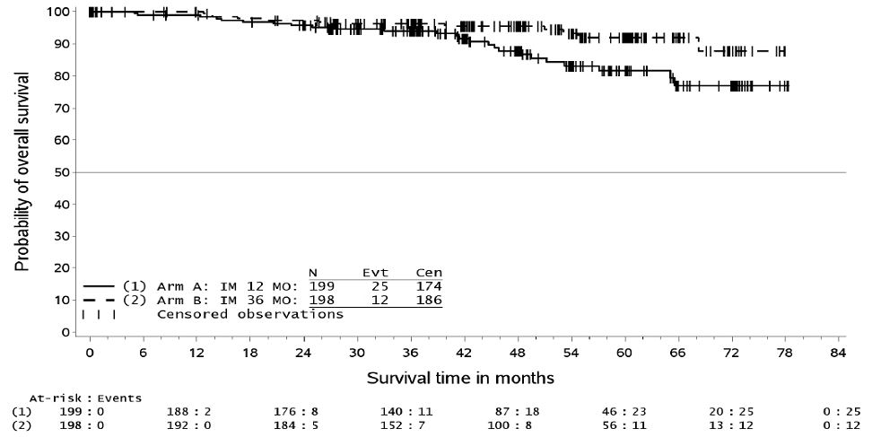
GIST-specific survival was measured from the date of randomisation to the date of death considered to be caused by GIST + 1 day. Patients alive were censored at the time of last follow-up, and patients who had died of a competing cause of death were censored on the date of death resulting from the intercurrent cause.
Fourteen deaths classified as GIST-related by the investigators were observed in the 12 month arm, compared to 7 GIST-related deaths in the 36 month arm after 72 months follow-up. The HR was 0.46 (95% CI 0.19-1.14), p=0.0872. GIST-specific survival probability for the 12-month arm compared to the 36-month arm at 24-months was 97.3 vs 98.9%, at 36 months was 96.7% vs 98.4% and at 60 months was 88.5% vs 95.1%. Results were similar for the efficacy population.
Comment: After 72 months of follow-up, the number of patients dying from GIST specific causes in the 12 month arm was more than in the 36-month arm – 14 (7%) and 7 (3.5%) respectively, but did not reach statistical significance, probably because of the low numbers.
For comparison, in the previous study on adjuvant therapy in which imatinib treatment was compared with placebo (Study Z9001, updated to July 2011, 60.2 months follow-up), the number of patients who died from GIST causes on the 12-month imatinib arm was 11 of 359 (3%). The higher figure above may be due to the selection of high risk patients for that study. In the first study, the number of deaths from non-GIST causes was similar (15 in each arm).
Exploratory End-Points: Subjects who had recurrent disease during the study could be treated at the investigators’ discretion. Treatments were recorded and assessment of outcome was attempted by measuring the progression-free survival and objective response rate.
Comment: Because of the following problems, given in the study report, these results have not been evaluated further. The analyses were based on the Efficacy population only; the data for PFS was immature when reported; the patients were assessed by investigators but without close monitoring; many observations were missing; and surgery was sometimes used to treat recurrence.

Other efficacy studies
No other efficacy studies were submitted.

Analyses performed across trials
No analyses were performed across trials.

Evaluator’s conclusions on clinical efficacy
Adequacy of Study Design: The final study design resulted from five revised protocols (original 2003, 2004, 2006, 2007, 2008) and three major amendments (2006, 2007, 2008), the changed protocol in 2004 being referred to as an “update”. The objectives of the first Phase II Scandinavian protocol were not stated and the protocol not provided. The Study Report states:
“This study was originally designed to assess RFS in a total of 80 GIST patients treated for either 12 months or 36 months with a follow-up of at least 5 years. The study was hypothesis generating and designed to compare each treatment arm with an historical control.”
Subsequent changes, including that from a Phase II to a Phase III study, are described in more detail in Protocol Amendments. The numerous changes produced a heterogeneous patient population. The intent of the study seems to have been to select only patients at high risk of recurrence after resection, defined as a 50% risk over 5 years. However, because of the changing definitions of “high-risk”, the actual ITT population in the completed study was composed of 82% patients at high-risk and 18% not at high-risk (Fletcher classification, used in the study). In the more recent classification of Miettinen, the high-risk population in the study was 71%. As well, in the initial protocol, patients with resected metastatic disease were eligible for inclusion. They were later excluded by the Oct 2006 amendment. At this time, a total of 83 and 95 patients had been enrolled in the 12-month and 36 month arms, respectively. Of these, only 5 had metastases at initial surgery. This small number would not therefore affect the final data analysis.
A further problem in studying GISTs is its relative rarity (7 to 19 cases per million: references in Joensuu, 2008) and the long clinical course for the overall patient population. One year after resection of tumours 3 cm diameter or greater with no macroscopic residual disease, 82% of patients had no disease recurrence (Australian PI).
In spite of these problems, the final study design was acceptable, the study itself was well conducted, and the data analysed appropriately.
Results: Recurrence-free survival was significantly improved in the 36-month arm compared to the 12-month arm.
- For the treated population, with 66% (Miettenen classification) to 82% (Fletcher classification) of patients at high risk of recurrence, those treated for 36 months were at significantly reduced risk of recurrence in the time period studied, compared to those treated for 12 months. The HR was 0.46 (95% CI: 0.32-0.65), and the p-value <0.0001.
- For the high-risk population, classified by either scheme, the HR was similar to that of the overall population in favour of 36 months treatment, with similar values for the HR ratios - 0.46 (95% CI 0.32-0.66, Fletcher classification), and 0.43 (95% CI 0.30-0.62, Miettinen classification).
- The non-high risk groups also showed an increased benefit from 36 months treatment, but the low number of recurrences in this smaller group did not give reliable estimates of the benefit.
- Estimates of OS demonstrated the lower risk of death from all causes in the 36-month arm compared to the 12-month arm with a HR of 0.45 (95% CI 0.22-0.89), p=0.0187. However the difference in the deaths from GIST was not statistically significant between the two arms. In this case, although the HR was 0.46 in favour of the 36 month arm, the 95% CI was very wide (0.19-1.14), and the p value 0.0872. There is no reason to expect an increase in non-GIST deaths in the 12-month arm, so the lack of a demonstrated statistical difference in the number of GIST deaths may be due to insufficient number of events (deaths) in this subgroup.
- Sensitivity and subgroup analyses were consistent with the above results for RFS.

Clinical safety

Studies providing evaluable safety data
The pivotal study STI571FI03 provided evaluable safety data. The following safety data were collected:
General adverse events (AEs) assessed as follows:
- Adverse events (AEs) were defined as any undesirable signs, symptoms or medical conditions occurring after the patient started taking study treatment, even if the events were not considered to be treatment related.
- AEs were recorded until the end of treatment in each arm (i.e. 12 or 36 months). AE summaries were generated both for the overall time period (i.e. 0 to 12 months, and 0 to 36 months for the respective arms), for 0 to 12 months (both arms), and for >12 to 36 months (36-month arm only); these time periods were defined based on the per-protocol planned visit schedule. Because of the approximately 2.7-fold difference in treatment duration between the two arms, a higher incidence of AEs was expected for the 36-month group relative to the 12- month group in the Overall analysis. Also events reported in the 0 to 12 months period could have been included as well in the >12 to 36 months period; consequently a direct comparison of the 2 treatment periods was not possible.
- Existing medical conditions or diseases present before starting study treatment were only considered AEs if they worsened after starting study treatment. Information about AEs, whether volunteered by the patient, discovered by investigator questioning, or detected through physical examination, laboratory test or other means, was recorded on the appropriate Case Report Form (CRF). AEs occurring at the time of study completion (within 2 weeks of the last dose of imatinib) were recorded on the CRF ‘adverse event page’. Information on relatedness to study treatment was not collected for AEs. However, see SAEs following.
- AEs were tabulated by System Organ Class (SOC) and preferred term from the Medical Dictionary for Regulatory Activities (MedDRA) (version 12.1).
- SAE information was taken from the internal Novartis safety database (ARGUS) and coded using the most up-to-date version of MedDRA at the time of database lock (version 13.1). Information about all SAEs and assessment of relationship to Novartis treatment were recorded by the investigator on the SAE Report Form.
AEs of particular interest were assessed as follows:
- The CRF developed by the Scandinavian Sarcoma Group (SSG) contained a list of 44 pre-specified AE terms that were considered to be common in patients who were treated with imatinib. These AEs were graded according to Common Toxicity Criteria (CTC) version 2.0 using the following scales:
  - Scale from 0 to 4: periorbital oedema, leg oedema, other oedema, vomiting, diarrhea, constipation, dysphagia, headache, dermatitis or rash, fever (no neutropenia), infection (no neutropenia), myalgia (muscle pain), arthralgia (joint pain), other pain, fatigue, paresthesia, hemoglobin, leukocyte count, neutrophil count, platelets, bilirubin, AST, ALT, alkaline phosphatase, lactate dehydrogenase, hypoproteinemia, creatinine.
  - Scale from 0 to 3: weight gain, muscle cramps, nausea, flatulence, dyspepsia/heartburn, loose stools, abdominal distension, pruritus, photosensitivity, hypoalbuminemia
  - Scale from 0 to 2: taste disturbance, increased lacrimation
  - Others: haemorrhage (0-1 or 3-4), febrile neutropenia (0 or 3-4), dyspnea (0 or 2-4), palpitation (0-1) and blurred vision (0 or 2-3).
- In addition to the pre-defined AEs, investigators were allowed to report other AE terms as free text (grades 0-4) at each visit. Note that including pre-specified AEs on the CRF could have led to over-reporting of these particular AEs by the investigators.
- In addition, cardiac complications as well as information on secondary primary malignancies other than GIST were reported on a separate CRF form during the complete duration of the study (not only during the actual treatment period). The following pre-defined 5 cardiac complications were collected and tabulated: diagnosis of myocardial infarction, diagnosis of cardiac failure, diagnosis of coronary artery disease, diagnosis of other cardiac disease, and cardiac intervention (e.g. surgery, artery dilatation).
Comment: The Scandinavian Sarcoma Group (SSG) was the sponsor of this trial and did not collect information on the association of adverse events to the study medication. Therefore no data on drug-related adverse events was provided in the Study Report. Data on SAEs was collected via the Novartis safety database (ARGUS). This included the relationship to the study drug, therefore this information has been provided in the Study Report and corresponding post-text tables.
Laboratory values at baseline were presented in the Study Report. The SSG did not collect information on laboratory values during the study. Laboratory tests were done as indicated in the protocol at each visit. If abnormal, they were not recorded in the clinical data base unless they qualified as an AE. Abnormal laboratory values or test results constituted AEs only if they induced clinical signs or symptoms or required therapy, when they were recorded on the AEs CRF under the signs, symptoms or diagnosis associated with them.
Comment: When asked to justify this lack of safety information, the sponsor (Novartis) replied that:
“Eleven of the forty-four pre-specified AE terms checked at each visit for the duration of treatment focused on laboratory values (haemoglobin, leukocyte count, neutrophil count, platelets, bilirubin, AST, ALT, Alk Phos, LDH, hypoproteinemia, creatinine). Therefore the protocol and the CRF ensured the study sites investigated the most important AEs with regard to laboratory values at each visit during the treatment phase. All laboratory data available in the clinical database has been provided with the Clinical Study Report. Additionally, the safety profile for Glivec is well established with thousands of CML patients treated for over a decade. Also, a smaller number of patients have been treated for over 5 years with GIST with good tolerability. In particular, approximately 15% of the patients enrolled in the original GIST study for metastatic disease, Study B2222, remain on treatment today.”
It appears that the patients on the trial were managed safely with respect to laboratory assessments, but that the results of those assessments have not been provided unless they were associated with an AE with clinical signs and symptoms. This is of special concern given the long period of 3 years’ treatment and the question of long-term safety in this disease, especially for adverse events such as drug-related hepatic toxicity. The study results show that the frequency of AEs is higher with 3 years treatment compared to 12 months treatment, even with the caveat that for some patients in the 36-month group, AEs may have been recorded more than once. The sponsor’s comment that 15% of patients from Study B2222 remain on treatment for over 5 years is reassuring but these patients had metastatic disease; they were not monitored as they would have been when on study; and their laboratory results are not available for assessment.

Pivotal studies that assessed safety as a primary outcome
No pivotal studies assessed safety as a primary outcome.

Dose-response and non-pivotal efficacy studies
No such studies were included. Other studies were evaluable for safety only.

Clinical pharmacology studies
One PK study, CST157A2107, provided safety data on 12 subjects in a study of possible interaction of imatinib and paracetamol.

Pivotal studies that assessed safety as a primary outcome
Not applicable.

Patient exposure in the pivotal trial
Duration of Exposure: The mean (±SD) and median duration of exposure were 10.8 (±3.2) and 12.0 months in the 12-month group, respectively, and 28.8 (±11.3) and 35.9 months in the 36-month group, respectively. The number of patients who completed the 12 months and 36 months treatment periods were 83.4% and 58.1%, respectively. Nineteen patients in the 36-month group were still on treatment as of the data cut-off date.
No relevant differences were observed in mean and median duration of exposure for male vs. female patients, or for patients aged ≤ 65 years vs. those aged > 65 years, across both treatment groups. The proportion of patients who had ≥ 12 months of treatment in the 12-month group was slightly smaller for patients aged > 65 years vs. ≤ 65 years (48.1% vs. 62.4%), and similar in females vs. males (54.8% vs. 58.4%). Similarly, the proportion of patients who had ≥ 36 months of treatment in the 36-month group was slightly smaller for patients aged > 65 years vs. ≤ 65 years (38.1% vs. 46.7%). In contrast, a slightly lower proportion of females than males in the 36-month group had exposure of at least 36 months (37.0% vs. 51.0%).
Average daily dose and dose interruptions/reductions: Patients received 400 mg imatinib orally once daily for either 12 months or 36 months according to their randomisation to one of the treatment arms. In case of AEs the study medication could be interrupted and restarted at either 300 mg or 400 mg as specified in the protocol.
The average daily dose was similar between the treatment groups, with mean average daily dose of 393.1 mg in the 12-month group and 394.3 mg in the 36-month group, with the same median values of 400mg for each group. In both groups, 48 patients (12.2%) received a dose less than 400 mg, and 6 a dose less than 300 mg. Overall, 128 (32.7%) patients required at least one dose reduction or dose interruption during the treatment period. The majority of dose reductions/interruptions were due to AEs. Dose reductions as reported due to AEs, or AEs and Other, were recorded by 20 patients in the 12-month group and 20 patients in the 36-month group. Dose interruptions due to AEs, or AE and Other were reported by 30 patients in the 12-month group and 54 patients in the 36-month group.
Time to early discontinuation of treatment: The results of Kaplan-Meier analyses of time to early discontinuation of treatment showed that in the 12-month group, 25 out of 194 patients at risk had discontinued, and in the 36-month group 51 out of 198 patients at risk. Over the first 12 months, the early discontinuation-free probability estimates were similar for the two treatment groups. At 12 months, the probability estimate (95% CI) of not having discontinued treatment early was 87.1% (81.5% to 91.1%) for the 12-month group, and 86.8% (81.2% to 90.8%) for the 36-month group.
The estimated rate of early discontinuation due to AE or death by 36 months in the 36-month group (16.6%) was approximately double the rate of early discontinuation seen by the 12-month time point in the 12-month group (8.4%) and for the first 12 months of the 36-month group (7.3%). This is as expected, because patients in the 36-month group had approximately 2.7 x longer exposure to study drug than those in the 12-month group.
Comment: The duration of exposure to imatinib during the 12 and 36 months of treatment was a median time of 12 months and 35.9 months respectively. However the number of patients who completed the 12 months and 36 months treatment periods were 83.4% and 58.1%, respectively. The median values given would have included the much longer times over which some patients were treated. For example 19 patients in the 36-month arm were on treatment at the cut-off date of the study (31 December 2010), almost 7 years after the study began (4 February 2004).
The average daily dose, both mean and median was equal or close to the intended dose of 400mg daily. In the combined population, 48 patients (12.2%) received less than 400 mg daily, an acceptable number in a study of this type. More patients (39%) in the 36-month arm had a dose reduction or interruption that in the 12-month arm (26.3%), as expected from the longer time of treatment in the 36 month arm, but these are acceptable figures for a study of this type and duration.
An important safety measure of drug toxicity is the number of patients who discontinue treatment because of AEs or death. In the 12 months arm, this was 8.4%, and in the 36 month arm, 16.6%. These figures are relatively low for such studies on anticancer drugs. The rates for discontinuation for the 12-month period of each arm were similar (8.4% for the 12-month group, and 7.3% for the 36-month group).

Adverse events

All adverse events (irrespective of relationship to study treatment)

Pivotal studies
Overview: A summary of deaths and AEs is provided in Table 10. There were fewer deaths in the 36-month group (12 patients, 6.1%) than in the 12-month group (25 patients, 12.9%). Only one death in each group occurred on treatment or within 30 days of last dose.
Table 10: Overall summary of deaths and adverse events in study CST1571BFI03 (Safety Population).
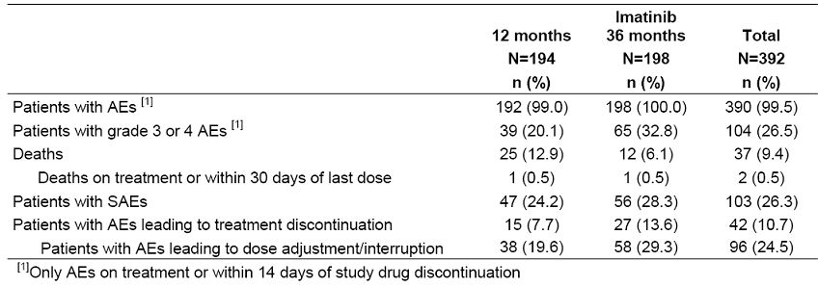
Almost all patients experienced at least one AE during the study. As expected, considering the longer duration of treatment in the 36-month group, a higher proportion of patients in the 36-month group had at least one grade 3 or 4 AEs, an AE leading to discontinuation or requiring dose adjustments or interruptions of therapy. The frequency of SAEs was similar between the 12-month and 36-month groups, but not for the first 12 months of treatment in each group.
Comment: Note that the greater number of deaths referred to above in the 12 month arm occurred during the whole study period, not in the 12 months of treatment.
Adverse Events Overall (by System Organ Classification [SOC]): Overall, 390 (99.5%) of patients experienced AEs, 192 (99.0%) of patients in the 12-month group and all 198 patients in the 36-month group. Grade 3 or 4 AEs were reported by 20.1% in the 12-month group and 32.8% in the 36-month group. SOCs with the highest frequency of AEs were: investigations (95.4%), GI disorders (81.6%), skin and subcutaneous tissue disorders (81.1%), and general disorders and administration site conditions (77.8%). SOCs with a difference in frequency between the two treatment groups of at least 10% were: musculoskeletal and connective tissue disorders (36.6% vs. 58.1%), metabolism and nutrition disorders (37.1% vs. 47.5%), infections and infestations (19.1% vs. 39.4%), nervous system disorders (22.7% vs. 34.3%), respiratory, and thoracic and mediastinal disorders (8.2% vs. 21.7%). Most AEs were no more than grade 1 or 2 in severity. The only SOC in which more than 10% of all patients had a grade 3 or 4 AE was investigations (10.2% overall, and 8.2% vs. 12.1% for the 12-month and 36-month groups).
Comment: Those AEs with a greater frequency in the 36 month arm compared to the 12 month arm would be expected to be drug related (see comparison in Treatment-related adverse events (adverse drug reactions)). Adverse events related to abnormal laboratory results are discussed in more detail in Laboratory tests, Section 8.5.
Adverse Events Overall (by preferred term): AEs that occurred in at least 10% of patients in any group are presented in Table 11. Overall, the most frequently reported AEs by preferred terms were decreased hemoglobin, periorbital edema, increased blood lactate dehydrogenase, diarrhea, fatigue, and nausea. Most were reported at a higher frequency in the 36-month group than the 12-month group, which is as expected considering the difference in treatment duration. The largest differences in frequencies (at least 15%) between the two groups were observed for increased blood lactate dehydrogenase, muscle spasms, and pain. The study report notes that the inclusion of pre-specified AEs on the CRF may have led to over reporting of some of these AEs, and that these results should be interpreted with caution.
Table 11: Most frequent adverse events irrespective of relationship to treatment by preferred term (at least 10% in total) in Study CST1571BFI03 (Safety population).
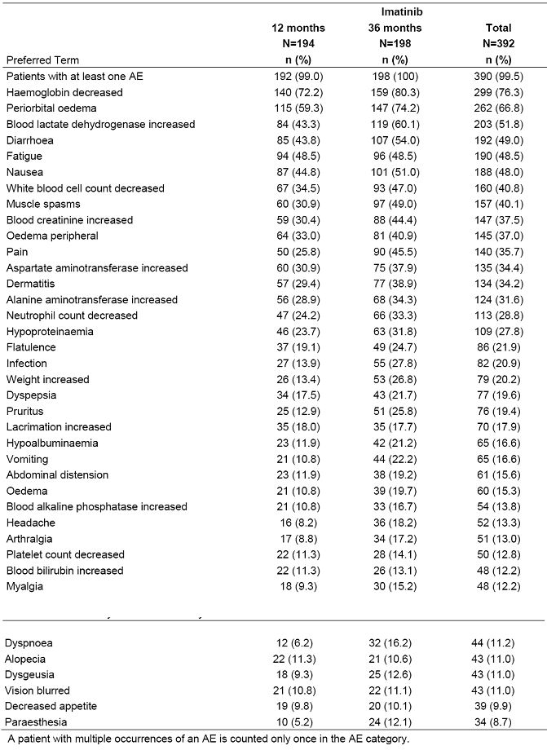
Comment: Overall, the frequency of AEs in the 12-month arm by preferred term were comparable to the frequency of those reported from the 12-month arm of the previous adjuvant trial in which imatinib treatment was compared to placebo treatment (Australian PI).
Fluid retention: Fluid retention is a frequent adverse event with imatinib treatment. The incidence as an AE of treated patients with CML was 76-59% all grades, and 1.8% Grade 3-4; and of patients with advanced or metastatic GIST, 80% all grades, and 7% Grade 3-4. With adjuvant treatment for 12 months, the incidence of periorbital oedema was 47% and of peripheral oedema 27% all grades (from Australian PI). In the present GIST study, the incidence of periorbital oedema was 60% cf 74%, and of peripheral oedema, 33% cf 41% in the 12 month and 36 month arms respectively. The incidence of the AE of oedema was 11 cf 20%, of weight increase, 13% and 27%, and of abdominal distension 12% and 20%, in the 12 month and 36 month arms respectively. These results suggest that the incidence of fluid retention was more a function of duration of treatment than of disease type, as suggested in the Australian PI.
Other AEs Listed in Precautions and Description of selected Adverse Drug Reactions in the Australian PI: Gastro-intestinal haemorrhage, intra-tumour haemorrhage and tumour lysis syndrome were AEs of concern with imatinib treatment of metastatic GIST tumours, but none occurred in the present study with adjuvant therapy. Hypophosphatemia also was not reported. The PI shows the incidence of an exfoliative rash to be 27% for all grades and 3% for Grade 3-4 for 12 month’s adjuvant treatment of GIST. This compares with 29% and 39% for “dermatitis”, in the 12 month and 36 month arms of the present study. Myelosupression, hepatotoxicity, renal and cardiac toxicity are addressed below in Laboratory tests.
Adverse Events Grades 3 and 4 (Severe AEs): AEs of grade 3 or grade 4 severity were reported by 39 patients (20.1%) in the 12-month group and by 65 patients (32.8%) in the 36-month group (Table 12). The most frequently reported grade 3 or 4 AEs were related to abnormal laboratory values. Other grade 3 or 4 AEs were reported by 3.0% or less of patients in either treatment group. No grade 3 or 4 AE was reported by more than 10 (5.1%) patients in any treatment group.
Table 12: Most frequent grade 3 or 4 adverse events by preferred term for overall treatment period (at least 2 patients in total) in study CST1371BF103 (Safety population).
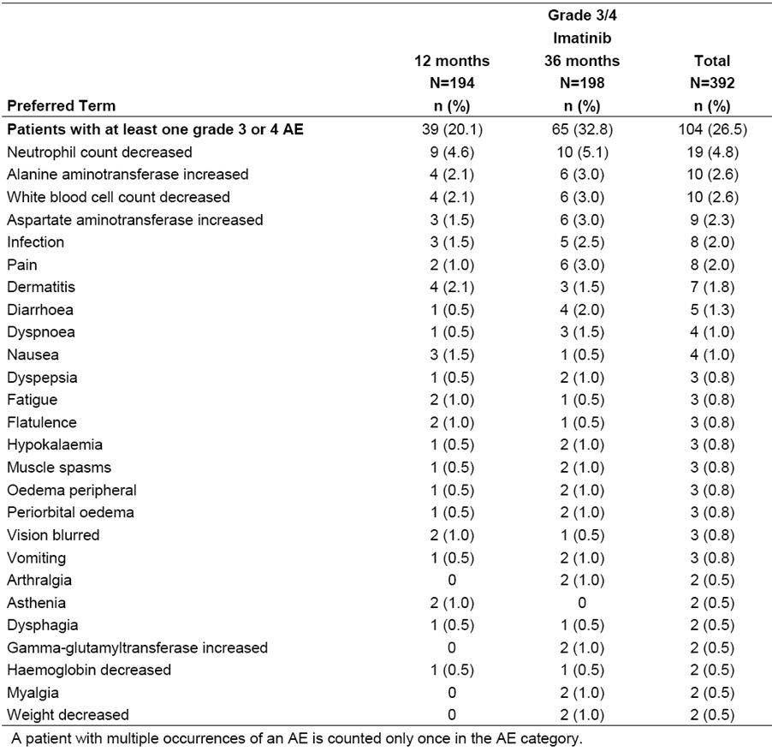
Adverse events reported between 0 and 12 months and >12 to 36 months in the 36-month treatment group: A comparison was made of AEs reported by patients in the 36-month group in the 0 to 12 month and >12 to 36 periods. Only patients who received treatment in the >12 to 36 month period were included in the analysis for that period, therefore the number of patients in this group was lower (N=169) than in the 0 to 12 month period (N=198). By SOC, AEs reported within the first 12 months in the 36-month group were consistent with those reported in the 12-month group. AEs in the SOC metabolism and nutrition disorder were reported by a higher proportion of patients in the > 12 to 36 month period (40.8%) than in the 0 to 12 month period (28.3%). Also, AEs in the SOC of infections and infestations were reported by a higher proportion of patients in the > 12 to 36 month period (32.5%) than in the 0 to 12 month period (22.2%). A difference was less for the SOC musculoskeletal and connective tissue disorders (48.5% vs. 40.4% for > 12 to 36 month and 0 to 12 month periods, respectively). Grade 3/4 AEs by SOC were infrequent and generally similar in the 0 to 12 and >12 to 36 month periods, although minor differences were noted. Grade 3/4 AEs were reported for a slightly higher proportion of patients in the > 12 to 36 month period than in the 0 to 12 month period for the SOC musculoskeletal and connective tissue disorders (2.4% vs. 0.5%).
Comment: By SOC, the increase in AEs observed in the >12 to 36 month period in the 36 month treatment group was confined to the AEs specified above – metabolic and nutritional disorders, infections and infestations, and disorders of musculoskeletal systems. These increased frequencies suggest that these AEs may result from a cumulative dose of imatinib over the longer period of treatment. If the increase were random and associated with longer exposure to imatininb, an increase of all SOCs would have been expected.

Other studies
Safety data were provided in the PK study CST157A2107 of a possible interaction between paracetamol and imatinib, with emphasis on potential hepatic toxicity. The main safety concerns were that the patient population in the study was Asian, and therefore did not assess safety in a Caucasian population that metabolises paracetamol differently; and that the number of subjects (n=12) was too small and the follow-up too short to assess possible rarer events of hepatic or renal toxicity from paracetamol in the presence of imatinib.

Treatment-related adverse events (adverse drug reactions)

Pivotal studies
The study report provided data on treatment-related serious adverse events, but not on other adverse events.
SAEs: SAEs that were determined by the investigator to be related to study treatment were summarised overall and for the 0 to 12 month and > 12 month to 36 month periods. The Summary of Clinical Safety claimed that no relevant differences were observed between the treatment groups overall although 14 patients (7.2%) in the 12-month group and 7 patients (3.5%) in the 36-month group reported treatment related SAEs. The SOC with the highest frequency of SAEs was GI disorders (6 patients, 1.5% overall). With the exception of one SAE of nervous system disorder reported in the > 12 to 36 month period in the 12-month group, all treatment-related SAEs were reported in the 0 to 12 month period.
Comment: The above statement that “No relevant differences were observed between the treatment groups” is not correct for SAEs, given the difference stated. In the first 12 months of treatment in each of the two arms, patient numbers were similar, as was the disease states and treatment, yet the incidence of SAEs in the 12 months of the 12-month group was twice that for the first 12-month period in the 36-month group (13 patients compared to 6). The difference is unexplained and raises a concern that there was under-reporting of AEs in the 36-month group. The sponsor should comment on this difference, and suggest a possible reason.

Other studies
PK Study STI A2107: There were no deaths, other SAEs, discontinuations due to AEs, or other significant AEs reported in the study. Four patients (4/12, 33.3%) experienced 8 treatment-emergent AEs. There were no unexpected safety findings in the patients. The AEs were consistent with previous clinical findings for imatinib in CML-CP patients. One AE (neutropenia) was categorised as Grade 4 and reported at the end of study visit; it was not considered to be serious, and resolved within 7 days following treatment with granulocyte colony-stimulating factor (lenograstim). The remaining AEs were grade 1 or 2. Seven out of the 8 treatment-emergent AEs were suspected to be study treatment related, and 7 of the 8 AEs were reported on or after the end of study visit.

Deaths and other serious adverse events

Pivotal studies
Deaths Irrespective of Relationship to Treatment: Of the 37 deaths reported during the study, 25 deaths occurred in the 12-month group and 12 deaths occurred in the 36-month group (Table 10). Twenty-one deaths were classified as related to GIST by the investigators (14 in the 12 month groups and 7 in the 36-month group), and 16 deaths were classified as due to other reasons (11 in the 12-month group and 5 in the 36-month group). Death due to primary or secondary tumours other than GIST was reported for 7 patients (3 in the 12-month group and 4 in the 36-month group); for the remaining 9 patients death occurred due to a variety of different reasons. Two deaths occurred on treatment (or within 30 days of last dose), one in each treatment group; these deaths were not GIST-related, and attributed to cardiac failure for one patient, and an "unconfirmed meningioma" [sic] in a patient with pre-existing stage IV malignant melanoma that worsened.
Comment: The study report did not attribute any death to treatment with Glivec.
Non-GIST related deaths: A summary of the 16 non-GIST-related deaths is provided in Table 10. Patient numbers [information redacted] were confirmed as not having recurrent GIST, and the reason for their death is given in [information redacted]. No further information was available on these patients. Further information on the other patients was provided in the study report.
Comment: Given the greater efficacy of the 36 months treatment with imatinib in preventing recurrence, it is expected that the number of deaths would be greater in the 12-month treatment arm (25 cf 12). What is unexpected is that the number of deaths due to GIST were similar (3 and 4 in the two arms), while the deaths from other causes were higher in the 12 month treatment arm (22 cf 8). The reason for this difference is not clear and is not discussed in the study report. The cause for death was unknown for 4 patients in the 12-month arm and for none in the 36-month arm. Narratives of these four patients were as follows:
[Information redacted]: This patient died at home. An autopsy was performed and it was considered that the terminal cause of death was “pulmonary embolia” [sic]; however, since the patient also had recurrent GIST this was considered the probable underlying cause of death. The last dose of study drug was administered on 15 June 2004; the death occurred on [information redacted] December 2007.
[Information redacted]: The patient’s co-morbidities included severe Parkinson disease and a “psycho-organic syndrome” after a central haemorrhage. Four months prior to his death the patient was GIST-free; however, his condition was deteriorating. The date of last dose of study drug was 29 March 2007; date of death was [information redacted] September 2010.
[Information redacted]: This patient had co-morbidities of angina pectoris and cardiac insufficiency. Two months prior to her death the patient was GIST free. No further details were available for this patient. The last dose of study drug was taken on 3 May 2007; death occurred on [information redacted] September 2009.
[Information redacted]: This patient stopped treatment approximately 1 month after randomisation and was hospitalised on [information redacted] November 2006 due to deterioration in general condition, and florid endocarditis of the mitral valve with septic disease. In February 2007 the patient experienced recurrence of GIST and imatinib treatment was reinitiated. In August 2008 the patient switched to sunitinib and subsequently changed to nilotinib in June 2009. The last recorded visit to the site for this patient was in 2006. Date of death was [information redacted] January 2010; last dose of study drug was administered on 26 November 2006.
Death in the case of patients noted first and fourth above can be reasonably assumed to be due to GIST. If these cases are added to the 3 established deaths from GIST in the 12 month arm, the 5 deaths are similar to the 4 deaths in the 36 month arm. It is possible that the small numbers involved may contribute to the discrepancy noted between the number of GIST deaths in the two groups.
Other Serious Adverse Events Irrespective of Relationship to Treatment: SOC: Overall, SAEs were experienced by 103 patients (26.3%), and the proportions of patients who experienced SAEs were similar between the 12-month and 36-month groups (24.2% vs. 28.3%). The frequencies were comparable between the treatment groups for most SOCs, however the proportion of patients with SAEs in the SOC cardiac disorders was lower in the 36-month group (1.5%) than in the 12 month group (5.7%). SAEs were summarised by SOC and preferred terms overall and for the 0 to 12 month, > 12 month to 36 month, and > 36 month periods. In the 36-month group, SAEs in the SOCs GI disorders and infections/infestations were reported at a higher frequency in the first 12 months (5.1% and 4.0%, respectively) than after the first 12 months (2.1% and 1.6%, respectively). No difference was seen for the SOC neoplasms (benign, malignant and Unspecified) or general disorders and administration site conditions; SAEs in other SOCs were too infrequent to allow a meaningful comparison.
Other Serious Adverse Events Irrespective of Relationship to Treatment: Preferred Terms: By preferred term, SAEs were comparable between the 12-month and 36-month groups (Table 13). The most frequent SAEs were related to malignancy (malignant neoplasm progression and prostate cancer), followed by pyrexia, nausea and neutropenia. Other preferred terms were reported by at most 4 patients overall (at most 3 patients in either treatment group).
Table 13: Most frequent serious adverse events (at least 2 patients in total) irrespective of relationship to treatment by preferred term (safety population).
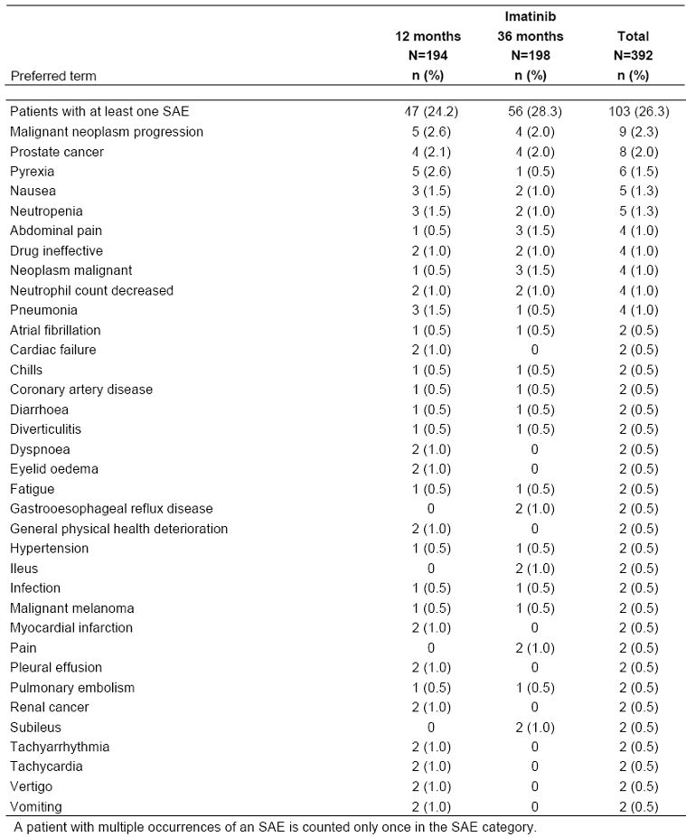
Comment: The nonclinical overview reported that 2-year treatment of rats with imatinib produced neoplastic changes in kidney, urinary bladder and urethra as well as in other organs, as stated in the CDS, and in the Australian PI. The incidence of prostate cancer in the total patient population in the pivotal study is given as 2% (n=8), and if corrected for the number of males (n=201), equates to 4% in the male patient population. This incidence is the cumulative figure over 5 years of the study, and so the annual rate is 0.8%. The estimated number of new prostate cancer cases in the USA for 2011 was 240,890 (4) in a male population of 155 million (estimated), so this incidence was 0.16%. The age distribution in the study would not affect the comparison, so the incidence of new cases of prostate cancer were increased 5- fold, with the caveat that the patients in the study were European (mainly German), and the figure quoted are for the USA..
The sponsor provided an epidemiology report, “Evaluation of frequency of second primary malignancies in Glivec treated patients in Novartis sponsored clinical trials- an update for Glivec RMP v.5”, dated 29 June 2011. The report assessed current and completed trials of Glivec treatment, but did not include the present adjuvant study, which was the only study in which the safety of long-term use of Glivec was monitored for 3-years or more in a controlled manner. Studies that used Glivec for shorter times showed an increase in the number of cases, n=20 compared to the 13 cases expected from general population data, although the ratio of risk did not reach statistical significance (95% CI 1.55, 0.95-2.44).
The sponsor should comment on this result.
Cardiac complications: Pivotal studies: The Summary of Clinical Safety states that overall, 12 (3.1%) patients reported at least one cardiac complication (8 patients in the 12-month group and 4 patients in the 36-month group). These were serious AEs as described above. However cardiac AES (by SOC) occurred in the 12 month arm in 8.2% (all grades) and 0.5% (Grade 3-4, n=1) of patients, and in the 36 month arm in 9.1% (all grades) and 0.5% (Grade 3-4) in the 36 month arm, with an overall incidence of 8.7% (all grades) and 0.5% (Grade 3-4).
Comment: The Precautions section of the Australian PI has one paragraph “Severe congestive heart failure and left ventricular dysfunction” and another “Patients with cardiac disease or renal failure”. These concerns appear to have been mainly in patients with newly diagnosed Ph+ CML in the chronic phase (Australian PI), in whom the incidence of severe cardiac failure and left ventricular dysfunction was 0.7% of patients taking Glivec compared to 0.9% of patients taking IFN + Ara-C. Severe cardiac AEs had an incidence of 0.5% in the present study, serious AEs of 3.1%, and for all grades 8.7% overall. The study showed that the incidence was not significantly increased by the longer treatment period of 36 months compared to 12 months. The result justify the present warning in the Australian PI that patients with cardiac disease, or risk factors for cardiac failure should be monitored carefully and any patient with signs or symptoms consistent with cardiac failure should be evaluated and treated.

Other studies
No deaths were reported in the PK study STI571A2107.

Discontinuation, and interruption of treatment, and dose reduction due to adverse events

Pivotal studies
Discontinuation of treatment: A total of 42 patients (10.7%) reported AEs leading to discontinuation, with a higher proportion of patients in the 36-month group (13.6%) than in the 12-month group (7.7%) (Table 14). The most frequently reported preferred terms were nausea, rash, abdominal pain, neutropenia, and abnormal liver function test. There were no relevant differences between the groups. AEs leading to discontinuation were summarized overall and for the 0 to 12 month and > 12 month to 36 month periods. In the 0 to 12 month period, 7.7% of patients in the 12-month group and 6.6% of patients in the 36-month group reported AEs leading to discontinuation. In the 36-month group, 8.3% of patients reported AEs leading to discontinuation after 12 months. All patients who discontinued due to nausea, rash, neutropenia, hepatotoxicity or myalgia did so in the first 12 months of treatment. Cumulative percentage estimates of the time to early discontinuation of treatment due to AE or death, by time intervals are presented in Table 15.
Table 14: Frequent adverse events (at least 2 patients in total) leading to treatment discontinuation irrespective of relationship to treatment by preferred term (safety population).
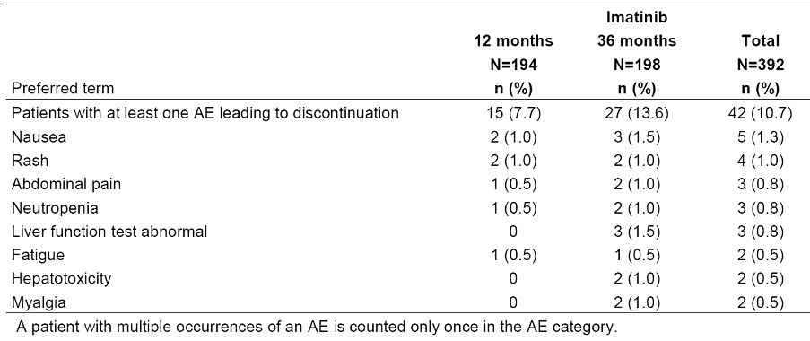
Table 15: Cumulative percentage estimates of patients discontinuing early due to adverse event or death (safety population).
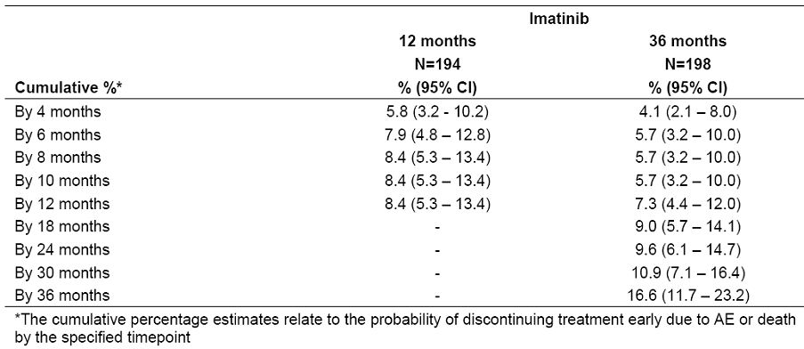
Interruption of treatment: AEs leading to treatment interruption were reported by 29 (14.9%) patients in the 12-month group and 54 (27.3%) patients in the 36-month group. AEs most commonly leading to treatment interruption were reported in the GI disorders SOC (11 patients; 5.7% in the 12-month group and 14 patients; 7.1% in the 36-month arm) and skin and subcutaneous tissue disorders (9 patients; 4.6% in the 12 month group and 11 patients; 5.6% in the 36-month group).
Dose Reduction: Overall, 40 patients experienced an AE that led to dose reduction, 20 (10.3%) patients in the 12-month group and 20 (10.1%) patients in the 36-month group. AEs were most commonly reported in the skin and subcutaneous tissue disorders (11 patients) and GI disorders (11 patients). It must be noted that the CRF was not optimally designed to capture all information on dose reductions; this may have led to some degree of underreporting.

Other studies
In the PK study, STI571A2107, dosing with imatinib was given for only 8 days, and no modifications of treatment occurred.

Laboratory tests
The study-report states “The institution performed laboratory analyses according to the Visit Schedules. Only baseline laboratory values were captured in the CRF. After start of study treatment any laboratory values meeting the definition of an AE were to be recorded on the CRF AE form”. Abnormal laboratory values or test results constituted AEs only if they induced clinical signs or symptoms or required therapy, when they were recorded on the AEs CRF under the signs, symptoms or diagnosis associated with them. The Clinical Laboratory Evaluation Study Report states “Abnormal laboratory values at baseline are presented in Section 14.3.4 and Appendix 16.2.8”. Each of these sections says “Not applicable”, and the latter refers to Listing 16.2.4-1.7, a table of 32 pages giving the laboratory results pre-treatment for all patients.
Comment: The laboratory evaluation is inadequate, as only those laboratory abnormalities that produce clinical signs or symptoms were recorded, not the laboratory values during treatment in the trial, so that even though a laboratory value may indicate Grade 4 toxicity by NCI/NIH CTC criteria, this would not be reported unless the patient had signs or symptoms. The sponsor has been asked to justify this, given the long period (36 months) of the trial.

Liver function

Pivotal studies
Abnormal liver function was reported as an AE only if signs or symptoms (presumably relating to the liver) were present (see above). A subset of these results is shown in Table 16.
Table 16: Liver function as AEs in the pivotal study.
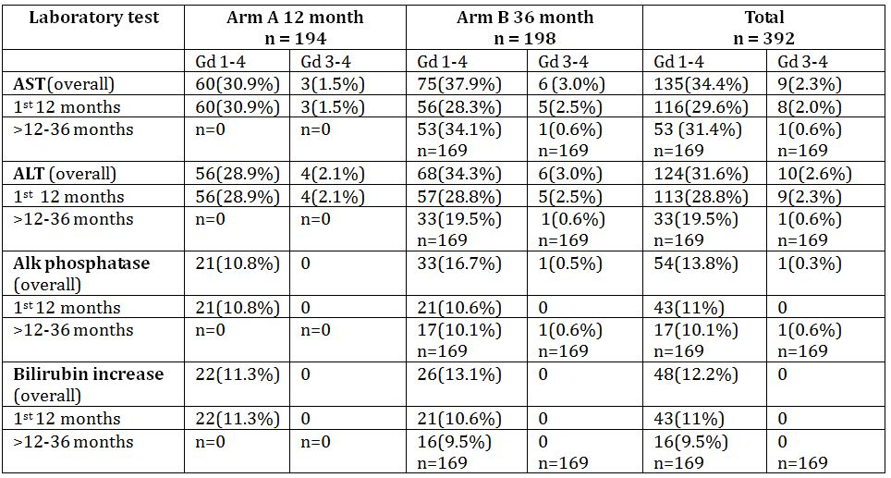
Comment: The abnormalities of Grade 1-4 liver abnormalities are high in the first 12 months of treatment, and all had to be accompanied by hepatic signs and symptoms, since this was required for reporting in the study (see above). Grade 3-4 abnormalities had a lower incidence. The incidence of all grades of AEs was higher overall in the 36 month arm compared to the 12 month arm, presumably because cases continued to occur in the >12-36 month period of the 36 month arm. Note that the combined total of the numbers in the first 12 month and the >12-36 month period (56+53), exceeds the overall total of 75 for Grade 1-4 Asp ATT values. A footnote to the Table states “A patient with multiple occurrences of the preferred term is counted only once for the corresponding preferred term category”, so this discrepancy is unexplained [However see the sponsor’s comments on the reporting of AEs in the adjuvant 36-month trial 1 that the same patient could be counted twice, once in the 0-12 month period and once in the 12-36 month period].
A comparison of the incidence of liver AEs in the 12 month period of the previous adjuvant trial (Australian PI) and the present trial, shows the incidence in the latter of increases in ALT and AST are twice those seen in the former trial (ALT, 31% cf 17%; AST, 29% cf 12%). There is no obvious reason for this difference, as the figures for the previous study (Australian PI) were irrespective of relationship to treatment, as were those for the present study. The incidence in the 36-month arm of the present trial, as stated above, was higher again. About 11% of patients reported an AE of increased bilirubin in both arms of the present trial, whereas none were reported in the previous adjuvant trial of 12 months, which reported only those over 10% incidence (The sponsor has corrected the 0% to 4%).
The sponsor has said that because of the way the laboratory results were recorded in this study, Hy’s law cannot be applied. Also the reply points to the absence of any cases fulfilling Hy’s law in the previous adjuvant study. However, in the present longer term study, the question remains open for reasons given in my comments on this point.

Other studies
None were provided.

Kidney function

Pivotal studies
Kidney function was reported as for liver function above. The incidence of reported AEs with abnormally increased serum creatinine was as follows:
Arm 1(12 month group): Overall period Grade 1-4, 59 of 194 (30.4%) Grade 3-4, 0
First 12 months ditto ditto
>12-36 months 0 of 0
Arm 2 (36 month group): Overall period Grade 1-4, 88 of 198 (44.4%) Grade 3-4, 0
First 12 months 65 of 198(32.8%) ditto
>12-36 months 62 of 169(36.7%) ditto
Comment: The incidence of the AE, abnormality in renal function, continued to increase during the additional period of treatment from 12 to 36 months. The discrepancy in the added figures is as above for liver function and is unexplained.
Compared to the incidence of this AE in the previous adjuvant trial for GIST (Australian PI), the incidence in the 12 month group was significantly higher in the present study – 30.4% cf 12%.

Other studies
None were provided.

Other clinical chemistry

Pivotal studies
No specific data were provided on other clinical chemistry values except as AEs of low incidence and severity.

Other studies
None were provided.

Haematology

Pivotal studies
Values for haematology parameters were not provided except as reported AEs (see above, Liver function). Incidence of reported AEs is shown in Table 17.
Table 17: Haematological toxicity as AEs in the pivotal study.
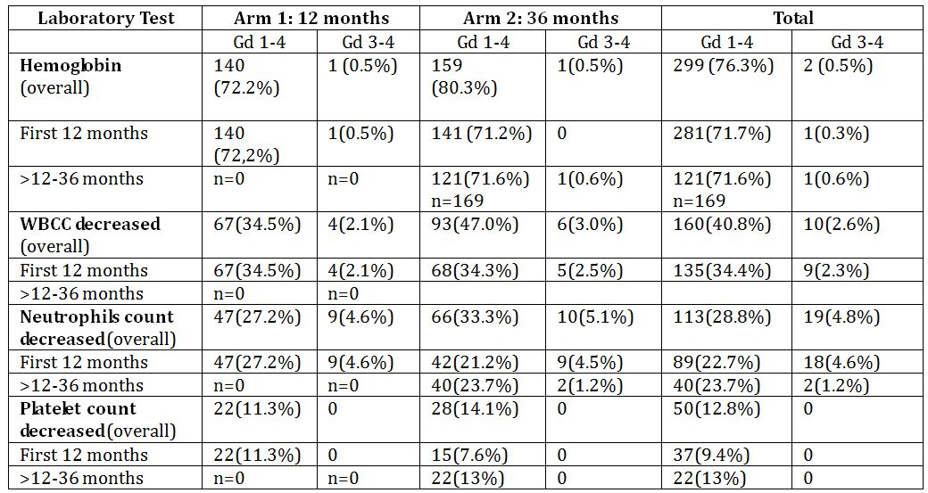
Comment: The comparison of the above results with those for the incidence of haematological AEs reported in the Australian PI for the 12 months of adjuvant treatment of GIST show that the former are approximately double those of the latter. For example, the incidence of AEs of a decreased WCC in the present study was 34.5% for the 12-month arm, and 14.5% for the previous adjuvant study (Australian PI). Similar comparisons for decreased haemoglobin was 72% cf 47%, decreased neutrophils, 27% cf 16%, and decreased platelets, 11% cf less than 10%. All values for the 36-month arm were greater than for the 12-month arm.

Other studies
None were provided.

Post-marketing experience
1. Post-Marketing Surveillance: The safety overview states “The post-marketing safety of imatinib is monitored on an ongoing basis. In the post-marketing setting, with approximately 776,114 patient-years of post-marketing exposure, no safety concerns have emerged that were not previously known for imatinib. The safety profile of imatinib remains consistent with the information provided in the Core Data Sheet, which is used as a reference for the prescribing information in all countries where the product is marketed.
[information redacted]
2. World-Wide Literature Search: A worldwide literature search was performed to capture any investigator reports on safety aspects, which are not included in the study reports. The Summary of Clinical Safety (SCS) states that the results of this literature search did not provide any evidence of unexpected or unknown events that would be attributable to treatment with imatinib, thus supporting the established safety and tolerability profile of imatinib.
Comment: The SCS, Appendix 1, reviewed published papers from 1 April 2008 to 31 March 2011, including investigators’ reports. Most described the results of clinical studies of imatinib used for a variety of medical conditions, and presumably reported the related adverse events found in those studies. Some papers were devoted to a single type of AE, and included the following:
- Decreased bone turnover despite persistent secondary hyperparathyroidism during prolonged treatment with imatinib (O’Sullivan et al).
- Development of hypogammaglobulinemia in patients treated with imatinib for chronic myeloid leukaemia or gastrointestinal stromal tumour (Santachiara et al).
- Rare incidence of congestive heart failure in gastrointestinal stromal tumour and other sarcoma patients receiving imatinib mesylate (Trent et al). Cardiac events in imatinib mesylate-treated chronic myeloid leukaemia patients: A single institution’s experience (Breccia et al).
- Cardiovascular effects of tyrosine kinase inhibitors used for gastrointestinal stromal tumours (Chintalgattu et al).
Based on the safety data from the present trial, none of the above were of concern, although the paper describing adverse cardiac effects (Trent et al) warrants further comment. The paper is specific and reports a retrospective analysis of 219 consecutive patients treated with imatinib mesylate. Grade 3 or 4 potentially cardiotoxic adverse events (mostly oedema or effusions) occurred in 8.2% of patients, were manageable with medical therapy, and infrequently required dose reduction or discontinuation of imatinib mesylate. Arrhythmias, acute coronary syndromes, or heart failure were uncommon, occurring in <1% of treated patients. A previous paper that included some of the same authors (Chintalgattu et al) was more general, and cited studies on the cardiotoxicity of imatinib in mice, and an earlier clinical study (Kerkela et al) that reported 10 cases of cardiac toxicity, but not the incidence, in patients treated with imatininb. Presumably those results have been reviewed in previous evaluations of imatinib. The incidence of Grade 3-4 events in the more recent paper (Trent et al) was much higher that that of 3.2% for all grades of this AE in the overall population in the present trial.
3. Safety in ongoing trials: No untoward effects that would materially alter the established safety profile of imatinib have been reported.

Safety issues with the potential for major regulatory impact
A new safety issue reported in the present study is a 5-fold increase in the incidence of prostate cancer in the patient population after 3 years or more treatment with imatinib. The sponsor is asked to comment on this. Other issues such as the greater incidence of adverse events in this study compared to earlier studies require appropriate changes to the proposed PI.

Other safety issues

Safety in special populations
AEs analysed by risk group, age and gender were summarised in post-text but not presented in the text of the CSR. The Summary of Clinical Safety summarised the data as follows: “There were no relevant differences in the pattern of AEs between patients classified as high risk vs. intermediate risk based on modified Fletcher risk classification (central review). Frequencies of AEs were generally similar between age groups of ≤ 65 years and >65 years, however some preferred terms were reported at slightly higher frequencies in the older patients. Of note, for patients ≤ 65 years of age, oedema peripheral was reported for 24.8% and 39.3% of patients in the 12-month and 36-month groups, respectively, whereas for patients >65 years of age, this AE was reported for 45.5% and 44.4% of patients. Similarly, for patients ≤ 65 years of age, blood creatinine increased was reported for 23.1% and 39.3% of patients, and for patients >65 years of age for 41.6% and 55.6% of patients in the respective treatment groups.”
Comment: A review of data provided on request from the sponsor, confirmed the above differences. Although some preferred terms such an “dermatitis” was increased by 13.8% in the older age group in the 12-month arm, this increase was not seen in the 36-month arm, and so does not fit any clinical pattern. I have therefore considered significant differences (10% or more) those that occurred in both the 12-month and 36-month arms. In the case of peripheral oedema, the frequency increased from 24.8% to 45.5% (a 20.7% increase) in the 12-month arm, and from 39.3% to 44.4% (a 5.1% increase) in the 36-month arm, an inconsistent result. Two AEs showed a clear increase in older patients in both arms, an increase in blood creatinine (18.5% in the 12-month arm, and 17.3% in the 36-month arm), and a decrease in haemoglobin (11.7% in the 12-month arm and 10.3% in the 36-month arm). This association with age should be included in the PI.
The SCS stated: “Analyses of AEs by sex showed no or minor differences in the frequencies of preferred terms between the groups. The most notable difference was noted for oedema peripheral, which was reported for 28.1% of men and 46.1% of women; for both sexes the frequencies of this AE were similar between the 0 to 12 months and the >12 to 36 months periods.”
Comment: The above statement is only partly true. Women had a frequency of peripheral oedema 20.7% higher than men in the 12-month arm (sponsor’s response 20 February 2012), and 22.4% higher in the 36-month arm. As well, the frequency of periorbital oedema was 13.1% higher in women in the 12-month arm and 13.7% higher in the 36-month arm; and the frequency of increased AAT was 19.1% higher in women than men in the 12-month arm and 16.4% higher in the 36-month arm.
Other AEs were 10% or more frequent in one or other of the two arms, but not in both. Therefore the three AEs above, peripheral and periorobital oedema and increased AAT and their association with gender should be stated in the PI.

Safety related to drug-drug interactions and other interactions
The sponsor proposes to delete the sentence statement “Glivec inhibits paracetamol O-glucuronidation in vitro (Ki value of 58.5 micromol/L) and may inhibit paracetamol metabolism at therapeutic levels (see “PRECAUTIONS”)” in the current PI, based on the submitted PK study CST157 A2107. This is not acceptable for the following reasons:
- The ethnic population used in the study were not the same as that in the Australian population.
- The Cmax values for plasma acetaminophen with and without imatinib were not equivalent.
- The numerous interactions of medications given in “real life” to cancer patients have the potential of producing a significant clinical interaction when acetaminophen is coadministered with imatinib.

Evaluator’s overall conclusions on clinical safety
The recording and reporting of some important safety data was not of an acceptable standard. The pivotal study was designed and carried out by the Swedish Sarcoma Group. Although the sponsor of the present application, Novartis, reworked the safety data, it was unable to correct the deficiencies. This is especially unfortunate since the study is the only monitored study of long-term usage (36 or more months) of Glivec. Long-term safety is therefore of concern.
Deficiencies in reporting safety data: The two main deficiencies dealt with in detail in earlier sections of this evaluation were:
- failure to record the relationship of AEs to treatment (the relationship of SAEs to treatment was listed);
- failure to record laboratory values during the trial unless associated with an related AE. This resulted among other things in an inability to assess hepatotoxicity by Hy’s law.
Safety data presented: The safety data presented showed that 36 months or more of treatment with Glivec was associated with one new adverse outcome, a 5-fold increase in the frequency of cancer of the prostate (sponsor to comment). Other AEs were similar to those seen in other studies with Glivec, but were approximately twice as frequent.
The AEs (SOC), metabolic and nutritional disorders, infections/infestations, and disorders of the musculoskeletal systems were more frequent in the 12 to 36 month period compared to the 0 to 12-month period of the 36-month treatment arm, as were the serious adverse events (SAEs by preferred terms), GI disorders and infections/infestations.
Approximately twice as many patients discontinued treatment in the 36-month arm as in the 12-month arm with 83.4% completing their 12-month treatment and 58.1% their 36-month treatment.
The assessment of long-term hepatotoxicity in the trial was not possible and is unknown. The frequency of Grade 1 and 2 laboratory abnormalities of liver function were high but not those of Grade 3 and 4.
Unexpected and unexplained safety results included:
- The higher frequency of SAEs in the 12 months of the 12-month arm (13 patients) compared to the first 12 months of the 36-month arm (6 patients)
- The number of deaths due to GIST were similar (3 and 4) in the two arms, while the deaths from other causes were significantly higher in the 12-month treatment arm (22 cf 8). Patients’ narratives suggest that more GIST deaths may have occurred in the 12 month arm.
As discussed above, the PK study (CST157A2107) on the interaction of imatinib and acetaminophen did not provide justification to remove the cautionary sentence about the inhibition of paracetamol metabolism In addition, the sponsor did not include in the proposed PI any table of the frequency of adverse events in the pivotal trial.
Overall: In the pivotal study there was no evidence that the safety of patients was compromised, but rather that the recording and reporting of certain safety data was deficient.
Except for cancer of the prostate, the AEs reported were those previously seen with treatment with Glivec in patients with GIST, but were about twice as frequent with 36 or more months of treatment. Most AEs were low-grade and manageable, but the deficiencies cited prevent the long-term safety of the treatment being fully assessed. Some reassurance is provided by the low incidence of serious and severe AEs, the absence of serious outcomes in patients treated for longer periods in other studies and from post marketing data, and appropriate surveillance in the RMP.

First round benefit-risk assessment

First round assessment of benefits
The survival of GIST patients after surgery alone is favourable compared to other intra-abdominal sarcomas (Demetri et al, DeMatteo et al), and those patients at high risk of recurrence (>50% at 5 years) can be identified and treated to delay or prevent recurrence. The present pivotal study convincingly showed the benefit of 36-month’s treatment with Glivec compared to 12 month’s treatment in delaying or preventing recurrence (RFS), the risk ratio being 0.46 (95% CI 0.32-0.66) in favour of the longer treatment.
The original study intended to treat only patients at high risk. However, in the treated patient population, only 66% of patients by the Miettenen classification and 82% by the Fletcher classification were at high risk (Demetri et al, DeMatteo et al). If these classifications applied to the patients in this study, the rate of recurrence would be expected to be high in the high-risk groups in each arm. However the rates of recurrence were very different (10-fold greater in the high risk group compared to the non high-risk group in the 36 month group, but only 2-fold different in the 12-month group. This indicates uncertainty about the applicability of this risk classification when used for treated patients.
The 36-month period of treatment also conferred an overall survival benefit, although not for GIST-related deaths. The latter may be explained by several doubtful assignments of the cause of death in the 12-month treatment arm, but such an assumption is made with reservations.
Overall the benefit to both high-risk patients and non-high risk patients is robust in the prevention of recurrence, less so in the increase in overall survival with respect to tumour-associated death. The question then arises, should both high risk and non-high risk populations be treated in the same way. Since there is some doubt about risk classification in treated patients as shown by the differences in rates of recurrence, both groups should be included in the indication.

First round assessment of risks
One risk of the proposed usage arises from the deficiencies in reporting adverse events in the pivotal trial, mainly that of possible drug-related hepatotoxicity from the long-term (36 months or more) treatment with Glivec. To balance this lack of information, the following points are noted, provided by the sponsor on 1 February 2012:
- approximately 15% of the patients enrolled in the original GIST study for metastatic disease, Study B2222, have been treated for over 5 years with GIST with good tolerability and remain on treatment today. Presumably no significant long-term toxicity has been reported in this group
- the Safety Risk Management Plan (released 7 July 2011) gives details of Important Identified Risk, Hepatotoxicity. This evaluation gives the conclusion of this assessment and indicates that serious and severe hepatotoxicity was uncommon.
The second risk to be considered is that the proposed treatment results in twice the frequency of AEs, but not of SAEs. The percentage of patients completing 36-months of treatment was only 58% compared to 83% for 12-month’s treatment because of AEs. Given the serious nature of the condition from the risk of recurrent disease with a fatal outcome, and the clear benefit for patients at high risk of recurrence (50% risk in 5 years), the high frequency of AEs is acceptable, A theoretical issue in an adjuvant study is whether patients at lower risk should be treated if the associated safety risks are high. However from the data above, the risk categories in the present study appear uncertain in treated patients, so the both populations, high risk and non high risk should be combined in the indication for treatment.
The third risk of long-term treatment is that the patients have 5 times the risk of developing cancer of the prostate. The overall survival of treated patients with recurrent GIST is comparatively long, as for prostate cancer. Given the current trend to more conservative management of prostate cancer, this risk is acceptable.

First round assessment of benefit-risk balance
Based on the definite benefit as described above, and after consideration of the risks as stated, the risk-benefit balance is in favour of the proposed usage of Glivec to treat operable GIST for 36-months.

First round recommendation regarding authorisation
The increase in the duration of treatment of adult patients following complete gross resection of KIT(CD117)-positive primary GIST with Glivec, 400 mg daily, from 12-months to 36-months is acceptable, subject to the TGA’s approval of related changes to the Product Information.

Clinical questions

Pharmacokinetics
No questions.

Pharmacodynamics
No questions.

Efficacy
No questions.

Safety
- Question 1. Comparing treatment-related serious adverse events (SAEs), the Summary of Clinical Safety claimed that “No relevant differences were observed between the treatment groups”. This was not correct, as 14 patients (7.2%) in the 12-month group, and 7 in the 36-month group reported treatment-related SAEs. As well, in the first 12 months of treatment in each of the two arms, patient numbers, their disease states, and treatments were similar, yet the incidence of SAEs in the 12 month treatment period of the 12-month group was twice that for the first 12 month period for the 36 month group (13 patients compared to 6). The difference is unexplained and raises a concern that there was under-reporting of AEs in the 36-month group. The sponsor should comment on this difference, and suggest a possible reason.
- Question 2. In Comments to subheading “Other Serious Adverse Events Irrespective of Relationship to Treatment: Preferred Terms”, reference is made to the apparent 5-fold increase in the incidence of prostate cancer with long-term treatment with imatinib, noting the neoplastic changes reported in the urogenital system in rats after 2-years treatment. The sponsor should comment on this result. Such comments will also relate to the PI.

Second round evaluation of clinical data submitted in response to questions
- Question 1. Comparing treatment-related serious adverse events (SAEs), the Summary of Clinical Safety claimed that “No relevant differences were observed between the treatment groups”. This was not correct, as 14 patients (7.2%) in the 12-month group, and 7 in the 36-month group reported treatment-related SAEs. As well, in the first 12 months of treatment in each of the two arms, patient numbers, their disease states, and treatments were similar, yet the incidence of SAEs in the 12 month treatment period of the 12-month group was twice that for the first 12 month period for the 36 month group (13 patients compared to 6). The difference is unexplained and raises a concern that there was under-reporting of AEs in the 36-month group. The sponsor should comment on this difference, and suggest a possible reason.
Sponsor Response: No significant difference between treatment groups according to Fisher’s Exact Test. Chance finding.
Comment: Sponsor response acceptable.
- Question 2. In Comments to subheading “Other Serious Adverse Events Irrespective of Relationship to Treatment: Preferred Terms”, reference is made to the apparent 5-fold increase in the incidence of prostate cancer with long-term treatment with imatinib, noting the neoplastic changes reported in the urogenital system in rats after 2-years treatment. The sponsor should comment on this result. Such comments will also relate to the PI.
Sponsor Response: Six of the eight cases of prostate cancer occurred in the 60-69 age group and one each in the 70-79 and 80+ age groups. The study was relatively small and the absolute number of cases of prostate cancer was low. Multiple different types of events were examined. Therefore, the finding is likely to be due to chance. An epidemiology report examining data from several trials will be available at the end of this year.
Comment: Sponsor response acceptable.

Second round benefit-risk assessment
After consideration of the responses to the clinical questions, the benefits and risks of imatinib in the proposed usage are unchanged from those identified in the CE. The benefit-risk balance is favourable.

Second round recommendation regarding authorisation
I recommend approval of the increased duration of Glivec treatment from one to three years in adults following gross resection of KIT (CD117)-positive primary GIST, subject to the PI changes in Section 6 of this report.

References
- Joensuu H. Risk stratification of patients diagnosed with gastrointestinal stromal tumor. Hum Pathol; (2008) 39:1411-9.
- Fletcher CDM, Berman JJ, Corless C, et al. Diagnosis of gastrointestinal stromal tumors: A consensus approach. Hum Pathol; (2002) 33:459-65.
- Miettinen M, Sobin LH, Lasota J. Gastrointestinal stromal tumors of the stomach: a clinicopathologic, immunohistochemical, and molecular genetic study of 1765 cases with long-term follow-up. Am J Surg Pathol (2005)29 (1): 52-68.
- Cancer Facts and Figures 2011 http://www.cancer.org/acs/groups/content/ @epidemiologysurveilance/documents/document/acspc-029771.pdf (accessed 09/01/12)
- O’Sullivan S, Hoene A, Wattie D, et al. Decreased bone turnover despite persistent secondary hyperparathyroidism during prolonged treatment with imatinib. J Clin Endocrinol Metab; (2009) 94(4):1131-36.
- Santachiara R, Maffei R, Martinelli S, et al. Development of hypogammaglobulinemia in patients treated with imatinib for chronic myeloid leukemia or gastrointestinal stromal tumor. Haematologica; (2008)93(8):1252-5.
- Trent JC, Patel SS, Zhang J, et al. Rare incidence of congestive heart failure in gastrointestinal stromal tumor and other sarcoma patients receiving imatinib mesylate. Cancer; (2010)116(1):184-92.
- Breccia M, Cannella L, Frustaci A, et al. Cardiac events in imatinib mesylate-treated chronic myeloid leukemia patients: A single institution experience. Leuk Res; (2008)32(5),835-6.
- Chintalgattu V, Patel SS and Khakoo AY Cardiovascular effects of tyrosine kinase inhibitors used for gastrointestinal stromal tumors. Hematol Oncol Clin North Am; 23(1):9(2009)7-107,viii-ix.
- Kerkela R, Grazette L, Yacobi R, et al. Cardiotoxicity of the cancer therapeutic agent imatinib mesylate. Nat Med; (2006)12(8):908–16.
- Demetri GD, Benjamin RS, Blanke CD, et al. NCCN Task Force report: management of patients with gastrointestinal stromal tumor (GIST)--update of the NCCN clinical practice guidelines. J Natl Compr Canc Netw 5 (Suppl 2): S1-29; quiz S30, 2007.
- DeMatteo RP, Lewis JJ, Leung D, et al. Two hundred gastrointestinal stromal tumors: recurrence patterns and prognostic factors for survival. Ann Surg 231 (1): 51-8, 2000.

