AusPAR Attachment 2

Extract from the Clinical Evaluation Report for idelalisib
  - Proprietary Product Name: Zydelig
  - Sponsor: Gilead Sciences Pty Ltd
First round report: January 2016

About the Therapeutic Goods Administration (TGA)
- The Therapeutic Goods Administration (TGA) is part of the Australian Government Department of Health, and is responsible for regulating medicines and medical devices.
- The TGA administers the Therapeutic Goods Act 1989 (the Act), applying a risk management approach designed to ensure therapeutic goods supplied in Australia meet acceptable standards of quality, safety and efficacy (performance), when necessary.
- The work of the TGA is based on applying scientific and clinical expertise to decision-making, to ensure that the benefits to consumers outweigh any risks associated with the use of medicines and medical devices.
- The TGA relies on the public, healthcare professionals and industry to report problems with medicines or medical devices. TGA investigates reports received by it to determine any necessary regulatory action.
- To report a problem with a medicine or medical device, please see the information on the TGA website <https://www.tga.gov.au>.
About the Extract from the Clinical Evaluation Report
- This document provides a more detailed evaluation of the clinical findings, extracted from the Clinical Evaluation Report (CER) prepared by the TGA. This extract does not include sections from the CER regarding product documentation or post market activities.
- The words [Information redacted], where they appear in this document, indicate that confidential information has been deleted.
- For the most recent Product Information (PI), please refer to the TGA website <https://www.tga.gov.au/product-information-pi>.
Copyright
© Commonwealth of Australia 2017
This work is copyright. You may reproduce the whole or part of this work in unaltered form for your own personal use or, if you are part of an organisation, for internal use within your organisation, but only if you or your organisation do not use the reproduction for any commercial purpose and retain this copyright notice and all disclaimer notices as part of that reproduction. Apart from rights to use as permitted by the Copyright Act 1968 or allowed by this copyright notice, all other rights are reserved and you are not allowed to reproduce the whole or any part of this work in any way (electronic or otherwise) without first being given specific written permission from the Commonwealth to do so. Requests and inquiries concerning reproduction and rights are to be sent to the TGA Copyright Officer, Therapeutic Goods Administration, PO Box 100, Woden ACT 2606 or emailed to <tga.copyright@tga.gov.au>.

Contents
List of abbreviations 5
1. Introduction 8
1.1. Drug class and therapeutic indication 8
1.2. Dosage forms and strengths 8
1.3. Dosage and administration 8
2. Clinical rationale 9
3. Contents of the clinical dossier 10
3.1. Scope of the clinical dossier 10
3.2. Paediatric data 11
3.3. Good clinical practice 11
4. Pharmacokinetics 11
5. Pharmacodynamics 13
6. Dosage selection for the pivotal studies 13
7. Clinical efficacy 14
7.1. Pivotal efficacy study (GS-US-312-0119) 14
7.2. Other efficacy studies 31
7.3. Analyses performed across trials (pooled & meta analyses) 32
7.4. Other efficacy data included in the submission 33
7.5. Evaluator’s conclusions on clinical efficacy 34
8. Clinical safety 35
8.1. Studies providing evaluable safety data 35
8.2. Patient exposure 36
8.3. Adverse events 36
8.4. Laboratory tests 48
8.5. Other safety data included 54
8.6. Post-marketing experience 55
8.7. Safety issues with the potential for major regulatory impact 55
8.8. Evaluator’s overall conclusions on clinical safety 56
9. First round benefit-risk assessment 56
9.1. First round assessment of benefits 56
9.2. First round assessment of risks 56
9.3. First round assessment of benefit-risk balance 56
10. First round recommendation 56
11. Clinical questions 56
12. Second round evaluation of clinical data 57
13. Second round benefit-risk assessment 57
14. Second round recommendation 57
15. References 57

List of abbreviations
Abbreviations | Meaning
AE | Adverse Event
ALC | Absolute Lymphocyte Count
ALP | Alkaline Phosphatase
ALT | Alanine Transaminase
ANC | Absolute Neutrophil Count
AST | Aspartate Transaminase
ARTG | Australian Register of Therapeutic Goods
AUC | Area under the curve
BD | Twice daily
CLL | Chronic Lymphocytic Leukaemia
Cmax | Maximum concentration
CMI | Consumer Medicines Information
CR | Complete Response
CT | X-Ray Computed Tomography
CTCAE | Common Toxicity Criteria for Adverse Events
DOR | Duration of Response
EMA | European Medicines Agency
EOS | End of Study
FACT | Functional Assessment of Cancer Therapy
FDA | Food and Drug Administration (US)
GCP | Good Clinical Practice
HRQL | Health Related Quality of Life
ICH | International Conference on Harmonisation
IRC | Independent Review Committee
ITT | Intention to Treat
IV | Intravenous
IWCLL | International Workshop on CLL
LDH | Lactate Dehydrogenase
LNR | Lymph Node Response
LVD | Longest Vertical Dimension
MedDRA | Medical Dictionary for Regulatory Activities
NCI | National Cancer Institute
NHL | Non-Hodgkins Lymphoma
OD | Once daily
ORR | Overall Response Rate
OS | Overall Survival
PD | Pharmacodynamics or Progressive Disease
PFS | Progression free survival
PI | Product Information
PK | Pharmacokinetics
PML | Progressive Multifocal Leukoencephalopathy
PP | Per protocol
PR | Partial Response
QoL | Quality of Life
RMP | Risk Management Plan
SAE | Serious Adverse Event
SD | Stable Disease
SLL | Small Lymphocytic Lymphoma
SPD | Sum of the Products of Perpendicular Diameters
Tmax | Time of maximum concentration
TTR | Time to Response
ULN | Upper Limit of Normal
Vss | Volume of distribution at steady state

Introduction
This is an abbreviated application to extend the indications of the product.

Drug class and therapeutic indication
Idelalisib is an inhibitor of phosphoinositide 3-kinase δ isoform (PI3δ kinase). PI3δ kinase is part of the B-cell receptor (BCR) signalling pathway, which is crucial for B-cell proliferation and survival. PI3 kinase signalling is constitutively activated in CLL.
The currently approved indications are:
Zydelig in combination with rituximab is indicated for the treatment of patients with chronic lymphocytic leukaemia (CLL)/small lymphocytic lymphoma (SLL) for whom chemo immunotherapy is not considered suitable, either:
    - Upon relapse after at least one prior therapy, or
    - As first-line treatment in the presence of 17p deletion or TP53 mutation.
Zydelig is indicated as monotherapy for the treatment of patients with refractory follicular lymphoma who have received at least two prior systemic therapies.
The application seeks to amend the CLL/SLL indication as follows:
Zydelig in combination with an anti-CD20 monoclonal antibody (rituximab or ofatumumab) is indicated for the treatment of patients with chronic lymphocytic leukaemia (CLL)/small lymphocytic lymphoma (SLL) for whom chemo immunotherapy is not considered suitable, either:
    - Upon relapse after at least one prior therapy, or
    - As first-line treatment in the presence of 17p deletion or TP53 mutation.
Hence the application is seeking approval for use of idelalisib in combination with ofatumumab for the treatment of CLL/SLL. No change to the follicular lymphoma indication is proposed.

Dosage forms and strengths
The following dosage forms and strengths are currently registered:
- 100 and 150 mg tablets.
No new dosage forms or strengths are proposed.

Dosage and administration
The idelalisib dose proposed for use in combination with ofatumumab is 150 mg BD, which is the same dose approved for the existing indications. For all indications the dose may be reduced to 100 mg BD in the event of toxicity.

Clinical rationale
CLL/SLL is a haematological malignancy that results from a clonal proliferation and accumulation of mature B-lymphocytes. It is typically a disease of the elderly with median age at diagnosis between 67 and 72 years, and is more common in males than females at a ratio of 1.7 to 1. According to Cancer Australia, there were 1,174 new cases of CLL in Australia in 2011, and in 2012 it caused 342 deaths. CLL and SLL are considered to be different presentations of the same disease. In CLL significant numbers of abnormal lymphocytes are found in blood and bone marrow, whereas in SLL they are predominantly found in lymph nodes and bone marrow.
Clinical symptoms and signs of CLL/SLL include weakness, fatigue, night sweats, fever, weight loss, frequent infections, lymphadenopathy, splenomegaly and hepatomegaly. Abnormal laboratory tests in CLL include a lymphocytosis in blood (≥ 5.0 x 10⁹ cells/L) and bone marrow (>30%). Cytopaenias (mainly anaemia and thrombocytopaenia) may occur, especially in advanced disease. Autoimmune phenomena such as haemolytic anaemia and immune thrombocytopaenia may also occur. Hypogammaglobulinaemia occurs in a proportion of patients.
There are currently two systems used for staging CLL – the Rai (Table 1) and Binet (Table 2) systems. Both these systems are based on physical examination and haematology parameters. Higher stages are associated with worse prognosis. Other factors associated with poor prognosis include elevated serum beta-2 microglobulin, elevated serum thymidine kinase, absence of mutations in immunoglobulin heavy chain variable (IGHV) region genes and cellular expression of CD38, CD49d and ZAP-70. Various cytogenetic abnormalities are also associated with poor clinical outcomes, particularly deletion of the long arm of chromosome 11 [del (11q)], deletion of the short arm of chromosome 17 [del (17p)] or mutations in the TP53 gene.
Table 1: Rai staging system for CLL.
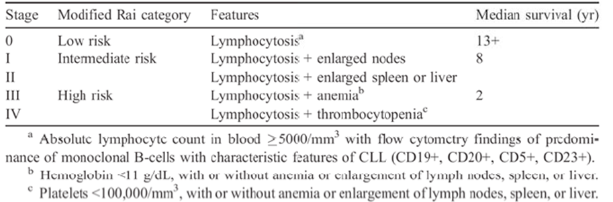
Table 2: Binet staging system for CLL.
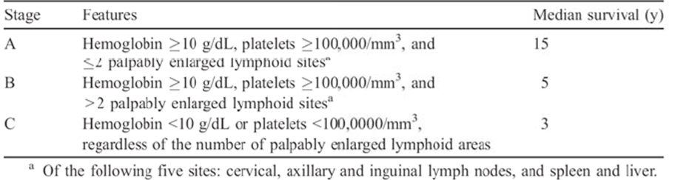
Agents that are currently registered in Australia for the treatment of CLL include alkylating agents (chlorambucil, bendamustine, cyclophosphamide), purine analogues (fludarabine, cladribine), monoclonal antibodies directed against CD20 (rituximab, ofatumumab, obinutuzumab), a monoclonal antibody directed against CD52 (alemtuzumab) and an inhibitor of Bruton’s tyrosine kinase (ibrutinib).
Recommended treatment of CLL/SLL depends on a number of factors including patient functional status, age, the presence or absence of certain cytogenetic abnormalities [del (11q), del (17p) or TP53 mutation] and the presence or absence of significant comorbidities. For previously untreated patients, aged < 70 and in good physical condition and without adverse cytogenetic abnormalities, combination therapy with a chemotherapy agent and a monoclonal antibody (“chemoimmunotherapy”) is usually recommended– e.g. fludaribine + cyclophosphamide + rituximab (FCR).
Previously submitted data had demonstrated that idelalisib in combination with rituximab was effective as a second line regimen in CLL/SLL, and as a first line regimen in subjects with del (17p) or TP53 mutation, who have poor outcomes with standard chemoimmunotherapy regimens. Ofatumumab is another anti-CD20 monoclonal antibody registered for the treatment of CLL/SLL. The efficacy and safety of the combination of idelalisib and ofatumumab would therefore be of clinical interest.

Contents of the clinical dossier

Scope of the clinical dossier
The submission contained the following clinical information:
- 1 pivotal efficacy/safety study (GS-US-312-0119) of idelalisib in combination with ofatumumab.
- An updated study report of one previously evaluated phase 1/2 study (study 101-07) that included some data on the use of idelalisib in combination with ofatumumab.
- Study reports of various other studies not directly relevant to the new indication. Some of these studies had previously been evaluated by TGA. The safety data from these studies have been reviewed in this evaluation.
- A validation study (Report 15-001) of a previously developed population pharmacokinetic model using PK data from the pivotal study.
- Tables of safety data from four ongoing, blinded, placebo-controlled Phase 3 studies of idelalisib (GS-US-312-0115, GS-US-312-0123, GS-US-313-0124, and GS-US-313-0125) in CLL and indolent NHL. These data were all blinded (i.e. it was not possible to determine whether a reported adverse event occurred in a placebo-treated or idelalisib-treated patient). The data were therefore not evaluable. According to the sponsor no new safety concerns have been identified to date from the blinded data.
- Literature references.

Paediatric data
The submission did not contain any paediatric data.
Comment: As CLL/SLL is a disease of adults the absence of paediatric data is acceptable.

Good clinical practice
The study reports included in this submission all contained assurances that the studies were conducted in accordance with the International Conference on Harmonization (ICH) guideline for Good Clinical Practice (GCP) and the original principles embodied in the Declaration of Helsinki.

Pharmacokinetics
Limited PK sampling was performed in the pivotal study included in this submission (GS-US-312-0119). Results are summarised in Table 3.
Table 3: Idelalisib plasma PK concentration (ng/Ml) PK analysis set.
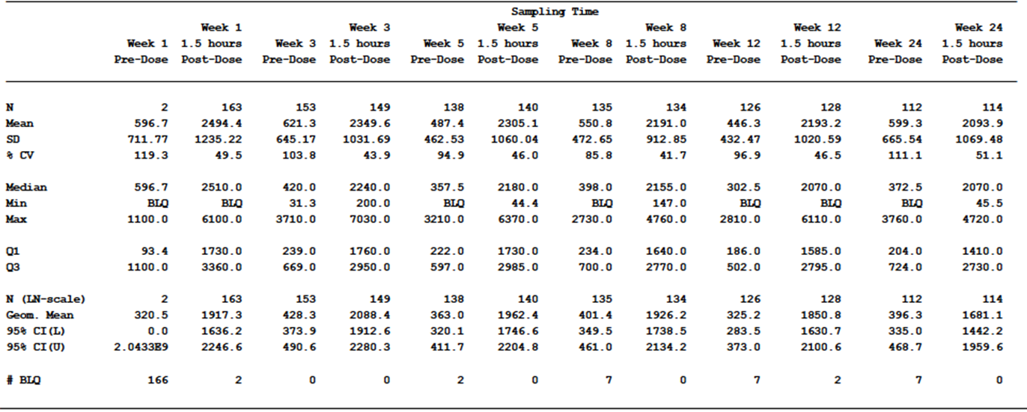
Note: the PK analysis set includes subjects in the safety analysis set who have baseline and on-study measurements to provide interpretable results, with treatment group designated according to the actual treatment received.
In addition, the sponsor conducted various population PK and population PK/PD analyses of subjects enrolled in the pivotal study using previously developed population PK models. Results for these analyses are summarised below.
Table 4: Effect of ofatumumab on idelalisib PK.
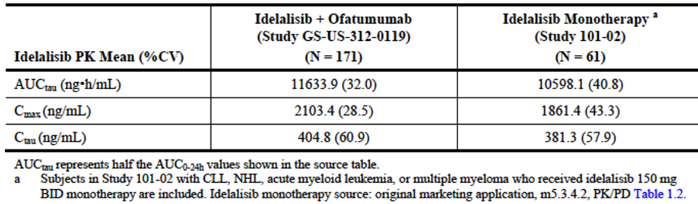
Table 5: Effect of intrinsic factors on idelalisib PK.
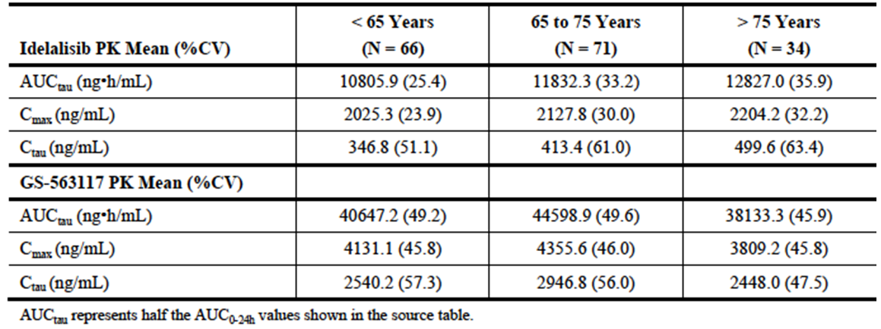
Figure 1: Study GS-US-312-0119: exposure-efficacy relationship, box plot of idelalisib C_{tau} stratified by BOR.
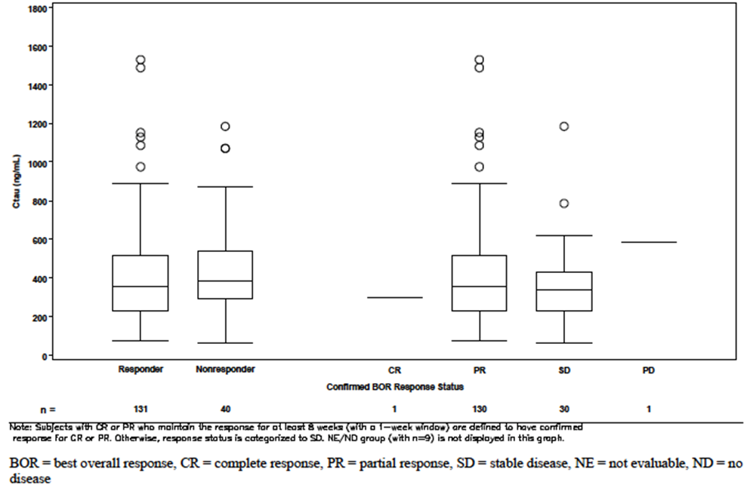

Figure 2: Study GS-US-312-0119: exposure-safety relationship, box plot of idelalisib C_{max} for subjects with ≥ Grade 3 AEs of interest.
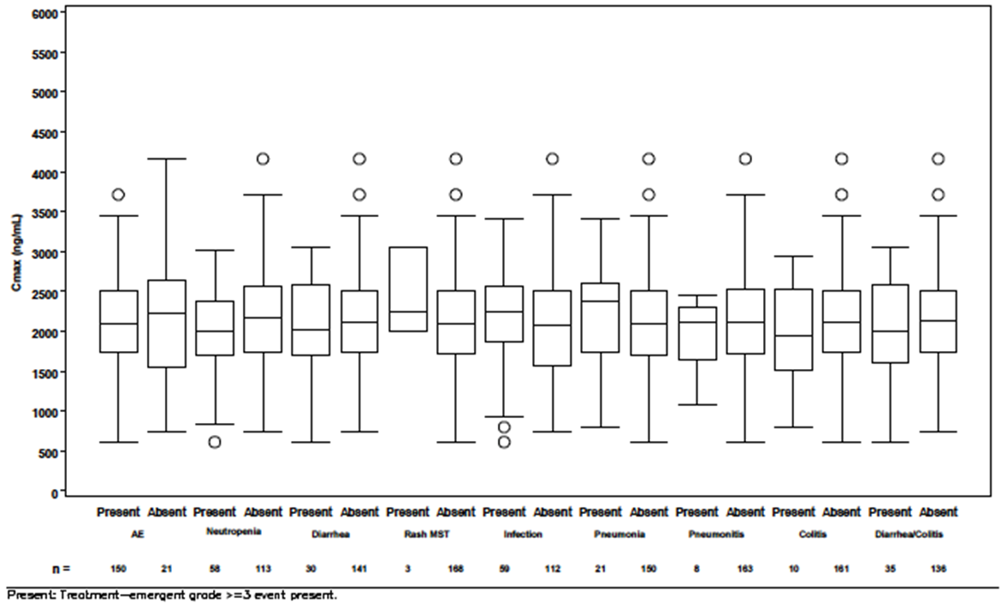
Conclusions drawn from these PK data were:
- Idelalisib trough and peak plasma concentrations remain reasonably stable over 24 weeks when the drug is administered in combination with ofatumumab;
- Co-administration of ofatumumab with idelalisib does not appear to significantly affect the PK of idelalisib;
- No relationships could be established between systemic exposure to idelalisib and efficacy outcomes;
- No relationships could be established between systemic exposure to idelalisib and the occurrence of common AEs.

Pharmacodynamics
No new pharmacodynamic data were included in the submission. In the pivotal study blood samples were collected for the measurement of plasma cytokines and chemokines, serum markers of iron metabolism and CLL cell DNA, RNA and protein. The study report did not contain analyses of these parameters. It indicated that a separate biomarker analysis report would be submitted.

Dosage selection for the pivotal studies
The dose of idelalisib used in the pivotal study was 150 mg BD. This is the same regimen used for the currently approved indications and was based on previously evaluated Phase 1 studies.
The choice of ofatumumab dose (1000 mg) was not discussed in the study report for the pivotal study. However, this dose was used in an earlier phase 1/2 study (101-07) where the stated justification was that the 1000 mg dose is common when ofatumumab is used in combination regimens.

Clinical efficacy

Pivotal efficacy study (GS-US-312-0119)

Study design, objectives, locations and dates
Study GS-US-312-0119 was a phase 3, randomised open-label controlled trial with two parallel groups. Subjects were randomised (2:1) to receive either the combination of ofatumumab with idelalisib (Group A) or ofatumumab monotherapy (Group B). A study schema is shown in Figure 3.
Figure 3: Study GS-US-312-0119 – Study schema.
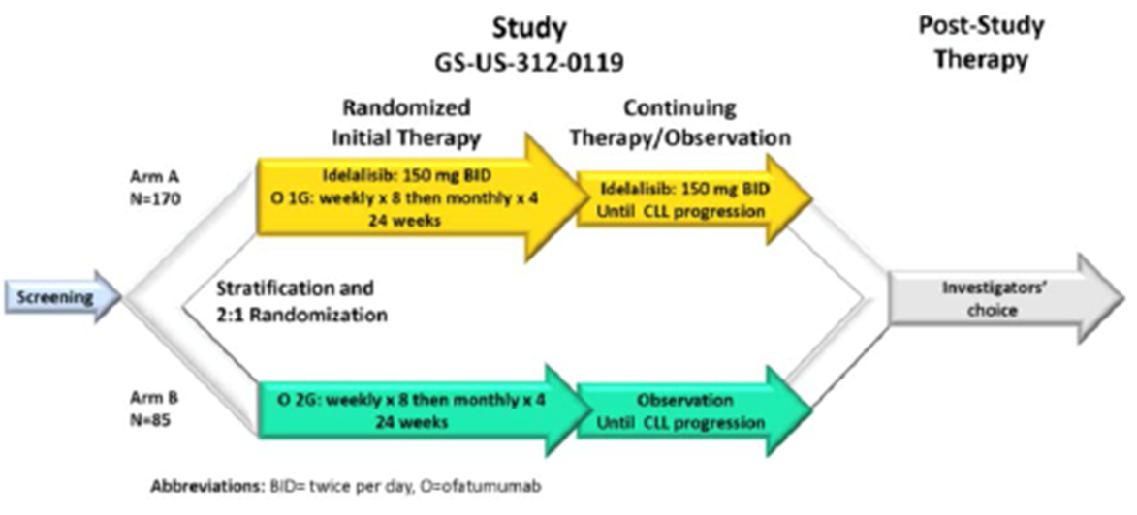
The primary objective of the study was to evaluate the effect of the addition of idelalisib to ofatumumab on progression-free survival (PFS) in subjects with previously treated CLL.
The secondary objectives were to:
- Evaluate the effect of the addition of idelalisib to ofatumumab on the onset, magnitude, and duration of tumour control;
- Evaluate the effect of the addition of idelalisib to ofatumumab on the onset, magnitude, and duration of tumour control for subjects with 17p deletion and/or TP53 mutation;
- Assess the effect of the addition of idelalisib to ofatumumab on measures of subject well being, including overall survival (OS), health-related quality of life (HRQL), and performance status;
- Assess the effects of the addition of idelalisib to ofatumumab on disease-associated biomarkers and to evaluate potential mechanisms of resistance to idelalisib;
- Characterize the effect of ofatumumab on idelalisib exposure through the evaluation of idelalisib plasma concentrations over time;
- Describe the safety profile observed with the addition of idelalisib to ofatumumab;
- Estimate health resource utilization associated with the addition of idelalisib to ofatumumab.
The study was conducted at 81 sites in 11 countries (the United States, Canada, Belgium, Denmark, France, Ireland, Poland, Spain, Sweden, United Kingdom, and Australia). It commenced in December 2012 and the cut-off date for inclusion of data in the study report was 15 January 2015. The study report itself was dated 21 April 2015. At the time of writing, it appears that the study has not been published other than as a conference abstract.

Inclusion and exclusion criteria
Inclusion criteria and exclusion criteria are listed below.

Inclusion criteria
Subjects who met all of the following criteria were eligible for participation in the study:
- Male or female ≥ 18 years of age
- Diagnosis of B cell CLL, with diagnosis established according to IWCLL criteria and documented within medical records
- CLL that warranted treatment (consistent with accepted IWCLL criteria for initiation of therapy). Any of the following conditions constitute CLL that warranted treatment:
  - Evidence of progressive marrow failure as manifested by the onset or worsening of anemia and/or thrombocytopenia, or
  - Massive (i.e. lower edge of spleen ≥ 6 cm below the left costal margin), progressive, or symptomatic splenomegaly,
  - Massive (i.e. ≥ 10 cm in the longest diameter), progressive, or symptomatic lymphadenopathy, or
  - Progressive lymphocytosis in the absence of infection, with an increase in blood ALC ≥ 50% over a 2-month period or lymphocyte doubling time of < 6 months (as long as initial ALC was ≥ 30,000/L), or
  - Autoimmune anemia and/or thrombocytopenia that is poorly responsive to corticosterioids or other standard therapy, or
  - Constitutional symptoms, defined as any one or more of the following disease-related symptoms or signs occurring in the absence of evidence of infection:
    - Unintentional weight loss of ≥ 10% within the previous 6 months, or
    - Significant fatigue (≥ Grade 2),
    - Fevers > 100.5 °F or 38.0 °C for ≥ 2 weeks, or
    - Night sweats for > 1 month
- Presence of radiographically measurable lymphadenopathy (defined as the presence of ≥ 1 nodal lesion that measures ≥ 2.0 cm in the longest diameter (LD] and ≥ 1.0 cm in the longest perpendicular diameter (LPD] as assessed by computed tomography [CT] or magnetic resonance imaging [MRI])
- Prior treatment for CLL comprising therapy with either of the following given alone or in combination:
  - A purine analog (e.g. fludarabine, pentostatin, cladribine) administered for ≥ 2 cycles of cytotoxic treatment, or
  - Bendamustine administered for ≥ 2 cycles of treatment
- Documentation of CLL progression < 24 months since the completion of the last prior therapy for CLL
- Discontinuation of all therapy (including radiotherapy, chemotherapy, immunotherapy, or investigational therapy) for the treatment of CLL > 6 weeks before randomisation
- All acute toxic effects of any prior anti-tumour therapy resolved to Grade ≤ 1 before randomisation (with the exception of alopecia [Grade 1 or 2 permitted], neurotoxicity [Grade 1 or 2 permitted], or bone marrow parameters [Grades 1, 2, 3 or 4 permitted])
- Karnofsky performance score of ≥ 60
- Required baseline laboratory data (within 4 weeks prior to randomisation) as shown in the table below. Subjects with any degree of neutropenia, thrombocytopenia, or anemia due to CLL or prior therapy could enrol
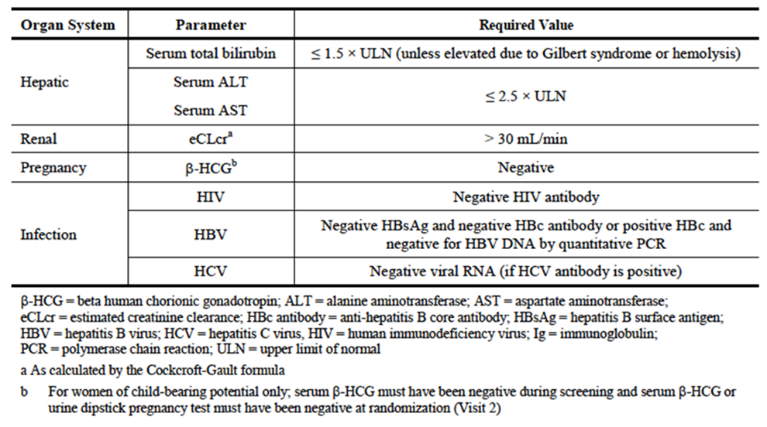
- For female subjects of child-bearing potential, willingness to use a protocol-recommended method of contraception from the screening visit (Visit 1) throughout the study treatment period and to 30 days from the last dose of study drug or 12 months from the last dose of ofatumumab (whichever is later)
- For male subjects of child-bearing potential and having intercourse with females of child-bearing potential, willingness to use a protocol-recommended method of contraception from the randomisation visit (Visit 2) throughout the study treatment period and for 90 days following the last dose of study drug and to refrain from sperm donation from randomisation (Visit 2) throughout the study treatment period and for 90 days following the last dose of study drug
- In the judgement of the investigator, participation in the protocol offers an acceptable benefit-to-risk ratio when considering current CLL disease status, medical condition, and the potential benefits and risks of alternative treatments for CLL
- Willingness and ability to comply with scheduled visits, drug administration plan, imaging studies, laboratory tests, other study procedures, and study restrictions
- Evidence of a personally signed informed consent indicating that the subject is aware of the neoplastic nature of the disease and has been informed of the procedures to be followed, the experimental nature of the therapy, alternatives, potential benefits, possible side effects, potential risks and discomforts, and other pertinent aspects of study participation

Exclusion criteria
Subjects with any of the following were not eligible for participation in the study:
- Known histological transformation from CLL to an aggressive lymphoma (i.e. Richter’s transformation)
- Known presence of intermediate- or high-grade myelodysplastic syndrome (i.e. subjects are excluded who have ≥ 5% bone marrow blasts; karotypic abnormalities other than normal, Y deletion, 5q deletion, or 20q deletion; or ≥ 2 lineages of cytopenias due to myelodysplasia)
- History of a non-CLL malignancy except for the following: adequately treated local basal cell or squamous cell carcinoma of the skin, cervical carcinoma in situ, superficial bladder cancer, asymptomatic prostate cancer without known metastatic disease and with no requirement for therapy or requiring only hormonal therapy and with normal prostate-specific antigen for ≥ 1 year prior to randomisation, other adequately treated Stage 1 or 2 cancer currently in complete remission, or any other cancer that has been in complete remission for ≥ 2 years
- Known hypersensitivity or intolerance to any of the active substances or excipients in the formulations for either idelalisib or ofatumumab
- Evidence of ongoing systemic bacterial, fungal, or viral infections at the time of initiation of randomisation (Visit 2)
- Ongoing drug-induced liver injury, chronic active hepatitis C virus (HCV), chronic active HBV, alcoholic liver disease, non-alcoholic steatohepatitis, primary biliary cirrhosis, extrahepatic obstruction caused by cholelithiasis, cirrhosis of the liver, or portal hypertension
- Ongoing drug-induced pneumonitis
- Ongoing inflammatory bowel disease
- Ongoing alcohol or drug addiction
- Pregnancy or breastfeeding
- History of prior allogenic bone marrow progenitor cell or solid organ transplantation
- Ongoing immunosuppressive therapy other than corticosteroids
- In a subject with a history of prior ofatumumab therapy, the time from the last dose of ofatumumab to documented CLL progression was < 6 months
- History of prior therapy with any inhibitor of serine/threonine protein kinase (Akt), Bruton tyrosine kinase, Janus kinase, mammalian target of rapamycin, PI3K (including idelalisib), or spleen tyrosine kinase
- Prior participation in an idelalisib clinical study
- Concurrent participation in another therapeutic clinical study
- Prior or ongoing clinically significant illness, medical condition, surgical history, physical finding, electrocardiogram (ECG) finding, or laboratory abnormality that, in the investigator’s opinion, could adversely affect the safety of the subject or impair the assessment of study results
Comment: The inclusion criteria refer to various criteria promulgated by the International Workshop on Chronic Lymphocytic Leukemia (IWCLL). These criteria come from an international consensus guideline originally developed by the National Cancer Institute (NCI) in the United States in 1996, which was revised in 2008. IWCLL criteria are currently standard for studies in CLL.
All subjects were required to have undergone prior treatment for CLL with either a purine analogue or bendamustine. However, the proposed indication includes use of the combination as first-line treatment in the presence of 17p deletion or TP53 mutation.
In Australia, ofatumumab monotherapy is only approved for use in subjects with CLL that is refractory to treatment with fludarabine and alemtuzumab. In the pivotal study of ofatumumab monotherapy, “refractory” was defined as failure to achieve at least a partial response with fludarabine or alemtuzumab treatment, or disease progression within 6 months of the last dose of fludarabine or alemtuzumab. The inclusion criteria for GS-US-312-0119 permitted enrolment of subjects with less treatment-resistant disease than this group. However, current treatment guidelines recommend ofatumumab monotherapy as a treatment option for all subjects with relapsed or refractory CLL. The choice of comparator is therefore considered acceptable.

Study treatments
Subjects were randomised (2:1) to the following:
- Group A – Ofatumumab 1g IV for a total of 12 doses, together with idelalisib 150 mg BD orally until disease progression;
- Group B - Ofatumumab 2 g IV for a total of 12 doses.
Idelalisib could be taken with or without food. Subjects were instructed to take the drug at approximately the same times each day at approximately 12-hour intervals. The dose of idelalisib could be reduced to 100 mg BD in the event of toxicity.
Ofatumumab was administered IV in the clinic starting at a dose of 300 mg on Day 1 (Week 1) (Groups A and B) and continued with a dose of either 1g (Group A) or 2g (Group B) on Day 8 (Week 2), Day 15 (Week 3), Day 22 (Week 4), Day 29 (Week 5), Day 36 (Week 6), Day 43 (Week 7), Day 50 (Week 8), Day 78 (Week 12), Day 106 (Week 16), Day 134 (Week 20), and Day 162 (Week 24). The ofatumumab dose was diluted into 1000 mLs of normal saline. The first infusion was commenced at 12 mLs/hour and the rate increased up to 200 mLs/hr over 2 hours. Subsequent infusions were commenced at 25 mLs/hr and increased up to 400 mLs/hr over 2 hours.
All subjects received the following recommended premedication prior to ofatumumab infusions: paracetamol 1g or equivalent, an oral or IV antihistamine (cetirizine 10 mg or equivalent) and an IV corticosteroid (prednisolone 100 mg or equivalent). These were administered 30 to 60 minutes prior to the ofatumumab infusion.
Comment: The ofatumumab monotherapy regimen used in Group B is identical to that approved in Australia for refractory CLL.

Efficacy variables and outcomes
The main efficacy variables were:
- Survival;
- Change in tumour size (e.g. lymph nodes, spleen, liver);
- Changes in haematological parameters.
The primary efficacy outcome was progression-free survival (PFS) defined as the interval from randomisation to first documentation of either definitive disease progression or death from any cause (whichever occurred earlier).
Secondary efficacy outcomes were:
- Overall response rate (ORR) – defined as the proportion of subjects who achieve a complete response (CR) or partial response (PR);
- Lymph node response (LNR) rate – defined as the proportion of subjects who achieve a ≥50% decrease in the sum of the products of the perpendicular diameters (SPD) of index lymph nodes;
- Overall survival (OS) – defined as the interval from randomisation to death from any cause;
- PFS in the subgroup of subjects with 17p deletion and/or TP53 mutation;
- CR rate – defined as the proportion of subjects who achieve a CR.
Exploratory efficacy outcomes were:
- Time to response (TTR) – defined as the interval from randomisation to the first documentation of confirmed CR or PR;
- Duration of response (DOR) – defined as the interval from the first documentation of confirmed CR or PR to the earlier of a) the first documentation of definitive disease progression or b) death from any cause;
- Percent change in lymph node area – defined as the percent change from baseline in the SPD of index lymph nodes;
- Splenomegaly response rate – defined as the proportion of subjects with a 50% decrease from baseline (minimum decrease of 2 cm) in the enlargement of the spleen in its longest vertical dimension (LVD) or to ≤ 12 cm by imaging;
- Hepatomegaly response rate – defined as the proportion of subjects with a 50% decrease (minimum decrease of 2 cm) from baseline in the enlargement of the liver in its LVD or to ≤ 18 cm by imaging, or regression to a liver LVD of ≤ 15 cm by physical examination;
- ALC response rate – defined as the proportion of subjects with baseline lymphocytosis (absolute lymphocyte count [ALC] ≥ 4 x 109/L) who achieve an on-study ALC < 4 x 109/L or demonstrate a 50% decrease in ALC from baseline;
- Platelet response rate – defined as the proportion of subjects with baseline thrombocytopenia (platelet count < 100 x 109/L) who achieve an on-study platelet count ≥ 100 x 109/L or demonstrate a ≥ 50% increase in platelet count from baseline without need for supportive care (e.g. transfusion or growth factor). Platelet values within 4 weeks post-baseline were excluded from the platelet response rate evaluation;
- Haemoglobin response rate – defined as the proportion of subjects with baseline anaemia (haemoglobin < 110 g/L) who achieve an on-study haemoglobin ≥ 110 g/L or demonstrate a ≥ 50% increase in haemoglobin from baseline without supportive care (e.g., red blood cell transfusions or growth factor). Haemoglobin values within 4 weeks post-baseline were excluded from the haemoglobin response rate evaluation;
- Neutrophil response rate – defined as the proportion of subjects with baseline neutropenia (absolute neutrophil count [ANC] < 1.5 x 109/L) who achieve an ANC ≥ 1.5 x 109/L or demonstrate a ≥ 50% increase in ANC from baseline without the need for exogenous growth factors. ANC values within 4 weeks post-baseline were excluded from the neutrophil response rate evaluation;
- Change in health-related quality of life (HRQL) based on the Functional Assessment of Cancer Therapy: Leukaemia (FACT-Leu) questionnaire.
- Changes in Karnofsky performance status.
Comment: Subjects in the trial were also administered another QoL instrument (the EQ5D). The sponsor considered this to be a pharmacoeconomic endpoint rather than an efficacy endpoint and therefore the results will not be reviewed in this report.
Tumour response and progression were defined according to IWCLL criteria. An independent review committee (IRC), which was blinded to treatment allocation, reviewed the radiographic and clinical data.
The FACT-Leu questionnaire has two parts – a general measure of quality of life (the FACT-G) containing 27 questions in four domains - Physical Well-Being (PWB - 7 items), Social/Family Well-Being (SFWB - 7 items), Emotional Well-Being (EWB - 6 items), and Functional Well-Being (FWB - 7 items) - and a section on ‘additional concerns’ containing 17 leukaemia-specific items (LeuS). Each of the 44 items is answered using a 5-point scale (0 = ‘Not at all’ to 4 = ‘Very much’). The questions refer to symptoms etc. experienced in the last 7 days. Scores are summed. Hence the range of possible scores for the total FACT-Leu score (44 items) is 0 to 176. High scores indicate better quality of life. The study report focussed on results for the following three scores:
- Trial Outcome Index (TOI, score range: 0-124) = PWB + FWB + LeuS;
- FACT-G Total Score (score range: 0-108) = PWB + SFWB + EWB + FWB;
- Additional concerns (score range: 0-68) = LeuS.
Subjects attended the clinic at weekly intervals up to week 8, then at 4-weekly intervals up to week 24, then 6-weekly intervals up to week 48 and at 12-weekly intervals thereafter until disease progression. At the time of discontinuation from the study, subjects had an end-of-study (EOS) clinic visit and a further visit 30 days after EOS.
Radiological assessment (CT or MRI) of the neck, chest abdomen and pelvis was performed within 6 weeks of randomisation and then at weeks 8, 16 and 24, then at 12 weekly intervals and at EOS. Physical examination (including lymph nodes, liver and spleen) was conducted at weeks 1, 5 and 8 and then at every clinic visit thereafter. Haematology parameters were measured at each clinic visit. Bone marrow biopsy or aspirate was only performed to confirm a CR or progressive disease (PD). FACT-Leu questionnaires were administered, and Karnofsky score recorded, at each study visit.
Subjects who permanently discontinued study drug for a reason other than progressive disease continued with scheduled efficacy assessments until disease progression or another anticancer or experimental therapy was initiated. Long-term follow-up for survival was to be conducted annually for 5 years, either at a clinic visit or via telephone.

Randomisation and blinding methods
Subjects were randomised 2:1 to Group A (combination of idelalisib and ofatumumab 1000 mg) or Group B (ofatumumab 2000 mg). Randomisation was performed centrally in blocks via an interactive web response system (IWRS) and was stratified according to the following factors:
- 17p deletion and/or TP53 mutation in CLL cells: either versus neither (or indeterminate);
- IGHV mutation: unmutated (or IGHV3-21) versus mutated (or indeterminate);
- Disease status: refractory (CLL progression < 6 months from completion of prior therapy) versus relapsed (CLL progression ≥ 6 months from completion of prior therapy).
Subjects and investigators were not blinded to treatment allocation. However, the IRC reviewing the efficacy data was blinded.

Analysis populations
The Intent-to Treat (ITT) Analysis Set included all subjects who were randomised, regardless of whether they received any study drug(s), or received a different regimen from that to which they were randomised. Treatment assignment was designated according to randomization. This population was used for most of the efficacy analyses.
The Per Protocol (PP) Analysis Set included subjects in the ITT Analysis Set who met the general criteria defining the target population for the study, were adherent to the protocol, were compliant with study drug treatment, and were evaluable for relevant efficacy endpoints. Study drug assignment was designated according to the actual treatment received. The PP Analysis Set was used for various sensitivity analyses.
A Safety Analysis Set included subjects who received ≥ 1 dose of study treatment, with treatment assignments designated according to the actual treatment received. This population was used in the analyses of safety.

Sample size
Based on a phase 2 study, it was assumed that median PFS in the ofatumumab monotherapy arm would be approximately 8 months. An improvement in median PFS to 14 months with the addition of idelalisib was selected as the effect size of interest. It was calculated that a total of 129 PFS events would be required for a power of 85% using a log-rank test with a 2-sided significance level of 0.05. Assuming an accrual period of 12 months, a minimum follow-up period of 12 months and a 10% loss of subjects to follow-up, a total of 170 subjects would be required in Group A and 85 subjects in Group B. The planned sample size was therefore 225 subjects.

Statistical methods
For the primary endpoint, the difference in PFS between the treatment arms was tested using a stratified log-rank test, adjusted for the stratification factors. Median PFS and the proportion of subjects who were progression-free at 6 and 12 months were estimated using Kaplan-Meier methods. A hazard ratio and 95% CI were calculated using a Cox proportional hazards regression model. Four exploratory sensitivity analyses were planned to test the robustness of the primary PFS results (an analysis using an unstratified log rank test, an analysis using the Per Protocol Analysis Set, an analysis in which subjects who missed ≥ 2 tumour assessments were not censored and an analysis in which subjects in the combination arm who were lost to follow up were categorized as having had a PFS event). Subgroup analyses of PFS would be assessed using Cox regression modeling. Other PFS endpoints and OS were tested using similar methods.
The final analysis was planned to occur after 129 PFS events. One interim analysis was performed after approximately 75% of the planned 129 events had occurred, and a decision was made to continue the study to the final analysis. The significance level required to reject the null hypothesis at the final analysis was set at p < 0.044.
To preserve the overall type I error rate across the primary and secondary endpoints of the study at a 2-sided significance level of 0.05, a hierarchical testing procedure was implemented. Secondary efficacy endpoints would only be tested if the null hypothesis had been rejected for the primary endpoint. Secondary endpoints would be tested in the following order: ORR, LNR rate, OS, PFS in the subgroup with 17p deletion or TP53 mutation, CR rate. Each would be tested only if the null hypothesis had been rejected for the previous endpoint.
Differences between the treatment arms in response rates were compared using Cochran-Mantel-Haenszel (CMH) Chi-square tests after adjusting for stratification factors.

Participant flow
A total of 261 subjects were randomised in the study – 174 to the combination and 87 to ofatumumab monotherapy. At the time of data cut-off 48.3% of subjects in the combination arm were ongoing in the study compared to 6.9% of subjects in the ofatumumab arm.

Major protocol violations/deviations
The overall incidence was the same in the two arms (39.1%). Generally the various types of violation occurred with similar frequency in the two treatment arms. Errors in stratification were the most common violation and these were more common in the ofatumumab arm (27.6% vs. 21.8%). The most common type of stratification error related to reporting of disease status (relapsed vs. refractory) by the investigator at baseline. The primary analysis was performed based on corrected strata (corrected during database clean up but after randomisation). However, additional ad hoc sensitivity analyses were performed, based on strata reported at randomisation. According to the sponsor these ad hoc analyses gave comparable results to the primary analyses.
A total of 12 subjects had protocol violations sufficient to exclude them from the Per Protocol Set – 10 in the combination arm and 2 in the ofatumumab arm.

Baseline data
The incidence of cytopaenias at baseline was comparable between the two arms.
Comment: The two treatment arms were reasonably well balanced at baseline with respect to demographic and disease characteristics. However, advanced stage disease (Rai stages III/IV, Binet stage C) was more common in the combination arm, whereas refractory disease was more common in the ofatumumab arm. Consistent with the known natural history of CLL the population was predominantly male and elderly.
The population was a heavily pre-treated one with a median of three prior regimens. The majority of subjects had previously been treated with rituximab, fludarabine and cyclophosphamide.
Comment: Prior treatment was comparable between the two arms.

Results for the primary efficacy outcome
Results for PFS as assessed by the IRC in the ITT analysis set are summarised in Table 6 and Figure 3. At the time of data cut-off a PFS event had been reported in 130 of the 271 subjects. Treatment with the combination was associated with a statistically significant reduction in the risk of experiencing a PFS event (hazard ratio 0.27; 95% CI: 0.19 to 0.39; p<0.0001).
Table 6: Study GS-US-312-0119 – Progression-free survival (primary endpoint).
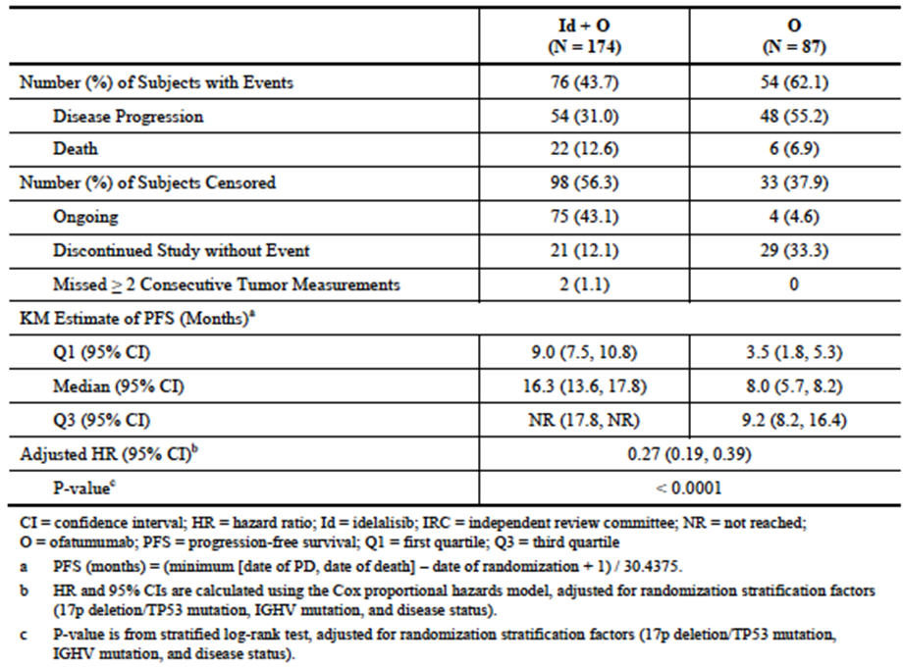
Figure 3: Study GS-US-312-0119 – Progression-free survival (primary endpoint).
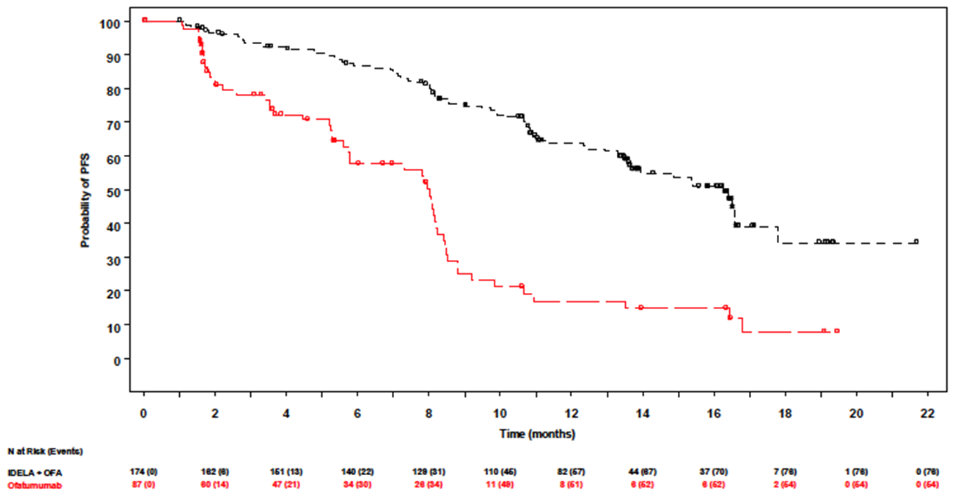
Median PFS was increased from 8.0 months to 16.3 months. Estimated PFS rate at 6 months was 86.7% (95% CI: 80.5 to 91.0) for the combination and 57.6% (95% CI: 45.0 to 68.3) for ofatumumab monotherapy. Estimated PFS rate at 12 months was 63.7% (95% CI: 55.5 to 70.7) for the combination and 17.0% (95% CI: 8.3 to 28.2) for ofatumumab monotherapy.
The four planned sensitivity analyses gave comparable results to the primary analysis. Subgroup analyses indicated that the benefit in PFS was consistent across the various subgroups examined (Figure 4).
Figure 4: Study GS-US-312-0119 – Progression-free survival – Subgroup analyses.
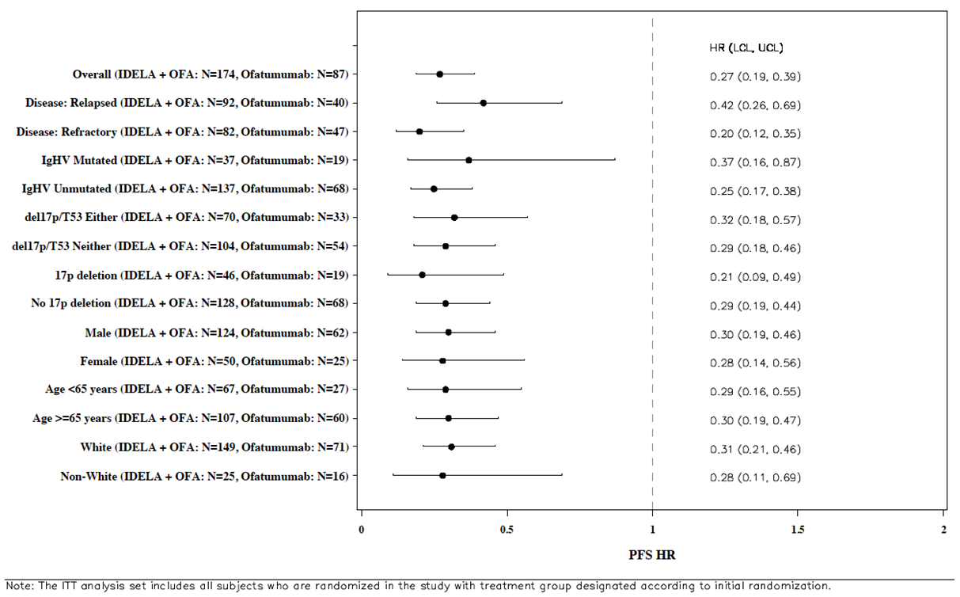

Results for secondary efficacy outcomes

Overall response rate
The ORR was 75.3% (95% CI: 68.2 to 81.5) in the combination arm and 18.4% (95% CI: 10.9 to 28.1) in the ofatumumab arm (Table 7). The difference was statistically significant (p < 0.0001). There was only 1 complete response (in the combination arm).
Table 7: Study GS-US-312-0119 – Response rates.
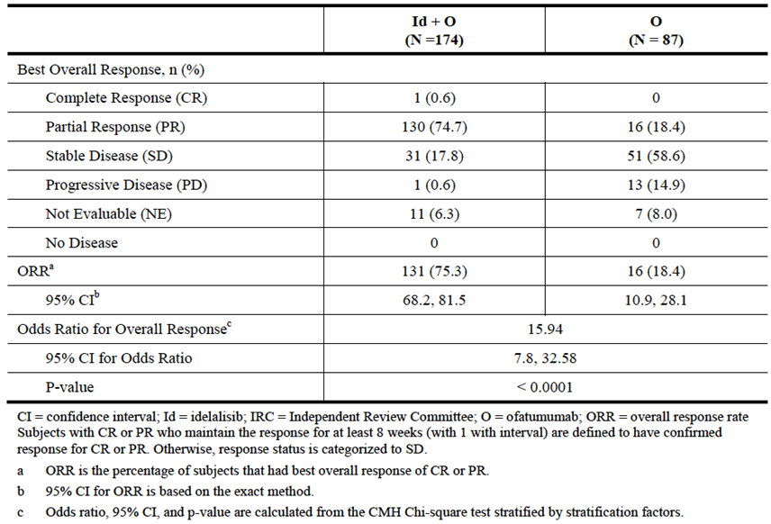

Lymph node response (LNR) rate
The LNR rate was 93.3% (95% CI: 88.3 to 96.6) in the combination arm and only 4.9% (95% CI: 1.4 to 12.2) in the ofatumumab arm (Table 8). The difference was statistically significant (p < 0.0001).
Table 8: Study GS-US-312-0119 – Lymph node response rates.
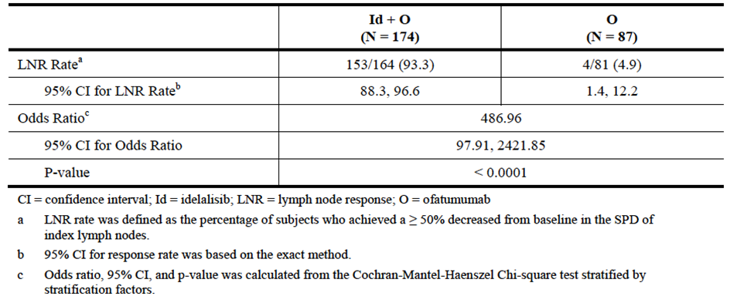

Overall survival
Results for OS in the ITT analysis set are summarised in Table 9 and Figure 5. OS data were immature with only 64 of 261 subjects (24.5%) having died. There was no statistically significant difference in overall survival between the two treatment arms.
Table 9: Study GS-US-312-0119 – Overall survival.
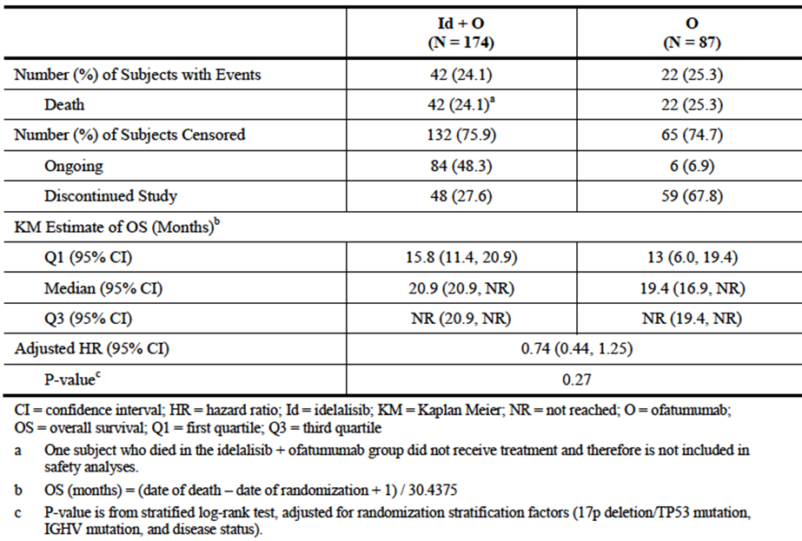
Figure 5: Study GS-US-312-0119 – Overall survival.
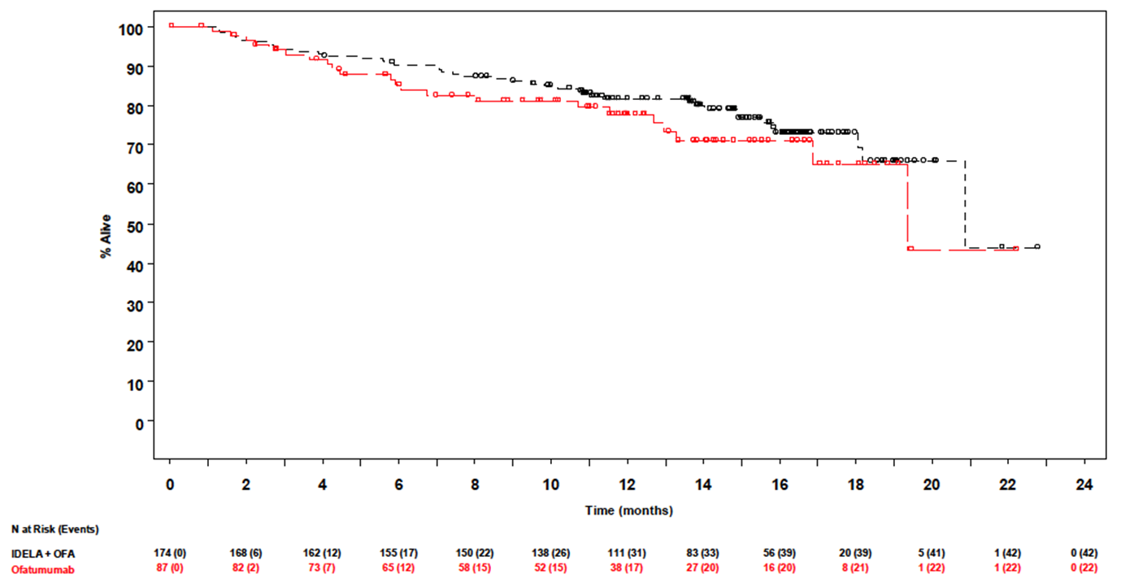
Comment: The study report did not contain any information on subsequent therapies received in subjects who experienced disease progression (e.g. whether subjects in the ofatumumab monotherapy arm with disease progression received idelalisib).

PFS in the subgroup of subjects with 17p deletion and/or TP53 mutation
Results for PFS in this subgroup of patients are summarised in Table 10. The incidence of PFS events was numerically lower in the combination arm (50.0% vs. 60.6%). As the null hypothesis for the previous secondary endpoint (OS) had not been rejected, formal statistical testing was not conducted. However, informal testing suggested that the difference between treatment arms was significant (HR = 0.32; 95% CI: 0.18 to 0.57; p < 0.0001) median PFS was prolonged from 5.8 months to 13.7 months.
Table 10: Study GS-US-312-0119 – PFS in subjects with 17p deletion or TP53 mutation.
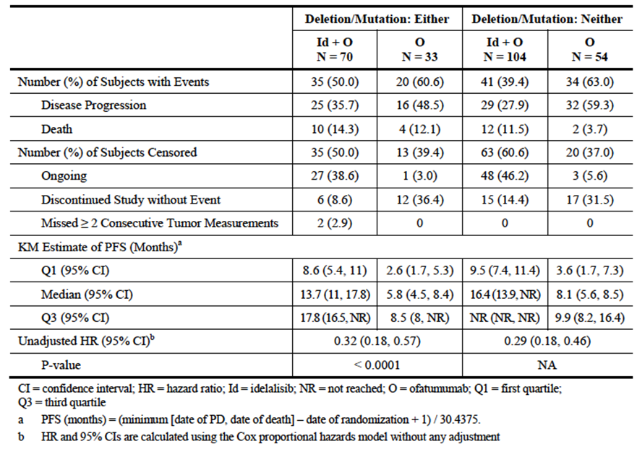

CR rate
As there was only one complete response this endpoint was not analysed.

Results for exploratory efficacy outcomes

Time to response
Median time to response was 1.7 months in both arms.

Duration of response
Median duration of response was 14.9 months (95% CI: 12.9 to not reached) in the combination arm and 6.7 months (95% CI: 5.6 to 15.0) in the ofatumumab arm.

Percent change in lymph node area
Results for this endpoint are summarised in Table 11. At baseline, mean lymph node area was greater in the ofatumumab group (8455.6 vs. 6528.3 mm²). After treatment, mean best percent reduction in lymph node area was greater in the combination arm (-72.1% vs. -11.2%).
Table 11: Study GS-US-312-0119 – Best percentage change in lymph node SPD.
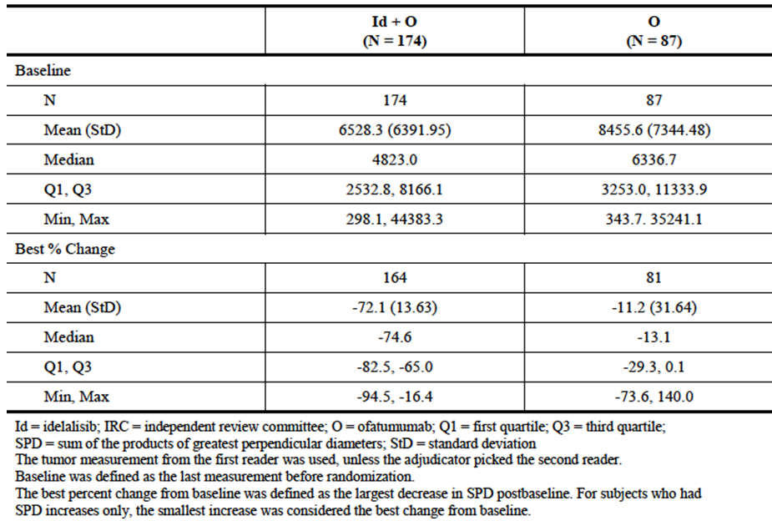

Splenomegaly and hepatomegaly response rates
Results are summarised in Table 12. A greater proportion of subjects in the combination arm achieved significant reductions in both spleen and liver size, compared with the ofatumumab arm.
Table 12: Study GS-US-312-0119 – Splenomegaly and hepatomegaly response rates.
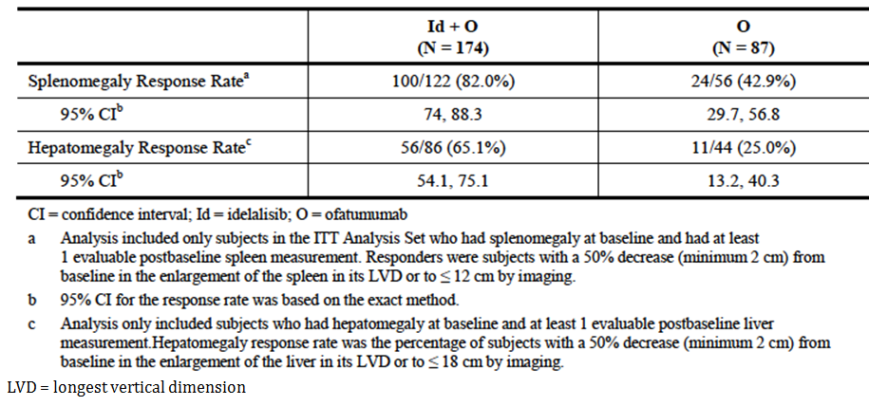

Responses in haematological parameters
Results are summarised in Table 13. For each of the four haematology parameters, a greater proportion of subjects in the combination arm achieved a response compared with the ofatumumab arm.
Table 13: Study GS-US-312-0119 – Haematology parameter response rates.
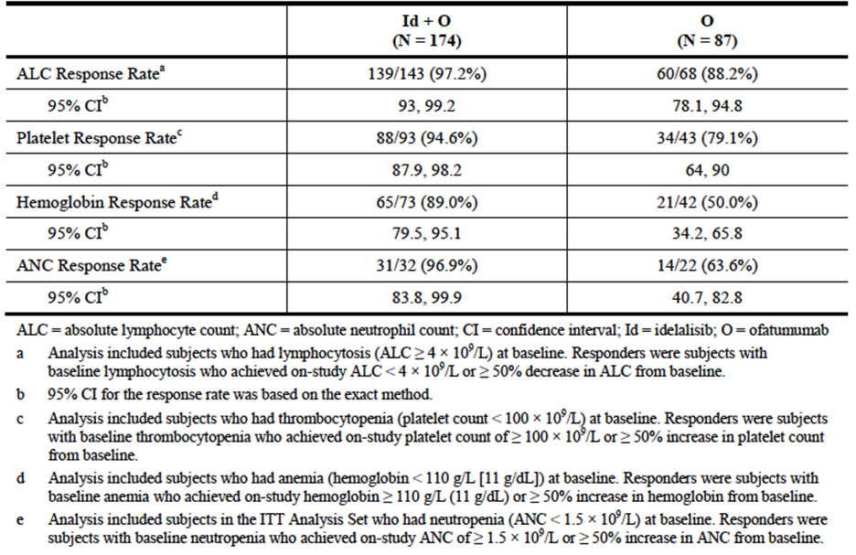

FACT-Leu questionnaire
The study report focussed on results for the Trial Outcome Index (TOI) composite score, the FACT-G Total Score and the Additional Concerns subscale (LeuS). For the Additional Concerns score, the percent change from baseline is illustrated in Figure 6, and the differences between the arms over time are summarised in14. The potential range of scores is 0-68. At baseline the mean score was 46.3 (± 10.9) in the combination arm and 45.7 (± 9.9) in the ofatumumab arm. Symptoms improved in both arms, with greater improvement in the combination arm. A similar pattern was seen with the TOI score and FACT-G total score.
Figure 6: Study GS-US-312-0119 – FACT-Leu questionnaire – Additional concerns (LeuS) subscale - change from baseline.
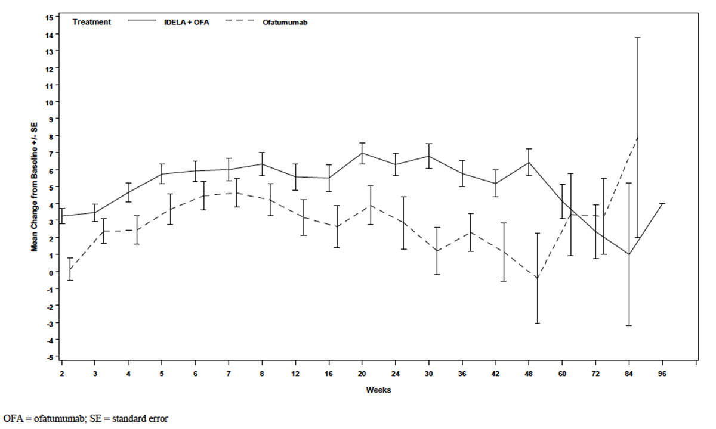
Table 14: Study GS-US-312-0119 – FACT-Leu questionnaire – Additional concerns (LeuS) subscale.
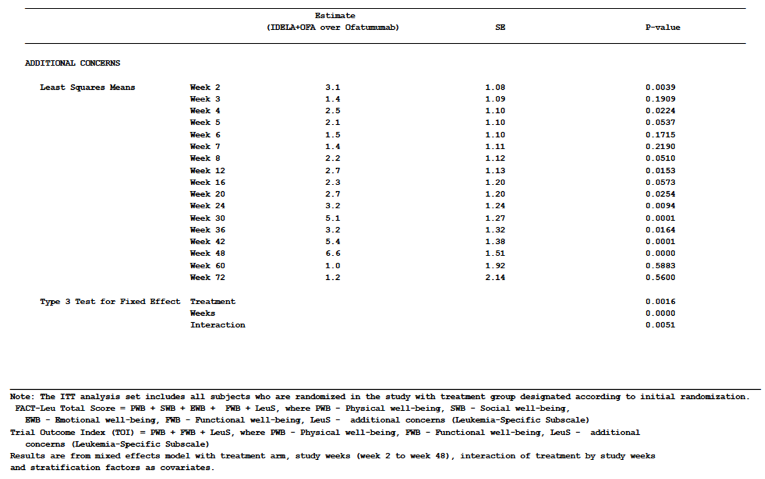
Comment: According to the sponsor the minimally important difference (MID) for the Additional Concerns score is 5 points. This cut-off was apparently based on a published study conducted in patients with chronic myeloid leukaemia. As shown in Table 14, the difference between the treatment arms was less than 5 points for most study visits. Therefore, although improvement in symptoms was greater in the combination arm, the difference is unlikely to be clinically significant. It is noted that the sponsor is not seeking to make any claims regarding improved quality of life in the product information.

Karnofsky score
Average Karnofsky score improved in both arms, to a similar extent (Table 15).
Table 15: Study GS-US-312-0119 – Karnofsky score.
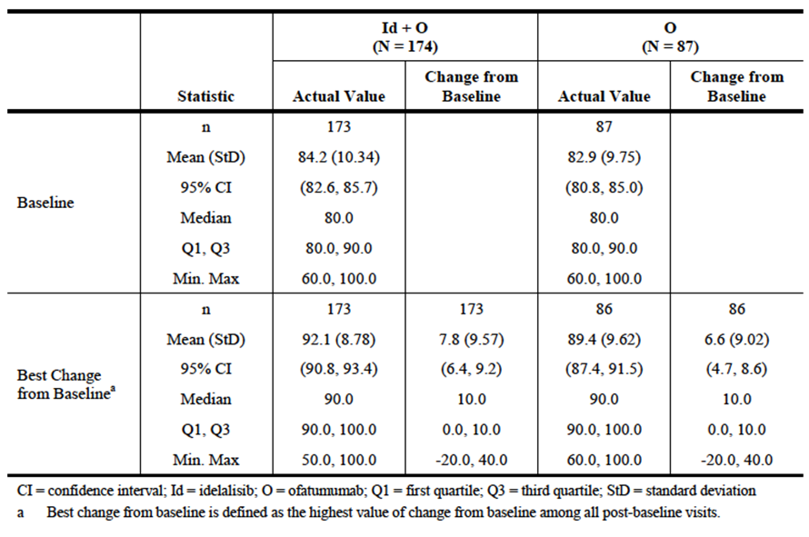

Other efficacy studies

Study 101-07
This study is an ongoing phase 1, open-label trial. It included subjects with CLL, indolent non-Hodgkin’s lymphoma (iNHL) or mantle cell lymphoma (MCL). Subjects were required to have relapsed or refractory disease. This study was reviewed in the clinical evaluation of the original submission for the registration of idelalisib. In the current submission, the sponsor provided an updated study report. The original report was dated 24 July 2013 and the updated report was dated 17 February 2015.
The study enrolled multiple separate cohorts of patients to explore the efficacy and safety of idelalisib when used in combination with a variety of other agents (rituximab, ofatumumab, bendamustine, fludarabine, everolimus, bortezomib, chlorambucil and lenalidomide) in the treatment of the three diseases. Overall, 241 subjects were enrolled. In one of the cohorts, subjects with relapsed or refractory CLL were treated with a combination of idelalisib and ofatumumab. Only the results for this cohort are reviewed in this report.
The cohort enrolled 21 subjects, 13 with relapsed disease and 8 with refractory disease. Median time since diagnosis was 6.5 years. Seven subjects (33.0%) had 17p deletion or TP53 mutation. The median number of prior treatment regimens was 2.0. Subjects were treated with idelalisib 150 mg BD. The ofatumumab dose regimen was identical to that used in the pivotal study (initial 300 mg dose, then 1000 mg per dose for a further 11 doses over 24 weeks).
Efficacy results for the cohort are summarised in Table 16.

Table 16: Study 101-07 – Efficacy results (Idelalisib + ofatumumab cohort).
N | 21
Complete response, n (%) | 2 (9.5)
Partial response, n (%) | 13 (61.9)
Stable disease, n (%) | 5 (23.8)
Progressive disease, n (%) | 0
Not done, n (%) | 1 (4.8)
Overall response rate, n (%) | 15 (71.4)
95% CI | 47.8 – 88.7
Duration of response (months), median (95% CI) | NR (3.5 – NR)
Time to response (months), median (Q1, Q3) | 1.9 (1.9 – 2.3)
Progression-free survival (months), median (95% CI) | NR (8.7 – NR)
Overall survival (months), median (95% CI) | NR (NR – NR)
Lymph Node response rate n (%) | 17 (81.0)
95% CI | 58.1 – 94.6
CI=confidence interval; NR=not reached; Q=quartile.
Comment: The overall response rate seen in this study (71.4%) is comparable to that seen in the pivotal study (75.3%). The efficacy results for this cohort in the updated study report are essentially unchanged from those in the original study report.

Analyses performed across trials (pooled & meta analyses)
In the Summary of Clinical Efficacy of the submission, the sponsor presented analyses of efficacy endpoints for pooled data from studies GS-US-312-0116 (combination with rituximab) and GS-US-312-0119 (combination with ofatumumab). As the question raised by the current application is the efficacy of the ofatumumab combination only, these analyses are not considered directly relevant to this review.
Both studies demonstrated a highly statistically significant effect of idelalisib on the primary endpoint of PFS. The pooled analysis of PFS gave a consistent result (HR=0.21; p < 0.0001). When the results of the extension study GS-US-312-0117 were included in an analysis, a beneficial effect of idelalisib on overall survival was suggested (Table 17). However, the data were not yet mature.

Table 17: Pooled analysis of overall survival.
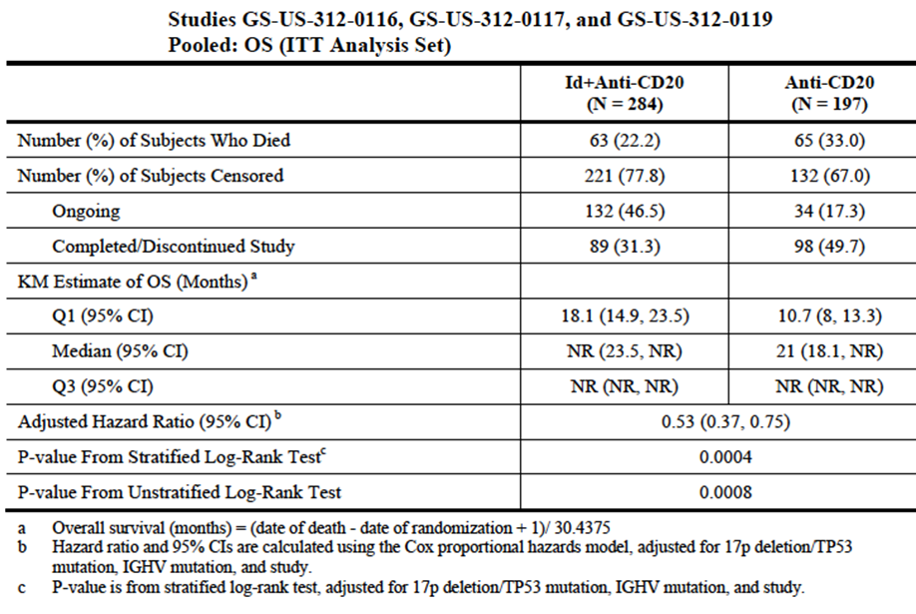

Other efficacy data included in the submission
The submission included a number of other studies that were not directly relevant to the proposed new indication. The safety data from these studies have been reviewed. One of these studies (Study 101-09) included efficacy data that was relevant to one of the currently approved indications (follicular lymphoma).
Study 101-09 was a phase 2 single-arm trial in 125 subjects with treatment-refractory indolent NHL. Subjects were treated with idelalisib monotherapy (150 mg BD). The primary efficacy variable was response rate. A full study report for this trial was reviewed in the clinical evaluation of the original submission to register idelalisib. In the current submission the sponsor provided a brief update of efficacy data from the study prepared in response to a request from the EMA as a ‘post-authorisation measure (PAM)’.
The original and updated results are summarised in Table 18. With longer follow-up, there was a slight increase in response rate.
Table 18: Study 101-09 – Updated efficacy results.
 | Original results | Updated results
N (all subjects) | 125 | 125
N (follicular lymphoma) | 72 | 72
Overall response rate, follicular lymphoma - % [95% CI] | 54.2  [42.0 – 66.0] | 55.6  [43.4 – 67.3]
Complete response, n (%) | 8.3 | 13.9
Partial response, n (%) | 45.8 | 41.7
Overall response rate, all subjects  - % [95% CI] | 56.8  [47.6 – 65.6] | 57.6  [48.4 – 66.4]
Duration of response, all subjects  - (months), median | 12.5 | 12.5

Evaluator’s conclusions on clinical efficacy
The pivotal efficacy study was well designed and executed. The study design was consistent with the recommendations of the relevant EMA guidelines adopted by the TGA. The study demonstrated a statistically significant improvement in efficacy when idelalisib was combined with ofatumumab, compared to ofatumumab monotherapy. The magnitude of the efficacy benefit was clinically significant with a doubling of median PFS (16.3 versus 8.0 months) and a 3.7 fold increase in the proportion of subjects alive and free of progressive disease at 12 months (63.7% versus 17.0%). A PFS benefit was observed consistently across the various subgroups examined including those subjects with an adverse prognosis due to the presence of a 17p deletion or TP53 mutation.
The sponsor is proposing that the combination of idelalisib with ofatumumab should be approved for use as first line therapy in subjects with 17p deletion or TP53 mutation. The submitted efficacy studies did not examine the efficacy of the combination in the first line setting. However, efficacy was demonstrated in this subgroup in the setting of relapsed/refractory disease. It is possible that efficacy may be superior in the first line setting where the disease would be expected to be less treatment resistant. Given that disease with 17p deletion or TP53 mutation responds poorly to conventional first line chemoimmunotherapy, it is considered reasonable to extrapolate the efficacy data into the first line setting for this subgroup. It is noted that idelalisib is already approved for use in combination with rituximab in the first line setting for these patients.
Table 19 shows a comparison of the PFS results obtained in Study GS-US-312-0119 with those obtained in Study GS-US-312-0116, the pivotal study that led to the approval of idelalisib in combination with rituximab in CLL. Although both studies were conducted in subjects with relapsed CLL, the inclusion criteria and baseline characteristics of subjects were different and as a result any conclusions regarding comparative efficacy based on cross-trial comparison are likely to be unreliable.
Table 19: Comparison of PFS results in studies GS-US-312-0119 and GS-US-312-0116.
 | GS-US-312-0119 |  | GS-US-312-0116
 | Idelalisib + Ofatumumab | Ofatumumab | Idelalisib + Rituximab | Rituximab
% of subjects with PFS event | 43.7% | 62.1% | 22.7% | 63.6%
Median PFS – months (95% CI) | 16.3  (13.6, 17.8) | 8.0  (5.7, 8.2) | 19.4  (12.3 – NR) | 6.5  (4.0, 7.3)
Adjusted HR (95% CI) | 0.27 (0.19 – 0.39) |  | 0.15 (0.09 – 0.24)
p-value | < 0.0001 |  | = 1.6 x 10⁻¹⁶
Study 101-07 provided some supportive evidence of efficacy with an overall response rate comparable to that seen in the pivotal study.
Updated efficacy data from study 101-09 in subjects with indolent NHL were consistent with the original data.

Clinical safety
Idelalisib is known to be associated with the following toxicities, as described in the current PI:
- Hepatotoxicity;
- Gastrointestinal toxicity (diarrhoea, colitis, intestinal perforation);
- Pneumonitis;
- Cutaneous reactions;
- Cytopaenias;
- Infections (possibly including reactivation of hepatitis infection and progressive multifocal leukoencephalopathy).

Studies providing evaluable safety data
The following studies provided evaluable safety data relevant to the proposed new indication (treatment of relapsed CLL with idelalisib in combination ofatumumab):

Pivotal efficacy study
In the pivotal efficacy study, the following safety data were collected:
- Data on general adverse events (AEs) were collected at each study visit, including the EOS visit and the 30-day follow-up visit. Subjects were asked an open-ended question regarding new health problems. An AE was defined as any untoward medical occurrence in a subject. AEs were assessed as either related or not related to study drug and were graded using the Common Toxicity Criteria for Adverse Events (CTCAE) version 4.03. AEs were coded using Medical Dictionary for Regulatory Activities (MedDRA) terminology.
- The following were considered AEs of particular interest: diarrhoea and/or colitis, rash, pneumonitis, pneumonia, bowel perforation, anaphylaxis, PML, Richter’s transformation and second malignancies.
- Laboratory tests, including haematology and biochemistry, were performed at each study visit. Urinalysis and ECGs were not routinely monitored during the study.
- Oxygen saturation by pulse oximetry was measured at each study visit. Other vital signs such as temperature, pulse and blood pressure were not systematically monitored during the study.

Study 101-07
Safety monitoring similar to that in the pivotal study was undertaken in this trial.

Patient exposure

Pivotal efficacy study
Median duration of exposure to idelalisib was 12.3 months. A total of 134 subjects were exposed for at least 6 months and 90 subjects for at least 12 months.
The planned dosing regimen for both arms involved a total of 12 doses with the final dose being given at week 24 (i.e. a planned duration of exposure of approximately 6 months). Median duration of exposure was 5.3 months in the combination arm and 4.2 months in the ofatumumab monotherapy arm.
Comment: Duration of exposure to treatment was considerably longer for subjects in the combination arm, and reporting of AEs would therefore have continued for a longer period. Crude incidence figures for AEs would therefore be expected to be higher in the combination arm.

Study 101-07
A total of 21 subjects were treated with the combination of idelalisib with ofatumumab. Median duration of exposure to idelalisib was 10.6 months. 15 subjects were exposed for at least 6 months and 1 subject for at least 12 months.

Adverse events
An overall summary of the incidence of AEs that occurred in the pivotal study is shown in Table 20. Exposure-adjusted incidence is summarised in Table 21.
Table 20: Study GS-US-312-0119 – Overall incidence of AEs.
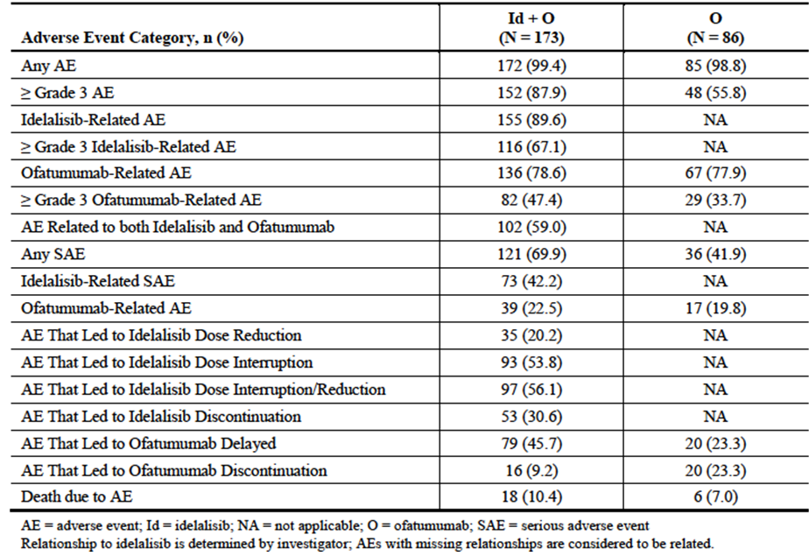
Table 21: Study GS-US-312-0119 – Overall incidence of AEs (exposure-adjusted).
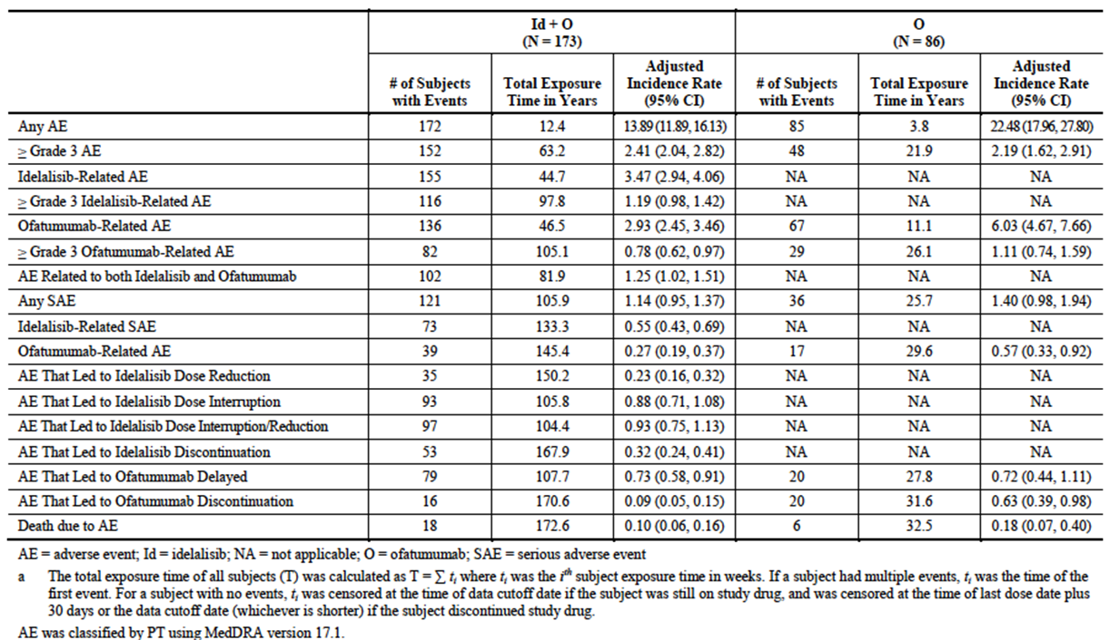

All adverse events (irrespective of relationship to study treatment)

Pivotal study
The incidence of AEs was high in both arms – 99.4% in the combination arm and 98.8% in the ofatumumab arm. Common AEs (those with an incidence ≥ 10%) are listed in Table 22. AEs that were notably more common in the idelalisib arm included diarrhoea, abdominal pain, cytopaenias, rash and hypokalaemia.
Table 22: Study GS-US-312-0119 – Common AEs (incidence ≥ 10%).
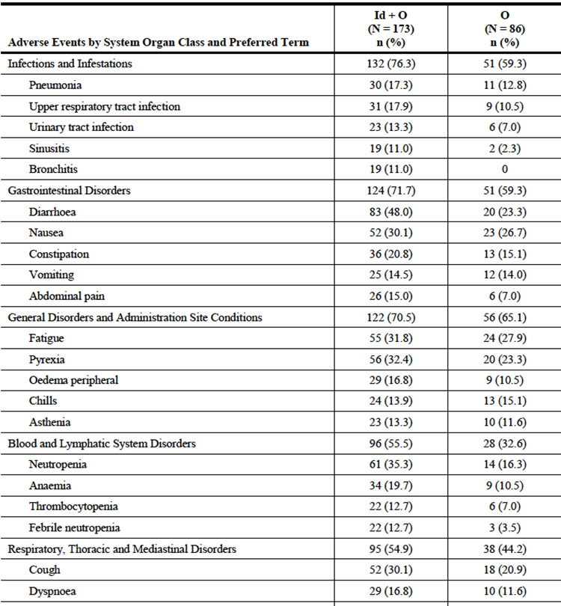
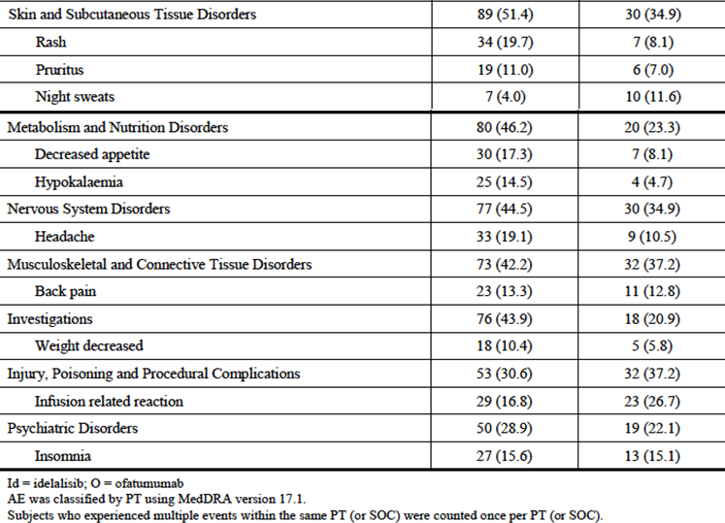
The sponsor also presented data on the incidence rate of AEs adjusted for exposure time. According to this analysis the incidence rates for individual AE terms were generally comparable for the two treatment arms. Events that were more common in the combination arm (by a margin of at least 0.05 events per year) were:
- Bronchitis (0.12 events/year vs. 0.00 events/year);
- Dehydration (0.09 vs. 0.00);
- Colitis (0.08 vs. 0.00);
- Oral candidiasis (0.07 vs. 0.00);
- Productive cough (0.07 vs. 0.00);
- Maculo-papular rash (0.07 vs. 0.00);
- Sinusitis (0.12 vs. 0.06); and
- Pneumonitis (0.06 vs. 0.00).

Study 101-07
All 21 subjects (100%) treated with the combination of idelalisib and ofatumumab experienced an adverse event. The most common AEs were diarrhoea (52.4%), cough (42.9%), dyspnoea (33.3%), pyrexia (33.3%), nausea (28.6%), neutropaenia (28.6%) and decreased appetite (23.8%).

Grade ≥ 3 adverse events

Pivotal study
The incidence of grade 3 or higher AEs was increased in the combination arm - 87.9% vs. 55.8%. Grade 3 or higher AEs occurring in > 2% of subjects are shown in Table 23.
Table 23: Study GS-US-312-0119 – Grade ≥ 3 AEs (incidence > 2%).
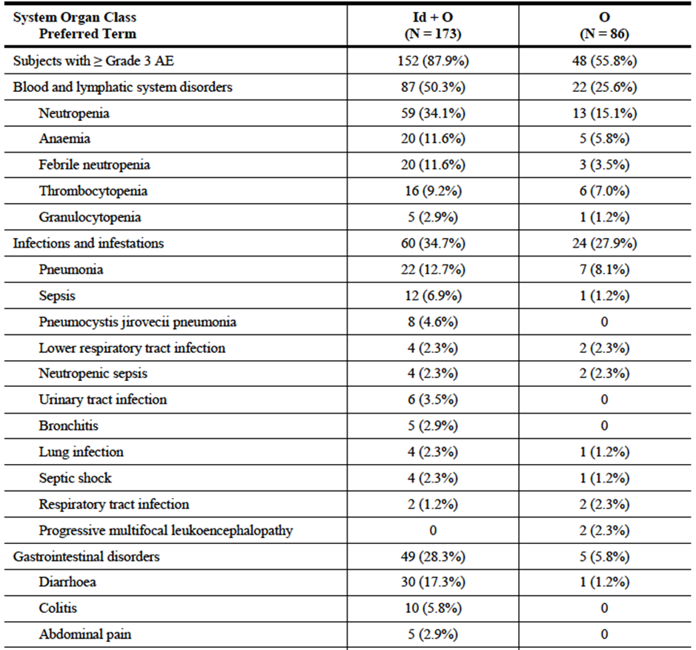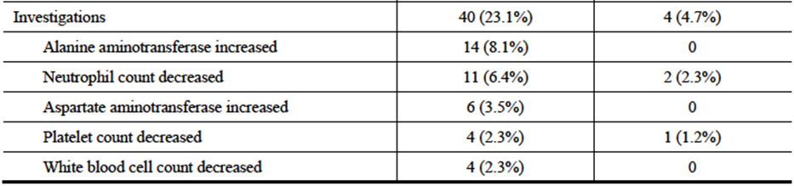
Table 23: Study GS-US-312-0119 – Grade ≥ 3 AEs (incidence > 2%).
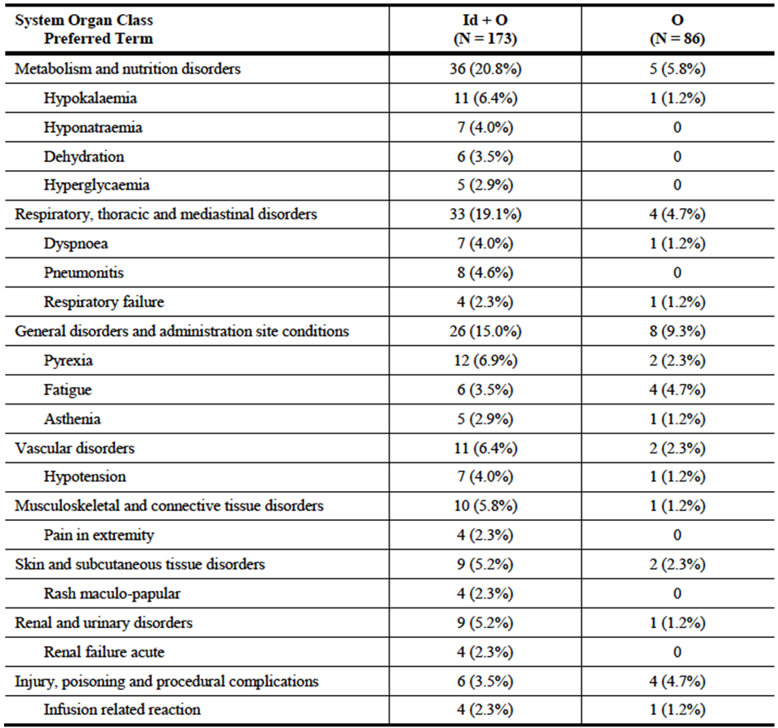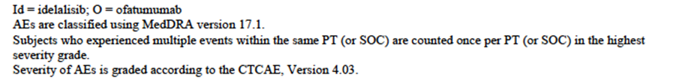
Comment: Grade 3 or higher diarrhoea and cytopaenias were again more common in the combination arm. Other notable Grade 3 or higher events that were more common in the combination arm included transaminase elevations (ALT: 8.1% vs. 0%; AST: 3.5% vs. 0%), pneumonitis (4.6% vs. 0%) and pneumocystis pneumonia (4.6% vs. 0%).

Study 101-07
16 of 21 subjects (76.2%) treated with the combination of idelalisib and ofatumumab experienced a grade 3 or higher AE. Individual Grade ≥ 3 AEs that occurred in more than one subject were neutropaenia (23.8%), pneumonia (14.3%), ALT increase (9.5%) and hyperglycaemia (9.5%)

Treatment-related adverse events (adverse drug reactions)

Pivotal study
A total of 89.6% of subjects in the combination arm experienced AEs that were assessed as being related to idelalisib. Those occurring in ≥ 5% of subjects are listed in Table 24. The most common events were diarrhoea, neutropaenia and fatigue. 67.1% of subjects experienced grade 3 or higher AEs that were assessed as being related to idelalisib.
Table 24: Study GS-US-312-0119 – AEs related to idelalisib (incidence ≥ 5%).
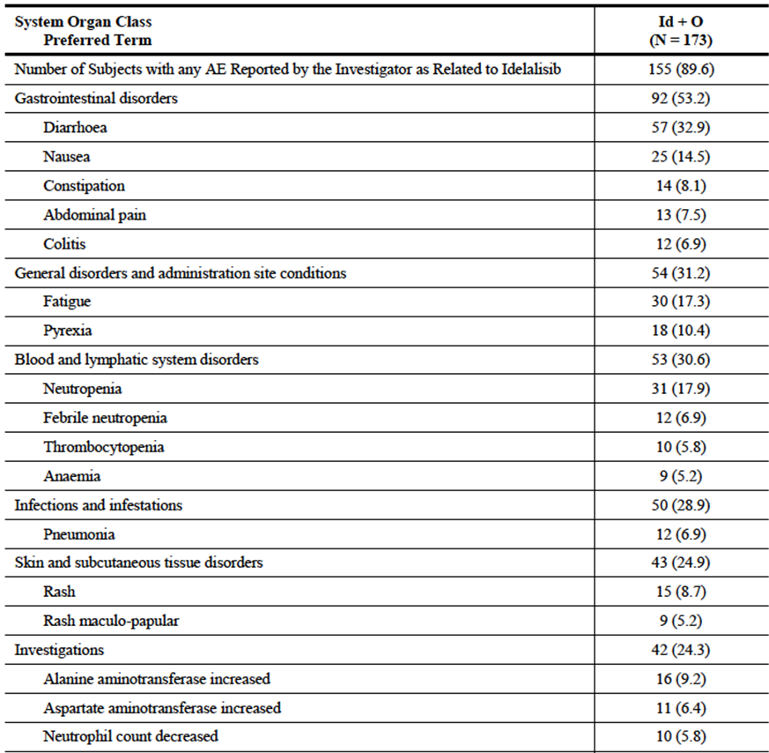
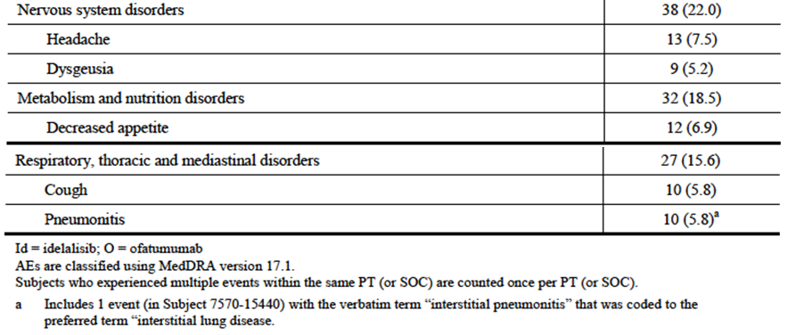
The overall incidence of AEs that were assessed as being related to ofatumumab was comparable in the two treatment arms – 78.6% in the combination arm and 77.9% in the ofatumumab arm. Those occurring in ≥ 5% of subjects are listed in Table 25. Grade 3 or higher events related to ofatumumab were more common in the combination arm (47.4% vs. 33.7%).
Table 25: Study GS-US-312-0119 – AEs related to ofatumumab (incidence ≥ 5%).
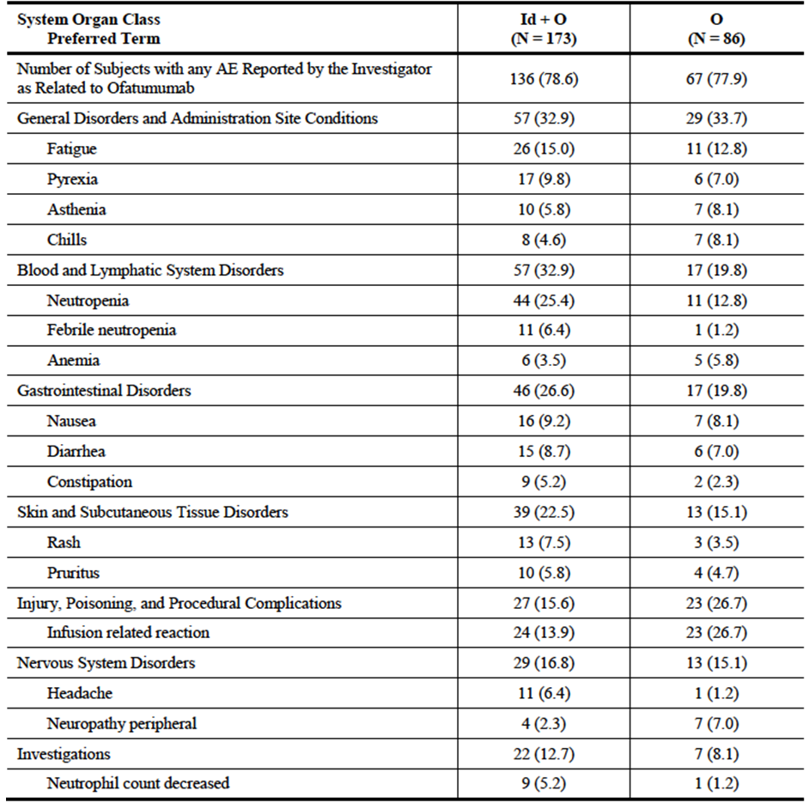
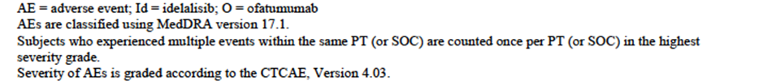
Comment: Although the overall incidence was comparable, there were some differences with respect to individual AE terms. Infusion reactions related to ofatumumab arm were less common in the combination arm (13.9% vs. 26.7%) whereas neutropaenia related to ofatumumab was more common in the combination arm (25.4% vs. 12.8%).

Study 101-07
13 of 21 subjects (61.9%) treated with the combination of idelalisib and ofatumumab experienced an AE that was considered related to idelalisib. Individual related AEs that occurred in more than one subject were neutropaenia (14.3%) and pneumonia (9.5%).

Deaths and other serious adverse events

Deaths

Pivotal study
A total of 63 treated subjects had died by the time of data cut-off – 41 (23.7%) in the combination arm and 22 (25.6%) in the ofatumumab arm. There were 37 deaths that occurred during study treatment (or within the first 30 days after the last dose). Of these, 29 occurred in the combination arm and 8 in the ofatumumab arm. In 24 of these 37 cases, AEs led to the death. There were 18 subjects with AEs that led to death in the combination arm and 6 subjects in the ofatumumab arm. These adverse events are listed in Table 26.
Table 26: Study GS-US-312-0119 – AEs leading to death.
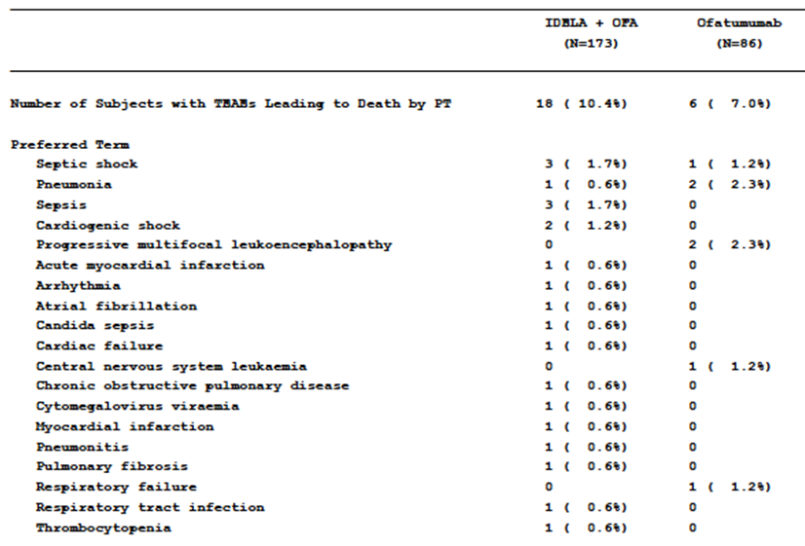
For 9 of the 18 deaths in the combination arm, the AEs leading to death were assessed as being related to idelalisib or the combination of idelalisib and ofatumumab. Most of these deaths were infection-related (pneumonia or sepsis). In two subjects cause of death included pneumonitis or fibrotic lung disease. For 2 of the 6 deaths in the ofatumumab arm the AEs leading to death were assessed as being related to ofatumumab (1 PML and 1 pneumonia).

Study 101-07
Four of the 21 subjects (19.0%) treated with the combination of idelalisib and ofatumumab died while on treatment or within 30 days of their last dose. None of these deaths were assessed as being related to idelalisib.

Serious adverse events

Pivotal study
An SAE was defined as an event that resulted in any of the following outcomes:
- Death
- Life-threatening situation (subject was at immediate risk of death);
- Inpatient hospitalization or prolongation of existing hospitalization;
- Persistent or significant disability/incapacity;
- A congenital anomaly/birth defect;
- Other medically significant events that, based upon appropriate medical judgment may have jeopardized the subject or may have required medical or surgical intervention to prevent one of the outcomes listed above.
The incidence of SAEs was higher in the combination arm - 69.9% vs. 41.9%. SAEs occurring in > 2% of subjects are shown in Table 27.
Table 27: Study GS-US-312-0119 – Serious AEs (incidence ≥ 2%).
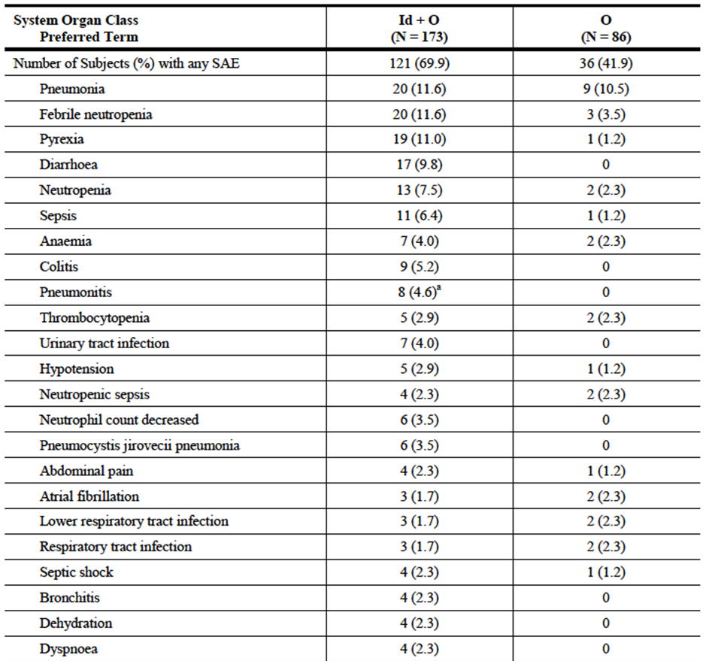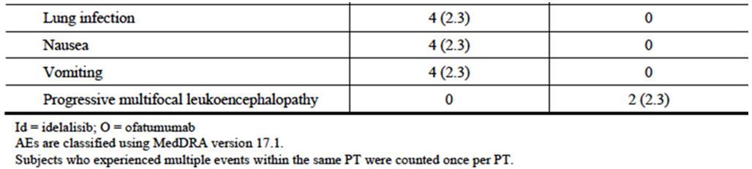
a. Includes 1 event (in Subject [information redacted]) with the verbatim term “interstitial pneumonitis” that was coded to the preferred term “interstitial lung disease”.
Comment: The pattern of SAEs was consistent with that observed for AEs overall, with an increased incidence of GIT toxicity (diarrhoea, colitis), cytopaenias, pneumonitis and some infections (sepsis, UTI, pneumocystis pneumonia) in the combination arm.

Study 101-07
12 of the 21 subjects (57.1%) treated with the combination of idelalisib and ofatumumab experienced an SAE. Individual related SAEs that occurred in more than one subject were pneumonia (9.5%) and pyrexia (9.5%).

Discontinuation due to adverse events

Pivotal study
A total of 53 subjects in the combination arm (30.6%) discontinued idelalisib due to an AE. AEs leading to discontinuation in at least 2% of subjects are listed in Table 28.
Table 28: Study GS-US-312-0119 –AEs leading to discontinuation of idelalisib (incidence > 2%).
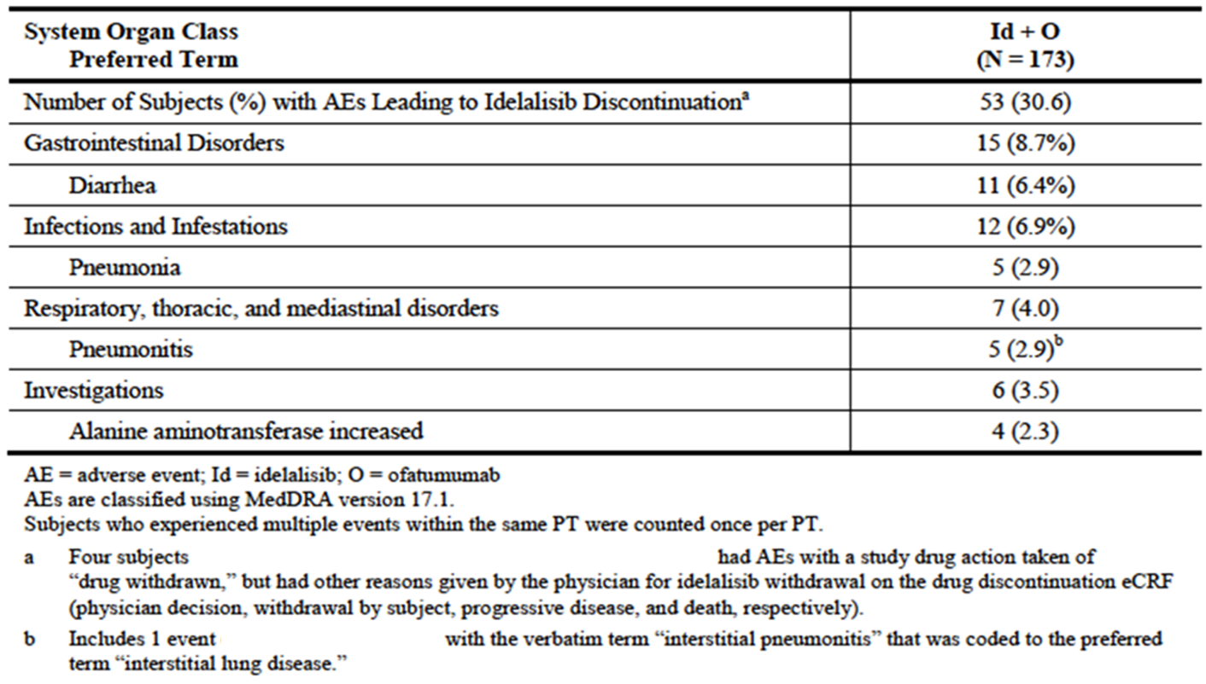
AEs leading to discontinuation of ofatumumab occurred in 9.2% of subjects in the combination arm and 23.3% of subjects in the ofatumumab monotherapy arm. The only AE that led to discontinuation in more than 2% of subjects was pneumonia, which occurred in 1.7% of subjects in the combination arm and 3.5% of subjects in the ofatumumab monotherapy arm.

Study 101-07
5 of the 21 subjects (23.8%) treated with the combination of idelalisib and ofatumumab discontinued idelalisib treatment due to an AE. These events were colitis, pneumonia, elevated transaminases, acute myeloid leukaemia and neutropaenic sepsis with endocrine disorder.

Adverse events of special interest (pivotal study)
Analyses of exposure-adjusted incidence rates for AEs of special interest are shown in Tables 29-30. Combination treatment was associated with increased incidences of grade ≥ 3 diarrhoea/colitis and pneumonitis (any grade).
Table 29: Study GS-US-312-0119 – AEs of special interest – Exposure-adjusted incidence rate (1).
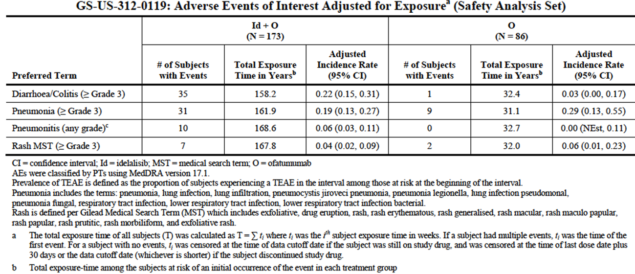
Table 30: Study GS-US-312-0119 – AEs of special interest – Exposure-adjusted incidence rate (2).
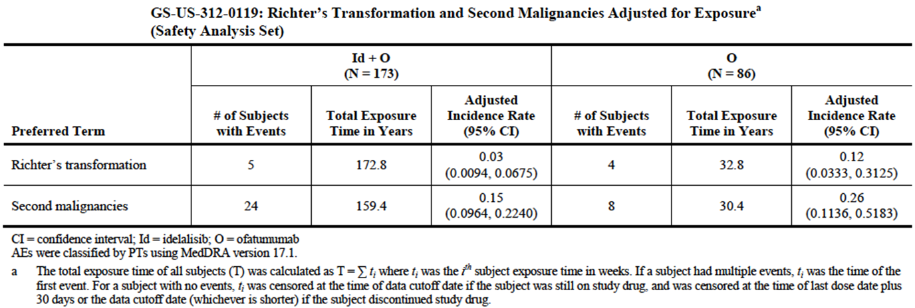
There was one case of bowel perforation in the combination arm and none in the ofatumumab arm. Anaphylaxis was reported in one subject in the ofatumumab arm only, and PML in two subjects in the ofatumumab arm only.

Laboratory tests

Liver function

Pivotal study
LFT abnormalities occurred with increased frequency in the combination arm (Table 31). After adjustment for duration of exposure, only the incidence of ALT elevations remained increased in the combination arm (Table 32).
Table 31: Study GS-US-312-0119 – LFT abnormalities.
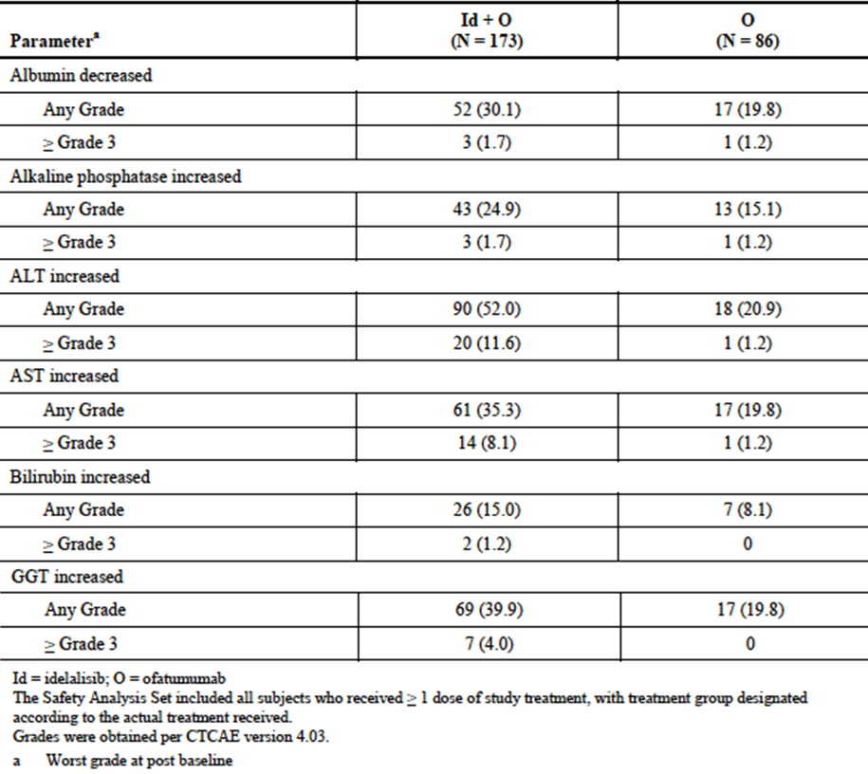
Table 32: Study GS-US-312-0119 – Abnormalities in biochemistry – Exposure-adjusted incidence rate.
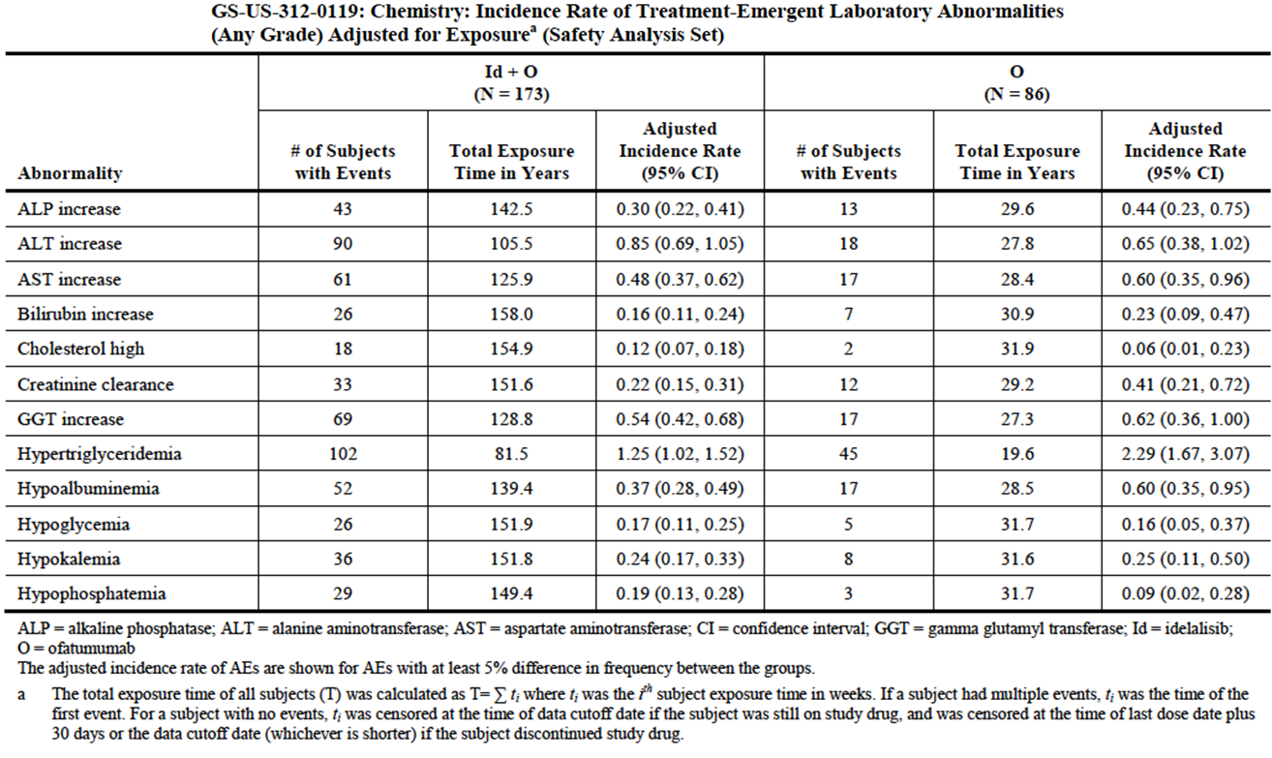
One subject in the combination arm developed abnormal LFTs that met the criteria for Hy’s law (AST or ALT > 3 × ULN with concurrent elevation of bilirubin > 2 × ULN and normal alkaline phosphatase). However, this subject had had abnormal transaminases for the previous 2 months with a concurrent intermittent grade 1 elevation of alkaline phosphatase, and at the time the bilirubin levels became elevated the subject had sepsis.

Study 101-07
For the 21 subjects treated with the combination of idelalisib and ofatumumab, the incidence of grade 3 or 4 transaminase elevations was 14.3%.

Kidney function

Pivotal study
Abnormalities in renal function tests occurred with comparable frequency in the two treatment arms (Table 33).
Table 33: Study GS-US-312-0119 – Renal function test abnormalities.
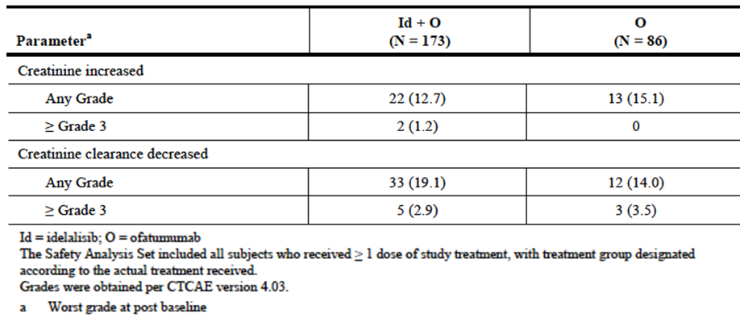

Study 101-07
There were no grades 3 or higher elevations in creatinine for the 21 subjects treated with the combination of idelalisib and ofatumumab.

Other clinical chemistry

Pivotal study
Decreased potassium and decreased phosphate occurred with greater frequency in the combination arm (Table 34). After adjustment for duration of exposure, only the incidence of decreased phosphate remained increased (Table 35).
Table 34: Study GS-US-312-0119 – Abnormalities in other biochemistry tests.
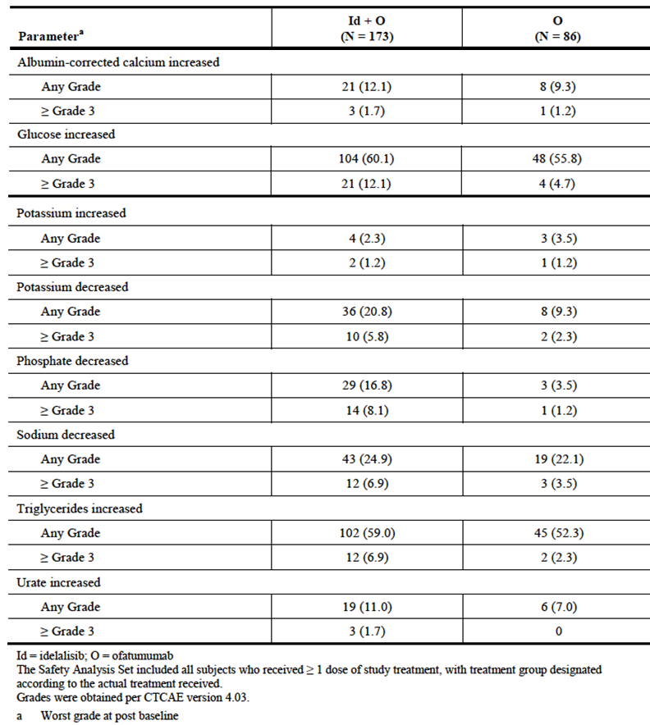
Table 35: Study GS-US-312-0119 – Abnormalities in biochemistry – Exposure-adjusted incidence rate.
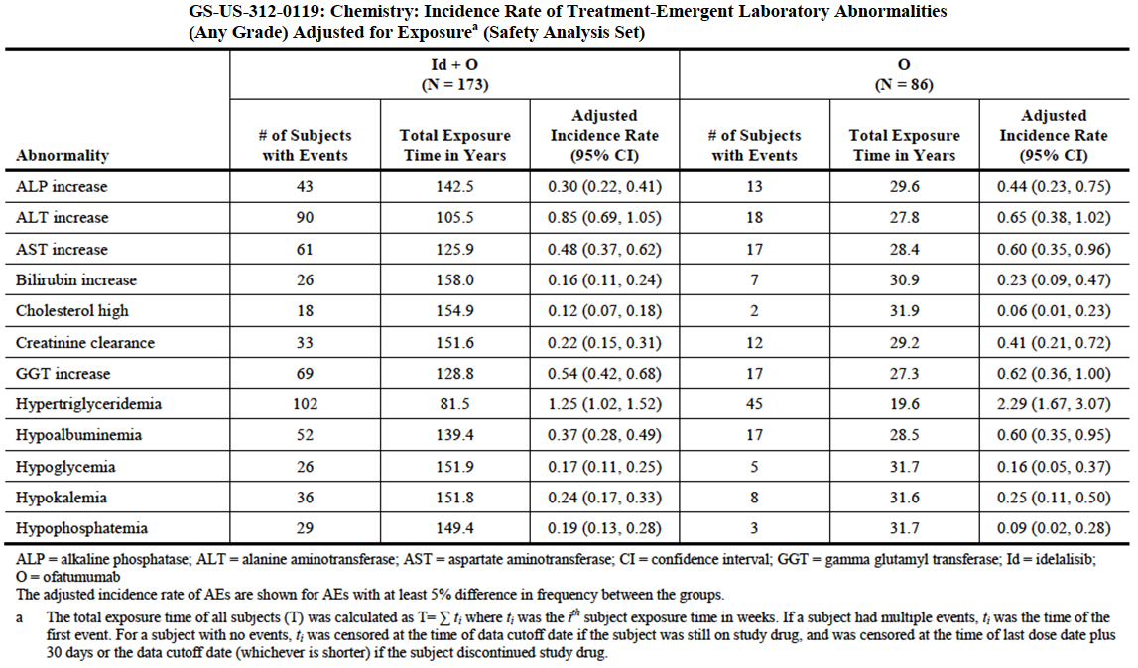

Study 101-07
There were no notable findings for other biochemistry parameters for the 21 subjects treated with the combination of idelalisib and ofatumumab.

Haematology

Pivotal study
The combination arm was associated with a greater frequency of the following haematology abnormalities – increased lymphocyte count, neutropaenia and thrombocytopaenia (Table 36). After correction for duration of exposure only the incidence of increased lymphocyte count remained higher in the combination arm (Table 37).
Table 36: Study GS-US-312-0119 – Abnormalities in haematology tests.
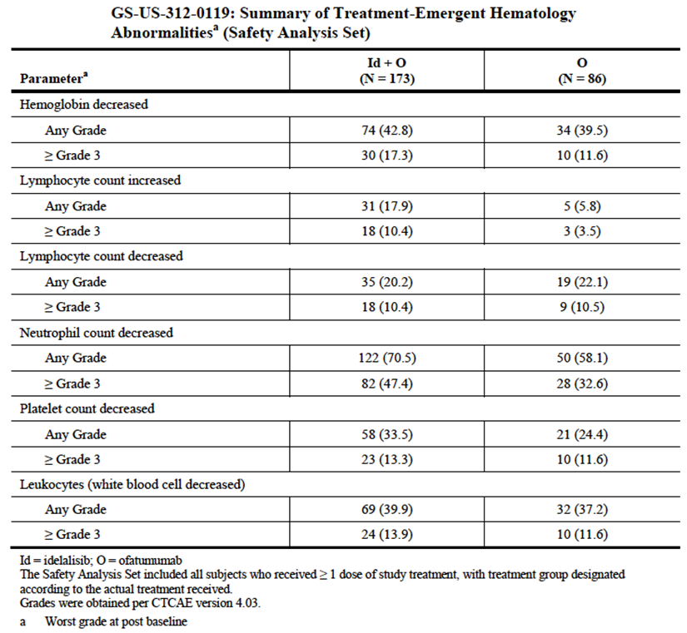
Table 37: Study GS-US-312-0119 – Abnormalities in haematology – Exposure-adjusted incidence rate.
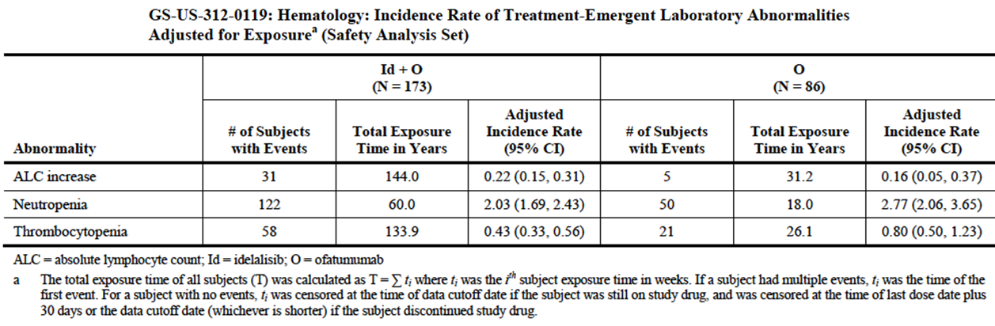

Study 101-07
For the 21 subjects treated with the combination of idelalisib and ofatumumab, incidences of grade 3 or 4 cytopaenias were 33.3% for neutropaenia, 4.8% for thrombocytopaenia and 4.8% for anaemia.

Vital signs

Pivotal study
There were no clinically significant differences between the study arms in average oxygen saturation measurements. The incidence of abnormally low oxygen saturation readings was comparable in the two arms.

Study 101-07
There were no clinically significant changes in temperature, blood pressure, or heart rate during this study.

Other safety data included
The submission included data from the following additional studies, which were not directly relevant to the proposed new indication:

Study GS-US-312-0116
This was the pivotal phase 3 study for the approval of idelalisib in combination with rituximab in relapsed CLL. In the current submission the sponsor provided an updated study report. This report was to be reviewed as part of a separate TGA submission and therefore has not been reviewed in this evaluation.

Study GS-US-312-0117
This trial was originally an extension study for subjects who had developed disease progression in study GS-US-312-0116. In addition, Study GS-US-312-0116 was stopped early due to overwhelming evidence efficacy following an interim analysis and all subjects still in the trial were transitioned to GS-US-312-0117. All subjects in GS-US-312-0117 were treated with idelalisib monotherapy. A total of 161 subjects were enrolled. Most subjects were treated with 150 mg BD. Four subjects were treated with 300 mg BD. Median duration of treatment with idelalisib was 5.7 months in subjects who had disease progression on placebo in study GS-US-312-0116, 9.9 months in subjects who did not have disease progression on placebo, and 15.9 months who were treated with idelalisib in study GS-US-312-0116.

Study 101-08
This was a phase 2 study in subjects with previously untreated CLL. The original submission to register idelalisib included a report of a cohort of 64 patients (Cohort 1) who were treated with idelalisib in combination with rituximab. In the current submission the sponsor provided a report on a separate cohort of 41 subjects (Cohort 2) who were treated with idelalisib monotherapy (150 mg BD). Median duration of treatment was 6.0 months.

Study 101-09
This was a phase 2 single-arm study in 125 subjects with treatment-refractory indolent NHL. Subjects were treated with idelalisib monotherapy (150 mg BD). A full study report for this trial was reviewed in the clinical evaluation of the original submission to register idelalisib. The trial provided the main evidence to support the TGA approval of idelalisib for refractory follicular lymphoma. In the current submission the sponsor provided a brief update of efficacy and safety data from the study. The update was prepared in response to a request from the EMA as a ‘post-authorisation measure (PAM)’. The updated efficacy data have been summarised. Median duration of treatment in the updated report was 6.6 months.

Study 101-99
This was open open-label extension study for subjects who had completed one of the following four early phase studies:
- Study 101-02 – a phase 1 dose-escalation trial in subjects with relapsed or refractory haematologic malignancies;
- Study 101-07 (as described above);
- Study 101-08 – Cohort 1 (as described above)
- Study 101-10 – a phase 1/2 study in subjects with previously treated low-grade lymphoma.
These four studies were reviewed during the evaluation of the original submission to register idelalisib. In 101-99 subjects were treated with idelalisib monotherapy at the last dose they received during their parent study. Doses ranged from 100 mg OD (or 50 mg BD) to 350 mg BD. A total of 198 subjects enrolled in the extension study. Median duration of exposure varied from 3.7 to 22.4 months for the four parent study groups. Only grade ≥ 3 AEs were recorded in the extension study.

Study GS-US-339-0103
This is an ongoing phase 2 study of idelalisib in combination with GS-9973 (an investigational oral inhibitor of spleen tyrosine kinase) in subjects with relapsed or refractory haematological malignancies. The only data supplied from this study were listings of serious AEs, AEs leading to discontinuations and deaths. No information was supplied on the study design or other study outcomes.
The safety data from these studies (except GS-US-312-0116) have been reviewed. The incidence and patterns of AEs and laboratory abnormalities observed in these studies were consistent with those observed in the pivotal study GS-US-312-0119, and with the toxicity profile of the drug as described in the currently approved product information. No new safety issues were identified.

Post-marketing experience
No post-marketing data were included in the submission.

Safety issues with the potential for major regulatory impact

Liver toxicity
Idelalisib is known to be associated with hepatotoxicity and this was confirmed in the pivotal study where subjects randomised to combination treatment had an increased incidence of transaminase elevation. There were no cases of severe drug induced liver injury (DILI) in any of the submitted studies. In addition there were no cases that clearly met ‘Hy’s law’ criteria (predictive of DILI).

Haematological toxicity
Cytopaenias are a known complication of CLL, especially in advanced disease and are a known adverse effect of idelalisib. They are also a complication of many agents used in the initial treatment of CLL. Cytopaenias occurred frequently in the submitted studies. However, in the pivotal study in this submission, the incidence of cytopaenias was not increased in the combination arm after incidence was adjusted for duration of exposure.

Serious skin reactions
Idelalisib is known to be associated with dermatological toxicity. In the pivotal study the incidence dermatological SAEs was 1.2% in the combination arm and 0% in the ofatumumab arm.

Cardiovascular safety
The submitted studies did not produce evidence to suggest that idelalisib is associated with significant cardiovascular toxicity.

Unwanted immunological events
Idelalisib was not associated with serious immunological reactions (e.g. anaphylaxis) in the submitted studies.

Evaluator’s overall conclusions on clinical safety
The safety profile of idelalisib in the submitted studies was consistent with that previously observed. No new safety issues were identified.
The addition of idelalisib to ofatumumab in the treatment of CLL results in some increase in the incidence of AEs. Combination treatment was associated with an increase in the incidence of grade ≥ 3 AEs (87.9% vs. 55.8%) and serious AEs (69.9% vs. 41.9%). This increased toxicity may be due in part to the longer observation period for subjects in the combination arm. 30% of subjects in the combination arm had an AE that led to discontinuation of idelalisib. Combination treatment was not associated with any increase in overall mortality.

First round benefit-risk assessment

First round assessment of benefits
The benefits of the combination of idelalisib and ofatumumab in the proposed usage are:
- A significant reduction in the risk of experiencing a PFS event (mainly events of disease progression) in patients with relapsed/refractory CLL

First round assessment of risks
The risks of idelalisib in the proposed usage are:
- An increase in the incidence of a number of adverse events such as diarrhoea, colitis, LFT abnormalities, pneumonitis and skin toxicity.
No new safety issues have been identified with the proposed new indication.
The efficacy and safety of the idelalisib-ofatumumab combination has not been presented for patients with 17p deletion who are treatment-naïve. Use in this group is consequently considered unfavourable.

First round assessment of benefit-risk balance
The benefit-risk balance of idelalisib used in combination with ofatumumab is considered favourable in patients with relapsed/refractory CLL without 17p deletion. Other studies included in the submission do not alter the benefit-risk balance for the currently approved indications.

First round recommendation
Satisfactory responses to the clinical questions are required before authorisation and approval of the proposed indication can be recommended.

Clinical questions
(Q1) Please provide an assurance that the tablet formulations used in the pivotal study (GS-US-312-0119) were identical to those registered in Australia.
(Q2) The sponsor is requested to provide a justification for the use of a non-registered regimen of ofatumumab for use in combination with idelalisib in the studies presented for evaluation.
(Q3) Given that the studies presented in this submission only recruited patients with CLL that were relapsed or refractory, the sponsor is requested to provide a justification for the extrapolation of use of the idelalisib-ofatumumab combination as first-line in patients with 17p deletion – as per the proposed indication.

Second round evaluation of clinical data
Not applicable

Second round benefit-risk assessment
Not applicable

Second round recommendation
Not applicable

References
- Blunt MD and Steele AJ. Pharmacological targeting of PI3K isoforms as a therapeutic strategy in chronic lymphocytic leukaemia. Leuk Res Rep. 2015; 4(2): 60-3.
- Hallek M. Chronic lymphocytic leukemia: 2013 update on diagnosis, risk stratification and treatment. Am J Hematol; 2013; 88: 804–816.
- Cancer Australia. Chronic lymphocytic leukaemia statistics.
- National Comprehensive Cancer Network (NCCN). NCCN Clinical Practice Guidelines in Oncology – Non-Hodgkin’s Lymphomas – Version 1.2016.
- Rai KR and and Patel DV. Chronic lymphocytic leukemia. In: Hoffman R, Benz EJ, Shattil SJ et al (eds). Hematology - Basic Principles and Practice. 3rd ed. Philadelphia: Churchill Livingstone, 2000, pp 1350-1363.
- European Medicines Agency. Guideline on the evaluation of anticancer medicinal products in man. EMA/CHMP/205/95/Rev.4; (2012).
- European Medicines Agency. Appendix 1 to the guideline on the evaluation of anticancer medicinal products in man. Methodological consideration for using progression-free survival (PFS) or disease-free survival (DFS) in confirmatory trials. EMA/CHMP/27994/2008/Rev.1; (2012).
- European Medicines Agency. Points to consider on application with 1. Meta-analyses; 2. One pivotal study; CPMP/EWP/2330/99 (2001).
- Jones JA, Wach M, Robak T et al. Results of a phase III randomized, controlled study evaluating the efficacy and safety of idelalisib (IDELA) in combination with ofatumumab (OFA) for previously treated chronic lymphocytic leukemia (CLL). J Clin Oncol 33, 2015 (suppl; abstr 7023).
- Hallek M, Cheson BD, Catovsky D et al. Guidelines for the diagnosis and treatment of chronic lymphocytic leukemia: a report from the International Workshop on Chronic Lymphocytic Leukemia updating the National Cancer Institute–Working Group 1996 guidelines. Blood; 2008; 111: 5446-5456.

Therapeutic Goods Administration
PO Box 100 Woden ACT 2606 Australia
Email: info@tga.gov.au Phone: 1800 020 653 Fax: 02 6232 8605
https://www.tga.gov.au

Blunt MD and Steele AJ. Pharmacological targeting of PI3K isoforms as a therapeutic strategy in chronic lymphocytic leukaemia. Leuk Res Rep. 4: 60-3 (2015).
Hallek M. Chronic lymphocytic leukemia: 2013 update on diagnosis, risk stratification and treatment. Am J Hematol. 88: 804-816 (2013).
Cancer Australia, Chronic lymphocytic leukaemia statistics.
National Comprehensive Cancer Network (NCCN). NCCN Clinical Practice Guidelines in Oncology – Non-Hodgkin’s Lymphomas – Version 1.2016.
Rai KR and and Patel DV. Chronic lymphocytic leukemia. In: Hoffman R, Benz EJ, Shattil SJ et al (eds). Hematology - Basic Principles and Practice. 3rd ed. Philadelphia: Churchill Livingstone, 2000, pp 1350-1363.
National Comprehensive Cancer Network (NCCN). NCCN Clinical Practice Guidelines in Oncology – Non-Hodgkin’s Lymphomas – Version 1.2016.
Jones JA, Wach M, Robak T et al. Results of a phase III randomized, controlled study evaluating the efficacy and safety of idelalisib (IDELA) in combination with ofatumumab (OFA) for previously treated chronic lymphocytic leukemia (CLL). J Clin Oncol 33, 2015 (suppl; abstr 7023).
Hallek M, Cheson BD, Catovsky D et al. Guidelines for the diagnosis and treatment of chronic lymphocytic leukemia: a report from the International Workshop on Chronic Lymphocytic Leukemia updating the National Cancer Institute–Working Group 1996 guidelines. Blood; 2008; 111: 5446-5456.
National Comprehensive Cancer Network (NCCN). NCCN Clinical Practice Guidelines in Oncology – Non-Hodgkin’s Lymphomas – Version 1.2016.

