July 2015

Australian Public Assessment Report for idelalisib
  - Proprietary Product Name: Zydelig
  - Sponsor: Gilead Sciences Pty Ltd

About the Therapeutic Goods Administration (TGA)
- The Therapeutic Goods Administration (TGA) is part of the Australian Government Department of Health and is responsible for regulating medicines and medical devices.
- The TGA administers the Therapeutic Goods Act 1989 (the Act), applying a risk management approach designed to ensure therapeutic goods supplied in Australia meet acceptable standards of quality, safety and efficacy (performance), when necessary.
- The work of the TGA is based on applying scientific and clinical expertise to decision-making, to ensure that the benefits to consumers outweigh any risks associated with the use of medicines and medical devices.
- The TGA relies on the public, healthcare professionals and industry to report problems with medicines or medical devices. TGA investigates reports received by it to determine any necessary regulatory action.
- To report a problem with a medicine or medical device, please see the information on the TGA website <www.tga.gov.au>.
About AusPARs
- An Australian Public Assessment Report (AusPAR) provides information about the evaluation of a prescription medicine and the considerations that led the TGA to approve or not approve a prescription medicine submission.
- AusPARs are prepared and published by the TGA.
- An AusPAR is prepared for submissions that relate to new chemical entities, generic medicines, major variations, and extensions of indications.
- An AusPAR is a static document, in that it will provide information that relates to a submission at a particular point in time.
- A new AusPAR will be developed to reflect changes to indications and/or major variations to a prescription medicine subject to evaluation by the TGA.
Copyright
© Commonwealth of Australia 2015
This work is copyright. You may reproduce the whole or part of this work in unaltered form for your own personal use or, if you are part of an organisation, for internal use within your organisation, but only if you or your organisation do not use the reproduction for any commercial purpose and retain this copyright notice and all disclaimer notices as part of that reproduction. Apart from rights to use as permitted by the Copyright Act 1968 or allowed by this copyright notice, all other rights are reserved and you are not allowed to reproduce the whole or any part of this work in any way (electronic or otherwise) without first being given specific written permission from the Commonwealth to do so. Requests and inquiries concerning reproduction and rights are to be sent to the TGA Copyright Officer, Therapeutic Goods Administration, PO Box 100, Woden ACT 2606 or emailed to <tga.copyright@tga.gov.au>.

Contents
List of abbreviations 5
I. Introduction to product submission 9
Submission details 9
Product background 9
Regulatory status 12
Product Information 13
II. Quality findings 13
Drug substance (active ingredient) 13
Drug product 14
Bioavailability 14
Quality summary and conclusions 15
III. Nonclinical findings 15
Introduction 15
Pharmacology 16
Pharmacokinetics 18
Toxicology 20
Nonclinical summary and conclusions 26
IV. Clinical findings 28
Introduction 28
Pharmacokinetics 30
Pharmacodynamics 33
Dosage selection for the pivotal studies 35
Efficacy 36
Safety 40
First round benefit-risk assessment 44
First round recommendation regarding authorisation 45
Clinical questions 46
Second round evaluation of clinical data 48
Second round benefit-risk assessment 49
V. Pharmacovigilance findings 49
Risk management plan 49
VI. Overall conclusion and risk/benefit assessment 55
Quality 55
Nonclinical 55
Clinical 55
Risk management plan 70
Risk-benefit analysis 71
Outcome 83
Attachment 1. Product Information 83
Attachment 2. Extract from the Clinical Evaluation Report 84

List of abbreviations
Abbreviation | Meaning
ADR | adverse drug reaction
AE | adverse event
ACPM | Advisory Committee on Prescription Medicines
ALP | alkaline phosphatase
ALT | alanine transaminase
ANS | autonomic nervous system
ASA | Australian Specific Annex
AST | aspartate aminotransferase
ATP | adenosine triphosphate
AUC | area under the plasma concentration-time curve
AUC_{t1-t2} | area under the plasma concentration-time curve from time t1 to t2
B-ALL | acute lymphoblastic B cell leukaemia
BCR | B cell receptor
BD | bis in die (twice daily)
BOR | best overall response
C_{max} | maximum plasma drug concentration
C_{min} | minimum plasma drug concentration
C_{tau} | trough concentration
CHMP | Committee for Medicinal Products for Human Use
CLL | chronic lymphocytic leukaemia
CL/F | oral clearance
CMI | Consumer Medicines Information
CNS | central nervous system
DOR | duration of response
DSUR | development safety update report
ECG | electrocardiogram
EMA | European Medicines Agency
ER_{AUC} | exposure ratio based on AUC
FDA | US Food and Drug Administration
FL | follicular lymphoma
fMLP | formyl-methionyl-leucyl-phenylalanine
GCP | Good Clinical Practice
GGT | gamma glutamyl transpeptidase
GI | gastrointestinal
GLP | Good Laboratory Practice
HRQL | health related quality of life
IBD | inflammatory bowel disease
IC₅₀ | half maximal inhibitory concentration
ICH | International Conference on Harmonisation of Technical Requirements for Registration of Pharmaceuticals for Human Use
ICSR | individual case safety report
IGHV | immunoglobulin heavy chain variable
iNHL | indolent non Hodgkin lymphoma
IRC | independent review committee
ITT | intention to treat
IV | intravenous
KLH | keyhole limpet hemocyanin
KM | Kaplan-Meier
LDH | lactate dehydrogenase
LFA-1 | leukocyte function associated antigen
LNR | lymph node response
LOEL | lowest observed effect level
LOK | lymphocyte oriented kinase
LPL | lymphoplasmacytic lymphoma
MZL | marginal zone lymphoma
NMT | Not More Than
NOEL | no observed effect level
OC | oral contraceptive
ORR | overall response rate
OS | overall survival
PI | Product Information
PI3K | phosphatidylinositol 3-kinase
PI3Kδ | phosphatidylinositol 3-kinase p110δ
PIP | Paediatric Investigation Plan
PFS | progression free survival
PML | progressive multifocal leucoencephalopathy
PO | per os (oral administration)
PSUR | periodic safety update report
RMP | risk management plan
SAE | serious adverse event
SJS | Stevens-Johnson syndrome
SLK | Ste20 like kinase
SLL | small lymphocytic lymphoma
SPD | sum of the products of diameters
t_{1/2} | elimination half life
T_{max} | time to reach maximum plasma concentration following drug administration
TEAE | treatment emergent adverse event
TEN | toxic epidermal necrolysis
TTF | time to treatment failure
TTR | time to response
WM | Waldenstrom macroglobulinemia

I. Introduction to product submission

Submission details
Type of submission: | New chemical entity
Decision: | Approved
Date of decision: | 30 January 2015
Active ingredient: | Idelalisib
Product name: | Zydelig
Sponsor’s name and address: | Gilead Sciences Pty Ltd  Level 6  4/7 St Kilda Road  Melbourne VIC 3004
Dose form: | Tablets: film coated, unscored
Strengths: | 100 mg and 150 mg
Container: | HDPE bottles with child resistant lids
Pack size: | 60 tablets
Approved therapeutic use: | Zydelig is indicated as monotherapy for the treatment of patients with refractory follicular lymphoma, who have received at least 2 prior systemic therapies.  Zydelig, in combination with rituximab, is indicated for the treatment of patients with chronic lymphocytic leukaemia (CLL)/small lymphocytic lymphoma (SLL) for whom chemo-immunotherapy is not considered suitable, either:  - upon relapse after at least one prior therapy;  or  - as first-line treatment in the presence of 17p deletion or TP53 mutation.
Route of administration: | Oral
Dosage: | Recommended 150 mg twice daily
ARTG numbers: | 218837 (100 mg)  218839 (150 mg)

Product background
This AusPAR describes the application by Gilead Sciences Pty Ltd to register Zydelig tablets, a new chemical entity comprising of idelalisib (idelalisib; GS-1101; formerly CAL-101) in a 100 mg and 150 mg tablet as an oral therapy for treatment of indolent non Hodgkin lymphoma (iNHL) and CLL.
Zydelig is a novel, highly selective competitive inhibitor of adenosine-5’-triphosphate binding to the catalytic subunit of phosphatidylinositol 3-kinase (PI3K) p110δ (PI3Kδ), which has been shown to be prominently expressed in cells of hematopoietic origin. PI3Kδ is critical for multiple signalling pathways that are hyperactive in B cell malignancies.
The proposed indications for Zydelig tablets are as follows:
Zydelig is indicated, alone or in combination, for the treatment of patients with relapsed chronic lymphocytic leukaemia (CLL).
Zydelig is indicated for the treatment of patients with refractory indolent non-Hodgkin lymphoma (iNHL).
The recommended dose for adults is 150 mg twice daily, taken orally. Treatment should be continued until disease progression or unacceptable toxicity. Zydelig can be taken with or without food.

Chronic lymphocytic leukaemia (CLL)
CLL is one of the chronic lymphoproliferative disorders and is characterised by a progressive accumulation of functionally incompetent lymphocytes, which are usually monoclonal in origin. In Australia, the average of age of onset is 70, with a male preponderance. While some patient subsets have survival rates that are similar to the normal population, others who present with early stage disease and poor-risk prognostic markers (for example, 17p deletion, TP53 mutations, CD38 positivity, unmutated segments of the immunoglobulin heavy chain variable [IGHV] genes) have a less favourable prognosis. Patients with del(17p) are at high risk of either not responding to initial treatment, or relapsing soon after achieving remission.
Therapy is offered to patients with early stage and poor risk disease (usually in a clinical trial if possible), symptomatic CLL, or advanced stage SLL, with the goals of ameliorating symptoms and improving progression free survival (PFS) and overall survival (OS). With the possible exception of allogeneic hematopoietic cell transplantation, CLL cannot be cured by current treatment options.
The currently registered treatments in Australia for CLL and NHL are in Table 1. Of relevance in the review of this application, rituximab is approved for use only in combination with chemotherapy for CD20+ CLL, not as monotherapy. Three monoclonal antibody therapies have been approved for use in small B cell lymphocytic lymphoma and chronic lymphocytic leukaemia.
Table 1: Products currently approved in Australia for the treatment of CLL & NHL.
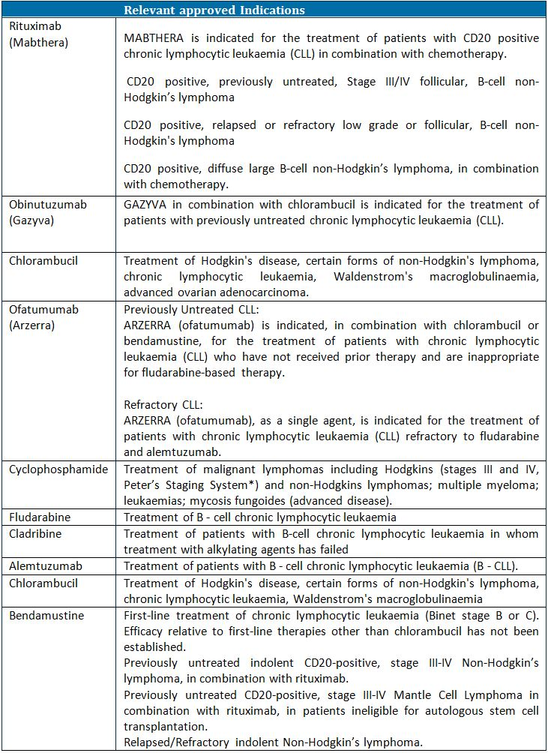

Non hodgkin lymphoma (NHL)
NHL is a diverse group of many different disease entities with differing presentations, clinical course prognoses and responsiveness to treatments, even within the same subtype. iNHL is not a specific entity; rather, it is a descriptive term for low grade lymphomas, which mostly follow a slowly progressive course over years characterised by progressive insensitivity to available therapies. The most common is follicular lymphoma (FL), and others are SLL, marginal zone lymphoma (MZL) and lymphoplasmacytic lymphoma (LPL). SLL is recognised as the same entity as CLL, but presenting with only nodal involvement, that is, the same disease at difference stages in the (2008 WHO classification of lymphoid neoplasms). iNHLs are curable in very few instances, with treatment aiming to control symptoms and improve quality of life, and choices frequently depend on the patient’s performance and co-morbidity status. Treatment options for recurrent iNHL include: single agent or combination chemotherapy, anti CD20 monoclonal antibodies (alone or in combination), or radiation therapy. Rituximab is one treatment, but it has shown lower response rates in this disease than in other B cell lymphomas.

Targets and mechanism of action of idelalisib
Idelalisib is stated to be a novel, highly selective competitive inhibitor of adenosine-5’-triphosphate which binds to the catalytic subunit of PI3Kδ, which is prominently expressed in cells of haematopoietic origin. The inhibition of PI3Kδ modulates B cell receptor (BCR) signalling and as well as signalling through cytokine, chemokine and integrin receptors, acts via downstream enzymes (most importantly the serine/threonine protein kinase [Akt]) to regulate proliferation, apoptosis motility, homing, and retention of B cells in lymphoid tissues and bone marrow. The broad effects of PI3Kδ dependent signalling inhibition (including reduced proliferation, survival, homing, motility, and retention in the tumour microenvironment) have been shown in a range of B cell malignancies.

Recent therapeutic advances
Treatment of malignancies of B cell origin has changed with the advent of a number of targeted therapies. These include monoclonal antibodies directed against cell surface markers, such as rituximab, ofatumumab and obinutuzumab. All of these intravenous agents are registered in Australia. New oral agents include ibrutinib, a Bruton kinase inhibitor which inhibits BCR signalling and cytokine pathways, given accelerated approval by the US Food and Drug Administration (FDA) and recently recommended for approval by the Committee for Medicinal Products for Human Use (CHMP) of the European Medicines Agency (EMA) (CHMP Summary of Opinion, 24 July 2014) for the treatment of CLL with the wording of indication similar to that given for idelalisib. There are numerous other oral and intravenous agents in clinical trial development. Each agent has varying efficacy and adverse event (AE) profiles, meaning that over time numerous agents in combination or as monotherapy can be used in individuals whose disease relapses.

Regulatory status
Applications to the US FDA and EMA were submitted in September and October 2013, respectively. The CHMP initially agreed upon an accelerated assessment procedure, but subsequently reverted to a normal timetable following compilation of their consolidated questions at their meeting in March 2014. At the time of submission to the TGA, the dossier stated that a submission to Health Canada was also intended, and the sponsor was requested to update the status of this application, and any others lodged elsewhere in the world.
The FDA approved Zydelig on 23 July 2014; the EMA recommended approval on 18 September 2014. Approved indications for Zydelig tablets are shown in Table 2.
Table 2: Approved indications in the major markets for Zydelig tablets.
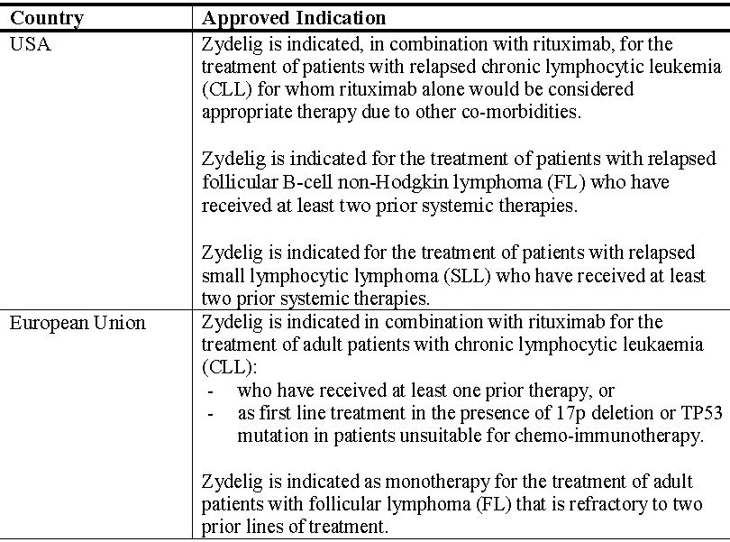

Product Information
The approved Product Information (PI) current at the time this AusPAR was prepared can be found as Attachment 1. For the most recent PI, please refer to the TGA website at <www.tga.gov.au/product-information-pi>.

II. Quality findings

Drug substance (active ingredient)
Idelalisib is a synthetic drug. It has one chiral centre: the drug substance is the 1S enantiomer, derived from L-aminobutyric acid. The chemical structure of idelalisib is not closely related to registered kinase inhibitors (Figure 1).
Figure 1: Chemical structure of idelalisib.
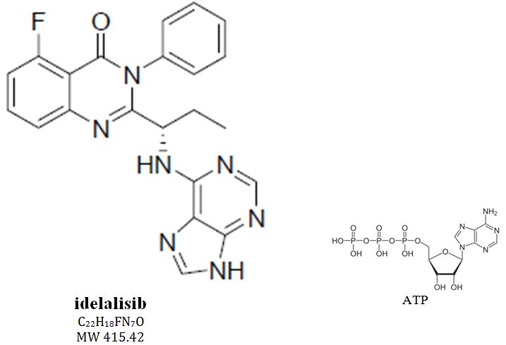
Epimerisation does not seem to be likely in vivo, but this has apparently not been tested.
The drug substance is basic, but it is isolated as the free base, which melts at 249°C. Two polymorphs are known, but have very similar physical properties. Aqueous solubility is very low except in strong acid (27 mg/mL at pH 1.2; but <0.1 mg/mL from pH 4 to pH 8; idelalisib pKa 1.6 and 3.4).
Idelalisib is isolated by crystallisation; it is not micronised. Particle size of the drug substance is rather variable. This potentially affects the rate of drug absorption in vivo (probably especially for achlorhydric patients given low solubility except in acid). The proposed drug substance specification includes a single particle size limit. It is considered prudent to tighten the particle size controls.
Impurity levels have been low in most commercial scale batches, but Gilead has set higher limits for four synthetic impurities. The limits are considered toxicologically acceptable. Limits for some other trace impurities, which are potentially genotoxic, are currently being reviewed.

Drug product
The sponsor proposes registration of both 100 mg and 150 mg tablets. The recommended dose of Zydelig for adults is 150 mg, taken orally, twice daily, with dose reductions in cases of adverse reactions.
The tablets are unscored and film coated. The two tablet strengths have the same shape; they are distinguished by colour and markings (‘100’/‘GSI’ or ‘150’/‘GSI’) and slightly by size. Zydelig is presented as sixty tablets in white, high density polyethylene bottles with a desiccant and a child resistant closure.
The tablets have a conventional immediate release formulation, made by high shear wet granulation, fluid bed drying, compression and film coating. The tablet cores are directly scaled.
Idelalisib degradation products have not been detected in tablet batches, except for traces of a hydrolysis impurity. Zydelig tablets are stored below 30°C with no special warnings; no changes on storage are apparent.
The limit on tablet water content should be tightened to match batch data and ensure lack of degradation or microbial issues.

Bioavailability
Idelalisib has low water solubility at most physiologically relevant pHs (dose dissolving in >2,900 mL) and moderate to high permeability (that is, ‘Biopharmaceutic Classification System’ Class 2 = low solubility - high permeability). Tablet dissolution is strongly dependent on pH, with dissolution profiles slower at pH 2.0 than at pH 1.2.
Idelalisib is metabolised aldehyde oxidase and CYP3A4. The major metabolite, GS-563117, is inactive in vitro. The distribution of radiolabelled idelalisib, taken as an oral dose with food was investigated in mass balance Study GS-US-313-0111. Radioactivity was quantifiable in plasma for up to 72 hours, but chiefly recovered from faeces 78.0%, with 14% in urine.
Assuming that idelalisib is well absorbed, this indicates hepatobiliary excretion.
Study 101-05 was a food effects study of the early capsule dosage form, which also used an intravenous, radiolabelled idelalisib solution microdose in the fasted arm, as well as a labelled oral dose. This could have established the absolute bioavailability of idelalisib, but unfortunately only total ¹⁴C radioactivity was analysed in samples, not the radioactivity in chromatographically separated idelalisib. The absolute bioavailability was estimated by the sponsor as 74% by comparing total radioactivity in plasma after IV and oral doses. This indicates a relatively small first pass effect. The sponsor argues that further studies would not provide significantly more information.
The pharmacokinetics of idelalisib are nonlinear, which the sponsor attributes to solubility limited absorption at doses above 150 mg.

Clinical trial formulations
Early clinical trials used neat idelalisib filled into capsules (17, 50, 100, 125 and 400 mg). A granulated capsule fill was developed and used in Phase II clinical trials (50, 75 and 100 mg). A tablet dosage form was then developed and used in some Phase II and all Phase III studies. Phase III studies used 100 and 150 tablets only.
The bioavailability of 100 mg dosage forms was compared in single dose, cross over bioavailability Study 101-06 in healthy males. This showed that tablets and capsules were bioequivalent (although bioavailability was marginally lower than a trial micronised drug capsule not used in other clinical trials). Given the use of tablets only in Phase III trials this is acceptable.
The bioequivalence of the proposed 100 mg and 150 mg tablet strengths has not been established clinically. The tablet cores are directly scaled. Direct dissolution profile comparisons are limited and only in acid. These show somewhat slower dissolution of the 150 mg tablets in vitro. The clinical significance is unclear.

Food
Study 101-05 tested the effect of food on idelalisib absorption from 4x100 mg capsule doses taken by twelve healthy male volunteers. Idelalisib exposure was somewhat slower but markedly (~40%) higher, outside conventional bioequivalence limits. The food effect on tablet doses has not been directly measured but is likely to be similar. Dose timing with respect to food was not controlled in the main clinical trials. The sponsor argues that the higher exposure with food is not considered clinically relevant, and recommends dosing without regard to food.

Quality summary and conclusions
The toxicological acceptability of some impurities in the drug substance is currently being reviewed. Changes to the limits for drug particle size and tablet water content have been proposed. If necessary, relevant conditions of registration might be imposed.
Registration is otherwise recommended with respect to chemistry, quality control and biopharmaceutic aspects.

III. Nonclinical findings

Introduction
The sponsor has applied to register a new chemical entity, idelalisib (Zydelig), a PI3Kδ inhibitor. This drug belongs to a new pharmacological class. Zydelig is proposed to be used, alone or in combination, for the treatment of patients with relapsed CLL. Zydelig is also proposed to be used for the treatment of patients with refractory iNHL. The proposed dosing regimen involves oral administration of one tablet (150 mg) twice daily.
The submitted nonclinical dossier was in accordance with the International Conference on Harmonisation of Technical Requirements for Registration of Pharmaceuticals for Human Use (ICH) guideline on the nonclinical evaluation of anticancer pharmaceuticals (ICH S9). The only notable limitation of the data package, is that the toxicity profile of the major human metabolite, GS-563117, has not been fully assessed.

Pharmacology

Primary pharmacology

Rationale and mechanism of action
CLL cells have an increase in PI3K activity, either due to up regulation of, or a constitutively active, kinase. There are four Class I PI3 kinase catalytic domains (p110α, β, γ and δ). The PI3Kδ kinase is expressed almost exclusively in haematopoietic cells and plays an important role in B cell proliferation and survival. Inhibition of PI3Kδ in CLL cells (as well as other B cell malignancies) by idelalisib is intended to reduce B cell tumour cell proliferation and cause apoptosis of these cells while having minimal adverse off target effects.

In vitro studies
Idelalisib inhibited PI3Kδ kinase activity with nanomolar potency (19 nM, ~12% of the clinical free C_{min} for idelalisib) and, based on crystal structure information, appeared to bind to the adenosine triphosphate (ATP) binding site of the kinase domain. In cellular assays, at concentrations lower than that expected clinically, idelalisib inhibited signalling through PI3Kδ: reduced B cell receptor signalling and B cell proliferation, reduced level of downstream signals such as phosphorylated Akt, and inhibition of anti FcεRI activation of basophils.
In peripheral blood and tumour cells from patients with B cell malignancies (CLL, mantle cell lymphoma, FL, and/or acute lymphoblastic B cell leukaemia [B-ALL]), idelalisib had a negative effect on survival, inducing apoptosis and cell cycle arrest in the G1 phase and inhibiting proliferation. Idelalisib treatment inhibited CLL cell chemotaxis induced by the chemokines CXCL12 and CXCL13 and inhibited migration of CLL cells beneath stromal cells in co-culture. These data support the proposed use of idelalisib. Idelalisib had an additive effect on CLL cell viability when combined with bendamustine, fludarabine or dexamethasone.
The major metabolite of idelalisib, GS-563117, did not significantly inhibit Class I PI3K kinase activity in in vitro enzyme assays at ≤10 μM (~17 times the clinical free C_{min} for this metabolite). Therefore, this metabolite is not expected to contribute significantly to the efficacy of the drug.

In vivo studies
No proof of concept animal studies were submitted. Mouse tumour models are available and could have been considered.

Secondary pharmacodynamics
Idelalisib displayed 110 to >1100 fold selectivity for PI3Kδ over the other Class I PI3K isoforms (based on kinase activity and cell based assays). Consistent with this, idelalisib had lower potency in inhibiting signalling through other PI3K isoforms (T cell proliferation and formyl-methionyl-leucyl-phenylalanine [fMLP] induced basophil activation). Off-target effects on these kinases are not predicted during clinical use (IC₅₀ values were at least 2.4 times the clinical free C_{max} [860 nM]). Greater selectivity was seen against the Class II PI3K, CIIβ , the Class III PI3K, hVPS34, and other PI3K related proteins, DNA-PK and mTOR.
Idelalisib (at 10 μM; ~12 times the clinical free C_{max}) had no significant binding activity at other kinase targets (at least 350 other kinases) and no significant inhibitory activity at 61 receptors, ion channels and transporters. Off target effects with idelalisib are not predicted during clinical use. GS-563117, the major metabolite of idelalisib, was also assessed for inhibitory activity against a panel of kinases. Significant inhibition was observed against lymphocyte oriented kinase (LOK) and Ste20 like kinase (SLK) activity (IC₅₀ values of 110 and 50 nM, respectively; that is, values below the clinical free C_{min}). Inhibition of these kinases may occur during clinical use. SLK and LOK have high sequence similarity. SLK is ubiquitously expressed in adult tissues with roles involving apoptosis, motility and proliferation. The effect of SLK inhibition in adults is unknown. LOK is preferentially expressed in haematopoietic cells and appears to have a role in regulating leukocyte function associated antigen (LFA-1) mediated lymphocyte adhesion. Mice deficient in LOK have no gross abnormalities and there was no remarkable alteration in immune responses (antibody production, formation of germinal centre and cytotoxicity activity of activated killer cells). Plasma levels of GS-563117 achieved in both rats and dogs in the toxicity studies were higher than the reported IC₅₀ values on these kinases; as a result, the toxicity associated with SLK and LOK inhibition is likely to have been assessed in the submitted repeat dose toxicity studies.
GS-563117 also demonstrated some inhibitory activity against ABL1(H396P) (non-phosphorylated) (82% inhibition), LCK (73% inhibition), LIMK2 (74% inhibition), MAP3K1 (95.8 inhibition), QSK (80% inhibition), SIK2 (66% inhibition) and TNNI3K (81% inhibition) in competitive binding assays at 10 μM. The activity at these kinases was not examined further, so the clinical relevance of these findings is uncertain. Nor was the potential of the metabolite for binding to receptors, ion channels and transporters studied.

Safety pharmacology
Dedicated safety pharmacology studies covered the central nervous, respiratory and cardiovascular systems. No adverse effects on central nervous system (CNS) or autonomic nervous system (ANS) function were seen in rats treated with ≤150 mg/kg per os (PO) idelalisib (estimated exposure ratio based on C_{max} [ER_{Cmax}] 9-15), and no adverse effects on respiratory or cardiovascular function were evident in (male) dogs that received ≤20 mg/kg PO idelalisib (estimate ER_{Cmax} 4). While landing foot splay values were lower in rats at the high dose and there was a marginal increase (by ≤6%) in blood pressure in dogs at ≥5 mg/kg PO idelalisib, these effects were not considered adverse. In the single dose toxicity studies in which higher doses were used, there were no clinical signs of adverse CNS or respiratory effects in rats that received ≤1500 mg/kg PO idelalisib (ER_{Cmax} 22) and dogs that received ≤50 mg/kg PO idelalisib (ER_{Cmax} 53). No electrocardiogram (ECG) abnormalities were seen in the latter animals. Estimated exposures to GS-563117 were lower (in rats) or marginally higher (in dogs; ~4 fold) than the clinical C_{max} for this metabolite. Idelalisib (at ≤50 μM; 58 times the clinical free C_{max}) had no effect on hERG K⁺ tail current suggesting a low potential for QT prolongation. Overall, no adverse effects on CNS, respiratory, or cardiovascular function are predicted during clinical use.

Pharmacokinetics
Idelalisib was rapidly absorbed by the oral route in rats (at ≤100 mg/kg), dogs (at ≤20 mg/kg) and human subjects (T_{max} 1-3 h). At higher doses, T_{max} was delayed in rats and dogs, and a saturation of absorption was observed in the former species at oral doses ≥300 mg/kg. For unknown reasons, exposures to idelalisib in female rats were generally higher than in male rats given the same dose but there were no sex differences in GS-563117 exposure. Because of this sex difference, exposure ratios for toxicity studies were calculated separately for males and females. There were no consistent sex differences in dogs. Oral bioavailability (at low doses) was moderate in rats and dogs (40-80%). Following intravenous (IV) dosing, plasma half lives were similar in rats, dogs and monkeys (1.3-2.3 h). Following oral dosing, the apparent plasma half life in dogs (at ≥10 mg/kg) and human subjects was longer (8-13 h). Clearance was faster in rats (IV dosing) than dogs (IV), monkeys (IV) and human subjects (PO) (48 mL/min/kg, compared with 5-13 mL/min/kg). There was evidence of accumulation with repeated once daily dosing to animals.
While GS-563117 was a significant metabolite in humans (exposures [AUC] were 3.3 times those of idelalisib), it was only a minor metabolite in animal species (exposures [AUC] to GS-563117 were 0.7-3.6%, 4.4-8.9% and 16-66% those of idelalisib in rats, rabbits and dogs, respectively). As a result, exposures to this metabolite were subclinical in the toxicity studies.
Plasma protein binding by idelalisib was moderate to high (16-21% free fraction) and independent of concentration in all species (mice, rats, dogs and humans). Protein binding by GS-563117 in human plasma was slightly higher than the parent drug (~12% free fraction). There was no preferential association of idelalisib or GS-563117 with blood cells from rats, dogs and humans. The volume of distribution was generally greater than total body water in all species (rats, dogs, monkeys and humans), suggesting significant extravascular distribution. Following oral administration of ¹⁴C-idelalisib to rats and dogs, radioactivity was widely distributed, but tissue levels were generally similar to plasma/blood levels (except for tissues involved in absorption/excretion). There was minimal penetration of the blood-brain barrier with peak levels in the CNS <6% those seen in plasma/blood. There appeared to be some retention of drug related material to pigmented tissues (skin and eyes), based on a slow elimination from these tissues.
Metabolism of idelalisib involved a mixture of oxidation, dealkylation, oxidative defluorination followed by further oxidation, oxidative defluorination, methylation and various conjugation reactions. Unchanged idelalisib was by far the dominant circulating species in laboratory animals, while GS-563117 (formed by purine ring oxidation on carbon-8) was the predominant drug-related species and only detectable circulating metabolite in human plasma. GS-563117 was also the predominant metabolite in the plasma of dogs but not rats. Other metabolites were primarily seen in excreted material. There were no human specific circulating metabolites. In vitro studies indicated a major role for aldehyde oxidase (based on inhibitor studies only) and a lesser role of CYP3A (based on inhibitor studies and studies with recombinant enzymes) in the oxidative metabolism of idelalisib and the formation of GS-563117. UGT1A4 plays a significant role in the glucuronidation reactions, though this is only a minor metabolic pathway in humans.
Excretion of idelalisib and/or its metabolites was predominantly via the faeces in all species (rats, dogs and human subjects). Biliary excretion was demonstrated in both animal species.
Aside from the greater oxidative metabolism observed in human subjects, the pharmacokinetic profile of idelalisib was qualitatively similar in humans and the species used in toxicity studies (rats and dogs) and they are considered adequate to serve as appropriate models for toxicity.

Pharmacokinetic drug interactions
As idelalisib is a substrate for CYP3A, P-glycoprotein and BCRP, inducers/inhibitors of these transporters and CYP3A may affect the systemic exposure to idelalisib. Idelalisib exposures (C_{max} and AUC) were increased (by 26% and 79%, respectively) in human subjects when the drug was co-administered with ketoconazole, a CYP3A, P-glycoprotein and BCRP inhibitor (Study GS-US-101-05). The relative contribution of CYP3A, P-glycoprotein or BCRP inhibition to this increase is unknown. Idelalisib was not a substrate for human OAT1, OAT3 or OCT2 and neither idelalisib nor GS-563117 were substrates for OATP1B1 or OATP1B3. Therefore, inducers/inhibitors of these transporters are not expected to affect the disposition of idelalisib.
While in vitro studies indicated the potential for idelalisib to inhibit intestinal P-glycoprotein (the IC₅₀ value (7.7 μM) was less than 0.1 fold the intestinal concentration of the drug, ~1444 uM) and for both idelalisib and GS-563117 to alter the exposure of drugs that are substrates of OATP1B1/B3 (IC₅₀ values [7-10 μM] for idelalisib were less than 25 fold the predicted unbound hepatic inlet concentration, ~1.2 μM), this did not appear to translate to the clinical situation. Co-administration of idelalisib with rosuvastatin, an OATP1B1/B3 substrate, or digoxin, a P-glycoprotein substrate, had no effect on rosuvastatin or digoxin exposures, respectively, in human subjects (Study GS-US-313-0130).
No clinically relevant inhibition was seen on BCRP, CYP1A2, CYP2C9, CYP2C19 or CYP2D6 activity with idelalisib or GS-563117; CYP3A or UGT1A1 activity with idelalisib; or P-glycoprotein, OAT1, OAT3, OCT2, CYP2B6 or CYP2C8 activity with GS-563117. While no significant inhibition of OCT2, OAT1, OAT3 and CYP2B6 was observed with idelalisib, the maximum tested concentration (10 μM for the transporters and 25 μM for CYP2B6) is too low (12 and 29 times the unbound clinical C_{max}) to rule out the possibility of clinically-relevant inhibition.
The inhibitory activity of idelalisib on CYP2C8 (IC₅₀ 13 μM; 15 times the unbound clinical C_{max}) and GS-563117 on UGT1A1 activity (IC₅₀ 23 fold the unbound clinical C_{max}) is potentially clinically relevant. GS-563117 (but not idelalisib) was a mechanism-based inhibitor of CYP3A (IC₅₀ 5.1-16.6 μM; K_{I} 0.18 μM, k_{inact} 0.033 min⁻¹). According to the basic model in the EMA guideline, this inhibition is predicted to be clinically relevant. Consistent with this, co-administration with idelalisib increased the midazolam (a CYP3A substrate) exposure (C_{max} by 2.3 times and AUC by 5.2 times) in a clinical drug interaction study (Study GS-US-313-0130).
In vitro, idelalisib appeared to be an inducer of CYP2B6 and CYP3A4 (activity and mRNA) and GS-563117 was an inducer of CYP1A2 (activity and mRNA). It remains to be seen if this has any clinical or in vivo relevance.
In summary, inducers/inhibitors of P-glycoprotein, BCRP or CYP3A may alter the systemic exposure to idelalisib. Idelalisib administration to patients has the potential to alter the exposure of coadministered drugs that are substrates for CYP2C8, UGT1A1 or CYP3A.

Toxicology

Acute toxicity
Single dose toxicity studies were conducted in rats and dogs following oral administration. Neither study was conducted under Good Laboratory Practice (GLP) conditions. Only an abbreviated observation period was used (5-7 days) and group sizes were small (2/sex), thus limiting the utility of the studies, but not considered to be a major deficiency. The target organs in rats appeared to be the lymphoid and haematopoietic tissues. No target organs for toxicity were identified in dogs. The maximum nonlethal oral dose was 1500 mg/kg in rats and 50 mg/kg in dogs. Idelalisib exposures (AUC) at these doses were large (39 and 186 times the clinical AUC_{0-24h} in rats and dogs, respectively [based on data from females]), suggesting a low order of acute toxicity.

Repeat dose toxicity
GLP compliant repeat dose toxicity studies were conducted in rats (up to 26 weeks) and dogs (up to 39 weeks) using the oral route. A short term (7 days) non GLP compliant study was conducted in female rabbits, presumably intended as a dose ranging study prior to the conduct of an embryofoetal development study (which was not submitted). Due to the limited reporting, findings from this study are not included in the discussion below. The choice of species (rat as the rodent and dog as the non rodent species), the duration of the pivotal studies, group sizes and the use of both sexes were consistent with the relevant guidelines. While dosing was via the clinical route (oral), the clinical dosing regimen (twice daily) was not employed in any of the studies (once daily dosing was used in all studies). As the animals were not always exposed for the full 24 h period, at least one study in dogs should have been conducted to assess whether greater toxicity was observed with twice daily dosing.

Relative exposure
Exposure ratios have been calculated based on animal AUC_{0-24h}:2 × human AUC_{0-12h}. Separate male and female data were used for rats due to the sex differences in exposure, while average AUC values across the sexes was used for dogs. Exposures to idelalisib in the pivotal studies were generally low, reaching up to 9 times the clinical exposure in rats (at least in females), while exposures were subclinical in dogs. Higher doses would have been achievable as dosing was not apparently limited by excessive toxicity. No significant difference in the toxicity profile was seen in the shorter term studies in which higher exposures were achieved (up to 25 times in rats [4 week study] and 20 times in dogs [2-week study, higher exposures achieved with gavage dosing compared with capsules] the clinical AUC_{0-24h}) and dosing was limited by excessive toxicity, suggesting the toxicity profile from the pivotal studies may be adequately representative.
Exposures (estimated and actual) to GS-563117 were subclinical in all repeat dose toxicity studies (Table 3). Therefore, the toxicity profile of this compound has not been adequately assessed in the submitted toxicity studies. Ideally, at least one toxicity study should have been conducted with this metabolite alone. However, this metabolite has no pharmacological activity against any of the Class I PI3K isoforms and the only notable pharmacological activity was against the LOK and SLK kinases. As stated above, adequate plasma levels should have been achieved to assess the potential effects of inhibition at these kinases.
Table 3: Relative exposure in selected repeat dose toxicity studies.
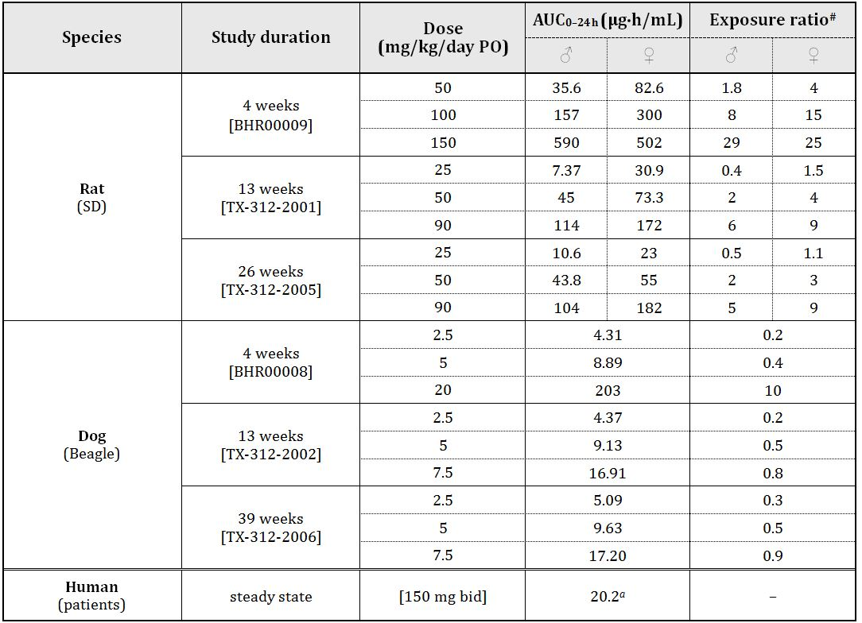
# = animal:human plasma AUC_{0–24 h}; ª2 × AUC_{0‒12h}

Major toxicities
Many of the effects in the toxicity studies with idelalisib are predictable based on its pharmacological activity, with the lymphoid organs and gastrointestinal tract affected. Other findings were seen in the bone marrow (rats), male reproductive organs (rats and dogs), tongue (rats), heart (rats), pancreas (rats) and liver (dogs). All of the findings were reversible or showed a trend to reversion.
Consistent with a role of PI3Kδ in the proliferation of B cells, lymphoid depletion was seen in the spleen, lymph nodes and Peyer’s patches of idelalisib treated rats and dogs. A no observed effect level (NOEL) was not established. In general, the B cell dependent areas were more severely affected than the T cell dependent areas, with the effects largely similar to those reported for PI3Kδ deficient animals. Effects on the lymphoid tissues correlated with impairment of and changes in immune responses, with opportunistic infections observed in treated dogs (demodicosis and systemic infections). Reddened eyes and ocular discharge, possibly associated with infections and generally without any adverse ophthalmological findings, was seen in idelalisib treated dogs at all doses. These findings suggest a risk of infection in patients. Although there was no apparent effect on the level of circulating lymphocytes, absolute neutrophil levels appeared to be higher in female rats (at 90 mg/kg/day; NOEL 50 mg/kg/day, ER_{AUC} 4) and female dogs (at 7.5 mg/kg/day; NOEL 5 mg/kg/day, ER_{AUC} 0.5). Elevated neutrophils have also been reported in PI3Kδ-deficient animals¹⁸.
Inflammation in the gastrointestinal (GI) tract was seen in dogs treated with ≥5 mg/kg/day PO idelalisib (NOEL 2.5 mg/kg/day; exposure ratio based on AUC [ER_{AUC}] 0.3). An increased incidence and/or severity of granulocyte infiltration was seen in the lower part of the small intestine, caecum, colon and rectum with crypt dilatation seen in the large intestine. No such GI effects were seen in rats. The GI tract lesions seen in idelalisib treated dogs are consistent with those reported in PI3Kδ deficient mice, which were reported to develop a mild inflammatory bowel disease (IBD) largely restricted to the caecal and rectal sections of the large intestine.¹⁸ These findings indicate adverse GI effects in patients taking idelalisib.
Large elevations in liver enzymes (by up to 60 times in aspartate aminotransferase [AST], up to 100 times in alanine transaminase [ALT] and up to 13 times in alkaline phosphatase [ALP]), as well as an increase in gamma glutamyl transpeptidase (GGT) and lactate dehydrogenase (LDH) levels were seen in dogs treated with ≥15 mg/kg/day PO idelalisib (NOEL 5 mg/kg/day; ER_{AUC} 0.5) with degenerative hepatic lesions at lower doses (≥5 mg/kg/day PO for 4 weeks; not seen in the longer term studies). Subacute or chronic inflammation was observed within areas of hepatocellular damage. The only evidence of hepatic damage observed in rats, was a slight increase in AST levels (by ≤1.5 times) and an increase in liver weights, with a notable absence of microscopic lesions, in male rats treated with ≥50 mg/kg/day PO idelalisib (ER_{AUC} 2) and female rats treated with 150 mg/kg/day PO idelalisib (ER_{AUC} 25) in the 4 week study (but not in any of the longer term studies), and a relatively small increase (by ≤2.7 times) after a single dose at ≥300 mg/kg (ER_{AUC} ≥30). Therefore, dogs appeared to be more sensitive, and given the margins observed in this species, elevated liver enzymes may be seen in patients. An absence of liver damage in dogs treated for a longer period, suggests these findings may be transient. This is also supported by findings in mechanistic studies. Co-administration of beclomethasone or budesonide appeared to alleviate the increase in ALT levels (and other liver enzymes) but had no effects on hepatic structural changes (hepatocellular necrosis) induced by idelalisib.
In vitro, at high concentrations, idelalisib inhibited erythroid differentiation in rat and human bone marrow cell cultures (at ≥10 μM and ≥0.1 μM, respectively). Similarly, erythroid depletion and a slight suppression of erythropoiesis was seen in rats given high oral doses of idelalisib (≥100 mg/kg/day to females and 150 mg/kg/day to males; ER_{AUC} at the NOEL, ~5). These findings are not expected to have clinical relevance.
Reduced testicular and epididymal weights were seen in rats and dogs. This correlated with seminiferous tubular atrophy/degeneration and hypospermatogenesis. Based on findings in the 13 week studies in both species at all doses, a NOEL was not established (ER_{AUC} at the lowest observed effect level [LOEL] was subclinical, 0.2-0.5). However, there was no functional effect on male fertility in a rat fertility study at reasonably high doses (≤100 mg/kg/day; ER_{AUC} 8). The underlying cause for the testicular/epididymal effects is unknown. The p110δ kinase has been shown to be expressed in the testes of male mice, though its function in this tissue has yet to be determined; male mice deficient in p110δ are fertile.¹⁸ It is unknown if p110δ is expressed in the testes of rats or dogs, but this kinase is not expressed in the testes of male human subjects.¹⁹ Therefore, there appears to be a species difference in the expression of this kinase. Alternatively, the effects on the male reproductive organs are associated with off target effects on other p110 isoforms, such as p110β, which has been shown to be essential for effective spermatogenesis and male fertility. If effects on spermatogenesis in rats and dogs were due to inhibition of testicular expressed p110δ or p110β, the findings may have low clinical relevance. However, given the low safety margins and an unknown underlying cause, the testicular findings should be assumed relevant to male subjects taking idelalisib.
Microscopic changes were seen in the tongue (subacute inflammation, ulceration), heart (increased incidence and severity of cardiomyopathy, myocardial infiltrates and fibrosis) and pancreas (subacute/chronic inflammation, haemorrhage, islet cell and acinar cell degeneration) of rats treated with high doses of idelalisib (≥50 mg/kg/day; ER_{AUC} 2). Of these findings, only mouth ulceration was observed in one dog treated with 20 mg/kg/day (ER_{AUC} 10). No adverse cardiac or pancreatic lesions were seen in dogs. The underlying cause for the lesions in the mouth, heart and pancreas of idelalisib treated animals is unknown, but, as they generally occurred at high doses, they are not expected to be clinically relevant.

Genotoxicity and carcinogenicity
The potential genotoxicity of idelilisib was investigated in the standard battery of tests, conducted in accordance with ICH guidelines. All assays were appropriately validated and conducted under GLP conditions. Appropriate bacterial strains were used in the Ames test and concentrations used in the in vitro assays were appropriate. The highest dose in the rat micronucleus study (2000 mg/kg PO) is estimated to result in an exposure ~40 times the clinical AUC for idelalisib. Negative results were returned in the bacterial mutagenicity and the in vitro clastogenicity tests. The rat micronucleus test gave equivocal results; a small, dose related, statistically significant increase in micronucleated immature erythrocytes was seen in males (but not females) treated with idelalisib (24 h but not 48 h harvest). Given the increase in micronucleated erythrocytes was small in magnitude, reaching levels above the historical control data only at the high dose and seen only in males, the weight of evidence indicates idelalisib is not genotoxic. The finding is not considered a concern for the current indication.
The potential genotoxicity of the major human metabolite, GS-563117, has not been adequately assessed.²² This is not considered a major deficiency for the current application. However, if the indications for idelalisib were to be extended from anticancer applications, the potential genotoxicity of GS-563117 needs to be assessed.
No carcinogenicity studies were conducted, which is considered acceptable given the indication.

Reproductive toxicity
The only reproductive toxicity studies submitted examined effects on fertility (male and female) and embryofoetal development toxicity in rats (Table 4). The lack of a postnatal development study is considered acceptable, given the indication, and the assessment of embryofoetal development toxicity in a single animal species is considered acceptable, given the demonstration of embryofoetal lethality and teratogenicity in the rat study. Adequate animal numbers were used and the study design was satisfactory. Maximum exposures to idelalisib were adequate, although exposures (or estimated exposures) to GS-563117 were subclinical.
Table 4: Relative exposure in reproductive toxicity studies.
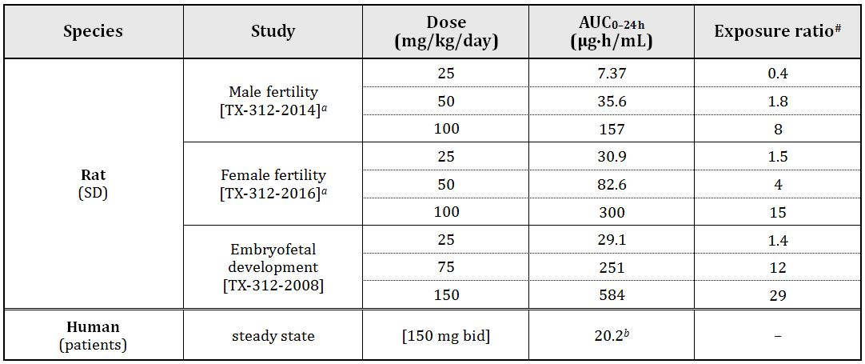
Functional fertility was unaffected when idelalisib treated males (≤100 mg/kg/day; ER_{AUC} 8) were paired with untreated females, despite reduced epididymal and testicular weights and reduced sperm concentrations observed in males treated at all doses. Female fertility was also unaffected when idelalisib treated females (≤100 mg/kg/day; ER_{AUC} 15 were paired with untreated males. However, embryolethality was observed (see below for further discussion).
No studies were conducted to assess placental transfer or excretion into milk. In the embryofoetal development study, foetal weights were reduced and an increased incidence of incomplete ossification were seen at 75 mg/kg/day, with embryolethality and an increase in foetal malformations (short tail, anury, vertebral agenesis, micropthalmia/anophthalmia and hydrocephaly) observed at the higher dose (150 mg/kg/day; ER_{AUC} 29). The NOAEL for embryofoetal effects was 25 mg/kg/day (ER_{AUC} 1.4). Mice deficient in PI3Kδ have no gross anatomical abnormalities.¹⁸ The embryofoetal lethality and toxicity (teratogenicity and reduced foetal weights) observed in the embryonic and embryofoetal development studies could be associated with inhibition of other p110 isoforms. Inactivation of either p110α or p110β leads to embryolethality, while reduced weights have been reported for foetuses with inactivated p110β., Alternatively, the adverse embryofoetal effects are associated with inhibition of SLK by the idelalisib metabolite, GS-563117. SLK is expressed in the muscle and neuronal lineages in the developing embryo and inactivation of this kinase has led to embryofoetal deaths., Nonetheless, the findings in rats indicate a risk to the developing foetus if idelalisib is taken during pregnancy.

Pregnancy classification
The sponsor has proposed Pregnancy Category B3. Given the increased incidences of embryofoetal lethality and malformations observed in the rat embryofoetal development study, Category D seems more appropriate.

Immunotoxicity
The effects of idelalisib on the immune system and immunocompetence were assessed in repeat dose toxicity studies and dedicated immunotoxicity studies as outlined in the ICH guideline. Lymphoid depletion was a feature in the toxicity studies. While the B cell areas were more significantly affected, there was some evidence of T cell depletion in the thymus, Peyer’s patches and some lymph nodes, but not the spleen of rats treated with ≥50 mg/kg/day PO idelalisib for 4 weeks. Similar effects were seen in mice deficient in PI3Kδ activity: they have a significantly reduced level of marginal zone B cells and reduced levels of activated T cells in the lymphoid tissues, suggesting a role for PI3Kδ in the differentiation of B cells and differentiation or survival of effector and possibly memory T cells. In dedicated immunotoxicity studies, a reduction in the antibody response was seen in rats (to keyhole limpet hemocyanin [KLH] and sheep red blood cells), both the IgM and IgG responses were significantly diminished. This is consistent with findings in PI3Kδ deficient mice where both T cell dependent and independent antibody responses were impaired. In a published paper, idelalisib inhibited inflammatory cytokine production by T-cells (IL-6, IL-10 and TNF-α) and NK cells (IFN-γ) but, unlike its effects on B cells, idelalisib did not induce apoptosis of NK cells or T cells. Also, there was no effect on antibody dependent cell mediated cytotoxicity, which is of relevance if idelalisib were to be co-administered with monoclonal antibody therapies (for example, rituximab or alemtuzumab). While idelalisib treatment did not appear to affect host defence (which generally requires functional B and T cells) against a Staphylococcus aureus infection in a rat groin abscess model, opportunistic infections (mite infestations and possibly conjunctivitis) were seen in dogs treated with idelalisib, likely as a result of the immunosuppressive action of idelalisib. The data suggest that clinical use of idelalisib may be associated with an increased risk of infection.
PI3Kδ plays a role in autoimmune reactions and allergic responses., Therefore, diminished allergic responses may be seen in patients taking idelalisib.

Phototoxicity
Idelalisib absorbs UV light with peaks at 206 nm, 269 nm and 310 nm, with extinction coefficients of 50700, 23100 and 6700 M⁻¹cm⁻¹, respectively. In vitro, the idelalisib metabolite, GS-563117, was clearly phototoxic to cultured cells (IC₅₀ 16-23 μg/mL; ER_{Cmax} 5-7), but the phototoxic potential of idelalisib was inconclusive. In tissue distribution studies, there appeared to be some retention of drug related material in pigmented tissues, but levels never exceeded the plasma/blood C_{max} following a single dose. The extent of accumulation in pigmented skin following repeated dosing was not assessed. Unfortunately, an in vivo phototoxicity study was not conducted. Given that idelalisib (and presumably GS-563117) absorbs light in a relevant range, distributes and is retained in pigmented skin, and the metabolite GS-563117 was shown to be phototoxic in vitro, some phototoxic skin reactions may be seen in vivo.

Impurities
The proposed specifications for impurities/degradants in the drug substance/product have been adequately qualified.

Paediatric use
Idelalisib is not proposed for paediatric use and no specific studies in juvenile animals were submitted.

Nonclinical summary and conclusions

Summary
- The submitted nonclinical dossier was in accordance with the ICH guideline on the nonclinical evaluation of anticancer pharmaceuticals (ICH S9). The only notable limitation of the data package, is that the toxicity profile of the major human metabolite, GS-563117, has not been fully assessed.
- In vitro, idelalisib inhibited PI3Kδ kinase activity with nanomolar potency and high selectivity over other Class I PI3K catalytic subunits, Class II and III PI3K enzymes and other PI3K related enzymes. In peripheral blood and tumour cells from patients with B cell malignancies, idelalisib had a negative effect on survival, inducing apoptosis and inhibiting proliferation. The major metabolite of idelalisib, GS-563117, is not expected to contribute significantly to the efficacy of the drug.
- No proof of concept animal studies were submitted.
- Based on a comprehensive screen against several kinases, receptors, ion channels and transporters, no off target effects are anticipated with idelalisib. However, GS-563117 had significant inhibitory activity on the SLK and LOK kinases at clinically relevant concentrations.
- CNS and respiratory function were unaffected in rats and dogs at high exposures. No ECG abnormalities were seen in the latter species. Idelalisib had no effect on hERG K+ tail current at high concentrations suggesting a low potential for QT prolongation.
- Oral bioavailability (at low doses) was moderate in rats and dogs. Saturation of absorption was seen at higher doses in rats. There was evidence of accumulation with repeated once daily dosing to animals. Plasma protein binding by idelalisib was moderate to high and independent of concentration in all species. Tissue distribution studies in rats indicated some retention of drug related material to pigmented tissues (skin and eyes), based on a slow elimination from these tissues. Unchanged idelalisib was by far the dominant circulating species in laboratory animals, while GS-563117 was the predominant drug related species and only circulating metabolite in human plasma. In vitro studies indicated a major role for aldehyde oxidase and a lesser role of CYP3A in the oxidative metabolism of idelalisib and the formation of GS-563117. Excretion of idelalisib and/or its metabolites was predominantly via the biliary/faecal route in animals and humans.
- Inducers/inhibitors of P-glycoprotein, BCRP or CYP3A may alter the systemic exposure to idelalisib. Idelalisib administration to patients has the potential to alter the exposure of coadministered drugs that are substrates for CYP2C8, UGT1A1 or CYP3A.
- Single dose toxicity studies in rats and dogs indicated a low order of acute toxicity.
- Repeat dose toxicity studies were conducted in rats (up to 26 weeks) and dogs (up to 39 weeks) using the oral route. The clinical dosing regimen (twice daily) was not employed in any of the studies (once daily dosing was used in all studies) and exposures to idelalisib were low in rats and subclinical in dogs in the pivotal studies. Notable target organs for toxicity were the lymphoid organs (lymphoid depletion and opportunistic infections; both species), gastrointestinal tract (inflammation; dogs), liver (transient elevations in liver enzymes and degenerative hepatic lesions with secondary inflammation; dogs and at very high doses in rats) and male reproductive organs (seminiferous tubular atrophy/degeneration and hypospermatogenesis; both species). All effects were reversible or showed a trend to reversion.
- Idelalisib was not mutagenic in an Ames test and was not clastogenic in vitro (in human lymphocytes). An equivocal result was obtained in the rat micronucleus study, but is considered of low concern. No carcinogenicity studies were conducted, which is considered acceptable.
- Reproductive toxicity studies with idelalisib examined effects on fertility (male and female) and embryofoetal development toxicity in rats. Functional fertility was unaffected in treated male and female rats, despite hypospermia being observed in treated males. Idelalisib was embryofoetal lethal, embryofetotoxic and teratogenic in rats. Exposure at the NOAEL for embryofoetal effects was similar to the clinical AUC.
- In dedicated immunotoxicity studies, idelalisib treatment led to a reduction in the antibody response to T cell dependent antigens (KLH and sheep red blood cells). Both the IgM and IgG responses were significantly diminished. While idelalisib treatment did not appear to affect short term host defence (which generally requires functional B and T cells) against a Staphylococcus aureus infection in a rat groin abscess model, opportunistic infections (mite infestations and possibly conjunctivitis) were seen in dogs treated chronically with idelalisib. Diminished allergic responses may be seen in patients taking idelalisib.
- The idelalisib metabolite, GS-563117, was phototoxic in vitro. Some phototoxic skin reactions may be seen in vivo. The phototoxic potential of idelalisib is inconclusive.

Conclusions
- The primary pharmacology studies lend some support (albeit minimal) for the proposed indication.
- The combined animal safety studies revealed the following findings of potential clinical relevance:
  - diminished immune reactions
  - opportunistic infections and possibly secondary malignancies
  - gastrointestinal disturbances
  - transient liver toxicity
  - hypospermia
  - embryofoetal toxicity and lethality
  - phototoxic skin reactions.
- The sponsor has proposed Pregnancy Category B3. Given the increased incidences of embryofoetal lethality and malformations observed in the rat embryofoetal development study, Category D seems more appropriate.
- There are no objections on nonclinical grounds to the proposed monotherapy indication. No nonclinical studies were submitted to support combination use. This needs to rely solely on clinical data.

IV. Clinical findings

Introduction

Clinical rationale
iNHL is comprised of four indolent lymphomas (FL, SLL, LPL with or without Waldenstrom macroglobulinemia [WM], and MZL). Idelalisib clinical studies included subjects with all four indolent lymphomas (FL, SLL, LPL/WM, and MZL). Indolent NHL is an incurable chronic life threatening disease in which the primary treatment goal is disease control for as long as possible. The cornerstones of initial and subsequent therapy are anti CD20 antibodies and chemotherapy. In this chronically relapsing disease, there are a handful of agents approved for use in the refractory setting; in particular, two anti CD20 radioimmunotherapies (¹³¹I-tositumomab [approved in the US] and ⁹⁰Y ibritumomab tiuxetan), rituximab, pixantrone (approved in the EU) and bendamustine. However, eligibility for the radioimmunotherapies is extremely limited as these agents cause severe, persistent hematologic toxicities (Grade 3 and 4 cytopenias) in >70% of patients who receive them, and GlaxoSmithKline announced it will discontinue the manufacture and sale of ¹³¹I-tositumomab in 2014 due to minimal use. iNHL refractory to both rituximab and alkylating agents is a serious life threatening condition for which there is no meaningful effective therapy available. Once patients have been treated with the two cornerstones of therapy, an anti CD20 antibody and an alkylating agent, and progress during their therapy or relapse shortly thereafter (within 6 months), standard treatment options become exhausted. In an attempt to exert some measure of disease control in this highly refractory population, current therapies for frontline treatment are frequently repeated despite lack of meaningful responses in many instances.
CLL is a serious, incurable hematologic malignancy that accounts for approximately one-third of all leukaemias. CLL is almost entirely a disease of the elderly; at diagnosis the median age is 72 years, and 70% of patients are ≥ 65 years of age. Treatment guidelines for CLL provided the by the European Society for Medical Oncology (ESMO) in the EU and by the National Comprehensive Cancer Network (NCCN) in the US recommend first line and relapse treatment options for several categories of patients. The guidelines consider stage of disease, age, comorbidities, and the presence or absence of adverse genetic markers, most importantly 17p deletion. Most indicated frontline regimens, depending on the level of fitness of the patient and age, include the anti CD20 antibody rituximab (R) in combination with fludarabine, cyclophosphamide and rituximab (FCR); fludarabine and rituximab (FR); pentostatin, cyclophosphamide and rituximab (PCR); bendamustine and rituximab (BR); and chlorambucil and rituximab (ChR). These combination chemoimmunotherapies are effective in providing durable remissions in those with treatment naive CLL without the 17p deletion. For patients with 17p deletion, standard therapy is not considered effective. Initial therapy for CLL is not curative; the disease eventually relapses and further intervention is required to regain disease control. The first line treatment may be repeated if the patient had a sufficient PFS interval to demonstrate likely continued responsiveness to the regimen (12 to 24 months for monotherapy or 24 to 36 months for combination therapy). ESMO guidelines recommend alemtuzumab ± rituximab as a suitable regimen in subjects with early relapse (or 17p deletion); other recommendations include FCR for those refractory to alkylators, BR, or ofatumumab in those without bulky disease. In subjects with multiple relapses, treatment options become restricted by significant cumulative toxicity or lack of efficacy as the disease becomes resistant to previously used agents. Thus, a high unmet medical need remains for all CLL patients, and particularly for elderly patients or patients with comorbidities, as they reach the practical limits of available therapy.
Idelalisib is a novel, highly selective competitive inhibitor of adenosine-5’-triphosphate binding to the catalytic subunit of PI3Kδ, which has been shown to be prominently expressed in cells of hematopoietic origin. PI3Kδ is critical for multiple signalling pathways that are hyperactive in B cell malignancies. Inhibition of PI3Kδ modulates BCR signalling as well as signalling through cytokine, chemokine and integrin receptors. These signalling pathways act via downstream enzymes (most importantly the serine/threonine protein kinase [Akt]) to regulate proliferation, apoptosis motility, homing, and retention of malignant B cells in lymphoid tissues and bone marrow compartments. By inhibiting PI3Kδ dependent signalling, idelalisib inhibits proliferation, survival, homing, motility, and retention in the tumour microenvironment in many B cell malignancies.

Guidance
A pre submission meeting was held between the sponsor and TGA in July 2013 to discuss the proposed application and submission strategy for Zydelig tablets.
The TGA raised no objections to submission of a Category 1 application seeking registration of idelalisib with an indication for the treatment of patients with refractory iNHL based on the pivotal Study 101-09, but requested a scientific rational for deviating from the adopted EU guideline to be provided. A scientific rational for using pivotal Study 101-09 to support an indication in refractory iNHL patients was provided in the pre submission planning form.
Comment: The evaluators were not able to locate the above mentioned pre submission planning form and clarification regarding this has been requested.
The TGA noted that an interim analysis of the Phase III data from Study GS-US-312-0116 would be available within months of the meeting and therefore this would make a more complete application. The sponsor noted the TGA opinion that Phase III data from Study GS-US- 312-0116 would make a more complete application and revised the proposed submission timelines accordingly. Data from the Phase III study GS-US-312-0116 is provided within this Category 1 application to support an indication in CLL patients.
Contents of the clinical dossier
The submission contained the following clinical information:
- 25 clinical pharmacology studies, including 16 that provided pharmacokinetic data and 12 that provided pharmacodynamics data
- 2 population pharmacokinetic analyses
- The clinical efficacy and safety of idelalisib as monotherapy and in combination regimens were evaluated in 6 Phase I and Phase II clinical studies in B cell malignancies: Studies 101-02, 101-07, 101-08, 101-09, 101-10, and 101-11, and 1 extension study (101-99) of Studies 01-02, 101-07, 101-08, and 101-10, and in 1 Phase III Study (312-0116).
In addition to the studies described above, the sponsor is currently conducting 5 Phase III studies: 2 in relapsed/refractory iNHL, and 3 in relapsed/refractory CLL in relapsed/refractory iNHL.

Paediatric data
The submission did not include paediatric data.

Good clinical practice
All clinical studies submitted with this application were conducted under local regulatory requirements and in accordance with recognised international scientific and ethical standards, including but not limited to the ICH guideline for Good Clinical Practice (GCP) and the original principles embodied in the Declaration of Helsinki.

Pharmacokinetics

Studies providing pharmacokinetic data
Table 5 shows the studies relating to each pharmacokinetic topic and the location of each study summary.
Table 5: Submitted pharmacokinetic studies.
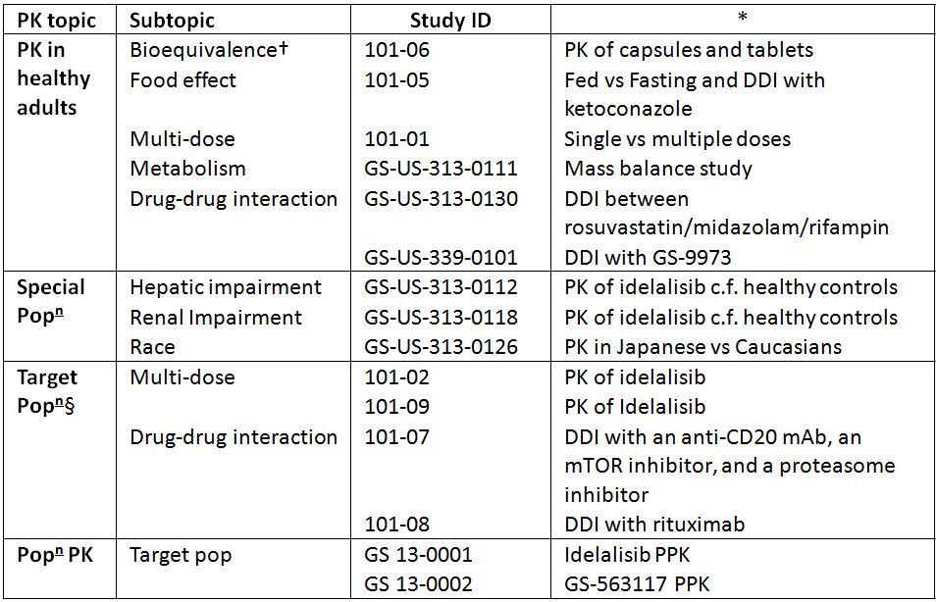
* Indicates the primary aim of the study.
† Bioequivalence of different formulations.
§ Subjects who would be eligible to receive the drug if approved for the proposed indication.
Table 6 lists pharmacokinetic results that were excluded from consideration due to study deficiencies.
Table 6: Pharmacokinetic results excluded from consideration.
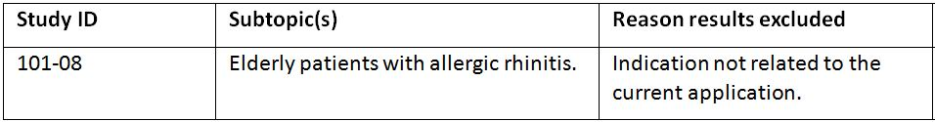

Evaluator’s conclusions on pharmacokinetics

Absorption
- Following the administration of a 100 mg oral tablet dose of the to-be-marketed formulation of idelalisib in healthy males, the T_{max} of idelalisib was 1 h and the C_{max}, AUC_{inf} and t_{1/2} of idelalisib were 1230 ng/mL, 6340 ng.h/mL and 7.76 h, respectively.
- No formal studies have examined the absolute bioavailability of idelalisib and the sponsor has provided a “Justification for not providing Biopharmaceutic Studies”. However, the evaluator believes this justification is not sufficient under the Australian regulatory guidelines for prescription medicines.

Bioequivalence
- The to-be-marketed tablet formulation and the capsule formulation used in the Phase II and III studies were bioequivalent in regards to their AUC_{0-last} and AUC_{inf} for idelalisib and almost bioequivalent in regards to their C_{max} with a geometric LS ratio (90% Confidence Interval [CI]) of 0.91 (0.76-1.09).

Food
- Following a 400 mg dose the C_{max} of idelalisib was similar under fasted and fed conditions, whereas the AUC_{0-last} and AUC_{0-inf} for idelalisib were approximately 40% higher under fed conditions. Idelalisib can be administered without regard to food.

Dose proportionality and accumulation
- Following a single dose, idelalisib C_{max}, AUC_{inf} and AUC_{0-t} increased with dose and increases in idelalisib AUC_{inf} were dose proportional, while increases in C_{max} were less than dose proportional. Following bis in die (BD, twice daily) dosing, the C_{max} and AUC₀₋₁₂ increased with dose, but the increases were less than dose proportional. Accumulation after multiple doses of idelalisib (AUC₀₋₁₂ on Day 7 over AUC₀₋₁₂ on Day 1) ranged between 20 and 80 percent.

Distribution
- Population pharmacokinetic analysis identified that the plasma pharmacokinetics of idelalisib in the clinical dose range could be described by a two compartment model and predicted, for a typical healthy subject or patient, that the volumes of distribution for the central and the peripheral compartments were 22.65 L and 72.97 L, respectively. Mean whole blood-to-plasma concentration ratio of [¹⁴C]-radioactivity ranged from 0.4 to 0.6 throughout the 48 h post dose and was time independent. The sponsor states that the distribution of idelalisib into compartments other than plasma has not been examined. Idelalisib protein binding was 93-94%.

Metabolism and excretion
- In vitro and in vivo studies in rats, dogs and humans have identified that idelalisib is primarily metabolised via oxidation in the liver where aldehyde oxidase converts idelalisib to its major circulating plasma metabolite, GS-563117. To a lesser extent, idelalisib is also metabolised through oxidation by CYP3A and glucuronidation by UGT1A4. In plasma, the only two circulating species identified were idelalisib (32%) and its primary inactive metabolite GS-563117 (62%).
- The mass balance study identified that 78% of the radioactive dose was recovered in faecal samples and 14.4% in urine samples over a 240 h period following dosing. In urine, total radioactivity consisted primarily of idelalisib (23%) and GS-563117 (49%) and several trace metabolites. In faeces, radioactivity was accounted for mainly by idelalisib (11.5%), GS-563117 (43.9%), and other oxidation products.
- Following a single 150 mg dose of idelalisib, the t_{1/2} values for idelalisib and GS-563117 were 5.74 h and 8.77 h, respectively.

Variability
- The inter subject variability in idelalisib C_{max}, AUC_{inf} and t_{1/2} following a 100 mg oral tablet dose was 37%, 33% and 17%, respectively.
- The estimated intra and inter individual variabilities in idelalisib clearance for a typical individual were 53.5% and 38.2%, respectively. For GS-563117, these values were 34.8% and 49.5%, respectively.

PKs in target population
- In the target population the C_{max} and AUC₀₋₆ values following a single dose and following 28 days of multiple dosing indicated that there was comparable exposure, which was consistent with minimal/modest idelalisib accumulation. The geometric mean Cmax and AUC₀₋₆ values for Day 1 and Day 28 increased in a less than dose-proportional manner.

PKs in hepatic and renal impairment
- Idelalisib C_{max} was slightly lower in subjects with moderate or severe hepatic impairment relative to normal matched control subjects, while AUC was higher (by 58% to 60%). T_{max} occurred later in the subjects with hepatic impairment; however, there was little to no change in t_{1/2}. By contrast, GS-563117 exposures (AUC and C_{max}) were significantly lower in subjects with moderate and severe hepatic impairment relative to matched healthy control subjects. Severe renal impairment had little effect on the pharmacokinetics of idelalisib or GS-563117 (for example, approximately 25% increase in AUC_{inf}).

Effect of age, gender, race, body weight on idelalisib PKs
- Population pharmacokinetic analyses indicated that age and gender did not affect the pharmacokinetics of idelalisib or GS-563117, while idelalisib T_{max} occurred later in healthy Caucasian than in Japanese subjects (2.75 h versus 1.25 h). The AUC_{0-last}, AUC_{inf}, and C_{max} values of idelalisib were higher (22%, 23%, and 28%, respectively) in Japanese subjects. Similarly, GS-563117 T_{max} occurred later in Caucasians than in Japanese subjects (3.5 versus 2.0 h), while exposure was higher in Japanese subjects. Body weight was identified as a covariate in the final idelalisib population pharmacokinetic model; however, it did not influence the pharmacokinetics of GS-563117.

Drug interactions
- Co-administration of 150 mg idelalisib did not affect the pharmacokinetics of drugs that were substrates of P-gp (digoxin) or OATP1B1/ OATP1B3 (rosuvastatin).

By contrast, co-administration of midazolam (a CYP3A4 substrate) with idelalisib resulted in significant increases in midazolam C_{max}, AUC_{last}, and AUC_{inf} (by 138%, 355%, and 437%, respectively) and decreased exposure to 1’-OH-midazolam compared to when it was given alone, indicating significant inhibition of CYP3A activity by idelalisib and/or its metabolite.
- When idelalisib was co-administered with the CYP3A inducer rifampicin, the C_{max} and AUC_{inf} values for both idelalisib and GS-563117 were significantly reduced, suggesting that CYP3A is an important mediator of the metabolism of both the parent molecule and its metabolite.
- Co-administration of idelalisib with ketoconazole (a CYP3A4 inhibitor) resulted in an increase in idelalisib C_{max} and AUC by 26% and 80%, respectively, indicating that idelalisib is a CYP3A4 substrate in vivo.
- The AUC_{tau}, C_{max}, and C_{tau} of GS-9973 were increased 51-64%, 38-50%, and 74-96% when it was co-administered with idelalisib at 100 or 150 mg BD compared to when it was administered alone. By contrast, co-administration of GS-9973 did not significantly affect the PKs of idelalisib.

Limitations of the pharmacokinetic data
- The justification for not submitting biopharmaceutical studies did not address all of the requirements as per TGA guidelines.
- Based on the plasma AUC₀₋₂₄ data presented, the total plasma radioactivity that can be attributed to idelalisib and GS-563117 is 94%; however, the sponsor states in the Summary of Clinical Pharmacology Studies that the total radioactivity of these two components adds to 100%. Can the sponsor please justify this discrepancy? If not, what does the 6% difference in total radioactivity represent?
- The oral clearance (CL/F) of idelalisib was not reported for patients with either hepatic or renal impairment as required per the TGA adopted EMA guidelines.
- One of the secondary objectives of the Phase III Study GS-US-312-0116 was to characterise the effect of rituximab on idelalisib exposure through evaluations of idelalisib plasma concentrations over time. Information relating to this objective was not available at the time of submission.
- Similarly, the drug-drug interaction data from Study 101-07, which examines the interaction of idelalisib with an anti CD20 monoclonal antibody, a chemotherapeutic agent, a mammalian target of rapamycin (mTOR) inhibitor, and/or a proteasome inhibitor, has not been provided for evaluation.

Pharmacodynamics

Studies providing pharmacodynamic data
Table 7 shows the studies relating to each pharmacodynamic topic and the location of each study summary.
Table 7: Submitted pharmacodynamic studies.
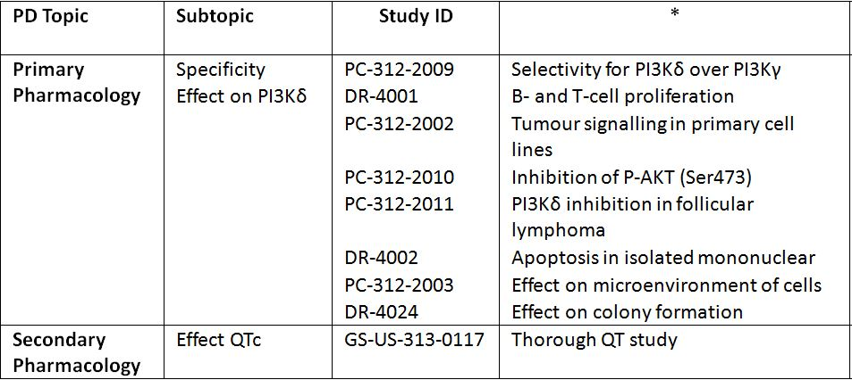
* Indicates the primary aim of the study.
§ Subjects who would be eligible to receive the drug if approved for the proposed indication.
‡ And adolescents if applicable.
None of the pharmacodynamic studies had deficiencies that excluded their results from consideration.

Evaluator’s conclusions on pharmacodynamics
- Idelalisib is a selective inhibitor of ATP binding to the catalytic domain of PI3Kδ, resulting in inhibition of the phosphorylation of the key lipid second messenger phosphatidylinositol and prevention of Akt phosphorylation, in particular pAktS473 induction.

Primary PD effects
- Idelalisib induces apoptosis and inhibits cell viability, basophil activation and proliferation in cell lines derived from malignant B cells and in primary tumour cells. In addition, idelalisib inhibits homing and retention of malignant B cells in the tumour microenvironment including lymphoid tissues and bone marrow. Idelalisib has also been shown to interrupt B cell cycle and inhibit the secretion of chemokines.
- Idelalisib inhibits the constitutive phosphorylation of Akt in cells from subjects with CLL to the levels seen in healthy volunteers.
- CD63 expression was decreased following both 1 and 4 days of dosing with idelalisib with greater inhibition observed following 4 days of dosing. Maximal mean inhibition of CD63+/CD123+HLA- cells peaked at 2 h post dose.

Secondary pharmacodynamic effects
- In contrast to moxifloxacin, therapeutic or supratherapeutic doses of idelalisib did not prolong QTcF, QTcB, QTcN or QTcI.
- Following dosing with either 100 mg or 200 mg idelalisib, the inhibition of CD63 was concentration dependent. By contrast, there was no correlation between the extent of exposure to idelalisib and inhibition of basophil stimulation or change in QTc.
- Pharmacodynamic drug interactions: Co-administration of GS 9973 and idelalisib led to a greater inhibition of CD63 than either drug was able to achieve when given alone. When given alone idelalisib had no effect on phospho-SYK (Y525) but it moderately potentiated the effects of GS 9973 on this pathway.

Limitations of pharmacodynamic data
- If it is now available, could the sponsor please provide the pharmacodynamic data relating to Studies 101-07, 101-08, 101-09, 101-10, and 101-11.
- Genetic, gender and age related differences in pharmacodynamics were not examined.

Dosage selection for the pivotal studies
The clinical dosage of 150 mg idelalisib was initially determined based on the results of a Phase I study (101-02), which examined the pharmacokinetics following idelalisib doses of 50, 100, 150, 200, or 350 mg BD, or 150 or 300 mg once daily administered as monotherapy to subjects with relapsed or refractory hematologic malignancies.
In this study, idelalisib exposure increased in a less than dose proportional manner; and the different dosing frequencies (that is, once daily versus BD) varied the shape of the concentration-time curves and the associated pharmacokinetic parameters used in exposure-response analyses. Tumour response was also assessed based upon the change in tumour size (sum of the products of diameters, SPD). In addition, in a subgroup of subjects with iNHL, predicted idelalisib exposures based on population pharmacokinetic modelling were evaluated against SPD to assess the exposure-efficacy relationship.
In the iNHL subgroup, over a wide dose/exposure range, median SPD response increased over the quartiles of idelalisib Ctau and reached a plateau at/above the second quartile (Figure 2). Idelalisib 150 mg BD provided exposures (trough concentration [C_{tau}]: 349 ng/mL) encompassed by the third exposure quartile (C_{tau} range: 280-405 ng/mL), corresponding to this plateau of high exposure-response and well above the EC₉₀ for PI3Kδ inhibition (~125 ng/mL or 301 nM). At the same total daily dose, idelalisib BD treatment delivered higher C_{tau} than once-daily dosing, while the AUC₀₋₂₄ values following idelalisib 150 mg BD and 300 mg once daily were comparable (median C_{tau} of 349 and 167 ng/mL and AUC₀₋₂₄ of 19,600 and 16,300 ng.h/mL, respectively).
Figure 2: Study 101-02 exposure-efficacy relationship: box plot of the sum of products of the greatest perpendicular diameters of index lesions stratified by quartile of idelalisib C_{tau} in subjects with iNHL.
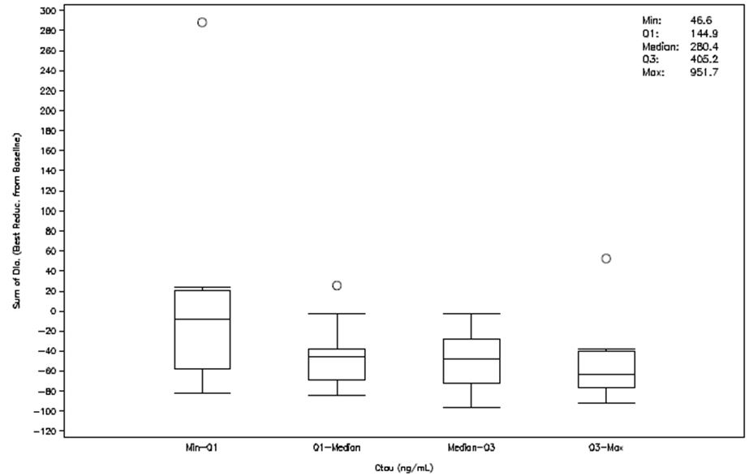
Comparison of SPD response in the BD versus once daily regimens indicated that efficacy was best associated with idelalisib trough concentrations. Therefore, 150 mg BD was chosen for further evaluation in clinical studies (including Study 101-09) as it would provide a mean C_{tau} above the EC₉₀ for PI3Kδ inhibition and should demonstrate robust efficacy.
In CLL subjects, the exposure-response relationship was similar to that observed in iNHL subjects (Figure 3). Across all quartiles of idelalisib exposure, SPD reductions of >50% were identified and SPD response plateaued over the third quartile of idelalisib C_{tau}. Idelalisib 150 mg BD provided exposures (C_{tau}: 349 ng/mL) in CLL subjects encompassed by the third exposure quartile (C_{tau} range: 295-437 ng/mL) and corresponded to the plateau phase of exposure-response that was observed in subjects with iNHL.
Figure 3: Study 101-02 exposure-efficacy relationship: box plot of the sum of products of the greatest perpendicular diameters of index lesions stratified by quartile of idelalisib C_{tau} in subjects with CLL.
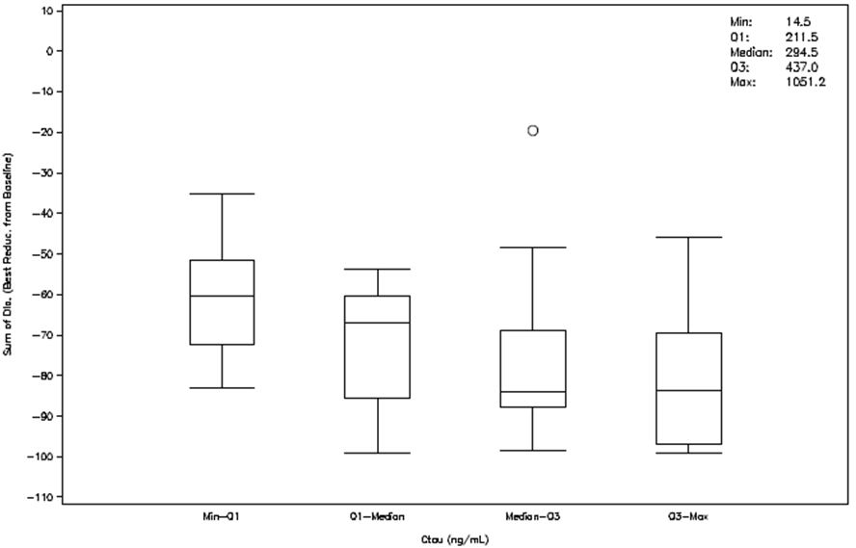
The exposure-response of idelalisib 150 mg BD.was further investigated in the Phase II Study 101-09 which examined a population with iNHL that was refractory to rituximab and alkylating agents. The primary objective of this study was to evaluate tumour regression, as assessed by an independent review committee (IRC) based on overall response rate (ORR). Additional efficacy endpoints based on IRC assessments such as best overall response (BOR), PFS, lymph node response (LNR), and SPD were also evaluated. This study demonstrated that there was no relationship between idelalisib exposure, based on C_{tau}, and any of the efficacy endpoints measured indicating that the 150 mg BD. regimen produced robust and consistent therapeutic effects across the exposure range observed.

Efficacy

Studies providing efficacy data for indication 1: treatment of patients with relapsed CLL

Pivotal efficacy studies

Study GS-US-312-0116
This was a Phase III, randomised, double blind, two treatment arm, placebo controlled study evaluating the efficacy and safety of idelalisib in combination with rituximab or placebo for previously treated CLL.
Primary objective was to evaluate the effect of the addition of idelalisib to rituximab on PFS in subjects with previously treated CLL.

Other efficacy studies

Study 101-08 (plus its extension Study 101-99)
This was a Phase II, single arm study of idelalisib plus rituximab in elderly subjects with previously untreated CLL or SLL.
Primary objective was to examine the ORR of idelalisib with rituximab in elderly subjects with previously untreated CLL or SLL.

Study 101-07
This is a Phase I, open label study of idelalisib in subjects with relapsed or refractory CLL (n = 114) or iNHL (n = 80) which is ongoing.
Primary objective was to investigate the safety of idelalisib in combination with an anti-CD20 monoclonal antibody, a chemotherapeutic agent, an mTOR inhibitor, and/or a proteasome inhibitor.

Study 101-02
This was a Phase I, dose ranging, open label study of safety, pharmacokinetics, pharmacodynamics, and clinical activity of idelalisib in patients with relapsed, refractory CLL, NHL, acute myeloid leukaemia, or multiple myeloma.

Evaluator’s conclusions on clinical efficacy in patients with relapsed CLL
The proposed indication in CLL is:
Zydelig is indicated, alone or in combination, for the treatment of patients with relapsed chronic lymphocytic leukaemia (CLL).
Table 8 shows a summary of the studies presented for the evaluation in CLL/SLL patients:
Table 8: Studies presented for the evaluation in CLL/SLL patients.
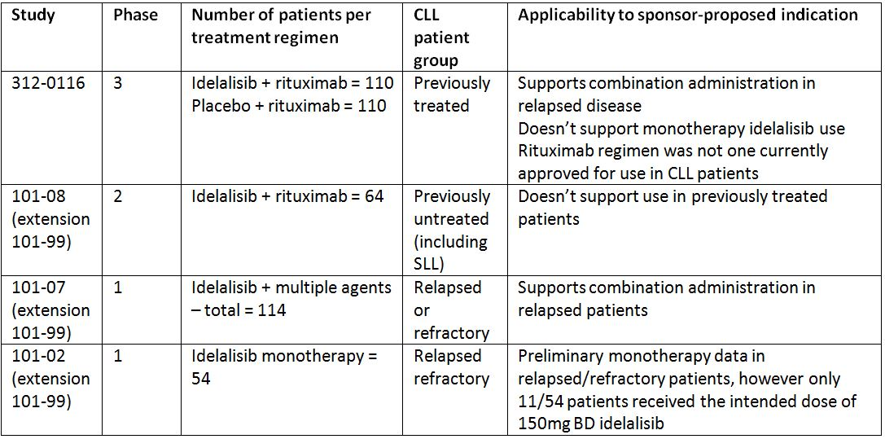
The pivotal trial of idelalisib use in CLL patients 312-0116 met its primary objective of demonstrating PFS improvement in in previously treated patients who would otherwise be eligible for monotherapy rituximab. Multiple secondary endpoints were also met, demonstrating a benefit from idelalisib + rituximab versus rituximab alone in: OS, ORR, LNR, and duration of response (DOR).
Furthermore, the efficacy demonstrated was independent of adverse tumour genetic factors which are known to be associated with poor outcome, namely 17p/TP53 and IGHV status.
In patients with baseline anaemia, there was a significant difference in the proportion that achieved an on-study improvement in haemoglobin in the idelalisib + rituximab arm. There was no difference in the proportion that achieved an improvement in platelet count, neutrophil count or lymphocyte count in subjects with baseline thrombocytopaenia, neutropaenia lymphopaenia.
However, this evidence does not support the wording of the initially proposed CLL indication, where “combination” is not further specified since combination rituximab/idelalisib was the only regimen studied. This pivotal trial does not support the use of monotherapy idelalisib.
Rituximab is neither approved as monotherapy for the treatment of CLL in Australia, nor approved for the regimen administered, thus limiting the extrapolation of the efficacy results. Additionally, the effect of idelalisib/rituximab in patients who had prior treatment with rituximab has not been described separate to those who had never previously received rituximab which may have implications in deciding whether rituximab resistance has an adverse effect on the demonstrated efficacy of the idelalisib/rituximab combination.
The Phase II Study 101-08 does not support the proposed indication for treatment of relapsed CLL as it only enrolled previously untreated patients. Indeed, the results in these treatment naïve CLL patients should be interpreted cautiously due to the small number of patients studied in a non randomised setting. Further, the dose regimen of rituximab was not that approved in the current PI, which confounds the ability to generalise the results outside of the clinical trial.
The Phase I Study 101-07 provides some supportive efficacy evidence for a combination regimen in previously treated patients showing an ORR of 82.4%, with median OR, DOR and PFS not reached after a median of 11 months of treatment.
The Phase I Study 101-02 provides only preliminary non randomised data in previously treated patients, but is insufficient to approve the monotherapy part of the proposed indication.
There are five other phase three trials in progress currently (2 in iNHL patients and 3 in CLL patients) which may provide supportive evidence for monotherapy idelalisib use.

Studies providing efficacy data for indication 2: treatment of patients with refractory iNHL

Pivotal efficacy studies

Study 101-09
This is a Phase II, open label, single group, two stage, efficacy, safety, and pharmacodynamic study of idelalisib in subjects with previously treated iNHL that was refractory both to rituximab and to alkylating agent containing chemotherapy. The pre specified study analysis was performed when all enrolled subjects completed efficacy, safety, and other assessments through at least 24 weeks of evaluation.
Its primary objective was the evaluation the effect of idelalisib on tumour regression as determined by ORR (proportion achieving a complete response or partial response; a minor response was permitted for subjects with WM) in subjects with iNHL refractory to rituximab and alkylating agents.

Study 101-07
This was a Phase I, open label study of idelalisib in subjects with relapsed or refractory CLL, iNHL, or Mantle cell lymphoma (MCL). The study was conducted at 11 sites in the US from 25 March 2011 (first subject screened) and is ongoing (last subject observation for this report was on 15 February 2013).
Its primary objective was the investigation the safety of idelalisib in combination with an anti CD20 monoclonal antibody, a chemotherapeutic agent, an mTOR inhibitor, and/or a proteasome inhibitor.

Study 101-10
A Phase I/II uncontrolled study to evaluate the safety and activity of idelalisib in previously untreated iNHL. The study was conducted at 1 US centre from 18 February 2011 and is still ongoing (data cut-off for interim report was 25 March 2013).
Due to Grade 3/4 transaminase elevations seen in the first two subjects enrolled, the protocol was amended to enrol only subjects with previously treated iNHL (Protocol Amendment 1). As a result of the protocol amendment and the change in patient population, the focus of the study shifted to exploratory pharmacodynamics.
Subjects were treated with 150 mg BD idelalisib, with the option of increasing the dose up to a maximum of 300 mg BD continuously per 28 day cycle, for a maximum of 12 cycles.
Subjects could be withdrawn from the study prematurely if they developed progressive disease while receiving idelalisib at the maximal escalated dose of 300 mg BD, if they experienced unacceptable toxicity, or if they were no longer deriving clinical benefit in the opinion of the investigator. As of the data cut-off of this interim report, no subject had received the 300 mg BD dose.
Its primary objective was to investigate the safety and efficacy of idelalisib in subjects with previously treated iNHL and to evaluate efficacy of idelalisib 300 mg BD in subjects with previously treated iNHL who were tolerating therapy but experienced disease progression while receiving ≤ 150 mg BD idelalisib.

Study 101-99: extension study of parent Studies 101-02, 101-07, and 101-08.
Its primary objective was the assessment of the long term safety and the duration of clinical benefit of idelalisib in subjects with haematological malignancies.

Study 101-11
This is a Phase II, open label, single arm, two stage study of, efficacy, safety, and pharmacodynamic study in subjects with relapsed or refractory Hodgkin’s Lymphoma.

Evaluator’s conclusions on clinical efficacy for refractory iNHL
The pivotal efficacy study supporting the use of idelalisib as treatment for refractory iNHL is Phase II Study 101-09 with supplementary evidence of efficacy from dose ranging, monotherapy, Phase I Study 101-02 (with extension Study 101-02/99), and dose ranging, combination therapy Phase I Study 101-07 (with extension Study 101-07/99).
In the pivotal study, in which 125 subjects with iNHL refractory to rituximab and an alkylating agent were treated with monotherapy Idelalisib 150 mg BD, the ORR was 46.9% (34.3, 59.8). In Study 101-07, idelalisib was administered in combination with other agents, the ORR (95% CI) for subjects treated with combination therapy (N = 79) was 81.0% (70.6, 89.0).
The median Kaplan-Meier (KM) estimate of DOR for subjects treated with idelalisib monotherapy was 18.4 months. Of the 4 categories of disease histology, subjects with LPL/WM had the longest DOR (32.8 months) and subjects with SLL had the shortest DOR (2.3 months).
The median KM estimate of PFS for subjects treated with idelalisib monotherapy was 7.6 months. Of the four categories of disease histology, subjects with LPL/WM had the longest PFS (33.3 months) and subjects with SLL had the shortest PFS (3.7 months).
The median KM estimate of OS was only reached for relapsed/refractory CLL subjects treated with combination therapy (N = 85) was 28.5 (25.6, not reached) months. The median KM estimate of OS was not reached for any other disease or treatment category (monotherapy or combination therapy).The largest estimated proportion of subjects surviving at 36 months was 91.4% for relapsed/refractory subjects with iNHL treated with combination therapy.

Safety

Studies providing safety data
Table 9 shows studies providing evaluable safety data.
Table 9: Studies providing evaluable safety data.
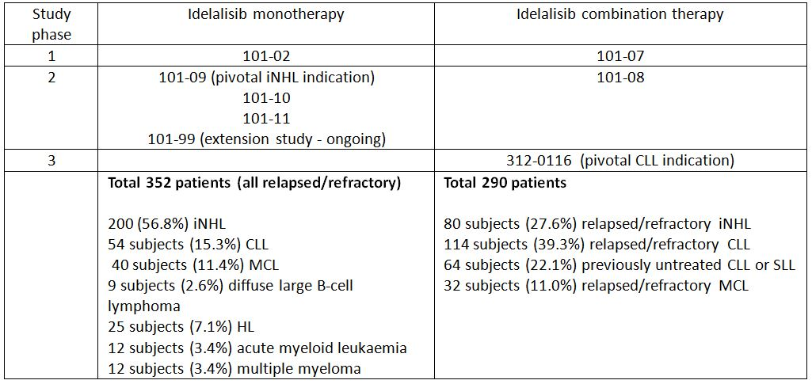
The safety analysis set (subjects who received at least 1 dose of idelalisib) for subjects treated with idelalisib monotherapy was summarised separately from subjects treated with idelalisib combination therapy. The analyses are further organised within each of these two groups into subjects with iNHL, subjects with CLL, and all subjects combined.
The safety data for idelalisib monotherapy was organized by dose category (< 150 mg BD or any once daily regimen, 150 mg BD, and >150 mg BD), and aggregated total for all idelalisib monotherapy.
The safety data for idelalisib combination therapy was reported according to treatment regimen: idelalisib plus rituximab (Id+R), idelalisib plus bendamustine (Id+B), idelalisib plus bendamustine and rituximab (Id+BR), idelalisib plus bortezomib (Id+Bo), idelalisib plus ofatumumab (Id+O), idelalisib plus everolimus (Id+E), idelalisib plus fludarabine (Id+F), idelalisib plus chlorambucil (Id+Ch), idelalsib plus rituximab and chlorambucil (Id+RCh), and aggregated total for all idelalisib combination therapy.

Patient exposure

Idelalisib monotherapy
Overall, 352 subjects were treated with idelalisib monotherapy (Table 10). All subjects received at least 1 dose of idelalisib. Studies 101-09, 101-10, 101-11, and extension Study 101-99 are ongoing.
Table 10: Subjects treated with idelalisib monotherapy.
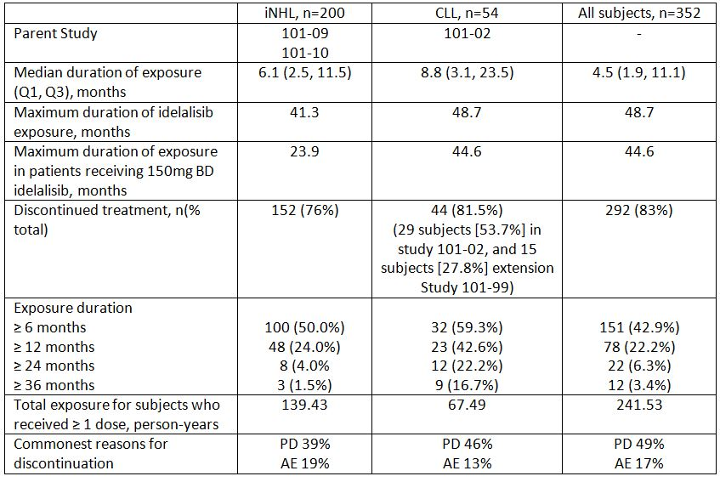

Idelalisib combination therapy
Overall, 290 subjects were treated with idelalisib in combination with other therapies (Table 11).
Table 11: Subjects treated with idelalisib in combination with other therapies.
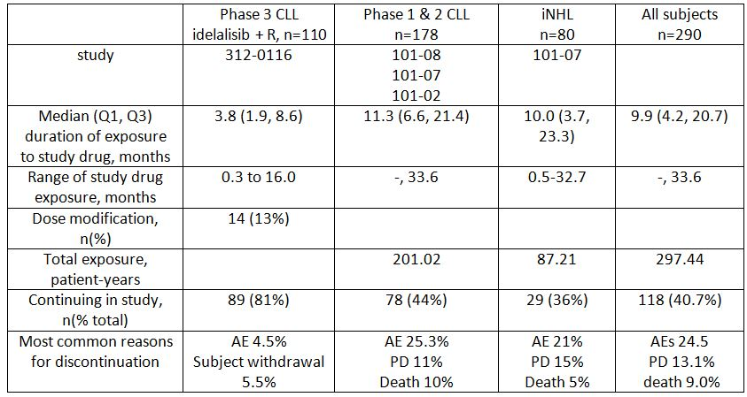

Safety issues with the potential for major regulatory impact

Liver toxicity
Reversible asymptomatic ALT/AST elevations were observed in Phase I studies (101-02 and 101-07) in subjects with hematologic malignancies.
In iNHL, the incidence of ALT/AST elevations was similar following idelalisib monotherapy (48.5% and 42.5% for ALT and AST elevations, respectively) and combination therapy (45% and 51.3%, respectively). A dose dependent effect on grade 3 or 4 ALT elevation was seen with increasing dose of idelalisib in this disease subtype. Grades 3 and 4 elevation of AST were approximately 3 fold higher in subjects receiving >150 mg BD.
In subjects with CLL, the incidence of ALT/AST elevations was higher following idelalisib combination therapy (41.6% and 43.8% for ALT and AST elevations, respectively) compared to idelalisib monotherapy (18.5% and 24.1%, respectively). In contrast to iNHL subjects, those with CLL did not experience a dose dependent incidence of grade 3 or 4 AST or ALT elevation.
The sponsor states that:
The elevations generally occurred within 4 to 12 weeks of drug initiation and resolved spontaneously over a period of 2 to 4 weeks when drug was withheld for grade 3 or 4 elevations until resolution and when drug was continued for grade 1 and 2 elevations. Transaminase elevations occur early, are generally asymptomatic, and are transient and reversible in nature. Grade 1 or 2 elevations resolved without interruption or reduction of idelalisib treatment grade 3 or 4 elevations resolved following temporary idelalisib dose interruption until elevations resolved to ≤ grade 1 levels. No case fulfilled the criteria for Hy’s Law. Overall, idelalisib appears to have no significant liver toxicity as the ALT/AST elevations occur early, are asymptomatic, transient and reversible (results spontaneously or with dose reduction).

Pneumonitis
In subjects with iNHL, 5 subjects (2.5%) developed a serious adverse event (SAE) of pneumonitis while receiving idelalisib monotherapy, and 2 subjects (2.5%) developed an SAE of pneumonitis while receiving idelalisib combination therapy with an agent known to be associated with pneumonitis (rituximab or bendamustine).
In subjects with CLL, 1 subject (1.9%) developed an SAE of pneumonitis while receiving idelalisib monotherapy and 6 subjects (3.4%) developed an SAE of pneumonitis while receiving idelalisib combination therapy with an agent known to be associated with pneumonitis (rituximab or fludarabine). In Study 312-0116, the incidence of pneumonitis of any grade was higher in the group receiving idelalisib + rituximab (5 subjects, 4.5%) than in the group receiving placebo + rituximab (1 subject, 0.9%).

Deaths occurring in association with pneumonitis
Three deaths were reported: one death occurring with idelalisib monotherapy and two with the idelalisib and rituximab combination.

Serious skin reactions
The FDA approved the PI for idelalisib contains a warning of toxic epidermal necrolysis. A search of the integrated safety summary for this term did not yield any reports of this event. No adverse drug reaction reports submitted to the TGA have contained this event term. The sponsor has been requested to provide information on this risk.
Treatment emergent adverse events (TEAEs) of “bullous conditions” and “blister” were observed in 10/352 (2.8%) of the safety analysis set. These were all grade 1 and 2 events.
In total, TEAEs of “dermatitis”, “dermatitis & eczema”, “eczema”, “dermatitis” and “exfoliative conditions”, “exfoliative rash”, “dermatitis exfoliative” and “skin exfoliation” comprised 21/352 (6%) of all subjects in the safety analysis set. Six of the 21 cases were grade 3 events; no grade 4 or 5 events were reported.

Cardiovascular safety
The sponsor states:
In patients with B cell malignancies, the overall cardiovascular assessment of idelalisib has shown no clinically concerning, treatment-emergent prolongation of the QT interval or ECG abnormalities.
In monotherapy idelalisib studies, no subjects were reported to have a QTc-Frederica interval of >480 msec using doses of >150 mg BD.

Tumour lysis syndrome
In the safety analysis set, two subjects (0.6%) were reported to have had a TEAE of tumour lysis syndrome, one subject each having grade 1 and 4 events.

Unwanted immunological events
Serum immunoglobulins IgG, IgM and IgA were assessed during treatment, in each disease type. There were no significant changes in immunoglobulin levels, irrespective of monotherapy or combination therapy with idelalisib.

Adverse drug reaction (ADR) reports submitted to the TGA
Four ADRs have been submitted to the TGA:
- One subject with previously treated CLL in Study 312-0119 developed febrile neutropaenia and cytomegalovirus (CMV) sepsis which proved fatal. The patient was taking 150 mg BD idelalisib in combination with ofatumumab.
- One subject with previously treated CLL in Study 312-0119 developed febrile neutropaenia whilst being administered idelalisib 150 mg BD in combination with ofatumumab. The report stated the event was continuing. A causal like between idelalisib and febrile neutropaenia was “confounded by the patient’s underlying CLL and immunosuppression related to prior CLL treatment, concurrent administration of ofatumumab, as well as significant history of febrile illnesses and urinary stents with recurrent urinary tract infections.”
- Two subjects with relapsed iNHL in Study 312-0125 developed urticaria ascribed to the blinded study drug – idelalisib or placebo. In neither case was the blinded study drug unmasked.

Postmarketing data
Idelalisib has not been marketed in any country at the time of this report.

Evaluator’s conclusions on safety
The studied population of patients with previously treated CLL, iNHL or SLL that had relapsed were representative of the general population with the conditions, many of whom were elderly and/or with associated co-morbidities.
As shown in the efficacy section, beneficial responses to treatment were long lasting. Discontinuation from treatment due to AEs was common, which may represent not only the AE profile of the drug but also the age and co-morbidity status of the subjects studied. Specific advice on idelalisib dose modification may ameliorate the proportion of subjects who discontinue treatment permanently.
The most common AE reported was of diarrhoea, which in the elderly population may be debilitating and precipitate hospitalisation. Colitis occurring separately from or in conjunction with diarrhoea was also very commonly observed. Of particular concern was the later onset of non infectious diarrhoea which necessitated the administration of other agents for symptomatic relief, which are not without their own risks in a frail population. Intestinal perforation may occur in isolation following colitis, or may occur at sites of intestinal disease deposit. It is unclear from the limited information currently available regarding a risk of intestinal obstruction with idelalisib use.
There is a risk of (potentially fatal) pneumonitis with idelalisib use. At the onset of pulmonary symptoms that are not explained by other aetiologies, idelalisib should be discontinued. The sponsor has been requested to provide a considered summary of the outcomes of patients with pneumonitis, which will inform the necessary dose modification information in the product information.
AEs of anaemia, lymphopaenia, neutropaenia and thrombocytopaenia were reported very commonly necessitating the close monitoring of haematological parameters in exposed patients.
Hepatotoxicities and liver transaminase elevations have been reported in the idelalisib development program. Severe grades of hepatic toxicity require dose interruption and cautious re-introduction of idelalisib.
AEs of immune mediated rash were very commonly observed, necessitating idelalisib interruption to facilitate.
The reported events of acute renal failure, including one death attributed to this, may reflect the co-morbidity status of the studies population. Given that the sponsor proposes that no dose modification occur in subjects with pre existing renal impairment, clinicians should maintain a high level of vigilance for the onset of worsening renal function.
Infections occurred very commonly, with a higher incidence in subjects treated with combination rather than with idelalisib monotherapy. AEs of infection, including those caused by atypical or opportunistic agents are not unexpected in patients with relapsed haematological malignancies, as a consequence of the disease process or as a result of impaired immune function during treatment.
The causes of death reported in the studies were heterogeneous in nature, with no overall preponderance.
The sponsor has been requested to provide a considered summary of the risks of second malignancies following idelalisib exposure.

First round benefit-risk assessment

First round assessment of benefits
Treatment of patients with relapsed CLL:
- Zydelig is an oral medication taken twice daily, without evidence of a food-effect
- Pharmacokinetics are not affected by gender, body weight, age or renal failure
- The novel mechanism of action permits use in patients who have relapsed or become refractory to existing therapies
- In patients with relapsed/refractory CLL that are considered eligible for monotherapy rituximab, the addition of idelalisib demonstrated a durable improvement in PFS and OS. The improvement in PFS was also demonstrated in subgroups with a known adverse tumour genetic profile
- Median haematological parameters of absolute neutrophil counts, platelets and haemoglobin did not worsen following idelalisib exposure in CLL patients
- Infusion related reactions were less common with idelalisib + rituximab as opposed to monotherapy rituximab
- The AE profile of idelalisib is generally manageable by dose modification and or supportive therapies.
Treatment of patients with refractory iNHL:
- Zydelig is an oral medication taken twice daily, without evidence of a food effect
- The novel mechanism of action permits use in patients who have relapsed or become refractory to existing therapies
- In patients with refractory iNHL, idelalisib treatment (monotherapy, or in combination) demonstrated a durable improvement in overall response rate
- The AE profile of idelalisib is generally manageable by dose modification and or supportive therapies.

First round assessment of risks
- Interactions with CYP3A4 inhibitors and inducers affect C_{max} and AUC of idelalisib
- Evidence to support of use of idelalisib as monotherapy in relapsed CLL is currently inadequate
- The method of reporting TEAEs yields uncertainty as to the relative safety profile in patients exposed to idelalisib + rituximab as opposed to rituximab alone
- The incidence of diarrhoea is very common (the commonest reported AE in iNHL subjects), irrespective of monotherapy use or combination therapy
- Very common incidence of severe colitis, requiring treatment with steroids and mesalazine
- Intestinal perforation was reported in one individual
- Intestinal obstruction was reported in two individuals, one of whom died
- There is a risk of pneumonitis additional to the known risk from other agents, necessitating idelalisib cessation. Fatal pneumonitis events were reported
- Risk of hepatotoxic events, including AST, ALT, and bilirubin elevation
- There is no experience of idelalisib use in patients with severe hepatic impairment;
- Very common events of neutropaenia, thrombocytopaenia and anaemia were seen in CLL patients exposed to monotherapy idelalisib, each with an incidence of >20%
- Increased risk of infections (including atypical and opportunistic)
- Increased risk of: dermatitis, exfoliation and bullous skin disorders associated with idelalisib treatment
- There is a risk of acute renal failure, which was fatal in one case.

First round recommendation regarding authorisation
The proposed use of idelalisib, alone or in combination for the treatment of patients with relapsed chronic lymphocytic leukaemia (CLL) is unfavourable given the proposed usage, but would become favourable if the changes recommended below are adopted:
The authorisation of the use of idelalisib in the treatment of relapsed/refractory CLL cannot yet be approved as:
- Evidence to support of use idelalisib as monotherapy in relapsed CLL is not yet adequate as only one Phase I dose ranging study (101-02) provided preliminary evidence.
- Although there was evidence to support use of idelalisib in combination with rituximab in elderly patients with relapsed, recurrent CLL with poor prognosis and limited treatment options, interpretation was limited by use of rituximab.monotherapy, using an unapproved regimen, as the control treatment in the pivotal CLL study (312-0116).
The proposed use of Idelalisib for treatment of patients with refractory iNHL is favourable.
It is recommended that the application for marketing approval for idelalisib 150mg BD be approved for the proposed indication of “treatment of patients with refractory indolent non-Hodgkin lymphoma (iNHL).”

Clinical questions

Pharmacokinetics
- The justification for not submitting biopharmaceutical studies did not address all of the requirements as per TGA guidelines. The sponsor is kindly requested to address these deficiencies.
- Based on the plasma AUC₀₋₂₄ data presented, the total plasma radioactivity that can be attributed to idelalisib and GS-563117 is 94%; however, the sponsor states in the Summary of Clinical Pharmacology Studies that the total radioactivity of these 2 components adds to 100%. The sponsor is kindly requested to explain this discrepancy.
- The sponsor is kindly requested to report the CL/F of idelalisib for patients with either hepatic or renal impairment as per the TGA guidelines.
- One of the secondary objectives of the Phase III Study GS-US-312-0116 was to characterise the effect of rituximab on idelalisib exposure through evaluations of idelalisib plasma concentrations over time. Information relating to this objective was not available at the time of submission. If this data is available, can it be presented?
- The sponsor is kindly requested to indicate whether the drug-drug interaction data from Study 101-07, which examines the interaction of idelalisib with an anti CD20 mAb, a chemotherapeutic agent, an mTOR inhibitor, and/or a proteasome inhibitor is now available.
- The sponsor is kindly requested to explain the difference between the protein binding value of idelalisib of 93-94% in the proposed Australian PI and the value of 84% contained in the FDA approved PI.

Pharmacodynamics
- The sponsor is kindly requested to indicate when the PD data relating to Studies 101-07, 101-08, 101-09, 101-10 and 101-11 will be available.
- Is there an analysis available for genetic, gender and age related differences in pharmacodynamics?

Efficacy
- What are the five additional phase three trials (2 in iNHL and 3 in CLL patients) in regard to the population being studied and the treatment regimen(s) being administered?
- The pivotal Study 312-0116 included 2 pre-specified formal interim efficacy analyses by an independent Data Monitoring Committee. Can the sponsor indicate when the second analysis for this study will be available?
- In Study 312-0116, what was the justification for using monotherapy rituximab, with additional 500 mg/m² doses separated fortnightly, as opposed to the currently approved regimen in the Australian PI?
- Why was chlorambucil not considered the appropriate standard treatment comparator in the pivotal CLL study, given the age and co-morbidities of the patients?
- Can the sponsor please report the proportion of patients that had ever received rituximab prior to enrolment in each arm of the pivotal study 312-0116?
- Molecular mechanisms of rituximab resistance have been characterised. In those patients in the pivotal study that had received prior rituximab, what proportions had documented rituximab resistance prior to enrolment in the study, and by what method(s) was rituximab resistance confirmed?
- In Study 312-0116, what was the sponsors’ justification for re-administering rituximab to patients that relapsed or become refractory following its use?
- The sponsor is kindly requested to compare the PFS outcome of the pivotal CLL trial according to prior rituximab exposure status, for each treatment arm.
- The sponsors have stated that analyses of health related quality of life (HRQL) and healthcare utility assessments will only be reported in the clinical safety report that covers entire blinded phase in Study 312-0116 involving patients with refractory, relapsed CLL. Can the sponsor please indicate when this data will be available?

Safety
- The sponsor is kindly requested provide any information it holds on the duration of B cell depletion following idelalisib treatment in CLL patients and iNHL patients separately.
- In Study 312-0116, the incidence of TEAEs was reported as 22/107 (20.6%) due to placebo exposure. Assuming the placebo was inactive; can the sponsor please explain why these were not categorised as rituximab related?
- In Study 312-0116, the total incidence of TEAEs does not equal the incidence of TEAEs ascribed to each of the two treatments (Table 12).
Table 12: Total incidence of TEAEs (Study 312-0116).
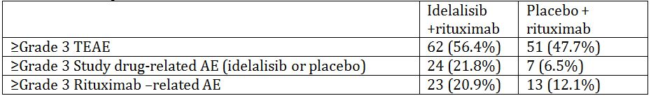
The sponsor is requested to provide a summary of the reasons why the overall incidence of ≥ grade 3 TEAEs is higher (in both study arms) as compared to the ≥ grade 3 events related to both study drug and rituximab arms combined.
- What was the incidence of histological transformation (Richter transformation) for any of the CLL patients exposed to idelalisib?
- For the subjects who experienced pneumonitis in association with idelalisib exposure, the sponsor is kindly requested to give a considered summary of these patients, specifically indicating (i) the duration (ii) the reversibility of symptoms and (iii) whether recurrence on re-challenge occurred.
- In the global development program, in patients exposed to idelalisib and rituximab, what was the incidence of (i) hepatitis B reactivation and (ii) fulminant hepatic failure (iii) progressive multifocal leucoencephalopathy?
- The exposure ratios of AUC_{0-last}, AUC_{inf} and C_{max} were outside the accepted bioequivalence range of 80-125% in patients with severe renal impairment as compared healthy controls. What is the sponsors’ justification for not recommending dose adjustment or contraindication in patients with renal impairment?
- Among the patients who died, one subject had an “acute abdomen” ascribed as the cause of death. What was the actual cause of death in this patient?
- Among the patients who died, one subject had “intestinal obstruction” ascribed as the cause of death. What was the actual cause of death in this patient?
- The FDA approved product information describes a risk of toxic epidermal necrolysis (TEN). The evaluator could not identify this term in the integrated safety summary. The sponsor is kindly requested to provide a summary of the case(s) with TEN AEs.
- The sponsor is kindly requested to provide a considered summary of the risk of second malignancy in idelalisib exposed subjects.
- The sponsor is kindly requested to provide a considered statement suitable for inclusion in the PI pertaining to the risks associated with immunisation before, during, and after idelalisib exposure.
For details of the sponsor’s responses and the evaluator’s comments on the sponsor’s responses, see Attachment 2 of this AusPAR.

Second round evaluation of clinical data

Second round assessment of benefits
The benefits of idelalisib in relapsed CLL remain as per the first round evaluation.
Given the additional information presented in the responses, the evaluator considers that there is sufficient evidence of efficacy in patients with refractory FL only. The size of the population studied with other subtypes of lymphoma is currently insufficient to support inclusion in the indication.

Second round assessment of risks
In addition to the risks identified at round one, there is a risk of anaphylactic reaction in association with idelalisib use which should be included in the PI.
The duration of B cell depletion and potential risk of sepsis has not been satisfactorily established by the sponsor.

Second round benefit-risk assessment
Providing the numerous amendments to the product information identified are implemented, then indication for idelalisib use in relapsed CLL could be considered appropriate for registration.
The proposed indication for refractory indolent iNHL is not supported, given only small numbers of patients in non randomised trials, with only ORR as the outcome. However, the evaluator proposes that the following indication may be appropriate for registration:
Zydelig is indicated as monotherapy for the treatment of patients with refractory follicular lymphoma, who have received at least two prior therapies.

V. Pharmacovigilance findings

Risk management plan
The sponsor submitted a Risk Management Plan EU-RMP (Version 0.1, dated 25 October 2013) with an updated Australian Specific Annex (ASA) (Version 0.2, dated August 2014) which was reviewed by the TGA’s Office of Product Review (OPR).

Safety specification
The sponsor provided a summary of ongoing safety concerns which are shown at Table 13.
Table 13: Ongoing safety concerns.
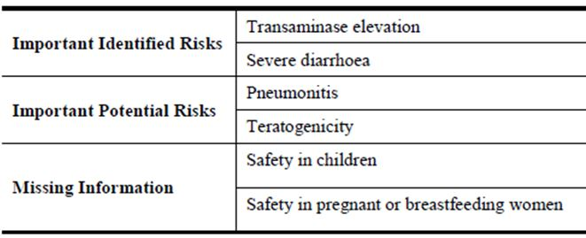

Pharmacovigilance plan
The sponsor proposes routine pharmacovigilance activities to monitor all the specified ongoing safety concerns. In regard to routine pharmacovigilance systems in Australia, the ASA states:
Gilead has a global routine pharmacovigilance system in place to enable the collection and analysis of safety data for all its medicinal products.
Gilead’s global DSPH Operations group is responsible for all single case processing from receipt through to submission to external parties ensuring that information about all suspected adverse reactions that are reported to the personnel of the company are collected and reported appropriately to regulatory authorities.
The Medical Surveillance and Coding group is responsible for all aggregate safety analysis of global data, signal detection, RMPs and other risk management activities. This group is also responsible for the scheduling and preparation of periodic reports (development safety update reports [DSURs], periodic safety update reports [PSURs] and other periodic reports) in accordance with applicable national legislation and ICH guidance.
Routine pharmacovigilance includes:
    - Processing and follow up of individual case safety reports (ICSRs)
    - Targeted follow up questionnaires, where appropriate
    - Signal detection (proactive review of new safety data every 2 weeks) and evaluation, including aggregate review of global postmarketing data during signal evaluation
    - Production of safety reports for Regulatory Authorities and Ethics Committees (including DSURs, PSURs and other periodic reports).
In regard to the additional pharmacovigilance activities proposed to further characterise the important missing information: ‘Safety in children’, the ASA states:
The only difference between the Required Additional Pharmacovigilance Activities outlined in the EU-RMP, compared to the Required Additional Pharmacovigilance Activities for Australia is regarding the information on the safety of idelalisib in children. The safety and efficacy of idelalisib in the paediatric population will be investigated under a Paediatric Investigation Plan (PIP) as per the requirements of the EMA Paediatric Committee (PDCO). Under the PIP, Gilead will develop an age-appropriate oral formulation of idelalisib, and conduct 2 nonclinical studies, an in vitro activity study in paediatric lymphoma cells and an in vitro study in primary patient samples. The PIP includes 2 clinical studies: BP-US-313-0128 and BP-US-313-0129.
Submission of a PIP is not a requirement within the Australian Regulatory Guidelines for Prescription Medicines (ARGPM), therefore, the Required Additional Pharmacovigilance Activities relating to the 2 clinical studies; BP-US-313-0128 and BP-US-313-0129 investigating the safety of idelalisib in children will not to be implemented in Australia. Any information gained from these studies may be incorporated into the Australian PI for idelalisib if deemed appropriate from a risk/benefit assessment.
Furthermore, the sponsor’s correspondence states:
These studies are not due to initiate until December 2014, so protocols are not available at this time.

Risk minimisation activities
The sponsor concluded that routine risk minimisation activities for all the specified ongoing safety concerns are sufficient.

Reconciliation of issues outlined in the RMP report
Reconciliation of issues outlined in the RMP report is as follows.

Recommendation #1 in RMP evaluation report
The ASA is referred to as Annex 13 to the EU-RMP. Nevertheless, it is suggested that appropriate version control, including dating the document, be applied to all future revisions of the ASA.

Sponsor response
Gilead has amended the updated ASA to v0.2, dated August 2014. Upon TGA approval of the ASA, the version will be updated to v1.0 and the date will be amended to reflect the date of TGA approval.

OPR evaluator’s comment
This is acceptable.

Recommendation #2 in RMP evaluation report
Safety considerations may be raised by the nonclinical and clinical evaluators through the consolidated Section 31 request and/or the nonclinical and clinical evaluation reports respectively. It is important to ensure that the information provided in response to these includes a consideration of the relevance for the RMP, and any specific information needed to address this issue in the RMP. For any safety considerations so raised, the sponsor should provide information that is relevant and necessary to address the issue in the RMP.

Sponsor response
Gilead agrees that consideration will be made to the RMP in response to safety considerations which may be raised by the nonclinical and clinical evaluators through the consolidated section 31 request.

OPR evaluator’s comment
Consequently, the sponsor should now add the important potential risks: ‘Anaphylactic reaction’, ‘Intestinal perforation’ & ‘Progressive multifocal leukoencephalopathy’ to the RMP as recommended by the clinical evaluator (see below). Subsequently, consideration must be given to proposing appropriate pharmacovigilance and risk minimisation activities for these new ongoing safety concerns, to be reflected in a revised ASA before this application is approved.
Similarly, the sponsor should provide an assurance that the nonclinical aspects of the Safety Specification of the EU-RMP will be revised in accordance with nonclinical evaluator’s comments when this document is next updated (see below). In the interim, these differences should be noted in a revised ASA before this application is approved.

Recommendation #3 in RMP evaluation report
Part II. 4.3.4: ‘Patients with hepatic impairment’ of the EU-RMP states:
Overall, caution is recommended upon dosing in subjects with severe hepatic impairment based on the lack of safety data upon chronic dosing in subjects.
and Part II. 4.4.1: ‘Missing Information’ Table 4-3: ‘Safety Concerns Due to Limitations of the Clinical Trial Program’ states:
As chronic use of idelalisib has not been studied in cancer patients with severe hepatic impairment, caution is recommended when administering idelalisib in this population. Additional information will be collected through routine pharmacovigilance.
Consequently, the sponsor should consider including the important missing information: ‘Long-term safety in patients with severe hepatic impairment’ as a new ongoing safety concern or provide compelling justification for its exclusion. It is noted that routine pharmacovigilance & risk minimisation activities are already proposed for this new ongoing safety concern, and if included the ASA should be revised accordingly.

Sponsor response
Gilead confirms that the important missing information ‘safety in patients with severe hepatic impairment’ has been added to the EU-RMP as an ongoing safety concern. As such, Gilead has updated Table 2 ‘Summary Table of Safety Concerns’ within the ASA. As a result of the updated ‘Summary Table of Safety Concerns’, Gilead has also updated section 3 (a) of the ASA which summarises the ‘Routine Risk Minimisation Measures’ proposed for each ongoing safety concern.

OPR evaluator’s comment
This is acceptable.

Recommendation #4 in RMP evaluation report
The sponsor should provide an assurance in a revised ASA that routine pharmacovigilance activities conducted in Australia are in accordance with the current Australian requirements and recommendations for pharmacovigilance responsibilities of sponsors of medicines on the TGA website.

Sponsor response
Gilead provides assurance that routine pharmacovigilance activities conducted in Australia are in accordance with the current Australian requirements and recommendations for pharmacovigilance responsibilities of sponsors of medicines on the TGA website.

OPR evaluator’s comment
This is acceptable.

Recommendation #5 in RMP evaluation report
The sponsor should state definitively if targeted follow up questionnaires are to be used in Australia for any of the specified ongoing safety concerns. If so, the sponsor should include such detail in a revised ASA and provide copies of these questionnaires and add them as an attachment to the ASA.

Sponsor response
The targeted follow up questionnaire related to the ongoing safety concern ‘Safety in Pregnancy’ is used in Australia. A copy of the recent targeted follow up questionnaire is provided as Attachment 1 to the ASA.

OPR evaluator’s comment
This is acceptable.

Recommendation #6 in RMP evaluation report
It is agreed that the planned paediatric clinical trials proposed to further characterise the important missing information: ‘Safety in children’, will not need to be conducted in Australia. Nevertheless, they are still considered to be part of the planned clinical trials of the Pharmacovigilance Plan. Consequently, the sponsor should provide an assurance that draft protocols for these studies will be provided to the TGA once they become available.

Sponsor response
Gilead provides assurance that protocols for the 2 clinical studies BP-US-313-0128 and BP-313-0129 will be provided to the TGA once they become available.

OPR evaluator’s comment
This is acceptable.

Recommendation #7 in RMP evaluation report
The studies referenced in the Pharmacovigilance Plan will generate safety data that will simply support the known safety profile of the medicine, while others will generate data that will provoke applications to amend the Australian registration details. To this end, it is suggested that the sponsor should provide an attachment to the ASA setting out all the forthcoming studies and the anticipated dates for their submission in Australia.

Sponsor response
Gilead has updated section 2 (b) of the ASA with an overview of all stated additional pharmacovigilance studies being conducted worldwide and the proposed timelines for submission in Australia. To note, these timelines are estimates only and may change depending on global filing dates.

OPR evaluator’s comment
This is acceptable.

Recommendation #8 in RMP evaluation report
At this time, the specified ongoing safety concerns would not appear to warrant additional risk minimisation activities.

Sponsor response
Gilead concurs with the evaluator’s comment.

OPR evaluator’s comment
N/A

Recommendation #9 in RMP evaluation report
The sponsor’s handling of the potential for medication errors using routine pharmacovigilance and routine risk minimisation activities is considered satisfactory. Nevertheless, the ASA should definitively state that such activities for medication errors will also be applicable in Australia.

Sponsor response
Gilead has updated section 2 (c) of the ASA with details of the preventive measures in relation to the routine risk minimisation activities for potential for medication errors.

OPR evaluator’s comment
This is acceptable.

Recommendation #10 in RMP evaluation report
The sponsor should provide a table summarising the pharmacovigilance plan and risk minimisation plan proposed for Australia in the ASA. Wording pertaining to all the specified ongoing safety concerns in the proposed Australian PI and Consumer Medicines Information (CMI) should be included in the table.

Sponsor response
Gilead has updated section 3 (a) of the ASA with a table summarising the pharmacovigilance plan and risk minimisation plan proposed for Australia.

OPR evaluator’s comment
Section 3(a): ‘Implementation of Risk Minimisation Activities’ of the updated ASA only details risk minimisation activities and is not inclusive of pharmacovigilance activities. It is recommended that the sponsor maintain this section of the ASA and also include a table summarising the pharmacovigilance and risk minimisation activities for all of the specified ongoing safety concerns and missing information proposed for Australia in a revised ASA, which should be submitted for review before this application is approved.

Summary of recommendations
It is considered that the sponsor’s response to the TGA Section 31 Request has not adequately addressed all of the issues identified in the RMP evaluation report.

Outstanding issues

Issues in relation to the RMP
The sponsor was asked to respond to safety considerations raised by the nonclinical and clinical evaluators through the consolidated Section 31 request and/or the nonclinical and clinical evaluation reports, respectively, in the context of relevance to the RMP. The sponsor states that consideration will be made to the RMP in response to safety considerations which may be raised by the nonclinical and clinical evaluators through the consolidated Section 31 request. Consequently, the sponsor should now add the important potential risks: ‘Anaphylactic reaction’, ‘Intestinal perforation’ & ‘Progressive multifocal leukoencephalopathy’ to the RMP as recommended by the clinical evaluator (see below). Subsequently, consideration must be given to proposing appropriate pharmacovigilance and risk minimisation activities for these new ongoing safety concerns, to be reflected in a revised ASA before this application is approved.
Similarly, the sponsor should provide an assurance that the nonclinical aspects of the Safety Specification of the EU-RMP will be revised in accordance with nonclinical evaluator’s comments when this document is next updated (see below). In the interim, these differences should be noted in a revised ASA before this application is approved.
The sponsor was asked to provide a table summarising the pharmacovigilance plan and risk minimisation plan proposed for Australia in the ASA. It was suggested that wording pertaining to all the specified ongoing safety concerns in the proposed Australian PI and CMI should be included in the table. The sponsor states: “Gilead has updated section 3 (a) of the ASA with a table summarising the pharmacovigilance plan and risk minimisation plan proposed for Australia.” However, Section 3(a): ‘Implementation of Risk Minimisation Activities’ of the updated ASA only details risk minimisation activities and is not inclusive of pharmacovigilance activities. It is recommended that the sponsor maintain this section of the ASA and also include a table summarising the pharmacovigilance and risk minimisation activities for all of the specified ongoing safety concerns and missing information proposed for Australia in a revised ASA, which should be submitted for review before this application is approved.

Advice from the Advisory Committee on the Safety of Medicines (ACSOM)
ACSOM advice was not sought for this submission.

Suggested wording for conditions of registration

RMP
The European RMP (Version 0.1, dated 25 October 2013) with an ASA (Version 0.2, dated August 2014), to be revised as agreed with the TGA, must be implemented.

PSUR
OMA to provide wording.

Key changes to the updated RMP
In their response to the TGA Section 31 Requests, the sponsor provided an updated ASA (Version 0.2, dated August 2014). Key changes from the versions evaluated at Round 1 are summarised below:
Table 14: Key changes from the versions evaluated at Round 1.
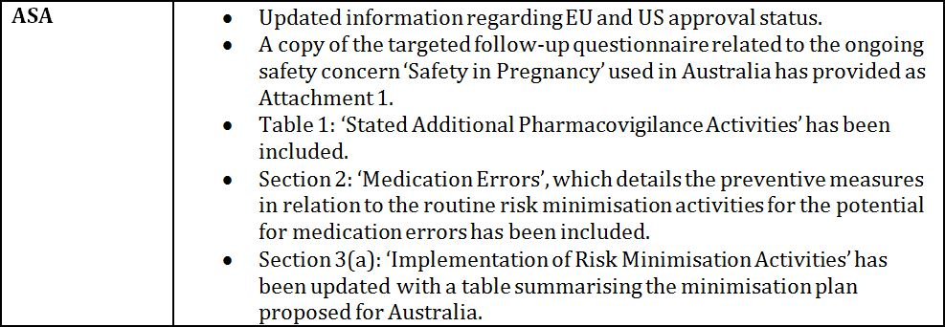

VI. Overall conclusion and risk/benefit assessment
The submission was summarised in the following Delegate’s overview and recommendations:

Quality
The toxicological acceptability of some impurities in the drug substance is currently being reviewed, and the nonclinical evaluator’s report will be made available to the sponsor in time for the pre Advisory Committee on Prescription Medicines (ACPM) response. Changes to the limits for drug particle size and tablet water content have been proposed. If necessary, relevant conditions of registration might be imposed.
Registration is otherwise recommended with respect to chemistry, quality control and biopharmaceutic aspects.

Nonclinical
There were no objections on nonclinical grounds to the proposed monotherapy indication. However, the evaluator noted that as no studies were submitted to support combination use, this needs to rely solely on clinical data.

Clinical

Pharmacology

Absorption
Median time of absorption was 1 h (range 0.5-4.0 h). Absolute bioavailability was not formally studied. A food effect study demonstrated a 40% increase in AUC under fed conditions: the regimen recommends that idelalisib can be administered without regard to food.
Pharmacokinetics parameters were less than dose proportional for BD dosing: accumulation ranged from 20-80%.
Following the administration of a 100 mg oral tablet dose of the to-be-marketed formulation of idelalisib in healthy males, the T_{max} of idelalisib was 1 h and the C_{max}, AUC_{inf} and t_{1/2} of idelalisib were 1230 ng/mL, 6340 ng.h/mL and 7.76 h, respectively.

Distribution
Population pharmacokinetic analysis identified that the plasma pharmacokinetics of idelalisib in the clinical dose range can be described by a two compartment model and predicted, for a typical healthy subject or patient. The volumes of distribution for the central and the peripheral compartments are 22.65 L and 72.97 L, respectively.
Mean whole blood-to-plasma concentration ratio of [¹⁴C]-radioactivity ranged from 0.4 to 0.6 throughout the 48 h post dose and was time independent. The sponsor stated that the distribution of idelalisib into compartments other than plasma has not been examined. Idelalisib protein binding was 93-94% in healthy subjects.

Metabolism
Preclinical studies identified the primary mechanism of metabolism is oxidation to an inactive metabolite GS-563117. Metabolism of the parent drug also occurs, but to a lesser extent through CYP3A and glucuronidation by UGT1A4. The primary metabolite is a strong CYP3A inhibitor and the potential for significant interactions exists.

Delegate comment
There is significant potential for inhibition of the metabolism of drugs with a narrow therapeutic range by the metabolite, GS-563117, and could pose significant risk. Given this risk, there should be a separate section in the ‘Precautions’ heading, cross referencing to the interactions and pharmacokinetic sections of the PI.
A mass balance study which showed the parent drug and GS-563117 as the only species identified in plasma.
There are no active metabolites of the parent drug against the PI3Kδ target, but GS-563117 is a weak inhibitor of UGT1A1 (at supra therapeutic exposure) and a moderate time dependent inhibitor of CYP3A. No inter conversion between enantiomers was reported.

Excretion
Single dose study of radiolabelled idelalisib demonstrated predominant routes of elimination were faecal (75% total) and urinary (25% total). In the mass balance study, 78% of the radioactive dose was recovered in faeces over 240 h following dosing.

Special populations
Population pharmacokinetic analysis demonstrated no effect of age, body weight or gender on pharmacokinetics of the parent drug or primary metabolite.
A 23% increase in AUC_{inf} was noted in Japanese compared with Caucasian patients in Study GS-US-313-0126.

Delegate comment
It should be stated in the Special Population section of the PI that Asian patients should be monitored closely for toxicity especially if other co-morbidities exist that would increase AUC_{inf} further, for example, hepatic impairment.

Drug-drug interactions
The following drug-drug interaction studies were performed.
Table 15: Drug-drug interaction studies.
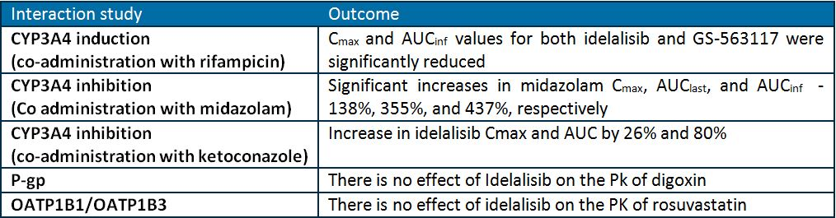

Delegate comments
The PI contains advice regarding potential for drug interactions from the above studies. In general, the PI has too much detail about the study and effects on the individual drug, and should just state the effect (increased or decreased metabolism) on substrates and the advice provided (dose reduction, monitoring for side effects). An example has been given in the PI changes section. The Delegate considers Zydelig is a strong not moderate inhibitor of CYP3A (4.4-fold increase in midazolam AUC very significant clinically), and that the potential for significant drug interactions needs to be highlighted. The PI needs to be changed to reflect this.
No studies of the effect of gastric pH modifying drugs on idelalisib absorption were submitted and this needs to be addressed by the sponsor in the pre ACPM response as kinase inhibitor absorption is often affected by gastric pH.
No studies were undertaken and no advice provided in the PI regarding the potential impact of idelalisib on metabolism of the oral contraceptives. The sponsor is requested to address this in the pre ACPM response and update the PI accordingly.

Pharmacodynamic interactions
These studies confirmed the mechanism of action of idelalisib, and importantly demonstrated no significant effect on QT interval in the thorough QT study.

Dosage selection
In the Phase I Study 101-02, dose limiting rises in ALT/AST were observed at 350 mg BD, 200 mg BD, 300 mg daily and 150 mg BD cohorts. The clinical safety report states that “because the rate of dose-limiting toxicity (DLT) at any dose level tested was always less than the pre specified 25%, no maximum tolerated dose (MTD) was defined.”

Delegate comment
The dose regimen selected appears therefore to have been defined more by efficacy and pharmacodynamic effects than by safety.

Efficacy – CLL patients
The following studies were presented for evaluation in patients with CLL.
Table 16: Studies presented for the evaluation in patients with CLL.
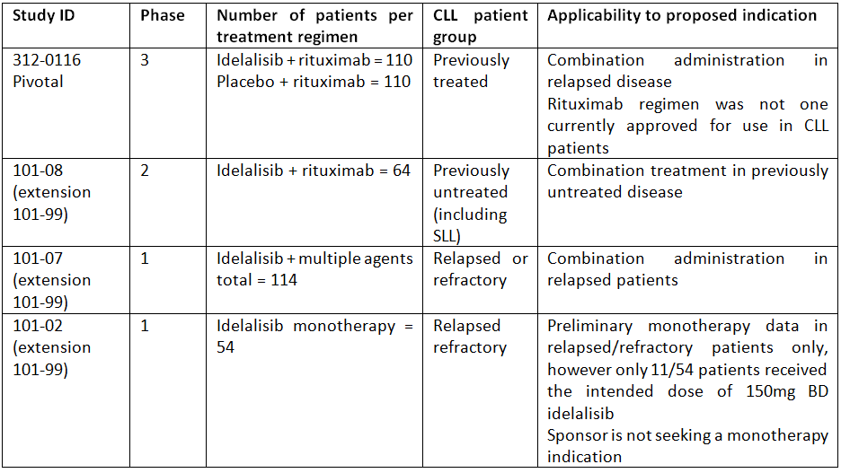

CLL pivotal study
Study 312-0116 was a multicentre (58 sites in US, France, Germany, UK, Italy and Germany) randomised, double blind, placebo controlled study which enrolled patients with CLL who had been treated with either an anti CD20 antibody or previously treated with ≥2 regimens containing ≥1 cytotoxic agent. Patients had to have measurable disease and documented progression <24 months since completion of their last therapy. The study was conducted from 1 May 2012 (first subject randomised) to 30 August 2013 (last subject observation for the interim report).
Stratification: by del17p and/or TP53 mutation status and IGVH mutation status. Stratification was initially proposed to include prior anti CD20 therapy; however, this was not performed since almost all (96%) subjects had received an anti CD20 therapy previously.
Inclusion and exclusion criteria: patients could have had either at least one prior anti CD20 monoclonal antibody containing regimen (those whose disease was refractory (relapse within 6 months) or demonstrated no response to rituximab were excluded) or at least 2 prior regimens with cytotoxic chemotherapy (alone or in combination). 90.9% in the idelalisib + rituximab arm and 88.2% in the placebo + rituximab had received rituximab previously either as monotherapy or in combination.
Idelalisib was administered at 150 mg twice daily, as per the proposed dosage. However, rituximab was administered at a dose that does not correspond to that currently approved in Australia: 375 mg/m² on Day 1 (Week 0), 500 mg/m² on Day 15 (Week 2), Day 29 (Week 4), Day 43 (Week 6), Day 57 (Week 8), Day 85 (Week 12), Day 113 (Week 16) and Day 141 (Week 20) for a total of 8 infusions.
(The currently approved does is 375 mg/m² administered on Day 1 of the first treatment cycle followed by 500 mg/m² administered on Day 1 of each subsequent cycle, for a total of 6 cycles.)

Delegate comment
Single agent rituximab is not approved for use in CLL in Australia. Rituximab has been shown to produce short lived partial responses (median response time of 20 weeks) when used as a single agent for the treatment of refractory CLL; however, two of these studies were dose finding and the third was a Phase II trial, and all used very different regimens with respect to dose, frequency and duration from the one used here. The sponsor indicates in the clinical rationale that the target population were “frail” heavily pre-treated patients with co-morbidities and few remaining treatment options. This is the justification for choosing rituximab, but even so the dosing regimen used in this study was not standard.

Primary objective
To evaluate PFS when idelalisib is added to rituximab in patients with previously treated CLL.

Secondary objectives
To evaluate:
- the magnitude and duration of tumour control: OS, ORR, time to response (TTR) , DOR, time to treatment failure (TTF), LNR, splenomegaly, platelet, haemoglobin, and neutrophil counts
- measures of subject well being: HRQL and performance status
- disease associated biomarkers and potential mechanisms of resistance to idelalisib.
Other endpoints were to characterise the effect of rituximab on idelalisib exposure (through evaluations of idelalisib plasma concentrations over time), to describe the safety profile, and estimate health resource utilisation of the combination treatment.

Statistical analysis, analysis populations
PFS, ORR, OS and CR rates were analysed from the intention to treat (ITT) population, with sensitivity analyses conducted using the per protocol analysis set. The safety analysis set was used for safety variables, study treatment variables, post-study therapy and health economic variables.
Subgroup analyses for ORR by mutation status, gender, age and race were performed.
The primary outcome of the pivotal CLL study was met, demonstrating a statistically significant increase in IRC assessed PFS in the idelalisib + rituximab arm of 10.7 months compared with 5.5 months in the placebo + rituximab arm. The magnitude of the difference in PFS was sufficient for the pivotal study to be prematurely terminated. The second efficacy analysis presented in the Section 31 responses reported an increase in investigator assessed overall survival, although the data are still immature with the median OS yet to be reached in either arm (Table 17).
Table 17: Study 312-0116 efficacy outcomes (Section 31 response).
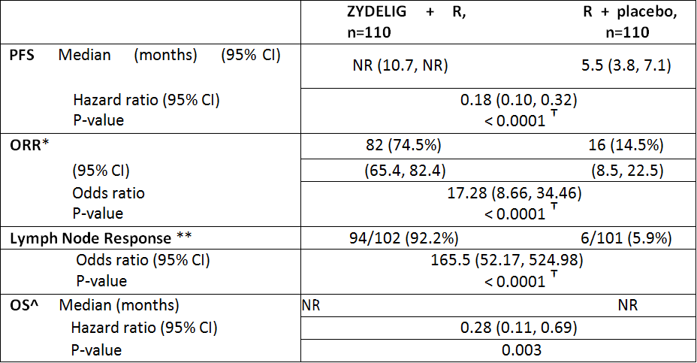
R: rituximab; PFS: progression-free survival; NR: not reached
* ORR defined as the proportion of patients who achieved a CR or PR based on the 2013 NCCN response criteria and Cheson (2012). Only patients that had both baseline and ≥1 evaluable post-baseline SPD were included in this analysis
** Lymph node response defined as the proportion of patients who achieve a ≥50% decrease in the sum of products of the greatest perpendicular diameter (SPD) of index lesions. Only patients that had both baseline and ≥1 evaluable post-baseline SPD were included in this analysis
^ OS analysis includes data from subjects who received placebo + rituximab on Study 312-0116 and subsequently received idelalisib in an extension study, based on ITT analysis
† Actual p-values: for PFS, p= 6 x 10⁻¹¹; for ORR, p=6.3 x 10⁻¹⁹; for LNR, p=4.1 x 10⁻³⁴
The primary analysis of PFS according to subgroup demonstrated a consistent effect of the idelalisib + rituximab combination over rituximab alone (Figures 4 and 5).
Figure 4: Forest plot of PFS according to sub group, Study 312-0116 (initial interim analysis).
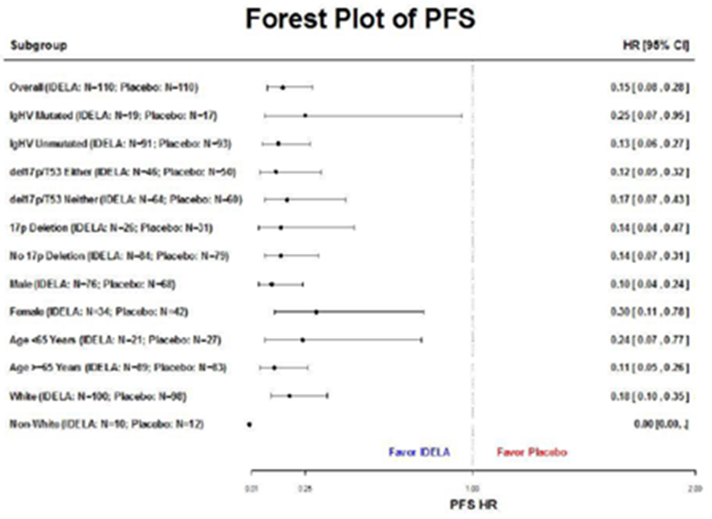
Figure 5: Study 312-0116 Kaplan-Meier estimate of PFS (initial interim analysis).
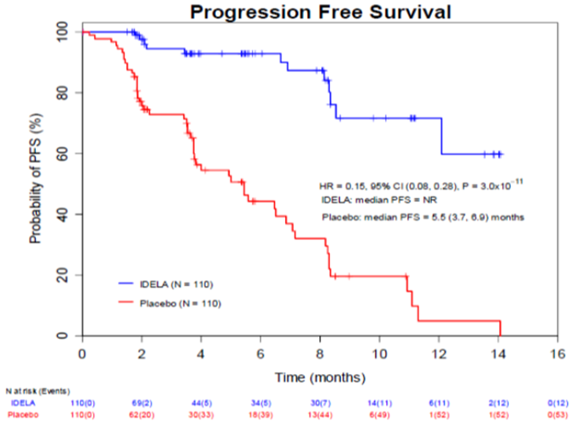

CLL with deletion of 17p or TP53 mutation
The proposed indication was amended in the Section 31 response, to propose idelalisib + rituximab combination be approved as a first line treatment in patients with deletion of 17p or TP53 mutation status. This additional claim of efficacy data was made based on those patients with del17p or TP53 mutation in the pivotal study having a response rate that was similar the whole study population in IRC assessed PFS and investigator assessed OS. It is noted that these data are immature with the median PFS not reached in the idelalisib + rituximab arm, and median OS not reached in either arm (Table 18).

Delegate comment
This represents a clinically meaningful outcome and use in the first line in this group whose disease is intrinsically refractory and particularly because their poor PS and co-morbidities means they can tolerate fewer treatment options. The sponsor will be required to submit a clinical safety report for evaluation as a Category 1 application when the mature OS data are available to confirm these findings are maintained, and ensure the OS continues to support the PFS and ORR data.
Table 18: Study 312-0116 outcomes in patients with del17p or TP53 mutation (43.2% of study population).
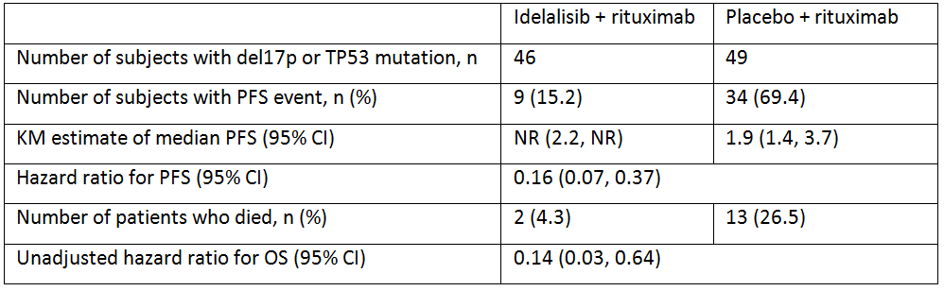
Supportive data from Study 101-07/99 demonstrated the ORR was 82.4% for the whole population compared with 70.8% for those with del17p or TP53 mutation. The PFS estimate for all 85 subjects was 23 months, compared with 19.9 months in those with del17p or TP53 mutation. Preliminary monotherapy efficacy data also supported the evidence for idelalisib efficacy those with high risk mutations; however, the numbers were small and the sponsor is not seeking a monotherapy indication for CLL.

Delegate comment
Based on these results, the sponsor is seeking approval for use idelalisib + rituximab in treatment naïve patients with a 17p deletion or TP53 mutation. However, this claim does not reflect that these findings were, in the sponsor’s own words, a “frail” population for whom chemo immunotherapy was not considered appropriate due to co-morbidities. The Delegate’s proposed indication incorporates this qualification. It is noted that the EMA approval was also similarly qualified.
No safety data accompanied this second analysis, limiting an assessment of the benefit-risk, and submission of this for evaluation as a Category 1 application is a condition of registration.

CLL supportive studies

Study 101-08/99
This Phase II non randomised study of idelalisib + rituximab in 64 previously untreated more elderly CLL patients (5 had SLL), median age of 72 (range 65-90). Daily idelalisib 150mg BD orally was given with rituximab 375 mg/m² IV, administered weekly for 8 doses (Cycles 1 and 2), with idelalisib given continuously thereafter, until disease progression or unacceptable toxicity, up to a maximum of 48 weeks of idelalisib.
The overall response rate was 62/64 (96.9% [95% CI 89.2, 99.6]), with 9 (14.1%) achieving a complete response and 53 (82.8%) achieved a partial response. In this study, only 14% of patients had the high-risk deletions of 17p or TP53.
The long term data are awaited, as at the time of application, there had been no patients whose disease had progressed. Notably, 17/64 discontinued due to AEs.

Delegate comment
As with the pivotal trial, the dose and regimen of rituximab was not standard. The data are strongly supportive of efficacy in a previously untreated population with the combination, including in those with SLL and the high-risk mutations although numbers are low in both. Submission as a Category 1 application for evaluation once PFS data are available is a condition of registration.

Study 101-07/99
This Phase I open label studied the effect of idelalisib plus combination of an anti CD20 monoclonal antibody, a chemotherapeutic agent, an mTOR inhibitor, and/or a proteasome inhibitor in relapsed/refractory CLL. In two of the treatment arms rituximab was co-administered with idelalisib, neither of which used the currently approved regimen for rituximab. An ORR was reported for 82.4% (95% CI 72.6%, 89.8%), with four subjects (4.7%) having a complete response and 66 subjects (77.6%) achieved partial response and 8 subjects (9.4%) had stable disease. The median KM estimates of OR, DOR and PFS were not reached, with a median follow up time of 11.0 months.

Study 101-02
This Phase I dose ranging study enrolled 54 CLL subjects. Idelalisib was administered as monotherapy at 50 mg to 350 mg once or twice daily. Overall, the investigator assessed ORR was 72.2% (95% CI 58.4, 83.5) with a median DOR of 16.2 months (95% CI 4.6, 40.9). Thirteen patients received 150 mg twice daily, their ORR was 81.8% (95% CI 48.2, 97.7) and the median DOR was 8.1 months (95% CI 2.6, 39.8). Fifteen patients did not respond; of these, 12 (22.2%) had stable disease and 3 (5.6%) were not evaluable. For the 13 patients with a 17p deletion and/or TP53 mutation, the ORR was 38.5% (95% CI 13.9, 68.4) and the DOR was 9.2 months.

Efficacy – iNHL patients
There were no Phase III studies for this indication. Support for this indication comes from Study 101-09 (Phase II) and Study 101-02 (Phase I). Study 101-07, where idelalisib was administered in combination with a range of other therapies, did not provide evaluable data for the monotherapy indication being sought.

Study 101-09
This was a Phase II, open label, single arm, two stage, safety (primary endpoint), efficacy, and pharmacodynamic study of idelalisib as monotherapy in patients with iNHL who had received at least 2 prior treatments (chemo or immunotherapy based regimens) and whose disease was refractory both to rituximab and to alkylating agent containing chemotherapy. This study was performed across 54 sites in North America and Europe. Key inclusion/exclusion criteria are summarised.
A total of 125 patients with a median age of 64 (range 33-87) were enrolled to receive 150 mg BD idelalisib until tumour progression or unacceptable toxicity. Dose reductions to 100 mg BD or 75 mg BD were permitted. At the 25 June 2013 cut off, 32% were still on treatment, 32.8% had progressive disease, 6.4% had died, and 28.8% discontinued treatment.
The number of patients with each type of lymphoma were as follows: FL (72), SLL (28), LPL/WM (10) MZL (15). The median range of prior treatments was 4 (range 2-12).
Primary efficacy outcome: the interim report demonstrated an IRC assessed ORR in 71/125 subjects (56.8%). Of these, 7 patients (5.6%) had complete response, 63 patients had a best response of ‘partial response’ and one patient with WM had a best response of ‘minor response’.
The ORR rate with idelalisib was higher, but the CR rate was lower compared with the response rates with the previous treatment.
Secondary outcomes (KM estimates based on IRC):
- median DOR was 12.5 months
- median PFS 11.0 months
- median OS 20.3 months
Other secondary outcomes:
- TTR 1.0 months (1.6-8.3 months)
- Health related quality of life responses were stable (FACT-Lymphoma) and 90% of patients reported some degree of improvement in their concerns about their disease at some point during the treatment.
Delegate comment: the ORR and DOR were clinically meaningful in this refractory population. The patient numbers are small for 3 of the 4 types of NHL included. There are quality of life data to support the findings.

Supportive studies – iNHL monotherapy

Study 101-02
This Phase I dose finding study enrolled 64 patients with relapsed or refractory iNHL (38FL, 11 SLL, 9LPL, 6 MZL) to receive escalating doses either continuously as once daily oral dosing, or BD either for 21/28 days or BD continuously to determine the safety and pharmacokinetic parameters as primary outcomes, and efficacy as a secondary outcome. The ORR for the entire iNHL group within the trial was 45.3% (95% CI 32.8, 51.3). Of the 10 patients with iNHL who received the 150 mg BD proposed for registration, 7 had FL (ORR 28%: 2 PR, 1 not evaluable), 2 had SLL (1 PR, 1 not evaluable), and 1 with LPL/WM had stable disease (ORR 0%). No patients with MZL received the 150 mg BD dose.

Study 101-10
Very limited additional efficacy data were available from Study 101-10, a Phase I/II uncontrolled study of the pharmacodynamics, safety and efficacy in 11 previously treated patients with 3 NHLs (9 FL, 1 SLL, 1 MZL). Subjects were initially treated with idelalisib at 150 mg BD, with an option to increase to 300 mg BD for a maximum of 12 months if experienced PD on the 150 mg BD dose level. Of 11 patients enrolled, 3 had insufficient data, none had a complete response, 3 subjects had a partial response, 2 had stable disease, and 3 subjects had disease progression.

Summary of efficacy for iNHL monotherapy
As noted in the introduction to the overview, iNHL is a descriptive term for different NHLs, not a diagnosis in its own right. Evidence in support of the efficacy of idelalisib as monotherapy in refractory and relapsed iNHL is drawn from a Phase I and a Phase II trial. In the Phase II trial, the ORR rate was 56% (95% CI 47.6, 65.6) which was statistically significant. 57% had FL and the remaining 43% patients had one of the other 3 types of NHL enrolled. Some support was provided by the results from Studies 101-02 and 101-10 but the numbers were small in each, particularly for the non FL subtypes.
ORR can be considered a relevant endpoint for registration purposes, but the magnitude of the effect must be compelling and supported by robust quality of life data. There is some improvement in the symptoms reported during the course of therapy in Study 101-09, and it is noted that 20% discontinued due to AEs.
There are sufficient numbers in the FL group for this to be considered likely to translate into a longer term benefit, but the numbers in the remainder of the groups are too small. Together with the open label, this non-randomised design and lack of a comparator make it difficult to be confident that such benefits in these three NHL subtypes will result in a confirmed longer term benefit more certainly associated with a meaningful clinical benefit, for example, PFS or OS.
Thus, registration of idelalisib in patients with FL is supported, but not for the broad population sought by the sponsor: all the studies were in those with refractory disease, who had had at least 2 prior therapies and this is reflected in the Delegate’s modified indication. Submission of an updated clinical safety report for the pivotal Study 101-09 is a condition of registration.
It is noted that two Phase III studies with patients randomised to receive idelalisib or placebo in combination with standard therapy are underway and should provide clearer information for these other NHLs. Updates of the safety and efficacy for evaluation as a Category 1 submission from Studies 101-09 once the data are more mature (PFS and OS available), and to assess the ongoing long term effects of idelalisib therapy are a condition of registration.

Ongoing Study 101-99
This extension study enrolled all patients continuing on idelalisib from monotherapy and combination therapy studies.

Safety
The following studies provided evaluable safety data.
Table 19: Studies providing evaluable safety data.
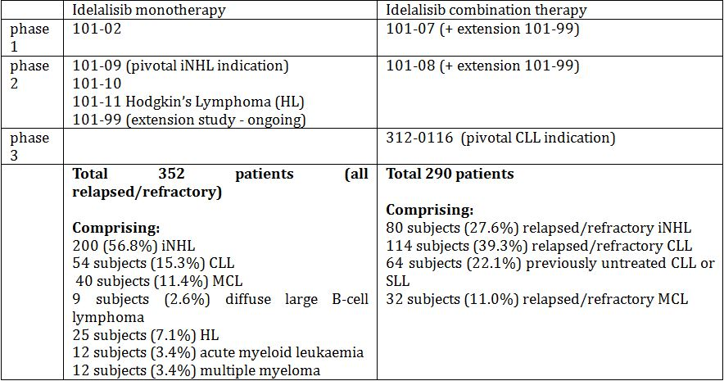
No pivotal studies reported safety as a primary outcome.

Monotherapy
The AE profiles were similar between iNHL and CLL patients receiving idelalisib monotherapy, although the AE rates were higher in the latter. Both contribute relevant safety data to examine the safety of idelalisib monotherapy.

iNHL monotherapy
The median duration of treatment in this group of 200 patients was 6.1 months (interquartile range 2.5, 11.5), with a maximum duration of exposure of approximately 3.5 years. A total of 125 of these patients participated in the pivotal trial.

Treatment-emergent – all NHL
Overall, 145/200 (72.5%) of subjects receiving at least one dose of idelalisib monotherapy experienced at least one TEAE of ≥ grade 3. For all subjects, the commonest reported TEAEs were: diarrhoea (40.5%), fatigue (31.5%), nausea (28.0%), cough (24.5%), pyrexia (24.5) and neutropenia (24.0%).

Treatment related – Pivotal Study101-09
A total of 82.4% experienced at least one TEAE, with gastrointestinal AEs (52%), abnormal haematological values (33.6%), other investigation abnormalities including liver function tests, weight loss (32.8%), general fatigue, asthenia, pyrexia (37.6%) and rash (8%).

SAEs and Deaths – Pivotal Study101-09
A total of 33.6% experienced an SAE related to study drug, most commonly diarrhoea (6.4%), pneumonia and pyrexia (5.6% each). There were 28 deaths while on or within 30 days of the study: 10 deaths (8% of those on study) were attributed to AEs. A total of 17 deaths were attributed to progressive disease, and the cause of the other death is not clear. The causes of the 10 deaths listed broad terms which could be underpinned by a range of precipitating disorders (for example, cardiac arrest, multi organ failure) but infection was a prominent cause including 3 cases of pneumonia (sepsis, septic shock), and pneumonitis.
Two instances of anaphylaxis in patients taking the proposed dose were identified in the NHL monotherapy trials by the clinical evaluator reviewing the line listings of AEs: one as “anaphylactic reaction” and one as “anaphylactic shock”. The sponsor is requested to provide the details surrounding these two events in the pre ACPM response and if idelalisib is causally implicated, to make a prominent change to the PI and to include anaphylaxis in the RMP.

Discontinuations and dose reductions – pivotal trial
Discontinuations due to AEs were common (24%), most commonly due to transaminase changes, pneumonia, pneumonitis, diarrhoea, colitis and sepsis. Dose reductions due to AEs were common (36%), mostly due to liver function test abnormalities (14.4%), diarrhoea/colitis (4%/1.6%), neutropenia and rash. An additional 12% of dose reduction occurred for laboratory abnormalities not otherwise specified.

Delegate comment
The number requiring a dose reduction suggests that the optimal dose level has not been adequately established in this population. Further, the lowest dose used in this trial (down to 75 mg BD) is not possible with the 100 mg and 150 mg tablets proposed for registration. The sponsor reports the 36% requiring dose reduction separately: AE related (24%), and due to laboratory abnormalities not reported as an AE (12%). The Delegate considers this potentially a reporting issue (but the hyperlink to review the data further did not work, preventing further assessment), and considers these dose reductions should be grouped together as related to AEs (treatment emergent or treatment related).

CLL monotherapy
The median duration of treatment in this group of 54 patients was 8.8 months (interquartile range 3.1, 23.5 months), with a maximum duration of exposure >4 years.

Treatment emergent AEs
Overall, 42/54 (77.8%) of subjects experienced at least one AE of grade ≥3. For all subjects, the commonest reported AEs were: fatigue (31.5%), diarrhoea (29.6%), pyrexia (27.8%), cough and thrombocytopenia (24.1% each), and anaemia, back pain, neutropenia, pneumonia, rash, and upper respiratory tract infection (22.2% each).

Deaths and discontinuations
There were 6 deaths (11.1%) attributed to an AE (mostly pneumonia including opportunistic and fungal infections) and 8 patients (14.8%) discontinued due to AEs, including pneumonia (2).

All patients receiving monotherapy

Treatment related AEs
In all patients receiving monotherapy at the proposed 150 mg BD dose level, ≥Grade 3 treatment-related AEs occurred in 75.7% of patients with those occurring in ≥10% of patients as follows: diarrhoea (24.3%), ALT/AST increased (16%), nausea (15.5%), neutropenia (16.5%), fatigue (15%), and rash (8.3%). The cut-off was ≥ 10% and so did not include the patients with more severe events such as pneumonitis.

Combination therapy
The median duration of treatment for 178 CLL patients receiving combination treatment in the Phase I and II studies was 11.3 months with a maximum duration of exposure of 33.6 months. There were 43.8% of patients who continued to receive idelalisib as part of the original study or in the extension Study 101-099. There were 218/220 patients in the pivotal study who provided evaluable safety data. The median duration of exposure in the idelalisib + rituximab arm was 5 months (range 0.3-17.3 months) compared with placebo + rituximab exposure of 3.7 months (range 0.1-14.6 months).

Delegate comment
The combination therapy for the Phase I and II is considered separately as the combinations in these trials were with a range of chemotherapeutic agents.

CLL pivotal study
The most commonly occurring AEs in the idelalisib arm were: pyrexia (34.5%), neutropenia (27.3%), fatigue and nausea (each 25.5%). Fatigue was common in the placebo + rituximab arm (27.8%) with other common events being infusion-related reactions (29.6%) and cough (27.8%).

Treatment related AEs
There were 47.3% in the idelalisib + rituximab arm who experienced a treatment related AE compared with 20.4% placebo + rituximab. It is notable that there is an increase in upper or lower respiratory tract infections (5.4% versus 0.9%), including pneumonia. Pneumonia is common in this population with advanced disease who are immunocompromised due to both the disease, prior treatment as well as any current treatment effect. The sponsor states that there is no causal link with idelalisib. The ACPM is requested to provide advice as to whether the increased frequency of infections including pneumonia (including opportunistic infections) requires a separate ‘Precautions’ statement in the PI.
≥Grade 3 AEs were notably higher in the idelalisib + rituximab arm for the following: neutropenia (21.8 versus 12%), diarrhoea (3.6% versus 0%), colitis (2.7% versus 0%), pneumonitis (3.6 versus 0.9%), abnormal liver function tests (5.4% versus 0.9%).

Delegate comment
When attributions are made about causality by the investigators, it is clear that idelalisib + rituximab is associated with an increased risk of AEs compared with rituximab alone.

Deaths and SAEs
There were 4 patients in the idelalisib + rituximab arm who died, and 12 in the placebo arm while on or within 30 days of receiving treatment in the study. Only 1 death in the idelalisib arm was considered to be related to treatment.
SAEs were higher in the idelalisib + rituximab arm (40.7% versus 34.6%) and were mostly due to increased numbers of infections, diarrhoea, pyrexia and pneumonitis (Table 20).

Table 20: GS-US-312-0116: SAEs reported for at least 2% of subjects in either treatment group (ITT Analysis Set).
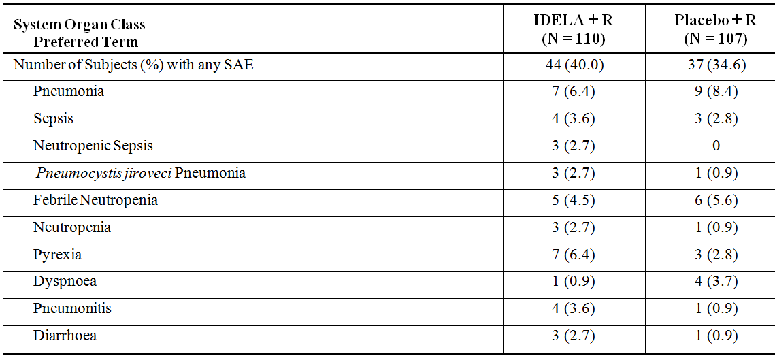
AEs are classified using MedDRA version 15.1.
Subjects who experienced multiple events within the same PT were counted once per PT.
IDELA = idelalisib

Discontinuations and dose reductions
There were 8.2% of patients who discontinued idelalisib + rituximab due to an AE, most commonly diarrhoea, colitis or elevated transaminases. 10.3% discontinued due to an AE in the placebo arm. Dose reductions were required in 16 patients, with the sponsor identifying 3 as being due to AEs (grade 3 pneumonitis, grade 3 rash, grade 1 maculopapular rash). The cause of the remaining 13 dose reductions was unclear and the sponsor is requested to provide the reasons for these other dose reductions.

All patients receiving combination therapy

TEAEs for all patients receiving combination therapy
Across the Phase I and II studies for all patients receiving combination therapy, the commonest AEs reported were diarrhoea (46.2%), pyrexia (43.4%), cough (34.5%), neutropenia (34.5%), fatigue (34.1%), nausea (32.4%), rash (29.7%), increased ALT (21.7%).
The most commonly occurring SAEs for NHL subjects were pneumonia (15.0%), pyrexia (12.5%), diarrhoea (6.3%), and febrile neutropenia (5.0%), whereas those for CLL subjects were pneumonia (13.5%), colitis (9.6%), febrile neutropenia (9.6%), diarrhoea (8.4%), and pyrexia (8.4%).

Safety in special populations

Elderly
Overall, the incidence of ADR (any or serious) did not increase with increasing age. However, the incidence of AE leading to treatment withdrawal did rise with increasing age. The sponsor stated that there was no pharmacodynamic assessment according to age for comparison with the safety findings.

Renal impairment
In subjects with renal impairment, single dose idelalisib had a higher exposure ratio and AUC_{0-last} as compared to matched controls. The sponsor states that there was no apparent increase in events of renal impairment in association with the high incidence of diarrhoea.
In the pivotal CLL study, the incidence of grade ≥3 decreased creatinine clearance was higher in the idelalisib arm (4.5%) as compared placebo (1.9%).

Hepatic impairment
No information is available regarding dosing in patients with varying degrees of hepatic impairment.

AEs of particular interest

Diarrhoea & colitis
Diarrhoea was the most commonly reported AE across the majority of studies. The onset of diarrhoea may be related to cumulative exposure, since events continued to occur months following treatment initiation (median 6-7 months). Serious events of diarrhoea, many occurring after months of exposure, were reported, necessitating steroids anti spasmodics and idelalisib cessation or interruption. Not all cases of diarrhoea resolved with these measures. In subjects with diarrhoea necessitating idelalisib interruption, the majority experienced a recrudescence of their diarrhoea upon re-challenge.
In the pivotal CLL study, events of colitis occurred more commonly in the idelalisib + rituximab arm (4.5%) as compared the placebo + rituximab arm (0.9%), with grade ≥3 events being 2.7% and 0%, respectively.

Hepatitis B reactivation
The sponsor provided the narrative for one subject with grade 1 hepatitis B reactivation, who is continuing in Study 313-0125 (idelalisib or placebo) and their study treatment has not been unblended so no causality can be ascribed. The conservative position of this being due to idelalisib is therefore adopted.

Delegate comment
The clinical evaluator noted that the FDA product label contains a boxed warning for hepatitis B reactivation and describes cases plural. The sponsor is requested to explain the discrepancy, and provide details of the other cases identified by the FDA in the pre-ACPM response. Given a case of reactivation has occurred and the high incidence of elevated transaminases, this should be included in the PI under a separate heading in the ‘Precautions’ section, with advice to consider screening for past hepatitis infection before commencing Zydelig.

Progressive multifocal leucoencephalopathy (PML)
Three cases of PML have been identified in the idelalisib development program, of whom two were not administered idelalisib. The remaining case developed PML after 14 months of idelalisib therapy which had been preceded by rituximab. A boxed warning for the risk of PML is therefore warranted, as a causative role is plausible given the timing – other agents which affect B lymphocyte function (rituximab and obinutuzumab) both have a boxed warning for PML. This information should also be clearly displayed in the CMI (including in the “Before taking this medicine” section). The sponsor is requested to provide an updated version of the CMI in the pre ACPM response.

Atypical infection
In the pivotal CLL trial, the incidence of pneumocystis pneumonia was higher (2.7%) with idelalisib than with placebo (0.9%).

Hepatotoxicity, elevated transaminases & hyperbilirubinaemia
The cumulative incidence of adverse hepatobiliary events with idelalisib monotherapy was 17/352 (4.8%). No events met the criteria for Hy’s law. The majority of events of transaminase elevations resolved (94.5%) within a median of 3.3 weeks. The sponsor should ensure that the section of the PI “hepatotoxicity” contains the incident cases of all hepatotoxicity events, not just those of transaminase/bilirubin elevation. Fatal or serious hepatotoxicity occurred in 14% of patients.

Delegate comment
Given the frequency of raised transaminases, and the observed case of hepatitis B reactivation, the latter should be included in the Precautions section under a separate heading. Advice to consider screening for hepatitis B prior to commencement of idelalisib should be included.

Cytopenias
There was a higher incidence of neutropenia and febrile neutropenia in the CLL pivotal study in association with idelalisib use (21.8%) compared with placebo (12.0%). The incidence of grade ≥3 anaemia or thrombocytopenia across the monotherapy studies was 7.1% and 6.3%, respectively.

Delegate comment
Lymphoid neoplasms are associated with bone marrow involvement and cytopenias. The sponsor claims idelalisib has no myelosuppressive effect, but this could be an effect of its metabolite. Further, the incidence of neutropenia and sepsis/infections were higher in the idelalisib arm of the only randomised trial, suggesting this may be a treatment effect. Thus, this should be included in both the PI and in the RMP. The advice of the ACPM is sought on this matter.

Richter transformation
Idelalisib exposure was not associated with an increased risk of Richter transformation.

Pneumonitis
Overall, 17 subjects developed pneumonitis while receiving either mono or combination idelalisib therapy. Symptoms of pneumonitis were irreversible in four subjects, with three deaths. Eight of the 17 patients had a successful re-challenge.

Intestinal perforation & obstruction
Of seven events of intestinal perforation identified, the majority had co-existent colitis and/or diarrhoea. A causal link between idelalisib exposure and intestinal perforation cannot be excluded.

Stevens-Johnson syndrome/toxic epidermal necrolysis (SJS/TEN)
One subject with recurrent iNHL developed SJS, with a fatal outcome while receiving a blinded study drug. The study drug should be unblinded to determine if a causal relationship with idelalisib exists. Should the subject have received idelalisib, there is sufficient clinical information to warrant a PI warning for SJS/TEN.

Second malignancies
There was no apparent increase in second malignancies with idelalisib exposure.

Risk management plan
It is considered that the sponsor’s response to the TGA Section 31 request has not adequately addressed all of the issues identified in the RMP evaluation report. The RMP evaluator does not support registration of Zydelig until the issues in relation to the RMP below are addressed (see below). A number of recommendations for the RMP (including the Safety Specification) have been provided by the RMP evaluator and the sponsor should address these matters in the pre ACPM Response and follow up where appropriate with the OPR.

Outstanding issues
- The RMP evaluator did not recommend approval of this application until the sponsor adds the important potential risks: ‘Anaphylactic reaction’, ‘Intestinal perforation’ & ‘Progressive multifocal leukoencephalopathy’ to the RMP as recommended by the Clinical Evaluator. The sponsor is requested to propose appropriate pharmacovigilance and risk minimisation activities for these new ongoing safety concerns, to be reflected in a revised ASA before this application is approved.
- Similarly the sponsor should provide an assurance that the nonclinical aspects of the Safety Specification of the EU-RMP will be revised in accordance with nonclinical evaluator’s comments when this document is next updated (see below). In the interim these differences should be noted in a revised ASA before this application is approved.
- The sponsor was asked to provide a table summarising the pharmacovigilance plan and risk minimisation plan proposed for Australia in the ASA. It was suggested that wording pertaining to all the specified ongoing safety concerns in the proposed Australian PI and CMI should be included in the table. The sponsor states: “Gilead has updated section 3 (a) of the ASA with a table summarising the pharmacovigilance plan and risk minimisation plan proposed for Australia.” However, Section 3(a): ‘Implementation of Risk Minimisation Activities’ of the updated ASA only details risk minimisation activities and is not inclusive of pharmacovigilance activities. It is recommended that the sponsor maintain this section of the ASA and also include a table summarising the pharmacovigilance and risk minimisation activities for all of the specified ongoing safety concerns and missing information proposed for Australia in a revised ASA, which should be submitted for review before this application is approved.
Advice from the Advisory Committee on the Safety of Medicines (ACSOM) was not sought for this submission.

Risk-benefit analysis

Delegate’s considerations

CLL
The efficacy of idelalisib has been demonstrated in combination with rituximab in previously treated patients with CLL (including those who have high risk mutations) who have significant comorbidities or poor performance status, which might otherwise preclude their receiving other chemo-immunotherapy regimens. Given the few treatment alternatives available in a population that have significant co-morbidities and poor performance status, it is considered reasonable that approval be given for use of the combination in the first line for those with a 17delP or TP53 mutation. The sponsor states in the Section 31 response to justify the choice of rituximab monotherapy that “the pivotal trial was designed to establish a non-cytotoxic treatment in a frail population not suitable for further chemotherapy and with high unmet medical need”. Currently, the sponsor’s proposed indication does not reflect this, and the Delegate proposed wording is intended to capture these criteria. It is noted that similar wording is also included in the FDA and EMA approved indications.
There are two Phase III trials underway evaluating the addition of idelalisib to currently approved agents (ofatumumab in Study GS-US-312-0119; or bendamustine + rituximab in Study GS-US-312-0115) for treating CLL, and the results of these will clarify further whether previously treated patients considered able to tolerate cytotoxic therapies, benefit from idelalisib combination therapy.

iNHL
The sponsor has proposed that the ORR Phase II data support the registration of idelalisib monotherapy in indolent NHL. As previously mentioned, iNHL is not a clinical entity; rather, iNHL is an umbrella term for a number of different diseases. This study included 72 patients with FL and 28 with small lymphocytic lymphoma and very few with lymphoplasmacytoid lymphoma (+/- WM) and MZL. Given it is a term covering four different diseases, it is important efficacy and safety are demonstrated for all four types. Registration for idelalisib monotherapy is not supported for the treatment of SLL, LPL or MZL as efficacy has not been adequately established due to:
- the small numbers with each lymphoma participating
- the data are non randomised, open label and therefore without a control and subject to bias
- the data are immature and the endpoint offered is overall response rate: registration on this endpoint requires that there is a large treatment effect which is compelling, and where there is a high likelihood that it will translate into a benefit demonstrated by more established markers of clinical benefit such as PFS or OS
- the data from the Phase I trial had very few numbers enrolled, and even fewer patients’ responses were evaluable and therefore offered only minimally supportive data for the pivotal Phase II trial eg there were no patients with MZL, only 1 evaluable for LPL.
However, registration is supported for the use of idelalisib monotherapy to treat FL that has relapsed and is refractory after at least 2 prior treatments.
SLL is regarded as the same entity as CLL. While the non randomised data in the small numbers is not considered sufficient to support registration of idelalisib monotherapy as a treatment for SLL, together with the data from Study 101-02 (5 cases of SLL) it is considered supportive of the use of combination therapy to treat SLL. It is noted that in the EMA positive recommendation, that these two entities were considered covered by the one term (CLL), but for the sake of clarity, this is stated explicitly in the Delegate’s proposed modified indication.
Two Phase III studies are underway in the same populations to determine the efficacy and safety of idelalisib in combination with other approved therapies for non Hodgkin lymphoma and the results of these will clarify whether the benefit-risk of adding idelalisib to standard of care therapies in these patients.

Safety
The AEs associated with treatment include a rise in transaminases, diarrhoea, colitis and pneumonitis; all led to deaths, discontinuations and dose reductions across the study populations. Pyrexia and rashes were also more common in patients receiving idelalisib. These risks appear to be largely manageable and reversible, with dose reductions or discontinuation. The discontinuation rates decreased in the Phase III trial, which may reflect experience gained through the development phase. The PI needs to reflect the risks and recommendations from the clinical evaluator, RMP evaluator, and Delegate are attached to ensure that these risks are conveyed and appropriate advice provided. These need to be addressed for the PI to be approved. In particular, both the Delegate and the clinical evaluator believe the absolute percentages should be included, not the “very common” terminology means anything ≥10% and events occurred with frequencies up to 40%.
Diarrhoea and colitis often presented later during treatment (after several months), and the onset of colitis was sometimes abrupt and not always preceded by severe diarrhoea. The PI contains appropriate advice about dose interruptions and dose reductions. Some cases required steroids, and further information needs to be gathered about the best way to manage such patients and should be included in the RMP.
By contrast, increased transaminases tended to occur early in the treatment course (first 12 weeks) and most were manageable with dose interruption and reduction, and appropriate advice is included in the PI.
Pneumonitis was a notable adverse drug reaction and there were 3 deaths in the development program. The current wording in the PI is not specific enough (see PI changes) and needs to state that in moderate-severe cases, idelalisib should be discontinued.
Other specific AEs included hepatitis B reactivation, and a case of PML where idelalisib is plausibly implicated. The sponsor claims that “there is no evidence that idelalisib is myelosuppressive or immunosuppressive”, but these two events, and the higher treatment-related infection rate in the Phase III pivotal CLL trial (12.7 versus 3.7%), including the increased rate of opportunistic infections (2.7% versus 0.9%) suggest otherwise. Further, in the animal studies there was evidence of diminished immune reactions and opportunistic infections, particularly with longer term use. The nonclinical evaluator noted the toxicity profile of the major human metabolite, GS-563117, has not been fully assessed, and the CHMP has requested additional nonclinical studies to investigate further the safety of the main metabolite (GS-563117). Additional studies requested by the CHMP include mechanistic studies on the effect of idelalisib on immune function for the submission to evaluate the effect of idelalisib on immune function and auto immunity. The sponsor is requested to indicate whether these studies are being undertaken, and if so, when they are likely to be completed and available for evaluation by the TGA (a Condition of Registration). Any claims that idelalisib has no immunosuppressive effect cannot be made until the results of these studies are made available.
Both the Delegate and the clinical evaluator consider a boxed warning for PML warranted (the wording has been suggested). This is consistent with the inclusion in the PIs for other agents approved for CLL linked with cases of PML (for example, rituximab, obinutuzumab). The advice of the ACPM is sought on this matter.
An additional potential toxicity identified in the animal studies is phototoxicity. This is highly relevant in the Australian context, and the sponsor is asked to comment in the pre-ACPM response as to whether this was observed in the clinical trials (see Questions for Sponsor).
Two instances of anaphylaxis in patients taking the proposed dose were identified in the NHL monotherapy trials by the clinical evaluator reviewing the line listings of AEs: one as “anaphylactic reaction” and one as “anaphylactic shock”. The sponsor is requested to provide the details in the pre ACPM response and if idelalisib is causally implicated, to make a prominent change to the PI and to include anaphylaxis in the RMP.
The high levels of AEs experienced by patients within the trials reflects in part their advanced disease and immunocompromised state resulting from both the disease itself and treatments, both prior and current. Many of these are common to these diseases and are familiar to the specialists providing care.

Questions for the sponsor
- The sponsor is requested to provide updated information about applications lodged with other regulatory agencies.
- The sponsor is requested to provide information about any studies undertaken or underway to determine the pharmacokinetic effect of idelalisib on the oral contraceptives, and include advice in the PI according to the status of such studies. If not completed, submission as a Category 1 application within 6 months of completion for evaluation is required as a condition of registration.
- The sponsor is requested to advise whether studies of the effect of drugs altering the gastric pH are to be undertaken, given the relative insolubility of idelalisib at higher pHs.
- The sponsor is requested to provide clinical details surrounding the two instances of anaphylaxis in patients taking the proposed dose in the NHL monotherapy trials.
- The sponsor is requested to provide the reasons for the dose reduction required in 13 patients in the pivotal CLL trial.
- The sponsor is requested to provide the details of the additional case(s) of hepatitis B reactivation mentioned in the FDA label.
- The sponsor is requested to advise whether the following are planned, as requested by the CHMP: nonclinical studies to investigate further the safety of the main metabolite (GS-563117), and mechanistic studies on the effect of idelalisib on immune function to evaluate the effect of idelalisib on immune function and auto-immunity. If so, when will these be completed and available for evaluation? If these studies are not planned, the sponsor is requested to provide a justification.
- The sponsor is requested to advise whether phototoxicity was observed in any patients in the clinical trials.

Conditions of registration
- The EU-RMP (Version 0.1, dated 25 October 2013) with an ASA (Version 0.2, dated August 2014), to be revised as agreed with the TGA, must be implemented.
- Submission as a Category 1 application for evaluation, the following studies as soon as each CSR becomes available:
  - Study 101-08/99 once mature PFS data are available
  - the updated safety summary from the second time point for the GS-US-312-0116 study (only efficacy results were presented in the Section 31 response
  - Study GS-US 312-0116 once the overall survival data are mature in this study, including for the high risk subgroups (TP53 mutation, 17delP)
  - Updates of the safety and efficacy from Studies 101-09 once the data are more mature (PFS and OS available), and from Study 101-02/99 to assess the ongoing long term effects of idelalisib therapy are a condition of registration
  - nonclinical studies to investigate further the safety of the main metabolite (GS-563117)
  - mechanistic studies on the effect of idelalisib on immune function to evaluate the effect of idelalisib on immune function and auto-immunity.

Summary of issues
Zydelig in combination with rituximab has demonstrated increased efficacy compared with rituximab alone (non standard regimen used) in a Phase III randomised controlled trial in patients with CLL, otherwise not considered candidates for chemo immunotherapies due to poor performance status and/or co-morbidities. Benefits were observed across high risk subgroups such as those with TP53 or 17p deletion. SLL is classified as a non leukemic equivalent of CLL, hence its inclusion in the Delegate’s proposed indication below.
The sponsor is seeking registration of Zydelig as monotherapy to treat refractory indolent NHL. This is an umbrella term for a number of NHLs rather than a diagnosis, and in the open label, single arm Phase II study submitted in support of this claim, Zydelig monotherapy was an ORR of 56% in refractory non Hodgkin lymphoma patients, of whom 57% had FL. No data confirming clinical benefit by an increase in PFS or OS are available in these patients (Conditions of Registration). Registration is supported for FL, but not the three other forms of non Hodgkin lymphoma.
There is a high rate of AEs reported with idelalisib usage, including severe and in some cases fatal instances of diarrhoea/colitis, elevated transaminases/hepatotoxicity and pneumonitis. Rash and pyrexia were more common and there was one case each of PML and hepatitis B reactivation. Most AEs appear manageable with dose interruption and reduction or cessation and appropriate supportive care.
There appears to be an immune effect which has not been fully characterised in the drug development program with an increase in infections, including opportunistic infections.

Request for ACPM advice
The committee is requested to provide advice on the following specific issues:
- Whether a black box warning is required for PML, given Zydelig is plausibly implicated in a confirmed case; such warnings exist for other therapies affecting B cell function approved for use in CLL, including rituximab and obinutuzumab
- Given the increased rate of neutropenia and infections (including opportunistic) in the only randomised trial, should infections and neutropenia be included in the Precautions section of the PI?
The committee is (also) requested to provide advice on any other issues that it thinks may be relevant to a decision on whether or not to approve this application.

Proposed action
The Delegate has no reason to say, at this time, that the application for Zydelig should not be approved for registration for the following modified indication.
Zydelig is indicated as monotherapy for the treatment of patients with refractory follicular lymphoma, who have received at least 2 prior systemic therapies.
Zydelig in combination with rituximab, is indicated for the treatment of patients with relapsed chronic lymphocytic leukaemia (CLL)/small lymphocytic lymphoma (SLL) for whom chemo immunotherapy is not considered suitable, either:
    - after at least one prior therapy;
or
    - as first-line treatment in the presence of 17p deletion or TP53 mutation.

Response from sponsor
Thank you for providing an opportunity to comment on the Delegate’s Overview proposing approval of the Category 1 application seeking registration of Zydelig.

Background
Zydelig is a targeted, highly selective, orally administered inhibitor of PI3Kδ with a novel mechanism of action compared to currently available therapies. Zydelig induces apoptosis and inhibits proliferation homing, and retention of malignant B cells in iNHL and CLL/SLL. Zydelig has been administered as monotherapy in a highly refractory iNHL population and as combination therapy and monotherapy in relapsed/refractory CLL/SLL populations.
iNHL is an incurable chronic life threatening disease in which the primary treatment goal is disease control for as long as possible. Zydelig, a chronically administered twice daily (BD) oral therapy, has the potential to address a significant unmet medical need in patients with iNHL that is refractory to both rituximab and an alkylating agent, a serious condition for which no standard of care exists and no other proven safe and effective treatment options are available. Zydelig has demonstrated clinically meaningful and durable response rates in patients with iNHL refractory to both rituximab and an alkylating agent. Zydelig is generally well tolerated, with a manageable safety profile resulting in a favourable risk-benefit profile. The indication for the treatment of patients with iNHL as proposed by Gilead is, for the treatment of adults with refractory iNHL, who have received at least two prior therapies.
CLL/SLL is a serious, incurable hematologic malignancy that accounts for approximately one third of all leukaemias. This incurable illness is characterised by frequent relapses and eventual refractoriness to standard treatments; thus, there is a continuing significant unmet need for patients with CLL/SLL in terms of new therapies with novel mechanisms of action to offer additional treatment options. The indication for the treatment of patients with CLL/SLL as proposed by Gilead and the TGA Delegate is, in combination with rituximab, for the treatment of patients with relapsed CLL/SLL for whom chemo immunotherapy is not considered suitable, either after at least one prior therapy, or; as first line treatment in the presence of 17p deletion or TP53 mutation.

ACPM advice being sought by the delegate

Black box warning for PML
The sponsor does not believe a boxed warning for the risk of PML is warranted. The patient population included in the development program to date had received multiple previous chemo immunotherapies that often included repeated courses of rituximab, putting this population at high risk for PML. As noted by the Delegate, 3 cases of PML were identified across the idelalisib development program, 2 of these occurred in subjects who never received idelalisib. These 2 events of PML occurred in subjects in Study GS-US-312-0119 in subjects who were receiving ofatumamab only. Despite the 2:1 randomisation, there were no events of PML reported in the idelalisib + ofatumamab arm in that trial. The remaining case of PML was reported in a subject who received idelalisib + rituximab in Study GS-US-312-0116 and had continued to receive idelalisib in Study GS-US-312-0117; the subject’s last dose of rituximab was administered approximately 14 months prior to onset of neurologic symptoms. Prior therapy in this treatment refractory subject included rituximab and fludarabine, which are both associated with PML. Therefore, the single case of PML in a subject receiving idelalisib is heavily confounded.
Zydelig has now received approval from the US FDA and the EMA; the approved US Prescribing Information (USPI) and Summary of Product Characteristics (SmPC), having undergone review by the FDA and EMA, respectively, do not contain any precautionary text relating to PML, or a black boxed warning.
Through the sponsor’s comprehensive drug safety monitoring in clinical studies and post marketing surveillance, PML has not been identified as a safety concern with idelalisib and as such does not appear in the Zydelig Core Company Data Sheet (CCDS).
The Delegate has also commented that other agents which affect B lymphocyte function (rituximab and obinutuzumab) have a boxed warning for PML. The sponsor does not believe a ‘class effect’ can be applied to all agents which affect B lymphocyte function. Zydelig is a first in class, targeted, highly selective, chronically administered oral inhibitor of PI3Kδ with a novel mechanism of action compared to currently available therapies.
PML is a serious, but rare disease. The sponsor proposes to continue monitoring the incidence of PML cases in the ongoing idelalisib clinical program and through post marketing surveillance, and will revise the PI if warranted. A copy of the CIOMS for the single identified case of PML described above can be provided upon TGA request.

Neutropenia
The sponsor acknowledges the Delegate’s comment and has included an additional ‘Precaution’ for the events of: anaemia, lymphopenia, neutropenia, and thrombocytopenia as described in the Delegate’s Overview in the current proposed PI.

Indication statement
The Delegate has recommended approval of Zydelig with the following indication for the treatment of patients with relapsed CLL/SLL:
Zydelig in combination with rituximab, is indicated for the treatment of patients with relapsed chronic lymphocytic leukaemia (CLL)/small lymphocytic lymphoma (SLL) for whom chemo-immunotherapy is not considered suitable, either:
    - after at least one prior therapy, or;
    - as first-line treatment in the presence of 17p deletion or TP53 mutation
The sponsor agrees with the Delegate’s proposed indication for the treatment of patients with relapsed CLL/SLL.
The Delegate has recommended approval of Zydelig with the following indication for the treatment of patients with FL:
Zydelig is indicated as monotherapy for the treatment of patients with refractory follicular lymphoma, who have received at least 2 prior systemic therapies.
Gilead does not agree that the indication statement should be limited to only the FL subtype. All subtypes of relapsed/refractory iNHL are serious life threatening conditions for which there is no meaningful effective therapy available. Once patients have been treated with the 2 cornerstones of therapy, an anti CD20 antibody and an alkylating agent, and progress during therapy or relapse shortly thereafter, standard treatment options are exhausted. Consequently, there is an unmet need for a novel, noncytotoxic, targeted therapy for the treatment of patients with any of the subtypes of iNHL. As such, the sponsor believes the indication statement as proposed by the Delegate excludes a number of patients for whom there are limited treatment options available, in an instance where Zydelig has demonstrated benefit in these patients.
In pivotal Study 101-09, Zydelig 150 mg BD administered orally as a single agent was effective in highly refractory patients who had experienced multiple relapses of the various subtypes of iNHL and exhausted other treatment options, including both rituximab and alkylating agents. As such, Gilead believes the indication as follows would provide a vital therapeutic option with a novel mechanism of action to the extremely limited armamentarium for treating this incurable life threatening disease:
Zydelig is indicated for the treatment of adults with refractory indolent non Hodgkin lymphoma (iNHL), who have received at least two prior therapies.
Idelalisib represents an important therapeutic advance for a small group of Australian patients, who have exhausted available treatment options for relapsed iNHL. Idelalisib offers substantial benefits in terms of overall response rate, duration of response, and quality of life, with the convenience of an oral tablet. This valuable new therapy will be welcomed by clinicians and patients, and provide a much needed new treatment option in all subtypes of relapsed/refractory iNHL.
The sponsor notes that ribomustin (bendamustine hydrochloride 25 mg powder for injection, AUST R 211685) received TGA approval in June 2014 with the approved indication of relapsed/refractory iNHL based on a single arm study of 100 patients.

Questions for the sponsor
- The sponsor is requested to provide updated information about applications lodged with other regulatory agencies.
Similar applications have been made in the following major markets as shown in Table 21.
Table 21: Updated information about applications lodged with other regulatory agencies.
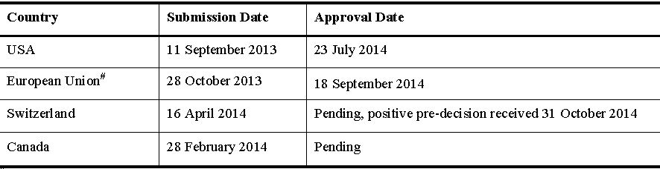
- The sponsor is requested to provide information about any studies undertaken or underway to determine the pharmacokinetic effect of idelalisib on the oral contraceptives, and include advice in the PI according to the status of such studies. If not completed, submission as a Category 1 application within 6 months of completion for evaluation is required as a condition of registration.
Pending the results of the drug-drug interaction study, Gilead proposes to update the ‘Effects on Fertility’ and ‘Use in Pregnancy’ sections of the PI for handling the risk of impaired activity of OCs. Gilead has amended the PI in line with the Delegate’s recommended text.
- The sponsor is requested to advise whether studies of the effect of drugs altering the gastric pH are to be undertaken, given the relative insolubility of idelalisib at higher pHs.
The solubility of idelalisib drug substance is pH dependent, with increasing solubility under more acidic conditions. However, it should be noted that the presence of proteins and bile salts in the GI tract enhances the solubility of idelalisib at a higher pH. For example, in simulated fed intestinal fluids at pH 6.5, the solubility is ~0.2 mg/mL compared to ~0.05 mg/mL in a buffered aqueous solution. Gilead has performed analyses evaluating the effect of acid reducing agents on the pharmacokinetics, efficacy, and safety of idelalisib and has determined that acid reducing agents (that is, proton pump inhibitors, histamine 2 receptor antagonists, magnesium oxide/magnesium hydroxide, and antacids) do not affect the pharmacokinetics or interfere with the clinical profile of idelalisib.
The results provided show that there were no systematic differences in idelalisib plasma exposure parameters based on concomitant use of acid reducing agents (proton pump inhibitors, histamine 2 receptor antagonists, or any acid reducer), demonstrating that acid reducers do not impact idelalisib pharmacokinetics. Therefore, no additional text is considered warranted in the PI regarding acid reducing agents.
- The sponsor is requested to provide clinical details surrounding the two instances of anaphylaxis in patients taking the proposed dose in the NHL monotherapy trials.
Idelalisib was not considered to be causally implicated in either of these 2 reports of anaphylaxis in the iNHL monotherapy trials. In both cases, a temporal association with other substances known to cause anaphylactic responses (beta lactamase antibiotic, iodine based IV radiocontrast agent) was evident. Accordingly, the sponsor does not consider a change to the PI or RMP to be warranted.
The first event reported as an anaphylactic reaction occurred in a female with FL (Study 101-09) 2 months after starting study drug and 1 day after concluding a 15 day course of amoxicillin associated with a recent dental procedure. The event began with lip swelling and slightly swollen upper arms, but progressed so that the subject was hospitalised the following day with dyspnea, angioedema, rash, tachycardia, and a positive formal shock index (specifics not provided) that was assessed by the hospital physician as an anaphylactic reaction to amoxicillin. Study drug was withheld, and after resolution of the event with antihistamine and corticosteroid treatment, was restarted 6 days later with no recurrence of anaphylaxis.
The second event reported as anaphylactic shock occurred in a female with FL (Study 101-09) 11 months after starting study drug when the subject received ioversol contrast media for a computed tomography (CT) scan. The event was treated with IV hydrocortisone and resolved that same day. The event was considered not related to the study drug, and dosing was not interrupted. No recurrence of anaphylaxis has occurred with ongoing study drug. A copy of the 2 complete narratives can be provided upon TGA request.
- The sponsor is requested to provide the reasons for the dose reduction required in 13 patients in the pivotal CLL trial.
Dose reductions in the idelalisib arm of Study 312-0116 due to AEs were generally due to ADRs known to be associated with idelalisib. In Study 312-0116, a total of 16 subjects (including the 3 subjects referenced within the Delegate’s Overview), all treated with idelalisib + rituximab, had dose reductions, with reasons summarised in Table 22.
Table 22: 312-0116, second interim analysis: subjects with idelalisib dose reductions.
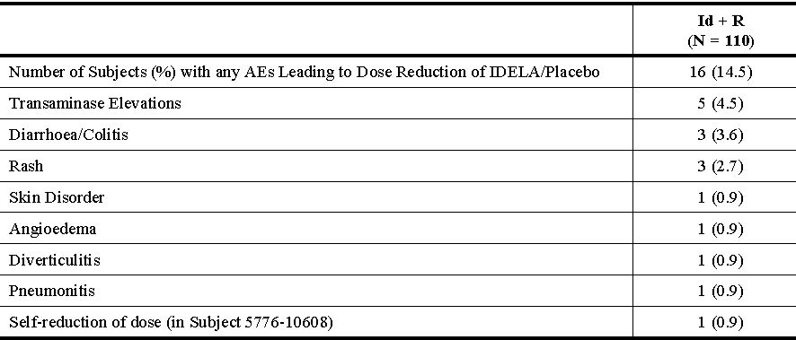
- The sponsor is requested to provide the details of the additional case(s) of hepatitis B reactivation mentioned in the FDA label.
Gilead provides clarification that the approved USPI does not contain any precautionary text, or a boxed warning for hepatitis B reactivation. As such, details of the single case of hepatitis B reactivation as described in response to a question in the clinical evaluation (consolidated Section 31 request for information) are correct.
- The sponsor is requested to advise whether the following are planned, as requested by the CHMP: nonclinical studies to investigate further the safety of the main metabolite (GS-563117), and mechanistic studies on the effect of idelalisib on immune function to evaluate the effect of idelalisib on immune function and autoimmunity. If so, when will these be completed and available for evaluation? If these studies are not planned, the sponsor is requested to provide a justification.
The requested studies evaluating the major metabolite, GS-563117, have been completed and have been submitted to the EMA. These studies will be submitted to TGA after approval. In summary, safety of the main metabolite, GS-563117, was evaluated in silico (DEREK) for genotoxicity, in vitro for receptor binding, and assessed in a 4 week dose range finding study with idelalisib in wild-type rasH2 mice. RasH2 (wild type) mice administered idelalisib at doses up to 1500 mg/kg/day for 4 weeks exhibited substantially increased metabolism of idelalisib to GS-563117 compared to rats and dogs. At 1500 mg/kg/day, GS-563117 exposure in wild type mice is approximately 75% the clinical steady state exposure in cancer patients. No new safety signals have been identified or attributed to GS-563117.
In addition, studies evaluating idelalisib and inhibition of PI3Kδ on immune function are ongoing and will be submitted to TGA after approval.
- The sponsor is requested to advise whether phototoxicity was observed in any patients in the clinical trials.
There was 1 AE reported as photosensitivity in the integrated summary of safety (n = 642) population. In Study 101-07, one subject initiated a regimen of idelalisib (150 mg BD) and bendamustine, and approximately 2 months later, experienced grade 2 photosensitivity. The event required no treatment and was reported as unrelated to idelalisib and related to bendamustine. The event was reported as resolved approximately 2 months later while the subject continued treatment with idelalisib and bendamustine. In Study 101-02, one subject initiated idelalisib monotherapy at 150 mg BD and 6 days later experienced grade 1 sunburn. The event required no treatment, was reported as unrelated to idelalisib, and was reported as resolved approximately 6 weeks later while continuing treatment with idelalisib.
Based on the paucity of clinical cases consistent with phototoxicity reactions, the sponsor continues to consider phototoxicity in idelalisib treated patients, via its major metabolite, GS 563117, as a theoretical risk.

RMP
The sponsor has noted the recommendations for the RMP (including the Safety Specification) provided by the RMP evaluator. The sponsor does not propose to add anaphylactic reaction, intestinal perforation, or PML to the RMP as suggested in the Delegate’s Overview. A justification to address the single case of PML is provided in this response. A justification to address anaphylactic reaction is provided. A justification for intestinal perforation was provided in response to the PI amendments in the clinical evaluation (consolidated Section 31 request) and is reproduced below:
To date, Gilead has identified 7 cases of bowel perforation in idelalisib treated subjects. All 7 cases have a complex medical course and are heavily confounded. Of the 7 cases, 1 subject’s colorectal cancer was the direct cause of the perforation as indicated on autopsy, 3 cases occurred in association with diverticulitis (a common condition in the elderly and a well known cause of perforation), 1 case of bowel micro perforation occurred in the context of sepsis and hypotension, 1 subject not on idelalisib at the time of the event had a surgical pathology report consistent with ischemic injury, and 1 subject with pancreatic adenocarcinoma had an initial CT scan suggestive of mesenteric thrombus.
The sponsor confirms that the EU-RMP has not been updated with regards to anaphylactic reaction, intestinal perforation, or PML.
Finally, with regards the remaining issues of the Delegate’s Overview, the sponsor provides assurance that an approved EU-RMP (Version 1.0, dated 19 September 2014) with a revised ASA, which will be updated in accordance with any further revisions to the PI, will be provided prior to approval.

Conditions of registration
The sponsor has noted the recommendation to submit a Category 1 application to TGA requesting evaluation of the 6 clinical and nonclinical studies. The sponsor routinely submits only Category 1 applications that change the risk-benefit profile of the product and warrant a PI update. The sponsor commits to submitting the 6 clinical and nonclinical studies; however, not all of these applications will have a corresponding component as global filings supporting these submissions may not be available to Australia.

Advisory Committee Considerations
The ACPM resolved to recommend to the TGA Delegate that taking into account the submitted evidence of efficacy, safety and quality, the ACPM agreed with the Delegate and considered Zydelig tablets containing 100 mg and 150 mg of idelalisib to have an overall positive benefit-risk profile for the Delegate’s amended indication:
Zydelig is indicated as monotherapy for the treatment of patients with refractory follicular lymphoma, who have received at least 2 prior systemic therapies.
Zydelig in combination with rituximab, is indicated for the treatment of patients with relapsed chronic lymphocytic leukaemia (CLL)/small lymphocytic lymphoma (SLL) for whom chemo-immunotherapy is not considered suitable, either:
    - after at least one prior therapy;
or
    - as first-line treatment in the presence of 17p deletion or TP53 mutation
In making this recommendation, the ACPM was of the view that there was insufficient evidence presented to support registration of idelalisib for iNHL, as the data are immature with only a surrogate endpoint, overall response rate, supporting efficacy. The ACPM noted that a large treatment effect would need to be of compelling weight to rely solely on this endpoint. Where there is a high likelihood that it will translate into a benefit, more established markers of clinical benefit such as PFS and OS should be provided.
The ACPM also noted the small number of patients for each type of lymphoma included in the trial and that the data are non randomised and open label therefore may be subject to bias, without a control group. The ACPM advised that the sponsor should submit, when available, the confirmatory iNHL data that has been requested by the FDA as part of the accelerated approval program.

Proposed conditions of registration
The ACPM agreed with the Delegate on the proposed conditions of registration and specifically advised on the inclusion of the following:
- Pharmacovigilence should be required for the following AEs: anaphylaxis, intestinal perforation and PML.

PI)/CMI amendments
The ACPM agreed with the Delegate to the proposed amendments to the PI and CMI and specifically advised on the inclusion of the following:
- A black box warning regarding PML was not considered to be required as there is insufficient evidence regarding the link between idelalisib and PML. However, the potential for PML should be highlighted in the ‘Precautions’ section.
- Statements on neutropenia, infections and opportunistic infections should be included in the ‘Precautions’ section and relevant sections of the CMI.
- A statement on viral hepatitis reactivation should be included in the ‘Precautions’ section and relevant sections of the CMI:
  - A requirement for hepatitis B (HBV) and hepatitis C (HCV) screening prior to treatment with idelalisib should be included.
- Include a warning about the risk of transient lymphocytosis which may occur when commencing treatment with idelalisib.
- Include instructions on when to administer annual vaccinations such as influenza.
- Use a statement similar to that in the EU SmPC for greater clarity in the ‘Precautions’ section and relevant sections of the CMI regarding pneumonitis
  - include information on when corticosteroids should be used.
- Statements in the ‘Precautions’ section with respect to colitis,
  - should mention that diarrhoea/dehydration can exacerbate pre-existing renal failure;
  - Regarding colitis, the PI should mention that Clostridium difficile should be considered when assessing patients with colitis;
  - the PI should highlight that corticosteroids might need to be considered for the treatment of severe colitis.
- Inclusion of a table for dose modification similar to the US PI would be useful for clinicians.
- The CMI should advise consumers to notify their doctor if they have any active infection and should advise more strongly about risks of infection
- The CMI should place more emphasis regarding the risk of diarrhoea, fatigue, pyrexia.

Specific Advice
The ACPM advised the following in response to the delegate’s specific questions on this submission:
- Whether a black box warning for progressive multifocal leukoencephalopathy, given Zydelig is plausibly implicated in a confirmed case; such warnings exist for other therapies affecting B cell function approved for use in CLL, including rituximab and obinutuzumab.
The ACPM noted that three cases of PML have been identified in the idelalisib development program but only one patient had received idelalisib. However, this patient also received rituximab and fludarabine.
The ACPM considered that a black box warning was not necessary at the current time as there is insufficient evidence linking idelalisib with PML. However, the potential for PML should be highlighted in the PI and CMI, and monitored with post marketing surveillance.
- Given the increased rate of neutropenia and infections (including opportunistic) in the only randomised trial, should infections and neutropenia be included in the ‘Precautions’ section of the PI?
The ACPM noted that there was a higher treatment-related infection rate in the Phase III pivotal CLL trial (12.7 versus 3.7%), including the increased rate of opportunistic infections (2.7% versus 0.9%). Along with data from animal studies demonstrating diminished immune reactions and opportunistic infections, the ACPM agreed with the Delegate that a strong case can be made for the inclusion of infections, opportunistic infections and neutropenia to be included in the ‘Precautions’ section of the PI.
The ACPM noted that the sponsor in its pre ACPM advice has agreed to include an additional ‘Precaution’ for the events of anaemia, lymphopenia, neutropenia, and thrombocytopenia.
The ACPM advised that implementation by the sponsor of the recommendations outlined above to the satisfaction of the TGA, in addition to the evidence of efficacy and safety provided would support the safe and effective use of these products.

Outcome
Based on a review of quality, safety and efficacy, TGA approved the registration of Zydelig tablets containing idelalisib 100 mg and 150 mg indicated for:
Zydelig is indicated as monotherapy for the treatment of patients with refractory follicular lymphoma, who have received at least 2 prior systemic therapies.
Zydelig, in combination with rituximab, is indicated for the treatment of patients with chronic lymphocytic leukaemia (CLL)/small lymphocytic lymphoma (SLL) for whom chemo-immunotherapy is not considered suitable, either:
    - upon relapse after at least one prior therapy;
or
    - as first-line treatment in the presence of 17p deletion or TP53 mutation.

Specific conditions of registration applying to these goods
- The EU-RMP (Version 0.1, dated 25 October 2013) with an ASA (Version 0.2, dated August 2014), to be revised as agreed with the TGA, must be implemented.
- Submission as a Category 1 application for evaluation, the following studies as soon as each CSR becomes available:
  - Study 101-08/99 once mature PFS data are available
  - The updated safety summary from the second time point for the GS-US-312-0116 study (only efficacy results were presented in the Section 31 response)
  - Study GS-US-312-0116 once the overall survival data are mature in this study, including for the high risk subgroups (TP53 mutation, 17delP)
  - Updates of the safety and efficacy from Studies 101-09 once the data are more mature (PFS and OS available), and from Study 101-02/99 to assess the ongoing long term effects of Idelalisib therapy are a condition of registration
  - Nonclinical studies to investigate further the safety of the main metabolite (GS-563117)
  - Mechanistic studies on the effect of idelalisib on immune function to evaluate the effect of idelalisib on immune function and autoimmunity.

Attachment 1. Product Information
The PI approved for Zydelig at the time this AusPAR was published is at Attachment 1. For the most recent PI, please refer to the TGA website at <www.tga.gov.au/product-information-pi>.

Attachment 2. Extract from the Clinical Evaluation Report

Therapeutic Goods Administration
PO Box 100 Woden ACT 2606 Australia
Email: info@tga.gov.au Phone: 1800 020 653 Fax: 02 6232 8605
https://www.tga.gov.au

Campo E, et al. (2011) The 2008 WHO classification of lymphoid neoplasms and beyond: evolving concepts and practical applications. Blood 117: 5019-32.
Huhn D, et al. (2001) Rituximab therapy of patients with B-cell chronic lymphocytic leukemia. Blood 98: 1326-31.
European Medicines Agency, “ICH Topic S 9 Nonclinical Evaluation for Anticancer Pharmaceuticals, Step 3: Note for Guidance on Nonclinical Evaluation for Anticancer Pharmaceuticals (EMEA/CHMP/ICH/646107/2008)”, December 2008.
Herman SE, et al. (2010) Phosphatidylinositol 3-kinase-δ inhibitor CAL-101 shows promising preclinical activity in chronic lymphocytic leukemia by antagonizing intrinsic and extrinsic cellular survival signals. Blood 116: 2078-88.
Chantry D, et al. (1997) p110delta, a novel phosphatidylinositol 3-kinase catalytic subunit that associates with p85 and is expressed predominantly in leukocytes. J. Biol. Chem. 272: 19236-41.
Lomon S, Fruman DA. (2012) PI3K signalling in B- and T-lymphocytes: new developments and therapeutic advances. Biochem J. 442: 465-81.
Based on a C_{min} of 765 nM and a free fraction of 20% (153 nM).
Based on a C_{min} of 5 μM and a free fraction of 12% (600 nM).
Lannutti BJ, et al. (2011) CAL-101, a p110delta selective phosphatidylinositol-3-kinase inhibitor for the treatment of B-cell malignancies, inhibits PI3K signaling and cellular viability. Blood 117: 591-4.
Al-Zahrani KN, et al. (2013) Ste20-like kinase SLK, at the crossroads: a matter of life and death. Cell Adh. Migr. 7: 1-10.
Endo J, et al. (2000) Deficiency of a STE20/PAK family kinase LOK leads to the acceleration of LFA-1 clustering and cell adhesion of activated lymphocytes. FEBS Lett. 468: 234-8.
Based on data from the 4-week repeat-dose toxicity study (Study BHR00009).
Based on Day 1 data from the 4 week repeat-dose toxicity study (which also used capsules) (Study BHR00008).
Assuming conservative exposures to GS-563117 were 0.7% and 16% those of idelalisib in rats and dogs.
In cardiology, the QT interval is a measure of the time between the start of the Q wave and the end of the T wave in the heart’s electrical cycle.
European Medicines Agency, “Guideline on the investigation of drug interactions (CPMP/EWP/560/95/Rev. 1 Corr. 2**)”, 21 June 2012.
European Medicines Agency, “Guideline on repeated dose toxicity (CPMP/SWP/1042/99 Rev 1 Corr*)”, 18 March 2010.
Okkenhaug K, et al. (2002) Impaired B and T cell antigen receptor signaling in p110delta PI 3-kinase mutant mice. Science 297: 1031-4.
Chantry D, et al. (1997) p110delta, a novel phosphatidylinositol 3-kinase catalytic subunit that associates with p85 and is expressed predominantly in leukocytes. J Biol Chem. 272: 19236-41.
Ciraolo E, et al. (2010) Essential role of the p110beta subunit of phosphoinositide 3-OH kinase in male fertility. Mol Biol Cell 21: 704-11.
ICH, “Guidance for Industry, S2(R1): Genotoxicity Testing and Data Interpretation for Pharmaceuticals Intended for Human Use”, June 2012.
Exposure to idelalisib saturates (to ~800 µg∙h/mL) in rats at oral doses ≥300 mg/kg/day. Exposure to GS-563117 is ~0.7% that of idelalisib, resulting in an estimated AUC of 5.6 µg∙h/mL (~8% of the clinical AUC) for this metabolite with an oral idelalisib dose of 2000 mg/kg.
European Medicines Agency, “ICH Topic S 9 Nonclinical Evaluation for Anticancer Pharmaceuticals, Step 3: Note for Guidance on Nonclinical Evaluation for Anticancer Pharmaceuticals (EMEA/CHMP/ICH/646107/2008)”, December 2008.
Ciraolo E, et al. (2008) Phosphoinositide 3-Kinase p110β activity: Key Role in Metabolism and Mammary Gland Cancer but not Development. Sci. Signal 1: ra3.
Vanhaesebroeck B. (2005) Signalling by PI3K isoforms: insights from gene-targeted mice. Trends Biochem. Sci. 30: 194-204.
Al-Zahrani KN, et al. (2014) Essential role for the SLK protein kinase in embryogenesis and placental tissue development. Dev. Dyn. 243: 640-51.
Al-Zahrani, KN, et al. (2013) Ste20-like kinase SLK, at the crossroads: a matter of life and death. Cell Adh. Migr. 7: 1-10.
Pregnancy Category D: Drugs which have caused, are suspected to have caused, or may be expected to cause an increased incidence of human foetal malformations or irreversible damage. These drugs may also have adverse pharmacological effects.
ICH, “Guidance for Industry, S8: Immunotoxicity studies for human pharmaceuticals”, April 2006.
Okkenhaug K, Vanhaesebroeck B. (2003) PI3K in lymphocyte development, differentiation and activation. Nat. Rev. Immunol. 3: 317-30.
Herman SE, et al. (2010) Phosphatidylinositol 3-kinase-δ inhibitor CAL-101 shows promising preclinical activity in chronic lymphocytic leukemia by antagonizing intrinsic and extrinsic cellular survival signals. Blood 116: 2078-88.
Ali K, et al. (2004) Essential role for the p110delta phosphoinositide 3-kinase in the allergic response. Nature 431: 1007-11.
Durand CA, et al. (2009) Phosphoinositide 3-kinase p110 delta regulates natural antibody production, marginal zone and B-1 B cell function, and autoantibody responses. J. Immunol. 183: 5673-84.
ICH, “Guidance for Industry, S10: Photosafety Evaluation of Pharmaceuticals”, January 2015.

