January 2016

Australian Public Assessment Report for human papillomavirus vaccine types 16 and 18 (recombinant, AS04 adjuvanted)
  - Proprietary Product Name: Cervarix
  - Sponsor: GlaxoSmithKline Australia Pty Ltd

About the Therapeutic Goods Administration (TGA)
- The Therapeutic Goods Administration (TGA) is part of the Australian Government Department of Health and is responsible for regulating medicines and medical devices.
- The TGA administers the Therapeutic Goods Act 1989 (the Act), applying a risk management approach designed to ensure therapeutic goods supplied in Australia meet acceptable standards of quality, safety and efficacy (performance) when necessary.
- The work of the TGA is based on applying scientific and clinical expertise to decision-making, to ensure that the benefits to consumers outweigh any risks associated with the use of medicines and medical devices.
- The TGA relies on the public, healthcare professionals and industry to report problems with medicines or medical devices. TGA investigates reports received by it to determine any necessary regulatory action.
- To report a problem with a medicine or medical device, please see the information on the TGA website <https://www.tga.gov.au>.

About AusPARs
- An Australian Public Assessment Report (AusPAR) provides information about the evaluation of a prescription medicine and the considerations that led the TGA to approve or not approve a prescription medicine submission.
- AusPARs are prepared and published by the TGA.
- An AusPAR is prepared for submissions that relate to new chemical entities, generic medicines, major variations and extensions of indications.
- An AusPAR is a static document; it provides information that relates to a submission at a particular point in time.
- A new AusPAR will be developed to reflect changes to indications and/or major variations to a prescription medicine subject to evaluation by the TGA.
Copyright
© Commonwealth of Australia 2015
This work is copyright. You may reproduce the whole or part of this work in unaltered form for your own personal use or, if you are part of an organisation, for internal use within your organisation, but only if you or your organisation do not use the reproduction for any commercial purpose and retain this copyright notice and all disclaimer notices as part of that reproduction. Apart from rights to use as permitted by the Copyright Act 1968 or allowed by this copyright notice, all other rights are reserved and you are not allowed to reproduce the whole or any part of this work in any way (electronic or otherwise) without first being given specific written permission from the Commonwealth to do so. Requests and inquiries concerning reproduction and rights are to be sent to the TGA Copyright Officer, Therapeutic Goods Administration, PO Box 100, Woden ACT 2606 or emailed to <tga.copyright@tga.gov.au>.

Contents
About AusPARs ii
Common abbreviations 4
I. Introduction to product submission 5
Submission details 5
Product background 6
Regulatory status 7
Product Information 7
II. Quality findings 7
III. Nonclinical findings 7
IV. Clinical findings 7
Introduction 7
Pharmacokinetics 9
Pharmacodynamics 9
Dosage selection for the pivotal studies 9
Efficacy 9
Safety 10
First round benefit-risk assessment 12
First round recommendation regarding authorisation 13
Clinical questions 13
Second round evaluation 13
V. Pharmacovigilance findings 13
Risk management plan 13
VI. Overall conclusion and risk/benefit assessment 22
Quality 22
Nonclinical 22
Clinical 22
Risk management plan 25
Risk-benefit analysis 25
Outcome 32
Attachment 1. Product Information 32
Attachment 2. Extract from the Clinical Evaluation Report 32

Common abbreviations
Abbreviation | Meaning
ACPM | Advisory Committee on Prescription Medicines
AE | adverse event
ASA | Australian Specific Annex
ATP | according to protocol
ED50 | effective dose 50%
EMA | European Medicines Agency
GMR | geometric means ratio
GMT | geometric mean titre
HAV | hepatitis A virus/vaccine
HPV | human papillomavirus
PI | Product Information
PsV | pseudovirion
RMP | Risk Management Plan
TVC | Total Vaccinated Cohort
VLP | virus like proteins

I. Introduction to product submission

Submission details
Type of submission: | Major variation
Decision: | Approved
Date of decision: | 21 September 2015
Date of entry onto ARTG | 25 September 2015

Active ingredient: | Human papillomavirus vaccine types 16 and 18 (recombinant, AS04 adjuvanted)
Product name: | Cervarix
Sponsor’s name and address: | GlaxoSmithKline Australia Pty Ltd  Level 4, 436 Johnston Street  Abbotsford VIC 3067
Strength / dose form: | Each 0.5 mL dose contains 20 μg each of HPV‐16 L1 and HPV‐ 18 L1 proteins as virus like proteins (VLPs). The antigens (HPV 16/18) are produced using a Baculovirus expression system in Trichoplusia ni cell.  The vaccine is adjuvanted using the proprietary ASO4 adjuvant system. The ASO4 comprises Al(OH)3 and 3‐O-desacyl‐ 4’‐monophosphoryl lipid A (MPL).
Container: | 0.5 ml of suspension in a pre-filled syringe (type I glass) with a plunger stopper (rubber butyl) with or without needles.
Pack sizes: | 1 and 10 prefilled syringes  1, 10 and 100 vials
Approved therapeutic use: | Cervarix is indicated in females from 10 to 45 years of age for the prevention of persistent infection, premalignant cervical lesions and cervical cancer caused by human papillomavirus types 16 and 18. Immunogenicity studies have been conducted in females aged 10 to 14 years and 26 to 45 years to link efficacy in females aged 15 to 25 years to other populations.
Route(s) of administration: | Intramuscular injection
Dosage: | The vaccination schedule depends on the age of the subject:  * If the second vaccine dose is administered before the 5th month after the first dose, a third dose should always be administered.  ** If flexibility in the vaccination schedule is necessary, the second dose can be administered between 1 month and 2.5 months after the first dose and the third dose between 5 and 12 months after the first dose.
  Age at the time of the first injection | Immunisation and schedule
  10 - 14 years | The vaccination schedule consists of a total of two doses each of 0.5 ml. The second dose given between 5 and 13 months after the first dose*  OR  The vaccination schedule consists of a total of three doses each of 0.5 ml given at 0, 1, 6 months**
  15 - 45 years | The vaccination schedule consists of a total of three doses each of 0.5 ml given at 0, 1, 6 months**
ARTG numbers: | 126114 (suspension for injection pre-filled syringe)  126115 (suspension for injection vial)

Product background
This AusPAR describes the application by GlaxoSmithKline Australia Pty Ltd for Cervarix to vary the dosage to allow for the administration of the vaccine according to an alternative 2 dose schedule (0, 5-13 months) in females aged 10-14 years old. The currently approved vaccination schedule is 3 doses (0, 1, 6 months) in females aged 10-45 years old. In addition, this is also an application to change the Product Information (PI) by updating the pregnancy section.
Cervarix is a vaccine against human papillomavirus (HPV) types 16 and 18. These two strains of HPV are estimated to be responsible for approximately 70% of all cervical cancers across all regions worldwide. Cervarix contains recombinant C-terminally truncated L1 proteins from human HPV types 16 and 18 each assembled as virus like particles (VLPs). The HPV-16 and HPV-18 L1 antigens are prepared by recombinant DNA technology using a Baculovirus expression system in Trichoplusia ni cells. Hence, Cervarix is not a live virus vaccine and does not cause infection. Cervarix is thought to exert its action through the development of a humoral immune response and cell mediated immunity to HPV-16 and HPV-18.
The approved indication is:
Cervarix is indicated in females from 10 to 45 years of age for the prevention of persistent infection, premalignant cervical lesions and cervical cancer caused by human papillomavirus types 16 and 18. Immunogenicity studies have been conducted in females aged 10 to 14 years and 26 to 45 years to link efficacy in females aged 15 to 25 years to other populations.
No changes to the approved indication are proposed.

Regulatory status
At the time the TGA considered this application, an application for a 2 dose schedule (0, 6 months) had been approved in the EU (Centralised Procedure) on 18 December 2013, in Canada on 3 July 2014, in Singapore on 29 May 2014, and Switzerland on 19 June 2015. Also, an application for a 2 dose schedule (0, 5-13 months) had been approved in the EU (Centralised Procedure) on 21 November 2014 and was submitted in New Zealand on 29 June 2015 and in Singapore on 14 January 2015.
An application for an amendment to update the ‘Use in Pregnancy’ section was approved in the EU (Centralised Procedure) on 26 February 2015 including many other countries.
There had been no deferrals, withdrawals, or rejections in any market.
The sponsor stated:
The data set which is contained within the Australian submission for CERVARIX is the same as that data submitted overseas.

Product Information
The approved PI current at the time this AusPAR was prepared can be found as Attachment 1. For the most recent PI, please refer to the TGA website at <https://www.tga.gov.au/product-information-pi>.

II. Quality findings
There was no requirement for a quality evaluation in a submission of this type.

III. Nonclinical findings
There was no requirement for a nonclinical evaluation in a submission of this type.

IV. Clinical findings
A summary of the clinical findings is presented in this section. Further details of these clinical findings can be found in Attachment 2.

Introduction
This is an application for Cervarix to vary the dosage to allow for the administration of the vaccine according to an alternative 2 dose schedule (0, 5-13 months) in females aged 10-14 years old. The currently approved vaccination schedule is 3 doses (0, 1, 6 months) in females aged 10-45 years old. In addition, this is also an application to change the PI by updating the pregnancy section.

Clinical rationale
The primary justification for the proposed new, alternative dosing schedule is summed up in the following paragraph from the Clinical Overview:
Public health stakeholders from various regions of the world have expressed an interest in a 2 dose HPV vaccination schedule as one of the solutions to address poor coverage due to the lack of vaccination program infrastructure to simplify implementation and to reduce the high cost of the 3 dose HPV vaccination course. A 2 dose schedule could lead to a substantial increase in the number of girls completing the vaccination course for the same cost, ensuring that greater numbers are protected. Ethical concerns of administering 3 doses in girls if 2 doses are sufficient have also been expressed. Some countries (for example, Canada [British Colombia and Quebec only], Mexico and Switzerland) have already implemented a 2 dose schedule for HPV vaccination in young girls, with the initial recommendation of a booster dose 5 years after first vaccination in Canada and Mexico.
The sponsor also proposes to update the ‘Use in Pregnancy’ section of the PI with information derived from all the pregnancy exposure data available to the sponsor since first authorisation.

Guidance
The sponsor refers to the following documents in the Clinical Overview:
- Committee for Medicinal Products for Human Use (CHMP) Variation Assessment Report. Type II variation EMEA/H/C/000721/II/0036, 21 February 2013.
- European Medicines Agency (EMA) Committee For Medicinal Products For Human Use (CHMP). Guidance on clinical evaluation of new vaccines. London 2005a. EMEA/CHMP/VWP/164653/2005.
- European Medicines Agency (EMA) Committee For Medicinal Products For Human Use (CHMP). Note for guidance on the clinical evaluation of vaccines. London 2005b. CHMP/VWP/164653/2005.
Specifically, in the Clinical Overview, the Sponsor states:
As an efficacy trial in the pre sexual debut target population is not feasible, protection of young girls (9-14 years) by the vaccine was inferred based on immunogenicity. However, no immunological correlate of protection has been demonstrated, the scientific community has shown that the mechanism of protection against HPV infection is antibody mediated (especially by neutralising antibodies against vaccine and non-vaccine HPV types). This has recently been recognised by the Committee For Medicinal Products For Human Use (CHMP) and confirms the adequacy of this approach.

Contents of the clinical dossier
The submission contained the following clinical information:
- One efficacy studies that evaluated the proposed alternative dosing schedule: Study HPV-070
- One efficacy study that supports a 2 dose schedule at Month 0 and Month 6: Study HPV-048
- Two supportive efficacy studies that provide data in support of a two-dose schedule: Study HPV-008 and Study HPV-009
- One post-marketing study in support of safety in pregnancy: Study EPI-HPV-018 VS UK DB

Paediatric data
The submission included paediatric efficacy and safety data for females aged 9 years and over.

Good clinical practice
GCP appears to have been adhered to in the clinical studies.

Pharmacokinetics
No new pharmacokinetic data were included in the submission.

Pharmacodynamics
No new pharmacodynamic data were included in the submission.

Dosage selection for the pivotal studies
Study HPV-048 contained some dose selection data that is discussed.

Efficacy

Evaluator’s conclusions on clinical efficacy for proposed 2 dose schedule at Month 0 and Month 6
Study HPV-070 demonstrated equivalent immunogenicity for the 2 dose schedule (Month 0 and Month 6) and the currently approved dosing schedule. In Study HPV-070 at one month and at 6 months after the last dose of vaccine all subjects in the ATP cohort for immunogenicity seroconverted. At one month after the second vaccination (Month 7), there was similar immune response for HPV-16 in Group (0, 1, 6) and in Group (0, 6) and the upper 95% CI was <2, and therefore within the predefined bounds for non-inferiority: GMT ratio (95% CI) 1.09 (0.97 to 1.22). There was a greater immune response to HPV-18 in Group (0, 6) than Group (0, 1, 6): GMT ratio (95% CI) 0.85 (0.76 to 0.95). At six months after the second vaccination (Month 12), there was greater immune response for HPV-16 in Group (0, 1, 6) than in Group (0, 6) but the upper 95% CI was <2, and therefore within the predefined bounds for non-inferiority: GMT ratio (95% CI) 1.25 (1.10 to 1.40). There was a similar immune response for the two groups to HPV-18: GMT ratio (95% CI) 0.99 (0.87 to 1.12). All subjects developed neutralising antibodies to HPV-16 PsV and to HPV-18 PsV. There were similar CD4+ and B cell responses to HPV-16, HPV-18, HPV-31 and HPV-45.
In Study HPV-048 all the subjects seroconverted. Within each treatment group, the GMT responses were similar by age strata. For HPV-16 the immune response one month after last vaccination was decreased in Group (0, 6; 20 μg) compared with standard dosing schedule: the GMR (95% CI) for GMT was 0.61 (0.51 to 0.74). For HPV-18 the immune response one month after last vaccination was similar in Group (0, 6; 20 μg) compared with standard dosing schedule: the GMR (95% CI) for GMT was 0.91 (0.75 to 1.11). In comparison with the results from Study HPV-070, for the 9 to 15 year age group there was similar response to HPV-16 for Group (0, 6; 20 μg) compared to the 15 to 25 year group for Group (0, 1, 6): GMT 11066.9 and 10322.0 respectively, GMT ratio (95% C) 0.93 (0.68 to 1.28); and for the 9 to 15 year age group there was similar response to HPV-18 for Group (0, 6; 20 μg) compared to the 15 to 25 year group for Group (0, 1, 6): GMT 4261.5 and 5509.8 respectively, GMT ratio (95% C) 0.77 (0.59 to 1.01). For both HPV-16 and HPV-18, there was similar immune response compared with the standard schedule for up to 48 months.
In Study HPV-008, in a population of women aged 15 to 25 years, for those subjects who received only two of three vaccine doses, with regard vaccine efficacy against HPV-16/18 incident infection: 5 (2.4%) subjects in the HPV group and 24 (11.3%) in the HAV developed incident infection, vaccine efficacy was 79.4 (44.8 to 93.9) %, p=0.0004. With regard vaccine efficacy against 6 month persistent infection: no subject in the HPV group and 11 (5.8%) in the HAV had persistent infection over 6 months, vaccine efficacy against 6 month persistent infection was 100 (60.9 to 100) %, p=0.0008.
Study HPV-009 found no increase in HPV-16 or HPV-18 infection in subjects who had received two instead of three doses, but the study did not have sufficient subjects to be able to demonstrate equivalence. In Study HPV-009, for those subjects who received 2 doses only, there were 3 (0.71%) subjects in the HPV group who had incident 12-month persistent HPV-16 or HPV-18 infections, compared with 17 (4.5%) in the HAV. For those subjects who received three doses, there were 25 (0.85%) subjects in the HPV group who had incident 12-month persistent HPV-16 or HPV-18 infections, compared with 133 (4.4%) in the HAV. The efficacy (95% CI) of 2 doses compared with three doses was 104 (69.3 to 129.0) %. Vaccine efficacy (95% CI) for three doses against newly detected HPV16 or HPV18 that persisted at least 1 year was 80.9 (71.1 to 87.7) %; for 2 doses was 84.1 (50.2 to 96.3) %; and for one dose was 100 (66.5 to 100) %.
The development program for the proposed new 2 dose schedule was appropriately designed and conformed with EMA guidance. The non-inferiority criteria for Study HPV-070 were appropriate, as were the statistical techniques used by the sponsor. In the opinion of the evaluator, it is appropriate to use immunogenicity as a surrogate measure of efficacy in the 9 to 15 year old population because HPV-16 and HPV-18 infection are uncommon in this age group and cannot be used as an efficacy outcome measure.

Evaluator’s conclusions on clinical efficacy for proposed 2 dose schedule at Month 0 and Month 12
Study HPV-070 demonstrated equivalent responses for the 2 dose schedule (Month 0 and Month 12) with the currently approved dosing schedule and with the Month 0 and Month 6 schedule. One month after the last dose of study vaccine, for the Group (0, 12), Group (0, 1, 6) comparison: all subjects in the ATP cohort for immunogenicity seroconverted. There was similar immune response for HPV-16 in Group (0, 1, 6) and Group (0, 12): GMT ratio (95% CI) 0.89 (0.79 to 1.01). There was a greater immune response to HPV-18 in Group (0, 12) than Group (0, 1, 6): GMT ratio (95% CI) 0.75 (0.67 to 0.85). For the Group (0, 12), Group (0, 6) comparison: all subjects in the ATP cohort for immunogenicity seroconverted. There was greater immune response for HPV-16 in Group (0, 12) than Group (0, 6): GMT ratio (95% CI) 0.82 (0.74 to 0.91). There was a greater immune response to HPV-18 in Group (0, 12) than Group (0, 6): GMT ratio (95% CI) 0.89 (0.80 to 0.99). All subjects developed an anti-HPV-16 and an anti HPV-18 PsV Ab titre equal to or above 40 ED50. CD4+ responses to HPV-16 and HPV-18 were similar for all three schedules. B cell responses were similar for the three dosing schedules for HPV-16, HPV-18, HPV-31 and HPV-45.

Safety

Studies providing safety data
The following studies provided evaluable safety data:

Pivotal efficacy studies
In the pivotal efficacy studies (Study HPV-070 and Study HPV-048), the following safety data were collected:
- Solicited local symptoms
- Solicited general symptoms
- Unsolicited symptoms
- Adverse events
- Laboratory safety variables

Pivotal studies that assessed safety as a primary outcome
Study EPI-HPV-018 VS UK DB is a post marketing study of safety in pregnancy.

Dose-response and non-pivotal efficacy studies
The dose-response and non-pivotal efficacy studies provided safety data, as follows:
- Study HPV-008 Report (M48) Amendment 1 did not present safety data for the subjects that received only 2 doses
- Kreimer et al. did not present safety data for the subjects that received only 2 doses

Patient exposure
In Study HPV-070:
- 550 subjects in Group (0, 6) were vaccinated: 4 (0.7%) received one dose, 546 (99.3%) received 2 doses
- 415 subjects in Group (0, 12) were vaccinated: 9 (2.2%) received one dose, 406 (97.8%) received 2 doses
- 482 subjects in Group (0, 12) were vaccinated: 6 (1.2%) received one dose, 5 (1.0%) received 2 doses and 471 (97.7%) received three doses
In Study HPV-048:
- 240 subjects were vaccinated in the 2 dose, 40 μg, Month 0 and Month 2 schedule
- 241 subjects were vaccinated in the 2 dose, 40 μg, Month 0 and Month 6 schedule
- 240 subjects were vaccinated in the 2 dose, 20 μg, Month 0 and Month 6 schedule
- 239 subjects were vaccinated in the three dose, 20 μg, Month 0, Month 1 and Month 6 schedule
Safety data were not presented for Study HPV-008 and Study HPV-009.

Safety issues with the potential for major regulatory impact
There were no safety issues with the potential for major regulatory impact identified in the data.

Evaluator’s conclusions on safety
The profile of local and general symptoms following Cervarix is similar for the proposed 2 dose schedule and the currently approved three dose schedule. There were no new safety concerns identified in the data.
Study EPI-HPV-018 VS UK DB did not identify any new safety concerns with regard the administration of Cervarix in pregnancy. There was no significant increase in spontaneous abortion, stillbirth, small for gestational age, large for gestational age, major birth defects, minor birth defects or one death in the first 12 weeks of life. However, there are insufficient data to demonstrate that it is completely safe to administer Cervarix in pregnancy.

First round benefit-risk assessment

First round assessment of benefits

Benefits of proposed 2 dose schedule at Month 0 and Month 6
The benefits of Cervarix in the proposed usage are:
- Cervarix has equivalent immunogenicity for the 2 dose schedule (Month 0 and Month 6) and the currently approved dosing schedule.
- In the population of females aged 9 to 15 years, a 2 dose schedule is likely to result in greater adherence, and overall a higher immunisation rate.
- A 2 dose schedule offers advantages to immunisation programs in terms of cost and ease of delivery

Benefits of proposed 2 dose schedule at Month 0 and Month 12
The benefits of Cervarix in the proposed usage are:
- Cervarix has equivalent immunogenicity for the 2 dose schedule (Month 0 and Month 12) and the both the currently approved dosing schedule, and the proposed 2 dose Month 0 and Month 6 schedule.
- In the population of females aged 9 to 15 years, a 2 dose schedule with a wider time window for the second dose (6 to 12 months after the first) is likely to result in even greater adherence, and overall a higher immunisation rate.
- A 2 dose schedule with a wider time window for the second dose (6 to 12 months after the first) offers further advantages to immunisation programs in terms of cost and ease of delivery.

First round assessment of risks
The profile of local and general symptoms following Cervarix is similar for the proposed 2 dose schedule and the currently approved three dose schedule. There were no new safety concerns identified in the data.
Study EPI-HPV-018 VS UK DB did not identify any new safety concerns with regard the administration of Cervarix in pregnancy. There was no significant increase in spontaneous abortion, stillbirth, small for gestational age, large for gestational age, major birth defects, minor birth defects or death in the first 12 weeks of life. However, there are insufficient data to demonstrate that it is completely safe to administer Cervarix in pregnancy.

First round assessment of benefit-risk balance
The benefit-risk balance of Cervarix, given the proposed usage, is favourable.

First round recommendation regarding authorisation
The evaluator has no objection to the approval of the proposed alternative 2 dose schedule.

Clinical questions
None

Second round evaluation
N/A

V. Pharmacovigilance findings

Risk management plan
The sponsor submitted:
- EU-RMP Risk Management Plan (RMP) Version 9.0 (dated 26 June 2014, DLP June 2014) & Australian Specific Annex (ASA) Version 1.0 (dated August 2014)
- EU-RMP Version 10.1 (dated 3 February 2015, DLP January 2015) & Australian Specific Annex Version 2.0 (dated March 2015)
Both were reviewed by the RMP evaluator.

Safety specification
The sponsor provided a summary of ongoing safety concerns which are shown at Table 1.
Table 1: Ongoing safety concerns.
Summary of safety concerns
Important identified risks | None identified
Important potential risks | Theoretical risk of acquiring vaccine-induced autoimmune disease after vaccination
Important missing information | - Use of HPV-16/18 vaccine in HIV-infected women or subjects with known immune deficiencies  - Impact of HPF-16/18 vaccine in pregnant women who are inadvertently exposed to the vaccine

OPR reviewer comment
Subject to the evaluation of the nonclinical and clinical aspects of the Safety Specification, the following issues are raised by the RMP evaluator.
- “Long term efficacy” and “HPV type replacement” are mentioned in the RMP as “Other plans and considerations”. It is recommended that the sponsor clarifies while these two items are not listed in the table of ongoing safety concerns.
- “Syncope” and “Hypersensitivity” are known to occur with this vaccine, a similar vaccine and vaccines in general and therefore, the sponsor should provide justification as to why these are not listed as ongoing safety concerns.
- The sponsor describes cases of medication errors where Cervarix was administered instead of a similar vaccine (Gardasil). To ensure comprehensive monitoring and reporting of such cases, it is recommended that the sponsor adds “Mixed schedule of vaccines” as an ongoing safety concern.

Pharmacovigilance plan

Proposed pharmacovigilance activities
The following table (Table 2) in the ASA outlines ongoing studies listed in the EU-RMP, which are relevant to Australian patients.
Table 2: Ongoing studies listed in the EU-RMP, which are relevant to Australian patients.
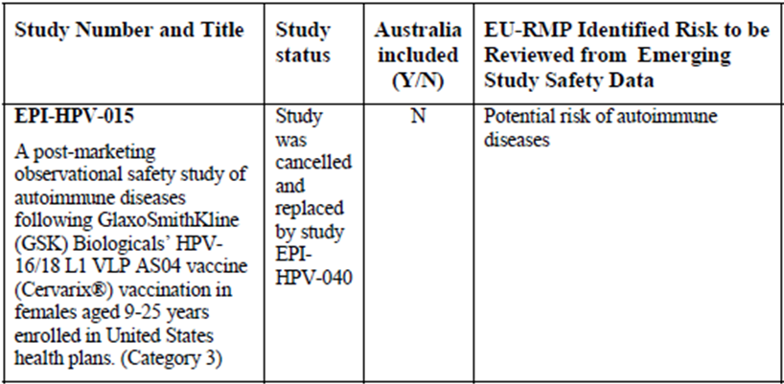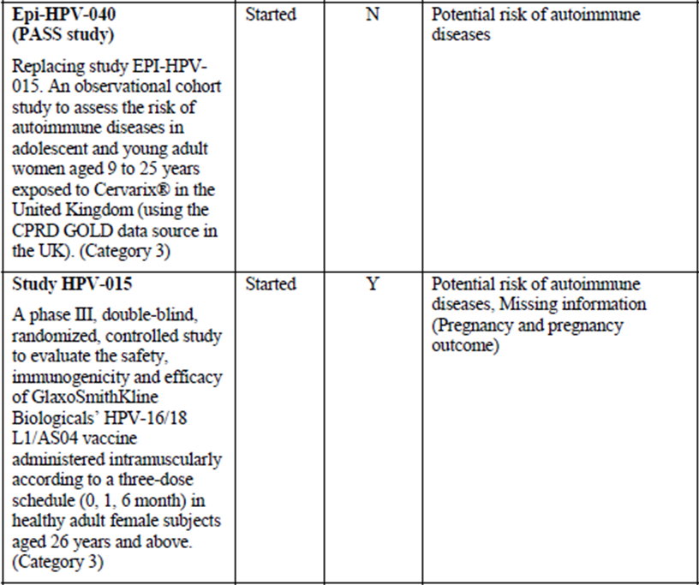
Table 2 (continued): Ongoing studies listed in the EU-RMP, which are relevant to Australian patients.
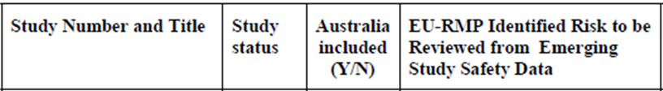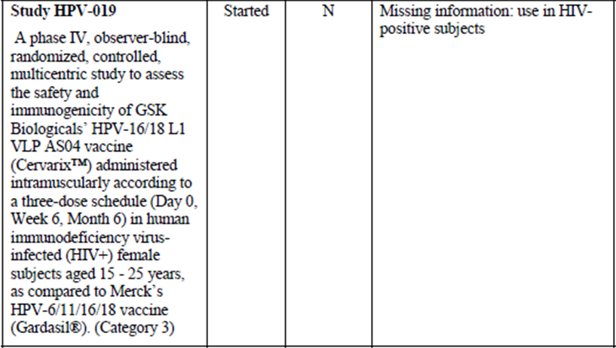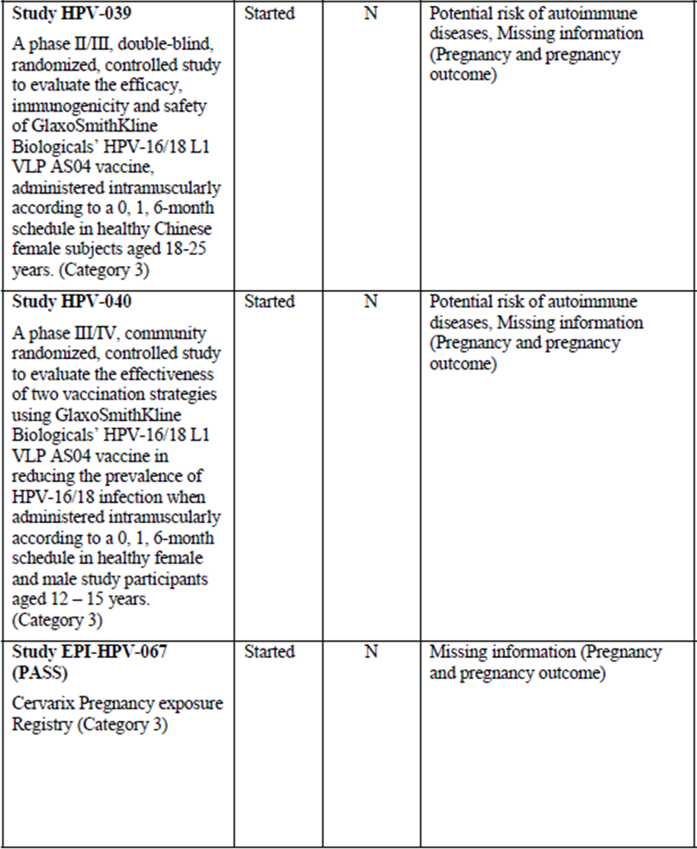
The sponsor states in the ASA:
The EU-RMP included in this submission was written for the Regulatory Authorities of the European Union and follows the instruction given in the EMA Guideline on good pharmacovigilance practices module V – risk management systems (GVPmV) and the EMA guideline on risk minimisation measures (GVPmXVI). Accordingly the document contains commitments made to the EU Authorities. The commitment packages (e.g. study protocol, study report) will not be submitted to the TGA. However the Company commits to submit any variations that might result from data generated as part of the RMP. Study protocols (for studies classified in categories 1-3 in the RMP) and study abstracts for newly available study reports will be appended to the RMP when available. Study results will also be presented in the periodic safety report.

OPR reviewer’s comments
All the described studies are ongoing at the time of evaluation and therefore, the protocols have not been reviewed in detail, as they are not considered to be part of the planned pharmacovigilance activities of the RMP.
It is recommended that the sponsor provides the EU-RMP in its entirety alongside all study protocols, synopsis and reports referenced in the EU-RMP. This will facilitate a comprehensive RMP evaluation including consideration of all relevant aspects of the pharmacovigilance plan.

Risk minimisation activities
The sponsor concludes that routine risk minimisation in form of provision of information on the product label is sufficient to address all ongoing safety concerns.

OPR reviewer comment
In principle, there are no objections to implement only routine risk-minimisation activities at this time.
Nevertheless, it is recommended that the sponsor clarifies how the change in dosing schedule will be communicated to health care professionals, and whether additional risk-minimisation activities may need to be utilised to communicate this change.

Reconciliation of issues outlined in the RMP report
The following section summarises the OPR’s first round evaluation of the RMP, the sponsor’s responses to issues raised by the OPR and the OPR’s evaluation of the sponsor’s responses.

Recommendation #1 in RMP evaluation report
Safety considerations may be raised by the clinical evaluators through the consolidated Section 31 request and/or the clinical evaluation report. It is important to ensure that the information provided in response to these includes a consideration of the relevance for the RMP, and any specific information needed to address this issue in the RMP. For any safety considerations so raised, the sponsor should provide information that is relevant and necessary to address the issue in the RMP.

Sponsor response
No questions or additional safety concerns have been raised by the clinical evaluator. Therefore, there were no responses that required a consideration of the relevance for the EU-RMP.

Evaluator’s comment
The sponsor’s response has been noted.

Recommendation #2 in RMP evaluation report
It is recommended that the sponsor provides an update of the progress of the application submitted to the EMA, to change the text of the pregnancy section as it is proposed for Australia.
It appears that the changes to the pregnancy section of the SmPC, which are essentially the same as those proposed for Australia, have not yet been approved. The text in the pregnancy section of the Summary of Product Characteristics (SmPC) for Cervarix remains unaltered as of 14 January 2015.

Sponsor response
On 8 July 2014, the Company submitted a variation to update the pregnancy section of the SmPC for Cervarix as a result of the outcome of Study EPI-HPV-018 and the review of all available data on exposure around/during pregnancy and pregnancy outcomes. The company proposed wording was as follows:
Animal studies do not indicate direct or indirect harmful effects with respect to fertility, pregnancy, embryonal/foetal development, parturition or post-natal development. Data in pregnant women collected as part of clinical trials, pregnancy registries, and epidemiological studies do not suggest that vaccination with Cervarix alters the risk of abnormal outcomes in neonates including birth defects. Data are insufficient to conclude whether or not vaccination with Cervarix affects the risk of spontaneous abortion. Women who are pregnant or trying to become pregnant, are advised to postpone vaccination until completion of pregnancy.
As a result of the discussion with the assessor, the company agreed with the following wording for Cervarix SmPC as reflected in the RMP (version 10.1) approved by the EMA on the 26 February 2015:
Specific studies of the vaccine in pregnant women were not conducted. Data in pregnant women collected as part of pregnancy registries, epidemiological studies and inadvertent exposure during clinical trials are insufficient to conclude whether or not vaccination with Cervarix affects the risk of adverse pregnancy outcomes including spontaneous abortion. However, during the clinical development program, a total of 10,476 pregnancies were reported including 5,387 in women who had received Cervarix. Overall, the proportions of pregnant subjects who experienced specific outcomes (e.g., normal infant, abnormal infants including congenital anomalies, premature birth, and spontaneous abortion) were similar between treatment groups. Animal studies do not indicate direct or indirect harmful effects with respect to fertility, pregnancy, embryonal/foetal development, parturition or post-natal development. As a precautionary measure, it is preferable to avoid the use of Cervarix during pregnancy. Women who are pregnant or trying to become pregnant are advised to postpone or interrupt vaccination until completion of pregnancy.

Evaluator’s comment
The sponsor’s response has been noted.
This update is brought to the Delegate’s attention.

Recommendation #3.1 in RMP evaluation report
“Long term efficacy” and “HPV type replacement” are mentioned in the RMP as “Other plans and considerations”. It is recommended that the sponsor clarifies while these two items are not listed in the table of ongoing safety concerns.
“Syncope” and “Hypersensitivity” are known to occur with this vaccine, a similar vaccine and vaccines in general and therefore, the sponsor should provide justification to why these are not listed as ongoing safety concerns.

Sponsor response
The Company believes that “long term efficacy”, “HPV type replacement”, “syncope” and “hypersensitivity” should not be considered as ongoing safety concerns at this stage. Efficacy of prevention against high grade cervical lesions has been clinically demonstrated for Cervarix. Cervarix vaccination consistently demonstrates sustained efficacy (Studies HPV-001/007/023 which included a follow-up of 9.4 years) and sustained immunogenicity across age groups and according to both licenced schedules (Studies HPV-001/007/023 for the 3-dose schedule in subjects aged 15 to 25 years , HPV- 048 for the 2 doses schedule with 5 years of follow-up in 9-14 year old subjects),and the long term follow-up Studies HPV-025(EXT HPV-013, 3 dose schedule, up to 14 years follow-up in subjects aged 10 to 14 years) and HPV-060 (EXT HPV-014, 3 doseschedule, up to 10 years of follow-up planned in subjects aged 15 to 55 years old). Both HPV-16 and HPV-18 types rise in prevalence as lesion severity increases from low grade squamous intraepithelial lesions (LSIL), high grade squamous intraepithelial lesions (HSIL) to squamous cell carcinoma (SCC). In addition, the importance of HPV-16 and HPV-18 infections in the progression of cervical lesions to cancer in comparison to other HR-HPV types has been demonstrated. HPV-16, HPV-18 and HPV-45 are detected significantly more commonly in SCC than in HSIL. In addition, they appear to be more common in SCC than in LSIL. The reverse occurs for other HR-HPV types: HPV-39, HPV-51 and HPV-56 are 10 times more common and HPV-53 and HPV-66 30 times more common in LSIL than in SCC.
While the company recognises the theoretical concern of HPV type replacement and the need to monitor it, there is currently no increased occurrence of non vaccine HPV types suggestive of type-replacement 1-4 years post vaccination among HPV-16/18-vaccinated subjects.
Syncope (or vasovagal responses to injection, sometimes accompanied by tonic-clonic movements), as well as hypersensitivity are recognised as adverse reactions in the Reference Safety Information (RSI) for Cervarix and are included in the sections ‘Warnings and Precaution’ and ‘Adverse events’ of the RSI. The current available safety data from the post-marketing surveillance do not indicate that vaccination with Cervarix increase the risk of these events and therefore do not require additional prevention measures other than routine pharmacovigilance.

Evaluator’s comment
This is considered acceptable at this time.

Recommendation #3.2 in RMP evaluation report
The sponsor describes cases of medication errors where Cervarix was administered instead of a similar vaccine (Gardasil). To ensure comprehensive monitoring and reporting of such cases, it is recommended that the sponsor adds “Mixed schedule of vaccines” as an ongoing safety concern.

Sponsor response
The company does not agree with the proposal to consider ‘Mixed schedule of vaccines’, as an ongoing safety concern.
The current Cervarix RSI does not indicate interchangeability of Cervarix with Gardasil. Therefore, this is considered as a maladministration. The available data do not suggest that there is an increase in the reporting rate of this type of maladministration and it remains very low (up to the Data Lock Point of 31 August 2014, a total of 108 cases reported a mixed schedule of vaccines, which corresponds to a reporting rate of 0.20 cases per 100,000 doses distributed). No safety concern was identified in these cases. Cases of maladministration, including alteration of the recommended schedule are monitored through routine pharmacovigilance and analysed cumulatively in periodic benefit-risk evaluation report (PBRER) cycles.

Evaluator’s comment
This is considered acceptable at this time.

Recommendation #4 in RMP evaluation report
It is recommended that the sponsor provides the EU-RMP in its entirely alongside all study protocols, synopsis and reports referenced in the EU-RMP.

Sponsor response
The company would like to clarify that the EU-RMP Version 9 submitted to TGA was complete and no information was missing.
The below paragraph contained within the ASA (and referenced in the RMP evaluation report) may have caused confusion as to the completeness of the submitted EU-RMP and the Company therefore wishes clarify this point.
The EU-RMP included in this submission was written for the regulatory authorities of the EU and follows the instructions given in the EMA guideline on good pharmacovigilance practices module V-risk management systems (GVPmV) and the EMA guideline on risk minimisation measures (GVPmXVI). Accordingly, the document contains commitments made to the EU authorities. The commitment packages (for example, study protocol, study report) will not be submitted to the TGA. However, the sponsor commits to submit any variations that might result from data generated as part of the RMP. Study protocols (for studies classified in categories 1-3 in the RMP) and study abstracts for newly available study reports will be appended to the RMP when available. Study results will also be presented in periodic safety reports.
As mentioned above, the EU-RMP included in the original submission was written for the regulatory authorities of the EU and therefore contains commitments made to the EU authorities. Should any new safety data that impacts the benefit risk profile of Cervarix become available, it will be communicated as appropriate and the EU-RMP will be updated and submitted to the TGA. According to TGA requirements and the sponsor’s corresponding standard internal process, any safety signals identified may result in an update to the Core Safety Information, which would trigger submissions to the TGA for assessment of additional safety information for inclusion in the PI. However, the sponsor does not intend submitting on an ongoing basis completed study reports/protocols for every study mentioned in the RMP.
Additionally, the sponsor would like to take this opportunity to submit the latest version of the EU-RMP with this response. The original submission included EU-RMP Version 9. The latest version of the EU-RMP is Version 10.1 and was approved by the EMA on 26 February 2015. The annotations in the EU-RMP Version 10.1 identify all changes made since Version 9.
In addition, the sponsor would like to inform the TGA that a new version of the EU-RMP (Version 11) is now available but it is not being provided with this response as the changes relate to a new indication application (prevention of anal cancer). Clean (including annexes) and annotated versions of the EU-RMP Version 10.1 and updated ASA are provided.

Evaluator’s comment
The sponsor’s response has been noted.

Recommendation #5 in RMP evaluation report
It is recommended that the sponsor clarifies how the change in dosing schedule will be communicated to health care professionals, and whether additional risk minimisation activities may need to be utilised to communicate this change.

Sponsor response
The sponsor does not currently promote Cervarix to Healthcare Professionals for the vaccination of females 10-14 years of age. HPV vaccination for this age group is currently incorporated into the National Immunisation Program (NIP) and Cervarix is not used by the Federal Government to immunise this cohort. Any change to the NIP to include Cervarix for the vaccination of females 10-14 years of age would involve communication and education of immunisers and health care providers by Federal and State government stakeholders. The sponsor would work with the government(s) to assist with any program changes and supporting material that may be required. No additional risk minimisation activities are deemed necessary in relation to the communication of the alternative 2 dose schedule.

Evaluator’s comment
This is considered acceptable at this time.

Summary of recommendations
It is considered that the sponsor’s response to the TGA Section 31 request has adequately addressed all of the issues identified in the RMP evaluation report.

Outstanding issues

Issues in relation to the RMP
There are no outstanding issues in relation to the RMP for this submission.

Advice from the Advisory Committee on the Safety of Vaccines (ACSOV)
ACSOV advice was not sought for this submission.

Issues brought to the Delegate’s attention
There has been an update to the sponsor’s submission to amend the pregnancy section of the EU SmPC submitted to the EMA. The variation has been approved on 26 February 2015.

Comments on the safety specification of the RMP

Clinical evaluation report
No comments were made by the clinical evaluator regarding the RMP.

Nonclinical evaluation report
The Scientific Evaluation and Special Product Access Branch (SESPAB) of the TGA was not required to review this application, and therefore this section of the RMP has not been evaluated.

Key changes to the updated RMP
EU-RMP Version 9.0 (dated 26 June 2014, DLP June 2014) and ASA Version 1.0 (dated August 2014) has been superseded by:
- EU-RMP Version 10.1 (dated 3 February 2015, DLP January 2015) and ASA Version 2.0 (dated March 2015)

RMP evaluator comment
The evaluator has no objection to the above changes and recommends to the Delegate that the updated version is implemented (see below).

Suggested wording for conditions of registration

RMP
Any changes to which the sponsor agreed become part of the risk management system, whether they are included in the currently available version of the RMP document, or not included, inadvertently or otherwise.
The suggested wording is:
- Implement EU-RMP Version 10.1 (dated 3 February 2015, DLP January 2015) with ASA Version 2.0 (dated March 2015) and any future updates as a condition of registration.

VI. Overall conclusion and risk/benefit assessment
The submission was summarised in the following Delegate’s overview and recommendations:

Quality
There was no quality evaluation.

Nonclinical
There was no nonclinical evaluation.

Clinical

Study HPV‐070
Study 070 was the pivotal study supporting the 2 dose vaccine schedule. It was open label, randomised, immunogenicity study of Cervarix investigating two alternative 2 dose schedule (0,6 months or 0,12 months) in girls aged 9‐14 years compared to the approved 3 dose schedule (0,1,6 months) in young females aged 15‐25 years. The vaccine was administered via intramuscular route.
A total of 1447 subjects were randomised with 550 in (0,6) group, 415 in (0,12) group and 482 in (0,1,6) group. The enrolment was stratified by age categories (9‐11/12‐14 years in the 9‐14 years group and 15‐19/20‐25 years in the 15‐25 years group). The primary outcome was immune response at one month after the last dose of study vaccines.
Based on According to Protocol (ATP) cohort for immunogenicity in initially seronegative participants, all subjects seroconverted for both antigen types HPV 16 & 18 at one month after the last vaccine dose in the respective groups. Thus, there were no relevant differences in (0,6) group or (0,12) group compared to the (0,1,6) group in regard to seroconversion rates (ELISA antibodies). The salient features of immune response based on GMTs were as follows:
- One month after the last dose of the study vaccines in the respective groups, the GMTs immune response (against both HPV types 16 & 18) was similar with 2 dose (0,6) months or (0,12) months vaccination schedule in girls 9‐14 years of age compared to the currently approved 3 dose (0,1,6) months vaccination schedule in young females 15‐25 years of age. Non‐inferiority was based on predefined criterion (Upper Limit of 95% CI for the geometric means ratio (GMR) not more than 2 fold). The response to HPV‐18 with the (0,1,6) schedule was found to be lower compared to the (0,6) schedule (GMR 0.85; 95% CI 0.76, 0.95). The response to HPV‐18 with the (0,1,6) schedule was also found to be lower compared to the (0,12) schedule (GMR 0.75; 95% CI 0.67, 0.85) in ATP analysis but was higher in TVC analysis (GMR 1.35, 95% CI 1.19, 1.52).
Overall, the results were consistent using ATP cohort for immunogenicity or the Total Vaccinated Cohort (TVC) based on the predefined criterion for non‐inferiority.
The two 2 dose vaccination schedules, that is (0,6) versus (0,12), were also similar. One month after the last dose of vaccine in the respective groups, the immune response (HPV 16 & 18) was non‐inferior as defined, with (0,6 months) vaccination compared with the (0,12 months) vaccination using both ATP and TVC populations, although the GMTs were numerically and statistically higher with (0,12) schedule compared to (0,6) schedule.
- Six months after the last dose of vaccine in the respective groups, the GMTs immune response (against both HPV 16 & 18) was non‐inferior as defined, with (0,1,6) schedule versus (0,6) schedule, although statistically higher for HPV‐16 with (0,1,6) schedule compared to (0,6) schedule (GMR 1.25, 95%CI 1.10, 1.40; ATP analysis) and was similar across the age strata (9‐11 years and 12‐14 year) in (0,6) group compared to the (0,1,6) group in 15‐25 years group (TVC analysis).
Six months after the last dose of vaccine in the respective groups, the GMT immune response (against both HPV types 16 & 18) was significantly lower with (0,1,6) schedule in 15‐25 years old females compared to (0,12) schedule in both age strata (9‐11 years and 12‐14 years) using TVC analysis. Analysis based on ATP cohort could not be located in the dossier.
- The GMTs immune response (against both HPV 16 & 18) at one month after (0,12) vaccination was significantly higher than the GMTs at 6 months after (0,6) vaccination (TVC analysis).
The post six months (0,6) group versus post six months (0,12) group comparison could not be located in the dossier. The sponsor is requested to provide this analysis in its pre Advisory Committee on Prescription Medicines (ACPM) response. The sponsor is also requested to indicate when the Months 18, 24 and 36 data are expected to become available.
- The GMTs immune response (against both HPV 16 & 18) at one month after (0,12) vaccination was similar to (non‐inferior as defined) the GMTs at 6 months after (0,1,6) vaccination (TVC analysis).
Please see the clinical evaluation report for results of neutralising antibodies and the cellular immune responses.

Study HPV‐048
This was a supporting study for the proposed 2 dose vaccination schedule of Cervarix and appears to have informed the pivotal Study 070. It was partially blinded (observer blinded for the 2 dose groups only), randomised, dose ranging study comparing the 2 dose schedules (HPV‐16/18 40 μg/40 μg formulation at 0,2 months or at 0,6 months or the standard 20 μg/20 μg formulation at 0,6 months) with the standard 20 μg/20μg formulation at the approved 0,1,6 monthly schedule.
The study population was females 9‐25 years in all groups. The age stratification 9‐14/15‐ 19/20‐25 at randomisation was used across all groups to facilitate equal age distribution.
A total of 960 subjects participated with 240 in each of the 4 groups. The ATP cohort for immunogenicity comprised of 843 subjects (224, 206, 205 and 208 in 40/40 (0,2) group, 40/40 (0,6) group, 20/20 (0,6) group and 20/20 (0,1,6) group respectively.
The primary immunogenicity outcomes were measured at one month after the last dose of vaccine in the respective groups. The results indicated that 40/40 (0,2) vaccination could be ruled out due to suboptimal immune response, whereas an appropriately pragmatic decision appears to have been made to select 20/20 (0,6) rather than 40/40 (0,6).
Further stratified analysis showed that overall the 20/20 (0,6) 9‐14Y group could be most favourably compared with 20/20 (0,1,6) 15‐25Y group based on immune response (against HPV 16 & 18) at one month after the last respective dose. At Month 48, age stratified results indicated similar levels of persisting antibodies in 20/20 (0,1) 9‐14Y group compared to the 20/20 (0,1,6) 15‐25Y group. These two groups were subsequently selected for investigation in the pivotal study 070, which in addition also included a (0,12) group.

Previous vaccine efficacy Studies 008 (N = 18,644) & 009 (N = 7,466)
These were large Phase III vaccine efficacy (VE) studies of Cervarix (3 dose (0,1,6) schedule) at the time of initial approval of Cervarix.
The current dossier included data from a small subset of patients who received only 2 of the intended 3 doses in these studies. These subjects mostly received 2 doses at (0,1) months, that is, failed to receive the 3rd allotted dose for various reasons. Both were controlled studies (hepatitis A vaccine) and the studied population in both was 15‐25 years old females. The following results are noted for the Study 008 (Table 3).
Table 3: Study 008 results.
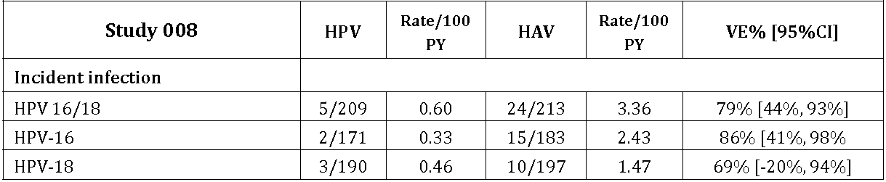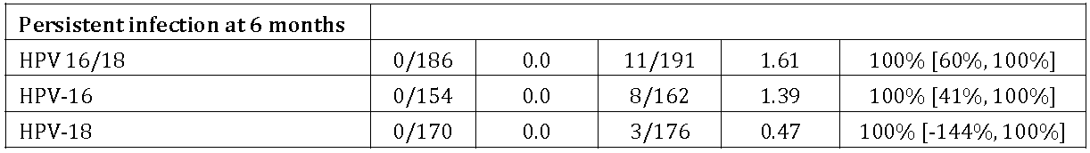
For the 2 dose recipients in the Study 009, the 12 months incident persistent HPV‐16/18 infection (newly detected infection that persisted at 12 months) was reported in 3/422 and 17/380 subjects in HPV and HAV groups respectively (VE 84%; 95%CI 50%, 96%).

Clinical safety
Overall, the reported clinical profile for the 2 dose schedules was similar to the currently approved 3 dose schedule based on both Studies 007 and 048.

Clinical evaluator’s recommendation
The clinical evaluator supports approval.

Risk management plan
EU‐RMP Version 9.0 (dated 26 June 2014, DLP June 2014) & ASA Version 1.0 (dated August 2014) and EU‐RMP Version 10.1 (dated 3 February 2015, DLP November 2014) & ASA Version 2.0 (dated March 2015) apply to this submission. The submission was not referred to the ACSOV.

Risk-benefit analysis

Delegate’s considerations
The following points are noted.
The use of immunogenicity endpoints to support the 2 dose schedule in 10‐14 years old girls has been justified based on the expected very low incidence of clinical endpoints in this age group. However, no justification has been provided for not investigating the 2‐ dose schedule in the 15‐25 years age group in the first place based on assessment of clinical efficacy.
It is to be noted that no immunogenicity data was available from a concurrent (0,6) group in 15‐25 years or concurrent (0,1,6) group in girls aged 9‐14 years in the pivotal study 070.
Although relative immunogenicity based on non‐inferiority is considered a reasonable approach, no judgement can be passed on the various reported statistically significant results as immune correlates of protection have not been validated.
Overall, the Delegate is of the view that the data support the 2 dose vaccination schedule in 9‐14 years old girls including the flexibility and the advice proposed in relation to the timing of the 2nd dose.
In its pre ACPM response the sponsor is requested to provide a summary of intended post market surveillance data that might validate the clinical efficacy of the 2 dose schedule compared to the current 3 dose schedule.
Submitted to ACPM for advice.

Proposed action
The Delegate has no reason to say, at this time, that the application for Cervarix should not be approved.

Request for ACPM advice
The ACPM is requested to provide advice on the following specific issues:
- Overall adequacy of the supporting data for the 2 dose alternative schedule in 9‐14 years old girls
The Committee is also requested to provide advice on any other issues that it thinks may be relevant to a decision on whether or not to approve this application.

Response from sponsor
Both the TGA clinical evaluator and Delegate have recommended approval of the proposed alternative 2 dose vaccination schedule (0, 5-13 months) for females aged 10-14 years of age for Cervarix. The currently approved Cervarix vaccination schedule is 3-doses (0, 1, 6 months) for females aged 10-45 years of age. In Australia, Cervarix is indicated for use in females from 10-45 years of age.
The pivotal study (HPV-070) has demonstrated that the 2 dose vaccination schedule (0, 5-13 months) in females aged 9-14 years of age is non-inferior to the 3 dose vaccination schedule (0, 1, 6 months) in females aged 15-25 years of age. The safety profile for the 2 dose and 3 dose vaccination schedules was confirmed to be similar. No safety concerns were identified.
Overall, the clinical data supports a favourable benefit-risk assessment for the registration of the 2 dose vaccination schedule and offers prescribers the flexibility to choose the most convenient schedule as well as potential benefits in terms of compliance and cost. The 2 dose could lead to a substantial increase in the number of girls completing the vaccination course, thus ensuring greater numbers are protected.
Cervarix 2 dose vaccination schedule was approved by the EMA on 18 December 2013 (0, 6 months) and 21 November 2014 (0, 5-13 months) and has been approved in over 40 countries.
Health Canada has also approved the 2 dose vaccination schedule (0, 6 months) on 3 July 2014.

Specific question raised by the TGA Delegate for the ACPM’s advice
- The ACPM is requested to provide advice on the overall adequacy of the supporting data for the 2 dose alternative schedule in 9-14 years old girls [Note from GSK: Australian indication is from 10 years]

Summary of efficacy
The immunogenicity of the proposed 2 dose vaccination schedule of 0, 5-13 months in females aged 9-14 years for Cervarix was demonstrated in the pivotal study (HPV-070), a supportive immunogenicity study (HPV-048), and supportive efficacy data with 2 doses of Cervarix from Studies HPV-008 and HPV-009. In addition, effectiveness results (follow-up period of 4 years) obtained from the surveillance of HPV specific infection after introduction of the National HPV Immunisation Program in the UK in girls aged 12-13 years (3-dose schedule) which was performed by the Health Protection Agency (HPA) were presented, which validates the immunological bridging approach that was used for registration of Cervarix in subjects below 15 years of age.
Overall, the clinical program has demonstrated that 2 doses of Cervarix administered as a 0, 5-13 month vaccination schedule in females aged 9-14 years provides non-inferior immunogenicity compared with females aged 15-25 years, the population in which vaccine efficacy was demonstrated, and who received the currently registered 3-dose vaccination schedule at 0, 1, 6 months.
In the pivotal study (HPV-070), 2 doses of Cervarix administered to 9-14 year old females at 0, 6 months were shown to elicit an immune response to both HPV-16 and HPV-18 antigens that was non-inferior to that induced by 3 doses of Cervarix administered according to the 3 dose schedule (0, 1, 6 months) in 15-25 year old females. The primary endpoint of non-inferiority in the study was met at Month 7 ATP cohort for immunogenicity. One month post the last vaccination (Month 7), all seronegative subjects vaccinated at 0, 6 months and 0, 1, 6 months had seroconverted for anti HPV-16 and anti HPV-18 antibodies when measured by ELISA and PBNA (neutralising antibodies). High GMTs were observed for both antigens in both groups. The results are summarised in Table 4.
Table 4: Non inferiority assessment HPV-16 and HPV-18 immune response one month after the last dose in initially seronegative subjects (ATP cohort for immunogenicity).
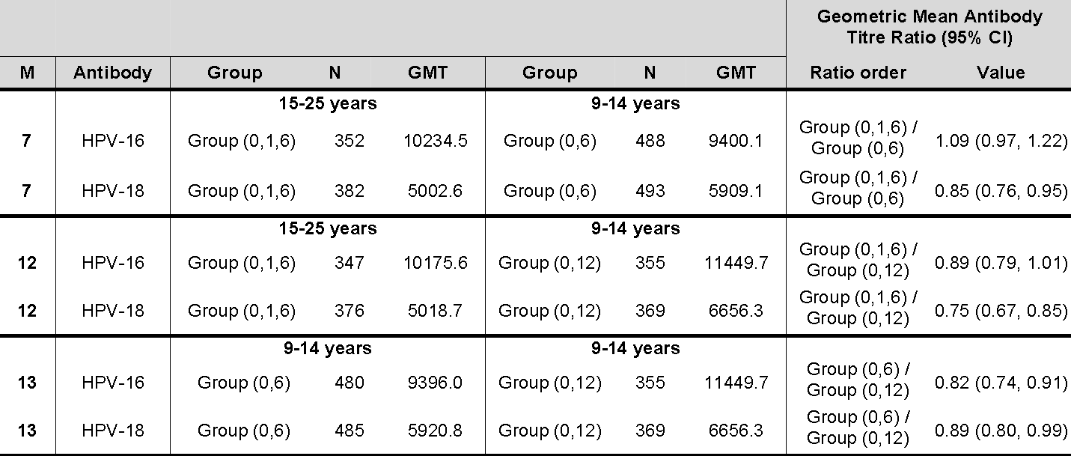
Group (0,6) = Females 9-14 years, 2 doses of Cervarix vaccine at Day 0 and Month 6
Group (0,12) = Females 9-14 years, 2 doses of Cervarix vaccine at Day 0 and Month 12
Group (0,1,6) = Females 15-25 years, 3 doses of Cervarix vaccine at Day 0, Month 1 and Month 6
N = Number of subjects with post-vaccination results available
GMT = geometric mean antibody titre
M = Month
95% CI = 95% confidence interval for the GMT ratio (ANOVA model - pooled variance)
Likewise, the non-inferiority of immune response to both HPV-16 and HPV-18 antigens was demonstrated one month post the last vaccination (Months 12 and 13) when Cervarix was administered according to a 2 dose schedule in 9-14 year old females (given at 0, 6 months and 0, 12 months) compared to a 3 dose schedule in 15-25 year old females (given at 0, 1, 6 months). The results are summarised in Table 4.
The immune response in terms of neutralising antibodies (PBNA) as well as T cell and memory B cell responses to HPV-16 and HPV-18 were similar in both the 9-14 years, 2 dose groups (0, 6 and 0, 12 months) and the 15-25 years, 3-dose group (0, 1, 6 months). In addition, the immune response against HPV-16 and HPV-18 between Month 5 and Month 7 was similar in 9-14 years old females who received a 2 dose schedule (0, 6 months) to the immune response between Month 10 and Month 13 in subjects from the same age group who received a 2 dose schedule (0, 12 months).
Therefore, the proposed 2 dose schedule using an interval of 5 to 13 months provides a suitable alternative to the 3 dose schedule and also provides greater flexibility in the timing of the second dose.
The clinical evaluator has noted advantages in the registration of a 2 dose stating
In the population of females aged 9 to 15 years, a 2 dose schedule is likely to result in greater adherence, and overall a higher immunisation rate.
and
A 2 dose schedule with a wider time window for the second dose (6 to 12 months after the first) offers advantages to immunisation programs in terms of cost and ease of delivery.
In conclusion, Cervarix administered as a 2 dose vaccination schedule (0, 5-13 months) in females aged 9-14 years of age provides similar immunogenicity to the currently registered 3 dose vaccination schedule (0, 1, 6 months), and provides both prescribers and vaccinees added flexibility and convenience in selecting a preferred vaccination schedule without compromising on the quality and duration of the immune response to the vaccine. This is supported by the Delegate who has stated
Overall, the Delegate is of the view the data support the 2 dose vaccination schedule in 10-14 years old girls including the flexibility and the advice proposed in relation to the timing of the 2nd dose.

Summary of safety
The safety profile of Cervarix when administered as a 2 dose vaccination schedule at 0, 5-13 months in females 9-14 years of age is based primarily on the safety data from the pivotal Study HPV-070 up to Month 13. Females aged 9-14 years of age generally reported fewer AEs, Grade 3 AEs, and AEs assessed as being related to vaccination than those receiving the 3 dose vaccination schedule.
The safety profile of Cervarix in females 9-14 years of age who received the 2 dose schedule is similar to that observed in females 15-25 years of age who received the currently registered 3 dose schedule (0, 1, 6 months). This was acknowledged by the clinical evaluator who has stated
The profile of local and general symptoms following Cervarix is similar for the proposed 2 dose schedule and the currently approved three dose schedule. There were no new safety concerns identified in the data.
Additionally, the Delegate has noted that
Overall, the reported clinical profile for the 2 dose schedules was similar to the currently approved 3 dose based on both Studies 007 and 048.
These were efficacy studies which confirmed the clinical protection offered by the 3-dose schedule.
The types of adverse reactions observed with the 2 dose vaccination schedule is consistent with the information previously included in the Adverse Reactions section of the Australian PI. There are no emergent concerns with respect to the safety of Cervarix in females aged 9-14 years of age.

Other issues raised by the TGA Delegate
- For Study HPV-070, the post six months (0,6) group versus post six months (0,12) group comparison could not be located in the dossier. The sponsor is requested to provide this analysis in its pre ACPM response. The sponsor is also requested to indicate when the Months 18, 24 and 36 data are expected to become available.
The sponsor wishes to clarify that the dossier contained two separate clinical study reports (CSR): a CSR for HPV-070 at Month 7, and another CSR for HPV-070 at Month 13.
CSR HPV-070 at Month 7 includes results for 1 month after the last dose for the 0, 6 group and 0, 1, 6 group. CSR HPV-070 at Month 13 includes results for 6 months after the last dose for the 0, 6 group and 0, 1, 6 groups and 1 month after last dose for the 0, 12 group.
It was not the sponsor’s intention to include results from Month 18 in the dossier, however, since submission of the original dossier, the HPV-070 Month 18 CSR has become available and includes the results for 6 and 12 month follow up for the 0, 1, 6 group, 0, 6 group and 0, 12 group. Tables 42 and 43 (non-inferiority seroconversion and GMTs for the 0, 1, 6 versus 0, 12 groups) and Tables 44 and 45 (non-inferiority seroconversion and GMTs for the 0, 12 versus 0, 6 groups) from HPV-070 at Month 18 (that is, 6 months after the last dose) are provided.
Overall, the results show that at Month 18, a 2 dose vaccination schedule continues to elicit a non-inferior immune response to the 3 dose standard vaccination schedule.
The sponsor anticipates the CSR for HPV-070 covering the time points of 24 and 36 months will be available by December 2015. Please note this will be one CSR for both time points.
- In its pre ACPM response the sponsor is requested to provide a summary of intended post market surveillance data that might validate the clinical efficacy of the 2 dose schedule compared to the current 3 dose schedule.
The sponsor asserts that the clinical data submitted has demonstrated that the 2 dose vaccination schedule in females aged 9(10)-14 years is non-inferior to the currently registered 3-dose vaccination schedule in young women aged 15-25 years and therefore further studies are not required to validate the clinical efficacy of the 2 dose schedule.
Initial registration of Cervarix with the 3 dose schedule (0, 1, 6 months) in females aged 15 years and below was obtained through immunological bridging to young women aged 15-25 years in which vaccine efficacy was demonstrated (that is, previously submitted studies HPV-001/007 and HPV-008). This immunological bridging approach was necessary as an efficacy trial requiring gynaecological examination is neither ethical nor feasible in young, pre-sexual debut girls. A similar approach, in terms of immunological bridging, was therefore taken for the proposed 2 dose schedule in females aged 9-14 years.
The sponsor has conducted a thorough clinical development plan for both the 3-dose and the 2 dose vaccination schedules with Cervarix. The studies demonstrated high immunogenicity after a 2 dose schedule (up to 4 years in Study HPV-048) and non-inferiority of the immune response to the vaccine when administered as a 2 dose schedule in subjects aged 9-14 years as compared to young women aged 15-25 years, the age group where the vaccine efficacy was demonstrated (3 dose schedule). Antibody levels after 2 doses were high and well above the plateau level associated with vaccine efficacy observed in Studies HPV-001/007/023 (up to a mean of 8.9 years after first vaccination). No correlate of protection for HPV has been determined, although it appears that a low level of antibodies may actually be sufficient to confer protection. Vaccination with Cervarix elicits a high and sustained immune response, and as observed in the previously submitted long term immunogenicity study (HPV-023), virtually 100% of subjects are still seropositive for both types nearly a decade after receiving the first dose.
Taking into consideration the entire Cervarix dataset for 2 dose and 3 dose vaccination schedules (both in terms of immunogenicity and efficacy), and that the sponsor’s modelling predicts detectable antibody titres over 20 years after first vaccination with the 2 dose schedule, a clinical trial to assess long term immunogenicity appears to hold little added value versus existing data, while a new efficacy trial (versus placebo or another HPV vaccine) to assess efficacy with a 2 dose schedule appears unfeasible for both ethical and practical reasons.
Additionally, efficacy data with 2 doses of Cervarix were generated in the efficacy trials HPV-008 (females 15-25 years) and HPV-009 (females 18-25 years) and were included in the current dossier. These data strongly suggest that efficacy is maintained when Cervarix is administered as a 2 dose schedule.
In collaboration with the sponsor, the NCI has also conducted a post hoc meta-analysis of pooled study data (HPV-008 and HPV-009) to evaluate vaccine efficacy of fewer doses among HPV naïve women, including cross protection. In this recent publication, it was concluded that 4 years after vaccination of women aged 15-25 years, 1 and 2 doses of the HPV 16/18 vaccine (Cervarix or Gardasil) seemed to protect against cervical HPV-16/18 infections, similar to the protection provided by the 3 dose schedule.
As part of routine pharmacovigilance activities, the sponsor will monitor all adverse events received for any emergent signals.
The sponsor considers that long term outcomes and vaccine efficacy have been sufficiently explored. No specific post market surveillance activities are planned in the post marketing setting related to the 2 dose vaccination schedule post vaccination.

Clinical importance of outcomes
The Delegate has acknowledged that relative immunogenicity based on non-inferiority for the 2 dose is considered a reasonable approach. However, has commented that
… no judgement can be passed on the various reported statistically significant results as immune correlates of protection have not been validated.
Since collection of efficacy data is not feasible in 9-14 year old females for ethical and practical reasons, the sponsor designed Study HPV-070, a Phase III confirmatory study to bridge the immunogenicity data with those in the adult age group (15-25 years) in which efficacy had been previously demonstrated. Although there is no identified immunological correlate of protection for HPV, it is recognised by the scientific community that protection against oncogenic HPV infection in humans is mainly based on the presence of neutralising antibodies. This has been recognised by the Committee For Medicinal Products For Human Use which also confirms the adequacy of the sponsor’s approach. In the clinical program, age stratified analyses of immunogenicity demonstrated that Cervarix elicits similar or higher levels of immune response in females aged 9-14 years, than in older age groups.
The clinical evaluator is also of the opinion that
... it is appropriate to use immunogenicity as a surrogate measure of efficacy in the 9 to 15 year old population because HPV-16 and HPV-18 infection are uncommon in this age group and cannot be used as an efficacy outcome measure.

RMP
The sponsor will implement the Cervarix EU-RMP (version 10.1, dated 3 February 2015) with an ASA (version 2.0, dated March 2015), both of which were submitted to the TGA on 30 March 2015.

Conclusion
The data from the pivotal study (HPV-070) support a favourable benefit-risk assessment for the registration of the Cervarix 2 dose vaccination schedule (0, 5-13 months) as an alternative to the existing 3 dose schedule (0, 1, 6 months) in girls aged 10-14 years of age. In terms of safety, the profile of the 2 dose vaccination schedule is similar to the current 3 dose vaccination schedule.
The sponsor trusts that the ACPM will align with the opinions of the TGA clinical evaluator and Delegate in recommending registration of the Cervarix 2 dose vaccination schedule (given at 0, 5-13 months) in females 10-14 years of age.

Advisory committee considerations
The ACPM, taking into account the submitted evidence of efficacy, safety and quality, agreed with the Delegate and considered Cervarix suspension for injection, containing HPV vaccine with 20 μg each of types HPV‐16 L1 and HPV‐18 L1 as VLPs (recombinant, AS04 adjuvanted) to have an overall positive benefit-risk profile for the proposed 2 dose vaccine schedule in 10‐14 years old girls. The currently approved indication remains unchanged as follows:
Cervarix is indicated in females from 10 to 45 years of age for the prevention of persistent infection, premalignant cervical lesions and cervical cancer caused by human papillomavirus types 16 and 18. Immunogenicity studies have been conducted in females aged 10 to 14 years and 26 to 45 years to link efficacy in females aged 15 to 25 years to other populations.
In making this recommendation, the ACPM:
- Noted that clinical evidence was inferred but acceptable in view of immunogenicity data.
- Was of the view that monitoring effectiveness in the post market setting was important for establishing efficacy and durability of protection afforded by the 2 dose strategy. Thus, pharmacovigilance activities should be designed to ensure that any difference or decline in protective efficacy is detected.
- Noted that duration of immunity was not yet established.
- Noted the data presented supported a minimum 6 month gap between doses in the 2 dose schedule rather than the proposed 5 month gap proposed.

Proposed conditions of registration
The ACPM agreed with the delegate on the proposed conditions of registration.

Proposed Product Information (PI)/Consumer Medicine Information (CMI) amendments
The ACPM agreed with the Delegate to the proposed amendments to the PI and CMI.

Specific advice
The ACPM advised the following in response to the Delegate’s specific questions on this submission:
- Overall adequacy of the supporting data for the 2 dose alternative schedule in 9‐14 years old girls.
The data demonstrate overall non‐inferiority of short term serological outcomes of the 2 dose strategy for girls aged 9‐14 years in comparison to current 3 dose schedule in girls and women. The sponsor wishes to extrapolate from the known efficacy using a 3 dose vaccine schedule to the 2 dose schedule based on short term serological outcomes. While the application can be supported it should be accompanied by post marketing measures which monitor continuing serological and clinical efficacy long term.
No data were presented for a 5 month gap between doses in the 2 dose schedule.
The ACPM was of the view that Australian specific data should be collected to monitor efficacy.
The ACPM advised that implementation by the sponsor of the recommendations outlined above to the satisfaction of the TGA, in addition to the evidence of efficacy and safety provided would support the safe and effective use of this product.

Outcome
Based on a review of quality, safety and efficacy, TGA approved the registration of Cervarix human papillomavirus vaccine for the new dose schedule as stated in the ‘Dose and Administration’ section of the PI:
Cervarix is indicated in females from 10 to 45 years of age for the prevention of persistent infection, premalignant cervical lesions and cervical cancer caused by human papillomavirus types 16 and 18. Immunogenicity studies have been conducted in females aged 10 to 14 years and 26 to 45 years to link efficacy in females aged 15 to 25 years to other populations. (See Precautions and Clinical Trials).

Specific conditions of registration applying to these goods
- RMP Version 10.1 (dated 3 February 2015, DLP January 2015) with ASA Version 2.0 (dated March 2015) and any future updates, and any subsequent revisions, as agreed with the TGA will be implemented in Australia.
- For all injectable products, the PI must be included with the product as a package insert.

Attachment 1. Product Information
The PI approved for Cervarix at the time this AusPAR was published is at Attachment 1. For the most recent PI, please refer to the TGA website at <https://www.tga.gov.au/product-information-pi>.

Attachment 2. Extract from the Clinical Evaluation Report

Therapeutic Goods Administration
PO Box 100 Woden ACT 2606 Australia
Email: info@tga.gov.au Phone: 1800 020 653 Fax: 02 6232 8605
https://www.tga.gov.au

Draper E, et al. A randomized, observer-blinded immunogenicity trial of Cervarix and Gardasil human papillomavirus vaccines in 12- 15 year old girls. PLoS One 8: e61825 (2013); Safaeian M, et al. Cross-protective vaccine efficacy of the bivalent HPV vaccine against HPV31 is associated with humoral immune responses: Results from the Costa Rica Vaccine Trial. Hum Vaccin Immunother. 9: 1399-406 (2013).
Kreimer AR, et al. Efficacy of fewer than three doses of an HPV-16/18 AS04-adjuvanted vaccine: combined analysis of data from the Costa Rica Vaccine and PATRICIA trials. Lancet 16: 775-86 (2015).
Clifford GM, et al. Human papillomavirus genotype distribution in low-grade cervical lesions: comparison by geographic region and with cervical cancer. Cancer Epidemiol Biomarkers Prev. 14: 1157-64 (2005); Tjalma WA, et al. Differences in human papillomavirus type distribution in high-grade cervical intraepithelial neoplasia and invasive cervical cancer in Europe. Int J Cancer 132: 854-67 (2013).
Clifford GM, et al. Comparison of HPV type distribution in high-grade cervical lesions and cervical cancer: a meta-analysis. Br J Cancer 89: 101-5 (2003); Clifford GM, et al. Human papillomavirus types in invasive cervical cancer worldwide: a meta-analysis. Br J Cancer 88: 63-73 (2003).
Clifford GM, et al. Human papillomavirus genotype distribution in low-grade cervical lesions: comparison by geographic region and with cervical cancer. Cancer Epidemiol Biomarkers Prev. 14: 1157-64 (2005).
Clifford GM, et al. Human papillomavirus genotype distribution in low-grade cervical lesions: comparison by geographic region and with cervical cancer. Cancer Epidemiol Biomarkers Prev. 14: 1157-64 (2005).
Palmroth J, et al. Occurrence of vaccine and non-vaccine human papillomavirus types in adolescent Finnish females 4 years post-vaccination. Int J Cancer 131: 2832-8 (2012).
Naud PS, et al. Sustained efficacy, immunogenicity, and safety of the HPV-16/18 AS04-adjuvanted vaccine: final analysis of a long-term follow-up study up to 9.4 years post-vaccination. Hum Vaccin Immunother. 10: 2147-62 (2014).
Kreimer AR, et al. Efficacy of fewer than three doses of an HPV-16/18 AS04-adjuvanted vaccine: combined analysis of data from the Costa Rica Vaccine and PATRICIA trials. Lancet 16: 775-86 (2015).
Draper E, et al. A randomized, observer-blinded immunogenicity trial of Cervarix and Gardasil human papillomavirus vaccines in 12- 15 year old girls. PLoS One 8: e61825 (2013); Safaeian M, et al. Cross-protective vaccine efficacy of the bivalent HPV vaccine against HPV31 is associated with humoral immune responses: Results from the Costa Rica Vaccine Trial. Hum Vaccin Immunother. 9: 1399-406 (2013).

